UNIVERSITY OF OKLAHOMA

GRADUATE COLLEGE

THE DECISION TO TRUST: AN APPLICATION OF STRUCTURAL EQUATION MODELING TO THE ACTOR EVALUATION AND TRUST FRAMEWORK

A THESIS
SUBMITTED TO THE GRADUATE FACULTY
in partial fulfillment of the requirements for the
Degree of
MASTER OF ARTS

By
TRISTAN KILGORE
Norman, Oklahoma
2024

THE DECISION TO TRUST: AN APPLICATION OF STRUCTURAL EQUATION MODELING TO THE ACTOR EVALUATION AND TRUST FRAMEWORK

A THESIS APPROVED FOR THE
DEPARTMENT OF POLITICAL SCIENCE

BY THE COMMITTEE CONSISTING OF

Dr. Joseph Ripberger, Chair

Dr. Hank Jenkins-Smith

Dr. Deven Carlson

© Copyright by TRISTAN KILGORE 2024
All Rights Reserved.
Acknowledgments
First and foremost, I would like to thank my advisor, Dr. Joseph Ripberger, for his unwavering support, guidance, and encouragement throughout my graduate studies at the University of Oklahoma. He has supported me since my beginnings as a doctoral student interested in studying water policy to where I am today as a Data Scientist directly serving Oklahomans. Further, his invaluable insights, constructive feedback, and endless patience have been instrumental in shaping my growth as a researcher.
I also extend my sincere thanks to my thesis committee members, Dr. Hank Jenkins-Smith and Dr. Deven Carlson, for their time, expertise, and mentorship during my time here. They have greatly improved the quality of this thesis with their support.
I would be remiss not to acknowledge the support and encouragement I have received from my fellow graduate students and colleagues at the University of Oklahoma. The stimulating discussions, collaborative projects, and shared experiences have made this journey an unforgettable one. I am grateful for the friendships forged and the memories created during this time.
Last but not least, I would like to thank my partner, Arely, as well as my parents, for their love, patience, and emotional support. I am forever indebted to you all and your presence in my life has been a constant source of motivation and inspiration.

Table of Contents
Abstract vii
Introduction 1
Trust in Risk Management 3
The Consensus Model - An Early Model of Trust 3
Models of Trust in Risk Management 5
Trust, Confidence, and Cooperation Model 5
The Associationist Model 8
The Integrative Model 10
Developing a Revised Model of Trust 11
Model Overview 14
Deep Core Beliefs 16
Cultural Theory– Grid and Group Dimensions 18
Cultural Theory– Descriptions of the Four Worldviews 20
Value Congruence as a Foundation for Trust 23
Definitions and Dimensions 23
Value Congruence and Trust 24
Risk Perception 25
Cultural Theory as a Driver of Risk Perception 26
Competency Perceptions 28
Methodological Design 30
Data Collection and Sample 30
Measures 31
Modeling Approach 32
Results 32
Descriptive Statistics 32
SEM Assumption Checks and Covariance Matrix 34
Estimation and Fit 37
Structural Model Parameter Estimates 40
Hypothesis 1: Deep Core Beliefs Influence Competency Perceptions 41
Hypothesis 2: Deep Core Beliefs Influence Value Congruence 42
Hypotheses 3: Value Congruence and Trust 43
Hypothesis 4: Competency Perceptions and Trust 43
Hypothesis 5: Deep Core Beliefs and Trust 43
Hypothesis 6: Deep Core Beliefs and Risk Perception 43
Hypothesis 7: Trust, Risk Perception, and Policy Cooperation 44
Discussion 45
Summary of Findings 45
Interpretation of Findings 47
Role of Deep Core Beliefs in the AETF 47
Importance of Value Congruence and Competency Perceptions 48
Risk Perception and Trust as a Policy Cooperation Driver 49
Limitations of Study 50
Potential issues with Measures and Data Limitations 50
Other Methodological Considerations 51
Future Research Directions 51
Refining the AETF and testing alternative models 51
Conclusion 53
Summary of Key Findings and Theoretical Contributions 53
Practical Implications for Practitioners 54
References 56
Appendix 64
Survey Questions 64
Risk Perception Questions 64
Policy Cooperation Questions 64
Trust in Risk Managers Questions 65
Value Congruence and Competency Perception Questions 65
Deep Core Beliefs/Cultural Theory Questions 65
Measurement Model Factor Loadings 67
Power Analysis 68
Correlation Matrix 71

List of Figures
Figure 1: Trust, Confidence, and Cooperation Model 7
Figure 2: The Associationist Model 8
Figure 3: The Integrative Model 10
Figure 4: The Actor Evaluation and Trust Framework (AETF) 14
Figure 5: Matrix of Sociality 19
Figure 6: Covariances of Observed Variables 37
Figure 7: Measurement Model 38
Figure 8: CDC Central and Non-Central Chi-Squared Distributions 68
Figure 9: State Health Department Central and Non-Central Chi-Squared Distributions 69
Figure 10: Primary Care Physician Central and Non-Central Chi-Squared Distributions 69
Figure 11: Correlation Matrix 71

List of Tables
Table 1: Descriptive Statistics for Exogenous Variables 33
Table 2: Descriptive Statistics for Endogenous Variables 34
Table 3: Goodness-of-Fit Indices 39
Table 4: Hypotheses 40
Table 5: Structural Equation Model Standardized Path Coefficients 41
Table 6: CDC Factor Loadings 67
Table 7: State Health Department Factor Loadings 67
Table 8: Primary Care Physician Factor Loadings 68
Table 9: Power Analysis Results 70

Abstract
The growing number of crises, from public health crises like COVID-19 to natural disasters like wildfires and hurricanes, has exposed the need for a comprehensive framework to understand how an individual decides who to trust and whether to cooperate with public policy to mitigate risk. Previous research has relied on contemporary social trust and confidence conceptualizations to develop complex models and frameworks with limited generalizability and applications. Further, many contemporary trust and policy cooperation frameworks lack robust empirical tests and evidence to support their claims and assumptions. This study introduces the Actor Evaluation and Trust Framework (AETF) and tests it using nationally representative survey data from the COVID-19 pandemic. Results from three structural equation models provide significant support for the AETF. The AETF offers a novel approach to understanding trust and policy cooperation, building on interdisciplinary research and insights from contemporary models.

KEYWORDS: Social Trust, Disaster Policy, COVID-19, Structural Equation Modeling, Cultural Theory, Value Congruence, Risk Perception, Crisis Management, Policy Cooperation

Introduction
Severe Acute Respiratory Syndrome Coronavirus 2, or COVID-19, devastated the world when it engulfed countries and communities in the spring of 2020. The pandemic presented governments and risk managers with unprecedented challenges that have underscored the need for effective risk management practices in safeguarding public health and ensuring community resilience.
Governments at all levels have attempted to contain the COVID-19 pandemic through various methods, such as mandating masks be worn in public places, restricting travel, school closures, and economic stimulus policies designed to support income due to job impacts (Hale et al. 2021). Many people have asked themselves: “Who do I trust to manage COVID-19?” with responses varying by age, education, cultural worldviews, and risk perception. However, the success of these measures depends not only on their effective implementation but also on public trust and cooperation with public policy.
Attention has turned to building rapport with communities, leading to trust and policy cooperation (i.e.: how can trust be built?). Current conceptualizations of social trust and confidence and contemporary policy cooperation frameworks maintain significant gaps despite the vast amount of research focused on these topics. Existing research, while substantial, fails to capture the foundation for the path an individual takes in their decision to trust a risk manager and eventually cooperate with public policy.
Therefore, there is an existing need to bridge these gaps and formulate a comprehensive framework for trust and policy cooperation that is generalizable to contexts outside of COVID-19 while providing a tool that allows for more effective risk communication and management. As a result, this study is focused on the following research questions:
- How do an individual’s foundational beliefs, like cultural worldviews, impact the decision to trust and cooperate with public policy?
- What is the impact of value congruence and competency perceptions of a risk manager on an individual’s level of trust in them to manage risk?
- How do trust and risk perception work together to determine policy cooperation in a crisis?
A new trust and policy cooperation model is proposed to answer the above questions: the Actor Evaluation and Trust Framework, or AETF. The AETF combines lessons from Cultural Theory, public administration research on value congruence, and conceptualizations of competency and risk perception to understand an individual's mental process to trust a risk manager and cooperate with public policy implemented to reduce the risks associated with a crisis.
This study will attempt to address the gap in risk management research by testing the AETF through structural equation modeling. First, this study will overview the dominant trust and policy cooperation models in the risk management literature: the Trust, Confidence, and Cooperation model, the Associationist Model, and the Integrative model. Special attention will be given to understanding the gaps and drawbacks of each model. Second, the AETF will be introduced. Prior research on the various components will be introduced and integrated into a comprehensive theoretical model. Then, the AETF will be tested through three structural equation models, each focused on a different risk management actor, using data from a nationally representative panel survey conducted in the United States. Lastly, the results from the structural equation models will be evaluated and discussed.

Trust in Risk Management

The Consensus Model - An Early Model of Trust
Trust has been an essential concept in the social sciences for decades, playing a prominent role in the study of politics and public policy. However, its research popularity has not prevented it from being highly contentious, with scholars unable to decide on standard definitions, theoretical models, or measurements.
Early researchers focused on the intersection of communication, persuasion, and trustworthiness in the early 50s, while in the late 90s, more focus was given to identifying the core components of trust (Hovland and Weiss 1951; Kasperson, Golding, and Tuler 1992; Metlay 1999; Renn and Levine 1991; Rousseau et al. 1998).
Hovland and Weiss (1951) conducted an experiment in which they provided information about several domains, like public health and the economy, to participants from two articles per domain—one trustworthy and one untrustworthy. Participants' opinions were gauged before the communication, immediately after, and one month after. These researchers found that the trustworthiness of an information source was highly influential in determining how an individual’s opinion would change.
Researchers in the 90s focused primarily on developing definitions, identifying components of trust, and laying the foundation for complex theoretical models. Here, trust is conceptualized using the same definition many traditional risk management scholars have used– a cognitive process in which the individual accepts vulnerability based on another actor's positive expectations, intents, and behaviors (Rousseau et al. 1998). The two core dimensions of trust, as argued by Rousseau et al. (1998), are relational trust and calculative trust. Values, norms, beliefs, and other social constructs primarily inform relational trust. Contract, calculative trust is akin to an economic rational model, where an individual’s decision to trust is based on proof of past performance or competence.
Other researchers have identified other core components, or dimensions, of trust that go far beyond Rousseau et al.’s (1998) initial conceptualization. Renn and Levine (1991) identify five core dimensions of trust based on findings and suggestions from literature: perceived competence, objectivity, fairness, consistency, and faith. They argue that trust is based on all five dimensions; however, shortcomings in one dimension can be compensated by an excess of another (Renn and Levine 1991). Here, trust and confidence are separated, similar to Rousseau et al. (1998), where confidence is based on a solid record of “trust-building communication” (Renn and Levine 1991, 180). Kasperson, Golding, and Tuler (1992) identify four key dimensions of social trust, which are defined as the person’s expectation that those in a social relationship can be relied upon to act in a certain way. Dimensions of social trust include commitment, competence, caring, and predictability.
Contrary to previously mentioned researchers, Metaly (1999) criticized researchers for making trust models incredibly complex, arguing that scholars have introduced and argued about models like calculus-based and knowledge-based trust. Metlay (1999) argued for two simple dimensions– one that focuses on an individual’s beliefs about how institutions should behave and the other on the perception of how competent an institution is.
The viewpoints and research above constitute the consensus model, an early and influential trust model in the social sciences. The model centers around relational and calculative trust, previously defined in this section. Generally, relational trust is more critical in cooperating than calculative trust. Further, the function of relational trust is to reduce the complexity of a scenario through social risk-taking. In contrast, calculative trust controls future behavior through knowledge of past performances and less emphasis on the heuristics (T. C. Earle 2010). However, several new trust models have been developed since the consensus model goes beyond the similarity of intentions, value similarity, and affect heuristics.

Models of Trust in Risk Management

Trust, Confidence, and Cooperation Model
Two conceptualizations of trust were most popular in a literature review– calculative and relational trust (T. C. Earle 2010). Based on those most common conceptualizations, the Trust, Confidence, and Cooperation (TCC) model attempts to provide a framework that relates multiple dimensions (T. Earle and Siegrist 2008). Additionally, the model focuses on the psychological aspects of what compels an individual to cooperate– a topic critical for public health topics like COVID-19. It incorporates variables like value similarity, perceived performance, and memory of historical performance involved in judgments of trust and confidence to create a framework that lays out the interactions between all dimensions and components that lead to cooperation. In sum, the framework attempts to provide a more robust solution to how trust and confidence calculations are formed and how those might lead to cooperation with public policy. In the context of COVID-19, if a doctor with high trust and confidence from the public helped develop a public health policy designed to limit the spread of COVID-19 (like a vaccine), the policy would see higher levels of cooperation due to the trust and confidence levels in the doctor. On the other hand, the opposite would also hold where low levels of trust and confidence would lead to low levels of cooperation with the policy.
The TCC model argues that confidence (i.e., calculative trust), as defined by Rousseau et al. (1998), is not a dimension of trust but rather an entirely new construct. Here, confidence is used to determine and predict compliance and is complementary to trust (i.e., relational trust). In the TCC model, trust is “the willingness, in the expectation of beneficial outcomes, to make oneself vulnerable to another based on a judgment of similarity of intentions or value.” Confidence is the “belief, based on experience or evidence, that certain future events will occur as expected.” This distinction between trust and confidence defines the core of the TCC model– one is social and relational, while the other is instrumental and calculative.
In the TCC model, social trust is shaped by how individuals perceive the similarity of their values to those of another party. Value similarity, or value congruence, has been extensively studied in fields like political science and public administration. It refers to how closely an individual's values align with those held by other individuals or organizations, as further elaborated in this paper. Conversely, confidence is influenced by factors related to past performance or the presence of institutions that may affect future performance adversely. These indicators of past performance can be quantitatively assessed using various methods, such as considering one's experience, control, and competence (as described by Earle and Siegrist in 2008). Similarly, value congruence can also be measured empirically, and various approaches are discussed later in this paper.
Figure 1 provides a comprehensive illustration of the decision-making process employed by individuals when determining their trust and confidence levels in individuals, organizations, or institutions, as well as their compliance with the respective regulations and policies. The components of the TCC model, as depicted in Figure 1, are designed as dual sets, one for social trust and the other for confidence. However, it's essential to note that the TCC model doesn't specify the mechanism for combining these elements to formulate beliefs of social trust and confidence, as articulated by Earle and Siegrist. Below is a concise overview of each aspect of social trust and confidence, as proposed by Earle and Siegrist in their research (2008, pp. 21-22).
Figure 1: Trust, Confidence, and Cooperation Model
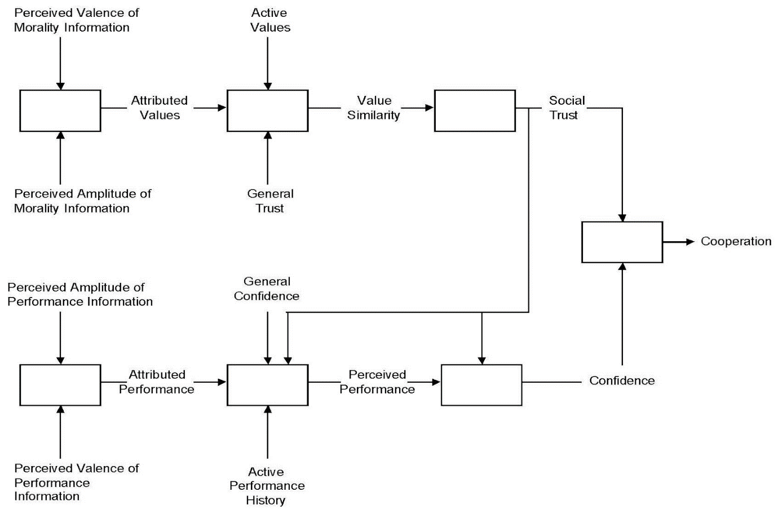
Notes: Adapted from Earle, T, and Michael Siegrist. “Trust, confidence and cooperation model: a frame-work for understanding the relation between trust and risk perception.” International Journal of Global Environmental Issues, 8 1/2, 21, Figure 1.

The components of the TCC model serve as a valuable framework for understanding how an individual decides to cooperate with actors managing risky situations. However, recent research suggests that the TCC model lacks internal validity surrounding the interactions of confidence and trust and how they influence cooperation (Myers 2023; Siegrist 2021).

The Associationist Model
Figure 2: The Associationist Model
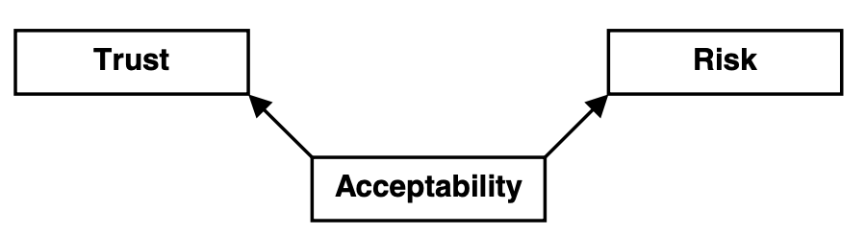
Notes: Adapted from Poortinga, W., & Pidgeon, N. F. (2005). Trust in Risk Regulation: Cause or Consequence of the Acceptability of GM Food? Risk Analysis, 25(1), 199–209, Figure 1.

Risk researchers have worked to expand and improve the consensus model, particularly in the context of trust and technology acceptance, a form of cooperation (Eiser, Miles, and Frewer 2002; Poortinga and Pidgeon 2003). The Associationist model argues that trust expresses attitudes about how a particular scenario or thing should be managed rather than a primary driver of risk perception and acceptance. This contradicts previous research in the risk management literature, which asserts that trust drives risk perception (i.e., if you have a high level of trust in someone to manage risk, your risk perception will be lower) (Johnson 1999; Johnson and Slovic 1995).
Several studies have provided empirical evidence supporting the claims of the Associationist model (Bronfman et al. 2008; Bronfman, Vázquez, and Dorantes 2009; Montijn-Dorgelo and Midden 2008; Poortinga and Pidgeon 2003). Eiser et al. (2002) and Poortinga and Pidgeon (2003) conducted initial exploratory studies looking at the relationship between trust and risk perception, finding that trust is a general indicator of attitudes rather than a direct predictor of risk perception and cooperation. In the international contexts of Mexico and Chile, Bronfman et al. (2008) and Bronfman, Vázquez, and Dorantes (2009) both find support for trust acting as a mediator between risk perception, cooperation, and benefits received. Lastly, Montijn-Dorgelo and Midden (2008) also find evidence for the moderating role of trust on the relationship between risk perception and perceived benefits. These results validate Figure 2, where risk perception and trust in someone to manage a technology are both mediated by an individual’s acceptability of said technology. In emergency management and risk, this suggests that if an individual is less concerned with a crisis (or more acceptable), their risk perception of the event is likely to be lower while holding a higher trust in the individuals responsible for managing it.
Researchers contrast their Associationist model with a causal chain model, arguing that trust affects risk perception and cooperation. T.C. Earle (2010) suggests that the Associationist model is at odds with the consensus model until you incorporate information availability into the equation. Suppose an individual deciding to trust has appropriate knowledge of either the subject at hand or proponents/opponents of the subject. In that case, the individual uses heuristics like value similarity to decide to trust. However, one major drawback of the Associationist model is that it only focuses on one form of trust– calculative trust, measured by one of their survey questions (Eiser, Miles, and Frewer 2002). It incorporates no notion of relational trust, informed by heuristics and similarity perceptions, which have been shown to impact cooperation and risk perception (T. C. Earle 2010; Siegrist 2021).

The Integrative Model
Figure 3: The Integrative Model
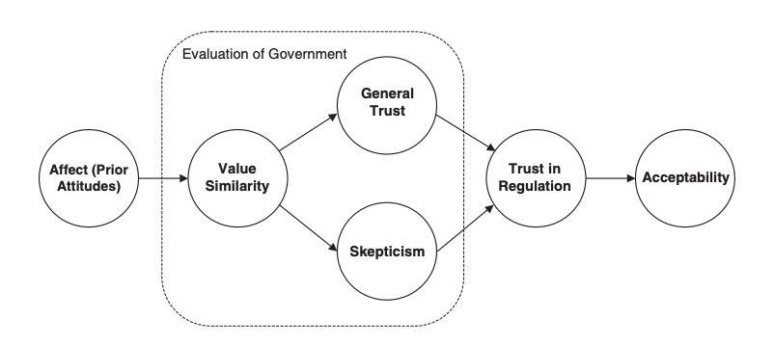
Notes: Adapted from Poortinga, W., & Pidgeon, N. F. (2006). Prior Attitudes, Salient Value Similarity, and Dimensionality: Toward an Integrative Model of Trust in Risk Regulation1. Journal of Applied Social Psychology, 36(7), 1674–1700, Figure 1.

Poortinga and Pidgeon (2006) attempt to reconcile the theoretical validity issues associated with the associationist model by developing the integrative model (see Figure 3), which incorporates relational and calculative trust. The model asserts that individuals maintain prior attitudes, or affect, on an issue or event, which then act as a heuristic for determining how similar their values are with the individuals or institutions regulating the issue (Poortinga and Pidgeon 2006). Here, government intention, or the trustee's intention, influences the value similarity between the two parties. The individual’s perception of value similarity influences and predicts two distinct trust factors– general trust and skepticism around the issue. An individual’s general trust and skepticism around the issue drive trust in regulation, which determines cooperation with the regulation (Poortinga and Pidgeon 2006).
The integrative model improved drastically on the associationist model by incorporating both dimensions of trust, one heuristic-based and one competence-informed. General trust and skepticism are primarily relational and heuristic-informed, while trust in risk regulation is calculative. Thus, the integrative model integrates critical aspects of the consensus model by employing both key dimensions of trust and showing that relational trust dominates calculative trust. Poortinga and Pidgeon (2006) provide an essential conceptual integration of the different theoretical approaches in risk management studies.
There is a wide variety of trust frameworks across the social sciences, but the three mentioned in this section are some of the most influential and comprehensive in risk management. Their varying approaches identify several holes in the trust theory, some suggesting that trust is not a linear causal model. In contrast, others argue that you cannot model the process of developing trust and intent to cooperate with complex theoretical models, like the Trust, Confidence, and Cooperation model (T. Earle and Siegrist 2008; Poortinga and Pidgeon 2003; 2005; 2006). Further, some research suggests that the exact relationship between relational and calculative trust and how they influence an individual’s desire to cooperate with risk regulation might not theoretically sound as previously thought (Myers 2023).

Developing a Revised Model of Trust
As evidenced by the previous section, many researchers have attempted to define and understand trust through deep core beliefs (i.e.: Cultural Theory), value similarity, competency, and confidence to predict whether an individual will cooperate with public policy. Slovic (1993) found that scenarios that the public found highly risky, like nuclear energy, are associated with lower trust and perhaps cooperation with risk managers. On the other hand, low-risk situations were related to high trust in those responsible for managing risk (Slovic 1993). These observations are critical as they open the pathway for influencing public risk perception and acceptance. If we understand trust, we can guide and alter the public’s risk perception and whether they choose to cooperate with public policies designed to minimize risk and reduce harm (Gutscher 2007).
The review of trust in the risk management literature (see sections 2 - 4) found that there were four primary models used for understanding and predicting cooperation in risky situations– the Consensus Model, the Trust, Confidence, and Cooperation (TCC) Model, the Associationist Model, and the Integrative Model. Each model has their strengths and weaknesses, which will be briefly discussed.
The Consensus Model is the foundation for many contemporary trust models and operationalizes relational and calculative trust; however, it is limited by its narrow focus on similarity of intentions, value similarity, and affect heuristics.
The TCC model argues that calculative trust is not a trust construct but an entirely new one (i.e., confidence). The TCC model is significantly more complex than other models of trust reviewed in this paper and does not specify how its components, like attributed values and performance, are combined to create an individual’s trust or confidence in a risk manager. Further, recent research has suggested that the TCC model lacks internal validity surrounding how trust and confidence interact to determine willingness to cooperate with risk management policies (Myers 2023).
The Associationist Model asserts trust is not a risk perception or cooperation driver. Instead, trust is a collection of beliefs about managing a risky event, which is a markedly different argument than the other trust models. Proponents of the TCC model emphasize that if you include information availability (i.e., the individual deciding to trust has knowledge of the risky event), individuals will instead use heuristics to make their decision. Further, the Associationist Model only incorporates calculative trust– forgoing any investigation into the effects mentioned by the TCC proponent.
The Integrative Model captures relational and calculative trust to reconcile the Associationist Model issues. Here, an individual’s trust in the actor and skepticism surrounding the issue predict whether they will trust the actor to regulate the risky scenario and, in turn, cooperate with policies. However, as with previous trust models, some researchers argue that trust cannot be modeled linearly or with complex theoretical models (Poortinga and Pidgeon 2005; 2006; 2003).
Except for the Integrative Model’s expansion of the Associationist Model, the prominent trust models in risk management research do not aim to integrate or learn from each other to form a robust model that will stand the test of time. Some are overly complex, while others fail to incorporate findings from other fields that influence cooperation and the decision to trust an actor to manage risk.
In this section, I introduce a new model of trust and cooperation that aims to rectify these issues by incorporating findings from all predominant models. First, this section will introduce a new model of trust and cooperation, coined the Actor Evaluation and Trust Framework, or AETF, along with hypotheses designed to assess the model's internal and external validity. Then, an in-depth exploration of deep core beliefs, value congruence, risk perception, and competency perception will be conducted to support the hypotheses' validity.

Model Overview
Figure 4: The Actor Evaluation and Trust Framework (AETF)
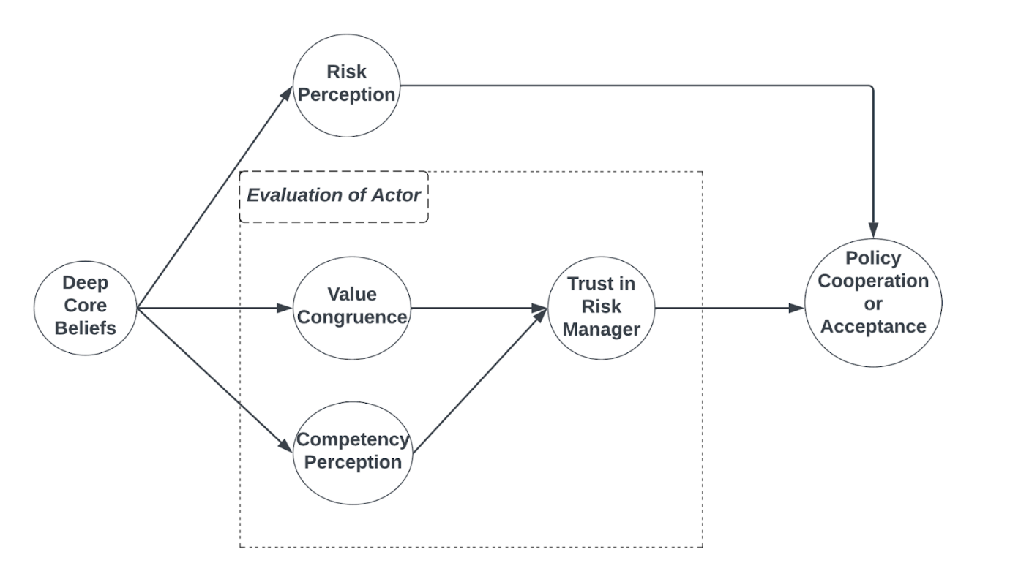
The Actor Evaluation and Trust Framework, or AETF, posits that an individual’s decision to cooperate or accept public policy is determined by their level of trust in the risk manager and their risk perception of the hazard. The AETF's core is evaluating the actor responsible for managing the hazard. During this evaluation, the decision to trust is conducted; however, contrary to risk management models like the Trust, Confidence, and Cooperation model, trust is not relational and social in this model. Instead, it combines value congruence (relational) and competency perception (calculative).
In the AETF, trust is the decision to make oneself vulnerable to another based on value similarity and competency perceptions with the expectation of favorable outcomes. Competency primarily indicates past performance, with competency perceptions being inherently subjective. This is supported by the foundations of an individual’s deep core beliefs. This information division is central in psychological research regarding impression formation but is relatively underutilized in risk management research (T. Earle and Siegrist 2008; Peeters and Czapinski 1990; Skowronski and Carlston 1989).
In the impression formation literature, morality information, such as value similarity, refers to the entity's values where trust (or distrust) is being decided and is informed by innate values (Peeters and Czapinski 1990; Skowronski and Carlston 1989). Similarly, performance information, like competency, is also informed by the same innate values (Peeters and Czapinski 1990; Skowronski and Carlston 1989). Combined, these constructs determine whether an individual trusts the risk management agent.
In the social psychology literature, the importance of morality and performance information is demonstrated, while Cultural Theory scholars have shown that these constructs are primarily informed by deep core beliefs (Marris, Langford, and O’Riordan 1998; McNeeley and Lazrus 2014; Rosenberg, Nelson, and Vivekananthan 1968; Thompson 2018; Wildavsky 1987). Studies in the social psychology literature show two general themes:
- People determine their impressions of others based on social desirability (value congruence) and intellectual desirability (competency perceptions) (Rosenberg, Nelson, and Vivekananthan 1968).
- Morality information (value congruence) dominates performance information (competency perceptions). In other words, low competency perceptions are judged much less harshly if individuals have a high-value congruence with the actor (De Bruin and Van Lange 1999a; 1999b; 2000; Wojciszke, Bazinska, and Jaworski 1998).

Like the TCC model, the AETF is aligned on parallel paths for relational (value congruence) and calculative trust (competency perceptions), which are combined to create a trust judgment. Then, combined with the individual’s risk perception of the hazard, the decision to cooperate or accept is made. The alignment of value-based trust, competence perceptions, and risk evaluation within the AETF underscores the multifaceted nature of trust dynamics in environmental decision-making processes.
The AETF employs a battery of hypotheses designed to be tested using structural equation modeling to test the framework's validity.:
H1: Deep core beliefs influence an individual’s competency perception of a risk manager.
H2: Deep core beliefs influence an individual’s value congruence with a risk manager.
H3: Higher value congruence will be associated with higher trust in risk managers.
H4: Higher competency perceptions will be associated with higher trust in risk managers.
H5: Deep core beliefs indirectly influence trust in a risk manager through value congruence and competency perceptions.
H6: Deep core beliefs influence risk perception of hazards.
H7: Higher levels of trust and risk perception will be associated with higher levels of policy cooperation.
Given this outline of the AETF and its hypotheses, the following sections will explore the framework's critical components, including deep core beliefs, value congruence, risk perception, and competency perceptions. Then, the discussion will be geared towards empirically testing the framework's validity.

Deep Core Beliefs
Public policy scholars have developed a robust model of individual cognition that attempts to predict how individuals engage in the policy process. Theoretical frameworks like the Advocacy Coalition Framework, or ACF, employ this model of individual cognition, which structures an individual’s perceptions and behavior (Ripberger et al. 2014). These normative deep core beliefs address the fundamental and ontological assumptions about how individuals interact with nature and what they believe the role of policy actors should be. Further, these beliefs serve as a filter for how individuals interact and perceive the world around them. In turn, they influence which actors, or risk managers, an individual decides to trust.
Several criteria should be met for a particular research program to work in measuring deep core beliefs (Ripberger et al. 2014). First, measures should be multidimensional, meaning that they should be able to speak to multiple deep core beliefs at a time. A robust measure of deep core beliefs would be able to gauge a wide range of topics, such as the role of the government versus the market in managing a risky situation or even preferences for expert-led responses to crises versus community-led reactions to crises.
Second, measures should be generalizable (Ripberger et al. 2014). Measures of deep core beliefs should apply to contexts outside of particular situations like public health emergencies. Further, they should be able to be extended to countries outside of the United States. A standard measure of deep core beliefs often used in political science and public policy research is political ideology; however, these measures fail to generalize to contexts outside of the United States (Sorrentino et al. 2005). This is due to the multiparty nature in other countries, like Germany, where issues are not debated between two ideological poles.
Lastly, deep core beliefs should be measurable using multiple techniques (Ripberger et al. 2014). A research program is not very useful for measuring deep core beliefs if it cannot be measured using different research tools– researchers should be able to use mediums ranging from surveys to interviews to content analysis to support those using quantitative, mixed-methods, or qualitative research designs.
One research program that satisfies the above criteria is Cultural Theory (CT), which has received considerable academic attention in recent years due to its flexibility and robustness in understanding an individual’s normative beliefs. Thus, I argue that CT provides a theoretically sound framework for understanding and measuring an individual’s beliefs and meets the above criteria of being multidimensional, generalizable, and measurable using multiple techniques (Ripberger et al. 2014). Further, it provides a solid foundation for constructing a new trust model using a set of measures honed and refined across several contexts.

Cultural Theory– Grid and Group Dimensions
Cultural Theory (CT) was developed in the 1970s by British Anthropologist Mary Douglas and her colleagues to explain societal conflict over risk– including an individual’s preferences on how risk should be managed and who they trust to manage it (Douglas 1978; Thompson 2018; Wildavsky 1987). Since its inception, CT has been used across various disciplines, like psychology and public policy. It has been used to understand individual behavior in a variety of scenarios, like preference formation and perceptions of governmental and non-governmental actors in risk scenarios(Grendstad and Selle 2000; Kahan, Jenkins-Smith, and Braman 2011; Ripberger, Jenkins-Smith, and Herron 2011; Wildavsky 1987; Wildavsky and Dake 1990). Further, it has been used to understand and predict state relationships at the international level, organizational levels, and managerial values in public administration (Conner et al. 2016; Hood 2000; Thompson and Wildavsky 2018).
CT’s central hypothesis asserts that social individuals' patterns in shaping their worldviews about nature, values, and behaviors they, and other individuals, should partake in (Thompson 2018). Essentially, these experiences shape how individuals view the world around them. Critical to this are two social dimensions by which an individual’s orientations are formed– grid and group. These dimensions help guide and shape the biases and worldviews described above.
Figure 5: Matrix of Sociality
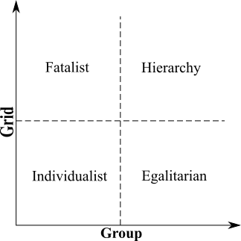
The group dimension of sociality focuses on how an individual interacts with group and community environments (i.e., how important are these structures to them?) (Thompson 2018). Individuals who do not view groups as essential to their identity are inherently more autonomous. In contrast, those who value it more and consider it a critical part of their identity tend to be governed more heavily by the groups and communities they are a part of, allowing them to influence and guide their decisions heavily. Take the example of someone who highly values their identity as a member of a religious group. CT asserts that they are much more likely to adhere to the teachings and norms of their religious group in their day-to-day life.
On the contrary, the grid dimension of sociality concerns itself with the impact rules, norms, laws, and other externally imposed concepts have on an individual’s identity (Thompson 2018). For example, individuals on the lower end of the grid dimension do not view externally imposed concepts as particularly binding or constricting. They believe their actions are instead informed primarily by their internal logic or rational models. On the other hand, those at the higher end of the grid dimension are much more willing to submit and adhere to externally imposed constructs rather than adhere to their internal logic or that of a group. For instance, someone who is found on the lower end of the grid dimension is much more likely to make personal decisions about what they should wear based on their own opinions. However, those on the higher end of the grid dimension may strictly follow the cultural or societal norms of their group, even if it directly contradicts their taste.
When the grid and group dimensions are combined, they produce the four worldviews: fatalism, hierarchism, individualism, and egalitarianism (Thompson 2018).

Cultural Theory– Descriptions of the Four Worldviews
CT explains and attempts to justify how individuals work toward their preferred way of life. Individuals who fall within the grid-group matrix of sociality adopt normative and ontological beliefs that guide their way of life (Marris, Langford, and O’Riordan 1998; Thompson 2018). These bundles of normative and ontological beliefs contain preferences for how risky scenarios should be handled and who should handle them. For example, who should manage the risks associated with COVID-19 or be responsible for mitigating the risks associated with climate change-induced natural disasters?
Fatalists find themselves in a high grid and low group position. They are characterized by their reliance on external constructs combined with minimal group affiliations. Therefore, they heavily consider external constraints like rules, laws, norms, and traditions while ignoring membership in groups and communities that might otherwise guide their personal beliefs. Further, they tend to believe they have little control over their lives and often feel dictated by the same external constraints they heavily subscribe to. They also tend not to frequently engage in social and political life, viewing nature as inconsistent and unable to be managed or wrangled properly. Fatalists are in a peculiar position within CT and risk management that presents unique challenges. Although fatalists tend to adhere to social constructs, Marris, Langford, and O’Riordan (1998) found a correlation between fatalists and trust in those close to them, like doctors. In this study, an overwhelming majority of respondents (76%) with fatalist tendencies said they would trust their doctors to tell them the truth about potential risks. In comparison, 8% of that group said they would trust the government to do the same thing. In sum, while they prefer the rigidness of external constraints, they likely place more confidence and trust in those close to them to help guide their decisions, like primary care physicians. Hierarchists find themselves in a high grid and high group position. They place immense weight on their group and community ties and pay close attention to who around them holds membership. Further, they prefer these organizations to be highly structured with clear rules and laws that can help guide the behavior of members. They believe humans are inherently flawed and require guidance to make the best decisions. Institutions and regulations that can help govern society and lead it toward a less flawed state are ideal. Further, hierarchists also prefer security to liberty and equality. Often, they support governments and institutions taking a more prominent role in mitigating risks to provide more protection, like in the case of public health emergencies like COVID-19. They care more about what experts, like scientists, think should be done rather than what the majority of the public believes should be done (Ripberger et al. 2014). Marris, Langford, and O’Riordan (1998) found statistically significant correlations between hierarchist worldviews and trust in governments and doctors, supporting the assertions made by CT scholars that hierarchists are more likely to trust people in positions of authority.
Individualists are the opposite of hierarchists, given that they find themselves in a low grid and group position. Their defining characteristic is prioritizing their rights and freedom over group and community membership in a society with strong social constructs. Due to these prioritizations, they often prefer market-based solutions to top-down governmental regulations. Supporting this, when it comes to making decisions about events like public health emergencies, they believe that those impacted should work together in the decision-making process to reach mutually beneficial outcomes that do not restrict the liberties of others.
Lastly, egalitarians are defined by a low grid and high group position. Their group and community membership heavily define their identities and worldviews. Due to these strong group memberships, they tend not to adhere to social constructs outside of their groups. Egalitarians favor small organizations and resist external controls from institutions like governments that encourage social differentiation. Further, they believe that members of their groups should make decisions based on what they think is best for the collective, often ignoring expert suggestions. Advocating for collectivism and equality, they argue that the government’s top priority should be protecting those who are vulnerable.
As mentioned above in the descriptions of the four worldviews, Cultural Theory provides a strong foundation for understanding an individual’s heuristics and how they decide to trust. For example, the worldviews tend to trust the following based on their conceptualization:
- Fatalists - close personal relations (friends, family, local community)
- Hierarchists - Authoritative institutions (government, public health officials, experts)
- Individualists - Non-experts, voluntary associations
- Egalitarians - Grassroots community organizations and other community-level groups.

Cultural Theory offers a robust framework for understanding and measuring deep core beliefs. It helps researchers understand individual belief systems' psychological and normative underpinnings and their impact on evaluating risk managers and policy actors. This paper leverages CT as the foundation of the theoretical model introduced earlier in this paper. It tests it through structural equation modeling to explore this initial step of the trust and cooperation process. In the next section, this paper will explore the concept of value congruence, the next step in the theoretical model, which is deeply rooted in CT. This approach underscores the seamless progression from cultural worldviews to an individual’s alignment of these normative beliefs using value congruence and their use as heuristics in an individual’s decision to trust an actor to manage a crisis.

Value Congruence as a Foundation for Trust

Definitions and Dimensions
Value congruence is the fit between an individual’s values and those of other individuals, organizations, or institutions (Boyd-Swan and Molina 2018; 2019). Values are defined in this paper as desirable normative behaviors or outcomes consistent with previous value congruence literature (J. R. Edwards and Cable 2009). Individuals apply heuristics that help guide them in life, such as trust or cultural worldviews, that help inform their behaviors and actions. Similarly, organizations provide norms that help guide employees on how to behave. This process and relationship informs the concept of value congruence– how well do an individual’s heuristics align with that of an organization or another individual’s?
Unlike this study, value congruence scholars are generally concerned with an individual’s fit within their work environment, commonly known as person-environment fit. Extensive research by value congruence scholars has identified several varieties that fall under person-environment fit, such as person-job fit, person-organization fit, and person-supervisor fit (Kristof-Brown, Zimmerman, and Johnson 2005). However, value congruence research has often been active in political science, public policy, and public administration. Studies have been conducted on various topics, including value congruence as a causal mechanism for determining whether individuals join voluntary civic organizations or even the role of value congruence in public health policy compliance during COVID-19 (Hooghe 2003; Yuan and Swedlow 2022). Other studies, particularly on ideological congruence in political parties, political campaigns and candidate perceptions, and value congruence between civil servants and their organizations, have also been conducted (Miller-Stevens, Taylor, and Morris 2015; Pinggera 2021; Williams et al. 2012). Value congruence has repeatedly been identified as a critical dimension of an individual’s decision to trust, cooperate, or align themselves with another actor.
Value congruence can be measured in subjective fit and objective fit (J. R. Edwards and Cable 2009). Subjective fit measures how well an individual’s perception of their values matches those of their organization or another actor. Similarly, objective fit measures the same thing– how well an individual’s values match those of their organization; however, it is calculated from the view of a third party, such as a researcher or the individual’s supervisor or coworkers. Subjective fit is the focus of this study, as it focuses primarily on an individual’s perceptions and their decision to trust actors to manage COVID-19. An individual’s subjective evaluations of their values and the values of the actors or organizations in question inform their value similarity, primarily in creating or refining trust models. A model of trust should mimic how individuals come to their decisions rationally, and individuals likely do not incorporate measures of objective fit in their mental models.

Value Congruence and Trust
There is a strong relationship between value congruence and the level of trust between individuals. This has been researched considerably within the organizational and business context. For example, value congruence has been shown to positively affect an individual’s perception of how competent another individual may be at completing a task, leading to higher levels of trust (Cazier, Shao, and Louis 2007). Further, when there are conflicting opinions between an individual and the actor– like values and disagreements on managing COVID-19 and other public health crises, there are much higher levels of bias perception between the parties involved (Kennedy and Pronin 2008). This leads to lower levels of trust overall. However, these findings directly contradict some of the popular risk management trust models, where competence and confidence are informed by perceptions of past actions (T. C. Earle 2010). This is not to say that value congruence is only essential for trust or confidence; rather, current conceptualizations of trust models in risk management may not be entirely accurate, failing to incorporate research from other research areas.
The AETF posits that value congruence is a primary predictor of trust in a risk manager; however, the relationship is moderated by two constructs:
- An individual’s risk perception of the crisis or scenario at hand
- An individual’s perception of the risk manager’s competency.
Risk and competency perceptions are driven by the individual’s deep core beliefs, contrary to the arguments of some previous trust models. Cultural Theory argues that an individual’s worldviews do dictate what disasters they find particularly risky and who should be responsible for managing them, or in other words, how competent they inherently believe some actors are. The AETF acknowledges the critical role of value congruence in an individual’s decision to trust and cooperate with policy. Still, it is crucial to consider the dynamic relationship between the two variables previously mentioned. The next section will bridge the discussion of value congruence with recent research in risk analysis combined with Cultural Theory to provide a more comprehensive understanding of the construct in the AETF and how it influences who an individual will decide to trust.

Risk Perception
People encounter many hazards in their day-to-day lives, ranging from driving cars to eating genetically modified food. How they perceive the level of danger a hazard might have, known as risk perception, is a crucial driver of whether individuals trust risk managers and cooperate with policy. When risk managers do not incorporate the affected community’s risk perception into their management through policy, communication, or other avenues, they are often met with distrust and a lack of acceptance on the community’s behalf (Visschers and Siegrist 2008). Several crises have demonstrated the importance of incorporating risk perception into public policy and risk management responses, like the BSE outbreak in the United Kingdom and the introduction of genetically modified organisms in Europe (Frewer, Miles, and Marsh 2002; O’Brien 2000).
The AETF posits that risk perception is crucial in an individual’s decision to cooperate or accept public policy. This argument contradicts much of the trust and risk management literature, broadly arguing that trust influences risk perception (T. C. Earle 2010; Siegrist 2021; Visschers and Siegrist 2008). The AETF asserts that risk perception, in the context of trust formulations and policy cooperation, is influenced by an individual’s deep core beliefs rather than trust, which is one of the primary predictors of whether an individual will comply with or accept the policy. This argument is predominantly based on the theoretical underpinnings of Cultural Theory.

Cultural Theory as a Driver of Risk Perception
Individuals are active organizers of their own beliefs and perceptions. As a result, individuals choose what and how much to fear to support their way of life (Marris, Langford, and O’Riordan 1998; McNeeley and Lazrus 2014; Thompson 2018). Individuals pay selective attention to certain risks and hazards and prefer risk-taking and avoiding them. These preferences correspond to the cultural worldviews, hierarchism, egalitarianism, fatalism, and individualism mentioned earlier in this paper. Cultural biases and worldviews interact mutually, reinforcing a situation where there can be no worldviews without cultural biases and vice-versa (Wildavsky and Dake 1990). In turn, the socially viable combinations of cultural worldviews and biases are hypothesized to determine what is considered a risk and what is not.
Regarding risk perception, the deep beliefs held by the cultural worldviews dictate how they navigate risky situations. Egalitarians believe nature is fragile and value vital equality to serve nature and their communities best. For example, they will likely think wealth, race, etc., and inequality are risky and threatening (Wildavsky and Dake 1990). Further, war and social deviance are less likely to be dangerous and are exaggerated by the institutions governing them (Wildavsky and Dake 1990). Due to their community-focused beliefs, crises that disproportionately impact marginalized communities and increase social disparities are particularly risky.
On the other hand, individualists believe that nature is designed to be exploited by society and that the benefits will outweigh the costs. Their worldviews are rooted in individual enterprise, which drives their risk perceptions. Hierarchists trust their institutions (economic, political, etc.) to control unexpected events. They are also technologically optimistic, seeing it as a driver for increased enterprise. However, they prefer self-regulation to institutional regulation. They believe they can navigate public health and natural disaster crises through their responsibility and freedom, opting against restrictions that might impact their ability to act. Thus, they perceive situations as relatively low risk without institutional limits.
Hierarchists and individualists have similarities regarding risk perception; however, their theoretical reasoning differs. For example, they view nature as perverse and tolerant and approve of technological innovations and risks if approved by experts—a markedly different rationale than individualists. Further, they have a high-risk perception of any situation that might affect the institutional structure of society, such as social deviance. The same can be said for natural disasters and public health emergencies that might upset the social order and social relations they favor.
On the other hand, Fatalists perceive risks as inherent to life and posit that nature is uncontrollable. They do not share the same risk perceptions as individualists or hierarchists and do not favor the community perspective of the egalitarians. Instead, they resign themselves to nature and do not believe any events are particularly risky due to the inevitability of some crises. As a result, they may not engage in proactive measures to protect themselves or engage in actions designed to mitigate risk.
Cultural Theory provides insights into how individuals formulate their risk perception and, in turn, cooperate with public policy designed to mitigate or reduce risk. Each worldview's cultural biases influence the prioritization of specific risks and their preferred management approaches. Next, the nature of competency perceptions will be discussed, focusing on the influence of deep core beliefs on perceptions and how competency is a critical dimension of trust.

Competency Perceptions
The foundation of the AETF is found within an individual’s deep core beliefs, operationalized in this paper using Cultural Theory. These beliefs play a critical role in how individuals perceive the competency of risk managers in the decision-making process. In the AETF, competency perception is perceptions of a risk manager’s past performance regarding the hazard. As posited by Cultural Theory researchers like Wildavsky and Dake, different cultural biases and worldviews– hierarchism, egalitarianism, individualism, and fatalism– inform patterns of social relations and internal values. These relations extend to judgments about how competent actors may be when responsible for managing hazards.
Hierarchists are characterized by their focus on hierarchical social relations and institutional structures (Thompson 2018). The AETF argues that hierarchies perceive actors as competent when they adhere to established rules and institutional norms and maintain order. This is primarily due to their emphasis on paramount obedience to authority, with actors who align with these norms judged competent. Unlike hierarchists, egalitarians value group membership and equality (Thompson 2018). Actors who align with these values, such as those who commit to reducing social inequality and championing fairness and equality, will be perceived as competent by egalitarians.
Individualists prefer self-regulation and autonomy (Thompson 2018). They view competency as the risk manager’s ability to navigate the complexities of individual enterprises. In the context of markets, competency is closely tied to facilitating freedom and managing market relationships. Risk managers and other actors who support self-regulation are more likely to be perceived as competent by individuals. Fatalists, conversely, are defined by their belief that nature cannot be controlled and that their fate does not lie in their own hands (Thompson 2018). Thus, they are not likely to perceive most risk managers as competent since risk managers cannot successfully control nature in their eyes. However, like individualists, risk managers who prioritize self-autonomy may be perceived as competent by fatalists. These cultural biases, rooted in distinct worldviews and innate beliefs about how the world should operate, are the foundation for the perception of competency across different social contexts, like crisis management.
The impact of cultural biases on competency perception is critical when attempting to understand the multifaceted and dimensional nature of decision-making. In risk management, individuals draw upon their cultural biases as heuristics to assess the competency of risk managers, especially when they do not have the necessary knowledge to make a holistic decision about the whole crisis. The distinct criteria that the worldviews maintain shape the lens through which individuals assess the competency of risk managers in crises.
Further, competency perceptions become integral dimensions in the broader trust and policy cooperation framework. As conceptualized in the AETF, trust is heavily influenced by value congruence and competency perceptions. Trust is not solely relational and based on value congruence but is a combination of relational and calculative constructs. In the AETF, actors' competency becomes a crucial determinant in the decision to trust and cooperate with policy, heightening the intricate connections between cultural biases, competency perceptions, and trust dynamics.
In summary, exploring deep core beliefs, Cultural Theory, value congruence, risk perceptions, and competency perceptions reveals the pivotal role of risk perception and cultural biases in shaping how individuals trust risk managers and eventually cooperate or accept public policy. The next section of this paper explores structural equation modeling to assess the internal and external validity of the AETF and empirically investigate the intricate connections between deep core beliefs and policy cooperation.

Methodological Design

Data Collection and Sample
This study explores the relationships between deep core beliefs, risk perception, value congruence, competency perceptions, trust, and an individual’s decision to cooperate with public health policy. To accomplish this, I used a panel survey of 1,000 internet-based responses (250 responses per week) fielded from February 9th, 2021, to March 3rd, 2021. The Institute for Public Policy Research and Analysis (IPPRA) contracted with Qualtrics to survey a sample of respondents broadly representative of the United States. This involved an active monitoring process that ensured the respondents resembled the broader population of the United States. With appropriate weighting, this is a standard approach to produce panel data sufficiently representative of the US population compared to telephone surveys– enabling robust analyses (Berrens et al. 2003). This sampling method mitigated the danger of ignoring large population segments due to the overrepresentation of smaller segments.
The survey instrument contained questions related to demographics, risk perceptions, knowledge, and information sources about COVID-19, as well as competency, value similarity, and trust perceptions of risk managers. Lastly, it included questions that gauged whether individuals intended to comply with a battery of public health policies recommended by risk managers. The survey questions used in the analysis can be found in the Appendix.

Measures
The analyses had many exogenous and endogenous variables, measured and latent variables. Deep core beliefs are a prominent latent variable in the study. This was informed by four sets of exogenous variables measuring each of the four cultural worldviews—hierarchism, individualism, egalitarianism, and fatalism. Each worldview was measured using three separate questions. These questions were then used to create a composite measure of each worldview that ranges from 3 to 15, with higher scores indicating that the respondent identifies heavily with that worldview.
The other latent variable, risk perception, was also measured using a similar approach. Three exogenous variables were used to create the risk perception construct. The survey questions underlying these variables measured the respondents' risk perceptions regarding the danger COVID-19 posed to themselves, the economy, and national security. These were then used to create a composite measure ranging from 3 to 15, with higher scores indicating that the respondent felt COVID-19 posed a considerable threat to the United States.
The remainder of the analysis was composed of endogenous, measured variables. These include competency perceptions, value congruence, and trust in 3 different risk managers (Centers for Disease Control, State Health Departments, Primary Care Physicians) responsible for managing the risks associated with COVID-19. These variables were measured on a scale of 1 to 5, where higher scores indicate higher levels of value congruence, competency perceptions, and trust in that risk manager. Lastly, a composite scale was created to measure policy cooperation and acceptance using five different survey questions related to precautions recommended by risk managers for mitigating the risk associated with COVID-19. These questions addressed topics like washing your hands more frequently, wearing a protective mask, avoiding trips to public spaces, canceling travel plans, and working from home. All were measured on a scale of 1 to 5, with the composite scale ranging from 4 to 20, with higher levels indicating a higher level of policy cooperation.

Modeling Approach
Structural Equation Modeling (SEM) was used to assess the Actor Evaluation and Trust Framework. Three different models were developed, each focused on a different risk manager– the CDC, State Health Departments, or Primary Care Physicians. In SEM, a common approach is to develop a model based on modification indices iteratively (MacCallum 1998). Modification indices indicate the potential improvement a model can have based on whether the suggested estimate or path is added. Then, the researcher can make the modifications and interpret the final model. Fit indices were used in the analysis; however, the models performed as expected, so no adjustments were made.

Results

Descriptive Statistics
Table 1 provides descriptive statistics for the exogenous variables used in the study. The variables represent respondents’ attitudes and perceptions related to Cultural Theory, which is how deep core beliefs were operationalized for this study, and perceived COVID-19 risks across three domains– national security, the economy, and their personal lives.
All Cultural Theory measures reported moderate levels of agreement, supporting previous research that suggests individuals fall within more than one worldview (Marris, Langford, and O’Riordan 1998; Thompson 2018). The three egalitarian measures (fairness, power, and income disparity) exhibited mean scores of 3.22 (SD = 1.25), 3.50 (SD = 1.12), and 3.21 (SD = 1.29), indicating moderate levels of agreement with principles associated with this worldview. Similarly, individualism measures (intervention, disadvantaged, and competition) reported mean scores around 3.20, with standard deviations ranging from 1.17 to 1.23, indicating a more balanced and nuanced perspective on individual autonomy and the interests of the collective.
Table 1: Descriptive Statistics for Exogenous Variables
Variable | N | Mean | SD | Skew | Kurtosis | SE
Egalitarianism - Fairness | 1000 | 3.22 | 1.25 | - 0.26 | - 0.83 | 0.04
Egalitarianism - Power | 1000 | 3.50 | 1.12 | - 0.39 | - 0.46 | 0.04
Egalitarianism - Income Disparity | 1000 | 3.21 | 1.29 | - 0.25 | - 0.95 | 0.04
Individualism - Intervention | 1000 | 3.23 | 1.20 | - 0.21 | - 0.75 | 0.04
Individualism - Disadvantaged | 1000 | 3.21 | 1.17 | - 0.20 | - 0.67 | 0.04
Individualism - Competition | 1000 | 3.14 | 1.23 | - 0.14 | - 0.86 | 0.04
Hierarchism - Get Ahead in Life | 1000 | 3.52 | 1.15 | - 0.44 | - 0.46 | 0.04
Hierarchism - Authority | 1000 | 3.20 | 1.21 | - 0.23 | - 0.78 | 0.04
Hierarchism - Punishment | 1000 | 3.21 | 1.25 | - 0.25 | - 0.84 | 0.04
Fatalism - Chance | 1000 | 2.88 | 1.20 | 0.12 | - 0.79 | 0.04
Fatalism - Control | 1000 | 3.08 | 1.24 | - 0.11 | - 0.91 | 0.04
Fatalism - Success | 1000 | 2.88 | 1.24 | 0.14 | - 0.89 | 0.04
Personal Covid Risk | 1000 | 3.16 | 1.10 | - 0.08 | - 0.64 | 0.03
Economy Covid Risk | 1000 | 3.96 | 0.92 | - 0.87 | 0.73 | 0.03
National Sec. Covid Risk | 1000 | 3.53 | 1.05 | - 0.34 | - 0.45 | 0.03

Respondents also resonated well with hierarchism (get ahead in life, authority, and punishment), with means ranging from 3.20 to 3.52, suggesting that respondents may value social hierarchies and authority structures. Mean scores for the fatalist dimensions were slightly lower, with the mean ranging from 2.88 to 3.08 for the chance, control, and success dimensions. This reflects moderate agreement with fatalist belief principles, but the other worldviews were better received.
Regarding perceived risk of COVID-19, respondents reported mean scores of 3.16 (SD = 1.10) for personal COVID risk, 3.96 (SD = 0.92) for risk to the economy, and 3.53 (SD = 1.05) for risk to national security. These statistics suggest moderate to high levels of risk perception across these domains.

Table 2: Descriptive Statistics for Endogenous Variables
Variable | N | Mean | SD | Skew | Kurtosis | SE
CDC Value Congruence | 1000 | 3.38 | 1.14 | - 0.43 | - 0.36 | 0.04
State Health Dept. Value Congruence | 1000 | 3.34 | 1.06 | - 0.41 | - 0.14 | 0.03
PCP Value Congruence | 1000 | 3.79 | 1.00 | - 0.66 | - 0.24 | 0.03
CDC Competency | 1000 | 3.64 | 1.11 | - 0.68 | - 0.07 | 0.04
State Health Dept. Competency | 1000 | 3.52 | 1.05 | - 0.51 | - 0.05 | 0.03
PCP Competency | 1000 | 3.93 | 1.05 | - 0.51 | - 0.05 | 0.03
CDC Trust | 1000 | 3.35 | 1.18 | - 0.47 | - 0.57 | 0.04
State Health Dept. Trust | 1000 | 3.39 | 1.14 | - 0.37 | - 0.46 | 0.04
PCP Trust | 1000 | 3.73 | 1.03 | - 0.73 | 0.28 | 0.03
Cooperation Index | 1000 | 20.05 | 21.68 | - 1.07 | 0.30 | 0.16
Table 2 displays the descriptive statistics for the endogenous variables used in this analysis. Value congruence with the Centers for Disease Control (CDC) had a mean of 3.38 (SD = 1.14), indicating moderate value similarity between respondents and the CDC. State Health Department (SHD) value congruence and primary care physician (PCP) value congruence reported means of 3.34 (SD = 1.06) and 3.79 (SD = 1.00), respectively, also indicating moderate levels of value similarity.
Competency perceptions for all risk managers ranged from 3.52 to 3.93, suggesting respondents have perceptions of moderate to high competency of actors responsible for managing the risks associated with COVID-19. Similarly, trust in the 3 different risk managers had means with a range of 3.35 to 3.73, indicating moderate to high levels of trust.
Lastly, the cooperation index showed a mean score of 20.05 (SD = 21.68), suggesting varying degrees of cooperation among respondents, with some exhibiting high levels of collaboration while others showed lower levels.

SEM Assumption Checks and Covariance Matrix
SEM relies on several assumptions for robust estimations and inference due to the underlying estimation methods, like maximum likelihood (MLE). MLE assumes that data are generated according to simple random sampling; however, social scientists rarely deal with such perfect data, which is often obtained through other methods. Generally, this leads to the violation of the core assumption of normality.
This basic assumption asserts that observations are drawn from a continuous and multivariate normal population and is critical for some estimates like MLE. If data follows the normal distribution, then estimates are robust and unbiased. As seen in Tables 1 and 2, the kurtosis and skew statistics suggest that the data does not follow the normal distribution. Thus, it violates the normality assumption. The Mardia test, which checks for multivariate normality, and the Shapiro-Wilk test, which checks for univariate normality, were conducted to further test this. The Mardia test returned a skewness of 41,937.84 and a kurtosis of 313.05, indicating that the data is not multivariate with a significant p-value of 0.00. The Shapiro-Wilk test returned similar statistically significant results and stated that the data had significant departures from normality for all variables. Tables containing the results of the above tests can be found in the Appendix.
Due to the resulting departure from normality and the violated assumption for MLE, the SEM models in this study employ MLM, or maximum likelihood estimation, with robust standard errors and a Satorra-Bentler scaled test statistic designed to be used with complete data. This estimator is commonly used for estimating model parameters where assumptions of normality are violated.
MLM consists of three components– MLE, robust standard errors, and the Satorra-Bentler scaled test statistic. As previously mentioned, MLE is commonly used in SEM and estimates the model's parameters by maximizing the likelihood function. This measures the probability of observing the sample data given the model’s parameters. Second, robust standard errors are frequently used since they are vital to normality violations. Lastly, the Satorra-Bentler scaled test statistic is a correction applied to the traditional chi-square test to assess model fit in SEM. The test statistic is scaled to account for non-normality and other assumption departures.
The following assumption of SEM addresses missing data and stems from the MLE and MLM estimators. This study employed K-Nearest Neighbors, or KNN, to address missing values in the dataset. It is a popular algorithm in machine learning for classification, regression, and imputation tasks. It was chosen due to its simplicity and effectiveness in handling missing data. The algorithm uses information from similar observations and provides a robust approach to imputing missing values while ensuring the dataset remains representative.
Missing values occurred in all variables used in SEM, with some variables having as many as 39 missing values. To address this, the KNN algorithm used the weighted average computation to impute the missing values. The weights were determined by the Euclidean distance between the observation with missing values and its neighbors, where the closer the neighbor, the higher its weight in the imputation. The value of k, or the number of neighbors considered, was set to 3 (k = 3). Once the algorithm imputed the missing values, the dataset was complete with 1000 observations (n = 1000).
Lastly, Figure 6 shows the covariances associated with each observed variable in a heat map due to the large number of variables. The heatmap suggests low levels of covariance between all variable pairs, indicating that no accommodation is needed in modeling. Covariances are critical in SEM due to their impact on model specification; however, covariances in this dataset are relatively low and do not impact the model specification.
Figure 6: Covariances of Observed Variables
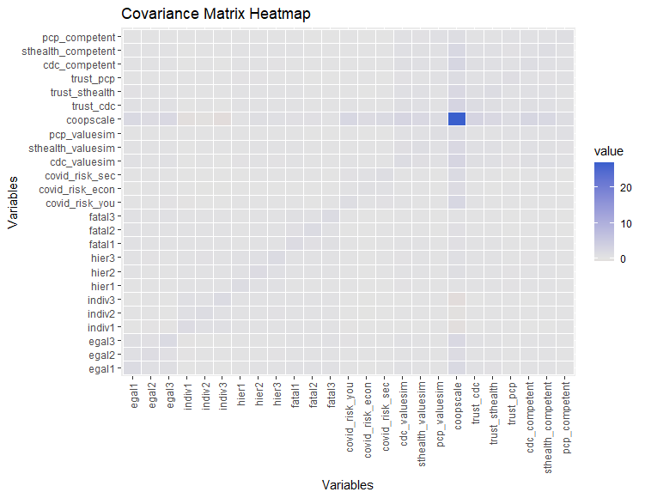

Estimation and Fit
As previously mentioned, MLM was used as the estimation method for all three models (CDC, State Health Department, PCP). All three models had the exact specification, except for changing the competency perception, value congruence, and trust variables, which depend on the risk manager. Figure 6 shows the measurement model without any additional information. Factor loadings for each model can be found in the appendix.

Figure 7: Measurement Model
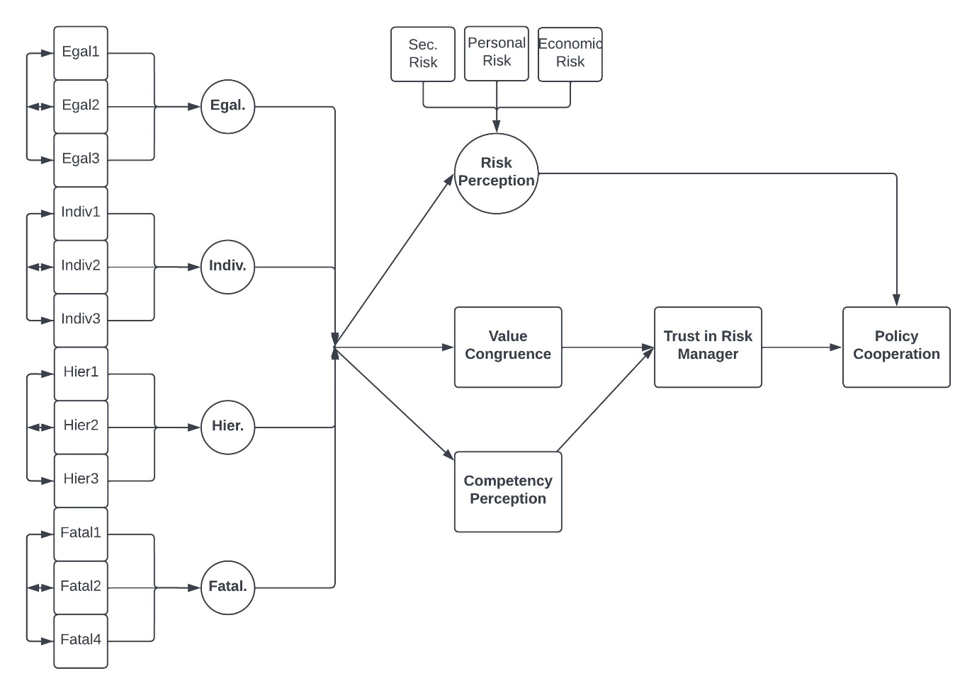

To test fit, several different indices were used– the Comparative Fit Index (CFI), the Tucker-Lewis Index (TLI), the Root Mean Square Error of Approximation (RMSEA), and the Standardized Root Mean Square Residual (SRMR). CFI compares the fit of the hypothesized model to a baseline model, where it gauges the improvement in the fit of the hypothetical model relative to the null model. These values range from 0 to 1, where 1 indicates a better fit. A CFI of 0.90 is used as the cutoff for this study and is generally considered appropriate. Similarly, the TLI compares the fit of the hypothetical model to a baseline model but penalizes complexity. These values also range from 0 to 1, with 1 indicating a better fix, with the same cutoff value being used.
Table 3: Goodness-of-Fit Indices
SEM Model | DF | N | CFI | TLI | RMSEA | χ² | P-Value
CDC SEM | 124 | 1000 | 0.96 | 0.94 | 0.05 | 407.07 | 0.000
SHD SEM | 124 | 1000 | 0.95 | 0.93 | 0.05 | 476.96 | 0.000
PCP SEM | 124 | 1000 | 0.94 | 0.92 | 0.05 | 463.52 | 0.000

The RMSEA is included to ensure robust estimation. RMSEA measures the discrepancy between the observed covariance matrix and the model-implied covariance matrix and represents the average error of the model per degree of freedom. Here, lower values indicate a better fit, with values near 0.05 indicating a good model fit; however, values up to 0.08 are acceptable.
Table 3 presents a consolidated view of the results from the fit indices, where the Chi-Squared results are also reported for good measure. Beginning with CFI and TLI, all three models meet the designated cutoffs of 0.90, indicating the models fit the data well. RMSEA provides additional evidence that the models represent the relationships among the variables of interest, as values for all models range between 0.05 and 0.08. Lastly, the Chi-Squared test indicates some discrepancy between the hypothesized models and the observed data; however, this fit index can be sensitive to sample size, where larger sample sizes see issues.

Structural Model Parameter Estimates
Table 4: Hypotheses
Hypothesis | Description
H1 | Deep core beliefs influence an individual’s competency perception of a risk manager.
H1a | Hierarchists will perceive all risk managers as competent.
H1b | Egalitarians will have higher competency perceptions for SHDs and PCPs.
H1c | Individualists will perceive no risk managers as competent.
H1d | Fatalists will have higher competency perceptions for PCPs.
H2 | Deep core beliefs influence an individual’s value congruence with a risk manager.
H2a | Hierarchists will have higher value congruence with all risk managers.
H2b | Egalitarians will have higher value congruence with SHDs and PCPs.
H2c | Individuals will have higher value congruence with PCPs.
H2d | Fatalists will have higher value congruence with PCPs.
H3 | Higher value congruence will be associated with higher trust in risk managers.
H4 | Higher competency perceptions will be associated with higher trust in risk managers.
H5 | Deep core beliefs indirectly influence trust in a risk manager through value congruence and competency perceptions.
H6 | Deep core beliefs influence risk perception of hazards.
H6a | Hierarchists will have a higher risk perception of COVID-19.
H6b | Egalitarians will have a higher risk perception of COVID-19.
H6c | Individualists will have a lower risk perception of COVID-19.
H6d | Fatalists will have a lower risk perception of COVID-19.
H7 | Higher levels of trust and risk perception will be associated with higher levels of policy cooperation.

Table 4 provides a consolidated view of all hypotheses previously discussed in this study, along with an additional 12 sub-hypotheses surrounding Cultural Theory. These additional hypotheses were included in order to fully gauge and represent the different worldviews path to their decision to cooperate or accept public health policy during COVID-19. While the addition of 12 more hypotheses may seem excessive, they are critical to testing whether Cultural Theory provides a good underlying construct for the deep core beliefs theorized in the AETF.

Table 5: Structural Equation Model Standardized Path Coefficients
Path | CDC | SE | SHD | SE | PCP | SE
Individualism → RP | 0.10 | 0.07 | 0.14 | 0.10 | 0.20 | 0.14
Hierarchism → RP | 0.06 | 0.04 | 0.06 | 0.04 | 0.05 | 0.05
Fatalism → RP | -0.36* | 0.12 | -0.47* | 0.19 | -0.57* | 0.27
Egalitarianism → RP | 0.56* | 0.10 | 0.65* | 0.16 | 0.74* | 0.24
Individualism → VC | 0.95* | 0.19 | 1.40* | 0.33 | 2.57* | 0.63
Hierarchism → VC | -0.11 | 0.11 | -0.15 | 0.15 | -0.25 | 0.27
Fatalism → VC | -1.98* | 0.34 | -2.75* | 0.64 | -5.04* | 1.22
Egalitarianism → VC | 2.27* | 0.28 | 2.87* | 0.55 | 4.45* | 1.06
Individualism → CP | 0.96* | 0.19 | 1.52* | 0.34 | 2.99* | 0.80
Hierarchism → CP | -0.05 | 0.11 | -0.14 | 0.16 | -0.34 | 0.31
Fatalism → CP | -2.05* | 0.33 | -3.02* | 0.68 | 5.82* | 1.57
Egalitarianism → CP | 2.18* | 0.27 | 3.05* | 0.58 | -5.08* | 1.35
Value Congruence → Trust | 0.36* | 0.03 | 0.33* | 0.04 | 0.19* | 0.04
Competency Perc. → Trust | 0.46* | 0.03 | 0.42* | 0.04 | 0.47* | 0.04
Trust → Policy Coop. | 0.38* | 0.02 | 0.28* | 0.02 | 0.21* | 0.02
Risk Perception → Policy Coop. | 0.35* | 0.02 | 0.41* | 0.02 | 0.44* | 0.02
CP = Competency Perception; VC = Value Congruence; RP = Risk Perception;
* = p < 0.05
CP = Competency Perception; VC = Value Congruence; RP = Risk Perception

Hypothesis 1: Deep Core Beliefs Influence Competency Perceptions
Table 5 presents the standardized path coefficients for the three structural equation models. Standardized path coefficients are reported, as they provide information on the relative strength of the relationships between constructs, regardless of scale differences. Hypothesis 1 argued that deep core beliefs would influence an individual’s competency perception of a risk manager. The results from the SEM model suggest that deep core beliefs do influence an individual’s perception of a risk manager’s competency. However, the sub-hypotheses associated with H1 were not supported.
Individualism had significant paths for all risk managers, with lower competency perceptions of the CDC (β = 0.96) and higher perceptions of SHD and PCPs (SHD β = 1.52; PCP β = 2.99). Interestingly, individualism is associated with higher levels of trust in all three risk managers.
Hierarchism had no significant paths to competency perceptions for any of the risk managers. Additionally, coefficients were small compared to the coefficients for other worldviews (CDC β = -0.05; SHD β = -3.02; PCP β = -0.34). These results are at odds with much of the research over hierarchists, as they are generally expected to favor risk managers like government agencies.
Fatalism had significant paths to competency perceptions for all three risk managers, with competency perceptions for PCPs having the higher coefficient (β = 5.82). Competency perceptions for SHDs and the CDC were negative and statistically significant (CDC β = -2.05; SHD β = -3.02). These results align with the broader Cultural Theory literature over how we expect fatalists to behave in risk situations.
Lastly, egalitarianism had significant paths to competency perception for all three risk managers; however, as predicted, higher levels of trust in SHDs and the CDC (CDC β = 2.18; SHD β = 3.05). However, egalitarianism was associated with lower levels of trust in PCPs (PCP β = -5.08). Overall, there is partial support for Hypothesis 1, as all worldviews except hierarchism were associated with competency perceptions of risk managers. Sub-hypotheses H1a-H1c were rejected, while sub-hypothesis H1d was supported.

Hypothesis 2: Deep Core Beliefs Influence Value Congruence
The results from the SEM model indicate that there is partial support for hypothesis 2. For instance, there are statistically significant paths from individualism to value congruence for all risk managers (CDC β = 0.95; SHD β = 1.40; PCP β = 2.50). Further, there is support for sub-hypothesis H2c as individualists have higher levels of trust in PCPs. Hierarchism had no significant paths to value congruence (CDC β = -0.11; SHD β = -0.15; PCP β = 0.25), indicating no support for sub-hypothesis H2a. Fatalism also had significant paths to value congruence for all three risk managers (CDC β = -1.98; SHD β = -2.75; PCP β = -5.04), also indicating no support for its sub-hypothesis. Lastly, egalitarianism was also associated with value congruence, as there were significant paths for all three risk managers (CDC β = 2.27; SHD β = 2.87; PCP β = 4.45). As predicted, egalitarianism was associated with higher levels of value congruence with PCPs, indicating support for H2b.
Hypotheses 3: Value Congruence and Trust
Hypothesis 3 stated that higher value congruence levels will be associated with higher trust in risk managers. All three SEM models indicated a positive and statistically significant relationship between value congruence and trust in the different risk managers (CDC β = 0.36; SHD β = 0.33; PCP β = 0.19). However, the coefficients of these paths were relatively low compared to other paths in the models. Regardless, the models fail to reject the null hypothesis due to the statistically significant relationships.

Hypothesis 4: Competency Perceptions and Trust
Hypothesis 4 stated that higher competency perceptions would be associated with higher trust in risk managers to manage the risks of COVID-19. Like hypothesis 3, all SEM models indicated a positive and statistically significant relationship between competency perceptions and trust (CDC β = 0.46; SHD β = 0.42; PCP β = 0.47). However, the coefficients were, similarly, very small compared to other paths. Still, the models failed to reject the null hypothesis.

Hypothesis 5: Deep Core Beliefs and Trust
Hypothesis 5 asserted that deep core beliefs would indirectly influence trust in a risk manager through value congruence and competency perceptions. There appears to be partial support for this hypothesis, as all worldviews had statistically significant paths to value congruence and competency perceptions, excluding hierarchism.
Hypothesis 6: Deep Core Beliefs and Risk Perception
There is some evidence to support hypothesis 6, which argued that deep core beliefs would have a statistically significant influence on an individual’s risk perception of COVID-19. However, this hypothesis is only partially supported, as some worldviews did not have statistically significant paths to risk perception. Both individualism and hierarchism did not have statistically significant relationships with risk perception and had small coefficients. However, fatalism had a statistically significant path to risk perception (CDC β = -0.36; SHD β = -0.47; PCP β = -0.57). Overall, fatalists had much lower levels of risk perception when compared to the other worldviews. Additionally, egalitarianism had statistically significant paths to risk perception (CDC β = 0.56; SHD β = 0.65; PCP β = 0.74). Additionally, they maintained higher levels of risk perception for COVID-19 than the other worldviews. Overall, there is support for the overarching hypothesis, and support for sub-hypotheses H6b and H6a.

Hypothesis 7: Trust, Risk Perception, and Policy Cooperation
Lastly, hypothesis 7 asserted that higher levels of trust in a risk manager and risk perception of the crisis would be associated with higher levels of policy cooperation. All models reported significant positive paths from risk perception to policy cooperation and trust to policy cooperation. Trust was, on average, less influential than risk perception in determining policy cooperation (CDC β = 0.38; SHD β = 0.28; PCP β = 0.21). The risk perception paths reported almost double the impact on policy cooperation (CDC β = 0.35; SHD β = 0.41; PCP β = 0.44). As a result, the models failed to reject hypothesis 7.
The next section of this paper engages in a discussion surrounding these results and the theoretical framework that was tested.

Discussion

Summary of Findings
Overall, all hypotheses were supported, some with partial support. Hypotheses with partial support were generally due to the lack of significant paths from hierarchism and individualism to constructs like risk perception, value congruence, and competency perceptions. These hypotheses focused on the idea that deep core beliefs, measured in this study by Cultural Theory constructs, would influence an individual’s value congruence, risk perception, and competency perceptions. Further, they posited that they would then indirectly influence trust.
There are several reasons why the paths between deep core beliefs and the outcome variables were insignificant. A few likely culprits are generally multicollinearity, small sample sizes, model misspecification, or measurement error. Figure 6 shows the covariances of the variables used in the analysis. While covariance by itself is not a sufficient indicator of multicollinearity, little evidence suggests this would be the case when combined with a correlation matrix (see appendix).
Sample sizes are often discussed when using structural equation modeling, as some parameters can require an immense sample size. There are several rules-of-thumb guidelines for SEM, such as a minimum sample size of 100 or 200, 5 or 10 observations per parameter, or 10 cases per variable (Bentler and Chou 1987; Bollen 1989; Boomsma 1982; MacCallum 1998; Nunnally 1994; Wolf et al. 2013). However, Wolf et al. (2013) argue that these rules can be problematic since they are broad and not model-specific. Some previous research suggests that MLM estimators for nonnormal continuous variables require sample sizes of 250 or greater (Hu and Bentler 1999; Yu 2002). As a result, the sample size of 1000 used in this analysis should be more than sufficient, especially given the model was not overly complex.
Model misspecification tests were conducted, and no additional paths were identified that would make theoretical sense in the context of this study. However, the theoretical model could have been incorrectly specified. Further, measurement error could have been a culprit. Measurement error is the discrepancy between the actual value of a variable and the observed value. There are two types of measurement error: random and systematic. Random error can result from natural variability in the topic at hand. Systematic error (i.e., bias), on the other hand, results from incorrectly specified survey instruments, errors in data collection, or other related aspects of the data collection process. However, the low standard errors reported suggest that measurement error may not be the culprit. Thus, it is likely the culprit is systematic error introduced by the nature of the COVID-19 pandemic, and potentially the survey instruments used.
Hypotheses 3, 4, and 7 were supported outside the deep core belief hypotheses. These findings support previous research suggesting that value congruence and competency perceptions are critical for establishing trust in risk managers (Boyd-Swan and Molina 2018; 2019; Cazier, Shao, and Louis 2007; T. C. Earle 2010; J. R. Edwards and Cable 2009). Further risk perception of a crisis and trust in risk managers are crucial for individuals deciding to cooperate with public policy. In this case, individuals with a higher risk perception and greater trust in the risk manager responsible for managing some aspects of COVID-19 were more likely to cooperate with public health policies implemented.
These findings are promising, as they indicate that the AETF is supported by previous research, even with partial support for the deep core beliefs hypotheses. Next, I present an interpretation of these findings and discuss what they mean for the future of the AETF.

Interpretation of Findings

Role of Deep Core Beliefs in the AETF
Deep core beliefs, measured by Cultural Theory, are the foundation of the Actor Evaluation and Trust Framework (AETF). Cultural Theory offers a time-tested framework and instrument for gauging an individual’s worldviews and understanding the normative and ontological beliefs that dictate how an individual will respond to a crisis. However, as mentioned in previous sections, the results did not support the proposed relationships between deep core beliefs and risk perception, value congruence, competency perceptions, and, trust in risk managers.
Statistically significant evidence was found suggesting deep core beliefs influence perceptions of competency of different risk managers in mitigating risk during COVID-19. Additionally, evidence suggested deep core beliefs impact value congruence and risk perception. These findings support the central premise of the AETF, which argues that deep core beliefs are the foundation and a filter for who individuals decide to choose and, ultimately, whether they choose to cooperate with public policy. However, some hypotheses related to deep core beliefs had partial support due to the lack of significant paths from hierarchism and individualism.
These partially-supported hypotheses contradict previous Cultural Theory findings, namely from Marris et al. (1998), which found that cultural worldviews inherently found different situations riskier than others while also finding that worldviews were more likely to trust certain actors. Cultural Theory is a robust framework for understanding how risk perceptions and trust are developed in other domains. The COVID-19 pandemic was multifaceted with many risk managers and actors, such as those analyzed in this study. As a result, the crisis studied may have disrupted the proposed relationships between deep core beliefs and risk perception, value congruence, competency perceptions, and trust. One possible hypothesis is that the rapidly evolving nature of the pandemic and the low knowledge base early on may have forced individuals to rely more on information sources and situational factors when evaluating the crisis and the risk managers responsible for managing it.
At a minimum, all cultural worldview paths should have been significant, regardless of the inclusion of a knowledge construct. For example, hierarchism did not have a single significant path to risk perception, value congruence, or competency perceptions in any of the 3 risk manager models. Further, individualism lacked a significant path to risk perception. As mentioned earlier, this indicates issues with the measurement of hierarchism and cultural theory, or it indicates gaps in knowledge about how the different worldviews act during scenarios like COVID-19.
While these results suggest that Cultural Theory might be more limited when used to understand public health crises than other risk domains, there are possible issues with the operationalization of measures like risk perception, value congruence, and competency perceptions, which are discussed later in this paper.

Importance of Value Congruence and Competency Perceptions
While deep core beliefs struggled to return statistically significant paths to critical variables, the paths from value congruence and competency perceptions to trust in a risk manager were statistically significant. These findings support prior trust research while improving on the Trust, Confidence, and Cooperation model from Earle and Siegrist (2008). Compared to the AETF, the TCC model is far more complex (see Figure 1), with paths leading from value congruence to social trust and then to policy cooperation. Similarly, competency paths into confidence, which is then influenced by social trust and later leads to policy cooperation.
The AETF simplifies these relationships by conceptualizing the constructs differently. For example, value congruence and competency perceptions feed into trust rather than social trust and confidence. The SEM findings support a significant assertion made by the AETF: social trust and confidence might be theoretically different, but in practice, they are the same.
Much of the risk management and trust literature suggests that they are different constructs, with the TCC model even arguing that value congruence feeds into confidence perceptions, which feed into trust. In this study, there were very low levels of correlation between value congruence and competency perceptions, indicating that prior theoretical models may not have been appropriately specified. Further, research has not clarified how confidence is precisely formulated outside of competency perceptions, albeit outside of the TCC model’s assertion that it is a mixture of past performance and value congruence. The findings in this study may suggest that confidence is not a necessary construct and over-complicates models of policy cooperation.
Additionally, the broader social trust literature indicates that competency perceptions should not affect trust, as it is not a values-based judgment. Instead, this study finds the opposite: trust is impacted by both value congruence and perceptions of performance. The implications this finding has for social trust and policy cooperation literature are interesting, as it may signal the need for a new conceptualization of trust in the context of disasters.

Risk Perception and Trust as a Policy Cooperation Driver
The findings regarding risk perception and trust and their influence on policy cooperation are unsurprising. It is common sense (and supported by the literature) that increased levels of trust in a risk manager will lead to an individual being more likely to cooperate with the public policy implemented by them. After all, this is the primary question associated with all policy cooperation models.
However, the operationalization and conceptualization of risk perception in the AETF differ from other policy cooperation models. For example, risk perception indicates policy cooperation with no relation to trust. This is contrary to many implementations of risk perception and studies attempting to understand the relationship between trust and risk perception. The results from the SEM exemplify the validity of the AETF by establishing that risk perception is a crucial indicator of policy cooperation, with no signs of correlation between risk perception and trust. However, there are limitations surrounding the AETF, particularly around measures and constructs.

Limitations of Study

Potential issues with Measures and Data Limitations
Value congruence is often studied in the context of person-organization fit. It seeks to understand what makes an individual have values similar to those of their organization. However, this study aims to understand value congruency at the person-person and the person-organization levels. As a result, the survey measures (see Appendix) used in this study may lack internal validity. Future applications of the AETF should use the extensive person-organization literature and mold questions from the Work Values Survey (WVS) to fit non-work contexts (J. Edwards and Cable 2002). Further, questions should be relationship-specific, meaning there are separate survey questions for person-person fit and person-organization fit, with both batteries informed by their relevant literature. This will help ensure a robust evaluation of value unity in the context of trust.
Risk perception is a multidimensional construct that requires more robust operationalizations. In this study, the risk perception questions were concerned with risk to national security, the economy, and the individual; however, some recent research suggests a more broadly applicable measure (Wilson, Zwickle, and Walpole 2019). Wilson et al. (2019) found that a three-factor model that measures effect, probability, and consequence outperformed one-dimensional general risk constructs. Future research surrounding the AETF should attempt to measure an individual’s exposure to the hazard, the likelihood of the individual experiencing the hazard, and the severity of the hazard to guarantee a more robust risk perception construct.

Other Methodological Considerations
The term causal modeling has previously been used to describe structural equation modeling, albeit it was met with criticism. SEM, primarily cross-sectional applications, “cannot ensure the necessary conditions of isolation, association, and direction of influence have been met” (Bullock, Harlow, and Mulaik 1994, 262). With non-experimental data, determining causation becomes challenging without implementing quasi-experimental techniques. Further, causality requires establishing temporal precedence, which is impossible with cross-sectional data. Additionally, non-experimental studies like this cannot account for all the potential confounding variables that can cause spurious interactions. The variables included in this study may also have reciprocal effects on each other over time, violating the recursivity assumption of SEM.
Future research on the AETF should focus on employing longitudinal or panel data, which will allow researchers to examine how changes in predictor variables potentially cause outcomes over time. Combined with quasi-experimental methods like regression discontinuity and differences-in-differences, this has the potential to identify causal relationships between the variables the AETF is interested in.

Future Research Directions

Refining the AETF and testing alternative models
While many components of the AETF were confirmed in this study, suggesting that it has the potential to be a viable framework for understanding policy cooperation, there is room for improvement. For example, the issue of sizeable deep core belief coefficients remains unresolved. Future research needs to expand the AETF while maintaining its simplicity, likely into knowledge and information.
A major downfall of the AETF is that it lacks any construct related to how much knowledge or information an individual has about the crisis at hand. Knowledge has been shown to directly affect how risky an individual views a crisis to be. Further, an individual requires knowledge about previous actions to determine whether an actor is competent enough to manage the crisis.
As mentioned, special attention should be paid to refining the constructs used to measure risk perception and value congruence. Combined with the additional knowledge construct, I argue that the AETF will provide robust results and statistically significant paths between deep core beliefs and risk perception, value congruence, and competency perceptions.
Further, the newly expanded AETF should be applied to disaster contexts outside of public health and COVID-19. COVID-19 represented a unique experience in the lives of many individuals around the globe. While the AETF did not find strong empirical support for some relationships proposed in the framework, there is still the possibility that there is applicability and value in other disaster contexts, especially given the broad nature of the framework. The AETF was designed to be generalizable to contexts outside of COVID-19, and as a result, other applications should be straightforward.
Contrary to COVID-19, natural disasters like hurricanes, wildfires, or earthquakes have more localized impacts and a smaller set of individuals responsible for managing the risks and outcomes. In contexts like these, pathways between constructs may be more salient when risks and authorities are more apparent. Further, engaging in research across disaster contexts may expose moderating variables that could be incorporated into the AETF, such as geographic scale, severity, media framing, or political polarization of the crisis.
By expanding the AETF and testing the framework in other contexts, researchers can begin iteratively expanding it to provide a robust policy cooperation framework. This will also allow researchers to gain a deeper understanding of the AETF’s explanatory power while exposing areas for refinement and theoretical extensions. These efforts are critical for developing robust policy cooperation models and can impact how policymakers, risk managers, and governments approach crisis management.

Conclusion

Summary of Key Findings and Theoretical Contributions
This study aimed to develop a new trust and policy cooperation model that was markedly less complex than current models yet informed by multiple literatures and frameworks. The Actor Evaluation and Trust Framework engages the relationships between deep core beliefs, value congruence, competency perceptions, risk perceptions, trust, and policy cooperation. A comprehensive examination of these relationships using data collected during the COVID-19 pandemic yielded promising results for the AETF. It sheds light on the underlying mechanisms shaping decision-making processes during times of crisis.
Structural equation models revealed that hypotheses focused on deep core beliefs, measured in this study using Cultural Theory, require additional conceptualization and improved operationalization. Further, paths beyond deep core beliefs revealed that the AETF provides a promising framework for understanding policy cooperation. As anticipated, value congruence and competency perceptions were associated with trust in risk managers to manage COVID-19 and implement public policy. Further, risk perception and trust were critical components of an individual’s decision to cooperate with public health policy during the pandemic. These results emphasize the multifaceted nature of trust formation and policy cooperation.
The theoretical implications of the findings in this study are apparent: the AETF has the potential to be a flexible and generalizable framework for understanding the mental process of trust and policy cooperation. The AETF challenges notions of social trust and confidence in the current risk management literature and suggests that these concepts may not be as well established as previously thought. Further, the AETF is inherently interdisciplinary, drawing from anthropology, sociology, political science, and economics. As a result, the internal and external validity of the AETF are impressive, ensuring that it can be employed in any context.
Additionally, the AETF’s emphasis on deep core beliefs as the foundation for the decision to trust or cooperate with public policy holds considerable theoretical implications. Previous policy cooperation and trust frameworks discussed in this paper do not address the underlying cultural worldviews that drive an individual to cooperate with public policy, at least not to the extent of the AETF. The framework offers valuable insights into the underlying mechanisms that drive the decision-making process and challenges conventional risk management approaches that have historically overlooked this aspect. Further, it established Cultural Theory as a potential construct allowing consistent application measurement.

Practical Implications for Practitioners
The findings of this study and the support for the AETF offer valuable insights for risk managers in charge of mitigating the effects of crises and disasters. Perhaps the most crucial insight is transparency and the need to understand the communities served. Policymakers and risk managers should prioritize openness in communication and design their operations to reduce disaster risks. This will help ensure accurate information is provided to the communities served in the short term, enhancing competency perceptions. Further, increasing transparency around decision-making processes, acknowledging uncertainties, and demonstrating proficiency in the areas required for effective risk management will improve the community's trust. As a result, greater cooperation with public policy designed to reduce risk will be seen.
Additionally, the findings surrounding the AETF suggest a need to adopt a more holistic approach to building trust, both as policymakers and risk managers. Competency perceptions and value congruence emphasize the need to build credibility, understand the specific needs and challenges, and actively engage with the community. Incorporating these tactics into risk communication has the potential to strengthen community resilience.
In conclusion, this study offers valuable insights into the complex dynamics of trust and policy cooperation during crises. The AETF has the potential to have significant implications not only for scholars interested in risk management but also for managers themselves. Continued research, collaboration, and refinement are essential for the AETF and will help ensure that evidence-based risk management strategies are developed.

References
Bentler, Peter M, and Chih-Ping Chou. 1987. “Practical Issues in Structural Modeling.” Sociological Methods & Research 16 (1): 78–117.
Berrens, Robert P, Alok K Bohara, Hank Jenkins-Smith, Carol Silva, and David L Weimer. 2003. “The Advent of Internet Surveys for Political Research: A Comparison of Telephone and Internet Samples.” Political Analysis 11 (1): 1–22.
Bollen, Kenneth A. 1989. Structural Equations with Latent Variables. Vol. 210. John Wiley & Sons.
Boomsma, Anne. 1982. “The Robustness of LISREL against Small Sample Sizes in Factor Analysis Models.” Systems under Indirect Observation: Causality, Structure, Prediction, 149–73.
Boyd-Swan, Casey H, and Anthony D Molina. 2018. “Cultural Competence & Citizen-Administrator Value Congruence.” Public Administration Quarterly 42 (4): 427–65.
———. 2019. “Public Service Integrity and the Quality of Governance: Examining the Role of Citizen-Administrator Value Congruence.” Public Integrity 21 (3): 229–47.
Bronfman, Nicolás C, Esperanza López Vázquez, and Gabriel Dorantes. 2009. “An Empirical Study for the Direct and Indirect Links between Trust in Regulatory Institutions and Acceptability of Hazards.” Safety Science 47 (5): 686–92.
Bronfman, Nicolás C, Esperanza López Vázquez, Virna Vaneza Gutiérrez, and Luis Abdón Cifuentes. 2008. “Trust, Acceptance and Knowledge of Technological and Environmental Hazards in Chile.” Journal of Risk Research 11 (6): 755–73.
Bullock, Heather E, Lisa L Harlow, and Stanley A Mulaik. 1994. “Causation Issues in Structural Equation Modeling Research.” Structural Equation Modeling: A Multidisciplinary Journal 1 (3): 253–67.
Cazier, Joseph A, Benjamin BM Shao, and Robert D St Louis. 2007. “Sharing Information and Building Trust through Value Congruence.” Information Systems Frontiers 9: 515–29.
Conner, Thaddieus W, Matthew C Nowlin, Thomas Rabovsky, and Joseph T Ripberger. 2016. “Cultural Theory and Managerial Values: Examining Trust as a Motivation for Collaboration.” Public Administration 94 (4): 915–32.
De Bruin, Ellen NM, and Paul AM Van Lange. 1999a. “Impression Formation and Cooperative Behavior.” European Journal of Social Psychology 29 (2–3): 305–28.
———. 1999b. “The Double Meaning of a Single Act: Influences of the Perceiver and the Perceived on Cooperative Behaviour.” European Journal of Personality 13 (3): 165–82.
———. 2000. “What People Look for in Others: Influences of the Perceiver and the Perceived on Information Selection.” Personality and Social Psychology Bulletin 26 (2): 206–19.
Douglas, Mary. 1978. “Cultural Bias. London: Royal Anthropological Institute.” Occasional Paper 35.
Earle, Tim, and Michael Siegrist. 2008. “Trust, Confidence and Cooperation Model: A Framework for Understanding the Relation between Trust and Risk Perception.” International Journal of Global Environmental Issues 8 (1–2): 17–29.
Earle, Timothy C. 2010. “Trust in Risk Management: A Model-Based Review of Empirical Research.” Risk Analysis: An International Journal 30 (4): 541–74.
Edwards, Jeffrey R., and Daniel M. Cable. 2009. “The Value of Value Congruence.” Journal of Applied Psychology 94 (3): 654–77. https://doi.org/10.1037/a0014891.
Edwards, JR, and DM Cable. 2002. “The Measurement of Work-Related Values: Development and Validation of the Work Values Survey (WVS).” Manuscript in Preparation, Kenan–Flagler Business School, University of North Carolina.
Eiser, J Richard, Susan Miles, and Lynn J Frewer. 2002. “Trust, Perceived Risk, and Attitudes toward Food Technologies 1.” Journal of Applied Social Psychology 32 (11): 2423–33.
Frewer, Lynn J, Susan Miles, and Roy Marsh. 2002. “The Media and Genetically Modified Foods: Evidence in Support of Social Amplification of Risk.” Risk Analysis: An International Journal 22 (4): 701–11.
Grendstad, Gunnar, and Per Selle. 2000. “Cultural Myths of Human and Physical Nature: Integrated or Separated?” Risk Analysis 20 (1): 27–40.
Gutscher, Timothy C. Earle, Michael Siegrist, Heinz. 2007. “Trust, Risk Perception and the TCC Model of Cooperation.” In Trust in Risk Management. Routledge.
Hale, Thomas, Noam Angrist, Rafael Goldszmidt, Beatriz Kira, Anna Petherick, Toby Phillips, Samuel Webster, et al. 2021. “A Global Panel Database of Pandemic Policies (Oxford COVID-19 Government Response Tracker).” Nature Human Behaviour 5 (4): 529–38.
Hood, Christopher. 2000. The Art of the State: Culture, Rhetoric, and Public Management. Oxford University Press.
Hooghe, Marc. 2003. “Voluntary Associations and Democratic Attitudes: Value Congruence as a Causal Mechanism.” In Generating Social Capital: Civil Society and Institutions in Comparative Perspective, 89–111. Springer.
Hovland, Carl I, and Walter Weiss. 1951. “The Influence of Source Credibility on Communication Effectiveness.” Public Opinion Quarterly 15 (4): 635–50.
Hu, Li-tze, and Peter M Bentler. 1999. “Cutoff Criteria for Fit Indexes in Covariance Structure Analysis: Conventional Criteria versus New Alternatives.” Structural Equation Modeling: A Multidisciplinary Journal 6 (1): 1–55.
Johnson, Branden B. 1999. “Exploring Dimensionality in the Origins of Hazard-Related Trust.” Journal of Risk Research 2 (4): 325–54.
Johnson, Branden B, and Paul Slovic. 1995. “Presenting Uncertainty in Health Risk Assessment: Initial Studies of Its Effects on Risk Perception and Trust.” Risk Analysis 15 (4): 485–94.
Kahan, Dan M, Hank Jenkins-Smith, and Donald Braman. 2011. “Cultural Cognition of Scientific Consensus.” Journal of Risk Research 14 (2): 147–74.
Kasperson, Roger E, Dominic Golding, and Seth Tuler. 1992. “Social Distrust as a Factor in Siting Hazardous Facilities and Communicating Risks.” Journal of Social Issues 48 (4): 161–87.
Kennedy, Kathleen A, and Emily Pronin. 2008. “When Disagreement Gets Ugly: Perceptions of Bias and the Escalation of Conflict.” Personality and Social Psychology Bulletin 34 (6): 833–48.
Kristof-Brown, Amy L, Ryan D Zimmerman, and Erin C Johnson. 2005. “Consequences OF INDIVIDUALS’FIT at Work: A Meta-Analysis OF Person–Job, Person–Organization, Person–Group, and Person–Supervisor Fit.” Personnel Psychology 58 (2): 281–342.
MacCallum, Robert. 1998. “Commentary on Quantitative Methods in I/O Research.” Industrial-Organizational Psychologist 35 (4).
Marris, Claire, Ian H Langford, and Timothy O’Riordan. 1998. “A Quantitative Test of the Cultural Theory of Risk Perceptions: Comparison with the Psychometric Paradigm.” Risk Analysis 18 (5): 635–47.
McNeeley, Shannon M, and Heather Lazrus. 2014. “The Cultural Theory of Risk for Climate Change Adaptation.” Weather, Climate, and Society 6 (4): 506–19.
Metlay, Daniel. 1999. “Institutional Trust and Confidence: A Journey into a Conceptual Quagmire 1.” In Social Trust and the Management of Risk. Routledge.
Miller-Stevens, Katrina, Jennifer A Taylor, and John C Morris. 2015. “Are We Really on the Same Page? An Empirical Examination of Value Congruence between Public Sector and Nonprofit Sector Managers.” VOLUNTAS: International Journal of Voluntary and Nonprofit Organizations 26: 2424–46.
Montijn-Dorgelo, Fiona NH, and Cees JH Midden. 2008. “The Role of Negative Associations and Trust in Risk Perception of New Hydrogen Systems.” Journal of Risk Research 11 (5): 659–71.
Myers, Lindsey M. 2023. “Testing the Trust, Confidence, and Cooperation Model with International Students and Coronavirus Disease 2019 (COVID-19) Spokespersons.” PhD Thesis, Kent State University.
Nunnally, Jum. 1994. “Psychometric Theory.” (No Title).
O’Brien, Michael. 2000. “Have Lessons Been Learned from the UK Bovine Spongiform Encephalopathy (BSE) Epidemic?” International Journal of Epidemiology 29 (4): 730–33.
Peeters, Guido, and Janusz Czapinski. 1990. “Positive-Negative Asymmetry in Evaluations: The Distinction between Affective and Informational Negativity Effects.” European Review of Social Psychology 1 (1): 33–60.
Pinggera, Michael. 2021. “Congruent with Whom? Parties’ Issue Emphases and Voter Preferences in Welfare Politics.” Journal of European Public Policy 28 (12): 1973–92.
Poortinga, Wouter, and Nick F Pidgeon. 2003. “Exploring the Dimensionality of Trust in Risk Regulation.” Risk Analysis: An International Journal 23 (5): 961–72.
———. 2005. “Trust in Risk Regulation: Cause or Consequence of the Acceptability of GM Food?” Risk Analysis: An International Journal 25 (1): 199–209.
———. 2006. “Prior Attitudes, Salient Value Similarity, and Dimensionality: Toward an Integrative Model of Trust in Risk Regulation 1.” Journal of Applied Social Psychology 36 (7): 1674–1700.
Renn, Ortwin, and Debra Levine. 1991. Credibility and Trust in Risk Communication. Springer.
Ripberger, Joseph T, Kuhika Gupta, Carol L Silva, and Hank C Jenkins-Smith. 2014. “Cultural Theory and the Measurement of Deep Core Beliefs within the Advocacy Coalition Framework.” Policy Studies Journal 42 (4): 509–27.
Ripberger, Joseph T, Hank C Jenkins-Smith, and Kerry G Herron. 2011. “How Cultural Orientations Create Shifting National Security Coalitions on Nuclear Weapons and Terrorist Threats in the American Public.” PS: Political Science & Politics 44 (4): 715–19.
Rosenberg, Seymour, Carnot Nelson, and Pathe S Vivekananthan. 1968. “A Multidimensional Approach to the Structure of Personality Impressions.” Journal of Personality and Social Psychology 9 (4): 283.
Rousseau, Denise M, Sim B Sitkin, Ronald S Burt, and Colin Camerer. 1998. “Not so Different after All: A Cross-Discipline View of Trust.” Academy of Management Review 23 (3): 393–404.
Siegrist, Michael. 2021. “Trust and Risk Perception: A Critical Review of the Literature.” Risk Analysis 41 (3): 480–90.
Skowronski, John J, and Donal E Carlston. 1989. “Negativity and Extremity Biases in Impression Formation: A Review of Explanations.” Psychological Bulletin 105 (1): 131.
Slovic, Paul. 1993. “Perceived Risk, Trust, and Democracy.” Risk Analysis 13 (6): 675–82.
Sorrentino, Richard M, Dov Cohen, James M Olson, and Mark P Zanna. 2005. Culture and Social Behavior: The Ontario Symposium, Volume 10. Psychology Press.
Thompson, Michael. 2018. Cultural Theory. Routledge.
Thompson, Michael, and Aaron Wildavsky. 2018. “A Cultural Theory of Information Bias in Organizations.” In The Institutional Dynamics of Culture, Volumes I and II, 704–17. Routledge.
Visschers, Vivianne HM, and Michael Siegrist. 2008. “Exploring the Triangular Relationship between Trust, Affect, and Risk Perception: A Review of the Literature.” Risk Management 10: 156–67.
Wildavsky, Aaron. 1987. “Choosing Preferences by Constructing Institutions: A Cultural Theory of Preference Formation.” American Political Science Review 81 (1): 3–21.
Wildavsky, Aaron, and Karl Dake. 1990. “Theories of Risk Perception: Who Fears What and Why?” Daedalus, 41–60.
Williams, Ethlyn A, Rajnandini Pillai, Bryan Deptula, and Kevin B Lowe. 2012. “The Effects of Crisis, Cynicism about Change, and Value Congruence on Perceptions of Authentic Leadership and Attributed Charisma in the 2008 Presidential Election.” The Leadership Quarterly 23 (3): 324–41.
Wilson, Robyn S, Adam Zwickle, and Hugh Walpole. 2019. “Developing a Broadly Applicable Measure of Risk Perception.” Risk Analysis 39 (4): 777–91.
Wojciszke, Bogdan, Roza Bazinska, and Marcin Jaworski. 1998. “On the Dominance of Moral Categories in Impression Formation.” Personality and Social Psychology Bulletin 24 (12): 1251–63.
Wolf, Erika J, Kelly M Harrington, Shaunna L Clark, and Mark W Miller. 2013. “Sample Size Requirements for Structural Equation Models: An Evaluation of Power, Bias, and Solution Propriety.” Educational and Psychological Measurement 73 (6): 913–34.
Yu, Ching-Yun. 2002. Evaluating Cutoff Criteria of Model Fit Indices for Latent Variable Models with Binary and Continuous Outcomes. University of California, Los Angeles.
Yuan, Meng, and Brendon Swedlow. 2022. “Chinese Cultural Biases, Value Congruence, and Support for and Compliance with Protective Policies during the COVID-19 Pandemic.” Review of Policy Research.

Appendix

Survey Questions

Risk Perception Questions
Public health emergencies like disease outbreaks can cause disruptions that impact large portions of the population. In addition to harming the quality of life, outbreaks can have significant impacts on economic well-being and national security.
- covid_risk_you (personal risk): How would you rate the risk of COVID-19 to you and the people you live with? (1 = No Risk, 5 = Extreme Risk)
- covid_risk_econ (economic risk): How would you rate the risk of COVID-19 to economic well-being in the United States? (1 = No Risk, 5 = Extreme Risk)
- covid_risk_sec (national security risk): How would you rate the risk of COVID-19 to national security in the United States? (1 = No Risk, 5 = Extreme Risk)

Policy Cooperation Questions
Public health officials suggest a variety of precautions people might take to limit the probability that they will get COVID-19. Thinking about the effectiveness and difficulty of each precaution, can you tell us how likely you are to take the following precautions to limit the probability that you will get COVID-19? [1 – Not at all likely; 2 – Somewhat likely; 3 – Likely; 4 – Very likely; 5 – Extremely likely]
- act_hands: Washing hands more frequently.
- act_mask: Wearing a protective mask.
- act_trips: Avoiding planned trips to crowded places like shopping malls, movie theaters, and sporting events.
- act_travel: Cancelling out-of-state travel plans (assuming you had some).
- act_work: Staying home from work for several days.

Trust in Risk Managers Questions
Issues concerning health risks are often complex. Please indicate the level of trust you have in experts on public health issues from the following organizations. [1 – No trust; 2 – Low trust; 3 – Moderate trust; 4 – High trust; 5 – Complete trust]
- trust_cdc: The US Centers for Disease Control (CDC).
- trust_sthealth: The [state] State Health Department.
- trust_pcp: [randomize] your primary care physician/local physicians.

Value Congruence and Competency Perception Questions
Now we want to know a little more about why you do or do not trust experts on public health issues. Do you agree or disagree with the following statements? [1 – Strongly Disagree 2 – Disagree 3 – Neither Agree nor Disagree 4 – Agree 5 – Strongly Agree]
- cdc_valuesim: Public health experts from the US Centers for Disease Control (CDC) share my values and beliefs.
- cdc_competent: Public health experts from the US Centers for Disease Control (CDC) are highly competent.
- sthealth_valuesim: Public health experts from the [state] State Health Department share my values and beliefs.
- sthealth_competent: Public health experts from the [state] State Health Department are highly competent.
- pcp_valuesim: My primary care physician shares my values and beliefs.
- pcp_competent: My primary care physician is highly competent.

Deep Core Beliefs/Cultural Theory Questions
Please respond to each of the following statements using a scale from one to five, where one means strongly disagree and five means strongly agree. [randomized table; column options: 1 – Strongly disagree to 5 – Strongly agree]
- egal1: What society needs is a fairness revolution to make the distribution of goods more equal.
- indiv1: Even if some people are at a disadvantage, it is best for society to let people succeed or fail on their own.
- hier1: The best way to get ahead in life is to work hard to do what you are told to do.
- fatal1: The most important things that take place in life happen by chance.
- egal2: Society works best if power is shared equally.
- indiv2: Even the disadvantaged should have to make their own way in the world.
- hier2: Society is in trouble because people do not obey those in authority.
- fatal2: No matter how hard we try, the course of our lives is largely determined by forces beyond our control.
- egal3: It is our responsibility to reduce differences in income between the rich and the poor.
- indiv3: We are all better off when we compete as individuals.
- hier3: Society would be much better off if the people in charge imposed strict and swift punishment on those who break the rules.
- fatal3: For the most part, succeeding in life is a matter of chance.

Measurement Model Factor Loadings
Table 6: CDC Factor Loadings
Latent Variable | Item | Coefficient | SE | P-Value
Individualism | indiv1 | 1.00 | - | -
 | indiv2 | 0.96 | 0.06 | 0.00
 | inidv3 | 0.91 | 0.06 | 0.00
Hierarchism | hier1 | 1.00 | -
 | hier2 | 1.06 | 0.07 | 0.00
 | hier3 | 1.12 | 0.06 | 0.00
Fatalism | fatal1 | 1.00 | - | -
 | fatal2 | 0.82 | 0.03 | 0.00
 | fatal3 | 0.84 | 0.03 | 0.00
Egalitarianism | egal1 | 1.00 | - | -
 | egal2 | 0.55 | 0.03 | 0.00
 | egal3 | 0.87 | 0.03 | 0.00
Risk Perception | covid_risk_you | 1.00 | - | -
 | covid_risk_econ | 0.56 | 0.07 | 0.00
 | covid_risk_sec | 0.72 | 0.07 | 0.00

Table 7: State Health Department Factor Loadings
Latent Variable | Item | Coefficient | SE | P-Value
Individualism | indiv1 | 1.00 | - | -
 | indiv2 | 0.97 | 0.06 | 0.00
 | inidv3 | 0.90 | 0.06 | 0.00
Hierarchism | hier1 | 1.00 | - | -
 | hier2 | 1.06 | 0.07 | 0.00
 | hier3 | 1.14 | 0.06 | 0.00
Fatalism | fatal1 | 1.00 | - | -
 | fatal2 | 0.80 | 0.03 | 0.00
 | fatal3 | 0.83 | 0.03 | 0.00
Egalitarianism | egal1 | 1.00 | - | -
 | egal2 | 0.58 | 0.03 | 0.00
 | egal3 | 0.86 | 0.03 | 0.00
Risk Perception | covid_risk_you | 1.00 | - | -
 | covid_risk_econ | 0.53 | 0.07 | 0.00
 | covid_risk_sec | 0.68 | 0.07 | 0.00

Table 8: Primary Care Physician Factor Loadings
Latent Variable | Item | Coefficient | SE | P-Value
Individualism | indiv1 | 1.00 | - | -
 | indiv2 | 0.95 | 0.06 | 0.00
 | inidv3 | 0.90 | 0.06 | 0.00
Hierarchism | hier1 | 1.00 | - | -
 | hier2 | 1.09 | 0.03 | 0.00
 | hier3 | 1.15 | 0.03 | 0.00
Fatalism | fatal1 | 1.00 | - | -
 | fatal2 | 0.80 | 0.03 | 0.00
 | fatal3 | 0.84 | 0.03 | 0.00
Egalitarianism | egal1 | 1.00 | - | -
 | egal2 | 0.56 | 0.03 | 0.00
 | egal3 | 0.85 | 0.03 | 0.00
Risk Perception | covid_risk_you | 1.00 | - | -
 | covid_risk_econ | 0.51 | 0.07 | 0.00
 | covid_risk_sec | 0.67 | 0.07 | 0.00

Power Analysis

Figure 8: CDC Central and Non-Central Chi-Squared Distributions
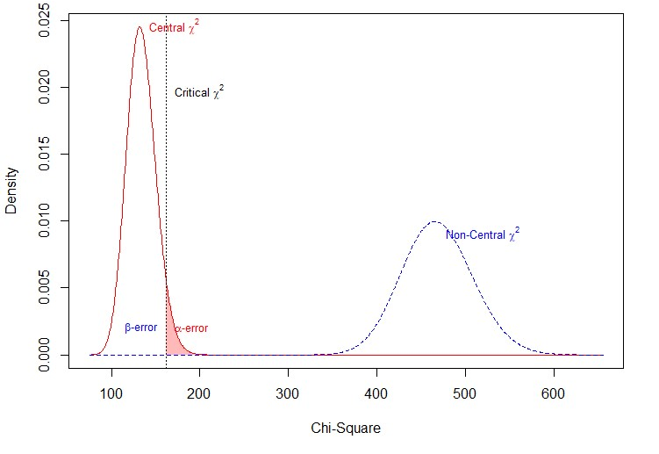

Figure 9: State Health Department Central and Non-Central Chi-Squared Distributions
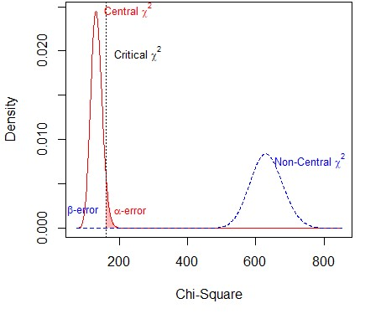
Figure 10: Primary Care Physician Central and Non-Central Chi-Squared Distributions
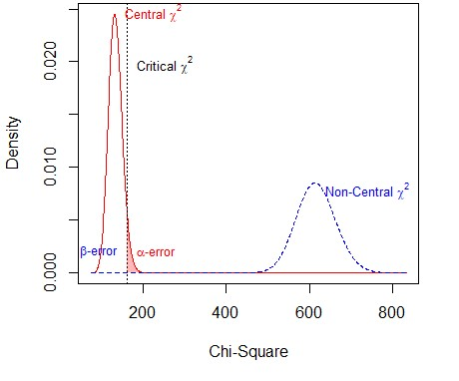
Table 9: Power Analysis Results
Parameter | CDC Model | State Health Dept. Model | Primary Care Physician Model
Hypothesized Effect | 0.34 | 0.50 | 0.48
RMSEA | 0.05 | 0.06 | 0.06
Critical Ratio | 0.85 | 0.78 | 0.79
Degrees of Freedom | 134 | 134 | 134
Total Observations | 1000 | 1000 | 1000
Non-Centrality Param. | 334.67 | 498.12 | 481.92
Critical Chi-Square | 162.02 | 162.02 | 162.02
Significance Level (Alpha) | 0.05 | 0.05 | 0.05
Probability of Type II Error (Beta) | < 1.949211e-23 | < 7.961607e-42 | < 6.733238e-40
Power (1 – Beta) | > 0.99 | > 0.99 | > 0.99
Implied Alpha/Beta Ratio | 2.565140e+21 | 6.280140e+39 | 7.425848e+37

Table 9 shows the results of an ad hoc power analysis for each of the three structural equation models developed in this study. Ad hoc power analysis evaluates the statistical power retrospectively, incorporating sample size and effect size. Across all models, the achieved statistical power exceeds 0.99, indicating good statistical power to detect the observed effect sizes. This suggests that the models had sufficient sample size and sensitivity to detect the hypotheses, reducing the risk of type II errors.

Correlation Matrix
Figure 11: Correlation Matrix
