University of Oklahoma

Graduate College

PHYSIOLOGICAL RESPONSES TO A SINGLE BOUT OF RESISTANCE EXERCISE BETWEEN MEN AND WOMEN

A thesis

submitted to the Graduate Faculty

in partial fulfillment of the requirements for the

Degree of

Master of Science

By

KAROLINA JULIA KOZIOL
Norman, Oklahoma
2018

PHYSIOLOGICAL RESPONSES TO A SINGLE BOUT OF RESISTANCE EXERCISE BETWEEN MEN AND WOMEN

A thesis approved for the
Department of Health and Exercise Science

By

______________________________
Dr. Michael G. Bemben, Chair

______________________________
Dr. Debra A. Bemben

______________________________
Dr. Daniel J. Larson

© Copyright by KAROLINA JULIA KOZIOL 2018
All Rights Reserved.

Acknowledgements
I’d like to begin by showing my greatest thanks to the best mentor and advisor ever, Dr. Michael Bemben, for allowing me to be a part of such an amazing program and for teaching me what research is truly about. I’d also like to extend my thanks and gratitude to Dr. Debra Bemben and Dr. Daniel Larson for spending your time with me to teach me what good research is all about and for giving me your expert advice, not just for this project, but throughout my entire two years with this program. And of course, I’d like to express my appreciation to the most amazing lab mates I could have ever asked for, Eduardo Freitas, Ryan Miller, Aaron Heishman, Japneet Kaur and David Ross. You guys are the reason I survived this master’s program!!! Thank you, guys, for all of the good times and laughs we shared – y’all made coming to the lab everyday fun and exciting every single day. I didn’t forget about you Bianca! Thank you, Bianca Galletti, for sharing this project and experience with me. I couldn’t have done it without you! Seriously! I wouldn’t have wanted to spend late evenings and early mornings in the lab with anyone but you. And last but not least, thanks Boo Bear for being my study buddy, listening to me verbally express my stress daily and encouraging me throughout this program. Love y’all!

Table of Contents
Acknowledgements iv
List of Tables viii
List of Figures x
Abstract xi
Chapter I: Introduction 1
Purpose of the Study 5
Research Questions 5
Research Sub-Questions 5
Research Hypotheses 6
Research Sub-Hypotheses 6
Significance of the Study 7
Delimitations 8
Limitations 9
Assumptions 9
Operational Definitions 10
Chapter II: Literature Review 11
Introduction 11
Skeletal Muscle Hypertrophy 11
Metabolite Accumulation and Endocrine Responses 13
Muscle Swelling 16
Muscle Activation 18
Cuff Type 20
Chapter III: Methodology 23
Participants 23
Inclusion Criteria 24
Exclusion Criteria 24
Research Design 24
Height and Weight 27
Brachial Blood Pressure 27
Ankle Brachial Index 27
Arterial Occlusion Pressure 28
One Repetition Maximum 28
Resistance Exercise 29
Thigh Circumference 30
Muscle Swelling 30
Lactate and Hematocrit 31
Electromyography 32
Perceived Pressure Scale, OMNI-Resistance Exercise Scale and Borg Discomfort 32
Data Analysis 33
Chapter IV: Results and Discussion 35
Subjects 35
Muscle Thickness 38
Lactate ……………………………………………………………………………...40
Hematocrit 43
Electromyography 47
Perceptual Response 56
Discussion 60
Muscle Swelling 60
Lactate ……………………………………………………………………………...63
Hematocrit and Plasma Volume Change 64
Electromyography 65
Perceptual Responses 67
Limitations 67
Chapter V: Conclusion 69
Practical Significance 75
Future Research Directions 75
References 77
Appendix A: Study Documents 83
Appendix B: Raw Data 101

List of Tables
Table 1. Participant characteristics by gender (mean ± SD)………………………...36
Table 2. Gender differences in 1RM (mean ± SD)………………………………….36
Table 3. Thigh circumference (cm; mean ± SD)……………………………………37
Table 4. Main Effects and Interactions for Thigh Circumference…………………..38
Table 5. Muscle thickness (cm; mean ± SD)…………………….…………….……39
Table 6. Main effects and interactions for muscle thickness………………………..40
Table 7. Lactate (mmol/L; mean ± SD)….……………………………………….....42
Table 8. Main effects and interactions for lactate…………………………………...42
Table 9. Hematocrit values (%; mean ± SD)……………….....………………….…44
Table 10. Main effects and interactions for hematocrit values………………..….…44
Table 11. Percent plasma volume change (mean ± SD)………………………...…..46
Table 12. Main effects and interactions for percent change plasma volume values...46
Table 13. Muscle activation (% max RMS) for leg press (3 sets) for both genders (mean ± SD)…………………………………………………………………………48
Table 14. Main effects and interactions for leg press EMG values (3 sets)…………49
Table 15. Muscle activation (% max RMS) for leg press (4 sets) for both genders (mean ± SD)………………………………………………………………………....50
Table 16. Main effects and interactions for leg press EMG values (4 sets)…………50
Table 17. Muscle activation (% max RMS) for knee extension (3 sets) for both genders (mean ± SD)………………………...……………………………...……….52
Table 18. Main effects and interactions for knee extension EMG values (3 sets)…..53
Table 19. Muscle activation (% max RMS) for knee extension (4 sets) for both genders (mean ± SD)...……………………………………………………………....54
Table 20. Main effects and interactions for knee extension EMG values (4 sets)…..54
Table 21. Ratings of perceived exertion for leg press across the different testing conditions and time points…………………………………………………………..56
Table 22. Ratings of perceived exertion for knee extension across the different testing conditions and time points………………...……………………………………..….57
Table 23. Ratings of discomfort for leg press across the different testing conditions and time points……………………………………………………………………....58
Table 24. Ratings of discomfort for knee extension across the different testing conditions and time points…………………………………………………………..59

Figure 1. Thigh circumference across time and condition for each gender……...….38
Figure 2. Muscle thickness across time and condition for each gender……………..40
Figure 3. Lactate values across time and condition for each gender………………...43
Figure 4. Hematocrit values across time and condition for each gender…………....45
Figure 5. Percent change in plasma volume across time and condition for each gender………………………………………………………………………………..47
Figure 6. EMG values across time and condition for leg press…………………...…51
Figure 7. EMG values across time and condition for knee extension……………….55

List of Figures

Abstract
It has been shown that blood flow restriction (BFR) exercise provides similar physiological muscular adaptations to traditional high intensity resistance exercise; however, there is still ambiguity about whether males and females respond similarly to BFR exercise. PURPOSE: The purpose of this study was to evaluate the acute physiological responses between males and females following a bout of practical BFR, controlled BFR, low intensity resistance exercise and traditional high intensity resistance exercise by observing lactate, hematocrit, muscle swelling and electromyography before and after exercise. METHODS: Recreationally trained men (n=14) and women (n=15) aged between 18-30 years participated in a randomized crossover design. Subjects visited the lab on 6 occasions. The first 2 visits consisted of paperwork, finding occlusion pressure and 1 repetition maximum for leg press and knee extension, ankle-brachial index, blood pressure and familiarization of exercises. The last 4 visits were the randomized exercise protocols: controlled BFR (cBFR), practical BFR (pBFR), high intensity (HI) and low intensity (LI) resistance exercise. Each visit involved a leg press exercise followed by a knee extension exercise with cBFR, which consisted of an inflated cuff, pBFR consisted of an elastic cuff, HI was a traditional high-intensity exercise and LI was a low-intensity resistance exercise day. Each subject attempted 4 sets of 30-15-15-15 repetitions for cBFR, pBFR and LI, while the HI condition consisted of 3 sets of 8-10 repetitions, with a minute of rest between each set. Lactate, hematocrit, thigh circumference, muscle thickness and electromyography were collected before exercise, immediately post-exercise, 5-minutes post-exercise and 15-minutes post-exercise. There was a wash-out period of at least 3 days between conditions. RESULTS: Through this investigation, males typically had significantly larger responses to all of the testing conditions for thigh circumference, lactate, hematocrit, and muscle activation. However, there was no gender difference for muscle thickness for any of the conditions. Typically, the HI and cBFR conditions produced similar physiological responses. Additionally, males typically reported higher RPE and discomfort ratings, which corresponds to greater muscle activation for males during cBFR and HI exercise conditions. CONCLUSION: This study concluded that cBFR and pBFR for males and females do not produce the same physiological responses, but HI and cBFR produced similar physiological responses.

Chapter I: Introduction
Skeletal muscle responds to mechanical stress by mediating muscle hypertrophy and atrophy in order to maintain homeostasis. It has been shown that skeletal muscle hypertrophy occurs at training intensities of at least 70% of one’s 1 repetition maximum (1RM) (ACSM, 2009). Training below this intensity primarily causes improved muscular endurance without a significant increase in muscle size or strength, unless there is a large increase in exercise volume. A consequence of high intensity exercise are micro tears of the myofibers. This may lead to an immune response that may cause delayed onset muscle soreness (DOMS) and a plasma volume shift causing muscle cell swelling (Freitas et al., 2017). Increased intracellular fluid is one of the ways that has been shown to induce skeletal muscle hypertrophy through the stimulation of protein synthesis.
Blood flow restriction (BFR) exercise is a relatively new method of resistance exercise training that provides similar physiological adaptations as traditional high intensity resistance exercise, including increased intracellular fluid (Loenneke et al., 2012). This type of restriction is performed with an inflatable cuff or BFR strap and is combined with low intensity (20-50% 1RM) resistance exercise. This method has been reported to initiate significant muscle swelling leading to muscle hypertrophy similar to traditional high intensity resistance training. BFR training can be beneficial to populations that are not able to endure the heavy mechanical stress on their joints that traditional high-intensity exercise may cause, including the elderly, diseased or injured (Loenneke et al., 2012; Lowery et al., 2014). Furthermore, it is difficult to use an inflatable cuff in certain settings, such as a gym, for exercise. Therefore, it is also important to evaluate the benefits from a practical BFR cuff. Wilson et al. (2013) demonstrated that practical BFR (pBFR) effects muscle swelling and muscle activation more than a workload match revealing that a bout of low-intensity pBFR exercise may be effective in stimulating muscle hypertrophy by cell swelling.
Considering acute responses observed post-BFR exercise, muscle cell swelling is known to inhibit catabolism and affect metabolism by promoting lipolysis and protein sparing for muscle hypertrophy. BFR exercise may also increase muscle protein synthesis through muscle cell swelling through the activation of mammalian target of rapamycin complex 1 (mTORC1) signaling (Fry et al., 2009). Additionally, Freitas et al. (2017) determined that muscle swelling lasted up to 75-mintues post BFR exercise, which was shown to be similar to high-intensity exercise responses. Muscle swelling may also happen without BFR, as found by Howell et al. (1992). This study concluded that muscle swelling increased by 3% immediately post resistance exercise without occlusion as assessed by ultrasound measurements. BFR in the absence of exercise has also been shown to induce cell swelling effects, which may be beneficial to limited populations (Loenneke et al., 2012). Furthermore, Yasuda et al. (2015) concluded that thigh muscle cross-sectional area (CSA) and muscle strength increased in women after BFR training, which could be further researched in men to provide information on the mechanisms of BFR-induced muscle hypertrophy.
Several studies have been conducted regarding physiological responses to traditional high intensity resistance training between men and women. After a 9-week training period of unilateral knee extension exercises, Ivey and colleagues (2000) found that men had a significantly greater increase in muscle volume than women. Another study evaluated older men and women after a training period of 26 weeks. The subjects were asked to perform knee extensor exercises 3 days a week at 65-80% of their 1RM. Vastus lateralis biopsies later showed that training led to greater myofiber hypertrophy in men compared to women (Bamman et al., 2003). The intracellular swelling that occurs during exercise may be caused by a plasma shift, which stimulates muscle hypertrophy by increasing protein synthesis (Yasuda et al., 2015).
An additional mechanism by which BFR induces muscle hypertrophy occurs when the restricted limb begins to accumulate metabolites, including lactate. Lactate accumulation causes the intramuscular environment to become acidic, which may stimulate sympathetic nerve activity through intramuscular chemoreceptors and afferent fibers. This mechanism may be related to the stimulation and secretion of growth hormone (GH) (Loenneke et al., 2010). Moreover, GH stimulates synthesis and secretion of insulin-like growth factor-1 (IGF-1), which is known to be critical for mediating the growth of skeletal muscle (Kawada et al., 2005). BFR creates a unique muscular environment which has also been shown to cause an increase in type II muscle fiber recruitment because of the metabolite accumulation and a lack of oxygen supply to the working muscle (Loenneke et al., 2014; Wilson et al., 2013). Similar physiological responses can be found in traditional high intensity resistance exercise (Borst et al., 2001; Kraemer et al., 1998). For example, Linnamo et al. (2005) evaluated blood lactate concentrations, GH and testosterone responses in men and women after high intensity resistance exercise with no occlusion and found that all three variables increased more in men than in women. These responses based on gender may be similar to BFR training; however, there is a gap in the literature regarding gender differences with BFR exercise.
BFR exercise may also induce an increase in muscle activation, which is important for sustaining typical daily physical activities. Studies show that there are metabolic changes caused by restricted blood flow, but also can happen through changes in venous blood oxygen saturation and accumulation of lactic acid (Yasuda et al., 2008; Wernbom et al., 2009). Reduced oxygen combined with an accumulation of metabolites causes an increase in high threshold fiber recruitment by stimulating groups III and IV afferents causing alpha motorneurons communicating with slow twitch fibers to be inhibited. This mechanism induces an increase in fast twitch fiber recruitment in order to maintain force and avoid conduction failure (Loenneke et al., 2011). Additionally, muscle activation was shown to increase during repetitive low-intensity resistance exercise without BFR by Moritani et al. (1992), revealing that resistance exercise without restriction also benefits muscular strength and size. Recent studies have concluded that low-intensity training with BFR leads to an increase in muscle activation comparable to high-intensity resistance exercise training (Abe et al., 2005). Additionally, Yasuda et al. (2008) studied varying levels of external limb compression in ten healthy young males. They determined that muscle activation increased progressively throughout each contraction bout at each level of restriction, including no restriction. However, the greatest increase was during the 147 mmHg protocol, which was the highest restriction pressure they tested.
All of the mechanisms responsible for the physiological responses to BFR training are still not completely known. There is no established protocol for the use of BFR exercises and the incorrect use of it may have negative effects, such as numbness or bruising. Currently, the safest way to apply this technique is to follow the directions based on scientific protocols and instructions (Fahs et al., 2012). The literature regarding physiological responses among men and women to controlled and practical BFR is scarce, therefore it is important continue researching BFR and optimize training programs among different populations.

Purpose of the Study
The purpose of this study was to determine if men and women respond differently to a single acute bout of low-intensity resistance exercise with controlled BFR (cBFR) or practical BFR (pBFR), as well as low and high intesntiy resistance exercise without BFR regarding measures of muscle activation, muscle swelling, thigh circumferences, blood lactate and hematocrit concentrations.

Research Questions
- Do the four different conditions (pBFR, cBFR, HI and LI) elicit the same or differing physiological responses in lactate, hematocrit, muscle swelling or muscle activation?
- Will the physiological responses in lactate, hematocrit, muscle swelling and muscle activation (regardless of condition) be similar or different for males and females?

Research Sub-Questions
- Do the four different conditions (pBFR, cBFR, HI and LI) elicit the same or differing physiological responses in lactate levels?
- Do the four different conditions (pBFR, cBFR, HI and LI) elicit the same or differing physiological responses in hematocrit levels?
- Do the four different conditions (pBFR, cBFR, HI and LI) elicit the same or differing physiological responses in muscle swelling?
- Do the four different conditions (pBFR, cBFR, HI and LI) elicit the same or differing physiological responses in muscle activation?
- Will the physiological responses in lactate levels (regardless of condition) be similar or different for males and females?
- Will the physiological responses in hematocrit levels (regardless of condition) be similar or different for males and females?
- Will the physiological responses in muscle swelling (regardless of condition) be similar or different for males and females?
- Will the physiological responses in muscle activation (regardless of condition) be similar or different for males and females?

Research Hypotheses
- Men will exhibit greater physiological responses than women for all four conditions based on traditional high intensity resistance exercise literature.
- cBFR and high-intensity (HI) resistance exercise will promote the greatest increases in muscle activation, muscle swelling, lactate and hematocrit levels compared to pBFR resistance exercise and low-intensity (LI) resistance exercise.

Research Sub-Hypotheses
- Men will exhibit greater lactate responses compared to women for each of the four exercise conditions.
- Men will exhibit greater hematocrit responses compared to women for each of the four exercise conditions.
- Men will exhibit greater muscle swelling responses compared to women for each of the four exercise conditions.
- Men will exhibit greater muscle activation responses compared to women for each of the four exercise conditions.
- cBFR and HI resistance exercise will promote the greatest increases in lactate responses compared to pBFR and LI resistance exercise, regardless of gender.
- cBFR and HI resistance exercise will promote the greatest increases in hematocrit responses compared to pBFR and LI resistance exercise, regardless of gender.
- cBFR and HI resistance exercise will promote the greatest increases in muscle swelling responses compared to pBFR and low-intensity resistance exercise, regardless of gender.
- cBFR and HI resistance exercise will promote the greatest increases in muscle activation responses compared to pBFR and low-intensity resistance exercise, regardless of gender.

Significance of the Study
Traditional HI resistance exercises are proven to stimulate muscle hypertrophy; however, not all populations are capable of performing such exercises, especially at higher loads. Examples of people who would not be able to perform exercises at high loads include the elderly, injured or diseased populations. In order to optimize BFR exercises, it is essential to also analyze physiological effects between cuff types, which Lonnoeke et al. (2013) determined there was no difference between practical BFR and controlled BFR. There is also little research done to date regarding BFR exercises between males and females, however, some research assessing traditional resistance exercise that may provide insight for BFR training.
For example, Linnamo et al. (2005) concluded that blood lactate concentrations showed a larger increase in men than in women after maximal heavy resistance exercise. This difference in blood lactate levels may occur similarly during BFR exercises. Furthermore, Gibala et al. (1995) evaluated changes in human skeletal muscle after acute resistance exercises in men by analyzing EMG data. They found that men showed a significantly greater average EMG activity during concentric contractions compared to eccentric contractions during arm curls. However, there is little evidence providing information on female muscle activation response to resistive exercises.
Additionally, resistance exercise causes muscle swelling due to plasma volume shifts which increases muscle protein synthesis. Yasuda et al. (2011) determined that the triceps brachii and pectoralis major cross-sectional area (CSA) increased by 8.8% and 15.8% during high intensity resistance training. Nevertheless, there is a lack of literature regarding muscle swelling with BFR exercises between males and females. This gap in knowledge provides researchers incentive to seek out answers in regard to BFR exercises which will further allow researchers to optimize exercise programs, especially gender specific programs.

Delimitations
The delimitations of this study include:
- The subjects included healthy males and females between the ages of 18-30 years.
- Subjects included in this study were recreationally trained.
- Subjects were excluded if their Body Mass Index (BMI) ≥ 30 kg/ m².
- Subjects were excluded if their Ankle-Brachial Index (ABI) ≤ 0.9 or ≥ 1.4.
- Subjects were excluded if they have a knee or hip injury or a cardiovascular disease that may affect the study.
- Females that were pregnant or planned to become pregnant during the duration of the study were excluded from this study.
- Females that were taking hormonal contraceptives to account for hormone variation during the menstrual cycle.

Limitations
The limitations for this study include:
- Normal daily diet was not be controlled for in this study, however, subjects were asked to maintain their usual diet throughout the duration of this study.
- Training status and age were not assessed in this study and may affect the outcome variables.
- These findings cannot be extended to older populations.

Assumptions
- Subjects gave maximal effort during leg press and knee extension 1RM.
- Subjects gave their best effort when completing the exercises.
- Subjects gave honest answers when completing health questionnaires.
- All subjects maintained their usual diet throughout the study.
- Subjects avoided performing lower body resistance exercises prior to testing sessions.
- The ultrasound is a valid and reliable method for determining muscle thickness.
- The Lactate Plus Analyzer is a valid and reliable method for determining blood lactate levels.

Operational Definitions
BFR: Blood flow restriction; occlude venous outflow and restrict arterial inflow (Loenneke et al., 2012).
Practical BFR (pBFR): Type of blood flow restriction done with an elastic cuff (Loenneke et al., 2013).
Controlled BFR (cBFR): Type of blood flow restriction done with an inflatable cuff (Loenneke et al., 2013).
Hematocrit (Hct): Percentage of red blood cells in the blood (Plowman et al., 2014).
Lactate: Byproduct of glycolysis; represents cellular glucose metabolism (Plowman et al., 2014).
One Repetition Maximum (1RM): Largest load an individual can lift for one repetition (Plowman et al., 2014).
Electromyography (EMG): System used to record the electrical activity in working muscles (Plowman et al., 2014).
Muscle thickness: The distance from the adipose tissue-muscle interface to the inter-muscular interface (Loenneke et al., 2012).

Chapter II: Literature Review

Introduction
The primary purpose of this study was to evaluate the acute physiological responses between males and females following a bout of practical and controlled blood flow restriction (BFR) exercise. Previously, BFR exercise has been reported to induce similar muscular adaptations as traditional high intensity resistance exercise. The comparable adaptations could be meaningful in populations that cannot withstand high mechanical stress, such as the elderly, or those recovering from an injury. The benefits from BFR training may vary based on methodology, such as cuff type or occlusion pressure (Loenneke et al., 2013). An abundant amount of literature suggests positive muscular adaptations can occur in response to BFR exercise, however, some literature has suggested that BFR exercise does not induce muscular adaptations (Loenneke et al., 2013; Burgomaster et al., 2003). Furthermore, since a predominant amount of research has been examined using male subjects, it is difficult to extrapolate information and apply the findings for females. Therefore, it may be useful to consider these gender differences and how they may be applied to BFR training research. Specifically the aims of this investigation are to determine lactate and hematocrit concentration, muscle swelling and muscle activation in response to a bout of controlled (cBFR) or practical (pBFR) BFR when compared to a bout of traditional high-intensity exercise.

Skeletal Muscle Hypertrophy
Skeletal muscle is a plastic tissue that is constantly responding to loading and unloading. Progressive overload causes skeletal muscle to synthesize more contractile proteins causing muscle hypertrophy, whereas muscular inactivity causes a decrease in protein synthesis leading to muscle atrophy (Loenneke et al., 2012). It is recommended that exercise training occurs at intensities of at least 70% of one’s 1RM for muscle hypertrophy (ACSM, 2009). There is previous literature based on traditional high-intensity exercise examining gender differences based on muscular hypertrophy and strength development. For example, testosterone has been commonly attributed to muscle tissue hypertrophy in males, yet females have been shown to demonstrate similar relative exercise adaptations despite their lower levels of testosterone (Kraemer et al., 1990). Although the role of testosterone is not entirely understood, it could function similarly to GH by increasing muscle hypertrophy (Weiss et al., 1983). Along with an ideal hormone balance for optimal muscle hypertrophy, there may be gender differences in neural activation, myostatin gene expression, muscle swelling, metabolite accumulation and activation of anabolic molecular pathways during resistance exercise (Hakkinen et al., 1995; Kraemer et al., 1990, Freitas et al., 2017; Laurentino et al., 2012; Manini et al., 2012).
As a relatively new method of exercise training, BFR has been shown to stimulate muscle hypertrophy similar to high intensity resistance training when combined with low intensity exercise (20% of 1RM) (Loenneke et al., 2010). It has been suggested that BFR exercise provides comparable muscular adaptations to high-intensity resistance exercise; however the precise mechanisms causing those adaptations in BFR remain unclear. BFR training adaptations have been observed to increase muscle cross sectional area (CSA) and strength by fully occluding venous outflow and restricting arterial blood inflow (Wilson et al., 2013).

Metabolite Accumulation and Endocrine Responses
BFR training leads to an accumulation of metabolites, such as lactate. A study done by Loenneke et al. (2010) recruited twelve men and women to perform leg extensions with and without blood flow restriction. The authors observed no differences in lactate concentration between the occlusion group and the control group, however, a trend was observed for higher lactate levels in the occlusion group. Gender differences were not reported in this study. It has also been shown that BFR in the absence of exercise may also produce small increases in intracellular lactate due to reduced oxygen availability. However, this is not enough to detect with a whole blood lactate measurement (Loenneke et al., 2012). Lactate accumulation creates an acidic intramuscular environment which stimulates the release of growth hormone (GH). In turn, GH stimulates the synthesis and secretion of insulin-like growth factor 1 (IGF-1) from the liver and skeletal muscle (Kawada et al., 2005; Loenneke et al., 2010). The GH/IGF-1 pathway is an important mediator for skeletal muscle growth in resistance training. Abe et al. (2006) investigated the effects of BFR training twice a day for two weeks in nine young men for squat and leg curls. They measured muscle CSA and volume with magnetic resonance imaging at baseline and 3 days after the final training session. This study found an increase in circulating IGF-1 and muscle CSA in the BFR training group but not in the non-BFR group. Therefore, IGF-1 increase is an indication of possible muscle hypertrophy and protein synthesis.
Traditional high-intensity resistance exercise has been shown to elicit metabolite accumulation in the blood, including lactate. Lactate concentrations are shown to increase significantly after high-intensity training, but may increase more in men than in women, which is due to fast glycolysis and men generally having more muscle mass than women (Kraemer et al., 1991, Linnamo et al., 2005, Loenneke et al., 2016). However, additional studies have reported that lactate concentrations increase following high intensity resistance exercise, but do not differ between men and women (Kraemer et al., 1997; Hakkinen et al., 1993). Furthermore, Kraemer et al. (1991) evaluated endocrine responses in men and women after a 10 RM and 5RM based workout and a 1-minute and 3-minute rest period, respectively, between sets for different leg and arm exercises. The study consisted of 8 males and 8 females who were healthy and had previous resistance training experience and found that whole blood lactate concentrations had significantly increased for both genders, with men displaying higher values.
Additionally, previous studies conclude that GH increases in both men and women after high-intensity exercise (Kraemer et al., 1991, Hakkinen et al., 1995); however, no significant differences between men and women in GH changes are observed (Kraemer et al., 1997). Since GH and IGF-1 work in conjunction, there are several proposed mechanisms to support their role in muscle hypertrophy and strength gains. As previously stated, training leads to higher GH secretion which causes an increase in hepatic IGF-1 secretion. This results in elevated levels of IGF-1 in the blood causing muscle IGF type I receptors to be stimulated influencing an increase in protein synthesis. Another possible mechanism is that resistance exercise increases GH secretion which directly stimulates endogenous muscle production of IGF-1. Lastly, De Vol et al., (1990) proposed a mechanism using a rat model and suggested that exercise increases muscular production of IGF-1 independently of GH or IGF-1 circulating in the blood.
Several studies have also evaluated the effects of exercise on circulating testosterone. Testosterone, along with GH, is an anabolic hormone important for muscular hypertrophy which can be increased through resistance exercise. It has been shown that acute testosterone responses to traditional resistance exercise are generally higher in men than in women since women do not activate muscles as quickly or forcefully as men (Linnamo et al., 2005, Weiss et al., 1983, Kraemer et al., 1991). The effects of testosterone are seen in the absence of exercise; however, its actions are augmented by mechanical loading. Testosterone may also act indirectly by stimulating the release of GH or by stimulating satellite cell replication and activation. Resistance exercise also upregulates androgen receptor content which increases the chances for testosterone binding and uptake into target tissues. Significant correlations between testosterone increases and muscle CSA have been determined, suggesting that testosterone may induce muscle fiber hypertrophy. However, acute testosterone responses to resistance exercise are reduced in women, attenuating muscle hypertrophy (Schoenfeld et al., 2010). In contrast, Fujita et al. (2007) found that there was no change in free testosterone concentration following a bout of resistance exercise in the six young male subjects studied. There is disagreement in the literature regarding endocrine responses to an acute bout of resistance exercise as well as an acute bout of BFR exercise which provides incentive for researchers to further study these methods of exercise.

Muscle Swelling
Traditional high-intensity resistance exercise may cause delayed onset muscle soreness (DOMS), which causes an inflammatory response and leads to a fluid shift into the cell leading to swelling. An increase in intracellular fluid is associated with protein synthesis resulting in muscle hypertrophy (Freitas et al., 2017). Metabolite accumulation caused by high-intensity resistance exercise also leads to an increase in intracellular osmolality in active muscles. This then leads to fluid fluxes from the interstitial space to the intracellular space as well as from vascular to interstitial spaces affecting plasma volume (Linnamo et al., 2005). Cell swelling has been shown to inhibit muscular catabolism and promote anabolism. It also has been shown to positively affect metabolism through protein sparing and increasing lipolysis (Loenneke et al., 2011).
BFR with low-intensity resistance exercise is known to induce significant muscle swelling, although the mechanisms are not entirely understood (Freitas et al., 2017, Loenneke et al., 2012). It has been suggested that the blood pooling caused by BFR alone may be adequate to promote shifts of intracellular and extracellular water balance. BFR may increase the hydrostatic pressure gradient which leads to the intracellular water flux. Another suggested mechanism is that BFR causes an increase in venous carbon dioxide from a decrease in intracellular pH which elevates the production of hydrogen ions. pH-regulating transporters have shown to mediate cell volume changes (Loenneke et al., 2011). Additionally, Loenneke et al. (2012) suggested that BFR mimics an ischemic environment which increases serum- and glucocorticoid-inducible kinase-1 (SGK1). Furthermore, muscular adaptations from BFR may cause muscle cell swelling through the activation of mammalian target of rapamycin (mTOR) and mitogen-activated protein-kinase (MAPK) pathways. Signaling modules associated with the MAPK pathway (extracellular signal-regulated kinases (ERK 1/2), p38 MAPK, and c-JUN NH2-terminal kinase (JNK)) are associated with muscular adaptations in response to exercise. Extracellular signal-regulated kinase has also been shown to increase with BFR exercise, which is responsible for osmosensing (Loenneke et al., 2012). Along with MAPK activation, BFR exercise has been shown to activate the mTOR signaling pathway, which is involved in cellular growth (Deldicque et al., 2005). These mechanisms may be responsible in regulating muscle cell volume and muscle hypertrophy (Lang et al., 2006).
Howell et al. (2012) assessed muscle swelling in six young men and six young women at the arm with an ultrasound. The exercise protocol consisted of preacher curls at 90% of their 1RM until fatigue followed by 2-minutes of rest. Then, a second and third bout of exercise was performed to fatigue at lesser loads. Arm circumference was immediately increased post-exercise by 3%, but had subsided 6 hours after. During the next 3 days, arm circumference increased again by 6-9% above control values. This study demonstrates that BFR with low-intensity exercise does induce muscle swelling, which is important for muscle fiber hypertrophy. BFR training has also been reported to attenuate both muscle atrophy and declines in strength through an acute plasma fluid shift induced by an increase in muscle size. Initial increases in muscle thickness may be due to venous pooling followed by an increase in muscle thickness due to the fluid shift into the muscle cells. This can be supported by significant decreases in plasma volume along with an increase in skeletal muscle size that remains even after the BFR cuffs are removed (Loenneke et al., 2012). Additionally, Freitas et al. (2017) measured muscle swelling in ten young males following low-intensity BFR exercise as well as traditional high-intensity resistance exercise and observed that BFR exercise produces similar muscle swelling results as high-intensity exercises. This response found in males may be applied to females as well, however, more research is needed to fully understand BFR exercise responses between both genders.

Muscle Activation
Muscle activation is important for performing daily physical activities. Force and speed of contraction are not the only variables that may affect muscle activation, but oxygen availability may affect it as well. Type II fibers are recruited more during an ischemic state, which could have an effect on muscle activation (Moritani et al., 1992). Loenneke et al. (2014) suggest that metabolite accumulation along with a hypoxic environment caused by BFR increases the recruitment of higher threshold fibers through the stimulation of group III and IV afferent fibers. Type II muscle fibers have a larger capacity for muscle fiber hypertrophy than type I fibers, therefore it is important to recruit these muscle fibers to induce muscular hypertrophy. High-intensity resistance exercise recruits large motor units as well as type II muscle fibers (Kawada 2005). It has been shown that muscle activation increases with BFR training in type II fibers, which could be due to the early fatigue of slow-twitch muscle fibers via a reduction in oxygen availability from BFR exercise as well as an early recruitment of fast-twitch muscle fibers due to an increased in sympathetic response and an increase in norepinephrine. Norepinephrine stimulates adrenergic β2 receptors, which leads to hypertrophy of type II muscle fibers (Freitas et al., 2017; Loenneke et al., 2012).
The size principle suggests that small motor units for type I fibers are recruited at lower levels of muscular activity, while larger motor units for type II fibers are recruited with an increase in force. Takarada et al. (2000) had five men perform elbow flexion exercises with restriction pressures between 0 and 100 mmHg. Acute responses were recorded, including electromyography (EMG), vascular resistive index and plasma lactate concentrations were measured. EMG, post-exercise hyperemia and lactate levels were increased with the increase in restriction pressure at low-intensity exercise, but were unchanged with the increase in restriction pressure at high-intensity exercise. Furthermore, this study included the investigation of the long-term effects of low-intensity exercise with restriction in 24 women for 16 weeks of training. There was an increase in CSA and strength of the elbow flexor muscles after low-intensity exercise with occlusion similar to the high-intensity exercise without restriction. On the other hand, Cook et al. (2013) concluded that low-intensity knee extension exercise with BFR produced less EMG activity than the high-intensity knee extension exercise protocol in eight active male subjects. Further research is needed to amend these conflicting results.
Muscular force production after acute high-intensity exercise is determined by fiber type of the muscle being tested, the type of muscle action being performed, the duration, and intensity of the contraction. Some studies suggest that a decrease in force during maximal contractions is due to central fatigue, which is the decrease in voluntary activation of muscle during exercise by motoneuronal, spinal and supraspinal factors (Hartman et al. 2011). Studies have shown that EMG activity decreased throughout a high-intensity exercise bout (Hartman et al., 2011; Babault et al., 2005). Moreover, during continued submaximal contractions without BFR, fatigue is supplemented with an increase in EMG amplitude (Potvin 1997). Semmler et al. (2007) recruited seven men and three women for their study involving submaximal elbow flexor exercises. They performed two tasks involving isometric contractions at the elbow flexor muscles including maximal voluntary contractions (MVC) as well as constant-force submaximal contractions at 5%, 20%, 35% and 50% MVC. They concluded that there was an increase in EMG activity in all elbow flexor muscles at low forces as well as an increase in coactivation of the triceps brachii muscle. Therefore, it is known that skeletal muscle hypertrophy can be caused by an increase in muscle activation (Freitas et al. 2017). This can be done through high-intensity exercise or through BFR combined with low-intensity exercise. However, more research should be conducted to determine the hypertrophic adaptations between males and females attributed to an increase in muscle activation caused by BFR.

Cuff Type
Although there are studies that demonstrate similar skeletal muscle adaptations between traditional high-intensity resistance exercise and low-intensity exercise with BFR, there are some that suggest that there are no benefits from BFR training (Burgomaster et al., 2003). The conflicting results may be explained by the methodology used. Cuff size and material may affect vascular occlusion and may potentially alter results between studies. It has been reported that wide nylon cuffs (13.5 cm) create a much lower pressure for arterial occlusion than narrow elastic cuffs (5 cm), which shows that reporting cuff size in BFR studies is crucial (Loenneke et al., 2013). Some cuffs can have their pressures regulated, which can potentially affect the results of a study. It has been shown that the initial pressure of BFR is important in regulating because different initial pressures have revealed different acute responses to BFR (Karabulut et al., 2011).
Loenneke et al. (2013) conducted a study evaluating the effects of cuff type on fatigue and perceptual responses to resistance exercise. This study involved sixteen recreationally active males and females who were asked to perform knee extension exercises to fatigue wearing either an elastic or nylon cuff of the same width. In addition, ratings of perceived exertion (RPE) were recorded. This study did not find any significant differences between cuff types and they also did not find any gender differences with respect to repetitions to fatigue. However, the results suggest that mean and percentile differences between genders become more apparent toward the end of the exercise protocol. The females in this study may have been completing more repetitions than the males as exercise duration increased which could be explained by the higher load the males exercised with. Higher exercise loads lead to an increase in intramuscular pressure, which causes an increase in fatigue due to the reduced blood flow and metabolite accumulation. BFR training can cause an increase in intramuscular inorganic phosphate concentration, which results in muscular fatigue. BFR may also cause a decrease in the amplitude of the calcium transient and may inhibit the cross-bridge cycle. The results from this study provide an explanation for the mechanisms behind skeletal muscle hypertrophy and will allow future researchers to directly compare results from many different studies
The present study evaluated the gender differences on lactate and hematocrit concentration, muscle thickness and muscle activation between two types of cuffs: an inflatable Hokanson nylon cuff that is 13 cm wide used for the cBFR protocol and an elastic cuff about 5 cm wide for the pBFR protocol.

Chapter III: Methodology
The purpose of this study was to determine gender differences in the physiological responses to an acute pBFR and cBFR exercise session as opposed to low and high intensity resistance exercise. Physiological responses include hematocrit levels, lactate levels, EMG activity and muscle swelling as determined by circumference and ultrasound. There are few studies that explain physiological responses to acute resistance exercise between genders and there is even less regarding BFR exercises.

Participants
G-power (version 3.1.9.2) was used to determine that a sample size of 15 males and 15 females would result in an expected statistical power of 0.80 and an effect size of 0.04, therefore, the study was designed to recruit up to 20 males and 20 females between the ages of 18 and 30 years to allow for possible dropouts (Loenneke et al., 2015, Loenneke et al., 2013, Kraemer et al., 1997). However, 17 males were recruited and 14 completed the study, while 16 females were recruited and 15 of the females completed the study. There were four testing conditions involving two lower body exercises (leg press and knee extension) that subjects performed in randomized order. These conditions included: 1) controlled blood flow restriction (50% occlusion) exercise at 30% of 1RM for four sets of 30-15-15-15 repetitions and a minute of rest in between each set; 2) practical blood flow restriction exercise at a 7 on a scale of 0-10 on the perceived pressure scale at 30% 1RM for four sets of 30-15-15-15 repetitions and a minute of rest in between each set; 3) high intensity at 80% of 1RM with no occlusion for three sets of 8 to 10 repetitions with a minute of rest in between each set; and 4) low-intensity which consisted of four sets of 30-15-15-15 repetitions at 30% of 1RM with no occlusion and a minute of rest in between each set. There was also about a 3-minute rest period in between each exercise. The last four visits were randomized through a generator online (random.org).

Inclusion Criteria
- Ankle brachial index > 0.9 and < 1.4.
- Recreationally active males and females between the ages of 18-30 years.
- Female participants taking hormonal contraceptives.
- Female subjects with a normal menstrual cycle between 28 and 30 days.
- Normotensive.
- Healthy subjects who are willing to participate in the study in accordance with the consent forms and questionnaires.

Exclusion Criteria
- Subjects who are not recreationally trained.
- Subjects with uncontrolled high blood pressure (>140/90 mmHg).
- Subjects with any cardiovascular or metabolic diseases.
- Subjects who have had a hip or knee injury in the last 6 months.
- Subjects with a BMI over 30 kg/m².
- Females who are pregnant or intend to become pregnant.
- Ankle brachial index < 0.9 or > 1.4.

Research Design
This study recruited 17 men and 16 women who were recreationally active, however, only 14 men and 15 women completed the study. In a randomized crossover design, subjects performed each of the 4 conditions in randomized order with at least 3 days between each condition as a wash-out period. The four exercise conditions included: 1) controlled blood flow restriction (50% occlusion) exercise at 30% of 1RM for four sets of 30-15-15-15 repetitions and a minute of rest in between each set (cBFR); 2) practical blood flow restriction exercise at a 7 on a scale of 0-10 on the pressure pain scale for four sets of 30-15-15-15 repetitions and a minute of rest in between each set (pBFR); 3) high-intensity at 80% of 1RM with no occlusion for three sets of 8 to 10 repetitions with a minute of rest in between each set (HI); and 4) low-intensity which consisted of four sets of 30-15-15-15 repetitions at 30% of 1RM with no occlusion and a minute of rest in between each set (LI). There was also about a 3-minute rest period in between each exercise.
There were 6 total visits for this study for each participant. During the first visit, the subjects completed a consent form, health insurance portability and accountability act (HIPAA) form, physical activity readiness questionnaire (PAR-Q), health status questionnaire and a menstrual questionnaire (women only). The first visit (1.5 hours) also included height, weight, brachial blood pressure, ankle-brachial index measurements and familiarization for the knee extension and leg press 1RM determination protocols. The second visit (1.5 hours) determined the total occlusion pressure of each participant as well as 1 repetition max (1RM) for leg press and knee extension (Cybex International Inc., Medway, MA, USA). The subjects were also familiarized with wearing BFR cuffs while exercising by completing 2 sets of 10 repetitions for leg press and 2 sets and 5 repetitions for knee extension. Before the last four visits, the subjects were asked to refrain from alcohol and heavy exercise 24 hours prior to testing as well as abstaining from caffeine ingestion 6 hours prior to testing. The last four visits (visits 3, 4, 5 and 6) lasted about 1.5 hours each and were done in randomized order. The last four visits included a bout of resistance exercise with cBFR, pBFR, high-intensity with no occlusion and low-intensity with no occlusion. Each of the last 4 sessions began by marking the sites for EMG electrode placement and ultrasound muscle thickness sites. Then the participants rested for 5-minutes to allow the researchers to obtain baseline measurements for lactate, hematocrit, muscle thickness and thigh circumference. Subjects then continued with 8-10 repetitions of 50% of their 1RM on leg press followed by a single repetition of the previously found 1RM load on the leg press in order to provide a reference EMG signal that will be used to normalize EMG activity. The same was then done for the knee extension machine. For cBFR and pBFR sessions, the BFR cuffs was placed high up on the thigh and subjects will perform 4 sets of 30-15-15-15 repetitions at 30% of their 1RM for both the leg press and knee extension exercises. The cBFR protocol was set at 50% of the subject’s total occlusion pressure and the pBFR protocol will be at a 7 on the perceived pressure scale. Each set had a minute of rest in between each set and about 3-minutes of rest between the leg press and knee extension exercises. For the session without BFR, the high intensity conditions included 3 sets of 8 to 10 repetitions at 80% of the subject’s 1RM. The LI day was at an intensity of 30% of 1RM with 4 sets of 30-15-15-15 repetitions without any occlusion. Immediately post exercise, 5-minutes post exercise and 15-minutes post exercise the measurements for muscle thickness, thigh circumference, hematocrit and blood lactate were assessed. EMG activity was recorded during each set of all of the exercise protocols. Muscle activity of the vastus lateralis (VL) for both legs were included in the EMG recordings. For each variable measured, only the dominant leg was used for statistical analyses. Each subject had at least 3 days between each visit to provide time for recovery and for a wash-out period.

Height and Weight
To obtain a height measurement, each subject was asked to stand straight against the stadiometer (Novel Products, Inc., Rockton, IL) with their arms hanging straight down and their feet together. Body weight was measured with a standard scale (Tanita, Model BWB-800A, Japan). Each measurement was recorded to the nearest 0.5 cm and 1 kg.

Brachial Blood Pressure
After resting for a period of 5 minutes in a supine position, blood pressure was measured with an automatic blood pressure cuff (Omron Healthcare Inc. Vernon Hills, IL Model HEM-773). Two blood pressure measurements were taken and a third was taken if the previous two measurements were more than 5 mmHg different.

Ankle Brachial Index
Ankle brachial index (ABI), which is the ratio of the highest blood pressure in the ankle and the highest blood pressure in the arm, was measured after a 5-minute rest period (Loenneke et al., 2013). Each subject was asked to rest in a supine position before ABI was assessed. In order to assess brachial blood pressure, a MV10 segmental cuff was used with a hand held bidirectional Doppler (MD4, Hokanson, Bellevue, WA). A cuff was placed on each arm and the doppler was also be placed on each arm at about a 45 to 60-degree angle on the surface of the brachial artery. The doppler picked up the sound given off by the brachial artery and the cuff was inflated until the sound disappears. The cuff was slowly be deflated until the first sound is heard again which gave the systolic blood pressure. Ankle systolic blood pressure was assessed by placing the cuff about 2 centimeters above the malleoli and the doppler was placed on the posterior tibial artery. This was done on each leg separately. Finally, ABI was calculated by dividing the systolic pressure of the ankles by the highest systolic pressure of the arms (Xu et al., 2013).

Arterial Occlusion Pressure
Arterial occlusion pressure was determined at both legs on the anterior tibial artery using the Hokanson (13.5 cm x 84 cm Hokanson, SC12, Bellevue, WA) with a doppler probe. A cuff was placed at the most proximal location of the thigh and was inflated until blood flow is no longer sensed by the doppler probe. The initial inflation of the cuff began at 50 mmHg and continued for 30 seconds until it was deflated for 10 seconds. The pressure values were displayed on a screen and the next inflation of the cuff was the subject’s systolic pressure. The pressure of the cuff increased by 40 mmHg every 30 seconds, with 10 seconds of rest in between, until total occlusion was reached. Once there was no sound coming from the doppler, the pressure was then lowered to the nearest 10 mmHg until the sound came back. Total arterial occlusion was set as the lowest pressure as soon as the pulse of the blood vessel is no longer detected. For the safety of the subjects, occlusion pressure did not exceed 300 mmHg, even if the blood vessel was not completed occluded (Loenneke et al., 2015). During the controlled BFR exercise condition, pressure was set at 50% of the occlusion pressure for each subject.

One Repetition Maximum
Before performing a 1RM test, subjects were asked to warm-up on leg press and knee extension at 50% of their 1RM that can be easily performed for 8 to 10 repetitions. The subject was then given 1-minute of rest while the researcher asked the subject how difficult the warm-up was on a scale of 1-10 (1 being easiest, 10 being most difficult). If the subject found the load to be easy, the researcher then increased the load based on how difficult the load was. This was followed by 3 to 5 repetitions of leg press or knee extension and a rest period of 2-minutes. After another perceived exertion rating, the load may have been increased or decreased. The researcher would then estimate a near maximal load that would allow the subject to perform 2 or 3 repetitions followed by a period of 2-4 minutes of rest. After another rating on the exertion scale, 1RM would be estimated (Clayton et al., 2015).

Resistance Exercise
The four exercise conditions were performed in randomized order consisting of: 1) cBFR (50% occlusion) exercise at 30% of 1RM for four sets of 30-15-15-15 repetitions and a minute of rest in between each set; 2) pBFR exercise at a 7 on a scale of 0-10 on the pressure pain scale at 30% of 1RM for four sets of 30-15-15-15 repetitions and a minute of rest in between each set; 3) HI at 80% of 1RM with no occlusion for three sets of 8 to 10 repetitions with a minute of rest in between each set; and 4) LI which consisted of four sets of 30-15-15-15 repetitions at 30% of 1RM with no occlusion and a minute of rest in between each set. There was also about a 3-minute rest period between each exercise. After 8-10 repetitions at 50% of 1RM on leg press as a warm-up and the 1RM reference replication, repeated again on the knee extension, the leg press and knee extension exercises took place. If the subject was unable to replicate their 1RM, then half to a full plate was taken off and the subject was allowed to rest for a minute before trying to replicate their 1RM again. Each session had a minute of rest in between sets. To maintain consistency for the EMG measurements, a metronome (SEIKO DM-11) was used to allow subjects to maintain a cadence of 1.5 seconds for each portion of the exercise (concentric and eccentric). Each variable measured post-exercise was done with the subject standing for majority of the time up to 15-minutes post-exercise to avoid variability in posture. Subjects were allowed to sit after the immediately post-exercise measurements up until the 5-minutes post-exercise measurements.

Thigh Circumference
Baseline thigh circumference was assessed after the subject had rested for 5-minutes in a seated position. Measurements were taken at the halfway point of the length of the femur after rest, immediately post exercise without the BFR cuff and 5 and 15-minutes post-exercise without the BFR cuff. The femur was measured from the greater trochanter to the femoral condyle with a standard measuring tape and marked with a permanent marker.

Muscle Swelling
Muscle swelling was determined by assessing muscle thickness with an ultrasound (Fukuda Denshi UF-4500, Tokyo, Japan). Muscle thickness was measured after the subject rested in a seated position for 5-minutes, immediately post exercise without the BFR cuff on and 5 and 15-minutes post exercise without the BFR cuff. While the subject was in a standing position, muscle thickness was measured at both legs at the halfway mark of the length of the femur. Transmission gel was placed on a 5 MHz linear probe and the probe was then placed perpendicular to the skin surface. The distance given by the ultrasound between the tissue and muscle as well as muscle to bone will give muscle thickness in centimeters. The diagnostic ultrasound is a reliable and inexpensive method for assessing muscle thickness (CV% between 3.5 and 6.7%) (Bemben et al., 2002).

Lactate and Hematocrit
Lactate was measured using the Lactate Plus Analyzer (Nova Biomedical Corporation Waltham, MA 02454, USA), which was found to be reliable and valid by Hart et al. (2013). The analyzer was first calibrated against two controls (a high and low control). Calibration was repeated until the controls match the specified ranges on the label. Once calibration was set, the subject’s finger middle or ring finger was cleaned with an alcohol wipe by the researcher, which allowed the area to dry and then the researcher pricked the finger with a lancet. The first drop of blood was removed in case of contamination, and the second drop was brought to the lactate strip. The strip was then inserted into the lactate analyzer for lactate measurements. The drop of blood should not be wiped off in case the analyzer could not read the initial drop of blood. The subject was then given a paper towel to place pressure on the finger prick with once the lactate reading was made.
Lactate and hematocrit measurements were taken while standing for baseline measurements at immediately post exercise, 5-minutes and 15-minutes post exercise without the BFR device after 5-minutes of seated rest. The blood sample was then collected at the same site as the lactate finger prick. The blood samples were collected in duplicate into two capillary tubes. The CritSpin (CritSpin Micro-Hematocrit Centrifuge, StatSpin, Inc., Norwood, MA 02062) then centrifuged the capillary tubes for 2-minutes and was then transferred to the hematocrit reader (DAMON/IEC DIVISION, 300 Second Ave. Needham HTS MASS 02194). Plasma volume change was found with the formula found below (Van Beaumont et al., 1972):
% change plasma volume = (100/(100 – Hct pre)) * 100 ((Hct pre – Hct post)/Hct post).

Electromyography
Muscle activity was measured from the VL of both legs using EMG. Bipolar electrodes were placed on the surface of the skin above the VL 20 millimeters apart. The distance between the anterior superior iliac spine and the lateral side of the patella was measured, and the electrodes were placed about 2/3 below the anterior superior iliac spine. A ground electrode was placed on the patella and all of the sites were marked with a permanent marker to maintain consistency and avoid variability. The electrodes were connected to an amplifier and digitized (Biopac System, Inc. Goleta, CA). The EMG signals were collected with AcqKnowledge Software (version 3.8.1) from both legs continuously during each set of the leg press and knee extension. EMG amplitude (room mean square, RMS) and mean power frequency (MPF) were analyzed for each set of each exercise during the last three concentric contractions and the signal was filtered (low-pass filter 500 Hz, high-pass filter 10Hz, amplified 1000x and sampled at a rate of 1KHz). During the 1RM test, the largest EMG value within 0.5 seconds was used as a reference for maximal voluntary contraction (MVC). Muscle activation was expressed compared to the largest RMS signal for both leg press and knee extension (%MVC).

Perceived Pressure Scale, OMNI-Resistance Exercise Scale and Borg Discomfort Scale
The Perceived Pressure Scale (PPS) was used to gauge how tight the pBFR group placed the strap on their thighs. The scale ranges from 0, meaning no pressure or pain, to 10 meaning extreme pressure with pain. The strap was tightened to about a 7 on the PPS, meaning moderate pressure with no pain (Wilson et al., 2013).
The OMNI-Resistance Exercise Scale (RES) was used to measure perceived intensity of each exercise condition (Colado et al., 2012). The scale ranges from 0, meaning extremely easy, to 10, meaning extremely difficult. This scale was used before the exercise and after each exercise set.
The Borg Discomfort Scale (DS) was used to assess discomfort the subject experiences. The scale ranges from 0, meaning no discomfort, to 10, described as the worst discomfort ever experienced by the participant (Loenneke et al., 2013). The DS was used before exercising and after each exercise set performed.

Data Analyses
A mixed model 3-way repeated measures analysis of variance (ANOVA) [gender (male and female) x time (pre, immediately, 5 and 15-minutes post) x condition (cBFR, pBFR, HI, LI)] was used to test for significant main effects and interactions using IBM SPSS 23 (SPSS, Chicago, IL). If there were significant gender by time or gender by condition interactions, the model was decomposed, and separate two-way repeated measures ANOVA with Bonferroni post hoc procedures were used to test the simple effects. One-way repeated measures ANOVA were used whenever significant condition by time interactions were observed. If there were significant gender by condition by time interactions, gender was separated and then two one-way repeated measures ANOVA’s were used with condition being averaged across time and time being averaged across each condition. Descriptive statistics were also analyzed using independent t-tests to compare to mean difference between males and females. Friedman’s non-parametric test was used to analyze the effort and discomfort responses across condition and time. Paired Wilcoxon non-parametric tests with a Bonferroni correction were used for pairwise comparisons. The alpha level was set at p ≤ 0.05 and data are presented as mean ± standard deviation, unless otherwise indicated.

Chapter IV: Results and Discussion
The purpose of this study was to determine if men and women respond differently to a single bout of low-intensity resistance exercise with cBFR or pBFR, as well as low and high-intensity resistance exercise without BFR in terms of acute physiological responses in muscle activation, muscle swelling, thigh circumference, blood lactate and hematocrit concentrations.

Subjects
A total of 33 participants were enrolled for this study, however, 3 males and 1 female were not able to complete the study. Therefore, a total of 29 participants (14 men and 15 women) completed each testing visit and were included in the statistical analyses. The subjects were aged between 18 and 29 years (men = 23.57 ± 2.65 years, women = 20.33 ± 1.63 years). Subjects did not have hip or knee injuries, nor did they have known cardiovascular disease. Subjects were not included if their body mass index (BMI) was ≥ 30 kg/m², if their blood pressure was < 140/90 mmHg, or had an ankle brachial index (ABI) of > 0.9 and < 1.4. Female subjects who were not on a hormonal contraceptive were excluded from the study. Further characteristics of all of the participants, as well as each gender, are shown in Table 1. Males had significantly greater values for age, weight, height and systolic blood pressure (SBP) than females (p < 0.001). Each subject had their 1 repetition maximum (1RM) evaluated during the second visit for leg press and knee extension and values are listed in Table 2. Males had significantly higher 1RM values for leg press and knee extension than females (p < 0.001).

Table 1. Participant characteristics by gender (mean ± SD)
Variable | Total (n = 29) | Male (n = 14) | Female (n = 15)
**Age (years) | 21.9 ± 2.70 | 23.57 ± 2.65 | 20.33 ± 1.63
**Weight (kg) | 71.97 ± 12.30 | 80.86 ± 10.07 | 63.67 ± 7.45
**Height (cm) | 1.71 ± 0.10 | 1.78 ± 0.06 | 1.65 ± 0.07
BMI (kg/m²) | 24.34 ± 2.73 | 25.34 ± 3.11 | 23.41 ± 1.99
**SBP (mmHg) | 120.45 ± 10.82 | 127.71 ± 3.12 | 113.67 ± 8.77
DBP (mmHg) | 72.19 ± 7.22 | 73.89 ± 7.74 | 70.60 ± 7.25
ABI | 1.09 ± 0.08 | 1.07 ± .08 | 1.12 ± 0.07
TOP (mmHg) | 139.16 ± 14.30 | 143.61 ± 13.09 | 135.00 ± 14.55
50% TOP (mmHg) | 69.76 ± 7.17 | 71.93 ± 6.56 | 67.73 ± 7.34
Abbreviations as follows: BMI - Body mass index; SBP - Systolic blood pressure; DBP - diastolic blood pressure; ABI - Ankle brachial index; TOP - Average of the total occlusion pressure of both legs; 50% TOP - Half of the total occlusion pressure; Symbols: **Males significantly greater than females (p < 0.001).
Table 2. Gender differences in 1RM (mean ± SD)
 |  | Intensity
 | Exercise | 1RM (kg) | 30% 1RM | 80% 1RM
Male | **Leg Press | 173.51 ± 32.32 | 52.05 ± 9.70 | 138.81 ± 25.86
Male | **Knee Extension | 107.61 ± 21.29 | 32.28 ± 6.39 | 86.08 ± 17.03
Female | Leg Press | 117.29 ± 23.22 | 35.19 ± 6.97 | 93.83 ± 18.57
Female | Knee Extension | 64.19 ± 12.80 | 19.26 ± 3.83 | 51.35 ± 10.23
Abbreviations as follows: 1RM - 1 repetition maximum in kilograms; 30% 1RM - 30% of the subject’s 1RM; 80% 1RM - 80% of the subject’s 1RM; Symbols: **Males significantly greater than females (p < 0.001).

Thigh Circumference
As presented in Tables 3 and 4, there were no significant gender (p = 0.109) or condition (p = 0.217) main effects, but there was a significant time main effect (p < 0.001), with post hoc analysis indicating that IP, 5P and 15P were significantly larger than pre-circumference values (p < 0.001). Additionally, IP was significantly greater than 5P and 15P, and 5P was significantly greater than 15P (p < 0.001). There were also no gender by condition (p = 0.459), condition by time (p = 0.186) or gender by time by condition (p = 0.109) interactions, but there was a significant gender by time interaction significant difference (p = 0.046) for thigh circumference. Figure 1 illustrates the trend for thigh circumference. Even though a significant gender by time interaction was observed, post hoc analysis did not detect such an interaction for both variables (p > 0.05).

Table 3. Thigh circumference (cm; mean ± SD)
 |  | Pre | IPª | 5P^{a,b} | 15P^{a,b,c}
Males | cBFR | 55.86 ± 5.49 | 57.82 ± 4.39 | 57.62 ± 4.36 | 57.77 ± 4.47
Males | pBFR | 56.62 ± 4.31 | 57.64 ± 4.33 | 57.50 ± 4.33 | 56.94 ± 4.67
Males | HI | 56.93 ± 4.34 | 58.01 ± 4.46 | 57.74 ± 4.35 | 57.54 ± 4.28
Males | LI | 56.41 ± 4.34 | 57.37 ± 4.41 | 57.21 ± 4.35 | 56.97 ± 4.38
Females | cBFR | 54.03 ± 4.40 | 54.90 ± 4.47 | 54.69 ± 4.33 | 54.38 ± 4.31
Females | pBFR | 54.21 ± 4.67 | 54.90 ± 4.74 | 54.90 ± 4.74 | 54.57 ± 3.92
Females | HI | 54.16 ± 3.92 | 54.84 ± 4.08 | 54.84 ± 4.08 | 54.55 ± 4.02
Females | LI | 54.13 ± 4.07 | 56.97 ± 4.38 | 54.71 ± 4.14 | 54.39 ± 4.23
Abbreviations as follows: Pre - pre-exercise; IP - immediately post-exercise; 5P - 5-min post-exercise; 15P - 15-min post-exercise; cBFR - controlled blood flow restriction (BFR); pBFR - practical BFR; HI - High intensity; LI - Low intensity. Significance as follows: ª p ≤ 0.01 vs pre, ^{b} p ≤ 0.01 vs IP, ^{c} p ≤ 0.01 vs 5P.
Table 4. Main Effects and Interactions for Thigh Circumference
Variable | F | p | η² | Power
Gender | 2.747 | 0.109 | 0.092 | 0.359
Condition | 1.513 | 0.217 | 0.053 | 0.386
**Time | 56.393 | <0.001 | 0.676 | 1.000
Gender by Condition | 0.872 | 0.459 | 0.031 | 0.232
*Gender by Time | 3.557 | 0.046 | 0.116 | 0.572
Condition by Time | 1.794 | 0.186 | 0.062 | 0.307
Gender by Condition by Time | 1.622 | 0.109 | 0.057 | 0.748
Abbreviations as follows: F – Ratio of the mean squares; p – Probability, p < 0.05 for statistical significance; η² – Effect size. Significance as follows: *p ≤ 0.05, ** p ≤ 0.01.

Figure 1. Thigh circumference across time and condition for each gender
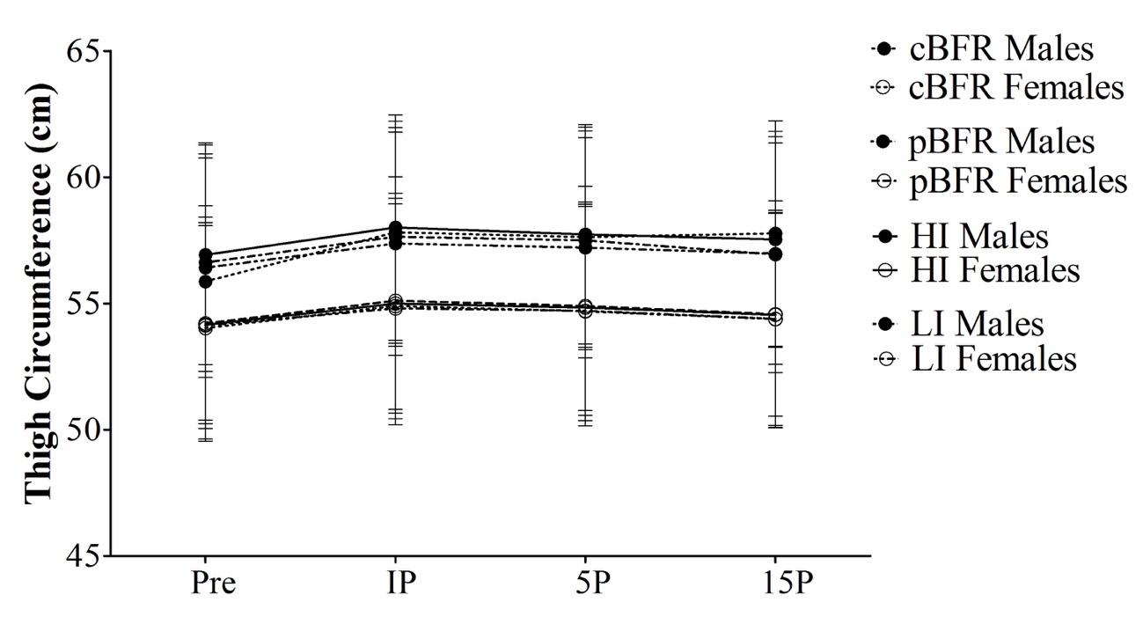
Abbreviations as follows: IP – immediately post-exercise, 5P – 5-min post-exercise, 15P – 15-min post-exercise. cBFR - controlled blood flow restriction, pBFR – practical blood flow restriction, HI – high intensity, LI – low intensity.

Muscle Thickness
Ultrasound measurements of thigh muscle thickness (Figure 2) revealed significant gender (p = 0.001) and time (p < 0.001) main effects, but no significant condition (p = 0.184) main effect, as presented in Table 5 and 6. Post hoc analysis revealed that males were significantly greater than females (p = 0.001), and regarding time, baseline measures were significantly less than IP, 5P, and 15P (p < 0.001). Additionally, IP was significantly greater (p < 0.001) than 5P and 15P, and 5P was significantly (p < 0.001) greater than 15P. There was a significant gender by time interaction (p < 0.001), but no gender by condition (p = 0.461), condition by time (p = 0.677) or gender by time by condition (p = 0.849) interactions. Further analysis of the gender by time interaction revealed that males showed significantly larger muscle thickness than women at baseline (p = 0.002), immediately post, 5-min and 15-min post-exercise (p ≤ 0.001).

Table 5. Muscle thickness (cm; mean ± SD)
 |  | Pre | IPª | 5P^{a,b,c} | 15P^{a,b}
Males* | cBFR | 5.850 ± 0.806 | 6.336 ± 0.834 | 5.807 ± 0.795 | 6.179 ± 0.825
Males* | pBFR | 5.807 ± 0.795 | 6.286 ± 0.818 | 6.207 ± 0.819 | 6.143 ± 0.833
Males* | HI | 5.821 ± 0.728 | 6.279 ± 0.813 | 6.257 ± 0.765 | 6.200 ± 0.783
Males* | LI | 5.779 ± 0.812 | 6.250 ± 0.916 | 6.171 ± 0.897 | 6.071 ± 0.894
Females | cBFR | 4.900 ± 0.655 | 4.893 ± 0.677 | 5.107 ± 0.669 | 5.073 ± 0.665
Females | pBFR | 4.893 ± 0.669 | 5.173 ± 0.657 | 5.120 ± 0.651 | 5.040 ± 0.645
Females | HI | 5.013 ± 0.811 | 5.333 ± 0.795 | 5.260 ± 0.832 | 5.107 ± 0.636
Females | LI | 4.873 ± 0.639 | 5.167 ± 0.659 | 5.107 ± 0.636 | 5.027 ± 0.617
Abbreviations: Pre - pre-exercise; IP - immediately post-exercise; 5P - 5-min post-exercise; 15P - 15-min post-exercise; cBFR - controlled blood flow restriction (BFR); pBFR - practical BFR; HI - High intensity; LI - Low intensity. Significance as follows: *Males significantly greater than females (p ≤ 0.01). ª p ≤ 0.01 vs Pre, ^{b} p ≤ 0.01 vs IP, ^{c} p ≤ 0.01 vs 15P.

Table 6. Main effects and interactions for muscle thickness
Variable | F | p | η² | Power
**Gender | 14.112 | 0.001 | 0.343 | 0.952
Condition | 1.812 | 0.184 | 0.063 | 0.306
**Time | 135.885 | < 0.001 | 0.834 | 1.000
Gender by Condition | 0.869 | 0.461 | 0.031 | 0.232
**Gender by Time | 9.6 | < 0.001 | 0.262 | 0.997
Condition by Time | 0.633 | 0.677 | 0.023 | 0.227
Gender by Condition by Time | 0.535 | 0.849 | 0.019 | 0.261
Abbreviations as follows: F – Ratio of the mean squares; p – Probability, p ≤ 0.05 for statistical significance; η² – Effect size. Significance as follows: ** p ≤ 0.001.

Figure 2. Muscle thickness across time and condition for each gender
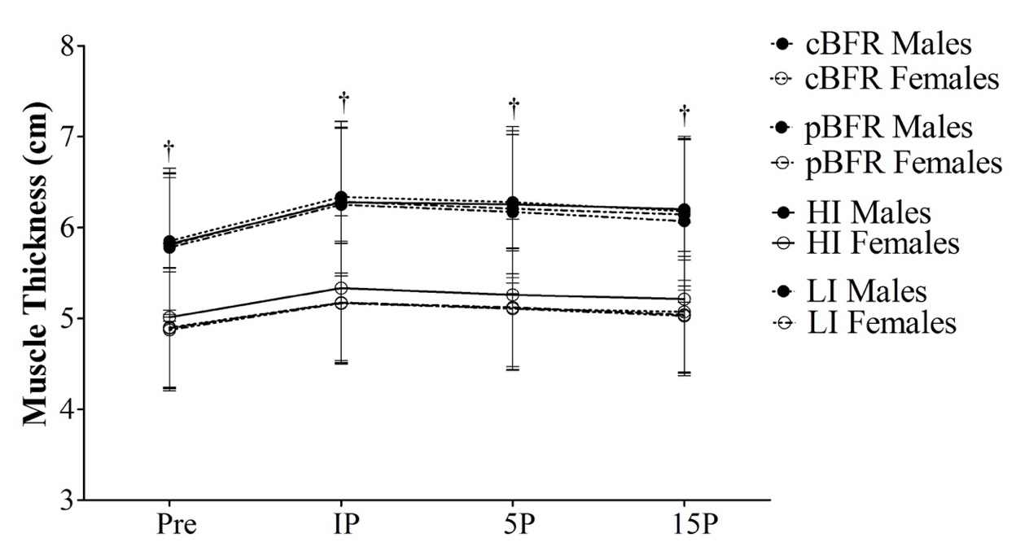
Abbreviations as follows: Pre – Pre-exercise, IP – immediately post-exercise, 5P – 5-min post-exercise, 15P – 15-min post-exercise. cBFR - controlled blood flow restriction, pBFR – practical blood flow restriction, HI – high intensity, LI – low intensity. Significance as follows: †Males significantly greater than females for each time point (p ≤ 0.05).

Lactate
For lactate values presented in Table 7 and Table 8, there was a significant gender (p = 0.006) main effect with males displaying greater lactate levels than females. There was also a significant condition (p ≤ 0.001) and time (p ≤ 0.001) main effect. For the condition main effect, HI was significantly larger than all the other testing conditions (p < 0.001). For the time main effect, IP, 5P and 15P was significantly greater than pre (p < 0.001). Additionally, IP was significantly greater than 5P and 15P (p ≤ 0.05), and 5P was significantly greater than 15P (p < 0.001).
Further analysis revealed that there was a gender by time interaction (p < 0.001). Results showed that males did not have significantly different lactate levels from females at baseline measures (p > 0.05); however, males did show higher lactate levels than females for every other time point (p ≤ 0.05). There was also a condition by time interaction (p < 0.001) which revealed that for each testing condition, IP, 5P and 15P were all significantly greater than baseline lactate values (p < 0.001). Additionally, IP and 5P were significantly greater than 15P (p < 0.001). Furthermore, looking at the condition by time interaction, baseline lactate values showed no significant difference across conditions (p > 0.05), but at IP, 5P and 15P, the HI condition had significantly larger lactate levels than every other condition (p ≤ 0.001). Lactate illustrated in Figure 3.

Table 7. Lactate (mmol/L; mean ± SD)
 |  | Pre | IP^{ab†} | 5P^{ac†} | 15P^{a†}
Males* | cBFR | 1.34 ± 0.63 | 7.95 ± 2.30§# | 7.76 ± 2.28§# | 5.21 ±1.96§
Males* | pBFR | 1.21 ± 0.69 | 7.39 ± 2.01§# | 7.32 ± 2.20§# | 4.86 ± 1.80§
Males* | HI^{β} | 1.11 ± 0.49 | 9.96 ± 2.94‡§# | 9.97 ± 3.00‡§# | 7.06 ± 2.65‡§
Males* | LI | 1.29 ± 0.52 | 7.64 ± 2.43§# | 7.57 ± 2.44§# | 5.06 ± 2.41§
Females | cBFR | 1.45 ± 0.50 | 5.93 ± 1.70§# | 5.54 ± 1.81§# | 3.39 ± 1.21§
Females | pBFR | 1.52 ± 0.74 | 5.62 ± 1.97§# | 4.96 ± 2.31§# | 3.12 ± 1.36§
Females | HI^{β} | 1.24 ± 0.39 | 7.74 ± 1.99‡§# | 7.25 ± 1.96‡§# | 4.85 ± 1.56‡§
Females | LI | 1.33 ± 0.50 | 5.85 ± 1.36§# | 5.19 ± 1.67§# | 3.15 ± 1.11§
Abbreviations as follows: Pre - pre-exercise; IP - immediately post-exercise; 5P - 5-min post-exercise; 15P - 15-min post-exercise; cBFR - controlled blood flow restriction (BFR); pBFR - practical BFR; HI - High intensity; LI - Low intensity. Significance as follows: * Males significantly greater than females (p ≤ 0.05). ^{β} p ≤ 0.01 vs all conditions. ª p ≤ 0.01 vs Pre, ^{b} p ≤ 0.05 vs 5P, 15P, ^{c} p ≤ 0.01 vs 15P. † p ≤ 0.01 males > females. ‡ p ≤ 0.01 vs all conditions, § p ≤ 0.01 vs pre, # p ≤ 0.01 vs 15P.

Table 8. Main effects and interactions for lactate
Variable | F | p | η² | Power
*Gender | 8.937 | 0.006 | 0.249 | 0.822
**Condition | 28.641 | < 0.001 | 0.515 | 1.000
**Time | 229.054 | < 0.001 | 0.895 | 1.000
Gender by Condition | 0.308 | 0.819 | 0.011 | 0.107
**Gender by Time | 9.925 | < 0.001 | 0.269 | 0.997
**Condition by Time | 23.444 | < 0.001 | 117.547 | 1.000
Gender by Condition by Time | 0.296 | 0.975 | 0.011 | 0.152
Abbreviations as follows: F – Ratio of the mean squares; p – Probability, p ≤ 0.05 for statistical significance; η² – Effect size. Significance as follows: * p ≤ 0.01, ** p ≤ 0.001.

Figure 3. Lactate values across time and condition for each gender
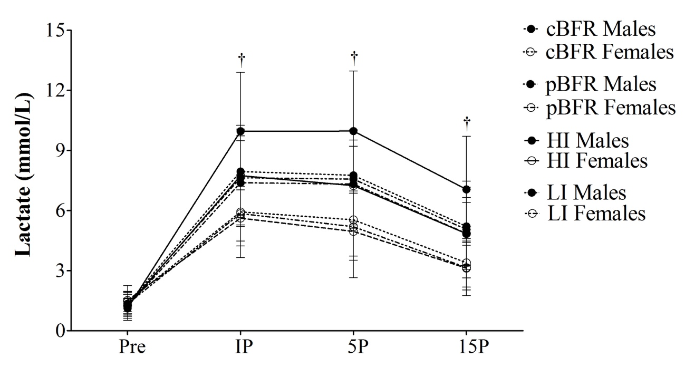
Abbreviations as follows: Pre - pre-exercise, IP - immediately post-exercise; 5P - 15-min post-exercise. cBFR - controlled blood flow restriction (BFR), pBFR - practical BFR; HI - High intensity, LI - Low intensity. Significance as follows: †Males significantly greater than females for each time point (p ≤ 0.01).

Hematocrit
There were significant gender and time (p < 0.001) main effects, but no condition (p = 0.101) main effect for hematocrit values. Males had significantly larger hematocrit values than females (p < 0.001) regardless of exercise condition or time point. Furthermore, baseline (p = 0.018), IP levels (p < 0.001) and 5P (p < 0.001) were significantly larger than 15P. Additionally, IP (p = 0.012) and 5P (p = 0.018) were significantly larger than baseline measures. Hematocrit values also showed a condition by time interaction (p = 0.010). Means and standard deviations are presented on Table 9 and main effect and interaction values are presented on Table 10.
The condition by time interaction observed for hematocrit revealed that IP and 5P were significantly larger than baseline and 15P (p ≤ 0.05) for both cBFR and HI conditions (Figure 4). For pBFR, IP was significantly larger than both baseline and 15P hematocrit values (p ≤ 0.05). Lastly, LI exhibited significantly greater (p < 0.001) 15P hematocrit values when compared to alternative time points (baseline, IP and 5P). Additionally, there were no significant differences were observed across conditions at baseline, IP, and 15P (p > 0.05). For the 5P time point, cBFR and HI displayed significantly greater hematocrit values than pBFR (p ≤ 0.05).

Table 9. Hematocrit values (%; mean ± SD)
 |  | Preª | IP^{a,b} | 5P^{a,b} | 15P
Males* | cBFR | 46.18 ± 2.83 | 47.93 ± 2.13§ | 47.93 ± 2.50‡§ | 45.75 ± 2.35
Males* | pBFR | 45.32 ± 2.09 | 46.64 ± 2.08§ | 46.50 ± 2.70§ | 45.29 ± 2.01
Males* | HI | 45.82 ± 2.28 | 47.29 ± 2.38§ | 47.46 ± 2.73‡§ | 45.89 ± 2.03
Males* | LI | 46.32 ± 3.38# | 46.86 ± 3.09# | 46.39 ± 3.50# | 45.07 ± 2.79
Females | cBFR | 42.62 ± 2.11 | 43.08 ± 2.75§ | 43.19 ± 2.18‡§ | 41.15 ± 2.59
Females | pBFR | 41.62 ± 2.62 | 42.31 ± 2.05§ | 42.12 ± 2.59§ | 41.54 ± 2.29
Females | HI | 42.35 ± 2.90 | 43.19 ± 2.95§ | 43.62 ± 2.98‡§ | 41.89 ± 3.06
Females | LI | 42.69 ± 4.11# | 41.89 ± 3.47# | 42.69 ± 3.41# | 41.12 ± 3.11
Abbreviations: Pre - pre-exercise; IP - immediately post-exercise; 5P - 5-min post-exercise; 15P - 15-min post-exercise; cBFR - controlled blood flow restriction (BFR); pBFR - practical BFR; HI - High intensity; LI - Low intensity. Significance as follows: *Males significantly greater than females (p ≤ 0.05). ªp ≤ 0.01 vs 15P, ^{b}p ≤ 0.01 vs Pre. ‡ p ≤ 0.05 vs pBFR, § p ≤ 0.01 vs Pre and 15P, # p ≤ 0.01 vs 15P.

Table 10. Main effects and interactions for hematocrit values
Variable | F | p | η2 | Power
**Gender | 22.99 | < 0.001 | 0.479 | 0.996
Condition | 2.154 | 0.101 | 0.079 | 0.528
**Time | 25.383 | < 0.001 | 0.504 | 1.000
Gender by Condition | 0.158 | 0.924 | 0.006 | 0.078
Gender by Time | 1.762 | 0.162 | 0.066 | 0.442
*Condition by Time | 2.916 | 0.010 | 0.104 | 0.889
Gender by Condition by Time | 0.613 | 0.785 | 0.024 | 0.299
Abbreviations as follows: F – Ratio of the mean squares; p – Probability, p < 0.05 for statistical significance; η² – Effect size. * p ≤ 0.05, ** p ≤ 0.001, †Males significantly greater than females for each time point (p ≤ 0.01).
Figure 4. Hematocrit values across time and condition for each gender
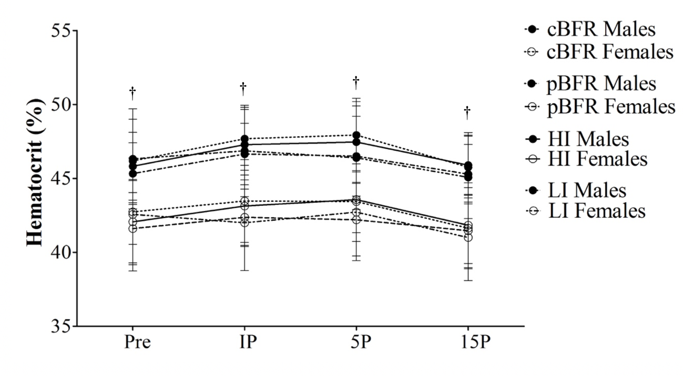
Abbreviations as follows: Pre - pre-exercise; IP - immediately post-exercise; 5P - 5-min post-exercise; 15P - 15-min post-exercise; cBFR - controlled blood flow restriction (BFR); pBFR - practical BFR; HI - High intensity; LI - Low intensity. Symbols as follows: †Males significantly greater than females for each time point (p ≤ 0.01).

The significant main effects for percent plasma volume change revealed condition (p = 0.002) and time (p < 0.001) main effects, but no gender main effect (p = 0.086). Further analysis revealed that, for the condition main effect, LI was significantly greater than pBFR (p = 0.028) and HI (p = 0.004). Additionally, post hoc analysis indicated that for the time main effect, 15P was significantly greater than IP and 5P (p < 0.001), displayed in Figure 5. There were no significant interactions for percent plasma volume change (%PVΔ) (p > 0.05). Means and SD, as well as main effects and interactions are presented on Table 11 and Table 12, respectively.

Table 11. Percent plasma volume change (mean ± SD)
 |  | IPª | 5Pª | 15P
Males | cBFR | -5.53 ± 8.51 | -6.46 ± 8.39 | 2.08 ± 8.76
Males | pBFR^{β} | -5.00 ± 6.08 | -4.08 ± 10.63 | 0.40 ± 7.43
Males | HI^{β} | -5.54 ± 6.12 | -6.13 ± 7.18 | 0.04 ± 8.31
Males | LI | -1.98 ± 5.86 | -0.06 ± 6.83 | 5.34 ± 6.28
Females | cBFR | -1.70 ± 5.31 | -2.17 ± 6.03 | 6.49 ± 7.81
Females | pBFR^{β} | -2.62 ± 6.56 | -1.65 ± 8.86 | 0.66 ± 9.32
Females | HI ^{β} | -3.27 ± 5.53 | -4.89 ± 5.92 | 2.08 ± 5.93
Females | LI | 3.47 ± 5.56 | 0.09 ± 5.54 | 6.89 ± 7.48
Abbreviations as follows: Pre - pre-exercise; IP - immediately post-exercise; 5P - 5-min post-exercise; 15P - 15-min post-exercise; cBFR - controlled blood flow restriction (BFR); pBFR - practical BFR; HI - High intensity; LI - Low intensity. Significance as follows: ª p ≤ 0.01 vs 15P, ^{β} p ≤ 0.05 vs LI.

Table 12. Main effects and interactions for percent change plasma volume values
Variable | F | p | η2 | Power
Gender | 2.358 | .137 | 0.086 | 0.315
*Condition | 5.229 | 0.002 | 0.173 | 0.915
**Time | 54.993 | < 0.001 | 0.687 | 1.000
Gender by Condition | 0.323 | 0.808 | 0.013 | 0.110
Gender by Time | 0.793 | 0.458 | 0.031 | 0.178
Condition by Time | 1.719 | 0.148 | 0.064 | 0.525
Gender by Condition by Time | 0.752 | 0.609 | 0.029 | 0.292
Abbreviations as follows: F – Ratio of the mean squares; p – Probability, p < 0.05 for statistical significance; η² – Effect size. * p ≤ 0.05, ** p ≤ 0.001.

Figure 5. Percent change in plasma volume across time and condition for each gender
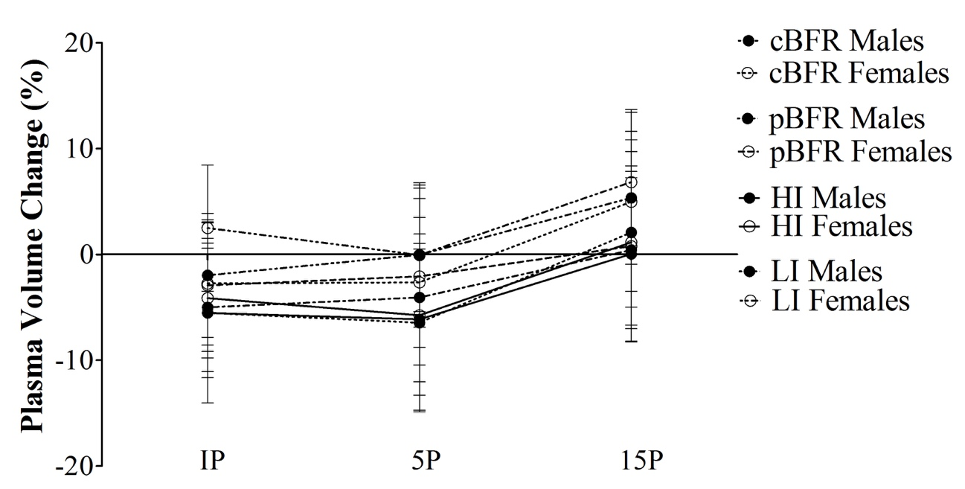
Abbreviations as follows: Pre - pre-exercise; IP - immediately post-exercise; 5P - 5-min post-exercise; 15P - 15-min post-exercise; cBFR - controlled blood flow restriction (BFR); pBFR - practical BFR; HI - High intensity; LI - Low intensity.

Electromyography
Electromyography (EMG) for both leg press and knee extension exercises was analyzed in two separate ways: the first analysis included the first 3 sets for each protocol and second analysis included all 4 sets for cBFR, pBFR and LI. This was done since the HI condition only consisted of 3 total sets for each exercise while, the other conditions involved 4 sets for each exercise.
Leg Press – 3 Sets
Beginning with the analysis of the first 3 sets of the leg press for all testing conditions, there was a significant condition (p < 0.001) and time (p = 0.024) main effect, but not a gender main effect (p = 0.095). For the condition main effect, it was revealed that the HI condition showed significantly larger EMG values than cBFR, pBFR and LI (p < 0.001). The time main effect indicated that set 1 had significantly larger muscle activation values than set 2 (p = 0.011). It was further revealed that there were significant gender by condition (p = 0.018) and gender by time (p = 0.030) interactions, but no significant condition by time (p = 0.604) or gender by condition by time interactions (p = 0.086). In the gender by condition interaction, it was further revealed that no actual gender difference existed for any of the sets (Figure 6). Lastly, in the condition by gender interaction, only cBFR and LI conditions showed males had significantly larger muscle activation than females (p ≤ 0.05) and pBFR and HI did not have any significant differences among gender (p > 0.05). Leg press values are presented on Table 13 and Table 14.

Table 13. Muscle activation (% max RMS) for leg press (3 sets) for both genders (mean ± SD)
 |  | Set 1 | Set 2ª | Set 3
Males | cBFR# | 41.95 ± 13.70 | 42.06 ± 14.88 | 42.59 ± 16.06
Males | pBFR | 39.38 ± 11.19 | 37.98 ± 11.78 | 39.27 ± 12.94
Males | HI^{β} | 87.18 ± 21.58 | 85.69 ± 20.24 | 91.14 ± 25.29
Males | LI# | 45.11 ± 17.64 | 43.06 ± 17.56 | 43.52 ± 15.35
Females | cBFR# | 33.18 ± 9.14 | 31.12 ± 10.63 | 28.78 ± 10.36
Females | pBFR | 33.04 ± 8.54 | 30.21 ± 8.87 | 30.96 ± 9.58
Females | HI^{β} | 93.89 ± 19.58 | 90.90 ± 19.84 | 89.66 ± 16.70
Females | LI# | 31.36 ± 9.79 | 29.71 ± 8.15 | 31.25 ± 8.88
Abbreviations: RMS – root mean square, Pre - pre-exercise; IP - immediately post-exercise; 5P - 5-min post-exercise; 15P - 15-min post-exercise; cBFR - controlled blood flow restriction (BFR); pBFR - practical BFR; HI - High intensity; LI - Low intensity. Significance as follows: ^{β} p ≤ 0.01 vs cBFR, pBFR and LI. ªp ≤ 0.01 vs Set 2. # p ≤ 0.05 vs females.

Table 14. Main effects and interactions for leg press EMG values (3 sets)
Variable | F | p | η2 | Power
Gender | 2.992 | 0.095 | 0.100 | 0.385
**Condition | 185.087 | < 0.001 | 0.873 | 1.000
*Time | 3.980 | 0.024 | 7.960 | 0.689
Gender by Condition | 3.568 | 0.018 | 0.117 | 0.770
*Gender by Time | 3.736 | 0.030 | 0.122 | 0.660
Condition by Time | 0.616 | 0.604 | 0.022 | 0.172
Gender by Condition by Time | 1.888 | 0.086 | 0.065 | 0.689
Abbreviations as follows: F – Ratio of the mean squares; p – Probability, p < 0.05 for statistical significance; η² – Effect size. * p ≤ 0.05, ** p ≤ 0.001.

Leg Press – 4 Sets
As aforementioned, a separate analysis was performed for the 4 sets of leg press (cBFR, pBFR and LI), without including the HI condition. Values for leg press (4 sets) are mentioned in Table 15 and Table 16. For this analysis, it was observed a significant gender (p = 0.005) and significant time main effect (p = 0.023), but no significant condition main effect (p = 0.599). For the gender main effect, males showed significantly larger muscle activation than for females (p = 0.005). Regarding the time main effect, it was revealed that set 1 was significantly larger than set 2 (p = 0.009). Further analysis revealed that there was no significant gender by time (p = 0.150), gender by condition (p = 0.418) or condition by time (p = 0.625) interactions, but there was a significant gender by condition by time (p = 0.021). Follow up analysis of this interaction showed that there were no significant differences in muscle activation across conditions for both males and females during set 1, set 2, set 3 or set 4 (p > 0.05). In the comparison across time, significant differences in muscle activation were observed for females (p = 0.007), in which set 4 was significantly greater than set 1 for the cBFR condition, but no significant differences were observed for males (p > 0.05). For pBFR, no significant differences were observed for males (p = 0.190) and, even though a significant difference was detected for females (p = 0.023), pairwise comparisons revealed that such difference does not actually exist (p > 0.05). Finally, no significant differences across time were observed for males or females during LI (p > 0.05).
Table 15. Muscle activation (% max RMS) for leg press (4 sets) for both genders (mean ± SD)
 |  | Set 1 | Set 2ª | Set 3 | Set 4
Males* | cBFR | 41.95 ± 13.70 | 42.06 ± 14.88 | 42.59 ± 16.06 | 44.08 ± 17.23‡
Males* | pBFR | 39.38 ± 11.19 | 37.98 ± 11.78 | 39.27 ± 12.94 | 38.04 ± 12.63
Males* | HI^{β} | 87.18 ± 21.58 | 85.69 ± 20.24 | 91.14 ± 25.29 | ^{N/A}
Males* | LI | 45.11 ± 17.64 | 43.06 ± 17.56 | 43.52 ± 15.35 | 43.88 ± 17.12
Females | cBFR | 33.18 ± 9.14 | 31.12 ± 10.63 | 28.78 ± 10.36 | 28.90 ± 10.0
Females | pBFR | 33.04 ± 8.54 | 30.21 ± 8.87 | 30.96 ± 9.58 | 30.95 ± 8.50
Females | HI^{β} | 93.89 ± 19.58 | 90.90 ± 19.84 | 89.66 ± 16.70 | ^{N/A}
Females | LI | 31.36 ± 9.79 | 29.71 ± 8.15 | 31.25 ± 8.88 | 30.47 ± 7.67
Abbreviations: RMS – root mean square, Pre - pre-exercise; IP - immediately post-exercise; 5P - 5-min post-exercise; 15P - 15-min post-exercise; cBFR - controlled blood flow restriction (BFR); pBFR - practical BFR; HI - High intensity; LI - Low intensity. Significance as follows: *Males significantly greater than females (p ≤ 0.05); ^{β} p ≤ 0.01 vs cBFR, pBFR and LI. ªp ≤ 0.01 vs Set 2. ‡ p ≤ 0.05 vs Set 1.

Table 16. Main effects and interactions for leg press EMG values (4 sets)
Variable | F | p | η2 | Power
*Gender | 9.332 | 0.005 | 0.257 | 0.838
Condition | 0.517 | 0.599 | 0.019 | 0.131
**Time | 3.829 | 0.023 | 0.124 | 0.713
Gender by Condition | 0.887 | 0.418 | 0.032 | 0.195
Gender by Time | 1.823 | 0.150 | 0.063 | 0.457
Condition by Time | 0.732 | 0.625 | 0.026 | 0.285
*Gender by Condition by Time | 2.560 | 0.021 | 0.087 | 0.837
Abbreviations as follows: F – Ratio of the mean squares; p – Probability, p < 0.05 for statistical significance; η² – Effect size. * p ≤ 0.05, ** p ≤ 0.001.

Figure 6. EMG values across time and condition for leg press
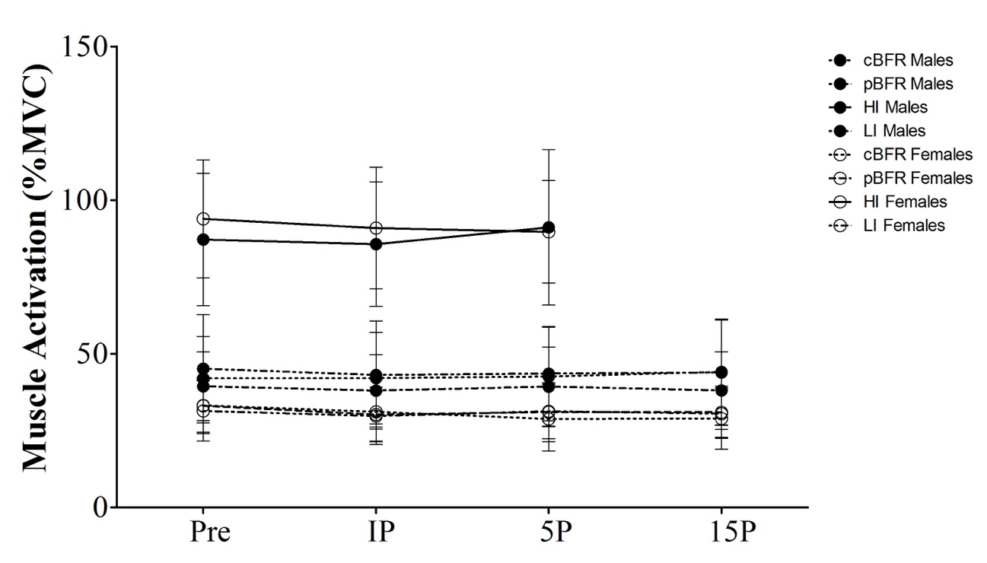
Abbreviations as follows: Pre - pre-exercise; IP - immediately post-exercise; 5P - 5-min post-exercise; 15P - 15-min post-exercise; cBFR - controlled blood flow restriction (BFR); pBFR - practical BFR; HI - High intensity; LI - Low intensity.

Knee Extension – 3 Sets
When comparing the first 3 sets of the knee extension exercise, there was a significant condition main effect (p < 0.001), but no gender (p = 0.069) or time main effects (p = 0.069). For the condition main effect, HI was significantly greater than all conditions (p < 0.001) and cBFR was significantly greater than LI (p = 0.017). Additionally, there was a significant gender by time interaction (p = 0.043) as well as a gender by time by condition interaction (p = 0.040). However, for the first 3 sets of knee extension, additional gender by time interaction decomposition indicated that no significant difference was observed between males and females during set 1 (p = 0.795), set 2 (p = 0.222), or set 3 (p = 0.160). Knee extension values are presented on Table 17 and Table 18.
Decomposing the 3-way interaction for the first 3 sets for knee extension muscle activation, looking across time within condition, cBFR and pBFR showed significantly greater EMG values for males at set 2 (p ≤ 0.05) and set 3 (p ≤ 0.05) when compared to set 1. Additionally, cBFR showed significantly larger EMG values for set 3 compared to set 2 (p = 0.042) for females. No significance was found for either gender across sets for the HI. For the LI condition, males had greater muscle activation at set 3 in comparison to set 1 (p = 0.011). Furthermore, comparing the 3-way interaction across conditions within time, both males and females showed significantly larger EMG values for HI compared to cBFR and LI (p ≤ 0.001) for set 1 and set 2. Lastly, at set 3, males also showed significantly larger muscle activation at HI compared to all the other conditions (p ≤ 0.001). Females showed significantly larger EMG values for cBFR compared to pBFR and LI (p <0.001), and HI revealed significantly larger EMG values for females than cBFR, pBFR and LI (p ≤ 0.001).

Table 17. Muscle activation (% max RMS) for knee extension (3 sets) for both genders (mean ± SD)
 |  | Set 1ª | Set 2ª | Set 3
Males | cBFR# | 65.34 ± 21.31 | 72.23 ± 23.49 | 75.49 ± 24.93
Males | pBFR | 62.67 ± 18.89 | 68.97 ± 22.66 | 71.19 ± 20.57
Males | HI ^{β} | 107.10 ± 27.18 | 100.50 ± 21.75 | 104.76 ± 24.70
Males | LI# | 62.29 ± 12.93 | 65.97 ± 14.87 | 69.79 ± 14.87
Females | cBFR# | 68.93 ± 20.90 | 63.31 ± 13.00 | 70.22 ± 15.73
Females | pBFR | 60.48 ± 15.46 | 58.23 ± 14.63 | 61.99 ± 16.62
Females | HI ^{β} | 104.25 ± 30.45 | 104.49 ± 27.03 | 102.04 ± 23.22
Females | LI # | 57.84 ± 14.91 | 56.48 ± 11.37 | 54.93 ± 10.91
Abbreviations: RMS – root mean square, Pre - pre-exercise; IP - immediately post-exercise; 5P - 5-min post-exercise; 15P - 15-min post-exercise; cBFR - controlled blood flow restriction (BFR); pBFR - practical BFR; HI - High intensity; LI - Low intensity. Significance as follows: ^{β} p ≤ 0.01 vs cBFR. ªp ≤ 0.01 vs Set 3.

Table 18. Main effects and interactions for knee extension EMG values (3 sets)
Variable | F | p | η2 | Power
Gender | 1.022 | 0.321 | 0.036 | 0.164
**Condition | 52.478 | < 0.001 | 0.660 | 1.000
Time | 2.805 | 0.069 | 0.094 | 0.529
Gender by Condition | 0.542 | 0.655 | 0.020 | 0.157
*Gender by Time | 3.536 | 0.036 | 0.116 | 0.634
Condition by Time | 2.023 | 0.101 | 0.070 | 0.567
Gender by Condition by Time | 2.672 | 0.017 | 0.090 | 0.855
Abbreviations as follows: F – Ratio of the mean squares; p – Probability, p < 0.05 for statistical significance; η² – Effect size. * p ≤ 0.05, ** p ≤ 0.001.

Knee Extension – 4 Sets
An additional analysis was run for knee extension (4 sets) and revealed a significant condition (p = 0.011) and time (p < 0.001) main effect, but no significant gender main effect (p = 0.169), as shown in Table 19 and Table 20. There was also a significant gender by time interaction (p = 0.001), but no gender by condition (p = 0.442), condition by time (p = 0.402) or gender by condition by time (p = 0.403) interactions. For the condition main effect, only the cBFR condition was significantly greater than the pBFR condition (p = 0.004). Additionally, the time main effect revealed that set 3 was significantly larger than set 1 (p = 0.032) and set 2 (p = 0.020). Additionally, set 4 was significantly larger than set 1 (p < 0.001), set 2 (p < 0.001) and set 3 (p < 0.001) for knee extension. Further analysis of the gender by time interaction revealed no actual gender difference during any set for cBFR, pBFR or LI (p > 0.05). Values illustrated in Figure 7.
Table 19. Muscle activation (% max RMS) for knee extension (4 sets) for both genders (mean ± SD)
 |  | Set 1^{ab} | Set 2^{ab} | Set 3^{b} | Set 4
Males | cBFR ^{β} | 65.34 ± 21.31 | 72.23 ± 23.49 | 75.49 ± 24.93 | 78.77 ± 24.04
Males | pBFR | 62.67 ± 18.89 | 68.97 ± 22.66 | 71.19 ± 20.57 | 76.28 ± 21.97
Males | LI | 62.29 ± 12.93 | 65.97 ± 14.87 | 69.79 ± 14.87 | 72.89 ± 17.68
Females | cBFR ^{β} | 68.93 ± 20.90 | 63.31 ± 13.00 | 70.22 ± 15.73 | 75.26 ± 16.95
Females | pBFR | 60.48 ± 15.46 | 58.23 ± 14.63 | 61.99 ± 16.62 | 65.01 ± 18.22
Females | LI | 57.84 ± 14.91 | 56.48 ± 11.37 | 54.93 ± 10.91 | 59.05 ± 10.93
Abbreviations: RMS – root mean square, Pre - pre-exercise; IP - immediately post-exercise; 5P - 5-min post-exercise; 15P - 15-min post-exercise; cBFR - controlled blood flow restriction (BFR); pBFR - practical BFR; HI - High intensity; LI - Low intensity. Significance as follows: ^{β} p ≤ 0.01 vs cBFR. ªp ≤ 0.01 vs Set 3. ^{b}p ≤ 0.01 vs Set 4. HI not represented.

Table 20. Main effects and interactions for knee extension EMG values (4 sets)
Variable | F | p | η2 | Power
Gender | 1.996 | 0.169 | 0.069 | 0.276
*Condition | 4.959 | 0.011 | 0.155 | 0.789
Time | 16.667 | < 0.001 | 0.382 | 0.999
Gender by Condition | 0.829 | 0.442 | 0.30 | 0.185
**Gender by Time | 5.750 | 0.001 | 0.176 | 0.940
*Condition by Time | 1.038 | 0.402 | 0.037 | 0.403
*Gender by Condition by Time | 1.038 | 0.403 | 0.037 | 0.402
Abbreviations as follows: F – Ratio of the mean squares; p – Probability, p < 0.05 for statistical significance; η² – Effect size. * p ≤ 0.05, ** p ≤ 0.001.

Figure 7. EMG values across time and condition for knee extension
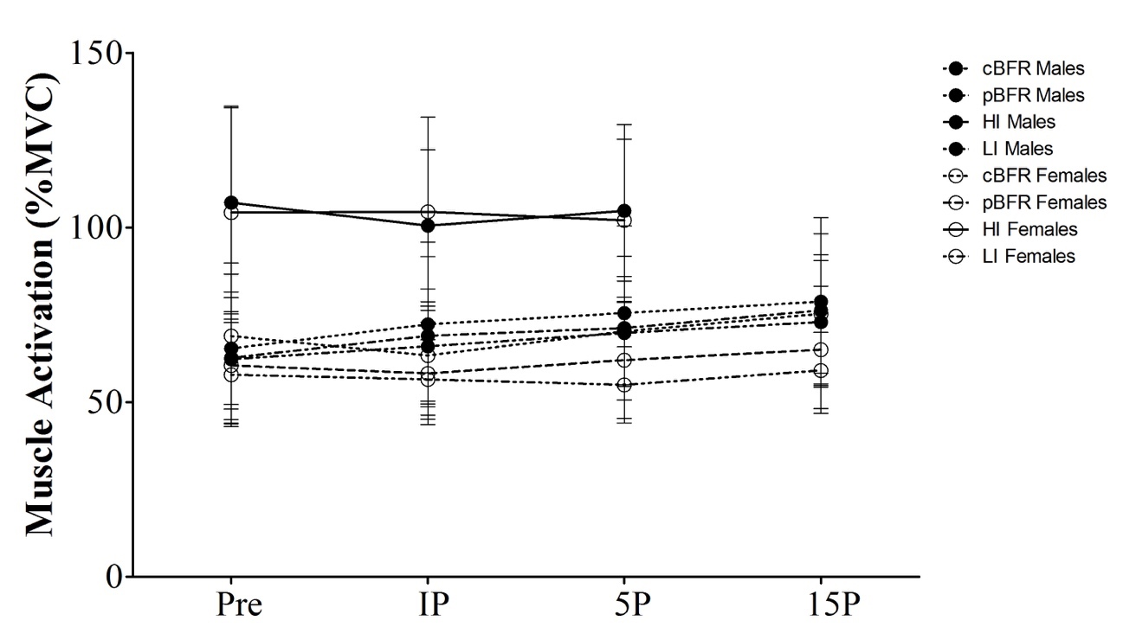
Abbreviations as follows: Pre - pre-exercise; IP - immediately post-exercise; 5P - 5-min post-exercise; 15P - 15-min post-exercise; cBFR - controlled blood flow restriction (BFR); pBFR - practical BFR; HI - High intensity; LI - Low intensity.

Perceptual Response
Rating of perceived exertion (RPE) leg press and knee extension as well as ratings of discomfort were recorded before the beginning of exercise and after each set for leg press and knee extension. The Friedman’s non-parametric test indicated that RPE for leg press significantly (p ≤ 0.05) increased across time, for all conditions and for both males and females. As displayed in Table 21, no significant difference was observed across conditions at rest for both males and females (p > 0.05). No significant difference was observed across sets 1 to 4 for either BFR conditions for both genders (p > 0.05). Similar RPE values were observed between men and women for both cBFR and pBFR. Finally, the LI condition displayed the lowest RPE for both genders.

Table 21. Ratings of perceived exertion for leg press across the different testing conditions and time points
Males (n = 14)
 | Rest | Set 1 | Set 2 | Set 3 | Set 4
cBFR | 0.0 ± 0.0 | 4.3 ± 1.9 ª | 5.4 ± 1.7^{a#} | 6.1 ± 2.1 ^{a,b,*} | 6.4 ± 2.3^{ab*}
pBFR | 0.1 ± 0.5 | 3.1 ± 1.3ª | 3.4 ±1.4ª | 3.7 ± 1.4 ª | 4.1 ± 1.6ª
HI | 0.0 ± 0.0 | 5.3 ± 1.8^{a*} | 6.9 ± 1.7^{a b#} | 7.6 ± 1.6 ^{a bc*} | N/A
LI | 0.0 ± 0.0 | 2.9 ± 1.7ª | 2.8 ± 1.7ª | 3.3 ± 1.6 ª | 3.7 ± 1.6ª
Females (n = 15)
 | Rest | Set 1 | Set 2 | Set 3 | Set 4
cBFR | 0.0 ± 0.0 | 3.8 ± 1.6^{a#} | 4.9 ± 1.6^{ab#} | 5.3 ± 1.7^{a b*} | 5.6 ± 1.8^{ab*}
pBFR | 0.0 ± 0.0 | 3.0 ± 1.2ª | 3.0 ± 1.0ª | 3.3 ± 1.3ª | 3.6 ± 1.8ª
HI | 0.0 ± 0.0 | 5.1 ± 1.8^{a*} | 6.0 ± 1.3 ^{a b#} | 6.9 ± 1.2^{abc*#} | N/A
LI | 0.0 ± 0.0 | 2.1 ± 0.9ª | 2.1 ± 1.2 ª | 2.3 ± 1.2ª | 2.4 ± 1.2 ª
Abbreviations as follows: cBFR - Control blood flow restriction (BFR); pBFR - Practical BFR; HI - High intensity; LI - Low intensity; Pre - Baseline measures; IP - Immediately post-exercise; 5P - 5-min post-exercise; 15P - 15-min post-exercise. Symbols as follows: ª p ≤ 0.01 vs Pre, ^{b} p ≤ 0.01 vs set 1, ^{c} p ≤ 0.01 vs set 2, * p ≤ 0.01 vs LI, pBFR, # p ≤ 0.01 vs LI, $ p ≤ 0.01 vs cBFR.

The Friedman’s non-parametric test indicated that rate RPE for knee extension showed no significant difference between males or females when performing either BFR conditions (p > 0.05). RPE showed a significant (p ≤ 0.05) increase across time, for all conditions and for both males and females. Similar results showed for the LI condition for males at each time point significantly (p ≤ 0.05) increased across time, for all conditions and for both males and females, as illustrated in Table 22. Furthermore, HI showed similar responses in RPE as cBFR and pBFR also showed no significant difference compared to LI (p > 0.05).

Table 22. Ratings of perceived exertion for knee extension across the different testing conditions and time points
Males (n = 14)
 | Set 1 | Set 2 | Set 3 | Set 4
cBFR | 7.21 ± 1.89* | 7.86 ± 1.79 | 8.50 ± 1.95 ^{b c #} | 8.86 ± 1.79^{b c}
pBFR | 5.79 ± 2.15$ | 6.57 ± 2.02 | 7.57 ± 2.24 ^{b c} | 8.00 ± 2.42^{b c}
HI | 5.29 ± 1.82* | 6.92 ± 1.69 ^{b *} | 7.64 ± 1.59^{b c*} | N/A
LI | 2.86 ± 1.70 | 2.78 ± 1.67 | 3.29 ± 1.64^{c d} | 3.71 ± 1.64^{b c}
Females (n = 15)
 | Set 1 | Set 2 | Set 3 | Set 4
cBFR | 5.93 ± 1.83 | 6.37 ± 1.82 | 6.67 ± 1.95 | 7.13 ± 2.26
pBFR | 5.53 ± 1.85 | 5.63 ± 1.91 | 5.93 ± 2.09 | 6.33 ± 2.23
HI | 5.07 ± 1.79* | 6.00 ± 1.25*$ | 6.93 ± 1.22*# | N/A
LI | 2.13 ± 0.92 | 2.13 ± 1.19 | 2.33 ± 1.18 | 2.40 ± 1.24
Abbreviations as follows: cBFR - Control blood flow restriction (BFR); pBFR - Practical BFR; HI - High intensity; LI - Low intensity; Pre - Baseline measures; IP - Immediately post-exercise; 5P - 5-min post-exercise; 15P - 15-min post-exercise. Symbols as follows: ^{b} p ≤ 0.01 vs set 1, ^{c} p ≤ 0.01 vs set 2, ^{d} p ≤ 0.01 vs set 4. * p ≤ 0.01 vs LI, pBFR, # p ≤ 0.01 vs LI, $ p ≤ 0.01 vs cBFR.

The discomfort scale for leg press as analyzed by the Freidman’s non-parametric test revealed that across time, males and females were very similar for the cBFR and HI conditions, as shown in Table 23. Additionally, discomfort during the HI condition was similar among males and females. Sets 2, 3 and 4 were also significantly greater than set 1 for the cBFR condition (p > 0.05). Furthermore, males and females showed significantly higher discomfort values for cBFR than pBFR during set 2 (p ≤ 0.004). Also, for set 2, females showed significantly larger values for cBFR (p = 0.001), pBFR (p = 0.006) and HI compared to LI (p = 0.005). Additionally, males and females showed significantly higher discomfort measures from cBFR compared to pBFR as well as from cBFR to LI and HI compared to LI (p > 0.05). Both genders also revealed larger cBFR discomfort values from cBFR compared to LI (p ≤ 0.010).

Table 23. Ratings of discomfort for leg press across the different testing conditions and time points
Males (n = 14)
 | Rest | Set 1 | Set 2 | Set 3 | Set 4
cBFR | 0.52 ± 0.61 | 2.24 ± 1.94 ª | 3.30 ± 2.25 ^{a b*} | 4.19 ± 2.52 ^{a b*} | 4.96 ± 3.02^{a b*}
pBFR | 0.39 ± 0.57 | 1.39 ± 0.74 ª | 1.64 ± 0.84 ª | 2.00 ± 1.09 ª | 2.18 ± 1.17 ª
HI | 0.07 ± 0.18 | 1.85 ± 1.15 ª | 3.25 ± 1.91 ^{a b} | 4.79 ± 2.72 ^{a b c*} | N/A
LI | 0.20 ± 0.37 | 1.42 ± 1.71 ª | 1.42 ± 1.59 ª | 1.64 ± 1.58ª | 2.00 ± 2.01 ª
Females (n = 15)
 | Rest | Set 1 | Set 2 | Set 3 | Set 4
cBFR | 0.73 ± 0.75# | 2.13 ± 1.23 ª | 3.09 ± 1.57 ^{a b#} | 3.78 ± 2.02 ^{a b*} | 4.39 ± 2.26 ^{a b c*}
pBFR | 0.49 ± 0.70 | 1.44 ± 0.87 ª | 1.32 ± 1.02 ^{a#} | 1.71 ± 1.32 ^{a#} | 2.01 ± 1.59 ^{a#}
HI | 0.00 ± 0.00$ | 1.73 ± 2.06 ª | 2.47 ± 2.10 ^{a b#} | 3.22 ± 2.38 ^{a b c*} | N/A
LI | 0.00 ± 0.00 | 0.62 ± 0.53 ª | 0.63 ± 0.51 ^{a$} | 0.73 ± 0.68 ª | 0.86 ± 0.94 ª
Abbreviations as follows: cBFR - Control blood flow restriction (BFR); pBFR - Practical BFR; HI - High intensity; LI - Low intensity; Pre - Baseline measures; IP - Immediately post-exercise; 5P - 5-min post-exercise; 15P - 15-min post-exercise. Symbols as follows: ª p ≤ 0.01 vs Pre, ^{b} p ≤ 0.01 vs set 1, ^{c} p ≤ 0.01 vs set 2, * p ≤ 0.01 vs LI, pBFR, # p ≤ 0.01 vs LI, $ p ≤ 0.01 vs cBFR.

For the discomfort scale for knee extension, set 4 was significantly smaller than set 1 (p = 0.002), set 2 (p = 0.003) and set 3 (p = 0.008) for cBFR. For pBFR, males showed higher discomfort values at set 3 compared to set 1 and set 4 compared to set 1 (p = 0.007). Furthermore, for pBFR, males and females revealed significantly higher discomfort values for set 3 (p = 0.006) and 4 (p = 0.005) compared to set 2. The HI condition revealed significantly higher values for both genders for set 2 and set 3 compared to set 1 (p < 0.05) as well as set 3 compared to set 2 (p < 0.05). There were no significant differences for females for the LI condition. However, males showed higher discomfort values for set 3 and 4 compared to set 1 as well as set 3 and set 4 compared to set 2 (p < 0.05). Additionally, there were no significant differences for females at set 1 across conditions (p > 0.05). However, males had a significantly larger value for cBFR compared to pBFR (p = 0.006). For set 2, males and females had significantly larger cBFR values than pBFR values (p ≤ 0.002). Values presented in Table 24.

Table 24. Ratings of discomfort for knee extension across the different testing conditions and time points
Males (n = 14)
 | Set 1 | Set 2 | Set 3 | Set 4
cBFR | 6.00 ± 2.88 ^{d} | 6.82 ± 2.87 ^{d} | 7.50 ± 3.18 ^{d} | 8.29 ± 3.52
pBFR | 4.35 ± 2.26 ^{d$} | 4.84 ± 2.83 ^{c} | 5.85 ± 3.36 ^{c} | 6.09 ± 3.62^{c$}
HI | 5.21 ± 3.05 | 6.50 ± 3.01 | 7.64 ± 3.43 | N/A
LI | 4.71 ± 2.58 | 5.10 ± 2.73 | 6.21 ± 3.09 ^{b c} | 6.89 ± 3.41 ^{b c}
Females (n = 15)
 | Set 1 | Set 2 | Set 3 | Set 4
cBFR | 4.09 ± 2.42 | 4.75 ± 2.45* | 4.95 ± 2.51 | 5.62 ± 2.86*
pBFR | 3.07 ± 1.56 | 3.20 ± 1.97 ^{d$} | 3.77 ± 2.37 ^{b} | 4.17 ± 2.81^{c}
HI | 2.92 ± 2.54 | 4.10 ± 2.92 ^{b} | 4.89 ± 2.99 ^{b c} | N/A
LI | 2.87 ± 1.50 | 2.69 ± 1.34 | 3.14 ± 1.88 | 3.47 ± 2.34
Abbreviations as follows: cBFR - Control blood flow restriction (BFR); pBFR - Practical BFR; HI - High intensity; LI - Low intensity; Pre - Baseline measures; IP - Immediately post-exercise; 5P - 5-min post-exercise; 15P - 15-min post-exercise. Symbols as follows: ^{b} p ≤ 0.01 vs set 1, ^{c} p ≤ 0.01 vs set 2, ^{d} p ≤ 0.01 vs set 4. * p ≤ 0.01 vs LI, pBFR, # p ≤ 0.01 vs LI, $ p ≤ 0.01 vs cBFR.

Discussion
The purpose of this study was to determine whether or not men and women respond differently to a single bout of resistance exercise between 4 different protocols: cBFR, pBFR, HI and LI (or our control) by evaluating changes in muscle activation, muscle swelling, thigh circumference, blood lactate and hematocrit concentrations.

Muscle Swelling
Changes in thigh circumference and muscle thickness were evaluated to determine if muscle swelling occurred during each of the exercise interventions. It has been speculated that muscle swelling may play a role in the adaptive response to BFR exercise, ultimately leading to increases in muscle hypertrophy and strength (Loenneke et al., 2012). The main finding in this study showed that muscle swelling, as assessed by ultrasound, occurred post-exercise and remained elevated at IP, 5P and 15P. This finding was consistent with Freitas et al. (2017), in which thigh circumference increased after both HI and BFR exercise conditions. BFR exercise is known for inducing metabolite accumulation within the working muscle due to reduced arterial blood flow and venous pooling (Suga et al., 2009). Therefore, it is very likely that the acute muscle swelling observed in the current study in both HI and BFR conditions was due to a plasma fluid shift into the intracellular space of the quadriceps muscles. Additionally, Loenneke et al. (2012) established that even in the absence of exercise, BFR still provides benefits to muscle hypertrophy. The authors explained that a fluid shift from the plasma into the muscle and venous pooling due to BFR are probable causes for the accumulation of metabolites, which might be responsible for stimulating protein synthesis and activating the mTOR pathway, promoting muscle hypertrophy.
This study also found that males had significantly larger muscle thickness values, as measured by ultrasound, than females at each time point (baseline, IP, 5P, 15P) despite the condition. Males in general have larger leg muscle mass, which would explain the gender difference. Additionally, females had a smaller load to exercise with, which could also explain why no significant differences were found among males and females.
Furthermore, muscle thickness increased after exercise, similar to thigh circumference. According to a study completed by Freitas et al. (2017), BFR and HI conditions had significantly greater IP and 30-minutes post-exercise muscle thickness values when compared to their control. This finding is similar to the results found in this study, which states that thigh circumference and muscle thickness were significantly greater after exercise for each condition (cBFR, pBFR, HI, and LI). However, Freitas et al. (2017) also concluded that the BFR protocol had significantly greater muscle thickness measurements than HI immediately post-exercise. This particular finding does not agree with the findings from the study, which states that each condition revealed similar trends for muscle thickness. Additionally, Yasuda et al. (2016) did not perform a gender comparison, however, they concluded that the BFR exercise group had larger muscle thickness values than the medium to high intensity exercise group without BFR immediately post-exercise.
Muscle thickness may have increased for similar reasons as thigh circumference as suggested by Loenneke et al. (2011), which suggested that muscle swelling post BFR exercise can occur through decreased oxygen availability in the muscle as well as an accumulation of metabolites due to the BFR cuffs. This muscular swelling can eventually lead to muscle hypertrophy through inhibition of catabolism, protein sparing and promotion of lipolysis (Loenneke et al., 2012). There were no significant differences between conditions for thigh circumference or muscle thickness in this study. However, muscle swelling might have happened for different reasons, where HI resistance exercise is more likely to induce muscle damage, causing an inflammatory response, BFR induced accumulation of metabolites and lack of oxygen in the muscle (Freitas et al., 2017). Furthermore, this study involved high-volume BFR exercises, which could also be a reason for the significant increase in muscle thickness and thigh circumference from baseline for cBFR, pBFR and LI.

Lactate
This study observed that lactate measurements were significantly higher for males than for females after exercising. Males are typically able to lift larger loads and usually have larger muscle mass than females, which could potentially explain the gender difference for lactate since skeletal muscle is a major source for lactate production during exercise (Zhang et al., 2016). Considering that lactate is a metabolite produced in the muscle, greater amounts of muscle mass would potentially generate greater production and release of lactate (Ferguson et al., 2018). However, lactate levels in the blood are also dependent on the removal of lactate by the liver, heart muscle and skeletal muscle. The accumulation of lactate is also dependent on the increase in glycolytic pathways dependence for energy during exercise, which in turn induces a faster rate of lactate diffusion into the blood as opposed to the removal. Generally, in addition to larger muscle mass, men have more blood volume and a higher VO2 max compared to women. These differences among gender may lead to varying lactate responses to strenuous exercise as well as removal during recovery.
Additionally, this study revealed that the HI condition had larger lactate values than any other condition after exercise. However, this finding was not supported by Loenneke et al. (2010), who reported that lactate increased regardless of testing condition (BFR or no BFR). Moreover, other studies, such as Gentil et al. (2006) and Takarada et al. (2000a, 2000b), conclude that lactate typically increases more with BFR exercise conditions compared to non-BFR exercises. Reasons for the disparity may include total exercise load or the intermittent inflation of the cuffs for this study. This study released the pressure of the cuff in between leg press and knee extension exercises, whereas other studies may have maintained restrictive pressure throughout the entire duration of the study and was not explained in their methods. Furthermore, the HI condition did not have occlusion, which could have allowed better diffusion of lactate into the blood. Additionally, BFR could have caused a slower diffusion rate of lactate out of the muscle and into the blood (Loenneke et al., 2010). Metabolites, including lactate, accumulate in the blood due to exercise, which causes the stimulation of GH synthesis and secretion into the bloodstream, which then causes the synthesis and secretion of IGF-1. These factors together promote muscle hypertrophy.

Hematocrit and Plasma Volume Change
For this study, hematocrit values increased after exercise and returned to baseline values after exercise, up to 15P. This finding is consistent with Freitas et al. (2017) and Yasuda et al. (2015), which demonstrated that hematocrit increased significantly after BFR exercise. Additionally, this study observed that %PVΔ decreased significantly due to exercise in this study. This is consistent with shifts in hematocrit values due to exercise – as hematocrit values increase, %PVΔ should correspondingly decrease because as water leaves the plasma, blood becomes more hemoconcentrated. This study also found that %PVΔ returned back to baseline at 15P for each condition. Furthermore, this study found no significant difference between exercise conditions for hematocrit and %PVΔ, which means that the BFR protocols and HI produced similar hematocrit changes. This result possibly occurred because both BFR and HI conditions induced the same metabolic stress. This finding is congruent with Freitas et al. (2017) and Yasuda et al. (2017), which also found that BFR and HI exercises induce similar hematocrit and plasma volume changes.
Lastly, this study revealed that hematocrit values for males were larger than females at each time point and condition. A possible explanation to this response is related to the fact that men generally present greater amounts of muscle mass in comparison to women. Thus, men have more tissue capable of absorbing water from the blood and therefore inducing greater decreases in plasma volume. Additionally, if men have greater muscle mass, then the exercise would possibly induce greater production and accumulation of metabolites within the muscle, such as lactate, hydrogen ions, inorganic phosphate and others, which would increase osmotic pressure and then cause water absorption (Zhang et al., 2017). Additionally, males have greater testosterone levels than females. Testosterone has been shown to stimulate erythropoietin, a hormone that is produced by the kidneys and promotes the synthesis of red blood cells in the bone marrow. Therefore, since males have higher testosterone levels than females, males have a greater capacity to produce red blood cells, which allows for greater decreases in plasma volume after exercise (Bachman et al., 2014).

Electromyography
The results from this study indicate that for the first 3 sets of leg press, the HI condition was significantly greater than all other conditions. The exercise intensity for HI was at 80% of the subject’s 1RM and the intensity for all of the other protocols was just at 30%. Studies (Takarada et al., 2000, Wernbom et al., 2009, Yasuda et al., 2008) have shown that BFR and non-BFR exercises both induce an increase in EMG amplitude, however, perhaps the metabolic overload (decrease in intramuscular pH and decline of phosphocreatine availability) was more extreme than in the BFR conditions. The first 3 sets of leg press also showed that set 1 had larger muscle activation than set 2. This may be due to the fact that set 1 involved more repetitions than the other sets, however, this does not apply for the HI protocol since it only involved 3 sets of 8-10 repetitions. A mismatch in energy supply and demand could potentially alter the metabolic stress induced on skeletal muscle (Yasuda et a., 2014). For males at the first 3 sets for leg press, it was shown that they had larger EMG values for cBFR and LI compared to females. A potential reason for this could be that lactate build up in women could have caused an early drop of fiber recruitment (Ferguson et al., 2018). Females also have less muscle mass, which could explain their smaller muscle activation values compared to men.
Moving onto the 4 sets for leg press, it was revealed that set 1 had greater EMG values than set 2. Again, this may be due to the fact that the first set had higher repetitions than the second set. Additionally, only females showed greater EMG values at set 4 compared to set 1 for the cBFR protocol. Compared to the first 3 sets of leg press, perhaps the extra set for leg press caused an increase in EMG for females from the initial sets. The results from the first 3 sets of knee extension also revealed that HI had significantly greater muscle activation than all other conditions. As mentioned before, HI was at a higher intensity than the other conditions, which could have caused greater metabolic stress on the skeletal muscle. It is clear that the knee extension protocol caused higher muscle activation than the leg press and for the cBFR and pBFR conditions, males had larger EMG values at sets 2 and 3 than set 1. Increases in EMG values could be explained by the increase in motor unit recruitment and synchronization (Potvin, 1997).
Moving onto the 4 sets of knee extension, it was revealed that cBFR had larger muscle activation than pBFR, but not other differences were shown. The cBFR condition could have potentially had a higher pressure than the pBFR condition, and in turn could have caused greater metabolic accumulation and more ischemic environment. Furthermore, this could have resulted in an increase in type II fiber recruitment through the stimulation of group III and IV afferent fibers (Loenneke et al., 2014). The 4 sets for knee extension additionally revealed the last set of knee extension showed the highest muscle activation compared to all other sets regardless of condition. The last set probably correlates to the most skeletal muscle fatigue, which may also cause an increase in motor unit recruitment and synchronization in order to compensate for some of the fatigued muscle fibers (Potvin, 1997). Set 4 was highest despite the condition, which shows that each condition for knee extension produced similar EMG values.

Perceptual Responses
The RPE and discomfort scales are non-parametric data and were analyzed to show that in general, knee extension caused higher RPE and discomfort for both men and women than leg press. This matches with EMG data, because there is greater muscle activation for men and women for knee extension compared to leg press. Greater muscle activation causes higher metabolic stress in the skeletal muscle which then causes a higher lactate release into the blood stream (greater metabolic response), which may cause a higher perception of discomfort (Loenneke et al., 2010).

Limitations
Several limitations exist in this study. Although participants were asked to refrain from heavy lower body exercise 24 hr prior, avoid caffeine 6 hr prior, and avoid alcohol prior to the study, it is not certain all participants did so. Another limitation of the study is that participants may not have given their true effort during the 1RM strength test, which would have affected EMG data. Additionally, this study involved leg press and knee extension exercises, which are seated or supine exercises, whereas all of the variables taken were done while the subject was standing. Posture may have affected some of the variables we were collecting. Lastly, some subjects were not able to follow the metronome for their contraction times perfectly, which could have affected some of the skeletal muscular responses.

Chapter V: Conclusion
The purpose of this study was to determine if men and women respond differently to a single acute bout of low-intensity resistance exercise with cBFR or pBFR, as well as low and high intensity resistance exercise without BFR regarding measures of muscle activation, muscle swelling, thigh circumferences, blood lactate and hematocrit concentrations.
Through this investigation, it was concluded that males typically had significantly larger responses to all of the testing conditions for thigh circumference, lactate, hematocrit and muscle activation. However, there was no gender difference for muscle thickness for any of the conditions. Typically, the HI and cBFR conditions produced similar physiological responses. Additionally, males typically reported higher RPE and discomfort ratings, which corresponds to greater muscle activation for cBFR and HI. This study concluded that cBFR and pBFR for males and females do not produce the same physiological responses, but HI and cBFR produced similar physiological responses.
First Research Question
Do the four different conditions (pBFR, cBFR, HI and LI) elicit the same or differing physiological responses in lactate, hematocrit, muscle swelling or muscle activation?
With the exception of thigh circumference and muscle thickness, the four conditions elicited different acute physiological responses. Lactate, hematocrit, and muscle activation responded differently with regard to condition, with cBFR and HI showing greater responses.
First Hypothesis
cBFR and high-intensity (HI) resistance exercise will promote the greatest increases in muscle activation, muscle swelling, lactate and hematocrit levels compared to pBFR resistance exercise and low-intensity (LI) resistance exercise.
Aside from thigh circumference and muscle swelling, HI and cBFR typically resulted in greater responses with the variables chosen. Therefore, this hypothesis was partially accepted.
Second Research Question
Will the physiological responses in lactate, hematocrit, muscle swelling and muscle activation (regardless of condition) be similar or different for males and females?
Males typically had higher responses to exercise compared to females. However, males and females showed similar responses for thigh circumference.
Second Hypothesis
Men will exhibit greater physiological responses than women for all four conditions based on traditional high intensity resistance exercise literature.
Men did show greater physiological responses for all variables, except thigh circumference. Therefore, this hypothesis was partially supported by the study.
First Sub-Question
Do the four different conditions (pBFR, cBFR, HI and LI) elicit the same or differing physiological responses in lactate levels?
Lactate levels responded differently between protocols. The HI condition elicited higher lactate values than any other condition.
First Sub-Hypothesis
cBFR and HI resistance exercise will promote the greatest increases in lactate responses compared to pBFR and LI resistance exercise, regardless of gender.
HI showed the greatest response in lactate compared to all other conditions. Therefore, this study partially accepts this hypothesis.
Second Sub-Question
Do the four different conditions (pBFR, cBFR, HI and LI) elicit the same or differing physiological responses in hematocrit levels?
The four conditions elicited similar hematocrit responses, however, there was a dependence on the time point.
Second Sub-Hypothesis
cBFR and HI resistance exercise will promote the greatest increases in hematocrit responses compared to pBFR and LI resistance exercise, regardless of gender.
All protocols produced similar responses in hematocrit, however, there was a dependence on the time point. Therefore, this hypothesis was partially accepted.

Third Sub-Question
Do the four different conditions (pBFR, cBFR, HI and LI) elicit the same or differing physiological responses in muscle swelling?
Thigh circumference and muscle thickness responded similarly across conditions, however, there is also a time dependency for muscle swelling values to consider.
Third Sub-Hypothesis
cBFR and HI resistance exercise will promote the greatest increases in muscle swelling responses compared to pBFR and LI resistance exercise, regardless of gender.
Thigh circumference was similar across all conditions and muscle thickness had time difference across conditions, therefore this hypothesis was partially accepted.
Fourth Sub-Question
Do the four different conditions (pBFR, cBFR, HI and LI) elicit the same or differing physiological responses in muscle activation?
For the 3 sets of leg press, HI had greater muscle activation values than all other conditions. For leg press 4 sets, there was no difference between conditions for muscle activation. For knee extension 3 sets, HI was greater than all other conditions and cBFR was greater than the LI condition. For knee extension 4 sets, cBFR showed greater muscle activation values.

Fourth Sub-Hypothesis
cBFR and HI resistance exercise will promote the greatest increases in muscle activation responses compared to pBFR and low-intensity resistance exercise, regardless of gender.
cBFR and HI showed greater muscle activation values for different exercises and sets, therefore, this hypothesis was partially accepted.
Fifth Sub-Question
Will the physiological responses in lactate levels (regardless of condition) be similar or different for males and females?
Males had greater lactate responses than females across conditions.
Fifth Sub-Hypothesis
Men will exhibit greater lactate responses compared to women for each of the four exercise conditions.
Men did exhibit higher lactate levels than females across conditions. Therefore, this hypothesis was supported by this study.
Sixth Sub-Question
Will the physiological responses in hematocrit levels (regardless of condition) be similar or different for males and females?
Males had greater hematocrit responses than females across conditions.
Sixth Sub-Hypothesis
Men will exhibit greater hematocrit responses compared to women for each of the four exercise conditions.
Men exhibited greater responses in hematocrit than females across conditions. Therefore, this hypothesis was accepted.
Seventh Sub-Question
Will the physiological responses in muscle swelling (regardless of condition) be similar or different for males and females?
Males had greater muscle thickness responses than females, but no difference was observed for thigh circumference.
Seventh Sub-Hypothesis
Men will exhibit greater muscle swelling responses compared to women for each of the four exercise conditions.
There was no gender difference for thigh circumference, but males did have a greater muscle thickness response compared to females across conditions. Therefore, this hypothesis was partially accepted.
Eighth Sub-Question
Will the physiological responses in muscle activation (regardless of condition) be similar or different for males and females?
Depending on the set and condition, males typically had greater muscle activation than females.
Eighth Sub-Hypothesis
Men will exhibit greater muscle activation responses compared to women for each of the four exercise conditions.
Males typically had higher responses than females for muscle activation. Since there was a dependency on which set and which exercise and exercise condition, this hypothesis was partially accepted.

Practical Significance
Traditional HI resistance exercise possesses the ability to stimulate muscle hypertrophy; however, not all populations are capable of performing resistance exercises with heavy loads. BFR exercise provides similar muscular adaptations as traditional HI resistance exercise in the absence of heavy loads, thus making BFR a possible modality for therapeutic intervention. However, in order to optimize BFR exercise, it is imperative to analyze the acute physiological responses between cuff type and between gender. Although the acute responses of traditional HI resistance exercise differ between males and females, there is currently an insufficiency of literature examining the potential gender or cuff type differences in response to BFR exercise. Therefore, examining the influence of gender and cuff type on acute BFR exercise responses may progress the development of BFR training, thereby improving therapeutic intervention for restricted populations.
For example, this study concluded that men and women showed similar lactate values at baseline, but after exercise, men had a greater response in lactate compared to women. Men also generally showed higher RPE and discomfort throughout the exercises compared to women, which corresponds with the increase in lactate in men. Lactate accumulation causes greater perceptual discomfort, therefore if males had greater lactate accumulation, it’s important to optimize a BFR training protocol that minimizes RPE and perceived discomfort. Furthermore, this study found that cBFR generally elicited greater physiological responses to exercise compared to pBFR, therefore it may be more beneficial for people to exercise with cBFR versus pBFR. However, more research should be done regarding cuff types and gender differences with BFR exercise in order to improve and create the safest and most beneficial BFR training program.

Future Research Directions
Future research should attempt to replicate this study while using older, diseased or injured participants. For example, the study could compare traditional rehabilitation methods while using BFR to enhance rehabilitation programs. Additionally, future research should attempt to investigate a training study comparing the chronic physiological adaptations between pBFR and cBFR. Lastly, future studies could analyze additional variables that are indicators for muscle hypertrophy during BFR exercise, such the hormones testosterone or GH, or markers that inhibit muscle hypertrophy, such as the protein myostatin.

References
Abe, T., Kearns, C. F., & Sato, Y. (2006). Muscle size and strength are increased following walk training with restricted venous blood flow from the leg muscle, Kaatsu-walk training. Journal of Applied Physiology, 100(5), 1460-1466.
Abe, T., Yasuda, T., Midorikawa, T., Sato, Y., Inoue, K., Koizumi, K., … & Ishii, N. (2005). Skeletal muscle size and circulating IGF-1 are increased after two weeks of twice daily “KAATSU” resistance training. International Journal of KAATSU Training Research, 1(1), 6-12.
American College of Sports Medicine. Progression models in resistance training for healthy adults. Medicine and Science in Sports and Exercise, 41: 687-708. 2009.
Babault, N., Desbrosses, K., Fabre, M. S., Michaut, A., & Pousson, M. (2006). Neuromuscular fatigue development during maximal concentric and isometric knee extensions. Journal of Applied Physiology, 100(3), 780-785.
Bachman, E., Travison, T. G., Basaria, S., Davda, M. N., Guo, W., Li, M., ... & Bhasin, S. (2013). Testosterone induces erythrocytosis via increased erythropoietin and suppressed hepcidin: evidence for a new erythropoietin/hemoglobin set point. Journals of Gerontology Series A: Biomedical Sciences and Medical Sciences, 69(6), 725-735.
Bamman, M. M., Hill, V. J., Adams, G. R., Haddad, F., Wetzstein, C. J., Gower, B. A., … & Hunter, G. R. (2003). Gender differences in resistance-training-induced myofiber hypertrophy among older adults. The Journals of Gerontology Series A: Biological Sciences and Medical Sciences, 58(2), B108-B116.
Bemben, M. G. (2002). Use of diagnostic ultrasound for assessing muscle size. Journal of Strength and Conditioning Research, 16(1), 103-108.
Borst, S. E., De Hoyos, D. V., Garzarella, L. I. N. D. A., Vincent, K. E. V. I. N., Pollock, B. H., Lowenthal, D. T., & Pollock, M. L. (2001). Effects of resistance training on insulin-like growth factor-I and IGF binding proteins. Medicine and Science in Sports and Exercise, 33(4), 648-653.
Burgomaster, K. A., Moore, D. R., Schofield, L. M., Phillips, S. M., Sale, D. G., & Gibala, M. J. (2003). Resistance training with vascular occlusion: metabolic adaptations in human muscle. Medicine and Science in Sports and Exercise, 35(7), 1203-1208.
Clayton, N., Drake, J., Larkin, S., Linkul, R., Martino, M., Nutting, M., & Tumminello, N. (2015). Foundations of Fitness Programming. Colorado Springs, CO: National Strength and Conditioning Association.
Cohen, J. E. (2003). Human population: the next half century. Science, 302(5648), 1172-1175.
Colado, J. C., Garcia-Masso, X., Triplett, T. N., Flandez, J., Borreani, S., & Tella, V. (2012). Concurrent validation of the OMNI-resistance exercise scale of perceived exertion with Thera-band resistance bands. The Journal of Strength and Conditioning Research, 26(11), 3018-3024.
Cook, S. B., Murphy, B. G., & Labarbera, K. E. (2013). Neuromuscular function after a bout of low-load blood flow-restricted exercise. Medicine and Science in Sports and Exercise, 45(1), 67-74.
Deldicque, L., Theisen, D., & Francaux, M. (2005). Regulation of mTOR by amino acids and resistance exercise in skeletal muscle. European Journal of Applied Physiology, 94(1-2), 1-10.
Devol, D. L., Rotwein, P., Sadow, J. L., Novakofski, J., & Bechtel, P. J. (1990). Activation of insulin-like growth factor gene expression during work-induced skeletal muscle growth. American Journal of Physiology-Endocrinology and Metabolism, 259(1), E89-E95.
Ferguson, B. S., Rogatzki, M. J., Goodwin, M. L., Kane, D. A., Rightmire, Z., & Gladden, L. B. (2018). Lactate metabolism: historical context, prior misinterpretations, and current understanding. European Journal of Applied Physiology, 1-38.
Freitas, E. D., Poole, C., Miller, R. M., Heishman, A. D., Kaur, J., Bemben, D. A., & Bemben, M. (2017). Time Course Change in Muscle Swelling: High-Intensity vs. Blood Flow Restriction Exercise. International Journal of Sports Medicine. 38(13), 1009-1016).
Fry, C. S., Glynn, E. L., Drummond, M. J., Timmerman, K. L., Fujita, S., Abe, T., & Rasmussen, B. B. (2010). Blood flow restriction exercise stimulates mTORC1 signaling and muscle protein synthesis in older men. Journal of Applied Physiology, 108(5), 1199-1209.
Fujita, S., Abe, T., Drummond, M. J., Cadenas, J. G., Dreyer, H. C., Sato, Y., ... & Rasmussen, B. B. (2007). Blood flow restriction during low-intensity resistance exercise increases S6K1 phosphorylation and muscle protein synthesis. Journal of Applied Physiology, 103(3), 903-910.
Gentil, P., Oliveira, E., & Bottaro, M. (2006). Time under tension and blood lactate response during four different resistance training methods. Journal of Physiological Anthropology, 25(5), 339-344.
Häkkinen, K., & Pakarinen, A. (1993). Muscle strength and serum testosterone, cortisol and SHBG concentrations in middle‐aged and elderly men and women. Acta Physiologica, 148(2), 199-207.
Häkkinen, K., & Pakarinen, A. (1995). Acute hormonal responses to heavy resistance exercise in men and women at different ages. International Journal of Sports Medicine, 16(08), 507-513.
Hart, S., Drevets, K., Alford, M., Salacinski, A., & Hunt, B. E. (2013). A method-comparison study regarding the validity and reliability of the Lactate Plus analyzer. BMJ open, 3(2), e001899.
Hartman, M. J., Ryan, E. D., Cramer, J. T., & Bemben, M. G. (2011). The effects of fatigue of the plantar flexors on peak torque and voluntary activation in untrained and resistance-trained men. The Journal of Strength and Conditioning Research, 25(2), 527-532.
Hollander, D. B., Durand, R. J., Trynicki, J. L., Larock, D., Castracane, V. D., Hebert, E. P., & Kraemer, R. R. (2003). RPE, pain, and physiological adjustment to concentric and eccentric contractions. Medicine and science in sports and exercise, 35(6), 1017-1025.
Howell, J. N., Chleboun, G., & Conatser, R. (1993). Muscle stiffness, strength loss, swelling and soreness following exercise‐induced injury in humans. The Journal of Physiology, 464(1), 183-196.
Ivey, F. M., Roth, S. M., Ferrell, R. E., Tracy, B. L., Lemmer, J. T., Hurlbut, D. E., & Fleg, J. L. (2000). Effects of age, gender, and myostatin genotype on the hypertrophic response to heavy resistance strength training. The Journals of Gerontology Series A: Biological Sciences and Medical Sciences, 55(11), M641-M648.
Karabulut, M., Mccarron, J., Abe, T., Sato, Y., & Bemben, M. (2011). The effects of different initial restrictive pressures used to reduce blood flow and thigh composition on tissue oxygenation of the quadriceps. Journal of Sports Sciences, 29(9), 951-958.
Kawada, S. (2005). What phenomena do occur in blood flow-restricted muscle?. International Journal of KAATSU Training Research, 1(2), 37-44.
Kraemer, W. J., Gordon, S. E., Fleck, S. J., Marchitelli, L. J., Mello, R., Dziados, J. E., & Fry, A. C. (1991). Endogenous anabolic hormonal and growth factor responses to heavy resistance exercise in males and females. International Journal of Sports Medicine, 12(02), 228-235.
Kraemer, W. J., Staron, R. S., Hagerman, F. C., Hikida, R. S., Fry, A. C., Gordon, S. E., ... & Newton, R. U. (1998). The effects of short-term resistance training on endocrine function in men and women. European Journal of Applied Physiology and Occupational Physiology, 78(1), 69-76.
Kraemer, W. J., Volek, J. S., Bush, J. A., Putukian, M., & Sebastianelli, W. J. (1998). Hormonal responses to consecutive days of heavy-resistance exercise with or without nutritional supplementation. Journal of Applied Physiology, 85(4), 1544-1555.
Lang, F., Böhmer, C., Palmada, M., Seebohm, G., Strutz-Seebohm, N., & Vallon, V. (2006). (Patho) physiological significance of the serum-and glucocorticoid-inducible kinase isoforms. Physiological Reviews, 86(4), 1151-1178.
Laurentino, G. C., Ugrinowitsch, C., Roschel, H., Aoki, M. S., Soares, A. G., Neves Jr, M., ... & Tricoli, V. (2012). Strength training with blood flow restriction diminishes myostatin gene expression. Medicine and Science in Sports Exercise, 44(3), 406-12.
Linnamo, V., Pakarinen, A., Komi, P. V., Kraemer, W. J., & Häkkinen, K. (2005). Acute hormonal responses to submaximal and maximal heavy resistance and explosive exercises in men and women. Journal of Strength and Conditioning Research, 19(3), 566.
Loenneke, J. P., Balapur, A., Thrower, A. D., Barnes, J. T., & Pujol, T. J. (2011). The perceptual responses to occluded exercise. International Journal of Sports Medicine, 32(03), 181-184.
Loenneke, J. P., Fahs, C. A., Rossow, L. M., Abe, T., & Bemben, M. G. (2012). The anabolic benefits of venous blood flow restriction training may be induced by muscle cell swelling. Medical Hypotheses, 78(1), 151-154.
Loenneke, J. P., Kearney, M. L., Thrower, A. D., Collins, S., & Pujol, T. J. (2010). The acute response of practical occlusion in the knee extensors. The Journal of Strength and Conditioning Research, 24(10), 2831-2834.
Loenneke, J. P., Kim, D., Fahs, C. A., Thiebaud, R. S., Abe, T., Larson, R. D., ... & Bemben, M. G. (2015). Effects of exercise with and without different degrees of blood flow restriction on torque and muscle activation. Muscle and Nerve, 51(5), 713-721.
Loenneke, J. P., Kim, D., Fahs, C. A., Thiebaud, R. S., Abe, T., Larson, R. D., ... & Bemben, M. G. (2016). The influence of exercise load with and without different levels of blood flow restriction on acute changes in muscle thickness and lactate. Clinical Physiology and Functional Imaging. 37(6), 734-740.
Loenneke, J. P., Thiebaud, R. S., Fahs, C. A., Rossow, L. M., Abe, T., & Bemben, M. G. (2013). Effect of cuff type on arterial occlusion. Clinical Physiology and Functional Imaging, 33(4), 325-327.
Loenneke, J., Fahs, C., Thiebaud, R., Rossow, L., Abe, T., Ye, X., ... & Bemben, M. (2012). The acute muscle swelling effects of blood flow restriction. Acta Physiologica Hungarica, 99(4), 400-410.
Loenneke, J., Thiebaud, R. S., Fahs, C. A., Rossow, L. M., Abe, T., & Bemben, M. G. (2014). Blood flow restriction: effects of cuff type on fatigue and perceptual responses to resistance exercise. Acta Physiologica Hungarica, 101(2), 158-166.
Lowery, R. P., Joy, J. M., Loenneke, J. P., Souza, E. O., Machado, M., Dudeck, J. E., & Wilson, J. M. (2014). Practical blood flow restriction training increases muscle hypertrophy during a periodized resistance training programme. Clinical Physiology and Functional Imaging, 34(4), 317-321.
Manini, T. M., Yarrow, J. F., Buford, T. W., Clark, B. C., Conover, C. F., & Borst, S. E. (2012). Growth hormone responses to acute resistance exercise with vascular restriction in young and old men. Growth Hormone and IGF Research, 22(5), 167-172.
Miller, A. E. J., MacDougall, J. D., Tarnopolsky, M. A., & Sale, D. G. (1993). Gender differences in strength and muscle fiber characteristics. European Journal of Applied Physiology and Occupational Physiology, 66(3), 254-262.
Moritani, T., Sherman, W. M., Shibata, M., Matsumoto, T., & Shinohara, M. (1992). Oxygen availability and motor unit activity in humans. European Journal of Applied Physiology and Occupational Physiology, 64(6), 552-556.
Plowman, S. A., & Smith, D. L. (2017). Exercise Physiology for Health Fitness and Performance. Lippincott Williams & Wilkins.
Potvin, J. R. (1997). Effects of muscle kinematics on surface EMG amplitude and frequency during fatiguing dynamic contractions. Journal of Applied Physiology, 82(1), 144-151.
Robertson, R. J., Goss, F. L., Rutkowski, J., Lenz, B., Dixon, C., Timmer, J., ... & Andreacci, J. (2003). Concurrent validation of the OMNI perceived exertion scale for resistance exercise. Medicine & Science in Sports & Exercise, 35(2), 333-341.
Schoenfeld, B. J. (2010). The mechanisms of muscle hypertrophy and their application to resistance training. The Journal of Strength and Conditioning Research, 24(10), 2857-2872.
Semmler, J. G., Tucker, K. J., Allen, T. J., & Proske, U. (2007). Eccentric exercise increases EMG amplitude and force fluctuations during submaximal contractions of elbow flexor muscles. Journal of Applied Physiology, 103(3), 979-989.
Suga, T., Okita, K., Morita, N., Yokota, T., Hirabayashi, K., Horiuchi, M., ... & Tsutsui, H. (2009). Intramuscular metabolism during low-intensity resistance exercise with blood flow restriction. Journal of Applied Physiology, 106(4), 1119-1124.
Takarada, Y., Nakamura, Y., Aruga, S., Onda, T., Miyazaki, S., & Ishii, N. (2000). Rapid increase in plasma growth hormone after low-intensity resistance exercise with vascular occlusion. Journal of Applied Physiology, 88(1), 61-65.
Takarada, Y., Takazawa, H., Sato, Y., Takebayashi, S., Tanaka, Y., & Ishii, N. (2000). Effects of resistance exercise combined with moderate vascular occlusion on muscular function in humans. Journal of Applied Physiology, 88(6), 2097-2106.
Takarada, Y., Takazawa, H., Sato, Y., Takebayashi, S., Tanaka, Y., & Ishii, N. (2000). Effects of resistance exercise combined with moderate vascular occlusion on muscular function in humans. Journal of Applied Physiology, 88(6), 2097-2106.
Van Beaumont, W., Greenleaf, J. E., & Juhos, L. (1972). Disproportional changes in hematocrit, plasma volume, and proteins during exercise and bed rest. Journal of Applied Physiology, 33(1), 55-61.
Weiss, L. W., Cureton, K. J., & Thompson, F. N. (1983). Comparison of serum testosterone and androstenedione responses to weight lifting in men and women. European Journal of Applied Physiology and Occupational Physiology, 50(3), 413-419.
Wernbom, M., Järrebring, R., Andreasson, M. A., & Augustsson, J. (2009). Acute effects of blood flow restriction on muscle activity and endurance during fatiguing dynamic knee extensions at low load. The Journal of Strength and Conditioning Research, 23(8), 2389-2395.
Wilson, J. M., Lowery, R. P., Joy, J. M., Loenneke, J. P., & Naimo, M. A. (2013). Practical blood flow restriction training increases acute determinants of hypertrophy without increasing indices of muscle damage. The Journal of Strength and Conditioning Research, 27(11), 3068-3075.
Xu, D., Zou, L., Xing, Y., Hou, L., Wei, Y., Zhang, J., ... & Ma, Y. (2013). Diagnostic value of ankle-brachial index in peripheral arterial disease: a meta-analysis. Canadian Journal of Cardiology, 29(4), 492-498.

Yasuda, T., Brechue, W. F., Fujita, T., Sato, Y., & Abe, T. (2008). Muscle activation during low-intensity muscle contractions with varying levels of external limb compression. Journal of Sports Science and Medicine, 7(4), 467.
Yasuda, T., Fukumura, K., Iida, H., & Nakajima, T. (2015). Effect of low-load resistance exercise with and without blood flow restriction to volitional fatigue on muscle swelling. European Journal of Applied Physiology, 115(5), 919-926.
Yasuda, T., Fukumura, K., Tomaru, T., & Nakajima, T. (2016). Thigh muscle size and vascular function after blood flow-restricted elastic band training in older women. Oncotarget, 7(23), 33595.
Zhang, Q., Puhl, J., & Jensen, B. (1992). Sex Differences In Peak Blood Lactate Concentration And Blood Lactate Removal Following Strenuous Exercise. Medicine and Science in Sports and Exercise, 24(5), S122.

Appendix A: Study Documents


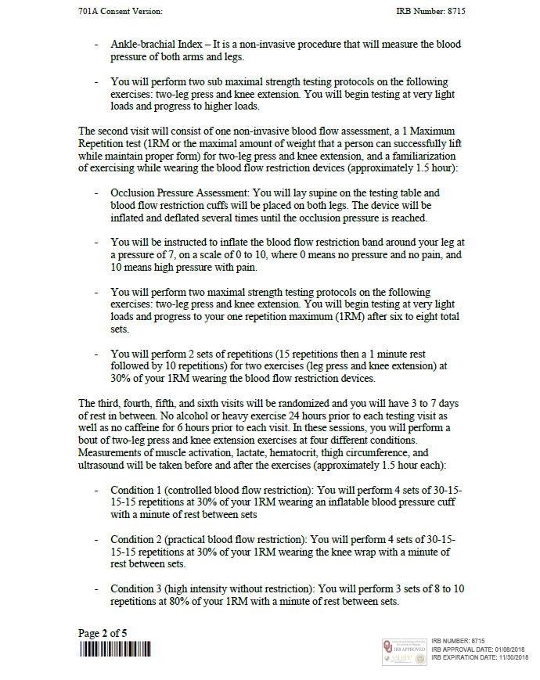

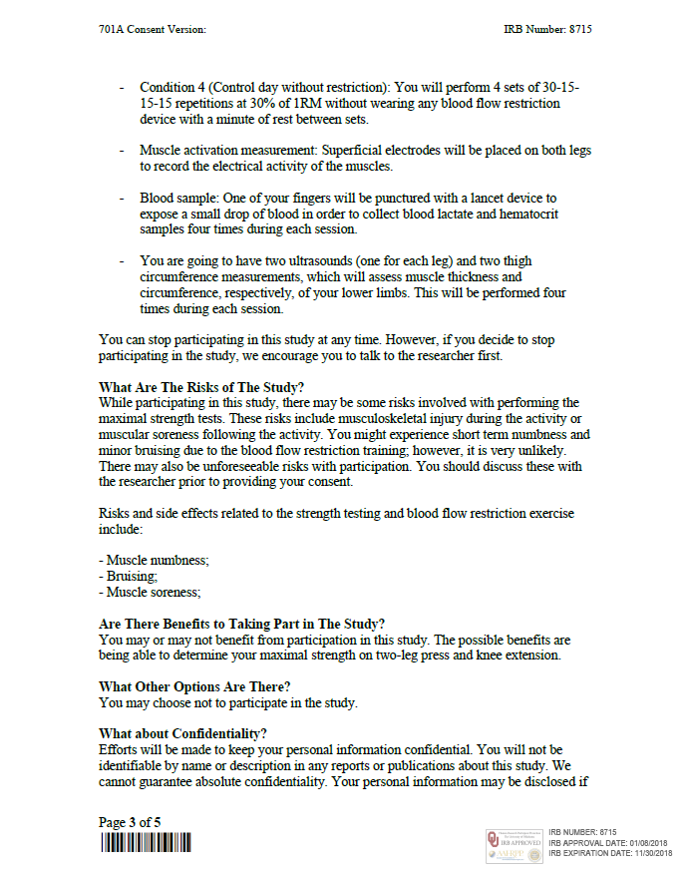



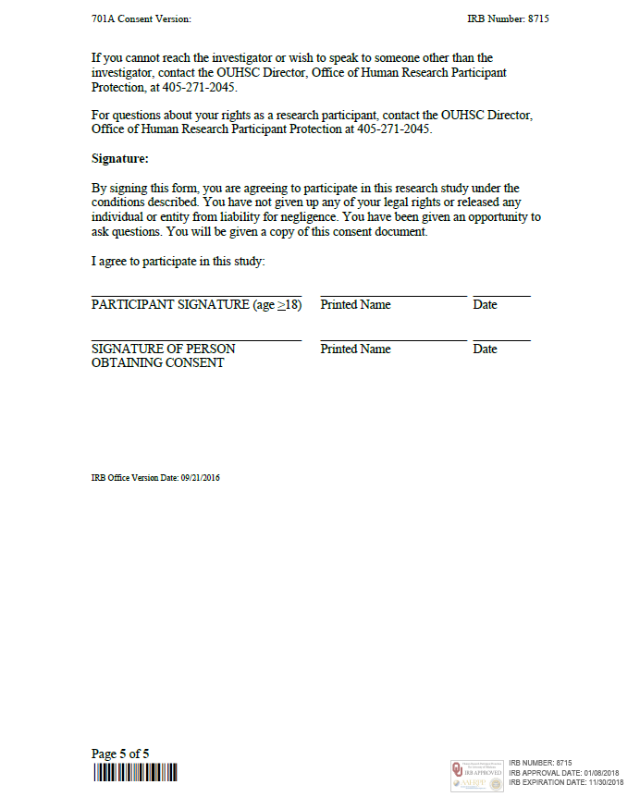

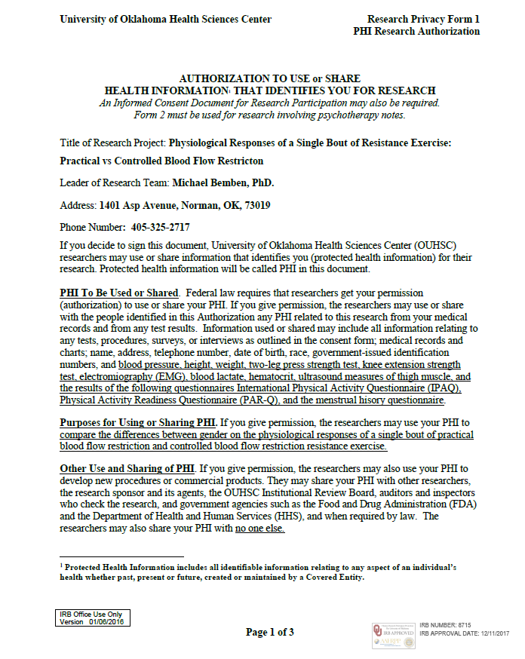



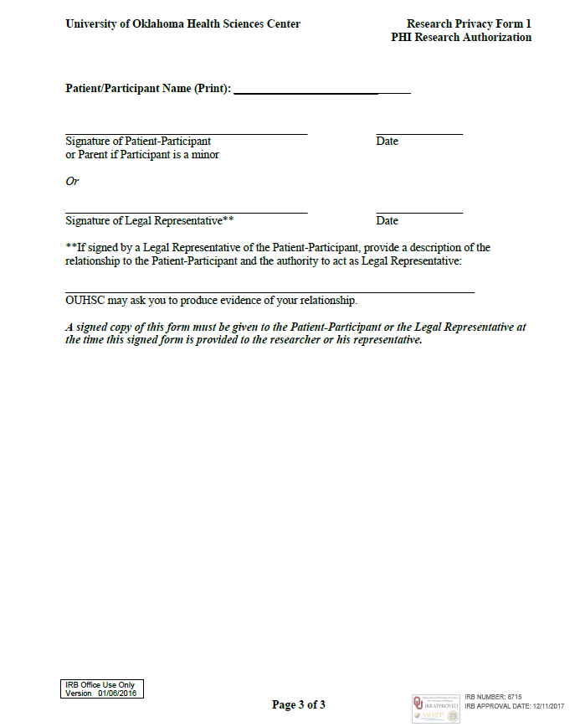

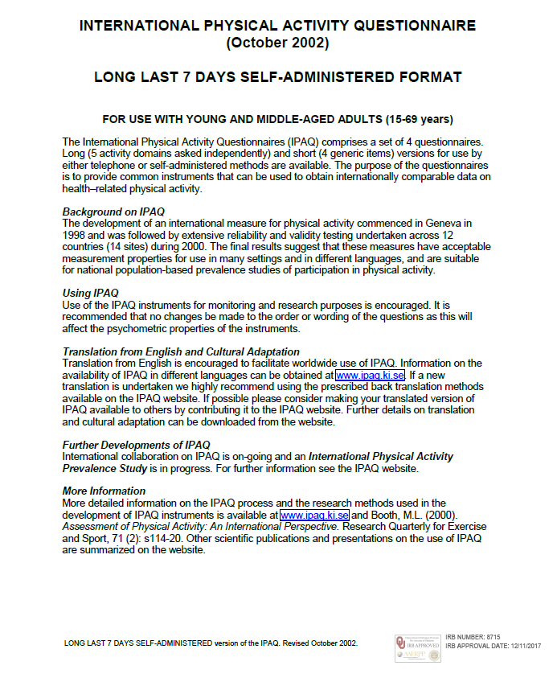
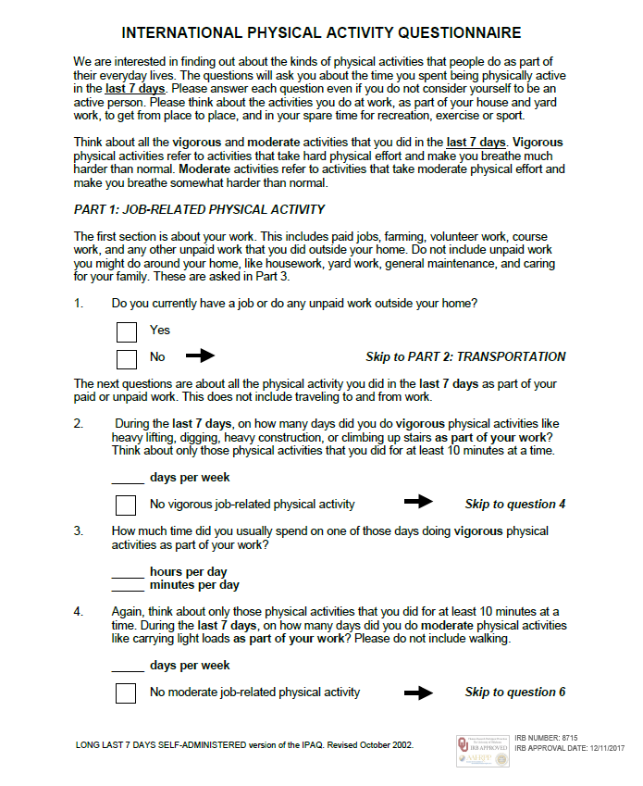

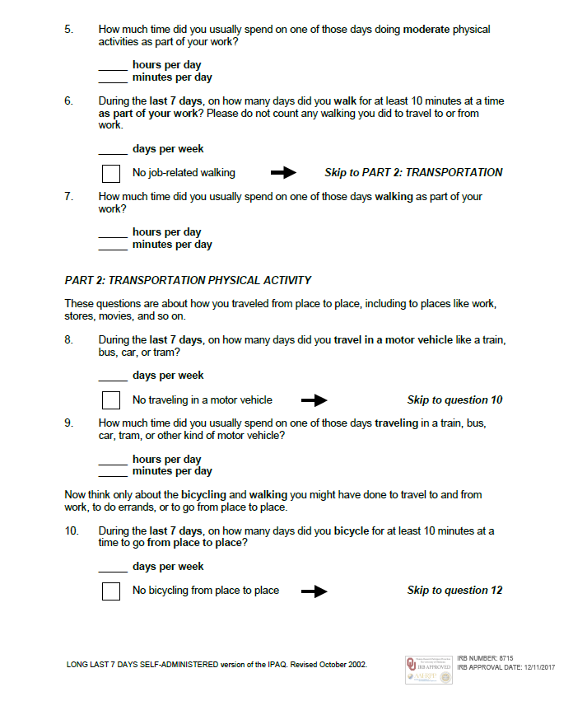

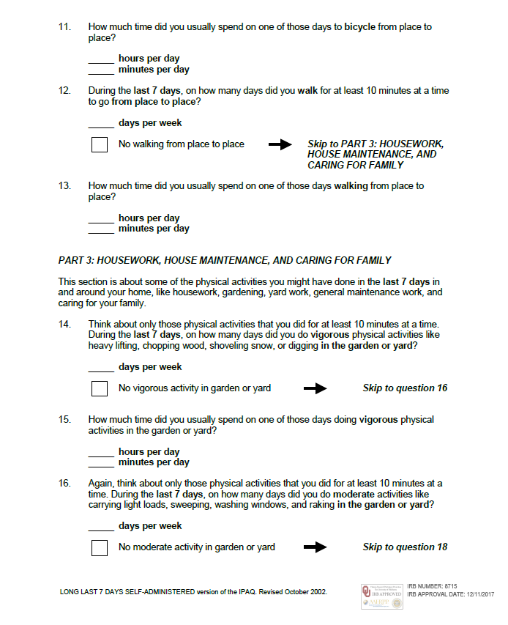

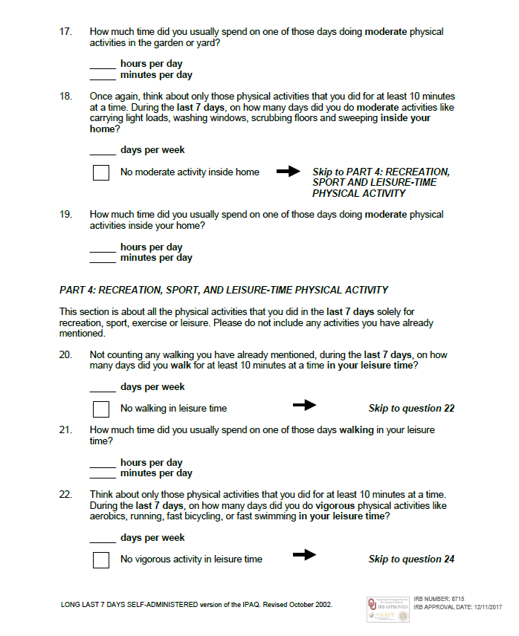

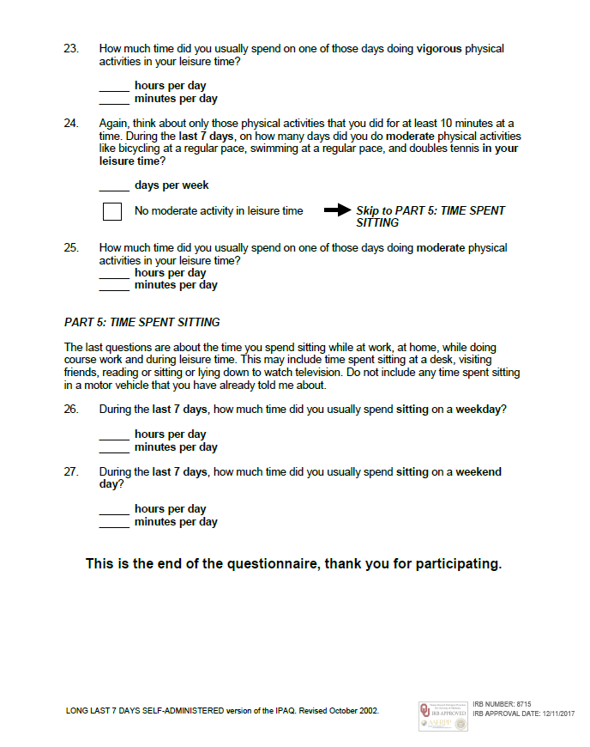







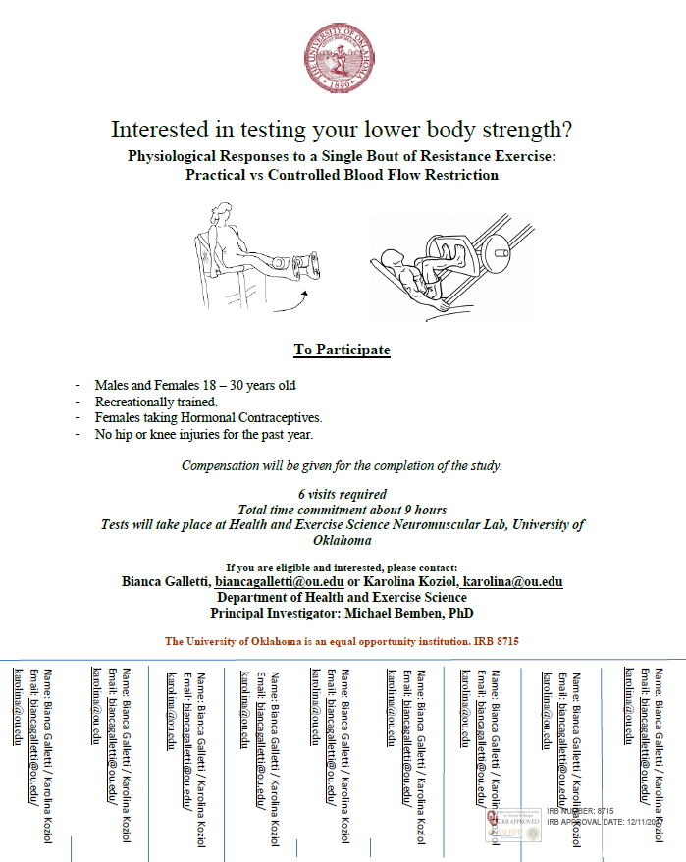

Appendix B: Data

Appendix B: Raw Data

