UNIVERSITY OF OKLAHOMA

GRADUATE COLLEGE

SYMPHONY NO. 1

A DOCUMENT

SUBMITTED TO THE GRADUATE FACULTY

In partial fulfillment of the requirements for the

Degree of

DOCTOR OF MUSICAL ARTS

By

KYLE DAVID VANDERBURG
Norman, Oklahoma
2014

SYMPHONY NO. 1

A DOCUMENT APPROVED FOR THE
SCHOOL OF MUSIC

BY

_____________________________________
Dr. Marvin Lamb, Chair

_____________________________________
Dr. Roland Barrett, Co-Chair

_____________________________________
Dr. Konstantinos Karathanasis

_____________________________________
Dr. Sanna Pederson

_____________________________________
Dr. Phil Gibson

© Copyright by KYLE DAVID VANDERBURG 2014
All Rights Reserved

Acknowledgments

The composer would like to express his sincere appreciation to Roland Barrett for his guidance and advice during the composition and editing processes, and for listening to multiple drafts of this work in its formative stages; to the members of his committee, Marvin Lamb, Konstantinos Karathanasis, Sanna Pederson, and Phil Gibson for their unrelenting support and wisdom in shepherding me through the DMA program; to David Ikard for his competition and camaraderie; to Steven Eiler and Walter Jordan for their suggestions, recommendations, and procrastination; to his parents for their never-ending encouragement; and to Cassie Keogh, for editing, listening, and more than can be remembered.

Table of Contents

Acknowledgments iv
Table of Contents v
List of Tables vi
List of Figures vii
Abstract ix
Chapter 1: Introduction 1
Chapter 2: Architecture of Symphony No. 1 3
Chapter 3: Section I, mm. 1–227 7
Chapter 4: Section II, mm. 229–362 14
Chapter 5: Section III, mm. 363–460 21
Chapter 6: Section IV, mm. 461–568 26
Chapter 7: Section V, mm. 569–755 30
Chapter 8: Section VI, mm. 756–1000 36
Chapter 9: Summary 41
Bibliography 42
Appendix A: Instrumentation 44
Appendix B: Complete Score of Symphony No. I 45
Appendix C: Complete Score of Discursion 123

List of Tables

Table 1: Table of Sections 3
Table 2: Mirrored Form 4
Table 3: Key Centers in Symphony No. I 4
Table 4: Thematic Distribution in Symphony No. I 6
Table 5: Structure of Section I 7
Table 6: Development, Section I (mm. 85-189) 12
Table 7: Section II Layers 18
Table 8: Starting Pitches in Layers 1-4 19
Table 9: Structure of Section V(a) 30
Table 10: Comparison of Layer Variations of Sections II(b) and V(a) 31
Table 11: Structure and outline of Theme V-B Iterations 34
Table 12: Structure of Section VI 36

List of Figures

Figure 1: Theme I-A (mm. 13-22) 5
Figure 2: Theme V-B (mm. 639-54) 5
Figure 3: Taxonomy of Themes in Symphony No. I 6
Figure 4: Section I Chordal Material, (mm. 1–12) 8
Figure 5: Chordal Material, Analyzed (mm. 1–12) 8
Figure 6: Theme I-A, mm. 13–22 9
Figure 7: Theme I-A, Harmonized 10
Figure 8: Theme V-B (mm. 639–54) 10
Figure 9: Theme I-B (mm. 23–36) 11
Figure 10: Theme I-C (mm. 49–56) 11
Figure 11: Theme I-D (mm. 85-92) 12
Figure 12: Groove (mm. 160–61) 12
Figure 13: Section II Form 15
Figure 14: Theme II-A 15
Figure 15: Relationship between Themes II-A (mm. 287–293) and V-B (mm. 639–54 ) 16
Figure 16: Theme II-A, Harmonized 16
Figure 17: Variations in Section II 17
Figure 18: Introductory Chords in Section II (mm. 228-45) 18
Figure 19: Theme I-A2, renotated 19
Figure 20: Section II, Polytonal Theme V-B 20
Figure 21: Section III Abstraction and Woodworth Tune 22
Figure 22: Pitch Mapping between Abstraction and Woodworth Tune 23
Figure 23: Section III Quintet with Hymn Abstraction (mm. 361–369) 24
Figure 24: Quintet and Theme V-B 24
Figure 25: Accompanimental Material in Section IV (mm. 461-62) 26
Figure 26: Second Ostinato in Section IV (mm. 464–65) 27
Figure 27: Third Ostinato in Section IV (mm. 466–67) 27
Figure 28: Section IV Introductory Melody (mm. 466–82) 27
Figure 29: Form of Sections II(b) through V(a) 31
Figure 30: Theme V-A (mm. 569–583) 31
Figure 31: Themes II-A (mm. 287–293) and V-A (mm. 569–583) 32
Figure 32: Themes V-A (mm. 569–582) and V-B (mm. 655–662) 32
Figure 33: Section V Bass Countermelody (mm. 569–82) and Theme I-A (mm. 13–20) 33
Figure 34: Theme V-B (mm. 655–62) 33
Figure 35: Holst Hymn showing Octave Repeat 34
Figure 36: Section V Transitional Material 35
Figure 37: Theme I-A 37
Figure 38: Theme VI-A 37
Figure 39: Theme I-C Fragment (mm. 49-50) 38
Figure 40: Theme VI-C Fragment (mm. 811-12) 38
Figure 41: Section VI Groove Section 39
Figure 42: Section VI Groove Section (2) 39
Figure 43: Section VI Countermelody 40

Abstract

This document contains the complete score to Symphony No. 1, a composition for concert band complete in one movement lasting approximately thirty-five minutes. On the macro level, this symphony is episodic, containing six sections of approximately equal length. These sections combine to form a mirror structure, with Sections I and VI, II and V, and III and IV corresponding to each other. At the micro level, the sections are constructed using ternary, theme and variations, and through-composed forms, and are unified through thematic development and restatement. The score to Symphony No. 1 is supplemented with an analysis of the structure, key centers, harmonic materials, and motivic and melodic usage. Material used in Section III of Symphony No. 1 was used to compose the companion work Discursion for woodwind quintet; this score is included as an appendix.

Chapter 1: Introduction

In its most basic definition, a symphony is a musical work for instruments that is of a significant length and requires a sizeable performance force, most often an orchestra or concert band. Symphony No. 1 adheres to these two basic criteria. It is an extended one-movement work for concert band, approximately thirty-five minutes in duration. As Symphony No. 1 has no programmatic title, in order to avoid confusion in discussing this work versus discussing the genre, the work will be signified by capitalization or the inclusion of the work’s full title.
Symphony no. 1 does not quite fit into the symphony’s historical definition of a four-movement work for orchestra with at least one movement adhering to the principles of sonata form, but at times it does reference these ideas. Though it has one movement instead of four, the movement is sectional in nature. None of the Symphony’s sections are in sonata form, but Sections I and VI are ternary in form, with the middle section acting as development, much like sonata form.
As with all music, the analysis presented herein may be considered subjective, and further analysis by the composer or others may yield different analytical or interpretive findings than those that follow, especially regarding the form of the Symphony. While some of these possible discrepancies will be discussed in the text, it is the composer’s intent to analyze this work based on the compositional process.

Chapter 2: Architecture of Symphony No. 1

Although Symphony No. 1 was not explicitly planned as a programmatic work, the sections contained herein do construct a loose narrative that is useful for analytical purposes. The underlying narrative of Symphony No. 1 is of a journey from the familiar to the unfamiliar, then a return to the familiar. This creates a large-scale form similar to a ternary or sonata form, a product of compositional process rather than intentional formal planning. Though it is a single-movement work, Symphony No. 1 is conceptually divided into six sections of approximately equal time (in this case, six minutes). These episodes are labeled with roman numerals (I-VI) for clarity and as a reference to traditional movement divisions. As a matter of convention, transitions between sections will be considered and analyzed as components of the preceding sections. Section I lasts through m. 227, Section II spans mm. 228–362, Section III spans mm. 363–460, Section IV spans mm. 461–568, Section V spans mm. 569–755, and Section VI closes the work, spanning mm. 756–1000. A codetta follows the final episode, and will be analyzed as part of that episode, as shown in Table 1.
Section I | Section II | Section III | Section IV | Section V | Section VI
mm. 1-227 | mm. 228-362 | mm. 363-460 | mm. 461-568 | mm. 569-755 | mm. 756-1000
Ternary | Variations, theme, and variations | Through-composed | Through-composed | Theme and variations, march | Ternary
Table 1: Table of Sections
The episodes of this work correspond to each other to create a mirrored form. Sections I and VI share significant melodic and harmonic materials to create a satisfactory sense of opening and closing. This setup also creates a sense of Exposition/Recapitulation on the symphony level, with the interior four sections acting as development. Sections II and V have similar primary motives and develop by a similar process, though this developmental process reverses for the latter section. Sections III and IV share little but a harmonic progression, though this progression is understated and accompanimental in Section III and exaggerated and melodic in Section IV. The six sections in total accommodate this mirrored form while preserving symmetry and preventing a sudden transition from the familiar to the unfamiliar. The mirrored form is outlined in Table 2.
Section I  Exposition | Section II  Dev. | Section II  Dev. | Section IV  Dev. | Section V  Dev. | Section VI  Recapitulation
Table 2: Mirrored Form
The pitch content of Symphony No. 1 largely adheres to major-minor tonality with widely varying degrees of functionality. The pitch centers tend to move toward flat key areas (see Table 3), with the work beginning and ending on C and moving to primarily flat pitch centers in between. These pitch centers were selected due to the composer’s preference and the suitability of these keys for wind instruments.
Section I | Section II | Section III | Section IV | Section V | Section VI
C, G, Eb, Ab | Eb, Bb, A, D, F, G | Bb, D | Eb | Bb, Ab, E | C, G, Eb, D
Table 3: Key Centers in Symphony No. I
Musical themes in Symphony No. 1 are notated in this document with a roman numeral indicating the section followed by a sequential letter indicating the relative placement of the theme within the section. For example, the first theme of Section I is labeled Theme I-A, the next theme in Section I is labeled Theme I-B, and so on. These thematic materials are closely related to each other, in that themes from one section are used as accompanimental figures or countermelodies to other sections. Especially prevalent in this work are Theme I-A (Figure 1) and Theme V-B (Figure 2), and materials generated from these two themes. When the themes of Symphony No. I are mapped and labeled as shown in Table 4, their usage outside of their original sections are accentuated. Also of interest is Figure 3, which outlines the development of the themes used in this symphony and traces them to one of the two themes listed above.
Figure 1: Theme I-A (mm. 13-22)
Figure 2: Theme V-B (mm. 639-54)

 | Section I | Section II | Section III | Section IV | Section V | Section VI
I Material | I-A,  I-B (V-B),  I-C,  I-D | I-A2 |  | I-A2 | I-A | I-A,  I-B,  I-C,  I-D
II Material |  | II-A (V-B) |  |  | V-A (II-A)
III Material |  |  | Quintet (V-B),  III-I (chordal) | III-I (chordal)
IV Material |  |  |  | IV-I (sixteenths) | IV-I (sixteenths)
V Material | I-B (V-B) | V-B | Quintet (V-B) |  | V-A (II-B), V-B | V-A
VI Material | VI Material nearly identical to I Material |  |  |  |  | VI-A, VI-B, VI-C,  V-D
Table 4: Thematic Distribution in Symphony No. I

Figure 3: Taxonomy of Themes in Symphony No. I

Chapter 3: Section I, mm. 1–227

As with any significant work’s opening movement, Section I serves as an integral part of the Symphony, acting on the global level as an exposition to the overall work and introducing themes that will later be manipulated, while operating on the local level as a self-contained movement with its own exposition and development sections. This section was conceived as a possible stand-alone work, which affected several compositional choices. At this point, however, an independent work has not been arranged.
Section I is written in ternary form, with clear A sections bookending a developmental B section as an homage to sonata form. The A sections, which serve as exposition and recapitulation, include elements reminiscent of sonata form such as primary and secondary themes and contrasting key areas. This is apparent when observing the section’s organizing segments, as listed below in Table 5.
Introduction | A | Transition | B | A
mm. 1–12 | mm. 13–72 | mm. 73–84 | mm. 85–189 | mm. 190–227
C Maj. | C Maj., G Maj | C Maj. | Eb Maj., Ab Maj., Eb Min. | C Maj.
Table 5: Structure of Section I
The pitch content of this section largely adheres to major-minor tonality with varying degrees of functionality. The overall key center is C Major, with sojourns to Eb Major, Ab Major, and Eb Minor in the development.
Despite the work’s tonal center of C major, the introductory chordal material (Figure 4) begins with a Bb major chord moving to C major. This ascending step relationship between bVII and I is prevalent throughout this Section. The opening chordal motive is divided into three sections, each lasting four measures. When analyzed with roman numeral analysis, two interesting points emerge (Figure 5). A chromatic circle of fifths progression in mm. 2-4 is unique to this progression and does not appear elsewhere in the Symphony. Secondly, the closing progression in the final four measures acts as a prolongation of the subdominant before a return to tonic, and is used in Theme I-A as a closing progression. The usage of a unique element paired with a foreshadowing element creates a distinct motivic figure that fits with the surrounding material, which allows it to be used later as transitional material.
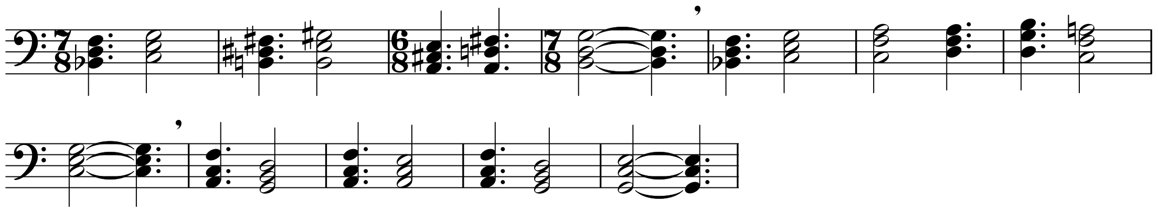
Figure 4: Section I Chordal Material, (mm. 1–12)
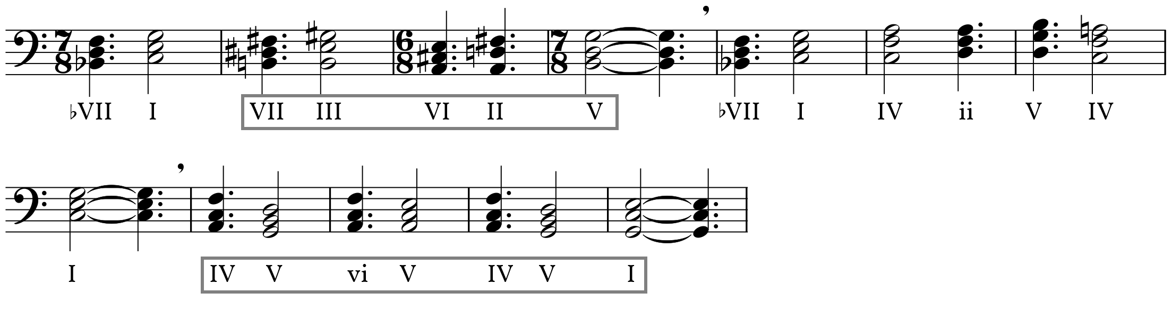
Figure 5: Chordal Material, Analyzed (mm. 1–12)
The first theme (Theme I-A) of Section I is a ten-measure figure primarily notated in $\begin{matrix}\text{7} \\ \text{8}\end{matrix}$ (Figure 6). The complex meters shift emphasis from the beginning of the theme (where they subdivide into 2+2+3) to the end (where they subdivide 3+2+2). This nonstandardized grouping of eighth notes in this passage paired with a meter that rests between the more common $\begin{matrix}\text{3} \\ \text{4}\end{matrix}$ and $\begin{matrix}\text{4} \\ \text{4}\end{matrix}$ meters attempts to create a sense of unpredictability.
Figure 6: Theme I-A, mm. 13–22
On first analysis, the theme is quite simple. With the exception of the one measure of$\begin{matrix}\text{9} \\ \text{8}\end{matrix}$, the theme is scalar and only spans a perfect fourth. However, the unusual harmonic material carried over from the introductory chords offsets the melodic simplicity. The ascending step relationship from the introduction appears in mm. 1–3 of the theme (mm. 13–15 of the score), and again in mm. 5–7 (mm. 17-19). Additionally, the closing progression from the introduction harmonizes the final four measures of the theme, this time functioning as a dominant prolongation rather than the subdominant prolongation heard in the introduction. Both of these phenomena are apparent when viewed with roman numeral analysis (Figure 7).
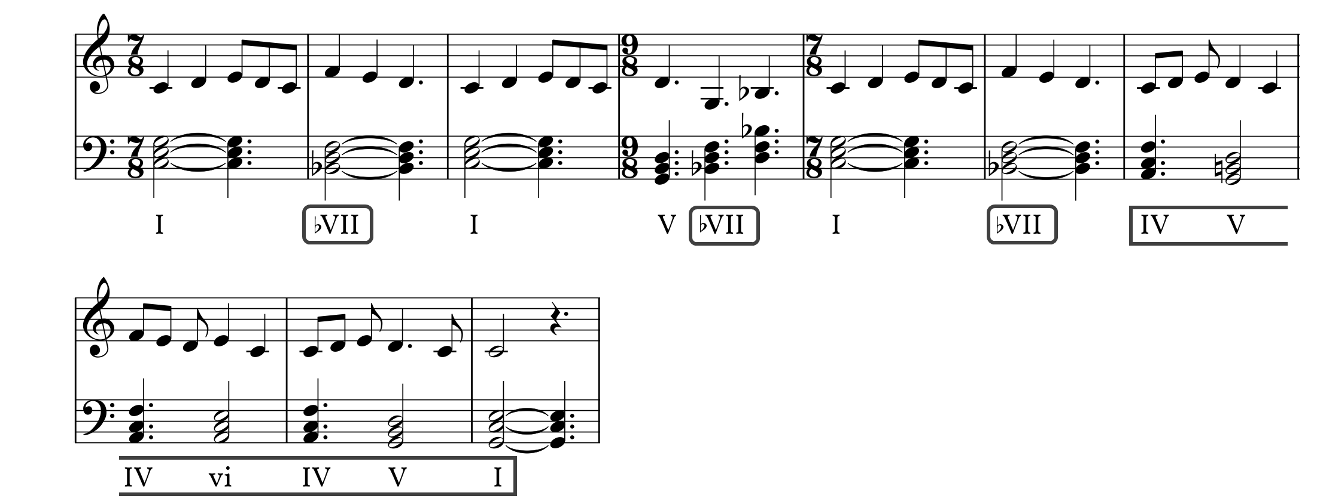
Figure 7: Theme I-A, Harmonized
The second theme (Theme I-B) of Section I is a modification of Theme V-B used in Section V (specifically, mm. 639–654). Theme V-B will be analyzed in context in Chapter 7, but is presented in Figure 8 for comparison with the secondary theme as seen in Figure 9. Both Themes V-B and I-B consist of a group of three notes followed by a scalar pattern, and both are constructed in such a way to facilitate an easy repeat of material. Using a modified form of a later theme in this first section solves several compositional problems. First, it foreshadows the eventual entrance of the theme in Section V. Second, it allows Theme V-B to serve elsewhere as transitional material (specifically in m. 352). The I-B theme is followed by an abridged version of Theme I-A, substituting a simple “IV-V-I” for the closing progression.
Figure 8: Theme V-B (mm. 639–54)
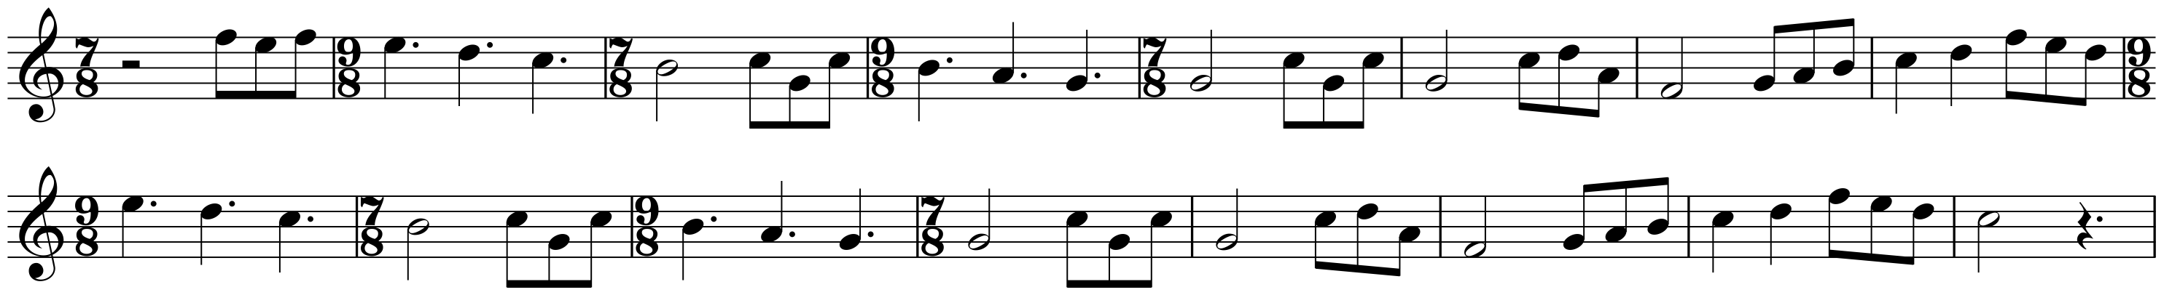
Figure 9: Theme I-B (mm. 23–36)
The Secondary area of Section I begins with an abridged version of the opening chordal material followed by Theme I-C (Figure 10). This theme is a shortened version of Theme I-A, but is presented here in the dominant. The alternating between $\begin{matrix}\text{7} \\ \text{8}\end{matrix}$and $\begin{matrix}\text{6} \\ \text{8}\end{matrix}$ loses an eighth note in the process in an attempt to create a sense of urgency in the I-C theme. The harmonic content of this area functions similarly to the I-A theme, but includes a chromatic progression at its closing. This leads back to a brief iteration of Theme I-A, before transitioning to a developmental section.
Figure 10: Theme I-C (mm. 49–56)
The development area of Section I uses Themes I-A and I-B as its material, in addition to a new thematic element, Theme I-D (Figure 11). After a repeat of the opening chordal progression at m. 73, the development divides into three sections: a fugato section, a statement of the I-A theme in minor, and a “groove section” in $\begin{matrix}\text{7} \\ \text{8}\end{matrix}$ based on Theme I-A (Table 6). The development uses Eb as its primary pitch center, with tonicizations of Ab in the fugato section. The fugato section itself is divisible into two areas, the first characterized by single entries of the Theme I-D material with accompanimental chords (mm. 85-100). The second area (mm. 101-132) of the fugato section adds more entries of the I-D theme instead of the chordal accompaniment, leading into the minor iteration of the I-A theme. The minor portion of the development section behaves as prepared in the original statement, with a presentation of the I-A theme in minor, two presentations of the I-B theme, and a partial recapitulation of the I-A theme before moving to the groove section.
Figure 11: Theme I-D (mm. 85-92)
Fugato | Minor | Groove
mm. 85-132 | mm. 133-159 | mm. 160-189
Eb, Ab | Eb Min. | Eb Min.
Table 6: Development, Section I (mm. 85-189)
The groove section is a portion of the development in $\begin{matrix}\text{7} \\ \text{8}\end{matrix}$characterized by a bass ostinato that alternates accenting beats five or six, as shown in Figure 12. This segment continues the Eb tonal center established by the prior two segments until retransitioning to Theme I-A (in C) by way of D (V/V of C) and G (V of C). The melodic material in this section is a series of dyads appearing first in the oboes, and later in the clarinets and piccolo.
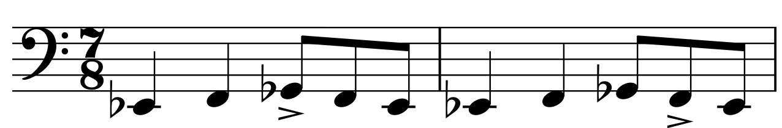
Figure 12: Groove (mm. 160–61)
The return of section I (mm. 190–227) presents the I-A theme with some alterations. First, the chords accompanying the second half of Theme I-B are quintal in nature, adding tonal ambiguity. Second, the ending portion of the theme is rewritten to include an emphasis on the dominant, facilitating the deceptive motion moving to Section II.

Chapter 4: Section II, mm. 229–362

Section II is arranged as a theme and variations with two unusual features. The first is that the variations following the theme are not variations of pitch material, meter, or modality, but instead they are variations of complexity, forces, and scale. With each iteration of the theme more instruments are added, more rhythmic complexity is layered on, and dynamics increase. The second feature is that there is a second series of variations that do behave more like traditional variations, but they occur before the presentation of the theme, resulting in a cumulative form. In this way, the progression of variations slowly come into focus to present the theme. This technique has been frequently used by composers such as Charles Ives, Don Martino, and Thea Musgrave, and by this composer in works such as Realms of Endless Day, Salvation, Caffeination, and Writer’s Block. To facilitate discussion of these two sets of variations, the first set will be referenced as “Variations” and will be numbered in the negative (numbers decrease farther from the theme), and the second set will be referenced as “Layers” and numbered in the positive. In addition to avoiding confusion, this helps to outline the focus/crescendo effect in use by the section, as seen in Figure 13.
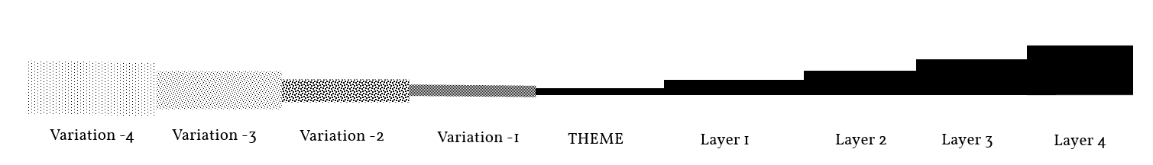
Figure 13: Section II Form
Due to the Variations-Theme-Variations form of this section, it is easiest to divide the analysis in two, looking at each set of variations as a progression from the theme, and then comparing and contrasting the two outcomes.
The theme of Section II (Theme II-A, Figure 14) relates to the I-B and V-B themes in that it begins with a grouping of three notes followed by one or two notes, then repeated. Like the aforementioned themes, the notes outside the group of three are without leaps. However, unlike the previous themes, the “scalar” passages simply rise or fall by half-step. This is indicative of the chromatic nature of this theme, which is made apparent when analyzing the passage’s pitch content (F, G, Ab, A, Bb, B, C, Db, D, Eb, E).
Figure 14: Theme II-A
The influence of Theme V-B appears in this theme as well, specifically in the second measure, where the opening motive from the V-B theme appears (Figure 15)
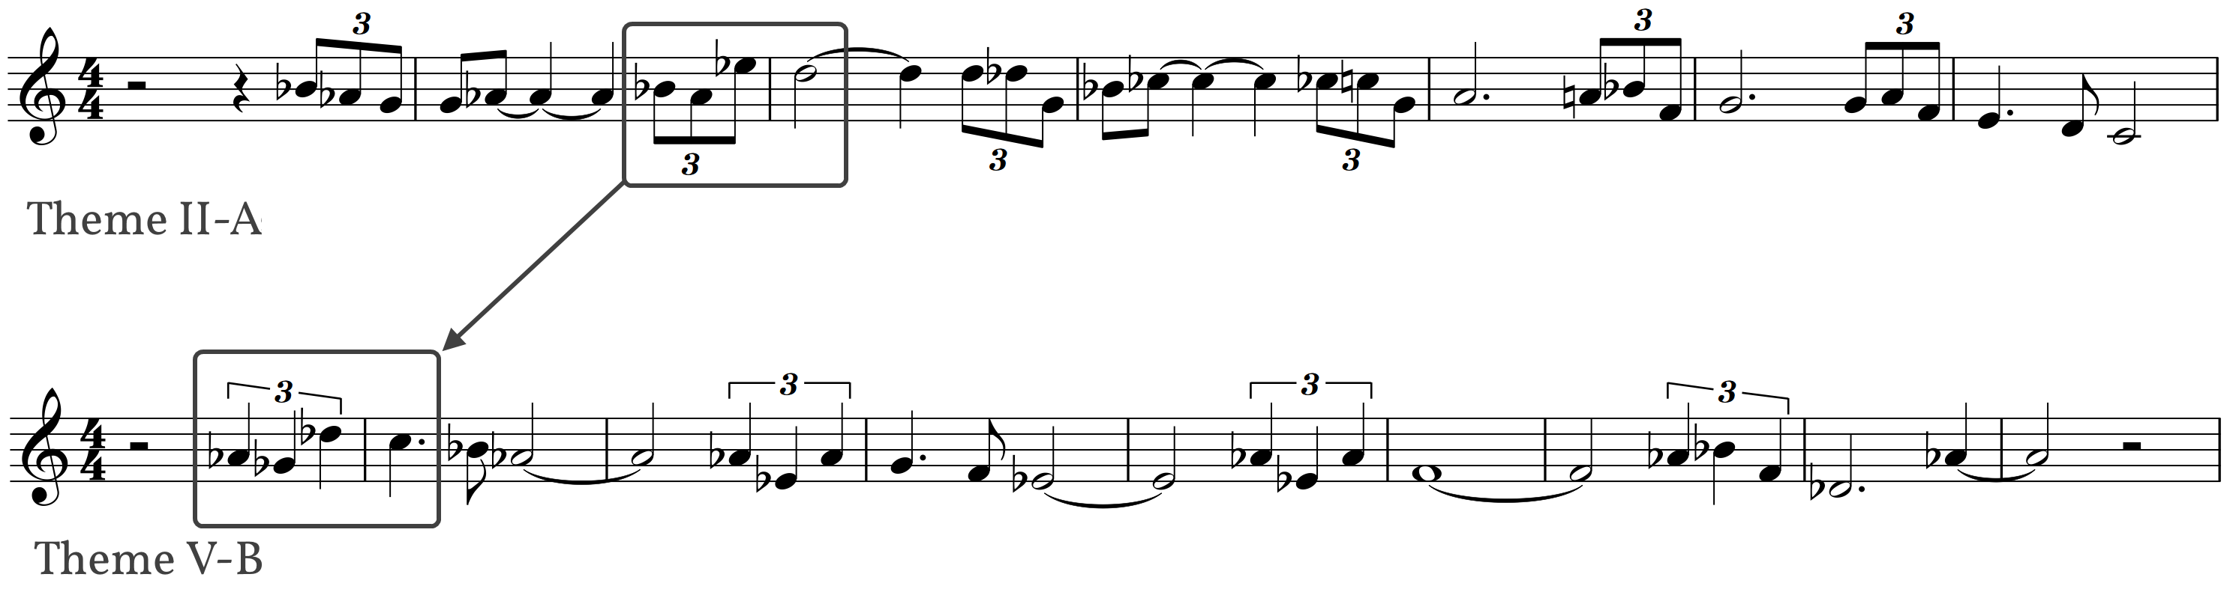
Figure 15: Relationship between Themes II-A (mm. 287–293) and V-B (mm. 639–54 )
Theme II-A is harmonized similarly to the themes in the first section, with largely triadic, simple tertian harmony. However the chords behave more erratically than in the first section, with no unifying pitch center. Instead, the harmonic motion progresses downward by way of passing tones, as seen in Figure 16.
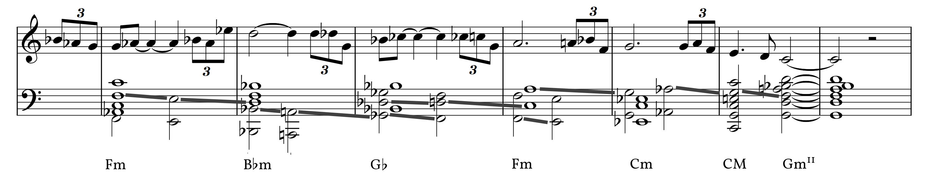
Figure 16: Theme II-A, Harmonized
In regards to the Symphony’s overall narrative of departure and return introduced in Chapter Two, Theme II-A embodies the idea of the actual journey. The themes presented in Section I were more rigid, adhering (or at least referencing) established norms, creating a clear sense of home or origin through repetition and pitch center. In contrast, the theme presented in this section twists and turns, with more leaps and direction changes, looking for a place to settle both harmonically and melodically.
The theme is preceded by a series of four variations, which were composed in reverse to facilitate the “coming into focus” effect of the cumulative form. As the variations travel toward the theme they become more complex, and in the case of the outermost variations, longer (Figure 17). As the variations become simpler the chords supporting them become more complex, creating a sense of motion toward the theme through harmonic simplification.
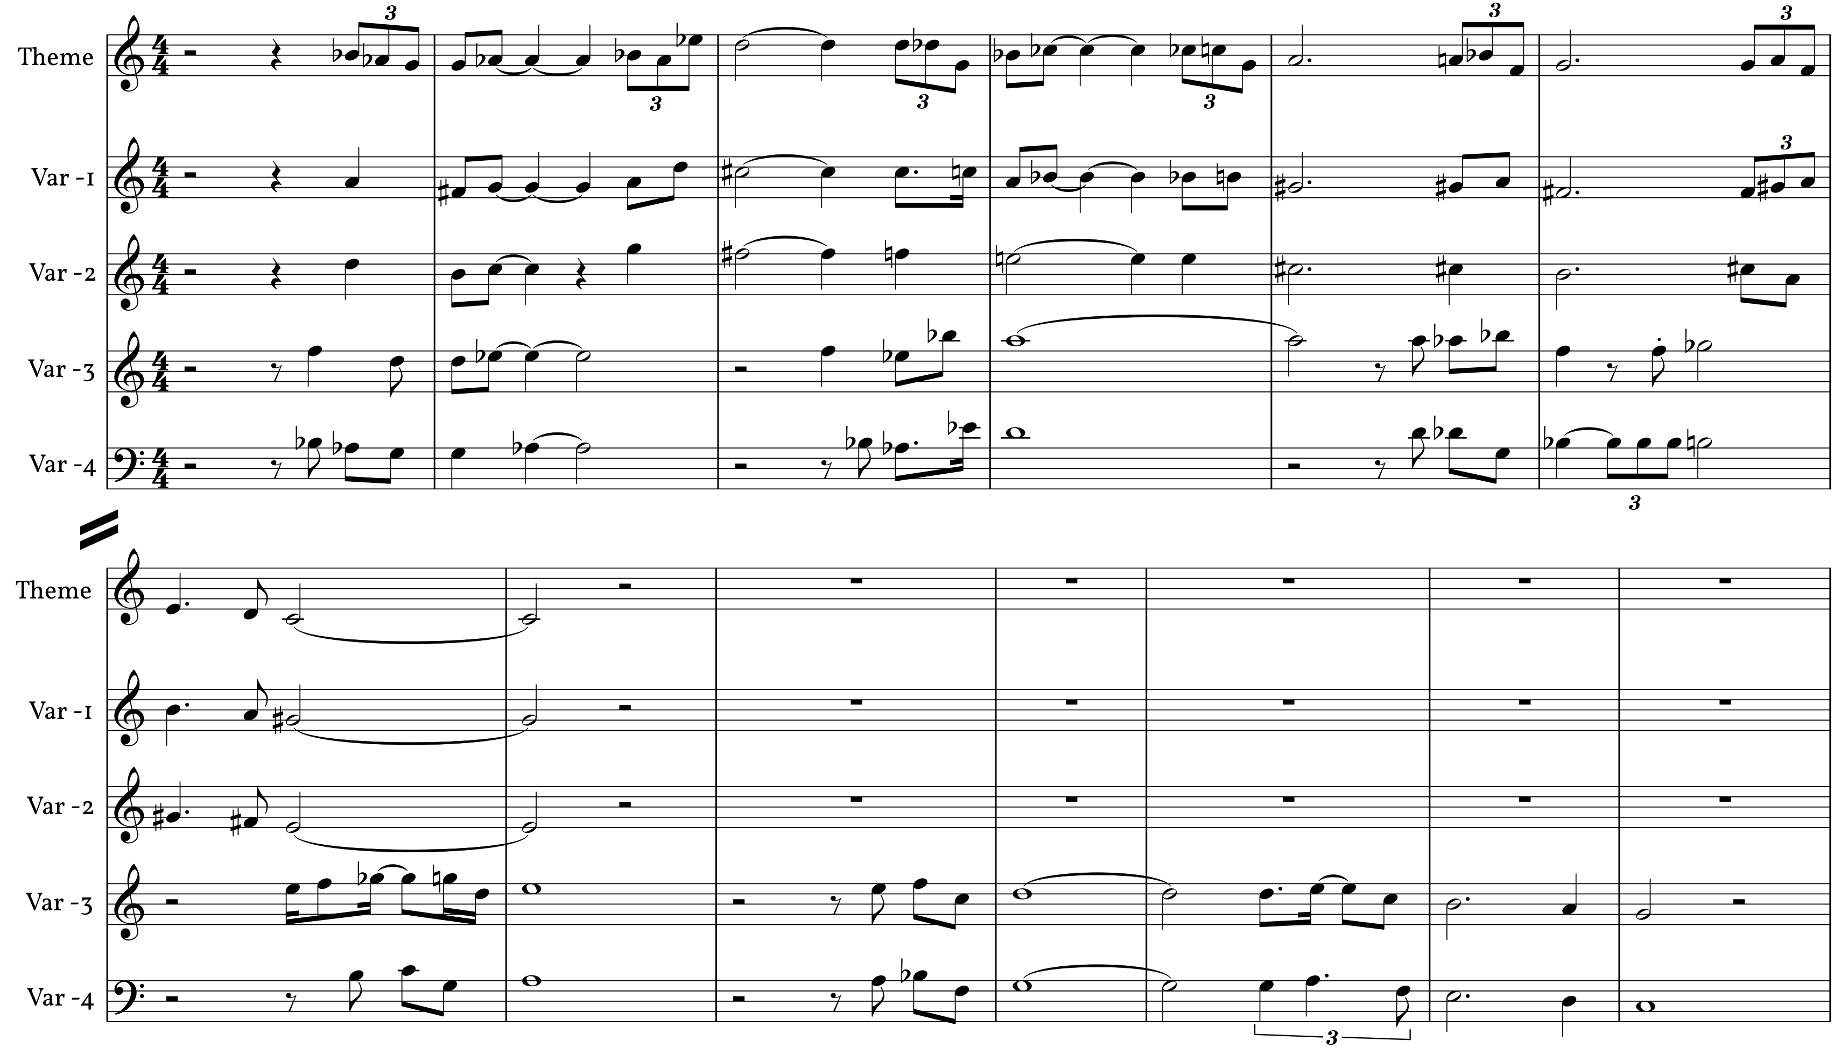
Figure 17: Variations in Section II
The variations are preceded by a chordal introduction similar to the beginning of Section I. This chordal segment serves primarily to absorb the impact of the end of Section I while preparing the listener for the slower variations. The chords used here are similar in motion to the chords at the beginning of Section III, and their use here foreshadows the hymn in the following section. Notable in this section is the use of B–C#–D# as a transitional device between chords as seen in Figure 18, foreshadowing the Woodworth hymn tune which begins Bb–C–D (Figure 21: Section III and Woodworth Tune, page 22).
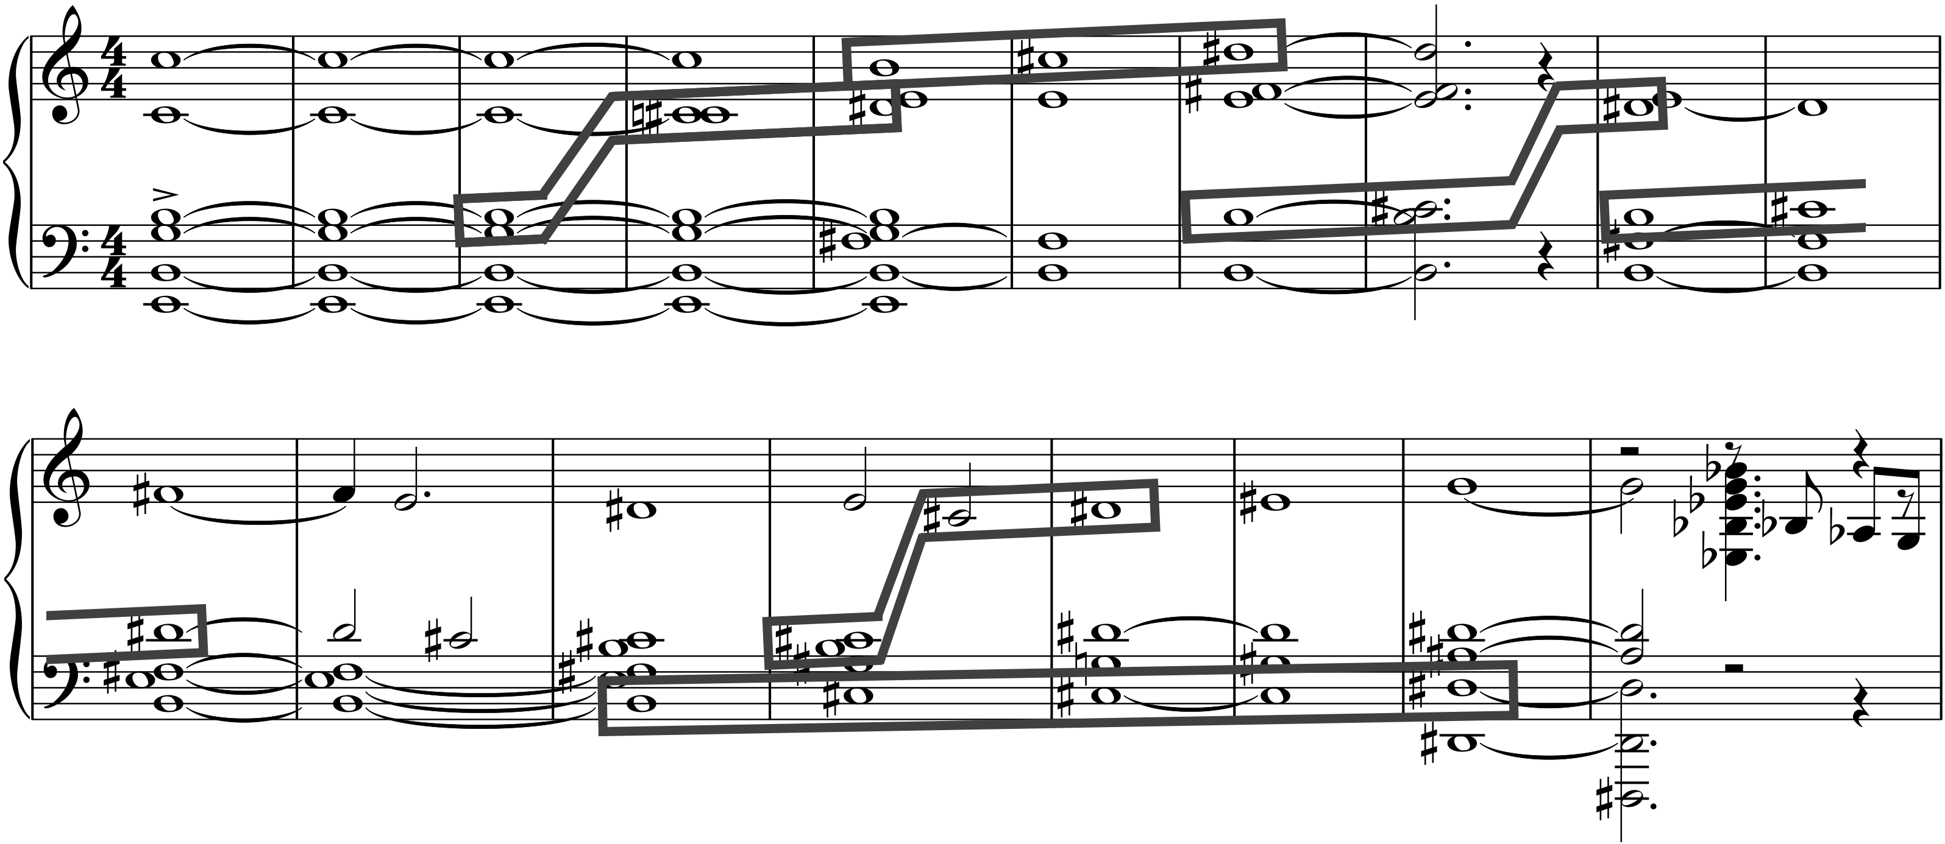
Figure 18: Introductory Chords in Section II (mm. 228-45)
The other set of variations, the Layers, progress and vary in an entirely different way. Rather than a manipulation of the theme, the accompaniment is altered by adding additional layers. This starts with the addition of sixteenth-note octaves in Layer 1, progresses to a harmonic arpeggiation in Layer 2, a sextuplet accompaniment figure in Layer 3, and finally an echo of the theme (offset by two beats) in Layer 4 (Table 7). In addition, with each presentation of a layer, the starting pitch is raised, preparing for the closing motive in C (Table 8).
Theme | Layer 1 | Layer 2 | Layer 3 | Layer 4
mm. 287–293 | mm. 294–299 | mm. 300–305 | mm. 306–312 | mm. 313–319
Chords | + Octaves | + Arpeggiation | + Sextuplets | + Echo
Table 7: Section II Layers

Layer 1 | Layer 2 | Layer 3 | Layer 4
mm. 294–299 | mm. 300–305 | mm. 306–312 | mm. 313–319
G | Ab | Bb | C
Table 8: Starting Pitches in Layers 1-4
Both sets of variations within Section II serve as development of a central theme. Though the processes used are significantly different, they hold some similarities. Both sets of variations build forward motion through slight pitch variation. Both build energy, though this is accomplished in different ways. The variations attempt to build energy through rhythmic accelerando and the gradual simplification of harmony, the layers build energy by accumulating layers.
Section II is followed by a return of Theme I-A, renotated in $\begin{matrix}\text{4} \\ \text{4}\end{matrix}$ (Theme I-A2, Figure 19). The first, third, fifth, and seventh measures served as anchor points within the melody, retaining their downbeat status. The extra beats (if any) from the transition from $\begin{matrix}7 \\ \text{8}\end{matrix}$ to $\begin{matrix}4 \\ \text{4}\end{matrix}$ were consolidated at the end of each two-measure phrase, resulting in an elongated last note. Additionally, this transition results in the second and sixth measures obscuring the internal beats while adhering to a two-measure phrase. This renotated theme appears twice more, harmonized similarly as it was in Section I.
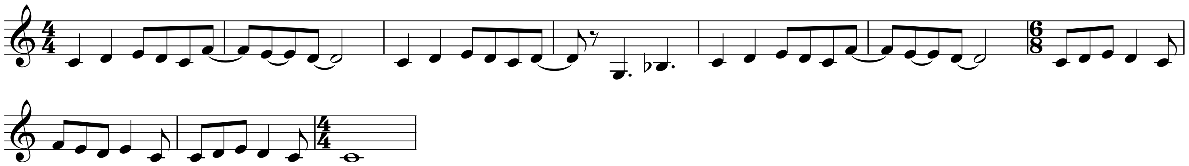
Figure 19: Theme I-A2, renotated
To transition to Section III, Theme I-A2 dissolves into a polytonal rendition of the V-B theme from Section V (Figure 20), which was introduced earlier in an obscured form as Theme I-B. In this version the melody is significantly more discernable, though it is not a complete presentation of the material.
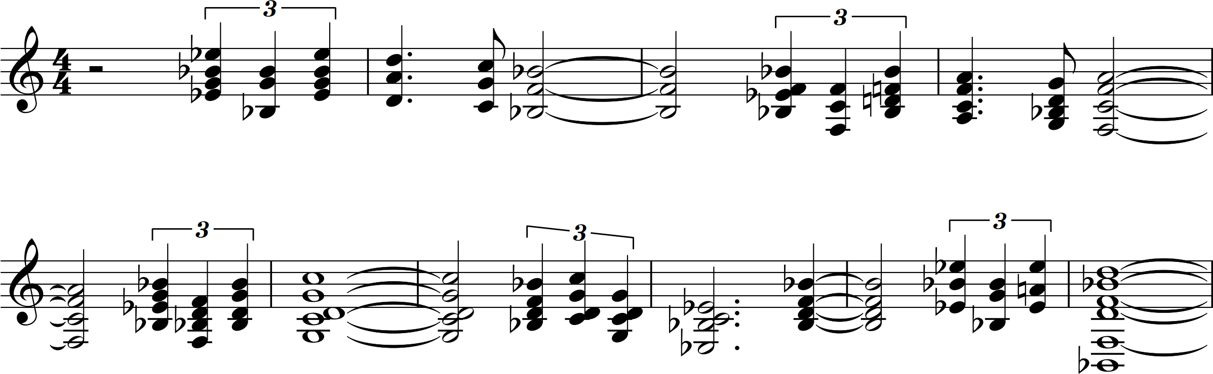
Figure 20: Section II, Polytonal Theme V-B

Chapter 5: Section III, mm. 363–460

Section III serves as the Symphony’s slow movement, and is through-composed. It is constructed in two separate layers: an accompaniment of slow-moving chords, overlaid by a woodwind quintet.
The inspiration for Section III comes from two sources. The first is Gavin Bryars’s Jesus’ Blood Never Failed Me Yet, in which a recording of a homeless man singing a hymn is backed by orchestral harmonies in gradually increasing dynamic levels and density. The second inspiration is John Adams’s Christian Zeal and Activity, the middle movement of his American Standard. In Adams’s work, a hymn tune (specifically “St. Gertrude”) is obscured by Adams to create displaced voice-leading in a Mahlerian style. Over this hymn tune a recording is overlaid, usually a recording that is religious in nature.
The chordal accompaniment of Section III is an obscured hymn tune like Adams’s Christian Zeal and Activity. In this case, the tune is Woodworth, the tune most familiar as the hymn “Just As I am”. The tune was doubled in note duration multiple times to extend the musical material. Because the tune is largely homorhythmic, the common tones were tied together to further hide the source material, and moments of attack were shifted forward or backward by one or more beats. The result is a texture not immediately recognizable, as seen in the comparison between the obscured and source material in Figure 21.
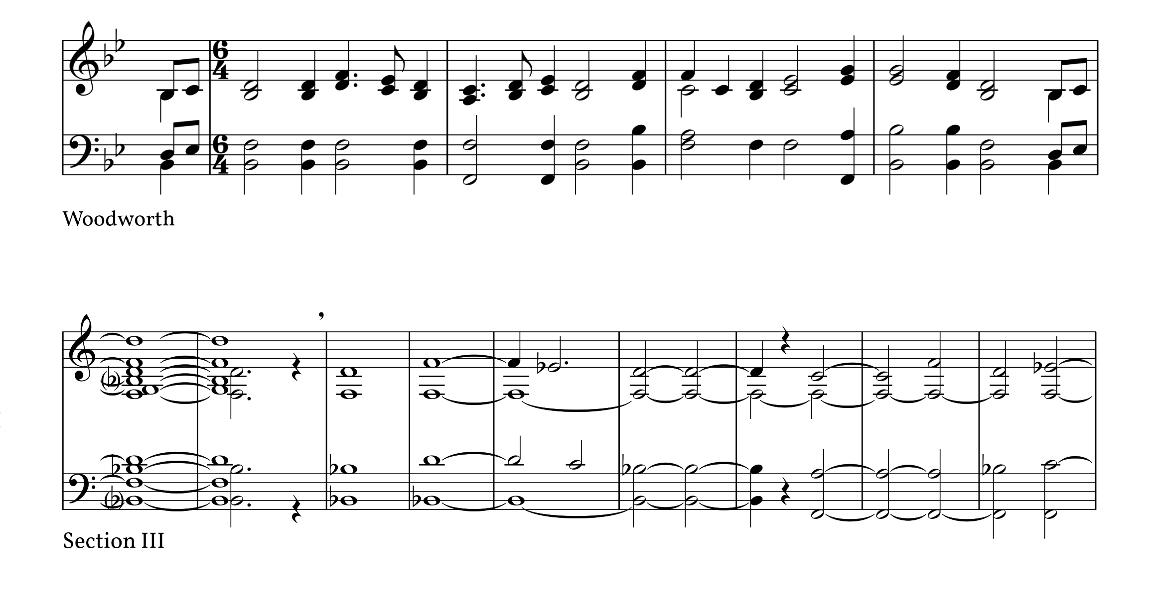
Figure 21: Section III and Woodworth Tune
Figure 22 shows the Soprano (solid) and Tenor (dashed) lines mapped to their original pitches in the source tune. This obscured tune is presented twice, the first time with a pitch center of Bb, the second with a pitch center of D. The two presentations are otherwise identical.
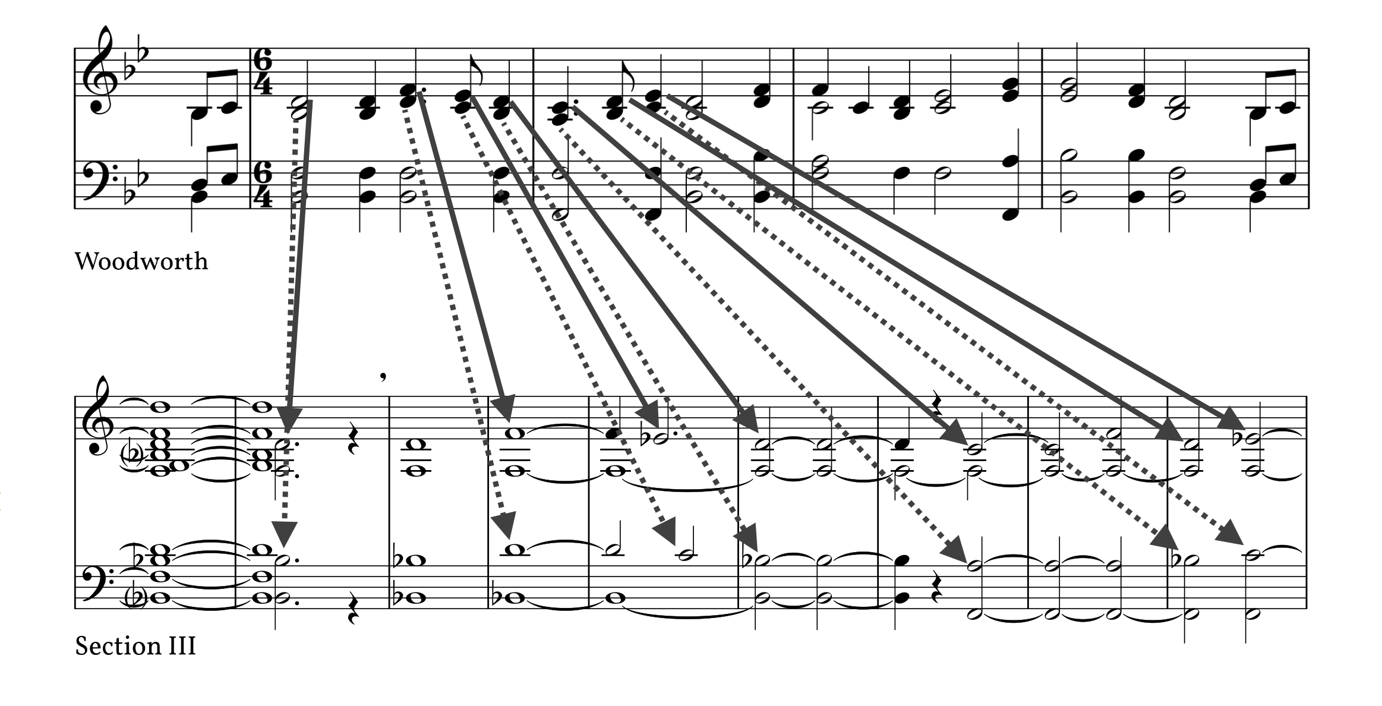
Figure 22: Pitch Mapping between Abstraction and Woodworth Tune
Though the process of generating the accompanimental material is engaging, the resultant music does not generate significant interest, nor was it designed to do so. Interest and motion in Section III is created in the woodwind quintet overlay. The quintet, titled Discursion, was conceived as both the highlight of Section III and a stand-alone work as well. Though Section III cannot adequately function without the quintet component, the quintet may be performed separately. A full score to the stand-alone quintet appears in Appendix C. The conscious choice to create a stand-alone work dictated the compositional process of the work. The quintet was written with the help of the already-created hymn abstraction as a harmonic guide, as seen in Figure 23. The chord progression of both the abstraction and quintet are identical.
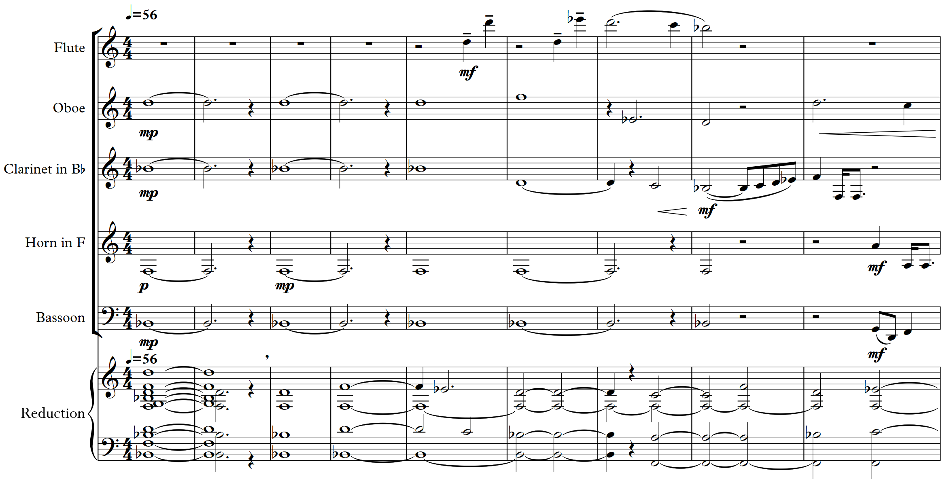
Figure 23: Section III Quintet with Hymn Abstraction (mm. 361–369)
The quintet portion is through-composed, meandering through the abstracted progression, seemingly somewhat aimlessly. Like the variations in Section II, the melodic components of the quintet follow a cumulative form. The melodic material starts as seemingly disjunct melodic fragments, but over time these fragments develop into a portion of the V-B theme, seen in Figure 24.
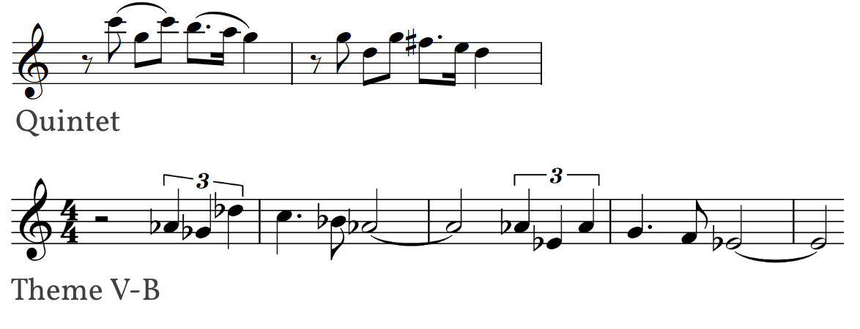
Figure 24: Quintet and Theme V-B
Aside from the technique of arranging fragments, there is no overarching form to the quintet. The resultant work aims to have the effect of wandering and soul searching within the narrative journey of the Symphony. Though Section I brought a clear form and Section II brought a more ambiguous form that started a new section approximately every twelve measures, Section III is the largest contiguous section in Symphony No. 1.

Chapter 6: Section IV, mm. 461–568

Section IV is the turning point of the Symphony. During the first three Sections the form has relaxed, the harmonies have become more abstract and less functional, and the overall character has moved from self-assured and whimsical to meandering and questioning. Section IV begins the musical journey back to the Symphony’s initial material. After the preceding six minutes of meandering woodwind quintet textures, Section IV rockets forward with newfound energy.
The source of this strength is familiar. In addition to the significant change in tempo, the accompanimental sixteenth-note figure in the piccolo and flute (Figure 25) references the same figure appearing in Section II, mm. 300. The use of this figure creates a sense of unity with the Variations portion of Section II (specifically, variations 2-4) and foreshadows the accompaniment in Section V.
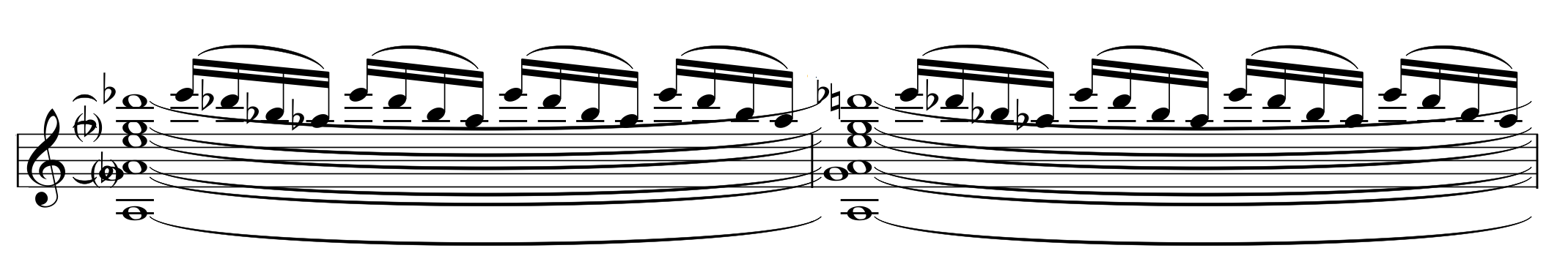
Figure 25: Accompanimental Material in Section IV (mm. 461-62)
Like the previous section, Section IV is through-composed, with a 23-measure introduction that leads to the section’s primary material. The introduction comprises a series of three ostinati, two of which continue through the primary material. The first is the sixteenth-note accompaniment from Figure 25, which has a duration of two eighth notes. The second is a five-note motive that is introduced in the bassoon and contrabassoon parts (Figure 26). Together with the sixteenth-note figure, a complete cycle of the two ostinati has a duration of ten eighth notes. While the first two ostinati carry over from the introduction to the primary material, the third ostinato (Figure 27) occurs only during the introduction. It differs from the first two ostinati by using notes of different values, which gives it a more melodic feel. It is the largest of the three ostinati with a length of seven eighth notes, and combined with the previous two it creates an ostinato cycle that repeats every seventy eighth notes, or at this time signature, eleven measures and one beat. In the course of the introduction, the combined three-part ostinato is presented slightly less than two complete cycles.
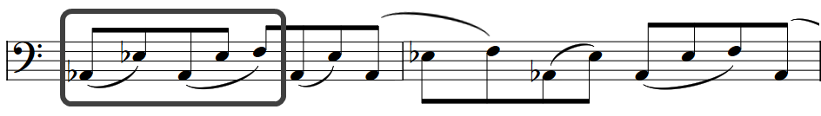
Figure 26: Second Ostinato in Section IV (mm. 464–65)
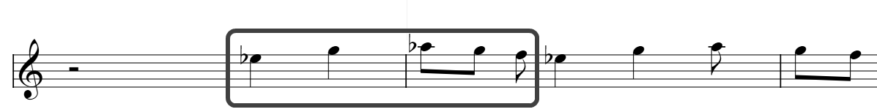
Figure 27: Third Ostinato in Section IV (mm. 466–67)
The focal point of the introduction is a collection of held Ebs and Abs, prepared by a note a half-step away, as shown in Figure 28. This figure contrasts the up-tempo ostinato and foreshadows the primary material in Eb.
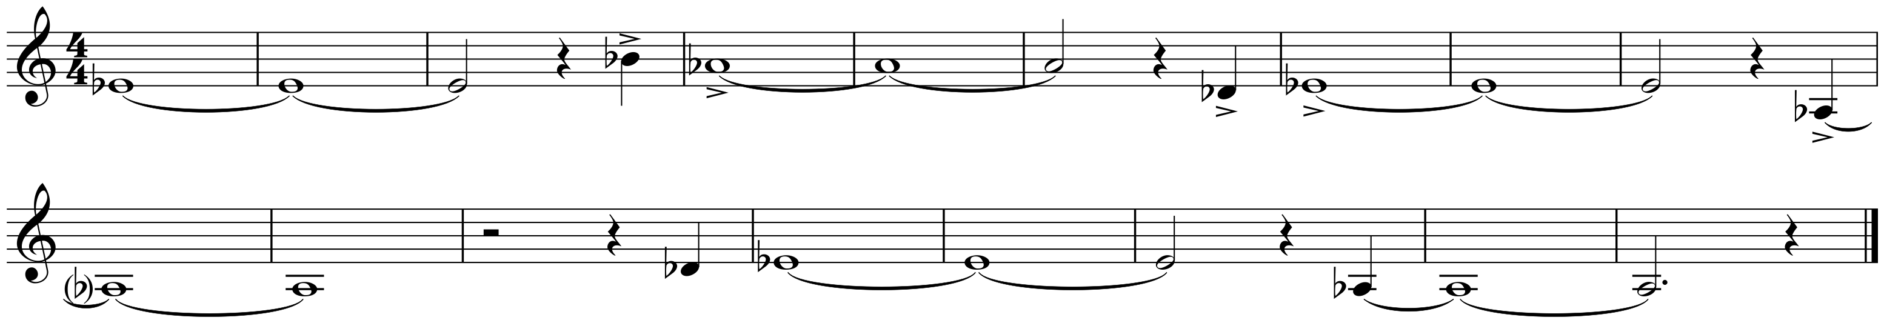
Figure 28: Section IV Introductory Melody (mm. 466–82)
The primary material of Section IV is the same obscured hymn tune from the previous section. Previously heard in the keys of Bb and D, Section IV presents the material in Eb. Now the obscured hymn is the point of focus, rather than the quintet from Section III or the ostinato. Like Section III, the abstraction here powers the other elements (quintet and ostinato) by way of harmonic progression, so it would appear likely that the abstraction would continue being an accompanimental device. However, the tempo increase from q=56 to q=138 and the addition of the ostinato allow the accompaniment to emerge as significant melodic material. The tempo increase allows the abstraction to be heard in context and be understood as a melodic line, as opposed to when it existed primarily as a slow-moving chord progression in Section III. The added ostinato, though interesting in the introduction, becomes familiar quickly and does little to generate interest, though it creates forward motion. The intended resulting effect is a balance of forces between the ostinato and the abstraction, resulting in a sort of forward-looking meditation.
The transformation that occurs between Sections III and IV takes on a deeper meaning considering the significance of the hymn tune. Just As I Am has a long history of use as an invitational hymn in American revivals, which leads to two different though not incompatible explanations for the transformation of the abstraction. On one level, the hymn’s message of an individual’s sufficiency to ask for salvation is mirrored in the Symphony’s usage of the same material as accompaniment and melody. The transformation between the sections is the realization that the abstraction is sufficient to serve not only as accompaniment, but also as melody. On another level, the transformation that occurs between Sections III and IV could be viewed as the act of salvation itself, with the abstraction being made new through a higher power, a power that is in this example higher in pitch (the ostinato). As a closing to this religious thought, the composer is reminded of Matthew 20:16, “So the last shall be first, and the first last”.
Closing out Section IV is a transition in two parts to Section V. The first portion is a repeat of Theme I-A2 from Section II and is augmented by the continuation of the ostinati from the Section IV accompaniment. The return of this theme marks the first use of Section I material since the end of Section II. The second portion of the transition is a more sparse presentation of fragments from Theme I-A, now presented in $\begin{matrix}\text{4} \\ \text{4}\end{matrix}$. The five-note ostinato ends in m. 560 but the sixteenth-note figure continues, as it plays an important role in Section V. The bass and brass instruments fall out in mm. 565–567, creating a texture that emphasizes the middle and high instruments. A sweeping run in the woodwinds brings us to the beginning of Section V.

Chapter 7: Section V, mm. 569–755

Section V is closely related to Section II, and has many of the same features. The first portion of the section is based on dense orchestration and uses this effect to drive a series of variations. However, instead of the variations, theme, and variations form of Section II, Section V is cleanly split into two segments, a set of variations of orchestration (notated Section V(a)) and a march (notated Section V(b)). Like Section II, this section serves as a bridge between the ambiguous middle sections (III and IV) and the more defined ending of Section VI.
Section V’s variation segment is constructed as the reverse of Section II’s. Instead of presenting a theme which is then intensified with multiple layers, Section V takes the energy generated during the previous section and slowly strips away layers until only the theme remains. Unlike Section II’s layered variations which occurred with every iteration of the melody, Section V’s present the entire melody in Layer I, then removes a layer every half-iteration. While Section II raised the pitch center with every iteration, Section V lowers the pitch center, first by step from Bb to Ab, and then by major third from Ab to E (Table 9).
Layer 1 | Layer 2 | Layer 3 | Layer 4 | Layer 5
All | - Echo | - Sextuplets | - Sixteenths | - Octaves
Bb | Ab | Ab | E | A (ambiguous)
mm. 569–582 | mm. 583–590 | mm. 591–596 | mm. 597–604 | mm. 605–609
Table 9: Structure of Section V(a)
Additionally, the subtraction of layers in Section V(a) reverses the addition of layers in Section II(b), as shown in Table 10. This attempts to help strengthen the association between sections, which together serve as internal bookends to the center material and creates an internal arch form (Figure 29).
 | Layer 1 | Layer 2 | Layer 3 | Layer 4 | Layer 5
mm. | 287–293 | 294–299 | 300–305 | 306–312 | 313–319
Section II | Theme | +Octaves | +Sixteenths | +Sextuplets | +Echo
Section V | All | -Echo | -Sextuplets | -Sixteenths | -Octaves
mm. | 569–582 | 583–590 | 591–596 | 597–604 | 605–609
Table 10: Comparison of Layer Variations of Sections II(b) and V(a)


Figure 29: Form of Sections II(b) through V(a)
The thematic material for Section V(a) is a melody based on Theme II-A. Like most themes in the Symphony, this theme is a collection of figures that include a three-note grouping (in this case a triplet) followed by a scalar passage (Figure 30).
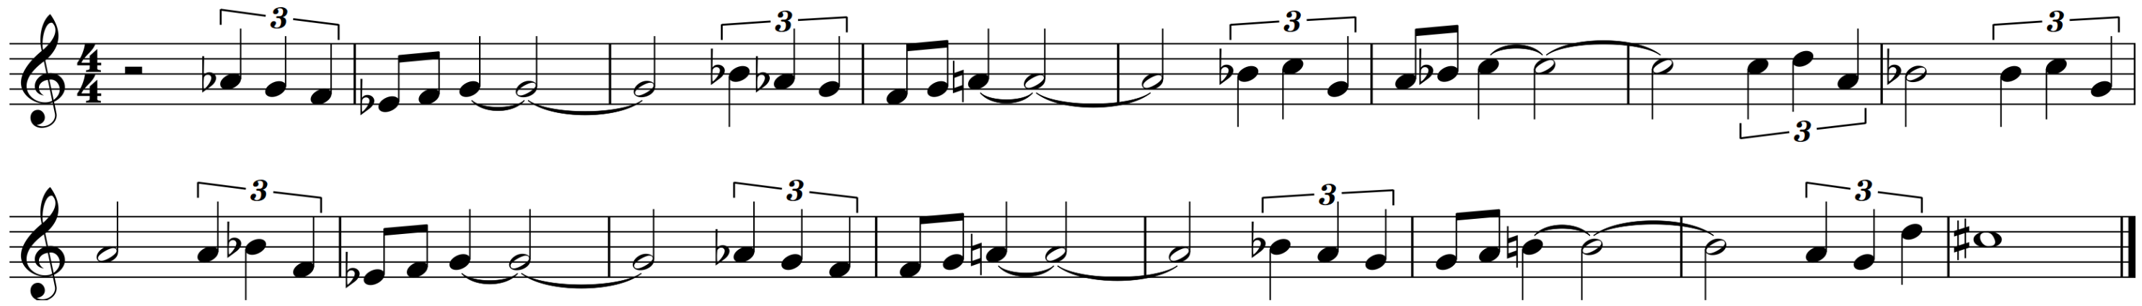
Figure 30: Theme V-A (mm. 569–583)
The opening motive of the V-A theme is a rhythmic augmentation of the opening motive of Theme II-A (Figure 31). Additionally, the V-A theme is significantly longer than its counterpart in Section II.
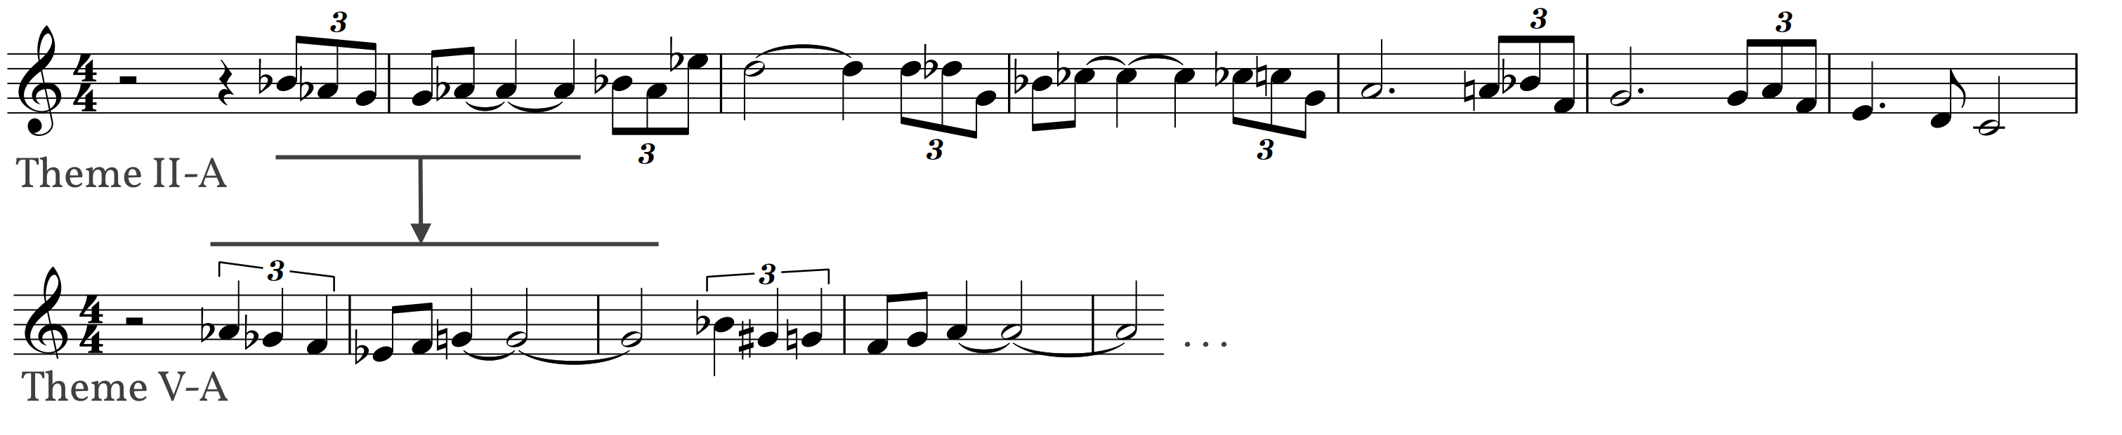
Figure 31: Themes II-A (mm. 287–293) and V-A (mm. 569–583)

As in Theme II-A, the V-A theme is influenced by Theme V-B, showing the same triplet and scalar passages as seen in most of the other themes in The Symphony. The beginning of Theme V-B ends the V-A theme, as seen in Figure 32. Though the themes are presented in sequence in Section V, they are not elided.
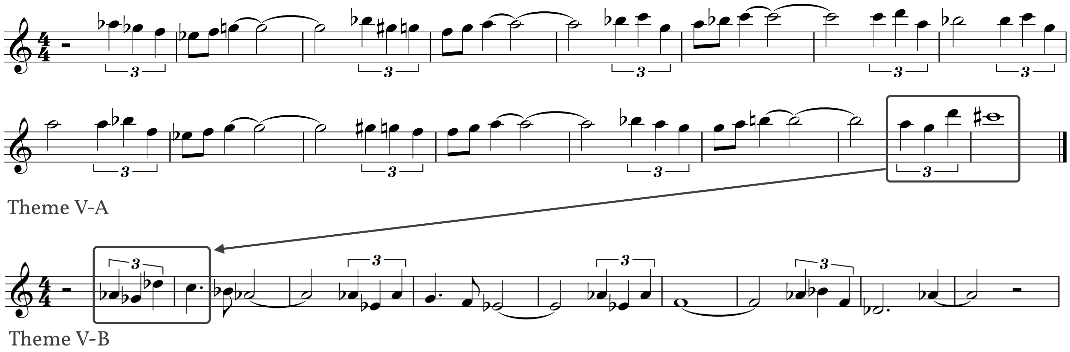
Figure 32: Themes V-A (mm. 569–582) and V-B (mm. 655–662)
In the first two layers of Section V(a), there is a countermelody in the tuba and bass clarinet parts (mm. 569–591). This melody is an augmented form of Theme I-A, as shown in Figure 33.
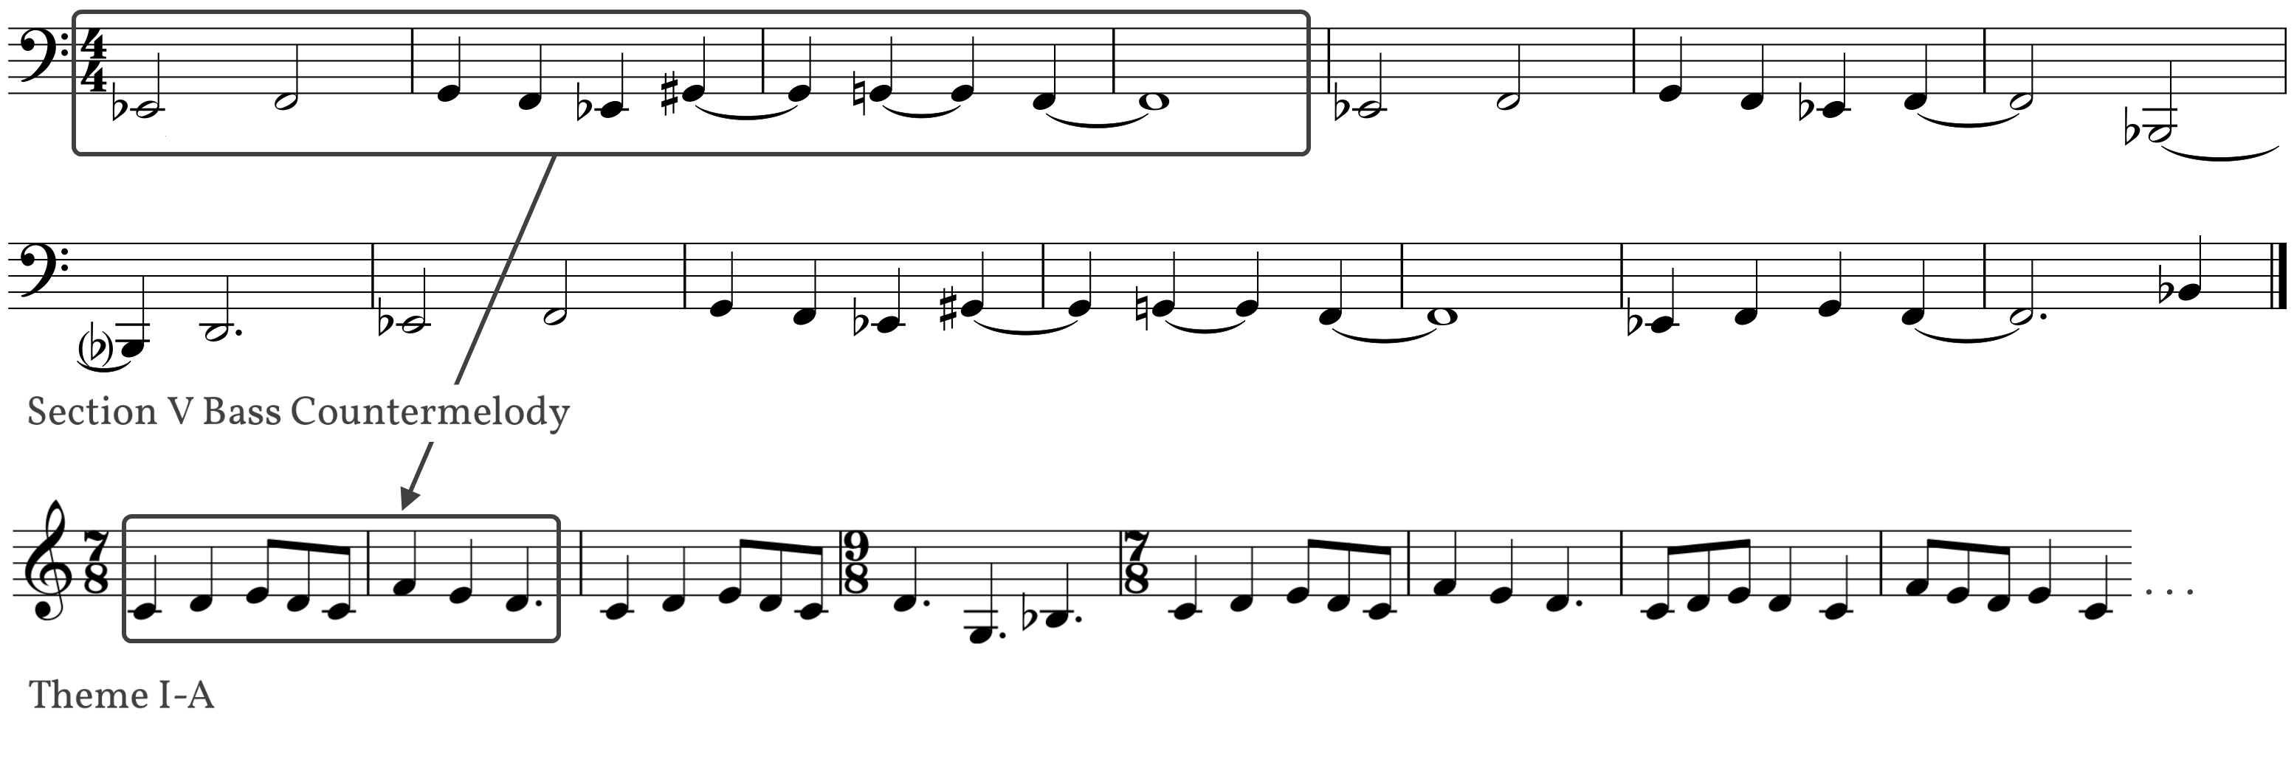
Figure 33: Section V Bass Countermelody (mm. 569–82) and Theme I-A (mm. 13–20)
The first portion of Section V closes with an iteration of the theme which slows, leads into a crescendo in all active parts, and lands on a sustained Db major chord, thus bringing the forward motion from this first portion to a halt.
The second portion of Section V is a march based on Theme V-B, which is the culmination of the previous use of this theme through the past four sections. The material in Section V(b) is based on Theme V-B, which is seen in Figure 34.
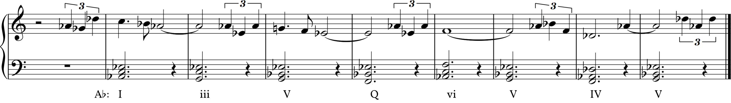
Figure 34: Theme V-B (mm. 655–62)
This theme poses a compositional challenge in that it ends on a half cadence, leading back into itself, making it difficult to compose a convincing closure. This closure issue is reminiscent of the hymn used in Jupiter, the Bringer of Jollity from Gustav Holst’s orchestral suite The Planets. Holst’s hymn also ends on a half cadence, and is written in such a way to suggest the most logical material to follow it is the same material transposed up an octave, as shown in Figure 35.
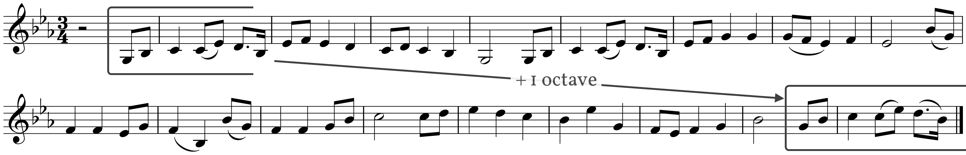
Figure 35: Holst Hymn showing Octave Repeat
Section V(b) begins with an unusual moment in the work. After the crescendo at the end of Section V(a), the motion stops and focus shifts to the percussion section, which presents an obscured version of the Theme V-A on pitched percussion. The sense of time is suspended in the percussion break, creating a free-flowing introduction to the march section.
After the percussion break, Theme V-A is presented once in the horns, leading to four presentations of Theme V-B. This material is presented in common time, in a steady tempo of q=100, accompanied by a snare drum ostinato that reinforces the march topos. The march section is followed by a closing using the V-A theme, as seen in Table 11. Each iteration of the V-B theme is louder and more heavily orchestrated than its predecessor, not unlike Holst’s treatment of the hymn in Jupiter. The repeated presentations of the V-B theme are presented with a pitch center of Ab, without variation in pitch center.
 | Section V-A Theme | V-B 1 | V-B 2 | V-B 3 | V-B 4 | Section V Closing
Mm. | 639–54 | 655–72 | 673–80 | 681–688 | 689–698 | 699–714
Melody | Horns | A. Sax | Cl. & Trp. | Fl., Cl., A.S. | Glock, Picc., Trp. | Horn, Trp.
Accomp. | Saxes | Bassoons, B.Sax | A. Sax, low brass | +Horns | -low brass | Clarinet
Perc. |  | Snare | + Chimes | + Marimba | +Vibes | Marimba
Table 11: Structure and outline of Theme V-B Iterations
The V-B march closes with a polytonal return to Theme V-A, which mirrors the polytonal V-B theme that closes Section II (Figure 20, page 20).
Section V ends with a two-part transition that leads to Section VI. The first portion of this transition is an amalgamation of previously introduced material, primarily by juxtaposing the first measure of Theme I-A and the second measure of Theme V-A, as shown in Figure 36. In addition, Theme II-A returns in the horns in m. 737.
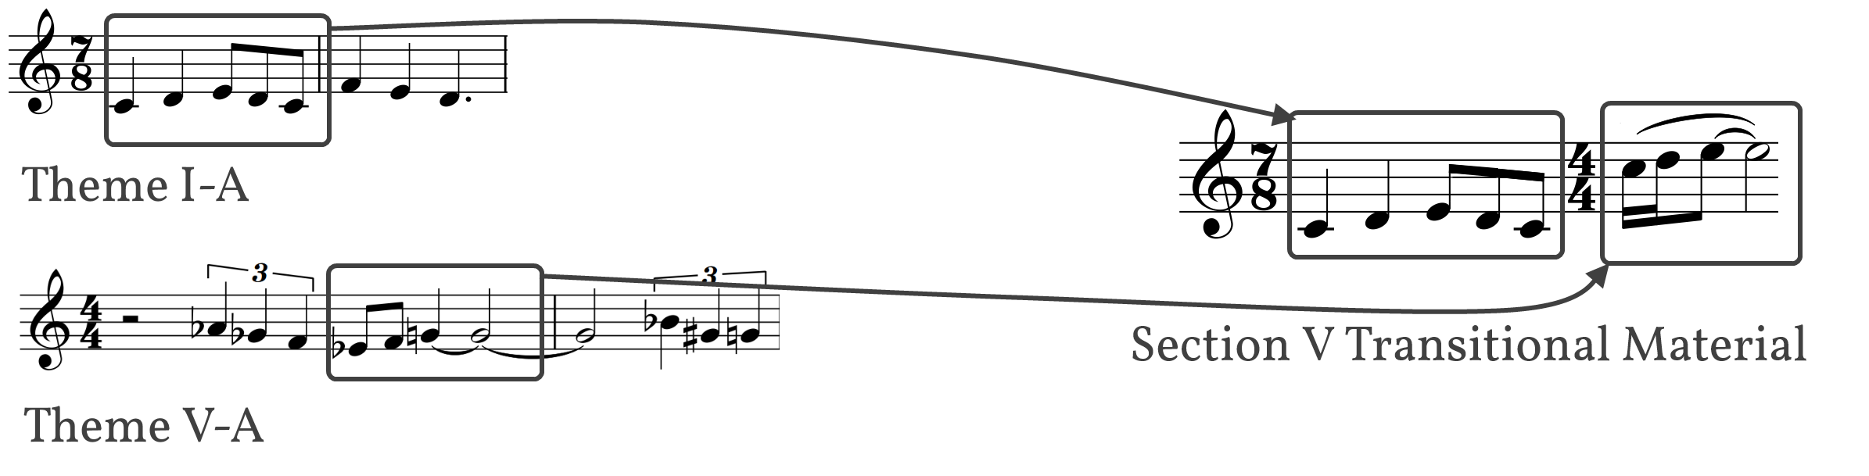
Figure 36: Section V Transitional Material
This transition immediately leads to a repeat of Theme I-A2 (see Figure 19: Theme I-A2, renotated, page 19), first seen in the closing of Section II and later appearing in the closing of Section IV.

Chapter 8: Section VI, mm. 756–1000

Section VI is the closing section of Symphony No. 1, and uses many of the same elements as its counterpart in the mirror form, Section I. For that reason, this chapter will focus primarily on its differences from Section I rather than an overall analysis.
Section VI serves as the work’s recapitulation, marking the end of a journey that began with the more traditional forms and harmonies of Section I, through lesser-organized forms and tonalities, self-searching and evaluation through Sections II-V, and back to its roots with a newfound purpose. Section VI is at its heart an affirmation of the Section I material. It has less hesitations and apprehension and more gumption and drive, as evidenced by the section’s usage of the more stable and predictable I-A2 theme in $\begin{matrix}\text{4} \\ \text{4}\end{matrix}$ and steady tempo. While Section I has tempo fluctuations between q=138 and q=152, Section VI holds at a constant q=168 with no tempo fluctuation until the codetta.
Like its counterpart, Section VI is roughly based on sonata principles, ternary in form, with its major sections outlined in Table 12. Additionally, with the exception of the introduction of Eb major in the A section and a collection of pitches suggesting a tonal center of D minor in the development, the key areas of this section are identical to Section I (Table 12).
Introduction | A | Transition | B (development) | A
mm. 756-67 | mm. 768-830 | mm. 831-42 | mm. 843-934 | mm. 935-71
C Maj. | C Maj., G Maj., Eb Maj. | Eb Maj. | Eb Maj., D min., Eb Min. | C Maj.
Table 12: Structure of Section VI
There are four main components of Section I that have been altered for this return. The first is the increased tempo and subsequent lack of tempo variations in Section VI, as previously discussed. The second is a renotation and change in Theme I-A. The original (Figure 37) is conceptualized and written in $\begin{matrix}\text{7} \\ \text{8}\end{matrix}$, with a measure of $\begin{matrix}9 \\ \text{8}\end{matrix}$ inserted. The renotated version for Section VI (Theme VI-A, Figure 38) is based in $\begin{matrix}\text{7} \\ \text{8}\end{matrix}$ but written in $\begin{matrix}\text{4} \\ \text{4}\end{matrix}$, with two measures of $\begin{matrix}\text{7} \\ \text{8}\end{matrix}$ to fit the closing measure’s agogic accents. The renotation to $\begin{matrix}4 \\ \text{4}\end{matrix}$ requires an extension of the last note of the second and sixth measures, which attempts to help the melody sound more established and less tentative, reaffirming the narrative of purpose. The change of the next-to-last measure from $\begin{matrix}\text{7} \\ \text{8}\end{matrix}$ to $\begin{matrix}6 \\ \text{8}\end{matrix}$ also helps the theme sound more decisive. Theme VI-A moves to Theme VI-B as expected, and remains unaltered from the original Theme I-B.
Figure 37: Theme I-A
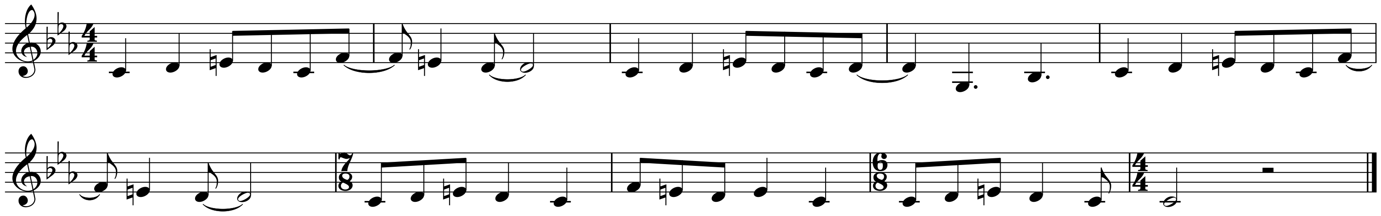
Figure 38: Theme VI-A
Theme VI-C (Figure 40), however, renotates the Theme I-C’s (Figure 39) first measure to $\begin{matrix}\text{4} \\ \text{4}\end{matrix}$, and swaps the $\begin{matrix}6 \\ \text{8}\end{matrix}$ measures for $\begin{matrix}\text{3} \\ \text{4}\end{matrix}$. This renotation and swap add an extra eighth note to each iteration of the secondary theme.

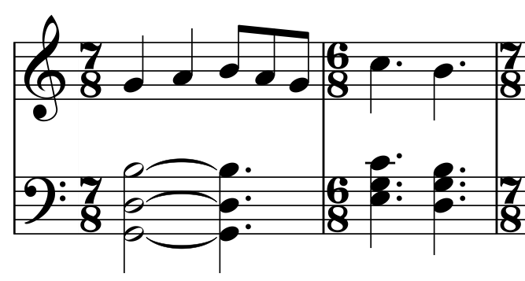
Figure 39: Theme I-C Fragment (mm. 49-50)
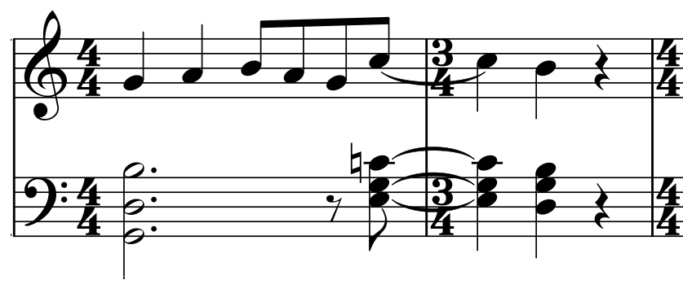
Figure 40: Theme VI-C Fragment (mm. 811-12)

In Section I’s I-C theme, the first presentation of VI-C is in G (acting as the dominant), and the second presentation appears in C (tonic). In Section VI, the first presentation remains in the dominant, but the second presentation moves to Eb, or bIII. This pitch center continues through a brief restatement of Theme VI-A and the introductory chordal material from mm. 1-12, never returning to the expected tonic of C, which closed the beginning A section in Section I.
The development begins with a fugato section similar to Section I, but rather than easing into an introductory section followed by a fugato section, Section VI immediately jumps into the full fugato section. Though both Section I and Section VI begin the imitative section with a tonal center of Eb, Section I moves to Ab while Section VI falls a half step to D. In both sections, the key change leads to an iteration of the primary material in Eb minor, which is identical to Section I’s presentation.
This minor version of the primary material leads directly to the groove section, which in Section VI is enhanced by the addition of a stylized iteration of Theme V-B (Figure 41).
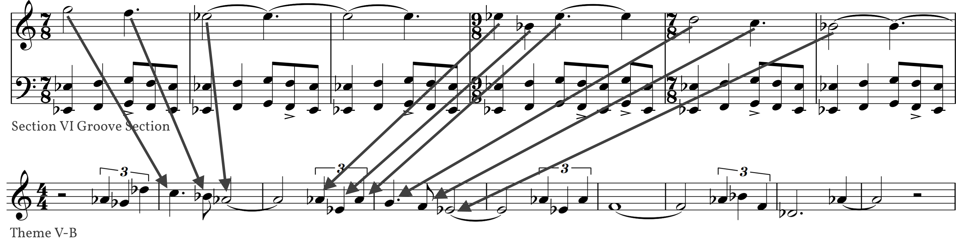
Figure 41: Section VI Groove Section
On the repeat of the groove section, an additional layer, an abstraction of Theme I-A, is added (Figure 42). It is altered to fit the $\begin{matrix}\text{7} \\ \text{8}\end{matrix}$ - $\begin{matrix}\text{9} \\ \text{8}\end{matrix}$ pattern, and serves as a grounding countermelody.
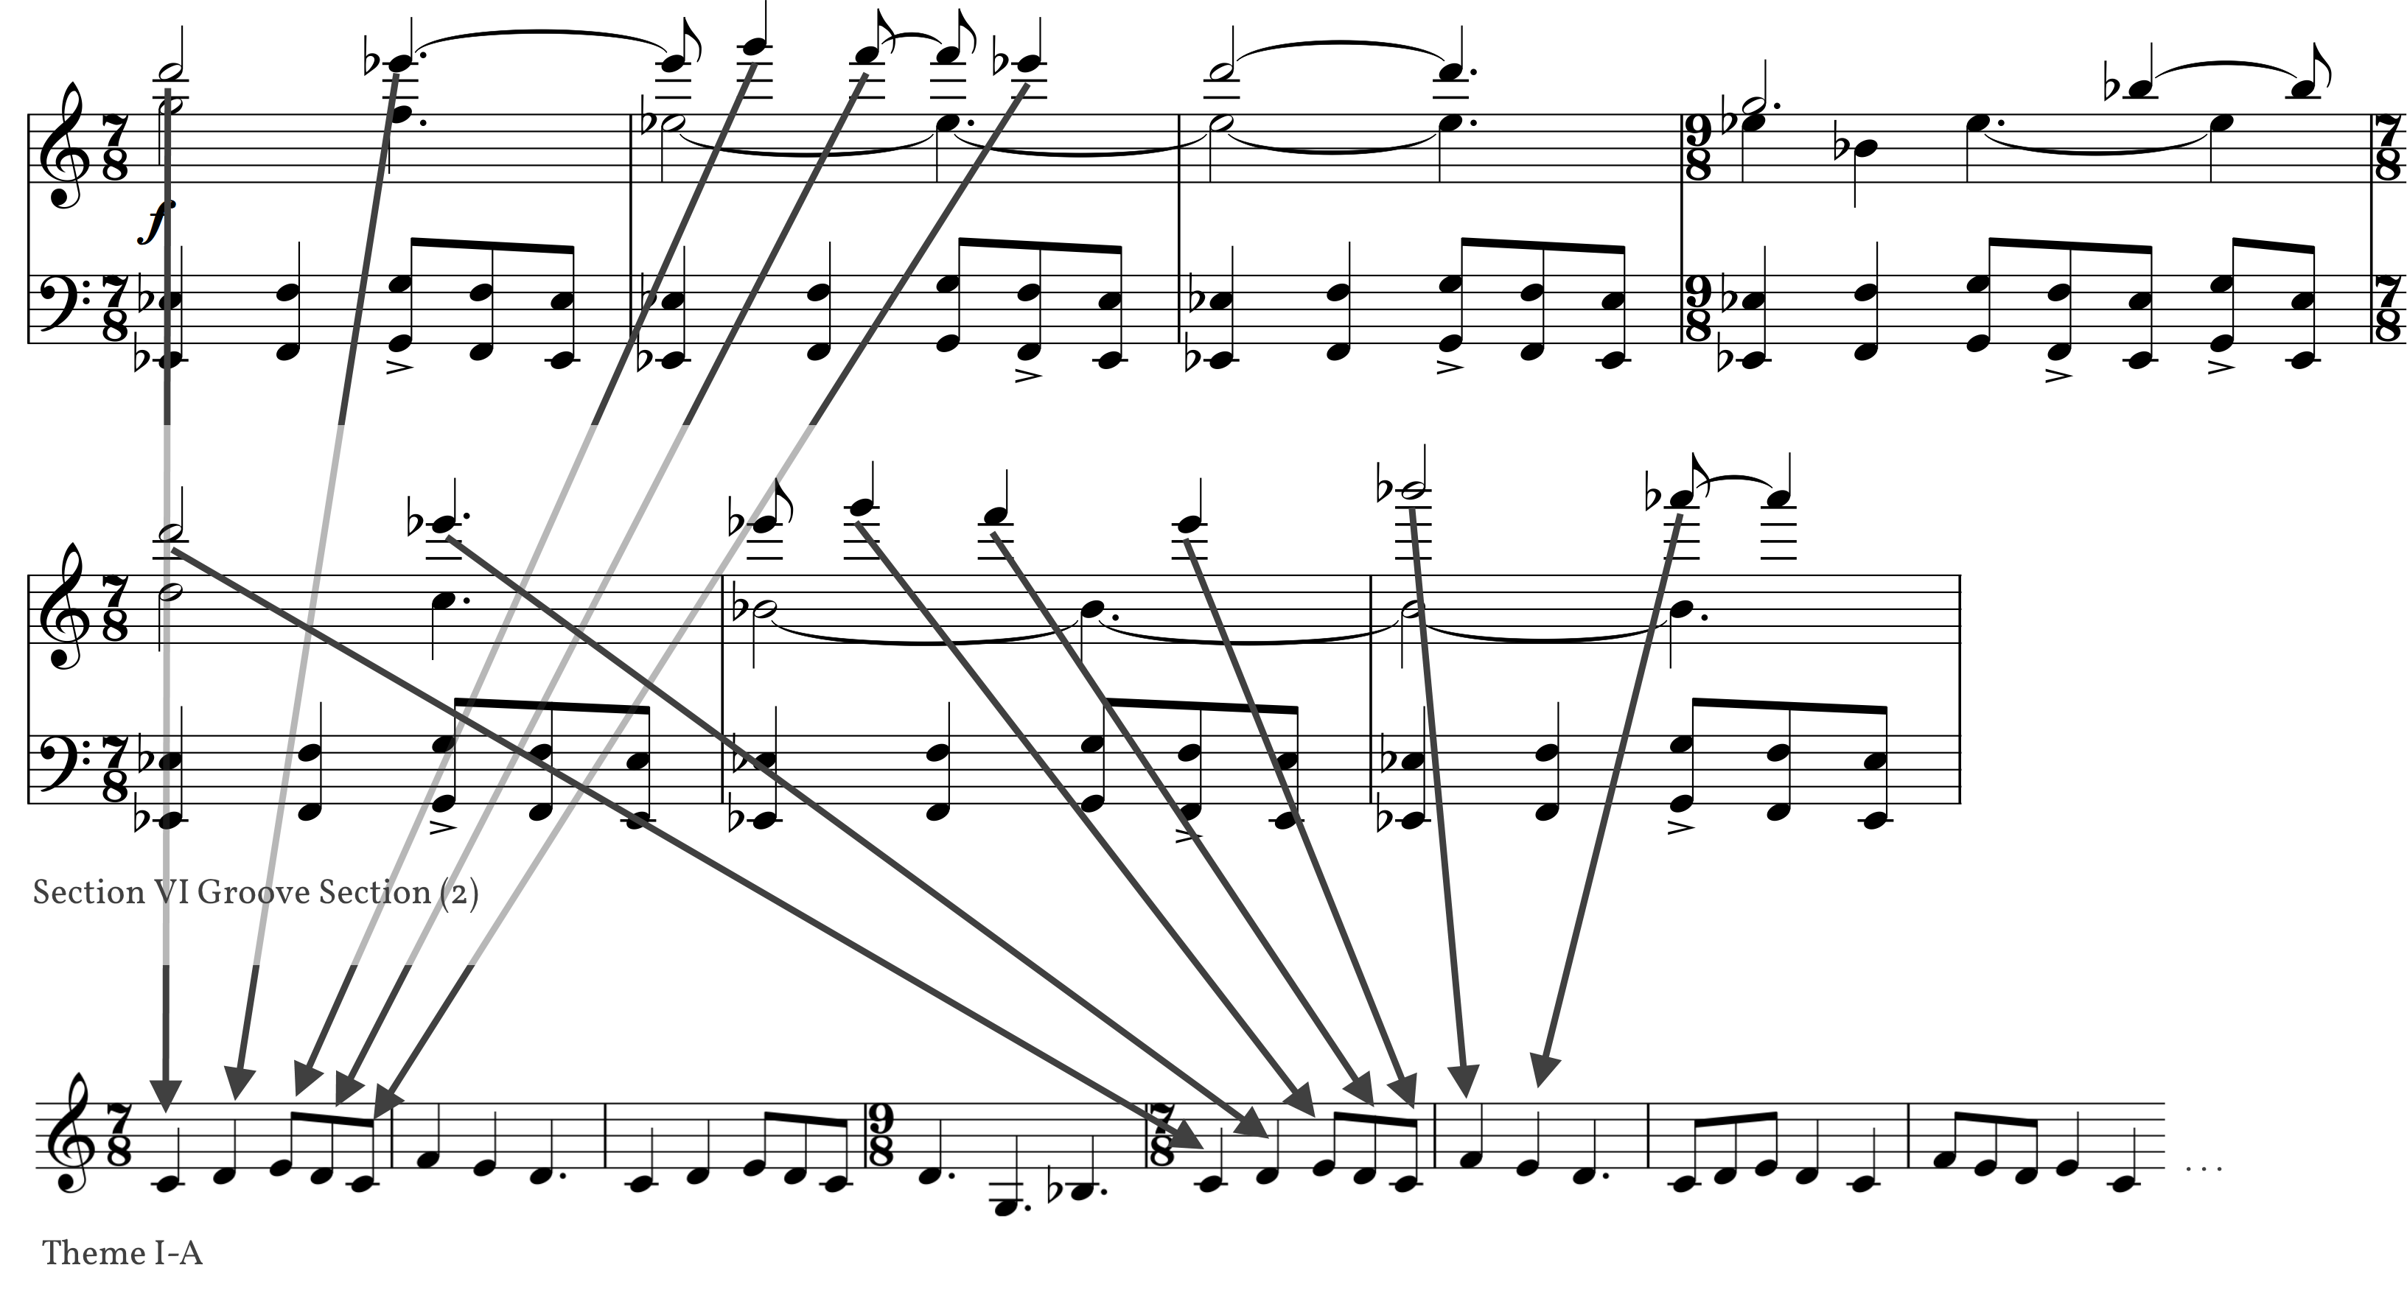
Figure 42: Section VI Groove Section (2)
As with Section I, the groove section brings us to a partial return recapitulation with a pitch center of C, omitting the secondary theme and key area. The final presentation of the VI-A theme is accented with a countermelody (Figure 43) in the trombones, partially based on the recently-developed groove section material.
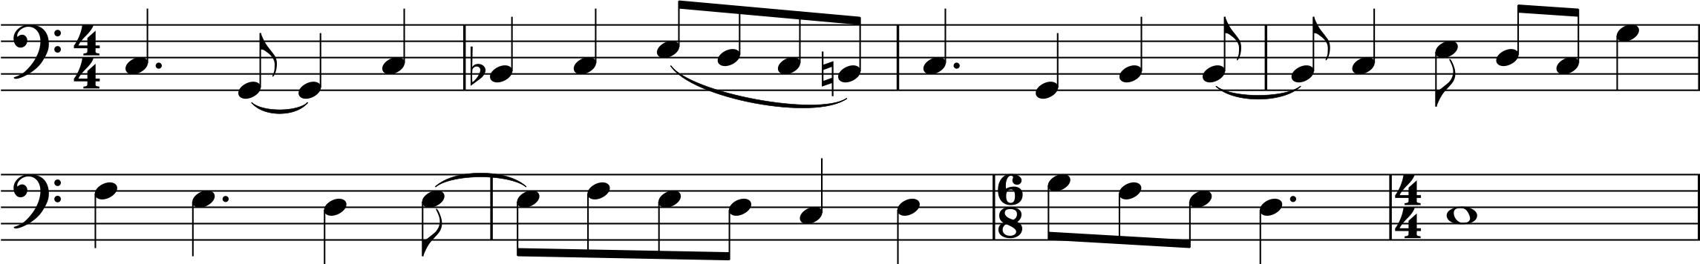
Figure 43: Section VI Countermelody
The final presentation of the VI-A theme leads to the codetta, which serves to reduce the energy and motion collected through the sixth section. Energy reduction is first accomplished by reducing note values, effectively halving the speed. However, this tactic would create too jarring of a transition, so a steady eighth-note pulse on C in the xylophone helps create motion through the final measures of the recapitulation into the beginning of the codetta while the winds hold a C Major chord (m. 927). Motion switches suddenly with an Ab chord introduced in the low winds and saxophones, followed by a recollection of Theme VI-A from the groove section. This Ab chord bounces around between G, Ab, and Bb (G, Bb, G, Ab, G) before landing on C to finish the work. The melodic material in the codetta is altered material based on the V-B and I-A themes. The final glissando is from Theme I-A2, where it initially served as transitional material. It now functions as cadential material to finish the symphony.

Chapter 9: Summary
Symphony No. 1 is a one-movement work with six interconnected sections or episodes that are organized by ternary, theme and variations, and cumulative forms. These sections are arranged to create an overall mirror form, where sections I, II, and III use similar materials or compositional processes as sections VI, V, and IV respectively.
Although this work does not strictly adhere to the symphony as a form in a traditional sense, there are several features of this symphony that reference or pay homage to the symphonic genre. The macro-level mirror form treats the innermost four sections as a development section, as expected in sonata form. The work includes a slower section (III) that functions as the expected slower second movement.
Additionally, the motivic material of this symphony is developed from two initial motives, I-A and V-B. Frequent references to previous or successive themes attempt to create a sense of unity throughout a substantial work. The symphony is only programmatic in the most abstract sense as a journey from familiar to unfamiliar material and back again.

Bibliography

Adams, John. Christian Zeal and Activity. Rhino R2 522120. CD. 2009.

Adler, Samuel. The Study of Orchestration, 3rd ed. New York: WW Norton, 2002.

Bradbury, William B. and Charlotte Elliott. “Just as I Am” (No. 488) in The Celebration Hymnal. Nashville: Word Music, 1997.

Bryars, Gavin. “Jesus’ Blood Never Failed Me Yet.” Gavin Bryars. http://www.gavinbryars.com/work/composition/jesus-blood-never-failed-me-yet (accessed April 16, 2014).

Burkholder, J. Peter. All Made of Tunes: Charles Ives and the Uses of Musical Borrowing. New Haven, Yale University Press, 1995.

Gould, Elaine. Behind Bars: The Definitive Guide to Music Notation. London, Faber Music, 2011.

Holst, Gustav. The Planets. Edited by Clinton F. Nieweg and Gregory Vaught. Boca Raton: Masters Music Publications, 1997.

LaRue, Jan et al. "Symphony." Grove Music Online. Oxford Music Online. Oxford University Press, accessed April 16, 2014, http://www.oxfordmusiconline.com/subscriber/article/grove/music/27254.

Maslanka, David. Symphony no. 4. New York: Carl Fischer, 1994.

Newman, Jonathan. Symphony No. 1, My Hands are a City. New York: OK Feel Good Music, 2009.

Pann, Carter. Slalom. King of Prussia: Theodore Presser Company, 2008.

Persichetti, Vincent. Symphony for Band. King of Prussia, Elkan-Vogel, 1958.

Schwantner, Joseph. In Evening’s Stillness. Mainz: Schott-Helicon Music Corporation, 1996.

Stedman, Preston. The Symphony. 2nd ed. Upper Saddle River: Prentice Hall, 1992.

Appendix A: Instrumentation

Piccolo
2 Flutes
2 Oboes (2nd doubling English Horn)
3 Clarinets in B-flat
Bass Clarinet in B-Flat
2 Alto Saxophones
Tenor Saxophone
Baritone Saxophone
2 Bassoons
Contrabassoon

3 Trumpets in B-flat
4 Horns in F
2 Trombones
Bass Trombone
2 Euphoniums
Tuba
Double Bass
Piano

Timpani
Percussion I (Glockenspiel, Bass Drum, Guiro, Tam-tam)
Percussion II (Tubular Bells, Xylophone, Claves, Shaker)
Percussion III (Marimba, tom-toms (5), Wind Chimes, Brake Drum, Cymbals)
Percussion IV (Vibraphone, Temple Blocks, Claves)
Percussion V (Triangle, Cymbals, Snare Drum, Gong, Tubular Bells (shared with II))
Percussion VI (Tam-tam, Crotales, Wood Blocks(5))

Appendix B: Complete Score of Symphony No. I

By Kyle Vanderburg

Appendix C: Complete Score of Discursion

By Kyle Vanderburg

Jan LaRue, et al, "Symphony," Grove Music Online, Oxford Music Online, Oxford University Press, http://www.oxfordmusiconline.com/subscriber/article/grove/music/27254 (accessed April 15, 2014).
When the same progression is used in Theme I-A as a closing, the melody’s emphasis on the dominant shifts the perceived prolongation to dominant, using the subdominant chords as neighbor motion to the dominant prolongation.
Cumulative form is defined by Peter Burkholder as “a thematic, non-repetitive form in which the principal theme is presented, not at the beginning as in traditional forms, but near the end, and is preceded, not followed by its development.” J. Peter Burkholder, All Made of Tunes: Charles Ives and the Uses of Musical Borrowing (New Haven, Yale University Press, 1995), 137.
Specifically, this motive re-appears in mm. 483-86 in the third trumpet, first and second horns, and first trombone.
The third and fourth measures were originally notated in $\begin{matrix}7 \\ \text{8}\end{matrix}$ and $\begin{matrix}9 \\ \text{8}\end{matrix}$, and the conversion to $\begin{matrix}4 \\ 4\end{matrix}$ resulted in no discernable change.
John Adams, interview by Charles Amirkhanian, Ode to Gravity, KPFA, April 18, 1973. https://archive.org/details/JohnAdamsOTG (accessed March 29, 2014)
John Adams, Christian Zeal and Activity, Rhino R2 522120, CD, 2009.
Matthew 20:16, (KJV).
This transition is covered in detail in its presentation in Chapter 4, located on page 19.

