UNIVERSITY OF OKLAHOMA
GRADUATE COLLEGE

NEED-BASED PROFESSIONAL DEVELOPMENT FOR SECONDARY MATH TEACHERS WITH ENGLISH LANGUAGE LEARNERS

A THESIS
SUBMITTED TO THE GRADUATE FACULTY
in partial fulfillment of the requirements for the
Degree of
MASTER OF EDUCATION

By
CRYSTAL NEILL
Norman, Oklahoma
2020

NEED-BASED PROFESSIONAL DEVELOPMENT FOR SECONDARY MATH TEACHERS WITH ENGLISH LANGUAGE LEARNERS

A THESIS APPROVED FOR THE
DEPARTMENT OF INSTRUCTIONAL LEADERSHIP AND ACADEMIC CURRICULUM

BY THE COMMITTEE CONSISTING OF

Dr. Kate Raymond, Chair
Dr. Heidi Torres
Dr. Rebecca Borden

©Copyright by CRYSTAL NEILL 2020
All Rights Reserved.
Table of Contents
Abstract vi
Chapter 1: Introduction 1
Current Status of English Language Learners 2
Importance of Access to Mathematics 4
Challenges for ELLs in Mathematics 5
Challenges for Math Teachers with ELLs 6
Research Question 7
Chapter 2: Literature Review 9
Effective Professional Development 9
Language Needs in Mathematics 13
Sheltered Instruction Observation Protocol 16
Disciplinary Literacy Strategies 20
Mathematics-Focused ELL Professional Development 27
Chapter 3: Methodology 29
Design 29
Selection of Participants 29
Data Collection and Analysis 31
Trustworthiness 34
Chapter 4: Findings 37
Overview of Needs 37
Strengths 41
Past PD Experiences 44
Perception of the PD Plan 46
Vision of PD Implementation 50
Chapter 5: Implications and Conclusion 54
Local Implications 54
Implications for Professional Developers 56
Implications for Future Research 60
Personal Implications 61
Conclusion 64
References 66
Appendix A: SIOP Checklist 74
Appendix B: Needs Assessment 75
Appendix C: Interview Protocol 86
Appendix D: Professional Development Plan 87

Abstract
As the number of English Language Learners in the U.S. continues to grow, all teachers, even high school math teachers, need to be prepared to scaffold both content and language for these students. However, current research shows that many teachers have not received professional development on these topics, even though theories such as the SIOP model and disciplinary literacy are available and shown to improve student achievement. This study will combine these theories with the principles of effective professional development and adult learning theory to investigate the needs of math teachers at a given school as well as the way teachers envision these needs being met through professional development. Findings showed that these teachers were unfamiliar with many of the ELL strategies presented and had widespread professional development needs. Teachers were also highly motivated and excited to learn through a plan that was tailored to their needs and offered choice in both topic and format. This study offers a snapshot of the potential of needs-based professional development for math teachers with English Language Learners.

Chapter 1: Introduction
“Can you draw a triangle?” I asked, mimicking “draw” with my hand. The Chinese teenager stared at his paper for a second, then looked at me and shook his head. My heart sank a little. I was observing a tenth-grade geometry class, and this student was repeating the class after failing it last year. He had come to the country a little over a year ago, and his conversational English was very low. Every day I watched him come into class, sit quietly until the lecture began, take notes for about five minutes, then lay his head down for the rest of the class. The teacher was frustrated that he was not putting forth enough effort; now I realized why. I had wanted to help with his worksheet and teach him the lesson vocabulary of the day, words like parallelogram and perimeter. Realizing he was not familiar with the word triangle after spending over a year in a geometry class meant he was missing the foundation of basic shapes needed to build a more complex mathematical vocabulary.
Another week, after a lesson on surface area, I went over and saw he was holding the 3D cylinder. Using this, we learned the word for circle and cylinder and reviewed rectangle. From there, we broke down how to find the surface area of a cylinder. I saw sparks of understanding as we went step by step through the complicated process, noticing him jumping ahead before I fully explained. Once we had done it together part by part, I showed him the formula from his notes and how it related, but he preferred doing the problems part by part and very quickly did the other three on his own. After that, we moved on to prisms, where he very quickly grasped what he was supposed to do and used some advanced mental math tricks to speed up the process, never touching the formula. He excitedly turned to me and said, “I did all this in China.” We finished in less than 15 minutes. The bell rang as I was teaching him a few more words, and he stayed until we were done, giving me a shy smile as he packed up.

Current Status of English Language Learners
English Language Learners, or ELLs, are the fastest growing population in United States public schools (Grantmakers for Education, 2013). In 2016, the population was 9.6% (National Center for Education Statistics, 2019), and estimates show that half of all public school students in 2020 come from non-English speaking backgrounds (Grantmakers for Education, 2013). As the percentage of ELLs continues to grow, educators continue to search for ways to equitably serve this population of students. These students come from a variety of backgrounds: they speak different home languages, were born in the United States and abroad, come from different social classes, and embody different cultures (Wright, 2015). Because of this diversity, teachers can often feel overwhelmed attempting to understand each student’s unique background and language needs while simultaneously teaching the content for which they are responsible.
This need can feel even greater in states where the increase of ELLs has been recent and steep. In the southern plains state in which this research was conducted, there was a 22% increase in the ELL population from the 2012 to 2018 school years, resulting in 8% of the current student body in the state labeled as ELL (X State Department of Education, 2019). However, requirements for teacher preparation programs and in-service professional development do not always respond quickly enough to meet this rising need (Education Commission of the States; Ballantyne et al., 2008).
For these reasons and many others, achievement gaps between ELL students and their peers persist. In 2019, only 34% of ELLs in fourth grade scored basic or above in reading on the National Assessment of Educational Progress (NAEP) exams, compared to 71% of non-ELL fourth graders. Although it might be expected for this subject to be difficult for ELLs at a young age, more concerning is the disparity in math achievement by eighth grade. 27% of ELLs scored basic or above on NAEP math assessments, while 72% of non-ELL students reached basic or above (The Nation’s Report Card, 2019). This gap of around forty percentage points has persisted on these reading and math assessments since 2000 (Murphey, 2014).
Assessment scores are not a complete picture of achievement. Another important indicator is high school graduation, which also reveals a disparity. In 2016, 67% of ELL students nationwide graduated high school on time, compared to 85% of non-ELL students. In the state where this research was conducted, only 58% of ELL students graduated on time (U.S. Department of Education, 2018). Considering that high school graduation corresponds to higher earnings and lower unemployment rates, this is a key indicator of the economic outlook for ELL students who have not been reclassified as non-ELL by the time they graduate (Bureau of Labor Statistics, 2018, 2019).
Regardless of the unique challenges associated with teaching ELLs and overcoming these gaps, Supreme Court decisions and federal law mandate equal treatment and access for ELL students to a public education. Brown v. Board of Education in 1954 overturned that separate facilities could in any manner be equal and mandated that states must provide “equal educational opportunities” for all students. Lau v. Nichols in 1974 dealt with the practice of putting ELL students in mainstream classrooms and leaving them to “sink or swim,” which was deemed by the Supreme Court to be unconstitutional, as simply giving them the same materials and facilities as English proficient students would not be providing equal educational opportunities. This decision was written into federal law in the Equal Educational Opportunities Act of 1974, stating that "No state shall deny educational opportunities to an individual on account of his or her race, color, sex, or national origin by … (f) the failure of an educational agency to take appropriate action to overcome language barriers that impede equal participation by its students in its instructional programs" (Wright, 2015). Given these constitutional and legal requirements, it is imperative that the educational community continues to work toward strategies to overcome language barriers and grant ELLs meaningful access to learn both English and content.

Importance of Access to Mathematics
The gaps in mathematical achievement and failure to provide equal access to math education for ELLs are especially concerning given the importance of mathematics. To me, mathematics is a complex discipline comprised of creating and analyzing patterns using critical thinking and problem solving. Beyond memorizing rules and procedures, mathematics requires learners to make connections between abstract structures, to reason about others’ arguments and construct their own, and to work within constraints to move towards solutions. Mathematics is an action, not just a body of knowledge.
Mathematics education is critical to the development of several parts of our society: an educated citizenry, a capable workforce, and perceptive people with high quality of life. Public education must provide a foundation for a lasting democracy. Educated citizens must be able to think critically and analyze proposals and programs, and math is a useful tool to accomplish this (Raymond, 2018). Mathematics should help students develop a critical consciousness with which they can challenge injustices around them and use math to expose and correct differences between goals and reality. Mathematics should help students learn how to reason and communicate their reasoning to a broader public as they become politically active citizens that will build the next generation of our country (Gutstein, 2012). To continue, students should be prepared for their future careers. Math is used in every career field, whether it is a marketer analyzing data or a chef scaling a recipe appropriately. Especially as the number of jobs in STEM fields increase, students must be mathematically prepared to succeed in learning content and skills for these more technical and math-heavy career paths. However, even for students who have decided on less mathematically intense careers, the problem-solving skills learned in the math classroom are valuable to any employer and will see students through difficult tasks in their futures. To finish, mathematics helps develop students into perceptive people who engage with the world around them. Mathematics education should support creative thinking, making connections, and seeing patterns in everyday life. Students can learn perseverance as they work on problems they do not immediately know how to solve, an important trait in relationships and everyday challenges. They can use mathematics in the future to make financial decisions, create and build, and sustain their families. Mathematics education is an integral part of supporting a democracy, achieving career success, and promoting personal flourishing. Thus, it is key that the segment of our society who is in the process of learning English is not denied meaningful participation in this critical subject area.

Challenges for ELLs in Mathematics
Although mathematics is often thought of as a “universal language,” learning mathematics in an English-speaking classroom still presents many challenges for ELLs, especially considering their diversity of backgrounds. As with the student in the opening story, students may have the prerequisite knowledge to complete a task but are still not able to access it due to misunderstanding the teacher’s lesson, directions, or the letters in a formula. For students who have had an interrupted education due to migration or conflict, foundational knowledge may be missing that prevents them from accessing the task, but they are unable to put what they do not understand into words to ask for help. In addition, once a student is able to understand the problem, they then face the challenge of producing and explaining their answer in English. These challenges will be explored in more depth in the next chapter.

Challenges for Math Teachers with ELLs
Consequently, teachers must have a full toolbox of pedagogical strategies and a deep understanding of cultural and linguistic diversity to help students overcome these challenges. However, many teachers do not feel like they have the resources to accomplish this task. Federal requirements state that teachers who work with ELLs must be provided with research-based professional development by their district, but as of 2014, over 30 states do not have any further requirements. Additionally, only a few states require pre-service programs to include coursework over ELL education (Education Commission of the States). Multiple studies have found that pre-service and novice teachers do not feel prepared to teach English Language Learners due to factors such as inadequate coursework, lack of clinical experience, lack of resources in schools, and a misunderstanding of ELL education as simply “differentiation” (Baecher et al., 2012; Jimenez-Silva et al., 2011; Aguinaga, 2018; Pavlak & Cavender, 2019). In the state where this research took place, no requirements exist beyond those of federal law (Education Commission of the States). The lack of quality pre-service preparation often means that teachers are learning how to support these students once they are already in a challenging position.
By 2001, 43% of mainstream teachers had taught at least one ELL student. Combined with the huge increase of ELLs in the last two decades, it is safe to say that the majority of mainstream teachers will have an ELL student in their classroom (Ballantyne et al., 2008). For math specifically, 59.1% of math teachers had an ELL student in 2012 (Besterman, 2018). However, few teachers have participated in professional development at all, much less the kind that will make a lasting impact. While data is difficult to find, a 2001 national study found that only 26% of in-service teachers had experienced professional development related to ELLs (Ballantyne et al., 2008). Furthermore, 80% of teachers surveyed in 2002 felt that they were not adequately trained to teach ELL students (Reeves, 2006). A later study in 2012 found that only 25% of math teachers had participated in ELL-specific professional development, and half of these had participated in eight hours or less (Besterman, 2018). With respect to professional development quality, teachers often experience one-day trainings that do not support long-term implementation (Ross, 2014). Districts often do not have the time or resources to provide sustained professional development that can lead to lasting change practice (Darling-Hammond et al., 2017).
Even among professional development programs that use research-based strategies and support teachers to make sustainable changes, the format and topics covered are often brought in by researchers or a training organization and not based on the specific needs of the teachers in the school, which may be influenced by factors such as their previous knowledge of ELL education, learning preferences, students, and content specialization (Short & Echevarría, 1999; Song, 2016; McIntyre et al., 2010). This does not fulfill two of Knowles’ core principles of adult learning: experience as the basis for learning activities and interest in subjects that are relevant and have a job impact (1984). If teachers do not feel like a professional development program applies to their content area or their students, or they feel like they already know what is being taught, they may disengage. This may be especially true for mathematics, as many people see it as a numbers-focused rather than language-focused endeavor (Wright, 2015).

Research Question
In summary, the population of English Language Learners in U.S. schools is continuing to increase rapidly, but these students still are being left behind in standardized test scores and graduation rates. Mathematics is one area in which they need more support, both because of its importance to students’ lives and future careers and because of the unique challenges it presents for language learners. Many teachers feel unprepared to help ELLs overcome these challenges due to lack of pre-service training and professional development. The professional development that teachers do receive is often generic and not tailored to their needs or content area. With this complex problem in mind, I asked what are the needs of math teachers in a given school with regards to teaching English Language Learners, and how do teachers envision their needs being met through professional development?

Chapter 2: Literature Review
To conceptualize this study, I drew on several bodies of literature: research on effective professional development, the linguistics of mathematics, the Sheltered Instruction Observation Protocol (SIOP), theories and strategies surrounding disciplinary literacy, and other studies concerning ELL professional development with math teachers.

Effective Professional Development
As the success of professional development (PD) initiatives is essential to any meaningful change in schools, much research has been done around what characteristics must be present to make professional development effective. Although there are many such frameworks, I will draw on a recent review of thirty-five studies that positively linked professional development, teaching practices, and student achievement (Darling-Hammond et al., 2017). From these studies, they condensed the findings into seven features of effective professional development: content focused, active learning, collaboration, modeling, coaching and expert support, feedback and reflection, and sustained duration.
First, content focused refers to the subject matter of the professional development being directed at teachers’ discipline– math, reading, social studies, etc. – rather than covering generic topics unrelated to teachers’ daily classroom practice. This also usually implies that professional development takes place within teachers’ classrooms with their students, making it job-embedded. The content chosen should ideally align with district and school goals to provide coherence with the daily administrative directions teachers are following.
Second, active learning implies that teachers should participate in engaging activities that mirror the learning activities they are being asked to design for their students, rather than be passive absorbers of information in a lecture. This also enables teachers to draw upon their wealth of experiences and knowledge to incorporate and reflect on new ideas or techniques, rather than assuming they are empty vessels to be filled. This “allow[s] teachers to transform their teaching and not simply layer new strategies on top of the old” (Darling-Hammond et al., 2017, p. 7). As teachers are functioning as active learners, they should also have opportunities to engage in inquiry based on the specific interests they have for their classroom and students.
Third, collaboration allows teachers to learn together, building a wider base of support that can lead to lasting change and extend beyond the classrooms of the teachers who were initially involved in the professional development initiative. Collaboration also helps teachers weather challenges and solve problems that may have initially prevented implementation. This collaboration can be one-on-one with an expert, with other teachers in one’s grade or subject area, school-wide, or district-wide. In one study cited by Darling-Hammond et al., collaboration was even achieved across four states by using an online course and discussion boards to connect participants (Landry et al., 2009).
Fourth, modeling can include watching videos of target instructional practices, participating in demonstration lessons, analyzing lesson plans or curriculum materials, and observing peers. This gives teachers a concrete vision of what abstract theories and goals look like in practice and makes them more attainable. For instance, in two studies cited in Darling-Hammond et al., modeling and giving teachers practice with how textbooks and curriculum materials could be used effectively raised student achievement when compared to just giving teachers the materials to use with no PD (Kleickmann et al., 2016; Doppelt et al., 2009).
Fifth, coaching and expert support can refer to learning from peers, expert teachers in the school, or professional developers. Often, one-on-one coaching in a teacher’s classroom can help teachers navigate the difficulties of putting a theory into practice by scaffolding challenges and facilitating reflection in the moment. Many different coaching models are available, but most allow teachers to set their own goals and receive detailed feedback on how they are progressing.
Sixth, feedback and reflection is a key feature throughout professional development, as teachers need information on how changes to their practice are perceived as well as time to think about how a new practice may be incorporated into their existing teacher identity, beliefs, and classroom routines. Feedback should be grounded in a specific occurrence, such as an observed lesson or a unit plan. Though feedback and reflection are most easily implemented during a coaching time, it is also important to give teachers time to process content while in a workshop or to debrief after the whole professional development program.
Seventh, professional development must be sustained, offering multiple opportunities for teachers to learn and grow incrementally rather than the typical one-shot workshop model. All of the studies in this review took weeks, months, or years to implement, offering times of group learning as well as supported implementation. In one literature review, Yoon et al. found that in the nine studies surveyed, professional development took an average of 49 hours per year and resulted in an average boost of 21 percentile points in student achievement (2007). Sustained PD allows teachers to continue learning between PD activities and bring new insight, experiences, and reflections to the next activity (Darling-Hammond et al., 2017).
These condensed features of effective professional development clearly involve Knowles’ four core principles of adult learning theory, or andragogy (1984). First, adults have a developed self-concept and should be involved in planning and evaluating their own learning. In professional development, this can include choice in planning the topics discussed and the format of activities, such as participating in learning based on one’s content area or analyzing lessons instead of listening to a lecture. This corresponds to collaboration as well as feedback and reflection. Second, adults have a wealth of experience that new learning should draw on and incorporate. This mirrors Darling-Hammond et al.’s features of active learning and reflection. Third, adults’ readiness to learn corresponds to how the learning experience will help them fulfill their social roles. This means that professional development should be job-embedded and linked to what teachers are doing every day in their classrooms, which connects to the content focused and modeling features. Fourth, adults are problem-oriented, desiring to learn things that are immediately applicable and useful in completing a current task rather than information about a topic that is not currently useful. This implies that teachers should be actively solving problems and implementing new knowledge during professional development, as discussed in relation to active learning, collaboration, and feedback and reflection (Knowles, 1984). Taken together, these principles of effective professional development and adult learning theory provide a clear picture of how to support teachers’ sustained learning and growth (see Figure 1).
Figure 1
Relationship between features of effective professional development and principles of andragogy
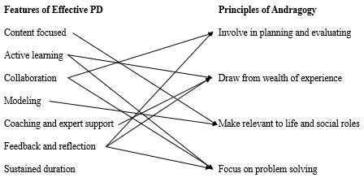

Language Needs in Mathematics
In developing teachers to better support their ELL students, they will need to understand the complexity of language use in mathematics. Students may encounter language difficulties in understanding mathematics tasks and texts as well as communicating mathematically. Every mathematics task comes with linguistic needs for understanding and working with the mathematics, such as new vocabulary, shifting between language registers, and engaging in disciplinary literacy strategies. Since all of these language skills are specific to mathematics, all students, not just ELLs, will likely need support to learn them. Three types of vocabulary appear in math tasks: everyday, technical, and specialist (Webb & Webb 2016). Everyday words are words that are not math specific. Take this question: “Sara walks five blocks to her neighbor’s house, then five blocks back to her house. Then she walks an arbitrary number of blocks to the grocery store and back to her house to return to the same point where she started. What is her displacement?” Everyday vocabulary here would be words like walks, house, grocery store, arbitrary. Often, everyday vocabulary is thought of as a stepping-stone to more technical vocabulary, but depending on the word and the student, everyday vocabulary may pose its own problems. For example, the word “arbitrary” is a more advanced word used outside of math contexts. Students who are still learning English might not know this word, although it is crucial to understanding the problem (Prediger & Krägeloh, 2016). Technical vocabulary, on the other hand, is the set of words used mostly in mathematics, like displacement in the last example (Webb & Webb 2016). These words will almost definitely need to be taught to all students, not just ELLs. Lastly, specialist vocabulary is the set of words used both in mathematics and daily life with different meanings in each context. In the last example, this would be the word, “point,” which in an everyday context means gesturing at something with your index finger but in a math context means a precise location. Each language has words that are stumbling blocks in math, like “whole,” “fraction,” and “proportion” (Phakeng, 2016). These words can be especially tricky and need to be explicitly taught to prevent misunderstandings.
Certain tasks or lessons may also be presented in forms that can be confusing. In a 2002 study by Cahnmann & Remillard, one teacher was leading a lesson that asked students to work backwards in an addition problem by presenting “riddles.” However, riddles were not a form of communication her students were familiar with, and she spent most of her time explaining riddles rather than the mathematics. Cultural differences that often come with language differences can also arise, especially in contextualized tasks. For example, asking a Muslim student to calculate the volume of a wine glass might cause unnecessary difficulties (Farsani, 2016), just as a problem about a gymnast flying off a vault might first need a video introduction for students who are not familiar with gymnastics (Leith et al., 2016). Also, textbooks can make mathematics inaccessible by presenting information in more formal sentences. Trying to break down these forms into something more understandable serves as another barrier for ELLs. All of these vocabulary types, communication forms, and cultural difficulties can prevent ELLs from comprehending mathematical texts, whether it be textbooks, lessons, peer discussions, or complex tasks.
On the other hand, students also need to be able to produce mathematical communication; that is, speaking and writing about their mathematical thinking and results in English. One of the Common Core State Standards for Mathematical Practice is to, “construct viable arguments and critique the reasoning of others,” which requires many high-level mathematical language skills like switching between language registers and using disciplinary literacy skills (2020). A language register is a “set of meanings that is appropriate to a particular function of language, together with the words and structures which express these meanings” (Moschkovich, 2010). Students move between the everyday, school, and technical registers in both languages to build mathematical understanding (Prediger & Krägeloh, 2016). However, math registers present difficulties for all students. For example, the phrase, “give me a quarter” means one thing in the everyday register (i.e. give me money) and another in the technical register (i.e. give me one-fourth) (Moschkovich, 2010). Students often use gestures and objects to identify what register others are speaking in or to communicate about their own register. Mastering the phrases, gestures, and ways of speaking in the technical register takes time, as does learning how to shift to the everyday or school register when something is not being communicated clearly. However, these skills are essential for students to be able to work with peers in the math classroom as they reason and make arguments.
Additionally, every subject has its own particular structures and forms in text that students need to be able to both decipher and produce. Familiarity with these structures and forms is known as disciplinary literacy (Ellery & Rosenboom, 2011). In mathematics, disciplinary literacy skills include describing the process of how one problem-solved using sequential words and structures; presenting and justifying arguments using diagrams, applying context, and using examples and nonexamples; and critiquing others’ reasoning by asking clarifying questions, responding logically, and making connections, among others (Wisconsin Department of Public Instruction). Using these skills requires students to think, listen, read, speak, and write like a mathematician – a daunting task in one’s first language. For ELLs, these skills take even more time and intentional instruction to develop.
To clarify, ELLs do not need to have mastery of the English language or all mathematical registers in order to participate in classroom activities (Wright, 2015). This stands in contrast to the teachers’ beliefs that Reeves found in 2006. 75% of those surveyed said that ELL students should achieve a minimum English proficiency before being allowed into mainstream classes. Furthermore, 72% thought that two years was a realistic goal for achieving English proficiency, while research shows that it takes four to six years to achieve academic language proficiency (Wright, 2015). These misconceptions may need to be addressed during professional development. Although there are many complex linguistic needs in math, teachers can support ELLs’ language learning and math learning just as they teach their English-proficient students to write a mathematical proof while also learning about geometry. Many instructional strategies and scaffolds can make mathematics comprehensible to students who have a low level of English proficiency and also help them grow in their language use (Wright, 2015).

Sheltered Instruction Observation Protocol
One tool for teaching both content and language simultaneously is the Sheltered Instruction Observation Protocol (SIOP), developed by Echevarría et al. (2008). The SIOP model is grounded in second language acquisition theory and contains thirty features of effective ELL education organized into eight components: lesson preparation, interaction, building background, practice and application, comprehensible input, lesson delivery, strategies, and review and assessment (see Appendix A). The model goes deeper than just instructional strategies with its emphasis on language objectives and primary language support (Echevarría et al., 2008). It was originally intended to be an observation instrument for researchers to evaluate how well teachers were accommodating ELLs, but teachers quickly realized its value as a lesson planning and reflection tool (Short & Echevarría, 1999). It has been field-tested with teacher input and shown to improve student outcomes in academic literacy (Short et al., 2011) and in reading achievement (McIntyre et al., 2010). It has also been shown to bolster students’ conceptual understanding of mathematics and use of mathematical language (Suweken et al., 2017).
As many studies have been done concerning SIOP professional development, one of the original developers of the model condensed their findings into seven features of effective ELL professional development, which seem to be a more specific version of the previously mentioned features written by Darling-Hammond et al. (2017). These ELL features are: 1) Start with an empirically validated intervention focused on the knowledge and skills teachers need to work with English learners (which in their research is the SIOP model). 2) Give teachers time to get good at it. 3) Design the program to be job-embedded in both presentation and practice. 4) Provide support, support, and more support. 5) Explain the theories that undergird the intervention. 6) Engage the school administration. 7) Employ a means to measure teacher implementation (Short, 2013). In order to understand what this looks like in practice, I will summarize seven studies that specifically focus on SIOP professional development and its impact on teachers’ practices and attitudes as well as student achievement.
When fully implemented, SIOP professional development has been shown to raise teachers’ commitment to supporting ELL students, increase teachers’ implementation of SIOP components, and improve ELLs’ achievement. Researchers have used a variety of tools to support both elementary and secondary teachers’ growth, but all seven studies that were examined included some form of workshop or intensive training (Short & Echevarría, 1999; Batt, 2010; Honigsfeld & Cohan, 2008; Song, 2016; McIntyre et al., 2010; Short et al., 2011; Crawford et al., 2008). Six of these studies used some form of coaching as additional support, although the frequency of coaching varied. In general, the more sustained the coaching, the greater the implementation and student achievement gains (Short & Echevarría, 1999; Batt, 2010; Honigsfeld & Cohan, 2008; McIntyre et al., 2010; Short et al., 2011; Crawford et al., 2008). The study that did not use coaching used lesson study instead, which is a Japanese technique where a group of teachers agrees on a goal, collaboratively plans a lesson, watches each other teach it, and then reflects on its effectiveness and makes revisions. This clearly involves collaboration, job-embedded problem-solving, and modeling (Song, 2016). It seems that whether a study used coaching with an expert or collaborative lesson study, the amount of job-embedded support greatly impacted the success of professional development. To involve problem-solving, three of these studies videoed participating teachers and students and used videos to spark coaching conversations and collaborative problem-solving around SIOP implementation and student engagement. If it was a video of another teacher, this fulfilled the modeling component of effective PD; if it was of themselves or their student, it involved active learning and collaborative problem-solving (Short & Echevarría, 1999; Batt, 2010; McIntyre et al., 2010). Additionally, four of these studies emphasized a structure for feedback and reflection from participating teachers, usually within the coaching relationship (Short & Echevarría, 1999; Batt, 2010; Honigsfeld & Cohan, 2008; Short et al., 2011). These format considerations will be important sources of information when structuring future professional development opportunities.
On the other hand, learning from the problems that professional development programs faced can also be helpful. Several studies showed that many teachers had problems implementing language objectives, one of the specific components of the SIOP model (Short & Echevarría, 1999; Song, 2016; McIntyre et al., 2010). This may have come from a lack of focus on language acquisition theory, as researchers often focused on strategies over an understanding of the theory undergirding the SIOP intervention. The frequency of coaching also had an effect on teachers’ ability to change their practice; McIntyre et al. only had time for one coaching session, did not involve administrators in PD, and teachers were spread out across many different schools. They found that traditional teachers showed little growth in SIOP implementation, potentially because of this lack of sustained support (2010). Two of these studies attempted to abbreviate this long, in-depth process for efficiency, but did not achieve the results they hoped for. Short et al. implemented a two-and-a-half-day intensive training followed by nine weeks of intensive coaching as teachers implemented ready-made ELL-modified units. Yet this was not enough to achieve high levels of implementation, and researchers concluded that it takes two to three years to truly affect change and raise student achievement (2011). Crawford et al. essentialized the SIOP model into ten components rather than thirty and cut out discussion of language acquisition theory and primary language support. They still implemented training over a span of two years, with eight coaching sessions, but few teachers showed mastery of the model (2008). These studies point to a need for teachers to thoroughly understand the theory behind the SIOP model and be provided with enough long-term support to navigate everyday challenges.
Aside from studies analyzing SIOP professional development, Daniel and Conlin offer a critique of the SIOP model in general. Citing a preservice teacher who viewed the SIOP model as just a checklist of helpful strategies and the lack of student-focused items in the model (three as opposed to twenty-five focused on teacher actions), they suggest that the model is easily misunderstood as formulaic and teacher-centered rather than emphasizing student thinking and how to respond to it. To rectify this, they advocate for adding seven components that focus on student thinking: anticipate students’ contributions, elicit student input and respond appropriately, revoice student comments, ask follow-up questions, press for rationale, observe reactions to see if input is comprehensible, and observe student interactions. This could lead to making space for student’s vast cultural and linguistic resources as well as reflecting more deeply on how much students understood (Daniel & Conlin, 2015).
When taking this critique in context of the variety of ways that SIOP PD was implemented and sustained, the lack of student focus may not be due to the model, but rather to the marginalizing of the theory and coherence behind the model. If, as in the Crawford et al. study, teachers are only exposed to a portion of the model, led to view it as a checklist, and do not think about students’ primary language, they may not see their students’ linguistic resources as valuable to mark anything off the checklist. However, if teachers are sufficiently supported through coaching and led to understand the theory, as in Batt’s cognitive coaching program, analyzing video recordings and student work will naturally lead them to focus on students. The SIOP features building background, strategies, interaction, and review and assessment will require teachers to think deeply about what knowledge students are bringing to class, what they need in the moment, how they are interacting with peers and their teacher, and how much they understood from the lesson. With this criticism in mind, professional developers and researchers should take care to emphasize the students during trainings and introduce the model as a systematic way of teaching, not a teacher checklist. By learning from these studies’ successes and mistakes, I hope to develop an effective professional development program that includes the SIOP model.

Disciplinary Literacy Strategies
Although SIOP is a useful tool for planning ELL instruction in any content area, the literature surrounding disciplinary literacy offers a helpful lens for supporting students’ growth in learning the language of mathematics. This concept has been mentioned previously, but this section will describe in more detail the specific skills all students, not just ELLs, need to read and write like a mathematician.
The concept of disciplinary literacy was a response to content area literacy, a push that declared “every teacher a teacher of reading,” and in many schools required daily reading and writing in every class. Although well-intentioned, the theory did not differentiate between the types of literacy skills needed for each subject, and many frustrated math teachers would have students read stories only tangentially related to mathematics to satisfy requirements (Lent, 2016). Shanahan and Shanahan (2008) responded by gathering a panel of professionals and teachers to investigate which literacy skills are used in each discipline. They asked them to read a complex text aloud and to verbalize their thought processes as they went. The professionals also looked at some widely used content area strategies and only considered a few useful within their respective disciplines. Next, as a team, teachers, researchers, and professionals developed new strategies and organizers to help students in specific discipline. These tools were then field-tested with high school students and taught to preservice teachers.
In mathematics, Shanahan and Shanahan noticed that professionals frequently reread text, closely read sentences rather than scanning, and looked for precision of meaning. Professionals also highlighted the importance of memorizing what variables meant at the beginning of text, distinguishing between the everyday and math-specific meanings of words, and attending to precise definitions of terms. Eventually, they developed a note-taking guide with columns for the main idea, an explanation, an example, formula, or visual representation and a precise mathematical definition (2008). Other sources add that mathematicians also make notes about confusion, read for clear reasoning and accuracy, look for patterns and relationships, draw on their background knowledge, and scrutinize how math is being used to make a point in news sources or other real-world situations (Lent, 2016). Overall, mathematical text requires all of these strategies because it uses compacted, conceptually deep prose, specific terminology, and multiple modes of presentation such as tables, graphs, and text that must be synthesized.
Since this original study, other researchers have developed guides to disciplinary literacy and instructional strategies in mathematics, expanding literacy to include visual, audio, and multimodal texts (Lent, 2016). They also point out that beyond just accessing disciplinary texts, disciplinary literacy immerses students into the discourse patterns of their subject (Buehl, 2011), and actually produces and constructs knowledge (Lent, 2016). A multitude of strategies exist to support students in reading, writing, and inquiry in math, but this review will go beyond strategies to understand the key skills students need to develop and how they can be mentored to become self-sufficient mathematicians. Strategies can often oversimplify thinking processes by being “shortcuts through content,” and putting the burden on teachers to inundate students with too many strategies in isolation can make the curriculum feel even more packed (Lent, 2016). Instead, disciplinary literacy principles can be woven into the classroom and teachers’ existing pedagogical practices.
Students need to develop and use literacy skills in reading, writing, and inquiry. First, reading should occur every day, but not always the textbook. Teachers can incorporate current events about mathematical discoveries, blogs, infographics and visual texts, word problems, narratives, tables and graphs, advertisements, and sections of technical texts. Although they should be related to math, they do not have to relate to the current unit, as these texts are still building students’ engagement with math as well as their mathematical literacy skills. By giving students a variety of texts, teachers prepare students to actually do work within mathematics rather than just prepare for a test. Students can read these collaboratively at first in order to process verbally what they are reading and boost comprehension. When teaching reading, teachers should move away from generic strategies and help students understand the skills that mathematicians use to read texts in their field. They should model the thinking and dialogue patterns of math by reading aloud at times, explaining how they are processing the text and showing how some words have both technical and everyday meanings (Lent, 2016).
However, students may struggle with comprehension due to academic knowledge gaps. This may be particularly true for ELLs that do not have a deep conceptual understanding of technical terms used in a mathematical text. To facilitate connections and prior knowledge, teachers can allow students to use their home language as a resource, rather than bypass language issues by translating a few key phrases or allowing students to use other resources. Teachers can also look for texts that have relevance to students’ lives in order for students to see themselves in mathematics and boost their engagement in difficult texts. If the text is difficult for students to connect to, teachers can also utilize frontloading strategies that activate prior knowledge and build the knowledge that students need to be able to access a text. Eventually, students should take ownership of these strategies, checking what understanding is missing and knowing which resources they can use to clarify a text. When the goal is to transition students to independence as readers, teachers help students make reading strategies their own and work through difficult texts, rather than “a pedagogy of telling” that creates a “continuing cycle of dependency on a knowledgeable other” (Buehl, 2011).
Although reading is incredibly important to learning, writing also helps students build knowledge as they have to connect concepts logically, understand details, and communicate clearly. Researchers have found that writing can boost memory and deepen understanding. In response to this, students should also write something related to mathematics every day. Just like with reading, there are a variety of ways to incorporate writing into daily instruction without overhauling routines. Teachers can establish an expectation of writing in math class, have students write instead of discuss, provide authentic audiences and relevant tasks, allow students to use nonlinguistic representations when writing, and provide constructive feedback. Task formats could include bell-ringer questions, quick jots, narratives about mathematics concepts, blogs, word walls, math pen pals, debates, or even a short book explaining how to solve a problem (Lent, 2016). Students’ writing will provide a much richer picture of their understanding than a multiple-choice question or showing some scratch work, and it will push ELLs to produce mathematical language rather than just absorbing it.
Past reading and writing, students also need to be able to develop literacy skills in inquiry, which can be described as the habits of thinking that mathematicians use to think through and investigate a problem. This is most similar to what mathematicians do for a career, and even for students who choose a different career, habits of inquiry will prepare them to problem solve in their job and personal life. When mathematicians engage in inquiry, they question and explore patterns, find connections between graphs and other texts, generalize and find exceptions, apply previous knowledge to new situations, estimate and make conjectures, and work beside others with specialized skills. They also engage in metacognitive behaviors and keep notes about the process (Lent, 2016). When teachers are building students’ inquiry skills, they can focus specifically on modeling self-questioning. Mathematicians especially are always questioning the truth of sources as well as their own understanding. Questioning strategies also depend on the type of text: with conceptual texts, students need to constantly ask themselves if they are understanding the “why,” while with procedural texts, students need to check if they understand the “how,” or the correct steps to use and when (Buehl, 2011). To support students’ growth in these techniques, teachers should allow inquiry to move through its stages and encourage reflection throughout the process. Many teachers see themselves as coaches, giving mini-lessons and then giving students space to work and actually engage in mathematical practice. To check that the process is working, teachers can use formative assessments and alter plans if students are missing a concept. However, inquiry requires a shift in thinking from covering lots of material to pure learning by doing. To make this shift, many teachers collaborate with colleagues in the inquiry process (Lent, 2016). Giving students the time and space to engage in inquiry as “mathematicians in training” can build students’ confidence, deepen understanding, and naturally incorporate many literacy skills.
Although many articles and books discuss the importance of disciplinary literacy and how to teach it, few researchers have studied how teachers learn to incorporate literacy strategies in their classroom, particularly math teachers. A search of an educational research database using the search terms “disciplinary literacy” and “professional development” yielded only three articles that discussed professional development initiatives either with all subject areas or with a few where math was included, and none focused only on math teachers.
Two of the studies reported on specific professional development programs. Both of them used massive open online courses (MOOC) to support teachers’ learning, and one supplemented this with weekly professional learning community meetings, classroom observations, and interviews (Graham et al., 2017). However, both reported a lack of focus from teachers on the strategies specific to their discipline, instead noticing that teachers still relied heavily on content area reading strategies during and after the professional development. This could be interpreted as a need to focus more closely on which strategies are helpful for which disciplines or to help teachers blend disciplinary literacy with more general content area strategies to address all of students’ literacy needs (Graham et al., 2017; Paul, 2018). In addition, Graham et al. found that math teachers specifically seemed to have a shallow understanding of the literacy needs in mathematics. One only discussed using authentic mathematical vocabulary and memorizing it by rote, while the other believed that disciplinary literacy happened unconsciously and did not read in her class because she did not see it as a language arts class. Rather than seeing language difficulties as a barrier to accessing existing mathematical understanding, she viewed a student’s reading level as directly related to their mathematics understanding (Graham et al., 2017).
More generally, a team of instructional coaches, consultants, and professors who have been leading disciplinary literacy professional learning for many years summarized what they have learned through the process in their 2016 article, condensing their experience into six takeaways. They found that rather than just focus on teachers’ content learning, it was just as important to build their collaborative capacity through professional learning communities and collaborative inquiry cycles. Rather than using literacy coaches to lead PD, they found that teacher leaders’ subject area knowledge made them more effective at creating sustainable change and buy-in from other teachers. Rather than viewing professional learning as a technical sequence of strategy adoption, they see it as an iterative and adaptive cycle of changing beliefs, adapting to students’ needs, and layering general literacy and disciplinary literacy strategies. Rather than assuming they know what teachers need, they begin with a needs assessment and adapt content to teachers’ strengths and weaknesses. Rather than an intensive institute, they changed to offering in-person summer workshops followed by webinars and check-ins throughout the school year. Rather than assuming all knowledge lies with the experts, they respect the ways that teachers can invent better strategies and problem solve in their own context (Ippolito et al., 2016).
When taken together, this research points to several needs for professional development about disciplinary literacy. Teachers need time to consider both general and disciplinary literacy strategies and figure out how layering them can best serve their students’ needs. Online courses are not enough to create lasting change in teachers’ beliefs about literacy in mathematics and should likely be supplemented with in-person support. Professional development should also be based on teachers’ needs and respond to the outcomes of trying new techniques in the classroom. It also should focus on how disciplinary literacy looks specifically in mathematics and make a distinction between general and disciplinary strategies. These conclusions will be helpful as I work with teachers to support their disciplinary literacy learning.

Mathematics-Focused ELL Professional Development
Although many studies have investigated teachers’ mathematics development, ELL’s mathematics learning, or professional development, literature reporting on their combination, effective professional development with secondary math teachers to support ELLs, is sparse. Morris and Easterday’s professional development research (2008) is one of the few studies that fits this description. Uniquely, the researchers gave each of the forty math teachers who participated an iPod preloaded with audio and video recordings of academic articles, teaching videos, student interviews, and presentations by math educators. This technology was used throughout professional development with a focus on improving teaching and learning of algebraic thinking with ELLs. Teachers would listen to the articles before a professional development meeting, enabling them to fit preparation into their busy schedules by multitasking while listening. During professional development sessions, teachers would watch classroom videos on the iPods and be able to rewind, pause, and take notes as they discussed what they were noticing with each other, leading to deeper conversations. Watching student interviews and recordings of student talk proved to teachers that ELLs were capable of engaging in higher order mathematical thinking before they had mastered vocabulary and grammar, increasing their belief in their own students. In summary, researchers believed that “the iPods™ are enabling the teachers to develop a more nuanced understanding of what constitutes student learning/growth and capacity to recognize it, coupled with an understanding of teaching strategies that can elicit rich student responses that can render student learning visible” (p. 58). This thoughtful use of technology to enhance teachers’ learning could be easily adapted to more current technologies and even augmented by newer advances such as discussion boards or Skype.
Adjacent to this specific focus, Orosco and Abdulrahim (2017) described one elementary special education teacher’s work with Latino ELL students who had mathematical learning disabilities after she participated in professional development focused on word problem comprehension. The PD was not described in detail, but we can glean that it was based on what she wanted to improve upon and supported her through the process of implementing new strategies and teaching word problems. It also highlights the importance of encouraging teachers to connect to students’ cultural background knowledge when exposing them to new contexts.
In summary, there is a clear need for more specific research that is focused on how mathematics teachers learn to support their ELLs through professional development. This project will attempt to contribute to this gap, drawing from work on what constitutes effective professional development, the complexity of language needs in mathematics, the empirically validated SIOP model, theories and professional development studies of disciplinary literacy, and the small body of work on ELL mathematics-focused professional development.

Chapter 3: Methodology

Design
To answer my research questions—what are the needs of math teachers in a given school with regards to teaching English Language Learners, and how do teachers envision their needs being met through professional development—I employed a qualitative case study design. Given these questions, I chose qualitative over quantitative research in order to understand “how people interpret their experiences, how they construct their worlds, and what meaning they attribute to their experiences” (Merriam & Tisdell, 2016, p. 6). Although a large-scale, quantitative study would be helpful for determining the general needs of math teachers across a state, I am more interested in deeply understanding how a few math teachers conceptualize and describe their specific needs given their school, prior experience, and students. This more in-depth knowledge can be valuable when planning targeted professional development, given the principles of andragogy that adults should be involved in the planning and evaluating of their learning, and it should be relevant to their life and work (Knowles, 1984). The desire to understand teachers’ needs in a given context pointed to choosing a case study design, in order to create “an in-depth description and analysis of a bounded system” (Merriam & Tisdell, 2016, p. 37).

Selection of Participants
For participant selection, I used purposeful criterion sampling to study in depth what the needs of teachers are within a given set of bounds (Merriam & Tisdell, 2016). Teachers must be 1) teaching at Washington High School (pseudonym), 2) teaching at least one math class, and 3) teaching English Language Learners in at least one math class. Each of these criteria has a rationale. First, teachers were only selected from one school in order to get a picture of the needs and approaches at one site. This allowed me to develop a professional development plan to give to the administrators of this school that I knew would be helpful for the teachers receiving the professional development. Washington High School provided an interesting case study due to the community and state demographics. This southern plains state has had a dramatic increase in its ELL population (22% from the 2012 to 2018 school years), and 8% of the current student body in the state labeled as ELL (X State Department of Education, 2019). Unfortunately, the state lacks specific guidelines for how ELL students are to be supported past the baseline federal guidelines previously mentioned (Education Commission of the States). Additionally, schools are already stretched to support students’ needs, as the state’s per pupil funding is the third lowest in the country (World Population Review, 2020). Washington High School is a suburban school located in a university town. Due to this location, the school has a wider variety of home languages spoken by ELLs and of social class status partially because of international families studying and working at the university. However, since it is not an urban school with a history of ELL students and still only has an ELL population of 3.7%, the school does not have the resources and capacity to fully support the ELL students they do have (X State Department of Education, 2019). Second, teachers must have at least one math class so that this study could focus specifically on the needs of math teachers surrounding supporting ELL students, which was a gap in the research literature. Third, only teachers who currently taught ELLs were recruited. This would make the research more relevant to these teachers and increase the likelihood that teachers would have a clear picture of their needs in teaching math to English Language Learners.
Eventually, two teachers agreed to participate, both math teachers at Washington High who had some ELL students in their current classes. See Table 1 for demographic information, and Table 2 for demographic information about participants’ students.
Table 1
Participant Demographics
Name | Classes taught | Years of experience teaching | Years of experience at this school | Educational Background | Race/Ethnicity | Languages Spoken
Faith | Algebra II | 2 | 2 | Teacher Prep Program | Asian/Chinese | English and Chinese
Maria | Algebra II | 5 | 5 | Teacher Prep Program | White | English

Table 2
Participants’ ELL Student Demographics
Name | Number of ELL Students | Languages Spoken by Students
Faith | 5 | Chinese and Spanish
Maria | 20 | Spanish

Data Collection and Analysis
Needs Assessment
After obtaining participants’ informed consent, they filled out a survey that covered demographic information, information about their ELL students, their attitudes toward teaching ELLs, their comfort with a list of SIOP and disciplinary literacy strategies, the formats of PD they prefer, and an open-ended question about their current ELL pedagogy.
Demographic information included classes taught, teaching experience, ethnicity, gender, and other languages spoken, in order to see how differences between the two teachers might affect their needs. Information about their ELL students included the number of students and their home languages, as this could impact the teachers’ needs. Attitudinal questions asked about their confidence in teaching ELLs as well as the responsibility teachers felt for their language development. This was included since teachers’ confidence in teaching ELLs is generally low (Reeves, 2006; Song, 2016) and Song (2016) found that after PD, most (but not all) teachers saw ELLs’ language development as their responsibility.
For the list of strategies, I included the 30 features of effective ELL education from the SIOP model (Echevarría et al., 2008) with aspects of disciplinary literacy drawn from multiple sources (Shanahan & Shanahan, 2008; Buehl, 2011; Ellery & Rosenbloom, 2011; Lent, 2016). The 15 disciplinary literacy strategies are in the areas of writing, vocabulary, comprehension, and inclusion and modification of mathematical texts. For each of these 45 strategies, teachers marked “Confident to implement,” “Would like more professional development,” or “Not confident but not interested at this time.” This gave a picture of strengths and weaknesses as well as interests, as teachers do not have the time to work on everything about their practice at once. At the end of this section, a short answer question asked, “Which of these strategies are you most interested in learning about?” so that I could focus on at least one strategy for their professional development plans in which they were highly interested.
To create activities that would be engaging to teachers, I also asked what formats of professional developments teachers preferred and what time they would be most available to do them. The 12 formats options extended beyond the traditional workshop, including book study, online modules, lesson study, peer observation, and coaching, which were again compiled from a variety of sources (Song, 2016; Wepner et al., 2014; Organisation for Economic Co-operation and Development, 2009). The components of interest in learning about certain topics and choosing preferred formats were intended to fulfill the principles of andragogy that adults should be involved in the planning of their learning and that the content should be relevant to their work (Knowles, 1984).
Lastly, I included a more open-ended question, “What strategies/pedagogies do you mostly draw from to teach your ELL students?” This was intended to gauge what teachers are already doing and putting most of their time towards, as well as what was not mentioned. Asking teachers to briefly describe their preferred strategies would also provide material for further interview questions and a basis for prior knowledge in professional development (see Appendix B for full Needs Assessment).
Professional Development Plan
After receiving survey responses, I compiled a profile of each survey respondent including demographic and student data, as well as reported confidence and responsibility. I then tabulated results for SIOP, disciplinary literacy, and format preferences and noted similarities and differences between the participants. Responses to the open-ended question were analyzed first using open coding, and then consolidated using axial coding (Merriam & Tisdell, 2016). Based on their reported needs, main interests, preferred formats, and strengths, I developed an individualized professional development plan for each participant around two main learning goals, drawing from the principles of effective professional development and adult learning theory as well as the SIOP, disciplinary literacy, and math-specific ELL education studies previously mentioned (e.g. Darling-Hammond et al., 2017; Knowles, 1984). These individualized plans were then emailed to each participant for their reflection and feedback (see Appendix D for the full PD plan).
Interviews
To gain insight and reflection, 30-minute, semi-structured interviews were conducted with each participant. Interview questions were developed from the differences I noticed in needs and demographic factors as well as responses to the open-ended questions. I also asked teachers to give feedback on their plans, especially what they thought would be helpful and how this might be different from normal professional development they had experienced (see Appendix C for Interview Protocol). Interviews were recorded and transcribed, then open coded and axial coded. For example, Maria’s statement “Besides me like using my hands a lot. I'm trying ways to explain basically multiple different words, try and use mathematical vocabulary and not” was open coded as “uses hands to explain concepts,” a code which was then used to code multiple similar statements from Faith and other parts of Maria’s transcript. This code was then grouped with other codes to form the category “current instruction.” This enabled me to analyze codes thematically after initially describing their meaning.

Trustworthiness
Although quantitative researchers strive for validity and reliability with the goal of applying their findings to other situations, qualitative researchers aim to gain a deep understanding, not an objective truth. Rather than empirically testing the validity of results, qualitative researchers can use triangulation and member checks to ensure they are getting a full picture of a case. Rather than pretending we can be completely objective observers, we should acknowledge the ways our positionality can bias us towards observing or not observing aspects of a case, then bracket our experiences as we try to step into another’s shoes (Merriam & Tisdell, 2016). Although research over the widespread professional development needs of math teachers in this area is important, this research aims to provide insight into the way site-specific and individual factors can influence teachers’ needs. While findings may not be transferable to other schools or districts, this method will be, as other researchers and professional can conduct needs assessments and develop professional development plans that are strongly grounded in what teachers say they want.
To strengthen the trustworthiness of this study, I used triangulation to compare data sources. Along with survey data, I conducted interviews with teachers to get a richer picture of their experiences and needs with teaching math to ELLs. I also used member checking by sending individualized professional development plans, which were a result of my survey analysis, to teachers for feedback. Finally, I rephrased and summarized participants’ responses during interviews to check that the main ideas I interpreted were true to their experience. These methods of double-checking increased the probability that I was understanding teachers and not simply finding what I wanted to find (Merriam & Tisdell, 2016).
I also employed reflexivity, turning inward and considering how my experiences may be coloríng my view. As a white, 22-year-old female, I have certain lenses through which I see the world. I have a strong sense of self-efficacy that can result in a desire to fix others’ problems rather than supporting others as they grow and make their own decisions, which is partially a product of my privilege and instilled values of hard work and resourcefulness. I am also a pre-service teacher. I completed my undergraduate degree in Math Education immediately before beginning my master’s degree and have therefore only had one semester in a classroom. My internship was in an urban, multicultural, high-poverty school with an ELL population of around 40%. Although I did experience teaching math to ELLs in the general classroom, I was always supported by my cooperating teacher and did not have to shoulder that responsibility on my own. I recognize that I do not have the daily lived experience of balancing state accountability, limited time and resources, and a variety of students with their own needs on my own. I have also observed in Washington High School, but I recognize that observations in one classroom are not reflective of the state of affairs in every classroom. The story at the beginning of Chapter One was drawn from these observations, but in a teacher’s classroom who did not participate in this research.
Aside from these experiences, I also have a strong interest in ELL education. Though I grew up speaking English at home, during study abroad programs I have experienced being confused in the language in which you are listening to a lesson, being put on the spot to speak in a language you are uncomfortable in, and feeling like a cultural outsider. Throughout my observations in schools, I have seen many ELL students pushed to the side of the classroom, ignored, or dismissed, though they may be mathematically gifted. My personal commitment to equity and belief that every student should have access to a quality education has pushed me to investigate this problem and how it can be addressed. I also believe that content area teachers are responsible for the language development of their ELL students and that mathematics is full of language needs that must be addressed for ELLs to access the content.
While analyzing data, writing professional development plans, and interviewing participants, I needed to bracket my own interests and experiences in order to truly listen to teachers. My role was not to fix their problems or mold them to my own agenda; I was present to listen to their needs and support them in that growth. I also positioned myself not as an expert, but as a student, hoping to learn from the experiences and daily challenges of these teachers as they work to teach their ELLs and to soon apply it to my own practice.

Chapter 4: Findings
In this chapter, I will answer my research questions for my two participant teachers at Washington High School: what are their needs with regards to teaching English Language Learners, and how do they envision their needs being met through professional development? Overall, teachers had widespread needs due to a lack of professional development around ELL instruction, but they prioritized vocabulary instruction and creating meaningful opportunities for students to develop their oral language skills. Teachers also discussed their current instructional practices and what they felt were their strengths, generating an overall confidence in ELL instruction from unexpected sources. After receiving a professional development plan based on these needs (see Appendix D), teachers discussed prior professional development experiences to establish a baseline, then they discussed the potential they saw in the plan, which I will organize according to the four principles of andragogy. Teachers also spoke about how they could see themselves implementing new techniques and bolstering current practice in the future.

Overview of Needs
Upon analysis of the needs assessment, teachers showed a desire to learn more of both the SIOP and disciplinary literacy strategies, with each teacher marking that she would like more professional development on 37 of the 45 total strategies (see Table 3 for a summary of responses). Comparatively, Faith and Maria only differed in responses to 10 of the 45 strategies, showing that their needs are similar.

Table 3
Needs Assessment Responses
Category | Participant | Confident to implement | Would like more PD | Not confident but not interested at this time
SIOP | Faith | 4 | 26 | 0
SIOP | Maria | 8 | 22 | 0
Disciplinary Literacy | Faith | 1 | 11 | 3
Disciplinary Literacy | Maria | 0 | 15 | 0

The high number of strategies for which teachers wanted more PD was surprising and motivated me to ask more about their past PD experiences in interviews. Faith had never participated in professional development for ELLs, and Maria described her ELL PD as limited to short sessions focused on testing accommodations. Therefore, Maria was also unfamiliar with the SIOP model and disciplinary literacy strategies.
Although teachers had widespread needs, it should also be noted that they had a strong desire to grow and improve. Together, the teachers only marked three strategies in which they were not confident and not interested, showing a willingness to learn. Throughout interviews, both discussed a desire to try out new strategies to better reach their ELL students. Maria showed her willingness to try new things, saying, “I’m always looking for better ways to support those guys because Algebra II is a tricky enough subject before you even add on a language barrier and vocabulary barrier and all of those things,” which was a sentiment echoed by Faith. Not only were they willing to try new things, but they actively enjoyed learning from their ELL students, rather than viewing them as a burden. After watching one of the videos included in the PD plan, Faith reflected, “it's a nice reminder that you're learning with them, when it comes to some of the languages, like it's okay to ask them how they speak it in their languages,” and Maria likewise expressed that having ELL students “makes it so fun and they teach me new things.” Beyond seeing that teachers have many needs surrounding ELL professional development, especially in SIOP and disciplinary literacy strategies, it should be noted that teachers have a desire for this learning and welcome the challenge of teaching math to ELLs.
Priorities
As 37 strategies are too many to include in one PD plan, I asked teachers in the survey which of the strategies were most interesting to them. Faith chose vocabulary visualization, reasoning, “if I had to strengthen something, maybe like connecting like the words to what they would think the word would mean and making a word in more meaningful ways through pictures or like visual things, and I haven't, I don't think I've done a very good job of that.” Both teachers had marked multiple strategies surrounding vocabulary in the needs assessment, and this was reflected in interviews by both teachers talking frequently about using their hands extensively to explain terms, but wanting to include more visuals and other strategies that might improve students’ vocabulary learning. Maria said that while she used her hands all the time, she did not employ a word wall or use many visuals, and that the funny math jokes on her walls were not helpful to her ELL students. Faith described the difficulty of helping students understand matrices, “I do this weird hand motion where like, we're going to do rows and every time I say rows I move my hands to do that and I move my hand to show a column. And I'm extremely visual there, just because it's really hard to explain to, if you were to just say it with no movement at all.”
As both teachers were interested in better ways to teach vocabulary, I made this one of the main goals of the PD plan. This goal was composed of 13 of the strategies from the needs assessment, encompassing both SIOP and disciplinary literacy strategies (see Appendix D for the complete list).
The second learning goal, meaningful oral language development, came from Maria’s priorities. When Maria was asked to identify what instructional strategies she most wanted to learn about, she responded,
Mostly, I want to provide students the space to become more proficient in English in the math classroom. I want to find ways to better provide students the space to work on this in my room. Many of my students understand English very well, but struggle to respond or ask their questions in English versus Spanish. I want them to feel comfortable and safe while they are working on this, too!
Upon asking Maria about her current instruction for ELLs, she described seating her ELLs together to work on math, as they all spoke Spanish and could collaborate. However, she recognized that she often would just check that they were good with a quick thumbs up, rather than giving them opportunities to learn how to discuss math in English.
From this description, I created the goal of meaningful oral language development to help students become more comfortable speaking and listening about math in English. This goal was made up of nine strategies, all from the SIOP model, including “plan meaningful language activities that integrate lesson concepts” and “provide hands-on activities for students to apply content and language knowledge in the classroom” (see Appendix D for the full list).
Interestingly, although Faith marked all of the strategies included in this goal as “Would like more professional development,” she did not consider it as much of a priority. When asked if she focused more on the vocabulary or meaningful oral language goal, she responded,
I think when it comes to oral, it's always something that like every teacher wants, especially in mathematics, we want you guys to be able to explain and discuss about the mathematical ideas that are coming into the classroom. And I think it is still very important for me but at the same time, I want the individual students to also grasp their concepts. And then if I feel like if an individual can grasp their concepts then the speaking part and discussing part will just come naturally. But then I also think like well if I get them to talk, then maybe they'll just end up, I don't know I feel like you can't have the other with… They're very close together.
Faith still saw oral language skills as important for her students to have, but she felt that her responsibility as a teacher was to focus on vocabulary and concepts, and then the oral skills would follow naturally.
Another reason for the difference in participants’ priorities could lie in the amount of responsibility teachers felt for the language development of their ELL students. On a scale from one to four, with one being not at all responsible and four being very responsible, Maria put four, while Faith put a two. Nevertheless, Faith saw the value in students being able to discuss mathematics and considered the PD activities associated with meaningful oral language development as well as those associated with vocabulary. Together, these two goals covered many of the strategies that teachers had expressed wanting to learn more about while tying them together around common themes that were more attainable than a list of disjointed strategies.

Strengths
As well as being similar in needs, participants were similar in strengths. Both marked that they were confident in “clearly define content objectives for students,” “explicitly link new concepts with past learning,” and “use a variety of question types.” As math teachers, these are skills they use every day with all students, not just ELLs.
In addition, Faith marked “clearly explain academic tasks” and “vocabulary contextualization” as confident areas. Clearly explaining tasks emerged in Faith’s discussion of her current instruction, describing the way she records everything she does as a teacher and uploads it to Google Classroom. She also explained that she sits down with each ELL students twice a week in a one-on-one setting to check that they are understanding the content and to explain, in their first language, any concepts they may be misunderstanding.
Maria also marked that she was confident in “emphasize key vocabulary,” “use appropriate speech for students’ fluency,” “use grouping configurations to support objectives,” “clearly support content objectives through lesson delivery,” and “provide comprehensive review of key concepts.” This confidence in more strategies may have come from her extra three years of teaching experience. Maria discussed using grouping configurations to support students’ learning during her interview: “I love the collaboration, whenever we try to kind of make pods, of ELL students in my classes, so that way they can work with each other.” However, she did not discuss any grouping of ELLs with native English speakers, which can also support students’ learning of content objectives.
Despite Faith marking that she was confident in 5 of the 45 strategies and Maria in 8 of the 45, each participant marked that their overall confidence in their ability to teach math to ELLs was a 3 out of 4, where 4 was very confident. This seemed at first contradictory to me, but understanding where teachers got their confidence illuminated the confusion. Although neither teacher had professional development regarding principles of ELL instruction, including SIOP or disciplinary literacy strategies, each had found ways of connecting with and instructing their ELL students.
Maria found her confidence in her comfort and enjoyment in teaching ELLs, using group work, and explaining vocabulary in multiple ways:
When I say that I'm comfortable with ELLs, I love having them in my class, I love working with our ELL coordinator who is amazing… It's more about, I love having them in my class and I'm so comfortable with that challenge, but not necessarily like specific strategies that I’m not as comfortable with. Besides me like using my hands a lot. I'm trying ways to explain basically multiple different words, trying to use mathematical vocabulary and not. And then of course having them collaborate with each other.
This description of her comfort and adaptation to teaching ELLs was mirrored when asked to describe her current pedagogy in the survey. In addition to group work and using her hands, she also included using pictures, increased wait time for student responses, and modified language on tests. Over time, Maria had found a few strategies that allowed her ELL students to access the mathematics in her class, especially since all of them shared a native tongue.
Faith, on the other hand, found her confidence in teaching ELLs in her ability to speak Chinese and some Spanish. Rather than adapting her everyday instruction, she carved out time to check in with each student for five to ten minutes, twice a week. During this time, she ensured that they understood the overall concepts for the week by describing them in their primary language, which she prepared for ahead of time: “I need to learn the new vocabulary that they're learning but in also their language too.” Not only did she see this as helping students understand the foundational mathematics, but she also saw that it helped her build relationships with her students, stating, “A lot of it, in my opinion, that's been effective for me is a lot of one on one time. Because it helps when you build a relationship with them.” Overall, Faith relied on her strength in speaking multiple languages to teach students not using English, but using their language. This resulted in high overall confidence, but low confidence in strategies designed for teachers instructing students in English.
However, she also acknowledged challenges with this approach, such as when students did not know the mathematical vocabulary in their primary language. For example, she stated that many of her Spanish-speaking students did not know the word “exponente,” so she would also explain that it was a “pequeño numbre [sic],” or small number, that refers to how many times you multiply something. She also understood that she was in a unique situation for this approach to work: “I teach them by trying to speak in their language, but I am fortunate enough to have only had Spanish and Chinese speakers. If I had other languages it would probably be more difficult to teach that student.” Faith recognized that her approach might not always work in her classroom and was thus open to learning other kinds of strategies to reach her ELLs.
Notably, Maria also considered speaking students’ native languages to be a high level of ELL expertise. When she was discussing the professional development plan, she described it as appropriate for her “moderate” level of expertise, “it wasn't an introduction, but it wasn’t super, like thinking I was fluent in Spanish or any of those things, or in any other language that my students might need.” Regardless of their multilingual abilities, Maria and Faith both saw fluency in students’ primary languages as providing a level of proficiency in ELL instruction, although this is not a part of the SIOP model or disciplinary literacy strategies.

Past PD Experiences
To understand how this plan might compare to teachers’ prior experience, I asked teachers to describe what ELL professional development typically looked like for them. As Faith had not experienced any ELL-focused PD, she described what PD looked like in her district for a variety of topics, while Maria spoke about the ELL trainings she had attended.
Faith reported that the district professional development she had participated in had been primarily a workshop, and then, “usually we have an assignment right after that we have to try to turn in. Which is stressful but it ends up being quite helpful, the trial and error.” In this way, implementing new ideas by way of trial and error after PD was similar to how Faith described the PD plan. However, having a menu of options rather than a set agenda for a workshop was exciting to Faith because of the ability to pick what was most applicable to her. She did mention that if she was given assignments to turn in soon after receiving this professional development, like she usually is with district PD, it would be extremely overwhelming.
For Maria, ELL professional development had been limited to quick trainings geared toward the entire faculty and focused on testing accommodations rather than instructional strategies:
Professional development that we do for ELLs, or that I have been to primarily has been through my faculty meetings, which are really just kind of like sit and get, if you will, just kind of listen and then you go about your day… It's mostly been ways that you can accommodate students like testing in a center and that kind of thing. Very like tip of the iceberg here are some things you can do. They do an incredibly good job, it’s just, I mean, you're trying to talk to 120 people with varying experience.
Maria appreciated the professional development she had received, but recognized it was limited in depth and could not be focused on her needs as it was geared toward the entire faculty. Given that her preferred PD formats were coaching and peer observation, faculty meetings are likely not the most engaging or useful for her learning.
Since Faith and Maria had both experienced limited or no professional development about ELL instruction, much less professional development based on their own needs and priorities, I was curious to see how the teachers reacted to the PD plan focused on math using their own learning goals and preferred formats.

Perception of the PD Plan
Overall, both Maria and Faith had a very positive view of the PD plan after looking through it and examining some of the resources. When asked, both said they would not change anything about it. Given this, we can assume it fit well with how these teachers envisioned their needs being met through professional development. After open coding participants’ comments about the PD plan, I noticed they fell neatly among the four principles of andragogy previously mentioned. In this section, I will describe the features that teachers appreciated about the plan using Knowles’ four principles of andragogy (1984), as well as discuss the teachers’ critiques.
Knowles’ first principle of andragogy, that adults should be involved in planning and evaluating their learning (1984), came up frequently, as teachers felt the plan was personalized to their needs and gave them a “menu” of options to choose from. Faith found value in the process of being surveyed, which she felt helped her summarize what she was thinking, and Maria felt that the plan was tailored to her needs. Both also enjoyed that they did not have to follow a set path, but rather could choose their preferred topic and formats. Faith described it as, “I like it because it's giving me a menu of things to look at. And then I can choose what I find applicable to me.” Similarly, the first thing Maria said when asked about the plan was, “So I really like it. What I really liked was that there were a lot of different options.” Basing the plan on the needs assessment and teachers’ level of confidence also resulted in Maria feeling like it was on her level, “because I'm not like a new teacher working with ELL students. I have been working with them for a couple of years. It was a good, what I call, like a moderate level. It wasn't an introduction.” Aside from choice in topic and level of difficulty, the plan let teachers choose the formats they had marked on the needs assessment. This preference obviously influenced how teachers engaged with the plan, as Faith discussed the options under “presentation from expert,” “workshop,” and “book study” more heavily, while Maria focused more on the “coaching” and “peer observation.” Overall, this principle of incorporating teachers in the planning and evaluating process emerged as very important to participants.
The second principle of andragogy, drawing on a wealth of experience (Knowles, 1984), also emerged from teachers’ reflections on the plan, whether it was their experience, fellow teachers’ experience, or researchers’ experience. Maria saw the plan as not only giving her new things to try, but also ways to build on her experience and strengths:
I think it would just be a great way for me to just better reach my ELL students, just like trying things that maybe I haven't tried before… being able to strengthen things that I already do, so being able to not just use hand gestures, but how can we better engage those guys to build their math vocabulary… Because you can always improve on things you’re comfortable with, so kind of two prongs, improve what you’re already doing and add new things to it.
Faith also identified building on her strengths as part of what she hoped to get out of using the PD plan, especially with the focus of reinforcing her confidence. One video of a high school algebra teacher using motion to engage his students with mathematical vocabulary resonated with Faith, as she described:
getting into the video where that guy was like jumping on tables to show them top to bottom, that helps me a lot and I’m like, “Oh, that's what I'm doing, so I'm not the only crazy person in the room!” and so that was kind of reassuring for me.
Teachers felt that the plan not only reinforced the strategies they were already using, but that it also drew from others’ experience. Maria referred to a part of the plan that suggested going to observe Ms. Smith (pseudonym), a math teacher at a nearby school, saying, “I love that you were using teachers from the metro. It was really cool for me knowing [Ms. Smith]. I loved that community feel.” Maria also saw engaging with researchers’ expertise in the literature included was a strength of the plan.
Being job-embedded and relevant to one’s life and work, the third principle of andragogy (Knowles, 1984), also appeared in the data, specifically with Faith discussing resources that she saw as relevant and useful in her classroom. She mentioned appreciating the abundance of secondary sources, rather than only generic or elementary level resources. Specifically, she commented multiple times on a list of resources for including mathematical texts in the classroom, especially the Primary Source Nexus, stating, “I really like that one probably the most because there was just like, more applications and ways to make math a little bit more engaging,” and said she would be coming back to this resource in the future. Aside from looking at vocabulary strategies, Faith also looked at the resources for meaningful oral language development, which was the less interesting learning goal to her. She centered in on one presentation about developing mathematical discourse in the classroom, describing it as, “it gave teachers a better attitude and so I really like that. I think I’m gonna keep that, and probably incorporate the ways that we can discuss about math.” With both the mathematical discourse presentation and the Primary Source Nexus, Faith looked forward to improving her instruction for both ELLs and her general education students. Faith’s focus on the resources that fit her classroom shows that teachers seeing resources as relevant to their careers is important for them to engage with professional development. On the other hand, Maria saw it as job-embedded because of the ability to immediately try things in her classroom:
With this I could go through at my own pace, dig into the things that I think are really important to me. I think it’s really important of being able to kind of dig in and then take that back to your classroom, try it and go from there, versus just somebody lecturing for 30 minutes. And it was tailored to what I wanted.
Maria thought the plan would be more helpful to her growth in teaching as compared to past ELL professional development as it was personalized to her classroom needs and offered an opportunity for practice in real time.
Knowles’ fourth principle of andragogy is a focus on problem-solving (1984), which came up in interviews as teachers described identifying things that could be improved and trying out new solutions. Maria noted that videoing herself and reviewing how she met her teaching goals with a coach, one option in the plan, would be very helpful for her learning:
I also really loved how you talked about like recording yourself and then watching yourself teach. I've had to do that for like the Teacher of the Year stuff and approaching National Board stuff. And it's so uncomfortable to record and watch yourself teach, but you learn so much when you do it.
Capturing classroom interactions on video would help teachers identify areas to work on and problem-solve how instruction could be improved. Both teachers also discussed throughout interviews how they would try out new strategies and tweak instruction, with Faith seeing this as a key part of professional development: “It's just a bit of being responsible myself and trying out small things at a time and seeing what works, what doesn't, or what needs to be edited.” This focus on solving problems and improving practice, rather than just learning content, resonated with participants, reinforcing this principle of andragogy.
Although teachers said they would not change anything about this plan and spoke about positive aspects that aligned well with the principles of andragogy, Faith presented a few criticisms of the plan. She commented that a few of the resources seemed more elementary-focused, especially an article about the components of effective vocabulary instruction. She also said there were a few resources she thought she had seen before, and so she gave the plan a four out of five for being applicable to her. Additionally, Faith mentioned that although she liked the menu of options, it was a bit overwhelming. Altogether, these were the only critiques teachers had of the plan, and overall, it fit their needs and vision of professional development well.

Vision of PD Implementation
As teachers were not required to implement this professional development plan, only preview it, I was curious if or how they saw themselves using it in the future. As previously mentioned, Maria briefly discussed engaging with the literature, videoing herself, trying out new strategies in her classroom, and strengthening techniques she was already using. On the other hand, Faith discussed more extensively how she saw herself using the plan going forward: ways she would try new things, resources that she would use, and potential tensions she could foresee. This could be an effect of Maria having more experience incorporating new strategies into her practice, where Faith as a second-year teacher may still be finding her own rhythm.
In trying new things, Faith recognized that she would need a way to pilot strategies, rather than overhauling her classroom structure. Her main approach for this was to begin using techniques from the PD plan in her bellwork:
One way that I've been trying to think about things is how do I just create a lesson plan that just is universally good towards everyone? And I think that comes down to thinking about, well if I just take maybe a moment in the bell work to try to strengthen things, that might be possible. So I'm always trying out different things for my bellwork. That's usually where my trial and error happens.
Not only did Faith see bellwork as a way to dip her toe into a new strategy before fully implementing it, but she also was concerned with strategies that would be good for all her students, not just her ELLs. She wanted to make sure that new techniques would not throw her students off, but rather would enhance vocabulary learning and mathematical discussions for her whole class.
In a similar vein, Faith wanted to use this plan to create content that helped all her students practice their vocabulary. She also discussed returning to the Primary Source Nexus and other ways to include mathematical texts as well as the presentation on mathematical discourse. Again, she felt that using primary sources would make the mathematics more engaging to all of her students, and that strengthening mathematical discourse would help with “any student overall.” It seems that to Faith, choosing which strategies to implement in the future depended on her vision of how it would assist all students, not just her ELL students.
For her ELL students specifically, Faith expressed some reservations about adding too many new activities, saying, “part of me also has this torn thing between teaching something that's applicable, and then not overwhelming my ELL students.” She described a statistics project that she does with her students that is engaging for her general education students, but is overwhelming for her ELLs because of all the vocabulary it entails:
It's easier for them to just learn the process of all the skills. So, we just end up getting through it and they learn how to use all the skills. It ends up being fine but at the end of the day it's always very much watered down.
In addition to her prior experience with the challenge of enrichment activities, she also noted that her ELL students were often the students who experienced difficulties outside of school that impacted their ability to learn:
I have one ELL student who works a lot and he sleeps on most days. On the one day he's alert, he's more than happy to learn the stuff. I work with him when he's like physically awake. So, some ELL kids are normal students, but then some, actually most of them have some struggle going on at home. So, sometimes I feel kind of this, I would love to do these extra vocabulary building things, but how do I create them in a way where it seems almost not like it's hurting them, like holding them back. Or taking up too much of their extra time.
Although Faith saw the potential in the vocabulary strategies discussed in the PD plan, she saw them as extra activities that might further burden her ELL students by taking up the small amount of time she had with them or taking away their free time after school. This was a tension she had not resolved by the end of our interview and seemed to be a potential obstacle for her implementation of any major changes. She also recognized that she personally needed “to learn how to make teaching almost automatic or like natural routines, but I'm starting to learn like how do I make this efficient.” Aside from overwhelming her students with too many new things, she also did not want to overwhelm herself by making too many changes to her daily routine too quickly. For all of these reasons, Faith had a vision of incremental changes to her instruction, trying some of the strategies from the PD plan during bellwork, and ensuring they helped all her students without overwhelming ELLs or herself.
In summary, both participants reported wanting professional development on many of the strategies included in the needs assessment, as neither had heard of the SIOP model or disciplinary literacy before. However, they both felt confident in their current ELL instruction, as each relied on their strengths they had developed based on classroom experience. Both participants responded positively to the professional development plan based on their needs. They focused on different topics and formats in the plan but had many views in common. The positive aspects they identified reinforced Knowles’ four principles of andragogy (1984), and the critiques Faith gave were minor. In comparing the plan to previous PD, both participants felt this would give them more choice and space to try strategies they were most interested in at their own speed. Finally, Faith’s vision for future implementation focused on piloting strategies that she felt would be good for all students during her bellwork time, as she foresaw challenges in adding too many things at once and putting a strain on herself and her ELL students.

Chapter 5: Implications and Conclusion
After going through this process of conducting a needs assessment, developing a professional development plan based on these needs, and gathering participants’ feedback on this plan, several implications emerge for different educational stakeholders, including local organizations, professional developers, researchers, and myself. Although a case study is not generalizable to a much larger sample, there are features that are transferable and questions for other situations that arise from findings (Merriam & Tisdell, 2016). In this section I will discuss ways that this case study has illustrated previous research findings, can inform decisions made by these stakeholders, and may raise more questions about ELL professional development for secondary math teachers.

Local Implications
As this case study was situated in a particular district and state, the experiences of these participants can inform decisions that this district and State Department of Education will make around ELL education. First, these findings illustrate what research tells us about math teachers’ preparation across the country: that only 25% had received ELL-focused PD, and half of these teachers had experienced 8 hours or less (Besterman, 2018). Faith had 5 ELL students and had never received ELL PD, and that Maria had 20 students and had received minimal ELL PD focused only on testing accommodations. Again, federal requirements state that all teachers of ELLs must be provided with research-based professional development (Education Commission of the States). In this state, there are no further requirements for teachers of ELLs receiving PD, but even federal requirements are not being met. Considering that Faith has been teaching for two years, and Maria for five, it is likely there are many other teachers in the district and state who are not properly prepared to serve their ELL students.
Teachers need not only professional development based on instructional strategies for ELLs, they need quality, research-based PD. In this gap, Faith and Maria have both found strategies that allow them to manage the challenges ELLs present and keep them engaged with math content, but they were not aware of research-based models like SIOP and disciplinary literacy that also fulfill students’ need to learn English and the academic language skills to communicate in English about math. This also came through in Faith’s marking only a two of four for level of responsibility for students’ language development. Maria and Faith also both seemed to hold the common misconception that a teacher needs to be able to speak students’ home languages to best instruct them, when this is in fact unrealistic in a multilingual classroom and does not provide space and support for students to learn academic English (Wright, 2015). Other teachers in this district and state may have also found ways to reach students through trial and error but hold a variety of misconceptions about ELL education. This points to a stark need for more professional development solidly grounded in research that will meet federal requirements and clear up teachers’ misconceptions that they may have developed in the absence of PD.
As this state saw a 22% increase in ELLs from 2012 to 2018 (X State Department of Education, 2019), a growth that will likely not slow down, this district and state need a clearer direction and vision of how they will support teachers to in turn support their increasing number of ELL students. While teachers like Faith with few ELL students may be able to manage with one-on-one meetings and speaking enough of students’ home languages, as the number and language diversity of these students increases, teachers will need more comprehensive direction on ways to holistically modify their classroom instruction. On this district’s webpage for English Learners, there is currently no vision statement for ELL education or goals for students, only protocols about intake forms and parent translators along with a few links for websites parents can look at (XX Public Schools, 2020). On the state website, the federal guidelines for Title III, which deals with ELL education, are simply copied and pasted, and all the following material deals with assessment and screening of ELLs. While the state may be assessing if the first goal of Title III is met, “to help ensure that English learners, including immigrant children and youth, attain English proficiency and develop high levels of academic achievement in English,” it is not providing a vision or supports for teachers and districts to reach this goal (X State Department of Education, 2020).
While this dearth of support may be discouraging, this district and state can also tap into the strengths that teachers have already developed to build a vision within the local context. As shown by Faith and Maria’s eagerness to learn and high levels of motivation to reach ELL students, teachers have experience to offer and are hungry for more support. For example, if other teachers also held the belief that establishing strong classroom relationships with and between ELL students is essential to learning, this could be incorporated into the district’s vision for ELL education. Whatever these visions and supports look like, they should meet federal guidelines for providing research-based PD to ELL teachers, give teachers a clear direction for the educational goals for ELLs, and be built from already-developed local strengths. Districts and states should value teachers’ contributions and build from skills that have already been developed to increase buy-in from teachers and use time efficiently.

Implications for Professional Developers
This case study also has implications for those who conduct professional development with teachers of ELLs, especially with math teachers. This PD plan, if thoroughly implemented over time to fulfill the “sustained in duration” criterion, would meet all the previously discussed criteria for effective professional development (Darling-Hammond et al., 2017) as well as the principles of andragogy (Knowles, 1984), and was designed to do so. In fact, participants, without discussion of this framework, appreciated features of the plan that fell neatly into the categories of andragogy (which align well with the Darling-Hammond framework). Though these features have empirically been proven to raise student achievement when incorporated in professional development, this case study indicates that these features are also noticeable to teachers. Incorporating the principles of andragogy can make PD more enjoyable and engaging and improve teacher perceptions of the PD’s efficacy. Structuring PD in this way has great potential for SIOP- and disciplinary literacy-focused programs, which previously in the research have not been personalized to teachers’ needs (Short & Echevarría, 1999; Batt, 2010; Honigsfeld & Cohan, 2008; Song, 2016; McIntyre et al., 2010; Short et al., 2011; Crawford et al., 2008; Graham et al., 2017; Paul, 2018).
Professional developers planning ELL PD for teachers based on a needs assessment should consider a few adaptations. First, if there is a “menu” of choices for topics, choice in evaluation should also be included. Faith expressed that it would be very overwhelming if she had to complete assignments over every task. This also reflects the first principle of andragogy, that adults should be involved in planning and evaluating their own learning (Knowles, 1984). Putting stress on teachers by evaluating their achievement on every learning goal would defeat the purpose of letting them direct their own learning. Second, although teachers are likely to have misconceptions about effective ELL instruction, professional developers should still aim to build off teachers’ strengths rather than attempt to scrap everything and start over. As Maria described, she wanted a two-prong approach that let her build on her current instruction as well as try new things. This is consistent with the second principle of andragogy, drawing from a wealth of experience (Knowles, 1984). For example, as Maria is already comfortable with using groupwork, a coach could help her reimagine how grouping configurations such as pairing ELLs with native English speakers could be used to meet oral language goals. Third, professional developers should consider how teachers’ priorities are unique and may reflect their classroom situation or their beliefs. For example, as Faith only had five ELL students throughout the day, she focused her attention on strategies that would not only be beneficial to her ELL students, but also to the rest of her students. Her focus on making the mathematics accessible to ELLs through translation over helping them develop oral language skills reflected her belief that she had limited responsibility for students’ language development. Professional developers should consider the roots of these priorities and understand that it may take time for teachers to change their beliefs.
Although this research was focused on basing PD on teachers’ reported needs, PD can also introduce ideas and theories that teachers may not initially feel that they need. Adding in these elements can provide coherence, help teachers grow in their blind spots, and resolve inner tensions. Although the teachers in this study were interested in incorporating many of the strategies they learned about through initial engagement, the lack of background theory in the plan meant that teachers’ beliefs and chosen strategies were not coherent. For instance, a discussion of the basics of second language acquisition theory, which undergirds the SIOP model, might have helped participants see that scaffolding students’ opportunities for developing mathematical English repertoires would be more helpful than translating math to their first language. Understanding this theory could also help Faith see English development as her responsibility. This could additionally resolve Faith’s tension between believing that oral language abilities would follow naturally from understanding the math concepts and wanting to try mathematical discourse scaffolds. This mirrors Daniel and Conlin’s 2015 critique of the SIOP model as being too formulaic and easily reduced to a checklist, rather than using it as a coherent whole backed by theory.
Professional development can also help teachers address blind spots. While discussing the PD plan, Maria noticed that she did not have anything helpful for vocabulary on her walls, although meaningful oral language activities were initially her focus. In reverse, Faith initially was interested in vocabulary development, but the mathematical discourse presentation under the meaningful oral language learning goal ended up being one of her favorite resources. Although teachers’ needs should be heavily considered when developing a plan, including resources and activities that address concepts which teachers have not yet considered can also be essential to their growth.
Professional developers should also examine the tensions that emerge during professional learning and how PD can resolve them. In this case study, Faith felt a tension between wanting to add vocabulary-building activities for her ELL students and not wanting to overwhelm them when they already had external pressures and limited time. This tension could be resolved through time with a developer presenting SIOP and disciplinary literacy strategies as modifying current instruction, rather than additional activities that only ELL students would have to complete. These tensions should not be dismissed, but rather explored and resolved over time through an understanding of theory and day-to-day implementation.
In summary, professional developers should consider planning PD based on teachers’ needs, incorporating the elements of effective PD and andragogy, as it is helpful for both teachers and students. If using this format, some extra adjustments should be made, such as choice in evaluation, building on teachers’ strengths, and considering the roots of their priorities. Although teachers’ needs are the basis for PD, professional developers should also provide activities that are theory-based and activities teachers did not initially consider, as this can improve coherence in instructional decision making, help teachers see blind spots, and resolve tensions that teachers feel.

Implications for Future Research
This case study also has implications for others conducting research in this field. More research needs to be done in understanding the large scale needs of math teachers with ELLs, as well as in understanding how needs-based, quality professional development can affect teachers and student achievement when compared to a more standard PD experience.
With the findings of this study indicating that some math teachers have received minimum or no ELL PD even when they have ELL students, researchers should investigate if this is a widespread or local gap. The last nationwide data available was taken in 2012 and showed that only 25% of math teachers had received PD over ELL education (Besterman, 2018); researchers should update this data and study if the country is prepared for the climbing number of ELLs (Grantmakers for Education, 2013). This research should go beyond asking if teachers have received ELL-focused PD and examine if this PD is instruction-focused or testing-focused, research-based or surface-level, need-based or one-size-fits-all. Do secondary teachers, especially math teachers, understand their responsibility for assisting students’ academic English development, or are they only focused on content learning? What kinds of strategies are they already using with their ELL students? These types of questions would give professional developers and educational agencies a better understanding of the needs our teachers have, the beliefs they hold, and the ways in which schools are or are not meeting federal guidelines.
Another area for further research is assessing the effectiveness of needs-based ELL PD programs that focus on a specific subject area. The few studies conducted over SIOP and disciplinary literacy professional development have shown these theories to be effective at raising student achievement, but how might they be improved by adapting to teachers’ contexts, needs, and content areas? This study indicates that teachers appreciated having a plan that was tailored to their needs, but still based on a theory; would this finding be repeated in other contexts? Further research could compare the teacher growth and student achievement of needs-based versus pre-packaged professional development, especially looking at how teachers’ beliefs might change over time. As this study was limited to a needs assessment and plan without enactment, researchers could also study how this kind of professional development unfolds when enacted over time and in the context of a learning community. When looking at a group of teachers instead of two individuals, consideration of the group’s needs might affect the PD plan as well as teachers’ reactions. As two of the features of effective PD are collaboration and sustained in duration, these kinds of variables might have a significant effect on teachers’ learning (Darling-Hammond, 2013). Overall, this study was limited in scope, but findings around the widespread needs of math teachers in ELL education and teachers’ engagement in a needs-based professional development can inform future research and raise more questions to be explored.

Personal Implications
Personally, I found meanings in this study that will have implications for my professional life as a math teacher and eventually as a coach or professional developer. I hope to get a high school math position in a school with a high ELL population, and this research has provided valuable knowledge for me to reflect on in that role. From Faith and Maria, I learned that as I am implementing new strategies, be it ELL-focused or in another area, I should not attempt to immediately overhaul all my instruction. Rather, I should try out strategies that I think will work in my classroom, and through trial and error, refine them until they become routine. In this process, I should be patient with myself that not every strategy will work perfectly the first time. This will shield me and my students from becoming overwhelmed and confused by too much change.
Another takeaway for my future teaching is the sheer amount of resources I can draw on for ELL instruction. It was difficult to narrow down resources for the PD plan, as there were so many quality videos, webinars, books, and webpages to choose from. Colorín Colorado especially impressed me with their collection of YouTube videos with both teaching clips and interviews with teachers and researchers. I will be returning to these and several of the other resources as I begin teaching, and I now feel that I am able to find quality resources more efficiently.
After teaching for a while, I hope to move into an instructional coach or professional development role, helping teachers improve their ELL instruction over time. These findings have also helped me think about changes I would make when working with teachers in the future. First, although I attempted to avoid Daniel & Conlin’s (2015) warning against using the SIOP model as a checklist by creating amalgamated learning goals for the PD plan, I think I still did not present it as a conceptual whole, and teachers came away with the understanding that SIOP was just a list of strategies. In the future, I will include information about the theoretical foundations of the theories to help teachers understand how strategies grow out of a change in mindset toward student activity, engagement, and language production. This theoretical content will likely include information about second language acquisition, as the beginning of PD would be a good time to start changing misconceptions. I could also make a shift in both the needs assessment and professional development activities toward presenting SIOP as the 8 domains rather than 30 components (see Appendix A). These 8 categories sort the 30 components well and might also help teachers see how the model is a coherent whole that affects every stage of teaching. Together, these adjustments might help teachers make conceptual changes rather than just small changes in practice. However, I will still need to be patient as change will happen incrementally, not overnight.
One other change I will need to make if working with teachers in the future is to understand the higher levels of situational complexity. In this study, I was looking primarily at the individual needs of two teachers and communicating with them directly, although I did compare their needs and cater some resources to fit both participants. In a professional developer role, I will likely need to look more across teachers to see the widespread needs of the school or department. I will need to balance the group’s needs with the priorities of individual teachers. Choice in professional development activities will still be able to help achieve this balance, but I will need to think more carefully about how to draw on teachers’ strengths and meet their needs while also achieving the vision of the principal or district. Although this will present more challenges, it will also be exciting to incorporate more collaboration in teachers’ learning and connect teachers who have complementary strengths.
This study had many implications for me personally as a future teacher and professional developer. It pushed me to be patient with myself and others, as change is slow; to reach out to a wide array of resources when I need help; to ground PD in theory and aim for conceptual change; and to lean into complexity and the opportunities of community.

Conclusion
For high school English Language Learners, math class often presents difficulties, even if students are familiar with the content. Learning to speak academically in another language while also learning new content in that language is a major challenge, one which math teachers are often not prepared to help students overcome. Although federal law dictates that ELL teachers should receive research-based professional development, many teachers feel underprepared to scaffold instruction for ELLs and have received limited to no PD. However, theories such as the SIOP model and disciplinary literacy have been well-researched and have much to offer math teachers with ELLs. Nevertheless, PD focused on these theories has often been one-size-fits-all and not adapted to teachers’ unique situational and content needs. Given this context, this research project asked what are the needs of math teachers in a given school with regards to teaching ELLs, and how do teachers envision their needs being met through professional development?
The needs of the two participants in this study were widespread, as neither was familiar with either SIOP or disciplinary literacy, but participants prioritized vocabulary instruction and creating meaningful activities for students to improve oral English skills. Although teachers had gaps in knowledge of second language acquisition and what research-based ELL instruction looks like, they had found confidence in teaching their ELL students by relying on their strengths and by trial and error. Teachers were highly motivated to learn, and the PD plan presented to them was well-received. Their vision of how this professional development would meet their needs aligned well to Knowles’ four principles of andragogy (1984) as well as many of the principles of effective professional development from Darling-Hammond et al. (2017).
Aside from having implications for the district and state, other professional developers, researchers, and myself, this study adds value to the field in filling a gap. This study showed that by employing both empirically proven ELL instructional theories and the empirically proven principles of effective PD, teachers felt that their needs were met and were highly motivated to try new strategies and strengthen their current instruction. When researchers draw from multiple fields and listen to teachers’ voices and needs, researchers and teachers can learn together for the equitable education of the millions of ELLs in our public schools.

References
Aguinaga, V. M. (2018). First year teachers' perceptions of their preparation for teaching English Language Learners (Doctoral dissertation). Retrieved from ProQuest Dissertations & Theses Global. (2125025138).
Baecher, L., Artigliere, M., Patterson, D. K., & Spatzer, A. (2012). Differentiated instruction for English language learners as “Variations on a Theme”. Middle School Journal, 43(3), 14-21.
Ballantyne, K.G., Sanderman, A.R., & Levy, J. (2008). Educating English language learners: Building teacher capacity. Washington, DC: National Clearinghouse for English Language Acquisition.
Batt, E. G. (2010). Cognitive coaching: A critical phase in professional development to implement sheltered instruction. Teaching and Teacher Education, 26, 997-1005.
Besterman, K. R., Ernst, J., & Williams, T. O. (2018). Developments in STEM educators’ preparedness for English Language Learners in the United States. Contemporary Issues in Education Research, 11(4), 165-176.
Buehl, D. (2011). Developing readers in the academic disciplines. Newark, DE: International Reading Association.
Bureau of Labor Statistics. (2018). Employment status of the civilian noninstitutional population 25 years and over by educational attainment, sex, race, and Hispanic or Latino ethnicity [PDF file]. Retrieved from https://www.bls.gov/cps/cpsaat07.pdf
Bureau of Labor Statistics. (2019, October 16). Usual weekly earnings of wage and salary workers: Third quarter 2019 [PDF file]. Retrieved from https://www.bls.gov/news.release/pdf/wkyeng.pdf
Cahnmann, M.S., & Remillard, J.T. (2002). What counts and how: Mathematics teaching in culturally, linguistically, and socioeconomically diverse urban settings. The Urban Review, 34(3), 179-204. Retrieved from https://link-springer-com.ezproxy.lib.ou.edu/article/10.1023%2FA%3A1020619922685
Common Core State Standards Initiative. (2020). Standards for mathematical practice. Retrieved from http://www.corestandards.org/Math/Practice/
Crawford, L., Schmeister, M., & Biggs, A. (2008). Impact of intensive professional development on teachers’ use of sheltered instruction with students who are English language learners. Journal of In-service Education, 34(3), 327-342.
Daniel, S. M., & Conlin, L. (2015). Shifting attention back to students within the sheltered instruction observation protocol. TESOL Quarterly, 49(1), 169-187.
Darling-Hammond, L., Hyler, M.E., & Gardner, M. (2017). Effective teacher professional development. Learning Policy Institute.
Doppelt, Y., Schunn C. D., Silk, E.M., Mehalik, M. M., Reynolds, B., & Ward, E. (2009). Evaluating the impact of facilitated learning community approach to professional development on teacher practice and student achievement. Research in Science and Technological Education, 27(3), 339–354.
Echevarría, J., Vogt, M.E., & Short, D. (2008). Making content comprehensible for English language learners: The SIOP Model. 3rd edition. Boston, MA: Pearson/Allyn & Bacon.
Education Commission of the States (2014). 50 state comparison: What ELL training, if any, is required of general classroom teachers? Retrieved from http://ecs.force.com/mbdata/mbquestNB2?rep=ELL1415
Ellery, V., & Rosenboom, J. L. (2011). Sustaining strategic readers: Techniques for supporting content literacy in grades 6-12. International Reading Association.
Farsani, D. (2016). Complementary functions of learning mathematics in complementary schools. In A. Halai & P. Clarkson (Eds.), Teaching and learning mathematics in multilingual classrooms (pp. 227-247). Rotterdam: SensePublishers.
Graham, A. C., Kerkhoff, S. N., & Spires, H. A. (2017). Disciplinary literacy in the middle school: Exploring pedagogical tensions. Middle Grades Research Journal, 11(1), 63-83.
Grantmakers for Education (2013, April). Educating English Language Learners: Grantmaking strategies for closing America’s other achievement gap. Retrieved from https://edfunders.org/sites/default/files/Educating%20English%20Language%20Learners_April%202013.pdf
Gutstein, E. (2012). Reflections on teaching and learning mathematics for social justice. In A. A. Wager & D. W. Stinson (Eds.), Teaching mathematics for social justice: Conversations with educators (pp. 63-78). Reston, Virginia: National Council of Teachers of Mathematics.
Honigsfeld, A., & Cohan, A. (2008). The power of two: Lesson study and SIOP help teachers instruct ELLs. The Journal of Staff Development, 29(1), 24-28.
Ippolito, J., Dobbs, C. L., Charner-Laird, M., & Lawrence, J. F. (2016). Delicate layers of learning: Achieving disciplinary literacy requires continuous, collaborative adjustment. Journal of Staff Development, 37(2), 34-38.
Jimenez-Silva, M., Olson, K., & Hernandez, N. J. (2011). The confidence to teach English language learners: Exploring coursework's role in developing preservice teachers' efficacy. Teacher Educator, 47(1), 9-28.
Kleickmann, T., Trobst, S., Jonen, A., Vehmeyer, J., & Moller, K. (2016). The effects of expert scaffolding in elementary science professional development on teachers’ beliefs and motivations, instructional practices, and student achievement. Journal of Educational Psychology, 108(1) 21–42.
Knowles, M. S. (1984). Andragogy in action: Applying modern principles of adult learning. San Francisco: Jossey-Bass Publishers.
Landry, S. H., Anthony, J. L., Swank, P. R., & Monseque-Bailey, P. (2009). Effectiveness of comprehensive professional development for teachers of at-risk preschoolers. Journal of Educational Psychology, 101(2), 448–465.
Leith, C., Rose, E., & King, T. (2016). Teaching mathematics to English Language Learners. Mathematics Teacher, 109(9), 670-678. Retrieved from http://www.jstor.org/stable/10.5951/mathteacher.109.9.0670
Lent, R. C. (2016). This is disciplinary literacy: Reading, writing, thinking, and doing ... content area by content area. Thousand Oaks: Corwin Literacy.
McIntyre, E., Kyle, D., Chen, C., Muñoz, M., & Beldon, S. (2010). Teacher learning and ELL reading achievement in sheltered instruction classrooms: Linking professional development to student development. Literacy Research and Instruction, 49, 334-351.
Merriam, S. B., & Tisdell, E. J. (2016). Qualitative research: A guide to design and implementation (4th ed.). Jossey-Bass.
Morris, K. A., & Easterday, J. (2008). Amplifying autonomy and collective conversation: Using video iPods to support mathematics teacher learning. Issues in Teacher Education, 17(2), 47-62.
Moschkovich, J. (2010). Mathematics, language, and bilingual Latina/o learners: A review of the empirical research literature. UC Santa Cruz: Education Department. Retrieved from https://escholarship.org/uc/item/5fw380k7
Murphey, D. (2014, December). The academic achievement of English Language Learners: Data for the U.S. and each of the states. Retrieved from Child Trends website: https://www.childtrends.org/wp-content/uploads/2015/07/2014-62AcademicAchievementEnglish.pdf
National Center for Education Statistics. (2019, May). English Language Learners in public schools. Retrieved from https://nces.ed.gov/programs/coe/indicator_cgf.asp.
The Nation’s Report Card. (2019). NAEP data explorer [Data file]. Available from https://www.nationsreportcard.gov/ndecore/xplore/nde
Organisation for Economic Co-operation and Development. (2009). The professional development of teachers. Creating effective teaching and learning environments: First results from TALIS. Retrieved from http://www.oecd.org/education/school/43023606.pdf
Orosco, M. J., & Abdulrahim, N. A. (2017). Culturally responsive professional development for one special education teacher of Latino English Language Learners with mathematics learning disabilities. Insights into Learning Disabilities, 14(1), 73-95.
Paul, C. M. (2018). Building disciplinary literacy: An analysis of history, science, and math teachers’ close reading strategies. Literacy, 52(3), 161-170.
Pavlak, C.M., & Cavender, M. (2019). When words do not work: Exploring preservice teachers’ confidence in teaching reading to English Learners. Networks: An Online Journal for Teacher Research, 21(2), 1-23.
Phakeng, M.K. (2016). Mathematics education and language diversity. In A. Halai & P. Clarkson (Eds.), Teaching and learning mathematics in multilingual classrooms (pp. 11-23). Rotterdam: SensePublishers.
Prediger S., Krägeloh N. (2016). “X-Arbitrary means any number, but you do not know which one”. In A. Halai & P. Clarkson (Eds.), Teaching and learning mathematics in multilingual classrooms (pp. 89-108). Rotterdam: SensePublishers.
Raymond, K. (2018). M is not just for STEM: How myths about the purposes of mathematics education have narrowed mathematics curricula in the United States. Education Sciences, 8(2), 47.
Reeves, J. R. (2006). Secondary teacher attitudes toward including English-language learners in mainstream classrooms. The Journal of Educational Research, (99)3, 131-143.
Ross, K. E. L. (2014). Professional development for practicing mathematics teachers: A critical connection to English language learner students in mainstream USA classrooms. Journal of Mathematics Teacher Education, 17, 85-100.
Shanahan, T., & Shanahan, C. (2008). Teaching disciplinary literacy to adolescents: Rethinking content-area literacy. Harvard Educational Review, 78(1), 40–59.
Short, D. J. (2013). Training and sustaining effective teachers of sheltered instruction. Theory into Practice, 52, 118-127.
Short, D. J., & Echevarría, J. (1999). The sheltered instruction observation protocol: A tool for teacher-researcher collaboration and professional development. Washington, D.C.: ERIC Clearinghouse on Languages and Linguistics. (ERIC Digests No. ED436981).
Short, D. J., Echevarría, J., & Richards-Tutor, C. (2011). Research on academic literacy development in sheltered instruction classrooms. Language Teaching Research, 15(3), 363-380.
Song, K. H. (2016). Systematic professional development training and its impact on teachers’ attitudes toward ELLs: SIOP and guided coaching. TESOL Journal, 7(4), 767-799.
Suweken, G., Waluyo, D., & Okassandiari, N. L. (2017). The improvement of students’ conceptual understanding and students’ academic language of mathematics through the implementation of SIOP model. International Research Journal of Management, IT and Social Sciences, 4(4), 58-69. Retrieved from https://sloap.org/journals/index.php/irjmis/article/view/474
U.S. Department of Education. (2018). Academic Performance and Outcomes for English Learners: Performance on National Assessments and On-Time Graduation Rates. Retrieved from https://www2.ed.gov/datastory/el-outcomes/index.html#introText
X State Department of Education. (2019, December). X Public Schools fast facts 2019-20. Retrieved from https://sde.ok.gov/sites/default/files/documents/files/FastFactsDecember2019.pdf
X State Department of Education. (2020, March). Title III-A, limited English proficient and immigrant. Retrieved from https://sde.ok.gov/title-iii
XX Public School. (2020, April). English learners. Retrieved from https://www.normanpublicschools.org/domain/87
Webb L., Webb P. (2016). Developing mathematical reasoning in English second-language classrooms based on dialogic practices. In A. Halai & P. Clarkson (Eds.), Teaching and learning mathematics in multilingual classrooms (pp. 194-209). Rotterdam: SensePublishers.
Wepner, S. B., Strickland, D. S., & Quatroche, D. J. (2014). The administration and supervision of reading programs (5th edition). Teachers College Press.
Wisconsin Department of Public Instruction (n.d.) Disciplinary literacy in mathematics. Retrieved from https://dpi.wi.gov/math/disciplinary-literacy
World Population Review. (2020, April 6). Per pupil spending by state 2020. https://worldpopulationreview.com/states/per-pupil-spending-by-state/
Wright, W. E. (2015). Foundations for teaching English language learners: Research, theory, policy, and practice (2nd ed.). Philadelphia: Caslon.
Yoon, K. S., Duncan, T., Lee, S. W. Y., Scarloss, B., & Shapley, K. (2007). Reviewing the evidence on how teacher professional development affects student achievement (Issues & Answers Report, REL 2007-No. 033). Washington, DC: U.S. Department of Education, Institute of Education Sciences, National Center for Education Evaluation and Regional Assistance, Regional Educational Laboratory Southwest.

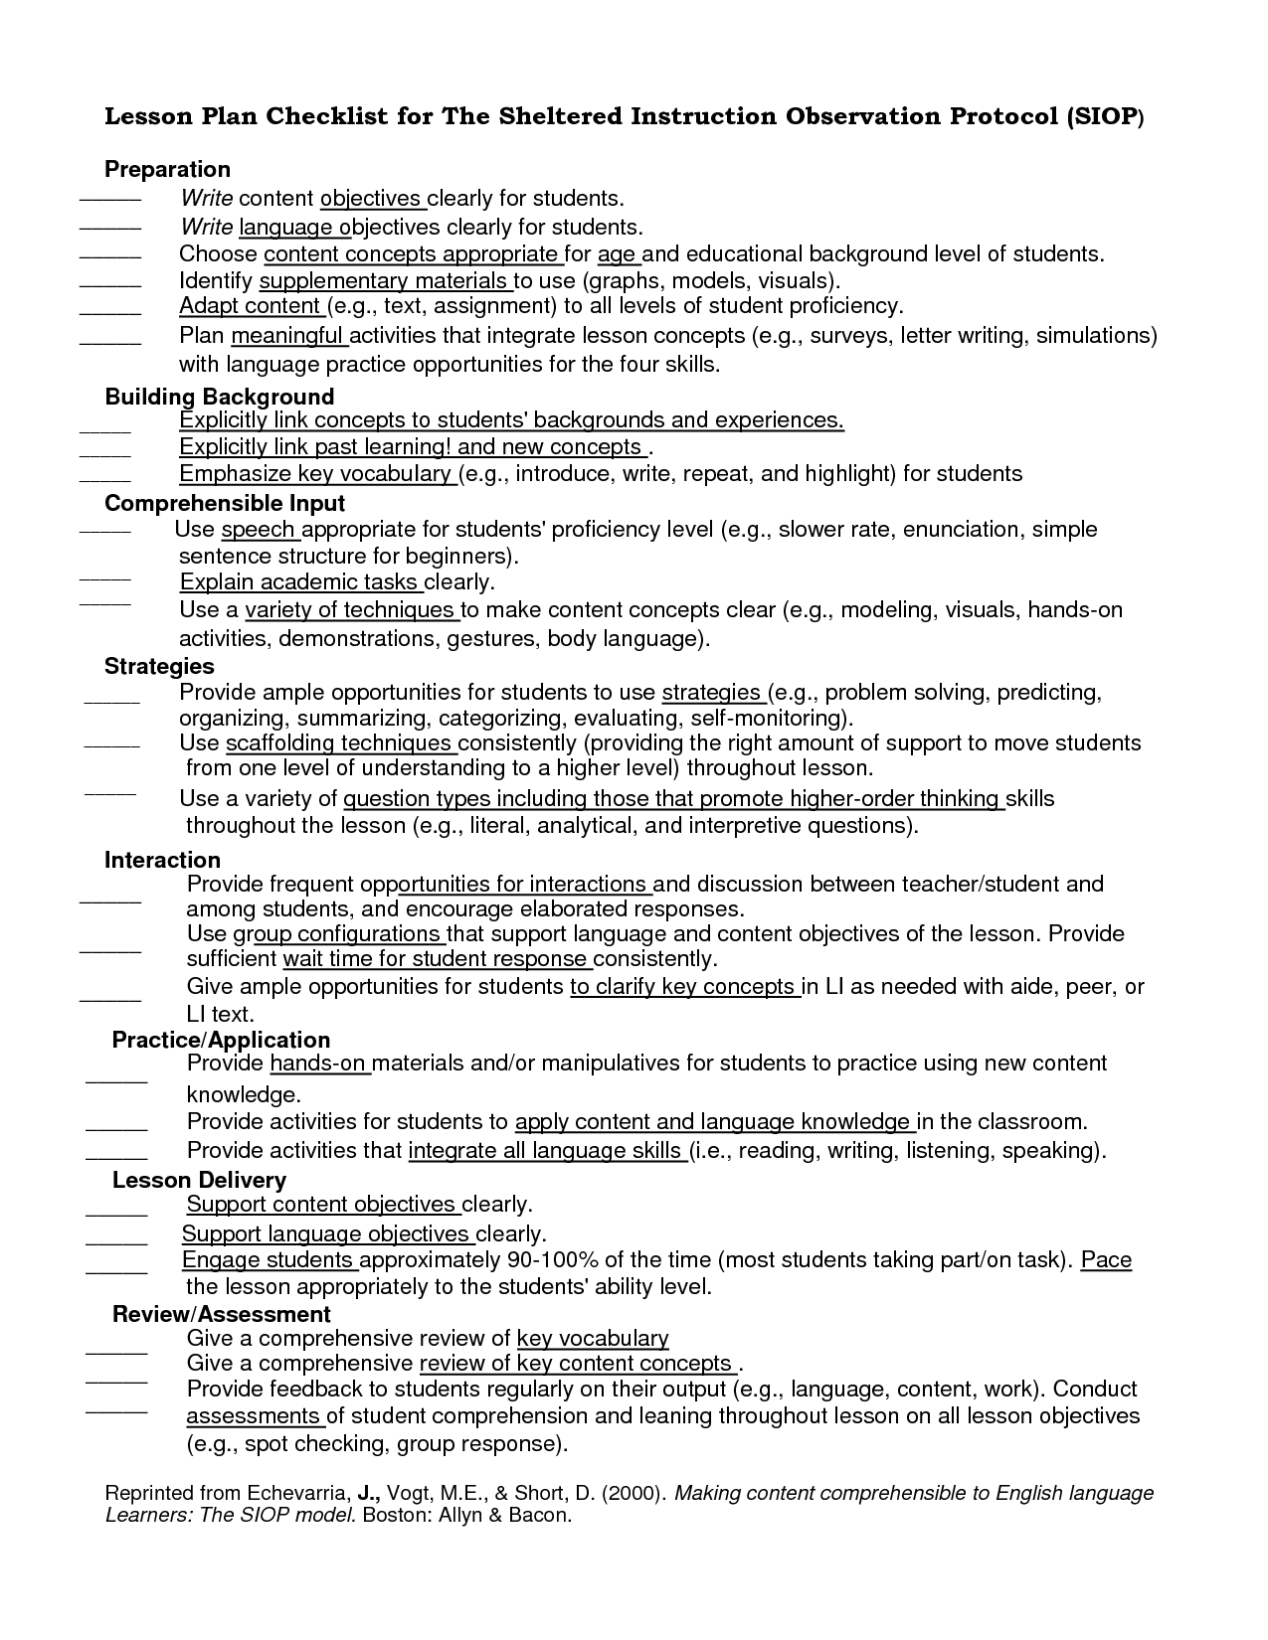
Appendix A: SIOP Checklist

Appendix B: Needs Assessment
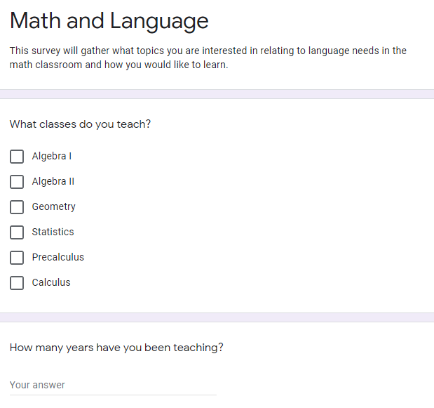

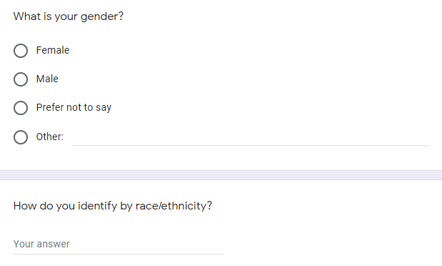
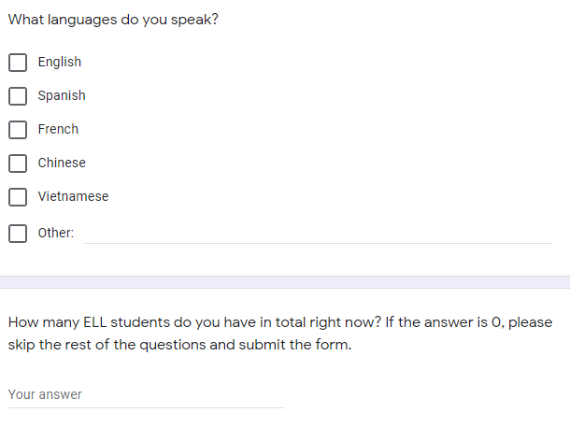
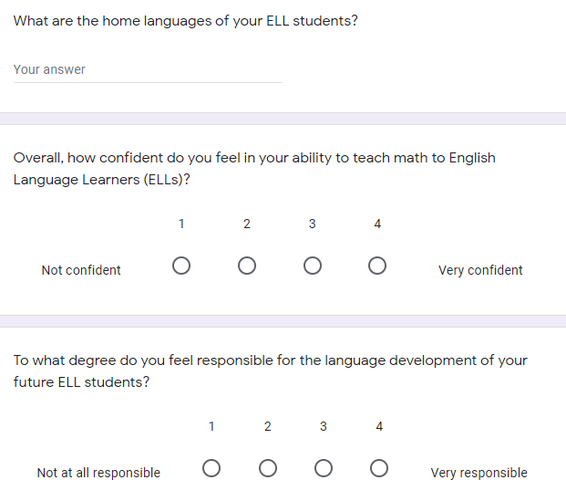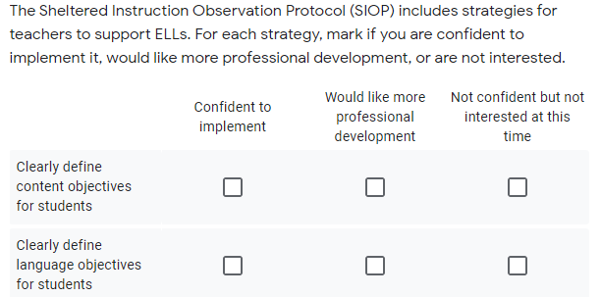
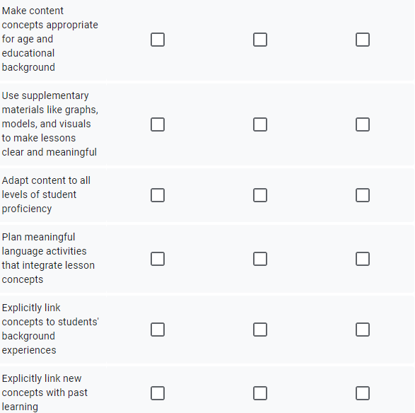
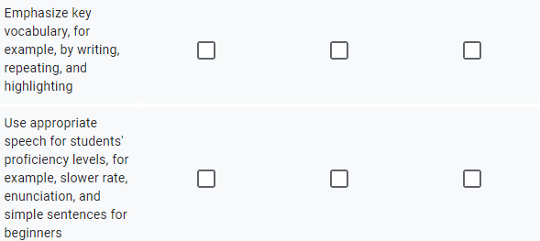
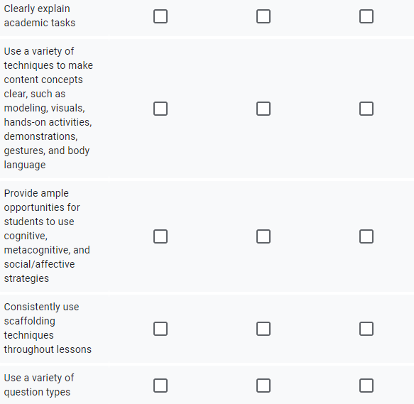
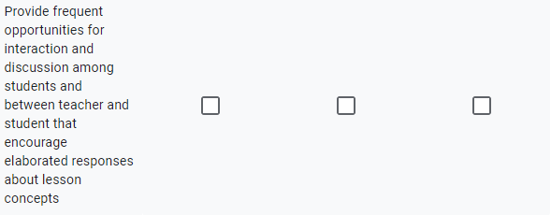
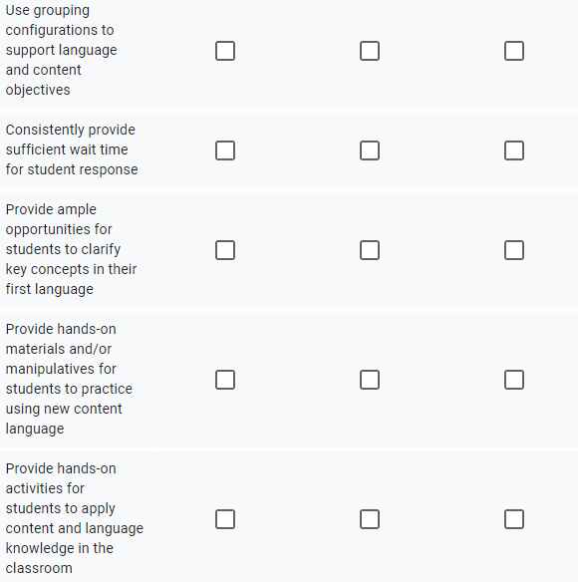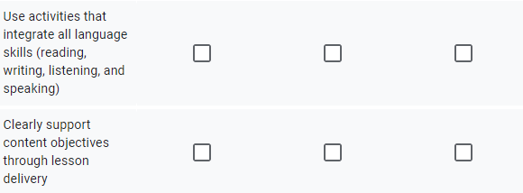
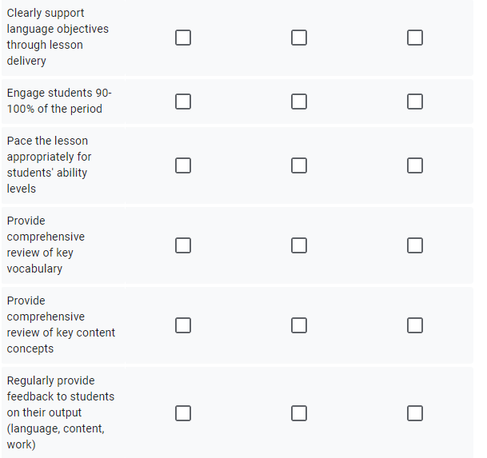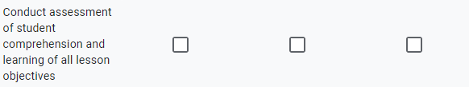
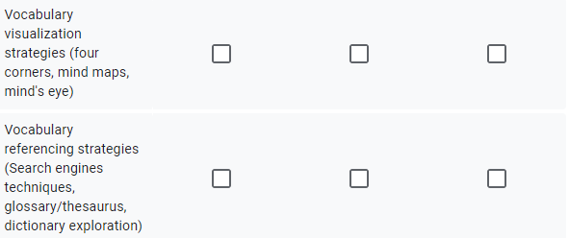
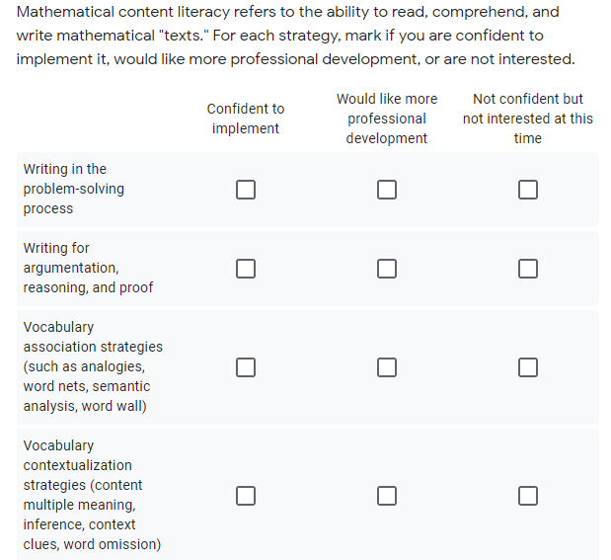
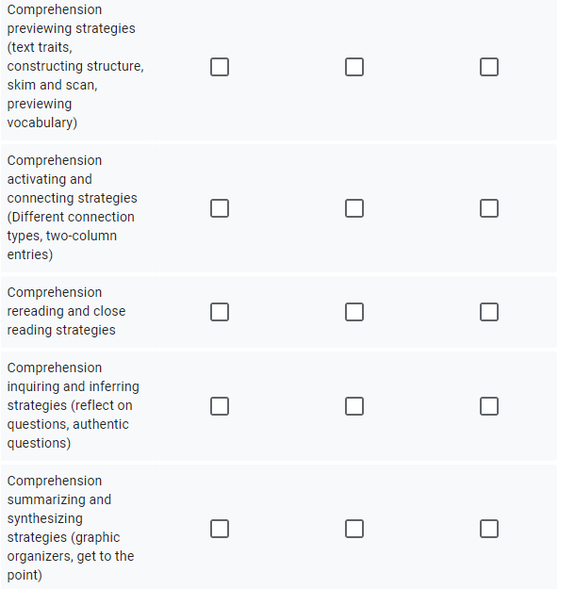
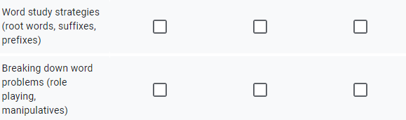
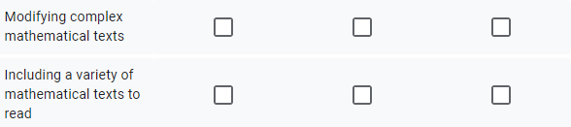
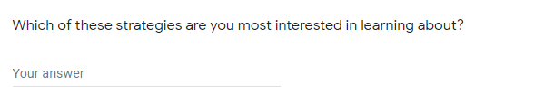
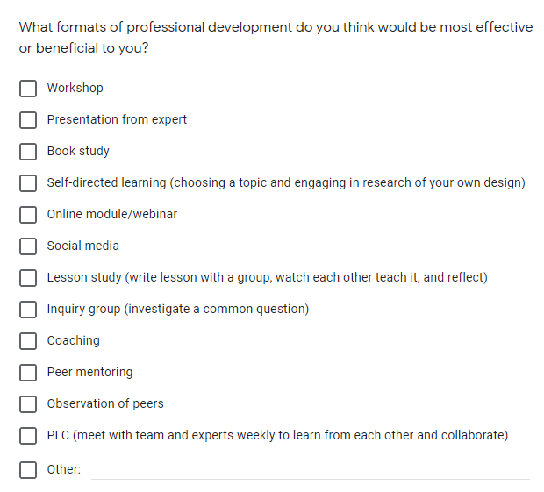


Appendix C: Interview Protocol
- Maria: You marked a 3 out of 4 on overall confidence at the beginning of the survey but only marked that you were confident on 8 of 45 strategies. That was surprising to me.
- Maria: When you listed strategies that you already use with your ELLs, you included wait time, pictures, and modified language on tests. However, the strategies you wanted more PD on included these three. What specifically do you want to improve on in these areas?
- Maria: What is your prior experience with the SIOP model and disciplinary literacy?
- Faith: You marked a 3 out of 4 on overall confidence at the beginning of the survey but only marked that you were confident on 8 of 45 strategies. That was surprising to me.
- Faith: You said that the main strategy you use with your ELL students is trying to speak to them in their language, but I didn’t see Spanish as a language that you speak. What do you usually translate? Directions? Lecture notes?
- Faith: What made you choose vocabulary visualization as the strategy you were most interested in?
- Both: Overall, how do you feel about this professional development plan?
- Both: What do you think you would learn or improve in from this PD plan?
- Both: How was this PD plan tailored to or not tailored to your needs?
- Both: How would this be similar or different than other PD you’ve participated in? How would that affect your learning?
- Both: What would you change about this plan?
- Both: Are there any other comments or questions you have for me?

Appendix D: Professional Development Plan
Rationale
As of the 2019-20 school year, X public schools were serving 57,134 English Language Learners (X State Department of Education, 2019), and many of these students will end up in mainstream classrooms where their content and language learning will be the responsibility of their classroom teachers. However, many teachers are not exposed to ELL instruction principles in their pre-service program, and professional development in the state around this issue has been minimal. However, there are many language supports that can be given to students in the math classroom as well as disciplinary literacy strategies that students can use to read and write mathematical texts.
This survey was designed to measure teachers’ confidence and interest in these strategies. The Sheltered Instruction Observation Protocol model was chosen because it is the only professional development tool that has been empirically proven to raise ELL achievement (Shearer, Carr, & Vogt, 2016). It is made up of 30 aspects in 8 domains to help content area teachers support their ELLs in learning content and language simultaneously. The 15 disciplinary literacy strategies were taken from a variety of sources, including Sustaining Strategic Readers (Ellery & Rosenboom, 2011) and This is Disciplinary Literacy: Reading, Writing, Thinking, And Doing ... Content Area by Content Area (Lent, 2016). Together, these strategies should provide a solid basis for future math teachers to support all of their students’ language needs.
Priorities
From the Needs Assessment, teachers marked many areas in which they desired more support. In fact, both marked 37 of the 45 strategies, and there were only 10 strategies where the teachers marked different options. Because of this, I decided to create two main priorities that would fit both teachers’ needs: meaningful oral language activities and vocabulary. Each of these topics is made up of several of the strategies from the needs assessment. Meaningful oral language activities focuses on developing language goals for students, giving them opportunities to talk and listen about the lesson content using mathematical vocabulary, then evaluating their progress. Vocabulary focuses on developing language goals, giving students tools to learn important vocabulary deeply, and providing texts that increase students’ vocabulary skills. Only one strategy in each category was marked as “confident” by either participant, so these should meet teachers’ stated needs.
Meaningful Oral Language Activities | Vocabulary
- Clearly define language objectives for students¹  - Plan meaningful language activities that integrate lesson concepts¹  - Provide hands-on materials and/or manipulatives for students to practice using new content language¹  - Provide hands-on activities for students to apply content and language knowledge in the classroom¹  - Use activities that integrate all language skills (reading, writing, listening, and speaking) ¹  - Provide frequent opportunities for interaction and discussion among students and between teacher and student that encourage elaborated responses about lesson concepts²  - Use grouping configurations to support language and content objectives²  - Clearly support language objectives through lesson delivery³  - Conduct assessment of student comprehension and learning of all lesson objectives³ | - Clearly define language objectives for students¹  - Include a variety of mathematical texts to read¹  - Use supplementary materials to make lessons clear and meaningful¹  - Provide ample opportunities for students to use cognitive and metacognitive strategies¹  - Provide ample opportunities for students to clarify key concepts in their first language¹  - Vocabulary visualization¹  - Vocabulary association¹  - Vocabulary referencing¹  - Emphasize key vocabulary²  - Use a variety of techniques to make content concepts clear²  - Provide comprehensive review of key vocabulary²  - Clearly support language objectives through lesson delivery³  - Conduct assessment of student comprehension and learning of all lesson objectives³
Formats
One teacher identified workshop, presentation from expert, and book study as her preferred PD formats, and the other chose coaching and observation of peers. For this reason I will provide each PD activity in two formats so that teachers can choose their preference.
Organization
The two charts are organized with learning stages in the first column and activity options in the second column. Although topics from the above chart will be addressed more than once, they are marked ¹ if mostly associated with Stage One, ² if Stage Two, and ³ if Stage Three.
Meaningful Oral Language Activities
Topic | Activities
Stage One: Planning | Book study: In “Making Content Comprehensible for English Learners: The SIOP Model” read sections “SIOP Feature 2,” “SIOP Feature 6,” “SIOP Feature 20,” “SIOP Feature 21,” and “SIOP Feature 22.” Take notes in a way you can quickly refer to while planning three lessons that incorporate these features and share your main takeaways with a colleague.  Peer observation: Ms. Jones at North High School is a math teacher who engages her ELLs in lots of oral language activities. After doing some preliminary research on what parts of meaningful oral language activities you want to focus on, observe her and look for those specific things, asking her any clarifying questions. Take notes about what you notice and what could work in your classroom.
Stage Two: Enacting | Presentation from expert: Before teaching the lessons you planned, look at this presentation about facilitating mathematical discourse. As you teach, make note of how students are communicating, which groups are working and talking together well, and which are not. Adjust groups for the next lesson as needed.  Coaching: Focusing on your ability to facilitate mathematical discourse and the way groups are supporting this, have an instructional coach observe a lesson and take notes on these goals. Video the lesson as well, watch it yourself afterwards, and then meet with the instructional coach to compare notes and identify strengths and weaknesses.
Stage Three:  Reflection | Workshop: With your professional learning community or with help from resources at the University, develop a mini assessment that looks at students’ ability to communicate orally about the mathematics they learned. This could involve recording a group explanation of a topic, a mini presentation, an Adobe Flash video, or something else that involves students’ voices.  Coaching: Develop an assessment for students’ ability to communicate orally about the mathematics they learned and include a question for students to tell you how they felt about their ability to talk about math and if the lesson activities helped. After looking through the results, discuss them with the coach and develop a plan to take what worked into your next lessons and adapt what didn’t.

Vocabulary
Topic | Activities
Stage One: Planning | Presentation from expert:  Colorín Colorado is an organization of experts focused on ELL instruction. First, read The Components of Effective Vocabulary Instruction, especially the sections after the heading “Explicit Instruction of Specific Words,” as well as Tips for Educators of ELLs: Teaching Vocabulary in Grades 4-12. Next, watch “Vocabulary” from Colorín Colorado and make note of any strategies she mentioned that sound interesting to you. To see what this could look like in action, watch “Teaching out of the Box”. Now that you’re thinking about ways to use vocabulary, read Language Objectives from Colorín Colorado. For more in-depth description of specific vocabulary strategies, watch this webinar from American TESOL (Teaching English to Speakers of Other Languages). For ideas of alternate texts (besides a textbook) that students can engage with to learn mathematical vocabulary in context and develop reading skills, see this list (Lent, 2016).To fill in gaps you still have questions about, refer to “Making Content Comprehensible for English Learners: The SIOP Model” or reach out to resources in the University’s College of Education for a personalized presentation.  Peer observation: Telannia Norfar at Northwest Classen High School is a math teacher who does really well with her ELLs. After doing some preliminary research on what parts of vocabulary you want to focus on (see links above), observe her and look for those specific things, asking her any clarifying questions. Take notes about what you notice and what could work in your classroom.
Stage Two:  Enacting | Workshop: For your next three lessons, write language objectives for all three, write at least one activity for each lesson that will require students to use vocabulary, and include a mathematical text (that isn’t a word problem) in at least one. Set up a workshop time with Janet Gorton, the World Languages Coordinator, to go over these plans and also brainstorm a list of ways you can emphasize key vocabulary for the lessons, explain them in different ways, and review the vocabulary.  Coaching: Reach out to resources in the University College of Education, Janet Gorton, the World Languages Coordinator, or an instructional coach for 2-3 coaching sessions. For each session, set a goal and communicate it to your coach so they will know what to look for. After the lesson, debrief with your coach about what went well and what didn’t, as well as what students were doing during the lesson. Brainstorm what adjustments could be made for the next lesson. Pay special attention to how you are emphasizing, explaining, and reviewing vocabulary.
Stage Three:  Reflecting | Book study: After teaching each lesson, write a quick reflection in bullet points about what went well, what didn’t go well, and how well students mastered vocabulary. Then, in “Making Content Comprehensible for English Learners: The SIOP Model” read the section titled “SIOP Feature 24” in Chapter 8 and “SIOP Feature 30” in Chapter 9. Discuss the contents of these sections and how they compare to your lesson delivery with a colleague or the World Languages Coordinator.  Coaching: While teaching, collect data on students’ vocab growth. With one of the people mentioned in the last section, ask them to come observe how clearly you are supporting the language objectives of your lessons with your lesson delivery (alternately, record yourself and send it to someone to review). Compare your reflection on implementation with your coach’s as well as with assessment data on vocabulary.
Evaluation
To assess how effective these professional development activities were, teachers could complete the original needs assessment again to see which areas they grew in, as well as complete a short reflection on which activities were most helpful and what topics they still would like help in.
References
Echevarría, J., Vogt, M.E., & Short, D. (2016). Making content comprehensible for English learners: The SIOP Model (5th ed.). Boston, MA: Pearson/Allyn & Bacon.
Ellery, V., & Rosenboom, J. L. (2011). Sustaining strategic readers: Techniques for supporting content literacy in grades 6-12. International Reading Association.
Lent, R. C. (2016). This is disciplinary literacy: Reading, writing, thinking, and doing ... content area by content area. Thousand Oaks: Corwin Literacy.
X State Department of Education. (2019). X public schools fast facts [PDF file].
Shearer, B. A., Carr, D. B. A., & Vogt, M. E. (2019). Reading specialists and literacy coaches in the real world. Long Grove, IL: Waveland Press, Inc.
Wepner, S. B., Strickland, D. S., & Quatroche, D. J. (2014). The administration and supervision of reading programs (5th ed.). New York, NY: Teachers College Press.

