THE UNIVERSITY OF OKLAHOMA
GRADUATE COLLEGE

THE UNDERESTIMATED CELLO CONCERTOS: HISTORICAL, STYLISTIC AND COMPOSITIONAL COMPARISON OF THE TWO CELLO CONCERTOS OF FELIKS NOWOWIEJSKI AND GRAŻYNA BACEWICZ

A DOCUMENT
SUBMITTED TO THE GRADUATE FACULTY
in partial fulfillment of the requirements for the
Degree of
DOCTOR OF MUSICAL ARTS

By
ANGELIKA MARTA MACHNIK-JONES
Norman, Oklahoma
2021
THE UNDERESTIMATED CELLO CONCERTOS: HISTORICAL, STYLISTIC AND COMPOSITIONAL COMPARISON OF THE TWO CELLO CONCERTOS OF FELIKS NOWOWIEJSKI AND GRAŻYNA BACEWICZ

A DOCUMENT APPROVED FOR THE
SCHOOL OF MUSIC

BY THE COMMITTEE CONSISTING OF

Dr. Jonathan Ruck, Chair

Dr. Anthony Stoops

Dr. Frank Riddick

Dr. Stephen Weldon

© Copyright by ANGELIKA MACHNIK-JONES 2021
All Rights Reserved.

ACKNOWLEDGEMENTS

I would like to thank the members of the committee for their guidance in preparation of this document. Dr. Jonathan Ruck has been a source of my constant academic support and encouragement. I am honored to have him as my mentor, inspiration for music excellence and friend. Dr. Anthony Stoops, Dr. Frank Riddick and Dr. Stephen Weldon have been encouraging and have provided me with excellent mentorship.
I would like to thank Paweł Nodzak, the librarian at the Stanisław Moniuszko Academy of Music in Gdańsk, for all the help in locating manuscripts and multiple resources about the Feliks Nowowiejski and his cello concerto. It has been especially difficult to obtain documents during the Covid-19 pandemic. I am grateful to Mr. Nodzak for helping me acquire copies of the documents existing only in the Polish libraries.
I would like to thank Jan Czaja and Paweł Panasiuk for our conversations on the Nowowiejski concerto. These conversations provided me with encouragement to continue learning about this concerto, as well as invaluable information coming from a point of view of the performer of this work.
I would like to thank my students for their patience during this busy time and my Oklahoma Conservatory of Music teachers for their understanding and constant encouragement.
Most importantly I would like to thank my husband, Dustin Jones for being my continuous cheerleader during this doctoral degree adventure. I could not have done this without him. From proofreading the document multiple times to taking care of our beautiful son Daniel, he’s always been there for me and I know he always will.
TABLE OF CONTENTS
Page

ACKNOWLEDGEMENTS iv
ABSTRACT vii
LIST OF MUSICAL EXAMPLES viii
- INTRODUCTION 1
Statement of Purpose 1

Need for Study 3

Methodology/Scope and Limitations 5

Review of Related Literature 7

- HOW TWENTIETH-CENTURY HISTORICAL AND POLITICAL EVENTS OF POLAND SHAPED THE DEVELOPMENT
OF POLISH MUSIC 16

Officially a Nation Again: Poland and Polish Music During
the First Half of Twentieth Century 16

A Nation Not Free: Poland and Polish Music During
the Second Half of Twentieth Century 24

- FELIKS NOWOWIEJSKI (1877-1946) 29

Biographical Information and Compositional Output 29

Reasons for Neglect and Long-Awaited Revival
of Nowowiejski’s Music 37

Poznan Period: Neoclassical Inspirations and Background of
the Concerto for Cello and Orchestra in e minor, op.55 40

Location and Information About the Manuscript 42

Analysis of Concerto for Cello and Orchestra in e minor, op.55 43

- Allegro con brio 43
- Aria: Andante tranquillo 54
- Passacaglia: Allegro moderato 60

‘Tour de Force’ Concerto: Performance Challenges 72

- GRAŻYNA BACEWICZ (1909-1969) 74

Biographical Information and Compositional Output 74

General Characteristics of Cello Concerto no.1 81

Analysis of Cello Concerto no.1 84

- Allegro non troppo 84
- Andante tranquillo 90
- Finale: Allegro giocoso 94

- SEPARATED BY A GENERATION AND A WAR,
UNITED BY ONE IDEA:
HISTORICAL, STYLISTIC AND COMPOSITIONAL
COMPARISON OF THE TWO CONCERTOS 101

- CONCLUSION 113

- BIBLIOGRAPHY 115

Books 112
Journal Articles and Conference Reports 114
Theses and Dissertations 115
Websites 115
Scores 116
ABSTRACT

Feliks Nowowiejski (1877-1946), a Polish composer whose name is synonymous with Polish patriotic music, including the country’s second unofficial anthem, contributed to the twentieth-century cello repertoire with his Concerto for Cello and Orchestra in E Minor, op.55. Except for Jan Maklakiewicz’s Cello Concerto on Gregorian Themes, Nowowiejski’s composition was the first known significant Polish cello concerto written in the twentieth century. Composed right before World War II, the concerto represents the neoclassical style of Nowowiejski’s last years. Grażyna Bacewicz (1909-1969), known for her violin compositions and string quartets, was a major representative of the Polish neoclassical style. Her Cello Concerto no.1, composed several years after World War II, represents the neoclassical style following the oppressive restrictions of the communist government. This document will explore and analyze these two concertos through the prism of the composers' experiences and influences. It also means to compare the concertos through a historical, stylistic, and compositional perspective. The Nowowiejski concerto has as of yet not received much attention. There is no publication of the composition, nor are there any recordings. The author of this document’s utmost hope is that this will change as more study is devoted to the life and compositions of this Warmian composer.

LIST OF MUSICAL EXAMPLES

Music Example 1: Feliks Nowowiejski, Concerto for Cello and Orchestra in
E Minor, I. Allegro con brio, Measures 1-8 45
Music Example 2: Feliks Nowowiejski, Concerto for Cello and Orchestra in
E Minor, I. Allegro con brio, Measures 23-36 47
Music Example 3: Feliks Nowowiejski, Concerto for Cello and Orchestra in
E Minor, I. Allegro con brio, Measures 100-125 49
Music Example 4: Feliks Nowowiejski, Concerto for Cello and Orchestra in
E Minor, II. Aria: Andante tranquillo, Measures 1-10 56
Music Example 5: Feliks Nowowiejski, Concerto for Cello and Orchestra in
E Minor, III. Passacaglia: Allegro moderato, Measures 61-75 64
Music Example 6: Feliks Nowowiejski, Concerto for Cello and Orchestra in
E Minor, III. Passacaglia: Allegro moderato, Measures 367-425 71
Music Example 7: Grażyna Bacewicz, Cello Concerto no.1, I. Allegro non troppo,
Measures 33-50 85
Music Example 8: Grażyna Bacewicz, Cello Concerto no.1, I. Allegro non troppo,
Measures 76-78 86
Music Example 9: Grażyna Bacewicz, Wind Quintet, II. Air: Andante,
Measures 5-16 87
Music Example 10: Grażyna Bacewicz, Partita for Orchestra, III. Intermezzo: Andantino
melancolico, Measures 1-3 87

Music Example 11: Grażyna Bacewicz, Cello Concerto no.1, II. Andante tranquillo,
Measures 1-14 91
Music Example 12: Grażyna Bacewicz, String Quartet no.4, III. Allegro giocoso,
Measures 11-26 94
Music Example 13: Grażyna Bacewicz, Cello Concerto no.1, III. Finale: Allegro giocoso,
Measures 5-16 95
Music Example 14: Grażyna Bacewicz, Cello Concerto no.1, III. Finale: Allegro giocoso,
Measures 133-137 98

- INTRODUCTION

Statement of Purpose

The purpose of this research is to closely examine the largely forgotten and overlooked Concerto for Cello and Orchestra op.55 in E Minor of the Polish composer Feliks Nowowiejski (1887-1946) and compare it with the Cello Concerto no.1 of Grażyna Bacewicz (1909-1969), which in recent years has gained substantial popularity among Polish cellists. Although both concertos have been written in the neoclassical style and were composed only thirteen years apart, they were written in two completely different realities of Polish history. The Cello Concerto of Feliks Nowowiejski was composed in 1938. This was the last year of Polish freedom and existence of the Second Republic of Poland, a country newly reborn in 1918, looking for its own voice in the cultural arena of Europe. Poland’s existence was again ceased after the German and Soviet invasion of the young country, beginning World War II, which among many other horrific events resulted in the elimination of a large portion of the population responsible for Poland’s political, cultural and scientific growth. After the war, Poland became Polish People’s Republic, a satellite state of the Soviet Union. The Cello Concerto no.1 of Grażyna Bacewicz was written in 1951, during the time when the Soviet reign had its' firmest grasp on many areas of life, including music.
This research examines the two concertos through the prism of the political realities, stylistic trends, and the composers' own inspirations and compositional methods. Much of the music of Nowowiejski, although internationally very well regarded and admired during the composer’s life, has for many reasons not withstood the passage of time. After the composer’s death in 1946, much of his music became largely forgotten. Nowowiejski was one of the "old guard" of composers. Born before the 1900s, this group learned their craft before the First World War and came to maturity and artistic stature during the interwar period. As with most of that generation of composers, Nowowiejski was brought up in the German neo-romantic style and became inspired by French neoclassicism only in the last decade of his life. The next generation of composers, including Grażyna Bacewicz, was hugely influenced by the innovative composer Karol Szymanowski (1882-1937), who advocated for young composers to study in Paris instead of Germany. This generation of composers became very adept followers of neoclassicism. Most of the composers who survived World War II continued to stay on the path of neoclassicism for another decade, although it was not a path fully favorable in the eyes of the communist leaders. The style reverted to old forms of composition and favored structural clarity, emotional objectivism, and avoided religion and individualism, which followed the vague objectives of social realism. At the same time, it was deemed "formalist," “anti-realistic," and “anti-social," as presented in the Conference of Łagów in 1949, which aimed at postulating the correct parameters of music composition. After the Stalinist “thaw” in 1956, Polish composers turned to new modernist styles, completely abandoning the "old language" and thus rendering composers like Nowowiejski obsolete and forgotten.
In recent years much has been accomplished in uncovering the forgotten life and music of Nowowiejski. Much has also been accomplished in uncovering the Polish cello literature of the first half of the twentieth century. The Cello Concerto no.1 of Grażyna Bacewicz has gained popularity in recent years, resulting in many performances of the composition, and an increased study of the work, although it still lies in the shadows of the Lutosławski and Penderecki cello concertos. The Nowowiejski Cello Concerto, unfortunately, remains mostly forgotten. This study aims to bring attention to these overlooked and overshadowed concertos with the hopes of further research and performance.

Need for Study

Much research exists on the Polish cello concertos written in the second half of the twentieth century. The genre became a frequently visited form of composition for many Polish composers, including Grażyna Bacewicz, Aleksander Tansman, Witold Lutosławski, Krzysztof Penderecki, Andrzej Panufnik, Boguslaw Schaeffer, Marek Stachowski, Krzysztof Meyer and Aleksander Lasoń. The cello was a much-favored instrument for its soloistic qualities, a wide range of tone and color, and many varieties of extended techniques. Virtuoso cellists of the time, such as Mscislav Rostropovich, Pablo Casals, Gaspar Cassadó, Miloš Sádlo, Siegfried Palm, and Kazimierz Wiłkomirski, were also largely responsible for either commissioning new works for cello and orchestra or inspiring composers to write for this medium. Overall, over forty cello concertos were written by Polish composers during the second half of the twentieth century.
The first half of the twentieth century shows a much different picture, with only seven known Polish cello concertos, all except one existing only in manuscript form or destroyed. The first Polish cello concertos were written by Władysław Rzepko, who composed them in 1908, 1923, and 1929. All three were written for his son, the cellist Karol Rzepko, and were mostly of pedagogical value. The Concerto for Cello and Orchestra on Gregorian Themes, written by Jan Maklakiewicz in 1929, has received much recognition through publication and a recent recording by a Polish cellist and pedagogue Tomasz Strahl. Jerzy Fitelberg, son of the famous Polish interwar period conductor Grzegorz Fitelberg, wrote his Cello Concerto in 1931. Both father and son managed to escape the Nazis and immigrate to the United States. The Cello Concerto of Stanisław Nawrocki is unfortunately lost, as it was destroyed with much of his other compositions during World War II. The Cello Concerto of Feliks Nowowiejski is, as Marcin Gmys described in his book Not Just Rota: Feliks Nowowiejski and His Music, “most likely the most important Polish concerto for cello and orchestra, penned by a Polish composer before the compositions of Witold Lutosławski and Krzysztof Penderecki." It is, in many ways, the most challenging Polish cello concerto of the period. Monumental in size, it is over forty minutes long. It uses large orchestral forces and features a very technically and artistically demanding solo cello part. Of all the above-mentioned cello concertos, it is written by the most famous composer of them all by far. Yet, for many reasons presented in this study, it has not received much attention. Any research is sporadic, written only in the Polish language, and scattered among different conference presentations, reports, and book mentions. There is a need for this research to be presented in one place, examined, analyzed, expanded, and written in the English language in order to reach a larger research community. It is also very important to present this research next to the only other neoclassical Polish cello concerto of the period, the Cello Concerto no.1 of Grażyna Bacewicz. Neo-classicism was a very interesting style in the first half of the twentieth century, hard to define accurately, and affected most composers of that era. It is of high value to compare how the two composers handled this style in their cello concertos, as representatives of two different generations, composing those specific works in two different political and cultural realities.

Methodology/Scope and Limitations

The study will begin by outlining the important historical and political events in twentieth-century Poland, which shaped Polish music's development and influences. This will paint a clear picture of the two composers' upbringing, education, and the cultural, political, and societal realities that formed their lives and artistic outputs. The study will then discuss the European neoclassicism seen in music in both the generation of Feliks Nowowiejski and Grażyna Bacewicz and how it manifested itself and evolved in the artistic language of both generations.
As the composer of Rota, the second official Polish anthem, Nowowiejski was an important composer who became known for raising the patriotic spirit of Poles during the turbulent years of the young Second Republic of Poland. For that purpose, he wrote numerous songs for amateur choirs that were sung throughout many regions of the country, especially those regions still not officially belonging to Poland at the time. He was also a very well-respected organist and composer of several celebrated and innovative organ works. In recent years, his patriotic songs and organ compositions have undergone a substantial revival. Unfortunately, his symphonic music, with the exception of few select works, is still in need of much uncovering and research.
The study will only touch on general aspects of Nowowiejski's biography and his compositional output. The book “Feliks Nowowiejski – biography” by Iwona Fokt, published just recently in 2019, is the first substantial book on this topic written in the English language. It is an in-depth look at Nowowiejski’s life with the factual correction of some events stated incorrectly in previous books. For this reason, a detailed account of his life is unnecessary in this study unless it pertains to the reasons for the disappearance of the composer's works from concert programs. The last twelve years of the composer’s life will be presented in more detail, as this is the period of his fascination with the neoclassical style.
Nowowiejski’s Cello Concerto will be discussed in much detail. The study aims to collect all the information and limited research previously done about the work, currently scattered among a small number of obscure conference reports and mentions in books and articles. The concerto will be thoroughly analyzed specifically through the prism of the neoclassical style. Information will be provided on the manuscripts' location, and there will be a list of past performances, including the circumstances surrounding the premiere of the work.
The Nowowiejski Concerto will then be compared to the Cello Concerto of Grażyna Bacewicz. It is unnecessary to include a thorough biography of Bacewicz, as enough material already exists on this matter. This document will highlight the biographical differences between Nowowiejski and Bacewicz, which influenced their ways of composing. The Bacewicz Concerto will then receive its analysis through the prism of neoclassicism, the differences in the use of the style between the concerto and composer’s other works of that period, and comparison to the Nowowiejski Cello Concerto.
The research will conclude with the importance of those works in the literature of Polish cello music.

Review of Literature

History of Poland and Polish Music in the Twentieth Century

British scholar Norman Davies is widely thought to be one of the most authoritative figures on Poland's history. God’s Playground. Volume II: 1795 to the Present is a detailed account of Polish history, starting with the beginnings of partitions and the country’s disappearance from the world map all way up to the first ten years of the newly reborn Third Polish Republic, free from its communist grasp. Davies' research is significant, as it brings a detailed historical, political, and philosophical account of events from an outsider's perspective. This book will help outline important events and thoughts, which shaped a particular narrative in the Polish evolution of music.
History of Music in Poland: Between Romanticism and the New Music by Zofia Helman is a treasure trove of detailed research on the Polish musical culture and stylistic tendencies developing throughout the first half of the twentieth century. The author provides a thorough account of important music institutions and people surrounding them in Poland's major cultural centers, including Warsaw, Cracow, Lviv, and Poznan. Of great importance to this research is Helman’s take on the generational conflict between the continuators of Romanticism and the Young Poland movement, a coalition of composers whose aim was to modernize Polish music, define its national characteristics, and make it relevant on the international stage. The second half of the book is devoted to neoclassicism in Poland. Helman discusses the neoclassical tendencies in Polish music during the interwar years and after World War II. She provides a detailed analysis of the tonal-harmonic issues, polyphony, orchestral techniques, sonoristic qualities, and form in Polish neoclassicism. This will be of great use when discussing the neoclassical style of Feliks Nowowiejski and Grażyna Bacewicz.
Polish Music Since Szymanowski by Adrian Thomas focuses on Polish music created after World War II. Thomas includes the Socialist realism period during the first ten years after the war, featuring the compositional output of Andrzej Panufnik, Grażyna Bacewicz, and Witold Lutosławski. The creation of Warsaw Autumn is of particular importance in the emergence of Polish avant-garde music and the artists' search for individual identity. This international festival featured many of Bacewicz’s works and proved her high artistic standing in the circle of celebrated composers of Europe. The remainder of the book deals with the sonoristic, experimental, and avant-garde music of Lutosławski, Serocki, Górecki, Scheaffer, Penderecki, and others. It provides reasons for the emergence of Polish avant-garde music onto the international stage and its use of innovation and individuality.
Polish Music in the Twentieth Century by Jacek Rogala is a study on how historical and political events of the country affected Polish music culture and compositional output. The book is not nearly as detailed as Helman’s History of Music in Poland, but it provides a clear understanding of how Polish music composition and culture evolved and exactly what challenges it faced. It begins with the overview of the music scene in nineteenth-century Poland, under Prussian, Austrian and Russian rule, and the critical role it played in the fight against the denationalization of the country. It moves on to the Young Poland movement at the beginning of the twentieth century, the role of Polish music during the "rebirth of the Polish State," and the neoclassical influence of Paris. Rogala provides an account of music, musicians, and composers during the German occupation, including Bacewicz and Nowowiejski. The author's thoughts on social realism and the communist period are also of importance, as they set a scene in which Bacewicz’s Cello Concerto no.1 was composed. The rest of the book deals with Polish discoveries of sonorism, aleatorism, and avant-garde tendencies in the music of Lutosławski, Penderecki, and subsequent departure from those tendencies in later works of Penderecki, as well as in the works of Mikolaj Górecki and Wojciech Kilar.
Neoklasycyzm w muzyce polskiej XX wieku (“Neoclassicism in Twentieth Century Polish Music”) by Zofia Helman is a comprehensive study of the aesthetics of neoclassicism in the European as well as specifically Polish artistic output of twentieth-century composers. Throughout the first half of the twentieth century, neoclassicism became an opposing force to Romanticism, a new language set to free the music from the complex nature of romantic extremes. It spread through Europe and became embraced by many composers seeking to change the direction of music and create something new and exciting by reaching for the formal language of balance and clarity. Nowowiejski became deeply influenced by this new style after his visit to Paris, and subsequent meeting and many discussions with “the great symphonisist…the French Brahms”, Albert Roussel. Roussel was a great propagator of French neoclassicism and influenced many other artists to delve into this new way of composition fully. Helman discusses how neoclassicism took root among most Polish composers of the time and continued well into the years after World War II. Helman’s research on the specific compositional techniques in Polish neoclassicism is of specific value to this research. The author's discussions on harmony, polyphony, polytonality, orchestral techniques, sonoristic qualities, and compositional forms will be constructive when analyzing the cello concertos of Nowowiejski and Bacewicz. This book is much more thorough research on the style than her later publication, The History of Poland: Between Romanticism and New Music.

Feliks Nowowiejski

Although the biography Feliks Nowowiejski, 1877-1946: zarys biograficzny written by Jan Boehm in 1977 is now outdated, it provides a perspective on Nowowiejski’s life and the history of the region of his birth, written only thirty years after the composer’s death. Boehm was a scholar on the Warmia region, an author of the first full-length biography on Nowowiejski, and a researcher dedicated to popularizing the artistic output of the celebrated Warmian composer.
Feliks Nowowiejski: biography, written by Iwona Fokt in 2019, is the newest full-length biography of the composer and the first biography of this type, written in English. It clarifies and corrects many facts of Nowowiejski’s life originally presented by Jan Boehm. Through careful analysis of material found in Poland and abroad, Fokt explores why the composer became an almost forgotten artist and the previous misconceptions of critics and musicologists. Nowowiejski lived during highly volatile times. His place of birth, the strong presence of patriotism and religion in his compositional output, and his resolve not to be influenced by new modernist trends created negative attitudes toward the composer’s works. During his lifetime, Nowowiejski’s patriotic compositions were widely performed and published because they met a specific social demand. Those works overshadowed his major symphonic works, and many of those symphonic works still, unfortunately, exist only in manuscript form.
Nie Tylko Rota: Feliks Nowowiejski i Jego Muzyka (“Not Only Rota: Feliks Nowowiejski and his Music”) by Marcin Gmys focuses on the Warmian composer’s artistic output. Gmys bases his biography of Nowowiejski on the works that the composer wrote throughout his life. Many of his works, including the Cello Concerto, are provided with background information, circumstances of composition, and a rough analysis. Gmys paints a clear picture of the composer’s Poznan period when he became influenced by French neoclassicism and focused his writing on large-scale symphonic works, including four symphonies, a cello concerto, and a piano concerto. Unfortunately, Nowowiejski's sons, Feliks Maria and Kazimierz played a detrimental role in the uncovering of the artist’s life and works. In a misguided belief of helping their father by misconstruing facts and even manipulating manuscripts, the sons made it much more difficult for the scholars to present the truth and bring to light his music. Gmys points out the many examples of the sons' manipulations so that the reader is aware of the problem when looking at specific compositions.
Orkiestra Symfoniczna w Tworczosci Feliksa Nowowiejskiego – Ewolucja Stylu i Warsztatu (“Symphony Orchestra in the Works of Feliks Nowowiejski – the Evolution of Style and the Compositional Technique”) is an article written by Jerzy Kukla, presented within the larger research on Nowowiejski, Feliks Nowowiejski i Jemu Wspolczesni Wobec Idei Muzycznych Przelomu XIX i XX wieku (“Feliks Nowowiejski and His Contemporaries Within the Musical Ideas of the Turn of the Centuries”), edited by Ilona Dulisz and Joanna Schiller-Rydzewska. Kukla chooses three symphonic works of the composer, representing the early, middle and late artistic periods of Nowowiejski. The third composition, Third Symphony, op.53, is of special importance to this study, as it was written right before the Cello Concerto, during the height of Nowowiejski’s neoclassical period. Kukla analyses each of the works within the context of instrumentation, dynamics and use of instrumental and harmonic color, melodic and rhythmic structures. Kuklas’s research will be of much value in transferring his findings to the analysis of the Cello Concerto.
The celebrated Polish cellist, Roman Suchecki, presented the premiere of Nowowiejski Cello Concerto together with the Śląsk Philharmonic in Katowice in 1963, twenty-five years after the completion of the concerto. Suchecki wrote about his findings and thoughts on the concerto in an article O Koncercie Wiolonczelowym Feliksa Nowowiejskiego (“About the Cello Concerto of Feliks Nowowiejski”). The article was featured in an academic session in Warsaw in 1987, dealing with the “Polish Cello Literature in Nineteenth and Twentieth Century." Suchecki provided a brief history of the concerto, a list of performances of the work up till 1977, a detailed description and state of all the manuscript parts, an explanation of notes written on the manuscript's parts by people other than the composer, and a brief formal analysis of each movement. He also shared his thoughts on performing the work and the notion of giving it justice by bringing to the forefront its sincerity of emotion, beauty, and virtuosity.

Grażyna Bacewicz

Grażyna Bacewicz: Her Life and Works by Judith Rosen is the first biography of the composer written in the English language, commemorating the seventy-fifth anniversary of Bacewicz’s birth. Although this Polish composer's music is frequently featured in concert programs in Europe, it is still largely unknown in the United States. This monograph on Bacewicz’s life and works, presented by the Polish Music Society at the University of Southern California, aims to familiarize the American music society with this celebrated Polish composer. Judith Rosen presents the composer’s life, describes Bacewicz’s three artistic periods, and provides an account of works written in each period with their stylistic attributes.
In his book Grażyna Bacewicz: Chamber and Orchestral Music, Adrian Thomas focuses on the artist’s compositional output. The book is designed to serve as a companion to Judith Rosen’s monograph. Thomas discusses the historical perspective of Polish music and Bacewicz’s place in it. He discusses her style, including her neoclassical period, and how it evolved throughout her relatively short life. Thomas divides Bacewicz’s compositional activity into three periods: a preparatory period (1932-1944), neoclassical period (1945-1959) and a third period (1960-1969) during which the composer moved away from neoclassicism and embraced sonorism. He then discusses specific works from each period and their relationship to one another. Although he only mentions the Cello Concerto no.1 in passing, he analyzes works written around the time of the Cello Concerto. These analyses will help this study decipher the concerto.
The article Grażyna Bacewicz – The Polish Sappho, written by Małgorzata Gąsiorowska, presents the composer's musical output against the background of events in her personal life and Polish and European history during the first seventy years of the twentieth century. Many of her works have been linked to neoclassicism and folkloric inspirations. Gąsiorowska incorporates portions of Bacewicz’s correspondence with her brother Vytautas and other artists, in which the composer mentions her thoughts on her specific compositions. Gąsiorowska also includes the opinions of other people and scholars on Bacewicz’s works. The author links Bacewicz’s biography with specific works and discusses them in detail. An important detail to this study is the thematic connection that Gąsiorowska finds between several compositions, including the Wind Quintet (1932), Cello Concerto no.1 (1951), and the Intermezzo movement from the Partita (1955).
The online resource www.bacewicz.polmic.pl is a treasure trove of detailed information on Grażyna Bacewicz and her compositional output. The website was developed by the Polish Ministry of Culture and National Heritage in partnership with The Polish Composers Union, the Polish Center for Music Information, PWM (Polish Music Publisher), and the Library of the University of Warsaw. The website contains articles and information presented by prominent scholars of Polish music. The website features a very detailed account of Bacewicz’s life, and many photographs, newspaper cutouts, and copies of important documents are included. It contains a list of all important dates and events in the composer's life, along with interviews and correspondence, which attest to Bacewicz’s personality and character, and many more audio and video files on the celebrated composer. One of the largest portions of this website contains information and analysis on every significant existing composition of the artist. It includes the Cello Concerto no.1. This will be a vital resource for this study.

- HOW TWENTIETH-CENTURY HISTORICAL AND POLITICAL EVENTS OF POLAND SHAPED THE DEVELOPMENT OF POLISH MUSIC

OFFICIALLY A NATION AGAIN: POLAND AND POLISH MUSIC DURING THE FIRST HALF OF TWENTIETH CENTURY

The beginning of the twentieth century marked one hundred and five years of the Polish nation existing only in the spirit of the Polish people's unwavering determination and patriotism. Once one of Europe's largest kingdoms, spanning from the Baltic Sea to the Black Sea, the Kingdom of Poland fell victim to the political schemes of the Russian Empress Catherine the Great, Frederick of Prussia, and Austrian Empress Maria Theresa. Through those schemes, as well as other reasons, Poland lost much of its territory in 1772 and then again in 1793. By 1795, the Kingdom became completely swallowed by the three Empires. What came next was the struggle for national independence and a fight to preserve the Polish spirit.
Music and literature became the primary weapon against the denationalization efforts of the three powers. Polish poetry and drama flourished like never before. Artists such as Adam Mickiewicz, Juliusz Słowacki, Zygmunt Krasiński, Henryk Sienkiewicz became household names and were instrumental in propagating the Polish language. In music, a national style began to emerge. Much of it was based on Polish folklore. Financial support was hard to find, and many composers left the Polish lands. “Abroad, where their artistic activity was not suppressed, but actually fanned by the homesickness, they bloomed freely. The best example is Fryderyk Chopin (1810-1849).” Another composer, Stanisław Moniuszko, did stay in Poland and managed to raise the performance standards of Polish music considerably. He became the creator of the Polish romantic song and national opera. Symphonic music was almost entirely non-existent due to the lack of any professional orchestras on Polish lands. What did emerge was chamber music, and with it, the violin and piano virtuosi such as Henryk Wieniawski and Ignacy Jan Paderewski.
Artistic life developed differently in each of the partitioned territories. On Austrian partitioned lands, denationalization efforts were least severe. Kraków was the cultural center of this part of the Austrian provinces. This royal city had always been the center with rich cultural traditions. It was the home of the Jagiellonian University, the second oldest university in Central Europe, founded in 1364 by Casimir III the Great, and one of the oldest surviving universities in the world. After the fall of the Kraków Republic in 1846, the political authorities of the time accepted the rule of Emperor Franz Joseph and pledged loyalty to his monarchy. Backed generously by Polish aristocracy, art and music thrived and expanded. The Kraków music scene was heavily influenced by the culture of Vienna. Polish musicians trained at the Vienna Conservatory and collaborations between the two cities were frequent. The Music Society was founded, and with it, an orchestra and a choir. Feliks Nowowiejski became director of this society in 1909, substantially raising the standards of symphonic performances.
On Prussian and Russian lands, denationalization efforts were quite severe. On the Prussian lands, the official language was German, and Polish was mostly prohibited. The end of the nineteenth century was marked by Kulturkampf. The policies of Kulturkampf, put in place in the Prussian Provinces by Otto von Bismarck, affected not just the politics and economy but also culture, education, and the Catholic Church. All public schools were taught only in German. Even Catholic mass services, which had a vital role in the lives of the Polish population, were restricted and solely presented in the German language. The responsibility was given to every Polish household to preserve the language by teaching it to future generations. Polish reading societies were formed, and those were fundamental in protecting the national fighting spirit. In music, amateur singing groups were organized, and private music schools taught and developed the region's young musicians. Towards the end of the century, Feliks Nowowiejski was one of those young musicians.
A similar situation was found in the Russian partitioned Polish provinces, including Warsaw. The Russification process encompassed all areas of life, but despite the unfavorable political situation, the population in Warsaw grew and along with it, the economy. New buildings were erected, including the Polytechnic (1899), the Philharmonic (1898), the Polish Theatre (1912), and the Public Library (1913). The education situation was challenging at all levels, which led to the organization of clandestine private courses and even covert schools. Thankfully, the First Russian Revolution of 1905 changed the Polish predicaments for the better. In Russia, the growing unemployment and falling salaries led to strikes and manifestations. Those manifestations culminated in the "Bloody Sunday," which took place in St. Petersburg on January 9, 1905. Those strikes spilled over to other cities, including Warsaw. The result of this revolution was Russia’s transformation into a constitutional state. The government's control was given to the Duma, and Poles were given the right to sit on the parliament. Those events fueled the Polish people’s aspirations for a free nation.
The twentieth century began with the emergence of the Young Poland movement. In literature, writers sought and defended their artistic freedom. In music, composers were improving their compositional techniques and creating a new modernized Polish musical language. The movement included composers such as Mieczysław Karłowicz, Karol Szymanowski, Apolinary Szeluto, Ludomir Różycki, and Grzegorz Fitelberg. Most composers, including Feliks Nowowiejski, were still very much influenced by the German romantic tradition of Richard Wagner, Richard Strauss, and Max Reger. Germany and Austria were the nearest centers of musical culture. That is where many prominent Polish composers of the turn of the century went to study and develop their artistic skills. The Warsaw music scene was still at the time quite severely underfunded. Both the Russian and Prussian partitioned Polish lands were subject to many efforts of national eradication. Kraków was not able to provide sufficient resources for the new emerging composers, either. The composers of the Young Poland turned to Berlin. There, with the help of the aristocratic Polonia, they began publishing their works and evolving their individual styles. Most of them continued composing in the neo-romantic tradition. The composer who chose a different path of musical evolution was Karol Szymanowski.
Szymanowski, thought to be an outsider in the world of Polish composition of the time, studied in Warsaw before leaving for Vienna and then taking several journeys to Sicily, North Africa, Paris, and London. All those travels opened his mind to new music, composers, and different exotic cultures. From an early age, he felt the responsibility of invigorating Polish music composition. After turning away from the neo-romanticism of his early compositions, he found spiritual, impressionist, and oriental inspirations before turning to Polish folklore. During the years of World War I and afterward, he embraced the French trends of atonality, polytonality, microtonality, rhythmic complexity, and the new timbral effects associated with these changes. His music came to most prominence during the war and interwar period, with masterpieces like the violin concertos, Myths for violin and piano, Métopes for piano, Stabat Mater for contralto, baritone, chorus, and orchestra, and the ballet Harnasie.
The end of World War I signified the Polish nation's rebirth as the Second Republic of Poland. Deciding on Poland's new borders became an issue debated by all of Europe, which caused fighting and civil unrest in many lands inhabited by the Polish population. Poland got back many parts of modern Ukraine, Belarus, and Lithuania, which were part of Poland before the partitions. As a result of the Treaty of Versailles, Poland also gained access to the Baltic sea through a corridor that connected Gdansk with the rest of the country. That territory, previously belonging to Prussia, became a point of much division between Poland and Germany. Other provinces were subjected to popular plebiscites, which would decide the fate of their people. The region of Warmia and Mazury, the home of Feliks Nowowiejski, was also involved in the voting process. Nowowiejski, after choosing the Polish side, helped the cause by raising people’s patriotic spirits through the composition of a multitude of patriotic songs, which were constantly performed by choirs all over the region. Unfortunately, the efforts in this region were unsuccessful. Warmia and Mazury remained under German rule until the end of World War II.
The rebirth of sovereign Poland caused new political and economic difficulties but also offered many new possibilities in the world of music. Polish Radio became one of the most influential cultural institutions during the interwar period. In 1935 Polish Radio Symphony Orchestra was founded by Grzegorz Fitelberg. Radio supported musical institutions and composers through the promotion of compositions and participated in international broadcasts. Music competitions and festivals were also important for the growth of cultural life. These included the International Fryderyk Chopin Piano Competition, the International Henryk Wieniawski Violin Competition, and the Festival of the International Society for Contemporary Music. By the outbreak of World War II, Poland had three opera houses (in Warsaw, Poznań, and Lwów) and two philharmonics (in Warsaw and Lwów). Young talented composers were emerging from Warsaw Conservatory, with Karol Szymanowski as their spiritual leader. One of those emerging composers was Grażyna Bacewicz.
Szymanowski was appointed director of the Warsaw Conservatory, where he revitalized the music education system and led young musicians towards discovering their musical identities as Polish composers. He inspired his students to seek education abroad, specifically in Paris, the center of artistic avant-garde. This young generation included Grażyna Bacewicz, Jerzy Fitelberg (son of Grzegorz Fitelberg, prominent Polish conductor and composer), Stefan Kisielewski, Szymon Laks, Jan Maklakiewicz, Roman Palester, Antoni Szałowski, Bolesław Woytowicz, and others. While in Paris, they studied with Nadia Boulanger, Paul Dukas, Albert Roussel, and Vincent d’Indy. The Young Polish Musicians Association in Paris was founded to promote Polish music abroad and provide assistance to young composers arriving from Poland. This association was supported generously by eminent musicians like Maurice Ravel, Arthur Honegger, Albert Roussel, Nadia Boulanger, Ignacy Jan Paderewski, Leopold Stokowski, Aleksander Tansman, and Karol Szymanowski. Jacek Rogala explained the Parisian influence on the Polish composers in the following way:
The music of the "Parisian School" was rooted in anti-romantic ideas. It was characterized by the restraint in the expression of emotion and conveying programmatic ideas through sound. The technique displayed a classic logical construction and a lucid texture. Aesthetically, it incorporated light and pleasant sounds. For Polish artists, using this style did not automatically mean the single-minded joining of the neo-classical trend. Most important for them was the fundamental change in their aesthetic orientation, namely liberating themselves from the influence of German art.

In the 1920s, the character of Polish music was dominated by nationalistic inspirations based on folk music. It was represented by Jan Maklakiewicz, Tadeusz Szeligowski, Stanisław Wiechowicz, and others. By the 1930s, composers began working with neo-classical trends, although the anti-romantic and anti-emotional theories of neo-classicism did not completely stick in Polish music. A characteristic Slavonic idiom remained, and so did the allusions to religious subject matter, as seen in the motet Angeli were Singing Sweetly by Tadeusz Szeligowski. Polish composers writing in the neo-classical style during the last years of the interwar period included Aleksander Tansman, Witold Lutosławski, Roman Palester, Feliks Nowowiejski, and Grażyna Bacewicz.
In 1939 everything changed. On the fateful day of September 1, 1939, all growth of social and cultural life came to a sudden halt. Germany invaded Poland, and with that act began World War II. History was now repeating itself. The British scholar and historian, Norman Davies wrote:
Under the cover of German-Soviet trade talks, Ribbentrop intimated that there was 'no problem' that could not be amicably resolved. Molotov responded the next morning. Amidst great secrecy, the terms were prepared. A public Pact of Non-Aggression between Germany and the USSR would bring the era of uncertainty in Eastern Europe to an end. At the same time, a Secret Protocol, designed to facilitate Germany’s military preparations, envisaged the partition of Poland and the Baltic States between the two opposing parties. This Protocol spelled out Poland's death warrant.

Russia followed Germany’s footsteps, and the Red Army entered Poland on September 17. One half of Poland found itself under German occupation and the other half under Russian occupation. "Terror reigned in both parts of the divided country, any signs of Polishness were brutally suppressed.” Ghettos, labor, and concentration camps were punishments for anything deemed punishable by the invading authorities. Mass executions were constant and unrelenting. The Katyń massacre was one of many examples of thinning out the population, where in the Spring of 1940 almost twenty-two thousand Polish military officers and intelligentsia were butchered by the NKVD, the Soviet Secret Police. During the six years of the war, over six million Poles lost their lives. That was one-fifth of the country’s population. "Warsaw, the nation's capital, was almost wiped off the face of the earth. No other European country suffered a catastrophe of such proportions.”
The Warsaw Philharmonic and Warsaw Opera were immediately destroyed in an air raid during the first month of the war. All remaining music institutions were liquidated. Musicians, finding themselves suddenly unemployed, began to unite and formed The Secret Union of Musicians. Concerts were organized in cafes, the only place sanctioned for public music performance. Many prominent Polish composers and musicians performed during those concerts, including Witold Lutosławski, Grażyna Bacewicz, Andrzej Panufnik, and Kazimierz Wiłkomirski. Composers were also busy writing new music, in defiance of German authorities, expressing their patriotic feelings. At the same time, Poland lost many gifted musicians, including Ignacy Jan Paderewski and Józef Koffler. Some artists managed to escape the German occupation by fleeing abroad. In addition, many manuscripts and recordings were lost in fires and raids. The music and works of art that Poland lost were irreplaceable. The spirit of culture was forever changed.

A NATION NOT FREE: POLAND AND POLISH MUSIC DURING THE SECOND HALF OF TWENTIETH CENTURY

After the war, Poland was annexed into the Soviet Eastern European bloc.
The territories were completely redrawn again. Poland gained lands like Pomerania, Warmia, and Mazury, which were under German control for centuries. Conversely, it lost the territories of today's' Ukraine, Belarus, and Lithuania. Altogether the country was reduced in size and lost almost half of its pre-war territory. Both occupations left the country in ruin. Gdańsk was burned down, and only fifteen percent of Warsaw was left standing. The Communists took over and began ruling the country under the strict control of the Soviet Union. The power of the Communist machine was inserted into every aspect of life and culture. The first ten years proved to be the hardest and most trying.
The country immediately began the process of rebuilding, and artists started the task of resurrecting the cultural scene. Orchestras and conservatories rebuilt within the first months after the war. Polish Radio expanded with more broadcasting stations and organized choirs and orchestras. The most important of them was the Orchestra of Polish Radio in Katowice. Polskie Wydawnictwo Muzyczne (Polish Music Publisher) was founded in Kraków and began publishing Polish composers' music. Music schools and conservatories opened in every major city.
The State tightly controlled the actions of artists. Every concert program had to include works of Soviet composers, and music could not be too ambitious in order to accommodate the experiences of the working-class population and peasants. It was decided that folk music would appeal to a broader audience and help composers create a national style. In 1947, the concept of a folk-style "mass song" was introduced, and most composers were obliged to provide music for such "mass songs." The terms "realism" and "formalism" made an appearance in Poland in 1948, following Moscow’s Conference for Musicians, organized by the Central Committee of the All-Union Communist Party. During this conference, Andrei Zhdanov, the leading promoter of the social realist movement, humiliated Shostakovich and Prokofiev for their individualism. In 1949, the Ministry of Culture and Fine Arts in Poland held a special conference in Łagów to draft a framework of composing. A specific explanation of "social realism" remained vague. It was determined that composers should use folk music, simple and popular idioms, and an optimistic and humanistic tone. Abstraction, complexity, and dissonance should be avoided. As those constraints were being developed and enforced in the last years of the 1940s, composers were given no choice but to conform to the new ideals. The older generation found it difficult to adapt. Some, like Feliks Nowowiejski, died soon after the war. Some stopped composing altogether. The younger generation of Grażyna Bacewicz was able to adapt, but not without difficulties. Works of Malawski, Palester, Panufnik, Kisielewski, Lutosławski were placed on the blacklist. Lutosławski's First Symphony became the victim of censure, as did Panufnik's Lullaby. Neo-classicism, although still prevalent in Poland, received a similar fate. As a result, some composers began reconstructing and arranging early Polish music. The years 1948 to 1950 brought a large output of mass songs, cantatas, and symphonies, which focused on Stalin, revolution and peace, agriculture, and industry. Composers, who sought artistic independence, were ridiculed and either stopped composing or left the country. The result of these social realist policies was a stagnation of Polish art.
Grażyna Bacewicz was in a unique situation. Her international stature as a renowned violinist and composer saved her from much of the Communist authorities' scrutiny. She had already been including folkloristic elements into her compositions, which was enough to satisfy the government. Artur Malawski was not so fortunate. Similarly to Bacewicz, he was influenced by French neo-classicism, but his harmonic language was much more radical. The composer fell into disgrace, and his works were seldom performed. Lutosławski wrote miniatures and songs to earn a living. However, he did write compositions where he could show his unique compositional techniques. His Concerto for Orchestra (1954), based on folk materials, was awarded the State prize in 1955 and first prize in 1963, at both the Gesellschaft der Musikfreunde in Vienna and the International Music Council. That presented a substantial political significance for the Polish government’s international cultural standing. Andrzej Panufnik referred to folk music idioms while seeking his own style. He was thought to be the most talented composer of his time, and because of that, he managed to stay away from official disapproval. He was allowed to take frequent concert tours abroad. In return, he had to write ideologically engaging compositions. To everyone’s surprise, Panufnik left Poland permanently in 1954, prompting the banning of his works from performances, the removal of his music from catalogues, and erasure of his radio recordings.
After the death of Stalin in 1953, the socialist realism movement started cracking. Composers became less malleable to communist pressures. Despite the pressures of the Party to keep central control in step with the USSR, the dissent inside and outside of the Party was increasing. Composers felt an overwhelming sense of cultural isolation. For Polish artists, composing gave them a certain level of psychological and spiritual freedom. The authorities began to understand that Soviet aesthetics in music could never be thoroughly adopted. Eventually, in 1956, boldly provoked by Tadeusz Baird and Kazimerz Serocki, the Polish Composers Union set up a music festival, which was to become the benchmark for Eastern European contemporary music. The festival was "Warsaw Autumn". This was a monumental step in opening the relations between Poland and the Western musical culture. The first festival presented the compositions of twenty Polish composers, in addition to works of Honegger, Janáček, Martinů, Stravinsky, Berg, Messiaen, Schoenberg, Bartok, as well as Tchaikovsky, Brahms, and Richard Strauss. "The importance of "Warsaw Autumn" Festival cannot be overestimated, and it was a powerful echo of Szymanowski's valiant and only partly successful attempts to regenerate Polish music after decades of nineteenth-century stagnation."
The final concert of this first festival was also symbolic. That day, October 21, 1956, was the day of confrontation between Nikita Khrushchev, successor of Stalin, and Władysław Gomułka, leader of the Polish Communist Party. Afterward, Gomułka promised the Polish people "a Polish road to socialism". Days later, the Hungarian uprising began.
After the "Stalinist thaw," composers had to catch up with the rest of European culture. They began applying advancements with intensity and ambition, joined the world of music avant-garde, and with their achievements, became successful on the international stage. The names like Witold Lutosławski, Krzysztof Penderecki, Mikołaj Górecki, Grażyna Bacewicz were now synonymous with the European music of the second half of the twentieth century.

III. FELIKS NOWOWIEJSKI (1877-1946)

BIOGRAPHICAL INFORMATION AND COMPOSITIONAL OUTPUT

Feliks Nowowiejski, the composer of Rota - the unofficial second Polish anthem – was a highly esteemed and internationally recognized artist who lived during the most turbulent period in Polish history. Born as a subject of the King of Prussia, in a region where Polish and German cultures constantly collided, he witnessed the Polish culture's reawakening in the partitioned lands and chose to be a Pole rather than a German. After the First World War, he saw the Polish State's rebirth and actively participated in the national culture's revitalization efforts, only to see it all shattered during the Second World War by a country that shaped him as a young musician. Fortunately, he lived long enough after the war to see his childhood region brought back into the Polish nation.
Nowowiejski was born in 1877, in the small town of Barczewo (Wartembork) in the region of Warmia. At the time of his birth, Warmia, together with the Masuria and Pomerania regions, belonged to East Prussia and was subject to German rule. Historically, it was a land rich in culture, art, and science, with its prominent figures such as Nicolaus Copernicus, Stanislaus Hosius, and Ignacy Krasicki. In the Middle Ages, the region was colonized by the tribes of Warmians, Natangians, and Galindians. In the thirteenth century, it was colonized by the Teutonic Order and remained under its rule for over two hundred years. In 1466, the land was placed under the Crown of the Kingdom of Poland and remained there until the First Partition in 1772. Over the next 173 years, it belonged to Prussia and then Germany to return to Poland in 1945, after the Second World War.
Warmia was a peculiar borderland of cultures with an equally Polish and German population. Feliks Nowowiejski’s ancestry was completely Polish. His mother spoke only Polish in the family household and had very little knowledge of the German language. His father was frequently involved in Polish political activities and promoted reading and cultivation of the native language. This period was also the height of the Kulturkampf Movement, where special efforts were undertaken toward the Germanization of the Polish population.
From a very early age, Nowowiejski showed considerable talent in music. At nine years old, at the recommendation of his elementary school teachers and following his first small piano compositions, he was sent to a music school in the nearby town of Swięta Lipka. He studied singing, theory and harmony, piano, organ, violin, cello, and horn. He became especially fond of the organ, frequently performing for various church services. Swięta Lipka was a well-known regional pilgrimage destination. The whole town was built around the Jesuit monastery, which also ran the music school. Nowowiejski became influenced by songs and customs, saturated with religious and patriotic overtones, which the visiting pilgrims brought with them. With its abundant sculptures, frescoes, and paintings, the local church also provided the young boy with much inspiration and was the beginning of his close relationships in religious circles.
At the age of sixteen, Nowowiejski moved with his family to Olsztyn. There he joined the Orchestra of the East Prussian Grenadier Regiment, where he played both French horn and cello. He also made a living by giving private lessons and performing at local music enthusiasts' homes. He performed in chamber ensembles and collaborated with local amateur musicians.
After realizing the need for more education, Nowowiejski moved to Berlin to study at the Stern Conservatory in 1898 with the financial help and encouragement of the local intelligentsia. He spent five months studying theory and counterpoint with Ludwig Bussler, organ with Otto Dienel, and piano with Adolf Stemler. The diligent young Feliks also joined the school orchestra as a cellist and was employed as a substitute conductor and organist in the St. Hedwig’s Church in Berlin. His first major compositional success came in May of 1898 when he was awarded the first prize in the British Musician Composition Composition for his march Under Freedom’s Flag. After completing his courses in Berlin, Nowowiejski came back to Olsztyn, where he immediately began his post as an organist for a parish church. In 1900, having developed aspirations for a career greater than that of a parish church organist, he enrolled at the Church Music School in Regensburg. At the turn of the century, Regensburg was the European center of church music development, which attracted artists from all over the continent. Nowowiejski broadened his organ and improvisational skills with the famous organist Joseph Renner. This course greatly influenced the composer's aesthetic views, which helped shape his career and compositions.
After the courses in Regensburg, Feliks Nowowiejski was admitted to the composition class of Max Bruch at the Königliche Musikakademie (Royal Music Academy) in Berlin, "where he thoroughly studied the rudiments of the composing technique characteristic of the neo-Romantic aesthetics, popular in Europe at that time.” In 1902, he won an early major success after he was granted the Giacomo Meyerbeer Prize. As a winner, he received a generous scholarship which allowed him to embark on a year-long artistic journey throughout Europe. The culturally rich centers that Nowowiejski visited that year included Paris, Brussels, Vienna, Dresden, Leipzig, Munich, Prague, and Rome. "The scholarship gave Nowowiejski an opportunity to extensively complement his knowledge gained at school and familiarize himself with the cultural heritage of major European centers to an extent practically unattainable for most musicians in Poland.” While in Prague, he met with Antonín Dvořák, who gave the young composer several lessons, and encouraged him to compose in a nationalistic style, embracing its Slavic characteristics. In 1904, Nowowiejski was awarded the Meyerbeer Prize for the second time. He used that scholarship money to continue his compositional studies with Max Bruch in Berlin. The teacher had a significant influence on the artistic development of the young Polish composer.
During his studies in Berlin, Nowowiejski became aware of his national belonging. Paradoxically, he did not come to the realization that he was a Pole until he moved to Berlin. German was the official language in Warmia. The older population of the region knew Polish very well, but unfortunately, the young generation raised during Kulturkampf was much less fluent in the Polish language. Nowowiejski spoke it well, although with a heavy Warmian accent, but he had to learn the written language over time. Only after becoming an adult did he begin to develop an interest in matters of national identity. Raised in both cultures, he consciously chose to join the Polish side. His sister and brother-in-law, on the other hand, chose the German path.
Much of his already sizeable compositional output of the time reflected his choice of nationality. His concert overture Swaty Polskie (Polish Matchmaking), which received a prize in 1903 at the Ludwig van Beethoven Competition in Bonn, was the first gesture of the composer’s self-definition as a Pole. His two other large-scale compositions also reflected both his national belonging and deep ties to sacred music and religion. The two compositions were both oratorios: Quo Vadis? (Based on a famous Polish novel by Henryk Sienkiewicz, dealing with the persecution of Christians in ancient Rome) and Znalezienie Św. Krzyza (Discovery of the Holy Cross). The two oratorios received international fame and became frequently performed both in Europe and the United States.
In 1909 Nowowiejski was chosen for the position of director of the Kraków Music Society. His primary responsibility was the organization of a varied and lively symphonic concert season in Kraków. He presented programs that featured Polish composers' music and simultaneously promoted the national cultural heritage and young emerging artists. He also featured masterpieces of great composers such as Brahms, Schumann, Beethoven, Liszt, Wagner, Mahler, Bruckner, and Palestrina. Many of those works had never been heard by the audiences in Kraków. Organizing concerts of this magnitude was quite the challenge, given the meager state of the orchestra and all its major surrounding organizations. In addition to symphonic engagements, Nowowiejski organized organ recitals and introduced the art of organ improvisation to aspiring organists. He began teaching both privately and at the local conservatory. He also became very active in the amateur choir circles, writing many songs that celebrated his fellow Poles' regional and national belonging. The year 1910 marked the 500th anniversary of the Battle of Grunwald, where Polish and Lithuanian combined forces beat the rapidly expanding Teutonic Order, severely diminishing its stronghold. For this occasion, Nowowiejski wrote the anthem Rota, which was performed by a joint choir of about 600 singers from all regions of partitioned Poland. Over time, the hymn became the second Polish anthem. He was also busy composing new music. He wrote many songs for choirs, as well as large-scale compositions, which included the opera Legenda Baltyku (The Legend of the Baltic), ballet-opera Malowanki Ludowe (Folk Paintings), ballet Leluja, and Symphony no.2 Praca i rytm (Work and Rhythm). Interestingly, Nowowiejski was not very well received by the music critics of the Krakow cultural arena. They did not perceive him as a Polish composer, holding against him his place of birth and choice of locations for his musical studies.
In 1914, after finally becoming tired of the criticisms and the still highly underdeveloped cultural life of Kraków, Nowowiejski accepted a teaching post at the Klindworth-Scharwenka Hochschule in Berlin. The outbreak of the First World War thwarted his teaching plans, and as a subject of the Prussian King, he was drafted into the military and ordered to serve in the Prussian Army. Fortunately, with the stature of a well-known composer, he managed to spend the war in Berlin working for a garrison orchestra. Immediately after the war, he began giving concerts in Berlin, featuring many works by Polish composers.
In his description of Nowowiejski’s experiences of the after-war Berlin, Krzysztof Szatrawski writes,
In the after-war Berlin such public displays of Polishness were not welcome by predominantly German audiences, especially since the Eastern borders of Germany were not established yet. In the state of geographic flux after the Versailles Treaty ending World War I, such areas as Silesia, Nowowiejski’s home province of Warmia, and other large districts could either become parts of new Poland or remain in Germany. As a result of musical demonstrations of Nowowiejski’s Polish patriotism in Berlin, demonstrations that were not welcome by the German music society, the Hochschule’s administration banned the composer from entering the school’s campus. Other music institutions soon initiated a boycott of his compositions. We saw that he was unwelcome in Krakow as too German; paradoxically, he was rejected in Berlin as a Pole.

Nowowiejski returned to his home province of Warmia and immediately became involved in political activities that supported the Warmian cause to rejoin the newly established Poland. He organized concerts, composed numerous patriotic songs, and advocated heavily for his homeland. Ultimately, the referendum of 1920 resulted in Warmia being retained as part of Germany. Nowowiejski left for Poland and settled in the city of Poznan.
During the first few years of his Poznan period, Nowowiejski taught at the newly founded State Music Academy. Over time, he began to limit his teaching to only organ performance and improvisation. By 1927, Nowowiejski’s career was completely devoted to composition. He wrote more oratorios and a number of large-scale vocal-instrumental mass settings. In 1935, he was awarded the title of Papal Chamberlain from Pope Pius XI for his extensive contributions to sacred music. In 1936 he was honored for his “achievements in the development of the arts” with the Commander Cross of the Order Polonia Restituta, the highest state honor in Poland at that time. His achievements in organ music included nine Organ Symphonies and four Organ Concertos. After 1930 Nowowiejski returned to writing symphonic forms and music for orchestra. He rewrote his earlier Second Symphony and composed two more. Symphony no.3 was titled Siedem barw Iris (The Seven Colors of Iris). Symphony no.4, written in 1941, was paradoxically titled Symphony of Peace. His other large-scale orchestral compositions included the Cello Concerto in E Minor (1938) and Piano Concerto in D Minor (1941).
The outbreak of World War II marked the beginning of a hard ending of the composer’s life. Right at the beginning of the war, Nowowiejski was taken in for questioning by the Gestapo. As a composer of patriotic music that fueled the Polish national spirit, he had good reason to fear for his life. After his release from the Gestapo interrogation, he went into hiding with the sisters from the St. Elizabeth hospital while his wife and children were displaced in a deportation camp. Fortunately, both Nowowiejski and his family managed to relocate to Krakow with help from his sons and friends. There he spent the rest of the war keeping a low profile. His health, unfortunately, deteriorated quickly. He managed to compose more music, but in 1941 suffered a stroke that put an end to any artistic activity. He did survive the war and managed to return to Poznan together with his family. Even in poor health, as soon as the war ended, he still promoted his music and managed to witness his beloved Warmia finally come back to the Polish land. He died in January of 1946.
Nowowiejski’s compositional output was enormous. It included about 740 works, 520 of which were choral songs. A portion of his works were unfortunately lost during World War II. Nowowiejski’s compositions included three oratorios – Quo Vadis?, Znalezienie Św. Krzyza (Finding of the Holy Cross), Powrót Syna Marnotrawnego (Prodigal Son); nine Masses; opera Legenda Baltyku (Legend of the Baltic); opera-ballet Malowanki ludowe (Folk Paintings); balet Tatry; symphonic poems Beatrice, Nina and Pergolesi, Smierć Ellenai (Death of Ellenai); four symphonies; nine organ symphonies; four organ concertos; Cello Concerto in E minor; Piano Concerto in D Minor; and numerous piano, organ, and vocal works.
As a young composer, Nowowiejski was highly influenced by his teacher Max Bruch, as well as Gustav Mahler and Richard Wagner. For most of his career, the composer operated within neo-Romantic circles. The first inclinations of him turning towards the more modern styles of the twentieth century can be noticed in his ballet Tatry. By 1934, after Nowowiejski’s visit to Paris, his style underwent substantial changes. Enamored by the works of Albert Roussel, he turned to a more original language with neo-classical inclinations, combining stricter and more transparent forms with the massive polyphonic sound and a harmonic language based on color rather than tonality. Ultimately, this new stylistic period was short-lived for Nowowiejski, as his untimely death cut short any opportunity to develop it further.

REASONS FOR NEGLECT AND LONG-AWAITED REVIVAL OF NOWOWIEJSKI’S MUSIC

Although Nowowiejski acquired international acclaim and respect during his lifetime, his fame vanished soon after his death. Directly following the end of the Second World War, which also coincided with the composer’s passing, Poland was in a state of political turmoil and became absorbed into the Russian communist regime. A roughly ten-year period of social realism, placed onto all cultural spheres, marked the beginning of a Russian satellite state of the People’s Republic of Poland.
The music of Nowowiejski fit nowhere within the social realist parameters. There was no room for fascination with religion and romantic poetry in a culture that celebrated optimism, secularism, and progress. It was only ironic that, in truth, what was seeping out of this new movement was doubt, anxiety, and depression. In addition, critics and musicologists did not understand the composer's background or the path of his artistic development for quite some time. They were especially critical of Nowowiejski's mass songs with deeply patriotic contexts. For the composer, the songs served to meet a specific social demand, as their contents fueled the Poles' desire for a better future. Nowowiejski was not concerned with novelty, modernism, or originality in these songs. He wanted them to be accessible to everyone. These were the composer’s works that were widely performed and published on a large scale. Meanwhile, many of his major works remained in manuscript form, untouched by publishers. This meant that the accessibility and popularization of his non-choral works would be much harder to achieve.
By the 1960s, the Polish school of sonorism came into existence and became widely popular with critics, musicians, and audiences both in Poland and abroad. In contrast to this avant-garde style, Nowowiejski’s music was much more traditional and romantic. As a result of these changing currents and rather difficult access to the composer's manuscripts, his music was almost completely removed from the artistic repertoire for decades. This substantial gap between the time of composition and the publication or performance of the works created an interpretation vacuum and has left publishers and performers of the works with many questions. The fact that Nowowiejski's sons, Feliks Maria and Kazimierz, took it upon themselves to make changes of different degrees to many of the manuscripts with the intention of "bettering" music did not help with its popularization. It did affect the works' artistic quality and publishing efforts in a substantially negative way. The most drastic example of the sons' manuscript manipulation was their revision of the opera Legenda Baltyku. As Marcin Gmys points out, in their efforts to modernize the opera the sons substantially changed the language of the libretto, switched the orders of scenes in both acts, and erased the final scene, replacing it by completely new music not written by their father.13
One city that never forgot Feliks Nowowiejski and his contributions to the world of music was Olsztyn, the capital city of Warmia. Concerts devoted to his music have been organized frequently, ever since the moment of his death. The biggest concert shortly following his death took place in 1957 and was programmed entirely with the fellow Warmian's works. The next large-scale concert took place five years later, on the fifteenth anniversary of the Olsztyn Symphony Orchestra's founding. At that point, the orchestra became named after Feliks Nowowiejski and has since performed works of the composer on every anniversary of his birth of death.
After the fall of communism in Poland in 1989, a slow process of historical and artistic uncovering took place. In the case of Nowowiejski, the revival of his compositional output has been slow but consistent. While many of his large-scale works still exist only in manuscript form, an increased number of performances and recordings has been achieved. The Republic of Poland's government has declared the period between 2016 and 2017 as the "double" year of Feliks Nowowiejski. With that occasion, much funding has been given to a large number of projects, including historical and biographical research, a compilation and organization of all of the composer’s artistic output, further publishing of his works, and numerous concerts presented around the country, many of them recorded and distributed online.
POZNAŃ PERIOD: NEOCLASSICAL INSPIRATIONS AND BACKGROUND OF THE CONCERTO FOR CELLO AND ORCHESTRA IN E MINOR, OP.55

In 1934 Nowowiejski left for Paris with hopes of forging new connections and presenting his orchestral, stage, and organ compositions to the Parisian audiences and critics. He was partially able to fulfill those plans. His Parisian stay also turned out to be extremely important in his compositional development. There he met Marcel Dupre, Alexander Glazunov, and the most influential figure for Nowowiejski – Albert Roussel. He forged a special relationship with the French composer. After his return to Poznan, Nowowiejski conducted all four symphonies of Roussel. Most importantly, the composer modernized his musical language by discarding any influences of late Romanticism, embracing French neoclassicism as well as the brutalism of Stravinsky and Bartok. Róże dla Safo (Roses for Sapho) op.51 for voice and piano was the first composition embracing the new influences. It was followed by Symphony no.2 entitled Praca i rytm (Work and Rhythm), Symphony no.3 entitled Siedem Barw Iris (Seven Colors of Iris), and Concerto for Cello and Orchestra op.55 in E Minor. Nowowiejski moved away from the functional tonality and fully embraced new harmonic colorings. He began using traditional formal structures combined with massive orchestration and power stemming from the character of fierceness.
Those exact tendencies were featured in the Cello Concerto. This was the first instrumental composition featuring a soloist since the Legenda op.32 for violin and orchestra, written about twenty-five years earlier. It was also the first time Nowowiejski used a three-movement concerto form as the canvas for the composition.
The concerto was written in 1938. The original plan was to have it premiered in Berlin during the celebrations for the anniversary of the non-aggression pact signed between the governments of Poland and Germany. The concerto was initially dedicated to Gunther Schulz-Furstenberg, who was to premiere the composition as the cello soloist. Unfortunately, due to worsening political relations between the Second Polish Republic and the Third Reich the Reichsmusikkammer made the decision to ban Schulz-Furstenberg from premiering the Polish cello concerto. Nowowiejski then changed the dedication to Dezyderiusz Danczowski, a prominent cellist in Poznan, who was to premiere the concerto instead. Regrettably, any plans of a premiere were erased with the outbreak of World War II. With Nowowiejski’s death occurring shortly after the war, the composer never witnessed a performance of this work.
The concerto finally received its premiere on April 11 and 12, 1963, in Katowice. The esteemed Polish cellist Roman Suchecki was the soloist with Michał Baranowski conducting the Państwowa Filharmonia Śląska (National Philharmonic of Silesia). Since then the concerto was performed seventeen times by Suchecki with orchestras in Gdańsk, Katowice, Lublin, Olsztyn, Poznań and Wrocław. Suchecki himself indicated every performance on the front page of the orchestral score manuscript. He was the first proponent of the concerto, bringing it to life after decades of collecting dust on library shelves. In recent years, the concerto has been performed by Pawel Panasiuk and Jan Czaja, who presented the concerto respectively with Filharmonia Warmińsko-Mazurska (Warmia-Masuria Philharmonic) and the Symphony Orchestra of Jan Paderewski Academy of Music in Poznań. Both performances occurred in 2016, in honor of the seventieth anniversary of Nowowiejski's death. That year was declared by the Polish government as the Year of Feliks Nowowiejski.

LOCATION AND INFORMATION ABOUT THE MANUSCRIPT

As of 2021, the Cello Concerto of Feliks Nowowiejski has not been published and exists only in manuscript form. The manuscript of the orchestral score, solo cello part, and piano reduction prepared by Nowowiejski is available in the Special Collections section of the Biblioteka im. Raczyńskich (Raczyński Library) in Poznań. A microfilm of the piano reduction is also located in the library of the Academy of Music in Gdańsk. The composer’s son, Feliks Maria Nowowiejski, is in possession of orchestral parts for the concerto.
The manuscript of the orchestral score contains annotations and markings written in pencil made by the conductors responsible for the performances of the composition: Michał Baranowski, Józef Daniel, Roman Urbanek, Czesław Orsztynowicz, Zdzisław Szostak, Tadeusz Babiński and Marek Pijarowski. Cuts to the music, also written in pencil, were done by Roman Suchecki. Sporadic fingering and bowing indications presented in the cello part were done by the composer himself. All the above information is provided by Suchecki in his article O Koncercie Wiolonczelowym Feliksa Nowowiejskiego (About the Cello Concerto of Feliks Nowowiejski).

ANALYSIS OF THE CONCERTO FOR CELLO AND ORCHESTRA
IN E MINOR, OP.55

- Allegro con brio-

The first movement, Allegro con brio, is a movement of substantial proportions. Structured within a sonata-allegro form, Nowowiejski utilizes the idea of motivic development to its fullest, creating new colors with daring harmonic choices, instrumentation, and powerful melodies. The use of structure in this movement is quite "classical". The exposition features two themes, with the second theme beginning in b minor, which is a perfect fifth higher from the first theme beginning in e minor. Predictably, the first theme is energetic, and the second theme is more lyrical. The development utilizes motives from the first theme by connecting, regrouping, and reshaping the different motives in new ways, and with that, creating new harmonic structures and instrumental coloring. The recapitulation also follows the rules of a sonata-allegro form. The two themes are restated, more or less in their original presentation, with the second theme being brought down into the key of the first theme. A massive coda closes the movement.
From the very beginning of the movement, Nowowiejski shows his affinity for operatic and symphonic sounds. The orchestral introduction presents multiple motives or small portions of motives, which become fully established in the exposition. This introduction creates a feeling of an operatic overture, using massive orchestral instrumentation and introducing the different "characters” of this movement.
The movement begins with octaves of tremolo e’s, paired with an ascending e melodic minor, assembling the notes in quite a creative and coloristic fashion. This melodic pattern, frequently used throughout the movement, uses the c-sharp and d-sharp melodic minor to create a striking major third with an unresolved d-sharp. It then adds a tritone c-sharp – g, which resolves into e minor with the raised seventh step (d sharp) both in the upward and downward direction.
Those first two measures give the listener a glimpse into the harmonic treatment of the movement. A beautiful tonal center of e minor is recognizable, although established in unorthodox ways. With a large crescendo, the two measures lead into the first phrase of the movement. These two introductory measures as well as the beginning of the first phrase are featured in Music Example 1.
The first phrase of the orchestral introduction contains three separate recurring motives. The first motive is presented in measures 3 and 4. It is a triplet motive, based on melodic minor, as well as perfect fourth, fifth and octave harmonies. The second motive appears in the initial theme of the solo cello. It contains brief moments of tertian sonorities (b minor, d minor), which do not often appear apart from diminished structures. The echo of the first three notes, presented in the horn section, adds to the harmonic and instrumental density of the first phrase. The third motive is a modified treatment of the triplet motive based on perfect fourth, fifth, and octave harmonies. The first motive of the phrase then returns, but this time with an added dissonance and rhythmic tension of the violin section.

Music Example 1: F.Nowowiejski, Concerto for Cello and Orchestra in E Minor,
I. Allegro con brio, mm.1-8
The second phrase of the orchestral introduction is almost entirely based on the sixteenth-note patterns, with an active and chromatic ostinato beginning in measure 12. This ostinato is initially presented in the low strings, bassoons, and bass clarinet and frequently returns throughout the movement.
Measures 19 through 22 feature a contrapuntal ostinato transition into the first theme of the exposition, first presented in the strings, then taken over by solo cello. The first theme, introduced by the cello, is a bold and commanding theme, full of chromatic movement and strong articulations. The rhythm oscillates between the circular character of the triplets and the angular character of the rest of the rhythmic patterns. The theme is divided into two eight-measure phrases. The first phrase is accompanied by the fast and chromatic ostinato movement, first presented in the orchestral introduction. Fourth and fifth-based chords are added to this accompaniment. The second phrase of the theme is characterized by the strongly articulated eight-note string crossings in the solo cello. This stable motive is contrasted by the unstable sixteenth-note accompaniment, moving back and forth between different instruments of the wind and string sections. This accompaniment is extremely uncomfortable for the ensemble because of the difficulty of these off-beat relays to be seamless and stable. The phrase was crossed out of the orchestral manuscript, most likely for this reason. As the marking was made only in pencil, we are able to see the composer’s original intention. Music Example 2 presents the first theme featured in solo cello and the orchestral ostinatos and rhythmic patterns, which accompany the solo instrument.

Music Example 2: F.Nowowiejski, Concerto for Cello and Orchestra in E Minor,
I. Allegro con brio, mm. 23-36
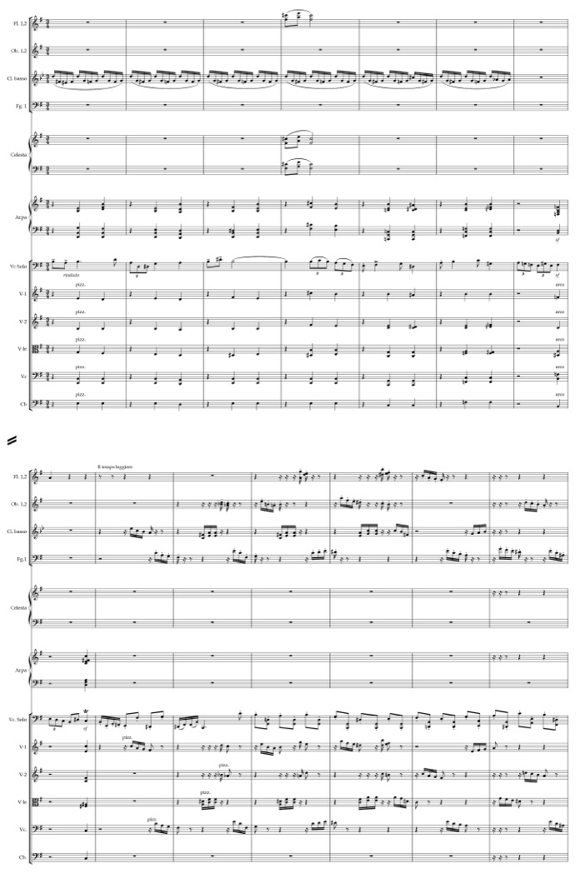
Beginning in measure 39, both phrases of the first theme are repeated a perfect fourth higher. In this restatement, the second phrase is presented by the orchestra instead of the cello. Over the next twelve measures, the first phrase is further developed with a perfect fifth tremolo shimmer added by the violins. Measures 68 through 82 feature a transition into a "faux" second theme of the exposition. The orchestra restates the first theme's two motives, and the cello arpeggiates with yet another rendering of a sixteenth-note ostinato. Although rather uncomfortable for the soloist, the ostinato creates an interesting harmonic progression, combining major and minor modes with an orchestral chordal blanket of fully diminished ninths. As the rhythmic intensity gradually dissipates, the harmonic tension releases with the appearance of g mixolydian mode in the cello voice and a coloring of F major chords in the upper strings.
The tranquillo section, beginning in measure 83, introduces a new tonality
(g-sharp minor), a slower tempo, and a contrasting melody. These are all clear characteristics of a typical second theme of a sonata-allegro form. Yet, it is a clear deception created by Nowowiejski. The proper second theme begins in measure 100. The theme is still in a slower tempo but switches tonality, indicating a new motivic idea. The theme itself is created out of three simultaneously running motives. The main melodic motive is first introduced in the violin section, then repeated a perfect fourth lower in the solo cello. The second simultaneous motive is the sixteenth-note ostinato line, first stated by the flutes and violas and then taken over by the oboes and violins. The rest of the instruments serve a harmonic function, introducing a new chordal motive. In each of the chords, the third is omitted, adding to the hollow harmonic color of the main melody doubled in octaves. Both the sixteenth-note motive and the chordal motive create a wave-like movement, changing direction with every chordal shift or switch of the sixteenth-note pattern. Measures 100 through 123 of the Music Example 3 show the second theme with its three simultaneous motivic ideas.

Music Example 3: F. Nowowiejski, Concerto for Cello and Orchestra in E Minor, I. Allegro con brio, mm.100-125

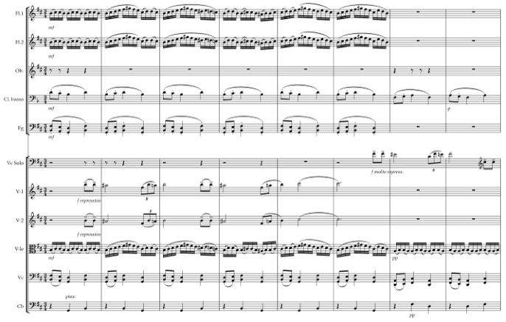
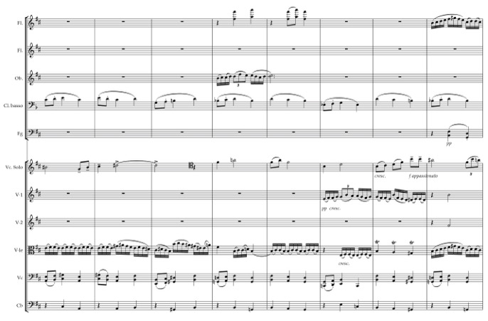

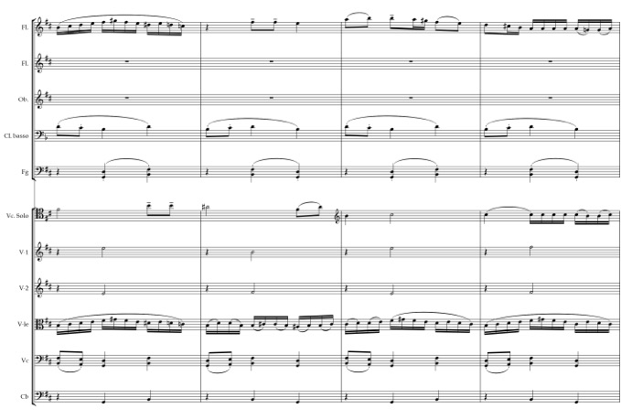

The transition into the development features another rendering of the arpeggio sixteenth-note pattern in the solo cello voice. It is a substantially chromatic pattern and another technical hurdle for the solo cellist. The orchestra adds to the cello's chromatic coloring with its own chromatic movement, featuring both tertian and quartal harmonies.
The development begins in measure 163. It revives the original tempo of the movement. The key signature changes into C major, yet that does not mean much since the harmonic texture is polychordal. Within the first two measures of the development, Nowowiejski combines C major with E-flat major and A-flat major with d minor. In addition to polychords, the development includes seventh chords, diminished chords, perfect fourth and fifth combinations, and other chromatic colorings. The cello solo voice also introduces new instrumental coloring. It begins the development with thick pizzicato chords, followed by a rapidly ascending c minor natural scale and a small lyrical melodic motive taken from the first theme. The first twelve measures end with a shimmering color of high false harmonics. The next seven measures (mm.175-181) focus on an oscillating pattern of perfect fifths in the solo cello and a syncopated D-flat major and C major movement with an added harmonic coloring with perfect fourths in the orchestra. This new idea creates a rather static impression, a feeling of movement without actual movement.
Throughout the development, the first theme's different motives are reworked, reharmonized, and presented with a new level of soloistic virtuosity. The sixteenth-note ostinato motive, first seen in the orchestral introduction, is combined with the melodic motive of the theme. The triplet motive from the first phrase of the theme then follows. This motive becomes a transition from the meandric feeling of the previous measures into the greater volume, energy, and thickness of the remainder of the development. The cello is presented in double-stops and develops the second phrase of the first theme into an energetic and biting character using staccato articulation and extreme registers. Beginning in measure 230, the ostinato motive receives another reworking with thick orchestration, volume, and articulation. The cello is featured in a dialog with the orchestra, borrowing material from the second phrase of the orchestral introduction. The harmonies are rich with polychords (m.229: f minor – c minor, f minor – E-flat major), half-diminished seventh chords, and blocks of perfect fifths and octaves (m.233-234).
The recapitulation begins in measure 246 with the return of the e minor "tonality”. It opens with the restatement of the first theme. Just as in the exposition, when the theme reappears after the initial sixteen measures, it is transposed by a perfect fourth/perfect fifth. This time the original presentation and the following restatement are flipped. Instead of beginning on the pitches b a b, the theme now begins on e d e. The material remains similar to the one in exposition, except for the disappearance of the ostinato sixteenth-note line, and most importantly, the omission of the solo cello voice. The entire first theme is presented only by the orchestra. During the transition into the restatement of the second theme, the solo cello returns, slightly decreasing the tempo with a meno mosso indication. The second theme of the recapitulation begins in measure 298. This time the moving sixteenth-note wave, initially presented in the violas and flutes, is established in the solo cello. Oboe, later followed by violins, presents the main motive while the violas and cellos create the harmonic wave. The entire second theme is moved a perfect fifth down, following the harmonic rules of a sonata-allegro form.
An extensive coda begins in measure 334. It utilizes the material from the orchestral introduction and reestablishes a character of power, drive, and energy. The solo cello part in the coda is fiendishly difficult for the soloist. It is a prime example of Nowowiejski’s limited knowledge of the instrument’s advanced technical capabilities. The most awkward in this section are the perfect fifth and octave fast double-stop runs, extreme and fast string crossings, and very uncomfortable chords interspersed with quick double-third progressions. It is no wonder that the few cellists who have performed this concerto in the past chose to alter some of the notes in the coda. Yet, even with these difficulties of execution, the movement ends like a spectacular show of fireworks, celebrating the power of sound.

- Aria: Andante tranquillo

The slow movement of the concerto is filled with lyricism and beauty, as well as mystery and suspense. The harmonic language and static use of rhythm create an unforgettable impression on the listener. Roman Suchecki writes about the second movement:
"The entirety of the second movement is corolostically rich. It is influenced by the French impressionism and the music of Karol Szymanowski. The composer develops the main theme led by bassoons, cellos and double basses, with the background of the high-register harmonic-rhythmic ostinato and celeste. With its modality and harmonic development, the melody becomes archaic in character. The main theme is also enhanced coloristically with the dynamically soft tremolo cymbals. In the recapitulation of the main theme, the composer introduces harmonics in the solo cello part, and the parallel motion of perfect fifths is replaced by a motion of parallel "Ravel chords"."

In this movement, Nowowiejski presents his masterful orchestration skills, pairing instruments in ways that create new colors and add to the music's mysticism. The string section is treated quite individually, with extensive use of divisi in all sections. Nowowiejski also adds color with the use of con sordino in the strings and brass, a prominently featured harp, celeste, and tremolo cymbals. The unorthodox combination of instruments is a technique he experimented with towards the end of his Poznan period. Coloristically, this movement resembles the finale of Nowowiejski’s Symphony no.3, entitled Siedem Barw Iris ("Seven Colors of Iris"), where the composer combines double basses, clarinets, and bassoon to create a mysterious and dark main melodic line.
In the second movement of the Cello Concerto, the cello solo weaves in and out of the orchestral sound, adding to the music's lyricism and song-like character. It is treated much less virtuosically than the first movement, but its melodic lines beautifully feature the instrument’s lyrical capabilities. The cadenza towards the end of the movement creates an unexpected surprise, especially when considering the omission of one in the virtuosic Allegro con brio.
This Andante tranquillo movement follows a rounded binary structure, with a somewhat condensed return of the A section after the cadenza. The main melodic theme presented in measure 3 by the cellos, basses, bassoon, and contrabassoon, offers an implication of D major. After the initial three measures, the oboe continues the more rhythmically active second half of the theme. Muted upper strings, harp, celeste, and cymbals provide an extremely coloristic ostinato accompaniment, creating an aura of other-worldliness. The harmonies are most effective. Moving in parallel motion of perfect fourths and perfect fifths, often adding a temporary tritone dissonance, they never resolve anywhere or move in any specific direction. They provide a motoric, high-pitched shimmer, letting the low register of the thematic material contrast with its instrumentation, rhythm, and character. Of special coloristic interest are the two polychords presented by the flutes, English horn, clarinets, and bassoon in measure 5 and then again in measure 10. The first polychord consists of a combination of D major and
f-sharp minor. The second polychord combines the C major and g-sharp minor chords. These two polychords present a rare occurrence of third-based harmonies in this movement. The Music Example 4 shows the beginning measures of the movement, with its coloristic ostinato effect, presentation of the thematic material, and use of the polychords mentioned above. The solo cello enters in measure 8 with a restatement of the theme. As the theme develops, the cello engages in a dialog with the clarinets, bassoons, and oboe. It then builds to the section's culmination with ornamental and virtuosic passages of fast chromatic runs, double-stops, and trills.

Music Example 4: F.Nowowiejski, Concerto for Cello and Orchestra in E Minor, II. Aria: Andante tranquillo, mm. 1-10

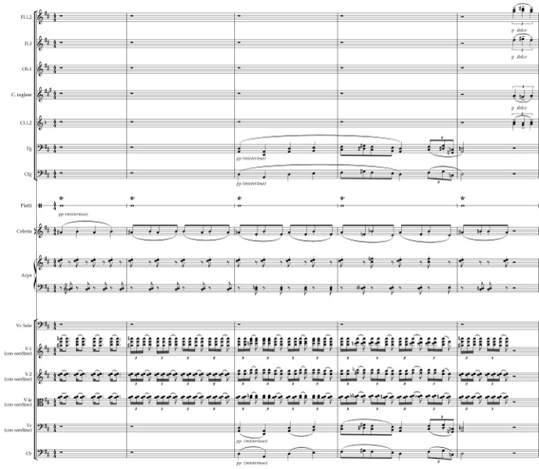

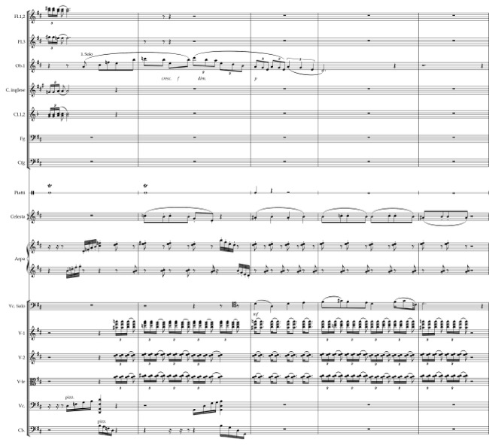

The largo sostenuto, beginning in measure 33, serves a transitional function into the B section. The key area moves from the D major of the A section into d minor of the next ten measures before transitioning over to f minor of the B section. The beginning of the transition features the full coloristic forces of the brass and wind sections, but contrary to the density of orchestration, it is presented in a quiet dynamic, and slow tempo. The four measures are purely chordal, creating a static effect of perfect fourth and perfect fifth-based harmonies. These harmonies, paired with the sounds of harp, celeste, con sordino violas, con sordino brass, winds, and timpani, showcase Nowowiejski's imaginative and unorthodox use of the orchestra. Solo instruments end the transitional section. Flutes, oboes, clarinets, English horn, bass clarinet, and bassoons engage in a dialog, exchanging the third-based melodic material with one another.
Section B begins in measure 43 with a key change to f minor and the return of the original tempo. It is a much more dissonant portion of the movement. The solo cello states the melodic material, partially resembling the opening motive of section A. However, instead of beginning with a downward perfect fourth, it opens with a tritone unaccompanied by any other instruments. Violins enter with a rhythmic ostinato material similar to the one in section A. Except now, the material is based on a dissonant clash of b-flat and c. The resemblance to section A disappears after the first three measures, giving way to coloristic and chromatic presentations of different solo instruments. The cello melds into the orchestra, interacting in a chamber music-like setting with the clarinet, english horn, bassoons, solo viola, and solo violin. As the movement shifts back into d minor, the B section becomes even more chromatic and more erratic. The rhythmic motion accelerates, and the cello becomes more virtuosic. The melodic line, indicated by Nowowiejski as flebile, meaning mournful, is established as an interaction between solo cello and solo flute. The line consists of fast sextuplet runs, double-stops in the cello part, trills, and sporadic dotted rhythms. The sextuplet passages incorporate arpeggiated diminished chords colored with additional chromatic harmonies. As the cello returns to the role of the main soloist, the orchestra becomes a harmonic accompaniment oscillating between perfect fourth and fifth-based chords and third-based chords. Eventually, the orchestra dissolves its harmonic accompaniment, letting the cello weave a new melodic line and transition into the cadenza.
The solo cello cadenza begins in measure 84. It is an extensive portion of the movement, featuring multiple techniques and capabilities of the instrument. The cello returns the tonality to the original D major. What is of particular interest here, though, is how the D major is treated. For two brief measures, the cello uses a very "classical" and traditional harmonic motion, not heard anywhere else in the movement. The first measure consists of a double feature of a tonic to dominant progression, while the second measure presents D major, e minor, and b minor chords building a I-ii-vi-ii progression. After this fleeting tonal occurrence, the harmonic motion becomes hollow and transparent with the next seven measures of double-stop harmonics. After the harmonics, which create a feeling of time suspension, the cello enters into an improvisatory and fast-moving portion of the cadenza. It is then momentarily interrupted by the flute, clarinet, and trumpet. After the brief interjection, the cello solo continues with the improvisatory character, quickly increasing in tempo. After the gradual climb in register and rhythmic intensity, the cello culminates on high double-stop trills.
Andante tranquillo returns at the conclusion of the solo cello cadenza, reestablishing the harmonic and melodic material from section A. The melodic main theme material appears first in the orchestra, but this time with no rhythmic diversity. It is then repeated by the cello with harmonic coloring and augmented rhythm. The parallel "Ravel chords", mentioned earlier by Roman Suchecki, are presented in the upper strings in the third measure of the cello’s main theme statement. The movement ends with a high harmonic a, slowly disappearing into silence.

- Passacaglia: Allegro moderato

The third movement of the concerto is the grandest movement of all three in terms of orchestration, formal structure, and length. It is built as a set of eleven variations, with a preceding introduction, a fugal section spanning over two variations and closing coda. As the name passacaglia suggests, an energetic eight-note ostinato material, based on the theme's first measure, frequently weaves in and out of different instrumental sections. It is either featured prominently or hides within melodic and harmonic structures. The thematic material presents a clear melodic and rhythmic structure, aiding greatly in its recognition inside of each of the variations. The solo cello part is highly demanding, given the virtuosic and improvisatory character of this movement. It features multiple moments in which the soloist needs to be inventive in the execution of very fast runs, navigating the tricky, left-hand passagework.
The fugue-like section settled in the middle of the movement is unforgettable. Its large instrumentation contributes to the grandiose character of the concerto. It is hard not to think of Nowowiejski’s affinity with church music, and organ in particular, when examining this movement. Nowowiejski was a master of organ improvisation, famous for his polyphonic, contrapuntal and improvisatory skills, which he acquired during his studies in Regensburg. Teaching and sharing the art of organ performance and improvisation was one of his passions. It is no surprise that this affinity found its way into his symphonic music. In addition to the third movement of the concerto, fugal moments can also be found in his Second Symphony, entitled Praca i rytm ("Work and Rhythm”).
The ending of the movement is an unsettled matter, which probably would have been finalized if Nowowiejski had a chance to hear his concerto. It was a well-known fact that after premiers of his works, the composer would make corrections, sometimes quite substantial, before being satisfied with the finished product. The piano reduction score contains an extra portion of twenty-six measures, which do not appear in the orchestral manuscript. This slow chorale-like ending, with elements of the second movement, provides quite a contrasting approach to the original bombastic ending of the movement. As Suchecki states: "With such an ending, all movements of the concerto lose their autonomy, the entire concerto loses its virtuosic character, and the second movement becomes the central point of the cycle.” One will never know Nowowiejski’s intentions, but since only the original ending exists in orchestral form, this ending is used in performances of this concerto. This ending will also be used in the analysis of the movement presented below.
The movement begins with a rather lengthy introduction marked Allegro moderato, that consists of two sections separated dramatically by a measure of pause. The first section presents the first two measures of the theme, which will make its first full appearance immediately after the introduction. The four-note motive, a-sharp – g – g – e, later developed in the main theme, will repeatedly appear throughout the movement. This ostinato-like motive creates the basis of the passacaglia form. Eleven variations are set within the movement, with the four-note ostinato fragmented and shifting between instruments and tonalities.
The first section of the introduction, consisting only of nine measures, is built almost exclusively on octave sonorities, with the full force of the brass, wind, and string sections participating. The few tertian chords provide a warm coloring to the otherwise grand but hollow harmonic structure. The second section continues with the fragmented thematic material, but this time it begins with the third measure of the theme, with notes
a-sharp – g – f sharp – e. This longer introductory section also features marked use of octave sonorities, with sporadic use of major and minor chords. The dramatic character is achieved by the fast, interrupted descending sixteenth-note runs, tremolos, and trills featured throughout the different instruments of the orchestra. Percussion instruments also make their appearance after being silent during the second movement.
The solo cello presents the main theme in measure 37. The increase of tempo to Vivace provides assistance in the energetic and driving character of the melody. With the exception of sporadic pizzicato in the strings sounding the four-note ostinato motive, the cello presents the theme alone. The unobstructed presentation of the theme creates a feeling of simplicity and a clear understanding of the melodic material, which will be important in spotting the upcoming variations. The theme itself is divided into two sections, with the second section featuring increased rhythmic intensity and higher pitch material.
The first variation begins in measure 61. The variation uses the overarching intervals of a minor sixth and tritone from the main theme and creates double-stop motives based on these two intervals. The a-sharp down to e interval in the first measure is a tritone, the e to c in the second measure is a minor sixth. The third measure again features a tritone, and the fourth measure again a minor sixth. The fifth measure shows an occurrence of a perfect fifth. These intervals establish almost the entire first variation with the exception of the low octaves at the end of this section. The solo cello line single-handedly leads in the presentation of this variation. Music Example 5 illustrates these intervals in the solo cello voice. The small orchestral forces provide a sporadic harmonic background, with the strings appearing briefly using the four-note ostinato-like motive. The double stops in the solo cello line provide a character of suspense and instability, while the staccato articulation of the eight-note double stops combined with the fast legato sixteenth-note double-stops create a sense of energy.
As the variation ends with the low octave double-stops in the cello, the strings and harp add decisiveness in the harmonic structure and dramatic character. They do so with the cleverly placed third-based chords (B flat major seventh, F major seventh, F major, A flat major seventh). Following that, a six-measure transition, presented first in the strings and by the brass and winds, accelerates the rhythmic movement and prepares the chromatic coloration of the second variation.

Music Example 5: F.Nowowiejski, Concerto for Cello and Orchestra in E Minor, III. Passacaglia: Allegro moderato, mm.61-75

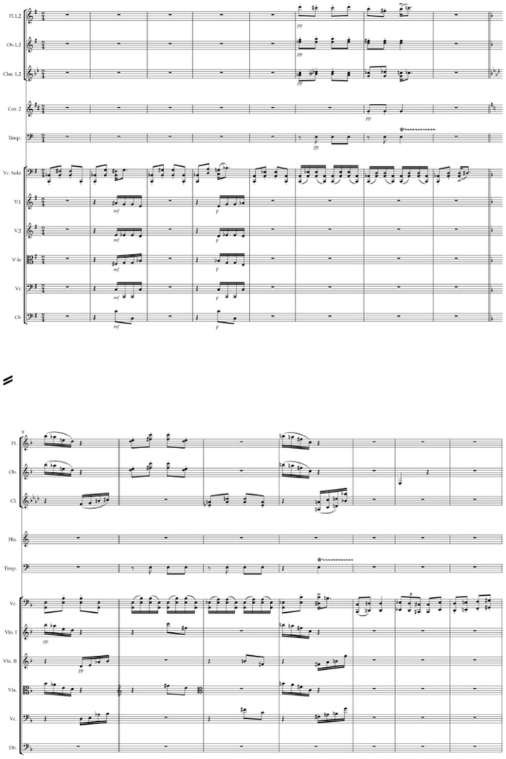
The second variation begins in measure 89. Rhythmically, the leading cello voice is constructed entirely out of sixteenth notes. Yet, the theme is cleverly hidden within the motoric runs. The theme is almost entirely melodically and rhythmically intact within a multitude of added chromatic notes that shape the dissonant character of this section. As the variation develops, several measures of the thematic melodic material appear either backward or with intervallic movement, descending instead of ascending. The orchestra contributes to the unstable and dissonant color of the variation with its chromatic sonorities, pizzicato strings, and the appearance of bells, tremolos, and ornaments.
After a brief, four-measure transition featuring a sweeping ascending motive of the harp, the third variation – beginning in measure 117 – reestablishes the theme. It is again presented in the cello, an octave higher from its original statement. Except for a few slight differences, the melodic material is almost identical to the initial theme. The difference lies in the orchestral accompaniment. The variation features rather active orchestral movement, contrary to the original thematic presentation with an almost non-existent orchestra. The motive from the first measures of the theme constantly reappears throughout different instruments, often either intervalically modified or as a retrograde. The wind section leads the orchestral development, and upper strings participate in the sporadic presentations of the four-note ostinato-like motive.
Following another brief transition, with the cello and timpani in unison with a tritone-based melody, the fourth variation begins in measure 145. The variation is a solo cello cadenza. The cadenza features a virtuosic and improvisatory character in the cello part. The fast passages are quite demanding for the left hand. There is no comfortable left-hand fingering to execute these passages, which force the cellist to battle with issues of speed, intonation and clarity of sound. Throughout these fast-paced and dissonant passages, fragments of the thematic material pop out sporadically before being swallowed again by the motoric movement of the cadenza. The end of the cadenza features only the viola section presenting the theme in its entirety with the accompaniment of the solo cello ostinato. This theme is an introduction to the fugal section featured in the subsequent two variations.
In the fifth variation, beginning in measure 187, the solo cello takes over the theme from the violas. Whereas the violas presented the theme transposed up a minor third, beginning on c-sharp, the cello begins it on f-sharp. The next entrance of the theme starts one measure later in the violin section, thus introducing canonic and fugal elements into the movement. That entrance also begins on f-sharp. The viola section becomes the counterpoint, weaving the legato sixteenth-note runs consisting of arpeggiated chords. They create a harmonic movement made of A-flat major, f-sharp diminished, a minor,
E-flat major, c minor, g minor, and perfect fourth/fifth-based chords. Both themes happening in the solo cello and second violins are presented in their entirety before transitioning into the sixth variation.
The sixth variation features the continuation of canonic and fugal elements, but this time, it is considerably expanded in length and instrumental forces. The contrapuntal melody changes drastically, indicating a significantly virtuosic character. The variation begins in measure 208, with both violin sections establishing the theme presented in octaves. The theme is then restated by the cellos and basses one measure later. A typical answer presents thematic material transposed into a new key, usually a fifth higher than the original theme. Nowowiejski does not do that here. He leaves this restatement of the theme in the same tonality, creating a canon between these two voices. The solo cello immediately introduces the virtuosic contrapuntal melodic material, which is then taken over by the violas. As this theme and its restatement progress, another theme makes an entrance, but it is transposed a perfect fourth higher. This theme presented by the flutes, oboes, English horn, and clarinets, is the actual answer to the original statement of the theme. It then continued canonically one measure later in the bass clarinet, bassoons and horns. The sonic effect of this variation is massive. The force of all instrumental sections featuring the theme in octave sonorities creates recurring waves of powerful sound as each new instrumental section begins the thematic material.
As the fugal variation ends, a transition section prepares the listener for the decrease in energy, speed, volume, and instrumentation. The transition moves quickly in the deceleration process, ending in a complete standstill of con sordino brass and strings. Solo cello reemerges with the melodic motive, which also decelerates through augmentation of rhythm. The transition then introduces the next variation.
The seventh variation, beginning in measure 250, presents the thematic material in pizzicato strings. The theme is featured in octaves but is highly fragmented as a result of rhythmic augmentation. The entire theme is presented almost completely note for note, but any energetic and articulated movement is largely suspended. The augmented thematic material contrasts heavily with the virtuosity of the solo cello, which moves in a fast motion, unphased by the pizzicato strings. Here, the cello becomes the driving force, weaving in and out of the augmented rhythm of the strings.
The eighth variation, beginning in measure 288, provides a respite between the augmentation of the thematic material in the seventh variation and the one presented in solo cello in the upcoming ninth variation. Marked Andante molto tranquillo, the eighth variation features two trumpets in first species counterpoint, almost exclusively moving in contrary motion. Based on the intervals from the theme, duet gradually becomes rhythmically augmented before arriving on a long-held perfect fifth. Violas, cellos, and basses provide a static chordal accompaniment consisting of the intervals present in the trumpet counterpoint. In the last two measures of the variation, the flutes foreshadow the next section with their triplet rhythm and third-based chords.
The ninth variation begins in measure 302. It features a significant character change with an almost tonal use of harmonic movement, lyrically featured thematic material and the appearance of a polymeter between the winds and strings. The solo cello leads with the development of the melodic, thematic material. The first eight measures of the melody utilize the original pitches of the theme's first four measures. They are presented in a slower and more lyrical rhythm, adding a scalar pattern at the end that contributes to the ornamental character of the variation. The next eight measures are based on the same four measures of the original thematic material, but are this time transposed up a perfect fourth. The variation is then developed using the same lyrical, rhythmic pattern and frequent bursts of ornamentation. The instrumental color also changes in this variation, featuring the harp, celeste, triangle, and bells prominently. Both harp and celeste participate in the harmonic movement. In the second half of the variation, the harp switches to fast-paced arpeggiated runs, contributing to the variation's ornamental character.
The vertical movement of the ninth variation features third-based harmonies. This is the first instance throughout the entire concerto where such harmonic movement appears for a significantly extended period. The harmonies do not follow any functional progression. However, after being subjected to the multitude of chromatic colorings, frequent dissonances, and perfect fourth/fifth-based chords, the freshness of color provided by the "traditional" harmonies is a welcome sensation to the listener. Flutes, oboes, and clarinets participate in the harmonic movement with a new rhythmic feel, which stems from the 6/8 time signature.
The transition into the tenth variation establishes the new rhythmic character based on arpeggiated triplets. This next variation, beginning in measure 355, features a much slower tempo of Andantino grazioso and a 6/8 time signature, the time signature introduced near the close the previous variation. In comparison to the ninth variation, this one is relatively brief. It provides a moment of energetic and virtuosic relaxation for both the orchestra and the soloist before the final "tour de force" variation. Harmonically, the tenth variation descends to a lower tonality centered on d, with solo cello grounding the new tonality. Meanwhile, the flutes and celeste keep the beginning of the variation unsettled with their dissonant melodic instability. This dissonant melodic movement paired with the small harmonic movement creates an interesting pairing of color and character.
The final variation, beginning in measure 367, reestablishes the tonal center of e and drastically increases in tempo after the slower Andantino grazioso variation. The orchestra utilizes different small fragments from the thematic material. The solo cello part becomes a display of virtuosic fireworks. The rapid spiccato passages combined with waves of broken and double-stop octaves, chords, quickly moving double-stops, downbow and upbow staccato, and double trills create a variation reserved only for cellists of the highest caliber. With this variation, Nowowiejski sums up the concerto's character and purpose, deserving a rightful place among the cello concertos of the highest technical difficulty. Music Example 6 features the cello part in the eleventh variation, taken straight from the manuscript. It undeniably shows the technical complexity and virtuosity which the cello soloist needs to be able to conquer.
The orchestra aids in the energy and drive of character by uniting motoric and ostinato-like rhythmic passages with melodic material presented in octaves. The different instrumental combinations contribute to the strength of sound. The beginning section of the theme is featured in solo horn aided by the viola section. In moments of exceptional difficulty and lower register of solo cello, Nowowiejski thins out the orchestration, letting the cello passagework stay in the forefront of the variation.
Just before the entrance of the coda, indicated as Stretto-Allegro, the cello becomes briefly suspended in tranquillo double-stop perfect fifths. Beginning in measure 426, the orchestra resumes the energetic drive, with the cello continuing its virtuosic passagework, although now not nearly as difficult as in the last variation. The concerto ends with a rocket-like display of a rapidly ascending harp, followed by ascending strings and fast tremolos in the winds.

Music Example 6: F.Nowowiejski, Concerto for Cello and Orchestra in E Minor,
III. Passacaglia: Allegro moderato, mm. 367-425

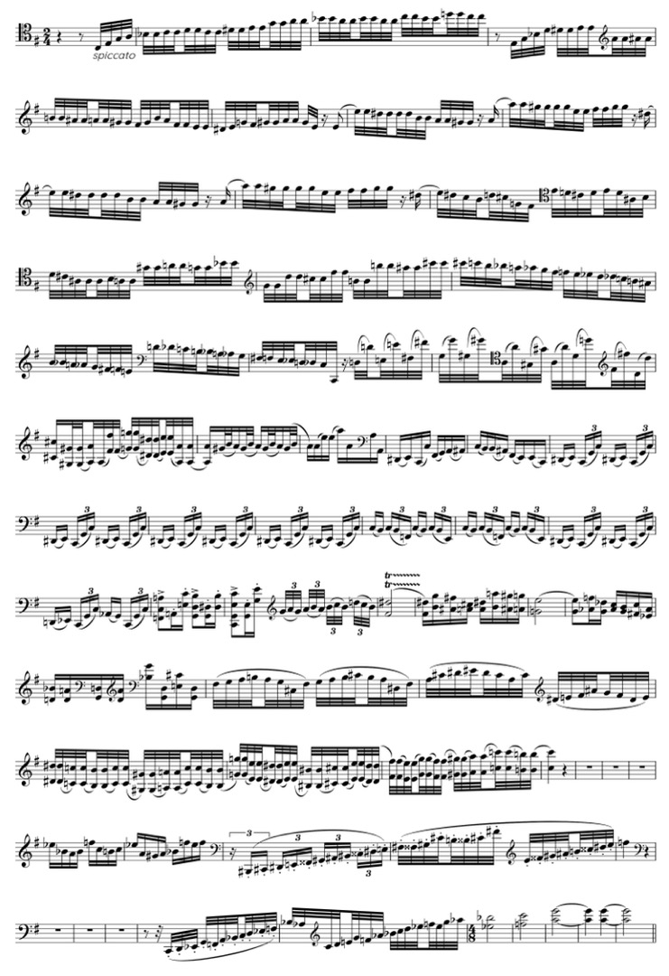
‘TOUR DE FORCE’ CONCERTO: PERFORMANCE CHALLENGES

Nowowiejski’s concerto is a highly challenging composition for both the soloist and orchestra. The orchestration entails a large and powerful accompanying ensemble. A formidable amount of string players is needed to compete with the expanded woodwind (three flutes, two oboes, English horn, two clarinets, bass clarinet, two bassoons, contrabassoon), brass (four horns, three trumpets, two trombones, tuba), and percussion sections (timpani, bass drum, tambourine, cymbals, triangle, bells) and an addition of celeste and harp. The cello soloist often blends in with the orchestral passages. The challenge then lies in balancing the two forces so that the cello remains in the forefront, especially during highly lyrical passages and moments of extreme virtuosity.
Nowowiejski did play the cello during his studies in Swięta Lipka. He was also employed as a cellist in the military orchestra in Olsztyn. However, it is most likely, as Roman Suchecki remarks, that his abilities did not extend past an elementary level. Therefore, one can assume that he did not fully understand the technical issues associated with this concerto. It consists of multiple moments in the cello part that are either extremely difficult to execute, or according to Roman Suchecki, with solutions yet to be found. The greatest difficulties lie in connecting double-stops and chords, leaving cellists with little choice other than altering the pitches themselves. Had the concerto received its premiere during the composer’s lifetime, he most likely would have made substantial changes to both the cello and orchestral parts. He would have also received considerable input from either Gunther Schulz-Furstenberg or Dezyderiusz Danczowski. Even the alternate ending featured in the piano reduction signifies that Nowowiejski was still improving the composition. The unfortunate fact remains that one will never know how the Warmian composer’s final product would have looked. As the piece currently stands, it is responsibility of each individual performer to decipher Nowowiejski’s possible intentions. Hopefully, a future publication of the work will aid in securing the concerto's historical legacy as the first formidable Polish cello concerto.

- GRAŻYNA BACEWICZ (1909-1969)

BIOGRAPHICAL INFORMATION AND COMPOSITIONAL OUTPUT

As Poland, itself, bridges the geographical gap between capitalistic and socialistic countries, Bacewicz along with her closely aligned musical compatriots bridges the gap between the neo-romanticism of Szymanowski and the modernism of Lutosławski. Admired and respected as an equal by her colleagues and adored by her public, she was an integral part of the Polish cultural world and helped to make the music of her country known throughout Europe.

Judith Rosen, “Grażyna Bacewicz: Her Life and Works”

Grażyna Bacewicz was born in 1909 in Lodz, which at the time belonged to the Prussian Empire. Her father, a Lithuanian, was a trained violinist and taught in different music schools throughout the city while her mother played piano. Music was an integral part of family life. All four children were encouraged to play and learn music and learned violin from their father. At the age of ten, Grażyna Bacewicz entered the Music Conservatory in Łódź. There she studied with Kazimierz Sikorski, an important music theory and composition professor, who was the first to guide her in her composition endeavors. In addition to violin and piano, she studied the foundations of music: solfeggio, harmony, counterpoint, and musical forms. Despite the evident technical immaturity, her early compositions show a striking predilection towards polyphonic constructions, and a certain self-restraint in the use of material, rejecting the neo-romantic convention.
Bacewicz’s musical studies continued in the shadow of World War I and its aftermath. Together with its Austro-Hungarian and Russian counterparts, the Prussian Empire was disintegrated, which led to a significant transformation of the political map of Europe. Both Poland and Lithuania regained their independence, but they were no longer one unified country, as before the time of partitions. Just as the two countries, which once were whole, became divided, so did the Bacewicz family. Vincas Bacevicius, Grażyna’s father, decided to return to his homeland in 1923. The young composer’s mother decided not to follow her husband. She stayed in Łódź, now part of the newly formed Republic of Poland. Eventually, after completing their musical studies, both sons joined their father in Lithuania. Although Grażyna visited her father’s homeland several times, she decided to remain in Poland.
Between 1928 and 1932, Bacewicz studied at the Warsaw Conservatory, focusing on violin with Józef Jarzębski, piano with Józef Turczyński and composition with Kazimierz Sikorski. After two years at the Conservatory, she gave up her piano studies, focusing on her career as a violinist and composer. At the Warsaw Conservatory, Karol Szymanowski became a major influence on the young composer. His generation was encouraged to broaden their studies in Germany, which was the center of the European neo-romantic culture of the time. On the other hand, Szymanowski urged the young composers of the new generation to seek education elsewhere, mainly in Paris. In 1932, Bacewicz moved to France's capital, and with the financial support of Jan Ignacy Paderewski, she began her studies with Nadia Boulanger at the Ecole Normale de Musique. While in Paris, she also studied violin first with Andre Touret and then with Carl Flesch. During her studies with Boulanger, Bacewicz wrote her Wind Quintet, which turned out to be her prime example of neoclassicism. For this work, she received the first prize at the competition of "Aide aux femmes de professions liberales”.
After completing her studies in France, the young violinist embarked on a concert tour around Spain and Majorca. Following her return to Poland, Bacewicz accepted the position of principal violinist with the Warsaw Philharmonic. She toured with the orchestra and had many of her works premiered by this ensemble. In 1936 Grażyna Bacewicz married the physician Andrzej Biernacki, who went on to become an eminent cardiologist and professor at the Warsaw Medical Academy.
The years of World War II proved difficult for the composer and her family. Yet, while living in Warsaw, she managed to be active in the underground concert scene. After the Warsaw Uprising of 1944, together with her family, Bacewicz was forced to relocate to the Pruszków transition camp and then to Lublin, where she spent the remainder of the war. At the end of 1945, the family returned to the rubble of Warsaw, and Bacewicz continued composing with renewed strength. She also resumed her concert activities both in Poland and France. After the war, Bacewicz’s Overture for Orchestra, written in 1943, received its premiere at the first "Festival of Polish Music” in Kraków. This performance immediately placed her among the best Polish composers of the time.
The first decade after the war proved to be a creative and cultural vacuum for the Polish artists. As Poland emerged after the war, looking for its identity within the new communist reality, much attention among artists was turned to Polish folklore. Folk music became synonymous with nationalism and was to be incorporated into the current musical language. The Conference of Music Composers and Critics in Łagów in 1949 was the official inauguration of the "social realist” movement in Poland. Composers were to abandon all experimentation and embrace the new ideals of a "classless” art.
Bacewicz’s use of folklorism and neoclassicism in her music aligned with the general thoughts of social realism. Her high profile and esteemed position in the Polish and European cultural life allowed her to be spared much of the criticism that befell her colleagues. Still, this oppressive atmosphere prevented her from becoming a fully independent artist. The composer’s works written between 1945 and 1953 are prime examples of her subordination to the principles of social realism. Among them are her four symphonies and the First Cello Concerto.
Bacewicz’s next major success came in 1950, after receiving the "National Prize" for her Concerto for Strings. In 1951 she received the first prize at the International Composer’s Competition in Liege for her String Quartet no.4. In 1953, the quartet became a required piece for the competitors in the International String Quartet Competition in Geneva. In 1952, she received the "National Prize" yet again, this time for her String Quartet no.4, Violin Concerto no.4, and Sonata no. 4 for violin and piano. In addition to composing, concertizing and serving on competition, juries occupied much of her time. By 1953, she began to withdraw from her concertizing engagements to devote more time to composition. By 1955, her career as a concert soloist came to a close.
In 1954, Bacewicz suffered a severe car accident, which threatened not only her career but her life. With a broken pelvis, broken ribs, and injuries to her head and face, the composer underwent a very long hospitalization stay. Judith Rosen writes about this traumatic event: “Her inner strength and courage were revealed in the days following the accident. Friends who went to visit her related this story: There she was in a darkened hospital ward, fighting for her life, and though she had difficulty talking, she spent the time joking and refusing to discuss the accident or the seriousness of her condition.”
High in spirits, she was finally released and immediately resumed her composing activities.
1956 marked the year of change in Polish culture and music. The Stalinist thaw, which resulted in a more liberal Polish Communist Party, opened the door to more religious and cultural freedom. The first International Festival of Contemporary Music, later known as the "Warsaw Autumn”, became the symbol of this newly found musical freedom. Bacewicz’s works were also performed at this festival, yet more evidence of her eminent stature in Polish music. Her works have been part of this festival ever since. For the first time, Poles heard the music of Schoenberg, Berg, Webern, and Messiaen. The long period of isolation ended, and composers turned their attention to the avant-garde.
Significant changes also occurred in Bacewicz’s compositions. Those changes included a departure from tonality, greater attention to instrumental color, and refinement of rhythmic patterns. This new stylistic development showed itself most evidently in her Music for Strings, Trumpets and Percussion, for which in 1960 she received the first prize in the orchestral division and third prize overall at UNESCO’s International Rostrum of Composers in Paris. She also continued her duties as a juror. In 1957, together with David Oistrakh and Louis Persinger, she judged the 3rd Wieniawski International Violin Competition. In 1958 she served on the jury at the first Tchaikovsky Competition in Moscow.
The intense creative work combined with frequent travels seriously undermined Bacewicz’s health. In 1963, following a long illness, she had to cope with her husband’s death. In 1966 she agreed to teach composition at the Fryderyk Chopin University in Warsaw, formerly known as the Music Conservatory in Warsaw. Towards the end of 1968, despite her poor physical health, she traveled to the Festival of Polish Music in Armenia. After her return, the composer's health rapidly deteriorated. She died in January of 1969, following complications with influenza and a possible heart attack.
Grażyna Bacewicz, despite her relatively brief creative period, composed over two hundred works. They included four symphonies, seven violin concertos, seven string quartets, five sonatas for violin and piano, concertos for piano, two pianos, viola and cello, and numerous works for chamber orchestra and full orchestra. Adrian Thomas divides Bacewicz’s music into three periods: 1932-1944, 1945-1959, and 1961-1969.
The first period dates from the composer’s graduation from the Warsaw Conservatory to the end of World War II. The works from that time include the Wind Quintet (1932), Children’s Suite for piano (1933), Theme and Variations for violin and piano (1934), Trio for the Oboe, Violin, and Cello (1935), Sonata no.1 for solo violin (1941), Overture (1943), and Suite for Two Violins (1943). At the beginning of this composing period, Bacewicz’s works show the influence of Sikorski and Boulanger. Here the composer identifies with a mild form of French neoclassicism, which manifests itself through clarity, wit, and brevity. By the early 1940s, her style becomes more muscular, active, and individual.
The second period can be divided into five-year intervals, with the central time of 1950-1954 as the years of greatest restriction and 1955-1959, as the time of reassessment after newly acquired freedom. During the first half of this period, Bacewicz embraces neoclassicism and the use of folk-inspired melodies and rhythmic patterns. Examples of the use of such idioms include Violin Concerto no.3 (1948), Piano Sonata. No.2 (1952) and encore pieces for violin and piano. The use of folk inspirations allowed her to remain reasonably safe in the difficult cultural atmosphere built up in the late 1940s. To appease the new system, Bacewicz composed in large classical genres, which included concertos and symphonies. She used a traditional formal structure, clear-cut cadences in concertos, clear tonal schemes, and thematic movement. This emphasis on large-scale orchestral works satisfied the need for grand symphonic works with a conservative idiom. Bacewicz was able to channel a more personal style into her chamber music, which was less suited for mass appeal and, because of that, was largely ignored by other composers and authorities. In the second half of this compositional period, Bacewicz’s style began to change and slowly move away from neoclassicism. The culmination of this period, which showed new compositional processes, was Music for Strings, Trumpets, and Percussion (1958). This composition began her affinity with sonorism.
The third compositional period of Grażyna Bacewicz involved exploring new techniques, including a loose use of twelve-tone procedures and new timbral ideas. That exploration manifested itself in String Quartet no.6 (1960) and Pensieri Notturni (1961). After those compositions, “…Bacewicz entered a contemplative period of re-evaluation and analysis which slowed down her usual rapid work pace She could not ignore the new musical expressions that were taking place around her, yet she was not sure to what extent they could or should be incorporated into her own musical language.” Nonetheless, she did manage to write the Cello Concerto no.2 (1963) and Quartet for Four Cellos (1964). The composer was looking for her own language, which constantly evolved. With her last works, she explored timbral possibilities, trying to find a balance between old and new techniques. Had her life not been cut short, one can only imagine how her new style would have developed.

GENERAL CHARACTERISTICS OF CELLO CONCERTO NO.1

Grażyna Bacewicz’s Cello Concerto no.1 was written in March of 1951 and was dedicated to the Czech cellist Miloš Sádlo (1912-2003). It received its premiere on September 21 of the same year in Warsaw, with Sádlo on cello and Witold Krzemieński conducting the Warsaw Philharmonic Orchestra. Following the premiere, the concerto was first published by PWM (Polskie Wydawnictwo Muzyczne) in 1953 with a piano reduction completed by Bacewicz, then in 1972 with the orchestral score. The cello part was edited by Kazimierz Wiłkomirski, a notable Polish cellist, pedagogue, and composer.
The concerto features a standard symphonic orchestration of one piccolo, two flutes, two oboes, two clarinets, two bassoons, four horns, three trumpets, two trombones, timpani, and strings. Bacewicz skillfully uses the coloring of each instrument to add to the character of every movement. It is not a long concerto, lasting only a little over twenty minutes. Motives are compact, to the point, without any overt meandering. It follows the early classical formal structure, with the first movement presented in sonata-allegro form, the second movement in a slow binary form, and the third movement in rondo form. The concerto is neoclassical in style, Bacewicz’s language of choice throughout a considerable portion of her life. The composer merges traditional formal structures with twentieth-century chromatic harmonies, rapid motivic work, and texture changes. The cello solo part is technically and expressively challenging. It is filled with fast motoric runs, rich melodies, and a large variety of techniques - evidence of Bacewicz’s extensive knowledge of the instrument.
The concerto was composed during the time of greatest artistic restrictions in post-war Poland. The work is quite timid compared to other compositions of Bacewicz. It represents all the characteristics needed to satisfy the authorities in charge of defining and enforcing the social realist beliefs. It was written for a full symphonic orchestra, making it accessible for a large audience to be enjoyed in large concert halls. The clear classical formal structures, not overly dissonant harmonic language, and energetic folk-like melodies create a feeling of simplicity, pleasantness, and charm. Yet, at the same time, it is still clearly the original musical language of Bacewicz. The concerto is modeled on the traditional classical forms with a clear "Haydn-esque” thematic simplicity, but the composer does not faithfully copy the style and narration of the great classicists. The harmonic language is her own, free of any boundaries and based purely on color and timbral effect.
The concerto is by no means innovative. Together with the Sonata da camera, Bacewicz’s Violin Sonata no.1 for violin and piano, written in 1945, the concerto bows towards the past in a very direct way, which is quite uncharacteristic from this Polish composer. It is also most interesting that it was written in the same year as the String Quartet no.4, thought to be the preeminent quartet of all the quartets written in Poland at that time, showcasing the neoclassical innovations of Bacewicz.
The concerto has not been well received by critics and musicologists. Stefan Kisielewski, Polish writer, publicist, and composer, wrote of the composition after its premiere performance in 1951, "The work was written well, easily accessible in performance as well as listening, but stylistically not too ambitious, not exemplifying any important stage in the compositional development of the famous composer.”
Malgorzata Gąsiorowska, in her summary of the concerto, is even less favorable to the work. She writes, "When one speaks of this concerto as neoclassical, one has to ask: was the composer not regressing in her compositional development, or was it a conscious gesture of returning towards a form of a dialog with the past?”
Cellists and audiences, fortunately, do not seem to be influenced by these unfavorable criticisms of the concerto. In recent years, the concerto has seen quite the resurgence. It received its first major recording in 2012 under the Dux Records label, with Adam Krzeszowiec on cello and George Tchitchinadze conducting the Polish Sinfonia Iuventus Orchestra. It has been included in the repertoire of many cellists and performed on stages with an increasing frequency.
The resurgence of the concerto seems to be partly in response to recent attempts to revive the past. The contributions of many Polish composers and artists are being celebrated. It is also because the era of Polish avant-garde and sonorism has slowly faded, and the allure of an avant-garde future has given way to new possibilities of expression through honoring and finding beauty in art that has been previously underestimated and set aside.

ANALYSIS OF CELLO CONCERTO NO.1

- Allegro non troppo

The first movement, Allegro non troppo, follows the traditional model of a sonata-allegro form. This classically modeled movement is clear and simple with its two contrasting themes, a predictable development, and recapitulation. What is not simple and clear is the composer’s harmonic language. Despite many fragments kept in traditional tonality, Bacewicz does not copy the classical giants but creates her own harmonic language, not based on tonal rules, but coloristic effects. This language will be discussed in more detail in the third movement of the concerto.
The movement begins with an orchestral introduction, presented in the form of a double period. From the start, Bacewicz cleverly combines motives, creating two contrasting characters: an energetic, syncopated character in double meter feel, and a singing and soaring one in triple meter feel. The simplicity, liveliness, and charm of the main theme are strengthened by the fact that it begins quite tonally in D major. The cello enters at measure 33 with the developed first theme, subtly contrasting between the energetic and soaring, the vertical and horizontal motion. It interlocks the two characters, resulting in a folk-like and memorable presentation of the main theme, as presented in Music Example 7.

Music Example 7: G.Bacewicz, Cello Concerto no.1, I.Allegro non troppo,
mm. 33-50

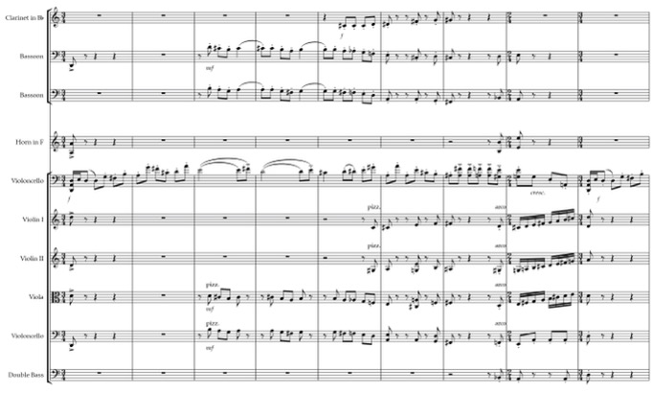
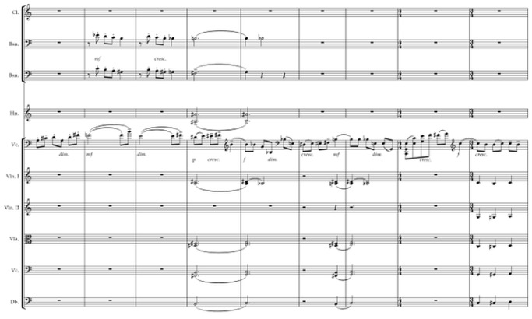

In preparation for the entrance of the second theme, the motoric movement slows down. The orchestra engages in a dialog with the cello, constantly responding to its flow of energy. With the entrance of the second theme, the orchestra turns into a lush blanket, letting the cello soar with its nostalgic, sweet, and narrative motive work. This transformation is indicated by the tempo change into poco meno mosso in measure 74.
This evocative second theme was iconic for Bacewicz. Its allure prompted her to use that four-note idea in her other compositions. In addition to the Cello Concerto no.1, it is found in the second movement of the Wind Quintet (1932), Intermezzo movement of the Partita for orchestra (1955), Viola Concerto (1968), as well as the ballet Desire (1968). One can only speculate as to why this motive was so important to her, as she used it throughout her entire composing career. The examples below show Bacewicz’s treatment of these four notes in the Cello Concerto, Wind Quintet and Partita for Orchestra. The motive is very prominent in each instance, with either subtle shimmering accompaniment or no accompaniment at all. The composer lets the motive speak for itself with its sweet but almost empty character.

Music Example 8: G.Bacewicz, Cello Concerto no.1, I.Allegro non troppo, mm.76-78, four-note motive featured in solo cello line
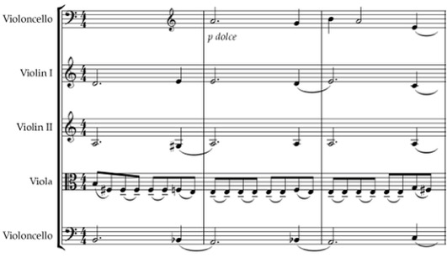
Music Example 9: G.Bacewicz, Wind Quintet, II. Air: Andante, mm. 5-16, four-note motive featured in the horn line between measures 8 and 11
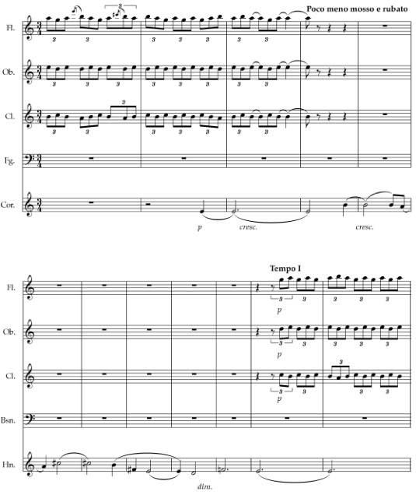

Music Example 10: G.Bacewicz, Partita for orchestra, III. Intermezzo: Andantino melancolico, mm. 1-3, four-note motive featured in the flutes
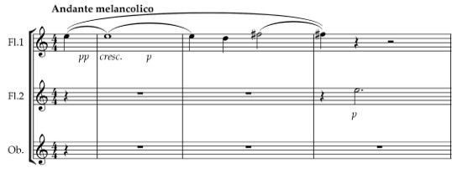

As the second theme ends in measure 96, the following section transitions this slow theme into a culmination of the exposition. The culmination is achieved by the increased energetic interruptions between cello and orchestra, increased rhythmic movement, speed, volume, and thickness of orchestration. This virtuosic treatment of the final measures of the exposition is frequently found in classical concertos and adds to the neo-classical features of the concerto.
The development section begins in measure 117. The orchestra is featured first, just as it was at the beginning of the exposition. It presents a luscious and rich transformation of the soaring motive from the first theme, fully embracing its triple meter and cantabile qualities. The soaring motive is then followed by a dialog of short motoric outbursts, rhythmically tied to the first theme. As the motoric motive increases in energy, volume, and speed, it becomes a virtuosic moment for the cello, creating folk-like energy and bounciness of rhythm and articulation. Bacewicz seems to be fond of such figurations. They can be found in her other virtuosic pieces, such as the Polish Caprice (1949), that utilizes the articulative aspects of a string instrument and a specific energy that reminds one of Polish folk music.
As the development closes, the orchestra is featured in a meno mosso transition, which begins in measure 187. The transition presents the grandiose qualities of the full orchestra and leads into the solo cello cadenza. Here again, Bacewicz gives prominence to the evocative four notes of the second theme, but this time, in the instrument's lower register. Although not overly complicated, the cadenza builds up with chromatic dissonance, increasing in speed and range, only to be calmed down again by the Andante cantabile motive. This motive eventually ushers out the dissonance and is transformed into the bouncy, energetic Allegro motive, jumping between several octaves of the cello range and finally resolving into the lively first theme of the recapitulation.
As the recapitulation enters in measure 206, the orchestra initiates the opening of the first theme, after which the cello takes over with the exact same material as in the exposition. That material is then extended. The recapitulation is yet another example of Bacewicz’s free treatment of the sonata-allegro form. The first theme is predictable and faithfully reintroduced in its original form. The second theme, on the other hand, is not. It appears only in small fragments. The iconic four-note motive is clearly stated, but it immediately shifts into fragments of the motoric double-stop triplets, initially presented in the transition following the second theme. It is also interesting that although Bacewicz treats the harmonic structure very freely, she does feature this second theme a fifth down from its original presentation in the exposition.
The coda begins in measure 248 with fast and energetic sixteenth-note runs, which continuously shift between solo cello and orchestra. The fast passagework of the cello oscillates between ascending G major and descending A flat major scales, with the chordal accompaniment matching the harmonic movement of the cello. As the orchestra continues the oscillating scalar shifts, the cello in turn contributes to the passagework with energetic chords matching the orchestral harmonic color. The last measures of the coda contain a restatement of the main motive of the first theme, presented in octaves by the string section. The entire coda presents Bacewicz’s typical bombastic ending to this energy-filled movement.

- Andante tranquillo

The lyrical second movement, full of expression and beauty of phrase, captures the listener with its Romantic song-like qualities. The movement roughly follows a rounded binary form, but with the constant ebbs and flows of phrases, it subtly frees itself from strict formal constraints. There is no overt innovation needed—just beauty for the sake of beauty.
The movement begins with a monorhythmic string ostinato, with a prompt entrance of the lyrical motive led by flute and clarinet, followed by oboe, second flute, and horn. The ostinato motive in the strings creates a lush and colorful accompanimental texture, like a pulsating blanket of sound. This interesting harmonic color is achieved by three beats of unchanging G major chords followed by the fourth beat, built on two perfect fifths (E-B, A flat-E flat). As the orchestral introduction prepares for the entrance of solo cello, the harmonic "pulsating blanket” becomes more unstable, turning into g minor with a doubled third and fifth (measure 7), which is then followed by perfect fifths with added chromatic coloring. The cantabile melody presented in the winds also adds an intriguing harmonic color, alternating between a pleasant counterpoint based on fifths and sixths and a chromatic clashing of major sevenths. After those first eight measures of the orchestral introduction, the cello enters, developing the phrase's expressiveness and adding its own harmonic color, as presented in Music Example 11.
The cello then leads numerous dialogues with the string and wind sections, respectively growing and relaxing the intensity of expression. In measure 18, Bacewicz
adds another warm harmonic color when the solo cello creates a texture of legato double-stops and chords, while horns continue the melodic phrasing, engaging in a dialogue with winds and strings.

Music Example 11: G.Bacewicz, Cello Concerto no.1, II.Andante tranquillo, mm.1-14

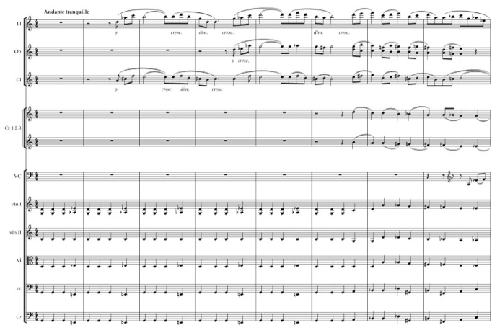
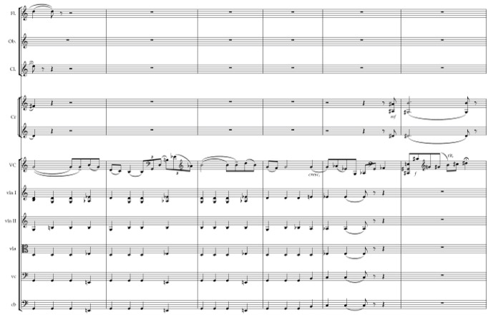

Section B begins in measure 42. It is preceded by four measures of an orchestral transition, which revives the mono-rhythmic ostinato, only this time presented in the winds and brass, and doubled in rhythmic speed. Poco piu mosso, which begins section B, indicates the intensification of drama and expressiveness. The motoric ostinato material, first shown in the transition by the winds and brass, is now taken over by the upper strings. At the same time, the cello, basses, horns, and winds hold long droning notes, which, over time, intensify the harmonic language with added clashing dissonances. Within this context, the cello soars with its extremely warm and lush phrasing, gradually moving upwards in pitch, volume, articulation, and speed. The end of this section becomes the culmination of expression and drama of the whole movement. This instance shows Bacewicz’s masterful skill of utilizing the cello’s lyrical and dramatic capabilities.
The solo cello leads the listener all by itself into the resolution and final release of the dramatic tension, which begins the return of an altered A section. The specific motivic material from the solo line in the A section does not return, but what does remain is the song-like expressive quality of the main melody. Bacewicz does revive the orchestral motivic material from the second half of the original A section. The chromatically descending motive, which appeared in flute and clarinet between measures 24 and 26, is now featured in the first violins. At the same time, the hollow and drone-like rhythmically repeating motive, presented initially in the violins and violas on notes d-e flat-e, returns at the beginning of the quasi A section, only this time presented in the flutes and horns. The last nine measures of the movement reestablish the mono-rhythmic string ostinato, which also began that movement. Just as in the beginning of this section, where motives were in different instruments than their original occurrence, the harmonic progression of this ostinato motive is also flipped. Initially, each measure's first three beats contained a G major chord, and the fourth beat turned into two stacked sets of perfect fifths. This time, the first three beats contain a hollow stacking of a perfect fifth
a-e, and the fourth beat is a B-flat major chord with a subtle f sharp coloring in double bass and cello. After a few measures, the ostinato returns to its original form of A section. Just as the movement began, so it ends with the "pulsating blanket”, but this time with the colors of the cello phrasing slowly fading into silence.

- Finale: Allegro giocoso

The concerto's final movement, Allegro giocoso, is set in a brisk, lively, and energetic character favored by Bacewicz, which presents itself in a staccato articulations and a rhythmically compact main theme. The movement is built on the rondo form, which follows the ABACABA structure. The main theme – section A – is first established in the tutti orchestra and then restated in the cello's entrance thirty-seven measures later. Here, just like in the first movement, the composer contrasts the liveliness and energy of the first twelve measures of the theme with the soaring character of the second part of the theme. This dialogue between contrasting characters - energetic and singing; staccato and legato - is a constant element in the movement’s motivic development.
The theme resembles in its character the final Allegro giocoso of Bacewicz’s String Quartet no.4, as it is rhythmically and poetically similar. Those similarities become even more striking when realizing that this quartet was written in the same year as the Cello Concerto no.1.

Music Example 12: G.Bacewicz, String Quartet no.4, III. Allegro giocoso, mm.11-26 – main theme
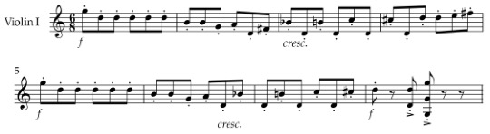

Music Example 13: G.Bacewicz, Cello Concerto no.1, III. Finale: Allegro giocoso, mm.5-16 – main theme
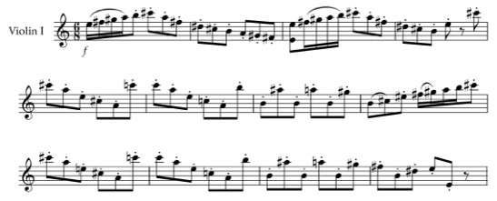

The first theme is presented in 6/8. The brisk portion of the theme consistently accentuates the predictable feel of the meter. The soaring legato portion of the theme, in contrast, frequently changes the rhythmic feel of 6/8 by shifting the metric stress and introducing hemiolas. None of this is in any way innovative or challenging, but it does create a character of charm, wittiness, and revolving energy.
Following section A, the orchestral interlude announces the introduction of section B in measure 96 through the gradual deceleration of pace and creation of new timbral colors. The new colors are presented in the violins, which feature a glassy, sul ponticello tremolo in the repeating harmonic background. This effect allows the cello to contradict the character established in the violins by creating warm and rich colors utilizing the solo instrument's low register. This successful utilization of the color contrast is more evidence of Bacewicz’s intimate knowledge of the string instruments and their timbral capabilities.
After the sweeping B section, the cello immediately reintroduces the A section. The main theme is presented almost entirely in its original form. The difference occurs in the tonality. The theme moves from its original statement in E major down to D major. Following the twelve measures of the theme, a new motive is introduced. It is first presented by the orchestra in a march-like character, with piccolo flute leading in the action. The solo cello now becomes the accompanist, adding to the character with its pizzicato chordal impulses.
Section C begins in measure 142. The change in tempo, indicated with Un poco meno mosso, signifies the inception of the new theme. This theme is characterized by the use of false harmonics and duple rhythms. Assisted by a quiet background of the orchestra, the cello enters into a new world of colors, creating a sense of vastness, emptiness, with time at a stand-still. This other-worldly section does not last long, and the orchestra returns the listener to “reality”, leading with its accelerated rhythms into yet another occurrence of the A section (measure 176). Here Bacewicz creates a little twist. Instead of beginning the section with its energetic staccato theme, she chooses the legato portion of the original section A. With this change, the middle portion of the movement remains more lyrical and richer in warm colors, creating a contrast with the outer layers of the music.
This shortened A section is followed by a transition, which eventually leads into a restatement of section B. The transition in itself is quite evocative. It reminds one of the second movement of the concerto, with its lyrical and Romantic phrases. No specific motive is ever directly quoted. What is similar are the intervallic melodic structures of major and minor seconds, followed by fourths. The decelerated rhythmic patterns, which now resemble the 4/4 feel rather than the 6/8 feel, also bring to mind the poetic nature of the second movement and add to the feeling of the displacement of this transition.
After a quick outburst of a fast motoric motive, the cello reintroduces the B section in measure 228. The lush theme is again accompanied by the tremolo shimmer of the upper strings. Here, the theme is presented a fifth higher than the original statement, occurring in A major instead of D major.
The last restatement of section A returns in measure 243. In this section, only the first ten measures of the theme remain the same. Even the orchestral accompaniment remains completely unchanged. A spirited transition into coda follows those ten measures. The coda is initiated by the orchestra, with the first measure of the main theme repeated twice, followed by two measures of repeated E major chords. This conscious repetition creates an intriguing effect of a "broken record”. The cello continues with a fast staccato chromatic descent, leading into the last four measures of robust and thick E’s, presented in octaves by almost all instruments of the orchestra.
The harmonic language in this concerto is complex and almost entirely free of tonal boundaries. The third movement begins with B octaves in every instrument. It then quickly moves into the home key of E major. Measures 7 and 8 feature a I-IV-I progression, which is actually quite surprising for this concerto. However, this seemingly tonal harmony does not last long, as it turns into unrelated instances of A major, a minor, B-flat major, C major, and many different chromatic chordal colorings. As section A enters in measure 37, it is presented in a predictable E major, followed by another IV-I progression. That also quickly changes with more linear presence, often featuring either chromatic descent or an ascending run of mixolydian scales. With all these linear motions, the vertical motions become more chromatic, adding their specific color to the section's character.
Section B is an interesting but highly successful harmonic contradiction. As the string shimmer creates chromatic horizontal motions, with either hollow or dissonant vertical structures, the solo cello line introduces a very tonal and familiar feeling. This contrast of harmonic languages enhances the coloristic character of solo cello and orchestra.
Section A reappears in measure 116. The tonality is also reintroduced, but this time the theme is transposed down into D major. I-IV-I progressions reappear, and the vertical motion is quite traditionally chordal, although the chord structures are not related to one another in any kind of meaningful way. This tonality lasts for about thirteen measures, after which polychords make their appearance, as in measure 131 with a combination of f sharp minor and d minor. Beginning in measure 133, a specific chromatic chordal progression is of interest, as it is presented in the cello line and is quite prominent. Both the harmonic and rhythmic movement contribute to the energetic character of this section. Music Example 14 presents the solo cello line with its chromatic chordal progression.

Music Example 14: G.Bacewicz, Cello Concerto no.1, III. Finale: Allegro giocoso, mm.133-137

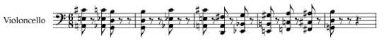

Section C features a chromatically descending motion in all instruments. A vertical line also emerges with the chromatically descending chords, presented in the winds and brass. It then introduces more polychordal combinations, as well as ascending and descending mixolydian scales. The return of section A in measure 176 continues with mixolydian runs in solo cello, chromatic horizontal movement in upper strings, and more polychordal combinations (example: B - C and B - C-sharp combination in measure 189). Of particular interest is the chromatic chordal progression occurring between measures 218 and 222. This is the moment of the evocative transition into the restatement of section B. It is a slow-moving e - F - F-sharp - G - G-sharp chromatic progression featured in strings and bassoon. It helps in enhancing the solo cello phrasing by adding this specific harmonic color. Just as in its original statement, Section B features the chromatic linear motion of the orchestra with a tonal setting of solo cello. The final section A reestablishes the tonality of E major and enhances it with a I-IV-IV-I progression between measures 243 and 246. After this tonal statement, the harmony alternates between specific chords (measures 250-252: C-sharp major, A major, a minor, measure 261: c-sharp minor and C major seventh chords), chromatic linear motion, chords based on perfect fourths and perfect fifths, and chromatic chordal ascent (measures 269-270: G major seventh, G-sharp major seventh, A major, B-flat major seventh and B major seventh). The coda, established in measure 273, features contrary linear motion and chromatic descent and ends the movement with a hollow E major without a single occurrence of a third or a fifth.
The harmonic language present in this concerto is the main contributor to the neoclassical style of the composition. The harmonic coloring created through the use of chromatic progressions of tertian chords, polychords, chromatic linear motions and mixolydian modes, shape the overall character of the work. The harmonic movement is not bound by any rules of tonality. Instead it enhances the free-spirited, expressive and energetic nature of Bacewicz’s music.

- SEPARATED BY A GENERATION AND A WAR, UNITED BY ONE IDEA: COMPARISON OF THE NOWOWIEJSKI AND BACEWICZ CELLO CONCERTOS

Bacewicz and Nowowiejski represent two separate generations of Polish composers, raised and coming to maturity in two different realities in Poland. Feliks Nowowiejski, born in Prussian-ruled Warmia, was almost entirely influenced by German culture. Yet, even though before 1918, an independent Poland was only a hopeful dream, Nowowiejski chose the Polish side. Unfortunately, by embracing his national identity, he burnt many bridges in the cultural capital of Germany. Paradoxically, he was never entirely accepted as a Pole, which unfavorably impacted his career. Bacewicz, on the other hand, grew up during the interwar years in an independent Poland, full of hope and optimism, with opportunities provided to her by multiple newly formed national organizations. As her international stature grew, she became celebrated by the Polish communist authorities, who realized it was in their best interest not to hinder the Polish composer’s artistic growth.

Historical Comparison of the Composers and Their Concertos

As a young student in a Prussian province, Nowowiejski did not have access to high-quality music education or high-level artists who would provide him with much needed inspiration and guidance. Thankfully, he was able to cultivate his talents through his studies in Germany and frequent travels to multiple European countries. As an adult, Nowowiejski made it his mission to revitalize Polish music education and provide more opportunities for the new generation of students. The formation of new orchestras was another essential aspect of the cultural arena during the interwar period, as there were no Polish symphonic orchestras in existence before World War I. With the establishment of national orchestras, the affinity for Polish symphonic music grew exponentially. Presenting works of the great European artists with the newly formed orchestras and inviting world-renowned soloists for performances, inspired young students and composers, such as Grażyna Bacewicz.
National violin schools and piano schools were also becoming more prominent during the interwar period. Unfortunately, the cello in Poland had a comparatively late beginning. The first surviving concerto for cello and orchestra dates from 1908. It was composed by Władysław Rzepko, who went on to write two more cello concertos in 1923 and 1929. Those are sadly only of pedagogical value. The first genuinely virtuosic cello concerto of significant proportions was composed by Feliks Nowowiejski himself. One can only speculate if he was ever influenced by Antonín Dvořák’s Cello Concerto in b minor. After all, the Czech composer guided the young Warmian into embracing his national roots and made a lasting impression on Nowowiejski.
Nowowiejski's Cello Concerto could not have been written at a worse time. 1938 was a year of substantial political tensions resulting in a war that would forever change the world. Thankfully, the concerto survived the ravages of war unlike many of Nowowiejski’s other compositions. These circumstances, combined with the composer's death soon after the war, meant the concerto became forgotten for several decades after its composition.
The concerto has never been published. It exists only in manuscript form. The cello solo part is highly challenging. Cellists and conductors who have performed it have omitted several passages either for technical and ensemble difficulty or excessive melodic meandering. One will never know precisely how Nowowiejski would have corrected the work if he could have heard his composition premiered and consulted with either Furstenberg-Schulz or Danczowski on the execution of the cello part. The limited access to the manuscript is another hurdle the cellist and orchestra must cross in order to perform the work. It is the author’s utmost hope that Nowowiejski's difficult but beautiful cello concerto will someday receive the publication it rightfully deserves.
Bacewicz grew up as a young violin, piano, and composition student during the interwar period. She had a substantial advantage from her earliest years, as her father was a violin teacher who made sure that all of his children were thoroughly immersed in music. She received music education in Poland, which Nowowiejski was never able to obtain completely. She also had an opportunity to study with such great artists as Nadia Boulanger and Carl Flesch. The years between 1918 and 1939 represented a period of substantial economic, political, national, and cultural growth. After emerging from 123 years of forced hibernation, Poland was eager to rejoin the rest of the world in every aspect possible. The newly acquired freedom meant that Polish artists could travel without any major restrictions. Foreign artists could frequently visit the new country and share their talents with Polish audiences, inspiring the younger generation. Polish cello virtuosi like Kazimierz Wiłkomirski were emerging and spreading the increasing popularity of the instrument.
Bacewicz had an advantage over a composer like Nowowiejski, considering that she was also an internationally renowned violinist and had a thorough understanding of the string instrument's capabilities. Being of international stature, she also had an opportunity to collaborate with many prominent violinists and cellists, including David Oistrakh, Miloš Sádlo, and Gaspar Cassadó. Because of these reasons, her Cello Concerto no.1 is much more accessible in performance than Nowowiejski’s. The concerto received its first publication in 1953, only two years after the composition was written. That made it accessible to cellists and conductors around the world.
Bacewicz’s international stature allowed her to have the renowned cellist Miloš Sádlo premiere the concerto and celebrated Polish cellist Kazimierz Wiłkomirski edit the cello part. The timing of the composition was also fortunate. Written in 1951, it was the second Polish cello concerto to be written after the war. The first was Wiłkomirski’s Sinfonia Concertante, composed just one year earlier. The only other concerto between the one of Nowowiejski and Bacewicz was Apolinary Szeluto’s Cello Concerto in D major, op.101, written in 1942.
The rise of communism in Poland resulted in an attempt to erase the past, especially the past that did not agree with the objectives of the new political movement. Nowowiejski, being the composer who fueled the patriotic sentiment with his choral compositions, was not spared the fate of a forgotten composer. New trends in Polish music also contributed to the temporary disappearance of Nowowiejski’s works from concert programs. It was not until after the Stalinist “thaw” in the late 1950s, where musicians felt comfortable exploring the pre-war compositions, like Nowowiejski’s Cello Concerto, and bringing them to life after decades of collecting dust on the library shelves. The rise of communism also hindered the creative freedom of post-war Polish composers. One can only speculate if Bacewicz’s Cello Concerto no.1 would have been more daring and unique had she not felt the obligation to compose something more accessible to wider audiences.

Stylistic and Compositional Comparison of the Two Cello Concertos

Both of the composers’ influences were drastically different. Nowowiejski grew up at the height of neoromanticism and was influenced by Max Bruch as his teacher and mentor. Bacewicz grew up at a time of stylistic rejection of neoromanticism, and as recommended by Karol Szymanowski, studied with Nadia Boulanger in Paris. There she embraced and developed her unique voice based on the neoclassical language. She devoted over half of her compositional period to this style, becoming one of its major Polish representatives. Nowowiejski, on the other hand, only began dabbling in the neoclassical style towards the end of his life, exploring its early developmental possibilities but still keeping his mature grandiose voice.
Neoclassicism in Poland developed quite differently from the rest of Europe. The political realities made it difficult for Polish composers to actively and successfully participate in Europe’s cultural trends. Neoclassicism first took root in composers' minds and works during the interwar period between 1918 and 1939. As the style reached its peak throughout much of Western Europe in the 1930s and 1940s, Poland was only beginning to shape its new compositional language. The style did not reach its maturity until the 1950s. This later emergence caused a certain distinctiveness. The aesthetics peculiar to the composers of Les Six never took hold in Polish music, and neither did the use of extraneous material as with Stravinsky’s Pulcinella. Polish composers turned to the music of baroque and early classicism for guidance. Their music was purely instrumental and focused on clear forms such as overtures, suites, concertos, and quartets. Polyphony was frequently featured. The texture was based on seventeenth and eighteenth-century models, which embraced reduced orchestral forces and typical chamber ensembles. Emphasis was placed on developing a new linear technique, new harmonic procedures, and new metro-rhythmic patterns. “One special trait of Polish neoclassicism was – in spite of its assumed objectivity and anti-emotionality – a tendency for lyrical expression borne by soft cantilena melodic lines, and at times for accentuating dramatic climaxes. Just as Szymanowski’s music remained deeply emotional to the end, despite his anti-romantic declarations, so the music of his successors not infrequently displays the same ‘romantic’ elements.”
After the Łagów Conference in 1948, neoclassicism was condemned as "formalistic," "anti-realistic," and "asocial." For neoclassical composers, the solution to this problem was to include folkloristic elements into their compositions. This became the hallmark of Polish neoclassicism during the late 1940s and first half of the 1950s.
Feliks Nowowiejski embraced the neoclassical trends just as they were making their appearance in Poland. His Cello Concerto is a prime example of the beginning stages of this newly-found style. Having explored Albert Roussel's works, he kept his fondness for large orchestral forces and substantial compositional structures. He abandoned the traditional tonal system in favor of exploring new harmonic colorings based on perfect fourths, perfect fifths, tritones, and chromaticism. He embraced the traditional formal structures, which in the concerto include sonata-allegro form in the first movement, rounded binary in the second movement, and a set of variations in the third movement. It was a trait of Polish neoclassicism already in the beginning stages to use forms developed in the Baroque and Classical eras, often naming compositions after specific structures. Nowowiejski did just that. The sonata-allegro form of the first movement follows the “classical” principles of two contrasting themes in the exposition, substantial development, and a recapitulation that reintroduces the two themes. Aria, the second movement, establishes the lyrical and cantilena-style motives, which create a sense of beauty, melancholy, and drama specific to Polish cultural identity. In the third movement, Nowowiejski bows to the contrapuntal masters of the Baroque era while keeping his affinity for large orchestral forces. He cleverly uses a passacaglia structure, weaving the motoric ostinato motive throughout the whole movement, skillfully passing it between the different instruments of the orchestra. Eleven variations form the movement's main idea, and Nowowiejski masterfully presents a large fugal section, which covers two of the variations. Here, the concerto is influenced by the organ’s polyphonic and improvisatory character, the instrument which Nowowiejski promoted wholeheartedly throughout most of his career.
Bacewicz, having written in the neoclassical style from the beginning of her compositional career, had a drastically different approach to the style than Nowowiejski. As represented by her Cello Concerto no.1, her works are much more concise in length, structure, and orchestration than of the Warmian composer. The length of both of the concertos alone shows the drastic difference of approach between the two artists. Nowowiejski’s concerto is about forty minutes long, while Bacewicz’s concerto lasts just a little over twenty minutes. The difference in orchestration is also substantial. Bacewicz’s orchestration of the concerto is relatively standard. It features a woodwind setting of piccolo, two flutes, two oboes, two clarinets, two bassoons; a brass setting of four horns, three trumpets, two trombones; timpani and strings. Nowowiejski expands the standard orchestration by adding English horn, bass clarinet, contrabassoon, celeste, harp, and a substantial number of percussion instruments, including bass drum, snare drum, tambourine, cymbals, triangle, and bells.
Bacewicz bases the formal structure of her Cello Concerto no.1 on classical eighteenth-century symphonic models. The first movement features a typical sonata-allegro form with two contrasting themes, a predictable development, and a recapitulation that reintroduces both themes. The second movement, as with Nowowiejski, is built on the rounded binary form and features lyrical and cantilena-style motives. Just like Nowowiejski, it is characterized by song-like qualities and by flowing phrases reaching dramatic climaxes. Both of these two composers' second movements are a prime example of the "emotional” trait in Polish neoclassicism. The third movement of Bacewicz’s concerto differs formally from the concerto of Nowowiejski. It is composed in a rondo form and faithfully follows the ABACABA structure. Whereas the Warmian composer’s movement is serious and grandiose in character, this movement is lively, brisk, and joyous.
Both composers honor the eighteenth-century models of form, which bring clarity and order to the compositions. They combine this “search for inspiration in traditional music," with their unique use of instrumental color, innovative harmonic procedures, and motivic development. The instrumental and harmonic color is quite distinctive in both of the concertos. Frequently, both Bacewicz and Nowowiejski feature instruments sharing the same register in the melodic foreground and create unique effects based on the colorings of the combinations of instruments. At the same time, other instruments sharing similar registers take on the role of a harmonic and rhythmic background.
Both composers are skillful masters of orchestration, but approach the application of instrumental color differently. Nowowiejski achieves a unique color of orchestration by adding instruments not frequently featured in Polish neoclassical symphonic music, displaying them prominently in specific portions of the concerto. A good example of that is the use of celeste and harp in the second movement. Bacewicz, on the other hand, uses unique timbral effects created by the instruments already traditionally present in a typical symphonic setting of the late Classical period. Strings, for example, create shimmering high-pitched tremolos, which establish a register contrast between the low-pitched melodies of the solo cello. Contrasting articulation and dynamics also contribute to the creation of unique timbral effects.
A significant distinction lies in the composers' approach to harmonic color. Both of the works use tonal centers as the basis for harmonic movement. Except for a small number of instances, they do not show any deliberate harmonic progressions. Instead, they feature chromaticism and dissonance as the basis of harmonic language. Nowowiejski’s concerto is centered in e minor, but this only means that each movement's sections periodically return to an e-based center with little additional evidence of traditional, functional tonality. The dissonance in the pre-war concerto is significant. Third-based harmonies are rare, and when they do appear, they immediately create a unique color. Most frequently, these harmonies are featured in polychordal combinations. The most often used harmonic structures in the concerto are based on perfect fourths, perfect fifths, tritones, octaves, diminished and augmented chords, seventh chords, ninth chords, and other chromatic colorings.
Bacewicz’s harmonic language in her cello concerto is much less dissonant than Nowowiejski’s. The composer uses frequent chromatic chordal colorings, often adding different combinations of polychords and seventh chords. The chords have no relation to each other except for contributing to the coloristic effects of the composition. Just like Nowowiejski, Bacewicz’s harmonic movement is free of any tonal boundaries, although she does introduce moments of tonal centers in the first and third movements. In the first movement, the first theme centers around D major, and the third movement also has a few occurrences of an E major center. The third movement also features rather unique moments of tonal progressions.
Just like Nowowiejski, Bacewicz prefers to feature linear structures instead of harmonic structures. This idea of focusing on the horizontal movement rather than the vertical movement is prevalent in much of Polish neoclassical music. It derives from the polyphonic influence of the Baroque masters. The chromatic linear structures often result in chromatic harmonies. Bacewicz combines these linear structures in such a clever way, the dissonance achieved is rarely overt. She also makes frequent use of mixolydian scales, which adds to the overall coloristic effect of the concerto.
Both composers shape their motives quite differently. Bacewicz’s themes and phrases are clear, concise and simple, with predictable contrasting articulations and rhythmic patterns. Melodies throughout the concerto feature folk-like characteristics, either filled with energy and liveliness or song-like lyricism. The motivic material in Bacewicz’s concerto provides a feeling of pleasantness, simplicity, joy, and charm. The motivic development in the concerto of Nowowiejski is much more complex. Phrases are long and combine multiple motives simultaneously. Textures are dense, often resulting in a feeling of motivic meandering. Yet, at the same time, this motivic development adds to the powerful and robust character of the concerto and accentuates the virtuosity of both the cello and the orchestra.
Both concertos feature frequent and extensive ostinato patterns. In both cases, the patterns contribute to the linear structures of the compositions. Nowowiejski uses his ostinato patterns to add to the concerto's virtuosic character, while in the third movement, the ostinato becomes essential in creating the passacaglia structure. Bacewicz uses her ostinatos for a coloristic effect of either a ‘pulsating blanket’ in the second movement or to emphasize the motoric and energetic character of the outer movements.
Both concertos present the main attributes of the Polish neoclassical style, which include: a focus on purely instrumental music; a return to baroque and early classicism styles of music, using twentieth-century linear and harmonic procedures; and a tendency for lyrical expression combined with dramatic climaxes. With the Nowowiejski concerto, one can trace the beginning of the style on Polish soil, still operating on a large textural and structural scale but bowing and honoring the masters of the past. At the same time, this concerto emphasizes the break from tonality and exploration of new harmonic possibilities. Bacewicz’s concerto, while written near the end of the period in which she favored neoclassicism, does not fully represent her achievements in the development of the style. It is a somewhat 'tame' concerto, lacking the daring spirit of the composer’s other works of the time. Nonetheless, the concerto is representative of stylistic ideas specific to the time and place of its composition.

- CONCLUSION

After the emergence of the sonoristic school of composition in Poland, composers like Lutosławski, Penderecki, and Panufnik entered the world stage of music, influencing and directing the development of the new style throughout all of the world’s inhabited continents. With its large register and endless timbral possibilities, the cello became the perfect medium for the new modernist techniques. The emergence of virtuosi such as Mstislav Rostropovich and Siegfried Palm made it possible for composers to seek inspiration and guidance from these distinguished modern soloists. Numerous new concertos were composed that became iconic within the twentieth-century cello repertoire. Today, every cellist is aware of the Lutosławski Cello Concerto and the Penderecki Cello Concerto no.1 and no.2. These cello concertos of the second half of the twentieth century have been studied thoroughly by many musicologists and theorists worldwide. They have received a large number of recordings and have been featured on stages worldwide hundreds of times.
The side-effect of that international fame was that the few cello concertos written during the first half of the twentieth century were pushed aside. They did not represent the revolutionary developments in music and were therefore deemed unimportant. Thankfully, trends are now changing. The musical legacies of Lutosławski, Penderecki, and their contemporaries will never be forgotten as they are part of a pivotal moment in music composition. However, artists are again exploring the past and reaching for music that has yet to receive significant attention. The Nowowiejski and Bacewicz concertos will always have their place in history, and it is likely only a matter of time before they receive renewed attention. They are special and unique compositions in their own right, and their beauty will never fade as long as they continue being performed, examined, and appreciated. That is the utmost hope of the author of this document.

- BIBLIOGRAPHY

Books

Antokoletz, Elliott. A History of Twentieth-Century Music in a Theoretic-
Analytical Context. New York and London: Routledge Taylor and Francis Group, 2014.
Boehm, Jan. Feliks Nowowiejski (1877-1946): Zarys Biograficzny. Olsztyn:
Pojezierze, 1977.
Cowling, Elizabeth. The Cello. New York: C. Scribner’s Sons, 1983.
Danuser, Hermann. “Rewriting the Past: Classicisms of the Inter-War Period.” In The
Cambridge History of Twentieth-Century Music, edited by Nicholas Cook and
Anthony Pople, 260-283. Cambridge: Cambridge University Press, 2008.
Davies, Norman. God’s Playground: A History of Poland. Volume II: 1795 To
The Present. New York: Columbia University Press, 2005.
Fokt, Iwona. Feliks Nowowiejski: Biography. Translated by Beata Brodniewicz.
Poznan: The Posnania City Publishing House, The Feliks Nowowiejski
Society, The I.J. Paderewski Academy of Music in Poznan, 2019.
Gmys, Marcin. Nie Tylko Rota: Feliks Nowowiejski i Jego Muzyka. Krakow:
Polskie Wydawnictwo Muzyczne, 2017.
Griffiths, Paul. A Concise History of Avant-Garde Music From Debussy To Boulez.
New York and Toronto: Oxford University Press, 1978.

Helman, Zofia. “Between Romanticism and the New Music.” Volume 6 of The
History of Music in Poland, edited by Stefan Sutkowski, translated by
John Comber. Warsaw: Sutkowski Edition, 2015.
Helman, Zofia. Neoklasycyzm w Muzyce Polskiej XX Wieku. Krakow: Polskie
Wydawnictwo Muzyczne, 1985.
Kukla, Jerzy. “Orkiestra Symfoniczna w Tworczosci Feliksa Nowowiejskiego –
Ewolucja Stylu i Warsztatu.” In Feliks Nowowiejski i Jemu Wspolczesni
Wobec Idei Muzycznych Przelomu XIX i XX wieku, edited by Ilona Dulisz
and Joanna Schiller-Rydzewska, 40-80. Olsztyn: Wydawnictwo
Uniwersytetu Warminsko-Mazurskiego, 2019.
Nowak, Anna. Wspolczesny Koncert Polski: Przemiany Gatunku. Bydgoszcz:
Akademia Muzyczna im. Feliksa Nowowiejskiego w Bydgoszczy, 1997.
Rappoport-Gelfand, Lidia. Musical Life in Poland: The Postwar Years 1945-
1977. Translated by Irina Lasoff. New York: Gordon and Breach, 1991.
Rogala, Jacek. Polish Music in the Twentieth Century. Edited by Ewa Widota-
Nyczek. Translated by Lukasz Litak. Krakow: Polskie Wydawnictwo
Muzyczne, 2000.
Rosen, Judith. Grazyna Bacewicz: Her Life and Works. Los Angeles: Polish
Music History Series, 1984.
Simms, Bryan. Music of the Twentieth Century: Style and Structure. New York:
Schirmer Books, 1996.
Stowell, Robin. The Cambidge Companion to the Cello. Cambridge: Cambridge
University Press, 1999.
Szatrawski, Krzysztof. “Feliks Nowowiejski: A Late Romantic From Warmia.” In
A Romantic Century in Polish Music, edited and translated by Maja
Trochimczyk, 223-243. Los Angeles: Moonrise Press, 2009.
Taruskin, Richard. Music in the Early Twentieth Century. Vol.4 of The Oxford
History of Western Music. Oxford: Oxford University Press, 2009.
Thomas, Adrian. Grazyna Bacewicz: Chamber and Orchestral Music. Los
Angeles: Polish Music History Series, University of Southern California,
1985.
Thomas, Adrian. Polish Music since Szymanowski. Cambridge: Cambridge
University Press, 2005.
Thomas, Adrian. Squaring the Triangle: Traditions and Tyrannies in Twentieth-
Century Polish Music. London: School of Slavonic and East European
Studies, University of London, 2000.

Journal Articles and Conference Reports

Demska-Trebacz, Mieczyslawa. “Miejsce Wiolonczeli w Tworczosci
Kompozytorow Polskich XIX i XX Wieku”. Z Prac Katedry
Instrumentow Smyczkowych: Polska Literatura Wiolonczelowa XIX i XX
Wieku. Musicological Session, Fryderyk Chopin Academy of Music in
Warsaw, April 1987.
Gasiorowska, Malgorzata. “Grazyna Bacewicz – The Polish Sappho”. Musicology
Today, Vol.16, no.1 (2019), 65-102.
Grella-Mozejko, Piotr. “Fifty Years of Freedom: Polish Music After 1945”.
Canadian Slavonic Papers Vol. 39, no.1/2 (March-June 1997), 181-208.
Suchecki, Roman. “O Koncercie Wiolonczelowym Feliksa Nowowiejskiego”. Z
Prac Katedry Instrumentow Smyczkowych: Polska Literatura
Wiolonczelowa XIX i XX Wieku. Musicological Session, Fryderyk Chopin
Academy of Music in Warsaw, April 1987.

Theses and Dissertations

Briel, Grazyna. “Thematisches Verzeichnis der Werke von Grazyna Bacewicz:
mit einem biographischen Essay.” Diss., Bonn Universitat, 2000.
Publisher: Aachen, Shaker, 2001.
Jarosz, Klaudia. “Grazyna Bacewicz and Her Contributions to the Cello
Repertoire.” DMA diss., University of Nebraska-Lincoln, 2020.
Levitov, Daniel. “Narrative and Program in the Twentieth-Century Cello Concerto.”
Diss., City University of New York, 2005.

Websites

Bacewicz, Grazyna. www.bacewicz.polmic.pl
Catalogue of Polish Cello Literature of XX and XXI Century. www.andrzejbauer.com/katalog

Scores

Bacewicz, Grazyna. I Koncert Wiolonczelowy. Piano reduction and cello part.
Krakow: Polskie Wydawnictwo Muzyczne, 1953.
Bacewicz, Grazyna. I Koncert Wiolonczelowy. Orchestral score. Krakow: Polskie
Wydawnictwo Muzyczne, 1953.
Bacewicz, Grazyna. Partita for Orchestra. Krakow: Polskie Wydawnictwo
Muzyczne, 1959.
Bacewicz, Grażyna. String Quartet no.4. Kraków: Polskie Wydawnictwo Muzyczne,
1995.
Bacewicz, Grazyna. Quintet for Wind Instruments. Krakow: Polskie
Wydawnictwo Muzyczne, 1978.
Nowowiejski, Feliks. Concerto pour violoncelle et orchestre. Manuscript of
orchestral score.
Nowowiejski, Feliks. Concerto pour violoncelle et orchestre. Manuscript of piano
reduction score.

Piotr Grella-Mozejko frequently uses this term in his article “Fifty Years of Freedom: Polish Music After 1945”, Canadian Slavonic Papers, Vol.39, no.1/2 (March-June 1997), pp.181-208.
Marcin Gmys, Nie tylko Rota: Feliks Nowowiejski i jego muzyka, (Kraków: Polskie Wydawnictwo Muzyczne, 2017), 216.
Ibid, 194.
Jacek Rogala, Polish Music in the Twentieth Century. (Krakow: Polskie Wydawnictwo Muzyczne, 2000), 35.
Ibid, 41.
Norman Davies, God’s Playground: A History of Poland. Volume II: 1795 to the Present, (New York: Columbia University Press, 2005), 320.
Jacek Rogala, Polish Music in the Twentieth Century, (Kraków: Polskie Wydawnictwo Muzyczne, 2000), 59.
Lidia Rappoport-Gelfand, Musical Life in Poland: The Postwar Years 1945-1977, (New York: Gordon and Breach, 1991),110.
Adrian Thomas, “Squaring the Triangle: Traditions and Tyrannies in Twentieth-Century Polish Music,” (London: School of Slavonic European Studies, University College London, 2000), 13.
Iwona Fokt, Feliks Nowowiejski Biography, (Poznan: The Posnania City Publishing House, 2019), 60.
Ibid., 63.
Krzysztof Szatrawski, Feliks Nowowiejski: A Late Romantic from Warmia. In A Romantic Century in Polish Music, edited and translated by Maja Trochimczyk (Los Angeles: Moonrise Press, 2009), 233.
13 Marcin Gmys, Nie tylko Rota: Feliks Nowowiejski i jego muzyka, (Kraków: Polskie Wydawnictwo Muzyczne, 2017), 141.
Roman Suchecki, O Koncercie Wiolonczelowym Feliksa Nowowiejskiego. In Z Prac Katedry Instrumentow Smyczkowych: Polska Literatura Wiolonczelowa XIX i XX Wieku. (Musicological session at Fryderyk Chopin Academy of Music in Warsaw, April 1987): 122. Translated by Angelika Machnik-Jones.
Ibid.: 121.
Ibid.: 122.
Ibid.: 123.
Ibid.: 26.
Adrian Thomas, Grażyna Bacewicz: Chamber and Orchestral Music. (Los Angeles: Polish Music History Series, University of Southern California: 1985): 25.
Judith Rosen, Grażyna Bacewicz: Her Life and Works. (Los Angeles: Polish Music History Series, University of Southern California, 1984): 30.
www.bacewicz.polmic.pl/i-koncert-wiolonczelowy/
Ibid.
Zofia Helman “Between Romanticism and the New Music.” Volume 6 of the The History of Music in Poland. Edited by Stefan Sutkowski, translated by John Comber (Warsaw: Sutkowski Edition, 2015), 534.
Ibid, 534.

