UNIVERSITY OF OKLAHOMA
GRADUATE COLLEGE

Women of Color in Academic Dance:

An Evaluation of How America and Oklahoma’s History of
Racial Injustice towards Black and First American People
Correlates to the Experiences of Black and First American
Female Identifying Students Majoring in Dance at
Oklahoma Higher Education Institutions

A THESIS
SUBMITTED TO THE GRADUATE FACULTY
in partial fulfillment of the requirements for the
Degree of
MASTER OF FINE ARTS IN DANCE

By
BRIANA SAYLES
Norman, Oklahoma
2023
WOMEN OF COLOR IN ACADEMIC DANCE: AN EVALUATION OF HOW AMERICA AND OKLAHOMA’S HISTORY OF RACIAL INJUSTICE TOWARDS BLACK AND FIRST AMERICAN FEMALE IDENTIFYING STUDENTS MAJORING IN DANCE AT OKLAHOMA HIGHER EDUCATION INSTITUTIONS

A THESIS APPROVED FOR THE
MASTER OF FINE ARTS IN DANCE

BY THE COMMITTEE CONSISTING OF

Leslie Kraus, Co-Chair
Roxanne Lyst, Co-Chair
Marie Casimir
Boyko Dossev

© Copyright by BRIANA SAYLES 2023
All Rights Reserved.

Table of Contents
Abstract ………………………………………………………………………vii
Introduction …………………………………………………………………viii
Racism in the United States …………………………………………………2
The Origins…………………………………………………………………..2
Women in Color in History………………………………………………….4
Systemic Racism: Roots of Western Medicine………………………………6
Women of Color in Medical History………………………………………..8
Dance and Racism ………………………………………………………...11
Black and Indigenous Dance in American Art Culture …………………….11
Black and Indigenous Women in Western Performance Dance …………16
Oklahoma and Racism ………………………………………………………22
Hate Crimes in the Sooner State History………………………………… 22
Oklahoma Higher Education and Racism…………………………………..24
Interviews……………………………………………………………………26
Malia……………………………………………………………………….26
Lucy………………………………………………………………………..32
Conclusion/Solution ………………………………………………………36
References…………………………………………………………………44

List of Illustrations
- Phrenology chart created by German anthropologist Ernst Haeckel in an attempt to prove meaningful similarities between the African skull and primates.
- “Theft of Life” column published to inform the public about the forced sterilization of Native women in America.
- Anarcha, one of the three female slaves that received the majority of Dr. Caldwell’s mutilations through experimental surgery, sitting on an examination table being evaluated by gynecologist.
- Krump dance co-founder and performer, Jo’Artis Ratti,, in a powerful still shot that was taken during the 2020 protests.
- Specifications of the “ideal dancer body” listed in the book, Classical Ballet, written by Gretchen Ward Warren.
- Photos showing appropriation vs. history of Black hairstyles.
  - Top Left: Top Left: K-pop group, Maple.lip, wearing cornrows, box braids, styled baby hairs
  - Top Right: A top view of one of the ways that cornrows, plaits, and braids were used for survival during slavery in America.
  - Bottom Left: Black female celebrities with Afro hairstyles
  - Bottom Right: popular magazine promoting and somewhat encouraging women of all backgrounds to wear Afros as a “fun” option to wear.
- Three Osage women, Mollie (right) with her sisters Anna (center) and Minnie, who belong to one of the first families targeted during the Osage Murders
- Racism towards Black individuals in Oklahoma
  - Article from The Black Dispatch detailing the chaos that ensued when Klansman rushed into a Black performer’s stage time at a local club.
  - Top Right: Street sign in Oklahoma honoring Grand Dragon of the KKK, Ed DeBarr, that was removed in 2017 after student protest.
  - Bottom Right: University informational plaque that summarizes the academic career of confirmed Klansman, Ed DeBarr, followed by a small note about his name being removed after student protest.
- Visual of what happens when trauma, anxiety, panic, and stress cycle through the nervous system.

Abstract:
In this paper, I discuss the difficulties faced by female-identifying dance students of color in Oklahoma higher-education. Due to the lack of educational training provided by higher-education dance programs, critical accessibility and an and share some of my own critical reflections on how educators have the ability to create an accessible and equitable experience within studio classroom settings. Speaking from the position of a researcher who belongs to the thesis demographic, my decade-long investigation into the experience of female-identifying Black and First American dance students within higher education dance programs highlights and uncovers traumas experienced by dance students within institutions in Oklahoma .
Keywords: dance, race, women, female-identifying, Black Americans, First Americans, Indigenous, Native American, Black women, Native women, pedagogy, dance education, appropriation, education, Oklahoma, Higher-Education, trauma, accessibility, equity, BIPOC, PWI

Introduction
As evidenced by popular news outlets, many people in American society believe topics such as racial inequality and a lack of equity between genders are unfortunate, but resolved tragedies that exist exclusively in the country’s history (Jensen 2021). In all actuality, the United States is still seeing the impacts of these inequalities in modern culture. In addition, there are identifiable, disproportionate struggles for Black, Indigenous, and Persons of Color (BIPOC) communities in southern states, such as Oklahoma, with topics like women’s healthcare rights and land ownership rights (Robinson 2020).
While these inequities were endured by BIPOC communities as a whole, there are specific traumas that were inflicted only upon the women , such as medical experimentation and reproductive mutilation (Schertow 2006). Terms such as “Squaw” (created in the 1800s by White male colonizers who wanted to clarify the ‘dirtiness’ of Native women in comparison to ‘pure’ White women) and “Mammy” (slave masters labeling for Black women that they saw as ‘grossly overweight, jolly, unattractive, dark-complexioned woman, and asexual; living only to serve) denote the dehumanization and degradation that have been targeted towards women of color (WOC) in America since the inception of our modern nation (Drexler 2019).
The violence towards WOC in America was also non-discriminatory about the female’s age from the beginning, depriving innocent Black and Native girls of their human rights to food and water, education , and bodily autonomy (Pendharkar 2022). As the years went on, female children of color stayed persistent in the journey to reclaim those rights, one generation after the other, but were forced to settle with miniscule amounts of progress that often times came with more fight than freedom in several instances. In a study focused on Native American girls in residential and boarding schools created to “Kill the Indian, [and] Save the Man”, the National Sexual Violence Resource Center noted that approximately one-fourth of the young girls reported they were sexually abused in these institutions., but it is assumed the real number is much higher (Nelson 2022). As an Afro-Indigenous female dance scholar that has pursued both bachelor’s and master’s degrees within Oklahoma, I knew that my voice had the potential to both educate and empower dance instructors and educators of all styles, across the state. In my conclusion, I propose both long-term and immediate solution-oriented options that seek to eliminate or reduce the strain that the extra obstacles faced by female dancers of color as they pursue collegiate training in dance. These proposals are presented a binary format to put focus on two foundational pieces that must be re-evaluated in order to create more accessible, equitable, and enriching curriculum for BIPOC women in Oklahoma dance programs: the two ‘Who’s identify characteristics of dance academics best-suited to create these environments, and the two ‘What’s provide current Oklahoma dance educators examples of what application of student-centered teaching practices can look like in the classroom.
RACISM IN THE UNITED STATES
The Origins
Beginning in the 17th century, colonizing forces began to displace, disrespect, and enslave African peoples. Known as the Trans-Atlantic Slave trade, this horrendous series of dehumanizing acts continued for hundreds of years, sending approximately 13 million African men, women, and children to locations around the globe, including the United States. Of these, it is approximated that around 11 million of those individuals survived the journey through the infamous Middle Passage that is in the Atlantic Ocean.(Muhammad 2003). This treacherous trip across the seas was unbearable for numerous reasons; being crammed into incredibly small spaces (sometimes lying horizontally, stacking one on top of another) and being abused at the whim of evil, bored crew members, claiming “exercise [was] deemed necessary for the preservation of [the slaves' health]” that would enjoy humiliating the captive Africans into entertainment acts to avoid physical punishment, stating that “if they go about it reluctantly, they [will be] flogged" (Higgins 2018).
In one community’s desperation to escape the lack of freedom that would continue to decrease as they got closer to their new “owners”, it was decided that committing collective suicide was a fate more desirable than facing the new horrors that awaited them on shore.
“Ibo Landing (also known as Ebo or Igbo) marks the site of resistance to enslavement by Igbo captives from West Africa in 1803. It is believed that the Igbo, following a revolt against their captors, chose death over a life of enslavement. The Igbo captives marched into the waters at Dunbar Creek and committed mass suicide, where it is said at least ten Igbo drowned. The Igbo suicide, preserved by oral traditions, became an important symbol in African American folklore.” (Powell 2020)

Though it may not have been the exact same individuals, White colonizing forces have enacted acts of violence against an endless list of Black and Brown peoples, including the country’s indigenous peoples, who are referred to as First American, Native American, or Indigenous (McDowell-Wahpekeche 2021). Land that has been proven to have been inhabited for thousands of years pre-colonization (originally known as “Turtle Island” by the tribes that were indigenous to the lands, now known as the Americas) was stolen from the Native people, leading to removal, relocation, and assimilation practices that would destroy the lives, homes, and ability to survive for thousands of people at a time (Carpella 2018).

Women of Color in History
When discussing the differences in treatment towards male and female slaves in her autobiography, Incidents in the Life of a Slave Girl: Written By Herself, Harriet Jacobs stated that, “Slavery is terrible for men; but it is far more terrible for women. Superadded to the burden common to all, they have wrongs, and sufferings, and mortifications peculiarly their own.”(Brent 1861) One of the mortifying abusive acts that Jacobs is referring to in this quote is the forceful rape and sexual torture of Black women and girls by their slave masters over the course of several decades while slavery was legal in the United States. The hyper sexualization of women of color in America has some of its strongest roots in these gruesome years of rape forced upon innocent Black women and girls, “their bodies commodified not only for labor but also for the carnal needs of slave masters who exotified their bodies.”(Spates 2020).
More than a century has passed since the release of this book, and though America has made significant strides in various areas of racial discrimination, Black women and girls of today and those of Harriet Jacobs’ time have sexual violence disproportionately affecting them Women of color that pursue higher education today have been found to more likely to experience sexual assault and violence, whereas White female students are more likely to be sexually harassed. (Klein 2019). In addition, the likelihood increases another 4% when the student is attending a Predominantly White Institution (PWI) as opposed to a Historically Black College or University (HBCU), which applies to almost all of the universities in Oklahoma that offer dance programs (Krebs 2011).
The entitlement that White men felt towards the bodies of Black women was also extended to Native American women throughout American history. Over the past 50 years, studies focused on Native rights and reservation life have revealed connections between the traumas inflicted on Native women during the heights of colonization and overwhelming number of Native women being taken, abused, sold, or otherwise today. (Bartley 2021).
Examples of forced sexual abuse between White men and Native women have been identified all throughout the forming of the country; in war times, the president himself at times would order American soldiers to inflict these punishments as their military duty (Stark 2020). Personal accounts of George Washington, America’s first president and a commonly used symbol of patriotic pride, tell of instances that he sent men to “put to death all the women and children, excepting some of the young women, whom they carried away for the use of their soldiers and were afterwards put to death in a more shameful manner” (Sjursen, 2018).

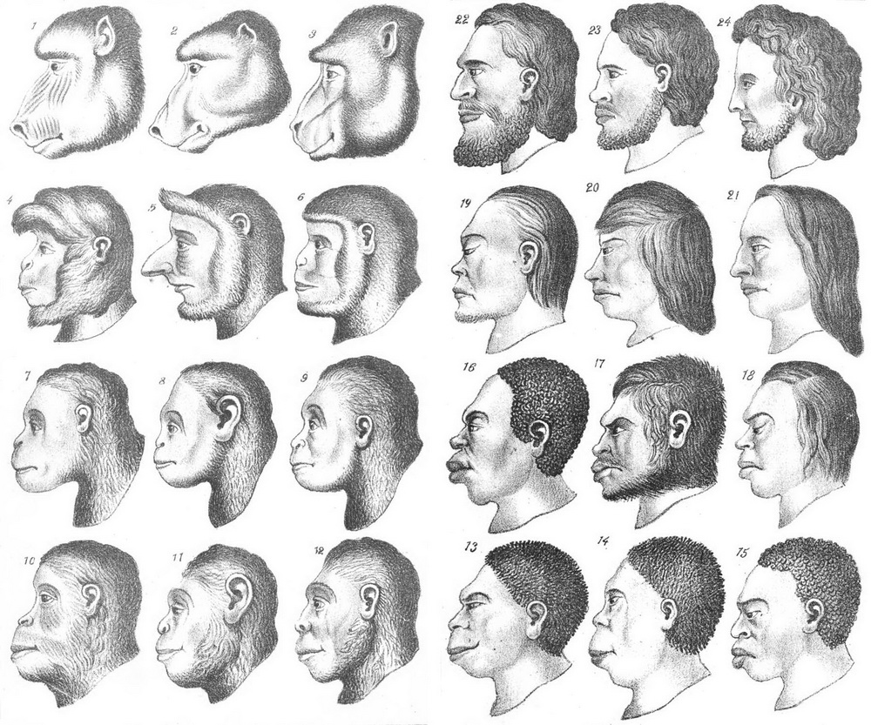
Systemic Racism in America: Roots of Western Medicine
Ernst Haeckel's figures XIII and XIV from the second German edition of Natural History of Creation (Hopwood 2015)

This idea would come to be known as “phrenology”; an area of medical science started in the 1830’s the United States. Phrenology was created to support and justify slavery by supposedly proving “Caucasian Anglo-Saxons were at the apex of human- and primate- evolution.” One of the leading researchers in Phrenology, Dr. Charles Caldwell, even claimed that the shapes of the bones in people of African descent “…indicated a “tamableness” that made them suited to be slaves and required them to “have a master”. (Newton 2017)
As if being written into medical science as a lower form of the human race wasn’t bad enough, dehumanizing of Native people in America has also continued to carried a massively damaging weight to the individuals who are still fighting to be recognized as equals, with racism in every area of the health industry still believing that there were intelligence disparities and that everyone being done for these marginalized communities should be created and enforced by others, under the guise that they were being cared for. For example, in the case of Native Americans, the work of physiologists including Samuel Morton helped justify their removal from their land in the 1830s and 40s. Morton’s 1839 book “Crania Americana” detailed skull configurations and consequent mental capacities of the four “separate species” he defined, including whites and Native Americans (Morton 1839). He saw differences between races as natural and dictated by God, rejecting the view that physical differences were created by environments. His study of skulls concluded that Native American minds were “different than that of the white man” and was cited in articles targeted at western settlers encountering Native Americans. One article stated that Native Americans were “adverse to cultivation, slow in acquiring knowledge”. This view of Native Americans existence in society as not conducive to industrialization and “progress” helped justify Andrew Jackson’s Indian removal policies and allowed western settlers to continue taking the land of Native Americans. Today, within the entity created for the healthcare of First Americans, called Indian Health Services (IHS), it was understood and accepted for many years that “ people of color were morally, mentally, and socially defective…Some of [the IHS doctors] did not believe that American Indian and other minority women had the intelligence to use other methods of birth control effectively and that there were already too many minority individuals causing problems in the nation.” (Little 2021).
Women of Color in Medical History
Though the bodies of “exotic women” were seen predominantly as sexually serving and reproducing objects at the start, the areas of acceptable abuse eventually grew to include medical experimentation and deception. In the Native community, it is most noticeable when looking at the forced sterilization of what has been determined to be up almost a quarter of the living female tribal members in America, starting in 1960 and continuing for almost two decades. Dr. Connie Redbird Pinkerman-Uri’s 1977, Theft of Life, she reveals some of the horrors she came across while investigating Indian Health Services:
“Two fifteen-year-old Native American women went into the hospital for tonsillectomies and came out with tubal ligations. Another Native American woman requested a “womb transplant,” only to reveal that she had been told that was an option after her uterus had been removed against her will. Cheyenne women had their Fallopian tubes severed, sometimes after being told that they could be “untied” again. The forced sterilization of thousands of Native American women by the Indian Health Service in the 1960s and 1970s—procedures thought to have been performed on one out of every four Native American women at the time, against their knowledge or consent.” (Ko 2016)
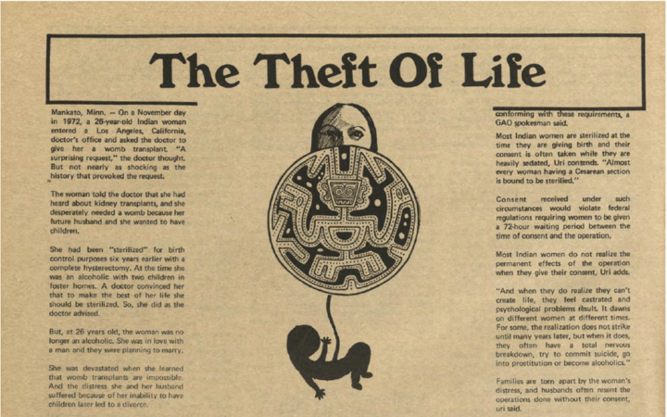
The Akwesasne Notes, a newspaper published by the Mohawk Nation, features an article on sterilizations by the IHS. (McKibban 2022)

Mirroring these violations in Black women’s bodies, the creation of common surgical practices in the Obstetrics and Gynecology fields were practiced and refined on Black female bodies. These women were strapped to tables and put through what can accurately be labeled torture, never having a choice in the matter, or being given any option for relief. Dr. J. Marion Sims, who is regarded as the “Father of Gynecology” by many to this day, used Black women’s bodies
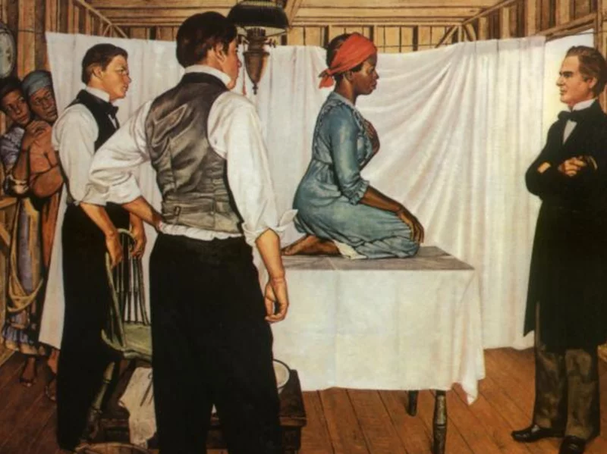
as guinea pigs that he was more than allowed to mutilate however he saw fit “for the advancement of science” that he felt he was called to do.
Illustration of Dr. J. Marion Sims with Anarcha by Robert Thom.
(Vendatam 2017)

Anarcha (pictured above), Lucy, and Bestsey were the three women who endured the majority of Sims torturous practices. The surgeries that the doctors forced upon these slaves were said to be “repeated again and again on the same women” , with some of the procedures being specifically documented up to “30 times on Anarcha”- not to mention that Sims was providing no protection or pain relief and was said to be “perfecting the technique on Black women, without anesthesia” that he would later provide only to White women.
Sims wrote in his autobiography of the results of one "stupid thing" he tested: "Lucy's agony was extreme. She was much prostrated, and I thought that she was going to die. ... After she had recovered entirely from the effects of this unfortunate experiment, I put her on a table, to examine." (Domonoske 2018)
In today’s medical treatment, one of the most common ways that medical racism affects Black women in today’s world is mistreatment during pregnancy and childbirth. Early experimentation done by those who created the original medical literature has led to years of neglect and wrongful deaths, because generations of doctors and nurses were told “ that blacks literally have thicker skin than whites and experience less pain." For black women, this means the odds of complications during pregnancy and giving birth are ignored, causing them to be “far more likely to die during pregnancy or childbirth than white women are.” (Garrison 2019)
DANCE AND RACISM
Black and Indigenous Dance in American Arts Culture

Unlike the Caucasian population of the United States, both Black and Native American communities have dance rooted deeply into their way of life; a means to celebrate, pray, mourn, mark rites of passage, speak to ancestors, and connect with the people and the land around them. For this reason, the efforts to assimilate and eliminate the artistic passion and soul connection that these communities have with music and movement was unsuccessful, and the people continued to dance (Hufford 2021)
In the Black community, we can see several genres of American dance brought to life by slaves on plantations, the freed descendants, and numerous generations that followed. Tap, jazz, swing dancing, and hip-hop have been a part of the American dance scene for decades, and yet, have never been able to gain the support and respect of white audiences in the way that classical ballets that have been performed thousands of times, over and over, year after year in the United States theatres (Blake 2010)
In the Native American community, tribal dances and Powwows dances have existed as foundational pillar for indigenous peoples for centuries, and yet, throughout the history of American arts post-colonization , Native dancers have been experiencing the othering of their cultural expression. In the 1920s, the Bureau of Indian Affairs signed into effect “Circular 1655”, a law that was meant to “ban ceremonial dances” (Jacobs 1997). This movement was notated in a confidential document called the “Secret Dance File” and detailed the specific of why White women were wildly upset by the “immoral” movements that Native American women were performing while White men were around, which, from their viewpoint, would only be “performed only for pleasure” (Blakemore 2019).
The sacred outfits worn by the dancers during Powwows, called regalia, hold power and meaning, and yet, outfits that are commonly worn by Native American women during these dances, such as buckskin dresses, are mimicked poorly and sexualized as Halloween costumes, dress-up clothes, and more by White women in the US. (Hayes 2001)
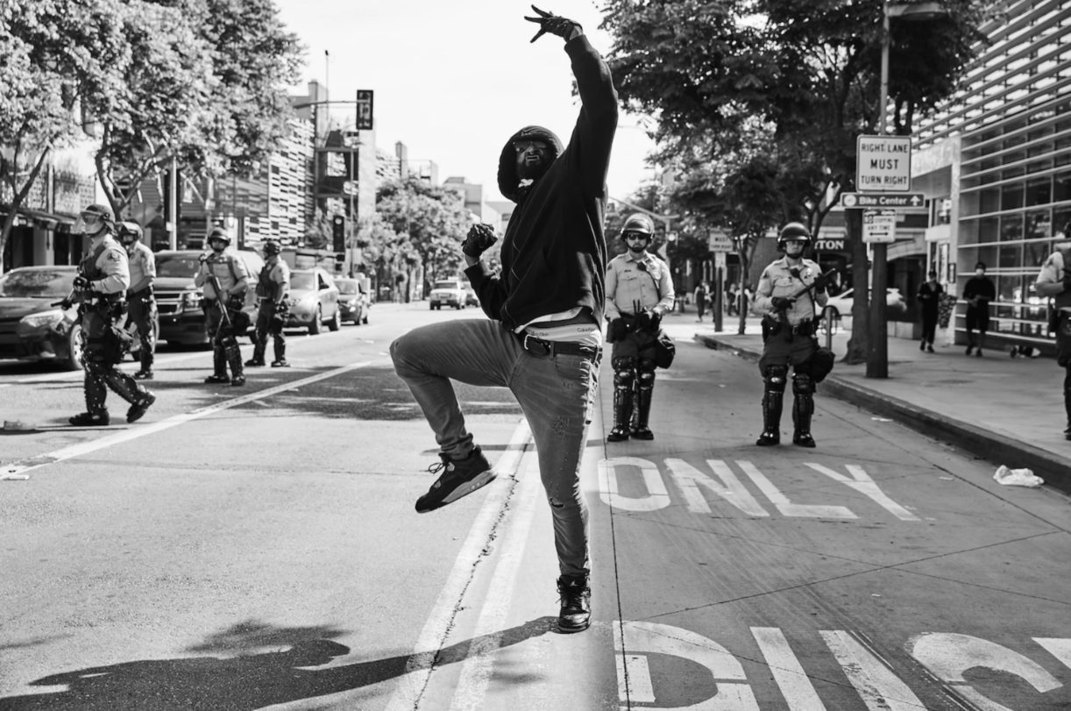
Movies like Bring It On introduce movements inspired by and claiming to be Krump into the households of thousands of viewers without ever feeling the need to put significant importance on the dance’s original purpose, and yet feeling comfortable connecting it to a dance battle among high-school students and cheerleaders. (Hartford 2011).
Still shot of Jo’Artis Ratti expressing his pain through Krump in front of law enforcement (Kaufman 2020)

This powerful photo was taken during 2020, just weeks after the murders of George Floyd, Ahmad Arbery, and Breonna Taylor, as enraged, broken-hearted, and hopeless Black citizens across took to the streets to scream for those who had been silenced too soon. His name is Jo’Artis Ratti, and he choose to speak his pain in the most authentic way he knew how: he danced. Ratti is “one of the founders” of Krump, a “hard-hitting competitive street dance from South Central Los Angeles” (Harris 2022). Krump, as demonstrated by Ratti in the picture, began in the 90’s and was used as an outlet through which dancers could work through and release some of the hurt that their bodies were holding on to from watching their community members be demonized, brutalized, incarcerated, and worse. The 1992 L.A. Riots that followed the police brutality against Rodney King is noted as one of the time periods that Krump began to gain more shape and more presence in black and brown communities(Krbechek 2017). “Krump is characterized by outsize muscular attack, far more aggressive than hip-hop” and rather than being performed in competitive or entertainment settings, Krump was originally made to “tell a story through visceral means that need no translation” so that any audience in the nation could “feel the anger, distress and courage [that] stem from a deep well of personal pain. (Calin 2020)
For Native peoples, there has been a fight to stop non-Natives from attempting to replicate sacred dances for decades. One example that was celebrated in America at the same time that Native American s were being mistreated, moved, and taken advantage of is the boy scout troupes that performed under the name of the Koshare club. (Houska 2018). Native women were seen as temptresses, Native men were seen as savages, but a small white child in a fake headdress running across a football field were seen as a wholesome, fun, entertaining treat for audiences and a wonderful experience for young, White boys (Bonham 2008). The boy scout group eventually gained so much praise and pride from the public that they felt called to also appropriate a spiritual space that belongs exclusively to Pueblo tribal members. This mockery of a museum, sometimes also referred to as a “clubhouse”, was built to resemble a Kiva: a sacred place for prayer and that non-Native American peoples are never permitted to enter.(White Swan-Perkins2016)

Black and Indigenous Women in Western Dance
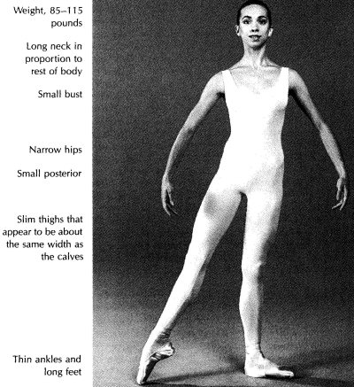

The ‘Ideal Dancer’s Body’ from Gretchen Ward Warren’s
“Classical Ballet Technique”(Ward Warren 2001)

It is common knowledge to most dance audiences made up of US citizens to know that ballerinas wear pink, but what they usually don’t know is that the color was set that way to match the dancer. “European Pink”, the shoe color that pointe shoes made today are still produced in, was originally meant to extend the line from the skin to the tights, and finally out to the tip of the toe, creating a perfectly seamless line for a delicate dancer. (W ard Warren 2001).
Maria Tallchief, a Native American ballerina of Osage Nation tribal heritage who was born in Oklahoma, has been recognized as one of the nation’s first prima ballet dancers since she debuted in the dance world during the early-to-mid 1900s . She, along with four other female Native American Ballet dancers make up the ‘Five Moons’, a name referencing a music and dance collaboration created to celebrate their stories (Talbert 2021). Although it is no doubt that these incredible artists were talented, it is important to recognize that a critical part of how and why these particular individuals were able to succeed to such high levels of fame. In “How 19th Century Women Were Taught to Think About Native Americans”, Erin Blakemore explains:
“Native American women were depicted as attractive, desirable, and pious. Their moral natures were celebrated in stories of their self-sacrifice and submission, and their beauty was described at length [and] matched nineteenth-century beauty ideals for white women: light skin, carefully groomed hair, a thin and shapely body dressed in popular colors. [The public] focused on physical attributes that linked [white and Native American] women together, rather than on their heritage…The Native American women that white women encountered in women’s magazines were, in a sense, white women.” (Blakemore 2017)
This digestible and appeasing packaging is part of what helped draw in White Americans as the Five Moons began to make waves in the art world. A TIME magazine headline for a performance that featured Maria Tallchief stated quite proudly, with the implication that the words are complimentary, that when she danced, she was “ as regal and exotic as a Russian princess; offstage, she is as American as wampum and apple pie”( Thomas 2019) This was said about one delicate dancer, while thousands of other Native American women were being forced to relocate away from their homes and then punished for expressing themselves through arts like music and dance. (Library of congress). While it’s undeniable that these Native dancers deserved recognition, the legacy they left in the dance world through performance and education has not been used to make a way for other Native American ballet dancers to succeed. These dancers are held at an observatory distance; much like “the vanishing Indian”, the Five Moons are locked into “once-in-a-lifetime” narrative of the past. (Gilio-Whitaker 2018)
Although Black women have held more professional ballet positions in recent years compared to Native women, they have endured unnecessary punishments for being a non-white performer all the same. To find a true flesh tone in tights and pointe shoes, black women in ballet have had to use the technique of "pancaking" which is described as “sponging makeup onto one's shoes [or other apparel]” (Winthrop 2019). In her article, “Black Dance and Dancers and the White Public: A Prolegomenon to Problems of Definition”, dance scholar Brenda Dixon notes that it is common in the United States dance industry for women of color to be “perceived of and treated as different” when pursuing careers in styles like Ballet and Modern dance. She supports this claim with the stories of several Black dancers, including herself and her discriminatory experience at a well-known Modern dance company audition, revealing that she was harshly rejected because her “skin color would ‘destroy the unity’ of the [all White] corps “ (Dixon 1990)
Raven Wilkinson, the first black women to hold a professional role at an American ballet company, Ballet Russe de Monte Carlo, knew quite well that she had opportunities that others wouldn’t have because of her lighter skin tone. Raven was a mixed-race woman and was “white passing”, which allowed her to have a career, but even her light skin tone would not prevent her being harassed and sometimes even hunted down when the company went on tour. In 1961, reporters noted that “Klan members stormed a rehearsal” searching for her more than once, and it was not long after that the dancer chose to leave the company (Looseleaf 2023). Misty Copeland, a current principal dancer at the American Ballet Theatre has been mentored by Ms. Wilkinson as she has made her way as a black ballerina, and shared the sentiment that though she has struggled from the start, she knows that there are opportunities that she was able to have that wouldn’t have been extended to many other black dancers. “Raven and I both have a light complexion, but darker dancers have experienced much worse.” (Gramm 2021)
Outside of ballet dancers that are approved to have a lighter and more aesthetically pleasing skin tone, Black women that choose to express themselves through more culturally connected dance styles are viewed as a entertainment that can be cherry picked and recycled for white women to enjoy without educating themselves on the history behind the hair or black women in general. Black women’s hair has been discriminated against for centuries, viewed as being unkempt, unprofessional, and unappealing to look at by various groups of people throughout history, even being made into law in some instances. The Tignon Law was created specifically to attack Black women and required that these women always have their hair covered when in the presence of others or in the public. Black hair also played an important role in the lives of slaves, who would use braiding techniques to create maps to freedom and store food for travel. (Foreman 2019)
Without knowing the history of black hair, these culturally specific hairstyles are seen as a way to fun way change up a look or a way to “look the part” when engaging with dance styles like hip-hop or Krump; available for the taking and changing by anyone in anyway, much like the way that colonizing forces took land and people when creating the United States.

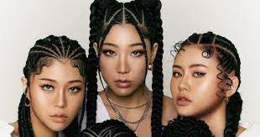
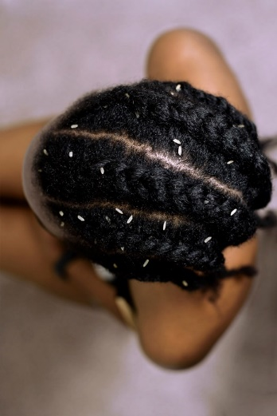

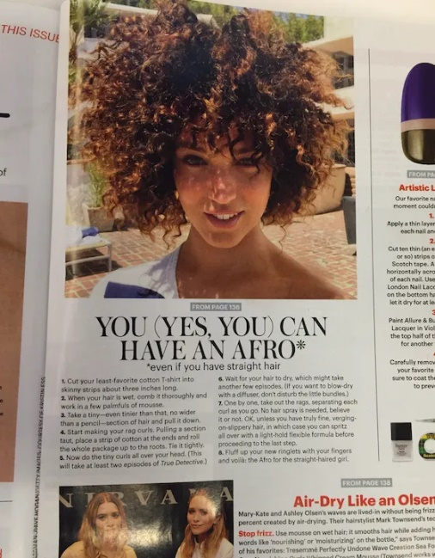
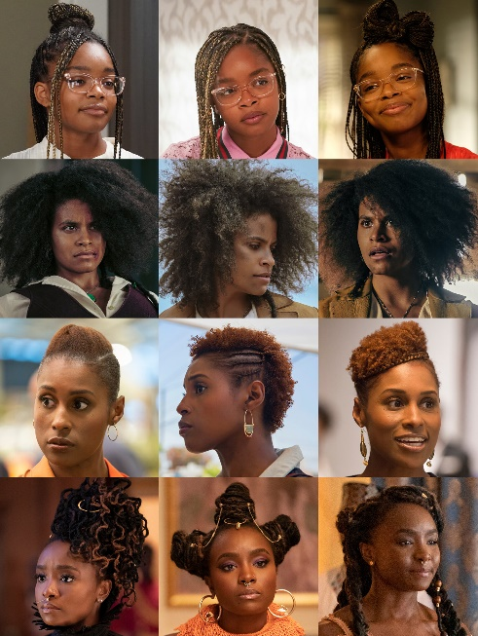
Top Left: K-pop group, Maple.lip, wearing cornrows, box braids, styled baby hairs (Koreaboo 2023)
Top Right: A top view of one of the ways that cornrows, plaits, and braids were used for survival during slavery in America.(Eissen 2022)
Bottom Left: Black female celebrities with Afro hairstyles (Martinburgh 2022)
Bottom Right: Allure magazine promoting and somewhat encouraging women of all backgrounds to wear Afros as a “fun” option to wear. (Wilson 2015)

“The discrimination against Black hairstyles has not only fueled the othering of Black people but also the exclusion of Black communities from creating generation wealth and stability for their families. Stereotypes around Black hair, as we've discovered, have literally kept Black women from work and education, making it more difficult to be financially independent members of society.” (Kia 2020)

OKLAHOMA RACISM
Hate Crimes in Sooner State History

As a state, Oklahoma has had a very negative relationship with black and brown communities from the start, but there are some infamous events and horrendous hate crimes that stand out for the level of brutality that was experienced by those on the receiving end. In the year 1921, an area of Tulsa, Oklahoma called the Greenwood District was home to such a significant concertation of affluent black Americans, it was more casually and commonly known as “Black Wall Street.” (Ellsworth 1983). On the last day of May, Dick Rowland was accused of having inappropriate contact with a white woman named Sarah Page during a short elevator ride. The accusation against Rowland quickly spread as fresh news in town, and the streets erupted into violence that started as fights in the streets, but ended in the burning and looting of the Greenwood district and killing hundreds of people.
Not far from Tulsa is the home of the Osage peoples, one of the largest land-owning tribes in the state. When the oil booming years were at their peak, many Osage citizens were in ownership of very valuable land and oil rights. In this time period, land and and oil rights (also known as head rights) were the ticket to incredible wealth and power were highly desirable and the jealousy of non-Natives would eventually cause them to commit some of the worst acts deception and destruction, resulting in the targeted murder between white men and Native women of the Osage Nation. (Gann 2017)

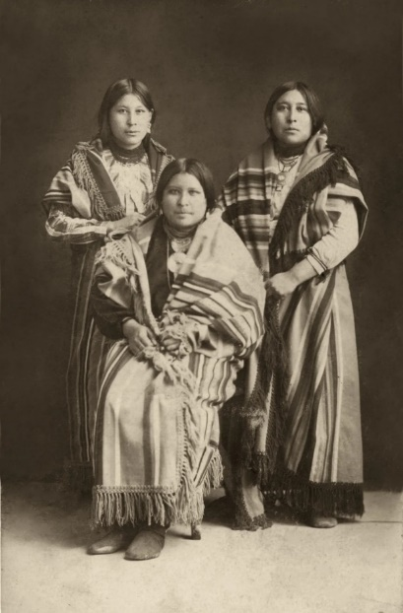

Mollie (right) with her sisters Anna (center) and Minnie : Osage women targeted by William Hale(Ross 2017)
The main mastermind behind this despicable set up of stealing Osage citizen’s land through life insurance after a “mysterious death” was named William Hale and was known to some as “so-called “King of the Osage Hills.” When Hale had finally been convicted for his murderous scheming and theft, law enforcement believed that Hale was responsible for approximately 24 deaths in total. (Chith 2018).
Oklahoma Higher Education and Racism
Oklahoma has been a significantly low performing state in education for far too long, affecting students from kindergarten through college who are left with fewer resources for success every year that they advance. Students who are entering classrooms with additional struggles from racial trauma are being asked to learn in classrooms that they feel don’t care about them as a person.
Black students and students of African descent have a presence of about 5% across larger Oklahoma institutions, and Native Americans are averaged about 3% (citation). These student groups combined make up less than 10% of the student body in Oklahoma higher education, which means it’s an even smaller percentage when one considers how many of those individuals are women. Universities in Oklahoma are comfortable with this statistic because they will occasionally make efforts to performatively uplift and celebrate these communities with land acknowledgement statements and Black history month events, but there is no urgency for the equity that’s missing.
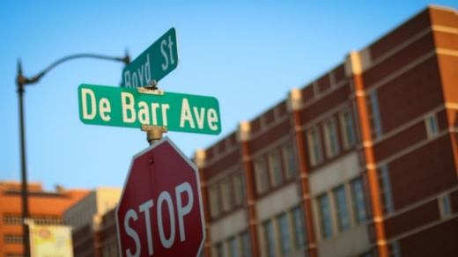
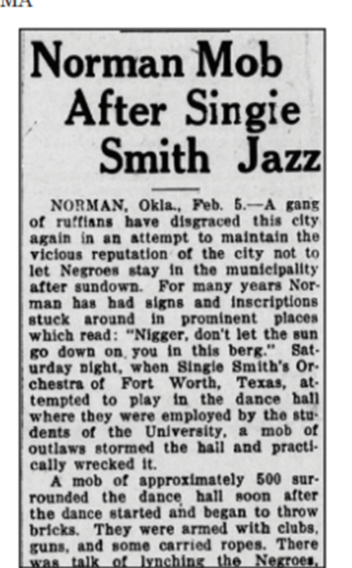

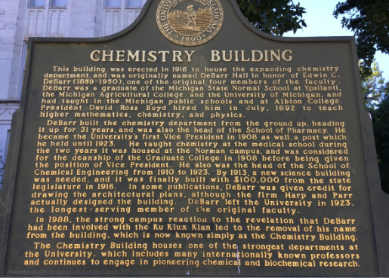

Left: Article from “The Black Dispatch” detailing the chaos that ensued when Klansman rushed into a Black performer’s stage time at a local club
Top Right: Street sign in Oklahoma honoring Grand Dragon of the KKK, Ed DeBarr, that was removed in 2017 after student protest.(OU Daily 2017)
Bottom Right: University informational plaque that summarizes the academic career of confirmed Klansman, Ed DeBarr, followed by a small note about his name being removed after student protest. (OU Daily 2017)

These photos show two examples of racism towards black individuals that exist within the institutional roots of one of Oklahoma’s most prestigious universities, as well as highly respected dance program. Edwin DeBarr, a founding university professor who was discovered to be a KKK grand dragon still holds presence and power on campus, in a town that was proud to be a self-proclaimed southern Sundown for decades. (Givel 2018)
INTERVIEWS
Malia
To get the most honest and authentic understanding of the experiences that women of color have in these specific environments, I spoke to two dancers that had both graduated with a bachelor’s in dance from Oklahoma universities. Unfortunately, through our conversations, clear examples of the struggles that women of color have been facing for hundreds of years still exist for these dancers-before, during, and after they have gone through the struggle of completing the required curriculum in college.
The first woman I spoke with was Malia, a mixed-race Black woman that grew up in Oklahoma, and attended her K-12 education just a mere 15 minutes down the road from the university that she would end up attending. Though she was quite hopeful and excited for the opportunities and acceptance that she had been told about when applying, she left her degree program feeling as though she had never been good enough, and sometimes even set up to fail.
To start our conversation, I felt it was appropriate to get an idea about her feelings towards her experiences overall. Before asking about if any of the negatives I suspected that she had come across, I asked first if she felt supported, capable, accepted, or any other positive things of that nature, during her time pursuing dance in Oklahoma higher education.
“Um, it's gonna be a no… no. Big capital NO.”
To get some clarity on the reasons why she felt this way, I asked her if she had any examples of moments she remembered feeling these negative emotions, and how it connected to her identity as a female dancer of color. Her eyes rolled back slowly as she told me about how the stereotyping of Black females’ voices being “too loud”, or “ghetto”, was a problem she faced in college from the very beginning:
“I remember there was this one time in Jazz class…I don't remember who I was talking to but, I just cackled like how I do, and the professor just like looked over at me in disgust, like, “Ugh… like, why would you laugh like that…what is wrong with you?” And she just like, kept on that track for the day, even outside of class, saying, “Malia, why are you always laughing? Why are you always talking?” And of course, I’m like, “Uh! Hello! What about the white girls in here that are talking?” Nah. They're alright , they're fine; they're using an acceptable cream-colored volume.”
As our conversation evolved, she revealed to me that, beginning in her junior year, she experienced the unexpected, gradual onset of a life-changing chronic illness; an autoimmune disease that changes the day-to-day lives of those diagnosed, described bluntly as an illness that “can be draining, can sometimes lead to life-threatening complications, and has no known cure.” (Mayoclinic.com)
“I'm in this place now, as an adult, that I am just so incredibly frustrated about how they acted when I was struggling so much at the beginning. I have days where I'm like. “I literally had a disability and if I would have had the right information, I could have gotten them in HUGE trouble.” I didn’t know about accommodations and help, and all of this ‘extra extensions on due date’ type stuff. You could dance or you just went in and sat and took notes. I was young, scared, confused, I didn't know who I was, and I didn't know that I could speak about this chronic illness that because I didn't know what was going on at the time.”
Malia then got into the specifics of how she felt completely unsupported, and many times, even punished for the negative, but unavoidable affects that her illness’s onset had started to have on her life as a student. She explained that there were instances that she would be trapped in the restrooms during her school day, experiencing severe pain and (more often than not) significant blood loss without any warning. When it interfered with unimportant issues comparatively, such as arriving slightly tardy to class or needing to adjust her participation in certain movement activities, Malia felt as though she was never treated fairly and her illness was not taken seriously by her instructors.
“It's just…how disconnected and like, full of yourself do you have to be to think that your Wednesday afternoon dance class in little ol’ Oklahoma is more important than someone telling you that there's blood pouring out of them? What do you think is about to happen in this next hour and 20 minutes that is more important than that…also why like was my well-being not the first thing that they considered… like “are you okay?” Yeah, no. They’d say, “No, don't care; sign in and go warm yourself up.”
Unfortunate, yet unsurprisingly, this was not Malia’s only example of harsh judgment that had been put upon her by people that she didn’t feel as though cared about her as a person, but rather saw her struggles as disrespect, lack of care, or laziness. She told me about the criticism she began to receive on her weight, not even a full year into her program. She described herself as a “shorter, thicker woman; big butt and real flat feet.”
“[I remember] we we're sitting outside, waiting to go into class, and I'm literally eating a Turkey sandwich with cheese and lettuce on it. I have a banana, a granola bar, and a Gatorade next to me… eating that, and nothing else. I don't have any sweets, I don't have any Sprite- I don't have nuh-thing! Then, here comes Jessie and Maria, eating hot Cheetos and drinking soda before they go into class. Yet, whenever I get in there, [the professor] asked me “How's your nutrition?” Are you ******* kidding me? Get out of my face … when is what I eat your business? Do I look sick? Are you concerned for me? Am I not [staying caught up] with the other dancers? It is none of your concern, because honestly, like honey…how many other people on these university grounds can come in here and be doing Ballet in the morning , jumping all across the floor, up in Modern rolling on the floor, and then gotta come back for Jazz for more, like every day for four years… is that not a healthy body?”
I asked if she felt isolated in her experience of getting negative feedback and unnecessary questions that concerned her physical appearance and nutritional habits, and she quickly confirmed that she had felt very alone and genuinely humiliated at that time.
“There was a different day with the other one, she came for all of us. I'll never forget her face, it’s like a video memory in my mind of that day that [the professor] went along the side of the room with all of our personal bags and stuff, and just started picking up the food and drinks she didn't approve of and throwing it in the trash! Um. Excuse me. You're a psycho. I mean, judging the food, just in general, in that way… like what a privileged, well-taken care of, small-town, white girl like, insecurity thing to feel; just so comfortable throwing away something that other people spent money on because you didn’t like it…We're college students and we're broke! That drink or snack might have been the only thing that person could buy today; those chips might have been the thing that they could afford instead of a real breakfast. How dare you?
Malia also felt strongly that she was judged by her outer appearance only, though she worked very hard to be a young woman with clean eating habits and made health-centered choices in several areas of her life.
“I mean, first of all, if you're concerned about some people's health, you need to look at the ones that look like they're about to fall over. Skinny white women, like Jessie and Maria, would have a diet of like cigarettes before they came to class, but they fit the body type, so whatever. What if y’all maybe check on the dancer’s smoke group that would walk across the street and sit by that stop sign on a 5-minute smoke on break from technique class!”
It was not difficult to deduce that Malia felt hurt, dismissed, and abandoned by the people who had claimed at the start to be her “new dance family.” She made it clear that she was so incredibly relieved to be away from such a broken environment upon graduation, but still feels sadness when she looks back at her college days. A large part of the pain that remains with her ultimately came back to the fact that she had felt so rejected by professionals she looked up to.
“It just…It sucks because I really wanted to impress those [instructors]. I wanted those [instructors] to think that I was good at dance, that I was worth their time. I really did! I constantly thought about how I wanna be one of their little special favorites, but no. My body wasn't good enough for them.”
Lucy
The second women I spoke with was a female dancer that identifies as Native American, Lucy. I wanted to know about her time pursuing dance in Oklahoma higher education, so that I could review the experiences of women with different racial backgrounds and different university attendance for similarities, differences, or other information that connected their experiences in these educational environments.
For this reason, I chose to start our conversation as I did with Malia: checking in for overall feelings and opinions about and towards the dance program she attended. She seemed somewhat neutral in her response, mentioning that there were one or two instructors she liked, and that she had some very valuable performance experiences. On the other hand, upon reflecting as a teacher and choreographer with experiences and understanding she previously did not have of what matters most in her dancing, she gave an example of a place that she felt was neglected in her studies.
“I feel like it's just…not taking the time to understand that dance is such an intellectual thing… [understanding that] if you keep sending mental signals from here, it's going to go into your body. What's going on in this area is translating to other places in your body and making your plies suck. You need to pay attention that deeply. [Being taught] this is what works for your body, this is where the leg can actually go, not like this is what it should look like in a line…explain where the energy is going, why this muscle is connected here, what you should be feeling, why you need to sit there and just feel one muscle at a time.”
As an educator that also heavily values and insists on dance science being a part of all classrooms, I could relate to her frustration. I also agreed with Lucy when she followed up by saying intense anatomical understanding should be a requirement for those who teach movement classes or set pieces because it creates safety hazards for dancers that are under their instruction.
“The fact that people are getting to a [higher-education faculty] point in their careers and don't have any of that information…it's terrifying. I mean, do we not care if the dancers get injured? ‘Cause this is how [it happens]…just running them through rehearsals and not telling them anything-this is how we get all of these injuries. It's crappy.”
Lucy said that uninformed dance instruction is one of the reasons that leads to dancers feeling lost and forgotten without performance opportunities if they do become injured.
“It's also kind of like the age-old saying, “When the horse needs to go out to pasture…” I feel like that's been the comparison to dancers for the longest time; you get that injury and that's it- you're done. You're finished. And all the programming supports that idea. It wasn't until I kind of got towards the end of things that I started understanding [that] I don't need to feel bad about not being able to do these things, all the time, every day. And it's actually a little bit crappy that [faculty members] are just kind of like, “Well, you can't. We don't want anything else. Just kind of just get over to the side.”
These comments began to remind me of some of the dismissal that Malia had said she experienced because of her body shape and inability to do all the tricks and turns that her instructors liked to see and celebrate, as well as the lack of medical support and information she received upon experiencing the onset of a chronic pain issue.
“I got really injured, it's a chronic thing now, and there wasn't really any kind of support there [to understand the injury]. We had kinesiology and anatomy type stuff, but there wasn't any kind of support, and I know I wasn't the only student having this issue in school. I definitely wasn't the only student that had a specific chronic pain or multiple injuries and there was no kind of education or support to [know] what to do in a new, difficult situation…it's kind of the no man's land after that to figure it out on your own, if you can.”
When Lucy mentioned that the options began to feel limited after her injury, I asked if there was any curriculum that helped her feel confident and capable of succeeding in the dance world in a non-performance-based career.
“[students] don’t get a lot of leadership in how to put a class together . You have to get used to how to phrase 8 counts so that it makes sense with music, how to teach in a way that a diverse group of people can actually understand. It kind of applies to the faculty, too. I don't feel like they were given a lot of those essential teaching tools in their training, either. So it was like, okay…how much have you actually been taught about how to teach a class? Other than like “Well, here's basically what you do if you wanna work at a local studio.” You're good to go for that, but like none of [the students] are being set up to go teach legitimately. Oh, and choreography, too…yeah, there's not a lot of choreography support or dance education and educator support in general.”
Since Lucy seemed to have nailed down some specific issues that she experienced and what affect the presence or absence of certain information can have on a dancer’s career after graduation, I asked her if there was anything that she felt would help move these programs in a positive and supportive direction for dancers like herself that attended in the future.
“The bare minimum of a follow-up… having alumni meetings like, “Hey , we see that you graduated blah-blah years ago. We wanna have a zoom call or would you take this survey? Can you tell us about the good things that you got out of your school experience here that are still benefiting you. Let us know about some of the obstacles that you've been facing that you're that you wish the school would have better prepared you for.”
Conclusion:
As I explained in the introduction of this paper, as an educator, I am adamant about putting the student at the center of their learning so that they can grow as their minds and bodies are most receptive to. I fully and happily accept the responsibility of prioritizing the individual above my personal expectations and understandings of the curriculum I introduce, meaning I must view lack of concept mastery in students as a place for discussion, investigation, and clarification from me and not a lack of car e or ability on the student’s part. In the dance classroom, an example might be noticing that even though the dancers verbally confirmed that they understood a movement, they are hesitating or frustrated when it comes time to apply the information. Instead of repeating instructions in the same way, a student-centered, accessible option would be to present the information in two new ways that cater to different learning styles than the first set of instructions (Choinsky 2021) Following the ‘across the floor’ example, I could chose to show a picture or video of the movement for visual learners, or I could write terminology on a white board or include daily reflective writings for learners that process information better through text .(Reese 2021)
The “Who” of the “Who and What” changes that could be made to better support dancers of color in Oklahoma higher education is the “Who” of the faculty and staff. Dance schools and departments can create prioritized hiring processes to secure space for Black and Brown voices to become a part of their instructional staff, as well as seeking out professionals of non-Western and non-performance-based dance styles to incorporate in curriculum. When Brown v. Board of Education, the American court case the deemed “separate, but equal” unconstitutional in 1954, was brought to the courtroom, one of the studies used to support the claim that representation and equity in race effected children’s mental development was the “Doll Study” by Dr. Kenneth and Mammie Clark (McNeill 2017). This study was one of the first to prove, through interviews and observations of over 200 children of color, that seeing others in the world who “look like you” can provide psychological and emotional support that is vital to the success and self-esteem of the individual (Byrd 2017).
In addition, the “Who” of this change should set minimum for time spent in educational studies for those getting hired and require continuing education from all hired faculty. While experience in the fine arts is invaluable and can provide information that classroom studies never could, it is important to balance the performance power with pedagogical proficiency (Kamarath 2012). Without spending a significant amount of time focusing on ‘how to teach who’ instead of ‘what to teach when’. Dance scholars investigating this issue at Temple University put blame on the generalization that dance teachers often depend on, but usually do not help the student. The researchers also claim that “assuming that students will ‘figure out’ how to apply their content knowledge within all teaching environments” is largely to blame, and that “how the content is taught receives far too little focus” within the academic world of dance (Hilsendager 2001). Upon reviewing the requirements of various Bachelor’s and Master of Education degree programs at the Oklahoma universities with dance schools and departments, one can see that there is a consistency in what matters most when considering a career teaching in an academic setting , especially when the universities in question are research focused. For instance, when comparing two different Oklahoma Master of Education degrees from universities with dance programs, both with focuses in “Secondary Education” or “Adult and Higher Education”, it is required that the individual completes between 33 and 34 hours of study on education itself before they graduate and are prepared to teach undergraduate students. Also, for a fine arts specific example, when comparing a Bachelor of Music Education program and a Bachelor of Arts in Education from two Oklahoma universities with dance programs, it is required that the individual completes between 30-31 hours of study on education to be prepared to teach K-12 students. (Retter 2020)
Moving on to a “What” improvement in the efforts to improve learning environments for women of color in Oklahoma dance programs that instructors can do now, referencing the previous mention of accessibility in the dance classroom: start revising class assignments or activities to be supportive of the human, not the dancer. Dancers of color are more likely to have experienced racially targeted pushback and exclusion because of their hair, skin color, and style choices, so adding in or amending something as harmless as the dress code can have an incredibly positive impact on dancers, as well as making sure that the instructor themselves is educated on the topic (Awad 2015)
Native American women have been fighting alongside their tribes to gain proper respect for the braid styles and sacred, spiritual value that their hair can hold (Hilleary 2018). Similarly, while investigating the external factors that significantly impacted the self-image of college-aged Black female students, hair was proved to be one of the most common and significant influencing factors, finding that “African American women spend a significant amount time and finances on their hair. There also may be social costs for women who choose to wear their hair natural” (Bryd 2002). Considering that Black and Native women only make up a total of 16% of the 2022-2023 Oklahoma Collegiate student body , with White women at 54%, and the dance genres available for study in Oklahoma (dominantly Ballet and Modern dance) have a history of documented racism and exclusion aimed at female dancers of color, being able to maintain power and autonomy in body and mind can significantly increase the student’s likelihood for comprehension and confidence in their studies (Rod 2020).
The last suggestion of “What” refers to what the dancers themselves are doing and what they understand about these actions. A seemingly simple, yet effective way to do this is to reassess and re-evaluate each student as class progresses and answer internally, “Does the student know what to do?” Mental health issues and intellectual disabilities are In 2016, the National Center for Education Statistics released data showing that among students ages three through 21-years-old, Native American and Black children represented a combined total of over 30% of the 6.7 million children in the American public education system receiving accommodations through the Individuals with Disabilities Education Act (NCES 2019). Also, Oklahoma reported in 2019 that 1 in 6 state residents have a disability of some variety, so the likelihood that a WOC in Oklahoma attending a college or university is quite high (OKDRS 2023).
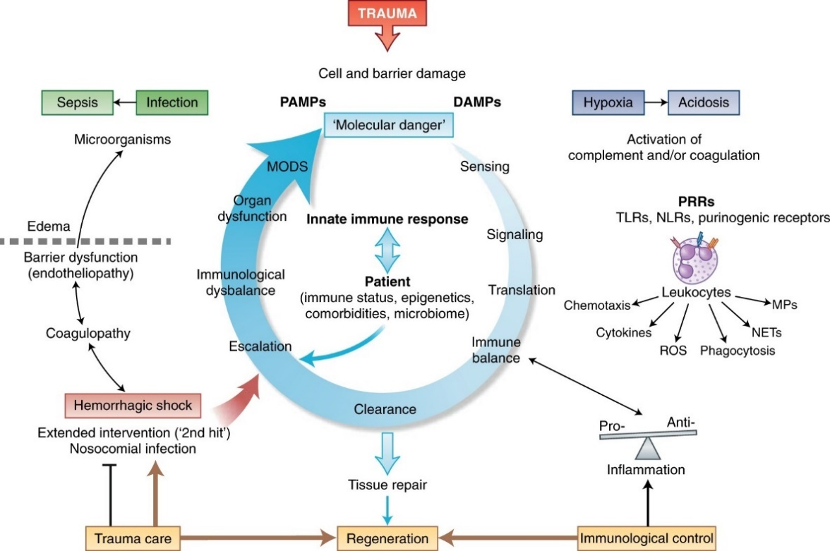
Opportunities for accessibility and inclusion in a dance studio can look quite different than it does in a traditional, seated-in-a-desk classroom, being that a large portion of the coursework is usually movement-based and mental illnesses and intellectual disabilities can create unique challenges for both the body and the brain of a dancer. One example being the physiological response of the nervous system when an individual is experiencing anxiety caused by stress, panic, and trauma (Chu 2022) Thinking of the female dancers of color, these physiological reactions may stem from Racial trauma, or race-based traumatic stress (RBTS), a created to describe the “mental and emotional injury caused by an emotionally painful, sudden, and uncontrollable racist encounters with racial bias and ethnic discrimination, racism, and hate crimes.(MHA 2016) The organization Mental Health America also found evidence showing that this type of trauma severely affects the BIPOC communities in America “due to living under a system of white supremacy” is at risk of suffering from a race-based traumatic stress injury. Dance Movement Therapy (DMT) researcher, Katrina Guittar, suggests that practices that bring dancers into the “here and now” are effective ways to calm and regulate feelings of this type; one of the most popular approaches being the use of Laban Movement Analysis (2018). Although Modern dance is more commonly recognized for using Laban as a language, it can help dancers understand the comforts and limits specific to their own body, rather than trying to mimic movements they don’t understand, reducing the risk of injury by allowing the dancer to create a continuous, trust-building conversation between the body and brain that is customized to their lived experiences (Levy 2005)

Protective and harmful innate immune responses to
trauma, panic, anxiety, and stress (Huber-Lang 2018)

Although it will take several years of difficult deconstruction and uncomfortable growth for colleges, dance companies, Oklahomans, and Americans to achieve significant, legitimate change towards systemic racism, I strongly believe that it is still within a dance educator’s power to set about change within their own classrooms. Accessibility and equity in education benefits both the students and instructors because it matters more that each individual improves from where their understanding began, rather than a passing or failing decision being used as an inaccurate measure of comprehension ( Nyanungo 2022) Through student-centered education, dance students are encouraged grow in ways that honor their bodies, their lives, and their safety, as opposed to the mastery of intricate body positions or movements (Henderson 2021). Not only will the dancers of color in Oklahoma begin to shine brighter and more often in this type of classroom, but it will also show young girls of Black and Native descent that if they want to be a dancer when they grow up, there is a safe place in the state for them to thrive. Every student deserves to have someone with their background to look up to, so I encourage educators to take on the challenge for themselves and strive to be someone that the next generation of dancers felt they were seen by, respected, and inspired to reach their full potential and any goal they set their mind to.

References:
“The 1491 Census: Native Creates Tribal Nations Map of Turtle Island.” Accessed April 19, 2023. https://ictnews.org/archive/the-1491-census-native-creates-tribal-nations-map-of-turtle-island.
“African Dance.” Encyclopædia Britannica. Encyclopædia Britannica, inc. Accessed April 2023. https://www.britannica.com/art/African-dance.
Author(s) Christopher P. Krebs. “Sexual Assault of Undergraduate Women at Historically Black Colleges and Universities (Hbcus).” Sexual Assault of Undergraduate Women at Historically Black Colleges and Universities (HBCUs) | Office of Justice Programs. Accessed April 18, 2023. https://www.ojp.gov/ncjrs/virtual-library/abstracts/sexual-assault-undergraduate-women-historically-black-colleges-and#:~:text=Findings%20indicate%20that%20approximately%209.7,%2DHBCUs%20(13.7%20percent).
Awad, Germine H, Carolette Norwood, Desire S Taylor, Mercedes Martinez, Shannon McClain, Bianca Jones, Andrea Holman, and Collette Chapman-Hilliard. “Beauty and Body Image Concerns among African American College Women.” The Journal of black psychology. U.S. National Library of Medicine, December 1, 2015. https://www.ncbi.nlm.nih.gov/pmc/articles/PMC4713035/.
“Benefits of Dance for Geriatrics - Loyola Marymount University.” Accessed April 19, 2023. https://digitalcommons.lmu.edu/cgi/viewcontent.cgi?article=1027&context=dance_students.
“Black Girl Linguistic Play | Camille A. Brown | Tedxbeaconstreetsalon.” YouTube. YouTube, March 29, 2016. https://www.youtube.com/watch?v=jBwBscuc08g.
“Blacks and Classical Dance - December 2008.” Ferris State University. Accessed April 2023. https://www.ferris.edu/HTMLS/news/jimcrow/question/2008/december.htm.
Blake, Meredith. “Ask an Academic: Tap Dancing America.” The New Yorker, March 11, 2010. https://www.newyorker.com/books/page-turner/ask-an-academic-tap-dancing-america.
Camille A. Brown. Accessed April 1, 2023. http://www.camilleabrown.org/camille.
“Colonialism, Genocide, and Gender Violence: Indigenous Women.” Intercontinental Cry, December 15, 2006. https://intercontinentalcry.org/colonialism-genocide-and-gender-violence-indigenous-women/.
“Digital Distractions in the Classroom Phase II: Student Classroom Use ...” Accessed May 6, 2023. https://digitalcommons.unl.edu/cgi/viewcontent.cgi?article=1091&context=journalismfacpub.
Dixon, Brenda. “Black Dance and Dancers and the White Public: A Prolegomenon to Problems of Definition.” Black American Literature Forum 24, no. 1 (1990): 117. https://doi.org/10.2307/2904070.
Domonoske, Camila. “'Father of Gynecology,' Who Experimented on Slaves, No Longer on Pedestal in NYC.” NPR. NPR, April 17, 2018. https://www.npr.org/sections/thetwo-way/2018/04/17/603163394/-father-of-gynecology-who-experimented-on-slaves-no-longer-on-pedestal-in-nyc.
Domonoske, Camila. “'Father of Gynecology,' Who Experimented on Slaves, No Longer on Pedestal in NYC.” NPR. NPR, April 17, 2018. https://www.npr.org/sections/thetwo-way/2018/04/17/603163394/-father-of-gynecology-who-experimented-on-slaves-no-longer-on-pedestal-in-nyc.
“The Early Trans-Atlantic Slave Trade from Western Africa.” The Rise of the Trans-Atlantic Slave Trade in Western Africa, 1300–1589, 2003, 177–207. https://doi.org/10.1017/cbo9781139016407.011.
“Electrolytes - Statpearls - NCBI Bookshelf.” Accessed May 6, 2023. https://www.ncbi.nlm.nih.gov/books/NBK541123/.
“Enrollment Statistics at Oklahoma Colleges.” Univstats. Accessed April 19, 2023. https://www.univstats.com/states/oklahoma/student-population/.
“Forces.” The Physics of Dance. Accessed April 2023. https://thephysicsofdance.weebly.com/forces.html.
Frontier, Notes From The. “The Sacred Sun Dance.” Frontier. Frontier, June 12, 2021. https://www.notesfromthefrontier.com/post/the-sun-dance-sacred-ceremony.
Givell. “Oklahoma Historical Society,” 2018. https://www.okhistory.org/publications/chroniclesok/COO96-3Givel.pdf.
Google Images. Google. Accessed April 2023. https://images.google.me/.
Grann, David. “The Marked Woman.” The New Yorker, March 1, 2017. https://www.newyorker.com/books/page-turner/the-marked-woman.
Griffin, Rachel Alicia. “I Am (Still) an Angry Black Woman.” Handbook of Autoethnography, 2021, 411–19. https://doi.org/10.4324/9780429431760-42.
Harris, Cora. “Krumping Dance: Definition, History, Moves, and More.” City Dance Studios, July 10, 2022. https://citydance.org/krumping-dance/.
Henderson, Garnet. “What Would It Take to Change Ballet's Aesthetic of Extreme Thinness?” Dance Magazine, July 8, 2021. https://www.dancemagazine.com/ballet-body/.
Higgins, Author Emma. “Tag: Dancing of the Slaves.” Early Modern History in 28 Objects, December 14, 2018. https://emh30.ace.fordham.edu/tag/dancing-of-the-slaves/.
Hilleary, Cecily. “Native Americans, Canada's First Peoples, Fight to Keep Long Hair.” VOA. Voice of America (VOA News), January 10, 2018. https://www.voanews.com/a/native-americans-canadas-first-peoples-fight-to-keep-hair-long/4199671.html#:~:text=A%20source%20of%20power,source%20of%20strength%20and%20power.
“Houska: Boy Scout Koshare Dancers Need to Stop Stealing from Natives.” Accessed May 6, 2023. https://ictnews.org/archive/houska-boy-scout-koshare-dancers-need-to-stop-stealing-from-natives.
Huber-Lang, Markus, John D. Lambris, and Peter A. Ward. “Innate Immune Responses to Trauma.” Nature News. Nature Publishing Group, March 5, 2018. https://www.nature.com/articles/s41590-018-0064-8.
Human Trafficking Search. “Indigenous People: Colonization, Forced Assimilation, and Sex Trafficking.” Human Trafficking Search. Human Trafficking Search, July 20, 2021. https://humantraffickingsearch.org/indigenous-people-colonization-forced-assimilation-and-sex-trafficking/.
“The Importance of Data Collection for Violence against Native American/Alaska Native Women.” National Sexual Violence Resource Center. Accessed April 17, 2023. https://www.nsvrc.org/blogs/importance-data-collection-violence-against-native-americanalaska-native-women.
“Incite!” INCITE! Accessed April 17, 2023. https://incite-national.org/.
Indicator 9: Students with disabilities. Accessed April 19, 2023. https://nces.ed.gov/programs/raceindicators/indicator_rbd.asp.
Jacobs, Harriet A., and Koritha Mitchell. Incidents in the Life of a Slave Girl: Written by Herself. Peterborough, Ontario: Broadview Editions, 2023.
Jensen, Erin. “'That's Just Insane': Tucker Carlson Resents Adl's Response to 'Replacement' Theory Remarks.” USA Today. Gannett Satellite Information Network, September 28, 2021. https://www.usatoday.com/story/entertainment/tv/2021/09/28/fox-news-tucker-carlson-adl-great-replacement-theory-reactions/5897547001/.
Johnson, Darin G., Bradley D. Mattan, Nelson Flores, Nina Lauharatanahirun, and Emily B. Falk. “Social-Cognitive and Affective Antecedents of Code Switching and the Consequences of Linguistic Racism for Black People and People of Color - Affective Science.” SpringerLink. Springer International Publishing, September 14, 2021. https://link.springer.com/article/10.1007/s42761-021-00072-8.
Killers of the Flower Moon. Accessed April 19, 2023. https://www.davidgrann.com/book/killers-of-the-flower-moon/.
“Korean Hip Hop Dance Crew Gets Accused of Cultural Appropriation.” Koreaboo, March 17, 2023. https://www.koreaboo.com/news/korean-hiphop-dance-crew-gets-accused-cultural-appropriation/.
Krbechek, Anjuli Sastry, and Karen Grigsby Bates. “When La Erupted in Anger: A Look Back at the Rodney King Riots.” NPR. NPR, April 26, 2017. https://www.npr.org/2017/04/26/524744989/when-la-erupted-in-anger-a-look-back-at-the-rodney-king-riots.
Lavi Wilson, Shanika, Shaquila O’Shay Massey, De’Onna Smith, and Christopher Solomon. “The Effects of Colorism on Self Perception and Self-Esteem.” Psychology and Mental Health Care 5, no. 2 (2021): 01–07. https://doi.org/10.31579/2637-8892/120.
Magazine, Smithsonian. “How a Psychologist's Work on Race Identity Helped Overturn School Segregation in 1950s America.” Smithsonian.com. Smithsonian Institution, October 26, 2017. https://www.smithsonianmag.com/science-nature/psychologist-work-racial-identity-helped-overturn-school-segregation-180966934/.
“Maria Tallchief and the Five Moons.” American Indian Policy Institute. Accessed April 18, 2023. https://aipi.asu.edu/blog/2022/03/maria-tallchief-and-five-moons#:~:text=The%20five%20moons%20were%20five,Rosella%20Hightower%2C%20and%20Moscelyne%20Larkin.
Martinbrough, Tiffany. “In Films and on TV, a New Openness to Natural Black Hairstyles.” The New York Times. The New York Times, April 28, 2022. https://www.nytimes.com/2022/04/28/movies/natural-black-hairstyles-hollywood.html.
Mcdaniel, Rhett. “Bloom's Taxonomy.” Vanderbilt University. Vanderbilt University, June 10, 1970. https://cft.vanderbilt.edu/guides-sub-pages/blooms-taxonomy/.
McDowell-Wahpekeche, Dacoda. “Which Is Correct? Native American, American Indian or Indigenous?” The Oklahoman. Oklahoman, April 23, 2021. https://www.oklahoman.com/story/special/2021/04/22/what-do-native-people-prefer-called/4831284001/.
McKibban, Allison. “Involuntary Sterilization.” History Workshop, October 29, 2022. https://www.historyworkshop.org.uk/anti-racism/involuntary-sterilization/.
McLean, Yvonne. “'Jezebel' Is One of Three Common Racial Slurs against All Black Women and Girls.” Baptist News Global, February 14, 2021. https://baptistnews.com/article/jezebel-is-one-of-three-common-racial-slurs-against-all-black-women-and-girls/.
“Missing and Murdered Indigenous Women (MMIW).” Native Hope. Accessed April 18, 2023. https://www.nativehope.org/missing-and-murdered-indigenous-women-mmiw.
“MMIW.” Native Womens Wilderness. Accessed April 18, 2023. https://www.nativewomenswilderness.org/mmiw.
“A Modern Doll Study ,” 2017. https://www.jstor.org/stable/26529244.
“Murder and Mayhem in the Osage Hills.” FBI. FBI, May 18, 2016. https://www.fbi.gov/history/famous-cases/murder-and-mayhem-in-the-osage-hills.
“Native American Dance Tradition.” CulturallyOurs, March 2, 2020. https://culturallyours.com/podcast/native-american-dance-tradition/#:~:text=Native%20American%20tribes.-,In%20Native%20American%20cultures%2C%20dance%20is%20a%20way%20of%20expression,from%20other%20tribes%20or%20nations.
“Native American Dance.” Encyclopædia Britannica. Encyclopædia Britannica, inc. Accessed April 2023. https://www.britannica.com/art/Native-American-dance.
Nature news. Nature Publishing Group. Accessed April 2023. https://www.nature.com/articles/s41590-018-0064-8/figures/1.
Pendharkar, Eesha. “Native American Children Endured Brutal Treatment in U.S. Boarding Schools, Federal Report Shows.” Education Week. Education Week, May 12, 2022. https://www.edweek.org/leadership/native-american-children-endured-brutal-treatment-in-u-s-boarding-schools-federal-report-shows/2022/05#:~:text=The%20punishment%20used%20at%20the,children%2C%20according%20to%20the%20report.
“Phrenology: What Is It, and How Did It Contribute to Neuroscience?” Medical News Today. MediLexicon International. Accessed April 18, 2023. https://www.medicalnewstoday.com/articles/phrenology-the-pseudoscience-of-skull-shapes.
PULIS, Fashion. “Insta Scoop: Netizens Lecture Herlene Budol on Using 'Fro' as a Statement.” Fashion PULIS, July 8, 2022. http://www.fashionpulis.com/2022/07/insta-scoop-netizens-lecture-herlene.html.
“Racial Trauma.” Mental Health America. Accessed May 5, 2023. https://www.mhanational.org/racial-trauma.
“Research Guides: Indian Removal Act: Primary Documents in American History: Introduction.” Introduction - Indian Removal Act: Primary Documents in American History - Research Guides at Library of Congress. Accessed April 17, 2023. https://guides.loc.gov/indian-removal-act#:~:text=The%20Indian%20Removal%20Act%20was,many%20resisted%20the%20relocation%20policy.
“Research Guides: Indian Removal Act: Primary Documents in American History: Introduction.” Introduction - Indian Removal Act: Primary Documents in American History - Research Guides at Library of Congress. Accessed April 17, 2023. https://guides.loc.gov/indian-removal-act#:~:text=The%20Indian%20Removal%20Act%20was,many%20resisted%20the%20relocation%20policy.
Robinson, Jeffery. “It's Time to Tell the Truth about the Confederacy and Its Symbols: ACLU.” American Civil Liberties Union, February 27, 2023. https://www.aclu.org/news/racial-justice/its-time-to-tell-the-truth-about-the-confederacy-and-its-symbols.
Ross, Theodore. “The Osage Murders: A Q&A with David Grann.” The New Republic, April 19, 2023. https://newrepublic.com/article/141957/osage-murders-qa-david-grann.
“Sexual Harassment of College and University Students: A Systematic ...” Accessed April 19, 2023. https://journals.sagepub.com/doi/abs/10.1177/1524838019881731?journalCode=tvaa.
Sjursen, Maj. Danny. “American History for Truthdiggers: Whose Revolution? (1775-1783).” Truthdig, July 4, 2018. https://www.truthdig.com/articles/american-history-for-truthdiggers-whose-revolution-1775-1783/.
Supermajda. “Black Rice.” The Photoville FENCE, September 29, 2020. https://fence.photoville.com/black-rice/#:~:text=Rice%20was%20braided%20into%20the,belongings%20through%20the%20Middle%20Passage.
“'Talkin' Bout Good & Bad' Pedagogies: Code-Switching vs. Comparative ...” Accessed April 2023. https://www.jstor.org/stable/pdf/44783614.pdf?addFooter=false.
“Temple University.” Opening Doors: Promoting Equity through Accessibility. Accessed May 5, 2023. https://teaching.temple.edu/edvice-exchange/2021/02/opening-doors-promoting-equity-through-accessibility.
“'That Took Long Enough!' – Black Ballerinas Finally Get Shoes to Match Their Skin.” The Guardian. Guardian News and Media, April 1, 2019. https://www.theguardian.com/stage/2019/apr/01/pointe-shoes-black-ballet-ballerinas-dancers.
Thomas, Heather. “Maria Tallchief: Osage Prima Ballerina: Headlines and Heroes.” The Library of Congress, November 19, 2019. https://blogs.loc.gov/headlinesandheroes/2019/11/maria-tallchief-osage-prima-ballerina/#:~:text=%E2%80%9CMARIA%20TALLCHIEF%20momentarily%20turns%20the,ballerina%20Maria%20Tallchief%20in%201951.
Thompson, Katrina Dyonne. “Ring Shout, Wheel About,” 2016. https://doi.org/10.5406/illinois/9780252038259.001.0001.
“Unit 2: Implementing the Use of Learning Styles within the Classroom.” KNILT. Accessed April 19, 2023. https://knilt.arcc.albany.edu/Unit_2:_Implementing_the_use_of_Learning_Styles_within_the_classroom.
“Unraveling the Persistent Legacy of Structural Racism against Poor Persons of Color in the U.S.” Taylor & Francis. Accessed April 2023. https://www.tandfonline.com/doi/abs/10.1080/10875549.2020.1811444.
“US Indian Boarding School History.” The National Native American Boarding School Healing Coalition. Accessed April 17, 2023. https://boardingschoolhealing.org/education/us-indian-boarding-school-history/.
User, Guest. “Squ*W: Colonization and Appropriation of Indigenous Women's Bodies.” Indigenous Climate Action. Indigenous Climate Action, October 13, 2020. https://www.indigenousclimateaction.com/entries/squw-colonization-and-appropriation-of-indigenous-womens-bodies.
Vedantam, Shankar, Maggie Penman, Jennifer Schmidt, Tara Boyle, Rhaina Cohen, and Chloe Connelly. “Remembering Anarcha, Lucy, and Betsey: The Mothers of Modern Gynecology.” NPR. NPR, February 7, 2017. https://www.npr.org/2017/02/07/513764158/remembering-anarcha-lucy-and-betsey-the-mothers-of-modern-gynecology.
Victoria Looseleaf is an award-winning international arts journalist who covers dance. “Remembering Pioneering Black Ballerina Raven Wilkinson.” San Francisco Classical Voice. Accessed April 19, 2023. https://www.sfcv.org/articles/preview/remembering-pioneering-black-ballerina-raven-wilkinson.
Warren, Sarah. “Exercises That Relieve Anxiety and Muscle Tension - Clinical Somatics.” Somatic Movement Center, July 28, 2021. https://somaticmovementcenter.com/anxiety-muscle-tension/.
“What Part of Africa Did Most Enslaved People Come from?” Accessed April 2023. https://www.history.com/news/what-part-of-africa-did-most-slaves-come-from.
“White Swan-Perkins: Koshare Dancers and Their Wildly Offensive Cultural ...” Accessed May 6, 2023. https://ictnews.org/archive/white-swan-perkins-koshare-dancers-and-their-wildly-offensive-cultural-appropriation.
“Why Do Native Americans Wear Their Hair Long?” Indian Traders. Indian Traders. Accessed April 19, 2023. https://www.indiantraders.com/blog/why-do-native-americans-wear-their-hair-long.html#:~:text=It%20is%20sacred%20to%20who,aspirations%2C%20history%2C%20and%20experiences.
“Why Were the First Anthropologists Creationists? - Wiley Online Library.” Accessed April 19, 2023. https://onlinelibrary.wiley.com/doi/10.1002/evan.20280.
“Why White Women Tried to Ban Native American Dances.” Accessed May 6, 2023. https://daily.jstor.org/why-white-women-tried-to-ban-native-american-dances/.
Wilson, Julee. “Allure Catches Hell for Teaching White Women How to Get an Afro.” HuffPost. HuffPost, August 5, 2015. https://www.huffpost.com/entry/allure-afro-tutorial-outrage_n_55bf852ae4b06363d5a2b1ae.
Woods-Giscombé, Cheryl L., and Marci Lobel. “Race and Gender Matter: A Multidimensional Approach to Conceptualizing and Measuring Stress in African American Women.” Cultural Diversity and Ethnic Minority Psychology 14, no. 3 (2008): 173–82. https://doi.org/10.1037/1099-9809.14.3.173.
“‘Real’ Indians, the Vanishing Native Myth, and the Blood Quantum Question.” Accessed April 19, 2023. https://ictnews.org/archive/real-indians-the-vanishing-native-myth-and-the-blood-quantum-question.

