University of Oklahoma

Graduate College

THE ROLE OF EMPLOYEE MOTIVES IN DETERMINING THE TYPE AND CONSEQUENCES OF CITIZENSHIP BEHAVIOR: tHE INTRODUCTION OF THE OCB-INTENTIONALITY SCALE

A Dissertation

submitted to the graduate faculty

in partial fulfillment of the requirements for the

Degree of

Doctor of Philosophy

By

ALEXANDRA Elizabeth MACDOUGALL
Norman, Oklahoma
2015

THE ROLE OF EMPLOYEE MOTIVES IN DETERMINING THE TYPE AND CONSEQUENCES OF CITIZENSHIP BEHAVIOR: THE INTRODUCTION OF THE OCB-INTENTIONALITY SCALE

A Dissertation approved for the
Department of Psychology

By

______________________________
Dr. Michael Buckley, Chair

______________________________
Dr. Michael Mumford

______________________________
Dr. Shane Connelly

______________________________
Dr. Robert Terry

______________________________
Dr. Jeffrey Schmidt

© Copyright by alexandra Elizabeth macdougall 2015
All Rights Reserved.

To my grandmother, Anastasia Tedesco Ellison, who sacrificed so much, including her own education, for the welfare of her family. At ninety-four, her zest for life along with her boundless humor, wit, and compassion have constantly reminded me to appreciate and find joy in everyday moments. I am so glad to share in this particularly special moment with her.

Acknowledgements
There are many people whose support have made this dissertation possible, and I am most grateful. First, I would like to thank my dissertation chair and advisor, Dr. Michael Buckley, for his constant guidance, support, and patience over the past five years. I am deeply indebted to you for all you have done. I would also like to thank my committee members, Drs. Mumford, Connelly, Terry, and Schmidt, for their invaluable feedback and insight on this and numerous other projects. Additionally, I would like to thank my scale development team for contributing their time and effort to make this research possible. I am also appreciative of Dr. Arno Kolz, whose passion for academia inspired me to pursue an academic career of my own. Finally, I am forever grateful to my family and friends for their unwavering support and for reminding me to not take myself too seriously. To my parents, John and Alice, and to my sister and future brother-in-law, Kimberly and Benjamin, thank you for your unconditional love and daily words of encouragement. You have been there for me every step of the way and believed in me even when I doubted myself. To Josh Wren, thank you for being my rock. Everything that happens is nicer with you.

Table of Contents
Acknowledgements iv
Table of Contents v
List of Tables vii
Abstract viii
Introduction 1
Organizational Citizenship Behavior: A Balanced Perspective 2
Introducing a Typology of OCB Motives 7
Prosocial Values 8
Organizational Concerns 10
Image Enhancement and Maintenance 12
Atonement 13
Obligation 15
Functionality 17
Task Avoidance 18
Personal Discontent 19
Social Interests 20
Summary and Study Overview 21
Study 1 22
Hypothesis Development 23
Personality 23
Emotions 24
Global Motives 24
Impression Management 25
Instrument Development 26
Method 28
Participants 28
Design and Procedure 28
Measures 29
Analyses and Results 32
Measure Refinement 32
Psychometric Properties 33
Correlational Analyses 33
Discussion 35
Study 2 35
Hypothesis Development 36
Situational Correlates of the OCB-IS 36
Motives as Determinants of Organizational Citizenship 38
Personal Costs of Citizenship Behavior 39
Method 40
Participants 40
Design and Procedure 41
Measures 42
Analyses and Results 44
Confirmatory Factor Analysis 44
Tests of Gender Differences 45
Correlational Analyses 46
Multivariate Multiple Regression Analyses 46
Discussion 49
General Discussion 49
Limitations 51
Implications 54
Future Research Directions 56
Conclusion 59
References 61
Appendix A: Tables 71
Appendix B: Initial Item Pool 85

List of Tables
Table 1. A Typology of Motives behind Organizational Citizenship Behavior 72
Table 2. Rotated Factor Pattern Matrix for the OCB-Intentionality Scale 73
Table 3. Inter-factor Correlations for the OCB-Intentionality Scale 75
Table 4. Correlations among OCB-Intentionality Scale Scores and Individual Differences 76
Table 5. Estimates of Model Fit Indices from Confirmatory Factor Analyses 77
Table 6. Summary of Parameter Estimates Obtained in Confirmatory Factor Analysis 78
Table 7. Tests of Gender Differences on Dimensions of the OCB-Intentionality Scale 80
Table 8. Correlations among Covariates, OCB-Intentionality Scale Scores, and Perceptions of the Work Environment 81
Table 9. Correlations among Covariates, OCB-Intentionality Scale Scores, OCB Dimensions, and Personal Outcomes 82
Table 10. Multivariate Multiple Regression Examining Motives on OCB Type 83
Table 11. Multivariate Multiple Regression Examining Motives on Personal Outcomes 84

Abstract
Several decades have passed since organizational citizenship behavior (OCB) began to permeate the organizational sciences. Only recently, however, have scholars begun to critically analyze the motives that drive OCB. The present effort first draws from the extant literature to introduce a typology of nine motives believed to underlie citizenship behavior. Next, two studies report on the development and initial validation of the OCB-Intentionality Scale (OCB-IS), a questionnaire designed to capture the nine motives elucidated in the typology. Study 1 outlines the scale construction and refinement process and establishes construct-related validation evidence through the formation of a nomological network. Study 2 provides further evidence of construct validity and examines the predictive utility of the OCB-IS. Results indicate that each of the nine motives relate in unique ways to individual difference and situational correlates, and that they differentially predict OCB dimensions and employee-relevant OCB outcomes. Implications and future research directions are discussed.
Keywords: organizational citizenship behavior, motives, typology, dark side, scale development, nomological network

Introduction

“An organization which depends solely upon its blueprints of prescribed behavior is a very fragile social system” (Katz, 1964, p. 132).

“We should often blush for our very best actions, if the world did but see all the motives upon which they were done” (La Rochefoucauld, 1665/1982).

Much like cities require good citizens to survive and thrive, so too do organizations. These “organizational citizens,” otherwise referred to as “good soldiers,” go beyond their formal, compulsory duties by engaging in discretionary behaviors that benefit others or the organization. Historically, organizational citizenship behavior (OCB) has been touted for contributing to organizational objectives and facilitating organizational functioning (Podsakoff & MacKenzie, 1997). It is therefore no wonder that good soldiers are increasingly valued as prized assets by organizations.
Only recently, however, have scholars begun to critically analyze the motives behind these organizational citizens. Whereas it was once believed that OCB stemmed from purely altruistic or other-serving motives (Organ, 1988), an emerging school of thought has countered this belief, proffering that citizenship may stem from more neutral or darker motives (e.g., Bolino, 1999; Rioux & Penner, 2001; Bolino, Turnley, & Niehoff, 2004; Bolino, Klotz, Turnley, & Harvey, 2013). Nevertheless, there has been fairly limited research examining precisely what these motives are and what respective impact they have on citizenship behavior itself as well as its resultant consequences.
The purpose of the current study is to expand our understanding of the personal motives that may underlie OCB. It is our contention that to truly understand citizenship behaviors, we must also understand what drives employees to incorporate them into their work lives. To this end, we first draw from the extant literature to elucidate and provide theoretical justification for nine possible motives for engaging in OCB. In Study 1, we outline the development and refinement of the OCB-Intentionality Scale (OCB-IS), a questionnaire designed to measure these nine motives. Moreover, we administer the OCB-IS alongside a number of individual difference traits to provide initial construct-related validation evidence through the formation of a nomological network. In Study 2, we administer the refined OCB-IS to a separate sample, examine situational correlates to contribute to the nomological network, and assess the predictive utility of the OCB-IS. In particular, we explore how certain motives differentially predict OCB dimensions as well as citizenship outcomes for the actor. Therefore, Study 2 offers preliminary criterion-related validation evidence for the newly-developed OCB-IS. We conclude by highlighting the theoretical and practical importance of understanding intentions associated with OCB and offer a number of avenues for future research.

Organizational Citizenship Behavior: A Balanced Perspective
Premised on earlier theory highlighting supra-role behavior (Katz, 1964; Katz & Kahn, 1966), Bateman and Organ (1983) conceptualized organizational citizenship behaviors as “those gestures (often taken for granted) that lubricate the social machinery of the organization but that do not directly inhere in the usual notion of task performance (p. 588). Building upon this early abstraction of OCB, several tenets of organizational citizenship followed suit (Organ, 1988). First, OCB was viewed as going above and beyond one’s required job tasks. In other words, it was held that citizenship behavior cannot be found in one’s job description, thereby maintaining that OCB is discretionary. Second, this voluntary assumption required that citizenship behaviors be excluded from formal organizational reward systems. Third, OCB was held to function as a support mechanism for the task environment. Finally, bearing in mind its support function, OCB was viewed only as those behaviors that, when taken in aggregate, would benefit organizational functioning.
These tenets, while a useful starting point for scholarship in OCB, ultimately proved too stringent for future research. Bearing on more recent developments that citizenship behaviors are not always as discretionary as once believed (e.g., Vigoda-Gadot, 2006, 2007; Bolino et al., 2013), and given that OCB is actually considered in formalized evaluation and reward decisions (e.g., Allen & Rush, 1998; Johnson, Erez, Kiker, & Motowidlo, 2002; Halbesleben, Bowler, Bolino, & Turnley, 2010), a broader definition with less restrictive assumptions has been deemed more appropriate. We therefore adopt Organ’s (1997) definition of OCB as “contributions to the maintenance and enhancement of the social and psychological context that supports task performance” (p. 91).
When considering this definition, one might ask what actually constitutes a contribution to the “social and psychological context” in an organization. Previous research has yielded several taxonomies that delineate specific types of OCB. For example, Organ (1988) identified five dimensions of OCB. The first of these, altruism, reflects behaviors intended to help a specific individual at work. Compliance, also referred to as conscientiousness, reflects acceptance and adherence to rules through role modeling exemplary behaviors (e.g., attendance, adherence to rules, respect of company property). Sportsmanship represents tolerating nuisances such as temporary inconveniences and impositions. Courtesy describes gestures such as “touching base” with others to help prevent problems. Finally, civic virtue involves active involvement and interest in company affairs and governance (e.g., attending meetings, keeping current on organizational information). Beyond Organ’s (1988) model, scholars have suggested that other dimensions, such as organizational obedience, loyalty, and participation (Van Dyne, Graham, & Dienesch, 1994) as well as taking individual initiative (Podsakoff, MacKenzie, Paine, & Bachrach, 2000; Bolino & Turnley, 2005) also reflect organizational citizenship. Yet another taxonomy, one which distinguishes between OCB directed at other individuals (interpersonal OCB) and those directed towards the organization (organizational OCB) has gained increasing favor (Williams & Anderson, 1991; Organ, 1997).
At a glance, citizenship behaviors such as these appear to be quite beneficial for the work environment, and indeed, research has supported this notion. At the individual level, research has indicated that individuals who exhibit OCB are rated more favorably on performance evaluations and receive more organizational rewards (Allen & Rush, 1998; Kiker & Motowidlo, 1999). In addition, OCB has been shown to negatively relate to withdrawal behaviors such as absenteeism and turnover (Chen, Hui, & Sego, 1998; Mossholder, Settoon, & Henagan, 2005). At the team level, OCB has been linked to increased unit-level profitability and customer service (Koys, 2001; Yen & Niehoff, 2004), as well as increased performance quantity and quality in work groups (Podsakoff, Ahearne, & MacKenzie, 1997). Research has also demonstrated the positive influence of citizenship behaviors on organizational effectiveness. For example, Yen and Niehoff (2004) showed that OCB reduces labor costs and positively impacts service quality, customer service ratings, and profitability. Moreover, a review of the literature (Podsakoff et al., 2000) revealed that OCB facilitates organizational functioning vis-à-vis increased performance quality, performance quantity, and financial efficiency. Finally, citizenship behaviors can serve to foster a positive working environment, which aids in attracting and retaining employees (Podsakoff et al., 2000). Taken together, it is clear that organizational citizenship has much to offer in the way of organizational benefits.
Nevertheless, considering that the prevailing assumption has long held OCB to be a positive organizational phenomenon, some scholars have begun to question whether these streams of research have been one-sided. To this end, there has been a recent call to address both the bright and dark sides of OCB so as to present a more balanced view of the construct. In theorizing the other, or dark, side, Bolino and his colleagues (2004, 2013) suggested that organizational citizenship (1) may result from neutral or self-serving motives in addition to prosocial motives, (2) may be unrelated, and at times negatively related, to organizational performance, and (3) may yield undesirable outcomes for OCB actors (i.e., those employees who engage in citizenship).
Several explanations may aid in better understanding the linkage between OCB and these darker conceptions. One such explanation involves viewing organizational citizenship from the lens of the “too-much-of-a-good-thing” effect (Baron, 1986; Grant & Schwartz, 2011; Pierce & Aguinis, 2011). According to this perspective, although OCB typically produces desirable outcomes, extreme levels of citizenship may actually be detrimental. For example, as OCB becomes increasingly normative, costs in the form of time and energy increase and may outweigh or mitigate individual and organizational benefits (Bolino et al., 2013). A second explanation draws upon the potential paradox of OCB to highlight the possible tradeoff between citizenship and task performance (Bergeron, 2007; Bergeron, Shipp, Rosen, & Furst, 2013). By adopting a resource-allocation framework, Bergeron and colleagues have proposed that the time and resources required of OCB take away from task performance, in turn detracting from organizational effectiveness and inhibiting individual career success (Bergeron, 2007; Bergeron, Shipp, Rosen, & Furst, 2013). Yet another explanation focuses on employees’ motives, contending that the specific motives driving OCB will have a bearing on the consequences of the behavior. Most notably is the supposition that OCB driven by feelings of pressure (as opposed to more discretionary motives) will result in negative consequences for employees (Bolino & Turnley, 2003; Bolino, Turnley, Gilstrap, & Suazo, 2010). In sum, there appear to be a number of boundary conditions on OCB, and despite initial strides in theory and research, questions remain.
Our intention in the present effort is to augment this research domain by addressing three fundamental issues: the potential motives behind OCB, correlates of these motives, and the consequences of OCB based on the actor’s motives. The remainder of this effort is organized around these three issues. Accordingly, we turn next to a discussion of motives, wherein we introduce a typology that presents a more balanced perspective of the motives that may lead employees to engage in OCB. Drawing from our proposed typology, we introduce the OCB-Intentionality Scale (OCB-IS), a questionnaire designed to capture nine motives that are likely to be pertinent to organizational citizenship. We contend that each of these motives will relate differentially to certain individual difference attributes and thus examine the nomological net surrounding OCB motives. We then build upon this nomological network by assessing situational correlates of motives. Finally, we investigate some of the personal consequences of engaging in OCB by focusing on the underlying motives at play. In particular, we suggest that the motives behind citizenship behavior may very well have a bearing on the enactment of OCB as well as subsequent outcomes for the organizational citizen.

Introducing a Typology of OCB Motives
Long before discussions of prosocial behavior entered the organizational context, social philosophers and social scientists theorized the motives behind prosocial behavior in a broader context (Batson, 1987). For example, why do people help one another? What leads someone to donate to a charity or to volunteer for a worthy cause? Early considerations of these questions, dated over a century ago, facilitated a distinction between altruistic, other-oriented motives, and egoistic, self-serving motives (e.g., Comte, 1851/1875). As theory progressed over the years, scholarly interest moved away from this dichotomy, instead viewing all behavior as stemming from some variation of egoistic intent. Interestingly, this view has continued to dominate contemporary psychology (Batson, 1987), especially as it is applied to work behaviors.
Perhaps even more interesting, then, is the lack of emphasis on potentially egoistic motives driving organizational citizenship behavior. Since its introduction to the empirical literature, OCB has overwhelmingly been attributed to altruistic or genuine motives (Organ, 1988). Precursors to OCB such as job satisfaction, organizational commitment, and perceived fairness, among others (Organ & Ryan, 1995) suggest to some that those who engage in organizational citizenship do so because they are content with their work and genuinely want to contribute extra to their colleagues or organization. Although OCB may very well result from such altruistic, other-oriented motivations, we must also consider the alternative – that consistent with modern thought concerning prosocial behavior, darker, more egoistic forces may also motivate organizational citizenship behavior. Accordingly, we maintain that employees engage in OCB for a variety of reasons, and that they do so to satisfy certain needs or motives (Penner, Midili, & Kegelmeyer, 1997). This would suggest that different employees can take part in the same type of OCB for very different reasons, and moreover, that differing motives may drive the same employee’s OCB at different times.
It is our imperative to approach OCB, and particularly the motives behind OCB, through a more holistic lens to accommodate this view. In line with the recent call to adopt a balanced perspective of OCB, we conducted a review of the literature to identify what motives, whether apparently positive, negative, or neutral, may account for citizenship behavior. Based on our review, we present a typology of nine OCB motives generated through the identification of general themes across the literature. We turn next to a detailed discussion of each of the nine OCB motives, providing theoretical rationale for each. A preview of these motives, including definitions and literature relevant to each, is depicted in Table 1.

Prosocial Values
When one thinks about who might engage in OCB and why, prosocial values are likely among the first explanation to come to mind. Prosocial values are defined as a strong moral compass and concern for the welfare of others. Individuals who hold prosocial values are often driven by a desire or inclination to benefit other people (Grant & Mayer, 2009; Rioux & Penner, 2001). Values such as these, or slight variations of them, have been tagged with differing names in the literature. Clary and Snyder (1991), for example, refer to value-expressive motives as behavioral intentions stemming from broad values about the well-being of others. Similarly, Batson and Shaw (1991) define altruistic intentions as those motivations driven by an end goal of increasing another’s welfare. Moreover, collectivistic beliefs reflect an orientation towards the social system and its members over and above oneself (Moorman & Blakely, 1995). Individuals with collectivistic beliefs value group membership and the well-being of the group or organization over their own personal interests or desires (Wagner & Moch, 1986). Like individuals with prosocial values and value-expressive motives, collectivistic individuals will be motivated by the prospect of benefitting or helping others. Assuming that each of these three definitions broadly reflect the same underlying motivations, we use prosocial values as an umbrella term to capture motives relevant to all.
According to Grant and Mayer (2009), there are three mechanisms through which prosocial values can drive organizational citizenship. First, because employees with prosocial values often focus on those around them rather than on themselves, they are more likely to recognize when others are in need of assistance and to identify opportunities to contribute to others and their organizations. Second, when employees hold prosocial values, they tend to feel responsible for the welfare of others and therefore place greater value on helping other people. Finally, given their concern for others, employees with prosocial values are more inclined to put their own self-interests aside in order to benefit others or the organization.
Also relevant to the prosocial values dimension is empathic arousal. Empathy, in part, is the capacity to understand another person’s emotional state or general situation. Over and above a level of understanding, however, empathy involves vicariously experiencing or relating to the emotions of another person (Krebs, 1975; Hoffman, 1975). In essence, empathy is imagining how it would feel to be in another person’s shoes. Eisenberg and Miller (1987) propose that empathic arousal can occur in one of two ways. The first of these, like the broader definition offered above, is referred to as emotional matching, or the process whereby one matches, or vicariously adopts, the emotional or affective state of another person. The second suggests that individuals also engage in sympathetic responding, characterized by feelings of compassion or concern for others. Often, it is this sympathetic responding that drives people into altruistic action so as to improve the welfare of others as needed (Krebs, 1975; Hoffman, 1975; 1981). In this way, empathic arousal can lead prosocial motives intended to benefit those around us.

Organizational Concerns
Individuals may also participate in OCB out of feelings of commitment to and pride in their organization (Rioux & Penner, 2001). Organizational concerns are motives that arise due to allegiance and devotion to the organization and a desire for it to do well. Thus, there is a clear attitudinal component related to organizational concerns. The literature is replete with evidence pointing to the important role of positive work attitudes on OCB. For example, recent meta-analyses have demonstrated that perceptions of fairness, job satisfaction, organizational commitment, and organizational loyalty all contribute to citizenship behaviors (Organ & Ryan, 1995; LePine, Erez, & Johnson, 2002). Given the nature of these constructs, it stands to reason that organizational concern motives are a driving force behind their link to citizenship behaviors.
Organizational concern motives may also be rooted in the reciprocity norm and social exchange theory. The norm of reciprocity is premised on the assumption that people will help others who have previously helped them and that they will withhold help from those who have previously denied them help (Gouldner, 1960; Dovidio & Penner, 2001). In other words, people tend to reciprocate benefits with benefits. Importantly, the reciprocity norm works from a social exchange perspective. Social exchange theory holds that social relationships, including the employee-employer relationship, are subject to an implied exchange contract (Konovsky & Pugh, 1994), whereby unspecified future obligations are expected in return for present contributions (Blau, 1964). In an organizational setting, social exchange theory suggests that when employees view the organization as contributing to their success, and when they are provided with positive work experiences, they are likely to reciprocate with bolstered commitment and by extending extra efforts such as citizenship behaviors (Lapierre & Hackett, 2007).
Similarly, employees who exhibit a strong devotion to their work may go out of their way to learn the ins and outs of the organization. For example, employees might attend extra events because they believe that doing so will contribute positively to their knowledgebase, and in turn, to the organization. This thought process is reflective of understanding or knowledge motives, which lead employees to take part in developmental and learning activities both internal and external to the organization (Clary & Snyder, 1991; Clary et al., 1998). Although such activities can certainly contribute to the employee independent of the organization, personal benefits are viewed as secondary to the ultimate goal of bolstering contributions to the organization (e.g., Batson & Shaw, 1991). Indeed, by choosing to partake in developmental experiences, employees contribute prosocially to the organization in two distinct ways. First, particularly when developmental opportunities are external to the organization, employees act as a representative of the organization, demonstrating to others that their employer values continuous learning. Second, employees serve as an agent of organizational learning by communicating their newfound knowledge back to their employer and coworkers.

Image Enhancement and Maintenance
In contrast to prosocial and organizational concern motives, another perspective suggests that employees strategically engage in organizational citizenship with the intention of presenting themselves in a favorable light to others (Bolino, 1999). The motive capturing this sentiment, image enhancement and maintenance, reflects self-presentation efforts intended to create and maintain a positive image. In this way, OCB may be used to impress others by bolstering perceptions of helpfulness, competency, and willingness to contribute extra efforts (Grant & Mayer, 2009; Yun, Takeuchi, & Liu, 2007). These self-enhancement motives are likely the most well-established alternative to the traditional stance that OCB is necessarily driven by altruistic intentions (Bolino et al., 2013), and recent years have witnessed increased empirical support for the existence of such motives (e.g., Rioux & Penner, 2001; Bolino, Varela, Bande, & Turnley, 2006; Yun et al., 2007).
For illustrative purposes, to what might we attribute behavior where an employee helps his or her supervisor? Do we consider this to be organizational citizenship, or is it a form of impression management? As highlighted by Bolino (1999), there is considerable overlap between the two constructs, and in circumstances such as these, it can be quite difficult to disentangle them. Accordingly, it is likely that certain political motives actually contribute to OCB (Podsakoff, MacKenzie, & Hui, 1993; Eastman, 1994). Indeed, if employees wish to positively influence the perception that others have of them, citizenship behaviors offer a rather convenient method for doing so.
There are several ways in which individuals may strategically use OCB to enhance their image in the workplace. Extrapolating from the impression management literature, tactics such as self-promotion, ingratiation, exemplification, supplication, and intimidation may all lead an individual to partake in organizational citizenship (Jones & Pittman, 1982). Each of these strategies has, at its core, some form of self-presentation intent. Self-promotion, for example, is a tactic applied by individuals who wish to highlight their accomplishments or be perceived as competent by others. Similarly, ingratiation is used to appear more likeable or attractive to observers. Exemplification reflects efforts to be viewed by others as dedicated or hardworking. Conversely, supplication occurs when individuals present weaknesses to project a need for assistance. Finally, intimidation is used by individuals attempting to project their power or appear threatening.
Each of these desired images can be facilitated greatly by OCB (see Bolino, 1999, for a detailed discussion). As an example, an employee might help a coworker to appear friendly, or alternatively, to demonstrate that he or she has the prerequisite knowledge and expertise needed to do so. Moreover, individuals might take on extra work or stay late to create the impression that they are dedicated and hardworking or simply to avoid looking lazy. Taking this a step further, related to intimidation efforts, individuals might go above and beyond or volunteer at work in hopes of looking superior to their coworkers. Although these are just a few examples, it is evident that image enhancement and maintenance motives may often yield acts of citizenship.

Atonement
Employees who have previously engaged in negative organizational behavior may subsequently partake in organizational citizenship with the intention of compensating for their past wrongdoing (Bolino et al., 2004). OCB that arises from such atonement motives are viewed as attempts to make amends for past transgressions to preserve one’s self-image. For example, Spector and Fox (2010) theorize that counterproductive and citizenship behaviors can at times occur together or sequentially. The authors provide a framework linking counterproductive and citizenship behaviors, suggesting that they reflect the extremes on a continuum of active, volitional behavior. One component of this framework holds that unjustified transgressions will induce feelings of guilt and remorse, in turn prompting the wrongdoer to repair the damage and restore equilibrium by putting forth extra effort (Spector & Fox, 2010).
Additional research has also highlighted the interplay between positive and negative organizational behavior. The compensatory ethics model, for example, submits that individuals decide how to behave based on the number of moral credits that they have available (Zhong, Ku, Lount, & Murninghan, 2010). Advocates of the compensatory ethics approach would suggest that rather than basing our moral self-image off of isolated decisions or actions, it is instead determined by our moral credits, which serve as a reflection of our ethicality in aggregate (e.g., Monin & Jordan, 2009). To this end, unethical choices or counterproductive behaviors reduce moral credits, thereby motivating individuals to compensate and gain back moral credits through subsequent ethical choices and positive behavior. Organizational citizenship likely functions as one avenue through which this can be accomplished.
Moral cleansing theory provides further evidence of atonement motives. Moral cleansing occurs when individuals seek to “cleanse” themselves from past transgressions as a means of reaffirming their core values and loyalty (Tetlock, Kristel, Elson, Green, & Lerner, 2000). The idea of moral cleansing suggests that immoral or counterproductive acts undercut the moral order and have a negative impact on one’s moral self-worth. Therefore, to restore balance after engaging in bad deeds, people respond with some form of positive, value-congruent behavior (Brañas-Garza, Bucheli, García-Muñoz, Espinosa, & Paz, 2013). In a similar framework, Clary and Snyder (1991) propose that prosocial behaviors function as ego defense against feelings of low self-worth. Like moral cleansing, ego-defensive motives drive individuals to partake in a good deed following a transgression. The underlying goal of ego defense, however, is to prevent acceptance of negative self-beliefs and instead to instill a sense of personal worth and confidence (Clary & Snyder, 1991).

Obligation
Although citizenship behaviors are still frequently viewed as discretionary, employees may very well feel compelled to partake. Obligation takes place when employees experience feelings of pressure or view acts of citizenship as necessary in-role behavior. A number of previously established constructs are useful in highlighting these two underlying aspects of obligatory motives. For example, compulsory citizenship behaviors (Vigoda-Gadot, 2006, 2007) and citizenship pressure (Bolino et al., 2010) both reflect circumstances wherein employees feel that they are expected to engage in OCB. According to Vigoda-Gadot (2006, 2007), compulsory citizenship behaviors occur when the free-will is taken out of OCB by powerful others (i.e., supervisors, managers). At times, supervisors may require their subordinates to go above and beyond what is stated in their job description, thereby eliminating the discretionary element of organizational citizenship.
In addition to supervisory expectations, pressures stemming from organizational norms or social comparison may further contribute to feelings of obligation. Accordingly, Bolino and colleagues (2010) introduced the concept of citizenship pressure and defined it as a specific job demand wherein employees experience pressure to perform extra-role behaviors. This broader conceptualization accounts for alternative pressures, both individual and situational, that may guide employees towards acts of citizenship.
Feelings of obligation may also stem from perceptions of necessity, particularly if an employee wishes to be viewed as a good soldier. Escalating citizenship (Bolino & Turnley, 2003) and job creep (Van Dyne & Ellis, 2004) suggest that the criterion space surrounding task performance often expands to include aspects of extra-role behaviors. In particular, escalating citizenship posits that in-role requirements can actually expand to include OCB as it becomes increasingly normative (Bolino & Turnley, 2003). In other words, if an employee regularly engages in a certain form of organizational citizenship, it may become expected and subsequently devalued. As a result, the employee must take on other tasks to maintain the perception that he or she is an organizational citizen. Van Dyne and Ellis (2004) refer to this phenomenon as job creep, defined as the “slow and subtle expansion of job duties” (p. 181). When job creep occurs, like escalating citizenship, behaviors that were once voluntary and viewed as “extra” can become ingrained and expected of employees. Consequently, continuing these behaviors might be viewed as necessary if an employee wishes to maintain his or her positive image.
Finally, citizenship may also be viewed as necessary to individuals with underperforming coworkers (Spector & Fox, 2010). When a coworker fails to meet expectations, other employees are often burdened with picking up the slack. This is particularly evident in group settings, where one person’s lack of performance is likely to bring the team down (e.g., Liden, Wayne, Jaworski, & Bennett, 2004), and when employees are working on tasks that are perceived to be of high importance (Williams & Karau, 1991). In instances such as these, individuals might view OCB as essential to the maintenance and quality of the work being done.

Functionality
Scholars have increasingly adopted a functional perspective of OCB, suggesting that people act as organizational citizens for opportunistic purposes (e.g., Fandt & Ferris, 1990). The motive corresponding to this notion, functionality, holds that employees engage in citizenship behavior due to the perceived utility or benefit in doing so. Accordingly, from a cost-reward perspective, it bears to reason that employees will engage in helping or other forms of citizenship behaviors if they believe it might ultimately contribute to their own self-interest (e.g., Piliavin, Dovidio, Gaertner, & Clark, 1981). For example, Hui, Lam, and Law (2000) demonstrated that individuals fluctuate in their OCB depending on its perceived instrumentality. In particular, the authors found that employees who were nearing a promotion decision frequently contributed over and above the call of duty. Upon receiving a promotion, however, these same employees reduced their citizenship behaviors. In this example, the function of organizational citizenship was to receive a promotion. Once the promotion was received, perceived instrumentality was reduced, and correspondingly, OCB was reduced as well.
The prospect of a promotion is only one of many potential functionality motives. Employees might engage in organizational citizenship with hopes of signaling to others that they are exceptional workers as a means of establishing job security (Salamon & Deutsch, 2006). Others might seek to use OCB as self-preservation against punishment or reprimands (Ball, Treviño, & Sims, 1994). Even more, employees may wish to build up favors or to be in the good graces of coworkers (Allen & Rush, 1988). Yet another potential function of citizenship is the accrual of organizational power, particularly for lower-level employees who typically lack in legitimate power (Baur, Buckley, & MacDougall, 2015).
The link between citizenship and outcome expectations such as those described above is perhaps best understood when considering Vroom’s (1964) expectancy theory. Expectancy theory posits that an employee’s motivation stems from three interrelated elements. First, employees must perceive a link between their effort and their performance. Second, they must believe that a certain level of performance, whether in-role or extra-role, will yield certain outcomes. Finally, they must conceive the outcomes as highly positive or attractive (Haworth & Levy, 2001). In the context of OCB, if all three elements are established, then employees will be energized to go above and beyond in hopes of receiving the outcome of interest. Alternatively, if the elements are not in place, employees may see little instrumentality and deem OCB a waste of time (Haworth & Levy, 2001).

Task Avoidance
Another potential motivation of organizational citizenship is the avoidance of other tasks. Task avoidance, defined as intentions to postpone or avoid task responsibilities, is theorized to result from two sources. First, as suggested by Bolino and colleagues (2014), individuals may simply wish to avoid their in-role responsibilities. Given that they would still be active at work, these individuals might engage in OCB to feel productive despite actually putting off their task responsibilities. Additionally, participating in citizenship behaviors might provide employees with a much-needed break from their in-role requirements. This likely holds true for individuals who are disinterested or dissatisfied with their task responsibilities, as well as those who are working on a challenging task or facing obstacles in their work. Taking part in OCB to put off in-role responsibilities may serve to rejuvenate employees for their task duties when they return to them.
Second, employees may be understimulated at work and search for alternative or additional ways to spend their time. Indeed, evidence suggests that individuals are likely to procrastinate on their responsibilities when they find them boring (Blunt & Pychyl, 1998; Vodanovich & Rupp, 1999). By engaging in active procrastination, organizational citizenship might serve as a coping mechanism to help overcome boredom stemming from understimulation (Spector & Fox, 2010). Previous research has indicated that boredom can, at times, serve a constructive purpose (Vodanovich, 2003) by motivating individuals to entertain themselves through internal stimulation (Workman & Studak, 2007) or sensation-seeking behaviors (Zuckerman, 1979). In the organizational context, this stimulation may very well come in the form of organizational citizenship.

Personal Discontent
Employees may also engage in citizenship behaviors as a means to cope with their personal lives. The motive reflecting this sentiment, personal discontent, involves the avoidance of personal responsibilities, home life, or loneliness through OCB. A great deal of research has explored the relationship between work and family life. One of the topics discussed in this realm is the spillover effect. The spillover effect holds that the relationship between work and family should be viewed from a reciprocal framework, whereby work and family impact one another in a cyclical manner (Crouter, 1984). Considering that one’s well-being is impacted by both home and work life, there is reason to believe that dissatisfaction experienced in one domain might be compensated for in the other (Edwards & Rothbard, 2000). For example, Lambert (1990) identified a number of processes linking work and family domains. According to Lambert, “compensation occurs when workers respond to unsatisfying job or family conditions by becoming more involved in the other sphere, in hopes of securing greater satisfaction there” (1990, p. 248). In this regard, individuals with unsatisfactory home lives may avoid or cope with it by reducing involvement at home and increasing involvement at work (Edwards & Rothbard, 2000). One avenue through which this might be accomplished is OCB.
Other research has indicated that, given a changing dynamic between work and home life, employees are actually experiencing less stress at work than they are at home. The “time bind” hypothesis, introduced by Hochschild (1997), suggests that home and work life have essentially switched places, and that individuals now spend more time at work so as to escape stressors at home. Later scholars have referred to this phenomenon as the “work as haven” effect, signaling that work can be an asylum from an otherwise chaotic and stressful life (Damaske, Smyth, & Zawadzki, 2014). As a result, employees may turn to organizational citizenship because they view it as a distraction from their personal responsibilities or problems. Even more, they might believe that OCB is more rewarding than various aspects of their personal lives, or find more enjoyment in citizenship behaviors.

Social Interests
The final category outlined in our typology adopts a relational perspective. In particular, motives driven by social interests are those that stem from enjoyment meeting and developing relationships with others. Social motives have been shown to influence volunteering behaviors, an activity closely related to OCB, due to the underlying desire to build social relationships (Clary et al., 1998). Relatedly, Clary and Snyder (1991) proposed that another social motive, social adjustment, arises from a desire to fit in. Thus, over and above building preexisting relationships, employees may engage in citizenship behaviors to gain acceptance from others by participating in activities that will be viewed favorably by one’s reference group (Clary & Snyder, 1991; Rioux & Penner, 2001).
This supposition is in line with Heider’s (1958) balance theory, which holds that individuals search for congruency of attitudes when establishing and developing social ties. Accordingly, employees may use OCB as a mechanism through which they can meet others with attitudes and values that are similar to their own. In considering a social network perspective, organizational citizenship may thus serve a dual function of building one’s network and formally engraining preexisting social ties. For example, Bowler and Brass (2006) found that individuals often engage in citizenship behaviors, particularly those directed towards other individuals, due to the influence of dyadic relationships. Moreover, third-party friendships also led to OCB, suggesting that employees partake in organizational citizenship when there is potential to expand their social network through a social exchange framework (Bowler & Brass, 2006). Yet other research has indicated that organizational citizenship is particularly prevalent when strong existing relationships (i.e., friendships) are in place (Anderson & Williams, 1996), providing a simple explanation that employees take part in OCB when they can spend time and interact with people they like.

Summary and Study Overview
There are numerous potential motives that may lead employees to engage in organizational citizenship. Moreover, it is important to note that at times, more than one motive may be at play in rousing OCB (Borman & Penner, 2001). In other words, the various types of OCB motives are not necessarily mutually exclusive. For example, an individual may have a genuine concern for the organization or for the welfare of coworkers, but also see that engaging in OCB could prove advantageous to him or herself (e.g., Grant & Mayer, 2009). This suggests that there might not be a clear-cut distinction between positive vs. negative or altruistic vs. egoistic motivations. Rather, employee motives for engaging in OCB may frequently be mixed.
To better understand these motives, their correlates, and their outcomes, we move forward with a two-pronged scale validation effort. In the first study, we describe the development and refinement of the OCB-IS utilizing a construct-based approach (Mumford et al., 1996; 2007). Upon establishing the factor structure of the scale, we examine the extent to which various individual difference traits relate to specific OCB motives. In the second study, we confirm the factor structure of the OCB-IS, build upon the nomological network surrounding OCB motives, and assess the predictive utility of the scale. Taken together, we seek to provide insight concerning what motives drive certain types of individuals to engage in OCB, and to explore the influence of employee intentionality on OCB type and outcomes.

Study 1
In Study 1, the initial construction of the OCB-IS is described. Following scale development, efforts are made to examine the psychometric properties of the scale, reduce scale length, and provide preliminary construct-related validation evidence. In doing so, we consider what individual difference constructs are conceptually related to the motives measured by the OCB-IS. The following section outlines our expectations with regard to personality, emotions, global motives, and impression management.

Hypothesis Development

Personality
A number of personality traits likely exhibit unique relationships with various OCB motives. For example, dark personality constructs including narcissism, Machiavellianism, egoism, and cynicism share common elements of interpersonal manipulation and unrealistic, grandiose expectations and beliefs about oneself (e.g., McHoskey, 1995; Weigel, Hessing, & Elffers, 1999; Guastello, Rieke, Guastello, & Billings, 1992). Individuals who score high on these constructs have consistently been shown to prioritize their own self-interests, often at the expense of others. With respect to OCB intentions, we would therefore expect these dark personality constructs to relate negatively to the apparently genuine motives of prosocial values, organizational concerns, and social interests. Conversely, positive relationships are expected among these traits and the more purposeful, goal-driven motives of image enhancement, atonement, functionality, task avoidance, and personal discontent.
The Big Five personality constructs should relate to the OCB-IS as well. Agreeableness, the extent to which one is likable or good-natured, and conscientiousness, characterized by dependability (Barrick & Mount, 1991), are likely to be particularly strong correlates of prosocial values, organizational concern, and social interest motives. Moreover, both agreeableness and conscientiousness should negatively relate to atonement and task avoidance motives. These motives both reflect a lapse in effort, whether before the OCB or because of it. Given that agreeable individuals are highly trustworthy and conscientious individuals highly reliable (Judge, Piccolo, & Kosalka, 2009), it seems unlikely that either would intentionally deviate from their in-role performance in a negative way.

Emotions
In addition to personality, basic emotions are expected to exhibit unique correlations with OCB motives. Zajonc (1980) contends that affect is transmitted predominantly through nonverbal cues or channels. Accordingly, it follows that OCB is one outlet through which affect may be expressed. In fact, previous research has indicated that negative emotions may lead to counterproductive work behaviors, whereas positive emotions predict OCB (Spector & Fox, 2002; Lee & Allen, 2002). However, bearing in mind the foregoing discussion concerning the many motives underlying OCB, it is likely that discrete emotions will relate in unique ways to OCB vis-à-vis motives. For example, the “feeling good-doing good” hypothesis holds that positive emotions lead to prosocial behaviors such as helping, protecting the organization, making constructive suggestions, developing oneself, and spreading goodwill (George & Brief, 1992). Accordingly, pleasant (i.e., positive) emotions such as love and joy are hypothesized to relate positively to prosocial values, organizational concerns, and social interest motives. On the contrary, unpleasant (i.e., negative) emotions are hypothesized to relate positively to atonement, task avoidance, and personal discontent motives given that each of these motives consist of some form of avoidant or deviant intent.

Global Motives
Another connection to explore is the manner in which global motives relate to OCB-specific motives. To this end, three primary motives of power, achievement, and affiliation (McClelland, 1961) are examined. Power motives lead individuals towards situations that will help them attain status and control over others. Achievement motives push individuals to take on challenging tasks and to perform with a high standard of excellence. Lastly, affiliation motives direct people to develop and maintain interpersonal relationships (Niehoff, 2000).
Bearing these definitions in mind, we hypothesize that power, achievement, and affiliation motives will all positively correlate with prosocial values, organizational concerns, and social interest motives. Moreover, the three primary motives are expected to relate positively to image enhancement as well as obligation motives. Indeed, to attain power, achievement, and affiliation, individuals should be invested in their organization and work to gain favor with organizational members. In addition, it is likely that power motives will relate positively to functionality motives so as to facilitate status accrual, and that achievement motivation will relate negatively with task avoidance. Rather than escaping challenging assignments, individuals with achievement motives are likely to excel at them.

Impression Management
Lastly, impression management tactics should relate to certain dimensions of the OCB-IS. Bolino (1999), for example, contends that impression management motives underscore OCB in several ways, namely when there is (1) perceived goal relevance or instrumental benefit, (2) value in enhancing one’s image, or (3) a discrepancy between one’s ideal and current image. Thus, dimensions of impression management should correlate with functionality and image enhancement motives. Given the variability in impression management tactics, moreover, differential relationships might arise. For example, self-promotion, ingratiation, and exemplification all reflect tactics that involve positive methods of showcasing one’s competence or kindness to others. Conversely, intimidation and supplication capture darker attempts to manage impressions by tearing others or themselves down, respectively (Bolino & Turnley, 1999). As such, whereas functionality motives likely relate to all five tactics, image enhancement motives are expected to relate only to self-promotion, ingratiation, and exemplification.
Furthermore, given that ingratiation involves flattery directed at others, we hypothesize that ingratiation will yield a positive relationship with prosocial values and social interest motives. Similarly, individuals utilizing ingratiation, self-promotion, and exemplification strategies are likely to adopt organizational concern motives, so as to demonstrate to others their commitment and value to the organization. On the contrary, intimidation and supplication are hypothesized to negatively correlate with prosocial values, organizational concerns, and social interests, and to positively correlate with task avoidance, atonement, and personal discontent. Indeed, it is likely that those who engage in intimidation and supplication will only engage in OCB when it is perceived as instrumental or as an avenue through which they can put off other responsibilities.

Instrument Development
Development of the OCB-Intentionality Scale followed recommendations outlined by previous authors (Devellis, 2012; Hinkin, 1995, 1998). Given the theoretical classification of the nine motives prior to scale development, a deductive approach was adopted to contribute to content validation (Hinkin, 1995; 1998). Existing items from two preexisting scales were used as a base for several of the motive dimensions (Allen & Rush, 1998; Rioux & Penner, 2001). Additional item generation was twofold, involving an item writing team as well as an item review team. Panel members were six senior level doctoral students (three per team) chosen for their expertise in item development and review. Specifically, all panel members had previously completed a two-day scale development workshop due to their involvement in a separate project.
Item writing followed the construct-based approach (Mumford et al., 1996; 2007). Accordingly, while members of the item-writing team were all familiar with OCB generally, they received operational definitions of the nine constructs under consideration for the OCB-IS. The panel spent time reviewing each construct and its respective definition, and drawing connections between each motive and OCB to ensure that mutual understanding was reached. From there, the item-writing team proceeded to item generation. Each panel member independently wrote items over multiple item writing sessions. The combined item pool generated from previous scales along with these sessions was 297 items, with roughly 30 (27-36) items generated per scale. After items were generated, the item-writing team collectively reviewed items for clarity and construct relevance. Items that were deemed unclear, irrelevant, or otherwise problematic were removed. This process reduced the initial item pool to 285 items.
Next, the item-review team content analyzed each OCB-IS item. As with the item-writing team, the item-review team consisted of members familiar with OCB. However, they received additional raining concerning the nine specific motives of interest for the current effort until consensus was reached. To test the content adequacy of the items, each rater independently categorized each item into one of the nine subscales, and rated items for relevance and clarity on a 5-point scale. Only items with 100% agreement for categorizations were retained. This criteria resulted in 228 items that were retained for use in initial analyses. These 228 items are presented in Appendix B. Mean ratings for relevance (M = 4.95, SD = .13) and clarity (M = 4.93, SD = .23) indicated that the items not only loaded onto the correct dimension, but that they were viewed as being highly relevant to the dimension and easy to understand.

Method

Participants
Participants were 667 students recruited from an undergraduate subject pool at a large Midwestern university. In return for their time, participants received one credit towards a research exposure requirement. The mean age of participants was 19.62 (SD = 2.82), and the majority of participants (64.8%) were female. Sixty-eight percent of participants identified themselves as white or Caucasian, 11% identified as Asian, 9% identified as American Indian/Alaska Native, 6% identified as Hispanic/Latino, 5% identified as Black/African American, and 1% identified as other ethnicities. Participants reflected a range of majors including business (13%), biology/biochemistry (12%), engineering (12%), health and exercise science (10%), nursing (10%), and psychology (9%), among others. Eighty-four percent of participants were employed. Results were analyzed to determine whether differences existed between the full dataset and a constrained dataset containing responses from employed participants only. Comparisons of results indicated that there were not differences. Therefore, results including the full sample are reported.

Design and Procedure
An online survey methodology was employed for the present effort. A recruitment message was posted online on SONA Systems, a research participation software program adopted by the university to maintain an undergraduate subject pool. Students who chose to sign up for the study received a link directing them to Qualtrics Survey Software, at which time they were presented with an information sheet for consent. Two students opted out of the study and were directed to the end of the questionnaire. Seven hundred and fifty-eight students agreed to participate in the study. Of those who agreed to participate, 690 completed the questionnaire. An additional 23 responses were dropped from the data due to incomplete responses.
The questionnaire took approximately one hour to complete. Participants were first asked to provide basic demographic information. Next, they completed a measurement battery consisting of the OCB-IS followed by a number of individual difference questionnaires. The OCB-IS was always completed first to mitigate fatigue effects. The remaining questionnaires, however, were presented to participants in random order. Item randomization was applied to all scales.

Measures
Narcissism. The 40-item Narcissistic Personality Inventory (NPI; Raskin & Hall, 1979) was used to measure narcissism. Items were presented on a 5-point Likert scale ranging from “Strongly Disagree” to “Strongly Agree.” Example items are “I can read people like a book” and “I insist on getting the respect that is due to me.”
Machiavellianism. Machiavellianism was assessed using the Mach-IV (Christie & Geis, 1970). The Mach-IV consists of 20 items capturing sentiments and beliefs outlined by Machiavelli. Items were presented on a 5-point Likert scale ranging from “Strongly Disagree” to “Strongly Agree.” Example items include “There is no excuse for lying to someone else (R)” and “It is wise to flatter important people.”
Egoism. Weigel and colleagues’ (1999) Egoism Scale was used to measure egoism. The Egoism Scale is comprised of 20 items scored on a 5-point Likert scale ranging from “Strongly Disagree” to “Strongly Agree.” Example items include “The best way to handle a person is to tell them what they want to hear” and “Most people don’t care what happens to the next fellow.”
Cynicism. The Dispositional Cynicism and Management Cynicism dimensions of the Cynicism Scale (Stanley, Meyer, & Topolnystky, 2005) were used in the present effort. Each dimension included 5 items for a total of 10 cynicism items. Responses were scored on a 7-point Likert scale ranging from “Strongly Disagree” to “Strongly Agree.” An example item from the dispositional subscale is “I tend to be on my guard with people who are more friendly than I had expected.” An example management cynicism item is “I often question the motives of management in my organization.”
Personality. Personality was assessed using the Big Five Inventory (BFI; John, Donahue, & Kentle, 1991). The BFI provides scores on neuroticism, extraversion, openness, agreeableness, and conscientiousness through 44 items. Items are presented in a 5-point Likert scale format ranging from “Strongly Disagree” to “Strongly Agree.” An example item for agreeableness is “I am someone who is helpful and selfish with others.” An example item for conscientiousness is “I am someone who makes plans and follows through with them.”
Affect. The Discrete Affect Scale (DAS; Diener, Smith, & Fujita, 1995) was used to assess six discrete emotions including love, joy, fear, anger, shame, and sadness. Participants were presented with 24 emotion words and were asked to indicate the extent to which they felt that way (i.e., affection, nervous, embarrassment) during the past few weeks. Four words were included for each of the six emotion categories. Participants responded on a frequency scale ranging from 1 (Not at All) to 5 (Extremely).
Motives. The power, achievement, and affiliation subscales of the Unified Motives Scale (Schönbrodt & Gerstenberg, 2012) were used to assess global motives. Each subscale consisted of 10 items for a total of 30 items measured in two response formats. For statements, responses were scored on a 6-point Likert scale ranging from 0 (does not fit at all) to 5 (fits perfectly). For goals, responses were scored on a 6-point Likert scale ranging from 0 (not important) to 5 (very important). An example statement item from the power dimension is “I would like to be an executive with power over others.” An example goal item from the affiliation dimension is “Engage in a lot of activities with other people.”
Impression Management. Employee impression management was measured using a scale developed by Bolino and Turnley (1999). The Employee Impression Management Scale is comprised of 22 items measuring five subscales including self-promotion, ingratiation, exemplification, intimidation, and supplication. Responses are scored on a 5-point Likert scale ranging from “Never Behave this Way” to “Often Behave this Way.” Example items include “Make people aware of your talents or qualifications” (self-promotion) and “Use intimidation to get colleagues to behave appropriately.”
Social Desirability. Social desirability was measured with the Marlowe-Crown Social Desirability Scale (MC-SDS; Crowne & Marlowe, 1960). The MC-SDS consists of 33 items presented in a true/false format. Example items include, “I always try to practice what I preach (T)” and “There have been occasions when I felt like smashing things (F)”. The measure was included as a control variable to determine whether participants were inclined to respond to survey measures in a socially desirable manner.

Analyses and Results

Measure Refinement
Prior to conducting exploratory factor analysis (EFA), tests for sampling adequacy were conducted. The Kaiser-Meyer-Olkin test yielded a score of .956, and Bartlett’s test of sphericity was significant, χ² (25878) = 114398.70, p < .0001. Thus, factor analysis was deemed appropriate. Next, a series of EFAs using maximum-likelihood estimation were conducted on the initial 228-item scale using SAS. Given that items were developed with respect to each of the nine motives identified in the typology, the number of factors was set to nine. Because intercorrelations were expected among these various motives, a promax (oblique) rotation was used to maximize interpretability. Examination of the scree plot along with a priori theoretical expectations led to the decision to retain nine factors. Items that loaded .50 or higher on one factor and below .30 on other factors were retained in the initial EFA. These decision criteria yielded 140 items.
For the sake of parsimony, a number of iterations followed to optimize scale length. Shorter measures are favorable for several reasons. For one, they increase ease of administration, particularly for applied samples. Moreover, shorter measures can aid in reducing fatigue effects and corresponding response bias (Hinkin, 1995, 1998). Accordingly, a series of EFAs were conducted applying increasingly stringent criteria. In addition, item-total correlations and alpha-if-deleted values were examined, as were the actual content of items. Heeding Hinkin’s (1998) recommendation that four to six items are optimal for most constructs, the top five items from each subscale were retained. Using the same estimation methods outlined above, a final EFA was conducted to ensure that the factor structure remained the same despite item reduction. Again, a nine-factor model was retained, accounting for 59.86% of the total variance. All items were found to load above .60 for their respective factors, and cross-loadings did not exceed .15. The final items and the standardized factor pattern derived from this EFA are presented in Table 2.

Psychometric Properties
After determining the factor structure of the OCB-IS, scores for each of the nine motives were calculated by taking the average of their respective items. Reliability analysis for each subscale indicated that average inter-item correlations were .81, .72, .63, .77, .58, .70, .67, .74, and .74 for organizational concerns, prosocial values, image enhancement, atonement, obligation, functionality, task avoidance, personal discontent, and social interest motives, respectively. Coefficient alphas ranged from .80 to .93. Next, the inter-factor correlations produced from the EFA were analyzed to provide evidence of discriminant validity. Inter-factor correlations, along with Cronbach’s alpha estimates, are presented in Table 3. Although there is no set cut-off, correlations with absolute values greater than .70 may suggest concept redundancy and therefore be problematic (Bedeian, 2014). In the present effort, correlations among the nine factors ranged from .01 to .55, indicating that while some motives are related to each other, they are conceptually distinct. Thus, the scale effectively discriminates between subscales, and evidence of discriminant validity was shown.

Correlational Analyses
Table 4 presents correlations among the nine motives and various individual difference traits. Given the large sample size, many correlations were found to be statistically significant. Accordingly, correlations were flagged based on their magnitude rather than significance level to aid in interpretation and help distinguish statistical from practical significance (Gliner, Leech, & Morgan, 2002). As correlations have been shown to stabilize at 500 cases, we may assume that estimates are accurate at two decimal places (Bedeian, 2014; Bedeian, Sturman, & Streiner, 2009). Gender, age, and social desirability were included in correlational analyses to determine whether they are important control variables for future studies.
Results suggest that there are gender differences in OCB. In particular, point-biserial correlations demonstrate that females tend to score higher on prosocial values, organizational concern, and social interest motives, whereas males, on average, score higher on atonement, functionality, task avoidance, and personal discontent motives. Results of correlational analyses further indicate that as age increases, employees are less likely to engage in OCB as a result of image enhancement, atonement, obligation, functionality, avoidance, and personal discontent motives. This suggests that perhaps younger employees feel more pressure to climb the latter or prove themselves at work, and thus engage in OCB as a means of doing so. Finally, social desirability was shown to have fairly sizeable relationships with several dimensions of the OCB-IS. This is not surprising, given that OCB is, by definition, socially desirable behavior (e.g., Jahangir, Akbar, & Haq, 2004). However, it does speak to the importance of controlling for socially desirable responding when using the OCB-IS.
Concerning hypothesized relationships, results were largely consistent with expectations. Given the number of interrelationships examined, however, several unexpected findings did arise. For example, narcissism was found to positively relate, albeit weakly, to organizational concern motives. Moreover, narcissism and dispositional cynicism correlated positively with obligation motives. With respect to personality, each of the big five traits (excluding neuroticism) related positively to prosocial values, organizational concern, and social interest motives. In addition, along with affiliation motives, achievement motives were found to correlate negatively with personal discontent. Finally, in terms of impression management correlates, exemplification did not relate as expected to prosocial values, whereas intimidation and supplication were found to be moderately correlated to obligation motives. With the exception of these unexpected relationships, results were largely in line with our hypotheses. Thus, results from the correlational analyses provide initial evidence for convergent validity of the OCB-IS.

Discussion
In Study 1, the OCB-Intentionality Scale was designed to capture nine motives employees may have for engaging in OCB. Scale construction followed the construct-based approach and involved rigorous assessment of each item’s content adequacy prior to administration. The initial 228-item instrument was subjected to EFA and scale refinement, thereby reducing the scale to 45 items. Examination of the interrelationships among the motives and various individual difference attributes indicate that the nine motives exhibit unique relationships with personality traits, emotions, motives, and impression management tactics. Taken together, preliminary evidence is provided for the content and construct validity of the scale.

Study 2
Study 2 further establishes the validity of the OCB-IS through continued examination of the nomological network surrounding OCB motives. In particular, interrelationships among the nine motives and two situational correlates, perceptions of organizational politics and perceptions of organizational support, are assessed. In addition to understanding their correlates, we address the question as to whether motives map onto outcomes of interest in meaningful and unique ways. Accordingly, we examine the role of motives in determining the type and consequences of organizational citizenship behavior. In doing so, we focus on three forms of citizenship behavior, namely OCB-I, OCB-O, and individual initiative. With respect to consequences, we emphasize employee-relevant outcomes including job stress along with time- and strain-based facets of work-family conflict. Our expectations concerning these relationships are described below.

Hypothesis Development

Situational Correlates of the OCB-IS
Conditions of the work environment may influence the extent to which employees adopt certain motives. Previous research has demonstrated that employees who perceive organizational support, or the organization’s commitment to them, reciprocate that commitment by dedicating themselves to their work (Eisenberger, Huntington, Hutchison, & Sowa, 1986) and engaging in organizational citizenship (Moorman, Blakely, & Niehoff, 1998; Randall, Cropanzano, Bormann, & Birjulin, 1999). Accordingly, perceptions of organizational support is expected to correlate positively with prosocial values, organizational concern, and social interest motives. In addition, it is likely that employees will signal their commitment by engaging in image enhancement motives. This relationship is likely to be stronger for support stemming from coworkers and superiors, given that employees will strive to maintain support at the interpersonal level. Similarly, it is likely that organizational support, and particularly coworker and supervisor support, will positively relate to personal discontent motives. For employees who lack a strong external support system, work may be viewed as a haven through which they can receive much needed interpersonal support, thus leading them to spend more time in the work environment by engaging in organizational citizenship. On the contrary, organizational support is hypothesized to negatively correlate with task avoidance and atonement motives. When employees believe that others are supportive of their efforts, they are presumably less likely to betray or take advantage of others or the organization.
Juxtaposed against organizational support, perceptions of organizational politics is expected to play an opposing role with respect to OCB motives. When employees sense that political behavior is the norm in their organization, they tend to invest less, contributing as little effort to the organization as possible (Randall et al., 1999). Therefore, a negative relationship is hypothesized for perceptions of organizational politics with prosocial values and organizational concern motives. Even more, a political environment can be highly stressful and unsatisfying for employees due to ambiguities and inconsistencies surrounding expectations and reward allocation decisions (Cropanzano, Howes, Grandey, & Toth, 1997). Circumstances such as these detract from goal attainment, and likely encourage motives focused not on the work itself, but instead on maintaining a favorable image and staying afloat within the political environment. Accordingly, when employees believe that politics are present in their workplace, they are expected to adopt image enhancement, atonement, obligation, functionality, and task avoidant motives.

Motives as Determinants of Organizational Citizenship
A substantial body of research has investigated individual difference precursors to OCB. Examinations of attitudinal and dispositional predictors, for example, have proved highly fruitful (Organ & Ryan, 1995). Unfortunately, our understanding of motivational antecedents lags significantly behind. Where research has been conducted, however, results are encouraging and suggest that motives do in fact account for significant variance in OCB. Accordingly, we build on this work by drawing from the expanded typology of motives captured by the OCB-IS and offer additional insights concerning why it is that employees might engage in certain types of OCB.
In one of the few studies to investigate the role of motives on subsequent citizenship behavior, Rioux and Penner (2001) found that differing motives can lead to differing OCB. Adopting the two-dimensional perspective, results indicated that OCB motivated by prosocial values was most clearly associated with citizenship behaviors directed at individuals, whereas OCB motivated by organizational concerns led to organizationally-directed OCB. Other motives are likely at play in predicting OCB-I and OCB-O as well. For example, impression management motives have been shown to predict interpersonally-oriented OCB (Grant & Mayer, 2009), as have motives focused on maintaining and building one’s social network (Bowler & Brass, 2006). Conversely, obligation and functionality motives are likely to predict organizationally-targeted OCB. Indeed, employees may feel bound by their organization to represent it in a positive light. Similarly, by demonstrating their commitment to the organization vis-à-vis OCB-O, employees might hope to be rewarded or recognized in some fashion. Taken together, we hypothesize that prosocial values, image enhancement, and social interest motives will lead to OCB-I, whereas organizational concerns, obligation, and functionality motives will predict OCB-O.
Motives may also contribute differentially to individual initiative. Individual initiative involves citizenship behaviors that are considered extra-role only insofar as they are performed beyond generally expected levels (Podsakoff et al., 2000). For example, initiative might be enacted by working over the weekend or voluntarily offering to take on extra work. Bearing these examples in mind, this OCB dimension offers a convenient outlet for personal discontent motives. Employees wishing to escape their home lives may do so by expending extra efforts and time at work. Moreover, obligation and functionality motives may further contribute to individual initiative. Feelings of pressure often arise in response to increased job demands (Brett & Stroh, 2003; Bolino et al., 2010), potentially creating the impression that individual initiative is necessary to meet company needs. Similarly, when these job demands arise, employees may view them as opportunities to go above and beyond for visibility purposes, thus appeasing functional motives, or as opportunities to meet and interact with coworkers, thereby contributing to social interest motives. In sum, we hypothesize that personal discontent, obligation, functionality, organizational concerns, and social interests will predict individual initiative.

Personal Costs of Citizenship Behavior
Beyond their utility in predicting OCB dimensions, motives may also have a bearing on the well-being of organizational citizens. Whereas previous literature has tended to highlight the favorable outcomes of OCB, it is plausible that darker, or more costly, outcomes arise in instances where citizenship behavior stems from correspondingly darker or less voluntary motives. Perhaps most notably, evidence suggests that obligatory motives will be costly in various ways at the individual level. For example, prior investigations have consistently shown that citizenship pressure (Bolino et al., 2010), escalating citizenship (Bolino & Turnley, 2003), and compulsory citizenship behaviors (Vigoda-Gadot, 2007) are detrimental to employee well-being vis-à-vis increased role ambiguity and overload, job stress, and work-family conflict. In these ways, feelings of pressure or necessity can lead employees to engage in citizenship behaviors that add an undue burden to their work lives. Thus, obligation is hypothesized to result in increased job stress and work-family conflict outcomes.
Prosocial values and social interest motives are expected to have the opposite influence on employee-relevant outcomes. Employees with prosocial values engage in OCB because they have a need or desire to help others (Rioux & Penner, 2001). Similarly, those with social interest motives engage in citizenship behaviors for affiliative purposes, and should therefore provide an enjoyable, rather than stressful, experience. Accordingly, prosocial values and social interest motives are hypothesized to negatively predict job stress and work-family conflict outcomes.

Method

Participants
Participants were 233 employed students recruited in an undergraduate business class. Three hundred and fifty points were available in the class. Participants received five points extra credit for completing each of the two study phases. Thus, a total of 10 potential extra credit points were available to participants in return for their time. The mean age of participants was 20.60 (SD = 3.22), and the majority of participants (60.5%) were male. On average, participants were employed for 3.47 years (SD = 3.51), having held 2.78 jobs (SD = 1.95). Seventy-two percent of participants identified as white or Caucasian, 11% identified as Asian, 7% identified as Hispanic or Latino, 6% identified as American Indian or Alaska Native, and 3% identified as Black or African American, and 1% identified as other ethnicities. Participants reflected a wide range of business majors, including accounting (18%), energy management (18%), finance (15%), marketing (10%), management or human resource management (7%), and international business (7%), among others.

Design and Procedure
Online survey methodology using Qualtrics Survey Software was adopted to collect participant responses at two points in time. A recruitment message and link directing students to the first study phase was emailed to the class list and posted on the course website. Upon following the URL linked in the recruitment messages, students were presented with an information sheet for consent. Two students declined participation and were directed to the end of the questionnaire. Three hundred and fifty-seven agreed to participate, and 290 completed the questionnaire. Given the work-related outcomes measured, only participants with work experience were included in analyses. Thus, 35 respondents without work experience were dropped from the data. An additional 22 responses were dropped due to incomplete answers.
Questionnaires were administered at two points in time. Participants were given two weeks to complete the first survey. Approximately one month later, the second survey was administered. The lapse in time allowed for a more stringent examination of OCB motives on outcomes of interest. The first study phase took approximately half an hour to complete. Participants provided basic demographic information and were then presented with the reduced, 45-item OCB-IS. Measures of social desirability, perceived organizational support, perceptions of organizational politics, and organizational citizenship behavior were collected in random order to follow. The second study phase took approximately ten minutes to complete. Participants responded to measures of job stress and work-family conflict. At both times, items in all scales were presented in randomized order.

Measures
Perceptions of Organizational Support. Two measures were used to assess support perceptions at work. First, the Survey of Perceptions of Organizational Support (SPOS; Eisenberger et al., 1986) was included to measure overall support perceptions. The SPOS entails 36 items scored on a 7-point Likert scale ranging from “Strongly Disagree” to “Strongly Agree.” Example items include “Help is available from the organization when I have a problem” and “The organization feels that hiring me was a definite mistake.”
In addition, the Multidimensional Scale of Perceived Social Support (Zimet, Dahlem, Zimet, & Farley, 1988) was adapted to measure interpersonal support dimensions relevant to the workplace. In particular, items referring to a “special person” were dropped, and items including the terms “family” and “friends” were modified to instead include “coworkers” and “boss.” Responses were scored on a 5-point Likert scale ranging from “Strongly Disagree” to “Strongly Agree.” A total of eight items, four for the boss subscale and four for the coworker subscale, were included. Example items are “My boss really tries to help me” and “I get the emotional help and support I need from my coworkers.”
Perceptions of Organizational Politics. The 15-item Perceptions of Politics Scale (POPS; Kacmar & Carlson, 1997) was used to measure three dimensions of politics perceptions including general political behavior, go along to get ahead, and pay and promotion policies. A 5-point Likert scale measured agreement ranging from “Strongly Disagree” to “Strongly Agree.” Example items include “Agreeing with powerful others is the best alternative in this organization” and “None of the raises I have received are consistent with the policies on how raises should be determined.”
Organizational Citizenship Behavior. Two measures of citizenship behavior were collected. The first scale is comprised of 16 items designed to capture OCB-I and OCB-O (Lee & Allen, 2002). An example OCB-I item is “Give up time to help others who have work or nonwork problems.” An example OCB-O item is “Demonstrate concern about the image of the organization.” The second scale was included to assess individual initiative (Bolino & Turnley, 2005). The individual initiative scale includes 15 items such as “Checks back with the office even when I am on vacation” and “Works late into the night at home.” Responses to both questionnaires were scored in a 5-point Likert-type format with responses ranging from “Strongly Disagree” to “Strongly Agree.”
Social Desirability. As with Study 1, the Marlowe-Crowne Social Desirability Scale (MC-SDS) was used to measure social desirability.
Job Stress. Job stress was measured using Keller’s (1984) Job Stress Scale. The Job Stress Scale has four items that are scored on a 5-point Likert scale ranging from “Strongly Disagree” to “Strongly Agree.” Example items include “I experience tension from my job” and “There is no strain from working in my job (R).”
Work-Family Conflict. Four subscales from the Work-Family Conflict Scale (Carlson et al., 2000) were collected to examine time- and strain- interference with work and family. Each subscale had three items, resulting in a total of 12 scale items. Responses were scored on a 5-point Likert scale ranging from “Strongly Disagree” to “Strongly Agree.” An example item assessing time-based work interference with family is “I have to miss family activities due to the amount of time I must spend on work responsibilities.” An example item from the strain-based family interference with work dimension is “Tension and anxiety from my family life often weakens my ability to do my job.”

Analyses and Results

Confirmatory Factor Analysis
Confirmatory factor analysis (CFA) was used to investigate the extent to which the factor structure of the OCB-IS remained consistent across samples. Moreover, confirmatory techniques are useful in examining construct validity. Specifically, when the factor structure of the scale is found to align with the constructs it is supposed to measure, evidence is provided for construct validity (Floyd & Widaman, 1995). Accordingly, a series of CFAs were conducted on the final OCB-IS using maximum-likelihood estimation in MPlus. Three models were tested to examine the fit of the hypothesized nine-factor model as compared to two alternative models.
In the first model, nine latent factors were specified, reflecting the nine-factor solution obtained in Study 1. Each factor had five indicators (i.e., scale items). Factor covariances were estimated to account for the interrelationship among factors. In the second model, a reduced three-factor CFA was estimated. The three-factor solution was determined by examining inter-factor correlations. Specifically, prosocial values, organizational concerns, and social interest motives were collapsed into the first factor. Image enhancement, obligation, and functionality motives were collapsed into the second factor. Atonement, task avoidance, and personal discontent motives were collapsed into the third factor. Accordingly, each of the three factors had 15 indicators. As with Model 1, covariances between factors were specified. Finally, a unidimensional model was estimated such that all indicators were captured by one latent variable.
Model comparison results, depicted in Table 5, indicate that the hypothesized nine-factor solution is the best fitting model. Although the chi-square value was significant, CFI, TLI, and RMSEA estimates denote adequate model fit. Moreover, standardized path loadings all exceeded .50 and were all significant at the p < .0001 level. Parameter estimates resulting from the retained CFA are provided in Table 6. Taken together, CFA results supported the construct validity of the OCB-IS.

Tests of Gender Differences
Given that gender arose as a significant correlate of various motives in Study 1, two approaches were adopted to identify gender differences among the nine OCB motives in Study 2. First, a series of independent samples t-tests were conducted to compare means between males and females. As depicted in Table 7, gender differences arose on four of the nine motives. In particular, results indicate that females score higher than males on prosocial values, organizational concerns, image enhancement, and social interests.
Second, a Multiple Indicator Multiple Cause (MIMIC) approach was applied. MIMIC models provide an avenue to examine the relationships among covariates, latent variables, and indicators simultaneously (Jöreskog & Goldberger, 1975). Accordingly, gender was added as a covariate by adding paths from gender to each of the nine latent factors (i.e., motives) in the retained model from CFA. The addition of gender to the model did not drastically influence model fit, χ² (945) = 1454.95, p < .0001; RMSEA=.05 [.043, .053]; CFI= .90; TLI=.90. However, results from the MIMIC model were consistent with those found from the t-tests such that females were more likely than males to engage in OCB due to prosocial values, organizational concerns, and social interest motives. Of note, the estimate for image enhancement was not found to be significant in the MIMIC model.

Correlational Analyses
The relationship between the nine OCB-IS dimensions with perceptions of organizational support and perceptions of politics were examined. As can be seen in Table 8, results were generally consistent with expectations. Several unexpected findings, however, are worthy of mention. Obligation and functionality were hypothesized to relate negatively to all dimensions of organizational support. Interestingly, of the three forms that were measured, only a weak negative correlation was found for overall organizational support. In addition, while personal discontent was not expected to relate to perceptions of politics, results yielded positive relationships, particularly for the general politics dimension. Despite these two surprising findings, results were again largely in line with our hypotheses.

Multivariate Multiple Regression Analyses
Prior to running regression analyses, intercorrelations among predictors and outcome variables were examined. Table 9 presents the correlation matrix for OCB-IS dimensions, OCB dimensions, and personal outcomes including job stress and work-family conflict dimensions. As previously noted, two variables that correlate at an absolute value greater than .70 may be redundant, and when included as predictor variables, susceptible to collinearity and Type I errors (Bedeian, 2014). While correlations among OCB motives did not approach .70, they were of moderate strength. Accordingly, the data were examined for multicollinearity for cautionary purposes before moving forward with analyses. Results indicated that despite the relationship among motives, variation inflation factors (VIF) and tolerance levels were within an acceptable range (VIF < 2.00, TOL > .50) and thus regression analyses were deemed appropriate. Given the strong interrelationships among several outcome variables of interest, multivariate techniques were adopted. Accordingly, two multivariate multiple regressions were conducted to examine the influence of OCB motives on (1) dimensions of OCB, and (2) job stress and work-family conflict outcomes. Gender, age, and social desirability were included as covariates in both analyses.

Motives on OCB Dimensions
A multivariate multiple regression was used to test our hypotheses concerning the role of OCB motives on interpersonal-OCB, organizational-OCB, and individual initiative. The overall multivariate model was found to be significant, Wilks’ Lambda = .40, F(36, 633) = 6.39, p < .0001. Individual parameter estimates are presented in Table 10.
We hypothesized that prosocial values, image enhancement, and social interest motives would lead to OCB-I, whereas organizational concerns, obligations, and functionality motives would predict OCB-O. Results offered partial support for our hypothesis. Specifically, while prosocial values and social interests did significantly predict OCB-I, image enhancement was only marginally significant. Moreover, organizational concerns was the only hypothesized motive found to exhibit a significant influence on OCB-O. It is worth noting, however, that obligatory motives approached significance. Moreover, although not hypothesized, atonement was found to negatively predict OCB-O and social interests was found to positively predict OCB-O. We also hypothesized that personal discontent, obligation, functionality, organizational concerns, and social interests would significantly predict individual initiative. With the exception of social interests, which was only marginally significant, results provided support for our hypothesis.

Motives on Personal Outcomes
In the second multivariate multiple regression, job stress, time-based interference with work, time-based interference with family, strain-based interference with work, and strain-based interference with family were regressed onto the nine OCB motives. Again, the multivariate model was significant, Wilks’ Lambda = .51, F(60, 804) = 2.08, p < .0001. Parameter estimates for individual effects are presented in Table 11.
As expected, obligation significantly predicted each of the employee-related outcomes. We also hypothesized that prosocial values and social interest motives would negatively predict these personal outcomes. Results yielded partial support for this expectation. Prosocial values was found to negatively predict the work-family conflict dimensions reflecting time- and strain-based work interference with family. Conversely, social interests negatively predicted time-based family interference with work, but did not predict for job stress or any of the remaining work-family conflict dimensions. Finally, personal discontent arose as a positive predictor of time-based family interference with work. Although unexpected, this finding makes sense considering the nature of personal discontent. Indeed, the same employees who are unsatisfied with their home lives are inclined to view their home lives as interfering with their work. Taken together, results from the multivariate multiple regression analyses provide initial criterion-related validation evidence for the OCB-IS with regard to employee-relevant outcomes.

Discussion
Study 2 was designed to provide additional validation evidence for the scale developed in Study 1. Using confirmatory techniques, the factor structure established in Study 1 was applied to data collected from an alternate sample. Inspection of model fit suggested that the hypothesized nine-factor solution fit the data well. Moreover, examination of situational correlates suggested that perceptions of the work environment, namely perceptions of organizational support and organizational politics, relate to the various motives in unique ways. Finally, we determined that the motives underlying employees’ OCB have implications for the type of citizenship behavior they engage in as well as the personal costs endured as a result. In other words, motives matter when it comes to organizational citizenship behavior. Taken together, these results speak to the construct- and criterion-related validity of the OCB-IS.

General Discussion
Recent research has called for a more balanced view of organizational citizenship behavior. One avenue to this end involves complementing our understanding of the dispositional and situational predictors of OCB through identification of motivational precursors. Accordingly, the present effort outlined the development and initial validation of a comprehensive scale for use in measuring the motives that underlie OCB. The results of two studies provide evidence concerning the content, construct, and criterion-related validity of the OCB-Intentionality Scale.
In Study 1, we outline the initial development and refinement of the OCB-IS following a construct-based approach. In doing so, we build upon previous work by drawing from both empirical and theoretical conceptualizations of OCB motives, thus providing a more comprehensive framework from which to study and understand the motivational origins of OCB. Moreover, preliminary evidence for discriminant and convergent scale validity is offered through the examination of unique motives as they relate to a nomological network of conceptually related individual difference constructs. Results from Study 1 demonstrate that although the motives measured by the OCB-IS are correlated, they do in fact capture distinct constructs and relate in unique ways to various individual difference attributes.
Upon closer examination of these motives, an underlying pattern emerged. In particular, it appears that while each of the nine motives are conceptually distinct, there are groupings of motives that tend to behave in similar ways. The first grouping reflects the motivations driven by a genuine, altruistic desire to contribute to the betterment of others or the organization, or to establish relationships with others. This group includes prosocial values, organizational concerns, and social interest motives. The second grouping appears to capture instrumental motives, and includes image enhancement, obligation, and functionality dimensions. The final grouping reflects motives driven by avoidant tendencies, while the target of the avoidant behavior differs by motive. This grouping captures the atonement, task avoidance, and personal discontent motives.
In Study 2, further evidence is established for the construct validity of the scale. For one, confirmatory factor analysis indicated that the nine-factor solution fit the data well, thus suggesting that dimensions of the OCB-IS are in fact measuring what they purport to measure. Relatedly, when examined with respect to situational elements associated with OCB, the subscales correlated differentially to perceptions of organizational politics and perceptions of organizational support. Even more, findings demonstrated that scores on several of the subscales differed by gender, and they did so in manners consistent with gender norms. Indeed, females were shown to score higher on prosocial values, organizational concerns, image enhancement, and social interest motives. Each of these motives tend to have some sort of nurturing or sociable component to them, traits often viewed as feminine. Again, this speaks to the construct validity of the OCB-IS.
Moreover, the predictive utility of the new scale was assessed with respect to employee-relevant outcomes including job stress and work-family conflict. Consistent with expectations, obligation motives arose as the single best predictor of job stress as well as time- and strain-related dimensions of work-family conflict. It is clear from these results that individuals who feel pressured to engage in OCB are likely to experience personal costs as a result. These findings are consistent with previous evidence that OCB, when no longer viewed as discretionary, can result in deleterious outcomes for the good soldier (e.g., Bolino & Turnley, 2003; Vigoda-Gadot, 2007; Bolino et al., 2010). On the contrary, findings indicate that prosocial values and social interest motives can, at times, alleviate feelings of stress and work-family conflict. Indeed, it is likely that those with prosocial values or social interest motives engage in OCB and view it as a positive, rewarding work opportunity. Taken together, the motives underlying OCB are believed to have meaningful influences on the behavior and well-being of employees.

Limitations
Before turning to the broader implications of this research, several limitations are worth mentioning. First, it is important to note the inherent limitation of utilizing an undergraduate sample as responses may have been biased as compared to those that would be obtained in a full-time, working sample. As an example, a motive such as personal discontent may behave rather differently in a working sample, given that a higher percentage of participants would have a significant other, and potentially a family, at home. In this way, range restriction may be at play in the measurement of some OCB motives in this study, thus reducing the strength of observed relationships (Bedeian, 2014). While the sample may have been restrictive in this way, it is important to note, however, that interesting findings did surface in the present effort. Therefore, it is likely that established relationships would be strengthened, not weakened, in a field sample. Moreover, participants had an average of three and a half years of work experience, and between the two studies, participants reflected a wide range of fields which may aid in generalizability. Nevertheless, caution should be taken when attempting to generalize study findings. Continued examination of the OCB-IS, particularly in field settings, would offer insights concerning the applicability of the scale across contexts.
A second limitation of the present effort is use of survey methodology. An important consideration in this regard is the potential for common method bias, or the possibility that variance is attributable to the measurement method rather than the hypothesized constructs (e.g., Podsakoff, MacKenzie, Podsakof, & Lee, 2003). While this is a possibility in the current study, the use of a two-pronged approach through inclusion of both Study 1 and Study 2, and collection of data at two time points in Study 2, should help to mitigate its likelihood. Moreover, counterbalancing question order and including a social desirability scale should further help to temper this issue (Podsakoff et al., 2003). Additionally, results of the present study, namely with respect to the inverse relationships between perceptions of organizational politics and support with the nine motives, suggests that the current study is not showing substantial common method bias. Regardless, expanding this research through use of multi-source data would certainly prove advantageous.
Also with respect to measurement considerations, another limitation is worthy of mention. While the final scale sufficiently captured the nine hypothesized OCB motives in a broad sense, it did not necessarily capture differing facets with respect to each motive. For example, the items retained for the obligation subscale focus heavily on pressure instilled from one’s boss. However, as outlined within the typology development, obligatory feelings may rise from multiple sources, including pressure from one’s boss, pressure to maintain past behaviors, or pressure to behave in a manner consistent with other employees. In this way, the potential multidimensionality of motives may have been lost in this effort. Given the breadth of this scale, the simplistic solution was preferable for the sake of parsimony. However, researchers seeking a thorough investigation of any one motive as opposed to the complete taxonomy of motives might reconsider the addition of initial items back into the individual scale so as to better capture these complexities.
Lastly, the influence of motives on outcomes of interest through OCB (i.e., mediation) was not directly assessed in the present effort. Rather, employee motives and OCB dimensions were measured in aggregate. As demonstrated here, motives differentially predict various dimensions of OCB. Drawing from past research, additionally, we know that OCB dimensions predict numerous outcomes of interest (e.g., Podsakoff, Whiting, Podsakoff, & Blume, 2009). Thus, future work is needed to distinguish the effects of unique motives on specific types of OCB and, in turn, on subsequent outcomes of interest.

Implications
The present work uncovers nine motives relevant to organizational citizenship behavior and provided initial validation evidence for a scale intended to capture these motives. From both scholarly and practical perspectives, this effort offers a valuable stride in our understanding of the motives and potential costs associated with OCB. Perhaps most pertinent is the apparently changing nature of employee perceptions surrounding citizenship behavior. It was once believed that OCB, given its voluntary nature, frees up organizational resources. Similarly, citizenship behavior was thought to obviate the need for formal mechanisms and rewards (Organ & Konovsky, 1989). Implications of the current effort suggest that this may no longer be the case. On the contrary, some employees strategically engage in OCB to avoid task performance or to gain advantages on the job, whereas others are feeling pressured to do so. Accordingly, OCB may, in certain instances, be highly costly to employees and organizations alike.
This research also has implications concerning the prioritization of contextual versus task performance. The line between performance dimensions is becoming increasingly blurred. As an example, what constitutes in-role performance? Is it construed based on one’s job description alone, or does it also entail expectations and pressures imposed by one’s boss? If the latter is true, then perhaps certain contextual behaviors should be considered in-role requirements. At the least, organizations may consider incorporating OCB within the performance appraisal process in a more formalized manner. Indeed, previous research has indicated that performance judgments and corresponding feedback are influenced by employees’ citizenship behavior (e.g., Allen & Rush, 1998). Thus, systematizing the process would prove helpful in communicating organizational expectations to employees.
Managers may be of the impression that employee motives lack importance so long as they are engaging in behaviors that go above and beyond at work. This effort indicates that motives are in fact important and that they have a bearing on the work being done as well as the well-being of employees. On one hand, employees may choose to engage in OCB for manipulative purposes, so as to avoid their task requirements or to draw attention to themselves prior to upcoming reward or promotion decisions. When this is the case, it is likely that both task and contextual performance will suffer (Bolino et al., 2000). On the contrary, some employees engage in citizenship behaviors because they feel that it is the right thing to do or feel that it is necessary of them, even when they are already overloaded. As demonstrated in the current research, this can have negative implications for employee well-being. These examples suggest that managers should be cognizant of the motivations underlying OCB, and that perhaps such motivations should be considered in the formation of management policy. Whereas manipulative employees should have strict oversight, employees with perceptions of pressure should be protected.
Finally, this research offers implications concerning human resource functions such as selection and job design. We now know that employees may engage in OCB with various distinct motives, and we have evidence that certain individual difference traits are telling of those motives. If in fact some OCB motives are dispositional, human resource personnel may be able to screen recruits based on their proclivity to go above and beyond at work for the right reasons. Even where motives are not dispositional in nature, organizations should do whatever possible to facilitate the adoption of more positive motives while reducing feelings of obligation and avoidance. One avenue towards this end is job design. For example, practitioners might consider a relational job design approach (Grant, 2007) so as to spark prosocial motivations in employees.

Future Research Directions
Although the present effort provided clarity concerning the impact of motives on organizational citizenship and personal outcomes, it also raised several questions warranting future investigation. One question raised by this research concerns whether OCB motives stem from stable, dispositional attributes or transitory, situational influences. The likely response is that both options play a role. For example, results of Study 1 demonstrated that prosocial values is highly related to agreeableness. Likewise, social interest and affiliation motives are strongly correlated. Even more, findings indicated a strong relationship between ingratiation and image enhancement motives. Bearing in mind these examples, it is highly likely that dispositional attributes predispose individuals towards certain types of motives. Nevertheless, transitory influences are also likely to play a role in determining OCB motives. For example, atonement motives were found to negatively predict OCB-O. Here, we speculate that perhaps this is because individuals likely to engage in OCB-O are unlikely to cut corners in the first place and would therefore have little to atone for. However, this explanation is only one of many. For instance, it is equally likely that atonement motives stem from situational elements rather than dispositional factors. Accordingly, future research is needed to investigate the relative influence of individual versus situational precursors of OCB motives.
One avenue to accomplish this goal would be to embed the present research into a model-building framework. As mentioned above, there remains a need to examine antecedents of the various motives. Leader-member exchange relationships, organizational commitment and loyalty, and goal orientation are among the factors that may lead to certain motives. Similarly, future research using the OCB-IS should offer a more thorough understanding concerning the impact of motivational precursors on additional outcomes of interest. The present study investigated job stress and work-family conflict. Additional employee-relevant outcomes, both negative and positive, should be examined. For example, role overload would likely result from certain motives, namely obligation, and might mediate the influence of obligation motives on job stress and work-family conflict. Moreover, from a career perspective, consideration of employee outcomes would prove fruitful. As an example, research might compare OCB motivated by functional versus task avoidant dimensions to examine the respective odds of receiving a raise or promotion. In this regard, attributions of motives as perceived by others would be expected to arise as a mediating influence (e.g., Allen & Rush, 1998; Halbesleben et al., 2010).
It would also be useful to examine the nine motives on localized versus organizational OCB and corresponding outcomes. As discussed previously, OCB has been shown to be particularly beneficial in team settings. Accordingly, it would be helpful to better understand how specific OCB intentions impact workgroup functioning with respect to the interrelationship among group members and the actual work being done. Alternatively, scholars might investigate OCB motives as they relate to various aspects of firm performance. Conducting studies such as these would facilitate a more thorough understanding of the contexts that would benefit the most from OCB.
Another fruitful direction for future research would measure the nature and quality of citizenship behavior arising from each motive, as well as interactions among motives. Previous research has suggested that certain conditions can lead to OCB of low quality (Bolino et al., 2004; 2013). It is likely that the nature of the citizenship behavior depends, at least in part, on the motives underscoring the behavior. Indeed, OCB conducted out of prosocial values or organizational concern motives would likely produce OCB of higher quality than those driven by purely functional motives. Furthermore, this suggests that the same OCB may have differing outcomes for different employees or at different times based on its motivational precursors. Accordingly, great value could be found in isolating individual motives, or combinations of motives, to examine the causal processes linking unique motives to OCB type and quality, and in turn, to personal and organizational outcomes. Such investigations would be strengthened through the application of longitudinal techniques.
As with any scale development effort, future work should also continue to establish validation evidence. It is likely that such efforts will reveal areas for continued scale refinement, thus increasing the utility of the OCB-IS. For example, future work should examine the extent to which the nine-factor scale is invariant across samples and settings. This is particularly important given the use of a student sample in the current effort. Moreover, invariance testing should be conducted across fields and industries to directly examine the extent to which the scale generalizes to different contexts.
Future research might also address the potential clustering of motives. As previously discussed, it appears that the nine motives are comprised of three categories, including (1) genuine or altruistic motives, (2) instrumental motives, and (3) avoidant motives. Moreover, motives described as belonging to each category were found to behave in similar ways when examined via correlational analyses. Accordingly, future work could apply hierarchical techniques to model three higher-order factors explaining the nine motives as measured by the OCB-IS. Such an approach could offer additional insights concerning the origins of each motive, and would further contribute to the construct validity of the scale.
Another avenue for scale modification would focus on individual subscales of the OCB-IS. Original items were developed to capture various ways in which each motive might manifest in a work setting. For example, functionality is conceptualized as a desire to (1) gain recognition or rewards, (2) avoid punishment or reprimand, or (3) build up favors for later exchange. While initial item development captured each of these sentiments, some were lost in the scale refinement process. To this end, scholars wishing to directly assess one motive of interest might consider adding initially developed items back to the item pool to examine the multidimensionality of subfacets of OCB motives. Alternatively, future work might adopt a multilevel approach to factor analysis to examine subscale dimensionality.
Research adopting a motivational approach to OCB is still in its infancy. Accordingly, this domain of scholarship is ripe with fecund opportunities for future investigations that would contribute greatly to our understanding of organizational behavior.

Conclusion
Penner, Midili, and Kegelmeyer (1997) contended that “because OCB may serve different needs or motives for different individuals, the measurement of these motives will improve the prediction of OCB” (p. 111). In line with this call, the present effort outlines the initial development and validation of the OCB-Intentionality Scale, a measurement instrument designed for use in capturing the complex motives that underscore citizenship behavior. Through two studies, preliminary content, construct, and criterion-related validity were established. Results revealed that motives offer a viable approach to predicting OCB and employee-relevant outcomes. Through continued exploration of OCB motives, we may glean a more balanced perspective of the precursors and outcomes associated with OCB itself. It is thus our hope that this study will serve as a springboard for continued research examining citizenship motives, and that these investigations will implement the OCB-IS in their scholarly pursuits.

References
Allen, T. A. & Rush, M. C. (1998). The effects of organizational citizenship behavior on performance judgments: A field study and a laboratory experiment. Journal of Applied Psychology, 83(2), 247-260.
Ball, G. A., Treviño, L. K., & Sims, H. P. Jr. (1994). Just and unjust punishment: Influences on subordinate performance and citizenship. Academy of Management Journal, 37(2), 299-322.
Baron, R. A. (1986). Self-presentation in job interviews: When there can be “too much of a good thing.” Journal of Applied Social Psychology, 16(1), 16-28.
Barrick, M. R., & Mount, M. K. (1991). The big five personality dimensions and job performance: A meta-analysis. Personnel Psychology, 44, 1-26.
Bateman, T. S. & Organ, D. W. (1983). Job satisfaction and the good soldier: The relationship between affect and employee “citizenship.” Academy of Management Journal, 26(4), 587-595.
Batson, C. D. (1987). Prosocial motivation: Is it ever truly altruistic? Advances in Experimental Social Psychology, 20, 65-122.
Batson, C. D. & Shaw, L. L. (1991). Evidence for altruism: Toward a pluralism of prosocial motives. Psychological Inquiry, 2(2), 107-122.
Baur, J. E., Buckley, M. R., & MacDougall, A. E. (2015) Not as selfless as we thought? Power as a motive for organizational citizenship behavior. Unpublished manuscript, University of Oklahoma, Norman, OK.
Bedeian, A. G. (2014). “More than meets the eye”: A guide to interpreting the descriptive statistics and correlation matrices reported in management research. Academy of Management Learning & Education, 13(1), 121-135.
Bedeian, A. G., Sturman, M. C., & Streiner, D. L. (2009). Decimal dust, significant digits, and the search for stars. Organizational Research Methods, 12(4), 687-694.
Bergeron, D. M. (2007). The potential paradox of organizational citizenship behavior: Good citizens at what cost? Academy of Management Review, 32(4), 1078-1095.
Bergeron, D. M., Shipp, A. J., Rosen, B., & Furst, S. A. (2013). Organizational citizenship behavior and career outcomes: The cost of being a good citizen. Journal of Management, 39(4), 958-984.
Blunt, A. & Pychyl, T. A. (1998). Volitional action and inaction in the lives of undergraduate students: State orientation, procrastination, and proneness to boredom. Personality and Individual Differences, 24(6), 387-846.
Bolino, M. C. (1999). Citizenship and impression management: Good soldiers or good actors? Academy of Management Review, 24(1), 82-98.
Bolino, M. C., Klotz, A. C., Turnley, W. H., & Harvey, J. (2013). Exploring the dark side of organizational citizenship behavior. Journal of Organizational Behavior, 34, 542-559.
Bolino, M. C., & Turnley, W. H. (1999). Measuring impression management in organizations: A scale development based on the Jones and Pittman taxonomy. Organizational Research Methods, 2(2), 187-206.
Bolino, M. C. & Turnley, W. H. (2003). Going the extra mile: Cultivating and managing employee citizenship behavior. Academy of Management Executive, 17(3), 60-71.
Bolino, M. C. & Turnley, W. H. (2005). The personal costs of citizenship behavior: The relationship between individual initiative and role overload, job stress, and work-family conflict. Journal of Applied Psychology, 90(4), 740-748.
Bolino, M. C., Turnley, W. H., Gilstrap, J. B., & Suazo, M. M. (2010). Citizenship under pressure: What’s a “good soldier” to do? Journal of Organizational Behavior, 31, 835-855.
Bolino, M. C., Turnley, W. H., & Niehoff, B. P. (2004). The other side of the story: Reexamining prevailing assumptions about organizational citizenship behavior. Human Resource Management Review, 14, 229-246.
Bolino, M. C., Varela, J. A., Bande, B., & Turnley, W. H. (2006). The impact of impression-management tactics on supervisor ratings of organizational citizenship behavior. Journal of Organizational Behavior, 27, 281-297.
Borman, W. C., & Penner, L. A. (2001). Citizenship performance: Its nature, antecedents, and motives. In B. W. Roberts & R. Hogan (Eds.), Personality psychology in the workplace (pp. 45-61). Washington, DC: American Psychological Association.
Bowler, W. M., & Brass, D. J. (2006). Relational correlates of interpersonal citizenship behavior: A social network perspective. Journal of Applied Psychology, 91(1), 70-82.
Brañas-Garza, P., Bucheli, M., García-Muñoz, T., Espinosa, A., & Paz, M. (2013). Moral cleansing and moral licenses: Empirical evidence. Economics and Philosophy, 29(2), 199-212.
Brett, J. M., & Stroh, L. K. (2003). Working 61 plus hours a week: Why do managers do it? Journal of Applied Psychology, 88(1), 67-78.
Carlson, D. S., Kacmar, K. M., & Williams, L. J. (2000). Construction and initial validation of a multidimensional measure of work-family conflict. Journal of Vocational Behavior, 56, 249-276.
Chen, X.-P., Hui, C., & Sego, D. J. (1998). The role of organizational citizenship behavior in turnover: Conceptualization and preliminary tests of key hypotheses. Journal of Applied Psychology, 83(6), 922-931.
Christie, R., & Geis, F. (1970). Studies in Machiavellianism. New York: Academic press.
Clary, E. G. & Snyder, M. (1991). A functional analysis of altruism and prosocial behavior: The case of volunteerism. In M. Clark (Ed.), Review of personality and social psychology (vol. 12) (pp. 119-148). Newbury Park, CA: Sage.
Comte, I. A. (1875). System of positive polity (vol. 1). London: Green and Company. (Original work published 1851)
Cropanzano, R., Howes, J. C., Grandey, A. A., & Toth, P. (1997). The relationship of organizational politics and support to work behaviors, attitudes, and stress. Journal of Organizational Behavior, 18(159-180).
Crouter, A. C. (1984). Spillover from family to work: The neglected side of the work-family interface. Human Relations, 37(6), 425-442.
Crowne, D. P., & Marlowe, D. (1960). A new scale of social desirability independent of psychopathology. Journal of Consulting Psychology, 24, 349-354.
Damaske, S., Smyth, J. M., & Zawadzki, M. J. (2014). Has work replaced home as a haven? Re-examining Arlie Hochschild’s Time Bind proposition with objective stress data. Social Science & Medicine, 115, 130-138.
DeVellis, R. F. (2012). Scale development (3rd Ed.). Los Angeles, CA: SAGE Publications, Inc.
Diener, E., Smith, H., & Fujita, F. (1995). The personality structure of affect. Journal of Personality and Social Psychology, 69(1), 130-141.
Eastman, K. K. (1994). In the eyes of the beholder: An attributional approach to ingratiation and organizational citizenship behavior. Academy of Management Journal, 37(5), 1379-1391.
Edwards, J. R. & Rothbard, N. P. (2000). Mechanisms linking work and family: Clarifying the relationship between work and family constructs. The Academy of Management Review, 25(1), 178-199.
Eisenberger, R., Huntington, R., Hutchison, S., & Sowa, D. (1986). Perceived organizational support. Journal of Applied Psychology, 71(3), 500-507.
Eisenberg, N. & Miller, A. P. (1987). The relation of empathy to prosocial and related behaviors. Psychological Bulletin, 101(1), 91-119.
Eisenberg, N. & Mussen, P. H. (1989). The Roots of Prosocial Behavior in Children. New York: Cambridge University Press.
Fandt, P. M. & Ferris, G. R. (1990). The management of information and impressions: When employees behave opportunistically. Organizational Behavior and Human Decision Processes, 45, 140-158.
Floyd, F. J., & Widaman, K. F. (1995). Factor analysis in the development and refinement of clinical assessment instruments. Psychological Assessment, 7(3), 286-299.
George, J. M., & Brief, A. P. (1992). Feeling good-doing good: A conceptual analysis of the mood at work-organizational spontaneity relationship. Psychological Bulletin, 112(2), 310-329.
Gliner, J. A., Leech, N. L., & Morgan, G. A. (2002). Problem with null hypothesis significance testing (NHST): What do the textbooks say? The Journal of Experimental Education, 71(1), 83-92.
Grant, A. M. (2007). Relational job design and the motivation to make a prosocial difference. Academy of Management Review, 32(2), 393-417.
Grant, A. M. & Mayer, D. M. (2009). Good soldiers and good actors: Prosocial and impression management motives as interactive predictors of affiliative citizenship behaviors. Journal of Applied Psychology, 94(4), 900-912.
Grant, A. M. & Schwartz, B. (2011). Too much of a good thing: The challenge and opportunity of the inverted U. Perspective on Psychological Science, 6(1), 61-76.
Guastello, S. J., Rieke, M. L., Guastello, D. D., & Billings, S. W. (1992). A study of cynicism, personality, and work values. The Journal of Psychology, 126(1), 37-48.
Halbesleben, J. R. B., Bowler, W. M. M., Bolino, M. C., & Turnley, W. H. (2010). Organizational concern, prosocial values, or impression management? How supervisors attribute motives to organizational citizenship behavior. Journal of Applied Social Psychology, 40(6), 1450-1489.
Haworth, C. L. & Levy, P. E. (2001). The importance of instrumentality beliefs in the prediction of organizational citizenship behaviors. Journal of Vocational Behavior, 59, 64-75.
Hinkin, T. R. (1995). A review of scale development practices in the study of organization. Journal of Management, 21(5), 967-988.
Hinkin, T. R. (1998). A brief tutorial on the development of measures for use in survey questionnaires. Organizational Research Methods, 1(1), 104-121.
Hochschild, A. R. (1997). The Time Bind: When work becomes home and home becomes work. New York, NY: Metropolitan Books.
Hoffman, M. L. (1975). Developmental synthesis of affect and cognition and its implications for altruistic motivation. Developmental Psychology, 11(5), 607-622.
Hoffman, M. L. (1981). Is altruism part of human nature? Journal of Personality and Social Psychology, 40, 121-137.
Hui, C., Lam, S. S. K., & Law, K. K. S. (2000). Instrumental values of organizational citizenship behavior for promotion: A field quasi-experiment. Journal of Applied Psychology, 85(5), 822-828.
Jahangir, N., Akbar, M. M., & Haq, M. (2004). Organizational citizenship behavior: Its nature and antecedents. BRAC University Journal, 1(2), 75-85.
John, O. P., Donahue, E. M., & Kentle, R. L. (1991). The Big Five Inventory-Versions 4a and 54. Berkley, CA: University of California, Berkely, Institute of Personality and Social Research.
Johnson, D. E., Erez, M., Kiker, D. S., & Motowidlo, S. J. (2002). Liking and attributions of motives as mediators of the relationships between individuals’ reputations, helpful behaviors, and raters’ reward decisions. Journal of Applied Psychology, 87(4), 808-815.
Jones, E.E. & Pittman, T. S. (1982). Toward a general theory of strategic self-presentation. In J. Suls (Ed.), Psychological Perspectives on the Self (pp. 231-263). Hillsdale, NJ: Lawrence Erlbaum Associates.
Jöreskog, K. G., & Goldberger, A. S. (1975). Estimation of a model with multiple indicators and multiple causes of a single latent variable. Journal of the American Statistical Association, 70(351), 361-639.
Judge, T. A., Piccolo, R. F., & Kosalka, T. (2009). The bright and dark sides of leader traits: A review and theoretical extension of the leader trait paradigm. The Leadership Quarterly, 20, 855-875.
Kacmar, K. M., & Carlson, D. S. (1997). Further validation of the perceptions of politics scale (POPS): A multiple sample investigation. Journal of Management, 23(5), 627-658.
Katz, D. (1964). The motivational basis of organizational behavior. Behavioral Science, 9, 131-133.
Katz, D. & Kahn, R. (1966). The social psychology of organizations. New York: Wiley.
Keller, R. T. (1984). The role of performance and absenteeism in the prediction of turnover. Academy of Management Journal, 27, 176-183.
Kiker, D. S. & Motowidlo, S. J. (1999). Main and interaction effects of task and contextual performance on supervisory reward decisions. Journal of Applied Psychology, 84(4), 602-609.
Koys, D. J. (2001). The effects of employee satisfaction, organizational citizenship behavior, and turnover on organizational effectiveness: A unit-level, longitudinal study. Personnel Psychology, 54, 101-114.
Krebs, D. (1975). Empathy and altruism. Journal of Personality and Social Psychology, 32(6), 1134-1146.
Lambert, S. J. (1990). Processes linking work and family: A critical review and research agenda. Human Relations, 43(3), 239-257.
La Rochefoucauld, F. (1982). Maxims. (L. Tancock, Trans.). New York: Penguin Publishing Group. (Original work published 1665)
Lee, K., & Allen, N. J. (2002). Organizational citizenship behavior and workplace deviance: The role of affect and cognitions. Journal of Applied Psychology, 82(1), 131-142.
Liden, R. C., Wayne, S. J., Jaworski, R. A., & Bennett, N. (2004). Social loafing: A field investigation. Journal of Management, 30(2), 285-304.
McClelland, D. C. (1961). The achieving society. New York: Free Press.
McHoskey, J. (1995). Narcissism and Machiavellianism. Psychological Reports, 77, 755-759.
Monin, B. & Jordan, A. H. (2009). Dynamic moral identity: A social psychological perspective. In D. Narvaez & D. Lapsley (Eds.), Personality, identity, and character: Explorations in moral psychology (pp. 341-354). Cambridge, MA: Cambridge University Press.
Moorman, R. H. & Blakely, G. L. (1995). Individualism-collectivism as an individual difference predictor of organizational citizenship behavior. Journal of Organizational Behavior, 16, 127-142.
Moorman, R. H., Blakely, G. L., & Niehoff, B. P. (1998). Does perceived organizational support mediate the relationship between procedural justice and organizational citizenship behavior? Academy of Management Journal, 41(3), 351-357.
Mossholder, K. W., Settoon, R. P., & Henagan, S. C. (2005). A relational perspective on turnover: Examining structural, attitudinal, and behavioral predictors. Academy of Management Journal, 48(4), 607-618.
Mumford, M. D., Costanza, D. P., Connelly, M. S., & Johnson, J. F. (1996). Item generation procedures and background data scales: Implications for construct and criterion-related validity. Personnel Psychology, 49, 361-398.
Mumford, M. D., Whetzel, D. L., Murphy, S. T., & Eubanks, D. L. (2007). Background data. In D. L. Whetzel & G. R. Wheaton (Eds.), Applied Measurement Methods in Industrial Psychology (pp. 201-233). Palo Alto, CA: Davies-Black.
Niehoff, B. P. (2000). A motive-based view of organizational citizenship behavior: Applying an old lens to a new glass of organizational behaviors. Proceedings, Midwest Academy of Management.
Organ, D. W. (1997). Organizational citizenship behavior: It’s construct clean-up time. Human Performance, 10(2), 85-97.
Organ, D. W. (1988). Organizational citizenship behavior: The good soldier syndrome. Lexington, MA: Lexington.
Organ, D. W., & Konovsky, M. (1989). Cognitive versus affective determinants of organizational citizenship behavior. Journal of Applied Psychology, 74(1), 157-164.
Organ, D. W. & Ryan, K. (1995). A meta-analytic review of attitudinal and dispositional predictors of organizational citizenship behavior. Personnel Psychology, 48, 775-802.
Pierce, J. R. & Aguinis, H. (2011). The too-much-of-a-good-thing effect in management. Journal of Management, 39, 313-338.
Piliavin, J. A., Dovidio, J. F., Gaertner, S. L., Clark, R. D. III. (1981). Emergency Intervention. New York: Academic Press.
Podsakoff, P. M., Ahearne, M. A, & MacKenzie, S. B. (1997). Organizational citizenship behavior and the quantity and quality of work group performance. Journal of Applied Psychology, 82(2), 262-270.
Podsakoff, P. M. & MacKenzie, S. B. (1997). Impact of organizational citizenship behavior on organizational performance: A review and suggestions for future research. Human Performance, 10(2), 133-151.
Podsakoff, P. M., MacKenzie, S. B., & Hui, C. (1993). Organizational citizenship behaviors and managerial evaluations of employee performance: A review and suggestions for future research. In G. R. Ferris (Ed.), Research in Personnel and Human Resources Management (Vol. 11) (pp. 1-40). Greenwich, CT: JAI Press.
Podsakoff, P. M., MacKenzie, S. B., Paine, J. B., & Bachrach, D. G. (2000). Organizational citizenship behaviors: A critical review of the theoretical and empirical literature and suggestions for future research. Journal of Management, 26(3), 513-563.
Podsakoff, P. M., MacKenzie, S. B., Podsakoff, N. P., & Lee, J. Y. (2003). Common method bias in behavioral research: A critical review of the literature and recommended remedies. Journal of Applied Psychology, 88(5), 879-903.
Podsakoff, N. P, Whiting, S. W., Podsakoff, P. M., & Blume, B. D. (2009). Individual- and organizational-level consequences of organizational citizenship behaviors: A meta-analysis. Journal of Applied Psychology, 94(1), 122-141.
Randall, M. L., Cropanzano, R., Bormann, C. A., & Birjulin, A. (1999). Organizational politics and organizational support as predictors of work attitudes, job performance, and organizational citizenship behavior. Journal of Organizational Behavior, 20, 159-174.
Raskin, R. N., & Hall, C. S. (1979). A narcissistic personality inventory. Psychological Reports, 45, 590.
Rioux, S. M. & Penner, L. A. (2001). The causes of organizational citizenship behavior: A motivational analysis. Journal of Applied Psychology, 86(6), 1306-1314.
Salamon, S. D. & Deutsch, Y. (2006). OCB as a handicap: An evolutionary psychological perspective. Journal of Organizational Behavior, 27, 185-199.
Schönbrodt, F. D., & Gerstenberg, F. X. R. (2012). An IRB analysis of motive questionnaires: The Unified Motive Scales. Journal of Research in Personality, 46(6), 725-742.
Spector, P. E., & Fox, S. (2002). An emotion-centered model of voluntary work behavior: Some parallels between counterproductive work behavior and organizational citizenship behavior. Human Resource Management Review, 12, 1-24.
Spector, P. E. & Fox, S. (2010). Counterproductive work behavior and organisational citizenship behavior: Are they opposite forms of active behavior? Applied Psychology: An International Review, 59(1), 21-39.
Stanley, D. J., Meyer, J. P., & Topolnytsky, L. (2005). Employee cynicism and resistance to organizational change. Journal of Business and Psychology, 19(4), 429-459.
Tetlock, P. E., Kristel, O. V., Elson, S. B., Green, M. C., & Lerner, J. S. (2000). The psychology of the unthinkable: Taboo trade-offs, forbidden base rates, and heretical counterfactuals. Journal of Personality and Social Psychology, 78(5), 853-870.
Van Dyne, L. & Ellis, J. B. (2004). Job creep: A reactance theory perspective on organizational citizenship behavior as over-fulfillment of obligations. In J. A. M. Coyle-Shapiro, L. M. Shore, M. S. Taylor, & L. E. Tetrick (Eds.), The employment relationship: Examining psychological and contextual perspectives (pp. 181-205). Oxford: Oxford University Press.
Van Dyne, L., Graham, J. W., & Dienesch, R. M. (1994). Organizational citizenship behavior: Construct redefinition, measurement, and validation. Academy of Management Journal, 37(4), 765-802.
Vigoda-Gadot, E. (2006). Compulsory citizenship behavior: Theorizing some dark sides of the good soldier syndrome in organizations. Journal for the Theory of Social Behavior, 36(1), 77-93.
Vigoda-Gadot, E. (2007). Redrawing the boundaries of OCB? An empirical examination of compulsory extra-role behavior in the workplace. Journal of Business and Psychology, 21(3), 377-405.
Vodanovich, S. J. (2003). On the possible benefits of boredom: A neglected area in personality research. Personality and Education: An Interdisciplinary Journal, 40, 28-33.
Vodanovich, S. J. & Rupp, D. E. (1999). Are procrastinators prone to boredom? Social Behavior and Personality, 27(1), 11-16.
Vroom, V. (1964). Work and motivation. New York: Wiley.
Wagner, J. A. III & Moch, M. K. (1986). Individualism-collectivism: Concept and measure. Group & Organization Studies, 11(3), 280-304.
Weigel, R. H., Hessing, D. J., & Elffers, H. (1999). Egoism: Concept, measurement and implications for deviance. Psychology, Crime, & Law, 5, 349-378.
Williams, L. J., & Anderson, S. E. (1991). Job satisfaction and organizational commitment as predictors of organizational citizenship and in-role behavior. Journal of Management, 17, 601-617.
Williams, K. D. & Karau, S. J. (1991). Social loafing and social comparison: The effects of expectations of co-worker performance. Journal of Personality and Social Psychology, 61(4), 570-581.
Workman, J. E. & Studak, C. M. (2007). Relationships among fashion consumer groups, locus of control, boredom proneness, boredom coping and intrinsic enjoyment. International Journal of Consumer Studies, 31, 66-75.
Yen, H. R. & Niehoff, B. P. (2004). Organizational citizenship behaviors and organizational effectiveness: Examining relationships in Taiwanese banks. Journal of Applied Social Psychology, 34(8), 1617-1637.
Yun, S., Takeuchi, R., & Liu, W. (2007). Employee self-enhancement motives and job performance behaviors: Investigating the moderating effects of employee role ambiguity and managerial perceptions of employee commitment. Journal of Applied Psychology, 92(3), 745-756.
Zajonc, R. B. (1980). Feeling and thinking: Preferences need no inferences. American Psychologist, 35(2), 151-175.
Zhong, C-B., Ku, G., Lount, R. B., & Murnighan, J. K. (2010). Compensatory ethics. Journal of Business Ethics, 92, 323-339.
Zimet, G. D., Dahlem, N. W., Zimet, S. G., & Farley, G. K. (1988). The multidimensional scale of perceived social support. Journal of Personality Assessment, 52(1), 30-41.
Zuckerman, M. (1979). Sensation seeking: Beyond the optimal level of arousal. Hillsdale, NJ: Erlbaum.

Appendix A: Tables

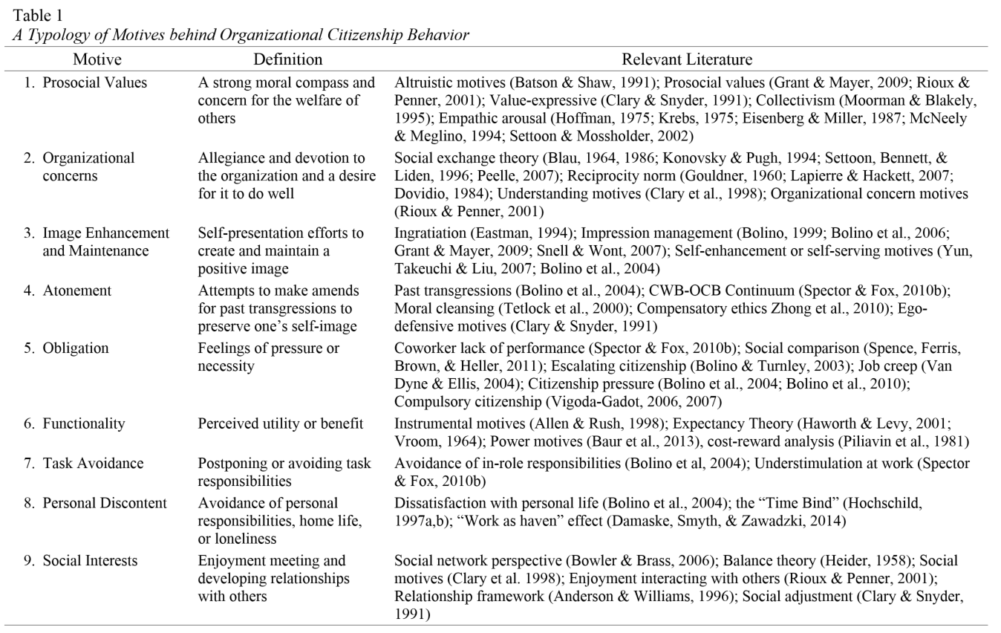

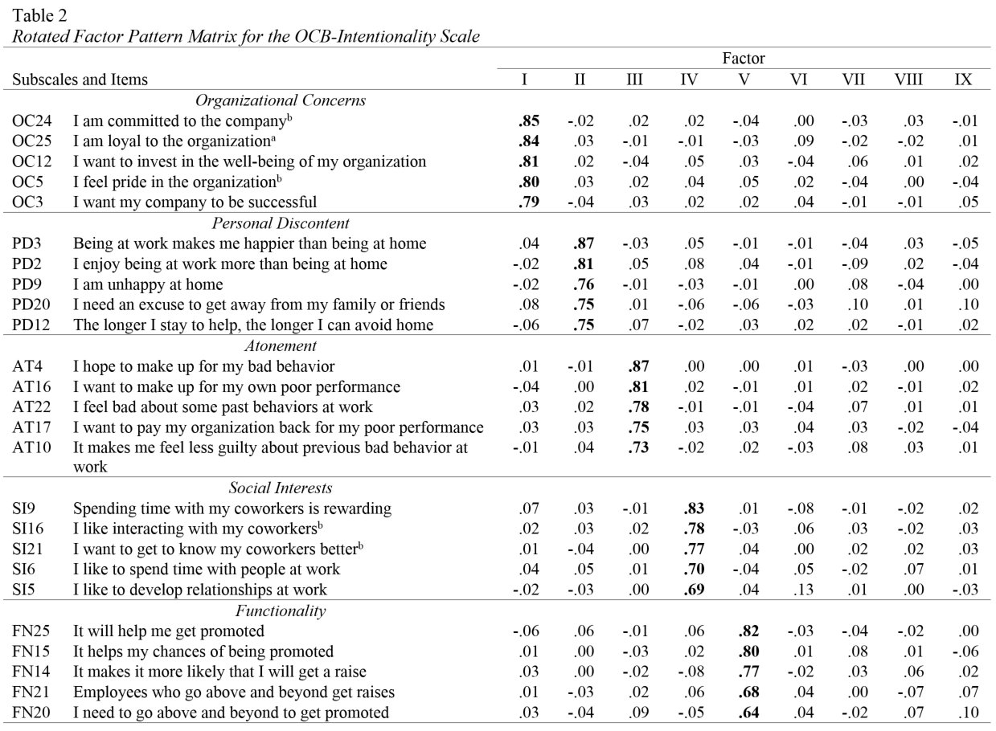

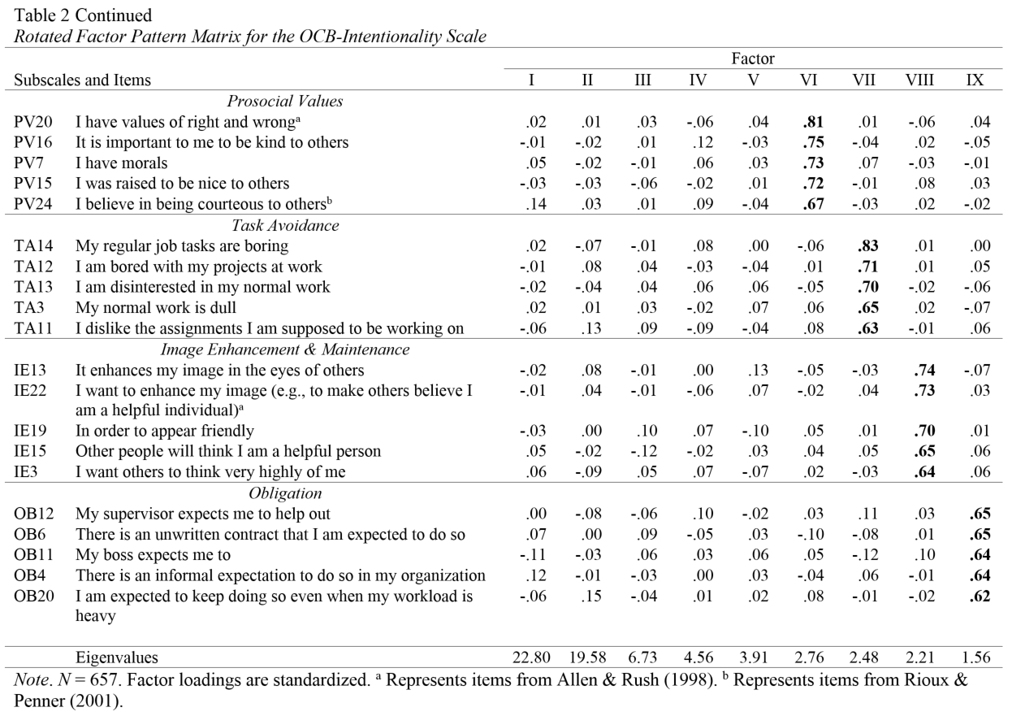

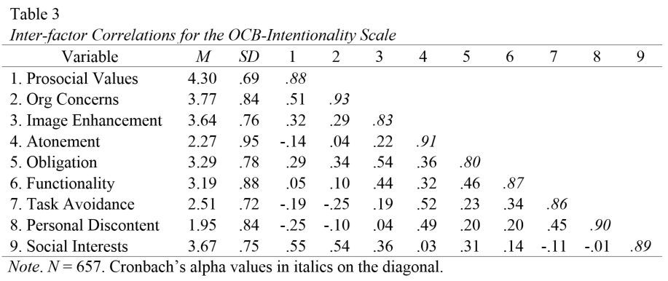

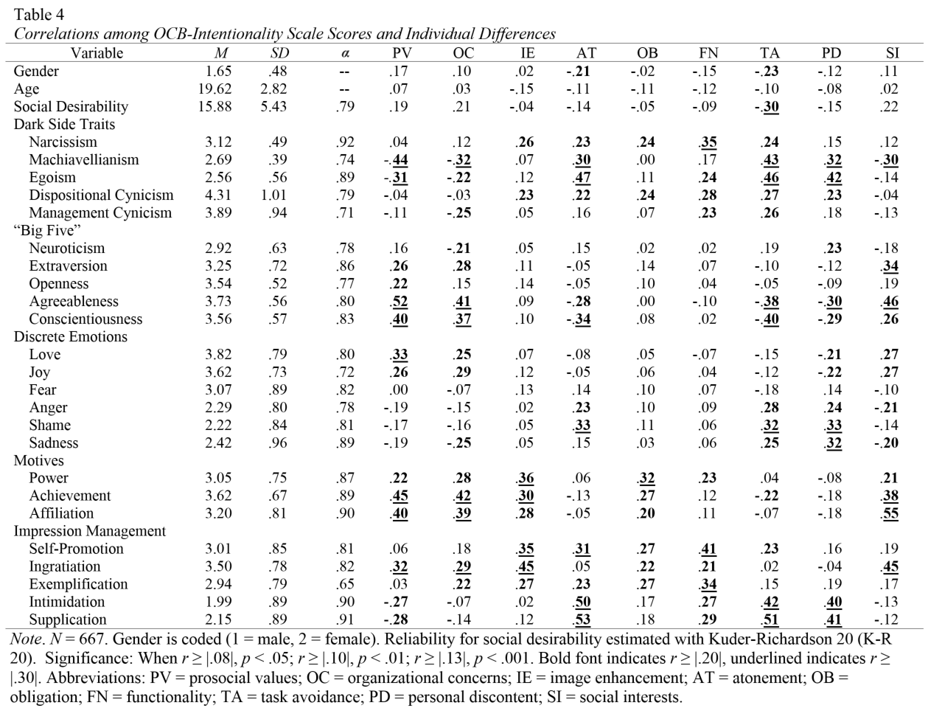

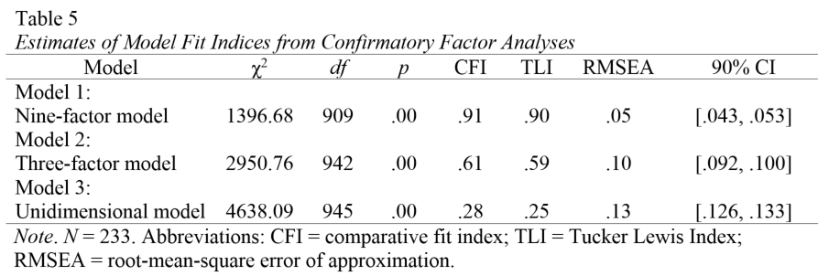

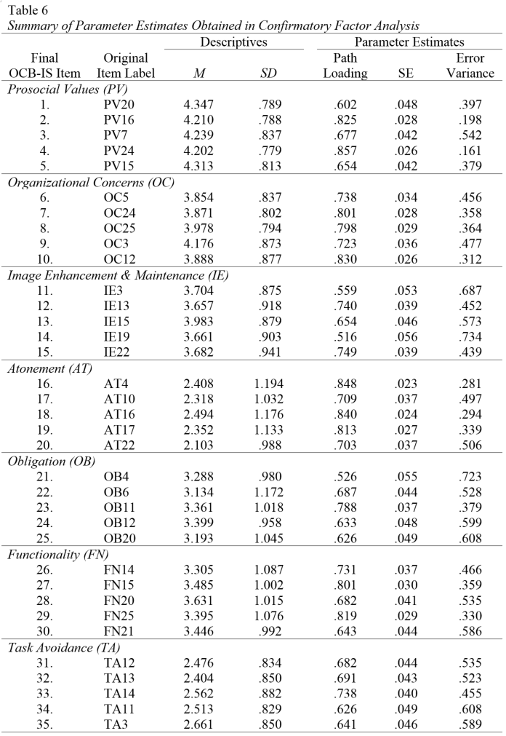

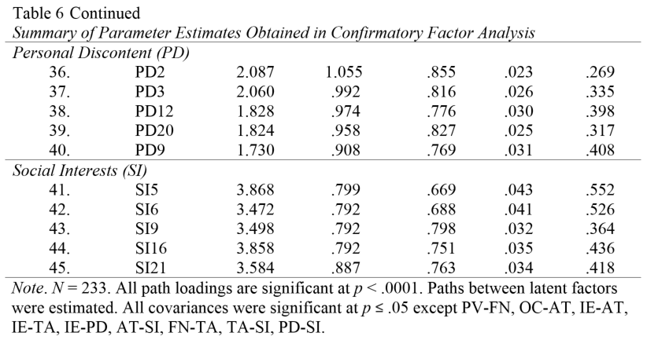

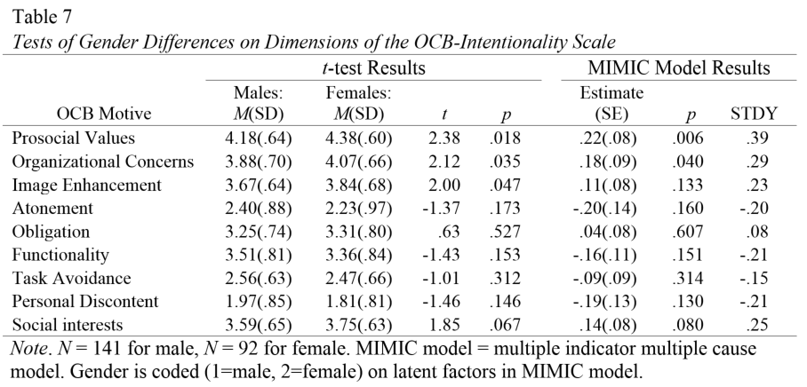

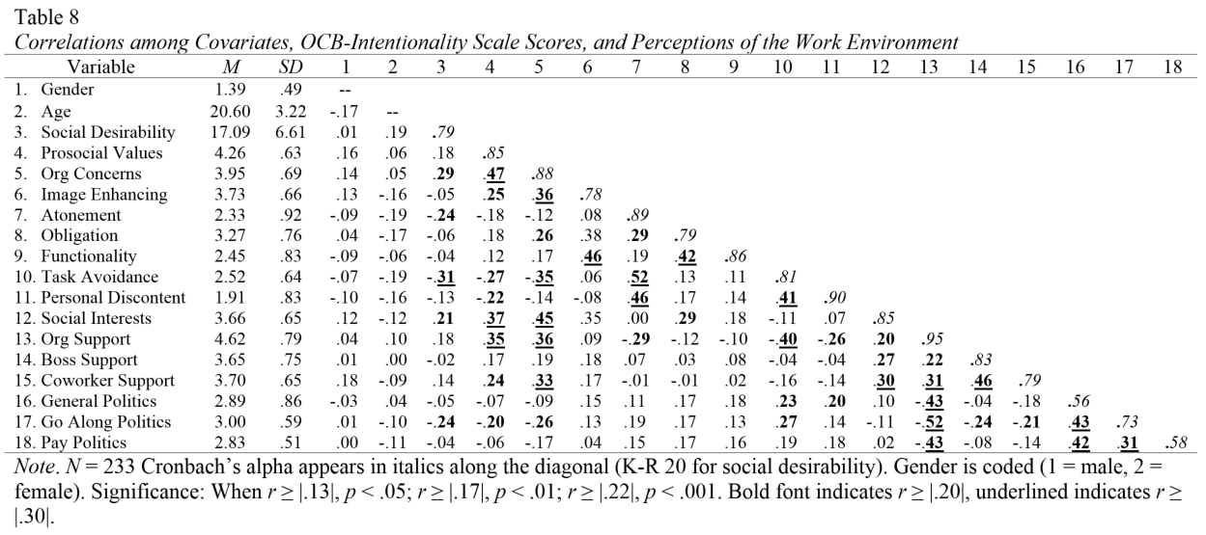
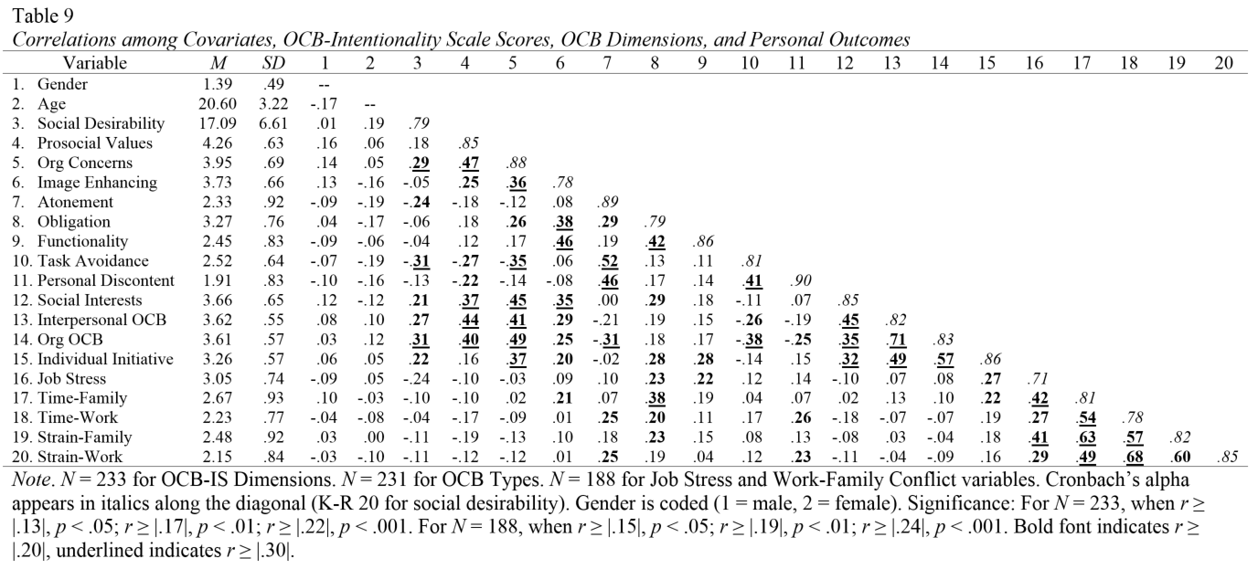
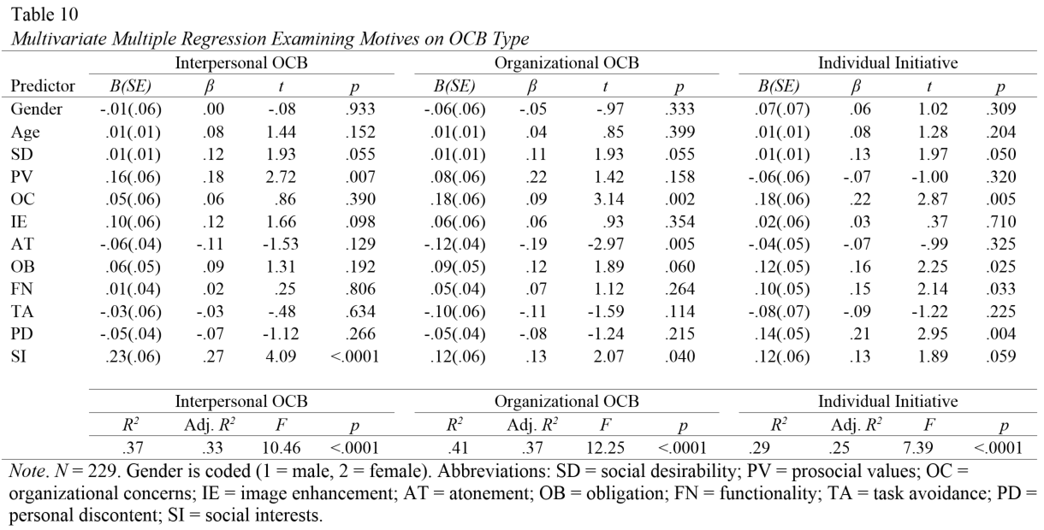
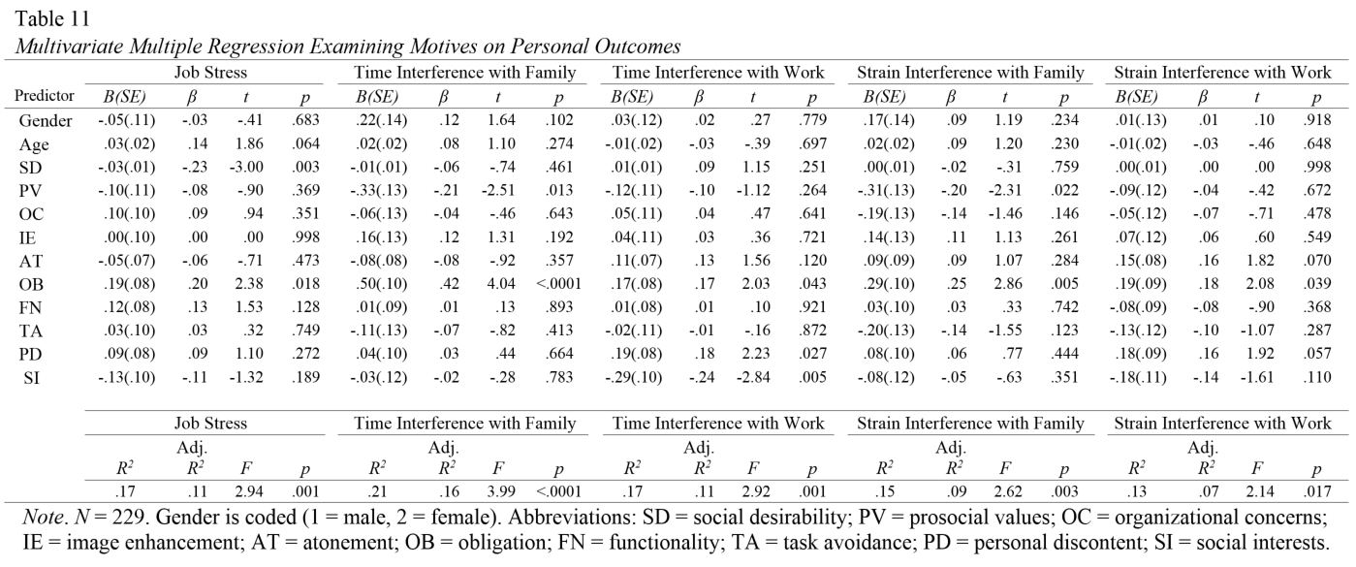

Appendix B: Initial Item Pool
Table A1
OCB-Intentionality Scale Instructions and Initial 228 Item Pool
Instructions
Sometimes people at work may make extra efforts that go “above and beyond the call of duty.” They may do things to help other individuals (e.g., volunteering to help coworkers either personally or professionally) or to help the organization (e.g., volunteering for extra work assignments, work extra hours without pay, offering suggestions to improve the work environment, attending meetings that are not mandatory).

People have different reasons for engaging in extra efforts that go “above and beyond the call of duty” at work. When you engage in this type of behavior, how much do the following statements explain your reasons for doing so?*

Label | Item
Prosocial Values
PV1 | I think it is important to consider others' feelings
PV2 | It makes me happy when I know that I have made a difference
PV3 | I value my ability to help others
PV4 | It is the right thing to do
PV5 | I value helping others
PV6 | I can offer resources that will make others' jobs easier
PV7 | I have morals
PV8 | Serving others is important to me
PV9 | It is the right thing to do
PV10 | I am sympathetic when others are in need of help
PV11 | I feel it is important to help those in need (b)
PV12 | Helping others is central to my personal values
PV13 | I like helping others succeed
PV14 | I want to help everyone put their best foot forward
PV15 | I was raised to be nice to others
PV16 | It is important to me to be kind to others
PV17 | My moral beliefs dictate that I should help others
PV18 | I have a sense of moral standards (a)
PV19 | I am concerned about the welfare of others
PV20 | I have values of right and wrong (a)
PV21 | I believe that helping others is important
PV22 | Helping others is the right thing to do
PV23 | I believe in helping others at work improve
PV24 | I believe in being courteous to others (b)
PV25 | I want to help my coworkers in any way I can (b)
Organizational Concern
OC1 | I want to give back to my organization
OC2 | I want to be fully involved in the company (b)
OC3 | I want my company to be successful
OC4 | It is important to be loyal to my organization
OC5 | I feel pride in the organization (b)
OC6 | My organization means a lot to me
OC7 | I am committed to the organization (a)
OC8 | I believe I am a part of my organization's success
OC9 | I am passionate about seeing my organization succeed
OC10 | I feel a strong attachment to my organization
OC11 | I am devoted to my organization
OC12 | I want to invest in the well-being of my organization
OC13 | I enjoy being a member of my organization
OC14 | Being involved in my organization is important
OC15 | I feel that my organization does important work
OC16 | I want to keep up with the latest developments in the organization (b)
OC17 | I want to represent my organization in the best light possible
OC18 | I am willing to make a personal sacrifice for the good of the organization
OC19 | I truly believe in my organization's mission
OC20 | That is what good employees should do for their organizations
OC21 | I care what happens to the company (b)
OC22 | I care about the future of my organization
OC23 | It is important to me to be a valuable part of my organization
OC24 | I am committed to the company (b)
OC25 | I am loyal to the organization (a)
Image Enhancement and Maintenance
IE1 | I want to look like I am busy (b)
IE2 | Others will think I am dependable
IE3 | Other people will think I am a helpful person
IE4 | Having a good reputation is important
IE5 | It is important to appear that I am willing to go the extra mile
IE6 | I want others to know that I am the type of person who helps
IE7 | I hope to impress my coworkers (b)
IE8 | I want to avoid looking lazy (b)
IE9 | It creates the impression that I work hard
IE10 | I want my supervisor to see that I am a hard worker
IE11 | I want to avoid looking bad in front of others (b)
IE12 | I care what others think of me
IE13 | It enhances my image in the eyes of others
IE14 | I want to showcase my competence to others
IE15 | I want others to think very highly of me
IE16 | I do not want anyone to think that I'm slacking off
IE17 | I fear appearing irresponsible (b)
IE18 | It makes me look good
IE19 | In order to appear friendly
IE20 | I enjoy appearing to be the person with the most expertise on a topic
IE21 | I like to maintain the perception that I am a busy person
IE22 | I want to enhance my image (e.g., to make others believe I am a helpful individual) (a)
IE23 | It gives me a good reputation
IE24 | I want to present myself in a favorable light to others
IE25 | It is important to make a good impression on others
IE26 | Helping others makes me look more likeable
IE27 | I am afraid people will think I am an irresponsible person if I don't
Atonement
AT1 | I owe my company for taking excessive time off
AT2 | I have not always been the best employee
AT3 | It makes up for times when I do not work as hard
AT4 | I hope to make up for my bad behavior
AT5 | I want to clear my conscience from previous counterproductive behavior
AT6 | It helps make up for times I have left early
AT7 | It makes up for the days when I arrive late
AT8 | I want to make up for cutting corners in other areas of work
AT9 | It helps me make up for times when my performance is poor
AT10 | It makes me feel less guilty about previous bad behavior at work
AT11 | Sometimes I take advantage of my organization and want to make up for it
AT12 | I want to repay my organization for the occasions I have wasted company time
AT13 | I sometimes cut corners in my job tasks
AT14 | I do not always give my best effort at work
AT15 | I owe my organization for times I have cut corners
AT16 | I want to make up for my own poor performance
AT17 | I want to pay my organization back for my poor performance
AT18 | I hope to compensate for arriving late or taking long breaks
AT19 | Sometimes I fall short of performance goals and need to make up for it
AT20 | It compensates for those times when I have to leave early
AT21 | I feel like I have to repay my organization for lost time
AT22 | I feel bad about some past behaviors at work
AT23 | I want to compensate for slacking on my responsibilities
AT24 | I feel guilty for not performing as well as I should
AT25 | I want to make amends for past wrongdoings
AT26 | I feel that I take overly long breaks sometimes
AT27 | I want to make things right with my coworkers
AT28 | Sometimes I owe my company for slacking off on past assignments
AT29 | I feel bad for wasting company resources
Obligation
OB1 | I feel that I must make up for others' poor performance
OB2 | It is my duty as a member of an organization
OB3 | It is a part of having a job
OB4 | There is an informal expectation to do so in my organization
OB5 | My coworkers make me feel bad if I do not
OB6 | There is an unwritten contract that I am expected to do so
OB7 | I see others engaging in such behaviors
OB8 | I am expected to maintain past extra-role behaviors
OB9 | My organization makes me feel like I owe them a lot
OB10 | Everyone else gives extra effort, so I should too
OB11 | My boss expects me to
OB12 | My supervisor expects me to help out
OB13 | Everyone around me goes the extra mile
OB14 | Others expect a lot from me
OB15 | Others persuade me to do so
OB16 | I feel pressure from others
OB17 | Everyone here is expected to take on extra work to get the job done
OB18 | I owe it to my organization to help out
OB19 | There is an unwritten code of conduct to do so
OB20 | I am expected to keep doing so even when my workload is heavy
OB21 | People count on me since I have helped in the past
OB22 | I feel obligated
OB23 | My coworkers will be disappointed in me if I do not
Functionality
FN1 | I view it as necessary for advancement
FN2 | I want to build up favors from others
FN3 | It makes it less likely that I will be punished
FN4 | I do not want to lose my job
FN5 | If I help my coworkers now, they will help me later
FN6 | Rewards are important to me (b)
FN7 | I want my coworkers to be seen less favorably so that I will be more likely to get promoted
FN8 | It will pay off in the long run
FN9 | My supervisor praises people who go above and beyond
FN10 | I want to stay out of trouble (b)
FN11 | I am more likely to receive organizational rewards
FN12 | The only people who get promoted are the ones who are seen engaging in these behaviors
FN13 | I want my supervisor to recognize my work
FN14 | It makes it more likely that I will get a raise
FN15 | It helps my chances of being promoted
FN16 | I desire to build up favors for later exchange (a)
FN17 | If I help others now, they will owe me later
FN18 | Doing favors for others means they will owe me in the future
FN19 | I want a raise (b)
FN20 | I need to go above and beyond to get promoted
FN21 | Employees who go above and beyond get raises
FN22 | I want to make others look bad to increase my chances of getting a raise
FN23 | I want to avoid being reprimanded by my boss (b)
FN24 | I am motivated by rewards
FN25 | It will help me get promoted
FN26 | It helps me stand out from my peers when bonuses are being awarded
FN27 | It will help me to win awards within my organization
FN28 | I desire recognition or other organizational rewards (a)
Task Avoidance
TA1 | I want to put off my required job tasks
TA2 | I like doing voluntary tasks more than my normal job tasks
TA3 | My normal work is dull
TA4 | I want variation from my work tasks
TA5 | Helping in extra ways is more fun than my regular job
TA6 | I need a break from my formal responsibilities
TA7 | I will feel productive while putting off work responsibilities
TA8 | It is nice to have a break from my usual work
TA9 | I am avoiding facing challenging work tasks
TA10 | I want to avoid my normal duties
TA11 | I dislike the assignments I am supposed to be working on
TA12 | I am bored with my projects at work
TA13 | I am disinterested in my normal work
TA14 | My regular job tasks are boring
TA15 | I still want to feel busy even if I am not on-task
TA16 | Sometimes I prefer to procrastinate on my main job assignments
TA17 | I want to postpone working on a challenging task
TA18 | I am bored with in-role responsibilities
TA19 | It is more enjoyable than my required tasks
TA20 | I do not feel motivated to work on my main job tasks
TA21 | I can look productive while avoiding my real work
TA22 | I would rather help out than do my real work
TA23 | I need a distraction from my work
TA24 | I put off doing boring work
TA25 | It makes me feel productive when I am not making progress on my job tasks
TA26 | It helps me feel like I am getting things done
TA27 | I am disinterested in normal work duties
Personal Discontent
PD1 | I want to escape household tasks
PD2 | I enjoy being at work more than being at home
PD3 | Being at work makes me happier than being at home
PD4 | It helps me avoid my home life
PD5 | I need a distraction from my home life
PD6 | I want to postpone going home after work
PD7 | They give me excuses to back out of responsibilities at home
PD8 | I prefer my work life to my home life
PD9 | I am unhappy at home
PD10 | They give me reasons to stay at the office longer when I do not want to go home
PD11 | I would rather spend extra time at work than face my personal life
PD12 | The longer I stay to help, the longer I can avoid home
PD13 | It helps me forget about problems at home
PD14 | It helps me avoid feelings of loneliness outside of work
PD15 | I want to spend less time at home
PD16 | I can avoid aspects of my personal life
PD17 | I have more friends at work than I do outside of work
PD18 | I enjoy doing them more than tasks around my house
PD19 | Going home means facing piles of housework
PD20 | I need an excuse to get away from my family or friends
PD21 | I would rather stay and help than deal with my personal life
PD22 | I want to avoid my home life
Social Interests
SI1 | Being with my coworkers makes me happy
SI2 | I want to strengthen my relationships with my colleagues
SI3 | I believe work is a great place to make friends
SI4 | I enjoy building relationships with others
SI5 | I like to develop relationships at work
SI6 | I like to spend time with people at work
SI7 | It is an opportunity to develop interpersonal relationships
SI8 | Networking with others is an enjoyable activity to me
SI9 | Spending time with my coworkers is rewarding
SI10 | I want to learn more about my coworkers
SI11 | I work with some of my best friends
SI12 | Building a professional social network is a priority to me
SI13 | It is fun to interact with people I enjoy being around
SI14 | It helps me make new contacts
SI15 | I am more willing to take on extra tasks when it is with people I like
SI16 | I like interacting with my coworkers (b)
SI17 | I enjoy being around other people
SI18 | I want to develop productive relationships with others at work
SI19 | I enjoy getting to know my coworkers
SI20 | I think making friends makes work more enjoyable
SI21 | I want to get to know my coworkers better (b)
SI22 | I want to build a network of contacts within the organization

