University of Oklahoma

Graduate College

ELECTROMYOGRAPHIC MEASUREMENT OF THE CHINCHILLA MIDDLE EAR MUSCLE REFLEX ELICITED BY ACOUSTIC OR BLAST STIMULI

A Dissertation

submitted to the Graduate Faculty

in partial fulfillment of the requirements for the

Degree of

Doctor of Philosophy

By

ZACHARY YOKELL
Norman, Oklahoma
2019

ELECTROMYOGRAPHIC MEASUREMENT OF THE CHINCHILLA MIDDLE EAR MUSCLE REFLEX ELICITED BY ACOUSTIC OR BLAST STIMULI

A Dissertation approved for the
Stephenson School of Biomedical Engineering

By

Dr. Rong Gan, Chair

Dr. Lei Ding

Dr. Edgar O’Rear

Dr. Vassilios Sikavitsas

Dr. Zahed Siddique

© Copyright by ZACHARY YOKELL 2019
All Rights Reserved.

I dedicate this dissertation to Neilee Wood, my overwhelmingly understanding spouse extraordinaire who’s stood by me through my time in this program.

Acknowledgements
I would like to thank Dr. Rong Gan, my advisor and the primary investigator of the Biomedical Engineering Laboratory at the University of Oklahoma. Her support and advice since I first joined the lab in 2012 have been invaluable.
I would also like to thank the other members of the lab, both past and present. Shangyuan Jiang, a fellow Ph.D. student who joined around the same time as I did, has been a great companion through many shared late nights in the lab. Don Nakmali was instrumental in determining the best way to insert electrodes into the chinchilla stapedius muscle. Brooke Hitt and Kyle Smith have also been incredibly helpful with the various animal studies I have been involved in with this lab. Dr. Xiying Guan, Dr. Xuelin Wang, Dr. Xiao Ji, Marcus Brown, Warren Engels, Dr. Tao Chen, Dr. Junfeng Liang, and Kegan Leckness have all helped in some way throughout my time here.
I would like to thank the members of my committee for their feedback.
Finally, I would like to thank my wife Neilee and my family for their love, support, and help through the entirety of my graduate studies.
This work was supported by NIH R01DC011585 and DOD W81XWH-14-1-00228.

Table of Contents
Acknowledgements iv
List of Tables ix
List of Figures x
Abstract xii
Chapter 1: Introduction 1
1.1 Mammalian Ear Anatomy 1
1.1.1 Structures of the Ear 1
1.1.2 Middle Ear Muscle Reflex 1
1.1.3 Muscle Biomechanics 3
1.2 The Significance of Hearing Damage 5
1.3 Audiological and Muscle Testing 9
1.3.1 Acoustic Reflex Threshold Testing 9
1.3.2 Electromyography 10
1.3.3 Auditory Brainstem Response 12
1.4 Chinchillas as a Hearing Model 13
1.4.1 Strengths of Chinchillas as a Hearing Model 13
1.4.2 Animal Model MEMR Literature 14
1.4.3 Sedation and its Implications on Ear Research 15
1.5 Study Goals 17
Chapter 2: Electromyographic Characterization of Chinchilla MEMR 18
2.1 Introduction 18
2.2 Experimental Setup 18
2.2.1 Chinchilla Specimens 18
2.2.2 Bipolar Electrode 19
2.2.3 Surgical Preparation and Initial Hearing Testing 19
2.2.4 Surgical Electrode Insertion 22
2.2.5 MEMR Threshold Determination 23
2.2.6 Data analysis 23
2.3 Results 28
2.3.1 MEMR Threshold in Chinchillas 28
2.3.2 Comparison of MEMR Threshold as Determined by ART Testing vs EMG 30
2.3.3 MEMR Latency 30
2.4 Discussion 32
2.4.1 Discrepancies Between EMG and ART Testing Results 32
2.4.2 Comparison to Existing Literature 33
2.4.3 Surgical Electrode Insertion Success Rate 36
2.4.4 Study Limitations 37
Chapter 3: Behavior of Middle Ear Muscle Reflex in Response to Blast Overpressure 38
3.1 Introduction 38
3.2 Experimental Setup 39
3.2.1 Chinchilla Specimens 39
3.2.2 Sedation and Electrode Insertion 40
3.2.3 Blast Exposure 40
3.3 Results 43
3.4 Discussion 48
3.4.1 EMG Amplitude and Muscle Response Strength 48
3.4.2 Blast MEMR Latency 48
3.4.3 Study Limitations 49
Chapter 4: Use of Electromyography to Quantify Level of Hearing Damage from Prolonged High Intensity Sound Exposure 50
4.1 Introduction 50
4.2 Experimental Setup 50
4.2.1 Chinchilla Specimens 50
4.2.2 Pre-testing 51
4.2.3 High Intensity Noise Exposure 51
4.2.4 Post-testing 53
4.3 Results 53
4.4 Discussion 58
4.4.1 Comparison to Existing Literature 58
4.4.2 Asymmetrical Threshold Shift 59
4.4.3 Study Limitations 60
Chapter 5: Conclusions and Future Studies 61
5.1 Conclusions 61
5.1.1 Viability of EMG for MEMR Studies 61
5.1.2 EMG Analysis of MEMR During Blast Exposure 62
5.1.3 EMG Analysis of MEMR After High Intensity Sound Exposure 62
5.2 Future Studies 62
References 65
Appendix A: List of Acronyms 75
Appendix B: MATLAB Code 76

List of Tables
Table 1-1 OSHA guidelines for noise exposure 7
Table 2-1 MEMR thresholds (dB) as determined through EMG 29
Table 2-2 MEMR thresholds (dB) as determined through ART testing 29
Table 2-3 MEMR latency (ms) measured at activation threshold 31
Table 2-4 MEMR latency (ms) measured at 110 dB 31
Table 4-1 Average MEMR thresholds (dB) at each frequency 55
Table 4-2 Average ABR thresholds (dB) at each frequency 55

List of Figures
Figure 1-1. Friedlander curve indicating overpressure (red) and underpressure (blue). 8
Figure 1-2. Chinchilla ossicles and middle ear muscles. 14
Figure 2-1. Bipolar tungsten electrode design with silver data port connections (left end) and exposed tungsten for muscle insertion (right end). 19
Figure 2-2. Chinchilla skull, marked with the sites for initial surgical entry (red), further exposure (blue), and skull-penetration target (green). 20
Figure 2-3. Electrode inserted into the chinchilla stapedius muscle. 21
Figure 2-4. EMG electrode recording schematic including electronics for data acquisition and stimulus generation. 22
Figure 2-5. Filtered but otherwise unprocessed EMG data over a stimulus intensity range from 50-110 dB. 25
Figure 2-6. Stages of EMG processing. 27
Figure 2-7. MEMR thresholds determined by ART testing and EMG. 28
Figure 2-8. MEMR latency time at each frequency tested. 32
Figure 3-1. Blast apparatus schematic. 39
Figure 3-2. Chinchilla blast holder. 41
Figure 3-3. Blast pressure data for two animals at different blast intensity levels corresponding to the >6 psi (left) and <3 psi (right) cases. 43
Figure 3-4. Raw EMG blast results from four different animals. 44
Figure 3-5. EMG amplitude (μV) vs blast intensity (psi). 45
Figure 3-6. EMG response amplitude in the three blast intensity groups tested. 46
Figure 3-7. Determination of blast MEMR latency as the difference between the overpressure peak (black) and the first EMG peak (red). 47
Figure 3-8. Latency of the MEMR at different blast intensities. 47
Figure 4-1. Noise insulated chamber for sound exposure. 52
Figure 4-2. Comparison between pre- (left) and post- (right) 1 hour noise exposure ABR behavior in response to eliciting stimuli ranging from 60 dB (bottom) to 80 dB (top) in 5 dB increments. 54
Figure 4-3. Comparison between pre- (left) and post- (right) 1 hour noise exposure MEMR behavior in response to eliciting stimuli of 90 dB (top), 100 dB (middle), or 110 dB (bottom). 54
Figure 4-4. ABR-determined MEMR Threshold Levels Before and After Noise Exposure. 56
Figure 4-5. EMG-determined MEMR Threshold Levels Before and After Noise Exposure. 56
Figure 4-6. EMG-determined Shift in MEMR Thresholds. 57
Figure 4-7. ABR-determined Shift in MEMR Thresholds. 57

Abstract
Hearing damage is a widespread problem that can cause social isolation and reductions in quality of life. A wide range of conditions including extended exposure to noise or near-instantaneous exposure to blast overpressure can result in hearing damage. When the ear is exposed to potentially dangerous stimuli, the contraction of the stapedius muscle serves a protective function known as the middle ear muscle reflex (MEMR). Clinical measurements of the MEMR through acoustic reflex threshold (ART) testing are indirect and limited to determining the reflex’s presence or absence. Electromyography (EMG) provides direct measurements of a muscle’s activity, thereby expanding the parameters available for study. While chinchillas are an important model for hearing studies, there is not currently published EMG data on the chinchilla MEMR.
To improve the utility of chinchilla models in hearing research, a surgical method of EMG electrode insertion was developed. The MEMR response to pure tone acoustic stimuli over a range of frequencies (1, 2, 4, and 6 kHz) and amplitudes (50-110 dB) was characterized in n=14 animals. EMG results were compared to MEMR activation thresholds determined through ART testing, which found that EMG may be more sensitive than ART testing at registering a reflex activation. At 1 kHz the mean EMG-determined threshold was 63.6 ± 16.5 dB; at 2 kHz it was 70.0 ± 12.4 dB; at 4 kHz it was 71.4 ± 13.5 dB; and finally at 6 kHz it was 76.4 ± 13.9 dB. Latency time between stimulus onset and muscle activation at the MEMR threshold was determined to be, on average, 8.20 ± 1.10 at 1 kHz; 6.84 ± 1.41 at 2 kHz; 6.56 ± 1.62 at 4 kHz; and 5.86 ± 1.37 at 6 kHz. The latency decreased as stimulus amplitude increased at 1 kHz and 2 kHz, but did not significantly change at 4 kHz or 6 kHz.
After the surgical approach for EMG was well established, it was applied to animals that were subjected to blast conditions, a stimulus for which no EMG stapedius data exists in any animal model. Chinchillas (n=10) were exposed to a series of blasts with increasing intensities. The average latency time between blast overpressure onset and muscle activation was determined to be 4.75 ± 3.19 ms. As this is shorter than the time course of a blast event, this confirmed that the MEMR activates too slowly in chinchillas to provide a mitigative function against blast overpressure waves.
Finally, existing noise-induced hearing loss models in animals typically require days or weeks of stimulus. In order to accommodate the acute nature of invasive EMG studies, a one-hour and a two-hour model of hearing damage was developed based on 130 dB sound exposure. The MEMR thresholds and hearing levels of these chinchillas (n=8) were tested before and after noise exposure to quantify the resultant level of hearing damage. While there was not a statistically significant difference between the damage caused by the two exposure durations, the one-hour case caused an average of 65.1 dB shift in the animals’ hearing levels and 54.7 dB shift in MEMR activation levels. This model can be used to assess protective interventions in a single day of experimentation.
These studies have successfully used EMG as a technique to study the MEMR in chinchillas for the first time. There is now baseline data for the MEMR of chinchillas with normal hearing, which can serve as a point of comparison for future studies. The latency time between stimulus and MEMR activation was confirmed to be too high for protection from blast trauma to be likely. Finally, an acute hearing damage model was established, facilitating future testing of protective interventions. By expanding the understanding of the chinchilla MEMR, this work has strengthened chinchillas as a model for hearing.

Introduction

1.1 Mammalian Ear Anatomy

1.1.1 Structures of the Ear
The mammalian ear is classically divided into three segments: outer, middle, and inner. The outer ear includes the ear canal and the pinna, the external structure which funnels sound waves into the canal. The tympanic membrane is located at the end of the ear canal and is the interface between the outer and middle ear, vibrating in response to sound and causing the bones of the middle ear to vibrate. The human ossicular chain is composed of three bones: the malleus, incus, and stapes. These bones are connected by the incudomalleolar and incudostapedial joints, allowing them to transmit the vibrations between the tympanic membrane and the cochlea (Mason, 2013). The incus and malleus are sometimes fused together into one bone in other animals, such as chinchillas (Puria et al., 2010). Finally, the inner ear includes the cochlea and the vestibular system. The cochlea is connected to the middle ear via the oval window and the round window, a pair of membrane-covered openings. The oval window specifically admits the vibrations of the stapes into the cochlea, wherein they are converted to nerve impulses and sent to the brain to be interpreted as sounds (Fuchs et al., 2015). The vestibular system is involved in balance rather than hearing. Finally, there are two muscles in the middle ear, the tensor tympani and the stapedius. These are attached to the malleus and the stapes, respectively, and serve different roles in moderating sound input to the ear.

1.1.2 Middle Ear Muscle Reflex
The stapedius muscle is activated in the middle ear muscle reflex (MEMR) as a protective function in response to high intensity sound exposure. When a sound is of sufficient amplitude to elicit the MEMR, the reflex damps the stapes’s motion and mitigates the high ossicular motion transmitted from the stapes to the cochlea (Aiken et al., 2013; Mukerji et al., 2010). While the MEMR is present in most people, some people do not have it and others lose it as they age or experience hearing damage (McGregor et al., 2018).
The MEMR is an imperfect source of protection from high amplitude, low duration sound, including blast overpressure waves, because of the latency between stimulus onset and muscle activation, which averages about 129.1 ms in healthy humans (Norris et al., 1974). If a stimulus is of high enough intensity to damage the ear instantaneously, the reflex may not act in time to cause any significant mitigation of damage. This is particularly relevant in the case of blast exposure wherein an extremely high change in pressure occurs in a timespan of only a few milliseconds. Typical blast durations range from under 1 ms to up to 15 ms, all significantly below the MEMR latency for humans (Courtney et al., 2015). An understanding of the MEMR is valuable both in understanding the mechanisms behind hearing damage and diagnosing hearing dysfunction.
Additionally, the MEMR has more medical significance than the protective function it serves. The MEMR also serves as an effective marker for healthy hearing in clinical testing thanks to its predictable and bilateral response to loud noises. As a healthy person will exhibit a MEMR response in both ears even if only one is stimulated, certain nerve pathway conditions may be diagnosed by looking at whether or not the contralateral response opposite the stimulated ear does happen, or if only the ipsilateral response of the same side as was stimulated occurs. The MEMR threshold is the minimum amplitude of sound that triggers the reflex action of the stapedius and is one of the primary ways the MEMR is quantified (Henin et al., 2014). It may be clinically examined using a tympanometer in acoustic reflex threshold (ART) testing. This method, described in more detail in section 1.3.1, noninvasively determines the MEMR activation threshold by finding the stimulus volume necessary to provoke a sufficient reflex to change the tympanic membrane’s compliance.

1.1.3 Muscle Biomechanics
An understanding of what muscles are and how they function is integral to fully understanding the behavior of a muscular reflex. Muscles are active soft tissues capable of contraction in order to cause motion of some sort. Three types exist: skeletal muscles, which can be voluntarily controlled and are primarily involved in the motion of bones; smooth muscles, which are involuntarily controlled and deal with blood vessels, the intestines, and other organs that need a way to enact motion; and cardiac muscle, which makes up the heart and acts involuntarily, despite being similar in some ways to the structure of skeletal muscle (Fung, 1993). The muscles of the middle ear are both skeletal muscles, and the stapedius is the smallest of the human body’s skeletal muscles.
To briefly summarize the mechanism of contraction for skeletal muscles, at a microscopic level muscles are composed of actin and myosin molecules, protein filaments that are arranged in parallel. When a nerve, chemical, or electric signal commands the muscle to act, these fibers twitch towards each other, microscopic heads on the myosin filaments binding to sites on the actin filament and pulling it inwards. In the aggregate, this contracts the entire muscle until it relaxes and expands again. When the rate of stimulation is high enough, these individual twitches build on each other before there is a chance to fully relax in what is known as tetanization, where the contractile force reaches an asymptote as additional twitches contribute less and less. The tension P in a tetanized muscle can be related to the velocity of contraction v in Hill’s equation (Eq. 1), where a and b are constants (Fung, 1993):
$\left(v+b\right)\left(P+a\right)=b(P_{0}+a)$ (1)
Due to the size, location, and fragility of the stapedius muscle and ossicular chain, direct measurements of the stapedius’ contraction velocity or tension were not attempted in the course of these studies, deferring instead to measurements of the electrical activity stimulating the muscle’s action. For a muscle that has not been tetanized, a separate model by Zahalak was published in 1976 describing the behavior of the forearm and wrist (Fung, 1993), where $p$ is the load applied at the wrist, $v$ is the angular velocity of the forearm, $e$ is the smoothed, rectified electromyogram, and $p_{0}^{+}\left(e\right)$ is an isometric load as a function of the electromyogram and five empirical constants that vary by subject.
$\left[p_{0}^{+}\left(e\right)-p\right]=\left(k_{1}+k_{2}p\right)v (0<v<0.5 v_{\left\{max\right\}}\left(p\right))$ (2)
The equation does not lend itself to easy adaptation to other muscles, however, and exhibits the same difficulties with measuring loads and velocities of a small, isolated muscle without damaging it. This contributes to the difficulty of analyzing the activity of the stapedius muscle.
Tetanization of the stapedius has been judged unlikely in rabbit and cat studies where measurements of the stapedius acting in response to normal stimuli were contrasted with the activity of the stapedius when electrically stimulated to maximal force (Guinan et al., 1987). Neither animal reached as high of force when acting in normal conditions as it did when electrically stimulated. One final useful concept is muscle fatigue. Eventually, a tensed muscle will reach a fatigued state and its ability to output force will decrease. To avoid this, some recovery time is built into the studies in Chapters 2 and 3; in the noise exposure study of Chapter 4, however, the high exposure duration is likely to cause fatigue in the stapedius, which may be a contributor in the level of damage caused.

1.2 The Significance of Hearing Damage
Due to the complexity and fragility of the mammalian auditory system, intensely loud sounds or abnormally high pressure waves applied to the ear may cause significant damage. As a result of high intensity input, the mechanical properties of the soft tissues of the ear may change, the ossicles may be dislocated, and the hair cells of the cochlea may die. Surgery may be needed to repair the ear in some cases, but in the case of the death of hair cells there is currently no medical intervention that can bring a patient’s hearing back to normal function. The prevention of hearing damage is particularly important in light of its potentially expensive or permanent nature. Patients exhibiting hearing damage may experience a variety of impairments including decreased sensitivity to sounds, tinnitus, or total deafness.
Hearing impairment is often linked to occupational exposure to dangerous sound levels; a variety of occupations from industrial sector jobs to work in the military may expose employees to risks of hearing loss. It is present in approximately 28 million Americans, and noise induced hearing loss is the cause of an estimated half of those cases (Daniel, 2007). An estimated 16.9% of Americans in production sector jobs are regularly exposed to potentially dangerous levels of sound, and occupational exposure may be responsible for as many as 24% of cases of hearing impairment in America (Rosenstock, 1998; Tak et al., 2008). Many popular leisure activities including listening to media players, attending concerts, or visiting nightclubs, result in unsafe levels of noise exposure (Keppler et al., 2014). Veterans are disproportionally affected by hearing loss because of their proximity to firearms, explosives, aircraft, and other occupational hazards to which civilians are not regularly exposed. These exposures result in veterans having four times more risk of hearing damage versus non-veterans and pose a substantial cost to the taxpayer with medical claims relating to hearing loss for veterans totaling $1.2 billion in 2009 (CDC, 2011; Saunders et al., 2009). Hearing loss has been linked to psychological and social problems as well as an overall decrease in quality of life (Kobosko et al., 2015; Niemensivu et al., 2015; Olusanya, 2015). As things currently stand, hearing damage is a major modern medical issue.
There are multiple possible mechanisms behind hearing damage depending partly on the source of the damage. The sensory hair cells in the cochlea may be damaged or killed by noise exposure; without them, certain sound frequency ranges may become difficult or impossible for a person to detect (Daniel, 2007). When a sound of a particular frequency may only be heard at higher presentation levels than were previously audible, a threshold shift has occurred in the subject’s hearing level. This shift will be the most pronounced immediately after exposure and is defined at that point as a temporary threshold shift (TTS). Some degree of recovery tends to occur over time, but in cases of severe exposure a permanent threshold shift (PTS) will remain after multiple weeks of recovery (Chen et al., 2014). Threshold shifts often impact the hair cells responsible for 3000-6000 Hz noises (Duarte et al., 2015). A PTS resulting from the death of cochlear hair cells is a significant problem as human hair cells are not capable of growing back over time (M. E. Smith et al., 2016). Mechanical damage to the structures of the ear can occur as a result of exposure to more extreme auditory trauma, such as blasts. This may include rupture of the tympanic membrane, which often heals naturally, although medical intervention may speed the process (Lou et al., 2016). Disarticulation of the ossicular chain is also possible and can cause significant hearing damage that may require surgical treatment (Ghonim et al., 2015). Because many of the mechanisms for hearing loss are difficult or impossible to treat with modern medical technology, prevention of damage is a superior option.
The presence and severity of hearing damage depends on the duration and intensity of the dangerous exposure. To reduce the risk of occupational hearing loss, the United States Occupational Safety and Health Administration (OSHA) has established a set of guidelines for safe levels of workplace noise exposure before some form of protective equipment must be used (OSHA, 2008). The baseline safe exposure level defined by OSHA is that 90 dB is the maximum sound level that an employee may be exposed to over the course of an eight-hour work day. The acceptable duration is halved for every 5 dB increase in sound intensity as shown in Table 1. An additional limitation given is that even impulse noise is potentially dangerous above 140 dB; therefore, beyond that point there is no safe exposure duration. Sounds of that intensity approach the danger level of blast exposure and should ideally never be experienced without protective equipment.

Table 1-1 OSHA guidelines for noise exposure
Sound  level (dB) | 90 | 92 | 95 | 97 | 100 | 102 | 105 | 110 | 115
Daily exposure  duration | 8 hrs | 6 hrs | 4 hrs | 3 hrs | 2 hrs | 1.5 hrs | 1 hr | 30 mins | < 15 mins

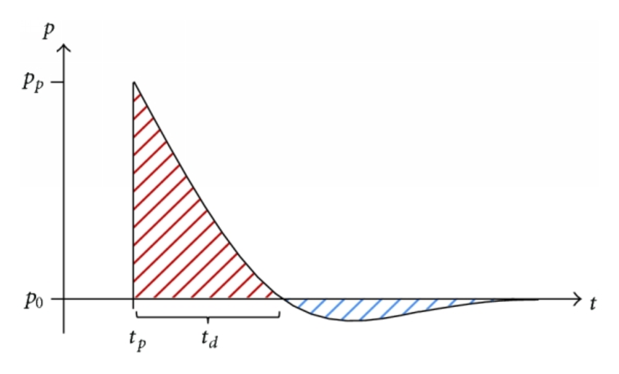
Figure 1-1. Friedlander curve indicating overpressure (red) and underpressure (blue).
In blast overpressure, a shock wave causes the rapid onset of high-amplitude pressure. This is most likely encountered in the form of an explosion, such as the detonation of a bomb or the discharge of a firearm. Blasts can reach 180 dB or higher and are capable of causing severe damage not only to the auditory system but also to the lungs and brain. A blast overpressure wave may be described in what is called the Friedlander curve, shown in Fig. 1.1 (Heimbs et al., 2015). When the wave reaches a location of interest at t=t_{p}, it will nearly instantaneously reach peak pressure, p_{p}, after which pressure will decrease to slightly below the initial pressure p₀ before finally stabilizing at p₀. This occurs within a period of mere milliseconds. The combination of the abrupt existence of an extremely high initial pressure peak with the swift return to baseline is dangerous to many organs, particularly the ear.

1.3 Audiological and Muscle Testing

1.3.1 Acoustic Reflex Threshold Testing
A fairly common measurement in clinical audiology, ART testing is a noninvasive, indirect way to study the threshold for activation of the MEMR. It is based on tympanometry, which measures the mobility of the tympanic membrane by sealing the ear canal, presenting a stimulus, and measuring the reflection of that stimulus off of the eardrum. The amount of sound that was reflected back to the microphone is compared to how much was admitted through the membrane into the ear in order to quantify the tympanic membrane’s mobility (Davies, 2016). In ART testing, tympanometry is performed multiple times in sequence while a reflex-eliciting tone is presented. The ear’s admittance will change if the MEMR activates; therefore, comparing a series of trials while increasing the amplitude of the eliciting tone to a normal tympanogram allows for a determination of what amplitude of stimulus is sufficient to elicit the reflex (Hunter et al., 1999). This method is suitable for clinical use due to its noninvasive nature, ease of use, and rapidity of its administration.
The various clinical applications of MEMR measurements are relevant from birth on to adulthood. By testing for the presence of the reflex in one ear while stimulating the opposite ear, physicians can determine if some neurological dysfunction is impairing hearing and preventing the reflex from being activated (Shivashankar et al., 2003). Measurements of the MEMR are also relevant in newborn health screenings and the prediction of certain auditory complaints (Duarte et al., 2015; Jacob-Corteletti et al., 2015). It is a clinically valuable measurement in predicting normal hearing in neonates, separating cochlear and retrocochlear pathologies, and predicting hearing loss in the elderly (Pérez-Villa et al., 2014; Schairer et al., 2013; Sogebi, 2015). By measuring the activity of the stapedius muscle, one can screen for hearing damage as well as determine if the muscle is contributing its protective mechanism in response to a certain stimulus. Unfortunately, since ART testing only measures muscle activity indirectly, it gives little useful physiological information beyond a determination of the presence or absence of the reflex.

1.3.2 Electromyography
In contrast to ART testing, electromyography (EMG) directly records the action potentials of muscles through an electrode. This time domain data includes the response amplitude, latency between stimulation and reflex activation, and duration of muscle contraction, which cannot be determined through ART testing. EMG data can be obtained through either a surface or needle electrode, each of which has advantages and disadvantages (S Rajaratnam, 2014). A surface electrode consists of an adhesive pad that can measure electrical activity at the surface of the skin, generally enhanced by the application of conductive gel at the electrode site. Multiple electrodes are applied to a subject and the difference in behavior between the two sites yields data about muscle function. This is generally used to measure the behavior of large muscles because surface electrodes are more open to electrical noise from other muscles than needle electrodes. Despite this limitation, surface electrodes are sufficient for many applications, particularly in human subjects where the ease of application and noninvasive nature of the measurement are valuable. Unfortunately, the stapedius muscle is located within the temporal bone, and its activity as measurable from the surface is dwarfed by the activity of the facial muscles. Needle electrodes offer an alternative known as intramuscular EMG. A needle inserted directly into a muscle can directly measure its activity, with reduced cross-talk from other muscles compared to the use of surface electrodes. This can be done with a single monopolar electrode or a bipolar electrode in conjunction with a reference electrode in either case. Because of the small size and isolated location of the stapedius, the latter option was used.
The necessity of inserting an electrode directly into the stapedius to get a signal poses a difficult challenge. Human studies with needle electrodes are generally only possible when another procedure has already necessitated the opening of the middle ear to allow access to the stapedius. In one of the first published instances of human stapedius EMG, the study was performed on otosclerosis patients undergoing a stapedectomy, in which the bones of the ossicular chain have started to fuse and must be removed and replaced by an ossicular implant. EMG was performed with a monopolar electrode inserted into the tensor of the stapedius muscle during the course of the stapedectomy (Djupesland, 1965). In a more recent study, a group of patients undergoing surgery for chronic otitis media were tested with an electrode in the diseased ear. Taking advantage of the bilateral nature of the MEMR, the opposite ear, which in all cases had healthy hearing, was stimulated and the contralateral response in the diseased ear was measured (Warmuth et al., 2014). This was done to test the viability of using EMG to assist in the tuning of cochlear implants, and in the second stage of the study a series of deaf patients undergoing cochlear implant surgery were also tested. In those patients, the muscle was stimulated electrically via 0.5 second current bursts of varying intensity. Because of the limited availability of willing surgical patients, these human studies have been narrow in scope.
Consequently, EMG study of the behavior of the stapedius in the MEMR has generally been confined to animal models. Studies have been performed in cats to characterize the duration and latency of the reflex as well as to quantify the difference in the strength of the contralateral response compared to that of the ipsilateral side (Eliasson et al., 1955; Guinan et al., 1987). Rat tests have been performed, measuring the reflex’s characteristics over a range of frequencies, characterizing reflex sensitivity, and determining effectiveness at reducing ossicular vibration (R S Clement et al., 2004; Murata et al., 1986; Pilz et al., 1997). Guinea pigs have also undergone stapedius EMG tests in an attempt to correlate EMG measurements of the strength of the reflex response to electrical stimulation to enhance cochlear implant comfort (Ryan S. Clement et al., 2002). EMG has not previously been used to study the MEMR of chinchillas.

1.3.3 Auditory Brainstem Response
Auditory brainstem response (ABR) testing is an objective measure of the electrical reaction of the brainstem to a sound. It is a commonly used audiological test in newborn health screenings to ascertain normal hearing levels because it does not require input from the subject (Seethapathy et al., 2018). For this same reason, it is popular in animal studies as animal subjects require extensive training for behavioral hearing tests to work. It has been used before in chinchillas to quantify hearing loss (Claussen et al., 2013; World Health Organization (WHO), 2009). In ABR, electrodes are inserted at the cranial vertex, mastoid process, and on one leg for use as a ground. Acoustic stimuli are presented over a range of frequencies and amplitudes. In the tests here described, amplitude was stepped from 30-80 dB with intervals of 5 dB, and frequency was 0.5, 1, 2, 4, 6, or 8 kHz. If a sound is loud enough to be processed by the subject’s brain, a repeatable wave pattern featuring five peaks will be visible. Determining the lowest amplitude to produce that pattern at a given frequency gives a reasonable estimation of its hearing capability.

1.4 Chinchillas as a Hearing Model

1.4.1 Strengths of Chinchillas as a Hearing Model
The risk of damaging a subject’s hearing in the course of experimentation related to hearing loss is a strong argument for the use of animal models. Chinchillas are particularly popular in hearing research because they have a similar hearing range to that of humans. Humans have an audible range of approximately 31-19,000 Hz, whereas the chinchilla range is about 52-33,000 Hz (Fay, 1989). The size of the chinchilla tympanic membrane is similar to that of a human. The auditory bullae of chinchillas are encased in thin bone, allowing for relatively easy access. Unlike in primates where a joint separates the incus and the malleus, chinchilla ears combine them into a single fused bone. The fused ossicles contribute to the similarity between the hearing ranges of chinchillas and humans despite the difference in the size of the ossicles between the two species, enhancing the chinchilla’s viability as an animal model for hearing (Puria et al., 2010). The ossicular chain and stapedius muscle of a chinchilla are shown in Fig. 1.2. Whereas some rodents have vestigial stapedius muscles or completely lack them, chinchillas do have a functional stapedius (Mason, 2013). Finally, as rodents, chinchillas are more readily available than the other animals with similar auditory properties to those of humans, such as other primates. Because of these factors, chinchillas were chosen as a reasonable animal model for hearing. In addition, the absence of EMG studies of the chinchilla MEMR represents a significant gap in audiological literature; a more thorough understanding of the behavior of the chinchilla MEMR through EMG study would further strengthen chinchillas as the optimal non-primate animal model for hearing studies.

1.4.2 Animal Model MEMR Literature
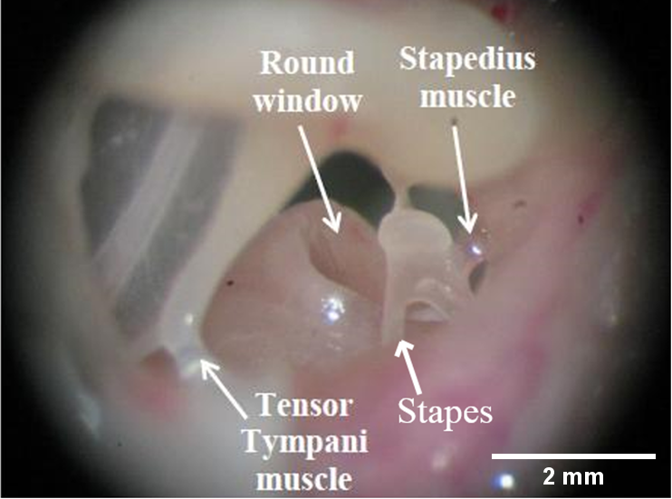
The chinchilla MEMR has been studied using the round window recorded cochlear microphonic, a response to sound generated by hair cells that can be measured via microphone at the round window (Ferraro et al., 1981). Dissection of chinchilla ears after chronic noise exposure has been performed but no hearing tests were administered before euthanasia so the damage seen could not be directly related to the level of hearing damage (Vertes et al., 1979). Other studies in both guinea pigs and chinchillas relied on trained animal behaviors to determine hearing thresholds rather than directly measuring auditory function (Burdick, 1979; Syka et al., 1980). While this does allow for hearing function to be determined, such results have a degree of subjectivity as they depend on the quality of the training and the researcher’s interpretation of the animal’s behavior. Most studies also keep their stimulus levels below 125 dB, so it is unknown to what degree hearing damage worsens at levels above that point compared to below it (Dunn et al., 1991; Ferraro et al., 1981; Rybalko et al., 2015; P. E. Smith, 2015). Since EMG allows for quantifications of changes in hearing ability, such as shifts in MEMR thresholds and changes in the strength of muscle activation as measured by the strength of the measured electrical signal, it may yield a more valuable assessment of hearing damage than currently exists for the case of high intensity noise exposure.
Figure 1-2. Chinchilla ossicles and middle ear muscles.
The activity and utility of the MEMR in response to noise has been extensively studied, but no data is available for blast stimulation of the ear. Methods of measuring the activation of the MEMR in response to intense sounds have been used in a variety of animal models including guinea pigs, cats, rabbits, and chinchillas (Avan et al., 1992; Gerhardt et al., 1979; Guinan et al., 1987; Teig, 1972). Humans undergoing ear surgery have had electrodes inserted to determine the criteria necessary for reflex activation (Djupesland, 1965). However, no studies seem to have addressed the case of blast stimulation; most use acoustic stimulation at levels that are insufficient to cause hearing loss. This may be partly due to limitations of the ART method, which generally relies on an operator to hold the probe in its proper place, a procedure that is not feasible in a blast exposure test without significant risk management. There is no data to show how the stapedius responds to high amplitude impulse sound, but such data would contribute to an understanding of how effectively, if at all, the MEMR can protect from impulse stimuli.

1.4.3 Sedation and its Implications on Ear Research
The EMG electrode insertion procedure here described requires the administration of sedatives to the subjects to achieve and maintain a state of general anesthesia, a chemically induced state of unconsciousness wherein the entire subject is rendered insensitive to stimuli (Millard, 2008). In a deep enough case to be suitable for invasive surgery, many involuntary reflexes will also be suppressed past their normal function during unconsciousness. To induce anesthesia, a 35 mg/kg ketamine and 7 mg/kg xylazine cocktail was injected per modern veterinary formulary (Richard Fish, Peggy J. Danneman, Marilyn Brown, 2011). Ketamine is a dissociative agent that produces light anesthesia along with analgesia, suppressing the capacity to feel pain (Millard, 2008). Xylazine is an alpha-2 agonist which supplements ketamine to produce a full state of anesthesia. Because ketamine is metabolized more quickly than xylazine, subsequent maintenance doses only include ketamine. While this mixture and dosage is capable of fully sedating a chinchilla within a minute, bringing it to a level where surgery can be safely performed, it is important to consider the ramifications of sedation on muscle reflex studies.
A rat study compared a ketamine/xylazine cocktail, isoflurane, and pentobarbital as sedatives for hearing tests including the contralateral MEMR (Campo et al., 2013). In this study, the reflex was measured indirectly via the change in distortion product otoacoustic emission (DPOAE) results with or without a MEMR-eliciting stimulus. While all three depressed the MEMR, the ketamine/xylazine mixture and pentobarbital did so more slowly than the isofluorane. In another study that compared the ipsilateral and contralateral MEMR responses to a variety of drugs that did not include ketamine/xylazine, the ipsilateral reflex was less severely impacted than the contralateral reflex (Borg et al., 1975). In all of the present work, only the ipsilateral reflex was measured in hopes that, while somewhat attenuated, attenuation would be minor compared to other sedative options or to the contralateral reflex. This judgement echoes that of a variety of other researchers whose MEMR studies used ketamine and xylazine together for sedation, considering it to be the least harmful option (Avan et al., 1992; Chertoff et al., 2018; R S Clement et al., 2004; Wolter et al., 2014).
The impact of ketamine/xylazine sedation on ABR results has also been studied. A rat study comparing ketamine to isoflurane, an inhaled sedative agent, found a significant elevation in ABR thresholds with the isofluorane compared to ketamine on the order of 10-40 dB, depending on frequency (Ruebhausen et al., 2012). In gerbils, there are some waveform changes in ABR under that sedative regimen; specifically, the V wave has increased latency the longer an animal has been sedated (Lima et al., 2012). Otherwise, that study deemed it a viable sedative regimen for ABR studies. As ABR analysis performed here is concerned with threshold identification instead of waveform analysis, the changes in V wave latency are inconsequential and the ketamine/xylazine cocktail was considered appropriate.

1.5 Study Goals
This document reports our study of the stapedius muscle reflex in a chinchilla model using pure tone acoustic stimulation, blast stimulation, and EMG measurements. A surgical approach was developed to implant electrodes in the stapedius muscle. The muscle reflex threshold was determined and compared to the results of ART testing with the objective of assessing the validity of EMG measurements of the stapedius in chinchillas. The latency was also characterized across a frequency range relevant to hearing damage. The EMG signal from the stapedius in response to blast stimulus was measured, and latency between blast onset and muscle activation was compared to an estimate of how long a blast wave would take to propagate through the ear and cause damage. Finally, EMG was considered as a method for judging the severity of hearing damage when induced via high intensity noise exposure. To accomplish this while performing invasive EMG surgery, a single-day model for hearing damage had to be created. Both 1-hour and 2-hour noise exposure cases were tested and compared to determine the extent of acute hearing damage they caused chinchillas. Threshold shifts for both hearing level and MEMR activation threshold were determined, establishing a model with potential future applications in assessing protective devices and interventions against hearing damage.

Electromyographic Characterization of Chinchilla MEMR

2.1 Introduction
The MEMR is of medical note for a variety of reasons but has not been studied in-depth in chinchillas despite their being an excellent animal model for hearing studies. To rectify this, it was necessary to find a way to determine if EMG yields valuable information about the behavior of the MEMR compared to noninvasive clinical techniques.
The first EMG study performed had two goals: quantification of the standard EMG response wavelength and thresholds, and comparison to ART-testing-derived reflex thresholds. The first major challenge involved in this was to find a suitable surgical approach and measurement protocol for EMG measurements, because such measurements have not been performed in chinchillas and therefore there are no guidelines regarding how to best access the muscle. It was important to balance the need for a reliable method for stapedial electrode insertion with a desire to minimize the invasiveness and the risk to the subjects. A protocol for analyzing the stapedius EMG data also needed to be devised based on approaches used in other muscles.

2.2 Experimental Setup

2.2.1 Chinchilla Specimens
Healthy adult chinchillas (Chinchilla lanigera, n=14) of mixed sex weighing between 515 and 860 grams with a mean of 607.9 grams were included in this study. The study protocol was approved by the Institutional Animal Care and Use Committee of the University of Oklahoma and met the guidelines of the National Institutes of Health. Animals were acquired from Moulton Chinchilla Ranch, Rochester, MN. They were housed at OU’s animal facility and given a minimum of three days there to acclimate before being tested.

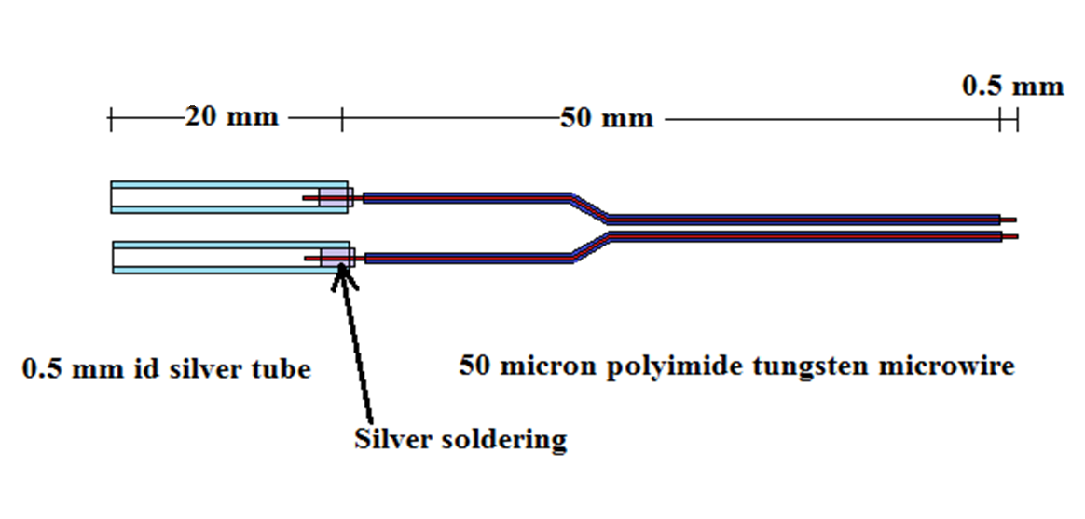
2.2.2 Bipolar Electrode
Figure 2-1. Bipolar tungsten electrode design with silver data port connections (left end) and exposed tungsten for muscle insertion (right end).
Electrodes were synthesized in-house out of polyimide insulated tungsten filament, AWG size 44, before each experiment began. In order to prepare the filaments, the final 0.5 mm of insulation was stripped off of a pair of approximately 15 cm long segments. The ends with the stripped insulation were the site for insertion into the muscle. The opposite ends were soldered onto silver tubes to allow for attachment to a TDT RA4PA pre-amplifier through which data could be acquired by a TDT System 3. The two prepped filaments were then bundled together with heat shrinkable PVC insulation tubing to form a single bipolar electrode. A schematic of the design is shown in Fig. 2.1. With careful trimming of about 1 cm from the insertion end and stripping of the insulation from the new end, electrodes could be reused for a total of about five animals before it became necessary to fabricate replacements.

2.2.3 Surgical Preparation and Initial Hearing Testing
Animals were sedated with a cocktail of 35 mg/kg ketamine and 7 mg/kg xylazine delivered by intramuscular (IM) injection, a dosage consistent with modern veterinary formulary for surgical anesthesia (Richard Fish, Peggy J. Danneman, Marilyn Brown, 2011). Level of sedation was evaluated every 10 minutes by manual testing of the palpebral and hind leg reflexes. For the palpebral reflex, the medial canthus of the eye where the upper and lower eyelids meet was gently touched with a surgical-gloved finger with the goal of visual observation of that eye blinking. For the hind leg reflex, one leg was manually withdrawn back away from its natural resting place close to the animal’s body with the goal of feeling resistance or withdrawal back towards the body. Either of these observations indicated that the level of sedation was approaching inadequate levels. Booster doses of ketamine were administered as necessary in whichever leg had least-recently received an injection to maintain general anesthesia. Temperature of the animals was measured via rectal thermometer and kept at safe levels through use of a heating blanket on a feedback loop.
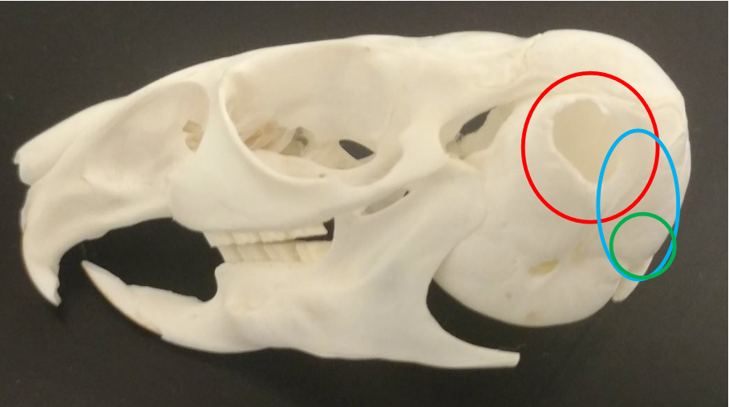
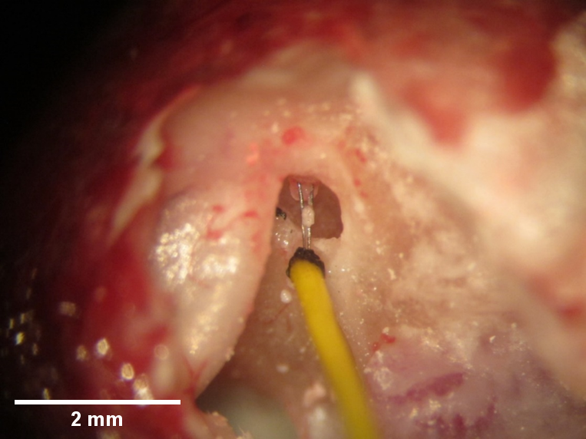
Once a state of general anesthesia was attained, the surgical approach began as shown in Fig. 2.2. A pinnectomy was performed via sharp dissection of the left ear to allow unobstructed access to the ear canal, revealing the region highlighted in red. The skin posterior to the site of the pinnectomy was opened to expose more of the auditory bulla, per the blue region. Hemostasis was achieved with the application of gauze and, in extreme cases, electrocautery. ART testing was performed at this stage using a wideband tympanometer (AT235h, Interacoustics, Denmark) to determine MEMR threshold levels. The animal’s head was held securely while a tympanometry probe was pressed against the ear canal opening. The device was activated through software and tested for the presence of the reflex at frequencies of 0.5, 1, 2, and 4 kHz. Animals without apparent MEMR activity were excluded from the study. After ART testing was completed, further flesh was cleared away via surgical scissors and scalpel to reveal the bone in the green region of Fig. 2.2. Hemostasis was again maintained to preclude the possibility of blood flow into the ear, and the skull was penetrated at that location with a dental drill. This perforation was widened to an approximately 1 cm diameter circle via medical scissors, wide enough to allow access within the bulla.
Figure 2-2. Chinchilla skull, marked with the sites for initial surgical entry (red), further exposure (blue), and skull-penetration target (green).
Figure 2-3. Electrode inserted into the chinchilla stapedius muscle.

2.2.4 Surgical Electrode Insertion
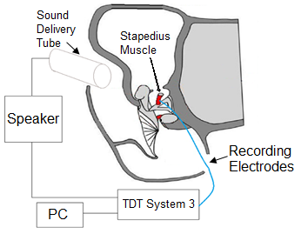
Once the skull was opened, a thin bony wall within the middle ear was removed through use of a dental drill in order to expose the stapedius muscle. Care was taken to ensure that the tympanic membrane and ossicular chain remained intact. Once the muscle was sufficiently exposed, a micromanipulator was used to insert a bipolar electrode directly into the stapedius muscle. Due to the miniscule size and fragility of the muscle, it was necessary to secure the wire in order to eliminate the risk of damaging the muscle through some motion in the electrode. The insulated segment of the electrode wires was fixed to the septa of the middle ear and to the skull of the animal with cyanoacrylate glue and small strips of paper, which became rigid when the glue dried. Figure 2.3 demonstrates the view seen inside an opened bulla after the insertion process with an electrode inserted properly into the muscle before finalizing the electrode’s fixation with glue. After insertion was finished, another wire electrode was inserted into the animal’s leg as a ground.
Figure 2-4. EMG electrode recording schematic including electronics for data acquisition and stimulus generation.

2.2.5 MEMR Threshold Determination
A schematic diagram of the experimental setup for acoustic stimulation is shown in Fig. 2.4. A sound delivery tube attached to a speaker was placed at the opening of the ear canal for stimulation. The stimulus was controlled using a TDT System 3 and BioSig software, which simultaneously acquired the EMG signal. The electrical activity of the muscle in response to increasing acoustic loads was measured while the animal was lightly anesthetized. A 50 Hz high pass filter and a 500 Hz low pass filter were applied to the signals to filter out noise.
Before testing, the speaker was calibrated with a probe microphone and SigCal software to ensure that the sound amplitude at the tympanic membrane was identical between animals. Each test consisted of a series of pure tone stimuli from the speaker controlled by the BioSig software. Repeated stimuli 50 ms in duration were delivered to the ear at a rate of three per second, and data was recorded in 150 ms windows starting with stimulus onset. 32 trials were averaged together for each combination of frequency and intensity. The frequencies tested were 1, 2, 4, and 6 kHz. Sound intensity for each frequency was varied from 50 to 110 dB SPL in 10 dB increments. The resulting signals were compared to determine the threshold at which an electrical response to stimulation was first visible. Animals were euthanized at the end of EMG testing with 1 mL of Euthasol (Pentobarbital Sodium 390 mg/ml and Phenytoin Sodium 50 mg/ml) administered intraperitoneally.

2.2.6 Data analysis
Interpretation of the data from the three clinical audiological tests is straightforward. Tympanograms measure the admittance of the tympanic membrane and output a graph of tympanic membrane compliance over a pressure range. The software automatically overlays the results on top of a curve from a healthy adult human along with grey shaded regions above and below indicating normal results. In the case of an ear infection, a result significantly outside the normal range will be obtained. If the tympanic membrane is perforated, the test will either fail completely or give highly anomalous results (as seen in a curve that is primarily flat, not fitting the sample “healthy range” watermarked behind the results) as tympanometry requires a stable pressurization of the ear canal. The ART testing software used directly outputs the determined reflex threshold in dB for a user-selected stimulus frequency. Because ART testing is an indirect test of the MEMR, it does not give any information about the strength or duration of muscle contraction. ABR testing gives a series of curves that must be visually inspected to determine the point at which a consistent response may be differentiated from the baseline noise. This point is the threshold for hearing as determined by monitoring signals from the brainstem. If ABR thresholds are elevated above what is expected, the animal has likely received some level of hearing damage and cannot detect noises below a certain level. Previous testing in chinchillas in our lab (data unpublished) established a healthy baseline average threshold of 45 ± 8 dB. A 10 dB elevation post-exposure would be considered significant hearing loss.
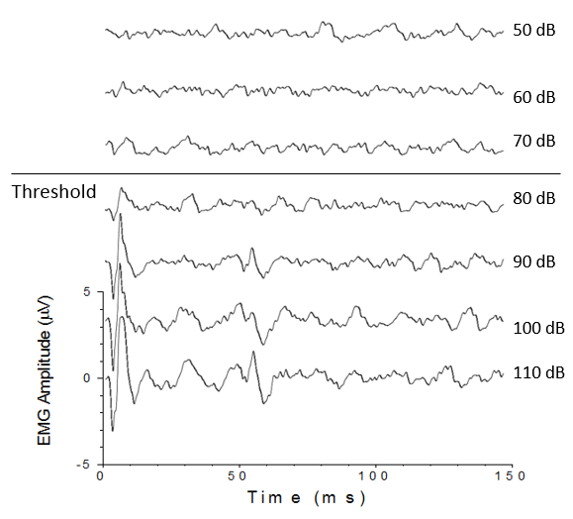
While some information can be gleaned from the raw signal, properly interpreting EMG signals requires a degree of post-processing. During the process of data acquisition, the signal goes through a notch filter of 60 Hz and a bandpass filter between 50-500 Hz. The amplitude of the signal represents the strength of the signal recruiting motor units and causing the muscle to contract. This signal strength does vary with the precise location of electrode insertion and with differences between subjects, however, so the amplitude is not sufficient to make comparisons between different animals. Increases in the amplitude can be seen in a filtered but otherwise unprocessed signal, shown in Fig. 2.5, corresponding to heightened tensing of the stapedius as the volume of the eliciting stimulus increases. It is possible to reasonably determine the threshold of activation from this, but not much else. Interpretations at this point are also subject to a degree of subjectivity depending on the interpreter; for instance, it would not be unthinkable for someone to judge 70 dB or 90 dB to be the true threshold in Fig. 2.5. In order to facilitate the interpretation of the EMG signal and remove some of this subjectivity, MATLAB was used for postprocessing.
Figure 2-5. Filtered but otherwise unprocessed EMG data over a stimulus intensity range from 50-110 dB.
Once data was imported into the MATLAB software, a script was applied to perform a series of functions on it. First, bias was removed by subtracting the mean. The signal then underwent full-wave rectification, taking the absolute value in order to preserve as much of the signal as possible. Since the typical signal begins with a trough before hitting a peak, half-wave rectification would have deleted that part of the signal, shifting latency measurements by a few miliseconds. Finally, a Paynter filter was applied to the signal to demodulate the amplitude and create an envelope. The Paynter filter was first proposed in 1970 for this purpose in EMG, clarifying the activation and deactivation times along with the average value of the rectified EMG of the target muscle, which corresponds to its average force of contraction (Gottlieb et al., 1970). The modified Paynter filter used in the MATLAB code paynter(τ,fs) results in the following output-over-input voltage transfer function T(s) where
τ = resistance*capacitance and s is a complex frequency variable (Platt et al., 1998):
$$T\left(s\right)=-\frac{\left(1+τs^{2}\right)}{\left(1+2τs\right)\left(1+1.2τs+1.6τ^{2}s^{2}\right)} (3)$$
In this study, the parameters used in MATLAB were τ = 400s and sampling rate fs = 24.39 kHz. The MATLAB code used can be found in Appendix A.
Figure 2.6 shows a set of EMG data going through this process, starting with the basic high-pass and low-pass filters from BioSig on top, then showing the signal post bias-removal and rectification in the middle, and finally the signal envelope after application of the Paynter filter on the bottom. For all cases, t=0 ms was the onset of acoustic stimulation and t=50 ms was the end of the stimulus. Looking at the point where the amplitude of the envelope exceeds the mean of the part of the signal outside of the region of anticipated muscle activation allows for a more objective determination of where the muscle response begins compared to looking at the raw signal. As stimulus onset was always t=0 ms, the time where the muscle response began was the same as the latency in milliseconds between stimulus onset and response.

Figure 2-6. Stages of EMG processing.

2.3 Results

2.3.1 MEMR Threshold in Chinchillas
As previously discussed, MEMR thresholds were determined both by direct EMG measurement of muscle activity through tungsten electrodes and through indirect ART testing. MEMR thresholds were determined by EMG at 1, 2, 4, and 6 kHz. Table 2-1 shows the EMG-obtained MEMR threshold results for the 14 animals tested in this part of the study. At 1 kHz the mean threshold was 63.6 ± 16.5 dB; at 2 kHz it was 70.0 ± 12.4 dB; at 4 kHz it was 71.4 ± 13.5 dB; and finally at 6 kHz it was 76.4 ± 13.9 dB.
ART testing determined thresholds at frequencies of 1, 2, and 4 kHz. Contrary to the EMG results, the tympanometer was not set up to determine a 6 kHz threshold. Table 2-2 shows these results. The threshold was 85.0 ± 15.4 dB at 1 kHz; 81.1 ± 11.5 dB at 2 kHz; and 73.9 ± 17.9 dB at 4 kHz. The threshold values for frequency values that were shared between EMG and ART testing are plotted on Fig. 2.7.
Figure 2-7. MEMR thresholds determined by ART testing and EMG.

Table 2-1 MEMR thresholds (dB) as determined through EMG
 | 1 kHz | 2 kHz | 4 kHz | 6 kHz
15-2-4 | 50 | 80 | 70 | 80
15-2-5 | 50 | 50 | 60 | 70
15-2-6 | 70 | 80 | 70 | 70
15-2-7 | 50 | 60 | 70 | 60
15-2-8 | 100 | 90 | 90 | 90
15-2-15 | 50 | 70 | 60 | 80
15-3-2 | 60 | 60 | 60 | 60
15-3-3 | 50 | 60 | 80 | 80
15-3-4 | 70 | 80 | 100 | 100
15-3-8 | 90 | 90 | 80 | 80
15-3-9 | 80 | 70 | 80 | 100
15-3-10 | 60 | 60 | 70 | 60
15-3-11 | 50 | 60 | 50 | 60
15-3-13 | 60 | 70 | 60 | 80
Mean | 63.6±16.5 | 70.0±12.4 | 71.4±13.5 | 76.4±13.9

Table 2-2 MEMR thresholds (dB) as determined through ART testing
 | 1 kHz | 2 kHz | 4 kHz
15-2-4 | 100 | 70 | 55
15-2-5 | 80 | 95 | 90
15-2-6 | 60 | 70 | 50
15-2-7 | 100 | 80 | 55
15-2-8 | 100 | 90 | 90
15-2-15 | 65 | 80 | 70
15-3-2 | 100 | 80 | 90
15-3-3 | 95 | 100 | 80
15-3-4 | 65 | 60 | 50
15-3-8 | 65 | 90 | 50
15-3-9 | 95 | 85 | 85
15-3-10 | 95 | 65 | 90
15-3-11 | 90 | 85 | 90
15-3-13 | 80 | 85 | 90
Mean | 85.0±15.4 | 81.1±11.5 | 73.9±17.9

2.3.2 Comparison of MEMR Threshold as Determined by ART Testing vs EMG
At all frequencies where thresholds were found, the ART-testing-determined mean threshold was higher than that determined via EMG. The most profound difference was 21.4 dB at 1 kHz, followed by 11.1 dB at 2 kHz and 2.5 dB at 4 kHz. A two-tailed paired t-test with a 95% confidence interval was applied to compare the results at each frequency. There was a significant difference at both 1 kHz and 2 kHz with p = 0.005 and p = 0.04, respectively. For 4 kHz, there was not a significant difference between EMG and ART testing results with p = 0.73.
Looking at individual specimens, the variance between methods seems even more profound. While ART testing results were always higher than EMG results on average, for some subjects this trend was reversed. Among the 14 animals tested, the highest discrepancies were 50 dB higher ART testing results than EMG in animals 15-2-4 and 15-2-7 at 1 kHz and 50 dB higher EMG results than ART testing in 15-3-4 at 4 kHz.

2.3.3 MEMR Latency
Latency is the time between stimulus onset and MEMR activation and is an important factor in determining whether or not the reflex will be active in time to protect from impulse noise. The latency in milliseconds is given for both the threshold activation level in Table 2-3 and the highest stimulus level tested in Table 2-4. The highest latencies with reference to the threshold level were 10.41 ms at 1 kHz; 9.01 ms at 2 kHz; 9.61 at 4 kHz; and 7.91 at 6 kHz. The minima were 6.41 ms at 1 kHz; 2.80 at 2 kHz; 3.00 at 4 kHz; and 3.00 at 6 kHz. At all frequencies other than 6 kHz, the latency at the MEMR threshold was lower compared to the latency at the highest level tested, 110 dB. In addition, the latency tended to decrease as the eliciting stimulus frequency increased.

Table 2-3 MEMR latency (ms) measured at activation threshold
 | 1 kHz | 2 kHz | 4 kHz | 6 kHz
15-2-4 | 7.11 | 2.80 | 3.00 | 3.00
15-2-5 | 8.71 | 8.11 | 6.61 | 7.11
15-2-6 | 8.11 | 6.81 | 6.41 | 6.61
15-2-7 | 7.01 | 6.41 | 5.81 | 6.41
15-2-8 | 6.91 | 6.81 | 6.01 | 6.01
15-2-15 | 10.41 | 7.31 | 7.51 | 5.81
15-3-2 | 7.51 | 6.61 | 6.41 | 6.21
15-3-3 | 8.51 | 7.01 | 6.61 | 6.81
15-3-4 | 9.01 | 7.71 | 9.41 | 6.21
15-3-8 | 8.51 | 7.91 | 6.21 | 7.91
15-3-9 | 9.41 | 9.01 | 9.61 | 3.00
15-3-10 | 6.41 | 6.01 | 5.41 | 5.31
15-3-11 | 8.51 | 6.41 | 5.91 | 5.61
15-3-13 | 8.71 | 6.81 | 6.91 | 6.01
Mean | 8.20±1.10 | 6.84±1.41 | 6.56±1.62 | 5.86±1.37

Table 2-4 MEMR latency (ms) measured at 110 dB
 | 1 kHz | 2 kHz | 4 kHz | 6 kHz
15-2-4 | 6.31 | 6.01 | 5.81 | 2.80
15-2-5 | 7.11 | 6.61 | 6.61 | 7.11
15-2-6 | 7.91 | 5.41 | 6.61 | 7.01
15-2-7 | 5.41 | 5.41 | 5.61 | 5.61
15-2-8 | 6.61 | 5.41 | 5.41 | 5.41
15-2-15 | 8.51 | 6.61 | 7.91 | 6.21
15-3-2 | 5.41 | 5.41 | 5.41 | 5.41
15-3-3 | 5.41 | 5.41 | 6.01 | 6.81
15-3-4 | 7.51 | 7.01 | 6.81 | 8.51
15-3-8 | 7.91 | 6.41 | 5.61 | 5.61
15-3-9 | 8.51 | 7.91 | 7.01 | 2.80
15-3-10 | 5.61 | 5.11 | 4.91 | 5.11
15-3-11 | 7.11 | 5.41 | 6.61 | 6.61
15-3-13 | 7.21 | 6.61 | 6.21 | 6.61
Mean | 6.89±1.13 | 6.05±0.82 | 6.18±0.80 | 5.83±1.56

Figure 2-8. MEMR latency time at each frequency tested.

Finally, statistical analysis was performed on the latency data at threshold level and at 110 dB for each frequency in the form of a two-tailed paired t-test with a 95% confidence interval. There was not a statistically significant difference between the latency at the threshold and at 110 dB for either 4 kHz or 6 kHz eliciting stimuli. There was a significant difference between the two, in both cases a decrease in latency at the 110 dB level, at 1 kHz with a p value below 0.0001 and at 2 kHz with a p value of 0.03. At 4 kHz and 6 kHz the p values were 0.31 and 0.92, respectively.

2.4 Discussion

2.4.1 Discrepancies Between EMG and ART Testing Results
Per 2.3.2, there was not good agreement between EMG and ART testing results at 1 kHz or 2 kHz. There was not a significant difference between the two methods at 4 kHz. A few possibilities can explain this. ART testing might be less sensitive at some frequencies, not detecting the MEMR if it isn’t sufficiently strong to alter tympanograms. This would be consistent with the trend of increasing EMG amplitude as stimulus amplitude increases, which suggests that muscle activation is weak at the threshold level but gets stronger at higher stimulus levels. EMG, on the other hand, should detect even a very weak reflex activation because it directly measures the muscle’s activity. This would be consistent with the results of a rat study of the MEMR which compared EMG-derived thresholds to visually-determined thresholds through a microscope (Murata et al., 1986). Murata et al. found that there was a minimum 10 dB increase in the visually-determined stapedius reflex threshold compared to the EMG thresholds. If this is the case, it could be a positive aspect of EMG for it to be able to pick up a reflex with heightened sensitivity; it could also mean that EMG is giving false positives in which an electrical signal is present but is not sufficient to fully activate the muscle.
It is worth noting that reflex thresholds have been found to be dependent on the stimulus duration; at 25 ms duration, 120 dB may be needed to elicit a MEMR response when 90 dB produces a response at 100 ms and 80 dB is sufficient at 1000 ms, all other factors kept the same (Morgan et al., 1977). This potentially complicates comparisons between methods or studies. EMG in our study was elicited with a 50 ms stimulus whereas the measuring point for ART testing was 4.5 ms after stimulus onset. This could also explain the discrepancy between ART testing results and EMG results.

2.4.2 Comparison to Existing Literature
There are very few existing studies of the chinchilla MEMR. A collaboration between Kent State University and Ohio State University studied the reflex by analyzing the cochlear microphonic in response to a 0.5 kHz eliciting tone (Gerhardt et al., 1979). This method involves recording the cochlear microphonic, a response to sound generated by the hair cells and measurable at the round window. This response is measurable instantly when a sound is input into an ear, but if the MEMR triggers the response, it will decline in magnitude after the latency period. By looking at whether the cochlear microphonic measurements stayed steady or were eventually damped by the MEMR, its presence can be determined. For the two control animals tested, the mean reflex threshold was 72.7 dB, and for the remaining six animals which went through further testing to cause hearing damage, the mean healthy reflex threshold was 72.8 dB. Standard deviations were not reported in that study, but those numbers are consistent with the average thresholds of 63.6±16.5 dB, 70.0±12.4 dB, and 71.4±13.5 dB found via EMG at 1, 2, and 4 kHz.
In humans, a study using ART testing with a broadband stimulus determined a MEMR threshold of 84.9 ± 7.8 dB (Moulin et al., 1993). A similar study estimated the reflex threshold to be between 82-87 dB using ART testing (Aiken et al., 2013). Two studies actually involved EMG. One was done during stapedectomy surgery to repair otosclerosis (Djupesland, 1965). Rather than determining a threshold, it looked in general at stimuli that can cause the stapedius and tensor tympani to contract, including voluntary closure of the eyes, air jets, swallowing, and vocalization. The major contribution of the noise-induced portion of that study was to show that there is a significantly reduced latency in the stapedius compared to the tensor tympani between stimulus onset and contraction, approximately 10 ms compared to 80-280 ms. This was one piece of evidence showing that the stapedius is significantly more involved in protecting the ear from sounds compared to the tensor tympani. The other EMG study in humans was performed in otitis media patients with one healthy and one diseased ear (Warmuth et al., 2014). The healthy ear was stimulated while EMG observations of the contralateral reflex were made of the diseased ear. One second acoustic bursts at 2 kHz were used to elicit the MEMR. A weak response was observed at 100 dB, with progressively higher amplitudes of electrical response measured at 105, 110, 115, and 120 dB; as no amplitudes below 100 dB were tested, this cannot be taken as a true determination of MEMR threshold.
One rat study tested three different methods, EMG, visual inspection of muscle motion, and the cochlear microphonic in response to 500 ms tone bursts (Murata et al., 1986). The minimum threshold found was 55 dB at 3 kHz with thresholds higher on either side of that frequency up to 100 dB at 0.6 and 10 kHz. This was 10 dB lower than the stapedius reflex found by observing muscle contractions. Cochlear microphonic results agreed closely with EMG results at most frequencies, only significantly departing at 10 or 12 kHz, where the cochlear microphonic underestimated the reflex threshold by 5-10 dB compared to EMG. Cats measured through EMG exhibit ipsilateral MEMR at thresholds between 93-110 dB between 0.25-8 kHz and contralateral responses approximately 5 dB elevated from those values with the highest thresholds at 0.25 and 0.5 kHz and the lowest at 1 or 2 kHz (Guinan et al., 1987). This pattern is different from the reasonably flat frequency-threshold relation found in chinchillas and was elevated at all levels compared to the chinchilla threshold.
Regarding latency, a human study using EMG found that latency was approximately 10 ms at stimulus amplitudes of 120 dB, higher than the maximum tested here of 110 dB (Djupesland, 1965). A separate study tested it at the reflex threshold and reported as long a delay as 76 ms (Terkildsen, 1960). Our findings in chinchillas had significantly less latency, around 6 ms, but were comparable to Djupesland’s number. The closest available results in chinchillas calculated the latency between a reflex-eliciting stimulus and the inhibition of DPOAE results (Wolter et al., 2014). DPOAE is an acoustic response generated by the response of inner ear hair cells when a pair of tonal stimuli is presented and is used to verify healthy cochlear activity. The study tested both control animals and chinchillas with severed ear muscle tendons; in the control animals, there was a latency of 96±16 ms at 0.5 kHz and 37±15 ms at 4.5 kHz. Both of these were elevated compared to the latencies found in this study but may not be directly comparable as they are based on the reflex’s impact on a different test, which may introduce additional lag time.

2.4.3 Surgical Electrode Insertion Success Rate
The surgical procedure for accessing the stapedius is difficult as the ossicles and middle ear muscles are small and fragile. In the course of drilling away the bone needed to expose the stapedius, a slip of the hand could cause the destruction of the bones of the middle ear, rendering the animal deaf on that side and making experimentation impossible. This resulted in a not insignificant number of failed tests, in which electrode insertion was never successfully achieved. When this occurred, the ear on the other side of the animal was operated on and insertion was attempted there. This did in some cases allow for effective testing, but efforts to reduce the failure rate became a major focus of this project after it was started.
This study was performed prior to the acquisition of a dedicated surgical space in the laboratory. This acquisition, between the performance of this work and that described in chapter 3, helped in minimizing potential distractions in the course of the surgical insertion. Techniques were developed to minimize the chance of damaging the ossicles, including bracing the arm holding the drill against a surface to improve the drill’s stability and designing, manufacturing, and using a special operating platform that allows the animal to be rotated and angled to allow for the best possible entrance angle for the drill. The procedures for fixing the electrodes in place were also improved; initially, only putty was used for this purpose, but the fixation was not adequate to keep the electrode in place. These changes led to a significantly higher rate of success in subsequent electrode studies.

2.4.4 Study Limitations
With the level of disagreement between the two methods used, this study would have greatly benefited from an additional method of testing the MEMR threshold in order to verify whether ART testing or EMG was more accurate. One possibility would be utilizing the cochlear microphonic as in Gerhardt’s study (1979). Another downside of EMG for MEMR measurement is that only the electrical activity of the muscle is measured; the actual force output by the muscle is still unknown. It would be difficult to fit a force transducer into the ear, but if possible it would be valuable to correlate the electrical activity with the actual force output of the muscle. Laser Doppler vibrometry (LDV) is an alternative option for measuring the motion of the ossicular chain during muscle activation.

Behavior of Middle Ear Muscle Reflex in Response to Blast Overpressure

3.1 Introduction
Blast trauma is a major cause of hearing damage. Although a blast exposure only lasts for a few milliseconds, the extreme pressure involved can rupture ear drums, disarticulate the ossicular chain, or even cause damage to the cochlea, auditory nerve, or brain. Because a blast wave is so ephemeral in duration and intense in energy, its mechanisms of damage may be different from those of other dangerously loud sounds. It is thus important to study what precisely goes wrong in an animal’s ears when impacted by a blast wave.
In order to study how the ear reacts to blasts, an anechoic blast chamber was used. Within this chamber is an apparatus, pictured in Fig. 3.1, that pressurizes a small cylindrical chamber with N₂ gas. The only outlet of this chamber is an orifice that can be blocked with a polycarbonate film. By pressurizing the film to the point of its rupture, a blast overpressure wave between 1-30 psi is generated. To control the blast level incident on a specimen, varying film thicknesses create different original blast amplitudes and samples may be suspended a variable distance from the orifice in order to control how much energy dissipates before it reaches them. This method has been previously established in our lab for modeling blast damage with human cadaver specimens (Engles et al., 2017). The chamber is lined with polyurethane foam and is contained within a room that is closed off for testing, providing two degrees of separation between the operator and the blast.
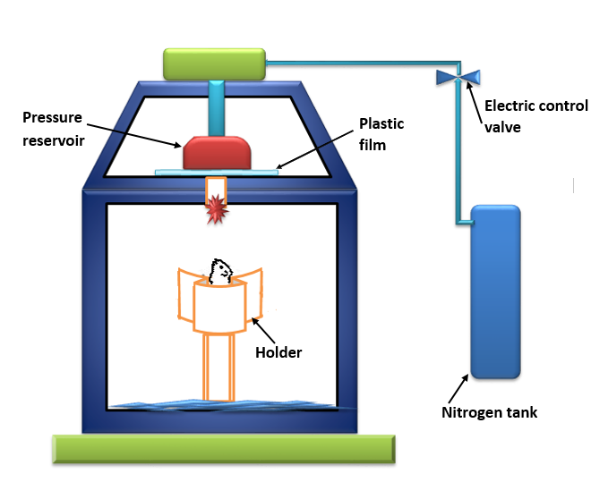
Figure 3-1. Blast apparatus schematic.

3.2 Experimental Setup

3.2.1 Chinchilla Specimens
Healthy adult chinchillas (Chinchilla lanigera, n=10) of mixed sex weighing between 575 and 700 grams were included in this study. The study protocol was approved by the Institutional Animal Care and Use Committee of the University of Oklahoma and met the guidelines of the National Institutes of Health. Animals were acquired from Moulton Chinchilla Ranch, Rochester, MN. They were housed at OU’s animal facility and given a minimum of three days there to acclimate before being tested.

3.2.2 Sedation and Electrode Insertion
Animals were sedated as described in 2.2.3. In short, an initial 35 mg/kg ketamine and 7 mg/kg xylazine dose was administered IM, followed by booster doses of ketamine when the animals approached consciousness. Degree of sedation and temperature were monitored throughout testing. Once general anesthesia was attained, animals were implanted with bipolar eletrodes in preparation for EMG.
Electrode insertion was as described in 2.2.3 and 2.2.4. In short, a pinnectomy was performed and flesh was cleared away from the auditory bulla. Tympanic membrane integrity was verified through tympanometry. A dental drill was used to create a hole in the bulla with further bony septa removed to create a straight path for the electrode. After insertion via micromanipulator, the electrode was secured via cyanoacrylate glue.

3.2.3 Blast Exposure
Once prepped for EMG, the chinchilla was placed in a specially designed holder made of PVC pipe as shown in Fig. 3.2. This holder has an internal diameter of 4 inches, wide enough to comfortably fit even large chinchillas. Padding was added to keep smaller animals secure. An adjustable false bottom was used to control how much of each animal was exposed through the opening of the holder with a height selected such that only the head emerged. A sensor holder (right side of the figure) was placed so that a PCB Piezotronics (Depew, NY) model 102B16 piezoelectric pressure sensor was at the same height as the animal’s ears. A door in the side allowed access to the animal’s legs in case further doses of sedative were needed. With the animal firmly secure within the holder, it was transported to the anechoic chamber and the holder was secured to a height-adjustable post within.
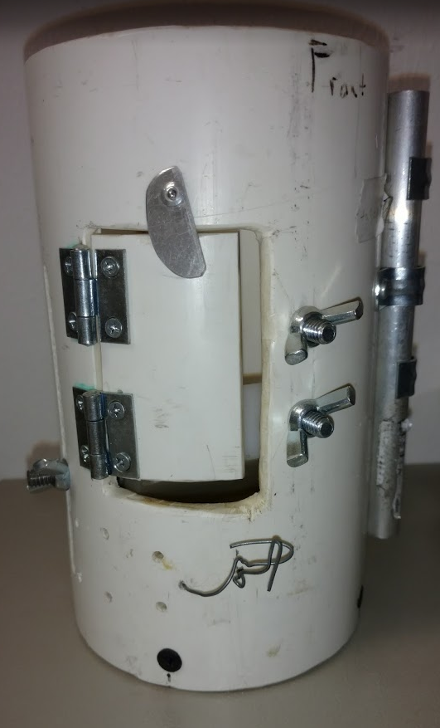
With the animal secure, the blast apparatus was loaded with polycarbonate film, the thickness of which depended on the desired blast amplitude. The combination of film thickness (either 0.13 or 0.25 mm) and distance between the apparatus and the test subject determined the blast amplitude at the point of the animal’s ear, which was recorded via the pressure sensor. The anechoic chamber was then sealed and the blast apparatus was activated remotely. Each animal was exposed to three blasts: one at approximately 1-3 psi (6.9-20.7 kPa or 170.8-180.3 dB); one at 3-6 psi (20.7-41.4 kPa or 180.3-186.3 dB); and one at 6+ psi (41.4+ kPa or 186.3+ dB). Due to the inherent variability of the membrane-rupture blast generation method in the open field, these ranges corresponded to the approximately ±2 psi variability in blast amplitude between blasts created with identical setups. Previous blast research determined the open field tympanic membrane rupture threshold of chinchillas to be 9.1 ± 1.7 psi or 62.7 ± 11.7 kPa (Gan et al., 2016). These three ranges were selected based on that; the lowest range was at least two standard deviations away from the mean rupture threshold, the middle range was close enough to the threshold that rupture was fairly likely, and the final blast intensity was intense enough to almost certainly rupture the tympanic membrane and cause significant hearing damage without causing fatalities. For each blast, data from the pressure sensor and electrode were simultaneously recorded through separate channels of a cDAQ-9174 (National Instruments, Austin, TX) 4-channel compact data acquisition system wired into a model 482C (PCB Piezotronics, Depew, NY) signal conditioner, controlled by NI LabVIEW SignalExpress software. Animals were euthanized at the end of EMG testing via intraperitoneal administration of 1 mL of Euthasol (Pentobarbital Sodium 390 mg/ml and Phenytoin Sodium 50 mg/ml).
Figure 3-2. Chinchilla blast holder.

3.3 Results
Blast pressure data generally had a good fit with the ideal open-field Friedlander waveform shown in Fig. 1.2 with a near-instantaneous overpressure peak decreasing back to ambient levels then dipping below ambient for an underpressure phase before returning to ambient values. A pair of blast waveforms are given in Fig. 3.3, one from the lowest (<3 psi) pressure group and one from the highest (>6 psi). In both cases, the underpressure was less than half of the magnitude of the overpressure at their respective minima and maxima, although the higher pressure (left) case more closely resembles the Friedlander curve in that its underpressure trough is shallow. The overpressure duration was about 0.5 ms in both cases whereas the underpressure duration was slightly longer in the higher pressure case compared with the underpressure duration of the lower pressure case. These blast pressure trends were consistent and repeatable through the study.

Figure 3-3. Blast pressure data for two animals at different blast intensity levels corresponding to the >6 psi (left) and <3 psi (right) cases.

Raw blast EMG results can be seen in Fig. 3.4. While the blast overpressure waveform is not depicted, in each case the first overpressure peak occurred at t=0 ms; this range of EMG data was chosen to simplify the determination of latency such that the time in ms of the first EMG peak was identical to the latency time between blast overpressure presentation and EMG response. There is significant waveform variability between different animals and blast exposures in contrast to acoustic EMG’s repeatability. EMG amplitude is also very variable between animals, although it can be reasonably used to judge muscle contraction strength within a single animal. Fig. 3.5 demonstrates this in two animals over multiple blast exposures; the relationship between EMG response amplitude and blast intensity is nearly linear. Comparisons
Figure 3-4. Raw EMG blast results from four different animals.
Figure 3-5. EMG amplitude (μV) vs blast intensity (psi).

between animals prove difficult, however. The highest blast level for the top animal in Fig. 3.5 was 5.7 psi, which elicited a 1.2 mV response. The highest blast experienced by the second animal was over 8 psi, larger than any the first animal was subjected to, yet its response was only 1 mV. Fig. 3.6 shows the EMG amplitudes for the animals tested broken down into low intensity (<3 psi), medium intensity (3-6 psi), and high intensity (>6 psi) pressure levels.
Latency between blast overpressure onset and EMG response was also measured. The time between the Friedlander waveform peak and the first EMG peak was defined as the latency time as per Fig. 3.7. Latency for all ten animals tested is given in Fig. 3.8. There is no readily apparent relationship between latency and blast intensity at the levels tested. The average latency was 4.75 ± 3.19 ms.
Figure 3-6. EMG response amplitude in the three blast intensity groups tested.

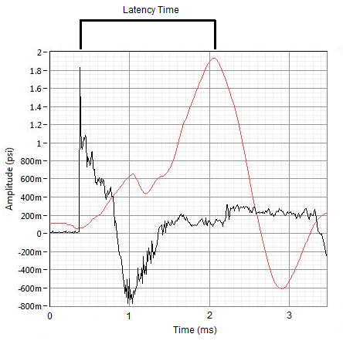

Figure 3-7. Determination of blast MEMR latency as the difference between the overpressure peak (black) and the first EMG peak (red).
Figure 3-8. Latency of the MEMR at different blast intensities.

3.4 Discussion

3.4.1 EMG Amplitude and Muscle Response Strength
Because the intensity of the blasts (170+ dB) used in this study is significantly higher than the threshold level for the chinchilla MEMR (approximately 60-75 dB), there were no cases where a blast did not lead to a MEMR response. Without any trials without responses, little can be said about the MEMR threshold. This left two main EMG parameters for analysis: response amplitude and latency. As shown above in Fig. 3.5, the variability between different animals renders comparisons of EMG amplitude problematic. However, EMG amplitude has been studied as a method of estimating response strength within individuals (Warmuth et al., 2014). Humans undergoing surgery were tested with an electrode in the stapedius muscle with an end goal of estimating ideal cochlear implant tuning parameters. It is possible that with further data something similar could be determined about the strength of the chinchilla MEMR.

3.4.2 Blast MEMR Latency
One major concern regarding the MEMR in blast scenarios is whether or not the latency between blast exposure and stapedius activation is fast enough for the reflex to provide its protective mechanism before damage occurs. In pressure data gathered in this study, the initial overpressure generally lasted 0.5 ms and the underpressure an additional 0.5-1 ms after that. Because the overpressure and underpressure are the principal mechanisms behind primary blast injury, the type of blast injury most responsible for damage to air-containing organs like the ear, this 1-1.5 ms window is crucial for protecting hearing (Zhao et al., 2015). It is worth noting that the pressure measurements taken here were recorded at the entrance to the ear canal and that some time is necessary for the pressure to propagate through the ear canal and across the ossicular chain. While a detailed finite element chinchilla blast model was not available, a human model using data from the same blast generation apparatus used here was able to estimate the additional time necessary for this propagation (Leckness et al., 2018). According to this model, it takes 0.1 ms in a human between the onset of overpressure at the ear canal and the commencement of motion in the stapes in response to that pressure. Assuming this blast propagation time is similar in magnitude in chinchillas, most of the blast waves observed in this study would have gone through both overpressure and underpressure with enough time for the impact of the underpressure to reach the stapes within approximately 1.6 ms. Comparing this to the average MEMR latency of 4.75 ± 3.19 ms found here for the blast case, it is likely that most or all of the mechanical damage from a blast will occur before MEMR activation. Despite having lower MEMR latency than some other animals per section 2.4.2, the chinchilla stapedius still does not respond quickly enough when activated by an impulse overpressure.

3.4.3 Study Limitations
One possible explanation for the high variability in waveforms between animals is blast interference with the electrode and wiring. Preliminary acoustic studies did have some interference at high stimulus levels from the speaker stimuli, but the filters used were designed in part to remove that noise. While attempts at that were made here as well, it is possible that better data could be obtained with either better-designed filters or more noise insulation for the wiring.
While this study corroborates the current understanding of the MEMR which suggests that protection from blast damage is unlikely due to latency, it does not rule out protection in a warned-stapedius case. It is possible that a reflex activating stimulus presented before blast onset could result in protection from damage, but that exceeded the scope of this study. This model could be easily adapted in the future to test that possibility by adding a MEMR-eliciting sound in advance of the blast wave.

Use of Electromyography to Quantify Level of Hearing Damage from Prolonged High Intensity Sound Exposure

4.1 Introduction
High-intensity noise exposure is also a major cause of hearing damage. Most commonly, people are exposed to intense noise in their workplace. Concerts, lawn mowers, and even headphones can potentially produce dangerous levels of sound as well. There are a variety of studies on how much the hearing threshold can shift after intense sound exposure, but these generally stay below 125 dB and involve days or weeks of repeated exposure. Due to the highly invasive nature of EMG measurement of the MEMR, it is not possible to insert the electrode before a multiple day long study without significant medical intervention to deal with both pain and chance of infection. In order to circumvent this issue, sound amplitudes above 130 dB were selected in order to cause hearing damage in only a single exposure session. The goals were to establish a single-day noise exposure model for hearing damage in chinchillas, compare the shift in hearing level to the shift in MEMR threshold after exposure, and analyze changes in the MEMR post-exposure.

4.2 Experimental Setup

4.2.1 Chinchilla Specimens
Healthy adult chinchillas (Chinchilla lanigera, n=8) of mixed sex weighing between 560 and 865 grams with a mean and standard deviation of 644.4 ± 96.3 g were included in this study. The study protocol was approved by the Institutional Animal Care and Use Committee of the University of Oklahoma and met the guidelines of the National Institutes of Health. Animals were acquired from Moulton Chinchilla Ranch, Rochester, MN. They were housed at OU’s animal facility and given a minimum of three days there to acclimate before being tested.

4.2.2 Pre-testing
Animals were sedated as described in 2.2.3; an initial 35 mg/kg ketamine and 7 mg/kg xylazine dose was administered IM, followed by booster doses of ketamine when the animals approached consciousness. Degree of sedation and temperature were monitored throughout testing.
Electrode insertion was as described in 2.2.3 and 2.2.4. In short, a pinnectomy was performed and flesh was cleared away from the auditory bulla. Tympanic membrane integrity was verified through tympanometry. A dental drill was used to create a hole in the bulla with further removal of bony septa to create a straight path for the electrode. After insertion via micromanipulator, the electrode was secured via cyanoacrylate glue.
ABR was performed to determine healthy hearing levels. A pair of needle electrodes were inserted subcutaneously at the cranial vertex and mastoid process. These electrodes were wired into an RA4PA Medusa Preamp, part of the TDT System 3. Stimulus was controled by TDT’s BioSig software. The test was run at 0.5, 1, 2, 4, 6, and 8 kHz, each of which was stepped in 5 dB intervals between 0-80 dB. The approximate hearing level at each frequency was defined as the lowest amplitude sound stimulus that elicited the recurring 5-peak waveform typical of ABR. After ABR, acoustic EMG was performed as in 2.2.5 to determine MEMR thresholds at 1, 2, 4, and 6 kHz with amplitudes ranging from 50-110 dB with a 10 dB step.

4.2.3 High Intensity Noise Exposure
The animals was then transferred to a sound-insulated chamber, shown in Fig. 4.1. The EMG electrodes were left inserted in the stapedius, and care was taken to secure them to the platform to prevent them from being jostled out of place. Within this chamber, a Pyle PH44 mid-tweeter controlled by a TDT System 3 was used for stimulus generation (Pyle, Brooklyn, NY). A platform allowed the animal to be positioned with one ear directly next to the speaker. Stimulus intensity at the location of the closest ear was verified via probe microphone. Only that ear was considered in post-exposure tests.
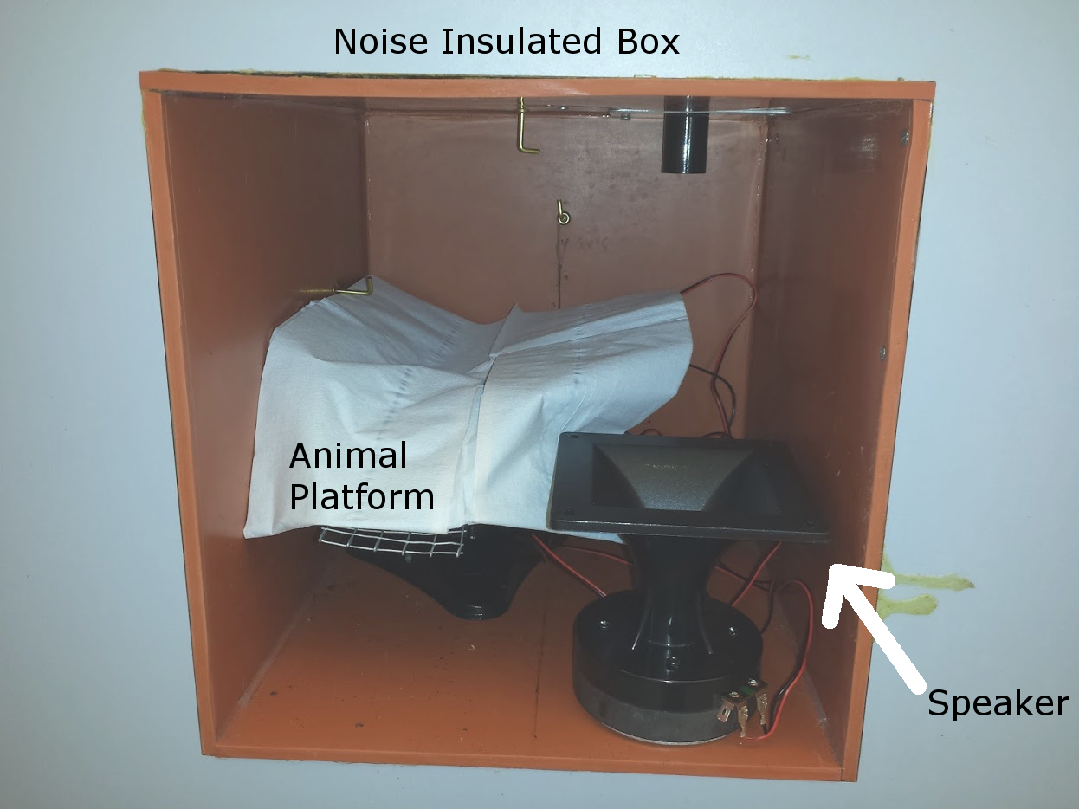
Animals were divided into one of two groups. One group (n=5) was exposed to one hour of 130 dB sound while the other (n=3) was exposed to two hours. The sound was presented as 5 second pulses of 2 kHz pure tone with a silent period of 1.67 seconds between each pulse included due to a software limitation preventing constant application of sound. Animals were checked every 15 minutes for level of consciousness, even while in the exposure chamber. One of the connections between the TDT System 3 and the speaker was disconnected before opening the door for this check in order to temporarily stop the sound. A booster shot was on hand when this was done, so even if drug administration was needed the interruption should not have lasted longer than a minute.
Figure 4-1. Noise insulated chamber for sound exposure.

4.2.4 Post-testing
After noise exposure, post-tests were performed with both ABR and EMG over the same frequencies described in 4.2.2 to determine the extent of damage caused by the exposure. Both the ABR and EMG shifts were so pronounced that the previously described stimulus intensity ranges were often insufficient to provoke responses. To counteract this, post-tests were performed over an expanded range going up to 120 dB at maximum for ABR and 130 dB maximum for EMG. Tests were done in the ear that had been directly adjacent to the speaker in the noise insulation box.
After post-testing, 1 mL of Euthasol (Pentobarbital Sodium 390 mg/ml and Phenytoin Sodium 50 mg/ml) was administered intraperitoneally for euthanasia. Analysis of ABR and EMG results was performed as described in previous studies.

4.3 Results
Noise exposure universally caused a substantial increase in both MEMR and ABR thresholds. Figure 4.2 shows pre-exposure EMG waveforms on the left and post-exposure on the right. Stimulus levels in both cases range from 90-110 dB. The peak-to-peak amplitude before noise exposure is approximately double compared to after exposure, and there was no response at all at 100 dB or above after noise exposure. In addition, the duration of the response is substantially decreased post-exposure. A comparison of ABR results before and after exposure between 60-80 dB can be seen in Fig. 4.3. There is, again, a stark difference between pre-exposure and post-exposure responses to identical eliciting stimulus levels.

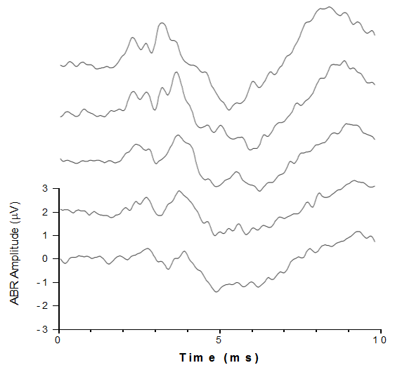
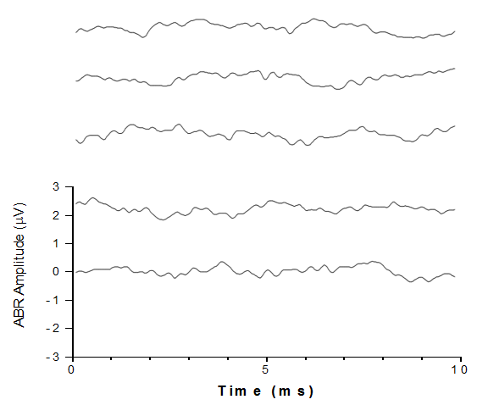
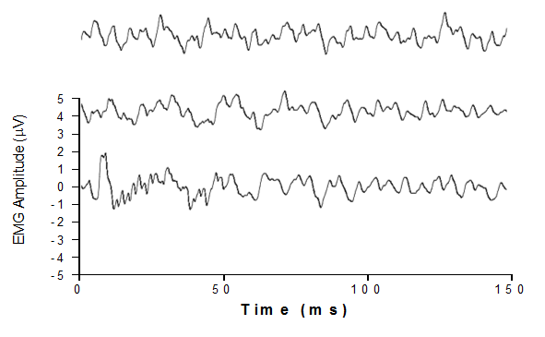
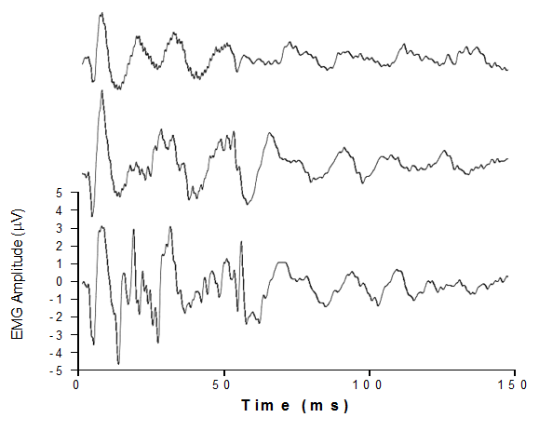
Figure 4-2. Comparison between pre- (left) and post- (right) 1 hour noise exposure ABR behavior in response to eliciting stimuli ranging from 60 dB (bottom) to 80 dB (top) in 5 dB increments.
Figure 4-3. Comparison between pre- (left) and post- (right) 1 hour noise exposure MEMR behavior in response to eliciting stimuli of 90 dB (top), 100 dB (middle), or 110 dB (bottom).

Table 4-1 Average MEMR thresholds (dB) at each frequency
 | Pre-exposure | 1-Hour | 2-Hour
1 kHz | 64.0±19.0 | 115.0±13.8 | 122.0±13.0
2 kHz | 68.0±14.8 | 120.0±12.6 | 126.0±8.9
4 kHz | 64.0±16.5 | 130.0±0 | 124.0±8.9
6 kHz | 79.0±24.7 | 128.3±4.1 | 126.0±8.9

Table 4-2 Average ABR thresholds (dB) at each frequency
 | Pre-exposure | 1-Hour | 2-Hour
0.5 kHz | 38.5±11.3 | 90.8±6.6 | 100.0±10.0
1 kHz | 39.0±9.9 | 98.3±4.1 | 100.0±12.7
2 kHz | 42.5±7.5 | 102.5±2.7 | 103.0±12.0
4 kHz | 31.0±6.6 | 110.8±3.8 | 108.0±10.4
6 kHz | 37.0±16.5 | 110.8±7.4 | 108.0±8.4
8 kHz | 35.0±17.0 | 108.3±8.8 | 116.0±9.6

Figures 4.4 and 4.5 show the MEMR and hearing level thresholds before and after exposure. The biggest differences in MEMR threshold between the 1-hour and 2-hour exposure times were at 1 and 2 kHz. For most animals, the slight increasing trend in the MEMR threshold continued after exposure; this did not hold true for all of the 2-hour animals, however. The average threshold with standard deviation can be found in Table 4-1 for MEMR and Table 4-2 for ABR. Across all frequencies tested, pre-exposure animals had an average MEMR threshold of 68.8 dB and ABR of 37.2 dB. After one hour of exposure these increased to 123.4 dB and 103.6 dB, respectively, and after two hours they increased to 124.5 dB and 105.8 dB.
Figures 4.6 and 4.7 show the shift in MEMR and hearing level threshold after exposure. Across all frequencies, the average MEMR threshold shift was 54.7 dB for one hour and 55.9 dB for two hours. For ABR, the shift was 65.1 dB for one hour and 67.3 dB for two hours. Unpaired t tests were performed between 1-hour and 2-hour points at each frequency. For MEMR, there was no frequency that had a significant difference in threshold shifts between exposure times.
Figure 4-4. ABR-determined MEMR Threshold Levels Before and After Noise Exposure.
Figure 4-5. EMG-determined MEMR Threshold Levels Before and After Noise Exposure.

Figure 4-6. EMG-determined Shift in MEMR Thresholds.

Figure 4-7. ABR-determined Shift in MEMR Thresholds.

The P values were as follows: at 1 kHz, 0.96; at 2 kHz, 0.84; at 4 kHz, 0.38, and finally at 6 kHz, 0.54. Similarly, ABR threshold shift results were not statistically significantly different at any frequency. At 0.5 kHz the P value was 0.74, at 1 kHz it was 0.81, at 2 kHz it was 0.86, at 4 kHz it was 0.53, at 6 kHz it was 0.92, and at 8 kHz it was 0.23.

4.4 Discussion

4.4.1 Comparison to Existing Literature
In the same study referenced in 2.4.2 in which the chinchilla MEMR was measured via cochlear microphonic, the researchers also exposed them to a 95 dB octave-band noise for 8-hour periods in order to test their threshold shift (Gerhardt et al., 1979). After eight hours of exposure, the average shift in reflex threshold was 14 dB above the pre-exposure average threshold of 72.8 dB. This is significantly smaller than the MEMR reflex shift exhibited in our animals.
Similar results have been obtained in other animals. Hearing level threshold shift was assessed in guinea pigs by conditioning the subjects to respond to a sound stimulus if they could hear it (Syka et al., 1980). Animals were exposed to 100 dB third octave-band noise centered at 2 kHz for five days. After exposure was complete, there was a 10 dB threshold shift at 0.5 kHz, a 40 dB threshold shift at 2 kHz, and a 45 dB shift at 4 kHz. Animals were kept for 120 days after noise exposure ended in order to compare permanent and temporary threshold shifts; hearing level at and below 0.5 kHz was returned to pre-exposure levels, but between 1-16 kHz the post-recovery threshold was still approximately halfway between the immediate post-exposure test and the pre-exposure test result. Given the large recovery time, these shifts were deemed permanent. A rat study using ABR examined the impact of narrow-band noise between 16-20 kHz on hearing levels (Chen et al., 2014). Sound exposure was stepped up week-by-week in 6 dB steps from an initial 80 dB to a final 104 dB on the fifth week. Because rats have a much larger range of hearing than humans or chinchillas, ABR was tested at 4, 8, 12, 16, 20, 24, and 32 kHz. At the end of the second week, the range deemed low-frequency (4-12 kHz) experienced between 2-9 dB ABR threshold shifts whereas the high-frequency (16-32 kHz) range experienced between 15-20 dB shifts. At the end of all five weeks, there was a 15 dB shift at 4 kHz, a 22-28 dB shift at 8-12 khz, and a 45-58 dB shift for high frequencies. Animals were allowed to recover for four weeks, after which the 4-12 kHz threshold shifts returned to baseline values. At higher frequency levels, there were permanent threshold shifts of 25 dB at 16 kHz, 35 dB at 20 kHz, 35 dB at 24 khz, and 38 dB at 32 kHz. Neither of these studies reached as large of ABR shifts as ours did, which was likely due to the difference in stimulus amplitudes. Because there was not a significant difference between 1-hour and 2-hour exposures in our study, it may be valuable to study a lower sound stimulus amplitude or duration in future work to be more comparable with similar studies rather than overshooting their shifts.

4.4.2 Asymmetrical Threshold Shift
The average MEMR shift across all frequencies was 10.4 dB less than the average ABR shift for 1-hour exposures and 11.4 dB less for 2-hour exposures. A two-tailed paired t-test with 95% confidence interval was applied to compare ABR shifts to MEMR shifts within the 1-hour and 2-hour groups to determine whether or not these two hearing parameters shifted in different amounts, excluding ABR data at 0.5 and 8 kHz in which there was no matching EMG data. In the 1-hour group, P was 0.0049, and in the 2-hour group, P was 0.0599, nearly yet not less than 0.05.

4.4.3 Study Limitations
One limitation of this study is that it focuses on TTS as an indicator for hearing damage. As testing is performed on the same day as exposure, and because the animals are euthanized after testing instead of allowed to recover with an open surgical site, there is no discrimination between TTS and PTS. Future testing would ideally take both into consideration separately by allowing for some recovery time. Because of the invasive nature of stapedius EMG testing, it would be unethical to perform the surgery, test EMG, allow the animal to regain consciousness, and keep it alive for another month to perform a second set of EMG tests to determine PTS. The noise exposure would have to happen on a different day from the surgery and testing with recovery time in between. In order to ensure that TTS recovery is complete and that any remaining damage is PTS would require approximately one month of recovery time for this severe of threshold shifts (Chen et al., 2014).
A second limitation is the lack of translational applicability; while an animal model of hearing damage was successfully created, no progress was made towards preventing damage. Further study should prioritize the testing of hearing protection devices or other prophylactic measures to examine how to prevent damage.

Conclusions and Future Studies

5.1 Conclusions

5.1.1 Viability of EMG for MEMR Studies
MEMR thresholds were successfully determined both directly via EMG and indirectly through ART testing. At 1 kHz the mean EMG-determined threshold was 63.6 ± 16.5 dB; at 2 kHz it was 70.0 ± 12.4 dB; at 4 kHz it was 71.4 ± 13.5 dB; and finally at 6 kHz it was 76.4 ± 13.9 dB. The mean ART-determined thresholds were 85.0 ± 15.4 dB at 1 kHz; 81.1 ± 11.5 dB at 2 kHz; and 73.9 ± 17.9 dB at 4 kHz. Only at 4 kHz was there not a statistically significant difference between the two methods. Possible explanations for the discrepancy between the two measurements include a difference in sensitivity between the two test methods or a change in behavior based on the reduced stimulus duration in ART testing compared to EMG. While caution should be taken if correlating the threshold EMG results with a strong enough MEMR to serve a protective function, similar discrepancies between EMG data and other methods of MEMR threshold determination exist in the literature.
MEMR latency was also determined via EMG. The highest latencies with reference to the threshold level were 10.41 ms at 1 kHz; 9.01 ms at 2 kHz; 9.61 at 4 kHz; and 7.91 at 6 kHz. The minima were 6.41 ms at 1 kHz; 2.80 at 2 kHz; 3.00 at 4 kHz; and 3.00 at 6 kHz. At all frequencies other than 4 and 6 kHz, the latency decreased a statistically significant amount between the threshold and 110 dB, the highest level tested. In addition, the latency tended to decrease as the eliciting stimulus frequency increased. Both latency and threshold results were comparable in magnitude to the results of similar studies.

5.1.2 EMG Analysis of MEMR During Blast Exposure
EMG was able to capture information about stapedius behavior during blast exposure. At no point was a blast insufficient to ellicit a MEMR from the subjects. Response strength as judged by EMG signal amplitude nearly linearly increased with blast pressure intensity for each animal, but variability between animals was too high for reasonable comparisons to be made. The average latency between blast overpressure and MEMR onset was 4.75 ± 3.19 ms. This is considerably longer than it takes an impulse blast overpressure wave to propagate through the ossicles, so despite the low latency time for the chinchilla MEMR it is unlikely to provide significant mitigation of blast damage.

5.1.3 EMG Analysis of MEMR After High Intensity Sound Exposure
A one-day exposure model of hearing damage in chinchillas was successfully created by exposing chinchillas to one or two hours of 130 dB pure tone sound in a noise-insulated box. There was an average MEMR threshold shift of 54.7 dB or 55.9 dB for one or two hours of exposure, respectively. The average ABR threshold shift was 65.1 dB with one hour of exposure and 67.3 dB for two hours. There was no frequency where either the MEMR or ABR shift was statistically significantly different between 1-hour and 2-hour exposure times. These shifts were bigger than those obtained by most similar sound exposure models in the literature and had the benefit of taking only an hour, enabling pre-testing, hearing damage, and post-testing to occur in the space of a single day. This is particularly valuable for tests as invasive as direct surgical electrode implantation, making this hearing damage model ideal if such tests are desirable.

5.2 Future Studies
There are a variety of studies that could be performed to better confirm or elaborate upon the conclusions discussed here. Shortcomings of these studies include the bad fit between EMG and ART determination of MEMR thresholds, the lack of distinguishing between temporary and permanent threshold shifts in hearing damage models, and the absence of translationality. Addressing these shortcomings should be a priority if work in this direction were to continue.
To check the accuracy of the MEMR thresholds obtained in this study, it would be valuable to apply a third measurement, such as the cochlear microphonic. This could elucidate whether EMG was truly more sensitive than ART testing or if ART testing was indeed more accurate. It would also be informative to add force transducers or utilize LDV while measuring EMG in order to quantify the force output by the muscle or the change in ossicular displacement with or without reflex activation. Correlating one or both of those things to the EMG measurements would ensure that a significant physiological activity is occuring beyond just the measurable electrical activity.
For both the blast and noise exposure studies, tests to quantify the level of hearing damage occurred immediately after exposure. These tests did demonstrate the presence of hearing loss, but there was no discrimination between temporary and permanent threshold shifts. As permanent threshold shifts are the bigger concern for a person’s future quality of life, it would be ideal to be able to compare the severity of the permanent shift to the temporary shift. Because of the invasive nature of the EMG electrode insertion, it would not be ethically sound to allow animals to recover for days or weeks post-exposure while doing progressive hearing tests. In addition to needing to manage the pain and keep the open wound from infection, the entire surgical procedure would need to be revised to use survival techniques, which are not currently employed as animals are euthanized after testing. As an alternative to changing to survival surgery, it would be easier to cause the hearing damage without electrode insertion, allow the animal to recover, and then only at the end perform EMG electrode insertion and measurement.
Finally, none of this work directly contributes to actively preventing hearing damage. Moving the project towards being translational would increase its marketability and broaden its significance. Possible routes to do so would be to test hearing protection devices or prophylactic drugs on animals and then create hearing damage via either blast or noise exposure. In the blast case, a reflex-eliciting tone could be played in advance of the blast to provoke the MEMR to see whether or not a pre-emptive reflex activation could better protect the ear from a blast. EMG could be used alongside ABR in any protection study to determine how effectively the intervention reduced the severity of hearing loss.

References
Aiken, S. J., Andrus, J. N., Bance, M., & Phillips, D. P. (2013). Acoustic stapedius reflex function in man revisited. Ear and Hearing, 34(4), e38-51. https://doi.org/10.1097/AUD.0b013e31827ad9d3
Avan, P., Loth, D., Menguy, C., & Teyssou, M. (1992). Hypothetical roles of middle ear muscles in the guinea-pig. Hearing Research, 59(1), 59–69. https://doi.org/10.1016/0378-5955(92)90102-S
Borg, E., & Møller, A. R. (1975). Effect of Central Depressants on the Acoustic Middle Ear Reflex in Rabbit: A method for quantitative measurements of drug effect on the CNS. Acta Physiologica Scandinavica, 94(3), 327–338. https://doi.org/10.1111/j.1748-1716.1975.tb05893.x
Burdick, C. K. (1979). Threshold shifts in chinchillas exposed to octave-band noise centered at 125 Hz for three days. The Journal of the Acoustical Society of America, 66(S1), S62. https://doi.org/10.1121/1.2017870
Campo, P., Venet, T., Thomas, A., Cour, C., Castel, B., Nunge, H., & Cosnier, F. (2013). Inhaled toluene can modulate the effects of anesthetics on the middle-ear acoustic reflex. Neurotoxicology and Teratology, 35(1), 1–6. https://doi.org/10.1016/j.ntt.2012.11.002
CDC. (2011). Severe Hearing Impairment Among Military Veterans - United States, 2010. Morb. Mortal. Wkly. Rep., 60(28), 955–958.
Chen, G.-D., Decker, B., Krishnan Muthaiah, V. P., Sheppard, A., & Salvi, R. (2014). Prolonged noise exposure-induced auditory threshold shifts in rats. Hearing Research, 317, 1–8. https://doi.org/10.1016/j.heares.2014.08.004
Chertoff, M. E., Martz, A., Sakumura, J. T., Kamerer, A. M., & Diaz, F. (2018). The Middle Ear Muscle Reflex in Rat. Ear and Hearing, 39(3), 605–614. https://doi.org/10.1097/AUD.0000000000000520
Claussen, A. D., Fox, D. J., Yu, X. C., Meech, R. P., Verhulst, S. J., Hargrove, T. L., & Campbell, K. C. M. (2013). D-methionine pre-loading reduces both noise-induced permanent threshold shift and outer hair cell loss in the chinchilla. International Journal of Audiology, 52(12), 801–807. https://doi.org/10.3109/14992027.2013.840933
Clement, R. S., Carter, P. M., & Kipke, D. R. (2002). Measuring the electrical stapedius reflex with stapedius muscle electromyogram recordings. Annals of Biomedical Engineering, 30(2), 169–179. https://doi.org/10.1114/1.1454132
Clement, R. S., & Kipke, D. R. (2004). Characteristics of stapedius muscle electromyograms elicited by cochlear implant stimulation in the rat. Conference Proceedings : ... Annual International Conference of the IEEE Engineering in Medicine and Biology Society. IEEE Engineering in Medicine and Biology Society. Conference, 6, 4221–4224. https://doi.org/10.1109/IEMBS.2004.1404177
Courtney, A., & Courtney, M. (2015). The Complexity of Biomechanics Causing Primary Blast-Induced Traumatic Brain Injury: A Review of Potential Mechanisms. Frontiers in Neurology, 6(October), 1–12. https://doi.org/10.3389/fneur.2015.00221
Daniel, E. (2007). Noise and hearing loss: A review. Journal of School Health, 77(5), 225–231. https://doi.org/10.1111/j.1746-1561.2007.00197.x
Davies, R. A. (2016). Audiometry and other hearing tests. In Handbook of Clinical Neurology (1st ed., Vol. 137, pp. 157–176). Elsevier B.V. https://doi.org/10.1016/B978-0-444-63437-5.00011-X
Djupesland, G. (1965). Electromyography of the Tympanic Muscles in Man. International Journal of Audiology, 4(1), 34–41. https://doi.org/10.3109/05384916509070162
Duarte, A. S. M., Tah, R., Ng, Y., Carvalho, G. M. De, Guimarães, A. C., Araujo, L., … Gusmão, R. J. (2015). High levels of sound pressure: acoustic reflex thresholds and auditory complaints of workers with noise exposure. Brazilian Journal of Otorhinolaryngology, 81(4), 374–383. https://doi.org/10.1016/j.bjorl.2014.07.017
Dunn, D. E., Davis, R. R., Merry, C. J., & Franks, J. R. (1991). Hearing loss in the chinchilla from impact and continuous noise exposure. The Journal of the Acoustical Society of America, 90(4 Pt 1), 1979–1985. https://doi.org/10.1121/1.401677
Eliasson, S., & Gisselsson, L. (1955). Electromyographic studies of the middle ear muscles of the cat. Electroencephalography and Clinical Neurophysiology, 7(3), 399–406. https://doi.org/10.1016/0013-4694(55)90013-4
Engles, W. G., Wang, X., & Gan, R. Z. (2017). Dynamic Properties of Human Tympanic Membrane After Exposure to Blast Waves. Annals of Biomedical Engineering, 45(10), 2383–2394. https://doi.org/10.1007/s10439-017-1870-0
Fay, R. R. (1989). Hearing in Vertebrates: A Psychophysics Databook. The Journal of the Acoustical Society of America, 86(5), 2044. https://doi.org/10.1121/1.398550
Ferraro, J. a, Melnick, W., & Gerhardt, K. R. (1981). Effects of prolonged noise exposure in chinchillas with severed middle ear muscles. American Journal of Otolaryngology, 2(1), 13–18. https://doi.org/10.1016/S0196-0709(81)80003-8
Fuchs, J. C., & Tucker, A. S. (2015). Development and Integration of the Ear. Craniofacial Development (1st ed., Vol. 115). Elsevier Inc. https://doi.org/10.1016/bs.ctdb.2015.07.007
Fung, Y. C. (1993). Chapter 9: Skeletal Muscle. In Biomechanics: Mechanical Properties of Living Tissues (Second, pp. 392–426). New York: Springer-Verlag.
Gan, R. Z., Nakmali, D., Ji, X. D., Leckness, K., & Yokell, Z. (2016). Mechanical damage of tympanic membrane in relation to impulse pressure waveform – A study in chinchillas. Hearing Research, 340, 25–34. https://doi.org/10.1016/j.heares.2016.01.004
Gerhardt, K. J., Melnick, W., & Ferraro, J. A. (1979). Reflex Threshold Shift in Chinchillas Following a Prolonged Exposure to Noise. Journal of Speech Language and Hearing Research, 22(1), 63. https://doi.org/10.1044/jshr.2201.63
Ghonim, M. R., Shabana, Y. K., Ashraf, B., & Salem, M. A. (2015). Traumatic Ossicular Disruption with Intact Tympanic Membrane: Treatment Modalities in 42 patients. Clinical Otolaryngology, n/a-n/a. https://doi.org/10.1111/coa.12461
Gottlieb, G. L., & Agarwal, G. C. (1970). Filtering of electromyographic signals. American Journal of Physical Medicine.
Guinan, J. J., & McCue, M. P. (1987). Asymmetries in the acoustic reflexes of the cat stapedius muscle. Hearing Research, 26(1), 1–10. https://doi.org/10.1016/0378-5955(87)90031-1
Heimbs, S., Ritzer, J., & Markmiller, J. (2015). A Numerical Method for Blast Shock Wave Analysis of Missile Launch from Aircraft. International Journal of Aerospace Engineering, 2015(May), 1–8. https://doi.org/10.1155/2015/897213
Henin, S., Long, G. R., & Thompson, S. (2014). Wideband detection of middle ear muscle activation using swept-tone distortion product otoacoustic emissions. The Journal of the Acoustical Society of America, 136(1), 272–283. https://doi.org/10.1121/1.4883361
Hunter, L. L., Ries, D. T., Schlauch, R. S., Levine, S. C., & Ward, W. D. (1999). Safety and Clinical Performance of Acoustic Reflex Tests. Ear and Hearing, 20(6), 506–514. https://doi.org/10613388
Jacob-Corteletti, L. C. B., Duarte, J. L., Zucki, F., Mariotto, L. D. F., Lauris, J. R. P., & Alvarenga, K. de F. (2015). Acoustic reflex on newborns: the influence of the 226 and 1,000 Hz probes. CoDAS, 27(3), 223–229. https://doi.org/10.1590/2317-1782/20152014117
Keppler, H., Dhooge, I., & Vinck, B. (2014). Hearing in young adults . Part II : The effects of recreational noise exposure, 17(78). https://doi.org/10.4103/1463-
Kobosko, J., Jedrzejczak, W. W., Pilka, E., Pankowska, A., & Skarzynski, H. (2015). Satisfaction With Cochlear Implants in Postlingually Deaf Adults and Its Nonaudiological Predictors: Psychological Distress, Coping Strategies, and Self-Esteem. Ear and Hearing. https://doi.org/10.1097/AUD.0000000000000179
Leckness, K., Nakmali, D., & Gan, R. Z. (2018). Computational Modeling of Blast Wave Transmission Through Human Ear. Military Medicine, 183, 262–268. https://doi.org/10.1093/milmed/usx226
Lima, J. P., Ariga, S., Velasco, I., & Schochat, E. (2012). Effect of the ketamine/xylazine anesthetic on the auditory brainstem response of adult gerbils. Brazilian Journal of Medical and Biological Research, 45(12), 1244–1247. https://doi.org/10.1590/S0100-879X2012007500144
Lou, Z., Lou, Z., Tang, Y., & Xiao, J. (2016). The effect of ofloxacin otic drops on the regeneration of human traumatic tympanic membrane perforations. Clinical Otolaryngology, 41(5), 564–570. https://doi.org/10.1111/coa.12564
Mason, M. J. (2013). Of mice, moles and guinea pigs: Functional morphology of the middle ear in living mammals. Hearing Research, 301, 4–18. https://doi.org/10.1016/j.heares.2012.10.004
McGregor, K. D., Flamme, G. A., Tasko, S. M., Deiters, K. K., Ahroon, W. A., Themann, C. L., & Murphy, W. J. (2018). Acoustic reflexes are common but not pervasive: evidence using a diagnostic middle ear analyser. International Journal of Audiology, 57(February), S42–S50. https://doi.org/10.1080/14992027.2017.1416189
Millard, P. (2008). Chapter 6: Anaesthetic Procedures. In V. Aspinall (Ed.), Clinical Procedures in Veterinary Nursing (Second, pp. 105–114). Elsevier Ltd.
Morgan, D. E., Gilman, S., & Dirks, D. D. (1977). Temporal integration at the ’’threshold’’ of the acoustic reflex. The Journal of the Acoustical Society of America, 62(1), 168–176. https://doi.org/10.1121/1.381499
Moulin, A., Collet, L., & Duclaux, R. (1993). Contralateral auditory stimulation alters acoustic distortion products in humans. Hearing Research, 65(1–2), 193–210. https://doi.org/10.1016/0378-5955(93)90213-K
Mukerji, S., Windsor, A. M., & Lee, D. J. (2010). Auditory Brainstem Circuits That Mediate the Middle Ear Muscle Reflex. Trends in Amplification, 14(3), 170–191. https://doi.org/10.1177/1084713810381771
Murata, K., Ito, S., Horikawa, J., & Minami, S. (1986). The acoustic middle ear muscle reflex in albino rats. Hearing Research, 23(2), 169–183. https://doi.org/10.1016/0378-5955(86)90014-6
Niemensivu, R., Manchaiah, V., Roine, R. P., Kentala, E., & Sintonen, H. (2015). Health-related quality of life in adults with hearing impairment before and after hearing-aid rehabilitation in Finland. International Journal of Audiology, 2027(November), 1–9. https://doi.org/10.3109/14992027.2015.1077400
Norris, T. W., Stelmachowicz, P., Bowling, C., & Taylor, D. (1974). Latency Measures of the Acoustic Reflex: Normal Versus Sensorineural. International Journal of Audiology, 13(6), 464–469. https://doi.org/10.3109/00206097409071709
Olusanya, B. O. (2015). Societal impact of bilirubin-induced hearing impairment in resource-limited nations. Seminars in Fetal and Neonatal Medicine, 20(1), 58–63. https://doi.org/10.1016/j.siny.2014.12.009
OSHA. (2008). Standards – 29 CFR Part 1910.95—Occupational noise exposure. Retrieved from Https://Www.Osha.Gov/Laws-Regs/Regulations/Standardnumber/1910/1910.95.
Pérez-Villa, Y. E., Mena-Ramírez, M. E., Chamlati Aguirre, L. E., Mora-Magaña, I., & Gutiérrez-Farfán, I. S. (2014). Diagnostic Utility of the Acoustic Reflex in Predicting Hearing in Paediatric Populations. Acta Otorrinolaringológica Española, 65(6), 332–338. https://doi.org/10.1016/j.otorri.2014.02.010
Pilz, P. K. D., Ostwald, J., Kreiter, a., & Schnitzler, H. U. (1997). Effect of the middle ear reflex on sound transmission to the inner ear of rat. Hearing Research, 105(1–2), 171–182. https://doi.org/10.1016/S0378-5955(96)00206-7
Platt, R. S., Hajduk, E. A., Hulliger, M., & Easton, P. A. (1998). A modified Bessel filter for amplitude demodulation of respiratory electromyograms. Journal of Applied Physiology, 84(1), 378–388. https://doi.org/10.1152/jappl.1998.84.1.378
Puria, S., & Steele, C. (2010). Tympanic-membrane and malleus-incus-complex co-adaptations for high-frequency hearing in mammals. Hearing Research, 263(1–2), 183–190. https://doi.org/10.1016/j.heares.2009.10.013
Richard Fish, Peggy J. Danneman, Marilyn Brown, A. K. (Ed.). (2011). Anesthesia and Analgesia in Laboratory Animals (2nd ed.). Academic Press. https://doi.org/0080559832
Rosenstock, L. (1998). Criteria for a recommended standard: occupational noise exposure. National Institute for Occupational Safety and Health. https://doi.org/No. 98-126
Ruebhausen, M. R., Brozoski, T. J., & Bauer, C. A. (2012). A comparison of the effects of isoflurane and ketamine anesthesia on auditory brainstem response (ABR) thresholds in rats. Hearing Research, 287(1–2), 25–29. https://doi.org/10.1016/j.heares.2012.04.005
Rybalko, N., Chumak, T., Bureš, Z., Popelář, J., Šuta, D., & Syka, J. (2015). Development of the acoustic startle response in rats and its change after early acoustic trauma. Behavioural Brain Research, 286, 212–221. https://doi.org/10.1016/j.bbr.2015.02.046
S Rajaratnam, B. (2014). A Comparison of EMG Signals from Surface and Fine-Wire Electrodes During Shoulder Abduction. International Journal of Physical Medicine & Rehabilitation, 02(04). https://doi.org/10.4172/2329-9096.1000206
Saunders, G., & Griest, S. (2009). Hearing loss in veterans and the need for hearing loss prevention programs. Noise and Health, 11(42), 14. https://doi.org/10.4103/1463-1741.45308
Schairer, K. S., Feeney, M. P., & Sanford, C. A. (2013). Acoustic Reflex Measurement. Ear and Hearing, 34, 43s–47s. https://doi.org/10.1097/AUD.0b013e31829c70d9
Seethapathy, J., Boominathan, P., Uppunda, A. K., & Ninan, B. (2018). Auditory brainstem response in very preterm, moderately preterm and late preterm infants. International Journal of Pediatric Otorhinolaryngology, 111(June), 119–127. https://doi.org/10.1016/j.ijporl.2018.06.006
Shivashankar, N., Satishchandra, P., Shashikala, H. R., & Gore, M. (2003). Primary auditory neuropathy - an enigma. Acta Neurologica Scandinavica, 108(2), 130–135. https://doi.org/10.1034/j.1600-0404.2003.00104.x
Smith, M. E., & Monroe, J. D. (2016). Causes and Consequences of Sensory Hair Cell Damage and Recovery in Fishes (pp. 393–417). https://doi.org/10.1007/978-3-319-21059-9_17
Smith, P. E. (2015). Temporary threshold shift produced by exposure to high-frequency noise. American Industrial Hygiene Association Journal, 28(5), 447–451. https://doi.org/10.1080/00028896709342663
Sogebi, O. A. (2015). Middle ear impedance studies in elderly patients implications on age-related hearing loss. Brazilian Journal of Otorhinolaryngology, 81(2), 133–140. https://doi.org/10.1016/j.bjorl.2014.09.007
Syka, J., & Popelář, J. (1980). Hearing threshold shifts from prolonged exposure to noise in guinea pigs. Hearing Research, 3(3), 205–213. https://doi.org/10.1016/0378-5955(80)90047-7
Tak, S. W., & Calvert, G. M. (2008). Hearing difficulty attributable to employment by industry and occupation: An analysis of the National Health Interview Survey - United States, 1997 to 2003. Journal of Occupational and Environmental Medicine, 50(1), 46–56. https://doi.org/10.1097/JOM.0b013e3181579316
Teig, E. (1972). Tension and contraction time of motor units of the middle ear muscles in the cat. Acta Physiologica Scandinavica, 84(1), 11–21.
Terkildsen, K. (1960). The Intra-Aural Muscle Reflexes in Normal Persons and in Workers Exposed to Intense Industrial Noise. Acta Oto-Laryngologica, 52(1–6), 384–396. https://doi.org/10.3109/00016486009123168
Vertes, D., Axelsson, a, & Lipscomb, D. M. (1979). Some vascular effects of noise exposure in the chinchilla cochlea. Archives of Oto-Rhino-Laryngology, 224(1–2), 97–101. https://doi.org/10.1007/BF00455230
Warmuth, R., Behrens, M., Behrens, M., Dahl, R., Ehrt, K., Pau, H. W., & Salomon, R. (2014). Automatic Detection of the Electrical Elicited Stapedius Reflex by Evaluation of Its Electromyographic Signals. Engineering, 06(04), 169–176. https://doi.org/10.4236/eng.2014.64020
Wolter, N. E., Harrison, R. V., & James, A. L. (2014). Separating the contributions of olivocochlear and middle ear muscle reflexes in modulation of distortion product otoacoustic emission levels. Audiology and Neurotology, 19(1), 41–48. https://doi.org/10.1159/000356174
World Health Organization (WHO). (2009). Newborn and infant hearing screening. WHO Library Cataloguing-in-Publication Data.
Zhao, Y., & Wang, Z. G. (2015). Blast-induced traumatic brain injury: A new trend of blast injury research. Chinese Journal of Traumatology - English Edition, 18(4), 201–203. https://doi.org/10.1016/j.cjtee.2015.10.002

Appendix A: List of Acronyms
MEMR | Middle ear muscle reflex
ART | Acoustic reflex threshold
EMG | Electromyography
TTS | Temporary threshold shift
PTS | Permanent threshold shift
OSHA | Occupational Safety and Health Administration
ABR | Auditory brainstem response
IM | Intramuscular
DPOAE | Distortion product otoacoustic emission
LDV | Laser Doppler vibrometry

Appendix B: MATLAB Code
data = xlsread('data.xls');
x = 21; % 7 1k, 14 2k, 21 4k, 28 6k 7 50 8 60 ... 13 110
analyze(:,1) = (1:3662)/(3662/150);
analyze(:,2) = data(:,x);
analyze(:,3) = abs(analyze(:,2)-mean(analyze(:,2))); %rectified, bias removed

% paynter filter setup and application
tau=400;
fs=24390;
[B,A]=paynter(tau,fs);
filtered_signal = filter(B,A,analyze(:,3));

subplot(3,1,1)
plot(analyze(:,1),analyze(:,2));
subplot(3,1,2)
plot(analyze(:,1),analyze(:,3));
subplot(3,1,3)
plot(analyze(:,1),filtered_signal)

