University of Oklahoma

Graduate College

An interpretive analysis of the historia di jephte by
giacomo Carissimi

A Document

submitted to the Graduate Faculty

in partial fulfillment of the requirements for the

Degree of

Doctor of Musical Arts

By

Sangwook park
Norman, Oklahoma
2016

an interpretive analysis of the historia di jephte by
giacomo carissimi

A Document approved for the
School of Music

By

______________________________
Dr. Richard Zielinski, Chair

______________________________
Dr. Changwook Kim

______________________________
Dr. Eugene Enrico

______________________________
Dr. Roland Barrett

______________________________
Mr. Kim Josephson

© Copyright by sangwook park 2016
All Rights Reserved.

All Praises to God my Lord!
To my Family.

Acknowledgements
First, I would like to express my sincere gratitude to my advisor Dr. Richard Zielinski for the continuous support during my D.M.A. studies and related research, for his patience, inspiration, and immense knowledge. His guidance helped me during my time of research and writing of this document. I could not imagine having a better advisor and mentor for my D.M.A. study.
I would like to thank the rest of my graduate committee: Dr. Changwook Kim, Dr. Eugene Enrico, Dr. Roland Barrett, and Prof. Kim Josephson, for their insightful comments and encouragements, and also for the hard questions which motivated me to widen my research from various perspectives.
My sincere thanks also go to Dr. David Howard for the great effort he invested in reading the document and providing insightful comments. Also, my heartfelt thanks goes to Dr. Sanna Pederson and Dr. Jeff Swinkin for their extra efforts in encouraging me to open my eyes to the serious subject and for their great recommendations of valuable literature for my research.
I thank my fellow choral conductors for the stimulating discussions we shared regarding musical subjects and interpretations. Also, I want to give great thanks to Mr. Danur Kvilhaug and members of the Doxology Singers who selflessly worked with me to make the early music together.
I want to thank to Ms. Lisbeth McCarty for her effort in reading and editing this document. Also, my gratefulness goes Ms. Hanul Park and Mr. Graeme Steele Johnson for taking the time to read my document.
Much gratitude and remembrance go to my parents in heaven for their thoughts and support throughout my life, even after they departed this earth. I also want to give thanks to my brother and sister for their emotional support for me while I have walked through this difficult journey. Also, a huge gratitude from me goes to my parents-in-law, who diligently prayed for me and supported my education and my family when we were in need for many years. I am happy to have a chance to hand over this document to in-laws, specifically because my father-in-law in particular has been very ill for many years. Also, I give thanks to Mr. Jim Foster, Mr. Doug Gardiner, Dr. Noble Ballard, the Lessards, and the church family of the First United Methodist Church in Altus, Oklahoma, for their love and their support for my life and study.
Last but with the utmost gratitude, I would like to sincerely thank my family: my lovely wife, Seungsook, and our three precious daughters, Hanul, Seyoon, and Sela, for their limitless spiritual love and support for my research throughout my writing of this document and throughout my life in general. Without their love and encouragement, I could not have reached the accomplishments I have during this stage of my life. I praise God for giving me this wonderful family!
With love and gratefulness to all,
Sangwook Park

Table of Contents
Acknowledgements ………………………………………………………………. iv
Table of Contents ………………………………………………………………… vi
List of Tables …………………………………………………………………….. vii
List of Figures (Examples)………………………………………………………. viii
Abstract …………………………………………………………………………... ix
Chapter 1: Introduction …………………………………………………………... 1
1. Early History of the Oratorio ………………………………………….. 4
2. Giacomo Carissimi …………………………………………………….. 8
3. The Oratorio, Jephte …………………………………………………… 9
Chapter 2: Compositional Techniques of Carissimi and the Affective
Characteristics in Modes and Intervals …………………………………… 11
1. Carissimi’s Compositional Techniques ……………………………….. 11
2. Affective Characteristics of Modes and Intervals …………………….. 14
Chapter 3: Analysis of the Jephte ………………………………………………... 20
1. Scene I. Nos. 1-3 Jephte’s Vow ……………………………………….. 21
2. Scene II. Nos. 4-8 Battle ………………………………………………. 29
3. Scene III. Nos. 9-13 Joy of Victory …………………………………… 41
4. Scene IV. Nos. 14-21 Jephte and his Daughter ……………………….. 57
5. Scene V. Nos. 22-24 In the Mountain ………………………………… 73
Chapter 4: Conclusion …………………………………………………………… 100
References ……………………………………………………………………….. 105
Appendix A: Historia di Jephte, Score with corrections ………………………… 110
Appendix B: Text and Translation ………………………………………………. 129

List of Tables
Table.1.3.1. Structure of the oratorio Jephte …………………………………... 10
Table.2.2.1. Affective Characteristics of Modes ………………………………. 15
Table.2.2.2. Affective Characteristics of Harmonic Intervals …………………. 16
Table.2.2.3. Affective Characteristics of Melodic Intervals …………………… 17
Table.3.1.1. No. 1 Historicus ………………………………………………...… 21
Table.3.1.2. No. 2 Jephte ………………………………………………………. 24
Table.3.1.3. No. 3 Chorus ……………………………………………………… 26
Table.3.2.1. No. 4 Historicus a 2 ………………………………………………. 29
Table.3.2.2. No. 5 Bassus ……………………………………………………… 32
Table.3.2.3. No. 6 Chorus a 6 ………………………………………………….. 34
Table.3.2.4. No. 7 Historicus ……………………………….……...….……..... 37
Table.3.2.5. No. 8 Historicus a 3 ………………………...…………….………. 38
Table.3.3.1. No. 9 Historicus ………………………………………….……….. 41
Table.3.3.2. No. 10 Filia ……………………………………………….………. 43
Table.3.3.2.1. No. 10A Filia …………………………………………….………. 43
Table.3.3.2.2. No. 10B Filia …………………………………………….………. 45
Table.3.3.2.3. No. 10C Filia …………………………………………….………. 47
Table.3.3.3. No. 11 Duet ……………………………………………….……… 49
Table.3.3.4. No. 12 Filia ……………………………………………….……… 51
Table.3.3.5. No. 13 Chorus a 6 …………………………………………..…….. 53
Table.3.4.1. No. 14 Historicus …………………………………………….…… 58
Table.3.4.2. No. 15 Jephte ………………………………………………….…. 60
Table.3.4.3. No. 16 Filia …………………………………………………….…. 62
Table.3.4.4. No. 17 Jephte ………………………………………………….…. 63
Table.3.4.5. No. 18 Filia …………………………………………………….…. 65
Table.3.4.6. No. 19 Jephte ………………………………………………….…. 68
Table.3.4.7. No. 20 Filia …………………………………………………….…. 69
Table.3.4.8. No. 21 Jephte ………………………………………………….…. 70
Table.3.5.1. No. 22 Historicus a 4 ………………………………………….…. 72
Table.3.5.2. No. 23 Filia …………………………………………………….…. 74
Table.3.5.2.1. No. 23-1 Stanza 1 ………………………………………………… 75
Table.3.5.2.2. No. 23-2 Stanza 2 ………………………………………………… 78
Table.3.5.2.3. No. 23-3 Stanza 3 ………………………………………………… 81
Table.3.5.2.4. No. 23-4 Stanza 4 ………………………………………………… 85
Table.3.5.3. No. 24 Chorus a 6 ……………….……………………………….. 87

List of Figures (Examples)
Ex.1.1.1. Floor Plan of the Chiesa Nuova ………………………………….. 6
Ex.2.1.1. Paired Transposition from no. 5 ...…………………...…………… 12
Ex.2.1.2. Type I Mutatio Toni ……………………………………………… 12
Ex.2.1.3. Type II Mutatio Toni ……………………………………………. 13
Ex.2.1.4. Mutatio Modi ……………………………………………………. 13
Ex.3.1.1. BC mm. 6-7 ……………………………………………………… 23
Ex.3.2.1. Irregular Exordium ………………………………………………. 30
Ex.3.2.2. Unison Structure …………………………………………………. 33
Ex.3.2.3. Harmonic Progression in mm. 59-60 ……………………………. 35
Ex.3.2.4. Chromatic Fourth ………………………………………………… 39
Ex.3.2.5. Chromatic Fourth Parallel …………………...…………………… 40
Ex.3.3.1. Interval Structure mm. 95-97.…………………………………….. 42
Ex.3.3.2. Gagliard Rhythm …………………………………………………. 45
Ex.3.3.3. Harmonic Progression in mm. 169-170 ………………...………... 54
Ex.3.4.1. Mutatio Modi …………………………………………………….. 59
Ex.3.4.2. Major 7th ………………………………………………………….. 61
Ex.3.4.3. Melody Structure in mm. 223-226 ……………………………….. 64
Ex.3.4.4. Interval Structure mm. 246-250 ………………………………….. 66
Ex.3.4.5. Intervals in mm. 271-2 …………………………………………… 71
Ex.3.5.1. Type II Mutatio Toni …………………………………………….. 79
Ex.3.5.2. Interval Structure mm. 328-329 …...…………………………….. 83
Ex.3.5.3. Lamento Della Ninfa Theme …………………………………….. 89
Ex.3.5.4. Mutatio Modi …………………………………………………….. 92
Ex.3.5.5. Dissonances ……………………………………………………… 93
Ex.3.5.6. Gavotte Rhythm ………………………………………………….. 94
Ex.3.5.7. Structural Listening ………………………………………………. 96

Abstract
The purpose of this study is to explore two aspects of the oratorio Jephte by Giacomo Carissimi: first is the manner in which Carissimi used The Doctrine of the Affections to organize the music textually, and second is the way in which Carissimi employed The Doctrine of the Affections to evoke Roman Catholic devotion.
In the oratorio Jephte, Carissimi followed the affective characteristics in the modes and intervals, which Gioseffo Zarlino, in his book Le Istitatione Harmoniche (1558), and Nicola Vicentino, in his book L’antica musica (1555), discussed in the early sixteenth century. For the purpose of expressiveness, Carissimi used three prominent compositional techniques: paired transposition, mutatio toni, and mutatio modi. The Counter-Reformation movement of the sixteenth century Catholic Church gave birth to the devotional musical genre, oratorio. Carissimi, as a master of the Roman School of composition, infused a pious quality throughout the whole work of the oratorio Jephte, using the Doctrine of the Affections.
The analysis explores Carissimi’s usage of the Doctrine of the Affections in the oratorio Jephte to musically express the devotional nature of the Biblical story. The primary modes employed in the oratorio Jephte are Mixolydian, Ionian, Aeolian, and Phrygian; each mode represents specific characters. Moreover, through the use of intervallic affective characteristics, Carissimi transmits the concrete emotional properties of the text to the music. In the last movement of Jephte, Carissimi also used symbolism to give a moral message to the listeners.

Chapter 1. Introduction
The purpose of this study is to explore the ways in which Giacomo Carissimi, a seventeenth-century composer, used The Doctrine of the Affections to enrich and transform the emotional aspects of the text in his oratorio Jephte. This study examines two important issues. Carissimi used The Doctrine of the Affections to control the emotion of the music in his oratorio Jephte through changes in modal and interval relationships. Second, Jephte reflects the spiritual practices of the Counter-Reformation by adding a strong devotional quality to the music.
The Doctrine of the Affections plays an important role in the Baroque period. The term, The Doctrine of the Affections, was formulated by twentieth-century German musicologists, including Hermann Kretzschmar and Arnold Schering, to describe an aesthetic theory of the musical expression of the Baroque music. Many composers and theorists in the seventeenth and eighteenth centuries argued that the affections conveyed the emotion and embedded narratives of their music, which aroused the appropriate emotion in the listener.
This tradition of affects dates back to the ancient Greek period, when Plato, in his Socratic dialogue, The Republic, discussed the affective characteristics of the Greek modes. Throughout history, many composers and theorists believed that specific modes affected listeners differently; accordingly, many musicians in the medieval and Renaissance periods carefully categorized the affective characteristics of each mode and interval.
In his four-volume book Le Istitatione Harmoniche (1558), Gioseffo Zarlino identified affective characteristics for each harmonic interval and church mode. Nicola Vicentino (1511–75), a theorist, composer, and contemporary of Gioseffo Zarlino, discussed the Greek practice of emotional affects in melodic intervals in his article “L’antica musica.” The theories of Zarlino and Vicentino provide an example of how an individual word can affect the melodic and harmonic interval relationships throughout a composition.
Composers working around 1600, such as Leonhard Lechner, Orlando di Lassus, and Claudio Monteverdi, also wrote music according to the unique characteristics of each mode. After the seconda prattica, the Italian musical tradition maintained a strong emphasis on modes and their theory. Adriano Banchieri’s discussion of the eight church modes in his treatise “L’Organo suonarino” (1605) greatly influenced Italian and German composers, including Giovanni Bononcini, Johann Andreas Herbst, and Giovannia Battista Chiodino.
Carissimi (1605–1674), with a keen sense of dramatic narrative, effectively treated the relationship between the text and the affected characteristics in modes and intervals, to heighten his musical expression. Athanasius Kircher, in his book Musurgia Universalis (1650), praises Carissimi’s ability to manipulate the listener’s mind through compositional techniques and the use of The Doctrine of the Affections. For example, in Carissimi’s oratorio Jephte, his choice of modes and intervals reinforces the emotional content of the text and heightens the emotional flow of the story. In his article “Carissimi, Progenitor of the Oratorio,” Joseph T. Rawlins proclaims Carissimi as the “father of the oratorio” for his artistic elevation of musical quality in this genre.

- Early History of the Oratorio:
It is necessary to look into the mid-sixteenth-century Counter-Reformation of the Italian Catholic Church to understand the devotional quality of the oratorio. After the Reformation in 1517, the Catholic Church tried to begin its own revival. One of the movements in the Catholic Church was the Jesuit movement, a spiritual exercise, which was established in 1534 by Ignatius Loyola. Pope Paul III officially approved the Order of the Jesuit in 1540. The Jesuits worked throughout Europe, Asia, Africa, and the New World. In 1552, the Jesuits established the Germanicum et Hungaricum in Rome (German College) where Carissimi worked from 1629-1674.
Another important event is the Tridentine Council (1545-63), which was held in northern Italy. As a reaction against the use of vernacular texts, the Tridentine Council advocated the use of Latin and Latin plainchant in the liturgy. As a result, the Catholic Church in the mid-sixteenth century promoted these spiritual exercises and practices. One of most important spiritual developments was the Congregation of the Oratory founded by Filippo Neri in the 1550s in Rome as a response to the Council of Trent. The members of this spiritual group were called Oratorians or Fathers of the Oratory.
As the small group of people met in the oratory, they prayed, sang hymns, and read scriptures. In these meetings, Neri used music as a means of increasing the attendance of the oratorio congregation. As time passed, music for these early gatherings included the laude, motet, dialogue, and madrigale spirituale. These musical genres later developed into dramatic religious music through the influence of the development of the opera. In the seventeenth century, with the revolutionary development of monody, oratorio performances grew from simple dialogue into large oratorios, which later in the century would become a substitute for opera during Lent in Italy.
The word “oratorio” had several meanings. The “oratorio” referred to the small chapel next to the sanctuary of a church, the spiritual practice that Filippo Neri established in 1550s, and the religious order recognized by the Pope Gregory XIII in 1575. In the seventeenth century, the meaning of “oratorio” was broadened to give a name to the musical genre performed within the service, typically held in a smaller chapel. The first documented use of the name as a musical genre was by Pietro Della Valle (1586-1653), who composed Oratorio della Purificatione (1640) for the oratory of the Chiesa Nuova. (See Ex.1.1.1) As a part of the oratorio movement, which was a spiritual practice, the oratorio functioned as a musical sermon. The oratorio developed into devotional and reflective music on Biblical stories, with many oratorios ending with a moralizing section.

Ex.1.1.1. Floor Plan of the Chiesa Nuova
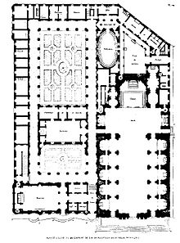
Many scholars believe that Emilio de’ Cavalieri’s Rappresentatione di Anima et di Corpo (1600) is the first oratorio because of its Biblical story, and its premiere at the Chiesa Nuova in Rome during Lent in 1600. This viewpoint, however, is quite controversial. There are large differences between early oratorios and Cavalieri’s Rappresentatione di Anima et di Corpo.
The first and most significant difference is the number of acts. Rappresentatione consists of three acts. In the early historical stage, however, common oratorios have just one or two acts with the playing time usually around thirty minutes, leaving time for the sermon and the devotional meeting. In contrast, the duration of Rappresentatione is more than one and a half hours.
Another difference is that the oratorio was not a staged work but rather music for a devotional worship service. Rappresentatione was a staged production with scenery, costumes, acting, and dancing. These differences show that Rappresentatione is actually a religious opera rather than an oratorio.

- Giacomo Carissimi (1605–1674)
Giacomo Carissimi, a leading composer of religious music in the early seventeenth century, was born in Marino, Italy in 1605. As a youth, he was a member of the choir at Tivoli Cathedral. At the age of nineteen, he became the organist there. In 1628, he was appointed maestro di cappella at the church in San Rufino in Assisi. In 1629, at the age of 24, Carissimi was offered a teaching post at the Collegium Germanicum et Hungaricum in Rome (German College), and also served as maestro di cappella at the college’s church Sant’ Apollinare. Carissimi remained there for 44 years, until his death in 1674.
Carissimi composed his oratorios with his expressive vocal technique and sense of modal/tonal architecture over the text. Carissimi’s expressive vocal technique was linked to the devotional purpose of sending a moral message to the audience through his use of symbolism and The Doctrine of the Affections. Carissimi’s oratorios are classified as Oratorio Latino, in which the text is written in Latin prose instead of in poetic narration in order to dramatize Biblical stories. Carissimi’s skillful ability to manipulate the music elevates the emotional and devotional quality of the dramatization of the text.
Carissimi wrote songs, masses, motets, more than twenty oratorios, keyboard works, theoretical works, and probably more than 150 cantatas. Many years later, during the Napoleonic invasion, a large number of Carissimi’s works at the German College were lost. In spite of this tragedy, Carissimi’s influence can be seen throughout Europe, particularly in the Latin Oratorio tradition.
- The Oratorio, Jephte:
Carissimi composed Jephte around 1648 on the libretto, which had been written anonymously in Latin. The story is based on chapters 10 through 12 of the biblical book of Judges. The main portion of the text comes from chapter 11, verses 28 to 40.
The story is from the period after the Israelites had been settled in Canaan for some time. Jephte, a commander of the Israelite army, requested passage through the territory of Ammon but was denied access by the Ammonite king. The king also declared war against Israel. As a result, Jephte swore a solemn vow to God, which was, “If you give the Ammonites into my hands, whatever comes out of the door of my house to meet me when I return in triumph from the Ammonites will be the Lord’s, and I will sacrifice it as a burnt offering.”
The Israelites were victorious over the Ammonites in the ensuing war. Upon Jephte’s return, he encountered his only child, a daughter. Jephte was heartbroken, and told his daughter about his vow to God. Jephte’s daughter promised to keep her father’s vow, and she asked to go up and down the mountains and bewail her virginity. After two months, she returned, then Jephte fulfilled his vow. Thereafter, “the daughters of Israel went year by year to lament the daughter of Jephthah the Gileadite four days in the year.”
To engage the listener’s emotion, Carissimi uses rhetorical manipulation to amplify the emotional response, increase the drama, and create effective narration and dialogue. Throughout Jephte, the narrator or historicus appears in various forms, from solo to four-part passages. There are 24 movements: Seven historicus movements with a variety of voicings, twelve ariosos and arias, one duet, and four choruses. Table.1.3.1 shows the structural outline of Jephte.
Table.1.3.1. Structure of the oratorio Jephte
Scene | No. | Characteristics | Type | Mode | Content | Bible | Mut.
I | 1 | Historicus | Recit. | Mixolydian | Ammon struggle | 11:28-9 | MT2
 | 2 | Jephte | Arioso | Lydian | Vow | 11:30-31 | MT2
 | 3 | Chorus a 6 | Reflective | Mixolydian | Confrontation war | 11:32
II | 4 | Historicus a 2 | Recit. | Ionian | War broken |  | MT1
 | 5 | Bassus | Arioso | Mixolydian | Command
 | 6 | Chorus a 6 | Reflective | Mixolydian | Battle |  | MT1
 | 7 | Historicus | Recit. | Ionian | Victory Announce | 11:33 | MT2
 | 8 | Historicus a 3 | Recit. | Aeolian | Ammonites’ sorrow |  | MT1
 | 9 | Historicus | Recit. | Ionian | Call for Dance |  | MT2
III | 10 | Filia (Daughter) | Aria | Mixolydian | Dance and  Hymn |  | MT1
 | 11 | Duet |  | Mixolydian | Hymn |  | MT2
 | 12 | Filia | Arioso | Mixolydian | Praise
 | 13 | Chorus a 6 | Hymn | Mixolydian | Praise
IV | 14 | Historicus | Recit. | Aeolian | Jephte meets  Daughter | 11:34 | MM
 | 15 | Jephte | Arioso | Aeolian | Screaming | 11:35 | MT1
 | 16 | Filia | Arioso | Aeolian | Question
 | 17 | Jephte | Arioso | Aeolian | Reason
 | 18 | Filia | Arioso | Mixolydian | Will to Follow | 11:36-7
 | 19 | Jephte | Arioso | Aeolian | Question
 | 20 | Filia | Arioso | Aeolian | Petition to leave | 11:38
 | 21 | Jephte | Arioso | Aeolian | Allowance
V | 22 | Historicus a 4 | Recit | Mixolydian | To Mountains |  | MT2
 | 23 | Filia | Aria | Phrygian – Aeolian | Lamentation |  | MT1,2
 | 24 | Chorus a 6 | Reflective | Aeolian - Mixolydian | Israel’s Lamentation |  | MM

Chapter 2. Compositional Techniques of Carissimi and the Affective Characteristics in Modes and Intervals

  - Carissimi’s Compositional Techniques:
Carissimi uses specific compositional techniques for expression in Jephte. Kircher, in his book Musurgia universalis (1650), praises Carissimi’s compositional ability to manipulate the listener’s mind. Carissimi’s choices of keys/modes, modal and tonal techniques, and symbolism in Jephte are not accidental. According to Beverley A. Stein, “Between Modes and Keys,” Carissimi uses them to express his compositional intention. A compositional technique used by Carissimi is the paired transpositions of a group of notes placed above the text. The other compositional techniques used by Carissimi are mutatio toni and mutatio modi.
The paired transpositions are used to emphasize a group of words by repetition at a different level, or reflect a syntactic relationship between two different phrases. (See Ex.2.1.1.) The transposition often appears in the difference of a perfect fourth or a fifth above, which recalls exordium to clarify the mode. Bernhard Meir, in his book The Modes of Classical Vocal Polyphony, however, asserts that in the Renaissance period, this kind of transposition of a fourth, in particular, is irregular, which avoids the modal characteristics. Therefore, Carissimi’s use of paired phrase transpositions in the irregular form of exordium shows his intent to dramatize the words.
Ex.2.1.1. Paired Transposition from no. 5
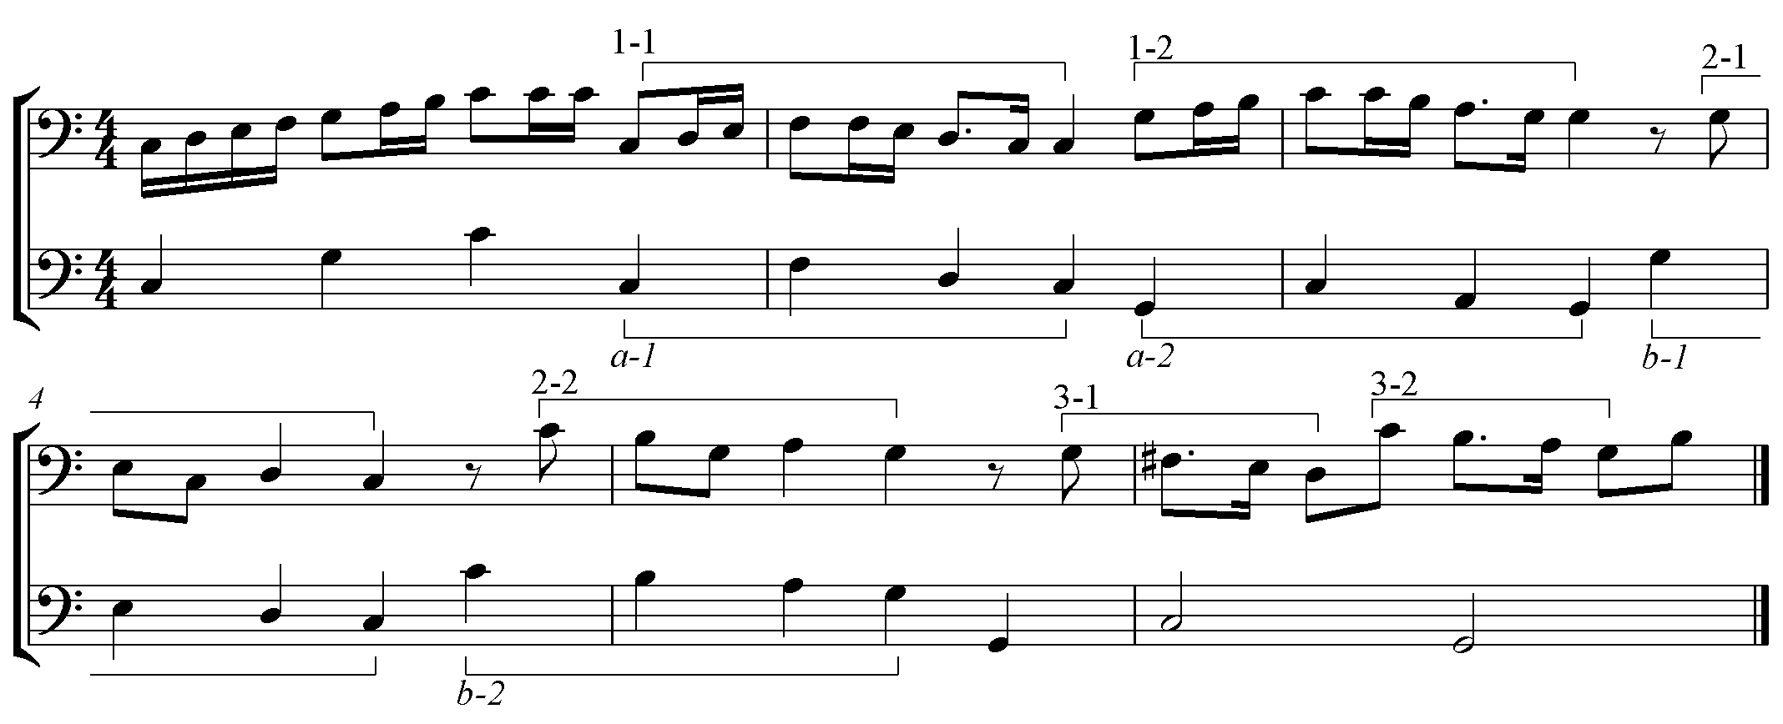
Mutatio is a compositional method used to emphasize two opposing affects through which change of modes (mutatio toni) and change of system (mutatio modi) are made. Mutatio toni appears as two types. The first type represents a large-scale shift from one mode to another, with the two modes representing different affects. The change from the Ionian mode of no. 7 to the Aeolian mode of no. 8 is an excellent example of type I mutatio toni. (See Ex.2.1.2.)
Ex.2.1.2. Type I Mutatio Toni
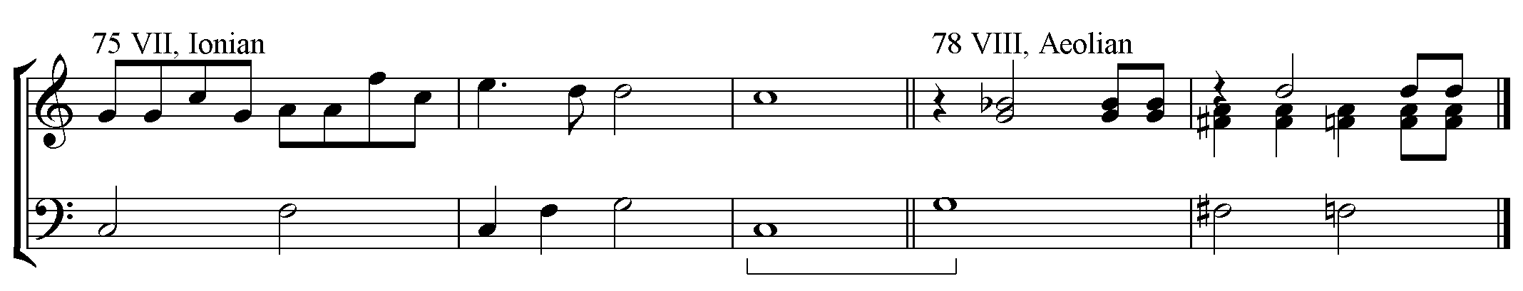
Type II mutatio toni is a lower-level tonal shift within a work. In Jephte, the last aria of the daughter is an example of type II mutatio toni. This type of mutatio toni expresses a sad or gentle emotion by the bass note moving down a step. (See Ex.2.1.3.)

Ex.2.1.3. Type II Mutatio Toni

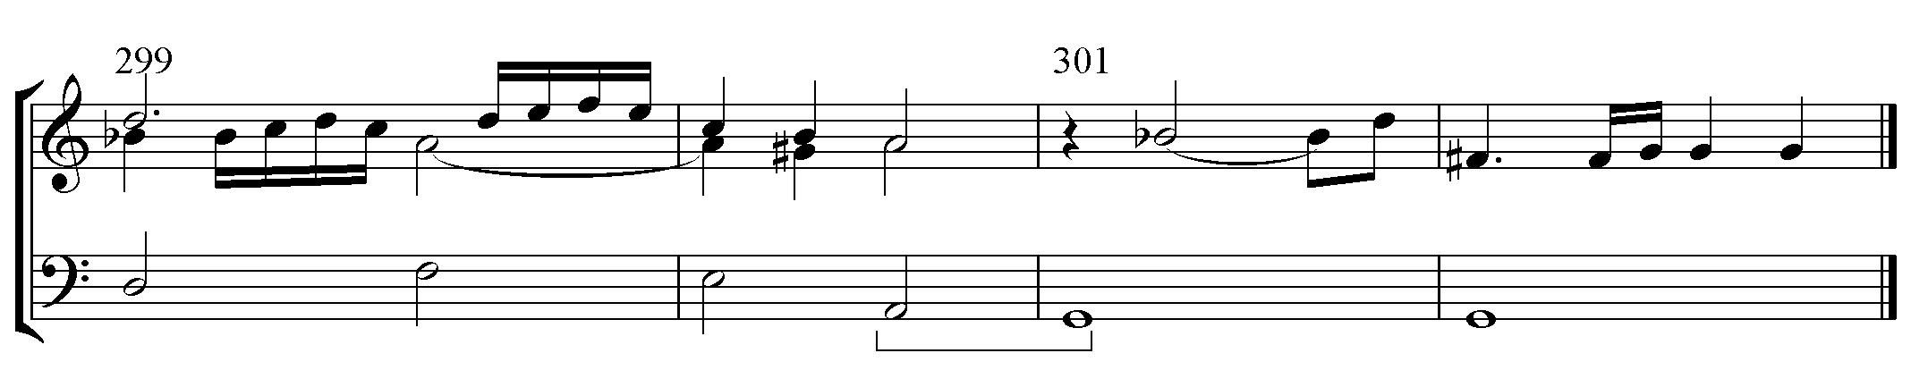

Mutatio modi is used to change the structure of the music for dramatic effect or to open a new story. Mutatio modi appears so that a chord with a natural tone, no accidental, changes to one with an unnatural, inflected tone. (See Ex.2.1.4.) Carissimi uses this method twice in Jephte to make crucial changes to the music. Mutatio modi first appears in measure 201 during the moment of change from the joy of victory to bitter sorrow. The second appearance is in m. 376, which emphasizes a point of the change from harsh sadness to mysterious thanksgiving. No. 14 represents a good example of mutatio modi.
Ex.2.1.4. Mutatio Modi
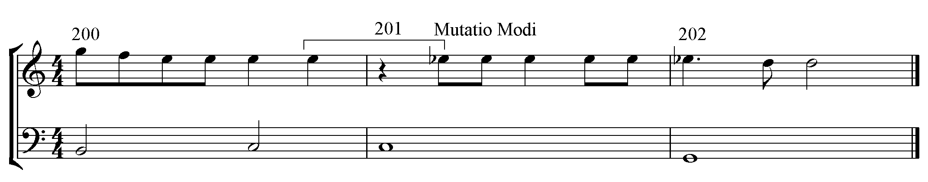

2. Affective Characteristics of Modes and Intervals:
The affective characteristics can be found in three different categories: modes, harmonic intervals, and melodic intervals. Zarlino and Vicentino, two significant theorists in the early sixteenth century, discussed music’s expressive power in these categories. In particular, Zarlino’s treatment of thirds established the polarity, giving the gay characteristic to major third and the sad characteristic to minor third. The concept of polarity allowed Zarlino to identify far more details about the affective characteristics of modes and intervals than did any other composer in history. Table.2.2.1. shows Zarlino’s discussion on the affective characteristics of the twelve modes from Le Istitutione Harmoniche Book IV.

Table.2.2.1. Affective Characteristics of Modes
Mode | Affective Characteristics
Dorian | Ecclesiastical, midway between sad and gay, gravity, high and meaningful
Hypodorian | Severe, not flattering, gravity, tearful, humble, deprecating, good for Lent and other fast days, weeping, sadness, loneliness, captivity, calamity, misery
Phrygian | Hard, weeping, lamenting
Hypophrygian | Sadness, supplicant lamentation, languor, quiet, tranquility, adulation, deception, detraction, flattering, sadder than principle, downward motion, slow tempo
Lydian | Modesty, happiness, elevation to the spirit from annoying cares; ancient use - victory, joyous, modest, pleasing, - frequent ecclesiastical use
Hypolydian | Not very gay or very elegant; serious, devout containing commiseration, tearful, funereal and calamitous
Mixolydian | Lascivious, gay, modest, threatening, perturbed, angry
Hypomixolydian | Naturally soft and sweet to fill listeners with joy, gaiety, sweetness, profound, speculative, divine, grace - good for tame, civilized or grave words
Aeolian | Open, terse, lyric, gay, sweet, soft, sonorous, pleasant severity, gaiety, softness,
Hypoaeolian | Seuouae (Seculorum Amen), most like the second mode.
Ionian | Dances, in our (Zarlino’s) time, lascivious
Hypoionian | Love containing lamentful things, sadness, gay

The second category is the affective characteristics of harmonic intervals by Zarlino. He was the first person to discuss the “gay” effect of the major third and the “sad” effect on the minor third. He divided the characteristics into two categories, emotions and effects. Table.2.2.2. outlines the affective characteristics of the harmonic intervals from Zarlino’s Le Istitutioni Harmoniche Book III.
Table.2.2.2. Affective Characteristics of Harmonic Intervals
Interval | Emotions | Effect
Octave | Clarity, Bright | Perfect, simple, absolute,
Fifth |  | Perfect less than Octave
Fourth |  | Perfect less than fifth
M3rd, M6th, their Compound | Alive, happy, gay | Great sonority
m3rd, m6th, their compound | Sweet, Mild, Sad, Languid
Major chord | Very pleasing
Minor chord | Sad, languid
M6th | Not absolutely simple
m6th | Not absolutely simple
Dissonances |  | Disagreeable, no sweetness, unbearable
M2nd
m2nd |  | Bitter, unbearable
M7th |  | Extreme
m7th |  | Extreme

Vicentino discussed the affective characteristics of the melodic intervals. He categorized the melodic intervals in two kinds, incitato (tense) and molle (slack). Also, these characteristics usually apply to the intervals smaller than a sixth. (See Table.2.2.3.)

Table.2.2.3. Affective Characteristics of the Melodic intervals
Basically Incitato in Ascent and Molle in Descent | Basically Molle in Ascent and Incitato in Descent | Same or Mixed in Ascent or Descent
Major enharmonic diesis  Minor semitone  Tone  Major tone  Third more than minor  Major third  Third more than major  Fourth  More than fourth  Tritone  Perfect fifth and all larger intervals | Major semitone  Minimal third  Minor third | Minor enharmonic diesis  Minor tone  Imperfect fifth  More than imperfect fifth

To apply Vicentino’s theory directly to the modern equal temperament is problematic. As the inventor of the archicembalo, Vicentino concentrated on the temperaments, and discussed many different kinds of semitones as shown in the table above. The different semitones have different kinds of characteristics.
Throughout history, the temperament system developed in a large variety of ways, producing different kinds of semitones. Even in the early seventeenth century, there were several dozen temperaments. When deciding the intervallic affective characteristics in Jephte, the understanding of the temperament during the time of Jephte is crucial for the use of semitones.
To make an appropriate decision about the semitones, the first consideration is the function of the oratorios; service music for a spiritual meeting held in an oratory. This implies that the oratorios were performed at a church with organs. The German College in Rome, where Carissimi worked, was established in 1552. Six years later, in 1558, Zarlino published Le Istitutioni Harmoniche, in which he discussed three different types of temperaments for three different groups of instruments (organ, string, trombone). Therefore, the organ of the German College would have been installed earlier than Zarlino’s publication, and the organ would not follow the temperaments of Zarlino’s classifications.
In the early sixteenth century, theorists suggested equal temperaments for keyboard instruments. Henricus Grammateus (1495-1525 or 1526) and Silvestro Ganassi (1492-mid 16th century) suggested a similar equal temperament. Particularly, Ganassi’s approximation shows a meantone basis of the tuning. Also, Arnolt Schlick (1450s-1521) suggested keyboard instruments should be tuned to the equal temperament.
The other tuning aspects that Carissimi might have used are the temperament systems in the early seventeenth century. Galileo Galilei (1564-1642) and Marin Mersenne (1588-1648), contemporaries of Carissimi, showed equal division of a meantone system but slightly narrowed intervals with accidentals. Also, Lodovico Zacconi, another contemporary of Carissimi, explained that an octave consists of ten semitones and two larger semitones.
Therefore, following the meantone-based equal temperament would be reasonable in order to obtain better affective characteristics of different kinds of minor seconds. As a result, in this study, the diatonic half steps (^e-f, ^b-c) will be regarded more likely as major semitone (major m2, wider than a half step of the equal temperament), and the chromatic half steps will be regarded as minor semitone (minor m2, narrower than a half step of the equal temperament).

Chapter 3. Analysis of the Jephte
The oratorio Jephte is through-composed. However, according to the musical and narrative flow, the whole work can be divided into five scenes; Scene I is nos. 1-3; scene II is nos. 4-8; scene III is nos. 9-13; scene IV is nos. 14-21; and scene V is nos. 22-24. Each scene is discussed as a unit, and each number will be discussed within the unit in great detail.
The analysis proceeds by first examining the modes and their emotional flow according to the discipline of affective characteristics. Then the harmonic and melodic intervals with their affective characteristics will be discussed within the relationship in the light of the modes and the text. At the conclusion of each scene, the way the affective characteristics highlight the text through their organization will be examined.

- Scene I. Nos. 1-3 Jephte’s Vow:
The historicus introduces the reason for the war between Jephte and the Ammonites. No. 2 is Jephte’s vow to reward God, if God will grant Jephte the victory. Next, the chorus sings as Jephte confronts the war with God’s might.

Table.3.1.1. No.1 Historicus
Measure | 1 | 5 | 7 | 10
Phrasing | 4 | 2 | 3 | 4
Mode | Mixolydian | Ionian | B♭ Lydian | Ionian
Charateristics | Lascivious, gay, modest, threatening, perturbed, angry | Dances,  in our (Zarlino’s)time, lascivious | Modesty, happiness, elevation of spirit, victory, joy, pleasing | Dances,  in our (Zarlino’s) time, lascivious
Text | Cum vocasset in proelium filio Israel rex Filiorum Ammon | Et verbis Jephte acquiescre noluisset | Factus est super Jephte Spiritus Domini | Et progressus ad filios Ammon votum vovit Domini dicens
Translation | Thus, when war was declared against the children of Israel by the king of Ammon | Jephte’s words were disregarded and ignored | Then, upon Jephte descended the spirit of God, the Lord | As he went against the children of Ammon, Jephte swore to God a solemn vow.

Stylistically, this is a secco recitative. (See Table.3.1.1.) The Mixolydian mode whose characteristic is modesty is used on “Israel,” and the Ionian mode whose characteristic is a lascivious dance, is used on “Ammon.” By contrast, the Lydian mode has a spiritual characteristic to aid in expressing the words of the Spirit of God descending. Then, the piece returns to Ionian mode in m. 9.
The special features of the shape of the melody also assist in conveying affective characteristics. The first phrase is a simple recitation, and its melody begins with the Mixolydian mode. (See p. 110, mm. 1-3) The first harmonic interval is a strong perfect fifth (P5), and the melody descends by a perfect fourth (P4), a molle, and continues to ascend by a major second (M2), an incitato. As a result, the structure of the melody arrives at a lower minor third (m3) from D5 to B4 at measure three (m. 3). The characteristic of a harmonic P5 is strong, and the ascending M2 and the descending m3 are all incitato (according to Vicentino), which increase tension. Also, it is interesting to note, the harmonic interval on “Israel” is a strong and resounding M3. In the Mixolydian mode, the intervals add firm and strong characteristics to the melody.
In mm. 3-4, the mode is Ionian, and the melody shape gradually ascends to a P4, comprised of two M2s and a m2. These intervals exemplify incitato. The melodic and harmonic intervals in m. 4 on “Ammon” have the same structure as “Israel” mm. 2-3 but at a higher pitch level, which signifies Ammon’s superior strength. The ascending m3 on “acquiescere” (acquiesce) in m. 5, despite being filled with an ascending m2 and M2, is a molle expressing that Jephte’s inquiry is not strong enough and, as a result, the inquiry is denied. The following descending M3 on “noluisset” (refused) in m. 6 is molle, representing Jephte’s disappointment.
In m. 7, the mode changes to B♭ Lydian. Between mm. 6-7 appears a tonicization F-B♭ in the basso continuo (BC); however, this is the quasi-type II mutatio toni with the key movement from C to B♭, which Carissimi used for emotional expression. This illustrates Jephte’s humiliation and the sweet descent of God’s spirit upon Jephte.
Ex.3.1.1. BC mm. 6-7
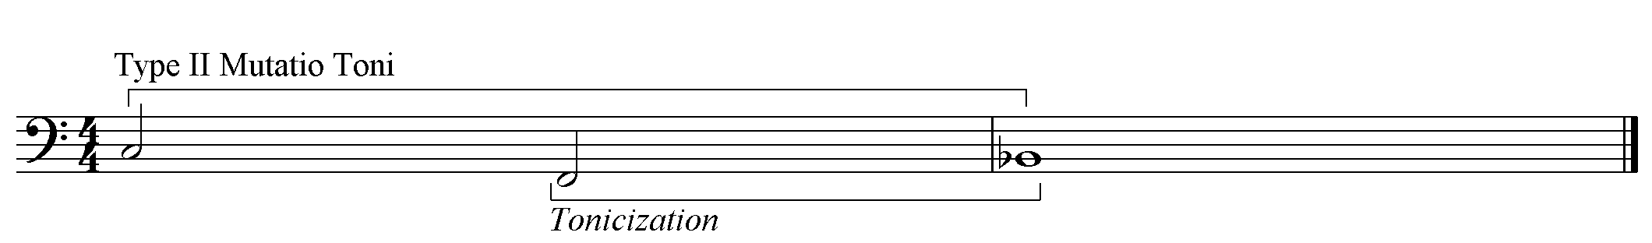
The melody, sung by Historicus, takes a mountain shape and places “super Jephte” in the middle, illustrating that God’s Spirit covers Jephte. (See p.110, mm.7-9) Also, the symmetry of the mountain shape in the melody create a good balance throughout this phrase.

Table.3.1.2. No. 2 Jephte
Measure | 14 | 17
Phrasing | 3 | 2, 3
Mode | Lydian | Mixolydian
Characteristic | Modesty, happiness, elevation to the spirit from annoying cares | Lascivious, gay, modesty, threat, perturbation, anger
Text | Si tradiderit Dominus filios Ammon in manus meas, | quicumque primus de domo mea occurrerit mihi, offeram illum Domino in holocaustum
Translation | If Thou wilt deliver, Oh Lord, my God, The children of Ammon into my hands, | Whatever first out of my house doth emerge to meet me, I shall offer unto God, the Lord, as a burnt offering.
Special Features |  | BC Chromatic ascending mm. 17, 18, 20

The second movement, which is Jephte’s arioso, is a solemn prayer in a two-fold structure. (See Table.3.1.2.) This begins with the type I mutatio toni in the Lydian mode. The characteristic of the mode, an elevation to the spirit, associates with the humble prayer of Jephte. The melody, mm. 14-16 (p.110), begins with a mountain shape, the same as in the first movement mm. 7-9. With the three-bar long pedal tone, the melody shows a stable and steady emotion.
The second phrase of the second movement, mm. 17-21, modulates to Mixolydian, and the strong characteristics of the mode serve well to represent Jephte’s will to offer a life, a sacrifice, to God. This phrase begins with a harmonic m3. The ascending P4 and M2s in m. 17 are incitatos. However, the harmonic m3 in m. 17 has some ambiguity. The chord on the downbeat of this measure can be recognized as either D6 or a diminished F#. In this case, the harmonic recognition of the BC as a diminished F# on beat one and two and a D6 on the third beat would intensify the meaning of the text. The quality of the diminished chord, the extremely unstable characteristic serves the unpleasant emotion. The series of ascending M2 in m. 19 is incitato. The languid harmonic m6 in m. 20 illustrates the sadness of the word “holocaustum” (burnt offering). In the BC in mm. 17 and 20 appear two sets of two ascending half-steps. Each set consists of two ascending minor half-steps, incitato. All the intervals cooperate together to show the strength of Jephte’s willingness to follow his oath to God. The qualities of the diminished chords and intervals, however, create a strange paradox on the text of Jephte’s strong willingness.
The paradox created by the contrast of modal and intervallic characteristics in the phrases illustrates that Jephte’s petition or God’s answer would be easy, but the offering is difficult, seemingly showing that Jephte’s idea of a reward to God is greater than God’s answer to the petition. Netherlandish Jesuit Cornelius a Lapide (1567-1637), who taught one of the two German colleges in Rome, described Jephte’s vow as being imperfect in spite of its good intent but through wrong means.
The next movement (See Table.3.1.3.) can be classified as a reflective chorus of commenting, according to Gayle A. Walker’s system of classification. The action of Jephte is set in homophony, while the texts of the Holy Spirit are polyphonic in three phrases.

Table.3.1.3. No. 3 Chorus
Measure | 22 | 26 | 28
Structure | A (Homophony) | B (Polyphony)
Substructure | a | b | c
Phrasing | 4 | 2 | 5
Mode | Mixolydian
Characteristic | Lascivious, gay, modesty, threat, perturbation, anger
Text | Transivit ergo Jephte ad filios Ammon, | ut in Spiritu forti et virtute Domini pugnaret | pugnaret contra eos.
Translation | Journeying, thus went Jephte to the children of Ammon, | with the spirit and fortitude and valor of God to battle | to battle against Ammon.
Special Features |  | The place of “pugnaret”.

No. 3 begins with Jephte’s action of confronting Ammon and uses the Mixolydian mode. (See. p. 110, m. 22) The first chord is a closed-root position of a major triad on the text, Transivit (Journeying), emphasizing Jephte’s action. The characteristic of a major triad is better than that of a minor triad. The following section about Ammon momentarily modulates to Ionian modes of earthly characteristics. The melodic shape is higher than at the beginning. The melodic interval of the down beat in m. 24, a descending major m2 on “filios” (sons), is an incitato. The following word “Ammon” has an ascending M2, incitato, and a 4-3 suspension, sounding harsh and sad. The last harmonic M3 on Ammon is harsh. These intervals are mixtures of strong and weak characteristics which illustrate that the Ammonites are strong but should become sad.
The second phrase (m. 25), in polyphonic style, returns to Mixolydian mode, with fast rhythms on the words about the act of the Holy Spirit. The beginning of the phrase, m. 24, has a harmonic M3 on the stressed beat, while the following stressed beats, m. 25, get closed-root positions with the harmonic intervals of P5 between outer voices. That is because the word “ut” in m. 24 is an adverb, and next stressed beats are on nouns.
The interesting harmonic interval is M3 on the third beat of m. 27. The melisma of the preceding beat uses three ascending M2s to reach the extreme ^F# on Domine, which is tritone from ^C, the lowest pitch of the melisma. The new harmonic interval of incitato on a strong beat after three P5s on strong beats creates very strong effect.
Another interesting aspect is the placement of the word “pugnaret” (battle m. 27-28). The word “pugnaret” should be the first word of the next phrase in m. 28. However, “Pugnaret” appears at the end of m. 27 on the V-I cadence, and it effectively becomes the last word of the “Domini” phrase. Though “pugnaret” is a verb describing the act of Jephte and his army, placing the word at the end of the “Domini” phrase could imply that God is fighting instead of Jephte. This notion of God’s role in the war is related to the word “Spiritu” in m. 25, and assigned to the higher ^G than Ammon’s ^F in the previous measure, suggesting God’s dominance; He is higher and thus, more powerful.
In the last phrase (p. 111, m. 28), the specific interval is four time-placed 4-3 suspensions in mm. 29, 30, 31, and 32. The suspensions of the sad characteristic are all on “eos,” which refers to Ammonites. Thus, this interval illustrates that Ammonites, represented by the earth with the number four, are sad because they are fought against by God. With fast rhythms, all the interval relationships in the second and third phrases enrich the anger characteristic of the Mixolydian mode.
As a conclusion of scene I, the contrast of the modes used shows clear references: the Mixolydian mode is for God, Jephte, and Israel; the Lydian mode is for the Holy Spirit; and the Ionian mode is for Ammon. The detailed meaning of the words is enriched through the characteristics of the intervals in each section. These expressive techniques provide the clear drama which is demonstrated by the text.

- Scene II. Nos. 4 – 8 Battle
This scene illustrates the war. The duet historicus uses the sounds of trumpets and drums to announce that the war has broken out. Next, the bassus tells the enemies to flee and orders the army to kill the Gentiles. No. 6 is a choral movement depicting the war scene. Afterward, the historicus announces the great conquest of Jephte. Then, the following three-voiced historicus sings the lamentation of the Ammonites. The flow of modes is Ionian - Mixolydian - Aeolian - Ionian - Mixolydian - Ionian – Aeolian.

Table.3.2.1. No. 4 Historicus a 2
Measure | 33 | 35 | 38
Structure | A - canon | B  irregular exordium | B’  Stretto. Parallel  Voice Crossing
Phrasing | 2 | 2, 1 | 2, 2
Mode | Ionian | Ionian – G Ionian | Ionian
Characteristics | Dances, in our (Zarlino’s) time, lascivious
Text | Et clangebant tubae  et personabant  tympana | et proelium commissum est  adversus Ammon.
Translation | Then sounded trumpets  and resonated tympani, | when battle then was joined  against the host of Ammon.

In movement No. 4, the historicus is written for two voices and features interesting duet techniques in place of the recitative style. As shown in the Table.3.2.1., the opening canon undergoes an expansion in section B through irregular exordium, creating the paired transposition. Through a stretto and parallel thirds, Section B’ expresses the words “when battle then was joined,” and extends with the repetition of the basso continuo and voice crossing.
The Ionian mode creates a cheerful and vital mood throughout the movement with its dance characteristic, and the melodic structure complements the mode. The first two measures rely on a very stable C major chord to express the firmness and strength of the trumpet and timpani sound in a war. Furthermore, the harmonic intervals on the stresses of the words are M3s with harsh characteristics adding strong effect on the melody.
The B section begins with a series of ascending seconds, and the ascending m3 arrives at the top pitch of an octave higher on “adversus” (against). (See p. 112, m. 36) The rest of the melody of the phrase is filled with descending seconds arriving at P5 lower. The incitato created by an ascending octave shows stronger power over the molle created by a descending P5. Then, the repetition begins at P4 lower and is an irregular exordium indicating a consciously-chaotic progression. (See Ex. 3.2.1.)
Ex.3.2.1. Irregular Exordium
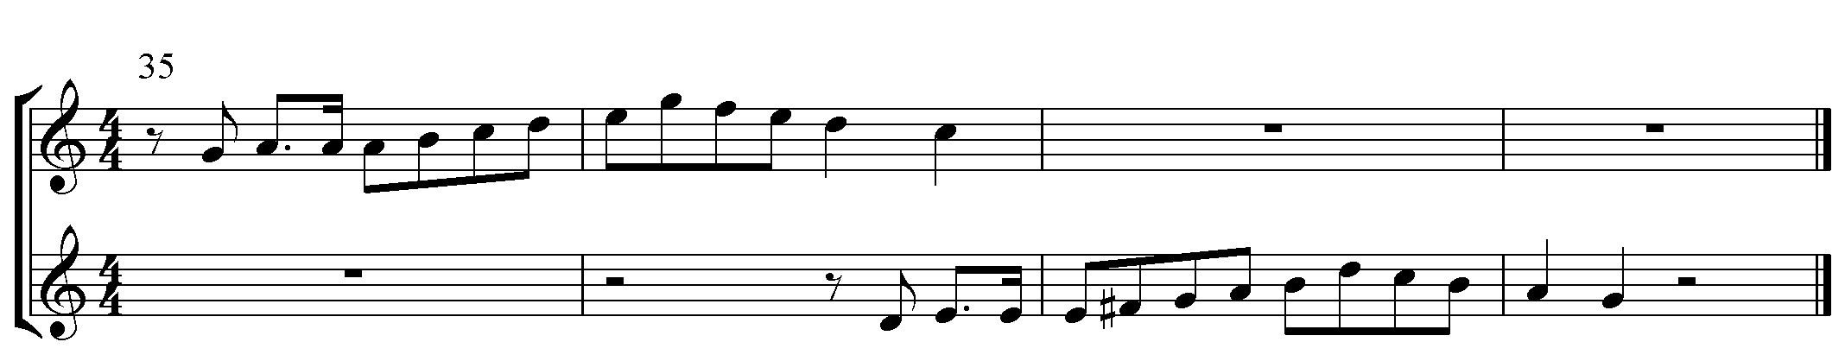
The B’ section, mm. 38-41, creates a very nice third parallel which has the harsh effect of illustrating the battle against Ammon. In the last phrase, the 4-3 suspension appears twice on the word “Ammon” in m. 40. Gioseffo Zarlino points out that the harshness of the two suspended notes is used to illustrate the fate of the Ammonites. These dueling characteristics imply the stability and vitality of the Israelites in contrast to the harshness that the Ammonites face.
Movement No. 5 is a bass arioso in two large sections. (See Table.3.2.2.) Each section contains three phrases. The first section is an order to the Gentiles, and the latter is the reason for the order. The interesting technique Giacomo Carissimi uses is paired transposition. This transposition appears six times in this short arioso to express virility. Furthermore, the modulation of the modes flows back and forth between Ionian and Mixolydian.

Table.3.2.2. No. 5 Bassus
Measure | 42 | 45 | 47 | 50 | 53
Structure | A |  |  | B
Substructure | a |  |  | b | c
Phrasing | 3 | 2 | 3 | 3 | 3, 3
Mode | Ionian |  | Mixolydian | Ionian | Ionian - Mixolydian
Characteristics | Dances, in our (Zarlino’s) time, lascivious |  | Lascivious, gay, modest, threatening, perturbed, angry | Dances, in our (Zarlino’s) time, lascivious | Lascivious, gay, modest, threatening, perturbed, angry
Text | Fugite, cedite, impii, | perite gentes, | occumbite in gladio; | Dominus exercituum  in proelium surrexit, | et pugnat contra vos.
Translation | Flee and run away, godless ones | Oh, perish, gentiles. | Fall down and  die upon our swords. | God,  the Lord of Hosts,  in might, now raises up an army. | He battles against you.

The first phrase has a fast rhythm on the text “fugite, cedite” (run away). (p. 112, m. 42-44) The BC and the melody have unison on the beats in the first five measures. The effect of this unison is absolute. (See. Ex. 3.2.2.) The melodic intervals of the BC are ascending P5 and P4s, and descending m3, which are incitato, and only M2, molle, as a cadential motion on “impii” (godless ones). The intervals create an absolute, strong command to the weak Gentiles.

Ex.3.2.2. Unison Structure mm. 42-46
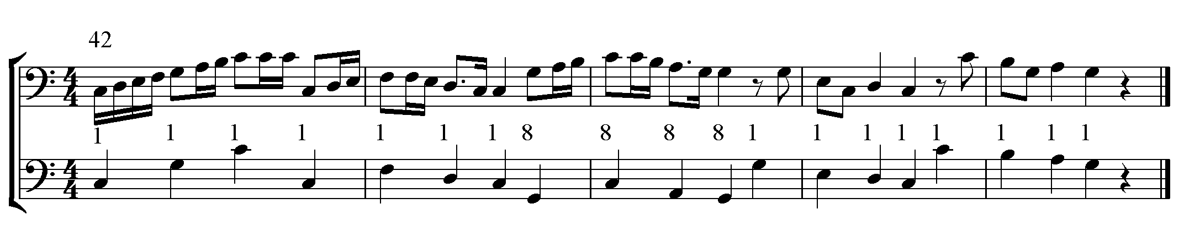
The second phrase, mm. 45-46, with a paired transposition, is a command to the Israelites, reinforced by the absolute unison on the beats. In the third phrase, the first three stressed beats have strong harmonic M3s on “occumbite” (die) and “gladio” (sword) in mm. 47-9. Also, as the words are repeated, they receive paired transpositions illustrating the anger in the Mixolydian mode.
The first harmonic interval of the section B, m. 50, is P5 on “Dominus” and the descending m3, incitato, is on “exercitum” (host) and “surrexit” (risen). “In proelium” (in battle) is repeated as a paired transposition. The melodic intervals of “pugnat contra vos” (He battles against you) contain an ascending minor m2 into the downbeat followed by ascending M2s, which are incitato. Then, the melisma on “vos”, referring to Ammon, with ascending M2s, incitato, illustrates that the Ammonites run away quickly. In the repeated section, the melisma is extended by another P4, adding more force. Also, the BC pitches of the four-time appearing ‘vos’, mm. 53-58, are D-G-C, A-D-G, G, and G. The circle of fifth refers to some motion or change, illustrating that the enemies are falling down to die.

Table.3.2.3. No. 6 Chorus
Measure | 59 | 62 | 65 | 68
Structure | A | B | A’ | B’
Phrasing | 3 | 3 | 3 | 5 (2, 3)
Style | Homophony | Polyphony | Homophony | Polyphony  Poly Choral
Mode | Aeolian | Ionian |  | Mixolydian
Characteristics | Open, terse, lyric, gay, sweet, soft, sonorous, pleasant, severity, gaiety, softness, | Dances, in our (Zarlino’s) time, lascivious |  | Lascivious, gay, modesty, threat, perturbation, anger
Text | fugite, cedite, impii, | corruite,  et in furore gladii dissipamini | fugite, cedite, impii, | corruite,  et in furore gladii dissipamini
Translation | Flee and run away, you infidels. | Fall down and die!  With our ferocious swords, we defeat and  scatter you. | Flee and run away, you infidels. | Fall down and die!  With our ferocious swords, we defeat and  scatter you.

The classification of this movement (Table.3.2.3.) is a reflective chorus of commenting. From the Ionian mode of the previous number, this movement begins in Aeolian mode by Type I mutatio toni to create different characteristics. Afterwards, the music modulates to the Ionian and Mixolydian modes, respectively. The act of the Israelites, the second portion of the text, takes the different mode of amplifying the words. The contrast of modes, together with the stylistic contrast, stresses that of the text between the command and the Israelites’ act. The last section is in polyphonic and polychoral style in Mixolydian mode. The gay characteristic of the mode suggests that although the war is serious, the victorious result is full of happiness and joy for the Israelites.
The first A minor root position of the section A is strong. (p. 113, m.59) Carissimi uses the alternation between the major and minor chords throughout the section to create a color contrast with the parallel chords. Timothy R. McKinney explains that the bipolar image of the contrasting sound doubles the effect and transforms it into a hard sense. The image expresses the strong power of command, the strength of the Israelites, and the harshness of the war. The galloping rhythm in stile concitato style throughout the movement illustrates a horse running on the battleground.
Ex.3.2.3. Harmonic Progression in mm. 59-60
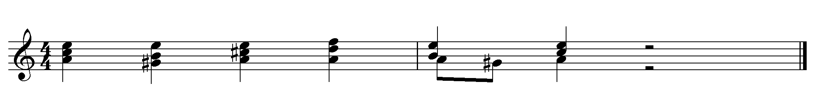
The section B begins with ^7 of D in the BC. (m. 62) This becomes of the first inversion of a major chord making the harmonic progression of the V of D and following the circle of fifths progression of A-D-G-C. This progression relates to the words “I cry.” The descending m3rd of incitato in the voices in m. 62 over the ascending minor m2 of the BC, incitato, expresses the strong action on the word “corruite” (fall down). The ascending P4 in m. 63 on “furore” (furious) gives a forceful effect to the word. The descending major m2 on “dissipamini” (be scattered) is another incitato which creates a strong effect with the double consonant expression of the Italian-Latin pronunciation. All the intervallic characteristics illustrate sadness of the Ammonites being killed by Israelites.
The A’ section in the homophonic style begins with a closed-root position of C major, with the strength again shown through the use of the galloping rhythm. (p. 113, m. 64) Differently from the A section, this section begins with low voices with a major chord. Also, the section does not have the parallel chord alternation. The word “fugite,” however, appears in a higher range than its range in section A, thus illustrating the elevated spirit of the Israelites. Soprano has an ascending m3 and descending major m2 on the weak beats in m. 66, creating the inverted stresses. Then, the “impii” (infidels) in m. 67 gets an ascending M2, incitato, and a harmonic M2, making a very annoying sound. These intervals express the strength of Israelites and the chaos of the Ammonites.
The ascending half steps of the basso continuo in mm. 67-69, a similar form of a chromatic tetrachord, passus duriusculus, demonstrate the sad fortune of “corruite” (“fall down and die”). The last polychoral section begins with a three-part stretto of ascending P4s filled with seconds, creating a tripled incitato. Also, the concertato style symbolizes the strength with the double consonant of “dissipamini.” All these characteristics add strength to the anger characteristic of Mixolydian mode.

Table.3.2.4. No. 7 Historicus
Measure | 73 | 75
Phrasing | 2 | 3
Mode | (Lydian) | Ionian
Characteristics | Modesty, happiness, elevation to the spirit from annoying cares; ancient use -- victory, joyous, modest, pleasing -- frequently ecclesiastical use | Dances; in our (Zarlino’s) time, lascivious
Text | Et percussit Jephte viginti civitates | Ammon plaga magna nimis.
Translation | Then attacked Jephte twenty of the cities | of Ammon, causing slaughter beyond any measure.

The whole movement is largely in the Ionian mode. (Table.3.2.4.) The beginning, however, uses Lydian mode by the type II mutatio toni, then ends in the Ionian mode. The Lydian mode is associated with the battle of Jephte, and the Ionian mode illustrates Ammon’s loss.
The movement (p. 115, m. 73) begins in unison, which creates absolute power. The pitches on the word “percussit” (attacked) receive the spelled-root position F major chord. The ascending M3 on “viginti” (twenty) is an incitato. These intervals add strength on the absolute power of Jephte, which gets harmonic unison.
“Plaga magna” (blow great) in m.75 repeats in the form of the little-varied paired transposition. The first gets a descending P4, a molle, and an ascending M2, an incitato. The repeated portion portrays strength, beginning on m6 higher, then uses an ascending M3, incitato, instead of an M2. This intervallic enlargement adds expressiveness on the word “magna” (great).
Table.3.2.5. No. 8 Historicus a 3
Measure | 78 | 82 | 86
Structure | a | a’ | b
Phrasing | 4 | 4 | 3
Mode | Aeolian
Characteristics | Open, terse, lyric, gay, sweet, soft, sonorous, pleasant severity, gaiety, softness
Text | Et ululantes filii Ammon, | facti sunt coram filiis Israel | humiliati.
Translation | Then came laments from the children of Ammon, | and before all the children of Israel, | Ammon was broken.
Special Features | Chromatic fourth – Passus duriusculus

This three-part historicus (Table.3.2.5.) is the lamentation of Ammon. This movement can be classified as a narrative chorus with non-repeated text. The theme begins in the G Aeolian mode with the severe characteristic, and later is transposed to D Aeolian, a P4 lower illustrating severe sadness of Ammonites. The first two parts in all three parts have a descending perfect fourth filled with all semitones, namely, Passus Duriusculus. (See Ex.3.2.4.) In the sixteenth and seventeenth centuries, the chromatic fourth was a compositional idiom, as an aphorism rendering a sad/lamenting emotion in Baroque-period music. Gioseppe Caimo refers the descending half steps to “cry”, and Kimmel relates this series of descending chromatic tones to “death related” that these emotional references reinforce the severity of Aeolian.
Ex.3.2.4. Chromatic Fourth
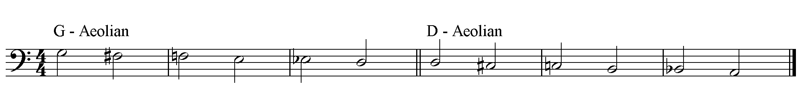
Another point of interest is the parallel motion in the section a and a’. The section begins with an m3 parallel between the lower two voices, which is the sad characteristic as indicated by Zarlino. (See. Ex.3.2.5.) When the top voice comes in, that voice is sixth parallel, which is quasi-fauxbourdon. The alternating pitch relationships of a m6 and a M6 between outer voices create bumpy and rough characteristics. The first m3-P4 chord, first inversion form of a major chord, which Zarlino describes as good, proceeds quickly to an M3-P4, first inversion form of a minor chord, which is bad, and then the chord progresses to m3-Aug4, M3-P4 and P4-m3. As a result, the qualities of the chords in the progression are inversions of major – minor – diminished – minor – minor, and arrives at the root position of a major chord as a cadence. The flow of effects of the chords before arriving at the cadential major chord is good – bad – extreme – bad – bad, creating efftto tristo, (wretched). Particularly, the word “ululantes” (howled) receives the diminished chord, creating an extreme effect. Combined with the implications of the death of the chromatic fourth, these harmonic features connect with the emotion of Aeolian, expressing Ammon’s bitter sadness and lamentation.

Ex.3.2.5. Chromatic Fourth Parallel
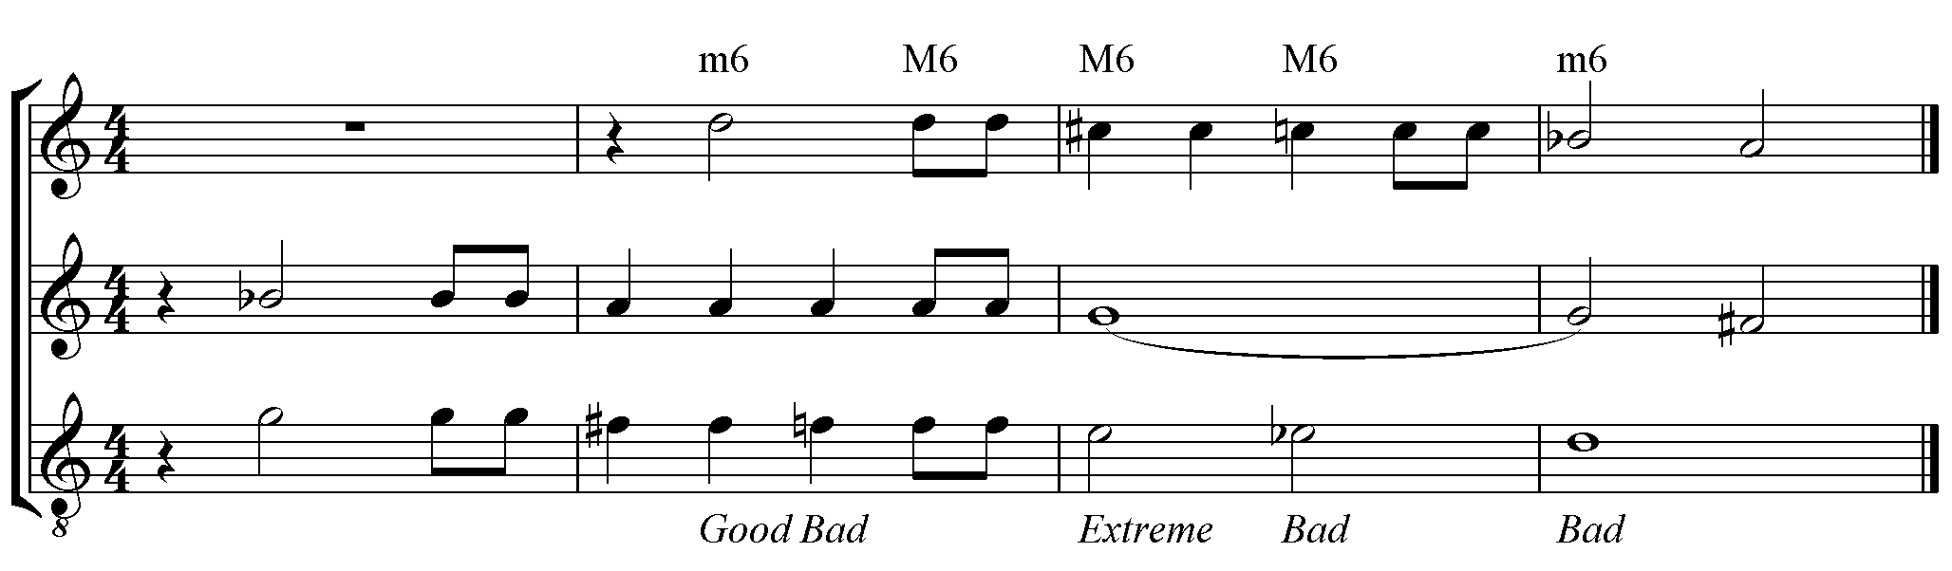
As a conclusion, this scene shows the Ionian mode as the center, whose war-related characteristic illustrates the brutality. The Mixolydian and Lydian modes associate with the Israelites and their winning battle, while the Aeolian mode references the Ammonites and their loss and severe sadness. In the relationships, the intervals enrich the characteristics.

- Scene III. Nos. 9-13 Joy of Victory:
Scene III begins with the announcement of the victory and the introduction of Filia’s joy and dance. No. 10 is Filia’s aria in A-B-C form. Filia commands Israel to praise God. Section B is the hymn of Israel or Filia, and section C is Filia’s praise. No. 11 is a duet or two-part choir on the paraphrased text of No. 10 B with extended melodic themes. No. 12 is again Filia’s praise, as an extended form of No. 10 C. This leads the whole of Israel to praise in a chorus. No. 13 shares almost the same text of No. 12.

Table.3.3.1. No. 9 Historicus
Measure | 89 | 92 | 95
Phrasing | 3 | 3 | 4
Mode | Ionian
Characteristics | Dances, in our (Zarlino’s) time, lascivious
Text | Cum autem victor Jephte  in domum suam reverteretur | occurrens ei unigenita filia sua cum tympanis et choris | praecinebat
Translation | When, thus, victorious Jephtah, unto his dwelling returned, | then out came running his only begotten daughter with tambourines and choruses, | sang
Special Features |  |  | Melisma

No. 9 is a recitative describing Jephte’s return and his daughter’s joyful singing and dancing. (Table.3.3.1.) This movement adopts the theme of No. 7, a recitative of the conquest. By type II mutatio toni, this movement begins in a different emotional level from the previous one in Aeolian.
The first phrase begins in unison and goes into the spelled-root position of the C major chord. (p. 116, m.89) The second phrase, m. 92, begins as an imitation of the beginning on P4 higher, showing a joyful response to the act of the first phrase, giving more strength by the use of the fast rhythm. The last section, m. 95, expresses the word “praecinebat” (sang) with a melisma. The melodic structure of the melisma is based on the paired transposition from ^EFG down to ^CDE. Then, the unit ascends every stressed beat as a paired transposition, resulting in the first note of the last unit at a P4 higher than the first note of the melisma. (See Ex.3.3.1.) As shown in the example below, the ascending unit creates an ascending P4 from the fourth note of a unit to the first note of the next unit. Then, the fourth note of the last unit creates an ascending M2 to arrive at the long G. These intervals indicate all incitato, making the melisma very strong on the “praecinebat.”
Ex.3.3.1. Interval Structure mm. 95-97
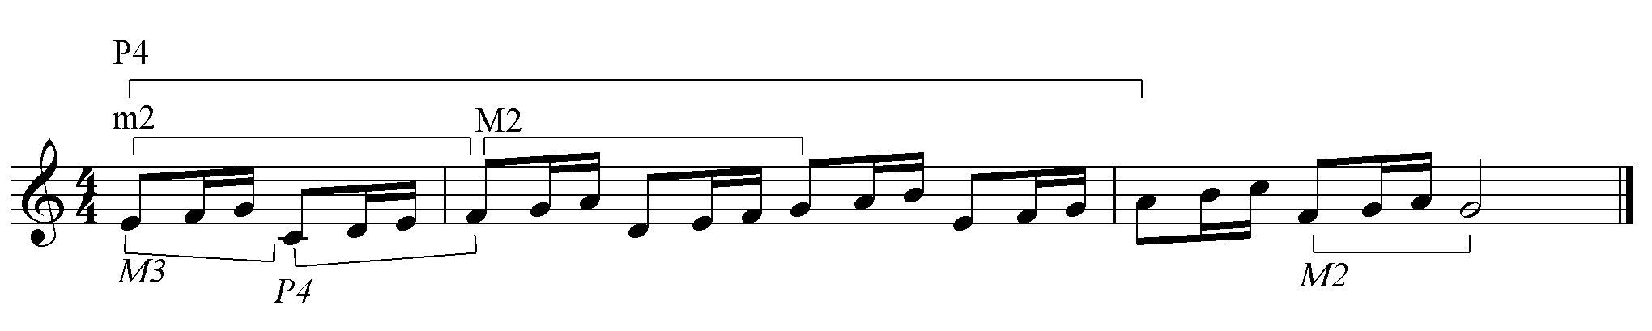

Table.3.3.2. No. 10 Filia
Measure | 99 | 106 | 120
Structure | A | B | C

No. 10 has three distinctive sections: 10A is Filia’s arioso; 10B is one of Filia’s aria; and 10C is Filia’s other aria. The analysis of no. 10 is by each section, respectively.

Measure | 99 | 102 | 104
Phrasing | 3 | 2 | 2
Mode | Mixolydian
Characteristics | Lascivious, gay, modesty, threat, perturbation, anger
Text | Incipite in tympanis et psallite in cymbalis. |  | et psallite in cymbalis.
Translation | Commence to strike the timbrels loud  and make, for joy, the cymbals sound. |  | and make, for joy, the cymbals sound.
Table.3.3.2.1. No. 10A Filia

No. 10A is Filia’s arioso, which suggests loud responses in the cymbals and drums. (Table.3.3.2.1.) The Mixolydian mode expresses the gaiety characteristic. The first phrase begins with an ascending P5, then uses a descending m3 filled with seconds. (p. 116, m. 99) Then, “psallite” (play), which contains two double consonants, receives a descending major m2. All those intervals are incitato. The harmonic intervals on the stresses are P5, P8, and M3, which all have strong effects. This strong phrase repeats as a paired transposition on P4 higher with great expressiveness.
The third phrase, mm. 104-105, begins with the harmonic interval of P8 with the absolute characteristic on the stress, then the harsh M3s, P8, and M3 follow on the stresses, giving strength. The ‘cymbalis’ (cymbals) in m. 104 get a sharp for a sudden key change on the downbeat and make an ascending M2, incitato. This accidental repeats as a paired transposition on ‘psallite.’ Then, in the following measure, the downbeat receives a descending major m2, incitato. All these intervals add energy to the music in the happy Mixolydian.

Table.3.3.2.2. No. 10B Filia
Measure | 106 | 112 | 116
Phrasing | 6 | 4 | 4
Mode | Hypoionian | Aeolian
Characteristics | Love containing lamentful things, sadness, gay | Open, terse, lyric, gay, sweet, soft, sonorous, pleasant severity, gaiety, softness,
Text | Hymnum cantemus Domino, | et modulemur canticum.
Translation | With sweet hymn singing to the Lord, | we play unto Him our songs.

No. 10 B (Table.3.3.2.2.) is Filia’s aria in triple meter. This movement begins with the type II mutatio toni in Hypoionian mode, adding emotional change. (p. 116, m. 106) In particular, the meter change from quadruple to triple effectively creates a mood change from shouting to heavenly praise. The triple rhythm with the hemiola signals the very happy dance of Filia. The rhythmic structures in mm. 106 – 112 are triple, syncopation, triple, syncopation, and Hemiola. The rhythm of the melody resembles a gagliard in a hyper-measure form. This dance form in the triple rhythm shows that Filia dances very happily.
Ex.3.3.2. Gagliard Rhythm
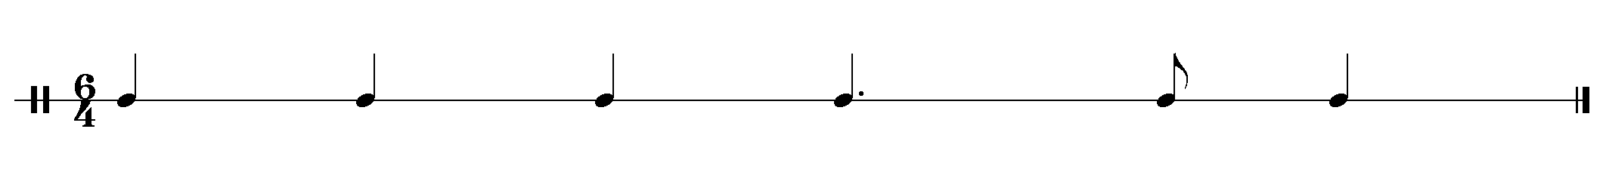
The harmonic intervals on the downbeats in the measures are P5, M3, m3, M3, and m3 on the hemiola. Placing the harsh M3 at the measures with syncopations satisfies the hyper-measure theory and gives great force on the syncopations. Also, the syncopated stresses in mm. 107 and 109 get the ascending m3, molle. The hemiola begins on the descending P4, again molle. The basso continuo line in mm. 107-111 plays the ascending scalar notes from F2 to G3, giving an uplifting emotion but in a gentle manner.
The second phrase, mm. 112-116, is in the Aeolian mode, which has a sweeter characteristic than Hypoionian. As an answer to the first phrase, this phrase repeats by the paired transposition at P5 lower in mm. 116-119. This reinforces the word “modulemur canticum” (we play our song), expressing the modesty of God’s people. The harmonic intervals are on the stresses in mm. 113-115 are P5, m3, and P5, a succession of characteristics of perfect, sweet, and perfect.
The melodic intervals of the short melisma on ‘et’ (and) in mm 112-114 give great characteristics. The melisma begins with an ascending M2, incitato, with following repeated ascending major m2s, molle, and ends with a descending m3, incitato. The intervallic characteristics of the following melisma melody get molle – incitato – molle, arriving at the sweet harmonic m3 on the downbeat of m. 114. The two important melodic intervals in mm. 115-116 are the descending P4 and M2, molle. Therefore, the sweet characteristic is stronger than the harshness as the phrase proceeds. With the descending structure of the whole melody, the repetition of the second phrase on P5 lower illustrates a physical bow to God with a song of praise.

Table.3.3.2.3. No. 10C Filia
Measure | 120 | 122 | 127
Phrasing | 3 | 2, 2 | 2
Mode | Mixolydian | Dorian | Mixolydian
Characteristics | Lascivious, gay, modest, threatening, perturbed, angry | Ecclesiastical, midway between sad and gay, grave, high and meaningful | Lascivious, gay, modesty, threat, perturbation, anger
Text | Laudemus regem coelitum,  laudemus belli principem, | qui filiorum Israel victorem ducem reddidit. | Victorem ducem reddidit.
Translation | We praise the King of heaven above,  We praise the prince of war and | Who made the children of Israel victorious anew today. | Victorious anew today.

No. 10 C is Filia’s aria in quadruple meter. (Table.3.3.2.3.) The gay characteristic of modes expresses the happy emotion represented by the words. The first phrase contains a paired transposition of the theme by P4 higher. (p. 116, mm. 120-122) The harmonic intervals from the third beat in m. 120 proceed by two m3s, which are sweet, to arrive at M3, which are very pleasing, on the downbeat in m. 121. The melody has an ascending P4, incitato, on the third beat in m. 120 and repeats. Also, the three on-beat notes from the same place make two ascending M2s, again incitato. The process makes the downbeat, “coelitum” (heaven), very happy, and doubles the characteristic on “principem” (foremost) by the paired transposition.
The second phrase, m. 122, has the head of descending scalar notes, beginning with a syncopation. At the syncopated note, the rapidly ascending m2 of the BC creates the harmonic M2, which is harsh. The two facts reinforce “Qu” (who), with “Qu” referring to God. From the third beat in m. 123 appear two harmonic m3s successively as on-beat notes, and the interval arrives at harmonic M6 on the next downbeat, which is greatly sonorous. The melody of the same place uses two descending m3s, incitatos, and turns like short melisma on the downbeat. Then, the whole phrase repeats as a paired transposition. This process reinforces the heavenly characteristic of the Dorian mode. The last phrase is an imitation of the tale of the second phrase and modulates to the Mixolydian mode. The harmonic and melodic intervals in this aria cooperate together to make the music very sonorous, thereby reinforcing the characteristics of each of the modes.

Table.3.3.3.No. 11 Duet
Measure | 129 | 133 | 137 | 143
Structure | A | B | A’ | B’
Phrasing | 4 | 4 | 4, 2 | 4, 2, 2
Mode | Mixolydian | Aeolian | C-Mixolydian | D-Aeolian,  Mixolydian
Characteristics | Lascivious, gay, modest, threatening, perturbed, angry | Open, terse, lyric, gay, sweet, soft, sonorous, pleasant severity, gaiety, softness, | Lascivious, gay, modest, threatening, perturbed, angry | Open, terse, lyric, gay, sweet, soft, sonorous, pleasant severity, gaiety, softness,
Text | Hymnum cantemus Domino, | et modulemur canticum, | qui dedit nobis gloriam | et Israel victoriam.
Translation | Let Israel sing unto God, our hymn | Let Israel play a new song to God, | Who made our host to be glorious, | and Israel victorious.

No. 11 is a duet in triple meter, in which Filia takes a part. (Table.3.3.3.) This movement is an extended form of the first phrase of no. 10B, with a skipping style in paired transposition. (p. 117, mm. 129-150) Because the first two phrases have V at the ends, while the last two phrases have tonic cadences, the modal recognition follows the last two phrases. After the statement of the paired transposition, the cadential statement of the fourth phrase modulates to Mixolydian. The significance of this movement is represented by the parallel third and the extended melisma. Because both M3 and m3 are pleasing to the ear, the parallel third creates a very pleasing sound throughout the duet.
The A (m. 129) and A’ (m. 137) sections begin with the harmonic interval of a harsh M3. The harmonies in mm. 132 and 140 are root-position major triads with a pleasing characteristic on “Dominum” and “gloriam.” The B (m. 133) and B’ (m. 143) begin with a languid harmonic m3, but arrive at the root-position major triads on “canticum” and “gloriam” in mm. 136 and 146.
The three cadences in mm. 140-1, 146-7, and 148-9 reflect a few points of interest. First is the hemiola, creating newly-accented rhythms. The second is the 4-3 suspension “victoriam” in mm. 141, 147, and 149. The third is the harmonic M2s in the measures. These cadences cooperate well to make the passage both harsh and sonorous, expressing the loud and boisterous happiness of Israel.

Table.3.3.4. No. 12 Filia
Measure | 151 | 153 | 162
Phrasing | 2 | 4, 5 | 3
Mode | Mixolydian | Aeolian, D-Aeolian, Mixolydian | Mixolydian
Characteristics | Lascivious, gay, modesty, threat, perturbation, anger | Open, terse, lyric, gay, sweet, soft, sonorous, pleasant severity, gaiety, softness, | Lascivious, gay, modesty, threat, perturbation, anger
Text: | Cantate mecum Domino, cantate omnes populi, | laudate belli principem,  qui nobis dedit gloriam  et Israel victoriam.. | et Israel victoriam
Translation: | Come sing with me to God on high.  Come sing now, all you people, sing. | We praise our prince of war and might,  who now has made us glorious  and Israel victorious | and Israel victorious

No. 12 is an extended form of No. 10C. (Table.3.3.4.) The beginning theme is the same, and the middle theme is augmented through repetitions, paired transpositions, and melismas. The first phrase is exactly the same as that in no. 10C. (p. 118, mm. 151-152) The second phrase has no syncopation, but a set of paired transpositions of the head theme and cadential motion, while both the head theme and the closing motion transpose as a different unit in no. 10C. Then, the phrase repeats immediately and expends by the modulation of the cadential portion from the Aeolian mode to the Mixolydian mode.
The ascending half steps in the BC in mm. 153-4 and 157-8 are incitato emphasizing the words “principem” (foremost) and “gloriam.” The ascending P4 filled with ascending seconds on the downbeat of m. 160 creates incitato at the modulation to Mixolydian. Also, “et Israel” in m.162 receives the ascending P4, incitato, and repeats as a paired transposition, making syncopated stresses on the second and fourth beats. The next measure m. 163 begins with another syncopated accent on the second beat with the ascending P4, and comes back to strong eighth note stress on the third beat. All of these intervallic passages in the Mixolydian mode and the rhythmic motions create a dramatic effect in the last phrase and conclusion of no. 12.

Table.3.3.5. No. 13 Chorus a 6
Measure | 165 | 169 | 174 | 181 | 185
Structure | A | B |  | B’
Substructure | a | b | c | b’ | c’
Phrasing | 2, 2 | 2, 3 | 2, 3, 2 | 4 | 2, 3, 2, 4
Mode | Mixolydian | Ionian | Dorian,  Mixolydian | Ionian | Dorian,  Mixolydian
Characteristics | Lascivious, gay, modest, threatening, perturbed, angry | Dances; in our (Zarlino’s) time, lascivious | Ecclesiastical, midway between sad and gay, grave, high, meaningful
Text | Cantemus omnes Domino, | laudemus belli principem, | qui dedit nobis gloriam  et Israel victoriam. | laudemus belli principem, | qui dedit nobis gloriam  et Israel victoriam.
Translation | Come, let us sing our thanks to God. | We praise him, the prince of Israel’s victory. | who now has made us glorious and Israel victorious | We praise him, the prince of Israel’s victory. | who now has made us glorious and Israel victorious

No. 13 (Table.3.3.5.) is a six-part chorus in ABB’ structure, with a double-choir structure which exemplifies a well-defined concertato style. (pp. 118-120) This chorus is classified as a devotional chorus. The modes are Mixolydian, Ionian, and Dorian. The Mixolydian mode is used for the text that describes gratefulness. The Ionian mode is used for “belli principem” (the prince of the war), m. 170, and the Dorian mode is used for “qui dedit” (who gave). (mm. 174-178) At the end of sections c and c’, m. 179, the Mixolydian mode serves “et Israel victoriam” (and Israel is victorious). Carissimi used the ecclesiastical characteristic of the Dorian mode to show the act of praising of God. This movement serves as a grand conclusion of the first half of the story and also illustrates the joyful dance and peace that Israel has achieved through the victory of the violent war.
No. 13 begins with a very slow and sustained harmonic rhythm in the first four measures. (p. 118, m. 165) Even after the addition of the lower three parts in m. 167, the sonority is quite static because of the voice crossing between the soprano and alto, which makes the pitch range remain the same. As a result, the closed-root position of the G major chord dominates the four measures, giving a solemn opening to the conclusion of scene III.
The outer voices of the first phrase of section b, mm. 169-170, begin and end with a resounding M3. The harmonic progression is C-F-(a)-F-G-C, which creates buoni effetti (good effects). Although the phrase sounds major, the minor sound is expanded in the next phrase to be more sonorous by the alternation of major and minor triads within the full chorus.
Ex.3.3.3. Harmonic Progression in mm. 169-170
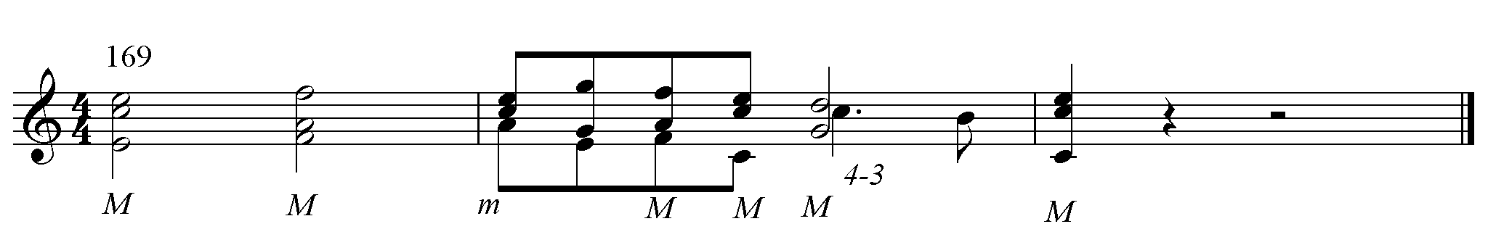
The chord progression of the first two phrases in subsection c, m. 174, follows the melodic minor scale. The scale is more for color than function. The scale only creates 6 minor chords out of the 27 chords in mm. 174-178. This technique keeps the joyful sound of the Mixolydian mode, even in the minor mode. The second of the two phrases is an irregular exordium as a paired transposition.
The ascending M2, incitato, of the soprano and the major sonority on “Israel” in m. 179, are incitato. Then, the harmonic intervals on downbeats between outer voices in mm. 179-180 are strong M3, which enriches the joyful praise of gratitude. The 4-3 suspension appears on the texts “principem” and victoriam,” a result heard eleven times in the movement (five times in B and six times in B’). This makes the song of praise very loud and sonorous.
At the conclusion of the scene III, the main mode is Mixolydian. Carissimi uses this mode to praise God. The Aeolian mode serves as the sweet hymn of praise, and the Dorian mode supports the act of God. With the modal construction, the use of triple meter for Filia’s aria and duet creates a very effective change in the music representing dance-like characteristic. In particular, the type II mutatio toni at 10B suggests that the triple meter is used to create a sweet and gentle characteristic. The intervals in the scene are not ambiguous, but instead, add sonority to the praise of God.
The first half of the entire story, scenes I – III, is in major modes. The main modes are generally Ionian and Mixolydian. The Ionian mode overshadows the scenes of the war, while the Mixolydian mode provides the happy characteristics to the praise to God. In this first half of the whole oratorio, the affective characteristics of different modes represent different characters with positive or negative images. Though there had been some inconsistency in applying the theory of interval affects even from the sixteenth century, Carissimi reinforces the characteristics of modes by applying the characteristics of each interval within each mode. This intention guided his choice of harmonic and melodic intervals according to their affective characteristics and allowed him to express the music more dynamically. As a result, the musical expressions in this first half are consistent with the emotion of the text.

- Scene IV. Nos. 14-21 Jephte and his Daughter:
Scene IV is a dialogue between Jephte and his daughter. Jephte’s daughter is the first person he meets on his way back home from the battlefield. Remembering his promise to God, he falls into a bitter sadness. Noticing her father’s anxiety, his daughter also worries as she listens to her father describing his promise to God. She nobly offers her life to God so that Jephte can keep his vow. Jephte takes pity on her and lets her go to the mountains with her friends for two months of lamentation.
Unlike previous scenes, this scene begins with a minor chord, and in m. 201, the first appearance of mutatio modi transforms the whole mood to sadness. The modes in this scene are Ionian and Aeolian in the historicus, and mostly Aeolian for the rest. The Mixolydian mode is used intermittently in Nos. 18 and 20. Therefore, the primary mode in the scene is Aeolian, and the story unfolds through the music in the terse and severe affects of the Aeolian mode.

Table.3.4.1. No. 14 Historicus
Measure | 196 | 201
Structure | A | B
Phrasing | 3, 2 | 2, 3
Mode | Ionian | Aeolian
Characteristics | Dances, in our (Zarlino’s) time, lascivious | Open, terse, lyric, gay, sweet, soft, sonorous, pleasant severity, gaiety, softness
Text | Cum vidisset Jephte, qui votum Domino voverat, filiam suam venientem in occursum, | Prae dolore et lachrimis scidit vestimenta sua et ait:
Translation | When returning Jephtah, who vowed to God his solemn oath, saw his only begotten daughter running out to meet him. | He wept in anguish. Then he rent his clothes, and sadly proclaimed.
Special Features |  | Mutatio Modi

The historicus narrates the scene in which Jephte comes back from the battlefield and meets his daughter. (Table.3.4.1.) This movement begins with the A minor chord by the type I mutatio toni. (p. 121, m. 196) The dramatic transformation, however, occurs with the parallel key change from C major to C minor at m. 201 through adding a flat on the pitch E. This mutatio modi is used to change the mood of the whole story, adding Phrygian sound to the Aeolian mode. In this recitative only, the historicus narrates the action until m. 201, then sings about the emotions onwards. In this moment, the whole story transforms from joy to sadness. (See Ex.3.4.1.)

Ex.3.4.1. Mutatio Modi
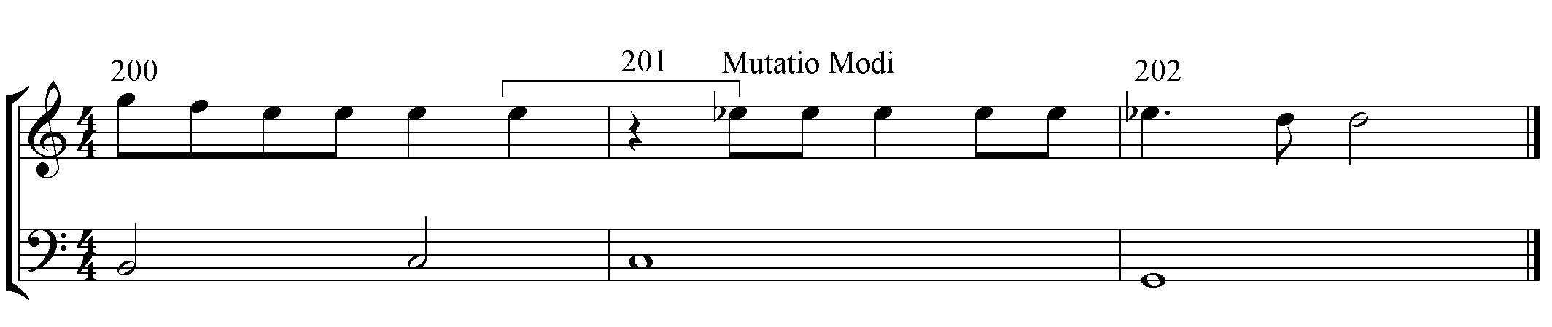

The descending major m2nd and M2 on the words “venientem” (come out) in mm. 199-200, (See page 120), adds strength on the upbeat and sweetness on the downbeat, resulting in a reversed energy on the melody. The simplified melody in mm. 199-202 has descending semitones, ^F-E-E♭-D, which is quasi-passus duriusculus, but the contour is broken by some escape tones. Particularly, the pitch change from ^E to ^E♭ in m. 201, which is the point of mutatio modi, momentarily produces a Phrygian sound on “prae dolore et lachrimmis” (he wept in anguish). Then, the ^6-5 suspensions in mm. 202 and 204 reinforce the sadness. As Zarlino recommended, this movement demonstrates the harshness as being more pronounced than in previous passages. These pitch relationships augment the effect of the mutatio modi in the Aeolian mode.

Table.3.4.2 No. 15 Jephte
Measure | 206 | 212
Phrasing | 2, 5 | 1, 4
Mode | Aeolian
Characteristics | Open, terse, lyric, gay, sweet, soft, sonorous, pleasant, severity, gaiety, softness,
Text | Heu mihi! Filia mea,  heu decepisti me filia unigenita, | et tu pariter, ,  heu filia mea, decepta es
Translation | Woe is me. My only daughter.  Woe! Thou hast undone me,  only begotten daughter, | and thou likewise  woe, my only daughter  thou art undone as well.
Special Features | M7th, TT

No. 15 is Jephte’s woeful scream, which deplorably laments his and his daughter’s fates. (Table.3.4.2.) This movement and all the transpositions fit into the Aeolian mode. The three shouts of the exclamation “heu” (Woe) portray the severity of Jephte’s shock. (p. 121, mm.206, 208, 213) At the downbeat of m. 206, the basso continuo can play a very fast tremolo and or arpeggiated scalar figures to express this grave surprise.
The M7 dissonances between the voice and the basso continuo in mm. 206, 208, and 213 are all unprepared harmonic intervals in seconda prattica style, which appear here for the first time in the entire piece. Zarlino describes the M7 as possessing an extreme, unrelenting, and penetrating sound. The use of the M7 reinforces the gravity and huge scale of Jephte’s harsh surprise.

Ex.3.4.2. Major 7th
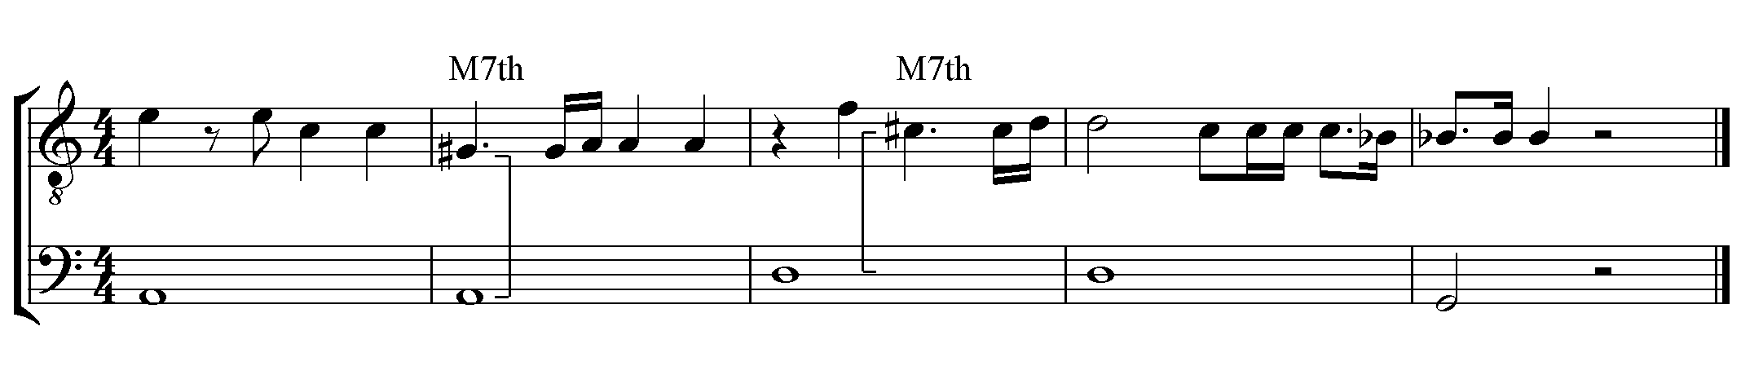
The two descending M2s in mm. 209-210 emphasize the sadness through the inherent molle characteristic of that interval. The descending tritone at the last beat of m. 210 accentuates the word “decepistime” (undone/discarded). The two ^4-3 suspensions in the paired transposition of the cadential motion in mm. 214-215 make the music very hard or harsh, and suggest sad emotions. These extremely harsh affected characteristics of intervals reinforce the severity of the Aeolian mode to express the painful intensity of Jephte’s sadness.

Table.3.4.3. No. 16 Filia
Measure | 217
Phrasing | 2, 4
Mode | Aeolian
Characteristics | Open, terse, lyric, gay, sweet, soft, sonorous, pleasant, severity, gaiety, softness,
Text | Cur ergo te pater,  decipi, et cur ego filia tua unigenita decepta sum?
Translation | How art thou, my father, undone?  And how then am I, your only begotten daughter, now undone as well?
Special Features | m7th

No. 16 (Table.3.4.3.) is Filia’s question regarding Jephte’s statement of “decepta” (undone) in previous movement. The Aeolian mode in this movement expresses that Filia succeeds Jephte’s emotion expressed in the previous movement in the same mode. The two phrases finish with half cadences, suggesting Filia’s questions. (p.121, mm. 218, 222) Despite the opening minor chord, the majority of the chords are major, with six major chords out of the eight total. Furthermore, the m7 in m. 220 does possess an extreme quality but a little less than the extremity of the M7 in the previous movement. The two descending major m2s of the BC in mm. 218 and 222, however, add some strength to the line. These intervallic relationships imply that Filia is alarmed but not yet as anxious as Jephte is. The effect of these intervallic interactions is a reduced severity of the Aeolian mode to contrast with the extreme agitation of Jephte in the previous movement.

Table.3.4.4. No. 17 Jephte
Measure | 223 | 230 | 235
Structure | A | B
Phrasing | 2, 5 | 2, 4 | 1, 4
Mode | Aeolian
Characteristics | Open, terse, lyric, gay, sweet, soft, sonorous, pleasant, severity, gaiety, softness,
Text | Aperui os meum ad Dominum,  ut quicumque primus de domo mea ocurrerit mihi offeram illum Domino in holocaustum. | Heu mihi! Filia mea,  heu decepisti me filia unigenita, | et tu pariter, ,  heu filia mea, decepta es
Translation | I opened my mouth in an oath to God:  That which comes out first from the doors of my house to greet me, I shall then offer to the Lord as sacrificial offering. | Woe is me. My only daughter.  Woe! Thou hast undone me,  only begotten daughter, | and thou likewise  woe, my only daughter  thou art undone as well.
Special Features | TT

No. 17 is Jephte’s arioso, which explains the reason why he is in panic, and repeats No. 15 to reiterate his lamentation. (Table.3.4.4.) The mode is continuously Aeolian to express the unrelenting severity of the narrative scene.
The first harmonic interval is a M3 with great sonority. (p. 121 m. 223) The melody spells the diminished fifth chord in mm. 223-5, which is annoying. The two ascending m3s in the chord doubles molle and arrives at the extreme diminished fifth, creating the unstable emotion on “mea” (my) in m. 226. With the extreme diminished fifth, the harmonic m3 adds sadness on “mihi” in m. 226. Also, 5-6 motion, a harmonic interval succession of diminished fifth and m6, as well as descending M3 and the final harmonic m3 in the measure heightens the sad characteristic. (See Ex.3.4.3.)
Ex.3.4.3. Melody Structure in mm. 223-226
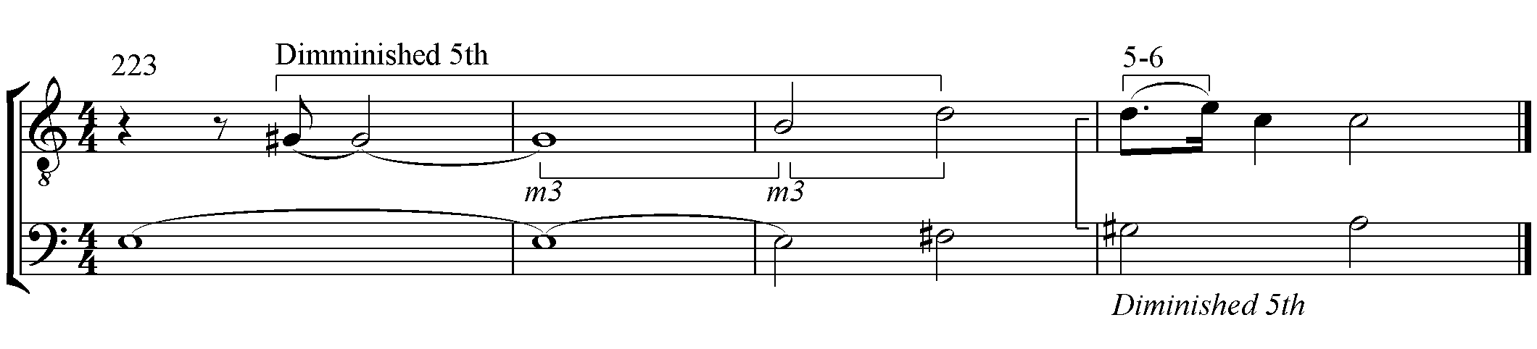
In m. 227, the melody has two ascending M2s, incitato, but a descending P5 on “Domino.” The placement of “Domino” is opposite from that in the second movement, which suggest something wrong. All the interval relationships provide a wrong characteristics on Jephte’s sworn oath to God.
Section B is a repetition of No. 15, but just a note change in the BC in m. 238. Through the change, descending m2 repeats in mm. 237 and 238, creating the early type of a chromatic fourth idiom.

Table.3.4.5. No. 18 Filia
Measure | 240 | 246 | 251
Phrasing | 2, 4 | 2, 3 | 3, 2
Mode | Mixolydian | Aeolian | Mixolydian
Characteristics | Lascivious, gay, modesty, threat, perturbation, anger | Open, terse, lyric, gay, sweet, soft, sonorous, pleasant, severity, gaiety, softness, | Lascivious, gay, modest, threatening, perturbed, angry
Text | Pater mi, si vovisti  votum Domino reversus victor ab hostibus, | ecce ego,  filia tua unigenita,  offer me in holocaustum  victoriae tuae, | hoc solum pater mi praesta  filiae tuae unigenitae  antequam moriar.
Translation | My father! If you swore a vow  to God, our Lord,  returning victorious over our foes. | Behold now I, your only begotten daughter,  offer up myself, a sacrifice to thy victory. | But only, my father, grant  unto your only begotten daughter  one wish before I die.
Special Features |  | Passus Duriusculus

No. 18 (Table 3.4.5.) is Filia’s answer to submit to Jephte’s vow after learning why that vow had caused him such anxiety. Her answer is noble, albeit unrealistic. The mode is Mixolydian, which conveys the joy and modesty of Filia’s willingness to keep her father’s vow. The Aeolian mode in the middle, however, suggests a sort of foreboding severity about Filia’s obedience. The return to the Mixolydian mode in the last section represents Filia’s modest petition, finishing with V of the mode.
The melody begins in A major and moves to D major through paired transposition. (p. 122, mm. 240-241) The two callings of “my father” use major chords with pleasing harmonic M3s to show Filia’s comforting heart for her father. Also, the transposition gets P4 higher on the second portion. This movement gives uplifting emotion with its incitato characteristic. The Mixolydian mode up until m. 245 reveals modesty and joy that God granted the victory through Jephte’s vow.
From m. 246, Filia swears to sacrifice herself in accordance with her father’s vow. The melodic structure has two ascending m2s in m. 246-7, quasi-passus duriusclus, on the passus duriusclus of the BC. The melody, however, needs ^F instead of ^D# of “offER” to make a complete passus duriusclus. With the ^D#, the melody has a descending minor m2, molle, and ascending m3, molle on “offer me,” resulting in the ascending M2, incitato, from “Offer” to “ME.” This incitato reveals Filia’s strong will in the middle of the doubled passus duriusclus, revealing Filia’s understanding that her father’s vow means her death. (See Ex.3.4.4.)
Ex.3.4.4. Interval Structure mm. 246-250
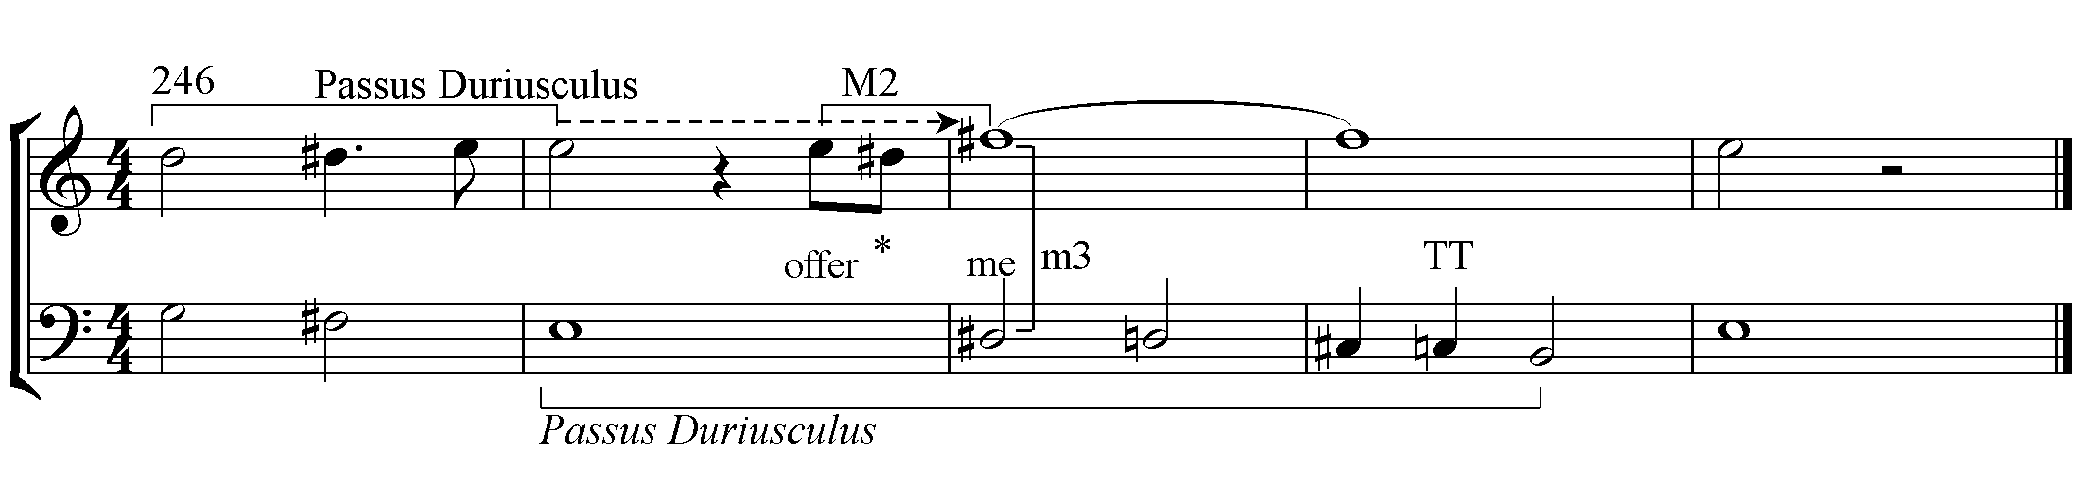
In mm. 248-9, Filia’s eight-beat long ^F# on the descending passus duriusculus creates the harmonic intervals of m3, M3, P4, augmented 4th, and P5. As a result, the succession of harmonic intervals heightens the tension to the extremity of the tritone. Therefore, those intervals convey unshakable strength of Filia’s commitment to sacrifice herself.
In this number, the emotions of the modes conflict with those of the pitch relationships. This clash represents two different emotions battling each other simultaneously: Filia’s obedience to her father’s vow, and her fear and sorrow in facing death.

Table.3.4.6. No. 19 Jephte
Measure | 256
Phrasing | 2, 3
Mode | Aeolian
Characteristics | Open, terse, lyric, gay, sweet, soft, sonorous, pleasant severity, gaiety, softness,
Text | Quid poterit animam tuam,  quid poterit te, moritura filia, consolari?
Translation | But what can I do to comfort your soul?  What can I offer you, doomed daughter, in consolation?
Special Features | Passus Duriusculus, TT

No. 19 is Jephte’s question about Filia’s final wish. (Table.3.4.6.) The Aeolian mode maintains the sense of severity. The first harmonic interval is M3 with harshness. (p. 122, m. 256) Then, the whole melody is on Passus duriusculus in the BC in mm. 258-260. This results in the harmonic intervals of M3 on “animam” (I do), m6 on “Filia,” and the 4-3 suspension with a tritone on “consolari” (consolation). Also, the melody in m. 259 has a descending tritone. All these intervals represent harsh and extreme characteristics on the death-related Passus duriusculus. The characteristics of intervals illustrate the sorrow for the fact that nothing can comfort Filia in dying. In addition to enriching the emotion of the Aeolian mode, these intervallic relationships highlight the father’s remorse for his inability to console his daughter on her way of death.

Table.3.4.7. No. 20 Filia
Measure | 261 | 264
Structure | A | B
Phrasing | 3 | 2, 2, 2
Mode | Mixolydian | Aeolian
Characteristics | Lascivious, gay, modest, threatening, perturbed, angry | Open, terse, lyric, gay, sweet, soft, sonorous, pleasant severity, gaiety, softness,
Text | Dimitte me, ut duobus mensibus circumeam montes, | et cum sodalibus meis,  plangam  virginitatem meam.
Translation | Send me away  for the space of two months to wander in the mountains. | And with my friends, as companions,  mournful, lament  there my virginity.

No. 20 (Table.3.4.7.) is Filia’s wish to go to the mountains for two months of mourning. The first three measures adopt no. 17 in a little-varied form. (p. 122, mm. 261-263) The bass is the same as that in no. 17 and Filia sings the spelled diminished fifth chord in the melody also. The biggest difference, however, is the last major chord on “montes” (mountains) in m. 263. Though the two ascending m3 doubles molle, the M3 on “montes” gives incitato, making the whole mode in Mixolydian, in which Carissimi expressed Filia’s modesty and firm commitment.
The Phrygian melodic shapes in paired transposition in mm. 265-266 on the word “plangam” (morning) contain two ^4-3 suspensions expressing further sadness and hardship. Also, this Phrygian melodic shape is a foretaste of no. 23, Filia’s long aria in the mountains.

Table.3.4.8. No. 21 Jephte
Measure | 270
Phrasing | 1, 2, 3
Mode | Aeolian
Characteristics | Open, terse, lyric, gay, sweet, soft, sonorous, pleasant, severity, gaiety, softness,
Text | Vade, filia mea unigenita,  et plange virginitatem tuam.
Translation | Go my daughter, my only begotten,  and mournful, lament there thy virginity.
Special Features | Diminished – Melody/Bass(repeat)

No. 21 is Jephte’s consent for Filia to go to the mountains. (Table.3.4.8.) This movement is again in the Aeolian mode. Three cutting diminished chords are spelled in voice and the BC in p. 122, mm.270-271, and in the BC alone in mm.272-273. The diminished chords illustrates how unbearably annoyed Jephte’s heart is. The descending m3 intervals in the chords are more examples of incitato, which create a rough aural effect. The second “vade” falls on a harmonic m3, expressing sadness. Together, these illustrate the pain and reluctance in Jephte’s heart over allowing Filia go to mountains. The word “mea Unigenita” in m. 271-2 contains harmonic tritone and P4 moving to M3. In the harmonic recognition of the BC, those pitches are m7 and M6 of the first inversion of the A major chord, creating the extreme characteristics of a harsh sound. (See Ex.3.4.5.) With the descending minor m2, molle, all the intervals indicate Filia’s own hardship.

Ex.3.4.5. Intervals in mm 271-2
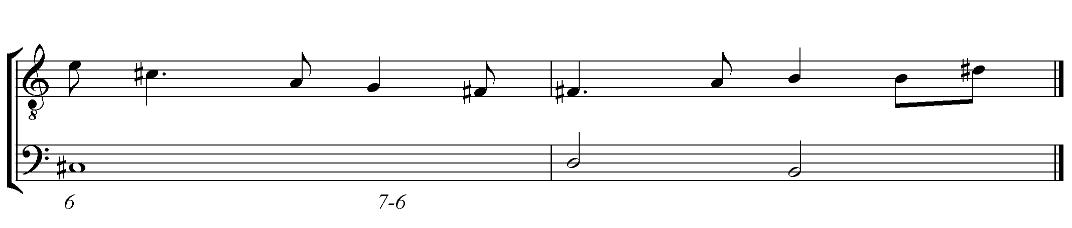
The harmonic intervals on the word “plange” in m. 272 are in unison and go to m6 in m. 273, evoking absolute sadness from their characteristics. A ^4-3 suspension tinges the cadence with more harshness. All of these dismal and pained intervallic effects amplify the severity of the Aeolian mode to paint a musical picture of Jephte’s intense sorrow.
As the short conclusion of the scene, the main mode of the scene is Aeolian, except for Filia’s answer to follow Jephte’s sworn oath to God. The uniqueness of the scene is that this is the only scene with no choral movement. Carissmi focuses on the dialogue between Jephte and his daughter to elevate the sadness and the hardship in their relationship. The appearance of mutatio modi creates a dramatic turning point of the whole story. Besides, the combinations of intervallic characteristics are not as straightforward as those in previous scenes. All the characteristics of intervals of this scene cooperate together to raise the emotions.

- Scene V. In the Mountain:
The fifth scene is Filia’s song in the mountains and Israel’s response. A four-part historicus introduces Filia’s journey to the mountains as a place where she could mourn. Then, the lone Filia sings the longest aria in the entire work, to which all of Israel responds in the last chorus.

Table.3.5.1. No. 22 Historicus a 4
Measure | 276
Phrasing | 4, 4, 3
Mode | Mixolydian
Characteristic | Lascivious, gay, modesty, threat, perturbation, anger
Text | Abiit ergo in montes filia Jephte,  et plorabat cum sodalibus, virginitatem suam,  dicens,
Translation | Then to the mountains went the daughter of Jephtah,  with her companions there lamenting her virginity with sorrow,  saying
Special Features | G minor on plorabat – Parallel minor

No. 22 is the historicus in four voices, set in the Mixolydian mode. (Table3.5.1.) This is a narrative chorus with a non-repeating text. This preponderance of the major sonorities lends special significance to the G minor (p. 123, m. 276), the parallel minor (m.280), that Carissimi places in the middle to emphasize the word “plorabat.” (lamenting) This harmonic exchange accentuates the word through the difference in harmonic color.
The first harmony in m. 276 is an open position of a G major chord with the ^3 in the soprano. The stable harmony represents the firm and solemn steps of the daughter, while the harmonic M3 between the outer voices adds a harsh characteristic. The word “filia” is syncopated in the second measure. Also, the two inner voices of “filia” receive M3 parallel, which creates a harsh image. Then, the harsh 4-3 suspension follows in m. 278. Carissimi uses these devices to depict the great challenge of the journey to the mountains.
The color contrast of the parallel minor, G minor in m. 280, emphasizes the word “plorabat.” According to Zarlino, when a chord has a third on top, the minor third between the top two voices gives almost a dissonance effect. With this effect, the soprano and tenor have harsh parallel M3s on the word, and the parallel intervals strengthen the softness of the melodic M2. The 4-3 suspension on “suam” (daughter) in mm. 283 adds another harsh characteristic. Then, the 7-6 suspension on “dicens” (saying) in m. 285 creates an extremely severe image by the characteristics of intervals, introducing the sadness of the following aria.

Table.3.5.2. No. 23. Filia
Measure | 287 | 301 | 318 | 342
Stanza | 1 | 2 | 3 | 4
Mode | Phrygian | Aeolian,  Phrygian | Aeolian | Aeolian,  Phrygian

No. 23 (Table.3.5.2.) is the longest and saddest aria in the entire oratorio. While on the mountain, Filia laments her death as a virgin without a child. Also, she is sad that there is no one there to comfort her. The song finally draws to a close as she implores all of Israel to cry for her.
This movement has a four-stanza structure, but is not in strophic form. Each stanza contains different levels of emotions. Carissimi uses type II mutatio toni more in this movement than in any other to heighten the emotional expressions. The table above shows the modes tracing a modulation from Phrygian to Aeolian and back to Phrygian. The characteristics of the modes are lamentation, severity, and again lamentation. The structure of the modulation suggests a particularly intense and severe lamentation for this tragic aria. For a detailed survey, the passages were analyzed according to each stanza.

Table.3.5.2.1. No. 23-1 Stanza 1
Measure | 287 | 292 | 299
Structure | A | B | Echo 1
Phrasing | 2, 3 | 4, 4 | 2
Mode | Phrygian
Characteristics | Hard, weeping, lament
Text | Plorate colles,  dolete montes, | et in afflictione cordis mei ululate! | Ululate!
Translation | Lament ye hills,  and mourn all ye mountains | Howl in affliction of my broken heart, sorrow and grief! | Howl!

Stanza 1 of No. 23 is a song in which Filia declaims her sorrow while she wandering in the mountains. (Table.3.5.2.1.) In the Phrygian mode, each section has paired transpositions from A-D and E-A. According to Adrian Willaert, the descending fifths-related sonority in the transposition signify a special device that appeals directly to the sense. This intervallic relationship advances the inherent lamenting quality of the Phrygian mode.
The stanza begins with a type I mutatio toni, a tone above from that of the last movement. (p. 123, m. 287) The first and second phrases have similar texts and melodic shapes, which take a paired transposition. The harmonic intervals on the first two stressed beats are m3s, which represent sadness, on the word “plorate” (lament). The melody begins with an ascending m3, then a descending M2, ascends by a M3, and descents by a m3. The former two are molle (sweet), while the latter two are incitato (tense), with the result that the prior sweetness is reinforced by the following strength. The ^B♭ on the second “plorate”, m. 287, is a lowered ^2, which functions to create the Phrygian mode. The melody of the Phrygian motion has an ascending M3, incitato, a descending M2, molle, descending m3, incitato, and a descending minor m2, molle. The alternating characteristics heighten the harshness of the passage on the descending major m2, incitato, in the BC. The 4-3 suspension, m. 288, created by the descending m2 adds great intensity. The descending m2 of the BC is a ^6-5 motion with a harsh characteristic creating a severe parallel M3 with contrasting rhythms on “colles” (hills), m. 288. This motion signifies the characteristic of the Phrygian melody as it appears throughout the movement. In the next transposed phrase, the intervals enrich the emotional expression in a different range, a P5 higher.
The third and fourth phrases, mm. 292-298, use the exact same technique of paired transposition. The first harmonic interval is a M3 which proceeds to a diminished fifth, associating the characteristics from harshness to the extreme characteristic of the tritone. Also, the two ascending minor m2s in the bass create a doubled incitato. The first melodic intervals in the first two measures are an ascending m3 and a descending M2, which are molle. Then, all the intervals reinforce the harsh characteristics of the following Phrygian cadential melody.
This Phrygian cadential melody, mm. 293-294, is slightly different from the beginning passage of this movement. The melody begins with a flattened ^2 and is elaborated by a melisma at the next beat. The structure of the melisma is two ascending M2s, incitato, arriving at an M3 higher, followed by a descending M2, molle. Next, a descending m3, incitato, is used to arrive at the tonic, followed by a descending minor m2, molle. The three descending half steps notes of the melody are F-E-D#, which are a form of Passus Duriusculus. All the intervals in the BC are either ascending m3, molle, or descending major m2, incitato. Among all nine melodic intervals, four half steps appear to heighten the sad characteristic of the Phrygian mode.
The two-part echo, mm. 299-300, has a delayed parallel third in delayed imitation, creating a harsh M3 parallel sound. Furthermore, the duet creates the 6-5 suspension above a 4-3 suspension, resulting in a soft parallel m3, with a unison cadence on the tonic. These interval patterns reinforce the feeling of despair. All of these intervallic relationships, in accord with the lamenting emotion of the Phrygian mode, work in tandem to intensify this sorrowful quality.

Table.3.5.2.2. No. 23-2 Stanza 2
Measure | 301 | 306 | 316
Structure | C | D | Echo 2
Phrasing | 2, 3 | 3, 3, 4 | 2
Mode | Aeolian G – E | Phrygian G-A | Phrygian
Characteristics | Open, terse, lyric, gay, sweet, soft, sonorous, pleasant severity, gaiety, softness, | Hard, weeping, lament
Text | Ecce moriar virgo,  et non potero morte mea meis filiis consolari, | ingemiscite silvae, fontes et flumina,  in interitu virginis lachrimate! | lachrimate!
Translation | Behold! For I die as a virgin,  in my death not finding in having children some consolation | Then, lament all ye woodlands, fountains, and flowing streams  at the destruction of a virgin. Oh! Cry in anguish! | Oh! Cry in anguish!
Special Features | M7th

In Stanza 2 (Table.3.5.2.2.) Filia mourns her childlessness leaving her with no sense of consolation in dying. She then asks the surrounding natural objects including woods and fountains to lament for her. As an extended version of Stanza 1, this stanza begins with a type II mutatio toni, deepening the emotion. (See Ex.3.5.1.) Carissimi uses the severity of the Aeolian mode for the first portion to convey intensity, with the melody arriving at the cadential Phrygian mode at the end of the second section.

Ex.3.5.1. Type II Mutatio Toni
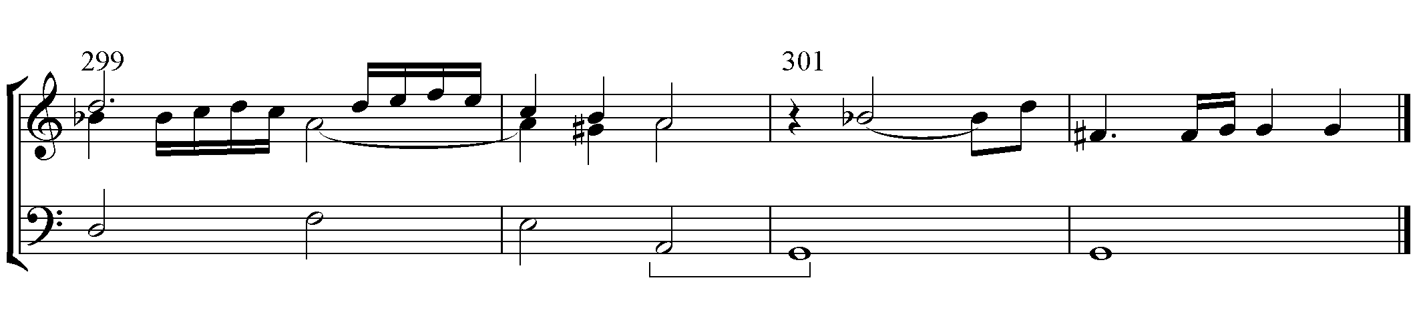
The first harmonic interval in m. 301 is the m3 of the sad characteristic on the second beat in a syncopated rhythm. The melodic interval in the melody is an ascending M3, which adds a harsh quality. Then, in m. 302, an extreme M7 appears on “morirar” (die), expressing an even more extreme hardness, recalling the M7s in movement 15.
In mm. 303-304, the BC has a Cambiata motion with two sets of half steps on the words “morte mea meis filiis” (my death, without a son). The melodic intervals on them are an ascending minor m2, an m3, and a minor m2, plus a descending m3. The two ascending minor semitones, incitato, are important to express the harshness of dying without having given birth to a son. Among the intervals, the last m3 arrives at the unison on “fillis” (son), expressing the absolute quality of a son for consolation. The 4-3 suspension on “consolari” (consolation) heightens the despair characteristic.
The major sonority in mm. 306-8 (p. 124), where Filia asks nature to cry for her, reflects back to No. 20, where Filia’s petition is represented in the major sonority. The ascending m3, molle, on “interibu” (destruction) in m. 309 changes the sonority into minor, and a descending M2, molle, appears on the word “virginis.” (virgin). Then, the Phrygian cadential melody is used. The Phrygian melody is slightly varied from that used in the first stanza. The difference is a falling P4, molle, instead of the M3 after the melisma, resulting in a heightened emotional level. After the end of the phrase in m. 311, the melody begins on the last beat an octave higher, creating a surprising syncopation. The melody in mm. 313-5 is a transposition of mm. 309-11.

Table.3.5.2.3. No. 23-3 Stanza 3
Measure | 318 | 324 | 331 | 340
Structure | E | F | G | Echo 3
Phrasing | 3, 3 | 2, 2, 3 | 5, 4 | 2
Mode | Aeolian A-E-A
Characteristics | Open, terse, lyric, gay, sweet, soft, sonorous, pleasant severity, gaiety, softness,
Text | Heu me dolentem  in laetitia populi,  in victoria Israel et gloria patris mei, | Ego sine filiis virgo,  ego filia unigenita, moriar et non vivam. | Exhorrescite rupes,  obstupescite colles, valles, et cavernae  in sonitu horribili resonate! | resonate!
Translation | Woe! is my heartbreak  amidst the joy of the multitude,  and the victory of Israel and glory of my father. | I am without children, a virgin,  I, the only begotten daughter now must die and not live more. | Quake and tremble ye rocks. Be astounded ye hills.  Valleys and caverns  in horrible sound resonate! | resonate!

Stanza 3 (Table 3.5.2.3.) begins again with a type II mutatio toni at a half step lower than the previous note in the BC. (p. 124, m. 318) The half step possesses a more bitter effect than the whole step of the first note of the previous stanza, thereby sharpening the emotional struggle depicted in this stanza. In Stanza 3, a paired transposition is used frequently to render all the affected emotions more expressively. The elements of syncopation combined with a fast rhythm enhance the severity of the Aeolian mode in this stanza.
The repeated text “Heu me dolentem” (Woe my heartbreak), mm. 318-320, takes the paired transposition in syncopated accents on the weak beats. The first harmonic interval is a characteristically sad m3 on the long “heu” (woe). The doubled paired transpositions appear in mm. 321-323. The melody is in the major sonorities, expressing Israel’s joyous victory, while the three half steps in the BC express Filia’s heartbreak. The fast rhythms heighten the portrayal of the struggling emotions.
The melody in mm. 324-5 is similar to the Phrygian melody (but without a flattened ^2), and repeats in the following measures. The melody begins with a harmonic m3 and the BC takes a Cambiata motion of G#-A-F-E. Particularly, F-E is a ^6-5 motion expressing sad emotion. Besides, the motion creates a heightened and harsh M3 parallel with the melody, using the same beat and long notes on “virgo” (virgin). The same structure appears on “morira” (die) in m. 327.
The second section, m. 324, begins with the harmonic interval of a sad m3, then ascends by m3, molle, on “sine” (without). With the sad characteristic of the intervals, the descending m2 on “virgo” (virgin) adds to this sense of grief concerning Filia being childless. The next phrase is a repetition that gently increases this sad emotion of Filia’s impending death.
The word “et” (and) is set to a melismatic passage. (See Ex.3.5.2.) Structurally, this melisma has an ascending major m2, molle, an M2, and a descending M2. Among the intervals, the middle M2 is very short and creates a neighboring tone, receiving less importance than the m2. As a result, the molle characteristic of the ascending major m2 represents the main characteristic of the four-note unit. Then, the notes are transposed to the P4 above, incitato, heightening the emotion, with an important variation. In the second unit, the m2 of the first unit is replaced by an ascending M2 in the second unit, and the M2 of the first unit is replaced by m2s. As a result, the molle characteristic of the ascending major m2 in the first unit is replaced by the incitato characteristic of the ascending M2, intensifying the emotional level. The 4-3 suspension on “vivam” adds more harshness to the passage. All the intervals express the bitter sorrow of Filia’s dying while still a virgin.
Ex.3.5.2. Interval Structure mm. 328-329
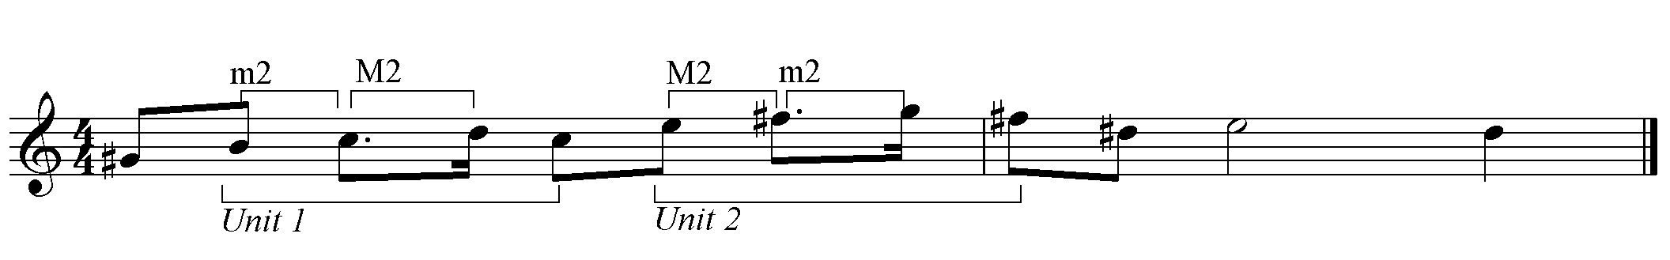
The third section, m. 330, is Filia’s plea to nature to quake and cry with horrible sounds in pity for her. An extremely fast rhythm is used to strengthen the command. The first word, “exhorrescite” (quake), is sung on the harmonic M3, expressing harshness concerning the rigor of what Filia has been asked to do. The following repeated paired transpositions go high by P4 twice, and arrive at the m7 above and emphasize the extremity of the emotion. The ascending m3, molle, and the descending major m2, incitato, on “in sonitu horribili” (in horrible sound) in m. 334 show that the “horribili” receives more intensity. In the next phrase, the melody in mm. 336-8, with the paired transposition, has an ascending m3 and a descending M2, all molle, denoting a weakened or saddened characteristic from “sonitu horribili” in mm. 333-4.
An extensive melisma follows in m. 338. The series of sixteenth notes uses an ascending M3 and a descending m7. The M3 increases the tension, and the descending m7 represents an extreme quality on the melisma. Then, the echo repeats the melisma with parallel thirds. The resulting amplification in volume and thicker texture is a sonic manifestation of the word “resonate.”
One interesting feature is the long rest after the echo. (p.125, m. 341) The space implies that Filia regains some stability to proceed. There is no special technique or modal change used between stanzas 3 and 4. Therefore, the rest creates a great moment of reenergizing the music for a different manner.

Table.3.5.2.4. No. 23-4 Stanza 4
Measure | 342 | 347
Structure | H | I
Phrasing | 3, 2 | 3, 2, 3, 2
Mode | Aeolian | Phrygian
Characteristics | Open, terse, lyric, gay, sweet, soft, sonorous, pleasant severity, gaiety, softness, | Hard, weeping, lament
Text | Plorate filii Israel,  plorate virginitatem meam, | et Jephte filiam unigenitam in carmine doloris  lamentamini.
Translation | Lament then ye children of Israel,  bewail ye at my virginity, | for Jephtah’s only begotten daughter hear songs of deepest anguish.  Lament.
Special Features | Passus duriusculus | TT

Stanza 4 (Table.3.5.2.4.) begins in Aeolian mode and then modulates to Phrygian. While the previous stanzas rely on nature for lamentation, a modified rhythm represents that Filia now petitions all the Israelites to cry for her. The first portion of the requesting lamentation (p. 125, m. 342) is in the Aeolian mode in order to take over the severity of the previous stanza. The second portion, m. 347, is in Phrygian mode, which is appropriately matched to the sad, lamenting songs.
The first section begins with an ascending m3, molle. The melody in m. 343 has two ascending m2s making parallel M6 with the BC, which reflects a hard characteristic, and repeats as a paired transposition. The series of ascending melodic semitones in mm. 345-346 is passus duriusculus, expresses Filia’s deep sorrow just moments before her death.
The melodic shape in mm. 348-9 has two ascending m3s, marking an arrival on the tritone through an annoying sound on “in carmine doloris” (bitter songs). Also, the harmonic tritones on “carmine” in m. 353 have the same affections. Then, the two downbeats of mm. 348-9 have the parallel motion of m. 343 within a decreased interval of m6, which are sad or languid. The m6 parallel downbeats repeat as in mm. 353-4. The melody in m. 353, however, increases the tension extremely, employing an m7 interval between the downbeat and the third beat. The Phrygian cadential motion in mm. 349-351 and 354-6 as a paired transposition adds extremely harsh characteristics with the 6-5 suspension on “doloris”, tritones on “LAmentamini”, and a 4-3 suspension on “lamentTAMIni.”
Table.3.5.3. No.24 Chorus a 6
Measure Number | 357-367  (386-395) | 368-375  (396-403) | 376-385  (404-413) | 414-431
Structure | A |  | B | Coda
Substructure | a | a’ | b | b’
Phrasing | 4 3 4 | 3 5 | 4 6 | 3 4 5 6
Style | Homophonic | Imitation | Homo,  Polychoral | Homo, Polychoral
Mode | Aeolian | Phrygian | Mixolydian | Mixolydian
Characteristics | Open, terse, lyric, gay, sweet, soft, sonorous, pleasant severity, gaiety, softness, | Hard, weeping, lament | Lascivious, gay, modesty, threat, perturbation, anger
Text | Plorate filii Israel,  Plorate omnes virgines  et filiam Jephte  unigenitam | in carmine doloris | lamentamini | lamentamini
Translation | Weep now oh children of Israel, for Jephte’s dear only begotten daughter weeps | In songs of bitter sorrow | lamentations | lamentations
Symbolism | m 2nd, m 3rd, Lamento della ninfa,  Phrygian, a minor, pitch E and C# |  | C, G, numerical, pitch D, Major 2nd, ascending bass, Numbers

The “Plorate” chorus (the closing chorus) has two versions of codas. One is three bars long, and the other is eighteen bars long. In this analysis, the latter coda is analyzed as containing more substantial meaning than the three-bar long coda. According to G. A. Walker’s classification of oratorio choruses, this movement is a type of a reflective chorus for providing listeners with moral lessons. Furthermore, in the story, this movement is a response to the daughter’s lamentation in the mountain, and the movement shares the sad text of Filia’s solo. As shown in the Table.3.5.3., the movement has a bar-form structure.
The bass repeats the first theme in the first seven bars, followed by a half-cadence structure. (p. 125, mm. 357-363) The theme is stated in the subsection a’ as a six-part fugue (imitation). The section B, mm. 376-385, a double choral style with a new theme, closes the first full statement by an imperfect authentic cadence. These three subsections seem to model a hybrid sentence consisting of a compound antecedent and a cadential progression. Therefore, to organize this into a three-part structure of the introduction of a theme, a thematic development, and a contrast is reasonable.
The subsections a, a’, and b, from m. 357 to m. 413, actually contain a ternary structure as the theme develops in the first two subsections as repetition, and a new theme is presented in the third subsection. As a result, the listeners hear seven subsections in total, consisting of three repeated sections with a coda. Seven subsections can be further divided into four and three sections: four is made up of the repetition of the two subsections of section a and a’, and three consists of the repeated b and the coda.
The subsection a, mm. 357-367, has an Aeolian mode in Homophonic style. As the text repeats the Stanza 4 of the previous aria, this mode illustrates the severe sadness of the text. This movement begins with V-i of the Aeolian mode, but the bass theme reveals a Phrygian melody. These two features provide the basis of a sad characteristics to the music.
The prominent theme, which the bass repeats, is Lamento della ninfa, an ancient form of a chromatic fourth which was used by Monteverdi to express sadness. (See Ex.3.5.3.) The descending four notes from ^A to ^E work as the source for all the thematic development (see Ex. 3.5.3.). The theme is a form of the chromatic fourth, discussed in movement No. 8, and its descending major m2, incitato, provides the feeling of the Phrygian mode. The second soprano’s theme in mm. 358-360 is a third parallel, and the alto’s theme is a retrograde of the bass theme.
Ex.3.5.3. Lamento Della Ninfa Theme
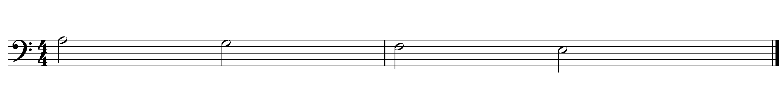
This movement begins with the bass and the upper parts coming in with a closed-root position of V, which segues into another closed-root position of i on the downbeat, and the qualities of the first five chords use an alternation of major and minor chords, creating a hard image. Among the two minor chords, the second one in m. 359 has the M3 beneath the P4, a first inversion form of the chord, with a bad quality. The other important interval is the M7 between the tenor and the bass in m. 359, adding extreme quality to sonority.
The first melodic interval of the soprano in m. 357-358, is an ascending major m2, making molle, and goes down from ^C to ^G#. (p. 125) The second soprano takes a contrary motion, creating the highest part in mm. 359-360, with an ascending M2 and a descending m3, all incitato. The harmonic and melodic intervals repeat in the following phrase, but with development in the tenor part. In m. 362, “virgine” has a descending m3 and ascending P5, all incitato. In particular, the harmonic M7 between the tenor and the bass in m. 359 on the word “Israel” equates the word “virgine” in m. 362 by the same interval between the soprano II and the bass, indicating the extreme harshness of the situation.
The third phrase of the subsection a, m.364, begins with a hard syncopation on the last beat and a minor quality chord contrast to the previous major chord. (p. 126) The minor chord quickly turns to a major chord at the next downbeat, and subsequent chords make the alternation of the minor and major sonority in the five chords in mm. 364-367 create the hard image. The bass part in mm. 364-367 features a circle of fifth, ^C-G-D-A progression, creating a plagal cadence. As a plagal cadential motion of Aeolian, the bass suggests negative effect.
The downbeat of m. 364 has the harsh harmonic M3 between the bass and the soprano on “filiam” (daughter). Then, the melodic intervals on “unigenitam” (only child), mm. 375-367, have descending m2s in sopranos, ascending M2 in tenor, ascending M3 in baritone, and ascending P5 in bass. Those intervals are all incitato, increasing the harsh characteristic of M3 on “filiam.” All the modal and intervallic implications in the section A imply how harsh the fate of “Filia” is.
The a’ section, mm. 368-375, is a six-part imitation prominently featuring the Lamento della ninfa theme. The theme contains the lowered ^2 and reveals the Phrygian mode, and the theme appears in each part in the alternation of E and B transpositions. As the imitation progresses, every other measure appears as an extreme harmonic M7, resulting in a total of three appearances of the interval in the section, mm. 368-373. The interval makes the lamenting characteristic of the extremely sad Phrygian mode.
After the third appearance of M7 in m. 373, the harsh parallel M3 appears in tenor and baritone. Then, all the voices have interesting interval changes: Soprano I has an ascending P5; Soprano II has a descending major m2; Alto has an ascending P4; Tenor has a melismatic ascending P4; Baritone has an ascending M2; and Bass has an ascending P5. All the intervals mentioned are incitato on the word “doloris” (bitter sorrow). Also, the plagal motion of the Phrygian mode in mm. 374-5 creates a negative image, and the 4-3 suspension in m. 375 increases the harshness of the passage. This organization suggests extreme sorrow throughout the passage, creating symbolic meaning by the number of M7 appearances, indicating ‘perfection’ through the use of the number three, while the interval organization in mm. 373-5 creates ‘bitter and perfect sorrow.’
Section B progresses from C major sonority to the Mixolydian mode. The m. 376 is a pivot by the C major chord in contrast to the previous E major chord. The appearance of sub-mediant is quite striking, and the pitch movement from G# to G in alto gives another evidence of mutatio modi. (See Ex.3.5.4.) The return to the C major chord, contrast to the mutatio modi in m. 201, is a resolving activity against the previous E major chord, creating the return of the music to the major sonority of Mixolydian mode.

Ex.3.5.4. Mutatio Modi
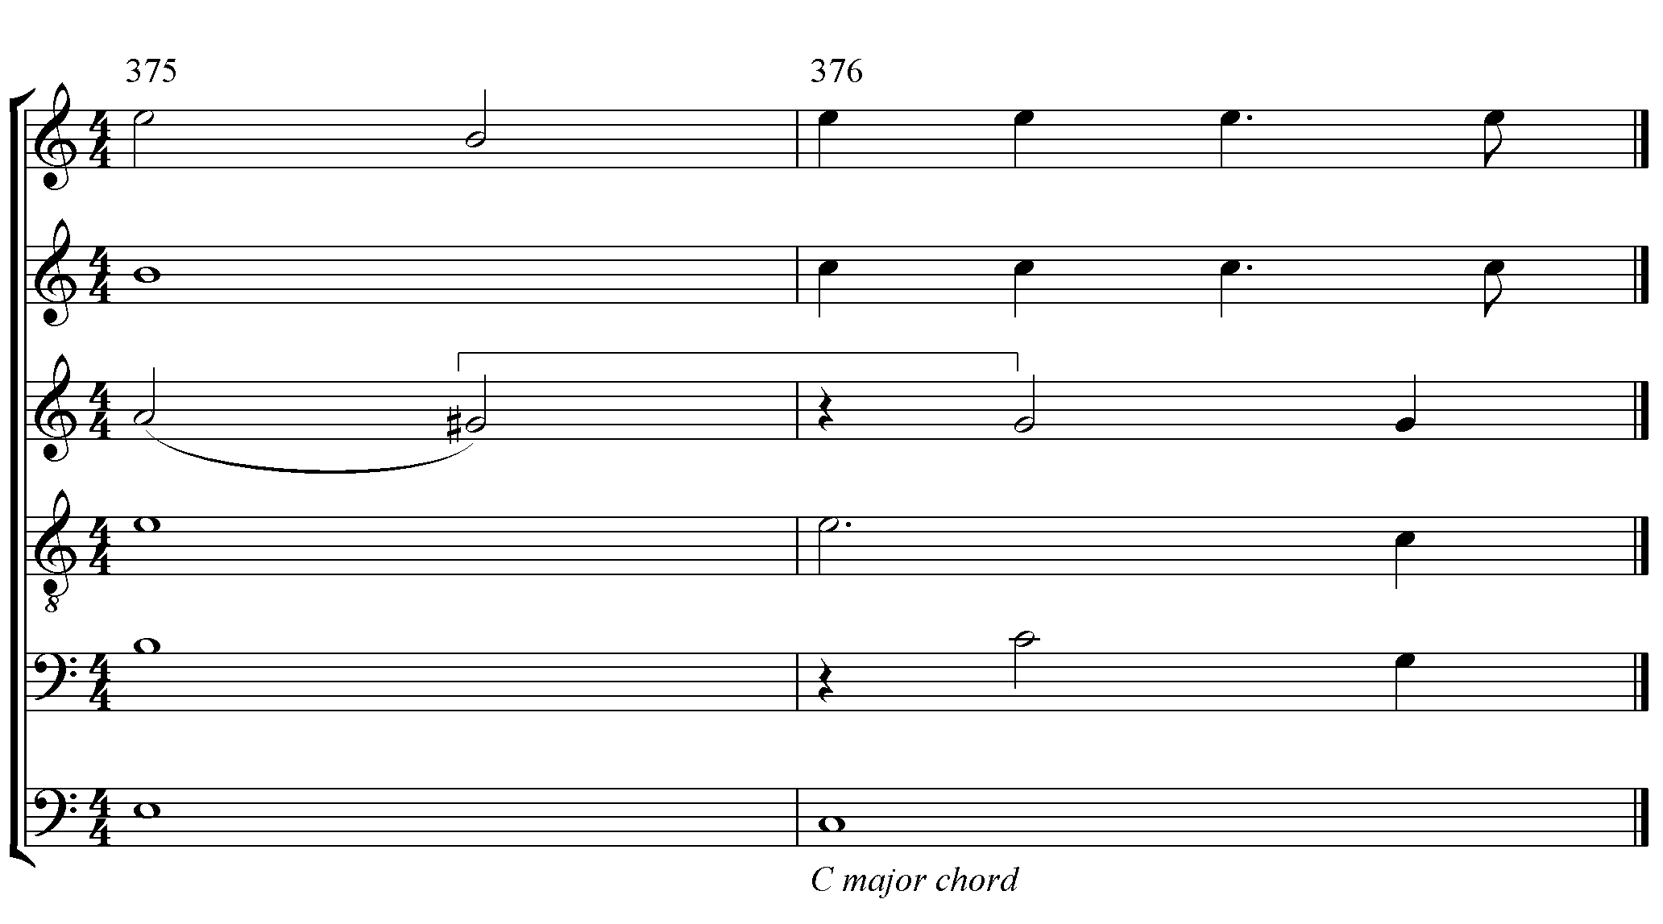
The appearance of the C major chord is a disruption from the progression of the music. From this point, the music abandons its minor characteristics for a change to the major mode. Zarlino discusses the aurally-pleasing effect of the harmonic division of the fifth (root-position major triad). Moreover, the first four measures, mm. 376-9, sound like the half cadence of the C major key or the Ionian mode. The affective characteristics of the Ionian mode are joy, lasciviousness, or “in our (Zarlino’s) time” (which refers a dance). These characteristics render the moods in which the melancholy text lamentamini is heard, providing stark contrast between the music and the text.
The first harmonic interval in m. 376 is a pleasing M3, and a descending M2 in the soprano, molle, follows. The upper three part of the down beat in m. 377 is a first inversion of a triad with good effect. When all the parallel motions in mm. 380-383 (See Ex.3.5.5.) descend by a step in the upper five voices, the lowered intervals release the heightened characteristics of the previous intervals producing a sweeter and pleasing sound. These mild characteristics of the intervals replace the bad effects of the sharp m2 relationship in the previous portions of the movement. Furthermore, the ascending five pitches in the bass in mm. 379-383 create contrast to the descending Lamento Della Ninfa theme of the previous sections.
Ex.3.5.5. Dissonances
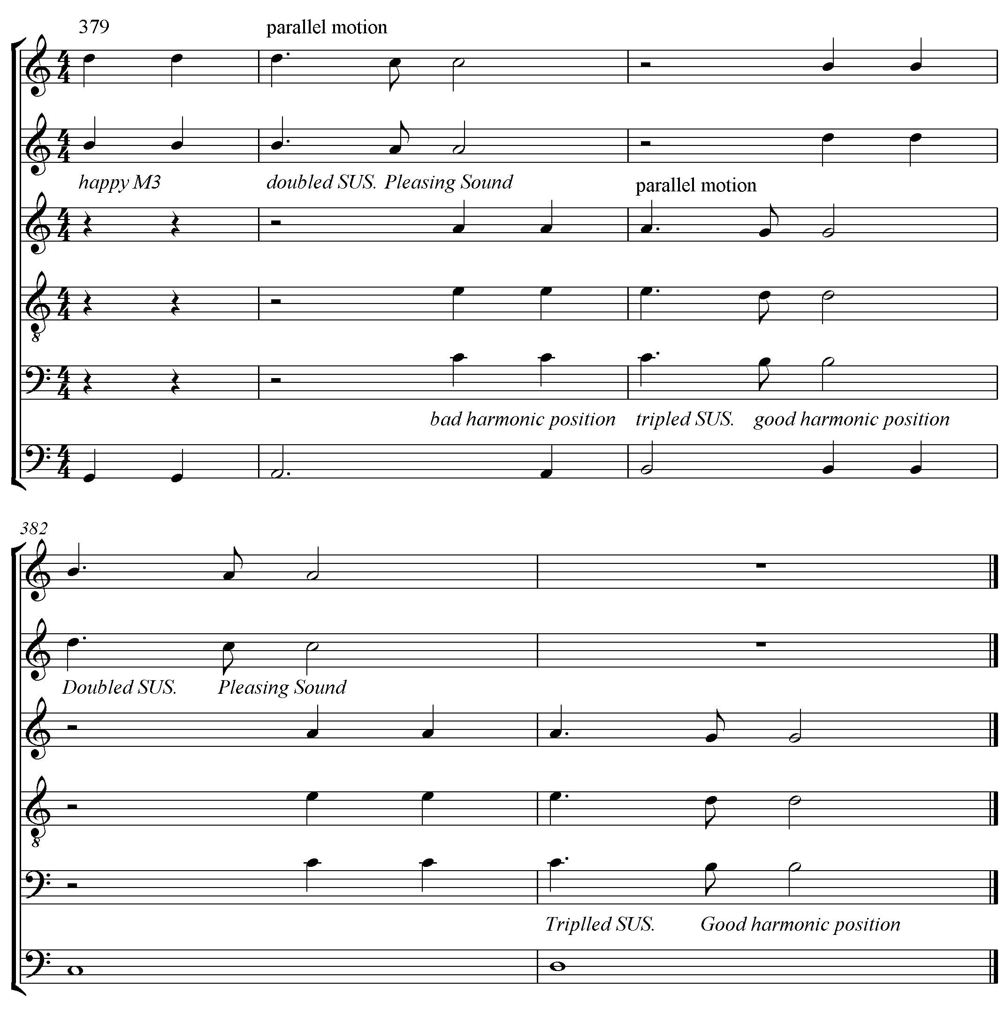
Section B begins in homophonic style and segues into a concertato style in m. 379 through polychoral technique. The upper five parts descend, while the bass ascends. The long-held pitch ^D is mostly doubled in the soprano and the tenor in different registers, creating a sort of highway in the music. Even at the end of the B section, ^D is tripled in three-octave levels. The soprano in mm. 381-5 creates a V shape. The pitch and the shape of the V suggest a strong symbolic meaning.
The treatment of dissonance is significant. The dissonances in the entire work are usually single form. Yet from this section, dissonances appear as multiple-layered suspensions in a beat, thus making the places with the dissonances more sonorous and the resolutions much clearer than those in previous portions in the work. Six places out of the total seven suspensions in this section use multiple-layer suspensions, making the number seven of the dissonances symbolically meaningful. Besides, the multiple-layer suspensions in mm. 379-383 create pleasing parallels by the resolutions. The structure of dissonance and the resolution is simple harmony – stressed multiple-layer dissonance and parallel motion to the harmony with better effect. (See Ex.3.5.5.)
The rhythm of lamentamini in mm. 379-385 is redolent of a gavotte (See Ex.3.24.6). This use of a dance rhythm on the sad text is interesting. The stress on the third syllable renders the first two syllables as lighter and softer. This gentle dance atop the highway of ^D also signals that the sad music transforms into a holy dance. (See Ex.3.5.6.)
Ex.3.5.6. Gavotte Rhythm
The coda is an extended form of section B into eighteen measures. (p. 127, mm. 414-431) While the text, “lamentamini,” (lament) repeats seven times in B, the coda has a twelve-time repetition of the text. The parts begin in the same range as section B through the voice crossing. The beginning phrase extends by three measures, and the polychoral structure becomes a little denser than that which was used in section B, and extends again by three measures. The bass in mm. 416-424 spells out a complete Mixolydian scale, through which the coda further develops the musical domains of section B (where only half of the scale is pronounced).
The upper parts change their melodic direction from descending to a repetitive back-and-forth motion. The first soprano in mm. 414-420 shapes a V through descending from ^C to ^G# and then back to ^C; a similar motion, which is the same gesture as in mm. 381-5, appears in the following measures. This can be considered as two appearances of the V. Carissimi further develops the music using the doubled ^D penetrating the whole coda. Particularly in the last eleven measures, the doubled ^D appears on the Gavott rhythm. The cadential motion is extended by the ^4-3-2-3 gesture in alto.
To gain a better understanding of this movement, a closer look into symbolism is necessary. Carissimi uses symbolism structurally, numerically, and modally.
In the structure, the measure numbers between section A and B with coda create symbolism. As repetition, section A has a total of thirty-seven and a half measures, while section B and coda have the same number of measures. The number of measures creates equilibrium, and this balance portrays a strong symbolic meaning. The harsh fate of Filia and the perfect sorrow symbolically revealed by modal, thematic, and intervallic relationships are totally resolved by the same weight of heavenly music after the mutatio modi. Thus, the endurance on the earth guarantees the same amount of rewards in heaven.
The structure expresses another quality of symbolism. Structural listening yields seven divisions, which can be divided into four and three sections. Number four reveals an earthly quality, while three affects a heavenly quality. (See Ex.3.5.7.) In this distinctive structure, the mode usage and all the other symbolic materials work in tandem to express the composer’s intention.
Ex.3.5.7. Structural Listening
Structure | A |  | B | Coda
Subsection | a | a’ | b | b’
Measures | 19 |  | 9.5
Measures | 18.5 |  | 10 | 18
Structural Listening | 2 | 2 | 2 | 1
Total Listening | 4 |  | 3

The modes create sharp contrasts by their characteristics. The Aeolian mode represents severity, and the Phrygian mode reflects lamentation. Then, the Mixolydian mode represents a heavenly quality. The Aeolian mode cooperates with the Phrygian mode to contrast with the Mixolydian mode. The intervals enrich the characteristics of the modes by heightening the contrast.
The symbolically-indicated numbers in section A are nineteen, eight, and seven. Number nineteen is the number of measures full of either good or bad energy, which most people often associate with bad luck. Eight is the number of measures of the section a’. The number represents resurrection or baptism. Seven is the places of non-chordal tones in section a’, which is the number of perfection. Even though the Phrygian mode and the non-chordal tones with sadly-affected characteristics dominate the section, the numeral symbolism reveals that Carissimi views sadness and hardship in keeping a vow to God as the way of Christian resurrection. Moreover, the balance and perfection of the number ten leads to section B, which belongs to the heavenly quality. Therefore, the sadness caused by keeping a promise to God is the way to heaven.
The generated numbers in section B and the coda are five, seven, ten, fourteen, and fifteen. The number five is generated from the shape V of the soprano. The number represents the five wounds of Christ from the crucifixion. Then, the shape appears four times through section B and the coda, creating an equilibrium against the structural listening of section A to signify the salvation of Christ.
The word “lamentamini” and dissonances are heard seven times each in section B, which is ten measures long. These two numbers traditionally illustrate the balance or perfection, by symbolizing the transformation of lamentation into perfection. Number fourteen is the sum of a doubled seven, which is formulated by the repeated listening of the section, symbolizing ‘grace and the help of the savior.’
Fifteen is the number of word “lamentamini” heard, as well as the number of dissonances in the coda. As the sum of two sacred numbers, three times five, fifteen symbolizes the fifteen mysteries of the life of Mary. As the Marian hymns Alma Redemptoris Mater and Ave Regina Coelorum from the medieval period profess Mary as the gate of heaven, this indicates that the coda symbolizes the arrival at that gate of heaven.
^D is the fifth of the Mixolydian mode and G major. As a bona-fide entity, the doubled ^D has a perfect effect over the tonic of Mixolydian mode. That ^D appears throughout the section B, and the coda as doubled or tripled, illustrates a perfect road to the end. With the effect of ^D, the dance rhythm of gavott and the numbers mentioned above imply that the lamentation now becomes a processional dance to heaven. In short, these numbers are associated with expressing that Jephte’s daughter is dancing on a bright path to heaven through the grace of the Savior.
The lascivious characteristic of the Mixolydian mode on the surface, appears improper or even sacrilegious to apply to a religious subject. One of the ideals of the counter-Reformation, however, was marriage to Jesus. The erotic expressions of sacred music were the manifestations of this ideal in the sixteenth and seventeenth centuries. Virginity was equated with angelic life, and Hellen Hills, in Performed Embodiment, Sacred Eroticism, and Voice in Devotions by Early Seventeenth-Century Italian Nuns, explains that the sacred sexuality allows virgins living the perfect state to achieve the angelic mode of existence. In measures 359 and 362, Carissimi treats “Israel” and “Virginity” equally. Through the symbolic process in the music, the virgin, Israel, transforms into an angel. Section B and the coda illustrate the way to heaven and Jephte’s dance for his daughter’s marriage to Jesus in heaven. Therefore, all the chosen people of Israel are virgins who marry Jesus. The second half is the lamentation of fathers who give their daughters to grooms. This features the lamentation set as a gentle, wedding-style dance. This mystical change was expressed through all the musical contents Carissimi intentionally injected as the moralizing section of the entire oratorio.
Scene V begins in the Mixolydian mode with an anxious characteristic. The Phrygian and Aeolian modes represent the sadness and severity that Filia endures. The intervals heighten characteristics of the modes in accordance. The “lamentamini” portion in the last movement, however, attains a mystical transformation as the moralizing section of the oratorio. Carissimi used the technique of mutatio modi, Mixolydian mode, and intervals to reveal the message beyond the music. He also stresses the numeric symbolism in the last half of this movement to create a transformation of the sad text into a passage of mystical praise.

Chapter 4. Conclusion
The purpose of this study is to explore two aspects of the oratorio Jephte by Giacomo Carissimi: first is the manner in which Carissimi used The Doctrine of the Affections to organize the music textually, and second is the way in which Carissimi employed The Doctrine of the Affections to evoke Roman Catholic devotion. To support my analysis, an understanding of the theoretical writings of Zarlino and Vicentino compared to Carissimi’s compositional style is necessary Theoretically, Le Istitutioni Harmoniche (published in 1558) by Gioseffo Zarlino provides valuable information of the affective characteristics in modes and harmonic intervals. Also, Timothy R. McKinney’s extensive study on the theory of interval affect provides useful information of the application on the affective characteristics in the intervals of Zarlino and his contemporaries, including Nicola Vicentino. The historical research in this study shows a great connection between Zarlino and Carissimi and their use of modal theory. For his musical expression, Carissimi kept the theory of affective characteristics of the sixteenth century composers, including Zarlino.
To investigate the devotional quality of the oratorio Jephte, it is necessary to understand how the Counter-Reformation movement affected the early history of the oratorio. As a revival movement of the Catholic Church, the counter-Reformation provides a strong background of the oratorio development: the spiritual movement of the Jesuit order; the Council of Trent; the oratorio movement of St. Filippo Neri; and the mystical movement of St. Teresa of Avila. The former three have a direct connection to the birth of the musical genre, oratorio, while the last provides a theological basis to the moralizing portion at the end of the oratorio Jephte.
Carissimi used three prominent compositional techniques to organize the affective characteristics: paired transposition for expressive purpose; mutatio toni for characteristic changes of the large sections; and mutatio modi for the dramatic narration. He organized the affective characteristics profoundly discussed by Zarlino and his contemporaries. Zarlino discussed the affective characteristics in the twelve modes and the affective characteristics and effects in the intervals and harmonies. Vicentino’s discussion of the intervallic movement in the melody provides further clarity to understand the use of the affective characteristics for expressive means. This theoretical survey provides the methodology of the analysis of the oratorio Jephte.
Carissimi’s use of specific modes is intentional. He divided the modes in groups to give specific roles to them. The modes primarily dominating the oratorio Jephte are Mixolydian, Ionian, Aeolian, and Phrygian. The Mixolydian mode represents the characters of God, Jephte, Filia, and the Israelites for their hymns of praise. The Ionian mode is used for the Ammonites and the war. The Aeolian mode is used to reflect severe sadness. Then, the Phrygian mode is used for the horrific sadness and the lamentation of Filia and Israel.
The intervallic affective characteristics provide concrete emotional properties of the text to the music. The intervallic characteristics, however, are often inconsistent. The inconsistency occurs because the interpretation of the characteristics is different under a mode in which the interval is used. Yet, a few intervals, like a diminished chord and a M7, always have the same effects throughout the work. All the intervals work to either enrich the text or sometimes make a paradoxical contrast to render the subtext.
The analysis of Jephte, provided an excellent chance to delve into the compositional plans through the organization of the affective characteristics. The analysis is based on the biblical story of Jephte, which divides the whole work into five scenes: Scene I is Jephte’s vow, nos. 1-3; Scene II represents the Israelites’ war against Ammonites, nos. 4-8; Scene III shows the joy of Israel, nos. 9-13; Scene IV is the dialogue between Jephte and Filia, nos. 14-21; and Scene V is Filia in the mountains, nos. 22-24.
In scene I, Carissimi uses the modes to express different characters: Mixolydian is for God, Jephte, Israel, and the Holy Spirit; Ionian is for Ammonites; and Lydian is for Jephte’s vow and the descent of the Holy Spirit. Technically, Carissimi uses type II motatio toni to express the modesty of the humble prayer of Jephte. The polyphony is used to express the anger of God, who fights on behalf of the Israelites against the Ammonites. The specific interval which makes the paradoxical contrast is the diminished harmony, which expresses that Jephte’s vow is incomplete by its means.
Scene II shows the harshness of the war. The Ionian mode reveals the war-related characteristic. Carissimi uses fast rhythms and paired transpositions with irregular exordium to characterize the horrific battle scene, and used the contrast of chords in major and minor to express the hard image of war. The choral movement has strong rhythmic expression in the double-chorus style. To show the victorious conquest of Jephte, Carissimi uses type II mutatio toni to express the humility, because God battles for him. The three-part Historicus has the chromatic fourth in parallel form in the Aeolian mode for the purpose of sad expression.
Scene III illustrates the joy of the Israelites for the victory of Jephte. This scene mostly contains the arias of Filia, who rejoices the most for her father’s victory. The main mode is Mixolydian, and the paired transposition technique appears very frequently to exaggerate the gay characteristic of the mode. The modified emotion of the first hymn of praise, no. 10B, is exaggerated in no. 11 by the skipping style of paired transposition and the third parallel with its pleasing sonority. The choral movement is a grand finale of the first half of the whole story, taking mostly major sonority even in the modes of major and minor.
Scene IV turns to a severe mood as the dialogue between Jephte and Filia, for Jephte remembers his vow to God to offer a burnt offering of the first person from his door. The person is his only child, Filia. Carissimi used the first mutatio modi to change the system of the whole story at the first recitative. The Aeolian mode and the M7 turn the whole mood to extremely sadness. Though Filia’s willingness to follow Jephte’s vow appears in Mixolydian mode, the diminished chords and chromatic fourth render the annoying sonorities to the broken heart of Jephte. The short Phrygian melody in Filia’s arioso, no. 20, calls forth the bitter lamentation in the next scene.
The final scene V contains Filia’s wandering in the mountains and Israel’s response to her calling. The four part Historicus uses the Mixolydian mode with the minor chord in the middle. The longest aria of Filia in four stanzas in Phrygian and Aeolian modes expresses her horrific sadness to die as a virgin. The final chorus is a response of the whole of Israel.
The chorus, however, has a mystical change employing mutatio modi for the second time in the whole work. The first half of the movement is full of sad lamentation in Aeolian and Phrygian modes. At the appearance of the C major chord in m. 376, the mode modulates to Mixolydian, and the music is full of numeric, pitch and rhythmic symbolism. The only text in the last half is “lamentatmini” (cry for me). By the mutatio modi, mode, and symbolism, the music turns to the moralizing portion of the oratorio. The music implies a mystical wedding dance for the marriage between Filia and the Christ. Though the music doesn’t have an independent movement of the moralization, Carissimi effectively transforms the sad movement into the mystical praise of all the Israelites, which gives the final lesson to the listeners; the final purpose of Christians is to marry Jesus Christ, through His salvation and help.
This analysis examines the affective characteristics that Carissimi used to express the devotional qualities of the music and his application of the affective characteristics in the modes and intervals to the text through his compositional techniques. The score of Jephte is full of devotional qualities, which reflect the biblical story through the affective characteristics of the modes. This study clearly shows that Carissimi achieved one of the most important purposes of the oratorios, which was to make music devotional and to provide a moral message to the listeners.

References
Agawu, V. Kofi. Music as Discourse: Semiotic Adventures in Romantic Music.
New York: Oxford University Press, 2009.

Agawu, V. Kofi. Playing with Signs: A Semiotic Interpretation of Classic Music.
Princeton, NJ: Princeton University Press, 1991.

Atcherson, Walter. “Key and Mode in Seventeenth-Century Music Theory
Books.” Journal of Music Theory 17, no. 2 (1973): 204–32. Accessed
October 11, 2015. doi:10.2307/843342.

Barbour, James Murray. Tuning and temperament, a historical survey. East Lasing, MI:
Michigan State College Press, 1953
https://babel-hathitrust-org.ezproxy.lib.ou.edu /cgi/pt?id=uc1.32106001387528;view=1up;seq=164

Barnett, Gregory. “Tonal Organization in Seventeenth-century Music
Theory.” The Cambridge History of Western Music Theory: 407–55. 2015.
Accessed September 17, 2015. doi:10.1017/chol9780521623711.015.

Bartel, Dietrich. Musica Poetica: Musical-rhetorical Figures in German Baroque
Music. Lincoln: University of Nebraska Press, 1997.

Bishop, Bruce W. “Story of Jephtah: An Oratorio by Giacomo Carissimi English
Translation and Dramatic Staging.” DMA diss. University of Arizona,
2007.

Bowie, Andrew. Music, Philosophy, and Modernity. Cambridge, UK: Cambridge
University Press, 2007.

Burke, Peter. “The Crisis in the Arts of the Seventeenth Century: A Crisis of
Representation?” Journal of Interdisciplinary History 40, no. 2 (2009): 239–61. Accessed October 20, 2015. doi:10.1162/jinh.2009.40.2.239.

Carissimi, Giacomo. Carissimi’s Werke. Edited by Fr. Chrysander. Hamburg;
Expedition der Denkaeler, 1869.

Carissimi, Giacomo. Historia di Jephte a 6v. Facsimile. Copied in 1677.

http://javanese.imslp.info/files/imglnks/usimg/3/31
/IMSLP164610-PMLP190763-Carissimi_-_Jephte.pdf

Carissimi, Giacomo. Historia di Jephte: Oratorio. Urtext prepared by Prattica
Terza. Petersburg, Russia, 2012
Carter, Tim, and John Butt, eds. The Cambridge History of Seventeenth-Century
Music. Cambridge: Cambridge University Press, 2005.

Chafe, Eric. “Allegorical Music: The Symbolism of Tonal Language in the Bach
Canons.” Journal of Musicology 3, no. 4 (1984): 340–62. Accessed
October 20, 2015. doi:10.1525/jm.1984.3.4.03a00020.

Cohen, Albert. “Performance Theory.” The Cambridge History of Western Music
Theory: 534–53. 2015. Accessed September 17, 2015.
doi:10.1017/chol9780521623711.019.

Cohen, Vered. “Zarlino on Modes: An Annotated, Indexed Translation, with
Introduction and Commentary, of Part IV of Le Istitutioni Harmoniche.”
PhD diss. City University New York, 1977.

Cope, Gilbert. Symbolism in the Bible and the Church. London: SCM Press, 1959.

Corwin, Lucille. “Le Istitutioni Harmoniche of Gioseffo Zarlino, Part 1: A
Translation with Introduction.” PhD diss. City University New
York, 2008.

Crowther, Victor. The Oratorio in Bologna: 1650–1730. Oxford: Oxford
University Press, 1999.

Dahlhaus, Carl. Studies on the Origin of Harmonic Tonality. Translated by Robert
O. Gjerdingen. Princeton, NJ: Princeton University Press, 1990.

Dyer, Joseph. “Roman Catholic church music”, Grove Music Online.
http://www.oxfordmusiconline.com.ezproxy.lib.ou.edu/subscriber/article /grove/ music/46758#S46758.2.1

Elders, Willem. Symbolic Scores: Studies in the Music of the Renaissance. Leiden:
E.J. Brill, 1994.

Farbridge, Maurice H. Studies in Biblical and Semitic Symbolism. London: Kegan
Paul, Trench, Trubner & Co., 1923.

Fisher, Alexander J. Music, Piety, and Propaganda: The Soundscapes of Counter-
reformation Bavaria. New York: Oxford University Press, 2014.

Gjerdingen, Robert. “The Psychology of Music.” The Cambridge History of
Western Music Theory: 956–81. 2015. Accessed September 17, 2015.
doi:10.1017/chol9780521623711.033.

Green, Burdette, and David Butler. “From Acoustics to Tonpsychologie.” The
Cambridge History of Western Music Theory: 246–71. 2015. Accessed September 17, 2015. doi:10.1017/chol9780521623711.011.

Hall, Robert W. Hanslick and Musical Expressiveness. Journal of Aesthetic
Education 29, no. 3 (1995): 85–92. Accessed October 23, 2015.
doi:10.2307/3333543.

Henry, Hugh Thomas. Catholic Customs and Symbols, Varied Forms and Figures
of Catholic Usage, Ceremony and Practice. New York: Benziger Brothers,
1925.

Hyer, Brian. Tonality. The Cambridge History of Western Music Theory:
726–52. 2015. Accessed September 17, 2015.
doi:10.1017/chol9780521623711.025.

Jones, Andrewe V. “Carissimi, Giacomo [Jacomo].” Grove Music Online,
http://www.oxfordmusiconline.com.ezproxy.lib.ou.edu/subscriber/article /grove/music/04932?q=carissimi&search=quick&pos=1&_start=1#firsthit

Jones, John A. “Nature Wrought Up to a Higher Pitch: The Influence of Science
and Philosophy on the Development of the Heroic Couplet and Baroque
Music.” The Centennial Review 25, no. 4 (1981): 389–416. Accessed
October 20, 2015. JSTOR.

Judd, Cristle Collins, ed. Tonal Structures in Early Music. New York: Garland,
1998.

Kirkendale, Warren. Emilio De’ Cavalieri Gentiluomo Romano: His Life and
Letters, His Role as Superintendent of All the Arts at the Medici Court,
and His Musical Compositions. Firenze: Leo S. Olschki Editore, 2001.

Kite-Powell, Jeffery T., ed. A Performer’s Guide to Renaissance Music. 2nd ed.
Bloomington: Indiana University Press, 2007.

Kivy, Peter. Sound Sentiment: An Essay on the Musical Emotions. Philadelphia:
Temple University Press, 1989.

Lester, Joel. Between Modes and Keys: German Theory, 1592–1802. Stuyvesant,
NY: Pendragon Press, 1989.

Lippman, Edward Arthur. “Symbolism in Music.” The Musical
Quarterly XXXIX, no. 4 (1953): 554–75. Accessed October 20, 2015.
doi:10.1093/mq/xxxix.4.554.

Marco, Guy Anthony. “Zarlino on Counterpoint: An Indexed Annotated
Translation of The Istitutioni Harmoniche, Book III, with a Glossary and
Commentary.” PhD diss. University of Chicago, 1956.

McKay, John Zachary. “Universal Music-Making: Athanasius Kircher and
Musical Thought in the Seventeenth Century.” PhD diss. Harvard
University, 2012.

McKinney, Timothy R. Adrian Willaert and the Theory of Interval Affect: The
‘Musica Nova’ Madrigals and the Novel Theories of Zarlino and Vicentino.
Franham Surrey, England: Ashgate, 2010.

Meier, Bernhard. The Modes of Classical Vocal Polyphony: Described According
to the Sources, with Revisions by the Author. Translated by Ellen S. Beebe.
New York: Broude Bros., 1988.

Monelle, Raymond. The Sense of Music: Semiotic Essays. Princeton: Princeton
University Press, 2000.

Nagley, Judith and Bojan Bujic. “Doctrine of Affections” Grove Music online
http://www.oxfordmusiconline.com.ezproxy.lib.ou.edu/subscriber/article/opr /t114/e94?q=doctrine+of+affections&search=quick&pos=3&_start=1#firsthit

Noske, Frits. “Sound and Sentiment: The Function of Music in the Gothic
Novel.” Music and Letters 62, no. 2 (1981): 162–75. Accessed October 5,
2015. doi:10.1093/ml/62.2.162.

Palmer, Peter. “Lost Paradises: Music and the Aesthetics of Symbolism.” The
Musical Times 148, no. 1899 (2007): 37–50. Accessed October 20, 2015.
doi:10.2307/25434456.

Plato, The Republic of Plato. 2nd ed. Translated by Allan Bloom. New York:
HarperCollins, 1968.

Rasch, Rudolf. “Tuning and Temperament.” The Cambridge History of Western
Music Theory: 193–222. 2015. Accessed September 17, 2015.
doi:10.1017/chol9780521623711.009.

Rawlins, Joseph. “Carissimi, Progenitor of the Oratorio.” The Choral Journal
21, No. 8 (April, 1981): 15–20. Accessed August 9, 2015.
http://www.jstor.org/stable/23545758.

Schimmel, Annemarie, and Franz Carl Endres. The Mystery of Numbers.
New York: Oxford University Press, 1993.

Schulenberg, David. “Musical Allegory Reconsidered: Representation and
Imagination in the Baroque.” Journal of Musicology 13, no. 2 (1995):
203–39. Accessed October 20, 2015. doi:10.1525/jm.1995.13.2.03a00030.

Smither, Howard E. A History of The Oratorio, Vol.1–4. Chapel Hill, NC:
University of North Carolina Press, 1977.

Smither, Howard E. “Oratorio.” Grove Music Online.
http://www.oxfordmusiconline.com.ezproxy.lib.ou.edu/subscriber/article/grove /music/20397?q=oratorio&search=quick&pos=1&_start=1#firsthit.

Steblin, Rita. A History of Key Characteristics in the Eighteenth and Early
Nineteenth Centuries. 2nd ed. Rochester, NY: University of Rochester
Press, 2002.

Stefon, Matt. “Jesuit” Encyclopedia Britannica, last modified 2015

http://academic.eb.com.ezproxy.lib.ou.edu/levels
/collegiate/article/43 579/history.

Stein, Beverly Ann. “Between Key and Mode: Tonal Practice in the Music of
Giacomo Carissimi.” PhD diss. Brandeis University, 1994.

Stein, Beverly. “Carissimi’s Tonal System and the Function of Transposition in
the Expansion of Tonality.” Journal of Musicology 19, no. 2 (2002): 264-
305. Accessed October 11, 2015. doi:10.1525/jm.2002.19.2.264.

Taruskin, Richard. Music in the Seventeenth and Eighteenth Centuries. Oxford:
Oxford University Press, 2010.

Walker, Gayle Ann. “The Use of Chorus in The Roman Oratorio, ca. 1620–ca.
1650.” DA diss. University of Northern Colorado, 1996.

Webber, Geoffrey. “Modes and Tones in Buxtehude’s Organ Works.” Early
Music 35, no. 3 (2007): 355–70. Accessed October 20, 2015.
doi:10.1093/em/cam042.

Williams, Peter. The Chromatic Fourth during Four Centuries of Music. Oxford:
Clarendon Press, 1997.

Zarlino, Gioseffo. Le Istitutione Harmoniche, Part 2 translated by Leonardo Perretti, 2003.

file:///C:/Users/hodie_000/Desktop/Zarlino%201558%20_Le%20instituti
one%20harmoniche_%20part%202,%20trans.%20Leonardo%20Perretti.
html.

Appendix A: Historia di Jephte
Score with Corrections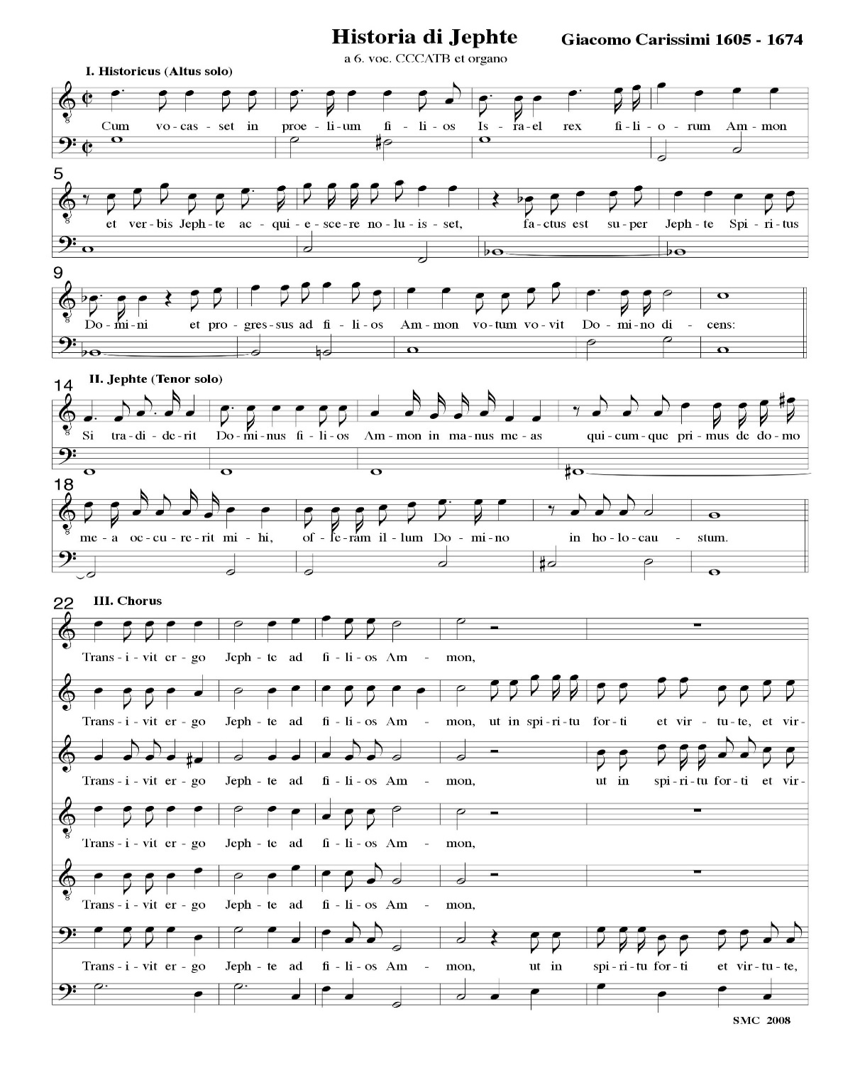
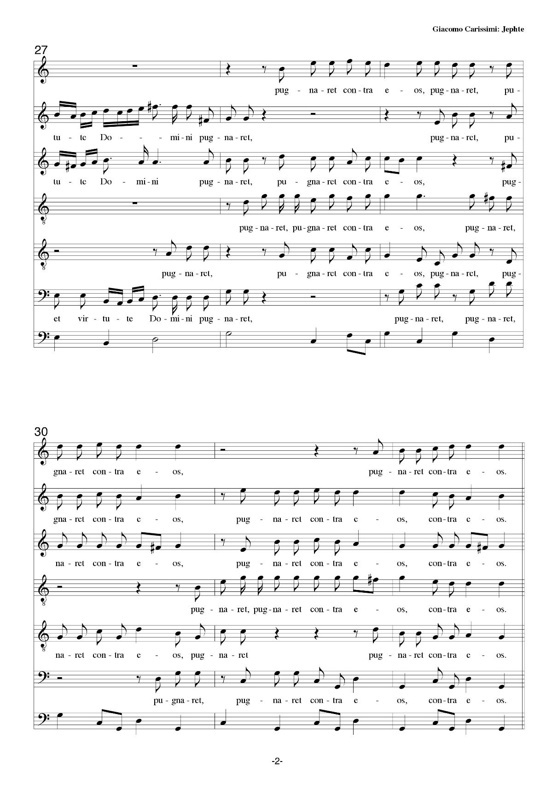
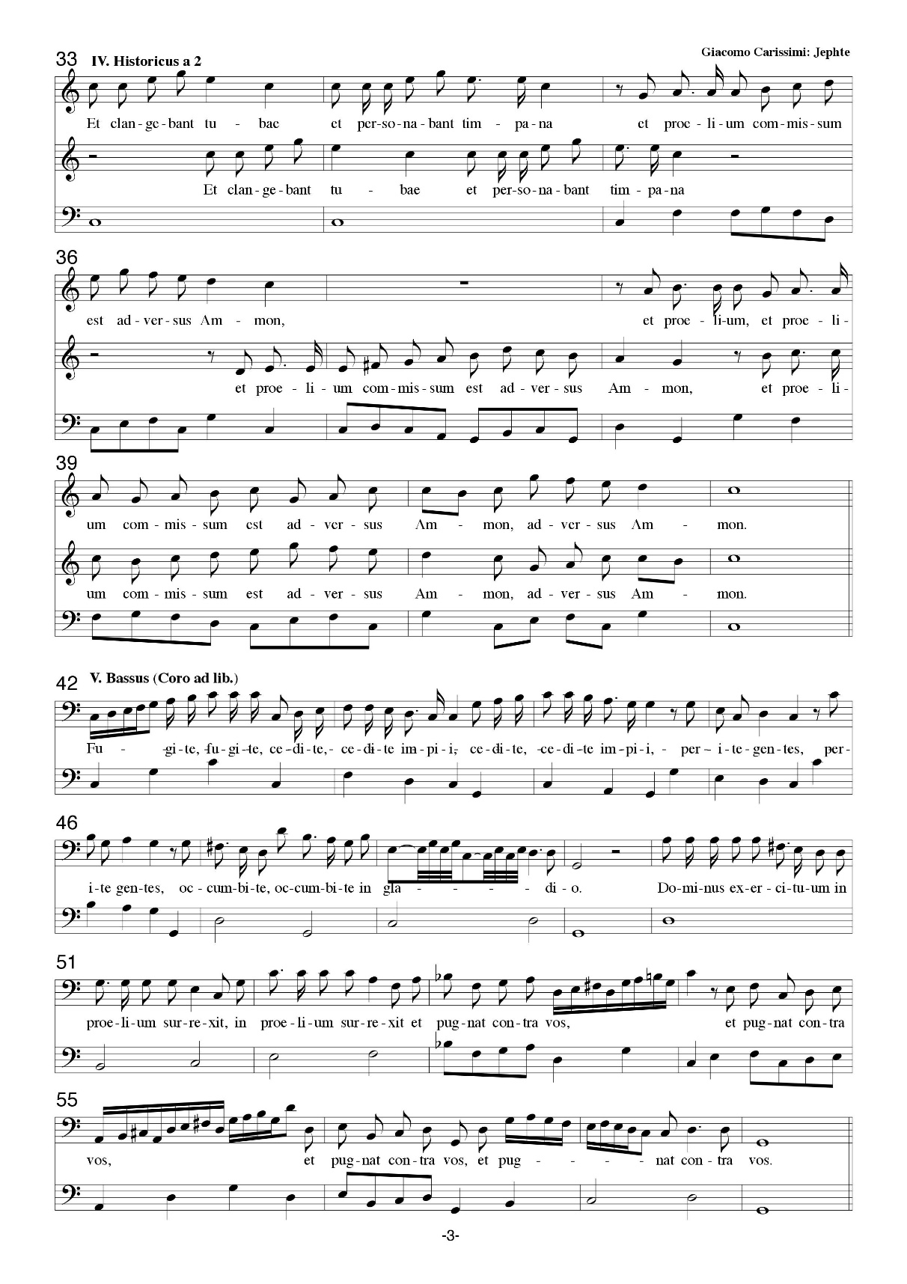
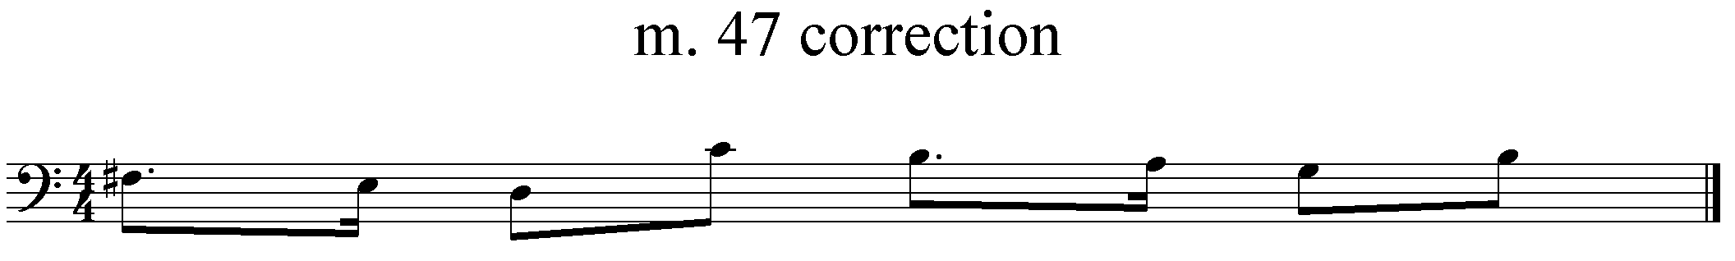
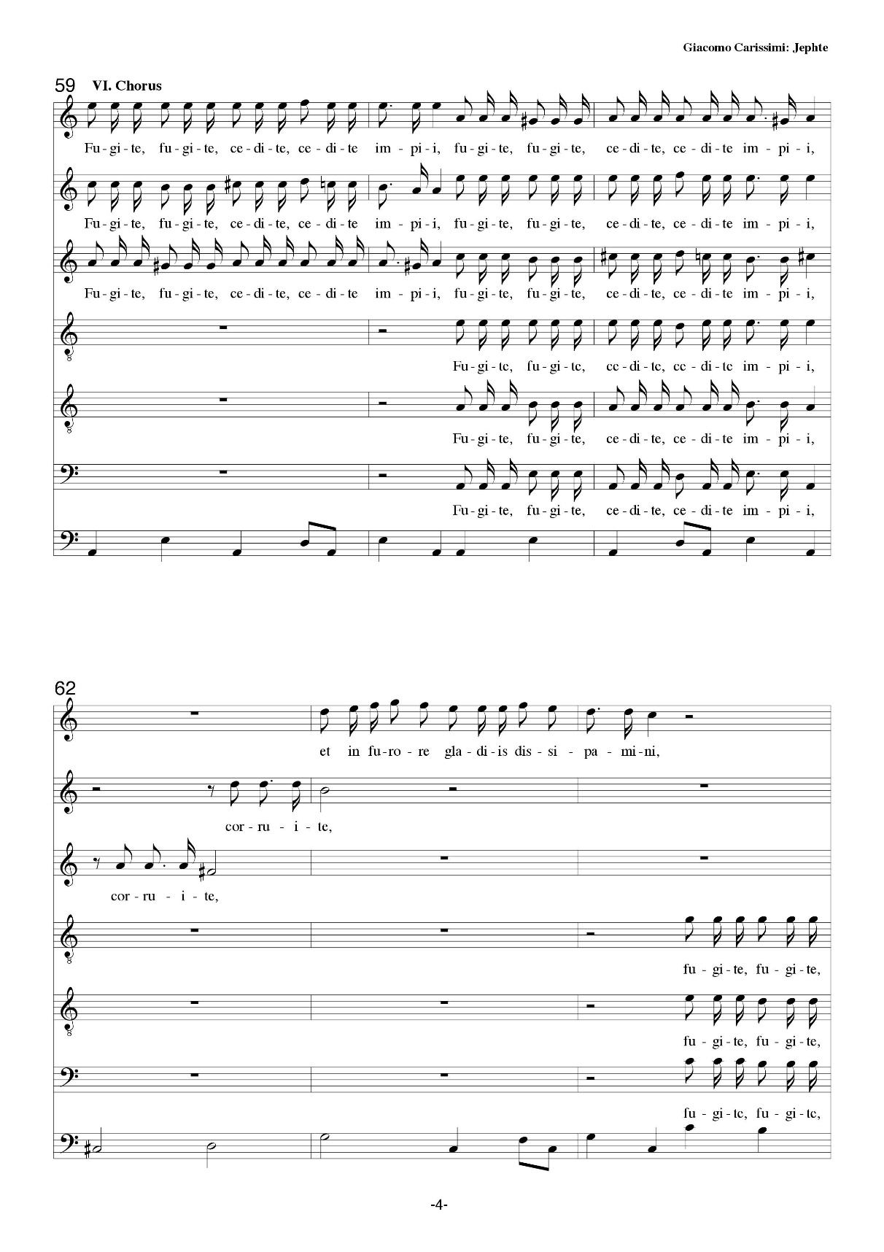
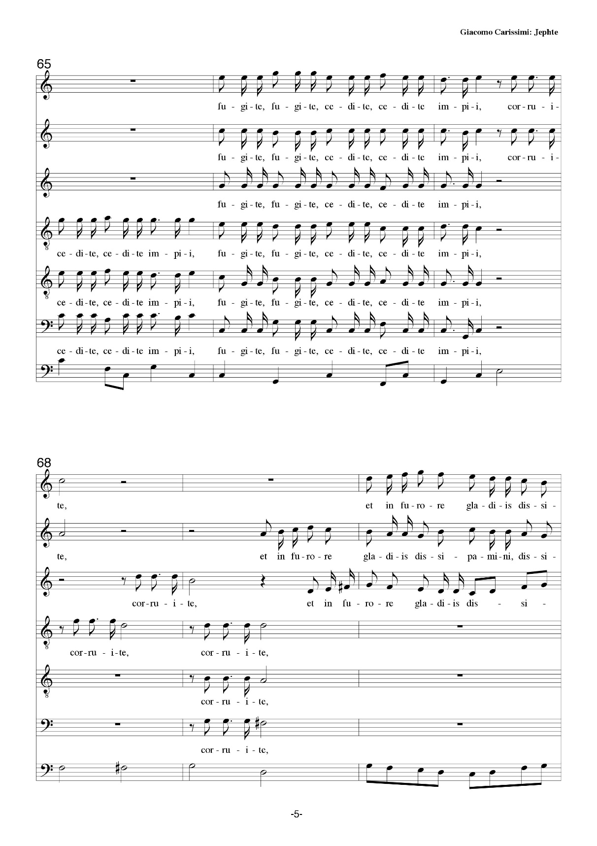
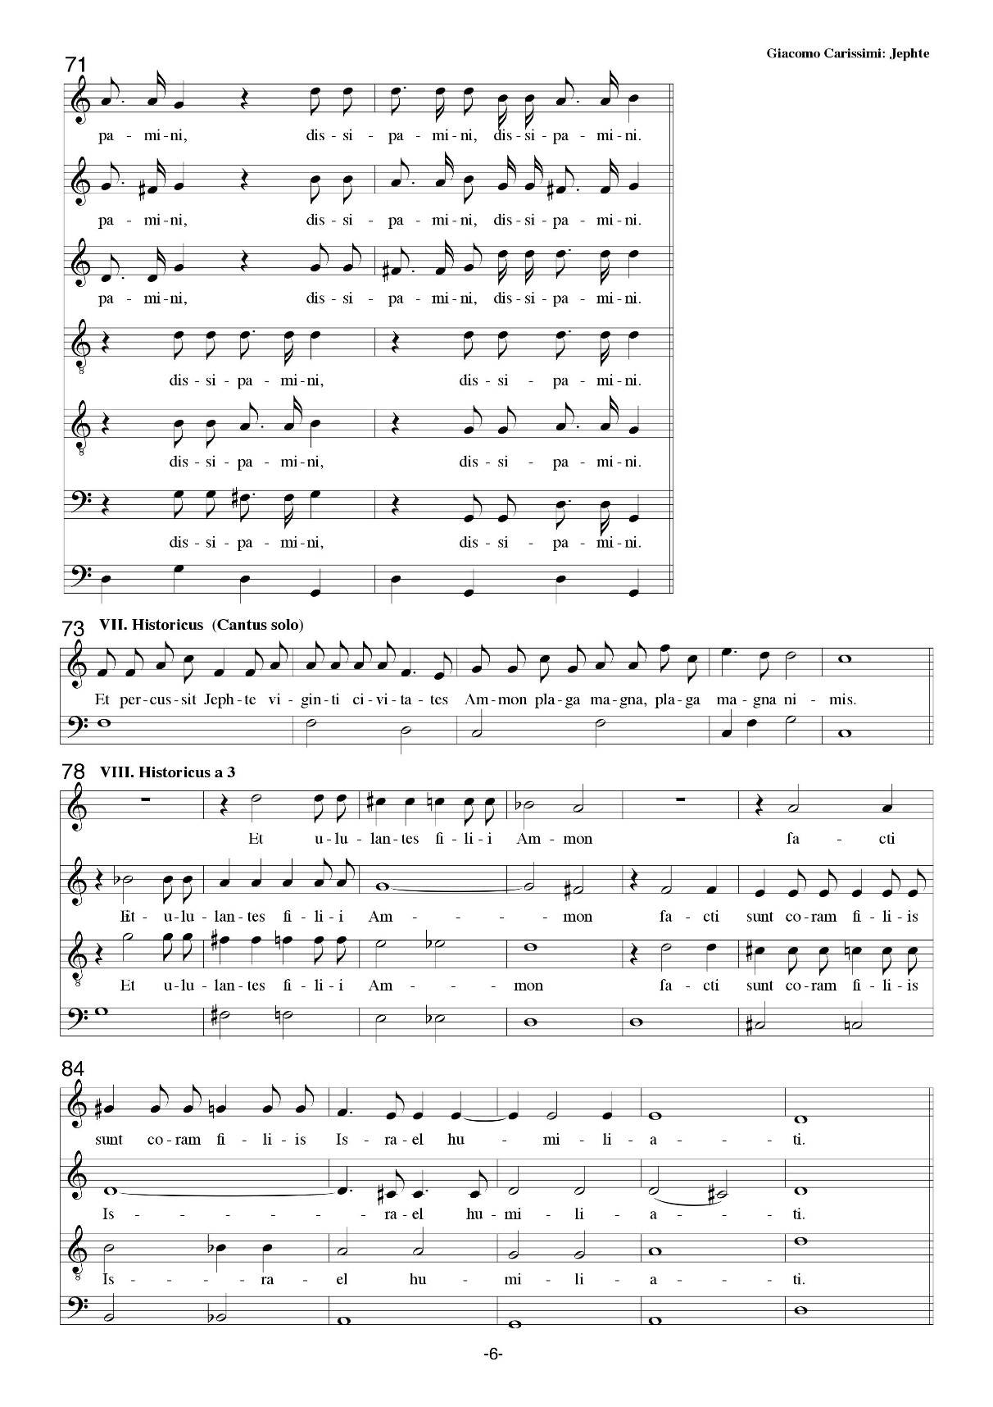
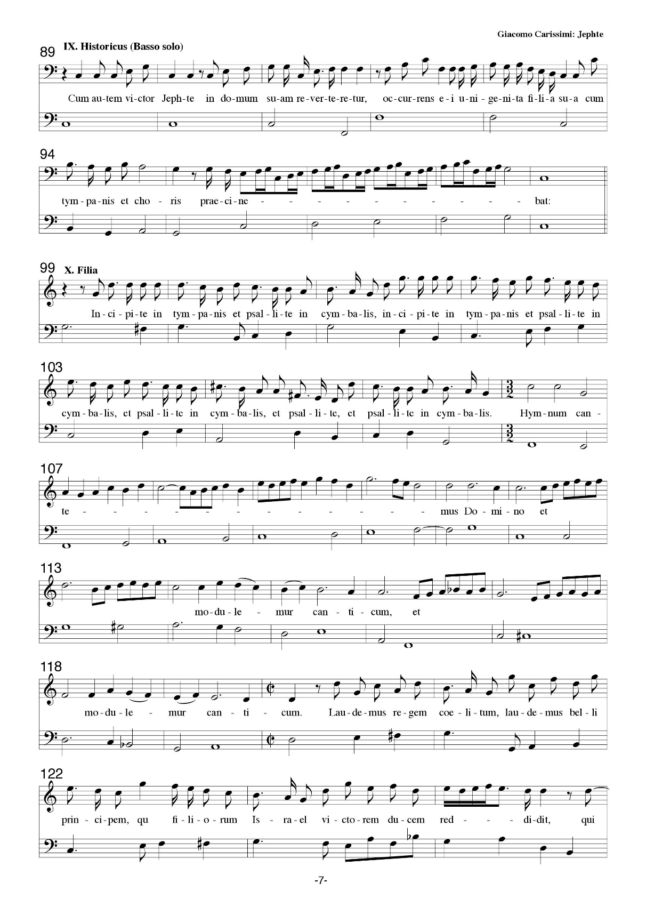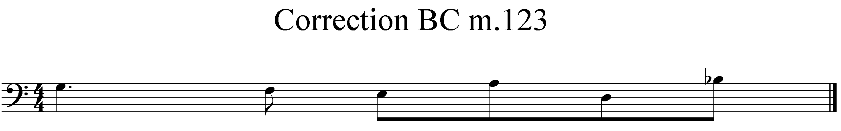
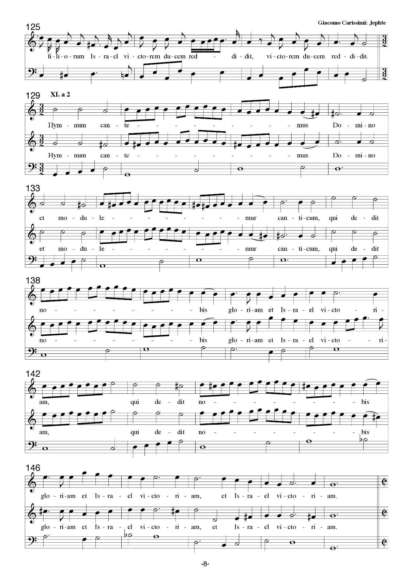
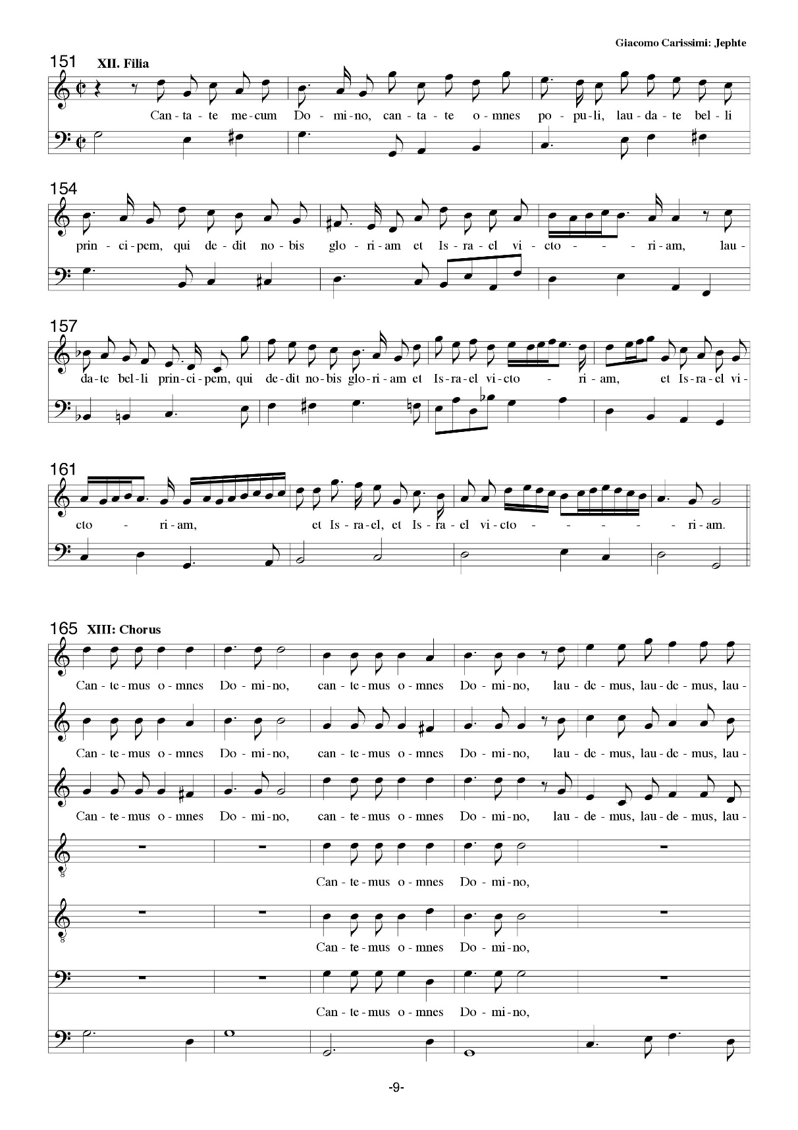
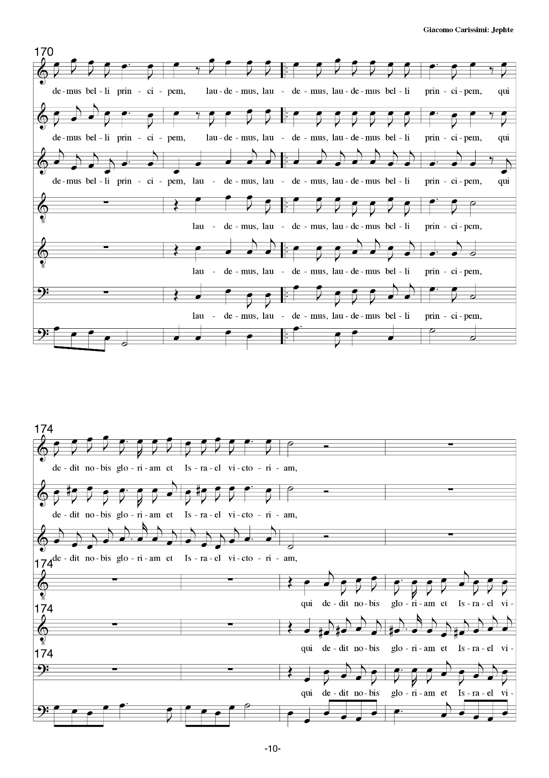
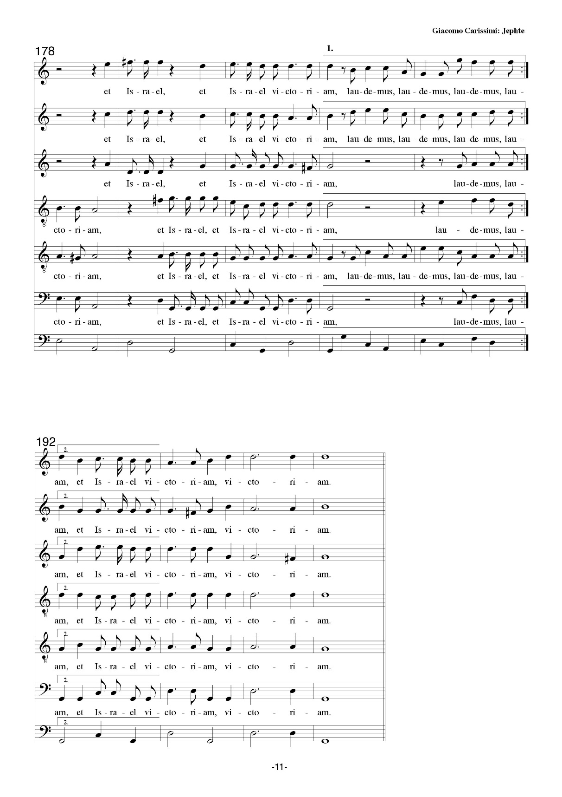
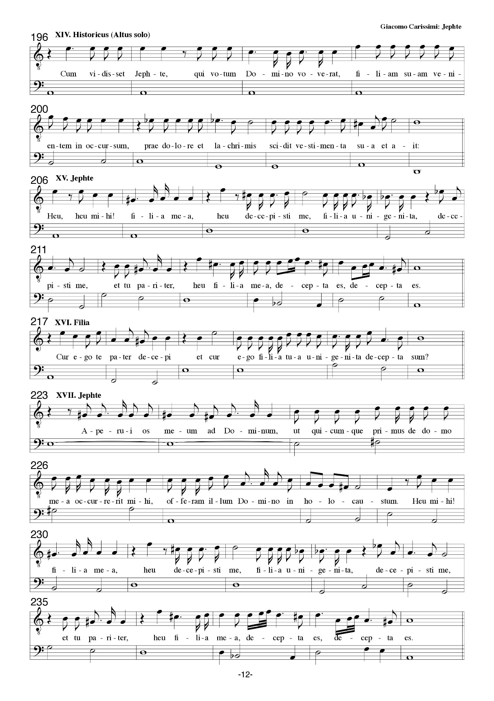
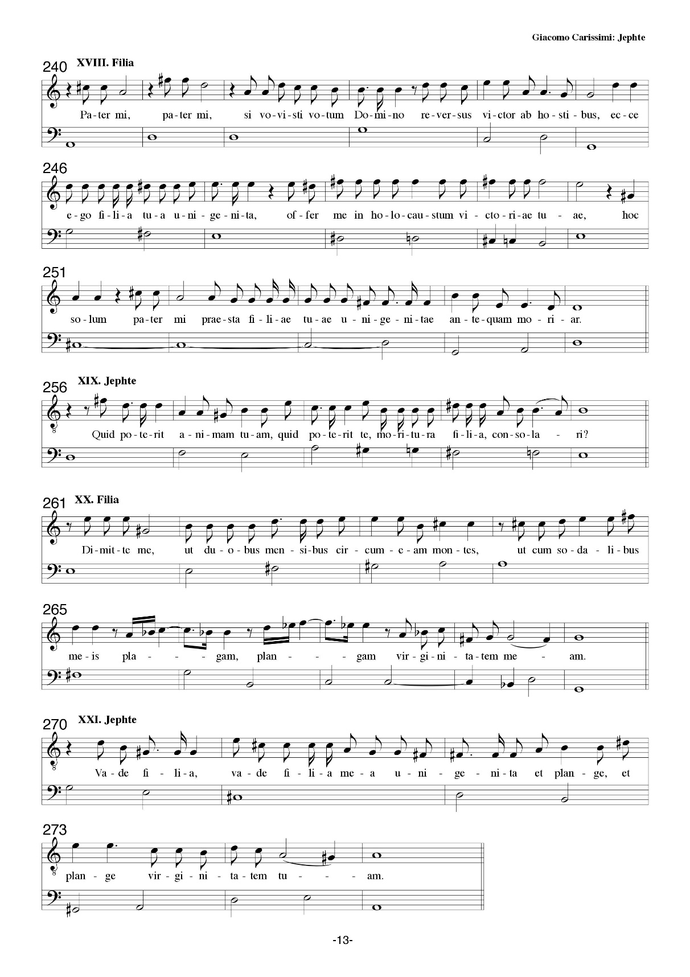
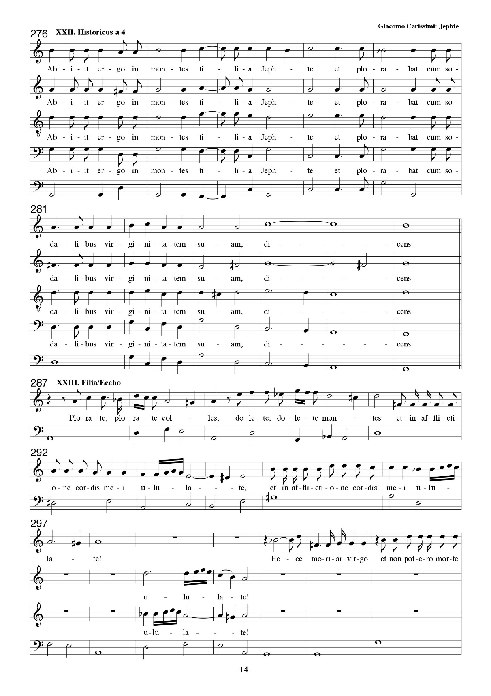
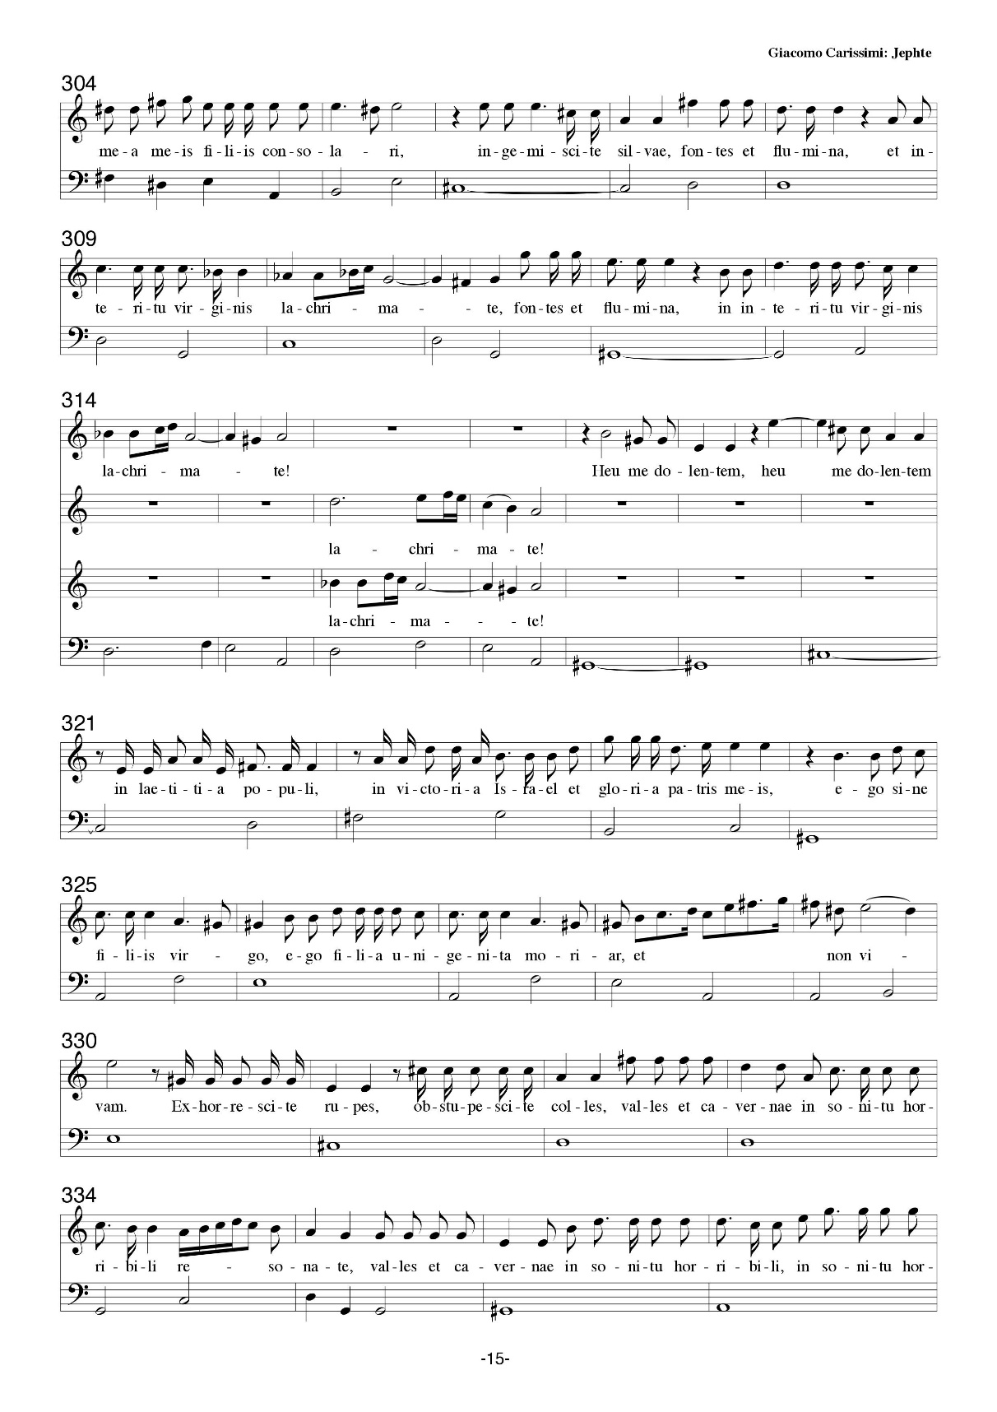
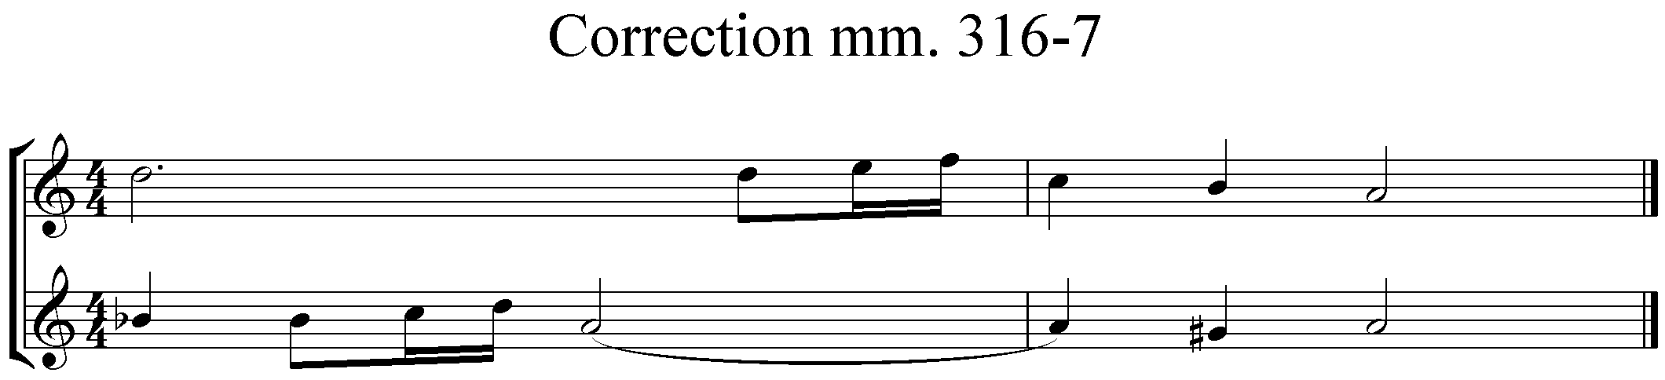
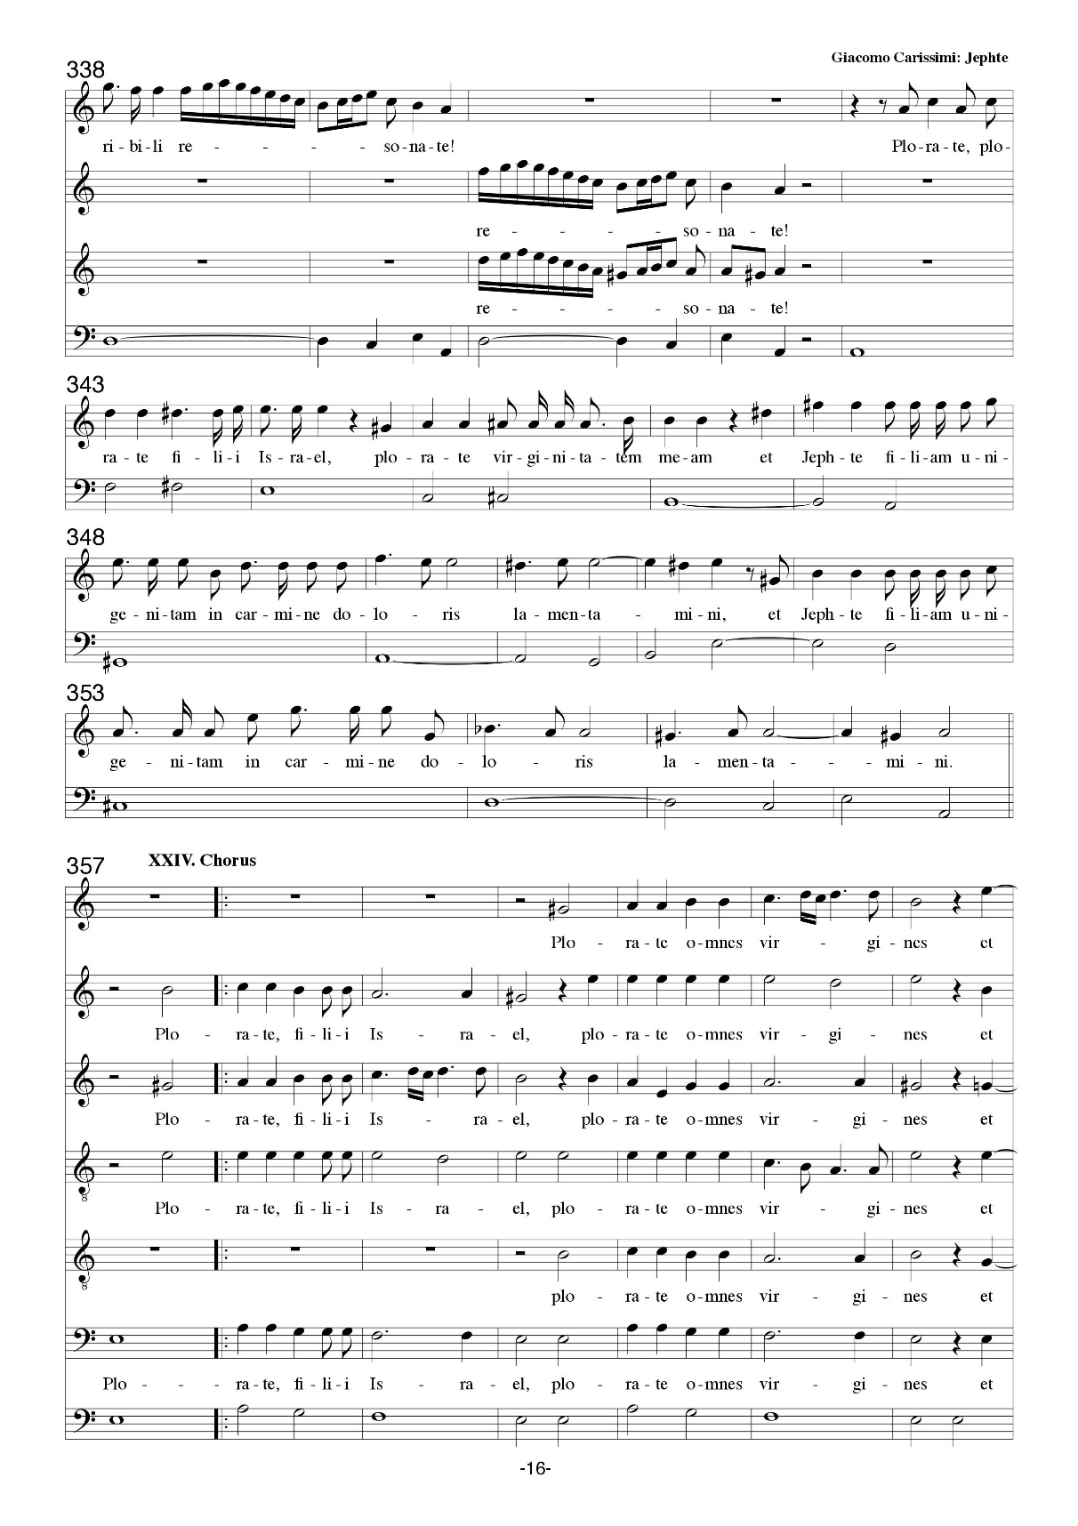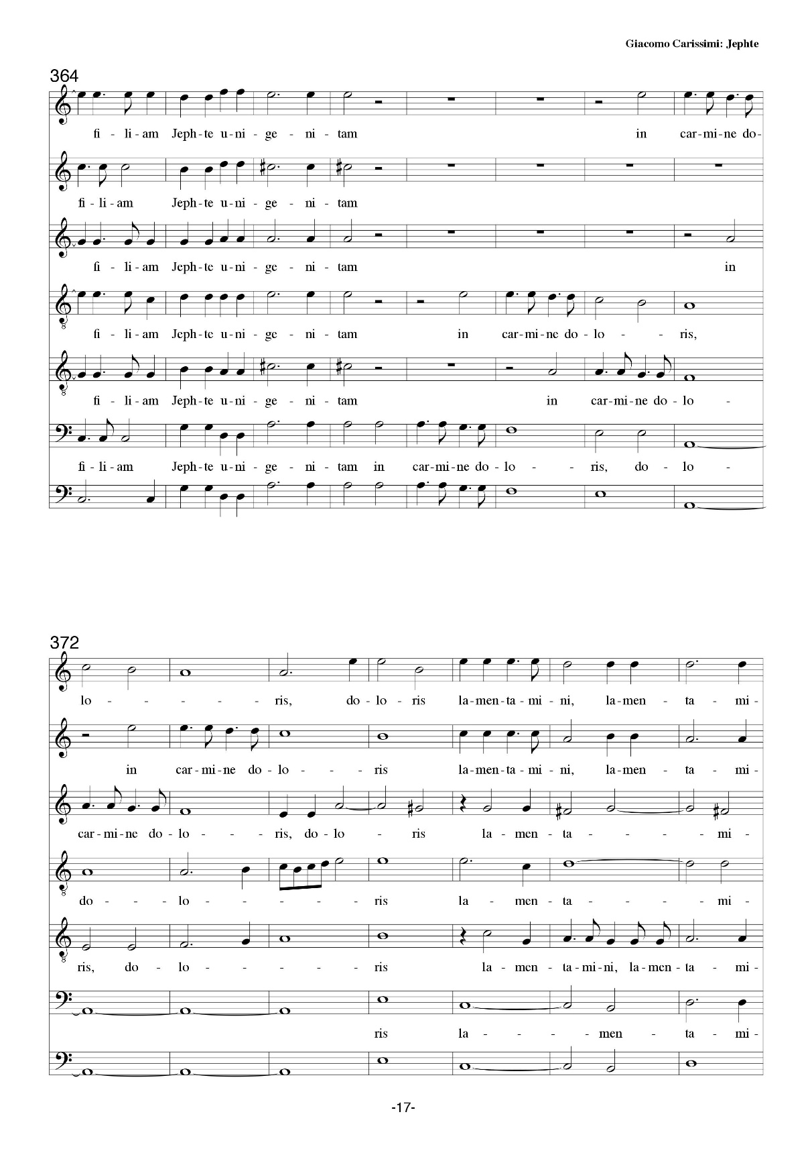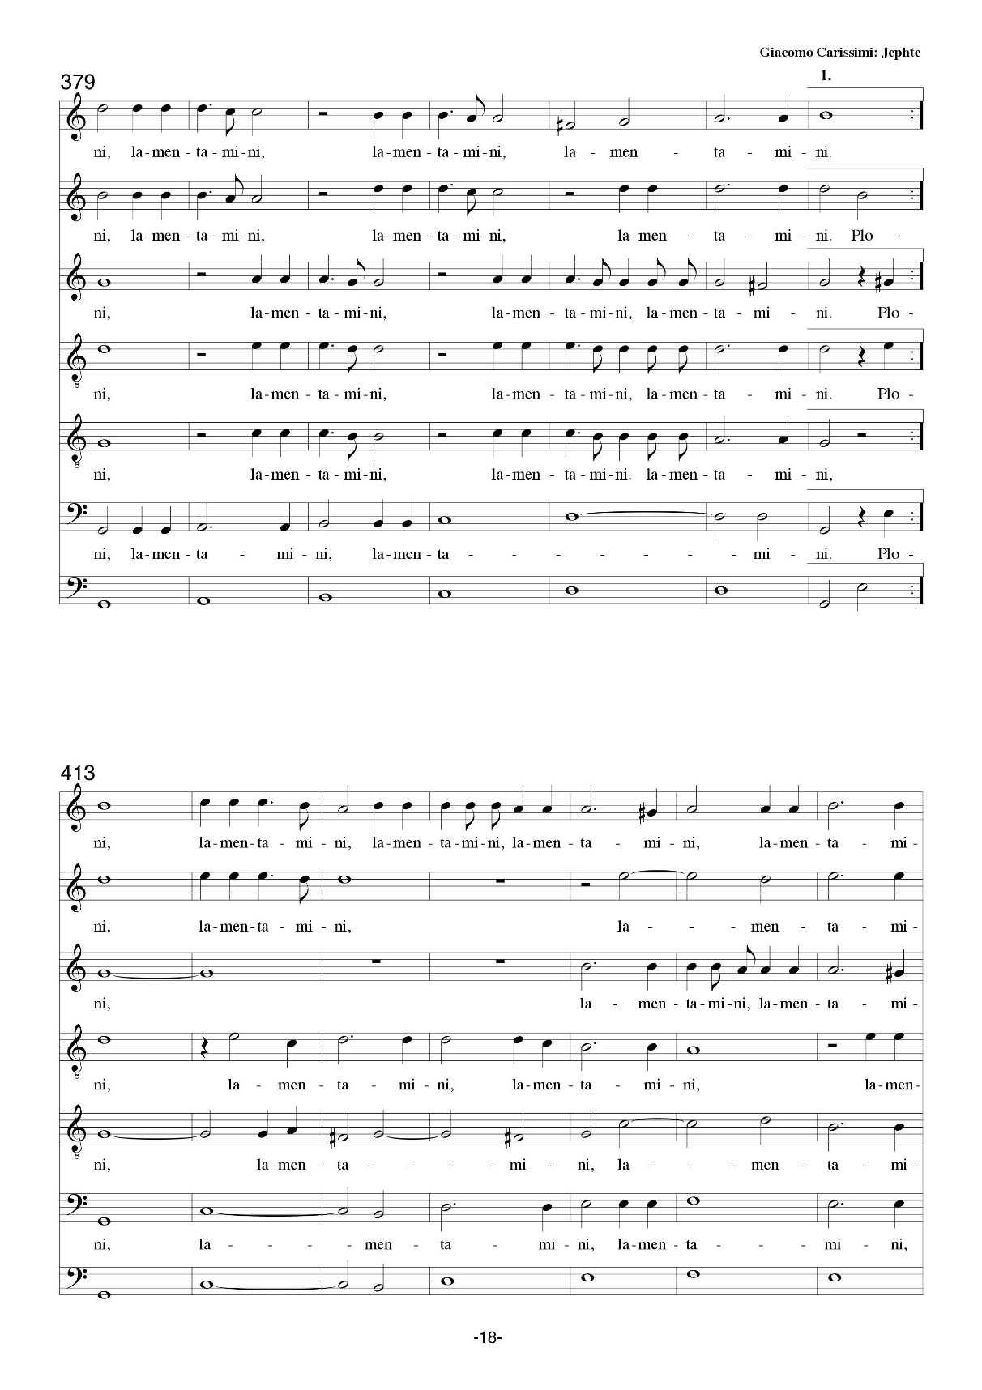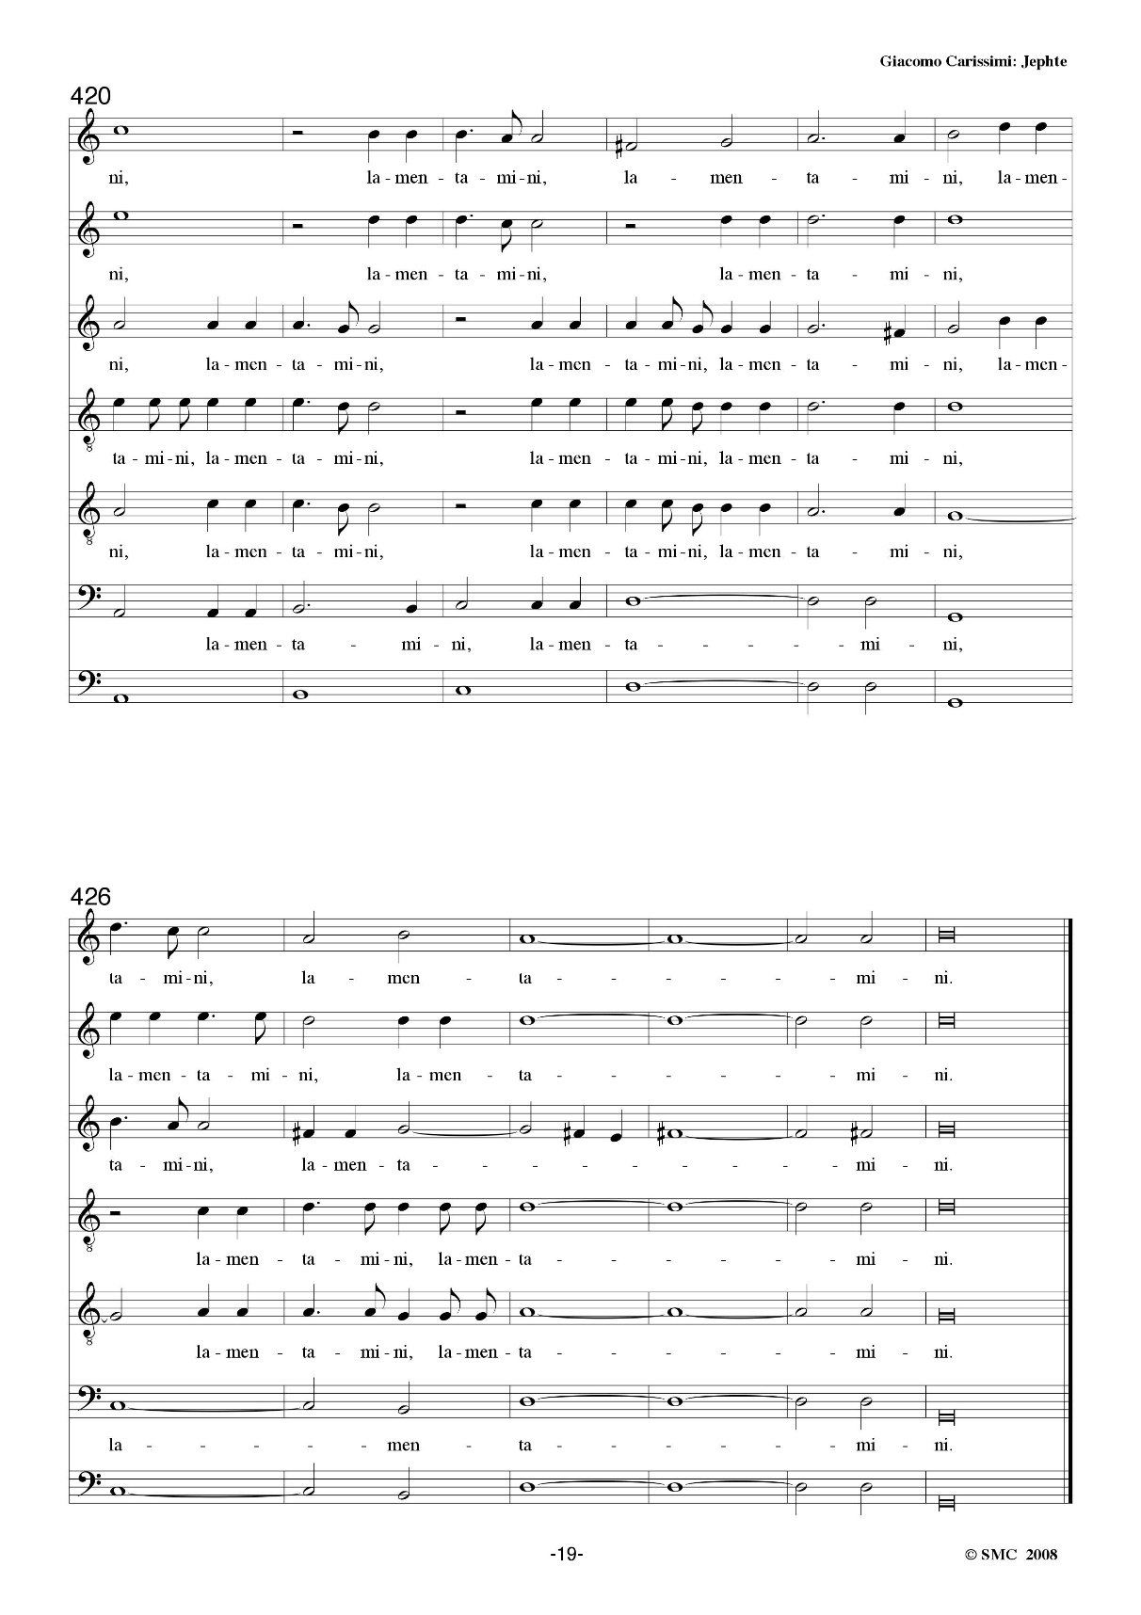
Appendix B: Text and Translation
by Dr. Bruce W. Bishop

Historicus  recitative |  | Cum / vocasset / in / proelium / filios  when / called / to / battle / (against) children  Israel / rex / filiorum / Ammon  Israel / king / of children / Ammon  et / verbis / Jephte / acquiescere / noluisset,  and / to words / Jephthah / acquiesce / refused  factus / est / super / Jephte / Spiritus / Domini  made / was / upon / Jephthah / Spirit / of the Lord  et / progressus / ad / filios / Ammon  and / advanced / towards / children / Ammon  votum / vovit / Domini / dicens:  vow / vowed / to the Lord / saying | Thus, when war was declared against the Children of  Israel by the king of Ammon,  and Jephte’s words were disregarded and ignored,  then upon Jephte descended the spirit of God, the Lord  as he went against the children of Ammon,  Jephte swore to God a solemn vow.
Jephte  arioso |  | "Si / tradiderit / Dominus / filios / Ammon  if / will hand over / Lord / children / Ammon  in / manus / meas, / quicumque / primus  in / hands / mine / whoever / first  de / domo / mea / occurrerit / mihi,  from / home / my / will meet / me  offeram / illum / Domino / in / holocaustum."  I will offer / him / to the Lord / as / burnt offering | “If Thou wilt deliver, Oh Lord, my God, the children of Ammon  into my hand, whatever first  out of the doors of my house to meet me,  I shall offer unto God, the Lord as a burnt offering.
Chorus à 6  narrative |  | Transivit / ergo / Jephte / ad / filios / Ammon,  passed over / then / Jephthah / to / children / Ammon  ut / in / spiritu / forti / et / virtute / Domini  so that / in / spirit / strength / and / valor / Lord’s  pugnaret / contra / eos.  he fought / against / them | Journeying, thus went Jephte to the children of Ammon  with the spirit and fortitude and valor of God  to battle against Ammon.
Historicus à 2  narrative |  | Et / clangebant / tubae / et / personabant / tympana  and / sounded / trumpets / and / resounded / drums  et / proelium / commissum / est / adversus / Ammon.  and / battle / joined / was / against / Ammon | Then sounded trumpets and resonated tympani  When battle then was joined against the host of Ammon.
Solo  arioso |  | Fugite, / cedite, / impii, / perite / gentes,  flee / give way / godless ones / perish / foreigners  occumbite / in / gladio. / Dominus / exercituum  fall and die / against / sword / Lord / of Hosts  in / proelium / surrexit / et / pugnat / contra / vos.  in / battle / has risen / and / fights / against / you | Flee and retreat quickly, turn back, and run away. Scatter and cede the day infidels.  Fall down and die upon our swards.  God, the Lord of Hosts,  In might, now raises up an army, He battles against you
Chorus à 6  address |  | Fugite, cedite, impii, / corruite,  flee, give way, godless ones / fall down  et / in / furore / gladii / dissipamini.  and / with / raging / swords / be scattered | Flee and retreat quickly, turn back and scatter, oh, infidels! Fall down and die!  With our ferocious swards we defeat and scatter you. Be ye scattered far.
Historicus  recitative |  | Et / percussit / Jephte / viginti / civitates / Ammon  and / struck / Jephthah / twenty / cities / Ammon  plaga / magna / nimis.  blow / great / beyond measure | Then attacked Jephte twenty of the cities of Ammon  Causing slaughter beyond any measure.
Historicus à 3  narrative |  | Et / ululantes / filii / Ammon, / facti / sunt  and / howled / children / Ammon/ made / were  coram / filiis / Israel / humiliati.  in the presence of / children / Israel / humble | Then came laments from children of Ammon, and before  all children of Israel Ammon was broken.
Historicus  recitative |  | Cum / autem / victor / Jephte / in / domum / suam  when / however / conqueror / Jephthah / to / home / his  reverteretur, / occurrens / ei / unigenita / filia / sua  returned / running to meet / him / only-born / daughter / his  cum / tympanis / et / choris / praecinebat:  with / timbrels / and / dances / sang | When, thus, victorious Jephte unto his dwelling returned,  then out came running his own begotten daughter  with tambourines and dancing. She rejoiced, singing:
Filia  aria |  | "Incipite / in / tympanis, / et / psallite / in / cymbalis.  begin / to / timbrels / and / play / upon / cymbals  Hymnum / cantemus / Domino, / et / modulemur / canticum.  hymn / let us sing / to the Lord / and / play / song  Laudemus / regem / coelitum,  let us praise / king / heaven  laudemus / belli / principem,  let us praise / war / prince  qui / filiorum / Israel / victorem / ducem / reddidit."  whom / children / Israel / victory / lead / gave back | Commence to strike the timbrels loud and make, for joy, the cymbals sound.  With sweet hymn singing to the Lord, we play unto Him our songs.  we praise the King of heaven above,  we praise the price of war and peace,  who made the children of Israel victorious anew today.
Duet  response |  | Hymnum cantemus Domino, / et modulemur canticum,  hymn / let us sing / to the Lord / and / play / song  qui / dedit / nobis / gloriam / et / Israel / victoriam.  who / gave / to us / glory / and / Israel / victory | Let Israel sing unto God, our hymn.  Let Israel play a new song to God.  Who made our host to be glorious, and Israel victorious.
Filia  aria |  | Cantate / mecum / Domino, / cantate / omnes / populi,  sing / with me / to the Lord / sing / all / peoples  laudate / belli / principem,  praise / war / prince  qui dedit nobis gloriam et Israel victoriam.  who / gave / to us / glory / and / Israel / victory | Come sing with me to God on high. Come sing now, all you people, sing.  We praise our prince of was and might,  Who now has made us glorious and Israel victorious.
Chorus à 6  response |  | Cantemus / omnes / Domino,  let us sing / all / to the Lord  laudemus / belli / principem,  let us praise / war / prince  qui dedit nobis gloriam et Israel victoriam.  who / gave / to us / glory / and / Israel / victory | Come, let us sing our thanks to God.  We praise him, the prince of Israel’s victory.  Who now has made us glorious and Israel victorious.
Historicus  recitative |  | Cum / vidisset / Jephte, / qui / votum / Domino / voverat,  when / saw / Jephthah / who / vow / to the Lord / had sworn  filiam / suam / venientem / in / occursum, / in / dolore  daughter / his / coming / to / meet him / in / anguish  et / lachrimis / scidit / vestimenta / sua / et / ait:  and / tears / he tore / clothes / his / and / said | When returning Jephte, who vowed to God his solemn oath,  saw his only begotten daughter running out to meet him. In anguish he wept  then he rent his cloths, and sadly proclaimed,
Jephthah  arioso |  | "Heu / mihi! / Filia / mea,  alas / to me / daughter / mine  heu / decepisti / me, / filia / unigenita,  alas / you have undone / me/ daughter / only-born  et / tu / pariter,  and / you / alike  heu / filia / mea, / decepta / es."  alas / daughter / my / undone / are | “Woe is me! My only daughter.  Woe! Thou hast undone me, only begotten daughter,  And thou likewise,  Woe, my only daughter thou art undone as well.”
Filia  recitative |  | "Cur / ergo / te / pater, / decipi,  how / then / you / father / you are undone  et / cur / ergo / ego  and / how / then / I  filia / tua / unigenita / decepta / sum?"  daughter / your / only-born / undone / am | “How art thou, my father, undone?  and how am I,  your only begotten daughter, now undone as well?”
Jephthah  arioso |  | "Aperui / os / meum / ad / Dominum  I opened / mouth / my / to / Lord  ut / quicumque primus de domo mea  that/ whoever / first / from / home / my  occurrerit mihi, offeram illum Domino  will meet / me / I will offer / him / to the Lord  in holocaustum. Heu mihi!  as / burnt offering / alas / to me  Filia mea, heu decepisti me,  daughter / my / alas / have undone / me  filia unigenita, et tu pariter,  daughter / only-born / and / you / alike  heu filia mea, decepta es."  alas / daughter / my / undone / are | “I opened my mouth in an oath to God:  That which comes out first from the door of my house  To greet me, I shall then offer to the Lord  as sacrificial offering. Woe is me,  my only daughter, woe thou hast undone me,  only begotten daughter, and thou likewise,  Woe. My only daughter, thou art undone as well.”
Filia  arioso |  | "Pater / mi, / si / vovisti / votum / Domino,  father / my / if / you vowed / vow / to the Lord  reversus / victor / ab / hostibus,  returned / victorious / from / enemies  ecce / ego / filia / tua / unigenita,  behold / I / daughter / your / only-born  offer / me / in / holocaustum / victoriae / tuae,  offer / myself / as / whole sacrifice / to victory / your  hoc / solum / pater / mi / praesta  but / only / father / my / fulfill  filiae / tuae / unigenitae / antequam / moriar."  daughter / your / only-born / before / will die | “My father. If you swore a vow to God, our Lord,  Returning victorious over our foes.  Behold now I, your only begotten daughter,  Offer up myself, a sacrifice to thy victory.  But only, my father, grant unto your only begotten daughter one wish before I die.”
Jephthah  arioso |  | "Quid / poterit / animam / tuam, / quid / poterit / te,  what / can / to soul / your / what / can / to you  moritura / filia, / consolari?"  will die / daughter / to comfort | “But what can I do to comfort your soul?  Doomed daughter, in consolation?”
Filia  arioso |  | "Dimitte / me, / ut / duobus / mensibus  send away / me / that / two / months  circumeam / montes, / et / cum  I will wander / mountains / and / with  sodalibus / meis / plangam / virginitatem / meam."  companions / my/ bewail / virginity / my | “Send me away for the space of two months  To wander in the mountains.  And with my friends, as companions, mournful, lament there my virginity.”
Jephthah  arioso |  | "Vade, / filia / mia / unigenita,  go / daughter / my / only-born  et / plange / virginitatem / tuam."  and / bewail / virginity / your | “Go, my only daughter,  go and lament your virginity.”
Historicus à 4  narrative  S-A-T-B |  | Abiit / ergo / in / montes / filia / Jephte, et  went away / then / to / mountains / daughter / Jephthah / and  plorabat / cum / sodalibus / virginitatem / suam, / dicens:  bewailed / with / companions / virginity / her / saying | Then to the mountains went the daughter of Jephte,  There lamenting, with her companions, her virginity with sorrow, saying:
Filia  aria |  | "Plorate / colles, / dolete / montes,  bewail / hills / grieve / mountains  et / in / afflictione / cordis / mei / ululate!  and / in / affliction / heart / my / howl | “Lament ye and mourn all ye hills, and grieve all ye mountains.  Howl in affliction of my broken heart, sorrow and grief!”
Echo |  | Ululate! | Howl!
Filia  aria |  | Ecce / moriar / virgo / et / non / potero  behold / will die / virgin / and / not / will be  morte mea / meis filiis / consolari,  death my / my children / to comfort  ingemiscite / silvae, / fontes / et / flumina,  sigh / woods/ fountains / and / rivers  in / interitu / virginis / lachrimate!  on / destruction / virgin / weep | “For I die as a virgin, in my death not finding some consolation in having children.  Then lament all ye woodlands,  fountains, and flowing streams,  At the destruction of a virgin.  Oh. Cry in anguish.”
Echo |  | Lachrimate! | Weep!
Filia  aria |  | Heu / me / dolentem / in / laetitia / populi,  alas / to me / I grieve / amidst / joy / of people  in/ victoria / Israel / et / gloria  amidst / victory / Israel / and / glory  patris / mei, / ego, / sine / filiis / virgo,  of father / my / I / without/ children / virgin  ego / filia / unigenita / moriar / et / non / vivam.  I / daughter / only-born / will die / and/ not / live  Exhorrescite / rupes, / obstupescite / colles, / valles  tremble / rocks / be astounded / hills/ valleys  et / cavernae/ in / sonitu / horribili / resonate!  and / caverns/ with / sound / horrible / resound | “Woe is my heart break amidst the joy of multitude,  And the victory of Israel and glory of  my father, I am without children, a virgin,  I, the only begotten daughter now must die and not live more.  Quake and tremble ye rocks. Be astounded ye hills.  Valleys and caverns in horrible sound resonate!”
Echo |  | Resonate! | Resonate!
Filia  aria |  | Plorate / filii / Israel,  bewail / chldren / Israel  plorate / virginitatem / meam,  bewail / virginity / my  et / Jephte / filiam / unigenitam / in  and / Jephthah / daughter / only-born / with  carmine / dolore / lamentamini."  songs / anguish / lament | “Lament then ye children of Israel,  bewail ye at my virginity,  for Jephte’s only begotten daughter,  Hear songs of deepest anguish.  Lamentation.
Chorus à 6 |  | Plorate / filii / Israel,  bewail / children / Israel  plorate / omnes / virgines,  bewail / all / virgins  et / filiam / Jephte / unigenitam / in  and / daughter / Jephthah / only-born / with  carmine / doloris / lamentamini.  songs / of anguish / lament  Lamentamini  lament | Weep now, oh children of Israel,  weep now, oh all ye virgins weep,  for Jephte’’s dear only begotten daughter, weep.  In songs of bitter sorrow grieve  Lamentation sound

Judith Nagley and Bojan Bujic, “Doctrine of Affections” Grove Music online, last updated 2007, http://www.oxfordmusiconline.com.ezproxy.lib.ou.edu/subscriber/article/opr/t114/e94?q=the+doctrine+of+the+affections&search=quick&pos=2&_start=1#firsthit
Plato, The Republic of Plato, second edition, tr. Allan Bloom (New York: HarperCollins, 1968), 77–78.
Timothy R. McKinney, Adrian Willaert and the Theory of Interval Affect: The Musica nova madrigals and the Noble Theories of Zarlino and Vicentino (Franham, England: Ashgate, 2010), 50–51.
Bernhard Meier, The Modes of Classical Vocal Polyphony: Described According to the Sources with Revisions by the Author, tr. Ellen S. Beebe (New York: Broude Brothers, 1988), 387.
Joel Lester, Between Modes and Keys: German Theory 1592–1802 (New York: Pencragon Press, 1989), 61–68.
Tim Carter, “The Search for Musical Meaning,” In The Cambridge History of Seventeenth-Century Music, ed. Tim Carter and John Butt (Cambridge: Cambridge University Press, 2005), 166.
Joseph T. Rawlins, “Carissimi, Progenitor of the Oratorio,” Choral Journal, Vol. 21, No. 8 (April 1981), 15.
Matt Stefon, “Jesuit,” Encyclopedia Britannica, last updated 2015, http://academic.eb.com.ezproxy.lib.ou.edu/levels/collegiate/article/43579
Howard E. Smither, A History of Oratorio, Vol. 1 (Chapel Hill, NC: The University of North Carolina Press, 1977), 43.
Howard E. Smither, “Oratorio,” Grove Music Online, last modified 2007, http://www.oxfordmusiconline.com.ezproxy.lib.ou.edu/subscriber/article/grove/music/20397?q=oratorio&search=quick&pos=1&_start=1#firsthit
Ibid.
In the floor plan, the right lower area is the sanctuary and the far left lower corner is the oratorio.
Smither, A History of Oratorio, Vol. 1, 204.
Smither, “Oratorio” Latin oratorio is of two kinds: Oratorio Latino and Oratorio Vulgate. In Oratorio Latino the text is in prose, while Oratorio Vulgate has poetic narration.
Judges 11: 30-31
Judges 11: 40
MM – Mutatio Modi, MT- Mutatio Toni
Tim Carter, 166
Beverly Stein “Carissimi’s Tonal System and the Function of Transposition in the Expansion of tonality,” The Journal of Musicology, Vol. 19, No. 2 (Spring 2002), 265
The fourth difference recalls authentic answer of a fugue while the fifth difference does tonal answer.
Meir, 354- 5
In the example, 1-1, 2-1, etc. refer to units in the melody, while a-1, b-1, etc. refer to units in the basso continuo.
Beverly Stein, “Between Keys and Modes; Tonal Practice in the Music of Giacomo Carissimi” (PhD diss., Brandeis University, 1994), 193-215
Vered Cohen, “Zarlino on Modes: An Annotated, Indexed Translation, with Introduction and Commentary, of Part IV of Le Istitutioni Harmoniche.” (PhD diss., City University New York, 1977), lxvii-lxviii
Mckinney, 50
McKinney, 51
Ibid., 196-7
James Murray Barbour, Tuning and temperament, a historical survey (East Lasing: Michigan State College Press, 1953), 188-196 https://babel-hathitrust-org.ezproxy.lib.ou.edu/cgi/pt?id=uc1.32106001387528;view=1up;seq=164
Ibid., 135-142
Ibid., 70
Ibid., 46
The Perfect 5th of basso continuo in m. 4 and 6 could be regarded as a transposition, but because Ionian mode modulates to Lydian mode by putting a flat on ^B, viewing this as Lydian mode is more reasonable.
McKinney, 22 The consideration of a harmonic interval is between outer voices.
Ibid., 51
Stein, 194-203
McKinney, 41-95
Stein, 194-203
Tim Carter and John Butt, eds. The Cambridge History of Seventeenth-Century Music (Cambridge: Cambridge University Press, 2005), 356
Gayle Ann Walker, “The Use of Chorus In The Roman Oratorio, ca. 1620 – ca. 1650” (DA diss., University of Northern Colorado, 1996), 51. Walker classifies three different kinds of choruses; Narrative, Participant, and Reflective. Among them, Narrative is divided into two types: those on non-repeated text and those on repeated text. Reflective choruses are divided into three types: moralizing for lessons, commenting for actions, and devotional for praises or prayers.
McKinney, 50
Meier, 334
Stein, “Carissimi’s Tonal System and Function of Transposition in the Expansion of Tonality,” 268
Rita Steblin, A History of Keys Characteristics in the Eighteenth and Early Nineteenth Centuries (Rochester: Universty of Rochester Press, 2002), 27, 33
Meier, 334
McKinney, 89
Cohen, 339-340
McKinney, 100-101
Ibid., 245
Ibid., 101
Peter Williams, The Chromatic Fourth During Four Centuries of Music (Oxford: Clarendon Press, 1997), 7-12
Walker, 51
Raymond Monelle, The Sense of Music: Semiotic Essays (Princeton: Princeton University Press, 2000), 73
Williams, 15-25
Guy Anthony Marco, “Zarlino on Counterpoint: An Indexed Translation of the Istitutioni Harmoniche, Book III, with a Glossary and Commentary” (PhD diss., University of Chicago, 1956), 242-244
Mckinney,49-50
In m. 115, the stress is on the second beat.
Lucille Corwin, “Le Istatutioni Harmoniche of Gioseffo Zarlino, Part 1; A Translation With Introduction” (PhD Diss., The City University of New York, 2008), 59
Walker, 55
Mckinney, 50
McKinney, 55
Mckinney, 63
Marco, 254
McKinney, 100-101
Mckinney, 90-96
McKinney, p.285
Marco, 325-6
Walker, 51
Two versions of the coda exist. One is only three-bars long, and the other is eighteen-bars long. The first version, with a three-bar long coda, can be regarded as a strophic form with a short codetta. The eighteen-bar long coda is analyzed in this thesis because that coda contains more symbolic properties (which create more meaning) than the three-bar coda.
The numerical symbolism is common in the Baroque period, and Carissimi uses a great deal of the symbolism in his music, which will be discussed later in this chapter.
McKinney 47
Cohen, 185
Annemarie Schimmel and Franz Carl Endres, The Mystery of Numbers. (New York: Oxford University Press, 1993), 58-104
Ibid., 224-5
Ibid., 156-188
Ibid., 132-7, 182-4
Ibid., 209-210
Ibid., 213
Hugh T. Henry, Catholic Customs And Symbols (New York: Benzinger Brothers, 1925), .255-257
Lindsay Maureen Johnson, “Performed Embodiment, Sacred Eroticism, and Voice in Devotions by Early Seventeenth-Century Italian Nuns” (PhD diss., University of California, Los Angeles, 2013), 28-29. A sixteenth century spiritualist and counter-Reformation theologian, St. Teresa of Avila, regarded the goal of spiritual exercise to be sexual union with Jesus Christ.
Ibid.,29-30
The corrections are based on the manuscript by Marc-Antoine Charpentier from Bibliotheque Nationale de France.

