University of Oklahoma

Graduate College

“My Choice?”: an analysis of a controversial women’s empowerment video from india

A thesis

submitted to the Graduate Faculty

in partial fulfillment of the requirements for the

Degree of

Master of Arts

By

ashley swamy
Norman, Oklahoma
2017

“my choice?”: an analysis of a controversial women’s empowerment video from india

A thesis approved for the
Department of Geography and Environmental Sustainability

By

______________________________
Dr. Laurel Smith, Chair

______________________________
Dr. Nicholas Bauch

______________________________
Dr. Lisa Funnell

© Copyright by ashley swamy 2017
All Rights Reserved.
Dedicated to my in-laws in India, who inspired this research.

Acknowledgements
I would like to thank my thesis advisor, Dr. Laurel Smith of the Department of Geography and Environmental Sustainability at the University of Oklahoma for her guidance and support in the creation and editing of this thesis. Her insight has been invaluable to the success of this thesis.
I would also like to acknowledge Dr. Lisa Funnell of the Women’s and Gender Studies Program at the University of Oklahoma for her very careful reading of my thesis and her valuable, detailed comments. I would also like to acknowledge Dr. Nicholas Bauch of the Department of Geography and Environmental Sustainability at the University of Oklahoma for his valuable input on my thesis.
I would like to thank Dr. Fred Shelley of the Department of Geography and Environmental Sustainability at the University of Oklahoma for his unwavering support during my time in the master’s program. Thank you for encouraging me to go to graduate school.
I would like to thank my husband, Atul Swamy, for his encouragement and support. I would also like to thank my family and friends for their support, especially my sister-in-law Amrita Swamy Martin, who helped me recruit participants in India. A special thank you goes to Kimberly Fitzpatrick for helping me format my thesis and create figures and tables.

Table of Contents

Acknowledgements iv
List of Tables viii
List of Figures ix
Abstract xi
Chapter 1: Feminist Geographies: Gendering Space and Place 1
Introduction 1
Multiple Feminisms 2
The Emergence of Feminist Geography in the United States, Canada, and the United Kingdom 3
Geographers take the ‘cultural turn’ 7
Situating Feminist Geography in India 9
Geographies of the Body 13
Geography and feminist methodologies 16
Conclusion 18
Overview of Chapters 19
Chapter 2: Initiating the Conversation: Polyvocal Interpretations of a Controversial Video 21
Introduction 21
Methodology 22
Situating Myself in the Research 22
Working with Visual Materials 23
Problems Some Women Face in India 29
The “New Indian Woman” 35
Analysis 41
The Site of Production: Situating Bollywood 41
The Site of Production: The Studio 44
The Site of Production: Situating the Transnational Star 44
The Site of Production: Target Audience for a Fashion Magazine 46
The Site of Production: Who Made the Video? 48
The Site of the Image: “My Choice” 48
The Site of Audiencing: Polyvocal Interpretations 51
Theme 1: Mind/Body/Poetry 51
“My body, my mind, my choice” 51
“My choice, to have your baby or not” 55
Theme 2: Marriage/Sex/Partnerships 57
“To have sex before marriage, to have sex outside of marriage, to not have sex, my choice” 57
“My choice, to love a man, or a woman, or both” 62
“My choice, to marry or not to marry” 63
Foucauldian Discourse Analysis: Truths 64
Foucauldian Discourse Analysis: Silenced 65
Polyvocal Interpretations: A Conversation about the Video 66
Theme 1: Mind/Body/Poetry 66
Theme 2: Marriage/Sex/Partnerships 67
Conclusion 67
Chapter 3: Video-Elicitation and Life Story Interviews: A Strategy for Researching Audience Reception 70
Introduction 70
Video-Elicitation Interviewing 70
Research Findings 81
Chapter 4: “My Choice”: Shop! 98
Post-Feminism and the New Indian Woman 98
The Question of “Empowerment” 100
Celebrity Feminism 101
Shopping “My Choice” 102
Moving Forward with Researching “My Choice” 104
Further Research- Geographies of Film 106
Conclusion 108
References 109

List of Tables

Table 1: Participant Demographics 74

List of Figures

Figure 1: Critical Visual Methodology, adapted from Rose (2012) 24
Figure 2: "My Choice" Critical Visual Methodology, adapted from Rose 2012 26
Figure 3: Marchers walk 4,000 km to protest trafficking of brides in India, 2016, ungift.org 31
Figure 4: Rape of a child sparks protests in India, 2013, abc.net.au 33
Figure 5: Roshini, 21, committed suicide and Rujukta 21, attempted suicide because their families did not approve of their lesbian relationship. Picture credit: mid-day.com, Story credit: nostringsng.com, 2016 34
Figure 6: Cosmopolitan India, 1996, Chandnimarket.com 35
Figure 7: Tuffs Shoe Advertisement, July 23, 1995, desicreative.com 37
Figure 8: In the Country of Deceit, Shashi Deshpande (2009), challengebookstore.com 40
Figure 9: Map of the Indian Diaspora, pinterest.com 42
Figure 10: English Vinglish movie poster, 2012, koimoi.com 43
Figure 11: Vogue India Media Kit, 2017 46
Figure 12: Deepika Padukone in "My Choice", 2015, YouTube.com 48
Figure 13: Deepika Padukone in "My Choice," 2015, mid-day.com 49
Figure 14: Deepika Padukone unhooking her bra in "My Choice", thevoiceofnation.com, 2015 54
Figure 15: Sign outside of an ultrasound clinic in India, Jed 2009, harmonicbody.wordpress.com 55
Figure 16: #VagueManpower: My Choice Too, youtube.com 58
Figure 17: Transgender "My Choice", 2015, NDTV.com 59
Figure 18: The Immigrant, Manju Kapur (2008), manjukapur.com 61
Figure 19: Screen grab of a scene in "My Choice", youtube.com 62
Figure 20: Two women getting married in a Hindu wedding ceremony. Braden Summers (2016) hinduismtoday.com 63
Figure 21: Map of Norman, Oklahoma (worldatlas.com) 75
Figure 22: Map of Nagpur, Maharashtra (worldatlas.com) 75
Figure 23: Woman wearing ghoonghat in a Rajasthani village, Yogesh Vhora, 2011, flickr.com 83
Figure 24: Screenshot of the Vogue Empower website, 2017 103

Abstract
In March 2015, Vogue India released the video “My Choice,” as part of a series of videos for the magazine’s women’s empowerment initiative. However, “My Choice” sparked outrage in India and abroad for controversial content surrounding a woman’s sexuality. The video’s analysis uses a critical visual methodology (Rose 2012), whereby the video’s production is examined as well as its audiovisual content and the video’s reception by various audiences. This study features a polyvocal analysis of the video that draws on writings of Indian feminists, Western feminists’ writings on bodies, and the mass media’s reaction as understood through discourse analysis of thirty news articles and six video responses. “My Choice” envisions the idea of the educated, urban “New Indian Woman,” who embodies modernity (Daya 2009). To test the video’s potential as a way to start a conversation about women’s rights, the video was used as an interviewing tool. The goal was to interview ten Indian people, five in Norman, Oklahoma, and five in Nagpur, India. Video-elicitation was used to gather reactions to the video, resulting in a variety of answers and a multitude of stories. The discovery is that video-elicitation often triggers emotional responses and memories from the participants. This research contributes to a growing body of literature on video-elicitation as an interview method, which can be used in a variety of settings.

Chapter 1: Feminist Geographies: Gendering Space and Place

Introduction
The examination of gender is woven into the practice of human geography. Feminist geography is an accepted part of geography as a discipline. At the annual meeting of the American Association of Geographers in 2017, multiple sessions addressed feminism. Forty-nine abstracts dealt with feminism directly, whereas 265 abstracts were associated with the term feminist in some way. There are also different groups associated with feminist geography, including the specialty group Geographic Perspectives on Women (GPOW). It hasn’t always been this way. Feminist geographers have fought to be accepted in mainstream geography, after the women’s liberation movement in the 1960s. This opening chapter of my thesis situates my scholarship within the rich history of feminist geography both here in the United States and also in India, where feminist geographers are starting to gain recognition.
This chapter examines the theory and practice of feminist geography. First it describes how feminist geography emerged out of critical Marxist geography. Next it introduces the ‘cultural turn’ and some concepts that are central to my geographic practice with special emphasis on the ways that feminist geographers contribute to them. The following section compares feminist scholarship in the United States, Canada and the U.K. with feminist scholarship in India. Afterward, the chapter reviews how feminist methods have shaped geographic research on the body. The chapter concludes by focusing on feminist methodologies in human geography.

Multiple Feminisms
As applied to feminist geography, the term feminism is difficult to define. Too often, it is portrayed as a single entity. Susan Archer Mann (2012) in Doing Feminist Theory: From Modernity and Postmodernity says that her book “highlights the multiplicity of feminisms existing here today and rejects the notion that feminism is a single or monolithic ‘ism” (2). The term feminism “defies any simple explanation” (2). This is especially true when studying feminism in different parts of the world, such as the work of the Indian feminist scholars featured in this thesis. The inability to pin down one definition of feminism is ultimately one of its strengths: a “commitment to openness and inclusiveness” (2).
Jay T. Johnson and Clare Madge (2016) conveyed the message of multiple feminisms, saying that understandings of feminism are “grounded in specific histories, places, and biographies” (78). For example, feminism in India looks different than feminism in the United States. However, there is a lot of variance of what feminism looks like within both locations. Methods in feminism are also incredibly varied. Johnson and Madge (2016) explained that there is no one single way to do feminist research because there are many different approaches. These practices have changed over time and have been conducted differently in different locations (77). My work highlights multiple feminisms and how it varies by location.
In 1997, Linda McDowell observed that “not all women are equal, or even similar (396).” In many feminist works in the United States, the American woman’s experience meant the white American woman’s experience (hooks 1981, 137). McDowell pointed out that women are positioned differently by class, age, family status, race, sexual orientation, and physical ability. I would add location. When discussing women, therefore, one must ask “which women, in what circumstances, and why?” (McDowell 1997, 396). Feminism as a subject of study is just as complex. When considering feminism, there is no singular brand of feminism, but rather, a global variety of feminisms.

The Emergence of Feminist Geography in the United States, Canada, and the United Kingdom
Recognizing that the concepts of feminism and feminist scholarship cannot be pigeonholed into a single category, it is important to trace the history of feminist scholarship in the West and in India in order to situate this project on India within its historical context. During the Women’s Liberation movements of the 1960s, early work focused on the social construction of femininity, which was important in second wave feminism in Britain and the U.S. Work from that period was influenced by Simone de Beauvoir’s 1949 book, The Second Sex, in which she challenged biological determinism and remarked that, “One is not born but rather becomes a woman” (de Beauvoir in McDowell 1999b, 13-14). Women in the 1960s continued the struggle to prove that they were not physically inferior to men. The important idea was differentiating gender from sex, and showing the cultural constructions of gender.
In the field of geography, scholarship about gender emerged out of Marxist geography. In Origin of the Family, Private Property and the State ([1884] 1972 quoted in Mann 2012b, 114), Friedrich Engels traced the roots of women’s oppression to economic factors. Engels argued that once societies had developed a system of private property and private property rights, it helped to establish patriarchal norms. Passing private property down to heirs required the control of women’s sexuality. Paternity was less certain than maternity, so men wanted to control women to make sure that they were the fathers of their children. As males passed property down to their children, creating a patrilineal lineage, the system of patriarchy was developed to control women’s sexuality (Mann 2012b, 114-115). Alison Hayford indicated that “the control of women was directly necessary for the stability of the productive system,” (1974, 138) which in this case, was the household unit. Women were restricted to the household and they were expected to stay in the private sphere.
Many observers suggest that feminist thought entered geography in 1974 when Hayford published a historical geography of women in the radical geography journal Antipode. Her work linked feminism with Marxist geography, which emerged out of the left-leaning radical geography and Marxist geography movements. Hayford observed that “[u]ntil recently women have been as invisible in geography as they have in history… few efforts have been made to investigate the particular contributions they have made” (1974, 136). To make women more visible, she illustrated how the creation of public/private spheres obscured the vital roles of women in society and locked women in one particular place, the home, where they were defined in terms of household (private) roles (138). Pushing back against such a limited geography, Hayford argued that women are “universal in space” although they are less mobile than men because they are restricted to the household. Drawing on Marxist geography, she emphasizes how capitalism disrupted traditional female roles. The system of capitalism made women leave the household for work, but women became less economically productive, due to being in subordinate positions in the labor force (Hayford 1974, 143). The old system of household production was in contradiction with capitalism and drove women into the workforce (143).
Five years later, Jacqueline Tivers’s article “How the other half lives: the geographical study of women” was published in the Institute of British Geographers’ journal Area. Tivers pointed out that women had not been studied by geographers because the vast majority of geographers were men. Like Hayford, she underscored how social expectations confine women to family roles. She also argued that focusing on the household as a unit of economic analysis renders women’s work invisible. Tivers suggested that the invisibility of women in work stemmed from their participation in part-time, low status and/or home-based work, which did not interest economic geographers who traditionally did not study those forms of employment. Radical feminists saw women’s participation in lower paid and less prestigious jobs as a reflection of patriarchy (Cresswell 2013, 152). Furthermore, Tivers noted that nothing would change unless researchers study women as a population subgroup and not merely as part of a household unit (Tivers 1978, 304).
In the early 1980s, Janice Monk and Susan Hanson published an article with a similar name, “On Not Excluding Half of the Human in Human Geography.” Their focus, however, was a bit different. Since only 9.6% of the members of the American Association of Geographers (which was then known as the Association of American Geographers) were women at that time, Monk and Hanson were leery of isolating feminist inquiry within a small subset of human geography. Alternatively, they encouraged “a feminist perspective within all streams of human geography” (Monk and Hanson 1982, 11). They also pointed out that the strict adherence to positivism in geographic research methods contributed to the failure to attend to women’s issues. Logical positivism, which at that time was a very common paradigm in geographical research, does not address social change because it strips research of values, in an effort to be value-free. Researchers following positivism sought to be neutral observers only. Positivism preserves the status quo in this way, by not attaching values oriented to social change (King 1976 cited in Monk and Hanson 1982, 12). As Tivers pointed out, the status quo in geography had a sexist bias. This sexist bias in geographic research gave rise to gender-blind theory, in which gender is omitted as a category of analysis. This made it all too easy to avoid themes that directly address women’s lives.
In 1984, geographers took further action to redress the lack of women’s issues within the discipline. In a co-authored article titled “Why Study Feminist Geography?” a largely British collective called the Women and Geography Study Group (WGSG), which was part of the Institute of British Geographers, pointed out that the domination of geography by men was related to the failure of ‘traditional’ geographers to study the socio-economic status of women. As did Monk and Hanson, they declared that feminist geography is not just about “adding women;” rather, gender should be a category of analysis throughout geography (emphasis mine). WGSG emphasized how studying the spatial behavior of women would provide greater understanding of the gender roles that underlie social structures (22). By critiquing universalized claims about space and place, feminists could focus on differences in gender, sexuality, culture, and history, which help to form identities (Duncan 1996, 5). For example, examining the division of labor based on gender provides a way to critically analyze social structures.
As the work reviewed here suggests, since they began publishing during the 1970s, feminist geographers have noted that focusing on gender was a political commitment that aimed to improve the position of women within academic institutions and elsewhere (McDowell 1999b, 25). Starting in the mid-1980s, however, their subjects of inquiry expanded from women studying women through the lens of socio-economic indicators and perhaps spatial patterns to also include tools borrowed from critical cultural theory. Feminist geographers – both women and (a few) men – began to study identity politics and deconstruct binaries.

Geographers take the ‘cultural turn’
As feminist geographers studied identity politics, geography experienced a shift from a focus on political economy in the 1980s to a growing occupation with culture-related concepts across all sub-disciplines, including feminist geography, in the 1990s (Crang 2000, 142). In this ‘cultural turn,’ geographers focused on culture as a signifying process of self, social group formation, and the creation of ‘others.’ Meaning was constructed through discourse, the master narratives of nature and culture were challenged, and a focus on social construction emerged (Cosgrove 2000, 136). The cultural turn went hand-in-hand with postmodernism. Denis Cosgrove (2000) stated, “It could almost be argued that the ‘cultural turn’ and the influence of postmodernism have so much impacted human geography that ‘all is cultural now’” (137). Economic geography shifted to analyzing cultural industries and radical geography shifted from Marxist and class geographies to identity-based, post-colonial, and environmental social movements (Crang 2000, 142).
Drawing on theories about language, symbolism, and the politics of representation, feminist geographers studied gendered subjectivities and identified sexed bodies. Central to their work was a notion of space as a “complex web of relations of domination and subordination, of solidarity and cooperation” (McDowell 1999; see also McDowell 1996). Doreen Massey’s foundational book Space, Place and Gender (1994) elegantly explained and carefully illustrated how a ‘power geometry’ shapes particular places in both local and global ways. These power structures can influence the international division of labor and uneven development in a globalizing world. Articulated social relations – in tandem with the growing influence of electronic and eventually digital communication technologies, as well as mass media and the internet – link the most localized places to far-flung forces. These geographical interactions make places unique and spatially connected to many other different places – on a multitude of scales, from the body and home to community, nation, and beyond. And in turn, these dynamic associations and processes of exchange foster multi-faceted cultural identities.
With their relational and process-oriented conceptions of places, things, practices, and persons, feminist geographers highlight how globalization does not mean that the world is becoming one homogenous place; rather, globalizing forces tend to reconstruct and not merely destroy localities. Feminist and many other geographers now conceptualize places as inherently contested, fluid, and uncertain. Informed by Massey’s work, they study how places are made as the exercise of power constructs spatial boundaries and socio-cultural identities that define inclusion or exclusion. As Linda McDowell (1999b, 8) declared:
…the key aim of feminist scholarship is to demonstrate the construction and significance of sexual differentiation as a key organizing principle and axis of social power, as well as a crucial part of the constitution of subjectivity, of an individual’s sense of their self-identity as a sexed and gendered person.

Keen to better understand how cultural differences constructed identities that are “unboundaried, open, porous, and fluid… and…always ‘in process,’” (Massey 1994 quoted in Bondi and Davidson 2005, 19) feminist geographers turned to queer theory, post-structuralism, and postcolonialism. These bodies of critical cultural theory focus attention on discursive constructions of identities that are not only gendered, but also racialized, aged, classed, sexed, and so on. They also allowed feminist geographers to deconstruct often binary-bound subjectivities such as women sequestered in the domestic sphere (Massey 1994; McDowell 1999b; Johnson 2012). Drawing on feminist scholars of science and technologies studies such as Donna Haraway, feminist geographers critique the mind/body dualism that gendered the mind as masculine and body as feminine because it suggests that men transcend their bodies in the pursuit of pure knowledge, while women’s bodies preclude their participation in authoritative knowledge production. Haraway (1991, 188) challenges the notion of objectivity in scientific knowledge production, replacing it with embodied, situated knowledge. For example, knowledge produced from feminist geographers in India is situated in their embodied knowledge production. Ideas about feminism are also influenced by location and histories. Within India as elsewhere, there also multiple feminisms.

Situating Feminist Geography in India
Feminist geographers in India face many obstacles in the discipline. Saraswati Raju, a feminist geographer in India, shared her frustration in a footnote, saying, “It is rather frustrating that each time gender is brought into geographical enquiry, there would still be someone questioning its legitimate place in the discipline, often asking ‘is this geography?’” (Raju 2011a, 13). Given the broad spectrum of the field of geography, it is hard to pin down exactly what geographical work looks like. As Raju also notes (2011a, 34), “[t]ill date, it is unresolved whether geography is part of ‘science’ or ‘social sciences.’”
In my analysis of a women’s empowerment video from India, I draw upon the works of feminist geographers many of whom are located in India or in the Indian diaspora. Indian feminists frequently study colonial rule and how it has shaped modern India (Majumdar 2007). Lahiri-Dutt (2011) makes the important point that to understand feminist movements in India, one must study colonial rule (62). The patriarchal structure of treating husbands like gods in the colonial period (as seen in calling one’s husband “pati parmeshwar,” or “my husband, my lord”) has shaped relations today (Majumdar 2007). Menon has attempted to find where women fit into the conversation, asking, “Is it the case that the subject of feminism is an already formed and known agent called ‘women’ or is women the name of a subject that comes into being in the course of a struggle?” (Menon 2004 in Majumdar 2007, 442). In this context, some Indian feminist scholars write about law and current issues such as sexual violence, abortion, and representation in politics.
The question of how the category of woman emerged is tricky. In India, considering oneself a feminist is a political stance. Feminism is seen negatively in India because it is associated with the “loose morals” of the Western world, as opposed to advancing the status of women (Lahiri-Dutt 2011, 52). Feminist scholars in India are going against the patriarchal grain by speaking out about the rights of women. Much of the work in Indian feminism revolves around violence and the body, and how women in India are the victims of patriarchy. Thus, much feminist scholarship in India is focused around such issues as violence against women (Bhattacharyya 2015), the skewed sex ratio (Chowdhry 2011), and same-sex couples committing joint suicide (Biswas 2011; Vanita 2009).
Indian feminists are not neutral in their values in their research and are often tied to activist groups (Raju 2011a, 81). One such group is Sayfty, whose vision is to empower women and girls to make them aware of their rights, educate them about gender violence, and encourage them to speak out. There are online groups as well, like the website FeministsIndia, which has been operating since 2009 and creates a feminist space. They are also trying to combat the problem that the term feminism is often misinterpreted as “hostile, misandrous and outdated.”
In India, the field of geography itself has traditionally been a masculine discipline with little focus on how gender is related to space and place. However, the number of scholars working in this area in India has been growing (Raju 2011a, 41). Raju (2011a, 13) argues that gender matters in how geographies are created. For example, in India caste, class, religion, ethnicity, and gender all affect how strict the spatial codes can be for Indian women, with women from higher castes being more restricted (14). Lahiri-Dutt explains that “doing gender” in geography means situating gender within the power structures present in society (2011, 45, 48). She calls for geographical research on gender in India to be connected to Indian feminisms, of which there are multiple strands unique to India (45, 46). Feminists in India take different approaches. She calls this phenomenon of different women’s movements and feminist positions “polyvocality” (54). Different feminist groups in India take opposing viewpoints on certain issues. For example, right-leaning feminist groups like the Hindutvabadi militant feminist group, have appropriated Western radical feminist thought in an inverted way for a fundamentalist agenda. According to Sarbani Ghosal, radical feminist thinking perceives all males as potential rapists, whereas the Hindutvabadi feminists believe that all males belonging to other religious communities are potential rapists (2005, 804-806, emphasis mine).
Polyvocality means that the viewpoints of Indian feminists are not monolithic and cannot be summarized into one standpoint. This idea is also evident in Western feminism with the co-existence of multiple feminisms. Johnson and Madge (2016) explain how feminism has been reconstituted into diverse feminisms that were aware of multiple oppressions, at the intersections of “lifecourse, class, race, ethnicity, sexuality, dis/ability, place, nation and religion” (78). There is not a “universal female identity” on which one could base feminism (78). There are multiple, diverse feminisms that are polyvocal and varied. However, there is a need to unite women politically in a way that acknowledges commonalities, yet accommodates difference. “Strategic essentialism” unites women through common experiences without resorting to earlier forms of essentialism, such as ecofeminist ideas of a woman’s inherent connection to nature or the biological aspects of women giving birth and being mothers. There are commonalities of experience that can be recognized across cultures, according to Avtar Brah (McDowell 1999d, 76-77).
In short, feminists in India are often seen negatively because the term feminism is associated with Western countries and their viewpoints (52). Again, Western influence is seen as negative, as shown in the complex modernity of the figure of the New Indian Woman, who is mentioned in Chapter Two. This point is key to the practice of feminist geographical research involving India.

Geographies of the Body
In the 1990s, feminist researchers embarked on a “body craze.” Many texts came out around that time about bodies and embodiment (Longhurst 2001). The discipline of geography has been masculinist, prioritizing the mind over the body with reason being the way to create knowledge (Longhurst 1995, 99). The privileging of the mind over the body dominates Western thinking. On this view, white males think they can transcend their embodiments by “seeing it as a simple container for the pure consciousness it held inside” (98). Women, people of color, LGBTQIA people, people with disabilities, the elderly, and children cannot transcend their embodiments (Longhurst 2001). Feminist geographers study bodies in space as well as the construction of identity. A few major themes emerged out of the selected texts for reviewed. First, bodies are discursively produced. Next, bodies are sites of inscription. Finally, gender is a bodily performance.
Some geographers and constructionist feminists draw on the work of Michel Foucault to explain not only how bodies are discursively produced, but how power also plays a role in this discursive production. Foucault shows that the body is an effect of power relations (Hubbard et al. 2002). He says that a “natural” body does not exist. It is a discursive regime (McDowell 1999). Discourses enter into the constitution of the body and society (Hubbard et al. 2002). Longhurst (2005) agrees that bodies are an effect of discourse, but they are also foundational. Another way that geographers have drawn on Foucault is through the social control of the body, through surveillance (McDowell 1999). Bodies are disciplined into behaviors (Hubbard et al. 2002).
The body is also a place where meanings are produced. Grosz (1990) describes the body as a site where inscriptions are placed upon it. Meaning is ascribed to the body by society. According to Grosz (1990), the body is a writing surface on which messages can be inscribed. Power is inscribed on bodies through supervision and discipline, as well as self-regulation. Here, she is drawing on Foucault by saying that ideas, beliefs, ideologies, and values are attributed to body inscription. Sometimes this happens violently, like through prisons or transgressing cultural values. She quotes Nietzsche, saying that the law is branded on bodies through a “mnemonics of pain.”
Beyond how bodies themselves are (somewhat passively) sites of inscription, people also actively alter their bodies to signify certain meanings. For example, Hubbard et al. (2002) describe the importance of “impression management” done through clothing choices. Clothing is symbolic and conveys certain messages. It can signify class status through the wearing of second hand clothing or designer labels. Clothing choices reflect gender through the choice to wear blue or pink clothing that is largely considered to signify masculinity and femininity respectively. The choices can have social, cultural, and political significance, like choosing to wear ethnic clothes that increase visibility or clothes that help a person conform to the cultural norm in order to fit in (110-113). Given their status as objects of patriarchy, women in particular are expected to sculpt their bodies in an effort to conform to the ideal body, which is supposed to reflect a well-managed, disciplined self (Hubbard et al. 2002, 114). Featherstone (1983) and Turner (1984) explain that bodies are means of self-expression. Meanings are attached to appearances, like size or build, temporary appearances (e.g. cosmetics), or more permanent appearances (e.g. body art like tattoos).
The choice of sculpting one’s body, getting tattoos, or selecting certain kinds of clothing are reminders of how people perform their identities. Judith Butler emphasized that the body is a site of performance. Gender and sex are performative accomplishments instead of socially fixed identities. As Gill Valentine, pointed out, we constantly monitor our appearance, illustrating that the types of identities are always in a state of becoming (Hubbard et al. 2002). The body is a place where identity is performed through how people look, act, and speak. According to McDowell (1999), embodiment shows fluidity, becoming, and performance, which take place within sets of power relations, most notably the control of female sexuality. Drawing on Butler, McDowell says that being female is a cultural performance through discursively constrained performative acts.
Although bodies are discursively produced as well as sites of inscription and performance, reducing the body to a text does not capture its messiness (Longhurst 2001). Longhurst explains that a body is a surface with social messages etched on it and this in turn renders it incorporeal and fleshless. The body as a surface is just language and is reduced to systems of signification. But the body is not just a textualized surface; it is flesh. The flesh of the body and the “realness” of the body cannot be left behind through theory-laden work. Longhurst urges researchers to remember the messiness and corporeal dimension of human bodies.

Geography and feminist methodologies
In 1997, Susan Hanson stated that feminist methods were not often found in methods texts published at that time. Feminist methods in general are quite different from the positivist, empirical, and (supposedly) value-free research that had characterized geography during the quantitative revolution in the 1950s and 1960s as a spatial science. In the 1980s and 1990s, however, feminist scholarship developed and relied primarily on qualitative methods. Hanson says also that the core of feminist methodology is an acknowledgement of a joint and unequal research situation. Thus, feminists are sensitive to how unequal power relations shape knowledge creation. McDowell (1999c, 228) advised that to understand gender relations, one must ask questions about women and men, especially to see how women are subordinate to men regarding masculinity and femininity.
McDowell said in 1992 that feminist methods are collaborative in order to break down unequal power relations. For women interviewing women (as was common in the 1980s), there should be a mutual exchange of views. Qualitative methods, such as interviewing or ethnographic research, are well suited to feminist research. McDowell also suggests that detailed, small scale, and case study work is good for feminist scholarship. In 1997, she continued suggesting collaborative methods and emphasized intersubjectivity (a consensus between the interviewer and the respondent) over objectivity (being detached from involvement with the respondent) because the interconnections and relationships between the interviewer and their respondents are a valid part of the research process (388).
In 1997, McDowell produced a chart that compared conventional methods with feminist ones. Understanding a topic will be different as conventional methods emphasize studying a subject through the lens of scholarly literature while feminist approaches emphasize the study of socially significant problems. Instead of being detached from their subject, a feminist researcher is actively involved. Rather than informing the design of the study, theory emerges from the study itself. The conventional method requires the researcher to be value-free, whereas the feminist researcher acknowledges values. McDowell suggests that data analysis should be done during the study, following the changes that occur during the data collection. Susan Hanson (1997) calls for methodological diversity to help with understanding. To improve the chance of surprise, she asks researchers to involve multiple voices and viewpoints throughout the whole process. She also asks researchers to combine narrative and scientific thinking. The combination of methods and voices leads to stronger and richer data, and, possibly, some kind of positive surprise.
In sum, feminist methods combine qualitative and quantitative methods. Feminists acknowledge their values and build relationships with their participants. They do multi-scale analyses, from the top structural level down to the micro-level with attitudes and behaviors (McDowell 1997). Feminist researchers study gender relations and they look at identities and representation (Jones et al. 1997). As Johnson and Madge (2016) pointed out, “many feminist research practices have become commonly accepted aspects of qualitative research” (80).

Conclusion
Even though feminist geographers are from diverse backgrounds, together they share a polyvocal interest in challenging gendered power differentials and their variety of intersections, such as race, class, and nation, in a commitment to “dialogic, pedagogic, research and political practices” (Raghuram and Madge 2007 in Johnson and Madge 2016, 79). Many feminists work toward a goal of women’s empowerment to increase the potential of marginalized women to overcome oppression and increase their opportunities, thus achieving greater social justice (Johnson and Madge 2016, 77). However, feminist geographies are influenced by location and the existence of multiple feminisms. It also takes into account the different meanings of the body as a location where meanings are performed and also ascribed.
Feminist geography has changed over time. It began as a way to gain visibility for women and to expand the masculine discipline of geography to include the study of women who have historically been overlooked or viewed strictly in relation to the household. Feminist geographers in the 1980s began studying other women, using qualitative and collaborative methods, and being politically active. Over time, the emphasis shifted to the study of gender, binaries, bodies, and representation. Feminist geographers began to use queer, post-structuralist and postcolonialist theories in their studies. The cultural turn signaled a shift toward seeing the body as text, although some feminist geographers pushed back with a reminder that the body is flesh. In the research that follows, I will follow in the footsteps of these feminist geographers and employ key feminist methodologies such as developing relationships with participants and working to dismantle the power differentials when conducting research. Various feminisms are also recognized in both the texts and in my interviews (Chapter Three). In doing so, this study recognizes the importance of understanding multiple feminisms, particularly as they have evolved in India with its long history of patriarchy and colonial rule.

Overview of Chapters
Chapter Two begins with the introduction of “My Choice,” a women’s empowerment from Vogue India. The critical visual methodology developed from Gillian Rose (2012) is used to set up the framework for analysis. To contextualize the video, the chapter describes the challenges Indian women face and introducing the media concept of the globalized “New Indian Woman.” The sites of production, image (video), and audiencing frame the analysis of the video. In addition, the study features a Foucauldian discourse analysis of numerous media sources, to understand the public’s reaction to the video. The resulting discussion is a polyvocal interpretation of the video, highlighting the work of Indian feminist scholars writing about the lives of women in India. The bodies on screen are part of the analysis, showing what meanings the bodies carry for the viewer. “My Choice” is a powerful video with a controversial message. The video presents a great start for conversation about women’s issues. However, the message may not resonate with Indian audiences and may offend more than it helps.
In Chapter Three, the video is mobilized as a tool to begin conversations about the video in an interview setting. Feminist methodologies are drawn upon in qualitative interviewing, but with a digital spin. By using video-elicitation and pairing it with probing questions developed from the research, the result was many stories about India and about the participants’ lives. This chapter demonstrates the effectiveness of video-elicitation in gathering life stories. Participants were interviewed in the United States and in India to determine if living in a Western country has an impact on how they interpret the message in “My Choice.” Using the video to begin the interview process made the participants eager to discuss the positive and negative aspects of this controversial video about women’s empowerment. Showing the video also resulted in a flow of stories, which allowed participants to drive the interview process and share aspects of their lives and cultures.
Chapter Four concludes the study with an emphasis on post-feminism, the message of self-empowerment, and how it relates to “My Choice,” the New Indian Woman, and celebrity feminism. The message of “My Choice” reflects a particular brand of post-feminism that focuses on individualistic improvement and purchasing power. Vogue India website users can purchase goods to support the cause of women’s empowerment. The chapter finishes with classifying the video as an advertisement for the rich elite, who believe in gender equality, but do not want any structural changes.

Chapter 2: Initiating the Conversation: Polyvocal Interpretations of a Controversial Video

Introduction
In March 2015, Vogue India released a women’s empowerment video (or short film) called “My Choice” on YouTube that sparked controversy in Indian media outlets. Vogue India included this video as part of a digital/online series identified with the hashtag #VogueEmpower, a social awareness initiative that draws attention to women’s empowerment in India (Vogue.in). The initiative also included videos, such as “Boys Don’t Cry,” about teaching boys not to make girls cry, and “Going Home,” which shows a utopia for women. Some viewers thought “My Choice” was great and many others found the video to be highly offensive and culturally inappropriate for India.
This chapter examines the reasons why some Indian women found this video offensive, even though it was intended to empower them. The first section begins by outlining the methodology used to analyze “My Choice.” Next, it contextualizes the video with a literature review focused on women’s daily lives in Northern and Southern India. Finally, it introduces the media image of the “New Indian Woman,” who many urban women emulate. The second section of the chapter analyzes “My Choice” in terms of three sites: production, image, and audiencing. It is followed by a polyvocal interpretation of the video that includes three different perspectives: Western writings on bodies, Indian feminists’ writings, and mass media interpretations.
The goal of this project is to explore cross-cultural and transnational interpretations of “My Choice.” The video will be examined from different perspectives and locations. I approach this video from my personal standings as a cisgender, white, American woman, but I also explore how Indian audiences view it. “My Choice” made me want to stand up and cheer when I first saw it. I balance my view with that of Indian feminist scholars, by comparing their writings to the video’s major themes. This chapter draws on their writings about the controversial topics in the video. The response from the mass media is considered through an analysis of thirty news articles and six videos that respond to the video. A discourse analysis of this material still suggests other meanings of the video “My Choice.” Lastly, the different viewpoints are placed in conversation with each other to discuss possibilities for women’s empowerment in India.

Methodology
In this section, I situate myself in the research and introduce the methodology which sets up how to work with a visual material, like the YouTube video I have selected. It is followed by a discussion of how audiences read visual materials and what that means for the later analysis of the three different perspectives that interpret the topics presented in “My Choice.”

Situating Myself in the Research
I am a white, middle-class, cisgender, American woman who knows about India from being married to an Indian man. I chose this research because of my growing interest in the daily lives of Indian women who I have come to know through direct observation in India in multiple visits. Because I am an outsider, I have sought to highlight the voices of Indian scholars because as insiders, they are much more informed about women’s empowerment in India. This project is about their writings on the topics presented in the video in an effort to understand why the media reacted to the video in a negative way. My goal was to investigate why the video received the reaction it did from Indian audiences.

Working with Visual Materials
This chapter draws on the work of the feminist geographer Gillian Rose, from her book Visual Methodologies: An Introduction to Researching with Visual Materials (2013). She explains how to work with multiple sites regarding visual materials (see Figure 1). This methodology mobilizes the analysis of the video “My Choice.”
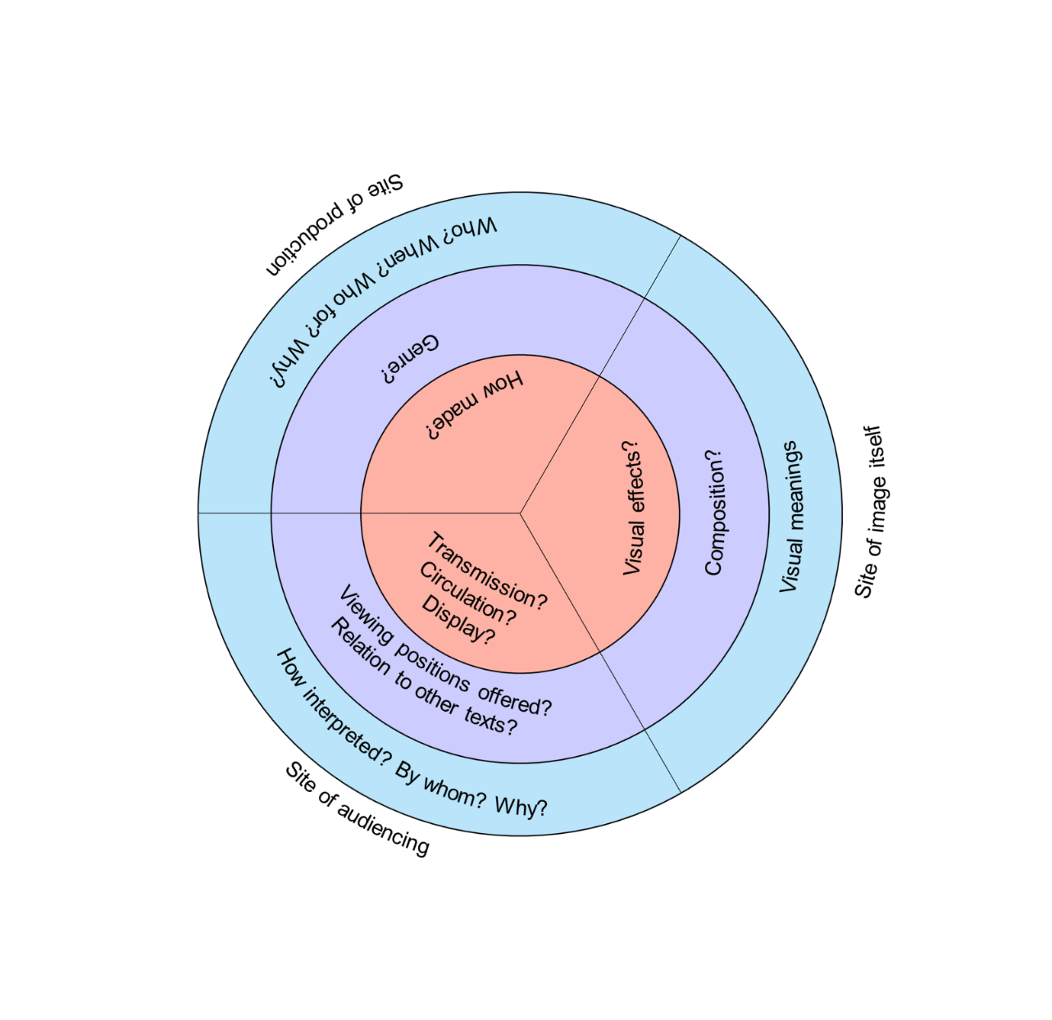
Figure 1: Critical Visual Methodology, adapted from Rose (2012)

To interpret the video “My Choice,” this chapter employs a critical visual methodology, as described by Gillian Rose (2012, 16-17). According to Rose, there are three criteria for a critical visual methodology. First, the images (or video in this case) must be analyzed carefully and taken seriously, because “they are not entirely reducible to their contexts; [they] have their own effects” (Rose 2012, 17). Then, the social conditions and effects of visual objects must be considered, because “cultural practices like visual representations both depend on and produce social inclusions and exclusions, and critical account needs to address both these practices and their cultural meanings and effects” (17). Finally, the researcher’s own way of looking at the images must be considered as well. The critic must be aware of how she/he is looking and considering from where she/he sees (17). This makes the research critically reflexive (Dowling 2010, 31) as the researcher constantly analyzes their role and influence in the research, as well as the way that the researcher analyzes power structures present in the video. The concept of critical reflexivity will be discussed further in Chapter Three.
This chapter employs a framework of sites to analyze images (Rose 2012, 21). There are three sites to consider when using this framework: a) the site of the image, which in this case is “My Choice,” its meanings and display of bodies, b) the site of production, which is the Bollywood filmmakers involved in the production of “My Choice,” and c) the site of audiencing, where the focus is on media reception and different interpretations.
The site is a spatial construct. Space is a “series of carefully worked-up connections through which what we know as the world interacts” (Thrift 2009, 88). Sites are points that connect the flow of goods, people, and information through space. The site of the image originated from the studio in which the video was produced, to the website on which it was uploaded. The website exists in cyberspace and grants access to viewers from various locations. Sites of the video’s production are connected to sites of audiencing, in a transactional flow. The director was influenced by Bollywood cinematic traditions and some audiences might view the product from a lens accustomed to Hollywood cinematic culture. The goal of the Vogue Empower website is to sell goods, which can also be purchased on Amazon. The retail website is available in different parts of the world, which connect centers of production and retail. The three sites – image, production and audiencing – are inextricably linked to each other in a continuous flow of media consumption. “My Choice” connects physical sites, websites, people, ideas, and products.
In Figure 2, the relationships among the sites of image, production, and audiencing are illustrated. The site of the image focuses on the video’s composition as a fast-paced advertisement meant for the male gaze. The site of production centers on Bollywood styles and Vogue India, along with their target audiences. The site of audiencing explains who could be an audience and how the video was received in online media.
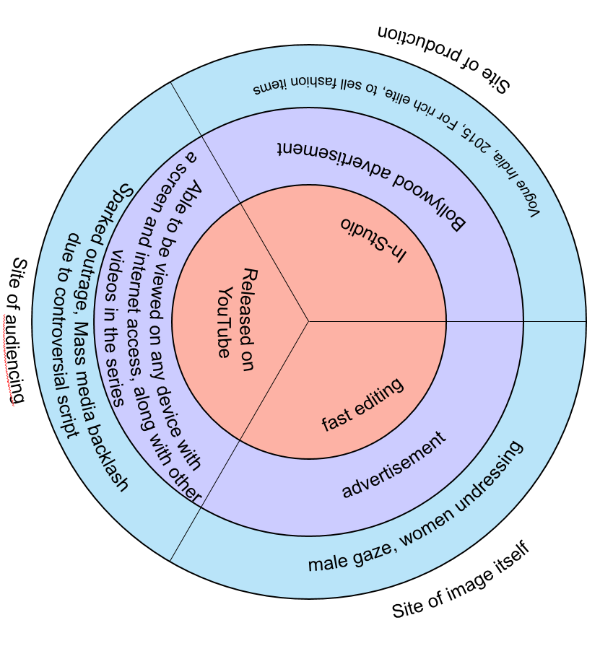
Figure 2: "My Choice" Critical Visual Methodology, adapted from Rose 2012

Gillian Rose also discusses how audiences interpret films, videos, and shows. Different audiences can interpret the same film, video, or show in completely different ways. Audience studies seek to interpret how viewers “read” films, videos and shows and determine what the readings mean. The central tenet of audience studies is decoding (Rose 2012, 268), which is defined by Stuart Hall as a process through which audiences actively make sense of the film, video or show and react in three different ways. The first way is a “preferred reading,” which maintains the status quo and affirms hegemonic ideals. The second way is an “oppositional reading,” which is “counter-hegemonic” and challenges the status quo. The third way is a “negotiated reading,” which mixes both. Audiences use their own mindsets and experiences to actively interpret the images and information they encounter in the media.
In the linguistic turn in postmodern theory, what was understood as reality could only come from language (Sheehan 2004, 24). However, the meanings that come from the texts can be radically different. Texts with multiple meanings are called polysemic. An example of a polysemic concept is the idea of “community,” which has several different interpretations (Averweg and Leaning 2011). Polysemy is based on the idea that texts can be read in various ways depending on the experience of the audience. In “My Choice,” while a straightforward meaning is possible, an enhanced reading is available to those who are familiar with various references throughout the video, like Indian audiences who can recognize the stars in the video, versus an American audience, who might recognize only a few people in “My Choice.” Different audiences can have multiple interpretations and readings of “My Choice.” This can affect how they decode the video. This project demonstrates how different audiences decode the video, while understanding that there are many ways to interpret its content.
Laurel Smith’s article about three audiences and one Indigenous video serves as a model for exploring how different audiences read a video (2012). Smith drew on ethnographic inquiry to explore an Indigenous video through three different audiences in an attempt to recognize the polyvocal nature of the audiences. She makes her interpretation a conversation among different voices. The video can be seen in three “entangled ways,” the first being the festival audiences, the second is a scholarly study of the making of the video and its subsequent geographical movements, and the third is an articulation of the video maker’s interpretation of his video and its target audience. The three audiences in her article serve to decolonize scholarly authority by decentering Smith’s authorial voice. This paper mobilizes the same strategy by interpreting three very different audience readings interpreting the same video, which include Western interpretations of bodies, the writings of Indian feminists, and the mass media’s outrage over the piece.

Foucauldian Discourse Analysis of Mass Media Sources
A search of thirty news articles and six YouTube responses to “My Choice” were put together for analysis. The searches took place in May 2016 using Google and various search terms. The selection was based on all of the top listed articles and blogs from both Indian websites and websites from other world countries that are in English. The goal was to see how the media reacted in the reception of the video. Discourse analysis also determined what truths are evident in the international media reception of the video.
The coding of the news articles and videos began with a version of a manifest content analysis, in which the number of times certain themes were present was counted (Waitt 2010, 219). The next step for discourse analysis drew on Waitt’s suggested strategies for methods based on Foucauldian Discourse Analysis, adapted from Gillian Rose (2001). After selecting the texts, the researcher suspends pre-existing categories, becomes familiar with the texts, codes the texts, searches the texts for power, knowledge and persuasion for the effects of “truth,” notices inconsistencies, and looks for what is silent, or not mentioned (Waitt 2010, 220). In doing so, the researcher determines what emergent truths about the texts are present.

Problems Some Women Face in India
India is a patriarchal society, where women have very specific gender roles and are frequently defined in relation to men as a wife, mother, sister, or daughter (Oza 2006, 30). Ample evidence indicates that India is a place where women have to fight for equality. Honor killings and child marriage still happen and the question of whether or not a woman should work or what her responsibilities are in the family remain a subject of debate. Examples of how India is a patriarchal society include a skewed sex ratio in northern India, victim blaming in assault cases, and lesbian suicides. These situations explained below contextualize some of the lines in the video, like “My choice, to love a man, or a woman, or both. Remember, you are my choice. I’m not your privilege.”
In “My Choice”, the narrator, Deepika Padukone, says, “My choice, to marry or not to marry.” Marriage is central to the construction of women’s gender roles in India. Traditionally, young people are expected to get married in their twenties (early twenties for women) and start a family immediately. A woman is defined socially by her role in the domestic sphere. The pressures to marry and have a family are strong, which puts a burden on women’s choices in her lifetime. The single, unmarried woman is regarded in India as a number of things, including: “unfortunate, lonely, vulnerable, incomplete, frustrated, frigid, man-hater, woman-lover, self-indulgent, promiscuous, predatory, unpredictable, non-conforming, subversive, free, independent, or autonomous” (Pappu 2011, 370). Pappu continues to say that “the unmarried single woman is either unthinkable or an enigma” (371). There is a strong desire to control a woman’s sexuality after she hits puberty. The goal is to marry her off to someone before she damages the family’s reputation by not getting married, which is seen as unnatural (Niranjana 2001, 63). Thus, a young woman is expected to get married sooner rather than later.
In India, attitudes towards women are different based on geographical location. In the north, girls have lower chances of survival due to poverty, lower levels of workforce participation, lower literacy levels, and higher reproductive burdens (Raju 2011b, 34, 38). Generally, the south is more gender egalitarian, with higher rates of literacy and workforce participation (Raju 2011b, 34). Region plays a strong role in shaping women’s autonomy (Raju 2011b, 47). Women in the north may have less autonomy than women who live in the south. Researchers have sought to determine why and how the north and the south are so different. Raju posits that the north is more patriarchal because land holdings have influenced marriage as a transaction in agrarian villages, which benefits men. Even marriage rituals vary, with women in the south celebrating women’s procreational role, and ceremonies in the north promoting the man’s role (Raju 2011b, 46).
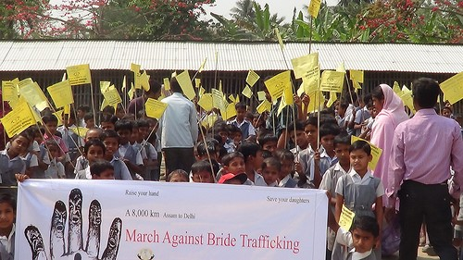
Figure 3: Marchers walk 4,000 km to protest trafficking of brides in India, 2016, ungift.org
Chowdhry (2011) warns that “[t]he recent and rampant use of sex-determination tests and sex-selective abortions has put the very existence of females at stake” (243). In the north, families prefer to have boys over girls, because girls are not as valued, which leads to female feticide and infanticide. This results in a skewed sex ratio. The cultural and social pressure to marry is strong for men in rural area, and since there are not enough women in the north to be brides for the men human trafficking of women occurs frequently. Some men purchase brides from other regions. Many brides are not allowed to be in touch with their families and are stuck in these foreign regions, not even being able to speak the language (255). Women also face problems with domestic violence in marital living, which includes intimate partner violence.
In the north, also, a woman not bearing a son has been used as a justification by her husband for enacting violence (Bhattacharyya 2015, 1342). She is blamed for not having a son, even though the sex of the child comes from the man because “men determine the sex of a baby depending on whether their sperm is carrying an X or Y chromosome” (PhysOrg.com). The home is not always a safe space for women. In Indian homes, domestic violence against women is “linked to deeply embedded cultural practices” (Bhattarcharyya 2015, 1341). Forty percent of women in India experience domestic violence in their married lives (Krishnan et al. 2010, quoted in Bhattarcharyya 2015, 1341). The way that Indian women are viewed by men also affects how they are treated. In families, women are still considered as property by patriarchal norms (Bhattarcharyya 2015, 1341).
Across India, women fear sexual assault and are often afraid to be in some public spaces, especially at night (1343). In India, a woman is raped every 22 minutes (1345); however, only 1 in 10,000 cases of sexual assault is reported to the police (Ramasubramaniam and Oliver 2003, quoted in Bhattarchayya 2015, 1347). When a woman does go the police, she faces misogyny and judgment as officers look at what she is wearing to determine if “she asked for it.” This type of victim blaming is upheld by Indian culture and society, and women’s bodies are closely watched, judged, and punished in this patriarchal system. The prevailing myth is that sexual assault against women only happens to “bad” women (i.e. the focus is on the victim rather than the perpetrator). A woman is expected to appear “respectable” in public or face the consequences. This puts the burden of safety on women alone and removes men from the equation (Bhattarchayya 2015, 1347). Part of the problem is that women are seen as responsible for upholding the “honor” of the family, which means a loss of honor if a woman is sexually assaulted or if she dresses inappropriately (Bhattarchayya 2015, 1349). Her safety is less important to her family than her respectability. Blaming female victims of sexual assault is another symptom of patriarchy.
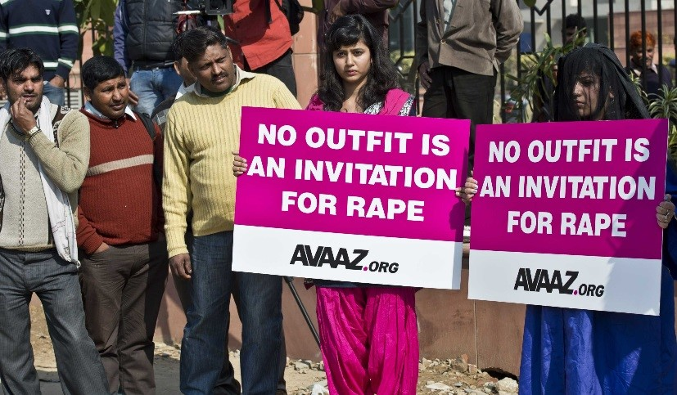
Figure 4: Rape of a child sparks protests in India, 2013, abc.net.au

Patriarchal norms in India are also strongly heteronormative. In 2004, two bodies were discovered in a small town outside of Kolkata. They were two young women in their late teens or early twenties, named Aparna and Kajli. They left a note saying:
“Forgive me Ma, I am leaving like a coward. But I can’t help it; I love her and she also loves me; it is impossible for us to live apart. It is impossible for us to live together. Nobody is responsible for our death. Our only request to you, Ma, let us both be cremated at the same crematorium.” (translated from Bangla by Biswas 2011, 415).

Their wish was not granted. They were cremated at different crematoriums. Stories of lesbian suicides are reported in newspapers, buried in the inside pages, unless they were particularly sensational. They are often not reported as being a couple, since heterosexual norms make their existence invisible (Biswas 2011, 415).
Homosexuality is frowned upon in modern Indian society because of its strong patriarchal social structure. Men need women for social mobility and it stands to reason that lesbianism serves as a barrier to this, since women being with other women takes them away from men. One could also say it threatens the social status and gender roles of other women. Women are socialized into a patriarchal system and oftentimes could be the strongest supporters of that system. Lesbianism could threaten their standing as wives and mothers in society.
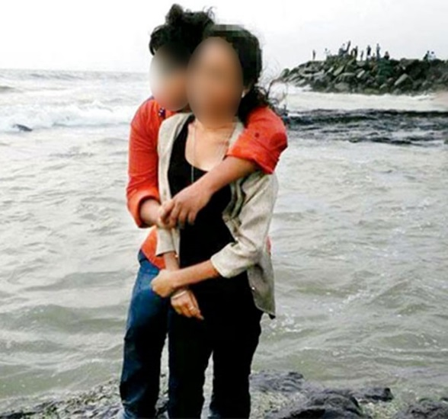
Figure 5: Roshini, 21, committed suicide and Rujukta 21, attempted suicide because their families did not approve of their lesbian relationship. Picture credit: mid-day.com, Story credit: nostringsng.com, 2016

It is not unusual to encounter stories of couples, both heterosexual and same-sex, who commit suicide to get out of the family pressures to separate and enter into an arranged marriage with a person of the family’s choice (Vanita 2009, 51). Many couples perform wedding rituals before committing suicide together (51). Sometimes, couples elope and get married in temples anyway. Families are left with no choice but to slowly accept these unions as “love marriages,” as opposed to arranged marriages, which are common throughout India (52). This further demonstrates the strict rules for women, dictating who they can marry and love in a patriarchal society. Transgressing these boundaries with a same-sex union is considered a crime by Indian nationalists, who have internalized homophobia.
#VogueEmpower comes out of this context, making videos to help women feel empowered. The video’s lines about same-sex unions, marriage choice, and choice in relationships are fighting against what is going on in India, like lesbian suicides, domestic assault, and bride trafficking. These are brief examples of the deeply rooted patriarchal social structure across India. “My Choice” was made with this situation in mind, seeking to change the mindsets of men and women in India about relationships and choice.

The “New Indian Woman”

Figure 6: Cosmopolitan India, 1996, Chandnimarket.com

Well-educated, middle-class, urban women have been at the forefront of cultural change. In urban areas in India, life is much different for women than for women who live in villages. Women in urban areas have purchasing power, which links to identity. Women can purchase identities, in a way, by attaining artifacts for themselves through following advertisements and fashion. People use their bodies to assert status through the stylized appearance of the body, concerned with impression management. Clothing is symbolic and people select clothing to convey messages about themselves (Hubbard et al. 2002).
The video showcases the image of the New Indian Woman. Against the backdrop of patriarchy and violence, Deepika Padukone in “My Choice” asserts that she can marry who she wants, love who she wants, and make her own choices. She is modern, sexual, liberated, and autonomous. She is not, however, totally free of the constraints of patriarchy. In the 1990s, India began allowing more Western programming on television and allowed more Western products into markets. With economic liberalization, many women became avid consumers of Western goods and practices (Oza 2006). In urban areas, the image of a new woman, who was perceived as being “modern,” began to emerge as an icon of liberalized India, which “mapped globalization onto women’s bodies” (22, 24) through fashion, where the clothes are symbolic of Western influences. The new woman became part of a community of global cosmopolitan women (27). Many magazines, like Femina and Cosmopolitan India, showed the Indian woman as a global consumer, who could purchase goods to build her identity. TV serials like Kismet and Asman se Aage, began to show sexually liberated women having extramarital affairs (27).
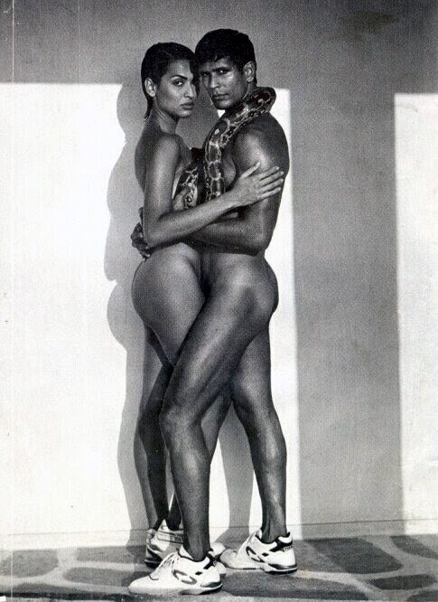
Despite her sexual freedom, the New Indian Woman was still seen as a housewife or future housewife and was not freed of her domestic duties. She had to be modern, as per Indian standards, but not too Western (31). “Westernized” modernity is seen negatively by traditionalists. Western modernity was seen as corrupt by right-wing groups, who have sought to represent a unified Indian (Hindu) culture. These groups pushed back against the growing tide of sexual liberation in promoted in magazines, on billboards and in advertisements by demarcating what they considered to be appropriate representations of women (23). This led to bans and censorship measures from the Cultural Minister of Maharashtra (Mumbai is in this state) (39). A tension exists between different identities of being traditional, Indian, modern and global. Even with her new modern Indian identity as a cosmopolitan consumer, the New Indian Woman remains a mother and a wife before anything else, reflecting a strong patriarchy in place, restricting women’s roles, even in the context of market liberalization in India. The New Indian Woman has to be global, but traditional, with strong, traditional (and patriarchal) Indian values (31).
Figure 7: Tuffs Shoe Advertisement, July 23, 1995, desicreative.com
In television advertisements during the 1990s and early 2000s, two types of women are portrayed. The first is the tempting, sexy dream woman made to sell products to men. According to Prahlad Kakkar, an owner of an advertising agency in North India, men held the purchasing power of India during that time, so advertising companies tried to get men to buy goods by using a tempting dream woman to sell them (Radhakrishnan 2001). The second type of woman seen in advertisements in the 1990s and 2000s is the traditional Indian woman, who the media portrays as a housewife. She embodies patriarchal family values through her dedication to her family’s needs. The advertisements suggest that the traditional woman is the better woman, the one who men want to marry, instead of a woman who appears too Western. Radhakrishnan provides an advertisement for Parry candy as an example of this scenario. A young Indian man and a white woman with blond hair are having a romantic moment. He is about to offer her a string of flowers resembling those used to propose. A traditionally dressed Indian woman wearing a sari and sporting vermillion on her forehead, interrupts this scene when she enters, carrying Parry candies. The young man offers the flowers to her instead, spurning the Western woman (Radhakrishnan 2001).
The Indian woman’s body not only serves as a site for constructing modernity, but Hindu elites also position the ideal woman as representing the upper caste in Hindu society within the Indian nation-state (Radhakrishnan 2001). Radhakrishnan argues (2001) that “the ‘new’ woman is intrinsically related to the ‘true’ identity of the nation and hence it becomes necessary for the oppressive patriarchal tradition to patrol and monitor the woman’s body and sexuality” (Radhakrishnan 2001). These circumstances drastically narrow the interpretation of what the modern Indian woman looks like in the media. Gender intersects with race, class, and caste. It also leaves out many Muslims, Christians, and Buddhists who live in India and may not see themselves represented as much in the media, or in “My Choice.” The New Indian Woman is not transgressive as long as she displays traditional Indian Hindu values and knows her place, which according to upper caste Hindu notions, is in her role as a mother, wife, sister, or daughter in the home. The ‘new’ woman in “My Choice” is making her own decisions, independent of family roles, which may be a reason that the video received such mixed reviews.
The New Indian Woman is modern because she connects more to the global cosmopolitan class, but this does not make her Western. Western ideals of individualism and independence look “selfish and irresponsible” to Indian women (Hussain 2005, 22 quoted in Lau 2014, 283). As long as Indian women do not abandon their roles as mothers and wives, however, being modern is acceptable. Through these roles in the family, however, women can gain power and influence. These roles are only in family roles and in relation to men, again reflecting the strong sense of patriarchy deeply rooted in Indian society (Lau 2014, 283). In Indian women’s writings in English women test the boundaries of their sexuality and agency by freely divorcing, having premarital and extramarital affairs and not having consequences or guilt over it (Lau 2014, 283). The New Indian Woman in this medium is still bound to her family roles as a mother, sister, or wife, but is makes her own decisions with her body, sexuality and partnerships without facing a penalty in society. Lau claims that New Indian Women want to be treated like persons with individual needs and desires that do not cast shame upon the family. The women in the writings still retain their middle-class status, which is important in the construction of the New Indian Woman (Lau 2014, 292).
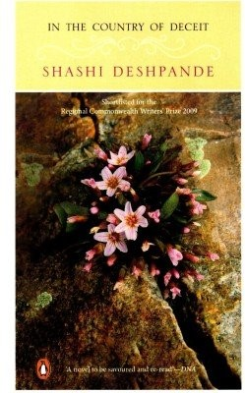
Figure 8: In the Country of Deceit, Shashi Deshpande (2009), challengebookstore.com

For example, in Shashi Deshpande’s novel, In the Country of Deceit (2011), the protagonist, Devayani, is a middle-class spinster that seeks a role outside of the culturally prescribed one. She is devoted to her family. She becomes the “other woman” and has a love affair with someone else’s husband. Lau says, “The rightness of their compatibility is presented as the counter balance to the wrongness of their affair… She transgresses because of her strong feelings, but despite compromising her own principles, does not lose her integrity” (284, 286). The lovers eventually mutually end the relationship. Lau argues that this novel is radical because nothing bad happens to Devayani for pursuing her own happiness. Society does not punish her for her transgressions. Eventually, she bows to tradition and ends the love affair (Lau 2014, 284-287).
Daya contends that sexual autonomy is the defining feature of the New Indian Woman’s modernity, like Lau. (2009, 99). This goes against the idealized values placed upon the ideal woman, which are “chastity, wifely fidelity, and silent suffering” (Mukherjee 1991 quoted in Daya 2009, 98). Daya notes, however, that the “conservative values that predominate are… indicative of the as-yet incomplete liberation of Indian women and therefore also of India’s un-achieved modernity (2009, 99). Daya argues that modernity in India is achieved through liberation of women.
The New Indian Woman is an urban, middle-class, modern, and sexually autonomous woman, who upholds Indian values and fulfills her family roles as a mother, sister, or a daughter. She is sexy, but chaste. “My Choice” shows a woman declaring that she can have sex with who she wants, she can marry who she wants and she is free to make these decisions. In the video, a commitment to family values is noticeably absent. This may be another reason that the video was criticized.

Analysis

The Site of Production: Situating Bollywood
Bollywood is India’s Hindi language cinema industry from Mumbai on India’s west coast. Bollywood is a “culture industry” with a global scope. (Rajadhyaksha 2003, quoted in Chatterjee 2016, 5). The industry is biased towards an urban audience, especially in cities such as Mumbai and New Delhi where Hindi is spoken. Also, it caters to the Indian diaspora because most of the revenue comes from these Indian expatriates (Ganti 2007, quoted in Chatterjee 2016, 6). Women in Bollywood films can be globally mobile, with films taking place in Europe or the United States for example, but they must retain traditional Indian values and often show actors and actresses in Indian dress.

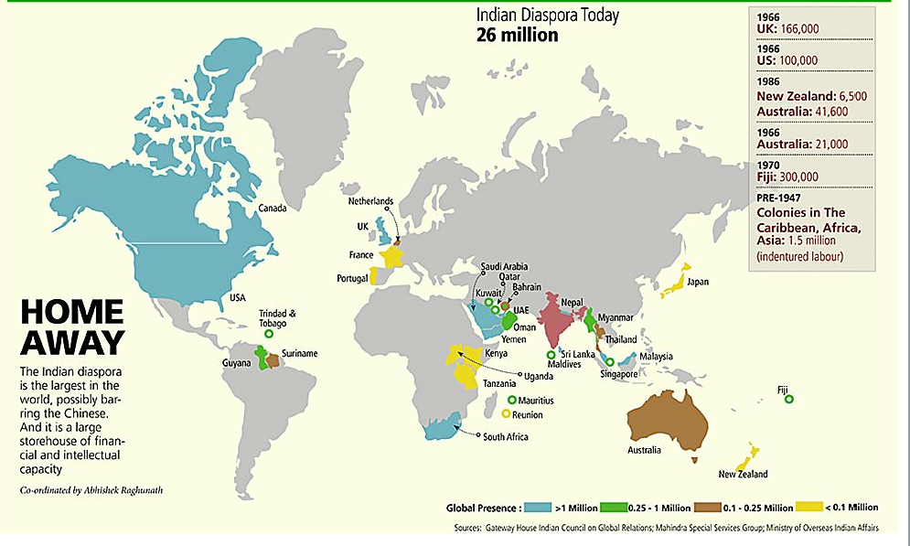
Figure 9: Map of the Indian Diaspora, pinterest.com

Bollywood’s film industry has a global reach, especially in catering to the massive Indian diaspora, all over the world. The Non Resident Indian retained strong Indian values. Therwath says” [t]he Non Resident Indian (NRI) became the epitome of Indianness and embodied at once capitalist and consumerist modernity and patriarchal, Northern and Hindu traditionalism” (2010). Films shifted their focus to cater to Indians living abroad. Even Vogue India acknowledges its readers in the diaspora. Thukral, an artist featured in a Vogue India article, said “[w]e grew up with the general acknowledgement that most Indians dream of leaving India and moving abroad,” adding that the dream is “laced with anxiety and insecurity” (Khetani 2013, Vogue India).
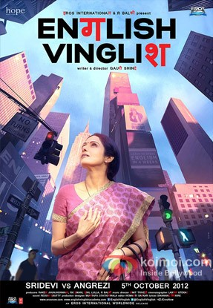
Figure 10: English Vinglish movie poster, 2012, koimoi.com

In Bollywood films, the ideal heroine is expected to be both “chaste” and “sexy” (Azmi 2004, quoted in Chatterjee 2016, 4). She has to have the “right” traditional approach to modernity and she must not lose her “Indian-ness,” even in a western setting (4). These expectations are visible in the movie English Vinglish (Shinde 2012) in which an Indian woman lives abroad and retains her Indian-ness even as she learns English in an English-speaking country. Her family had treated her with disrespect for not knowing English. Speaking English was a matter of status. In reality, only about thirty percent of people in India speak English. Those who do are typically the elite and upper class (Aula 2014). The fact that “My Choice” is in English will be discussed in detail in the next chapter.
In the movie Queen (Bahl 2013), a bride is dumped on her wedding day, but she decides to go on her honeymoon anyway, by herself. She retains her modest behavior and dress even though she is in Europe with new friends on an adventure. She sets out boldly on her own, but remains shy and innocent. She gains confidence in her solo adventure. At the end of the film, she returns her engagement ring to her former fiancé and thanks him for cancelling the wedding. The woman travels Europe and learns the customs there, but still retains her Indian-ness by entering a cooking competition and preparing traditional Indian food.

The Site of Production: The Studio
The video does not take place in public spaces. It does not feature the everyday, average women on the street. Instead, the video takes place in a studio. The ninety-nine women in the video were most likely cast by those in charge of the video, like the director, producer, or Vogue India. Many of the women featured are famous and prominent women known in India. This was by design, to show viewers that important women support the message. The studio is an elite space, for Bollywood VIPs who are invited to enter. Average women are not visible in this studio space.

The Site of Production: Situating the Transnational Star
As explained previously, Bollywood is a cinema with a global audience, with films featuring many different global locations. Bollywood films are geared to connect to the large Indian diaspora, creating transnational flows of media. Some Bollywood actors and actresses have become transnational stars, crossing over into Hollywood cinema. Other world cinemas also have prominent actors and actresses who connect to Hollywood cinema.
In Hong Kong cinema, some stars come from different, foreign backgrounds. A Malaysian beauty queen, Michelle Yeoh, began to star in Hong Kong cinema as an action woman (Funnell 2014, 38-39). She rose to Pan-Asian superstardom and became the face of Hong Kong action cinema (40-42). She further crossed over into Hollywood as a “Bond Girl” in the James Bond film, Tomorrow Never Dies (Spottiswoode 1997) (42). Unlike many Asian female stars, she was known for her achievements as an action star, rather than her sexual appeal (Funnell 2015, 83).
Similarly, Bollywood actresses have transnational appeal and cross over into Hollywood cinema. Priyanka Chopra, a former Miss World and a major Bollywood actress, currently stars in the U.S. television series Quantico, becoming the first South Asian person to headline an American network series. This is a progressive change, since there is a long history of role segregation in Hollywood, with white actors being cast to play Asian roles (Wong 1978 quoted in Funnell 2015, 80). Fisher Stevens being cast to play the Indian man Ben Jabituya in the films Short Circuit (Badham 1986) and Short Circuit 2 (Johnson 1988) is an example of a white man donning brownface to play a South Asian role.
Deepika Padukone, the star of “My Choice” and numerous Indian films has also crossed over recently into Hollywood films, making her a transnational star. She starred in the film xXx: The Return of Xander Cage (Caruso 2017). It was released in India on January 14, 2017 and in the U.S. on January 20, 2017. Like the typical Bollywood stars in the films English Vinglish (2012) and Queen (2013), she retains her “Indian-ness”, with keeping her Indian accent (Bawa 2017), unlike Priyanka Chopra in Quantico, who had a dialect coach to make her sound “American” (Singh 2015).
With Bollywood’s already transnational appeal, due to the global nature of the film locations and the diaspora, stars are crossing over into other cinemas, namely Hollywood, increasing the visibility of the Bollywood cinema culture industry. Michelle Yeoh, Priyanka Chopra and Deepika Padukone (and many others) have become transnational film stars. In this era of instant digital connection, stars can become globally mobile like never before. The video “My Choice” became available all over the globe through YouTube. Global audiences reacted to “My Choice,” sharing it on social media. But who was the target audience of the video?

The Site of Production: Target Audience for a Fashion Magazine
Answering the question of “who for?” in the site of production, an examination of the media kit is in order for the “digital audience profile” of the average Vogue India online consumers. The magazine is available digitally and in print. Because the video was released online, I focused on the online users. Below is a table describing the Vogue India online profile.

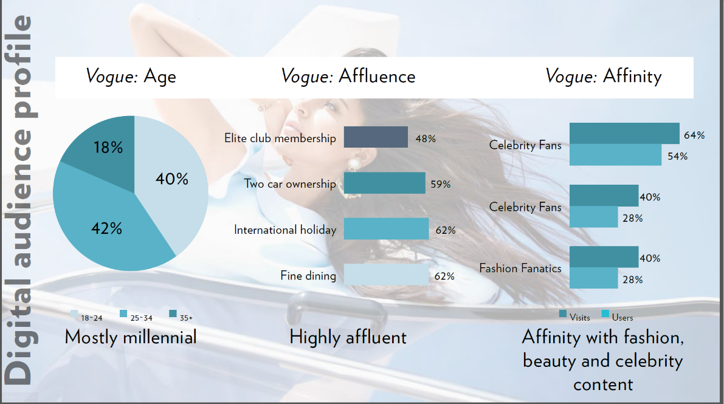
Figure 11: Vogue India Media Kit, 2017

Millennials mostly consume Vogue India’s material, with 82 percent of its digital audience less than 35 years of age. The digital audience is also quite affluent by Indian standards, enjoying fine dining, elite club membership, international holidays, and two car ownership. Two car ownership is quite rare in India, since, according to the 2011 census in India, only 9.7% of urban residents own even one car, jeep, or van. These highly affluent website users are often interested in fashion, beauty, and celebrities, as illustrated by the fact that more than half of visitors and users described themselves as “celebrity fans.” These tastes are woven into the structure of “My Choice.” Viewer interest in celebrities might be a reason why Deepika Padukone, as a major Bollywood star, was selected as the star of “My Choice.”
The video “My Choice” was released online on the Vogue India website, Vogue.in, on March 27, 2015. As of March 12, 2017, the video had 10,795,461 views on YouTube, the platform through which the video was shared. YouTube viewers can access the video on many different kinds of devices with internet access. It is also easily shared through social media, like Facebook.
The target audience for Vogue India is affluent. Vogue India is a fashion magazine, which pushes a fashion-forward message. However, the video was considered too elitist in its approach in some media articles (Bawa 2015), with critics claiming that “it represents only a small segment of privileged women” (The Hindu, 2015). Writing in The Washington Post, McDonald (2015) called the video “corporatized feminism” and questioned whether celebrities are the best people to spread a feminist message.

The Site of Production: Who Made the Video?
To examine the site of production, the study must identify who made the video and why it matters. The script is based on a piece written by Kersi Khambatta, a former sailor who is now a writer who has produced screenplays for Bollywood films like Being Cyrus (2006) and Finding Fanny (2014). He also writes novels, like The Village of Pointless Conversation (2015), which can be found in English and is an extension of Finding Fanny (2014). He is known for his partnership with the director, Homi Adajania, who earned critical acclaim for directing Being Cyrus (2006). Adajania worked with Deepika Padukone in the 2012 film Cocktail. Adajania, Khambatta, and Padukone all worked together on Finding Fanny (2014). The three have a history of working together. Together, they worked to produce “My Choice.”

The Site of the Image: “My Choice”

Figure 12: Deepika Padukone in "My Choice", 2015, YouTube.com

Next, the study examines the site of the image (see Figures 1 and 2). The video “My Choice” is in black and white with flashes of red. The video is in English. It is two minutes and thirty seconds long and opens with a shot of Deepika Padukone with bare shoulders and flowing hair. Images of ninety-nine different women then flash on the screen. They appear in various stages of dress and undress(ing). Some dance while others hold photos of other women. Many smile and some scream. A few women are elderly, while most are younger. Words occasionally flash across the screen: my choice, equality, my empowerment, and the number four. Thunderous drumming sets the stage for the women dancing, while other music communicates power and intensity, with singing and string and percussion instruments. The video ends with the same scene as the opening scene, with Padukone’s hair flying over her bare shoulders. Then, it shows #VOGUEEMPOWER with the slogan “it starts with you.”
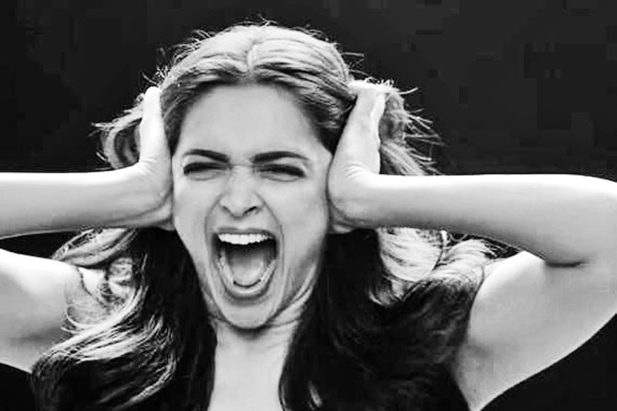
Figure 13: Deepika Padukone in "My Choice," 2015, mid-day.com

Below is the script of the video:
My body, my mind, my choice
To wear the clothes that I like even as my spirit roams naked, my choice
To be a size zero or a size fifteen, they don’t have a size for my spirit, and never will
To use cotton and silk to trap my soul is to believe you can halt the expansion of the universe
Or capture sunlight in the palm of your hand
Your mind is caged, let it free
My body’s not, let it be
My choice, to marry or not to marry
To have sex before marriage, to have sex outside of marriage, to not have sex, my choice
To love temporarily, or to lust forever
My choice, to love a man, or a woman, or both
Remember, you are my choice. I’m not your privilege.
The bindi on my forehead, the ring on my finger, adding your surname to mine
They’re ornaments. They can be replaced. My love for you cannot. So treasure that.
My choice, to come home when I want
Don’t be upset if I come home at four a.m.
Don’t be fooled if I come home by six p.m.
My choice, to have your baby or not
To pick you from seven billion choices, or not
So don’t get cocky
My pleasure may be your pain
My songs, your noise
My order, your anarchy
Your sins, my virtues
My choices are like my fingerprints. They make me unique.
I am the tree not the forest. I am the snowflake not the snowfall. You are the snowflake.
Wake up.
Get out of the shit storm.
I choose to empathize, or to be indifferent.
I choose to be different.
I am the universe, infinite in every direction. This, is my choice.
(Vogue India, YouTube, 2015)

Given an online video’s wide and global reach, there can be many different audiences viewing the video in a variety of ways, such as on mobile phones or tablets, laptops, and computers in a variety of settings, virtually anywhere. The audiences could be of any nationality or ethnicity. As long as the person has access to the internet, the video could be available. Some may even download it for offline use, acknowledging the multiple websites that offer YouTube video downloaders. The video exists in cyberspace, where it can be accessed publicly, in a shared location simultaneously with many users. It is a piece of digital media that has the ability to be in many locations (user devices) and one location (the website) at the same time. The YouTube platform allows for users to leave comments and interact with the video. The share button is especially useful for sharing the video on other websites and social media platforms.

The Site of Audiencing: Polyvocal Interpretations

Theme 1: Mind/Body/Poetry
Two major themes arise from the video’s script: mind/body/poetry, in which the script focuses on the mind and the body, as well as using poetry to create meaning, and marriage/sex/partnerships, in which the script focuses on those areas and asserts new ways of imagining those categories. These themes are used to go through the script and analyze key phrases for meanings between the different audiences. Images within the video are also interpreted for meaning, especially in the mass media’s overall reaction to “My Choice.”
Throughout the video lines in the script refer to making choices, embodied knowledge, and the importance of the body. Some of the lines in the script are also poetic and deliver an important feminist message in a creative way. In this section, lines and selected images from the video are critiqued through the lenses of three different viewpoints, namely, Western feminist writings on the body, the writings of Indian feminists, and the mass media. Lines from the script are in quotation marks in the sub-headings.

“My body, my mind, my choice”
The concepts “my body, my mind, my choice,” are simple, yet powerful. The script that Padukone reads in the video asserts her control over her own body and the importance of her own thoughts and voice. Her declarations of autonomy and self-value resemble the modernity of the New Indian Woman, who has an embodied modernity through her sexual autonomy. The New Indian Woman has a sexually autonomous body and the agency to make her own decisions about it. However, she is expected to conform to the patriarchal norms of Indian society associated with her role in the domestic sphere.
Central to Western thought is the mind/body dualism, in which the mind and the body are separate. The mind has been associated with masculinity. The body is associated with femininity. Women are anchored to their bodies and through their bodies, they experience knowledge. In other words, the woman is the body (Kirby 1992, in Longhurst 1995, 99). The addition of saying “my mind” is significant, beyond just “my body, my choice.” She is experiencing knowledge through her body. She acknowledges that she is a thinking being, but she does not deny her body. Privileged white men presume that they can transcend their embodiment, since it is only a shell for the mind, but people of color and women cannot (Longhurst 2001). However, Padukone acknowledges that she has a body, but that her mind is part of her body, which gives her control over what happens to her body and that it’s her choice what happens to her body.
The body is also a surface on which messages can be inscribed. Ideas, beliefs, ideologies, and values are attributed to body inscription (Grosz 1990). People mark their bodies through appearance, which helps build an identity in relation to others (Grosz 1990). There are ninety-nine women appearing in “My Choice.” Their bodies look different and have different cultural markers, like traditional dress or a bindi, but also Western dress. Their choice of clothing is important in that this video was produced by a fashion magazine. Clothing is symbolic and the selection of clothing conveys messages and class status, as well as gender identity (Hubbard et al. 2002). Vogue India carefully selects fashionable clothing for people to purchase. In “My Choice,” they have selected to place famous women in a women’s empowerment video. Their bodies are selling an idea, feminism, and placing it on the bodies of famous Indian women, making it something you can purchase. The media caught on quickly to this “commodified feminism,” which will be described in further detail in what is silenced, and also in Chapter Three.
The inscription of messages onto women’s bodies is also a reflection of power. The elite expect women to purchase fashionable clothes and buy into their brand of feminism. Feminism became a commodity in this video, alongside the half-naked actress showing her skin for women who fear showing skin due to harassment. Vogue India only represented their demographic, showing women of a certain body shape and size. The video showed some elderly women, but only for a quick flash of a second. There were many women who were not represented in this showcase of what the publishers of Vogue India thinks feminism should look like.
The women dressing or undressing makes them subject to the male gaze. Mulvey (1989) has described two ways of pleasure in looking. It split between the “active/male” and “passive/female.” The male gaze then “projects its fantasy onto the female figure, which is styled accordingly.” In this case, there are women dressing and undressing on screen.

Figure 14: Deepika Padukone unhooking her bra in "My Choice", thevoiceofnation.com, 2015

In particular, Deepika Padukone is shown unhooking her bra from behind and she starts and ends the video in a shot from the shoulders up, with no visible bra straps. The way that her body is portrayed with and without clothing can be debated. For instance, one could argue that her bra represents the type of feminism she is portraying or, conversely, that she is removed the social and aesthetic construct of femininity. In the thirty news articles analyzed, five mentioned Padukone’s bra or nude body. Articles stated such things as, “Deepika unclasping her bra is not empowerment” (Bawa 2015) or that it took away from the message. “There was more focus on Deepika unhooking her bra on the camera than the message itself” (Kulkarni 2016). Although a woman unclasping a bra is a common occurrence, here it is sexualized. The unfortunate thing about this is the way that people focus on this part of the video as a distraction from the message, showing that even in empowerment videos, women’s bodies are policed. Some articles stated that it makes her subject to the male gaze, as mentioned previously, which is something the video does not address, but instead, seems to feed.

“My choice, to have your baby or not”
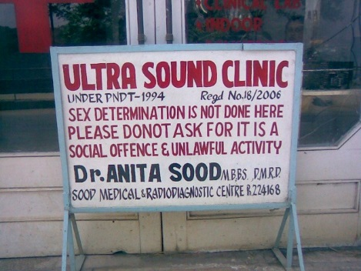
In the video, Padukone says that it is a woman’s choice whether to have a baby, or not. This leads to the question of terminating unplanned or unwanted pregnancies. The pro-choice/pro-life debates in the United States make abortion a difficult issue, with many lawmakers, some of whom are male, trying to overturn the 1973 Supreme Court decision to protect a woman’s privacy in her medical decisions, including the decision to get an abortion. In India, abortion has been legal since 1971, when it was introduced as a measure to curb population growth (Menon 2009, 107). Due to the development of sex determination technology in the 1980s, women began aborting female fetuses. Menon states that because of the abortion of female fetuses, the first voices demanding a reduction in abortions were feminists in India (107).
Figure 15: Sign outside of an ultrasound clinic in India, Jed 2009, harmonicbody.wordpress.com
The abortion of female fetuses and female infanticide led to a decline in the male-female sex ratio in India. Sex determination is illegal in India, but women have found loopholes to get around it. A woman can get ultrasounds or amniocentesis at one clinic to “test for fetal abnormalities.” Then she can go to another clinic and get the abortion, no questions asked (107). Feminists in India want stricter controls on pre-natal testing to eliminate these loopholes.
The government has come up with suggestions and schemes to try to stop sex-selective abortions. One suggestion was to have a drop off center for unwanted daughters. A different approach was to establish a mandatory registration of pregnancies and a system to monitor abortions (107). The sad reality is that most women in India “have no control over the conditions in which they have sex, and often abortion becomes the only form of birth control” (108). If she cannot control getting pregnant, she can at least control giving birth. “My Choice” asserts that a woman can have control over their bodies, their decisions to have sex, the decisions to keep the baby or not, and the decisions to be in a relationship or not. If a woman cannot access birth control, she should be able to access a legal abortion.
However, it becomes hard to monitor the abortion of female fetuses. Many women get sex selective abortions under pressure from their husband’s families. The real problem to tackle here is not abortion itself, but the “fundamental devaluing of women” (109). Menon says that fighting this devaluing of women will have to be done with consistent feminist politics (109). “My Choice” could be a step in the right direction by asserting that women have control over their bodies. Ultimately, Menon (in Majumdar 2007) sums up her view on abortion as follows:
The ideal feminist world would not be one in which abortions are free and common, but rather one in which most of the social constraints and technological inadequacies that make for unwanted pregnancies, would have been dealt with. Ultimately, as feminists we must affirm ‘life’ – not in some absolute sense, but as it appears within our specific moral and ethical universe - while at the same time, in a hugely imperfect and unjust world, accepting the need for abortion and struggling for safe and universal access to it.

Theme 2: Marriage/Sex/Partnerships

“To have sex before marriage, to have sex outside of marriage, to not have sex, my choice”
This line, as it is emphasized in the media, appears to be the most controversial line in the whole video. Having sex before marriage in India is taboo. News outlets interpreted the “sex outside of marriage” line to mean infidelity or adultery, which appeared 29 times in 30 news articles. Clearly, this line outraged large numbers of viewers. Perhaps a different meaning comes from the movements of organized sex workers. Sex workers have mobilized, claiming visibility and legitimacy for “sex outside marriage” (Menon 2009, 102). They represent their profession as a business, giving some workers more power. Sex workers’ movements challenge heteronormativity because they challenge the stable identity of woman in the patriarchal family (102). The movements also include many transgendered sex workers. Perhaps the line “sex outside of marriage” is a nod to the movements of sex workers, some of whom challenge feminist understandings of “prostitution as violence” (102). Some women, though, are trafficked and sold into the industry as slaves.
Another interpretation might be that the words mean a woman can have casual sex with someone without the prospect of marriage. The words imply that a woman can have sex without thinking about marriage at all, completely outside of it. Sex does not have to be wrapped up in marriage. A woman can have sex before marriage, if she even chooses to get married. A woman can have sex without marriage even being in the question. She is asserting that her body is her own and she can have consensual sex with whomever she chooses. To not have sex is also an important line because it also shows that what she wants to do with her body is up to her. She can choose what she wants to do with her body. She should not be pressured to have sex. She has agency.
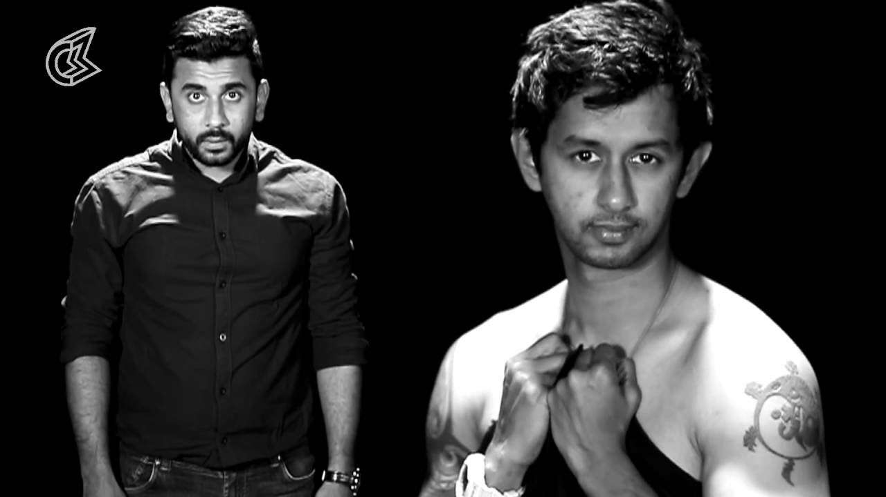
Figure 16: #VagueManpower: My Choice Too, youtube.com

Infidelity, which was emphasized by the media, was okay on Indian TV serials and in Indian women’s writings in English (Oza 2006; Lau 2014), but not acceptable in society. “My Choice” tested the boundaries of what Indian society deems acceptable. In one male parody video, #VagueManpower, a man takes up the issue of models representing society and the “self-entitled arrogant actress,” most likely Deepika Padukone, with whom he disagrees. There is also the “Male Version”. Once the men reach the part about having sex outside of marriage, a man on screen is confronted by an angry woman and other women join her. Then, on the screen, it says “Respect Women and Men. We don’t support cheating or adultery.” This line is a direct attack on the “sex outside of marriage” line, calling it cheating and adultery.
One positive response to the video was the Transgender version of “My Choice,” about hijras, the third gender in Indian society, which are male-to-female transgender individuals. In the video, they discuss the challenges of being a hijra. The narrator says “to be born with the sex I don’t conform with, wasn’t my choice.” The video touches topics of ridicule, rape, and prostitution. It ends on a positive note, with the narrator saying “deciding to live as a proud hijra was my choice.” It ends with a screen that says, “They are not different. They are just treated differently,” which heightens awareness of how hijras should be treated.
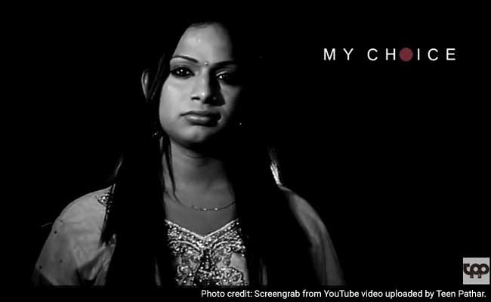
Figure 17: Transgender "My Choice", 2015, NDTV.com

In the news articles, adultery and infidelity were mentioned twenty-nine times. Padukone felt the need to “break her silence” about “My Choice” and come out and say that she did not endorse infidelity and that she disagreed with a few of the lines in the video (Business of Cinema News Network, First Post, Video ibeat, Deccan Chronicle, BuzzFeed India 2015). The media treated this as breaking news, as if Deepika Padukone herself was responsible for the controversy. One article tracked down the director, Homi Adajania, who said to the critics, “they don’t understand the context, or they are Internet trolls hankering for attention, or maybe they have a different viewpoint… it’s a democracy and this is our view and they are entitled to theirs” (Deccan Chronicle 2016). However, most of the writers blamed Padukone for the controversy as if she had written it herself.
The articles spoke particularly negatively about this line being in the video, claiming that if women can sleep around, then men should be able to do it as well without being called a cheat (Arora 2015). The media’s negative response also included other actors saying that “sex outside marriage” is not empowerment. A strong inconsistency emerged in the texts about what empowerment or feminism really means. It appeared to be entirely unclear. The issue of infidelity was so upsetting, that it was the most dominant theme of the news surrounding the video’s release, with sixteen out of thirty articles mentioning infidelity, which appeared twenty-nine times across those articles.
Not everyone is offended by the “sex outside of marriage” line. Indian women authors seem to have no problem with it, writing many different scenarios where women are free to have affairs and make their own sexual decisions. Lau writes that in Indian Women’s Writings in English (IWE) women are being shown as chasing self-fulfillment and happiness through sexual autonomy without modesty, shame and guilt (Lau 2014, 280). The trend in IWE is to show middle-class women that are older as having more autonomy, defying taboos and “getting away with it” (280). These women can have sex outside of marriage and nothing bad will happen to them. IWE is “moving to a social scene where the New Indian Women (even if they are mothers) can freely divorce, have pre and extramarital affairs and can do so with neither guilt nor social consequences” (283). The New Indian Woman can be a loving mother, a good daughter, and well respected, but also a divorcee, a mistress, and/or the “other” woman (284). In “My Choice,” the New Indian Woman, represented by Deepika Padukone, is making these claims.
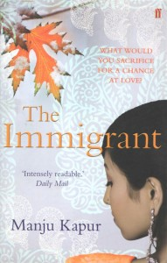
Figure 18: The Immigrant, Manju Kapur (2008), manjukapur.com

An example of sexual transgressions in IWE is in The Immigrant, by Manju Kapur. The protagonist, Nina, lives in Canada as an immigrant. She is married and repeatedly cheats on her husband, who also cheats on her. Nina’s lover is another woman. Kapur’s protagonists have deviated from the good path because of stress, but they carry on with their lives and do not suffer severe consequences for their actions (Lau 2014, 288). These writings reveal a sexual autonomy for the New Indian Woman in fiction, but can show the changing undercurrent in reality of women choosing to have sex before marriage, having extramarital affairs, or even choosing not to have sex at all. According to a three-year research project in Kolkata by Mukhopadhyay, in which she studied marriage arrangements for men and women in middle and working classes, pre-marital sex is more common among working class women, but middle-class women have to be secret about it because of social pressures (2011, 145).
Whether or not it is referring to sex work, extramarital affairs or casual sex, the controversial line in “My Choice” started a conversation about women’s choices in relationships and with their bodies. Sex outside of marriage can be read in many different ways and different feminist movements in India might also read it differently. The text could be polysemic, with different audiences interpreting the meaning quite differently. Or, perhaps, the controversial line was taken way out of context.
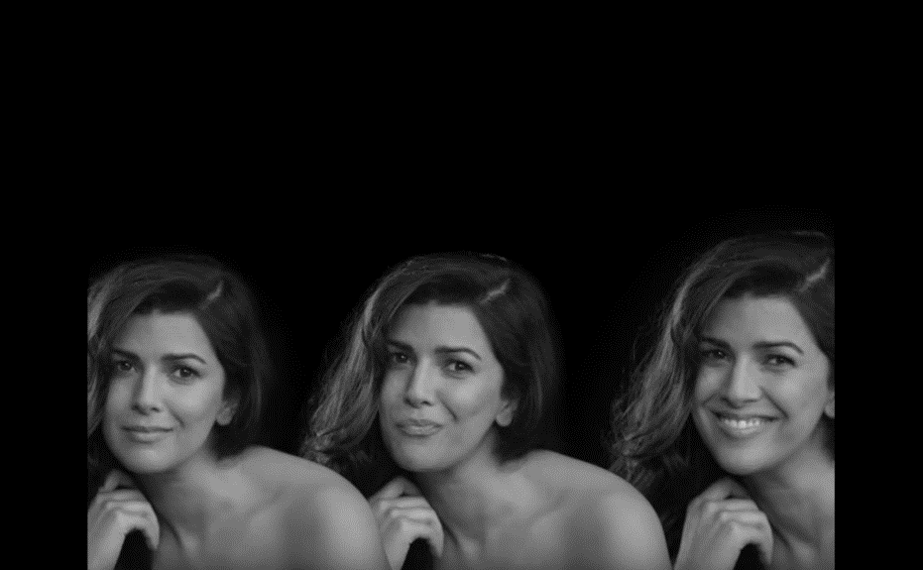
Figure 19: Screen grab of a scene in "My Choice", youtube.com

“My choice, to love a man, or a woman, or both”
In the video, when Padukone says “to love a man, or a woman, or both,” the same woman appears three times across the screen. She is not shown in a relationship with anyone, male or female. In a way, the imagery “plays it safe” by not showing a lesbian relationship. In India, where lesbian suicides are common, same-sex unions are illegal. However, same-sex unions have been represented in Indian literature for two millennia. Individuals in same-sex unions could have been lovers in a past life and cannot help their attraction. Homophobia in India started during colonial rule, from the British, who attacked Indian sexual mores. Homophobia has been adopted by right-wing groups, such as the Vishwa Hindu Parishad or the Shiv Sena, who protested outside of a hospital where a lesbian was fighting for her life after attempting suicide. Vanita interviewed Swamis about the matter of same-sex unions and Swami Bodhananda Saraswati said that “There is no official position in Hinduism… It’s a Christian idea that it is wrong. From a Hindu standpoint, there is nothing against it in scripture.” (Vanita 2009, 48, 50, 55). The ideas about homosexuality being an unspeakable crime come from British influences during colonial rule that have been internalized by right-wing groups today.
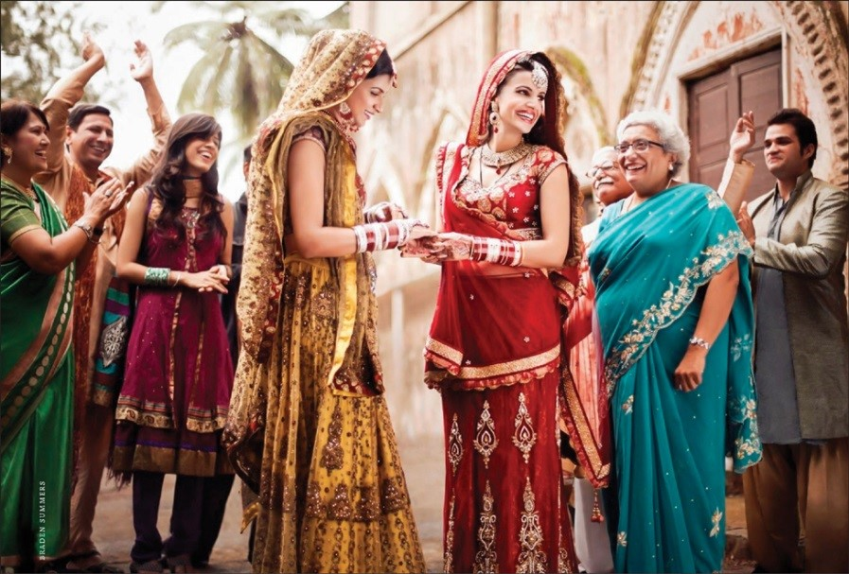
Figure 20: Two women getting married in a Hindu wedding ceremony. Braden Summers (2016) hinduismtoday.com

On a positive note, Vanita reports that there are many cases of families accepting same-sex unions and even arranging wedding ceremonies for the couple, like the one shown above (2009, 51-52). These unions are seen as unusual but acceptable gandharva marriages, a traditional Hindu form of marriage based on love, or a love marriage (53). These marriages lead into a discussion about the decision to marry or not to marry, whether same-sex or heterosexual, which is one of the lines in “My Choice.”

“My choice, to marry or not to marry”
The binary between love marriages and arranged marriages is starting to blur. In many cases, parents are involved in marriage choices, even in love marriages. With this level of involvement, the practice of an “arranged love marriage,’ where one falls in love with the parents’ choice, is gaining popularity among the middle class (Uberoi 2006 quoted in Mukhopadhyay 2011, 125, 132). Most parents accept the principle of choice in marriage, which absolves the parents of the right to pay a dowry among working class families (Mukhopadhyay 2011, 124-125.)
Mukhopadhyay states that class considerations in marriage decisions are becoming equally or more important than caste (2011, 127). Marriage choices and decisions are highly gendered, with women, more than men being denied the right to choose their own partners in marriage (127). Among the participants that Mukhopadhyay studied, the choice of not getting married did not seem to exist, unlike the line in “My Choice,” where Padukone says she doesn’t have to get married. There also appears to be a short window for the prospect of a love marriage. If one does not get married by a certain time, parents will step in to fill the gap and find a partner. If the marriage is not successful, divorce carries a greater stigma for women than for men (129, 131,138).

Foucauldian Discourse Analysis: Truths
Critics of the video reacted mostly negatively, as evidenced in the articles. The articles mainly focused on infidelity and issues of equality and inequality. Padukone promotes gender equality in the articles, by saying that “gender inequality is a global issue that needs to be addressed,” (Joshi 2015). However, Indian mass media did not like the idea something that is women’s empowerment promoting infidelity. They criticized Padukone for unhooking her bra or not mentioning the problems women in India face every day. Eleven articles mentioned the video’s elitist approach, appealing only to urban, middle class women. Vogue India directly tried to appeal to the New Indian Woman as a consumer of feminism, which became a commodity in this video, according to the mass media.

Foucauldian Discourse Analysis: Silenced
Eight articles mentioned the issues left out by the video, criticizing it for not focusing on issues that matter to women in India. These issues mentioned that were forgotten were: rape, female feticide, domestic violence, harassment in the workplace, the pay gap, intrusive male gaze, child abuse, employment, strength, violence against women, education, financial independence, and the power to support families. The video’s focus on going out and coming back whenever she wants, wearing whatever clothes she wants (particularly fashionable clothes featured in Vogue India), and having sex with whoever she wants did not appeal to women who were upset about very real and present problems in India, such as those mentioned above. News articles critiqued the brand of feminism put forth by Vogue India for being corporatized or commodified feminism that promotes consumerism, which, in turn, empowers the New Indian Woman as a consumer. From this perspective, this video depicts feminism as an advertisement by elite celebrities who do not address the real problems women are concerned about.
McDonald (2015) said, “But with this video, Padukone has waded into more controversial territory. Not everyone found her video empowering. Conservative backlash on social media consisted of chastising Padukone for tacitly endorsing premarital sex.” The BBC said, “Padukone’s video has received support and criticism in equal measure in the media and on social media platforms… An article on the Quartz website says, ‘Vogue and Padukone have a lot in common: They’re both from an industry that is based on fetishising, objectifying and reinforcing sexist standards of beauty on women.’” (BBC, 2015).
No articles mentioned that asserting women’s agency makes a woman less feminine. However, some articles mentioned that women are putting men down, acting superior to men or “man-bashing.” This is a threat to hegemonic masculinity and could certainly be met with resistance. One article claimed, “reverse oppression,” where men are oppressed by a woman having agency (Goecker 2015). They are not, however, saying that she is becoming masculine in any way, but rather, that she is acting superior as a woman, which is a transgression of patriarchal norms.

Polyvocal Interpretations: A Conversation about the Video

Theme 1: Mind/Body/Poetry
In one editorial, Liesl Goecker (2015) noted that Kersi Khambatta’s script was poetic, but “its social message is about as nuanced as a piece of paper” and that he should “perhaps stick to screenplays.” The poetry is wonderful, but perhaps does not convey the message that Indian women want to see. With Indian women fighting for basic rights and agency, though, beginning with a simple choice could be a start. Menon (2009) might argue that the devaluing of women needs to be a main focus. This piece of poetry may not be able to address all of the issues that Indian women face, but could serve as a starting point for a growing movement for women’s rights and gender equality in India.

Theme 2: Marriage/Sex/Partnerships
The news articles mainly focused on the idea that “My Choice” promotes infidelity, with the line where Padukone says “sex outside of marriage.” This line could be promoting a casual hookup, without the prospect of marriage. This idea is a Western notion, seen in films like Friends with Benefits (Gluck 2011), or No Strings Attached (Reitman 2011), which may be why it was met with such horror in the Indian media (even though it is okay in Indian fiction writing.) Vogue India may have pushed an idea that was too Western on an audience that was not ready for it. Indian audiences might have trouble understanding sex without the prospect of marriage, since marriage is so important in Indian culture. Families are often involved and will arrange marriages for their sons and daughters. Love comes after marriage in this case (Mukhopadhyay 2011, 146). In the film Vivah (Barjatya, 2006) a couple decides to get married based on initial attraction, and then they fall in love after getting engaged. They agreed to get married first and then they fell in love. It falls in line with Mukhopadhyay’s statement that couples fall in love after marriage arrangements are made. The idea of sex without marriage is much different from the notion promoted in Bollywood cinema that love comes after marriage. Padukone also mentions in “My Choice” that it is her choice to have sex before marriage, but marriage is still in the equation.

Conclusion
Three different views on the same video (Western writings on bodies, Indian feminists, and media articles) provide a strong polyvocal narrative about the video itself. Personally, from my position in a Western country, I liked the video. The mass media in India did not love it and the Indian feminists provided context for the topics the required more background information. Without their writings, I could not provide information about marriage choices, abortion, or the LGBTQ community. Without the literature on the New Indian Woman, the understanding of how Vogue India’s “My Choice” video came about would be lost. The reaction of the media and the reaction on social media sparked my interest in studying this video. The New Indian Woman herself might be changing as India becomes more globalized and there is a growing cosmopolitan middle class. This iteration of what she might stand for might be rejected by the mass media, but in Indian Women’s Writings in English, ideas about affairs and sexual autonomy are changing to where women no longer have to face severe consequences for being the “other woman.”
The news articles cried out that the video was too elitist in its approach. That is one of the video’s major limitations. The video was in English and appealed to readers of Vogue who are most likely urban, middle-class, educated, New Indian Women. The video did not reach out to where women need it most, in places where female infants are killed or brides are trafficked because no one wanted to raise a girl and pay her dowry. These women most likely do not have the means to purchase items advertised in a fashion magazine. The video did not address issues about women in the workplace, which is a difficult notion today for married women who must be a housewife and do everything at home as well as maintain a career. The video’s script, written by a man, does not represent what women really care about, unless they are very privileged and only have to worry about what time they come home or what they wear. I think it was a good start, but it fell short in several areas. The video looks good and flashy on the surface, drawing the viewer into its powerful presentation, but upon analyzing the message of the video, it becomes quite problematic. It certainly will get people talking with its controversial message of empowerment.

Chapter 3: Video-Elicitation and Life Story Interviews: A Strategy for Researching Audience Reception

Introduction
In March 2015, Vogue India released a controversial women’s empowerment video called “My Choice.” It features Bollywood actress Deepika Padukone as the narrator and 98 other women. “My Choice” was criticized for being elitist and not representing the issues that Indian women care about (Bawa 2015; The Hindu 2015). Building on the critical visual methodology outlined and utilized in the previous chapter, this chapter brings together an audience of ten Indian women and men to discuss the video. During life story interviews, the participants were asked to relate the video to their lives and the lives of others. This study demonstrates that using this video as an interview tool “stimulates recall” (Henry and Fetters 2012, 119-120). It prompts participants to remember memories, which leads to storytelling when paired with the right questions. While this is only a pilot study, it strongly suggests the value of life story interviewing for researching audience reception of visual media like the video “My Choice.”

Video-Elicitation Interviewing
This study uses interviewing as a way to “collect a diversity of meaning, opinion and experiences” (Dunn 2010, 102) on a controversial topic, the “My Choice” video. Researchers often choose from three major forms of interviewing: structured, semi-structured, and unstructured (Dunn 2010, 102). A structured interview is inflexible and does not allow for following up on participants’ stories and ideas. However, a completely unstructured interview would make it difficult to make comparisons about ideas and viewpoints about the video. A semi-structured interview has a direction or an order to them, but semi-structured interviews are flexible enough to allow for the participant to guide this direction. Semi-structured interviewing was a great fit for this study. It provided a way to be consistent, with an interview guide, which is a set of questions to use in an interview, but also partially unstructured, to allow for the participants to share what they deemed important.
Because data about individuals’ lives is often personal, trust must be built up between the participant and the interviewer. Trust requires recognizing power structures that differentiate the lives of researcher and participant (Jackson and Russell 2010, 177). Researchers engaging in a life story interview must safeguard the storyteller’s rights. They must exercise an ethics of care, and not reveal sensitive information if and when required (Jackson and Russell 2010, 179; Atkinson 1998, 36). Life story interviews often become autobiographies (Atkinson 1998, 2).
Using visual material to initiate an interview provides a successful platform for participants to share their thoughts. This data collection strategy has its roots in photo-elicitation, in which participants are asked questions about photos presented to them. Sometimes the researcher provides the photos; other times participants take the photos (Rose 2012, 304). Using photos in an interview evokes emotions and enriches the interview with participant led data. Photos can bring up memories and prompt participants to share different kinds of knowledge than the standard interview process focused exclusively on a list of questions (Rose 2012, 306). Furthermore, Leonard and McKnight (2015, 632) demonstrate that using even researcher-generated photos in their interviews encouraged more collaborative research by reducing power imbalances in the research process characterizing traditional interviewing methods, where the interviewer asks and the participant tells. Richard and Lahman (2015, 5) argue that photo-elicitation not only offers a way for participants to share knowledge and intense feelings, but it also helps them begin to articulate suppressed feelings and beliefs (Collier 1957 in Richard and Lahman 2015, Table 1). These benefits make photo-elicitation an ideal research method for collaboratively exploring participants’ values, beliefs, attitudes, and meanings (Prosser and Schwartz 1998, in Richard and Lahman, Table 1).
But what happens when video is used? Video-elicitation describes a process in which the researcher shows a participant a video and then asks the participant questions about the video during an interview. Wilhoit and Kisselburgh (2015) developed a method called Participant Viewpoint Ethnography (PVE) (210). Participants had cameras mounted to their helmets while riding bicycles around their city. Wilhoit and Kisselburgh reviewed and coded the video footage and then used it as a basis for interviewing the participants about their daily routes. They found this method permitted them to ask participants to clarify their experience and decisions. It gave the researchers an excellent starting point to begin interviewing the participants about their route choices. In clinical settings, video-elicitation offers the means to study physician-patient interactions (Henry and Fetters 2012, 119). Medical researchers sometimes call this “stimulated recall” or “interpersonal recall” in the literature, which details how video-elicitation interviews help participants recall their experience of the interactions (Henry and Fetters 2012, 119-120).
The use of “My Choice” to undertake life story interviews constitutes a form of researcher-generated video-elicitation. The participants were asked to watch “My Choice” at the beginning of the interview for the best recall effect. Viewing “My Choice” at the start prompted lively discussions about its meaning and value. It evoked often emotional responses from participants that seemed to make it easier for them to discuss what they found important about the video. Using the video also “stimulated recall”; participants began sharing stories about what the video brought forth in their memory. Using “My Choice” for video-elicitation offered a successful strategy for gathering data about the ways an audience of participants in the Indian city of Nagpur and in the Indian diaspora living in Norman, Oklahoma interpreted the video, not only in relation to their own lives, but also in relation to the lives of many women living in India.

Research Design, Locations and Process
The study is designed to explore whether or not “My Choice” effectively conveyed a message of women’s empowerment to people who fit the Vogue India viewer/reader profile (see discussion of this magazine’s online viewership in Chapter 2). To approximate this magazine’s online audience, ten participants who identify as young urban Indian professionals were recruited (see Table 1). There were six women and four men, all of whom were of Indian descent. Two of the women and three of the men live in Norman, Oklahoma, and four of the women and one of the men live in Nagpur, India. All participants were Millennials, ages 18-35, who are well educated and living in urban areas as working professionals, former professionals, or students. Each speaks and understands English. It is important to note, however, that although these individuals match key demographic aspects of the target demographic of Vogue India, (see a discussion of the average online Vogue India user in Chapter Two) my participants were not as affluent as the Vogue India website user appears to be.
Below is a table describing the participants in my research. It is important to note that the topic of religion came up during the interviews in India, but it was not mentioned in the U.S. interviews. The men in this study were not married, but most of the women were married.

Table 1: Participant Demographics

Participant | Age | Gender | Location | Occupation | Religion | Marital Status
1 | 23 | Male | U.S. | PhD Student | - | Not Married
2 | 30 | Male | U.S. | PhD Student | - | Not Married
3 | 25 | Female | U.S. | Master's Student | - | Married
4 | 32 | Male | U.S. | PhD Student | - | Not Married
5 | 28 | Female | U.S. | PhD Student | - | Not Married
6 | 34 | Female | India | Housewife | Jewish | Married
7 | 25 | Female | India | Dentist | Hindu | Not Married
8 | 25 | Male | India | Dentist | Muslim | Not Married
9 | 31 | Female | India | Homemaker | Muslim | Married
10 | 33 | Female | India | Radio Jockey | Hindu | Married

Bradshaw and Stratford (2010, 76) observe that the “richness of the information, its validity and meaning, is more dependent on the abilities of the researcher than on size of sample.” This was a pilot study and as such a small sample size was necessary to not only gather information about the video but to explore how video-elicitation works as a methodological approach.
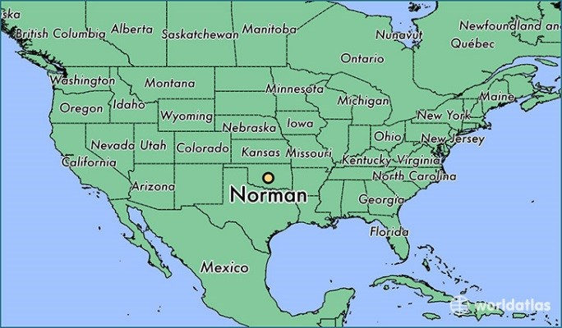
Figure 21: Map of Norman, Oklahoma (worldatlas.com)

Norman, Oklahoma is a suburb of Oklahoma City, Oklahoma, in the central United States. Norman is also a college town with a campus that functions like a small city (Gumprecht 2009, 40). This small city is home to the largest university in Oklahoma, the University of Oklahoma (OU), which has 31,250 students, as well federal agencies and knowledge industries associated with the university’s large research community. At OU, there are many students and young professionals. The largest age group in Norman’s population of about 120,000 residents is student aged (20-24 years). These people comprise 15.8% of the city’s entire population. One of the largest and most active student organizations at OU is the Indian Student Association (OU ISA).
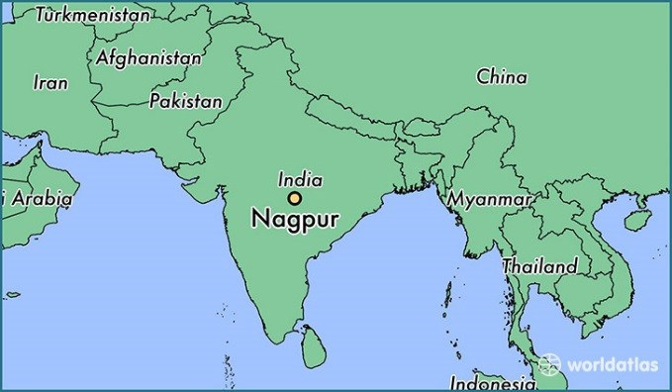
Figure 22: Map of Nagpur, Maharashtra (worldatlas.com)

With a population of about 2.5 million, Nagpur is a much larger city in central India. The third largest city in the Indian state of Maharashtra, Nagpur serves as the winter capital of the government of Maharashtra. Its prominent information technology sector and 24 Information Technology and Computer Science colleges (http://www.jagranjosh.com/) make this city attractive to a large number of young students and professionals. According to 2011 census data, Nagpur has one of the highest literacy rates (91.92%) among all the urban agglomerations in India, including large cities like Chennai (90.18%) and Mumbai (89.73%). In Nagpur, Marathi is the most spoken language and the official language.
To recruit participants, I relied on snowball sampling (Bradshaw and Stratford 2010, 75). Initial participants were asked to identify and recommend other people who fit the criteria. In Norman, I started with people I knew at the university and then they helped recruit more people, as is expected in this method. In Nagpur, my sister-in-law helped me recruit five participants from a network of people with whom she communicates through WhatsApp – a phone messaging service.
The research on Indian audience response to the women’s empowerment video “My Choice” is not only international but also cross-cultural. As such it inevitably raises concerns about uneven power and ethics. I am a white, American middle-class, cisgender female interviewing people who identify themselves in relation to the country of India. Our conversations concerned the meaning and value of a video about Indian women. Because I am not Indian, I am an outsider (Dowling 2010, 36) but not an entirely uninformed outsider. After marrying into a middle-class Indian family, I have learned much about appropriate customs and cultural protocols for women in middle-class Indian families, both in Norman and Nagpur (Howitt and Stevens 2010, 47). I practiced critical reflexivity while conducting research. Through this process of “constant self-scrutiny of the self as researcher and of the research process” (England 1994 in Dowling 2010, 31), I remained committed to continuously analyzing my situation in the research process. As such, I studied my own situation, especially my social position and power dynamic, in relation to the participants’ situations. I acknowledged rather than denied our different social positions, always asking how my research interactions and information collection were socially conditioned (Dowling 2010, 37).
The individuals who participated in my study, both in Norman and in Nagpur, live in a socio-economic status somewhat similar to my own. Education levels were also similar, since I am a graduate student and my participants were educated students, professionals, and former professionals. Such parity made our relationships somewhat, but not completely, reciprocal (Dowling 2010, 32). I felt an easy rapport with most of my participants, and I am reasonably confident that we successfully established a degree of trust that encouraged them to share their life stories. To ensure rigor, however, interview questions were developed through research, prioritizing the written work of Indian feminists. Over the course of the interview, I collected qualitative data, keeping a research diary where I recorded handwritten notes on my experience of interviewing. I also reflected on how what I was doing, learning, and thinking intersected with the scholarship I read. Other members of the interpretive community informing my project (Bradshaw and Stratford 2010, 77) include my advisor and OU’s Institutional Review Board, both of which approved and monitored my study’s protocol.
Notions of privacy vary across time and space (Stake and Jegatheesan 2008, 2). Participants were interviewed in locations devoid of as many curious listeners as possible. In the United States, the interviews took place in a quiet and contained conference room in an office building at the University of Oklahoma. In India, most of the interviews took place in a bedroom on a different floor of a house, away from other people who were home at the time. Knowing that participants’ accents would differ from mine, I sought and received permission from all of them to both audio and video record the interviews. After the interviews were complete, I recorded observations about the interview and reflected about my interviewing skills and the participants’ answers in my field notes.
Before starting each interview, each participant reviewed a written consent form and asked questions if necessary. After the participant signed the form, verbal consent was attained before turning on recording devices. Consent is sometimes a continuous process, and it was sought if needed throughout the interview process. After each interview, I verified that the participant was comfortable with me narrating their stories in my scholarship. To further ensure confidentiality, interview transcripts were anonymized by stripping them of names. (Dowling 2010, 29). Digital data were stored safely on password protected devices.
After the consenting process and the recording devices started, the interview began by handing the participant a tablet device and asking them to watch the video “My Choice.” When they finished, we put the tablet aside and began talking about the video. The interview guide was shaped by a combination of funnel and pyramid structures, in which the interview starts with simple and easy questions, then goes to abstract and reflective questions, before asking sensitive questions (Dunn 2010, 109). The interview guide featured twenty-eight questions (see Appendix A).The first few questions were a few basic demographic questions. After that, the next questions solicited participations’ impressions of the video. What did they like and what did they dislike? Gradually the questions guided the conversation toward personal issues, such as life choices and how they related (or not) to the video (Dunn 2010, 109). Additionally, to better understand the terms participants used to discuss the video, participants were asked to define the terms “feminism” and “women’s empowerment.”
The final set of questions drew concepts from the work of Indian feminists who have written about the social geographies of women in India. The participants discussed if women should be self-sacrificing; in other words, if they put the family’s needs above their own (Lau 2014, 283). Next, the participants described and compared a modern Indian woman with a traditional Indian woman (Oza 2006, 27-31). These were often terms that could both apply to a woman at the same time. The life story interviewing portion was about partnership choices and the key role that parents and families play in making such decisions (Mukhopadhyay 2011, 122-123). Some questions addressed women’s reproductive health and access because of the line in “My Choice” where Deepika Padukone says, “my choice, to have your baby or not”. Those questions were also tied to research about the ways women are able to get sex-selective abortions (Menon 2009, 107). Because they are so visible in feminist struggles for rights and the services in India, participants discussed their thoughts about sex workers, same-sex unions, and premarital sex (Menon 2009, 102; Vanita 2009, 51-52; Mukhopadhyay 2011, 145).
Each of the ten interviews took place in a single session, lasting from forty-five minutes to over two hours. After completing each interview, I recorded my observations and reflected on my interviewing skills and the participants’ answers in my field notes. As soon as possible after each interview, the audio recordings were transcribed without video (due to a faulty video camera).
After transcribing the interviews, several rounds of coding took place (Miles et al. 2013, 74-77). Coding was done without computer assistance, for a closer reading of the texts. Initially, to identify overarching themes in the results, the themes shaping the interview questions (e.g., feminism, gender roles, and marriage) helped to code the interview data in the initial rounds. As a result, some topics were common across all interviews. For instance, some questions were about gender roles in the household and how parents participated in decisions about finding a partner. Holistic coding was used, wherein a single topical code, such as an event, is applied to a larger story. This allowed for distinguishing between personal stories and stories about events like Nirbhaya (the famous 2012 New Delhi gang rape case) or acid attacks. Next, in vivo codes were created that referenced common words or short phrases the participants used. Examples of in vivo codes in the U.S. interviews include “rights” or “generational.” Some in vivo codes were unique to Indian participants such as terms like “broadminded” or “backward.” Twenty codes were generated (see Appendix B). The codes were clarified by using evaluative markers such as plus (+) or minus (-) symbols to indicate the difference between equality and inequality or to suggest a positive (+) or negative (-) impression of a concept, for example: feminism.
Video-elicitation offered a concrete starting point for talking about more abstract concepts. The video served as a potent prompt for life story interviews with participants. Video-elicitation allowed them to focus on specific topics associated with the video “My Choice” that they found most interesting or relevant. Most of the personal stories participants shared focused on what life is like for women in India, whether the story was about the participant, their family member or friend. I also interpreted the data collected from my own standpoint, making it possible that my interpretations were subjective (Dowling 2010, 35).

Research Findings
Out of the many stories that participants told me, some stand out as examples of how the video can trigger recall of memories and can serve as a starting point for deeper conversation. Paired with questions in a pyramid structure, the interviews gradually became more telling about the lives of my participants and how they relate to the topics in the video. This allowed the video to be mobilized as a strategy for collecting life stories.
Coding the data generated twenty main codes, some of which were more prominent than others across all ten interviews. The third code, women’s dress, became one of the most important codes throughout the interviews. Many of the participants wanted to comment on a woman’s choice of dress, whether it was considered to be Western, traditional, modern, or immodest, the latter of which is used by police as a form of victim blaming in cases of sexual assault (Bhattarcharyya 2015, 1349). Men as well as women commented on a women’s choice of dress. The men discussed how women in India are asked to dress a certain way to please other men.
Participant 4, male, U.S.: And I think that is something that all men need to keep in mind that their partners don’t really owe it to them dress a certain way or to always please them.

Participant 1, male, U.S.: When women don’t wear saris and wear jeans, they’ll raise an eyebrow. They might not explicitly say ‘hey you shouldn’t do that’, but they (upper caste Brahmin Hindus from Mumbai) will silently disapprove.

Participant 8, male, India: See, traditional does not mean that woman should be staying at home, or wearing saris, or any kind of family inspired clothing, or living the life of somebody else. Traditional woman is also an individual woman who should be living life for her own. And I have not seen very traditional woman, but what I feel is that women who are actually who choose to live life in a traditional way, wearing saris, are wearing whatever their clothings are, or living at home, not working, but they should be like individual, like independent, I guess.

The women had different experiences with the rules surrounding women’s dress in India and in the diaspora. They stated that women in India face very tangible ramifications if they do not follow the expected norms. The fashion shown in magazines is not considered appropriate street wear because it could be dangerous for a woman. Women are told what to wear by their families and are expected to obey. Jeans could be considered rebellious or modern, depending on the situation.
Participant 5, female, U.S.: (after watching “My Choice”) They chose very real looking women. They chose women that were wearing tank tops, but also saris, so I liked that bit as well. It’s sort of like they’re representing how the average Indian woman looks like.

Participant 6, female India, Yes, feminism, for me being independent doesn’t mean I would want to wear a bikini or wear a short skirt and go. Talking about me personally. That is not, that is nothing.

Participant 6, female, India, I’m wearing, this is what I regularly wear (jeans and a top). Yeah. Some people would see this and say, ‘she’s modern,’ but why, because she’s dressed like that. In India, I’m talking.

Participant 7, female, India: You would definitely see girls covered up wherever they go. That is also something protective for them. And you’ll not find many people wearing shorter dresses, like here in Nagpur. If they have, if there are such people, they would just come in their cars [as opposed to scooters or motorbikes] and that would definitely be safe… [T]here are kinds of people who would follow you if you are on a two-wheeler.

Participant 9, female, India: I have been to Jaipur a month back, so there womens are restricted in ghoonghat… They cover their head… with their choli and their dupattas, and they are not allowed to eat, even when they’re in restaurants… And then when they’re in restaurants, they have food under the choli… And they are not allowed to show they face to the mans… When we are allowed to go outside, we have to hide our face from other mens.

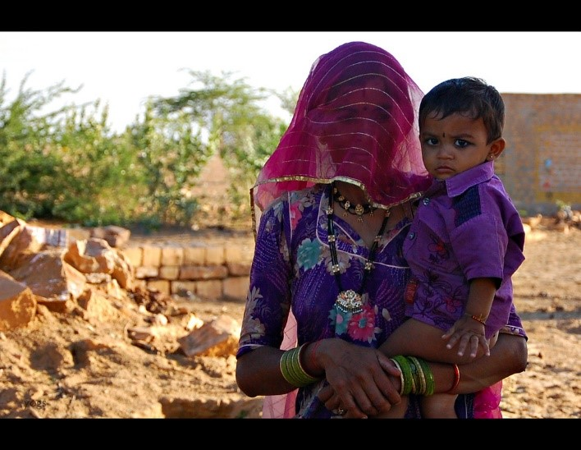
Figure 23: Woman wearing ghoonghat in a Rajasthani village, Yogesh Vhora, 2011, flickr.com

Participant 9, female, India: So there are certain limitations which I have to follow, wear a [salwar] suit and dupatta and all. So, I follow it, it doesn’t mean I do not wear jeans, but their [in-laws] own choice, for my own choice, sometimes I wear jeans as well. That time they do not say anything. But mostly I wear [salwar] suit, just for their own wish.

Participant 10, female, India: [Nagpur is] not that progressive. I have to think twice before wearing something to work. Yes, I do. I have to.

The choice of dress for a woman in India is a matter of life and death, in some cases. If a woman’s skirt is too short, she may fear for her safety. Women are often told what they can and cannot wear, like a ghoonghat or a traditional salwar suit, as opposed to jeans, or very modest clothing out of fear. “My Choice” shows women wearing Western and traditional clothing, in various stages of dressing and undressing. Bodies in the video are carefully stylized to communicate wealth, to resonate with the average reader of Vogue India. The image put forth is that of a modern woman, who can wear whatever she likes, including a fancy black bra that Deepika Padukone is shown taking off. Clothing conveys messages about the person, which projects a certain image, which in this case is liberated and wealthy (Lurie 1992 in Hubbard et al. 2002, 110-111). The choice to go outside in a salwar suit, sari, or jeans and a top is essentially a political decision, highlighting the cultural politics of the body. The clothing makes a statement about identity (Hubbard et al. 2002, 113). However, some clothing is not a choice for many women, who are forced to wear ghoonghat to leave the house, or a family that does not approve of a woman wearing symbols of Western fashion, like jeans. The modern Indian woman, according to my participants, has to be careful about clothing choices, yet she displays her modernity through adopting Western styles, a symbol of the cosmopolitan middle class in urban areas. Oza (2006) states that in urban areas, the image of a new woman, who was perceived as being “modern,” began to emerge as an icon of liberalized India, which “mapped globalization onto women’s bodies” (22, 24). The clothes that women who want to be modern wear show the effects of globalization and signify being part of a global cosmopolitan middle/upper class.
Feminism was a real point of confusion for my participants. Each participant had a different idea of what feminism means, making it challenging to draw conclusions about whether the participants agree with feminism in general, or if the video had a feminist message. Each of the ten participants was asked to provide his or her definition of feminism. The American participants were in agreement that feminism implies gender equality, whereas the Indian participants articulated different definitions:
Participant 1, male, U.S.: Equality, particularly between the sexes and I mean in most contexts that involves the advocacy of women’s rights.

Participant 2, male, U.S.: …that you treat men and women equally, regardless of their gender or you provide equal opportunities… But when I looked at the textbook definition it seemed to indicate more about advocating the rights of women where women’s rights are not or where there’s inequality.

Participant 3, female, U.S.: It means including everyone. It means that women and men stand on the same level and there’s no one above the other.
Participant 4, male, U.S.: Feminism to me means equality. So we want equality but clearly the women are the less privileged class, so I think it is very appropriate to call it feminism because we are trying to achieve equality for women.

Participant 5, female, U.S.: I haven’t really thought about it. I think maybe it was more relevant 50 years ago when women has- or maybe it’s more relevant in countries where women have less rights, like voting and driving.

Participant 6, female, India: For me it means a lot of self-respect. Independent. Caring. Trying hard to be a good mother and a spouse. Broad minded… You have that personality of being a feminine, of being a feminist. And you do it with love… Feminism is more of what you are, you know? ... Feminism is your personality… It’s like what, it’s how God created women. Gentle, delicate.

Participant 7, female, India: Feminism is like being elegant, being strong, being independent women and to be able to adjust to everything that you come across and being straightforward and still being like that.

Participant 8, male, India: Feminism is supporting the right of a woman, regardless of any activities, whether it’s wrong, or right, and living like an individual with freedom.

Participant 9, female, India: Feminism is made to be like when the woman is over power, is a feminism. So it should be, feminism should be in the society, but not to that much.

Participant 10, female, India: I don’t believe in feminism. I don’t believe in chauvinism. I believe… in being a human and please treat me like one… If you push me, I’ll show you what a feminist is. But don’t push me is what my point is… You’re just closing yourself to one gender when you say you’re a feminist…So for me the term is extremely restrictive. Use it when it’s required.

An example of Participant 10 using feminism as a tool: Yeah, in remote places in India, where child marriage is still practiced, remote places in India where having a girl child is to get aborted if you have a girl child, use it then. Don’t use it everywhere.

With feminism being such a difficult term to define, it became clear that feminism had different meanings to different people. Susan Archer Mann describes this challenge, “because there are many and diverse feminist perspectives, the term feminism defies any simple explanation” (Mann 2012, 2). Vogue India never mentions feminism directly in the video, but when I asked my participants if they associated the video with a feminist perspective, eight out of ten of my participants said that they did. The responses of the participants indicated that feminism meant something different to Indians in India than to Indians in the United States. These differences illustrate that there are multiple feminisms, also differences in definition might reflect some unfamiliarity with the term. This might be why Vogue India calls “My Choice” a “women’s empowerment” video and not a “feminist” video.
One of the blind spots of “My Choice” was that it acknowledged the lesbian, gay, and bisexual communities, but it left out the trans community. In response, a transgender version of “My Choice” was released on YouTube a few weeks later. The hijra community are a male-to-female transgender community. They are recognized as a third gender by the Indian government. The existence of a third gender goes back to ancient Hindu texts. Hijras today are often “disowned by their families in their childhood and ridiculed” (Sharma 2012, 64-71). Some of these painful experiences are addressed in the transgender “My Choice”. Participant 2 addressed the trans community during the interview.

Participant 2, male, U.S.:
I think feminism should be about gender inequality wherever it exists, so that includes trans rights, for instance… I did not know too much about the trans community growing up and that's because l almost the entire LGBT community were kind of like put into one basket back when I was growing up or at least based on the information I had back then. It wasn't until like later that I realized that, that there are separate issues there, right? So in short, everyone in the LGBT community be considered as someone being trans, for instance. So the trans community is very, very it's a very visible community, even though India is a big country with a lot of people, everyone knows about the trans community in India. But traditionally like they were looked upon as like as a nuisance basically. They often times in public transportation mainly the trains, you would find people from the trans community kind of singing songs or dancing often times what they do is they kind of approach men and try and harass them so what would happen is the men would give them some money and they would go away. So they would keep harassing them until they gave them some money. So it was seen as a nuisance and kind of a nuisance to and so their rights were definitely ridiculed, right? And it wasn't I think until recently that some progress had started to be, started being made in that issue, so. They are definitely more marginalized than women are, for instance in India. So, I would say like now along with women empowerment uh, maybe if the feminist movement in India can include trans rights that would be a good thing.

“My Choice” recognized the lesbian, gay, and bisexual communities in the video with the line “my choice to love a man, or a woman, or both.” I asked my participants what they thought about same-sex marriage and if they thought that same-sex marriages should be allowed in religious places of worship, like temples. This question was also related to prior research, about lesbians eloping to temples and sometimes committing suicide together (Vanita 2009, 51; Biswas 2011, 415). Participant 2 gave me some background knowledge on homosexuality in India, which like Vanita (2009) stated, has been around for two millennia. The recent criminalization of homosexuality stems from colonial rule (48).

Participant 2, male, U.S.:
Sure, I mean, I don't see an issue there. So, I mean, there was homosexual. I mean Indian it's obvious filled with homosexuality. And if sexuality in general, like polygamy, polyandry, all kinds of things, so to turn around and say "Oh, our culture is this or that" is kind of (discussion?) of this. I mean there are definitely certain, accepted. What I'm saying is there are laws against some things and there are good reasons for those laws. There are also some laws which should not be there. For instance, I think homosexuality is illegal in India, which should not be. So, I mean that needs to change and I think, definite, I don't see any issue and in that being a part of Indian culture, which is what we're kind of talking about, whether they should take place in temples. I don’t see an issue with that because India's part of Indian mythology and culture and stuff. Like for instance, Shiva who was a god in Indian mythology, is supposedly one half of a man woman duo, the other half being his wife, so I mean, there's a bit of gender fluidity there… So I mean like, I really find it disingenuous like the ways some of these religious leaders especially condemn things like, oh, homosexuality, or even just like sexuality in general, that is something that is not part of Indian culture, which clearly it is, like the rich history.

Participant 3 was reminded of a story about lesbians being sent to a mental hospital in India.

Participant 3, female, U.S.:
I'm truly for them. I have a ton of friends, actually I have a few friends in India who are lesbian and they told me that they didn't want to tell their parents and all of this stuff. Their parents found out accidentally, because they saw them making out. And then they come to them like, they sent them to a place for, they sent them to like an asylum. (laughs) Which was really bad (laughs). Actually, I'm laughing because it was kind of funny. So they sent them to an asylum and when they got there to test them, the guy, the person who was supposed to do their little intake, he was like, there's nothing wrong with them. And so the dad said, "No! There is, there is, they like each other." And the guy said, "No! That's not something that you bring them here for. And he was like, “No I know I heard about this place. Really, the best the best mental hospital in India, or something like that.” And the guy kept saying, “there's nothing wrong with them. I can't, I can't admit them, there’s nothing wrong with them.” And then after several times of him saying that, he was like “Fine, I'll just lock you in your room then.” She was like, “Um, there's windows.” And he's like, “Well I'll barricade the windows.” She was like, “Okay.” And so, yeah, he never did that. And then it took like about a year to be okay with it and now he's okay with it. So yeah, I'm totally for it. But the same way you've got to fight for your marriage. If you love someone, you've got to fight for it. So yeah, totally, totally for it.

Some of my participants reflected back on what the video really meant to them, whether it was good for starting a conversation about women’s empowerment, or how it inspires women’s freedom. Participant 4 talked about brutal acid attacks on women and how a video like “My Choice” can actually start a discussion about women’s rights.
Participant 4, male, U.S.:
And I think it has to begin somewhere and I think videos and social media, even if there are people that watch the video and disagree, I think that message still needs to be given out. It needs to be out there so people can actually start having a discussion. Maybe somebody will watch the video and disagree with it, but if they discuss it with something, a (muffled) like me who agrees with the video maybe I may not be able to get them on board, with what I say entirely, but maybe we can meet somewhere in the middle. Maybe it will make them think. Maybe it will change their mind a couple of years from now. So the dialog definitely has to be started, the message definitely has to be out there that there are women and there are men supporting these women. We're saying enough is enough, you know?

Participant 7 discussed how “My Choice” represents the interests of women and can inspire them, including her mother who works tirelessly for her family. For these participants, “My Choice” represented a good starting point, even if women cannot follow the message completely, as Participant 7 emphasizes later in the interview.
Participant 7, female, India:
Um, you know is a woman is already married and she has a lot of responsibilities, so after watching a video like this maybe she gets inspired to speak for herself. She speaks for her own freedom, for her own rights. Like, if you have to be at home doing all the things, and everything, you have to take so many responsibilities, women should always have the right, to take some time out for herself. It's not just for the family, it's not just the responsibilities that she has to take, she's taking it because she is considering you as a part of your family and she is doing it without anybody's forcing her to do it, she's not being forced but still she does it just because it's like this stuff is the birthright of a woman. Okay? This is what Indian women say. My mother being a housewife, she is working 24/7 and even she needs some, her freedom if she wants to do anything out of her work, she should be allowed. That's how I feel.

One of the main personal questions asked in the interviews was about how the married participants chose their partners. In “My Choice,” Deepika Padukone says it is her choice to marry or not to marry. The participants were asked if they have/had a choice and if their marriages were arranged or love marriages. It is too small of a sample to determine if love marriages or arranged marriages are more common among Indian Millennials, but Mukhopadhyay (2011) in Kolkata suggests that there is a new form of something called an “arranged love marriage,” in which the son or daughter falls in love with the parents’ choice. These stories provide an intimate look at the decisions women make regarding marriage.

Participant 9, female, India:
Choosing my partner, I have actually this a completely arranged marriage and when I met him, it is allowing of the family when the boy comes, you are allowed to talk to you in a separate room. You both are allowed to talk and you both can share your experiences, you both can share your need. What is their expectations? So, if they both, if both of them's expectations are matching, they can go ahead. So my parents… allowed me to talk to him in a separate room. So I found somewhere he is a quite flexible man. And our understanding as well. And he was… everything which I want. So I accepted his offer and yes, I can go with him. I was against arranged marriage. I always wanted to have a love marriage but I have other (cousins?) with a completely arranged marriage. So when I was getting married, I found no this a real man.

Participant 3, female, U.S.:
Now, now we're like, we're all one big family, but at first we were not. At first it was very difficult to bring our whole union together. So we got married with neither of our families attending, we just got married with ten friends. And, we told them we were getting married. And we told them, we know you're not okay with it, but it's our decision, it's not yours, so you can either be okay with it or not. So I'm getting married today. Wish us luck or not. And they both phoned and they said, “Good luck with your marriage, I hope everything goes well” and they wished us really well and we got married without them. In the end we decided like, if they're okay with it, we'll go back to both of our countries and get married... [That] way we can respect both cultures. Do it my way in South Africa. Do it his way in Nepal. That way everyone's happy. And it worked out that way. That's what we're doing. So, this December we are going to South Africa and then this December we are going to Nepal, everything should be merry.

Participant 6, female, India:
And then we finished our school and we started our college together and it was a journey of 12 years together before our marriage. Yes. 12 years together and lots of ups and downs on this journey because my mom and dad, parents did not want him at all because of his background with me being Jewish, believing in Jesus and him being a Hindu and such a traditional Hindu. But he himself accepted Jesus, that it where I actually said, um, yeah, anyway, yes, because yeah he did this. In the beginning, he accepted Jesus for me, but eventually Jesus became his life, as he is mine. So. Today, even if I am there in his life, or not in his life, he would still just follow Jesus and Jesus alone. So a lot of ups and downs in this 12 years, lots of ups and downs, a lot of God thing involved. I used to pray a lot. And this one time came, and people don't believe it usually when I say it, they I was lying on my bed and as I said, I have three elder brothers and I am the younger sister, so they were all very protective of me, so one of the brothers, who used to always beat him up said something about him that was wrong and I said why doesn't he believe me that he's a good person?

Participant 10, female, India:
So when I chose my partner or my partner chose me, we were pretty much on the same page when it comes to, he doesn't believe in any feminism or chauvinism, he believes in the same thing, he's like if it's good for you, it should be good for me too. If I can wear shorts and roam out, I want you to wear shorts and roam out. You have more choices to wear clothes, so do it. And it's not about clothes, like I said, I work from 10 to 8. He's a business man. He does not have to report to a boss. So he can leave home, adjust his work meetings accordingly and leave home accordingly. So, one of us has taken some responsibility. I have taken some responsibility. And that understanding is there because of which we are together. Had that understanding not been there between us, I don't think we would have been together. Why would I be married to a man who tries to suppress me all the time? I wouldn't be. Everybody in my family has had a love marriage. My family's all love marriage, except for two of my, no, one of my aunt and one uncle, who has had arranged marriages, otherwise everybody have fought for their love and you know, put up a big fight like Romeo and Juliet, and *laughs* in the course of the marriage.

Women’s mobility is greatly restricted in India. Mona Domosh and Joni Seager (2001) describe the restrictions on mobility that women face around the world. It is difficult to maintain patriarchal control over women if they are free to move about as they would like through space (115-116). There is also an element of fear of violence that keeps women under a virtual curfew (116). In my field notes, I noted that when I was riding in a vehicle late at night in Mumbai, I looked at the people out and about. They were all men, except for maybe two women, who were with men. Women in India have a societal curfew. In “My Choice,” Deepika Padukone goes against this saying it’s “[m]y choice, to come home when I want. Don’t be upset if I come home at four a.m. Don’t be fooled if I come home by six p.m.” Participant 6 pushed back very strongly on this issue, saying that her family monitoring her comings and goings is done out of love. Families may restrict a woman’s movements in the name of safety, due to a fear of something bad happening to a woman at night. Participant 10 mentioned a woman who worked a very late night shift and a man had slashed her tires because he thought she shouldn’t be out at 3:00 am. She had transgressed the gendered concept of nighttime by having a job that required her to work late. Perhaps this video can get people talking about why the streets are only for men at night and why women’s mobility is restricted.
In conclusion, here is a quick excerpt from Participant 7, who even though she agrees with the brand of feminism put forth in “My Choice”, she cannot follow the message of the video. She says that she watches the video when she needs inspiration. However, this inspiration cannot be realized. Her inner turmoil over pleasing her family and fighting for her own rights and career can be seen in this statement, which sums up why “My Choice” failed to positively impact women’s empowerment.

Participant 7 (P7), female, India:
Like how I view it, it is inspiring for me, but when I think what would the people think if I do it, if I personally do it, then it would be a little saddening for my parents, to see such a (mumbled) like if it is inspiring for me, it would not be a very positive gesture for them. That is the only thing-

Interviewer (A): So if you follow what goes on in the video-

P7: Yeah okay

A: Then it would be bad?

P7: Yeah, for my family.

A: For your family

P7: Yeah. (Definitely?)

A: That's interesting. So it inspires you, but you can't-

P7: You cannot do it.

A: You can't do it.

P7: You cannot even express that yes, it is inspiring. You cannot even express it because they will take it in some other way. Like, there is not everything that we the generation that we are, not everything that we would do, we would restrict ourselves just because we have Indian values. And still the parents would think that following such videos might take us on some wrong path. So that would be the reason I would not completely agree to it.

A: Okay and do you have any final thoughts about this inspiring video that you like?

P7: *laughs* I really think, I wish I had, I should have expressed thoughts in front of my family, I wish I could have. And you know, told my parents about that a girl and boy are equal and you should treat them equal.

A: You can't tell your family?

P7: No, actually. It's like you're a girl so you need to speak politely. You should not be speaking too loudly in front of people. So, yeah you should not be coming home late. So there are some things that you cannot explain to your patients, to your parents like they're always like, we're doing it for your safety. You need to be safe. That's the only answer they can give. So you cannot explain them these things.

The traditional values clash with the progressive message of empowerment. Participant 7 cannot even express that she is inspired by “My Choice,” without upsetting her parents and breaking out of her prescribed gender role of staying quiet and polite. Participant 3’s main theme throughout her interview was about women not speaking up for themselves. A woman who is bold enough to speak up for herself would be chastised if her parents are traditional. Some women place a high value on pleasing their parents and family, and sacrifice their chance at standing up for themselves and demanding more agency and autonomy, or more freedoms and rights. In this way, women’s empowerment cannot be realized without disrupting the influence of family and traditional values.

Conclusion

This research demonstrates the effectiveness of using video-elicitation to gather stories, some of which are personal. It shows that Indians living in the United States had a different understanding of the topics in the video than Indians living in India, due to living in a Western country. Most of the U.S. participants had a similar view of feminism as equality, whereas some of the Indian participants associated the term with feminine or had a negative view of women having some kind of power with feminism. Societal restrictions came out in the storytelling from India, which the participants in the U.S. simply did not have. For example, in India, what a woman wears in incredibly important and can carry different meanings, like modernity or oppression. U.S. based participants also told stories about the challenges women face in India, relating it back to the video’s topics of same-sex partnerships or a woman having a choice to wear what she wants, for example. The participants in the U.S. were somewhat detached from what is happening in India, with one participant saying:
Participant 1, male, U.S.: So I can kind of distance myself from that place [India]. So personally, for me, it feels like, ‘oh god’, that. I don’t know, it’s kind of unsettling that they are still tackling all of these problems. It brings back memories and images of that’s going on there and somebody needs to go fix that, but there’s so much work to do.

The video reminded him of what women face in India, and he doesn’t normally have to think of that.
The stories gathered from the participants show how deep and personal conversations can go when the video is about a relevant topic, such as women’s empowerment in a particular location, like India. After viewing the video, participants voiced their opinions and told their own stories about what it means to be Indian, living in India or in the diaspora. The video featured women wearing different styles of clothing, which carried different meanings, noted by the participants and their own clothing choices. Coming from a fashion magazine, the importance of clothing carries a sense of commodification of bodies, trying to sell a form of feminism that did not reach the women it needed to reach. It started a conversation about women’s rights and equality, but only in the sense of the daily lives of elite and affluent women.
The responses varied between participants in the diaspora and in India. Being in a Western country did not change family norms, though, with participants having to deal with family influence in decisions regarding partnership. The participants in the diaspora and those in India faced the same kind of cultural expectations regarding gender roles and marriage. The video inspired some participants, saying “it’s needed.” For others, it was not needed or they felt nothing. One participant in India was embarrassed by the video, saying it “actually made me feel a little embarrassing because she basically made this video because there was something to come up with, right, because she wasn't getting that kind of freedom and she wasn't getting that kind of liberty to live with”. The participant was embarrassed that the video was made at all, because it highlights the inequality of women in India.
The video was effective in getting the conversation started, with participants focusing in on the parts that they felt strongly about, which turned into how they related or did not relate to the video from their own standpoint. This view was crucial to understanding how a video can evoke emotions and memories in the interview process. The data gathered balances the ideals of the video with real life scenarios. Starting an interview with a controversial video and providing the right questions derived from the video and research on topics related to the video resulted in a variety of stories told by the participants that provides a glimpse of what it means to be a modern Indian woman and the struggles women face daily in that culture and in that body.
This small pilot study demonstrates the effectiveness of gathering stories in the interview process through the means of showing the participants a controversial video, to get their mind going before asking targeted questions about topics related to it. The video enhances the responses by giving the participants something to discuss freely before responding to questions about controversial topics, like abortion or same-sex marriage. The participants can refer to the lines about “my choice, to have your baby or not” or “my choice, to love a man, or a woman, or both” (My Choice, youtube.com) as a starting point for answering questions about those topics and whether or not they agree or disagree and why. Many times, there was a story that followed the answer, like the story about the woman in a village that killed eleven children, or the personal story of a woman getting an abortion and what that is like in India, with the family involved.
In conclusion, using the video-elicitation method in the interview process, paired with probing questions, proved to be effective way to hear stories, some of which are personal, from the participants. This method could be expanded to a much larger sample to determine the overall reaction to the video selected. In this case, the video was researcher-generated, but participant-generated video could provide an even better understanding of the daily lives of women. This method has shown the strength of using a video in the interview process, to begin the interview with the participants eager to speak about the video and begin the interview. In this case, the participants discussed the positive and negative aspects of a controversial video about women’s empowerment. Showing that video to begin the interview resulted in hearing several stories, which gave the participants the upper hand in educating the interviewer about their lives and culture.

Chapter 4: “My Choice”: Shop!

Post-Feminism and the New Indian Woman
According to some women, feminism is dead. It is associated with the past and “old and unglamorous women” (McRobbie 2011, 180). Some young women today do not identify with feminism. They consider it irrelevant (180). This happened after myths were spread in the 1990s that the decade was about gender equality and that women had achieved all the rights that feminists had fought for during the Second Wave. The continuing push for feminism was condemned for “undermining heterosexual relationships” (Coppock et al. 1995, 4). Feminists were portrayed as being “unhappy, embittered, man-hating women” (4). A resurgence of women promoting “old values” and rigidly defined gender roles prompted journalist Geneva Overholser to comment that “to call that post-feminism is only to give sexism a subtler name” (Overholser 1986 quoted in Coppock et al. 1995, 5). The central idea of post-feminism is that through equal opportunity initiatives and sex discrimination legislation, there is nothing left to do to advance women (8).
Deepika Padukone, in interviews after the release of “My Choice,” turned her focus on gender equality, saying in one interview, “gender inequality is a global issue that demands to be addressed” (Joshi 2015). In comparison, Homi Adajania, thought that equality to some degree has already been achieved, saying
It’s sad that we have to sit and talk about gender equality in 2015. It’s like a joke. So, any women who breaks those barriers and lives on her own terms, like Deepika and my over-empowered wife (Anaita), I think that’s the sign of it. (Joshi 2015)

The statement is post-feminist, in that Adajania explains that gender equality is a joke. He also thinks some women are over-empowered. In post-feminism, the principles of gender equality are upheld, however the image of the feminist is denigrated (McRobbie 2011, 179). Adajania thinks that his wife has too much power, showing that he does not support women actually being empowered. Feminists asking for equality must be too much for men like Adajania, who believes they already have too much of it. In post-feminism, gender equality is promoted without any call to change the status quo. Women have achieved a superficial sense of equality, according to philosopher Jean-Luc Nancy (McRobbie 2011, 180). The post-feminist woman has a strong attitude of self-empowerment.
The image of the “can-do girl” (Harris quoted in McRobbie 2011, 181) is marketed towards young women as a kind of faux-feminism. Girls are celebrated for their potential, which is attached to a new form of “consumer citizenship” (182). In what McRobbie dubs the “new sexual contract,” young women can expect equality when they go to school, get jobs, and gain independence. She also gains sexual freedoms of, most importantly, sex outside of marriage. The sexual double-standard is removed. Accompanying this sexual freedom is a contract tying women to being consumers, creating an explosion in beauty and fashion corporations. What is left out is any notion of the need for political participation (182). This post-feminist woman is the same as the “New Indian Woman” now being promoted in India. The New Indian Woman is an avid consumer of goods. She is independent and enjoys sexual freedoms. She is the same, in many ways, as the post-feminist woman, although she is still expected to be or want to be a housewife. In other words, post-feminists promote old values positioning men as breadwinners and placing women in a supporting role at home.
Post-feminism has different meanings. What qualifies as post-feminism is debated. Gill says the term is “used variously (and frequently contradictorily) to signal an epistemological break with (second wave) feminism, an historical shift (to a third wave) or a regressive political stance (backlash)” (2007, quoted in Sarikakis and Tsaliki 2011, 111). In media targeting women, the focus is on personal empowerment and self-determination in a neo-liberal understanding of feminism (111). This new feminism is pervasive in movies, television, and literature. Old feminism is no longer needed. The message suggests that as long as women are consuming they have the chance to be on equal footing with men, without addressing any of the patriarchal power structures under which they are oppressed.

The Question of “Empowerment”
“My Choice” was part of a women’s empowerment initiative by a high-end fashion magazine. The meaning of the term empowerment has changed over time. Riordan says that in the 1990s, the rhetoric of empowerment became commonplace in U.S. popular discourse (2001, 281). Empowerment worked its way into the mainstream popular culture, again, promoting individualistic ideals for women’s empowerment. In this way, Riordan says empowerment “contributes to rearticulating dominant patriarchal and capitalist values, while not substantially disrupting power relations” (2001, 282). Individualistic empowerment ignores structural power relations and oppressions and does not enact change. Instead, it’s about feeling good.
An example of this brand of post-feminism and self-empowerment is the commodification of girl power through the Spice Girls, a British pop girl group formed in 1994. Empowerment for them was “in the way one dresses, looks, and uses her sexuality for a heterosexual male gaze to get what she wants” (Riordan 2001, 290). Their song “Wannabe” had pro-girl lyrics, but their images contradicted the message. The way to achieve power is through sexuality and looks. The Spice Girls capitalized on a “constructed and commodified image of female beauty” (290). This image sells what looks like empowerment, but really just reinforces patriarchal norms.

Celebrity Feminism
Vogue India website users consume media related to celebrities, fashion, and beauty (See Figure 11 above). The Vogue Empower website also lists many celebrities who promote the empowerment initiative. Some are featured in videos, like the “My Choice” video. Deepika Padukone, the star of “My Choice” became the celebrity face on this particular brand of post-feminism and self-empowerment. The kind of feminism that celebrities promote is still part of the media-packaged commodity that sells products. Feminist writer bell hooks critiqued Beyoncé for her recent visual album Lemonade. In Lemonade, she says that the black female bodies are commodified. Beyoncé herself “is the embodiment of a fantastical female power, which is just that- pure fantasy” (hooks 2016). hooks goes on to echo the same sentiment of other feminists about a post-feminist message, saying,
[H]er construction of feminism cannot be trusted. Her vision of feminism does not call for an end to patriarchal domination. It’s all about insisting on equal rights for men and women. In a world of fantasy feminism, there are no class, sex, and race hierarchies that breakdown simplified categories of women and men, no call to challenge and change systems of domination, no emphasis on intersectionality. In such a simplified worldview, women gaining the freedom to be like men can be seen as powerful. But it is a false construction of power as so many men, especially black men, do not possess actual power. (2016)

According to hooks, the kind of power that Beyoncé shows in Lemonade is just fantasy feminism because it completely ignores the systems of domination and oppression women and many men face. It is, however, easily packaged by the media and sold as empowerment. Beyoncé has capitalist aims. She wants to sell albums and merchandise. It begs the question, should celebrities be who women follow for feminism and empowerment? Perhaps, if the audience agrees with the message.

Shopping “My Choice”
Vogue India made the video “My Choice” with a target audience in mind. The New Indian Woman, focusing on self-empowerment and having the same sexual freedoms as men, reflects a post-feminist ideology of gender equality without social change. Like Vogue India, the Spice Girls attract an audience of girls and young women who are socialized to focus on beauty and sexuality while offering a commodified form of empowerment that doesn’t change anything and makes them feel good (Riordan 2001, 291). This form of feminism is “packaged and sold by media industries and bought by a large number of young women” (295). Vogue India is selling empowerment, particularly on the website where one can buy a dress by a designer in the name of empowerment.
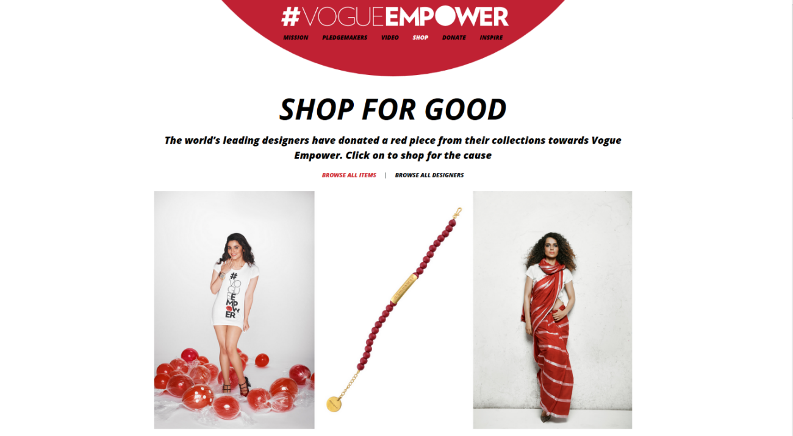
Figure 24: Screenshot of the Vogue Empower website, 2017

Vogue India website users can go to the Vogue Empower website to read about celebrities who endorse empowerment and watch videos related to empowerment (although “My Choice” no longer appears on the website, possibly due to its controversial message). Most importantly, users can go to the “shop” tab and look at the clothing made by designers to “Shop for Good.” The content and design of this website indicate the ways in which the New Indian Woman is a consumer. Her way of empowerment is buying a dress to support the cause and make her feel good about it. She might share a few videos, wear red, and buy a dress. She has bought the post-feminist message of self-empowerment and gender equality without disrupting the status quo.
In conclusion, the video “My Choice” was intended for an audience already socialized to believe that beauty and sexuality opens the door to success. Gender equality is achieved by enjoying the same freedoms as men without changing patriarchal norms. The audience consumes the post-feminist message of being a “can-do girl” by making her own purchase choices. “My Choice” shares a form of individualistic empowerment that doesn’t call for collective action against multiple oppressions. Instead, viewers and website users can shop for the cause, buy a red dress, and feel good. This is why Indian mass media criticized “My Choice” for not representing the real issues Indian women face daily. That said, if she has sufficient resources, the New Indian Woman is probably feeling empowered.

Moving Forward with Researching “My Choice”
Using the video as an interviewing tool brought surprising results in the way of a flow from questions to stories. It appears that using something controversial to begin the interviews really makes the participants want to discuss those topics and drive the interview. The questions went from general to specific, beginning with “what did you think about the video?” and moving to “what did the video get wrong?” It was challenging to select which stories were included in chapter three, since there were several stories coded for each interview. Using video-elicitation and a specific set of questions results in a flood of stories. A larger study would be beneficial, perhaps across multiple cities in India to compare responses in northern and southern India. Further research could be done about hijras in India, after the transgender “My Choice” response video. Transgender people face different challenges around the world.
More questions could investigate women’s access to abortions and how women manage reproduction, through different forms of birth control, like condoms or pills. Another interesting area of further research would be the mobility restrictions on women, especially at night, especially since this phenomenon is observable on city streets late at night in India. Interviewing men about women’s choices was actually quite interesting. Many of the men discussed the women in their lives, such as mothers or grandmothers. The men interviewed in the United States had a different perspective on women’s empowerment, especially since they had a positive perception of Western feminism. The man interviewed in India was a bit more uncomfortable with the interview than the women in India I interviewed, until he talked about his mother. It would be good to interview more men in India about the women and girls in their families. It is interesting to see from a man’s point of view what a woman’s role in the family should be.
Looking forward, someone could translate the video into different local languages, like Hindi and Marathi in Maharashtra. Then they could show it to women who do not know English. It would be good to contrast the opinions of urban women with women in villages, who may or may not relate to anything in the video at all. Further research could be done to interview older, urban women as well. Vogue India is geared towards a younger audience, but older women may have different views about mobility, sexuality, and gender roles. Another way to expand this study is if someone interviewed women of different races and ethnicities here in the U.S. about “My Choice.” Maybe they would pick up on the brand of Western feminism highlighted in the video. They also might be offended by the same or different parts of the video. It would be an interesting comparison to Indian women’s responses.

Further Research- Geographies of Film
“My Choice” was called a short film by its creator, Vogue India. It was produced by Bollywood directors and starred Bollywood figures. However, due to its release on YouTube, there was a focus on its viral and mobile nature as a piece of digital media (a video) that can be accessed anywhere, as opposed to the more traditional methods of accessing film. That said, the video does have some connections to the growing body of literature in the subfield of film geography.
The author-text-reader (ATR) model used in film geography (Sharp and Lukinbeal 2015, 21) is very similar to Gillian Rose’s critical visual methodology, with sites and modalities (shown in Chapter 2). Focusing on the author is similar to this study examined the writer, director and star. The text centered approach is similar to this study, which focused on the site of the image, describing the video’s mise-en-scéne. Reader centered approaches form the site of audiencing. Geographers grapple with the real/reel binary, in which the onscreen world is a representation of reality. Attempts to overcome this binary have been through dialectics, simulacra, and haptics. The first two work with the film as text, whereas haptics make the viewing experience emotional and embodied (22). Lisa Funnell and Klaus Dodds (2017) provide an example of haptic geographies in film in their book Geographies, Genders and Geopolitics of James Bond. They explore how James Bond’s body is the locus of his identity and how he is portrayed on film appeals to the senses, namely touch. Bond himself is touch oriented and sensuous (21-22). It would be interesting to involve haptics in the viewing of “My Choice.”
The “reality” of film is often questioned. Because it cannot mimic the space-time continuum that we live in, it is regarded as inferior (Cresswell and Dixon 2002, 2). Others take a different approach, saying that films create reality and are produced by reality. Geographers are tasked with exposing the truisms hidden within the ideological camouflage (3). “My Choice” tries to represent “real” women by choosing ninety-nine women supposedly from various walks of life (Vogue.in). Some women are clearly left out.
Seeing the video “My Choice” as a cultural commodity, Garnham would argue that “the costs of reproduction are marginal in relation to the costs of production” (Garnham 1987 in Christophers 2015, 68). It costs nothing to watch “My Choice” on YouTube, if there is a device that can connect to the internet. To maximize the sales of music, film, or television, producers try to expand their audiences into international markets in a kind of “media globalization” (68-69). Because of the digital nature of “My Choice,” media geographers are rethinking the relationship between viewers/users and digital information (Aitken and Craine 2015, 86).
There are many more ways to work with “My Choice,” since it walks the line of being a short film, a video, a link, a file, something to share on social media, and more. This study did not focus too much on film geographies because of the emphasis that “My Choice” is not the same as a traditional film. It has filmic elements and production qualities, but the focus on it as a video on YouTube shaped how it was analyzed. Gillian Rose’s critical visual methodology set up a great framework for working with a visual material like “My Choice.” ATR is very similar.

Conclusion
I first encountered “My Choice” on Facebook around the time of its release, in early April of 2015. When I saw it, I was moved. I was also astonished at how Indian women were offended by it. The goal in this research was to understand how a women’s empowerment video could be so offensive. After studying its message next to the writings of Indian feminists and interviewing 10 people about the video’s message, it became readily apparent that “My Choice” is all about purchasing power and feel good (post-)feminism. It is poetic, intense, and powerful, but the message of the video falls flat. A women’s empowerment video is a good step in the right direction for India, but now it is evident why the video is controversial. It doesn’t address the issues that concern Indian women. It pushes a Western idea of feminism that doesn’t resonate with Indian feminists’ views. What works for American feminists might not go over well with Indian feminists. Feminism is not monolithic; there are multiple feminisms across the globe and within communities

References
Aitken, Stuart C. and James W. Craine. 2015. “A Brief History of Mediated, Sensational and Virtual Geographies.” In Mediated Geographies and Geographies of Media, edited by Susan P. Mains, Chris Lukinbeal, and Julie Cupples, 81-92. E-Book: Springer.
Aitken, Stuart, and Deborah P. Dixon. 2006. “Imagining Geographies of Film.” Erkunde 60 (4): 326–36.
Alam, Mohammad Sanjeer. 2011. “Unequal They Stand: Decision-Making and Gendered Spaces within Family.” In Doing Gender, Doing Geography: Emerging Research in India, edited by Saraswati Raju and Kuntala Lahiri-Dutt, 229–47. New Delhi: Routledge.
Alcoff, Linda Martin. 1996. “Feminist Theory and Social Science: New Knowledges, New Epistemologies.” In BodySpace: Destabilizing Geographies of Gender and Sexuality, edited by Nancy Duncan, 13–27. London and New York: Routledge.
“An Exhibition about the Anxieties of the Indian Diaspora.” 2013. VOGUE India. November 22. http://www.vogue.in/content/thukral-and-tagra-nature-morte/.
Anand, Madhureeta. 2015. “Madhureeta Anand: Deepika Padukone’s ‘My Choice’ Video Limited to Urban Understanding - Times of India.” The Times of India. November 2. http://timesofindia.indiatimes.com/entertainment/hindi/bollywood/news/Madhureeta-Anand-Deepika-Padukones-My-Choice-video-limited-to-urban-understanding/articleshow/49632762.cms.
Andre Borges BuzzFeed India Contributor. 2015. “Deepika Padukone Had Personal Issues With Several Lines In Vogue’s ‘My Choice.’” BuzzFeed. May 5. http://www.buzzfeed.com/andreborges/kinda-my-choice.
Arora, Gaurav. 2015. “My Choice Is To Not Support Deepika Padukone This Time.” March 30. https://www.scoopwhoop.com/inothernews/vogue-empower-response/#.y91grefy8.
Atkinson, Robert. 1998. The Life Story Interview. Vol. 44. Qualitative Research Methods. Thousand Oaks, California: SAGE.
Aula, Sahith. 2014. “The Problem With The English Language In India.” Forbes. https://www.forbes.com/sites/realspin/2014/11/06/the-problem-with-the-english-language-in-india/#b7b5dde403e5.
Avarweg, Udo R. and Leaning, Marcus A. 2011. “Visions of Community: Community Informatics and the Contested Nature of a Polysemic Term for a Progressive Discipline. Information Technologies & International Development, 7(2): 17-29.
Barnes, Trevor. 2000. “Situated Knowledge.” Edited by R.J. Johnston, Derek Gregory, Geraldine Pratt, and Michael Watts. The Dictionary of Human Geography. Malden, MA: Blackwell Publishing.
Bawa, Jyoti Sharma. 2015. “Sorry Deepika Padukone, These Are Not the Choices Women Need.” Http://Www.hindustantimes.com/. March 31. http://www.hindustantimes.com/bollywood/sorry-deepika-padukone-these-are-not-the-choices-women-need/story-sjkcRzCx8j48InY9VcP28N.html.
BeingIndian. 2015. #VagueManpower - My Choice Too. https://www.youtube.com/watch?v=JnBdxu0qABI.
Bhattacharjee, Moumita. 2015. “Deepika Padukone Disappointed at the Response My Choice Garnered- Watch Video.” May 4. http://www.bollywoodlife.com/news-gossip/deepika-padukone-disappointed-at-the-response-my-choice-garnered-watch-video/.
Bhattacharyya, Rituparna. 2015. “Understanding the Spatialities of Sexual Assault against Indian Women in India.” Gender, Place & Culture 22 (9): 1340–55.
Biswas, Ranjita. 2011. “Of Love, Marriage and Kinship: Queering the Family.” In Intimate Others: Marriage and Sexualities in India, edited by Samita Sen, Ranjita Biswas, and Nandita Dhawan, 414–35. Kolkata: STREE.
Bollywood Hardcore. 2015. Deepika Padukone’s Reaction - “My Choice” - Vogue Empower. https://www.youtube.com/watch?v=DHlKjTlbp8o.
Bondi, Liz, and Joyce Davidson. 2005. “Situating Gender.” In A Companion to Feminist Geography, edited by Lise Nelson and Joni Seager, 15–31. Malden, MA: Blackwell Publishing, Ltd.
Bose, Adrija. 2015. “Transgender Version of the ‘My Choice’ Video Celebrates the Third Gender.” April 15. http://www.ndtv.com/offbeat/transgender-version-of-the-my-choice-video-celebrates-the-third-gender-755218.
“Boy or Girl? It’s in the Father’s Genes.” 2017. Accessed March 19. https://phys.org/news/2008-12-boy-girl-father-genes.html.
Brat House Films. 2015. “My Choice” – Male Version. https://www.youtube.com/watch?v=VhjOnXGXpHo.
Chatterjee, Sushmita. 2016. “‘English Vinglish’ and Bollywood: What Is ‘New’ about the ‘New Woman’?” Gender, Place & Culture, 1–14. doi:10.1080/0966369X.2015.1136816.
Chowdhry, Prem. 2011. “Men, Marriage and Sexuality in Northern India.” In Intimate Others: Marriage and Sexualities in India, edited by Samita Sen, Ranjita Biswas, and Nandita Dhawan, 241–62. Kolkata: STREE.
Christophers, Brett. 2015. “Cultural Industries and the (Geographical) Political Economy of the Media.” In Mediated Geographies and Geographies of Media, edited by Susan P. Mains, Chris Lukinbeal, and Julie Cupples, 65-80. E-Book: Springer.
Coppock, Vicki, Deena Haydon and Ingrid Richter (1995). “Introduction: Locating ‘Post-Feminism’, Exploring the Myths.” In The Illusions of ‘Post-Feminism’: New Women, Old Myths. London: Taylor and Francis.
Cosgrove, Denis. 2000. “Cultural Geography.” Edited by R.J. Johnston, Derek Gregory, Geraldine Pratt, and Michael Watts. The Dictionary of Human Geography. Malden, MA: Blackwell Publishing.
Crang, Phil. 2000. “Cultural Turn.” Edited by R.J. Johnston, Derek Gregory, Geraldine Pratt, and Michael Watts. The Dictionary of Human Geography. Malden, MA: Blackwell Publishing.
Cresswell, Tim. 2013. “Feminist Geography.” In Geographic Thought: A Critical Introduction, 147-169. Malden, MA: Wiley Blackwell.
Cresswell, Tim and Deborah Dixon 2002. “Introduction: Engaging Film” In Engaging Film: Geographies of Mobility and Identity, edited by Tim Cresswell and Deborah Dixon, 1-10. Lanham, Maryland: Rowman and Littlefield Publishers.
Datta, Anindita. 2016. “The Genderscapes of Hate: On Violence against Women in India.” Dialogues in Human Geography, Intervention, 6 (2): 178–81. doi:10.1177/2043820616655016.
Datta, Ayona. 2016. “Another Rape? The Persistence of Public/Private Divides in Sexual Violence Debates in India.” Dialogues in Human Geography, Intervention, 6 (2): 173–77. doi:10.1177/2043820616653321.
Daya, Shari. 2009. “Embodying Modernity: Reading Narratives of Indian Women’s Sexual Autonomy and Violation.” Gender, Place & Culture 16 (1): 97–110.
Deepika Padukone Breaks Her Silence On My Choice - Filmibeat Videos. 2016. Accessed December 18. http://videos.filmibeat.com/bollywood/gossipnews/deepika-padukone-breaks-her-silence-on-my-choice-132091.html.
“Deepika Padukone Finally Breaks Her Silence On My Choice Video.” 2015. May 5. http://businessofcinema.com/bollywood_news/deepika-padukone-finally-breaks-her-silence-on-my-choice-video/205887.
“Deepika Padukone: Male Bashing or Women’s Empowerment? - BBC News.” 2015. March 31. http://www.bbc.com/news/world-asia-india-32126807.
“Deepika Padukone – ‘My Choice’ Directed By Homi Adajania - VOGUE Empower.” 2015. YouTube. Accessed April 15. https://www.youtube.com/watch?v=KtPv7IEhWRA.
“Deepika Padukone Speaks up after #MyChoice Video, Says Would Never Endorse Infidelity - Firstpost.” 2015. May 5. http://www.firstpost.com/bollywood/deepika-padukone-speaks-up-after-mychoice-video-says-would-never-endorse-infidelity-2227548.html.
“Deepika Padukone’s ‘My Choice’ Video: Twitteratti Stands Divided - The Hindu.” 2015. April 1. http://www.thehindu.com/trending/deepika-padukone-in-my-choice-video-of-vogue/article7056615.ece.
Dhawan, Nandita. 2011. “The ‘Legitimate’ in Marriage, Legan Regulation and Social Norms.” In Intimate Others: Marriage and Sexualities in India, edited by Samita Sen, Ranjita Biswas, and Nandita Dhawan, 149–72. Kolkata: STREE.
Domosh, Mona and Joni Seager. 2001. “On the Move.” In Putting Women in Place: Feminist Geographers Make Sense of the World, 110-139. New York: The Guilford Press.
Duncan, Nancy. 1996. “Introduction: (Re)Placings.” In BodySpace: Destabilizing Geographies of Gender and Sexuality, 1-10. London: Routledge.
Erwer, Monica. 2011. “Emerging Feminist Space Politicizes Violence against Women.” In Gendered Geographies: Space and Place in South Asia, edited by Saraswati Raju, 129–57. New Delhi: Oxford University Press.
“FeministsIndia-Sharing Is Living- Indian Feminists Writing, Activism, Feminism, Women’s Groups.” 2017. Accessed April 14. http://feministsindia.com/.
Flows, Capital. 2017. “The Problem With The English Language In India.” Forbes. Accessed March 12. http://www.forbes.com/sites/realspin/2014/11/06/the-problem-with-the-english-language-in-india/.
Funnell, Lisa. 2015. “Objects of White Male Desire: (D)Evolving Representations of Asian Women in Bond Films.” In For His Eyes Only: The Women of James Bond, edited by Lisa Funnell, 79-91. New York: Columbia University Press.
———. 2014. Warrior Women: Gender, Race, and the Transnational Chinese Action Star. Albany: State University of New York Press, 2014. eBook Collection (EBSCOhost), EBSCOhost (accessed April 15, 2017).
Funnell, Lisa and Klaus Dodds. 2017. “The Haptic Geographies of James Bond’s Body.” In Geographies, Genders, and Geopolitics of James Bond, 21-43. London: Palgrave Macmillan.
Gera, Sonal. 2015. “Deepika Padukone’s ‘powerful’ Video: I Beg to Differ.” The Indian Express. March 30. http://indianexpress.com/article/blogs/deepika-padukones-powerful-video-we-beg-to-differ/.
Ghosal, Sarbani Guha. 2005. “Major Trends of Feminism in India.” The Indian Journal of Political Science 66 (4): 793–812.
Goecker, Liesl. 2015. “Deepika Padukone’s My Choice Video Isn’t About Equality.” The Swaddle. April 1. http://theswaddle.com/editorial-deepika-padukone-my-choice-video-answers-privelege-with-privilege/.
Grosz, Elizabeth. 1990. “Inscriptions and Body Maps: Representations and the Corporeal.” In Feminine, Masculine, and Representation, edited by T. Threadgold and A. Cranny-Francis, 62–74. London: Allen and Unwin.
Gumprecht, Blake. 2009. “The Campus as a Public Space.” In The American College Town, 40-70. Amherst and Boston: University of Massachusetts Press.
Haraway, Donna Jeanne. 1991. Simians, cyborgs, and women: the reinvention of nature. New York: Routledge.
Hanson, Susan. 1997. “As the World Turns: New Horizons in Feminist Geographic Methods.” In Thresholds in Feminist Geography: Difference, Methodology, Representation, edited by John Paul Jones, Heidi J. Nast, and Susan M. Roberts, 119–28. Lanham, Maryland: Rowman & Littlefield Publishers, Inc.
Hayford, Alison. 1974. “The Geography of Women: An Historical Introduction.” Antipode 6(2): 1-19.
Henry, Stephen G., and Michael D. Fetters. 2012. “Video Elicitation Interviews: A Qualitative Research Method for Investigating Physician-Patient Interactions.” Annals of Family Medicine 10 (2).
“Home.” 2017. Sayfty. Accessed April 14. http://sayfty.com/.
“Homi Adajania Finally Speaks up on Deepika Padukones My Choice Video.” 2015. April 10. http://indiatoday.intoday.in/story/homi-adajania-finally-speaks-up-on-explosively-viral-deepikas-my-choice-video/1/429554.html.
hooks, bell. 1982. “Racism and Feminism: The Issue of Accountability.” In Ain’t I A Woman: Black Women and Feminism, 119–59. London: Pluto Press.
hooks, bell. 2016. “Moving Beyond Pain.” bell hooks Institute Blog. Accessed May 6, 2017 http://www.bellhooksinstitute.com/blog/
Hubbard et al. 2002. “Geographies of the Body.” In Thinking Geographically: Space, Theory and Contemporary Human Geography, 97–123. London and New York: Continuum.
Jackson, Peter, and Polly Russell. 2010. “Life History Interviewing.” In The SAGE Handbook of Qualitative Geography, edited by Dydia DeLyser, Steve Herbert, Stuart Aitken, Mike Crang, and Linda McDowell, 172–92. London: SAGE.
Jackson, Peter. 1999. “Culture.” Edited by Linda McDowell and Joanne P. Sharp. A Feminist Glossary of Human Geography. New York: Oxford University Press.
Johnson, Jay T. and Clare Madge. 2015. “Empowering Methodologies: Feminist and Indigenous Approaches.” In Qualitative Research Methods in Human Geography, Fourth Edition, edited by Iain Hay, 76-94. Oxford University Press.
Johnson, Louise C. 2012. “Feminist Geography 30 Years on- They Came, They Saw But Did They Conquer?” Geographical Research 50 (4): 345–55. doi:10.1111/j.1745-5871.2012.00785.x.
Jones, John Paul, Heidi J. Nast, and Susan M. Roberts. 1997. “Thresholds in Feminist Geography: Difference, Methodology, Representation.” In Thresholds in Feminist Geography: Difference, Methodology, Representation, xxi–xxxix. Lanham, Maryland: Rowman & Littlefield Publishers, Inc.
Joshal, Rishma. 2015. “The Criticisms Against Deepika Padukone’s ‘My Choice’ Women’s Empowerment Video Fall Short - Brown Girl Magazine.” April 3. http://www.browngirlmagazine.com/2015/04/criticisms-against-deepika-padukone-my-choice-womens-empowerment-video-fall-short/.
Joshi, Priya. 2015. “Deepika Padukone: ‘It Is My Choice to Live Life the Way I Want.’” April 1. http://www.digitalspy.com/bollywood/news/a639150/deepika-padukone-it-is-my-choice-to-live-life-the-way-i-want/.
Kanungo, Soumonty. 2015. “Deepika Padukone’s ‘Empowering’ Video: Whose Choice Is It Anyway? | Latest News & Updates at DNAIndia.com.” Dna. March 30. http://www.dnaindia.com/blogs/post-deepika-padukone-s-empowering-video-whose-choice-is-it-anyway-2073312.
Khetani, Sanya. 2013. “An Exhibition about the Anxieties of the Indian Diaspora.” VOGUE India. November 22. http://www.vogue.in/content/thukral-and-tagra-nature-morte/.
Khurram, Shahjahan. 2015. “Bollywood Praises Deepika’s ‘My Choice’ Video on Twitter! – ARYNEWS.” March 30. http://arynews.tv/en/bollywood-praises-deepika-padukones-my-choice-on-twitter/.
Knoblauch, Hubert, Alejandro Baer, Eric Laurier, Sabine Petschke, and Bernt Schnettler. 2008. “Visual Analysis. New Developments in the Interpretive Analysis of Video and Photography.” Forum: Qualitative Social Research 9 (3). http://nbn-resolving.de/urn:nbn:de:0114-fqs0803148.
Kulkarni, Preeti. 2016. “Radhika Apte Gives Deepika Padukone’s My Choice Video a More REALISTIC Touch! - Bollywoodlife.com.” April 22. http://www.bollywoodlife.com/news-gossip/radhika-apte-gives-deepika-padukones-my-choice-video-a-more-realistic-touch/.
Lahiri-Dutt, Kuntala. 2011. “‘Doing Gender’ in Geography: Exploring Contemporary Methodologies.” In Doing Gender, Doing Geography: Emerging Research in India, edited by Saraswati Raju and Kuntala Lahiri-Dutt, 45–83. New Delhi: Routledge.
Lahiri-Dutt, Kuntala, and Pallabi Sil. 2004. “Beyond the Boundary: Middle-Class Women in Income-Generating Activities in Burdwan, India.” Contemporary South Asia 13 (3): 257–72.
Lau, Lisa. 2014. “No Longer Good Girls; Sexual Transgressions in Indian Women’s Writings.” Gender, Place & Culture 21 (3): 279–96.
Leonard, Madeleine, and Martina McKnight. 2015. “Look and Tell: Using Photo-Elicitation Methods with Teenagers.” Children’s Geographies 13 (6): 629–42. doi:10.1080/14733285.2014.887812.
Longhurst, Robyn. 1995. “VIEWPOINT The Body and Geography.” Gender, Place & Culture 2 (1): 97–106. doi:10.1080/09663699550022134.
———. 2001. “Corporeographies.” In Bodies: Exploring Fluid Boundaries, 9–32. London and New York: Routledge.
———. 2005. “Situating Bodies.” In A Companion to Feminist Geography, edited by Lise Nelson and Joni Seager, 337–49. Malden, MA: Blackwell Publishing, Ltd.
Lukinbeal, Chris, and Stefan Zimmermann. 2006. “Film Geography: A New Subfield.” Erkunde 60 (4): 315–25.
Majumdar, Rochona. 2007. “Arguments within Indian Feminism.” Social History 32 (4): 434–45. doi:81-9.
Mann, Susan Archer. 2012a. “Doing Feminist Theory.” In Doing Feminist Theory: From Modernity to Postmodernity, 1-30. New York and Oxford: Oxford University Press.
———. 2012b. “Marxist, Socialist, and Anarchist Feminisms.” In Doing Feminist Theory: From Modernity to Postmodernity, 112-159. New York and Oxford: Oxford University Press.
Massey, Doreen. 1992. “Space, Place and Gender.” In Space, Place and Gender, 185–90. London: Polity Press in association with Blackwell Publishers.
———. 1994. “Part III Introduction.” In Space, Place and Gender, 177–84. Great Britain: Polity Press in association with Blackwell Publishers.
McDonald, Soraya Nadia. 2015. “Bollywood Star Deepika Padukone Seems Firmly Committed to Feminism. But Not Everyone Is Getting behind Her Message. - The Washington Post.” April 1. https://www.washingtonpost.com/news/arts-and-entertainment/wp/2015/04/01/bollywood-star-deepika-padukone-seems-firmly-committed-to-feminism-but-not-everyone-is-getting-behind-her-message/.
McDowell, Linda. 1992. “Doing Gender: Feminism, Feminists and Research Methods in Human Geography.” Transactions of the Institute of British Geographers 17: 399–416.
———. 1996. “Spatializing Feminism.” In BodySpace: Destabilizing Geographies of Gender and Sexuality, edited by Nancy Duncan, 28–44. London and New York: Routledge.
———. 1997. “Women/Gender/Feminisms: Doing Feminist Geography.” Journal of Geography in Higher Education 21 (3): 381–400.
———. 1999a. “In and Out of Place: Bodies and Embodiment.” In Gender, Identity, and Place: Understanding Feminist Geographies, 34–70. Great Britain: Polity Press in association with Blackwell Publishers.
———. 1999b. “Introduction: Place and Gender.” In Gender, Identity and Place: Understanding Feminist Geographies, 1–33. Cambridge: Polity Press in association with Blackwell Publishers.
———. 1999c. “Postscript: Reflections on the Dilemmas of Feminist Research.” In Gender, Identity and Place: Understanding Feminist Geographies, 224–49. Cambridge: Polity Press in association with Blackwell Publishers.
———. 1999d. “Essentialism.” In A Feminist Glossary of Human Geography, edited by Linda McDowell and Joanne P. Sharp, 77-77. New York, NY: Oxford University Press.
McRobbie, Angela. 2011. “Beyond post-feminism.” Public Policy Research, September/November. 179-184.
Menon, Nivedita. 2009. “Sexuality, Caste, Governmentality: Contests over ‘Gender’ in India.” Feminist Review, south asian feminisms: negotiating new terrains, 91: 94–112.
Miles, Matthew B., Michael Huberman, and Johnny Saldana. 2014a. “Fundamentals of Qualitative Data Analysis.” In Qualitative Data Analysis: A Methods Sourcebook, 3rd ed., 69–104. Thousand Oaks, California: SAGE.
———. 2014b. “Research Design and Management.” In Qualitative Data Analysis, 3rd ed., 17–54. Thousand Oaks, California: SAGE.
Monk, Janice and Hanson, Susan. 1982. “On Not Excluding Half of the Human in Human Geography.” The Professional Geographer, 34 (1): 11-23.
Mukherjee, Nikita. 2016. “Sonakshi Sinha Makes The Most Logical Point About Deepika Padukone’s #MyChoice Video.” Www.mensxp.com. Accessed December 18. http://www.mensxp.com/special-features/today/25537-sonakshi-sinha-makes-the-most-logical-point-about-deepika-padukones-mychoice-video.html.
Mukhopadhyay, Madhurima. 2011. “Choice and Agency in Marital Decisions: A Study among Hindu Bengalis Across Class in Kolkata.” In Intimate Others: Marriage and Sexualities in India, edited by Samita Sen, Ranjita Biswas, and Nandita Dhawan, 121–48. Kolkata: STREE.
“My Body, My Mind, My Choice: Deepika Padukone - The Express Tribune.” 2015. March 29. http://tribune.com.pk/story/860808/my-body-my-mind-my-choice-deepika-padukone/.
Niranjana, Seemanthini. 2001. Gender and Space: Femininity, Sexualization and the Female Body. SAGE.
Oza, Rupal. 2006. “The New Liberal Indian Woman and Globalization.” In The Making of Neoliberal India: Nationalism, Gender and the Paradoxes of Globalization, 21–44. New York: Routledge.
Pappu, Rekha. 2011. “Reconsidering Romance and Intimacy: The Case of the Single Unmarried Woman.” In Intimate Others: Marriage and Sexualities in India, edited by Samita Sen, Ranjita Biswas, and Nandita Dhawan, 370–90. Kolkata: STREE.
Patel, Arti. 2015. “Bollywood Actress Deepika Padukone’s ‘My Choice’ Campaign Receives Backlash.” March 31. http://www.huffingtonpost.ca/2015/03/31/deepika-padukone-my-choice_n_6978692.html
Prasad, Priyanka. 2015. “Watch: Deepika Padukone Finally Talks About ‘My Choice’ Controversy - Filmibeat.” May 4. http://www.filmibeat.com/bollywood/news/2015/watch-deepika-padukone-finally-talks-about-her-my-choice-video-controversy-182080.html.
“Priyanka Chopra Was Very Stressed about Her Accent in Quantico | Bollywood | Hindustan Times.” 2017. Accessed April 15. http://www.hindustantimes.com/bollywood/priyanka-chopra-was-very-stressed-about-her-accent-in-quantico/story-pYmkyJdAVxgwI0k0xoeXtI.html.
PTI. 2015. “I Didn’t Endorse Infidelity in ‘My Choice’: Deepika Padukone - The Hindu.” May 5. http://www.thehindu.com/entertainment/i-didnt-endorse-infidelity-in-my-choice-deepika-padukone/article7173531.ece.
Radhakrishnan, Chitra. 2001. “The Image of Women in Indian Television.” Women in Action 81 (1). http://search.rdsinc.com/.
Raju, Saraswati. 2011a. “Engendering the Androcentric Discipline of Geography and Claiming a Place: Revisiting the (Un)Familiar.” In Doing Gender, Doing Geography: Emerging Research in India, edited by Saraswati Raju and Kuntala Lahiri-Dutt, 12–44. New Delhi: Routledge.
———. 2011b. “Introduction: Conceptualizing Gender, Space and Place.” In Gendered Geographies: Space and Place in South Asia, edited by Saraswati Raju. 1-28. New Delhi: Oxford University Press.
———. 2011c. “Reclaiming Spaces and Places: The Making of Gendered Geography of India.” In Gendered Geographies: Space and Place in South Asia, edited by Saraswati Raju, 39–59. New Delhi: Oxford University Press.
Riordan, Ellen. 2001. “Commodified Agents and Empowered Girls: Consuming and Producing Feminism.” Journal of Communication Inquiry, 25 (3): 279-297.
Rose, Gilllian. 2012. Visual Methodologies: An Introduction to Researching with Visual Materials, Third Edition. London: SAGE.
Sarikakis, Katharine and Liza Tsaliki. 2011. “Post/feminism and the politics of mediated sex.” International Journal of Media and Cultural Politics, 7 (2): 109-119.
Sen, Samita, Ranjita Biswas, and Nandita Dhawan. 2011. “Introduction.” In Intimate Others: Marriage and Sexualities in India, edited by Samita Sen, Ranjita Biswas, and Nandita Dhawan, 1–34. Kolkata: STREE.
Sharma, Preeti. 2012. “Historical Background and Legal Status of Third Gender in Indian Society”. International Journal of Research in Economics & Social Sciences (2) 12: 64-71.
Sharp, Joanne. 2009a. “Can the Subaltern Speak?” In Geographies of Postcolonialism: Spaces of Power and Representation, 109–30. London: SAGE.
———. 2009b. “Coke or Mecca-Cola? Globalisation and Cultural Imperialism.” In Geographies of Postcolonialism: Spaces of Power and Representation, 82–105. London: SAGE.
Sharp, Laura, and Chris Lukinbeal. 2015. “Film Geography: A Review and Prospectus.” In Mediated Geographies and Geographies of Media, edited by Susan P. Mains, Chris Lukinbeal, and Julie Cupples, 21–35. E-Book: Springer.
Smith, Laurel C. 2012. “Decolonizing Hybridity: Indigenous Video, Knowledge, and Diffraction.” Cultural Geographies 19 (3): 329–48. doi:10.1177/1474474011429407.
“Sonakshi Sinha: Deepika’s Video Comes From Good Space But Sex Outside Marriage Is Not Empowerment - NDTV Movies.” 2015. April 1. http://movies.ndtv.com/bollywood/sonakshi-sinha-deepikas-video-comes-from-good-space-but-sex-outside-marriage-is-not-empowerment-751448.
Sra, Gunjeet. 2015. “Deepika Padukone’s Video for Vogue Is Not Empowering—it’s Hypocritical — Quartz.” March 30. http://qz.com/372373/deepika-padukones-video-for-vogue-is-not-empowering-its-hypocritical/.
Stake, Robert and Jegatheesan Brinda. 2008. “Access, A Zone of Comprehension and Intrusion.” In Access, A Zone of Comprehension and Intrusion, edited by Brinda Jegatheesan, 1-15. UK: Emerald Group Publishing Ltd.
Talwaar, Pooja. 2015. “Deepika Padukone: Don’t Agree With Infidelity, Empowerment Is Equality - NDTV Movies.” May 4. http://movies.ndtv.com/bollywood/deepika-padukone-dont-agree-with-infidelity-empowerment-is-equality-760382.
“The Public Reaction To Deepika Padukone’s ‘My Choice’ Video Is Not What Vogue Even Vaguely Expected.” 2016. Accessed December 18. http://www.thebuzzdiary.com/lifestyle/the-public-reaction-to-deepika-padukones-my-choice-video-is-not-what-vogue-even-vaguely-expected/.
Therwath, Ingrid. 2010. “‘Shining Indians’: Diaspora and Exemplarity in Bollywood.” South Asia Multidisciplinary Academic Journal, no. 4 (December). doi:10.4000/samaj.3000.
“They Don’t Understand the Context: Homi Adajania to ‘My Choice’ Critics.” 2015. March 31. http://www.deccanchronicle.com/150331/entertainment-bollywood/article/my-choice-homi-adajania-reacts-all-criticism.
Thrift, Nigel. 2009. “Space: the Fundamental Stuff of Geography.” In Key Concepts in Geography, Second Edition, edited by Nicholas J. Clifford, Sarah L. Holloway, Stephen P. Rice and Gill Valentine, 85-96. London: SAGE.
Tivers, Jacqueline. 1979. “How the Other Half Lives: The Geographical Study of Women.” Area 10 (4): 302-306.
Vanita, Ruth. 2009. “Same-Sex Weddings, Hindu Traditions and Modern India.” Feminist Review, south asian feminisms: negotiating new terrains, 91: 47–60.
Veronica M. Richard, and Maria K.E. Lahman. 2015. “Photo-Elicitation: Reflexivity on Method, Analysis, and Graphic Portraits.” International Journal of Research & Method in Education 38 (1): 3–22. doi:10.1080/1743727X.2013.843073.
Waitt, Gordon. 2010. “Doing Foulcadian Discourse Analysis- Revealing Social Identities.” In Qualitative Research Methods in Human Geography, edited by Iain Hay, Third Edition. Oxford: Oxford University Press.
“Watch: Deepika Padukone Breaks Her Silence on ‘My Choice’ Video.” 2015. Http://Www.deccanchronicle.com/. May 3. http://www.deccanchronicle.com/150503/entertainment-bollywood/article/watch-deepika-padukone-breaks-her-silence-%E2%80%98my-choice%E2%80%99-video.
“Watch Deepika Padukone in New #VogueEmpower Film: ‘My Choice’ | Vogue India | Culture & Living | Culture.” 2015. March 27. http://www.vogue.in/content/watch-deepika-padukone-new-vogueempower-film-my-choice/.
Wilhoit, Elizabeth D., and Lorraine G. Kisselburgh. 2015. “Through the Eyes of the Participant: Making Connections between Researcher and Subject with Participant Viewpoint Ethnography.” Field Methods 28 (2): 208–26. doi:10.1177/1525822X15601950.
Women and Geography Study Group. 1984. “Why Study Feminist Geography?” In Geography and Gender: An Introduction to Feminist Geography, 19–23. London: Hutchinson, in association with the Explorations in Feminism Collective.
“xXx Return of Xander Cage Movie Review: Deepika Padukone Is Real Winner of This Vin Diesel Actioner | The Indian Express.” 2017. Accessed April 15. http://indianexpress.com/article/entertainment/xxx-3-return-of-xander-cage-movie-review-deepika-padukone-vin-diesel-d-j-caruso-star-rating-4470880/.
“‘xXx: Return of Xander Cage’: Film Review.” 2017. The Hollywood Reporter. Accessed April 15. http://www.hollywoodreporter.com/review/xxx-return-xander-review-965998.

Appendix A: List of Questions I Anticipate Asking Participants During a 1-2 Hour Interview
- Do you consent to participating in this interview?
- Is it okay if I record this interview on video or audio?
- Is it okay if we watch the video? May I begin recording once we start watching the video?
- What do you think about the video?
- Did you enjoy the video?
- How does the video make you feel? Were there any humorous parts? Any inappropriate parts?
- What did you like about the video?
- What do you think the video did wrong?
- What do you think the video got right?
- Was there anything that upset you about the video?
- Do you think that this message represents the interests of women, men, and families in India?
- Why do you think this video was made? Who was it made for?
- What does “feminism” mean to you?
- Do you associate the video with a feminist perspective?
- What does women’s empowerment mean to you? Is it different from feminism?
- Should a woman always follow her husband’s wishes? What decisions should she make on her own?
- Should a woman be self-sacrificing? What is a woman’s role in the family? What is your role?
- What is the modern Indian woman like? Is she traditional Indian woman?
- What is the most pressing concern of women in India?
- Do you think India is doing enough to protect the rights of women?
- Should a woman have a right to marry who she chooses? Who should be involved in the choice?
- Would you like to tell me about choosing your partner?
- Would you like to tell me about your wedding?
- What do you think about same-sex marriages? Should they be performed in temples?
- Should a woman be able to make her own decisions about sex? Is sex before marriage okay?
- What do you think about the rights of sex workers? Should they be supported?
- Should women be allowed to get abortions? Should women be allowed to find out the sex of the child?
- Do you think there is enough access to forms of birth control in India? Should women be allowed to have access to it on their own? When do you think young women should be allowed to access it?


IRB NUMBER: 6789
IRB APPROVAL DATE: 05/20/2016

Appendix B: List of Twenty Codes

1. Equality/inequality (+/-)
2. Sex Outside of Marriage
3. Women’s Dress
4. Empowerment (+/-)
5. Generational
6. Speaking Out
7. Rights
8. Freedom (+/-)
9. Rape
10. Bodies
11. Backward
12. Education
13. Flexible/adjust
14. Mentality/broadminded
15. Limited
16. Gender roles
17. Feminism (+/-)
18. Major themes by interview (varies by participant)
19. Personal story
20. Story

1 Vogue India calls “My Choice” a short film. It was produced by a Bollywood director and has a cinematic quality to it. However, because it was released on YouTube, I will refer to it as a video to highlight its viral nature and online presence.
2 There is a mistake in the graphic in the Vogue India media kit. Celebrity fans are mentioned twice. The missing category is most likely beauty. I can take from the graphic that users prefer celebrity content and fashion.
³ There is a lot of pressure for women to marry at a young age in India. Men do not face the same kind of pressure. This may be part of the reason that the men in my study were unmarried whereas most of the women were married.

