UNIVERSITY OF OKLAHOMA
GRADUATE COLLEGE

SLOWING DOWN AND THE VERTICAL/HORIZONTAL SPECTRUM
IN KAIJA SAARIAHO’S DUFT

A THESIS
SUBMITTED TO THE GRADUATE FACULTY
in partial fulfillment of the requirements for the
Degree of
MASTER OF MUSIC

By
KATHRYN VETTER
Norman, Oklahoma
2018

SLOWING DOWN AND THE VERTICAL/HORIZONTAL SPECTRUM
IN KAIJA SAARIAHO’S DUFT

A THESIS APPROVED FOR THE
SCHOOL OF MUSIC

BY

_______________________________
Dr. Sarah Ellis, Chair

_______________________________
Dr. Suzanne Tirk

_______________________________
Dr. Jennifer Saltzstein

© Copyright by KATHRYN VETTER 2018
All Rights Reserved.
Table of Contents
List of Tables vi
List of Figures vii
List of Examples viii
Abstract ix
Introduction 1
Compositional and Analytical Techniques and Approaches 3
Slowing Down 3
Network of Textures and Local Use of Slowing Down 6
Vertical/Horizontal Spectrum 7
Duft 8
“Blütenstaub” 9
Local-Level Slowing Down Along the Sound/Noise Axis in“Blütenstaub” 10
Two Voices in “Blütenstaub” 12
Large-Scale Slowing Down in “Blütenstaub” 16
V/H1 Dominance in “Blütenstaub” 17
“Blühend” 18
V/H2 Dominance and Instances of V/H1 and V/H3 in “Blühend” 25
“Flüchtig” 27
Three Sections in “Flüchtig” 28
V/H3 Dominance in “Flüchtig” 39
Conclusion: Multi-Movement Slowing Down in Duft 40

List of Tables
1 “Flüchtig,” mm. 1-22, contour analysis for the first four phrases 30

List of Figures
1 Vers le blanc, harmonic progression 4
2 Verblendungen, harmonic progression 5
3 Vertical/Horizontal Spectrum 8
4 “Blütenstaub,” harmonic reduction 14
5 “Blütenstaub,” two voices 15
6 “Blütenstaub,” summary of V/H1 dominance and large-scale Slowing Down 18
7 “Blühend,” composite melodies determined through stream segemenation 21
8 “Flüchtig,” Section A ascent with measure numbers 31
9 “Flüchtig,” mm. 23-47, composite melodies in Section B 35
10 “Flüchtig,” summary of ascents, descents, and interruptions 38
11 Duft, Multi-Movement Slowing Down 40

List of Examples
1 “Blütenstaub,” mm. 15-18, example of local Slowing Down through the Network of Textures 10
2 “Blütenstaub,” mm. 7-8, tremolos 11
3 “Blütenstaub,” m. 21 12
4 “Blütenstaub,” m. 23 12
5 “Blütenstaub,” m. 4 14
6 “Blühend,” mm. 8-12, three phrases showing a dominant descent and interrupting (01) segments 22
7 “Flüchtig,” mm. 20-22, foreshadowing the final ascent 29
8 “Flüchtig,” mm. 77-84, the final ascent 29
9 “Flüchtig,” mm. 25-26, common material in Section B 33
10 “Flüchtig,” mm. 9-10 34
11 “Flüchtig,” mm. 32-33 34
12 “Flüchtig,” m. 19, (016) 34
13 “Flüchtig,” m. 36, (016) 34
14 “Flüchtig,” m. 27, (015)

Abstract
Finnish composer Kaija Saariaho moved to Paris in 1982 to work at IRCAM (Institut de Recherche et de Coordination Acoustique/Musique) and GRM (Groupe de Recherches Musicales). Her research involved slowing down tape samples to study the nuances of sounds imperceivable at their normal speed. She called this her “microscope for music” and developed a compositional approach called Slowing Down, which replicates the effects of zooming in on a sound. After writing electronic compositions that highlight the effects of Slowing Down, Saariaho discovered techniques to imitate these effects on acoustic instruments. Although the composer claims an end to a compositional period in 1990, the outcomes of her research are still present in her works today.
In this analysis, I will show how Duft for solo clarinet (2011) contains effects from Saariaho’s research through a multi-movement Slowing Down. Since Saariaho does not provide a concrete analytical method for Slowing Down, I have created the Vertical/Horizontal Spectrum. This spectrum provides three categories (V/H1, V/H2, V/H3) and labels musical material based on its location in the Slowing Down process. When one zooms in on two nearly simultaneous events, the objects move farther apart until they are seemingly horizontal. Through pattern dominance, the first movement of Duft contains extended techniques that create vertical harmonies (V/H1). The following movements move along the spectrum with V/H2 and end with V/H3 (horizontal). By concretely defining the presence of Slowing Down in Duft, my analysis demonstrates that Saariaho’s compositions still contain effects from her research findings in the 1980s.

Introduction
Kaija Saariaho developed a unique compositional style through her computer music research completed in Paris. Her compositions magnify details of sounds and often create multiple voices in a solo-voice texture. Considering her treatment of solo-voice pieces, perhaps it is not surprising that Saariaho, a Finnish composer born in 1952, grew up listening to the music of Bach, a composer who frequently created multiple melodies within a single-voice instrument. By combining this influence from a Baroque composer with electronic techniques, Saariaho began writing in a contemporary compositional style that is intriguingly unique. When she moved to Paris in 1982, Saariaho worked at IRCAM (Institut de Recherche et de Coordination Acoustique/Musique), and GRM (Groupe de Recherches Musicales). She became dissatisfied with the intellectually-focused post-serialist music that surrounded her and turned to spectralism, a compositional style which values aural perception over the visual aspects of a score. Her time at IRCAM and GRM opened up compositional possibilities beyond the traditional scale. Rather than following her post-serialist contemporaries, Saariaho used her work with electronics to study the nuances of sound. She slowed down tape samples to discover details imperceptible in real time. She then used electronic techniques to accentuate sounds hidden from our aural perception. This led to her expansion of details over longer durations, or her compositional approach of Slowing Down.
Kaija Saariaho’s Duft, written for a solo-voice, acoustic instrument, displays influence from her computer music research through a multi-movement Slowing Down, which is supported by the Vertical/Horizontal Spectrum. Although this analysis uses Saariaho’s findings as analytic tools, I have offered the Vertical/Horizontal Spectrum as a means of concretely depicting Slowing Down. The Vertical/Horizontal Spectrum, which will be discussed in more detail, replicates Saariaho’s process of zooming in on a sound. It defines a vertical harmony (fully zoomed out), a horizontal single-line melody (fully zoomed in), and the stages in between these two ends of the spectrum. The spectrum divides into three flexible categories, V/H1, V/H2, and V/H3. The three movements in Duft each contain a different dominant V/H category, which creates a multi-movement motion from vertical to horizontal. The first movement, “Blütenstaub” (“Pollen”), creates harmony through category V/H1. This includes simultaneous notes or contextually-close notes, which in a solo-voice texture are typically created by extended techniques. V/H2 dominates in “Blühend” (“In Bloom”), the second movement, which contains composite melodies. “Flüchtig” (“Fleetingly”) the final movement, presents a singular voice in a linear, ascending motion (V/H3 dominance), along with some V/H ambiguity. This analysis will use approaches from Saariaho’s computer research and conventional contemporary music analysis practices, such as segmentation, pitch contour analysis, and set class analysis, to categorize material along my V/H Spectrum (V/H1-V/H2-V/H3). This categorization and V/H dominance will show a multi-movement Slowing Down throughout the piece.
Compositional and Analytical Techniques and Approaches
Saariaho’s compositional techniques and approaches developed through her computer research inform this analysis of Duft. Slowing Down, the Sound/Noise Axis, and the Network of Textures are her most prominent compositional approaches. Saariaho discusses these at length in her article “Timbre and Harmony: Interpolations of Timbral Structures.” After developing these ideas with the aid of computers and applying them to her electronic compositions, Saariaho brought these approaches into her acoustic music. In addition to Saariaho’s research findings, I will apply my own Vertical/Horizontal Spectrum to the analysis of Duft. Considering that Saariaho’s approaches are fairly abstract and perceptual, this analytical technique provides a concrete method to the analysis of Slowing Down.
Slowing Down
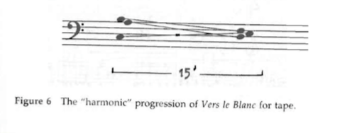
Slowing Down is one of the most distinct compositional approaches Saariaho developed through her research. By slowing down tape samples without altering the pitch, she was able to study the physical properties and nuances of sounds that are imperceptible at the normal speed. She called this her “microscope for music” and began accentuating parts of the sounds she found intriguing by electronically altering them. Despite its name, this technique does not refer to decreasing the tempo of the piece. Rather, it refers to the idea of stretching out a sound to encompass more time and space or zooming in on a sound so the details are more prominent. For example, if one zooms in on two notes that are fairly close together, the notes become further apart and the transition between the two notes becomes more detailed. In other terms, it can be understood as an augmentation or a delay of a musical arrival. Saariaho stated, “You can take one aspect of a sound that is interesting and extend that timbre through electronic processing, like the symmetrical form of a flower being dispersed by the wind.” Saariaho’s first composition realized with a computer, Vers le blanc (1982), presents an example of Slowing Down, which is shown in Figure 1. The entire piece consists of two sonorities (C3, A3, B3 and D3, E3, and F3), each only occurring once. Rather than simply switching between the two sonorities quickly, the piece draws out, or slows down, the transition between the two so the audience can hear all of the details that occur during the shift.
Figure 1: Vers le blanc, harmonic progression (Saariaho, "Timbre and Harmony: Interpolations of Timbral Structures," 104.)
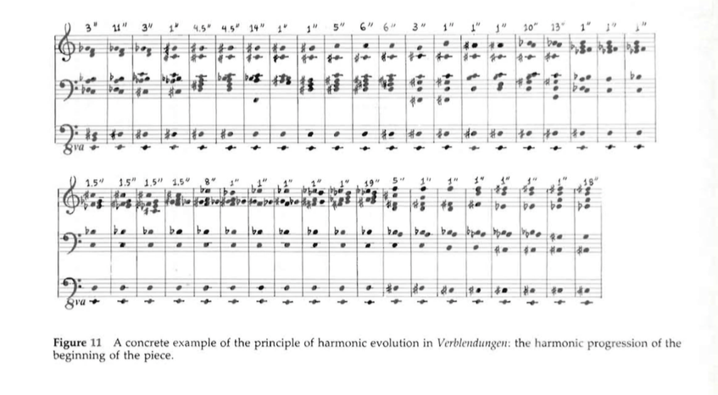
Verblendungen (1984) for orchestra and tape also demonstrates Slowing Down by moving through sonorities at a nearly unperceivable rate. In this piece, Saariaho makes use of tremolos, trills, and string bowings to create tension and slow transitions between harmonies. Figure 2 shows the harmonic reduction of Verblendungen in Saariaho’s article, “Timbre and Harmony: Interpolations of Timbral Structures,” which depicts the harmonic pathway from the first chord to the last. The last chord contains many of the same notes as the first, but the range is extended. The bass remains the same, while the soprano voices move up one octave over the course of the piece.
Figure 2: Verblendungen, harmonic progression (Saariaho, "Timbre and Harmony: Interpolations of Timbral Structures," 109.)
After Saariaho’s initial compositions that were written with a computer, Vers le Blanc for electronics and Verblendungen for orchestra and tape, she began to explore ways instruments could create similar effects. As she worked with performers, especially cellist Anssi Karttunen, Saariaho learned the playing techniques that created similar effects of Slowing Down to those she had previously created electronically. This often occurred through extended instrumental techniques that allowed for a breakdown in the traditional harmonic structure. The use of these extended techniques is best described through Saariaho’s Sound/Noise Axis and Network of Textures.
Network of Textures and Local Use of Slowing Down
Local instances of Slowing Down often occur as a drawn-out transition along the Sound/Noise Axis. The Sound/Noise Axis is Saariaho’s atonal equivalent to consonance and dissonance. Sounds, or traditional instrumental tones, are comparable to consonance, while noises, including those produced by extended techniques, are analogous to dissonance. Saariaho compares noise to dissonance when she states, “noise in the purely physical sense is a form of dissonance pushed to the extreme.” Similar to the Sound/Noise Axis, Saariaho’s Network of Textures categorizes extended techniques on a spectrum of stasis versus tension. Stasis refers to traditional instrumental techniques, while tension relates to extended instrumental techniques. Comparable to a modulation in a tonal work, Saariaho describes the transition between these two textures as phenomenon that creates movement. Despite categorizing the Sound/Noise Axis and Network of Textures as spectrums, Saariaho does not present any hierarchy of auditory experiences in terms of what would be on the farthest ends of the spectrums. Since this hierarchy was not clearly defined, her music is the only means we have of discerning her hierarchy. The lack of defined hierarchy also leads me to believe that for Saariaho, this is something that can easily change with context. Although Saariaho does not provide a definitive hierarchy in terms of the Sound/Noise Axis and Network of Textures in her article, transitions between Sounds and Noises are often clear in her music.
Vertical/Horizontal Spectrum
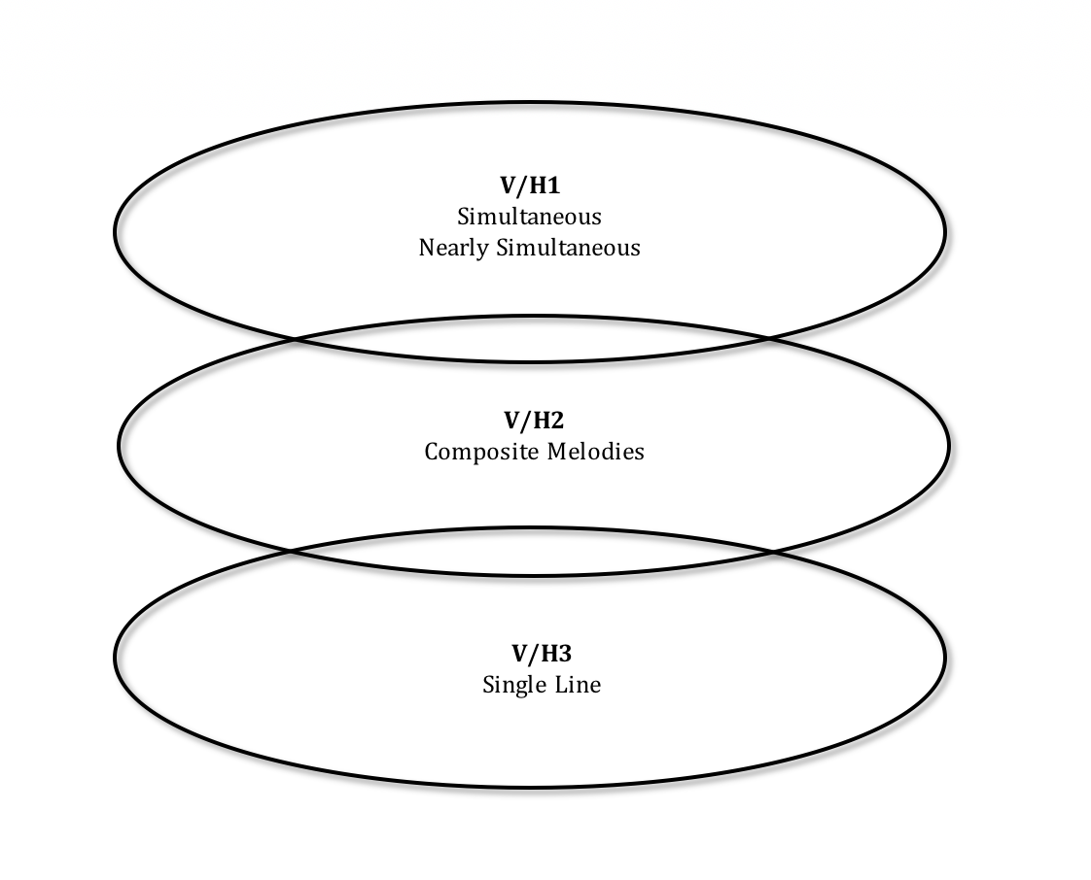
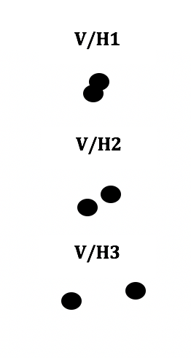
In order to concretely discuss the multi-movement Slowing Down in Duft, I developed the Vertical/Horizontal Spectrum. This spectrum moves from simultaneous harmony on the vertical end to a single-line melody on the horizontal end. The middle category accounts for composite melodies, or two intertwining melodies. Figure 3 shows three broad and overlapping categories on this spectrum. Since it is a spectrum rather than three definitive categories, there are some cases of categorical ambiguity. The first category on the Vertical/Horizontal Spectrum, titled V/H1, encompasses notes occurring simultaneously or notes that are nearly concurrent. The last category, titled V/H3 refers to single-line melodies. Although the pitch may rise and fall, this category is referred to as horizontal, as the melody is forward-moving, rather than creating a vertical harmony. The second category serves as a middle ground, with composite melodies as the most common example of a V/H2. Within a composite melody, individual notes are occurring horizontally, but are serving two separate, concurrent melodies.
Figure 3: Vertical/Horizontal Spectrum
Duft
Between 1982, when Saariaho began working at IRCAM, and 1989, Saariaho’s interest in the spectral analysis of sounds heavily influenced her compositions. She claims an end to this compositional period with Du cristal (1989) and a move away from this compositional style by using material from Du cristal in a completely different composition, …à la fummée (1990). Despite these claims, Saariaho’s acoustic music continues to demonstrate influence from her research in the early 1980s.
Duft, written for solo clarinet in 2011, translates to “fragarance.” Each of the three movements, “Blütenstaub” (“Pollen”), “Blühend” (“In Bloom”), and “Flüchitg” (“Fleetingly”), refers to a motion of smell. The three movements create a motion along the Vertical/Horizontal Spectrum through dominance of a different Vertical/Horizontal category. The first two movements uniquely overcome the lack of harmony in a solo instrumental work through V/H1 and V/H2. The first movement, “Blütenstaub,” establishes V/H1 through simulating simultaneities, and the second movement, “Blühend,” demonstrates V/H2 through composite melodies. These multiple voices and harmonies are separated through extended techniques, wide interval leaps, and stream segmentation. The final movement, “Flüchtig,” holds V/H3 dominance, along with some Vertical/Horizontal ambiguity. This analysis uses melodic contour analysis techniques to support V/H3 dominance. For the analysis of Duft, I will discuss in more detail the analytical techniques used to support each Vertical/Horizontal category, show dominance of the different V/H categories within each movement, and finally discuss Slowing Down with respect to the entire piece.
“Blütenstaub”
The first movement of Duft, “Blütenstaub” (“Pollen”), uses the Sound/Noise Axis, Network of Textures, and Slowing Down to create V/H1 and a modified arch-shaped form from D3 to E3. This analysis will first address local occurrences of Slowing Down, which manifest through drawn-out transitions, augmentation, and foreshadowing. The second part of this “Blütenstaub” analysis will discuss how Saariaho’s compositional techniques create two voices within this solo voice texture and how the voices construct large-scale Slowing Down. Finally, I will examine the dominance of V/H1 throughout the movement, which begins the multi-movement Slowing Down for the entire piece.
Local-Level Slowing Down Along the Sound/Noise Axis in “Blütenstaub”
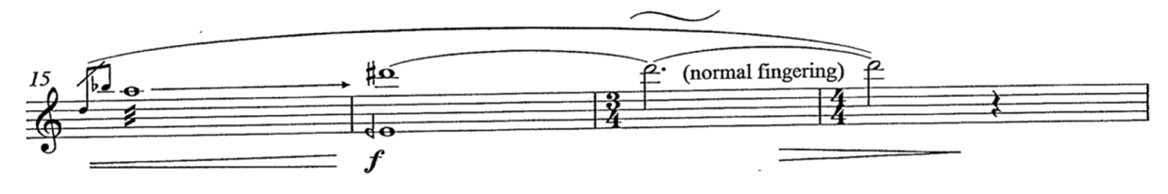
The first movement’s use of Slowing Down does not encompass the entire movement as it did in Verblendungen and Vers le Blanc, but we can see the technique through local events. “Blütenstaub” contains many Sounds (traditional tones), Noises (usually created by extended techniques), and transitions between these consonances and dissonances along the Sound/Noise Axis. Some of these dissonances, or Noises, in this movement occur through multiphonics (m. 16) and flutter tongue techniques (m. 9, 15, 19, 28). The most prominent example of a transition along the Network of Textures occurs in mm. 15-18. As shown in Example 1, m. 15 begins with two grace notes leading to a flutter tongued G5, a tension. This technique leads directly into a multiphonic (C#6 and quartertone flat D4), another tension. The arrow present in the score between the G5 and the multiphonic may indicate that the clarinetist should consider the connection between these two events. As the performer moves to a C#6 with no multiphonic, a stasis, the transition is smoothed out, or elongated, through slow pitch oscillations. Measure 18 contains the C#6 without any pitch manipulation or multiphonic to complete the transition to stasis. Thus, instead of moving directly to the C#6, the transition from G5 to C#6 is drawn out through a multiphonic and wide vibrato.
Example 1: “Blütenstaub,” mm. 15-18, example of local Slowing Down through the Network of Textures
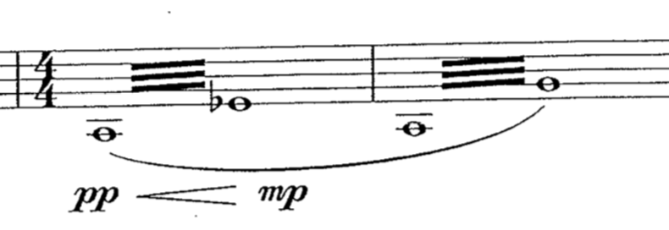
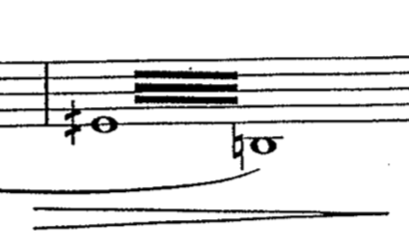
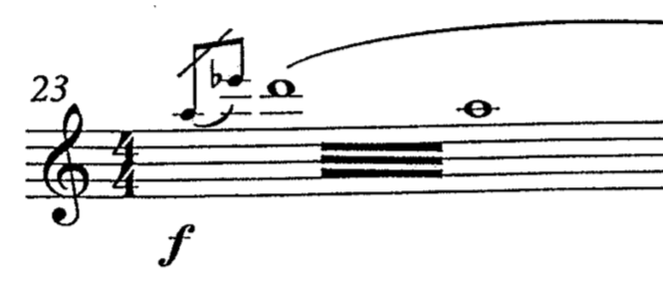
Although mm. 15-18 include a clear example of Slowing Down, there are many more local-level examples in this first movement. Measures 7 and 8, shown in Example 2, contain tremolos to Db4 and F4. These upper notes on their respective tremolos are drawn-out versions of Db4 and F4 of shorter durations in m. 4. These two notes move from the boundary notes of m. 4 to each lasting an entire measure within a tremolo. Measures 21 and 23, shown in Examples 3 and 4, similarly foreshadow an arrival. By using a quartertone sharp D4, Saariaho creates a microtonal variation on a perfect fourth. After a measure of silence and two grace notes creating a diminished fifth, the clarinet plays m. 23 containing a traditional perfect fourth expressed through a tremolo whose arrival had been delayed through its previous microtonal occurrence. One last example of local Slowing Down in this first movement occurs briefly in m. 28. The pitch bend between C6 and Bb5 allows every frequency between this semitone to be heard. Through this pitch bend the transition between the two pitches is drawn out or slowed down. Although this is a short glissando, the second and third movements of Duft contain significantly more glissandi with some drawn out over multiple measures. Continuing with the technique of foreshadowing and Slowing Down, this short glissando is hinting at the extended glissandi in the later movements.
Example 2: “Blütenstaub,” mm. 7-8, tremolos
Example 3: “Blütenstaub,” m. 21 Example 4: “Blütenstaub,” m. 23
Two Voices in “Blütenstaub”
In “Blütenstaub,” there are two simultaneous or nearly simultaneous voices that create the V/H1 category. This part of the analysis presents two simultaneous or nearly-simultaneous voices, explains the separation of these voices through extended instrumental techniques, and offers a large-scale Slowing Down within the movement. This large-scale Slowing Down is separate from the multi-movement Slowing Down of the entire piece, yet it provides another analytical level in which Saariaho’s technique appears.
Tremolos, multiphonics, wide intervallic leaps, and grace notes distinguish the two voices despite the solo voice texture. To play a tremolo, the performer alternates between two pitches at a fast rate. The faster this technique is performed, the more these two pitches sound nearly simultaneously. Similar to tremolos, Saariaho’s use of grace notes is a more melodic means of placing two notes close together. Multiphonics is one of the only techniques, in addition to singing while playing, in which a clarinetist can produce two or more pitches at exactly the same time. This movement also uses many pitch bends and flutter tongue articulations. These techniques intensify the sense of tension and noise (dissonance) rather than creating harmony and an additional voice, but they do take the pitch away from being a single-voiced, traditional sound.
Similar to Saariaho’s implementation of Slowing Down, Duft is not the first solo piece she has used extended techniques to create harmony and multiple voices. When speaking about Laconisme de l’aile (1982), written for solo flute, Saariaho said, “My intention here was to create an impression of polyphony on several levels for a solo instrument, to expand the melodic line in some way.” These extended techniques Saariaho employs do not only create momentary harmony, but instead reveal two distinct voices within this work for solo clarinet.
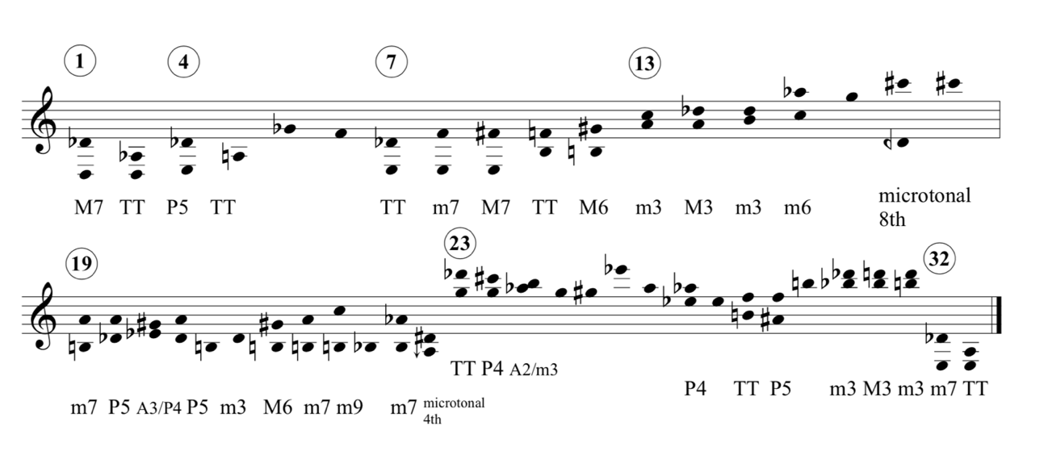
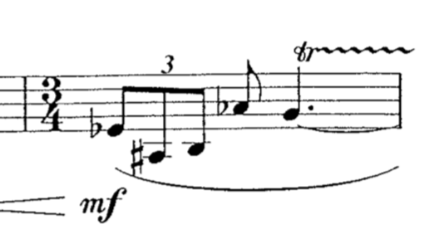
Figure 4 is a harmonic reduction of “Blütenstaub,” comparable to Saariaho’s reduction of Verblendugen, showing the two-voice texture. These voices were derived from each of the extended techniques. For example, m. 1 contains a tremolo between D3 and Db4; therefore, these two pitches are considered the beginning of the two distinct voices. The remaining tremolos are analyzed analogously. The upper note in the m. 16 multiphonic corresponds with Voice 1 (the upper voice), while the lower note is included in Voice 2 (the lower voice). When the composition becomes more melodic, large intervallic leaps distinguish the two voices. Example 5 shows m. 4 in which Db4, Gb4, and F4 outline the upper voice while the G#3 and A3 create the lower voice. This method of analysis is also used in mm. 19, 25, and 28. The glissando in m. 28 attaches the B5 to Bb5, both members Voice 2, instead of including the B5 in Voice 1 between F5 and Db6.
Figure 4: “Blütenstaub,” harmonic reduction

Example 5: “Blütenstaub,” m. 4
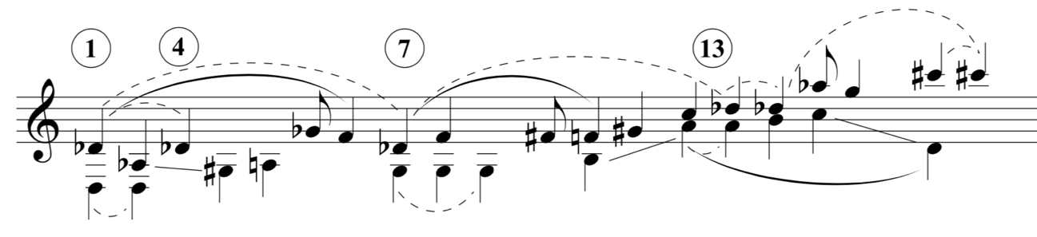
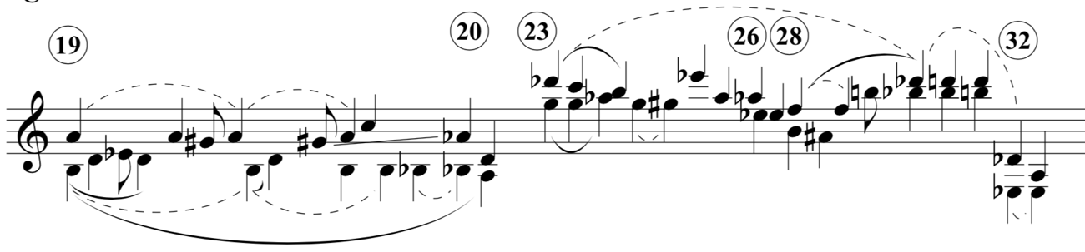
Figure 5 includes more temporal details and depicts this analysis’s interpretation through slurs, lines, and rhythmic durations. Voice 1 is notated with stems pointing up, and Voice 2’s stems are pointing down. The graph’s dotted slurs highlight the constant Db throughout the movement, along with other temporarily reoccurring notes. Solid lines show stepwise motion through octave displacement or across voices and enharmonic spellings. The solid slurs identify ascents and descents. Most of these ascents and descents are stepwise, occasionally hidden through octave displacement or enharmonic spellings. In the three instances where solid slurs do not indicate stepwise ascents, they highlight an ascending chordal skip that repeats. For example, the Db4 to F4 in Voice 1 of mm. 1-5 repeats again in mm. 7-9. The graph also reveals a retrograde of this intervallic leap in mm. 28-29 that is hidden through octave displacement. The few eighth notes indicate a neighbor tone to the following note.
Figure 5: “Blütenstaub,” two voices

Large-Scale Slowing Down in “Blütenstaub”
Similar to Saariaho’s early electronic compositions, “Blütenstaub” contains large-scale Slowing Down between its opening and closing material, in addition to contributing to the multi-movement Slowing Down through V/H1 dominance. This analysis argues for an arch form to the movement through a comparison of the opening and closing material along with the persistent Db throughout the movement. larger scale.
“Blütenstaub” begins with a tremolo starting on an D3 and ends with a tremolo starting on an Eb3. The top notes of the tremolos in m. 1 change from Db4 to Ab3, while the top notes of the ending tremolos switch between Db4 and A3. Figure 4 shows a return of the two opening intervals of a major seventh and a tritone as a minor seventh and a tritone at the end of the movement, thus showing a large-scale Slowing Down across the movement. Dynamically speaking, the movement begins ppp and ends mp with an undefined decrescendo. The duration of the last two sonorities are over four times the length of the first two sonorities. Therefore, the move from the first two sonorities to the last two contain a slight compression of intervals, an increase in dynamic, and a significant increase in duration.
In between these slight changes, Db remains a constant throughout the movement. After being introduced as the top note of the first tremolo, it occurs as a C#6 in mm. 16-18 and as a Db6 in m. 23. When Db occurs again in m. 28 as the upper note of a tremolo, it is followed by a neighboring D-natural as the upper notes of tremolos occurring in mm. 29-30 and then moves back down to Db as the upper notes in the tremolos that finish the movement, mm. 32-35. Measure 19 is the only section that Db is absent. This measure is the most rhythmically active in the movement, and its sudden registeral shift serves as an interlude between C#6 in m. 18 and the return of Db6 in m. 23. The overall shape of this piece begins with a tremolo D3 to Db4, gradually ascends to Db6, and then jumps down to the ending tremolo of Eb3 to Db4. With regards to pitch, dynamics, and duration, the whole movement ends slightly higher, louder, and longer than it began while maintaining Db4 throughout. Despite the wide range of musical activity that occurs between these beginning and ending tremolos, the small change in pitch and dynamics resembles Saariaho’s early compositions, Verblendungen and Vers le Blanc.
A similar effect to the constant Db throughout the movement occurs on a local level in mm. 7-9 and m. 19. The reduction in Figure 4 reveals the pedal notes in the lower voice, the G3 present for mm. 7-9 and the B3 persisting through m. 19 until the Bb in m. 20. These pedal points add to the Slowing Down effect since the oblique motion between the two voices results in less motion overall.
V/H1 Dominance in “Blütenstaub”
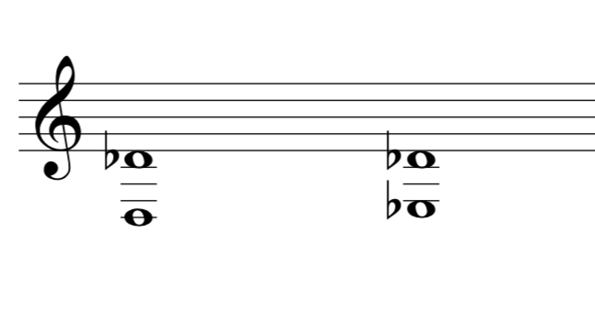
“Blütenstaub” prepares the multi-movement Slowing Down through its V/H1 dominance. The two distinct voices in “Blütenstaub” are created through simultaneity or simulated simultaneity, which are the most common types of V/H1. Multiphonics, tremolos, and grace notes all simulate simultaneity in this movement. V/H1 not only creates the two distinct voices, but it also dominants “Blütenstaub.” Out of the 35 measures in the movement, 19.875 measures (56.79%) are completely filled with V/H1 and 2 additional measures contain shorter cases of V/H1 through grace notes (62.5% total). Measure 15 contains two grace notes and m. 19 contains 4. Rests compromise of 5.5 measures (15.71%). That leaves 7.625 measures (21.79%) without V/H1 or rests. With a total of 62.5% of measures encompassing or containing simulated simultaneities, V/H1 is the clear dominant Vertical/Horizontal category in this movement. Figure 6 represents V/H1 dominance by using the sonorities from the beginning and end of the movement.
Figure 6: “Blütenstaub,” summary of V/H1 dominance and large-scale Slowing Down
“Blühend”
Instead of creating multiple voices through simultaneous tones, “Blühend” (“In Bloom”) creates overlapping, composite melodies using asynchronous notes. The composite melodies in this movement include a juxtaposition between wide leaps and stepwise motion with the majority of the stepwise motion occurs between semitones. Since the second movement does not contain any tremolos or multiphonics like the first movement, segmentation relies on wide intervallic leaps and is supported through Dimitris Rafailidis’s stream segmentation. Rafailidis’s stream segmentation ideas reveal a significant number of set class (01) throughout the movement. Composite melodies fall into the V/H2 category, which holds dominance throughout the movement. This shift from V/H1 dominance in “Blütenstaub” to V/H2 dominance in “Blütenstaub” creates the first step in the multi-movement Slowing Down along the Vertical/Horizontal Spectrum. In addition to V/H2 dominance, “Blühend” incorporates brief instances of V/H3. These occasions of the more horizontal end of the spectrum foreshadow the completion of the multi-movement Slowing Down in the final movement.
This analysis uses Rafailidis’s stream segmentation to distinguish the voices within the composite melodies. Rafailidis describes stream segments as “a relatively short coherent sequence of tones that is separated horizontally from co-sounding streams and, vertically from neighboring musical sequences.” By this definition, notes in the composite melodies of “Blühend” are separated from their horizontally-adjacent neighbors through wide intervals. Although Rafailidis presents an algorithm to compute such groupings, he also describes stream segments as “a relatively small number of tones grouped together into a coherent ‘whole’ perceived independently from other adjacent tones.” Since perception can vary, there is an element of subjectivity when separating composite melodies. When describing local stream segmentation, Rafailidis states, “a large pitch interval in between smaller ones signifies a potential local boundary.” This analysis of “Blühend” is largely influenced by Rafailidis’s idea that pitches separated by relatively small intervals are grouped together and those divided by large-intervals belong to separate groups.
When applied to “Blühend,” Rafailidis’s stream segmentation ideas typically produce two or three distinct voices within each phrase. For example, in mm. 1-4 the motion between C#-D, G-F#, and C-B creates three distinct voices through a composite melody. Figure 7 uses this method and shows the distinct voices for the entire movement. This figure was generated through segmenting the movement at each phrase. In another example, mm. 5-7 (including the anacrusis) segments into F#-G, A-Bb, C#-D, and C-B. While these notes could be arranged into a continuous group of semitones and major seconds (F#-G-A-Bb-B-C-C#-D), they occur in the music as either one or two notes of the semitones followed by a leap of at least a major third. These three measures are a great example of the crucial role of the wide intervallic leaps.
Typically, the material in this movement appears as semitones followed by a wide intervallic leap; however, there are a few cases that stray from this configuration. The semitones normally occur as a written minor second, but mm. 6-7 contain a rare octave displacement when C#5 leaps to D6. The alternative to keeping C# in the same octave of D6 (C#6-D6) creates stepwise motion between B5, C#6, and D6. The octave displacement adopts the role of wide intervallic leaps rather than creating a stepwise motion that would join two (01) segments.
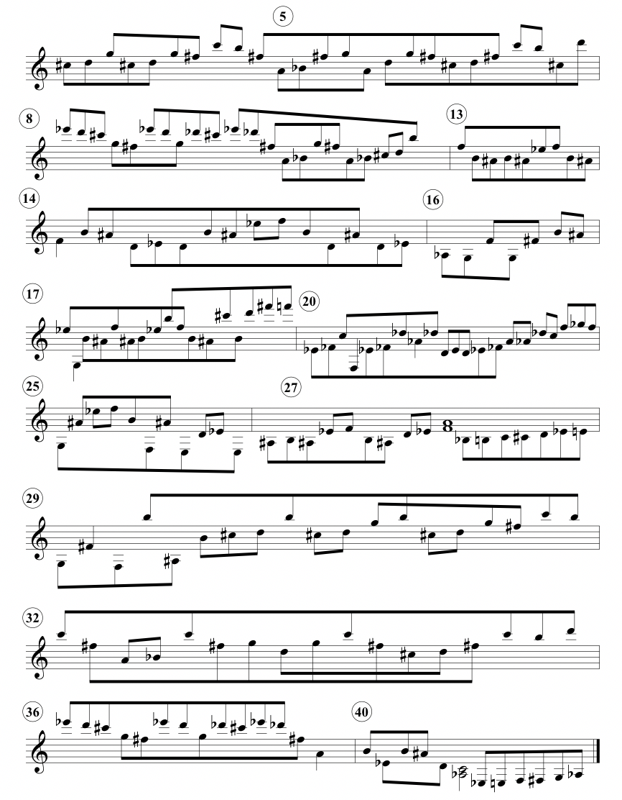
Figure 7 “Blühend,” composite melodies determined through stream segmentation
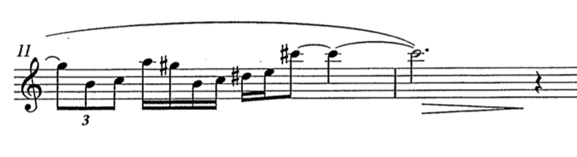
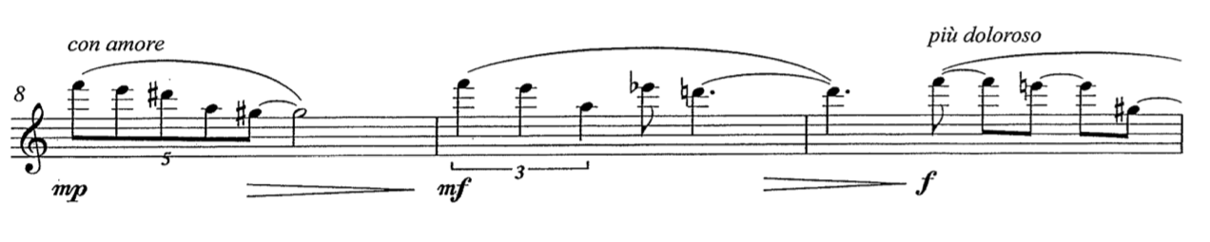
Beyond this unusual leap of a minor ninth, some voices in this movement extend beyond a semitone. These extensions are directed and therefore create linear descents and ascents. Since linear motion falls into the V/H3 category, these descents and ascents cause dominance ambiguity in this movement. For example, in m. 8, an elongated semitone descent begins. Unlike the single semitone segments, this voice contains five notes all descending by semitone. As seen in Example 6, this voice spans three phrase segments (mm. 8-12) by restarting from the top (Eb6) and descending further with each phrase. These descents are interrupted by the F#-G, A-B, and C#-D voices. The semitone voices in the final attempt at the descent are significantly more prevalent than the first two phrases. The first attempt ends with a single instance of the F#-G voice, and the second attempt only has a single G in the middle of the four-note descent. The final attempt, which finishes the descent to B5 (with the omission of Db and C presented in the second attempt), contains interruptions from the F#-G, A-B, and C#-D voices. Consequently, this phrase is longer than the previous two and is paired with the text “più doloroso,” or ‘more painful,’ in the score. This linear descent and semitone interruptions over mm. 8-12 cause V/H dominance ambiguity. V/H3 holds fairly strong dominance through the descent’s duration and tessitura, while the semitones act as interruptions. Although V/H3 dominance is clear in these four measures, m. 11 holds V/H2 dominance. With V/H2 encompassing a large portion of this descent’s ending, the movement returns to V/H2 dominance in m. 13.
Example 6: “Blühend,” mm. 8-12, three phrases showing a dominant decent and interrupting (01) segments
A similar descent occurs starting in m. 36, but the descent only spans four notes by semitone. Once again, there are three attempts at the descent. Unlike the descent beginning in m. 8, the lowest point of this descent is in the second attempt and there are fewer interruptions of the (01) segments. Consequently, the third attempt is proportionally shorter than the third attempt in the earlier (m. 8-12) descent. Additionally, the third attempt ends only one semitone below the initial Eb6. The descending voices of these examples in m. 8 and the m. 36 prevail over the (01) segments. With these (01) segments acting as interruptions, the descending voices in these few examples show a more horizontal V/H category. Another extended semitone descent in m. 25, but it only spans 3 notes beginning on G3. These notes are grace notes, while the contrasting (01) voices are eighth notes. In this instance, the (01) voices are more prominent than the descent, which helps keep the descending voices from having dominance for the entire movement.
Similar to the descents, the few instances of linear ascents in “Blühend” further question V/H dominance. The most apparent example happens in m. 17-18. The semitone ascent begins on B6, steps to C#6 and D6, and then slides up to F#6 through a glissando before stepping down to F6. This ascent is followed by a smaller ascent in the improvised graces notes (D6-Eb6-E6) while F6 is being held out. Improvised grace notes paired with tremolos occur three times in the movement, mm. 18, 28, and 40. In the score, the grace notes are presented as ascending semitones and include three, seven, and five notes, respectively. In m. 18, Saariaho instructs the clarinetist to “improvise with given grace notes during the trill.” The following two instances instructs the performer to “improvise with given grace notes in free order.” This additional instruction removes the ascending order from the presented grace notes and leaves the interpretation up to the performer in mm. 28 and 40. However, Saariaho retains the ascending order in m. 18 which reiterates the ascension of the previous measure. Ordered improvised grace notes work to create V/H2 dominance in “Blühend,” while the subsequent unordered use of grace notes exclude the linear motion. As the grace notes in all three examples are interrupting a trill, depending on the duration of the grace notes, these measures fall closer to the vertical end of V/H2.
Although most voices move in semitones, there are a few cases of whole-step motion, which often mark an important movement within the music. Measure 13 contains the first major second with the upper voice moving between F5 and Eb5. At the beginning of this measure, there is a marking “intenso.” Along with the expression marking, this change in interval from a semitone to a major second increases the intensity of the music. Measure 16 presents three distinct semitone voices, some of which become grace notes in m. 17. These grace notes are interrupting the (02) voices, Eb5-F5 and B5-C#6. After these wider intervals, C#6 begins the significant ascent discussed earlier. The use of a larger interval, (02) instead of (01), signifies a change leading to the ascension. The major second of Eb-F returns in m. 25 and again in mm. 27-28. Although m. 25 is an isolated segment, Eb4-F4 in mm. 27-28 is paired with a ‘misterioso’ marking in the score. This voice drops down to D4-Eb4 before ascending back to F4. The (02) segments always occur between Eb and F and are either paired with an indication of an intensified musical moment or lead to a musical arrival. In summary, m. 13 is paired with “intense,” m. 17 leads to a prominent and rare ascent, m. 25 is paired with a subito mf after a diminuendo from a p, and mm. 27-28 leads to a whole note tremolo with improvised grace notes.
Overall, “Blühend” comprises mostly of composite melodies of (01) segments, where wide-interval leaps distinguish the multiple voices using Rafailidis’s stream segmentation. Despite this common material, variations exist through linear ascents and descents and occasional (02) segments. Each of these variations accompanies an intensified musical moment or expressive marking in the score.
V/H2 Dominance and Instances of V/H1 and V/H3 in “Blühend”
Instead of simulating simultaneities (V/H1), as done in “Blütenstaub,” Saariaho creates multiple voices in “Blühend” through composite melodies (V/H2). Thus, across the movements Saariaho is using her Slowing Down technique by shifting from simultaneous voices (V/H1) to intertwined voices (V/H2), with composite melodies consuming the majority of the second movement. While Figure 7 visually displays the dominance of V/H2 throughout this movement, as discussed earlier “Blühend” also makes use of V/H1 and V/H3. These instances that stray from the dominance of V/H2 act as connections between the movements that remind of the past and foreshadow the future.
While there are more examples of V/H3 in this movement, we are reminded of V/H1 through the trills paired with improvised grace notes in mm. 18, 28, and 40. While these two distinct voices fall in more of a gray area in between V/H1 and V/H2. The close proximity is similar to the simulated simultaneity of the first movement, but the interrupting juxtaposition also alludes to V/H2; therefore, these three measures land between V/H1 and V/H2 along the spectrum.
In addition to the ascents and descents discussed earlier, there are some instances where the semitones allude more to the horizontal end of the V/H Spectrum. Compared to the composite melodies in the movement, the ascensions expanding beyond one semitone create a clear linear, or horizontal, motion. Measure 16 is an example of a combination of the composite melodies and a linear ascent. In another instance of ascent, m. 22, beat 3 through m. 24 includes four (01) segments, Eb4-E4, Ab4-A4, C5-Db5, and F5-Gb5. Even though leaps of fourths or fifths separate these distinct semitones, the (01) segments create a generally ascending line with a prime contour of <0,1> N=2. This more linear interpretation of these measures also hints to a combination of multiple voices into a single voice, once again showing a trend towards the horizontal end of the V/H spectrum. Despite the allusions towards V/H3, each ascent ends in a semitone decent. With the semitone descent, we are reminded of dominance of the (01) segments, composite melodies, and V/H2 throughout the movement.
“Flüchtig”
In this final movement, Saariaho completes the multi-movement Slowing Down in Duft through consistent V/H3 dominance. The multi-measure glissandi in the final third of the movement create the most prominent examples of V/H3. By themselves, glissandi serve as examples of Slowing Down by drawing out every frequency between two pitches. They are continual linear ascents and are therefore classified as V/H3. This analysis divides “Flüchtig” (“Feeltingly”) into three sections, with the final third displaying clear examples of V/H3 through the consistent use of slow-paced glissandi. Although the first two sections are also dominated by V/H3, there is more ambiguity within the V/H spectrum.
To support the V/H classification of the phrases in “Flüchtig,” I will draw on Rob Schultz’s prime contour analysis, Michael Friedmann’s Contour Adjacency Series (CAS), and CSEGs (“c-segment” where “c” represents ordered elements of music, i.e. pitch, duration, etc.) as discussed by Elizabeth Marvin. I will use all three of these methods with relation to pitch contour. Since these three different methods of contour analysis focus on a different aspect of contour, using all three supplies a more complete picture of each phrase. Prime contour outlines the general shape of the line by removing any note that isn’t one of the maxima (highest note), minima (lowest note), or the boundary notes of the phrase. For example, the prime contour for the following phrase: C4, A4, G4, F4, B3, C5 is C4, B3, C5, or <1,0,2> N=2, with the N values representing the depth of analysis. CSEGs provide a more detailed account of the local phrase shape. CSEGs assign every note in phrase a number starting with 0 for the lowest note and sequentially ascending. For example, the earlier phrase used as an example for prime contours has a CSEG of <1,4,3,2,0,5>. Contour Adjacency Series, or CAS, depicts the directedness of the phrase. If a phrase does not contain many changes in contour (<+,+,+,+> or <-,-,-,-,+>), it is directed. A phrase with a large amount of contour changes is not directed, or jagged. Similar to the use of contour analysis with regards to the second movement’s ascents and descents, these analytical techniques show the linear motion of several phrases of “Flüchtig” despite local jagged movement. This overall linear ascent suggests a V/H3 categorization.
Three Sections in “Flüchtig”
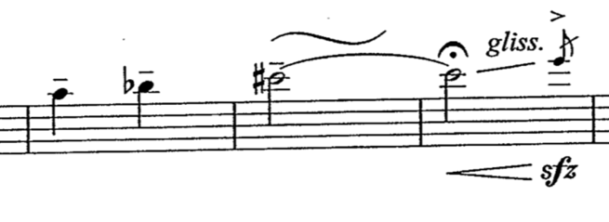
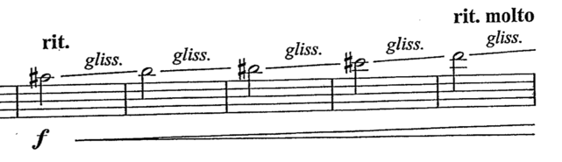
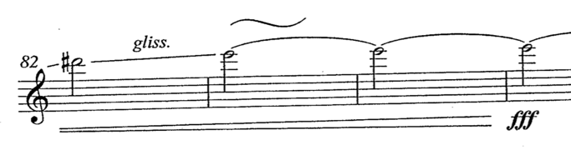
As noted, “Flüchtig” divides into three sections that vary slightly in V/H dominance. Nevertheless, the summary of all three sections depicts V/H3 dominance and therefore completes the multi-movement Slowing Down in Duft. These sections are separated by significant musical events. The first section (Section A) ends in m. 22 with a foreshadowing of the movement’s final ascent in mm. 77-84. (Examples 7 and 8) The closing ascent ends on the highest pitch of the movement. This pitch, D6, only occurs one other time in the movement, at the end of a fast glissando in m. 22. Due to its short duration, its appearance in m. 22 merely foreshadows the end. Section B begins at m. 23 and continues until the three-measure trill and decrescendo on F3 ending in m. 47. The final section (Section C) begins at m. 48 after this trill and decrescendo and continues until the end of the piece. Section C, as discussed earlier, contains almost exclusively multi-measure glissandi ascents.
Example 7: “Flüchtig.” Mm. 20-22, foreshadowing the final ascent
Example 8: “Flüchtig,” mm. 77-84, the final ascent
Section A contains four phrases with ascending contours on both local and global levels. Contour analysis helps show the local ascension, while segmentation leads to a global linear ascent. As seen in Table 1, each phrase contains a prime contour of <1,0,2>, except for the fourth phrase with a prime contour of <0,1>. Although <1,0,2> is a jagged contour, a closer look at the CSEGs of the first three phrases shows a more significant ascent from 1 to 2 than the descent from 1 to 0.

Phrase | Prime Contour | CSEG | CAS
1 (mm. 1-5) | <1,0,2> N=3 | <1,2,0,1,2,3,4,2,5,6,5,2,6,5,2,6,5,7> | <+,-,+,+,+,+,-,+,+,-,-,+,-,-,+,-,+>
2 (mm. 6-10) | <1,0,2> N=3 | <2,3,2,3,5,4,0,1,2,3,5,4,6,7,8,9,10,11,12,13,8,9,10,12,13> | <+,-,+,+,-,-,+,+,+,+,-,+,+,+,+,+,+,+,+,-,+,+,+,+>
3 (mm. 11-18) | <1,0,2> N=3 | <1,4,1,2,0,1,2,3,5,6,3,5,1,2,3,5,6,7> | <+,-,+,-,+,++,+,+,-,+,-,+,+,+,+,+>
4 (mm. 19-22) | <0,1> N=1 | <0,1,2,3,4,5,6> | <+,+,+,+,+,+>
The lowest note of these three phrases always appears towards the beginning of the phrase, and the first note of the phrase is only ever one or two notes higher in the contour. The last notes of the phrases are always the highest and have a minimum of five notes in between the lowest and highest notes of the contour. This close relation between the first notes and the lowest notes create a less significant descent than the ascent from the lowest notes to the last notes (highest notes) of the phrases. For example, the first phrase begins on 1, and its lowest point is 0 and highest point is 7. This shows a greater difference in the increase from 1 to 7 than the difference in the decrease from 1 to 0. Although CSEGs only show the number of notes in between, the score shows a minor second separating 1 and 0 and a minor ninth separating 1 and 7. Thus, while the CAS analyses of the first three phrases show somewhat jagged shapes, the phrases contain more ascending intervals than descending.
Table 1: “Flüchtig,” mm. 1-22, contour analysis for the first four phrases
Amongst these linear phrases, the first two phrases contain many semitones similar to the second movement. The first movement has motion between D#3-E3, A#3-B3, and D4-Eb4 with each of these semitones being interrupted by a leap to a G#3. Despite the leaps to G#3, the (01) segments occur in an ascending order, as shown through the CSEGs in Table 1. The second phrase contains fewer (01) segments and more major seconds and major and minor thirds. Similar to the first phrase, the arrangement of the intervals typically occurs in ascending order. The (01) segments create linear ascents similar to mm. 16-17 in “Blühend,” rather than composite melodies like the ones that dominant the second movement.
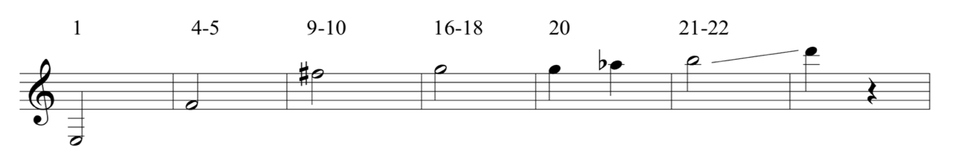
In addition to local ascents, the four phrases of Section A create a global linear ascent, as shown in Figure 8. The first three phrases end on F4, F#5, and G5, respectively, creating a semitone ascent with a single instance of octave displacement. The third phrase begins on a F#5 grace note leaping down to F4 and the middle of the phrase has another F#5 grace note leaping down to A4. These F# grace notes stick out due to the succeeding large intervals, and they further support to importance of F#5 before continuing the ascent to G5. To extend the ascent, the first note of the piece, E3, is included as the starting pitch. E3 is included because of its long duration (2.25 beats), fermata, and dramatic crescendo. The fourth phrase of section A uniquely continues the motion established by the first three phrases. Rather than only using the last note to contribute to the ascending line, the majority of the fourth phrase brings the ascent to its final height. Measure 19 contains a quarter-note triplet leading up to the G5 that ended the third phrase. The remainder of this phrase is included in Section A’s global ascent because it contains notes of long durations (1 beat or greater) compared to the sixteenth and thirty-second notes of the previous three phrases. The semitone ascent from G5 steps to Ab5 before leaping up to a B5 in m. 21. Despite this leap, the B5 contains slow pitch oscillations blurring the lines of the concrete pitch and filling in some of the leap. After the pitch oscillations are complete, the clarinetist sustains a B5 without vibrato and then completes the ascent to a D6 through a quick glissando. Globally, E3 ascends to D6 with octave displacement. The notes contributing to this ascent are not only important because they are the first or last notes of the phrases; they also hold the longest durations in their respective phrases. All of these notes are at least a quarter note long, but most are longer than a half note. The remainder of the phrases contain eighth notes, sixteenth notes, and notes of similar durations. Measures 13-14 contain the only note holding a similar duration that did not contribute to this ascent. After the second F#5 grace note in the third phrase, an A4 with a trill is held for four beats. This A could potentially be interpreted as working to fill in the leap between Ab5 and B5 in mm. 20-21, although it takes place before the ascent even reaches G. Another interpretation could hear this A as a neighbor tone to G5. With this reading, the F4 in m. 11 that lasts for 1.5 beats could complete a large-scale double neighbor between F-A-G. Either way this A is interpreted, it still occurs in the middle of the third phrase and is less significant than the G ending the phrase.
Figure 8: “Flüchtig,” Section A ascent with measure numbers
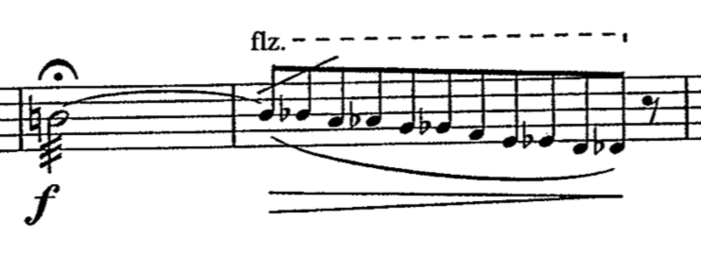
Section B (mm. 23-47) differs from the other two sections, because it contains a global descent (V/H3) and some V/H2 material. On a large-scale level, there is a descent from A4 in m. 25 down to F3 in m. 45. The notes that form this descent have a contextually-longer duration (1.5 beats or greater), contain a flutter tongue articulation, and lead to a chromatic local descent of grace notes in free meter accompanied with a decrescendo, as shown in Example 9. These notes are A4 in m. 25, Ab4 in m. 37 (repeated in m. 41 with a shorter duration), G4 in m. 42, and F3 in m. 45. The only other note with a duration of 1.5 beats or greater in section B is the C#4 in m. 44, which breaks up the octave displacement from G4 to F3. The last note is the only iteration that does not include a flutter tongue or end with a grace note descent. Instead of ending with the chromatic free meter descent, F3 lasts 2.75 measures with a trill instead of a flutter tongue. These modifications indicate the end of the section.
Example 9: “Flüchtig,” mm. 25-26, common material in Section B. The notes with contextually long durations and flutter tongue articulations form Section B’s global descent.
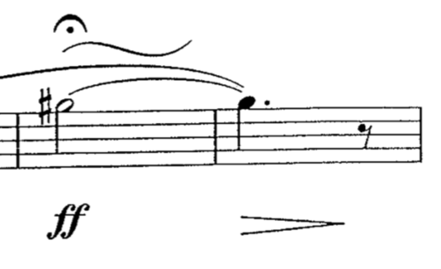
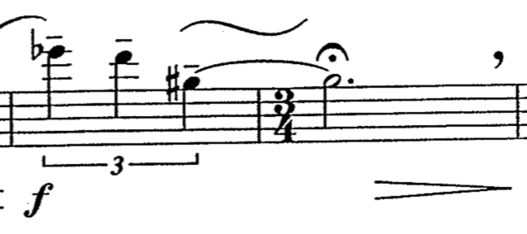
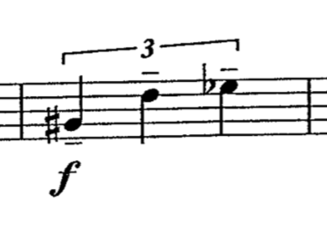
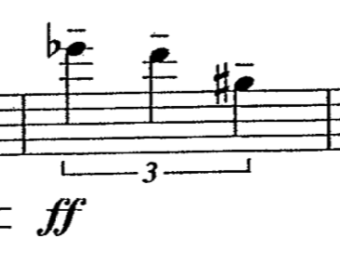
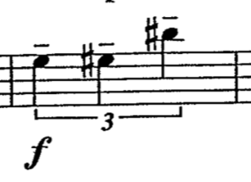
While a large-scale descent is a prominent feature of Section B, additional (01) segments and composite melodies challenge the idea of V/H3 dominance. The material creates ambiguous V/H dominance by recalling material from Section A and imitating the composite melodies of “Blühend.” The most notable reference to the Section A happens in mm. 32-33 when the phrase ends on F#5 with pitch oscillations and a fermata, as shown in Examples 10 and 11. This is almost identical material to mm. 9-10, a significant two measures in Section A’s ascent. Measures 32 and 36 also call back an important motive from Section A. As Example 12 shows, the quarter-note triplet in m. 19 of Section A contains a (016) pitch set class leading to the final ascent of the section. Example 13 shows the music in m. 36 is an exact retrograde of this motive displaced by an octave. Along with the retrograde, the contour changes from an ascending line (prime contour <0,1> N=1) to a descending line (prime contour <1,0> N=1). Measure 32 sets up the reference back to m. 9 (F#5 with pitch oscillations), while m. 36 leads to a continuation of the large-scale descent of Section B. Measure 27, shown in Example 14, has the same rhythm as mm. 19, 32, and 36, but uses a (015) set class instead of (016). Additionally, the intervallic cardinality of m. 27 is in retrograde compared to m. 19. The semitone occurs first, followed by a perfect fifth. Measure 27’s compressed motivic repetition and the two retrogrades support the ambiguity in Section B.
Example 10: “Flüchtig,” mm. 9-10 Example 11: “Flüchtig,” mm. 32-33
Example 12: “Flüchtig,” m. 19, (016) Example 13: “Flüchtig,” m. 36, (016)
Descending
(This material is repeated in m. 32. See Example 5)
Example 14 Measure 27 (015)

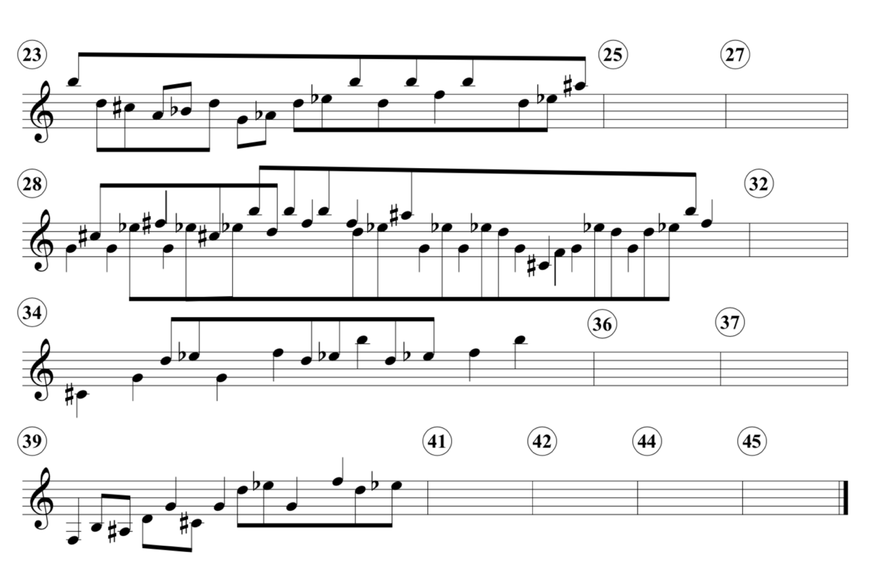
To briefly summarize, Section A aligns the (01) segments into a linear ascent leaning more towards a singular voice, while Section B acts similarly to “Blühend” with its creation of composite melodies. Figure 9 depicts the composite melodies in Section B. Although there are many (01) segments separated by wide intervals, Figure 9 shows many more interruptions to the composite melodies than in “Blühend.” The (01) segments are beamed together in Figure 9, while the quarter-notes show the notes that do not belong to a (01) segment. An empty measure represents an event that either contributes to the global descent discussed earlier or repeats material from Section A. Although this style change in Section B uses techniques from the previous movement, the section continues to show some progress towards V/H3 through the interruptions to composite melodies, the descent, and the references back to Section A through pitch oscillations and retrograded quarter-note triplets.
Figure 9: “Flüchtig,” mm. 23-47, composite melodies in Section B

Section C (mm. 48-87) of “Flüchtig” has the most prominent V/H3 dominance. This section contains four multi-measure, slow-paced glissandi and two shorter glissandi. Dissimilar to the previous two movements’ multiple voices, these glissandi create a single voice in a linear ascent. Saariaho pairs these instances of V/H3 (glissandi) with V/H2 material. Determined by the component’s lengths, this pairing begins with V/H2 dominance and transitions back to V/H3 dominance.
Each of the six phrases in Section C begins with 1-3 measures of composite melody material (semitones separated by wide intervals), followed by 1-6 measures of a glissando. Although mm. 48-53 follow this pattern, the glissandi are short in duration (one measure or less). Due to the glissandi’s brevity, the composite melodies (V/H2) hold more dominance. Section C still includes these six measures due to the pattern of their material, but mm. 48-53 serve more as a transition from Section B’s ambiguity back to V/H3 dominance. The glissandi in the last three phrases (mm. 54-87) are longer in duration and louder in dynamic than their paired composite melodies, which solidifies the V/H3 dominance and the completion of the multi-movement Slowing Down.
Additionally, the notes of the glissandi in Section C correlate with the ascent of Section A. The relationships between these two ascents further support the interpretation of mm. 48-55 function as transitional material before the completed ascent. Furthermore, the correlation retroactively supports the contour analysis of Section A leading to V/H3 dominance. Measure 49, the first glissando in Section C, begins where the third phrase of Section A ended, G5. The transitional section ascends to G#5 by m. 50, and m. 53 repeats this G#5 arrival. Measure 53 also begins the ascending glissando one semitone lower than the glissando in m. 49. This descent continues down to E5 in m. 56, which is the beginning of the V/H3 dominance in Section C. Measure 56 is also the first time the beginning of the ascents returns to where the Section A ascent began, E. The repeated E5 grace notes in mm. 59-60 stand out from the rest of the measures’ material because of the large, descending leaps that follow the grace notes. These repetitions of E5 further emphasize the return of Section A’s ascent. Measures 61-65 repeat the glissando from mm. 56-58 with added duration and pitch oscillations on the last note. Similar to the repeated E5 grace notes, the repetition of the glissando that began V/H3 dominance and the added emphasis supports the existence of transitional material and m. 54 as the beginning of V/H3 dominance. The glissando in the penultimate phrase begins one semitone lower than the Section A ascent on D#5. Since this is not a boundary phrase of Section C, it can either be interpreted as a lower neighbor or an expansion of Section C’s global ascent to further emphasize its finality. After more repeated E5 grace notes in m. 76, the final glissando begins where every previous one in Section C ended, G#5, and ascends to the final D6, which is the highest note of any glissando. The final D6 lasts for five measures and includes variations in pitch oscillations and straight tone, a fortississimo dynamic (the loudest in the entire pieces), and a fermata.
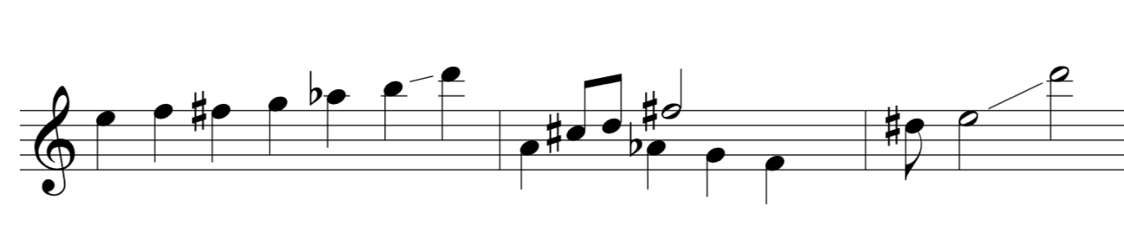
The final ascent signifies the dominance of V/H3 despite the ambiguity presented in Section B. The movement-long ascent in “Flüchtig” is outlined in Figure 10. Here one can see how “Flüchtig” begins on E3 and ascends through F4 in m. 4, F#5 in m. 9, and G5 in mm. 16-17. Measures 19-22 then foreshadow the final ascent though a short glissando. Section B contradicts the ascent through a large-scale descent and (01) segments, but it also includes signifying events (mm. 32-33, 36) as reminders of the move towards V/H3. After some transitional material that descends back to the beginning of Section A’s ascent with octave displacement, the large-scale ascent returns at m. 56. Each local ascent in Section C continues up to G#. This G# maintains through its repetitions until it begins the final ascent in m. 77. The final phrase ascends from G# to D6.
Figure 10: “Flüchtig,” summary of ascents, descents, and interruptions

On a local level, Section C’s surface material varies greatly from that of Section A. Although there are a few short, repeated figures from Section A and Section B, there is no “return” of Section A. Despite these surface-level differences, both Section A and Section C create almost-identical ascents. Because of this repetition, it is appropriate to change the final section to Section A’ on a global level. This creates an ABA’ form for “Flüchtig.”
V/H3 Dominance in “Flüchtig”
In “Flüchtig,” Section A and Section C contain both local and global ascents. Section A shows local ascents on the phrase-level, shown through contour analysis, and a global ascents of the phrases’ boundary notes. Section C contains several multi-measure glissandi, local ascents, and the boundary notes of these glissandi repeat the global ascent from Section A. Additionally, Section B outlines a global decent (V/H3). These local and global ascents and Section B’s global descent fall into the V/H3 category as primarily horizontal motion. Since these sections cover the majority of the movement, “Flüchtig” contains V/H3 dominance.
Although V/H3 dominates this movement, “Flüchtig” also has some subsidiary V/H2 material. Section B contains some brief composite melodies, and Section A’s linear melodies comprise of (01) segments. Although Section A’s (01) segments are examples of V/H2, they contribute to the general ascent of the phrases. Since the V/H3 material encompasses the majority of the movement and the V/H2 material is secondary, “Flüchtig” completes with multi-movement Slowing Down with V/H3 dominance.

Conclusion: Multi-Movement Slowing Down in Duft
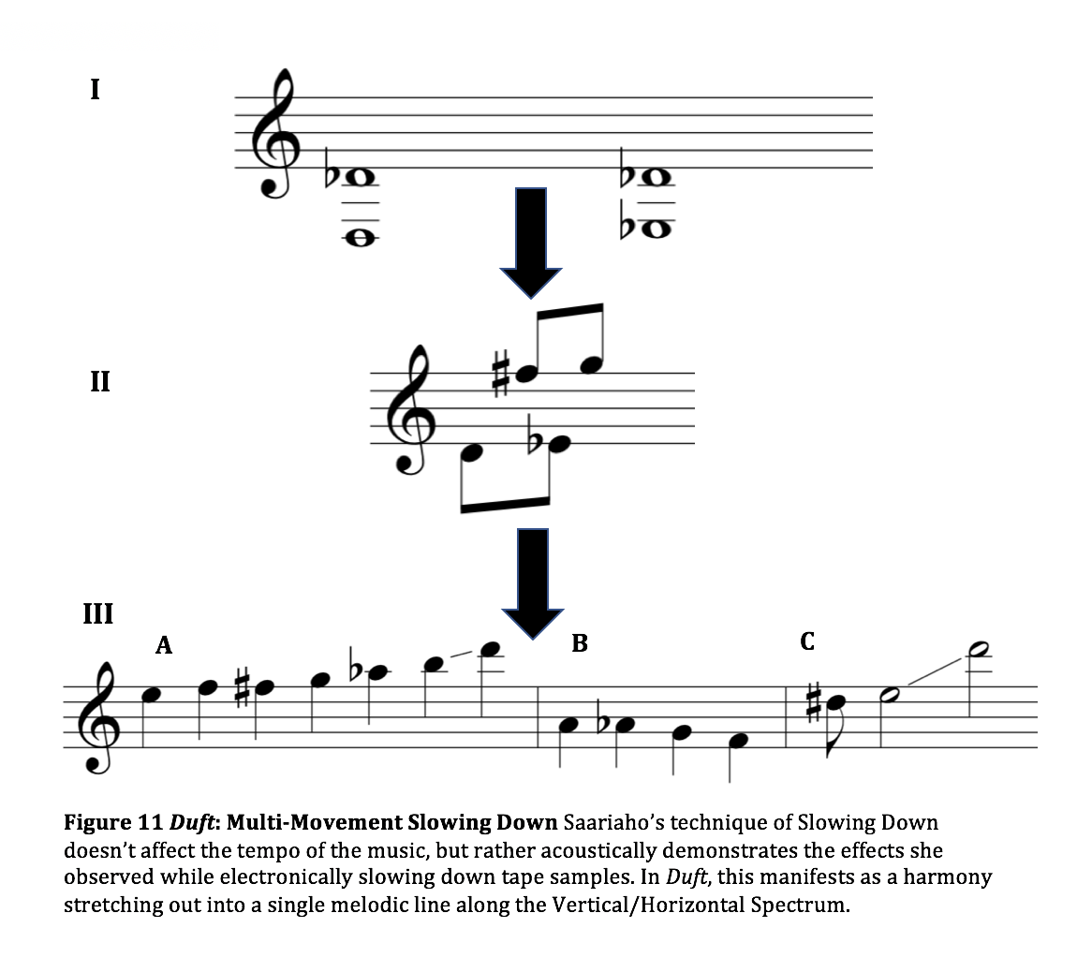
This analysis demonstrates Saariaho’s unique compositional style through the presence of a multi-movement Slowing Down in Duft. In order to concretely determine the process of Slowing Down, I created the Vertical/Horizontal Spectrum, which categorizes musical material from vertical harmonies to linear melodies. Figure 11 summarizes the multi-movement linear motion along the Vertical/Horizontal Spectrum. The first movement, “Blütenstaub,” displays V/H1 dominance through simultaneous notes or simulated simultaneity often achieved through extended techniques. “Blühend” shifts to V/H2 dominance with composite melodies and alludes to V/H3 through temporary linear ascents and descents. The final movement, “Flüchtig,” completes the large-scale Slowing Down through its move to V/H3 dominance. Despite this dominance, the movement begins with two sections that contain instances of V/H2, which creates an even smoother transition between V/H2 and V/H3. This linear motion through the V/H Spectrum (V/H1-V/H2-V/H3) outlines a multi-movement Slowing Down in Duft, and local-level instances of V/H ambiguity create more gradual transitions along the spectrum.
Additionally, local-level examples of Slowing Down and transitions along the Sound/Noise Axis further demonstrate the influence of Saariaho’s computer music research on her acoustic, solo instrument compositions. Considering these local instances of Slowing Down, the large-scale Slowing Down over the first movement, and the multi-movement Slowing Down across the piece, it is apparent that Saariaho’s compositional approach appears on many levels of analysis.
Saariaho’s unique compositional style, which developed through years of education, research, and composition, embraces her ideas of Slowing Down and the Sound/Noise Axis. Duft was composed nearly three decades after Saariaho began her work at IRCAM. Despite her compositional growth over this time, her music still exhibits influence from her research in the 1980s. With the presence of Saariaho’s compositional approaches in Duft, the composer’s self-proclaimed end to a compositional period in 1990 may not be as sharply defined as she intended.

Bibliography

Beyer, Anders. “Kaija Saariaho: Colour, Timbre, and Harmony.” In The Voice of Music: Conversations with Composers of Our Time, edited and translated by Jean Christensen and Anders Beyers, 301–315. Aldershot, England: Ashgate Publishing Limited, 2000.

Ellison, Cori. “Uncovering Beauty in Ordinary Noise.” The New York Times, November 7, 1999. http://www.nytimes.com/1999/11/07/arts/music-uncovering-beauty-in-ordinary-noise.html?pagewanted=all.

Friedmann, Michael. “A Methodology for the Discussion of Contour: Its Application to Schoenberg’s Music.” Journal of Music Theory 29, no. 2 (Autumn 1985): 223–248.

Marvin, Elizabeth West, Paul Laprade. “Relating Musical Contours: Extensions of a Theory for Contour.” Journal of Music Theory 31, no. 2 (Autumn 1987): 225–267.

Moisala, Pirkko. Kaija Saariaho. Urbana: University of Illinois Press, 2009.

Rafailidis, Dimitrios, Alexandros Nanopoulos, Yannis Manolopoulos and Emilios Cambouropoulos. “Detection of Stream Segments in Symbolic Musical Data.” International Society of Music Information Retrieval (2008): 83–88.

Saariaho, Kaija. Duft. London, England: Chester Music Ltd, 2012.

Saariaho, Kaija. “Timbre and Harmony: Interpolations of Timbral Structures.” Music and Psychology 2, no. 1 (1987): 99–133.

Schultz, Rob. “Melodic Contour and Nonretrogradable Structure in the Birdsong of Olivier Messiaen.” Music Theory Spectrum 30, no. 1 (2008): 89–137.
Service, Tom, and Kaija Saariaho. “Meet the Composer: Kaija Saariaho in Conversation with Tom Service.” In Kaija Saariaho: Visions, Narratives, Dialogues, edited by Tim Howell, Jon Hargreaves, and Michael Rofe, 3–14. Surrey, England: Ashgate Publishing Limited, 2011.

Sirota, Nadia. “Kaija Saariaho: Ears Open.” Meet the Composer podcast, 1:31. Posted July 29, 2015. http://www.wqxr.org/#!/story/kaija-saariaho-mtc-ears-open/.

Tom Service, and Kaija Saariaho, “Meet the Composer: Kaija Saariaho in Conversation with Tom Service,” in Kaija Saariaho: Visions, Narratives, Dialogues, ed. Tim Howell, Jon Hargreaves, and Michael Rofe, (Surrey, England: Ashgate Publishing Limited, 2011), 3–14.
Cori Ellison, “Uncovering Beauty in Ordinary Noise,” The New York Times, November 7, 1999, http://www.nytimes.com/1999/11/07/arts/music-uncovering-beauty-in-ordinary-noise.html?pagewanted=all.
Pirkko Moisala, Kaija Saariaho, (Urbana: University of Illinois Press, 2009), 10–11.
Georgina Born’s Rationalizing Culture provides a context for Saariaho’s experiences and opportunities at IRCAM. Although Saariaho worked at IRCAM during the years the book discuss, she is not mentioned once in the entire book. However, there is a picture of her at IRCAM on page 222 where the caption neglects to provide her name.
I have capitalized this term to distinguish between the compositional approach and the common description of a musical tempo slowing down.
I have capitalized the terms Slowing Down, Sound/Noise Axis, and Network of Textures to make it clear that these are the compositional approaches Saariaho developed.
Kaija Saariaho, “Timbre and Harmony: Interpolations of Timbral Structures,” Music and Psychology 2, no. 1 (1987): 99–133.
Moisala, 10–11.
Ibid.
Ibid., 11–12.
Saariaho, “Timbre and Harmony,” 104–5.
Ibid., 107–23.
Ibid.
Nadia Sirota and Alexander Overington, Kaija Saariaho: Ears Open, Meet the Composer podcast, 1:31, Posted July 29, 2015. http://www.wqxr.org/#!/story/kaija-saariaho-mtc-ears-open/.
Ibid.
Saariaho, “Timbre and Harmony,” 94.
Ibid.
Ibid., 104.
Anders Beyer, “Kaija Saariaho: Colour, Timbre, and Harmony,” in The Voice of Music: Conversations with Composers of Our Time, trans. and ed. Jean Christensen and Anders Beyers, (Aldershot, England: Ashgate Publishing Limited, 2000), 307–8.
Kaija Saariaho, Duft, London, England: Chester Music Ltd, 2012.
All examples from Duft are in treble clef and written in Bb. To transpose to concert pitch, move written pitches down one whole step.
All pitches in prose refer to concert pitch. To transpose to the corresponding written pitch for clarinet, move up one whole step.
Saariaho, “Timbre and Harmony,” 194.
This number does not account for the 2 measures that contain grace notes but do not have V/H1 for the entirety of the measures.
Dimitrios Rafailidis, Alexandros Nanopoulos, Yannis Manolopoulos and Emilios Cambouropoulos, “Detection of Stream Segments in Symbolic Musical Data,” International Society of Music Information Retrieval (2008): 83–8.
Rafailidis 84.
Ibid., 83.
Ibid., 84. Emphasis mine.
Grace notes not shown in Figure 7.
Saariaho, Duft.
Prime Contours are discussed at length in “Flüchtig” analysis.
Rob Schultz, “Melodic Contour and Nonretrogradable Structure in the Birdsong of Olivier Messiaen,” Music Theory Spectrum 30, no. 1 (2008): 89–137.
Ibid.
Michael Friedmann, “A Methodology for the Discussion of Contour: Its Application to Schoenberg’s Music,” Journal of Music Theory 29, no. 2 (Autumn 1985): 223–48.
Elizabeth West Marvin and Paul Laprade, “Relating Musical Contours: Extensions of a Theory for Contour,” Journal of Music Theory 31, no. 2 (Autumn 1987): 225–67.
Schultz, 108.
Marvin, 225–6.
These measures omit initial grace notes before beat 2 of m. 11. The grace notes serve as a continuation or reminder of the end of the second phrase.

