University of Oklahoma

Graduate College

Characterization of Fungal contaminants in b20 biodiesel storage tanks and their effect on fuel composition

A thesis

submitted to the Graduate Faculty

in partial fulfillment of the requirements for the

Degree of

Master of Science

By

ODERAY ANDRADE ELJURI
Norman, Oklahoma
2016

Characterization of Fungal contaminants in b20 biodiesel storage tanks and their effect on fuel composition

A thesis approved for the
Department of Microbiology and Plant Biology

By

______________________________
Dr. Bradley Stevenson, Chair

______________________________
Dr. Amy Callaghan

______________________________
Dr. Boris Wawrik

© Copyright by oderay andrade eljuri 2016
All Rights Reserved.

“Science is more than a body of knowledge. It is a way of thinking; a way of skeptically interrogating the universe with a fine understanding of human fallibility.”
-Carl Sagan

To Matias. You are my candle in the dark.

To Sebastian and Adrian. My biggest dream is to be part of your adventures and accomplishments, as you are being part of mine.

Acknowledgements
First, I would like to thank the Secretariat for Higher Education, Science, Technology and Innovation of the Republic of Ecuador “SENESCYT”, for granting me with a scholarship to study abroad.

I would like to express my gratitude to my advisor, Dr. Bradley S. Stevenson. Thank you for giving me the opportunity to be part of the Stevenson Research Group. Your office door was always open when my questions and doubts arose. Your love for Microbiology is an inspiration.

I would like to acknowledge my laboratory colleagues: Blake Stamps, Brian Bill, Heather Nunn and James Floyd. Our lives crossed paths in this fascinating journey through Microbiology, and from you all I learned how the ‘circle of niceness’ works. Thank you Blake, for the fuel collection and support on the isolation of the microorganisms and fuel characterization. James, thank you for the assistance in the preparation and viewing of scanning microscope images. Heather, thank you for all of your advice on developing my experimental designs. Brian, I am indebted to your valuable comments and constant feedback during the writing process of this thesis. Special thanks goes to Matias Robayo, for his tireless and skillful collaboration in the statistical analysis.

Funding for this project was provided by the COP Technical Corrosion Collaboration grant #FA7000-15-2-0001.

Table of Contents
Acknowledgements iv
List of Tables vii
List of Figures viii
Abstract x
Chapter 1: Problem Statement 1
Chapter 2: Characterization of Fungal Contaminants from B20 Storage Tanks 9
2.1 Introduction 9
2.2 Materials and Methods 14
2.2.1 Sample Collection and Cultivation 14
2.2.2 Molecular Identification of Fungal Isolates 15
2.2.3 Phenotypic and Biochemical Characterization 17
2.2.4 Chemotaxonomic Characterization 19
2.2.5 B20 Biodegradation Experiments with Fungal Isolates 19
2.3 Results 21
2.3.1 Isolation 21
2.3.2 Characterization of the Filamentous Fungus Byssochlamys (strain ID: SW2) 21
2.3.3 Characterization of the Yeast Wickerhamomyces (strain ID: SE3) 22
2.3.4 Fungal Biodegradation of B20 biodiesel 23
2.4 Discussion 26
Chapter 3: Chemical Analysis of B20 Biodiesel Fuel Exposed to Contaminated Underground Storage Tanks and its Correlation to Fungal Biodegradation 49
3.1 Introduction 49
3.2 Materials and Methods 52
3.2.1 Sampling and GC/MS data collection 52
3.2.2 Chromatographic Data Analysis 53
3.2.3 Fungal Biodegradation Classification Model 54
3.3 Results 56
3.3.1 Characterization of the Composition of B20 Fuel Samples 56
3.3.2 Fungal Biodegradation Model 57
3.4 Discussion 59
Chapter 4: Summary and Future Directions 73
References 77

List of Tables

Table 2.1 Identity and provenance of isolated fungi. 34
Table 2.2 Physiological characteristics of Wickerhamomyces anomalus SE3. 38
Table 2.3 Physiological characteristicsª of Byssochlamys sp. SW2 39
Table 3.1 Common fatty acid methyl esters found in biodiesel ^{a.} 64
Table 3.2 Retention times of major peaks identified in B20 fuel samples. 66
Table 3.3 Principal component analyses (PCAs) of global B20 fuel dataset. 67
Table 3.4 Description of the test set of B20 samples obtained from SE facility and used to validate the LDA model. 71

List of Figures

Figure 1.1 Transesterification reaction scheme to produce biodiesel 3
Figure 1.2 Images of B20 fuel samples obtained from a storage tank at a USAF facility 5
Figure 1.3 Fungal communities detected at the bottom of storage tanks 6
Figure 2.1 Morphology of Byssochlamys sp. SW2 and Wickerhamomyces anomalus SE3 35
Figure 2.2 Maximum Likelihood tree based on 28S rRNA sequence phylogeny of the yeast Wickerhamomyces anomalus SE3 and its close relatives 36
Figure 2.3 Maximum Likelihood tree based on 28S rRNA sequence phylogeny of the filamentous fungus Byssochlamys sp. SW2 and its close relatives 37
Figure 2.4 Degradation of FAME in B20 biodiesel after 7 days of incubation with isolates Wickerhamomyces anomalus SE3 and Byssochlamys sp. SW2 40
Figure 2.5 Degradation of hydrocarbons in B20 biodiesel after 7 days of incubation with isolate Wickerhamomyces anomalus SE3 41
Figure 2.6 Growth curve for Wickerhamomyces anomalus SE3 in ASW medium containing B20 biodiesel as sole carbon source 42
Figure 2.7 Degradation of FAME in B20 biodiesel after 30 days of incubation with isolate Byssochlamys sp. SW2 43
Figure 2.8 Representative total ion chromatograms of aqueous phase after 80 days of biodegradation of B20 with isolate Byssochlamys sp. SW2. 44
Figure 2.9 Effect of temperature on growth of the yeast Wickerhamomyces anomalus SE3 45
Figure 2.10 Effect of pH on growth of the yeast Wickerhamomyces anomalus SE3 46
Figure 2.11 Effect of temperature on growth of Byssochlamys sp. SW2 47
Figure 2.12 Effect of pH on growth of the Byssochlamys sp. SW2 48
Figure 3.1 Representative total ion chromatogram (TIC) obtained from a B20 fuel sample 65
Figure 3.2 3-dimensional ordination of B20 fuel samples by principal components (PC) 1, 2 and 3. 68
Figure 3.3 Proportion of 16 major compounds of B20 found in unexposed fuel samples 69
Figure 3.4 Score plot for the first two linear discriminant factors of biodegradation patterns obtained after incubation of Byssochlamys sp. SW2 in B20 fuels. 70
Figure 3.5 LDA prediction plot containing data from the test set samples. 72

Abstract

The liquid transportation fuel B20 biodiesel is an 80:20 blend of petroleum-derived ultra-low sulfur diesel (ULSD) and biodiesel. Although B20 biodiesel represents a fungible fuel with a reduced carbon footprint compared to petroleum diesel, it is more susceptible to microbial contamination and biodegradation. The research described in this thesis characterized the numerically abundant fungi responsible for fouling in B20 biodiesel storage tanks. This work also investigated the effect of microbial contamination and proliferation on B20 biodiesel composition. Fungi from the genera Wickerhamomyces and Byssochlamys were abundant in the B20 storage tanks that were monitored in this study. Members of the yeast Wickerhamomyces anomalus SE3 and the filamentous fungus Byssochlamys sp. SW2 that represent the major taxa in B20 storage tanks were isolated and characterized for their ability to degrade components of B20 biodiesel. Both Wickerhamomyces anomalus SE3 and Byssochlamys sp. SW2 were able to use B20 biodiesel as sole carbon and energy source. We show that the presence of Byssochlamys sp. SW2 can alter the composition in B20 biodiesel in storage tanks, and we offer a model for predicting the severity of biodegradation. Byssochlamys sp. SW2 preferentially degraded palmitic and linoleic acid methyl esters, and our in situ model supports the hypothesis that palmitic and linoleic acid methyl esters are the most susceptible components to biodegradation. We suggest the use of alternative feedstocks containing less palmitic and linoleic acid for B20 biodiesel production to increase fuel stability in storage tanks.

Chapter 1: Problem Statement

The energy demand of a globalized, increasing world population is rising quickly. Worldwide energy consumption is projected to increase 1.4% per year (Sieminski, 2014) from 549 quadrillion British Thermal Unit (BTUs) in 2012 to 815 quadrillion BTUs in 2040. Fossil fuels, including petroleum, coal and natural gas, account for more than three-quarters of the world’s total energy consumption (DOE, 2016). The United States (U.S.) is the largest consumer of petroleum using approximately 19 million barrels per day in 2014, and projected to increase 1% per year (EIA, 2016a).

The Department of Defense (DoD) is the largest single consumer of energy in the U.S., with the Armed Forces purchasing 32.0 billion gallons of petroleum at a cost of $107.2 billion, from 2007 to 2014 (GAO, 2015). This represents approximately 1.9% of total annual U.S. petroleum consumption (EIA, 2016a), with the Air Force (USAF) accounting for 48% of the total DoD energy consumption (USAF, 2013). The reliance on fossil fuel has led to concerns mainly related with energy security (Leiby, 2007) and environmental hazards (Kharaka & Dorsey, 2005). The DoD has focused on the use of alternatives to petroleum-based liquid transportation fuels in order to increase its use of renewable, reliable, and clean energy sources (Congress, 2005).

The DoD has established the technical, economic and environmental requirements for any alternative fuel to be included in their portfolio (Blakeley, 2012). Technically, the fuel must be fungible or “drop-in”, meaning that it requires no modification to existing engines and infrastructure. Any alternative fuel must also be cost-competitive with petroleum fuels, as well as environmentally sustainable, derived from feedstocks that do not affect the food market, and fulfill regulatory initiatives to reduce greenhouse emissions. The USAF has selected Ethanol E85 (85% ethanol and 15% gasoline) and B20 biodiesel (20% biodiesel and 80% Ultra Low Sulfur Diesel) for displacing gasoline and diesel, respectively (DOD, 2007). Both biofuels are used in non-tactical vehicles as part of a USAF goal for reducing in 2% the annual petroleum consumption for vehicles through 2020 (DOD, 2011).

The majority of the USAF biofuel consumption was B20,, and by year 2011, more than 60 bases were dispensing it (DOD, 2011). Biodiesel is a “fuel comprised of mono-alkyl esters of long chain fatty acids derived from vegetable oils or animal fats” (ASTM-D7467-15, 2015). Biodiesel is produced by converting a triglyceride feedstock to fatty acid methyl esters (FAME) through a base-catalyzed transesterification reaction (Fig. 1.1) (Knothe, Krahl, & Van Gerpen, 2015). During this process, byproducts are produced including glycerol, soaps and water which are removed to obtain neat biodiesel (B100) (Hoekman, Broch, Robbins, Ceniceros, & Natarajan, 2012). Soybeans represent the feedstock most commonly used in 90% of U.S. production followed by corn oil, canola, and animal fats (EIA, 2016b). However, there is an increased interest in non-food feedstocks like jatropha (Sarin, Sharma, Sinharay, & Malhotra, 2007) and microalgae (Ahmad, Yasin, Derek, & Lim, 2011; Chen et al., 2015) for future commercialization. The triglyceride feedstocks represent renewable sources of energy and the fuel produced with them biodegradable (Jakeria, Fazal, & Haseeb, 2014).
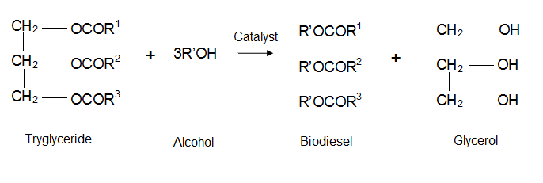

Figure 1.1 Transesterification reaction scheme to produce biodiesel (Adapted from Knothe, 2008) R1, R2, R3 represent the hydrocarbon chains of the parental triglyceride. R’ present the alkyl radical of the used alcohol.

Neat biodiesel can be blended in any proportion to petroleum diesel (Weiksner, Crump, & White, 2008), but B20 is the most commonly used blend in the U.S. (AFDC, 2016) due to several advantages (AFDC, 2016). Specifically, B20 is compatible with existing diesel engines and infrastructure, while contributing with the engine power and increasing the fuel efficiency (Lahane & Subramanian, 2015). B20 has better tolerance to cold weather than higher blends (Knothe et al., 2015), and presents a good balance between gas emissions and costs (NREL, 2009).

Despite its advantages, the stability of biodiesel and, therefore B20 presents several technical problems (Jakeria et al., 2014; Pullen & Saeed, 2012). FAMEs in biodiesel increase its oxygen content and hygroscopic nature compared to the hydrocarbons in petroleum based ULSD. This makes biodiesel oxidatively unstable (Pullen & Saeed, 2012) and susceptible to microbial contamination especially during mid and long term storage (Knothe et al., 2015; Lee, Ray, & Little, 2010; Zuleta, Baena, Rios, & Calderón, 2012). Uncontrollable microbial growth in B20 fuel systems increases the presence of flocculent material along with sludge formation and fouling of fuel probes (Chao, Liu, Zhang, & Chen, 2010; Passman, 2003). Consequences of microbial metabolism of FAMEs (Jakeria et al., 2014; Schleicher, Werkmeister, Russ, & Meyer-Pittroff, 2009) include water formation and biodegradation of the fuel (Knothe et al., 2015). Ultimately, the properties and quality of the fuel are altered.

We have studied the B20 fuels from underground storage tanks at several Air Force Bases, both with and without reported issues with fuel quality (color, clarity, particulates, Fig 1.2) reported by operators (Dr. Wendy J.Crookes-Goodson, personal communication). Fuels of compromised quality from two different AFBs (SE and SW) had substantial microbial contamination believed to be the root cause of reported issues. Molecular characterization of the microbial assemblages showed that these fuels harbored an abundance of biomass from the fungal classes Eurotiomycetes (genus Byssochlamys) and Saccharomycetes (genus Wickerhamomyces).

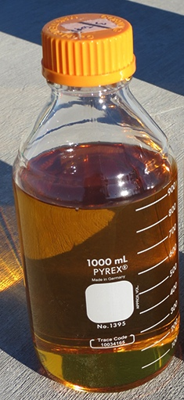

Figure 1.2 Images of B20 fuel samples obtained from a storage tank at a USAF facility. Yellow and bright fuel obtained prior exposure to the tanks (left) and fuel obtained from the bottom of a tank experiencing water and fouling problems (right). Flocculent material present in the interface between fuel and water (right).

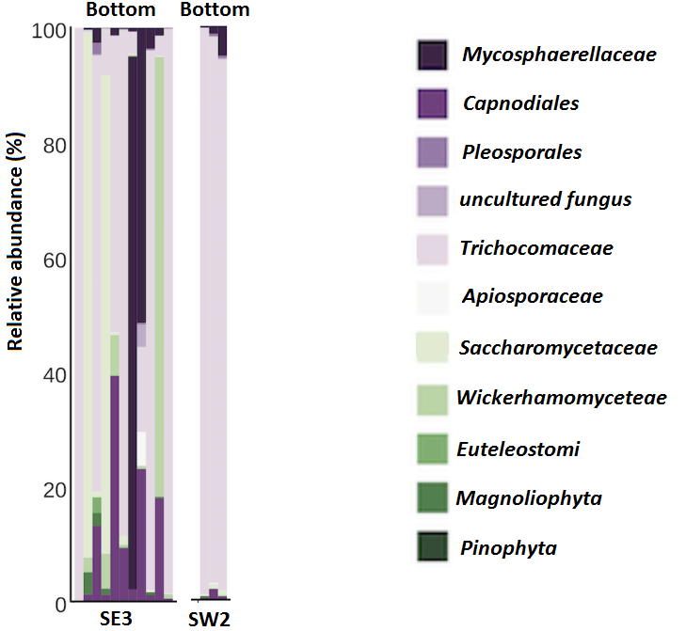

Figure 1.3 Fungal communities detected at the bottom of storage tanks (Adapted from Stamps, 2016). Relative abundance of fungal families in B20 storage tanks at two different locations (SE and SW) based on amplified 18S rRNA gene libraries.

Members of the fungal genera Byssochlamys and Wickerhamomyces are ubiquitous (Passoth, Fredlund, Druvefors, & Schnürer, 2006; Samson, Houbraken, Varga, & Frisvad, 2009). Members from the genus Byssochlamys are commonly found in fruits and soil (Kotzekidou, 1999), and are usually associated with spoilage of heat-processed foods (Samson, Houbraken, Varga, & Frisvad, 2009). Members from the genus Wickerhamomyces exhibit wide metabolic and physiological diversity (Passoth, Fredlund, Druvefors, & Schnürer, 2006) and have been frequently isolated in natural habitats like plants, fruits and insects (Walker, 2011).

Members from both fungal genera have been detected in fuel systems (Bücker et al., 2011; Gassen et al., 2015; Rauch et al., 2006), although they have not been extensively characterized. A detailed study of individual fuel contaminants is only recommended when the microbial organism is abundant and its analysis can provide insight on the sources of contamination (Hill & Hill, 2008) and/or the susceptibility of the fuel to its growth (Cazarolli et al., 2014; Sheridan, Nelson, & Tan, 1971).

The present research sought to identify and characterize the abundant fungal contaminants from B20 fuel storage tanks at two Air Force bases, and determine whether their presence was correlated with fuel degradation. In Chapter 2, the isolation and detailed characterization of the members of the genera Byssochlamys and Wickerhamomyces is described. Also, their ability to degrade B20 fuel as a sole carbon and energy source is analyzed. This information is used to discuss their ecological predominance in the tanks. In Chapter 3, the chemical composition of B20 fuel samples obtained from the contaminated storage tanks is analyzed. The exploration of patterns of fungal biodegradation in the samples is discussed. This information was then used to evaluate the susceptibility of the B20 biodiesel to fungal contamination. Moreover, these results were applied to the development of a statistical tool useful to monitor biodegradation of the fuel.

Chapter 2: Characterization of Fungal Contaminants from B20 Storage Tanks

2.1 Introduction

Biodiesel is composed of fatty acid methyl esters (FAMEs) converted from the fats and oils of various plant and animal feedstocks (ASTM-D7467-15, 2015). Blends of biodiesel, such as B20, which is composed of 20% FAMEs and 80% Ultra Low Sulfur Diesel (ULSD), have the advantage of retaining most of the properties of petroleum diesel but at the same time having a lower carbon footprint (Knothe et al., 2015). Due to its composition, biodiesel is much more biodegradable than petroleum diesel (Mariano, Tomasella, De Oliveira, Contiero, & De Angelis, 2008; Peterson & Moller, 2005). This can be an advantage when there is a spill of biodiesel, but it is also a drawback when microorganisms that can degrade biodiesel colonize storage tanks (Passman, 2013). All grades of fuels are susceptible to microbial growth (Dodos, Konstantakos, Longinos, & Zannikos, 2012; Hill & Hill, 2008; Leja & Broda, 2009; Rauch et al., 2006), but with the introduction of unleaded gasoline, ultra-low sulfur diesel and alternative fuels, microbial contamination and proliferation during storage has become more frequent and severe (Hill & Hill, 2008).

The susceptibility of a fuel to microbial contamination depends on its composition, especially when they provide a source of macro and micronutrients needed for growth (Gaylarde, Bento, & Kelley, 1999). The FAMEs in biodiesel are a readily available source of carbon and energy (Prince, Haitmanek, & Lee, 2008). Coupled with the hygroscopic nature of the biodiesel (Fregolente, Fregolente, & Wolf Maciel, 2012) and the sub-inhibitory concentrations of sulfur in ULSD (Ali, Ghaloum, & Hauser, 2006; Londry & Suflita, 1998), B20 biodiesel blends are particularly prone to contamination and proliferation compared to fossil fuels (Bücker et al., 2011; Dodos, Konstantakos, Longinos, & Zannikos, 2012; Zimmer et al., 2013).

Microorganism can be introduced to the fuel distribution systems soon after the refinery processes (ASTM:D6469, 2003). During normal operations, fuel transfers out of storage tanks increase the risk of microbial contamination (Engelen, 2009; Passman, 2013) because air/water vapor is pulled from outside the tanks, through vents, to compensate for the vacuum caused by the fuel removal. Microorganisms are easily dispersed through atmospheric circulation (Nemergut et al., 2013) and contaminate the storage tanks when attached to particles, dust, and pollen from proximal soils (Rauch et al., 2006).

Any B20 storage tank contains multiple habitats, each with unique selective pressures (Passman, 2003). At the fuel-water interface, aerobic and facultative microorganism will thrive (Engelen, 2009). In this zone, water, nutrients and oxygen are available to support biofilm formation (Lee et al., 2010), both in the fluid as well as on tank walls (Passman, 2003). Fuel degraders will metabolize FAMEs (Bücker et al., 2011; Prince et al., 2008) through enzymatic hydrolysis and subsequent beta-oxidation. (Jakeria et al., 2014; Kumari & Gupta, 2014) Organic acids and other byproducts can serve as nutrient sources for other microorganisms (Hill & Hill, 2008). The co-metabolism of hydrocarbon in biodiesel/petroleum diesel blends is also possible (Pasqualino, Montane, & Salvado, 2006; Zhang, Peterson, Reece, Haws, & Möller, 1998). Anaerobic microorganisms will be present in the bottom of the tanks, where oxygen is usually depleted. The anaerobic metabolism of FAME will include hydrolysis (Lapinskienė & Martinkus, 2007) and β-oxidation (Sousa, Smidt, Alves, & Stams, 2009). Under these conditions, the weak organic acids along with electro-potential gradients can accelerate the rate of biocorrosion (Aktas et al., 2010).

We have monitored B20 biodiesel storage tanks at two USAF facilities since 2014. These installations have experienced recurrent filter clogging (fouling), presence of water, particulates, and increased rates of corrosion (Stamps, 2016). Microscopy, molecular analyses, and cultivation experiments indicated that the fungal organisms across multiple tanks and locations were members of the families Trichocomaceae and Saccharomycetaceae. The research presented here aimed to study the fungal organisms that were predominant in these biofilms. The numerically dominant OTU from these systems was a member of the family Trichocomaceae and the genus Byssochlamys. The numerically abundant Saccharomycetaceae was a member of the genus Wickerhamomyces (Stamps, 2016).

B20 storage tanks are adequate places to support fungal growth since moisture, nutrient availability, and surface area are available (Bücker et al., 2011). Fungi are heterotrophs showing great phenotypic plasticity to different environments (Barnett & Barnett, 2011; Hawker, 2016). During B20 fuel storage, uncontrollable proliferation of fungal hyphae and single-celled yeasts can contribute to flocs and filter plugging (Passman, 2003). Most fungi are capable of aerobic and fermentative assimilation of many carbon substrates (C. Kurtzman, Fell, & Boekhout, 2011) including biologically available fuel components in B20 biodiesel, which can originate from changes in fuel properties as result of deterioration (Bücker et al., 2011; Gassen et al., 2015). Finally, organic acids and water are released as byproducts of fuel metabolism, creating favorable conditions for corrosion of metal surfaces (Little & Ray, 2002).

The role of members of the genera Byssochlamys and Wickerhamomyces as fuel contaminants in storage tanks across the USAF is still under investigation, but their abundance suggests that they play a role both in biofilm formation, bio-deterioration, and perhaps and increased risk of microbially influenced corrosion. This study aimed to isolate, identify, and characterize these fungal organisms from the contaminated storage tanks. We hypothesized that Byssochlamys and Wickerhamomyces are fuel degraders able to grow using B20 as sole carbon and energy source. To test this hypothesis, we quantified the loss of B20 components using GC-MS as part of growth experiments. We also investigated morphological and physiological traits of the isolates as baseline information for future studies regarding the risks of fungal contamination and their role in B20 storage tanks.

2.2 Materials and Methods

2.2.1 Sample Collection and Cultivation

Fuel samples were collected from underground storage tanks at two USAF facilities located in the southwest (SW) and southeast (SE) of the continental United States. Samples from SE were obtained during the months of August 2014 and April 2015. Samples from SW were collected in September 2014.

At SE, 1 L samples were collected from the bottom of 3 underground B20 biodiesel storage tanks using a sample thief (“Bacon Bomb”; Koehler Instrument Company; Holtsville, New York). Each sample was transferred into sterile HDPE bottles, shipped at room temperature, and processed within 24-72 h of collection. Biomass was recovered by filtration using a Stericup® bottle top filter unit (120 mm dia, 0.22 µm pore size, PES filter; EMD Millipore, Billerica, MA) attached to a sterile 1 L glass bottle. After filtration, the filter was cut into quarters with a sterile disposable scalpel and placed into Hestrin Schramm (HS) broth (Hestrin & Schramm, 1954), which contains (per L); 20 g glucose, 5 g yeast extract, 5 g polypeptone, 2.7 g NH₂PO₄, and 1.15 g of citric acid. The pH of the medium was adjusted to 5.5 with 0.1 M HCl prior to autoclaving. Inoculated cultures were incubated at 25 °C for 48 h and shaking at 250 rpm. Aliquots (100 µL) of each culture were subsequently spread onto solid HS medium containing 1.5% w/v agar to facilitate isolation of individual clonal populations.

At SW, biofilms were sampled from the surface of steel witness coupons suspended in three storage tanks (Stamps, 2016) using nylon flocked swabs (Therapak Corp, Los Angeles, CA). Enrichment cultures of the liquid media Sabouraud Dextrose (SAB), Potato Dextrose (PD), Malt Extract (ME) (Becton, Dickinson and Company; Franklin Lakes, NJ), and HS were inoculated on site, shipped to the laboratory, and spread (100 µL) onto solid agar medium of the same composition within 24-72 hours of collection. Isolated fungi were obtained in pure culture by repeated sub-culturing on solid agar. For all purposes, cultures were incubated aerobically at room temperature for 5-7 days and shaking at 250 rpm. Stocks of pure cultures were stored in 10% glycerol at -80 °C.

2.2.2 Molecular Identification of Fungal Isolates

Total genomic DNA was extracted from biomass of each isolate using the UltraClean Microbial DNA Isolation Kit (MoBio Lab. Inc., Carlsbad, CA) following manufacturer’s instructions. For molecular identification at the genus level, a fragment of the 18S rRNA gene including the V4 and V5 regions was amplified using PCR with universal primers 566F (5`-CAGCAGCCGCGGTAATTCC-3`) and 1200R (5`-CCCGTG TTGAGTCAAATTAAGC-3`) (Hadziavdic et al., 2014). For identification at a potentially higher taxonomic level, the divergent D1/D2 domain of large subunit (26S) ribosomal RNA was amplified using primers NL-1 (5`-GCATATCAATAAGCGGAGGAAAAG-3`) and NL-4 (5`GGTCCGTGTTTCAAGACGG-3`) (C. P. Kurtzman & Robnett, 1998). Gene fragments were amplified using 20 µL of 5 Prime Hot master mix (5 Prime, Inc., Gaithersburg, MD) and 0.2 µM of each primer in a total volume of 50 µL. Thermal cycling for the 18S rRNA PCR was carried out in a Techne, TC-512 thermal cycler consisting for 35 cycles of 94 °C for 45 s, 60 °C for 45 s and 72 °C for 1 m, and held at 4 °C, while the reaction for the amplification of the 26S rRNA fragments consisted of 36 cycles, 94 °C for 1 m, 52 °C for 45 s and 72 °C for 2 m, and holding at 4 °C.

Amplified fragments were purified using Agencourt AMPure XP paramagnetic beads (Beckman Coulter Inc., Indianapolis, IL) following the manufacturer’s recommendations. Fragments were sequenced in an automatic DNA sequencer (3130xl Genetic Analyzer, Applied Biosystems / Thermo Scientific, Carlsbad, CA) using the Big Dye terminator cycle sequencing kit (ver. 3.1). Sequences were aligned using ClustalX (Higgins, Thompson, & Gibson, 1997) against their closest matches according to the NCBI and SILVA refseq database and phylogenic trees were constructed using the Maximum Likelihood method with 500 bootstrap replicates in the program MEGA version v6.0 (Kumar, Nei, Dudley, & Tamura, 2008).

2.2.3 Phenotypic and Biochemical Characterization

The fungal isolates of interest were tested for utilization of various compounds as energy and/or carbon sources, as well as growth in vitamin-free medium, high osmotic pressure, different temperatures and pH under aerobic conditions (C. P. Kurtzman, Fell, Boekhout, & Robert, 2011). Growth was either monitored by optical density (OD) at 600 nm (Spectronic 20D, Milton Roy, DE) or by dry weight (Analytical Balance Metler Toledo AL104). Morphology was described using scanning electron microscope (ZEISS NEON 40 EsB, Samuels Roberts Noble Microscopy Laboratory, at the University of Oklahoma).

For each growth experiment, an inoculum was prepared by growing the isolates on YM agar, which contains (per L); 3 g of yeast extract, 3 g of malt extract, 5 g of peptone and 10 g of glucose. These cultures were incubated for 24-48 h at room temperature and shaking at 250 rpm before inoculum preparation (C. P. Kurtzman et al., 2011). For the yeasts, the cells were transferred to Yeast Nitrogen Base (Sigma Aldrich) liquid medium with 1% glucose for 48 h at room temperature and shaking at 250 rpm. Each experimental tube was inoculated with a yeast suspension to achieve an initial OD of 0.02. For experiments with filamentous fungi, a spore suspension was prepared by removing mycelia from YM agar with sterile water, filtration (8.0 µm pore size) and washing (3 times) by filtration, followed by centrifugation and resuspension of spores in sterile water. Each experimental tube was inoculated with 1x10⁶ spores ml⁻¹.

To test the ability of the fungal isolates to grow in vitamin-free medium, 5 mL of Artificial Sump Water (ASW, per L; 15 mg, 35 mg NaF, 2 mg CaCl2, 18 mg KNO3, 10 mg Na₂SO₄, 15 mg (NH₄)₂SO₄, and 17 mg K₂HPO₄) (McNamara et al., 2005) was used, supplemented with 10 g of glucose. After 1 week of incubation at 25 °C, an aliquot was transferred to a new set of test tubes and growth was evaluated after another week of incubation. To test the ability to grow at high osmotic pressure, the fungi were grown on 50% glucose agar plates containing per 0.1 L 13 g of agar, 500 g of glucose and 1 g yeast extract, and in liquid medium containing per L 100 g of sodium chloride, 50 g of glucose, and 6.7 g of Yeast Nitrogen Base (Sigma Aldrich, USA) (C. P. Kurtzman et al., 2011). Growth at various temperatures was determined in Yeast Nitrogen Base liquid medium supplemented with 5% glucose for the yeast and 10 g/L of agar added for solid medium for the filamentous fungi. Temperatures tested included 9, 15, 20, 25, 30, 37, 40, 45 and 50 °C. The range and optimal pH for both organisms was determined by growth at various pH (3.0-10.0 with increments of 1.0 pH units) at 25 °C and shaking at 250 rpm in HS medium adjusting the pH with an appropriate buffer (citric acid-sodium solution, MES, MOPs, Tris base, sodium carbonate-sodium bicarbonate solution, Sigma Aldrich, Buffer Reference Center).

2.2.4 Chemotaxonomic Characterization

Biomass for fatty acid analysis was collected from a plate of HS agar final pH 5.5 after 48 hours incubation for the yeast and 5 days incubation for the filamentous fungi, both at room temperature. Fatty acid methyl esters were extracted using the Sherlock Microbial Identification System (MIDI; version 6.1) according to manufacturer’s protocol (MIDI, Newark, Delaware USA). Fatty acids were identified using an Agilent Technologies 6890N gas chromatograph (Patel et al., 2015). The results were expressed in the form of percentages using the QTSA peak naming database.

2.2.5 B20 Biodegradation Experiments with Fungal Isolates

Fungal biodegradation was evaluated by direct measure of fungal growth and consumption of the fuel components. Two independent experiments were designed: a 15-day incubation experiment to measure fungal growth and evaluate the ability to degrade B20 biodiesel, and an 80-day experiment to determine preferential consumption of B20 components and detect biodegradation metabolites. All biodegradation experiments were incubated aerobically at 25 °C and shaking at 250 rpm. Culture tubes for both growth experiments contained filter-sterilized B20 as the sole carbon source and ASW liquid medium (pH 5.5) in a 1:100 ratio. For the longer experiment, caps w/PTFE a liner were used to avoid evaporation of the fuel. For the yeast, the inocula were from cultures transferred multiple times in ASW amended with B20. An equal amount of yeast inoculum was added to each test tube. The filamentous fungi were inoculated with a conidia suspension in a final concentration of 1x10⁶ spores ml⁻¹ in each test tube. Growth was measured as CFU mL⁻¹ for the yeast and dry weight for the filamentous fungi. The fuel phase of these cultures was extracted with hexane (Sigma Aldrich CHROMASOLV®, for HPLC, ≥97.0% (GC)) and analyzed by Gas Chromatography/Mass Spectrometry (GC/MS) (See protocol, Section 3.2). The experiment was carried out with numerous replicates, allowing for destructive sampling of triplicates at each time point. The degradation of compounds was evaluated as the amount (%) of the peak area remaining relative to day 0 of the negative control. The aqueous-phase from triplicate cultures was filtered, extracted and analyzed for metabolites. Ethyl acetate (3 mL) was added to 1 mL of aqueous culture, separated from the aqueous phase, and dried, under N₂ gas to a final volume of 100 µL. These extractions were derivatized by addition of a 1:1 volume of BSTFA (N, O-Bis (trimethylsilyl) trifluoroacetamide, Sigma Aldrich) and incubation at 75 °C for 15 m. A 50-µL aliquot of the derivatized extraction was diluted with hexane to a final volume of 1 mL and analyzed by GC/MS (Shimadzu QP2010-SE, University of Oklahoma). For all experiments, negative controls (un-inoculated) were included to evaluate contamination risks and assess abiotic degradation. Un-amended controls (inoculated but with no B20) were also included to evaluate nutrient carryover from the initial inocula.

2.3 Results

2.3.1 Isolation

A total of 10 fungal organisms were isolated under aerobic conditions, the majority of them recovered from HS agar (Table 2.1). Strain differentiation was first approached by alignment of the 18S rRNA gene sequences against the refseq database. From the swabs taken at SW, the isolates were related to the genera Byssochlamys, Rhodotorula and Rhodosporidium. From the fuel at SE, the isolates corresponded to the genera Aspergilllus, Aureobasidium, Galactomyces, Hypopichia, Meyerozyma, Rhizopus and Wickerhamomyces. Of the 10 isolates, the genus Wickerhamomyces and Byssochlamys represented the genera detected in greatest abundance in the storage tanks (Stamps, 2016), and were chosen for further characterization.

2.3.2 Characterization of the Filamentous Fungus Byssochlamys (strain ID: SW2)

An isolate, SW2, that was likely a member of the genus Byssochlamys was further characterized in order to more precisely determine its taxonomic identity, its physiological properties and metabolic capabilities. Colonies of SW2 on HS were 15-20 mm in diameter, consisting of cinnamon-brown mycelia and cream-colored fuzzy edges (Figure 2.1 a), with brown mycelia covering the whole plate after 5 days. Cellular morphology included ellipsoidal conidia with a flattened base and average length of 4.32 x 2.70 µm (Fig. 2.1 b). A 511 bp sequence from the D1/D2 domain of large subunit (28S) ribosomal RNA had a similarity of 99% with members of the genus Byssochlamys. Phylogenetic analysis based on this sequence fragment suggested that it might be a new species of Byssochlamys (Figure 2.3). Isolate SW2 was able to assimilate 44 carbon sources from 96 tested. It grew fast (<72 h) on sources like glucose, fructose, succinic acid, galactose, salicilin; growth was slow (> 4 days) in carbon sources like tween 80 and putrescine; and negative in compounds like glycerol (Table 2.3). Isolate SW2 grew in vitamin-free medium as well as in medium with high osmotic pressure (Table 2.3). The optimal growth temperature was 30°C. Growth at 37 °C and at 40°C was detectable after 5 days of incubation. SW2 was also able to grow at temperatures as low as 10°C in HS agar after 6 days of incubation (Figure 2.11). Growth was observed at pH range from 3 to 8 (Figure 2.12). The major fatty acids in its cell wall were C18:2 _{ω6,9c}/C18:0 _{ANTE} (Table 2.3).

2.3.3 Characterization of the Yeast Wickerhamomyces (strain ID: SE3)

Sequence (491 bp) from the D1/D2 domain of the large subunit (28S) ribosomal RNA of isolate SE3 was identical to that of members of the genus Wickerhamomyces and was clustered with the yeast Wickerhamomyces anomalus (Figure 2.2). Taxonomic identification of isolate SE3 was conducted by characterization of its morphological and physiological properties. Colonies of SE3 were white and smooth with an entire margin after 48 h at 25 °C on HS agar (Fig. 2.1 d). The cellular morphology of this yeast consisted of spherical-elongated cells with multilateral budding (Fig. 2.1 e). Isolate SE3 was able to assimilate 34 carbon sources from the 96 that were tested. It grew quickly (<72 h) on sources like glucose, fructose, succinic acid, and glycerol; growth was slow (> 4 days) in carbon sources like tween, salicilin and serine; and negative in compounds like tween 80 (Table 2.2). Isolate SE3 grew in vitamin-free medium as well as in medium with high osmotic pressure (Table 2.2). Isolate SE3 grew optimally at 30 °C (Figure 2.9). Growth was also noticeable after at 37 °C after 30 hours incubation and at 40 °C after 4 days. The lowest temperature where growth was determined was 9 °C in HS agar after 4 days of incubation. Isolate SE3 grew at a pH of 3 to 9 (Figure 2.10), and its major fatty acids were C18:2 _{ω6,9c}/C18:0 _{ANTE} (Table 2.2).

2.3.4 Fungal Biodegradation of B20 biodiesel

The isolates SW2 and SE3 were grown with B20 as sole carbon an energy source. Wickerhamomyces anomalus SE3 was able to use components of the B20 fuel to grow. Exponential growth of Wickerhamomyces anomalus SE3 was observed after 4 days of lag phase. The yeast reached biomass maximum of 10⁷ CFU ml⁻¹ after 15 days of incubation when the initial concentration was 10³ CFU ml⁻¹ (Fig. 2.6 c, Fig. 2.1 f). Analysis of the B20 component of the medium at day 7 showed a reduction in the peak areas of all the detected fatty acid methyl esters as well as many of the hydrocarbon components of the fuel. Compared to the negative control at day 7, the FAMEs had a reduction of more than 50% from their original intensity by biotic mechanisms (Fig. 2.4 a). Hydrocarbons including alkanes, branched alkanes such us octyl- cyclo hexane, and even some aromatics such as octyl-benzene also experienced a considerable reduction (Fig. 2.5).

Byssochlamys sp. SW2 was able to use B20 fuel components to grow. Spore germination of the fungus Byssochlamys sp. SW2 was observed after 4 days. After 15 days of incubation, biomass reached 2.6±0.5 mg (dry weight). Following inoculation with a suspension of conidia (1x106 spores mL-1) at day 0, analysis of the B20 biodiesel component of the medium at day 7 did not show any reduction of the fuel components compared to the negative control at day 0 (Fig. 2.4). After 30 days of incubation; however, a reduction of 21.0 ±9.4% of the peak area for methyl palmitate was observed relative to the negative control at day 0 (Fig. 2.7). After 80 days of incubation, an analysis of the aqueous phase for metabolites detected palmitic, linoleic, oleic and stearic acid (Figure 2.8). The spectra showed palmitic acid as the most abundant fatty acid detected in the water phase. Phase contrast microscopy of samples at day 80 revealed the presence of chlamydospores and hyphae (Fig. 2.1 c).

In all of the biodegradation experiments, no growth was seen in the un-amended controls (no B20 added). Analysis of the negative controls after 7 days of incubation, showed evaporation of all fuel components (~15-20% reduction in the peak areas). All long-term incubations were sealed with Teflon-lined caps and; therefore, the negative controls showed no abiotic losses. After 80 days incubation, no metabolites were detected in the negative controls.

2.4 Discussion

In the present study, members representing ten different genera of fungi were isolated from B20 storage tanks at two USAF facilities. Prior molecular analyses based on 18S rRNA gene libraries indicated that representatives of the genera Byssochlamys and Wickerhamomyces were persistent in these tanks and numerically abundant (Stamps, 2016). The isolates identified as Byssochlamys sp. SW2 and Wickerhamomyces anomalus SE3 were of particular interest in this study because previous studies have implicated them in fouling and increased risk of microbially influenced corrosion (Stamps, 2016). Most of the organisms isolated in this study have been reported as contaminants of fuel systems, especially Aspergillus sp., Rhodotorula sp., and Aureobasidium sp. (Bücker et al., 2011; Rauch et al., 2006).

The genus Byssochlamys (anamorph Paecilomyces) is composed of a group of mitosporic filamentous fungi that are widely distributed in nature (Zawadneak et al., 2015). Members of this genus have been implicated in fuel contamination and have been isolated from petroleum diesel tanks (Gassen et al., 2015; Lee et al., 2010), jet fuel (Rauch et al., 2006) and biodiesel storage tanks (Bento & Gaylarde, 2001). Its presence has been considered an important problem in the food industry, particularly in pasteurized and canned food (Banner, Mattick, & Splittstoesser, 1979; Houbraken, Varga, Rico-Munoz, Johnson, & Samson, 2008) due to its heat resistant spores (Samson et al., 2009). In the tanks under study, members of the genus Byssochlamys have proven to be a numerically abundant organisms in biofilms causing fouling (Stamps, 2016). We isolated the strain Byssochlamys sp. SW2 from biofilms attached to the metal surface of coupons placed inside B20 biodiesel storage tanks.

Phylogenetic analysis of sequences from portions of the small subunit (SSU) and large subunit (LSU) rRNA genes showed that strain SW2 clustered within the genus Byssochlamys. However, there was not close similarity with any referenced species. We attempted to amplify the ITS region with the primers ITS1 and ITS4; ITS1-F and ITS4 (White, Bruns, Lee, & Taylor, 1990) and use this sequence data to more closely identify/differentiate SW2 from the other known taxa. The ITS region of the rRNA represents a highly variable region that is useful for species identification (Martin & Rygiewicz, 2005); however, successful amplification with these primers can vary (Schoch et al., 2012). Amplification of the ITS with these primers for our isolate was not successful. Based on phylogenetic analysis of the sequence for the LSU rRNA gene, our isolate might be a novel species, but this remains to be demonstrated.

Byssochlamys sp. SW2 grew with B20 as the sole carbon and energy source using Teflon-lined caps, producing a biofilm. Members of the genus Byssochlamys, are known for their ability to grow under low oxygen tensions (Taniwaki, 1995). Degradation of the fuel was observed at day 30 with a preferential consumption for palmitic acid methyl ester. This result is in agreement with other studies where the closest relative Pichia variotti has been reported as a major contaminant of crude palm oil (Campinha, Machado, & Araújo, 2007). Similar biodegradation experiments demonstrated a preferential consumption for palmitic and oleic acid ME by Pichia variotii (Bücker et al., 2011).

The components of B20 biodiesel that are preferentially degraded can also be deduced by the detection of their metabolite intermediates (Aktas et al., 2010; Parisi et al., 2009). After 80 days of incubation, the major FAMEs of the B20 were substantially reduced in abundance and their fatty acids were detectable in the aqueous phase. Palmitic acid ME was reduced more than the other FAMEs and palmitic acid was more abundant than linoleic, oleic and stearic acid. Overall, this could suggest that these FAMEs were initially hydrolyzed to methanol and their representative fatty acids. This process can be catalyzed by lipases able to break down the FAME structure (Jakeria et al., 2014), just as members of the genus Paecilomyces have been shown to do (Fernandes, Valério, Feltrin, & Sand, 2012). Fatty acids of smaller chain lengths by two C would have suggested subsequent β-oxidation was occurring; however, these metabolites were either not present or in amounts not detectable by our methods.

Abiotic oxidation of FAMEs to fatty acids is also possible (Jakeria et al., 2014). Nevertheless, these acidic compounds were not detected in any of the replicates for the negative controls. The cell walls of fungi also contain C16:0, C18:2, C18:0 and C18:1 as major fatty acids, which could have been extracted and detected. However, the biodegradation of the fatty acid methyl esters peaks by Byssochlamys sp. SW2 is in agreement with the correspondent detected fatty acids (Figure 2.8). Moreover, the aqueous phase of the culture was filtered prior to extraction in order to limit the concentration of fatty acids proceeding from the cell walls.

An interesting observation of the fungal growth during the long-term growth experiments was the formation of chlamydospores in ASW with B20 as sole carbon and energy source. Chlamydospores are thick-walled resting spores that are produced under unfavorable conditions, and due to their perennation nature, these cultures still harbored plenty of viable organisms (Barnett & Barnett, 2011; Hawker, 2016). Chlamydospores can occur when the fungus competes with other microorganisms for substrates or when nutrients are deficient (Lockwood & Filonow, 1981). In the long-term experiments, there were plenty of carbon substrates but other macronutrients were limited and waste products were definitely accumulating.

Members of the genus Wickerhamomyces are yeasts considered to be ubiquitous in natural environments (C. P. Kurtzman, 2011; Walker, 2011) such as soil (Hesham et al., 2006), plants (Sláviková, Vadkertiová, & Vránová, 2007), and associated with human (Murphy et al., 1986) and animal (Ricci et al., 2010) hosts. The study described here was the first in which an isolate of Wickerhamomyces anomalus was obtained from a B20 fuel storage tank. The ubiquity of members of this genus, in particular Wickerhamomyces anomalus, is due to their tolerance to different and often stressful conditions (Passoth et al., 2006; Walker, 2011). Our isolate SE3 was able to grow under rather acidic and basic pH (3-9), high salinity (5% NaCl), high osmolarity (50% Glucose), over a wide range of temperatures (9-40°C), as well as in vitamin-free medium. The isolate SE3 differs from the Wickerhamomyces anomalus type strain (NRRL-Y-366) in that SE3 cannot grow at pH 10, cannot assimilate galactose, and is able to grow at 37 °C.
Wickerhamomyces anomalus SE3 was able to grow using B20 as sole carbon source degrading FAMEs and hydrocarbons of various chain lengths. Aerobic experiments posed a specific technical challenge with evaporation of fuel components (Prince et al., 2008). Although some of the loss of fuel components might have been due to evaporation, our results are in agreement with those of other studies. For example, Wickerhamomyces anomalus strains AEH and 2.2540 isolated from oil-contaminated soil are fuel degraders able to metabolize aromatic hydrocarbons (Hesham et al., 2006; Pan, Yang, Zhang, Zhang, & Yang, 2004). We found that Wickerhamomyces anomalus SE3 was able to degrade octyl-benzene but not naphthalene. Wickerhamomyces sp. are closely related to members of the genus Candida, which are frequently implicated as capable of degrading the hydrocarbons in fuels (Bento & Gaylarde, 2001; Miranda et al., 2007; Rauch et al., 2006). The yeast Candida silvicola has a teleomorph named Pichia hosltii that can grow aerobically in B20 reaching a maximum biomass of 10⁸ CFU mL⁻¹ after 7 days of incubation (Bücker et al., 2011). In this study, Wickerhamomyces anomalus SE3 reached a maximum biomass of 10⁷ CFU mL⁻¹ after 7 days that was the basis for proposing the organism was capable of degrading B20 biodiesel.

During long-term incubation experiments, cultures and controls were sealed with Teflon-lined caps to avoid issues with evaporation of the more volatile fuel components. Despite a 4:1 volume ratio of air to medium, Wickerhamomyces anomalus SE3 was not able to degrade components of the B20 biodiesel and did not exhibit obvious growth. These incubations still yielded viable cells, even after 45 days of incubation. One explanation could rely on a metabolic characteristic found in some members of the order Saccharomycetaceae (Dashko, Zhou, Compagno, & Piškur, 2014). In an anoxic environment, cell synthesis stops in Saccharomyces cerevisiae and Candida albicans after a few generations if the anaerobic growth factors ergosterol, unsaturated fatty acids, and nicotinic acid are not present (Fornairon-Bonnefond, Demaretz, Rosenfeld, & Salmon, 2002). We considered the possibility that oxygen would be rapidly consumed by the cells inside the sealed tubes, but wanted to simulate what might happen in a B20 biodiesel storage tank that became anoxic. In a minimal medium like ASW with B20, these organisms would not have access to these anaerobic growth factors. From these results, we hypothesized that Wickerhamomyces anomalus SE3 needs unknown anaerobic factors to continue to grow and degrade B20 in ASW once O₂ is depleted. This remains to be tested.

Fungi have various adaptations that allow them to colonize and survive in diverse niches (Leducq, 2014). The isolates SW2 and SE3 have the morphological and physiological potential to grow as numerically abundant organism in the B20 storage tanks. Byssochlamys sp. SW2 and Wickerhamomyces anomalus SE3 are fuel degraders, which is a characteristic that provides a nearly unlimited source of carbon and energy inside the tanks. Wickerhamomyces anomalus SE3 also had the ability to assimilate glycerol, which would be an advantage if the fuel contains traces of glycerol, a by-product of the transesterification reaction (Gandhi & Wille, 2013). The morphological trait of Byssochlamys sp. SW2 to form mycelium networks can be beneficial at the fuel-water interface where it will compete for limited nutrients with other organisms (Buzzini & Margesin, 2014). Both isolates Byssochlamys sp. SW2 and Wickerhamomyces anomalus SE3 showed a wide range of adaptation to temperature and pH, the ability to grow under high osmotic pressure and without added vitamins. The tolerance to temperature and pH is beneficial in B20 biodiesel, where temperatures can fluctuate depending on the environmental conditions (Passman, 2003), and where bottom water can range from 6.8-8.5 (Passman, 2003), but can be acidify due to the presence of organic acids from microbial metabolism (Bücker et al., 2011) or can become very basic due to the presence of atmospheric corrosion products like iron hydroxides (Morcillo, Fuente, Díaz Ocaña, & Cano, 2011). Their tolerance to high osmotic pressure can provide more resistance to the attack of antimicrobials added to the fuel as mitigation strategy (Passman, 2003) and would serve them well in the low water environment of the fuel. Finally, the isolates showed that they can synthesize all the vitamins that they require (Madan & Thind, 1998), which would be beneficial in the micronutrient-limited environment of fuel storage tanks.

The results of this research have lead us to conclude that Byssochlamys sp. SW2 and Wickerhamomyces anomalus SE3 were the fungal flora dwelling in the B20 storage tanks. Understanding the flora of the fuel system represents an essential baseline for a comprehensive analysis of the problems occurring with the fuel and the infrastructure. The identification of the prominent fungi in contaminated B20 biodiesel storage systems and their physiological properties should allow operators to better monitor, understand, and prevent contamination and proliferation.

Table 2.1 Identity and provenance of isolated fungi.

Isolateª | Sample/Incubation  Description^{b}
Wickerhamomyces sp. | SE, 3, F, HS
Rhizopus sp. | SE, 3, F, HS
Aureobasidium sp. | SE, 3, F, HS
Galactomyces sp. | SE, 3, F, HS
Hypopichia sp. | SE, 3, F, HS
Aspergillus sp. | SE, 3, F, HS
Meyerozyma sp. | SE, 3, F, HS
Byssochlamys sp. | SW, 2, C, HS
Rhodosporidium sp. | SW, 3, C, SAB
Rhodotorula sp. | SW, 3, C, SAB

ª Isolate identity based on 18S SSU rRNA gene sequence identity (100%) with nearest cultivated representative.

^{b} Sample descriptors include the Southeast (SE) or Southwest (SW) AFB, tank (2 or 3), fuel (F) or coupon surface (C) as inoculum, and initial isolation on either Hestrin-Schramm (HS), Malt Extract (ME), or Sabouraud (SAB) medium.

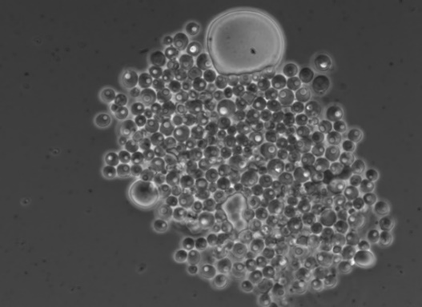
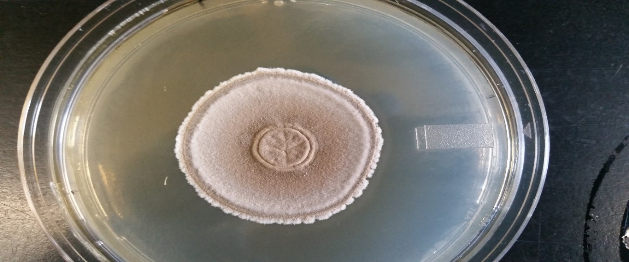
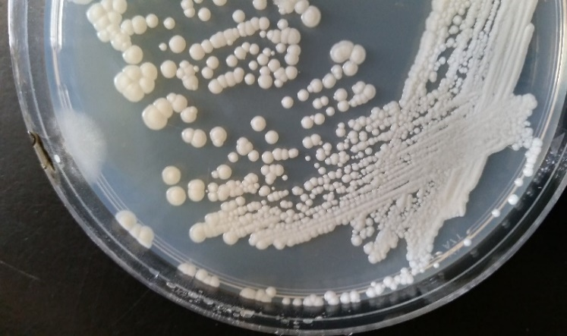
20 µm
a
d

200 nm
b
e
c
f

Figure 2.1 Morphology of Byssochlamys sp. SW2 and Wickerhamomyces anomalus SE3. Byssochlamys sp. SW2 (a) colony morphology agar and (b) conidia and conidiophore morphology (1.00 kX mag) after 5 days growth on HS are shown. Panel (c) shows terminal chlamydospores (arrow) and hyphal morphology using phase contrast microscopy (400x mag) after incubation (80 d) in B20 minimal medium. Wickerhamomyces anomalus SE3 (d) colony morphology and (e) cellular morphology with budding scars (24.08 kX mag) after 3 days of growth on HS agar. Panel (f) shows cellular morphology using phase contrast microscopy (1000 X mag) after 15 days of growth in B20 minimal medium.

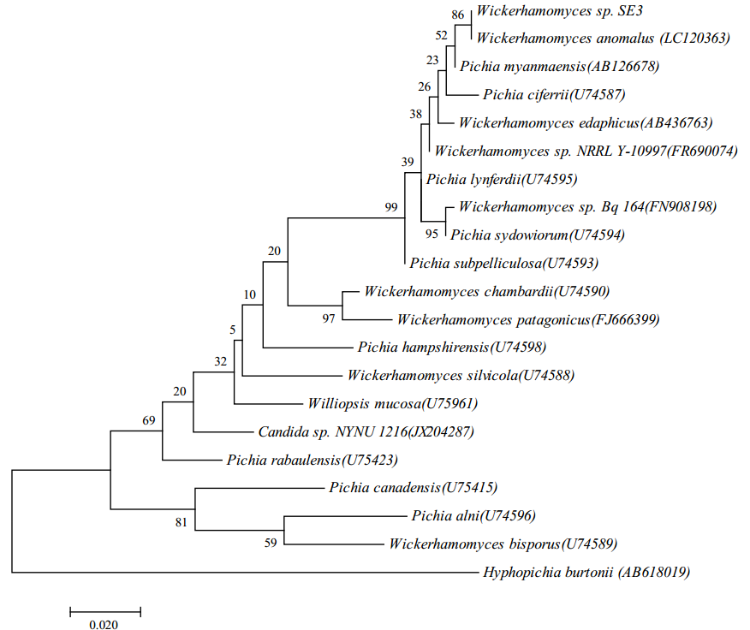

Figure 2.2 Maximum Likelihood tree based on 28S rRNA sequence phylogeny of the yeast Wickerhamomyces anomalus SE3 and its close relatives. Phylogeny is based on sequences of the D1/D2 domains of the 28S rRNA genes for the isolate (arrow) and selected closest relatives. Sequence for Hypopichia burtonii was used as the outgroup, values of a bootstraps analysis >50% (500 replicates) are displayed at each node, and the scale bar represents 0.02 changes per nucleotide position.

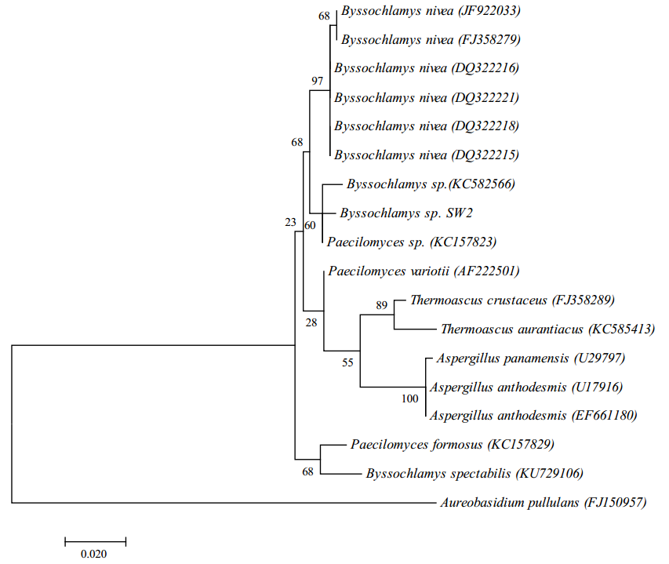

Figure 2.3 Maximum Likelihood tree based on 28S rRNA sequence phylogeny of the filamentous fungus Byssochlamys sp. SW2 and its close relatives. Phylogeny is based on sequences of the D1/D2 domains of the 28S rRNA genes for the isolate (arrow) and selected closest relatives. Sequence for Aureobasidium pullulans was included as the outgroup. Bootstraps values >50% (1000 replicates) are displayed on supported nodes. The error bar represents 0.02 changes per nucleotide position.

Table 2.2 Physiological characteristics of Wickerhamomyces anomalus SE3.

Symbols denote assimilation +, Positive; -, Negative; w, Weak.
Table 2.3 Physiological characteristicsª of Byssochlamys sp. SW2.

ª symbols denote assimilation +, Positive; -, Negative; w, Weak.

Figure 2.4 Degradation of FAME in B20 biodiesel after 7 days of incubation with isolates Wickerhamomyces anomalus SE3 and Byssochlamys sp. SW2. Colored bars represent the remaining percentage of compound after 7 days of incubation compared to negative control at day 0.

Negative Control Day 7 W. anomalus

Figure 2.5 Degradation of hydrocarbons in B20 biodiesel after 7 days of incubation with isolate Wickerhamomyces anomalus SE3. Colored bars represent the remaining percentage of compound after 7 days of incubation compared to negative control at day 0.

Figure 2.6 Growth curve for Wickerhamomyces anomalus SE3 in ASW medium containing B20 biodiesel as sole carbon source. Error bars represent standard deviation of triplicates.

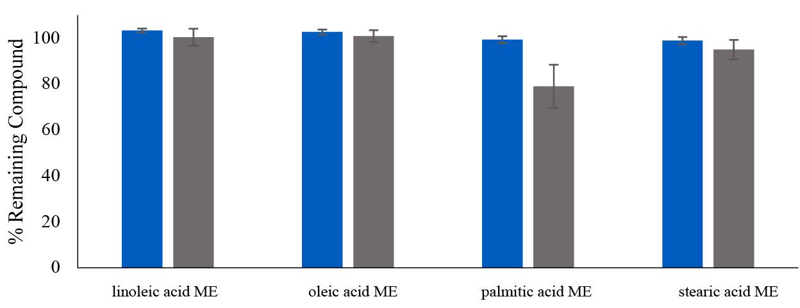

Negative Control Day 30 Byssochlamys sp.

Figure 2.7 Degradation of FAME in B20 biodiesel after 30 days of incubation with isolate Byssochlamys sp. SW2. Colored bars represent the remaining percentage of compound after 30 days of incubation compared to negative control at day 0. Error bars represent standard deviation of triplicates.

Figure 2.8 Representative total ion chromatograms of aqueous phase after 80 days of biodegradation of B20 with isolate Byssochlamys sp. SW2. Biodegraded sample (black) is compared to negative control (blue).

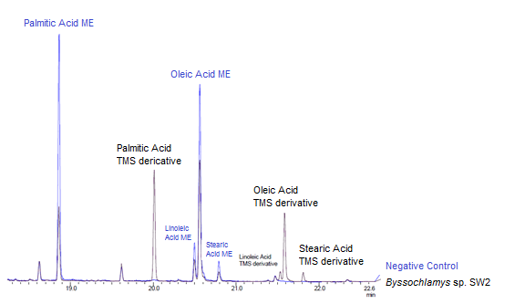

Figure 2.9 Effect of temperature on growth of the yeast Wickerhamomyces anomalus SE3. p-value <0.01 between all treatments (Anova-Tukey Test). Error bars represent standard deviation of triplicate samples.

Figure 2.10 Effect of pH on growth of the yeast Wickerhamomyces anomalus SE3. Significant differences were found between treatments (p-value = 0.03. According to Tukey’s test, pH 4 is the treatments that differs from pH 5 (*p-value<0.05). The other combinations does not differ between each other significantly. Error bars represent standard deviation of triplicate samples.

Figure 2.11 Effect of temperature on growth of Byssochlamys sp. SW2. According to ANOVA-Tukey’s HSD test, treatments sharing letter represent: a, not significantly different; b, p-value<0.05. No shared letters represent p-value<0.01.

Figure 2.12 Effect of pH on growth of the Byssochlamys sp. SW2. According to ANOVA-Tukey’s HSD test, shared letters denote significance: a-c, p-value between 0.05-0.1; d-f, p-value <0.05.

Chapter 3: Chemical Analysis of B20 Biodiesel Fuel Exposed to Contaminated Underground Storage Tanks and its Correlation to Fungal Biodegradation

3.1 Introduction

B20 biodiesel is an alternative fuel considered to be a suitable option to replace petroleum diesel as a source of liquid transportation fuel (Hoekman, Broch, Robbins, Ceniceros, & Natarajan, 2012; Knothe, Krahl, & Van Gerpen, 2015). The DoD considers B20 biodiesel to be a means to reduce it’s carbon footprint and achieve energy security (DOD, 2011; GAO, 2015). During long term; however, storage the fuel can be susceptible to microbial contamination (Bücker et al., 2011; Lee, Ray, & Little, 2010) and oxidative instability (Jakeria et al., 2014). The negative effects associated with these problems include fuel degradation (Zuleta, Baena, Rios, & Calderón, 2012) and damage to the infrastructure due to fouling (Passman, 2013) and corrosion (Lee et al., 2010; Zuleta et al., 2012). The maintenance costs related with these problems can quickly surpass the savings of using biodiesel (Chavez, 2013), which ultimately threaten its broader use.

The fuel B20 is a blend of 20% biodiesel and 80% ultralow sulfur diesel (ASTM-D7467-15, 2015). The biodiesel portion is a mixture of fatty acid methyl esters (FAME) produced by chemical transesterification of raw materials rich in triglycerides (ASTM-D7467-15, 2015; NREL, 2009). The feedstocks for biodiesel production can be obtained from edible and non-edible sources including vegetable oils, animal fats, waste grease, and even some microalgae species (Hoekman et al., 2012). The triglyceride content of the parental feedstock determines the FAME mixture in the final product (Jakeria, Fazal, & Haseeb, 2014; Knothe, 2005). The most common FAMEs present in biodiesel are composed of 16 to 18 carbons and varying degrees of unsaturation (Table 3.1).

Biodiesel and its blends are more easily degraded by abiotic and biotic mechanisms than ULSD (Bücker et al., 2011; Mariano, Tomasella, De Oliveira, Contiero, & De Angelis, 2008; Zhang et al., 1998), especially during fuel storage. Autoxidation is the abiotic mechanism that is considered to be of primary concern during long term storage (Pullen & Saeed, 2012), however it can be controlled by the addition of antioxidants (Pullen & Saeed, 2012). Fuel biodegradation refers to changes in the fuel composition as the consequence of microbial metabolism, which affects the integrity and properties of the fuel (Pullen & Saeed, 2012). Fuel biodegradation depends on the microbial contaminants and their potential to accelerate degradation processes (Jakeria et al., 2014; Makareviciene & Janulis, 2003), as well as on the fuel chemistry, environmental conditions, presence of fuel additives, storage and handling conditions and the design of the fuel tanks and delivery systems (Passman, 2013).

The evaluation of biodegradation problems in a fuel system is a complex process that requires both the fuel and infrastructure be examined and monitored (Knothe et al., 2015). An initial examination is usually done by gross observations for signs of microbial contamination such as, changes in fuel color and turbidity, the presence of water, or accumulation of particulates (Passman, 2003). A thorough analysis is necessary to understand the extent of the problem and to define the strategies for an effective control. For further root-cause analysis and monitoring, a correlation between data obtained by physical, chemical and microbiological analyses is required (Hoekman et al., 2012; Passman, 2003).

Recent studies have suggested a correlation between the presence of the fungal genus Byssochlamys (family Trichocomaceae) and recurrent problems of discolored fuel, presence of flocculent material, and fouling at two USAF facilities (Stamps, 2016). However, the impact of the contamination on the fuel was unknown. We hypothesized that fungal contamination of USAF B20 fuel tanks changes the chemical composition of the B20 biodiesel. This hypothesis was tested by measuring the effect of the growth of Byssochlamys sp. SW2 on the chemical composition of B20 fuel in cultivation experiments. A statistical model was then developed to predict fuel degradation for quality monitoring purposes. To validate our model, we characterized B20 biodiesel samples from contaminated storage tanks at two USAF facilities.

3.2 Materials and Methods

3.2.1 Sampling and GC/MS data collection

Samples of B20 biodiesel were collected from six underground storage tanks at two USAF facilities in the Southwest (SW2, SW3, and SW4) and Southeast (SE3, SE4, and SEE) United States. Samples (1 L) were collected at multiple levels over an 18-month period to measure the temporal variation in fuel composition. A total of sixty samples were collected (17 from SW and 43 from SE) into sterile bottles using a fuel sampler (Koehler Instrument Company, Inc., Holtsville, New York) and transported at room temperature in the dark. The fuel was sterilized by filtration using 0.22 µm polyether sulfone bottle top filters (EMD Millipore, Billerica, MA), prior to chemical analysis. Triplicate 2 mL aliquots of each sample were stored in gas chromatography vials at room temperature in the dark.

The chemical composition of each B20 biodiesel sample was determined by Gas Chromatography/Mass Spectrometry (GC/MS) using a Shimadzu QP 2010 SE (Shimadzu Corporation, USA). Each sample was diluted 1:200 with hexane (ChromasolV®, for HPLC, >95%, Sigma Aldrich) prior to injection. A volume of 1 µL was injected via autosampler with a split ratio of 1:10. Injection started at 300 °C, oven at 40 °C with a 0.5 min hold and increased to 320 °C at a rate of 10 °C min⁻¹. Peaks were separated with a Restek Column Rxi 5Sil with dimensions: 30 m, 0.25 mm ID, 0.25 µm. High purity helium was used as carrier gas at a linear velocity of 36.8 cm s⁻¹. Mass spectra were analyzed in scan mode with the following conditions: interface at 320 °C, ion source 200 °C, solvent cut of 2 min, event time of 0.25 sec and scan speed of 2000.

3.2.2 Chromatographic Data Analysis

Each Total Ion Chromatogram (TIC) was processed using the software LabSolutions version 4.20 (Shimadzu Corporation, USA). Peaks were identified using the mass spectra library NIST version 14. Reference standards for FAME (Supelco® 37 Component FAME Mix, Sigma Aldrich, USA) and B20 (Diesel:Biodiesel (80:20) Blend Standard, RESTEK, USA) were used to confirm major alkanes and FAME peaks identified by the NIST library. Qualitative integration of peak areas was performed using a common detection sensitivity (slope: 1000/min) to distinguish peaks from background/noise. Only well-defined peaks with more than 90% similarity with the NIST library were chosen for further analysis. A similarity index of 100 was used when the spectra were perfectly identical. Individual peaks were quantified using the area normalization method following the equation $i\%=\frac{Ai}{\sum{Ai}}×100$ where Ai is the peak area of a compound and ∑Ai is the sum of peak area of all components (Linskens et al., 1986; Qi et al., 2011).

Data was analyzed in R version 3.2.2, using the Stats (Team, 2014), Caret (Kuhn, 2008), Mass (Venables & Ripley, 2002) and Vegan (Oksanen et al., 2015) packages. An ANOVA-based variable selection was applied to highlight the compounds with relevant differences among the samples. Each compound was treated as a one-way ANOVA type problem with N measurements represented by the 60 samples and K groups represented by the two facilities (SE and SW). Compounds with p-values <0.05 were selected for multivariate analysis using Permutational Multivariate Analysis of Variance (PERMANOVA) and Principal Component Analysis (PCA).

3.2.3 Fungal Biodegradation Classification Model

The results from biodegradation experiments of B20 with Byssochlamys sp. SW2 were used to construct a Linear Discriminant Analysis (LDA) classification model with prediction properties. Biodegraded and non-biodegraded datasets were defined as classes for discrimination. For the biodegraded group, four samples of B20 fuel that were retained prior to addition to tanks, that were never exposed to the biology in the tanks, were individually exposed during 30 days of incubation to fungal biodegradation using Byssochlamys sp. SW2. The non-biodegraded group consisted of negative controls with no inoculum for each fuel. Samples from tanks SE3, SE4 and SEE were used as test sets to validate the model (Table 3.4). In the test set we included two samples representing a pre- and post-cleaning procedure applied to the tanks after a contamination event (Table 3.4).

Experimental conditions included destructive sampling at days 0, 5, 14 and 30 of triplicates for each experimental tube and control, to simulate a fuel biodegradation progression. Each experiment was set up in 16 x 100 mm glass tubes filled with 1 mL of ASW and 10 µL of filter-sterilized B20 as the sole carbon and energy source, sealed with vials with a cap that had a PTFE liner to avoid evaporation. An inoculum resulting in 1x10⁶ spores mL⁻¹ of Byssochlamys was added to each tube and incubated at 25°C, shaking at 250 rpm. Un-amended controls containing no electron donor were included to evaluate carbon source carryover. At then end of each incubation period, the fuel phase was extracted and a chromatographic analysis was performed (see above, Section 3.2.2).

3.3 Results

3.3.1 Characterization of the Composition of B20 Fuel Samples

B20 fuel samples exposed to bio-contaminated tanks were analyzed by GC/MS. The TIC of each sample showed a complex mixture of compounds (Fig. 3.1). Alkanes and FAMEs were detected in all B20 fuel samples. Well-defined peaks with a similarity index of >90% to the NIST library were identified (Table 3.2). The identified peaks were well spread over the retention time range in the chromatogram (Table 3.2) in accordance with the reference standards. Minor peaks that were not qualified by the selection criteria were discarded from further analysis and included various branched alkanes, naphthalenes and aromatics. Sixteen major fuel components including alkanes of various chain lengths and FAMEs were retained.

Patterns of variation in the dataset were identified using a combined approach of variable selection and multivariate analysis. Nine peaks were highlighted with significant differences among samples (Table 3.2), using a one-way ANOVA approach. Fuel samples between SE and SW (GC/MS data 1-factor PERMANOVA, F=25.32, R²=0.30, p=0.001) showed significant differences in their composition of the selected variables. Geographic location appeared as a discrimination factor (Fig. 3.2). Linoleic and palmitic acid methyl esters (loadings = 0.4445 and -0.4388 respectively) accounted for most of the discrimination between locations SE and SW, with an indirectly proportional trend in their concentrations (Table 3.3). Variations within location SE were also investigated (Fig. 3.2). Fuel composition between tanks at SE3, SE4 and SEE varied significantly (GC/MS data 1-factor PERMANOVA, F=3.8017, R²=0.21, p=0.013). The discrimination was based on the first three principal components (Table 3.3), capable of explaining 75% of the variability in the dataset.

Four samples of B20 obtained at SE and never exposed to the biology in the tanks showed differences in their proportion of FAMEs (Fig. 3.3). Unexposed fuels A and C showed similar relative abundances of linoleic and oleic acid methyl esters, while B and D had similar abundances of palmitic and oleic acid methyl ester (Fig. 3.3). Unexposed fuels were discriminated according to their patterns and clustered in two separated groups (Fig. 3.2).

3.3.2 Fungal Biodegradation Model

An LDA model constructed with biodegraded and non-biodegraded datasets allowed us to predict the severity of biodegradation in B20 fuel samples. The variables used to construct the model were identical to those used for the characterization of in situ B20 fuel samples (Table 3.2). The model consisted of three clusters that showed separation between each other (Figure 3.4), corresponding to the length of incubation and a progression from non-degraded (days 0, 5), degraded at day 14, and the most degraded group at day 30. The linear discriminant LD1 accounted for 97.1% of the total discrimination, responsible for the observed separation. The largest linear discriminant coefficients were Linoleic and Palmitic Acid ME (-16.969, -12.964 respectively).

Samples of B20 fuel obtained from SE (Table 3.4) were objectively classified by the apparent severity of their fungal biodegradation. Nine samples including an unexposed fuel control were classified in the non-degraded group (Figure 3.5). These samples corresponded to fuels obtained from different locations (nozzle, middle and bottom) inside tanks SE4 and SEE, and differences between them were not detectable. Four samples obtained from the bottom of tank SE3 (sample numbers 27, 30, 16, 36; Table 3.4) were classified as degraded. Samples 27 and 30 were similar to fuels exposed to Byssochlamys sp. SW2 for 14 and 30 days. Sample 30 was obtained in March 2015 and sample 27 in the month of May 2015. Both represent the pre- cleaning stage of tank 3 where contamination was highest. Sample 16 represents the post-cleaning state of tank 3 in the Month of May 2015 and it was classified as degraded but in the group of Day 14. Sample 36 was classified as the most degraded since it most closely related to the degraded sample at day 30. These results represented a demonstration of the predictive properties of the LDA model.

3.4 Discussion

We hypothesized that fungal contaminants of USAF B20 biodiesel fuel tanks metabolize components of the fuel, causing changes in its chemical composition. The stability and properties of B20 are influenced by its composition (Ghazali, Mamat, Masjuki, & Najafi, 2015), which can be affected during its storage. We detected variation in fuel components in B20 fuel samples obtained from underground storage tanks with recurrent problems of fungal contamination. Our results suggested that the observed differences are the result of different FAME feedstocks that are susceptible to fungal biodegradation. These results are important to assessing the risk of fungal growth on particular feedstocks used to produce B20 blends.

Biodiesel blends can contain over 2000 compounds (Marchal, Penet, Solano-Serena, & Vandecasteele, 2003) that can be characterized by GC/MS (Pauls, 2011). Pattern recognition methods (Brereton, 2009; Hochkirchen, 2010; Johnson & Synovec, 2002; Sutro, 1971; Wongravee et al., 2009) have been successfully used in the discrimination of fuel types (Flood, Goding, O’Connor, Ragon, & Hupp, 2014), identification of fuel adulteration (Skrobot, Castro, Pereira, Pasa, & Fortes, 2007) and monitoring of fuel degradation (Johnson, Rose-Pehrsson, & Morris, 2004). We found 9 compounds that change significantly among samples and used them to evaluate how fuel changes can be altered by fungal biodegradation using multivariate techniques. This allowed us to identify differences in fuel composition in situ and monitor degradation in vivo.

Fuel components varied among facilities and tanks within facilities (Fig. 3.2). The unexposed fuels varied in their content of FAMEs, suggesting the use of different feedstocks in biodiesel production (Jakeria et al., 2014). Feedstock availability and production capacity directly affect the supply chain (DOD, 2007). It is reasonable to expect different FAME profiles between or within different storage facilities. The provenance of the feedstock oil was not known or available, but the source of feedstock could potentially explain the differences observed between facilities. Common biodiesel feedstocks in the U.S are soybean and canola (EIA, 2016b), and have high concentrations of mono- and poly-unsaturated fatty acids (Knothe, 2008). Other well-known feedstocks are palm oil and tallow (EIA, 2016b), which contain abundant saturated fatty acids (Knothe, 2008).

We identified the FAMEs Palmitic (C16:0) and Linoleic Acid (C18:2) ME as the compounds that accounted for most of the variation among clusters. Interestingly, Palmitic and Linoleic Acid ME explained most of the variation in the fungal community structure (Stamps, 2016), suggesting a selective biodegradation. The genus Byssochlamys was an abundant OTU in the fungal community (Stamps, 2016). Because Byssochlamys sp. can use B20 as sole source of carbon and energy (Andrade, Chapter 2), we used it to investigate selective biodegradation.

An LDA (Hochkirchen, 2010) was constructed using GC/MS chemical profile data of the fuel component of the B20 biodegradation experiments with Byssochlamys sp. SW2 (Fig. 3.4). Palmitic and linoleic acid ME corresponded to the largest and negative linear coefficients (Brereton, 2009), which indicate a preferential degradation of palmitic and linoleic acid ME by this organism. This is consistent with other studies that show that Byssochlamys sp. and a close relative Paecilomyces variotti, can degrade palmitic acid ME in storage tanks (Andrade, Chapter 2; Curvelo, Almeida, Nunes, & Feitosa, 2011). New feedstocks rich in palmitic acid ME (Chen et al., 2015; Fazaeli & Aliyan, 2015) are considered a promising alternative to satisfy future biodiesel demands. In this study; however, we quite clearly show the susceptibility of palmitic acid ME in B20 biodiesel to microbial contamination during storage, especially by fungi of the genus Byssochlamys.

The LDA model was used to objectively classify samples of B20 fuel from storage tanks in service into groups and identify patterns of fungal biodegradation. Samples of B20 obtained from the bottom of these tanks were classified as biodegraded (Fig. 3.5). This prediction was reasonable considering that most of the microbial contaminants will thrive in the bottom of tanks due to water accumulation (Bento & Gaylarde, 2001) and only very limited mixing occurs in these tanks. The water-fuel interface is often the location of dense fungal biofilms and thus biodegradation of the fuel (Passman, 2003).

The LDA prediction of patterns of biodegradation appeared to be an effective tool to evaluate fungal contamination during fuel storage. In the test set, we detected a biodegraded sample from the bottom of tank SE3 (#36, Fig. 3.5) that contained only low amounts of adenosine triphosphate (ATP; 3.2X10² RLU, (Stamps, 2016)) measured in situ. Quantification of ATP is a standard method used to detect microbial contamination in fuel systems (ASTM:D7687, 2011), but the results can be deceiving if the values are low. For instance, fungal spores have << 1 fg ATP/spore (Passman, 2013), and their higher hydrophobicity can pull them to the fuel phase compared with mycelium that lies in the fuel-water interface (Linder, Szilvay, Nakari-Setälä, & Penttilä, 2005). Thus, when sampling fuel contaminated with fungi, it is possible that only fungal spores might be present (ASTM:D7687, 2011), generating a false negative result with low ATP measurements below the detection limit (Passman, 2013; Rakotonirainy, Heraud, & Lavédrine, 2003).

The LDA model was also useful in assessing the efficacy of a procedure used to remove water from the bottom of a storage tank (Figure 3.5). Samples obtained before the removal of water from SE3 tank were categorized as the most degraded (Table 3.4). Samples taken after removal of water (and some fuel); however, still indicated that biodegradation had occurred, but noticeably less. This data suggests that the biodegraded fuel is most closely associated with water and/or the bottom of the tank. Fuel higher up in the tank does not carry the same chemical profile that would be recognized as biodegradation. A storage tank with fungal contamination that affects the fuel composition, fouling, and potentially microbially influenced corrosion may be asymptomatic according to fuel samples taken from the dispenser or top of the tank.

Chemical characterization of B20 biodiesel samples from contaminated underground storage tanks is an effective method for detection of past or current fungal contamination. This signal is largely due to the fungi altering the content of the FAMEs palmitic and linoleic acid methyl ester. Biodiesel containing a significant proportion of these FAMEs is more likely to support the growth of the fungi studied here and; therefore, more susceptible to fungal biodegradation. The research presented here not only provides a methodology that should be considered for monitoring B20 biodiesel for fungal contamination and proliferation, but also suggests that the feedstocks used in production of biodiesel should be reconsidered for their susceptibility to biodegradation.

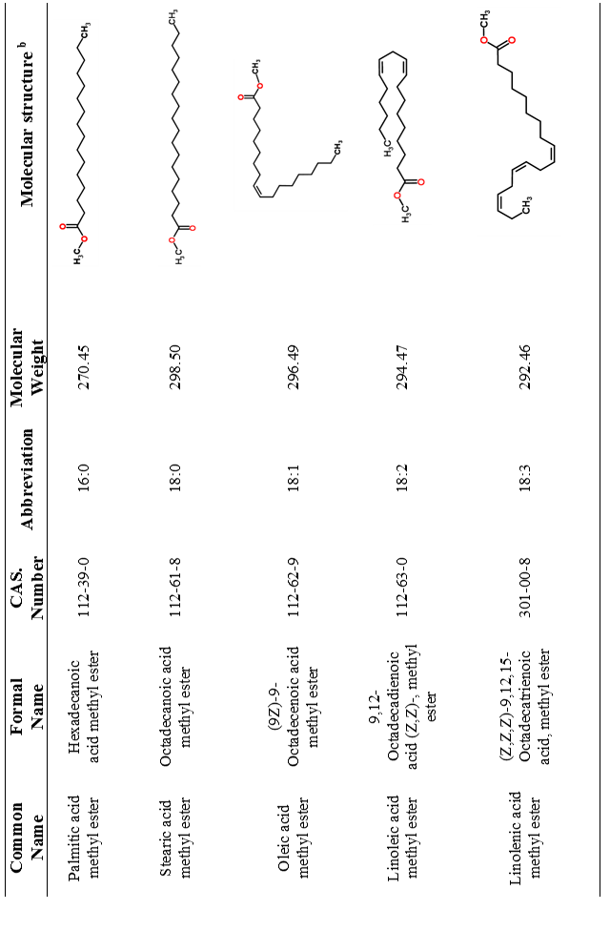

a. Table adapted from Hoekman et al., 2012
b. Figures for the molecular structure were taken from https://pubchem.ncbi.nlm.nih.gov

Table 3.1 Common fatty acid methyl esters found in biodiesel ^{a.}

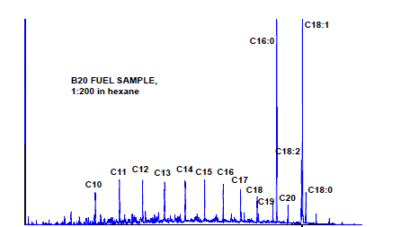

Figure 3.1 Representative total ion chromatogram (TIC) obtained from a B20 fuel sample. Major peaks for n-alkanes and FAMEs are labeled.

Table 3.2 Retention times of major peaks identified in B20 fuel samples.
Variable | Compound | Retention Time (min)
n-C9ª | n-nonane | 5.316 - 5.337
n-C11 | n-undecane | 8.502 - 8.525
n-C12 | n-dodecane | 10.030 - 10.053
n-C13ª | n-tridecane | 11.473 - 11.497
n-C14ª | n-tetradecane | 12.834 - 12.859
n-C16 | n-hexadecane | 15.335 - 15.361
n-C17 | n-heptadecane | 16.485 - 16.512
n-C18 | n-octadecane | 17.578 - 17.605
n-C19ª | n-nonadecane | 18.617 - 18.645
n-C20ª | n-eicosane | 19.609 - 19.637
C16:0ª | n-palmitic acid methyl ester | 18.854 - 18.895
C18:2ª | n-linoleic acid methyl ester | 20.496 - 20.594
C18:1ª | n-oleic acid methyl ester | 20.564- 20.594
C18:0ª | n-stearic acid methyl ester | 20.738 - 20.811

ª Compounds selected for multivariate analysis.

Table 3.3 Principal component analyses (PCAs) of global B20 fuel dataset.

Order of  importance | PC1 39%ª | PC2 20%ª | PC3 16%ª
1st | Linoleic Acid ME  (0.44) | n-C20  (-0.50) | n-C9  (0.51)
2nd | Palmitic Acid ME  (-0.43) | n-C19  (-0.46) | n-C14  (-0.50)
3rd | Stearic Acid ME  (0.38) | n-C13  (0.43) | Stearic Acid ME  (0.42)
4th | n-C19  (0.36) | n-C14  (0.32) | n-C13  (-0.29)
5th | n-C13  (0.35) | Oleic Acid ME  (0.28) | n-C20  (-0.27)
6th | n-C14  (0.29) | Palmitic Acid ME  (-0.24) | Palmitic Acid ME  (-0.24)
7th | Oleic Acid ME  (-0.25) | n-C9  (0.23) | Oleic Acid ME  (0.19)
8th | n-C20  (0.22) | Stearic Acid ME  (-0.15) | Linoleic Acid ME  (0.16)
9th | n-C9  (-0.023) | Linoleic Acid ME  (0.13) | n-C19  (0.08)

ª Percentage correspond to the variation explained by the Principal Component. Variable loadings of the three principal components (PC) are shown in parenthesis.

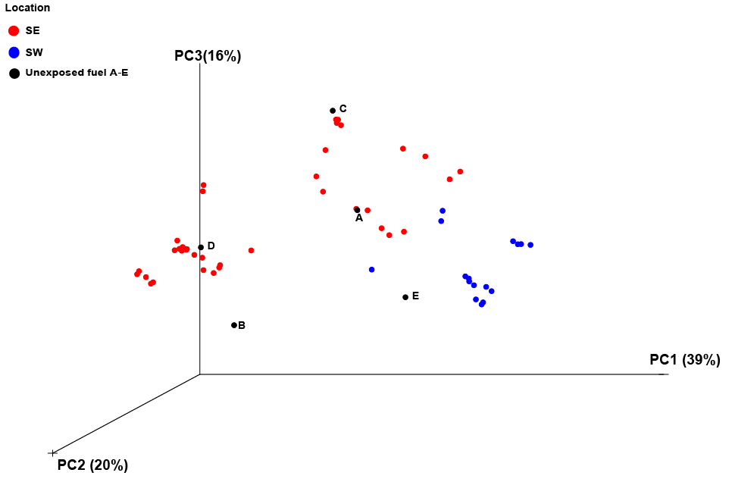

Figure 3.2 3-dimensional ordination of B20 fuel samples by principal components (PC) 1, 2 and 3. Each fuel sample from SE (red), SW (blue), and unexposed fuel (black, A-D) is represented by a circle.

Figure 3.3 Proportion of 16 major compounds of B20 found in unexposed fuel samples. Fuels ‘A to D’ where obtained at SE location, while fuel ‘E’ at SW location.

Figure 3.4 Score plot for the first two linear discriminant factors of biodegradation patterns obtained after incubation of Byssochlamys sp. SW2 in B20 fuels. The scores were calculated by LDA of nine major peaks found in B20 (see table 3.2). The 95% confidence ellipses for the individual groups are also shown.

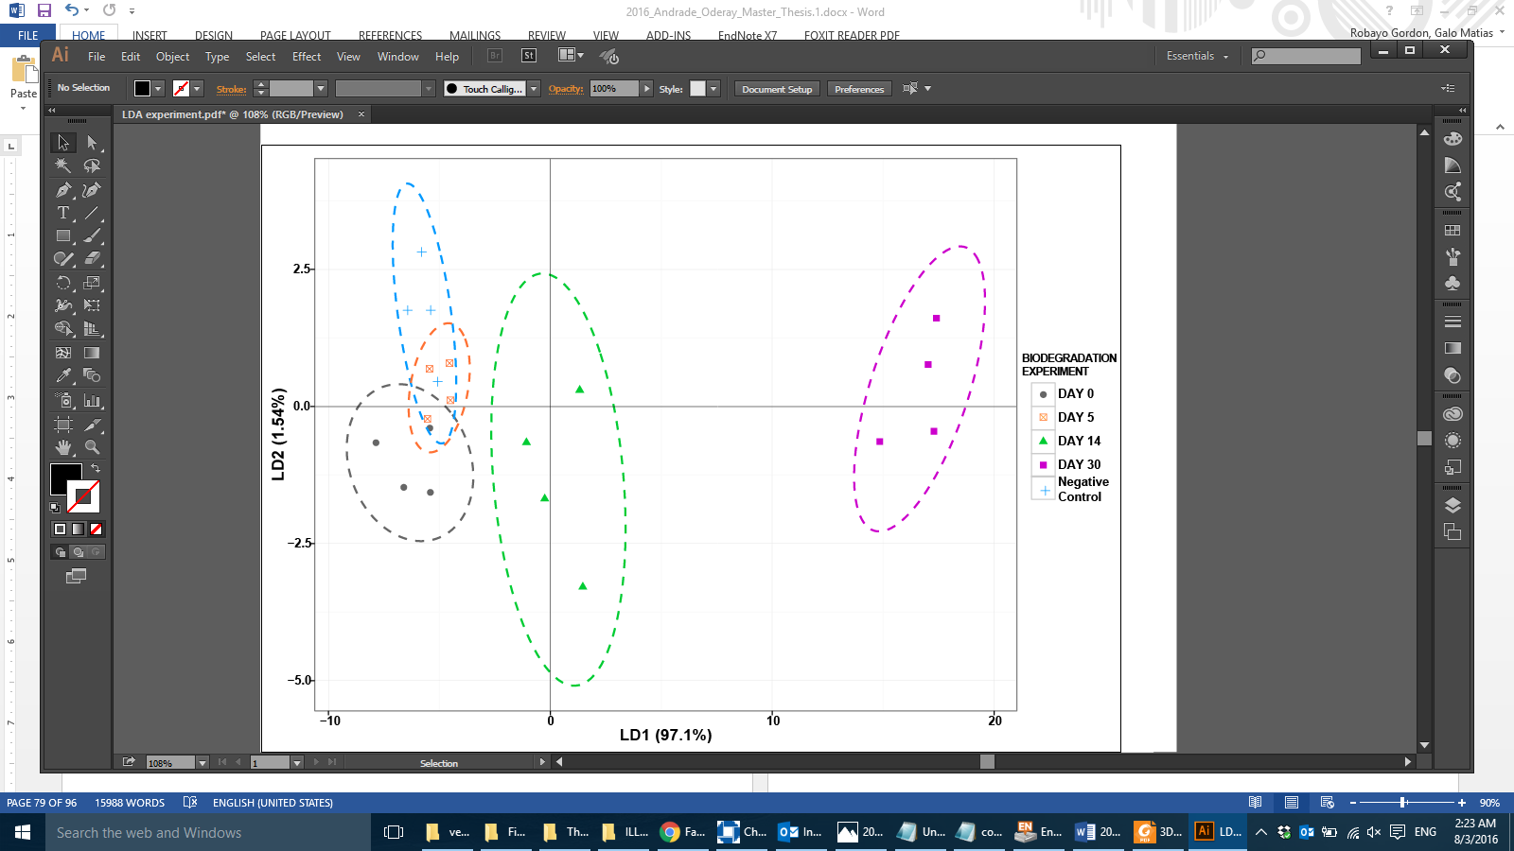
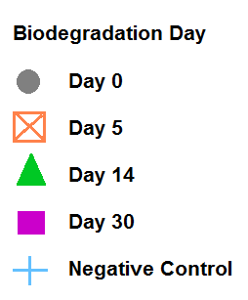

Table 3.4 Description of the test set of B20 samples obtained from SE facility and used to validate the LDA model.

Sample  # | Sampling Location  Description ª | Sampling  Date | LDA  prediction ^{b}
36 | SE,3,B | 10/28/2014 | D
42 | SE,E,B | 3/12/2015 | ND
30 | SE,3,B | 3/12/2015 | D
14 | SE,-,N | 5/7/2015 | ND
48 | SE,E,B | 5/7/2015 | ND
52 | SE,E,M | 5/7/2015 | ND
53 | SE,E,N | 5/7/2015 | ND
4 | SE,3,N | 5/7/2015 | ND
13 | SE,3,R | 5/7/2015 | ND
16 | SE,3,B (post-cleaning) | 5/7/2015 | D
27 | SE,3,B (pre-cleaning) | 5/7/2015 | D
44 | SE,4,B | 5/7/2015 | ND
47 | SE,4,M | 5/7/2015 | ND

ª Sample descriptors include the facility Southeast (SE), tank (3, 4 or E), location in the tank (B, bottom; M, middle; N, nozzle; -, unknown location), fuel unexposed to the tanks (R).

^{b} Sample predicted to be not degraded (ND). Sample predicted to be degraded (D).

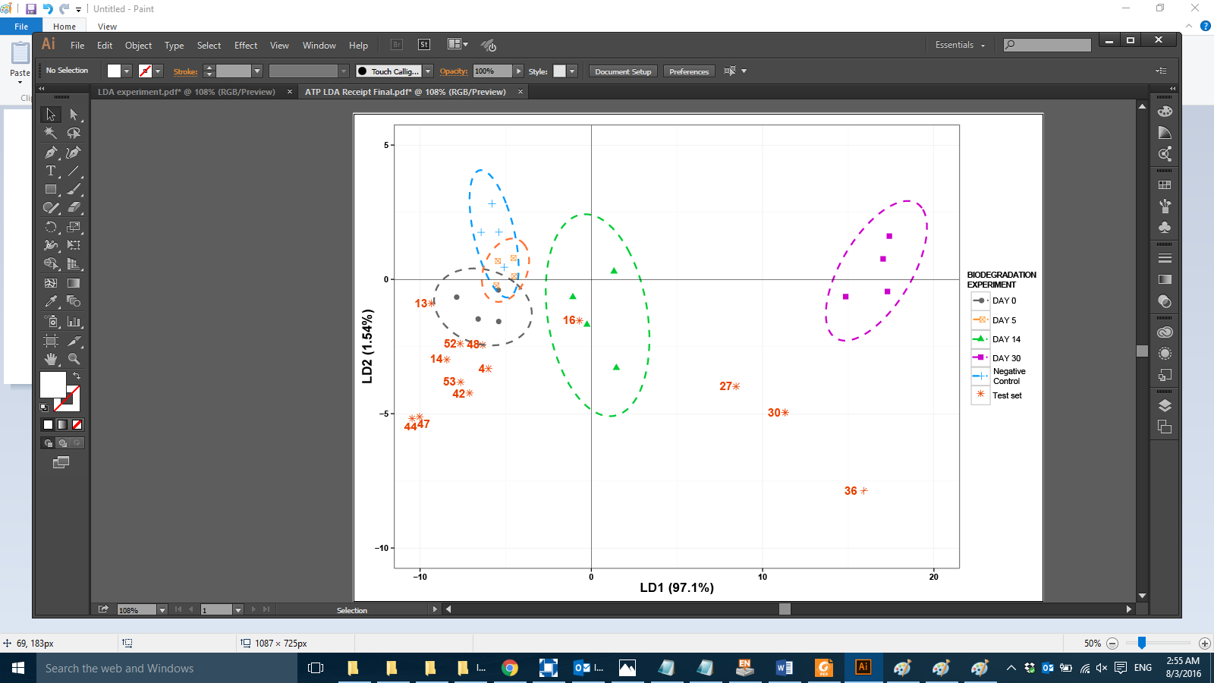
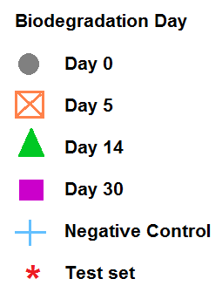

Figure 3.5 LDA prediction plot containing data from the test set samples. The 95% confidence ellipses for the individual groups are also shown.

Chapter 4: Summary and Future Directions

The Department of Defense (DoD) has been increasing the use of alternative fuels in ground vehicles and equipment as part of its Strategic Energy Plan (DOD, 2011). As a result, many military bases have infrastructure dedicated to the storage and dispensing of B20 biodiesel. Biodiesel is composed of single chain fatty acid methyl esters (FAME) derived from plant or animal fats, and B20 is an 80:20 blend of petroleum-derived ultra-low sulfur diesel (ULSD) and biodiesel (ASTM-D7467-15, 2015). Biodiesel contains more oxygen, is more hygroscopic, and is more oxidatively unstable compared to ULSD (Jakeria et al., 2014). This potentially increases the susceptibility of biodiesel to microbial contamination and degradation (Bücker et al., 2011; Mariano et al., 2008; Prince et al., 2008).

We have studied B20 biodiesel from storage tanks at several Air Force Bases, both with and without reported issues with fuel quality (color, clarity, particulates). Fuels of compromised quality from two different AFBs had substantial microbial contamination, which was believed to be the root cause of reported issues. Molecular characterization of the microbial assemblages showed that these fuels harbored a high concentration of the fungal genera Byssochlamys and Wickerhamomyces. We isolated ten different genera of fungi from B20 storage tanks at two USAF facilities. Two of these isolates were representatives of the most abundant genera in the B20 storage tanks (Stamps, 2016). Byssochlamys sp. SW2 and Wickerhamomyces anomalus SE3 are able to grow in B20 as the sole source of carbon and energy. These fungi were capable of aerobic degradation of many carbon substrates in low water environments over a broad pH range.

In this research we hypothesized that fungal contamination of USAF B20 fuel tanks cause changes in the chemical composition of the fuel. Fuel components varied among facilities and tanks within facilities (Figure 3.2). The unexposed fuels varied in their content of FAMEs, suggesting the use of different feedstocks in biodiesel production (Jakeria et al., 2014). Byssochlamys sp. SW2 and Wickerhamomyces anomalus SE3 preferentially degraded palmitic and linoleic acid methyl esters, and our in situ model supports the hypothesis that palmitic and linoleic acid methyl esters are the most susceptible components to biodegradation.

In our data, we lack the information regarding the specific feedstocks used to produce the B20 fuel stored in the USAF tanks, which was a limitation. Based on our findings, we suggest that biodiesel from different feedstocks will be differentially susceptible to fungal contamination. This hypothesis remains to be tested by biodegradation experiments comparing the susceptibility of different feedstocks to fungal attack. Feedstocks commonly used with high content of palmitic acid methyl ester include palm oil and cottonseed (Knothe, 2008), as well as novel feedstocks from marine microalgae (Chen et al., 2015). Feedstocks with high concentrations of linoleic acid include soybean, sunflower and cottonseed (Jakeria, Fazal, & Haseeb, 2014). Current investigation about the design of optimal biodiesel blends (Knothe, 2008) is focused only in the improvement of the oxidative stability, cold flow, and increased NOx exhaust. We suggest that considering the effect of microbial degradation in the search of new feedstocks and mixtures for biodiesel production is also important.

We show that the presence of Byssochlamys sp. SW2 can alter the composition of B20 biodiesel in storage tanks, and we offer a model for predicting severity of biodegradation. We used Byssochlamys sp. SW2 in our research, because it represented an abundant organism in the tanks that were studied (Stamps, 2016). However, we are aware that microorganisms that contribute to alterations of the fuel quality during storage are part of microbial communities and consortia (Bücker et al., 2014; Lee, Ray, & Little, 2010; Passman, 2003; Stamps, 2016). In consortia, microorganism can accomplish complex tasks that are not possible individually (Brune & Bayer, 2012; Passman, 2003). Our understanding of the most abundant organism represents an essential baseline for future studies of root-cause analysis. Based on our results, our hypothesis is that Byssochlamys sp. and Wickerhamomyces anomalus have an active role in biodegradation of B20 inside the storage tanks. Modeling and monitoring of mesocosm experiments where Byssochlamys sp. and Wickerhamomyces anomalus interact with other bacteria and fungi, will be a first approach to test this hypothesis.

In conclusion, we show that the presence of Byssochlamys sp. alters the composition of B20 biodiesel in storage tanks, and we offer a model for predicting severity of biodegradation. Byssochlamys sp. SW2 and Wickerhamomyces anomalus SE3 preferentially degraded palmitic and linoleic acid methyl esters, and our in situ model supports the hypothesis that palmitic and linoleic acid methyl esters are the most susceptible components to biodegradable. We suggest the use of alternative feedstocks containing less palmitic and linoleic acid for B20 biodiesel production to increase fuel stability in storage tanks.

References
AFDC. (2016). Alternative Fuels Data Center, http://www.afdc.energy.gov/fuels/biodiesel_blends.html.

Ahmad, A., Yasin, N. M., Derek, C., & Lim, J. (2011). Microalgae as a sustainable energy source for biodiesel production: a review. Renewable and Sustainable Energy Reviews, 15(1), 584-593.

Aktas, D. F., Lee, J. S., Little, B. J., Ray, R. I., Davidova, I. A., Lyles, C. N., & Suflita, J. M. (2010). Anaerobic metabolism of biodiesel and its impact on metal corrosion. Energy & Fuels, 24(5), 2924-2928.

Ali, F. A., Ghaloum, N., & Hauser, A. (2006). Structure representation of asphaltene GPC fractions derived from Kuwaiti residual oils. Energy & Fuels, 20(1), 231-238.

Andrade, O. (Chapter 2). Characterization of fungal contaminants crom B20 storage tanks

ASTM-D7467-15. (2015). Standard Specification for Diesel Fuel Oil, Biodiesel Blend (B6 to B20)

ASTM:D6469. (2003). Standard guide for microbial contamination in fuels and fuel systems Fuel and Fuel System Microbiology: Fundamentals, Diagnosis, and Contamination Control (pp. 81-91): ASTM International PA, USA.

ASTM:D7687. (2011). Standard Test Method for Measurement of Cellular Adenosine Triphosphate in Fuel, Fuel/Water Mixtures, and Fuel-Associated Water with Sample Concentration by Filtration.

Banner, M., Mattick, L., & Splittstoesser, D. (1979). Chemical composition of the ascospores of Byssochlamys fulva. Journal of Food Science, 44(2), 545-548.

Barnett, J. A., & Barnett, L. (2011). Yeast research: a historical overview: American Society for Microbiology Press.

Bento, F. M., & Gaylarde, C. C. (2001). Biodeterioration of stored diesel oil: studies in Brazil. International Biodeterioration & Biodegradation, 47(2), 107-112.

Blakeley, K. (2012). DOD Alternative Fuels: Policy, Initiatives and Legislative Activity

Brereton, R. (2009). Chemometrics for pattern recognition: John Wiley & Sons.

Bücker, F., Santestevan, N. A., Roesch, L. F., Jacques, R. J. S., Peralba, M. d. C. R., de Oliveira Camargo, F. A., & Bento, F. M. (2011). Impact of biodiesel on biodeterioration of stored Brazilian diesel oil. International Biodeterioration & Biodegradation, 65(1), 172-178.

Buzzini, P., & Margesin, R. (2014). Cold-adapted yeasts. Miscellaneous Cold-Active Yeast Enzymes of Industrial Importance. New York: Springer.

Campinha, C., Machado, C., & Araújo, W. (2007). Causa do aumento da acidez do óleo bruto durante o armazenamento. Paper presented at the Anais do I Congresso da Rede Brasileira de Tecnologia do Biodiesel.

Cazarolli, J. C., Guzatto, R., Samios, D., Peralba, M. d. C. R., de Siqueira Cavalcanti, E. H., & Bento, F. M. (2014). Susceptibility of linseed, soybean, and olive biodiesel to growth of the deteriogenic fungus Pseudallescheria boydii. International Biodeterioration & Biodegradation, 95, 364-372.

Chao, Y., Liu, N., Zhang, T., & Chen, S. (2010). Isolation and characterization of bacteria from engine sludge generated from biodiesel-diesel blends. Fuel, 89(11), 3358-3364.

Chen, W., Ma, L., Zhou, P.-p., Zhu, Y.-m., Wang, X.-p., Luo, X.-a., . . . Yu, L.-j. (2015). A novel feedstock for biodiesel production: The application of palmitic acid from Schizochytrium. Energy, 86, 128-138.

Congress, U. (2005). Energy policy act of 2005. Public Law, 109(58), 42.

Curvelo, F. M., Almeida, D. T. d., Nunes, I. L., & Feitosa, S. (2011). Qualidade do óleo de palma bruto (Elaeis guineensis): matéria-prima para fritura de acarajés. Revista do Instituto Adolfo Lutz (Impresso), 70(4), 641-646.

Dashko, S., Zhou, N., Compagno, C., & Piškur, J. (2014). Why, when, and how did yeast evolve alcoholic fermentation? FEMS Yeast Research, 14(6), 826-832.

DOD. (2007). Department of Defense, Report to Congress on Use of Biofuels and Measures for Increasing Such Use in FY07–12

DOD. (2011). Department of Defense, Opportunities for DOD use of alternative and renewable fuels

Dodos, G., Konstantakos, T., Longinos, S., & Zannikos, F. (2012). Effects of microbiological contamination in the quality of biodiesel fuels. Global Nest Journal, 14(2), 175-182.

DOE. (2016). U.S Department of Energy http://energy.gov/.

EIA. (2016a). U.S Energy Information Administration http://www.eia.gov last update: March 2016.

EIA. (2016b). U.S Energy Information Administration, Monthly Biodiesel Production Report March 2016.

Engelen, B. (2009). Guidelines for handling and blending FAME. Retrieved from

Fazaeli, R., & Aliyan, H. (2015). Production of biodiesel through esterification of palmitic acid using 12-tungestoposphoric acid supported on nanocavity of aluminium incorporated mesoporous SBA-15. Russian Journal of Applied Chemistry, 88(4), 676-681.

Fernandes, E. G., Valério, H. M., Feltrin, T., & Sand, S. T. V. D. (2012). Variability in the production of extracellular enzymes by entomopathogenic fungi grown on different substrates. Brazilian Journal of Microbiology, 43(2), 827-833.

Flood, M. E., Goding, J. C., O’Connor, J. B., Ragon, D. Y., & Hupp, A. M. (2014). Analysis of biodiesel feedstock using GCMS and unsupervised chemometric methods. Journal of the American Oil Chemists' Society, 91(8), 1443-1452.

Fregolente, P. B. L., Fregolente, L. V., & Wolf Maciel, M. R. (2012). Water content in biodiesel, diesel, and biodiesel–diesel blends. Journal of Chemical & Engineering Data, 57(6), 1817-1821.

Gandhi, J., & Wille, A. (2013). Glycerol Determination in Biodiesel and Biodiesel Blends According to ASTM D 7591. LC GC EUROPE, 10-13.

GAO. (2015). U.S Government Accountability Office, Observations on DOD's Investments in Alternative Fuels.

Gassen, J., Bento, F., Frazzon, A., Ferrão, M., Marroni, I., & Simonetti, A. (2015). Growth of Paecilomyces variotii in B0 (diesel), B100 (biodiesel) and B7 (blend), degradation and molecular detection. Brazilian Journal of Biology, 75(3), 541-547.

Gaylarde, C. C., Bento, F. M., & Kelley, J. (1999). Microbial contamination of stored hydrocarbon fuels and its control. Revista de Microbiologia, 30(1), 01-10.

Ghazali, W. N. M. W., Mamat, R., Masjuki, H., & Najafi, G. (2015). Effects of biodiesel from different feedstocks on engine performance and emissions: A review. Renewable and Sustainable Energy Reviews, 51, 585-602.

Hadziavdic, K., Lekang, K., Lanzen, A., Jonassen, I., Thompson, E. M., & Troedsson, C. (2014). Characterization of the 18S rRNA gene for designing universal eukaryote specific primers. PloS One, 9(2), e87624.

Hawker, L. E. (2016). The physiology of reproduction in fungi: Cambridge University Press.

Hesham, A. E.-L., Wang, Z., Zhang, Y., Zhang, J., Lv, W., & Yang, M. (2006). Isolation and identification of a yeast strain capable of degrading four and five ring aromatic hydrocarbons. Annals of Microbiology, 56(2), 109-112.

Higgins, D., Thompson, J., & Gibson, T. (1997). The ClustalX windows interface: flexible strategies for multiple sequence alignment aided by quality analysis tools. Nucleic Acids Research, 25(24), 4876-4882.

Hill, E. C., & Hill, G. C. (2008). Microbial contamination and associated corrosion in fuels, during storage, distribution and use. Paper presented at the Advanced Materials Research.

Hochkirchen, T. (2010). Modern multivariate statistical techniques: Regression, classification, and manifold learning. Journal of the Royal Statistical Society: Series A (Statistics in Society), 173(2), 467-467.

Hoekman, S. K., Broch, A., Robbins, C., Ceniceros, E., & Natarajan, M. (2012). Review of biodiesel composition, properties, and specifications. Renewable and Sustainable Energy Reviews, 16(1), 143-169.

Houbraken, J., Varga, J., Rico-Munoz, E., Johnson, S., & Samson, R. A. (2008). Sexual reproduction as the cause of heat resistance in the food spoilage fungus Byssochlamys spectabilis (anamorph Paecilomyces variotii). Applied and Environmental Microbiology, 74(5), 1613-1619.

Jakeria, M., Fazal, M., & Haseeb, A. (2014). Influence of different factors on the stability of biodiesel: A review. Renewable and Sustainable Energy Reviews, 30, 154-163.

Johnson, K. J., Rose-Pehrsson, S. L., & Morris, R. E. (2004). Monitoring diesel fuel degradation by gas chromatography-mass Spectroscopy and chemometric analysis. Energy & Fuels, 18(3), 844-850.

Johnson, K. J., & Synovec, R. E. (2002). Pattern recognition of jet fuels: comprehensive GC× GC with ANOVA-based feature selection and principal component analysis. Chemometrics and Intelligent Laboratory Systems, 60(1), 225-237.

Kharaka, Y. K., & Dorsey, N. S. (2005). Environmental issues of petroleum exploration and production: Introduction. Environmental Geosciences, 12(2), 61-63.

Knothe, G. (2008). “Designer” biodiesel: optimizing fatty ester composition to improve fuel properties†. Energy & Fuels, 22(2), 1358-1364.

Knothe, G., Krahl, J., & Van Gerpen, J. (2015). The biodiesel handbook: Elsevier.

Kotzekidou, P. (1999). Byssochlamys Encyclopedia of Food Microbiology (pp. 328-333): Academic Press London, UK.

Kuhn, M. (2008). Caret package. Journal of Statistical Software, 28(5).

Kumar, S., Nei, M., Dudley, J., & Tamura, K. (2008). MEGA: a biologist-centric software for evolutionary analysis of DNA and protein sequences. Briefings in Bioinformatics, 9(4), 299-306.

Kumari, A., & Gupta, R. (2014). Novel Strategy of Using Methyl Esters as Slow Release Methanol Source during Lipase Expression by mut+ Pichia pastoris X33. PloS One, 9(8), e104272.

Kurtzman, C., Fell, J. W., & Boekhout, T. (2011). The yeasts: a taxonomic study: Elsevier.

Kurtzman, C. P. (2011). Phylogeny of the ascomycetous yeasts and the renaming of Pichia anomala to Wickerhamomyces anomalus. Antonie Van Leeuwenhoek, 99(1), 13-23.

Kurtzman, C. P., Fell, J. W., Boekhout, T., & Robert, V. (2011). Methods for isolation, phenotypic characterization and maintenance of yeasts. The yeasts, a taxonomic study, 5th edn. Elsevier, Amsterdam, 87-110.

Kurtzman, C. P., & Robnett, C. J. (1998). Identification and phylogeny of ascomycetous yeasts from analysis of nuclear large subunit (26S) ribosomal DNA partial sequences. Antonie Van Leeuwenhoek, 73(4), 331-371.

Lahane, S., & Subramanian, K. (2015). Effect of different percentages of biodiesel–diesel blends on injection, spray, combustion, performance, and emission characteristics of a diesel engine. Fuel, 139, 537-545.

Lapinskienė, A., & Martinkus, P. (2007). Research on Anaerobic Biodegradation of Fats, Biodiesel Fuel and Diesel Fuel in Soil Medium. Environmental Research, Engineering & Management, 39(1).

Leducq, J.-B. (2014). Ecological genomics of adaptation and speciation in fungi Ecological Genomics (pp. 49-72): Springer.

Lee, J. S., Ray, R. I., & Little, B. J. (2010). An assessment of alternative diesel fuels: microbiological contamination and corrosion under storage conditions. Biofouling, 26(6), 623-635.

Leiby, P. N. (2007). Estimating the energy security benefits of reduced US oil imports: Citeseer.

Linder, M. B., Szilvay, G. R., Nakari-Setälä, T., & Penttilä, M. E. (2005). Hydrophobins: the protein-amphiphiles of filamentous fungi. FEMS Microbiology Reviews, 29(5), 877-896.

Linskens, H. F., Jackson, J. F., Bandurski, R. S., Combaut, G., Ehmann, A., Hedden, P., Lynch, D. (1986). Gas chromatography-mass spectrometry: Springer.

Little, B. J., & Ray, R. I. (2002). The Role of Fungi in Microbiologically Influenced Corrosion.

Lockwood, J. L., & Filonow, A. B. (1981). Responses of fungi to nutrient-limiting conditions and to inhibitory substances in natural habitats Advances in Microbial Ecology (pp. 1-61): Springer.

Londry, K. L., & Suflita, J. M. (1998). Toxicity effects of organosulfur compounds on anaerobic microbial metabolism. Environmental Toxicology and Chemistry, 17(7), 1199-1206.

Madan, M., & Thind, K. (1998). Physiology of Fungi: APH Publishing.

Makareviciene, V., & Janulis, P. (2003). Environmental effect of rapeseed oil ethyl ester. Renewable energy, 28(15), 2395-2403.

Mariano, A. P., Tomasella, R. C., De Oliveira, L. M., Contiero, J., & De Angelis, D. d. F. (2008). Biodegradability of diesel and biodiesel blends. African Journal of Biotechnology, 7(9).

McNamara, C. J., Perry IV, T. D., Leard, R., Bearce, K., Dante, J., & Mitchell, R. (2005). Corrosion of aluminum alloy 2024 by microorganisms isolated from aircraft fuel tanks. Biofouling, 21(5-6), 257-265.

Morcillo, M., Fuente, D. d. l., Díaz Ocaña, I., & Cano, H. (2011). Atmospheric corrosion of mild steel.

Murphy, N., Damjanovic, V., Hart, C., Buchanan, C., Whitaker, R., & Cooke, R. (1986). Infection and colonisation of neonates by Hansenula anomala. The Lancet, 327(8476), 291-293.

Nemergut, D. R., Schmidt, S. K., Fukami, T., O'Neill, S. P., Bilinski, T. M., Stanish, L. F.,Wickey, P. (2013). Patterns and processes of microbial community assembly. Microbiology and Molecular Biology Reviews, 77(3), 342-356.

NREL. (2009). Handling Biodiesel, Use Guide, 4th Edn., NREL Report. Retrieved from
Oksanen, J., Blanchet, F. G., Kindt, R., Legendre, P., Minchin, P. R., O’Hara, R., . . . Wagner, H. (2015). vegan: Community Ecology Package. R package version 2.0-10. 2013. There is no corresponding record for this reference.

Pan, F., Yang, Q., Zhang, Y., Zhang, S., & Yang, M. (2004). Biodegradation of polycyclic aromatic hydrocarbons by Pichia anomala. Biotechnology letters, 26(10), 803-806.

Parisi, V. A., Brubaker, G. R., Zenker, M. J., Prince, R. C., Gieg, L. M., Da Silva, M. L., Suflita, J. M. (2009). Field metabolomics and laboratory assessments of anaerobic intrinsic bioremediation of hydrocarbons at a petroleum‐contaminated site. Microbial biotechnology, 2(2), 202-212.

Pasqualino, J. C., Montane, D., & Salvado, J. (2006). Synergic effects of biodiesel in the biodegradability of fossil-derived fuels. Biomass and bioenergy, 30(10), 874-879.

Passman, F. J. (2003). Introduction to fuel microbiology. ASTM Manual, 47, 1-13.

Passman, F. J. (2013). Microbial contamination and its control in fuels and fuel systems since 1980–a review. International Biodeterioration & Biodegradation, 81, 88-104.

Passoth, V., Fredlund, E., Druvefors, U. Ä., & Schnürer, J. (2006). Biotechnology, physiology and genetics of the yeast Pichia anomala. FEMS yeast research, 6(1), 3-13.

Patel, N. B., Tito, R. Y., Obregón-Tito, A. J., O'Neal, L., Trujillo-Villaroel, O., Marin-Reyes, L., Uchino, Y. (2015). Ezakiella peruensis gen. nov., sp. nov. isolated from human fecal sample from a coastal traditional community in Peru. Anaerobe, 32, 43-48.

Pauls, R. (2011). A review of chromatographic characterization techniques for biodiesel and biodiesel blends. Journal of chromatographic science, 49(5), 384-396.

Prince, R. C., Haitmanek, C., & Lee, C. C. (2008). The primary aerobic biodegradation of biodiesel B20. Chemosphere, 71(8), 1446-1451.

Pullen, J., & Saeed, K. (2012). An overview of biodiesel oxidation stability. Renewable and Sustainable Energy Reviews, 16(8), 5924-5950.

Qi, F., De-Kai, Y., Dao-Quan, W., Xiao-Mei, L., Jian-Jun, Z., Jin-Ping, W., & Fu-Heng, C. (2011). Eco-friendly Synthesis of Cyclododecanone from Cyclododecatriene. Green and Sustainable Chemistry, 2011.

Rakotonirainy, M. S., Heraud, C., & Lavédrine, B. (2003). Detection of viable fungal spores contaminant on documents and rapid control of the effectiveness of an ethylene oxide disinfection using ATP assay. Luminescence, 18(2), 113-121.

Rauch, M. E., Graef, H. W., Rozenzhak, S. M., Jones, S. E., Bleckmann, C. A., Kruger, R. L., Stone, M. O. (2006). Characterization of microbial contamination in United States Air Force aviation fuel tanks. Journal of Industrial Microbiology and Biotechnology, 33(1), 29-36.

Ricci, I., Mosca, M., Damiani, C., Scuppa, P., Rossi, P., Capone, A., Bandi, C. (2010). Wickerhamomyces anomalus inhabits the midgut and reproductive organs of the Asian malaria vector Anopheles stephensi. Antonie Van Leeuwenhoek.

Samson, R., Houbraken, J., Varga, J., & Frisvad, J. C. (2009). Polyphasic taxonomy of the heat resistant ascomycete genus Byssochlamys and its Paecilomyces anamorphs. Persoonia-Molecular Phylogeny and Evolution of Fungi, 22(1), 14-27.

Sarin, R., Sharma, M., Sinharay, S., & Malhotra, R. K. (2007). Jatropha–palm biodiesel blends: an optimum mix for Asia. Fuel, 86(10), 1365-1371.

Schleicher, T., Werkmeister, R., Russ, W., & Meyer-Pittroff, R. (2009). Microbiological stability of biodiesel–diesel-mixtures. Bioresource technology, 100(2), 724-730.

Sheridan, J., Nelson, J., & Tan, Y. (1971). Studies on the ‘Kerosene Fungus’ Cladosporium Resinae (Lindau) De Vries—Part I. The problem of microbial contamination of aviation fuels. Tuatara: J Biol Soc, 19(1), 21-40.

Sieminski, A. (2014). International Energy Outlook. Energy Information Administration (EIA).

Skrobot, V. L., Castro, E. V., Pereira, R. C., Pasa, V. M., & Fortes, I. C. (2007). Use of principal component analysis (PCA) and linear discriminant analysis (LDA) in gas chromatographic (GC) data in the investigation of gasoline adulteration. Energy & Fuels, 21(6), 3394-3400.

Sláviková, E., Vadkertiová, R., & Vránová, D. (2007). Yeasts colonizing the leaf surfaces. Journal of basic microbiology, 47(4), 344-350.

Sousa, D. Z., Smidt, H., Alves, M. M., & Stams, A. J. (2009). Ecophysiology of syntrophic communities that degrade saturated and unsaturated long-chain fatty acids. FEMS microbiology ecology, 68(3), 257-272.

Stamps, B. (2016). Ph.D. Dissertation: "The application of microbial community and population dynamics to processes within engineered systems". University of Oklahoma.

Sutro, L. L. (1971). Methodologies of pattern recognition: Edited by Satose Watanabe. Academic Press, New York, London. 1969. : Academic Press.

Taniwaki, M. H. (1995). Growth and mycotoxin production by fungi under modified atmospheres: University of New South Wales.

Team, R. C. (2014). R: A language and environment for statistical computing. R Foundation for Statistical Computing, Vienna, Austria. 2013: ISBN 3-900051-07-0.

USAF. (2013). U.S. Air Force Energy STRATEGIC PLAN. Retrieved from
Venables, W., & Ripley, B. (2002). Modern applied statistics with S: Springer-Verlag. Available from:< www. r-project. org.

Walker, G. M. (2011). Pichia anomala: cell physiology and biotechnology relative to other yeasts. Antonie Van Leeuwenhoek, 99(1), 25-34.

Weiksner, J., Crump, S., & White, T. (2008). Understanding biodiesel fuel quality and performance. Contract No. DE-AC09-96SR18500.

White, T. J., Bruns, T., Lee, S., & Taylor, J. (1990). Amplification and direct sequencing of fungal ribosomal RNA genes for phylogenetics. PCR protocols: a guide to methods and applications, 18(1), 315-322.

Wongravee, K., Heinrich, N., Holmboe, M., Schaefer, M. L., Reed, R. R., Trevejo, J., & Brereton, R. G. (2009). Variable selection using iterative reformulation of training set models for discrimination of samples: application to gas chromatography/mass spectrometry of mouse urinary metabolites. Analytical chemistry, 81(13), 5204-5217.

Zawadneak, M., Pimentel, I., Robl, D., Dalzoto, P., Vicente, V., Sosa-Gómez, D., Cuquel, F. (2015). Paecilomyces niveus Stolk & Samson, 1971 (Ascomycota: Thermoascaceae) as a pathogen of Nasonovia ribisnigri (Mosley, 1841)(Hemiptera, Aphididae) in Brazil. Brazilian Journal of Biology(AHEAD), 0-0.

Zhang, X., Peterson, C., Reece, D., Haws, R., & Möller, G. (1998). Biodegradability of biodiesel in the aquatic environment. Transactions of the ASAE, 41(5), 1423.

Zimmer, A., Cazarolli, J., Teixeira, R., Viscardi, S., Cavalcanti, E., Gerbase, A., Bento, F. (2013). Monitoring of efficacy of antimicrobial products during 60days storage simulation of diesel (B0), biodiesel (B100) and blends (B7 and B10). Fuel, 112, 153-162.

Zuleta, E. C., Baena, L., Rios, L. A., & Calderón, J. A. (2012). The oxidative stability of biodiesel and its impact on the deterioration of metallic and polymeric materials: a review. Journal of the Brazilian Chemical Society, 23(12), 2159-2175.

