University of Oklahoma

Graduate College

Integration of geochemistry, toxicology, and epidemiology to evaluate the lignite-water hypothesis in the united states gulf coast region

A dissertation

submitted to the Graduate Faculty

in partial fulfillment of the requirements for the

Degree of

DOCTOR OF philosophy

By

Ann sullivan ojeda
Norman, Oklahoma
2017

Integration of geochemistry, toxicology, and epidemiology to evaluate the lignite-water hypothesis in the united states gulf coast region

A Dissertation approved for the
CONOCOPHILLIPS SCHOOL OF GEOLOGY AND GEOPHYSICS

By

______________________________
Dr. R. Paul Philp, Chair

______________________________
Dr. Mark Nanny

______________________________
Dr. Michael Engel

______________________________
Dr. Kyle Murray

______________________________
Dr. Robert Finkelman

© Copyright by ann sullivan ojeda 2017
All Rights Reserved.

Acknowledgements

I owe many thanks to all of those people who have made this journey possible. Thank you to my advisor, Paul Philp, for your support, advice, and guidance. Thank you also to Bob Finkelman for suggesting this topic and for your continued support. Also, thank you to the other members of my committee, Drs. Mark Nanny, Mike Engel, and Kyle Murray. You have all challenged me to develop a passionate idea into a thoughtful and centered research project. I also would like to thank Drs. Andy and Megan Elwood-Madden for their advocacy and guidance as well.
I also am grateful to my collaborators in the Department of Pharmacy at the OU Health Science Center, Drs. Randy Gallucci, Michael Ihnat, and Lerin Chastain. Your willingness to lend your time and experience to this project has been invaluable.
Thank you to the Biostatistics Epidemiology and Research Design (BERD) unit at the OU Health Sciences Center and Dr. Chris Aston, in particular. Your guidance and overall advice in project management are greatly appreciated. Also, thank you to Jeff Widener for your help with GIS analysis and for your moral support.
Support for this research includes funding from the Robberson Research Grant from the OU Graduate College, the OU Graduate Student Senate Grant, and the Graduate Student Grant from the Geological Society of America.
A final thank you is owed to my supportive family. Eric Ojeda has been my editor, voice of reason, and source of endless encouragement.

Table of Contents

Acknowledgements iv
List of Figures x
Chapter 1: Introduction 1
Hypothesis 5
Study area 7
References 11
Chapter 2: Geochemical characterization of water-soluble extracts from Gulf Coast lignite 15
Abstract 15
Introduction 16
Methods 18
Coal samples 18
Water-soluble lignite extracts 19
Thermogravimetric analysis 20
UV/Vis spectroscopy 20
Gas chromatography/mass spectrometry (GC/MS) 20
Results. 21
Organic carbon and elemental composition 21
Thermogravimetric analysis 25
UV-Vis spectroscopy 28
Molecular composition 30
Discussion 36
Conclusions 38
Acknowledgements 39
References 40
Chapter 3: Renal cell toxicity of water-soluble extracts from Gulf Coast lignite 46
Abstract 46
Introduction 47
Materials and methods 49
Water-soluble lignite extracts 49
Geochemical analysis 49
Kidney cell cultures 49
Dose-response 50
Results and discussion 51
Chemical characterization of the water-soluble extracts 51
Cytotoxicity 55
Relating geochemistry and cytotoxicity 56
Limitations 60
Conclusions 61
Acknowledgements 61
References 63
Chapter 4: ESRD and ESRD-DM associated with lignite-containing aquifers in the Gulf Coast region of Arkansas, Louisiana, and Texas 67
Abstract 67
Introduction 68
Materials and methods 71
ESRD data 71
Aquifers 72
Data analysis 72
Results and discussion 73
All incidents of ESRD 76
Diabetes associated ESRD (ESRD-DM) 79
Confounding factors 81
Public water supply withdrawal 86
Conclusions 88
Acknowledgements 89
References 91
Chapter 5: Conclusions 95
Summary 95
Future work 95
Geochemistry 96
Toxicology 97
Epidemiology 99
References 100
Appendix A: Supplemental thermogravitational analysis data 102
Appendix B: Calculated rates of ESRD by county for Texas, Arkansas and Louisiana 105

List of Tables
Table 1. Sample description and chemical characteristics of water-soluble extracts from Gulf Coast lignite. 22
Table 2. Elemental composition of the freeze-dried extracts. Organic matter is calculated on an ash-free and moisture free basis. 23
Table 3. UV-Vis spectroscopic features of the water-soluble extracts from Gulf Coast lignite. 29
Table 4. Compounds identified in the Gulf Coast extracts by GC/MS after treatment with BSFTA. Diagnostic ions are shown with the base beak underlined and the molecular ion italicized. Compound IDs correspond to the total ion chromatogram in Figure 9. 31
Table 5. Summary of DOC and inorganic leachates from Gulf Coast lignite. 53
Table 6. IC₅₀ values for water-soluble extracts from Gulf Coast lignites. 55
Table 7. Cytotoxicity of nephrotoxic chemicals to HK-2 cells in culture. Values shown in parenthesis are calculated from reported values for comparison. 58
Table 8. County rates of ESRD per 10,000 persons 40+ years in the tri-state region (Arkansas, Louisiana, and Texas), 1998–2007 by reliance on lignite-containing aquifers. 77
Table 9. County rates of diabetes associated ESRD per 10,000 persons 40+ years in the tri-state area (Arkansas, Louisiana, and Texas), 1998–2007 by reliance on lignite-containing aquifers. 80
Table 10. Results from a generalized linear model showing the effect of lignite-containing aquifers on the rate of ESRD in the tri-state area. 85
Table 11. Results from a generalized linear model showing the effect of lignite-containing aquifer on the rate of diabetes associated ESRD in the tri-state region. 85
Table 12. Spearman rank correlations for water withdrawal for public supply by county for those counties that rely fully or partially on lignite-containing aquifers. 87

List of Figures
Figure 1. Long and Voice's model for environmental exposure analysis (Long and Voice, 2007). 2
Figure 2. Coal deposits in the United States. The study area, Arkansas, Texas, and Louisiana, is highlighted. 7
Figure 3. Generalized stratigraphic column of the Coastal Plain region of Arkansas, Texas, and Louisiana (modified from Clark and Hart, 2009). The red box highlights units that contain lignite. 8
Figure 4. Extent of the outcrop (solid) and subsurface (transparent) of the aquifer units that are part of the Mississippi Embayment and Texas Coastal Uplands aquifer system. Modified from Hosman and Weiss (1991). 9
Figure 5. The United States Gulf Coast coal deposits (inset) and distribution through Texas, Arkansas, and Louisiana. Sample locations for this study are shown for mine samples (box) and outcrop samples (circles). 19
Figure 6. van Krevlen diagram of the Gulf Coast extracts, Gulf Coast lignite (Finkelman et al., 1987), and lignin (Lui et al., 2016). 24
Figure 7. Experimental procedure for TGA with typical mass loss curve for reference. 24
Figure 8. Mass loss during TPD (A), mass loss by zone during TPD (B), mass loss during TPO (C), mass loss by zone during TPO (D). 27
Figure 9. Total ion chromatogram of Gulf Coast lignite extracts. Compound numbers correlate to those in Table 4. Colors represent different compound classes: aliphatic acids (orange), diacids (red), phenols and benzoic acids (blue), thiophenes (pink). 34
Figure 10. Percentage of organic compound classes in water-soluble extracts identified from GC/MS chromatograms. 35
Figure 11. Brightfield (left) and fluorescent (right) images from untreated cells (top), the highest dose (middle, 10% w/v) and lowest dose (bottom, 0.003% w/v) of the Monticello extract. Many of the extracts produced micro-precipitates similar to that shown in (C) during the 48hr exposure. Cell nuclei were detecting using Hoechst 33342 fluorescent dye (blue), and necrotic cells detected using Sytox Green fluorescent dye (green). 54
Figure 12. Coal deposits in the United States. 74
Figure 13. Three groups are defined based on public water withdrawal rates to identify counties where the lignite-containing aquifers are available to meet water demands. Reliance on these aquifers for public use is likely mirrored for domestic supply and are classified as: (1) counties that rely on lignite-containing aquifers only (fully, dark blue), (2) counties that partially rely on lignite-containing aquifers (partial, light blue), and (3) counties outside of the lignite-containing region that use other water sources (control, unshaded areas). 75
Figure 14. Rates of all incidents of ESRD, calculated per 10,000 persons 40+ years. 78
Figure 15. Rates of ESRD-DM, calculated per 10,000 persons 40+ years. 81
Figure 16. Distribution of percent African American (A), percent Hispanic (B), and percent of families below the poverty level (C) in the tri-state region for 1999. 84
Figure 17. The rate of public water supply withdrawal by county from lignite-containing aquifers in millions of gallons of water per capita (Mgal per capita) for the year 2000. 87
Figure 18. Thermogravimetric analysis and evolved gases detected by mass spectrometry for Pulaski County (top) and Hot Springs County (bottom). Mass fragments correspond to water (m/z 18), carbon monoxide (m/z 28), ethane (m/z 30), carbon dioxide (m/z 44), nitrogen dioxide (m/z 46), and sulfur dioxide (m/z 64). 102
Figure 19. Thermogravimetric analysis and evolved gases detected by mass spectrometry for Dolet Hills (top) and Monticello (bottom). Mass fragments correspond to water (m/z 18), carbon monoxide (m/z 28), ethane (m/z 30), carbon dioxide (m/z 44), nitrogen dioxide (m/z 46), and sulfur dioxide (m/z 64). 103

Abstract

Many Gulf Coast states including Arkansas, Texas and Louisiana rely on groundwater from aquifers that contain low-rank coal called lignite. These lignite seams may be a source of dissolved organic matter, and continuous consumption of organic matter in drinking water over time may increase the risk of kidney disease. The fundamental research questions are: what are the geochemical characteristics of organic matter that can leach into the groundwater, and is it dangerous? Are there higher rates of kidney disease associated with lignite-containing aquifers in the Gulf Coast region? Laboratory leaching experiments were performed to produce the water-soluble fraction from several Gulf Coast lignite samples, and the leachates were characterized using a variety of geochemical methods. Lignin degradation products and microbial signatures identified as phenols and aliphatic acids dominate the coal extracts. A fraction of the water-soluble leachates were also exposed to human kidney cells to quantify the toxicity of the extract, which showed comparable toxicity to other organic nephrotoxins. The relationship between lignite deposits and incident rates of end-stage renal disease (ESRD) in Texas, Arkansas and Louisiana was also investigated. Rates of ESRD were spatially correlated with areas that rely on lignite-containing aquifers for water needs, even after considering confounding factors like race, ethnicity, and poverty. Together, the research presented here provides evidence in support of links between lignite-derived organic material and kidney disease.

Chapter 1: Introduction

Water is an essential resource, and in many parts of the Gulf Coast region water demands are met by pumping water from underground reserves. Two Gulf Coast aquifers, the Mississippi Embayment and the Texas Coastal Uplands, serve roughly 100 counties and 8.9 million people through both public and private supply wells (Clark et al., 2011), so the quality of the groundwater is important to the health and wellbeing of the people who rely on these sources. These two aquifer systems also contain lignite, and it is possible that organic material derived from coal in these aquifers could pose an environmental health risk for those that rely on this water supply.
It is exceedingly difficult to tie a particular environmental agent to health effects, even when the target compound can be traced from the source to the tap. Long et al. (2007) proposed an exposure analysis model that demonstrates the difficulty of linking environmental exposure to endemic disease (Figure 1). As Long and Voice suggest, researchers are often working with bits of information gathered from different sources that produce an incomplete picture. A variety of disciplines like geology, chemistry, environmental science, and public health come together to work both upstream (to find the agent) and downstream (to identify the health effect) in order to fill the gaps in our current knowledge.
Long and Voice’s model can be applied to explore the potential for groundwater contamination from subsurface lignite in the Gulf Coast region. Feder et al. (1991) first noted important geographic consistencies between Pliocene aged lignite deposits and villages plagued with kidney disease in the Balkan peninsula. The disease referred to as Balkan Endemic Nephropathy (BEN) had resulted in thousands of deaths in the former Yugoslavia, Romania, and Bulgaria due to kidney failure. It represented a new idea and environmental risk for a disease that has puzzled the medical community for over 60 years. The so-called Pliocene lignite hypothesis was the only theory that explained the geographic limitations of the kidney disease, and it garnered much attention in the years that have followed.
Figure 1. Long and Voice's model for environmental exposure analysis (Long and Voice, 2007).
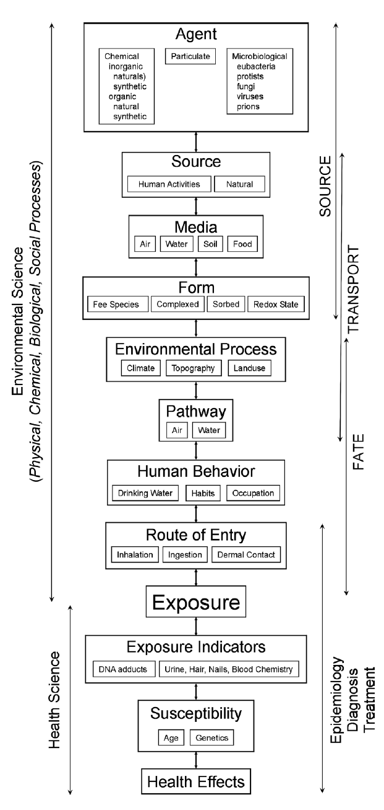
In the last decade, this hypothesis has been extended to the United States where there is a geologic framework similar to that in the Balkans. Lignite is distributed throughout the Gulf Coast region (Tully, 1996) with many of the inter-bedded sands serving as primary aquifers (Clark and Hart, 2009; Clark et al., 2011). Lignite is geologically young slightly metamorphosed degraded plant material that could give rise to potentially toxic and water-soluble organic compounds such as polyaromatic hydrocarbons, aliphatic and aromatic heterocyclic compounds, aromatic amines and thiophenes, and cyclic and acyclic aliphatics (Johansen et al., 1996; Bunnell et al., 2003; Orem et al., 2007; Blum et al., 2011; Orem et al., 2014; Stearman et al., 2014; Chakraborty et al., 2017). It is possible that conditions similar to what is seen in the Balkans can occur in rural regions of the Gulf Coast for residents who consume water from these aquifers.
Some literature exists that addresses the geographic commonalities between the BEN and the United States (Bunnell et al., 2003, 2006; Carlson and Biersel, 2008, 2009), however little work has been done to link the source of organic material (lignite) to potential agents that cause the disease. This project addresses this gap in knowledge at crucial points in the environmental exposure model, characterizing the source of organic matter and identifying the potential agent(s) responsible for contributing to kidney disease. Also, I use a public health and geostatistical approach to interpret the kidney disease as a function of water source. The history of kidney disease in the Balkans, Balkan endemic nephropathy (BEN), and the coal deposits and groundwater resources in the Gulf Coast region will be discussed as they provide context to this hypothesis.
Balkan endemic nephropathy, BEN, is a chronic and slow progressing renal disease that is confined to the endemic regions of Bosnia, Bulgaria, Croatia, Romania, and Serbia (Pavlović, 2013; Stiborová et al., 2016). In rural areas, BEN affects primarily adults ages 30–50 who have lived in the area for an extended time, and terminates in end-stage renal disease (ESRD) and/or urinary tract tumors (Danilovic et al., 1957). Many environmental and genetic factors have been postulated as contributing factors to BEN (reviewed by Bui-Klimke and Wu, 2014; Stiborová et al., 2016). Metals such as lead, cadmium, and arsenic have been ruled out as likely causes (Wedeen, 1991). Other agents have been examined that are linked to kidney disease like ochratoxin A (Petkova-Bocharova et al., 1988; Mally et al., 2007) and aristolochic acid (Grollman et al., 2007). However, these toxins usually cause immediate concern and do not fit the geographic consistency of the endemic areas (Batuman, 2006).
Some evidence supports BEN being a multifactorial condition (Toncheva et al., 1998), with one hypothesis postulates that consumption of naturally contaminated drinking water from lignite beds could be a contributing factor to BEN (Feder et al., 1991; Finkelman et al., 1991; Orem et al., 1999). With respect to this hypothesis, kidney failures were attributed to the slow accumulation of toxic organic compounds that were found in the well water that had been in contact with the coal deposits. Orem et al. (1999) found elevated levels of polyaromatic hydrocarbons (PAHs) in the well water from endemic villages, and laboratory coal leaching experiments showed that lignite from endemic regions contained many more water soluble compounds than did more mature bituminous deposits (Maharaja et al., 2014). Human stem cells (Suciu et al., 2005) and human kidney cells (Bunnell et al., 2007) exposed to groundwater extracts from endemic areas showed increased cellular proliferation and differentiation as compared to the control, although a threshold for toxicity wasn’t clear.
Criticism of the Pliocene lignite hypothesis is centered on the lack of evidence beyond the geographic association originally proposed by Feder et al. (Pfohl-Leszkowicz et al., 2002; Voice et al., 2006; Schmeiser et al., 2012; Stiborová et al., 2016). Confirming lignite as the source of organic material in the well water has been elusive, weakening the cause-and-effect relationship (Voice et al., 2006). The work presented in this dissertation provides evidence to strengthen the lignite-water hypothesis.

Hypothesis

BEN is a well-studied phenomenon, but the Pliocene lignite hypothesis has not been as extensively tested outside of the Balkans. The working hypothesis in the United States titled, “lignite-water hypothesis” first outlined as the “lignite-water syndrome” in 2012, is similar to Feder’s first postulation. It states that lignite seams can be a source of dissolved organic matter, and long-term consumption of the organic matter in the drinking water may increase the risk of kidney disease over time. The aim of this research is to test this hypothesis as it applies to the Gulf Coast region, and fill in the gap of knowledge between the source of organic matter and the agents that contribute to kidney disease. Three independent research questions have been developed:
1) What are the geochemical characteristics of organic matter that can leach into the groundwater?
2) Is lignite-derived organic matter toxic to human kidney cells?
3) What is the relationship between ESRD and lignite-containing aquifers in the Gulf Coast region?
These research questions are designed to move past the casual geographic relationship proposed by Feder et al. (1991). The water-soluble leachate from Gulf Coast lignite is not well characterized in the literature but represents the portion of coal mostly likely to enter the groundwater. Laboratory-leaching experiments were performed with several lignite samples, and the geochemical characteristics of the organic matter from the coal were defined. Understanding the geochemical signatures preserved, enriched, and/or altered during the leaching process is an important step to understanding the profile of organic matter that could be contributing to kidney disease. A multi-dimensional approach using UV-Vis spectroscopy (UV-Vis), elemental analysis, thermogravitational analysis (TGA), and gas chromatography/mass spectrometry (GC/MS) were used to characterize the leachates.
The second research question addresses the toxicity of the leachates and provides a crucial link between lignite-derived organic material and renal disease. Human kidney cells were exposed to the extracts and thresholds of toxicity, IC₅₀ values were calculated. These results represent the first instance of IC₅₀ values for lignite-derived material in the literature.
The final question addresses the health effects portion of Long and Voice’s model and the association between kidney disease and the consumption of water from lignite-containing aquifers. Spatial and temporal trends of ESRD were evaluated along with geologic, hydrogeologic, and demographic variables. Epidemiological and statistical correlations were used to evaluate the risk for kidney disease within the regions of the Gulf Coast areas that extensively rely on groundwater from lignite-containing aquifers.

Study area

Figure 2. Coal deposits in the United States. The study area, Arkansas, Texas, and Louisiana, is highlighted.
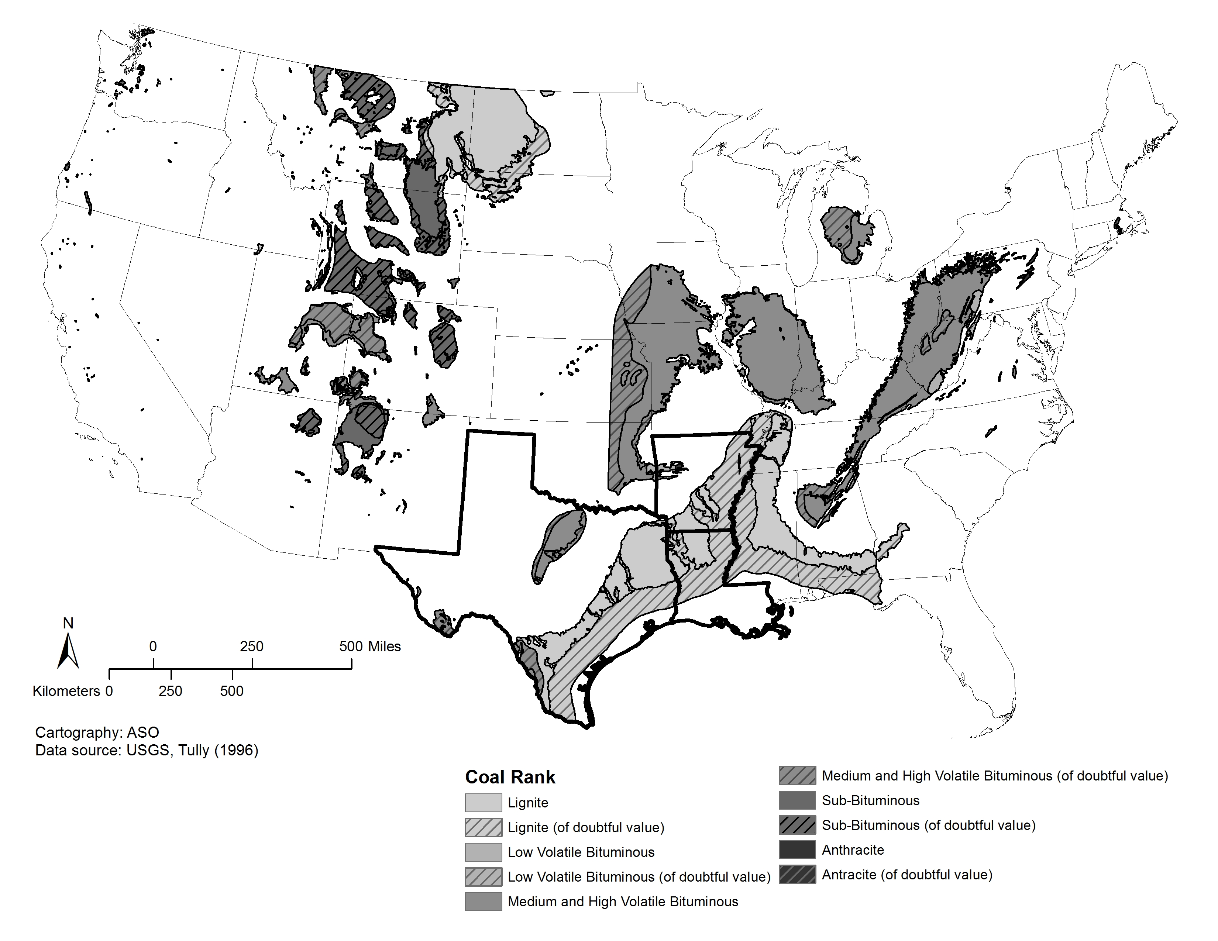
For this study, the area is limited to Texas, Arkansas, and Louisiana although the lignite deposits extend through Mississippi and lower Alabama, and as far north as Missouri (Figure 2). The largest deposits are contained in the Wilcox, Claiborne, and Jackson Groups (Figure 3, red box) that lie below a series of younger terrace and alluvial deposits. The lignite containing regions represent swampy deposits during the Paleocene to Eocene with little deep-marine influence. The Claiborne in particular is characterized as a near-shore marine setting with significant detrital input (McFarland, 2004). The lignite deposits from the Wilcox and Claiborne units are low in sulfur (<1%) and pyrite (<0.05%), indicating oxic sediment deposition. These conditions lead to the preservation of terrigenous material rich in lignin products.
The aquifer system in the Gulf Coast region contains many regional and local aquifers. The Mississippi Embayment and Texas Coastal Uplands aquifers extend through Texas, Arkansas, and Louisiana and are typically categorized by age into the Quaternary and Tertiary systems. The Quaternary Alluvial aquifer is comprised of the alluvial and terrace deposits, whereas the Tertiary system includes Claiborne and Wilcox aquifers (Figure 3).

Figure 3. Generalized stratigraphic column of the Coastal Plain region of Arkansas, Texas, and Louisiana (modified from Clark and Hart, 2009). The red box highlights units that contain lignite.
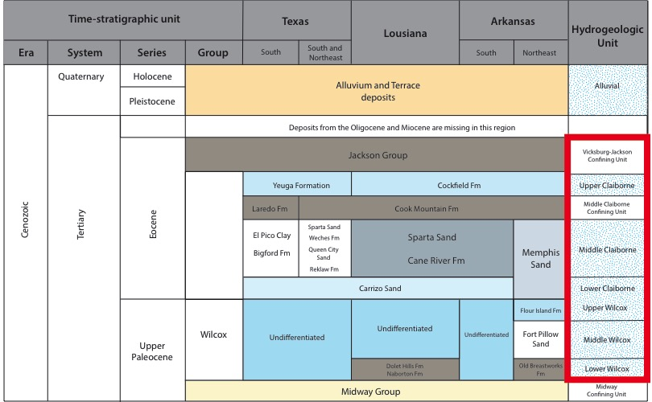
Figure 4. Extent of the outcrop (solid) and subsurface (transparent) of the aquifer units that are part of the Mississippi Embayment and Texas Coastal Uplands aquifer system. Modified from Hosman and Weiss (1991).
Water enters the aquifer system in the outcrop area along the eastern edge of the formations. The formation down dips toward the coast and becomes confined for the majority of the aquifer extent. In Figure 4, the outcrop region and the subsurface extent of the aquifer system is shown for the study area. The full extent of the aquifer system is highlighted in blue. The Claiborne and Wilcox aquifers are bounded at the top by the Vicksburg confining unit and the bottom by Midway confining unit and are hydraulically connected to the lignite deposits to varying extents throughout the tri-state region (Hosman and Weiss, 1991). The occurrence of lignite in the Wilcox, Upper, and Middle Claiborne aquifers is common. Relatively small lenticular beds do not impede vertical hydraulic conductivity in Arkansas and parts of northeastern Louisiana. Larger lignite deposits in Texas and parts of northwestern Louisiana could be considered local confining units.
The majority of groundwater in these states is used for irrigation, however the largest withdrawals for public and domestic supply are from Claiborne and Wilcox aquifers (Welch et al., 2009). Water withdrawals from the Tertiary aquifers in the Gulf Coast region averaged 1,327 million gallons per day (Mgal/d) for public supply, irrigation, and self-supplied industrial uses in 2000 (Maupin and Barber, 2005). In Arkansas, the Middle Claiborne aquifer (Sparta Sand) averaged 196 Mgal/d withdrawal and over 23 Mgal/d drawn from the Wilcox in 2010 (Kresse, et al., 2014). These aquifer systems were targeted in the epidemiology study associated with this research.

References

Batuman, V., 2006. Fifty years of Balkan endemic nephropathy: daunting questions, elusive answers. Kidney Int. 69, 644–646.

Blum, P., Sagner, A., Tiehm, A., Martus, P., Wendel, T., Grathwohl, P., 2011. Importance of heterocylic aromatic compounds in monitored natural attenuation for coal tar contaminated aquifers: A review. J. Contam. Hydrol. 126, 181–194.

Bui-Klimke, T., Wu, F., 2014. Evaluating weight of evidence in the mystery of Balkan endemic nephropathy. Risk Anal. 34, 1688–1705.

Bunnell, J.E., Bushon, R.N., Stoeckel, D.M., Gifford, A.M., Beck, M., Lerch, H.E., Shi, R., Mcgee, B., Hanson, B.C., Kolak, J., Warwick, P.D., Blank, F., 2003. Preliminary Geochemical, Microbiological, and Epidemiological Investigations into Possible Linkages between Lignite Aquifers, Pathogenic Microbes, and Kidney Disease in Northwestern Louisiana. U.S. Geological Survey, Open-File Report 03–374.

Bunnell, J.E., Tatu, C.A., Lerch, H.E., Orem, W.H., Pavlovic, N., 2007. Evaluating nephrotoxicity of high-molecular-weight organic compounds in drinking water from lignite aquifers. J Toxicol Env. Heal. A 70, 2089–2091.

Carlson, D., Biersel, T. Van, 2008. Distribution of Possible Disease-Causing Inorganic Tracers from Lignite in the Wilcox Aquifer in Caddo Parish, Louisiana. Gulf Coast Assoc. Geol. Soc. Trans. 58, 149–159.

Carlson, D., Biersel, T. Van, 2009. Dependence of the Wilcox Aquifer Water Chemistry on Stratigraphy, Spatial Distribution, and Proximity to Lignite in Southern Caddo Parish, Louisiana. Gulf Coast Assoc. Geol. Soc. Trans. 59, 145–157.

Chakraborty, J., Varonka, M., Orem, W., Finkelman, R.B., Manton, W., 2017. Geogenic organic contaminants in the low-rank coal-bearing Carrizo-Wilcox aquifer of East Texas, USA. Hydrogeol. J. 25, 1219–1228.

Clark, B.R., Hart, R.M., 2009. The Mississippi Embayment Regional Aquifer Study (MERAS): Documentation of a Groundwater-Flow Model Constructed to Assess Water Availability in the Mississippi Embayment, U.S. Geological Survey. United States Geological Survey, Scientific Investigations Report 2009–5172.

Clark, B.R., Hart, R.M., Gurdak, J.J., 2011. Groundwater availability of the Mississippi Embayment. United States Geological Survey, Professional Paper 1785.

Danilovic, V., Djurisic, M., Mokranjac, M., Stojimirovic, B., Zivojinovic, J., Stojakovic, P., 1957. Chronic nephritis due to lead poisoning by digestive route (flour). Presse Med. 65, 2039.

Feder, G.L., Radovanoic, Z., Finkelman, R.B., 1991. Relationship between weathered coal deposits and the etiology of Balkan endemic nephropathy. Kidney Int. Suppl. 40, S9-S11.

Grollman, A.P., Shibutani, S., Moriya, M., Miller, F., Wu, L., Moll, U., Suzuki, N., Fernandes, A., Rosenquist, T., Medverec, Z., Jakovina, K., Brdar, B., Slade, N., Turesky, R.J., Goodenough, A.K., Rieger, R., Vukelić, M., Jelaković, B., 2007. Aristolochic acid and the etiology of endemic (Balkan) nephropathy. Proc. Natl. Acad. Sci. U. S. A. 104, 12129–12134.

Hosman, R.L., Weiss, J.S., 1991. Geohydrologic units of the Mississippi embayment and Texas coastal uplands aquifer systems, south-central United States. United States Geological Survey, Professional Paper 1416–B.

Johansen, S., Hansen, A., Mosbaek, H., Arvin, E., 1996. Method development for trace analysis of heteroaromatic compounds in contaminated groundwater. J. Chromatogr. A 738, 295–304.

Kresse, T.M., Hays, P.D., Merriman, K.R., Gillip, J.A., Fugitt, D.T., Spellman, J.L., Nottmeier, A.M., Westerman, D.A., Blackstock, J.M., Battrea, J.L., 2014. Aquifers of Arkansas — Protection , Management , and Hydrologic and Geochemical Characteristics of Groundwater Resources in Arkansas. United States Geological Survey, Scientific Investigations Report 2014 – 5149.

Long, D.T., Voice, T.C., 2007. Role of exposure analysis in solving the mystery of Balkan endemic nephropathy. Croat. Med. J. 48, 300–311.

Maharaj, S.V.M., Orem, W.H., Tatu, C. a, Lerch, H.E., Szilagyi, D.N., 2014. Organic compounds in water extracts of coal: links to Balkan endemic nephropathy. Environ. Geochem. Health 36, 1–17.

Mally, A., Hard, G.C., Dekant, W., 2007. Ochratoxin A as a potential etiologic factor in endemic nephropathy: lessons from toxicity studies in rats. Food Chem. Toxicol. 45, 2254–2260.

Maupin, M. A, Barber, N.L., 2005. Estimated withdrawals from principal aquifers in the United States, 2000. United States Geological Survey, Circular 1405.

McFarland, J.D., 2004. Stratigraphic Summary of Arkansas. Arkansas Geological Survey, Information Circular 36.

Orem, W. H., Tatu, C., Varonka, M., Lerch, H., Bates, A., Engle, M., Crosby, L., McIntosh, J., 2014. Organic substances in produced and formation water from unconventional natural gas extraction in coal and shale. Int. J. Coal Geol. 126, 20–31.

Orem, W.H., Feder, G.L., Finkelman, R.B., 1999. A possible link between Balkan endemic nephropathy and the leaching of toxic organic compounds from Pliocene lignite by groundwater: preliminary investigation. Int. J. Coal Geol. 40, 237–252.

Orem, W.H., Tatu, C.A., Lerch, H.E., Rice, C.A., Bartos, T.T., Bates, A.L., Tewalt, S., Corum, M.D., 2007. Organic compounds in produced waters from coalbed natural gas wells in the Powder River Basin, Wyoming, USA. Appl. Geochemistry 22, 2240–2256.

Orem, W., Tatu, C., Pavlovic, N., Bunnell, J., Lerch, H., Paunescu, V., Ordodi, V., Flores, D., Corum, M., Bates, A., 2007. Health Effects of Toxic Organic Substances from Coal: Toward “Panendemic” Nephropathy. AMBIO A J. Hum. Environ. 36, 98–102.

Pavlović, N.M., 2013. Balkan endemic nephropathy - Current status and future perspectives. Clin. Kidney J. 6, 257–265.

Petkova‐Bocharova, T., Chernozemsky, I.N., Castegnaro, M., 1988. Ochratoxin A in human blood in relation to Balkan endemic nephropathy and urinary system tumours in Bulgaria. Food Addit. Contam. 5, 299–301.

Pfohl-Leszkowicz, A., Petkova-Bocharova, T., Chernozemsky, I.N., Castegnaro, M., 2002. Balkan endemic nephropathy and associated urinary tract tumours: a review on aetiological causes and the potential role of mycotoxins. Food Addit. Contam. 19, 282–302.

Schmeiser, H.H., Kucab, J.E., Arlt, V.M., Phillips, D.H., Hollstein, M., Gluhovschi, G., Gluhovschi, C., Modilca, M., Daminescu, L., Petrica, L., 2012. Evidence of exposure to aristolochic acid in patients with urothelial cancer from a Balkan endemic nephropathy region of Romania. Environ. Mol. Mutagen. 53, 636–641.

Stearman, W., Taulis, M., Smith, J., Corkeron, M., 2014. Assessment of Geogenic Contaminants in Water Co-Produced with Coal Seam Gas Extraction in Queensland, Australia: Implications for Human Health Risk. Geosciences 4, 219–239.

Stiborová, M., Arlt, V.M., Schmeiser, H.H., 2016. Balkan endemic nephropathy: an update on its aetiology. Arch. Toxicol. 90, 2595–2615.

Suciu, E.I., Ordodi, V., Szilagyi, D.N., Tatu, C. a, Orem, W.H., Lerch, H.E., Bunnell, J., Paunescu, V., 2005. Balkan Endemic Nephropathy Etiology: a Link Between Geochemistry and Medicine. Timisoara Med. J. 55, 228–234.

Toncheva, D., Dimitrov, T., Stojanova, S., 1998. Etiology of Balkan endemic nephropathy: a multifactorial disease? Eur. J. Epidemiol. 14, 389–394.

Voice, T.C., McElmurry, S.P., Long, D.T., Dimitrov, P., Ganev, V.S., Peptropoulos, E. a, 2006. Evaluation of the hypothesis that Balkan endemic nephropathy is caused by drinking water exposure to contaminants leaching from Pliocene coal deposits. J. Expo. Sci. Environ. Epidemiol. 16, 515–524.

Wedeen, R.P., 1991. Environmental renal disease: lead, cadmium and Balkan endemic nephropathy. Kidney Int. Suppl. 40, S4-S8.

Welch, H.L., Kingsbury, J.A., Tollett, R.W., Seanor, R.C., 2009. Quality of Shallow Groundwater and Drinking Water in the Mississippi Embayment-Texas Coastal Uplands Aquifer System and the Mississippi River Valley Alluvial Aquifer, South-Central United States, 1994–2004. U. S. Geological Survey, Scientific Investigations Report 2009–5091.

Chapter 2: Geochemical characterization of water-soluble extracts from Gulf Coast lignite

Abstract

A wide assortment of organic material can leach from lignite (a low-rank coal) in water, which potentially leads to subsurface coal deposits negatively affecting groundwater quality. The water-soluble fraction from lignite has been associated with adverse health effects in areas of the Balkans, where rural residents rely extensively on untreated well water. Recent efforts have been made to evaluate this hypothesis in other regions where lignite is in contact with groundwater. In the Gulf Coast region of the United States, lignite seams are in communication with shallow aquifers. However, there is little information regarding the water-soluble fraction from Gulf Coast lignite and less information regarding its potential health effects. In this study, six Gulf Coast lignite samples representing various depositional horizons, and formations were extracted with water over the course of five days. The water-soluble portion of the coal was then characterized using a variety of geochemical techniques including total organic carbon (TOC) and UV-Vis spectroscopy. A lyophilized fraction of the extract was analyzed using thermogravimetric analysis and the organic material extracted and analyzed by gas chromatography/mass spectrometry (GC/MS). Between 75–271 mg/L of dissolved organic carbon was leached from the coals, which shows enrichment in lignin character relative to the lignite. Compounds identified in the extract were low molecular weight phenols, benzoic acids, aliphatic acids, and diacids. There were few differences from sample-to-sample in the organic material leached from the lignites from the Gulf Coast region. This study offers a baseline of comparison to identify lignite-derived material in groundwater samples from the aquifers associated with lignite in the Gulf Coast.

Introduction

Coal is a complex mixture of organic matter and mineral products derived from a variety of sources, and the nature of coal is highly dependent on its geologic history. Lignite, a low-rank coal, is in the early stages of transformation from peat to anthracite. The health effects of coal use have been extensively studied (Finkelman et al., 2002). When in contact with water, lignite has the potential to leach a higher yield of organic components than more mature sub-bituminous and bituminous coals (Nakajima et al., 2008), and various organic compounds such as phenols and polycyclic aromatic hydrocarbons (PAHs) have been observed in situations where coal is in contact with water such as in coal pile runoff (Fendlnger et al., 1989) and lignite dewatering processes (Racovalis et al., 2002; Qi, 2004). Water-soluble extracts from lignite have also been implicated in the development of kidney disease in areas of the Balkans. The disease– Balkan endemic nephropathy (BEN)– is of unknown origin, and many environmental factors could contribute to the development of BEN (reviewed by Bui-Klimke and Wu, 2014; Stiborová et al., 2016). Geographic consistencies were identified between endemic villages and Pliocene age lignite deposits, leading to the development of the lignite-water hypothesis (Feder et al., 1991). It is suggested that consumption of drinking water contaminated from organic material leached from lignite beds can lead to the development of BEN (Orem et al., 1999).
Recent attempts have been made to understand how this hypothesis might apply to the United States Gulf Coast region, where lignite seams are in communication with shallow aquifers. Well water extracts from lignite-containing aquifers in Texas showed a number of potentially lignite-derived compounds like PAHs and alkylated and hydroxyl-phenols (Chakraborty et al., 2017). Additionally, in Louisiana, increased incidence of renal pelvic cancers have been correlated to a number of inorganic species linked to lignite seams within aquifers (Bunnell et al., 2006; Carlson and Biersel, 2008, 2009). In this study, using a variety of geochemical methods to characterize the water-soluble fraction from several Gulf Coast lignites tests this hypothesis further. The compounds most likely to enter the groundwater are identified and the fate of this organic matter is discussed.
The study area is limited to Texas, Arkansas, and Louisiana although the lignite deposits extend through Mississippi and lower Alabama, and as far north as Missouri shown in Figure 5 (Schobert, 1995; Tully, 1996). The largest lignite deposits are contained in the Wilcox, Claiborne, and Jackson Groups that have been extensively studied (Finkelman et al., 1987; Warwick et al., 1996, 1997; Robert et al., 2011; Hackley et al., 2011, 2012; Swanson et al., 2015). These formations also contain large sandstone deposits that serve as local and regional aquifers in the western extent of the formations (Hosman and Weiss, 1991). The lignite deposits represent swampy, sometimes lagoonal deposits during the Paleocene to Eocene with little deep-marine influence. The lignite deposits from the Wilcox and Jackson units are low in sulfur (<1%) and pyrite (<0.05%) supporting oxic sediment deposition, leading to the preservation of terrigenous material rich in lignin products (Finkelman et al., 1987; Schobert, 1995).

Methods

Coal samples

Six coal samples were collected from outcrops and surface mines, representing different formations and horizons to account for spatial variability in Gulf Coast lignite. Subsurface lignite samples in Arkansas are scarce since there are no active mine sites in the region (Energy Information Administration, 2016), so two coal outcrop samples from the Wilcox formation were collected in the spring of 2015. One sample was collected from an active clay mine in Hot Springs County, Arkansas and another from an abandoned clay mine in rural Pulaski County, Arkansas. A channel sample was taken along each seam and several samples from the same seam were combined for analysis. Four additional coal samples (Dolet Hills, Monticello, Oak Hill, and San Miguel) were obtained from the United States Geological Survey from Gulf Coast lignite deposits in Texas and Louisiana. The spatial distribution of the coal samples collected for this study is presented in Figure 5.
Figure 5. The United States Gulf Coast coal deposits (inset) and distribution through Texas, Arkansas, and Louisiana. Sample locations for this study are shown for mine samples (box) and outcrop samples (circles).

Water-soluble lignite extracts

A round bottom flask (500mL) was fitted with a water-jacket condenser. A Teflon stir bar, lignite that was ground and passed through a 60 mesh sieve (8g), as well as ultrapure water (18Ω, 350mL) were added, and the slurry was stirred at 80°C for 5 days. The solution was then filtered hot through a 0.45 µm glass fiber filter (Whattman), acidified with HCl (1mL/L), and stored at 4°C. An aliquot of the water-soluble extract (50 mL) was lyophilized (0.133m bar, –85°C), producing a solid residue.

Thermogravimetric analysis

Thermogravimetric analysis was performed using a Netzsch F1 Jupiter thermal analyzer coupled to an Aëolos QMS 403C mass spectrometer. A two-stage pyrolysis program was used, including temperature programmed desorption (TPD) in argon with a gas flow of 60 ml/min from 40–550°C to measure moisture, oxygen, and volatile hydrocarbon content. The TPD was followed by a temperature programmed oxidation (TPO) in air with a gas flow of 60 ml/min from 100–900°C to measure hydrogen, carbon, nitrogen, sulfur, and salt content. A ceramic crucible was loaded with 5–20 mg of sample and pyrolysis was carried out with a heating rate of 1°C/min during TPD and 2ºC/min during TPO. The following mass fragments (± 0.1 amu) were monitored during TPD and TPO: m/z 2 (H₂), 16 (CH₄), 18 (H₂O), 28 (CO), 30 (C₂H₆), 44 (CO₂), 46 (NO₂), and 64 (SO₂). TGA profiles and mass spectra are shown in Appendix A.

UV/Vis spectroscopy

UV-Vis spectra were obtained using a Hewlett Packard 8452A diode array spectrophotometer fitted with a 0.1cm cell, scanning from 190–700nm. Water-soluble extracts were analyzed in triplicate with ultra-pure water (18Ω) as a blank.

Gas chromatography/mass spectrometry (GC/MS)

The lyophilized extract (20–30 mg) was dissolved in a 50:50 mixture of reagent grade dichloromethane and methanol before being filtered through a pre-cleaned glass wool plug. An aliquot of the filtrate (50 µL) was added to a 50 µL solution of N,O-bis(trimethylsilyl)trifluoroacetamide (BSFTA) to derivatize polar functional groups in the solution. Samples were analyzed using and Agilent GC/MS system under the following conditions: a 30m x 250µm x 0.25µm HP-5MS column (95% dimethyl, 5% diphenyl polysiloxane); 1 µl splitless injection; a constant flow of 1.4 ml/ min; solvent delay of 22.0 min; injector temperature of 300°C; ramp rate of 4°C/min from 40–300°C; and mass scan from 50 to 550 Dalton. Compound identification was made through comparison with published spectra and matches to mass spectral databases.

Results

Organic carbon and elemental composition

Chemical characteristics of the water-soluble extracts from the Gulf Coast lignite samples are summarized in Table 1. The amount of dissolved organic carbon (DOC) extracted in the lignite leachates ranged from 75.0 to 256 mg/L, which corresponds to 0.23–1.04% (w/w) of the total rock that leached into the water. The amount of DOC leached from many of the Gulf Coast lignites is comparable to reports from Czech Republic lignite samples (Peuravuori et al., 2006; Doskocil et al., 2015). The pH of the extracts ranged from 2.7–5.1, suggesting that acidic functionalities dominate the leachates.

Table 1. Sample description and chemical characteristics of water-soluble extracts from Gulf Coast lignite.
Sample | Location | Formation | Sample Type | DOC  (mg/L) | pH | % Organic material  extracted from rock (w/w)
Pulaski County | AR | Wilcox | Outcrop | 75.0 | 5.1 | 0.23
Hot Springs County | AR | Wilcox | Outcrop | 160 | 4.6 | 0.53
Dolet Hills | LA | Wilcox | Surface mine | 127 | 4.0 | 0.48
Monticello | TX | Wilcox | Surface mine | 256 | 4.9 | 1.03
Oak Hill | TX | Wilcox | Surface mine | 139 | 2.7 | 0.59
San Miguel | TX | Lower Jackson | Surface mine | 271 | 4.2 | 1.04

The elemental compositions of the leachates are shown in Table 2. Carbon content of the extracts ranges from 52.4–74.1%. A van Krevlen diagram (Figure 6) shows that the Gulf Coast extracts are depleted in hydrogen and enriched in oxygen relative to the lignite, and most of the extracts show a relative enrichment in lignin-character. The relatively low abundance of nitrogen in the samples coincides with the oxic depositional environment and low (<1%) nitrogen in the lignite (Finkelman et al., 1987). Only one leachate, Oak Hill, contained sulfur. The amount of organic sulfur in coals from the Wilcox formation in Texas is low (0.59%; Finkelman et al., 1987), and the GC/MS chromatogram of the Oak Hill extract, discussed in the Molecular composition section, did not show significantly more organo-sulfur compounds compared to other extracts. Overall, the elemental compositions of the Gulf Coast extracts are similar to lignite humic acid fractions from the Czech Republic (Peuravuori et al., 2006), Pakistan (Nasir et al., 2011), other regions of the USA, and Italy (Francioso et al., 2005). Additionally, there was no significant difference between the amount of organic carbon or composition of the organic material leached from the outcrop samples compared to the surface mine samples.

Table 2. Elemental composition of the freeze-dried extracts. Organic matter is calculated on an ash-free and moisture free basis.
Sample | % C | % H | %O | % N | % S | H/C | O/C
Pulaski County | 60.2 | 17.9 | 21.7 | 0.1 | 0.0 | 0.30 | 0.36
Hot Springs County | 61.6 | 18.3 | 22.2 | 0.1 | 0.0 | 0.26 | 0.31
Dolet Hills | 52.4 | 13.8 | 16.1 | 0.0 | 0.0 | 0.36 | 0.54
Monticello | 59.1 | 30.0 | 10.9 | 0.0 | 0.0 | 0.51 | 0.18
Oak Hill | 66.9 | 12.6 | 17.8 | 0.0 | 2.6 | 0.19 | 0.27
San Miguel | 74.1 | 14.7 | 11.0 | 0.1 | 0.0 | 0.20 | 0.15

Figure 6. van Krevlen diagram of the Gulf Coast extracts, Gulf Coast lignite (Finkelman et al., 1987), and lignin (Lui et al., 2016).
Figure 7. Experimental procedure for TGA with typical mass loss curve for reference.

Thermogravimetric analysis

The experimental profile during temperature-programmed desorption (TPD) in argon, and the temperature programmed oxidation (TPO) in air are shown in Figure 7. The maximum temperature reached during TPD was 550°C to prevent polycondensation of aromatic rings in the extract (Iordanidis et al., 2001; Francioso et al., 2005). It is important to note that TPD induces self-oxidation and CO₂ evolved is generated from breaking carbon-oxygen bonds in place. Additional mass lost may be accounted for by the volatilization of light hydrocarbons as well. Following TPD, TPO promotes full combustion of all organic material in the sample. The mass loss profile paired with gas evolution measured by mass spectrometry is presented in Appendix A for all samples.
Figure 8 shows the mass loss curve during TPD (A) and total mass lost by zone (B). After the initial mass lost from adsorbed water (<150°C), three temperature zones during TPD were identified that correspond to bond-dissociation energies (Shi et al., 2012) and thermal degradation of lignite extracts (Kučerík et al., 2004; Francioso et al., 2005). Total mass loss on a moisture-free basis during TPD are ranked as Dolet Hills > Monticello > Hot Springs County > Oak Hill > Pulaski > San Miguel (Figure 8, B).
Zone 1 was designated between 150–220°C and the mass loss ranged from 6–14%. For Oak Hill and San Miguel, this temperature range coincided with evolution of CO₂ due to decarboxylation of acidic moieties in the sample. Zone 2 was designated between 240–385°C with mass losses from 7–22%. All samples except Pulaski County showed a peak in the CO₂ mass spectrum in Zone 2 resulting from breaking aliphatic carbon-carbon and carbon-oxygen bonds (Shi et al., 2012). Zone 3 represents temperatures between 385–500°C with mass losses between 4–18%, and corresponds to the decomposition of aromatic carbon-oxygen bonds. The sharp mass loss (Figure 8, A) in the Oak Hill sample corresponded to the evolution of CO₂ as well as SO₂. Mass loss in the Oak Hill samples was also shifted to higher temperatures (445°C) compared to the other samples (~408°C). This could be explained by the relatively stronger carbon-sulfur bond and decomposition of organo-sulfur compounds in the extract.
All oxygen was expelled during TPD, and oxidation in air (TPO) results in mass loss curves (C) and mass lost by zone (D) in Figure 8. The TPO showed less distinctive features than TPD, and only two zones were identified. No mass was lost in any sample from 150–300°C, most likely because volitization occurred during TPD. The first zone identified in TPO, labeled Zone 4, from 300–500°C corresponded to the release of CO₂ and H₂O in all samples except Oak Hill. Interestingly, the Oak Hill sample showed no mass loss during TPO. The absence of mass lost during TPO could be attributed to complete degradation during TPD. Zone 4 correlated to breaking alkyl carbon-carbon, alkyl carbon-hydrogen, and aromatic carbon-alkyl carbon bonds. Mass loss above 500°C, zone 5, can be attributed to breaking aromatic carbon-carbon and aromatic carbon-hydrogen bonds. Only Monticello, Dolet Hills, and San Miguel show distinct CO₂ mass spectrum peaks in this region.

Figure 8. Mass loss during TPD (A), mass loss by zone during TPD (B), mass loss during TPO (C), mass loss by zone during TPO (D).

Unlike bulk coal samples (Serio et al., 1987; Seo et al., 2011) and lignin (Sanchez-Silva et al., 2012), the Gulf Coast extracts did not show formation of CH₄ or H₂, during TPD or TPO. These products are generated though cleavage of alkyl or ether bridges between lignin units (Serio et al., 1987), and their absence suggests that macromolecular structures are not leached in high abundance under these conditions.
(D)
(C)
(B)
(A)

UV-Vis spectroscopy

The UV-Vis spectra of most samples showed a maximum absorbance at 208–209 nm, corresponding to conjugated pi systems prevalent in organic matter (Korshin et al., 1997). The specific UV absorbance (SUVA₂₅₄) is a common parameter used to characterize natural organic matter that correlates to the aromaticity of the DOC in the sample (Weishaar et al., 2003). SUVA₂₅₄ values for the Gulf Coast extracts range from 2.52–4.27, and the calculated percentage of aromatic character ranged from 20.1–31.3%
(Table 3). These values fall within humic and fulvic acid standards presented by Weishaar et al. (2003). The aromatic character is significantly higher for the Gulf Coast lignite compared to the water-soluble extracts from Czech lignite (Doskocil et al., 2015). The E_{Et}/E_{Bz} ratio, which is calculated from the absorbance of the electron transfer band (E_{Et}) at 253nm and the absorbance of the pi system in benzene (E_{Bz}) at 203nm, describes the aromatic substitution patterns in the DOC (Korshin et al., 1997). Ratios below 0.2 are typical of aliphatic substitution, while increasing E_{Et}/E_{Bz} ratios indicate hydroxyl, ester, carbonyl, and carboxylic acid substitution. The Gulf Coast extracts show E_{Et}/E_{Bz} values between 0.49 and 0.58 consistent with hydroxyl and carboxylic acid substitution (Korshin et al., 1997) characteristic of lignin products (Doskocil et al., 2015).

Table 3. UV-Vis spectroscopic features of the water-soluble extracts from Gulf Coast lignite.

Sample | λ_{max}ª | SUVA₂₅₄^{b} | %Aromaticity^{c} | E_{Et}/E_{Bz}^{d}
Pulaski County | 190 | 3.39 | 25.7 | 0.54
Hot Springs County | 206 | 2.97 | 23.0 | 0.51
Dolet Hills | 206 | 4.24 | 31.3 | 0.51
Monticello | 208 | 2.70 | 21.1 | 0.55
Oak Hill | 206 | 2.52 | 20.1 | 0.49
San Miguel | 206 | 3.40 | 25.8 | 0.58
ª wavelength of maximum absorbance from 190–700nm
^{b} Specific UV Absorbance = A₂₅₄ (m⁻¹)/TOC (mg/L) according to Weishaar (2003).
^{c} calculated from SUVA₂₅₄ (Weishaar, 2003)
^{d} Absorbance at 253nm (E_{Et}) / absorbance at 203nm (E_{Bz}) according to (Korshin et al., 1997)

Oak Hill has the lowest SUVA₂₅₄ value and therefore the lowest percentage of aromatic character. This, combined with significant decarboxylation during TPD and a pH value of 2.1, suggests that a significant portion of the water-soluble extract from Oak Hill is made up of aliphatic acids. Conversely, Dolet Hills shows the highest percentage of aromatic character with a high O/C value. However, Dolet Hills doesn’t show decarboxylation during TPD nor does it have a low pH value. Therefore, the Dolet Hills extract is most likely dominated by aromatic structures such as phenols.

Molecular composition

A summary of the compounds identified with >90% match to reported spectra and identification from diagnostic m/z ions are presented in Table 4. Compound identification numbers in the table correspond to those in chromatograms in Figure 9.
Fatty acids from n–C₈ to n–C₁₈ were identified in all of the samples with major contributions from microbial lipids C₉, C₁₆, and C₁₈. Fatty acids can either be bound in the lignin structure, hydrolyzed during water extraction (Doskocil et al., 2015), or
represent microbial artifacts of cellular membranes (Nichols et al., 1985). A series of diacids ranging from C₈ to C₁₃ also contribute to the acidic nature of the extract and have been described as hydrolysis of the bridges between larger subunits of lignin or intermediate metabolites from cell function (Templier et al., 2005; Doskočil et al., 2014). A variety of hydroxl-, syringyl- and vanillyl-phenols as well as dibenzoic acids were identified and could come from microbially degraded lignin or hydrolysis of lignin (Berwick et al., 2010). The presence of vanillyl- and syringyl-phenols indicates that the lignin is derived from both gymnosperm and angiosperm precursors (Hedges and Parker, 1976), which agrees with previous descriptions of the depositional environment for Gulf Coast lignite (Warwick et al., 1996; Robert et al., 2011). Hot Springs County, Dolet Hills, Oak Hill, and San Miguel samples also contained an interesting series of compounds centering around 56 minutes and 61 minutes in the GC/MS chromatogram. These compounds are presumed to be an isomeric series of diacids, owing to the same molecular ion (M* = 362) and large mass spectral peaks at m/z 117 and 73 corresponding to the C(O)OTMS fragment. A similar series of compounds was seen in the total ion chromatogram of water extracts of lignite from Romania and Serbia (Skinner and Berger, 2003). Several samples also contained small amounts (<1%) of phthalate contaminants possibly derived from the plastic containers used for sample storage. Similar suites of compounds have been identified in other instances where lignite seams are in contact with water. A variety of benzoic acids, phenols, and fatty acid were identified from dewatering operations from Australian brown coals (Qi, 2004), lignites during coal bed methane extraction (Orem et al., 2014), and peat (Mursito et al., 2010) as well as in wastewater from lignite gasification (Gangwal, 1977; Pissolatto et al., 1996).

Table 4. Compounds identified in the Gulf Coast extracts by GC/MS after treatment with BSFTA. Diagnostic ions are shown with the base beak underlined and the molecular ion italicized. Compound IDs correspond to the total ion chromatogram in Figure 9.

Compound  class | Compound  ID | Name |  |  |  | Common name |  | Diagnostic m/z ions
Aliphatic acids
 | 1 | 4-Oxo-pentanoic acid |  |  |  | Levulic acid |  | 75, 145, 173
 | 2 | Heptanoic acid |  |  |  |  |  | 73, 117, 187
 | 6 | Octanoic acid |  |  |  |  |  | 73, 117, 201
 | 7 | Butanedioic acid |  |  |  | Succinic acid |  | 147, 73, 247
 | 10 | Nonanoic acid |  |  |  | Pelargonic acid |  | 73, 117, 215
 | 13 | Decanoic acid |  |  |  |  |  | 73, 117, 229
 | 17 | Undecanoic acid |  |  |  | Lauric acid |  | 73, 117, 243
 | 24 | Dodecanoic acid |  |  |  |  |  | 73, 117, 257
 | 24 | Octanedioic acid |  |  |  |  |  | 73, 75, 303
 | 32 | Nonanedioic acid |  |  |  | Azelaic acid |  | 73, 75, 317
 | 34 | Tetradecanoic acid |  |  |  |  |  | 73, 117, 285
 | 37 | Decanedioic acid |  |  |  | Sebacic acid |  | 73, 75, 331
 | 40 | Undecanedioic acid |  |  |  |  |  | 73, 75, 345
 | 41 | Hexadecanoic acid |  |  |  | Palmitic acid |  | 73, 117, 313
 | 42 | Dodecanedioic acid |  |  |  |  |  | 73, 75, 359
 | 43 | Tridecanedioic acid |  |  |  |  |  | 73, 75, 373
 | 44 | Octadecanoic acid |  |  |  | Steric acid |  | 73, 117, 341
Phenols and Benzoic acids
 | 3 | Benzoic acid |  |  |  |  |  | 105, 179, 77
 | 8 | 4-Hydroxy benzaldehyde |  |  |  |  |  | 179, 194, 151
 | 9 | 2-methoxy benzoic acid |  |  |  |  |  | 193, 119, 149
 | 11 | 4-Hydroxy benzaldehyde?? |  |  |  |  |  | 179, 194, 151
 | 12 | 3-Hydroxy acetophenone |  |  |  |  |  | 193, 208, 151
 | 14 | 4-Hydroxy acetophenone |  |  |  |  |  | 193, 208, 73
 | 15 | 2-Hydroxy benzoic acid |  |  |  |  |  | 267, 73, 135
 | 16 | 4-Hydroxy-3-methoxy benzaldehyde |  |  |  | Vanillin |  | 194, 193, 209
 | 18 | 3-Hydroxy benzoic acid |  |  |  |  |  | 267, 223, 282
 | 19 | Unknown |  |  |  |  |  | 241, 213, 75
 | 21 | 2-Hydroxy-4-methyl benzoic acid |  |  |  |  |  | 281, 73
 | 22 | 4-Hydroxy-3-methoxy-acetophenone |  |  |  | Acetovanillone |  | 193, 208, 223
 | 23 | 4-Hydroxy benzoic acid |  |  |  |  |  | 267, 223, 193
 | 25 | 2-Hydroxy-5-methoxy benzoic acid |  |  |  |  |  | 297, 73, 312
 | 27 | 3,5-Dimethoxy -4-hydroxy benzaldehyde |  |  |  | Syringaldehyde |  | 224, 239, 254
 | 28 | 3-Methoxy-4-hydroxy benzoic acid |  |  |  | Vanillic acid |  | 267, 297, 312
 | 29 | 3-Hydroxy-4-methoxy benzoic acid |  |  |  | Isovanillic acid |  | 297, 267, 225
 | 30 | 1,2-Dibenzoic acid |  |  |  |  |  | 295, 73
 | 31 | 1,3-Dibenzoic acid |  |  |  |  |  | 295, 73
 | 33 | ?Methyl-Dibenzoic acid |  |  |  |  |  | 309, 73
 | 35 | ?Methyl-Dibenzoic acid |  |  |  |  |  | 309, 73
 | 36 | 1,4-Dibenzoic acid |  |  |  |  |  | 295, 73
 | 38 | 3,5-Dimethoxy-4-hydroxy benzoic acid |  |  |  | Syringic acid |  | 327, 312, 297
 | 39 | ?Methyl-Dibenzoic acid |  |  |  |  |  | 309, 73
Heterocyclic compounds
 | 4 | 2-Thiophene carboxylic acid |  |  |  |  |  | 141, 185, 73
 | 5 | ?-Thiophene carboxylic acid |  |  |  |  |  | 141, 185, 73
Phthalates
 | 20 | Diethyl phthalate |  |  |  |  |  | 149, 178, 222

Figure 9. Total ion chromatogram of Gulf Coast lignite extracts. Compound numbers correlate to those in Table 4. Colors represent different compound classes: aliphatic acids (orange), diacids (red), phenols and benzoic acids (blue), thiophenes (pink).

Figure 10. Percentage of organic compound classes in water-soluble extracts identified from GC/MS chromatograms.

The percentage of each compound class in the GC/MS chromatogram was calculated based on integration of all of the peaks in the total ion chromatogram. The suite of lignin products including vanillyl-, syringyl-, and p-hydroxy phenols, lignin product isomers, and fatty acids account for up to 70% of the identified compounds in the water-soluble extract (Figure 10). Outcrops of organic-rich rocks typically exhibit a high portion of humic material as an effect of biodegradation of the organic material (Tamamura et al., 2015), so it would be expected that outcrop samples exhibit higher proportions of biological products like aliphatic acids compared to mine samples. Hot Springs County does show a high proportion of aliphatic acids and a high abundance of the diacid isomer series. However aliphatic acids do not dominate the Pulaski County sample, also an outcrop. The mine samples, Dolet Hills, Monticello, Oak Hill, and San Miguel, experience less weathering than outcrop samples but vary in composition as well and do not follow a discernable trend. Biodegradation in situ likely contributes to the high proportions of aliphatic acids in these samples, and in some areas the Wilcox formation in Texas and Louisiana are targets for biogenic coal bed methane (Warwick et al., 2002, 2008). Additionally, the proportion of each compound class does not correlate to other geochemical parameters such as SUVA₂₅₄ and aromaticity, O/C or H/C ratios. It could be that the percentage of unidentified products in each sample weakens any correlation that could exist.

Discussion

The fraction of Gulf Coast lignite most likely to enter the groundwater consists of relatively small hydrophilic lignin degradation products and microbial artifacts from biodegradation within the coal seam. Although the coal samples are from the Gulf Coast region, and many from the Wilcox formation in particular, the composition of the leached material is variable. Different proportions of phenolic lignin derivatives as well as a variety of aliphatic acids, as identified by GC/MS, are leached and present in the coal extracts. Characterization of organic material extracted from groundwater in lignite-containing regions has relied heavily on GC/MS compound identification. However, as seen in this study, a high percentage of compounds can go unidentified, resulting in only a partial characterization of the organic matter. Additionally, GC/MS is biased towards analyzing small, relatively hydrophobic compounds that can elute from the GC column. Other techniques outlined here, such as thermal degradation profiles and UV-Vis absorbance measurements, can help to rectify the bias and should be used in the future to constrain portions of organic matter leached from lignite in environmental samples.
The high abundance of phenolic compounds in the extracts leads to a more significant discussion on the health effects of organic material derived from coal. Historically, polyaromatic hydrocarbons (PAHs) have been the target for environmental concern in coal contaminated systems (Marston et al., 2001). A number of PAHs have been detected in produced waters from coal-bed methane operations within higher rank, subbituminous and bituminous coals (Orem et al., 2014). However, low rank coals like those in the Gulf Coast region are immature and extensive aromatization of lignin has not yet occurred to produce PAH products. Therefore as seen in this study, it is unlikely that a significant amount of PAHs leach from the lignites in the Gulf Coast. Phenolic compounds, however, do readily leach and have been implicated in a number of adverse health effects including kidney disease (Bruce et al., 1987). These compounds are present in concentrations below the toxic thresholds (Qi, 2004), however low-level, chronic exposure to a variety of these compounds is currently unknown.
Several factors should be considered when applying the results of this study to an environmental system. The DOC released from lignite is a function of temperature (Nakajima et al., 2005), and in the subsurface this could correlate to much less organic material leached from coals than seen here. However, even at relatively low temperatures (25ºC) organic matter leached from coals shows significant aromatic character (Doskocil et al., 2015), and water extracts from Balkan lignites (Maharaj et al., 2014) and Bulgarian lignites (Kosateva et al., 2017) show the presence of phenolic compounds.
It should also be noted that these products might have a limited lifetime in the environment. Low-molecular weight acids from coals have been identified as a feedstock for microbial growth in the subsurface (Vieth et al., 2008), and lignin products are consumed by a variety of microbes in both aerobic and anaerobic environments (Young and Frazer, 1987). The lifetime of these compounds could be days to weeks depending on environmental factors (Young and Frazer, 1987; Artanto et al., 2009). Phenolic compounds also often have high adsorption coefficients to organic matter as well as inorganic sediments (Schwarzenbach et al., 2005). Even so, organic material associated with coal has been identified in well water that is in contact with coal seams in Texas (Chakraborty et al., 2017) and Louisiana (Bunnell et al., 2003) as well as in well water samples from BEN villages (Orem et al., 2004). It is worth further exploring the effect of local water chemistry and biogeochemistry on the fate and persistence of these compounds in the subsurface.

Conclusions

The Gulf Coast lignite contains up to 1% water-soluble organic matter, and water leaches between 75–256 mg/L DOC. Small hydrophilic compounds are the most abundant compounds released, which are mostly aliphatic acids and phenolic compounds. The thermal degradation and UV-Vis absorbances of the extracts are useful tools for studying water-soluble organic mater. The profiles of each presented in this study can be used as an end-member for studying the contribution of organic matter from lignite in natural water systems. Finally, our results suggests that the health impacts from lignite in contact with groundwater should focus on the fate, transport, and toxicity of phenolic compounds derived from lignite as opposed to PAHs, since condensed aromatic structures were not readily identified in the Gulf Coal leachates.

Acknowledgements

This work was funded partially by the Graduate Student Grant from the University of Oklahoma and the Graduate Student Fellowship from the Geological Society of America. Sample collection was done with the assistance of the Arkansas Geological Survey. Dr. Steven Crossley, Lawrence Barrett and the University of Oklahoma Department of Chemical Engineering graciously provided elemental analysis and thermogravimetric analysis. UV-Vis analysis was done with the assistance of Kellye Sutton in the Department of Chemistry and Biochemistry at the University of Oklahoma.

References

Artanto, Y., McDonnell, E., Verheyen, T.V., Adeloju, S., Chaffee, A.L., 2009. The remediation of MTE water by combined anaerobic digestion and chemical treatment. Fuel 88, 1786–1792.

Berwick, L.J., Greenwood, P.F., Meredith, W., Snape, C.E., Talbot, H.M., 2010. Comparison of microscale sealed vessel pyrolysis (MSSVpy) and hydropyrolysis (Hypy) for the characterisation of extant and sedimentary organic matter. J. Anal. Appl. Pyrolysis 87, 108–116.

Bruce, R.M., Santodonato, J., Neal, M.W., 1987. Summary Review of the Health Effects Associated With Phenol. Toxicol. Ind. Health 3, 535–568.

Bui-Klimke, T., Wu, F., 2014. Evaluating weight of evidence in the mystery of Balkan endemic nephropathy. Risk Anal. 34, 1688–1705.

Bunnell, J.E., Bushon, R.N., Stoeckel, D.M., Gifford, A.M., Beck, M., Lerch, H.E., Shi, R., Mcgee, B., Hanson, B.C., Kolak, J., Warwick, P.D., Blank, F., 2003. Preliminary Geochemical, Microbiological, and Epidemiological Investigations into Possible Linkages between Lignite Aquifers, Pathogenic Microbes, and Kidney Disease in Northwestern Louisiana. U.S. Geological Survey, Open-File Report 03-374.

Bunnell, J.E., Tatu, C. A, Bushon, R.N., Stoeckel, D.M., Brady, A.M.G., Beck, M., Lerch, H.E., McGee, B., Hanson, B.C., Shi, R., Orem, W.H., 2006. Possible linkages between lignite aquifers, pathogenic microbes, and renal pelvic cancer in northwestern Louisiana, USA. Environ. Geochem. Health 28, 577–587.

Carlson, D., Biersel, T. Van, 2008. Distribution of Possible Disease-Causing Inorganic Tracers from Lignite in the Wilcox Aquifer in Caddo Parish, Louisiana. Gulf Coast Assoc. Geol. Soc. Trans. 58, 149–159.

Carlson, D., Biersel, T. Van, 2009. Dependence of the Wilcox Aquifer Water Chemistry on Stratigraphy, Spatial Distribution, and Proximity to Lignite in Southern Caddo Parish, Louisiana. Gulf Coast Assoc. Geol. Soc. Trans. 59, 145–157.

Chakraborty, J., Varonka, M., Orem, W., Finkelman, R.B., Manton, W., 2017. Geogenic organic contaminants in the low-rank coal-bearing Carrizo-Wilcox aquifer of East Texas, USA. Hydrogeol. J. 25, 1219–1228.

Doskočil, L., Grasset, L., Enev, V., Kalina, L., Pekař,, M., 2015. Study of water-extractable fractions from South Moravian lignite. Environ. Earth Sci. 73, 3873–3885.

Doskočil, L., Grasset, L., Válková, D., Pekař, M., 2014. Hydrogen peroxide oxidation of humic acids and lignite. Fuel 134, 406–413.

Energy Information Administration, 2016. Annual Coal Report 2015. U.S. Dep. Energy Rep. No. DOE/EIA 0584 69.

Feder, G.L., Radovanoic, Z., Finkelman, R.B., 1991. Relationship between weathered coal deposits and the etiology of Balkan endemic nephropathy. Kidney Int. Suppl. 40, S9-S11.

Fendlnger, N.J., Radway, J.C., Tuttle, J.H., Means, J.C., 1989. Characterization of Organic Material Leached from Coal by Simulated Rainfall. Environ. Sci. Technol. 23, 170–177.

Finkelman, R.B., Casagrande, D.J., Benson, S.A. (Eds.), 1987. Gulf Coast Lignite Geology. Environmental and Coal Associates, Reston, VA. p. 283.

Finkelman, R.B., Orem, W., Castranova, V., Tatu, C.A., Belkin, H.E., Zheng, B., Lerch, H.E., Maharaj, S. V, Bates, A.L., 2002. Health impacts of coal and coal use: possible solutions. Int. J. Coal Geol. 50, 425–443.

Francioso, O., Montecchio, D., Gioacchini, P., Ciavatta, C., 2005. Thermal analysis (TG-DTA) and isotopic characterization (¹³C-¹⁵N) of humic acids from different origins. Appl. Geochemistry 20, 537–544.

Gangwal, S.K., 1977. Gas Chromatographic Investigation of Raw Wastewater from Coal Gasification 136, 63–72.

Hackley, P.C., Warwick, P.D., Hook, R.W., Alimi, H., Mastalerz, M., Swanson, S.M., 2012. Organic geochemistry and petrology of subsurface Paleocene–Eocene Wilcox and Claiborne Group coal beds, Zavala County, Maverick Basin, Texas, USA. Org. Geochem. 46, 137–153.

Hackley, P.C., Willett, J.C., Warwick, P.D., Law, S.J., Nichols, D.J., 2011. A Review of the Lignite Resources of Arkansas, in: Geologic Assessment of Coal in the Gulf of Mexico Coastal Plain, U.S.A. pp. 313–325.

Hedges, J.I., Parker, P.L., 1976. Land-derived organic matter in surface sediments from the Gulf of Mexico. Geochim. Cosmochim. Acta 40, 1019–1029.

Hosman, R.L., Weiss, J.S., 1991. Geohydrologic units of the Mississippi embayment and Texas coastal uplands aquifer systems, south-central United States. United States Geological Survey, Professional Paper 1416-B.

Iordanidis, A., Georgakopoulos, A., Markova, K., Filippidis, A., Kassoli-Fournaraki, A., 2001. Application of TG-DTA to the study of Amynteon lignites, northern Greece. Thermochim. Acta 371, 137–141.

Korshin, G. V, Li, C., Benjamin, M.M., 1997. Organic Matter Through UV Spectroscopy : Water Res. 31, 1787–1795.

Kosateva, A., Stefanova, M., Marinov, S., Czech, J., Carleer, R., Yperman, J., 2017. Characterization of organic components in leachables from Bulgarian lignites by spectroscopy, chromatography and reductive pyrolysis. Int. J. Coal Geol. 183, 100–109.

Kučerík, J., Kovář, J., Pekař, M., 2004. Thermoanalytical investigation of lignite humic acids fractions. J. Therm. Anal. Calorim. 76, 55–65.

Liu, P., Zhang, D., Wang, L., Zhou, Y., Pan, T., Lu, X., 2016. The structure and pyrolysis product distribution of lignite from different sedimentary environment. Appl. Energy 163, 254–262.

Maharaj, S.V.M., Orem, W.H., Tatu, C. A, Lerch, H.E., Szilagyi, D.N., 2014. Organic compounds in water extracts of coal: links to Balkan endemic nephropathy. Environ. Geochem. Health 36, 1–17.

Marston, C.P., Pereira, C., Ferguson, J., Fischer, K., Hedstrom, O., Dashwood, W.M., Baird, W.M., 2001. Effect of a complex environmental mixture from coal tar containing polycyclic aromatic hydrocarbons (PAH) on the tumor initiation, PAH-DNA binding and metabolic activation of carcinogenic PAH in mouse epidermis. Carcinogenesis 22, 1077–1086.

Mursito, A.T., Hirajima, T., Sasaki, K., Kumagai, S., 2010. The effect of hydrothermal dewatering of Pontianak tropical peat on organics in wastewater and gaseous products. Fuel 89, 3934–3942.

Nakajima, T., Hasegawa, H., Nakamata, S., Takanashi, H., Ohki, A., 2008. Mutagenicity of eluent by hot water extraction of various coals: Effect of chlorination. Fuel 87, 3132–3136.

Nakajima, T., Kanda, T., Fukuda, T., Takanashi, H., Ohki, A., 2005. Characterization of eluent by hot water extraction of coals in terms of total organic carbon and environmental impacts. Fuel 84, 783–789.

Nasir, S., Sarfaraz, T.B., Verheyen, T.V., Chaffee, A.L., 2011. Structural elucidation of humic acids extracted from Pakistani lignite using spectroscopic and thermal degradative techniques. Fuel Process. Technol. 92, 983–991.

Nichols, P.D., Glen A, S., Antworth, C.P., Hanson, R.S., White, D.C., 1985. Phospholipid and lipopolysaccharide normal and hydroxy fatty acids as potential signatures for methane-oxidizing bacteria. FEMS Microbiol. Lett. 31, 327–335.
Orem, W., Tatu, C., Varonka, M., Lerch, H., Bates, A., Engle, M., Crosby, L., McIntosh, J., 2014. Organic substances in produced and formation water from unconventional natural gas extraction in coal and shale. Int. J. Coal Geol. 126, 20–31.

Orem, W.H., Feder, G.L., Finkelman, R.B., 1999. A possible link between Balkan endemic nephropathy and the leaching of toxic organic compounds from Pliocene lignite by groundwater: preliminary investigation. Int. J. Coal Geol. 40, 237–252.

Orem, W.H., Tatu, C.A., Lerch, H.E., Maharaj, S.V.M., Pavlović, N.M., Paunescu, V., Dumitrascu, V., 2004. Identification and Environmental Identification and Environmental Significance of the Organic Compounds in Water Supplies associated with a Balkan Endemic Nephropathy Region in Romania. J. Environ. Heal. Res. 3.2, 53-61.

Peuravuori, J., Žbánková, P., Pihlaja, K., 2006. Aspects of structural features in lignite and lignite humic acids. Fuel Process. Technol. 87, 829–839.

Pissolatto, T.M., Schossler, P., Geller, A.M., Caramao, E.B., Martins, A.F., 1996. Identification of phenolic compounds in waste water from coal gasification by SPE and GC/MS. Hrc-Journal High Resolut. Chromatogr. 19, 577–580.

Qi, Y., 2004. Characterisation of organic and inorganic components in process water from a novel lignite dewatering process. Ph.D. Thesis, Monash University, 117-119.

Racovalis, L., Hobday, M.D., Hodges, S., 2002. Effect of processing conditions on organics in wastewater from hydrothermal dewatering of low-rank coal. Fuel 81, 1369–1378.

Robert, W., Warwick, P.D., Sanfilipo, J.R., Group, W., Survey, U.S.G., 2011. Wilcox Group (Paleocene to Eocene) Coals of the Sabine Uplift Area, Texas and Louisiana, in: Geologic Assessment of Coal in the Gulf of Mexico Coastal Plain, U.S.A. pp. 95–108.

Sanchez-Silva, L., Lopez-Gonzalez, D., Villasenor, J., Sanchez, P., Valverde, J.L., 2012. Thermogravimetric-mass spectrometric analysis of lignocellulosic and marine biomass pyrolysis. Bioresour. Technol. 109, 163–172.

Schobert, H.H., 1995. The Principle Lignite Deposits of North America, in: Lignites of North America, Coal Science and Technology. Elsevier, pp. 1–50.

Schwarzenbach, R.P., Gschwend, P.M., Imboden, D.M., 2005. Environmental Organic Chemistry. John Wiley & Sons.

Seo, D.K., Park, S.S., Kim, Y.T., Hwang, J., Yu, T.U., 2011. Study of coal pyrolysis by thermo-gravimetric analysis (TGA) and concentration measurements of the evolved species. J. Anal. Appl. Pyrolysis 92, 209–216.

Serio, M.A., Hamblen, D.G., Markham, J.R., Solomon, P.R., 1987. Kinetics of Volatile Product Evolution in Coal Pyrolysis: Experiment and Theory. Energy and Fuels 1, 138–152.

Shi, L., Liu, Q., Guo, X., Wu, W., Liu, Z., 2012. Pyrolysis behavior and bonding information of coal - A TGA study. Fuel Process. Technol. 108, 125–132.

Skinner, H.C.W., Berger, A.R., 2003. Geology and health: closing the gap. Oxford University Press. p. 179.

Stiborová, M., Arlt, V.M., Schmeiser, H.H., 2016. Balkan endemic nephropathy: an update on its aetiology. Arch. Toxicol. 90, 2595–2615.

Swanson, S.M., Mastalerz, M.D., Engle, M.A., Valentine, B.J., Warwick, P.D., Hackley, P.C., Belkin, H.E., 2015. Pore characteristics of Wilcox Group Coal, U.S. Gulf Coast Region: Implications for the occurrence of coalbed gas. Int. J. Coal Geol. 139, 80–94.

Tamamura, S., Ueno, A., Aramaki, N., Matsumoto, H., Uchida, K., Igarashi, T., Kaneko, K., 2015. Effects of oxidative weathering on the composition of organic matter in coal and sedimentary rock. Org. Geochem. 81, 8–19.

Templier, J., Derenne, S., Croué, J.P., Largeau, C., 2005. Comparative study of two fractions of riverine dissolved organic matter using various analytical pyrolytic methods and a 13C CP/MAS NMR approach. Org. Geochem. 36, 1418–1442.

Tully, J., 1996. Coal fields of the conterminous United States. United States Geological Survey, Open file report 96-92.

Vieth, A., Mangelsdorf, K., Sykes, R., Horsfield, B., 2008. Water extraction of coals – potential for estimating low molecular weight organic acids as carbon feedstock for the deep terrestrial biosphere. Org. Geochem. 39, 985–991.

Warwick, P.D., Barker, C.E., Sanfilipo, J.R., 2002. Preliminary evaluation of the coalbed methane potential of the Gulf Coastal Plain, USA and Mexico. Rocky Mountain Association of Geologists, pp. 99–107.

Warwick, P.D., Breland, F.C., Hackley, P.C., 2008. Biogenic origin of coalbed gas in the northern Gulf of Mexico Coastal Plain, U.S.A. Int. J. Coal Geol. 76, 119–137.

Warwick, P.D., Crowley, S.S., Ruppert, L.F., Pontolillo, J., 1997. Petrography and geochemistry of selected lignite beds in the Gibbons Creek mine (Manning Formation, Jackson Group, Paleocene) of east-central Texas. Int. J. Coal Geol. 34, 307–326.

Warwick, P.D., Crowley, S.S., Ruppert, L.F., Pontolillo, J., 1996. Petrography and geochemistry of the San Miguel lignite, Jackson Group (Eocene), south Texas. Org. Geochem. 24, 197–217.

Weishaar, J.L., Aiken, G.R., Bergamaschi, B.A., Fram, M.S., Fujii, R., Mopper, K., 2003. Evaluation of specific ultraviolet absorbance as an indicator of the chemical composition and reactivity of dissolved organic carbon. Environ. Sci. Technol. 37, 4702–4708.

Young, L.Y., Frazer, A. C., 1987. The fate of lignin and lignin-derived compounds in anaerobic environments, Geomicrobiol. J. 5, 261-293.

Chapter 3: Renal cell toxicity of water-soluble extracts from Gulf Coast lignite

Abstract

Many rural residents In the United States Gulf Coast region rely on private well water for drinking, cooking, and other domestic needs. A large portion of this region contains lignite deposits that are in communication with shallow aquifers. The groundwater can potentially leach organic matter into the water supply, and it is proposed that the organic matter leached from lignite deposits contributes to the development of kidney disease in this area. However, little work has been done to investigate the toxicity of coal extracts in the US. In this study, toxicity was assessed by exposing human kidney cells (HK-2) to water-soluble extracts of Gulf Coast lignite. Cell viability was measured using an Operetta imaging system, and a dose-response curve was used to generate IC₅₀ values, wherein the concentration of the water-soluble extract induced 50% cell death. The extracts showed significant toxicity that ranged from 0.49% w/v to 3% w/v. The most toxic extract (Dolet Hills, 0.49% w/v) was from Louisiana where lignite-derived organic material has been previously linked to high incidents of renal pelvic cancer (RPC). Concentrations of nephrotoxic metals (As, Cd, Co, Cu, Hg, Pb, V, Zn) leached from the lignite at concentrations that were below toxic thresholds. This study shows that leachate from lignite deposits do indeed have toxic affects on cultured human renal cells. Although the IC₅₀ values measured in this study are substantially higher than the concentration of organic matter in the groundwater, typically <5 mg/L (0.005% w/v), the effects of long term low level exposure is not known and may entail increased risk for renal disease.

Introduction

The lignite-water hypothesis suggests that consumption of drinking water contaminated from organic material leached from lignite deposits is a significant risk to develop kidney disease (Feder et al., 1991; Orem et al., 1999, 2003). Geographic consistencies were noted between endemic villages and Pliocene age lignite deposits in areas of the Balkans including regions of the former Yugoslavia and Romania (Feder et al., 1991). Further analysis of the well water showed many more organic contaminants in endemic well water than well water from non-endemic areas (Orem et al., 2004). Lignite samples from endemic areas also produced many more water-soluble compounds during leaching experiments as compared to more mature bituminous coals (Maharaj et al., 2014). Recent research has investigated the lignite-water hypothesis and how it might apply to the United States Gulf Coast region where a similar geologic setting exists to that of the Balkans. Lignite deposits are frequent occurrences in shallow aquifers in Texas, Arkansas, Louisiana, Mississippi, and Alabama (Hosman and Weiss, 1991). Well water extracts from lignite-being aquifers in Texas showed a number of potentially lignite-derived compounds like PAHs and alkylated and hydroxyl-phenols (Chakraborty et al., 2017). Further, increased incidence of renal pelvic cancers have been linked to organic and inorganic parameters related to lignite leaching within local aquifers in Louisiana (Bunnell et al., 2006; Carlson and Biersel, 2009, 2008).
It is possible that residents that consume untreated private well water from lignite-containing strata in rural regions of the Gulf Coast could be a higher risk for kidney disease, but the toxicity of organic material derived from lignite is poorly understood. Water-extracts from lignite have been shown to have high affinity for estrogen receptors, leading to endocrine-disrupting effects (Nakajima et al., 2005). However, there is little evidence that the water-soluble fraction from lignite is linked to kidney disease, as postulated in the lignite-water hypothesis. Orem et al. (2007) showed that renal cells exposed to both organic concentrates from coal and well water from endemic regions of the Balkans induced changes in cell morphology while higher doses induced cell death with large vacuoles in the cells. Human stem cells exposed to well water extracts from endemic areas in the Balkans also showed increased cellular proliferation and differentiation as compared to controls (Suciu et al., 2005). Additionally, high-molecular weight organic material isolated from an endemic village water well caused increased cell death and proliferation in human kidney cells when compared to the controls, although a dose-response relationship was unclear (Bunnell et al., 2007). One limitation of these studies is that they associate coal leachates and groundwater contamination with increased risk for renal disease, but do not clearly demonstrate the degree and variability of renal cell toxicity. In this study, the renal cell toxicity of a series of water-soluble extracts from Gulf Coast lignite is investigated and related to geochemical characteristics of the extracts.

Materials and methods

Water-soluble lignite extracts

Coal samples (8g) were extracted in ultrapure water (18Ω) at 80°C for 5 days, then filtered hot through a 0.45 µm glass fiber filter (Whattman), acidified with HCl, and stored at 4°C. An aliquot of the water-soluble extract (50 mL) was lyophilized (0.133m bar, –85°C), producing a solid residue.

Geochemical analysis

Dissolved organic carbon analysis was performed by the Oklahoma Department of Environmental Quality (ODEQ) following the EPA Method 5310C. Metals analysis was performed by the ODEQ following EPA Method 200.7 for iron, EPA method 200.8 for arsenic, cadmium, chromium, cobalt, copper, lead, vanadium, and zinc, and EPA method 245.1 for mercury. All analyses were done in duplicate when possible and reporting limits follow the EPA method for each analysis.

Kidney cell cultures

Human kidney HK-2 (American Type Culture Collection) cells were cultured in Keratinocyte Serum-Free (KCSF) media supplemented with bovine pituitary extract and epidermal growth factor. Cells were grown according to ATCC guidelines and passaged in 1:4 when at 80% confluence.

Dose-response

The coal extracts were dissolved in media (10% w/v) and sterile filtered prior to addition to cultures. Cells were plated on a 96 well plate (Corning, Costar) and extracts were added by a 1:2 serial dilution with 10% as the maximum dose with a total of 3 replicates per extract, leaving one column as the untreated control. Cells were held at 37°C, 5% CO₂ for 48 hrs and up to 80% confluence prior to analysis. At the end of the 48hr period Hoechst 33342 (1:5,000 dilution) and Sytox Green fluorescent (1:10,000 dilution) dyes were added to each well and held at 37°C, 5% CO₂ for 15 minutes. Confocal images were acquired using a Perkin-Elmer Operetta High Content Imaging System. In each well, five fields were screened using a 10x field objective. Hoechst 33342 was detected using an excitation wavelength of 360–400 nm and emission wavelength of 490–500 nm. Sytox Green was detected using an excitation wavelength of 500–520 nm and emission wavelength 520–530 nm. Brightfield images were also acquired for each field. Images were analyzed using Harmony software (Perkin-Elmer). Hoechst 33342 was used to identify cell nuclei, while Sytox Green was used to identify necrotic cells. Cell counts were summed over the five fields for each well and the percentage of viable cells was calculated relative to the untreated control. Linear regression analysis was used to calculate the concentration at which the water-soluble extract induced 50% cell death, an IC₅₀ value, for each extract using Prism Software version 7.0c. Standard deviations are reported for IC₅₀ values representing 6–9 replicates per extract.

Results and discussion

Chemical characterization of the water-soluble extracts

Gulf Coast lignites are rich in organic matter with organic carbon composing between 60–70% of the whole rock (Finelman et al.; 1987). The amount of dissolved organic carbon (DOC) extracted from the coals ranged from 75.0 to 256 mg/L, which corresponds to 0.23–1.04% (w/w) of the rock that leached into the water. The amount of DOC leached from many of the Gulf Coast lignite is comparable to reports from South Moravian (Czech Republic) lignite samples that leach 0.38% (w/w) (Peuravuori et al., 2006) and 0.3% (w/w) (Doskocil et al., 2015).
The water-soluble extracts were screened for inorganic species that are reported to have nephrotoxic activity (Sabolić, 2006) including As, Cd, Co, Cu, Fe, Hg, Pb, and Zn. Many of these metals are in low abundance in Gulf Coast lignite (Pierce et al., 2011), and Pb, Hg, and Cd leached in concentrations below reporting limits of the EPA method used in this study (Table 5). All coal samples leach arsenic, but the San Miguel and Hot Spring County lignite in particular leach arsenic at concentrations above the EPA minimum contamination limit (MCL). Both samples are the only samples to leach chromium, although at concentrations below the EPA MCL. Arsenic, cobalt, copper, chromium, and zinc are all typically associated with organic matter in lignite and brown coals (Huggins et al., 1996. 2000, 2002; Orem and Finkelman, 2003 Finkelman et al., 2017). Lignite samples from the San Miguel mine have higher concentrations of arsenic, 13.4 ppm, compared to the average for Gulf Coast lignite, 4.0 ppm. In addition, high ash content in the San Miguel lignite could also mean that some of these trace elements are associated with detrital inputs (Finkelman et al., 2017; Warwick et al., 1996) All of the samples also leach iron, which is most likely associated with carbonate minerals, monosulfides, phosphates, and sulfates (Finkelman et al., 2017). All of the samples also leach vanadium that is associated with organic matter and clays in lignite (Finkelman et al., 2017). Mercury is thought to be associated with pyrite in lignite and brown coals (Finkelman et al., 2017), and the amount of mercury in the Gulf Coast lignite, 0.21 ppm on average, is high in comparison to other coal deposits in the US like the Illinois Basin (0.12ppm), Williston Basin (0.06 ppm), and the Powder River Basin (0.13) (Pierce et al., 2011). However, the mercury leached from the Gulf Coast lignite is minimal. Two samples, Hot Springs County and San Miguel, did leach mercury at concentrations below the reporting limit of the method (5 ppb) but higher than the detection limit of the instrument (0.011ppb).
Table 5. Summary of DOC and inorganic leachates from Gulf Coast lignite.

Inorganic species (ug/L, ppb) | Zn^{d} | 323 | 309 | 476 | 295 | 711 | 5,000^{f} | ª Reporting limit is 2.0ug/L for As, Cd | ^{b} Reporting limits are 5.0 ug/L for Cr, Co, Cu, Fe, Pb, V | ^{c} Reporting limit is 0.05 ug/L for Hg | ^{d} Reporting limit is 10 ug/L | ^{e} Concentration is below the reporting limit (5 ug/L) but above detection limits (0.011 ug/L) | ^{f} Secondary minimum contamination limits (SMCL)
Inorganic species (ug/L, ppb) | V^{b} | 5 | 24.7 | 6.4 | 5 | 105 | -
Inorganic species (ug/L, ppb) | Pb^{b} | <5.0 | <5.0 | <5.0 | <5.0 | <5.0 | 15
Inorganic species (ug/L, ppb) | Hg^{c} | <0.05 | <0.05e | <0.05 | <0.05 | <0.05e | 2
Inorganic species (ug/L, ppb) | Fe^{b} | 4300 | 127 | 6700 | 157 | 3310 | 300^{f}
Inorganic species (ug/L, ppb) | Cu^{b} | 6.5 | 14.2 | 14.1 | <5.0 | 12.8 | 1,300
Inorganic species (ug/L, ppb) | Co^{b} | <5.0 | 8 | <5.0 | <5.0 | 6.7 | -
Inorganic species (ug/L, ppb) | Cr^{b} | <5.0 | 11.8 | <5.0 | <5.0 | 20.6 | 100
Inorganic species (ug/L, ppb) | Cd | <2.0 | <2.0 | <2.0 | <2.0 | <2.0 | 5
Inorganic species (ug/L, ppb) | Asª | 3.5 | 11.6 | 4.2 | 6.2 | 65.7 | 10
 | DOC (mg/L) | 75 | 160 | 127 | 256 | 271 | EPA MCL Standard
Sample Type |  | Outcrop | Outcrop | Surface mine | Surface mine | Surface mine
Formation |  | Wilcox | Wilcox | Wilcox | Wilcox | Lower Jackson
Location |  | AR | AR | LA | TX | TX
Sample |  | Pulaski County | Hot Springs County | Dolet Hills | Monticello | San Miguel
Figure 11. Brightfield (left) and fluorescent (right) images from untreated cells (top), the highest dose (middle, 10% w/v) and lowest dose (bottom, 0.003% w/v) of the Monticello extract. Many of the extracts produced micro-precipitates similar to that shown in (C) during the 48hr exposure. Cell nuclei were detecting using Hoechst 33342 fluorescent dye (blue), and necrotic cells detected using Sytox Green fluorescent dye (green).
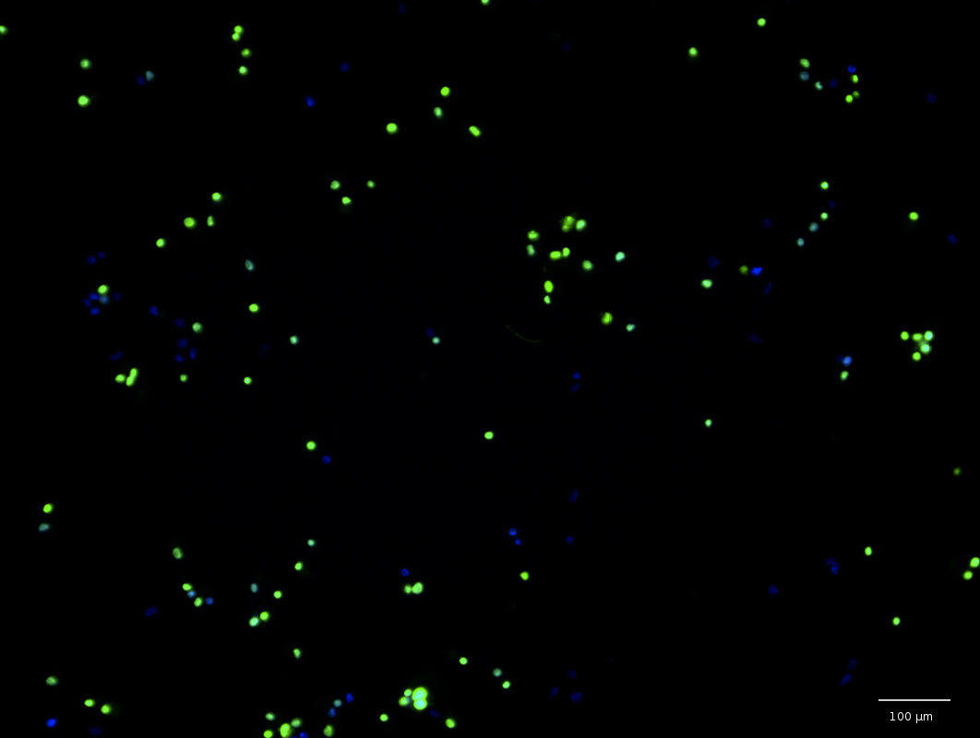
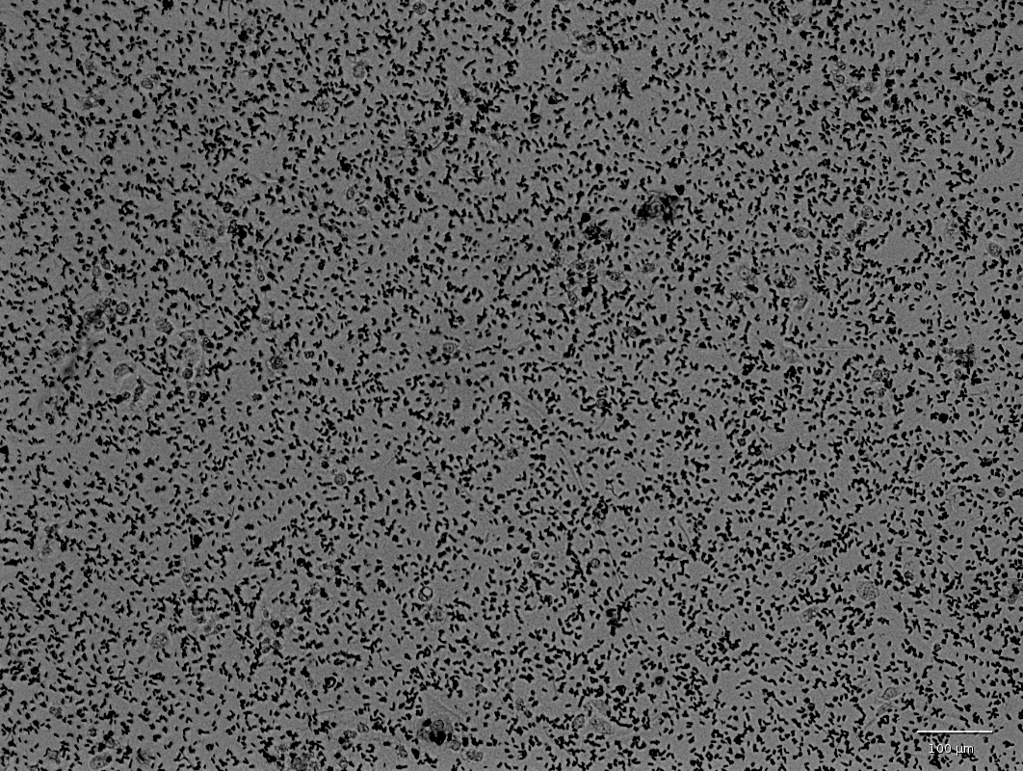
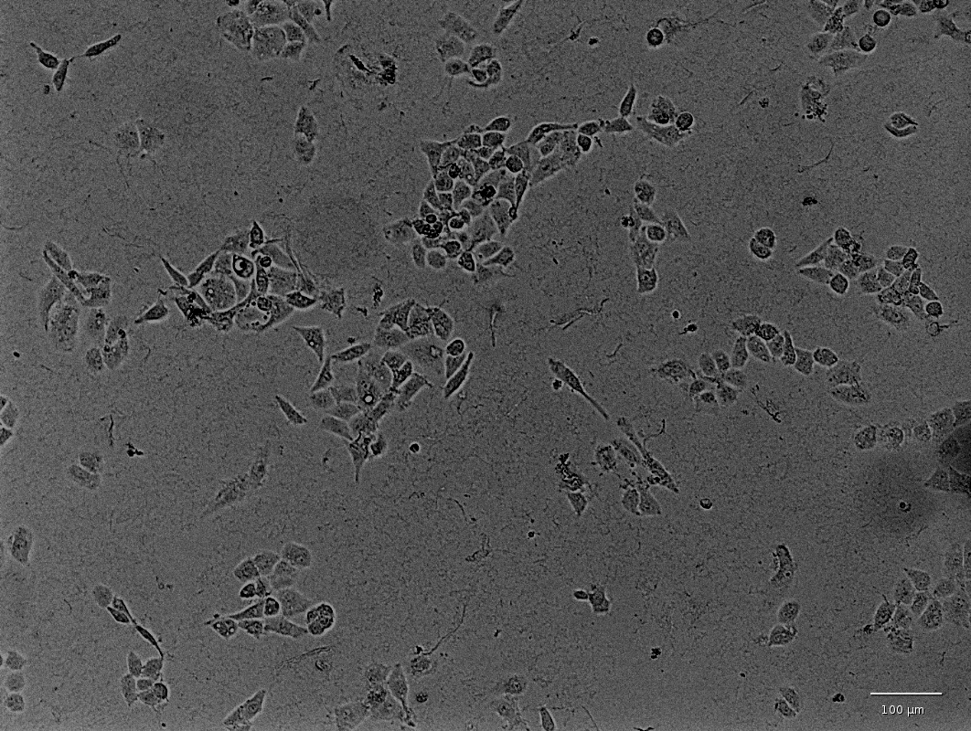
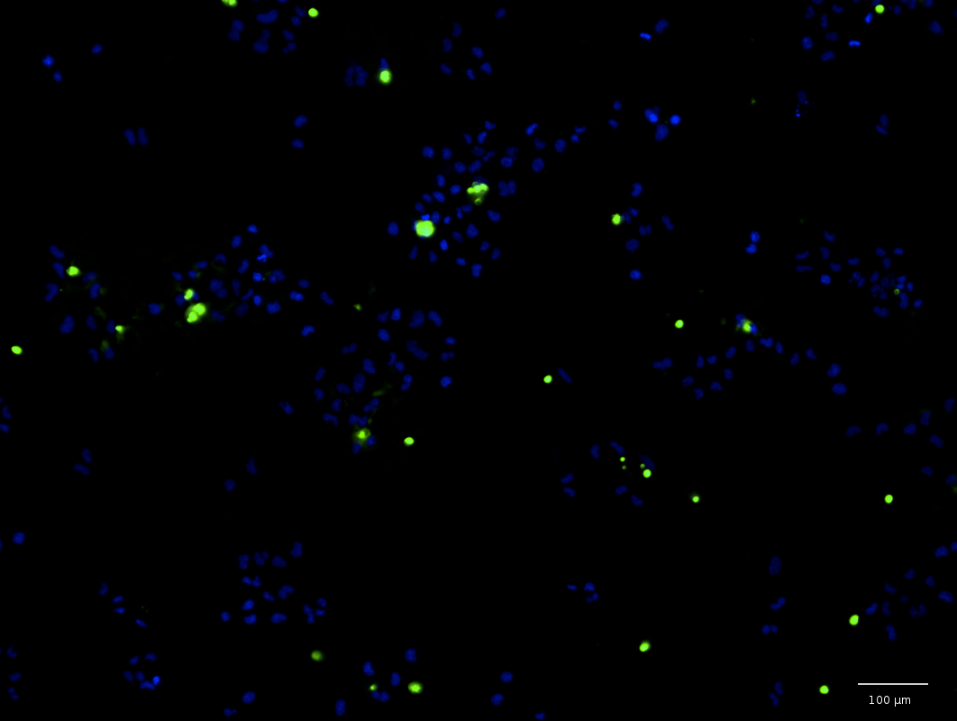
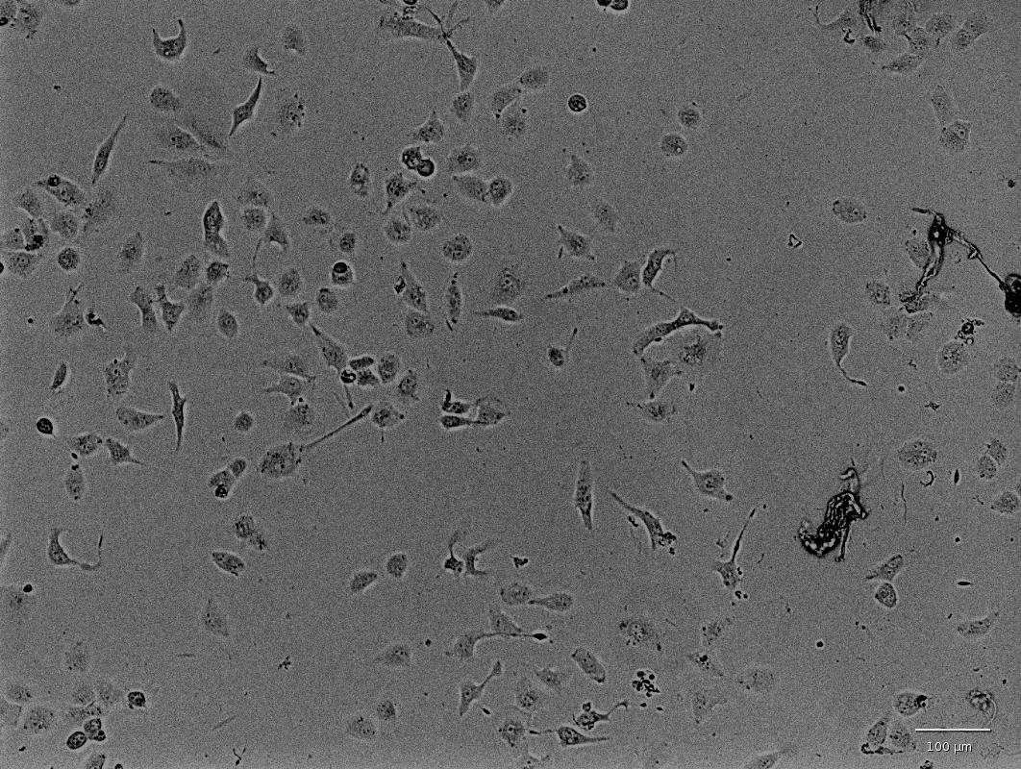
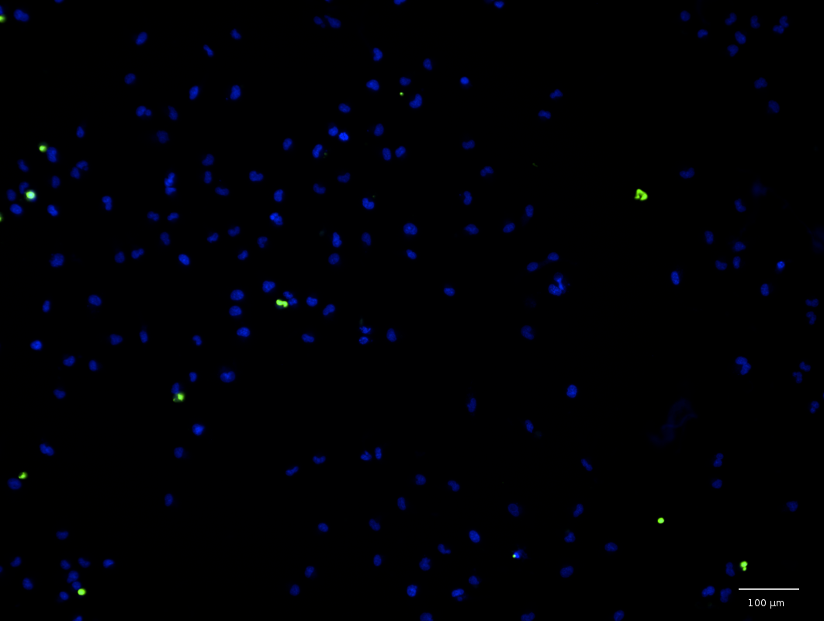
A
B
C
D
E
F

Cytotoxicity

Human kidney cells were exposed to the water-soluble extracts for 48hr and cell viability was measured with an Operetta imaging system using Hoechst 33342 dye to identify cell nuclei and Sytox Green to identify necrotic cells. Cells exposed to the water-soluble extracts showed much higher rates of death and morphological changes as compared to the controls. Brightfield and fluorescent images in Figure 11 show the untreated cells (panels A and B), the highest dose (panels C and D), and lowest dose (panels E and F) of the Monticello leachate. At high doses, some of the extracts formed micro-precipitates shown in the brightfield image in Figure 11 A. The precipitates are currently unidentified, and were not noted in other coal-extract experiments (Nakajima et al., 2005; Bunnell et al., 2007; Orem et al., 2007).

Table 6. IC₅₀ values for water-soluble extracts from Gulf Coast lignites.

Sample | IC₅₀ (% w/v)
Pulaski County | 2.12 | ± | 0.15
Hot Springs County | 3.07 | ± | 0.09
Dolet Hills | 0.49 | ± | 0.27
Monticello | 1.25 | ± | 0.05
Oak Hill | 1.27 | ± | 0.16
San Miguel | 1.65 | ± | 0.53

The IC₅₀ values for the extracts, wherein exposure results in 50% cell death, are shown in Table 6. The toxicity of the extracts ranges from 0.49–3.07% (w/v) water-soluble extract and are ranked as Dolet Hills > Monticello > Oak Hill > San Miguel > Pulaski County > Hot Springs County. The two samples from Arkansas, both outcrop samples, are the least toxic extracts, although the range of toxicity is relatively narrow. Dolet Hills extract was the most toxic with IC₅₀ value of 0.49% (w/v) extract. In this region of Louisiana, incidents of renal pelvic cancers (RPC) correlated to several parameters that are associated with coal leachate in the groundwater (Bunnell et al., 2006). The number of organic compounds in the groundwater showed significant correlation to incidents of RPC as did nephrotoxic metals such as Cr and As, although the concentration of these metals was below the minimum contamination level standards set by the EPA (Bunnell et al., 2006).

Relating geochemistry and cytotoxicity

The toxicity of the water-soluble extracts is much lower (~100–1000×) than that of metals like arsenic and cadmium, and is closer to the order of magnitude of organic species like acetaminophen and aristolochic acid (Zhang et al., 2007). The renal cell (HK-2) toxicity of some environmentally relevant species is shown in Table 7. The concentration of metals leached from the Gulf Coast lignite is significantly lower than the toxic thresholds for arsenic, cadmium, chromium, and copper. Other metals screened in the study have a more complex function in the cell, like iron. Iron is necessary for various cell functions but can become toxic at high concentration by promoting radical formation in Fenton-type reactions (Papanikolaou and Pantopoulos, 2005). Iron toxicity in HK-2 cells has been related to the extent the metal is chelating with small organic material in solution, which can be easily transported into the cell where it then induces oxidative stress at much lower concentrations than soluble iron (Zager et al., 2002). Various organic bound iron species showed markers of toxic stress in HK-2 cells at concentrations between 60–1,000 ppm, though direct IC₅₀ values were not calculated (Zager et al., 2002). Iron leaches from the Gulf Coast lignites at concentrations lower than the toxic concentrations described previously and leach between 0.127 and 6.70 ppm. Vanadium also induces reactive oxygen species in cells (Sabolić, 2006), although toxicity to renal cells is unclear. At normal concentrations, zinc has an antagonistic affect against other toxic metals, but can become toxic at high concentrations (Sabolić, 2006). Cherian (1985) showed that the growth isolated epithelial kidney cell cultures were stunted without significant cell death at zinc concentrations of ~160ppm. The concentrations of zinc leached from Gulf Coast lignite are 0.295–0.711 ppm, well below the range of toxicity. It is also important to note that sub-toxic exposure to combinations of metals may induce different cellular responses, leading to increased toxicity of the mixture (Madden et al., 2002; Madden and Fowler, 2000; Fowler et al., 2004). Because the concentration of nephrotoxic metals are in such low concentration in the Gulf Coast leachates, it is likely that metals minimally contribute to the toxicity of the water-soluble extract as a whole.

 | IC₅₀
Toxin | µM | ppm | Reference
Potassium dichromate | 65.75 ± 14.83 | (19.12) | S. Li. (2017)
 | 47 | (14) | Y. Li. (2013)
Cadmium (II) chloride | 26.98 ± 4.60 | (4.945) | S. Li. (2017)
 |  | 1.35 ± 0.21 | Zhang (2007)
Arsenic trioxide | 13.15 ± 1.07 | (2.60) | S. Li. (2017)
 | 35 | (7) | Y. Li. (2013)
Copper (II) chloride | 862 | (116) | Y. Li. (2013)
 |  | 50.89 ± 7.08 | Zhang (2007)
Acetaminophen |  | 1249.09 ± 29.03 | Zhang (2007)
Aristolochic acid |  | 125.22 ± 3.22 | Zhang (2007)
Gulf Coast Extracts
Pulaski County |  | 2,120 ± 150
Hot Springs County |  | 3,070 ± 90
Dolet Hills |  | 490 ± 270
Monticello |  | 1,250 ± 50
Oak Hill |  | 1,270 ± 160
San Miguel |  | 1,650 ± 530
Table 7. Cytotoxicity of nephrotoxic chemicals to HK-2 cells in culture. Values shown in parenthesis are calculated from reported values for comparison.

Organic matter leached from the lignite samples at approximately 1,000× higher concentrations than metal species, and in this study the organic matter is thought to be the mode of toxicity. A number or organic compounds have shown renal cell toxicity including acetaminophen, ibuprofen, and aristolochic acid (Zhang et al., 2007; Li et al., 2013). At high doses (>2,000 mg/kg), highly reactive metabolites from acetaminophen can form resulting in cellular dysfunction leading to cell death and renal injury (Blantz, 1996). The latter, aristolochic acid, has been directly implicated in the development of Balkan Endemic Nephropathy and linked to Chinese Herb Nephropathy (De Broe, 2012; Schmeiser et al., 2012). The IC₅₀ values of the Gulf Coast extracts are on the same order of magnitude as organic species and less toxic than nephrotoxic metals (Table 7). Unfortunately, the IC₅₀ values do not significantly correlate to DOC (Spearman: r = –0.341, p = 0.564). More work is needed to understand the types of compounds that leach from lignite and their mechanism of toxicity. Nevertheless, these results suggest that organic matter leached from coal may play an important role in the toxicity of water-soluble leachates from lignite.
Studies of water-associated heath risks from organic species often focus on one compound of interest. However, Hendriks et al., (1994) showed that this single chemical approach could only explain roughly 10% of the toxicity at a contaminated surface water site, attributing 89% of the toxic effects to unidentified compounds. In the case of water-soluble coal extracts, Doskocil et al. (2015) reported that no single identified toxic compound was shown to leach from lignite in high abundance or above toxicity thresholds. But in another case, the whole fraction of water-soluble extract from lignite showed an affinity for estrogen receptors, leading to estrogen disrupting effects (Nakajima et al., 2008). In light of the toxicity to renal cells seen here, it may be that the joint effect of the mixture may pose the greatest threat when many compounds are present together at relatively low concentrations. Many of the compounds identified in coal leachates have little to no associated toxicological data, and a number of compounds have yet to be identified through GC/MS. It may be that although no single compound may exceed toxicity thresholds, the cumulative effect may be significant.

Limitations

The initial lignite-water hypothesis states that consumption of organic matter derived from coal contributes to the development of kidney disease. However, one criticism of the hypothesis is that several factors like environmental pathways and exposure indicators need to be considered (Long and Voice, 2007). Several environmental processes could alter the amount, composition, or nature of the organic matter leached from coal, potentially transforming the coal derived material from the coal source to consumption. Many of the fatty acids and lignin hydrolysis products that leach from coals are feed stocks for microbial processes in the subsurface (Vieth et al., 2008; Young and Frazer, 1987) and may be short lived in the environment. It is important to also note that the concentration of dissolved organic carbon (DOC) in the groundwater supply is relatively low- less than 5 mg/L on average (Welch et al., 2009). In this study, high doses of extract were used to elicit a response within a short exposure time (48hrs), and the highest dose used in this study (10% w/v) is more than three orders of magnitude more concentrated than DOC in the groundwater (~0.005% w/v). Even so, residents in these areas may consume this water with low DOC over a lifetime with cumulative effects. Acute exposure cannot directly predict chronic results, and a better understanding of chronic exposure would come from studies in vivo. Additionally, the in vitro toxicity is difficult to extrapolate to toxicity induced in an organism. The metabolism and fate of lignite-derived compound mixtures in the organism, at an organ or even at the cellular level, are also unknown. Some structural components are common in lignite-leachates such as aldehydes, phenols and aromatic rings (Gangwal, 1977; Maharaj et al., 2014; Pissolatto et al., 1996; Qi, 2004). Some of these compounds like phenols are well studied (Bruce et al., 1987) and could be representative agents of a particular class of compounds seen in the coal extracts from the Gulf Coast region. More work should be done to elucidate the mechanism of toxicity and also the toxic effect of mixtures containing similar organic compounds.

Conclusions

This is the first evidence of quantifiable in vitro renal cell toxicity from water-soluble fractions of lignite. The mode of toxicity is likely to come from the organic matter in the extracts, which are roughly 1000× more abundant in the leachates as compared to nephrotoxic metals. Moreover, the IC₅₀ values calculated from the extract range from 490–3,070 ppm and are similar to that of other nephrotoxic organic compounds such as acetaminophen. These results lend support to the lignite-water hypothesis, although more work is needed to understand the fate of these organic compounds in the subsurface. Further support could also come from understanding of the mechanism of toxicity and the fate of these compounds following metabolism.

Acknowledgements

This work was funded partially by the Robberson Research Grant from the University of Oklahoma. The in vitro experiments were preformed in collaboration with Drs. Randle Gallucci, Michael Ihnat, and Lerin Chastain at the OU Health Science Center, College of Pharmacy, Department of Pharmaceutical Sciences. Sterling Ford, a contributor to this research, was supported by the OUHSC Graduate College Summer Undergraduate Research Experience program.

References

Bruce, R.M., Santodonato, J., Neal, M.W., 1987. Summary Review of the Health Effects Associated With Phenol. Toxicol. Ind. Health 3, 535–568.

Bunnell, J.E., Tatu, C.A., Lerch, H.E., Orem, W.H., Pavlovic, N., 2007. Evaluating nephrotoxicity of high-molecular-weight organic compounds in drinking water from lignite aquifers. J Toxicol Env. Heal. A 70, 2089–2091.

Bunnell, J.E., Tatu, C. a, Bushon, R.N., Stoeckel, D.M., Brady, A.M.G., Beck, M., Lerch, H.E., McGee, B., Hanson, B.C., Shi, R., Orem, W.H., 2006. Possible linkages between lignite aquifers, pathogenic microbes, and renal pelvic cancer in northwestern Louisiana, USA. Environ. Geochem. Health 28, 577–587.

Carlson, D., Biersel, T. Van, 2009. Dependence of the Wilcox Aquifer Water Chemistry on Stratigraphy, Spatial Distribution, and Proximity to Lignite in Southern Caddo Parish, Louisiana. Gulf Coast Assoc. Geol. Soc. Trans. 59, 145–157.

Carlson, D., Biersel, T. Van, 2008. Distribution of Possible Disease-Causing Inorganic Tracers from Lignite in the Wilcox Aquifer in Caddo Parish, Louisiana. Gulf Coast Assoc. Geol. Soc. Trans. 58, 149–159.

Chakraborty, J., Varonka, M., Orem, W., Finkelman, R.B., Manton, W., 2017. Geogenic organic contaminants in the low-rank coal-bearing Carrizo-Wilcox aquifer of East Texas, USA. Hydrogeol. J. 25, 1219–1228.

Cherian, M.G., 1985. Rat Kidney Epithelial Cell Culture for Metal Toxicity Studies. Vitr. Cell. Dev. 21, 505-508.

De Broe, M.E., 2012. Chinese herbs nephropathy and Balkan endemic nephropathy: toward a single entity, aristolochic acid nephropathy. Kidney Int. 81, 513–515.

Doskocil, L., Grasset, L., Enev, V., Kalina, L., Pekar, M., 2015. Study of water-extractable fractions from South Moravian lignite. Environ. Earth Sci. 73, 3873–3885.

Feder, G.L., Radovanoic, Z., Finkelman, R.B., 1991. Relationship between weathered coal deposits and the etiology of Balkan endemic nephropathy. Kidney Int. Suppl. 40, S9-S11.

Finkelman, R.B., Casagrande, D.J., Benson, S.A. (Eds.), 1987. Gulf Coast Lignite Geology. Environmental and Coal Associates, Reston, VA. p. 283.

Finkelman, R.B., Orem, W., Castranova, V., Tatu, C.A., Belkin, H.E., Zheng, B., Lerch, H.E., Maharaj, S. V, Bates, A.L., 2002. Health impacts of coal and coal use: possible solutions. Int. J. Coal Geol. 50, 425–443.

Finkelman, R.B., Palmer, C.A., Wang, P., 2017. Quantifying the modes of occurrence of 42 elements in coal. Int. J. Coal Geol. In press.
doi.org/10.1016/j.coal.2017.09.005

Fowler, B.A., Whittaker, M.H., Lipsky, M., Wang, G., Chen, X.Q., 2004. Oxidative stress induced by lead, cadmium and arsenic mixtures: 30-Day, 90-day, and 180-day drinking water studies in rats: An overview. BioMetals 17, 567–568.

Gangwal, S.K., 1977. Gas Chromatographic Investigation of Raw Wastewater from Coal Gasification 136, 63–72.

Hendriks, A.J., Maas-Diepeveen, J.L., Noordsij, A., Van der Gaag, M.A., 1994. Monitoring response of XAD-concentrated water in the rhine delta: A major part of the toxic compounds remains unidentified. Water Res. 28, 581–598.

Hosman, R.L., Weiss, J.S., 1991. Geohydrologic units of the Mississippi embayment and Texas coastal uplands aquifer systems, south-central United States. United States Geological Survey, Professional Paper 1416-B.

Huggins, F.E., Goodarzi, F., Lafferty, C.J., 1996. Mode of occurrence of arsenic in subbituminous coals. Energy Fuels 10, 1001–1004.

Huggins, F.E., Huffman, G.P., Kolker, A., Mroczkowski, S.J., Palmer, C.A., Finkelman, R.B., 2002. Combined application of XAFS spectroscopy and sequential leaching for determination of arsenic speciation in coal. Energy and Fuels 16, 1167–1172.

Huggins, F.E., Shah, N., Huffman, G.P., Kolker, A., Crowley, S., Palmer, C.A., Finkelman, R.B., 2000. Mode of occurrence of chromium in four US coals. Fuel Process. Technol. 63, 79–92.

Li, S., Zhao, J., Huang, R., Steiner, T., Bourner, M., Mitchell, M., Thompson, D.C., Zhao, B., Xia, M., 2017. Current Chemical Genomics and Translational Medicine Development and Application of Human Renal Proximal Tubule Epithelial Cells for Assessment of Compound Toxicity. Curr. Chem. Genomics Transl. Med. 11, 19–30.

Li, Y., Oo, Z.Y., Chang, S.Y., Huang, P., Eng, K.G., Zeng, J.L., Kaestli, A.J., Gopalan, B., Kandasamy, K., Tasnim, F., Zink, D., 2013. An in vitro method for the prediction of renal proximal tubular toxicity in humans. Toxicol. Res. (Camb). 2, 352–365.

Long, D.T., Voice, T.C., 2007. Role of exposure analysis in solving the mystery of Balkan endemic nephropathy. Croat. Med. J. 48, 300–11.

Madden, E.F., Akkerman, M., Fowler, B.A., 2002. A comparison of 60, 70, and 90 kDa stress protein expression in normal rat NRK-52 and human HK-2 kidney cell lines following in vitro exposure to arsenite and cadmium alone or in combination. J. Biochem. Mol. Toxicol. 16, 24–32.

Madden, E.F., Fowler, B.A., 2000. Mechanism of Nephrotoxicity from Metal Combinations: A review. Drug Chem. Toxicol. 23, 1–12.

Maharaj, S.V.M., Orem, W.H., Tatu, C. a, Lerch, H.E., Szilagyi, D.N., 2014. Organic compounds in water extracts of coal: links to Balkan endemic nephropathy. Environ. Geochem. Health 36, 1–17.

Nakajima, T., Hasegawa, H., Nakamata, S., Takanashi, H., Ohki, A., 2008. Mutagenicity of eluent by hot water extraction of various coals: Effect of chlorination. Fuel 87, 3132–3136.

Nakajima, T., Kanda, T., Fukuda, T., Takanashi, H., Ohki, A., 2005. Characterization of eluent by hot water extraction of coals in terms of total organic carbon and environmental impacts. Fuel 84, 783–789.

Orem, W.H., Feder, G.L., Finkelman, R.B., 1999. A possible link between Balkan endemic nephropathy and the leaching of toxic organic compounds from Pliocene lignite by groundwater: preliminary investigation. Int. J. Coal Geol. 40, 237–252.

Orem, W.H., Finkelman, R.B., 2003. Coal Formation and Geochemistry, in: Treatise on Geochemistry. pp. 191–222.

Orem, W.H., Maharaj, S.V.M., Finkelman, R.B., Szilagyi, D.N., Dumitrascu, V., van Bronswijk, W., 2003. Organic compounds derived from Pliocene lignite and the etiology of Balkan endemic nephropathy. Geol. Heal. Closing gap, p159.

Orem, W.H., Tatu, C.A., Lerch, H.E., Maharaj, S.V.M., Pavlović, N.M., Paunescu, V., Dumitrascu, V., 2004. Identification and Environmental Significance of the Organic Compounds in Water Supplies associated with a Balkan Endemic Nephropathy Region in Romania. J. Environ. Heal. Res. 3.2, 53-61.

Orem, W., Tatu, C., Pavlovic, N., Bunnell, J., Lerch, H., Paunescu, V., Ordodi, V., Flores, D., Corum, M., Bates, A., 2007. Health Effects of Toxic Organic Substances from Coal: Toward “Panendemic” Nephropathy. AMBIO A J. Hum. Environ. 36, 98–102.

Papanikolaou, G., Pantopoulos, K., 2005. Iron metabolism and toxicity. Toxicol. Appl. Pharmacol. 202, 199–211.

Peuravuori, J., Žbánková, P., Pihlaja, K., 2006. Aspects of structural features in lignite and lignite humic acids. Fuel Process. Technol. 87, 829–839.
Pierce, B.S., Survey, U.S.G., Swanson, S.M., Survey, U.S.G., 2011. Chapter 4 Coal Quality of Assessed Areas of Texas 44–94.

Pissolatto, T.M., Schossler, P., Geller, A.M., Caramao, E.B., Martins, A.F., 1996. Identification of phenolic compounds in waste water from coal gasification by SPE and GC/MS. Hrc-Journal High Resolut. Chromatogr. 19, 577–580.

Qi, Y., 2004. Characterisation of organic and inorganic components in process water from a novel lignite dewatering process. Monash University, 117-119.

Sabolić, I., 2006. Common mechanisms in nephropathy induced by toxic metals. Nephron - Physiol. 104, 107–114.

Schmeiser, H.H., Kucab, J.E., Arlt, V.M., Phillips, D.H., Hollstein, M., Gluhovschi, G., Gluhovschi, C., Modilca, M., Daminescu, L., Petrica, L., 2012. Evidence of exposure to aristolochic acid in patients with urothelial cancer from a Balkan endemic nephropathy region of Romania. Environ. Mol. Mutagen. 53, 636–641.

Suciu, E.I., Ordodi, V., Szilagyi, D.N., Tatu, C. a, Orem, W.H., Lerch, H.E., Bunnell, J., Paunescu, V., 2005. Balkan Endemic Nephropathy Etiology: a Link Between Geochemistry and Medicine. Timisoara Med. J. 55, 228–234.

Vieth, A., Mangelsdorf, K., Sykes, R., Horsfield, B., 2008. Water extraction of coals – potential for estimating low molecular weight organic acids as carbon feedstock for the deep terrestrial biosphere. Org. Geochem. 39, 985–991.

Warwick, P.D., Crowley, S.S., Ruppert, L.F., Pontolillo, J., 1996. Petrography and geochemistry of the San Miguel lignite, Jackson Group (Eocene), south Texas. Org. Geochem. 24, 197–217.

Welch, H.L., Kingsbury, J.A., Tollett, R.W., Seanor, R.C., 2009. Quality of Shallow Groundwater and Drinking Water in the Mississippi Embayment-Texas Coastal Uplands Aquifer System and the Mississippi River Valley Alluvial Aquifer, South-Central United States, 1994-2004. U. S. Geological Survey, Scientific Investigations Report 2009–5091.

Young, L.Y., Frazer, A. C., 1987. The fate of lignin and lignin‐derived compounds in anaerobic environments, Geomicrob. J. 5, 261-293.

Zager, R.A., Johnson, A.C.M., Hanson, S.Y., Wasse, H., 2002. Parenteral iron formulations: A comparative toxicologic analysis and mechanisms of cell injury. Am. J. Kidney Dis. 40, 90–103.

Zhang, L., Mu, X., Fu, J., Zhou, Z., 2007. In vitro cytotoxicity assay with selected chemicals using human cells to predict target-organ toxicity of liver and kidney. Toxicol. Vitr. 21, 734–740.

Chapter 4: ESRD and ESRD-DM associated with lignite-containing aquifers in the Gulf Coast region of Arkansas, Louisiana, and Texas

Abstract

Balkan endemic nephropathy (BEN) is an irreversible, lethal kidney disease that occurs in regions of the Balkans where residents drink untreated well water. A key factor contributing to the development of BEN may be consumption of dissolved organic matter leached from low-rank coal called lignite. Although the lignite-water hypothesis was first posed for areas of the Balkans, a similar geologic framework exists in the United States (US) Gulf Coast region in parts of the Mississippi Embayment and the Texas Coastal Uplands aquifers. It is possible that a BEN-like condition exists in US states—Arkansas, Louisiana, and Texas, for instance—that rely heavily on groundwater from aquifers that contain lignite. This paper utilizes a geographic information system (GIS) to map the distributions of end-stage renal disease (ESRD) in relation to water from lignite-containing aquifers in the tri-state region. Regional patterns emerged from geospatial analysis, indicating that counties that relied on lignite-containing aquifers for their main water source had higher rates of ESRD in comparison to other populations in the state that rely on other water sources, including surface water and groundwater from aquifers not associated with coal seams. Statewide rates of ESRD and diabetes associated ESRD (ESRD-DM) showed strong correlations to the percent of families at or below poverty level and the percentage of African Americans. These confounding factors at the state level somewhat mitigate the association seen between ESRD and lignite-containing regions. However, at the larger tri-state view, there is a significant (p = 0.002) increase in incidence rates when considering both race and poverty. Additionally, no relationship was observed between rate of public water supply withdrawal from lignite-bearing aquifers and rates of ESRD or ESRD-DM at the state or tri-state regions, supporting the observation that the risk associated with water from lignite-containing aquifers is limited to water from untreated domestic supply.

Introduction

Balkan endemic nephropathy (BEN) is a chronic renal disease that is confined to Balkan regions, including Bosnia, Bulgaria, Croatia, Romania, and Serbia (Pavlović, 2013; Stiborová et al., 2016). BEN largely occurs in rural areas and primarily affects adults ages 30–50 who are native residents of endemic villiages. Numerous members of a single generation or multiple generations living in the same household can be afflicted by the disease, leading to the hypothesis that the eitology is tied to a hosehold's food and/or water supply (Bamais and Botetis, 2008). BEN typically terminates in end-stage renal disease (ESRD) and/or urinary tract tumors (Danilovic et al., 1957). Many environmental and genetic factors have been postulated as contributing factors BEN (reviewed by Bui-Klimke and Wu, 2014; Stiborová et al., 2016). Some evidence supports the etiology of BEN as a multifactorial condition (Toncheva et al., 1998), with one hypothesis postulating that consumption of naturally contaminated drinking water from lignite beds could contribute to the development of kidney disease (Orem et al., 1999).
The lignite-water hypothesis was first proposed by geologists at the United States Geological Survey (USGS) after researchers observed spatial patterns between Pliocene age lignite deposits and villages plagued with BEN (Feder et al., 1991). Lignite is composed of relatively unmetamorphosed plant material in the early stages of the transformation from peat to anthracite. This organic rich material could give rise to potentially toxic water-soluble organic compounds such as polyaromatic hydrocarbons, heterocyclic compounds such as aromatic amines and thiophenes, as well as cyclic and acyclic aliphatics (Hazai et al., 1988, 1989). Laboratory leaching studies found that Pliocene age coal from endemic regions of the Balkans produced many more water-soluble compounds than did more mature bituminous deposits (Maharaj et al., 2014). In addition, analyses of well water from the endemic regions showed elevated levels of organic contaminants including polyaromatic hydrocarbons (PAHs; Orem et al., 1999). Human stem cells exposed to water extracts of an endemic area also showed increased cellular proliferation and differentiation as compared to controls (Suciu et al., 2005). Furthermore, humic and fulvic acids isolated from an endemic village water sample caused excess cell death or proliferation in human kidney cells when compared to the controls (Bunnell et al., 2007). Together, these studies demonstrate a potential risk associated with compounds derived from lignite products in the water supply.
The United States (US) Gulf Coast region presents a similar geologic framework to that of the Balkans (Figure 12). Lignite and subbituminous deposits are found throughout the Gulf Coast (Tully, 1996) and is actively mined in areas of Texas and Louisiana. Lignite deposits in the Gulf Coast are chiefly contained within the Wilcox, Claiborne, and Jackson groups (Schobert, 1995; Hook et al., 2011). The Sparta Sand, Carizzo Sand, and Wilcox Sand Formations serve as regional and local aquifers (Clark et al., 2011).
It is possible that a BEN-like condition can occur in rural regions of the Gulf Coast for residents that consume untreated private well water from lignite-containing strata. Chakraborty (2017) reported aromatic and aliphatic compounds in well water from rural areas of east Texas that are part of the Carrizo-Wilcox aquifer system. Although the levels detected were below toxicity thresholds, heath effects related to low-level exposure to these coal derived materials have not been investigated. Carlson and Biersel (2008) reported that water samples from lignite-containing aquifers in northwest Louisiana had higher mean values of some inorganic species like strontium, fluoride, boron, and chromium. The authors did not report any correlation between the number and type of organic compounds in the water samples. Despite the potential health hazards, few epidemiological studies exist that investigate the association between renal disease and lignite containing aquifers in the US. However, in one study researchers showed a positive correlation between renal pelvic cancers and the number of organic compounds in well water in areas of Louisiana that are part of the Carrizo-Wilcox aquifer system (Bunnell et al., 2003).
This article describes a study of statewide and regional distributions of ESRD in Arkansas, Texas and Louisiana in the US Gulf Coast region. A geospatial information system (GIS) was used to store, manipulate, analyze and visualize a variety of geologic and geographic data to understand patterns between water withdrawal from lignite-containing aquifers and population characteristics as it relates to occurrences of ESRD.
Utilizing a GIS—typically defined as (computer based) applications for storing, manipulating, and projecting data, particularly spatial data—in epidemiology offers researchers a way to statistically evaluate and visualize environmental determinants in public health. While creating a GIS to study public health issues is well established, the geospatial analysis in fields outside of medical and/or health geography and planning is relatively still novel, especially in the emerging field of medical geology. GIS affords the opportunity for interdisciplinary researchers to work together to better understand geologic and environmental factors that might have an impact on public health concerns. This study uses a computer-based GIS to analyze various physical and cultural geospatial attributes and their relation to the lignite-water hypothesis.

Materials and methods

ESRD data

The total number of ESRD and diabetes induced ESRD (ESRD-DM) cases among persons 40 years or older by county was obtained from the United States Renal Data System (USRDS: www.usrds.org) for Arkansas, Texas, and Louisiana in the time period 1998–2007. Per USRDS policy, data were censored for any county with 10 or fewer cases in the time period with zero incidents being reported as such. Censored data were omitted for this analysis.
Census data from the 2000 decennial census were obtained from the American Factfinder database (www.factfinder.census.gov) by county for Arkansas, Texas, and Louisiana. Data extracted were number of individuals 40 years or older, percent African American or black, percent Hispanic, and percent of families below the poverty level.
Unadjusted rates of ESRD per 10,000 persons (40 years or older) were then calculated for each county.

Aquifers

Water withdrawal by aquifer and county was aggregated from several sources. The United States Geological Survey-Lower Mississippi Gulf website provided data for Arkansas, and withdrawal rates for public supply in 2000 were summed for the coal containing aquifers: Carrizo-Wilcox, Cane River, Cockfield, and Sparta, aquifers. Per capita withdrawal was calculated in relation to the 2000 census for each state. Water withdrawal by aquifer for Texas was obtained through the Texas Water Development Board Website (http://www.twdb.texas.gov), and withdrawal for lignite-containing aquifer units include Carrizo-Wilcox, Queen City, Sparta, and Jackson. Lignite-containing aquifers in Louisiana include the Carrizo-Wilcox, Cockfield, and Sparta, and water withdrawal for each aquifer in Louisiana was obtained from the USGS, Lower Mississippi-Gulf Water Science Center.

Data analysis

Calculated rates along with demographic data obtained from the US Census Bureau were joined with geographic variable shapefiles from the USGS in ArcGIS Desktop 10.4 for the tri-state region. The data were further manipulated and mapped to show spatial patterns and relationships. Raw data is presented in Appendix B.
A generalized linear model was used to interpret the influence of several demographic variables at the county, state, and regional scales. Percent African American, percent Hispanic, and the percent of families below poverty level were introduced as continuous variables, while counties that rely on lignite-bearing aquifers were incorporated as categorical variables.

Results and discussion

Lignite beds are distributed throughout several geologic units in the Gulf Coast region including the Cockfield, Cane River, Sparta, and the Wilcox formations. These formations also serve as local and regional aquifers that supply drinking water to many local residents (Sargent, 2002; Holland, 2004; George et al., 2011). These deposits are exposed at the surface along the western extent of the formation and cut diagonally across the states (Figure 12). They dip shallowly toward the coast and quickly become confined by alluvial deposits.
Domestic well water is almost exclusively withdrawn from shallow groundwater resources (Hosman and Weiss, 1991). In the lignite-containing region of the Gulf Coast, this is limited to two sources: the lignite-containing and alluvial aquifers. In some cases, deep aquifers exist that do not contain coal and are potential sources of water; however, they are unreasonable targets for domestic water supplies due to cost. The extent of the aquifer system and the 107 counties served in the tri-state region is shown in Figure 13.
Figure 12. Coal deposits in the United States.

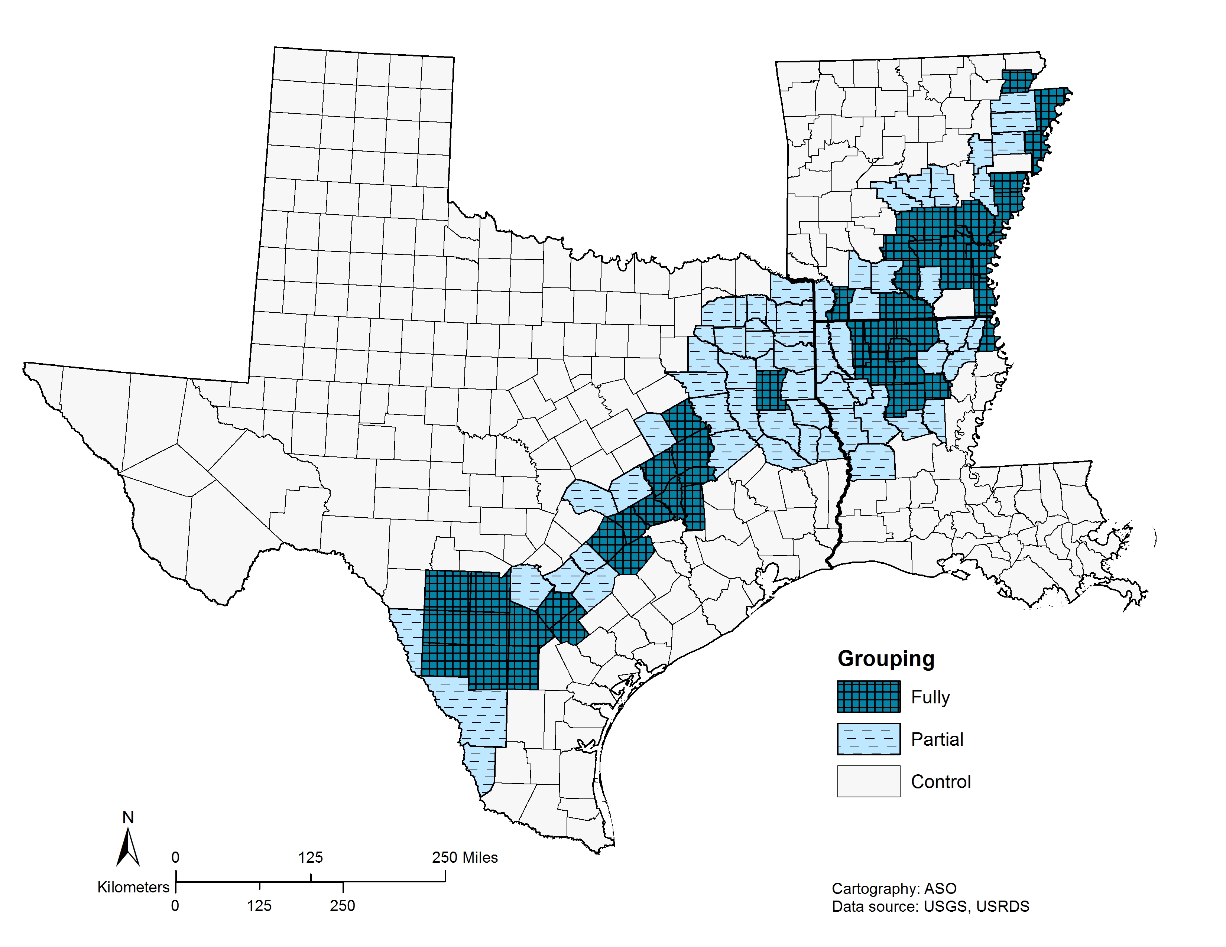
Figure 13. Three groups are defined based on public water withdrawal rates to identify counties where the lignite-containing aquifers are available to meet water demands. Reliance on these aquifers for public use is likely mirrored for domestic supply and are classified as: (1) counties that rely on lignite-containing aquifers only (fully, dark blue), (2) counties that partially rely on lignite-containing aquifers (partial, light blue), and (3) counties outside of the lignite-containing region that use other water sources (control, unshaded areas).

Although BEN is known to occur in areas in the Balkans that rely on untreated well water, water withdrawn from wells for domestic use (i.e. private well water) in the US is not reliably reported from state to state, making associations between domestic well water withdrawal and ESRD difficult to quantify. This study works under the assumption that domestic water is limited to groundwater reserves and the same aquifer(s) as public supply. The counties that rely on lignite-containing aquifers are shown in Figure 13 and are categorized into three groups for this study. Two groups represent counties that rely (partially or fully) on groundwater from lignite-containing aquifers to meet water supply demands, which are likely mirrored for domestic use. The third group represents control counties that are outside of the lignite-containing region that use other water sources such as surface water or groundwater not in hydraulic connection to the lignite-containing aquifers. For the counties that partially or fully rely on lignite-containing aquifers, actual withdrawal rates vary based on need and availability (George et al., 2011; Kresse et al., 2014). In some cases, the alluvial aquifer water quality may be compromised due to heavy agriculture or industrial activity (Welch et al., 2009), and the water demand is met by groundwater sources coming exclusively from lignite-containing aquifers.

All incidents of ESRD

Aggregations of the county data for all incidents of ESRD are summarized in Figure 14 and Table 8. The national unadjusted ESRD rate for all ages reported by the USRDS is 3.4 incidents per 10,000 persons with the age-adjusted rate being comparable at 3.5 incidents per 10,000 persons. For persons >40 years in the US, the un-adjusted ESRD rate nearly triples to 8.9 incidents per 10,000 persons for (USRDS, 2016). Direct comparison between our calculated rates and published reports are difficult since an age restriction was imposed for this study since the USRDS reported unadjusted rates by state and age are not delineated. However, our calculated statewide rates are comparable to age-adjusted published reports after factoring in the tripling effect due to the age-restriction imposed.

Table 8. County rates of ESRD per 10,000 persons 40+ years in the tri-state region (Arkansas, Louisiana, and Texas), 1998–2007 by reliance on lignite-containing aquifers.
 | n | Rate | p*
TRI-STATE REGION | 387 | 8.9 ± 5.1
Water Source
Rely on lignite-containing aquifers | 107 | 11.1 ± 4.4 | 0.000000
fully | 47 | 11.7 ± 5.0 | 0.000010
partially | 60 | 10.5 ± 3.8 | 0.001310
Other water sources | 280 | 8.1 ± 5.1 | -
ARKANSAS | 75 | 8.1 ± 3.5
Water Source
Rely on lignite-containing aquifers | 30 | 10.5 ± 3.7 | 0.000000
fully | 17 | 11.3 ± 4.1 | 0.000001
partially | 13 | 9.5 ± 3.0 | 0.008141
Other water sources | 45 | 6.6 ± 2.3 | -
LOUSIANA | 63 | 13.0 ± 3.4
Water Source
Rely on lignite-containing aquifers | 21 | 13.8 ± 3.8 | 0.178803
fully | 9 | 15.1 ± 3.5 | 0.102066
partially | 12 | 12.8 ± 3.9 | 0.975035
Other water sources | 42 | 12.5 ± 3.2 | -
TEXAS | 249 | 8.1 ± 5.3
Water Source
Rely on lignite-containing aquifers | 56 | 10.3 ± 4.6 | 0.000310
fully | 21 | 10.6 ± 5.7 | 0.024536
partially | 35 | 10.2 ± 3.9 | 0.012982
Other water sources | 193 | 7.5 ± 5.4 | -
* p –value for comparison to “Other water sources”
For all states, comparison of fully to partial was not significant, p > 0.05

Figure 14. Rates of all incidents of ESRD, calculated per 10,000 persons 40+ years.
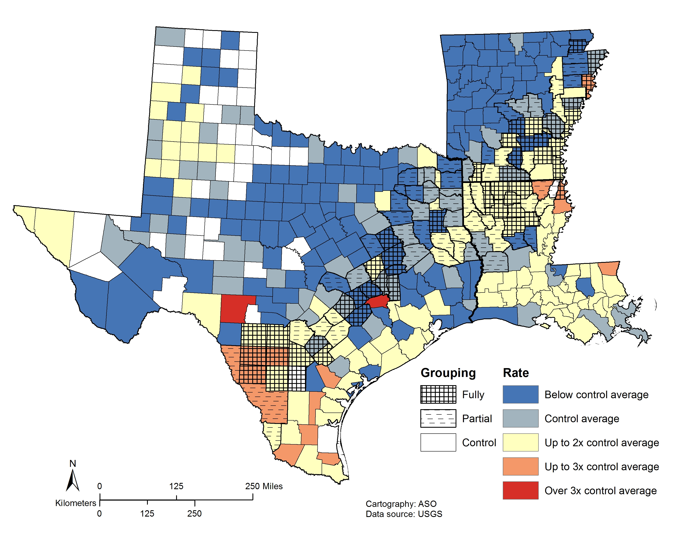
At the regional and state levels, the counties that rely on the coal containing aquifers show consistently higher rates of ESRD per 10,000 persons than do the regions that rely on other water sources (Table 8). There is a significant difference between the control counties and counties that fully or partially draw water from lignite-containing aquifers. In Arkansas, the difference is most pronounced with a rate of 6.6 incidents per 10,000 persons in control counties and 11.3 incidents per 10,000 persons for counties that fully rely on lignite-containing aquifers (p = 0.000001). The trend is not as clear in Louisiana, where although the rates of ESRD are higher, there is not a significant difference between lignite containing aquifers and control counties (p>0.05).

Diabetes associated ESRD (ESRD-DM)

Diabetes is the leading cause of ESRD in the US (USRDS, 2016). Rates of diabetes associated ESRD (ESRD-DM) were calculated for each county and compiled for the tri-state region (Table 9). The USRDS reports national unadjusted ESRD-DM rates for >40 years are 4.2 incidents per 10,000 persons with the rate for all ages being 1.5 incidents per 10,000 or 2.8 times less (USRDS, 2016) Statewide rates of ESRD-DM for all ages are comparable to those calculated for this study once accounting for this age related factor. Similar to ESRD rates, rates of ESRD-DM (Table 9) were higher for the lignite-containing aquifer regions, although the rates were collectively lower than all incidents of ESRD. Additionally, counties in the tri-state region that fully rely on lignite-containing aquifers consistently showed higher rates (p = 0.000013) of ESRD-DM as compared to control counties. At the state level, Arkansas (p = 0.000011) and Texas (p = 0.000681) both showed significantly higher rates of ESRD-DM in counties that rely on lignite-containing aquifers when compared to the control counties. In all three states, counties that fully rely on lignite-containing aquifers have higher rates of ESRD-DM compared to counties that partially rely on the aquifers, but the difference was not significant in all states (p > 0.05).

Table 9. County rates of diabetes associated ESRD per 10,000 persons 40+ years in the tri-state area (Arkansas, Louisiana, and Texas), 1998–2007 by reliance on lignite-containing aquifers.
 | n | Rate | p*
TRI-STATE REGION | 375 | 4.5 ± 3.5
Water Source
Rely on lignite-containing aquifers | 106 | 5.7 ± 3.3 | 0.000013
fully | 46 | 6.3 ± 3.6 | 0.000067
partially | 60 | 5.3 ± 3.0 | 0.026447
Other water sources | 269 | 4.0 ± 3.4 | -
ARKANSAS | 66 | 3.9 ± 1.6
Water Source
Rely on lignite-containing aquifers | 29 | 4.8 ± 1.7 | 0.000011
fully | 16 | 5.1 ± 1.6 | 0.000037
partially | 13 | 4.4 ± 1.9 | 0.017952
Other water sources | 37 | 3.2 ± 1.1 | -
LOUSIANA | 62 | 6.2 ± 1.9
Water Source
Rely on lignite-containing aquifers | 21 | 6.8 ± 2.4 | 0.084868
fully | 9 | 7.7 ± 2.5 | 0.023554
partially | 12 | 6.1 ± 2.2 | 0.953866
Other water sources | 41 | 5.9 ± 1.5 | -
TEXAS | 247 | 4.2 ± 4.0
Water Source
Rely on lignite-containing aquifers | 56 | 5.8 ± 4.1 | 0.000681
fully | 21 | 6.6 ± 4.8 | 0.004216
partially | 35 | 5.3 ± 3.6 | 0.083317
Other water sources | 191 | 3.8 ± 3.8 | -
* p –value for comparison to “Other water sources”
For all states, comparison of fully and partial was not significant, p > 0.05

Figure 15. Rates of ESRD-DM, calculated per 10,000 persons 40+ years.
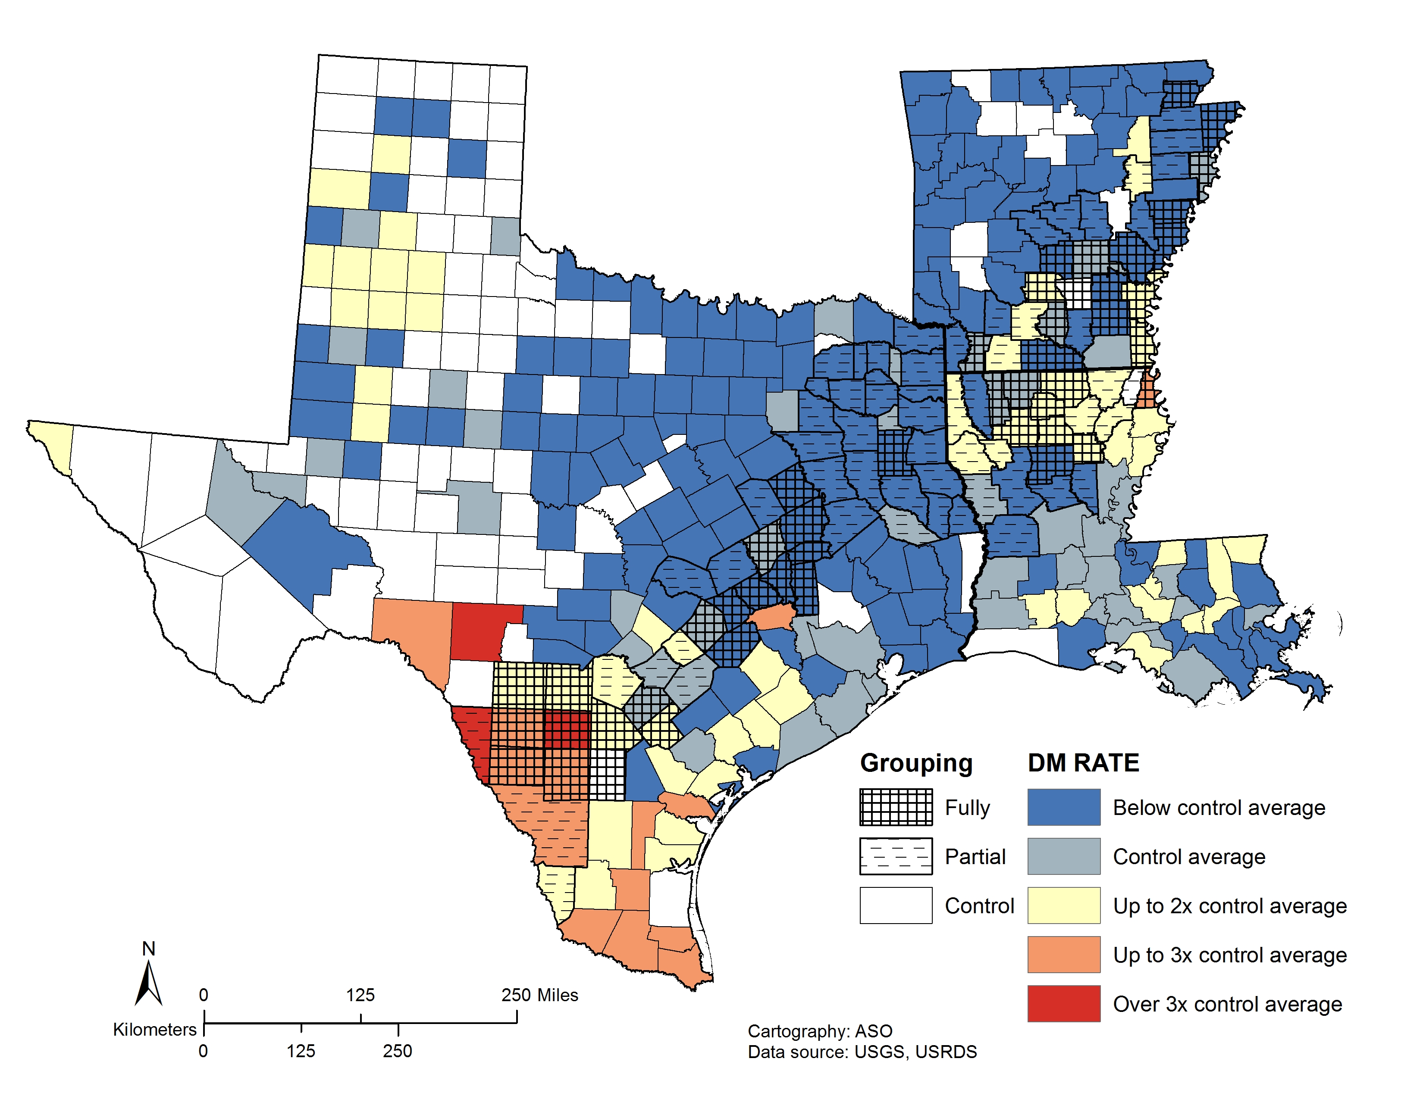

It is important to note that incidence rates of ESRD-DM are estimated for self-reported diabetics. Many patients either do not report their condition or are simply not aware of the condition, making these estimations tenuous (USRDS, 2016). Also, the reliability and consistency of assigning primary-cause of ESRD has not been well established (USRDS, 2016).

Confounding factors

Rates for both incidents of ESRD and ESRD-DM are consistently higher for the lignite-containing regions compared to the regions without lignite deposits for each county in the tri-state region. However, geographical variations ESRD have been linked to rural/urban environment (Fan et al., 2007), low socio-economic status ( Young et al., 1994; Wolf et al., 2011; Patzer and McClellan, 2012) , race (Volkova et al., 2008; McClellan et al., 2011), and access to care (Ward, 2009). Race is a well-established factor in development of ESRD, with African Americans being at four-times greater risk for developing ESRD compared to whites (Klag et al., 1997; Martins et al., 2002; Norris and Agoda, 2005). Ethnicity is also a contributing factor with Hispanics at a higher risk for ESRD compared to non-Hispanics (Norris and Agoda, 2005). The influence of poverty, in addition to or separate from race, on the rates of ESRD is difficult to unravel. Some evidence suggests that race plays only a small role compared to economic status (Byrne et al., 1994), but other studies suggest that a greater disparity in ESRD rates are seen between whites and African Americans with increasing poverty (Young et al., 1994; Volkova et al., 2008). Low socioeconomic status (including those living below the poverty threshold) has been previously associated with inadequate dialysis treatment, reduced access to care, and poor overall health outcomes (Patzer and McClellans et al., 2012).
Three confounding factors were considered for this study: 1) the percent African American, 2) the percent Hispanic, and 3) the percent of families living below the poverty threshold. The spatial distributions of each confounding variable in the tri-state region is shown in Figure 16. Simple spatial consistencies emerge between these variables and the lignite-containing region, and it is clear that these factors play an important role in the development of kidney disease in these states.
A generalized linear model of the tri-state region was used to understand the impact of these demographic variables on rates of ESRD and ESRD-DM and is summarized in Tables 10 and 11. The percent African American and Hispanics both significantly (p<0.0001) influence the rates of ESRD for the tri-state region. In Texas and Louisiana, the percent Hispanic significantly impact the rate of ESRD but not in Arkansas. The percent African Americans also show significant influence over ESRD rates at the tri-state region and are also significant influences at the state level as well.
Unlike race or ethnicity, the percentage of families below the poverty level presents a strong and consistent control over the rates of ESRD and ESRD-DM in the tri-state region. It should be noted that poverty thresholds calculated for the census data are not adjusted for the cost of living across the US, and the poverty threshold for a family of four in 1999 was an annual income equal to or less than $17,029. An average of 12.4% of Americans lived below the poverty level in 1999, and Texas (15.4%), Arkansas (15.8%) and Louisiana (19.6%) all exceeded the national average (Bishaw and Iceland, 2003). Many of the counties that represent the highest population of families living below the poverty level are living in lignite-containing regions of the states (Figure 16, C).

Figure 16. Distribution of percent African American (A), percent Hispanic (B), and percent of families below the poverty level (C) in the tri-state region for 1999.

Table 10. Results from a generalized linear model showing the effect of lignite-containing aquifers on the rate of ESRD in the tri-state area.
 |  |  | 95% Confidence Interval
Parameter |  | B | Lower | Upper | p*
% African American (Tri-state) |  | - | - | - | <0.0001
 | % African American (TX) | 0.147 | 0.078 | 0.216 | <0.0001
 | % African American (AR) | 0.126 | 0.077 | 0.175 | <0.0001
 | % African American (LA) | 0.164 | 0.117 | 0.211 | <0.0001
% Hispanic (Tri-state) |  | - | - | - | <0.0001
 | % Hispanic (TX) | 0.073 | 0.049 | 0.097 | <0.0001
 | % Hispanic (AR) | 0.115 | -0.033 | 0.264 | 0.129
 | % Hispanic (LA) | 0.455 | 0.097 | 0.814 | 0.013
Percent families below  poverty level (Tri-state) |  | 0.232 | 0.141 | 0.322 | <0.0001
Rely on groundwater from lignite-containing aquifers (partially or fully) |  | 1.427 | .509 | 2.345 | 0.002

Table 11. Results from a generalized linear model showing the effect of lignite-containing aquifer on the rate of diabetes associated ESRD in the tri-state region.
 |  |  | 95% Confidence Interval
Parameter |  | B | Lower | Upper | p*
% African American (Tri-state) |  | - | - | - | <0.0001
 | % African American (TX) | 0.059 | 0.008 | 0.109 | 0.024
 | % African American (AR) | 0.043 | 0.007 | 0.079 | 0.020
 | % African American (LA) | 0.082 | 0.047 | 0.116 | <0.0001
% Hispanic (Tri-state) |  | - | - | - | <0.0001
 | % Hispanic (TX) | 0.066 | 0.048 | 0.084 | <0.0001
 | % Hispanic (AR) | 0.113 | 0.002 | 0.224 | 0.045
 | % Hispanic (LA) | 0.257 | -0.004 | 0.518 | 0.054
Percent families below  poverty level (Tri-state) |  | 0.141 | 0.075 | 0.208 | <0.0001
Rely on groundwater from lignite-containing aquifers (partially or fully) |  | 1.316 | 0.647 | 1.984 | <0.0001

Public water supply withdrawal

Two statistical tests, Spearman rank correlations and a generalized linear model, were used to evaluate the influence of water withdrawal from lignite-containing aquifers on ESRD and ESRD-DM. Water withdrawal in millions of gallons (Mgal) per capita for those counties that rely on lignite-containing aquifers grouped by full or partial dependence is presented in Figure 17. A Spearman rank correlation, a nonparametric test that shows covariance between two rank variables, was performed between the amount of water withdrawn from lignite-containing aquifers and rates of ESRD and ESRD-DM (Table 12). Although higher overall rates of ESRD are associated with counties that withdrawal water from lignite-containing aquifers (Tables 8 and 9), there was no correlation between ESRD and water withdrawal for public supply for counties that partially or fully rely on lignite-containing aquifers (0.13973, p = 0.4615), or those that rely on the lignite-containing aquifers only (0.07843, p = 0.7648) (Table 12). This observation supports the initial lignite-water hypothesis (Feder et al., 1991), which states that the risk is limited to those residents who rely on domestic well water and is not linked to public supply withdrawal or consumption.
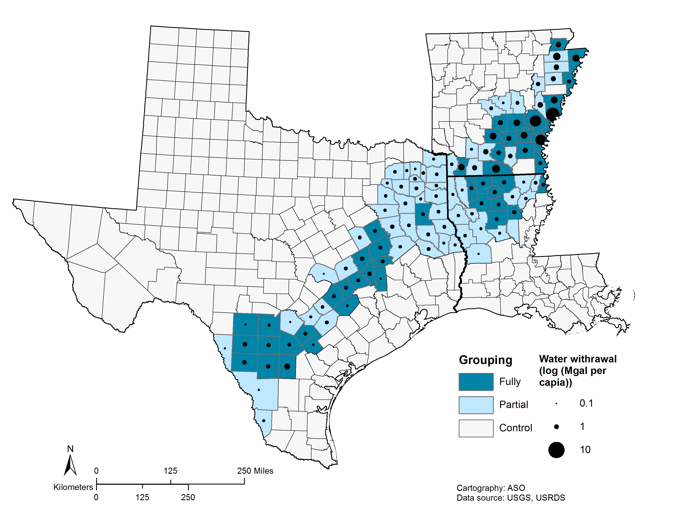
Figure 17. The rate of public water supply withdrawal by county from lignite-containing aquifers in millions of gallons of water per capita (Mgal per capita) for the year 2000.

Table 12. Spearman rank correlations for water withdrawal for public supply by county for those counties that rely fully or partially on lignite-containing aquifers.
 | Rate ESRD (all) | Rate ESRD-DM
Fully rely on lignite-containing aquifers | –0.00391  n = 46 | –0.17018  n = 45
Fully rely on lignite-containing aquifers | p = 0.9794 | p = 0.2637
Partially rely on lignite-containing aquifers | –0.10859  n = 60 | –0.17783  n = 60
Partially rely on lignite-containing aquifers | p = 0.4089 | p = 0.2638
All counties that withdraw from lignite-containing aquifers | 0.00534  n =105 | –0.08520  n =104
All counties that withdraw from lignite-containing aquifers | p = 0.9569 | p = 0.3898
In the generalized model of ESRD and ESRD-DM, water withdrawal from lignite-containing aquifers was introduced as a categorical variable with counties either utilizing the aquifer or not. Counties that rely on the lignite-containing aquifer showed a significant positive association with ESRD (B = 1.427, p= 0.002) and ESRD-DM (B = 1.316, p < 0.0001), even when considering the confounding variables discussed above. Separating the counties by full or partial reliance on the lignite-containing aquifers did not show a statistically significant influence on rates of ESRD or ESRD-DM.
Although the Spearman correlation between direct withdrawals did not show a significant correlation to rates of ESRD or ESRD-DM, the generalized model shows that there is residual impact related to water withdrawal from lignite-containing aquifers in addition to racial and ethnic risk factors. The relative size of the impact also may point to a risk that is not linked to the public supply, which serves the majority of Gulf Coast residents. Rural residents in areas of low physician density have been shown to have higher rates of ESRD (Fan et al., 2009). Residents most likely to be at risk as described in the lignite-water hypothesis are rural residents whose water is exclusively drawn from private wells. The compounding effect of several factors in these areas may lead to higher rates of kidney disease.

Conclusions

This is the first epidemiological evidence for a BEN-type syndrome in the US that correlates lignite-containing aquifers to ESRD. In the Gulf Coast region of Texas, Arkansas, and Louisiana, statistically higher rates of ESRD and ESRD-DM are associated with counties that depend on lignite-containing aquifers. This association may be significantly influenced, however, by ethnicity, race and poverty in the same region. Although these confounding factors mask the affect at the state level, there is a small but significant influence at the regional scale. Race specific rates of ESRD should be considered to better understand the relationship between race and rates of kidney disease in the region. Additionally, as the initial lignite-water hypothesis suggests, the association between ESRD and water quality compromised by organic compounds leached from lignite-associated aquifers seams to be limited to domestic supply water since no relationship to the public water supply tied to the lignite-containing aquifers was observed. Limitations associated with available datasets and methods to constrain the target area, hinder epidemiological studies exploring the lignite-water hypothesis in the US. Future studies should extend to include other states that share the hydrogeologic features to Texas, Louisiana, and Arkansas like Mississippi, and Alabama as well as portions of North and South Dakota. Additionally, integration of GIS into these types of analyses can help identify areas that are most likely at risk while simultaneously compiling various physical and cultural spatial attributes, leading to a more robust understanding of the results and limitations of the study.

Acknowledgements

This work was funded partially by the Graduate Student Grant from the University of Oklahoma, and in collaboration with the Biostatistics Epidemiology and Research Design (BERD) unit at the University of Oklahoma Health Sciences Center. Funding for BERD is provided by National Institutes of Health, National Institute of General Medical Sciences [grant 1 U54GM104938].
The data reported here have been supplied by the United States Renal Data System (USRDS). The interpretation and reporting of these data are the responsibility of the author(s) and in no way should be seen as an official policy or interpretation of the U.S. government.

References

Bamias, G., Boletis, J., 2008. Balkan nephropathy: evolution of our knowledge. Am. J. Kidney Dis. 52, 606–16.

Bishaw, A., Iceland, J., 2003. Poverty: 1999. The U.S. Census Breau.

Bui-Klimke, T., Wu, F., 2014. Evaluating weight of evidence in the mystery of Balkan endemic nephropathy. Risk Anal. 34, 1688–705.

Bunnell, J.E., Bushon, R.N., Stoeckel, D.M., Gifford, A.M., Beck, M., Lerch, H.E., Shi, R., Mcgee, B., Hanson, B.C., Kolak, J., Warwick, P.D., Blank, F., 2003. Preliminary Geochemical, Microbiological, and Epidemiological Investigations into Possible Linkages between Lignite Aquifers, Pathogenic Microbes, and Kidney Disease in Northwestern Louisiana. U.S. Geological Survey, Open-File Report 03-374.

Bunnell, J.E., Tatu, C.A., Lerch, H.E., Orem, W.H., Pavlovic, N., 2007. Evaluating nephrotoxicity of high-molecular-weight organic compounds in drinking water from lignite aquifers. J Toxicol Env. Heal. A 70, 2089–2091.

Byrne, C., Nedelman, J., Luke, R.G., 1994. Race, socioeconomic status, and the development of end-stage renal disease. Am. J. Kidney Dis. 23, 16–22.

Carlson, D., Biersel, T. Van, 2008. Distribution of Possible Disease-Causing Inorganic Tracers from Lignite in the Wilcox Aquifer in Caddo Parish, Louisiana. Gulf Coast Assoc. Geol. Soc. Trans. 58, 149–159.

Chakraborty, J., Varonka, M., Orem, W., Finkelman, R.B., Manton, W., 2017. Geogenic organic contaminants in the low-rank coal-bearing Carrizo-Wilcox aquifer of East Texas, USA. Hydrogeol. 25, 1219-1228.

Clark, B.R., Hart, R.M., Gurdak, J.J., 2011. Groundwater availability of the Mississippi Embayment. United States Geological Survey, Professional Paper 1785.

Danilovic, V., Djurisic, M., Mokranjac, M., Stojimirovic, B., Zivojinovic, J., Stojakovic, P., 1957. Chronic nephritis due to lead poisoning by digestive route (flour). Presse Med. 65, 2039.

Fan, Z.J., Lackland, D.T., Lipsitz, S.R., Nicholas, J.S., Egan, B.M., Tim Garvey, W., Hutchison, F.N., 2007. Geographical patterns of end-stage renal disease incidence and risk factors in rural and urban areas of South Carolina. Health Place 13, 179–187.

Feder, G.L., Radovanoic, Z., Finkelman, R.B., 1991. Relationship between weathered coal deposits and the etiology of Balkan endemic nephropathy. Kidney Int. Suppl. 40, S9-S11.

George, P.G., Mace, R., Petrossian, R., 2011. Aquifers of Texas, Texas Water Development Board, Report 380.

Hackley, P.C., Willett, J.C., Warwick, P.D., Law, S.J., Nichols, D.J., 2011. A Review of the Lignite Resources of Arkansas, in: Geologic Assessment of Coal in the Gulf of Mexico Coastal Plain, U.S.A. pp. 313–325.

Hazai, I., Alexander, G., Essiger, B., Szekely, T., 1988. Identification of aliphatic biological markers in brown coals. Fuel 67, 973–982.

Hazai, I., Alexander, G., Székely, T., 1989. Study of aromatic biomarkers in brown coal extracts. Fuel 68, 49–54.

Holland, T.W., 2004. Estimated Water Use In Arkansas, 2000. Scientific Investigations Report 2004-5230.

Hook, R.W., Warwick, P.D., Karlsen, A.W., Tewalt, S.J., 2011. Bibliography of the Gulf of Mexico Coastal, in: Geologic Assessment of Coal in the Gulf of Mexico Coastal Plain, U.S.A. pp. 348–389.

Kresse, T.M., Hays, P.D., Merriman, K.R., Gillip, J.A., Fugitt, D.T., Spellman, J.L., Nottmeier, A.M., Westerman, D.A., Blackstock, J.M., Battrea, J.L., 2014. Aquifers of Arkansas — Protection , Management , and Hydrologic and Geochemical Characteristics of Groundwater Resources in Arkansas. United States Geological Survey, Scientific Investigations Report 2014 – 5149.

Klag, M.J., Whelton, P.K., Randall, B.L., Neaton, J.D., Brancati, F.L., Stamler, J., Id, C.R.E.F., Oku, M.L., Library, M., 1997. End-stage renal disease in African-American and white men: 16-year MRFIT findings. J. Am. Med. Assoc. 277, 1293–1298.

Maharaj, S.V.M., Orem, W.H., Tatu, C. a, Lerch, H.E., Szilagyi, D.N., 2014. Organic compounds in water extracts of coal: links to Balkan endemic nephropathy. Environ. Geochem. Health 36, 1–17.

Martins, D., Tareen, N., Norris, K.C., 2002. The Epidemiology of End-Stage Renal Disease among African Americans. Am. J. Med. Sci. 323, 65–71.

McClellan, W.M., Warnock, D.G., Judd, S., Muntner, P., Kewalramani, R., Cushman, M., McClure, L. a, Newsome, B.B., Howard, G., 2011. Albuminuria and racial disparities in the risk for ESRD. J. Am. Soc. Nephrol. 22, 1721–1728.

Norris, K.C., Agoda, L.Y., 2005. Unraveling the racial disparities associated with kidney disease. Kidney 68, 914–924.

Orem, W.H., Feder, G.L., Finkelman, R.B., 1999. A possible link between Balkan endemic nephropathy and the leaching of toxic organic compounds from Pliocene lignite by groundwater: preliminary investigation. Int. J. Coal Geol. 40, 237–252.

Patzer, R.E., McClellan, W.M., 2012. Influence of race, ethnicity and socioeconomic status on kidney disease. Nat. Rev. Nephrol. 8, 533–541.

Pavlović, N.M., 2013. Balkan endemic nephropathy - Current status and future perspectives. Clin. Kidney J. 6, 257–265.

Sargent, B.P., 2002. Water Use In Louisiana , 2000. Water Resour. Spec. Rep. No. 15.

Schobert, H.H., 1995. The Principle Lignite Deposits of North America, in: Lignites of North America, Coal Science and Technology. Elsevier, pp. 1–50.

Stiborová, M., Arlt, V.M., Schmeiser, H.H., 2016. Balkan endemic nephropathy: an update on its aetiology. Arch. Toxicol. 90, 2595–2615.

Suciu, E.I., Ordodi, V., Szilagyi, D.N., Tatu, C. a, Orem, W.H., Lerch, H.E., Bunnell, J., Paunescu, V., 2005. Balkan Endemic Nephropathy Etiology: a Link Between Geochemistry and Medicine. Timisoara Med. J. 55, 228–234.

Toncheva, D., Dimitrov, T., Stojanova, S., 1998. Etiology of Balkan endemic nephropathy: a multifactorial disease? Eur. J. Epidemiol. 14, 389–394.

Tully, J., 1996. Coal fields of the conterminous United States. United States Geological Survey, Open file report 96-92.

United States Renal Data System, 2016. 2016 USRDS annual data report: Epidemiology of kidney disease in the United States.

Volkova, N., McClellan, W., Klein, M., Flanders, D., Kleinbaum, D., Soucie, J.M., Presley, R., 2008. Neighborhood poverty and racial differences in ESRD incidence. J. Am. Soc. Nephrol. 19, 356–364.

Ward, M.M., 2009. Access to care and the incidence of end-stage renal disease due to diabetes. Diabetes Care 32, 1032–1036.

Welch, H.L., Kingsbury, J.A., Tollett, R.W., Seanor, R.C., 2009. Quality of Shallow Groundwater and Drinking Water in the Mississippi Embayment-Texas Coastal Uplands Aquifer System and the Mississippi River Valley Alluvial Aquifer, South-Central United States, 1994-2004. U. S. Geological Survey, Scientific Investigations Report 2009–5091.

Wolf, G., Busch, M., Müller, N., Müller, U.A., 2011. Association between socioeconomic status and renal function in a population of German patients with diabetic nephropathy treated at a tertiary centre. Nephrol. Dial. Transplant. 26, 4017–4023.

Young, E.W., Mauger, E. a, Jiang, K.H., Port, F.K., Wolfe, R. a, 1994. Socioeconomic status and end-stage renal disease in the United States. Kidney Int. 45, 907–911.

Chapter 5: Conclusions

Summary

Groundwater is a valuable and important resource because it is the main water supply for almost half of rural residents in the United States. In parts of the Gulf Coast region, this supply might be at risk for contamination and lead to a reduced quality of life for those that depend on it, in particular with respect to private wells. The current body of literature is relatively small and does not systematically address the source or agents leaching from lignite deposits. The research described in this thesis fills in the gap in our current understanding by characterizing the source and profile of lignite-derived beyond traditional identification through GC/MS. It also quantifies and links renal cell toxicity to lignite, a connection that currently is lacking for the lignite-water hypothesis in the Gulf Coast region. An epidemiological approach compliments the other methods to evaluate this hypothesis by taking a wider view of the problem, putting the research in a realistic context.

Future work

As in Long and Voice’s model, I am working simultaneously to fill in the route between agent and health effect to ultimately improve the lives of the about nine million people in the Gulf Coast that rely on water from lignite-containing aquifers. The work presented here is an effort to further understand this link, and future efforts described below could test and strengthen the lignite-water hypothesis.

Geochemistry

Laboratory characterization of compounds from coal leachates in the laboratory is ultimately aimed at applying that knowledge to identify lignite-derived toxins in environmental samples. Current methods used to identify lignite-derived material in groundwater generally are focused on liquid-liquid extractions of relatively small volumes (1L) of water (Bunnell et al., 2003; Chakraborty et al., 2017). As discussed in Chapter 2, this method is highly biased toward small hydrophobic compounds that volatilize at or below the temperature of the GC injector (~300°C). Any high molecular weight species are not characterized by GC/MS and are, therefore, neglected during analysis. Micro-scale sealed vessel (MSSV) pyrolysis has the advantage of being able to characterize macromolecular structures, and is used extensively to characterize coal (Chaffee et al., 1983a, 1983b) and dissolved natural organic matter in water (del Río et al., 1994; Martin et al., 1994; Schulten and Gleixner, 1999; Berwick et al., 2010a, 2010b). High molecular weight compounds are cracked during pyrolysis and the fragments can then be identified through GC/MS and tied back to the larger structure and source. MSSV would allow a more comprehensive understanding of the macromolecular components that leach from coal, and offer an additional comparison between laboratory studies and environmental samples.

Toxicology

The in vitro toxicity of the Gulf Coast lignite extracts is the first step in linking water-soluble extracts from lignite to kidney disease. It is a crucial step, and owing to the fact that the lignite-water hypothesis was first put forth by geologists, has been somewhat neglected. As discussed in Chapter 3, future work in this area should be focused on elucidating a mechanism of toxicity in the cell, organ, and organism. Considering the toxicity of the leachates and high abundance of phenolic compounds leached from the coals, attention could first be directed at replicating the in vitro experiments using a series of lignin phenol model compounds. Alternatively, instead of treating the cells with a whole extract, sub-fractions of the extract could be isolated that are enriched in particular components utilizing separation methods such as those presented by Leenheer (1981), could be administered to the cells and the toxicity of the sub-fraction be compared to the whole-extract.
These experiments would establish a link between renal toxicity and the lignite leachates, however it does not consider the nature of the organic material that is consumed by the residents that rely on the lignite-containing aquifers. A number of potentially lignite-derived compounds have been identified in well water that is in communication with lignite including polyaromatic hydrocarbons, phenols, and amines (Bunnell et al., 2003, 2006; Chakraborty et al., 2017). In addition to these compounds, anthropogenic compounds like herbicides, pesticides, plasticizers as well as industrial waste chemicals we identified in one or more of the samples. The presences of these compounds raises the question as to whether the lignite-derived material ingested from contaminated well water is truly responsible for toxicity. Parallel experiments involving organic concentrates from well water in communication with the lignite should be tested in addition to the laboratory leachates. Similar experiments were performed using well water extracts from endemic villages in the Balkans (Suciu et al, 2005; Bunnell et al, 2007; Orem et al., 2007), and that effort should be mirrored for well water extracts in the Gulf Coast region.
The activity of nephrotoxic metals leached from the lignite samples is assumed to be negligible in the experiments described in Chapter 3, but it cannot be ruled out completely. The active mechanism of toxicity for Cd, Hg, and Pb often involves these metals mimicking Ca²⁺ in cellular ion transport channels, and then irreversibly binding to essential proteins and enzymes (Sabolić, 2006). Redox active metals such as Fe, Cu, and Cr can promote the formation of reactive oxygen species (ROS) within the cells, which cannot be contained by free radical scavengers at high metal concentrations (Fowler, 1993; Sabolić, 2006). It is important to note that these mechanisms are known for free ions in solution, and an ionic charge is essential for these metals to interact with ion channels within the cell membrane. It has also been well studied that chelation to organic matter can provide a shielding effect that diminishes toxicity. A number of organic chelating agents have been developed that bind to metals, thus reducing their toxic effects (Goyer and Clarkson, 1996). However, some evidence exists that iron chelated to relatively small carbohydrates has a limited protective effect to renal cells in vivo, and a secondary mechanism of toxicity was observed in addition to oxidative stress by ROS (Zager et al., 2002; 2004). An experiment where renal cells are exposed metal chelates that simulate the organic compounds leached from lignite chelated and free metals would help further understand the relationship between chelation and metal toxicity and its potential influence on the observed results in the initial Gulf Coast lignite leachate experiments.

Epidemiology

The major shortcoming of the epidemiology study conducted here is that it is heavily tied to public water supply demands. A clearer link between water source and renal disease in the region could come from similar analyses done with domestic water usage, although that information is not readily available in many states. More support for this hypothesis could also come from extending the study area to other Gulf Coast states like Mississippi, Alabama, and Florida as well as states in the north central US including North Dakota, South Dakota, and Montana where lignite is also present in shallow aquifers.

References

Berwick, L.J, Greenwood, P.F., Smernik, R.J., 2010a. The use of MSSV pyrolysis to assist the molecular characterisation of aquatic natural organic matter. Water Res. 44, 3039–3054.

Berwick, L.J., Greenwood, P.F., Meredith, W., Snape, C.E., Talbot, H.M., 2010b. Comparison of microscale sealed vessel pyrolysis (MSSVpy) and hydropyrolysis (Hypy) for the characterisation of extant and sedimentary organic matter. J. Anal. Appl. Pyrolysis 87, 108–116.

Bunnell, J.E., Bushon, R.N., Stoeckel, D.M., Gifford, A.M., Beck, M., Lerch, H.E., Shi, R., Mcgee, B., Hanson, B.C., Kolak, J., Warwick, P.D., Blank, F., 2003. Preliminary Geochemical, Microbiological, and Epidemiological Investigations into Possible Linkages between Lignite Aquifers, Pathogenic Microbes, and Kidney Disease in Northwestern Louisiana. U.S. Geological Survey, Open-File Report 03 - 374.

Bunnell, J.E., Tatu, C.A., Lerch, H.E., Orem, W.H., Pavlovic, N., 2007. Evaluating nephrotoxicity of high-molecular-weight organic compounds in drinking water from lignite aquifers. J Toxicol Env. Heal. A 70, 2089–2091.

Chaffee, A.L., Perry, G.J., Johns, R.B., 1983a. Pyrolysis-gas chromatography of Australian coals. I. Victorian brown coal lithotypes. Fuel 62, 303–310.

Chaffee, A.L., Perry, G.J., Johns, R.B., 1983b. Pyrolysis-gas chromatography of Australian coals. 2. Bituminous coals. Fuel 62, 311–316.

Chakraborty, J., Varonka, M., Orem, W., Finkelman, R.B., Manton, W., 2017. Geogenic organic contaminants in the low-rank coal-bearing Carrizo-Wilcox aquifer of East Texas, USA. Hydrogeol. J. 25, 1219–1228.

del Río, J.C., González-Vila, F.J., Martín, F., Verdejo, T., 1994. Characterization of humic acids from low-rank coals by ¹³C-NMR and pyrolysis-methylation. Formation of benzenecarboxylic acid moieties during the coalification process. Org. Geochem. 22, 885–891.

Fowler, B.A., 1993. Mechanisms of kidney cell injury from metals. Environ. Health Perspect. 100, 57–63.

Goyer, R.A., Clarkson, T.W., 1996. Toxic effects of metals. Casarett Doull’s Toxicol. Basic Sci. Poisons, Fifth Ed. McGraw-Hill Heal. Prof. Div. ISBN 71054766.

Leenheer, J.A., 1981. Comprehensive approach to preparative isolation and fractionation of dissolved organic carbon from natural waters and wastewaters. Environ. Sci. Technol. 15, 578–587.

Martin, F., González-Vila, F.J., del Rio, J.C., Verdejo, T., 1994. Pyrolysis derivatization of humic substances 1. Pyrolysis of fulvic acids in the presence of tetramethylammonium hydroxide. J. Anal. Appl. Pyrolysis 28, 71–80.

Orem, W., Tatu, C., Pavlovic, N., Bunnell, J., Lerch, H., Paunescu, V., Ordodi, V., Flores, D., Corum, M., Bates, A., 2007. Health Effects of Toxic Organic Substances from Coal: Toward “Panendemic” Nephropathy. AMBIO A J. Hum. Environ. 36, 98–102.

Sabolić, I., 2006. Common mechanisms in nephropathy induced by toxic metals. Nephron - Physiol. 104, 107–114.

Schulten, H.R., Gleixner, G., 1999. Analytical pyrolysis of humic substances and dissolved organic matter in aquatic systems: structure and origin. Water Res. 33, 2489–2498.

Suciu, E.I., Ordodi, V., Szilagyi, D.N., Tatu, C. a, Orem, W.H., Lerch, H.E., Bunnell, J., Paunescu, V., 2005. Balkan Endemic Nephropathy Etiology: a Link Between Geochemistry and Medicine. Timisoara Med. J. 55, 228–234.

Zager, R.A., Johnson, A.C.M., Hanson, S.Y., 2004. Parenteral iron nephrotoxicity: Potential mechanisms and consequences. Kidney Int. 66, 144–156.

Zager, R.A., Johnson, A.C.M., Hanson, S.Y., Wasse, H., 2002. Parenteral iron formulations: A comparative toxicologic analysis and mechanisms of cell injury. Am. J. Kidney Dis. 40, 90–103.

Appendix A: Supplemental thermogravitational analysis data
Figure 18. Thermogravimetric analysis and evolved gases detected by mass spectrometry for Pulaski County (top) and Hot Springs County (bottom). Mass fragments correspond to water (m/z 18), carbon monoxide (m/z 28), ethane (m/z 30), carbon dioxide (m/z 44), nitrogen dioxide (m/z 46), and sulfur dioxide (m/z 64).

Figure 19. Thermogravimetric analysis and evolved gases detected by mass spectrometry for Dolet Hills (top) and Monticello (bottom). Mass fragments correspond to water (m/z 18), carbon monoxide (m/z 28), ethane (m/z 30), carbon dioxide (m/z 44), nitrogen dioxide (m/z 46), and sulfur dioxide (m/z 64).

Figure 20. Thermogravimetric analysis and evolved gases detected by mass spectrometry for Oak Hill (top) and San Miguel (bottom). Mass fragments correspond to water (m/z 18), carbon monoxide (m/z 28), ethane (m/z 30), carbon dioxide (m/z 44), nitrogen dioxide (m/z 46), and sulfur dioxide (m/z 64).

Appendix B: Calculated rates of ESRD by county for Texas, Arkansas and Louisiana
County | State | Grouping  for analysis | Rate of ESRD,  1998-2007 | Rate of ESRD-DM,  1998-2007 | Water withdrawal  from lignite-containing aquifers (Mgal per capita, 2000)
Arkansas County | AR | Fully | 8.91 | 3.92 | 0.64
Ashley County | AR | Control | 11.51 | 5.26 | 0
Baxter County | AR | Control | 9.52 | 2.89 | 0
Benton County | AR | Control | 5.87 | 2.5 | 0
Boone County | AR | Control | 7.18 | 3.13 | 0
Bradley County | AR | Partial | 11.81 | 4.13 | 0.097
Calhoun County | AR | Fully | 7.79 | 6.06 | 0.108
Carroll County | AR | Control | 3.11 |  | 0
Chicot County | AR | Fully | 17.7 | 6.97 | 0.047
Clark County | AR | Control | 10.35 | 3.7 | 0
Clay County | AR | Control | 5.82 | 2.97 | 0
Cleburne County | AR | Control | 3.72 | 1.9 | 0
Cleveland County | AR | Fully | 7.63 |  | 0.14
Columbia County | AR | Partial | 12.03 | 6.7 | 0.141
Conway County | AR | Control | 8.45 | 4.1 | 0
Craighead County | AR | Partial | 4.95 | 2.27 | 0.381
Crawford County | AR | Control | 5.51 | 2.7 | 0
Crittenden County | AR | Fully | 19.82 | 6.07 | 0.06
Cross County | AR | Partial | 8.33 | 3.95 | 0.155
Dallas County | AR | Fully | 11.37 | 7.67 | 0.314
Desha County | AR | Fully | 15.92 | 7.25 | 0.594
Drew County | AR | Fully | 11.67 | 4.98 | 0.143
Faulkner County | AR | Control | 6.79 | 2.81 | 0
Franklin County | AR | Control | 5.2 | 2.74 | 0
Fulton County | AR | Control | 7.64 | 2.73 | 0
Garland County | AR | Control | 7.78 | 3.51 | 0
Grant County | AR | Fully | 7.33 | 2.83 | 0.145
Greene County | AR | Fully | 5.22 | 2.9 | 0.202
Hempstead County | AR | Control | 8.88 | 4.98 | 0
Hot Spring County | AR | Control | 7.11 | 3.68 | 0
Howard County | AR | Control | 6.47 | 3.62 | 0
Independence County | AR | Control | 6.43 | 2.8 | 0
Izard County | AR | Control | 7.07 | 2.09 | 0
Jackson County | AR | Control | 12.11 | 7.13 | 0
Jefferson County | AR | Fully | 13.86 | 6.13 | 0.341
Johnson County | AR | Control | 5.97 | 3.39 | 0
Lafayette County | AR | Fully | 11.38 | 6.1 | 0.265
Lawrence County | AR | Control | 5.54 | 2.63 | 0
Lee County | AR | Fully | 9.52 | 4.08 | 0.315
Lincoln County | AR | Fully | 8.34 | 2.99 | 0.308
Little River County | AR | Control | 7.93 | 3.25 | 0
Logan County | AR | Control | 4.68 | 2.34 | 0
Lonoke County | AR | Partial | 9.02 | 3.63 | 0.054
Madison County | AR | Control | 4.17 | 2.18 | 0
Marion County | AR | Control | 6.51 | 2.68 | 0
Miller County | AR | Partial | 9.76 | 4.84 | 0.012
Mississippi County | AR | Fully | 10.27 | 4.49 | 0.343
Monroe County | AR | Partial | 11.97 | 4.31 | 0.188
Montgomery County | AR | Control | 4.78 |  | 0
Nevada County | AR | Partial | 7.79 | 3.27 | 0.009
Newton County | AR | Control | 3.83 |  | 0
Ouachita County | AR | Partial | 12.08 | 6.6 | 0.179
Perry County | AR | Control | 6.73 | 3.24 | 0
Phillips County | AR | Fully | 16.03 | 4.63 | 0.732
Pike County | AR | Control | 4.48 |  | 0
Poinsett County | AR | Partial | 7.4 | 3.19 | 0.191
Polk County | AR | Control | 5.6 | 2.15 | 0
Pope County | AR | Control | 4.98 | 2.12 | 0
Prairie County | AR | Control | 6.67 |  | 0
Pulaski County | AR | Partial | 10.2 | 4.62 | 0.002
Randolph County | AR | Control | 3.85 | 1.86 | 0
Saline County | AR | Partial | 3.85 | 1.66 | 0.055
Scott County | AR | Control | 5.85 | 2.57 | 0
Searcy County | AR | Control | 4.74 |  | 0
Sebastian County | AR | Control | 7.14 | 3.62 | 0
Sevier County | AR | Control | 6.44 | 3.31 | 0
Sharp County | AR | Control | 8.09 | 3.81 | 0
St. Francis County | AR | Control | 14.93 | 4.74 | 0
Stone County | AR | Control | 3.88 |  | 0
Union County | AR | Fully | 9.7 | 4.97 | 0.445
Van Buren County | AR | Control | 4.42 |  | 0
Washington County | AR | Control | 6.92 | 3.19 | 0
White County | AR | Control | 7.34 | 3.46 | 0
Woodruff County | AR | Partial | 13.92 | 8.35 | 0.069
Yell County | AR | Control | 6.9 | 2.17 | 0
Acadia Parish | LA | Control | 14.13 | 6.86 | 0
Allen Parish | LA | Control | 10.96 | 4.58 | 0
Ascension Parish | LA | Control | 11.3 | 5.44 | 0
Assumption Parish | LA | Control | 10.85 | 4.13 | 0
Avoyelles Parish | LA | Control | 11.77 | 6.4 | 0
Beauregard Parish | LA | Control | 11.71 | 5.51 | 0
Bienville Parish | LA | Fully | 13.15 | 8.24 | 0.048
Bossier Parish | LA | Partial | 11.48 | 4.84 | 0.009
Caddo Parish | LA | Partial | 15.68 | 6.97 | 0.004
Calcasieu Parish | LA | Control | 12.33 | 6.03 | 0
Caldwell Parish | LA | Fully | 15.8 | 10.19 | 0.059
Cameron Parish | LA | Control | 4.31 |  | 0
Catahoula Parish | LA | Control | 10.78 | 5.39 | 0
Claiborne Parish | LA | Fully | 14.39 | 6.45 | 0.051
Concordia Parish | LA | Control | 11.67 | 5.64 | 0
De Soto Parish | LA | Partial | 14.83 | 7.1 | 0.027
East Baton Rouge Parish | LA | Control | 12.21 | 5.57 | 0
East Carroll Parish | LA | Fully | 24 | 13.03 | 0.056
East Feliciana Parish | LA | Control | 13.65 | 6.55 | 0
Evangeline Parish | LA | Control | 12.93 | 5.27 | 0
Franklin Parish | LA | Control | 16.56 | 8.97 | 0
Grant Parish | LA | Partial | 8.39 | 4.34 | 0.004
Iberia Parish | LA | Control | 14.47 | 6.49 | 0
Iberville Parish | LA | Control | 13.87 | 8.19 | 0
Jackson Parish | LA | Fully | 14.37 | 7.02 | 0.047
Jefferson Davis Parish | LA | Control | 15.03 | 6.59 | 0
Jefferson Parish | LA | Control | 10.68 | 4.58 | 0
La Salle Parish | LA | Partial | 5.44 | 3 | 0
Lafayette Parish | LA | Control | 11.86 | 5.12 | 0
Lafourche Parish | LA | Control | 10.38 | 4.54 | 0
Lincoln Parish | LA | Fully | 15.19 | 7.56 | 0.073
Livingston Parish | LA | Control | 8.22 | 4.04 | 0
Madison Parish | LA | Control | 19.45 | 8.77 | 0
Morehouse Parish | LA | Partial | 18.62 | 10.24 | 0.011
Natchitoches Parish | LA | Partial | 13.51 | 4.99 | 0.01
Orleans Parish | LA | Control | 13.32 | 5.9 | 0
Ouachita Parish | LA | Partial | 15.68 | 8.57 | 0.027
Plaquemines Parish | LA | Control | 8.77 | 3.84 | 0
Pointe Coupee Parish | LA | Control | 9.38 | 4.99 | 0
Rapides Parish | LA | Control | 9.37 | 5.3 | 0
Red River Parish | LA | Partial | 14.5 | 6.96 | 0.026
Richland Parish | LA | Partial | 16.01 | 7.41 | 0.021
Sabine Parish | LA | Partial | 10.31 | 5.21 | 0.028
St. Bernard Parish | LA | Control | 8.84 | 3.93 | 0
St. Charles Parish | LA | Control | 10.88 | 4.44 | 0
St. Helena Parish | LA | Control | 11.17 | 4.79 | 0
St. James Parish | LA | Control | 17.07 | 6.94 | 0
St. John the Baptist Parish | LA | Control | 16.64 | 8.6 | 0
St. Landry Parish | LA | Control | 15.21 | 5.47 | 0
St. Martin Parish | LA | Control | 13.53 | 6.37 | 0
St. Mary Parish | LA | Control | 15.84 | 8.18 | 0
St. Tammany Parish | LA | Control | 10.8 | 4.08 | 0
Tangipahoa Parish | LA | Control | 17.66 | 8.24 | 0
Tensas Parish | LA | Control | 16.89 | 6.68 | 0
Terrebonne Parish | LA | Control | 12 | 5.33 | 0
Union Parish | LA | Fully | 13.48 | 7.02 | 0.082
Vermilion Parish | LA | Control | 9.81 | 4.66 | 0
Vernon Parish | LA | Partial | 8.86 | 3.39 | 0
Washington Parish | LA | Control | 18.97 | 8.74 | 0
Webster Parish | LA | Fully | 13.25 | 5.58 | 0.055
West Baton Rouge Parish | LA | Control | 13.7 | 7.66 | 0
West Carroll Parish | LA | Partial |  |  | 0.037
West Feliciana Parish | LA | Control | 7.69 | 3.42 | 0
Winn Parish | LA | Fully | 12.42 | 4.52 | 0.051
Anderson County | TX | Partial | 8.59 | 3.99 | 0.056
Andrews County | TX | Control | 5.36 | 3.26 | 0
Angelina County | TX | Partial | 11.34 | 6.26 | 0.053
Aransas County | TX | Control | 8.17 | 3.52 | 0
Archer County | TX | Control |  |  | 0
Armstrong County | TX | Control |  |  | 0
Atascosa County | TX | Fully | 14.42 | 9.69 | 0.043
Austin County | TX | Control | 8.47 | 3.85 | 0
Bailey County | TX | Control | 10.42 | 7.08 | 0
Bandera County | TX | Control | 4.53 | 2.85 | 0
Bastrop County | TX | Fully | 9.1 | 5.02 | 0.052
Baylor County | TX | Control |  |  | 0
Bee County | TX | Control | 18.14 | 10.84 | 0
Bell County | TX | Control | 8.51 | 4.95 | 0
Bexar County | TX | Partial | 14.21 | 9.36 | 0
Blanco County | TX | Control | 10.02 | 5.15 | 0
Borden County | TX | Control |  |  | 0
Bosque County | TX | Control | 5.23 | 2.81 | 0
Bowie County | TX | Partial | 8.38 | 3.74 | 0.004
Brazoria County | TX | Control | 10.81 | 5.7 | 0
Brazos County | TX | Fully | 8.88 | 4.54 | 0.068
Brewster County | TX | Control | 4.4 |  | 0
Briscoe County | TX | Control |  |  | 0
Brooks County | TX | Control | 20.12 | 16.65 | 0
Brown County | TX | Control | 6.96 | 3.92 | 0
Burleson County | TX | Fully | 5.56 | 2.47 | 0.048
Burnet County | TX | Control | 6.42 | 2.9 | 0
Caldwell County | TX | Partial | 11.18 | 7.27 | 0.026
Calhoun County | TX | Control | 2.45 | 1.91 | 0
Callahan County | TX | Control | 5.5 | 2.75 | 0
Cameron County | TX | Control | 17.53 | 12.1 | 0
Camp County | TX | Partial | 10.42 | 3.99 | 0.041
Carson County | TX | Control | 5.81 |  | 0
Cass County | TX | Partial | 8.33 | 3.52 | 0.014
Castro County | TX | Control | 7.9 | 5.39 | 0
Chambers County | TX | Control | 5.81 | 2.44 | 0
Cherokee County | TX | Partial | 5.68 | 2.49 | 0.047
Childress County | TX | Control | 8.51 | 5.18 | 0
Clay County | TX | Control | 9.74 | 4.98 | 0
Cochran County | TX | Control | 9.8 |  | 0
Coke County | TX | Control | 7.06 |  | 0
Coleman County | TX | Control | 7.36 | 4.37 | 0
Collin County | TX | Control | 5.45 | 2.54 | 0
Collingsworth County | TX | Control |  |  | 0
Colorado County | TX | Control | 10.46 | 6.94 | 0
Comal County | TX | Control | 9.09 | 5.35 | 0
Comanche County | TX | Control | 4.66 | 3.22 | 0
Concho County | TX | Control | 9.29 |  | 0
Cooke County | TX | Control | 6.97 | 2.98 | 0
Coryell County | TX | Control | 7.12 | 4.04 | 0
Cottle County | TX | Control |  |  | 0
Crane County | TX | Control |  |  | 0
Crockett County | TX | Control | 8.44 |  | 0
Crosby County | TX | Control | 12.33 | 8.09 | 0
Culberson County | TX | Control |  |  | 0
Dallam County | TX | Control | 8.86 |  | 0
Dallas County | TX | Control | 0.07 | 0.05 | 0
Dawson County | TX | Control | 14.59 | 9.21 | 0
Deaf Smith County | TX | Control | 13.14 | 9.22 | 0
Delta County | TX | Control | 7.7 |  | 0
Denton County | TX | Control | 5.42 | 2.51 | 0
DeWitt County | TX | Control | 10.66 | 4.98 | 0
Dickens County | TX | Control | 12.25 |  | 0
Dimmit County | TX | Fully | 22.85 | 14.94 | 0.08
Donley County | TX | Control |  |  | 0
Duval County | TX | Control | 17.2 | 11.25 | 0
Eastland County | TX | Control | 3.67 | 2.08 | 0
Ector County | TX | Control | 9.43 | 5.98 | 0
Edwards County | TX | Control | 33.15 | 23.2 | 0
El Paso County | TX | Control | 15.74 | 10.67 | 0
Ellis County | TX | Control | 8.98 | 4.65 | 0
Erath County | TX | Control | 4.19 | 1.68 | 0
Falls County | TX | Control | 7.58 | 4.15 | 0
Fannin County | TX | Control | 7.83 | 3.83 | 0
Fayette County | TX | Fully | 7.44 | 3.87 | 0
Fisher County | TX | Control |  |  | 0
Floyd County | TX | Control | 10.48 | 6.99 | 0
Foard County | TX | Control |  |  | 0
Fort Bend County | TX | Control | 8.44 | 4.62 | 0
Franklin County | TX | Partial | 8.74 | 4.61 | 0.007
Freestone County | TX | Fully | 5.39 | 3.69 | 0.054
Frio County | TX | Fully | 20.56 | 17.42 | 0.064
Gaines County | TX | Control | 5.78 | 3.61 | 0
Galveston County | TX | Control | 12.02 | 5.67 | 0
Garza County | TX | Control | 10.42 |  | 0
Gillespie County | TX | Control | 4.46 | 2.32 | 0
Glasscock County | TX | Control |  |  | 0
Goliad County | TX | Control | 10.16 | 6.43 | 0
Gonzales County | TX | Partial | 12.39 | 6.27 | 0.048
Gray County | TX | Control | 7.07 | 4.13 | 0
Grayson County | TX | Control | 8.47 | 3.87 | 0
Gregg County | TX | Partial | 12.05 | 5.37 | 0.004
Grimes County | TX | Fully | 8.55 | 3.82 | 0
Guadalupe County | TX | Partial | 10.54 | 5.94 | 0.004
Hale County | TX | Control | 10.87 | 7.45 | 0
Hall County | TX | Control | 9.04 |  | 0
Hamilton County | TX | Control | 3.08 |  | 0
Hansford County | TX | Control |  |  | 0
Hardeman County | TX | Control | 5.7 |  | 0
Hardin County | TX | Control | 7.81 | 3.11 | 0
Harris County | TX | Control | 11.86 | 6.01 | 0
Harrison County | TX | Partial | 9.05 | 3.25 | 0.021
Hartley County | TX | Control |  |  | 0
Haskell County | TX | Control | 6.78 | 4.74 | 0
Hays County | TX | Control | 10.88 | 7.13 | 0
Hemphill County | TX | Control |  |  | 0
Henderson County | TX | Partial | 5.68 | 2.38 | 0.024
Hidalgo County | TX | Control | 17.88 | 13.12 | 0
Hill County | TX | Control | 7.07 | 3.88 | 0
Hockley County | TX | Control | 11.14 | 8.09 | 0
Hood County | TX | Control | 5.58 | 2.51 | 0
Hopkins County | TX | Partial | 6.06 | 2.79 | 0.017
Houston County | TX | Partial | 10.09 | 4.18 | 0.015
Howard County | TX | Control | 2.82 | 1.58 | 0
Hudspeth County | TX | Control | 11.85 |  | 0
Hunt County | TX | Control | 6.89 | 3.46 | 0
Hutchinson County | TX | Control | 6.46 | 3.94 | 0
Irion County | TX | Control |  |  | 0
Jack County | TX | Control | 4.65 |  | 0
Jackson County | TX | Control | 16.33 | 9.62 | 0
Jasper County | TX | Control | 8.48 | 3.91 | 0
Jeff Davis County | TX | Control |  |  | 0
Jefferson County | TX | Control | 4.67 | 2.07 | 0
Jim Hogg County | TX | Control | 13.26 | 9.02 | 0
Jim Wells County | TX | Control | 19.78 | 13.7 | 0
Johnson County | TX | Control | 1.25 | 0.71 | 0
Jones County | TX | Control | 5.64 | 4.27 | 0
Karnes County | TX | Fully | 13.12 | 7.95 | 0.003
Kaufman County | TX | Control | 10.89 | 5.51 | 0
Kendall County | TX | Control | 8.58 | 3.45 | 0
Kenedy County | TX | Control |  |  | 0
Kent County | TX | Control |  |  | 0
Kerr County | TX | Control | 6.86 | 3.17 | 0
Kimble County | TX | Control | 6.56 |  | 0
King County | TX | Control |  |  | 0
Kinney County | TX | Control | 6.86 |  | 0
Kleberg County | TX | Control | 12.66 | 8.69 | 0
Knox County | TX | Control |  |  | 0
La Salle County | TX | Fully | 15.53 | 11.9 | 0.087
Lamar County | TX | Control | 9.7 | 5.09 | 0
Lamb County | TX | Control | 11.24 | 6.6 | 0
Lampasas County | TX | Control | 6.75 | 4.05 | 0
Lavaca County | TX | Control | 7.56 | 4.12 | 0
Lee County | TX | Fully | 7.51 | 3.22 | 0.054
Leon County | TX | Fully | 6.01 | 2.72 | 0.052
Liberty County | TX | Control | 11.03 | 4.73 | 0
Limestone County | TX | Partial | 6.26 | 3.25 | 0.033
Lipscomb County | TX | Control |  |  | 0
Live Oak County | TX | Control | 8.1 | 4.94 | 0
Llano County | TX | Control | 5.85 | 3.26 | 0
Loving County | TX | Control |  |  | 0
Lubbock County | TX | Control | 11.62 | 6.75 | 0
Lynn County | TX | Control | 8.73 | 4.8 | 0
Madison County | TX | Fully | 5.23 | 2.73 | 0.052
Marion County | TX | Partial | 9.79 | 4.03 | 0.024
Martin County | TX | Control | 9.58 | 7.03 | 0
Mason County | TX | Control | 8.7 |  | 0
Matagorda County | TX | Control | 12.77 | 5.31 | 0
Maverick County | TX | Partial | 24.68 | 19.25 | 0
McCulloch County | TX | Control | 5.56 | 3.06 | 0
McLennan County | TX | Control | 7.75 | 4.31 | 0
McMullen County | TX | Fully |  |  | 0.249
Medina County | TX | Fully | 12.9 | 8.78 | 0.007
Menard County | TX | Control |  |  | 0
Midland County | TX | Control | 7.63 | 4.45 | 0
Milam County | TX | Partial | 8.64 | 4.32 | 0.048
Mills County | TX | Control |  |  | 0
Mitchell County | TX | Control | 6.78 | 4.34 | 0
Montague County | TX | Control | 4.66 | 2.33 | 0
Montgomery County | TX | Control | 0.21 |  | 0
Moore County | TX | Control | 6.72 | 4.14 | 0
Morris County | TX | Partial | 10.94 | 5.2 | 0.017
Motley County | TX | Control |  |  | 0
Nacogdoches County | TX | Partial | 11.17 | 4.53 | 0.043
Navarro County | TX | Control | 9.56 | 4.5 | 0
Newton County | TX | Control | 2.43 |  | 0
Nolan County | TX | Control | 7.64 | 5.52 | 0
Nueces County | TX | Control | 16.19 | 10.83 | 0
Ochiltree County | TX | Control | 4.12 |  | 0
Oldham County | TX | Control |  |  | 0
Orange County | TX | Control | 9.21 | 4.26 | 0
Palo Pinto County | TX | Control | 5.92 | 3.05 | 0
Panola County | TX | Partial | 9.56 | 4.56 | 0.039
Parker County | TX | Control | 6.17 | 2.44 | 0
Parmer County | TX | Control | 11.1 | 4.94 | 0
Pecos County | TX | Control | 6.64 | 4.37 | 0
Polk County | TX | Control | 2.71 | 1.04 | 0
Potter County | TX | Control | 13.4 | 6.92 | 0
Presidio County | TX | Control | 5.62 |  | 0
Rains County | TX | Partial | 5.99 | 3.25 | 0.009
Randall County | TX | Control | 2.24 | 1.12 | 0
Reagan County | TX | Control |  |  | 0
Real County | TX | Control |  |  | 0
Red River County | TX | Control | 11.13 | 4.77 | 0
Reeves County | TX | Control | 9.95 | 5.88 | 0
Refugio County | TX | Control | 11.96 | 7.87 | 0
Roberts County | TX | Control |  |  | 0
Robertson County | TX | Fully | 10.92 | 5.15 | 0.064
Rockwall County | TX | Control | 6.56 | 3.21 | 0
Runnels County | TX | Control | 4.31 |  | 0
Rusk County | TX | Fully | 6.5 | 3.09 | 0.049
Sabine County | TX | Partial | 9.35 | 4.03 | 0.008
San Augustine County | TX | Partial | 11.55 | 4.09 | 0.01
San Jacinto County | TX | Control | 6.77 | 2.85 | 0
San Patricio County | TX | Control | 16.94 | 11.46 | 0
San Saba County | TX | Control |  |  | 0
Schleicher County | TX | Control | 10.01 |  | 0
Scurry County | TX | Control | 9.2 | 5.81 | 0
Shackelford County | TX | Control | 7.83 |  | 0
Shelby County | TX | Partial | 10.93 | 4.9 | 0.03
Sherman County | TX | Control |  |  | 0
Smith County | TX | Partial | 9.31 | 3.83 | 0.041
Somervell County | TX | Control | 4.36 |  | 0
Starr County | TX | Control | 20.05 | 14.03 | 0
Stephens County | TX | Control | 5.81 | 3.03 | 0
Sterling County | TX | Control |  |  | 0
Stonewall County | TX | Control |  |  | 0
Sutton County | TX | Control | 8.66 |  | 0
Swisher County | TX | Control | 10.84 | 7.22 | 0
Tarrant County | TX | Control | 9.27 | 4.8 | 0
Taylor County | TX | Control | 7 | 4.06 | 0
Terrell County | TX | Control |  |  | 0
Terry County | TX | Control | 12.25 | 6.46 | 0
Throckmorton County | TX | Control | 0 | 0 | 0
Titus County | TX | Partial | 10.01 | 4.78 | 0.001
Tom Green County | TX | Control | 9.83 | 5.62 | 0
Travis County | TX | Control | 8.58 | 4.65 | 0
Trinity County | TX | Control | 10.02 | 4.25 | 0
Tyler County | TX | Control | 8.63 | 3.91 | 0
Upshur County | TX | Partial | 9.38 | 4.06 | 0.035
Upton County | TX | Control | 8.52 |  | 0
Uvalde County | TX | Fully | 12.29 | 7.58 | 0
Val Verde County | TX | Control | 15.66 | 12.02 | 0
Van Zandt County | TX | Partial | 6.88 | 2.92 | 0.017
Victoria County | TX | Control | 11.43 | 6.92 | 0
Walker County | TX | Control | 7.72 | 3.66 | 0
Waller County | TX | Control | 10.66 | 5.12 | 0
Ward County | TX | Control | 9.03 | 6.02 | 0
Washington County | TX | Control | 27.14 | 12.51 | 0
Webb County | TX | Partial | 21.13 | 16.57 | 0
Wharton County | TX | Control | 15 | 7.6 | 0
Wheeler County | TX | Control |  |  | 0
Wichita County | TX | Control | 6.79 | 4.05 | 0
Wilbarger County | TX | Control | 6.12 | 3.42 | 0
Willacy County | TX | Control | 18.35 | 14.68 | 0
Williamson County | TX | Partial | 7.12 | 3.56 | 0
Wilson County | TX | Fully | 9.43 | 5.43 | 0.049
Winkler County | TX | Control | 5.13 |  | 0
Wise County | TX | Control | 5.6 | 2.5 | 0
Wood County | TX | Partial | 7.71 | 3.39 | 0.045
Yoakum County | TX | Control | 12.07 | 5 | 0
Young County | TX | Control | 6.17 | 3.47 | 0
Zapata County | TX | Partial | 13.24 | 9.74 | 0.004
Zavala County | TX | Fully | 20.4 | 15.51 | 0.124

