UNIVERSITY OF OKLAHOMA

GRADUATE COLLEGE

FOUR SONG SETTINGS OF HEINRICH HEINE BY
FANNY MENDELSSOHN-HENSEL

A DOCUMENT

SUBMITTED TO THE GRADUATE FACULTY

in partial fulfillment of the requirements for the

Degree of

DOCTOR OF MUSICAL ARTS

By

JAMES EDWARD KILLION
Norman, Oklahoma
2017

FOUR SONG SETTINGS OF HEINRICH HEINE BY
FANNY MENDELSSOHN-HENSEL

A DOCUMENT APPROVED FOR THE
SCHOOL OF MUSIC

BY

____________________________________________
Dr. William Wakefield, Chair

____________________________________________
Mr. Kim Josephson

____________________________________________
Dr. Michael Lee

____________________________________________
Dr. Marvin Lamb

____________________________________________
Dr. Judith Pender

© Copyright by JAMES EDWARD KILLION 2017
All Rights Reserved.
Acknowledgements

With the deepest appreciation, I want to express gratitude to my committee members for the role that each has played in the completion of this document. I could not have hoped for a wiser or more generous group of mentors. I am especially thankful for my committee chair, Dr. William Wakefield. The investment of your time and energy in assisting me through this process has been invaluable. To my voice professor, Mr. Kim Josephson, words cannot begin to express all that you have meant to me during my doctoral studies at the University of Oklahoma. You have given me so much. The gifts you have given me will surely endure. To Dr. Marvin Lamb, Dr. Michael Lee, and to Dr. Judith Pender, it is my judgment that you each represent qualities that make this university exceptional. You exude excellence. With encouragement you fully invest yourselves into your students. I have so much admiration and respect for each of you.
To my wife, Kelly, you are the best! You have endured this project, and have never wavered in your loving and joyful encouragements. Your belief in me has made the greatest difference. I love you forever.
I want to express gratitude to Ms. Gaye Hawkins, Dr. Gregory Woodward, and Dr. Ed Steele, for your investment in this project. Your suggestions and corrections have been an outstanding resource. To Dr. Bill Green, I want to say, what a friend and mentor you have been in my life! I am forever grateful for your many encouragements. There are many others, family members and friends, who have challenging me to finish the course. To each of you, I say, thank you!
Lastly, the day that Jesus Christ entered my life I was changed forever. His love never fails. For every good thing in my life, He deserves all glory.
Table of Contents

Acknowledgements…….....………………………...…………………………………….iv
List of Figures…….....…………………………...……………….………………………vi
Abstract…….....…………………………….……………………………………….......viii
Chapter 1: Introduction……………………………………………………………………1
The Composer and the Poet, Their Lives, Their Lieder……………………..........…..2
Fanny Hensel………………………………………………………………...………..2
Heinrich Heine……………………...............................................................………..16
Heine’s Buch der Lieder……………………………………………….…...………..27
The Mendelssohns and Heine……………………........................................………..29
Chapter 2: “Verlust” (Loss)………………………...…………………………………....33
Chapter 3: “Allnächtlich im Traume” (Every Night in My Dreams)…………………....50
Chapter 4: “Fichtenbaum und Palme” (Fir Tree and Palm)……………………..…....….64
Chapter 5: “Ich wandelte unter den Bäumen” (I Wandered Amid the Trees)……......….79
Chapter 6: Summary and Conclusion……………………………………………………91
Bibliography…………………………………................................................................100
Books………………………………………………………………..…….…..……100
Journal and Newspaper Articles…………………………….………….………......108
Reference Works………………………………………….………………………...109
Thesis and Dissertations………………………………………………..……….….110
Websites…………………………………………………………………………….112
Sound Recordings…………………………………………………………………..112
Musical Scores……………………………………………………………………...113
List of Figures

Figure 2.1 “Verlust” mm. 1-2 Fanny Hensel…………………………………………….40
Figure 2.2 “Und wüβten’s die Blumen” mm. 1-2 Robert Schumann……………………40
Figure 2.3 “Verlust” mm. 7-10 Fanny Hensel…………………………………………...41
Figure 2.4 “Verlust” mm. 15-19 Fanny Mendelssohn Hensel…………………………...42
Figure 2.5 “Verlust mm. 4-8 Fanny Hensel……………………………………………...43
Figure 2.6 “Verlust” mm. 39-41 Fanny Hensel, 1877 Breitkopf & Härtel edition………44
Figure 2.7 “Verlust” mm. 39-41 Fanny Hensel, December 28 manuscript……………...44
Figure 2.8 “Und wüβten’s die Blumen” mm. 29-37 Robert Schumann…………………48
Figure 3.1 “Allnächtlich im Traume” mm. 1-9 Fanny Hensel melody………………….56
Figure 3.2 “Allnächtlich im Traume” mm. 1-9 Fanny Hensel melody………………….57
Figure 3.3 “Allnächtlich im Traume” mm. 1-5 Fanny Hensel…………………………..57
Figure 3.4 “Allnächtlich im Traume” mm. 5-9 Fanny Hensel…………………………..57
Figure 3.5 “Allnächtlich im Traume” mm. 28-32 Felix Mendelssohn…………………..58
Figure 3.6 “Allnächtlich im Traume” mm. 33-37 Felix Mendelssohn…………………..59
Figure 3.7 “Allnächtlich im Traume” mm. 8-11 Felix Mendelssohn……………………59
Figure 3.8 “Allnächtlich im Traume” mm. 26-30 Felix Mendelssohn…………………..60
Figure 3.9 “Allnächtlich im Traume” mm. 1-5 Felix Mendelssohn……………………..60
Figure 4.1 “Fichtenbaum und Palme” mm. 1-3 Fanny Hensel…………………………..72
Figure 4.2 “Fichtenbaum und Palme” mm. 6-9 Fanny Hensel…………………………..73
Figure 4.3 “Fichtenbaum und Palme” mm. 9-13 Fanny Hensel…………………………73
Figure 4.4 “Fichtenbaum und Palme” mm. 14-15 Fanny Hensel………………………..74
Figure 4.5 “Ein Fichtenbaum steht einsam” mm. 1-5 Franz Liszt……………………….75
Figure 4.6 “Ein Fichtenbaum steht einsam” mm. 22-26 Franz Liszt…………………….75
Figure 4.7 “Ein Fichtenbaum steht einsam” mm. 9-21 Franz Liszt……………………...77
Figure 4.8 “Fichtenbaum und Palme” mm. 26-28 Fanny Hensel………………………..76
Figure 5.1 “Ich wandelte unter den Bäumen” mm. 1-4 Fanny Hensel…………………..83
Figure 5.2 “Ich wandelte unter den Bäumen” mm. 6-10 Fanny Hensel…………………84
Figure 5.3 “Ich wandelte unter den Bäumen” mm. 29-32 Fanny Hensel………………..84
Figure 5.4 “Ich wandelte unter den Bäumen” mm. 65-75 Fanny Hensel………………..87
Figure 5.5 “Ich wandelte unter den Bäumen” mm. 104-108 Fanny Hensel……………..88
Figure 5.6 “Ich wandelte unter den Bäumen” mm. 37-40 Robert Schumann…………...89

Abstract

This study examines four lied settings of Heinrich Heine by Fanny Mendelssohn Hensel. In this document, details of each Heine poem, “Und Wüssten’s die Blumen,” “Allnächtlich im Traume,” “Ein Fichtenbaum steht einsam” and “Ich Wandelte Unter Den Bäumen” are examined and the most interesting aspects of Hensel’s musical settings are discussed. Because these particular poems were also set for voice and piano by other composers who were acquainted with Fanny Hensel, dramatic elements in their lieder provide points of contrast and comparison with Hensel’s songs. Details of her interactions within the rich cultural milieu in which she lived and composed serve as a backdrop for the discussion of each song.
This document consists of an introduction followed by six chapters. The introduction includes a brief account of Hensel’s accomplishments as a song composer and describes various aspects of the study. Chapter one offers general information concerning Hensel’s lieder and Heine’s literary works, especially his, Buch der Lieder and presents biographical details which include the influential people which surrounded Hensel’s and Heine’s lives. This chapter also explores the unusual relationship between the Mendelssohn siblings and Heine. Chapters two through five highlight interesting features in each of the selected lieder and include a discussion of pertinent biographical information related to the creation of each song. In chapter six, conclusions drawn from the study of each lied are presented, as well as suggestions for further work on the topic of Hensel’s lieder.
Chapter 1

Introduction

Among Fanny Mendelssohn-Hensel’s (1805-47) nearly 500 compositions, there are an estimated 300 lieder, of which are many examples of her finest compositional work. At least 14 of her lieder were settings of poems by Heinrich Heine. This document focuses upon four of the composer’s Heine settings for voice and piano. Written over the span of 11 years (1827-38) during Hensel’s short life, these four lieder offer examples of her early and mature lied style. These specific compositions reveal a variety of song forms, ranging from a simple strophic setting, in the mode of Hensel’s teacher Carl Friedrich Zelter, to a through-composed setting that represents the composer’s uniquely creative style.
Both Fanny Hensel and Heinrich Heine were 19th century Jewish-Germans who faced difficulties in their time and yet, in their own fashion, triumphed. They knew each other and shared common acquaintances. To gain a greater understanding of the Heine poems, and the musical settings by Hensel, facets of their lives and relationship connected to the creation of these poems and lieder will be particularly important for gaining insight into Fanny Mendelssohn-Hensel’s settings.
In addition to examining Fanny Mendelssohn-Hensel’s settings of the four Heine poems, the study compares selected dramatic features of the same Heine texts by Hensel’s well-known contemporaries Felix Mendelssohn, Robert Schumann, Franz Liszt, and Josephine Lang. In each discussion of Hensel’s song settings, specific performance considerations are given for musicians preparing to present this collection of songs.

The Composer and the Poet, Their Lives, Their Lieder

Fanny Hensel

Franz Krautwurst contends that Fanny Mendelssohn-Hensel (1805-1847), the child prodigy and older sister to Felix Mendelssohn, is “without doubt, the most significant woman composer of the nineteenth century.” Hensel’s compositions fall into a variety of genres. She wrote an orchestral overture, an oratorio, and several cantatas. Regarding smaller works, she composed chamber music, many works for keyboard, as well as vocal duets and trios. However, of all creative output, her 300 lieder and keyboard works were dominant. Seventeen of Hensel’s 300 songs were settings of poems by Heinrich Heine (1797-1856). Between 1827 and 1840, Fanny Hensel composed a total of 29 songs, duets, trios, or quartets on Heine poems. Among her Heine lieder settings, “Verlust (Und Wüssten’s die Blumen),” “Allnächtlich im Traume,” “Fichtenbaum und Palme (Ein Fichtenbaum steht einsam),” and “Ich Wandelte Unter Den Bäumen” exemplify Hensel’s early and mature styles. These four songs range from a simple strophic setting, in the mode of Hensel’s teacher Carl Friedrich Zelter (1758-1832), to more complex settings that represent the composer’s unique and creative style.
An examination of these four lieder along with Heine’s poetry offers insight for musicians preparing this particular grouping of songs, as well as other Hensel settings. Furthermore, comparisons of dramatic features of the same Heine texts by Hensel’s contemporaries, Felix Mendelssohn, Robert Schumann, Franz Liszt, and Josephine Lang underscores Hensel’s distinct creative style. Because Hensel’s creative work did not occur in isolation, this document explores the rich cultural environment in which Fanny Hensel lived. Heinrich Heine’s story, secondary to Hensel in this study, intersects the same cultural milieu of Berlin in the early 19th century, and therefore, the document includes pertinent biographical details of his life.
At the time of Fanny Hensel’s birth, German lyric poetry was in full bloom. This genre gained its maturity due to “several significant factors: the advent of the new German lyric poetry; the pianoforte with its wider range of expressive effects and musical sonorities; and changes in the social and political climate of Germany.” Poets such as Goethe, Heine, Eichendorff, Rückert, and Mörike composed vast amounts of lyric poetry. Capitalizing upon this explosion of poetry, Fanny Hensel’s contemporary, Franz Schubert (1797-1828), blazed a trail for other Romantic composers. Fanny Mendelssohn-Hensel was almost nine years old when on October 14, 1814, Franz Schubert completed his first lied masterpiece, “Gretchen am Spinnrade,” and with this song, he inaugurated what Carol Kimball calls the “High Romantic Lied.” Schubert, as described by historian, Lorraine Gorrell,
elevated song to the rank of major genre primarily by writing with great artistry, artistry that demonstrated what a varied, challenging, sophisticated medium song could be. He was the first important composer who explored the vast possibilities of song composition, and it is significant that he presented a repertory of such bulk and variety to illustrate the limitless potential of a musical domain that had largely been taken for granted or ignored by other composers.

Schubert, who died at the age of thirty-one, composed an amazing 600 lieder. What impact did this pioneer song composer have upon Fanny Mendelssohn-Hensel? Eric Werner states that her brother Felix “was not even aware of his existence until 1827, and then only Schubert’s songs were available to him.” Werner also asserts, “Felix knew some of Schubert’s songs (not many) and admired them. . . .” On July 13, 1840, Hensel writes in her diary of an evening in Italy with friends when she sang a couple of Schubert songs. Other than this, there is little mention of Schubert in all of her correspondence or diary entries. It can be stated that Franz Schubert and Fanny Hensel lived within the same extraordinary artistic context that for each resulted in a proliferation of song composition.
During her formative years, German lyric poetry held a significant place in Hensel’s life. She not only read contemporary poets’ works, but was also personally acquainted with the poets. Other relationships were equally significant. Felix and Fanny,
at one time or another . . . brushed shoulders with the likes of Goethe, Humboldt, Heine, and Eichendorff, a grandfather recognized as one of Germany’s foremost philosophers (Moses Mendelssohn), an aunt (Dorothea Veit) who lived with the writer and poet Friedrich Schlegel, and another aunt (Henriette) a school principal in Paris. (The models of such obviously strong-willed aunts no doubt encouraged Hensel’s lifelong assertiveness.) All of this fostered intellectual curiosity and wide familiarity with the literature of past and present.

Poets often entered the Mendelssohn domain through the Sunday concerts that occurred at the Mendelssohn estate. Carl Friedrich Zelter (1748-1832), the siblings’ teacher, introduced them to Johann Goethe (1749-1832). The poet even composed a poem as a gift to Fanny. The young prodigy, Felix, greatly impressed Goethe and the poet described Fanny as Felix’s “equally gifted sister.” Poets and poetry in Hensel’s life left an indelible mark and played a significant role in the development of her song-craft. Hensel’s music studies during her developmental years also helped to channel her attention toward lieder composition.
Fanny and Felix began their music training through piano lessons with their mother, Lea. In 1816, their piano studies continued with Marie Bigot and Pierre Baillot. The following year they studied with Ludwig Berger. In time, the Mendelssohn siblings’ musical instruction took distinct paths. Abraham and Lea offered Felix opportunities that prepared him to compose in musical forms for larger forces. Fanny, by contrast, focused attention primarily upon smaller forms. In 1819, Felix began to study the violin, and this was an opportunity not afforded to Fanny. For both siblings, the common mentor who most influenced their musical development was Carl Friedrich Zelter.
R. Larry Todd offers this description of Felix and Fanny’s initial lessons with Zelter: “Presumably formal instruction was underway by May 1819, for Felix and Fanny were then attending Zelter’s Ripienschule.” It is noteworthy, that in his lifetime, Carl Friedrich Zelter composed some 400 lieder, and song composition became a regular part of Zelter’s assignments for the Mendelssohn siblings. Hensel’s early lieder, naturally, were fashioned after her teacher’s model. The model for Zelter’s lieder, along with those of Reichardt, “adhered to a highly restrained, conservative style of songwriting.” To Zelter,
the ideal song was strophic . . . and the vocal lines were relatively undemanding and easily singable, as if a concession to their amateur audiences. Elaborate word repetitions and melodic flourishes were kept to a minimum, and the piano accompaniment was mostly restricted to a backdrop of chords that merely supported the metrical and rhythmic patterns of the poem.

Goethe considered Zelter to be “the ideal song composer, whose music faithfully reproduced the poet’s intentions and elevated the poetry into the listener’s consciousness.” These characteristics are recognized traits in Hensel’s lieder during the period of her studies with him.
Concerning her earliest attempts at song composition, in a letter to his father, Felix refers to Fanny’s song “Hören möcht’ ich” as her first lied. However, it is “Ihr Töne, schwingt euch freundlich,” which is the earliest existing song composition by Fanny Hensel. At the age of fourteen, Fanny presented “Ihr Töne" to her father as a birthday gift and Felix also presented a setting of this text to his father. Françoise Tillard speaks of Hensel’s “Ihr Töne, schwingt euch freundlich” as a song in which,
melody and its accompaniment (a light Alberti bass) emphasize the text while staying close to it, with just enough chromaticism and modulations to related keys to sustain the musical interest. Yet it already evinces the spontaneity and melodic inspiration that would always be characteristic of Fanny’s style.

Todd describes this early Hensel song, in comparison to Felix’s version, as one “set in a considerably more complex, through-composed arrangement, with subtle alterations in the vocal line for the second strophe, and a series of key changes and melodic departures for the third and fourth before the reconfirmation of the original key for the fifth.” He characterizes her craft in this fashion: “Fanny’s supple melodic lines show the gift of a natural songwriter.” This example of the siblings choosing the same text for these early songs demonstrates an artistic connection that would endure throughout their lives.
Even their early compositional style bears strong similarities and those similarities have led to the characterization, “The Mendelssohnian Style.” Their musical interaction was extraordinary. As Felix and Fanny composed, they consistently relied upon each other for advice. Felix,
routinely submitted compositions to Fanny’s judgment and took her criticisms to heart, “mercilessly” striking passages she questioned. Fanny became his Minerva, the Roman goddess of wisdom and decorative arts, who in classical mythology sprang fully mature from Jupiter’s head. Felix’s respect for Fanny’s musical acumen, playfully expressed through mythological fantasizing, was high praise, indeed.

In 1822 Fanny explained their relationship in this fashion: “Up to the present moment I possess his unbounded confidence, I have watched the progress of his talent step by step, and may say I have contributed to his development. I have always been his only musical adviser, and he never writes down a thought before submitting it to my judgment.” In a letter to Carl Klingemann, July 15, 1836, Hensel expressed this dependence upon her brother’s feedback in this complaint:
I enclose two pianoforte-pieces, which I have written since I came home from Düsseldorf. I leave it to you to say whether they are worth presenting to my unknown young friend, but I must add that it is a pleasure to me to find a public for my little pieces in London, for here I have none at all. Once a year, perhaps, someone will copy a piece of mine, or ask me to play something special—certainly not oftener; and now that Rebecca has left off singing, my songs lie unheeded and unknown. If nobody ever offers an opinion, or takes the slightest interest in one’s productions, one loses in time not only all pleasure in them, but all power of judging their value. Felix, who is alone a sufficient public for me, is so seldom here that he cannot help me much, and thus I am thrown back on myself.

In this statement, one can more fully understand Felix’s importance in validating Fanny’s self-efficacy. Her father’s opinions, as well, strongly affected Hensel’s musical pursuits.
Had she been born in another generation or under different circumstances, Fanny Hensel might have focused more attention, as did her brother, upon musical works for larger forces such as oratorios, concertos, and symphonies. Consequently, her life’s work was distinct from that of Felix. His pathway sent him toward a successful international musical career. In Contrast, Fanny’s station followed her father’s instruction in a letter composed in July of 1820:
What you wrote to me about your musical occupations with reference to and in comparison with Felix was both rightly thought and expressed. Music will perhaps become his profession, whilst for you it can and must only be an ornament, never the root of your being and doing. We may therefore pardon him some ambition and desire to be acknowledged in a pursuit which appears very important to him, because he feels a vocation for it, whilst it does you credit that you have always shown yourself good and sensible in these matters; and your very joy at the praise he earns proves that you might, in his place, have merited equal approval. Remain true to these sentiments and to this line of conduct; they are feminine, and only what is truly feminine is an ornament to your sex.

Had she spoken to her father about aspirations beyond societal norms? If there were such aspirations, Abraham Mendelssohn made clear his sentiments concerning the role of women in a letter to Fanny on her 23rd birthday:
You are good in heart and mind. ‘Good’ is a small word, but has a big meaning, and I would not apply it to everybody. However, you must still improve! You must become more steady and collected, and prepare more earnestly and eagerly for your real calling, the only calling of a young woman—I mean the state of a housewife. True economy is true liberality. He who throws away money must become either a miser or an impostor. Women have a difficult task; the constant occupation with apparent trifles, the interception of each drop of rain, that it may not evaporate, but be conducted into the right channel, and spread wealth and blessing; the unremitting attention to every detail, the appreciation of every moment and its improvement for some benefit or other—all these and more (you will think of many more) are the weighty duties of a woman.

Felix, whom she loved and respected, shared this philosophy. The lines were clearly established and her musical enterprises would be restricted to the home. Despite these restrictions, Fanny Hensel maintained her will to compose, and a sizable number of piano and song compositions flowed from her pen. Hensel’s focus upon these genres “was typical of the women of the Romantic period, who were encouraged to write in the genres appropriate for domestic or salon music making.” The Sonntagsmusiken, Sunday musicals, became her greatest platform for musical expression. That platform, in turn, provided a sufficient impetus for composition.
Lied, for Hensel, was a musical form well-suited for the Sunday musicals. These musicals first began in 1822 at the Mendelssohn’s home at Neue Promenade No. 7, where a small group of friends would attend the performances. In 1825, when the family moved to a much more expansive residence on Leipziger Strasse No. 3, the scale of these concerts increased greatly. Fanny’s son, Sebastian Hensel, offered this description of their Leipziger Strasse estate, “One room especially, overlooking the court, and opening by means of three arches into an adjoining apartment, was beautiful, and most suitable for theatrical representations. For many, many years, at Christmas, and on birthdays and other festive occasions, this was the scene of delightful performances, overflowing with wit and humor.” He continues with a description of the garden house on the property where Fanny and Wilhelm, after their marriage, were to live:
The centre part of the house, and its most invaluable and beautiful portion, consisted in a very spacious hall, too large to be called a drawing room. There was space in it for several hundred people, and it had on the garden side a movable glass wall, interrupted by pillars, so that the hall could be changed into an open portico. The walls and ceiling (a flat cupola) were covered with fantastic fresco-paintings. This was the real scene of the Sunday matinees.

Abraham Mendelssohn, sparing no expense, would hire a small orchestra for these musical events and “Fanny and Felix often premiered their own compositions for this kind of audience or performed works they were studying. Since most of Fanny’s works were written to be performed in her home, chamber music and song resulted naturally.” Her sister Rebecca, to whom she dedicated her Op. 7, often performed as the soloist for her lieder.
Fanny, after 1831, took complete oversight of these Sunday musicals. Her roles in these events included producing and participating “in the programs as a pianist and the conductor of a choral group that she rehearsed each week.” As the producer of Sunday musicals, Hensel sharpened her skills as a composer, pianist, and conductor. The recurring Sunday musicals demanded almost continual attention to composition for Fanny. Felix, who held the highest respect for his sister’s gifts, expressed his admiration for her lieder to his father in a letter from England on August 25 of 1829. There, he speaks of an Englishman, who as Felix is “singing Fanny’s first song, “Hören möcht’ ich” (I’d Like to Hear), in the stagecoach—grabbed him by the sleeve and showed him a salmon-fishing spot, where one can catch the fattest salmon.” Felix relays that, “I would never have snapped or growled at him. These songs are more beautiful than can be described. I speak—God is my witness—as a sober judge, and find them pretty. But truly there is music which seems to have distilled the very quintessence of music, as if it were the soul of music itself—such are these songs. By Jesus! I know of nothing better.” In spite of Felix’s strong opinions against any professional musical career for his sister, Felix encouraged her song composition.
As would be expected, Fanny Hensel, over her lifetime, sharpened her song composition skills. Jürgen Thym, in his article in the book, German Lieder: In the Nineteenth Century, discusses the general characteristics of Hensel’s early song compositions:
Almost without exception, Fanny’s songs composed in the 1820s are simple strophic settings with subordinate piano accompaniment.” He continues, “The vocal parts have a certain predictability, relieved occasionally through unusual melodic twists and exuberant melismas, often at the end of songs. The chordal accompaniment is rendered flexible by various types of arpeggios in the right hand; occasionally the piano accompaniment is handled in imaginative ways.

As her song-craft developed, Fanny Hensel’s lieder took on the characteristics that exhibited her unique fingerprint. James Deaville describes her evolution in this way:
After those early songs, her musical style came to contrast significantly with the relative simplicity that mark the Lieder of composers then active in Berlin; in the event, the sophistication of many of her songs warrants comparison with the best of Robert Schumann’s songs. Her Lieder moved from the realm of objective, light-hearted compositions (the Op. 1 Morgenständchen), well suited for consumption within the Sonntagsmusiken, to the subjective interpretation of texts through wide-ranging melodies, varied harmonic resources, through-composed forms, and equal partnership of voice and piano.

Fanny Hensel steadily composed lieder throughout her life. There were seasons when she produced an abundance of songs. This was a similar case for Robert Schumann. In 1840, Schumann composed over 140 lieder, his Liederjahr, the same year as his much-longed-for marriage to Clara. For Fanny Hensel, her greatest output of songs came in 1823 when she was just eighteen. Unlike Schumann, 1823 was not in the middle of love’s bloom, but rather during her separation from Wilhelm. He had left Berlin for work in Italy, and Fanny’s mother, Lea, disallowed any correspondence with Fanny. Many of the themes of the poetry she set from that year speak of separated lovers.
Even though she just composed nine lieder that year, R. Larry Todd designates 1841 as perhaps the most productive year of lied for Hensel. He offered the opinion that in 1841 Hensel, “crafted several examples that, in their sensitivity to text setting, imaginative harmonic treatment, and formal spontaneity, are worthy exemplars of the well-made song.” Another year of marked distinction came as Hensel branched out beyond family and societal barriers with her decision to publish.
On July 9, 1846, in a letter to Felix, Fanny presented plans to publish some of her music. In this heroic step for Hensel she reveals her insecurity in the matter:
So laugh at me or not, as you wish: I’m afraid of my brothers at age 40, as I was of Father at age 14—or, more aptly expressed, desirous of pleasing you and everyone I’ve loved throughout my life. And when I now know in advance that it won’t be the case, I thus feel RATHER uncomfortable. In a word, I’m beginning to publish. I have Herr Bock’s sincere offer for my lieder and have finally turned a receptive ear to his favorable terms.

The topic of Fanny publishing had been a complicated matter for Fanny. Her father and Felix had made their opinions clear: this was not appropriate. Yet, Wilhelm and Lea were encouraging her toward publication. Lea, in fact, wrote to Felix in 1837 and suggested that Fanny should be publishing some of her lieder and piano pieces. Felix replied,
I still hold the same opinion—I regard publishing as something serious (it should at least be that) and believe one should do it only if one is willing to appear and remain an author for one’s life. That means a series of works, one after the other; to come forward with just one or two is only to annoy the public. . . Fanny, as I know her, has neither enthusiasm nor calling for authorship.

Felix had included six of Fanny’s lieder as a part of his published Op. 8 and Op. 9, but these songs appeared under his name. Ultimately, he did offer her his professional blessing. He writes to her August 12, 1846:
My dearest Fance, --Not till to-day, just as I am on the point of starting, do I, unnatural brother that I am, find time to thank you for your charming letter, and send you my professional blessing on becoming a member of the craft. This I do now in full, Fance, and may you have much happiness in giving pleasure to others; may you taste only the sweets and none of the bitternesses of authorship; may the public pelt you with roses, and never with sand; and may the printer’s ink never draw black lines upon your soul—all of which I devoutly believe will be the case, so what is the use of my wishing it! But it is the custom of the guild, so take my blessing under my hand and seal. The journeyman tailor, Felix Mendelssohn Bartholdy.

R. v. Keudell, a close friend to Fanny in her last year, also played a role in persuading Fanny to publish. She spoke of him kindly in July of 1846, “Keudell keeps my music alive and in constant activity, as Gounod did once. He takes an intense interest in everything that I write, and calls my attention to any shortcomings; being generally in the right too.” The blessing of her brother, and Keudell’s encouragement tragically came less than a year before her death. Her son, Sebastian, offers this assessment of her intent:
She had . . . no intention whatever of publishing on a large scale, although the publishers would have gladly taken any amount, as her own reputation in Berlin and her brother’s world-wide fame would have insured a large sale for her works. In the meantime, she was glad to see her best things published, and, the remainder of her life being so short, she tasted only the pleasures of authorship.

There were some thirty songs published in her last year or just after her death.

In one of the last entries in her diary, Fanny described her happiness in the spring of 1847. “Yesterday the first breath of spring was in the air. It has been a long winter, with much frost and snow, universal dearth and distress, indeed a winter full of suffering. What have we done to deserve being among the few happy ones in the world? My inmost heart is at any rate full of thankfulness.” April 26 is the date of her last entry. Here she complains, “I am now having a dreadful time; nothing musical is succeeding for me—since my trio I have not written a single usable bar . . . . But by May 13, her spirits revived; when she commented to Hensel that she did not deserve her good fortune, he replied, ‘If you do not deserve it, who does?’” Fanny Mendelssohn-Hensel completed her final composition on May 13, 1847. It was the day before her death. She passed from this life carrying on what she loved most. During the choir rehearsal of Felix’s Die erste Walpurgisnacht in preparation for their performance for the upcoming Sunday musical, she collapsed, suffering from a stroke and passed away that evening, May 14. The lines from her last lied, the Eichendorff poem, “Gedanken gehn und Lieder fort bis ins Himmelreich” (Thoughts and songs to heaven fly), as well as her melody, are engraved upon Hensel’s tombstone. On April 12, she commented in her diary an ill-fated prophecy, “My last three books are now appearing, and I am afraid I am at the end of my editorship.”

Heinrich Heine

Heinrich Heine (1797-1856), a contemporary of Fanny Hensel, was a remarkable and controversial 19th century German writer and poet. Composers including Schubert, Schumann, Mendelssohn and Liszt have set Heine’s lyric poetry over 10,000 times. A composer choosing to set Heine’s poetry to music must determine how to address, in musical terms, the often-concluding irony in his poetry. Franz Schubert, for example, set six of Heine’s poems. Concerning these six Heine settings, in his book Poem and Music in the German Lied, Jack M. Stein concludes that, “each one is a misinterpretation of Heine” . . . and he continues, “No one could possibly expect Schubert to have understood Heine as he is only now beginning to be known, over a hundred years afterward.” Despite this challenge, Heine’s poetry has proven to be a favorite of lied composers. Robert Schumann, who believed that only the best poetry should be set to music, asked this question, “Why turn to mediocre poems?” “Schumann felt a special relationship to the poems of Heine. He used forty-one of them in all; over thirty in the Liederjahr alone.” Heine was an obvious favorite of Schumann. Even though Fanny Hensel, by far, set more of Goethe’s poetry to music than any other poet, Heine and Eichendorff tied for second place as her most preferred poets for musical settings.
Heine was a figure who was unique in his temperament and revolutionary in his craft. How was this, and what relationships or events helped to shape his attitudes and his poetic style? Heinrich Heine, or “Harry” as he preferred, was born in Düsseldorf, Germany on December 13, 1797. This birth date is a bit of a mystery, because Heine’s “official documents were destroyed in a fire.” Heine, as well, stated in his published memoires that, “For the date of my birth I set down that, according to my certificate of baptism, I was born on December 13, 1799.” He also declared, “I am one of the first men of the century.” In speaking of his birth, he said, “place and time are things of great moment. I was born at the end of the skeptical eighteenth century, and in a town where not only the French, but also the genius of the French, ruled during my childhood: at Düsseldorf on the Rhine.” Heinrich Heine was the firstborn son of Samson and Peira Heine. His father “was a kindly, soft, somewhat weak man who loved the pleasures of life much more than the drudgeries of his dry-goods business.” Heine’s mother, Betty, despised poetry and worked industriously toward her son’s successful future. She also “took a prominent interest in the education of her children.” Because of her efforts, Harry left for Hamburg for training under his millionaire uncle Solomon Heine. However, his newly acquired business, “Harry Heine & Co,” was a failure. While in Hamburg, he fell in love with Solomon’s oldest daughter, Amalie. The following poem, placed at the close of the Hamburg section of his published memoirs speaks, perhaps from many years later, of his affection for his cousin:
I dreamed that I was once more young and merry
And in the country, high upon a hill,
And down I ran, adown the path, and very
Light-hearted were we, tiny Jack and Jill.
How fine she was, how fairly made, my cousin
With sea-green eyes that lured like nixey’s eyes
She stood so firm upon her feet; and thus in
Her were grace and strength allied in wondrous wise,
The sweet sound of her voice is true and tender,
One seems to see into her inmost heart,
And all she says is wisdom thought doth lend her.
Her mouth is like a rose-bud passing art;
My reason’s mine, I love her not and in me
Is nothing that I cannot understand;
And yet she doth disturb and wholly win me,
And with a secret thrill I kiss her hand.
And in the end I think I plucked a flower
And gave it her and said, “Do marry me
Dear coz, my dearest, so that from this hour,
Like you I may both good and happy be.”
And what her answer was is lost for ever,
For slowly I awoke—and found myself,
A sick man, sick past all endeavour
A cripple laid long since upon the shelf—

His passion for his first cousin consumed him, but this romance was not to be. Her father put an end to it, and Amalie eventually married a man who was to her father’s liking, Johann Friedländer. Amalie, as a result, became to Heine a point of unresolved passion, a fixation, and a person he both loved and hated. That fixation provided fuel for his ironic verse. A second unresolved turmoil plagued him. He was to remain financially dependent on his uncle for much of his life. Heine,
had entered on that galling financial dependence upon his uncle for which he never had the courage to renounce, and sometimes, indeed, claimed with an almost impertinent arrogance, but which, nevertheless, as time went on, grated more and more on his nerves and turned his feelings towards the whole world of money-makers into gall and wormwood.

Even to visit the town of Hamburg brought him agony.
Heine maintained an enduring love for his parents, even though they seemed to show little sympathy or understanding for him. He said of his family, “My mother had read the tragedies and poems without particularly enjoying them, my sister barely tolerates them, my brothers don’t understand them, and my father has not read them.” His mother remained a positive force throughout his life. Other family members, as well, offered inspiration to the young Heine.
From his memoirs, Heine spoke favorably of two uncles. His mother’s brother, Simon de Geldern, is the first. “From the material standpoint his life was a failure. Simon de Geldern had pursued the so-called humanist studies—humaniora—at the college of the Jesuits, but when the death of his parents gave him free and full choice of a career he made none, renounced every practical study in foreign universities, and preferred to remain at home at Düsseldorf in the “Noah’s Ark,” as the little house was called.” Heinrich continued, “This uncle had a great influence on my mental development, and for that I can never cease to thank him.” He also credited Simon for giving him “the most costly works, [and] he placed his library at my disposal—it was very rich in classical books and weighty tracts for the times—and he even allowed me to burrow in the chests in the attic of the Noah’s Ark, which contained the old books and manuscripts of my grandfather.” That attic also produced what Harry called “The greatest and most precious find.”
In those dusty chests were the hand written stories of his great-uncle, known as “the Chevalier or the Oriental.” This great-uncle Simon was an adventurer. He travelled to the Orient and, after returning, continued to dress the part. The Chevalier boasted that he became the leader of a tribe of Bedouins in North Africa. Intensifying his imagination, Harry’s aunts told stories of the Chevalier’s escapades. Harry wrote of how they affected him:
My great-uncle busied his young relative’s imagination to an extraordinary degree. Everything that was told of him made an ineradicable impression on my young intelligence, and I was so steeped in his wanderings and fortunes, that often in the clear light of the sun I was seized by an uncanny feeling, and it seemed to me that I myself might be my deceased great-uncle, and was living only a continuation of a life, long since laid down. . . . In the night the same idea was reflected in my dreams. My life at that time was like a great journal of which the upper half contained the present, each day with its news and debates, while in the lower half in a succession of dreams, the poetic past was recorded fantastically like a series of feuilletons. In these dreams I identified myself completely with my great-uncle, and it was a horror for me to feel that I was someone else and belonged to a different time. There were, in that region, relationships which I had never before suspected, and yet I wandered there sure of foot and mien.

One can imagine the impact of these two men upon this impressionable boy. What future imaginations stirred up within him from these experiences! Beyond his family and childhood imaginations, there was another that pressed an imprint upon the young Harry Heine, Napoleon Bonaparte.
Heinrich Heine was, in many respects, a product of the French revolution. Heine was Jewish. Being a German Jew, he witnessed things under French rule that marked for him a sense of right and wrong and defined his perceptions of life. In the German states, the Rhineland was the first to feel the impact of the French. “Such a potent force was undoubtedly the Napoleonic Empire in the Rhineland, from 1806-1814, that is, roughly, from Heine’s ninth to his sixteenth year.” “The new revolutionary laws which were promulgated broke the power of the landed aristocracy and the clergy, effected the redistribution of the land, abolished serfdom and payment of tithes, [and] established legal and religious equality.” For the Jews, the French brought a complete new way of existence. They became citizens. They were no longer relegated to the Ghettos. “The French commissioner addressed the Jews saying, ‘All traces of slavery are now abolished. . . . You shall account to God alone for your religious beliefs, and as to your civil status, all men stand equal before the law.’”
During the twenty years the French administered that region, the middle classes and peasantry achieved a degree of freedom they had never known before, and the Jews a sense of self-respect along with their title, citizens. The Rhineland was close to France. It was never to be completely free of French influences and ideas, and being industrially and economically more advanced, it remained one of the most liberal centers of Germany.”

At fourteen, Heinrich Heine first saw Napoleon. In his green uniform, he proudly rode down the avenue on his white steed, and everyone called out, “Long live the Emperor!” Napoleon became the boy’s hero. Yet, in his adult reflections, Heine’s admiration for Napoleon faded.
After Napoleon’s defeat, the climate for Jews in Germany became difficult again, and after the Congress of Vienna in 1815, the old order for Jews returned.
The Jews had already lost most of the economic and political rights they had achieved during the Emancipation. In many towns they were forced to return to the ghettoes. They were expelled from Lübeck and Bremen. In Frankfurt, where they had bought civic rights with a payment of 450,000 gulden, they were told after the Restoration that the agreement was void. But no effort was made to repay the gold.

Another result of the Congress of Vienna was that Jews were “barred from practically all occupations except trading and money-lending.” At his mother’s encouragement, and with the financial support of his uncle Solomon, Heinrich Heine began a pursuit of law studies. In 1819, he attended the newly-formed University of Bonn. There he met the poet A. W. Schlegel and he said of this man, “With the exception of Napoleon, he was the first great man I had seen, and I shall never forget that sublime moment.” In 1820, he moved to Göttingen to continue his studies in law, but because of a duel with another student he had to leave that university. Heine transferred to the University of Berlin to study law. He was never very enthusiastic about the courses in law and invested much of his time in studying literature and poetry.
In Berlin, he heard the lectures of Hegel. He was also frequently a guest in the Berlin salons. At the salon of Rahel Varnhagen von Ense, he found her to be “an intellectual mother who guided, reproved, corrected, and encouraged the erratic young genius.” Heine also became, for a time, connected with the Society for Jewish Culture and Science. In January of 1824, Heine returned to Göttingen. On his way, in Weimar, he visited the great Goethe. This meeting was a disappointment to Heine. Recounting his visit, he said,
I was very near addressing him in Greek; but then I observed that he understood German, so I told him in German that the plums on the road between Jena and Weimar tasted very good. I had thought out on so many winter nights what sublime and profound things I should say to Goethe if ever I were to see him. And when at length I did see him I told him that the plums of Saxony tasted very good.

The eloquent speech that Heine had envisioned never materialized.
On June 28, 1825, Heine was baptized into the Lutheran church. This was no small matter to Heine, but as he saw it, this “was entirely a business proposition, for he had completed law school and needed to escape the very real disabilities he would have had to face as a Jewish lawyer. Clearly, he was disturbed by his own act and remained so for his entire life.” Max Brod makes the point that Heine needed this event if he was to have any chance of a post in Germany. His regret was immediate. In a letter to his friend Moses Moser on January 9, 1826 he confessed, “I am now detested by Christian and Jew alike. I am very sorry that I had myself baptized: I do not see that things have gone any the better for me since: on the contrary, I have had nothing but misfortune—Is it not foolish? Scarcely am I baptized than I am decried as a Jew. But I tell you there have been nothing but contradictions since then.” On July 20, 1825, he both delivered his dissertation and defended it in Latin. After five years of labored study, he became a doctor of laws. Even though he presented plans to his uncle to open a practice, those plans never materialized. For the rest of his life he would do the work of a writer/poet.
The act of baptism did not produce the life that Heine had hoped. In his pursuit of success, Heine faced one barrier after another. Was it his Jewishness that brought him difficulties, or was it the boldness of his articles which often spoke against the German power structures? From Bagni Di Lucca on September 6, 1828 Heine describes to Moser his intentions,
People think I shall tone down my attacks on nobility now, as I’m at home with the aristocrats and in love with the most lovable aristocratic ladies—and am loved by them. But they are mistaken. My love for equality, my hatred of nobility and clergy, were never stronger than now, it has become almost an obsession with me. But if you want to do things, you’ve just got to be obsessed.

Heine searched for numerous posts in Germany, but there were none for him. Income from his writing was limited, due to the ban placed upon his Reisebilder. There were no opportunities in law, or at the universities.
The third volume of Reisebilder appeared early in 1830. It was immediately banned in Prussia. Heine, who had gained a wide reputation as a lyric poet, was now also known through his two previous Reisebilder volumes as a champion of Liberalism in politics. In some of the German States every word he wrote was rigorously examined for subversive tendencies.

It was late in April of 1831 that he left Hamburg. In Frankfurt, friends warned him that it would be wise to leave Germany. In Strasbourg, he left his Fatherland and settled in France.
On May 1, 1831, Heine set his feet on French soil. This is his account of his first experiences there,
In twenty minutes I was in Paris, and entered through the triumphal arch of the Boulevard Saint Denis, which was originally erected in honour of Louis XIV, but now served to glorify my entry into Paris. I was really surprised by the crowd of gay people, dressed very tastefully like fashion plates. Then I was impressed by them all speaking French, which is with us the mark of the polite world; but everybody is as polite here as the aristocracy in my country. The men were all so courteous, and the lovely ladies all so smiling.

Though it was not his intention, Paris was to become his home until the day he died. France was good to Heine. In 1834, he met a young woman whom he was to marry. Her name was Crescentia Eugénie Mirat, but Heine renamed her Mathilda. When they met, Heine was thirty-seven, and Mathilda was nineteen. Even after they married, she had no idea of Heinrich Heine’s fame. She once said to Heinrich Laube, “People say my Henry is a great poet. Isn’t it funny I don’t understand anything about it?” This was Heine’s description of her, “I am still so inflamed by her rosy cheeks, my brain is still so stupefied by the overpowering scent of flowers that emanates from her, that I am incapable of talking to you rationally. Have you read the Song of Songs of King Solomon? Well, read it again, and you’ll find everything I could tell you today in it.” Harry and Mathilda married in 1841 and remained so until Heine’s death in 1856.
During the latter part of his life, Heine became ill. For many years he suffered from severe headaches and hypersensitiveness to noise. In 1832, he began to see the first signs of paralysis. In time, his eyes began to fail him and the left side of his body became immobile. In the last eight years of his life he spent his days in what he termed, “his mattress grave.” Through medical treatment, he recovered his sight and the use of his arms, and “Heine was able to write again. A desk was rigged up over the bedclothes and on this Heine penciled his verses on numbered slips of paper in letters almost an inch high.” He yearned for Germany and hoped that in Germany he might find a cure. “Oh, if only I could see my Fatherland again, if only it could be vouchsafed to me to die in Germany,” he exclaimed. An idea he frequently conjured in conversation with Dr. Gruby was to have himself transported to Hamburg, to his mother, or to Gastein, in a specially constructed “mattress coach.” Heine died on February 17, 1856.
About two hundred people joined the procession to the Montmartre cemetery where Heine had expressed his desire to be buried. Mathilde was missing. She had left the house a half hour before the funeral and was not seen again for the rest of that month. Her whereabouts during that period remain a mystery. Dumas, Gautier, and Minget were among the mourners, but there were no ceremonies, for that was Heine’s stated wish in his will.

Heinrich Heine’s Buch der Lieder

Michaeil Perraudin, professor of Germanic Studies, in his chapter on Heine’s Buch der Lieder, states that Heine’s work “articulates as no other work in German does the combination of disappointment, skepticism, irony, and self-pity that was the prevailing mood of the first post-Romantic generation.” Perraudin states that “the characteristic gesture of the Buch der Lieder is the invoking of an ideal domain that loses credibility in collision with material reality—social, psychological, emotional—and then an implication of regret at the loss.” All four lieder from this study are found in Heinrich Heine’s Buch der Lieder, published in 1827. Earlier collections, Poems by H. Heine of 1821 and Tragedies and a Lyrical Intermezzo, which appeared in 1823, each gave Heine some reason to be hopeful. However, this Book of Songs was Heine’s first truly successful book. The first edition sold five thousand copies. Heine revised other editions that came out in 1837, 1839, 1841, and 1844. “Eight other uncorrected editions appeared during his lifetime, and it had been estimated by a German writer that before 1870 more than two hundred thousand copies of the book had been sold.” Putting this work in perspective, “The Gedichte of Lenau appeared in 1832, those of Eichendorff in 1837, and those of Mörike in 1838, yet none of these collections attracted anything like the same amount of attention.”
There are five sections in Heine’s Book of Songs: Jungen Leiden, Traumbilder, Die Heimkehr, Aus der Harzreise, and Die Nordsee. Heine organized these sections chronologically, and they contain poetry that represents his work from 1816 to 1827. The Jungen Leiden were written during the first five years, 1816-20. Heine’s Traödien nebst einem lyrischen Intermezzo published in 1823 included sixty-five poems of the Intermezzo portion of the Buch der Lieder. In the later publication, there is a slightly different grouping of poems. Paul Peters, pointing to Heine’s failed love affair with his cousin, Amalie, explains that:
In his vicissitudes, he consoled himself, as so many before and after him, with verses. . . . Indeed, it was this experience of jilted and unhappy love that was to make of Heine the poet of the Buch der Lieder (1827), to this day his most celebrated work, a book of European impact and reputation, and, throughout the nineteenth century, the lyric companion for several generations of German youth.

The Mendelssohns and Heine

Within the Mendelssohn and Heine families, a number of connections existed. Heine’s uncle Solomon “socialized with Abraham and Lea Mendelssohn in Hamburg.” Felix and Fanny’s younger brother Paul married Albertine Heine, who was a cousin to Heinrich Heine. Rebecca, the other Mendelssohn sibling, caught the attention of Heinrich Heine while he was in school at the University of Berlin. Harry once confessed that, “he called at the house only because she was there.” Beginning in 1825, the Mendelssohn children, in one of the summer houses on their estate, as well as putting on Shakespeare plays, also
began to publish a “newspaper,” a journal to which all visitors were invited to contribute, and which was later read aloud. It took the form of several pens, ink, and a stack of paper neatly arranged on a table; among the contributors were Alexander Humboldt, Frederick Hegel, and Heinrich Heine. In the summer, the journal was called The Garden Times; in the winter, The Tea-and-Snow Times.

The weekly Sunday musicals, attended by the growing entourage of Felix’s friends, made the Mendelssohn’s home a natural gathering place.
Todd suggests that it was at Rahel’s celebrated salon where Heine may have met Felix. The poet, in 1822, in praise of Felix, pronounced him as a “musical miracle” and a “second Mozart. A very close friend to the Mendelssohns was the baritone and actor, Eduard Devrient. In his book, My Recollections of Felix Mendelssohn-Bartholdy, Devrient describes the activities within the Mendelssohn home:
A large circle of friends now used to assemble on Sunday evenings; during the summer dispersing themselves from the open drawing-room over the park-like garden, and the many blooming young friends of the daughters of the house gave Felix his first experiences in love making. As at the winter meetings, instrumental and vocal music were the social bond. . . Rahel often enlivened the circle.

From these gatherings, Devrient retells a specific interaction between Heine and Hensel:

Another great leader of talk was Professor Gans, especially on political subjects. . . Amongst the casual visitors Lildblad . . . and Heine, whose listless, blasé manners were far from pleasing, were remarkable to me. When the young people of the house made some enthusiastic remark about Jean Paul, he drawled out, “What of Jean Paul? He never saw the ocean.” Fanny, with ready wit, retorted, “Certainly not, he had no Uncle Solomon to pay his expenses.

Fanny’s quick retort reveals that a strain had developed between the Mendelssohn siblings and Heinrich Heine. In a letter from 1829, Fanny, who was never one to hold back her true feelings, with plain speech described how she felt toward Harry Heine:
Heine is here, and I do not like him at all, he is so affected. If he would let himself go, he would of all eccentric men be the most amiable; or if in good earnest he would keep a tight hand over himself, gravity also would become him, for he is grave too. But he gives himself sentimental airs, is affectedly affected, talks incessantly of himself, and all the while looks at you to see whether you look at him.

In spite of her personal feelings toward Heine, Fanny liked his poetry and set many of his poems to her vocal compositions. She indicates these affections for his work in a letter to Felix: “Have you, by the way, met with his ‘Reisebilder’ from Italy? They contain delightful things; and though for ten times you may be inclined to despise him, the eleventh time you cannot help confessing that he is a poet, a true poet! How he manages the words! What a feeling he has for nature, such as only a real poet has!”
Felix and Heine were not close either. Felix could not relate to his liberal ideas and his politics. As a result, Felix sought to avoid him. Heine, on the other hand, likely due to his own self-hate, could not forgive Felix for his relationship to the church. Max Brod explains Heine’s feelings on this matter:
The only justification for baptism was the necessity to earn one’s daily bread! As late as 1856 Heine wrote in this strain about Felix Mendelssohn: ‘I dislike his Christianizing, I can’t forgive the manner in which this man of independent means serves the religiously minded with his great, his enormous talent.’ Heine believed firmly that a formal change of faith could be justified only as a concession to the Jew’s environment and on grounds of occupational necessity. He would allow no other reasons. There could be no question whatever of any inner conversion, of any spiritual change towards Christianity. He had not the slightest understanding for genuine conversions such as were then of everyday occurrence in the circles of Rahel Levin, Henriette Herz, the Mendelssohns, and the Veits.

Felix, in spite of all this, expressed the same admiration for Heine’s poetry as did his sister. In a letter to Karl Immermann in 1832, Felix commented that Heine “has recently published sixty ‘Fruehlings Lieder’. Very few of them seem to me either genuine or truthful, but these few are indeed wonderful. Have you heard them? They appeared in the second volume of the Reisebilder.” Though the Mendelssohn siblings and Heinrich Heine shared little love for each other, they could not deny each other’s true gifts. Artistic genius would be an apt description for all three. Through the genre of song, their artistry mingles beautifully.
This relationship between the Mendelssohns and Heinrich Heine is captivating because, although they were divided on various fronts personally, their art, intertwined into song, has an enduring quality that still knits their lives together. The chapters that follow will explore four of these songs. Fanny Hensel created her music within the context of her culture. In this case, she did so in spite of personal disdain for Heine. What an interesting context by which to create something beautiful. For Hensel, her culture was a mixed bag. The Hungarian psychologist, Mihaly Csikszentmihalyi, in his book, Creativity: Flow and the Psychology of Discovery and Invention, makes the assertion that environment strongly affects the creative process. He states that,
No matter how gifted a person is, he or she has no chance to achieve anything creative unless the right conditions are provided by the field. . . . In terms of what we have learned from this study, it is possible to single out seven major elements in the social milieu that help make creative contributions possible: training, expectations, resources, recognition, hope, opportunity, and reward. Some of these are direct responsibilities of the field, others depend on the broader social system. If our argument is correct, then creativity can be substantially increased by making sure that society provides these opportunities more widely.

There were contributors within Hensel’s society that enhanced her creativity, notably Heine as muse for her musical settings. Furthermore, the case has been made that other contributions perhaps hindered her potential. For these reasons, this study of her lieder will include some sense of the Berlinian setting for Hensel’s work, which proved to be the “right conditions” for a unique place in the music history canon.

Chapter 2
“Verlust” (Loss)
On Christmas day, 1827 Fanny wrote to Klingemann of their families recent events:
The Christmas-candles are burnt down, the beautiful presents stowed away, and we spend our Christmas day quietly at home. . . . Our Christmas-eve, however, was very merry and pleasant. Felix had written for Rebecca a children’s symphony with the instruments of the Haydn one, which we performed. It is most amusing. For me he has written a piece of a different kind, a four-part chorus with small orchestra accompaniment on the chorale, ‘Christe, du Lamm Gottes.’ I have played it several times to-day; it is most beautiful. Altogether he has devoted himself much to church music of late. On my birthday he gave me a piece for chorus and orchestra, in nineteen parts, on the words, ‘Tu es Petrus, et super hanc petram aedificabo ecclesiam meam.’ I believe it to be a very remarkable work, but only to be fully appreciated when performed in a great church and under proper conditions.

Three days later she completed her setting of Heine’s poem, “Und wüßten’s die Blumen.” The story of Hensel’s “Verlust” is very much linked to the difficult topic of the publication of her music. Interestingly, Felix, who was opposed to her becoming a published author, collaborated with his sister in the publication of her songs. In 1830, as Felix Mendelssohn’s Op. 9, Zwölf Lieder was published; this collection included three of Fanny Hensel’s songs. Number ten in the Op. 9 is Hensel’s “Verlust.” Earlier, in 1827 three other Hensel lieder were included in Felix’s Op. 8 collection of songs. Many have questioned, concerning Opuses 8 and 9, why Fanny’s name was not given as the author of any those six lieder. R. Larry Todd suggests that her anonymity was kept not because Felix wanted credit for her songs, but rather, her “authorship was suppressed . . . in order to ‘protect’ her privacy.” According to Todd, Hensel actually played a central role in the compilation of Felix’s Op. 9:
Fanny, it seems, was intimately involved in compiling the opus. From Glasgow in August 1829, Felix had authorized her to begin selecting songs for the opus according to her own discretion, either from his or her compositions. Thus, she may have had a voice in shaping the opus and in seeing it through the press, only to remain concealed behind her brother’s official, public voice.

Though her name was not listed in these collections, the family’s circle of friends knew her songs and certain critics offered hints to her authorship. Felix, when pressed, did not withhold the truth about which songs belonged to her. For instance, he confessed before the royal family at Buckingham Palace on July 9, 1842, that the song “Italien,” from Mendelssohn’s Op. 8, belonged to Fanny. In a letter to his mother, Felix gave an account of his conversation with the queen:
The Duchess of Kent came in too, and while they were all talking I rummaged about amongst the music, and soon discovered my first set of songs. So, of course, I begged her rather to sing one of those than the Gluck, to which she very kindly consented: and which did she choose?—‘Schöner und schöner schmückt sich’—sang it quite charmingly, in strict time and tune, and with very good execution. . . . Then I was obliged to confess that Fanny had written the song (which I found very hard, but pride must have a fall), and beg her to sing one of my own also.

The queen had asked Felix earlier that evening if he “had written any new songs, and said she was very fond of [his] published ones.” That she selected to sing “Italien” from all of the songs in his collection demonstrated her oblivious admiration for his sister’s songs. We can also draw a conclusion that since Fanny personally selected these songs for Felix’s collections, they must have each represented what she considered to be the very best of her work.
“Und wüssten's die Blumen,” entitled “Verlust” in Felix’s Op. 9, was the only Heine lied in either opus. Fanny became acquainted with the poetry of Heine in 1827, and without delay began to set his poetry to music. Of the thirty songs she composed during the years 1827 and 1828, six were settings of Heine’s poetry. From the sixty-five poems in the Lyrisches Intermezzo from Heine’s Buch der Lieder, “Und wüssten's die Blumen” is number twenty-two. On May 4, 1823, writing to Maximilian Schottey, Heine speaks of the earlier publication of these poems, “I hope the tragedies will please you, and that you will be satisfied with my new treatment of the folk-song, as shown in the lyrical Intermezzo. When I was writing the little songs I often had in my mind your short Austrian dance-rhymes with their epigrammatic conclusion.” Heine, in his
letter to Wilhelm Müller, praises Müller’s poetry and confesses his influence upon his own craft:
How pure and how clear are your songs, and they are essentially folk-songs. But in my poems only the form is in some degree that of the folk-song, and the substance of them is that of conventionalized society. Yes. I am great enough to repeat—and you will find it expressed publicly—that I only saw clearly through reading your seventy-seven poems, how out of the old existing folk-song forms new forms can be fashioned, which are actually of the people, without it being necessary to imitate the old roughness and clumsiness of speech. In the second part of your poems I find the form even more pure and more transparently clear—but, however much I may say of form, it is more important for me to say that, with the exception of Goethe, there is no writer of songs whom I love so much as you.

Fanny Hensel also shared a love for Müller’s poetry and perhaps this explains Hensel’s attraction to Heinrich Heine’s poems.
Heine’s inner torment is evident in his “Und wüßten’s die Blumen.” This torment must certainly have stemmed from the pain of his unfulfilled longing for his cousin, Amalie.
Und wüßten’s die Blumen, die kleinen, And if the flowers knew, even the
smallest,
Wie tief verwundet mein Herz, how deeply wounded is my heart,
Sie würden mit mir weinen, they would cry with me
Zu heilen meinen Schmerz. to heal my pain.

Und wüßten’s die Nachtigallen, And if the nightingales knew
Wie ich so traurig und krank, how very sad and sick I am,
Sie ließen fröhlich erschallen they would sound out joyfully
Erquickenden Gesang. a comforting song.

Und wüßten sie mein Wehe, And if they knew my pain,
Die goldnen Sternelein, the little golden stars
Sie kämen aus ihrer Höhe, would come from on high,
Und sprächen Trost mir ein. and speak consolingly to me.

Die alle können’s nicht wissen, They all cannot know it,
Nur Eine kennt meinen Schmerz: only one knows my pain;
Sie hat ja selbst zerrissen, and she has torn,
Zerrissen mir das Herz. torn my heart in two.

The protagonist in Heine’s poem contends that the flowers cannot know, and neither the nightingales, nor can the golden stars know the depth of his sadness. Only the one who has torn his heart in two can really understand his pain. Who else in Heine’s life could have evoked such expressions of devastation? It could be none but his cousin. As Brod explains, Amalie’s hold on Heine was great:
It is impossible to over-estimate the importance of this love in Heine’s life. It determined absolutely the direction that life was to take. It was the cause of his resentful attitude through life and of his contempt for humanity. It aroused in him his pernicious talent for mockery and frivolity. It drove him into a series of easy, unsatisfying liaisons which stimulated his desire for further amorous adventures but which were in their turn quickly abandoned. . . .

In 1816 Heine confessed to his friend Christian Sethe that he had lost Amalie. He told his friend, “She loves me not! You know, Christian, that from the very first moment I saw you, I was involuntarily attracted to you. . . . And lo! I have found this same puzzling something in Molly’s eyes. And this is just what it is that is driving me frantic.” Amalie’s impact upon his art is unmistakable. But as he sought to enlist a review for his poems by Adolf Müllner, Heine tries to convince the man, and perhaps himself, that a woman is not to blame for his emotional state. He declares, “I am very irritable, morose, cross, and fretful to-day; ill-humour has put the break on my phantasy, and all my quips are in mourning. Do not imagine that the faithlessness of some woman is the cause of it. I am for ever in love with women. . . .” “Und wüssten's die Blumen” is notably placed in Heine’s published memoires among the poems he composed in Hamburg. There his poem includes three additional verses.
They have borne you tales of your lover,
Of slanders what a host!
But never could they discover
What wrung my soul the most.

They made a pother uncivil,
With doleful shake of the head;
They whispered I was the devil,
And you believed all they said.

But none of them knew wholly
What far surpassed the rest—
The greatest evil and folly
Lay hid in my own breast.
Following his broken relationship with Amalie, the very city where their lives intertwined became problematic. Heine considered Hamburg to be his home of unreachable love, “the ‘beautiful cradle of his sorrows’ and a ‘beautiful tomb of his repose.’”
Beauteous cradle of my sorrow,
Beauteous grave where peace I knew,
Beauteous town, I go to-morrow;
To thee all I cry Adieu!

Fare thee well, thou garden holy,
Where my pensive love doth pace!
Fare thee well, thou threshold lowly,
Where I first beheld her face.

Hadst thou never looked upon me,
Oh! My spirit’s beauteous Queen,
Woe had never fallen on me,
Wretched I had never been.

In this poem, Heine expressed a longing to rid himself of this city of his sorrow, of the holy garden, and beauteous grave. Her memory had left him a wretched man. It was this city, Hamburg that gave birth to the devastated heart expressed in these words. Fanny Hensel also, though in a less dramatic way, understood the pain of love’s “loss.”
Fanny Mendelssohn and Wilhelm Hensel were married October 3, 1829. But in 1827, the year she composed this lied, there was no guarantee of a rekindled relationship between the two. Four years had passed since their last communication. Was it Wilhelm who came to her mind as she read “Und wüßten’s die Blumen” from Heine’s Buch der Lieder? Was it her “loss” that led her to set his words to music?
Despite her misgivings toward Heinrich Heine, the person, Fanny admired his poetic gift. The form of his poems fit well into her lied construction. Todd explains that, “Fanny would have appreciated Heine’s conspicuous compression of means. Many of the poems from the Lyrisches Intermezzo (Lyrical Intermezzo) and Die Heimkehr (The Homecoming)—the most celebrated parts of the Buch der Lieder, and the parts from which Fanny drew—fall into a few compact quatrains, well suited to her miniaturist settings and pithy musical gestures.” Hensel’s setting of “Und wüßten’s die Blumen,” as do so many of her lieder, followed this miniaturist approach, and she incorporated a number of methods to accomplish its compression. Hensel often began her songs with an abbreviated introduction. Many of her songs have no introduction at all. Some begin with a simple a cappella anacrusis note in the vocal part. In her lied “Verlust” the introduction is certainly abbreviated. It begins with lone octave bass clef whole notes in the piano score (Fig. 2.1). In that first bar, the voice and right hand piano parts enter together on beat four. She avoided any exorbitant or flowery display in the introduction, adhering closely to the tenets of her teacher. Zelter, “espoused the lied aesthetic of his great contemporary Goethe, for whom simplicity and singability were the essence of song; anything too elaborate, in voice or piano, would overload a basically simple genre.” Was it Zelter’s lied aesthetic that dictated this approach to an introduction? There is a similarly brief introduction in Robert Schumann’s setting of this same Heine text (Fig. 2.2). His setting opens with only two 32nd notes from the piano score before the vocal 16th note anacrusis entrance. Since both Hensel and Schumann began their songs in a similar fashion, could there have been another reason for such brevity in their introductory material? Was it Heine’s poetic structure that dictated their approach?
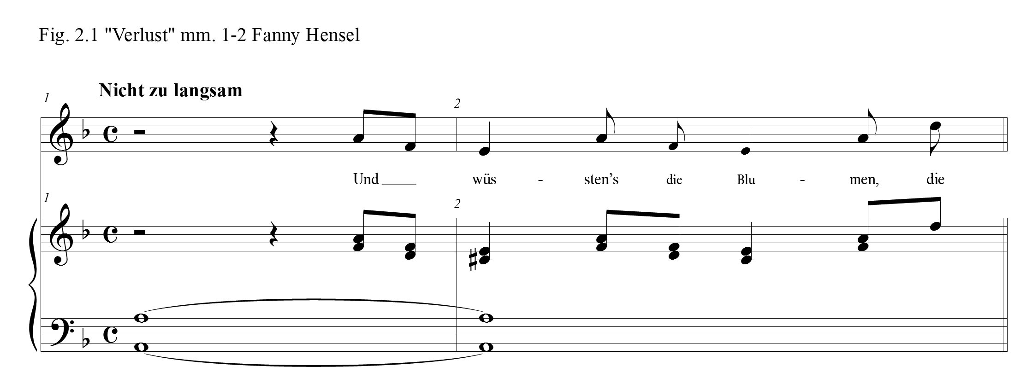
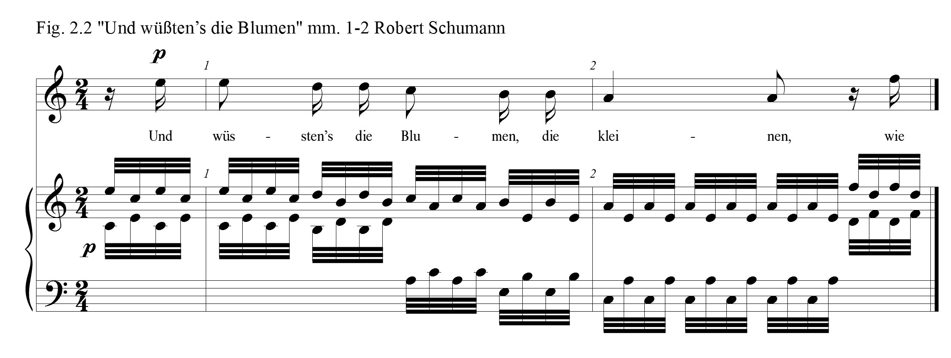
Whatever their motivation, these brief introductions require special performance considerations. With little or no instrumental introduction, the singer and pianist face the challenge of immediately unifying tempo while executing with precision the given rhythms and pitch. There is also the challenge of immediately presenting the character of the music as the song is initiated. With very little advance, the singer is also confronted with the difficulty of preparing and coordinating the breath, and performing an instantaneous connected and lively vocal line. These issues are present in the opening line for both settings.
Hensel’s miniaturist construction was also achieved in her very short interludes, some no longer than two beats. Consequently, the length of the entire composition is only forty-one measures. Musical material was also condensed through a rapid harmonic rhythm. Hensel, as well, set the words to “Verlust,” syllabically. In the midst of a syllabic text setting, every anomaly can highlight textual drama and offers opportunity for text painting. She placed such anomalies in measures eight and nine (Fig. 2.3). Here, she extended the musical phrase slightly by setting text melismatically. Verses two and four contain the most florid melismas within the setting, as is illustrated in Fig. 2.4. In verses one and two these melismas emphasize the dramatic words: “zu heilen meinen Schmerz” (heal my pain) and “erquickenden Gesang” (refreshing singing) in measures 8-9 and 17-18. Beginning in measures 15 and 35, the dramatic effect is intensified by a swelling
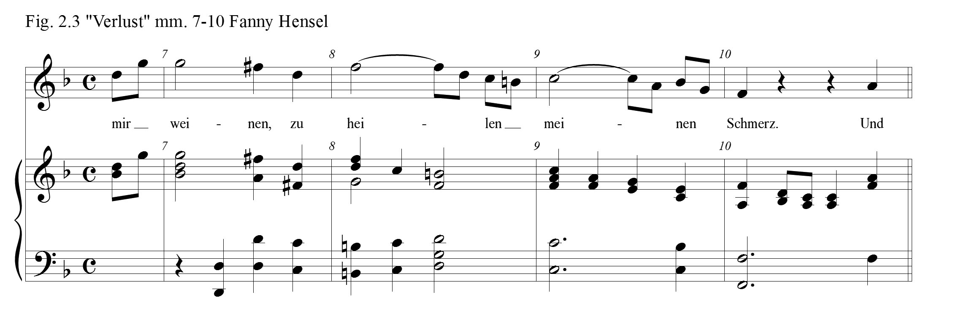
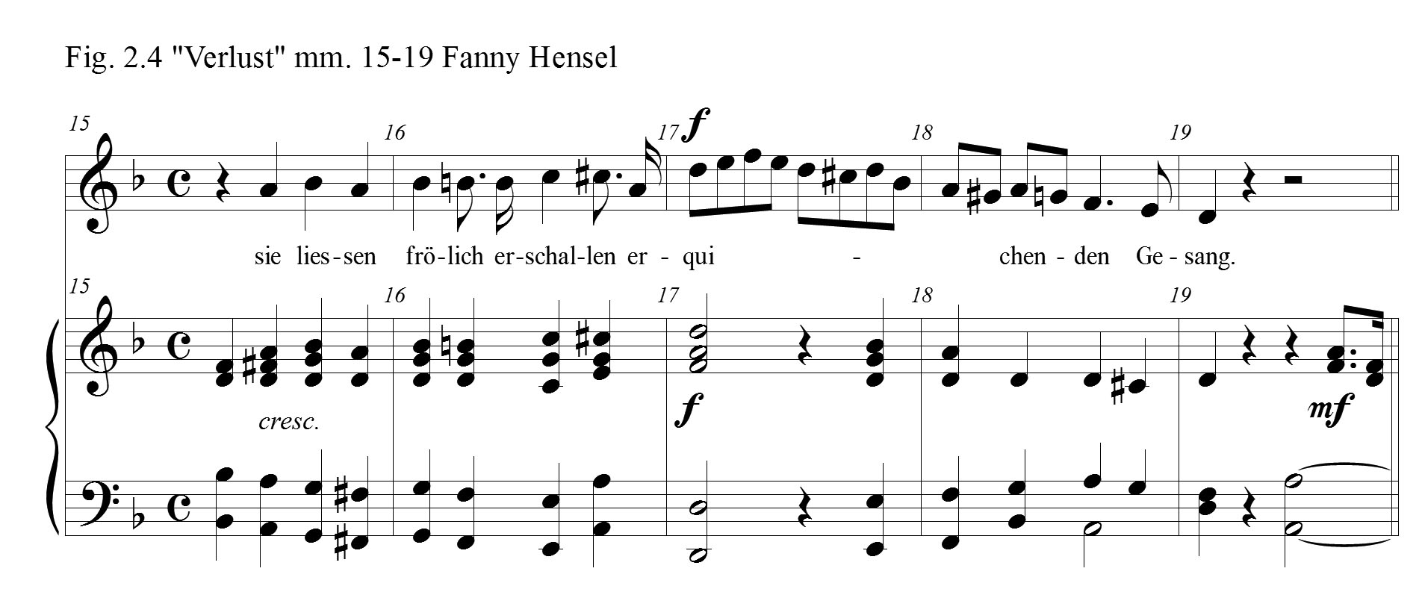
crescendo and accented chords amid a broadening chromatic melody and accompaniment. The sweeping vocal line, as well, extends upward to the top of the staff as the bass line of the accompaniment descends downward in octaves. The melody moves
beyond the span of an octave from A4 to F5 and then returns with similar chromatic motion downward until the arrival home to the tonic D4 in measure 19 accentuating the text, “sie liessen fröhlich erschallen erquickenden Gesang” (They would cheerfully resound with refreshing singing) and in measure 39, “er hat ja selbst zerrissen, zerissen mir das Herz” (He has indeed torn, torn my heart in two).
Fanny Hensel, in her lieder, often sought to avoid tonic pitch and harmony. Figure 2.1 displays this technique in the opening measures of the lied. The first tone in “Verlust” begins on the dominant of D minor. There is a brief hint of tonic as the voice enters and a D minor 6/4 chord is outlined in the accompaniment. Beat one of the first measure, however, lands on an A major chord giving a false impression that the song might be in A. This unexpected musical opening corresponds to Heine’s unusual opening phrase that begins with the conjunction “and.” Had Heine began his poem with “If the little flowers had known how deeply my heart has been wounded” rather than “And if the little flowers . . .” Hensel surely would have conceived a different opening musical statement. In that scenario, tonic harmony likely would have been established at the top and she and Schumann might have composed an extended introduction for their respective songs. Heine’s poem begins as though it is in mid-sentence. Hensel’s music seems to begin in the same fashion. Any sense of tonic doesn’t appear until the first authentic cadence in the middle of measure five, but it lands in the parallel-D major (Fig. 2.5). Then there ensues is a series of wandering key centers. Verse one closes in the relative, F major. Verse two travels from F major to B-flat major and finally closes in D minor. Verses three and four follow a similar scheme with just a few harmonic departures. There is a strong authentic cadence in D minor at the close of verse four, and the lied is extended by means of a short postlude with material reminiscent of the opening line but then ends on the dominant A major, once again obscuring tonic (Fig. 2.6).
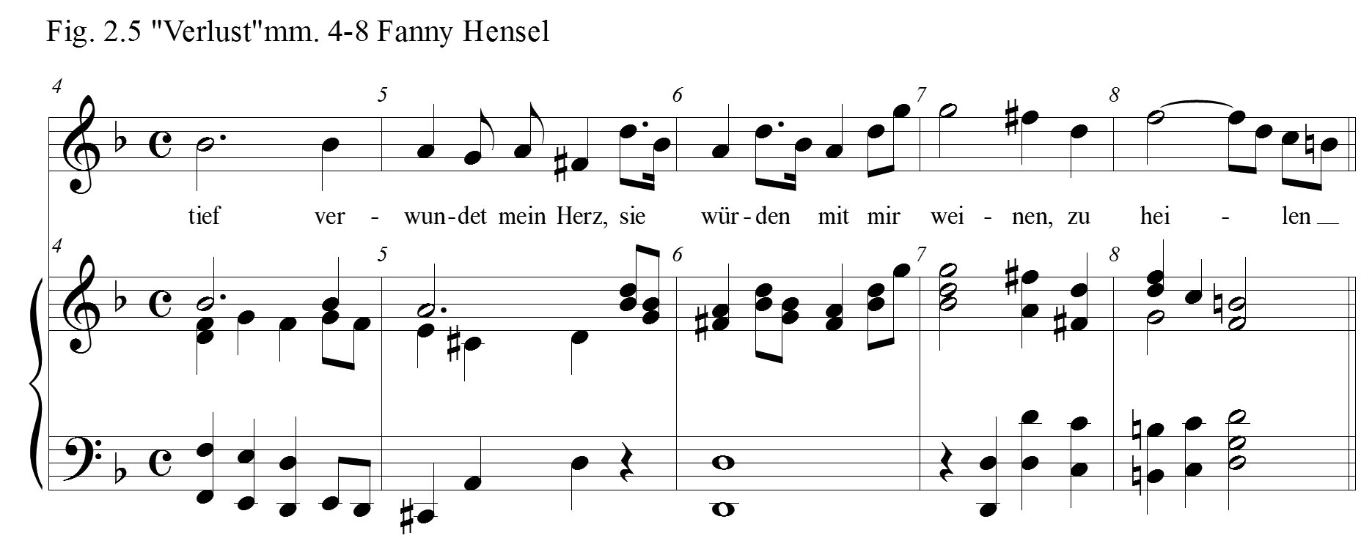
Recordings of Fanny Hensel’s “Verlust” consistently present the ending which is found in the published editions of “Verlust,” including the Breitkopf & Härtel edition of Felix’s Zwölf Lieder from 1877. However, in Hensel’s manuscript, as is transcribed in Fig. 2.7,
the following changes can be noted: the D minor to A major final cadence is crossed out and the chords G major to D major are penciled in. Cornelia Bartsch and Cordula

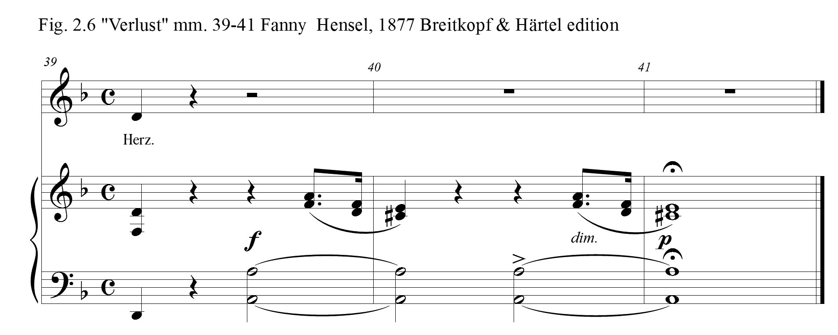
Heymann-Wentzel, in the urtext edition Lieder ohne Namen (1820-1844), offer what seems to be a compromised ending. There, a second measure is added with an A major chord that moves to the D major tonic. Looking at the manuscript, Fanny seems to have wrestled over which ending would be the best: to close her lied on the dominant, or finish “Verlust” with the tonic Picardy third. Felix’s Op. 9 published version indicates that Fanny decided upon a dominant concluding chord. The protagonist in Heine’s “Und
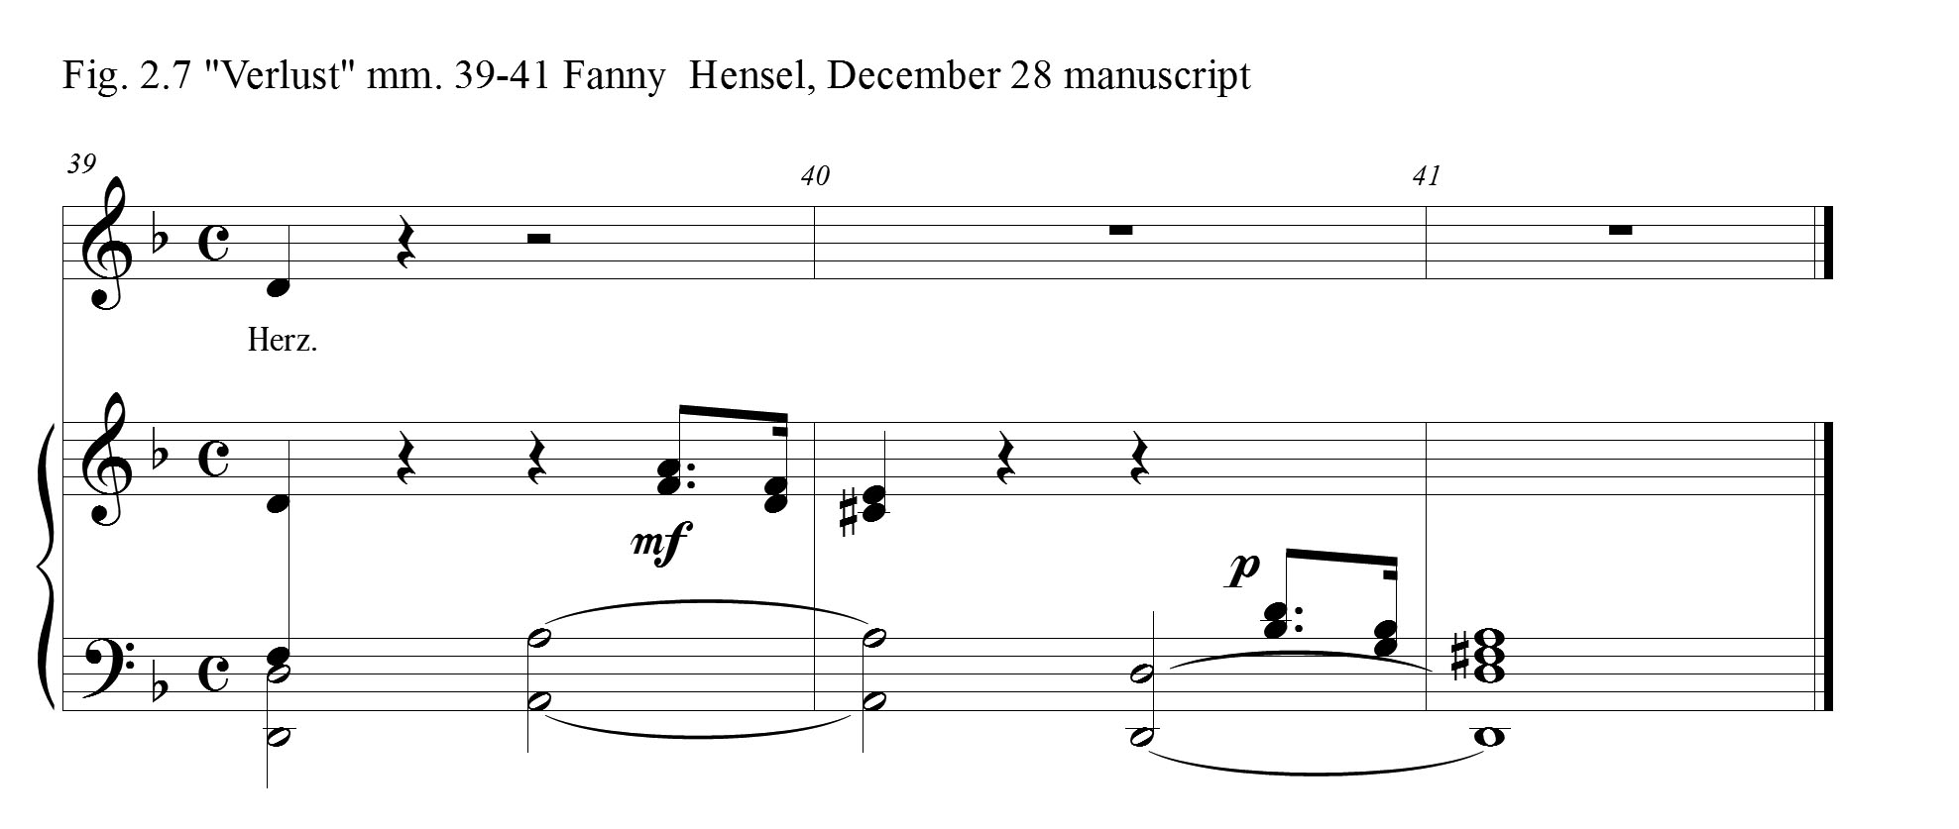

wüßten’s die Blumen” finds no resolution to his broken heart, and Hensel, with this ending on the dominant, leaves the listener with a fitting unresolved musical conclusion.
Hensel, on occasion, would alter the text of the poetry in her song settings, and she did so in “Verlust.” Notice that she changed Heine’s original gender in the final verse, from Eine to Einer, and Sie to Er.
Heinrich Heine Fanny Mendelssohn Hensel
Die alle können’s nicht wissen, Die alle können’s nicht wissen,
Nur Eine kennt meinen Schmerz: Nur Einer kennt meinen Schmerz:
Sie hat ja selbst zerrissen, Er hat ja selbst zerrissen,
Zerrissen mir das Herz. Zerrissen mir das Herz.
Was this alteration made in order to reveal Hensel’s self-identification in the story, or had she made this adjustment because her sister Rebecka often performed her songs? Fanny Hensel’s contemporary Josephine Lang (1815-1880), a student of Felix, in her setting of Heine’s poem, kept his specific words intact, but she extended her song setting to a length of sixty-eight measures by repeating the final words of verses two and four, and then repeated the entire text a second time.
Josephine Lang made a lasting impression upon Felix. Because of his clearly established beliefs concerning Fanny’s role as a woman, his investments in Lang’s music career raises questions. Felix spoke of his relationship to her in a letter to his family on October 6, 1831:
I forgot, however, to say that every day at twelve o’clock I give little Mademoiselle L an hour’s instruction in double counterpoint, and four-part composition, etc., which makes me realize more than ever the stupidity and confusion of most masters and books on the subject; for nothing can be clearer than the whole thing when properly explained. She is one of the sweetest creatures I ever saw. Imagine a small, delicate-looking, pale girl, with noble but not pretty features, so singular and interesting that it is difficult to turn your eyes from her; while her every gesture and word are full of talent. She has the gift for composing songs, and singing them in a way I never heard before, causing me the most unalloyed musical delight I ever experienced. . . . She has no one to understand or to guide her, and because, strangely enough, she completely lacks musical culture; she knows very little, and can scarcely distinguish good music from bad; in fact, except for her own pieces, she thinks everything is wonderfully fine. If she were to become satisfied, as it were, with herself, it would all be over with her. I have, for my part, done what I could, and implored her parents and herself in the most urgent manner, to avoid society, and not allow such divine talent to be wasted.

Felix wanted to send her to Berlin to study with Zelter and with his sister, Fanny. Though his plans for her continued training never materialized, Fanny became acquainted with Josephine’s music and found her songs to be delightful:
Odd things have happened again involving Lang’s lieder. Several days ago Trautwein had sent me a package of new pieces. And JUST the day before Paul returns, I play them through and discover, after encountering many novelties that prevent me from proceeding beyond the first ten measures, that they’re by Lang. I like them so much that I play them, and play them again—I can’t tear myself away—and then finally put them aside. I’ve been singing them all day so that I’ll remember them, especially the one alto lied, and I’ve also been telling everybody about them.

Lang composed her lied, “Und wüßten’s die Blumen,” in 1864. She had been a widow since her husband’s death in 1856, and was dependent upon the success of her published music to provide for her six children. She constructed the lied utilizing the same binary structure for her setting as did Hensel. Lang also utilized in her introduction, interlude and postlude a C pedal-point in the left hand, a technique often employed by both Felix and Fanny. Maybe it was her difficult financial circumstances that distinguished Lang from his sister in the mind of Felix. Todd assessed that Felix, “stood as ready to support Lang’s public career as he was unwilling to promote Fanny’s.”
Many of Hensel’s early lieder were strophic in their form. Her “Verlust,” though, is binary. Two themes are presented in the first two stanzas. Verses three and four repeat these AB themes, each having slight variations. Concerning Heinrich Heine’s poem, the first three verses possess a similar theme. The flowers, the nightingales, and the golden stars would offer healing if they had known the depths of his pain. Verse four, by contrast, declares that none of the three can know his pain. Only the one who tore his heart in two can understand. Robert Schumann, in his modified strophic setting of this poetry from 1840, number eight in his Dichterliebe, seems to have perfectly organized his musical setting to suit the structure of the poem. In Schumann’s first three verses, the rhythm of the melody, from verse to verse, takes slight adjustments to adapt to the flow of the changing text. Interest is achieved in these verses by a variety of chord choices from verse to verse. Verse four, though, makes a harmonic shift to the parallel A major. The melody also moves quickly down a third, ends dramatically on the repeated word, “zerrissen,” and closes with a fiery five-bar piano postlude whose material is built upon the opening motive from the vocal line, now in the bass clef. The right hand, in concert, spins out triplet 16th notes against the dotted 8th and 16th notes in the bass (Figure 2.8). With power, Schumann captures in his music the torn heart in verse four. Hensel achieves dramatic effect in “Verlust” through “sudden shifts from minor to major (a frequent occurrence in Fanny’s music), its chromatic chord alterations, and its melismatic phrases.” The vocalist and pianist should seek to exploit
these elements in Hensel’s “Verlust.”
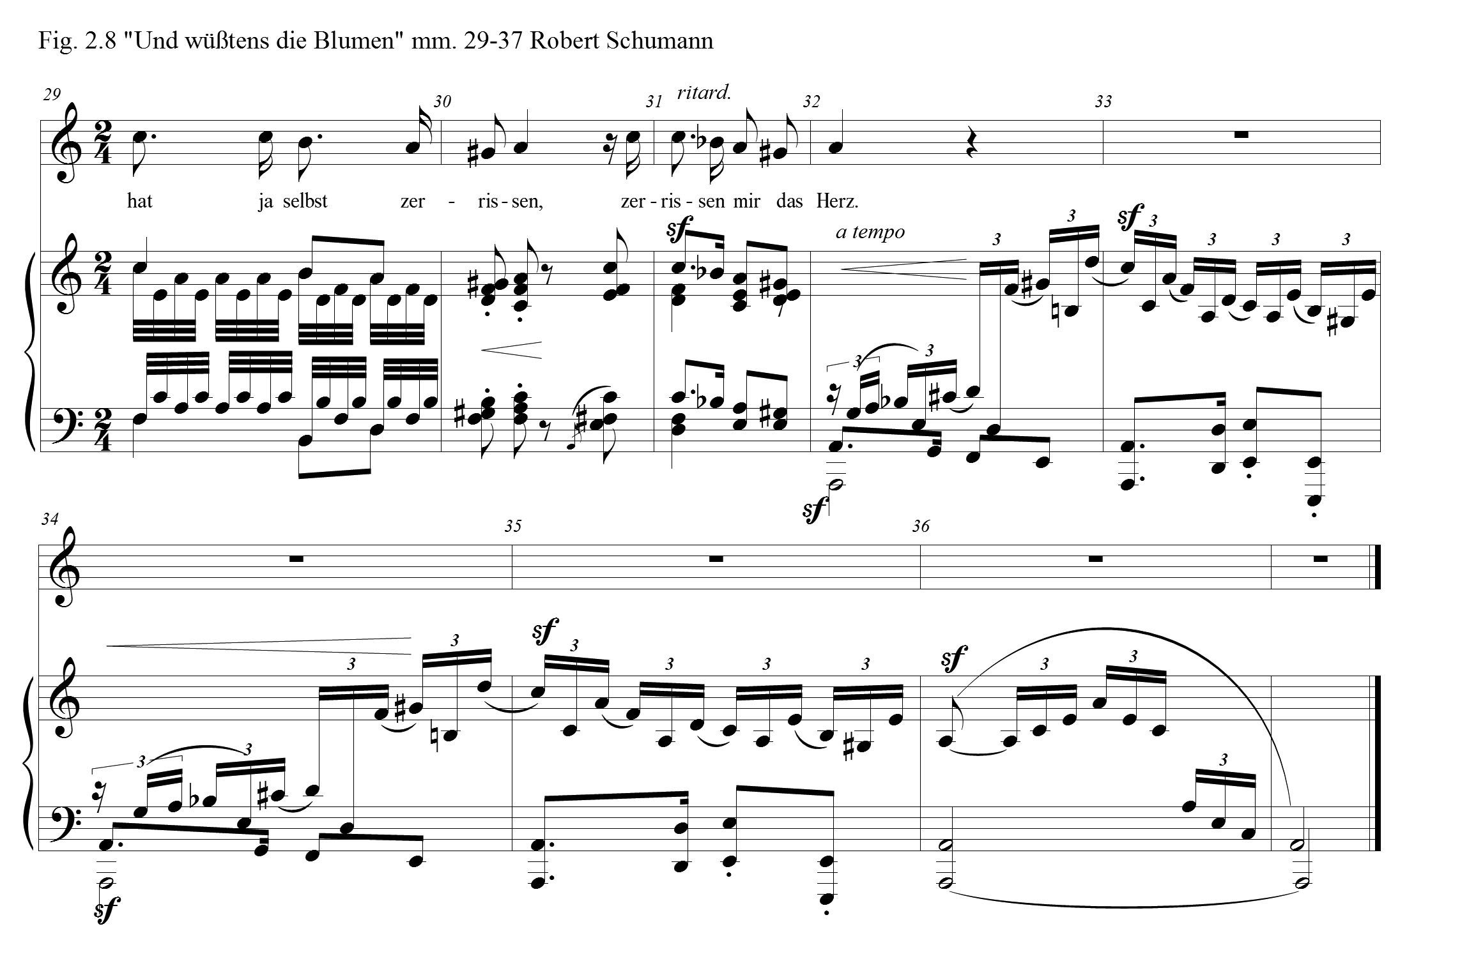
Hensel composed “Verlust (Und wüßtens die Blumen)” on December 28, 1827 when she was twenty-two years old. Though she was coming to an end of her composition lessons with Zelter, her setting of Heine’s “Und wüßtens die Blumen” still reveals his influence. In Felix’s Op. 9 this lied is entitled “Verlust,” but in her manuscript, as was normal, no title is given. In her notebook “Verlust” appears on the same page as another Heine setting, “Am leuchtenden Sommermorgen,” dated December 14 of that same year. Though there are numerous corrections written into the score for “Und wüßtens die Blumen,” the only extra markings for “Am leuchtenden Sommermorgen” is an added measure in the margin at the end of the Lied to avoid using another system of staves for just one measure. Cornelia Bartsch and Cordula Heymann-Wenzel, from their “Critical Report” in the Furore Verlag edition Lieder ohne Namen suggests that the edits made in the autograph versions of Felix’s Op. 8 and Op. 9 “were all made in another hand.” This revelation adds some mystery to exactly what process the siblings took in bringing these collections of songs to the point of publication.
“Verlust” was only the third Heine poem that Fanny Hensel set to music. Five months later in 1828 she would complete her fourth Heine song setting, “Allnächtlich im traume,” which is explored next.

Chapter 3

“Allnächtlich im Traume” (Every Night in My Dreams)
“Allnächtlich im Traume,” one of Fanny Hensel’s most concise lieder, only thirteen measures in all, was completed July 21, 1828 when she was only twenty-two. At this point in her life, Hensel had already composed some 160 songs. She fashioned this lied with the simplest folk-like construction and at the same time created a song of exquisite loveliness. Loraine Gorrell, in describing Hensel’s early songs, explains that they, “already show many of the qualities that characterize all of Fanny’s writing. They are clearly structured, usually as strophic songs, with an accompaniment subordinate to the vocal line.” Marcia J. Citron states in her article on Hensel’s lieder in the Musical Quarterly that, “most of the Lieder of the 1820s show clearly the influence of the Volkslied, espoused by Zelter. Strophic form, sparse texture, repetitive rhythms in the voice and accompaniment, clear-cut phrases, syllabic text setting, few expression marks, diatonic harmony, diatonic melody, and a minimal sense of dramatic pacing characterize this style.” This general description of her early songs perfectly describes this lied.
Once again, it is important to consider this composition in the context of the world about her. Hensel was not writing her lieder for publication, nor for performance on the stage. Her songs were composed either to be performed along side of Felix’s music at the family’s Sunday musicales by her sister Rebecka, or simply for her own pleasure. Gorrell, in her discussion of the development of the genre, describes lied in a way that would have been familiar to Hensel: “In the early stages of its development, the lied was performed at home by amateurs. Composers such as Johann Friedrich Reichardt, Luise Reichardt, and Carl Zelter wrote songs with modest vocal ranges and simple piano accompaniments that were well within the capabilities of the talented amateur.” Later in the nineteenth century, art song became something beyond amateur performance to a genre more appropriate for performance in the concert hall, but Jane K. Brown, in her chapter in The Cambridge Companion to the Lied, “In the Beginning was Poetry,” states that this, “professionalization of song [ran] counter not only to the conditions that created the Lied, but also to the close alliance of art song with folk song. In its willed simplicity and singability, eighteenth-century song had an implicit connection to folk song that became explicit in the style shift in the last third of the century.”
In 1828, the Mendelssohns enjoyed a relatively quiet year. Felix attended the University of Berlin and spent most of that year at home. Eduard Devrient, a close friend to Felix, in his biography, My Recollections of Felix Mendelssohn-Bartholdy, conveyed details concerning the many visitors who gathered at the Mendelssohn home in 1827-28:
Some University friends now visited the house; amongst them were Droysen, at this time a divinity student, who wrote verses, which Felix and Fanny delighted to set to music; the brothers Heydemann, one a lawyer, the other a philologist; Dorn, who abandoned science for the sake of music; Kugler, who was at that time half student, half painter; Schubring, a theological student, with whom I was on friendly terms; my cousin and friend Baur, whom I had introduced at the Mendelssohn’s musical parties, and who, having been a first class man in 1813, was able to give some valuable hints to Felix; both were disciples of Schleiermacher. They sang lustily whatever Felix gave out for practice, assisted him afterwards in his oratorios, and remained his faithful friends till the close of his life.

Devrient also recalls that,
Felix began, in the winter of 1827, to assemble a small and trusty choir, who met usually on Saturdays, for the practice of rarely-heard works. We soon entered upon his revered ‘Matthäus Passion.’ With this work a new world opened to us, as we mastered it piece by piece. The impersonation of the several characters of the Gospel by different voices struck us as being the pith of the work, the antiquity of this practice in old church music being long forgotten. The dramatic treatment that arose from it, the overwhelming
majesty of the choruses, above all the wondrous declamation of the part of Christ, were to me a new and sacred Bible-speech, and increased with every time of hearing our reverence and astonishment at the greatness of this work.

Philip Radcliffe offered more details on this topic, stating that in 1828, “rehearsals of the Passion had been continuing all through the year, and early in 1829 Devrient was determined to have it performed at the Singakademie. He was longing to sing the part of Christ, and Felix must conduct.” The following year, after winning Zelter over, the Passion was performed “for the first time since Bach’s death on 11 March and again on 21 March, Bach’s birthday, with the greatest success.” Fanny shared her personal account of the first performance to Klingemann in a letter from March 22, 1829.
We were the first in the orchestra. As soon as the doors were opened, rushed into the hall, which was quite full in less than a quarter of an hour. I sat at the corner, where I could see Felix very well, and had gathered the strongest alto-voices around me. The choruses were sung with a fire, a striking power, and also with a touching delicacy and softness the like of which I have never heard, except at the second concert, when they surpassed themselves.

Fanny, who was a prolific letter writer, composed only a few letters that year to their friend, Karl Klingemann. In these letters she discussed Felix’s music and various activities in Berlin, but mentions very little of her own music, except that she did answer his request for a piano piece for four hands stating, “nothing exists as yet. But who knows, perhaps I may some day find leisure and set to work arranging the overture for the [Midsummer Night’s] Dream for you. It will be quite as nice a gift as a purse or a pocket-book.” In October, Fanny, along with a few quips from Rebecka, wrote a letter to Felix. She told him that she had begun writing a fugue on a theme. There is no commentary from Fanny in her diary in 1828, as the first entry in her Tagebücher did not appear until January 29, 1829.
Five years had passed since her last contact with Wilhelm at the time of the completion of “Allnächtlich im Traume.” Though he had continued correspondence with Fanny’s mother, Lea, his art had become his only means of connection with Fanny. Lea expressed gratitude for his drawings in a letter,
First of all, I must express to you my long-delayed but heartfelt thanks for your highly welcomed gift of the album-drawing. I cannot tell you how much its exquisite beauty of execution and fine delicate idea has surprised and touched us. The spiritualized, à la Hensel idealized likeness of the four children has not escaped our eyes. Although since your absence they have so much changed and grown, and somehow got coarse-grained, that your ideal likeness only represents them as they were.

In October of 1828 Wilhelm returned to Berlin, and Fanny, in her December letter to Klingemann, described the young man, “Amongst the new-comers there is also Hensel, who returned from Italy two months ago, and is likewise a merry, animating member of our society.” In July, however, at the time of her crafting “Allnächtlich im Traume,” she would not have known anything of Wilhelm’s return to Berlin. Felix and Fanny continued to compose during this year. She composed thirteen pieces in all, most of them lieder; three were settings of Heine’s poetry.
In Heine’s Lyrisches Intermezzo from his Buch der Lieder “Allnächtlich im Traume” is number fifty-seven of the sixty-five poems. In this poem, the protagonist tells of a dream. In that dream he sees his beloved. The reunion overwhelms him, for she gives him a kind greeting and he throws himself at her feet, loudly weeping. Tears like pearl drops fall from her eyes. As she presents him a cypress spray, she whispers into his ear an intimate word. Abruptly, he awakes. The cypress spray vanishes, and he cannot remember the word she had spoken.
Allnächtlich im Traume seh' ich dich, Every night in my dreams I see you,
Und sehe dich freundlich grüßen, and see your friendly greeting;
Und laut aufweinend stürz ich mich and, loudly weeping, I throw myself
Zu deinen süßen Füßen. at your sweet feet.

Du siehst mich an wehmütiglich, You look at me sadly
Und schüttelst das blonde Köpfchen; and shake your little blond head;
Aus deinen Augen schleichen sich from your eyes steal
Die Perlentränentröpfchen. teardrops like pearls.

Du sagst mir heimlich ein leises Wort, You murmur intimately a quiet word
to me,
Und gibst mir den Strauß von Zypressen and give me a spray of cypress.
Ich wache auf, und der Strauß ist fort, I wake up and the spray is gone
Und’s Wort hab ich vergessen. and I have forgotten the word.

Who is the woman in his dream? Is she living or dead? His weeping as he sees her and the gift of cypress spray, a symbol of death, insinuates that perhaps his loved one is deceased. Or is this dream encounter with his dead-beloved a metaphor representing the death of Amalie’s love?
Hensel chose to set this poem by the simplest musical means. It is a thirteen-bar strophic song with an unpretentious accompaniment. James Husst Hall in his book, The Art Song, discusses issues related to strophic song settings:
Such a form is most frequently summoned by a lyric poem in which essentially a single mood or emotion is maintained. The crystallization of this mood in music must be broad and general, conceived in terms of the whole. “Love’s longing” may be the underlying sentiment, but the poet will reveal this in various lights and shadows. His stanzas will not be monotonous repetitions. The lines and accents will be varied, the word of greatest meaning not always falling in the same position within either the line or the stanza. . . . The composer must seize upon the dominant sentiment and be content with a musical complement which is not too sharply focused.

Heine, of course, rarely maintained a single mood or emotion in his poetry, and Hensel preferred Heine’s poems where, “he gives up the ironic conceit.” In this case, his irony is somewhat muted and her strophic setting of the poem is successful.
That her lied appears to be unadorned should not indicate that “Allnächtlich im Traume” is insignificant. Neither does simplicity equate poor quality. Fanny Hensel, the minimalist, achieves in these few measures all that is needed for art. It is in melodic craft that Fanny Mendelssohn-Hensel truly shines. Her simple melody in “Allnächtlich im Traume” outlines, with some decoration, a G minor chord, a B-flat major chord, and then again, a G minor chord (Fig. 3.1). Susan Youens offers the following general description
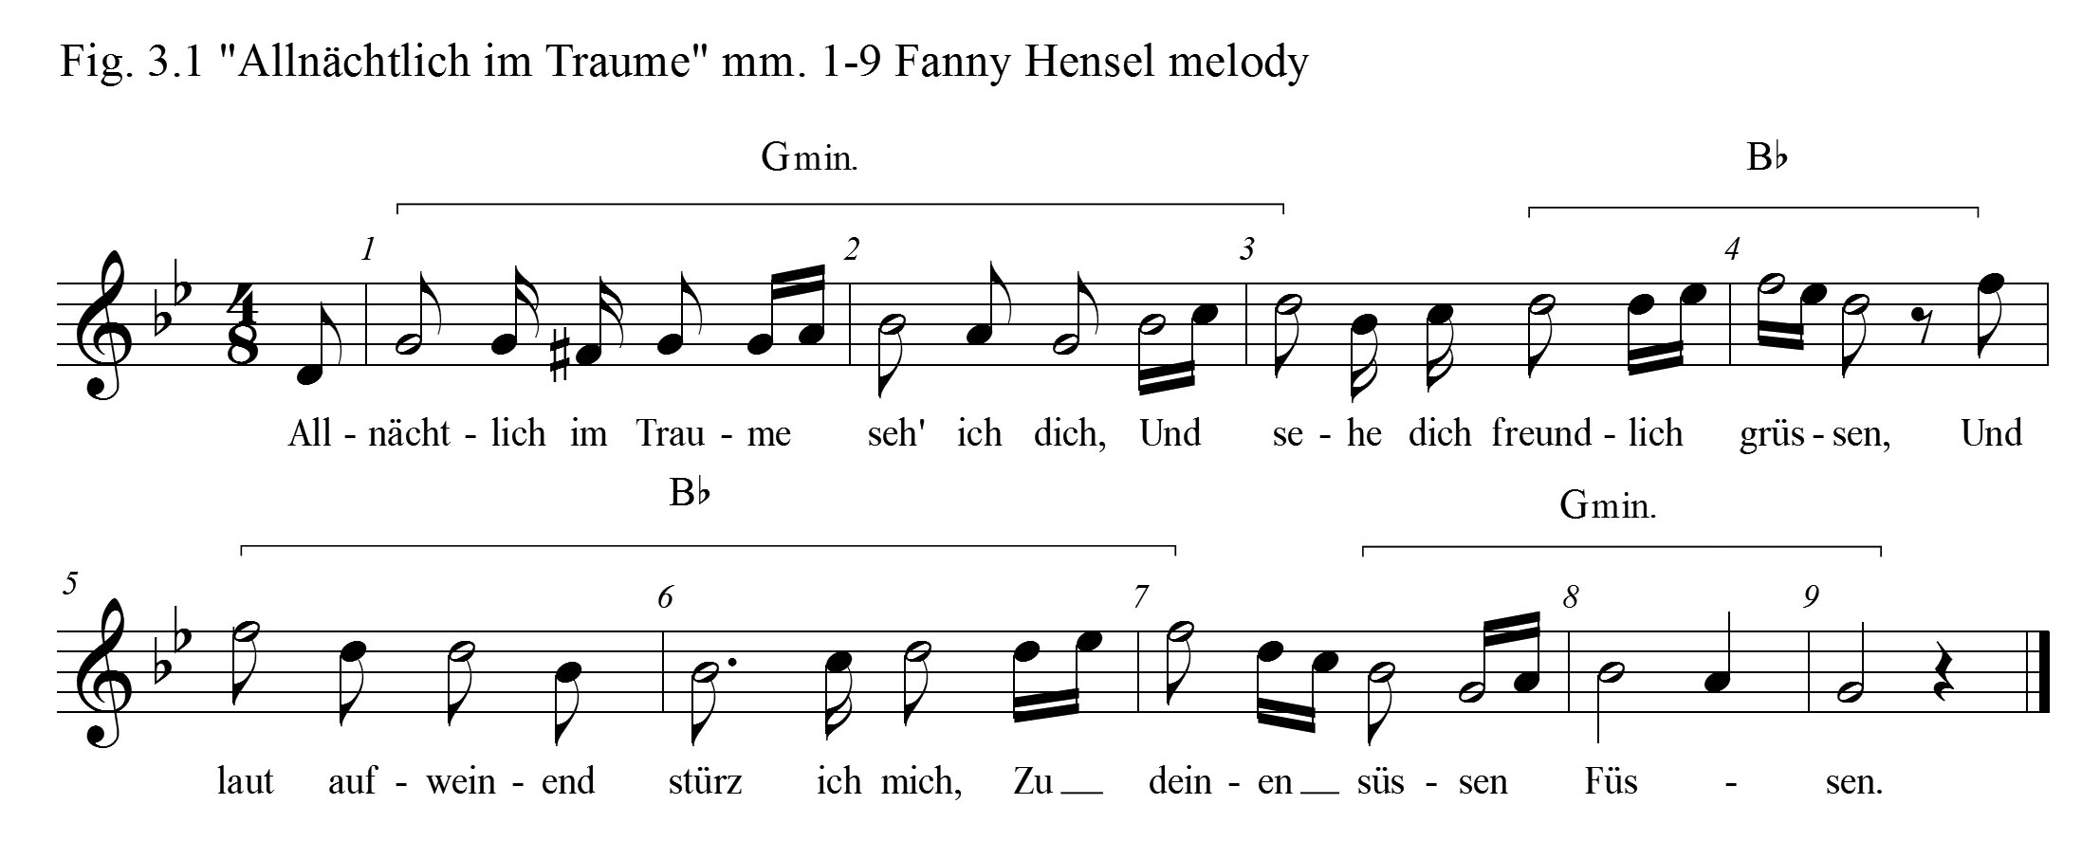
of Hensel’s melodies, “Her vocal lines are lyrical and generally pleasing. They may alternate between an outline of the song’s harmonic scheme and simple linear movement.” Victoria Sirota also characterizes her compositional craft, “Fanny’s gift for melody was matched with a sensitivity to nuance, interesting harmonic progressions, and a dramatic sense that resulted in a certain sophistication in even the simplest of her songs.” Hensel’s folk-like tune is singable. Decorations which move around these outlined chord tones make this tune delightful. Notice the recurring rocking motion with the 8th and two 16th notes moving by scale steps up and then down, which color the outlined broken chords (Fig. 3.2). Could the rocking motion in this melodic line be a depiction of sleep? Are these moments of text painting in Hensel’s lied? At the point of, “I see your friendly greeting” in measures three and four (Fig. 3.3), the harmony moves
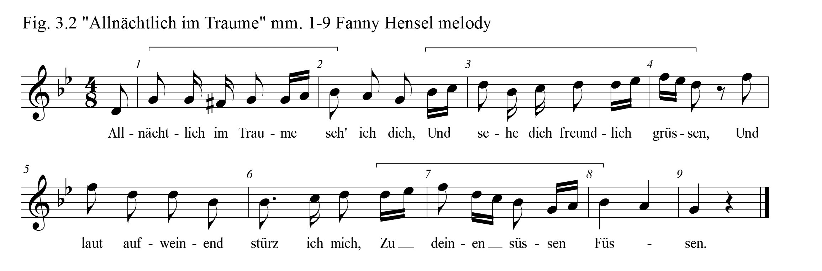
quickly to the relative major key and the vocal line reaches the highest point in the melody. As the next line in the poetry in measure five speaks of loud weeping, the vocal line, mimicking sighs, falls in intervals of a 3rd, all apparent cases of text-painting
(Fig. 3.4).
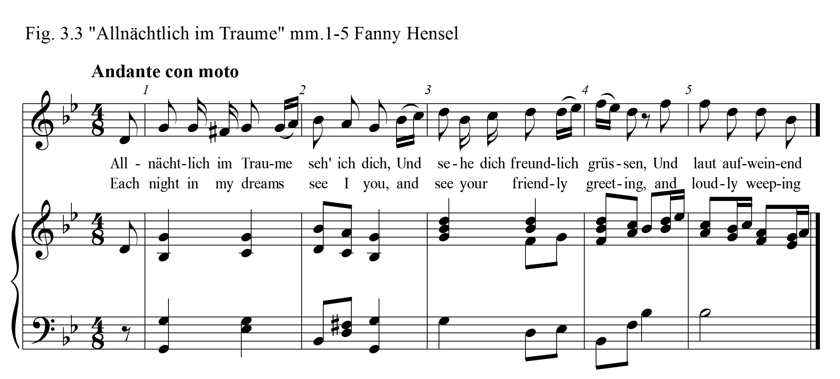
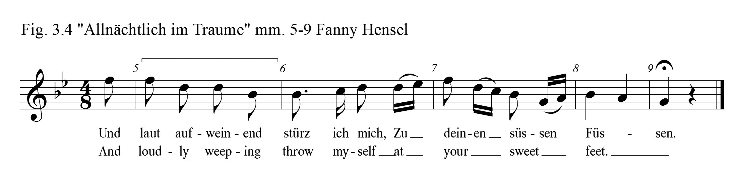
Felix, in his version of “Allnächtlich im Traume,” created a striking melody with a completely dissimilar treatment from that of Hensel’s setting. His modified strophic lied follows the construction of the poem very well, but the tempo of his “Allnächtlich im Traume” is fast-moving, and the accompaniment is full of energy. The rhythm of the melody in the opening line evokes the feeling of galloping. Lorraine Gorrell praises Felix’s lieder, declaring that his “beautiful melodies are the most important and successful feature of his songs. The shape and direction of the melodic phrase dominate as he focuses all attention on the vocal line, subordinating the accompaniment as well as the setting of text to this single quality. In fact, the best of Mendelssohn’s songs depend upon charming tunes.” But she offers this criticism,
Mendelssohn treated poetry with noticeable casualness. He, like Brahms, focused musical attention on the melodies of his songs, and when his melodies took on a life of their own, they overrode the structure and shape of the poem being set—it was the melody that “won.” He freely repeated words and phrases when his musical ideas had not yet run their course but the poem had been ‘used up.’

This was, in some respects, his approach in “Allnächtlich im Traume.” The final line of
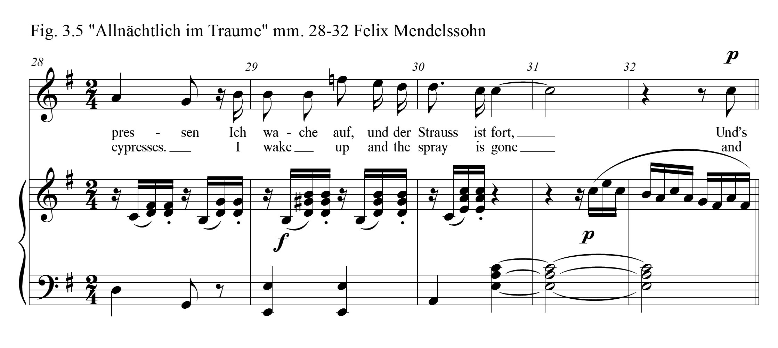
verses one and two is repeated for dramatic emphasis and to extend the musical phrase.
On verse three however, rather than repeating the final phrase, Mendelssohn extends the last note of the third line emphasizing the word, “gone” (Fig. 3.5). Then he lengthens the penultimate note, holding it for two full measures, magnifying the last word, “forgotten” (Fig. 3.6). Felix utilizes contrast effectively for dramatic effect. The vocal line begins quietly in all three verses, and there is a sudden sforzando in measures ten and twenty-nine suddenly exploding the words, “loud weeping” (Fig. 3.7) and “I wake up” (Fig. 3.8). In Hensel’s song there are no dynamic markings at all. The harmonic language in Felix’s
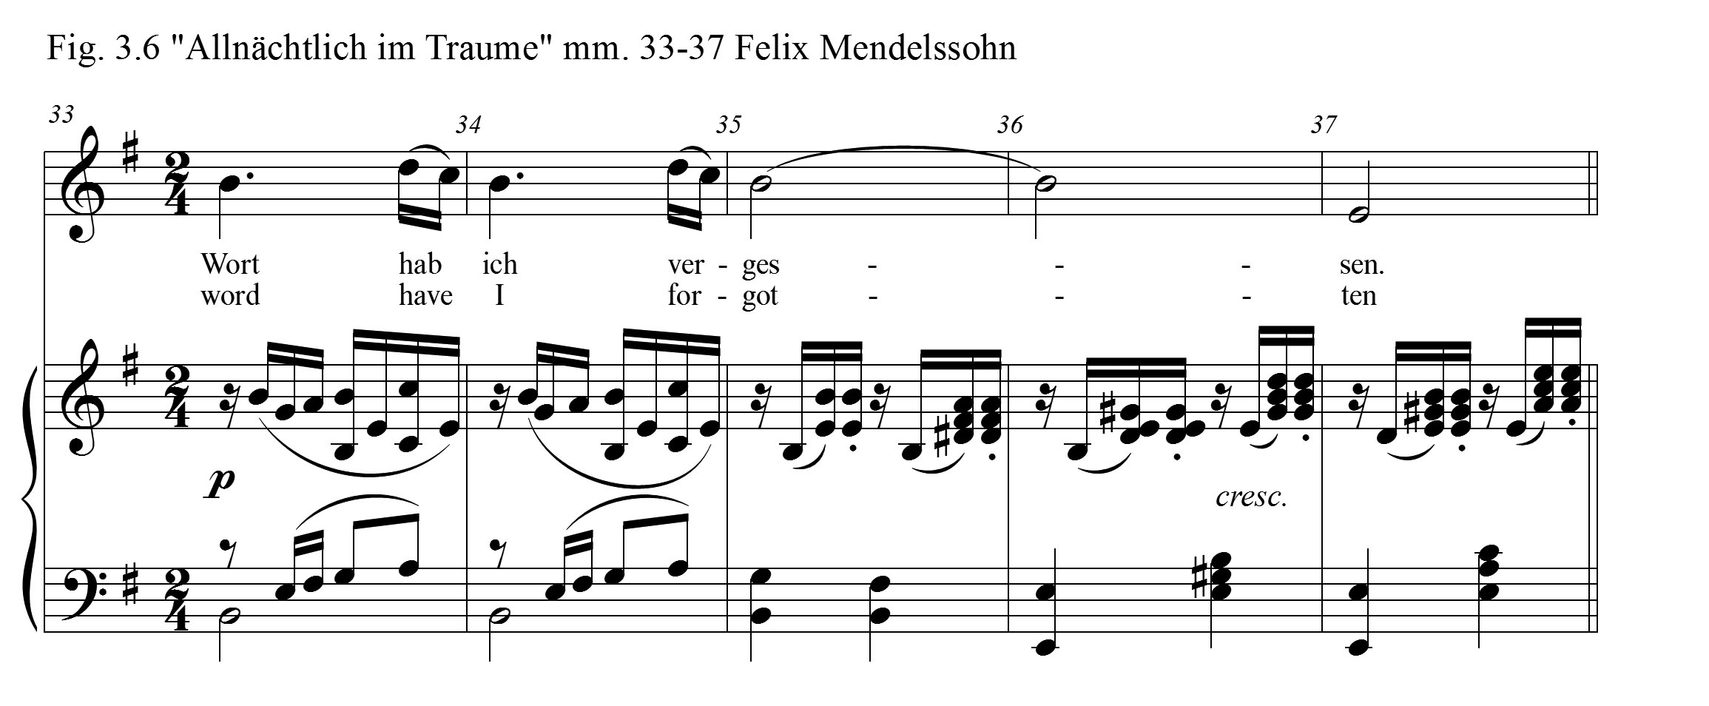
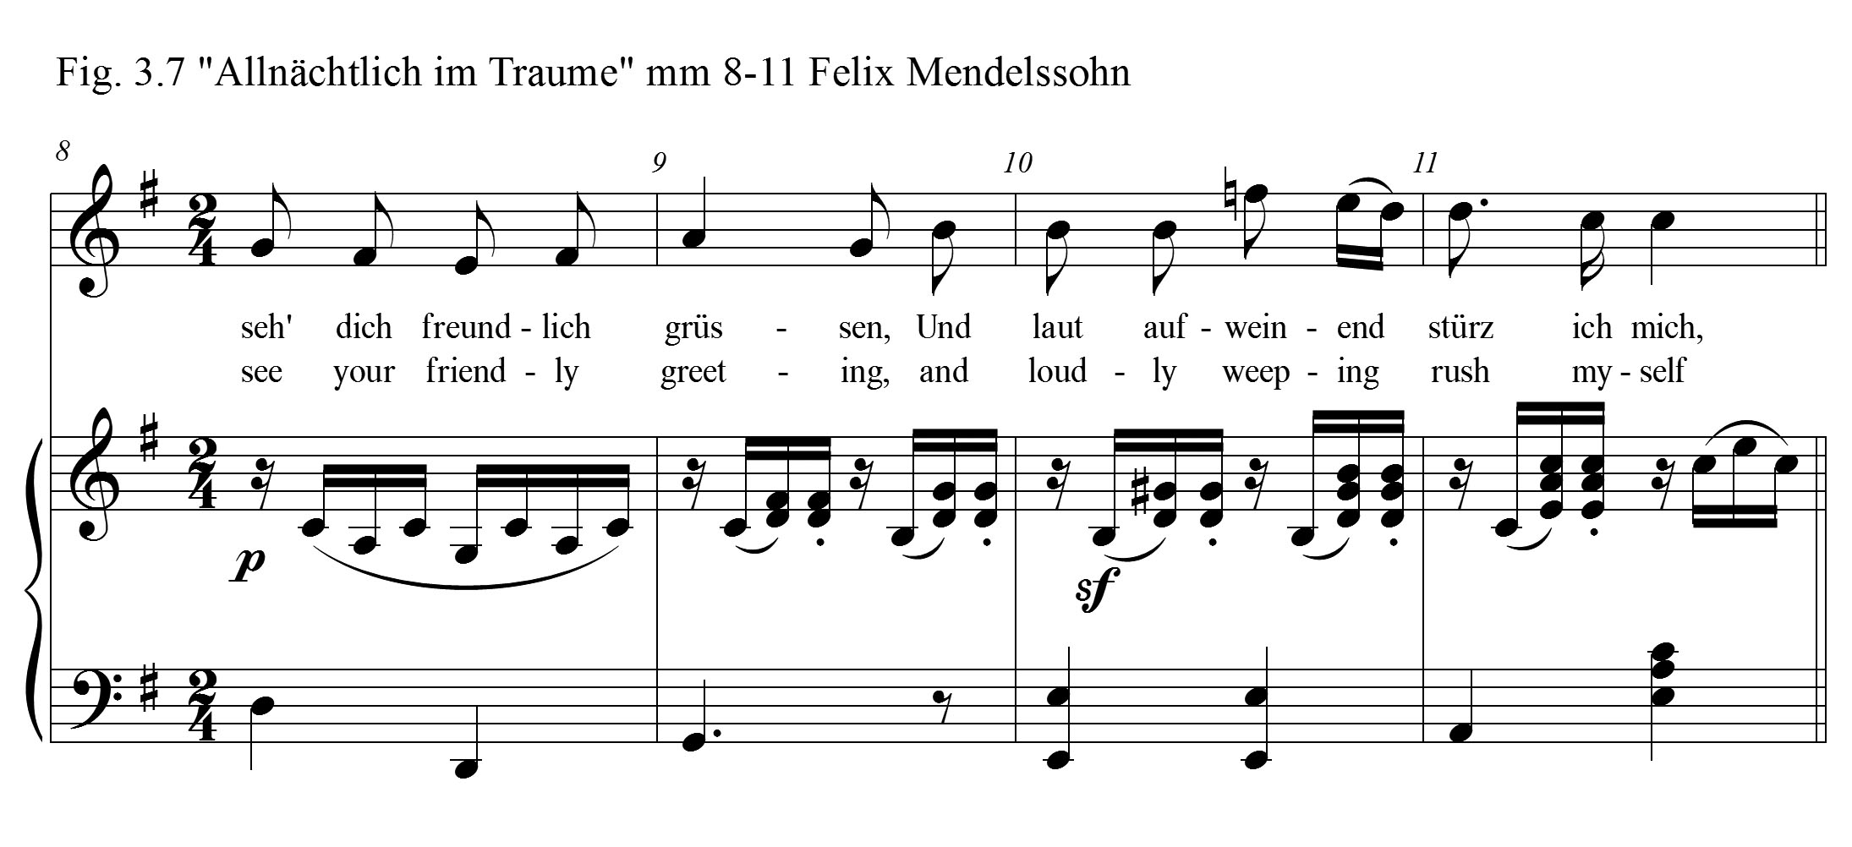
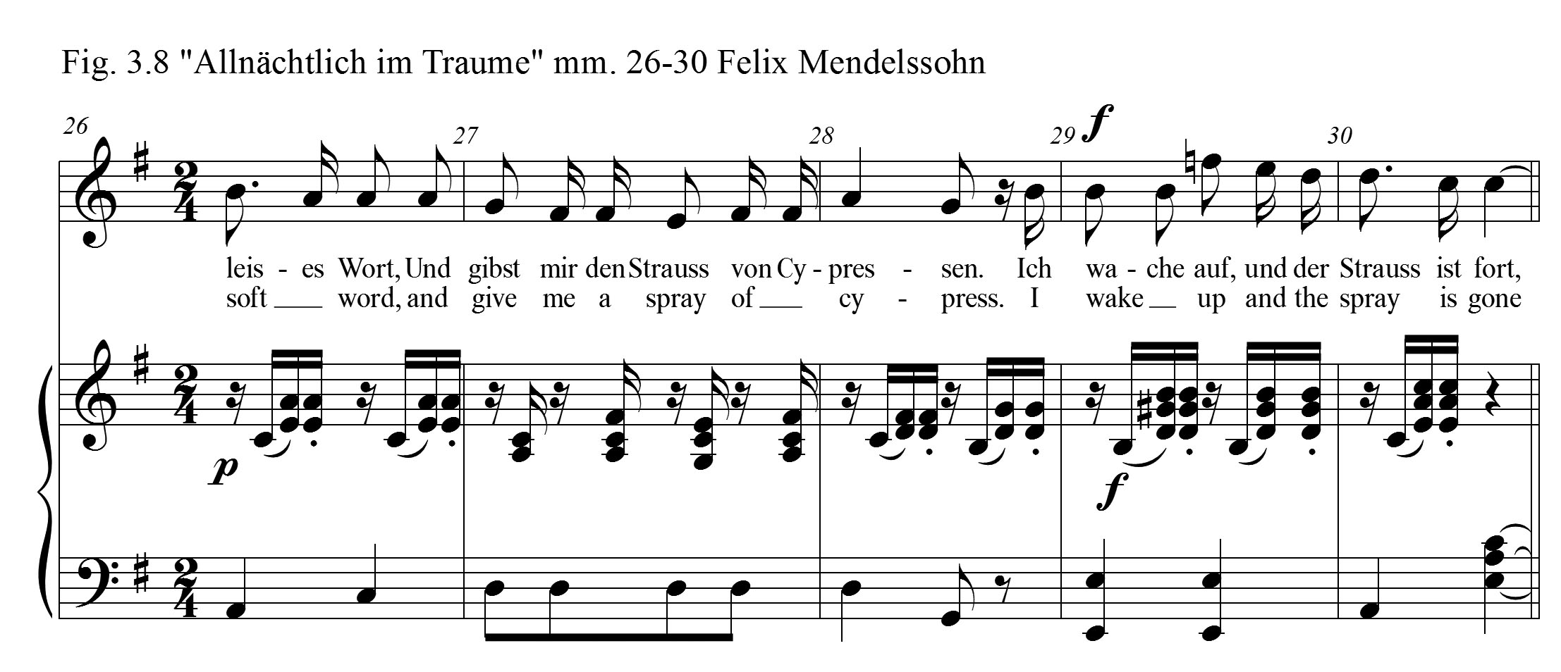
setting is much more varied than Hensel’s. The most intense feature is found in the introduction, interludes, and postlude. Here, there is a recurring D-sharp diminished seven chord over a pedal tone E which provides an undergirding for a repeated 16th note melody which is built upon the D-sharp diminished scale (Fig. 3.9). The final statement of this motive is doubled to encompass four bars and resolves to the tonic chord. In the right hand, Mendelssohn outlines the parallel E major triad, but the final tone that is heard is the dominant note of that scale, B. This tone lands on beat three, which offers the listener a sense that there should be more. In Hensel’s setting, there are no dramatic
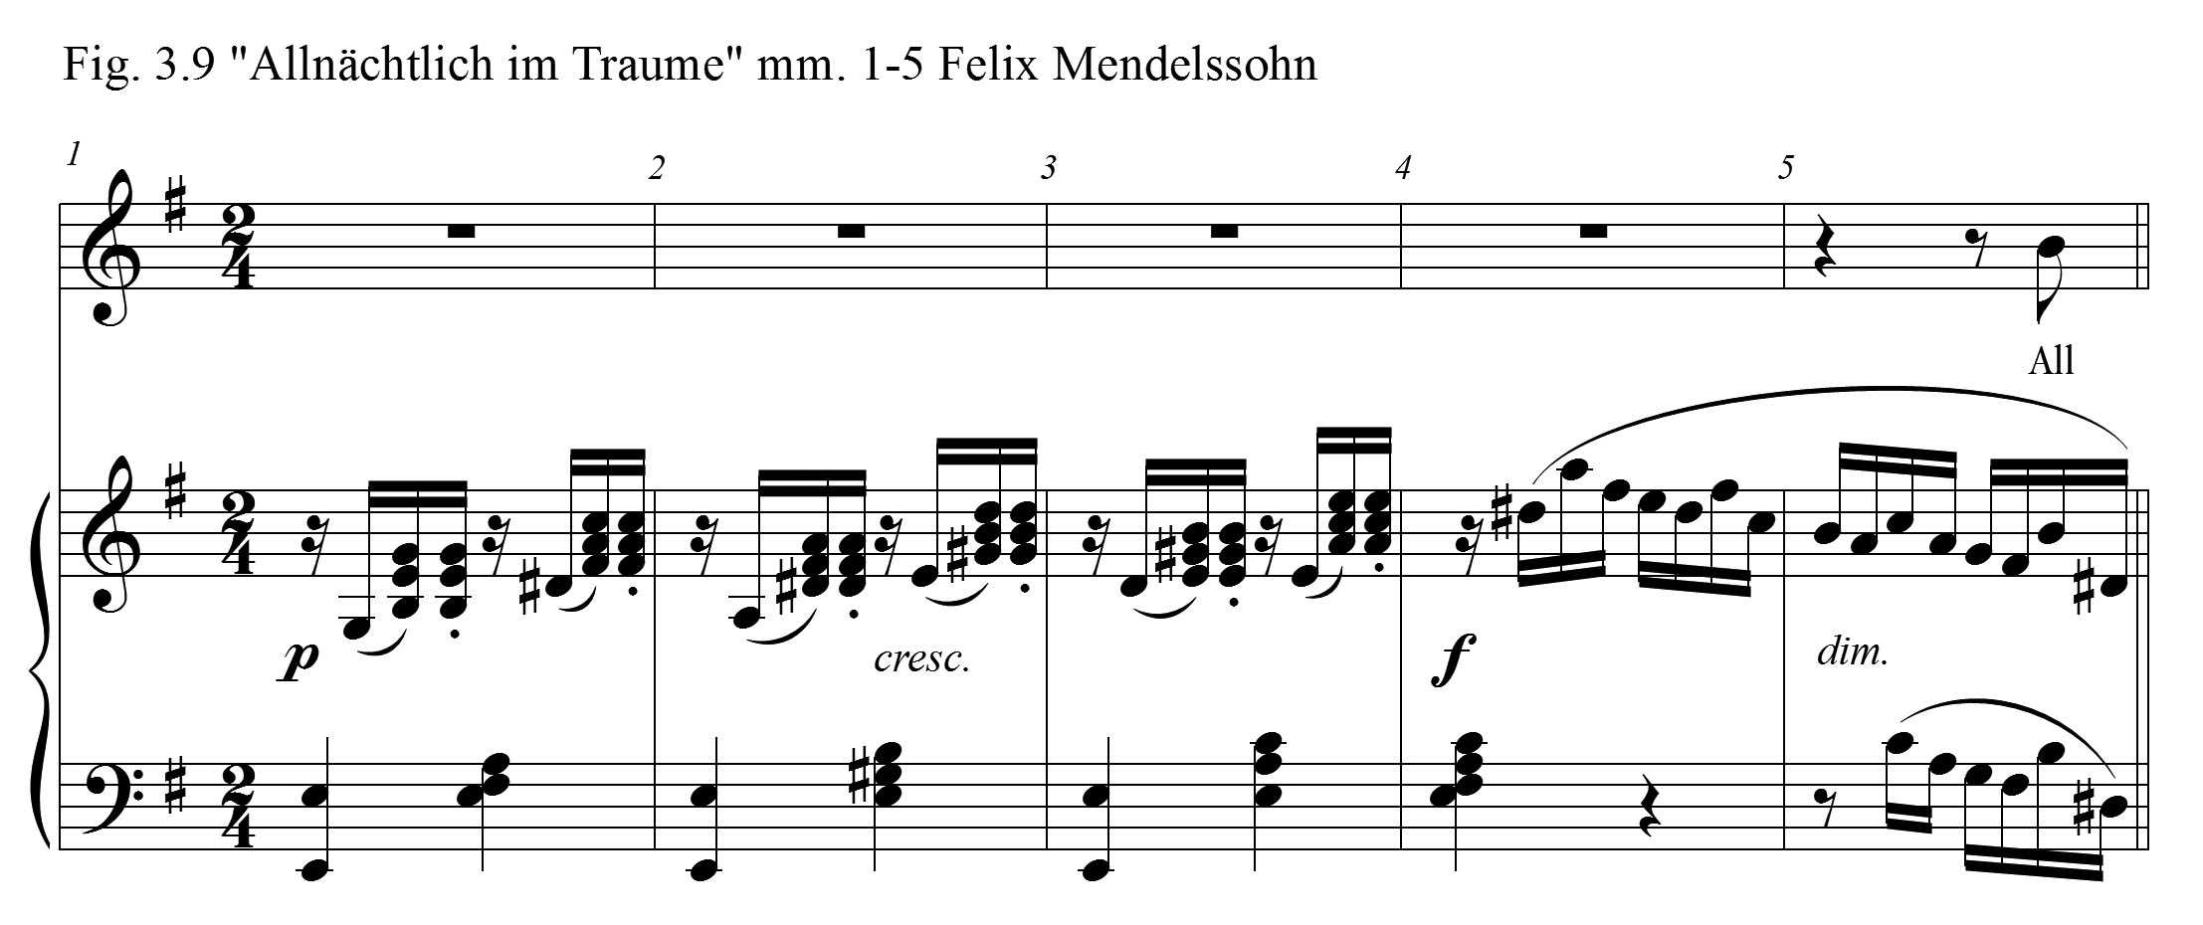
elements to compare to Felix’s lied. In her purely strophic setting there is no contrasting music material for the final verse. But in Hensel’s lied, the beauty and flow of her melody and the simplicity and consonance found in the construction of the accompaniment is equal to the character and beauty of Heine’s poem.
The score in Felix Mendelssohn’s “Allnächtlich im Traume” offers clear directives which point the performers toward a vital and dramatic presentation of this story. These directives are present in the richness and energy of the accompaniment as well as the moments of dynamic contrast. The musical material within Felix’s final verse is divergent from earlier verses. Contrastingly, since there are few written directives in Hensel’s strophic lied, performers of Fanny Hensel’s song must intuitively generate the appropriate energy and drama as the story progresses. As is true in every strophic song, energy unique to each phrase is created by the story-tellers, which are the vocalist and pianist. In spite of recurring musical material: expression, contrast, and drama in the story-telling by the musical team evoke a compelling performance. For example, the emptiness and loss expressed in the last two lines of the third verse should be approached uniquely from that which is presented in the first two verses. The artist-singer and artist-pianist paint the portrait as they go, giving attention to key words, and invoking the dynamics, accents, and tone colors that is called for in the story.
There were a number of significant events in Fanny Mendelssohn Hensel’s life in the decade beyond 1828 that very likely impacted her life and her compositional work. In 1829 Wilhelm and Fanny became engaged and married. With the blessing of her parents upon this marriage, Fanny began to fulfill her father’s direction that she should, “prepare more earnestly and eagerly for [her] real calling,” She did embrace the role of a housewife, but could her musical enterprises be characterized as just an ‘ornament?’ There is no doubt that her father’s words yielded power over her life. Angela Christian contends that Hensel, “even considered giving up her musical pursuits, fearing that they would impede the proper fulfillment of her expected duties as a wife.” Perhaps her strongest human bond in life, even competing with her husband, was her brother Felix. On April 10, 1829, Felix left home, “embarking upon the first of several trips which constituted his ‘Grand Tour’ lasting almost four years, that well-known rite of passage for wealthy young gentlemen in the nineteenth century.” Beyond this point, Fanny observed her brother from a distance, and yet continued to serve as an occasional editor for his compositions. On June 14, 1830, Fanny gave birth prematurely to her son, Sebastian. It was in the area of her domestic responsibilities that Felix raised his opposition to the possibility of Fanny becoming a published author. He stated to his mother, “She is too much of a woman for this. She manages her home and neither thinks of the public, nor of the musical world, nor even of music at all, until her first duties are fulfilled.” On February 8, 1831 Fanny writes to Felix of her plans to reinstate the Sunday concerts. October 4, she writes in her diary, “My Sunday musicals are prospering greatly, and I am very happy.” November 19, 1835, Fanny’s father, Abraham dies. Even after her Father passed away, Fanny still felt the weight of her brother’s ideals as she considered seeing her music published.
By 1838 Fanny Mendelssohn Hensel’s lieder had developed significantly and through her Sonntagsmusiken, Fanny richly impacted the musical culture of the world around her.

Chapter 4
“Fichtenbaum und Palme” (Fir Tree and Palm)
Although Fanny Hensel’s compositional output in 1838 was comparatively small, only thirteen compositions in all, her lied from that year, “Fichtenbaum und Palme,” could be considered among her most excellently crafted lieder. Of her thirteen compositions produced in 1838, six were settings of Heinrich Heine poems, three duets, and three lieder. Heine’s poem, “Ein Fichtenbaum steht einsam,” the first of Hensel’s lied settings that year, is among the group of poems entitled “Lyrisches Intermezzo” in his Buch der Lieder. Hensel completed this Heine poem setting, which she titled “Fichtenbaum und Palme,” on March 30, 1838.
Early in 1838, Fanny Hensel was busy with various musical activities, including the Sunday concerts at their estate. From her diary entry July 8, 1839, Hensel recalls details of those performances from the previous year. She tells of the “regular music” and the great crowds who attended. So many people attended that the rooms were overcrowded and some guests were sent away. Even the singers had to stand because there was no room for them to be seated. During one concert, Novello, Fassamann, Decker, and Curschmann performed Mozart’s La Clemenza da Tito. Fanny portrayed that winter’s entertainments as having “reached their greatest splendor.” In January, Fanny attended the Singakademie’s St. Paul rehearsals in order to offer her critiques in Felix’s absence. In a letter to Felix dated January 15, 1838, she related the story:
So I went there last Tuesday and was quite appalled, just as you have described it. I was suffering and champing at the bit, just like you, as I heard the whining and Grell’s dirty fingers on the piano. I thought to myself, “If you were only up there, everything would be fine.” Lichtenstein sat next to me and heard my sighs. They started “Mach dich auf” at half the right temp, and then I instinctively called out, “My God, it must go twice as fast!” Lichtenstein invited me to show them the way but told me that Schnieder, the music director, had assured them that one cannot be ruled by a metronome marking. Then I assured them that they could be ruled by my word, and they had better do it, for God’s sake.

Fanny, in a second letter to Felix dated January 19, presented a positive conclusion to the story:

I want to send you a summary report on St. Paul, dear Felix, because since I was satisfied overall, you won’t ask me to go into details and mention the mistakes. It was by far the best performance that has taken place here since Zelter’s death. Every possible effort was expended, and one couldn’t ask for more from anyone. It would have become a historic performance had you been here.

In February, Hensel performed her sole public piano performance for a charity concert, about which she offered details in a letter to Klingemann,
Last week the fashionable world was in great excitement about a charity-concert—one of those amateur affairs where the tickets are twice the usual price and the chorus is composed of countesses, ambassadresses, and officers. A woman of my rank was of course pressed to play, so I performed in public for the first time in my life, and took Felix’s G minor concerto. I was not the least nervous, my friends being kind enough to undertake that part of the business for me, and the concert, wretched as the programme was, realized 2,500 thalers.

Felix, in response to this news, gave her enthusiastic praise, “You are indeed playing in concert! Bravisississisimo. That is lovely and splendid; if only I could hear it!” In the early part of 1838, there were Sunday concerts. Hensel consulted for the Singakademie’s St. Paul rehearsals, and she performed publically for the first time in her life. Could it be the volume of activities early that year that hindered her attention to composition?
Fanny expressed her artistic frustrations in a letter to her brother, “I have not composed a single note this winter, although for that reason, perhaps, I have played more than ever; but I scarcely remember what it feels like to be writing a song. Will it ever come back?” Felix endured his own challenges in 1838. In a letter to his friend, the violinist, Ferdinand David, on January 20, 1838, Felix complained:
I am suffering, as I did four years ago, from complete deafness of one ear, with occasional pains in the head and neck, etc.; the weakness in the ear keeps on without any interruption, and as I have to conduct and play in spite of it (I have kept to my room for a fortnight) you may imagine my agony, not being able properly to hear either the orchestra or my own playing on the piano!

There were positive developments in the Mendelssohn home, though. His wife, Cécile, was nearing the time of the birth of their first child. In the midst of his poor health, and his concerns for his wife, “Felix remained immersed in professional concerns. He reviewed four potential opera subjects, reacted with alarm when he received an unsolicited text for Elijah from the Reverend J. Barry, published two Lieder in a supplement to Schumann’s Neue Zeitschrift für Musik,, and released the six part-songs Op. 41 to Breitkopf & Härtel.” On February 7, their first child, Carl Wolfgang Paul was born.
Felix continued to compose and he produced a concert series featuring the music of Bach, Beethoven, Handel, Gluck, Haydn, Mozart, and others. Fanny, regaining her creative powers, began to compose again, too. Among the few compositions from early 1838 was her lied, “Fichtenbaum und Palme.”
Heine’s “Ein Fichtenbaum steht einsam” first appeared in his 1923 published work, Tragödien nebst einem lyrischen Intermezzo. In this Lyrical Intermezzo, “Ein Fichtenbaum steht einsam” is the thirty-first poem, but in Heine’s Buch der Lieder, published four years later, it is listed as number thirty-three. In Heine’s poem there are two trees, a fir tree and a palm. German language gender sheds some light upon the poem’s meaning. Ein Fichtenbaum, in the German language, is masculine and einer Palme is feminine. The personification of these trees illustrates the cold and lonely nature of love’s loss.
Ein Fichtenbaum steht einsam A fir-tree stands lonely
Im Norden auf kahler Höh'; In-the north on bare height
Ihn schläfert; mit weißer Decke [He] slumbers with white blanket
Umhüllen ihn Eis und Schnee. Surround him ice and snow

Er träumt von einer Palme, He dreams of a palm-tree
Die fern im Morgenland, Who far in-the orient
Einsam und schweigend trauert Lonely and silently mourns
Auf brennender Felsenwand. On burning rock-wall

Heine’s poem could be interpreted in multiple ways. The most obvious interpretation follows the frequent theme in his poetry, that of unattainable love. In this interpretation, the fir tree represents a man, Heine, and the palm tree is the distant woman, Amalie. These trees are separated by a great distance. Both are planted in separate worlds and are immoveable. They are also divided by realms of consciousness. The fir tree lives in the natural realm and the palm tree exists in the fir tree’s dream state. Both are lonely and unreachable.
Susan Youens suggests a second possible interpretation. To her, the fir tree represents the German Romantic poet who is deep in Romantic sleep. Youens explains that Heine,
was no undiluted Romantic, and his love-hate relationship with the literary world from which he came is encoded in this poem. Here the German Romantic poet, symbolized by the evergreen tree, (was he tweaking pretensions to immortality?) is isolated on his wintry peak; Heine took note of the Romantics who surveyed time, space, and history from their mountaintop vantage points and surround his poet with wintry death. Sunk in Romantic sleep, the tree persona dreams of the Oriental “ferne Geliebte,” who mourns for him in her far-off land.

Although there is validity in each interpretation, it should be noted that Heine’s poem, along with his “Und wüssten’s die Blumen,” was placed in Heine’s memoirs among the poetry of Hamburg, lending strength to the first idea.
When comparing Fanny Mendelssohn Hensel’s lieder examples from 1827, “Verlust”, and 1828, “Allnächlich im Traume” to her lieder of 1838, great innovations in her compositional method can be observed. Marcia J. Citron illustrates that her mature works,
covering most of her creative years, exhibit stylistic diversity. Structurally there is less dependence on strophic form. A greater percentage of the Lieder are through-composed, some are modified strophic, some are ternary, some are without a repetition scheme. The average length of a lied exceeds that of the early ones. The piano part now assumes a more active role, displays a greater variety of figurations within a song and between songs, interacts more subtly with the vocal part, and shows more idiomatic writing. Melodically the vocal line tends to exhibit a more convincing dramatic shape, usually with a climax shortly before the end. Often the climax involves an extension of the phrase and a more melismatic text setting. There is greater flexibility of rhythm and phrase structure, and chords and internal key relationships are more chromatic.

Many of the innovations listed by Citron are found in Hensel’s “Fichtenbaum und Palme.” What elements contributed to her maturing compositional style? Is it reasonable to surmise that the influence of other lied composers, such as Schumann, Schubert, and Liszt played a role in her growth as a composer? In 1835, Felix became acquainted with Robert and Clara Schumann and a close friendship developed. Felix composed two lieder for Clara, performed for her birthday, and met with them on many occasions. Felix spoke of Clara’s performance of his B minor Capriccio in a letter to Fanny that year. He declared, “(Clara played it like a witch), and I liked it very well.” Interestingly though, in 1846, Fanny asserted in a letter to Felix, “I just can’t acquire a taste for this Schumann.” Her sentiment draws into question the extent of his influence. As early as the late 1820s, Felix and Fanny were acquainted with some of the lieder of Schubert. According to Eric Werner, “Felix introduced in Berlin and Leipzig some songs of the then still unknown Franz Schubert, especially his Erlkönig” Fanny had also been strongly affected by the music and the performances of Liszt. Seemingly never afraid to speak her mind, Fanny spoke critically of Liszt in an April 1839 letter to Felix:
Liszt invented the art of happily confusing and disfiguring musical orthography, which I thought existed to make music readable, to such an extent that he’s succeeded in making his compositions, which were already nonsensical and formless, even more nonsensical and more formless with the help of his notation. If chaos hadn’t already been invented by the good Lord before the creation of the world, Liszt could have disputed His right to it.

Felix developed mixed opinions concerning Liszt and mentioned his experiences with him in a letter to Fanny from April 1840.
Liszt was here for two weeks and caused a devil of a scandal—in the good and in the bad sense. His playing and his technique are magnificent, and his personality, too, pleases me greatly; in my heart I consider him a good artist and human being. But the newspapers! There was such a flood of explanations and counter-explanations, and reviews and lawsuits, and this, that, and the other that has nothing to do with music, that his visit caused almost as much irritation as pleasure.

Notwithstanding these negatives, his style did have its bearing upon Hensel. R. Larry Todd discusses how, in the 1830s, virtuoso display impacted Fanny Hensel.
She came to terms with the changing musical landscape of the 1830s—the decade of Liszt, Thalberg, and countless other concertizing pianists. Like Felix, Fanny was keenly aware that the virtuoso wars were fundamentally transforming piano technique. . . . Several months later, she composed one of her most remarkable compositions, an etude in the same key, G minor (H-U 333), with sweeping thirty-second-note arpeggiations bolstered by bass octaves, and for the pianist treacherous, if rhapsodic, hand crossings—almost as if to explore further virtuoso idioms in the privacy of her residence.

Liszt, the composer of keyboard works and creator of the Symphonic Poem, was also a lied composer and a proponent of song composition. On one occasion he sought to convince Wagner of its worth, stating, “For works of this sort, signed with your name, it would not be difficult for me to find a publisher and arrange for a decent payment, and surely you would not scorn taking the path that Mozart, Beethoven, Schubert, and Rossini did not distain.” Franz Liszt, who composed two lied versions of “Ein Fichtenbaum steht einsam,” composed over eighty songs in his lifetime. Susan Youens, referring to his songs, stated, “for years, one commentator after another has pointed out that much of what is best in Liszt is encapsulated in his songs and that this repertory deserves more attention than it has received today.” Liszt’s two lied settings of Heine’s “Ein Fichtenbaum steht einsam,” according to Susan Youens, were “begun in 1845 and first published in 1860.” Could these two composers have known of each other’s lied? Liszt did not begin composing songs until 1839, and because he did not compose this particular lied until two years before Fanny’s death, makes it improbable. But he had many encounters with Felix and on two occasions it is recorded that he attended Fanny’s Sunday musicals, both in 1841 and 1844. He certainly could have experienced some of her music, but the possibility of Liszt hearing this particular setting is equally unlikely. But, concerning the possible influence of these composers, an investigation of Hensel’s lieder of 1838 reveals an expansion of the role of the piano, and specifically in “Fichtenbaum und Palme” there is a more virtuosic character present than we see in her earlier lieder; each are qualities that she must have first observed in the music of her peers.
In Hensel’s “Fichtenbaum und Palme” there is a brilliant musical portrayal of the story. Heine’s first stanza tells of a fir tree standing alone in frozen stillness and is sleeping. Hensel’s musical depiction of this scene includes a captivating, static and repeated grouping of E-flat 16th notes. This single pitch motif illustrates the stationary, cold, and lonely life of the fir tree. (Fig. 4.1) This E-flat motif serves as a pedal note, a signature technique of Fanny Hensel that is a continual presence throughout the first eight
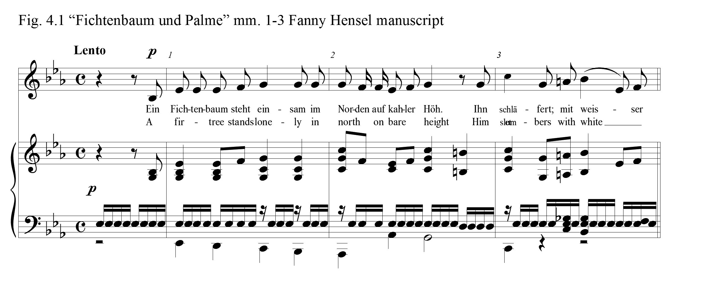

and one half measures. The only variances in this pitch occur in beat four of measure three where the pitch moves to a D to accommodate the V of VI chord in the piano score, and throughout measure 6, where the pitch moves to a G, the dominant of the relative C minor. Throughout the entire A section of the song, this steady sixteenth note activity is a conspicuous and unifying component of the setting. The right hand piano part, in the first six measures, consists of block chords with a few eighth note passing tones that mirror the melody in the vocal line. The tempo is lento and the dynamic level is piano. The registration of the voice and piano parts are low. The texture of the accompaniment is closed. E flat is the prominent pitch in both the piano and vocal scores throughout this section. The extraordinarily simplistic vocal part closes the A section with the recurring E flat pitch and repeated last words of the first stanza, “with a white blanket, he is surrounded with ice and snow.” The harmony under this repeated E-flat is a recurring plagal cadence which is illustrative of the quiet moments before falling asleep. (Fig. 4.2) All these components in the A section: simplicity, quiet and low registration, and incessant pedal tone of E-flat sixteenth notes all work together
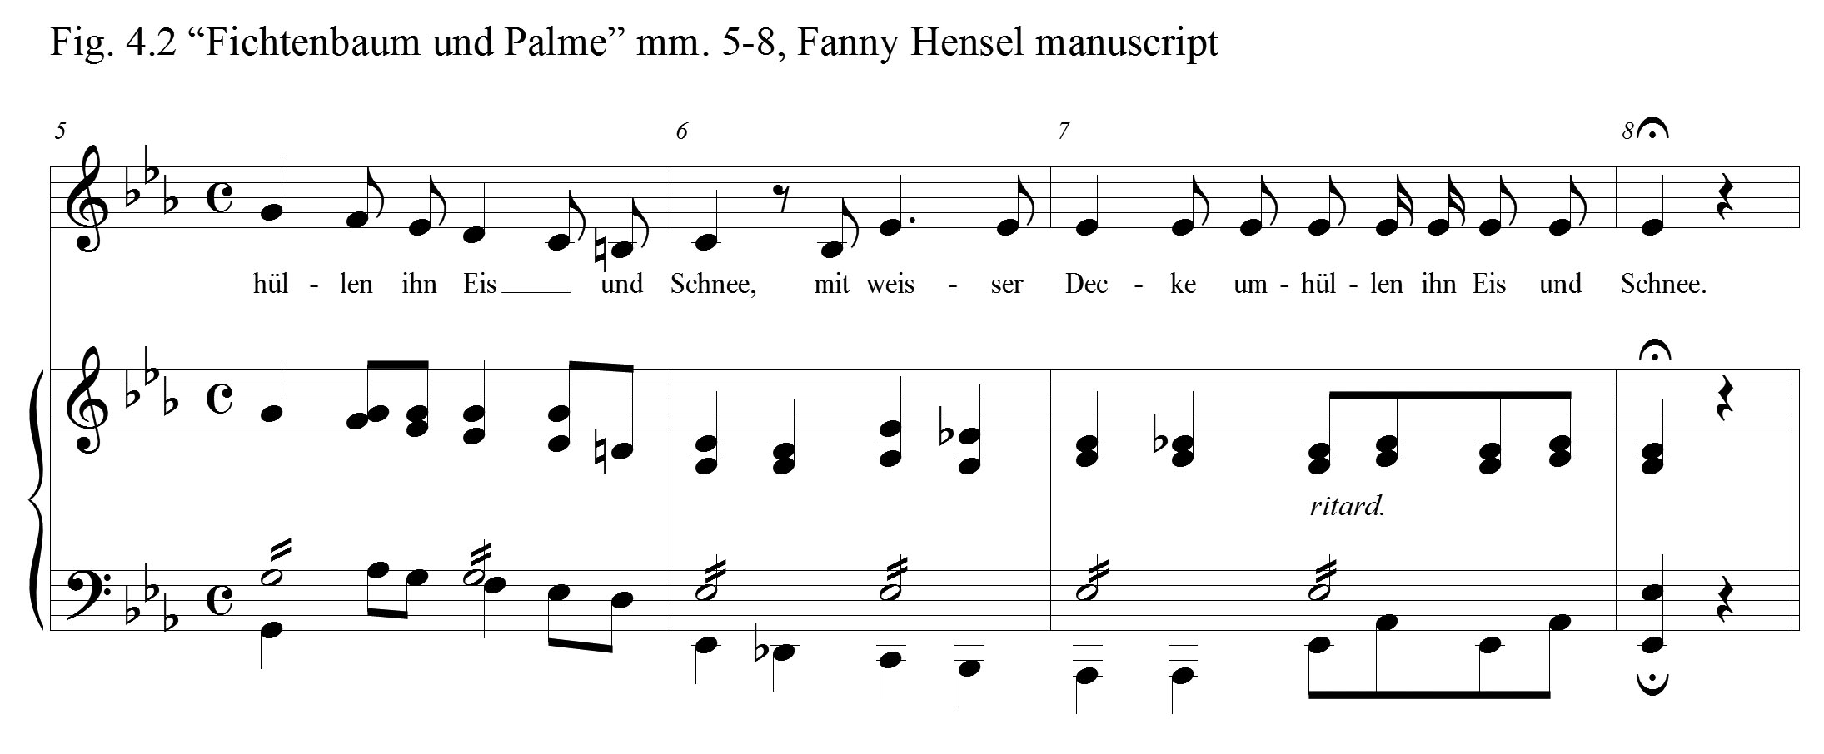

to picture the drowsy fir tree on a lonely frozen, snow-covered slope. The phrase concludes with a held note followed by lonely silence, depicting a state of deep sleep.
After the silence, without warning, the listener is musically transported to the protagonist’s dream-world through a bold new key, B major. (Fig. 4.3) The dynamic is
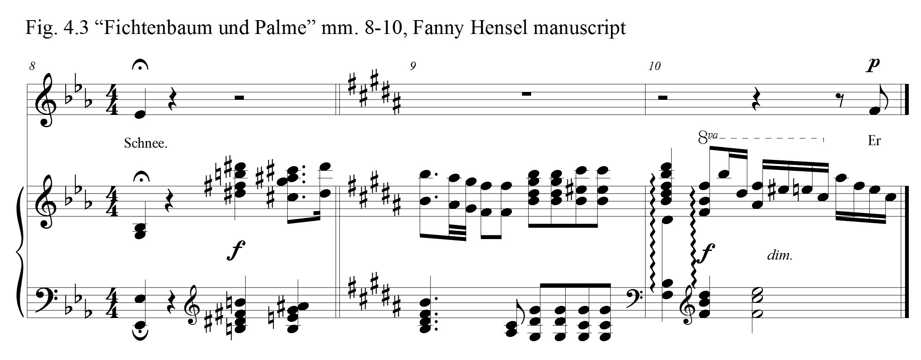

now forte, and the register for both hands of the piano brightly moves to the treble clef. This interlude is striking, and the tonality shifts logically through the common tone change from E-flat to D-sharp. In measure 14, the voice enters softly, now at a higher register, articulating the dream of the fir tree. She, the palm tree in the Far East, is now before him. She is alone, silent, and in mourning upon a burning rock wall. The piano
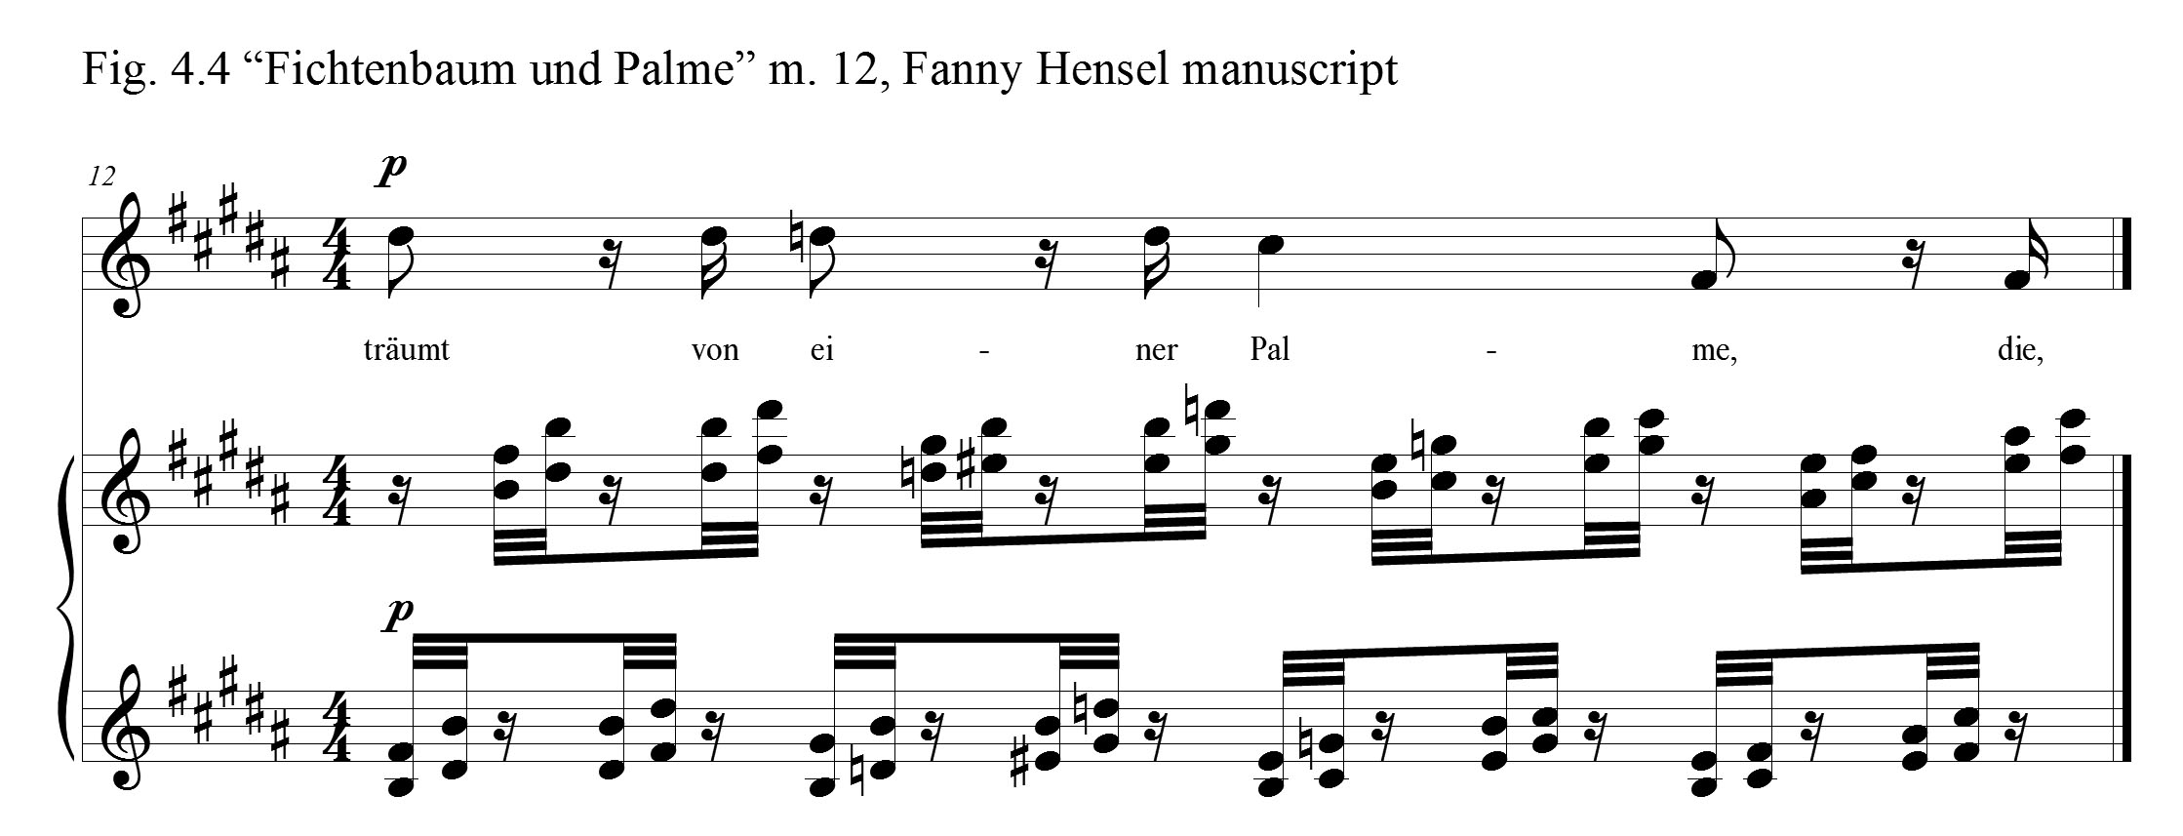
accompaniment, throughout this B section, presents a harp-like, 32nd note figuration almost continually in the treble register. (Fig. 4.4) The character transformation in Hensel’s music is suggestive of the fir tree’s great delight in seeing the object of his affection. Throughout the B section harmonic structures are much more unstable and chromatic. Tessitura in the vocal part has moved upward from E-flat 4 in Section A to B4 in the B section. The rhythm and the melody of the vocal line are lively, flowing, and chromatic; all elements emblematic of the dream sequence.
Franz Liszt’s first version of “Ein Fichtenbaum steht einsam” holds some similarities to Hensel’s lied. Contrasting sections depicting the bare northern height and the dream scene are equally striking. Liszt, like Hensel, utilizes a recurring motif. Liszt, in this motif, exploits the leading tone / tonic relationship. (Fig. 4.5) His B section which begins in measure 25, similar to Hensel’s setting, utilizes a register change to musically
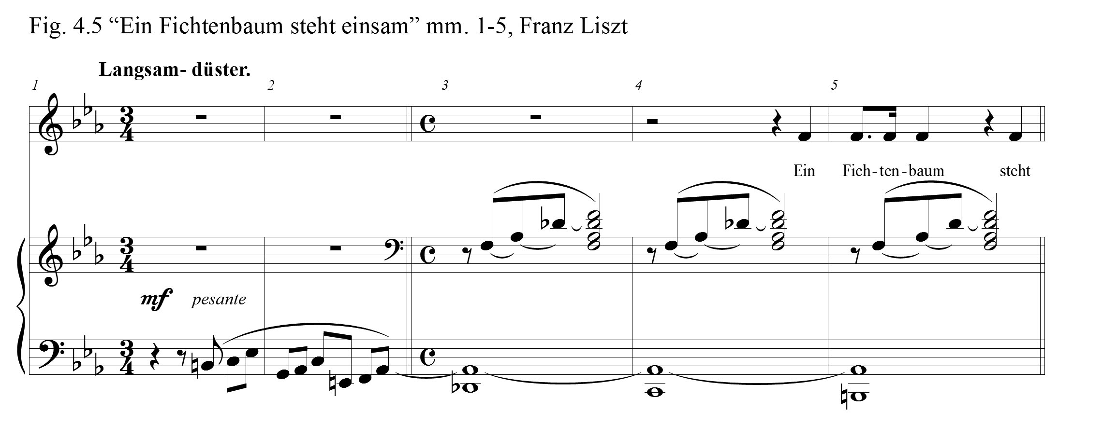
capture the dream state. Both hands in the piano score shift to the treble clef. Quietly, with an uptick in motion, above the left hand melody, are recurring eighth note chords, marked very soft, and dolcissisimo. Liszt’s effects produce an equally heavenly effect. (Fig. 4.6) This setting is much more chromatic and certainly leans toward a more modern approach than that of Hensel’s. In fact, chromaticism is a characteristic component in much of his lieder. Notice in measure 9, the chromatic movement in Liszt’s melody,
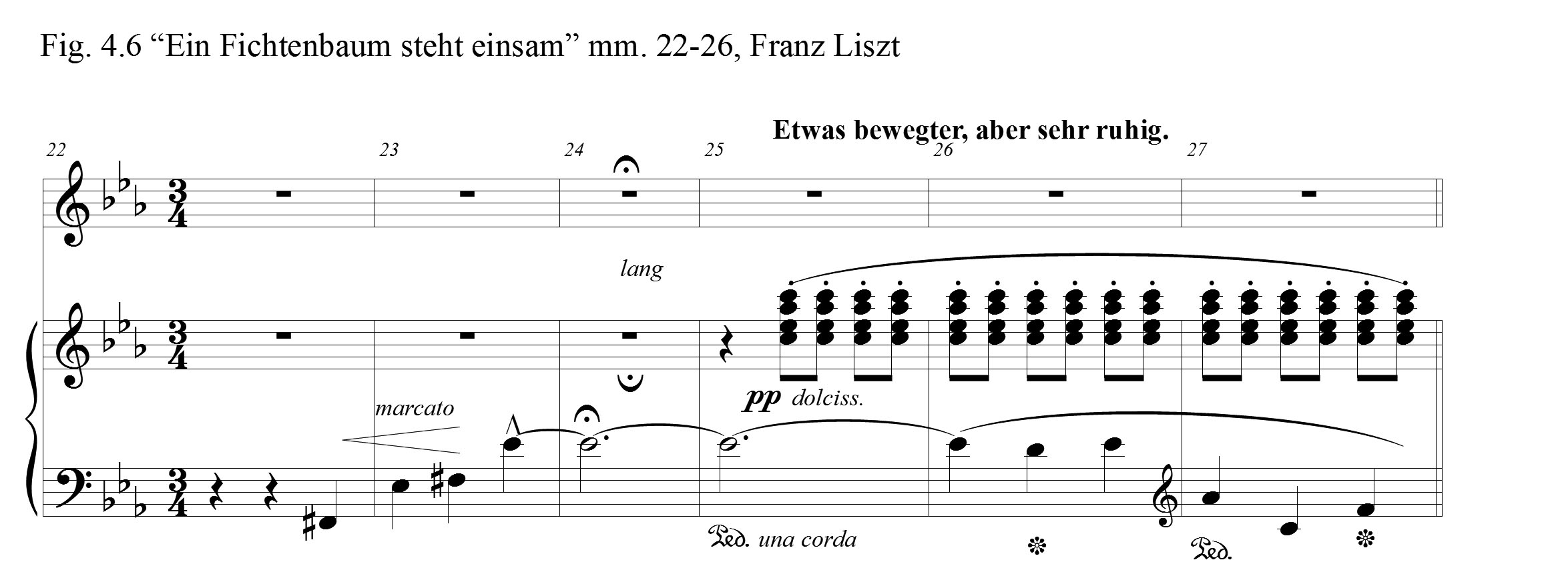

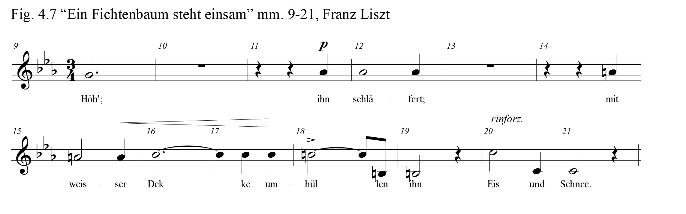
moving upward from G4 to C5 at the close of the A section in measures 20-21. (Fig. 4.7) Beneath this chromatic melody is a series of restatements of the chief motif that also rises by chromatic steps. After a dramatic moment of silence in measure 49, Liszt closes his setting by repeating the final two lines of the poem, “alone and silent, mourning on a burning rock wall”. Here, these words are sung to a restatement of the melody from measures 7-9 in the A section. Is Liszt projecting the understanding, as this melody is reintroduced, that the protagonist has awakened to the truth that she is indeed gone?
In Hensel’s transition into the final section, after the VII diminished 7 chord to I cadence in measures 26 and 27, the harmonic center returns to E flat major. The opening E-flat motif reappears and the 16th note D-sharps in the piano score return to the
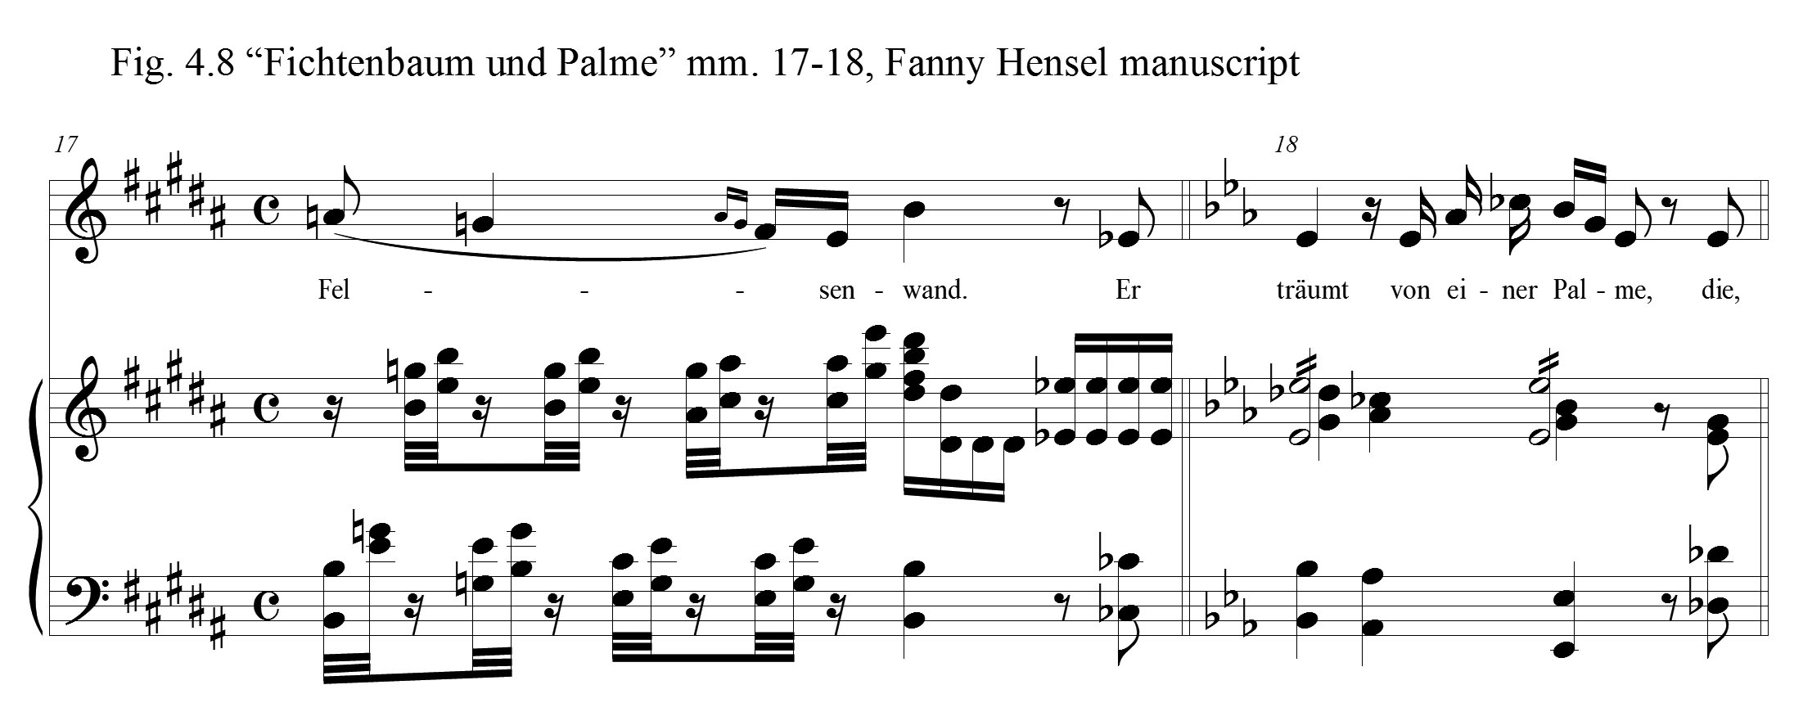

enharmonic E-flat. (Fig. 4.8) The E-flat pedal is now in the treble clef at the octave. Hensel restates the second verse words to a new melody. The return to E-flat major, along with the reappearance of the E-flat pedal, similar to Liszt’s lied, seems to suggest to the listener that the fir tree is beginning to wake, realizing the vision of the palm tree was only a dream. Hensel’s manuscript, dated March 30, 1838, was not the final version of this lied. She created an edited version, which appears in Breitkopf’s Ausgewählte Lieder, number 8596, volume two, and is the most beautifully crafted of the two. Distinguishable characteristics between the two song versions include a longer introduction in the second setting, as well as a measure where the melody line of the piano and voice are interchanged. The time signature is altered in the B section of the edited version and there are harmonic modifications throughout. In each case, these changes are an improvement upon the original. Conversely, the elements which define the musical character of the contrasting sections of the song are identical in each. Both Hensel’s “Ein Fichtenbaum steht eisam” and Franz Liszt’s song setting are examples of the best of their lied composition, and would be excellent selections to be performed for a senior or graduate recital.
Jürgen Thym offered this characterization of her mature lieder, “Her Heine lieder of the 1830s and her Eichendorff songs, mostly composed after 1840, indeed show a new synthesis as well as, occasionally, an experimental quality.” It would be impossible to dissect with specificity the role that Hensel’s environment played in her development over this decade. We must take into account her ingenuity as a creative artist when we attempt to explain the heightened quality of her songs. But, at the same time bear in mind the forces of influence about her. These forces include the opportunities afforded her as a composer of new works to be performed at the Sunday musicals (Hensel composed thirty-three songs between the 1831 and 1838, as well as numerous larger works with orchestral accompaniment); and the new compositional techniques that she observed in other composer’s music that she was exposed to.
In the summer of 1838, Fanny Hensel composed another song, her second setting of a Heine poem that year, “Ich Wandelte unter den Bäumen,” which is the subject of the following chapter. R. Larry Todd, praised both “Fichtenbaum und Palme” and “Ich Wandelte unter den Bäumen,” declaring that, “the five solo lieder, composed between January 1837 and September 1838, offer some of her most exquisitely crafted examples of the genre.”

Chapter 5

“Ich wandelte unter den Bäumen” (I Wandered Amid the Trees)

Fanny Hensel completed her fifteenth Heinrich Heine lied setting, “Ich wandelte unter den Bäumen,” on August 7, 1838. This lied was composed in the midst of the Felix Mendelssohn family’s visit to Berlin that summer. Sebastian Hensel presented a summary of this reunion in his family biography,
The family life at Berlin this summer was most pleasant, in spite of the wretched weather, which prevented the use of the garden and even of the garden saloon. Felix composed a good deal, while Cécile drew and painted; a companionship which Fanny used to call the ‘double counter-point’ of her own married life. Her thoughts were constantly in England or engaged in planning a journey to Italy, to be undertaken directly after Hensel’s return.

Shortly after the completion of this lied, in mid-August, measles struck the Mendelssohn family. Felix and family travelled home quickly and the delightful summer was ended. Rebecka’s baby, Felix, or as Fanny called him, Felixchen, was the first to become ill. Complications from that illness later resulted in the child’s death. From Fanny’s published diary we find this account:
November 16 passed without any major change. I had informed Paul at an early date and he and Albertine came at once. The child was not in a frightening state. As the evening came he seemed to be much better. Rebecka drew a breath, and took courage. . . . The next morning sad news awaited us. Earlier, the most serious coincidences had been repeated, and we found the child abandoned. Rebecka was by his bed, and in a state which I shall never forget. It is difficult and wretched to see a child die, but it is much more miserable to see the mother. I think that it was about 9:00 on November 17 when the beautiful little angel died. We were all gathered around his bed, Rebecka at once went to her mother who remained in the hall, and when she came back she sank at the child's bed. . . .Wilhelm drew his dear face as if alive, and rarely did such a company succeed so much. The picture is indescribably similar and touching. He then drew him once again as in death, and then painted him as an angel in a round portrait.

One month after completing this lied, on September 6, Fanny completed another Heine lied setting, “Das meer erglänzte weit hinaus.” During the difficult autumn of 1838, she composed only three other compositions, one duet and two piano pieces.
The other Heinrich Heine poems highlighted in this document each came from the Lyrisches Intermezzo section of Heine’s Buch der Lieder. “Ich wandelte unter den Bäumen,” on the other hand, is located in the Junge Leiden portion of the same book. Jungen Leiden, or youthful sufferings, is a collection of early Heine poems. These nine poems, unsurprisingly, lament love’s loss. The themes of sadness, grief, agitation, and sleeplessness are present throughout the nine poems. Illustrating the devastation of a broken heart, Heine spoke of the hammering of an evil carpenter building a coffin inside his heart. He asks the carpenter to hurry and complete his work so that he can sleep. He refers to the cradle of his sorrows and reminisces of the threshold where his darling once walked. Despising that sacred spot, he wishes that he had never seen her. He longs to find rest in a cool and distant grave. He calls for a wild boatman to carry him away from her. In a graphic manner, he speaks of blood flowing from his eyes and with that blood he writes down his agonies. He pictures lofty mountains and castles reflecting into the Rhine. But the sunshine and the golden waves of the water only cover over the death and night that is below the surface. Lastly, he illustrates a funeral scene, where a coffin is covered by myrtle and roses, fragrant cypresses and gold tinsel. He imagines his book of poems to be a coffin where he can bury his songs. His songs were once as wild as Mount Etna’s flowing lava, but now lie cold in death. He hopes that the warmth of the spirit of love will one day thaw his dead songs and she will hold them in her hands and break the magic spell.
It was not just Fanny Hensel who drew from this group of Heine poems. Robert Schumann set all nine of these Heine poems in his Liederkreis, Op. 24. In a letter to Clara in February, 1840, he enlightens her of his process:
My dear Clara, I am sending you a little song, to comfort you; sing it to yourself softly, simply, like yourself. . . . During the last few days I have finished a great cycle of Heine songs. . . . I cannot tell you how easily all this has come to me, and how much I enjoyed doing it. As a rule I compose them standing or walking, not at the piano. It is a quite different sort of music, which does not come first through the fingers—much more direct and melodious.

Among the sections of Heine’s Buch der Lieder, the Junge Leiden are some of his earliest poems, representing his work from 1816-20. Of these nine poems Fanny Hensel set only this one. Fanny and Felix, as they grew up, created their music with hands, hearts, and minds blended together, almost inseparable in their projects. Once again, for a brief season, their musical creations were being birthed under the same roof. What inspiration they must have found and what joy-filled moments they must have shared that summer of 1838, engaging, as they did in their childhood, in each other’s music!
Heine in his poem, “Ich wandelte unter den Bäumen,” employs the image of a “word” in much the same way he did in his poem “Allnächtlich im Traume.” In the previously studied poem, the protagonist meets his love in a dream. She whispers to him a “word,” and when he awakes, he has forgotten it altogether. In “Ich wandelte unter den Bäumen,” the grieving protagonist wanders among the trees. He hears the birds singing a “lovely word” that his lover once sang. But, the birds captured that golden word and he fears that they desire to steal his grief as well. What does this golden word represent? Was this word a lover’s expression known only to them? Since the birds sang the word, was it a love song that she often sang? These questions cause the reader to wonder and increases the poem’s charm.
Ich wandelte unter den Bäumen Amid the trees I wandered
Mit meinem Gram allein; with my grief, alone;
Da kam das alte Träumen, and the old dreams came,
Und schlich mir ins Herz hinein. and stole into my heart.

Wer hat euch dies Wörtlein gelehret, Who taught you that dear word,
Ihr Vöglein in luftiger Höh? birds in the airy heights?
Schweigt still! wenn mein Herz es höret, Be silent. When my heart hears it,
Dann tut es noch einmal so weh. it causes again such pain.

"Es kam ein Jungfräulein gegangen, ‘A maid there was came walking,
Die sang es immerfort, she sang it all the time,
Da haben wir Vöglein gefangen and we birds seized upon it,
Das hübsche, goldne Wort." that lovely, golden word.’

Das sollt ihr mir nicht mehr erzählen, You’re not to tell me that,
Ihr Vöglein wunderschlau; you birds so wondrous sly;
Ihr wollt meinen Kummer mir stehlen, my grief you would steal from me,
Ich aber Niemanden trau. but no one do I trust.

Did Heine reveal the genesis of this mysterious ‘word’ that he referenced in these two poems? In the concluding poem of the Hamburg section of his published memoires, is there a hint? In that particular poem, the protagonist dreams of his ‘fairly made’ cousin. With a flower he asks for her hand in marriage. But, he awakes before she can say the ‘word’ yes, or no. Alas, in his wakened state, he finds himself crippled and sick and for a long time placed upon the shelf.
The singing birds of Heine’s “Ich wandelte unter den Bäumen” can be clearly envisioned in Fanny Hensel’s modified strophic lied. No doubt, in Berlin that summer there would have been song birds chirping and singing outside the window as Fanny, and Felix, and Cécile passed their time. Was it the melody of the Nightingale in the garden at dusk that offered Fanny inspiration for this lied? Or was it the song of the Goldcrest or Mockingbird in the morning that took her mind back to this poem? A melody reminiscent of a song-bird’s refrain is found in the first four measures of the treble clef in the piano score. (Fig. 5.1) This bird-like theme exploits the half step - leading tone motion to the fifth, third, and tonic (B to C; G-sharp to A; and E to F). The theme returns in the interlude between verses two and three (mm. 49-51), and again at the close of the Lied. (mm. 108-11) Throughout the lied, Hensel inserts into the vocal part various
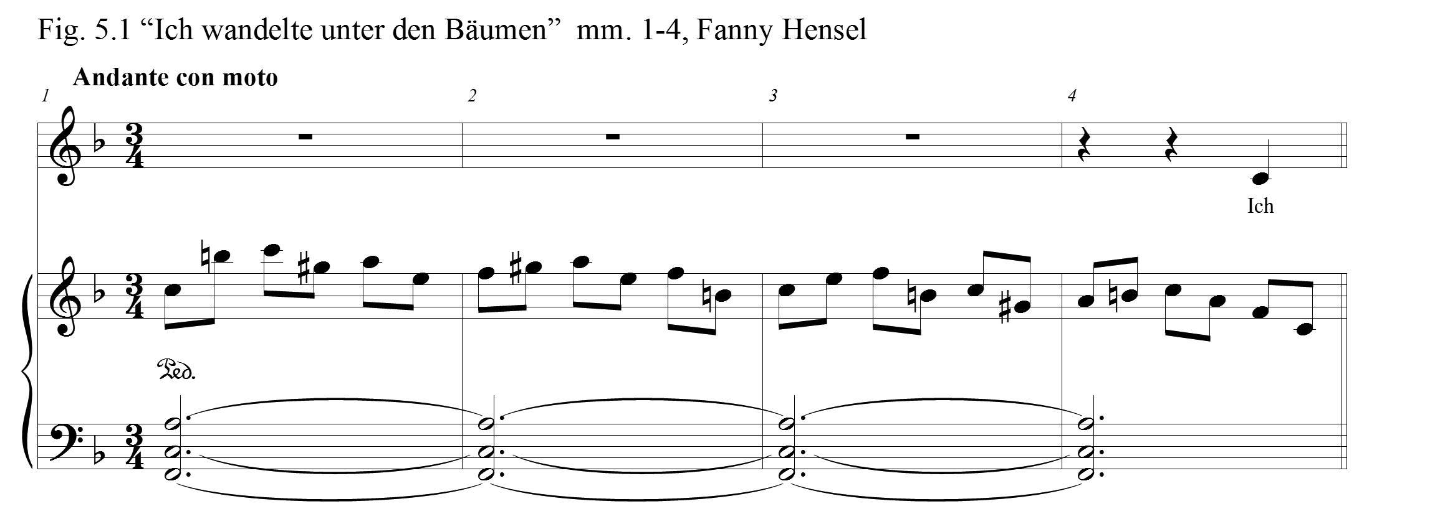
ornamentations, suggesting another musical allusion to the little birds of Heine’s poem. In verse one, as the protagonist is describing his stroll into the woods, Hensel places embellishments upon the words trees, grief, and heart (Fig. 5.2). As the man begins to question the birds, Hensel inserts full measure trills into the vocal part (Fig. 5.3). Interestingly, ornaments are present only as the man is speaking in verses two and four. While the birds explain how they learned her “lovely, golden word,” Hensel left out any ornamentation.
It would be important, in preparing for a performance of this lied, to have some understanding of how Hensel’s “Ich wandelte unter den Bäumen” might have been performed at one of her Sunday musicals at Leipzigerstrasse No. 3. Martha Elliott, in her
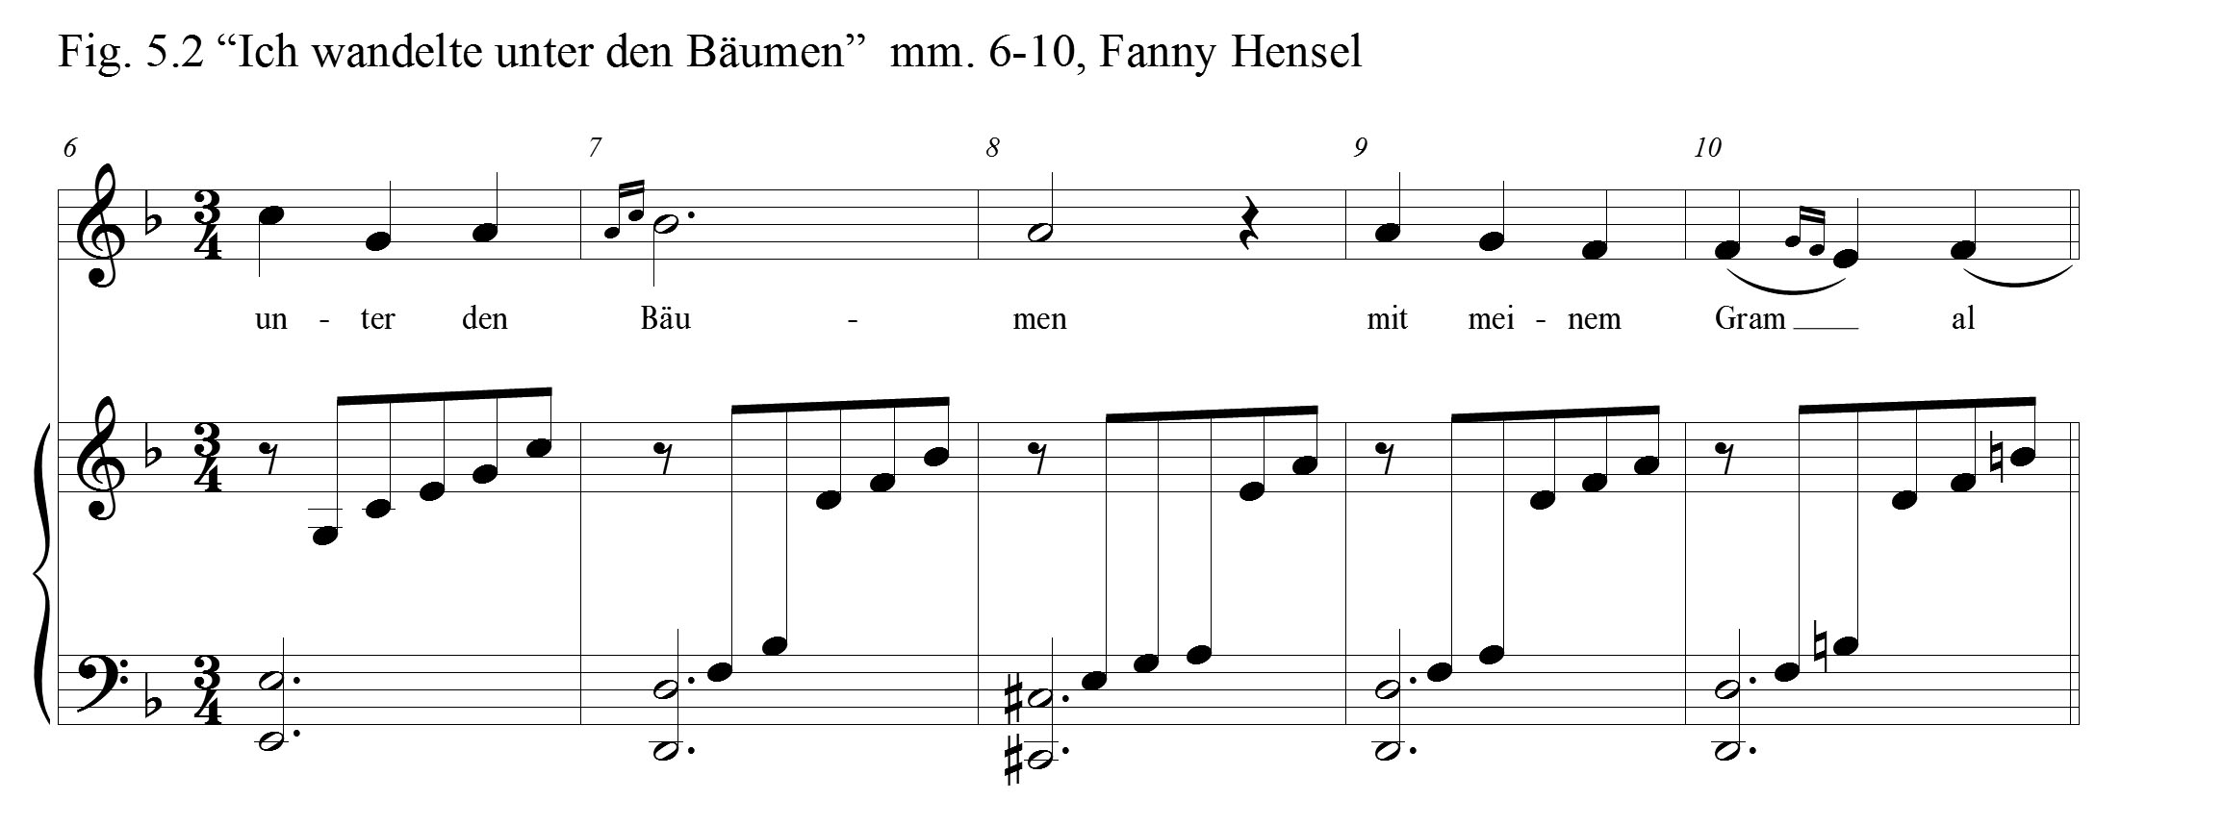
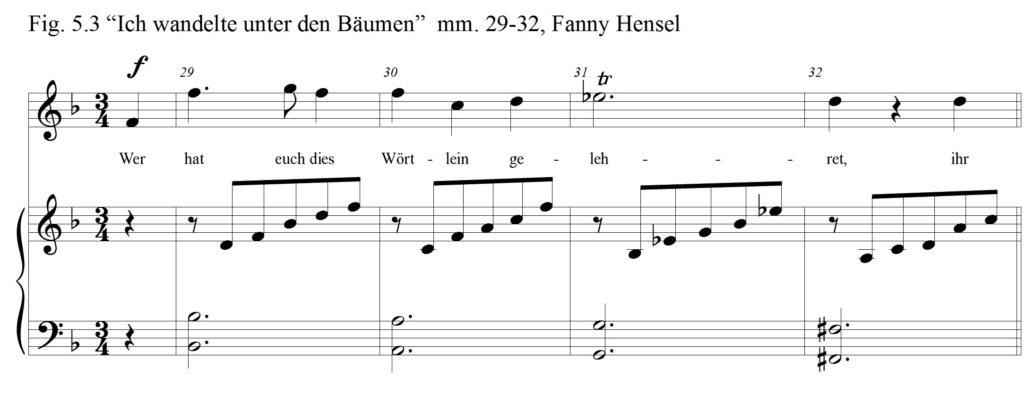

book, Singing in Style, discusses the practice of performing nineteenth-century embellishments, “By the midcentury the small ornamental note, particularly with a slash through it, came to be understood almost universally as a fast, light grace note to be performed either just before the beat or right on it. . . .” Concerning ornamentation in Schubert’s songs, she explains that the practice seems unclear:
In Schubert’s songs, however, the notation of appoggiaturas and grace notes is very inconsistent. The NSA [Neue Schubert Ausgabe] offers suggested solutions to questionable situations, but they are not always the only answer. Since Schubert composed in a transitional period between late Classical practices and early Romantic ones, his music can follow the rules for graces outlined in the eighteenth-century treatises of C. P. E. Bach and others. Often a small ornamental note will add expressive dissonance in a Schubert song and should be stressed and performed on the beat. Sometimes an appoggiatura should take half the value of the note it decorates, while other times it will demand the entire value of the main note. In some situations the textual content or the notation in another part of the song may reveal the most appropriate execution. Still other situations have no clear solution.

Hensel also composed in this transitional period, but the Schubert explanation offers little clarity for the performer.
The Swedish opera singer, Jenny Lind (1820-87), may shine some light upon proper German lied ornamentation. Lind became especially close to Felix in the 1840s and collaborated in various musical events. “Mendelssohn, who wrote songs with flowing melodies and simple accompaniments, loved her singing and often accompanied the ‘Swedish Nightingale’ on his songs.” Felix spent “the last months of his life working on the opera Die Lorelei, with its title role conceived for the soprano.” Clara Schumann, who admired Lind, spoke of her in her diary, “Her singing is ever so sincere. There is no showmanship, no great display of emotion, yet she touches your heart. . . . No weeping, sobbing, or quavering sounds, no bad habits of any kind.” Fanny, herself, offered this positive critique of Lind’s performance in Bellini’s opera Norma, “Her voice is of the sharpest purity, which is very pleasing to hear, and exquisitely beautiful in her high register through [B-flat]. Her dexterity is not exactly overwhelming but certainly adequate for every large role, her trills are very good, and her interpretation and expression, as much as one can tell in such a mawkish work, quite strong and lovely.” Jenny Lind, who was modest in her approach to embellishments, provides a very good example for singers seeking to accurately facilitate German lied ornamentation, but her specific methodology is not completely revealed.
Felix’s attitude toward added embellishments could be useful in appropriating an authentic performance of Fanny’s lieder. Elliot states that,
Mendelssohn’s attitude was . . . conservative, but he may have allowed small additions and alterations in some cases. Chorley reports that ‘Mendelssohn wrote so as to allow no space or exercise of fancy for the vocal embroiderer; and thus to alter or add to his music, would be to injure it, by showing arrogant disloyalty to the master’s wishes and meanings. . . . Yet in some of his songs, including the op. 8 ‘Frühlingslied,’ rather than allowing the singer freedom to improvise, he wrote out his own version of an Italianate cadenza.

Fanny was as conservative as her brother, and must have assumed that the written ornaments would be observed without any additions by the singer. John Glenn Patton, in his background discussion on “Ich wandelte unter den Bäumen,” offers these clear instructions, “Probably the trills should be done in the Romantic fashion, rapidly and beginning on the main note. The ornamental notes in measures 7, 10, 22, etc., are also to be done in Romantic style: quickly and ahead of the beat.”
Fanny Hensel’s lyric and flowing melody in “Ich wandelte unter den Bäumen,” like so many of her lieder, is its most endearing quality. Another notable characteristic in the lied is Hensel’s phrase extensions at the close of each verse. In verses one and two, she merely repeated the last line. In verse three, she restated the words, “wir Vöglein,” and then, in bold fashion, expanded upon Heine’s verse. Heine simply wrote, “Das hübsche, goldne Wort,” but Hensel’s version reads: das süsse Wort, das goldne Wort, das süsse, goldne Wort, das süsse Wort, das goldne Wort” (Fig. 5.4). In the final verse, she repeated the last line twice, then closed the lied by repeating the second line
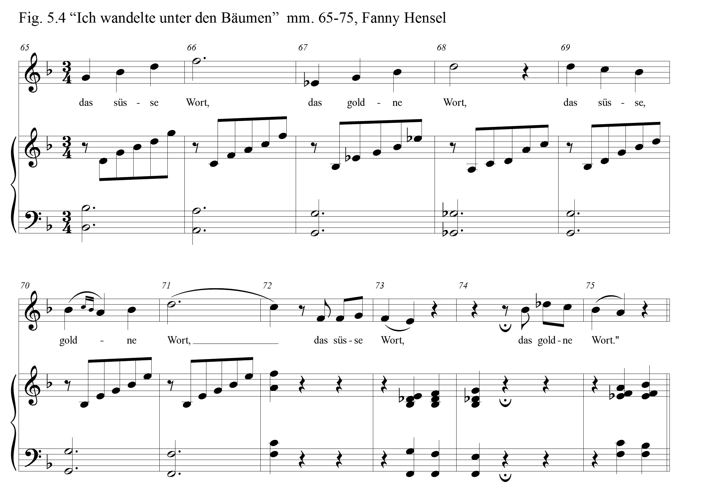
two times with a melisma on the word, “wunderschlau.” The melody rises in a sweeping arpeggio from A4 to A5 and returns primarily by scale steps back to tonic F4 (Fig. 5.5). By returning to and emphasizing the text, “You wonderfully clever little birds,” she avoids closing with the negative irony of Heine’s last line, “I however trust no one.” Through her lovely melody she offers no musical acquiescence to his pessimistic sentiment. Such a bold reorganization of Heine’s poem would have not been welcomed by the poet.
Robert Schumann’s setting of “Ich wandelte unter den Bäumen” is much more contemplative and solemn than the flowing and ornamented lied of Fanny Hensel. In his AABA’ setting, Schumann presented new material for the third verse as the birds speak. The piano score shifts to the treble clef, now in the key of G major. The tempo is
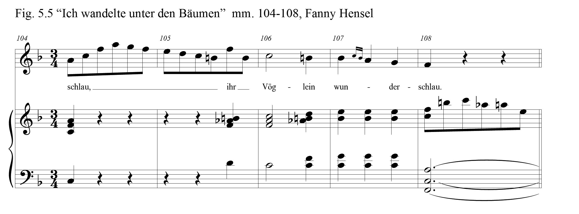

now slower. The only repeated text in his setting is the final line, “I however trust no one.” For this last line of the poem, the melody drops to its lowest range and the last note, appropriately, is the lowest of all (Fig. 5.6). In his musical setting, Schumann did not capture the bird’s song that is emphasized in Hensel’s lied, but instead drew attention
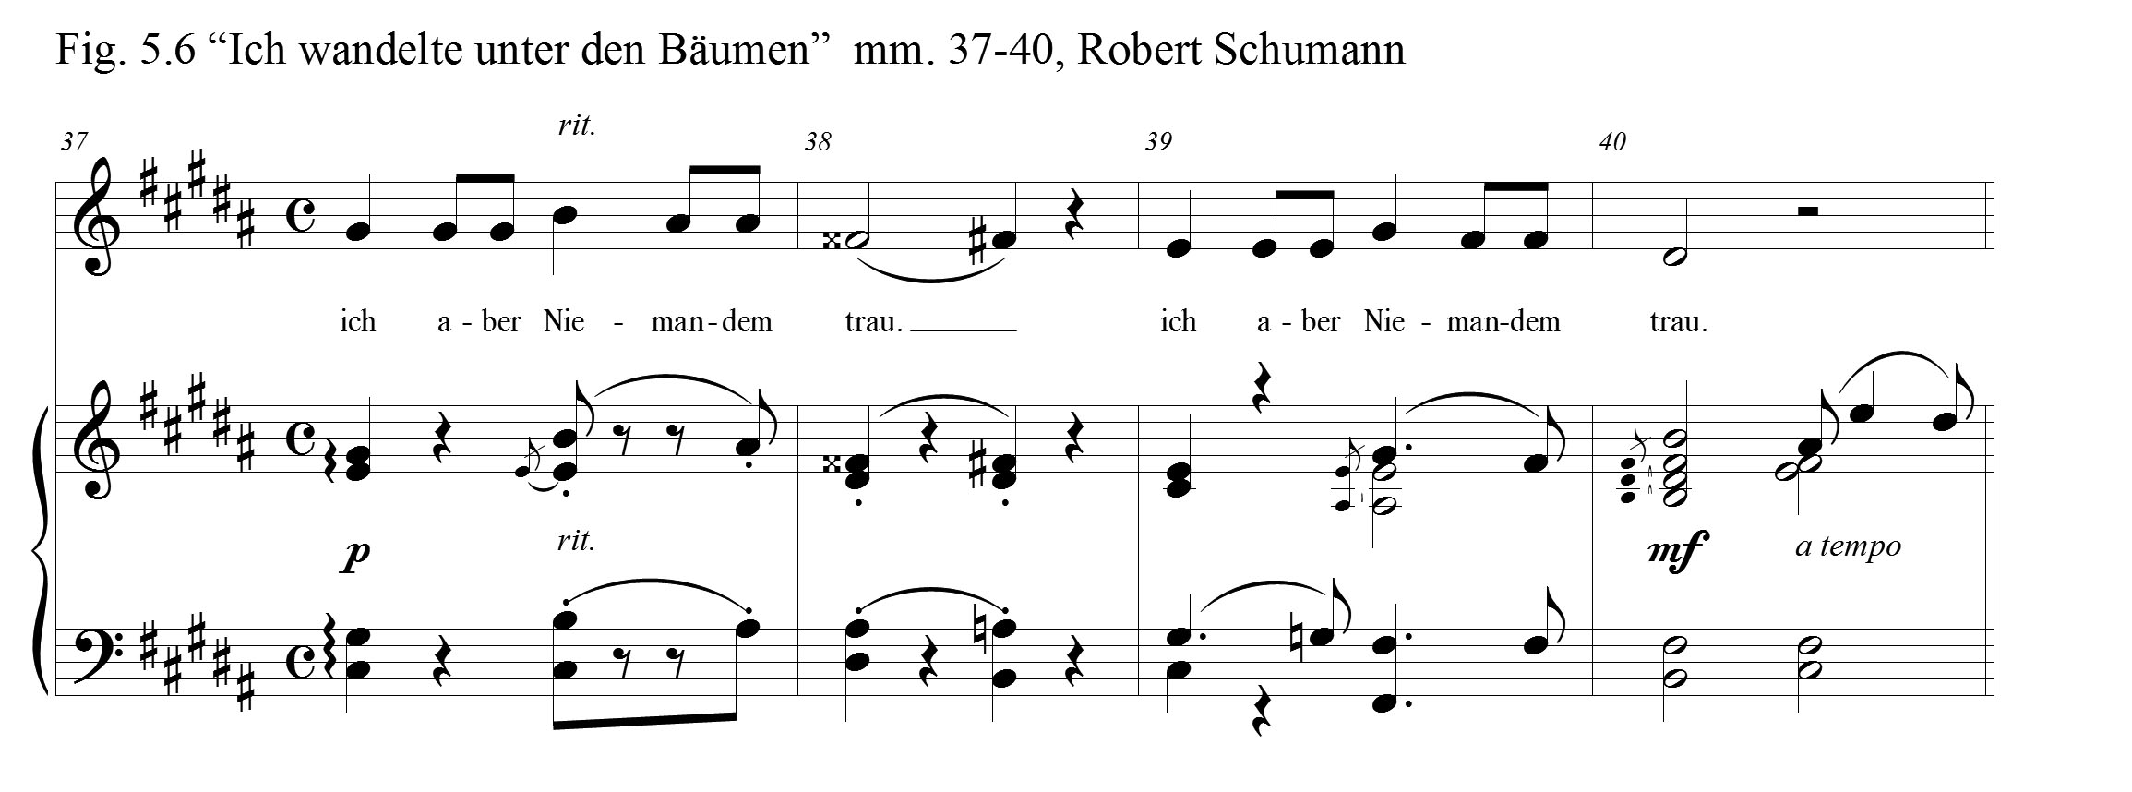
to the melancholy and sadness in Heine’s poem, emotions which would plague many seasons of Schumann’s own life.
There are two distinguishing marks in Hensel’s “Ich wandelte unter den Bäumen,” which distinguish it from the vast majority of her song literature: her use of ornamentation, and the length of the lied, which extends to a total of 114 measures. Concerning performance challenges in Hensel’s lied there are two concerns for the vocalist. The first issue is the range of the melody. The vocal part extends from C4 to A5, an octave and a sixth. The other vocal challenge for some singers will be in facilitating the vocal trill. Even though there is an occasional octave leap in the vocal part, the melody flows naturally and should be accessible for most singers preparing for recital.
Fanny Hensel enjoyed nine more years of fruitful artistry until her death in 1847. In 1839, Fanny, Wilhelm, and Sebastian journeyed to Italy. This trip proved to be invigorating to Fanny. From Rome, she writes these words to her sister Rebecka:
I have been composing a good deal lately, and have called my piano pieces after the names of my favourite haunts, partly because they really came into my mind at these spots, partly because our pleasant excursions were in my mind while I was writing them. They will form a delightful souvenir, a kind of second diary. . . . We have kept open house, or rather open salon, here after our manner, and have hardly spent three evenings alone the whole winter.

The Hensels made many acquaintances during their long vacation. On May 2, 1840, Fanny writes in her diary of one new friend, whom she affected greatly,
In the evening I played a good deal, finishing with Bach’s concerto, and all the people went quite mad about it, though they had heard it so often, and pressed about me shaking and kissing my hand. Among those who found the greatest difficulty in composing themselves was Gounod, who, lively as he is, declares himself quite at a loss for words to express his appreciation of my influence over him and his happiness in our society.

As their refreshing time in Rome was coming to an end, Fanny reminisced, “How much I have seen and gone through in Rome! When rambling about in this merry way under the bright southern moon, I thought a hundred times of that first night of Wilhelm’s illness, when I sat by his bed in such deadly anxiety! I have a curious feeling that all these experiences have made me younger instead of older. Such a tour as this is a treasure for life.” September 11, 1840, Fanny made the final leg of their journey from Leipzig to Berlin. She was refreshed, not just physically, but also renewed in her enthusiasm for composing. That year Hensel composed four lieder, one of which was her last Heine setting, “Schwanenlied.” But, from 1841 until her death in 1847, Hensel composed another thirty-eight lieder; sixteen coming the year before she died.

Chapter 6

Summary and Conclusion
This study explores four lied settings of Heine poems by Fanny Mendelssohn Hensel. Through this study, performers may gain a greater understanding of Hensel’s music that leads toward an informed performance. Locating these same Heine poem settings by composers within her circle of acquaintance became important criteria in the song-selection process. Among the criteria for the selection of lieder among Hensel’s many songs, was to locate the same Heine poem settings by composers in her circle of acquaintance. It was expected that, through a comparison of selected dramatic features in these lieder, aspects of Hensel’s distinctive style would be magnified. Lastly, an exploration of the selected compositions, in the context of the rich cultural environment in which Fanny Hensel lived, became a key component to this study. This approach was undertaken in order to create, for those who encounter her music, a more profound experience with her songs.
Is it possible to imagine that below the surface of the pages of Hensel’s music are hidden the deep currents of Fanny’s heritage, her family relationships and beliefs, her extraordinarily close relationship with Felix, and the artistic culture with which she mingled her entire life? What would be the result for the performer of her songs that held such an understanding? To know the rich cultural milieu from which she lived and composed would have bearing upon performers of her songs. Therefore, personal accounts and biographical details from diaries and letters surrounding the years in which these lieder were composed (1827, 1828, and 1838) were presented as a backdrop for each song’s examination.
According to R. Larry Todd,
by 1827 Felix indeed had completed his musical education . . . . Felix’s lessons with Zelter—and presumably, Fanny’s as well—were now discontinued. If Zelter’s diminishment in the Mendelssohn household silenced one of the few authorities who could critique Fanny’s music, it also freed her from her teacher’s conservative musical tastes and, if anything, encouraged her to be more creative and spontaneous in her compositions.

Such creativity and spontaneity can be observed in this setting of Heine’s poem, “Und wüssten’s die Blumen.” Completed December 28, 1827, “Verlust” contains many interesting details: her attention to Heine’s text; the harmonic and melodic means by which she avoided tonic; her use of chromaticism for dramatic effect; and the sweeping melismas at the close of verses two and four. Here she accentuated the dramatic phrases, “refreshing singing,” and “torn my heart.” Perhaps the most intriguing aspect of Hensel’s “Verlust” pertains to the editorial markings in her manuscript. In the other two Heine lied settings from 1827 there are no expression markings indicated. In her song “Was will die einsame Träne” from August 5, there is only one dynamic marking of piano in the last two measures of the strophic song. In her “Am leuchtenden Sommermorgen,” in a similar fashion, there is a lone dynamic marking of piano with an expression indication of dolce that occurs four measures from the close. “Verlust,” by contrast, begins with the expression indication, Nicht zu langsam, and there are nine dynamic changes given in the score. In seven of forty-two measures, corrections were made. The most fascinating corrections happen in the final two measures where there was obvious wrestling over the final cadence. In each case, these edits are reminders of the difficult circumstances surrounding Felix and Fanny, and the publishing of her music.
In the summer of 1828, Hensel produced her first Heine lied setting of the year, “Allnächtlich im Traume.” The most distinctive attributes in this song are its simplicity and the loveliness of its melody. Revealing Zelter’s influence, in its thirteen measures, Hensel removed all extraneous musical material, and over the most basic accompaniment created a wonderfully lyric, folk-like tune that is almost completely set syllabically. Built upon G minor and B flat major triads, there are moments of text painting that correlate with the initial verse. Felix’s concept for his setting of this text is quite different from Fanny’s. His lied contained a fast moving and vigorous accompaniment in which the piano score rivals the vocal part in interest. The mood of Hensel’s song is reminiscent of the dream in Heine’s poem. The mood of Felix’s setting is more agitated, perhaps in anticipation of the frustration in the final verse. Both melodies are lyric in nature. The closing four measures of the first two verses in Felix’s song are reminiscent of Hensel’s sweeping closing phrase in her lied, “Verlust.”
Hensel’s “Fichtenbaum und Palme,” written a decade after “Allnächtlich im Traume,” is an example of the sophistication and independence of her mature compositional style. Perhaps the greatest quality in this lied is Hensel’s ability to capture, in her music, the vividly contrasting scenes in Heine’s poem; that of the cold barren mountain height and the dream world where the palm tree dwells. Certainly her melody is effective in evoking the divergent landscapes, but it is the dramatic character of the piano score, in concert with her brilliant key and register movement between sections, that is the most captivating of all. Franz Liszt’s first setting of this text, composed twenty-eight years later, is an equally compelling composition. The qualities that are similar between the two settings, since it is likely they were unaware of the other composer’s song, is noteworthy. Each setting utilizes a pedal note in the opening and closing sections of the songs. Each setting creates dramatic tension through silence. Each setting captures the essence of the dream scene through a key change, transferred to a higher register for the piano and voice. In each, there are motifs from earlier in the song which return in the final section as text from the poem is repeated, inferring an awakening to the truth that she indeed is still out of his reach.
Composed in the same year, Hensel’s “Ich wandelte unter den Bäumen” is an example of compositional devices familiar and new. Familiar attributes are found in her accompaniment. Throughout the lied eighth note arpeggiations, which are often found in Hensel’s other accompaniments, appear in the piano score. The melody is diatonic and lyrical, but what is not expected are overtures to the bird’s song expressed in the embellishments that Hensel that are found in the vocal line. The other unusual quality in this lied is its length. At 114 measures, this is one of Hensel’s longest songs. Hensel, as she did in several of her Heine settings, made changes to Heine’s poem in order to avoid his ironic closing statement. Schuman, taking a different path, embraced Heine’s ironic verse. The mood of his setting sought to capture the grief and distrust of the protagonist. Hensel’s more cheerful setting highlights the song of the birds.
Felix and Fanny enjoyed a number of commonalities: extraordinary musical gifting, a means and environment to see those gifts flourish, as well as a bond of friendship which fostered mutual intellectual and artistic vitality. What separated them, however, were nineteenth-century societal and familial conventions which dictated proper roles for the separate genders and led them to diverse pursuits. Placed at the close of chapter one was this quote by Mihaly Csikszentmihalyi: “No matter how gifted a person is, he or she has no chance to achieve anything creative unless the right conditions are provided by the field.” Csikszentmihalyi listed seven elements in a social setting that are necessary for creativity to thrive, “training, expectations, resources, recognition, hope, opportunity, and reward,” and he contended that as society produces a scenario where these are present, then creativity can be increased. Amazingly, the Mendelssohn siblings enjoyed each of these elements in their upbringing. Elsewhere in his book on creativity, Csikszentmihalyi makes this assertion: “Central among the traits that define a creative person are two somewhat opposed tendencies: a great deal of curiosity and openness on the one hand, and an almost obsessive perseverance on the other. Both of these have to be present for a person to have fresh ideas and then to make them prevail.” Continuing on this topic, Csikszentmihalyi contends,
Interest and curiosity tend to be stimulated by positive experiences with family, by a supportive emotional environment, by a rich cultural heritage, by exposure to many opportunities, and by high expectations. In contrast, perseverance seems to develop as a response to a precarious emotional environment, a dysfunctional family, solitude, a feeling of rejection and marginality. Most people experience either one or the other of these early environments, but not both of them.

That the Mendelssohn siblings were brought up in a supportive “emotional environment” is well established.
Their “rich cultural heritage” is also quite remarkable. Lea Salomon, Felix and Fanny’s mother, “‘played and sang with expression and grace, but seldom, and only for her friends; she drew exquisitely; she spoke and read French, English, Italian, and—secretly—Homer, in the original language.’” The Sonntagsmusiken, which Abraham and Lea organized in the Mendelssohn home, was not only a platform to highlight the children’s music, but it also exposed them to artists, musicians, poets, and the elite of Berlinian society. Prior to the beginnings of the Mendelssohn salon, the Itzig daughters, Felix and Fanny’s great-aunts, hosted their own salons in Berlin, “which became a neutral meeting ground—accessible to merchants, intellectuals, writers, and artists.” Most famous in the Mendelssohn family was their great-grandfather, the philosopher, Moses Mendelssohn. He “surmounted considerable barriers in emerging from the ghetto to affect a rapprochement with the Enlightenment.” Both of their great grand-fathers, through their financial successes, and because they received “privileged” status, paved the way for their descendents to not only assimilate, but to become leading voices in German life. The ‘cultural heritage’ handed to the Mendelssohn siblings, the ‘opportunities’ presented, and the ‘expectations’ placed upon them worked together to provide rich soil for their art to blossom.
However, concerning the second aspect of Csikszentmihalyi’s equation, it was Fanny, and not Felix, who persevered through numerous challenges. It was not as though Felix faced no obstacles in his life, but most difficulties came in the area of the management of his successful career. Fanny, on the other hand, faced hindrances that Felix never encountered. Felix faced adoring audiences and received a continual positive reinforcement as he conducted or performed his own works. Fanny endured seasons when there was no one to hear her music or to offer criticisms or affirmations of their worth. Felix had free rein to compose his music with publication in mind, and publishers continually sought them out. Fanny spent the majority of her life with no thought of publishing. When she, at last, mustered the courage to submit her music, she felt the need to seek the approval of her reluctant brother. As he was growing up, Felix received an open door from his parents to explore every possibility that the world might offer him. But, any dreams that Fanny might have had to pursue the same public life as her brother were redirected by her father. Fanny, in response, persevered and found a way to thrive within the framework of her set environment. Fanny Hensel, in spite of disappointments, came into her own as a conductor, performer, and composer.
The gulf separating her more complex and individualistic lieder of 1838 from the simpler structures of Fanny Hensel’s lieder of the late 1820s is profound. Fanny Hensel’s process toward a mature conception of lied composition can be linked: to the distance in time from Zelter’s confined model; the passing of her Father; and her exposure to the music of her peers. That exposure broadened her mind to the possibilities of expanded harmonic language, the heightened role of the piano and dramatic expression. The successful revival of her Sonntagsmusiken clearly played a role in the maturation process for Fanny. As Lorraine Bodley has calculated the Sunday Musicales, “Between 1833 and 1847, 53 concerts can be traced with fixed dates and definite programmes, and a further 20 concerts where either the dates are uncertain or programmes unknown.” Bodley, in her discussion of Hensel’s salon, states that,
The professional nature of Hensel’s Sunday musicales were more along the lines of the salons of her famous great-aunt, Sara Levy, where the tension between amateur and professional is again at play. . . . Her ‘salon’ became one of the most important centres of music making in Berlin musical life, for hearing unusual repertoire superbly performed, and bordering on professional concert life. Like Rahel von Varnhage, Hensel viewed her role as salonniére as a professional one and her guest list gives ample evidence of the diversity and prominence of her salon.

After 1831, as the producer of these concerts, Hensel was allowed to, not only explore the many colors of her compositional palate in the genres where she most often composed, in keyboard works and lieder, but also to try her hand at extended works with expanded forces.
What can be concluded concerning Fanny Hensel as a result of this study, and what are the implications for future attention by musicologists and performers? Considering the great number of lieder that she produced in her short lifetime and the musical enterprise she produced in the Sunday concerts in her home, Fanny Hensel rightfully holds a place of significance among the composers of the 19th century. The songs selected for this study stand as representations of the nature and quality of all her oeuvre. Hensel made her mark and has, in the past decades, received appropriate recognition. This study has highlighted the sociological context that influenced her unique compositional style. An understanding of these many layered details should deepen the experience of those who are preparing to perform her songs and offer the opportunity for a more insightful performance. Beyond this study, more remains to be achieved concerning her songs.
In this respect, it should be considered that roughly one half of Hensel’s 300 songs have yet to be published or recorded. In the quest to understand the totality of her musical imprint, those songs, still hidden to the world and whose tunes lay dormant, should be uncovered and made available for performance and further analysis. It is hopeful that this study will encourage publishers to undertake such projects; and that singers, from intermediate to advanced, will increasingly program her songs for recitals and for professional recordings. Finally, in order to better appreciate the environment in which Hensel’s songs were originally performed, reproductions of the Sonntagsmusiken in the homes of those who love her music would be richly rewarding.

Bibliography
Books
Arnold, Denis. “Felix Mendelssohn-Bartholdy.” In The New Oxford Companion to
Music, 1162-1164. Vol. 2. 1983. Reprint, Oxford: Oxford University Press, 1984.

Bartsch, Cornelia and Cordula Heymann-Wentzel. “Critical Report.” In Lieder ohne
Namen (1820-1827) Ausgewählte Lieder für Singstimme und Klavier, Vol. 1:
1820-1827, translated by Holger Klier. Kassell: Furore Verlag, 2003.

Basch, Victor. Schumann: A Life of Suffering. Translated by Catherine Alison
Phillips.1931. Reprint, Freeport, NY: Books for Libraries Press, 1970.

Bernstein, Susan. Virtuosity of the Nineteenth Century: Performing Music and Language
in Heine, Liszt, and Baudelaire. Stanford: Stanford University Press,1998.

Brod, Max. Heinrich Heine. New York: Collier Books, 1957.

_____. Heine: The Artist in Revolt. Translated by Joseph Witriol. New York: Collier
Books, 1962.

Brody, Elaine and Robert A. Fowkes. The German Lied and it’s Poetry. New York: New
York University Press, 1971.

Brown, Mayer Brown and Stanley Sadie. Performance Practice: Music After 1600. New York: W. W. Norton, 1989.
Brown, Thomas Alan. The Aesthetics of Robert Schumann. Westport, CT: Greenwood Press, 1968.

Burkholder, J. Peter, Donald Jay Grout and Claude V. Palisca. A History of Western Music. 8th ed. New York: W. W. Norton, 2010.

Burton, Anthony. A Performer’s Guide to Music of the Romantic Period. 2002. Reprint, London: Associated Board of the Royal Schools of Music, 2007.
Butler, E. M. Heinrich Heine: A Biography. London: Hogarth Press, 1956.

Chorley, Henry F. Modern German Music: Recollections and Criticisms. Vols. 1 and 2. London: Smith, Elder & Co., 1854.

Citron, Marcia J. “Fanny Mendelssohn Hensel: Musician in Her Brother’s Shadow.” In
The Female Autograph, edited by Domna C. Stanton, 152-159. Chicago: The University of Chicago Press, 1984.
_____. The Letters of Fanny Hensel to Felix Mendelssohn. Hillsdale, NY: Pendragon Press, 1987.

_____. “Women and the Lied, 1775-1850.” In Women Making Music, edited by Jane Bowers and Judith Tick, 224-248. Urbana, IL: University of Illinois Press, 1986.

Coffin, Berton, Werner Singer and Pierre Delattre. Word-by-Word Translations of Songs and Arias: A Companion to the Singer’s Repertoire. Part 1. Oxford: Scarecrow Press, 1966.

Cone, Edward T. Music: A View from Delft. Chicago: University of Chicago Press, 1989.

Conway, David. Jewry in Music: Entry to the Profession from the Enlightenment to Richard Wagner. Cambridge: Cambridge University Press, 2012.

Cook, Roger F., ed. A Companion to the Works of Heinrich Heine. Rochester, NY: Camden House, 2002.

Cooper, John Michael. Felix Mendelssohn Bartholdy: A Research and Information Guide. 2001. Reprint, New York: Routledge Publishing, 2010.

Cooper, John Michael and Julie D. Prandi. The Mendelssohns: Their Music in History. 2002. Reprint, Oxford: Oxford University Press, 2009.

Csikszentmihalyi, Mihaly. Creativity: Flow and the Psychology of Discovery and Invention. New York: HarperCollins, 1996.

Dahlhaus, Carl. Nineteenth-Century Music. Translated by J. Bradford Robinson. Berkeley, CA: University of California Press. 1989.

Daverio, John. Robert Schumann: Herald of a “New Poetic Age”. New York: Oxford University Press, 1997.

Devrient, Eduard. My Recollections of Felix Mendelssohn-Bartholdy and His Letters to Me. Translated by Natalia MacFarren. 1869. Reprint, New York: Cambridge University Press, 2013.

Ebel, Otto. Women Composers: A Biographical Handbook of Woman’s Work in Music.
Brooklyn, NY: F. H. Chandler, 1902.

Einstein, Alfred. Music in the Romantic Era. New York: W.W. Norton, 1947.

Elliot, Martha. Singing in Style: A Guide to Vocal Performance Practices. New Haven, CT: Yale University Press, 2006.
Elvers, Rudolf, ed. Felix Mendelssohn: A Life in Letters. Translated by Craig Tomlinson.
Mt. Prospect, IL: Fromm International, 1986.

Espina, Noni. Repertoire for the Solo Voice. Metuchen, NJ: The Scarecrow Press, 1977.

Ewen, Frederic, ed. The Poetry and Prose of Heinrich Heine. New York: The Citadel Press, 1948.

Finson, Jon W. Robert Schumann: The Book of Songs. Cambridge, MA: Harvard University Press, 2007.

Fischer-Diescau, Dietrich. Robert Schuman Words and Music: The Vocal Compositions,
Translated by Reinhard G. Pauly. Portland: Amadeus Press, 1988.

_____. The Fischer-Diskau Book of Lieder: The Original Texts of Over Seven Hundred and Fifty Songs. Translated by George Bird, and Richard Stokes. 4th ed. New York: Limelight Editions, 1995.

Gibbs, Christopher H. and Dana Gooley, eds. “Heine, Liszt, and the Song of the Future.” In Franz Liszt: and His World, 39-74. Princeton, NJ: Princeton University Press, 2006.

______, eds. “Heinrich Heine on Liszt,” in Franz Liszt: and His World, trans. Susan Gillespie, 441-166. Princeton, NJ: Princeton University Press, 2006).

Glickman, Sylvia and Martha Furman Schleifer, eds. From Convent to Concert Hall: A Guide to Women Composers. Westpoint, CT: Greenwood Press, 2003.

Gorrell, Lorraine. The Nineteenth-Century German Lied. Edited by Reinhard G. Pauly. Portland, OR: Amadeus Press, 1993.

Gounod, Charles François. Memoirs of an Artist: An Autobiography. Translated by Annette E. Crocker. Chicago: Rand, McNally & Company, 1895.

Hall, James Husst. The Art Song. Norman: University of Oklahoma Press, 1953.

Hallmark, Rufus E., ed. German Lieder in the Nineteenth Century. 2nd ed. New York:
Routledge, 2010.

Heine, Heinrich. Everyman’s Poetry. Edited by T. J. Reed, and David Cram. London: J. M. Dent, 1997.

_____. Religion and Philosophy. Translated by John Snodgrass. Albany, NY: State University of New York Press, 1986.

_____. Songs of Love and Grief: A Bilingual Anthology in the Verse Forms of the Originals. Translated and Annotated by Jeffrey L. Sammons. Evanston, IL: Northwestern University Press, 1995.

Hennemann, Monika. “Liszt’s Lieder.” In The Cambridge Companion to Liszt, edited by
Kenneth Hamilton, 192-205. Cambridge: Cambridge University Press, 2005.

Hensel, Fanny. Tagebücher. Edited by Hans-Günter Klein, and Rudolf Elvers. Wiesbaden, GER: Breitkopf & Hartel, 2002.

Hensel, Sabastian. The Mendelssohn Family (1929-1847): from Letters and Journals. Vol. 1, 2nd Rev. ed. Translated by Carl Klingemann. New York: Harper & Brothers, 1881.

_____. The Mendelssohn Family (1929-1847): from Letters and Journals. Vol. 2, 2nd Rev. ed. Translated by Carl Klingemann. New York: Harper & Brothers, 1882.

Hiller, Ferdinand. Mendelssohn: Letters and Recollections. New York: Vienna House, 1972.

Ivey, Donald. Song: Anatomy, Imagery, and Styles. New York: The Free Press, 1970.

Jacob, Heinrich Eduard. Felix and His Times. Translated by Richard and Clara Winston.
1963. Reprint, Westport, CT: Greenwood Press, 1973.

Jezic, Diane Peacock. Women Composers: The Lost Tradition Found. 2nd ed. Prepared by Elizabeth Wood. New York: The Feminist Press, 1988.

Karpeles, Gustav, ed. Heinrich Heine’s Memoirs: From His Works, Letters, and Conversations. Vols. 1 and 2. Translated by Gilbert Cannan. New York: John Lane Company, 1910.

Kenny, Aisling and Susan Wollenberg, eds. Women and the Nineteenth-Century Lied. Surrey, GB: Ashgate Publishing, 2015.

Kimball, Carol. Song: A Guide to Style and Literature. Rev. ed. Milwaukee, WI: Hal Leonard, 2005.

_____. Art Song: Linking Poetry and Music. Milwaukee, WI: Hal Leonard, 2013.

Kimber, Marian Wilson. “Felix and Fanny: gender, biography, and history.” In The Cambridge Companion to Mendelssohn, edited by Peter Mercer-Taylor, 42-54. Cambridge: Cambridge University Press, 2004.

Kirby, F. E. Music in the Romantic Period: An Anthology with Commentary. New York:
Schirmer, 1986.
Klein, Hans-Günter, ed. Die Musikveranstaltungen bei den Mendelssohns – Ein “musikalischer Salon. Leipzig: Mendelssohn-Haus, 2006.
_____. “Similarities and Differences in the Artistic Development of Fanny and Felix
Mendelssohn Bartholdy in a Family Context: Observations Based on the Early Berlin Autograph Volumes.” In The Mendelssohns: Their Music in History, edited by John Michael Cooper, and Julie D. Prandi, 233-43. Oxford: Oxford University Press, 2001.

Komar, Arthur, ed. Robert Schumann Dichterliebe: An Authoritative Score, Historical
Background, Essays in Analysis, Views and Comments. New York: W. W. Norton, 1971.

Kossoff, Philip. Valiant Heart: A Biography of Heinrich Heine. New York: Cornwall Books, 1983.

Kramer, Richard. Distant Cycles: Schubert and the Conceiving of Song. Chicago: The
University of Chicago Press, 1994.

Kravitt, Edward F. The Lied: Mirror of Late Romanticism. New Haven, CT: Yale University Press, 1996.

Krebs, Harald. “Hypermeter and Hypermetric Irregularity in the Songs of Josephine
Lang.” In Engaging Music: Essays in Music Analysis, edited by Deborah Stein, 13-29. New York: Oxford University Press, 2005.

Krebs, Harald and Sharon Krebs. Josephine Lang: Her Life and Songs. Oxford: Oxford
University Press, 2007.

Kupferberg, Herbert. The Mendelssohns: Three Generations of Genius. New York: Charles Scribner’s Sons, 1972.

Lackmann, Thomas. Das Glück der Mendelssohns: Geschichte einer deutschen Familie.
Berlin: Aufbau Verlag, 2009.

Landau, Anneliese. The Lied. The Unfolding of Its Style. Washington, DC: University Press of America, 1980.

Langer, William L., ed. A Survey of European Civilization. 2nd ed. Boston, MA: Houghton Mifflin Co., 1952.

Lees, John, ed. Buch der Lieder von Heinrich Heine. London: Longmans, Green & Co., 1920.

Lehmann, Lotte. Eighteen Song Cycles: Studies in Their Interpretation. New York: Praeger Publishers, 1972.

Little, Wm. A. “Mendelssohn and Liszt.” In Mendelssohn Studies, edited by R. Larry Todd, 106-125. Cambridge: Cambridge University Press, 1992.

Machlis, Joseph. The Enjoyment of Music. 4th ed. New York: W. W. Norton, 1977.

Malin, Yonatan. Songs in Motion: Rhythm and Meter in the German Lied. Edited by Richard Cohn. Oxford: Oxford University Press, 2010.

Mendelssohn Bartholdy, Paul and Carl Mendelssohn Bartholdy. Letters of Felix Mendelssohn Bartholdy: from 1833 to 1847. 1864. Reprint, Freeport, NY: Books for Libraries Press, 1970.

Mercer-Taylor, Peter, ed. The Cambridge Companion to Mendelssohn. Cambridge: Cambridge University Press, 2004.

Miller, Philip L. The Ring of Words: An Anthology of Song Texts, 1963. Reprint, New York: W. W. Norton, 1973.

Mintz, Donald. “1848, Anti-Semitism, and the Mendelssohn Reception,” in Mendelssohn
Studies, edited by R. Larry Todd. Cambridge: Cambridge University Press, 1992.

Moscheles, Charlotte, ed. Recent Music and Musicians as Described in the Diaries of Ignaz Moscheles. Translated by A. D. Coleridge. New York: H. Holt, 1873.

Neuls-Bates, Carol, ed. Women in Music: An Anthology of Source Readings from the Middle Ages to the Present. Rev. ed. Boston: Northeastern University Press, 1996.

Olivier, Antje. Mendelssohn Schwester Fanny Hensel: Musikerin, Komponistin, Dirigentin. Düsseldorf, GER: Droste, 1997.

Parsons, James, ed. The Cambridge Companion to the Lied. Cambridge: Cambridge University Press, 2004.

Parton, James. Eminent Women: A Series of Sketches of Women Who Have Won
Distinction by Their Genius and Achievements as Authors, Artists, Actors, Rulers, or Within the Precincts of Home. New York: John W. Lovell Company, 1890.

Perrey, Beate, ed. The Cambridge Companion to Schumann. Cambridge: Cambridge University Press, 2007.

Peters, George F. The Poet as Provocateur: Heinrich Heine and His Critics. Rochester, NY: Camden House, 2000.

Plantinga, Leon. Romantic Music. New York: W.W. Norton, 1984.

Pleasants, Henry. The Musical World of Robert Schumann. New York: St. Martin's Press, 1965.

Porter, Ernest G. Schubert’s Song Technique. London: Dobson Books, 1961.

Radcliffe, Philip. Mendelssohn. 3rd. ed. Oxford: Oxford University Press, 2000.

Reich, Nancy B. “The Power of Class: Fanny Hensel,” in Mendelssohn and His World, edited by R. Larry Todd. Princeton, NJ: Princeton University Press, 1991.

Retzlaff, Jonathan and Cheri Montgomery. Exploring Art Song Lyrics: Translation and
Pronunciation of Italian, German, and French Repertoire. New York: Oxford University Press, 2012.

Sadie, Julie Anne and Rhian Samuel. The Norton/Grove Dictionary of Women Composers. New York: W.W. Norton, 1995.

Sams, Eric. The Songs of Robert Schumann. Bloomington, IN: Indiana University Press, 1993.

Samson, Jim, ed. The Cambridge History of Nineteenth-Century Music. Cambridge: Cambridge University Press, 2002.

Schumann, Clara. Early Letters of Robert Schumann. Translated by May Herbert. 1888. Reprint, St. Clair Shores, MI: Scholarly Press, 1970.

Schumann, Elisabeth. German Song. 1948. Reprint, Westport, CT: Greenwood Press, 1979.

Searle, Humphrey. The Music of Liszt. New York: Dover Publications, 1966.

_____, ed. The Mendelssohn Companion. Westport, CT: Greenwood Press, 2001.

Selden-Goth, G., ed. Felix Mendelssohn: Letters. NewYork: Random House, 1972.

Smeed, J. W. German Song and its Poetry 1740-1900. London: Croom Helm Ltd., 1987.

Stanton, Domna C., ed. The Female Autograph: Theory and Practice of Autobiography from the Tenth to the Twentieth Century. Chicago: The University of Chicago Press, 1984.

Stein, Deborah and Robert Spillman. Poetry into Song: Performance and Analysis of Lieder. New York: Oxford University Press, 1996.

Stein, Jack M. Poem and Music in the German Lied from Gluck to Hugo Wolf. Cambridge, MA: Harvard University Press, 1971.

Stevens, Denis, ed. A History of Song. Rev. ed. New York: W. W. Norton, 1960.

Storck, Karl, ed. The Letters of Robert Schumann. Translated by Hannah Bryant. 1907. Reprint, New York: Arno Press, 1979.

Taruskin, Richard. Music in the Nineteenth Century. Oxford: Oxford University Press, 2010.

Taylor, Ronald. Robert Schumann: His Life and Work. London: Granada Publishing Limited, 1982.

Thym, Jurgen. “Crosscurrents in Song: Five Distinctive Voices.” In German Lieder in the
Nineteenth Century, edited by Rufus Hallmark, 153-185. New York: Schirmer Books, 1996.

Tillard, Françoise. Fanny Mendelssohn. Translated by Camille Naish. Portland: Amadeus Press, 1996.

_____. “Felix Mendelssohn and Fanny Hensel: The Search for Perfection in Opposing Private and Public Worlds.” In The Mendelssohns: Their Music in History, edited by John Michael Cooper, and Julie D. Prandi, 279-88. Oxford: Oxford University Press, 2001.

Todd, R. Larry. “On Stylistic Affinities in the Works of Fanny Hensel and Felix Mendelssohn Bartholdy.” In The Mendelssohns: Their Music in History, edited by John Michael Cooper, and Julie D. Prandi, 244-61. Oxford: Oxford University Press, 2001.

_____. Fanny Hensel: The Other Mendelssohn. Oxford: Oxford University Press, 2010.

_____. Mendelssohn and His World. Princeton, NJ: Princeton University Press, 1991.

_____. Mendelssohn: A Life in Music. Oxford: Oxford University Press, 2003.

_____. Mendelssohn Essays. New York: Routledge Publishing, 2008.

_____. Mendelssohn Studies. Cambridge: Cambridge University Press, 1992.

_____, ed. Schumann and His World. Princeton, NJ: Princeton University Press, 1994.

Upton, George P. Women in Music. 5th ed. Chicago: A. C. McClurg, 1895.

Walker, Alan, ed. Robert Schumann: the Man and his Music. Great Britain: Barrie & Jenkins, 1974.

_____. Franz Liszt: The Virtuoso Years (1811-1847). Vol. 1. Rev. ed. New York: Cornell
University Press, 1987.

_____. Franz Liszt: The Weimar Years (1848-1861). Vol. 2. Rev. ed. New York: Cornell
University Press, 1993.

_____. Franz Liszt: The Final Years (1861-1886). Vol. 3. Rev. ed. New York: Cornell
University Press, 1997.

Werner, Eric. Mendelssohn: A New Image of the Composer and His Age. Translated by Dika Newlin. London: Collier-Macmillan, 1963.

Worthen, John. Robert Schumann: Life and Death of a Musician. New Haven: Yale University Press, 2007.

Youens, Susan. “Heine, Liszt, and the Song of the Future” in Franz Liszt and His World, edited by Christopher H. Gibbs, and Dana Gooley. Princeton: Princeton University Press, 2006.

_____. “Mendelssohn’s Songs.” In The Cambridge Companion to Mendelssohn, edited by Peter Mercer-Taylor, 189-205. Cambridge: Cambridge University Press, 2004.

Journal Articles

Ben-Asher, J. “Music notes: Recording lovingly recalls siblings’ lifelong
relationship.” Jewish News. (December 2, 1999): Accessed April 23, 2016. http://search.proquest.com/ docview/364841159?accountid=12964.

Citron, Marcia J. “Felix Mendelssohn’s Influence on Fanny Mendelssohn Hensel as a
Professional Composer.” Current Musicology. 37/38 (1984): 9-17. Accessed April 23, 2016. http://dx.doi.org/10.7916/D8KH0M72.

_____. “The Lieder of Fanny Mendelssohn Hensel.” In The Musical Quarterly, 69, no. 4
(Autumn 1983): 570-594. Accessed December 8, 2013. http://www.jstor.org/ stable/741981.

Cooper, John Michael, “Of Red Roofs and Hunting Horns: Mendelssohn’s Song
Aesthetic, with an Unpublished Cycle (1830).” Journal of Musicological Research 21, no. 4 (December 2002): 277-317. Accessed April 23, 2016. http://web.b.ebscohost.com. ezproxy.lib.ou.edu/ehost/pdfviewer/pdfviewer? vid=8&sid=90b2d764-abf6-4ddb-bf8d 842e957ec066%40sessionmgr114 &hid=118.

Gorrell, Lorraine. “Fanny Mendelssohn and her Songs.” The NATS Journal 42, no. 5
(May/June 1986): 6-11. Accessed April 23, 2016. http://www.nats.org/cgi/page. cgi/_sub scription.html?cmd=dl&file=5ED8qhfwgvNSgDS0LhVqg 9NIAa6F _21Jf25rzJeNKFN.

Rodgers, Stephen. "Fanny Hensel's Lied Aesthetic." Journal of Musicological Research
30, no. 3 (July 2011): 175-201. Accessed May 13, 2014). http://web.b.ebscohost.com. ezproxy.lib.ou.edu/ehost/pdfviewer/pdfviewer? vid=6&sid=90b2d764-abf6-4ddb-bf8d 842e957ec066%40sessionmgr114& hid=118.

Rothenberg, Sarah. “’Thus Far, But No Farther’: Fanny Mendelssohn-Hensel’s
Unfinished Journey.” The Musical Quarterly 77 no. 4 (Winter 1993): 689-708. Accessed May 19, 2014. http://www.jstor.org.ezproxy.lib.ou.edu/stable/i229726.

Rothstein, Edward. “Yes, Fanny Is Neglected. But Unjustly?” New York Times
(September 29, 1991). Accessed May 2, 2016. http://www.nytimes.com/1991/ 09/29 /arts/ classical-view-yes-fanny-is-neglected-but-unjustly.html.

Walker, Nancy. “Parallels between Fanny Mendelssohn Hensel and Clara Wieck
Schumann: Their Lives and Their Songs,” The NATS Journal 50, no. 4 (March/April 1994): 9-13, 50. Accessed April, 23, 2016. http://www.nats.org/ cgi/page. cgi/_subscription.html?cmd=dl&file=5ED8qhfwgvNSgDS 0LhVqg9NIAa6F_21JPnGzJevPTLK.

Reference Works

Finscher Ludwig, ed. Die Musik in Geschichte und Gegenwart: Allgemeine
Enzyklopadie der Musik, begründet von Friedrich Blume, 2nd ed. Basel:
Bärenreiter-Verlag, 2004.

Maitland, J. A. Fuller, ed. Grove’s Dictionary of Music and Musicians, vol. 3. New York:
Macmillan, 1909.

Sadie, Stanley. The New Grove Dictionary of Music and Musicians, 2nd ed. New York:
Macmillan, 2001.

Slonimsky, Nicolas. Baker’s Biographical Dictionary of Musicians. 8th ed. New York:
Schirmer Books, 1992.

Taruskin, Richard. The Oxford History of Western Music: the Nineteenth Century.
Oxford: Oxford University Press, 2005.

Theses and Dissertations

Adamson, Lisa Ellen. “Women Composers of Art Songs.” Master’s thesis, University of
Nebraska at Omaha, 1992. Accessed April 23, 2016. http://search.proquest.com/ doc view/1705570337?accountid=12964.

Baker, Michael. “Text-Music Relationships in the Solo Songs of Felix Mendelssohn.”
PhD diss., Indiana University, 2007. Accessed April 23, 2016. http://search. proquest.com /docview/ 304856117?accountid=12829.

Barr, Raymond Arthur. “Carl Friedrich Zelter: A Study of the Lied in Berlin during the
Late Eighteenth and Early Nineteenth Centuries.” PhD diss., University of Wisconsin, 1968. Accessed April 23, 2016. http://search.proquest.com/docview /302377347? accountid=12964.

Brickman, Scott Thomas. “Analysis and Interpretation of Fanny Hensel’s “Italien”,
“Notturno” and “Piano Trio” (first movement).” PhD diss., Brandeis University, 1995. Accessed April 23, 2016. http://search.Proquest.com/docview /304244193?accountid=12964.

Campbell, Stephanie Lynn. “Carl Friedrich Zelter and Text Setting: A Comparison of
Goethe Settings by Zelter, Beethoven and Schubert.” PhD diss., Washington University, 1997. Accessed April 23, 2016. http://search.proquest.com/ docview/304392123?accountid=12829.

Conway, David. “Jewry in Music: Jewish Entry to the Musical Professions 1780–
1850.” PhD diss., University College London, 2007. Accessed April 23, 2016.
http://search.proquest.com/docview/ 1433830648?accountid=12829.

Draper, Brian W. “Text-Painting and Musical Style in the Lieder of Fanny Hensel.”
Master’s Thesis, University of Oregon, 2012. Accessed April 23, 2016. http://search.proquest. com/docview/1038364223?accountid=12964.

Earl, Don Lee. “The Solo Song Cycle in Germany.” PhD diss., Indiana University, 1952.
Accessed April 23, 2016.
http://search.proquest.com/docview/ 301977956?
accountid=12829.

Foerster, Lisa R. “Expressive use of Form, Melody and Harmony in Fanny Hensel’s
Settings of Lyric Poetry by Johann Wolfgang Von Goethe: A Study of Selected
Lieder.” DMA diss., University of North Carolina at Greensboro, 2012. Accessed April 23, 2016. http://search.proquest.com/docview/10221812 42?accounted =12964.

Gates, Eugene Murray. “The Woman Composer Question: Four Case Studies from the
Romantic Era.” EdD diss., University of Toronto, 1992. Assessed April 23, 2016.
http://search.proquest.com/docview/193825143?accountid=12964.

Gordy, Laura Ann. “Women Creating Music, 1750-1850: Marianne Martinez, Maria
Theresia Von Paradis, Fanny Mendelssohn Hensel, and Clara Wieck Schumann.” DMA diss., The University of Alabama, 1987. Accessed April 23, 2016. http://search.pro quest.com/docview/303538255?accountid=12964.
.
Greene, Kimberly. “The Effects of German Gender Essentialism on the Musical
Production of Nineteenth-Century Women Composers.” Master’s thesis, California State University, Fullerton, 2007. Accessed April 23, 2016. http://search.proquest.com/ docview/304709314?accountid=12964.

LeeMaster, Vernon J. “A history of the art song in Germany.” Master’s thesis, University
of Southern California, 1942. Accessed April 23, 2016. http://search.proquest. com/ docview/1651562809?accountid=12829.

Mace, Angela Regina. “Fanny Hensel, Felix Mendelssohn Bartholdy, and the
Formation of the Mendelssohnian Style.” PhD. Diss., Duke University, 2013. Accessed May 19, 2014. http://search.proquest.com/docview/1352758418?.

Martin, Gayle Hollister. “Gender Issues in the Compositions of Fanny Mendelssohn
Hensel: Selected Choral and Organ Works.” DMA diss., University of Alberta,
2004. Accessed May 17, 2014.http://search.proquest.com/docview/ 305098 980?accountid=12964. (305098980).

Quin, Carol Lynelle. "Fanny Mendelssohn Hensel: Her Contributions to Nineteenth-
Century Musical Life." Ph.D. diss., University of Kentucky, 1981. Accessed April 23, 2016. http://search.proquest.com/docview/303174620?accountid =12964.

Schwaneflugel, Susan C. "Modes of Performance: Women's Musico-Literary
Masquerade in Early Nineteenth-Century Germany." Ph.D. diss., University of Pennsylvania, 1997. Accessed April 23, 2016. http://search.proquest.com/
Docview/304369289?accountid=12964.
Sirota, Victoria Ressmeyer. "The Life and Works of Fanny Mendelssohn Hensel." DMA
diss., Boston University, 1981. Accessed April 23, 2016. http://search.proquest. com/docview/303218894?accountid=12964.

Tarpenning, Emily Ryan. "Fanny Mendelssohn Hensel: A Bridge between Felix
Mendelssohn and Johannes Brahms." Master’s Thesis, University of North Texas, 1997. Accessed April 23, 2016. http://search.proquest.com/docview/304393395?
accountid=12964.

Walker, Nancy Lucile. “A Stylistic Analysis of Selected Lieder of Fanny Mendelssohn
Hensel and Clara Wieck Schumann.” DM diss., Indiana University, 1988. Accessed April 16, 2016. http://search.proquest.com/docview/ 303692046? accountid=12829.

Werner, Roberta (Carol). “The Songs of Josephine Caroline Lang: The Expression of a Life. (volumes I-III).” PhD diss., University of Minnesota, 1992. Accessed April 23, 2016. http://search.proquest.com/docview/303976399?accountid=12964.

Websites

“The LiederNet Archive.” Accessed April 26, 2016. http://www.lieder.net/lieder/index.
html.

Sound Recordings

Baird, Julianne and Keith Weber. Fanny Mendelssohn Lieder. Newport Classic.
0032466565229. CD. 1999.

Brown, Donna and Francoise Tillard. Mendelssohn: Lieder & Trio by Mendelssohn-
Hensel. Opus 111. 3386700030712. CD. 1992.

Craxton, Dorthea and Babette Dorn. Fanny Mendelssohn-Hensel: Songs, Vol. 2. Naxos.
8.572781. CD. 2013.

Danemann, Sophie, Nathan Berg and Eugene Asti. Mendelssohn: Songs and duets.
Hyperion. CDA66906. CD. 1998.

Grimm, Ann, Roswitha Müller, Kobie van Rensburg, Maarten Koningsberger and Kelvin
Grout. Fanny Mendelssohn Hensel: Lied Edition, vol. 1 (1819-1837). Troubadisc. 1420. CD. 2001.

Grimm, Ann, Roswitha Müller, Kobie van Rensburg, Maarten Koningsberger and Kelvin
Grout. Fanny Mendelssohn Hensel: Lied Edition, vol. 2 (1837-1847). Troubadisc. 1421. CD. 2001.

Gritton, Susan and Eugene Asti. Fanny Mendelssohn Lieder. Hyperion. CDA67110. CD.
2000.

Högman, Christina and Roland Pöntinen. Clara Schumann, Fanny Mendelssohn, Alma
Mahler Lieder. Hyperion. BIS CD 738. CD. 1996.

Kolb, Lauralyn and Arlene Shrut. Fanny Mendelssohn Hensel Lieder. Centaur. CRC
2120. CD. 1992.

Rao, Lan and Micaela Gelius. Fanny Hensel-Mendelssohn Lieder. Arte Nova Classics.
0723721313654. CD. 2007.

Simone, Bianca and Alessandro Tenaglia. Fanny Mendelssohn Hensel: Lieder. Velut
Luna. 3381218. CD. 1999.

Musical Scores

Briscoe, James R. ed. Historical Anthology of Music by Women. Bloomington: Indiana
University Press, 1987.

_____. New Historical Anthology of Music by Women. Bloomington, Indiana: Indiana
University Press, 2004.

Hensel, Fanny. Hensel: Ausgewählte Lieder für Singstimme und Klavier, Band II. Edited
by Annette Maurer Wiesbaden: Breitkopf & Härtel, 1993.

_____. Paton, John Glenn, ed. Fanny Mendelssohn Hensel, 16 Songs. Van Nuys, CA:
Alfred Publishing Co., 1995.

_____. Lieder ohne Namen (1820-1844): Ausgewählte Lieder für Singstimme und
Klavier. Edited by Cornelia Bartsch, and Cordula Heymann-Wentzel. Vol. I. Kassel: Furore Verlag, 2003.

_____. Und wüssten’s die Blumen: Ausgewählte Lieder für Singstimme und Gitarre.
Arranged by Guido Böger. Kassel: Furore Verlag, 2015.

Komar, Arthur, ed. Schumann Dichterliebe: An Authoritative Score, Historical
Background, Essays in Analysis, Views and Comments. New York: Norton, 1971.

Lang, Josephine. Ausgewählte Lieder auf Texte von Heine, Goethe, Lenau, u. a.: für
Singstimme und Klavier. Edited by Barbara Gabler. Kassell, Furore Verlag, 2009.

Mendelssohn, Felix. Mendelssohn Lieder: für eine Singstimme und Klavier. London: C.
F. Peters.

_____. Seventy-Nine Songs: for Voice and Piano with German Text. Melville,
NY: Belwin Mills.

Paton, John Glenn, ed. Gateway to German Lieder: An Anthology of German Song and
Interpretation. Van Nuys, CA: Alfred Publishing, 2000.

1. Nancy B. Reich, “The Power of Class: Fanny Hensel,” in Mendelssohn and His World, ed. R. Larry Todd (Princeton, NJ: Princeton University Press, 1991), 93.
2. Carol Kimball, Song: A Guide to Art Song Style and Literature, rev. ed. (Milwaukee, WI: Hal Leonard, 2005), 40.
3. Kimball, Art Song Style, 39.
4. Lorraine Gorrell, The Nineteenth-Century German Lied, ed. Reinhard G. Pauly (Portland, OR: Amadeus Press, 1993), 109.
5. Eric Werner, Mendelssohn: A New Image of the Composer and His Age, trans. Dika Newlin (London: Collier-Macmillan, 1963), 107.
6. Werner, Mendelssohn, 124.
7. James Deaville, “A Multitude of Voices: The Lied at Mid Century,” in The Cambridge Companion to the Lied, ed. James Parsons (Cambridge, UK: Cambridge University Press, 2004), 151.
8. Françoise Tillard, Fanny Mendelssohn, trans. Camille Naish (Portland, OR: Amadeus Press, 1992), 102-03.
9. R. Larry Todd, Mendelssohn: A Life in Music (Oxford: Oxford University Press, 2003), 33-37.
10. R. Larry Todd. Fanny Hensel: The Other Mendelssohn (Oxford: Oxford University Press, 2010), 32.
11. Todd, Mendelssohn, 44.
12. Jack M. Stein, Poem and Music in the German Lied from Gluck to Hugo Wolf (Cambridge, Mass: Harvard University Press, 1971), 41.
13. Gorrell, German Lied, 112.
14. Todd, Fanny Hensel, 30.
15. Todd, Fanny Hensel, 30.
16. Rudolf Elvers, ed., Felix Mendelssohn: A Life In Letters, trans. Craig Tomlinson (New York: Fromm International, 1986), 96.
17. Tillard, Fanny Mendelssohn, 67.
18. Todd, Fanny Hensel, 33.
19. Todd, Fanny Hensel, 33.
20. Todd, Mendelssohn, 74.
21. Sebastian Hensel, The Mendelssohn Family (1729-1847): From Letters and Journals, vol. 1, 2nd rev. ed., trans. Carl Klingemann (New York: Harper & Brothers, 1881), 117.
22. Carol Neuls-Bates, ed. Women in Music: An Anthology of Source Readings from the Middle Ages to the Present, rev. ed. (Boston: Northeastern University Press, 1996), 147-48.
23. Hensel, Mendelssohn Family, vol. 1, 82.
24. Hensel, Mendelssohn Family, vol. 1, 84.
25. Diane Peacock Jezic, Women Composers: The Lost Tradition Found, 2nd ed. (New York: The Feminist Press, 1988), 75-76.
26. Hensel, Mendelssohn Family, vol. 1, 118.
27. Hensel, Mendelssohn Family, vol. 1, 121.
28. Hensel, Mendelssohn Family, vol. 1, 122.
29. Gorrell, German Lied, 195.
30. Gorrell, German Lied, 202-03.
31. Neuls-Bates, Women in Music, 147.
32. Rudolf Elvers, Felix Mendelssohn, 96.
33. Rudolf Elvers, Felix Mendelssohn, 96.
34. Jürgen Thym, “Crosscurrents in Song: Five Distinctive Voices,” in German Lieder: In the Nineteenth Century, ed. Rufus Hallmark (New York: Schirmer Books, 1996), 164.
35. Deaville, “The Lied at Mid Century,” 152.
36. Todd, Fanny Hensel, 75.
37. Todd, Fanny Hensel, 272.
38. Todd, Fanny Hensel, 272-73.
39. Marcia J. Citron, ed., The Letters of Fanny Hensel to Felix Mendelssohn (Hillsdale, NY: Pendragon Press, 1987), 349.
40. Todd, Fanny Hensel, 209.
41. Sebastian Hensel, The Mendelssohn Family (1729-1847): From Letters and Journals, vol. 2, 2nd rev. ed., trans. Carl Klingemann (New York: Harper & Brothers, 1882), 326.
42. Hensel, Mendelssohn Family, vol. 2, 325.
43. Hensel, Mendelssohn Family, vol. 2, 325.
44. Deaville, “The Lied at Mid Century,” 151.
45. Hensel, Mendelssohn Family, vol. 2, 334.
46. Todd, Fanny Hensel, 342-43.
47. Todd, Fanny Hensel, 342-43.
48. Fanny Hensel, Tagebücher, eds. Hans-Günter Klein and Rudolf Elvers (Wiesbaden, GER: Breitkopf & Härtel, 2002), 275.
49. George F. Peters, The Poet as Provocateur: Heinrich Heine and His Critics (Rochester, NY: Camden House, 2000), 4.
50. Stein, Poem and Music, 4.
51. Stein, Poem and Music, 97.
52. Stein, Poem and Music, 98.
53. Max Brod, Heine: The Artist in Revolt, trans. Joseph Witriol (New York: Collier Books, 1962), 25.
54. Gustav Karpeles, ed., Heinrich Heine’s Memoirs: from His Works, Letters, and Conversations, vol. 1, trans. Gilbert Cannan (New York: John Lane Company, 1910), 5.
55. Brod, Heine, 25.
56. Karpeles, Heine’s Memoirs, vol. 1, 5.
57. Frederic Ewen, ed., The Poetry and Prose of Heinrich Heine (New York: Citadel Press, 1948), 5.
58. Ewen, Poetry and Prose, 5.
59. Karpeles, Heine’s Memoirs, vol. 1, 74.
60. John Lees, ed., Buch der Lieder von Heinrich Heine (London: Longmans, Green & Co., 1920), xvi.
61. Brod, Heine, 167.
62. Karpeles, Heine’s Memoirs, vol. 1, 23.
63. Karpeles, Heine’s Memoirs, vol. 1, 24.
64. Karpeles, Heine’s Memoirs, vol. 1, 25.
65. Karpeles, Heine’s Memoirs, vol. 1, 26.
66. Karpeles, Heine’s Memoirs, vol. 1, 26.
67. Karpeles, Heine’s Memoirs, vol. 1, 28.
68. Lees, Buch der Lieder, xii.
69. Ewen, Poetry and Prose, 3-4.
70. Ewen, Poetry and Prose, 4.
71. Ewen, Poetry and Prose, 5.
72. Philip Kossoff, Valiant Heart: A Biography of Heinrich Heine (New York: Cornwall Books, 1983), 25.
73. Ewen, Poetry and Prose, 7.
74. Ewen, Poetry and Prose, 7.
75. Karpeles, Heine’s Memoirs, vol. 1, 78.
76. Ewen, Poetry and Prose, 11.
77. Karpeles, Heine’s Memoirs, vol. 1, 147-48.
78. Donald Mintz, “1848, Anti-Semitism, and the Mendelssohn Reception,” in Mendelssohn Studies, ed. R. Larry Todd (Cambridge: Cambridge University Press, 1992), 132.
79. Brod, Heine, 250.
80. Karpeles, Heine’s Memoirs, vol. 1, 172.
81. Kossoff, Valiant Heart, 82-83.
82. Brod, Heine, 259.
83. Brod, Heine, 255-56.
84. Brod, Heine, 272.
85. Kossoff, Valiant Heart, 111.
86. Karpeles, Heine’s Memoirs, vol. 1, 263.
87. Brod, Heine, 319.
88. Brod, Heine, 319.
89. Brod, Heine, 327.
90. Brod, Heine, 329.
91. Kossoff, Valiant Heart, 208.
92. Michael Perraudin, “Illusions Lost and Found: The Experiential World of Heine’s Buch der Lieder,” in A Companion to the Works of Heinrich Heine, ed. Roger F. Cook (Rochester, NY: Camden House, 2002), 37.
93. Perraudin, “Illusions,” 38.
94. Lees, Buch der Lieder, xi.
95. Lees, Buch der Lieder, x.
96. Paul Peters, “A Walk on the Wild Side: Heine’s Eroticism,” in A Companion to the Works of Heinrich Heine, ed. Roger F. Cook (Rochester, NY: Camden House, 2002), 55.
97. Todd, Fanny Hensel, 109.
98. Herbert Kupferberg, The Mendelssohns: Three Generations of Genius (New York: Charles Scribner’s Sons, 1972), 154.
99. Kupferberg, The Mendelssohns, 112.
100. Todd, Fanny Hensel, 109.
101. Eduard Devrient, My Recollections of Felix Mendelssohn-Bartholdy: and His Letters to Me, trans. Natalia Macfarren (1869; repr., New York: Cambridge University Press, 2013), 36.
102. Devrient, My Recollections, 37-38.
103. Hensel, Mendelssohn Family, vol. 1, 173.
104. Hensel, Mendelssohn Family, vol. 1, 173.
105. Brod, Heine, 251.
106. G. Selden-Goth, ed., Felix Mendelssohn: Letters (NewYork: Random House, 1972), 186-87.
107. Mihaly Csikszentmihalyi, Creativity: Flow and the Psychology of Discovery and Invention (New York: HarperCollins, 1996), 330.
1. Hensel, Mendelssohn Family, vol. 1, 150-51.
2. Todd, Fanny Hensel, 143.
3. Todd, Fanny Hensel, 143.
4. Todd, Fanny Hensel, 105.
5. Hensel, Mendelssohn Family, vol. 2, 170.
6. Hensel, Mendelssohn Family, vol. 2, 169.
7. Karpeles, Heine’s Memoirs, vol. 1, 122-23.
8. Karpeles, Heine’s Memoirs, vol. 1, 123.
9. Jonathan Retzlaff and Cheri Montgomery, Exploring Art Song Lyrics: Translation and Pronunciation of Italian, German, and French Repertoire (New York: Oxford University Press, 2012). 242.
10. Brod, Heine, 63.
11. Brod, Heine, 67-68.
12. Karpeles, Heine’s Memoirs, vol. 1, 104.
13. Karpeles, Heine’s Memoirs, vol. 1, 70-71.
14. Brod, Heine, 70.
15. Karpeles, Heine’s Memoires, vol. 1, 72.
16. Todd, Fanny Hensel, 110.
17. Thym, “Crosscurrents,” 163.
18. Cornelia Bartsch and Cordula Heymann-Wentzel, eds., Lieder ohne Namen (1820-1827) Ausgewählte Lieder für Singstimme und Klavier, Vol. 1: 1820-1827, trans. Holger Klier (Kassell: Furore Verlag, 2003), 41.
19. Selden-Goth, Felix Mendelssohn, 175-76.
20. Harald Krebs and Sharon Krebs, Josephine Lang: Her Life and Songs (Oxford: Oxford University Press, 2007), 24.
21. Citron, Letters, 308.
22. Todd, Fanny Hensel, 273.
23. Gorrell, German Lied, 193.
24. Bartsch, and Heymann-Wentzel, “Critical Report,” 43.
1. Gorrell, German Lied, 193.
2. Marcia J. Citron, "The Lieder of Fanny Mendelssohn Hensel," in The Musical Quarterly 69, no. 4 (1983): 581, accessed February 19, 2017, http://www.jstor.org/stable/741981.
3. Gorrell, German Lied, 77.
4. Jane K. Brown, “In the Beginning was Poetry,” in The Cambridge Companion to the Lied, ed. James Parsons (Cambridge, UK: Cambridge University Press, 2004), 22.
5. Devrient, My Recollections, 33-34.
6. Devrient, My Recollections, 38-39.
7. Philip Radcliffe, Mendelssohn, 3rd ed. (Oxford: Oxford University Press, 2000), 13.
8. Radcliffe, Mendelssohn, 13.
9. Hensel, Mendelssohn Family, vol. 1, 172.
10. Hensel, Mendelssohn Family, vol. 1, 161.
11. Citron, Letters, 21.
12. Hensel, Mendelssohn Family, vol. 1, 103.
13. Hensel, Mendelssohn Family, vol. 1, 164.
14. Philip L. Miller, The Ring of Words: An Anthology of Song Texts (1963; repr., New York: Norton, 1973), 111.
15. James Husst Hall, The Art Song (Norman, Oklahoma: University of Oklahoma Press, 1981), 5.
16. Citron, Letters, 128.
17. Susan Youens, “Mendelssohn’s Songs” in The Cambridge Companion to Mendelssohn, ed. Peter Mercer-Taylor (Cambridge: Cambridge University Press, 2004), 204.
18. Victoria Ressmeyer Sirota, “The Life and Works of Fanny Mendelssohn Hensel” (DMA diss., Boston University School of Music, 1981), 186, accessed April 23, 2016, http://search.proquest.com/docview/303218894? accountid=12964.
19. Gorrell, German Lied, 211.
20. Gorrell, German Lied, 211.
21. Hensel, Mendelssohn Family, vol. 1, 84.
22. Angela Mace Christian, “‘Der Jüngling und Das Mädchen’: Fanny Hensel, Felix Mendelssohn and the Zwölf Lieder, op. 9,” in Women and the Nineteenth Century Lied, eds. Aisling Kenny and Susan Wollenberg (Surry, England: Ashgate Publishing), 64.
23. Christian, “Felix Mendelssohn and the Zwölf Lieder,” 63.
24. Selden-Goth, Felix Mendelssohn, 267.
25. Hensel, Tagebücher, 35.
1. Hensel, Tagebücher, 86.
2. Citron, Letters, 248.
3. Citron, Letters, 251.
4. Hensel, Mendelssohn Family, vol. 2, 37.
5. Citron, Letters, 259n.
6. Hensel, Mendelssohn Family, vol. 2, 38.
7. Selden-Goth, Felix Mendelssohn, 275.
8. Todd, Mendelssohn, 362.
9. Philip Wilson, Translation after Wittgenstein (London: Routledge, 2016), 34.
10. Susan Youens, “Heine, Liszt, and the Song of the Future” in Franz Liszt and His World, eds. Christopher H. Gibbs and Dana Gooley (Princeton: Princeton University Press, 2006), 64.
11. Citron, Marcia J. "The Lieder of Fanny Mendelssohn Hensel." (The Musical Quarterly 69, no. 4, 1983): 591-92, accessed December 8, 2013. http://www.jstor.org/stable/741981.
12. Hensel, Mendelssohn Family, vol. 1, 334.
13. Citron, Letters, 345.
14. Werner, Mendelssohn, 74.
15. Citron, Letters, 277.
16. Werner, Mendelssohn, 315.
17. Todd, Fanny Hensel, 229.
18. Susan Youens, “Heine, Liszt, and the Song of the Future”, in Franz Liszt and His World (Princeton, NJ: Princeton University Press, 2006), 40.
19. Youens, “Song of the Future,” 39.
20. Youens, “Song of the Future,” 62.
21. Fanny Hensel, Hensel: Ausgewählte Lieder für Singstimme und Klavier, Band II, ed. Annette Maurer (Wiesbaden: Breitkopf & Härtel, 1993), 26.
22. Thym, “Crosscurrents,” 165.
23. Todd, Fanny Hensel, 221.
1. Hensel, The Mendelssohn Family, vol. 2, 43.
2. Hensel, Tagebücher, 90.
3. Gorrell, German Lied, 139.
4. Dietrich Fischer-Dieskau, The Fischer-Dieskau Book of Lieder: The Original Texts of Over Seven Hundred and Fifty Songs. trans. George Bird and Richard Stokes (New York: Limelight Editions, 1995), 288.
5. Karpeles, Heine’s Memoirs, vol. 1, 74.
6. Martha Elliot, Singing in Style: A Guide to Vocal Performance Practices (New Haven: Yale University Press, 2006), 173-74.
7. Elliot, Singing In Style, 174.
8. Elliot, Singing in Style, 167.
9. Todd, Fanny Hensel, 311.
10. Elliot, Singing in Style, 167.
11. Citron, Letters, 330.
12. Elliot, Singing In Style, 172.
13. John Glenn Patton, ed., Fanny Mendelssohn Hensel: 16 Songs (Van Nuys, CA: Alfred Publishing Co., 1995), 44.
14. Hensel, The Mendelssohn Family, vol. 2, 103.
15. Hensel, The Mendelssohn Family, vol. 2, 104.
16. Hensel, The Mendelssohn Family, vol. 2, 112.
1. Todd, Fanny Hensel, 104.
2. Csikszentmihalyi, Creativity, 330.
3. Csikszentmihalyi, Creativity, 330.
4. Csikszentmihalyi, Creativity, 326.
5. Csikszentmihalyi, Creativity, 327.
6. Todd, Mendelssohn, 17.
7. Todd, Mendelssohn, 10.
8. Todd, Mendelssohn, 5.
9. Lorraine Byrne Bodley, “In Pursuit of a Single Flame: Fanny Hensel’s ‘Musical Salon,’” in Women and the Nineteenth-Century Lied, eds. Aisling Kenny and Susan Wollenberg (Surrey, GB: Ashgate Publishing, 2015), 54.
10. Bodley, “Single Flame,” 55-56.

