UNIVERSITY OF OKLAHOMA
GRADUATE COLLEGE

DIURNAL EFFECTS OF EXERCISE ON MARKERS OF MUSCLE DAMAGE IN COLLEGE-AGE HEALTHY INDIVIDUALS

A THESIS
SUBMITTED TO THE GRADUATE FACULTY
in partial fulfillment of the requirements for the
Degree of
MASTER OF SCIENCE

By
CHINGUUN KHURELBAATAR
Norman, Oklahoma
2024

DIURNAL EFFECTS OF EXERCISE ON MARKERS OF MUSCLE DAMAGE IN COLLEGE-AGE HEALTHY INDIVIDUALS

A THESIS APPROVED FOR THE
DEPARTMENT OF HEALTH AND EXERCISE SCIENCE

BY THE COMMITTEE CONSISTING OF

Dr. Christopher D. Black, Chair
Dr. Rebecca Larson
Dr. Yair Pincu

© COPYRIGHT BY CHINGUUN KHURELBAATAR 2024
All Rights Reserved.

ACKNOWLEDGEMENTS
Dr. Black, thank you so much for all the help you have provided me with throughout my master’s degree. It was a great risk taking on a student who lived fourteen hours north and whom you barely knew, and I appreciate it a lot. Thank you for teaching me how to become a researcher and showing us that we are capable of handling tremendous feats on our own. I will always appreciate the bro science talks we had and allowing me to put science to my own gym training.
Dr. Pincu, thank you so much for the patience and willingness to teach me molecular physiology techniques despite my lack of experience in that area. Thank you for being patient with me and allowing me randomly to stop by your office to banter about exercise and random research tidbits.
Dr. Larson, thank you for all the help and guidance you have provided throughout the course of this project and truly fine tuning it to be the project it is today. I truly appreciated your patience early on in the project while I was still familiarizing myself to many of the protocols. I also appreciate having been a student of yours in Health Theory & Fitness and the energy you brought to the classroom despite being a late evening course.
Dr. Deb, thank you for teaching exercise endocrinology, despite being the only one enrolled in your course for the longest time. I thoroughly enjoyed taking your classes and respect your approach to research tremendously. Thank you for unknowingly helping me develop my passion for molecular research. I would not have the scientific writing skills I have today had it not been for your coursework.
Kristina, thank you for looking after all of us in the lab and taking time out of your busy workload to stop what you are doing to help us. You are one of the biggest reasons I was able to get through this program and without your constant support and help, I would not be the academic I am today.
To my father and mother, thank you for always believing in me and supporting me through every step of my journey. I haven’t been the greatest kid growing up, but you always saw past my flaws and believed in my skills more than I did. Thank you for always being there for me and proving to me that anything is possible if you work hard enough. There are days that go by that feel like the weight of the world lies on my shoulders, but my hope for getting through those days are your stories of packing up your belongings, moving away from a country where all your friends, families, and memories belonged, and moving across the world for a better future for me. You have sacrificed too much for me to ever consider the idea of giving up.
To my best friends, Tyler and Tanner, thank you for always being a safe place for me whenever I come home, and always supporting me from back home.
To all my lab mates and friends I made along the way, I hope you all succeed in life and reach your personal and professional goals. I will truly miss all of you.

TABLE OF CONTENTS
ACKNOWLEDGEMENTS iv
LIST OF TABLES vii
LIST OF FIGURES vii
ABSTRACT ix
CHAPTER I: INTRODUCTION 1
1.01 Purpose 5
1.02 Significance 5
1.03 Research Questions 6
1.04 Research Hypotheses 6
1.05 Delimitations 6
1.06 Limitations 7
1.07 Assumptions 7
1.08 Operational Definitions 8
CHAPTER II: REVIEW OF LITERATURE 9
2.01 Outline 9
2.02 Titin Physiology 10
2.03 Skeletal Muscle Circadian Rhythm 13
2.04 Exercise-Induced Muscle Damage 14
2.05 Assessment of Skeletal Muscle Damage 15
2.06 Urinary Titin Analysis 15
2.07 Literature Summary 17
CHAPTER III: METHODOLOGY 18
3.01 Purpose 18
3.02 Participants 18
3.03 Research Design 20
3.04 Measurement Protocols 24
3.05 Data Management and Analysis 26
CHAPTER IV: RESULTS 28
4.01 Subject Characteristics 28
4.02 Maximal Voluntary Isometric Contraction 29
4.03 Muscle Swelling 31
4.04 Muscle Thickness 33
4.05 Elbow Range of Motion 35
4.06 Muscle Soreness 37
4.07 Rochester Fatigue Index 38
4.08 Urinary Titin 39

CHAPTER V: DISCUSSION 41
5.01 Discussion 41
5.02 Limitations 45
5.03 Conclusion 45
REFERENCES 46
APPENDIX A: IRB APPROVAL LETTER 50
APPENDIX B: INFORMED CONSENT FORM 51
APPENDIX C: HIPAA AUTHORIZATION FORM 57
APPENDIX D: PHYSICAL ACTIVITY READINESS QUESTIONNAIRE 60
APPENDIX E: MENSTRUAL HISTORY QUESTIONNAIRE 64
APPENDIX F: HEALTH SCREENING QUESTIONNAIRE 65
APPENDIX G: RHABDOMYALYSIS SCREENING 66
APPENDIX H: RECRUITMENT FLYER 67
APPENDIX I: ROCHESTER FATIGUE 68
APPENDIX J: VISUAL ANALOGUE SCALE 69
APPENDIX K: COVID SCREENING 70
APPENDIX L: DATA COLLECTION FORM 79

LIST OF TABLES

Table 1: Descriptive Characteristics 28
Table 2: Pearson Product Moment Correlation of Urinary Titin 39
Table 3: Correlation Table of Damage 40

LIST OF FIGURES

Figure 1: Research Design Flow Chart 23
Figure 2: Absolute MVC 29
Figure 3: Percent Change MVC 30
Figure 4: Absolute Muscle Swelling 31
Figure 5: Percent Change Muscle Swelling 32
Figure 6: Absolute Muscle Thickness 33
Figure 7: Percent Change Muscle Thickness 34
Figure 8: Absolute Range of Motion 35
Figure 9: Percent Change Range of Motion 36
Figure 10: Muscle Soreness 37
Figure 11: Rochester Fatigue Index 38
Figure 12: Urinary Titin Pre-Exercise Comparison 40

ABSTRACT

The primary aim of this study was to examine differences in muscle damage markers (maximal voluntary isometric contraction, range of motion, soreness, swelling, thickness, urinary titin) between a morning group and an evening group. A secondary aim was to determine a correlation between pre-exercise urinary titin concentrations and performance metrics of muscle damage, serving as a predictor of muscle damage. 28 participants were recruited and randomized into two groups (14 each). Participants either arrived at 7:00 am or 5:00 pm and were instructed to perform 3 sets of 10 eccentric bicep curls at 120% of their established one repetition concentric maximum. MVC was assessed before and after to ensure a 40% decline. ROM, DOMS, swelling, and thickness were assessed before and immediately post-exercise. Performance metrics of muscle damage were assessed, 24, 48, 72 and 96-hours post exercise, and urinary titin was measured 96 hours post-exercise to capture peak concentrations. The primary findings were that time of day did not affect the degree of muscle damage, nor baseline measures of pre-exercise urinary titin. Although post-exercise urinary titin concentrations could not be quantified due to extremely high concentrations that exceeded the assay’s top limit of detection, it is clear that the muscle damaging protocol utilized in this project resulted in exaggerated urinary titin response. In the future, we plan to further explore the urinary titin response to damaging exercise and the potential diurnal variations in this response.

CHAPTER I
INTRODUCTION

Exercise induced muscle damage (EIMD) is a phenomenon that occurs following unaccustomed actions or novel stimuli to the muscle. EIMD can be defined as the mechanical disruption and damage to the sarcomere and impairment to the excitation-contraction coupling system ¹. EIMD can occur at the micro-level of muscle tissue, affecting actin and myosin, or, may manifests as large tears in the sarcolemma, basal lamina, connective tissue and cause injury to contractile protein elements and structural proteins ². EIMD sets off a cascade of cellular responses including inflammation and disturbed calcium regulation which correspond with increased blood markers of muscle damage and reduced force production ³. EIMD can be identified using functional metrics such as a decrease in isometric strength (maximal voluntary contraction; MVC) and joint range-of motion (ROM), and heightened pain during movement often termed delayed onset muscle soreness (DOMS). EIMD can also be identified biochemically through an increase in blood biomarkers of cellular damage such as creatine kinase, lactate dehydrogenase, creatinine, or pyruvate dehydrogenase⁴. However, interpretation of elevated biomarkers can be difficult, as early assessment post-exercise may be more reflective of a metabolic disturbance rather than physical damage ^{4,5}.
Emerging evidence suggests a key sarcomeric structural protein, titin, may vary its intracellular concentrations in a circadian manner with levels changing over the course of the day. Given titin’s key role in the structural integrity of sarcomeres this may potentially create a vulnerable period for exercise-induced muscle damage at certain times of the day. This potential vulnerable period is explained by reductions in structural attachment of myosin to the Z-disc via reductions in the amount of titin-cap protein (TCAP) present in the sarcomere. Titin (also known as connectin) is a massive single-chain protein abundant in skeletal and cardiac muscle sarcomeres and serves as a functional scaffold, a mechano-signaler of hypertrophy and for generating passive elastic energy as part of stretch-shortening cycle (SSC) ⁶. A single molecule of titin spans the width of the sarcomere from the Z-disc to the M-line (> 1 μm long) ⁷. The skeletal muscle isoform of titin is called N2A titin (3.3-3.7 MDa) and is expressed as multiple splice variants. The titin filament is arranged into several immunoglobulin-like domains (Ig-domains), fibronectin-type-3 domains and several unique sequences (US). Of particular interest is the NH₂-terminal end of titin which anchors titin to the Z-disc via TCAP and another protein called nebulin ⁸. The NH₂-terminal end is comprised primarily of two proteins: α-actinin 2 and telethonin or TCAP protein. The NH₂-terminal region of titin undergoes vast amounts of splicing with increases or reductions of these repeats eliciting an increase or decreased length of titin respectively, therefore playing a critical role in muscle function.
Recent evidence has indicated that circadian rhythm plays a role in regulating skeletal muscle structure and function. Circadian rhythms are regulated by a feedback loop regulated by cell-autonomous, transcriptional-translational processes that function as a molecular clock⁹. The skeletal muscle molecular clock is regulated by what are termed clock-controlled genes (CCGs). The molecular clock is split into two phases, the active phase, and the inactive phase. In rodent models, the active phase lasts approximately 12 hours and corresponds to the darkness of nighttime while the inactive phase corresponds to approximately 12 hours of light during the daytime. This pattern of active to inactive phase reflects sleep/wake schedule of rodents. The specific CCGs termed CLOCK and BMAL1 have been shown to play a role in the active phase of the molecular clock¹⁰ and may be of key importance for the circadian regulation of titin. For example, BMAL1 has been shown to regulate a downstream gene known as RBM20. Riley and colleagues (2022) demonstrated that mice with a BMAL1 knockout display altered splicing of titin which led to increased heterogeneity of sarcomere length, which has been suggested to lead to an increased risk of overstretching and muscle damage¹¹. Heterogenous sarcomere lengths have also been shown to be disadvantageous for force production at the whole muscle level, as the likelihood that individual sarcomeres working at their optimal length would be diminished, reducing the total number of actin-myosin crossbridge links¹¹.Overexpression of RBM20, in the BMAL1 knockout model was subsequently shown to rescue titin function⁹. BMAL1 has been shown to have reduced activity during the inactive phase of the skeletal-muscle molecular clock. As such titin splicing is likely altered during the inactive phase of the molecular clock in a manner that will lead to greater heterogeneity and a greater risk of muscle damage. Previous work has also demonstrated that TCAP concentrations vary in a diurnal pattern, with the highest amounts present in the active phase. TCAP levels appear to be controlled by the activity of BMAL1 and CLOCK 1,2. ⁹ both of which increase their expression during the active phase of the circadian clock. Because of TCAP’s structural role in anchoring the myosin thick filament to the Z-disc of the sarcomere, there is a potential vulnerable period of skeletal muscle damage in the inactive phase of the skeletal-molecular when TCAP levels will be reduced.
Given the evidence of circadian variations in TCAP and titin splicing, which plays a key role in the structural integrity of sarcomeres, it is plausible that the susceptibility of sarcomeres to exercise-induced muscle damage might be different at different times of the day. This supposition is supported by previous work comparing diurnal variations in exercise-induced skeletal muscle damage in athletes, with serum biomarkers of muscle damage (creatine kinase and leukocyte infiltration) ^{12,13} being elevated, likely indicating greater EIMD, following strenuous exercise in the evening (17:00 h) compared to morning (7:00 h). However, these two studies have several important limitations. First, creatine kinase was assessed immediately upon completion of exercise (it is typically assessed 24-96 hours after exercise to indicate EIMD), therefore making it impossible to determine if the magnitude of the response was due to mechanical damage of the muscle or merely a metabolic disruption. Further, the studies employed a repeated measures design whereby each participant exercised in the morning and the evening in a counterbalanced fashion. This is a limitation because the repeated bout effect was not taken into consideration in this within-subjects design. The repeated bout effect is a “protective” phenomenon where an initial bout of strenuous exercise produces muscle damage, and then limits damage in subsequent bouts that occur of up to 6 months later¹⁴. It is likely that the initial bout of exercise, whether it occurred in the morning or the evening, functioned to limit the magnitude of damage in the second bout. Therefore, it is difficult to interpret whether the observed differences in EIMD in the morning compared to the evening are due to diurnal timing of exercise, or if they are the consequence of the repeated-bout effect. Previous work from Yamaguchi and colleagues demonstrated urinary titin fragments (UTF) to sensitively reflect the repeated bout effect, with significant reductions in UTF in the second bout of eccentric elbow flexor exercise compared to the first bout ¹⁵. Both visits were separated by a 2-week period.
To date, no study has assessed circadian variation in titin levels prior to performing strenuous eccentric exercise to induce EIMD. This is likely due to the fact that previously, the assessment of sarcomeric titin concentration required a muscle biopsy, gel electrophoresis and Western Blotting or immunoblotting analysis ¹⁶. However, recent advances in proteomic tools offer a non-invasive assessment of titin using urinary concentrations coupled with assessment via enzyme-linked immunosorbent assays (ELISA). While the mechanism underlying urinary excretion of titin NH₂-terminal fragments is not fully understood, it is likely that NH₂-terminal fragments of titin are enzymatically cleaved at the muscle level and excreted into urine through glomerular filtration ¹⁷. Previous work from Kanda and colleagues validated urinary titin NH₂-terminal ends as a biomarker of muscle damage by demonstrating significant correlations to other serum markers of muscle damage (serum creatine kinase, myoglobin). Further, urinary titin concentrations 96 hours post-EIMD were strongly correlated with functional measures such as range of motion and delayed-onset muscle soreness ¹⁷. They suggest the assessment of urinary titin has potential to be used as a high quality/practical biomarker of muscle damage. This is due to the non-invasive nature of sample collection and does not require specially trained personnel.
1.01 Purpose
Given the biological plausibility of circadian fluctuations in titin levels leading to a vulnerable period for EIMD and the limitations of previous human studies examining diurnal variation in the magnitude of EIMD following a bout of damaging exercise, the aim of this study will be two-fold: 1) to assess diurnal (morning vs. evening) variation in exercise-induced muscle damage in two groups of individuals (limiting the possible effects of the repeated bout effect), and 2) to examine the relationship between pre-exercise urinary titin concentrations with traditional functional measures of EIMD such as decline in MVC, joint range-of-motion, limb circumference, ultrasound assessed muscle thickness, and delayed onset muscle soreness.
1.02 Significance
Assessment of exercise induced muscle damage is important for researchers, coaches, and practitioners alike. Understanding diurnal patterns of muscle damage may be important when trying to optimize periodization schemes for various athletes. Physique and barbell athletes may want to prioritize exercising during the potential vulnerable period to maximize returns on training, whereas “in-season” athletes may want to avoid training during the potential vulnerable period as exercise induced muscle damage and the corresponding soreness may interfere with sport-specific performance. Assessment of urinary titin and diurnal differences in muscle damage may be useful for clinical populations as well, as determining a time-of-day in which less muscle damage occurs and subsequently less associated soreness, may help with exercise retention rates. Further, assessment of urinary titin may be a non-invasive method of predicting muscle damage and serve as a reliable biomarker of muscle damage compared to commonly used analytes such as creatine kinase and lactate dehydrogenase.
1.03 Research Questions
- Does eccentric exercise in the evening invoke a greater muscle damage response than morning?
- Do pre-exercise urinary titin values correlate with MVC, ROM, swelling, DOMS, and thickness of the elbow flexors?
- Do post-exercise urinary titin values correlate with MVC, ROM, swelling, DOMS, and thickness of the elbow flexors?
1.04 Research Hypotheses
- Eccentric exercise in the evening will invoke a greater muscle damage response than morning due
- Pre-exercise urinary titin values will have negative correlation with MVC and ROM, and positive correlation with Swelling, DOMS, and Thickness.
- Post-exercise urinary titin will have a negative correlation with MVC and ROM, and positive correlation with Swelling, DOMS, and Thickness
1.05 Delimitations
- All subjects are free of current and past skeletal musculotendinous injuries.
- All subjects are healthy college-aged resistance naïve men and women (ages 18-30).
- All subjects are instructed to replicate diet for each training session.
- All subjects are asked to abstain from resistance training 48 hours from visit 1 and throughout the remainder of the study
- All subjects are asked to abstain from acute caffeine consumption, β-hydroxymethylbutyrate, creatine, and β-alanine.
1.06 Limitations
- Findings from this study may not be applicable to populations not specified such as trained athletes and older populations.
- Findings from this study may not be applicable to other muscle groups or training modalities.
1.07 Assumptions
- Participants will give maximal effort during exercise protocols.
- Participants are truthful in reporting dietary intake.
- Participants are truthful in abstaining from exercise prior to protocol.
- Urinary N-titin fragments are primarily reflective of skeletal muscle titin turnover and muscle damage and not cardiomyocyte turnover.

1.08 Operational Definitions
- TCAP: Titin-cap or Telethonin, one of the two heterodimer proteins responsible for anchoring titin to the Z-line⁷
- Enzyme-Linked Immunosorbent Assay (ELISA): An analytical biochemistry assay used to detect presence of ligand in a liquid sample using specific antibodies¹⁸
- Delayed Onset Muscle Soreness (DOMS): Phenomenon that occurs after novel training or eccentric contraction overload that results in a delayed increase of pain and soreness¹⁹
- Maximal Voluntary Isometric Contraction (MVC): Assessment that looks at the maximal isometric force production of a given muscle²⁰
- Exercise Induced Muscle Damage (EIMD): A phenomenon that occurs following novel training stimulus or eccentric contraction overload that results in damage of the muscle tissue.²¹
- CCG: Clock-Controlled Genes¹⁰
- BMAL1: Brain and Muscle Arnt-Like Protein-1, one of the positive arm proteins responsible for driving the active phase of the molecular clock and driving transcription of PER1,2 and CRY1,2.¹⁰
- Range of Motion (ROM): An assessment of a joint that rotation of the moving lever from the stationary lever.²²
- PER1: Period 1¹⁰
- PER2: Period 2¹⁰
- CRY1: Cryptochrome 1¹⁰
- CRY2: Cryptochrome 2¹⁰
- RBM20: RNA-Binding Motif Protein-20⁹
CHAPTER II
REVIEW OF LITERATURE
2.01 Outline
Skeletal muscle fibers contain hundreds to thousands of myofibrils, which are composed of many sarcomeres arranged end to end throughout the myofibril. Sarcomeres are the individual functional units of skeletal muscle and are responsible for generating force through myosin thick filament and actin thin filament ATP-sequenced cross-bridge cycling (also known as the sliding filament theory) ²³. Historically, sarcomeres have been understood as a two-filament system, primarily consisting of myosin and actin; however, a third filament comprised of the giant molecular protein titin is now understood as playing roles in both contractile and structural functions of sarcomeres ²⁴. The primary contractile filaments of the sarcomere consist of the myosin thick filament and the actin thin filament. The Z-lines at the serial end of each sarcomere consists of primarily of actin and serves to anchor both the myosin thick and actin thin filaments to the sarcomere. Titin is responsible for attaching the myosin thick filament to the Z-line and is intertwined with myosin. The NH2-terminal end of titin is the region of titin between the end of the myosin thick filament and the Z-line and is the region of attachment between the two filaments. The titin cap protein (aka Telethonin/TCAP) is the small region of the NH2-terminal end in which titin is anchored to the Z-line⁷. Emerging evidence in animal and human cardiomyocyte models have identified titin to have a circadian rhythm, with lower concentrations of titin-cap (telethonin) protein during the inactive phase of the circadian rhythm ⁹. This inactive phase of the circadian rhythm is defined in rodent models as reductions in the clock-controlled gene heterodimer: CLOCK and BMAL1 with concomitant increases in PER1, PER2, CRY1 and CRY2, occurring during light time. Comparative analysis has demonstrated that many physiological rhythms in nocturnal species are opposite to those in humans. This principle is consistent with the expression of the molecular clock in rodents vs. humans ¹⁰. This inactive phase in rodents is observed during light/day whereas humans it occurs in the dark, when the sun is down ¹⁰. Due to the structural nature of titin, this period of reduced titin-cap concentrations has led to the idea of a possible vulnerable period for skeletal muscle damage. Further, the assessment of skeletal muscle titin is an invasive and time-consuming process. However, advances in proteomic measures offering a potential solution via urinary titin analysis. The following review of literature covers background on skeletal muscle titin physiology, the skeletal muscle circadian rhythm, exercise-induced muscle damage, the assessment of skeletal muscle damage and urinary titin analysis.
2.02 Titin Physiology
Titin (also known as connectin) is a large single-chain mega protein abundant in skeletal and cardiac muscle sarcomeres and spans the width of the sarcomere from Z-disc to the M-line (> 1 μm long) ⁷. The skeletal muscle isoform type is called N2A titin (3.3-3.7 MDa) and is expressed as multiple splice variants. The titin filament is arranged into immunoglobulin-like domains (Ig-domains), fibronectin-type-3 domains and several unique sequences (US). Of particular interest is the NH₂-terminal end of titin which anchors titin to the Z-disc via nebulin ⁸. The NH₂-terminal end is comprised primarily of two proteins: α-actinin 2 and telethonin (TCAP). The NH₂-terminal end and Ig-domains comprise the I-band region of titin and acts as a viscoelastic spring mechanism ⁹. This region of titin undergoes vast amounts of splicing with increases or reductions of these repeats eliciting an increase or decreased length of titin respectively, therefore playing a critical role in muscle function. Skeletal muscle titin has many predominant roles and serves as a functional scaffold, potential exercise-induced mechano-signaler of hypertrophy and an adaptable molecular spring responsible for generating passive elastic energy through a force-enhancing mechanism known as the stretch-shortening cycle (SSC) ⁶.
Titin serves a functional scaffolding role in the sarcomere by anchoring the myosin thick filament to the Z-disc of the sarcomere. This functional scaffolding role is further supported by titin’s role in providing elasticity to the sarcomere. This role is described by the ability of titin to increase length under applied forces and then shorten to pre-existing lengths when the force is removed. These conformational changes are explained in a multi-phase step. Titin shape changes occur under small, applied forces followed by increases in forces through hierarchical force-responsive unfolding of the polypeptide. The exact pattern of these changes has yet to be fully elucidated ²⁵.
Equivocal findings have also shown titin to have potential hypertrophic signaling properties. During active skeletal muscle contraction, myosin heads bind to actin filaments in an ATP-controlled sequence of steps and propagates along the filament. The relative load placed on the myosin head is either under internal (shortening) or external (lengthening) load and is dependent on the relative compliance of the contractile proteins ²⁶. Recent evidence suggests myosin to be more compliant than originally thought, with speculations that M-line titin is subsequently extended and loaded under force. ²⁷. There are two main classes of force receptors. The first type of mechanosensor responds immediately to force, a primary example are mechanosensitive ion channels in which mechanical signals are transformed into chemical signals via ion signaling ²⁶. Of particular interest is the second class of force receptors which can indirectly measure external force acting on a molecule. Focal adhesion kinase (FAK) is an example that senses substrate stiffness via the integrin-talin-actin force chain ²⁸. Titin utilizes a second-class force receptor known as titin kinase (TK). Titin kinase in its activated form has been shown to directly interact with the ubiquitin-associated zinc-finger protein neighbor of-BRCA1-gene-1 (Nbr1) which forms a signaling complex with p62/SQSTM1 and the muscle ring finger proteins 1, 2 and 3 (MuRF1, MuRF2, MuRF3) ²⁹. Under applied lengthening forces, titin kinase opens and phosphorylates, removing its stimulatory effects on MuRFs ²⁶. Knockout of MuRF1 and MuRF2 results in increases in skeletal muscle hypertrophy by reductions in muscle protein breakdown.
Titin may play a role in the force-augmenting mechanism known as the stretch shortening cycle (SSC). The stretch-shortening cycle is a combination of a rapid eccentric contraction followed by a brief latency period and rapid concentric muscle action ⁶. The comprehensive mechanisms surrounding the SSC are not fully understood but are associated with the passive elements of titin. Because of the structural and viscoelastic spring-like roles of titin and its ability to modulate length and stiffness upon force application, it is theorized to be the primary contributor to the augmented force production following this phenomenon.
Previous work in rodent cardiomyocytes has demonstrated that titin-cap protein (T-cap), a section of the NH₂-terminal end of titin, exhibits diurnal variation with the lowest concentrations present in the inactive phase of the circadian rhythm ⁹. T-cap functions to anchor titin to the Z-line by binding titin’s Z1Z2 domain and allows the sarcomere to resist strong stretching forces. ^{30,31}. The NH₂-terminal region of titin (comprised of T-cap and α-actinin heterodimer) is intimately involved in the formation of Z-lines during nascent myogenesis ³¹. Overexpression of zeugmatin, a protein located in the NH2-terminal end of titin in chick skeletal muscle cultures causes disruption in myofibril integrity by eliminating binding sites for titin, further demonstrating the important role of the NH2-terminal end of titin in regulating myofibril integrity. ³². Due to the multi-faceted roles of titin and its circadian variation, previous work in cardiomyocytes found with genetic ablation of T-cap in mice, T-tubules were altered and subsequently led to contractile, stretch-sensing defects, and dilated cardiomyopathy. T-cap Z-disc complex disfigurations in humans have also been associated with heart failure ^{33,34}. If such model of T-cap diurnal fluctuation exists in human skeletal muscle tissue, it would allow skeletal muscle fibers to modulate titin length on a frequent circadian basis. This notion for a potential vulnerable period is supported by previous studies assessing diurnal variation in muscle damage with measurements of CK and leukocyte infiltration ^{12,13}.
2.03 Skeletal Muscle Circadian Rhythm
The skeletal muscle circadian rhythm is a newly discovered field and yet to be fully elucidated. The skeletal muscle circadian rhythm is regulated by the molecular clock. The molecular clock is a cell autonomous feedback loop regulated by transcriptional-translational processes ³⁵. The molecular mechanisms underlying the sarcomere’s circadian rhythm is understood as a 24-hour phasic cycle with the active phase regulated by core clock-controlled genes identified as CLOCK and BMAL1. It is estimated that CLOCK and BMAL1 regulate over 4000 genes. These clock-controlled genes are then inhibited by PER1, PER2, CRY1 and CRY2 to initiate the inactive phase of the circadian rhythm. BMAL1 is one of the primary clock-controlled genes responsible for regulating the active phase of the circadian rhythm and regulates a clock-controlled gene known as RBM20 ¹⁰. Riley and colleagues demonstrated in mice with BMAL1 knockout that titin splicing was altered with subsequent disruptions in sarcomere length. Overexpression of RBM20 in BMAL1 knockout mice ameliorated the deleterious effects of BMAL1 knockout on titin splicing ⁹.
Historically, it was understood that the phase of the molecular clocks across all peripheral tissues were regulated by the suprachiasmatic nuclei (SCN), however the molecular clock has been identified as a self-sustaining 24-hour phasic cycle that can operate independent of signals from the environment and SCN. Recent evidence suggests that time of feeding and time of physical activity are quintessential cues that can modify the phase of the molecular clock in peripheral tissue independent of changes in the central clock ¹⁰.
2.04 Exercise-Induced Muscle Damage
Exercise induced muscle damage (EIMD) is a common occurrence following a bout of intense exercise particularly with novel muscle action stimulus. EIMD can affect a few macromolecules of muscle tissue or result in large tears in the sarcolemma, basal lamina, connective tissue or as injury to contractile proteins and cytoskeletal structure². EIMD sets off a cascade of events including but not limited to; local inflammation, disturbed calcium regulation, activation of ubiquitin-proteosome pathways, and secretion of biomarkers of damage into the blood stream³. EIMD displays a continuum ranging from favorable adaptive cell signaling with mild-to-moderate levels of damage spanning to maladaptive responses such as pervasive membrane damage, tissue necrosis and severe myocellular disruptions³⁶. EIMD is highly influenced by muscle action with a greater response elicited by eccentric contractions compared to concentric and isometric contractions ³⁷. Mechanistically this can be explained by a reduced demand of motor units to maintain a given amount of force, as cross-bridges do not need to be detached during eccentric contractions, increasing the force per motor unit at a given load. EIMD leads to mechanical disruption of the actin-myosin cross-bridges, titin, desmin, and deformation of T-tubules leading to subsequent disruptions in calcium homeostasis ^{38,39} . EIMD is eventually repaired, soreness is dissipated, and force production returns to baseline or above in a super-compensatory manner over several days to weeks ⁵.
2.05 Assessment of Skeletal Muscle Damage
Assessment of skeletal muscle damage can be performed biochemically, histologically, and functionally. Histological evidence of skeletal muscle damage can be observed from muscle biopsy samples analyzed under light and electron microscopy via observing Z-line streaming, and loss of lateral registration of sarcomeres however, this method primarily serves as a confirmational rather than quantification tool. Indirect evidence of muscle damage can also be observed through magnetic resonance imaging (MRI). Direct evidence is the preferred assessment method but is limited by cost of materials and the invasive nature of it ⁴⁰. Skeletal muscle damage can also be assessed biochemically through assessments of creatine kinase (CK), myoglobin, lactate dehydrogenase (LDH), aspartate amino transferase (AST) and myosin heavy chain (MHC) in the blood ⁴¹. The appearance of creatine kinase in the blood has generally been considered an indirect marker of muscle damage but has limitations. Creatine kinase has been shown to be affected by nonmodifiable factors such as ethnicity, age, and gender with elevated levels at low-to-moderate intensity exercise. The appearance of CK in serum following low intensity exercise represents a disturbance to muscle metabolism rather than skeletal muscle damage ⁴. Functional assessments of muscle damage include assessing maximal voluntary contraction, range of motion (ROM), soreness and edema.
2.06 Urinary Titin Analysis
The assessment of skeletal muscle titin concentrations requires a complex and invasive process of collecting muscle tissue via biopsy and analyzing the sample under electron microscopy. Recent advances in proteomics offer a non-invasive assessment of N-terminal fragment of titin, which has become measurable using an enzyme-linked immunosorbent assay kit (ELISA) with a urinary sample ⁴². The assessment of urinary titin concentrations must be standardized with the assessment of urinary creatinine to account for dilution of the urine sample and rate of glomerular protein filtration. Urinary creatinine is the most widely used analyte to correct urinary titin concentrations because it is an inert biproduct of non-enzymatic metabolism of skeletal muscle creatine. Further, urinary creatinine has been shown to be produced at a constant daily rate and has been used as a biomarker to assess renal function ⁴³. The direct mechanism underlying the transference of skeletal muscle titin to urinary filtrate is unknown. It is reasonable to assume an inverse relationship between skeletal muscle titin concentration and urinary titin concentration. Previous work has demonstrated a negative relationship between urinary titin concentration and femoral muscle volume in ICU admitted patients ⁴⁴. Mechanistically, it is thought that eccentric contractions cause the proliferation of calpain-3, a calcium dependent protease. Calpain-3 has been shown to degrade and cleave titin, resulting in the release of the N-terminal fragment into the urine through glomerular filtration ^{43,45}. Previous work from Yamaguchi and colleagues compared the urinary titin fragment (UTF) response between concentric and eccentric contractions and found a significantly greater UTF response after eccentric contractions compared to concentric ⁴⁶. The ubiquitin-proteosome pathway may also play a role in titin breakdown. Previous work from Lang and colleagues found gradual increases in ubiquitinated titin levels in mice with denervation-induced muscle atrophy, as well as upregulations in the autophagy-lysosome pathway ⁴⁷. This mechanism of glomerular filtration of UTF can be partially explained by the delayed increase in titin fragments 96 hours after eccentric exercise, which may reflect the complicated urinary excretion of titin fragments ¹⁷. Work from Kanda and colleagues demonstrated a high negative correlation between urinary titin and range of motion and maximal voluntary contraction and a positive correlation between urinary titin concentrations and delayed onset muscle soreness.
Urinary titin concentrations do not entirely reflect skeletal muscle titin turnover, as the diaphragm and cardiac cells possess titin. It is reasonable to assume urinary titin concentrations primarily reflect skeletal muscle titin turnover, as previous work from Nakanishi and colleagues examined urinary titin concentrations in critically ill patients with diaphragm atrophy versus a control group and found no significant difference in urinary titin concentrations ⁴⁸. Urinary titin concentrations were also found to have a significant negative correlation with erector spinae muscle mass and pectoralis major muscle mass in patients with interstitial lung diseases ⁴⁹. Further, skeletal muscle mass accounts for roughly 40% of human body mass and the heart accounts for less than 1% of human body mass ^{50,51}.
2.07 Literature Summary
Circadian rhythms have a significant effect on the structural integrity of the sarcomere via changes in titin concentrations. Circadian fluctuations in titin have been observed in humans and mice with altered molecular clock genes. Due to the structural nature of titin in the sarcomere, this circadian fluctuation in titin creates a potential vulnerable period for skeletal muscle damage. Previous studies have looked at time of day exercise induced muscle damage on other blood biomarkers of muscle damage such as CK and leukocyte infiltration, but no study has looked at diurnal variations in muscle damage and subsequent skeletal muscle titin concentrations. Further, no study has looked at the diurnal effects of exercise induced muscle damage on urinary titin concentrations in humans. Additional research is needed to clarify the extent of these changes in urinary titin concentrations and the potential relationship to skeletal muscle damage in humans.

CHAPTER III
METHODOLOGY
3.01 Purpose
The purpose of this study was to assess differences in performance metrics of muscle damage following eccentric muscle damaging protocols conducted either in the morning or in the evening. A secondary purpose was to determine if a relationship exists between baseline urinary titin concentrations prior to exercise and post-exercise measures of muscle damage.
3.02 Participants
All participants recruited were healthy college aged men and women (aged 18-30 year old) who were resistance-training naïve (~6 months resistance training free) and free of musculoskeletal injury. A power analysis, using G power, performed for a mixed-model ANOVA (2 groups—morning vs evening x 6 assessments of EIMD) with a projected effect size of 0.60 SD in the magnitude of EIMD revealed a total sample size of 28 participants, with 14 in each group would be sufficient with a beta of 0.80 and an alpha of p < 0.05. The sample selected included women as previous work has suggested that men and women experience similar symptoms of EIMD ^{52,53}. Further, since urine volume and related renal components are affected by physiological changes such as sex, dehydration and kidney function, creatinine was used as an analyte to correct urinary titin volumes for sex differences⁵⁴. Estrogen has been demonstrated to have anabolic effects regarding glycogen metabolism, and progesterone has been demonstrated to have antagonistic effects on estrogen. During the luteal phase of menstruation, both estrogen and progesterone are high, thus all women in this study were tested in the luteal phase. This was done to limit negative performance effects of low estrogen, and super compensated effects of estrogen due to low progesterone ⁵⁵. Women on hormonal contraceptives who participated did so at any point during their cycle as long as they were not actively menstruating. Prior long-term ICU admittance was also an exclusion criterion that will be evaluated during the initial visit. Previous work has also demonstrated a phenomenon called Intensive Care Unit Acquired Weakness (ICU-AW). This phenomenon whereby admittance into the ICU under critically ill conditions leads to loss of muscle mass and physical function persisting up to 5 years after discharge ⁴². All participants recruited were free of renal dysfunction as pathologies of the nephrons and podocytes such as focal segmental glomerulosclerosis can affect the passing of filtrate and may skew urinary titin readings ⁵⁶. Sampling was localized to the University of Oklahoma Norman campus and University of Oklahoma Health Science Center campus. Recruited participants were finalized after meeting the inclusion criteria detailed in this chapter.
Inclusion Criteria | Exclusion Criteria
- Healthy college-aged individuals (18-30).  - Resistance training naïve in upper extremities (~6 months resistance training free).  - Free of skeletomuscular injuries.  - Free of renal dysfunction.  - No history of ICU admittance | - Use of the following ergogenic aids (β-hydroxymethylbutyrate, creatine, acute caffeine usage, β-alanine)  - Use of prescription pain or psychiatric medication  - Regular third shift work schedule (~11 pm – 7 am)  - Regular upper body resistance training or endurance training  - Abnormal/irregular sleep schedules  - Irregular fad diets (ketogenic, carnivore, etc.)

3.03 Research Design
This study employed the use of between-group comparison design to examine changes in urinary titin concentration in response to morning versus evening muscle damaging eccentric exercise. A total of 6 visits to the laboratory were required to complete this study. A visual flow chart of the procedures is shown in Figure 1. During the first visit, participants were familiarized with experimental procedures including: maximal voluntary isometric contraction assessment on an isokinetic dynamometer (KinCom, Chattanooga, TN, USA), exercise technique and protocol, and instructions on proper urine sample provisions. Peak maximal voluntary contraction was assessed from three attempts. Participants baseline measures of DOMS, muscle swelling (assessed via tape measure), muscle thickness (assessed via ultrasound), range of motion, and MVC were assessed in that order. Average ROM was recorded from three assessments. All testing was performed in the non-dominant arm. Participants were required to provide clean catch urine samples for titin analysis. Finally, a body composition assessment using a dual-energy x-ray absorptiometry (DXA) was conducted to assess lean body mass. Female participants were required to fill out a menstrual history form and were required to perform a pregnancy test prior to DXA assessment. Participants were also screened for symptoms of long-COVID syndrome and were instructed to fill out the Rochester Fatigue Index for the duration of the study to assess fatigue and sleep pattern abnormalities. Following the first visit, participants were randomized by a digital randomizer app to determine if they were in the morning or evening group for visit 2. The morning protocol took place between 07:00 to 08:30h and the evening protocol between 17:00 to 18:30h. Upon arrival for visit 2, participants were asked to provide a urine sample for hydration status assessment via urine specific gravity refractometer (USG). If USG values were within 1.004 and 1.029 A.U., participants were instructed to provide a clean catch urine sample for baseline titin measurements and then assessed on DOMS, muscle swelling, muscle thickness, range of motion and maximal isometric voluntary contraction of the biceps. If USG values were higher than the previously mentioned range, participants were asked to rehydrate for another assessment 10-15 minutes later. If USG values fell below the range, participants were rescheduled due to hyperhydration. Upon completion of baseline maximal voluntary isometric contraction assessment (MVC), participants were instructed to provide a one repetition maximum on the unilateral concentric bicep curl. Participants were given five minutes of rest between attempts until a maximum concentric repetition was established. The weight was taken at the top of the movement by the researcher to prevent extraneous eccentric muscle actions that could potentially damage the muscle or influence the subsequent performance. Following the establishment of the one-repetition maximum, the participants were instructed to perform 3 second eccentric tempo curls at 120% of their established concentric one repetition maximum. The eccentric exercise protocol consisted of a minimum of three sets of ten repetitions at 120% of their established one repetition maximum until their MVC fell to 60% of their baseline value. This protocol was successfully used to induced damage by Hight and colleagues ⁵⁷. MVC was assessed after each set and if MVC had not declined to 60% of baseline upon completion of the first three sets, an additional set was performed and MVC was reassessed. Upon completion of visit 2, participants were instructed to return to the laboratory within 24 hours to assess DOMS, arm circumference, and ultrasound assessment of muscle swelling, muscle thickness, ROM, and MVC of the biceps for visit 3. Visit 4 took place 24 hours following visit 3 and visit 5 took place 24 hours following visit 4 and the same assessments in the given order were conducted. Following completion of visit 5, participants were asked to return to the laboratory after 24 to assess hydration status and to provide a urine sample and was assessed on DOMS, arm circumference, muscle thickness, ROM, and MVC.
To control confounding factors that might affect internal and external validity, participants were asked to maintain their normal physical activity, sleep and dietary schedule to avoid invoking the Hawthorne effect. The Hawthorne effect is a psychological phenomenon in which participants alter lifestyle behavior due to their awareness of being observed. Participants were asked to abstain from exercise and recovery interventions such as icing, heating, massage, until completion of the protocol. Participants were asked to replicate their diet each day throughout the protocol. All participants were tested using the same devices and protocols for both morning and evening visits and will receive similar degrees of verbal encouragement. Further, the morning and evening protocols were separated into two groups to account for the repeated bout effect. The repeated bout effect is a protective phenomenon that occurs in response to a single bout of eccentric exercise, where subsequent bouts of exercise result in attenuated exercise induced muscle damage. The repeated bout effect has been shown to last several weeks up to 6 months¹⁴. Previous work from Yamaguchi and colleagues demonstrated urinary titin fragments (UTF) to sensitively reflect the repeated bout effect, with significant reductions in UTF in the second bout of eccentric elbow flexor exercise compared to the first bout ¹⁵. Both visits were separated by a 2-week period.

Figure 1: Overview of experimental procedures
Visit 1: Familiarization
- Informed Consent
- Pregnancy test
- DXA
- Assessment of DOMS, bicep circumference, ultrasound, ROM, MVC
- Rochester form sent home (filled daily)

Randomization
Visit 2: Morning/Evening Damaging Protocol
- Assess hydration status via USG

- Provide baseline urine sample

- Assessment of ROM, DOMS, ultrasound, bicep circumference

- Assessment of MVC

- Muscle damaging protocol:
  - Establishment of 1 RM
  - ~3 x 10 @ 120% 1RM

24 hours
Visit 3: Assessment of Post-Exercise MVC (24H Post)
- Assessment of ROM, DOMS, ultrasound, bicep circumference

- Assessment of MVC

24 hours
Visit 4: Assessment of Post-Exercise MVC (48H Post)
- Assessment of ROM, DOMS, ultrasound, bicep circumference

- Assessment of MVC

24 hours
Visit 5: Assessment of Post-Exercise MVC (72H Post)
- Assessment of ROM, DOMS, ultrasound, bicep circumference

- Assessment of MVC

24 hours

Visit 6: Provide Post-Exercise Urinary Sample (96H Post)
- Assess hydration status via USG

- Provide a urine sample

- Assessment of ROM, DOMS, ultrasound, bicep circumference

- Assessment of MVC

- Rochester form collected
3.04 Measurement Protocols
Urinary Titin
The assessment of urinary titin was conducted using the Human Titin N-Fragment (Urine) enzyme linked immunosorbent assay (ELISA) Kit (IBL, Fujioka-Shi, Gunma, JAPAN). Participants were instructed to provide a urine sample 96 hours after eccentric muscle damaging protocol to be analyzed. Reported assay sensitivity is 27.91 pmol/L and intra-assay precision coefficient of variance is 4.5% for humans^{46,58}. Urinary titin (UT) values were normalized to urinary creatinine (CR) values to adjust for kidney function. The following equation was used to correct urinary titin values: UT/CR = Titin N Fragment (pmol/L) / Creatinine (mg/dL).
Maximal Isometric Voluntary Contraction
Another outcome variable that was assessed was maximal voluntary isometric contraction of the biceps. Participants were seated with hips at 90 degrees and their non-dominant arm placed in 90 degrees of elbow flexion on an isokinetic dynamometer (KinCom, Chattanooga, TN, USA). They were instructed to perform elbow flexion against the lever arm of the dynamometer. Force output from the KinCom will be interfaced with a Biopac MP150 (Biopac Systems, Inc., Goleta, CA) and sampled at 2000 Hz. Data was displayed to the participant using Acknowledge software (v4.4, Biopac Systems Inc., Goleta, CA) to provide visual feedback to aid maximal force production. Strong verbal encouragement will be provided during each effort. The use of the KinCom dynamometer for assessing maximal voluntary contraction is well-established and has been demonstrated to have high reliability in assessments of constant velocity resisted muscle shortening and muscle lengthening ⁵⁹.

Muscle Swelling
Swelling of the elbow flexors will be assessed in two ways: 1) by measuring circumference of the biceps using a tape measure and 2) through the use of doppler ultrasound. To assess circumference of the elbow flexors, the midline of the humerus was identified and marked as half the distance between the lateral epicondyle of the elbow and the acromion process on the shoulder. A tape measure was placed around the upper arm perpendicular to the midline of the humerus and the circumference will be recorded in centimeters. Participants were told to stand with their arm hanging passively at their side during the measurement. Three measures were taken, and the two most similar measures were averaged for the criterion assessment of circumference.
Muscle Thickness
Assessment of muscle thickness was conducted by an ultrasound device (Fukuda Denshi UF-750XT, Redmond, WA, USA). Participants were instructed to be in a seated position, with their hands supinated and elbow placed in approximately 90 degrees of flexion while resting on a padded support. Ultrasound gel was applied to participants biceps and the linear probe was placed longitudinally on muscle belly of the biceps at the midline of the humerus as described above⁶⁰. The “Freeze” button was selected and the “F1-DIST” prompt was selected. The first point was then set on the visual interface where the epidermis and adipocyte layer ends, and the final point was set just before the humerus, to obtain thickness in centimeters.
Elbow Range-of-Motion
A handheld goniometer was used to assess elbow ROM. The fulcrum/axis of rotation of the goniometer was placed at the lateral epicondyle, the stationary arm of the goniometer was placed along the line of the humerus. The traveling arm was then placed in line with the ulna and was used to assess degrees of rotation (range of motion – ROM) after the participant had been asked to flex their elbow as much as possible. Starting from full extension of the arm, participants were instructed to perform elbow flexion and the peak elbow flexion was assessed via goniometer ⁶¹. Range of motion was assessed by a single researcher and the average of three attempts was recorded.
Muscle Soreness
Delayed onset muscle soreness was assessed using a visual analogue scale (VAS) with values ranging from 0-100, with 100 being the highest level of perceived pain and soreness. Participants will perform elbow flexion with a light weight (5 lbs for female and 10 lbs for male participants) through a full range of motion. Upon completion they were asked to place a mark/line on the VAS scale that best represented the amount of pain experienced during flexion.
DXA Scan
Body composition/lean tissue mass was determined using a whole body DXA scan (Lunar Prodigy Advance; GE-Medical Systems, Madison, WI) and corresponding analysis software (enCore 2011, version 13.60, GE-Healthcare, Madison, WI) performed according to the manufacturer’s instructions. Custom region of interest (ROI) boxes were drawn for upper arm specific analysis. The ROI area for the biceps were measured from the armpit to the antecubital fossa. Participants were asked to lie in a supine position with their arms resting against the sides of the body during each scan and the DXA equipment was calibrated according to the protocol provided by the manufacturer.
3.05 Data Management and Analysis
All statistical analysis of outcome variables was assessed using a digital statistical software package (SPSS v28, SPSS Inc., Chicago, IL, USA). A paired T-test with alpha set at 0.05 was conducted to compare differences in pre-exercise morning and evening urinary titin concentration to post-exercise morning and evening urinary titin concentration. Normality of distribution was assessed using the Shapiro-Wilk test. A mixed-model repeated measures ANOVA (2 groups—morning and evening exercise x 6 time points) was used to assess change in MVC, ROM, Circumference, Muscle Thickness, and DOMS from baseline, immediately post exercise, 24hr, 48hr, 72hr, and 96 hours post-exercise between the morning and evening exercise groups An independent T-test with alpha set at 0.05 was conducted to compare pre-exercise urinary titin values between evening and morning groups. To determine relationships between baseline urinary titin concentrations and changes in performance metrics of muscle damage, Pearson Product Moment correlations were conducted.

CHAPTER IV
RESULTS
4.01 Subject Characteristics
A total of 31 participants were consented and screened in visit 1, but only 28 were included in this data set. There were 14 in the morning group (07:00-08:30H) and 14 in the evening group (17:00-18:30H). Table 1 displays the mean ± SD of age, height, weight, 1RM, and lean body mass of their non-dominant arm (LBMbi).

Table 1. Descriptive Statistics (N = 28)
 | Morning Group  (N = 14, F = 7) | Evening Group  (N = 14, F = 9) | P-Value
Age (years) | 22.86 ± 3.00 | 23.14 ± 3.25 | 0.41
Height (cm) | 169.92 ± 6.96 | 172.54 ± 8.81 | 0.18
Weight (kg) | 70.07 ± 12.74 | 69.49 ± 13.18 | 0.46
1RM (kg) | 11.90 ± 4.37 | 11.05 ± 4.81 | 0.47
LBMbi (kg) | 2.83 ± 0.79 | 2.93 ± 1.05 | 0.39
BF% | 31.66 ± 11.10 | 31.87 ± 10.80 | 0.48

Values displayed as mean ± SD. 1RM: One repetition maximum; LBMbi: Lean body mass of biceps; BF% = Body fat percentage

4.02 Maximal Voluntary Isometric Contraction
Absolute MVC
Figure 2 displays changes in maximal voluntary isometric contraction and expressed as absolute force (newtons). There was no significant time x group interaction (p = 0.72). There was no main effect for group between the morning and evening groups (p = 0.55) There was a significant main effect of time (p < 0.001), with differences observed when comparing pre-exercise MVC to immediately post-exercise, 24-hours post, 48 hours-post, 72-hours-post, 96-hours post (p < 0.001).
Figure 2. – Absolute maximal voluntary contraction force prior to (PRE) and over 4 days following eccentric exercise performed in the morning (white) and evening (gray). Values are displayed as means. * indicates a significant difference (main comparison) from pre-exercise values (p < 0.05).

%∆ Maximal Voluntary Isometric Contraction
Figure 3 displays relative changes in maximal voluntary isometric contraction and is expressed as percent change from PRE (%∆). There was no significant time x group interaction (p = 0.64). There was no main effect for group (p = 0.51) There was a significant main effect of time (p < 0.001), with no differences when comparing immediately post-exercise to 24-hours post and 48-hours post (p ≥ 0.06). Differences were observed when comparing immediately post-exercise MVC values to 72-hours post and 96-hours post (p ≥ 0.001).
Figure 3. – Percent change maximal voluntary contraction force following eccentric exercise performed in the morning (white) and evening (gray). Values are displayed as means. * indicates a significant difference (main comparison) from immediately post (IP) values (p < 0.05).

4.03 Muscle Swelling
Absolute Muscle Swelling
Figure 4 displays changes in values of muscle swelling expressed as circumference values (cm). There was no significant time x group interaction (p = 0.689). There was no main effect of group (p = 0.982). There was a main effect of time (p < 0.001) with significant differences observed when comparing pre-exercise swelling to immediately post, 24-hours post, 48-hours post, 72-hours post, and 96-hours post (p < 0.001).
Figure 4. –Absolute muscle swelling values prior to (PRE) and over 4 days following eccentric exercise performed in the morning (white) and evening (gray). Values are displayed as means. * indicates a significant difference (main comparison) from pre-exercise values (p < 0.05).

%∆ Muscle Swelling
Figure 5 displays relative changes in muscle swelling and is expressed as percent change from PRE (%∆). There was no significant time x group interaction (p = 0.81). There was no main effect for group (p = 0.09) There was a significant main effect of time (p < 0.001), with no differences when comparing immediately post-exercise to 24-hours post and 48-hours post (p ≥ 0.135). Differences were observed when comparing immediately post-exercise MVC values to 72-hours post and 96-hours post (p ≥ 0.003).
Figure 5. – Percent change muscle swelling following eccentric exercise performed in the morning (white) and evening (gray). Values are displayed as means. * indicates a significant difference (main comparison) from immediately post (IP) values (p < 0.05).

4.04 Muscle Thickness
Absolute Muscle Thickness
Figure 6 displays changes in values of muscle thickness expressed as thickness (cm). There was no significant time x group interaction (p = 0.25). There was no main effect of group (p = 0.54). There was a main effect of time (p < 0.001) with significant differences observed when comparing pre-exercise thickness to immediately post, 24-hours post, 48-hours post, 72-hours post, and 96-hours post (p < 0.001).
Figure 6. – Muscle thickness values prior to (PRE) and over 4 days following eccentric exercise performed in the morning (white) and evening (gray). Values are displayed as means. * indicates a significant difference (main comparison) from pre-exercise values (p < 0.05).

%∆ Muscle Thickness
Figure 7 displays relative changes in muscle thickness expressed as percent change (%∆) from PRE. There was no significant time x group interaction (p = 0.34). There was no main effect of group (p = 0.35). There was no main effect of time (p = 0.529).
Figure 7. – Percent change muscle thickness following eccentric exercise performed in the morning (white) and evening (gray). Values are mean ± SD.

4.05 Elbow Range of Motion
Absolute Range of Motion
Figure 8 displays changes in values of absolute range of motion expressed as degrees of flexion. There was no significant time x group interaction (p = 0.75). There was no main effect of group (p = 0.75). There was a main effect of time (p < 0.001) with significant differences observed when comparing pre-exercise swelling to immediately post, 24-hours post, 48-hours post, 72-hours post, and 96-hours post (p < 0.001).
Figure 8. – Percent change range of motion following eccentric exercise performed in the morning (white) and evening (gray). Values are displayed as means. * indicates a significant difference (main comparison) from pre-exercise values (p < 0.05).

%∆ Range of Motion
Figure 9 displays relative changes in range of motion and is expressed as percent change from PRE (%∆). There was no significant time x group interaction (p = 0.35). There was no main effect for group (p = 0.37) There was a significant main effect of time (p = 0.03), with no differences when comparing immediately post-exercise to 24-hours post, 72-hours post, and 96-hours post (p ≥ 0.10). Differences were observed when comparing immediately post-exercise MVC values to 48-hours post (p = 0.032).

Figure 9. – Muscle soreness prior to (PRE) and over 4 days following eccentric exercise performed in the morning (white) and evening (gray). Values are displayed as means. * indicates a significant difference (main comparison) from immediately post (IP) values (p < 0.05).

4.06 Muscle Soreness
Absolute Soreness
Figure 10 displays changes in values of absolute muscle soreness expressed as soreness (0-100). There was no significant time x group interaction (p = 0.14). There was no main effect of group (p = 0.17). There was a main effect of time (p < 0.001) with significant differences observed when comparing pre-exercise swelling to immediately post, 24-hours post, 48-hours post, 72-hours post, and 96-hours post (p < 0.001).

Figure 10. – Muscle soreness prior to (PRE) and over 4 days following eccentric exercise performed in the morning (white) and evening (gray). Values are displayed as means. * indicates a significant difference (main comparison) from pre-exercise values (p < 0.05).

4.07 Rochester Fatigue Index
Figure 11 displays changes in fatigue and energy state of participants expressed as values from 0 – 100. There was no significant time x group interaction (p = 0.06). There was no significant main effect of time (p = 0.41).
Figure 11. – Fatigue and energy state prior to visit 2 and over 4 days following eccentric exercise performed in the morning (white) and evening (gray). Values are displayed as means.

Table 2. Pearsons Product Moment Correlations of All Metrics of Damage

 | MVC48h | DOMS48h | THICK48h | SWELL48h | ROM48h | TITINpre
MVC48h | ---
DOMS48h | -0.21 | ---
THICK48h | 0.39* | 0.36 | ---
SWELL48h | 0.39* | 0.29 | 0.86* | ---
ROM48h | 0.18 | -0.59* | -0.61* | -0.57* | ---
TITINpre | 0.22 | -0.23 | 0.07 | 0.29 | 0.14 | ---

*Represents significant correlation (p < 0.05) observed. MVC = Maximal Voluntary Contraction, DOMS = Delayed Onset Muscle Soreness, THICK = Muscle Thickness, SWELL = Muscle Swelling, ROM = Range of Motion, TITINpre = Pre-Exercise Urinary Titin

4.08 Urinary Titin
Pre Exercise Urinary Titin
Post-exercise (96h post) urinary titin values were collected but upon analysis, exceeded the top detection limit of the assay kit (48.66-3000 pmol/L). All urinary titin values were corrected by creatinine values. Pre-exercise urinary titin values were not significantly different between groups (Morning Group = 46.46, Evening Group = 29.97, p = 0.10, Figure 12). Pre-exercise urinary titin values were not significantly correlated to any post-exercise metric of muscle damage (p ≥ 0.05, Table 2). Pre-exercise urinary titin values were not significantly different between sexes in the entire cohort (p = 0.42) Table 3. displays the correlations between all metrics of muscle damage at 48 hours, as this ensured that changes were attributed mostly to muscle damage and not fatigue.

Figure 12. – Pre-exercise urinary titin values between morning (white) and evening (gray).

Table 3. Pearsons Product Moment Correlation of Urinary Titin (pmol/mg/dl)
 | p Value, r Value |  | p Value, r Value
MVC (newtons)  0h  24h  48h  72h  96h | p = 0.76, r = 0.06  p = 0.64, r = 0.09  p = 0.27, r = 0.22  p = 0.34, r = 0.19  p = 0.29, r= 0.19 | SWELL (cm)  0h  24h  48h  72h  96h | p = 0.19, r = 0.28  p = 0.09, r = 0.33  p = 0.14, r = 0.29  p = 0.11, r = 0.32  p = 0.09, r = 0.32
DOMS (VAS 1-100)  0h  24h  48h  72h  96h | p = 0.69, r = 0.08  p = 0.75, r = 0.06  p = 0.24, r = -0.23  p = 0.08, r = -0.35  p = 0.13, r = -0.30 | ROM (degrees of flexion)  0h  24h  48h  72h  96h | p = 0.30, r = 0.31  p = 0.41, r = 0.17  p = 0.49, r = 0.14  p = 0.37, r = 0.18  p = 0.85, r = 0.04
THICK (cm)  0h  24h  48h  72h  96h | p = 0.50, r = 0.05  p = 0.80, r = 0  p = 0.74, r = 0.07  p = 0.93, r = 0.02  p = 0.53, r = 0.13
MVC: Maximal Voluntary Contraction; DOMS: Delayed Onset Muscle Soreness; THICK: Muscle Thickness; SWELL: Muscle Swelling; ROM: Range of Motion
Chapter V
Discussion
5.01 Discussion
Assessing diurnal variations in muscle damage may be important for clinicians and practitioners alike. Determining if evening exercise elicits the more muscle damage compared to morning exercise, or vice-versa, may be beneficial to strength and conditioning practitioners who wish to periodize a regimen in which resistance training interferes least with sport-specific training. Strength and physique athletes may want to prioritize a time-of-day in which more muscle damage occurs to capitalize on hypertrophic responses. However, the relationship between muscle damage and skeletal muscle hypertrophy remains contested. Clinicians may also want to schedule therapeutic resistance training during times-of-day in which less muscle damage may occur to minimize soreness as delayed onset muscle soreness is a common symptom of muscle damage. The resultant soreness may be a biopsychosocial deterrent for some.
Previous work in rodent models has demonstrated that titin splicing is regulated in a circadian manner through modulation of RNA Binding Motif Protein 20 (RBM20) expression⁹. This study by Riley and colleagues⁹ utilized a chronic clock stop model to mechanistically understand circadian regulation of titin. When a core clock-controlled gene, BMAL1, was knocked out, downstream expression of RBM20 was reduced which reduced titin length and increased sarcomeric heterogeneity. BMAL1 in conjunction with CLOCK are important clock-controlled genes known to regulate the positive arm of the molecular clock, initiating the active phase. Should daily oscillations of these clock-controlled genes be profound enough, notable changes in sarcomeric integrity would be observed due to reductions in titin. Further, previous work in rodent cardiomyocytes demonstrated a diurnal turnover of cardiac titin, with reductions in the inactive phase of the molecular clock³³. Given titin plays an important structural role in the sarcomere, combined with the observed circadian regulation in rodent models, we wanted to examine this potential mechanism of muscle damage in a human study. We wanted to utilize the assessment of titin through urine samples as a non-invasive alternative to muscle biopsies and as a proxy of skeletal muscle titin. We reasonably assumed that urinary titin values would be reflective of skeletal muscle values (albeit from several days prior), as the assessment of urinary titin has been validated as a biomarker of muscle damage. Further, urinary titin concentrations have been demonstrated to be greater in that of patients suffering from muscle atrophy compared to healthy controls^{42,47}.
The primary findings of current study were that 1) pre-exercise values of urinary titin did not differ between the morning and evening groups, and 2) significant differences in muscle damage between morning (07:00-08:30H) and evening (17:00-18:30H) were not observed when looking at changes in maximal voluntary isometric contraction, delayed onset muscle soreness, muscle thickness, range of motion, and muscle swelling of the biceps. This may indicate that diurnal variation of titin in human skeletal muscle may not occur in a magnitude similar to that observed in animals.
Despite previous research from Hammouda and colleagues demonstrating an increase in muscle damage biomarkers occurring in the evening when compared to morning^{12,13}, we failed to replicate those findings in the present study. These previous studies utilized a one group, randomized, crossover design with a short latency period in elite rugby athletes. This design did not properly account for the repeated bout effect^{15,57}. The degree of subsequent muscle damage with the repeated bout effect has been shown to be as low as 1/3rd of the initial bout of muscle damage⁶³. Yamaguchi and colleagues¹⁵ also demonstrated that urinary titin fragments sensitively reflect the repeated bout effect in the elbow flexor with significant reductions observed in exercise bouts separated by one week. In the previous studies from Hammouda and colleagues^{12,13} biomarkers of muscle damage such as creatine kinase were also immediately assessed post-exercise which calls into question whether these measures are attributed to metabolic perturbation, fatigue, or muscle damage. We took into consideration the methodological errors in previous studies and utilized a randomized two-group design and assessed performance metrics of muscle damage.
Previous work from Kanda and colleagues utilizing urinary titin as a biomarker of muscle damage has demonstrated that assessment of creatine kinase at 48 and 72 hours post exercise was significantly correlated to urinary titin at 48 and 72 hours post exercise¹⁷. In their damage protocol, they utilized a single-ankle plantar flexion exercise consisting of 10 sets of 40 repetitions with 3 minutes rest between sets. They also assessed MVC as a performance metric of muscle damage and only found significance when comparing immediately post, and 24 hours post to pre-exercise values. The latter finding is inconsistent with our findings, where we found significance at all time points (0h, 24h, 48h, 72h, 96h) compared to pre-exercise. This may be resultant of our protocol, where we standardized the degree of muscle damage each participant received instead of assigning an absolute workload. We performed 3 sets of 10 repetitions of eccentric bicep curls and ensured that participant MVC fell to 60% of their baseline MVC, ensuring an approximate 40% decline. Inami and colleagues⁶⁴ induced muscle damage of the elbow flexors utilizing an absolute workload and instructed participants to perform 5 sets of 10 eccentric repetitions with a dumbbell weighing 50% of elbow joint MVC. Inami and colleagues reported a 51% decline in MVC observed. Urinary titin fragments were significantly increased at 96h post-exercise. Range of motion and soreness of the elbow flexor at immediately post, 24h, 48h, 72h, and 96h post exercise⁶⁴. These findings were consistent with our findings.
Previous work from Lee and colleagues⁶⁵ looked at different urinary titin fragment responses to two separate dynamic eccentric exercises of the lower limbs. They utilized repeated drop jumps and eccentric ergometer exercise of the quadriceps. Although not significant, they found changes in plasma myomesin-3 fragments, creatine kinase, myoglobin, and urinary titin fragments. However, the changes in urinary titin fragments were significantly correlated with those of creatine kinase and myoglobin. This provides reasonable evidence that significant muscle damage did not occur, but urinary titin fragments sensitively reflect muscle damage⁶⁵. Post-exercise titin values which were collected at 96h post-exercise, exceeded the top detection limit of the assay kit. We were not able to quantify the degree of change in urinary titin fragments but can reasonably confirm its use as a non-invasive biomarker of muscle damage.
An interesting observation from the present study, was the lack of percent change in muscle thickness observed by an ultrasound, despite meaningful changes in muscle swelling when measuring circumference of the elbow flexor. This may be due to a combination of our sample consisting of untrained individuals and poor detection of the ultrasound device. Reductions in antagonist co-activation is a neuromuscular adaptation to training, with little to or lack thereof in untrained populations. This increase in circumference may be resultant of increases in damage of the elbow extensors and perfusion of intramuscular fluid from the biceps to the triceps. We cannot confirm this as metrics of muscle damage were not assessed on the elbow extensors, but it is a reasonable speculation.

5.02 Limitations
In this present study, we set forth criteria to determine the training status of individuals and we aimed to recruit untrained individuals for a more homogenous muscle damage response. Our criteria set forth for untrained status was ~6 months of no upper body resistance training. Previously well-trained individuals who have not resistance trained in the past 6 months met this criterion and were recruited. There is currently no distinct literature on the differences in muscle damage response between untrained and detrained individuals. Further, we cannot say with confidence that post-exercise urinary titin was different between groups, as these obtained values exceeded the detection limit of the ELISA kit.
5.03 Conclusion
We conclude that in untrained healthy college-aged men and women, that there is no significant difference in muscle damage between morning and evening. We also support previous work utilizing the current eccentric damaging protocol of the biceps as we identified a significant main effect of time, indicating significant muscle damage occurred. Further, we conclude that there is no diurnal variation in basal urinary titin values in healthy college-aged men and women. The assessment of diurnal variations in muscle damage can serve as an important tool for clinicians and practitioners and so future research should further investigate diurnal variations in skeletal muscle damage and urinary titin. Should a strong relationship be determined in a larger sample, it is important to determine basal circadian fluctuations in urinary titin to understand circadian related skeletal muscle integrity. Further investigation is needed to compare various time points in the day on its effect on skeletal muscle damage and should be investigated in trained athletes.

References
1. Proske U, Morgan DL. Muscle damage from eccentric exercise: mechanism, mechanical signs, adaptation and clinical applications. J Physiol. 2001;537(2):333-345. doi:10.1111/j.1469-7793.2001.00333.x
2. Vierck J. Satellite Cell Regulation Following Myotrauma Caused by Resistance Exercise. Cell Biol Int. 2000;24(5):263-272. doi:10.1006/cbir.2000.0499
3. Wackerhage H, Schoenfeld BJ, Hamilton DL, Lehti M, Hulmi JJ. Stimuli and sensors that initiate skeletal muscle hypertrophy following resistance exercise. J Appl Physiol. 2019;126(1):30-43. doi:10.1152/japplphysiol.00685.2018
4. Baird MF, Graham SM, Baker JS, Bickerstaff GF. Creatine-Kinase- and Exercise-Related Muscle Damage Implications for Muscle Performance and Recovery. J Nutr Metab. 2012;2012:1-13. doi:10.1155/2012/960363
5. Clarkson PM, Tremblay I. Exercise-induced muscle damage, repair, and adaptation in humans. J Appl Physiol. 1988;65(1):1-6. doi:10.1152/jappl.1988.65.1.1
6. Groeber M, Reinhart L, Kornfeind P, Baca A. The Contraction Modalities in a Stretch-Shortening Cycle in Animals and Single Joint Movements in Humans: A Systematic Review. J Sports Sci Med. 2019;18(4):604-614.
7. Skeie GO. Skeletal muscle titin: physiology and pathophysiology. Cellular and Molecular Life Sciences. 2000;57(11):1570-1576. doi:10.1007/PL00000642
8. Witt CC, Burkart C, Labeit D, et al. Nebulin regulates thin filament length, contractility, and Z-disk structure in vivo. EMBO J. 2006;25(16):3843-3855. doi:10.1038/sj.emboj.7601242
9. Riley LA, Zhang X, Douglas CM, et al. The skeletal muscle circadian clock regulates titin splicing through RBM20. Elife. 2022;11. doi:10.7554/eLife.76478
10. Wolff CA, Esser KA. Exercise timing and circadian rhythms. Curr Opin Physiol. 2019;10:64-69. doi:10.1016/j.cophys.2019.04.020
11. Hou M. Force-length relation of skeletal muscles: from sarcomeres to myofibril. Biomech Model Mechanobiol. 2018;17(6):1797-1810. doi:10.1007/s10237-018-1057-0
12. Hammouda O, Chtourou H, Chahed H, et al. Diurnal Variations of Plasma Homocysteine, Total Antioxidant Status, and Biological Markers of Muscle Injury During Repeated Sprint: Effect on Performance and Muscle Fatigue—A Pilot Study. Chronobiol Int. 2011;28(10):958-967. doi:10.3109/07420528.2011.613683
13. Hammouda O, Chtourou H, Chahed H, et al. High Intensity Exercise Affects Diurnal Variation of Some Biological Markers in Trained Subjects. Int J Sports Med. 2012;33(11):886-891. doi:10.1055/s-0032-1301887
15. Yamaguchi S, Suzuki K, Kanda K, Inami T, Okada J. Changes in urinary titin N-terminal fragments as a biomarker of exercise-induced muscle damage in the repeated bout effect. J Sci Med Sport. 2020;23(6):536-540. doi:10.1016/j.jsams.2019.12.023
16. Wu MP, Chang NC, Chung CL, et al. Analysis of Titin in Red and White Muscles: Crucial Role on Muscle Contractions Using a Fish Model. Biomed Res Int. 2018;2018:1-11. doi:10.1155/2018/5816875
17. Kanda K, Sakuma J, Akimoto T, Kawakami Y, Suzuki K. Detection of titin fragments in urine in response to exercise-induced muscle damage. PLoS One. 2017;12(7):e0181623. doi:10.1371/journal.pone.0181623
18. Tabatabaei MS, Ahmed M. Enzyme-Linked Immunosorbent Assay (ELISA). Methods Mol Biol. 2022;2508:115-134. doi:10.1007/978-1-0716-2376-3_10
19. Hotfiel T, Freiwald J, Hoppe MW, et al. Advances in Delayed-Onset Muscle Soreness (DOMS): Part I: Pathogenesis and Diagnostics. Sportverletz Sportschaden. 2018;32(4):243-250. doi:10.1055/a-0753-1884
20. Visser J, Mans E, de Visser M, et al. Comparison of maximal voluntary isometric contraction and hand-held dynamometry in measuring muscle strength of patients with progressive lower motor neuron syndrome. Neuromuscul Disord. 2003;13(9):744-750. doi:10.1016/s0960-8966(03)00135-4
21. Schoenfeld BJ. Does exercise-induced muscle damage play a role in skeletal muscle hypertrophy? J Strength Cond Res. 2012;26(5):1441-1453. doi:10.1519/JSC.0b013e31824f207e
22. Marcano-Fernández F, Prada C, Johal H. Physical outcome measures: The role of strength and range of motion in orthopaedic research. Injury. 2020;51 Suppl 2:S106-S110. doi:10.1016/j.injury.2019.11.017
23. Lieber RL, Roberts TJ, Blemker SS, Lee SSM, Herzog W. Skeletal muscle mechanics, energetics and plasticity. J Neuroeng Rehabil. 2017;14(1):108. doi:10.1186/s12984-017-0318-y
24. Freundt JK, Linke WA. Titin as a force-generating muscle protein under regulatory control. J Appl Physiol. 2019;126(5):1474-1482. doi:10.1152/japplphysiol.00865.2018
25. Tskhovrebova L, Trinick J. Roles of Titin in the Structure and Elasticity of the Sarcomere. J Biomed Biotechnol. 2010;2010:1-7. doi:10.1155/2010/612482
26. Ibata N, Terentjev EM. Why exercise builds muscles: titin mechanosensing controls skeletal muscle growth under load. Biophys J. 2021;120(17):3649-3663. doi:10.1016/j.bpj.2021.07.023
27. Ma W, Gong H, Kiss B, Lee EJ, Granzier H, Irving T. Thick-Filament Extensibility in Intact Skeletal Muscle. Biophys J. 2018;115(8):1580-1588. doi:10.1016/j.bpj.2018.08.038
28. Bell S, Terentjev EM. Focal Adhesion Kinase: The Reversible Molecular Mechanosensor. Biophys J. 2017;112(11):2439-2450. doi:10.1016/j.bpj.2017.04.048
29. Krüger M, Kötter S. Titin, a Central Mediator for Hypertrophic Signaling, Exercise-Induced Mechanosignaling and Skeletal Muscle Remodeling. Front Physiol. 2016;7. doi:10.3389/fphys.2016.00076
30. Lee EH, Gao M, Pinotsis N, Wilmanns M, Schulten K. Mechanical Strength of the Titin Z1Z2-Telethonin Complex. Structure. 2006;14(3):497-509. doi:10.1016/j.str.2005.12.005
31. Gregorio CC, Trombitás K, Centner T, et al. The NH2 Terminus of Titin Spans the Z-Disc: Its Interaction with a Novel 19-kD Ligand (T-cap) Is Required for Sarcomeric Integrity. J Cell Biol. 1998;143(4):1013-1027. doi:10.1083/jcb.143.4.1013
32. Turnacioglu KK, Mittal B, Dabiri GA, Sanger JM, Sanger JW. Zeugmatin is part of the Z-band targeting region of titin. Cell Struct Funct. 1997;22(1):73-82. doi:10.1247/csf.22.73
33. Podobed PS, Alibhai FJ, Chow CW, Martino TA. Circadian Regulation of Myocardial Sarcomeric Titin-cap (Tcap, Telethonin): Identification of Cardiac Clock-Controlled Genes Using Open Access Bioinformatics Data. PLoS One. 2014;9(8):e104907. doi:10.1371/journal.pone.0104907
34. Knöll R, Hoshijima M, Hoffman HM, et al. The Cardiac Mechanical Stretch Sensor Machinery Involves a Z Disc Complex that Is Defective in a Subset of Human Dilated Cardiomyopathy. Cell. 2002;111(7):943-955. doi:10.1016/S0092-8674(02)01226-6
35. Takahashi JS. Transcriptional architecture of the mammalian circadian clock. Nat Rev Genet. 2017;18(3):164-179. doi:10.1038/nrg.2016.150
36. Hyldahl RD, Hubal MJ. Lengthening our perspective: Morphological, cellular, and molecular responses to eccentric exercise. Muscle Nerve. 2014;49(2):155-170. doi:10.1002/mus.24077
37. Gibala MJ, MacDougall JD, Tarnopolsky MA, Stauber WT, Elorriaga A. Changes in human skeletal muscle ultrastructure and force production after acute resistance exercise. J Appl Physiol. 1995;78(2):702-708. doi:10.1152/jappl.1995.78.2.702
38. Allen DG, Whitehead NP, Yeung EW. Mechanisms of stretch-induced muscle damage in normal and dystrophic muscle: role of ionic changes. J Physiol. 2005;567(3):723-735. doi:10.1113/jphysiol.2005.091694
39. Black CD, Elder CP, Gorgey A, Dudley GA. High specific torque is related to lengthening contraction-induced skeletal muscle injury. J Appl Physiol (1985). 2008;104(3):639-647. doi:10.1152/japplphysiol.00322.2007
40. Fridén J, Lieber RL. Structural and mechanical basis of exercise-induced muscle injury. Med Sci Sports Exerc. 1992;24(5):521-530.
41. Brancaccio P, Lippi G, Maffulli N. Biochemical markers of muscular damage. cclm. 2010;48(6):757-767. doi:10.1515/CCLM.2010.179
42. Nakanishi N, Tsutsumi R, Hara K, Matsuo M, Sakaue H, Oto J. Urinary Titin N-Fragment as a Biomarker of Muscle Atrophy, Intensive Care Unit-Acquired Weakness, and Possible Application for Post-Intensive Care Syndrome. J Clin Med. 2021;10(4):614. doi:10.3390/jcm10040614
43. Yamada S, Hashizume A, Hijikata Y, et al. Ratio of urinary N-terminal titin fragment to urinary creatinine is a novel biomarker for amyotrophic lateral sclerosis. J Neurol Neurosurg Psychiatry. 2021;92(10):1072-1079. doi:10.1136/jnnp-2020-324615
44. Nakano H, Matsubara T, Yamakawa K, Nakamura K. Urine TITIN N-fragment as a novel biomarker for critical illness myopathy: a pilot study. Crit Care. 2020;24(1):177. doi:10.1186/s13054-020-02842-5
45. Raastad T, Owe SG, Paulson G, et al. Changes in Calpain Activity, Muscle Structure, and Function after Eccentric Exercise. Med Sci Sports Exerc. 2010;42(1):86-95. doi:10.1249/MSS.0b013e3181ac7afa
46. Yamaguchi S, Suzuki K, Inami T, Kanda K, Hanye Z, Okada J. Changes in Urinary Titin N-terminal Fragment Concentration after Concentric and Eccentric Exercise. J Sports Sci Med. 2020;19(1):121-129.
47. Lang F, Aravamudhan S, Nolte H, et al. Dynamic changes in the skeletal muscle proteome during denervation-induced atrophy. Dis Model Mech. Published online January 1, 2017. doi:10.1242/dmm.028910
48. Nakanishi N, Tsutsumi R, Hara K, Matsuo M, Sakaue H, Oto J. Urinary titin N-fragment as a biomarker of muscle atrophy, intensive care unit-acquired weakness, and possible application for post-intensive care syndrome. Published online 2020. doi:10.20944/preprints202012.0755.v1
49. Hanada M, Ishimatsu Y, Sakamoto N, et al. Urinary titin N-fragment as a predictor of decreased skeletal muscle mass in patients with interstitial lung diseases. Sci Rep. 2023;13(1):9723. doi:10.1038/s41598-023-36827-5
50. Kim KM, Jang HC, Lim S. Differences among skeletal muscle mass indices derived from height-, weight-, and body mass index-adjusted models in assessing sarcopenia. Korean J Intern Med. 2016;31(4):643-650. doi:10.3904/kjim.2016.015
51. Molina DK, DiMaio VJM. Normal Organ Weights in Men. American Journal of Forensic Medicine & Pathology. 2012;33(4):362-367. doi:10.1097/PAF.0b013e31823d298b
52. Hubal MJ, Rubinstein SR, Clarkson PM. Mechanisms of Variability in Strength Loss after Muscle-Lengthening Actions. Med Sci Sports Exerc. 2007;39(3):461-468. doi:10.1249/01.mss.0000247007.19127.da
53. Hubal MJ, Rubinstein SR, Clarkson PM. Muscle Function in Men and Women During Maximal Eccentric Exercise. J Strength Cond Res. 2008;22(4):1332-1338. doi:10.1519/JSC.0b013e31817392ec
54. Maruyama N, Asai T, Abe C, et al. Establishment of a highly sensitive sandwich ELISA for the N-Terminal fragment of titin in urine. Sci Rep. 2016;6. doi:10.1038/srep39375
55. McNulty KL, Elliott-Sale KJ, Dolan E, et al. The Effects of Menstrual Cycle Phase on Exercise Performance in Eumenorrheic Women: A Systematic Review and Meta-Analysis. Sports Med. 2020;50(10):1813-1827. doi:10.1007/s40279-020-01319-3
56. Fogo AB. Causes and pathogenesis of focal segmental glomerulosclerosis. Nat Rev Nephrol. 2015;11(2):76-87. doi:10.1038/nrneph.2014.216
57. Hight RE, Beck TW, Bemben DA, Black CD. Adaptations in antagonist co-activation: Role in the repeated-bout effect. PLoS One. 2017;12(12):e0189323. doi:10.1371/journal.pone.0189323
58. Shirakawa T, Ikushima A, Maruyama N, et al. A sandwich ELISA kit reveals marked elevation of titin N‐terminal fragment levels in the urine of mdx mice. Animal Model Exp Med. 2022;5(1):48-55. doi:10.1002/ame2.12204
59. Snow CJ, Blacklin K. Reliability of knee flexor peak torque measurements from a standardized test protocol on a Kin/Com dynamometer. Arch Phys Med Rehabil. 1992;73(1):15-21.
60. Drolet P, Martineau A, Lacroix R, Roy JS. Reliability of ultrasound evaluation of the long head of the biceps tendon. J Rehabil Med. 2016;48(6):554-558. doi:10.2340/16501977-2095
61. Black CD, Herring MP, Hurley DJ, O’Connor PJ. Ginger (Zingiber officinale) reduces muscle pain caused by eccentric exercise. J Pain. 2010;11(9):894-903. doi:10.1016/j.jpain.2009.12.013
62. Foley JM, Jayaraman RC, Prior BM, Pivarnik JM, Meyer RA. MR measurements of muscle damage and adaptation after eccentric exercise. J Appl Physiol (1985). 1999;87(6):2311-2318. doi:10.1152/jappl.1999.87.6.2311
63. McHugh MP. Recent advances in the understanding of the repeated bout effect: the protective effect against muscle damage from a single bout of eccentric exercise. Scand J Med Sci Sports. 2003;13(2):88-97. doi:10.1034/j.1600-0838.2003.02477.x
64. Inami T, Yamaguchi S, Nishioka T, et al. Relationships between Changes in Muscle Shear Modulus, Urinary Titin N- Terminal Fragment, and Maximum Voluntary Contraction Torque after Eccentric Exercise of the Elbow Flexors. J Sports Sci Med. 2023;22(4):797-805. doi:10.52082/jssm.2024.797
65. Lee M, Goral K, Flis D, et al. Changes in Urinary Titin Fragment in Response to Different Types of Dynamic Eccentric Exercises. Int J Sports Med. 2021;42(5):432-440. doi:10.1055/a-1273-8082
APPENDIX A: IRB APPROVAL LETTER
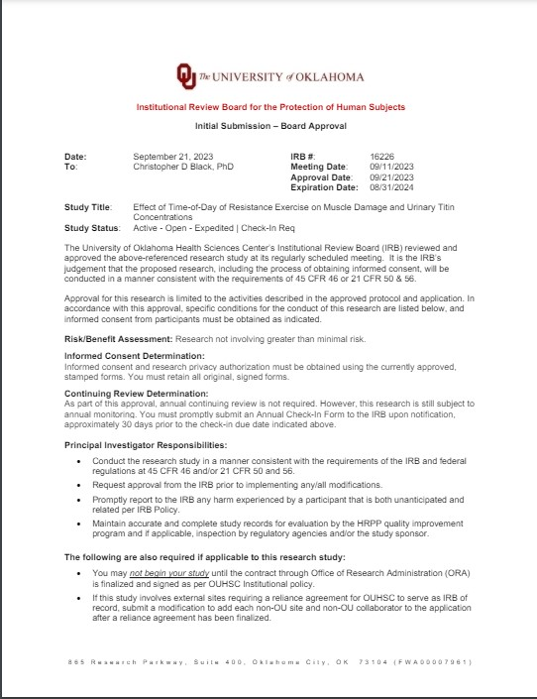

APPENDIX B: INFORMED CONSENT FORM



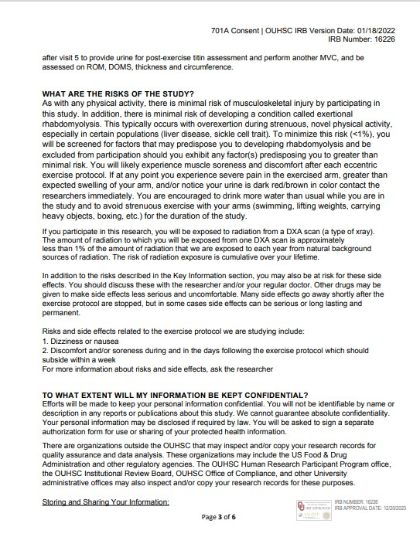
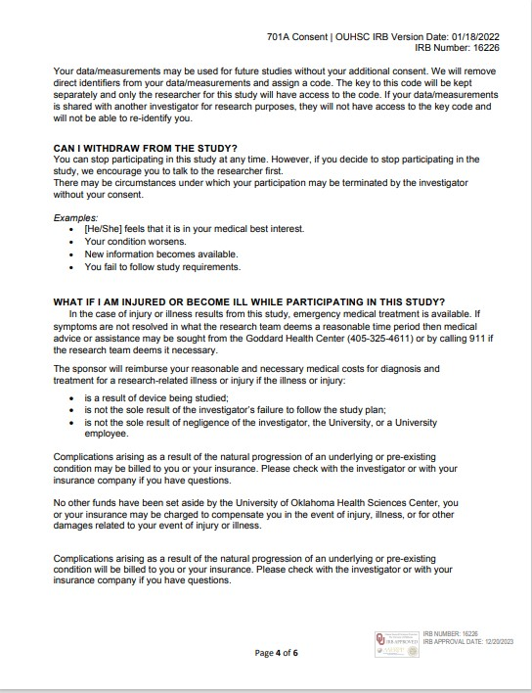
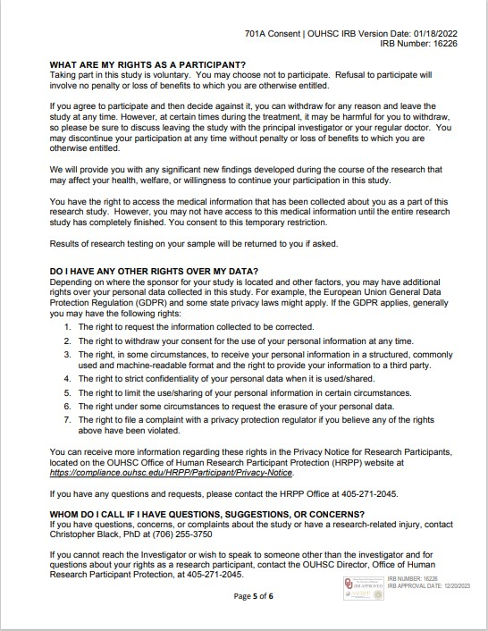
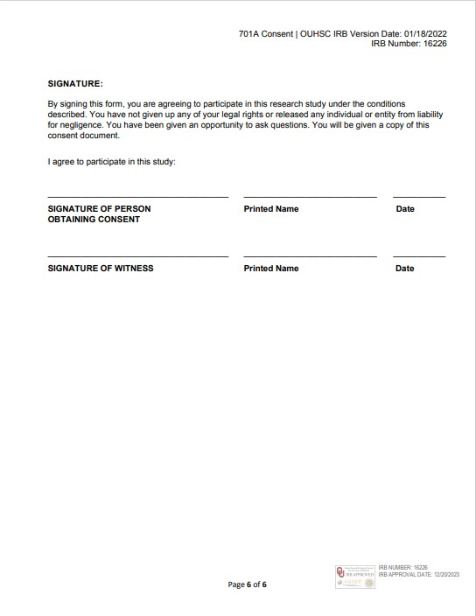

APPENDIX C: HIPAA AUTHORIZATION FORM

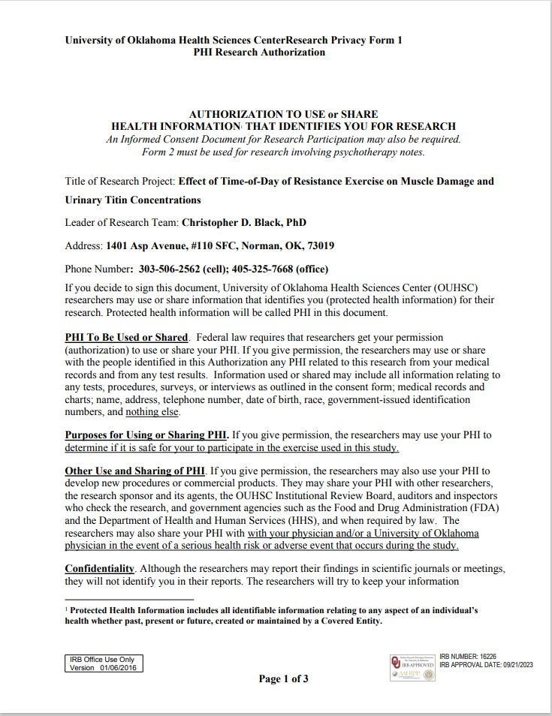

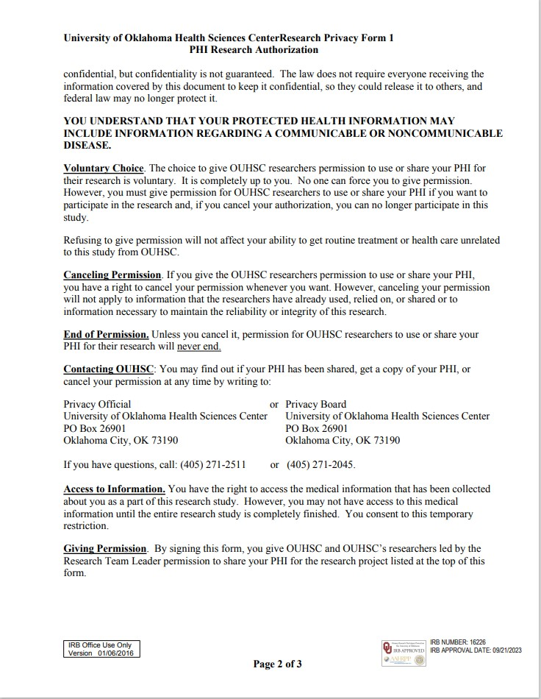
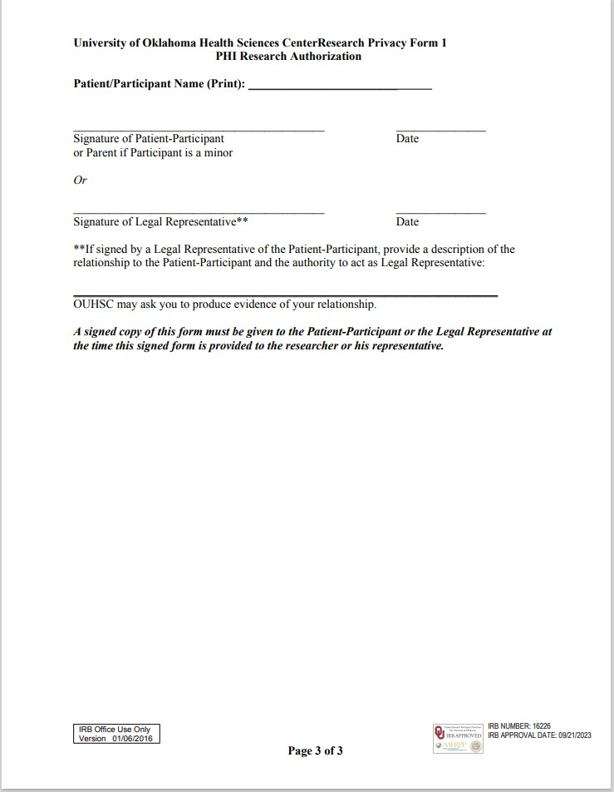

APPENDIX D: THE PHYSICAL ACTIVITY READINESS QUESTIONNAIRE


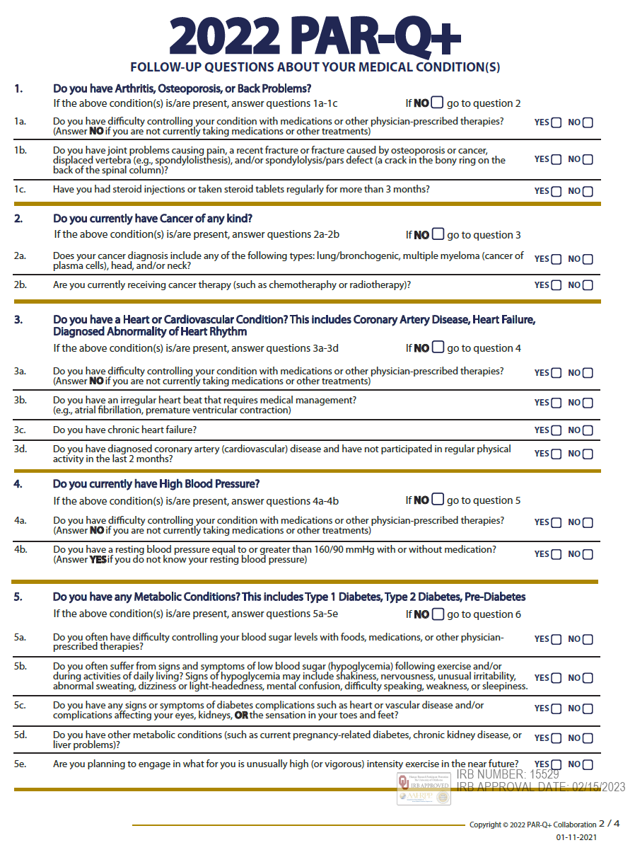

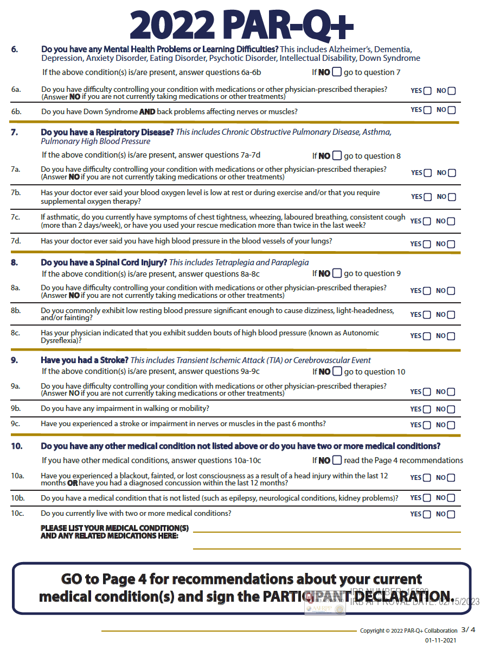
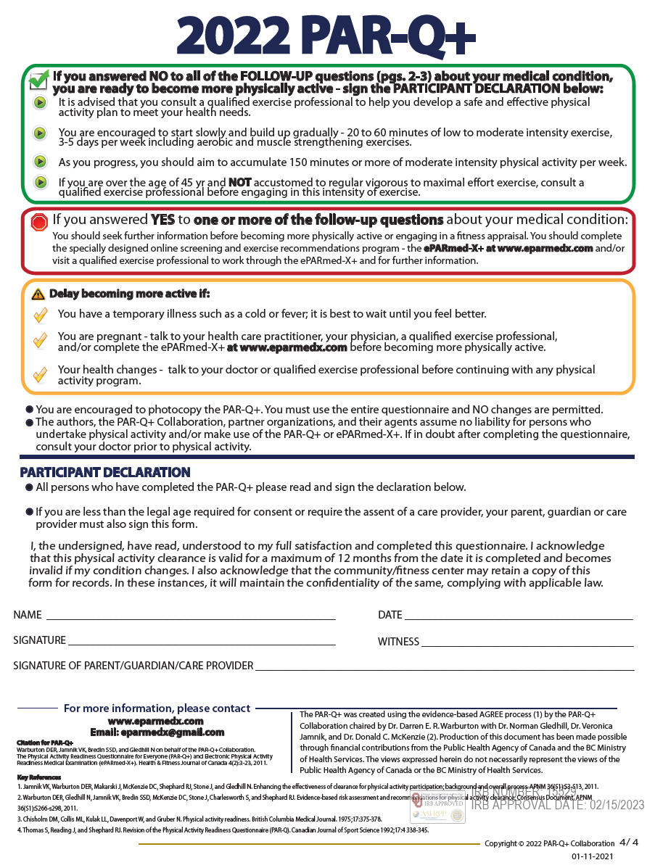

APPENDIX E: MENSTRUAL HISTORY QUESTIONNAIRE


APPENDIX F: HEALTH SCREENING QUESTIONNAIRE

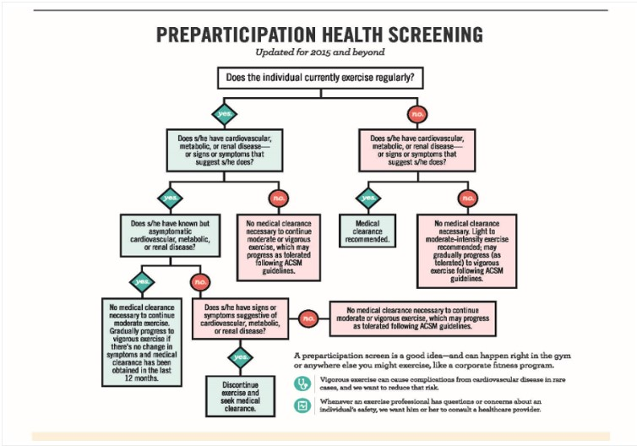

APPENDIX G: RHABDOMYALSIS SCREENING
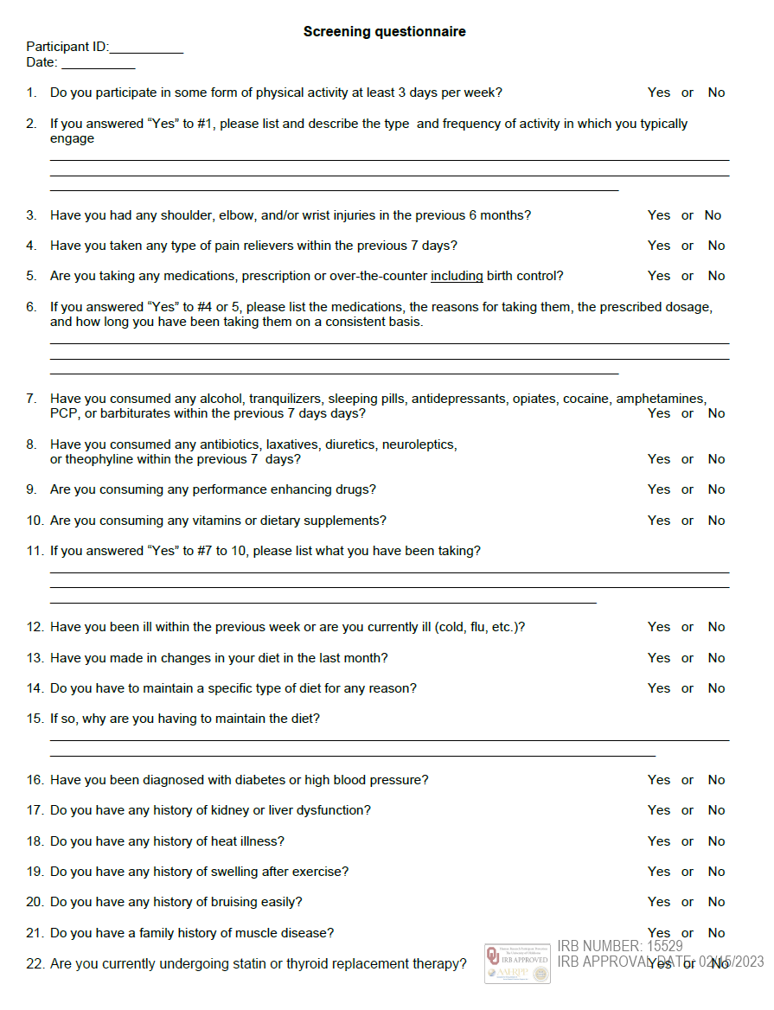

APPENDIX H: RECRUITMENT FLYER

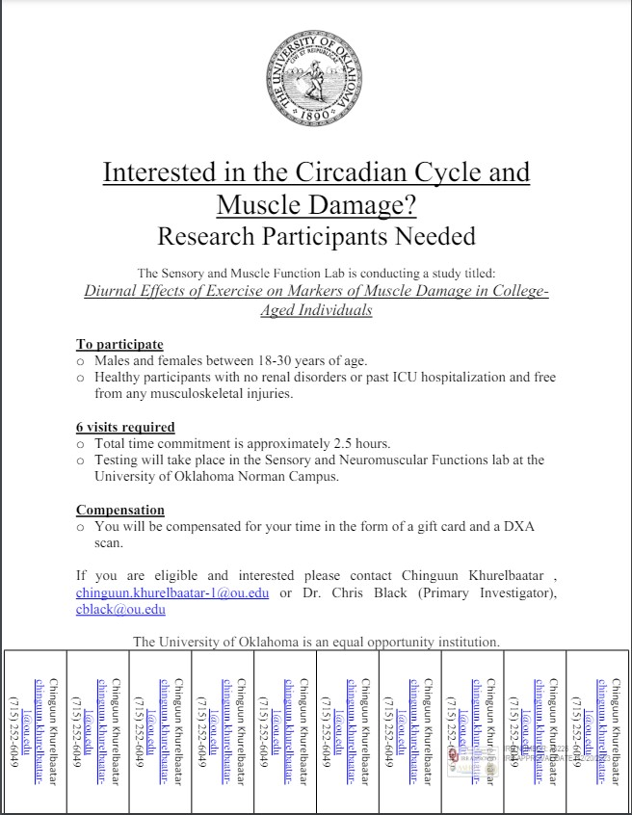
APPENDIX I: ROCHESTER FATIGUE
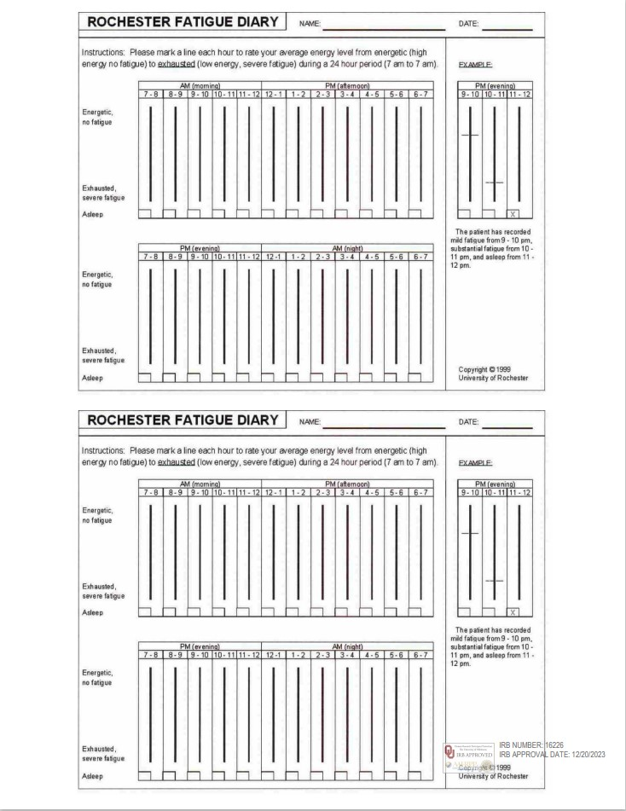
APPENDIX J: VISUAL ANALOGUE SCALE
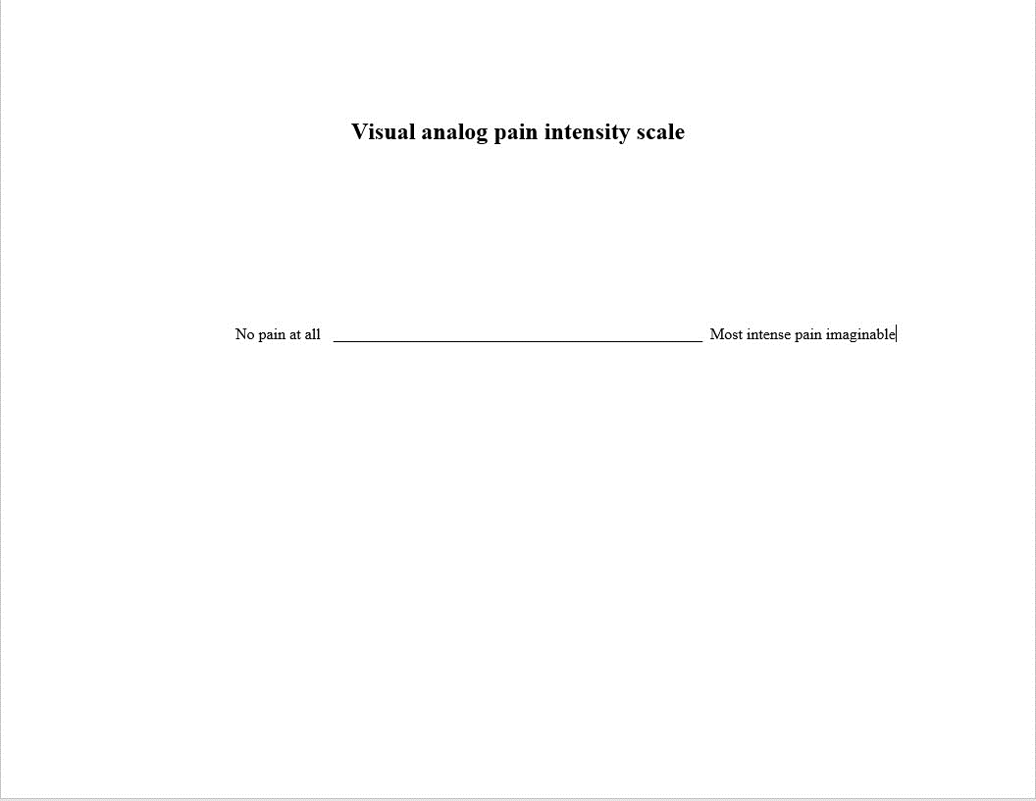

APPENDIX K: COVID SCREENING
Q1.
What year are you in college?
- Freshman
- Sophomore
- Junior
- Senior
- Graduate Student
- Other

Q2.
What is your age in years? _________

Q3.
What is your height in centimeters? _________

Q4.
What is your weight in kilograms? _________

Q5.
What is your biological sex?
- Man
- Woman
- Other

Q6.
Are you Hispanic/Latino?
- Yes
- No

Q7.
What race do you identify as?
- White
- Black or African American
- American Indian or Alaska Native
- Asian
- Native Hawaiian or Pacific Islander
- Other

Q8.
Smoking Status
- Non-smoker
- Former smoker
- Current smoker
- Prefer not to say

Q9.
Do you have any of the following conditions (circle all that apply)?
- COPD
- Hypertension
- Asthma
- Fibromyalgia
- Anxiety
- Depression
- Migraine
- Erectile Dysfunction
- Multiple Sclerosis
- Celiac Disease
- Irritable Bowl Syndrome
- Endometriosis
- Anemia / Low Hemoglobin Content
- Polycystic Ovarian Syndrome
- Back Pain
- Arthritis
- Cancer
- Chronic Sinusitis
- Disordered Eating
- Substance Misuse/Abuse
- Deafness
- Blindness

Q10.
Are you vaccinated for COVID-19?
- No
- Partially (one shot of Moderna or Pfizer but not both)
- Fully (two shots of Moderna or Pfizer, or one shot of Johnson & Johnson)
- Boosted Once (fully vaccinated and another shot received)
- Boosted Twice (fully vaccinated and 2 more shots received)

Q11.
How many times have you had COVID-19 (confirmed by COVID-19 PCR test and/or a rapid at-home test)?
- 0
- 1
- 2
- 3
- 4+
If you answered B.
When did you get COVID-19 the first time?
Month: _________
Year: _________
What was your vaccination status at the time of your first infection?
- Unvaccinated
- Partially vaccinated (one shot of Moderna or Pfizer but not both)
- Fully vaccinated (both shots of Moderna or Pfizer, or one Johnson & Johnson)
- Fully vaccinated and boosted (both shots of Moderna or Pfizer, or the J&J AND a booster shot)
- Fully vaccinated and boosted twice (both shots of Moderna or Pfizer, or the J&J, and two booster shots)
If you answered C.
When did you get COVID-19 the second time?
Month: ________
Year: ________
What was your vaccination status at the time of your second infection?
- Unvaccinated
- Partially vaccinated (one shot of Moderna or Pfizer but not both)
- Fully vaccinated (both shots of Moderna or Pfizer, or one Johnson & Johnson)
- Fully vaccinated and boosted (both shots of Moderna or Pfizer, or the J&J AND a booster shot)
- Fully vaccinated and boosted twice (both shots of Moderna or Pfizer, or the J&J, and two booster shots)

If you answered D.
When did you get COVID-19 the third time?
Month: _________
Year: _________
What was your vaccination status at the time of your third infection?
- Unvaccinated
- Partially vaccinated (one shot of Moderna or Pfizer but not both)
- Fully vaccinated (both shots of Moderna or Pfizer, or one Johnson & Johnson)
- Fully vaccinated and boosted (both shots of Moderna or Pfizer, or the J&J AND a booster shot)
- Fully vaccinated and boosted twice (both shots of Moderna or Pfizer, or the J&J, and two booster shots)

If you answered E.
When did you get COVID-19 the fourth time?
Month: __________
Year: _________
What was your vaccination status at the time of your fourth infection?
- Unvaccinated
- Partially vaccinated (one shot of Moderna or Pfizer but not both)
- Fully vaccinated (both shots of Moderna or Pfizer, or one Johnson & Johnson)
- Fully vaccinated and boosted (both shots of Moderna or Pfizer, or the J&J AND a booster shot)
- Fully vaccinated and boosted twice (both shots of Moderna or Pfizer, or the J&J, and two booster shots)
Q12.
Were you hospitalized for any of your infection(s)?
- Yes (if yes, circle all that apply)
  - First time
  - Second time
  - Third time
  - Fourth time
- No
Q13.
Did you have symptoms with your first infection?
- Yes
- No
If yes, how severe were the following symptoms? (0-10, 0 = no symptoms, 10 = very severe)
Fever: _________
Cough: _________
Headache: _________
Shortness of Breath: __________
Change in Smell/Taste: __________
Fatigue or Tiredness That Interferes with Daily Life: __________
Difficulty Thinking or Concentrating: __________
Chest Pain: _________
Body/Joint Aches: __________
Sleep Problems: _________
Heart Palpitations: _________
Dizziness When Standing Up: __________
Diarrhea: __________
Stomach Pain: _________
Rash: ____________
Paresthesia: ________
Anxiety: _________
Depression: _________
Change in Menstrual Cycle: _________
Change in Sexual Function: __________

Q14.
Did you have symptoms with your second infection?
- Yes
- No

If yes, how severe were the following symptoms? (0-10, 0 = no symptoms, 10 = very severe)
Fever: _________
Cough: _________
Headache: _________
Shortness of Breath: __________
Change in Smell/Taste: __________
Fatigue or Tiredness That Interferes with Daily Life: __________
Difficulty Thinking or Concentrating: __________
Chest Pain: _________
Body/Joint Aches: __________
Sleep Problems: _________
Heart Palpitations: _________
Dizziness When Standing Up: __________
Diarrhea: __________
Stomach Pain: _________
Rash: ____________
Paresthesia: ________
Anxiety: _________
Depression: _________
Change in Menstrual Cycle: _________
Change in Sexual Function: __________
Q15.
Did you have symptoms with your third infection?
- Yes
- No

If yes, how severe were the following symptoms? (0-10, 0 = no symptoms, 10 = very severe)
Fever: _________
Cough: _________
Headache: _________
Shortness of Breath: __________
Change in Smell/Taste: __________
Fatigue or Tiredness That Interferes with Daily Life: __________
Difficulty Thinking or Concentrating: __________
Chest Pain: _________
Body/Joint Aches: __________
Sleep Problems: _________
Heart Palpitations: _________
Dizziness When Standing Up: __________
Diarrhea: __________
Stomach Pain: _________
Rash: ____________
Paresthesia: ________
Anxiety: _________
Depression: _________
Change in Menstrual Cycle: _________
Change in Sexual Function: __________
Q16.
Did you have symptoms with your fourth infection?
- Yes
- No

If yes, how severe were the following symptoms? (0-10, 0 = no symptoms, 10 = very severe)
Fever: _________
Cough: _________
Headache: _________
Shortness of Breath: __________
Change in Smell/Taste: __________
Fatigue or Tiredness That Interferes with Daily Life: __________
Difficulty Thinking or Concentrating: __________
Chest Pain: _________
Body/Joint Aches: __________
Sleep Problems: _________
Heart Palpitations: _________
Dizziness When Standing Up: __________
Diarrhea: __________
Stomach Pain: _________
Rash: ____________
Paresthesia: ________
Anxiety: _________
Depression: _________
Change in Menstrual Cycle: _________
Change in Sexual Function: __________

Q17.
Are you currently experiencing any post-COVID symptoms that have lasted longer than 3 months?
- Yes
- No

APPENDIX L: DATA COLLECTION FORM

Visit 1 – Familiarization
Time:________ AM / PM
Subject ID:_____________ Name:_________________ Date:_______________
Sex: M | F
Informed Consent: Y | N
Rhabdomyolysis Screening: Y | N
Health Screening Questionnaire: Y | N
PAR-Q: Y | N
(If Female)
Pregnancy Test: P | F
Menstrual History Questionnaire: Y | N
DEXA ASSESSMENT

LBM (KG): ___________
BMC (KG): ___________
FM (KG): ___________
RANDOMIZATION (CIRCLE ONE)
Morning (07:00 – 08:30 am)
Evening (05:00 – 06:30 pm)

Visit 2 – Experimental Protocol
SUBJECT ARRIVAL
Time:__________ AM/PM
PRE-EXERCISE PROTOCOL
Diet Log: Y | N
Sleep Questionnaire: Y | N
Hydration Status (1.004 – 1.029): ______ USG
Baseline Urine Sample: Y | N
Baseline Bicep ROM: __________
Ultrasound Thickness: _________ mm
Bicep Circumference: _________ cm
BASELINE MAXIMAL VOLUNTARY CONTRACTION
Attempt 1: __________ (Nm)
Attempt 2: __________ (Nm)
Attempt 3: __________ (Nm)
Peak MVC Value __________ (Nm)
1RM ESTABLISHMENT
Warm Ups:
Load___________Reps_________
Load___________Reps_________
Load___________Reps_________
Load___________Reps_________
Load___________Reps_________
Load___________Reps_________
Load___________Reps_________
Load___________Reps_________
1 RM = ___________ lbs
EXERCISE PROTOCOL (3 x 10 @ 120% 1 RM)
Load___________Reps_________
Load___________Reps_________
Load___________Reps_________
(Additional Sets – If Needed)
Load___________Reps_________
Load___________Reps_________
Load___________Reps_________
Load___________Reps_________
Load___________Reps_________
Load___________Reps_________
Post-Exercise Maximal Voluntary Contraction
Time __________ AM / PM
Attempt 1: __________ (Nm)
Attempt 2: __________ (Nm)
Attempt 3: __________ (Nm)
Peak MVC Value __________ (Nm)
% Decline ____________
POST-EXERCISE PROTOCOLS
Post-Exercise Bicep ROM: __________
Ultrasound Thickness: _________ mm
Bicep Circumference: _________ cm

Visit 3 (24h post visit 2)
SUBJECT ARRIVAL
Time:__________ AM/PM
Diet Log: Y | N
Sleep Questionnaire: Y | N
Bicep ROM: __________
Ultrasound Thickness: _________ mm
Bicep Circumference: _________ cm
Delayed Onset Muscle Soreness: _________ VAS
MAXIMAL VOLUNTARY CONTRACTION
Attempt 1: __________ (Nm)
Attempt 2: __________ (Nm)
Attempt 3: __________ (Nm)
Peak MVC Value __________ (Nm)
% Decline from Baseline: _________

Visit 4 (24h post visit 3)
SUBJECT ARRIVAL
Time:__________ AM/PM
Diet Log: Y | N
Sleep Questionnaire: Y | N
Bicep ROM: __________
Ultrasound Thickness: _________ mm
Bicep Circumference: _________ cm
Delayed Onset Muscle Soreness: _________ VAS
MAXIMAL VOLUNTARY CONTRACTION
Attempt 1: __________ (Nm)
Attempt 2: __________ (Nm)
Attempt 3: __________ (Nm)
Peak MVC Value __________ (Nm)
% Decline from Baseline: _________

Visit 5 (24h post visit 4)
SUBJECT ARRIVAL
Time:__________ AM/PM
Diet Log: Y | N
Sleep Questionnaire: Y | N
Bicep ROM: __________
Ultrasound Thickness: _________ mm
Bicep Circumference: _________ cm
Delayed Onset Muscle Soreness: _________ VAS
MAXIMAL VOLUNTARY CONTRACTION
Attempt 1: __________ (Nm)
Attempt 2: __________ (Nm)
Attempt 3: __________ (Nm)
Peak MVC Value __________ (Nm)
% Decline from Baseline: _________
Visit 6 (24h post visit 5)
SUBJECT ARRIVAL
Time:__________ AM/PM
Diet Log: Y | N
Sleep Questionnaire: Y | N
Hydration Status (1.004 – 1.029): ______ USG
Post-Exercise Urine Sample: Y | N
Bicep ROM: __________
Ultrasound Thickness: _________ mm
Bicep Circumference: _________ cm
Delayed Onset Muscle Soreness: ________ VAS
MAXIMAL VOLUNTARY CONTRACTION
Attempt 1: __________ (Nm)
Attempt 2: __________ (Nm)
Attempt 3: __________ (Nm)
Peak MVC Value __________ (Nm)
% Decline from Baseline: _________

