SOONER HORIZON, SPRING 19
View Static Version

SOONER HORIZON The University of Oklahoma Special Collections | Spring 2019 | Vol 7, No 1

OU LIBRARIES JOINS PROJECT STAND
Student Activism, Now Documented
Project STAND is a nationwide consortium of more than 40 colleges and universities that is creating an online hub to heighten access to digital and analog archival and historical collections documenting student activism.
"In joining Project STAND, the OU Libraries acknowledges and highlights the voices of student activists at the University of Oklahoma, historically and in the present day. Our campus history, as told in the University Archives, extends beyond the administrative records of the institution. The archives also document student life. Participating in Project STAND gives us the tools we need to present an inclusive and diverse record of the student experience at OU, while also adding the OU experience to a national narrative." - Bridget Burke, OU Libraries Associate Dean for Special Collections
Project STAND will be hosting a series of symposia around the nation over the next year, funded by a federal grant awarded by the Institute for Museum and Library Services.
"Activism on all sides, across a spectrum of interests, is part of this national conversation. It would be great to see Oklahoma student activists represented," said Burke.
Learn more about Project STAND
___________________________________________
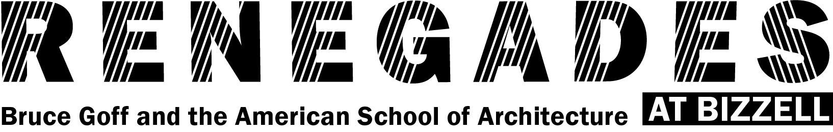
September 22, 2018 - July 29, 2019
The Renegades: Bruce Goff and the American School of Architecture at Bizzell exhibition and partnership with the Christopher C. Gibbs College of Architecture continues with a Presidential Dream Course and programming through the spring 2019 semester.
A seminar on the American School examined the history of architecture at OU, including Bruce Goff, who served as department chairman in the 1940s and '50s, his architectural progenies, and the pedagogical experiment they fostered.
To date, over a dozen collections have been donated from architects influenced by Frank Lloyd Wright and Bruce Goff.
The first of these organic architecture collections to be made available for research will be that of Michigan architect Harvey Ferrero.
Ferrero studied with OU architecture professor Bruce Goff, and served as one of Goff's draftsmen before launching his own architectural practice. A 1955 graduate of Lawrence Technological University, Ferrero worked as an apprentice to Bruce Goff in 1958-1960 at the Price Tower in Bartlesville, Oklahoma. He later returned to his alma mater as an architecture professor, and also worked as an architectural illustrator. His drawings in the American School Archive span the length of his career from 1955 to 2014. The collection features colorful sketches of residential and commercial projects in his home state of Michigan, including the Max Klein Building, and others throughout the United States. The Ferrero drawings number in the thousands and include representations of commissioned buildings in Oklahoma and elsewhere, as well as built and unbuilt projects.
College of Architecture graduate students spent part of their 2018 fall semester organizing and describing over 400 of these drawings. The process of examining and describing each drawing allowed the students to closely study Ferrero’s illustrations, and learn how to preserve them for future generations of architects.
On February 4, 2019, students enrolled in the Dream Course visited the Bizzell Memorial Library, where OU Libraries associate dean for special collections, Bridget Burke, led students though a discussion about acquiring and caring for architectural archives. Students viewed a sample of works by Ferrero. The students considered the fragility and size of architectural records and brainstormed in small groups about what an ideal architectural archive would include.
___________________________________________

Welcoming Dr. Todd Fuller to the Western History Collections
As curator, Fuller is responsible for leading and directing the Western History Collections, with particular responsibility for outreach to scholarly and other communities, the development of programing and exhibits, and the continued growth of the collections
Fuller is co-curator of the current exhibition, Red Dust Oklahoma: A Poetic History. He brings a passion for the collections and the stories they hold, extensive experience with outreach to scholarly and public audiences, and administrative, grant writing, and fundraising experience to his new role.
"I look forward to working with University Libraries staff and others to advance the mission of the Western History Collections through developing diverse and collaborative programming, conducting dynamic outreach, expanding the holdings in strategic ways, and realizing sustainability that benefits researchers, students, staff, and the communities we serve," said Fuller. "Because of all these things (and so much more), it is my honor to be the next curator of the Western History Collections, a task I face with humility, dedication, perseverance, and excitement.”
___________________________________________

RECENT ACQUISITIONS

The Torrens Collections
A generous donation of 30 boxes of research notes and paper gifted by Hugh and Shirley Torrens marks the launch of a history of geology archive within OU Libraries special collections.
Hugh Torrens, a professor emeritus of Keele University in Britain, is one of the most distinguished living historians of geology. He has received, in recognition of a lifetime of achievement, the Sue Tyler Friedman Medal from the Geological Society of London, the Mary C. Rabbitt History of Geology Award from the Geological Society of America, and the Tikhomirov Medal from the International Union of Geological Sciences. His nearly 400 publications cluster around a common theme of the historical relations between industrialization and geology.
Torrens’ passion has been to recover the voices of invisible and forgotten figures who may have left no books, but whose labors led to major discoveries and achievements in geology. Whether an iron worker in the English Industrial Revolution or a British mining engineer whose expertise was coveted around the world, Torrens reconstructs their lives and contributions.
Torrens is the foremost historian of William Smith and of Mary Anning.
Smith, creator of the single most renowned geological map, was a working-class canal surveyor by trade whose now famous map led not to honor, but to confinement in debtor’s prison.
Anning, a working-class discoverer of dinosaur fossils near Lyme Regis, made a lot of gentlemen geologists famous.
Now, through the History of Geology Archive, the obscure leads, hard-to-find clues, and research notes behind Torren’s investigations will become available to other scholars. Historians and geologists from the United States and beyond have already begun making inquiries about the Torrens Collection; it has even informed a 7th-grader’s play about Mary Anning. Processing of the archive is ongoing, with an additional shipment of papers expected this summer.
The History of Geology Archive includes the Torrens Collection, the David B. Kitts Collection, and the Alexander Ospovat Collection. The papers of Kitts, a late OU professor of Geology and the History of Science, span the topics of the history of geology, the philosophy of geology, and the work of Charles Darwin. The papers of Ospovat, a late OU History of Science alumnus and Oklahoma State University professor, largely concern A. G. Werner, the most influential 18th century German geologist. Uniting these collections into a larger History of Geology Archive will attract additional collections by distinguished historians of geology. Their papers, thus preserved and made accessible at OU, will receive the attention of scholars internationally.
___________________________________________

RECENT AQUISITIONS

James Hawes Book Collection
In the fall of 2018, the Western History Collections received a donation of beautifully hand-tooled leather-bound books donated by Charlotte Gaston. The volumes are the work of her grandfather, Jesse James Harold Hawes, a skilled saddle-maker who specialized in silver inlay.
The skill and craftsmanship that Hawes brought to his leatherwork with saddles served him equally well in another area of artistic effort — beautifully decorative hand tooled leather bindings of classic works of literature.
Titles in the collection include of Nathanial Hawthorne’s The Scarlet Letter, Ernest Thompson Seton’s Woodmyth and Fable, and Kit Carson’s Life and Adventures.
Gaston also donated her grandfather’s manuscript on leather work, along with a catalog of his products and some family photos. The catalog is illustrative of Hawes’ expertise and talent in creating one-of-a-kind saddles and leather accessories.
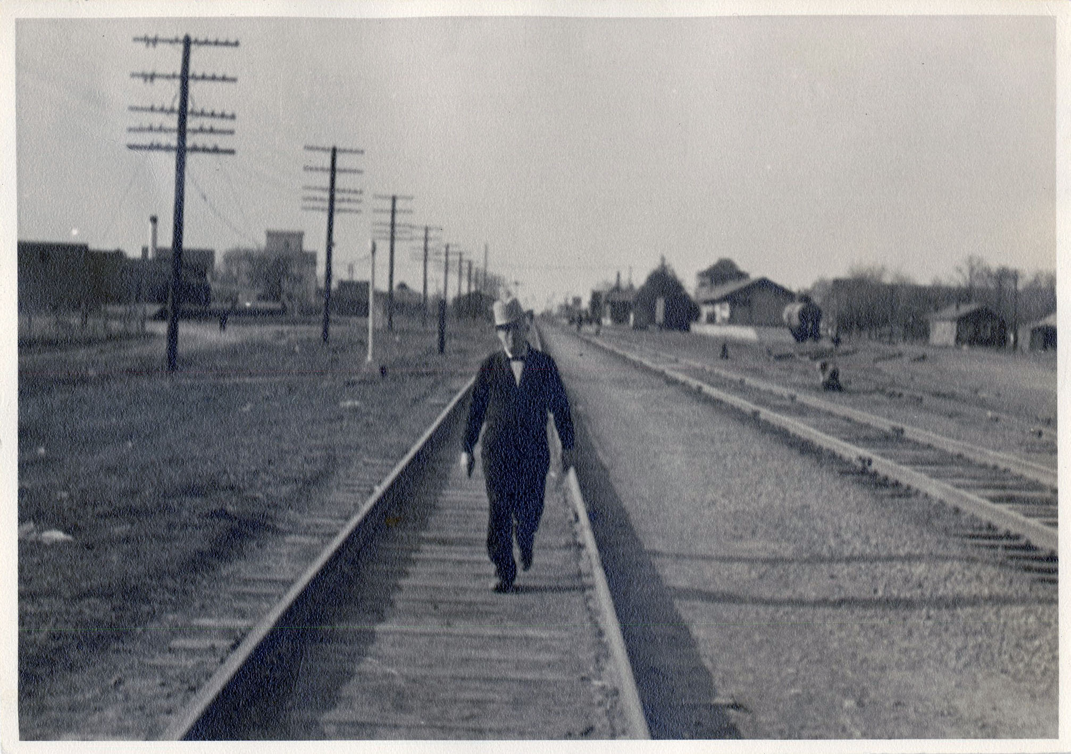
Hawes grew up near Lexington, Oklahoma. As a youth, he learned to play several musical instruments. His favorite was the trombone and he played for the Ringling Brothers Circus for a time. He later moved to Henryetta, even serving as its mayor, and worked with his father making saddles. Hawes and his wife Bertha eventually moved to Norman.
Their eldest son, James, was editor of The Sooner Yearbook (1935), and then attended law school. Their daughter, Olive, earned bachelor’s (1933) and master’s (1935) degrees in linguistics from OU. She was a talented linguist and after working as a secretary and instructor in the Department of Modern Languages. In 1941, she became chief translator for the Federal Communications Commission in Washington D.C.
The youngest son, Charles Richard, graduated from medical school at OU in 1946. He likely earned an officer’s commission because in 1948, Lt. Hawes was stationed in the medical corps in Japan with the Army occupation forces. Dr. Hawes inherited the gorgeous leather-bound books from his father, and then passed them to his daughter, Charlotte Gaston.
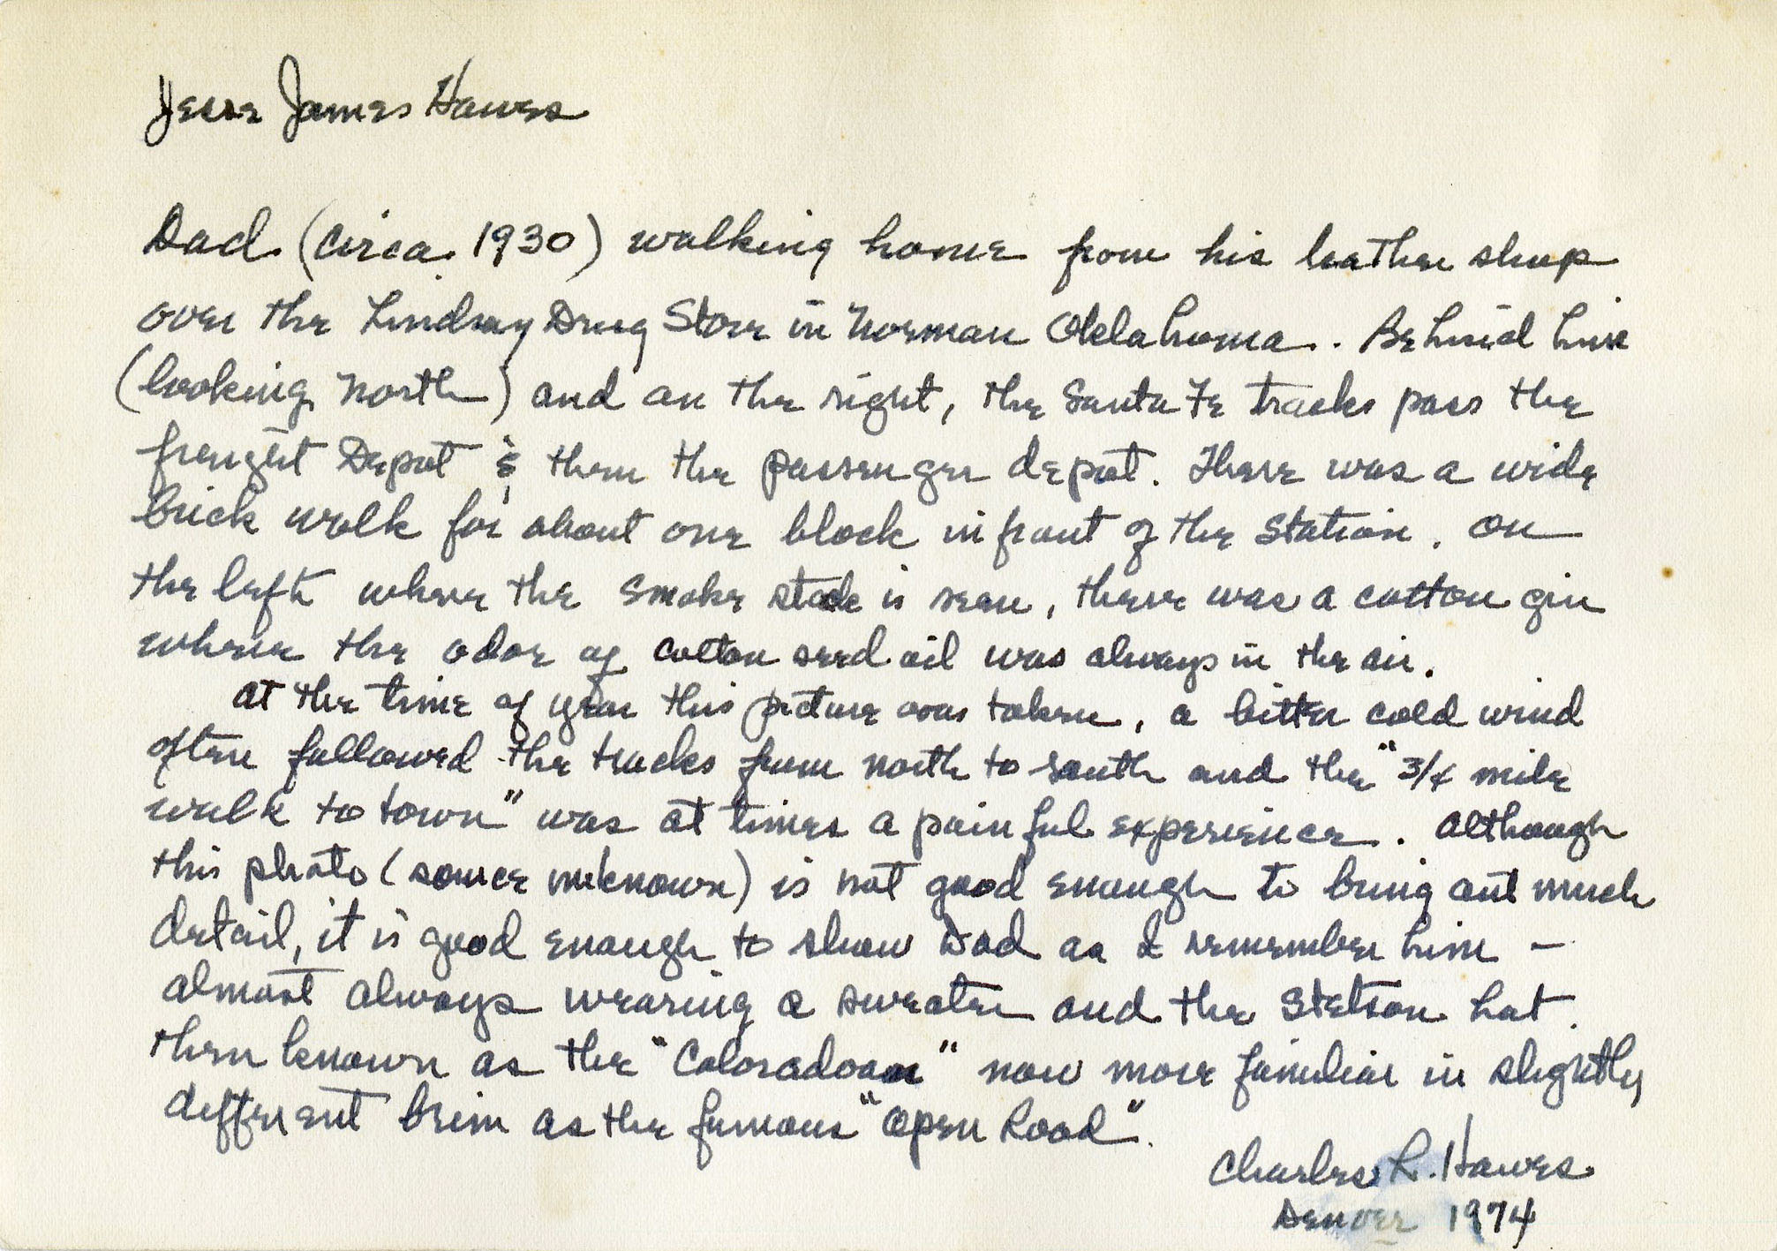
___________________________________________

SCHOLARLY IMPACT
OU Libraries special collections serve scholars from around the world, who then amplify the academic significance of the collections through citations and interactions with colleagues and students. As important, are the relationships made between visiting scholars with resident professors, students, and library personnel. The following section describes a few such instances of visiting scholars' use of the collections and the academic impact that follows.

Mellon Research Fellows: Kate Sheppard
Last fall, Dr. Kate Sheppard, an Associate Professor from Missouri University of Science and Technology, conducted research at OU Libraries in support of her project “Hotels as Sites of Knowledge Creation in Egyptology.” The Andrew W. Mellon Travel Fellowship Program funded her visit through an award from the History of Science Collections and the Department of the History of Mellon Fellowship Program Science.
Sheppard’s research explores the intersections of the history of archeology, Egyptology, women’s history, gender studies, and popular culture. Sheppard used unique and rare materials from several special collections at OU Libraries including the Bass Business History Collection, the John and Mary Nichols Collection, and the History of Science Collections. Further, since her research involves the late 19th century through early 20th century Egyptology, Sheppard was able to complement her research with materials from the circulating stacks from the Bizzell Memorial Library
Sheppard applied for a Mellon Fellowship at OU in order to use the resources of the special collections and to beneﬁt from interactions with the community of scholars in her ﬁeld here on campus. As the only historian of science at her home university, based in the Department of History and Political Science, she welcomed the opportunity to conduct research at an institution with scholars working in her academic ﬁeld. Sheppard was able to interact with faculty and graduate students and gain valuable feedback on her current research project.
In her trip report, Sheppard expressed appreciation for interactions with OU colleagues whose “insight into my project and open questions were helpful to my thinking. ”
Her campus interactions also included exchanges with undergraduates, including a visit to a capstone class for history of science majors. Sheppard shared insight to her working process and answered questions about research from students, who were all working on a semester-long research paper.
Each year, the collections hosts a dozen visits from classes across disciplines. With these visits, faculty enrich the student research experience through engagement with original, primary source materials related to the subject of their class. They gain insight into the periods or topics covered from the materials shown. They also acquire a tactile connection and understanding through interaction with these objects, something not possible when working exclusively with online materials or digital resources.
Sheppard is just one of the Mellon Fellows who were awarded travel grants and visited the University of Oklahoma during 2018. For over two decades, the Mellon Fellowship Program at OU has hosted dozens of scholars from all over the world. These fellows conduct research, give talks and interact with students and faculty across campus during their period of residence. Visitors have access to materials at one of the premier collections of materials for the study of history of science, technology and medicine.
___________________________________________

SCHOLARLY IMPACT

Visiting Scholars to the Chinese Literature Translation Archive
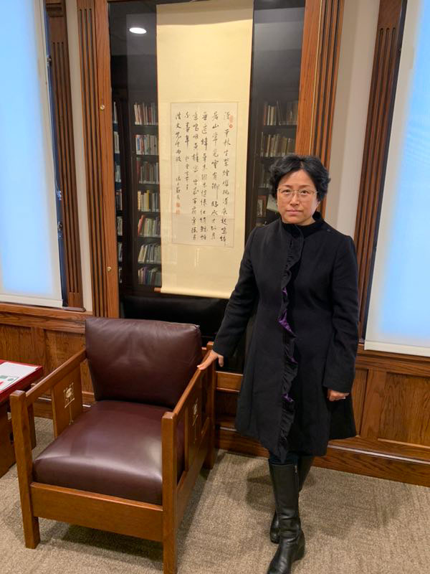
Sun Huijun, Vice Dean, College of English, Shanghai International Studies University.
“For scholars engaged in Chinese Literature in translation, Bizzell Memorial Library, Norman, Oklahoma University, is a place that must be visited. A faculty member of Shanghai International Studies University, one of China’s top three universities of foreign languages and literatures, here I am, spending hours every weekday in the reading room...rummaging through the translation manuscripts by Howard Goldblatt—widely regarded as the foremost translator of modern and contemporary Chinese literature, and his otherwise unavailable correspondence with his many Chinese authors, among which is Mo Yan, the 2012 Nobel Prize laureate. Chinese Literature Translation Archive has turned out to be a gold mine with so many invaluable holdings to be amazed at.” - Sun Huijun, Vice Dean, College of English, Shanghai International Studies University.
___________________________________________

SCHOLARLY IMPACT

Western History Collections Scholarly Citations
The Western History Collections are visited by a range of scholarly users. Historians, educators, folklorists, ethnographers, linguists, and scholars of Native American history and the history of science have all used the collections to tell stories, develop arguments, or illustrate their work for publication.
- Tone-Pah-Hote, Jenny. Crafting an Indigenous Nation: Kiowa Expressive Culture in the Progressive Era. University of North Carolina Press. 2019.
- Buchkoski, John. “Being Judged by Its Fruits: Transforming Indian Land into Orchards along the Arkansas River, 1800-1867.” Great Plains Quarterly 39, no. 1 (Winter 2019): 39-58.
- Oskison, John Milton. Tales of the Old Indian Territory and Essays on the Indian Condition. ed. By Lionel Larre. University of Nebraska Press. 2012.
- Roth, J.E. “Long Lot Colonial Landscapes in New Mexico and Texas: The Spanish-French Frontier Connection, 1693-1731.” Material Culture 50, no. 2 (Fall 2018): 53-72.
- Haag, Marcia. “The evolution of Choctaw grammatical words hosh and ho: Evidence from the Pitchlynn manuscript.” Folia Linguistica 39, no. 2 (2018): 361-381.
- McDown, George H. and Daniel L. Stiffler. “Statewide Public School Music Competitions/Festivals in Kansas and Oklahoma: The Beginnings of the School Music Contest Movement in the United States.” Journal of Historical Research in Music Education (November 2018): 1-24.
- Bicknell, Thomas C. and Chuch Parsons. Ben Thompson: Portrait of a Gunfight. University of North Texas Press. 2018.
- Ogilvie, Marilyn Bailey. For the Birds: American Ornithologist Margaret Morse Nice. University of Oklahoma Press. 2018.
___________________________________________

NEWS

OU Libraries Receives Grant to Process Jens Rud Nielson Collection
The American Institute of Physics has awarded OU Libraries a $9,173 grant to process, arrange, describe, and make findable the papers of the Jens Rudd Nielson Collection within the History of Science Collections.
Jens Rud Nielsen (1894-1979) was a student and colleague of Niels Bohr, who had significant impact on the development of 20th century physics, including a leading role in the establishment of a physics research community at OU. The Nielsen collection documents his scientific work and publications, the international physics community, and the physics program at OU. The collection contains 60 document boxes (manuscript materials, ephemera, photographs) and more than 1,000 glass slides from his personal collection.
In addition to these unprocessed materials, the History of Science Collections holds over 50 books from Nielsen's personal library collection, his manuscript notebook "Memories of Niels Bohr," an audio recording of Bohr's 1957 public lecture, and an instrument collection curated by Emeritus Professor Stu Ryan.
The scope of materials in the collection suggests potential for historical research in a wide range of areas related to 20th century physics: the Nielsen-Bohr relationship, including Nielsen's contributions to Bohr commemorative publications and meetings; Bohr's visits to OU from 1937 to 1957; the development of the graduate program in physics; Nielsen's research, and his work with graduate students; the OU Department of Physics in the context of wider physics community as well as WWII and Cold War culture.
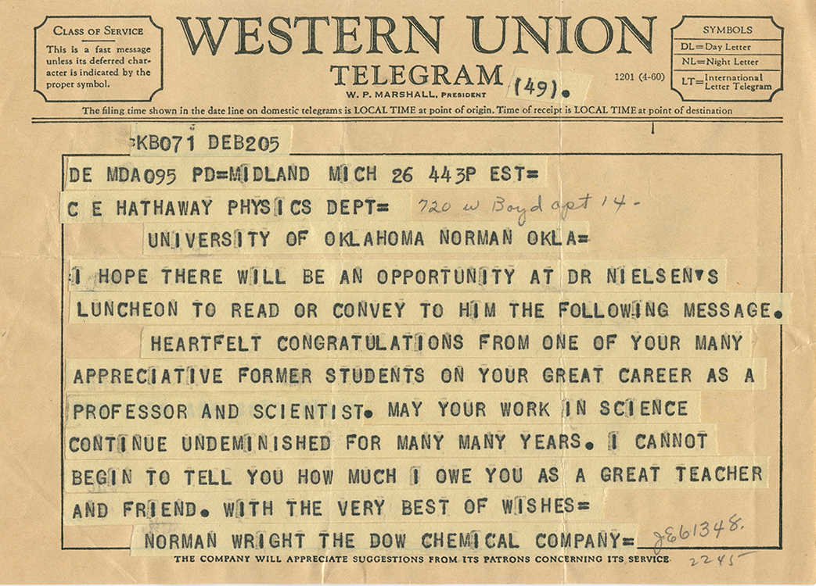
___________________________________________

SAVE THE DATE
Native Voices Over the Airwaves: The Indians for Indians Hour Radio Show, an exhibition in Bizzell Memorial Library
Opening November 2019
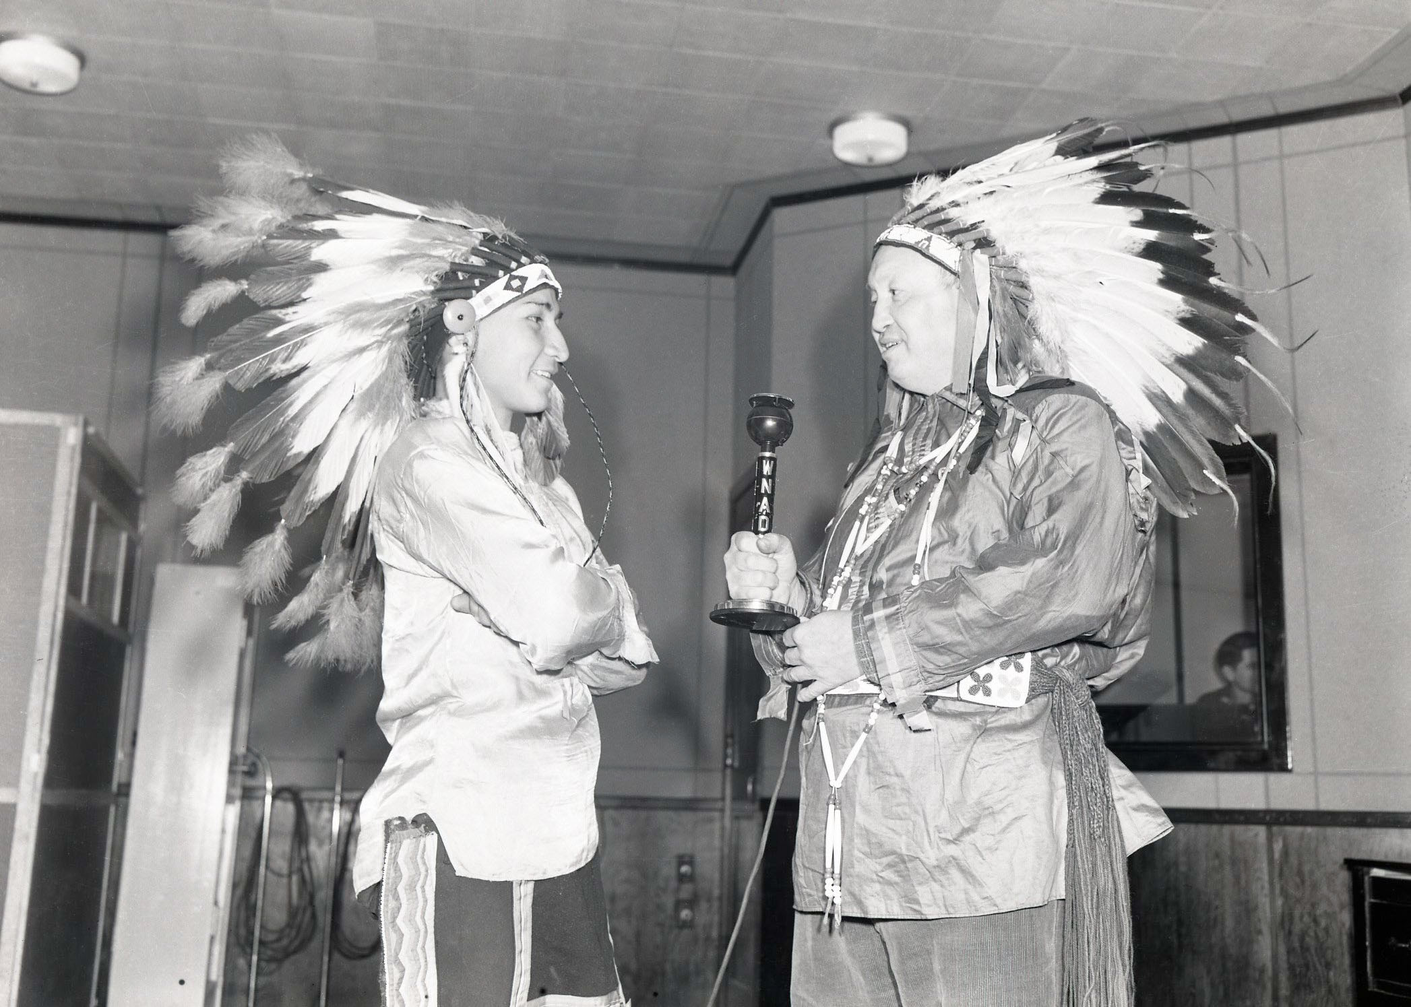
Don Whistler (right) with unidentified teenager (left), in OU’s WNAD studio, during a broadcast of the Indians for Indians radio program.
The Indians for Indians Hour radio show recordings comprise a cultural archive for Oklahoma's Native peoples from the 1940s through the early 1970s. This collection is a rare audio resource to study Native American self-representation and the intertwined topics of history, language, religion, education, and community life in the 20th century.
Through a grant from the Council on Library and Information Resources, 400 hours of the radio program on 152 open-reel tapes was recently digitized and will become publicly accessible later this year.
OU Libraries will feature this unique collection in an exhibition as a means of bringing together campus and statewide communities to explore Oklahoma and U.S. history through the lens of Native voices and to promote this collection as a resource for scholarship and cultural revitalization.
___________________________________________

IN MEMORIAM
John Hampton Marshall (1940 - 2019) served for many years as an active and valuable member of the Everett Dale Society of the Western History Collections. His service on the board was highlighted by his enthusiasm for Oklahoma and Texas history in particular. He was also a member of the Oklahoma Historical Society and wrote a number of Western history articles. He also had a distinguished career in banking. He is survived by his wife Ann and numerous relatives, including a great granddaughter, a granddaughter, and his son. The WHC is grateful for his service and contributions; his insights and humor will be sorely missed.
___________________________________________

THANK YOU FOR READING
Your support makes all the difference. Please consider making a contribution to invest in OU Libraries special collections and ensure that students and researchers around the globe continue to have access to these rare scholarly and cultural resources.
Support OU Libraries Special Collections

CREDITS
Interim Dean of Libraries, Carl Grant | Associate Dean for Special Collections, Bridget Burke
Editor: Chelsea Julian
Contributors: Bridget Burke, Kerry Magruder, Todd Fuller, Lina Ortega, JoAnn Palmeri, Jonathan Stalling, Melissa Rickman, Jackie Reese, Rachael Lester
Photos by: Rachael Lester, Rick Shultz, Ashley West, or provided

