UNIVERSITY OF OKLAHOMA
GRADUATE COLLEGE

THE AGING WORKFORCE: THE ROLE OF INFORMAL LEARNING AND EMPLOYEE ENGAGEMENT OUTCOME

A DISSERTATION
SUBMITTED TO THE GRADUATE FACULTY
in partial fulfilment of the requirements for the
Degree of
Doctor of Philosophy

By
OSARETIN UHUNOMA
Norman, Oklahoma
2018

THE AGING WORKFORCE: THE ROLE OF INFORMAL LEARNING AND EMPLOYEE ENGAGEMENT OUTCOME

A Dissertation approved for the
Department of Educational Leadership and Policy Studies

By

Dr. Doo Hun Lim, Chair

Dr. H. Michael Crowson

Dr. Angela Urick

Dr. Junghwan Kim

Dr. Siduri Haslerig

© Copyright by OSARETIN UHUNOMA 2018
All Rights Reserved.

Dedication

This research is dedicated to our Lord and Savior Jesus Christ.
"Every good gift and every perfect gift is from above, and cometh down from the Father of lights, with whom is no variableness, neither shadow of turning." James 1:17
&
Noriode Uhunoma (Mi Amore), Esosa Uhunoma, Brume Uhunoma, and Efeosa Uhunoma. My siblings, Itohan, Kenneth, Omoruyi, Uhunoma. My brother and friend Akporode and Mena Enaohwo.

Acknowledgement

I would like to thank my committee chairman, Dr. Lim Doo Hun and the committee members, Dr. Michael Crowson, Dr. Siduri Haslerig, Dr. Angela Urick, and Dr. Junghwan Kim for their guidance and support throughout this tedious process. A special thanks to Dr. Lim Doo Hun and Dr. Michael Crowson for your time and support. I am very grateful.
I also want to express my thanks to Oklahoma state employees especially the Oklahoma Department of Rehabilitation Services. Thanks also to Ms. Jan Hatch program manager, Mr. Mike Kinnison division administrator, and the entire staff at the Norman office, South Side office, Stillwater office, and Shepherd mall office of the Oklahoma Department of Rehabilitation Services.
I would also like to express my appreciation to my late-father (Uhunoma Aigbe) who taught me the value of quality education and my mother Ms. R. Aigbe. I also want to express deepest appreciation to my Mi-Amore Ms. N. Uhunoma and the boys, for their support and understanding during this doctoral studies. I would like to express my appreciation to my extended family members and siblings, Akugbe, Osagioduwa, Enorese, Aisosa, Osamuyi, Esohe, Etinosa, and Peace Uhuoma. Also, my mother-in-law Ms. F. Ogbon. God bless you all.

Table of Contents
Abstract x
CHAPTER ONE 1
Introduction 1
Problem Statement 2
Purpose Statement 10
Research Questions and Hypotheses 10
Significance of the Study 11
Operational Definitions 12
CHAPTER TWO 13
Theoretical Framework 13
The Watkins and Marsick Model 13
Knowledge Transfer in the Organizations 18
Intergenerational Learning in Organizations 20
The Antecedent of Informal Learning in an Organization 23
Definitions and Characteristics of Informal Learning 26
Types of Informal Learning in Organizations 29
Variables Affecting Informal Learning in Organizations and their Significance for Organizational Performance. 32
Study Variables 34
Self-Efficacy 34
Organizational Culture 36
Employee Engagement 39
Employees’ Age 43
Hypotheses 47
The Relationship between Self-Efficacy and Informal Learning 47
The Relationship between Self-Efficacy and Employee Engagement 48
The Relationship between Organizational Culture and Informal Learning 49
The Relationship between Organizational Culture and Employee Engagement 51
The Relationship between Informal Learning and Employee Engagement 51
The Relationship between Age and Self-Efficacy 55
The Relationship between Age and Organizational Culture 57
The Relationship between Age and Employee Engagement 57
The Relationship between Age and Informal learning 59
CHAPTER THREE 62
Study Design 62
Population 63
Sample Size 63
Instrumentation 64
Measuring General Self-Efficacy 65
Measuring Employee Engagement 65
Measuring Organizational Culture 66
Measuring Informal Learning 69
Measuring Age 70
Strategies to Assure Internal Validity and Reliability 70
Data Collection Procedure 71
Data Screening 71
Accuracy 71
Missing Data 72
Outliers 72
Linearity 72
Normality 73
Multicollinearity 73
Data Analysis 73
Descriptive Statistics 73
Reliability 74
Correlation Analysis 74
Structural Equation Modeling (SEM) 74
Test for Mediation Effect 75
CHAPTER FOUR 77
The Characteristics of the Sample 77
Demographic Characteristics 77
Data Screening 78
Accuracy 78
Missing Data 78
Outliers 79
Linearity 79
Multicollinearity 79
Normality 80
Estimates of Reliability 82
Correlation Analysis 83
Testing for Measurement Invariance 84
The model Comparison 85
Group Correlational Analysis 88
Participants 50 and Younger 88
Participants 51 Years and Older 89
Structural Equation Modeling 90
Participants 50 Years and Younger 90
Participants 51 Years and Older 92
CHAPTER FIVE: 95
Brief Summary 95
Discussion 97
Hypothesis 1: The Relationship between Self-Efficacy and Informal Learning 97
Hypothesis 2: The Relationship between Self-Efficacy and Employee Engagement 98
Hypothesis 3: The Relationship between Organizational Culture and Informal Learning 99
Hypothesis 5: The Relationship between Informal Learning and Employee Engagement 101
Hypothesis 6: The relationship between organizational culture and employee engagement will be mediated by informal learning. 102
Hypothesis 7: The relationship between self-efficacy and employee engagement will be mediated by informal learning. 102
Limitations of the Study 104
Implication for HRD Research, Theory, and Practice 104
Recommendations and Directions for Future Research 108
Summary and Conclusion 111
References 112
Appendix A: Graphs 131
Appendix B: Scale Measurement Instruments 141

List of Table
Table 1: Collinearity Diagnostic Table…………………………………………………………..80
Table 2: Estimates of Reliability………………………………………………………………....82
Table 3: Correlations Analysis…………………………………………………………………...84
Table 4: Model Fit for the Measurement Invariance…………………………………………….85
Table 5: Multi-Group Model Comparison……………………………………………………….87
Table 6: Descriptive statistics for 50 years and younger………………………………………...87
Table 7: Descriptive statistics for 51 years and older…………………………………………....87
Table 8: Correlation Matrix for 50 years and Younger………………………………………….88
Table 9: Correlation Matrix for 51 Years and Older ……………………………………………90
Table 10: Participants 50 Years and Younger…………………………………………………...91
Table 11: Standardized Regression Weights…………………………………………………….91
Table 12: Participants 51 Years and Older………………………………………………………93
Table 13: Standardized Regression Weights…………………………………………………….93

List of Diagrams

Diagram 1: The Hypothesized Conceptual Model……………………………………………….60
Diagram 2: Standardized and diagrammatic representation for 50 years and younger………….92
Diagram 3: Standardized and diagrammatic representation for 51 years and older……………..94
Diagram 4: Diagrammatic representation of the mediation effect of informal learning……….103

Abstract
The high rate of retirement of older employees in organizations is a growing concern, and the trend is expected to continue, thereby leaving organizations with invaluable knowledge gaps or losses. Researchers have conducted various studies on this topic; however, there has been a paucity of studies on self-efficacy and organizational culture roles in determining the engagement of employee as it relates to the retirement of employees in organizations. Therefore, the purpose of this study is to examine the role of organizational culture and self-efficacy in organizations to achieve employee engagement due to the aging workforce and to ensure intergenerational knowledge transfer.
The Watkins and Marsick’s theories of informal and incidental learning were used as a framework for this study. The theories frame the hypothesized conceptual model of employee engagement outcomes for the study. The systematic review of the relevant literature identified self-efficacy and organizational culture as key concepts of informal learning, and employees’ age for the potential outcomes of employee engagement.
A 101-item survey was utilized to collect the data. The survey instruments were electronically sent to the pre-selected government agencies’ employees in the state of Oklahoma. The methodology for the study includes descriptive statistics, reliability analysis, and correlation analysis, multi-group structural equation modeling (SEM), mediation effects, and moderation effects. The hypothesized model has a clear and complete illustration of how self-efficacy, organizational culture, informal learning, and employees’ age affect employees’ engagement. The findings from the study provide empirical support to the proposed relationship between the variables and enhance the selected theories by offering additional empirical support.

CHAPTER ONE

Introduction
Delong (2004) gave three illustrations of the effects of aging employees in today’s workforce. First, human resource (HR) leaders at a U.S. chemical company claimed that within the next five years, 50 percent of their engineers will be eligible for retirement, thereby leading to knowledge loss. Second, the personnel manager at a Japanese-based chemical company noted that there is an overwhelming number of people in their 50s (45 percent) in the production area of the company that will be retirement eligible which may lead to a knowledge gap or loss as well. Third, the global recruitment and HR managers at a European-based petrochemical company also indicated that in the next five years, their organization will have a 16 percent increase in the retirement rate of their employees and they will be due for retirement. These illustrations show the extent of the effects of aging employees in organizations around the developed world from the United States (U.S) to the European Union (E.U) and the continent of Asia.
This trend will create a specific and real hardship to organizations by way of knowledge loss due to the retirement of experienced and knowledgeable employees in organizations. DeLong (2004) stated that one of the issues with the retirement of older employees in organizations is the inability of the organizations to capture the vast amount of important knowledge, skills, and experience of retiring employees and transfer knowledge to younger employees. The inability of the organization to replace these older employees and transfer knowledge from the older employees to the younger ones will eventually lead to knowledge loss in organizations. Losing employees with a tremendous amount of knowledge about the industries or organizations and lack of a competent replacement will significantly reduce the organizational efficiency resulting in disruption of service performance in the organization.
One of the issues with ageing workforce in the organizations according to (Rheberger & Wognum, 1997), is that older employees are being classified as immobile, rigid, and less able to deal with fluid situations in the organizations. The authors also indicate that older employees are capable and able to learn new information but the organizations fail to fully maximize their potentials due to stereotypes. Rheberger and Wognum (1997) concluded that older employees learn more informally in the organizations. The informal learning process includes learning by participation, learning on the job, one on one coaching, and mentoring. These processes of learning are relevant to their career development in the organizations. Career development of older employees is influenced by a myriad of factors. These factors include role variety, the effect of mentors, and the willingness to take risk (Strate & Torraco, 2005). The authors conclude that older workers can adapt to new career responsibilities under the right environment. In addition, management perception of the older workers tend to influence the policy and practice in the organizations thereby influencing their career development (Strate & DiPietro, 2006).

Problem Statement
The labor force in developed countries around the world is aging and this is affecting the composition and make-up of employees in organizations (Armstrong-Stassen, 2008; Armstrong-Stassen & Schlosser, 2011; Perry, 2010; Pinto, Silva Ramos, & Nunes, 2015; Streb, Voelpel, & Leibold, 2008). According to the authors, since the workforce compositions are severely affected by aging, organizations will need to create systematic ways to improve their labor force in order to reduce knowledge loss. One of the systematic ways to reduce knowledge loss for organizations is to incorporate the older employees into their main workforce to harness and capture their work skills, experience, and knowledge before they eventually retire (Perry, 2010) and ensure that knowledge is transferred and shared among its employees.
Toossi in 2013, indicated that the labor force participation rate is the main determining factor of the state of the labor market in the United States. Several factors including the employees’ age, gender, and race, cyclical and structural changes, and changes in the demographic composition are the factors affecting the labor force participation rate in the United States. Also, The Bureau of Labor Statistics in 2014, stated that the composition of the labor force will be affected by the baby boomers retirement. The labor force will be greatly impacted by the decline in the baby boomers workforce as they make up a valuable composition of the labor force. As such, in 2013, Toossi stated that, the year 2000, the baby boomers in their prime age category ranging from 36 to 54 years old had the highest labor force participation rate in the workforce. According to the author, every year after the year 2000, many baby boomers population will move into the 55-years-age categories, i.e. moving from the active participation age category to the one with much lower participation rates, which eventually led to a decrease in the labor force. The rate of decline will accelerate further in the 2012-2022 time frame.
The author posits that the movement of roughly 76.4 million baby boomers to a participation rate below 40 percent from the 80 percent rate and the eventual retirement of the baby boomers without adequate replacement will definitely exert substantial pressure on the participation rate of the labor force. The retirement of the baby boomers will create a significant knowledge loss in the organization if not properly managed and will thereby affect the overall productivity and performance of organizations.
The Bureau of Labor Statistics (2014) projected that the participation in the labor force for the late teen (age 16-19) will be 27.3 percent in 2022. The participation in the labor force for this age group is declining, as the participation rate was 47.4 percent in 2002 and decline further to 34.3 percent in 2012 for that age group. Similarly, the participation in the labor force in 2002, for the young adult (20-24 years) declined from 76.4 percent to 70.9 percent in 2012, and it is expected to decline further to 67.3 percent in 2022. In addition, the 25-54-years old group is the most active in the labor force participation of all the groups. The participation rate was greater than 80 percent for the last several years. Although, there has been an annual decline with this group since 2000, in 2002, the participation in the labor force for the age group was 83.3 percent and in 2012, it dropped to 81.4 percent, and it is expected to drop to 81.0 percent in 2022.
By contrast, since 1996, people that are older than 55 years old have experienced strong growth in the labor force participation in comparison to other age groups. Although from the 1970s to the early 1990s the participation in the labor force has declined, however, in 2002, the rate of participation in labor for people that are older than 55 years rose to 34.5 percent. The rate was also projected to rise to 41.5 percent in 2022 from 40.5 percent in 2012. There has been a steady increase in the labor force. Consequently, the baby boomer generation is projected to become a larger segment of the workforce due to decline in population growth and lower fertility rate (Delong, 2004) and lower labor force participation among younger employees.
However, organizations continue to employ younger workers from the dwindling pools of highly skilled workers instead of harnessing the knowledge and skill of the older workers, (Delong, 2004; Pinto, Silva Ramos, & Nunes, 2014) thereby creating stiff competition for the available talents among the various organizations and creating conflicts of interest among the younger employees and the older employees (Perry, 2010). The practice of employing less-experienced younger employees to replace the highly skilled older employees and not harnessing the knowledge of the older workers (Delong, 2004; Homberg & Bui, 2013) creates an intergenerational knowledge gap thereby leading to poor performance and productivity in organizations. As organizations continue to place more emphasis on the employment of younger employees and fail to harvest the knowledge of the older employees, this leads to significant knowledge loss. It then behooves on organizations to create a mix of the older employees and the younger employees in order to maximize the knowledge of the matured employees and the skills of the younger employees leading to intergenerational collaborative learning in the organization.
Intergenerational learning has been defined as a collaborative practice between the different generations of employees in an organization leading to new knowledge, knowledge sharing or transfer, skill development, and practice among the employees (Ropes, 2013) thereby leading to organizational efficiency, effectiveness, and optimal performance. Knowledge transfer in an organization occurs when knowledge is shared among employees in an organization and the process can occur through the process of socialization, education, and learning, thereby leading to knowledge creation and retention (DeLong, 2004; Foss, Husted, & Michailova, 2010; Robert, 2000). The transfer of knowledge will be a major concern for organizations with an aging workforce as it affects long-term planning, competitiveness, and service performance. The question for concerned organizations will be: how to address the issue of knowledge loss as a result of the aging workforce?
Various measures have been proposed by different authors on how to address the issue of knowledge transfer as the workforce is aging in the organizations (Armstrong-Stassen & Schlosser, 2011; Koc-Menard, 2009; Kooij, de Lange, Jansen, & Dikkers, 2008; Paulin, 2014; Pinto, Silva Ramos, & Nunes, 2015; Streb, Voelpel, & Leibold, 2008). Paulin (2014) propose several methods to retain older employees in organizations in order to ensure adequate knowledge transfer to younger employees. The author stated that the measures include; requesting older employees to lead projects and be included in special projects in the organization (mentorship program), the creation of flexible work arrangements, training for skills (transitioning an older worker into the role of a formal trainer), providing career and personal growth opportunities for the matured employees, and the use of mixed age work-group in the organizations. These measures will enable younger employees to take advantage of the experiences and expertise of the older employees and this will eventually lead to job satisfaction and employee engagement and thus ensure knowledge transfer among the employees and increase productivity in the organization.
Also, Pinto, Silva Ramos, and Nunes (2015) argue that the most valued human resources practice intervention to manage the aging workforce in an organization is the use of training and reward, recognition and participation to retain older employees. The authors were focused on the use of a compensation and reward system to persuade older employees to stay with the organization instead of retiring soon. They also argued that employees of all ages, including older employees, show greater importance to performance evaluation, when employee performance is recognized it leads to higher compensation. Armstrong-Stassen and Schlosser (2011) discussed other possible interventions to ensure that knowledge transfer takes place in the organizations. They recommended specialized policies to manage the unique and diverse needs or requirement of the older employees and supervisors should be implementing human resource practices fairly with respect and dignity. In addition, the authors stated that supervisors should create a working environment that optimizes older employees’ abilities to make a meaningful contribution to the organizations thereby enabling the older employees to be involved in mentoring opportunities that enable the transfer of their knowledge, skills, and expertise to younger employees, creating a continuity in the organization. These interventions proposed by the authors seem plausible and implementable but the success of these interventions should be backed by management support from the organization, which is a significant key to knowledge transfer.
Streb, Voelpel, and Leibold (2008) presented further interventions or approaches to retaining older employees in an organization. The approaches include knowledge transfer between generations, retainment policies targeted toward new retirement, work arrangement that is flexible, appropriate training and development and work design. They grouped these interventions or approaches into five categories including; health management, managerial mindset, work environment, and knowledge management and learning, and ergonomics. They also stressed the importance of phased retirement to allow older employees to gradually plan their own exit out of full employment from the organizations. The key point mentioned in this study was job rotation between organizational units. Job rotation facilitates knowledge transfer quickly throughout the organization. According to the authors, suitable training and development should be offered to the targeted age group and the importance of organizational support was also emphasized, stating that it fosters retention among the targeted age group. While the elements listed above are relevant to knowledge transfer, the authors did not discuss the method most feasible for effective knowledge transfer. Also, an informal learning procedure for knowledge transfer was elusive in the discussion as well.
Kooij, de Lange, Jansen, and Dikkers (2008) identified the human resource management practice that encourages older employees to continue working to include ergonomic adjustments (in the workplace), mentoring (Armstrong-Stassen & Schlosser, 2011; Eddy, D’Abate, Tannenbaum, Givens-Skeaton, & Robinson, 2006; Harvey 2012; Kyndt, Dochy, & Nijs, 2009; Liu & Fu, 2011; Paulin, 2014) and continuing career development. These interventions highlight the issue of knowledge loss in an organization due to the aging workforce. Harvey (2012) states that one-on-one mentoring and storytelling serve as a means of transferring knowledge in an organization. Mentoring is a form of informal learning within organizations; the author concluded that social proximity increases social capital, builds stronger connections, encourages moral obligation and the sense of belonging which is a recipe for knowledge transfer in an organization.
Further, Koc-Menard (2009) discussed four practical ways for organizations to support older employees in organizations. An organization should offer training to update the skills and knowledge of experienced workers, as they would need to renew some of their technical skills in order to remain productive and competitive for several more years. The training program should also involve the older employees training the younger colleagues on how to acquire critical skills and abilities to function optimally in the organization. Organizations should also offer new challenges to the older employees as an intervention strategy to retaining them in the organization. This involves reassigning older employees to other departments who might become redundant in their previous position, as this will allow them to develop new skills and become more productive. These interventions or measures - as proposed by Koc-Menard – are expected to enhance knowledge transfer in organizations.
The measures proposed by these authors appear atomistic in nature, yet feasible and plausible and would be effective in organizations that practice them. However, the authors did not specify which measures are most effective and why, the impact and relationship between the variables or constructs of concern and the most efficient way to transfer knowledge from the aging employees to the younger employees in an organization. It also appears that the various factors that significantly influence informal learning in organizations to reduce knowledge loss considering the employees’ age were all-too-briefly sketchy or not discussed at all. The research strategy of the present study will focus on the factors of informal learning that significantly affect knowledge transfer in the organizations due to an aging workforce. This is necessary in order to bridge the intergenerational knowledge gap and achieve employee engagement.
Pinto, Silva Ramos, and Nunes (2014) indicate that additional study will be required to understand the key support factors that affect the older employees’ retention in an organization to effect knowledge transfer. Kooij, de Lange, Jansen, and Dikkers (2008) indicate that there is an opportunity for more research to be conducted on the impact of mentoring, ergonomics, and career development on the motivation to stay at an organization by the older employees. The various factors influencing informal learning significantly determine the mentoring relationship between employees. In addition, Noe, Tews, and Marand (2013) stated that the impact of self-efficacy and goal orientation should be explored as it relates to informal learning in an organization. They stated that self-efficacy influences individual’s motivation to engage in reflection, which is a significant element of informal learning. In addition, the research of Armstrong-Stassen and Schlosser (2011) identifies the need to create a link or relationship between organizational membership and the need for the older employees to continue with the organization in future research. Also, Choi and Jacob (2011) approached organizational learning using informal learning as a tool to solve organizational knowledge loss, but they did not take into consideration the effects of age in their analysis. Although Armstrong-Stassen and Schlosser (2011), and Doornbos, Simons, and Denessen (2008) discussed age, they did not position it as a moderating variable relating to employee engagement in organizations. These authors did not approach their studies using informal learning variables as a tool to solving organizational knowledge loss.

Purpose Statement
Due to the problem of an intergenerational knowledge gap in organizations resulting from an aging workforce, therefore, the purpose of this research is to examine the relationship between organizational culture and self-efficacy with informal learning in organizations to achieve employee engagement as a result of the aging workforce. The study will also examine the direct and indirect effects of the various factors that influence informal learning and the relationship between those variables. The independent or manifest variables to be examined include organizational culture and self-efficacy. The dependent variable is employee engagement and the mediating variable is informal learning, while the moderating variable is employees’ age.

Research Questions and Hypotheses
In order to investigate the associations between self-efficacy and organizational culture with employee engagement, the present study attempts to answer the following research questions:
- What is the relationship between self-efficacy and employee engagement taking the employees’ age into consideration?
- What is the relationship between organizational culture and employee engagement taking the employees’ age into consideration?
This study proposes that the relationship between self-efficacy and organizational culture with employee engagement will be mediated by informal learning and moderated by employees’ age. Based on the research questions the following research hypotheses are proposed.
Hypothesis 1: There will be a significant positive relationship between self-efficacy and informal learning.
Hypothesis 2: There will be a significant positive relationship between self-efficacy and employee engagement.
Hypothesis 3: There will be a significant positive relationship between organizational culture and informal learning.
Hypothesis 4: There will be a significant positive relationship between organizational culture and employee engagement.
Hypothesis 5: There will be a significant positive relationship between informal learning and employee engagement.
Hypothesis 6: The relationship between organizational culture and employee engagement will be mediated by informal learning.
Hypothesis 7: The relationship between self-efficacy and employee engagement will be mediated by informal learning.
Hypothesis 8: The relationship between self-efficacy, organizational culture, and informal learning with employment engagement will be moderated by employees’ age.

Significance of the Study
This study will have significant implications for HRD research and practice. Even though there have been studies on the aging workforce, there is a lack of studies that relate informal learning and employee engagement taking the employees’ age as a moderating variable. It is important to have a clear understanding of the relationship between self-efficacy, organizational culture with informal learning. Current literature lacks a clear understanding about how informal learning plays a critical role to bridge the gap in intergenerational knowledge transfer. Also, the difference in the impact of the age group (young and old) on how it influences employees’ self-efficacy and organizational culture in achieving employee engagement has not been specified. This research study intends to fill the research void by examining the relationship between the selected variables of informal learning in order to reduce knowledge lost due to the aging workforce.
Further, this research study will assist organizations in implementing and evaluating relevant policies as it relates to training strategies and knowledge transfer in workplace organizations. The findings from this study will assist HRD professionals in understanding the impact of informal learning in organizations taking employees’ age into consideration. The findings will also identify and highlight the specific areas of informal learning, and the relationships between the specific areas and their impact on employee engagement.

Operational Definitions
Engagement
Engagement is defined as a “positive, fulfilling, work-related state of mind that is characterized by vigor, dedication, and absorption” (Schaufeli, et al., 2002, para.74).
Informal Learning
It is defined as learner-initiated learning and involves both action and doing; the learner is motivated by a desire for self-development in a non-formal environment (Noe, 2013).
Organizational Culture
This is an idea-defining structure and a communal vision in an organization (Belias et al., 2016).
Self-Efficacy
Bandura (as cited in Nair & Dovina, 2015) defined self-efficacy as the ability of the employees to have confidence in their capability and competence to manage potential situations.

CHAPTER TWO
An overview of Informal learning in the organizations will be presented in this chapter. The theoretical framework of this study is discussed followed by the antecedent of informal learning. The various factors that significantly impact informal learning in the organizations will also be discussed. A background of organizational learning is provided, including their characteristics and significance. In addition, the contrast between the definitions of informal learning and formal learning will be highlighted. The characteristics of informal learning will be also discussed. The different types of variables that affect informal learning in organizations are presented, along with a discussion of their significance to organizational performance. Various outcome variables are defined. A review is of the relationships between the selected outcome variables of informal learning in organizations is also presented. Lastly, a hypothesized conceptual model is proposed.

Theoretical Framework
The Watkins and Marsick’s theories of informal and incidental learning provide the theoretical framework for this study. This model was used to examine and frame informal learning outcomes in organizations. The description of this theory is discussed below, along with brief rationales concerning how it was used to frame the conceptual model for the current study.

The Watkins and Marsick Model
The theories of informal and incidental learning by Watkins and Marsick (1992) will be used as a framework for this research study. The Watkins and Marsick theory is largely based on the Argyris and Schon action science perspective: the action research, and the uniting theory and practice by Dewey and Lewin. Watkins and Marsick (1992) state that the following concepts are germane to informal and incidental learning:
- Learning from experience;
- Organizational context;
- Focus on action;
- Non-routine versus routine condition;
- The tacit dimension of knowledge;
- Delimiters to learning; and
- Enhancers of learning.
Learning from Experience
Watkins and Marsick (1992) indicate that the primary features of informal and incidental learning have its foundation in the learning experiences of the participants. The learning experiences of the participants involve the systematic ways or methods that the participants make meaning of the various situational contexts they face with and manage daily. These circumstances could be in their daily work, their households, or any situations. In establishing the conceptual foundation, the authors borrow from a number of learning experience theorists, such as Kolb, Jarvis, and Dewey. They state that learning is a reflection on experience that starts with a trigger of discomfort, which eventually leads to the acquisition of new information. The trigger of discomfort also leads to one belief system being challenged and the participants experimenting with different ways of doing, outlook and thinking. When a learner investigates deeper into the underlying principles that influence their prior comprehension of a given position, their learning process will have begun a process of change with which they view the world around them (Watkins & Marsick, 1992).

Organizational Context
Constructed on the work of Mocker and Spear, Watkins and Marsick (1992) indicated that the contextual settings of the learners are a significant influence in planning a learning project in the organizations. An organization that supports learning, creates an environment suitable for employees to share knowledge. An environment where employees feel the need to share knowledge will inevitably achieve knowledge sharing among employees. Watkins and Marsick (1992) argue that the workplace is a social environment where decisions are made and executed by employees. These decisions made by the employees are influenced by the organizational culture, shared values, belief systems and cultural norms within the affected organizations. Hence, Watkins and Marsick (1992) state that the work environment affects the way in which employees define a given context, select resolutions to interest, and develop a relationship with other employees. The employees’ relationships with each other tend to create an opportunity for informal learning to take place.
Focus on Action
Founded on the work of Argyris and Schon and Dewey and Kurt Lewin, Watkins and Marsick (1992) state that people learn when they come across unfamiliar situations that would require a specific way to finding a solution to the unfamiliar situations. In addition, the authors noted that the challenges that employees face as a result of not being able to develop their plan could be due to lack of awareness of the fundamental assumptions surrounding the issues. Employees are likely to exercise professional judgment when they are faced with unfamiliar situations. As such, employee perceptions are shaped through conscious and unconscious contextual learning.

Non-Routine vs. Routine Conditions
Grounded in the work of Herbert Simon, Watkins and Marsick (1992) state that informal and incidental learning occurs when circumstances are non-routine. According to Watkins and Marsick (1992), managerial activity is both programmed and un-programmed. Un-programmed activity occurs when there is no predefined way to solving the problem due to the originality and elusiveness of the problem or the issues require customized solutions.
According to the authors, intelligence, design, and choice activity are the three stages of un-programmed activity. The intelligence activity is a situation where employees search their work settings for a condition calling for a decision. Design activity is where employees create, develop, and investigate available choices. Choice activity is where employees eventually decide on a route of action. This process of cognitive work is similar to the informal learning process. Informal learning is known to be non-routine and unpredictable as learning informally occurs in a non-controlled context. In this study, the new non-routine situation will be the consequences of knowledge loss in an organization due to the aging workforce in the organization and the question of how to transfer knowledge from the aging workforce to new or inexperienced employees.
The Tacit Dimension of Knowledge
Based on the work of Polanyi, Watkins and Marsick (1992) stated that all forms of learning and knowledge have an implicit aspect. The tacit dimension of learning is demonstrated when employees learn informally. According to the author, tacit knowledge, which resides outside of employees’ main emphasis is a conducive context for informal and incidental learning to occur. In addition, the authors argue that tacit knowledge plays a pertinent part in informal learning activity taking into consideration the way problems are designed. As a result, the type of the problems defines the situations, its usefulness, and the availability of time for learning. The nature of the tasks also acts as a benchmark for success (Watkins & Marsick, 1992).
Delimiters and Enhancer of Learning
Based on the work of Schon, Watkins and Marsick (1992) argue that informal and incidental learning is significantly impacted by the way employees view the given context/situation as a problem. They opine that employees can focus specifically on the present situation or they can expand their views to include other aspects of the context that the problems exist. This will open one up to several definitions of the problems and to an exploration of other learning outcomes.
Founded on the study of Eliot Jaques', Watkins and Marsick (1992) explained another form of delimiter, intellectual capacity. From the perception of informal learning, Watkins and Marsick (1992) state that individuals' ability to comprehend the scope of learning tasks vary considerably. Due to this idea, work capacity is measured by the organization by the interval of time it takes to plan and complete a project without the need for feedback on the project. In this regard, work capacity can vary among employees in the organization.
Proactivity, critical reflectivity, and creativity are the three conditions that improve the efficacy of learning in the organizations (Watkins & Marsick 1992). The presence of these conditions influences the quality of learning. Employees are also in control of these informal learning conditions. Proactivity means employees’ willingness to take initiative. Reactivity is defined as a situation where one lets circumstances dictate responses. Therefore, an organization experiencing intergenerational knowledge loss may consider taking a proactive stance in its learning approach and ability to share knowledge through informal learning.
Using Mezirow’s work as a foundation Watkins and Marsick (1992) define critical reflectivity as the ability to have a known expectation, and standard and bringing it into awareness while critically evaluating them. The authors indicated that employees should carefully consider and investigate the organization's culture with the intention of clarifying or challenging it for a change. This behavior by employees enhances learning and knowledge transfer in organizations. In addition, Watkins and Marsick (1992) argue that creativity help foster thoughts beyond the employees’ norm and allow them to frame situation differently.
In this study, the likelihood of losing older employees with significant organizational knowledge due to retirement is a critical factor that created the need for knowledge transfer in the organization. The eventual retirement of the aging employees will create a knowledge gap in the organizations if their knowledge is not harnessed and transferred to employees in the organizations. It is pertinent then that organizations create tactics and techniques to ensure that knowledge is retained in the organization. What is more, understanding of the current dire situations in the organizations (due to the knowledge gap) will prompt management to take decisive actions to ensure that the organization is not negatively impacted. Organizational support and context are significant in achieving knowledge transfer. The sociability of the work environment vis-a-vis the organizational culture and climate will theoretically impact the way knowledge is transferred in organizations.

Knowledge Transfer in the Organizations
Islam, Hasan, and Rahman (2015) defined knowledge transfer from the perspective of the organizations and that it involved two or more parties. Knowledge transfer is a process whereby one party is influenced by another party’s experience in the organizations (Argote & Ingram, 2000; Islam, Hasan, & Rahman, 2015). The party could be individuals, departments, or even divisions in the organizations. Aibino, Garaveli, and Gorgoglione (2004) stated that the knowledge transfer depends mostly on the individuals’ characteristics which include their experience level, self-efficacy, and their belief systems. Therefore, knowledge creation is based on the ability of the individual employees since organization are not able to create knowledge themselves (Islam, Hasan, & Rahman 2015). According to Ives (as stated by Islam, Hasan, & Rahman 2015), organizational variables such as structure of the organization, organizational culture and process, the organization strategy, and information plays a key role in knowledge transfer.
Public service is meeting the need and expectation of the general public and serving communities. Knowledge transfer tends to provide public employees with adequate and competent insight and information to meeting these needs. And, the public employees tend to perceive knowledge management as the sole responsibility of management, which makes it entirely different from the private sector (Seba, Rowley, & Delbridge, 2011). The authors also noted that knowledge transfer in the public sector is regarded as a social good compared to the private sector where knowledge is regarded mostly as trade secrets. Hence, there is the super fluidity of knowledge transfer in the public sector. Another difference noted by Seba, Rowley, and Delbridge (2011) with regard to knowledge transfer between the public sector and private sector, is that the private sector is mostly profit-oriented compared to the public sector. Hence, there will be restricted knowledge transfer in the private sector than in the public sector. Due to the flexibility of knowledge transfer and sharing among the public sector employees, this study will use the employees in the public sector as study samples.

Intergenerational Learning in Organizations
There are four generations of active employees according to Dries, Pepermans, and De Kerpel, (2008). From 1925 to 1945 are the silent generation, from 1946 to 1964 are the baby boomers generations, Generation X is from 1965 to 1980, lastly, and from 1981 to 2001 is Generation Y or the millennial generation. According to the authors, the silent generation is mostly retired. The workforce today is made up of mostly the baby boomer generation and they are retiring on a large scale. They are referred to as the older employees in this research study. Generation X is in a pole position to take over from the baby boomers while generation Y is just getting into the workforce. Generation X and generation Y are referred to as the “younger employees” in this research study. The interactions and understanding of the different composition of employees in the workplace can create a great benefit for organizations and employees. Collaboration among the employees of different generations in an organization enhances the collaborative learning process for the purpose of knowledge transfer in the workplace.
Ropes (2013) defined intergenerational learning as a collaborative procedure occurs within the mix of generations in an organization that results in the gaining and exchange of knowledge, skills, and values beneficial to the employees. The benefits of intergenerational learning, according to Ropes (2013), include the reduction in negative stereotypes among employees of different generations, development of the network, increased knowledge, inclusion, and skills development. Osoian (2014) stated that intergenerational learning is the process of interactions between employees of all generations and they can learn together and from each other, i.e. employees of all generations. The author went on to say that different generation can work together to gain skills, values, and knowledge that help in self-development for the employees and eventually improve productivity and organizational improvement and efficiency.
Tempest (2003) stated that intergenerational learning among the employees enables mutual intergenerational knowledge exchange for innovation. This creates a healthy balance whereby the younger employees act as a basis for unlocking the potential and knowledge base of the older employees. This might otherwise have remained largely untapped and underutilized in organizations. In this regard, the younger employees play a significant role in knowledge acquisition and transfer in an organization. In addition, Bratianu and Leon (2015) define intergenerational learning as a:
“organizations where the working force contains several generations, from young to senior knowledge workers, and intergenerational learning is based on knowledge transfer from the generation with a higher knowledge level toward the generation with a lower knowledge level” (p. 553).
These definitions significantly defined this research study as it indicates the significance, collaboration, and involvement of the different generations of employees in the knowledge transfer process in organizations, (i.e., leveraging the experience of the older employees in collaboration with younger employees to achieve knowledge transfer). Spannring offers another insight into intergenerational learning in organizations. (As cited in Ropes, 2013) Spannring states that an apprenticeship program (i.e., individual/specialized training), group mentoring (i.e., with older employees guiding the discussion), multigenerational work-teams (i.e., generational diversity), and mentoring (i.e., matching older employees with younger employees) are examples of intergenerational learning in an organization. Mentoring is the most common of all learning methods in organizations.
Ropes (2013) studied employees’ intergenerational learning in the organizations. The research focuses on effective and efficient ways to encourage and promote the employees’ learning and development in the organizations. The author concludes that some of the critical success factors for intergenerational learning are an existing need, a positive learning climate, an open culture, employee coaching, and effective implementation. A positive learning climate entails management support, while an organization that is free from discriminating against age and diversity is an open culture. Also, an existing need is when the organization respond to the learning need of the employees and prioritizing the need.
Bratianu and Leon (2015), using empirical studies, studied strategies and methods to improve intergenerational learning and decreasing knowledge loss in universities. The article uses a mixed-method approach, which includes literature review, content analysis, interview and questionnaire based on survey approach, and the analytic hierarchy process to analyze the study. The key premise of the research was based on the cooperative relationship between employees (which is informal in nature) and the informal process of learning was adopted in the study. The authors concluded that a mentoring strategy supports intergenerational learning as the employees are the core or focal point of the learning process. Another valuable strategy for intergenerational knowledge transfer according to the authors is storytelling and sharing memories. These measures provide the employees with effective communication strategies necessary for collaborative, persuasive, and interactive skills essential to an informal learning process. These forms of intergenerational knowledge transfer in organizations lead to effective informal learning in organizations.

The Antecedent of Informal Learning in an Organization
Historically, before the 1970s, the adult teachers focus mainly on the mental comprehension of learning (Merriam, Caffarella, & Baumgartner, 2007). This form of teaching was the basis of their practice. According to the authors, Knowles’ andragogy and Illeris three dimension of learning model implemented informal learning as a strategy in the analyze of adult learning. Also, the Johnstone and Rivera study and the Penland’s research also applied informal learning as an approach to analyzing adult learning.
The first model to be analyzed in this research is Knowles’ andragogy. Merriam, Caffarella, and Baumgartner (2007) state that the Knowles’ andragogy is grounded on the significant assumptions regarding the adults’ learner. The first assumption indicates that the self-concept of an older employees changes to a self-directed learner from that of a dependent personality. Another assumption is that the adult learner has a lot of experience, which is necessary for learning. A pertinent relationship exists between the readiness to learn and developmental task or social role of the adult learner. In addition, the time perspective changes as people aged. The changes are to the immediate application of knowledge from the future application of knowledge. Therefore, in a learning situation, the adult learners are more problem-centered than subject-centered. Another assumption, while comparing internal vs. external motivation, the authors state that the most effective form of motivation is internal motivation. And for effective learning to take place, the adult learners will want to know the reason for the learning. Merriam, Caffarella, and Baumgartner (2007) argue that the adults are self-directed learners as they can participate in the identification, planning, evaluation, and implementation of their learning circumstances and desires.
The next historical model of informal learning to be discussed here is Illeris’s model of the three dimensions of the learning. The Illeris model of adult learning has three dimensions (Merriam, Caffarella, & Baumgartner, 2007). These dimensions are cognition, society/environment, and emotion. Skills and knowledge make up cognitive dimensions, while motivation and feelings make up emotive dimensions. The dimension that requires cooperation and participation from the employees is the dimension of social interaction. According to the authors, the internal processes are emotions and cognitions. This process interacts concurrently in the process of acquiring knowledge and skills in the organizations. The environment refers to the contribution of others to the learning process.
The five motivations behind the learning process according to Illeris (as cited in Merriam, Caffarella, & Baumgartner, 2007) are, perception, experience, imitation, transmission, and goal-directed activity. According to the author, these activities are interconnected and each of them is more prominent depending on learning situations.
Perception, “where the surrounding world comes to the individual as a totally unmediated sense impression” (p. 97). Transmission, (i.e., where someone else passes on information to others); experiences, (i.e., which includes perception and transmission and presupposes particular events plus the action of learners on the information after receiving). Imitation, (i.e., in which learners model or copy and replicate another behavior). Lastly, the goal-directed activity is the activity the learner is engaged in, which includes participating with others in the community of practice.
Another historical research study relevant to informal learning is the 1965 research by Johnstone and Rivera. Merriam, Caffarella, and Baumgartner (2007) state that the Johnstone and Rivera’s landmark study describes participation in formal and informal learning activities, the evaluation of attitudes, outlook, and the view held by adults regarding education. Merriam, Caffarella, and Baumgartner (2007) state that the Johnstone and Rivera landmark study describes how adults are involved in learning activities whether formal or informal, the opinion or ideas of the adult learner in the learning process, their outlook, and the evaluation of the adults’ learning approaches. The study also describes the organizations providing education to the adult learners in the modern cities and the emphasis was educational and work experiences of the seventeen to twenty-four years’ old. The authors conclude that the main purpose of any educational activity should include the ability of the learner to gain new skills and knowledge. The authors go to say that acquired skills will require some forms of formal and informal instruction. The author concluded that adult learning is more practice and skill oriented in comparison to formal learning. The inclusion of independent self-education to their model was the strength and usefulness of the Johnstone and Rivera’s model.
Another historical study on learning was done by Penland (1977). The author states that eighty percent of the population over eighteen years-of-age perceive themselves to be learners, whether in a formal educational program or self-initiated learning projects. Furthermore, the author states that younger people tend to be more motivated to learn informally and formally, as they spend more time on projects than older adults. The reasoning behind the claim of the author is that younger people have more time and are less involved with the ongoing events in society than the older adults. The older adults have more time to participate in informal learning activities. The author concludes that the younger generations of today might sustain their interest in learning as the future augurs well for self-learning activities and formal learning.

Definitions and Characteristics of Informal Learning
Merriam, Cafferella, and Baumgartner (2007) argue that formal learning process is a “highly institutionalized, bureaucratic, curriculum-driven form of learning and it is formally recognized with grades, diplomas, or certificates” (p. 29). The characteristics of formal learning, according to these authors, include well-organized settings, instructor-led, instructional methods, and well-designed lectures. It can be indicated, therefore, that formal learning is a common system of learning in educational institutions due to its uniqueness and characteristics. According to Noe (2013), while formal training in an organization includes training and development programs, courses, and events (i.e., those that are developed and organized by the company or organization which include face-to-face training program and online program), formal learning is also commonplace in organizational learning. Formal learning is institutionally sponsored and planned by the organization to achieve knowledge dissemination and transfer in an organization (Berg & Chyung, 2008; Choi & Jacob, 2011). Furthermore, Eraut (2000) concludes that formal learning characteristics include a predetermined learning agenda, how the learning event is organized, and the presence of a trainer in the event, award of diploma, and the external specification of results. Formal learning is formally recognized with awards, which is a distinct characteristic in comparison to informal learning.
Noe (2013) defines informal learning as a learner initiated process. It involves action and doing from the learner, and the learner is motivated by an intent to develop the learning process. This form of learning does not occur in formal settings in order to achieve knowledge transfer in organizations. The characteristics of informal learning include the following: learning can occur without a facilitator, it is employee-controlled, the learning process occurs on a daily basis, and it accounts for seventy-five percent of learning within the organization (Noe, 2013). Informal learning also refers to a learning that is neither structured nor planned which include daily home, after-school, and sports activities. It also occurs in formal environments including the workplace, the marketplace, the library, and the museum. Most adults (approximately 90 percent) are engaged informal learning activities (Lohman, 2003; Merriam, Cafferella, & Baumgartner, 2007).
In addition, Choi and Jacob (2011) defined informal learning as such learning that occurs as a result of employees making meaning to the situation they encountered at work. The characteristics of informal learning according to the authors include it being unintentionally structured and the learners’ have control over their learning process or activities. Consequently, Lohman (2003) defined informal learning as a learning process in the organizations that result in the professional skills development of the employees. The informal learning process can be either a planned and structured, or unplanned and unstructured by the organizations. For the purpose of this current study, informal learning will refer to an unstructured, unplanned, and deliberate act of learning initiated by the learners and supported by the organization for the process of knowledge transfer between the older employees and the younger employees. This is done to facilitate knowledge transfer for organization productivity, employee performance, and employee engagement.
Characteristics of informal learning according to Marsick (2009), include, the problem of standardization to the norm, codification, and access to knowledge. Marsick and Volpe (1999) maintained that the integration of informal learning process into people’s daily work and their routine is one of the foundations of informal learning in the organizations. Informal learning arises spontaneously as a result of challenges within the framework of people’s work context, and the unanticipated need or chance occurrence of work situations. Employees in an organization have the freedom to follow interests as they arise. Marsick and Volpe (1999) also stated, that, even though the learning process does not always lead to a predetermined outcome, the organization will still ensure it has the ability to solve its problems. The organization solves its problems by the redesigning of job, effective work practice and procedure, and ensuring work relationship among employees, which will lead to an efficient knowledge sharing in the organization.
The other important features of informal learning as indicated by Marsick and Volpe (1999) are that learning informally usually begins with an unanticipated or anticipatory issue, and that it is characterized by the frequent scan of the environment by an individual and organization for relevant knowledge for the employees and organization. That is, informal learning is initiated from the environment as a result of personal or organizational interest and vision. Organizational leaders will need to adapt to changes in their environment to ensure that knowledge is effectively transferred to others in their organizations. Informal learning in its tacit nature often depends on a chance encounter and random events and circumstances. It is often spontaneous having chance occurrence and may be somewhat unplanned (Marsick & Volpe, 1999). Likewise, Marsick and Watkin’s (2001) informal learning is generally premeditated and unstructured for effective learning to take place. Self-directed learning as well as networking, coaching in the organizations, mentorship program, and performance planning have been identified as the types of informal learning in the organizations. Due to the nature of this research, informal learning will be referred to the intentional collaborative learning between individuals. This type of learning is with or without a facilitator, driven by the individuals or employees, supported by the organization, and occurring on a daily basis without a structured curriculum to achieve knowledge transfer. The facilitators refer to older or other employees with more experience or skill in the organizational knowledge relevant to the growth of the organization.

Types of Informal Learning in Organizations
Several authors have identified various forms of informal learning in organizations
(Berg & Chyung, 2008; Lohman, 2000, 2003, 2005; Mattox II, 2012; Merriam, Caffarella, & Baumgartner, 2007; Noe, Tews, & Marand, 2013). Merriam, Caffarella, and Baumgartner’s (2007) descriptions of an informal process of learning due to the timing of the experience of the learners were based on intentionality and awareness of the learner. Consequently, the three forms of learning identified in the organizations are an incidental, tacit, and self-directed learning process. The authors further stated that learning that is consciously intentional is the self-directed learning while learning that is unintentional is the incidental learning and nevertheless, the learner will become aware that learning experience has occurred. Tacit learning, on the other hand, is when the learner becomes aware retrospectively that learning has occurred.
Intentional informal learning process as stated by Berg and Chyung (2008) includes asking questions, mentoring, self-directed learning, networking, and receiving feedback. Unintentional learning process, on the other hand, includes the employees making mistakes and learning from the experiences. Organizations that encourage intentional and unintentional learning activities tend to create the possibilities of knowledge transfer in organizations by the process of informal learning. Communities of practice encouraged by the organizations, encouraging the employees to share knowledge online, job aids, mentorship program, and on the job experience are forms of informal learning in the organizations (Mattox II, 2012). Organization’s communities of practice tend to also include virtual communities dedicated to a topic, function, or role.
In addition, Lohman (2000) added to this by identification, observation, collaboration, mentoring, and reflecting on past experience, role playing, sharing resources, and talking as forms of informal learning in organizations. Lohman (2005) also states that talking and collaboration, observations, resources sharing, internet searches, trial and error, and reflections are the various forms of informal learning in organizations. Informal learning according to these authors can be grouped into knowledge exchange, environmental scanning, and experimentation. Furthermore, Noe, Tews, and Marand, (2013) grouped informal learning activities into three dimensions and these include learning from self as well as others and also using non-interpersonal materials. Learning from self, entails thinking on new ways to improve on one’s previous performance. Learning from others includes interacting with colleagues (subordinate or superior) to solicit ideas and feedback and develop strategies for performance improvement. The non-personal include the reading publications and business journal and online resources.
Different authors have listed and discussed diverse forms of informal learning in the organizations, therefore, this study will focus on few of the forms of informal learning in the organizations. Communities of practices and mentoring are the most common form of informal learning in organizations that are listed. Delong (2004) defines a community of practice as the building of an informal network of employees who share common interests and problems. Delong (2004) argues that this may be a very significant way to transfer and retain knowledge in an organization.
Consequently, Li et al. (2009) state that organizations that create a community of practice tend to improve communication among its employees and also knowledge transfer in the organization. The community of practice in an organization among employees enables knowledge transfer as well as communal abilities and capabilities among employees of all kinds. Further, Brown and Duguid (1991) argue that to understand any organization workplace learning, the community of practice need to be investigated. According to the authors, the employees’ creation and involvement in the communities of practice often lead to pertinent changes in the employee identities. The changes often reflect the organization commitment to work place learning. They contend that if an organization limits or disrupt its communities of practice, organization’s own survival will be threatened as it will tend to destroy the very working and learning practice of the organization. The disruption of the community of practice will also cut the organization from major sources of potential innovation that arise as a result of collaborative working and learning in the organization. Therefore, the community of practice is relevant to organizational survival and the achievement of optimal performance among its employees.
Another important concept related to informal learning in organizations is mentoring. Srivastava and Jomon (2013) emphasize mentoring relationship in the workplace, i.e. the employees with more on the job experiences relating and sharing knowledge with employees with less job experiences. The purpose of the relationship is to ensure knowledge transfer, growth, and development of the employees. According to the authors, the benefits of the mentoring relationship are that mentors help their protégés by providing career functions and psychosocial support. Examples of career functions include coaching, sponsorship, protection, and exposure through challenging assignment while psychosocial support includes role demonstrating, acceptance, and friendship. The mentoring relationship helps create a lasting relationship in organizations and create a conducive work setting suitable for knowledge transfer.
Additionally, Srivastava and Thakur (2013) give three types of mentoring including: relational mentoring, supervisory mentoring, and formal mentoring. Ragin (as cited in Srivastava & Thakur, 2013) states that relational mentoring is a communally interdependent relationship. The relationship empowers and creates, and provides employees (older and younger) with knowledge growth in the organizations. What is more, Murray (as cited in Srivastava & Thakur, 2013) indicates that formal mentoring is the intentional pairing or combination of more skilled or experienced employees with lesser skilled or experienced employees to achieve knowledge transfer or sharing. The goal of matching experienced employees and less experienced employees is to enable the less experienced employees to grow and develop specific competencies and skills in the organizations.
Lastly, Scandura and Schriesheim (as cited in Srivastava & Thakur, 2013) defined supervisory mentoring as a transformational activity involving a communal commitment by the older employees to the younger employees to ensure the growth and development of the younger employees. This long-term development initiative by the organization will serve as an extra organizational investment in the younger employees by the older employees to accomplish shared values, knowledge, and experience. To conclude, mentoring can be said to involve the complete development and growth of the less experienced employees in the organizations, by sharing, creating and transferring of knowledge among the employees in the organizations.

Variables Affecting Informal Learning in Organizations and their Significance for Organizational Performance.
The factors or drivers influencing informal learning in organizations are: task and job, and personal, and organizational drivers (Marsick & Watkins, 2001; Schurmann & Beausaert, 2016). Organizational drivers include its people and resources, work tools, organizational culture and management, management and leadership committed to learning in the organization, and an organizational culture that is dedicated to learning. Task and job drivers include the current job task and the challenging demands of the job. Personal drivers include reflecting on oneself, self-efficacy, shared vision, learning by trial and error, groupthink experimentation, and awareness and knowledge sharing. Marsick and Watkins (2001) concluded that organizational drivers, personal drivers, and task and job drivers are positively related to informal learning in organizations, thereby driving up organizational performance.
The factors that positively impact informal learning in the organizations according to Doornbos, Simons, and Denessen (2008) are relational and work, and personal characteristics or factors. Personal factors are the employees determined level of capabilities and work-related learning. Relational factors include support from organizational management, shared feedback, social integration, and network participation. Work characteristics include task and work pressure, and task variation. They identify personal and relational characteristics as the most significant factors that positively affect informal learning in organizations to achieve organizational performance in the Dutch police force.
Also, Kwakman (2003) states that work environment, personal, and task factors affect participation in informal learning activities in organizations. Professional attitude, appraisal of feasibility and meaningfulness, lack of energy, and loss of personal achievement are forms of personal factors. Task factors include the pressure of participation at work, emotional work demand and variety, and work autonomy. Lastly, work environment includes support from management and colleagues and intentional learning support. Kwakman concludes that even though all the factors have an effect on informal learning in an organization, personal factors appear to be more significant in predicting professional learning in an organization in comparison with the task and work environment factors.
Similarly, Kim and Jeon (2013) identify organizational and task factors as the factors influencing knowledge transfer in organizations. They state that organizational factors (interactive learning and learning from other employees), and the effectiveness of informal learning are positively related. The result of their study supports a positive relationship between the effectiveness of informal learning and task factors. Also, Li et al. (2008) state that informal learning is effective when individual and organizational supports are present. In addition, Van Woerkom, Nijhof, and Nieuwenhuis (2002) identify the individual, work and organizational factors as pertinent factors in employee knowledge transfer and sharing in organizations. They argued that self-efficacy has the most striking results of all factors affecting informal learning followed by workplace and organizational factors.

Study Variables

Self-Efficacy
Bandura (as cited in Nair & Dovina, 2015) defined self-efficacy as the ability of the employees to have confidence in their capability and competence to manage potential situations. That is the belief in ones’ ability to make changes in situations at work and other settings. According to Luthan (as cited in Nair & Dovina, 2015), the employees’ self-assurance in their competency to garner the resources, action plan and motivations needed to perform a given task is called self-efficacy. In this study, self-efficacy will be regarded as the employees’ belief in their capability and competence to accomplish a task in the organizations. Also, Feasel (as cited in Nair & Dovina, 2015) stated that self-efficacy is the feeling that employees possess what is needed to accomplish a significant goal and predict life satisfaction and positive emotions. According to Wood and Bandura (1989), to define self-efficacy, they stated that the employees need to have confidence and belief in their capability to perform responsibilities either in the organization or in their personal life in the face of challenges. As a result, it can be inferred that self-efficacy, the belief that employees have in their abilities, may help facilitate and promote knowledge sharing via informal learning in an organization. Self-efficacy promotes collegial supports and feedback among employees in any organizations to achieve optimal performance.
Van Woerkom, Nijhof, and Nieuwenhuis (2002) identify motivation, self-efficacy, and experience concentration as individual factors influencing knowledge transfer in organizations. Self-efficacy was identified as the single most important factor due to its impact on informal learning in an organization. Also, Lohman (2003, 2005, 2006) states that self-efficacy and other factors which include continuous learning commitment, initiative, self-directed learning, an outgoing personality, a nurturing personality, integrity, teamwork ethics, and curiosity tend to positively affect informal learning in an organization. Learning motivation, self-efficacy, and new skill acquisition desire are significant predictors of informal learning in the organizations (Choi & Jacob, 2011).
Lee (as cited in Lee Endres, Endres, Chowdhury, & Alam 2007) states that, to share tacit information between employees, the organization most effective means of sharing such knowledge is through informal knowledge transfer and sharing. Employees will be able to learn and collaborate with each other thereby passing on knowledge to each other. The authors also state that self-efficacy has been corroborated to predict actions in a highly complex task and attitudes in diverse situations. Consequently, the authors conclude that self-efﬁcacy would significantly predict knowledge-sharing activity. As such, self-efficacy would be an efficient factor in employee learning task orientation and disseminating vital information to employees. So, Hu and Zhao (2016) conclude that employees with high self-efficacy are proactive in originating ideas, adapting to unconventional methods, and are involved in knowledge sharing in the organizations.

Organizational Culture
Belias et al. (2016) define organizational culture as an idea-sharing structure and a communal vision by the employees in the organizations. The employees in the organization set the parameters of the scopes by the ways to deal with one another in the organizations. The authors further indicate that organizational culture is significant and pertinent to employees and organizations as it promotes and supports systematic operation and reduces the uncertainty of employees and helps promote organizational creativity and innovation. Organizational culture is the way the employees represent themselves and how they present the organization to other employees or customers. Additionally, Deshpande and Webster (1989) define organizational culture as the designed communal values that facilitate or assist the individuals in understanding the way the organization functions. It also acts as a behavioral standard or norm in the organization.
In addition, according to Marquardt (2011), an organizational culture was defined as an organization’s accepted values, practices, and customs that shape behavior and fashion perception and views within the organization. According to Marquardt, organizational culture is significant as it enhances, promotes and recognizes that learning in the organization is important for business success and growth by promoting and encouraging values such as teamwork, self-management, empowerment, and knowledge sharing among employees. Consequently, the organization with a great culture for learning will enhance and promote culture for knowledge transfer and employees’ collaborations. Schein (as cited in Anderson, 2015) defined organizational culture as a shared and acceptable set of assumptions as defined and learned by the employees and consequently use to solve its organizational problems. The author further indicates that the shared value should be considered valued and transferred to new members as the acceptable way to finding solutions to the organizational issues.
Therefore, an organizational culture which is a standardized norm, shared value and belief system are pertinent to any organization as it helps in promoting employees’ productivity, engagement, and knowledge sharing in the organization. For knowledge to be effectively shared by the employees, the organizations’ management support is key to the efficient implementation of knowledge sharing in the organization (Marsick, 2009). Organizational support for learning and organizational culture are a necessary tool for success in informal learning in an organization. The author indicates that since individual learning is within the context of an organization, therefore, an organization plays a significant role in the way employees learn at work. Hence, organizational culture and support are emphasized as some of the effective drivers in informal learning (Berg & Chyung, 2008; Ellinger, 2005; Eraut, 2004; Li et al., 2009; Lohman, 2006; Schurmann & Beausaert, 2015).
Ellinger (2005) presents four organizational factors including: leadership committed to learning, an organization whose culture is dedicated to learning, the organization resources and work, and support for learning by the employees. Ellinger argues that senior managers can influence informal learning in organizations due to their dominant effect and power in the organization. Senior managers create an informal learning process, mentoring relationships, role model, learning support, encourage knowledge sharing and risk-taking for the development of others in the organization, and lastly provide positive feedback and recognition among employees.
Hence, it can be stated that organizational culture supports informal learning in organizations. In addition, Islam, Rahman, Hasan, and Kifle (2014) concluded that the relationship among the various organizational cultural factors (trust, communication, reward, and organizational structure) and knowledge sharing and transfer in organizations among employees is significant. Janz and Prasarnphanich (2003) indicate that organization culture determines the organizational values system that could either promote or impair knowledge transfer, dissemination and creation in the organization. Hence, the authors conclude that organizational culture is an invaluable factor in knowledge transfer in the organizations.
As such, organizations whose culture remain aligned with the external environment tend to also have business perpetuity (Valle, 1999). Accordingly, the author further indicates that an organization whose culture value the process of changes or adaptation tend to use a myriad of skills by the employees in seeking information and support to manage the complex task. That is, the organization tend to employ the skills of all employees to achieve its objectives either formally or informally. Hence, the employees are compelled to share ideas, knowledge, and subsequently work together to accomplish the mission of the organizations. Harter, Schmidt, and Hayes, (2002) stated that employee’s involvement in creating solutions to complex tasks as well as fervor for the tasks tend to create employee engagement at work. As such, Cartwright and Cooper, (1993) stated that organizational culture creates organizational cohesiveness among the employees. The authors also indicate that “culture is as fundamental to an organization as personality is to the individual, the degree of culture fit that exists between the combining organizations is likely to be directly correlated to the success of the combination” (p. 60). Consequently, employees that are aware of the culture that exist in the organizations tend to be more supportive of the organization mission (Schulz, 2001). According to the author, the organizations function better when its organizational culture is positive, consistent, and effective. Also, the authors indicate that organizations with strong culture that is align with it missions and objectives tend to outperform organizations with weak culture.

Employee Engagement
Khan (1990) states that “personal engagement is the simultaneous employment and expression of a person’s “preferred self” in task behaviors that promote connections to work and to others, personal presence (physical, cognitive, and emotional), and active, full role performance.” (p. 700). Khan gave three psychological conditions for personal engagement based on the notion that if these conditions are met to some acceptable degree, individuals or employees can personally be engaged in moments of task performance. These conditions also show how people perform their roles and responsibilities. Meaningfulness, safety, and availability are the three psychological conditions discussed by Khan.
People experience meaningfulness when they feel invaluable to the organization, and their contribution to other employees’ work roles are valued and recognized. Psychological safety refers to the employees’ ability to be effective and productive in the organizations and not being scared of undesirable repercussion to work or self. And psychological safety refers to organizations that create conducive settings in which employees can safely express themselves and be engaged in the process of change. Khan’s (1990) states that psychological availability refers to the employees’ access to psychological resources, being available physically and mentally, and possessing emotional abilities to be engaged at the time. According to the author, psychological availability also measures readiness with which employees in the organizations participate in the organizational activities, given the interferences they experience as members of an organization.
Schaufeli, Salanova, González-Romá, and Bakker (2002) explain that engagement is characterized by “vigor, dedication, and absorption” and it is a satisfying occupational activity to the employees. They contend that engagement is not an object, event, behavior, or individual dependent or focused but rather a determined state of the employees toward their responsibilities.
The authors further contend that engaged employees are able to meet the desired work-related responsibilities due to their dedication and connections with work-related activities. In addition, Maslach, Schaufeli, and Leiter (2001) state that engagement at work indicate that employees have a comprehensive and in-depth relationship with work. It can be inferred that employee engagement and work-related activities are highly correlated. The relationship that exists between the employees and their work-related task is work engagement (Schaufeli & Salanova, 2011; Wood, Kim, & Khan 2016) while the relationship that exists between the employees’ professional roles with their organization is employee engagement (Schaufeli & Salanova, 2011).
Hence, engaged employees are invested and devoted to their work responsibility, and are more satisfied with their work responsibilities. As a result, they are adept to knowledge sharing in the organizations. Therefore, Wood, Kim, and Khan (2016) conclude that fully engaged employees are psychologically and mentally healthier, more creative and proactive in their work, and they display a strong sense of self-efficacy, demonstrate organizational committed relationship and commitment, and are more satisfied with the job. In conclusion, Eldor (2017) indicates that engaged employees are more inclined to transferring and sharing knowledge, more creative, proactive, and adaptive in the organization. The author also indicates that engaged employees reshape their work environment and are more effective in improving their performance in the organization.
According to Bedarkar and Pandita (2014), employees that are highly devoted and engaged to their responsibilities or job-related task will always outperform the set norms and create new goals in the organizations. As such, it can be inferred that engaged employees tend to outperform required responsibilities and also engage others in the process. Hence, engaged employees are more productive and they are key to organizational success and performance, which eventually results in a positive regard towards work in the organization (Bedarkar & Pandita, 2014). According to the authors, employee engagement also leads to intrinsic motivation, which eventually foster creativity and motivation leading to authentic and ethical behavior in the organization. Employee’s eventual involvement in and fulfillment with work as well as fervor for job-related activities is employee engagement (Harter, Schmidt, & Hayes, 2002). They conclude that employee engagement and meaningful business reports/performance are related and significant. In summary, employee engagement can eventually lead to optimal productivity among employees.
Employee engagement is predicted to improve employee outcomes, organizational performance, the financial health of an organization, and customer engagement (Bates, 2004; Saks, 2006). Hence, Saks (2006) reports that engaged employees are dedicated and involved in the performance of their task and responsibilities. Accordingly, Macey and Schneider (2008) mentioned that, in the dynamic world in terms of aging employees and the changing global nature of the work or task, the organizations with engaged employees will have competitive advantages over organizations with disengaged employees. In the same vein, Harter, Schmidt, and Hayes (2002) conclude that the level of engagement and satisfaction of the employees in the organization are pertinent to the success of the organizations. Therefore, Eldor and Harpaz (2016) stated that the relationship among the engaged employee, the climate of learning in the organization, shared knowledge, and creativity in organizations is significantly positive.
Despite the perceived importance of employee engagement to organizations, Bates (2004) reports that employee engagement has weakened over the past generation causing a pertinent change in the employer-employee relationship. Therefore, any organizations that suffer from employee disengagement tend to suffer from low productivity among employees as well as customer dissatisfaction. Johnson (2004) states that the Gallup Employee Engagement Index estimated that 70 percent of employees are disengaged and American organizations are losing $300 billion a year in productivity. The recent Employee Engagement Gallup estimate in 2015 stated that only 32 percent of workers are engaged, while 50.8 percent were not engaged. Also, 17.2 percent of the employees were disengaged from their work-related task. The report further states that 2015 averages were at par with 2014 averages and that employee engagement has not experienced a significant improvement in the last 15 years and has remained relatively stable at 33 percent. Kruger and Killham (2006) state that 59 percent of employees that are devoted to their job task strongly agree that their current employment enable them to more creative and respond to other ideas or initiatives from work colleagues, while 61 percent of engaged employees strongly agree that they share ideas and feed off creativity from their colleagues. Therefore, employees that are engaged in their job-related tasks are more involved in the organizations’ activities, which eventually results in knowledge sharing among colleagues. Due to the nature of this research, this study will be focusing on the individual level of engagement i.e. employee engagement.

Employees’ Age
De Lange, Taris, Jansen, Smulders, Houtman, and Kompier (2006) defined age to include vicissitudes in social, biological, communal functioning, and psychological changes over time. In addition, Settersten and Mayer (1997) categorize age into formal and informal distinctions. They argue that formal age categories include “cohorts, roles, and age strata and its relationship to political, economic, kinship and other social systems and historical changes” (p. 235). While informal age categories:
“discuss how individuals go about dividing the life course into meaningful segments and what kind of behavior is appropriate for individuals of different ages and what notions (norms) exist about the proper timing and sequencing of life events and transitions” (p. 236).
Therefore, in this study, age is used with reference to the passage of time measured in biological terms.
Sterns and Doverspike (as cited in Kooij, de Lange, Jansen, & Dikkers, 2008) explore five diverse methodologies to the concept of age, to include chronological, functioning, life-span concept, psychosocial or subjective, and organizational age. They contend that calendar age and chronological age are similar. They define older employees as fitting into the age range from 40 to75 years old. In addition, Kogan, Margolis, and Salkind (2006) state that chronological age is a marker for noting the passage of time in a one’s life and it is marked by various important life events such as formal completion of education, marriage, the birth of a first child, and retirement from employment.
In addition, Kogan, Margolis, and Salkind (2006) state that chronological age is a marker for noting the movement of time-period in one’s life. It is marked by various important life events such as formal completion of education, child birthdate, and retirement from employment. Kooij, de Lange, Jansen, and Dikkers (2008) state that as employees’ chronological age increase, due to different psychological and biological vicissitudes, these changes may be reﬂected in the performance of employees, which can impact the overall productivity in organizations. These psychological and biological changes impact the employees’ health, physical ability, and abilities, cognitive capabilities. Hence, the authors conclude that chronological age gives older employees a notion of being redundant and may affect their desire to continue to work after their retirement decision.
Another important concept of age is functional or performance-based age. Kooij, de Lange, Jansen, and Dikkers (2008) state that a worker’s performance determines the functional age, and that individual’s abilities and function are age-dependent or vary across age. Functional or performance age is a combination of chronological and psychological age. According to the authors, employees tend to prefer task as they age psychologically. The task includes responsibilities that support positive self-efficacy, productive task, and general knowledge task with verbal comprehension. Consequently, psychological and chronological ages are strong determinants of employee decisions to stay or retire from any organizations when considering age as a factor in retirement decisions. Chronological age tends to affect work motivation while psychological age affects the task demand at work. Organizations that are concerned about aging employees and that are seeking for ways to transfer knowledge among employees should take chronological and psychological age factors into consideration when planning knowledge transfer, task assignment, and stratification of task responsibilities in the organization. This is necessary in order to capture the pertinent knowledge from the aging employees before their eventual retirement.
Kooij, de Lange, Jansen, and Dikkers (2008) state that the societal perception of age influences the psychosocial age or the subjective age. Hence, societal views tend to significantly impact employees with respect to organizational policies and procedures. The psychosocial age focuses on three issues for the older worker and these include: the perceived age viewed as older, the social norm and acceptance, and the effects in personnel decisions. These views impact the older worker and the organization policies significantly. The aging of the employees in the organizations is organizational age (Kooij, de Lange, Jansen, & Dikkers, 2008). This is also frequently referred to as attaining a higher position in the organizational chart or tenure. It can be inferred that the psychosocial perception of age based on social arrangement creates a social stereotype that can affect the older employees’ ability to perform at an optimal level or eventually become disengaged.
Cleveland and Shore (1992) categorize age into three different groups. These are subjective age, social age, and the perceived relative age of the individual. Subjective age “reflects the age group with which the individual feels closest, either directly (i.e., on the basis of chronological age) or indirectly (i.e., on the basis of shared characteristics)” (p. 470), while social age refers to “the reflection on subjective age as rated and appraised by others” (p. 470). Lastly, they argued that “perceived relative age refers to the perceived age of an individual in comparison with some normative group often consisting of the other individuals in the immediate environment” (p. 470). When comparing the older employees to the younger employees of comparable status, the older employees are more dedicated, engaged, and devoted to the organizations (Cleveland & Shore, 1992).
In addition, Lord (2004) states that older employees get the most satisfaction out of doing different things compared to younger employees. According to the author, the older employees derive satisfaction and fulfillment from using their skills to benefit the organizations. They also derived a sense of achievement from the jobs they performed and they enjoyed variety as well as opportunities to be creative by using their own methods and abilities in the workplace. Therefore, organizations appreciate the contribution and the belongingness of the older employees, as they tend to pass down their knowledge to other employees and contribute more to organizations.
Even though older employees are able to perform in the workplace, Rosenbladt and Bilger (as cited in European Centre for the Development of Vocational Training, 2012) posit that many biases exist against older employees at work and that it is generally assumed that their level of intelligence and ability tend to decrease with age. As such, older employees tend to suffer age-related stereotypes in organizations. Unless organizations recognize these stereotypes and create ways to mitigate this, the organizations tend to suffer significant knowledge loss from the older employees. The authors conclude that older employees, due to their philosophical beliefs, show a higher level of loyalty, professionalism, established network and are able to analyze complex and significant issues to achieve determined results. They also serve as mentors to younger employees due to experience on the job. In addition, Baltes, Staudinger, and Lindenberger (1999) state that older employees need more resources in order to create and sustain high levels of functioning in organizations to attain optimal performance. Therefore, older employees need encouragement from management to stay or continue working with organizations due to their level of commitment and knowledge of the organization.
However, Billett, Dymock, Johnson, and Martin (2011) state that some level of age discrimination does exist in some organizations regarding older employees as they are not highly regarded compared to younger employees. Yet, their general findings were that age discrimination was not rampant in organizations in their research. They concluded that not all older employees are seeking advancement or even training opportunities, but that does not mean a lack of interest or engagement in their employment. At times, older employees report a strong desire to contribute to their workplace through mentoring activities and supporting other workers. Consequently, training and development are invaluable to younger employees as well as older employees and human resources need to integrate training and development activities into employees’ portfolios regardless of their age and according to their individual needs (Pinto, Ramos, & Nunes, 2014; Streb, Voelpel, & Leibold, 2008).

Hypotheses

The Relationship between Self-Efficacy and Informal Learning
Self-efficacy is a significant determinant of informal learning in organizations and it is the most researched variable in the studies of motivations in the organizations (Noe, Tews, & Marand, 2013). According to the authors, self-efficacy is a significant predictor of effort and performance motivation in the organizations based on several studies. They also indicate that informal learning was significantly impacted by self-efficacy. In the same direction, Nair and Dovina (2015) also state that the relationship between self-efficacy and positive affect is statistically significant. This conclusion also corroborates with Sousa, Coelho, and Guillamon-Soarin (2012). Sousa, Coelho, and Guillamon-Soarin (2012) indicate that personal value and autonomy positively and significantly influence employees’ self-efficacy. Therefore, based on the assertion from the authors, self-efficacy is a significant predictor of informal learning in organizations.
Lohman (2003), using public schools teachers as a case study, examined the situation that triggers involvement in informal learning activities by the employee in the organizations. The theory of margin by McClusky and adult learning theory by Jarvis was adopted in the study as the theoretical framework. The study was met to examine the different situations at work that enable the teachers to engage in informal learning activities in the public school. Twenty-two teachers participated in the study. The results show that self-efficacy was instrumental to successful informal learning in public schools. These study results and conclusions are similar to Lohman’s (2006) studies. Lohman (2006) concluded that self-efficacy and informal learning are positively related. Also in 2009, Lohman used information technology employees as different participants in her studies. The results from these findings were consistent with previous findings as it showed that self-efficacy was significantly related to informal learning in organizations.
Sousa, Coelho, and Guilamon-Saorin (2012), using alternative theoretical perspectives, examined self-efficacy, personal autonomy and personal values in a research. The inference from the study indicates that self-efficacy and task autonomy are positively associated. In the same context, Choi and Jacobs (2011) study also demonstrated that employees’ self-efficacy and the level of motivation have a significant influence on informal learning. Similarly, Van Woerkom, Nijhof, and Nieuwenhuis (2002) state that self-efficacy and informal learning are significantly related when compared to other measures or predictors of critical reflective behavior. This finding is similar to that of Noe, Tews, and Marand (2013), in which they examined informal learning with respect to employees’ distinctiveness in the organizations. They concluded that self-efficacy positively affects and relates to informal learning in an organization. Based on this findings, the following hypothesis is proposed.
Hypothesis 1: There will be a positive relationship between self-efficacy and informal learning.

The Relationship between Self-Efficacy and Employee Engagement
Robertson-Smith and Markwick (2009) point out that employee engagement creates a sense of self-efficacy. Llorens, Schaufeli, Bakker, and Salanova (2007) state that task resources increase employee self-efficacy, leading to higher engagement, and boosting future efficacy, and increases the perception of greater job resources in an organization. Using correlation and regression analyses, Chaudhary, Rangnekar, and Barua (2012), examined the association that exists among work engagement, organizational human resources climate, and occupational self-efficacy. They investigated business executives’ engagement within some selected organizations in India. The research study used a sample population of 150-business executives from the manufacturing and service sectors in India. They concluded that occupational self-efﬁcacy and work engagement are correlated.
Luthans and Peterson (2002) state a strong positive relationship exists among self-efficacy, performance and employee engagement in the organizations. The authors conclude that the self-efficacy strengthens the relationship of employee engagement and managerial effectiveness and value to workplace outcome and development. A higher level of performance, engagement, and motivation among employees in the organization are associated with higher level of self-efficacy (Fearon, McLaughlin, & Morris, 2013). Conclusively, self-efficacy and employee engagement are positively related and the following hypothesis is developed.
Hypothesis 2: There will be a positive relationship between self-efficacy and employee engagement.

The Relationship between Organizational Culture and Informal Learning
It has been stated that organizational culture is positively related to employees’ learning as it promotes systematic operation and reduces the uncertainty of employees, encourages organizational creativity, and promotes innovation among employees (Belias et al., 2016). Joseph and Dai (2009) ensure that, with organizational culture centered on learning, employees feel empowered to learn and are motivated and involved in the transfer of knowledge. The authors further state that culture will challenge employees to share and transfer knowledge which leads to innovative capacities. The authors conclude that organizational culture significantly influences learning, productivity, and motivation of the employees in the organization. Also, the authors note that individual learning is just a component of the myriad components of learning organization culture. Hence, an organization that provides a solid structure for informal learning tends to make knowledge sharing easier among employees. Accordingly, Lohman (2009) states that unsupportive organizational cultures inhibit informal learning activities in organizations. Additionally, Ellinger (2005) determines that the strongest influence on informal learning is organizational culture. In addition, Marsick (2009) concludes that organizational culture, leadership, and informal learning are positively related.
Jeon and Kim (2012) explored how informal learning is impacted by the organizational and task factors in the organizations. The research purpose entailed exploring the relationship between the effectiveness of two informal learning methods: task factors and organizational factors. The informal learning methods were peer collaborations and learning by doing a personal task. The findings from the study showed that these factors (learning-oriented leadership, the learning culture and informal learning) are positively correlated. In a similar context, Kyndt, Dochy, and Nijs (2009) state that organizational culture has a pertinent impact on informal learning in an organization irrespective of the organization size and type. Also, Lohman (2009) concludes that unsupportive organizational culture is negatively related to employee engagement in informal learning. Therefore, we propose the following hypothesis.
Hypothesis 3: There will be a positive relationship between organizational culture and informal learning.

The Relationship between Organizational Culture and Employee Engagement
While studying the influence of the culture of the organization and communication on employee engagement Sarangi and Srivastava (2012) used private banks in Indian as a case study. The study aims to explore the impact of the culture of the organization and its communication strategy in facilitating employee engagement using 247 bank executives as a sample for the study. The result of the study shows that organizational culture and communication were significant predictors of employee engagement.
Also, Sadeli (2015) conclude that organizational culture positively and significantly influences employee engagement in the organizations. In the same vein, de Mello e Souza Wildermuth and Pauken (2008) also infer that environmental and leadership factors are connected to employee engagement and significantly influence it. In addition, Bedarkar and Pandita (2014) state that there is an interdependent relationship between the organizations and employees in achieving or meeting their respective objectives. Therefore, according to the authors, for an organization to achieve optimal performance, employees’ engagement activities that directly affect the performance should be incorporated into the culture of the organizations. Christian, Garza, and Slaughter (2011) stated that employee engagement significantly impacts job performance and organizational commitment. From these findings, we propose the following hypothesis.
Hypothesis 4: There will be a positive relationship between organizational culture and employee engagement.

The Relationship between Informal Learning and Employee Engagement
Robinson, Perryman, and Hayday (2004) state that as employees get older, their level of engagement decline until they reach the age of 60 where the level of engagement suddenly rises. In addition, they also stated that this age group of 60 years old seems to be the most engaged of all; older engaged employees tend to show commitment to organizations thereby leading to higher productivity and optimal performance. Engaged older employees in an organization are an invaluable source of information or knowledge to other employees and can act as a guide to the younger employees’ development and growth in the organization, thereby creating collaborative learning in an organization.
Accordingly, Wadhwa (2012) define collaborative learning as a group of employees or individuals with diverse capabilities, experience, and background in collaboration to understanding a given situation and solving problems. Collaborative learning strategies can be formal, informal or non-formal learning processes in an organization and they can drive up business results as well as create employee engagement. Wadhwa (2012) states that older employees can share their experiences, skills, and knowledge and be engaged with potential younger or less experienced learners as mentors, whose contribution is noticeable by the management through collaborative learning strategies. Additionally, the authors indicate that providing younger inexperienced employees an avenue to share their knowledge and abilities tend to foster a learning culture among the employees. The engagement and collaboration of younger and older employees who share common job interests can lead to a community of learning in the organization, thereby increasing their engagement level. Consequently, Cofer (2000) stated that activities that are initiated in the workplace settings resulting in employees’ development, engagement, knowledge, and growth is informal learning. Hence, an informal learning process is a factor that leads to employee engagement if properly harnessed and utilized by the organization (Anita, 2014).
Van Rijn, Yang, and Sanders (2013) study ways to comprehend informal learning work environment, taking employee motivation and self-identification into consideration. The findings from the research show that informal workplace learning is significantly related to employee engagement. A study by Lund and Borg (1999), on health and work environment, as rated by the employees as predictors of staying at work for five years or more among Danish employees. The study used participants who are 35-59 years of age as a sample and performed a logistic regression on 1190 male and 1105 females as the method. Identifying the pertinent factors that motivate employees to stay at work was the aim of the research. The chances for employees to remain at work and fully engage is positively related to the high development and learning opportunities and possibilities at work. Therefore, employee engagement is significantly influenced by the employees’ development and motivation to engage in learning processes in the organization. Consequently, Mikkelsen, Saksvik, Eriksen, and Ursin (as cited in Maurer, Weiss, & Barbeite, 2003) conclude that learning and development opportunities are related to a higher organizational commitment, leading to greater commitment, satisfaction, and engagement from the employees.
Naquin and Holton III (2002) explored the impacts of personality, affectivity and work commitment in an organization. The study aimed to explore the employees’ motivation to improving learning through employees’ personality, affectivity, and work commitment. The research study used structural equation modeling to analyze 239 private sector employees. One of the results of the study indicates that organizational performance is significantly impacted by the readiness and the learning ability of the employees who use their experiences gained to make changes in a workplace.
Maurer, Weiss, and Barbeite (2003) conclude that work and non-work (family and friends) circumstances that support learning and development may, directly and indirectly, influence attitudes and intentions of employees in an organization. Hence, learning and development are significant and imperative to building employees’ retention culture in the organization. Van Rijn, Yang, and Sanders (2013) concluded that career motivation and learning informally in the workplace are positively related. Brad Shuck, Rocco, and Albornoz (2011) conclude that informal learning activities in organizations help translate job task into a motivating and engaging experience for employees. Consequently, organizations that provide training experiences (formal and informal) to its employees including coaching for new and old employees and mentorship program tend to influence important organizational outcomes such as employees development, employee engagement, organizational commitment, and job satisfaction (Brad Shuck, Rocco,& Albornoz, 2011; Huselid, 1995). In addition, Lee and Bruvold (2003) conclude that organizations can achieve competitive advantage through sustained employee informal or formal development program. The training provides employees with benefits such as skills and career development, thereby enhancing the organization’s productivity. The authors also conclude that such a relationship between the employers and the employees promotes employee engagement and commitment to the organizations. Based on these findings, we propose the following hypotheses.
Hypothesis 5: There is a positive relationship between informal learning and employee engagement.
Hypothesis 6: The relationship between organizational culture and employee engagement will be mediated by informal learning.
Hypothesis 7: The relationship between self-efficacy and employee engagement will be mediated by informal learning.

The Relationship between Age and Self-Efficacy
In an article by Klassen and Chiu (2010), the authors explore the correlation that exists among the teachers’ characteristics and years of experience, self-efficacy domain, job stress, and satisfaction. Gender and teaching level were the characteristics of the teachers examined. The instructional method, strategies for managing the classroom and ways to engage the students were in the domain of self-efficacy. Lastly, the teacher workload and the stress from teaching were in the job stress categories. The study used 1,430 working teachers as samples and a structural equation modeling approach as its methodology. Conclusively, self-efficacy of the teachers was significantly related to their years of experience and the related stress on the job. The self-efficacy of the teachers tended to influence their job satisfaction as well.
Hence, the teacher performance age which include: chronological age and psychological age, (Kooij, de Lange, Jansen, & Dikkers, 2008) would be significantly influenced by self-efficacy. The results from the study also show that the association between the teachers’ self-efficacy and their years of teaching experience was non-linear. The results also show that at early and mid-career teachers tend to have increasing self-efficacy compared to the declining self-efficacy of the teachers in their late career (Klassen & Chiu, 2010).
This study confirms Bandura’s (1994) research; Bandura asserts that people in their middle years who are established into a routine such as a career that stabilizes their sense of well-being, tend to have a higher level of self-efficacy in occupational functioning. Bandura’s (1994) also indicates that older employees with strong memory recall tend to have a stronger sense of memory efficacy. When older employees measure their capabilities and abilities with their peers, their self-efficacy tends to be reaffirmed. However, if they measure their capabilities and abilities with younger employees, they tend to view themselves as declining in capabilities, which in turn adversely impact their self-efficacy (Bandura, 1994). Hence, the author concludes that a declining self-efficacy in employees in organizations may be attributed to a cultural process that is negative rather than the natural aging process. Therefore, organizational support and culture tend to influence older employees’ self-efficacy. Also, an organizational culture that eliminates or reduces age-related stereotypes among its employees tends to create an opportunity for growth and knowledge transfer.
Griffin and Hesketh (2003) conclude that adaptive behavior and performance relationship in the organizations were significantly related and very important to the success of the organizations. Kanfer and Ackerman (2004) also indicate that there is neither any theoretical evidence nor empirical ones to suggest that a decline in work motivation of the employees is associated with age. The authors also indicate that there is no difference in work motivations between midlife and late career life, as both age groups follow the same basic principles, which include building on employee competence, promoting self-efficacy and self-concept and the offering of opportunities for the attainment of desired results.
Niessen, Swarowsky, and Leiz (2010) studied the workplace due to the age of the employees and adaptation to changes in the organizations. The study aim was to investigate the relationship between the age of the employees and adaptation to changes in the organizations. A sample of 117 employees was recruited from three organizations operating in different countries using hierarchical linear modeling as the methodology. The findings from the study indicate that as employees get older, their existing knowledge, capabilities, and skills do not align with the new requirement of the changed task. Therefore, employees’ age categories affect their motivation at work and significantly influence their self-efficacy in organizations.

The Relationship between Age and Organizational Culture
Helms and Stern (2001) indicate that the age of employees will affect the experiences they have had as well as the mode or patterns of interactions with other employees and the way they perceived the organizational culture. They further state that employees of the same age will tend to have similar environmental events (economic cycles, technological changes, and political events) and these events influence the organizational culture. Those employees of a similar cohort tend to have similar experiences and this will impact the organizational culture. Consequently, Wagner, Pfeffer, and O’Reilly (1984) conclude that age similarities tend to affect and predict employees’ turnover in organizations that affects the organizational culture. Furthermore, Helms and Stern (2001) conclude that employees’ perceptions about organizational culture were systematically different across different age groups in organizations, while, Bellou’s (2007) findings indicate that age and tenure correlate significantly with innovativeness, meaning that older employees value the importance of innovativeness and find new ways to better serve customers. Bellou (2010) stated that the satisfaction of the younger employees in the organizations can be predicted by the availability and chances of self-development and growth with the organizations. According to the authors, the older employees tend not to care so much to be competitive in the organization due to the fact that they have already proven themselves in the past.

The Relationship between Age and Employee Engagement
Several authors have indicated that there are limited academic studies that investigate the association between the employees’ engagement and their age in the organizations (Avery, McKay, & Wilson, 2007; James, McKechnie, & Swanberg, 2011; Kordbacheh, Shultz, & Olson, 2014). Due to the dearth of research literature relating employee engagement to age, James, McKechnie, and Swanberg (2011) reveal that more studies are needed to know the degree to which the mature employees are engaged and devoted to their employment in comparison to the younger employees. While studying ways to engage the aging workforce in the organizations, Avery, McKay, and Wilson (2007) explore the correlation between the employee age similarities, engagement of the employees, and satisfaction with colleagues at work. The findings show that the level of satisfaction between older and younger coworkers related significantly to engagement. The results also indicate that age similarity and engagement among the older employees were more interconnected compare to the younger employees. Varisakis and Langford (as cited Montford, 2011) state that older employees are more job satisfied, committed and have a higher retention rate and engagement in the organizations. In addition, Bennington and Tharenou, (1996) inferred that the satisfaction rate for older employees and their level of interest in their work are higher compared to the younger employees.
While studying ways to predict employee engagement using the age diversified retail workforce, James, McKechnie, and Swanberg (2011) conclude that older employees in comparison to the younger employees are significantly more engaged. The older employees and younger employees tend to have the same or similar conditions that predict employees’ engagement in organizations. In addition, Robinson, Perryman, and Hayday (2004) indicate that age is a significant predictor of employees’ commitment. The authors conclude that employee engagement tends to decline with age until the age of 60, at this age, the employee level of engagement starts to rise steadily. This age group is the most engaged of all age groups in the organizations
In a study of European managers in the organizations, D’Amato and Herzfeldt (2008) examine the relationship between organizational commitment, generational talent retention in the organizations and the learning orientation. Testing the significant relationship between the variables of the construct was the purpose of the research. The relationships were the organizational commitment, talent retention, and learning orientation among the managers in Europe. The research used ANOVA to test a sample of 1,666 European managers to look at these issues. The findings indicate that the retention rate for the younger generations employees are lower and they have a higher probability of leaving the organizations. They also tend to have a declining commitment to any organizations compare to older employees. As such, younger employees tend to have a greater desire to seek other opportunities than older employees and have a lesser commitment to any organizations. James, Swanberg, and McKechnie (2007) examine responsive workplaces for older workers, in the areas of job quality, flexibility and employee engagement. The results of the study indicate employees (55-years and older) are more devoted compare to the younger employees less than 54-years old in the organizations. Also, Kordbacheh, Shultz, and Olson (2014) concluded that intrinsically motivated or not, older employees tend to be more engaged in their job responsibilities.

The Relationship between Age and Informal learning
Schulz and Stamov Roßnagel (2010) examined informal learning in the organization by exploring the age difference using various learning competence. The study aims to access whether learning competency constructs can predict informal learning outcome in the organizations. The study uses an online survey of 470 workers. The outcome of the study shows that informal learning is independent of age. The author further asserts that aging does not lead to a decline in learning competence if the molar processes (drawing a conclusion in a relatively wide domain of knowledge) of workplace informal learning are considered. While exploring the various constructs that tend to affect informal learning in the organizations, Berg and Chyung (2008) conclude that the older employees’ engagement with informal learning activities tends to increase. Hence, the older employees have a stronger affinity towards informal learning. Based on the above assertion, employees’ age does not negatively influence their learning process, but rather it positively impacts their informal learning process as employees get older. Livingstone (2000) states that there is no significant relationship between the decline in the incidence of informal learning and employees’ age. In comparison to the younger employees, employees who are 65-years and older are more involved in informal learning process. The findings by Livingstone (2000) tend to corroborate the conclusion drawn by Berg and Chyung (2008).
Using structural equation modeling, Froehlich, Beausaert, Segers, and Gerken (2014) explored the learning (formal and informal) activities with the chronological age and the effect on employability in the organizations. The study uses a 780 sample of Dutch and Austrian organizations. The findings show that there was evidence of a non-direct impact of chronological age on employability through the informal learning activities path. Also, informal learning in the organization was not or less dependent on the resources of the organizations. These results indicate that informal learning is an invaluable process in the organization, as the older employees are able to maintain their employability in organizations and disseminate information to other employees. Based on these research findings, the following hypothesis is proposed.
Hypothesis 8: Employees’ age will moderate the relationship between informal learning and employee engagement.
Diagram 1: The Hypothesized Conceptual Model
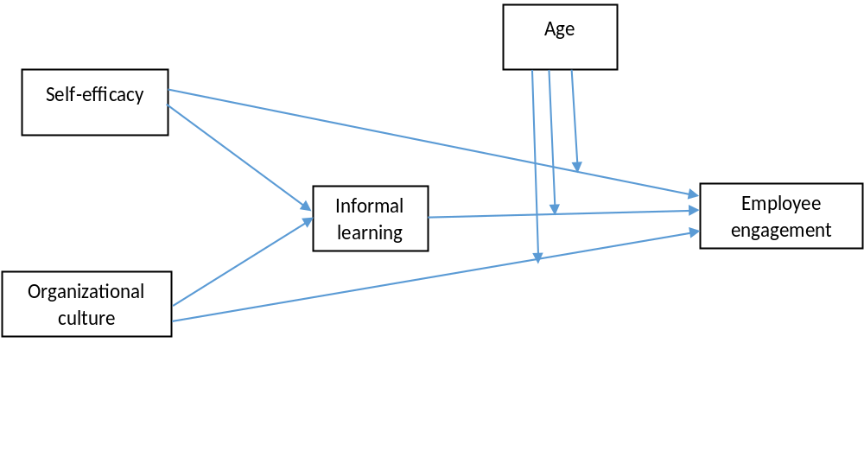
Self-efficacy is significantly positively related to informal learning and employee engagement.
Organizational culture is significantly positively related to informal learning and employee engagement.
Informal learning is significantly positively related to employee engagement.
Mediating variable: Informal learning will mediate the potential relationship between organizational culture and self-efficacy with employee engagement.
Moderating variable: Employee age will moderate the relationship between informal learning and employee engagement.

CHAPTER THREE
This section discussed the design and sample of the study and the demographic characteristics. The instruments for measuring the variables will also be addressed. The procedure used to collect the data was discussed, and finally, the details and the methods and techniques used for data analysis wwere presented.

Study Design
The purpose of this research study was to address the study research question. What is the relationship between self-efficacy and employee engagement taking the employees’ age into consideration? What is the relationship between organizational culture and employee engagement taking the employees’ age into consideration? This study proposed that the relationship between self-efficacy and organizational culture with employee engagement was mediated by informal learning and moderated by employees’ age.
An electronic survey was utilized to collect data for the study. Four existing instruments measured, self-efficacy (Bosscher & Smit, 1998), employee engagement (Schaufeli et al., 2002), organizational culture (Denison & Fisher, 2005), and informal learning (Lohman, 2005), were used for the survey. Age was operationalized as calendar age. The readability level for the survey was established using the Flesh-Kincaid Grade Level technique in MS word. A pilot test was conducted with twenty-five participants to determine the clarity of survey instructions and questions and the functionality of the online survey instrument.
Data was collected via three rounds of email invitations with a survey link, which was sent to the employees via their official email. After data collection, estimates of reliability was conducted for each four factors self-efficacy, organizational culture, informal learning, and employee engagement and all 101 instruments’ items were combined for the study using Cronbach’s alpha technique. A structural equation modeling analysis was conducted to test the theoretical model and structural correlation hypothesized in this study.

Population
The population of this study comprised of the employees working for the Oklahoma state government. Wong, McNamara, Shulkin, Lettieri, and Careiro (2008) indicated that people 55 years old and above make up 24 percent of the total populations of the state of Oklahoma. The percentage of population ages 55-64 employed in the state of Oklahoma is 57.8 percent. According to Wong, McNamara, Shulkin, Lettieri, and Careiro (2008), the industry with the highest population of 55-59-year-old people in the public administration which is 33.3 percent, and the unemployment rate for the same group is 2.6 percent. Also, workers aged 45-54 comprise the largest percentage of labor force participants working for the state of Oklahoma as public employees as of 2007.
Therefore, the population of this study was comprised of public employees from the Department of Rehabilitation Services, the Oklahoma Department of Transportation, Department of Agriculture, the Department of Corrections, and the Oklahoma Department of Mental Health and Substance Abuse. These departments were selected because they have the highest number of employees in the state of Oklahoma. According to Blatt (2014), Oklahoma has 36,470 full-time employees’ (FTE) positions. The departments listed above have 16,652 FTE positions, which is 45 percent of the total FTE positions in Oklahoma, hence the use of these departments for better representation and a meaningful context for the study to generate new and valuable findings.

Sample Size
The Structural Equation Modeling (SEM) is known to be a large scale or sample procedure for data modeling (Kline, 2016). The standard error of latent variables can be affected or may be inaccurate if the sample size is not large enough. Greater complexity or number of parameters requires bigger sample size than those with few parameters. Also, a large sample size is needed if scores of reliability are low; that is, less precise data require a more sample in order to offset the potentially distorting effects of measurement error. In addition, a higher level of missing data also requires larger sample sizes in order to make up for the loss of information.
Kline (2016) further states that the sample size requirement in SEM can be explored from two different viewpoints; the required number of cases so that the results can have adequate statistical precision and the minimum sample size needed in order for significance tests in SEM to have reasonable power. Jackson, (as cited in Kline, 2016) described the N:q rule for sample size estimation. The sample size for the study can be estimated by the ratio of the model of parameters that require statistical estimates (q) to the number of N-cases of the model. A recommended sample size to parameter ratio will 20:1. However, Kline (2016) also suggests that a median sample size for a typical SEM may be 200 cases based on the education and psychology research studies.

Instrumentation
The following assessment instruments were used for the study. They are self-efficacy (Bosscher & Smit, 1998), employee engagement (Schaufeli et al., 2002), organizational culture (Denison & Fisher, 2005), informal learning (Lohman, 2005), and age was operationalized as calendar age. These instruments were selected taking two criteria into consideration. The instruments must meet reasonable validity and reliability standards and the instruments are short and practical to implement in terms of the time to complete the survey by the respondents. The instrument employed in the survey had 101 items, excluding demographic information items. Each item was presented as a five-point Likert type scales with 5 being “strongly agree” and 1 being “strongly disagree”.

Measuring General Self-Efficacy
Following Bosscher and Smit (1998), self-efficacy was assessed using a scale originally created by Sherer et al. in 1982. The scale will measure three subscales and these include initiative, effort, and persistence subscales. The study reported a Cronbach alpha of 0.81. Chen, Gully, and Eden (2001) state that the internal consistency reliability for the general self-efficacy ranges from 0.76 to 0.89 and it has shown to be internally consistent in numerous organizations. The authors also state that the general self-efficacy scale has a high internal consistency reliability and predictive validity.
Sherer et al. (as cited in Bosscher & Smit, 1998) developed the general self-efficacy assessment instrument. The self-efficacy scale measures general self-efficacy expectancies in three core areas. The areas include persistence in the face of adversity, the willingness to initiate behavior and expend effort in completing the behavior. Bosscher and Smit (1998) state that the original scale had 17 items that were recorded on a 5-point Likert scale. Based on a pilot study conducted on the elderly respondents, five items were removed from the scale due to low correlation among the items and also due to ambiguous wording in the scale. This resulted in a new scale with 12-items (Bosscher & Smit, 1998). For full scale see appendix B.

Measuring Employee Engagement
Khan (1990) stated that if employees encountered the three psychological conditions, employees can successfully engage in work performance resulting in an employee performing their roles and responsibilities optimally. The conditions are meaningfulness, safety, and availability. However, Schaufeli et al., (2002) contend that Khan did not operationalize these constructs (psychological conditions). Hence, Schaufeli et al., (2002) proposed that engagement can be measured using vigor, dedication, and absorption. The author states that a higher level of resilience and persistence is vigor, and higher level of inspiration, challenges, and significance is associated with dedication. Lastly, to be dedicated, devoted, and absorbed in work-related activities is absorptions.
Schaufeli and colleagues initially measured an engagement with 24 self-constructed items. The engagement items initially reflect three dimensions, Vigor (VI) (9 items) Dedication (DE) (8 items), and Absorption (AB) (7 items), but after eliminating seven unsound items, three internally consistent scales were constructed that include 17 items altogether on a 5-point Likert scale. Schaufeli et al., (2002), the Internal consistencies for employee engagement for the 17 items were VI, α = 0.79, DE, α = 0.89, AB, α = 0.72. For full scale see appendix.

Measuring Organizational Culture
Ghosh and Srivastava, (2014) indicate that there are myriad of instruments for measuring organizational culture. Streimikiene and Mikalauskiene (2012) identify nine organizational culture survey instruments based on their specific outcomes. The different instruments measure different attributes related to organizational culture and some of the instruments tend to measure culture differently than other instruments depending on the researcher’s interest (Denison & Fisher, 2005).
This study adopted the Denison Organizational Culture Survey (DOCS). The DOCS instrument has been used by more than 6000 diverse organizations around the world and has been converted to different languages (Denison & Fisher, 2005). Denison and Mishra (1989) proposed four dimensions or traits of organizational culture. These dimensions are involvement, consistency, adaptability, and mission.
Streimikiene and Mikalauskiene (2012), the four main groups were further divided into three subgroups. First, employee empowerment, team orientation, development of capability were grouped into involvement. The organizational core value, agreement, and integration were grouped under consistency. Under adaptation, there are the need to create changes, customers focus, and organizational learning as subgroup. Lastly, organizational strategic directions, its visions, and goals were grouped under mission. According to Streimikiene and Mikalauskiene (2012), the advantage of the DOCS instrument is its ability to explore the relationship between organizational culture and its effectiveness.
Involvement. Denison and Mishra (1989) state that employees that are highly involved and participate in organizational activities tend to develop an engaged attitude with responsibilities. Involved or engaged employees are committed to the organizations and tend to operate under a greater autonomy. Hence, Streimikiene and Mikalauskiene (2012) state that, from the perspective of the organization, involvement is how the organization is able to focus and develop its employee and engage the employees in creating more commitment to the organizations.
Streimikiene and Mikalauskiene (2012) state that involvement has three dimensions, which include empowerment, team orientation, and capability development. Empowerment is where the employees have the power, ability, and creativity to manage their work situations without interference. The team orientation is where the employees take responsibilities to work toward mutual objectives in a cooperative and valued manner. Capability development involved the on-going investment by the organizations in the development of skills to meet the growth and development desire of the employees.
Consistency. According to Denison and Mishra (1989), cultural practices that are widely understood by employees in organizations tend to positively influence the employees’ ability to perform actions that are coordinated in the organization and also reach an agreement. Unfamiliar situations or contexts would require the employees to be more consistent in their actions and approach: employees are better able to react to the situations in predictable ways to an unpredicted environment. Agreement, coordination, core value, and integration are the three subdivision of consistency (Streimikiene & Mikalauskiene 2012). According to Streimikiene and Mikalauskiene (2012), the working together of the diverse part of the organization to achieving a stated objective is integration and coordination. The organization’s ability to reach a common consensus in determining sensitive issues is agreement. Sharing acceptable principles and standard with a defined expectation and distinct identity of the employees is the core value.
Adaptability. Denison and Mishra (1989) assert that the organizational customs and belief influence the ability and capacity of an organization to receive and process organizational information. To increase the organization’s chance of survival, the organization should be able to understand, and process external information into its internal process to effect changes. Streimikiene and Mikalauskiene (2012) identified three dimensions or traits of adaptability, and these include creating changes, customer focus, and organizational learning. Lastly, the organization’s capability to understand received information from the external environment and process it and subsequently turning that information into opportunities for innovation is organizational learning.
Mission. According to Denison and Mishra (1989), the organization purpose, its social roles and responsibilities to the external environment, and the employees perceived responsibilities with respect to the organizational roles and responsibilities is the mission.
The three subdivisions are the vision, strategic direction and intent, and goals and objectives (Streimikiene & Mikalauskiene, 2012). The organization’s purpose and how employees will contribute to the purpose is strategic direction and intent. The organization core value and shared views of the impending prospect by the employees are called vision. The distinct procedure to follow at work for all employees is the organizational objective which can be linked to the mission, vision and prospective approach to the organization.
According to Yilmaz and Ergun (2008), the coefficient alphas for the subgroup ranged from 0.7 to 0.86 for the twelve indices and from 0.87 to 0.92 for four traits or dimensions. For full scale see appendix B.

Measuring Informal Learning
There is the lack of indicators to measure informal learning in organizations, and this is related to inadequacies in current theories of workplace learning (Skule, 2004). However, to measure informal learning in the work environment, Lohman (2005) constructed a written questionnaire measuring public school educators and HRD professionals in the workplace. The adaptability and generalizability of this scale to other studies was the purpose of the study by (Lohman, 2005). Choi (2009) adopted this scale and generalized it to fit the context of its research. The survey instrument with twelve items was grouped into three domains. The first domain contains four items concerning learning with others, the second domain contains four items concerning self-experimentation, and the last domain contains four items concerning external scanning. The alpha level for learning with others was 0.866, the alpha level for self-experimentation was 0.829, and the alpha level for external scanning was 0.842 (Choi, 2009). A five-point Likert scale is used for each item and ranges from 1 (Infrequent) to 5 (Frequent) for this study. For full scale see appendix.

Measuring Age
Chronological age was operationalized as a calendar age. The age ranged from 16 to 65, which is the full benefit age of retirement. Participants were asked to state their full age in years. The age group of 1925 to 1945 is the silent generation, the baby boomers generation is from 1946 to 1964, from 1965 to 1980 is the generation X, and lastly, generation Y or millennium age bracket is from 1981 to 2001. Due to the nature of this study, the participants were categorized into older employees (the baby boomers) and younger employees (generation X and millennium).

Strategies to Assure Internal Validity and Reliability
The instruments were selected because they met the reasonable validity and reliability conditions, and they appear short and practical to administer taking the time to complete the survey into consideration. Even though the reliability and validity of the assessing instruments have been known in other studies, a Cronbach alpha for the sample of the study was determined. A pilot study survey was used to estimate the reliability, functionality of the instruments, the time it takes average participants to complete the questionnaire, and the clarity of the questions, and to remove any ambiguous questionnaire. This enabled necessary changes to be made before it can be sent out to the participants. This also allowed appropriate revisions to be made to improve the effectiveness of the online survey. The participants for pilot studies were the staff of the Department of Rehabilitation Services. The university survey service, Qualtrics, was used for data collection. An alpha whose coefficient is not is less than 0.7 is acceptable. It means that 70 percent of the variance is reliable as well as systematic (Kline, 2005).

Data Collection Procedure
Institutional Review Board (IRB) approval was obtained prior to contacting the participants for the research study. The agencies’ administrators were contacted for permission to have access to the agencies’ staffs email addresses. The primary mode of contact was the employees’ work email. The purpose and the general outline of the research study were introduced. An invitation email with a cover letter introducing the research study, the researcher and the benefits of the study was discussed and provided. Also, any likely harm that may come as a result of the study, confidentiality assurance, the contact information of the researcher, the term of consent, the researcher’s advisor information, and the approval letter from the IRB was discussed and provided. Electronic surveys were sent to the participants at Oklahoma state agencies. Three invitational email reminders to the online survey were employed to collect data from the participants at the Oklahoma state agencies.

Data Screening
The data were examined to resolve any issues before running the main analysis. The data were checked for accuracy, any missing data from the survey, outliers in the sample, multivariate normality, univariate normality, and linearity, and singularity and multicollinearity (Tabachnick & Fidell, 1996).

Accuracy
Tabachnick and Fidell (1996) stated that for data accuracy, the original data file is checked against the computer data file window. Since this research study involved a large data file, the examination of descriptive statistics and graphic representation of the variables was employed. IBM SPSS FREQUENCIES was use to examine the univariate statistics. Since the data were continuous variables, the study ensured that the data were within range and the standard deviation is plausible.

Missing Data
According to Tabachnick and Fidell, (1996), when comparing the amount and pattern of missing data, the most significant is the pattern of the missing data in the sample. The randomly scattered missing value in the data matrix was less of a problem, while nonrandomly missing values are serious because they affect the generalizability of the results. Missing data occur when respondents did not complete the questionnaire. Kline (2016) stated that a few missing values of less than 5 % in the total data set may be of little concern to the researcher as any method of handling missing values will yield similar results.

Outliers
Kline (2016) states that outlier scores can potentially alter the results of the analysis as the scores are different from the other scores in the data set. To determine outliers, Kline (2016) states that three standard deviations of the data were above the mean of the distribution. Statistical packages have outlier detection methods, and this includes box plot display, scatterplot, histogram, and frequency distribution (Schumacker & Lomax, 2016), and Mahalanobis distance (Kline, 2016) for multivariate outliers.

Linearity
According to Tabachnick and Fidell (1996), the assumption of linearity between two variables is the presence of a straight line relationship between them. If there is no substantial relationship between the variables, the relationship is ignored. To inspect the linearity in a relationship between variables, Tabachnick and Fidell (1996) stated that a bivariate scatter plot can be used. If the scatter plot is oval shaped then linearity is indicated.

Normality
Tabachnick and Fidell (1996) stated that normality of a variable can be assessed either by graphical or statistical methods. When a distribution is normal, the value of the skewness and kurtosis are zero. To test the significance of the skewness and kurtosis in a moderate to small samples, a conventional alpha level of 0.01 or 0.001 is used. In the case of a large sample, Tabachnick and Fidell (1996) stated that the researcher should look at the shape of the distribution. Also, a frequency histogram is an important graphical device for assessing normality.

Multicollinearity
Multicollinearity and singularity become an issue in the data when the variables are shows very high correlation between them in the correlation matrix (Tabachnick & Fidell, 1996). With multicollinearity, the variables are highly correlated (0.90 or above) and in singularity the variables are redundant. Logical and statistical can issues arise in the data set due to multicollinearity and singularity.

Data Analysis
The data analyses in the present research will include descriptive statistics for the data and structural equation modeling using Amos. A structural equation modeling was utilized to investigate the hypothesized structural relationship and the theoretical model. SPSS will also be used for descriptive statistics, construct validity, the estimate of reliability, and correlation analysis.

Descriptive Statistics
The descriptive statistics will include the total number of participants in the study. The means and the standard deviations for the items in survey instruments were presented.

Reliability
Reliability of the particular data samples has to do with how precise the scores in the samples are precise (Kline, 2016). Cronbach alpha was used to examine the internal consistency of the four instruments. For a Cronbach alpha to be considered excellent, it has to be around 0.9, very good it has to be 0.8, and 0.7 are adequate (Kline, 2016).

Correlation Analysis
Tabachnick and Fidell (1996) stated that the value of Pearson correlation ranges from + 1 and - 1, where values close to zero represent no linear relationship between the variables. Values of + 1 or -1 indicate perfect predictability of one score when the other is known.

Structural Equation Modeling (SEM)
The SEM was used to test the theoretical model and the structural relationship hypothesized in the current study. According to Lomax and Schumacker (2016), the first criterion for model testing is the chi-square test. If the model fit results in a non-significance test, the test is acceptable. This is a global fit measurement. This means that there are similarities between covariance and the model-implied covariance matrix. The acceptable level for the chi-square is the tabled Chi-square value, and one should compare obtained values with the tabled values for given degrees of freedom. The next criterion is Goodness of Fit Index (GFI); a value of zero indicates a no fit, while a value of 1 indicates a perfect fit, values very close to 0.90 or 0.95 reflect a good fit. The next model fit criterion is Adjusted GFI (AGFI), a value of zero indicates a no fit while a value of 1 indicates a perfect fit, the value adjusted for degrees of freedom with 0.90 or 0.95 indicate a good model fit. The next criterion is Root-mean-square residual (RMR). The next criterion is standardized RMR (SRMR); the acceptable level is less than 0.05 and a value less than 0.05 indicates a good model fit. The other criterion is Root mean square error of approximation (RMSEA); acceptable values range from 0.05 to 0.08, values of 0.05 to 0.08 indicate a close fit.
The remaining criterion measures model comparison. The proposed model and the null model are compared. The first criterion is the Tucker-Lewis index (TLI), a value of zero indicates a no fit, while a value of 1 indicates a perfect fit, and a value close to 0.90 or 0.95 reflects a good model fit. The other criterion is the Normed fit index (NFI); a value of zero indicates a no fit, while a value of 1 indicates a perfect fit, a value close to 0.90 or 0.95 reflects a good model fit. The next criterion is the Parsimony fit index (PNFI); a value of zero indicates a no fit, while a value of 1 indicates a perfect fit and compares values in alternative models. Lastly, with the Akaike information criterion (AIC), a value of zero indicates a perfect fit while a positive value indicates a poor fit and compares values in alternative models.
While discussing model identification, Tabachnick and Fidell (2013) stated that in order for the analysis to be carried out, the data point should be more than the parameter to be estimated, hence the model is over-identified. However, if the data point is equal to the parameter, the model is just identified, i.e., “the ‘estimated parameters perfectly reproduce the sample covariance matrix: chi-square and the degrees of freedom are equal to zero” (p. 714). The authors’ further stated that the measurement indices and analysis are uninteresting since the adequacy of the hypothesis cannot be tested but the path of the model can be tested.

Test for Mediation Effect
Kline (2016) stated that mediation refers to the causal hypothesis that one variable causes changes in another variable, which in turns leads to changes in the outcome variables. The Sobel test (Sobel, 1982) was used to determine if mediation has occurred in the analysis. Jose (2013) state that Sobel test is a statistical test that can be used to determine or verify that a reduction is statistically significant, i.e. the test of the size of the indirect effect.
The formula for the Sobel test is:
z – value = _ a*b_________
SQRT (b² *S²_{a} +a²*S²_{b})

According to Jose (2013), “‘a’ refers to the unstandardized regression coefficient for the path between the independent latent variable and the mediator”. The “‘b’ refers to the unstandardized regression coefficient for the path from the mediating variable to the outcome variable in a simultaneous inclusion regression involving the predictor variables and the mediator as a predictor of outcome variables.” The “‘S_{a}’ refers to the standard error of the ‘a’ path and ‘S_{b}’ refers to the standard error of the ‘b’ path.” The Sobel calculator was utilized to calculate the Sobel test. According to Jose (2013), the website (http://www.quantpsy.org/sobel/sobel/htm) was used to perform the Sobel calculation to test for the mediation effects. For the mediation effect to be significant, the p-value must be less than 0.5. To determine the amount of mediation effect (small, medium or large), the R² measures were utilized (Jose 2013). The R² is the proportion of the variance of the indirect effect to the variance of the total effect.

CHAPTER FOUR
This chapter presents the analysis and results of the models. The characteristics of the sample as well as the demographic were discussed, data screening was discussed as well and the various strategies for managing data accuracy, missing data, outliers, normality, linearity, and multicollinearity. Lastly, the path analysis for the two models (age groups) was discussed. The Sobel test of mediation test effect was also discussed as well.

The Characteristics of the Sample
The survey was sent to more than 2000 employees that work at the various Oklahoma State public agencies. Twenty-three percent or 439 of the employees participated in the survey. After examining the total responses from the participants, twenty-two of the responses were considered as inadmissible because the participants rarely or did not answer the survey questions up to fifty percent. The responses were deleted from the survey. The incomplete and deleted responses were (22/439) i.e., 5.01 %. The acceptable sample size was 417 to represent a population of more 2000 employees at the Oklahoma State public employees. After examining the remaining 417 survey responses, there were 11.27 percent or 47 cases of missing data. Using SPSS to detect if there were a specific pattern of missing data, no specific pattern of missing data was detected.

Demographic Characteristics
In order to examine the demographic characteristics of the participants, the researcher examines the descriptive statistics. The demographics includes the participants’ age, level of education, employment status, gender, ethnicity, and how long they have been working with the state of Oklahoma as a public employee.
Based on the demographic characteristics of the participants in the data sample, the age distribution were 46.3 % for the younger participants (50 years and younger) and 53.7 % for the older participants (51years and older). The older participants were the largest respondents to the survey. Of the respondents to the survey, 283 had bachelor and master’s degrees. The participants’ length of time employed with the Oklahoma State range for (0-20 years) was 316 while (21-above years) was 100 with one missing data. The participant employment status was 406 full-time employees and 9 part-time employees. The majority of the participants were 287 Caucasian, 73 Africa American, and 26 Native American i.e. 92.6% of the entire participants. There were 112 male respondents and 305 female respondents to the survey.

Data Screening

Accuracy
Since the data file for the research study involves a very large data set, the graphical representation of the variables was employed. The descriptive statistics were also examined for the data set. The examination of the descriptive statistics and graphical representation of the 101 items through SPSS FREQUENCIES shows that the data entered file were accurate. The data were within range and the standard deviation was plausible, and the minimum and maximum numbers were within the specified range of (1-5).

Missing Data
The method of multiple imputation through SPSS was applied to the dataset to manage the missing data. The method of multiple imputation makes no assumption if the missing data is random (Tabachnick & Fidell, 2013). Therefore the 417 cases were identified as the final sample size for the study.

Outliers
The box plot was used for the inspection of univariate outliers. The box plot of 101 items were examined to detect univariate outliers. The results from the box plot indicate a very small amount of outliers to the sample of the study. Mahalanobis distance was also computed for inspection of multivariate outliers. Twenty-five cases of outliers were observed, which is 5.99% and it implied a small amount of the outliers combined. See figure 1.

Linearity
The dataset was examined for linearity confirmation using scatter plot. Due to the impracticality of inspecting all scatter plots and due to the large sample data set, the scatter plot was inspected randomly. It was observed that there were linear relationships among the selected pairs of the variables. Hence, the assumption of linearity was met. See figure 2.

Multicollinearity
The criteria for multicollinearity as specified by Tabachnick and Fidell 2(013) are that the conditioning index is greater than 30 for a given dimension and the variance proportion (row) is greater than 0.50 for at least two different variables in the row. As seen on the collinearity diagnostic, the condition index was less than 30. No dimension (row) has more than one variance proportion greater than 0.50. It can be concluded that no multicollinearity was detected. Also, since the analysis for this study is for prediction purposes, the effect of collinearity can be ignored (Tabachnick & Fidell, 2013). See table 1.
Table 1: Collinearity Diagnostic Table

Variance proportion

Dimension | Eigen  value | Cond index | Constant | SE | IL | OC (Inv) | OC (Con) | OC (Adp) | OC (Miss)
1.00 | 6.73 | 1.00 | .00 | .00 | .00 | .00 | .00 | .00 | .00
2.00 | .13 | 7.20 | .01 | .33 | .03 | .02 | .02 | .00 | .03
3.00 | .06 | 10.66 | .04 | .55 | .38 | .00 | .00 | .00 | .01
4.00 | .03 | 15.73 | .23 | .05 | .13 | .28 | .06 | .05 | .21
5.00 | .02 | 17.25 | .32 | .03 | .28 | .00 | .30 | .00 | .37
6.00 | .02 | 20.76 | .09 | .03 | .12 | .48 | .58 | .16 | .14
7.00 | .01 | 22.68 | .31 | .01 | .06 | .21 | .03 | .78 | .23
SE = Self-Efficacy, IL = informal Learning, OC = Organizational Culture

Normality
The standardized skew index greater than 3 indicates a positive skew and less than three indicate a negative skew (Tabachnick & Fidell, 2013). Kline (2005) states that Kurtosis index greater than 20 indicates a high peaked distribution. Log and square root transformation will be performed in case of non-normality in order to achieve normality of the data distribution.
The skewness for the data set ranges from 0.48 to 1.107 and the kurtosis ranges from 0.004 to 1.782, which is within range for normal distribution. However, it is pertinent to note that the distribution for self-efficacy was not significantly departing from normality but it was not perfect as well. According to Tabachnick and Fidell (2013), if the sample is large, it is good to look at the histogram, as standard error decrease errors for both skewness and kurtosis decrease with larger N. Hence, using the histogram, all the variables were normally distributed except for self-efficacy. Transforming the variables into log and square-root for self-efficacy variables, the histogram for the self-efficacy was not normally distributed. See Histogram graph 1.
Due to one of the variables (self-efficacy) not normally distributed, the need to use multivariate normality was necessary. According to Kline (2016), in order to run the analysis to determine if it meets normality assumption with a critical ratio of < -1.96 or > 1.96, and an alpha of 0.05, and consequently rejecting the null hypothesis and to indicate departure from normality, the kurtosis should be greater than 7 and the skewness values be greater than 3.
In the assessment of normality, the skewness for all the variables were less than 3, the kurtosis for all the variables were less than 7 except for two variables whose kurtosis was 7.098 and 7.327. The critical ratio for 32 variables out of 101 total variables were in the range < -1.96 to > 1.96, i.e. 31.7%. This indicates a departure from normality. The CMIN/Chi-Square model was 0.164 which is not statistically significant, hence the model is a good fit for the data. Sample size tends to impact the chi-square report. The TLI value was 0.990, and the CFI was 0.999 which indicate a good fit and the RMSEA value was 0.041 which is very close to the required range of 0.05 to 0.08 for a close fit. The multivariate kurtosis values > 5 indicate a departure from multivariate normality. The multivariate kurtosis was 841.673 which is greater than 5, hence a departure from multivariate normality. Hence the need to bootstrap the data distribution using the Bollen-Stine method exists.
After bootstrapping, the p-value for the CMIN was significant indicating a poor fit to the model, the TLI drop to 0.709 and the CFI drop to 0.716, which is a moderate fit to the data, but the RMSEA improve to 0.058 from 0.041 which is slight and indicate a very close fit. The bootstrap distribution using the Bollen-Stine indicates a poor fit to the model as the chi-square (11843.977) falls in the upper tail of the sampling distribution ranging from 4704.77 to 7634.679. The Bollen-Stine p-value was 0.002 which indicate a poor fit to the data distribution. The unstandardized regression weight p-value was less than 0.05 for all the variables indicating a statistical significance for the variables. The maximum likelihood estimate critical ratio falls outside of < -1.96 and > 1.96, which indicate a departure from normality.
In conclusion, using the Bollen-Stine method for bootstrapping in order to achieve normality for the variables actually created more problems for the data set. The fit indices achieve were not a better fit for the model. The previous results obtained without the bootstrapping procedure indicate a better fit than the bootstrapped data distribution.

Estimates of Reliability
The reliability estimation was performed for self-efficacy, employee engagement, informal learning, and organizational culture (involvement, mission, consistency, and adaptability) using Cronbach alpha technique. The result shows that self-efficacy scale demonstrated a Cronbach alpha of 0.857, the employee engagement scale demonstrated a 0.816, informal learning scale reported a 0.839, organizational culture scale (consistency reported a 0.773, involvement reported a 0.759, adaptability reported a 0.775, and mission reported a 0.776). These reports alphas indicated that at least 75% of the variance was systematic and reliable. See table 2

Table 2: Estimates of Reliability
Item-Total Statistics

 | Scale Mean if Deleted | Scale Variance if item Deleted | Corrected item Total Correlation | Squared Multiple Correlation | Cronbach’s Alpha if item Deleted
SE | 15.0294 | 10.919 | 0.154 | 0.068 | 0.857
EE | 14.6547 | 9.198 | 0.497 | 0.353 | 0.816
IL | 14.2144 | 10.283 | 0.313 | 0.236 | 0.839
OC (Inv) | 14.2290 | 7.618 | 0.806 | 0.734 | 0.759
OC (Con) | 14.2216 | 8.042 | 0.739 | 0.699 | 0.773
OC (Adp) | 14.0802 | 8.434 | 0.752 | 0.698 | 0.775
OC (Mss) | 14.3158 | 8.004 | 0.721 | 0.691 | 0.776
SE = Self-Efficacy, EE = Employee Engagement, IL = informal Learning, OC = Organizational Culture

Correlation Analysis
The p-value was used to test for the correlation coefficient in the data set. For p-value < 0.05, this study rejects the null hypothesis and infers that the true population correlation between the variables is not zero (Kline, 2013). The p-value of less than 0.05 was used to determine if the degree of association was significant. Also, the Cohen and Cohen (1988) rule was adopted. Rho (ρ) absolute values of 0.10 indicate a small relationship, an absolute value of 0.30 indicates a medium relationship and an absolute value 0.50 indicates a large relationship.
Using the p-value, the relationship between self-efficacy and employee engagement was statistically significant at p < 0.05 but has a small to moderate relationship as the correlation between the two variables was 0.243. The relationship between self-efficacy and informal learning was statistically significant at p < 0.005 but has a weak relationship as the correlation between the two variables was 0.134. The relationship between self-efficacy and organizational culture was not statistically significant at p < 0.005 and has a weak relationship as the correlation between the two variables was 0.095.
The relationship between employee engagement and informal learning was statistically significant at p < 0.005 and has a moderate to a strong relationship as the correlation between the two variables was 0.471. The relationship between employee engagement and organizational culture was statistically significant at p < 0.005 and has a moderate to a strong relationship as the correlation between the two variables was 0.401. The relationship between informal learning and organizational culture was statistically significant at p < 0.005 and has a medium relationship as the correlation between two variables was 0.219. See table 3

Table 3: Correlations Analysis

 | SE | EE | IL | OC
SE | 1
EE | .243** | 1
IL | .134** | .471** | 1
OC | .095 | .401** | .219** | 1
Mean | 1.761 | 2.136 | 2.576 | 2.579
SD | .564 | .702 | .588 | .682
Skewness | 1.099 | 1.107 | .116 | .509
Kurtosis | 1.782 | 1.894 | .307 | -.119
** Correlation is significant at the 0.01 level (2 tailed). N=417, M=Mean; SD=Standard deviation SE = Self-Efficacy, EE = Employee Engagement, IL = informal Learning, OC = Organizational Culture

Testing for Measurement Invariance
The participants were grouped in two groups (50 years and younger) and (51 years and older) for analysis and comparison. This is necessary to understand the effect or influence of age on the participants. According to Schumacker and Lomax (2016), the general assumption is that the data for each group is adequate to the measurement model for a multiple group analysis. As noted by Tabachnick and Fidell, (2013), to begin a multi-group analysis, different groups with a good fitting model will have to be created and run separately. The different models with no parameters constrained to be equal are then tested in one run. The authors further state that the unconstrained model is used as a standard to evaluate other restricted models. Using unconstrained model as a standard, other rigorous constraints are then indicated by constraining several parameters among the groups. Also, the authors stated that the chi-square test is performed for each group between the less restrictive and the more restrictive group. The researcher will want a nonsignificant chi-square. If the regression coefficient, variance, and covariance are the same across groups, it is concluded that the different group represents the same population.
The unconstrained is just identified as the degrees of freedom is zero. The structural weight with 5 degrees of freedom is the fit of the model that is forcing the equality of the path coefficient. The relative fit indices of structural weight appear good. The fit of the models was tested with equality constrained places in an increasingly restricted fashion, there was a structural weight, structural covariance models and structural residual. The structural weight model, structural covariance models and structural residual are fitting in the data based on the indices.
Table 4: Model Fit for the Measurement Invariance

Model | CMIN | GFI | AGFI | CFI | RMSEA
Unconstrained | 0.00 | 1.000 | 0 | 0 | 0.000
Structural weight | 4.507 | 0.020 | 0.978 | 1.00 | 0.000
Structural covariance | 7.135 | 0.019 | 0.978 | 1.00 | 0.000
Structural residual | 14.488 | 0.024 | 0.976 | 0.974 | 0.033

The model Comparison
The model comparison, i.e., testing to see if this model yields a significant decrease in fit relative to the unconstrained model. Comparing each of this model against the unconstrained model, the structural weight chi-square difference was 4.507 with a p=0.479 which is non-significant. That means that the assumptions of invariance parameter hold, the model did not yield any significant decrease in fit relative to the unconstrained model means all the path coefficient can be treated as invariant between the two groups. Hence the relationship between the two groups is the same. The structural covariance model is being compared against the structural weight model, the chi-square comparing the model with constrained structural covariance indicate that there is no significant decrease in fit as the chi-square difference was 2.628 with a p =0.453 which is non-significant. Hence, relationship between the two groups is the same. There is a significant decrease in fit in structural residual model by forcing the error to be equal.
The unconstrained model has no equality constraints, meaning that all parameters are allowed to be freely estimated in each group. The structural weights model incorporates equality constraints for all path coefficients. Overall, the fit of this model to the data was good, and there was no significant decrease in fit relative to the unconstrained model. The structural covariance model incorporated added equality constraints (i.e., equal variances and covariance among the exogenous predictor variables). This model also fit the data well and there was no significant decrease in fit relative to the structural weights model. The final model was a structural residuals model that included two additional equality constraints pertaining to the disturbance terms in the model. This model also fit the data well. However, the chi-square difference test indicated that by adding in these last equality constraints the model decreased significantly in terms of its fit (relative to the structural covariance model). It can be concluded based on this data sample that age does not moderate the relationship between self-efficacy, organizational culture, informal learning with employee engagement, see table 11. There is also no statistical difference between the mean and standard deviations for the two groups. See table 12 and 13. Consequently, hypothesis 8 is not supported.
Table 5: Multi-Group Model Comparison
Predictor | Chi-square/GOF & DF |  | CFI |  | RMSEA | PLCOSE |  | Chi square difference  Δχ²
Structural weight invariant | X² (5) =4.507  p= 0.479 |  | 1.00 |  | 0.00 | 0.862 |  | X² (5)=4.507  p =0.479
+Structural covariance invariant | X² (8)=7.135  p =0.522 |  | 1.00 |  | 0.00 | 0.932 |  | X² (3)=2.628  p =0.453
+Structural residual | X² (10)=14.48  p =0.152 |  | 0.978 |  | 0.033 | 0.760 |  | X² (2)=7.353  p =0.025
Table 6: Descriptive statistics for 50 years and younger
 |  | N |  | Mean |  |  | Standard deviation
SE |  | 193 |  | 1.8074 |  |  | 0.53577
EE |  | 193 |  | 2.2179 |  |  | 0.71994
IL |  | 193 |  | 2.5495 |  |  | 0.54159
OC |  | 193 |  | 2.5399 |  |  | 0.66339
SE = Self-Efficacy, EE = Employee Engagement, IL = informal Learning, OC = Organizational Culture

Table 7: Descriptive statistics for 51 years and older

 |  | N |  | Mean |  |  | Standard deviation
SE |  | 224 |  | 1.7219 |  |  | 0.58726
EE |  | 224 |  | 2.0657 |  |  | 0.68135
IL |  | 224 |  | 2.5996 |  |  | 0.62713
OC |  | 224 |  | 2.6131 |  |  | 0.69783
SE = Self-Efficacy, EE = Employee Engagement, IL = informal Learning, OC = Organizational Culture

Group Correlational Analysis

Participants 50 and Younger
The correlation between self-efficacy and employee engagement is statistically significant at p < 0.001. Adopting the Cohen and Cohen (1983) criteria, the relationship between the two variables is medium and there is a positive correlation between the variables. This supports hypothesis 2. The correlation between self-efficacy and informal learning is statistically significant at p < 0.001. Adopting the Cohen and Cohen (1983) criteria, the relationship between the two variables is medium and there is a positive correlation between the variables. This supports hypothesis 1. The correlation between self-efficacy and organizational culture is not statistically significant at p < 0.001. Adopting the Cohen and Cohen (1983) criteria, the relationship between the two variables is very weak and there is a positive correlation between the variables. There was no hypothesis testing for this relationship.
The correlation between employee engagement and informal learning is statistically significant at p < 0.001. Adopting the Cohen and Cohen (1983) criteria, the relationship between the two variables is moderately strong and there is a positive correlation between the variables. This supports hypothesis 5. The correlation between employee engagement and organizational culture is statistically significant at p < 0.001. Adopting the Cohen and Cohen (1983) criteria, the relationship between the two variables is moderately strong and there is a positive correlation between the variables. This supports hypothesis 4. The correlation between informal learning and organizational culture is statistically significant at p < 0.001. Adopting the Cohen and Cohen (1983) criteria, the relationship between the two variables is medium and there is a positive correlation between the variables. This supports hypothesis 3.

Table 8: Correlation Matrix for 50 years and Younger

 | SE | EE | IL | OC
SE | 1
EE | 0.210** | 1
IL | 0.196** | 0.486** | 1
OC | 0.058 | 0.459** | 0.278** | 1
**. Correlation is significant at the 0.01 level (2 tailed), SE = Self-Efficacy, EE = Employee Engagement, IL = informal Learning, OC = Organizational Culture

Participants 51 Years and Older
The correlation between self-efficacy and employee engagement is statistically significant at p < 0.001. Adopting the Cohen and Cohen (1983) criteria, the relationship between the two variables is medium and there is a positive correlation between the variables. This supports hypothesis 2. The correlation between self-efficacy and informal learning is not statistically significant at p < 0.001. Adopting the Cohen and Cohen (1983) criteria, the relationship between the two variables is very weak but there is a positive correlation between the variables. Hypothesis 1 is not supported for this age group. The correlation between self-efficacy and organizational culture is not statistically significant at p < 0.001. Adopting the Cohen and Cohen (1983) criteria, the relationship between the two variables is weak and there is a positive correlation between the variables. There was no hypothesis testing for this relationship.
The correlation between employee engagement and informal learning is statistically significant at p < 0.001. Adopting the Cohen and Cohen (1983) criteria, the relationship between the two variables is moderately strong and there is a positive correlation between the variables. This supports hypothesis 5. The correlation between employee engagement and organizational culture is statistically significant at p < 0.001. Adopting the Cohen and Cohen (1983) criteria, the relationship between the two variables is medium and there is a positive correlation between the variables. This supports hypothesis 4. The correlation between informal learning and organizational culture is statistically significant at p < 0.001. Adopting the Cohen and Cohen (1983) criteria, the relationship between the two variables is weak and there is a positive correlation between the variables. This support hypothesis 3.

Table 9: Correlation Matrix for 51 Years and Older

 | SE | EE | IL | OC
SE | 1
EE | 0.260** | 1
IL | 0.097 | 0.478** | 1
OC | 0.130 | 0.367** | 0.174** | 1
**. Correlation is significant at the 0.01 level (2 tailed) SE = Self-Efficacy, EE = Employee Engagement, IL = informal Learning, OC = Organizational Culture

Structural Equation Modeling
Since the model to be estimated is just identified, the chi-square and degrees of freedom will be equal to zero. Using the Amos software, the number of distinct sample moment was 10, the number of distinct parameters to be estimated was 10. The degree of freedom was zero. The model was just identified. The model fit indices/statistics for the just identified model cannot be used to estimate the model, hence, the researcher will have to look at the individual parameters to make a determination.

Participants 50 Years and Younger
Organizational culture was found to be a significant predictor of informal learning with (β = 0.268, p < 0.001), hence hypothesis 3 was supported. Organizational culture was found to be a significant predictor of employee engagement with (β = 0.351, p < 0.001), hence hypothesis 4 was supported. Self-efficacy was found to be a significant predictor of informal learning with (β = 0.181, p =0.008), hence hypothesis 1 was supported. Self-efficacy was found to be a significant predictor of employee engagement with (β = 0.118, p =0.044) hence hypothesis 2 was supported. Informal learning was found to be a significant predictor of employee engagement with (β = 0.365, p < 0.001) hence hypothesis 5 was supported. There was no significant relationship between self-efficacy and organizational culture at p =0.426. Self-efficacy and organizational culture account for 11.0 % of the variance in informal learning. Self-efficacy and organizational culture account for 36.4 % of the variance in employee engagement.
Table 10: Participants 50 Years and Younger
Predictor | B | S.E | C.R | p-value | Standardized Beta
SE | 0.183 | 0.069 | 2.655 | 0.008 | 0.181
OC | 0.218 | 0.056 | 3.923 | 0.000 | 0.268
IL | 0.485 | 0.081 | 5.984 | 0.000 | 0.365
SE = Self-Efficacy, IL = informal Learning, OC = Organizational Culture

Table 11: Standardized Regression Weights

 | Estimate
IL< ------ SE | 0.181
IL< ------- OC | 0.268
EE < ---- IL | 0.365
EE< ---- SE | 0.118
EE < ---- OC | 0.351
SE = Self-Efficacy, EE = Employee Engagement, IL = informal Learning, OC = Organizational Culture

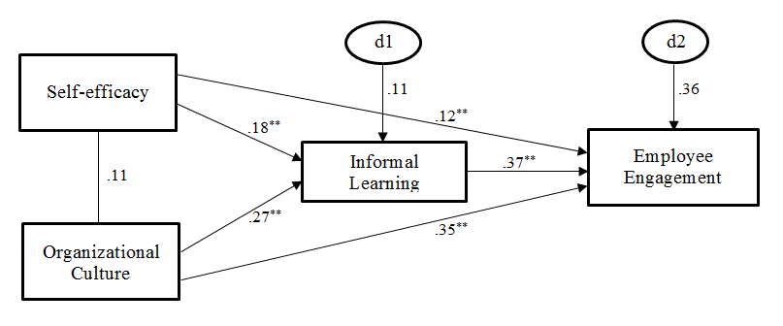
Diagram 2: Standardized and diagrammatic representation for 50 years and younger.
** Significant at p <.001

Participants 51 Years and Older
Organizational culture was found to be a significant predictor of informal learning with (β = 0.165, p = 0.013), therefore hypothesis 3 was supported. Organizational culture was found to be a significant predictor of employee engagement with (β = 0.271, p < 0.001), thus hypothesis 4 was supported. Self-efficacy was not found to be a significant predictor of informal learning with (β = 0.076, p = 0.253), hence hypothesis 1 was not supported for this age group. Self-efficacy was found to be a significant predictor of employee engagement with (β = 0.184, p < 0.005) hence hypothesis 2 was supported. Informal learning was found to be a significant predictor of employee engagement with (β = 0.412, p < 0.001) hence hypothesis 5 was supported. There was no significant relationship between self-efficacy and organizational culture at p = 0.054. Self-efficacy and organizational culture account for 3.6% of the variance in informal learning. Self-efficacy and organizational culture account for 34.5% of the variance in employee engagement.
When assessing the two groups for a difference in parameters estimates, it was found that there was a significant difference between the age group 50 years and younger, and age group 51 years and older in self-efficacy. There was no significant difference between the age group 50 years and younger, and age group 51 years and older in organizational culture and informal learning.
Table 12: Participants 51 Years and Older
Predictor | B |  | S.E | C.R |  |  | p-value |  | Standardized Beta
SE | 0.081 |  | 0.071 | 1.144 |  |  | 0.253 |  | 0.076
OC | 0.148 |  | 0.060 | 2.482 |  |  | 0.013 |  | 0.165
IL | 0.448 |  | 0.060 | 7.469 |  |  | 0.000 |  | 0.412
SE = Self-Efficacy, IL = informal Learning, OC = Organizational Culture

Table 13: Standardized Regression Weights

 | Estimate
IL< ------ SE | 0.076
IL< ------- OC | 0.165
EE< ------- IL | 0.412
EE < -------SE | 0.184
EE < ------ OC | 0.271
SE = Self-Efficacy, EE = Employee Engagement, IL = informal Learning, OC = Organizational Culture

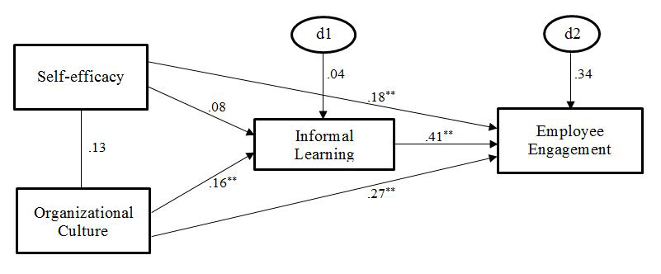
Diagram 3: Standardized and diagrammatic representation for 51 years and older
** Significant at p < 0.001

CHAPTER FIVE:
A brief summary of the analysis was highlighted and discussed. The research hypotheses and related findings in the study from the two age groups were discussed. A comparison between the two groups was also offered as well. The implication for research, HRD professional, and limitations of the study were discussed, followed by the recommendation and direction for future studies.

Brief Summary
The purpose of this research was to examine the relationship between organizational culture and self-efficacy in organizations to achieving employee engagement as a result of the aging workforce and to reduce the intergenerational knowledge gap. The participants in the survey were divided into two categories: the older participants aged 51 and older, and the younger participants, 50 years old and younger. The research also examine if there was any significant difference in organizational culture experience and self-efficacy between the two groups in achieving employee engagement. The variables of the study were self-efficacy, organizational culture, informal learning, and employee engagement. The participants’ age was the moderating variable, while informal learning was the mediating variable in the study analysis.
The survey use four instruments and these include self-efficacy (Bosscher & Smit, 1998), employee engagement (Schaufeli et al., 2002), organizational culture (Denison & Fisher, 2005), and informal learning (Lohman, 2005). Organizational culture was grouped into four survey instruments for the ease of analysis and these include mission, adaptability, consistency, and involvement. This is consistent with the development of the instrument. The survey had a total of 101 items excluding demographics. The 101 survey items were presented on a five-point Likert-type scale with 1 being, strongly agree to 5 being, strongly disagree. Some of the items were reverse coded. A pilot test was conducted with twenty-five participants to determine the reliability, and clarity of the survey items, and the functionality of the online survey instrument. After examination of the pilot participants’ responses, minor changes were made to ensure the functionality and the ease of participation in the survey. The reliability estimate calculated for the pilot study shows that the Cronbach alpha was greater than 0.80 for all variables. A Cronbach alpha of 0.9 is considered excellent, values around 0.80 are very good, and values around 0.7 are adequate (Kline, 2016).
Prior to analyzing the data, the items that were reversed coded were re-coded appropriately for uniformity. Also, certain assumptions required before data analysis can be carried were conducted. These include missing data, multivariate normality, linearity, outliers, the estimate of reliability, and multicollinearity. Results of the data screening show that data transformation was required for one of the survey items (self-efficacy), however, after using log and square root transformation, there was no significant difference to the results. Hence, the self-efficacy was used as is without any transformation, even though there was some evidence of modest non-normality on some of the variables but it was not substantial.
The data analyses include descriptive statistics, correlation analysis, and multi-group structural equation modeling (SEM). The SEM was divided into two groups due to the age of the participants (50-years-old and younger, and 51-years-old and older). Multi-groups analysis was performed to determine good-fitting models for each group and the moderating effect of age on the groups. The statistical software SPSS was used for the descriptive statistics, reliability estimates, correlation analysis, while AMOS was used for the multi-group SEM. The online Sobel test was used to calculate the mediating effects.

Discussion

Hypothesis 1: The Relationship between Self-Efficacy and Informal Learning
As indicated in hypothesis 1, there will be a significant positive relationship between self-efficacy and informal learning between all participants irrespective of the age group. Hypothesis 1 was supported by the empirical data for participants 50 years and younger but not supported by the empirical data for participants 51 years and older. Self-efficacy has a significant relationship with informal learning for participants 50 years and younger for (p < 0.05). Self-efficacy does not have a significant relationship with informal learning for participants 51 years and older (p < 0.05). Adopting the Cohen and Cohen (1988) standard, the strength of the relationship was medium for participants 50 years and younger and participants 51 years and older. Self-efficacy was a significant predictor of informal learning for participants 50 years and younger, but a not a significant predictor for participants 51 and older (for p < = 0.05). Also, 18.1 percent of the variance in informal learning was explained by the variance in self-efficacy for participants 50 years and younger. While only 7.6 percent of the variance in informal learning was explained by the variance in self-efficacy for participants 51 years and older. It is pertinent to note that informal learning mediates the relationship between self-efficacy and employee engagement for all participants.
Most literature identified in this study indicated the importance and the relationship between self-efficacy and informal learning. It was highly anticipated that the age group (50 year and younger and 51 years and older) will not have any effect on the relationship between self-efficacy and informal learning. However, the results from the correlation analysis and regression estimates indicate otherwise particularly for participants 51 years and older. This result confirms Klassen and Chu (2010) study when they conclude that self-efficacy tends to be significantly influenced by the participants’ age. They stated that self-efficacy tends to increase in early and mid-career stages and decrease with late career stages. Also, Niessen, Swarowsky, and Leiz (2010) concluded that as participants aged, their motivation and self-efficacy at work is significantly affected. This also confirms the result of this study. This study found that self-efficacy was not directly and significantly related to informal learning for participants 51 years and older. However, the study also found that self-efficacy was directly and significantly related to informal learning for participants 50 years and younger.

Hypothesis 2: The Relationship between Self-Efficacy and Employee Engagement
As indicated in hypothesis 2, there was a significant positive relationship between self-efficacy and employee engagement between all participants irrespective of the age group. Hypothesis 2 was supported by the empirical data for participants 50 years and younger and participants 51 years and older. Self-efficacy has a significant relationship with employee engagement for participants 50 years and younger and participants 51 years and older (p < 0.05). Adopting the Cohen and Cohen (1983) standard, the strength of the relationship was medium for participants 50 years and younger and participants 51 years and older. Self-efficacy was a significant predictor of informal learning for participants 50 years and younger, and participants 51 and older (for p < = 0.05). Also, 11.8 percent of the variance in employee engagement was explained by the variance in self-efficacy for participants 50 years and younger. Comparably, 18.4 percent of the variance in employee engagement was explained by the variance in self-efficacy for participants 51 years and older.
This result also confirmed (Fearon, McLaughlin, & Morris, 2013; Luthan & Peterson, 2002) when they assert that self-efficacy and employee engagement have a strong positive relationship. It can be pointed out that the higher the employee self-efficacy, the higher the level of employee engagement at work. Therefore, Robertson-Smith and Markwick (2009) conclude that employees with self-efficacy tend to engage themselves in their role at work and are efficient.

Hypothesis 3: The Relationship between Organizational Culture and Informal Learning
As indicated in hypothesis 3, there was a significant positive relationship between organizational culture and informal learning between all participants irrespective of the participants’ age group. Hypothesis 3 was supported by the empirical data for participants 50 years and younger and participants 51 years and older. Organizational culture had a significant relationship with informal learning for participants 50 years and younger and participants 51 years and older (p < 0.05). Adopting the Cohen and Cohen (1983) standard, the strength of the relationship was medium for participants 50 years and younger and participants 51 years and older. Organizational culture was a predictor of informal learning for participants 50 years and younger, and participants 51 and older (for p < = 0.05). Also, 26.8 percent of the variance in informal learning was explained by the variance in organizational culture for participants 50 years and younger. In contrast, 16.5 percent of the variance in informal learning was explained by the variance in organizational culture for participants 51 years and older. This result confirmed (Ellinger, 2005; Kyndt, Dochy, & Nijs, 2009; Lohman, 2009) studies. These authors conclude that organizational culture has a positive impact on the informal transfer of knowledge in an organization. This study also found that organizational culture was directly and significantly related to informal learning for all participants.

Hypothesis 4: The relationship between Organizational Culture and Employee Engagement
As indicated in hypothesis 4, there was a significant positive relationship between organizational culture and employee engagement between all participants irrespective of the participants’ age group. Hypothesis 4 was supported by the empirical data for participants 50 years and younger and participants 51 years and older. Organizational culture had a significant relationship with employee engagement for participants 50 years and younger and participants 51 years and older (p < 0.05). Adopting the Cohen and Cohen (1983) standard, the strength of the relationship was moderately strong for participants 50 years and younger and medium for participants 51 years and older. Organizational culture was a predictor of employee engagement for participants 50 years and younger, and participants 51 and older (for p < 0.05). Also, 35.1 percent of the variance in employee engagement was explained by the variance in organizational culture for participants 50 years and younger while 27.1 percent of the variance in employee engagement was explained by the variance in organizational culture for participants 51 years and older.
This result is consistent with findings from (Sadeli, 2015; Bedarkar & Pandita, 2014; Sarangi & Srivastava, 2012) studies. These authors concluded that organizational culture and employee engagement are positively related. Hence, the authors also indicate that for any organization to achieve organizational performance with regard to knowledge transfer, the organizational culture of the organization needs to significantly influence the employee engagement.

Hypothesis 5: The Relationship between Informal Learning and Employee Engagement
Lastly, as indicated in hypothesis 5, there was a significant positive relationship between informal learning and employee engagement between all participants irrespective of the participants’ age group. Hypothesis 5 was supported by the empirical data for participants 50 years and younger and participants 51 years and older. Informal learning had a significant relationship with employee engagement for participants 50 years and younger and participants 51 years and older (p < 0.05). Adopting the Cohen and Cohen (1983) standard, the strength of the relationship was moderately strong for participants 50 years and younger and moderately strong for participants 51 years and older. Informal learning was a predictor of employee engagement for participants 50 years and younger, and participants 51 and older (for p < = 0.05). Also, 36.5 percent of the variance in employee engagement was explained by the variance in informal learning for participants 50 years and younger while 41.2 percent of the variance in employee engagement was explained by the variance in informal learning for participants 51 years and older.
This result is consistent with Robinson, Perryman, and Hayday’s (2004) studies. They asserted that the older the employees the stronger their informal learning engagement level in an organization. This study also confirms (Brad Shuck, Rocco, & Albornoz, 2011; Lund & Borg, 1999; Naquin & Holton III, 2002, Van Rijn, Yang, & Sanders, 2013) studies and conclusions. They conclude that engaged employees tend to participate informal learning activities thereby promoting knowledge transfer in the organization.

Hypothesis 6: The relationship between organizational culture and employee engagement will be mediated by informal learning.

Hypothesis 7: The relationship between self-efficacy and employee engagement will be mediated by informal learning.
To determine if informal learning was a mediator variable, the process of Baron and Kenny (1986) was used to make the determination. The process includes: the outcome variable is regressed on the predictor variable, followed by the mediator being regress on the predictor variable. Lastly, the predictor variable and mediator are then regressed on the outcome variable. Then testing the path described above involves the use of Sobel test calculator. The p-value of less than 0.05 was used as a criterion to determine if the mediation effect was significant.
In this study, employee engagement was regressed on self-efficacy, informal learning was regressed on self-efficacy, and self-efficacy and informal learning were regressed on employee engagement. The Sobel test statistic t-value was 2.30 and p-value = 0.021. This suggests that informal learning mediates the relationship between self-efficacy and employee engagement. Employee engagement was regressed on organizational culture (Inv), informal learning was regressed on organizational culture (Inv), and organizational culture (Inv) and informal learning were regressed on employee engagement. The Sobel test statistic t-value was 4.63 and p-value was 0.000. This suggests that informal learning mediate the relationship between organizational culture (Inv) and employee engagement. Employee engagement was regressed on organizational culture (Con), Informal learning was regressed on organizational culture (Con), and informal learning and organizational culture (Con) were regressed on employee engagement. The Sobel test statistic t-value was 3.21 and the p-value was 0.001. This suggests that informal learning mediates the relationship between organizational culture (Con) and employee engagement. Employee engagement was regressed on organizational culture (Adap), Informal learning was regressed on organizational culture (Adap), and informal learning and organizational culture (Adap) were regressed on employee engagement. The Sobel test statistic t-value was 3.25 and the p-value was 0.001. This suggests that informal learning mediates the relationship between organizational culture (Adap) and employee engagement. Employee engagement was regressed on organizational culture (Miss), Informal learning was regressed on organizational culture (Miss), and informal learning and organizational culture (Miss) were regressed on employee engagement. The Sobel test statistic t-value was 2.83 and the p-value was 0.004. This suggests that informal learning mediates the relationship between organizational culture (Miss) and employee engagement. The study validates hypothesis 6 and hypothesis 7.
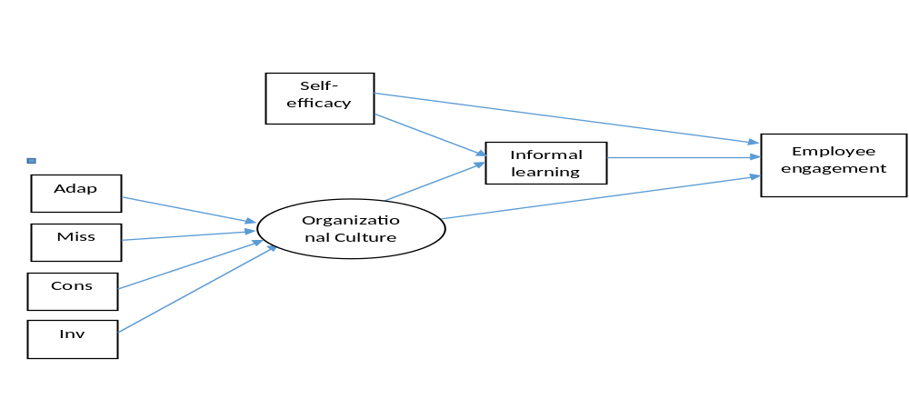
Diagram 4: Diagrammatic representation of the mediation effect of informal learning

Limitations of the Study
Several limitations may affect the generalizability of the findings of this study. This research used the public sector as the sample for the study. The entire pool is from the same public sector of the economy. In order to better generalize the results, the researcher should also apply the study to the private sector. However, with informal learning in organizations, whether in the public or private sectors, there is a lack of statistical and significant differences in employees’ reliance upon informal learning in their training/learning activities (Wu & Rocheleau, 2001). Bullock, Stritch, and Rainey (2015) conclude that there is significant evidence that indicates that public sector employees have a higher level of public-service-oriented motives and organizational commitment and engagement than private sector employees. Hence, the findings from the present study may be difficult to generalize to the private sector.
Another limitation is the self-reporting. Self-reporting on a closed-format survey will not allow participants to choose more than one answer or try to describe the situations that impact their level of engagement, self-efficacy or the culture of the organization differently. The self-report format chosen for this research compels participants to answer questions in a way that may not reflect their views or opinions. Another anticipated issue with the self-reporting format is the issue with participants refusing to answer some of the survey questions; participants may also not respond to questions truthfully because they cannot remember or they wish to present themselves in a socially acceptable manner.

Implication for HRD Research, Theory, and Practice
This research study will have several implications for HRD theory, practitioners, and researchers. The following implications arose from this study. This study adds to the existing knowledge of informal learning in the organizations as well as applying and reinforcing theories, and helping practitioners maximize their leadership positions in the organizations.
The anticipated exit of the baby boomers from the workforce will create a huge knowledge void that will need to be filed. The inability of the organization to fill these positions with competent and knowledgeable employees will inevitably result in poor employee engagement, leading to poor performance and financial loss to the organizations. Therefore, management will need to seek effective ways to address this concern. There is a vast amount of literatures that discussed the issue of knowledge loss in the organizations and how to effectively manage the issue. However, very few literature mention the benefits of informal learning as a way to ensure that knowledge is transferrable among employees to create employee engagement while taking the employees’ age into considerations.
This study offers first-hand support to the potential advantage of informal learning to achieving employees’ engagement taking the employees’ age into consideration, while attaining knowledge transfer in the organizations. Even though there were previous reports from practitioners on ways to transfer knowledge in the organizations, few studies examined it from the context of the employee’s age. The hypothesized model of employee engagement outcome using informal learning as a mediating variable and the employees’ age as moderating variables in this study was sufficiently supported by the empirical data of this study.
The research study identified informal learning as a method for managing knowledge loss due to the baby boomers exit from the workforce. In addition, this research study identified organizational culture and self-efficacy as invaluable variables affecting informal learning in the organizations. The results of this study provide further evidence that age moderates the relationship between organizational culture, self-efficacy, informal learning, with employee engagement for participants 50 years and younger and participants 51 years and older. This was in line with data collected for the study. The results also show that informal learning was a mediating variable between self-efficacy and organizational culture, with employee engagement. This relationship has not been established in previous studies investigating employee engagement due to baby boomers exiting the workforce due to retirement.
From the findings, employees’ age affected their self-efficacy with respect to informal learning for participants 51 years and older, but not for participants 50-years and younger. This result confirms Klassen and Chu’s (2010) study when they conclude that self-efficacy tends to be significantly influenced by the participants’ age. This also confirms Bandura (1994). Bandura (1994) state that when the older employees measure their work abilities or performances with the younger employees, it results in lower self-efficacy for the older employees. Employees with a low self-efficacy are known to be less active in acquiring and sharing knowledge in the organizations (Shao, Wang, & Feng, 2015). Researchers, practitioners, as well as management interested in retaining older employees and creating mentorship programs will be vested in understanding ways to ensure that the older employees have a higher self-efficacy. Also, the results show that, for all participants, including the 51-years and older, their self-efficacy and employee engagement were highly correlated. Hence, Robertson-Smith and Markwick (2009) conclude that employees with self-efficacy tend to engage themselves in their role at work and are efficient.
The results also indicate the organizational culture was a very pertinent factor in informal learning. Belias et al. (2016) stated that organizational culture is significant and pertinent to employees and organizations as it promotes and supports systematic operation and reduces the uncertainty of employees and helps to promote organizational creativity and innovation. Organizational culture that promotes and recognizes that learning in the organization is important for business success and growth, tend to promote and encourage values such as teamwork, self-management, empowerment, and knowledge sharing among employees (Marquardt, 2011). Practitioners should promote a culture that fosters productivity, knowledge sharing, and employees’ empowerment and initiatives in the organizations.
Practitioners should promote learning in the organization by supporting and creating a learning culture where knowledge is free flowing from the older employees to the younger employees. Practitioners and management should understand how to create an organizational culture that encourages informal learning for all employees. The organizational culture that encourages informal learning tends to create a work environment where employees who believe in their capability are able to make a difference in the organizations. Older employees who have a higher self-efficacy and believe in their abilities to perform in the organization tend to stay longer beyond their retirement with the organization. Successful retention policy gearing towards the development of older employees’ self-efficacy and strong organizational culture will ultimately lead to knowledge transfer in the organization. Consequently, this study presents a strong argument for informal learning in the organizations while taking the employees’ age into consideration.
The results from this research bear implication for the theoretical framework of informal learning especially corroborating with the Watkins and Marsick model of informal learning. Some of the tenets of the Watkins and Marsick model propose the concept of experiential learning, organizational context, and the concept of critical reflectivity. As the learning from experience notion as suggested by Watkins and Marsick (1992), the older employees have invaluable experience that can benefit the younger employees as vice versa. This involves the collaboration and challenging the initial belief system and experimenting with new processes. The collaboration between the employees creates a solid relationship for effective knowledge transfer. For the organizational context notion as put forward by Watkins and Marsick (1992), the organization that supports learning tend to create work settings suitable for knowledge transfer. Critical reflection according to Watkins and Marsick (1992) is the bringing of one's expectations and critically appraising the expectation. Consequently, Van Woerkom, Nijhof and Nieuwenhuis (2002) identify motivation, self-efficacy, and experience concentration as factors influencing informal learning. Therefore, this theory provided a deeper foundation for this study while this research provided empirical support to the Watkins and Marsick’s theory of informal learning.
The findings from this study provide solid justification for promoting informal learning in the organizations to ensure knowledge transfer. The empirical impact of informal learning from this study can be used as a management strategy or tools to achieve knowledge transfer, employee engagement, and improve performance while minimizing or reducing knowledge and financial loss to the organizations. As such, the management, organizations, and HRD professionals should create a culture that integrates informal learning where employees can learn continuously from each other.

Recommendations and Directions for Future Research
The findings from this research study have a possible application and intervention in the organizations experiencing high baby boomer retirement. This study identified organizational culture and self-efficacy as a predictor of employee engagement via informal learning with the participants’ age as moderating factor. Self-efficacy was a not predicting informal learning for participant 51 years and older and the relationship was not statistically significant. But in general, self-efficacy and organizational culture have been predicted to be strong predictors of informal learning for different age groups.
It would behoove on the organizations to strengthen the self-efficacy of the older employees to help them feel highly motivated to share their knowledge with younger employees and be willing to contribute more. As stated in previous studies, Lee (as cited in Lee Endres, Endres, Chowdhury, & Alam, 2007) stated that collaborations among employees ensure knowledge transfers and learning outcome, and self-efficacy has a strong predictive factor in knowledge sharing among employees. Organizations actively seeking ways to ensure knowledge transfer should seek ways to improve the self-efficacy of the older adults. One of the processes of improving self-efficacy involves learning from peers (Paggi & Jopp, 2015).
Organizations whose culture promote and support systematic operations tend to promote organizational creativity and innovation (Belias et al., 2016). Organizations that promote and encourage teamwork, and empowerment among their employees tend to indicate strong knowledge transfer activities among the employees (Marquardt, 2011). Hence, the organizations should adopt a culture that promotes employees’ productivity and knowledge sharing in the organization.
Some of the common forms of informal learning in the organizations are the community of practice and mentoring program. Hence, organizations that create a community of practice tend to indicate a high level of knowledge sharing within the organizations (Li et al., 2009). Organizations that limit or disrupt communities of practice tend to destroy the very working and learning practice of the organization. Therefore, organizations are encouraged to create a community of practices focusing on knowledge transfer. Mentoring is a situation where employees are paired with each other to foster a learning relationship in the organization for the purpose of knowledge sharing (Srivastava & Jomon, 2013). The organizations involved in the intentional pairing of the less experienced employees with the experience employees tend to create a lasting relationship conducive to knowledge sharing leading to employee engagement.
As stated earlier, there is a paucity of studies with regard to using age as a moderating variable to determine the relationship between self-efficacy, organizational culture, informal learning and employee engagement. There is also a lack of studies that use informal learning as a mediating variable between self-efficacy and organizational culture in achieving employee engagement. Hence, the need for this study is assured. It is necessary also to explore other variables that explain variations in informal learning and explore employee engagement due to knowledge gap as a result of the exit of the baby boomers in the organizations.
Since this research explores the public sector only, it becomes imperative that further qualitative and quantitative research that explore other sectors of the economy are performed. This is necessary in order to extend the usefulness and generalization of this study. This will give a deeper insight into the relationship between employee engagement, self-efficacy, and organizational culture. This will also test if the model will behave the same way across the different sectors in further studies.
Paggi and Jopp (2015) indicate that most of the constructs for measurement in the psychological field were normed to the younger individuals. According to the authors, self-efficacy instrument was normed to the younger individuals, hence the authors recommend the use of occupational self-efficacy for measurement for older adults. However, Paggi and Jopp (2015) further state there was no much information about the predictor and outcome of the measurement for the older adults. It is recommended that further research should be done in this area to test the occupational self-efficacy for the older adults.

Summary and Conclusion
Organizational drivers, personal drivers, relations drivers, and task and job drivers are positively related to informal learning in organizations thereby driving up organization performance and reducing intergenerational knowledge loss in organizations. It should be noted that any organizations concerning with the knowledge loss as a result of the retirement of its employees, should consider its organizational cultures, and ways to improve employee self-efficacy, especially among the older employees in order to ensure knowledge transfer among its employees through the informal learning process.

References
Aibino, V., Garavelli, A.C., & Gorgolione, M. (2004). Organization and technology in knowledge transfer. An International Journal 11(6), 584-600.
Anderson, L.D. (2015). Organization development: The process of leading organizational change. Thousand Oaks, CA: Sage.
Argote, L, & Ingram, P. (2000). Knowledge transfer: A basis for competitive advantage in firms. Organizational Behavior and Human Decision Processes. 82(1), 150-169.
Armstrong-Stassen, M. (2008). Human resource practices for mature workers—And why aren’t employers using them? Asia Pacific Journal of Human Resources, 46(3), 334–352.
Armstrong-Stassen, M., & Schlosser, F. (2011). Perceived organizational membership and the retention of older workers. Journal of Organizational Behavior, 32(2), 319–344. https://doi.org/10.1002/job.647.
Avery, D. R., McKay, P. F., & Wilson, D. C. (2007). Engaging the aging workforce: The relationship between perceived age similarity, satisfaction with coworkers, and employee engagement. Journal of Applied Psychology, 92(6), 1542–1556. doi:10.1037/0021-9010.92.6.1542.
Baltes, B.P., Staudinger, U. M., Lindenberger, U. (1999). Lifespan psychology: Theory and application to intellectual functioning. Annual Review of Psychology, 50(1), 471-507.
Bandura, A. (1994). Self-efficacy. In V. S. Ramachaudran (Ed.), Encyclopedia of Human Behavior. (Vol. 4, pp. 71-81). New York, NY: Encyclopedia of Human Behavior.
Baron, R. M. & Kenny, D. A. (1986). The moderator-mediator variable distinction in social psychological research: conceptual strategic and statistical considerations. Journal of Personality and Social Psychology, 51(6), 1173-1182.
Bates, S. (2004). Getting engaged. HR Magazine, 49(2), 44-51. Retrieved from https://search-proquest-com.ezproxy.lib.ou.edu/docview/205260619?accountid=12964.
Bedarkar, M., & Pandita, D. (2014). A study on the drivers of employee engagement impacting employee performance. Procedia - Social and Behavioral Sciences, 133, 106–115. doi: 10.1016/j.sbspro.2014.04.174.
Belias, D., Velissariou, E., Kyriakou, D., Gkolia, A., Sdrolias, L., Koustelios, A., & Varsanis, K. (2016). The advantages of organizational culture in Greek banks. Journal of Management Research, 16(3), 123–134.
Bellou, V. (2007). Achieving long‐term customer satisfaction through organizational culture: Evidence from the health care sector. Managing Service Quality: An International Journal, 17(5), 510–522. doi:10.1108/09604520710817334.
Bellou, V. (2010). Organizational culture as a predictor of job satisfaction: The role of gender and age. Career Development International, 15(1), 4–19. doi:10.1108/13620431011020862.
Bennington, L., & Tharenou, P. (1996). Older workers: Myths, evidence and implications for Australian managers. Asia Pacific Journal of Human Resources, 34(3), 63–76.
Berg, S. A., & Chyung, S. Y. (Yonnie). (2008). Factors that influence informal learning in the workplace. Journal of Workplace Learning, 20(4), 229–244. doi:10.1108/13665620810871097.
Billett, S., Dymock, D., Johnson, G., & Martin, G. (2011). Last resort employees: Older workers’ perceptions of workplace discrimination. Human Resource Development International, 14(4), 375–389. doi:10.1080/13678868.2011.601571.
Bosscher, R. J., & Smit, J. H. (1998). Confirmatory factor analysis of the general self-efficacy scale. Behaviour Research and Therapy, 36(3), 339–343.
Brad Shuck, M., Rocco, T. S., & Albornoz, C. A. (2011). Exploring employee engagement from the employee perspective: Implications for HRD. Journal of European Industrial Training, 35(4), 300–325. doi:10.1108/03090591111128306.
Bratianu, C., & Leon, R. D. (2015). Strategies to enhance intergenerational learning and reducing knowledge loss: An empirical study of universities. VINE, 45(4), 551–567. doi:10.1108/VINE-01-2015-0007.
Brown, J. S., & Duguid, P. (1991). Organizational learning and communities-of-practice: Toward a unified view of working, learning, and innovation. Organization Science, 2(1), 40–57.
Bullock, J. B., Stritch, J. M., & Rainey, H. G. (2015). International comparison of public and private employees’ work motives, attitudes, and perceived rewards. Public Administration Review, 75(3), 479–489. doi:10.1111/puar.12356.
Cartwright, S., & Cooper, C. L. (1993). The role of culture compatibility in successful organizational marriage. Academy of Management Perspectives, 7(2), 57–70.
Chaudhary, R., Rangnekar, S., & Barua, M. K. (2012). Relationships between occupational self-efficacy, human resource development climate, and work engagement. Team Performance Management: An International Journal, 18(7/8), 370–383. doi:10.1108/13527591211281110.
Chen, G., Gully, S. M., & Eden, D. (2001). Validation of a new general self-efficacy scale. Organizational Research Methods, 4(1), 62–83.
Choi, W. (2009). Influences of formal learning, personal characteristics, and work environment characteristics on informal learning among middle managers in the Korean banking sector. (Doctoral Dissertation). Retrieved from https://etd.ohiolink.edu/. (Document No. Osu 1258387882.).
Choi, W., & Jacobs, R. L. (2011). Influences of formal learning, personal learning orientation, and supportive learning environment on informal learning. Human Resource Development Quarterly, 22(3), 239–257. doi:10.1002/hrdq.20078.
Christian, M. S., Garza, A. S., & Slaughter, J. E. (2011). Work engagement: A quantitative review and test of its relations with task and contextual performance. Personnel Psychology, 64(1), 89–136.
Cleveland, J. N., & Shore, L. M. (1992). Self-and supervisory perspectives on age and work attitudes and performance. Journal of Applied Psychology, 77(4), 469.
Cofer, D.A. (2000.d). Informal workplace learning. (Issue Brief No. 10). Retrieved from http://www.calpro-online.org/eric/textonly/docgen.asp?tbl=pab&ID=100.
Cohen, J., & Cohen, P. (1983). Applied multiple regression/correlation analysis for the behavioral sciences. Hillsdale, N.J: L. Erlbaum Associates.
D’Amato, A., & Herzfeldt, R. (2008). Learning orientation, organizational commitment and talent retention across generations: A study of European managers. Journal of Managerial Psychology, 23(8), 929–953. doi:10.1108/02683940810904402.
De Lange, A. H., Taris, T. W., Jansen, P., Smulders, P., Houtman, I., & Kompier, M. (2006). Age as a factor in the relation between work and mental health: Results from the longitudinal TAS survey. Occupational Health Psychology: European Perspectives on Research, Education and Practice, 1, 21–45.
de Mello e Souza Wildermuth, C., & Pauken, P. D. (2008). A perfect match: Decoding employee engagement – Part I: Engaging cultures and leaders. Industrial and Commercial Training, 40(3), 122–128. doi:10.1108/00197850810868603.
DeLong, D. W. (2004). Lost knowledge: Confronting the threat of an aging workforce. New York: Oxford University Press.
Denison, D. R., & Fisher, C. (2005). The Role of the board of directors in shaping corporate culture: Reactive compliance or visionary leadership? Paper presented at the “Changing the Game Forum: Reforming American Business. June 2-4, 2005, Beaver Creek, Colorado.
Denison, D. R., & Mishra, A. K. (1989). Organizational culture and organizational effectiveness: A theory and some preliminary empirical evidence. In academy of management proceedings. Academy of Management, 168–172. Retrieved from http://proceedings.aom.org/content/1989/1/168.short.
Deshpande, R., & Webster Jr., F. E. (1989). Organizational culture and marketing: Defining the research agenda. The Journal of Marketing, 3–15.
Doornbos, A. J., Simons, R.J., & Denessen, E. (2008). Relations between characteristics of workplace practices and types of informal work-related learning: A survey study among Dutch police. Human Resource Development Quarterly, 19(2), 129–151. doi:10.1002/hrdq.1231.
Dries, N., Pepermans, R., & De Kerpel, E. (2008). Exploring four generations’ beliefs about career: Is “satisfied” the new “successful”? Journal of Managerial Psychology, 23(8), 907–928. doi: 10.1108/02683940810904394.
Eddy, E. R., D’Abate, C. P., Tannenbaum, S. I., Givens-Skeaton, S., & Robinson, G. (2006). Key characteristics of effective and ineffective developmental interactions. Human Resource Development Quarterly, 17(1), 59–84. doi:10.1002/hrdq.1161.
Eldor, L. (2017). Looking on the bright side: The positive role of organizational politics in the relationship between employee engagement and performance at work. Applied Psychology, 66(2), 233–259. https://doi.org/10.1111/apps.12090.
Eldor, L., & Harpaz, I. (2016). A process model of employee engagement: The learning climate and its relationship with extra-role performance behaviors: A process model of employee engagement. Journal of Organizational Behavior, 37(2), 213–235. doi:10.1002/job.2037.
Ellinger, A. D. (2005). Contextual factors influencing informal learning in a workplace setting: The case of “reinventing itself company.” Human Resource Development Quarterly, 16(3), 389–415.
Eraut, M. (2000). Non-formal learning and tacit knowledge in professional work. British Journal of Educational Psychology, 70(1), 113–136.
Eraut, M. (2004). Informal learning in the work. Studies in Continuing Education, 26(2), 247-273.
European Centre for the Development of Vocational Training. (2012). Working and ageing: The benefits of investing in an ageing workforce. Luxembourg: Publications Office of the European Union.
Fearon, C., McLaughlin, H., & Morris, L. (2013). Conceptualising work engagement: An individual, collective and organisational efficacy perspective. European Journal of Training and Development, 37(3), 244–256. doi:10.1108/03090591311312723.
Foss, N. J., Husted, K., & Michailova, S. (2010). Governing knowledge sharing in organizations: Levels of analysis, governance mechanisms, and research directions. Journal of Management Studies, 47(3), 455–482. doi:10.1111/j.1467-6486.2009.00870.x.
Froehlich, D., Beausaert, S., Segers, M., & Gerken, M. (2014). Learning to stay employable. Career Development International, 19(5), 508–525. doi:10.1108/CDI-11-2013-0139.
Ghosh, S., & Srivastava, B. K. (2014). Construction of a reliable and valid scale for measuring organizational culture. Global Business Review, 15(3), 583–596. doi:10.1177/0972150914535145.
Griffin, B., & Hesketh, B. (2003). Adaptable behaviours for successful work and career adjustment. Australian Journal of Psychology, 55(2), 65–73.
Harter, J. K., Schmidt, F. L., & Hayes, T. L. (2002). Business-unit-level relationship between employee satisfaction, employee engagement, and business outcomes: A meta-analysis. Journal of Applied Psychology, 87(2), 268–279. doi:10.1037/0021-9010.87.2.268.
Harvey, J. (2012). Managing organizational memory with intergenerational knowledge transfer. Journal of Knowledge Management, 16(3), 400–417. doi:10.1108/13673271211238733.
Helms, M. M., & Stern, R. (2001). Exploring the factors that influence employees’ perceptions of their organization’s culture. Journal of Management in Medicine, 15(6), 415–429. doi:10.1108/EUM0000000006502.
Homberg, F., & Bui, H. T. (2013). Top management team diversity: A systematic review. Group & Organization Management, 38(4), 455–479.
Hu, B., & Zhao, Y. (2016). Creative self-efficacy mediates the relationship between knowledge sharing and employee innovation. Social Behavior and Personality: An International Journal, 44(5), 815–826. Doi:10.2224/sbp.2016.44.5.815.
Huselid, M.A. (1995). The impact of human resources management practices on turnover, productivity, and corporate financial performance. Academy of Management Journal, 38(3), 635-672.
Islam, M. Z., Rahman, M. H., Hasan, I., & Kifle, H. B. H. (2014). Organizational culture and knowledge transfer: Evidence from the Bruneian public organization employees. In European Conference on Knowledge Management, 2(1), 463-470. Academic Conferences International Limited.
Islam, Z., Hasan. I., & Rahman, M. H. (2015). Factor affecting knowledge transfer in public organization employees. Asia Social Science. 11(4). 223-233.
James, J. B., McKechnie, S., & Swanberg, J. (2011). Predicting employee engagement in an age-diverse retail workforce. Journal of Organizational Behavior, 32(2), 173–196.
James, J. B., Swanberg, J. E., & McKechnie, S. P. (2007, October). Responsive workplaces for older workers: Job quality, flexibility and employee engagement. (Issue Brief No. 11). Retrieved from Boston College, Center on Aging & Workplace Flexibility. http://hdl.handle.net/2345/3535.
Janz, B. D., & Prasarnphanich, P. (2003). Understanding the antecedents of effective knowledge management: The importance of a knowledge-centered culture. Decision Sciences, 34(2), 351–384.
Jeon, K. S., & Kim, K. N. (2012). How do organizational and task factors influence informal learning in the workplace? Human Resource Development International, 15(2), 209–226. doi: 10.1080/13678868.2011.647463.
Johnson, G. (2004). Otherwise engaged. Training, 41(10), 4. Retrieved from https://search-proquest-com.ezproxy.lib.ou.edu/docview/203413031?accountid=12964.
Joseph, K., & Dai. C. (2009). The influence of organizational culture on organizational learning, worker involvement and worker productivity. International Journal of Business and Management, 4(9), 243.
Kanfer, R., & Ackerman, P. L. (2004). Aging, adult development, and work motivation. Academy of Management Review, 29(3), 440–458.
Khan, W. A. (1990). Psychological conditions of personal engagement and disengagement at work. Academy of Management Journal, 33(4), 692-724. Retrieved from https://search-proquest-com.ezproxy.lib.ou.edu/docview/199783385?accountid=12964.
Klassen, R. M., & Chiu, M. M. (2010). Effects on teachers’ self-efficacy and job satisfaction: Teacher gender, years of experience, and job stress. Journal of Educational Psychology, 102(3), 741–756. doi:10.1037/a0019237.
Kline, R.B. (2016). Principles and practice of structural equation modeling. London; New York: The Guildford Press.
Koc‐Menard, S. (2009). Training strategies for an aging workforce. Industrial and Commercial Training, 41(6), 334–338. doi:10.1108/00197850910983938.
Kogan, N., Margolis, L., & Salkind, N. (2006). Chronological age. In Encyclopedia of Human Development. (Vol.1, pp. 266-267). Retrieved from http://asp6new.alexanderstreet.com.ezproxy.lib.ou.edu/psyc/psyc.object.details.aspx?dorpID=1000387025.
Kooij, D., de Lange, A., Jansen, P., & Dikkers, J. (2008). Older workers’ motivation to continue to work: Five meanings of age: A conceptual review. Journal of Managerial Psychology, 23(4), 364–394. doi:10.1108/02683940810869015.
Kordbacheh, N., Shultz, K. S., & Olson, D. A. (2014). Engaging mid and late career employees: The relationship between age and employee engagement, intrinsic motivation, and meaningfulness. Journal of Organizational Psychology, 14(1), 11.
Kruger, J., & Killham, E. (2006). Who’s driving innovation at your company? Gallup. Retrieved from http://www.gallup.com/businessjournal/24472/whos-driving-innovation-your-company.aspx.
Kwakman, K. (2003). Factors affecting teachers’ participation in professional learning activities. Teaching and Teacher Education, 19(2), 149–170. doi:10.1016/S0742-051X(02)00101-4.
Kyndt, E., Dochy, F., & Nijs, H. (2009). Learning conditions for non‐formal and informal workplace learning. Journal of Workplace Learning, 21(5), 369–383. doi:10.1108/13665620910966785.
Lee Endres, M., Endres, S. P., Chowdhury, S. K., & Alam, I. (2007). Tacit knowledge sharing, self‐efficacy theory, and application to the Open Source community. Journal of Knowledge Management, 11(3), 92–103. doi:10.1108/13673270710752135.
Li, J., Brake, G., Champion, A., Fuller, T., Gabel, S., & Hatcher‐Busch, L. (2009). Workplace learning: The roles of knowledge accessibility and management. Journal of Workplace Learning, 21(4), 347–364. doi:10.1108/13665620910954238.
Liu, D., & Fu, P. (2011). Motivating protégés’ personal learning in teams: A multilevel investigation of autonomy support and autonomy orientation. Journal of Applied Psychology, 96(6), 1195–1208. doi:10.1037/a0024716.
Livingstone, D.W. (2000). Researching expanded notions of learning and work and underemployment: Finding of the first Canadian survey of informal learning practice. International Review of Education, 46(6), 491-514.
Llorens, S., Schaufeli, W., Bakker, A., & Salanova, M. (2007). Does a positive gain spiral of resources, efficacy beliefs and engagement exist? Computers in Human Behavior, 23(1), 825–841. doi:10.1016/j.chb.2004.11.012.
Lohman, M. C. (2000). Environmental inhibitors to informal learning in the workplace: A case study of public school teachers. Adult Education Quarterly, 50(2), 83–101.
Lohman, M. C. (2003). Work situations triggering participation in informal learning in the workplace: A case study of public school teachers. Performance Improvement Quarterly, 16(1), 40–54.
Lohman, M. C. (2005). A survey of factors influencing the engagement of two professional groups in informal workplace learning activities. Human Resource Development Quarterly, 16(4), 501–527.
Lohman, M. C. (2009). A survey of factors influencing the engagement of information technology professionals in informal learning activities. Information Technology, Learning, and Performance Journal, 25(1), 43.
Lohman, M.C. (2006). Factors influencing teachers’ engagement in informal learning activities. Journal of Workplace Learning, 18(3), 141-156.
Lord, R. L. (2004). Empirical evaluation of classical behavioral theories with respect to the motivation of older knowledge workers. (Unpublished Doctoral Dissertation). University of Alabama, Huntsville.
Lund, T., & Borg, V. (1999). Work environment and self-rated health as predictors of remaining in work 5 years later among Danish employees 35-59 years of age. Experimental Aging Research, 25(4), 429–434. doi:10.1080/036107399243904.
Luthans, F., & Peterson, S. J. (2002). Employee engagement and manager self-efficacy. Journal of Management Development, 21(5), 376–387. doi:10.1108/02621710210426864.
Macey, W. H., & Schneider, B. (2008). The meaning of employee engagement. Industrial and Organizational Psychology, 1(1), 3–30.
Marquardt, J.M. (2011). Building the learning organization: Achieving strategic advantage through a commitment to learning. Boston, MA: Nicholas Brealey Publishing.
Marsick, V. J. (2009). Toward a unifying framework to support informal learning theory, research and practice. Journal of Workplace Learning, 21(4), 265–275. doi:10.1108/13665620910954184.
Marsick, V. J., & Volpe, M. (1999). The nature and need for informal learning. Advances in Developing Human Resources, 1(3), 1–9.
Marsick, V. J., & Watkins, K. E. (2001). Informal and incidental learning. New Directions for Adult and Continuing Education, 2001(89), 25–34.
Marsick, V. J., Watkins, K. E., Callahan, M. W., & Volpe, M. (2006). Reviewing theory and research on informal and incidental learning. Online Submission. Retrieved from https://eric.ed.gov/?id=ED492754.
Maslach, C., Schuafeli, B.W., & Leiter. P. M. (2001). Job burnout. Annual Review of Psychology, 52, 397-422. doi: 0066-4308/01/0201-0397.
Mattox, J. R. (2012). Measuring the effectiveness of informal learning methodologies. Developmental and Learning in Organizations: An International journal, 66(2), 48-53.
Maurer, T. J., Weiss, E. M., & Barbeite, F. G. (2003). A model of involvement in work-related learning and development activity: The effects of individual, situational, motivational, and age variables. Journal of Applied Psychology, 88(4), 707–724. doi:10.1037/0021-9010.88.4.707.
Merriam, B.S., Caffarella, S.R., & Baumgartner, M.L (2007). Learning in adulthood: A comprehensive guide. San Francisco, CA: John Wiley & Son.
Mishra, B., & Bhaskar, A. U. (2010). The learning enabling structure: Validating a measuring instrument. Indian Journal of Industrial Relations, 46(1), 157–164.
Montford, H. (2011). Oh won’t you stay just a little bit longer: Changing employers’ views. Australian Bulletin of Labor, 37(2), 164-190.
Nair, C. J., & Dovina, T. (2015). Relationship between self-efficacy and subjective wellbeing of employees in an organization. Annamalai International Journal of Business Studies & Research. Retrieved from http://search.ebscohost.com/login.aspx?direct=true&profile=ehost&scope=site&authtype=crawler&jrnl=0975749X&AN=109025176&h=GEAvGWaDzAA%2BvFQqpt4St8IsO%2F%2Faxj4%2BBA8ctF0EDqhNgh33EQhzwhUQ6mzUg2n7CvTcCl3vpmXKvcWjddrMrQ%3D%3D&crl=f.
Naquin, S.S., & Holton, E.F. (2002). The effects of personality, affectivity, and work commitment on motivation to improve work through learning. Human Resource Development Quarterly, 4(4), 357-376.
Niessen, C., Swarowsky, C., & Leiz, M. (2010). Age and adaptation to changes in the workplace. Journal of Managerial Psychology, 25(4), 356–383. doi:10.1108/02683941011035287.
Noe, R. A., Tews, M. J., & Marand, A. D. (2013). Individual differences and informal learning in the workplace. Journal of Vocational Behavior, 83(3), 327–335. doi:10.1016/j.jvb.2013.06.009.
Noe, R.A. (2013). Employee training and development. New York, NY: McGraw-Hill Irwin
Osoian, A. (2014). Memories, a bridge towards intergenerational learning! Procedia - Social and Behavioral Sciences, 142, 499–505. https://doi.org/10.1016/j.sbspro.2014.07.655.
Paggi, M., & Jopp, D. (2015). Outcomes of Occupational Self-Efficacy in Older Workers. The International Journal of Aging and Human Development, 80(4), 357-378.
Paulin, C. (2014). The aging workforce: Leveraging the talents of mature employees. SHRM foundation’s effective practice guidelines series (SHRM Publication No. 14-0749). Alexandria, VA: SHRM Foundation. Retrieved from https://www.researchgate.net/publication/274707176_The_Aging_Workforce_Leveraging_the_Talents_of_Mature_Employees?enrichId=rgreq-559d21edc473b57ecaacffabb1042c90-XXX&enrichSource=Y292ZXJQYWdlOzI3NDcwNzE3NjtBUzoyMTYzMjM2MTIyNTQyMDhAMTQyODU4Njk3NjQ3Ng%3D%3D&el=1_x_2&_esc=publicationCoverPdf.
Penland, P. R. (1977). Self-planned learning in America. Final report. Retrieved from http://eric.ed.gov/?id=ED184589.
Perry, L. S. (2010). The aging workforce. Professional Safety, 55(4), 22-28. Retrieved from https://search-proquest-com.ezproxy.lib.ou.edu/docview/304680959?accountid=12964.
Pinto, A. M. G. L. R. S., da Silva Ramos, S. C. M., & Nunes, S. M. M. D. (2014). Managing an aging workforce: What is the value of human resource management practices for different age groups of workers? Tékhne, 12, 58–68. doi:10.1016/j.tekhne.2015.01.007.
Rheberger, B., & Wognum, I. (1997). Supporting the career development of older employees: an HRD study in a Dutch company. International Journal of Training and Development, 1(3), 191-198.
Roberts, J. (2000). From know-how to show-how? Questioning the role of information and communication technologies in knowledge transfer. Technology Analysis & Strategic Management, 12(4), 429-443. Retrieved from https://search-proquest-com.ezproxy.lib.ou.edu/docview/226916149?accountid=12964.
Robinson, D., Perryman, S., & Hayday, S. (2004). The drivers of employee engagement (Report No. 408). Retrieved from the Institute for Employment Studies website: http://www.employment-studies.co.uk/system/files/resources/files/408.pdf.
Ropes, D. (2013). Intergenerational learning in organizations. European Journal of Training and Development, 37(8), 713–727. doi:10.1108/EJTD-11-2012-0081.
Ropes, D. (2014). Intergenerational learning in organizations: An effective way to stimulate older employee learning and development. Development and Learning in Organizations: An International Journal, 28(2), 7–9. doi:10.1108/DLO-10-2013-0078.
Sadeli, J. (2015). The influence of leadership, talent management, organizational culture and organizational support on employee engagement. International Research Journal of Business Studies, 5(3). Retrieved from http://irjbs.com/index.php/jurnalirjbs/article/viewFile/109/81.
Saks, A. M. (2006). Antecedents and consequences of employee engagement. Journal of Managerial Psychology, 21(7), 600–619. doi:10.1108/02683940610690169.
Sarangi, S., & Srivastava, R. K. (2012). Impact of organizational culture and communication on employee engagement: An investigation of Indian private banks. South Asian Journal of Management, 19(3), 18-33. Retrieved from https://search-proquest-com.ezproxy.lib.ou.edu/docview/1152425759?accountid=12964.
Schaufeli, W. B., Salanova, M., González-Romá, V., & Bakker, A. B. (2002). The measurement of engagement and burnout: A two sample confirmatory factor analytic approach. Journal of Happiness Studies, 3(1), 71–92.
Schaufeli, W., & Salanova, M. (2011). Work engagement: On how to better catch a slippery concept. European Journal of Work and Organizational Psychology, 20(1), 39–46. doi: 10.1080/1359432X.2010.515981.
Schulz, J.W. (2001). Tapping the best that is within: why corporate culture matters. Management Quaterly, 42(1), 29-35.
Schulz, M., & Roßnagel, C. S. (2010). Informal workplace learning: An exploration of age differences in learning competence. Learning and Instruction, 20(5), 383–399. doi: 10.1016/j.learninstruc.2009.03.003.
Schumacker, R.E., & Lomax, G.R. (2016). A beginner’s guide to structural equation modeling. New York, NY: Routledge.
Schürmann, E., & Beausaert, S. (2016). What are drivers for informal learning? European Journal of Training and Development, 40(3), 130–154. doi:10.1108/EJTD-06-2015-0044.
Seba, I., Rowley, J., & Delbridge, R. (2011). Knowledge sharing in the Dubai Police Force. Journal of Knowledge Management. 16(1). 114-128.
Settersten, R. A., & Mayer, K. U. (1997). The measurement of age, age structuring, and the life course. Annual Review of Sociology, 23, 233-261.
Shao, Z., Wang, T., & Feng, Y. (2015). Impact of organizational culture and computer self-efficacy on knowledge sharing. Industrial Management & Data Systems, 115(4), 590-611.
Skule, S. (2004). Learning conditions at work: A framework to understand and assess informal learning in the workplace. International Journal of Training and Development, 8(1), 8–20.
Sobel, M.E. (1982). Asymptotic intervals for indirect effects in structural equations models. In S. Leinhart (Ed.), Sociological methodology (pp. 290-312). San Francisco, CA: Jossey-Bass.
Sousa, C. M., Coelho, F., & Guillamon-Saorin, E. (2012). Personal values, autonomy, and self-efficacy: Evidence from frontline service employees. International Journal of Selection and Assessment, 20(2), 159–170.
Srivastava, S., & Jomon, M. G. (2013). Outcome linkage in formal & supervisory mentoring in a business organization. Indian Journal of Industrial Relations, 82–96.
Srivastava, S., & Thakur, M. K. (2013). Mentoring and performance: Testing a mediated model in supervisory and formal mentoring in business organization. International Journal of Business Insights & Transformation, 6(2).
Strate, M. L, & Dipietro, R. B. (2006). Management perceptions of older employees in the U.S. Quick service restaurant industry, Foodservice Business Research, 9(2), 169-185.
Strate, M., & Torraco, R. (2005). “Career development and older workers: Study evaluating adaptability in older workers using Hall’s model”. Paper presented at the annual conference of the Academy of Human Resources Development, Este Park, CO.
Streb, C. K., Voelpel, S. C., & Leibold, M. (2008). Managing the aging workforce. European Management Journal, 26(1), 1–10. doi:10.1016/j.emj.2007.08.004.
Streimikiene, D., & Mikalauskiene, A. (2012). Comparative assessment of the impact of national culture dimensions on traits of organization culture. Intelektine Ekonomika, 6(4). Retrieved from https://www.ceeol.com/content-files/document-64471.pdf.
Tabachnick, B.G., & Fidell, S.L. (2013). Using multivariate statistics. New Jersey, NJ: Pearson.
Tempest, S. (2003). Intergenerational learning: A reciprocal knowledge development process that challenges the language of learning. Management Learning, 34(2), 181–200. doi: 10.1177/1350507603034002002.
Toossi, M. (2013). Labor force projections to 2022: The labor force participation rate continues to fall. Monthly Lab. Rev., 136, 1.
U.S Department of Labor, Bureau of Labor Statistics. (2014). The economic daily: Labor force projected to fall for people under age 55 and rise for older age groups. Retrieved from https://www.bls.gov/opub/ted/2014/ted_20140106.htm.
Valle, M. (1999). Crisis, culture and charisma: The new leader’s work in public organizations. Public Personnel Management, 28(2), 245–257.
van Rijn, M., Yang, H., & Sanders, K. (2013). Understanding employees’ informal workplace learning: The joint influence of career motivation and self-construal. Career Development International; 18(6), 610–628.
Van Woerkom, M., Nijhof, W. J., & Nieuwenhuis, L. F. M. (2002). Critical reflective working behaviour: A survey research. Journal of European Industrial Training, 26(8), 375–383. doi: 10.1108/03090590210444955.
Wadhwa, S. (2012). Employee engagement through collaborative learning. Training & Development, 39(4), 12.
Wagner, W. G., Pfeffer, J., & O’Reilly, C. A. (1984). Organizational demography and turnover in top-management group. Administrative Science Quarterly, 29(1), 74. doi:10.2307/2393081.
Watkins, K. E., & Marsick, V. J. (1992). Towards a theory of informal and incidental learning in organizations. International Journal of Lifelong Education, 11(4), 287–300. doi:10.1080/0260137920110403.
Wong, M., McNamara, T., Shulkin, S., Lettieri, C., & Careiro, V. (2008, April). Oklahoma indicators: Aging and work. Retrieved from Boston College, The Center on Aging & Work State Perspective website: https://www.bc.edu/content/dam/files/research_sites/agingandwork/pdf/publications/states/Oklahoma.pdf.
Wood, J., Kim, W., & Khan, G. F. (2016). Work engagement in organizations: A social network analysis of the domain. Scientometrics, 109(1), 317–336. doi:10.1007/s11192-016-1974-6.
Wood, R., & Bandura, A. (1989). Social cognitive theory of organizational management. Academy of Management Review, 14(3), 361. Retrieved from https://search-proquest-com.ezproxy.lib.ou.edu/docview/210936027?accountid=12964.
Wu, L., & Rocheleau, B. (2001). Formal versus informal end user training in public and private sector organizations. Public Performance & Management Review, 24(4), 312-321.
Yilmaz, C, & Ergun, E. (2008). Organizational culture and firm effectiveness: An examination of relative effects of culture traits and the balanced culture hypothesis in an emerging economy. Journal of World Business, 43(3), 290-306.

Appendix A: Graphs

Figure 1: Outliers

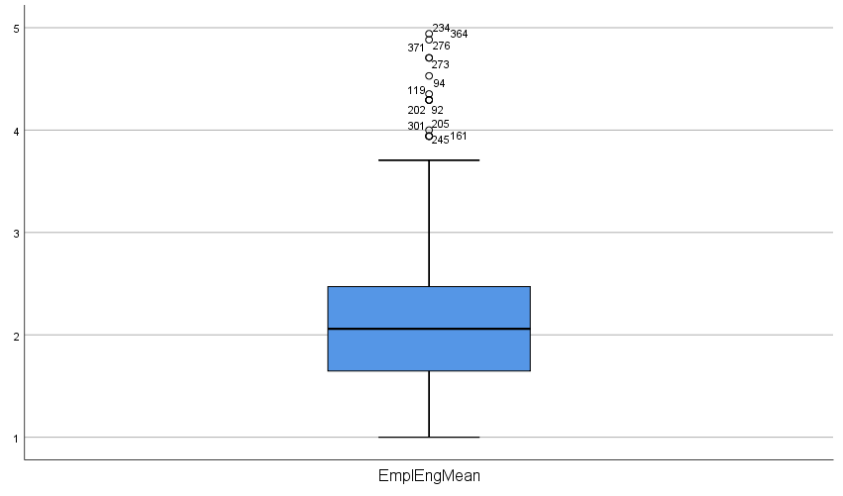

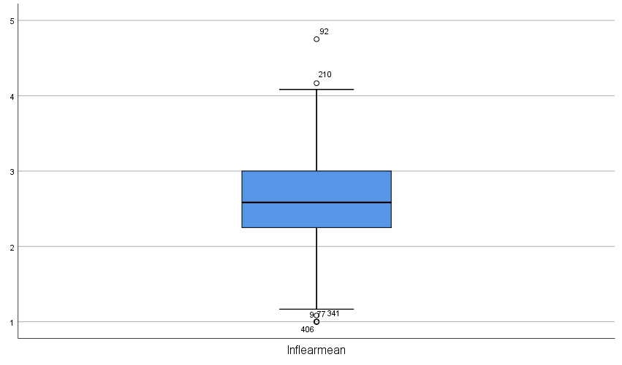

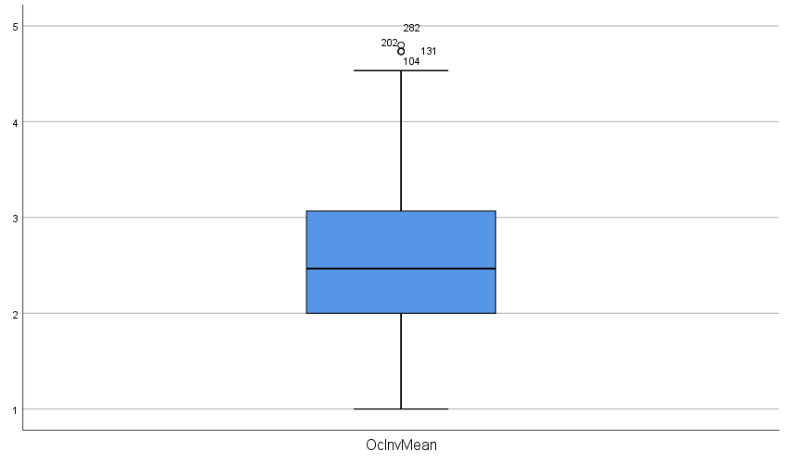

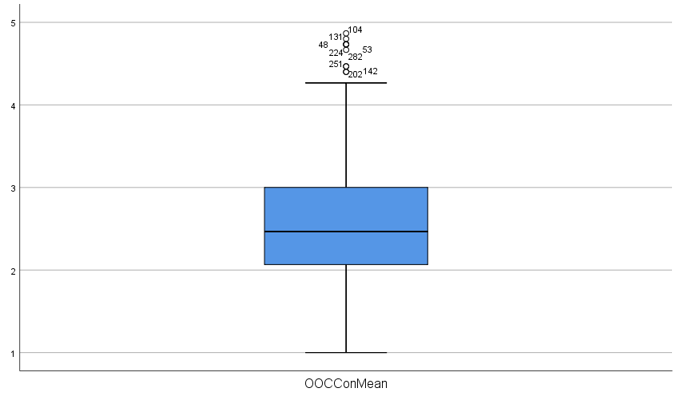

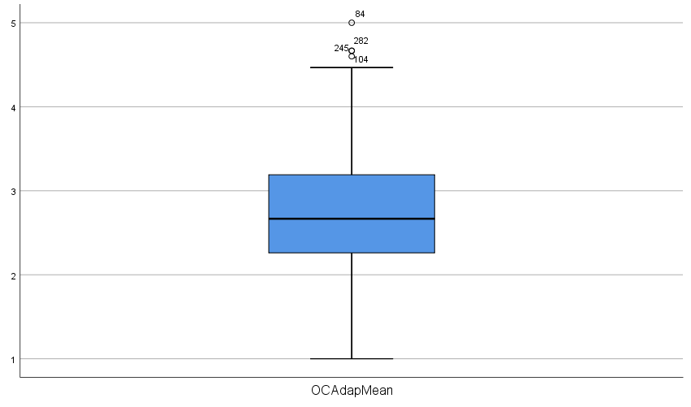

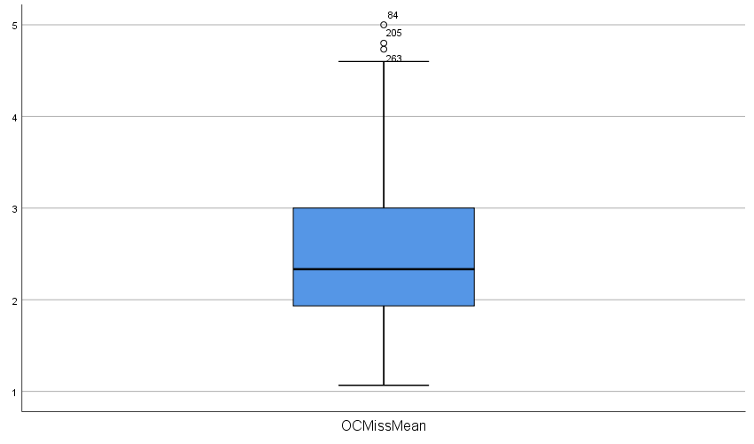
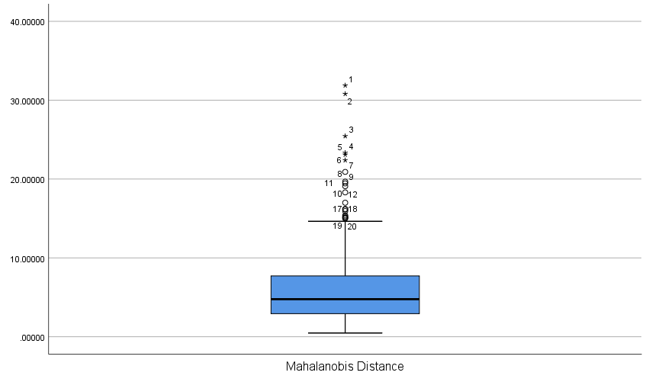

Figure 2: Linearity
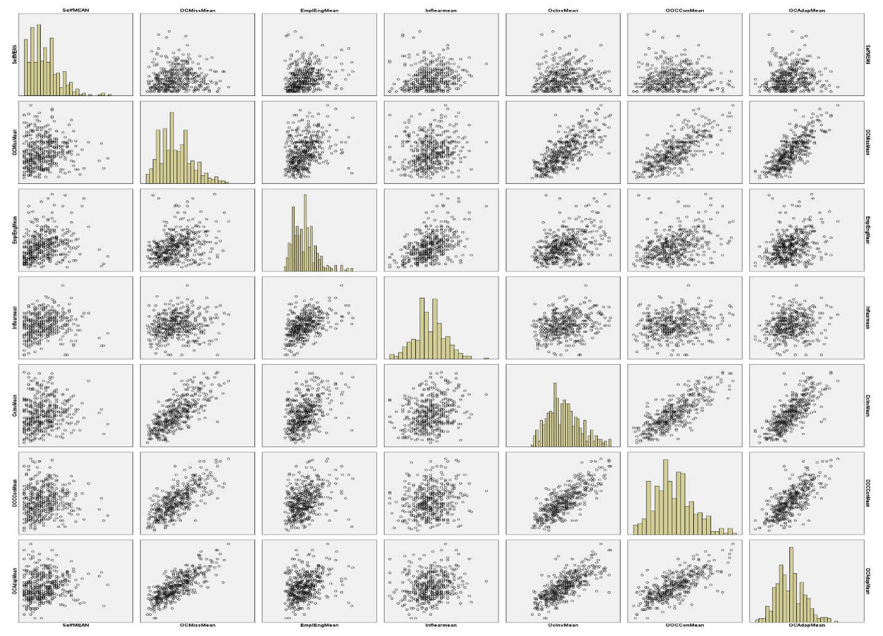

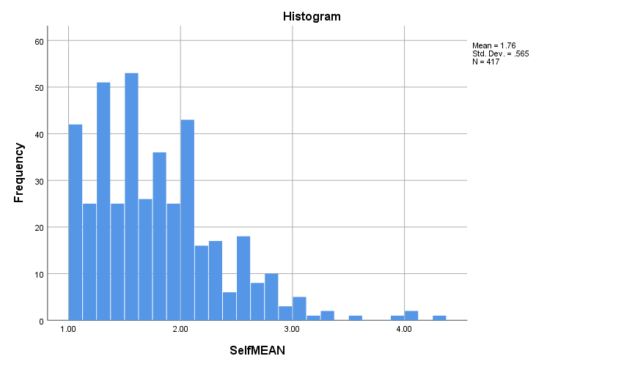
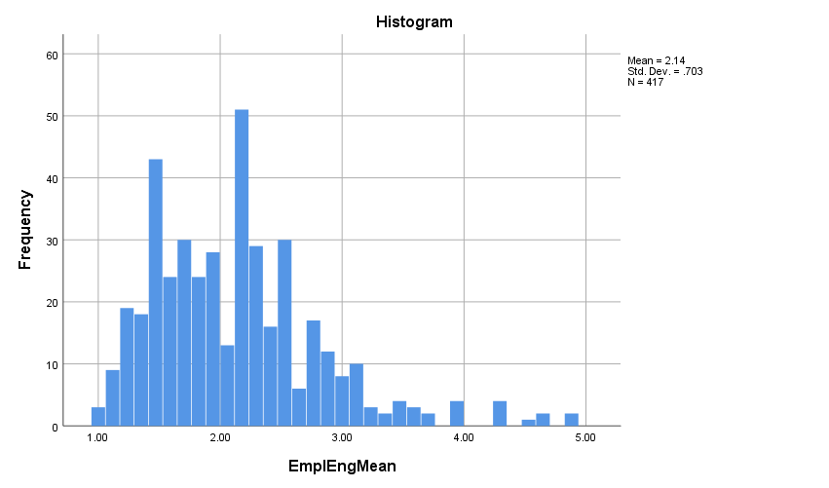
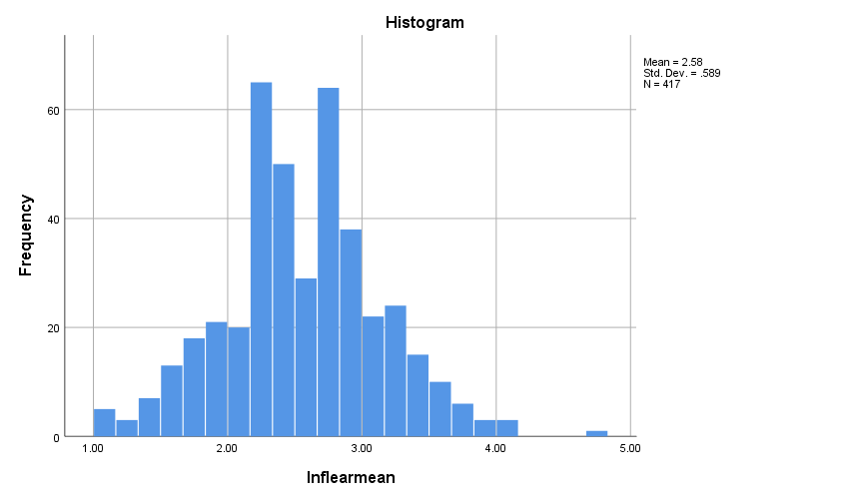
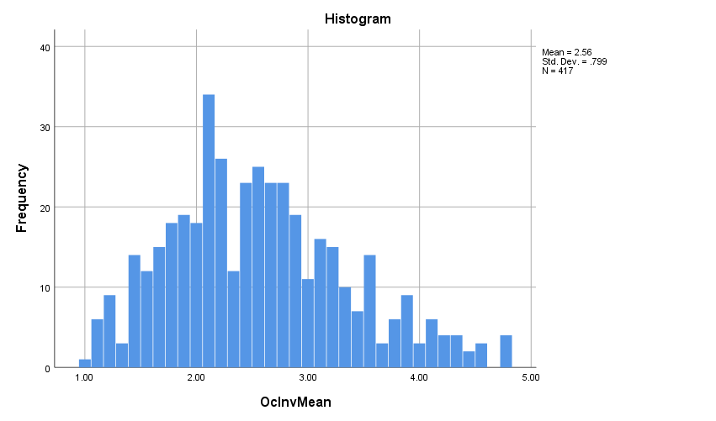
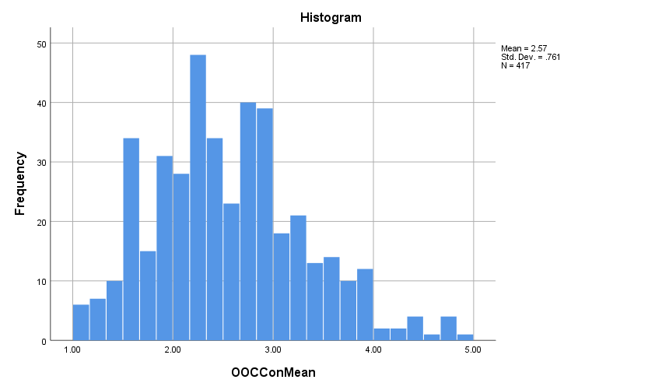
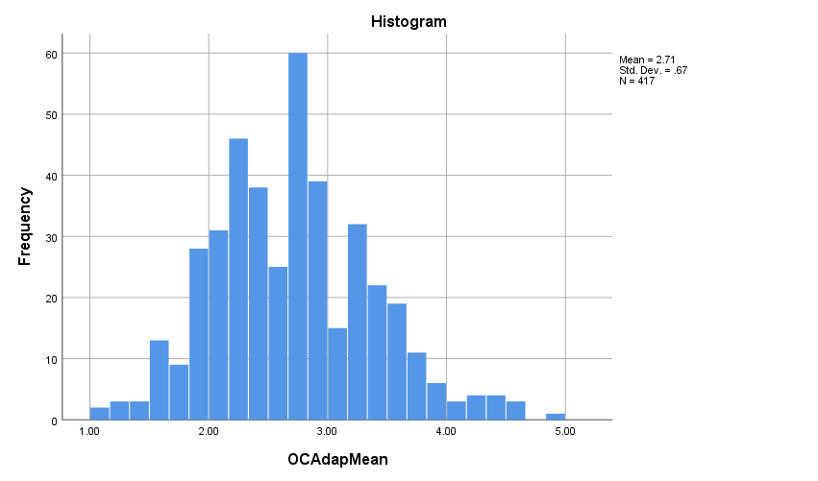
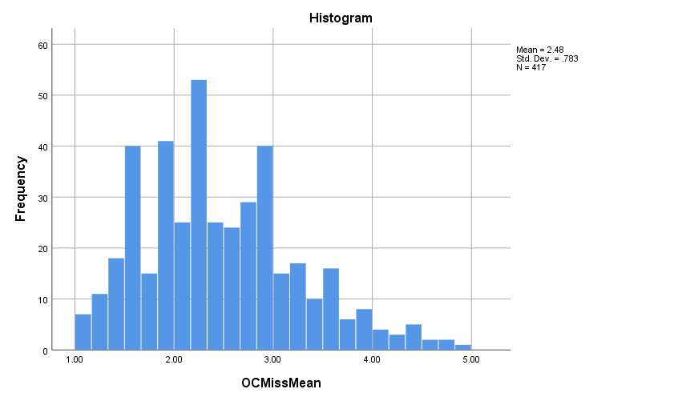

Self-efficacy transformation (Log and Square root)
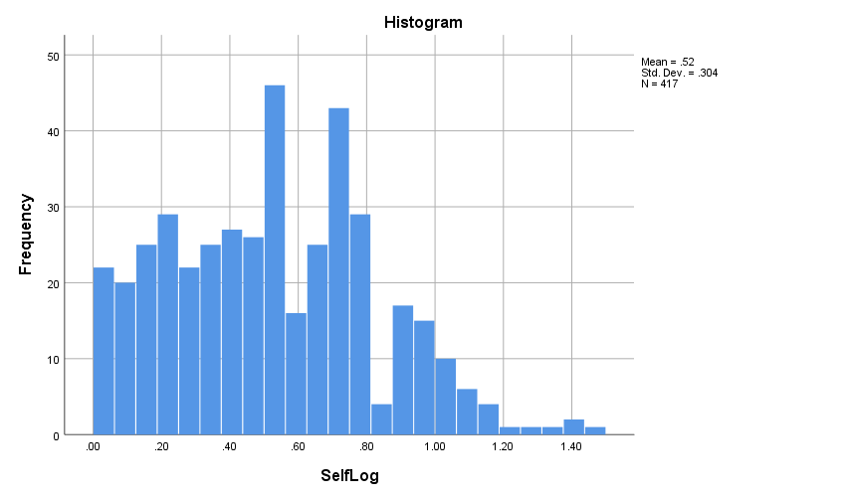
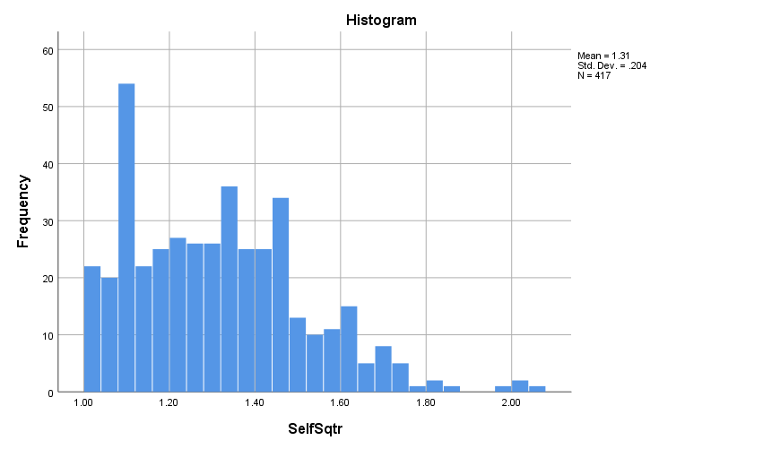

Appendix B: Scale Measurement Instruments
General Self-Efficacy scale
Initiative
- If something looks too complicated I will not even bother to try it.
- I avoid trying to learn new things when they look too difficult.
- When trying to learn something new, I soon give up if I am not initially successful.
Effort
- When I make plans, I am certain I can make them work.
- If I can't do a job the first time, I keep trying until I can.
- When I have something unpleasant to do, I stick to it until I finish it.
- When I decide to do something, I go right to work on it.
- Failure just makes me try harder.
Persistence
- When I set important goals for myself, I rarely achieve them.
- I do not seem capable of dealing with most problems that come up in my life.
- When unexpected problems occur, I don't handle them very well.
- I feel insecure about my ability to do things.
Measuring Employee Engagement
Vigor (VI)
- When I get up in the morning, I feel like going to work.
- At my work, I feel bursting with energy.
- At my work, I always persevere, even when things do not go well.
- I can continue working for very long periods at a time.
- At my job, I am very resilient, mentally.
- At my job, I feel strong and vigorous.
Dedication (DE)
- To me, my job is challenging.
- My job inspires me.
- I am enthusiastic about my job.
- I am proud on the work that I do.
- I ﬁnd the work that I do full of meaning and purpose.
Absorption (AB)
- When I am working, I forget everything else around me.
- Time ﬂies when I am working.
- I get carried away when I am working.
- It is difﬁcult to detach myself from my job.
- I am immersed in my work.
- I feel happy when I am working intensely.
Measuring Organizational Culture
Involvement
Empowerment (Alpha=0.78)
- Most employees are highly involved in their work.
- Decisions are usually made at the level where the best information is available.
- Information is widely shared so that everyone can get the information he or she needs when it is needed.
- Everyone believes that he or she can have a positive impact.
- Business planning is ongoing and involves everyone in the process to some degree.
Team orientation (Alpha=0.82)
- Cooperation across different parts of the organization is actively encouraged.
- People work like they are part of a team.
- Teamwork is used to get work done.
- Teams are our primary building blocks.
- Work is organized so that each person can see the relationship between his or her job and the goals of the organization.
Capability development (Alpha=0.77)
- Authority is delegated so that people can act on their own.
- The ‘‘bench strength’’ ( the capability of people) is constantly improving.
- There is continuous investment in the skills of employees.
- The capabilities of people are viewed as an important source of competitive advantage.
- Problems often arise because we do not have the skills necessary to do the job (R).
Consistency
Core values (Alpha=0.77)
- The leaders and managers ‘‘practice what they preach.’’
- There is a characteristic management style and a distinct set of management practices.
- There is a clear and consistent set of values that governs the way we do business.
- Ignoring core values will get you in trouble.
- There is an ethical code that guides our behavior and tells us right from wrong.
Agreement (Alpha=0.79)
- When disagreements occur, we work hard to achieve ‘‘win-win’’ solutions.
- There is a ‘‘strong’’ culture.
- It is easy to reach consensus, even on difficult issues.
- We often have trouble reaching agreement on key issues (R).
- There is a clear agreement about the right way and the wrong way to do things.
Coordination and integration (Alpha=0.81)
- Our approach in doing business is very consistent and predictable.
- People from different parts of the organization share a common perspective.
- It is easy to coordinate projects across different parts of the company.
- Working with someone from another part of this organization is like working with someone from a different organization (R).
- There is a good alignment of goals across levels.
Adaptability
Creating change (Alpha=0.77)
- The way things are done is very flexible and easy to change.
- We respond well to competitors and other changes in the business environment.
- New and improved ways to do work are continually adopted.
- Attempts to create change usually meet with resistance (R).
- Different parts of the organization often cooperate to create change.

Customer focus (Alpha=0.77)
- Customer comments and recommendations often lead to changes.
- Customer input directly influences our decisions.
- All members have a deep understanding of customer wants and needs.
- The interests of the customer often get ignored in our decisions (R).
- We encourage direct contact with customers by our people.
Organizational learning (Alpha=0.77)
- We view failure as an opportunity for learning and improvement.
- Innovation and risk taking are encouraged and rewarded.
- Lots of things ‘‘fall between the cracks’’ (R).
- Learning is an important objective in our day-to-day work.
- We make certain that the ‘‘right hand knows what the left hand is doing.’’
Mission
Strategic Direction and Intent (Alpha=0.83)
- There is a long-term purpose and direction.
- Our strategy leads other organizations to change the way they compete in the industry.
- There is a clear mission that gives meaning and direction to our work.
- There is a clear strategy for the future.
- Our strategic direction is unclear (R).
Goals and objectives (Alpha=0.86)
- There is widespread agreement about goals.
- Leaders set goals that are ambitious, but realistic.
- The leadership has ‘‘gone on record’’ about the objectives we are trying to meet.
- We continuously track our progress against our stated goals.
- People understand what needs to be done for us to succeed in the long run.
Vision (Alpha=0.83)
- We have a shared vision of what the organization will be like in the future.
- Leaders have a long-term viewpoint.
- Short-term thinking often compromises our long-term vision (R).
- Our vision creates excitement and motivation for our employees.
- We are able to meet short-term demands without compromising our long-term vision.
Measuring Informal Learning
Learning with others
- Informal one-on-one discussion with supervisor about some work situation.
- Idea exchange on how to solve a problem situation with peers during a break or lunch period.
- Observation of how other employees dealt with a challenging work situation.
- Collaboration with others who shared the need to solve a particular problem.
Self-Experimentation
- Spending time to reflect back how I dealt with a challenging work situation.
- Trying to solve a challenging work situation through trial and error process by myself.
- Spending time to reflect on what I had learned in a classroom training program to apply that information to a challenging work situation.
- Reading a standard operations manual or other similar texts on my own to find an answer to a question.
External Scanning
- Searching the Internet for information to help solve a challenging work situation.
- Attendance at a non-mandatory professional conference or seminar that might provide useful information.
- Reading professional magazines or vender publications to be current in some topic.
- Having contact with someone outside the company who is able to help solve a challenging work situation.

