UNIVERSITY OF OKLAHOMA
GRADUATE COLLEGE

COMPARISON OF MIGRATORY AND RESIDENT BIRD SPECIES IN A CONTAMINATED ENVIRONMENT

A THESIS
SUBMITTED TO THE GRADUATE FACULTY
in partial fulfillment of the requirements for the
Degree of
MASTER OF SCIENCE

By
HEATHER K. LEPAGE
Norman, Oklahoma
2020

COMPARISON OF MIGRATORY AND RESIDENT BIRD SPECIES IN A CONTAMINATED ENVIRONMENT

A THESIS APPROVED FOR THE
DEPARTMENT OF BIOLOGY

BY THE COMMITTEE CONSISTING OF

Dr. Eli S. Bridge, Chair
Dr. Douglas D. Gaffin
Dr. Jeffrey Kelly

© Copyright by HEATHER K. LEPAGE 2020
All Rights Reserved.
ACKNOWLEDGEMENTS
I would first like to thank my committee, Dr. Jeff Kelly, Dr. Douglas Gaffin, and chair Dr. Eli Bridge. Eli guided me through this process with his patience, knowledge, and always creative ideas. Most importantly his support, not only through this project but in the obstacles I’ve tackled through these years, has been invaluable to me. I truly could not have accomplished any of this without him and his homemade pizzas. Eli and his family made me feel loved and at home in a foreign state.
Rebecca Jim is the voice of Tar Creek her passion for speaking out against the injustice faced by the people and the environment was the fire that kept me going when I was ready to quit. Her home served as my reference site and her role as my Tar Creek guide developed into her being my role model. Our friendship is the most precious result of this project.
I would also like to acknowledge my family and friends whose support was vital to me during my time in graduate school. Particularly my abuela Nancy del Val, friend Sandra Pletschet, brother Andrew LePage, and loving partner William Oakley, who was the backbone of this project. He helped capture and sample these birds as well as preserved my sanity these last several years.
Lastly, I would not be working with birds without the support and inspiration of the wonderful Dr. Alex Jahn. He introduced me to Eli Bridge and to the world of birds. Alex took me under his wing and taught me both how to study birds and how to love them. He and his beautiful wife, Shazeeda, are my forever friends and ultimate mentors in life.

TABLE OF CONTENTS
ACKNOWLEDGMENTS………………………………………………………………………..iv
ABSTRACT...................................................................................................................................vi
INTRODUCTION...........................................................................................................................1
METHODS......................................................................................................................................4
RESULTS........................................................................................................................................9
DISCUSSION................................................................................................................................12
REFERENCES .............................................................................................................................18
FIGURES……………………………………………………………………...…………………30
FIGURE 1…………..……………………………………………………………………30
FIGURE 2…………..……………………………………………………………………31
FIGURE 3…………..……………………………………………………………………32
FIGURE 4…………..……………………………………………………………………33
FIGURE 5…………..……………………………………………………………………34
FIGURE 6…………..……………………………………………………...…………….35
TABLE 1…………………………………………………………………………………37

ABSTRACT
Billions of animals seasonally migrate long distances which allows them to exploit resources or favorable environmental conditions across time and space. In addition, long-distance migratory movements may allow animals to temporarily avoid certain hazards such as parasites or diseases associated with a particular habitat. This concept has been termed “migratory escape”, and it has been applied to taxa ranging from zebras to butterflies. In this study we test whether “migratory escape” applies to human-induced contamination by comparing heavy metal exposure in migratory and non-migratory birds captured at one of the most highly toxic areas in the United States, the Tar Creek Superfund Site (TCSS) in northeastern Oklahoma. Concentrations of lead, cadmium, and zinc (Pb, Cd, Zn) were measured in both the blood and feathers of adult passerines from TCSS and from a non-contaminated reference site. We also sampled nestlings of two migratory swallow species, Northern Rough-winged Swallow (Stelgidopteryx serripennis) and Bank Swallow (Riperia riperia) to enable comparisons between migrants that have never left TCSS and adult swallows (i.e. birds that have migrated at least once). We initially found limited evidence of “migratory escape” from a data set wherein swallows dominated our sample of migrant species. More specifically, both resident and migrant birds from TCSS exhibited higher levels of Pb in blood, and Pb, Cd, and Zn in feathers than birds sampled from a non-contaminated reference site. Also, Pb in feathers and Cd in blood of adult swallows were significantly lower than in nestling swallows. We found strong evidence of “migratory escape” when swallows were excluded from the migrant sample. Non-swallow migrants had significantly lower levels of Pb, Cd, and Zn in feathers than resident species at TCSS. The swallows we sampled nested directly in the contaminated mine tailings, which may explain why the evidence of “migratory escape” was not as strong when swallows were part of the analysis. Our results generally align with the idea that migrants benefit from migration by escaping long-term exposure to toxic heavy metals. “Migratory escape” studies have previously focused on disease and parasites; this is the first study to apply this concept to human-induced contamination.

INTRODUCTION
Migration allows animals to exploit seasonal changes in resource distributions across space and time, and this capacity to track resources is presumably the primary driver for the evolution and maintenance of migration behavior (Greenberg and Marra, 2005). However, there may be less obvious benefits associated with a migratory life history. One potential benefit is that migratory birds may temporarily avoid detrimental aspects of their breeding or wintering areas. For example, if parasites or pathogens accumulate in the hosts’ environment over time, animals may escape these hazards by migrating. This concept, termed “migratory escape”, suggests that disease, parasites, and predators are powerful selective forces driving migratory behavior (Loehle, 1995). In this study we extend the concept of “migratory escape” to apply to heavy metal contamination that results from mining activities. Although industrial scale mining and the associated contamination have not contributed to the origin and maintenance of migration on an evolutionary timescale, it is possible that exposure to heavy metals exerts selection on animal populations in a manner that could favor migratory behavior.
“Migratory escape,” traditionally refers to the tendency for migratory animals to avoid exposure to parasites, pathogens, and predators (Loehle, 1995). For example, in a sedentary population of Monarch butterflies (Danaus plexippus), parasite infestation increased from early to late in the breeding season; whereas monarchs that overwintered in Mexico had lower parasite loads (Bartel et al., 2011). Similarly, comparisons of migratory and non-migratory populations of galaxiid fish (genus Galaxias;), Dark-eyed Juncos (Junco hyemalis), and Reindeer (Rangifer tarandus) have shown evidence of reduced parasite exposure in association with a migratory life history (Poulin et al., 2012; Slowinski et al., 2018; Folstad et al., 1991). Support for “migratory escape” as a form of pathogen avoidance comes from computer models that employ a pathogen-migration framework to predict lower disease prevalence for animals that seasonally migrate (Hall et al., 2014; Johns and Shaw, 2016). Finally, “migratory escape” may apply to forms of predation wherein the predators are unwilling or unable to pursue migrating prey (Avgar et al., 2014). For example, Gliwicz (1986), demonstrated that zooplankton exhibit diel vertical migration in lakes containing predatory fish whereas the behavior is not apparent in lakes without predators. The implication is that vertical migration functions as a predator avoidance strategy.
It is likely that migratory behavior has evolved in the context of natural hazards in the form of parasites, pathogens, and predators (Shaw and Binning, 2020). However, humans have introduced several new hazards for wildlife, one of the most pervasive being environmental contamination by heavy metals. Heavy metals in the environment adversely affect living organisms by making them susceptible to illnesses and developmental abnormalities (Borghesi et al., 2017). Although heavy metals occur naturally, human activities have resulted in dramatic increases in the bioavailability of heavy metals in mining sites and industrial areas. At present, human activity has driven approximately half of all metal fluctuation in the environment (Paris et al., 2015). Birds are highly sensitive and particularly vulnerable to heavy metal exposure and can be adversely affected by relatively low heavy metal concentrations (Markowski et al., 2013). For example, Golden eagles (Aquila chrysaetos) exposed to lead exhibited reduced activity levels (Ecke et al., 2017), and Great tits (Parus major) living near a metal pollution source experienced reduced novel environment exploration behavior, an important personality trait (Grunst et al., 2019).
The current study focuses on three heavy metals: lead (Pb), cadmium (Cd), and zinc (Zn); which number among the seven heavy metals of greatest environmental concern (Han et al, 2002). Pb and Cd are non-essential and highly toxic, while Zn is essential yet toxic in large amounts. Blood Pb has a short biological half-life--around two weeks in birds, so Pb blood concentrations indicate recent absorption (Pain et al., 2009). Pb absorption can cause detrimental reproductive, and hematologic effects (Gochfeld and Burger, 2000) and can permanently affect brain function (Stansfield et al., 2012); it is believed that Pb exposure is one of the causes of learning and behavioral problems in humans (Dietrich et al., 1987). Cd has a long biological half-life, so concentrations increase with age and are highest in the kidneys and liver (Kushwaha, 2016; Furness, 1996). Cd negatively affects growth and reproduction of birds (Spahn and Sherry, 1999; Feng et al., 2001). Finally, Zn is essential for feather formation (Kushawa, 2016), but persistent exposure can cause adverse health effects via degradation of the kidneys and pancreas (Chow and Pollock, 2009).
We compared concentrations of Pb, Cd, and Zn in migratory and non-migratory birds captured during the summer breeding season at the Tar Creek Superfund Site (TCSS) in Northeastern Oklahoma, where all three of these metals are found in high quantities in various environmental media (Hu et al., 2007; Juracek, 2013). To minimize invasive and/or destructive procedures, we collected only blood and feathers from each captured bird, and we sampled from nestling migrants and adults of both migratory and resident species. We also collected the same tissues from birds at a nearby, uncontaminated reference site. We sought to test four specific predictions. First, we predicted that TCSS residents and migrants should have elevated levels of Pb, Cd, Zn when compared to birds from the reference site. In accordance with the “migration escape” paradigm, our second prediction was that residents of TCSS would have higher contamination levels than migrants in the same contaminated habitat. Third, we predicted that nestlings of migratory species in the TCSS would have higher contaminant levels than adults of the same species. Finally, our fourth prediction was that contaminant levels in blood and feathers should be correlated across individuals. This fourth general prediction is based on an assumption that the birds were exposed to toxins in a generalized manner such that contaminant loads for one metal can predict that of the others. Similarly, we expected indices from the blood and feathers of the same individual to be similar. Finally, we expected correlations across different metals and tissues to be most pronounced in resident species because they will have the most consistent exposure.
The concept of “migratory escape” has so far only been applied to naturally occurring hazards (Altizer et al., 2011), and our study is the first effort to evaluate “migratory escape” in the context of anthropogenic heavy metal contamination. Captive studies have been used widely for measuring heavy metal concentrations in animals, but there are few in situ field studies illustrating heavy metal contaminant levels on free-ranging avian communities. In addition to this novel evaluation “migratory escape”, monitoring birds at the TCSS can give us insight into the environmental health and changing biodiversity of the TCSS as remediation efforts there continue.
METHODS
Study Sites—We sampled feathers and blood from passerines in contaminated sites within the TCSS and in a reference site approximately 50 km to the Southwest. TCSS encompasses the Oklahoma portion of the former Tri-State Mining District which included Northeastern Oklahoma, Southeastern Kansas, and Southwestern Missouri (see Figure 1).
The Tri-State Mining District extracted massive quantities of Pb and Zn during the mid-twentieth century that produced, among other things, the majority of bullets for both World Wars, and supplied 35% of all heavy metals worldwide for over a decade (Phelps, 2006). Mining operations ceased in the 1970s, but the decades of mining, milling, and smelting continued to contribute to ground contamination of Pb, Cd, and Zn which remain on site in the form of over 60 million tons of milled mine waste (“chat”), flotation tailings, and aerial particulates (Phelps, 2006; Datin and Cates, 2002). Around 300 piles, some hundreds of feet high, remain at TCSS today. TCSS was among the first sites to be listed by the EPA as a superfund site and is currently one of the largest existing superfund sites in the United States (USACE, 2005). The fine material left behind due to poor cleanup practices is highly bioavailable and about 1000x higher in Pb content than typical gravel-sized chat (Datin and Cates, 2002). Moreover, in 1979 the abandoned mines filled with water and contaminated mine drainage began to seep from the ground into streams and other surface water (EPA, 1994). In 2008 the federal government forced an evacuation of the TCSS area in light of evidence of lead poisoning and associated learning and behavioral problems in local children (Hu et al., 2007).
Sampling— One focus of our sampling effort was on a mixed species colony comprised of two species: Northern Rough-winged Swallow (Stelgidopteryx serripennis) and Bank Swallow (Riparia riparia). We were interested in these species because they nest directly in the chat piles, and all swallows used in this study came from three chat piles which the birds were using as a nesting substrate (see Figure 2). One pile was owned by Bingham Sand and Gravel, Inc (now Williams Diversified Materials) and the other two were on land owned by the Quapaw Nation.
Non-swallow passerines were also sampled within the TCSS area in and around the abandoned town of Pitcher, OK in mixed cross timber and woodland habitats that surround the chat piles in the area. Reference samples were collected in Vinita, OK, where bird diversity and landscape features are similar to those in the TCSS area. In the reference area there is no history of mining or evidence of contamination on the order of the TCSS.
Non-swallow passerines were all captured with mist nests, using playbacks to draw in birds. Adult swallows were captured both with mist nets and using a fishing net to catch birds as they exited a nest cavity. Nestling swallows were extracted from nest cavities using a fiber optic camera and a miniature snare pole. All captured birds were banded with metal leg bands and subjected to a series of morphological measurements. We collected blood (less than 1% of body mass) from the brachial vein, by puncturing the vein with a 25 gauge hypodermic needle and drawing the blood into a capillary tube. Blood samples were stored in Microtainer® Blood Collection Tubes with K2EDTA, placed on ice in coolers and kept refrigerated until analysis. For feather samples, we plucked P9 (the outermost primary) and several contour feathers from the bird’s back and stored them dry in paper envelopes. All field work was performed between 24 April and 29 June in 2017-2019.
Chemical Analysis—Toxicology analysis was conducted by the Michigan State University Veterinary Diagnostic Laboratory (MSU-VDL) (East Lansing, MI, USA). Toxic elements in whole blood were analyzed using inductively coupled plasma mass spectrometry (ICP-MS), as previously described (Slabe et al., 2020). The blood samples we provided to the MSU-VDL were below the minimum volume required for toxicology analysis. However, the lab was willing to alter their protocol considering the constraints associated with sampling small birds. Nevertheless, we had to pool some samples from nestlings to obtain a sufficient analysis volume. In these cases, we pooled blood samples from the same nest (i.e. siblings). The blood volumes we collected were not adequate for Zn analysis; hence Zn analysis were only performed on feathers. For nests where blood samples were pooled, we also pooled all feather samples into a single analysis sample. Otherwise all feathers sampled from each individual were pooled together and processed as one sample. Processing of feathers involved rigorous cleaning and subsequent air drying to remove all exogenous contaminants before initiating gas chromatography-mass spectrometry (GC/MS). We report blood metal concentrations on a wet weight basis in parts per million (ppm). Data on feather metal concentrations are reported on a dry weight basis in parts per million (ppm).
Statistical Analysis—All statistical analyses were performed in R (R Core Team, 2019), and we made use of packages “car” (Fox and Weisberg, 2019), “lme4” (Bates et al., 2015), and “lmerTest” (Kuznetsova et al., 2017). A number of samples indicated heavy metal concentrations that were below detectable concentrations. These detectable limits were <0.005 ppm for Pb and <0.005-0.01 ppm Cd in blood, < 0.876 ppm Pb in feathers, and ranged from <0.247-0.876 ppm for Cd in feathers. Samples below detectable limits were considered as one-half of the respective limit of detection.
Preliminary analyses indicated that the results from our blood and feather analyses were skewed to the left. Hence, we performed a square root transformation on all heavy metal concentrations in both blood and feathers to achieve a more normal distribution. We first tested for differences among adult birds from the reference site (n=21), TCSS residents (n=19), and TCSS migrants (n=32). We reasoned that there is no reason to expect animals to have high exposure to heavy metals at the reference site regardless of migratory behavior. Therefore, birds at the reference site were pooled into a single control group regardless of whether they were migratory (n=2) or resident (n=19) species. To compare birds from TCSS and the reference site we ran five generalized linear mixed models (GLMM) with the results from each of the heavy metal analyses (Pb-blood, Pb-feathers, Cd-blood, Cd-feathers, Zn-feathers) used as the dependent variable. The groups (Reference Site, TCSS Residents, and TCSS Migrants) were included as a factor, and species was included as a random factor. We calculated p-values from least-square means to discern significant differences among the three groups while controlling for multiple comparisons.
As a follow up, we reran this same analysis with the swallows excluded. Swallows made up the vast majority of the migratory birds in the analysis. They also may have higher toxin exposure because they were nesting directly in chat piles (Figure 2), which means that they were likely ingesting and inhaling contaminated fine chat directly from their nest environment. With swallows excluded, our sample of migratory birds from TCSS was very small (n =5), but these migrants were likely more similar to the resident species in terms of their daily contaminant exposure at TCSS.
Next, we compared heavy metals in nestling swallows vs. adult swallows. This test was performed with a subset of data that included only the two swallow species. Within each nest, data from nestlings were pooled in one of two ways. For smaller nestlings, blood and feather samples from individual birds were pooled prior to chemical analyses in order to achieve a sufficient volume of tissue. For larger nestlings, we were able to analyze blood and feathers from each individual, but the results were averaged within each nest because the data from siblings were not independent. Hence, we compared heavy metals in adult swallows (n=27) to average heavy metal values from sets of siblings in swallow nests (n=16). For this test we ran five one-way ANOVAs with each of the heavy metal detection tests (Pb-blood, Pb-feathers, Cd-blood, Cd-feathers, Zn-feathers) used as the dependent variable.
Our final analysis tested for correlations among heavy metal concentrations in blood and feathers. Heavy metals in feathers result from a prolonged deposition process that likely represents exposure over a period of a few weeks, whereas heavy metals in blood may be more representative of short-term exposure. In testing for a correlation between heavy metal concentrations in blood and feathers we separated our samples into three groups: Adult Residents, Adult Migrants, and Nestlings. The justification for these groupings relates to the fact that deposition of heavy metals in feathers occurs only during feather replacement. Most birds replace all their feathers in an annual molt that follows the breeding season and, depending on the species, there may or may not be additional molts at other times in the annual cycle. There is uncertainty regarding the molting locations of the adult migrants, which warrants separating them from the other birds. For the migrant nestlings and resident birds, we assume that they grow their feathers in the environment where they were captured. Correlations in nestlings and migrants were tested separately because of presumed physiological differences in how a rapidly growing nesting may absorb, turnover, and excrete contaminants as opposed to an adult. We generated a correlation matrix to examine all possible pairwise correlations across measures of heavy metals. As with the other analyses we used square root transformed data.
RESULTS
We captured and processed a total of 130 individual birds and had successful heavy metal analyses for 86 individuals and 9 pooled nests. Of these, 21 were from the reference site, and 74 were from TCSS. Among the birds from TCSS there were 32 migratory adult birds and 19 residents. Twenty-seven of the migratory birds from TCSS were swallows (17 Bank Swallows and 10 Northern Rough-winged Swallows). There were only 5 migratory birds from TCSS that were not swallows (4 Indigo Buntings [Passerina cyanea] and 1 Painted Bunting [Passerina ciris]). For some analyses samples from nestling swallows were pooled by nest, such that we had 16 nests represented.
Mean heavy metal concentrations in feathers were clearly elevated in the TCSS area relative to the reference site. Average blood Pb concentrations were 400% higher in resident TCSS birds (M=0.1, SD=0.152) than birds at the reference site (M=0.047, SD=0.03) (GLMM; t= -2.828, p=0.006). Similarly, Feather Pb and Zn concentrations differed significantly among all three groups. Average feather Pb concentrations were almost 1000% higher in TCSS resident birds (M=5.763, SD=9.078) than reference birds (Pb: M=0.593, SD=0.389) (GLMM; t= -5.872, p=1.65e-07;). Average feather Cd concentrations were over 250% higher in TCSS resident birds (M= 1.449, SD= 1.961) than reference birds (M=0.535, SD=0.222) (GLMM; t= -4.527, p= 2.6e-05;). Average feather Zn concentrations were over 150% higher in TCSS resident (M=258.062, SD=122.812) than reference birds (M=190.702, SD=34.099) (GLMM; t= -5.737, p=2.90e-07). Interestingly, Cd in feathers was significantly higher in resident birds at TCSS than TCSS migrants (GLMM; t= 2.936, p=0.013). Feather Pb and Zn concentrations were overall higher in resident TCSS birds than migrants, although not significantly (Pb: GLMM; t= 0.237, p=8.16e-01; Zn: GLMM; t= 1.677, p=1.15e-01), but to a lesser extent than Cd (See Figure 3).
When the above analysis was repeated with non-swallow migrants as its own group, there was a strong suggestion that migratory birds “escaped” contamination by heavy metals to some extent. All comparisons of different metals and tissues indicated that non-swallow migratory birds had lower heavy metal concentrations than TCSS resident birds (Blood-Pb: GLMM; t= 1.593, p=0.069; Feather-Pb: GLMM; t= 2.494, p=0.019; Feather-Cd: GLMM; t= 2.604, p=0.015; Feather-Zn: GLMM; t= 2.639, p=0.013) except for blood Cd levels (GLMM; t= 0.850, p =0.402). In the case of Cd in blood, four of the five migratory birds had Cd levels below the detection limit, and the fifth bird had an extremely high blood Cd concentration. Hence, the lack of significance here was probably due to an outlier that we suspect resulted from an intense short-term exposure to a Cd source that occurred just before the bird was captured and sampled. All five of the migratory birds in this analysis were captured in late June (26th-29th), such that they had likely been at TCSS for at least 8 weeks before they were sampled (See Figure 4).
The comparison of nestling and adult swallows provided only limited evidence of a “migratory escape” from heavy metal contamination. Concentrations of Cd in nestling blood (M=0.013, SD=0.005) were almost 150% higher than in adults (M=0.009, SD=0.012) (GLMM; F(1,41)=5.69, p=0.022). Concentrations of Pb in adult feathers (M=15.676, SD=13.294) were 180% higher than in nestlings (M=8.638, SD=16.003) (GLMM; F(1,41)=7.308, p=0.01) (See Figure 5).
There did not appear to be strong correlations between heavy metals in blood and feathers of adult migrants. However, blood and feather Pb concentrations were strongly correlated among adult residents (r=0.68, n=37, p=9.3e-05) and nestling swallows (r=0.54, n=23, p=0.007). There were no strong correlations between Cd of blood and feathers within the groups. However, there were strong correlations between the metals themselves. Feather concentrations of Pb and Cd, Pb and Zn, and Cd and Zn were positively correlated in all three groups. Blood Pb and Cd concentrations were positively correlated in adult migrants (r=0.86, n=35, p=2.8e-11), but not in adult residents (r=0.17, n=37, p=0.38) or nestlings (r=0.37, n=23, p=0.078) (See Figure 6).
DISCUSSION
In accordance with our first prediction, we found clear evidence of elevated heavy metal exposure among birds captured at TCSS. This finding agrees with the only previous study of heavy metal concentrations in birds from TCSS (Beyer et al., 2004) as well as studies at other former mining districts in the United States (Beyer et al., 2013; Hansen et al., 2011; Johnson et al., 1999). As expected, blood Pb concentrations of TCSS resident birds was higher than in reference birds, though blood Cd concentrations did not differ among the groups. Feather Pb concentrations in both resident and migrant TCSS birds were higher than in reference birds. Although heavy metal concentrations of migratory birds at TCSS were elevated, it was to a lesser extent than residents. Interestingly, feather Cd concentrations were considerably higher in TCSS residents than the other two groups. Feather Zn concentrations was substantially higher in TCSS residents and migrants than in reference birds.
We also observed higher contamination levels among TCSS resident birds than migrants from TCSS, which aligns with our second prediction and the concept of “migratory escape”. However, support for this prediction was limited to Pb, Cd, and Zn in feathers. There was much stronger support for “migratory escape” when we considered only non-swallow migratory species. As suggested above, the swallows in our sample may have a disproportionately high degree of exposure since they were nesting directly in chat piles. Moreover, these birds were likely consuming prey species from nearby acid drainage ponds that receive large amounts of runoff from chat piles. Hence, the swallows we sampled were likely subject to ingestion and inhalation of heavy metals at a higher rate than non-swallows.
Our third prediction was that nestlings of migratory species should have higher exposure to contaminants than their parents. We reasoned that nestlings raised in TCSS will have had no exposure to non-contaminated areas, unlike their parents which have presumably spent the winter in a non-contaminated area. We cannot definitively say that feather samples collected from adult swallows indicate exposure solely from TCSS. Feather metal concentrations indicate incorporation of the metals at the time of formation, i.e. molt (Kushwaha, 2016). Molt for Bank Swallows and Northern-rough Winged Swallows begins on breeding grounds about time young have completed fledging and is suspended during fall migration, then completed on wintering grounds (Garrison and Turner, 2020; De Jong, 2020). However, Bank Swallows do exhibit high site fidelity (Garrison and Turner, 2020) so we assume that the adults we captured began molting at TCSS the previous summer. Overall, nestlings had higher concentrations of metals in their blood than adults. Metal concentrations in blood are indicative of recent exposure as the metals circulate in the bloodstream before being absorbed into organs and other tissue. Adults had higher levels of Pb and Zn in their feathers, but lower levels of Cd. This may be due to the sequestration and slow elimination of Cd from the kidneys and liver (Fernandez et al., 1996).
Our final prediction was that contaminant levels in blood and feathers should be correlated across individuals. Among the three groups tested (residents, adult migrants, and nestlings), significant positive correlations were found in Pb of residents and nestlings (See Table 1). Burger and Gochfeld (1990) previously found that concentrations of Pb in feathers are strongly correlated to the levels in blood. Cd was not correlated among groups. Interactions between Pb, Cd, Zn and other xenobiotics can increase, inhibit, or offset their absorption and effects (Goyer, 1997). Therefore, correlations between the metals themselves were also tested and almost all were positively correlated.
Our results differed from similar comparisons of adult and nestling birds. Adult Red-shouldered Hawks (Buteo lineatus) exhibited higher levels of Pb than nestlings during the breeding season (Slabe et al., 2019). Similarly, adult Glaucous-winged Gulls (Larus glaucescens) had higher levels of Cd and Pb concentrations in feathers (Burger et al., 2009). These larger birds are higher on the trophic level and the primary source of heavy metal exposure is diet. For passerines, inhalation and ingestion are the two most important exposure routes (Pattee and Pain, 2003). The nestling swallows in our study are probably inhaling chat particles in a continuous manner for roughly three weeks before they fledge. There is evidence that Pb does not transfer significantly into eggs (Henny, 2003) indicating that the high concentrations of heavy metals in nestlings are accumulated quickly after hatching through inhalation and parental feeding. Little Blue Heron (Egretta caerulea) chicks exposed to Cd had significantly slower growth rates than non-exposed chicks, and exposure to Pb was correlated with increased nestling mortality (Spahn and Sherry, 1999). We did not attempt to measure growth rates in this study due to the difficulty and disturbance associated with accessing the nestlings. However, it would be interesting to compare their growth rates with a reference population.
TCSS is the first site at which wild birds, specifically waterfowl, have been shown to suffer from severe effects of zinc poisoning. (Beyer et al., 2004). Additionally, American Robins (Turdus migratorius), Northern Cardinals (Cardinalis cardinalis), and several species of waterfowl (Anseriformes) at TCSS that exhibited increased Pb tissue concentrations and showed external signs of lead poisoning when compared to reference populations (Beyer et al., 2004). However, although the concentrations of metals in our sampled birds surpassed the levels which should indicate illness or death, the birds did not seem to exhibit outward symptoms. Captive, laboratory studies show that Pb poisoning at ranges lesser than exhibited in our study experienced symptoms like inability to walk, delayed fledging, and growth abnormalities (Burger, 1993; Janssens et al., 2003). One issue with these studies is that exposure to heavy metals are typically evaluated on an individual chemical basis, which does not adequately account for the wide array of co-contaminants encountered in the environment (Anyanwu et al., 2018). Physiologically, even moderate levels of Zn can influence the absorption of Pb (Noonan et al., 2003) and inversely affect absorption, accumulation and toxicity of Cd (Brzóska and Moniuszko-Jakoniuk, 2001). Zn can protect against some toxic effects of Pb and Cd (Saxena et al., 1989). Kim et al., (2009) found that Cd concentrations in the livers of wild birds in Korea were positively correlated with Zn. In pigeon feathers Pb, Cd, and Zn were highly correlated (Frantz et al., 2012). However, the concentrations of the metals at TCSS may simply explain the correlations we see in our study (Frantz et al., 2012).
That blood Pb concentrations weren’t significantly different between TCSS migrants and reference birds shows some evidence of “migratory escape”. Migrant birds escape the contaminated habitat allowing them to recover/detoxify so they should have reduced levels of heavy metals more similar to reference birds. Our strongest evidence for “migratory escape“ is the analysis comparing non-swallow migrants to resident TCSS birds. Although our sample size was small, it was clear that migrants were avoiding the accumulation of toxic heavy metals, which is likely due to the birds leaving the area for part of the year or because they recently dispersed into it.
The negative effects of heavy metals are particularly detrimental to migratory species. Many bird species demonstrate dramatic changes in brain organization over the course of their annual cycle (Hoffman et al., 2002). This adult neurogenesis accounts for birds’ abilities to functionally navigate, survive, and adapt to changing habitats. Successful migrants rely more heavily on these abilities as they travel long distances. Migrant birds exposed to heavy metal pollution may experience greater changes in cognition and behavior (Avgar et al., 2014). At the Coeur d’Alene River Basin (CDA), Pb concentrations in blood of migratory wood ducks was higher later in the season suggesting that the amount of time spent in the area and exposed to lead seems to be a factor (Henny, 2003). Tundra swans (Cygnus columbianus) are only in the CDA for a several weeks but were often discovered ill or dead. Significantly higher lead concentrations were found in the blood of living swans sampled when compared to reference swans (Henny, 2003). Concentrations of blood lead in these birds dramatically increased in only a few days. In addition to the direct consequences of metal exposure to birds, they can also have indirect effects. Metal pollution, particularly Pb and Cd alters habitat and food quality indirectly increasing oxidative stress in birds (Koivula and Eeva, 2010). For example, insectivores may consume metal-impacted invertebrates (Eeva et al., 2005, 2008) reducing the amount of dietary antioxidants available thereby decreasing their ability to defend against free radicals. This lowered antioxidant defense mechanism alters birds’ abilities to remove harmful toxicants from the body (Koivula and Eeva, 2010).
Due to increasing amounts of hazardous chemicals released into the environment, there is a high demand for developing easy and non-destructive biomonitoring tools (Jaspers et al., 2019). Birds provide humans a non-invasive way of informing us of the ecological health and/or pollution levels in an area, and they’re relatively easy to sample. They are also readily observable and sensitive to toxicity, high on the food chain, and of interest to the public. Over the years birds have served as early warnings for a number of environmental contaminants such as DDT, pesticides, and heavy metals (Tsipoura et al., 2008). Raptors, shorebirds, seabirds, waterfowl have all been used to assess environmental health (Dykstra et al., 2010). Recent studies have begun to look at passerines as bio-sentinels, or indicators of local contamination. Tree swallows (Tachycineta bicolor) readily use nest boxes, so study sites can be established at specific locations of interest (Custer et al., 2003). Pigeons and Starlings have been suggested as indicators of lead contamination in human environments (Solonen et al., 1999; Pattee and Pain, 2003; Frantz et al., 2012).
Although contamination like that of the TCSS has only occurred in the past 200 years, there may already be evolutionary consequences evident in the genetics of affected animal populations. Brown trout populations impacted by metals are genetically distinct from populations in clean rivers and exhibit lower genetic diversity, possibly due to severe population declines (Paris et al., 2015). Lester and van Riper III (2014) suggested that although levels of heavy metals in some birds may not exceed seemingly innocuous background concentrations, they may be accumulating significantly greater burdens of metals over time. For example, Pb stored in bones from chronic exposure over a bird’s lifetime will ultimately get released back into the bloodstream so older birds will exhibit higher concentrations due to recurring exposure (Slabe et al., 2019). Since concentration levels in feathers reflect the body accumulation during the entire time of feather development, potential age biases can be circumvented by restricting the analyses to chick feathers (Borghesi et al., 2017). We recommend using nestlings as bioindicators for studies aiming to assess local environmental contamination. Nestlings seem a more optimal choice for the evaluation of local pollution since we can sample data from a defined area and time period. Also, because the nestlings stay within the nest boxes, there is a very limited possibility of external airborne deposition from industrial sources. Metals in bird nestlings, like Sparrows, reflect local pollution levels, as nestlings are fed entirely on food collected by parents near their breeding colony. Lead concentrations in tissues of juvenile birds have been shown to be a reliable indicator of dietary exposure (Burger, 1995; Janssens et al., 2003) and to be correlated with lead in some tissues (Golden et al. 2003).
As songbird populations continue to decline (Pennisi, 2019), it’s important to understand all the disadvantages and advantages birds face. This is the first study to examine heavy metal exposure in the context of the “migratory escape” concept, and clearly further study is needed to illuminate how migratory birds respond long-term to accumulation of anthropogenic contaminants in the environment. Partial migrants, such as American Robins, may be ideal study organisms for further research on this topic. Partial migration is when some members of a breeding population migrate, while others remain at the breeding grounds (Greenberg and Marra, 2005). If migration provides a means of avoiding detrimental accumulation of heavy metals, there might be a shift toward increased migration among local robin populations. Additionally, robins are ground feeders and so would ingest an elevated amount of contaminated soil (Beyer and Sample, 2017) as well as earthworms, which have been proposed as key species in risk assessments where the contaminant is found in the soil and sediment (Beyer and Fries, 2003; Helmke et al. 1979). Robins are widely distributed, tolerant of humans (Wauer, 1999) and have been shown to have elevated concentrations of toxins in some cases (Barker, 1958; Bernard, 1966, Balcomb et al., 1984). The prospects of migratory birds are unknown so “migratory escape” is especially important to identify and predict risks to migrants, humans, and other wildlife.
REFERENCES
Altizer, Sonia, Rebecca Bartel, and Barbara A. Han. “Animal Migration and Infectious Disease Risk.” Science 331, no. 6015 (2011): 296–302.
Anyanwu, Brilliance, Anthonet Ezejiofor, Zelinjo Igweze, and Orish Orisakwe. “Heavy Metal Mixture Exposure and Effects in Developing Nations: An Update.” Toxics 6, no. 4 (November 2, 2018): 65. https://doi.org/10.3390/toxics6040065.
Avgar, T., G. Street, and J.M. Fryxell. “On the Adaptive Benefits of Mammal Migration.” Canadian Journal of Zoology 92, no. 6 (June 2014): 481–90. https://doi.org/10.1139/cjz-2013-0076.
Balcomb, Richard, Charles A. Bowen, Dallas Wright, and Mark Law. “Effects on Wildlife of At-Planting Corn Applications of Granular Carbofuran.” The Journal of Wildlife Management 48, no. 4 (1984): 1353–59. https://doi.org/10.2307/3801796.
Barker, Roy J. “Notes on Some Ecological Effects of DDT Sprayed on Elms.” The Journal of Wildlife Management 22, no. 3 (July 1958): 269. https://doi.org/10.2307/3796459.
Bartel, Rebecca A., Karen S. Oberhauser, Jacobus C. de Roode, and Sonia M. Altizer. “Monarch Butterfly Migration and Parasite Transmission in Eastern North America.” Ecology 92, no. 2 (2011): 342–51. https://doi.org/10.1890/10-0489.1.
Bates, Douglas, Martin Maechler, Ben Bolker, Steven Walker, Rune Haubo Bojesen Christensen, Henrik Singmann, Bin Dai, Gabor Grothendieck, Peter Green, and Maintainer Ben Bolker. "Package ‘lme4’." Convergence 12, no. 1 (2015): 2.
Bernard, Richard F. “DDT Residues in Avian Tissues.” The Journal of Applied Ecology 3 (June 1966): 193. https://doi.org/10.2307/2401459.
Beyer, W. N., and G. F. Fries. "Chapter 6: Toxicological significance of soil ingestion by wild and domestic animals." Hoffman DJ, Rattner BA, Burton GA and Cairns J.(Eds.) (2003).
Beyer, W. N., J. Dalgarn, S. Dudding, J. B. French, R. Mateo, J. Miesner, L. Sileo, and J. Spann. “Zinc and Lead Poisoning in Wild Birds in the Tri-State Mining District (Oklahoma, Kansas, and Missouri).” Archives of Environmental Contamination and Toxicology 48, no. 1 (December 2004): 108–17. https://doi.org/10.1007/s00244-004-0010-7.
Beyer, W. Nelson, J. Christian Franson, John B. French, Thomas May, Barnett A. Rattner, Valerie I. Shearn-Bochsler, Sarah E. Warner, John Weber, and David Mosby. “Toxic Exposure of Songbirds to Lead in the Southeast Missouri Lead Mining District.” Archives of Environmental Contamination and Toxicology 65, no. 3 (October 2013): 598–610. https://doi.org/10.1007/s00244-013-9923-3.
Beyer, W Nelson, and Bradley E Sample. “An Evaluation of Inorganic Toxicity Reference Values for Use in Assessing Hazards to American Robins ( Turdus Migratorius ): Toxicity Reference Values for Assessing Hazards to Robins.” Integrated Environmental Assessment and Management 13, no. 2 (March 2017): 352–59. https://doi.org/10.1002/ieam.1792.
Borghesi, Fabrizio, Enrico Dinelli, Francesca Migani, Arnaud Béchet, Manuel Rendón‐Martos, Juan A. Amat, Simone Sommer, and Mark A. F. Gillingham. “Assessing Environmental Pollution in Birds: A New Methodological Approach for Interpreting Bioaccumulation of Trace Elements in Feather Shafts Using Geochemical Sediment Data.” Edited by Matthew Davey. Methods in Ecology and Evolution 8, no. 1 (January 2017): 96–108. https://doi.org/10.1111/2041-210X.12644.
Brzóska, M. M., and J. Moniuszko-Jakoniuk. “Interactions between Cadmium and Zinc in the Organism.” Food and Chemical Toxicology: An International Journal Published for the British Industrial Biological Research Association 39, no. 10 (October 2001): 967–80. https://doi.org/10.1016/s0278-6915(01)00048-5.
Burger, Joanna. “A Risk Assessment for Lead in Birds.” Journal of Toxicology and Environmental Health 45, no. 4 (August 1, 1995): 369–96. https://doi.org/10.1080/15287399509532003.
Burger, Joanna, Michael Gochfeld, Christian Jeitner, Sean Burke, Conrad D. Volz, Ronald Snigaroff, Daniel Snigaroff, Tara Shukla, and Sheila Shukla. “Mercury and Other Metals in Eggs and Feathers of Glaucous-Winged Gulls (Larus Glaucescens) in the Aleutians.” Environmental Monitoring and Assessment 152, no. 1–4 (May 2009): 179–94. https://doi.org/10.1007/s10661-008-0306-6.
Burger, Joanna, Mark Laska, and Michael Gochfeld. “Metal Concentrations in Feathers of Birds from Papua New Guinea Forests: Evidence of Pollution.” Environmental Toxicology and Chemistry 12, no. 7 (July 1993): 1291–96. https://doi.org/10.1002/etc.5620120719.
Chow, Cynthia, and Christal Pollock. "Heavy Metal Poisoning in Birds." Fonte:< https://lafeber. com/vet/heavy-metal-poisoningin-birds/>[Accessed online in May 2015] (2009).
Custer, C. M., Custer, T. W., Dummer, P. M., & Munney, K. L. (2003). Exposure and effects of chemical contaminants on tree swallows nesting along the Housatonic River, Berkshire County, Massachusetts, USA, 1998–2000. Environmental Toxicology and Chemistry: An International Journal, 22(7), 1605-1621.
Datin, Dennis L., and David A. Cates. "Sampling and metal analysis of chat piles in the Tar Creek Superfund Site." Oklahoma Department of Environmental Quality, Oklahoma City (2002).
De Jong, M. J. (2020). Northern Rough-winged Swallow (Stelgidopteryx serripennis), version 1.0. In Birds of the World (A. F. Poole and F. B. Gill, Editors). Cornell Lab of Ornithology, Ithaca, NY, USA. https://doi-org.ezproxy.lib.ou.edu/10.2173/bow.nrwswa.01
Dietrich, Kim N., Kathleen M. Krafft, Robert L. Bornschein, Paul B. Hammond, Omer Berger, Paul A. Succop, and Mariana Bier. “Low-Level Fetal Lead Exposure Effect on Neurobehavioral Development in Early Infancy.” Pediatrics 80, no. 5 (November 1, 1987): 721–30.
Dykstra, Cheryl R., William T. Route, Michael W. Meyer, and Paul W. Rasmussen. “Contaminant Concentrations in Bald Eagles Nesting on Lake Superior, the Upper Mississippi River, and the St. Croix River.” Journal of Great Lakes Research 36, no. 3 (September 2010): 561–69. https://doi.org/10.1016/j.jglr.2010.06.006.
Ecke, Frauke, Navinder J. Singh, Jon M. Arnemo, Anders Bignert, Björn Helander, Åsa M. M. Berglund, Hans Borg, et al. “Sublethal Lead Exposure Alters Movement Behavior in Free-Ranging Golden Eagles.” Environmental Science & Technology 51, no. 10 (May 16, 2017): 5729–36. https://doi.org/10.1021/acs.est.6b06024.
Eeva, Tapio, Dennis Hasselquist, Åsa Langefors, Lea Tummeleht, Mikko Nikinmaa, and Petteri Ilmonen. “Pollution Related Effects on Immune Function and Stress in a Free-Living Population of Pied Flycatcher Ficedula Hypoleuca.” Journal of Avian Biology 36, no. 5 (2005): 405–12. https://doi.org/10.1111/j.0908-8857.2005.03449.x.
Eeva, Tapio, Saila Sillanpää, Juha-Pekka Salminen, Lauri Nikkinen, Anu Tuominen, Eija Toivonen, Kalevi Pihlaja, and Esa Lehikoinen. “Environmental Pollution Affects the Plumage Color of Great Tit Nestlings through Carotenoid Availability.” EcoHealth 5, no. 3 (September 1, 2008): 328–37. https://doi.org/10.1007/s10393-008-0184-y.
EPA. 1994. Five Year Review, Tar Creek Superfund Site, Ottawa County, Oklahoma.
Folstad, Ivar, Arne C. Nilssen, Odd Halvorsen, and Johan Andersen. “Parasite Avoidance: The Cause of Post-Calving Migrations in Rangifer ?” Canadian Journal of Zoology 69, no. 9 (September 1, 1991): 2423–29. https://doi.org/10.1139/z91-340.
Fox, J., et al. "R Core Team.(2018). car: Companion to applied regression. R package version 3.0-2." (2019).
Frantz, Adrien, Marie-Anne Pottier, Battle Karimi, Hélène Corbel, Emmanuel Aubry, Claudy Haussy, Julien Gasparini, and Maryse Castrec-Rouelle. “Contrasting Levels of Heavy Metals in the Feathers of Urban Pigeons from Close Habitats Suggest Limited Movements at a Restricted Scale.” Environmental Pollution 168 (September 2012): 23–28. https://doi.org/10.1016/j.envpol.2012.04.003.
Garrison, B. A. and A. Turner (2020). Bank Swallow (Riparia riparia), version 1.0. In Birds of the World (S. M. Billerman, Editor). Cornell Lab of Ornithology, Ithaca, NY, USA. https://doi-org.ezproxy.lib.ou.edu/10.2173/bow.banswa.01
Gliwicz, Maciej Z. “Predation and the Evolution of Vertical Migration in Zooplankton.” Nature 320, no. 6064 (April 1986): 746–48. https://doi.org/10.1038/320746a0.
Gochfeld, Michael, Joanna Burger. “EFFECTS OF LEAD ON BIRDS (LARIDAE): A REVIEW OF LABORATORY AND FIELD STUDIES.” Journal of Toxicology and Environmental Health, Part B 3, no. 2 (April 2000): 59–78. https://doi.org/10.1080/109374000281096.
Golden, Nancy Heather. “MONITORING OF ORGANIC AND HEAVY METAL CONTAMINANTS IN WILDLIFE: NONLETHAL METHODS AND SPECIES SELECTION,” n.d., 234.
Goyer, Robert A. “TOXIC AND ESSENTIAL METAL INTERACTIONS.” Annual Review of Nutrition 17, no. 1 (July 1997): 37–50. https://doi.org/10.1146/annurev.nutr.17.1.37.
Greenberg, Russell, and Peter P. Marra. Birds of Two Worlds: The Ecology and Evolution of Migration. JHU Press, 2005.
Grunst, Andrea S., Melissa L. Grunst, Rianne Pinxten, and Marcel Eens. “Personality and Plasticity in Neophobia Levels Vary with Anthropogenic Disturbance but Not Toxic Metal Exposure in Urban Great Tits: Urban Disturbance, Metal Pollution and Neophobia.” Science of The Total Environment 656 (March 15, 2019): 997–1009. https://doi.org/10.1016/j.scitotenv.2018.11.383.
Hall, Richard J., Sonia Altizer, and Rebecca A. Bartel. “Greater Migratory Propensity in Hosts Lowers Pathogen Transmission and Impacts.” Journal of Animal Ecology 83, no. 5 (September 1, 2014): 1068–77. https://doi.org/10.1111/1365-2656.12204@10.1111/(ISSN)1365-2656.MovementEcology.
Han, Fengxiang X., Amos Banin, Yi Su, David L. Monts, John M. Plodinec, William L. Kingery, and Glover E. Triplett. “Industrial Age Anthropogenic Inputs of Heavy Metals into the Pedosphere.” Naturwissenschaften 89, no. 11 (November 1, 2002): 497–504. https://doi.org/10.1007/s00114-002-0373-4.
Hansen, James A, Daniel Audet, Brian L Spears, Kate A Healy, Roy E Brazzle, David J Hoffman, Anne Dailey, and W Nelson Beyer. “Lead Exposure and Poisoning of Songbirds Using the Coeur d’Alene River Basin, Idaho, USA.” Integrated Environmental Assessment and Management 7, no. 4 (October 2011): 587–95. https://doi.org/10.1002/ieam.201.
Helmke, P. A., W. P. Robarge, R. L. Korotev, and P. J. Schomberg. “Effects of Soil-Applied Sewage Sludge on Concentrations of Elements in Earthworms.” Journal of Environmental Quality 8, no. 3 (1979): 322–27. https://doi.org/10.2134/jeq1979.00472425000800030012x.
Henny, Charles J. "Effects of mining lead on birds: A case history at Coeur d’Alene Basin, Idaho." Handbook of Ecotoxicology, second edition (DJ Hoffman, BA Rattner, GA Burton, Jr., and J. Cairns, Jr., Editors). Lewis, Boca Raton, FL, USA (2003): 755-766.
Hoffman, D. J., Rattner, B. A., Burton Jr, G. A., & Cairns Jr, J. (Eds.). (2002). Handbook of ecotoxicology. CRC press.
Hu, Howard, James Shine, and Robert O. Wright. “The Challenge Posed to Children’s Health by Mixtures of Toxic Waste: The Tar Creek Superfund Site as a Case-Study.” Pediatric Clinics of North America 54, no. 1 (February 2007): 155–75. https://doi.org/10.1016/j.pcl.2006.11.009.
Janssens, Ellen, Tom Dauwe, Rianne Pinxten, Lieven Bervoets, Ronny Blust, and Marcel Eens. “Effects of Heavy Metal Exposure on the Condition and Health of Nestlings of the Great Tit (Parus Major), a Small Songbird Species.” Environmental Pollution 126, no. 2 (November 2003): 267–74. https://doi.org/10.1016/S0269-7491(03)00185-4.
Jaspers, Veerle L.B., Adrian Covaci, Dorte Herzke, Igor Eulaers, and Marcel Eens. “Bird Feathers as a Biomonitor for Environmental Pollutants: Prospects and Pitfalls.” TrAC Trends in Analytical Chemistry 118 (September 2019): 223–26. https://doi.org/10.1016/j.trac.2019.05.019.
Johns, Sophie, and Allison K. Shaw. “Theoretical Insight into Three Disease-Related Benefits of Migration.” Population Ecology 58, no. 1 (January 1, 2016): 213–21. https://doi.org/10.1007/s10144-015-0518-x.
Johnson, Gregory D., Daniel J. Audet, John W. Kern, Leonard J. LeCaptain, M. Dale Strickland, David J. Hoffman, and Lyman L. McDonald. “Lead Exposure in Passerines Inhabiting Lead-Contaminated Floodplains in the Coeur D’Alene River Basin, Idaho, USA.” Environmental Toxicology and Chemistry 18, no. 6 (June 1999): 1190–94. https://doi.org/10.1002/etc.5620180617.
Juracek, Kyle E. Occurrence and Variability of Mining-related Lead and Zinc in the Spring River Flood Plain and Tributary Flood Plains, Cherokee County, Kansas, 2009-11. US Department of the Interior, US Geological Survey, 2013.
Kim, Jungsoo, Ju-Ryul Shin, and Tae-Hoe Koo. “Heavy Metal Distribution in Some Wild Birds from Korea.” Archives of Environmental Contamination and Toxicology 56, no. 2 (February 2009): 317–24. https://doi.org/10.1007/s00244-008-9180-z.
Koivula, Miia J., and Tapio Eeva. “Metal-Related Oxidative Stress in Birds.” Environmental Pollution 158, no. 7 (July 2010): 2359–70. https://doi.org/10.1016/j.envpol.2010.03.013.
Kushwaha, Sonika. “Heavy Metal Concentrations in Feathers of Critically Endangered Long-Billed Vultures (Gyps Indicus) in Bundelkhand Region, India.” International Journal of Life-Sciences Scientific Research 2, no. 4 (July 8, 2016). https://doi.org/10.21276/ijlssr.2016.2.4.9.
Kuznetsova, Alexandra, Per B. Brockhoff, and Rune Haubo Bojesen Christensen. "lmerTest package: tests in linear mixed effects models." Journal of statistical software 82.13 (2017).
Lester, Michael B., and Charles van Riper. “The Distribution and Extent of Heavy Metal Accumulation in Song Sparrows along Arizona’s Upper Santa Cruz River.” Environmental Monitoring and Assessment 186, no. 8 (August 1, 2014): 4779–91. https://doi.org/10.1007/s10661-014-3737-2.
Loehle, Craig. “Social Barriers to Pathogen Transmission in Wild Animal Populations.” Ecology 76, no. 2 (1995): 326–35. https://doi.org/10.2307/1941192.
Markowski, Marcin, Adam Kaliński, Joanna Skwarska, Jarosław Wawrzyniak, Mirosława Bańbura, Janusz Markowski, Piotr Zieliński, and Jerzy Bańbura. “Avian Feathers as Bioindicators of the Exposure to Heavy Metal Contamination of Food.” Bulletin of Environmental Contamination and Toxicology 91, no. 3 (September 2013): 302–5. https://doi.org/10.1007/s00128-013-1065-9.
Noonan, Curtis W., Steven J. Kathman, Sara M. Sarasua, and Mary C. White. “Influence of Environmental Zinc on the Association between Environmental and Biological Measures of Lead in Children.” Journal of Exposure Science & Environmental Epidemiology 13, no. 4 (July 2003): 318–23. https://doi.org/10.1038/sj.jea.7500286.
Pain, Deborah. “A Global Update of Lead Poisoning in Terrestrial Birds from Ammunition Sources.” In Ingestion of Lead from Spent Ammunition: Implications for Wildlife and Humans. The Peregrine Fund, 2009. https://doi.org/10.4080/ilsa.2009.0108.
Paris, Josephine R., R. Andrew King, and Jamie R. Stevens. “Human Mining Activity across the Ages Determines the Genetic Structure of Modern Brown Trout (Salmo Trutta L.) Populations.” Evolutionary Applications 8, no. 6 (2015): 573–85. https://doi.org/10.1111/eva.12266.
Pattee, Oliver H., and Deborah J. Pain. "Lead in the environment." Handbook of ecotoxicology 2 (2003): 373-399.
Pennisi, Elizabeth. "Billions of North American birds have vanished." (2019): 1228-1229.
Phelps, Kendra Lyn. “ECOLOGICAL CHARACTERISTICS OF SMALL MAMMAL COMMUNITIES INHABITING TAR CREEK SUPERFUND SITE, OKLAHOMA,” n.d., 89.
Poulin, Robert, Gerard P. Closs, Adrian W. T. Lill, Andy S. Hicks, Kristin K. Herrmann, and David W. Kelly. “Migration as an Escape from Parasitism in New Zealand Galaxiid Fishes.” Oecologia 169, no. 4 (August 1, 2012): 955–63. https://doi.org/10.1007/s00442-012-2251-x.
Saxena, D. K., R. C. Murthy, C. Singh, and S. V. Chandra. “Zinc Protects Testicular Injury Induced by Concurrent Exposure to Cadmium and Lead in Rats.” Research Communications in Chemical Pathology and Pharmacology 64, no. 2 (May 1989): 317–29.
Shaw, Allison K., and Sandra A. Binning. “Recovery from Infection Is More Likely to Favour the Evolution of Migration than Social Escape from Infection.” Journal of Animal Ecology n/a, no. n/a. Accessed March 30, 2020. https://doi.org/10.1111/1365-2656.13195.
Slabe, Vincent A., James T. Anderson, Jeff Cooper, Patricia Ortiz, Anna Wrona, Meghan K. Jensen, John Buchweitz, and Todd Katzner. “Lead Exposure of Red-Shouldered Hawks During the Breeding Season in the Central Appalachians, USA.” Bulletin of Environmental Contamination and Toxicology 103, no. 6 (December 1, 2019): 783–88. https://doi.org/10.1007/s00128-019-02732-9.
Slabe, Vincent A., James T. Anderson, Jeff Cooper, Tricia A. Miller, Bracken Brown, Anna Wrona, Patricia Ortiz, et al. “Feeding Ecology Drives Lead Exposure of Facultative and Obligate Avian Scavengers in the Eastern United States.” Environmental Toxicology and Chemistry 39, no. 4 (2020): 882–92. https://doi.org/10.1002/etc.4680.
Slowinski, Samuel P., Adam M. Fudickar, Alex M. Hughes, Raeann D. Mettler, Oxana V. Gorbatenko, Garth M. Spellman, Ellen D. Ketterson, and Jonathan W. Atwell. “Sedentary Songbirds Maintain Higher Prevalence of Haemosporidian Parasite Infections than Migratory Conspecifics during Seasonal Sympatry.” Edited by Érika Martins Braga. PLOS ONE 13, no. 8 (August 22, 2018): e0201563. https://doi.org/10.1371/journal.pone.0201563.
Solonen, Tapio, Martin Lodenius, and Esa Tulisalo. “Metal Levels of Feathers in Birds of Various Food Chains in Southern Finland” 76 (1999): 9.
Stansfield, Kirstie H., J. Richard Pilsner, Quan Lu, Robert O. Wright, and Tomás R. Guilarte. “Dysregulation of BDNF-TrkB Signaling in Developing Hippocampal Neurons by Pb2+: Implications for an Environmental Basis of Neurodevelopmental Disorders.” Toxicological Sciences 127, no. 1 (May 2012): 277–95. https://doi.org/10.1093/toxsci/kfs090.
Team, R. Core. "R: a language and environment for statistical computing, version 3.0. 2. Vienna, Austria: R Foundation for Statistical Computing; 2013." (2019).
Tsipoura, Nellie, Joanna Burger, Ross Feltes, Janet Yacabucci, David Mizrahi, Christian Jeitner, and Michael Gochfeld. “Metal Concentrations in Three Species of Passerine Birds Breeding in the Hackensack Meadowlands of New Jersey.” Environmental Research 107, no. 2 (June 2008): 218–28. https://doi.org/10.1016/j.envres.2007.11.003.
[USACE] United States Army Corps of Engineers. 2005. Tar Creek is nation’s largest
superfund. Engineer Update 29.
Wauer, Roland H. The American Robin. University of Texas Press, 1999.

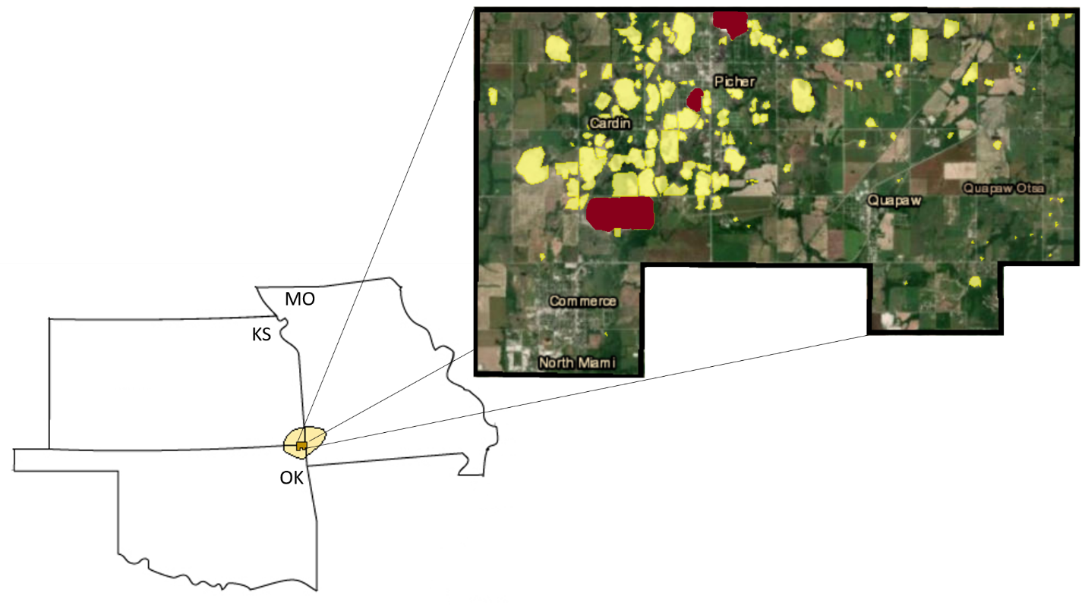

Figure 1: Map of the Tri-State Mining District zooming in on The Tar Creek Superfund Site boundary. Yellow areas represent chat piles in and around the towns of Picher and Cardin in Oklahoma. Red piles indicate chat piles where passerines were sampled.

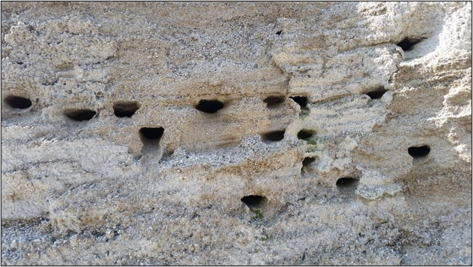
Figure 2: A section of Northern Rough-winged swallow and Bank Swallow colony nest cavities in a chat pile at the Tar Creek Superfund Site.

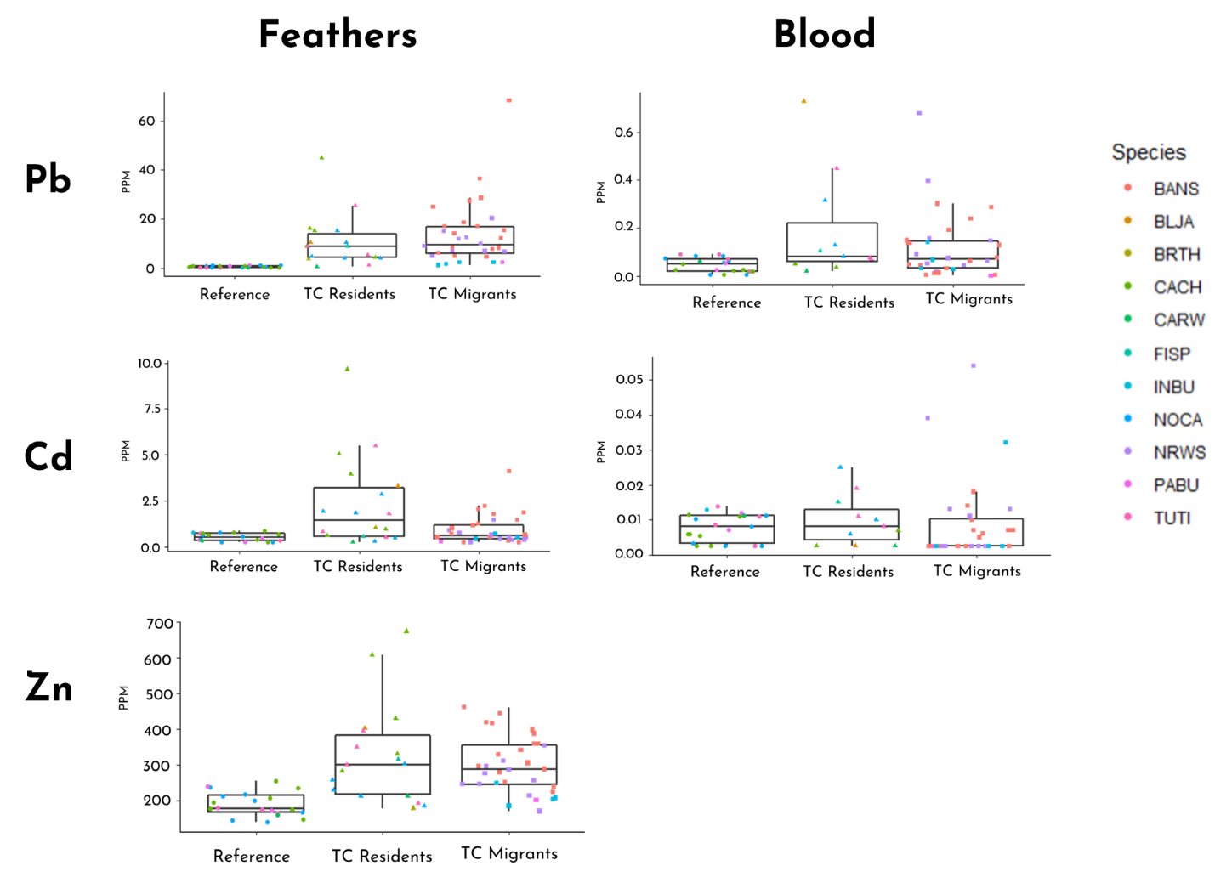

Figure 3: Five generalized linear mixed models (GLMM) with the results from each of the heavy metal analyses (Pb-blood, Pb-feathers, Cd-blood, Cd-feathers, Zn-feathers) used as the dependent variable. The groups (Reference Site birds, Tar Creek (TC) Resident birds, and Tar Creek (TC) Migrant birds) were included as a factor, and species was included as a random factor.

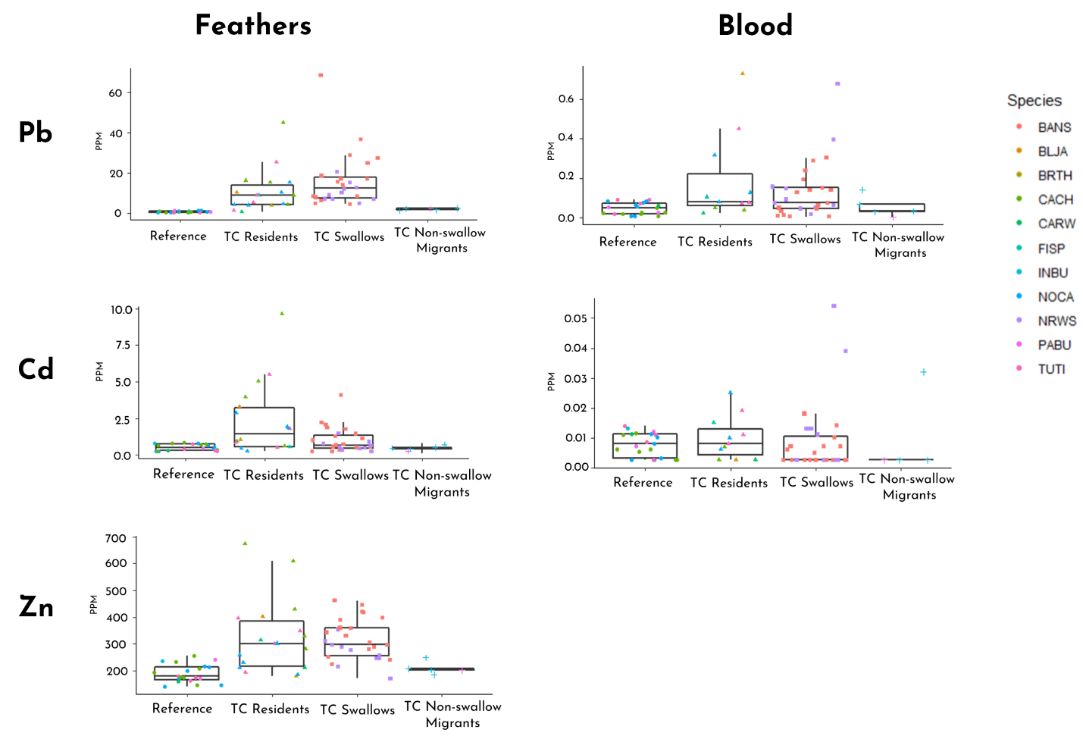
Figure 4: Five generalized linear mixed models (GLMM) with the results from each of the heavy metal analyses (Pb-blood, Pb-feathers, Cd-blood, Cd-feathers, Zn-feathers) used as the dependent variable. The groups (Reference Site birds, Tar Creek (TC) Resident birds, Tar Creek (TC) Swallows, and Tar Creek (TC) non-Swallow Migrant birds) were included as a factor, and species was included as a random factor.

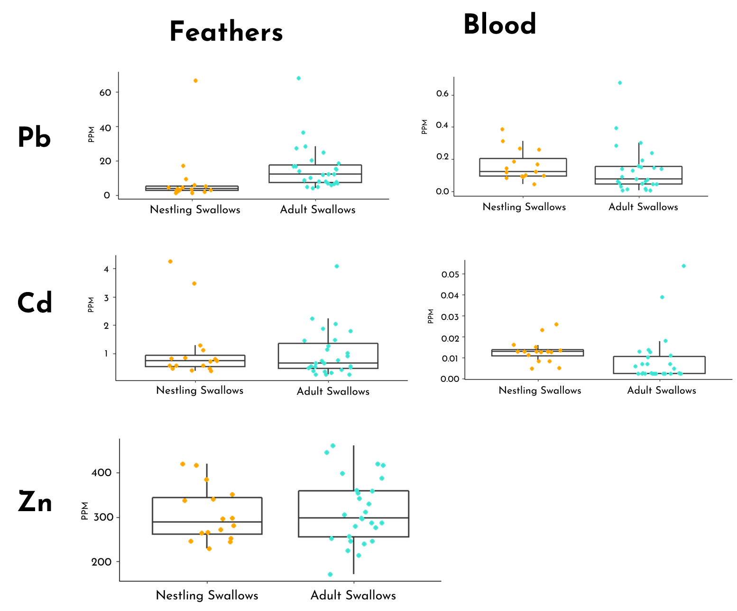

Figure 5: Five one-way ANOVAs with each of the heavy metal detection tests (Pb-blood, Pb-feathers, Cd-blood, Cd-feathers, Zn-feathers) used as the dependent variable. The groups (Nestling Swallows and Adult Swallows) were included as a factor. The two species sampled were Northern Rough-winged Swallows (Stelgidopteryx serripennis) and Bank Swallows (Riperia riperia).

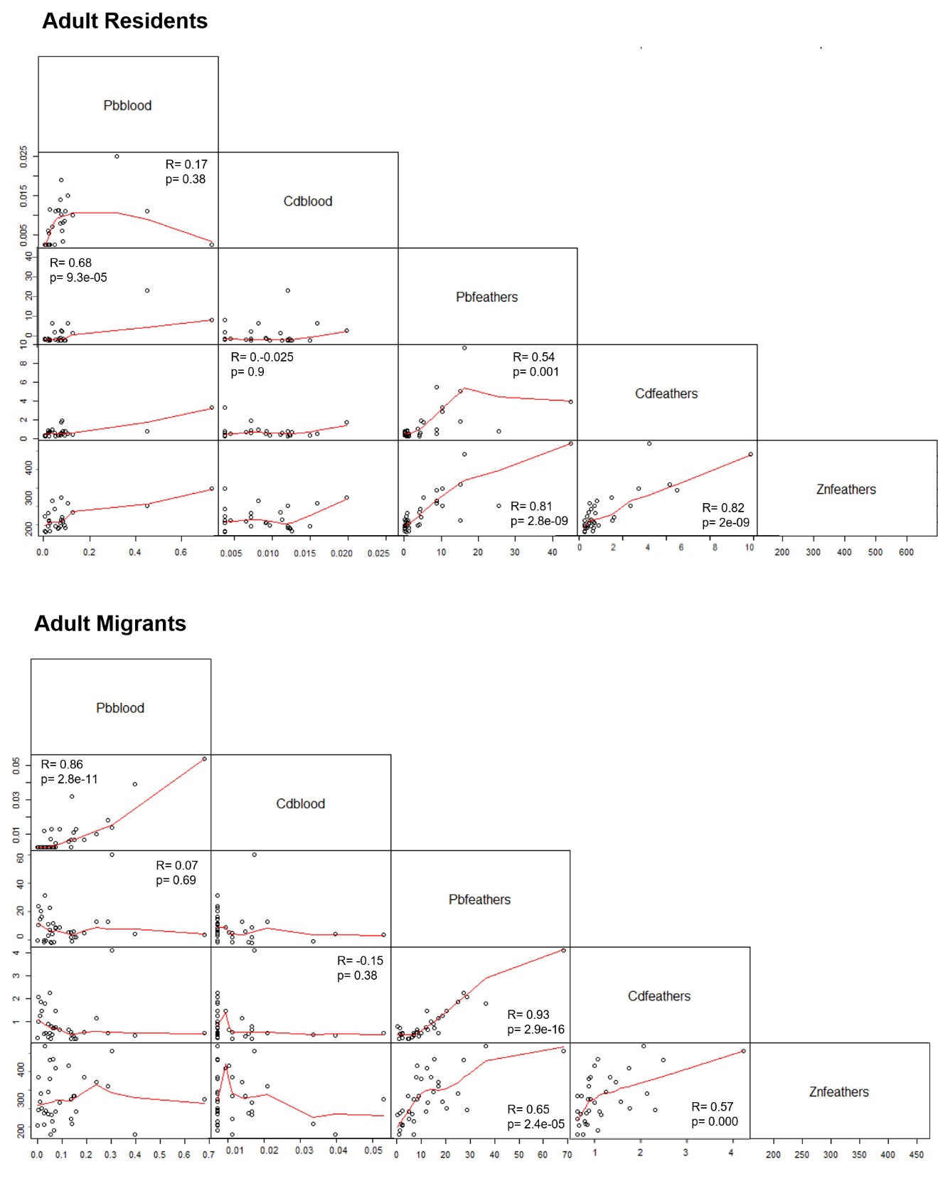
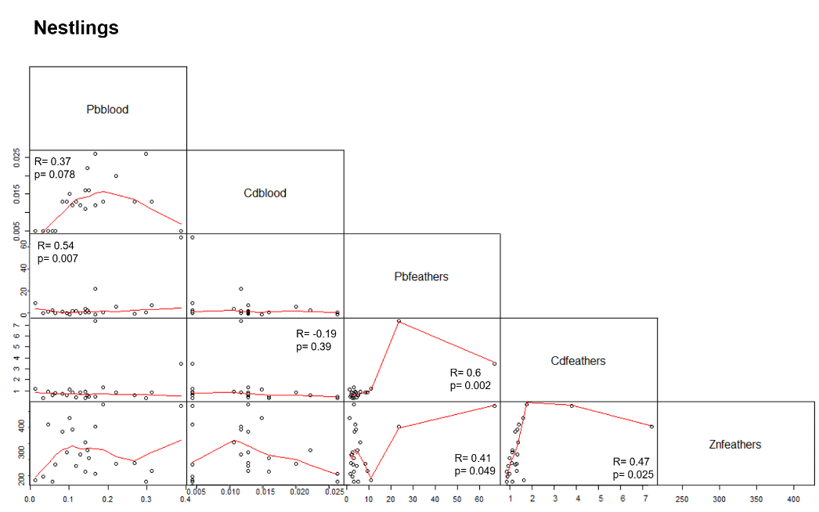

Figure 6: Correlation Matrices and table showing Pearson correlation coefficients between five variables (Pb-blood, Pb-feathers, Cd-blood, Cd-feathers, Zn-feathers) and three groups (Adult Resident birds, Adult Migrant birds, and Nestling Swallows). The Nestling Swallows group consists of two species: Northern Rough-winged Swallows (Stelgidopteryx serripennis) and Bank Swallows (Riperia riperia).

Table 1: Table of Pearson correlation coefficients and p-values between five variables (Pb-blood, Pb-feathers, Cd-blood, Cd-feathers, Zn-feathers) and three groups (Adult Resident birds, Adult Migrant birds, and Nestling Swallows). The Nestling Swallows group consists of two species: Northern Rough-winged Swallows (Stelgidopteryx serripennis) and Bank Swallows (Riperia riperia).

