UNIVERSITY OF OKLAHOMA

GRADUATE COLLEGE

AN ANALYSIS OF THREE RECITAL PIECES BY WILLIAM LLOYD WEBBER

A DISSERTATION

SUBMITTED TO THE GRADUATE FACULTY

in partial fulfillment of the requirement for the

Degree of

DOCTOR OF MUSICAL ARTS

By

ALVEZ BARKOSKIE IV
Oklahoma City, Oklahoma
2021

AN ANALYSIS OF THREE RECITAL PIECES BY WILLIAM LLOYD WEBBER

A DISSERTATION APPROVED FOR THE
SCHOOL OF MUSIC

BY THE COMMITTEE CONSISTING OF

Dr. Sarah Ellis, Chair

Dr. Damin Spritzer

Dr. Eugene Enrico

Dr. Kathleen Crowther

© Copyright by Alvez T. Barkoskie IV, 2021
All Rights Reserved.
Table of Contents

List of Tables v

List of Figures v

Abstract vii

Introduction 1

Chapter 1: William Lloyd Webber 2

Chapter 2: “Prelude” 11

Chapter 3: “Barcolle” 26

Chapter 4: “Nuptial march” 45

Chapter 5: Conclusion 58

Bibliography 66

Appendix A: Timeline of William Lloyd Webber’s significant dates 67

Appendix B: List of published organ works by William Lloyd Webber 68

List of Tables

Table 2.1 Form of “Prelude” 11

Table 2.2 Similarities between melodic statements 15

Table 3.1 Form of “Barcolle” 27

Table 4.1 Form of “Nuptial march” 46

List of Figures

Figure 2.1 Opening phrase 12

Figure 2.2 Pedal, mm. 6-12 14

Figure 2.3 Migration of sixteenth notes, mm. 10-12 15

Figure 2.4 Pedal, mm. 18-20 16

Figure 2.5 Quasi-model/sequence, mm. 14-15 (right-hand) 17

Figure 2.6 Reference to Bitonality, mm. 23-34 18

Figure 2.7 Chromatic bass line, mm. 28-32 19

Figure 2.8 Melodic fragment, mm. 37-38 20

Figure 3.1 Melody, first and second phrases, mm. 3-15 29

Figure 3.2 Accompaniment, mm. 18-28 31

Figure 3.3 Melody, third and fourth phrases, m. 18-29 32

Figure 3.4 Four-note motive, mm. 48-53 34

Figure 3.5 Three note motive, mm. 57-58 34

Figure 3.6 Canon at the ninth (bi-tonality), mm. 59-63 35

Figure 3.7 Comparison of A Section and B Section Melodies, mm. 3-15 & mm. 59-68 36

Figure 3.8 Altered half cadence, m. 71(V⁺⁹) 37

Figure 3.9 Stoplist for 1831 Callinet/1800 Cavaillé-Coll Gallery Organ, Orléans 42
Figure 3.10 Pianistic texture: arpeggios, mm. 15-17 43

Figure 3.11 Dupré “Variation VIII” from Variations sur un Noël, op. 20 44

Figure 4.1 A Section Melody, mm. 5-36 48

Figure 4.2 B Section Melody, compare mm. 44-47 to mm. 9-12 49

Figure 4.3 Phrase a’, mm. 94-101 51

Figure 4.4 Comparison of mm. 26-28 and mm. 107-109 51

Figure 4.5 Clash of D major and E-flat, mm. 110-111 51

Figure 4.6 Melodic fragment from A section melody, mm. 124-129 52

Figure 4.7 Melodic fragment from A section melody, varied, mm. 128-132 52

Figure 4.8 Four-note motive, mm. 37-40 54

Figure 4.9 Motive, mm. 56-62 55

Figure 4.10 Four-note motive in sequence, mm. 132-136 55

Abstract

Born into a family of musicians, William Lloyd Webber (1914-1982), composed numerous pieces for the organ. Many of the pieces were published during his lifetime, but several more were found and published after his death by his family. This document presents detailed analysis of his Three recital pieces for organ. Each of the three pieces, “Prelude,” “Barcolle,” and “Nuptial march,” are analyzed separately as well as compared to one another to draw conclusions of the composer’s use of form, composition techniques, harmonic language, texture, organ registration, and any other notable musical observations. A brief biography is also included to provide a context for the composer’s work.

Introduction

William Lloyd Webber (1914-1982) came from a lineage of musicians. He became an organist as a child and wrote numerous pieces for solo organ. While his music is somewhat known, primarily in Anglican (U.K.) and Episcopal (U.S.) circles, there has been no extensive theoretical analysis of his music. Most writings about him are strictly biographical, or in a few instances, surveys of some of his organ music.
This document will present a theoretical analysis of his Three recital pieces, “Prelude,” “Barcarolle,” and “Nuptial March.” Each of the three pieces will be analyzed on their own and then compared to each other to draw conclusions on the composer’s use of form, composition techniques, harmonic language, texture, organ registration, and any other notable musical observations. This comprehensive study of William Lloyd Webber’s Three recital pieces should not only inform future performers on possible interpretations of these specific works, but may also give insight into the composer’s other organ compositions.
While Lloyd Webber was embarrassed that his music was too conservative and romantic compared to that of his contemporaries, the accessibility and appeal of his music is quite refreshing compared to some of the more avant-garde music during his time. It is well-crafted, as well as both technically and aesthetically valuable, which leads to the purpose of this study. Church musicians seeking new repertoire that is accessible to play on the organ and sing with church choirs would do well do explore the music by this long-overlooked composer.

Chapter 1: William Lloyd Webber

William Southcombe Webber was born in England in 1914. Lloyd, his third Christian name was added when he attended the Royal College of Music to distinguish himself from another music student named W.G. Webber. When his two sons Andrew and Julian were born years later he liked the name so much that he had them both baptized as Lloyd Webber.
William S. Lloyd Webber came from a lineage of musicians on his paternal side of the family. His grandfather played the violin and his father, William Charles Webber, sang alto in his youth and tenor in his adult life. His talent as a tenor led to his singing with several choirs such as the George Mitchell Choir, Black and White Minstrels, All Saints Margaret Street, and Winchester Cathedral, the latter of which was the leading Anglo-Catholic church in Britain. As a result of his father’s singing positions, church music was ever-present in William Lloyd Webber’s youth.
While William’s father sang in different choirs throughout his son’s childhood, he actually made a living as a self-employed plumber. Although money was tight, as “a keen organ buff’ he still made it a priority to take young William to visit the various organs around Britain. These visits resulted in William’s early development as an organist and he was presenting organ recitals as early as the age of 10. He composed pieces for the twin-consoled organ at St. George’s Chapel during his early teens and even played them with Walford Davies, the Chapel organist. At the age of 14, William played live on BBC Radio 3 on January 11, 1929. That same year he became Organist at Christ Church, Newgate Street and received scholarships to both Mercer’s School and the Royal College of Music. At the Royal College of Music that he studied composition with Ralph Vaughan Williams. Felix Aprahamian recalled that when William was 15 he was demonstrating remarkable talent at the organ: “He and his father interrupted my organ practice at Park Chapel in Crouch End. After he’d blazed his way through the Widor Toccata, I suggested he sight-read the Rapsodie Catalan by Joseph Bonnet, with its fiendish pedal cadenza. His playing was absolutely faultless.” By 1932 he was the Organist at St. Cyprian’s, Clarence Gate and received a Fellowship Diplomas from the Royal College of Organists at the age of 19.
In 1939 he became Organist and Choirmaster at All Saints, Margaret Street, one of the churches his father had sung tenor for when William was young. This position was his “quintessential smells-and-bells” job. Ray Elliott, one of the basses who sang under his direction at All Saints recalls, “His conducting gave the impression of a very reserved, restrained man and that’s the way he was. You could never really say you knew him. But at the organ – well, I think there he let himself go.” While serving at All Saints he also composed small musicals for the junior department of the Royal College of Music. It was there that he met a young violinist named Jean Johnstone, who later became his wife on October 3, 1942.
Lloyd Webber’s composing was unfortunately interrupted by World War II (1939-1945). During the war he remained organist and choir master at All Saints in addition to working in the Royal Army Pay Corps in Chelsea. The combination of both of these jobs made it nearly impossible for him to compose so he instead concentrated on supporting his family, a decision he regretted for the rest of his life. Lloyd Webber was particularly upset that Benjamin Britten was able to avoid the war by living in America resulting in his first opera, Peter Grimes in 1945.
The years after the war witnessed his most prolific years. It is remarkable that William’s organ career started so young, but none of his compositions were published until 1950. Perhaps this was because he left his position at All Saints in 1948 and didn’t take up another church position until a decade later. He may also have had more time to compose after the war. Between 1945 and 1950 Lloyd Webber composed for a variety of mediums including choral, chamber, vocal, and instrumental, but organ works were his largest output. The majority of his organ works were short pieces written in binary or ternary forms.
While he was particularly successful as a church-music composer, his sights were set on being a “real” composer. During this time English music was “undergoing a renaissance.” Elgar was the first native English composer in quite some time after a long period when classical music was dominated by Handel, a German transplant. After the war the music of Frederick Delius, Ralph Vaughan Williams, and Gustav Holst was in vogue, as was music by a younger generation of English composers including Benjamin Britten, William Walton, and Arnold Bax. Between 1948 and 1951 Lloyd Webber did write one major orchestral work: a tone poem titled Aurora. This ten-minute work was never published, but was broadcast on BBC.
Lloyd Webber’s style was “firmly embedded in the romanticism.” The composers Rachmaninoff, Sibelius, and Franck were influences on his music, and “he became increasingly convinced that his own music was out of step with the prevailing climate of the time.” He also admired Giacomo Puccini’s operas even though they were out of fashion during this time in England. In fact, before William and his wife had children they owned a female macaque monkey named after Mimi from Puccini’s La Bohème. Aware that his composition style was not the prevailing fashion of the day and with a desire to not compromise his own voice, he turned his efforts to music in academia.
In 1946 he became the Professor of Theory and Composition at the Royal College of Music and in 1964 he was appointed the Director of the London College of Music. During his tenure at the Royal College of Music he deputized for the regular composition teacher for a two-week period. During those two weeks the composer Malcolm Arnold studied with Lloyd Webber and claimed that he “learned more in those two lessons than [he] had in the previous two years.” Lloyd Webber made little time for verbosity and would ask his pupils “Why write six pages [of music] when six bars will do?”
While Lloyd Webber turned his focus in music to academia, he continued working in the church, though ten years passed between his position at All Saints and Methodist Central Hall where in 1958 he became the Director of Music. He continued both of his academic positions at RCM and LCM as well as the latter church position until his death in 1982. John Chapman, his successor at Methodist Central Hall, described Lloyd Webber’s playing: “He had such a passion for colour and romanticism, especially in his improvisations. You’d feel the hair on your neck stand on end.” It is unfortunate that there are no commercial recordings of his organ playing in his prime. There is a vinyl LP of him playing at Methodist Central Hall, but it only includes two of his own compositions, and it was produced towards the end of his life when he no longer had the facility that he once possessed.
In addition to feeling that his compositions were out of step, Lloyd Webber was very shy and sensitive to criticism. It is because of this that so much of his music wasn’t even discovered until after his death. This shyness may have been the reason that he did not pursue recording contracts for his organ playing. He often was reluctant to publish or even talk about his own music. William Lloyd Webber’s son, Julian, who himself is a classically trained musician, a cellist, recounts: “[My father] wasn’t prepared to face the kind of criticism that I’m sure would have come his way. Rather than expose it to abuse, he didn’t let it out. He hated anything to do with promotion, and wouldn’t listen to anyone who tried to persuade him to do something with his compositions.” It wasn’t until after the death Julian’s mother that he discovered that his father had written many pieces that no one in the family knew about. It is likely that this newly discovered music was written shortly before his death when he resumed composing after having written virtually no music since the late 1950s. Several of these works were published posthumously in the 1990s.
Andrew Lloyd Webber offers further evaluation of his father claiming that he was “not equipped to break the mold of his background and simply go for things he really cared about. His romanticism combined with his craftmanship could have made him a brilliant composer for films or the theatre – he was far better than most film writers of the day.” Perhaps William’s career as a church organist kept him from becoming the ‘real composer’ he so desired to become. One day Julian and his father were watching Ken Russell’s film The Sound of Summer. Julian remembers that “we were at the point where Delius says to his amanuensis Eric Fenby that British music will never get anywhere until it rids itself of the church’s influence. My father simply burst into tears. I think he felt he’d become sucked into the world of the church. By the end of his life he was a very unhappy person.”
There is further evidence that William Lloyd Webber’s church career had put his higher composition ambitions on the back burner. John Chapman, his successor at Methodist Central Hall, said that Lloyd Webber once confided in him that taking that post had ‘finished’ him. He felt that his life-long church career had caused him to lose prestige “in the eyes of the establishment.” He actually had the opportunity to compose a film score, but turned it down. He claimed it was too much trouble, but it is more likely that he considered it too mundane – not worthy of a ‘real’ composer.
Self-criticism seemed to be a constant companion throughout his career. When he took position of Director of the London College of Music in 1964, the school was not doing well. While his tenure actually improved the situation at LCM and he was an immensely talented organist, “self-analysis insisted he had failed in his ambition to earn a living as a composer.” When his tone poem Aurora was broadcast on BBC he wrote a short program note which demonstrates just how little self-confidence he had:
Arriving from the East in a chariot of winged horses, dispelling night and dispersing the dews of the morning, Aurora was the Roman goddess of the dawn. This short tone poem attempts to portray in reasonably respectable sonata first movement form, the inherent sensuality of her nature.
Consecutive 6/4 chords introduce a bit of night music soon to be dispelled by the dawn theme, announced by the flute. Aurora’s theme forms the second subject and (it is hoped) is of suitably lyrical nature, as befits such a beautiful goddess. Her amorous adventures can possibly be imagined in the development section, and in the recapitulation her theme occurs twice – the first time with a light textured orchestration, and then with all the instruments that were available at the time of writing the piece.
At the moment of climax, the night music returns again and Aurora has to leave us. However the final cadence has a hint of her theme, and there is always the promise of a new day.

Michael Walsh describes the several instances of self-deprecation in William’s aforementioned program note for Aurora as “characteristically English” and “middle-class propriety,” but there are so many self-deprecating remarks in such a short note that Walsh says this indicates how William Lloyd Webber really evaluated himself as a composer. While Lloyd Webber may have not held Aurora in high self-esteem, Walsh calls it “pleasant to listen to, well crafted, [sic] handsomely scored, and entirely representative of mainstream twentieth-century British composition…English Impressionism. Perhaps Aurora was the closest William Lloyd Webber came to becoming the ‘real’ composer he had so longed to become.
Sadly, William Lloyd Webber was so unhappy with his career as a musician that he actually discouraged both of his sons from pursuing similar careers. He once told his sons: “enter music as a last resort, only if there is absolutely nothing else you can do, he said – not, please note, if your talent simply won’t permit you to do anything else.” Ultimately neither of his sons listened. Andrew, of course, went on to compose numerous musicals and Julian became a professional cellist. It is interesting to ponder how William may have felt when his son Andrew became successful in the same field in which he never felt he had succeeded:
In his desperate moments he would become maudlin and self-pitying, cursing the fate that had denied him his dream. He had offered the boy very little guidance and precious little acknowledgement: “If you ever write a song as good as ‘Some Enchanted Evening,” I’ll tell you,” he said to Andrew. He never did.

In a 1985 article in the Independent, Julian said that his father was “tremendously proud” of he and Andrew, “but I also feel,” he continued, “that hearing us praised had the effect of emphasising to him that, yes, he’d been a failure. But he hadn’t. His music is successful.”
In 1987, following the release of an album of music by Andrew Lloyd Webber, featuring Julian as a performer, and a commercial recording of William’s Aurora, Jean Lloyd Webber, shared that her husband had mixed emotions surrounding the successes of his sons: “It was a slightly tricky situation because one side of him was absolutely delighted and proud of them. The other side was a slightly envious one, thinking ‘Oh Lord, they have more drive to them, they are more single-track minded.’ I suppose he felt he had not achieved all he might.”
“A voyage around my father” by Julian Lloyd Webber not only offers a brief biography of his father’s career, but this excerpt shares many personal reflections which may help in understanding him:
I look back on my childhood in the run-down, red-brick, Victorian block of flats in London's South Kensington with immense affection: 10 Harrington Court was an extraordinary place to be brought up. It was a crazy, hothouse atmosphere populated by exceptionally gifted, strong-willed characters who seemed to drift in and out whenever they pleased. Amid the electric organ, assorted pianos, violins, cellos, french [sic] horns and trumpets were "pedigree" mice, Siamese cats, ancient gas fires that farted, an aged, deaf, grandmother, a brother (and his lyricist) writing musicals, a concert pianist who was about to win the Tchaikovsky prize, and various girlfriends wandering about in equally varied states of undress. Expectations of excellence were the norm and achievement was the never-stated aim.
There were times of great humour and laughter. But always, in the background, was the sense that the head of family was a deeply disappointed, unhappy man who had not fulfilled his immense gift for composition. Alcohol was ever-present, tears and rage lay just beneath the surface, liable to erupt at any time. But my father loved the company of young people. He adored his students and, today, many testify to his personal help and kindness. He was a good listener and he remained steadfastly loyal to his restless, eccentric, intensely spiritual wife. Yet he was a curiously remote figure – a private, lonely man living among a crowd.

Despite his many flaws and shortcomings, Julian says that “The real William Lloyd Webber is to be found in his music.” While this study will only focus on a single set of compositions perhaps the reader will find some of the real William Lloyd Webber here. Ironically, it is William’s displeasure in his own music that leads to this study and its purpose. While William was embarrassed that his music was too conservative and romantic compared to that of his contemporaries, the accessibility and appeal of his music is quite refreshing compared to some of the more avant-garde music during his time. It is well-crafted, as well as both technically and aesthetically valuable, which leads to the purpose of this study. Church musicians seeking new repertoire that is accessible to play on the organ and sing with church choirs would do well do explore the music by this long-overlooked composer.

Chapter 2: “Prelude”

As noted earlier Lloyd Webber made little time for verbosity and would ask his pupils “Why write six pages when six bars will do?” At a total of 57 measures, “Prelude” from Three Recital Pieces exemplifies his penchant for brevity. However, his brevity shouldn’t be mistaken for simplicity. While his music is consider far more conservative than that of his more avant-garde contemporaries there is still a lot to unpack. Numerous late-romantic and 20th-century techniques are utilized, such as harmonic ambiguity and non-functional tonality through layers of chromaticism, distant key relationships, and lack of harmonic closure.
The overall form of the piece is simply ABA’ Coda, but the key structure is more adventurous. (Table 2.1) The B section moves through several keys, beginning in the key of A major/minor, a very distant relationship to the home key of E-flat. Bitonal passage work in the right hand further blur the tonality of the piece. Eventually a more straight-forward key scheme emerges beginning with d minor, moving to F major, then B-flat major, and finally returning the home key of E-flat major with the arrival of the A’ section.
Table 2.1 Form of “Prelude”
Section | Measures | Description | Key areas
A | 1-20 |  | E-flat
 | 3-12 | Melody in right hand | E-flat
 | 12-20 | Melody in left hand | E-flat
Transition | 21-22 |  | ---
B | 23-39
 | 23-31 | No prominent melody/chromatic passage work | A major/minor
 | 32-35 | Fragmented material | V/d minor
Retransition | 36-39 | Fragment of opening melody | V/V in E-flat
A’ | 40-57 |  | E-flat
stage I | 40-47 | Structural return – key & melody | E-flat
stage II | 48-53 | Textural return – texture, melody, and key | E-flat
Coda | 54-57 | False move to B section | E-flat
At first Lloyd Webber’s music looks quite simple: the opening phrase, which is a sentence structure, (Figure 2.1) is completely diatonic, but as the piece progresses a complexity of composition is revealed layer by layer. The piece begins in E-flat major, with a sentence structure ending on scale-degree 5 and the second statement ending on scale-degree 1. So far this seems quite conservative, but it’s not the melody itself, but the way that it is harmonized that is notable. The first three measures of the melody are accompanied by a sixteenth-note pattern in the left hand and a pedal tone; the latter two of which begin two measures before the melody starts. Like the melody, the first three measures of the left hand and pedal are completely diatonic and the pedal tone serves as a prolongation of the tonic chord. But in m. 5, things become more interesting. The static pedal line jumps up an octave and begins a stepwise descent which provides a more active accompaniment to the melody. Also by m. 5 the first non-diatonic note of the piece is introduced: an A-natural in the form of passing tone. By m. 6 the piece becomes increasingly chromatic particularly in the pedal with a leap from A-natural up an octave and then a descending stepwise line this time made up primarily of half steps. While the melody continues to be completely diatonic the left hand that began as diatonic is now introducing more and more non-diatonic notes each measure.
Figure 2.1 Opening sentence structure
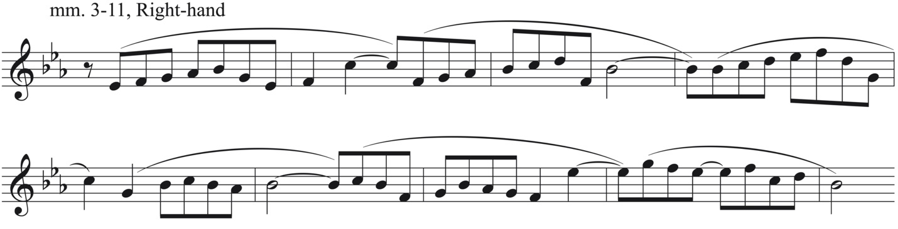

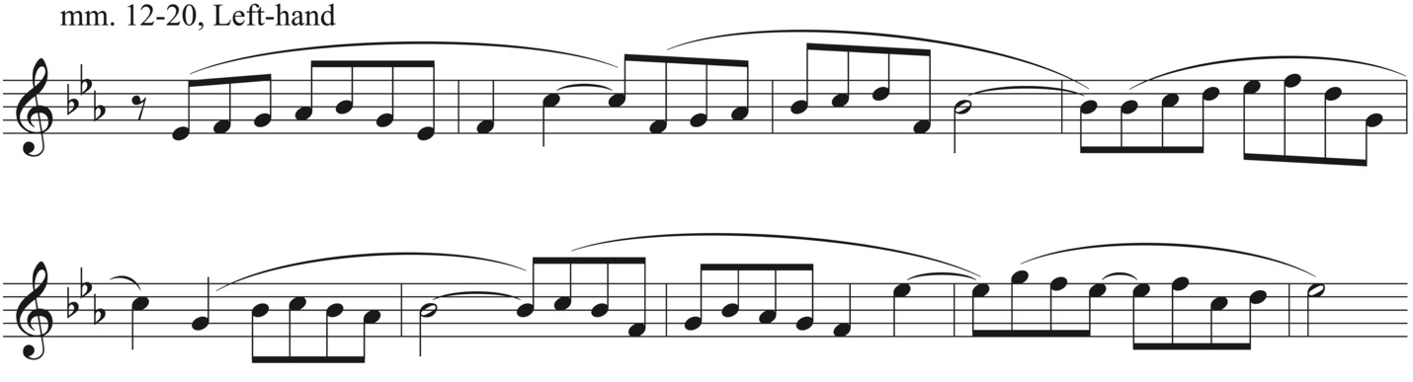
Musical excerpt © 1961 The Really Useful Music Group Limited.

This non-diatonic harmonization is not at all uncommon in the tool box of organist techniques. As a serious church musician, Lloyd Webber likely would have reharmonized hymns on the regular basis or would have at least been familiar with the technique. Like the opening melody of “Prelude,” many hymns are simple diatonic melodies, which organists will often reharmonize with tonicizations, modal mixture, and other altered chords for the purpose of text painting or simply as variation technique. Lloyd Webber’s chromatic treatment of the diatonic opening melody can be heard as just that. While many composers might present the entire melody or at least the first phrase with diatonic harmonization prior to introducing the a more chromatic treatment, Lloyd Webber in his trademark brevity gives only three measures before the first non-diatonic note is introduced and a measure later chromaticism is pervasive in two of the three layers of music.
Starting in m. 6 the pedal line provides the most satisfying sense of ‘harmonic motion’ (Figure 2.2). However, a local Roman numeral analysis of this phrase does not provide any straight-forward harmonic progression in the traditional sense of the word. By the b. 2 of m. 9 the chromatic pedal line arrives at C, then F, then B-flat. This circle of fifths bass line compensates for the lack of harmonic motion in the opening measures when there was a tonic pedal tone and provides harmonic clarity after the brief chromatic excursion of mm. 7-8. The circle of fifths bass line also serves to bring us back to tonic for the altered repeat of the
Figure 2.2 Pedal, mm. 6-12
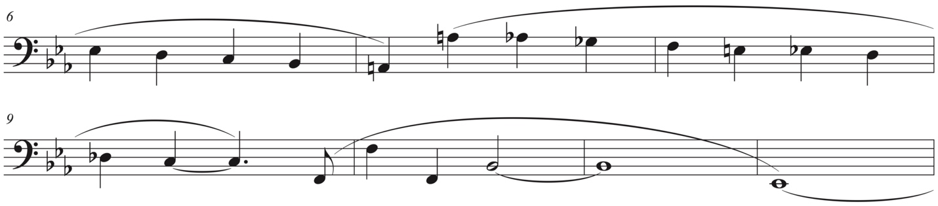
Musical excerpt © 1961 The Really Useful Music Group Limited.

sentence structure in m. 12-20. Before the return of the tonic pedal tone in m. 12, the first phrase ends with a half cadence on b. 1 of m. 11. The melody is then passed to the left hand in the following measure. The sixteenth-notes figures that had dominated the left hand for the first ten measures of the piece move to the right hand via a brief excursion to the alto line for the first two beats of m. 11 (Figure 2.3). The sixteenth-note figures, now in the right hand, provide a similar texture to the first statement of the melody, but the notes are not the same and eventually eighth notes are introduced providing a welcome change in the accompanying rhythm. The pedal line also takes on a more rhythmically interesting role with the introduction of the dotted quarter note.
There are many parallels found in the first and second sentences (mm. 12-19) of the melody (Table 2.2). Like the first, the second sentence begins with a pedal tone, but now the melody is taken by the left hand. The first three measures of the pedal and the right hand are diatonic, with the exception of an E-natural passing tone displaced by an octave in m. 13. As before, by the fifth measure of the second phrase chromaticism is introduced again in stepwise motion in the pedal and in the sixteenth-note figures of the right hand. Finally, the second phrase also ends with a circle of fifths bass line in mm. 18-19.

Figure 2.3 Migration of sixteenth-notes from left hand to right hand, mm. 10-12
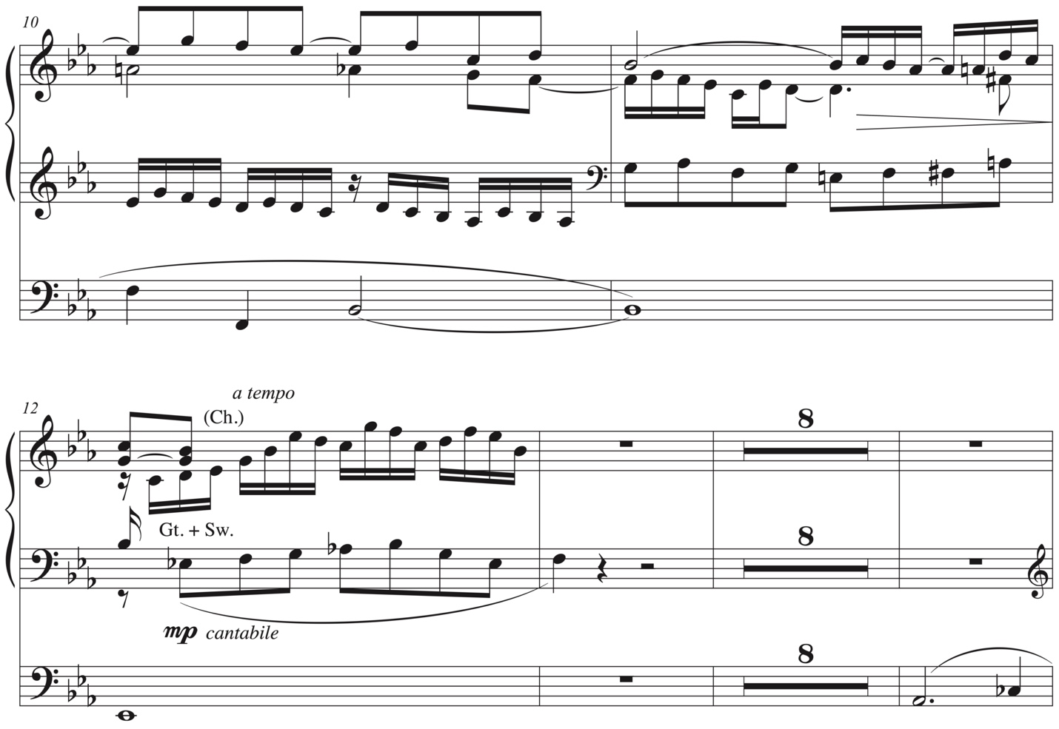
Musical excerpt © 1961 The Really Useful Music Group Limited.

Table 2.2 Similarities between melodic statements
Phrase 1 | Phrase 2
mm. 3-5: pedal tone | m. 12: pedal tone
mm. 7-9: chromaticism introduced | mm. 16-18: chromaticism introduced
mm. 9-10: circle of fifths bass line | mm. 18-19: circle of fifths bass line

As one might expect, the second melodic statement ends on an E-flat offering a resolution to the first melodic statement which ended on a B-flat. However, the harmony offers no such relief. Rather than ending on a tonic chord offering a closed cadence, the root of the B-flat⁷ chord slips to an A, A-flat, and finally a G in the pedal closing the section on a I⁶ chord (Figure 2.4). The A section never achieves a satisfactory harmonic close. After the A section closes, Lloyd Webber writes several chromatic chords in mm. 21-22, which transitions to the B section. Prior to m. 23 the original key signature of E-flat is cancelled out with all naturals for the first nine measures of this section, which is harmonically ambiguous.
Figure 2.4 Pedal, mm. 18-20
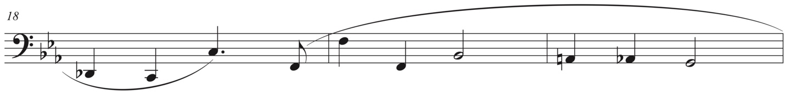
Musical excerpt © 1961 The Really Useful Music Group Limited.

The left hand part from mm. 3-11 and the right hand part in mm. 12-20 show Lloyd Webber’s knowledge of organ improvisation. While there do not seem to be any notable recurring motives in this passage work, there are a few instances of quasi model-sequence technique. That is, the sequence is not a true sequence because it does not follow the real or tonally altered intervals of the model, but the contour is similar enough that it draws the attention of both the listener and the performer. The instances of quasi model-sequence fulfill both an improvisatory and compositional function in this piece: providing a sense of cohesion. These quasi model-sequences may be found in in the left hand of m. 8-9 and the right hand of m. 14-15, m. 17-18, and m. 19-20. The instance at m. 14-15 (Figure 2.5) is particularly prominent because it is presented in a higher register and the melody is at rest. Furthermore, this gesture of model-sequence can be rooted in organ improvisation, which has a rich history in church music and organ performances. Just as Lloyd Webber would have been familiar with the technique of reharmonizing hymns, he would have been familiar with improvisation. Improvisation has many similarities with written composition. In fact, there is a saying among organists that improvisations should sound like written compositions and written compositions should sound like improvisations. That is to say, improvisations should have an intentional quality rather than that of meandering with no true sense of direction and compositions should have an element of surprise.
Figure 2.5 Quasi-model/sequence (shown in brackets), mm. 14-15 (right hand)
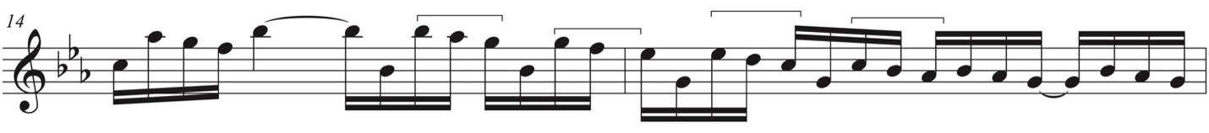
Musical excerpt © 1961 The Really Useful Music Group Limited.

As noted, the transition which follows the evaded cadence in m. 20, continues to harmonically destabilize the music as it moves into the B section at m. 23. While the B section begins with a change in key signature to cancel out the three flats of the opening E-flat key signature, this is not necessarily an indication of a change of key, but rather for the convenience of notation. A harmonic analysis of the left hand and pedal of mm. 23-27 suggests a mixed mode version of the distant key of A, a tritone away from the tonic of E-flat. The highly chromatic nature of this section coupled with the right hand passage work which is not in the key of A makes it impossible to determine the mode, though the minor mode would fit with the notated key signature of no sharps or flats. The passagework in the right hand playing against the more sustained dominant ninth chord in A references the twentieth-century technique of bitonality (Figure 2.6). The key of A is established by the dominant ninth chord in the left hand, the right hand does not fit comfortably in the same key. Harmonically distance and unstable, the flowing sixteenth-notes passages still provide cohesion between the A and B sections. Here Lloyd Webber uses rhythmic motives to tie together complex pitch structures. The quasi model-sequence in mm. 23-24 also works to create cohesion between the two sections (Figure 2.6).
Figure 2.6 Reference to Bitonality, 16th notes to create cohesion between A and B
sections, quasi-model sequence (shown in brackets), mm. 23-24
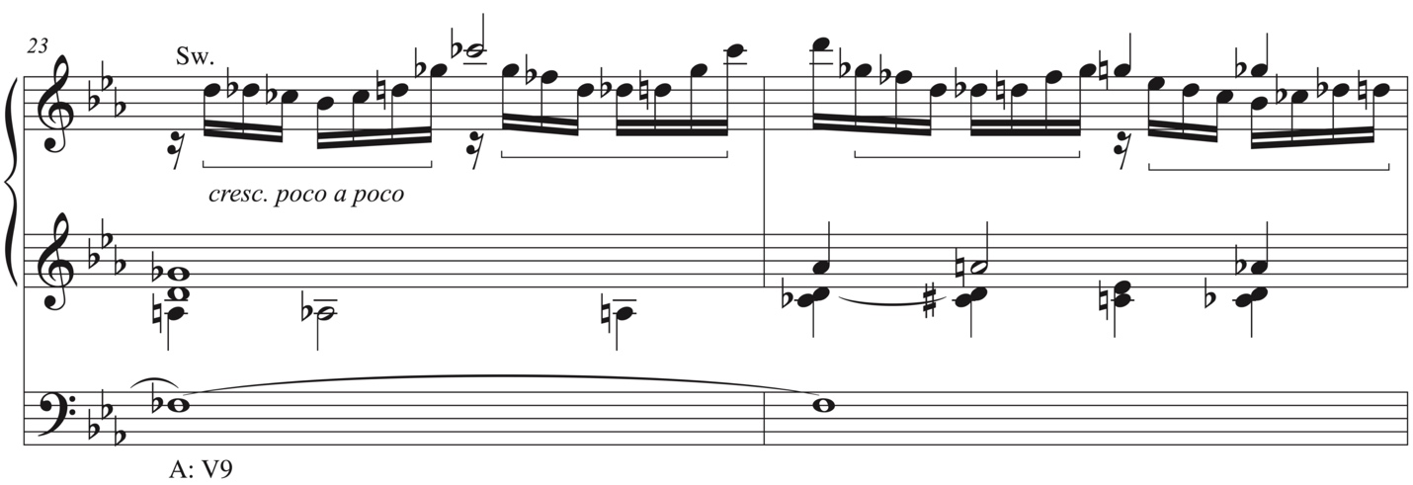
Musical excerpt © 1961 The Really Useful Music Group Limited.

At the end of m. 27 Lloyd Webber seemingly sets up the first cadence of the section. While there is not a clear dominant chord, the G-sharp on the second half of b. 4 in m. 27 functions as a leading tone in A, suggesting cadential motion. Instead of dominant to tonic motion in A, Lloyd Webber writes a more interesting progression. The G-sharp in the top voice is harmonized with a C in the alto, an E in the left hand, and another C in the pedal. The resulting progression is a C⁺ moving to F⁺⁹. This augmented chord moving to another augmented chord functions as a secondary altered dominant moving to another secondary altered dominant in a circle of fifths progression. An F⁺⁹ chord normally would resolve to B-flat, the dominant of the home key of E-flat. However, this F⁺⁹ chord does not resolve. Instead it foreshadows the standing on the dominant at end of the retransition in mm. 38-39. Starting in m. 29 Lloyd Webber writes a quick modal excursion with C Lydian, further weakening the harmonic clarity. While the hint of Lydian in m. 29 serves to complicate the tonality of the movement even more, as Figure 2.7 shows, beginning in m. 28 the chromatic bass line works to move the harmony to A⁷ in m. 32, which begins the retransition. In some ways the A⁷ is a fulfilment of the A chord we might have expected in m. 28, but the added seventh changes its function from a tonic one to a dominant one. A local Roman numeral analysis of these measures is fruitless as the chords are not functionally tonal; instead the chromatic bass line itself provides the real sense of forward motion, similar to mm. 6-12 in the A section.
Figure 2.7 Chromatic bass line, mm. 28-32
Musical excerpt © 1961 The Really Useful Music Group Limited.

Beginning in m. 32 with the retransition, the music moves through a series of key changes: d minor, B-Flat, and finally E-flat. The pickup to m. 34 brings back the F⁺⁹ chord (first heard in m. 28). Here the chord resolves as expected to B-flat (this motion repeats in m. 34). This begins not only a circle of fifths bass line as seen in the A section in mm. 8-11 and mm. 18-19, but an actual circle of fifths progression. This time with a V/ii in m. 35, leading to a V/V in m. 36, to a V⁷ in mm. 38-39 and finally a return to E-flat in m. 40, which signals the return of the A section. Just prior to the return, a fragment of the opening melody from mm. 10-11 of the A section is reprised in m. 38-39. The repetition of this melodic fragment coinciding with the standing on the dominant at the end of the B section parallels its first occurrence at the half cadence in m. 11 (Figure 2.8).
Figure 2.8 Melodic fragment (bracketed), mm. 37-38 (right hand) (cf. mm. 10-11)
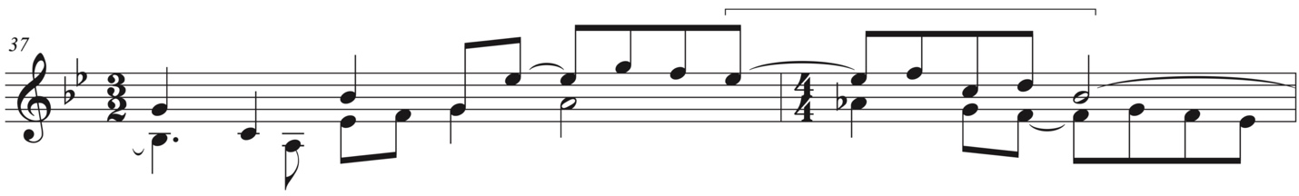 Musical excerpt © 1961 The Really Useful Music Group Limited.

Lloyd Webber moves the music from the opening section in A’ in two stages: first, the return of the opening melody in the home key of E-flat and second, the entrance of the sixteenth-note texture. In m. 40, he places the opening melody more prominently, an octave higher than in the beginning of the work, but the texture that originally accompanied the melody is noticeably absent. Unlike the murmuring sixteenth-note accompaniment in the A section, the melody is harmonized in a quasi-chorale-style with a fortissimo dynamic indication. The first phrase of the melody is given in an almost completely unaltered statement until m. 47 where it is interrupted with few chromatic notes. This measure ends with Italian augmented sixth chord which resolves with punch on m. 48 on the dominant, signaling the second stage of the return. Now the sixteenth-note figures that opened the piece enter and remain unaltered, until the final beat of m. 49, over a dominant pedal tone (instead of the tonic pedal tone). In m. 50 the melody returns over a tonic pedal tone with the sixteenth-note texture continuing in the left hand. The return is complete, as the opening texture, withheld from the listener in the structural return in m. 40, has been enjoined with the melody. In the second melodic sentence is truncated and by m. 52 the melody fragments and disintegrates into the chromatic transition, first heard in m. 22 and now at m. 54.
A brief coda, which begins in m. 55, sounds like the beginning of the B section with a small revision, now the pedal tone is E-flat instead of E-natural. This short continuation of the ABA rotation is only one measure before it gives way to the tonic chord in the home key. The music still does not cadence, instead the move to the beginning of the B section is a clever way of reminding the listener and performer that the A section perhaps never really truly concluded, implying a continual cycle.
Reflecting on the piece as a whole, there are two interesting moments in the A section which foreshadow the move to the distant key of A in the B section. First, in m. 6, the first non-diatonic pitch is A-natural in the form of a passing tone in the left hand sixteenth-note passage work. Second, and more compelling, the use of the A-natural to foreshadow the key of the B section is in m. 20. In m. 20, the listener fully expects to hear the B-flat⁷ chord to resolve to tonic, or at least a deceptive cadence before finally resolving to the tonic a few measures later. However, the B-flat bass note slips to A natural instead, presaging the same motion later in the work (see last measure of Figure 2.4).
While Lloyd Webber’s prelude is often not functionally tonal he uses the diatonic opening melody and a bass line to ground his composition. The lack of harmonic closure in the A section serves as a departure point for an even more harmonically unstable B section which is in the distant key of a tritone away from the home key. In the B section he uses bitonality and modality to further blur functional tonality. Often a Roman numeral analysis is not practical as most harmonies do not combine to create functionally tonal progressions. However, Lloyd Webber doesn’t hesitate to use the pedal both chromatically and through movements of fourths and fifths to created forward motion in the absence of functional tonality.

Registration as a compositional technique

Often times composers use texture, tessitura, dynamics, orchestration, and other musical expressions to highlight formal pillars in their music. In organ music, registrations may also be used to highlight these important moments. While composers like Bach rarely indicated specific organ registrations, later composers, particularly in the Romantic and twentieth centuries gave increasing specific registration indications. Some composers such as Cesar Franck gave registrations specific to their own church instruments, where non-organist composers like William Bolcom may indicate a specific color description that the organist will have to translate into a practical registration on a particular instrument. Still other composers give only dynamic indications which an organist can interpret as a change in registration, change of manual, or can change dynamics using a division under expression which is controlled with a pedal that allows more or less sound out of the instrument into the room.
While Lloyd Webber was himself an organist, there are almost no registration indications in “Prelude,” but still other important indications unique to the organ that are worth noting. For the layperson, there are three typical divisions of the organ: swell, choir, and great. While some organs have more divisions and some have less, these divisions give the organist insight in to how to approach the piece. They can simply be explained as a different manual (keyboard), or as a different sound, like divisions of the orchestra or separating a choir into two or three separate ensembles. These division may also be couple together. That is, if the choir and swell are coupled, then two of the three ensembles or divisions are being used. If the swell, great, and choir are all couple together, then it can be consider something as approaching tutti, but only in as much that all the divisions are used, the dynamic is not necessarily forte.
In the opening of “Prelude” the swell division of the organ is indicated for the introduction. In m. 3 the left hand continues to play on the swell, but the right hand plays on the choir which is coupled to the swell. This means that the right hand, which is playing the melody will be more prominent because it is sounding on two divisions whereas the left hand is only playing on one division. Even if the melody were only played on the choir division without coupling the swell, the organist can select different stops, or timbres to make the melody stand out from the accompaniment. These are important concepts as they allow the composer and the performer to also be an orchestrator. In m. 12 with the start of the second phrase of the melody, Lloyd Webber indicates that the melody, now in the left hand, should be played on the great with the swell coupled to it. The great is the largest division of the organ and in many cases is unenclosed, meaning that passages played on the great will by default be louder than the other divisions, depending on what registrations are used. In the case of this piece, it is important that the melody balances with the right hand which is in a much more prominent register. Up to this point the composer has not changed the dynamic from mezzo piano aside from a few hairpin dynamics and the use of poco. crescendo. That is to say that the overall dynamic has been largely unchanged and that the manual indications of swell, choir, and great may have been offered primarily to ensure that the melody is always the most prominent voice. In m. 20 the left hand changes from great to choir on the second half of the measure signaling that the melody is over.
As one might expect, Lloyd Webber highlights the beginning of the B section through a change in division. The left hand remains on the choir manual, but the right hand switches to the swell manual. Most organists will instinctively change organ registrations at this moment taking into consideration the style of the piece, the texture of the section, the dynamic, what they know about the composer and the instruments of the period, etc. While Lloyd Webber does not indicate a specific dynamic, but he does indicated a cresc. poco a poco. Unless the organist has taken the swell coupler off the choir that the right hand is playing on the swell and the left hand is playing on the choir with the swell coupled. This might be an assumption on the part of the composer that the organist would do this, or it could be intentional that the left hand is a bit more prominent than the right hand. The right hand offers no prominent melody, but some passage work that continues the sixteenth-note drive from the previous section. The left hand and the pedal provide a more harmonically stable sound compared to the right hand which is in a different tonality all together. Therefore, the organist might experiment with the counterintuitive practice of playing the left hand which appears to be the accompaniment slightly louder than the right hand which contains the more active passage work. This practice could help elucidate the bitonal moment and the harmonic ambiguity that results. At m. 25 the B section continues to crescendo over time by indication of manual changes (moving to the right hand to the choir and then the great and then both hands to the great) as well as dynamic changes (mezzo forte moving to forte). Measure 32 marks both the arrival of the retransition and the composers first registration indication: a full swell, boxed closed. This indication means that most of the stops on the swell are engaged, but the box closed means that their full effect won’t be heard until the box is opened which can be done over time as indicated in the succeeding measures.
At the arrival of the return of the A section the organist is already playing with both hands of the great, the largest division, with the full swell coupled to it. The composer’s indication of fortissimo can be interpreted as opening the swell box all the way, if the performer hasn’t already, or adding some stops to the great and pedal division. Most performers would likely do both. The indication of the right hand moving to the swell in m. 48 will clarify the recapitulation of the sixteenth-note passages in the left hand which remains on the more prominent great division. The composer also gives his second ‘clear’ registration indication here, which is to gradually reduce the stops on the great and swell over the next few measures. In m. 50, where the both the melody and texture from the opening return, Lloyd Webber indicates that the melody should be played on the choir. This parallels his manual indication on the opening section of the piece. In m. 52 the left hand joins the right hand on the choir so further facilitate the decrescendo. Finally, in m. 55 the right hand moves to the swell while the left hand remains on the choir. As mentioned in the beginning of the B section, the right hand will sound more distant than the left hand if the swell is still coupled to the choir. In this instance a distant sound would be fitting as these last few measures are like a memory of the harmonically unstable and tumultuous B section.
In conclusion, the beginning of this chapter explored ways in which Lloyd Webber composed a seemingly conservative organ prelude, which contains layers of complexity just beneath the surface through the use of harmonic ambiguity, non-functional tonality, chromaticism, distant key relationships, and a lack of harmonic closure. Organ registration may be used by the performer to highlight these complexities and to signal the important formal moments of the piece that might otherwise be blurred through contemporary compositional techniques.

Chapter 3: “Barcolle”

Unlike his generically titled “Prelude,” Lloyd Webber gives us more a deliberate impression in “Barcolle,” the second of his Three Recital Pieces. A barcolle is a character piece in 6/8 that imitated the lilting songs “sung by Venetian gondoliers as they propel(ed) their boats through the water.” As Lloyd Webber’s piece progresses and often fails to reach harmonic closure when the listener might expect it to, one can almost imagine the gondolier getting their boat stuck on debris in the canals of Venice. The piece is in the standard form for a Romantic character piece, ABA with a Coda, as shown in Table 1.
Lloyd Webber utilizes the following compositional techniques in “Barcolle:” a pitch centricity combined with extensive used of the whole tone scale, bitonality, structural foreshadowing, minimal authentic cadences, and altered spellings of the half cadence. There are also several French influences. All of these techniques and influences will be explored in depth below.
The A section of “Barcolle” is a double period. The first three phrases end with a half cadence. The fourth and final phrase ends on an authentic cadence. In the second and fourth phrases Lloyd Webber uncovers more and more chromaticism. Phrase a’ (mm. 8-15) introduces elements of the whole-tone scale, which will become more prominent as the piece progresses.
Apropos the title, the piece begins in 6/8 with a lilting rhythm. The pedal plays on the beats one and two, slurred in groups of two to achieve this. The accompanying figure in the left

Table 3.1 Form of “Barcolle”
Section | Measures | Label | Key area(s) | Other
A | 1-29 | Double period | G minor
 | 1-7 | Phrase a | G minor | Melodic minor
 | 8-15 | Phrase a’ | G minor | More chromatic than Phrase a
 | 15-22 | Phrase a’’ | G minor | No ornament in m. 20  (unlike m. 5 of first statement of a
 | 23-29 | Phrase a’’’ | G minor | Finally cadences on a PAC
Transition | 29-33 |  | - | Scherzo-like texture
B | 34-71 |  | Various
 | 34-50 |  | C minor
 | 51-58 |  | E minor | Return of A section melody (fragments)
 | 59-65 |  | RH: C-sharp minor  LH: B minor | Bitonal/Canon at the 9th presentation of the A section melody
 | 66-67(9) |  | B-flat minor (LH) | A section melody continues
 | 70-71 |  | E-flat minor | A section melody continues
 | 71 |  | *HC in G minor | altered dominant HC  (whole-tone cluster)
Return of A | 71-85 |  | G minor
 | 71-78 | Phrase a | G minor | cf. mm. 1-7, different registration
 | 79-85 | Phrase a’ | G minor | cf. mm. 8-15, ends on altered dominant HC
Coda | 86- 106 |  | G minor
 | 86-90 | Phrase a | G minor
 | 91-99 |  | G minor | mm. 96-98, standing on the dominant
 | 99-101 | TR material | - | cf. mm. 29-31 (identical)
 | 102-106 | TR material | G minor | cf. mm. 32-33 (similar)

hand begins on the second division of beat two and is tied to beat one lending to an even further sensation of a swaying boat. The minor mode coupled with pervasive extended tertian sonorities in the accompaniment figure reflect the tempo marking of comodo, poco mesto, or comfortable tempo, mournful. The plagal motion in mm. 1-4 is not unlike Lloyd Webber’s use of the pedal tone in “Prelude,” to create harmonic stasis and ambiguity. Similarly to “Prelude,” a local Roman numeral analysis is generally not helpful in understanding the composer’s harmonic method.
The melody, played on the oboe stop of the organ and accompanied by the lilting rhythm of extended tertian sonorities, has an almost haunting and sensual effect. The first phrase of the melody uses the melodic minor version of the scale ending on a half cadence. In the pickup to m. 8 the second phrase begins almost identical to the first phrase, but in the following measure what was originally an f-sharp in the first phrase slips to an f-natural in the subsequent phrase. This thwarting of expectations is not unlike the B-flat⁷ chord in the “Prelude” that slips to an A in the pedal line in mm. 19-20. Phrase two has another striking similarity with the “Prelude.” In the second phrase of “Barcolle,” like the second phrase of “Prelude” the melody becomes increasingly chromatic. However, in “Barcolle” the accompanying pedal part also becomes more chromatic. The accompaniment in the left hand, introduces chromaticism as early as m. 6 with the cross relation of a C-sharp against a C-natural in the melody.
As in the previous piece, Lloyd Webber utilizes twentieth-century techniques in “Barcolle.” At the conclusion of second phrase in mm. 14-15 Lloyd Webber introduces the whole-tone scale, which pervades the remainder of the work. His use of this ambiguous scale is an effective color further developing the melancholy character of the work. Interestingly, the whole-tone scale is never exclusively used. That is, Lloyd Webber always includes non whole-tone pitches accompanying the whole-tone harmonies or passages. This is likely due to the scale’s repetitive and ambiguous nature. Of the seventeen notes in m. 14, three of them do not fit in the whole-tone scale (Figure 3.1). Likely Lloyd Webbers uses non-whole-tone pitches to stretch out and embellish the ascending scaler passage to D, which signals the arrival of the second half cadence of the piece.

Figure 3.1 Melody, first and second phrases, mm. 3-15
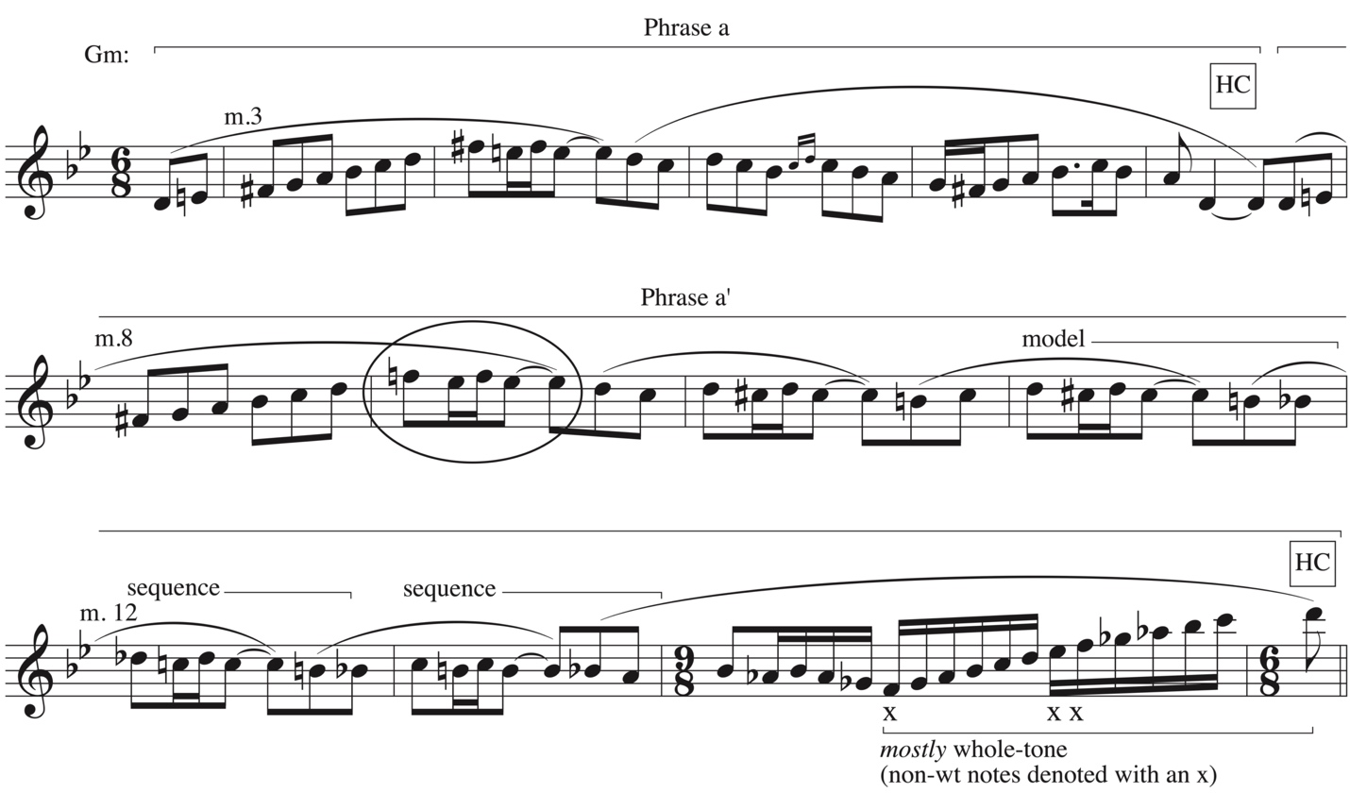 Musical excerpt © 1997, 2013 Kevin Mayhew Ltd. Used with permission.

Another interesting feature of phrase two is its lack of symmetry with phrase one. While both phrases end with a half cadence in G-minor, the first phrase is only five measures and the second phrase is seven measures. The second phrase is lengthened in a couple of ways. First, by the use of model/sequence technique which in addition to extending the phrase also provides cohesion to the piece. As the second phrase becomes increasingly chromatic, the sequences function to prevent the listener from getting completely lost. Second, the 9/8 bar in m. 14 adds extra space for a longer scaler passage which also accommodates the introduction and more extended uses of the whole-tone scale. These features, combined with the dominant pedal point from mm. 12-15, make the half cadence at m. 15 a stronger point of arrival than the first cadence at m. 7. While the half cadence at m. 15 functions as a point of arrival, it still can also be heard another unexpected turn by the composer. After the half cadence at m. 7, a closed cadence at m. 15 is expected. Instead the half cadence at m. 15 gives the impression that the gondolier is stuck on a branch. In the second half of m. 15 the accompaniment figure that opens the piece returns in a slightly varied state, now with an arpeggio of broken chords. Perhaps this signifies that the gondolier has reset his voyage and is going to try again, this time avoiding the branch hidden in the murky Venetian waters. In m. 18 the melody returns (phrase three) with a different organ registration and without the ornament in m. 20 as there originally was in m. 5. The pickup notes from the first statement are also absent. The left hand and pedal accompaniment to phrase three is a more rhythmically-active texture than the accompaniment to the first phrase. This change of texture begins in mm. 15-17, a variation on the first two measures of the piece. Perhaps the more rhythmically-active accompaniment will give the gondolier the momentum they need to coast over the branch that hindered them in phrase two. The most distinctive difference in the accompaniment is not the texture, but the pervasive use of the whole-tone scale. Like the use of the whole-tone scale in the melody of m. 14, the accompaniment in mm. 18-28 is mostly whole-tone throughout (Figure 3.2). While the whole-tone scale by definition does not contain the leading tone, G is still clearly the pitch center. Lloyd Webber establishes this pitch center via repetition and by the melody in the right hand which was previously heard with a tonal harmonization at the beginning of the piece. In this way, Lloyd Webber can use the whole-
Figure 3.2 Accompaniment, mm. 18-28
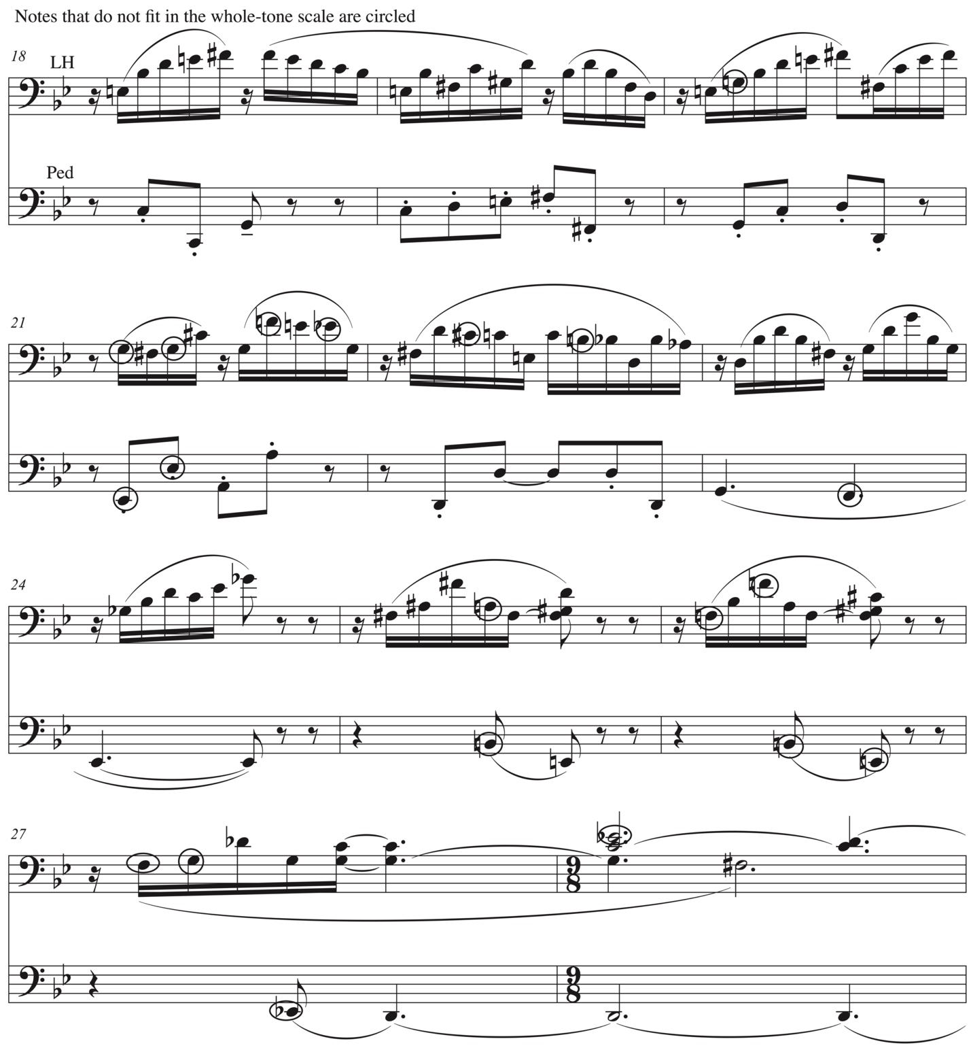
Musical excerpt © 1997, 2013 Kevin Mayhew Ltd. Used with permission.

tone scale to create ambiguity, while simultaneously using a largely unaltered version of phrase one the more freely altered version of phrase two (Figure 3.3), and the repetition of the tonic note to keep the piece grounded. Finally, in m. 29 Lloyd Webber gives us the first perfect authentic cadence of the piece.
Measures 29-33 function as a transition to the B section. In mm. 29-31 the gondolier celebrates their triumph over the branch with a short scherzo-like passage signaling the transition to the B section. The scherzo-like passage is followed by a more legato transition section in mm. 32-33 melding into the start of the B section in m. 34.

Figure 3.3 Melody, third and fourth phrases, mm. 18-29
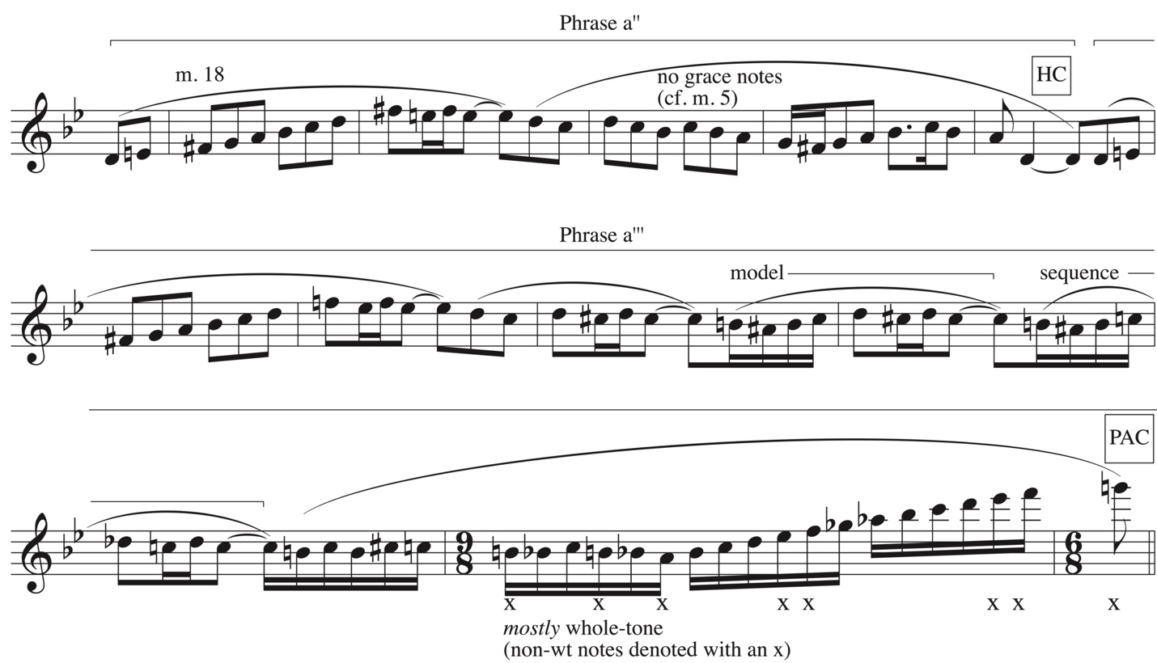
Musical excerpt © 1997, 2013 Kevin Mayhew Ltd. Used with permission.

The B section, is distinguished from the A section through is use of several different textures. Beginning in C minor continues the more legato character of the transitional measures that preceded it. A chorale-like texture, which contrasts with the more rhythmically-active texture of the A section opens this section. This chorale-like texture last for sixteen measures before material from the A section returns and the music modulates through various key areas. A more imitative texture begins in m. 51 with the beginnings of a canon appearing in m. 59. However, the canon is quickly abandoned and short counter-motives are introduced in m. 63. Not only does the texture differ from the A section, but so does Lloyd Webber’s use of cadences. There are no clear cadences in the B section until it’s conclusion in m. 71.
The first sixteen measures of the B section set a strikingly different tone from the A section. In addition to the chorale-like texture, the pedal drops out for the first nine measures of the B section, the longest the pedal doesn’t play in any of the Three Recital Pieces. These first sixteen measures are also the only part of the B section that does not incorporate the A section melody.
While the legato, chorale-like texture portrays the image of calm waters, there are still many dissonant moments indicating a rough undercurrent. One of these dissonant moments is a split-third chord in m. 35 where the alto note is B-flat and the tenor note is a B-natural. Furthermore, the C minor section never cadences. The section ends with a circle of fifths progression in mm. 46-49 which brings the section to A-flat minor, before a phrase modulation to E minor in the pickup to m. 51. The A-flat minor and E minor sections repeat a four-note motive (Figure 3.4) twice in each key giving a sense that the gondolier is stuck again, perhaps this time by the rough undercurrent hidden beneath the seemingly calm waters of the opening of the B section. By mm. 56-58 the gondolier is stuck yet again, this time as demonstrated by a three-note scaler figure (Figure 3.5) reminiscent of the A section melody.

Figure 3.4 Four-note motive, mm. 48-53
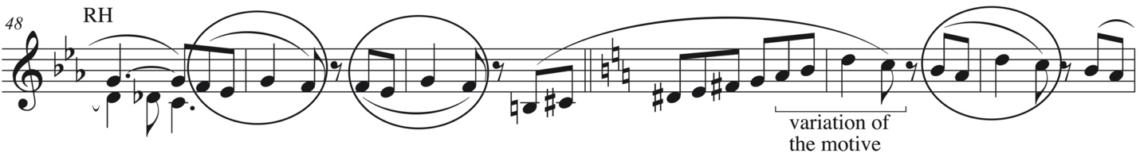
Musical excerpt © 1997, 2013 Kevin Mayhew Ltd. Used with permission.
Figure 3.5 Three-note motive, mm. 57-58
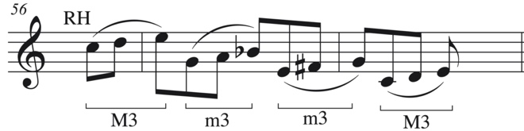
Musical excerpt © 1997, 2013 Kevin Mayhew Ltd. Used with permission.

This three-note figure introduces the return of the opening melody from the A section in the left hand, in the pickup to m. 59 now in B minor. The waters of tonality are further blurred when the right hand counters it with a portion of the opening melody in C-sharp minor in a short quasi-canon at the ninth with the left hand in the same measure (Figure 3.6). While only the first five notes of the right hand in m. 59 are the from the opening melody, in this moment, however brief, Lloyd Webber makes use of bitonality, a technique which he referenced in mm. 23-25 of “Prelude.” By m. 60 Lloyd Webber retreats to a more harmonically straight-forward accompaniment figure in the right hand, but by m. 63 whole-tone segments are creeping their way back into the accompaniment.

Figure 3.6 Canon at the ninth (bi-tonality), mm. 59-63
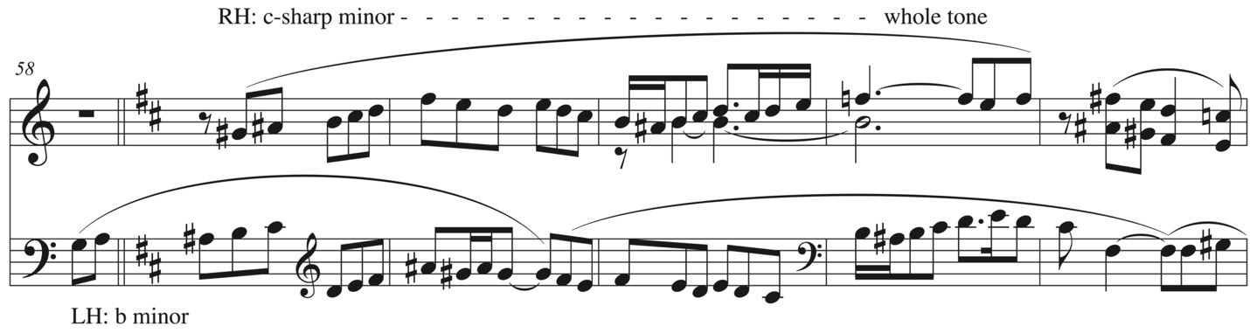
Musical excerpt © 1997, 2013 Kevin Mayhew Ltd. Used with permission.

While the left hand melody, with the pickup to m. 59, begins in the key of B-minor, by m. 66 it slips to B-flat minor. Lloyd Webber slyly shifts the melody down a half step through a serious of small interval changes illustrated in Figure 3.7. With a couple of other slight alterations to the melody in mm. 67, by mm. 68-71 appears exactly as in mm. 12-15 at the end of the A section. Measures 66-70 are also accompanied by model/sequence technique, grounding the piece as the B section comes to a close on a half cadence in m. 71.
The half cadence in m. 71 is an unusual one. While it sounds and feels like a half cadence, it is a V⁺⁹ in G minor and contains five of the six notes of the whole-tone scale. (Figure 3.8). In fact, five of the six notes in the whole-tone scale Lloyd Webber has consistently used are present in this single beat: C, D, E, F-sharp, and B-flat. Perhaps G-sharp, the raised tonic, was just a bit too dissonant for Lloyd Webber to use in this rhetorically important moment. This altered half cadence is not unlike how composers of the Romantic era expanded the chord qualities of the half cadence of the Classical era. Whereas in the Classical era the half cadence was limited to a simple V triad, Romantic composers commonly used the V⁷ chord to create a half cadence. Here Lloyd Webber continues this legacy of expansion by using an altered dominant to create a half cadence.
Figure 3.7 Comparison of A Section and B Section Melodies, mm. 3-15 & mm. 59-68
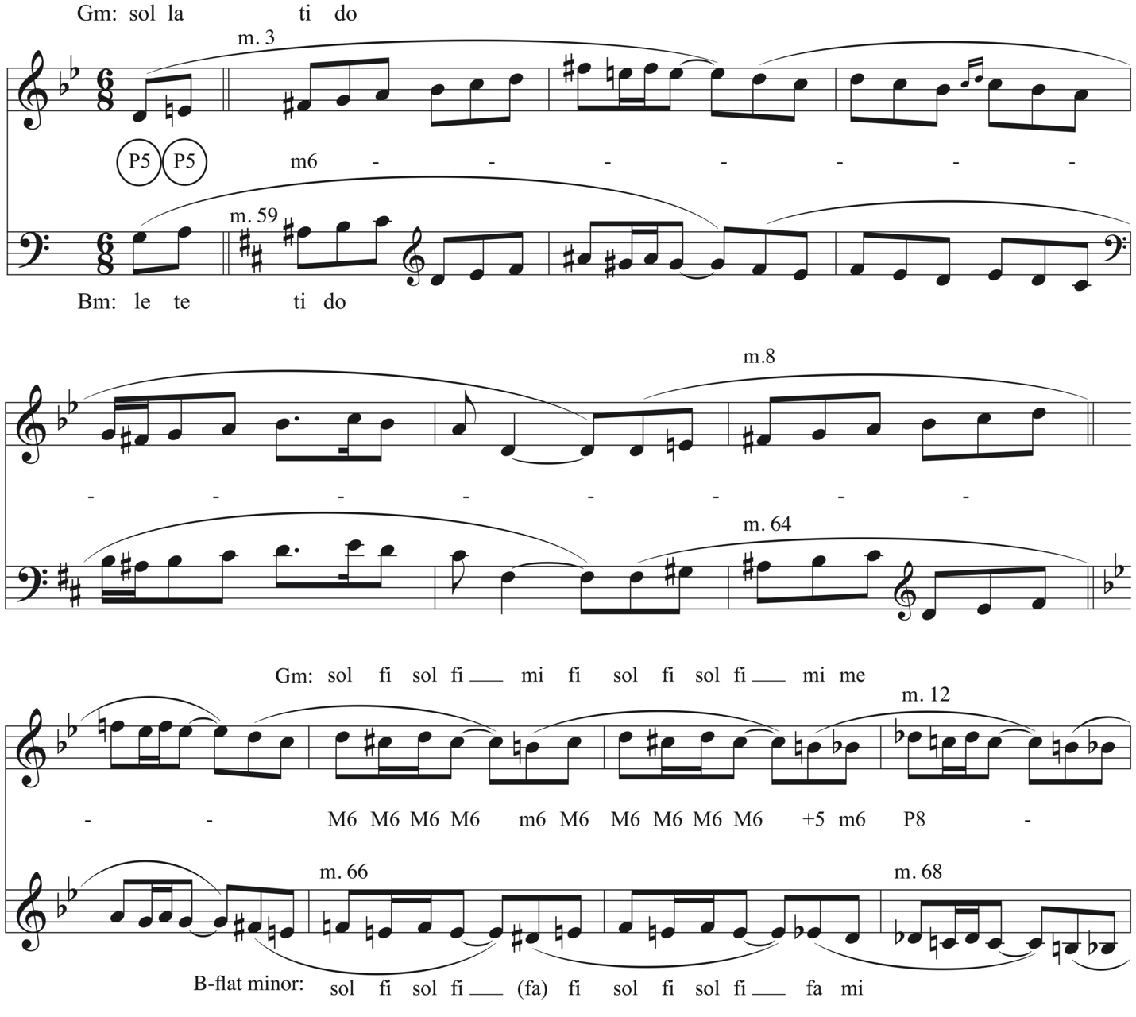
Musical excerpt © 1997, 2013 Kevin Mayhew Ltd. Used with permission.

Figure 3.8 Altered half cadence, m. 71 (V⁺⁹)
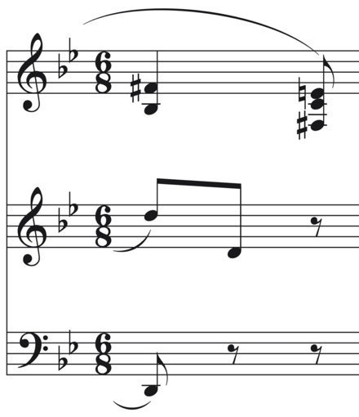
Musical excerpt © 1997, 2013 Kevin Mayhew Ltd. Used with permission.

The return of the A section differs from the original A section in several ways. Instead of a double period, Lloyd Webber uses a single period. Like the first period in the original A section this period uses two half cadences, the first a V⁷ and the second and altered dominant, V⁺. This lack of closure necessitates another section which results in new material, a Coda.
Before analyzing the Coda, there are some specific details in the return of the A section to discuss. When the A section returns at m. 71 it is with the initial harmony and a slightly varied version of the original accompaniment texture. We hear the melody again on the oboe stop, but with the swell sub-coupler engaged, meaning that the melody will be heard as written and an octave lower providing a more sonorous and haunting presentation of the melody. By m. 76 the left hand accompaniment introduces further subtle variation in the form of a short lilting counter-melody, which disintegrates by m. 80. With the exception of the dropped ornament in m. 76 (cf. m. 5) the melody is identical to the first two phrases from the original A section until m. 80 where, for the first time, Lloyd Webber introduces the complement to the whole-tone scale he has been using throughout. The passages in mm. 82-83 and mm. 84-85 resemble the passages in m. 14 and m. 28 in their quickly rising scalar figurations. The first occurrence (mm. 82-83) does not cadence and reminds us of the stuck feeling first experienced at m. 15 as well as other instances in the B section. The second passage (mm. 84-85) also feels stuck, but can be read as another altered dominant half cadence (V⁺). The feeling of being stuck introduced at m. 15 returns in mm. 83 and 85. In fact, the A section does not achieve a satisfactory cadence.
Where the original A section finally achieves closure with a perfect authentic cadence in m. 29, the return of the A section does not. Beginning in m. 86, a coda ultimately achieves harmonic closure for the piece. The piece picks up momentum with the coda: running sixteenth notes in the left hand accompany a new melody in the right hand from mm. 86-89 ending with an inauthentic perfect cadence. These running sixteenths use two different forms the G minor scale: Dorian and harmonic minor. The accompanying pedal part is reminiscent of pizzicato cello and double basses. The melody continues in mm. 90-98 with the pedal also continuing to dance along. However, the sixteenths in the left hand fall to the wayside and patterns similar to the left hand from the original A section emerge.
Just as the gondolier was stuck in m. 15 and then restarted the opening phrase with a variation to achieve harmonic closure in m. 29, the return of the A section experiences this stuck harmonic progression in its lack of fulfillment at m. 85. The coda is in essence the gondolier attempting his voyage in a new way. The melody of the A section only took him so far, so he had to try something new to achieve closure which is achieved in m. 99.
Finally after standing on the dominant in mm. 96-98 the gondolier breaks free; a perfect authentic cadence is achieved at m. 99. Measures 99-101 are identical to mm. 29-31 from the transition to the B section. Instead of leading to the B section, on the downbeat of m. 102, Lloyd Webber writes a C major chord, instead of the unstable C-flat⁺ chord he used in m. 32. The legato passage in mm. 102-103 resembles the legato passage in mm. 32-33, but this time instead using the subdominant C minor, the music moves to an altered G minor chord (GmM⁷), followed by another altered G minor chord (Gm ^{add #6}) in the subsequent measure, and finally a true, unaltered G minor chord in the final measure.
Reflecting on this piece as a whole, in “Barcolle” there are several seemingly minor musical observations that may be seen as more important when viewed in the context of the full piece. First, short arrivals which seem inconsequential during the transition, later prove to be more substantial in the B section. In m. 29 of the transition, the scherzo-like texture lands on a B-flat minor chord in b. 3. B-flat minor is the key of the left hand melody in mm. 66-70 later in the B section. Similarly, in m. 30 the scherzo-like texture lands on a B-minor chord. This is the key used by the left hand in mm. 59-65 of the B section. Second, the structural plagal motion is foreshadowed by the undulating chords of the opening measures. The opening measures of the piece undulate between G minor and C minor chords. The A section begins in the home key of G minor and the B section begins in C minor. Last, the transition between the A and B sections returns at the end of the coda in mm. 99-101 of “Barcolle” similar to the way in which the transition between the A and B sections returns at the end of “Prelude” in m. 55, which may reflect either a characteristic of Lloyd Webber’s composing as a whole, or a larger link between the first and second pieces of Three Recital Pieces which will be further explored in the concluding chapter.
***
In her article, “Organ music of William Lloyd Webber,” Jane Watts reveals:
I must confess that if I had heard the second of these three pieces, the Barcarolle, for the very first time and been asked who wrote it, I am sure I would not have guessed that the composer was British. To my ears at least, the harmonies are reminiscent sometimes of those of Fauré and sometimes of Vierne. . . I can imagine this work sounding wonderfully effective on, for example, the Cavaillé-Coll organ in Orléans Cathedral: indeed, some of the registrations marked in the score make me feel that William Lloyd Webber may have had just such sounds in mind.

Many students would be fooled by this piece on a listening exam and that is one of the many reasons this piece is so alluring. Three of the names Watts mentions are Frenchmen: composer Gabriel Fauré (1845-1924), organist and composer Louis Vierne (1870-1937), and organ builder Aristide Cavaillé-Coll (1811-1899). What exactly is it that makes this piece sound more French than English-influenced? There are several potential reasons for this piece’s French sound via cultural influences and compositional structure.
First, as a serious church musician and academic, Lloyd Webber would have been familiar with French organ music. Christopher Anderson claims that twentieth-century French organ music was shaped by (1) the sound quality and technique of the Cavaillé-Coll symphonic organ, (2) the style of the French organists Cesar Franck and Charles Marie Widor which included the “integration of traditional contrapuntal textures and pianistic, even orchestral techniques and genres,” and (3) association with the liturgical practice of the French Organ Mass and its characteristic solo pieces. As Jane Watts mentioned above, the French organ maker Cavaillé-Coll could have very likely informed Lloyd Webber’s registration indications in “Barcolle.” Figure 3.9 illustrates the stop list of the aforementioned Cavaillé-Coll in Orléans Cathedral. Second, the title of this piece clearly references the barcolle as a piano, orchestral, or opera genre. Several of the textures found in “Barcolle” are represented in piano and orchestral works, particularly the pianistic arpeggios in mm. 15-17 (Figure 3.10) and the scherzo-like figurations in mm. 29-31. The introduction of the melody on the oboe and later with a differing organ registration also suggests an orchestral influence, albeit a fairly common organ technique as well. In the return of the A section, the opening melody sounds on the original oboe stop, but with the sub-coupler engaged, which results in hearing the melody at the original pitch and an octave lower. This is not just a slight variation in re-presenting the melody, but also the orchestral equivalent of adding the bassoon or bass clarinet to the opening orchestration. Indeed these pianistic and orchestral textures might very well have been influenced by the Franck and Widor. Last, while this piece is not an Organ Mass, a genre often used by French organ composers particularly during the French Classic (Baroque) period, two of the three pieces in Three Recital Pieces use titles that suggest they may be used in liturgical setting: the “Prelude,” which may simply be used as a prelude before a service and the “Nuptial march,” which as its name suggests may be used for a bridal procession or retiring processional at a wedding.
As far as structural explanations for the “Barcolle” sounding more French than English,
the most significant is the use of the whole-tone scale. Whole-tone melodic passages can be found within Western Art music as early as the nineteenth-century, most extensively by Russian composers such as Glinka and Dargomïzhsky. However, Debussy and other French Impressionists were the first to use the whole-tone scale “in opposition to the major-minor system, as a means of suspending tonality.” Lloyd Webber’s use of the whole-tone scale throughout the piece points to the influence of Impressionism within the work, albeit a more tonally-stable compositional process. The title “Barcolle” also suggests the image or impression of a Venetian gondolier.
Figure 3.9 Stoplist for 1831 Callinet/1880 Cavaillé-Coll Gallery Organ at Cathédrale
Saint-Croix, Orléans
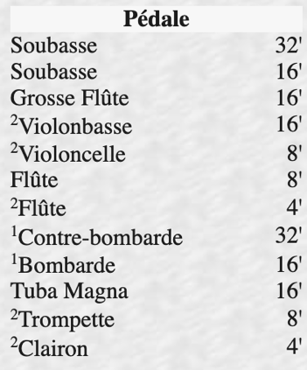
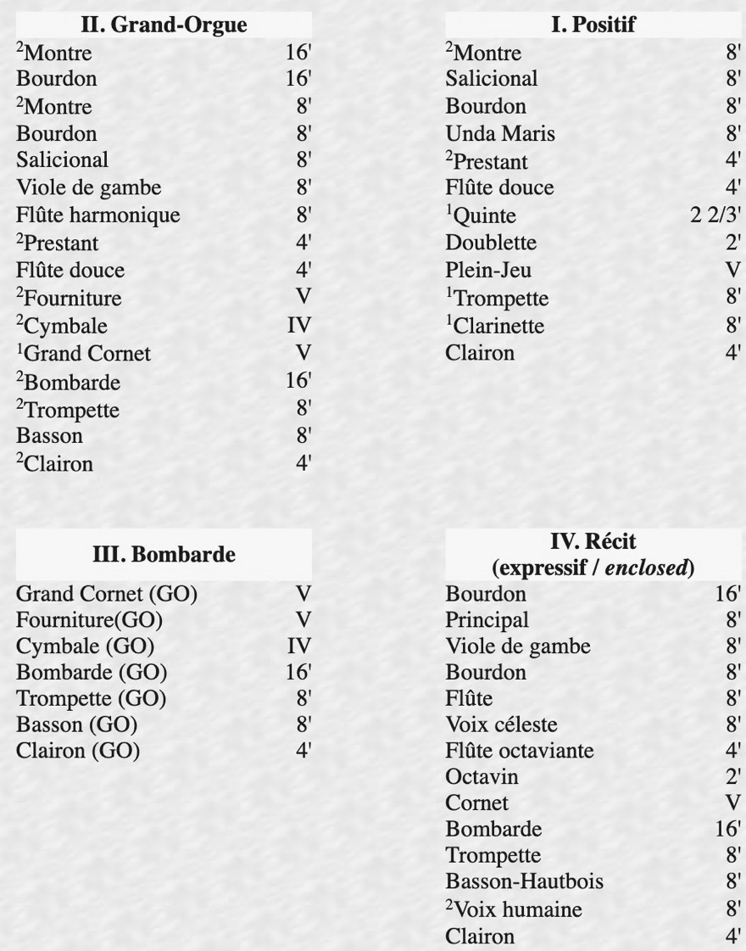

Figure 3.10 Pianistic texture: arpeggios, mm. 15-17
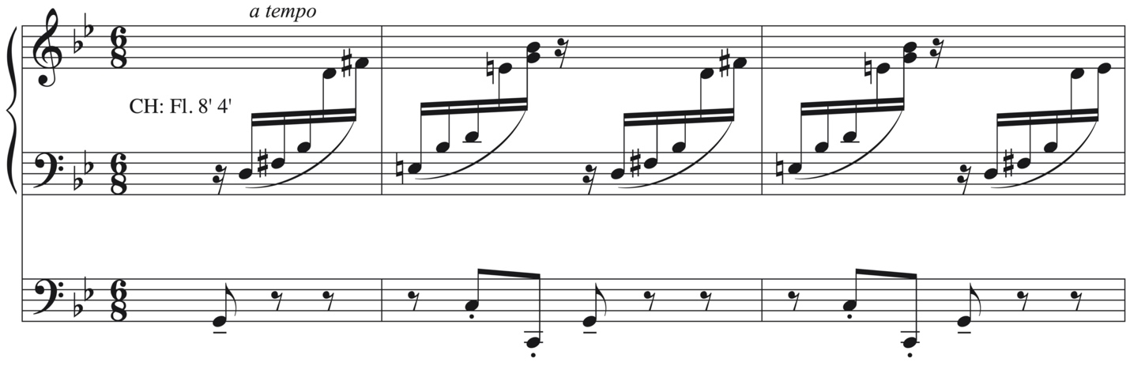
Musical excerpt © 1997, 2013 Kevin Mayhew Ltd. Used with permission.
While Watts does not mention of Debussy or French Impressionism she specifically references Fauré and Vierne, the latter of which used whole-tone scales in his organ works. In his Symphonie No. 6, Op. 59 for Organ, Vierne uses the whole-tone scale in a couple of ways: “Specifically, Vierne uses. . . whole[-]tone passages as modulatory devices in both the development section of the Allegro and the A sections of the Scherzo. By contrast, Vierne also uses the whole tone scale to temporarily suspend tonality in the B section of the Aria.”
While not specifically mentioned as an influence to Lloyd Webber, Marcel Dupré “was not only a dominant figure in France as organist, improviser, composer, teacher, author, and editor, but also undoubtedly the world’s most prominent organist” from 1925 to 1970. Dupré’s prominence undoubtedly meant that Lloyd Webber knew of his works. A particularly popular work by Dupré was his Variations sur un Noël, opus 20, composed in 1922. The eighth variation in this organ work is no less than a canon at the ninth between the pedal and right hand. (Figure 3.11) Perhaps Lloyd Webber’s brief hint at the canon in mm. 59-60 of “Barcolle” is an homage to this.
Figure 3.11 Dupré “Variation VIII” from Variations sur un Noël, op. 20
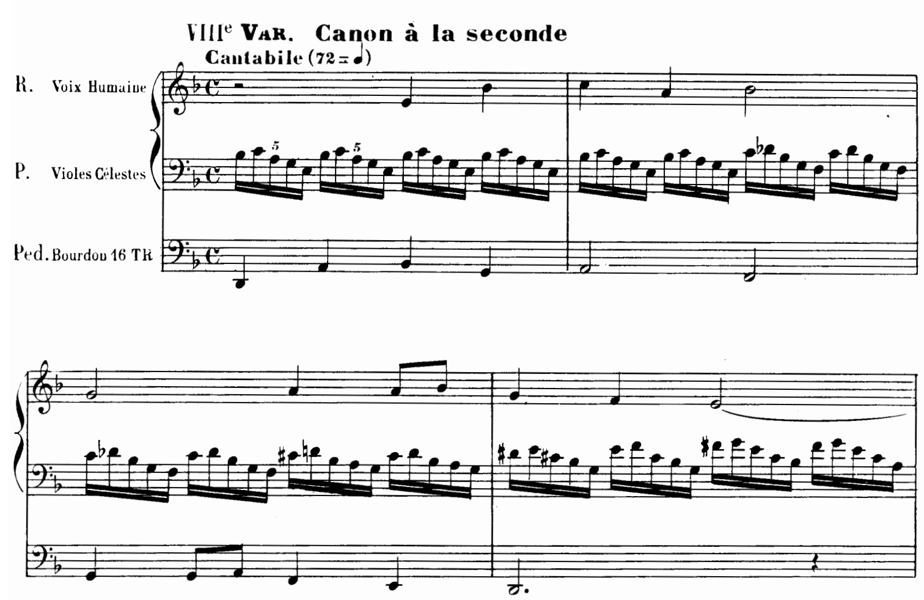
Musical excerpt © 1923, Alphonse Leduc.
While all of these musical and theoretical examples could explain why “Barcolle” sounds more French than English there is still another explanation given by Neurologist Oliver Sacks:
…there might be correspondences between speech patterns and the instrumental music of particular cultures. There has long been an impression among musicologists that such correspondences exist, and this has now been formally, quantitatively studied by Patel, Iversen, and their colleagues at the Neurosciences Institute. “What makes the music of Sir Edward Elgar sound so distinctively English?” they ask. “What makes the music of Debussy sound so French?” Patel, et. al. compared rhythm and melody in British English speech and music to that of French speech and music, using the music of a dozen different composers. They found, by plotting rhythm and melody together, that “a striking pattern emerges, suggesting that a nation’s language exerts a ‘gravitational pull’ on the structure of its music.

Perhaps in emulating music by French composers, Lloyd Webber, whether intentional or not, also emulated the “gravitational pull” of the French language that Sacks describes.

Chapter 4: “Nuptial march”

Lloyd Webber concludes his Three Recital Pieces with “Nuptial march.” Like, the first piece of the set, “Prelude,” the title suggests that it is Gebrauchsmusik, music composed for a specific function or purpose; in this case, use in a worship service. “Nuptial march,” also has a commonality with “Barcolle,” in that it conveys a more specific image, in this instance, a wedding. The title “Nuptial march” suggests both a specific use and a specific image.
Three elements of “Nuptial march” will be discussed in this chapter: 1) its form (ternary), 2) the use of motives to create cohesion, and 3) the use of E-flat as a pitch, chord, and key center even though it is distantly-related to the home key of D major.
Like the previous two pieces, “Nuptial march” is in the ternary form: ABA Coda (Table 4.1). Structurally and harmonically, this piece is perhaps the most straight-forward piece in the set, at least in the beginning of the opening section. The A section utilizes symmetrical phrases and a descending scalar harmonic sequence (I-V⁶-IV⁶-V-IV-I⁶) throughout. This is a variation on a harmonic sequence because the V⁶ and V chords are only implied; ti and sol in mm. 5-6 of the pedal are actually functioning as passing tones, not chord tones. This descending scalar passage becomes a recurring motive throughout the work. Often nuptial marches chosen for weddings are more traditional in both their harmonic language and structure. The use of the harmonic sequence is perhaps the most conservative harmonic language we have seen in Three Recital Pieces.
Table 4.1 Form of “Nuptial march”

Section | Measures | Label | Key area(s) | Other
A | 1-35 |  | D major
 | 1-4 | Fanfare | D major
 | 5-12 | Phrase a | D major | Ends with HC
 | 13-20 | Phrase a’ | D major | Ends with HC
 | 21-28 | Phrase b | D major | No Cadence
 | 29-35 | Phrase c | D major | Ends with IAC
Transition | 36-39 |  | D major –  B-flat major | Pedal motive ascends through left hand to right hand
B | 40-81 |  | B-flat major,  D minor, D major
 | 40-47 | B melody | B-flat major
 | 48-55 | B melody | B-flat major
 | 56-62 | Sequential | B-flat major
 | 62-69 | B melody’ | B-flat major | Shorten and altered at m. 69
 | 70-73 |  | D minor | 2-note motive
 | 73-81 |  | V/D (d) | Standing on the dominant
Return of A | 82-115
 | 82-85 | Fanfare |  | Thicker texture than before
 | 86-93 | Phrase a | D major | cf. mm. 5-12
 | 94-102 | Phrase a’ | D major –  E-flat major | cf. mm. 13-20, modulates in mm. 99-100
 | 102-109 | Phrase b | E-flat major | cf. 21-28, changes in mm. 108-109
 | 110-115 |  | D major | Fragment of Phrase a in left hand
Coda | 116-138 |  | D major | Prominently using B material
 | 116-123 | B melody | D major
 | 124-127 | B melody | D major | Fragment of Phrase a from A section in the pedal
 | 128-131 |  |  | Fragment of Phrase a in right hand
 | 132-135 |  | D major –  B-flat major | Pedal motive from transition returns
 | 136-138 |  | D major | IAC
Perhaps it is for this reason that Lloyd Webber chose a more conservative harmonic language and more symmetrical phrases for this piece. However, as with the previous pieces, the harmonic language becomes more complex as the piece progresses.
Like the A section in “Barcolle,” the A section in “Nuptial march” is a double period, aa’bc. However, where the double period in “Barcolle” was a parallel period, in “Nuptial march” only the first two phrases are parallel, while the second half of the period is contrasting. Even with the contrasting phrases, Lloyd Webber creates cohesion in the first half of Phrase b by using the same rhythm he used in the first half of Phrase a and a’, but with different pitches. Figure 4.1 outlines the melody of the double period with the descending second motive (discussed later in the chapter) highlighted throughout.
While the harmony of the A section begins in a more straight-forward fashion than the previous two pieces, a local Roman numeral analysis will only go so far. After the variation on a harmonic sequence in mm. 5-8, the harmonies become more complex, but a combination of bass movement by fourths, fifths, and half steps always brings the progression back to the dominant at structurally important moments.
As one might expect the harmony of the B section is more adventurous than the A section. In fact, for all of the straight-forwardness of the phrases and initial harmonic language in the A section, Lloyd Webber choses B-flat Major as the first key of the B section. While this chromatic mediant relationship is not uncommon in music of the Romantic era, Lloyd Webber’s use of this key relationship is a bit unexpected in “Nuptial march,” since the beginning of the piece resembles a more classically informed voluntary, particularly with its symmetrical phrases. This large-scale harmonic motion of D major to B-flat major is not unlike Lloyd Webber’s unexpected turn in the his “Prelude” when the V⁷ chord slips to an A natural in the bass instead of resolving as expected to an E-flat chord in mm. 19-20. In this instance, instead of D major progressing to its dominant key of A major, it overshoots a half step to B-flat major. Perhaps this over-correction can serve as a balance to the slippage of B-flat to A in the bass of “Prelude.”
Figure 4.1 A Section Melody, mm. 5-36 (descending second motives circled and bracketed)
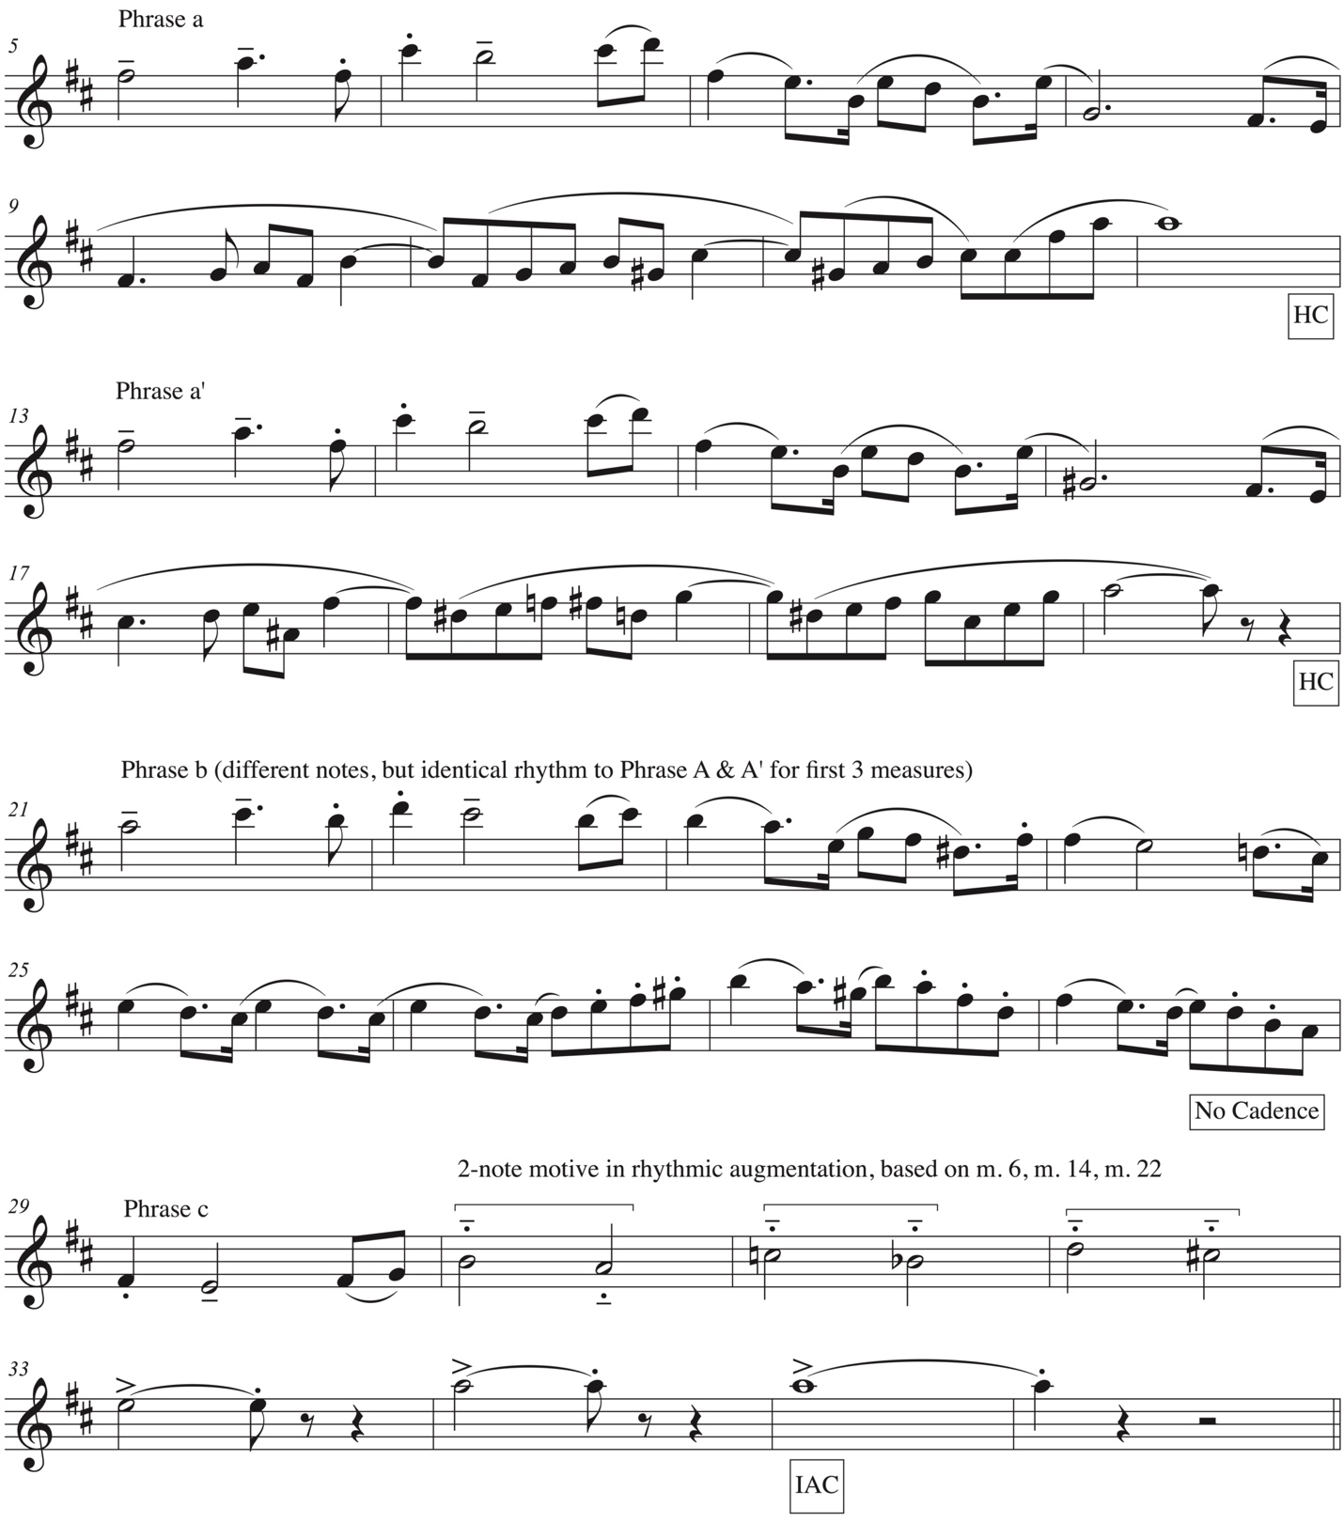
Musical excerpt © 1997, 2013 Kevin Mayhew Ltd. Used with permission.

The melody in the B section is more legato than the A section melody creating a nice contrast between the two. The first half of the B melody uses longer rhythmic values, but the second half shares more similarities with the A section melody such as syncopations across barlines, the use of model/sequence technique, and ascending subphrases (Figure 4.2).

Figure 4.2 B Section Melody (Compare mm. 44-47 to mm. 9-12 and mm. 17-21 of
Figure 4.1)
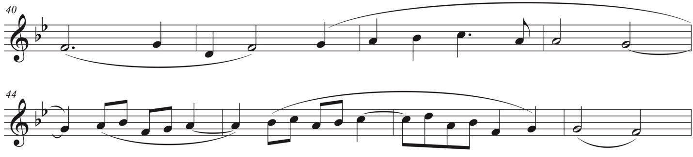
Musical excerpt © 1997, 2013 Kevin Mayhew Ltd. Used with permission.

The harmonization of the B section melody is much more chromatic than the initial harmonization of the A section. However, the eight-measure melody itself remains diatonic throughout each of its three initial statements. This chromatic harmonization is like the harmonization of the melody in “Prelude” where the melody remains completely diatonic while the harmonization becomes increasingly chromatic. Much of the chromaticism in the harmonization of this melody comes in pervasive use of chromatic neighbor tones. In mm. 48-57 a variation on the invertible counterpoint of mm. 40-47 ensues: the melody moves from the soprano voice to the tenor voice; the alto voice becomes the soprano voice; the tenor voice becomes the alto voice, and an lowest voice in the manual moves to the pedal to facilitate playing the tenor melody on a solo stop (Gt. or solo Horn).
In mm. 56-62 Lloyd Webber writes a short reprieve from the B section melody as new material is introduced. A portion of the B melody returns in mm. 63-70. After this incomplete statement the retransition to the A section begins in mm. 70-81. In mm. 70-81, Lloyd Webber arrives at a standing on the dominant through a repetitive pedal passage as D⁺ chords in the hands contribute to a harmonically unstable moment beginning in mm. 76-77. The D⁺ resolves to G as expected, but while the dominant continuing in the pedal. An almost fully chromatic line in the lowest voice of each hand begins in m. 77 and ends in m. 79 on a G which becomes the seventh of the A⁷ chord in the half cadence in m. 81 bringing the B section to a close.
The tuba fanfare in mm. 82-85 signals the triumphant return of the A section. This fanfare is a thicker texture than the one that opens the piece, but the original melody and harmony are both intact. While phrase a (mm. 86-93) of the return of the A section is identical to the initial statement in mm. 5-12, phrase a’ begins the same, but modulates to E-flat major, adding another unexpected harmonic turn. (Figure 4.3). Phrase b (mm. 102-109) is also begins identically to the original Phrase b (mm. 21-28) except that it is transposed to E-flat major and the final two and a half measures (the second half of b. 3 of m. 107 – m. 109) are different (Figure 4.4). Lloyd Webber most likely creates the latter difference to slip back from E-flat major to the tonic key of D major. This reaches the apex of tension in mm. 110-111 when the tuba returns in the left hand punctuating the original melody in the home in full chords against the right hand which retains the B-flat pitches from E-flat resulting in a clash between D major and E-flat as shown in Figure 4.5. Further observation of this clash reveals another interesting reading: when considering the G-sharp and B-flat in the pedal, along with the D and F-sharp in the hands, an altered Ger⁺⁶ chord, not unlike the altered half cadences found in “Barcolle,” can be implied. This altered Ger⁺⁶ chord contains le do mi fi, with mi as an alteration of the typical me and indeed functions as an augmented sixth chord moving to a V⁹ in m. 114.

Figure 4.3 Phrase a’, mm. 94-101 (cf. mm. 13-20 in Figure 4.1)
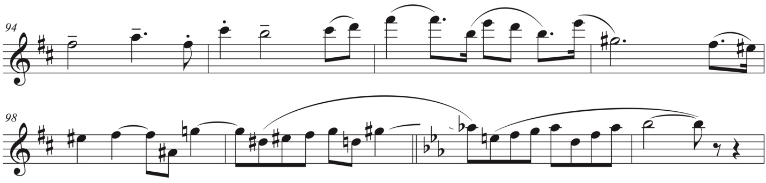
Musical excerpt © 1997, 2013 Kevin Mayhew Ltd. Used with permission.

Figure 4.4 Comparison of mm. 26-28 and mm. 107-109 (cf. mm. 21-28)
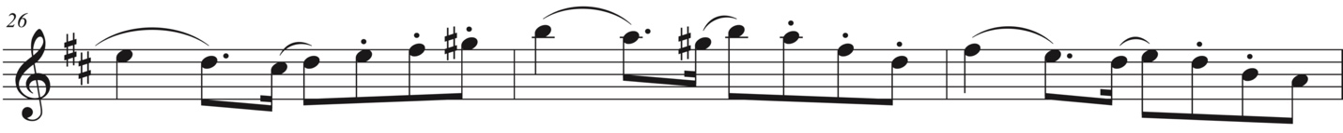
Musical excerpt © 1997, 2013 Kevin Mayhew Ltd. Used with permission.
Figure 4.5 Clash of D major and E-flat, mm. 110-111
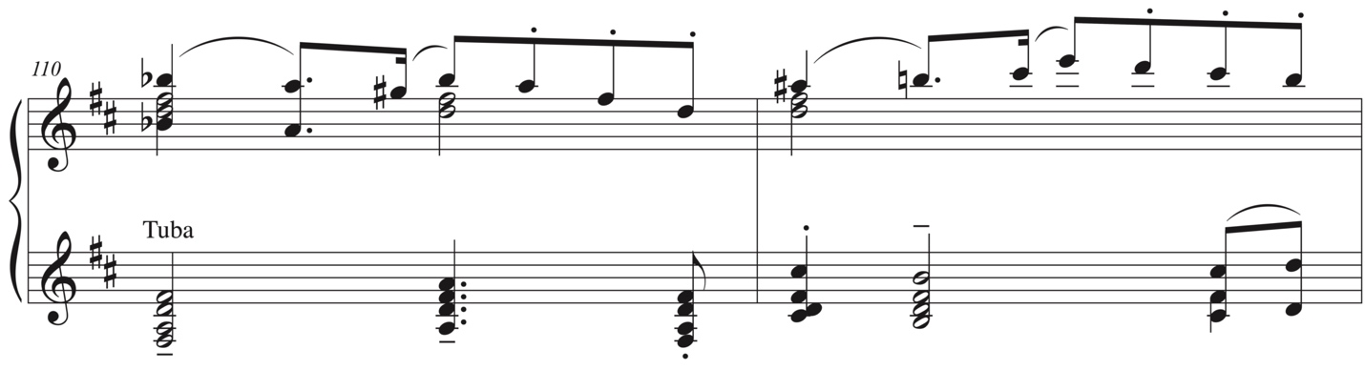
Musical excerpt © 1997, 2013 Kevin Mayhew Ltd. Used with permission.

An authentic cadence mirroring the one in m. 35 is expected in m. 116, but Lloyd Webber uses an inauthentic cadence instead and the melody from the B is section returns, this time in the home key, signaling a coda. After one statement of the B section melody (mm. 116-123), the pedal plays fragments of the A section melody under a fragment of the B section melody shown in Figure 4.6. The two-measure melodic fragment from the A section is transposed up a whole step in m. 126 before giving way to a chromatic passage in the pedal in m. 127. In the following two measures the right hand takes over the melodic fragment, but its intervallic relationship is varied and in mm. 130-131 this fragment is even further fragmented and repeated as illustrated in Figure 4.7, creating tension which builds to full chords in both hands beginning in m. 132. A roman numeral analysis of the final seven measures reads: I – VI – flat VI – iv – flat II – I revealing a plagal cadence. The repetition of the tonic chord in mm. 132-133 and then the B-flat⁷ chord in m. 134, followed by the B-flat⁹ chord in m. 135, all with an A in the top note is somewhat reminiscent of the altered tonic chords at the end of “Barcolle,” before ending on a true tonic chord at rest.
Figure 4.6 Melodic fragment from A section melody, mm. 124-129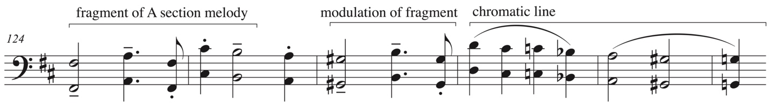
Musical excerpt © 1997, 2013 Kevin Mayhew Ltd. Used with permission.
Figure 4.7 Melodic of fragment from A section melody, varied, mm. 128-132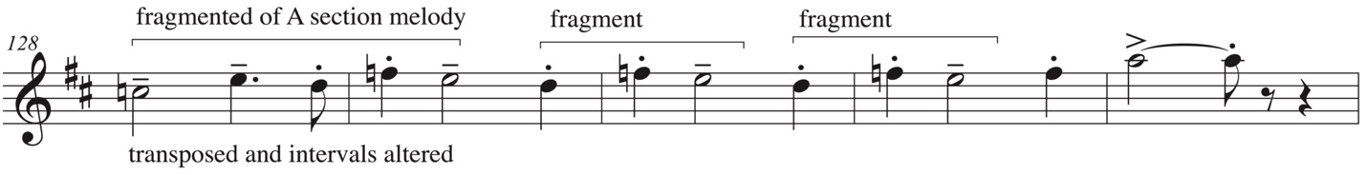
Musical excerpt © 1997, 2013 Kevin Mayhew Ltd. Used with permission.

The use of motives to create cohesion

Throughout the piece, Lloyd Webber uses motives to create cohesion and interest. The first motive is only two notes: a descending second. The descending second motive is most clearly heard in m. 6, m. 14, and m. 22. Later in mm. 30-32 the descending second motive appears in augmentation. Figure 4.1 shows the descending second motive circled in phrases a, a’, and b and in brackets when it appears in augmentation in phrase c. This motive appears as both a descending whole step and a descending half step throughout. The whole-step version is used most often as seen, in mm. 6, 14, 22, and 30-21, whereas the half step, as in m. 32, is less frequent. This descending second motive returns several times throughout the piece such as towards the end of the B section in mm. 71-73 in both hands and veiled in an inner voice in the right hand of m. 75.
The transition between the A and B sections in mm. 36-39 introduces another prominent motive: a four-note motive found in two arrangements. First, an ascending minor third, descending minor second, ascending minor second. Second, and ascending perfect fourth, descending minor second, ascending minor second. An example of the first type of four-note motive begins in the pedal in the anacrusis to m. 37, moves to the left hand for mm. 38-39 (using both the first and second version of the motive) and then to the lower voice of the right hand in m. 40 in tandem to the lower voice of the left hand (Figure 4.8). By m. 41 the motive appears exclusively to the left hand where it remains until the pedal returns in m. 47. By m. 57 Lloyd Webber abandons the motive until it returns insistently in the pedal from mm. 75-77.

Figure 4.8 Four-note motive, mm. 37-40
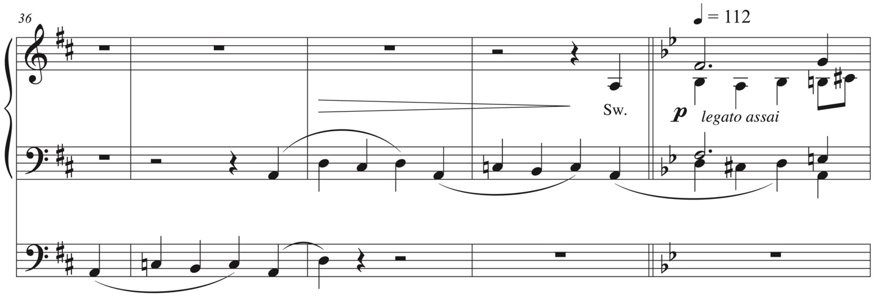
Musical excerpt © 1997, 2013 Kevin Mayhew Ltd. Used with permission.

In mm. 56-62 Lloyd Webber introduces a new motive which offers a short reprieve from the B section melody (Figure 4.9). More gestural than pitch specific, this motive consists of a large ascending leap, followed by a smaller descending skip, and two descending steps. It first appears in m. 56 in the top voice of the right hand. It then alternates back and forth between the pedal and right hand in mm. 57-60. In m. 61 the a variation of the motive repeats in the right hand before dissipating into an incomplete statement of the B section melody in mm. 63-69. After this incomplete statement the retransition to the A section begins in mm. 70-81 with a sort of tonicized standing on the dominant. This is achieved through a variation of the four-note motive: descending minor second, ascending minor second, and descending perfect fourth. It is the second version of the four-note motive in retrograde. A similar effect is created by the oscillation up from A to B-flat and down from A to G-sharp in mm. 110-113 of the pedal and brings back the idea of the descending second motive seen earlier in the piece. It also implies a prolongation of the dominant function; a sort of tonicized standing on the dominant as seen in mm. 75-77. After the D major/E-flat major clash in the hands of mm. 110-111, the descending second motive returns yet again, this time as it appeared mm. 31-32, but in quarter notes instead of half notes. Finally, the four-note motive makes one last appearance in mm. 132-136 in sequence at the end of the piece (Figure 4.10).

Figure 4.9 Motive, mm. 56-62
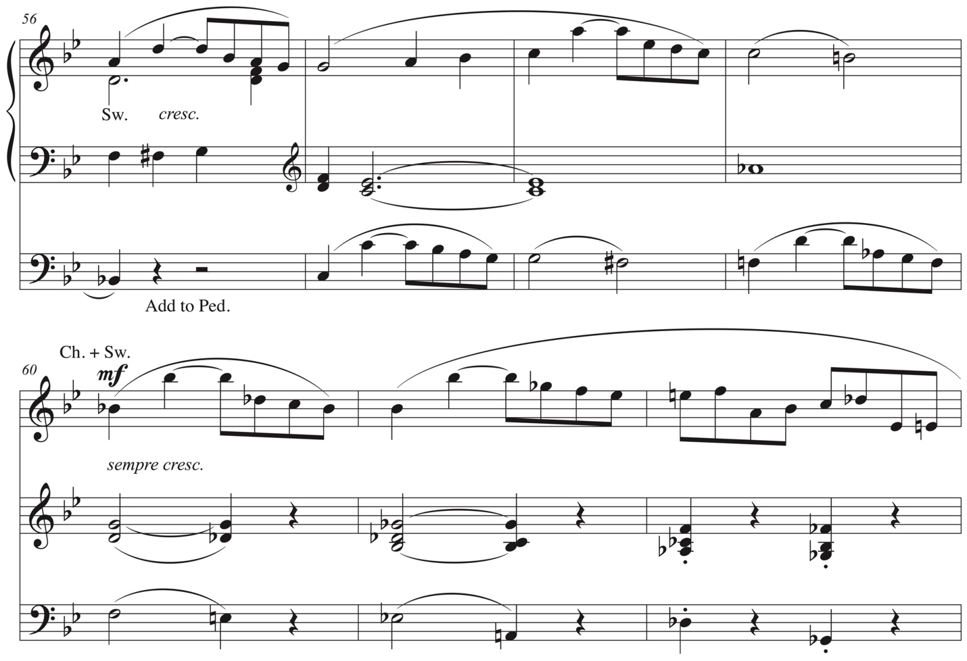

Figure 4.10 Four-note motive in sequence, mm. 132-136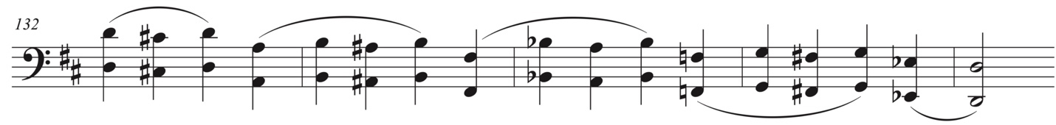
Musical excerpt © 1997, 2013 Kevin Mayhew Ltd. Used with permission.

The use of E-flat

For a piece that begins with a straight-forward harmonic language “Nuptial march” never achieves a perfect authentic cadence in the home key, even at the very end of the piece. Not only does the final chord end with sol in the highest voice instead of do, but it is also preceded by a flat-II chord instead of a root position V chord. While plagal cadences such as IV – I, flat-VI – I, etc. are common in the Romantic era, flat-II – I, especially to end a piece, is less common. However, the use of the flat-II in this case is significant and a fitting end for this piece. The most obvious interpretation of the E-flat chord preceding the final chord of the piece can be that it is a reminder of the unexpected modulation to E-flat in mm. 100-109. Lloyd Webber’s use of E-flat for the penultimate chord punctuates this unusual modulation and brings further cohesion to the piece. There is also the relationship between the E-flat chord and the chromatic mediant movement to B-flat at the beginning of the B section. B-flat is the dominant of E-flat which can be interpreted as a sort of fulfilment for the dominant of D major (A major) that was never achieved as a structural moment in this piece. Finally, the E-flat highlights the piece as a whole: the E-flat chord preceding the final chord in “Nuptial march” can be heard as an echo of the tonic key of “Prelude,” the very first piece in Three Recital Pieces. Furthermore, one of the keys hinted at in the B section of “Prelude” was A. It is almost as if Lloyd Webber did a bit of a mashup with the keys trading one key for another between the first and last pieces of Three Recital Pieces. All of these readings could easily explain the composers choice of using E-flat instead of A as the penultimate chord of the piece as a compositional device to create cohesion rather than just a plagal cadence.

Comparisons to previous two pieces

Throughout “Barcolle” and earlier in this chapter there have been several comparisons drawn to previous pieces. Here are a couple other comparisons. First, an interesting harmonic device is found in mm. 106-107 of “Nuptial march.” The harmonies in both hands and pedal move in parallel motion, indicating ‘planing,’ an impressionist technique. This impressionist technique serves as a reminder of other impressionist influences found in “Barcolle.” Second, the final note of the transposition of the melodic fragment in mm. 126-127 arrives at a D-natural instead of a D-sharp. While the latter would be an exact transposition of the fragment up a whole step, using a D-natural resembles the sort of slippage in expectation aforementioned in Lloyd Webber’s “Prelude” in mm. 19-20.

Chapter 5: Conclusion

One work or three

Is Three Recital Pieces a three movement work or are Three Recital Pieces three distinct pieces? Does it matter? In terms of performance all three pieces could be played consecutively like a three-movement work, while in a liturgy they may be spread out with several prayers between them. Lloyd Webber’s tempo indications of each piece or movement: Moderato, poco mosso; Comodo, poco mesto; and Allegro spiritoso can be interpreted as a variation on the three movement prototypical fast – slow – fast scheme. The only significant tempo difference here is that the first movement is moderate rather than fast. The more lyrical character of the second movement also lends itself to this three movement performance interpretation.
Perhaps more problematic is the key scheme of three movements: E-flat, G minor, D major. In many multimovement works the first and final movements might share the same key. However, given the more interesting key schemes within each individual movement, this key scheme is not as jarring as it might seem. Recall the short modulation from D major to E-flat major in the return of A section in the third piece, “Nuptial march.” This unexpected half-step modulation can be heard as a return to the tonic key of the “Prelude,” providing more cohesion to the piece as a multi-movement work rather than three individual pieces. One can also interpret the final work’s tonic key of D major as falling short, or slipping from the more typical E-flat expectation. This key slippage can be seen as early as the end of the A section in “Prelude,” where the bass of the V⁷ chord slips to A natural instead of reaching a I chord. There is also sufficient tension between D Major and E-flat in the return of the A section of “Nuptial march” (mm. 110-111) to suggest that Lloyd Webber intentionally made this unorthodox key scheme for Three Recital Pieces as a whole. The key scheme of “Nuptial march” alone suggests a sort of fulfillment of the road not taken in “Prelude.” The B section in “Nuptial march” does not modulate to the expected dominant of D major, A, but instead to B-flat which is the dominant of E-flat, the tonic key of “Prelude.” While “Prelude” did eventually reach B-flat major towards the end of the B section, it never firmly established it as a key in its own right, but more as a standing on the dominant to return to A. Perhaps Lloyd Webber’s unusual modulation to B-flat in “Nuptial march” was to compensate for the lack of an establishment of dominant in the B section of “Prelude.”
Another incompleteness in “Prelude” that is fulfilled in “Nuptial march” is the return of the B section within the coda. In m. 55 of the “Prelude,” the B section makes a very quick one-measure return before ending on the tonic of E-flat. In “Nuptial march,” the B section returns in the home key of D major for eight measures (mm. 116-123). While neither return of B section is a full statement of the original, the eight measure return in “Nuptial march” is more substantial than the former, giving the latter a stronger reference to the continual cycle referenced in the “Prelude.”
An organist might just as successfully excerpt any of the three pieces and play them individually for a recital or a church service. Interestingly, many of the movements found in the Six Organ Sonatas, Op. 65 by Felix Mendelssohn (1809-1847) were not conceived of as complete works until after they were written. They were later organized into the sonatas we know today by the composer. In fact, one could easily take an inner movement of a multi-movement work and replace it with another movement in the same or closely related key by the same composer without seriously detracting from the overall work unless themes are shared between movements.
Another viable use of Three Recital Pieces liturgically is an organist may wish to treat them more functionally within a single service such as the “Prelude” before the service begins, “Barcolle” as an Offertory or Communion Meditation during the service, and the “Nuptial march” as a Voluntary or Postlude at the conclusion of the service. While this method of use spreads the pieces out of time, they can still be heard as significant musical pillars to the service. After all, Lloyd Webber in addition to his academic positions was a church musician and organist.

Organ music for organists by an organist

The fact that Three Recital Pieces were written for organ by an organist is also an important consideration. There is almost always an advantage to pieces written for instruments by someone who plays the same instrument. Such pieces tend to be more idiomatic when written by someone who truly understands the instrument, particularly if the composer composes at the instrument itself. While some might criticize this approach as lacking in creativity, because familiar idiomatic patterns may arise, it does have the benefit of being more accessible to the performer.
Writing the pitches and rhythms, however, are only part of the composition process for the organ. The registration, not unlike orchestration, is also an important aspect of the work. Will this phrase be played fortissimo on full organ, or pianissimo on full organ with the swell shades closed, or will it be played pianissimo on softer organ stops? If the stops are in fact softer, will they be flutes, or stings, or even a soft reed or diapason? The registration seemingly has limitless possibilities and combinations. Many twentieth-century organ composers give more detailed registration indications, particularly if the composers are organists themselves. Composers who are not organists tend to use more generalized indications like color descriptions. Interestingly Lloyd Webber gave very little in the form of specific registration indications in “Prelude,” but did indicate which manuals and dynamics to use. His lack of detail in this regard gives the organist more flexibility in interpreting this piece and in effect makes the organist part orchestrator as examined at the end of chapter 2.
“Barcolle” has slightly more detail in its registration indications. Where “Prelude” only gave a dynamic and manual indication in the opening measures, “Barcolle” indicates specific organ stops to use: Left hand on the choir dulciana 8’ and the right hand on the swell oboe 8’ (the melody). By m. 15 both hands move to the choir on a new registration of flutes at 8’ and 4’ pitch. This registration continues until the B section begins in m. 34 when both hands switch to the swell with 8’ strings and 4’ flutes. Through registration Lloyd Webber is able to help the performer and the listener understand the form of the piece. Some registrations simply vary the color of a repeated phrases, while others indicate a new phrase, section, or sub-section. There are several other manual changes in the B section as tension and intensity build until the return of the A section in m. 71 where the opening registration of a choir dulciana at 8’ returns with the subtle addition of an 8’ flute. When the melody returns in the right hand on the oboe it is played at 8’ and 16’ giving a more ominous sound and a nice contrast to the first time the melody was heard at the beginning of the piece. The next registration change is at m. 86 which is important because it helps highlight the coda, another structural use of registration to elucidate the formal characteristics of the piece.
“Nuptial march” is a bit of a hybrid of the previous two pieces in terms of registration indications. It opens with a specific registration indication of a Tuba for the fanfare, after which it simply gives the indication of fortissimo on the great with the swell coupled to it in m. 5. Other than hairpin dynamics and crescendo indications there are no other registration or dynamic changes until the end of the A section when the Tuba returns in m. 27 in the left hand and then m. 29 in both hands. The next significant registration change signals the beginning of the B section, but it simply indicates “gradually reduce Gt. Sw. and Ped.” No specific registration or color is indicated until m. 48 when the left hand repeats the B section melody first heard in the right hand in m. 40. For most of the remainder of the section, Lloyd Webber just indicates manual and coupler changes until m. 70 where he indicates full swell with the boxed close. The return of the tuba in the anacrusis of m. 82 gives the performer and listener an undeniable cue that the A section is returning. After this, the remainder of the piece only indicates changes in manual or dynamic except with a few curtain calls from the Tuba and an indication of “Full” in. 128. Since the title of “Nuptial march” gives the performer a fairly straight-forward indication of function, perhaps Lloyd Webber did not feel the need to micromanage the registration.
While Lloyd Webber’s registration indications are not as detailed as other twentieth-century composers, his indications give a clear indication of important formal sections of his pieces as well as subtle changes for variation in color.

Other comparisons between pieces

In addition to the similarities noted above, particularly in ‘One work or three,’ there other similarities that may spark interest in further studies of William Lloyd Webber. For instance, are these similarities between the Three Recital Pieces confined to this work only, or are they pervasive across more of Lloyd Webber’s works. Both the A section melody of “Prelude” and B section melody of “Nuptial march” use diatonic melodies that are harmonized with more chromatic harmonizations, i.e. reharmonizing hymns. The first phrase of the melody in “Prelude” begins with a diatonic harmonization, but the second phrase receives a more chromatic treatment. In “Nuptial march,” the B section melody is completely diatonic, but always receives a chromatic harmonization. Similarly in “Barcolle” the melody begins diatonic with a mostly diatonic harmonization, but the second phrase introduces more chromaticism in both the melody and the harmonization. Lloyd Webber’s use of chromaticism is more pervasive in this piece.
All three pieces confound most local Roman numeral analyses and large scale harmonic schemes reveal and interesting pattern: none of them move to V for the B section. “Prelude” moves from E-flat to A (sharp IV), an unorthodox tritone movement; “Barcolle” has a less unusual movement from G minor to C minor (iv); and “Nuptial march” moves from D major to B-flat major (flat VI). All of these key schemes are within a whole or half step of the dominant, but not the dominant itself. As mentioned in chapter 4, the movement of D major to B-flat major in “Nuptial march” can be seen as a counterbalance to the movement of E-flat major to A in “Prelude.” Where the Prelude failed to reach B-flat, slipping down a half step, “Nuptial march” over-corrected a half step higher than the dominant of A major.
A commonality that all three pieces share is the return of elements from sections other than the A section at the end of each piece, most notably the transition material from the A to the B section. Sometimes these returns are very brief, just a measure, and other times they are more extended. In “Prelude,” a very brief return of the transitional material in m. 22 returns in m. 54. This transitional material is also followed by a one measure return of the B section before the piece ends. In “Barcolle,” the three measure scherzo-like figurations that first appear in mm. 29-30 return in mm. 99-101. Finally, in “Nuptial march,” not only does the B section return in the tonic key in mm. 116-123, but the transitional material, the four-note motive found in mm. 36-39, makes several appearances and is prominently featured in the pedal in octaves in mm. 133-135 before a Tuba flourish into the final cadence.
Lloyd Webber’s use of cadences in Three Recital Pieces is sparse and there are several instances of evaded cadences. The first cadence in “Prelude” is a half cadence in m. 11. An authentic cadence is expected in m. 20 to bring the A section to a close, but the bass slips to an A, A-flat, and G before transitional material brings the piece to the B section. The only cadence found in the B section is the half cadence in mm. 38-39 signaling the return of the A section in m. 40. Instead, Lloyd Webber uses a chromatic bass line as well as fourths and fifths to suggest other key areas. The only authentic cadence results in mm. 48-50 when a second stage recapitulation occurs, this time returning the melody and texture of the original A section. The piece ends on a I chord, but it is not a perfect authentic cadence, because it is not preceded by a root position V chord. In fact, it is not preceded by a V chord at all.
Perhaps the most straightforward uses of cadences is seen in “Barcolle.” It is in this movement that the only two perfect authentic cadences of Three Recital Pieces are found (mm. 29 and 99). Half cadences are found in mm. 7, 15, and 22 in the A section; an altered half cadence in m. 71 at the end of the B section; and mm. 78 and 85 in the return of the A section.
“Nuptial march” also makes much use of half cadences, but like “Prelude,” there are no perfect authentic cadences. Half cadences are found at the conclusion of the tuba fanfare in m. 4; mm. 12 and 20 in the A section; in m. 81 ending the B section; in m. 85 of the return of the fanfare; and in m. 123 at the end of the return of B. The A section ends on an imperfect authentic cadence in m. 35. An authentic cadence is expected in m. 116 to end the return of the A section. The expected tonic chord arrives, but it is undercut by the return of the B section material and the root of the chord in the pedal quickly moves up chromatically further subverting expectations. The piece finally ends on an authentic cadence, this time with do in the top voice, but it is preceded by a root position flat II chord instead of a V chord.
A final difference between each of the Three Recital Pieces is Lloyd Webber’s use of phrase structures. While both the “Prelude” and “Barcolle” use asymmetrical phrases, the later uses them in the context of parallel period structures. The former uses a melody that is more similar to a sentence structure. The “Nuptial march” is the only piece to consistently use symmetrical phrases, which are in line with its more conservative English Voluntary-like aesthetic, at least in the beginning. Like “Barcolle,” “Nuptial march” uses parallel period structures.
***
Lloyd Webber’s experience as a church musician, composer, and academic have largely influenced his Three Recital Pieces. They are well-crafted and useful in both performance and liturgical contexts. Performers and church musicians alike would do well to perform and further study his music.
Bibliography

Anderson, Christopher S., Twentieth-Century Organ Music. Oxfordshire, England, United Kingdom: Routledge, 2011.

Copland, Aaron. What to Listen for in Music. New York, NY: New American Library, 1939, 1957.

Green, Andrew. “The other Lloyd Webber: eclipsed by his children and out of step with his times?; Andrew Green on William, father of Andrew and Julian.” The Independent, October 1995.

Hardwick, Peter. British Organ Music of the Twentieth Century. Lanham, Maryland: Scarecrow Press, Inc., 2003.

Lester, Joel. Analytic Approaches to Twentieth-Century Music. New York: W.N. Norton & Company, 1989.

Little, William, Mendelssohn and the Organ, New York: Oxford University Press, 2010.

Lloyd Webber, Julian, “A voyage around my father.” Last modified 2017. Accessed September 12, 2018. http://williamlloydwebber.com/web/wp-content/uploads/2017/06/A-Voyage-Around-My-Father.pdf

“Biography.” William Lloyd Webber. Last modified 2017. Accessed September 12, 2018. http://williamlloydwebber.com.

Meixner, Emily Marie, The Sixth Organ Symphony of Louis Vierne (1870-1937), Notre Dame, Indiana: University of Notre Dame, 2017.

Murdin, Lynda. “Bill and Sons,” London Daily News, March 11, 1987.

Sacks, Oliver. Musicophila: Tales of Music and the Brain. New York: Vintage Books, 2008.

Stewart, Andrew. “William Lloyd-Webber.” Music Week, May 23, 1998.

Walsh, Michael. Andrew Lloyd Webber: His Life and Works. New York, New York: Harry N. Abrams, Inc, 1989.

Watts, Jane. “Organ music of William Lloyd Webber.” Organist’s Review, March 2014.

Appendix A: Timeline of William Lloyd Webber’s significant dates

March 11, 1914 Born in London, England

January 11, 1929 Played live on BBC Radio 3 at the age of 14

1929 Became Organist at Christ Church, Newgate Street

1929 Organ Scholarship to Mercer’s School

1929 Scholarship to Royal College of Music
(where he studied composition with Ralph Vaughan Williams)

1932-1939 Became Organist at St. Cyprian’s, Clarence Gate

1932 Received a Fellowship Diploma from the Royal College of Organists

1939-1948 Organist and Choirmaster at All Saints, Margaret Street

1939-1945 World War II

October 3, 1942 Married Jean Johnstone

1946-1982 Professor of Theory and Composition at Royal College of Music

March 22, 1948 Andrew Lloyd Webber is born

1950 First organ publications

April 14, 1951 Julian Lloyd Webber is born

1958-1982 Director of Music at Methodist Central Hall, Westminster

1964-1982 Director of London College of Music

1980 Made a Commander of the British Empire for his ‘services to music’
October 29, 1982 Died in London, England at the age of 68

1990’s Several works published posthumously after they were discovered by his
son, Julian Lloyd Webber

Appendix B: Published solo organ works by William Lloyd Webber

A Postlude for Christmas. London, England: Francis, Day, and Hunter, 1953.

Aria – Thirteen pieces for organ. Bury St. Edmonds, Suffolk: Kevin Mayhew, 1995.

Arietta in A major. London, England: Elkin and Co., 1957.

Benedictus (Diapasons). London, England: Novello, 1960.

Beside the Restful Waters: Six Introductory Improvisations. London, England: Bosworth, 1952.

Chorale, Cantilena and Finale. London, England, 1958.

Dedication March. London, England: Elkin and Co., 1953.

Eight varied pieces for organ. London, England: Bosworth, 1995.

Five Portraits for home organs. Borough Green, Sevenoaks, Kent: Paxton Music, 1980.

Five Versets. London, England, Novello, 1964.

Four Epilogues. London, England: Bosworth, 1953.

Four Quiet Interludes. London, England: Bosworth, 1956.

Prayer and Praise. London, England: Really Useful Group, 1975.

Reflections – Seven pieces for organ. Bury St. Edmonds, Suffolk: Kevin Mayhew, 1996.

Rhapsody on Helmsley. London, England: Novello, 1956.

Six Interludes on Christmas Carols. London, England: Novello, 1961.

Six Interludes on Passion Hymns. London, England, Novello, 1963.

Six Sketches for organ. London, England: Francis, Day, and Hunter, 1956.

“Solemn Procession” from Fanfares and Processionals: Eight pieces for Organ by Modern Composers. London, England: Novello, 1961.

Songs without Words – Six pieces for organ. London, England: Really Useful Group, 2002.

Suite in B-flat major for organ. London, England: Bosworth, 1951.

Three Improvisations. London, England: Novello, 1965.

Three Recital Pieces. London, England: Really Useful Group, 1961.

Three Voluntaries for organ: Introit, Offertory, Recessional. London, England: Bosworth, 1950.

Peter Hardwick, British Organ Music of the Twentieth Century (Lanham, Maryland, Scarecrow Press, Inc. 2003), 189-194.
Jane Watts, “Organ music of William Lloyd Webber,” Organist’s Review, March 2014, 12-17.
Michael Walsh, Andrew Lloyd Webber: His Life and Works (New York, New York: Harry N. Abrams, Inc., 1989), 15-25.
Ibid., 15.
“Biography,” William Lloyd Webber, last modified 2017, Accessed September 12, 2018, http://williamlloydwebber.com.
Walsh, 15.
Hardwick, 189.
Andrew Green, “The other Lloyd Webber: eclipsed by his children and out of step with his times?; Andrew Green on William, father of Andrew and Julian,” The Independent, October 1995, 16-19.
Hardwick, 189.
Walsh, 15.
Green, 16.
Ibid.
Walsh, 25.
Walsh, 16.
Hardwick, 189.
Watts, 12.
Hardwick, 190.
Walsh, 16.
Ibid., 15.
Ibid.
Walsh, 16.
Watts, 12.
Ibid.
Walsh, 16.
Ibid., 25.
Watts, 12.
Ibid.
Julian Lloyd Webber, “A Voyage around my father,” William Lloyd Webber, last modified 2017, accessed September 12, 2018, http://williamlloydwebber.com/web/wp-content/uploads/2017/06/A-Voyage-Around-My-Father.pdf
“Biography.”
Watts, 12.
Green, 16.
Watts, 16-17.
Andrew Stewart, “William Lloyd-Webber” Music Week, May 23, 1998, 11.
Watts, 17.
Stewart, 11.
Ibid.
Watts, 13.
Green, 2.
Ibid.
Walsh, 16.
Green, 16.
Walsh, 16.
Ibid.
Ibid., 25.
Walsh, 16.
Ibid., 16.
Green, 19.
Lynda Murdin, “Bill and Sons,” London Daily News, March 11, 1987.
“A Voyage around my father.”
Ibid.
“Biography.”
As Joel Lester states, “In twentieth-century music in which pitch structures are complex, we often hear rhythmic motives more clearly than pitch motives.” Lester, Joel. “Analytic Approaches to Twentieth-Century Music. New York: W.N. Norton & Company, 1989, 29.
“The use of modal alterations and non-diatonic scales, often for exotic effects… also weakens the clarity of harmonic and melodic goals.” Lester, 7.
Brown, Maurice J.E., and Kenneth L. Hamilton. "Barcarolle." Grove Music Online. 2001; Accessed 12 Jul. 2021. https://www.oxfordmusiconline.com/grovemusic/view/10.1093/gmo/9781561592630.001.0001/omo-9781561592630-e-0000002021.
“The barcarolle has been much used in Romantic opera, where it has a sentimental, even melancholy atmosphere: the most famous example is that by Offenbach in Act 2 of Les contes d’Hoffmann,” Brown.
“The whole-tone scale, [0,2,4,6,8,10], is the basis for occasional passages in the music of many composers. But the resources of this scale are too limited for extensive use: Only three interval-classes are present, two of them occurring the same number of times. The number of subsets is likewise extremely limited: there are only three different types of trichords ([0,2,4], [0,2,6], and [0,4,8]), three different types of tetrachords ([0,2,4,6], [0,2,4,8], and [0,2,6,8]), and one type of pentachord ([0,2,4,6,8]). Finally, since the scale is entirely uniform in structure, its own inversion, and has another whole-tone scale as its compliment, there are only two such scales. Any other transposition or inversion is a reordering of one of these two forms. With its uniform structure and limited resources, the scale or portions of it are often used in brief sections or along with other elements.” Lester, Joel, 158-159.
“[Janet] Schmalfeldt introduces in the Chopin chapter one of only a few specifically nineteenth-century analytical categories she uses: the ‘nineteen-century half cadence’. . . By this she means ‘a local form-defining arrival on the dominant that, unlike the typical goal of Classical half cadences, includes its seventh,’” Vande Moortele, Steven, (2013): “In Search of Romantic Form”, Music Analysis, DOI: 10.1111/musa.12015, 412.
Lloyd Webber uses the whole-tone scale C-D-E-F#-G#-A#-C throughout most of the piece. In m. 80 he uses its only transposition, which is also its complement G-A-B-C#-D#-E#.
Watts, 15
Anderson, Christopher S., Twentieth-Century Organ Music (Oxfordshire, England, United Kingdom: Routledge, 2011), 140
Andrews, H.K., Grove Music Online.
Andrews.
https://www.musiqueorguequebec.ca/orgues/france/orleanssc.html#Liste
Meixner, Emily Marie, The Sixth Organ Symphony of Louis Vierne (1870-1937) (Notre Dame, Indiana: University of Notre Dame, 2017), 102.
Anderson, 142.
Sacks, Oliver. Musicophila: Tales of Music and the Brain. New York: Vintage Books, 2008. pgs. 158-159.
In this case a very specific worship service, a marriage.
“The third and final work, Nuptial March, begins triumphantly in its home key of D major, but just because of this title one should not be lulled into thinking that this piece is going to be straightforwardly joyous harmonically. During its first section it mostly is, but its middle section – not for the first time in works by William Lloyd Webber – has an altogether darker tone, that of ruminating whilst moving through its various harmonies,” Watts, 13.
In fact, the descending scale first appears as early as the fanfare in mm. 1-4 in the bass voice, but since it is not accented by the pedal until mm. 5-8, this iteration is not as prominent.
“This section leads to what initially appears to be a return to the first, but which itself soon moves its harmonic centre up a semitone to E-flat major, eventually leading to a direct clash (Could this be a hint of what is occasionally to come in this new relationship?) Happily, after much building of tension in its final bars, the work resolves in majestic fashion to its home key,” Watts, 13.
This motive first appears in m. 4 in the top notes of the left hand, but the occurrences in m. 6, 14, 22, and 30-32 are more prominent since they are in an outer voice rather than hidden in an inner voice.
Since this motive is only two notes, numerous occurrences can be found throughout this piece, or really any music. It is therefore the context of the two notes that reveal if it is in fact the descending second motive or not.
The descending second motive in m. 75 is similar to the its occurrence in the inner voice of m. 4 and later in m. 85.
Except in m. 57 where it is a descending step.
There were also instances of planing in the left hand of mm. 63 and 68-69 in the B section of “Nuptial march.”
cf. Chapter 2, page 21, paragraph 1 of this document.
Little, William, Mendelssohn and the Organ (New York: Oxford University Press, 2010), 243 “The nineteen movements that make up Opus 65 were drawn from a total of 29 works that Mendelssohn composed or assembled as he developed his final plans for the makeup of his Organ Sonatas. His original drafts of movements that he considered potential components for Opus 65 are almost all contained in MN volumes 39 and 40, which were part of the composer's estate donated by the Mendelssohn family in 1878 to the Royal (i.e., State) Library in Berlin.”
Copland, Aaron. What to Listen for in Music (New York, NY: New American Library, 1939, 1957,), 151 “People generally want to know what it is that makes these three or four movements belong together. No one has come forward with a completely satisfactory answer to that question. Custom and familiarity make them seem to belong together, but I have always suspected that one could substitute the Minuet of Haydn’s 98th symphony for the Minuet in Haydn’s 99th symphony without sensing a serious lack coherence in either work.”
The closest resemblance to a V chord in this final measures is m. 54, b. 4 (C-flat, A-flat, E-flat, and F). This could be interpreted as an altered V chord which foreshadows the altered half cadences in “Barcolle” and the altered German augmented sixth chord later in “Nuptial march.”

