UNIVERSITY OF OKLAHOMA
GRADUATE COLLEGE

AIRLINE DEMAND GROWTH AND FORECASTING USING AN ECONOMETRIC MODEL: A COMPARATIVE EMPIRICAL ANALYSIS AMONG BRAZIL, CHINA AND INDIA

A THESIS
SUBMITTED TO THE GRADUATE FACULTY
in partial fulfillment of the requirements for the
Degree of
MASTER OF SCIENCE

By
DEEPAK THENGUMPALLIL ABRAHAM
Norman, Oklahoma
2016

AIRLINE DEMAND GROWTH AND FORECASTING USING AN ECONOMETRIC MODEL: A COMPARATIVE EMPIRICAL ANALYSIS AMONG BRAZIL, CHINA AND INDIA

A THESIS APPROVED FOR THE
SCHOOL OF INDUSTRIAL AND SYSTEMS ENGINEERING

BY

Dr. Shivakumar Raman, Chair

Dr. Randa Shehab

Dr. Mark Nejad

© Copyright by DEEPAK THENGUMPALLIL ABRAHAM 2016
All Rights Reserved.

Acknowledgements
My achievement would not be realized if there were not the efforts of the people who have given me a precious help.
I give my sincere appreciation to my advisor, Dr. Shivakumar Raman. His continuous encouragement, guidance, and untainted reliance upon me make this work possible. He gave me the primary motivation and inspiration for this research as well as generous support. His broad knowledge and insight guided me from the start of this journey to the end.
I give my special thanks to my co-advisor, Dr. Mark Nejad, his expertise in predictive analysis and econometric modeling is the major guidance in this work. His enthusiasm in this area was great encouragement in my work.
I thank Dr. Randa Shehab. This achievement would not be possible without her help. Her continuous guidance has helped me grow intellectually and personally.
I thank all my colleagues at the School of Industrial & Systems engineering @ OU who were next to me and inspired me during the last two years, especially Anand Balu Nellippallil, Akash Gowtham and Vijay Sankar.
I offer my deepest thanks to my parents for their continuous encouragement, sacrifice, and love throughout this process.
I would like to dedicate this thesis to my parents, Abraham Mathew, and Ansamma Abraham.
I thank my Lord for everything.

Table of Contents
Acknowledgements iv
List of Figures viii
List of Tables viii
Glossary xi
Abstract xiii
1. CHAPTER ONE AIRLINE DEMAND GROWTH AND FORECASTING USING AN ECONOMETRIC MODEL: A COMPARATIVE EMPRICIAL ANALYSIS AMONG BRAZIL, CHINA AND INDIA 1
1.1. IMPORTANCE OF THE AIR TRAFFIC DEMAND FORECASTING IN THE TWENTY FIRST CENTURY 2
1.1.1. Air traffic demand in emerging economies (Brazil, China, and India) 3
1.2. MAJOR DEMAND FACTORS AFFECTING THE GLOBAL AVIATION INDUSTRY 5
1.2.1. Direct factors affecting global aviation 5
1.2.2. In-Direct Factors affecting global aviation 6
1.2.3. Demand factors associated with Brazil, China and India 9
1.3. DIFFERENT TYPES OF AIR TRAFFIC DEMAND FORECASTING 20
1.3.1. Qualitative methods 21
1.3.1.1. Executive judgment 21
1.3.1.2. Market research 21
1.3.1.3. Delphi method 21
1.3.2. ` Time Series Projections 21
1.3.2.1. Average rate of growth 22
1.3.2.2. Moving average growth 22
1.3.2.3. Exponential smoothing 22
1.3.2.4. Simple trend 23
1.3.2.5. Moving average trend 23
1.3.3. Econometric or causal models 23
1.3.3.1. Regression models 23
1.3.3.2. Gravity models 24
1.4. RESEARCH GAP 24
1.5. RESEARCH QUESTIONS AND CORRESPONDING HYPOTHESES 25
1.6. METHODOLOGY 27
2. CHAPTER TWO CRITICAL EVALUATION OF THE LITERATURE AND JUSTIFICATION OF RESEARCH QUESTIONS 29
2.1. SCHEDULED AIR TRANSPORTATION DEMAND FACTORS 29
2.2. TYPES OF AIRLINE FORECASTING 31
2.3. FORECASTING USING ECONOMETRIC MODEL 34
3. CHAPTER THREE A METHOD FOR STUDYING DEMAND FACTORS 36
3.1. MULTIPLE REGRESSION 36
3.2. DATA SOURCES 37
3.3. DATA VISUALIZATION USING SCATTER PLOTS 46
3.3.1. Scatter plots between the various independent variables and the dependent variable for Brazil 47
3.3.2. Scatter plots between the various independent variables and the dependent variable for China 48
3.3.3. Scatter plots between the various independent variables and THE dependent variable for India 50
3.4. CORRELATION MATRIX 52
3.5. MULTICOLLINEARITY AMONG EXPLANATORY VARIABLES 58
3.6. BUILDING AN ECONOMETRIC MODEL 60
4. CHAPTER FOUR ACTIVITIES FOR BUILDING EFFECTIVE MULTIPLE REGRESSION MODELS 66
4.1. F-TEST 66
4.2. ADJUSTED R SQUARE 68
4.3. PARAMETER COEFFICIENTS 70
4.4. T-TEST 71
4.5. P-VALUES 73
4.6. REGRESSION MODEL RESULTS 74
5. CHAPTER FIVE FORECASTING DEMAND USING THE ECONOMETRIC MODEL 76
5.1. FORECASTING RESULTS FOR BRAZIL 76
5.2. FORECASTING RESULTS FOR CHINA 77
5.3. FORECASTING RESULTS FOR INDIA 79
6. CHAPTER SIX CONCLUSION 80
6.1. ASSESSING THE READINESS OF THE DEMAND FORECASTING MODEL 80
6.2. LIMITATIONS AND CHALLENGES 84
References 85
Appendix A: R code 89

List of Figures

Figure 1 Structure and connectivity between different sections in Chapter 1 2
Figure 2 Air travel passengers in Brazil in recent years 9
Figure 3 GDP growth in Brazil in recent years[9] 10
Figure 4 Air travel passengers in China in recent years[9] 13
Figure 5 GDP growth in China in recent years[9] 13
Figure 6 Air travel passengers in India in recent years[9] 17
Figure 7GDP growth in India in recent years[9] 17
Figure 8 Methodology to study, develop and forecast air travel demand 28
Figure 9 Results showing the linear relationship between No of Passengers and (a) Gross Domestic Product,(b) GDP per Capita,(c) GDP growth rate, (d) Inflation GDP Deflator,(e) Exchange Rate Fluctuation,(f) Population,(g) Population ages15-64,(h) Oil Prices,(i) Accidents Deaths, (j) No of Accidents 48
Figure 10 Results showing the linear relationship between No of Passengers and (a) Gross Domestic Product, (b) GDP per Capita,(c) GDP growth rate, (d) Inflation GDP Deflator,(e) Exchange Rate Fluctuation,(f) Population,(g) Population ages15-64,(h) Accident Deaths, (i)Oil Prices,(j) No of Accidents 50
Figure 11 Results showing the linear relationship between No of Passengers and (a) Gross Domestic Product,(b) GDP per Capita,(c) GDP growth rate, (d) Inflation GDP Deflator,(e) Exchange Rate Fluctuation,(f) Population,(g) Population ages15-64,(h) Accident Deaths,(i) Oil Prices, (j) No of Accidents,(k) Consumer Price Index 52
Figure 12 Annual passenger movements on scheduled flights in Brazil (1970-2014) 75
Figure 13 Annual passenger movements on scheduled flights in China (1970-2014) 75
Figure 14 Annual passenger movements on scheduled flights in India (1970-2014) 76
Figure 15 Forecasted passenger movements on scheduled flights in Brazil (2015-2020) 77
Figure 16 Forecasted passenger movements on scheduled flights in China (2015-2020) 78
Figure 17 Forecasted passenger movements on scheduled flights in China (2015-2020) 79

List of Tables

Table 1Selected air traffic demand factors for Brazil, China and India 31
Table 2 Data set for Brazil for Gross Domestic Product, GDP per Capita, Inflation GDP Deflator, Exchange Rate Fluctuation (1970-2014) 32
Table 3 Data set for Brazil for Population, Population ages 15-64 (% of Total), Oil Prices (USD), Accident Deaths, No of Accidents, No of Passengers (1970-2014) 33
Table 4 Data set for China for Gross Domestic Product, GDP per Capita, Inflation GDP Deflator, Exchange Rate Fluctuation (1970-2014) 34
Table 5 Data set for China for Population, Population ages 15-64 (% of Total), Oil Prices (USD), Accident Deaths, No of Accidents, No of Passengers (1970-2014) 35
Table 6 Data set for India for Gross Domestic Product, GDP per Captiva, Consumer Price Index, Inflation GDP Deflator, (1970-2014) 36
Table 7 Data set for India for Exchange Rate Fluctuation, Population, Population ages 15-64 (% of Total), Oil Prices (USD), Accident Deaths, No of Accidents, No of Passengers (1970-2014) 37
Table 8 Correlation matrix for all candidate explanatory variables and air travel for Brazil 45
Table 9 Correlation matrix for all candidate explanatory variables and air travel for China 47
Table 10 Correlation matrix for all candidate explanatory variables and air travel for India 48
Table 11 F-Value for all different econometric models for Brazil 56
Table 12 F-Value for all different econometric models for China 57
Table 13 F-Value for all different econometric models for India 57
Table 14 R Square and Adjusted R Square for all different econometric models for Brazil 58
Table 15 R Square and Adjusted R Square for all different econometric models for China 58
Table 16 R Square and Adjusted R Square for all different econometric models for India 59
Table 17 R Square and Adjusted R Square for all different econometric models for Brazil 59
Table 18 R Square and Adjusted R Square for all different econometric models for China 60
Table 19 R Square and Adjusted R Square for all different econometric models for India 60
Table 20 T-Test for all different econometric models for Brazil 61
Table 21 . T-Test for all different econometric models for China 61
Table 22 T-Test for all different econometric models for India 61
Table 23 P-Value for all different econometric models for Brazil 62
Table 24 P-Value for all different econometric models for China 62
Table 25 P-Value for all different econometric models for India 62
Table 26 Regression output parameters for Model 1 for Brazil 64
Table 27 Forecast Output for Brazil 2015-2020 65
Table 28 Regression output parameters for Model 2 for China 65
Table 29 Forecast Output for China 2015-2020 66
Table 30 Regression output parameters for Model 1 for India 67
Table 31 Forecast Output for India 2015-2020 68

Glossary

Gross Domestic Product: Gross domestic product (GDP) is the monetary value of all the finished goods and services produced within a country's borders in a specific time period. Though GDP is usually calculated on an annual basis, it can be calculated on a quarterly basis as well. GDP includes all private and public consumption, government outlays, investments and exports minus imports that occur within a defined territory.
GDP Growth Rate: Real economic growth rate is the rate at which a nation's Gross Domestic product (GDP) changes/grows from one year to another. GDP is the market value of all the goods and services produced in a country in a particular time period.
GDP per Capita: GDP per capita is a measure of average income per person in a country. This measure National income / National Output and National expenditure. GDP per capita divides the GDP by the population.
Inflation GDP Deflator: The GDP price deflator is an economic metric that accounts for inflation by converting output measured at current prices into constant-dollar GDP. The GDP deflator shows how much a change in the base year's GDP relies upon changes in the price level. Also known as the "GDP implicit price deflator”.
Consumer Price Index: The consumer price index (CPI) is a measure that examines the weighted average of prices of a basket of consumer goods and services, such as transportation, food and medical care. The CPI is calculated by taking price changes for each item in the predetermined basket of goods and averaging them; the goods are weighted according to their importance. Changes in CPI are used to assess price changes associated with the cost of living.
Exchange Rate Fluctuation: The price of a nation’s currency in terms of another currency. An exchange rate thus has two components, the domestic currency and a foreign currency, and can be quoted either directly or indirectly. In a direct quotation, the price of a unit of foreign currency is expressed in terms of the domestic currency. In an indirect quotation, the price of a unit of domestic currency is expressed in terms of the foreign currency.
Oil prices: Crude oil is a naturally occurring, unrefined petroleum product composed of hydrocarbon deposits and other organic materials. World crude oil prices are established in relation to three market traded benchmarks (West Texas Intermediate [WTI], Brent, Dubai), and are quoted at premiums or discounts to these prices. The OPEC basket price and the NMEX futures price are also sometimes quoted.
Population, total: Total population is based on the de facto definition of population, which counts all residents regardless of legal status or citizenship--except for refugees not permanently settled in the country of asylum, who are generally considered part of the population of their country of origin.
Population 15-64 (% of total): Population ages 15 to 64 is the percentage of the total population that is in the age group 15 to 64.

Abstract

Aviation Industry is growing in an unprecedented pace in the twenty first century. Today, over 1000 commercial airlines operate more than 15,000 aircrafts, carrying 3.1billion people and 51.7m tons of freight every year. Therefore air traffic analysis is a critical exercise for both airlines and the concerned civil aviation authority. China, India and Brazil are the three countries closely watched by economists, sociologists and political observers, seen as key indicators of the new world economic order. Air traffic growth and air transportation networks in these three countries is amplifying every day. The fundamental research question being asked in this thesis, is what are the major aviation activity parameters and measures of forecast in these three countries and how can an econometric model be developed to forecast the air traffic demand? In response to the research question, this thesis addresses analyzing and forecasting air travel market in China, India and Brazil using econometric models. Historic air traffic demand data from the year 1970 to 2014 is used to analyze and understand the key demand factors affecting scheduled aviation market in India, China and Brazil. With the decisive factors determined, an attempt is made to develop diverse econometric models for the air travel demand with different combinations of explanatory variables utilizing stepwise regression technique. Multiple regression analysis is performed on the different econometric models developed in order to find the most appropriate model using${ adjusted R}^{2} value$. A five year forecast (short term) is executed using the most appropriate model econometric model to estimate scheduled air traffic demand in the three countries. The forecasting results can be used by OEM (Original Equipment Manufacturer) like Airbus and Boeing or concerned civil aviation authorities and airlines to perform market study and thereby ensuring the air traffic demand is well matched with the supply.

CHAPTER ONE AIRLINE DEMAND GROWTH AND FORECASTING USING AN ECONOMETRIC MODEL: A COMPARATIVE EMPRICIAL ANALYSIS AMONG BRAZIL, CHINA AND INDIA

In this chapter, the importance, current practices and requirements regarding the problem of developing an econometric model are addressed. Then, the research gap is highlighted, followed by defined research question and expected contributions. Then, the proposed methodology for air traffic forecasting is explained.
The organization of Chapter 1 is shown in Figure 1. The importance of air traffic demand forecasting in the twenty first century is discussed in Section 1.1. This section is followed by the expansion and surge in air traffic in the emerging economies like Brazil, China and India in Section 1.1.1. From the perspective of air traffic demand, the major demand factors that affect the global aviation industry is addressed in Section 1.2, and the demand factors associated with Brazil, China and India are discussed in Section 1.2.1. The different types of air traffic demand forecasting currently used in the industry is discussed in Section 1.3. The gap analysis is discussed in Section 1.4, and research questions and corresponding hypotheses are established in Section 1.5. The methodology used is explained briefly in Section 1.6.

Motivation and problem statement
Section 1.1

Characteristics of the problem
Section 1.2
State of art and requirements related to the problem
Section 1.3

Research gap based on the requirement list of the problem
Section 1.4

Research questions
Section 1.5

Proposed methods and expected outcomes (new knowledge)
Section 1.6

Figure 1 Structure and connectivity between different sections in Chapter 1

IMPORTANCE OF THE AIR TRAFFIC DEMAND FORECASTING IN THE TWENTY FIRST CENTURY
The global airline industry continues to grow rapidly, consistently and with robust profitability. Measured by revenue, the industry has doubled over the past decade, from US$369 billion in 2004 to a projected $746 billion in 2014, according to the International Air Transport Association (IATA)[1]. According to IATA’s Vision 2050 report released in 2011 “The global economy has also seen reasonably steady growth over the past 40 years, with the GDP of the G20 countries increasing from $38 trillion in 2009 to $170 trillion today. China became the world’s largest economy just over 15 years ago and today China, India, Brazil, Russia and Mexico account for just over 50% of the GDP of the G20 countries. Indonesia, Philippines, Vietnam, Iran, Turkey, Chile, and South Africa are not far behind[2]”. Forty years ago the industry’s two largest markets were the United States and Europe. But this has not been the case for a long time. The shift eastward started early in the century supported by strong growth in economy in China and India. When Indians started travelling with the same propensity as North Americans, that scheduled air transportation market alone jumped to three billion passengers. Yet it’s one of the sustaining ironies of the industry that the companies that actually transport passengers from one destination to another, the most critical link in the chain, struggle to break even. Given these unique situation, airlines need to focus on gross sales or revenue because their limited profitability depends almost solely on revenue gains, while increasing productivity in order to shore up and perhaps even increase margins [2].

Air traffic demand in emerging economies (Brazil, China, and India)
Experts from industry say that aviation industry is moving towards a saturated point in the United States and Western Europe, the industry’s low margins are driven by its fragmentation, and resulting in overcapacity in these markets which suggests that the general growth rate will be limited to 2.2% CAGR (Compounded Annual Growth Rate) [3]. However, at the same time the world’s leading aircraft manufacturers are forecasting blue skies ahead for the aviation industry over the next two decades. The 2014 market-outlook reports from Boeing, Airbus, Bombardier and Embraer predict the world’s aircraft fleet to double in size over the next 20 years [4]. Well, then the natural question that arises is if not US and Europe then who are Boeing, Airbus and other OEM’s talking about. Yes, it is Brazil, China and India. The aviation industry in these three countries are growing in pace unprecedented. India’s civil aviation industry is on a high-growth trajectory. India aims to become the third-largest aviation market by 2020 and the largest by 2030. Despite questions reverberate regarding the China’s economy and slowing growth, nothing really seems to affect the robust aviation industry, with surging growth rate of 13% during Q1 2015 and surpassing 100 million passengers for the first time. Brazil has seen passenger growth jump by 39% over the past five years with the economies expected to double over the next 10 years with the upcoming Olympics helping to drive growth. Aviation Industry in India and China have gone through a lot of changes in the past several decades, with new companies coming into business and few airlines going out to business, stiff competition from low-cost airlines and much more. With the changing economic environment in both these countries, it would be interesting to look into the several factors that would drive passenger traffic demand and other auxiliary industries [5]. Given the situation, factors like economic growth, GDP and all other macroeconomic and microeconomic variables will play a major role in determining number of passengers preferring to travel by air in Brazil, China and India. Hence there is a great need of some serious study in order to help both airlines and civil aviation authorities to cater to this growing number of passengers [6].

MAJOR DEMAND FACTORS AFFECTING THE GLOBAL AVIATION INDUSTRY
The air traffic demand factors fall into two categories. The first category contains factors that directly affect the air transportation on a day to day basis. Some of them are: exogenous demand shocks, economic downturns, political and economic sanctions, competition from other transportation modes and civil unrest. The second category, contains demand factors that indirectly affect the air traffic demand. Those are the country’s economic attributes like Gross Domestic Product (GDP), GDP per capita, GDP growth rate, supporting infrastructure investment, exchange rate fluctuations, political and macroeconomic stability, and growing consumer demand [7]. In addition to these indirect factors, other general factors that help stimulate air passenger development worldwide are changes in management practices, and liberalization and globalization of trade in manufacturing and services.

Direct factors affecting global aviation
The various demand factors being discussed in this thesis are detailed below:
- Exogenous Demand Stocks: These include acts of terrorism, perceived health risks, natural disasters, aviation accidents, and oil shocks. Since airline demand is driven by conditions in the particular economy and the rest of the world, external factors affect both sides of the economy [7].
- Economic downturn: Airline demand is directly affected by the economic downturn in a particular country and the rest of the world. It impacts both the in-bound and out-bound travel needs of the region. In some countries airline demand is solely based on international consumers, both for business and leisure, so the travel demand in these countries will depend on the economic situation around the world [7].
- Political and Economic Sanctions: This plays a great role if serious travel restrictions are imposed on the citizens of a country or changes in visa requirements that may constrain or promote both inbound and outbound travel needs [7].
- Competitions from other modes of transport: Demand for short-haul and medium-haul air services is subject to competition from surface transportation modes such as roadways and railways. In particular, improvements in non-aviation transport infrastructure may lead to unsustainable competition on certain routes [7].

In-Direct Factors affecting global aviation
The in-direct factors being discussed in this thesis is detailed below:
- Economic Liberation: Economic liberation can be achieved in a variety of ways including economic liberalization, institutional reforms, investment into supporting infrastructure, and educational reforms which increase the economy’s skilled labor stock. Specifically, decrease in the number of government regulations and restrictions enabled the flows of foreign direct investment. All these leads to economic prosperity, thereby making air travel affordable to major sections of the society.
- Institutional & Political Reforms: The economies of China and India were effectively isolated from the global economy until the institutional and political reforms were implemented over the last several decades. As a result of these reforms, manufacturing and services came to play a more prominent economic role. Similarly, air transportation demand increased in China and India after the government decided to pursue international economic integration in the early 1980s and 1990s respectively.
- Supporting Infrastructure Investment: Changes in the institutional framework and supporting infrastructure investment stimulated the growth of foreign investment flows into China, India, United Arab Emirates and Qatar. China began encouraging foreign investments and market-oriented economic developments in the early 1980s and quickly became an attractive investment location due to its good physical infrastructure, availability of low-cost labor and a large domestic market size. India’s software export industry has been expanding since the 1990s due to further economic liberalization and development of local supporting infrastructure, including telecommunications, which increased the level of foreign direct investment into the Information Technology sector.
- Exchange Rate Fluctuations: The demand for goods and services produced by the economy is influenced by the exchange rates and trade agreements with the rest of the world. Fluctuations in exchange rate changes the relative price of imports and exports. Local currency appreciation makes the country more expensive compared to other economies. The economic literature suggests that exchange rate regimes have an impact on trade flows, thereby impacting air passengers flow and cargo flow destined for international destinations [8].
- Political and Macroeconomic Instability: Political and macroeconomic instability may suppress both the economic and air transportation system developments as was demonstrated in Bulgaria and Zimbabwe. In both of these countries, the policies implemented by the ruling political parties resulted in deteriorating economic and social conditions decreasing the number of inbound air passengers.
- Consumer Price Index: Strong economic growth can stimulate private consumer demand which includes the air travel demand. The growth of domestic demand in India, Turkey and Indonesia was affected by the changes in the air transportation industry. The low-cost demand stimulation effect following deregulation helped stimulate the air passenger travel, particularly the leisure markets, in India and Indonesia. In China, while the majority of air passengers still travel for business purposes, the demand for leisure services which provide access to tourism destinations increased with an increase of China’s middle class.
- Change in Management Practices: Other general economic trends which contribute towards changes in air mobility and air cargo usage include the general worldwide trend toward globalization of trade in manufacturing and services, changes in management practices, such as, progressive economic and trade liberalization reforms between countries and political changes. Changes in economic attributes in competing economies may also influence the demand for air transportation services.
- Environmental Issues: Like any other form of public mass transport that relies on finite planetary resources, aviation (in its present form) cannot be considered sustainable in the very long term. Because of the finite nature of the resources upon which aviation relies, it is more realistic in the medium term to think how best to improve the sustainability of air transport rather than it achieving sustainable development.

Demand factors associated with Brazil, China and India

- In this section, the demand factors closely associated with Brazil is discussed.

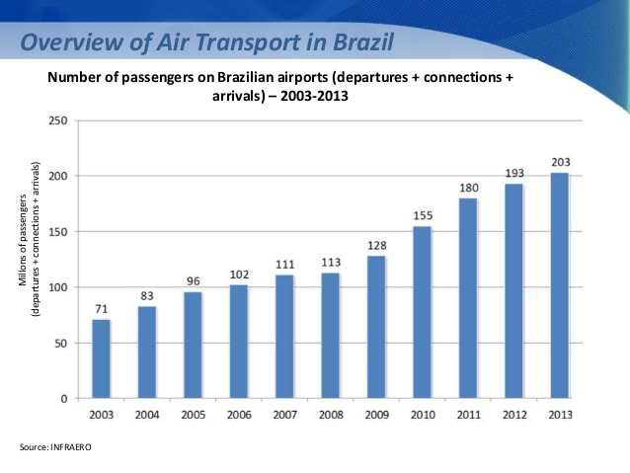
Figure 2 Air travel passengers in Brazil in recent years
[9]
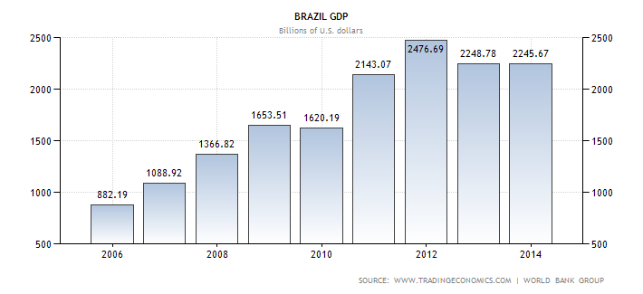
Figure 3 GDP growth in Brazil in recent years[9]

Brazil is the largest country, in terms of size and population, in South America. Brazil’s aviation sector is comprised of multiple local and international airlines. Brazil has approximately 2,500 airports (including landing strips). São Paulo-Guarulhos International Airport is the largest and busiest airport, with Congonhas and Campo de Marte serving as regional airports in São Paulo. TAM Airlines is the biggest Brazilian airline followed by GOL and Azul which operate regionally with some international services.
In 2011 Brazil became the sixth-largest economy in the world [10]. With substantial oil and gas reserves continuing to be discovered off Brazil's coast in recent years, the country is now the world's ninth largest oil producer. The country is enjoying an economic boom because of high oil prices, which in turn has led to rapid growth. Brazil is also the largest Latin American economy and one of the so-called BRIC nations together with Russia, India and China, with growth far outpacing the US and Western Europe. From Figure 2 and Figure 3, a swift increase is seen in no of passengers travelling through Brazilian airports and the GDP growth is also seen to be on the rise since 2006. This rapid growth makes it an attractive destination for foreign investors. The economy of Brazil was only marginally impacted by the global financial crisis in 2009 in which a growth rate of -0.6% year-on-year was recorded. Air travel in Brazil is expected to double over the next decade, driven by an average economic growth rate of approximately 4% per year which in turn will see the average level of disposable income rise across the country, driving demand for air travel. Due to the large size of the country air transportation is a crucial link in Brazil’s infrastructure. The National Civil Aviation Agency (Agência Nacional de Aviação Civil), or ANAC, is the regulatory body in the country. The Brazilian aviation industry has experienced a significant capacity growth of 39% over last five years driven mainly by the introduction of low cost carriers into the region [11]. As the region’s economies grow, Brazil presents opportunities for international carriers and the aviation industry as a whole.
The Brazilian aerospace industry is dominated by Embraer and its suppliers, now the third largest commercial aircraft producer in the world. Added to this, the nation’s over-200 million population and vast geographic area, air travel will continue to grow [11]. The civil aviation industry is an important link in the continuing growth of Brazil and to connect the most populous cities across the country. The dependence on this system, along with the country’s policy to improve the industry, makes the aviation sector an excellent area for investment. The Brazilian aviation industry is going through a period of rapid growth, with a growth in passenger demand for travel combined with greater domestic and international investment into the country. Brazil has seen passenger growth jump by 39% over the past five years with the economies expected to double over the next 10 years with the upcoming Olympics helping to drive growth. The rapid growth has presented a challenge to the airports and surrounding infrastructure as they try to keep pace. But investment continues into the country as Brazil’s economy and the rest of South America’s economy strengthens, presenting new opportunities for growth for US and European carriers looking for strong yielding routes.
Brazil: Change Factors Summary
- Gross Domestic Product
- GDP per Capita
- GDP Growth rate
- Inflation GDP Deflator
- Exchange Rate Fluctuation
- Consumer Price Index
- Population
- Population ages 15-64
- Oil Prices
- Accidents Deaths
- No of Accidents

- In this section, the demand factors closely associated with China is discussed.
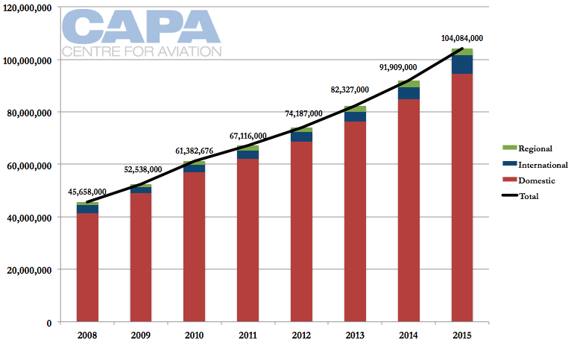
Figure 4 Air travel passengers in China in recent years[9]
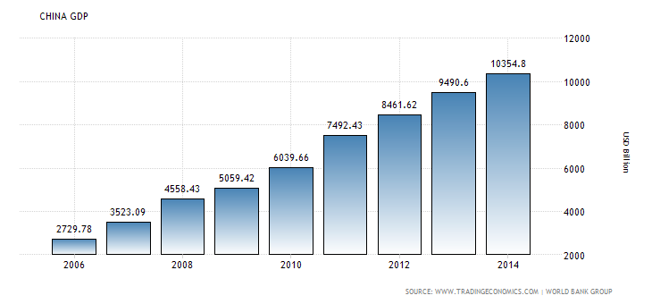
Figure 5 GDP growth in China in recent years[9]
On analyzing Figures 4 and 5, China’s air transportation sector and economy have seen rapid expansion in the last decade. Between 1985 and 2015, the average growth rates for the number of passengers carried by China’s airlines and GDP were 14.8% and 9.85% [12]. During these years, the air transportation industry underwent several changes both in the regulatory framework and infrastructure capability. These changes allowed for the development of both international and domestic aviation markets. In particular, China’s rapid economic growth and increase of the discretionary income of the emerging middle class fueled the development of domestic air travel demand. In particular, air transportation aided in the development of the manufacturing sector because it provided access to foreign capital and knowledge and enabled flows of goods to major global markets. Ready access to air transportation has enabled these high-skill professionals to maintain cross-border networks abroad while taking advantage of the local opportunities in China. While the majority of air passengers from China still travel for business purposes, as the country’s economy continues to grow, air transportation has come to play an important role in providing access to tourism destinations for China’s growing middle class.
The regulatory changes in China’s air transportation system reflect the general economic reforms in the country which started in the late 1970s. The first regulatory change occurred in 1980 when the Civil Aviation Administration of China was separated from the Air Force and came under the direct supervision of the state council [13]. Since then, deregulation, privatization and airline consolidation were encouraged by the government to increase operational efficiency and profitability of the airline industry. However, many of the industry’s operational aspects still remain under governmental control. China began deregulating its air transportation sector in 1987 when it separated the Civil Aviation Administration of China from direct management of airlines and airports and proceeded with further deregulation and privatization reforms in 1997.
The growth in air traffic has put a strain on the existing aviation infrastructure and the country has been investing into new airports, runways, terminals, and surveillance infrastructure. China’s airport infrastructure consists of 230 civil airports by the end of 2015.
China’s growing consumer markets and interaction with the rest of the world resulted in rapid development of both air passenger and cargo services over the last twenty years. The growth was in part stimulated by the reforms initiated in the mid-1980s which deregulated the domestic airline industry and resulted in expansion of the domestic network following the creation of new airlines. To accommodate the rapid growth in demand, the government has been investing into the aviation infrastructure with particular emphasis on development of regional airport and aviation infrastructure to promote economic development away from Eastern hubs. In addition to development of regional airport infrastructure, infrastructure expansion projects were conducted in major centers including Beijing, Guangzhou and Shanghai. Limited liberalization of passenger markets in recent years has also allowed the low-cost international carriers to extend their operations to China.
In addition to factors which have stimulated the growth of air transportation supply, China has had strong growth in air travel demand both for passengers and cargo. In particular, China’s growing middle class and tourism awareness have helped stimulate domestic and outbound air travel demand. In addition, inbound travel demand has been growing following the institutional and political reforms in the 1990s which have resulted in greater knowledge and investment flows both from foreign nationals and returning Chinese expatriates. In addition to the institutional reforms, physical supporting infrastructure played an important role in the growth of these flows and the development of export-based manufacturing and services industries. The enabling impact of air transportation plays a significant role in China’s economic development and reflects the country’s unique factor conditions: growing market-oriented economy, well-developed supporting physical infrastructure, low-cost labor, and government support of foreign investment. The availability of air passenger services allows China to access foreign investors, it enables the flows of remittances, knowledge and investment from the diaspora, and helps enable inbound tourism as well as develop the domestic and outbound tourism industries.
China: Change Factors Summary
- Gross Domestic Product
- GDP per Capita
- GDP Growth rate
- Inflation GDP Deflator
- Exchange Rate Fluctuation
- Consumer Price Index
- Population
- Population ages 15-64
- Oil Prices
- Accidents Deaths
- No of Accidents

- In this section, the demand factors closely associated with India is discussed.
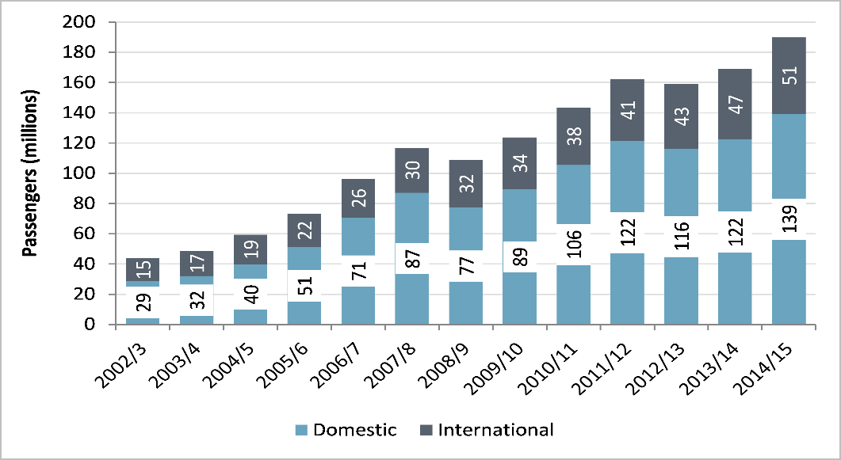
Figure 6 Air travel passengers in India in recent years[9]
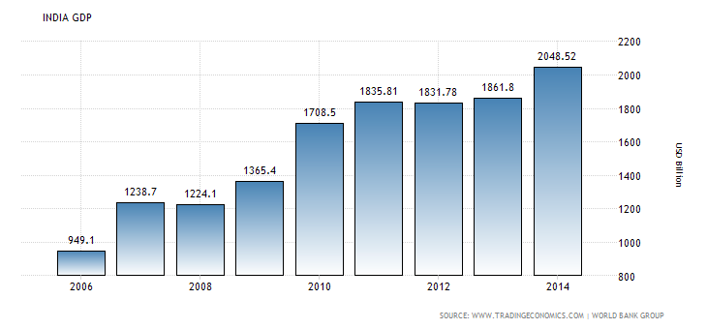
Figure 7GDP growth in India in recent years[9]
On analyzing Figures 6 and 7, air transportation development in India has been surging with economic development since the air passenger traffic experienced unprecedented growth starting in 2003. India is the largest country in South Asia and the world’s second most populous country. While the change in the growth rate of air passenger traffic is relatively recent, the country’s economy has experienced steady growth over the last two decades with an average rate of 6.41% between 1985 and 2015 [12].
The recent increase in the air passenger growth rates has been primarily due to domestic deregulation and the ensuing development of low-cost carriers which led to a sharp drop in prices and enabled personal air travel for the country’s growing middle class. In addition to domestic air passenger growth, India’s international aviation flows have increased substantially in recent years following the signing of bilateral aviation agreements which enabled international airlines to gain access to India’s aviation markets. India’s economic liberalization also helped stimulate air passenger demand. Over the years, business passenger travel and foreign investors in particular have come to play an important role as India has continued to develop its services-based industries for international consumer markets. In addition to foreign investors, air transportation has enabled access to the extensive diaspora community affecting inward flows of capital, knowledge and remittances.
Until the early 1990s Indian aviation needs were served by two inefficient state-owned carriers. The government started deregulating the industry in 1988 when it authorized operation of domestic charter flights by private companies. By 1993 private operators had a 30% domestic market share [14]. However, it was only after 2003 that India’s domestic aviation has experienced unprecedented growth rates following the entry of the first low-cost carrier Air Deccan which led to a sharp drop in prices and enabled personal air travel for the country’s growing middle class[15].
Domestic air services deregulation and introduction of low-cost carriers in 2003 were the major stimulating factors behind India’s air transportation growth. In particular, poor level of other transportation infrastructure, growing consumer demand and reduced fares provided by the low-cost carriers enabled rapid growth of the domestic air transportation industry.
From Figure 6, the GDP growth has been experiencing an upward trend. Therefore, stimulating factors included India’s economic liberalization and privatization reforms in the early 1990s which affected both air transportation supply and demand. In particular, these reforms enabled both investment into the aviation infrastructure and development of export-oriented industries which rely on access to foreign capital and markets. Gradual liberalization of international passenger services has also stimulated the growth of international passenger traffic. In particular, it allowed foreign airlines to carry passengers on routes where the demand growth was suppressed prior to liberalization because India’s national carriers had insufficient capacity to satisfy the potential demand levels.
In general, deficiencies in aviation and airport infrastructure have negatively influenced India’s air transportation development. However, recent ownership and privatization reforms have enabled the flow of private funds into the aviation sector and resulted in the construction of several new airports in major urban areas. Specifically, new investments included the construction of green field airports in Cochin in 1999, Hyderabad and Bangalore in 2008, and a second international airport to serve the Mumbai catchment area.

India: Change Factors Summary
- Gross Domestic Product
- GDP per Capita
- GDP Growth rate
- Inflation GDP Deflator
- Exchange Rate Fluctuation
- Consumer Price Index
- Population
- Population ages 15-64
- Oil Prices
- Accidents Deaths
- No of Accidents

DIFFERENT TYPES OF AIR TRAFFIC DEMAND FORECASTING
There are numerous forecasting techniques used in the airline industry to forecast future volume of air traffic. Some of which are discussed below. However, this is not an exhaustive review, since some of the forecasting tools little used by airlines are not examined. The forecasting methods discussed in this thesis are Qualitative Methods, Time Series Projections,

Qualitative methods

Executive judgment
Executive judgement is based on the insight and assessment of a person, who often may not be a forecaster, but who has special knowledge of the route or market in question. Their knowledge will include an understanding of the recent and current traffic growth and of other social/economic developments likely to affect future demand.

Market research
Market research techniques are used to analyze the characteristics of demand for both passenger and freight. These techniques will include attitudinal and behavioral surveys of passengers. Such studies might be commissioned from specialist market research companies.

Delphi method
Delphi method requires the building up a consensus forecast based on the views of individuals who are considered to have sufficient expertise to be able to anticipate future trends. The process is an iterative one, possibly involving several rounds of consultation.

` Time Series Projections
Time-series methods make forecasts based solely on historical patterns in the data. Time-series methods use time as independent variable to produce demand. In a time series, measurements are taken at successive points or over successive periods. The measurements may be taken every hour, day, week, month, or year, or at any other regular (or irregular) interval[16].

Average rate of growth
The forecast for the value of Y at time t+1 is made at time t equals the simple average of the most recent ‘m’ observations:
$$\hat{Y_{t+1}}=\frac{Y_{1}+Y_{t-1}+….+Y_{t-m+1}}{m}$$

Moving average growth
The simple moving average model treats the last k observations equally and completely ignores all preceding observations. In order do this, normally three (or more) observations are added together and the average is calculated
$$\hat{Y_{t+1}}=\frac{Y_{1}+Y_{t-1}+Y_{t-2}+Y_{t-3}}{3}$$

Exponential smoothing
The most recent observation with a little more weight than the 2nd most recent, and the 2nd most recent should get a little more weight than the 3rd most recent, and so on.
$$y+1=αy+α\left(1-α\right)y_{-1}+α{(1-α)}^{2}y_{-2}+α{(1-α)}^{3}y_{-3}…..$$
Let $α$ denote a "smoothing constant" (a number between 0 and 1). Y is the number of passengers in year y and $y_{t+1}$ is the first year forecast.

Simple trend
The underlying assumption of this method is that a straight line best represents the trend of the traffic over time and that traffic increases by a constant amount with each unit of time. The technique involves drawing a straight line through the times series so as to produce a best fit. This is normally done by least square method.

Moving average trend
Large variations in the past traffic volumes can be reduced by calculating moving average and establishing a new time series. This would contain the trend component in the traffic and it should be easier to fit to a trend line.

Econometric or causal models
Changes in any one of the variable will affect demand. Causal models attempts to measure that causal relationship so that by forecasting or even implementing change in any one of the variables, one can predict the consequent impact on demand levels[16].

Regression models
Forecasts from a simple linear model are easily obtained using the equation
$\hat{y}=\hat{β_{0}}$+$\hat{β_{1}}$x
Where, x is the value of the predictor that require a forecast. That is, if one input a value of x in the equation one obtain a corresponding forecast$\hat{y}$.

Gravity models
Gravity models can be explained with a simple formulation that air traffic between two points is proportional to the product of their populations and inversely proportional to the distance between them; so that:
$$T_{ij}=K\frac{P_{i}P_{j}}{D_{ij}}$$
Where, $T_{ij }$is the traffic between two towns i and j, K is a constant, $P_{i}$ and $P_{j}$are the populations of the towns and $D_{ij}$ is the distance between them.

RESEARCH GAP
There are several studies done on the topic of airline demand forecasting in the past several years. Most of the studies focus on the time-series method forecasting method and casual forecasting methods, including regression analysis. Moreover, most of the earlier forecast focuses on Western aviation markets including United States, Europe etc. The forecasted surge in air traffic in global aviation has been characterized by a greater use of macro-economic variables, making the exercise even more relevant for airline strategy formulation. However, these studies have mainly addressed the US and European market. Hence, demand for the air travel services assumes prime importance and airlines have to be aware of their demand on respective sectors prior to operations. Airline demand forecast is a very important task for air companies to operate an existing airline or open a new airline.
Earlier econometric works did not fully incorporate the role of macro-economic demand factors in airline demand forecasting, nor did they recognize the air accidents statistics in decision variables required in a market model. There is a serious lack of study on emerging markets like Brazil, China and India, where a large chunk of growth is going to take place in the next 20-30 years. Moreover, the existing literatures only focuses on determining the traffic estimates of western markets and did not really care about the air traffic estimates in the emerging economies.

RESEARCH QUESTIONS AND CORRESPONDING HYPOTHESES
In this section, the research questions and their corresponding research hypotheses are explained in detail.
Research Questions No: 1
How to develop an econometric statistical model that predicts the number of passengers travelling in the scheduled aviation sector in Brazil, China and India over the next 5 years?
Research Hypothesis
A correlation matrix analysis seems to be an effective method to identify the major driving factors. $'R values'$ from a Correlation matrix can help to find major potential factors that have a significant effect on the dependent variable using R Studio software. This result will help to to identify the major demand factors required to develop the econometric model.
Expected Outcome
The major demand factors that really affect the air traffic demand in Brazil, China and India are determined
Research Questions No: 2
How to relate the potential demand factors to future demand and there by develop a predictive statistical econometric model to forecast future demand?
Research Hypothesis
A stepwise regression method (forward or backward) can be used to develop the predictive statistical econometric model using R Studio software.
Expected Outcome
Develop a predictive statistical model that forecast future demand.
Why Econometric model?
Decided to do forecasting using econometric models because, econometric model is one of the tools economists use to forecast future developments in the industry. It helps to understand and measure past relationships among different variables and will also help to forecast how changes in some variables will affect the future course of others. Econometric model guides in figuring out how different factors interact with one other. Econometric forecasting supports economic judgment that can be used to determine values for exogenous variables and also to reduce the likely size of model error.

METHODOLOGY
In the above context, this thesis aims to discuss a methodology to develop a scheduled air traffic forecasting model for airlines operating on sectors from Brazil, China and India. This study provides a comprehensive picture of the factors affecting airline demand, factors that could play an important role in demand growth and also aims at forecasting passenger demand in the Indian Chinese and Brazilian scheduled aviation industry in the short term. Thereby helping the airlines to make improved decisions for efficient revenue management. With the developed statistical econometric model, one can perform forecast and estimate demand growth. The first question that is addressed is “What are various demand factors that drives passenger demand in these three countries”? The factors can range from various macroeconomic variables like Gross Domestic Product (GDP), Inflation rate, Consumer price index, Population (Between 15 to 64), Exchange rate fluctuations etc. and safety/maintenance variables like No of Air accidents, No of deaths in air accidents etc. The primary objective is to study what are the potential factors that drives airline demand and what impact will each of these factors have on demand growth. In order to do so, one plan to develop a correlation matrix using all the explanatory variables and the dependent variable using historic data of the various factors mentioned above. The correlation matrix would give $'R values'$ using which one could identify the significant factors that has an effect on the dependent variable. After identifying the major demand factors, the factors are divided into different groups in different combination of demand variables. This is done to avoid multi-collinearity among the demand variables. Hence, more than one econometric model is developed for each country. Multiple regression analysis is then performed on all the models to identify the most appropriate model to perform forecasting. Multiple regression analysis would give $R^{2}$ and adjusted $R^{2}$ values, based on which one would be able to finalize on the decisions on the econometric forecast model. Forecasting would then be performed for 5 years ahead to determine the demand estimates. Forecasting plays a major role in logistic planning and it is an essential analytical tool in countries’ air traffic strategies. This study would definitely have a profound impact on the changes need to be implemented in Indian and Chinese aviation industry.
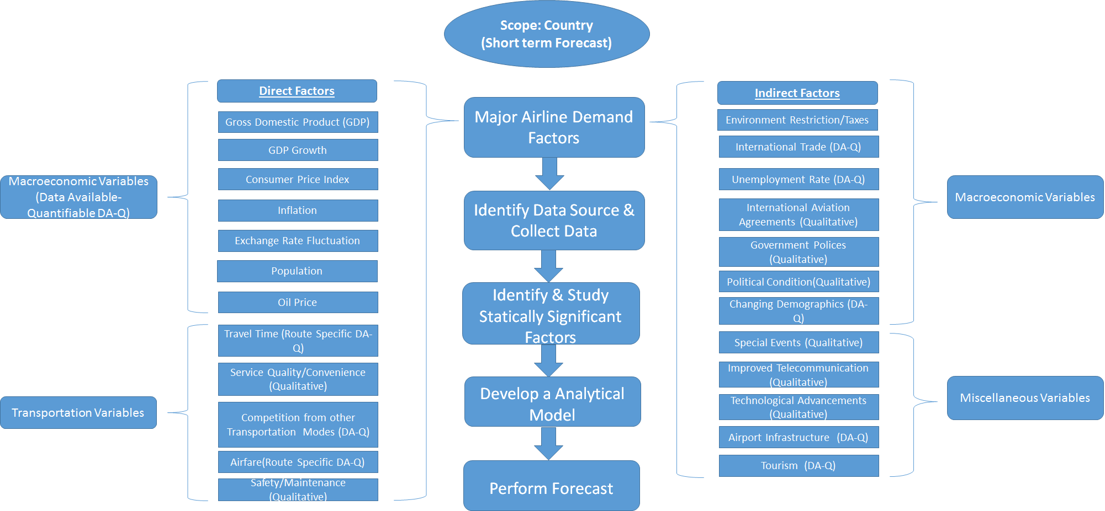
Figure 8 Methodology to study, develop and forecast air travel demand

- CHAPTER TWO CRITICAL EVALUATION OF THE LITERATURE AND JUSTIFICATION OF RESEARCH QUESTIONS
In this chapter, a critical evaluation of the literature, and expansion of the research gap, presented in Section 1.2, 1.3 and 1.4, are presented. This chapter is organized based on the four aspects of the considered problem i) the literature related to the first aspect of the problem, the scheduled air transportation demand factors, is presented in Section 2.1, ii) the literature related to the second aspect of the problem, types of airline forecasting and multiple regression, is addressed in Section 2.2, and, the literature of the third forecasting using an econometric model is presented. In each section (Sections 2.1, 2.2, and 2.3), first, the fundamental concept and definitions related to each aspect is presented, then it is followed by the critical evaluation of the literature.

SCHEDULED AIR TRANSPORTATION DEMAND FACTORS
During the last three decades, the study of air travel demand has attracted considerable attention of researchers and academics. An extensive literature has emerged to explain the determinants of air travel demand. Pioneering work in this area includes, among others, that by Ghobrial (1992) [17], Alperovich and Machnes (1994) [18] and Bafail et al. (2000) [19]. Some of the research done in this area will be reviewed in this section.
An examination of the current economic situation and a consideration of projections during the next decade is of crucial importance. As will be seen later, macro-economic indicators are linearly related with growth and extensively used in forecasting future demand. These indications include such variables as inflation, GDP and oil prices [17]. Thus economic trends and an overall appraisal of the current economic environment are helpful in understanding the assumptions for forecasting future growth [20].
The use of a sophisticated model to develop an equation giving the amount of air travel as a function of factors such as GDP and average income does not eliminate judgment from the estimates of future conditions. The procedure just shifts it from air travel to those other quantities, the future of which may be less uncertain but still difficult to assess. To avoid this dependency of gross judgment, statistical analysis often focusses on assessing the change of traffic caused by key variables which planners may control or at least estimate more readily. Thus it is convenient to calculate the elasticity of demand. This is according to Bafail et al. (2000) [19]
Three sorts of impacts are typically measured:
Direct – employment or economic output affected by the business activities or a proposed development of the industry. For aviation, direct impacts are employment and output in the aviation sector [21].
Indirect – employment or economic output caused by inter-industry purchases of goods and services as they respond to changes in industry activity. For aviation, indirect impacts include employment and activity generated in the industry’s supply chain [21].
Induced – employment or economic output created through household spending of those employed directly and indirectly through the industry’s business activities [21].
Elasticities may be constant or can change and thus reflect existing or changing trends. Recent indications are that the demand elasticity of air travel is generally low, partly because the consumers’ relative position in relation to travel costs has improved along with his increased affluence. There is a natural rate of annual traffic growth that reflects the stage of development composition and consumer behavior generally conducive to spending on activities such as recreational travel [22]. Macroeconomic indicators have generally been used in the models as the independent variables while elasticities have been checked to reveal how, and to what extent, those economic factors influence traffic. According to X Fu, TH Oum, A Zhang (2010) The most commonly used indicators entering the equations as explanatory variables have been GDP, Passenger Yield, Consumer Price Index (CPI), and Income [23].

TYPES OF AIRLINE FORECASTING
Another study by Faraway et al. (1998) presents an econometric model that estimates the aggregate demand for an airline. The demand is expressed in terms of airline network structure, operating characteristics and firm specific variables. A number of model formulations with different combinations of explanatory variables are estimated using the two-stage-least-squares procedure. The results suggest that the airline aggregate demand is elastic with respect to yield, and inelastic with respect to network size and hub dominance [24].
In the book “The Airline Business in 21st Century” by Rigas Doganis[25], techniques for forecasting air travel demand can be broadly classified into three categories: judgmental, mechanical, and analytical. When using the judgmental method, the analyst makes an educated guess of the travel demand for the forecast period [26].
The mechanical method assumes that future travel demand is a time function of past experience. The application of the mechanical method varies from the simple extrapolation of historical trends to the use of complex mathematical growth curves, such as the Logistic and Gompertz curves [27]. These are known as intrinsic models. In a study conducted by Nam (1995) [28] time is taken to be the only predictor variable, reflecting the interplay of economic, industry, and government activities. In other words, the mechanical method assumes that the demand generated over time is a function of time alone. The use of direct extrapolation, is not considered a satisfactory method for forecasting. It merely indicates that parameters exist which have influenced the demand in the past at a rate which is a function of time. It is, therefore, difficult to project the demand based on time alone unless one knows these time-based parameters and the extent of their influence. It is also difficult to forecast the time at which these influences may cease to operate or their effects will change [26].

The analytical method explores and analyzes parameters which have affected the historical travel demand pattern and those parameters which may influence the future travel demand. This method utilizes past relationships between travel volume and other variables such as income and fares. These are known as the regression techniques of projecting travel volumes [26].
Ghobbar, at al (2003) [29]has conducted that states that although time can enter the relationship as a predictor variable, it cannot be the sole predictor variable, for then the model would be intrinsic, a time-series model. The analytical method employs the dependent variable traffic as it relates to the logically relevant independent variables through a mathematical expression. It must be emphasized, however, that statistical correlation does not by any means imply cause and effect [29].
Various methods are available, ranging from econometric modeling to time series techniques, for representing the air travel market. Time series approaches are the most common methods for forecasting the traffic demand. These methods are handicapped by their inability to identify the causes of market growth and to link the future growth with expected developments of causative factors. They cannot, however, explain the impact of a reduction in fares, the introduction of new aircraft, an economic recession, or the uncertainties with regard to future regulatory conditions [30]. Such questions can only be answered if the forecaster has specified and calibrated a formal model that shows the influence and interaction of all the relevant variables and not just one (i.e., time). Because of the complex nature of air transportation industry, the past records of air traffic forecasters (using mostly trend extrapolation) has not been impressive. In recent years, therefore, the trend has been to develop causal models that not only predict traffic but also determine the impact of changes within the economic environment on traffic [22].

FORECASTING USING ECONOMETRIC MODEL
The econometric model is by far the most frequently used method for forecasting aviation demand. It is a mathematical representation of air traffic or its constituent parts and those independent variables of the national economy which are thought to influence traffic growth[30]. Econometrics is the statistical technique used to quantify these relationships. The mathematical equations of the model relate economic factors to the level of aviation activity, based on observation of past behavior of both the economy and the aviation industry. The equations may also be constructed so as to reflect the effects of specific factors within the air transportation industry itself, such as fare levels, route configurations, fuel costs, etc. [31].
Models mainly use macro-economic indicators as their explanatory variables. They have been found reasonably satisfactory in describing and explaining air traffic growth behavior. The most commonly used factors were GNP/GDP, CPI and yield.
In a number of papers there has been an attempt to assess the extent to which air travel is to be affected by current economic conditions. Profillidis (2000)[32] , for example, estimate a model in which they include GDP growth, fuel prices and some dummy variables to reflect events such as SARS, 9/11 and Asian financial crises. They use aggregate data from 1980 to 2008 to examine how these factors listed affected total air travel – domestic plus international. They find the elasticity of air travel with respect to GDP is 1.58, but argue this value is inflated because it captures influences which were not included in the model, such as increased services and new routes [32].
The results differ considerably from the model of Oum et al. (2008)[33], but this model was estimated on only international air passengers, whereas their model was estimated on total world air traffic. The model was composed of a panel data set with 8 cross sections (regions) and 12 years for each region. The variables are in logs so the coefficients can be interpreted as elasticities. Note the GDP elasticity is quite low, a mere 0.06, which is sensible in that the amount of international travel will be influenced but only in a small way by domestic growth. Also having trade, foreign investment and connectivity in the equation takes a good deal away from the magnitude of the coefficient [32].
According to Fildes et al (2011)[34], this paper had the objective of trying to understand “what international air passenger travel will look like in five, ten or fifteen years and what were the underlying drivers”. This required answering two questions; to identify what will be the more important determinants of international passenger travel in the future and secondly to translate the impact of these factors into expected changes in future passenger growth. Identifying the drivers was relatively successful in determining which are most relevant and how large each of the effects would be on traffic growth was less successful [34, 35].
- CHAPTER THREE A METHOD FOR STUDYING DEMAND FACTORS
Here, one intend to use Multiple Regression analysis to study the significant scheduled air transportation demand factors out of the different potential demand factors selected for the study. The methodology is explained in detail in this chapter [36].

MULTIPLE REGRESSION
Multiple Regression is a quantitative method that has a wide range of application today and is one of the most widely used modelling technique in business.
The main three advantages of multiple regression are as follows:
- Structure analysis: Estimation of the impact of variables (demand factors) that influence demand as measured by elasticities
- Policy evaluation: The ability to measure the impact of policies that may affect consumer demand, such as GDP changes using what-if analysis
- Forecasting: More accurate demand forecasting for particular items in the short, medium and long range
With multiple regression, as with simple regression, there is one target variable, Y (also known as the dependent variable) to be predicted (e.g., demand). However, unlike simple regression, multiple regression uses two or more explanatory variables (independent variables).
The general ordinary least square form of multiple regression is:

$$\hat{Y}=β_{0}+β_{1}X_{1}+β_{2}X_{2}……+β_{n}X_{n}$$

Where $\hat{Y}=target, or dependent variable to be forecasted$

$$β_{0}=constant or intercept \left(α\right)$$
$$β_{n}=parameter estimates or coefficients (b)$$
$$X_{n}=explanatory or independent variables$$

One of the initial steps when applying a multiple regression model requires the identification of those variables that are associated with changes in the dependent variable. A certain number of variables are identified as possibly having an impact on the dependent variable, but only a small number of them actually have any real value as predictors in the regression model. This thesis plan to study the scheduled air traffic demand factors of the three major emerging economies in the world Brazil, China and India. In order to find the major demand factors in each market, historic data is collected for certain macroeconomic and safety factors for a period of 45 year from 1970 to 2014. The factors are selected based on literature review. The dependent variable being studied here is ‘No of Passengers’ travelled during a year. The number of passengers carried include both domestic and international aircraft passengers of air carries registered in the country.

DATA SOURCES
Econometric model is invaluable tool for increasing the understanding of the way an economic system works and for testing and evaluating alternative policies. However, such model are useless if it operates on poor quality historical data or faulty knowledge of the causative factors underlying traffic growth. The availability of a consistent data set allows the use of annual data for the period 1970-2014. The data used in the estimation of the model originate from two sources. Macro-economic and demographic data of the Brazil, China and India are taken from the World Bank data bank (http://databank.worldbank.org/data/home.aspx)[37]. The data related to number of air accidents and number of deaths in air accidents are taken from Aviation Safety Network (https://aviation-safety.net/database) [38].

Table 1 Selected air traffic demand factors for Brazil, China and India
Brazil | China | India
Gross Domestic Product | Gross Domestic Product | Gross Domestic Product
GDP Growth rate | GDP Growth rate | GDP Growth rate
GDP per Capita | GDP per Capita | GDP per Capita
Inflation GDP Deflator | Inflation GDP Deflator | Inflation GDP Deflator
Exchange Rate Fluctuation | Exchange Rate Fluctuation | Exchange Rate Fluctuation
Population (Total) | Population (Total) | Population (Total)
Population, ages 15-64 (% of total) | Population, ages 15-64 (% of total) | Population, ages 15-64 (% of total)
Oil Prices (USD) | Oil Prices (USD) | Oil Prices (USD)
Accident Deaths per year | Accident Deaths per year | Accident Deaths per year
No of Accidents per year | No of Accidents per year | No of Accidents per year
 |  | Consumer Price Index

Table 2 Data set for Brazil for Gross Domestic Product, GDP per Capita, Inflation GDP Deflator, Exchange Rate Fluctuation (1970-2014)[37]
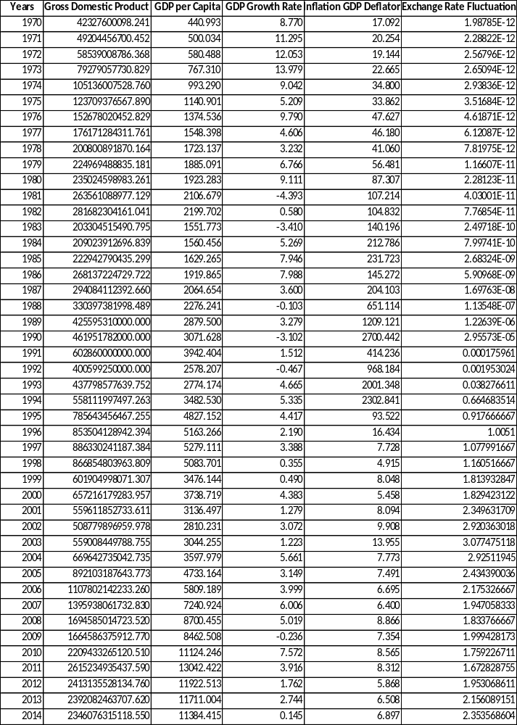
Table 3 Data set for Brazil for Population, Population ages 15-64 (% of Total), Oil Prices (USD), Accident Deaths, No of Accidents, No of Passengers (1970-2014)[37]
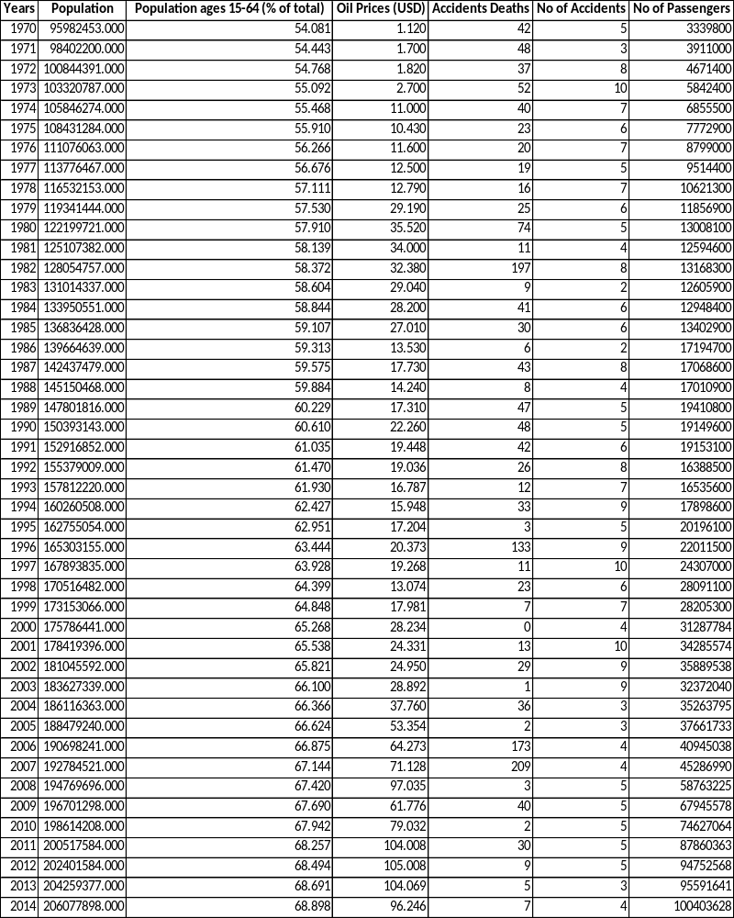

Table 4 Data set for China for Gross Domestic Product, GDP per Capita, Inflation GDP Deflator, Exchange Rate Fluctuation (1970-2014)[37]
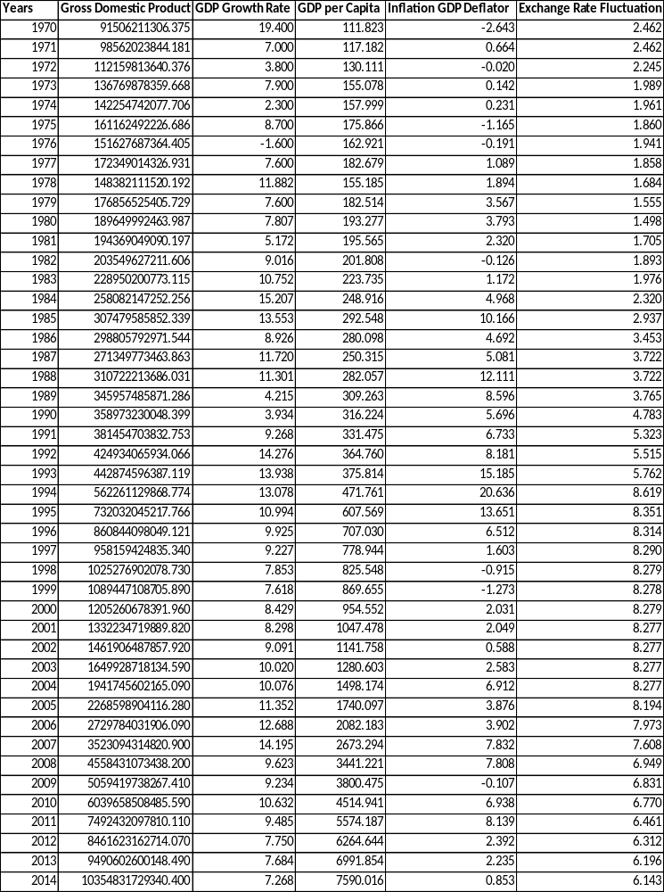

Table 5 Data set for China for Population, Population ages 15-64 (% of Total), Oil Prices (USD), Accident Deaths, No of Accidents, No of Passengers (1970-2014)[37]
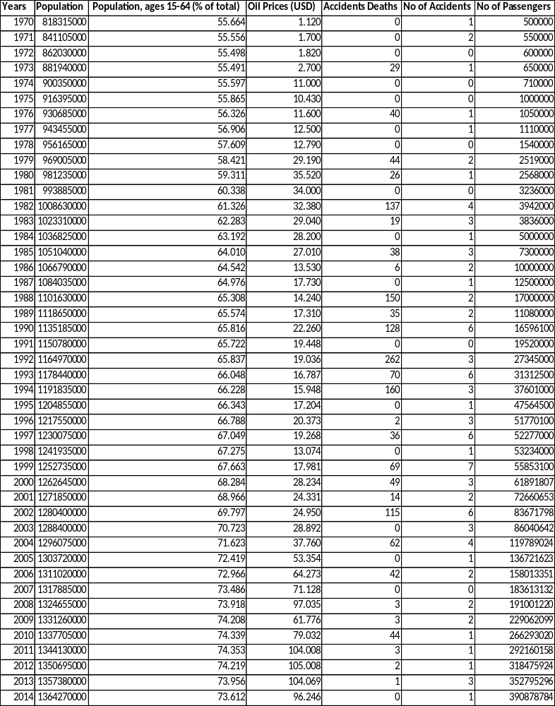

Table 6 Data set for India for Gross Domestic Product, GDP per Captiva, Consumer Price Index, Inflation GDP Deflator, (1970-2014)[37]
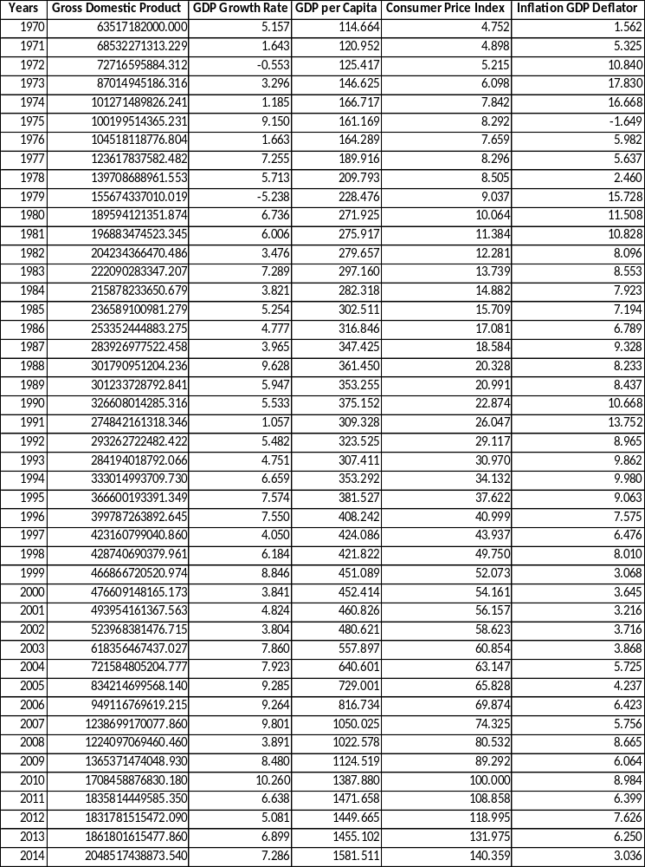

Table 7 Data set for India for Exchange Rate Fluctuation, Population, Population ages 15-64 (% of Total), Oil Prices (USD), Accident Deaths, No of Accidents, No of Passengers (1970-2014)[37]
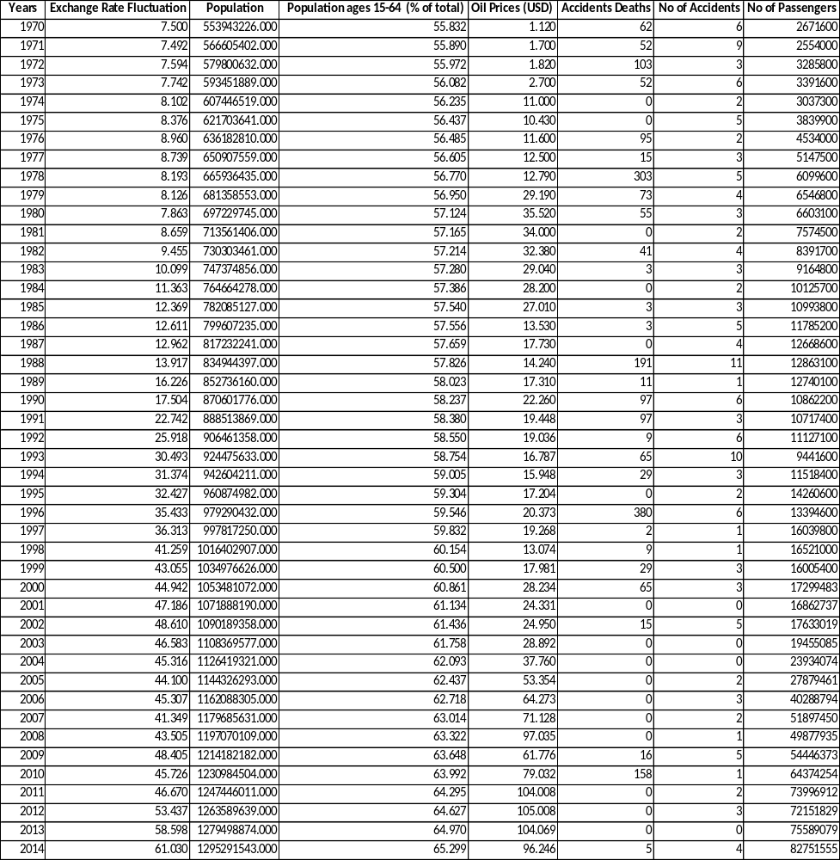

The five key considerations that were made sure regarding each variable are as follows:
Adequate Data: There must be adequate data available for each proposed independent variable to measure the true relationship with the dependent variable. In fact, the amount of data must be greater than the number of variables in the model. A suggested ratio followed here is that there should be at least four periods of data for each independent variable in the equation. Therefore 10 independent variables of Brazil and China each and 11 independent variables for India are selected. In total data for a total 45 years are taken for study.

Data periodicity: Not only is it important to have sufficient historical data, but the data must be available in the same periodicity. All the independent variables and the dependent variable are in per year basis. I.e. there are in the same time period

Future projections for independent variables: Since the independent variables are used to shape and forecast demand, there will be a need for accurate estimates of future values for each explanatory variable. Those future estimated values for all the independent variables must also exist for the same time horizon into the future that one plan to forecast demand. The dependent variable forecasted are in the same time horizon as the future projections for the independent variable.

Likelihood the relationship between the variables continues into the future: The regression coefficient ($β_{n}$) measures the amount of change that occurs with the dependent variable for every unit change in the independent variables. If the $β_{n}$ value is going to be a significant predictor of changes in the corresponding independent variable, then that relationship must be consistent over time.

Linear explanatory with the dependent variable: There must be a linear relationship between the dependent variable and the independent variables. If a linear relationship does not exist initially, the data can be transformed using a log/log or semi-log form of the initial equation.

DATA VISUALIZATION USING SCATTER PLOTS
A scatter plot can suggest various kinds of correlations between variables with a reasonable level of confidence. Those correlations can be linear positive (rising from left to right), linear negative (falling from left to right), or neither (no correlation). A line of best fit (also called a trend line) can be drawn in order to study the correlation between the variables. The most powerful aspect of a scatter plot is its ability to show nonlinear relationships between variables. Scatter plots are similar to line graphs in that they use horizontal and vertical axes to plot data points. However, they have a very specific purpose. Scatter plots show how much one variable is affected by another, or correlation. Scatter plots usually consist of a large number of data points. The more those data points converge when plotted forming a straight line, the stronger the correlation between the two variables. Scatter plots can also help to identify potential outliers.

Scatter plots between the various independent variables and the dependent variable for Brazil
Here, scatter plots for Brazil are plotted for all the independent factors against the dependent variable i.e. the No of Passengers. After plotting all the scatter plots using the R Studio software, one see a positive linear relationship between the dependent variable (No of passengers) and the following independent variables which are Gross Domestic Product, GDP per Capita, Population, Population ages 15-64 and Oil Prices. From this one can conclude that the above mentioned factors have strong correlations with the dependent variable. However, one can see a non-linear relationship between No of Passengers and GDP Growth rate, Inflation GDP Deflator, Exchange rate Fluctuation, No of Accidents and Accident Deaths. These plots suggests that there are no correlation between the mentioned variables and the dependent variable.
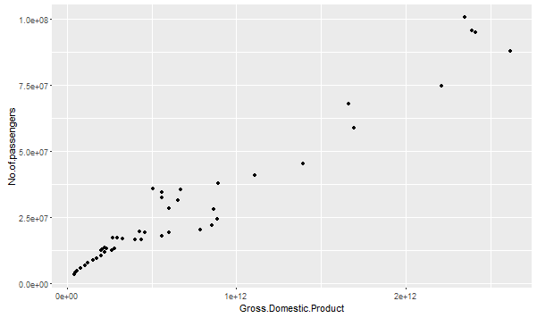 | 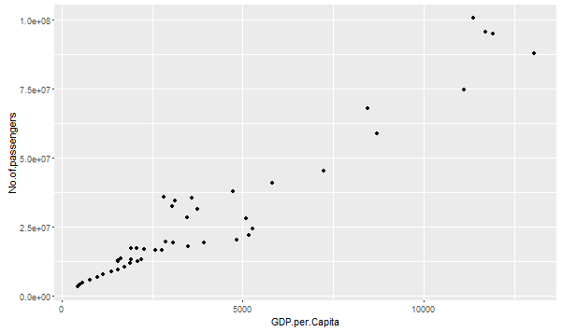
(a) | (b)
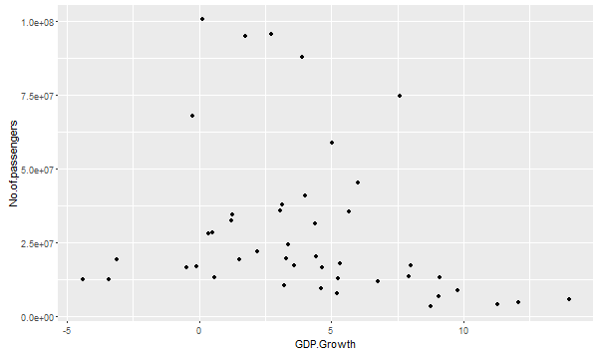 | 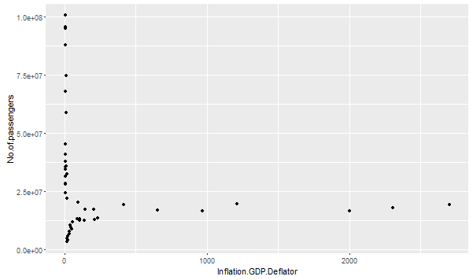
(c) | (d)
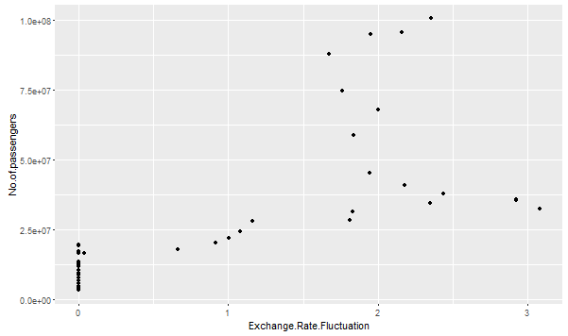 | 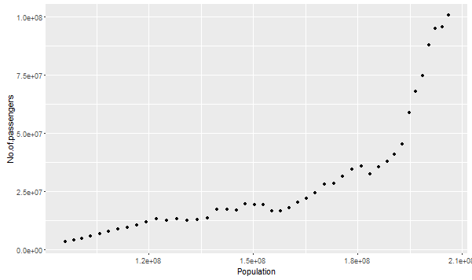
(e) | (f)
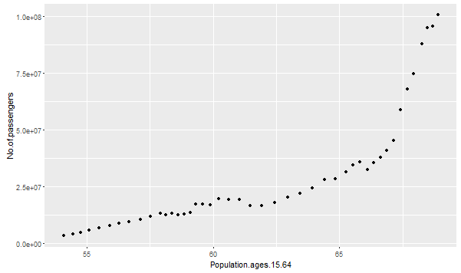 | 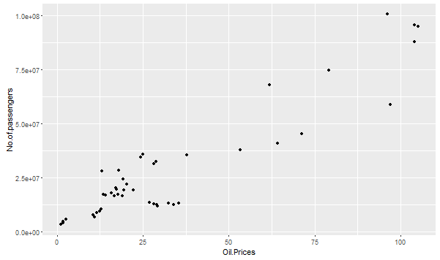
(g) | (h)
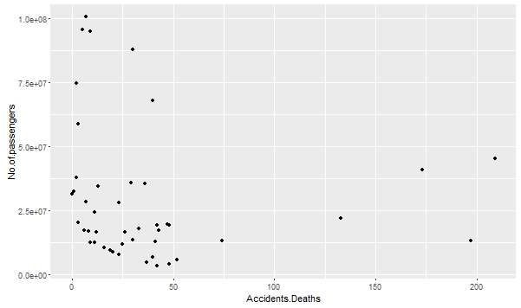 | 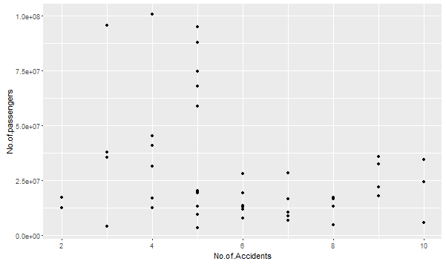
(i) | (j)
Figure 9 Results showing the linear relationship between No of Passengers and (a) Gross Domestic Product,(b) GDP per Capita,(c) GDP growth rate, (d) Inflation GDP Deflator,(e) Exchange Rate Fluctuation,(f) Population,(g) Population ages15-64,(h) Oil Prices,(i) Accidents Deaths, (j) No of Accidents

Scatter plots between the various independent variables and the dependent variable for China
Here, scatter plots for China are plotted for all the independent factors against the dependent variable i.e. the No of Passengers. After plotting all the scatter plots using the R Studio software, one can see a positive linear relationship between the dependent variable (No of passengers) and the following independent variables which are Gross Domestic Product, GDP per Capita, Population, Population ages 15-64 and Oil Prices. From this one conclude that the above mentioned factors have strong correlations with the dependent variable. However, one can see a non-linear relationship between No of Passengers and GDP Growth rate, Inflation GDP Deflator, Exchange rate Fluctuation, No of Accidents and Accident Deaths. These plots suggests that there are no correlation between the mentioned variables and the dependent variable.
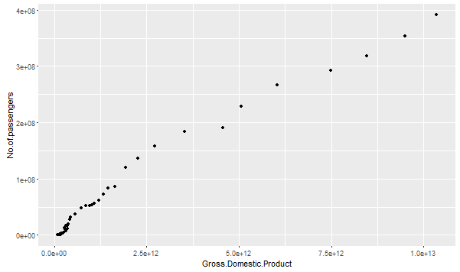 | 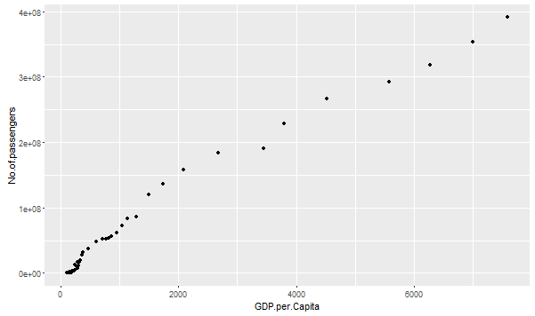
(a) | (b)
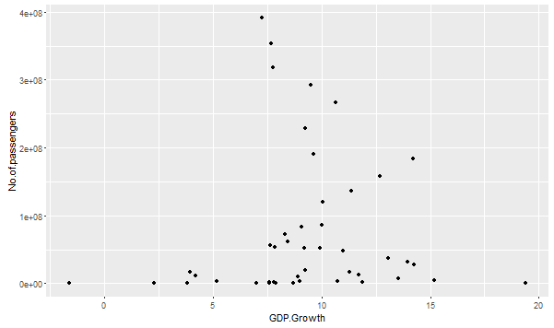 | 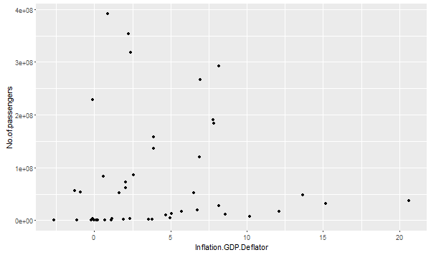
(c) | (d)
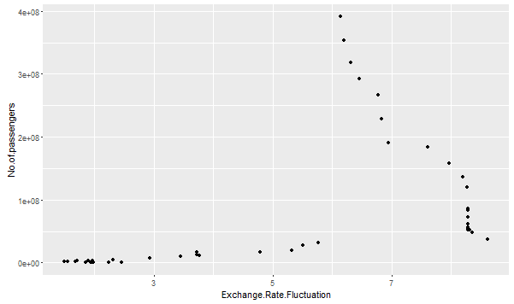 | 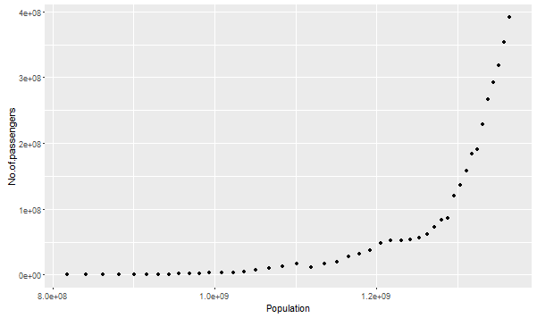
(e) | (f)
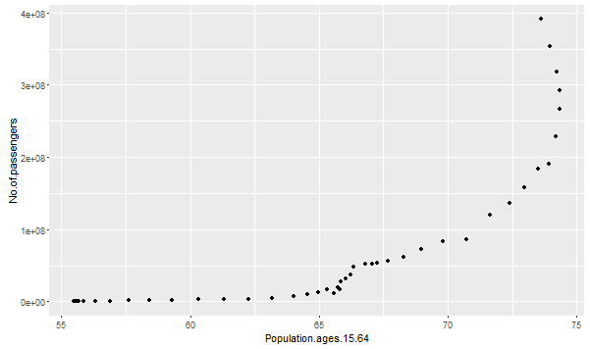 | 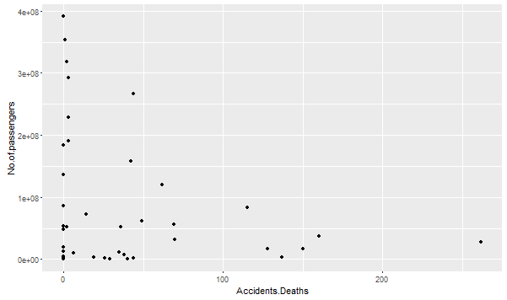
(g) | (h)
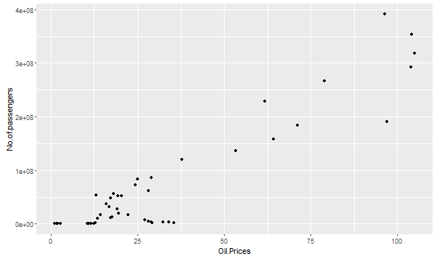 | 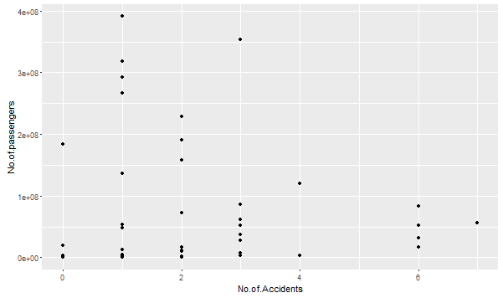
(i) | (j)
Figure 10 Results showing the linear relationship between No of Passengers and (a) Gross Domestic Product, (b) GDP per Capita,(c) GDP growth rate, (d) Inflation GDP Deflator,(e) Exchange Rate Fluctuation,(f) Population,(g) Population ages15-64,(h) Accident Deaths, (i)Oil Prices,(j) No of Accidents

Scatter plots between the various independent variables and THE dependent variable for India
Here, scatter plots for India are plotted for all the independent factors against the dependent variable i.e. the No of Passengers. After plotting all the scatter plots using the R Studio software, one can see a positive linear relationship between the dependent variable (No of passengers) and the following independent variables which are Gross Domestic Product, GDP per Capita, Consumer Price Index, Exchange rate Fluctuation, Population, Population ages 15-64 and Oil Prices. From this one can conclude that the above mentioned factors have strong correlations with the dependent variable. However, one can see a non-linear relationship between No of Passengers and GDP Growth rate, Inflation GDP Deflator, No of Accidents and Accident Deaths. These plots suggests that there are no correlation between the mentioned variables and the dependent variable.
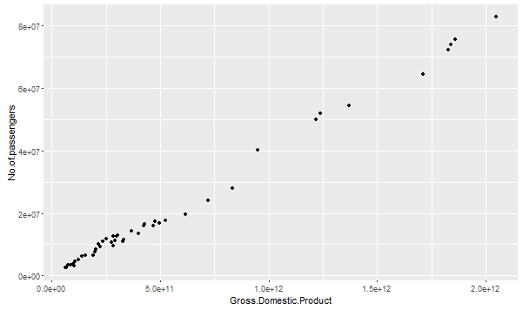 | 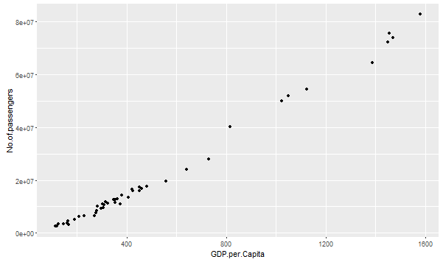
(a) | (b)
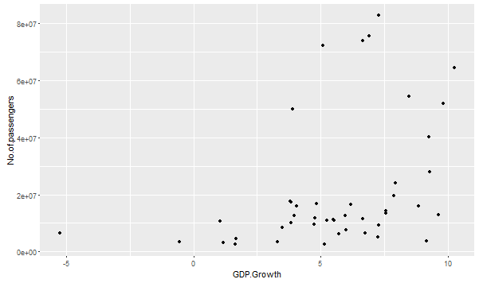 | 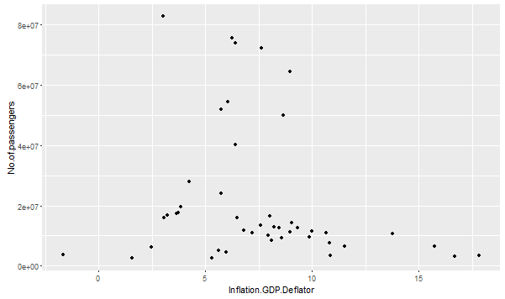
(c) | (d)
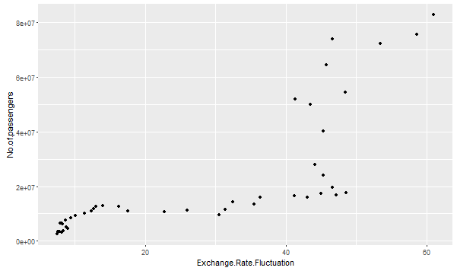 | 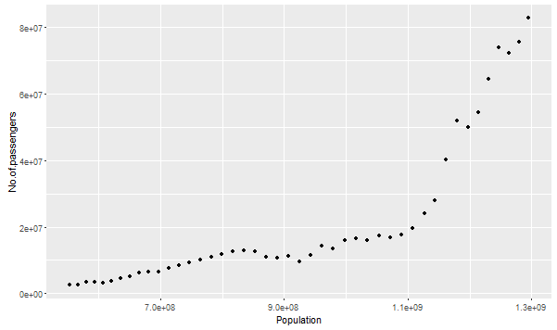
(e) | (f)
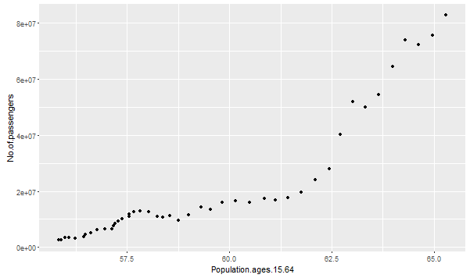 | 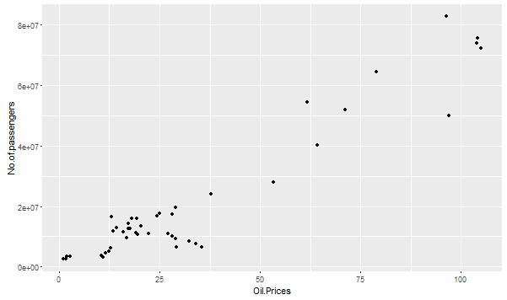
(g) | (h)
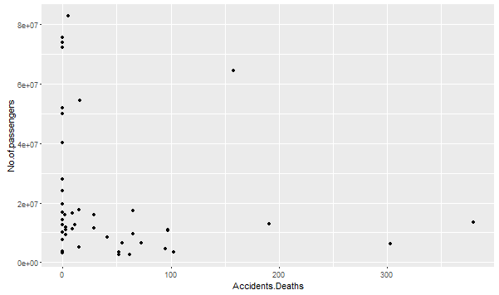 | 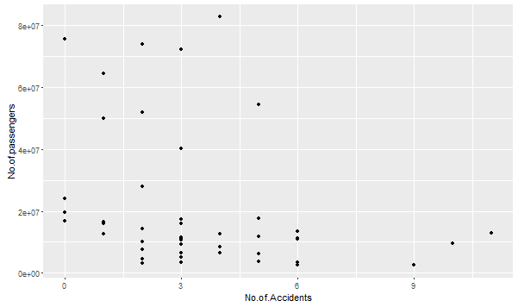
(i) | (j)
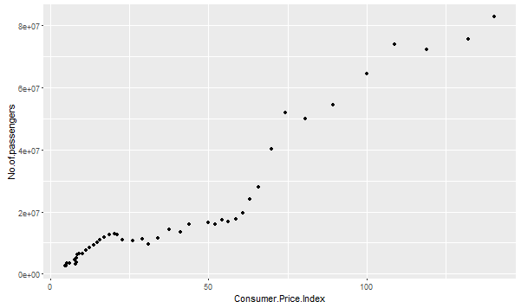
(k)
Figure 11 Results showing the linear relationship between No of Passengers and (a) Gross Domestic Product,(b) GDP per Capita,(c) GDP growth rate, (d) Inflation GDP Deflator,(e) Exchange Rate Fluctuation,(f) Population,(g) Population ages15-64,(h) Accident Deaths,(i) Oil Prices, (j) No of Accidents,(k) Consumer Price Index

CORRELATION MATRIX
The most widely accepted way of determining which independent variables are correlated to the dependent variable is a correlation matrix. A correlation matrix identifies the correlation coefficients (r values) between all the independent variables collected for the model. The r values are correlation coefficients, not coefficients of determination (R²). Table 2, Table 3 and Table 4 shows the degree of correlation between each independent variable and the dependent variable, which is unit demand for the No of Passengers for Brazil, China and India respectively.
Subsequently, those independent variables with an ‘r value’ greater than 0.7000 or greater are highly correlated to the dependent variable demand, and are considered as primary candidates in the regression model
- Brazil
The correlation matrix table for Brazil is shown in Table 2. From the table one can see that the R values for Gross Domestic Product = 0.974, GDP per Capital = 0.962, Exchange Rate Fluctuation = 0.708, Population =0.840, Population.ages.15.64=0.845, Oil. Prices =0.927. These variables are highly correlated to the dependent variable demand when compared to other independent variables which have r values less than 0.7000.
Table 8 Correlation matrix for all candidate explanatory variables and air travel for Brazil
 | Gross Domestic Product | GDP per Capita | GDP Growth | Inflation GDP Deflator
Gross Domestic Product | 1.000
GDP per Capita | 0.998 | 1.000
GDP Growth | -0.229 | -0.253 | 1.000
Inflation GDP Deflator | -0.165 | -0.147 | -0.217 | 1.000
Exchange Rate Fluctuation | 0.641 | 0.623 | -0.221 | -0.305
Population | 0.829 | 0.832 | -0.428 | -0.035
Population ages 15-64 | 0.832 | 0.834 | -0.411 | -0.081
Oil Prices | 0.923 | 0.914 | -0.224 | -0.212
Accidents Deaths | -0.046 | -0.037 | 0.077 | -0.036
No of Accidents | -0.254 | -0.244 | 0.107 | 0.111
No of passengers | 0.974 | 0.962 | -0.260 | -0.193

 | Exchange Rate Fluctuation | Population | Population ages 15-64 | Oil Prices
Gross Domestic Product
GDP per Capita
GDP Growth
Inflation GDP Deflator
Exchange Rate Fluctuation | 1.000
Population | 0.848 | 1.000
Population ages 15-64 | 0.874 | 0.997 | 1.000
Oil Prices | 0.600 | 0.755 | 0.760 | 1.000
Accidents Deaths | -0.042 | -0.032 | -0.033 | 0.042
No of Accidents | -0.053 | -0.143 | -0.132 | -0.373
No of passengers | 0.708 | 0.840 | 0.845 | 0.927

 | Accidents Deaths | No of Accidents | No of passengers
Gross Domestic Product
GDP per Capita
GDP Growth
Inflation GDP Deflator
Exchange Rate Fluctuation
Population
Population ages 15-64
Oil Prices
Accidents Deaths | 1.000
No of Accidents | 0.076 | 1.000
No of passengers | -0.109 | -0.269 | 1.000

- China
The correlation matrix table for China is shown in Table 3. From the table one can see that the R values for Gross Domestic Product = 0.987, GDP per Capital = 0.988, Population = 0.761, Population ages 15-64=0.794, Oil. Prices =0.927. These variables are highly correlated to the dependent variable demand when compared to other independent variables which have r values less than 0.7000.
Table 9 Correlation matrix for all candidate explanatory variables and air travel for China
 | Gross Domestic Product | GDP Growth | GDP per Capita | Inflation GDP Deflator
Gross Domestic Product | 1.000
GDP Growth | -0.014 | 1.000
GDP per Capita | 1.000 | -0.013 | 1.000
Inflation GDP Deflator | -0.027 | 0.361 | -0.026 | 1.000
Exchange Rate Fluctuation | 0.394 | 0.217 | 0.398 | 0.288
Population | 0.682 | 0.169 | 0.686 | 0.283
Population, ages 15-64 (% of total) | 0.717 | 0.230 | 0.721 | 0.296
Oil Prices (USD) | 0.921 | 0.054 | 0.923 | 0.070
Accidents Deaths | -0.216 | 0.143 | -0.217 | 0.374
No of Accidents | -0.085 | 0.063 | -0.084 | 0.127
No of passengers | 0.987 | 0.038 | 0.988 | 0.011

 | Exchange Rate Fluctuation | Population | Population, ages 15-64 | Oil Prices
Gross Domestic Product
GDP Growth
GDP per Capita
Inflation GDP Deflator
Exchange Rate Fluctuation | 1.000
Population | 0.875 | 1.000
Population, ages 15-64 (% of total) | 0.810 | 0.980 | 1.000
Oil Prices (USD) | 0.361 | 0.701 | 0.760 | 1.000
Accidents Deaths | 0.104 | 0.062 | 0.037 | -0.188
No of Accidents | 0.389 | 0.300 | 0.251 | -0.096
No of passengers | 0.502 | 0.761 | 0.794 | 0.927

 | Accidents Deaths | No of Accidents | No of passengers
Gross Domestic Product
GDP Growth
GDP per Capita
Inflation GDP Deflator
Exchange Rate Fluctuation
Population
Population, ages 15-64 (% of total)
Oil Prices (USD)
Accidents Deaths | 1.000
No of Accidents | 0.522 | 1.000
No of passengers | -0.194 | -0.051 | 1.000

- India
The correlation matrix table for China is shown in Table 4. From the table one can see that the R values for Gross Domestic Product = 0.996, GDP per Capital = 0.996, Exchange Rate Fluctuation=0.775, Consumer Price Index = 0.954, Population =0.837, Population ages 15-64=0.910, Oil. Prices =0.949. These variables are highly correlated to the dependent variable demand when compared to other independent variables which have r values less than 0.7000.
Table 10 Correlation matrix for all candidate explanatory variables and air travel for India
 | Gross Domestic Product | GDP per Capita | GDP Growth | Inflation GDP Deflator
Gross Domestic Product | 1.000
GDP per Capita | 0.999 | 1.000
GDP Growth | 0.400 | 0.413 | 1.000
Inflation GDP Deflator | -0.217 | -0.206 | -0.492 | 1.000
Exchange Rate Fluctuation | 0.807 | 0.802 | 0.429 | -0.349
Consumer Price Index | 0.969 | 0.964 | 0.415 | -0.288
Population | 0.862 | 0.868 | 0.485 | -0.278
Population, ages 15-64 | 0.931 | 0.932 | 0.463 | -0.300
Oil Prices | 0.944 | 0.949 | 0.314 | -0.126
Accidents Deaths | -0.181 | -0.180 | -0.018 | 0.045
No of Accidents | -0.315 | -0.319 | -0.076 | 0.052
No of passengers | 0.996 | 0.996 | 0.382 | -0.205

 | Exchange Rate Fluctuation | Consumer Price Index | Population
Gross Domestic Product
GDP per Capita
GDP Growth
Inflation GDP Deflator
Exchange Rate Fluctuation | 1.000
Consumer Price Index | 0.922 | 1.000
Population | 0.963 | 0.934 | 1.000
Population, ages 15-64 | 0.953 | 0.978 | 0.980
Oil Prices | 0.687 | 0.882 | 0.781
Accidents Deaths | -0.192 | -0.201 | -0.196
No of Accidents | -0.366 | -0.352 | -0.371
No of passengers | 0.775 | 0.954 | 0.837

 | Population, ages 15-64 | Oil Prices | Accidents Deaths | No of Accidents | No of passengers
Gross Domestic Product
GDP per Capita
GDP Growth
Inflation GDP Deflator
Exchange Rate Fluctuation
Consumer Price Index
Population
Population, ages 15-64 | 1.000
Oil Prices | 0.858 | 1.000
Accidents Deaths | -0.213 | -0.228 | 1.000
No of Accidents | -0.390 | -0.360 | 0.408 | 1.000
No of passengers | 0.910 | 0.949 | -0.190 | -0.301 | 1.000

MULTICOLLINEARITY AMONG EXPLANATORY VARIABLES
In addition to indicating the correlation between the dependent and independent variables, the correlation matrix also identifies the correlation with the independent variables themselves. If two or more independent variables are highly correlated ($±$.7000 or greater), severe multicollinearity is present. Multicollinearity is common in regression models due to the fact that many of the independent variables are related to one another or implemented during the same time periods. When the independent variables are highly correlated with one another, they tend to explain the same variance in demand, making it difficult to determine the specific impact of each independent variable. In order to avoid multicollinearity among the highly correlated variables, the variables are grouped in several groups. While per capita income is the gross domestic product divided by the population size, gross domestic product and per capita income are not necessary to exist together as independent explanatory variables of the same model. The same thing can be said about population size and per capita income. Based on the above discussion, the model that represents the demand for international air travel will consist of a subset of one of the following groups of variables.
- Brazil
Group 1 (Gross Domestic Product, Exchange Rate Fluctuation, Population, Oil Prices)
Group 2(GDP per Capita, Exchange Rate Fluctuation, Population ages 15-64, Oil Prices)
Group 3 (Gross Domestic Product, Population, Oil Prices)
Group 4 (GDP per Capita, Population ages 15-64, Oil Prices)
Group 5 (Gross Domestic Product, Exchange Rate Fluctuation)
Group 6 (GDP per Capita, Exchange Rate Fluctuation)
Group 7 (Gross Domestic Product, Population)
Group 8 (GDP per Capita, Population ages 15-64)
- China
Group 1(Gross Domestic Product, Population, Oil Prices)
Group 2 (GDP per Capita, Population ages 15-64, Oil Prices)
Group 3 (Gross Domestic Product, Population)
Group 4 (GDP per Capita, Population ages 15-64)
- India
Group1 (Gross Domestic Product, Consumer Price Index, Exchange Rate Fluctuation, Population, Oil Prices)
Group 2(GDP per Capita, Consumer Price Index, Exchange Rate Fluctuation, Population ages 15-64, Oil Prices)
Group 3(Gross Domestic Product, Population, Oil Prices)
Group 4 (GDP per Capita, Population ages15-64, Oil Prices)
Group 5 (Gross Domestic Product, Consumer Price Index, Exchange Rate Fluctuation)
Group 6 (GDP per Capita, Consumer Price Index, Exchange Rate Fluctuation)
Group 7 (Gross Domestic Product, Population)
Group 8 (GDP per Capita, Population ages 15-64)

BUILDING AN ECONOMETRIC MODEL
Now, one have divided the highly correlated variables into different groups. A sequence of regression equations is computed by using different combination of the group's variables through stepwise regression procedure for selecting independent variables. At each step, an independent variable is either added or deleted until the prediction of the dependent variable (international air travel demand) does not significantly improve. The stepwise regression is performed in R studio using the leaps function.
Identify those suspected explanatory (independent) variables that may influence the dependent variable. The following questions are asked before performing the step-wise regression analysis.
- Is there enough past historical data?
- Is the past historical data in the appropriate periodicity?
- Are there available forward forecasts (projections) for each explanatory variable?
- Is the relationship of the explanatory variable and the dependent variable likely to continue into the future?
- Is there a linear relationship between the explanatory variable and the dependent variable?
All the data are gathered for the variables, including the dependent variable, to be included in the initial regression model.
The data is entered into the R Studio software, and the appropriate step-wise regression function method is selected. Evaluate each explanatory variable based on available forecasting software output.
Here are seven key activities or guidelines for building effective multiple regression models. The activities are listed in sequential order, and each must is executed take place to ensure the model performs effectively.
- Review scatter plots.
- Review the correlation matrix to identify significant predictor variables and highly correlated explanatory variables
- Review the F-test results to determine the overall fit of the model based on the selected predictor variables.
- Review the R² and the adjusted R² to determine how much variability is being explained by the explanatory variables selected.
- Review the t-tests for all the explanatory variables and corresponding P-values to determine each individual variable’s significance.
These models or regression equations were developed using R Studio software. The R Studio output shows the relevant variables in every group that best specify the model as follows:
- Brazil
Group 1: (Gross Domestic Product, Exchange Rate Fluctuation, Population, Oil Prices): the subset of the group's variables which appear most relevant and best specify the model is (Gross Domestic Product, Exchange Rate Fluctuation, Oil Prices)
Group 2: (GDP per Capita, Exchange Rate Fluctuation, Population ages 15-64, Oil Prices): the subset of the group's variables which appear most relevant and best specify the model is
(GDP per Capita, Exchange Rate Fluctuation, Population ages 15-64, Oil Prices)
Group 3: (Gross Domestic Product, Population, Oil Prices): the subset of the group's variables which appear most relevant and best specify the model is (Gross Domestic Product, Population, Oil Prices)
Group 4: (GDP per Capita, Population ages 15-64, Oil Prices): the subset of the group's variables which appear most relevant and best specify the model is (GDP per Capita, Population ages 15-64, Oil Prices)
Group 5: (Gross Domestic Product, Exchange Rate Fluctuation): the subset of the group's variables which appear most relevant and best specify the model is (Gross Domestic Product, Exchange Rate Fluctuation)
Group 6: (GDP per Capita, Exchange Rate Fluctuation): the subset of the group's variables which appear most relevant and best specify the model is (GDP per Capita, Exchange Rate Fluctuation)
Group 7: (Gross Domestic Product, Population): the subset of the group's variables which appear most relevant and best specify the model is (Gross Domestic Product, Population)
Group 8: (GDP per Capita, Population ages 15-64): the subset of the group's variables which appear most relevant and best specify the model is (GDP per Capita, Population ages 15-64)
- China
Group 1: (Gross Domestic Product, Population, Oil Prices): the subset of the group's variables which appear most relevant and best specify the model is (Gross Domestic Product, Population)
Group 2: (GDP per Capita, Population.ages.15.64, Oil. Prices): the subset of the group's variables which appear most relevant and best specify the model is (GDP per Capita Population ages 15-64)
Group 3: (Gross Domestic Product, Population): the subset of the group's variables which appear most relevant and best specify the model is (Gross Domestic Product, Population)
Group 4: (GDP per Capita, Population ages 15-64): the subset of the group's variables which appear most relevant and best specify the model is (GDP per Capita, Population ages 15-64)

- India
Group1: (Gross Domestic Product, Consumer Price Index, Exchange Rate Fluctuation, Population, Oil Prices): the subset of the group's variables which appear most relevant and best specify the model is (Gross Domestic Product, Exchange Rate Fluctuation)
Group2: (GDP per Capita, Consumer Price Index, Exchange Rate Fluctuation, Population ages 15-64, Oil Prices): the subset of the group's variables which appear most relevant and best specify the model is (GDP per Capita, Consumer Price Index, Population ages 15.64, Oil Prices)
Group 3: (Gross Domestic Product, Population, Oil Prices): the subset of the group's variables which appear most relevant and best specify the model is (Gross Domestic Product, Population, Oil Prices)
Group 4: (GDP per Capita, Population ages 15-64, Oil Prices): the subset of the group's variables which appear most relevant and best specify the model is (GDP per Capita, Population ages 15-64)
Group 5: (Gross Domestic Product, Consumer Price Index, Exchange Rate Fluctuation): the subset of the group's variables which appear most relevant and best specify the model is (Gross Domestic Product, Exchange Rate Fluctuation)
Group 6: (GDP per Capita, Consumer Price Index, Exchange Rate Fluctuation): the subset of the group's variables which appear most relevant and best specify the model is (GDP per Capita Consumer Price Index, Exchange Rate Fluctuation)
Group 7: (Gross Domestic Product, Population): the subset of the group's variables which appear most relevant and best specify the model is (Gross Domestic Product, Population)
Group 8: (GDP per Capita, Population ages 15-64): the subset of the group's variables which appear most relevant and best specify the model is (GDP per Capita, Population ages 15-64)
From the Stepwise regression technique the following econometric models are being developed
- Brazil
Model 1: (Gross Domestic Product, Exchange Rate Fluctuation, Oil Prices)
Model 2: (GDP per Capita, Exchange Rate Fluctuation, Population ages 15-64, Oil Prices)
Model 3: (Gross Domestic Product, Population, Oil Prices)
Model 4: (GDP per Capita, Population ages 15-64, Oil Prices)
Model 5: (Gross Domestic Product, Exchange Rate Fluctuation)
Model 6: (GDP per Capita, Exchange Rate Fluctuation)
Model 7: (Gross Domestic Product, Population)
Model 8: (GDP per Capita, Population ages 15-64)
- China
Model 1: (Gross Domestic Product, Population)
Model 2: (GDP per Capita Population ages 15-64)
- India
Model 1: (Gross Domestic Product, Exchange Rate Fluctuation)
Model 2: (GDP per Capita, Consumer Price Index, Population ages 15-64, Oil Prices)
Model 3: (Gross Domestic Product, Population, Oil Prices)
Model 4: (GDP per Capita, Population ages 15-64)
Model 5: (GDP per Capita Consumer Price Index, Exchange Rate Fluctuation)
Model 6: (Gross Domestic Product, Population)
- CHAPTER FOUR ACTIVITIES FOR BUILDING EFFECTIVE MULTIPLE REGRESSION MODELS

F-TEST
The F statistic is used to measure the overall fit of the regression model or statistical significance of the regression model. The F statistic is defined as the ratio of two variables (or mean squares). The F statistic is written as:
$$F=\frac{MSR}{MSE}=\frac{\sum{\frac{{(\hat{Y}-\overline{Y})}^{2}}{k}}}{\sum{\frac{{(Y-\hat{Y})}^{2}}{(n-k-1)}}}$$

Note that the F-test is sensitive to the relative strengths of the numerator and the denominator. If the unexplained mean squared (MS) (variance of the errors) is large, then the regression model is not doing well, and F becomes smaller. If the MS is large relative to the unexplained MS, the F becomes larger. F table that is used to determine the optimal F value. The rule of thumb is that at a .05 (95 percent) significance, the F statistic should be +4.00 or higher for the overall fit of the model to be good. In other words, if F = 4.0 or greater, there is a significant relationship between the dependent and independent variables. The regression output for the is being evaluated for F- test
- Brazil
Table 11 F-Value for all different econometric models for Brazil
Model Number | F-Value
Model 1 | 376.3
Model 2 | 226.9
Model 3 | 307.8
Model 4 | 236
Model 5 | 505.6
Model 6 | 357.9
Model 7 | 414.8
Model 8 | 284.9

- China
Table 12 F-Value for all different econometric models for China
Model Number | F-Value
Model 1 | 1805
Model 2 | 2034
Model 3 | 1805
Model 4 | 2034

- India
Table 13 F-Value for all different econometric models for India
Model Number | F-Value
Model 1 | 4427
Model 2 | 2060
Model 3 | 2702
Model 4 | 3494
Model 5 | 4427
Model 6 | 2587
Model 7 | 3849
Model 8 | 3494

ADJUSTED R SQUARE
From the table 8, one have the $R^{2}and adjusted R^{2}$ values for the eight models developed for Brazil. Model 1 gives a $R^{2}$ value of 0.965, which means the three explanatory variables chosen for Model 1 are explaining 96.5 percent of the variance in demand (dependent variable). Similarly Model 2 gives a $R^{2}$value of 0.957 meaning the four explanatory variables chosen for Model 2 are explaining 95.7 percent of variance in demand. Likewise, the remaining models for Brazil, China and India can be interpreted from Table 8, 9 and 10 respectively. Although one wants the model that gives the highest $R^{2}$ and contains all the explanatory variables, each additional explanatory variable added to the model increases$R^{2}$. As a result, one must mention some notes of caution regarding${ R}^{2}$.
$R^{2}$ is a non-descending function of the number of explanatory variables present in the model. As one add more historical data points to all the variables, both Ys and Xs, and add more explanatory variables (or Xs), $R^{2}$ almost always increases and never decreases. This statistical phenomenon occurs because adding more explanatory variables to the model causes the prediction errors to be small, hence reducing sum of squares residuals (SSR).
The main problem with $R^{2 }$is the fact that it does not take into account degrees of freedom. Degrees of freedom is defined as the number of observations included in the formula minus the number of parameters estimated using the data. To overcome this problem, adjusted $R^{2}$ is introduced as:
$$Adjusted R^{2}=1-(1-R^{2})\frac{(n-1)}{(n-k-1)}$$
The greater the difference between R² and adjusted R², the poorer the fit obtained for the model.
Table 14 R Square and Adjusted R Square for all different econometric models for Brazil
Model Number | R Square | Adjusted R Square
Model 1 | 0.9650 | 0.9624
Model 2 | 0.9578 | 0.9536
Model 3 | 0.9575 | 0.9544
Model 4 | 0.9453 | 0.9413
Model 5 | 0.9601 | 0.9582
Model 6 | 0.9446 | 0.9419
Model 7 | 0.9518 | 0.9495
Model 8 | 0.9314 | 0.9281

Table 15 R Square and Adjusted R Square for all different econometric models for China
Model Number | R Square | Adjusted R Square
Model 1 | 0.9885 | 0.9880
Model 2 | 0.9898 | 0.9893

Table 16 R Square and Adjusted R Square for all different econometric models for India
Model Number | R Square | Adjusted R Square
Model 1 | 0.9953 | 0.9951
Model 2 | 0.9952 | 0.9947
Model 3 | 0.9950 | 0.9946
Model 4 | 0.9940 | 0.9937
Model 5 | 0.9947 | 0.9944
Model 6 | 0.9946 | 0.9943

PARAMETER COEFFICIENTS
The constant $β_{0} or α intercept$ is simply the anchor point on the y-axis where the line is defined by the regression equation. Subsequently, it may or may not have a managerial interpretation. However, it does aid in a better prediction. In this case Model 1 for Brazil from table 11, the constant is positive, which means if one hold all the explanatory variables at zero, the dependent variable would be 2077000. In this case, the constant is positive, which means it could suggest that the 2077000 number of passengers who would have travelled in Brazil regardless of any of the air traffic demand factors. A negative constant is more difficult to explain. The recommended strategy is not to discuss the constant if it is negative.
Since the independent variables parameter estimates (β coefficients) are often in different units of measure (dollars, percentages, etc.), it is difficult to compare them to determine their relative importance, or contribution to the forecast. The parameter coefficients for all the remaining models for Brazil, China and India can be interpreted similarly from table 11, 12 and 13 respectively.
Table 17 R Square and Adjusted R Square for all different econometric models for Brazil
Model Number | Parameter Coefficients (intercept)
Model 1 | 2077000
Model 2 | 48934386
Model 3 | -8098000
Model 4 | -47070000
Model 5 | 3038000
Model 6 | -1258295
Model 7 | -6426000
Model 8 | -45910449

Table 18 R Square and Adjusted R Square for all different econometric models for China
Model Number | Parameter Coefficients (intercept)
Model 1 | -104200000
Model 2 | -173262563

Table 19 R Square and Adjusted R Square for all different econometric models for India
Model Number | Parameter Coefficients (intercept)
Model 1 | 862100
Model 2 | 113141704
Model 3 | 4454000
Model 4 | 53679999
Model 5 | -2587985
Model 6 | 5258000

T-TEST
After determining the overall significance of the regression model, it is important to understand the significance of the individual explanatory coefficients. The most important thing to remember is that the t-test is a test of the significance for each individual explanatory variable in the presence of all the other explanatory variables. This significance test determines whether each explanatory variable is helping in the prediction of Y (dependent variable) in the presence of the other explanatory variables. The sign ($±$) indicates the direction of the relationship.

A coefficient is significantly different from zero at the 95 percent confidence level if the absolute value of the computed t-test is greater than the corresponding value from the t-table, which is generally $±$2.0. However, empirical testing has proven that a t-test of $±$1.65 or greater is also structurally significant at the 90 percent confidence level. So, one can lower the confidence level to 90 percent without losing the structural integrity of the model. Note that the size of the t-test has nothing to do with the significance of the explanatory variable’s magnitude or impact on the dependent variable Y. It indicates only whether it is correlated or not.
Table 20 T-Test for all different econometric models for Brazil
Model Number | Intercept | X1 | X2 | X3 | X4 | X5 | X6
Model 1 | 1.7890 | 9.0540 | NA | NA | NA | 3.6450 | 2.3780
Model 2 | 1.4470 | NA | 6.9680 | NA | -1.4920 | 3.4440 | 2.9250
Model 3 | -1.4080 | 7.1290 | NA | 1.9370 | NA | NA | 2.3400
Model 4 | -2.1870 | NA | 5.4320 | NA | 2.1410 | NA | 3.2270
Model 5 | 2.6470 | 21.9900 | NA | NA | NA | 3.5230 | NA
Model 6 | -0.8550 | NA | 18.3330 | NA | NA | 3.8060 | NA
Model 7 | -1.0710 | 14.6520 | NA | 1.7390 | NA | NA | NA
Model 8 | -1.9280 | NA | 11.5270 | NA | 1.8990 | NA | NA

Table 21 . T-Test for all different econometric models for China
Model Number | Intercept | X1 | X2 | X3 | X4 | X5 | X6
Model 1 | -6.7260 | 38.6510 | NA | 7.2920 | NA | NA | NA
Model 2 | -7.3210 | NA | 38.4680 | NA | 7.5310 | NA | NA

Table 22 T-Test for all different econometric models for India
Model Number | Intercept | X1 | X2 | X3 | X4 | X5 | X6 | X7
Model 1 | 1.9160 | 59.2640 | NA | NA | NA | -4.6550 | NA | NA
Model 2 | 4.7410 | NA | 13.8870 | NA | -5.0140 | NA | 1.3540 | 3.0660
Model 3 | 2.7020 | 23.9400 | NA | -3.3500 | NA | NA | 1.7920 | NA
Model 4 | 3.7340 | NA | NA | 34.2080 | -4.1810 | NA | NA | NA
Model 5 | -2.6830 | NA | 9.4630 | NA | NA | -4.5370 | NA | 3.5510
Model 6 | 3.2320 | 47.6480 | NA | -3.6610 | NA | NA | NA | NA

P-VALUES
There is a direct relationship between confidence intervals (t-tests) and P-values. The P-value measures the probability of obtaining a sample result that is more unlikely than the observed sample result in this case, the t-test. P-values describe the exact significance level associated with each explanatory variable. If the P-value is 0.05 or less at a 95 percent confidence interval, then the explanatory variable is significant in predicting Y. If the P-value is relatively large (above 0.05), then it is not consistent with the null hypothesis. The important thing to remember about P-values is that they provide additional evidence that the t-test is valid at a 95 percent confidence interval if the P-value is 0.05 or less.
Table 23 P-Value for all different econometric models for Brazil
Model Number | Intercept | X1 | X2 | X3 | X4 | X5 | X6
Model 1 | 0.0811 | 0.0000 | NA | NA | NA | 0.0007 | 0.0222
Model 2 | 0.1557 | NA | 0.0000 | NA | 0.1436 | 0.0014 | 0.0057
Model 3 | 0.1666 | 0.0000 | NA | 0.0596 | NA | NA | 0.0242
Model 4 | 0.0345 | NA | 0.0000 | NA | 0.0382 | NA | 0.0025
Model 5 | 0.0114 | < 2e-16 | NA | NA | NA | 0.0010 | NA
Model 6 | 0.3972 | NA | < 2e-16 | NA | NA | 0.0005 | NA
Model 7 | 0.2905 | <2e-16 | NA | 0.0894 | NA | NA | NA
Model 8 | 0.0607 | NA | 0.0000 | NA | 0.0645 | NA | NA

Table 24 P-Value for all different econometric models for China
Model Number | Intercept | X1 | X2 | X3 | X4 | X5 | X6
Model 1 | 0.0000 | < 2e-16 | NA | 0.0000 | NA | NA | NA
Model 2 | 0.0000 | NA | < 2e-16 | NA | 0.0000 | NA | NA

Table 25 P-Value for all different econometric models for India
Model Number | Intercept | X1 | X2 | X3 | X4 | X5 | X6 | X7
Model 1 | 0.0622 | < 2e-16 | NA | NA | NA | 0.0000 | NA | NA
Model 2 | 0.0000 | NA | < 2e-16 | NA | 0.0000 | NA | 0.1832 | 0.0039
Model 3 | 0.0100 | < 2e-16 | NA | 0.0017 | NA | NA | 0.0805 | NA
Model 4 | 0.0006 | NA | < 2e-16 | NA | 0.0001 |  | NA | NA
Model 5 | 0.0105 | NA | 0.0000 | NA | NA | 0.0000 | NA | 0.0010
Model 6 | 0.0024 | < 2e-16 | NA | 0.0007 | NA | NA | NA | NA

REGRESSION MODEL RESULTS
Regression analysis offers much more than improvement in explaining the variation in demand and forecast accuracy. Regression provides the means to identify and measure key demand signals that influence demand. Forecast accuracy is the final by-product of the efforts, but it is far from the true nature of the analytic benefits that helps to understand the dynamics of the business.

Figure 12 Annual passenger movements on scheduled flights in Brazil (1970-2014)

Figure 13 Annual passenger movements on scheduled flights in China (1970-2014)

Figure 14 Annual passenger movements on scheduled flights in India (1970-2014)
- CHAPTER FIVE FORECASTING DEMAND USING THE ECONOMETRIC MODEL

FORECASTING RESULTS FOR BRAZIL
Model developed for Brazil: No of passengers (y) = 2.077e+06 +GDP (2.610e-05) + Exchange Rate Fluctuation (3.422e+06) +Oil Prices (1.585e+05)

Model 1

Table 26 Regression output parameters for Model 1 for Brazil
F Value | R Square | Adjusted R Square | Parameter Coefficients
376.3 | 0.9650 | 0.9624 | 2077000

Intercept | X1 | X2 | X3 | X4 | X5 | X6
1.7890 | 9.0540 | NA | NA | NA | 3.6450 | 2.3780

P-Value | X1 | X2 | X3 | X4 | X5 | X6
0.0811 | 0.0000 | NA | NA | NA | 0.0007 | 0.0222

Figure 15 Forecasted passenger movements on scheduled flights in Brazil (2015-2020)

Table 27 Forecast Output for Brazil 2015-2020
Year | Intercept | Gross Domestic Product | Exchange rate Fluctuation | Oil Prices | No of Passengers
2015 | 2.08E+06 | 2.28E+12 | 3.28 | 48 | 80304774.07
2016 | 2.08E+06 | 2.25E+12 | 3.71 | 34.4 | 79026677.93
2017 | 2.08E+06 | 2.30E+12 | 4.24 | 43.9 | 83698526.06
2018 | 2.08E+06 | 2.36E+12 | 4.37 | 46.2 | 85951634.37
2019 | 2.08E+06 | 2.42E+12 | 4.59 | 48.6 | 88624819.23
2020 | 2.08E+06 | 2.48E+12 | 4.74 | 51.2 | 91128662.71

FORECASTING RESULTS FOR CHINA
Model developed for China: No of passengers (y) = -173262563 +GDP per Capita (46950) + Population.ages.15.64 (2848744)

Model 2

Table 28 Regression output parameters for Model 2 for China

F Value | R Square | Adjusted R Square | Parameter Coefficients
2034 | 0.9898 | 0.9893 | -173262563

Intercept | X1 | X2 | X3 | X4 | X5 | X6
-7.3210 | NA | 38.4680 | NA | 7.5310 | NA | NA

P-Value | X1 | X2 | X3 | X4 | X5 | X6
0.0000 | NA | < 2e-16 | NA | 0.0000 | NA | NA

Figure 16 Forecasted passenger movements on scheduled flights in China (2015-2020)
Table 29 Forecast Output for China 2015-2020
Year | Intercept | Gross per capita | Population ages 15-64 | No of Passengers
2015 | -173262563 | 8154.38 | 72.38366223 | 415788101
2016 | -173262563 | 8659.39 | 71.91342033 | 438158722
2017 | -173262563 | 9259.34 | 71.40460668 | 464876895
2018 | -173262563 | 9935.69 | 70.89647171 | 495183981
2019 | -173262563 | 10662.3 | 70.44008727 | 527998198
2020 | -173262563 | 11449.16 | 70.06604935 | 563875737

FORECASTING RESULTS FOR INDIA
Model developed for India: No of passengers (y) = 8.621e+05 +GDP (4.257e-05) - Exchange Rate Fluctuation (1.058e+05)

Model 1
Table 30 Regression output parameters for Model 1 for India
F Value | R Square | Adjusted R Square | Parameter Coefficients
3494 | 0.9953 | 0.9951 | 862100

India | Intercept | X1 | X2 | X3 | X4 | X5 | X6 | X7
Model 1 | 1.9160 | 59.2640 | NA | NA | NA | -4.6550 | NA | NA

India | Intercept | X1 | X2 | X3 | X4 | X5 | X6 | X7
Model 1 | 0.0622 | < 2e-16 | NA | NA | NA | 0.0000 | NA | NA

Figure 17 Forecasted passenger movements on scheduled flights in China (2015-2020)

Table 31 Forecast Output for India 2015-2020
Year | Intercept | Gross Domestic Product | Exchange Rate Fluctuation | No of Passengers
2015 | 8.62E+05 | 2.20E+12 | 64.45 | 87614670.65
2016 | 8.62E+05 | 2.36E+12 | 68.58 | 94101998.82
2017 | 8.62E+05 | 2.53E+12 | 72.48 | 101025562.2
2018 | 8.62E+05 | 2.72E+12 | 73.36 | 108804183
2019 | 8.62E+05 | 2.93E+12 | 74.56 | 117817805.1
2020 | 8.62E+05 | 3.14E+12 | 75.02 | 126757916.1
- CHAPTER SIX CONCLUSION

ASSESSING THE READINESS OF THE DEMAND FORECASTING MODEL
By looking into the results of regression analysis for Brazil, it is found that the Gross Domestic Product, Exchange Rate Fluctuation and Oil Prices has a positive effect on international air travel demand holding other things the same. As the Gross Domestic Product goes up by one unit, on the average demand for air travel goes up by 2.610e-05 passengers. Likewise, if the total exchange rate fluctuation goes up by one unit point, on the average demand for air travel goes up by 3.422e+06 passengers. Furthermore, if the Oil Price in (USD) goes up by one unit, on the average demand for air travel goes up by 1.585e+05 passengers, other things keeping the same.

Similarly, for China, it is found that the GDP per Capita and Population of age group (15-64) has a positive effect on international air travel demand holding other things the same. As the GDP per Capita goes up by one unit, on the average demand for air travel goes up by 46950 passengers. Likewise, if the Population of age group (15-64) goes up by one unit point, on the average demand for air travel goes up by 2848744 passengers, other things keeping the same.

Furthermore, for India, it is found that the Gross Domestic Product and Exchange Rate Fluctuation has a positive effect on international air travel demand holding other things the same. As the Gross Domestic Product goes up by one unit, on the average demand for air travel goes up by 4.257e-05 passengers. Likewise, if the total exchange rate fluctuation goes up by one unit point, on the average demand for air travel goes up by 1.058e+05 passengers, other things keeping the same.
- Brazil
The two-tailed t-test can be used to test whether such a null hypothesis stands up against the (two-sided) alternative hypothesis that true population coefficient is different from zero. The degrees of freedom are 41, which are obtained by subtracting the number of parameters estimated, which are 3 in the selected Model from n (=45). If $α$ is set at 0.05, the two-tailed critical t value is about $±$2.018 for 42 d.f. If $α$is fixed at 0.01 or 1% level, the critical t value for 42 d.f. is $±$2.698 (two-tailed). Looking at the t-values presented in Table 26, it is found that each partial regression coefficient is statistically significantly different from zero at the 5% level of significance.
What about the overall significance of the estimated regression line? That is, the null hypothesis that all partial slopes are simultaneously equal to zero or, equivalently, R= ‘0’, be accepted? This hypothesis was tested with the help of F-test. The F value has an F distribution with 3 and 41 d.f. If $α$is set at 0.05, the F table shows the critical F value of 2.84. The corresponding value at $α$‘0.01’ is 4.31 .The computed F of 376.3 far exceeds either of this critical F value. Therefore, the null hypothesis, i.e., all partial slopes are simultaneously equal to zero or, alternatively, $R^{2}=$0, is rejected. Gross Domestic Product, Exchange Rate Fluctuation and Oil Prices, collectively and individually, influence international air travel demand. The previous analysis shows that all the developed models for international air travel demand are well fitting.
- China
The two-tailed t-test can be used to test whether such a null hypothesis stands up against the (two-sided) alternative hypothesis that true population coefficient is different from zero. The degrees of freedom are 42, which are obtained by subtracting the number of parameters estimated, which are 2 in the selected Model from n (=45). If $α$ is set at 0.05, the two-tailed critical t value is about $±$2.018 for 42 d.f. If $α$is fixed at 0.01 or 1% level, the critical t value for 42 d.f. is $±$2.698 (two-tailed). Looking at the t-values presented in Table 28, it is found that each partial regression coefficient is statistically significantly different from zero at the 1% level of significance.
What about the overall significance of the estimated regression line? That is, the null hypothesis that all partial slopes are simultaneously equal to zero or, equivalently, R= ‘0’, be accepted? This hypothesis was tested with the help of F-test. The F value has an F distribution with 2 and 42 d.f. If $α$is set at 0.05, the F table shows the critical F value of 3.23. The corresponding value at $α$‘0.01’ is 5.18. The computed F of 2034 far exceeds either of this critical F value. Therefore, the null hypothesis, i.e., all partial slopes are simultaneously equal to zero or, alternatively, $R^{2}=$0, is rejected. Gross Domestic Product, Exchange Rate Fluctuation and Oil Prices, collectively and individually, influence international air travel demand. Since the computed d value in the model is closer to 2, the evidence is in favor of no autocorrelation. The previous analysis shows that all the developed models for international air travel demand are well fitting.
- India
The two-tailed t-test can be used to test whether such a null hypothesis stands up against the (two-sided) alternative hypothesis that true population coefficient is different from zero. The degrees of freedom are 42, which are obtained by subtracting the number of parameters estimated, which are 2 in the present instance from n (=45). If $α$ is set at 0.05, the two-tailed critical t value is about $±$2.018 for 42 d.f. If $α$is fixed at 0.01 or 1% level, the critical t value for 42 d.f. is $±$2.698 (two-tailed). Looking at the t-values presented in Table 30, it is found that each partial regression coefficient is statistically significantly different from zero at the 1% level of significance.
What about the overall significance of the estimated regression line? That is, the null hypothesis that all partial slopes are simultaneously equal to zero or, equivalently, R= ‘0’, be accepted? This hypothesis was tested with the help of F-test. The F value has an F distribution with 2 and 42 d.f. If $α$is set at 0.05, the F table shows the critical F value of 2.23. The corresponding value at $α$‘0.01’ is 5.18. The computed F of 4427 far exceeds either of this critical F value. Therefore, the null hypothesis, i.e., all partial slopes are simultaneously equal to zero or, alternatively, $R^{2}=$0, is rejected. Gross Domestic Product, Exchange Rate Fluctuation and Oil Prices, collectively and individually, influence international air travel demand. Since the computed d value in the model is closer to 2, the evidence is in favor of no autocorrelation. The previous analysis shows that all the developed models for international air travel demand are well fitting.

LIMITATIONS AND CHALLENGES
The thesis devotes a detailed description of the steps followed for the development of the econometric models of international air travel demand in Brazil, China and India. Econometric models were attempted to analyze and forecast the air traffic through establishing statistical relationship between selected demand-influencing factors and the corresponding level of traffic. From the statistical measures for evaluating the models, it is found that (i) Gross Domestic Product, Exchange rate fluctuation and Oil Prices, (ii) GDP per Capita and Population of ages 15-64 (% of total),(iii) Gross Domestic Product and Exchange rate fluctuation are the main determinants of international air travel in Brazil, China and India respectively. This model is very good in terms of Goodness of Fit measure. Based on the air traffic analysis through the proposed model, the airlines and civil aviation authorities can develop their corporate plan.

References

1. IATA Air Passenger Forecast Shows Dip in Long-Term Demand. 2015 26 November 2015 [cited 2016 03/17]; Available from: http://www.iata.org/pressroom/pr/Pages/2015-11-26-01.aspx.

2. Thomas, V. and S. Burgess, International Air Transport Association Vision 2050 Report Assessment. 2015.

3. US Aviation Industry Faces Global Challenges. Thursday, December 12, 2013 [cited 2016 03/28]; Available from: http://www.aviationtoday.com/the-checklist/US-Aviation-Industry-Faces-Global-Challenges_80834.html#.VvmOvPkrLIU.

4. BOEING - CURRENT MARKET OUTLOOK 2015-2034. 2015: USA. p. 60.

5. Ren, X. The sexist truth about China’s booming aviation industry. 2015 October 9, 2015 [cited 2016 03/28].

6. JIANG, S. Chinese aviation sector flies into 2016 on record profits. 2016 Sunday, 27 December, 2015 [cited 2016 03/28].

7. Hansman, R.J. and M. Ishutkina, Analysis of the Interaction Between Air Transportation and Economic Activity: A Worldwide Perspective. ICAT-2009-2;, 2009.

8. Maier, M., Rise of the Emirates empire. CNNMoney. com: Business, 2005. 2.

9. Harbison, P. and P. McDermott, Global LCC outlook report: the world has changed. Global LCC outlook report: the world has changed, 2009.

10. Alekseev, K. and J. Seixas, A multivariate neural forecasting modeling for air transport–Preprocessed by decomposition: A Brazilian application. Journal of Air Transport Management, 2009. 15(5): p. 212-216.

11. Goldstein, A., The political economy of high‐tech industries in developing countries: aerospace in Brazil, Indonesia and South Africa. Cambridge Journal of Economics, 2002. 26(4): p. 521-538.

12. Maitah, M. and N. Salim, The Impact of Foreign Investments on the Achievement of Economic Growth. AGRIS on-line Papers in Economics and Informatics, 2010. 2(2): p. E15-E26.
13. Zhang, Y. and D.K. Round, China's airline deregulation since 1997 and the driving forces behind the 2002 airline consolidations. Journal of Air Transport Management, 2008. 14(3): p. 130-142.

14. Williams, G., Airline Competition-Deregulation's Mixed Legacy. 2002.

15. Unit, E.I., Country Report. Economist, 2010.

16. Van Ryzin, G. and J. McGill, Revenue management without forecasting or optimization: An adaptive algorithm for determining airline seat protection levels. Management Science, 2000. 46(6): p. 760-775
.
17. Ghobrial, A. and S. Soliman, An assessment of some factors influencing the competitive strategies of airlines in domestic markets. International Journal of Transport Economics/Rivista internazionale di economia dei trasporti, 1992: p. 247-258.

18. Alperovich, G. and Y. Machnes, The role of wealth in the demand for international air travel. Journal of Transport Economics and Policy, 1994: p. 163-173.

19. Bafail, A.O., et al., The determinants of domestic air travel demand in the Kingdom of Saudi Arabia. Journal of Air Transportation World Wide, 2000. 5(2): p. 72-86.

20. THEOLOGITIS, Y. and D. POWELL, AIR TRANSPORT IN THE 1980's: FACTORS AFFECTING MARKET FORCES AND CURRENT FORECASTING TECHNIQUES (IL TRASPORTO AEREO NEGLI ANNI'80: FATTORIINFLUENZANTI IL MERCATO E ATTUALI TECNICHE DI PREVISIONE). International Journal of Transport Economics/Rivista internazionale di economia dei trasporti, 1982: p. 205-222.

21. Goodwin, P.B., A review of new demand elasticities with special reference to short and long run effects of price changes. Journal of transport economics and policy, 1992: p. 155-169.

22. Fridström, L. and H. Thune-Larsen, An econometric air travel demand model for the entire conventional domestic network: the case of Norway. Transportation Research Part B: Methodological, 1989. 23(3): p. 213-223.

23. Fu, X., T.H. Oum, and A. Zhang, Air transport liberalization and its impacts on airline competition and air passenger traffic. Transportation Journal, 2010: p. 24-41.
24. Faraway, J. and C. Chatfield, Time series forecasting with neural networks: a comparative study using the airline data. Applied statistics, 1998: p. 231-250.

25. Rigas, D., The airline business in the 21st century. 2001, Routledge
.
26. Cento, A., The airline industry: challenges in the 21st century. 2008: Springer Science & Business Media.

27. Winsor, C.P., The Gompertz curve as a growth curve. Proceedings of the national academy of sciences, 1932. 18(1): p. 1-8.

28. Nam, K. and T. Schaefer, Forecasting international airline passenger traffic using neural networks. Logistics and Transportation Review, 1995. 31(3): p. 239.

29. Ghobbar, A.A. and C.H. Friend, Evaluation of forecasting methods for intermittent parts demand in the field of aviation: a predictive model. Computers & Operations Research, 2003. 30(14): p. 2097-2114.

30. Witt, S.F. and C.A. Martin, Econometric models for forecasting international tourism demand. Journal of Travel Research, 1987. 25(3): p. 23-30.

31. Babić, R.Š., et al. Comparison of Air Travel Demand Forecasting Methods. in ICTS 2011: 14th International Conference on Transport Science MARITIME, TRANSPORT AND LOGISTICS SCIENCE. 2011.

32. Profillidis, V., Econometric and fuzzy models for the forecast of demand in the airport of Rhodes. Journal of air transport management, 2000. 6(2): p. 95-100.

33. Oum, T.H., J. Yan, and C. Yu, Ownership forms matter for airport efficiency: A stochastic frontier investigation of worldwide airports. Journal of Urban Economics, 2008. 64(2): p. 422-435.

34. Fildes, R., Y. Wei, and S. Ismail, Evaluating the forecasting performance of econometric models of air passenger traffic flows using multiple error measures. International Journal of Forecasting, 2011. 27(3): p. 902-922.

35. Witt, S.F. and C.A. Witt, Forecasting tourism demand: A review of empirical research. International journal of Forecasting, 1995. 11(3): p. 447-475.

36. Chase Jr, C.W., Demand-driven forecasting: a structured approach to forecasting. 2013: John Wiley & Sons.
37. Group, W.B., World Development Indicators 2012. 2012: World Bank Publications.

38. Aviation Safety Database. [cited 2016 03/25/2016]; Available from: https://aviation-safety.net/database/.

Appendix A: R code

- Brazil

Autocorrelation Matrix
Gross.Domestic.Product GDP.per.Capita GDP.Growth
Gross.Domestic.Product 1.00000000 0.99779224 -0.22935562
GDP.per.Capita 0.99779224 1.00000000 -0.25293994
GDP.Growth -0.22935562 -0.25293994 1.00000000
Inflation.GDP.Deflator -0.16540154 -0.14714373 -0.21722449
Exchange.Rate.Fluctuation 0.64134023 0.62343439 -0.22106556
Population 0.82865145 0.83220912 -0.42755518
Population.ages.15.64 0.83211230 0.83449859 -0.41099145
Oil.Prices 0.92310017 0.91415229 -0.22381076
Accidents.Deaths -0.04648559 -0.03723149 0.07660289
No.of.Accidents -0.25406605 -0.24382781 0.10745496
No.of.passengers 0.97382767 0.96201043 -0.25999025

Inflation.GDP.Deflator Exchange.Rate.Fluctuation Population
Gross.Domestic.Product -0.16540154 0.64134023 0.82865145
GDP.per.Capita -0.14714373 0.62343439 0.83220912
GDP.Growth -0.21722449 -0.22106556 -0.42755518
Inflation.GDP.Deflator 1.00000000 -0.30462604 -0.03457744
Exchange.Rate.Fluctuation -0.30462604 1.00000000 0.84752728
Population -0.03457744 0.84752728 1.00000000
Population.ages.15.64 -0.08130970 0.87420894 0.99707149
Oil.Prices -0.21183355 0.60024831 0.75480605
Accidents.Deaths -0.03556841 -0.04178082 -0.03207420
No.of.Accidents 0.11067823 -0.05311509 -0.14254913
No.of.passengers -0.19301529 0.70784653 0.83993717

Population.ages.15.64 Oil.Prices Accidents.Deaths
Gross.Domestic.Product 0.8321123 0.92310017 -0.04648559
GDP.per.Capita 0.8344986 0.91415229 -0.03723149
GDP.Growth -0.4109915 -0.22381076 0.07660289
Inflation.GDP.Deflator -0.0813097 -0.21183355 -0.03556841
Exchange.Rate.Fluctuation 0.8742089 0.60024831 -0.04178082
Population 0.9970715 0.75480605 -0.03207420
Population.ages.15.64 1.0000000 0.76001611 -0.03304940
Oil.Prices 0.7600161 1.00000000 0.04164056
Accidents.Deaths -0.0330494 0.04164056 1.00000000
No.of.Accidents -0.1321082 -0.37289756 0.07612069
No.of.passengers 0.8450881 0.92682425 -0.10874893

No.of.Accidents No.of.passengers
Gross.Domestic.Product -0.25406605 0.9738277
GDP.per.Capita -0.24382781 0.9620104
GDP.Growth 0.10745496 -0.2599902
Inflation.GDP.Deflator 0.11067823 -0.1930153
Exchange.Rate.Fluctuation -0.05311509 0.7078465
Population -0.14254913 0.8399372
Population.ages.15.64 -0.13210821 0.8450881
Oil.Prices -0.37289756 0.9268243
Accidents.Deaths 0.07612069 -0.1087489
No.of.Accidents 1.00000000 -0.2685733
No.of.passengers -0.26857329 1.0000000

Step Wise Regression

Group 1 (Gross.Domestic.Product,Exchange.Rate.Fluctuation,Population, Oil.Prices)

> leaps( x=Group.1[,2:5], y=Group.1[,1], names=names(Group.1)[2:5], method="adjr2")
$which
Gross.Domestic.Product Exchange.Rate.Fluctuation Population Oil.Prices
1 TRUE FALSE FALSE FALSE
1 FALSE FALSE FALSE TRUE
1 FALSE FALSE TRUE FALSE
1 FALSE TRUE FALSE FALSE
2 TRUE TRUE FALSE FALSE
2 TRUE FALSE FALSE TRUE
2 TRUE FALSE TRUE FALSE
2 FALSE FALSE TRUE TRUE
2 FALSE TRUE FALSE TRUE
2 FALSE TRUE TRUE FALSE
3 TRUE TRUE FALSE TRUE
3 TRUE TRUE TRUE FALSE
3 TRUE FALSE TRUE TRUE
3 FALSE TRUE TRUE TRUE
4 TRUE TRUE TRUE TRUE

$label
[1] "(Intercept)" "Gross.Domestic.Product" "Exchange.Rate.Fluctuation"
[4] "Population" "Oil.Prices"

$size
[1] 2 2 2 2 3 3 3 3 3 3 4 4 4 4 5

$adjr2
[1] 0.9471390 0.8557242 0.6986455 0.4894431 0.9582263 0.9513882 0.9495155 0.9002602
[9] 0.8898881 0.6915306 0.9623924 0.9582387 0.9543791 0.8998407 0.9620955

Result 1 (Gross.Domestic.Product Exchange.Rate.Fluctuation, Oil.Prices)
Group 2
> View(Group.2)
> leaps( x=Group.2[,2:5], y=Group.2[,1], names=names(Group.2)[2:5], method="adjr2")
$which
GDP.per.Capita Exchange.Rate.Fluctuation Population.ages.15.64 Oil.Prices
1 TRUE FALSE FALSE FALSE
1 FALSE FALSE FALSE TRUE
1 FALSE FALSE TRUE FALSE
1 FALSE TRUE FALSE FALSE
2 TRUE TRUE FALSE FALSE
2 TRUE FALSE FALSE TRUE
2 TRUE FALSE TRUE FALSE
2 FALSE FALSE TRUE TRUE
2 FALSE TRUE FALSE TRUE
2 FALSE TRUE TRUE FALSE
3 TRUE TRUE FALSE TRUE
3 TRUE TRUE TRUE FALSE
3 TRUE FALSE TRUE TRUE
3 FALSE TRUE TRUE TRUE
4 TRUE TRUE TRUE TRUE

$label
[1] "(Intercept)" "GDP.per.Capita" "Exchange.Rate.Fluctuation"
[4] "Population.ages.15.64" "Oil.Prices"

$size
[1] 2 2 2 2 3 3 3 3 3 3 4 4 4 4 5

$adjr2
[1] 0.9237307 0.8557242 0.7075267 0.4894431 0.9419386 0.9362386 0.9280863 0.9013811
[9] 0.8898881 0.7048160 0.9521694 0.9450020 0.9412541 0.8996928 0.9535577

Results 2 (GDP.per.Capita , Exchange.Rate.Fluctuation, Population.ages.15.64, Oil.Prices)
Group 3
> leaps( x=Group.3[,2:4], y=Group.3[,1], names=names(Group.3)[2:4], method="adjr2")
$which
Gross.Domestic.Product Population Oil.Prices
1 TRUE FALSE
1 FALSE FALSE TRUE
1 FALSE TRUE FALSE
2 TRUE FALSE TRUE
2 TRUE TRUE FALSE
2 FALSE TRUE TRUE
3 TRUE TRUE TRUE

$label
[1] "(Intercept)" "Gross.Domestic.Product" "Population"
[4] "Oil.Prices"

$size
[1] 2 2 2 3 3 3 4

$adjr2
[1] 0.9471390 0.8557242 0.6986455 0.9513882 0.9495155 0.9002602 0.9543791

Result 3 (Gross.Domestic.Product, Population, Oil.Prices)
Group 4
> View(Group.4)
> leaps( x=Group.4[,2:4], y=Group.4[,1], names=names(Group.4)[2:4], method="adjr2")
$which
GDP.per.Capita Population.ages.15.64 Oil.Prices
1 TRUE FALSE FALSE
1 FALSE FALSE TRUE
1 FALSE TRUE FALSE
2 TRUE FALSE TRUE
2 TRUE TRUE FALSE
2 FALSE TRUE TRUE
3 TRUE TRUE TRUE

$label
[1] "(Intercept)" "GDP.per.Capita" "Population.ages.15.64"
[4] "Oil.Prices"

$size
[1] 2 2 2 3 3 3 4

$adjr2
[1] 0.9237307 0.8557242 0.7075267 0.9362386 0.9280863 0.9013811 0.9412541

Result 4 (GDP.per.Capita Population.ages.15.64 Oil.Prices)
Group 5
> leaps( x=Group.5[,2:3], y=Group.5[,1], names=names(Group.5)[2:3], method="adjr2")
$which
Gross.Domestic.Product Exchange.Rate.Fluctuation
1 TRUE FALSE
1 FALSE TRUE
2 TRUE TRUE

$label
[1] "(Intercept)" "Gross.Domestic.Product" "Exchange.Rate.Fluctuation"

$size
[1] 2 2 3

$adjr2
[1] 0.9471390 0.4894431 0.9582263

Result 5 (Gross.Domestic.Product Exchange.Rate.Fluctuation)

Group 6
> Group.6 <- read.csv("C:/University of Oklahoma/University of Oklahoma/Thesis/Project/Brazil/Group 6.csv")
> View(Group.6)
> leaps( x=Group.6[,2:3], y=Group.6[,1], names=names(Group.6)[2:3], method="adjr2")
$which
GDP.per.Capita Exchange.Rate.Fluctuation
1 TRUE FALSE
1 FALSE TRUE
2 TRUE TRUE

$label
[1] "(Intercept)" "GDP.per.Capita" "Exchange.Rate.Fluctuation"

$size
[1] 2 2 3

$adjr2
[1] 0.9237307 0.4894431 0.9419386

Result 6 (GDP.per.Capita Exchange.Rate.Fluctuation)
Group 7
> leaps( x=Group.7[,2:3], y=Group.7[,1], names=names(Group.7)[2:3], method="adjr2")
$which
Gross.Domestic.Product Population
1 TRUE FALSE
1 FALSE TRUE
2 TRUE TRUE

$label
[1] "(Intercept)" "Gross.Domestic.Product" "Population"

$size
[1] 2 2 3

$adjr2
[1] 0.9471390 0.6986455 0.9495155

Result 7 (Gross.Domestic.Product Population)
Group 8
> leaps( x=Group.8[,2:3], y=Group.8[,1], names=names(Group.8)[2:3], method="adjr2")
$which
GDP.per.Capita Population.ages.15.64
1 TRUE FALSE
1 FALSE TRUE
2 TRUE TRUE

$label
[1] "(Intercept)" "GDP.per.Capita" "Population.ages.15.64"

$size
[1] 2 2 3

$adjr2
[1] 0.9237307 0.7075267 0.9280863

Result 8 (GDP.per.Capita Population.ages.15.64)
Multiple Regression
Model 1
> myModel<-lm( No.of.passengers~ Gross.Domestic.Product+Exchange.Rate.Fluctuation+Oil.Prices , Group.1)
> summary(myModel)

Call:
lm(formula = No.of.passengers ~ Gross.Domestic.Product + Exchange.Rate.Fluctuation +
Oil.Prices, data = Group.1)

Residuals:
Min 1Q Median 3Q Max
-11152603 -1748823 620954 1364721 13797840

Coefficients:
Estimate Std. Error t value Pr(>|t|)
(Intercept) 2.077e+06 1.161e+06 1.789 0.081084 .
Gross.Domestic.Product 2.610e-05 2.882e-06 9.054 2.49e-11 ***
Exchange.Rate.Fluctuation 3.422e+06 9.386e+05 3.645 0.000744 ***
Oil.Prices 1.585e+05 6.666e+04 2.378 0.022175 *
---
Signif. codes: 0 ‘***’ 0.001 ‘**’ 0.01 ‘*’ 0.05 ‘.’ 0.1 ‘ ’ 1

Residual standard error: 5067000 on 41 degrees of freedom
Multiple R-squared: 0.965, Adjusted R-squared: 0.9624
F-statistic: 376.3 on 3 and 41 DF, p-value: < 2.2e-16

Model 2
> myModel<-lm( No.of.passengers~ GDP.per.Capita+Exchange.Rate.Fluctuation+Population.ages.15.64+Oil.Prices, Group.2)
> summary(myModel)

Call:
lm(formula = No.of.passengers ~ GDP.per.Capita + Exchange.Rate.Fluctuation +
Population.ages.15.64 + Oil.Prices, data = Group.2)

Residuals:
Min 1Q Median 3Q Max
-11255423 -2722398 -171477 3351572 14783955

Coefficients:
Estimate Std. Error t value Pr(>|t|)
(Intercept) 48934385.6 33815817.6 1.447 0.15567
GDP.per.Capita 5507.1 790.3 6.968 2.08e-08 ***
Exchange.Rate.Fluctuation 6291031.2 1826607.7 3.444 0.00136 **
Population.ages.15.64 -884525.1 592906.2 -1.492 0.14358
Oil.Prices 209107.7 71500.1 2.925 0.00566 **
---
Signif. codes: 0 ‘***’ 0.001 ‘**’ 0.01 ‘*’ 0.05 ‘.’ 0.1 ‘ ’ 1

Residual standard error: 5631000 on 40 degrees of freedom
Multiple R-squared: 0.9578, Adjusted R-squared: 0.9536
F-statistic: 226.9 on 4 and 40 DF, p-value: < 2.2e-16

Model 3
> myModel<-lm( No.of.passengers~ Gross.Domestic.Product+Population+Oil.Prices, Group.3)
> summary(myModel)

Call:
lm(formula = No.of.passengers ~ Gross.Domestic.Product + Population +
Oil.Prices, data = Group.3)

Residuals:
Min 1Q Median 3Q Max
-10958541 -2787933 990277 2575073 14506714

Coefficients:
Estimate Std. Error t value Pr(>|t|)
(Intercept) -8.098e+06 5.751e+06 -1.408 0.1666
Gross.Domestic.Product 2.546e-05 3.571e-06 7.129 1.08e-08 ***
Population 8.597e-02 4.438e-02 1.937 0.0596 .
Oil.Prices 1.719e+05 7.347e+04 2.340 0.0242 *
---
Signif. codes: 0 ‘***’ 0.001 ‘**’ 0.01 ‘*’ 0.05 ‘.’ 0.1 ‘ ’ 1

Residual standard error: 5581000 on 41 degrees of freedom
Multiple R-squared: 0.9575, Adjusted R-squared: 0.9544
F-statistic: 307.8 on 3 and 41 DF, p-value: < 2.2e-16

Model 4
> myModel<-lm( No.of.passengers~ GDP.per.Capita+Population.ages.15.64+Oil.Prices, Group.4)
> summary(myModel)

Call:
lm(formula = No.of.passengers ~ GDP.per.Capita + Population.ages.15.64 +
Oil.Prices, data = Group.4)

Residuals:
Min 1Q Median 3Q Max
-11934123 -4061733 867610 4547234 16938916

Coefficients:
Estimate Std. Error t value Pr(>|t|)
(Intercept) -4.707e+07 2.153e+07 -2.187 0.03454 *
GDP.per.Capita 4.448e+03 8.188e+02 5.432 2.77e-06 ***
Population.ages.15.64 8.035e+05 3.752e+05 2.141 0.03823 *
Oil.Prices 2.550e+05 7.901e+04 3.227 0.00246 **
---
Signif. codes: 0 ‘***’ 0.001 ‘**’ 0.01 ‘*’ 0.05 ‘.’ 0.1 ‘ ’ 1

Residual standard error: 6333000 on 41 degrees of freedom
Multiple R-squared: 0.9453, Adjusted R-squared: 0.9413
F-statistic: 236 on 3 and 41 DF, p-value: < 2.2e-16

Model 5
> myModel<-lm( No.of.passengers~ Gross.Domestic.Product+Exchange.Rate.Fluctuation, Group.5)
> summary(myModel)

Call:
lm(formula = No.of.passengers ~ Gross.Domestic.Product + Exchange.Rate.Fluctuation,
data = Group.5)

Residuals:
Min 1Q Median 3Q Max
-11930037 -2498401 763002 3040573 13845147

Coefficients:
Estimate Std. Error t value Pr(>|t|)
(Intercept) 3.038e+06 1.148e+06 2.647 0.01137 *
Gross.Domestic.Product 3.210e-05 1.460e-06 21.990 < 2e-16 ***
Exchange.Rate.Fluctuation 3.484e+06 9.888e+05 3.523 0.00104 **
---
Signif. codes: 0 ‘***’ 0.001 ‘**’ 0.01 ‘*’ 0.05 ‘.’ 0.1 ‘ ’ 1

Residual standard error: 5340000 on 42 degrees of freedom
Multiple R-squared: 0.9601, Adjusted R-squared: 0.9582
F-statistic: 505.6 on 2 and 42 DF, p-value: < 2.2e-16

Model 6
> myModel<-lm( No.of.passengers~ GDP.per.Capita+Exchange.Rate.Fluctuation, Group.6)
> summary(myModel)

Call:
lm(formula = No.of.passengers ~ GDP.per.Capita + Exchange.Rate.Fluctuation,
data = Group.6)

Residuals:
Min 1Q Median 3Q Max
-14976148 -2727393 725799 3337538 16735584

Coefficients:
Estimate Std. Error t value Pr(>|t|)
(Intercept) -1258295.4 1471187.7 -0.855 0.397242
GDP.per.Capita 6559.8 357.8 18.333 < 2e-16 ***
Exchange.Rate.Fluctuation 4353807.2 1143968.4 3.806 0.000453 ***
---
Signif. codes: 0 ‘***’ 0.001 ‘**’ 0.01 ‘*’ 0.05 ‘.’ 0.1 ‘ ’ 1

Residual standard error: 6296000 on 42 degrees of freedom
Multiple R-squared: 0.9446, Adjusted R-squared: 0.9419
F-statistic: 357.9 on 2 and 42 DF, p-value: < 2.2e-16

Model 7
> myModel<-lm( No.of.passengers~ Gross.Domestic.Product+Population, Group.7)
> summary(myModel)

Call:
lm(formula = No.of.passengers ~ Gross.Domestic.Product + Population,
data = Group.7)

Residuals:
Min 1Q Median 3Q Max
-12478634 -3801309 1035563 1949131 14495785

Coefficients:
Estimate Std. Error t value Pr(>|t|)
(Intercept) -6.426e+06 6.003e+06 -1.071 0.2905
Gross.Domestic.Product 3.223e-05 2.200e-06 14.652 <2e-16 ***
Population 8.109e-02 4.663e-02 1.739 0.0894 .
---
Signif. codes: 0 ‘***’ 0.001 ‘**’ 0.01 ‘*’ 0.05 ‘.’ 0.1 ‘ ’ 1

Residual standard error: 5871000 on 42 degrees of freedom
Multiple R-squared: 0.9518, Adjusted R-squared: 0.9495
F-statistic: 414.8 on 2 and 42 DF, p-value: < 2.2e-16

Model 8

> myModel<-lm( No.of.passengers~ GDP.per.Capita+Population.ages.15.64, Group.8)
> summary(myModel)

Call:
lm(formula = No.of.passengers ~ GDP.per.Capita + Population.ages.15.64,
data = Group.8)

Residuals:
Min 1Q Median 3Q Max
-15711436 -3689183 750539 3636846 17861135

Coefficients:
Estimate Std. Error t value Pr(>|t|)
(Intercept) -45910449 23816591 -1.928 0.0607 .
GDP.per.Capita 6514 565 11.527 1.36e-14 ***
Population.ages.15.64 788127 415126 1.899 0.0645 .
---
Signif. codes: 0 ‘***’ 0.001 ‘**’ 0.01 ‘*’ 0.05 ‘.’ 0.1 ‘ ’ 1

Residual standard error: 7007000 on 42 degrees of freedom
Multiple R-squared: 0.9314, Adjusted R-squared: 0.9281
F-statistic: 284.9 on 2 and 42 DF, p-value: < 2.2e-16

- China

Correlation Matrix

Years Gross.Domestic.Product GDP.Growth GDP.per.Capita
Years 1.000000000 0.76840462 0.16017346 0.77220549
Gross.Domestic.Product 0.768404619 1.00000000 -0.01455028 0.99994715
GDP.Growth 0.160173455 -0.01455028 1.00000000 -0.01257345
GDP.per.Capita 0.772205486 0.99994715 -0.01257345 1.00000000
Inflation.GDP.Deflator 0.231274198 -0.02760619 0.36074769 -0.02574070
Exchange.Rate.Fluctuation 0.832314262 0.39356338 0.21729989 0.39837404
Population 0.990775100 0.68186307 0.16934927 0.68598752
Population.ages.15.64 0.985117710 0.71657259 0.23005749 0.72085326
Oil.Prices 0.778649105 0.92089877 0.05380112 0.92294784
Accidents.Deaths 0.005895971 -0.21647157 0.14325006 -0.21694571
No.of.Accidents 0.239973443 -0.08552680 0.06264404 -0.08434894
No.of.passengers 0.839162099 0.98688231 0.03827489 0.98791864
Inflation.GDP.Deflator Exchange.Rate.Fluctuation Population
Years 0.23127420 0.8323143 0.9907751
Gross.Domestic.Product -0.02760619 0.3935634 0.6818631
GDP.Growth 0.36074769 0.2172999 0.1693493
GDP.per.Capita -0.02574070 0.3983740 0.6859875
Inflation.GDP.Deflator 1.00000000 0.2882708 0.2832665
Exchange.Rate.Fluctuation 0.28827076 1.0000000 0.8745436
Population 0.28326650 0.8745436 1.0000000
Population.ages.15.64 0.29616442 0.8101807 0.9803413
Oil.Prices 0.06956476 0.3610734 0.7011247
Accidents.Deaths 0.37433380 0.1040993 0.0624218
No.of.Accidents 0.12718379 0.3892901 0.3004969
No.of.passengers 0.01104102 0.5017921 0.7611885
Population.ages.15.64 Oil.Prices Accidents.Dead No.of.Accidents
Years 0.98511771 0.77864911 0.005895971 0.23997344
Gross.Domestic.Product 0.71657259 0.92089877 -0.216471569 -0.08552680
GDP.Growth 0.23005749 0.05380112 0.143250055 0.06264404
GDP.per.Capita 0.72085326 0.92294784 -0.216945707 -0.08434894
Inflation.GDP.Deflator 0.29616442 0.06956476 0.374333796 0.12718379
Exchange.Rate.Fluctuation 0.81018066 0.36107335 0.104099328 0.38929006
Population 0.98034126 0.70112472 0.062421805 0.30049692
Population.ages.15.64 1.00000000 0.75996119 0.037067625 0.25068652
Oil.Prices 0.75996119 1.00000000 -0.187854870 -0.09608376
Accidents.Deaths 0.03706763 -0.18785487 1.000000000 0.52212151
No.of.Accidents 0.25068652 -0.09608376 0.522121514 1.00000000
No.of.passengers 0.79355757 0.92678745 -0.193869887 -0.05142400

No.of.passengers
Years 0.83916210
Gross.Domestic.Product 0.98688231
GDP.Growth 0.03827489
GDP.per.Capita 0.98791864
Inflation.GDP.Deflator 0.01104102
Exchange.Rate.Fluctuation 0.50179205
Population 0.76118855
Population.ages.15.64 0.79355757
Oil.Prices 0.92678745
Accidents.Deaths -0.19386989
No.of.Accidents -0.05142400
No.of.passengers 1.00000000

Stepwise Regression

Group 1
> leaps( x=Group.1[,2:4], y=Group.1[,1], names=names(Group.1)[2:4], method="adjr2")
$which
Gross.Domestic.Product Population Oil.Prices
1 TRUE FALSE FALSE
1 FALSE FALSE TRUE
1 FALSE TRUE FALSE
2 TRUE TRUE FALSE
2 TRUE FALSE TRUE
2 FALSE TRUE TRUE
3 TRUE TRUE TRUE

$label
[1] "(Intercept)" "Gross.Domestic.Product" "Population"
[4] "Oil.Prices"

$size
[1] 2 2 2 3 3 3 4

$adjr2
[1] 0.9733306 0.8556544 0.5696268 0.9879510 0.9749217 0.8777863 0.9879197

Result 1 (Gross.Domestic.Product Population)

Group 2
> leaps( x=Group.2[,2:4], y=Group.2[,1], names=names(Group.2)[2:4], method="adjr2")
$which
GDP.per.Capita Population.ages.15.64 Oil.Prices
1 TRUE FALSE FALSE
1 FALSE FALSE TRUE
1 FALSE TRUE FALSE
2 TRUE TRUE FALSE
2 TRUE FALSE TRUE
2 FALSE TRUE TRUE
3 TRUE TRUE TRUE

$label
[1] "(Intercept)" "GDP.per.Capita" "Population.ages.15.64"
[4] "Oil.Prices"

$size
[1] 2 2 2 3 3 3 4

$adjr2
[1] 0.9754247 0.8556544 0.6211228 0.9892945 0.9764283 0.8719641 0.9890426

Result 2 (GDP.per.Capita Population.ages.15.64)

Group 3
> leaps( x=Group.3[,2:3], y=Group.3[,1], names=names(Group.3)[2:3], method="adjr2")
$which
Gross.Domestic.Product Population
1 TRUE FALSE
1 FALSE TRUE
2 TRUE TRUE

$label
[1] "(Intercept)" "Gross.Domestic.Product" "Population"

$size
[1] 2 2 3

$adjr2
[1] 0.9733306 0.5696268 0.9879510
Result 3 (Gross.Domestic.Product Population)

Group 4
> leaps( x=Group.4[,2:3], y=Group.4[,1], names=names(Group.4)[2:3], method="adjr2")
$which
GDP.per.Capita Population.ages.15.64
1 TRUE FALSE
1 FALSE TRUE
2 TRUE TRUE

$label
[1] "(Intercept)" "GDP.per.Capita" "Population.ages.15.64"

$size
[1] 2 2 3

$adjr2
[1] 0.9754247 0.6211228 0.9892945
Result 4 (GDP.per.Capita Population.ages.15.64)

Group 5
> leaps( x=Group.5[,2:6], y=Group.5[,1], names=names(Group.5)[2:6], method="adjr2")
$which
Gross.Domestic.Product GDP.per.Capita Population Population.ages.15.64 Oil.Prices
1 FALSE TRUE FALSE FALSE FALSE
1 TRUE FALSE FALSE FALSE FALSE
1 FALSE FALSE FALSE FALSE TRUE
1 FALSE FALSE FALSE TRUE FALSE
1 FALSE FALSE TRUE FALSE FALSE
2 FALSE TRUE FALSE TRUE FALSE
2 TRUE FALSE FALSE TRUE FALSE
2 FALSE TRUE TRUE FALSE FALSE
2 TRUE FALSE TRUE FALSE FALSE
2 TRUE TRUE FALSE FALSE FALSE
2 FALSE TRUE FALSE FALSE TRUE
2 TRUE FALSE FALSE FALSE TRUE
2 FALSE FALSE TRUE FALSE TRUE
2 FALSE FALSE FALSE TRUE TRUE
2 FALSE FALSE TRUE TRUE FALSE
3 TRUE TRUE FALSE TRUE FALSE
3 TRUE TRUE TRUE FALSE FALSE
3 FALSE TRUE TRUE TRUE FALSE
3 FALSE TRUE FALSE TRUE TRUE
3 TRUE FALSE TRUE TRUE FALSE
3 FALSE TRUE TRUE FALSE TRUE
3 TRUE FALSE FALSE TRUE TRUE
3 TRUE FALSE TRUE FALSE TRUE
3 TRUE TRUE FALSE FALSE TRUE
3 FALSE FALSE TRUE TRUE TRUE
4 TRUE TRUE FALSE TRUE TRUE
4 TRUE TRUE TRUE TRUE FALSE
4 TRUE TRUE TRUE FALSE TRUE
4 FALSE TRUE TRUE TRUE TRUE
4 TRUE FALSE TRUE TRUE TRUE
5 TRUE TRUE TRUE TRUE TRUE

$label
[1] "(Intercept)" "Gross.Domestic.Product" "GDP.per.Capita"
[4] "Population" "Population.ages.15.64" "Oil.Prices"

$size
[1] 2 2 2 2 2 3 3 3 3 3 3 3 3 3 3 4 4 4 4 4 4 4 4 4 4 5 5 5 5 5 6

$adjr2
[1] 0.9754247 0.9733306 0.8556544 0.6211228 0.5696268 0.9892945 0.9887640 0.9886325
[9] 0.9879510 0.9844396 0.9764283 0.9749217 0.8777863 0.8719641 0.6196686 0.9901389
[17] 0.9900233 0.9890706 0.9890426 0.9885159 0.9884955 0.9884903 0.9879197 0.9841887
[25] 0.8777251 0.9902043 0.9900024 0.9898358 0.9887978 0.9882370 0.9899704

Result 5 (Gross.Domestic.Product GDP.per.Capita, Population.ages.15.64 Oil.Prices)

Group 6
> leaps( x=Group.6[,2:5], y=Group.6[,1], names=names(Group.6)[2:5], method="adjr2")
$which
Gross.Domestic.Product GDP.per.Capita Population.ages.15.64 Oil.Prices
1 FALSE TRUE FALSE FALSE
1 TRUE FALSE FALSE FALSE
1 FALSE FALSE FALSE TRUE
1 FALSE FALSE TRUE FALSE
2 FALSE TRUE TRUE FALSE
2 TRUE FALSE TRUE FALSE
2 TRUE TRUE FALSE FALSE
2 FALSE TRUE FALSE TRUE
2 TRUE FALSE FALSE TRUE
2 FALSE FALSE TRUE TRUE
3 TRUE TRUE TRUE FALSE
3 FALSE TRUE TRUE TRUE
3 TRUE FALSE TRUE TRUE
3 TRUE TRUE FALSE TRUE
4 TRUE TRUE TRUE TRUE

$label
[1] "(Intercept)" "Gross.Domestic.Product" "GDP.per.Capita"
[4] "Population.ages.15.64" "Oil.Prices"

$size
[1] 2 2 2 2 3 3 3 3 3 3 4 4 4 4 5

$adjr2
[1] 0.9754247 0.9733306 0.8556544 0.6211228 0.9892945 0.9887640 0.9844396 0.9764283
[9] 0.9749217 0.8719641 0.9901389 0.9890426 0.9884903 0.9841887 0.9902043

Result 6 (Gross.Domestic.Product GDP.per.Capita Population.ages.15.64 Oil.Prices)

Group 7
> leaps( x=Group.7[,2:4], y=Group.7[,1], names=names(Group.7)[2:4], method="adjr2")
$which
Gross.Domestic.Product GDP.per.Capita Population.ages.15.64
1 FALSE TRUE FALSE
1 TRUE FALSE FALSE
1 FALSE FALSE TRUE
2 FALSE TRUE TRUE
2 TRUE FALSE TRUE
2 TRUE TRUE FALSE
3 TRUE TRUE TRUE

$label
[1] "(Intercept)" "Gross.Domestic.Product" "GDP.per.Capita"
[4] "Population.ages.15.64"

$size
[1] 2 2 2 3 3 3 4

$adjr2
[1] 0.9754247 0.9733306 0.6211228 0.9892945 0.9887640 0.9844396 0.9901389

Result 7 (Gross.Domestic.Product GDP.per.Capita Population.ages.15.64)

Multiple Regression
Group 1
> myModel<-lm( No.of.passengers~ Gross.Domestic.Product+Population, Group.1)
> summary(myModel)

Call:
lm(formula = No.of.passengers ~ Gross.Domestic.Product + Population,
data = Group.1)

Residuals:
Min 1Q Median 3Q Max
-15374453 -8449892 -3138766 3166955 29452172

Coefficients:
Estimate Std. Error t value Pr(>|t|)
(Intercept) -1.042e+08 1.549e+07 -6.726 3.58e-08 ***
Gross.Domestic.Product 3.472e-05 8.984e-07 38.651 < 2e-16 ***
Population 1.052e-01 1.443e-02 7.292 5.57e-09 ***
---
Signif. codes: 0 ‘***’ 0.001 ‘**’ 0.01 ‘*’ 0.05 ‘.’ 0.1 ‘ ’ 1

Residual standard error: 11670000 on 42 degrees of freedom
Multiple R-squared: 0.9885, Adjusted R-squared: 0.988
F-statistic: 1805 on 2 and 42 DF, p-value: < 2.2e-16

Group 2
> myModel<-lm( No.of.passengers~ GDP.per.Capita+Population.ages.15.64, Group.2)
> summary(myModel)

Call:
lm(formula = No.of.passengers ~ GDP.per.Capita + Population.ages.15.64,
data = Group.2)

Residuals:
Min 1Q Median 3Q Max
-16981368 -8096214 -1910078 6861950 25656477

Coefficients:
Estimate Std. Error t value Pr(>|t|)
(Intercept) -173262563 23666561 -7.321 5.07e-09 ***
GDP.per.Capita 46950 1220 38.468 < 2e-16 ***
Population.ages.15.64 2848744 378289 7.531 2.56e-09 ***
---
Signif. codes: 0 ‘***’ 0.001 ‘**’ 0.01 ‘*’ 0.05 ‘.’ 0.1 ‘ ’ 1

Residual standard error: 1.1e+07 on 42 degrees of freedom
Multiple R-squared: 0.9898, Adjusted R-squared: 0.9893
F-statistic: 2034 on 2 and 42 DF, p-value: < 2.2e-16

- India
Autocorrelation Matrix
> mcor <- cor(Data_India)
> mcor
Years Gross.Domestic.Product GDP.Growth GDP.per.Capita
Years 1.0000000 0.8555272 0.48622536 0.8626372
Gross.Domestic.Product 0.8555272 1.0000000 0.39985824 0.9988883
GDP.Growth 0.4862254 0.3998582 1.00000000 0.4131179
GDP.per.Capita 0.8626372 0.9988883 0.41311789 1.0000000
Consumer.Price.Index 0.9285394 0.9684232 0.41456910 0.9641625
Inflation.GDP.Deflator -0.2696387 -0.2169125 -0.49162407 -0.2064550
Exchange.Rate.Fluctuation 0.9575281 0.8069248 0.42887853 0.8020961
Population 0.9994299 0.8616144 0.48489003 0.8676328
Population.ages.15.64 0.9748795 0.9304873 0.46279145 0.9317694
Oil.Prices 0.7786491 0.9435743 0.31368984 0.9489493
Accidents.Deaths -0.1941443 -0.1811858 -0.01835877 -0.1803513
No.of.Accidents -0.3708947 -0.3143033 -0.07627371 -0.3186793
No.of.passengers 0.8317491 0.9964147 0.38214801 0.9957605

Consumer.Price.Index Inflation.GDP.Deflator Exchange.Rate.Fluctuation
Years 0.9285394 -0.26963869 0.9575281
Gross.Domestic.Product 0.9684232 -0.21691246 0.8069248
GDP.Growth 0.4145691 -0.49162407 0.4288785
GDP.per.Capita 0.9641625 -0.20645503 0.8020961
Consumer.Price.Index 1.0000000 -0.28755920 0.9223702
Inflation.GDP.Deflator -0.2875592 1.00000000 -0.3488877
Exchange.Rate.Fluctuation 0.9223702 -0.34888771 1.0000000
Population 0.9344850 -0.27755420 0.9631569
Population.ages.15.64 0.9776943 -0.29954124 0.9532756
Oil.Prices 0.8822029 -0.12590779 0.6873823
Accidents.Deaths -0.2013909 0.04464670 -0.1923672
No.of.Accidents -0.3520952 0.05227746 -0.3662042
No.of.passengers 0.9537465 -0.20518113 0.7748783

Population Population.ages.15.64 Oil.Prices Accidents.Deaths
Years 0.9994299 0.9748795 0.7786491 -0.19414430
Gross.Domestic.Product 0.8616144 0.9304873 0.9435743 -0.18118578
GDP.Growth 0.4848900 0.4627915 0.3136898 -0.01835877
GDP.per.Capita 0.8676328 0.9317694 0.9489493 -0.18035127
Consumer.Price.Index 0.9344850 0.9776943 0.8822029 -0.20139088
Inflation.GDP.Deflator -0.2775542 -0.2995412 -0.1259078 0.04464670
Exchange.Rate.Fluctuation 0.9631569 0.9532756 0.6873823 -0.19236722
Population 1.0000000 0.9796638 0.7812636 -0.19616473
Population.ages.15.64 0.9796638 1.0000000 0.8583959 -0.21278618
Oil.Prices 0.7812636 0.8583959 1.0000000 -0.22821234
Accidents.Deaths -0.1961647 -0.2127862 -0.2282123 1.00000000
No.of.Accidents -0.3711260 -0.3900560 -0.3596949 0.40754259
No.of.passengers 0.8374054 0.9097140 0.9492494 -0.18969535

No.of.Accidents No.of.passengers
Years -0.37089475 0.8317491
Gross.Domestic.Product -0.31430329 0.9964147
GDP.Growth -0.07627371 0.3821480
GDP.per.Capita -0.31867925 0.9957605
Consumer.Price.Index -0.35209523 0.9537465
Inflation.GDP.Deflator 0.05227746 -0.2051811
Exchange.Rate.Fluctuation -0.36620420 0.7748783
Population -0.37112598 0.8374054
Population.ages.15.64 -0.39005599 0.9097140
Oil.Prices -0.35969495 0.9492494
Accidents.Deaths 0.40754259 -0.1896954
No.of.Accidents 1.00000000 -0.3006744
No.of.passengers -0.30067442 1.0000000

Group 1 (Gross.Domestic.Product,Consumer.Price.Index,Exchange.Rate.Fluctuation,Population, Oil.Prices)

> Group.1 <- read.csv("C:/University of Oklahoma/University of Oklahoma/Thesis/Project/India/Group 1.csv")
> View(Group.1)
> leaps( x=Group.1[,2:6], y=Group.1[,1], names=names(Group.1)[2:6], method="adjr2")
$which
Gross.Domestic.Product Consumer.Price.Index Exchange.Rate.Fluctuation Population Oil.Prices
1 TRUE FALSE FALSE FALSE FALSE
1 FALSE TRUE FALSE FALSE FALSE
1 FALSE FALSE FALSE FALSE TRUE
1 FALSE FALSE FALSE TRUE FALSE
1 FALSE FALSE TRUE FALSE FALSE
2 TRUE FALSE TRUE FALSE FALSE
2 TRUE TRUE FALSE FALSE FALSE
2 TRUE FALSE FALSE TRUE FALSE
2 TRUE FALSE FALSE FALSE TRUE
2 FALSE TRUE TRUE FALSE FALSE
2 FALSE TRUE FALSE FALSE TRUE
2 FALSE TRUE FALSE TRUE FALSE
2 FALSE FALSE TRUE FALSE TRUE
2 FALSE FALSE FALSE TRUE TRUE
2 FALSE FALSE TRUE TRUE FALSE
3 TRUE FALSE TRUE FALSE TRUE
3 TRUE TRUE TRUE FALSE FALSE
3 TRUE FALSE TRUE TRUE FALSE
3 TRUE TRUE FALSE FALSE TRUE
3 TRUE FALSE FALSE TRUE TRUE
3 TRUE TRUE FALSE TRUE FALSE
3 FALSE TRUE TRUE TRUE FALSE
3 FALSE TRUE TRUE FALSE TRUE
3 FALSE TRUE FALSE TRUE TRUE
3 FALSE FALSE TRUE TRUE TRUE
4 TRUE TRUE TRUE TRUE FALSE
4 TRUE TRUE TRUE FALSE TRUE
4 TRUE FALSE TRUE TRUE TRUE
4 TRUE TRUE FALSE TRUE TRUE
4 FALSE TRUE TRUE TRUE TRUE
5 TRUE TRUE TRUE TRUE TRUE

$label
[1] "(Intercept)" "Gross.Domestic.Product" "Consumer.Price.Index"
[4] "Exchange.Rate.Fluctuation" "Population" "Oil.Prices"

$size
[1] 2 2 2 2 2 3 3 3 3 3 3 3 3 3 3 4 4 4 4 4 4 4 4 4 4 5 5 5 5 5 6

$adjr2
[1] 0.9926758 0.9075308 0.8987738 0.6943001 0.5911443 0.9950536 0.9946174 0.9943153 0.9932852
[10] 0.9824729 0.9602901 0.9293049 0.9261080 0.9210358 0.7015531 0.9950273 0.9950000 0.9949662
[19] 0.9946160 0.9945996 0.9945916 0.9875381 0.9854593 0.9691197 0.9245287 0.9950055 0.9949851
[28] 0.9949090 0.9946499 0.9877788 0.9949238

Result 1 :( Gross.Domestic.Product Exchange.Rate.Fluctuation)

Group 2(GDP.per.Capita,Consumer.Price.Index,Exchange.Rate.Fluctuation, Population.ages.15.64, Oil.Prices )
> Group.2 <- read.csv("C:/University of Oklahoma/University of Oklahoma/Thesis/Project/India/Group 2.csv")
> View(Group.2)
> leaps( x=Group.2[,2:6], y=Group.2[,1], names=names(Group.2)[2:6], method="adjr2")
$which
GDP.per.Capita Consumer.Price.Index Exchange.Rate.Fluctuation Population.ages.15.64 Oil.Prices
1 TRUE FALSE FALSE FALSE FALSE
1 FALSE TRUE FALSE FALSE FALSE
1 FALSE FALSE FALSE FALSE TRUE
1 FALSE FALSE FALSE TRUE FALSE
1 FALSE FALSE TRUE FALSE FALSE
2 TRUE FALSE FALSE TRUE FALSE
2 TRUE FALSE TRUE FALSE FALSE
2 TRUE TRUE FALSE FALSE FALSE
2 TRUE FALSE FALSE FALSE TRUE
2 FALSE TRUE TRUE FALSE FALSE
2 FALSE TRUE FALSE FALSE TRUE
2 FALSE FALSE FALSE TRUE TRUE
2 FALSE FALSE TRUE FALSE TRUE
2 FALSE TRUE FALSE TRUE FALSE
2 FALSE FALSE TRUE TRUE FALSE
3 TRUE TRUE FALSE TRUE FALSE
3 TRUE TRUE TRUE FALSE FALSE
3 TRUE FALSE TRUE TRUE FALSE
3 TRUE FALSE FALSE TRUE TRUE
3 TRUE FALSE TRUE FALSE TRUE
3 TRUE TRUE FALSE FALSE TRUE
3 FALSE TRUE TRUE TRUE FALSE
3 FALSE TRUE TRUE FALSE TRUE
3 FALSE TRUE FALSE TRUE TRUE
3 FALSE FALSE TRUE TRUE TRUE
4 TRUE TRUE FALSE TRUE TRUE
4 TRUE FALSE TRUE TRUE TRUE
4 TRUE TRUE TRUE TRUE FALSE
4 TRUE TRUE TRUE FALSE TRUE
4 FALSE TRUE TRUE TRUE TRUE
5 TRUE TRUE TRUE TRUE TRUE

$label
[1] "(Intercept)" "GDP.per.Capita" "Consumer.Price.Index"
[4] "Exchange.Rate.Fluctuation" "Population.ages.15.64" "Oil.Prices"

$size
[1] 2 2 2 2 2 3 3 3 3 3 3 3 3 3 3 4 4 4 4 4 4 4 4 4 4 5 5 5 5 5 6

$adjr2
[1] 0.9913423 0.9075308 0.8987738 0.8235699 0.5911443 0.9937415 0.9928024 0.9917322 0.9913329
[10] 0.9824729 0.9602901 0.9322029 0.9261080 0.9176293 0.9172237 0.9945766 0.9943610 0.9942011
[19] 0.9935958 0.9926315 0.9915548 0.9893607 0.9854593 0.9698143 0.9335729 0.9946848 0.9945055
[28] 0.9944953 0.9942209 0.9891128 0.9945545

Result 2; (GDP.per.Capita, Consumer.Price.Index, Population.ages.15.64, Oil.Prices)

Group 3(Gross.Domestic.Product, Population, Oil.Prices)
> Group.3 <- read.csv("C:/University of Oklahoma/University of Oklahoma/Thesis/Project/India/Group 3.csv")
> View(Group.3)
> Group.4 <- read.csv("C:/University of Oklahoma/University of Oklahoma/Thesis/Project/India/Group 4.csv")
> View(Group.4)
> leaps( x=Group.3[,2:4], y=Group.3[,1], names=names(Group.3)[2:4], method="adjr2")
$which
Gross.Domestic.Product Population Oil.Prices
1 TRUE FALSE FALSE
1 FALSE FALSE TRUE
1 FALSE TRUE FALSE
2 TRUE TRUE FALSE
2 TRUE FALSE TRUE
2 FALSE TRUE TRUE
3 TRUE TRUE TRUE

$label
[1] "(Intercept)" "Gross.Domestic.Product" "Population"
[4] "Oil.Prices"

$size
[1] 2 2 2 3 3 3 4

$adjr2
[1] 0.9926758 0.8987738 0.6943001 0.9943153 0.9932852 0.9210358 0.9945996

Result 3 (Gross.Domestic.Product Population Oil.Prices)

Group 4 (GDP.per.Capita , Population.ages.15.64 , Oil.Prices )
> leaps( x=Group.4[,2:4], y=Group.4[,1], names=names(Group.4)[2:4], method="adjr2")
$which
GDP.per.Capita Population.ages.15.64 Oil.Prices
1 TRUE FALSE FALSE
1 FALSE FALSE TRUE
1 FALSE TRUE FALSE
2 TRUE TRUE FALSE
2 TRUE FALSE TRUE
2 FALSE TRUE TRUE
3 TRUE TRUE TRUE

$label
[1] "(Intercept)" "GDP.per.Capita" "Population.ages.15.64" "Oil.Prices"

$size
[1] 2 2 2 3 3 3 4

$adjr2
[1] 0.9913423 0.8987738 0.8235699 0.9937415 0.9913329 0.9322029 0.9935958

Result 4: (GDP.per.Capita , Population.ages.15.64)

Group 5 (Gross.Domestic.Product ,Consumer.Price.Index , Exchange.Rate.Fluctuation )
> Group.5 <- read.csv("C:/University of Oklahoma/University of Oklahoma/Thesis/Project/India/Group 5.csv")
> View(Group.5)
> leaps( x=Group.5[,2:4], y=Group.5[,1], names=names(Group.5)[2:4], method="adjr2")
$which
Gross.Domestic.Product Consumer.Price.Index Exchange.Rate.Fluctuation
1 TRUE FALSE FALSE
1 FALSE TRUE FALSE
1 FALSE FALSE TRUE
2 TRUE FALSE TRUE
2 TRUE TRUE FALSE
2 FALSE TRUE TRUE
3 TRUE TRUE TRUE

$label
[1] "(Intercept)" "Gross.Domestic.Product" "Consumer.Price.Index"
[4] "Exchange.Rate.Fluctuation"

$size
[1] 2 2 2 3 3 3 4

$adjr2
[1] 0.9926758 0.9075308 0.5911443 0.9950536 0.9946174 0.9824729 0.9950000

Result 5: (Gross.Domestic.Product, Exchange.Rate.Fluctuation)
Group 6 (GDP.per.Capita , Consumer.Price.Index , Exchange.Rate.Fluctuation)
> Group.6 <- read.csv("C:/University of Oklahoma/University of Oklahoma/Thesis/Project/India/Group 6.csv")
> View(Group.6)
> leaps( x=Group.6[,2:4], y=Group.6[,1], names=names(Group.6)[2:4], method="adjr2")
$which
GDP.per.Capita Consumer.Price.Index Exchange.Rate.Fluctuation
1 TRUE FALSE FALSE
1 FALSE TRUE FALSE
1 FALSE FALSE TRUE
2 TRUE FALSE TRUE
2 TRUE TRUE FALSE
2 FALSE TRUE TRUE
3 TRUE TRUE TRUE

$label
[1] "(Intercept)" "GDP.per.Capita" "Consumer.Price.Index"
[4] "Exchange.Rate.Fluctuation"

$size
[1] 2 2 2 3 3 3 4

$adjr2
[1] 0.9913423 0.9075308 0.5911443 0.9928024 0.9917322 0.9824729 0.9943610

Result 6: (GDP.per.Capita Consumer.Price.Index Exchange.Rate.Fluctuation)
Group 7 (Gross.Domestic.Product, Population)
> Group.7 <- read.csv("C:/University of Oklahoma/University of Oklahoma/Thesis/Project/India/Group 7.csv")
> View(Group.7)
> leaps( x=Group.7[,2:3], y=Group.7[,1], names=names(Group.7)[2:3], method="adjr2")
$which
Gross.Domestic.Product Population
1 TRUE FALSE
1 FALSE TRUE
2 TRUE TRUE

$label
[1] "(Intercept)" "Gross.Domestic.Product" "Population"

$size
[1] 2 2 3

$adjr2
[1] 0.9926758 0.6943001 0.9943153
Result 7 :( Gross.Domestic.Product Population)

Group 8 (GDP.per.Capita, Population.ages.15.64)

> Group.8 <- read.csv("C:/University of Oklahoma/University of Oklahoma/Thesis/Project/India/Group 8.csv")
> View(Group.8)
> leaps( x=Group.8[,2:3], y=Group.8[,1], names=names(Group.8)[2:3], method="adjr2")
$which
GDP.per.Capita Population.ages.15.64
1 TRUE FALSE
1 FALSE TRUE
2 TRUE TRUE

$label
[1] "(Intercept)" "GDP.per.Capita" "Population.ages.15.64"

$size
[1] 2 2 3

$adjr2
[1] 0.9913423 0.8235699 0.9937415
Result 8 :( GDP.per.Capita Population.ages.15.64)

Multiple Regression
Group 1
> myModel<-lm( No.of.passengers~ Gross.Domestic.Product+Exchange.Rate.Fluctuation , Group.1)
> summary(myModel)

Call:
lm(formula = No.of.passengers ~ Gross.Domestic.Product + Exchange.Rate.Fluctuation,
data = Group.1)

Residuals:
Min 1Q Median 3Q Max
-4446712 -394352 -69041 1011352 3819604

Coefficients:
Estimate Std. Error t value Pr(>|t|)
(Intercept) 8.621e+05 4.499e+05 1.916 0.0622 .
Gross.Domestic.Product 4.257e-05 7.183e-07 59.264 < 2e-16 ***
Exchange.Rate.Fluctuation -1.058e+05 2.272e+04 -4.655 3.23e-05 ***
---
Signif. codes: 0 ‘***’ 0.001 ‘**’ 0.01 ‘*’ 0.05 ‘.’ 0.1 ‘ ’ 1

Residual standard error: 1581000 on 42 degrees of freedom
Multiple R-squared: 0.9953, Adjusted R-squared: 0.9951
F-statistic: 4427 on 2 and 42 DF, p-value: < 2.2e-16

Group 2
> myModel<-lm( No.of.passengers~ GDP.per.Capita+Consumer.Price.Index+Population.ages.15.64+Oil.Prices, Group.2)
> summary(myModel)

Call:
lm(formula = No.of.passengers ~ GDP.per.Capita + Consumer.Price.Index +
Population.ages.15.64 + Oil.Prices, data = Group.2)

Residuals:
Min 1Q Median 3Q Max
-3655124 -1101414 367721 709066 4549753

Coefficients:
Estimate Std. Error t value Pr(>|t|)
(Intercept) 113141704 23866758 4.741 2.70e-05 ***
GDP.per.Capita 52481 3779 13.887 < 2e-16 ***
Consumer.Price.Index 147328 48053 3.066 0.00388 **
Population.ages.15.64 -2122019 423190 -5.014 1.13e-05 ***
Oil.Prices 39355 29056 1.354 0.18319
---
Signif. codes: 0 ‘***’ 0.001 ‘**’ 0.01 ‘*’ 0.05 ‘.’ 0.1 ‘ ’ 1

Residual standard error: 1639000 on 40 degrees of freedom
Multiple R-squared: 0.9952, Adjusted R-squared: 0.9947
F-statistic: 2060 on 4 and 40 DF, p-value: < 2.2e-16
Group 3
> myModel<-lm( No.of.passengers~ Gross.Domestic.Product+Population+Oil.Prices, Group.3)
> summary(myModel)

Call:
lm(formula = No.of.passengers ~ Gross.Domestic.Product + Population +
Oil.Prices, data = Group.3)

Residuals:
Min 1Q Median 3Q Max
-4116182 -681924 -58398 1071445 3305213

Coefficients:
Estimate Std. Error t value Pr(>|t|)
(Intercept) 4.454e+06 1.648e+06 2.702 0.00997 **
Gross.Domestic.Product 4.013e-05 1.676e-06 23.940 < 2e-16 ***
Population -7.329e-03 2.188e-03 -3.350 0.00174 **
Oil.Prices 4.604e+04 2.569e+04 1.792 0.08050 .
---
Signif. codes: 0 ‘***’ 0.001 ‘**’ 0.01 ‘*’ 0.05 ‘.’ 0.1 ‘ ’ 1

Residual standard error: 1652000 on 41 degrees of freedom
Multiple R-squared: 0.995, Adjusted R-squared: 0.9946
F-statistic: 2702 on 3 and 41 DF, p-value: < 2.2e-16
Group 4
> myModel<-lm( No.of.passengers~ GDP.per.Capita+Population.ages.15.64, Group.4)
> summary(myModel)

Call:
lm(formula = No.of.passengers ~ GDP.per.Capita + Population.ages.15.64,
data = Group.4)

Residuals:
Min 1Q Median 3Q Max
-5406547 -716161 406364 812123 3962701

Coefficients:
Estimate Std. Error t value Pr(>|t|)
(Intercept) 53679999 14376421 3.734 0.000561 ***
GDP.per.Capita 60963 1782 34.208 < 2e-16 ***
Population.ages.15.64 -1070566 256027 -4.181 0.000144 ***
---
Signif. codes: 0 ‘***’ 0.001 ‘**’ 0.01 ‘*’ 0.05 ‘.’ 0.1 ‘ ’ 1

Residual standard error: 1779000 on 42 degrees of freedom
Multiple R-squared: 0.994, Adjusted R-squared: 0.9937
F-statistic: 3494 on 2 and 42 DF, p-value: < 2.2e-16

Group 5
> myModel<-lm( No.of.passengers~ GDP.per.Capita+Consumer.Price.Index+Exchange.Rate.Fluctuation, Group.6)
> summary(myModel)

Call:
lm(formula = No.of.passengers ~ GDP.per.Capita + Consumer.Price.Index +
Exchange.Rate.Fluctuation, data = Group.6)

Residuals:
Min 1Q Median 3Q Max
-3741871 -861213 308105 683578 4292952

Coefficients:
Estimate Std. Error t value Pr(>|t|)
(Intercept) -2587985 964592 -2.683 0.010473 *
GDP.per.Capita 41707 4407 9.463 7.23e-12 ***
Consumer.Price.Index 272446 76726 3.551 0.000981 ***
Exchange.Rate.Fluctuation -320400 70626 -4.537 4.91e-05 ***
---
Signif. codes: 0 ‘***’ 0.001 ‘**’ 0.01 ‘*’ 0.05 ‘.’ 0.1 ‘ ’ 1

Residual standard error: 1688000 on 41 degrees of freedom
Multiple R-squared: 0.9947, Adjusted R-squared: 0.9944
F-statistic: 2587 on 3 and 41 DF, p-value: < 2.2e-16

Group 6
> myModel<-lm( No.of.passengers~ Gross.Domestic.Product+Population, Group.7)
> summary(myModel)

Call:
lm(formula = No.of.passengers ~ Gross.Domestic.Product + Population,
data = Group.7)

Residuals:
Min 1Q Median 3Q Max
-3966335 -842313 125085 1084839 3885971

Coefficients:
Estimate Std. Error t value Pr(>|t|)
(Intercept) 5.258e+06 1.627e+06 3.232 0.002391 **
Gross.Domestic.Product 4.270e-05 8.961e-07 47.648 < 2e-16 ***
Population -8.069e-03 2.204e-03 -3.661 0.000697 ***
---
Signif. codes: 0 ‘***’ 0.001 ‘**’ 0.01 ‘*’ 0.05 ‘.’ 0.1 ‘ ’ 1

Residual standard error: 1695000 on 42 degrees of freedom
Multiple R-squared: 0.9946, Adjusted R-squared: 0.9943
F-statistic: 3849 on 2 and 42 DF, p-value: < 2.2e-16

