University of Oklahoma

Graduate College

the divergence of soxe gene function during vertebrate evolution

A Dissertation

submitted to the graduate faculty

in partial fulfillment of the requirements for the

Degree of

Doctor of Philosophy

By

ERIC M. Lee
Norman, Oklahoma
2014

the divergence of soxe gene function during vertebrate evolution

A Dissertation approved for the
Department of Biology

By

______________________________
Dr. David McCauley, Chair

______________________________
Dr. David Durica

______________________________
Dr. Randy Hewes

______________________________
Dr. Ben Holt

______________________________
Dr. Bing Zhang

© Copyright by ERIC M. lee 2014
All Rights Reserved.

I dedicate this dissertation in its entirety to my pillar of support and loving wife Catherine Lee. Catherine has been right there with me throughout the daily challenges that have culminated in this work. I thank her for being understanding and supportive even as I prioritized the completion of this degree. Thank you for lifting my spirits, especially during the home stretch. Thank you for your unconditional love, and patience. We did it Buddy!
I dedicate my entire education to my loving parents. I am eternally grateful to my parents, Yoo Bok Lee and Byong Ja Hong, for their relentless love, care, and support. I thank them for giving me the opportunity to pursue my education in this great country, for without them I would not be where I am today. I thank my twin sisters, Kitty Lee and Tina Lee, for their unwavering understanding, love, and support over the years. I thank you girls for taking care of our parents when I could not be there.
I dedicate this work to my family and friends. I thank Dr. Ray Beddoe, Susan Beddoe, and Meegan Beddoe being so kind and understanding throughout this process. I thank each of you for facilitating the completion of this work in your own special way. Last but not least, I thank my musketeers, Dr. Jason Kesinger and soon to be (Dr.) Vu Dinh, for staying true to our friendship in my long absence. I sincerely thank you all.

Acknowledgements
First and foremost, I would like to thank my advisor Dr. David McCauley. David has been there for me from the beginning and continues to do so today. He never ceases to be a caring and understanding person. His mentorship extends beyond my graduate training, which has played a tremendous role in nurturing my growth and maturation as both a graduate student and as a person. I owe much of what I know of this world to my mentor, friend, and family. I am sincerely grateful to him for giving me the opportunity to work towards this degree.
I thank the members of my dissertation committee in alphabetical order. Dr. David Durica has given me guidance since my senior year of college, and has served on both my masters and dissertation committees. I thank him for the years of advice in both research and writing. I have also known Dr. Randy Hewes for a good part of a decade. Randy has always shown support and enthusiasm for my growth as a scholar, which he continues to do so as our department Chair. I will always be appreciative of everything that he has done to help me get where I am today. I thank my outside member Dr. Ben Holt, for bringing his wisdom and expertise to this committee. His invaluable mentorship has steered me away from costly pitfalls time and time again. I thank Dr. Bing Zhang for always showing strong enthusiasm for my cause and success. Bing provided the inspiration and encouragement I needed to push forward and work towards my future. I am very fortunate to have been surrounded by such a fine group of mentors. I hold all of my committee members in the highest regard.

I would like to send a special thank you to Dr. William Matthews for his support as former Chair of our department; he stood up for me at a time of great need, which is a something that I shall never forget. Last but not least, I thank Dr. Rosemary Knapp for serving as graduate liaison, Dr. JP Masly for teaching me statistics in his office, and Tian Yuan for being a great colleague and friend. I also thank the department staff in alphabetical order, Ms. Carol Baylor, Ms. Marie Brooks, Mr. Kaye Carter, Ms. Liz Cooley, Mr. George Davis, Ms. Beverly Hall, Mr. George, Ms. Wendy Martin, and Ms. Robbie Stinchcomb for the years of support and friendship. Finally, I would like to thank the Department of Biology for supporting me with TA assistantships, scholarships, and travel grants. This department takes good care of its graduate students.

Table of Contents
Acknowledgements………………………………………………………………....iv
List of Tables…………………………………………………….………………….vii
List of Figures…………………………………………………………………….. viii
Abstract…………………………………………………………………………......ix
Chapter 1 – The study of Vertebrate Evolution using Lampreys and Zebrafish
Lampreys and Comparative studies of Vertebrate Evolution…………….……….. 1
Neural Crest Cells………………………………………………………………….. 2
Placodes………...………………………………………………………………….. 6
Lateral Line and Otic Placodes…………………………………………………….. 8
Nasohypophyseal Placode...……………………………………………………….. 10
Paired Appendages..……………………………………………………………….. 11
Skeleton…………………………………………………………………………….. 13
Articulated Jaws…...……………………………………………………………….. 16
Myelination of Vertebrate Nerves...……………………………………………….. 18
Adaptive Immunity..……………………………………………………………….. 21
Techniques to study Lamprey Development..…………………………………….. 22
Comparative Approach using both Lampreys and Zebrafish….………………….. 25
References………………………………………………………………………….. 32

Chapter 2 – Differential activity of SoxE Transcription factors in Neural Crest Development and Evolution
Abstract…………………………………………………………………………….. 57
Introduction…..…………………………………………………………………….. 59
Materials and Methods…………………………………………………………….. 63
Results..…………………………………………………………………………….. 69
Discussion..……………..………………………………………………………….. 74
Acknowledgements………………………………………………………………… 82
References………………………………………………………………………….. 83
Figures….………………………………………………………………………….. 94

Chapter 3 – Evolution of SoxE Protein Domains across the Agnathan-Gnathostome Boundary
Abstract……………………………………..……………………………….…….111
Introduction…..…………………………………………………………….. ……..113
Materials and Methods ...………………………………………………………….118
Results..……………………………………………………………………………123
Discussion ……………..………………………………………………………….128
References…………………………………………………………………………136
Figures……………………………………………………………………………..146

List of Tables
Chapter 2
Table 2.1.…………………………………………………………………....…….109
Table 2.2.………………………………………………………………….............110

Chapter 3
Table 3.1.……………………………………………………………………….....156
Table 3.2.……………………………………………………………………….....158
Table 3.3.……………………………………………………………………….....159

List of Figures
Chapter 2
Figure 2.1………….……………………………………………………………….94
Figure 2.2…………………………………………………………………………..95
Figure 2.3……………………………………………………………………….….96
Figure 2.4……………………………………………………………………….….97
Figure 2.5…………………………………………………………………………..98
Figure 2.6……………………………………………………………………….….99
Figure 2.7…………………………….…………………………………………….100
Figure 2.8…………….…………………………………………………………….102
Figure 2.9…………….…………………………………………………………….104
Figure 2.10………………………….………………….…………………….…….105
Figure 2.11……………….……………………………….………………….…….106
Figure 2.12…..……………………………………………………………….…….107
Figure 2.13.………………………………….……………………………….…….108
Chapter 3
Figure 3.1………………………………………………………………………….146
Figure 3.2………………………………………………………………………….147
Figure 3.3………………………………………………………………………….149
Figure 3.4………………………………………………………………………….150
Figure 3.5………………………………………………………………………….152
Figure 3.6………………………………………………………………………….153
Figure 3.7………………………………………………………………………….154
Figure 3.8…………….……………………………………………………………155

Abstract
Evolutionary developmental biology (evo-devo) is the study of how developmental mechanisms that shape organisms have changed through evolutionary time. A central question in evo-devo asks how early vertebrates may have transitioned from sedentary filter feeding to active predatory lifestyles during early Cambria. Neural crest cells (NCCs) are a vertebrate innovation that has been credited for facilitating this transition and therefore have long been of interest to evolutionary developmental biologists. NCCs have also been regarded as a ‘fourth germ-layer” due to the wide array of cell types they can generate, such as jaws. Lampreys are primitively jawless vertebrates (agnathans) that possess NCCs and occupy a critical position at the base of vertebrate phylogeny with fossils dating back to 360 million years ago. Additionally, advancements in molecular biology have engendered a resurgence of interest in lamprey research in recent years. Zebrafish are basal jawed vertebrates (gnathostomes) and straddle the agnathan-gnathostome boundary. Zebrafish research has continued to gain momentum over the years, becoming a powerful vertebrate model for developmental studies alongside mice, Xenopus, and chick. This dissertation work combines the power of zebrafish genetics and the critical phylogenetic position of lampreys to study how regulation of neural crest development has evolved by changes in the functions of SoxE transcription factors across the agnathan-gnathostome boundary. In Chapter One, I provide the context for how research on lampreys can inform our understanding of vertebrate evolution. I also lay out a rationale for using lampreys and zebrafish to study the evolution of neural crest developmental mechanisms.
The regulation of neural crest development is a complex system composed of a gene regulatory network that involves signaling molecules, transcription factors, and effector genes. SoxE genes (Sox8, Sox9, and Sox10) originated from a single ancestral SoxE through gene duplication and encode transcription factors that regulate neural crest specification, survival during migration, and activation of effector genes to initiate differentiation of multiple cell types. The sea lamprey (Petromyzon marinus) possesses three SoxE genes (PmSoxE1, PmSoxE2, and PmSoxE3), of which only PmSoxE2 is required for pigment cell and peripheral neuron development. In Chapter Two, I show that PmSoxE2 is the likely agnathan ortholog of Sox10 and also retains functional conservation with zebrafish (Danio rerio) Drsox10. I show also that the regulatory role by a SoxE gene may be different between lampreys and zebrafish in the context of cartilage differentiation. While Sox9 regulates differentiation of cartilage in gnathostome vertebrates, this function was acquired in lampreys by the lamprey specific SoxE homolog, PmSoxE1, instead of the lamprey Sox9 ortholog, PmSoxE3. Taken together, these results suggest that Sox10/SoxE2 diverged from Sox9 early in vertebrate evolution and these genes now possess disparate functions and are specialized for lineage specific activities during neural crest development. However, it remains unclear what confers these different abilities to closely related SoxE paralogs. In Chapter Three, I have performed an in-depth comparison between zebrafish Drsox10 and lamprey SoxE protein domains using chimeric PmSoxE1, PmSoxE2, and PmSoxE3 constructs that feature domains recombined from among different SoxE paralogs. The differential ability of these chimeric constructs to induce melanogenesis, neurogenesis, and chondrogenesis in zebrafish Drsox10 and Drsox9a mutants was compared with the abilities of full-length lamprey SoxE constructs. The results show that the composition of the C-terminal transactivation (TA) domain of SoxE proteins can have a significant impact in their abilities to induce melanogenesis and neurogenesis. However, protein regions outside of the TA domain may also have important roles in the regulation of neural crest development. Furthermore, our results suggest that the inability of PmSoxE2 to regulate cartilage differentiation is likely due to protein regions outside of its TA domain. We speculate that multiple SoxE protein domains may work in concert to fully activate specific downstream target effector genes. Additional studies incorporating precise amino acid changes in chimeric variants will be important for understanding how SoxE protein domains may have evolved differently across the agnathan-gnathostome boundary to acquire neural crest lineage-specific activities.

Chapter 1
The Study of Vertebrate Evolution using Lampreys and Zebrafish

Authors: Eric Myung Jae Lee and David W. McCauley
Department of Biology, University of Oklahoma, 730 Van Vleet Oval, Norman, OK

Abstract
The development of lampreys has fascinated evolutionary developmental (evo-devo) biologists for a long time. Lampreys, as one of the two surviving members of an ancient group of jawless vertebrates, have long been recognized as key taxa for understanding vertebrate evolution due to their basal position in vertebrate phylogeny. While classical descriptions of lamprey development have uncovered many similarities in development among the few lamprey species that have been studied, these studies, together with modern techniques, have provided key insights for understanding how developmental changes have been important for vertebrate evolution. The use of zebrafish for the study of vertebrate development has seen tremendous growth over the past two decades, and unlike lampreys, zebrafish are highly amenable to both forward and reverse genetics. Here we provide an updated overview of contributions of both lamprey and zebrafish developmental studies for understanding vertebrate evolution, a summary of modern molecular and genetic tools, and methods that have been applied in both lamprey and zebrafish evo-devo research. Finally, we lay out the rational for combining the strengths of both model organisms to address questions regarding vertebrate evolution.
Lampreys and Comparative Studies of Vertebrate Evolution
Lampreys are popularly referred to as “living fossils” (Eisner, 2003). However, they cannot be considered as a proxy for the ancestral vertebrate since gnathostome (jawed) and agnathan (jawless) vertebrates have both diverged from a common ancestor ca. 500 million years ago (Janvier, 1996). Nevertheless, extant lampreys are remarkably similar in appearance to fossil lampreys (Bardack and Zangerl, 1968; Gess et al., 2006). In the forward to Hardisty and Potter’s The Biology of Lampreys, volume 1, Young pointed out that the interest in lampreys among zoologists stems from the observation that “Lampreys and hagfishes retain more features of the presumed ancestral craniate than do any other members of the group” (Young, 1971). However, while primitive, lampreys contain characters that are defining for vertebrates, including an axial skeleton, tripartite brain complexity, placode-derived sensory ganglia, and neural crest cells and their derivatives. As the sister taxa to gnathostome vertebrates, cyclostomes (lampreys and hagfish) can be used in comparative studies with model gnathostomes to differentiate the origins of developmental mechanisms for characters that are shared among all vertebrates from those that may be derived in gnathostomes. Each of these characters represents an avenue of investigation for understanding vertebrate development and evolution. Among these, development of the neural crest has gained perhaps the most interest among evolutionary developmental biologists, owing to the hypothesized critical importance of the neural crest for vertebrate origins (Gans and Northcutt, 1983). Early in the 21st century, as new molecular, cellular, and genetic tools are developed, their application to lamprey development continues to increase interest among evolutionary developmental biologists to use them as a tool for understanding vertebrate evolution and development.

Neural Crest Cells
The neural crest is a transient population of multipotent cells that migrate through tissues of the early embryo and contribute or give rise to numerous derivatives critical to vertebrate development. These include such defining features as the peripheral nervous system with contributions to cranial ganglia, the craniofacial cartilage, and most notably the jaws (Hall, 1999; Le Douarin and Kalchiem, 1999).
Induction is a process by which one group of cells influences another, causing them to adopt a new cell fate. The coordination of multiple signaling pathways (i.e., Wnt, FGF, BMP, and Notch) from the neural plate, adjacent non-neural ectoderm, and paraxial mesoderm is required for the induction of the neural crest at the neural plate border, which results in the activation of neural plate boarder specifier genes including Msx1, Msx2, Pax3, Pax7, and Zic1 (Meulemans and Bronner-Fraser, 2004; Sauka-Spengler and Bronner-Fraser, 2008a). As the neural plate invaginates and folds onto itself to form the neural tube, the two borders (neural folds) meet at the midline along the anteroposterior axis. The dorsal most aspect of the neural tube (roof plate) is where neural crest progenitors arise. During or after neural tube closure, neural crest cells undergo an epithelial-to-mesenchymal transition to dissociate from the neural tube and migrate toward their final locations. Neural crest migration is followed by lineage specific differentiation into different derivatives. The discrete steps of neural crest development are regulated by a network of signaling molecules and transcription factors that are deployed with precise spatiotemporal control. Advancements in molecular techniques for the lamprey model organism has facilitated the elucidation of gene regulatory networks in the last decade (Jandzik et al., 2014; McCauley and Bronner-Fraser, 2003, 2006; Nikitina et al., 2008; Sauka-Spengler and Bronner-Fraser, 2008b).
Since its discovery by Wilhelm His in 1868 (His, 1868; Hörstadius, 1950), the neural crest has been of interest to embryologists and evolutionary developmental biologists due to its intimate link to the vertebrate transition from sedentary filter feeding to active predatory lifestyles (Gans and Northcutt, 1983). Over the past decade, increasing knowledge of the neural crest induction process at molecular and genetic levels (discussed below) suggests that the origin of neural crest cells predates vertebrates (Donoghue et al., 2008). Critical support for this idea comes from the discovery and investigation of rudimentary neural crest-like cells (NCLC) in urochordates (tunicates). In 2004, Jeffery and colleagues discovered NCLC in the ascidian Ecteinascidia turbinata that originate near the neural tube, undergo extensive migration, express the HNK-1 antigen, and differentiate into pigment cells (Jeffery et al., 2004). Subsequent studies showed that this cell line originates from mesoderm flanking the neural tube, but nonetheless, expresses a host of key neural crest markers (Twist, AP2, FoxD, and Myc) reminiscent of vertebrate neural crest cells (Jeffery, 2006; Jeffery et al., 2008). A more recent study by Abitua and colleagues identified a cephalic melanocyte lineage in the ascidian, Ciona intestinalis. This cell line originates at the neural plate border, expresses neural crest specification genes (Id, Snail, Ets, and FoxD) and can be reprogrammed into migrating ‘ectomesenchyme’ by targeted missexpression of Twist driven by a Mitf enhancer (Abitua et al., 2012).
While these studies reinforce the idea that a rudimentary Neural Crest Gene Regulatory Network (NC-GRN) existed prior to the emergence of the neural crest, true neural crest cells that possess all components of the NC-GRN still remain a vertebrate innovation (Hall and Gillis, 2013). Evidence to support this theory comes from lamprey developmental studies that employ molecular techniques. As a basal vertebrate, lampreys possess a well-developed, bona fide neural crest population, and although they lack major neural crest derivatives, such as the jaws and sympathetic chain ganglia of gnathostomes, lamprey neural crest development follows that of other vertebrates (Horigome et al., 1999; Johnels, 1956; McCauley and Bronner-Fraser, 2003; Tomsa and Langeland, 1999). Limitations of earlier studies of lamprey neural crest development, using purely descriptive or experimental embryology (Langille and Hall, 1988; Newth, 1950, 1951), have been overcome by using molecular techniques. Investigations using lipophilic DiI-labeling experiments show that lamprey neural crest cells take migratory routes similar to those seen in gnathostomes, with two exceptions: the migratory pattern of neural crest originating from the hindbrain and timing differences of migration into the presumptive pharyngeal region (Horigome et al., 1999; McCauley and Bronner-Fraser, 2003).
Gene expression studies laid the initial groundwork for comparisons to be made between lamprey and gnathostome neural crest regulation (Meulemans and Bronner-Fraser, 2002; Meulemans et al., 2003; Myojin et al., 2001; Neidert et al., 2001; Tomsa and Langeland, 1999). Subsequently, synthetic antisense morpholino oligonucleotides (morpholinos) have been used to knockdown expression of lamprey neural crest specifier genes to investigate chondrogenic neural crest in the lamprey (McCauley and Bronner-Fraser, 2006). Morpholinos have also been used in conjunction with mRNA rescue experiments to carefully dissect the lamprey NC-GRN (Nikitina et al., 2008; Sauka-Spengler et al., 2007). These studies revealed that the underlying NC-GRN is conserved between lampreys and higher vertebrates, albeit with differences in the spatiotemporal expression of neural crest specifiers such as Twist and Ets1 (Nikitina et al., 2008; Nikitina and Bronner-Fraser, 2009; Sauka-Spengler and Bronner-Fraser, 2008b; Sauka-Spengler et al., 2007).
Lampreys are well suited for these studies due to their relatively slow rate of development; fertilization to hatching occurs over 11 days (Piavis, 1971), and neural crest migration can be observed by the sixth day of development (McCauley and Bronner-Fraser, 2003). This slower rate of development allows for investigators to more precisely observe the timing of gene expression and the effects of gene knockdown on putative gene targets, which may have otherwise been missed in a more rapidly developing model system. The construction of the lamprey NC-GRN has also opened doors for comparisons to be made to invertebrate chordates (Yu et al., 2008). With these factors taken together with the recent sequencing of the lamprey genome (Smith et al., 2013), lampreys will continue to be a valuable model for studying the evolution and diversification of neural crest cells (Green and Bronner, 2013).

Placodes
Cranial placodes are transient ectodermal thickenings of columnar epithelial cells with defined boundaries that form in stereotypic regions of the vertebrate embryonic head. Together with contributions from neural crest cells, placodes give rise to numerous cranial paired sensory organs of the vertebrate embryo, including the nose, ears, eyes, and sensory ganglia, as well as the lateral line system found in basal aquatic vertebrates (Graham and Begbie, 2000; Le Douarin N.M., 1986; Le Douarin et al., 1992; Northcutt, 1996; Vogel and Davies, 1993; Webb and Noden, 1993). Similar to the various derivatives of neural crest cells, individual placode lineages that give rise to different derivatives are thought to have evolved at different times (Baker and Bronner-Fraser, 1997; Graham and Begbie, 2000; Graham and Shimeld, 2013; Shimeld and Holland, 2000). Therefore, the emergence of cranial placodes is central to the evolution of vertebrate sensory systems (Baker and Bronner-Fraser, 1997; Gans and Northcutt, 1983).
Despite the fact that placodes were described by von Kupffer more than a century ago (Beard, 1885; van Wijhe, 1883; von Kupffer, 1891), much of our understanding of placode development comes from recent studies in several vertebrate species including zebrafish, Xenopus, chick, and mouse (Baker and Bronner-Fraser, 2001). Placodes are thought to originate from a common pan-placodal primordium located at the border of the neural plate and future epidermis (Baker and Bronner-Fraser, 2001; Noramly and Grainger, 2002; Schlosser, 2002; Schlosser and Northcutt, 2000; Toro and Varga, 2007). The expression of general placode markers Six1/2, Six4/5 (sine oculis) and Eya (eyes absent) families of transcription factors are required for initial placodal differentiation, whereas expression of the Pitx, Sox, Dlx, Fox, and Pax families of transcription factors is required for lineage-specific differentiation (Ladher et al., 2010; Sato et al., 2012; Schlosser, 2005, 2006, 2010; Schlosser and Ahrens, 2004).
Placode development has also been studied in non-vertebrates, including urochordates (Gasparini et al., 2013; Manni et al., 2004; Mazet et al., 2005; Meinertzhagen and Okamura, 2001; Wada et al., 1998), cephalochordates (Holland and Holland, 2001; Kozmik et al., 2007; Manzanares et al., 2000; Meulemans and Bronner-Fraser, 2007), and other invertebrates (Hill et al., 2010; Posnien et al., 2011). Interestingly, a global comparison among these studies suggests that a pre-existing gene regulatory network for sensory epidermal cell formation was coopted for placode formation during the course of chordate evolution (Bertrand and Escriva, 2011).
Lampreys possess sensory organs and cranial ganglia that are derived from placodes as in other higher vertebrates, and they may provide key insights into the origin of such placode-derived features as ears and the lateral line system, as well as developmental mechanisms important for origin of paired nostrils (diplorhiny). Here we highlight the current understanding of these features.

Lateral Line and Otic Placodes
Similar to gnathostomes, the lamprey lateral line contains both mechanosensory neuromasts and electroreceptive epidermal ‘end bud’ organs, suggesting that the vertebrate acquisition of the lateral line predates the gnathostome-agnathan divergence (Akoev and Muraveiko, 1984; Baker et al., 2013; Gelman et al., 2007). The lateral line and ears originate from a common placode and together form the acoustico-lateralis system that; a system that possesses mechanoreceptive hair cells (Baker et al., 2013; Gelman et al., 2007; Schlosser, 2002). While the otic placode is believed to be common to all chordates (Shimeld and Holland, 2000), its origin remains a mystery. In order to address questions regarding vertebrate ear evolution, it is also important to understand the development of its critical components, namely hair cells and sensory neurons (Fritzsch and Beisel, 2001), all of which are derived from the otic placode (Barald and Kelley, 2004; Fritzsch et al., 2006). Recent studies using light and electron microscopy have shown that tunicates possess secondary sensory cells located on the coronal organ. These cells resemble vertebrate hair cells, suggesting that hair cells originated in the chordate common ancestor (Burighel et al., 2008; Burighel et al., 2003; Caicci et al., 2007; Caicci et al., 2010; Caicci et al., 2013; Manni et al., 2004; Manni et al., 2006; Rigon et al., 2013).
The vertebrate inner ear is a complex sensory organ that is responsible for hearing, balance, and orientation in three-dimensional space. It is comprised of the cochlea of the auditory system along with the semicircular canals and otolith organs (utricle, saccule, lagena) of the vestibular system (Rinkwitz et al., 2001). Angular acceleration causes the displacement of endolymph contained throughout the three semicircular canals. This displacement is detected by mechanoreceptive hair cells of the crista ampullaris located at the base of each canal. Therefore, each semicircular canal detects a major axis of movement. Development of the vertebrate inner ear begins during gastrulation as surface ectoderm that thickens to form the otic placodes at either side of the neural tube (Rinkwitz et al., 2001). A signaling cascade, involving fibroblast growth factors (FGFs), bone morphogenetic proteins (BMPs), sonic hedgehog (Shh), and Wnts, has been described for otic placode induction and inner ear morphogenesis (Chatterjee et al., 2010; Chen and Streit, 2013; Groves and Fekete, 2012; Kiernan, 2013; Ladher et al., 2010). Lamprey otic vesicle development follows that of other vertebrates and also possesses horizontal semicircular canals that likely arose through parallel evolution (Maklad et al., 2014; Richardson et al., 2010; Scott, 1887; Shipley, 1887). The process of patterning and morphogenesis of the three semicircular canals from the dorsal otic placode is not fully understood (Bok et al., 2007; Martin and Swanson, 1993). Recent studies have shown that Otx1 may account for all major differences between gnathostome and lamprey otic vesicles, suggesting that lamprey ears may represent a primitive version of gnathostome inner ears (Fritzsch et al., 2001; Hammond and Whitfield, 2006). Further studies have highlighted the importance of bmp2b and Wnt/β-catenin signaling specifically during morphogenesis of semicircular canals in zebrafish and mice (Hammond et al., 2009; Rakowiecki and Epstein, 2013), but this has yet to be examined in lampreys.

Nasohypophyseal placode
Unlike the diplorhiny seen in all gnathostomes, lampreys possess a single nostril (monorhiny) that develops from a median domain of the rostral ectoderm called the nasohypophyseal placode (Kleerekoper and Erkel, 1960). The solid nasohypophyseal plate precludes the rostromedial growth of premandibular ectomesenchyme, which forms major components of the gnathostome jaw. It has been hypothesized that the heterotopic separation of the nasal and hypophyseal placodes may have been a prerequisite to the emergence of the jaw (Gai et al., 2011; Kuratani, 2005, 2012; Kuratani et al., 2013; Kuratani et al., 2001; Oisi et al., 2013; Uchida et al., 2003).
Despite the evolutionary significance of placode-derived features, it is not known if the developmental and molecular mechanisms of early placode development are conserved between lampreys and gnathostomes. In gene expression studies, it was shown that placodes present in the developing lamprey embryo express Dlx and Pax transcription factors, likely reflecting an ancient role of these genes in fate specification of placodes that extends to the base of vertebrates (McCauley and Bronner-Fraser, 2002; Neidert et al., 2001). Given the poor state of our current understanding, the evolution of vertebrate placode development is ripe for investigation using the lamprey as a model.

Paired appendages
Another key vertebrate innovation is paired lateral appendages. Therefore, after over 150 years of research (Owen, 1849), the vertebrate limb still garners interest from evolutionary and developmental biologists (Coates, 1994; Coates and Cohn, 1999; Ruvinsky and Gibson-Brown, 2000). Lateral appendages (i.e., fins and limbs) are important for locomotive stability and sophisticated maneuvering (Breder, 1926; Drucker and Lauder, 2002). All gnathostomes possess paired appendages; the paired sets of pectoral and pelvic fins in bony and cartilaginous fishes are homologous to the forelimbs and hindlimbs of tetrapods, respectively (Carroll, 1988; Shubin et al., 1997). Snakes, caecilians, and eels that have undergone secondary loss of paired appendages, and aquatic species (e.g., whales, dolphins, Fugu) have lost pelvic fins that in some cases exist as vestigial structures (Bejder and Hall, 2002; Cohn and Tickle, 1999; Don et al., 2013; Tanaka et al., 2005). In contrast, lampreys are primitively limbless agnathan vertebrates that diverged prior to the emergence of paired appendages over 360 million years ago (Donoghue et al., 2000; Gess et al., 2006).
Modern molecular techniques can now be used to address questions regarding the evolutionary origin of vertebrate paired appendages (Niswander, 1997; Tanaka and Onimaru, 2012; Tickle, 2003). A study by Freitas and colleagues shows the shared expression of two genes implicated in limb development (Hox and Tbx) in both median and paired fins of the developing catshark (Scyliorhinidae). These genes are also expressed in lamprey median fins, suggesting that the developmental mechanism responsible for the paired appendages of gnathostomes may have its origins in the median fin of the ancestral vertebrate (Freitas et al., 2006). More recent analysis showed that hoxd13a activity promotes distal proliferation of zebrafish fins, suggesting that the modulation of 5’Hoxd gene expression through novel enhancer elements may have facilitated the evolution of fins (Freitas et al., 2012). Further, analysis of the recently sequenced lamprey genome revealed a lack of the long range cis-acting enhancer Shh appendage-specific regulatory element (ShARE), which is required for limb-specific expression of Shh. Thus, this regulatory element required for patterning the anteroposterior axis of limbs may have evolved independently in the gnathostome lineage (Smith et al., 2013).
Comparative studies of lampreys have also elucidated our understanding of the tissue context in which paired fins first appeared. In gnathostomes, the generation of fin/limb buds from the somatic mesoderm (somatopleure) involves multiple developmental steps. First, the lateral plate mesoderm divides into cardiac mesoderm (CM) and posterior lateral plate mesoderm (LPM). Hox genes have been shown to play a crucial role in defining the anterior-posterior axis of the LPM, where they show nested expression in co-linear fashion (Ruvinsky and Gibson-Brown, 2000). Second, the LPM thickens before further splitting into the somatopleure and splanchnopleure. Genes involved in the generation of fin/limb bud-forming fields are expressed in the somatopleure, which gives rise to fin/limb buds that develop into paired appendages (Logan, 2003). However, in lampreys, histological evidence shows that the LPM does not split into the somatopleure and the splanchnopleure despite the fact that nested Hox gene expression is present in the LPM (Onimaru et al., 2011). Interestingly, lipophilic DiI-labeling shows that the somatopleure is eliminated during the course of lamprey embryonic development (Tulenko et al., 2013). These results suggest that both the nested Hox gene expression patterns in the LPM and the formation of the somatopleure facilitated the emergence of fin/limb buds after the agnathan-gnathostome transition. Future advancements of molecular techniques will allow for the dissection of gene regulatory interactions in lampreys to further our understanding of vertebrate paired appendage evolution.

Skeleton
Cartilage and mineralized bone are key vertebrate characteristics, and they are used for structural support, protection, and predation. Therefore, the vertebrate skeleton has long been a subject of interest to biologists (De Beer, 1924, 1937; Gadow, 1933; Hertwig, 1874; Kingsley, 1894; Reif, 1982; Smith and Hall, 1990). Despite the fact that cartilaginous structures have been found in invertebrates, their homology to vertebrate cartilage remains unclear (Cole, 2011; Cole and Hall, 2004).
Questions regarding the origin of the vertebral elements have been addressed using lampreys and hagfish. The gnathostome vertebrae differentiate from the sclerotome, and consist of two axial elements that form both dorsally and ventrally along the notochord (Goodrich, 1930; Janvier, 1996). The development of the vertebrae involves a complex patterning of mesodermal somites that create separate compartments to form the dermatome, myotome, and sclerotome. It is the ventromedial somites (sclerotome) that give rise to the vertebrate axial skeleton. The mechanism of vertebrate sclerotome induction involves interplay between hedgehog signals from the notochord and antagonistic Bmp signaling from more lateral mesoderm to subdivide the somite (Christ et al., 2004; Shimeld, 1999; Shimeld and Holland, 2000). While the spinal cord of lampreys is not ensheathed within a vertebral column, they do possess neural crest-derived and sclerotome-derived axial cartilage nodules dorsally along the notochord, which are thought to be homologous to gnathostome vertebral elements (Shimeld and Donoghue, 2012; Tretjakoff, 1927; Zhang, 2009). Furthermore, hagfish possess sclerotome-derived axial cartilage nodules have been found in ventral aspects of the notochord (Ota et al., 2011, 2013). The evolutionary sequence that led to these cartilage nodules in lamprey and hagfish remains a mystery.
Questions regarding the evolution of skeletal tissues and their mineralization have also been addressed by using lampreys and hagfish. Studies have shown that the cartilage of lampreys and hagfish, share similar gene expression profiles (SoxD, SoxE, and Runx) with that of gnathostomes, while additional studies in amphioxus suggest that a primitive genetic repertoire already existed in the protochordate (Cattell et al., 2011; Hecht et al., 2008; McCauley, 2008; McCauley and Bronner-Fraser, 2006; Ohtani et al., 2008; Wada, 2010; Zhang and Cohn, 2006; Zhang et al., 2006).
Lampreys are known to have structurally distinct cartilage types not found in gnathostomes; elastin-like proteins known as lamprins serve as the major extracellular matrix component in contrast to the fibrillar collagen that composes most of gnathostome cellular cartilage (Lakiza et al., 2011; Ohtani et al., 2008; Robson et al., 1993; Wright et al., 2001; Wright et al., 1983; Wright and Youson, 1983; Yao et al., 2008). Mucocartilage is another lamprey-specific type of cartilage that supports most of the anterior head structures of the ammocoete larva (Yao et al., 2011). Whereas the elastin-like cartilage of the branchial basket supports the pharynx and gill openings, mucocartilage supports the lamprey upper and lower lips, the ventral pharynx, and the first and second arches. This histologically distinct cartilage shares major similarities with gnathostome cellular cartilage in that it expresses RunxA, Barx, and Alx genes, and is patterned along the dorsoventral axis by endothelin signaling (Cattell et al., 2011; Wright and Youson, 1982; Yao et al., 2011).
Lamprey craniofacial cartilage is composed of elements that support and protect the brain, and a viscerocranial skeleton made up of cartilage elements forms a fused pharyngeal basket to support the 7 gill arches and associated lamellibranchs (Martin et al., 2009). The lamprey trabecular cartilage forms as paired cartilage rod-like elements that are located laterally alongside the adenohypophysis to support the brain (Johnels, 1948; Kuratani et al., 2004; Langille and Hall, 1988; Martin et al., 2009). Given their possession of unique and potentially primitive cartilage types, a dissecting of the genetic basis underlying the cartilage diversity in lampreys may elucidate our understanding of vertebrate skeletal evolution.

Articulated jaws
The acquisition of articulated jaws during vertebrate evolution is thought to have led to the explosive adaptive radiation of gnathostomes (Gans and Northcutt, 1983; Janvier, 1996; Mallatt, 1996). Advantages conferred by jaws include improved efficiency of the branchial respiration system via the musculature of the upper and lower skeletal elements, and the ability to occupy entirely new environmental niches via predation.
The vertebrate head is comprised of the neurocranium (dorsal), viscerocranium (ventral), and mandibular arch. With the exception of the neurocranium all of these structures are derived exclusively from the neural crest (Le Douarin and Kalchiem, 1999; Noden, 1988). The development of the jaw requires the dorsoventral subdivision of the embryonic rostral-most pharyngeal arch, the mandibular arch (Kuratani and Ota, 2008; Mallatt, 2008). The mandibular arch formed the palatoquadrate of the upper jaw and Meckel’s cartilage of the lower jaw in ancient placoderm fish (Sienknecht, 2013).
The classic theory by Carl Gegenbaur postulated that evolution of the jaw and hyoid arch was facilitated by the transformation of a rostral gill arch (Gegenbaur et al., 1878). Mallat theorized that the original mandibular arch first functioned in ventilation before moving rostrally towards the old mouth to form a “new mouth” (Mallatt, 1996). Janvier hypothesized that the mandibular arch arose through modification of the velar skeleton (found in lancelets and lampreys), because the velar cartilage in lampreys is comprised of articulated upper and lower elements (Janvier, 1996). While fossil intermediaries to support these theories are lacking, Gegenbaur’s original theory is supported by molecular evidence to suggest the importance of the Distal-less homologs, Dlx genes, in the dorsoventral (DV) patterning of the first pharyngeal arch, and ultimately in the evolutionary acquisition of jaws (Depew et al., 2002; Panganiban and Rubenstein, 2002; Qiu et al., 1997; Simeone et al., 1994). The advent of the segmented branchial bars and jaws is assumed to have occurred in the vertebrate lineage after the agnathan-gnathostome divergence, and that gradual changes in the interaction between migrating neural crest cells and surrounding pharyngeal tissues could account for the evolution of the mandibular arch (Shigetani et al., 2002). These features make lampreys an attractive model for studying vertebrate jaw evolution (Kuratani and Ota, 2008).
As discussed above, lampreys possess an upper lip, lower lip, first arch, and second arch that consist of mucocartilage, and a fused branchial basket composed of seven pharyngeal arches that consist of cellular cartilage. Studies have reported a conserved nested pattern of Dlx expression in the pharyngeal arch of gnathostomes, suggesting that a ‘Dlx code’ was coopted for the dorsoventral patterning of the jaw during vertebrate evolution (Medeiros and Crump, 2012; Minoux and Rijli, 2010; Takechi et al., 2013; Talbot et al., 2010; Zuniga et al., 2011). While initial studies using lampreys showed expression of Dlx throughout the proximodistal axis of the pharyngeal arches (Kuraku et al., 2010; Neidert et al., 2001), a subsequent study by Cerney et al. showed a nested expression of Dlx genes, together with dynamic expression of Msx, Hand, and Gsc genes along the dorsoventral axis of the lamprey pharyngeal arch (Cerny et al., 2010). This suggests that the pharyngeal arch dorsoventral polarity already existed in the vertebrate common ancestor (Medeiros and Crump, 2012). Furthermore, recent studies have reported the nested expression of Dlx genes in the pharyngeal arch of elasmobranches and paddlefish, suggesting a minimal degree of neo-functionalization of Dlx genes over gnathostome evolution and further supporting the theory of a pharyngeal arch-derived jaw by the cooption of an ancient “Dlx code” (Compagnucci et al., 2013; Debiais-Thibaud et al., 2013; Gillis et al., 2013; Takechi et al., 2013).
While these studies suggest that the core components of the dorsoventral patterning program already existed in a jawless vertebrate ancestor, several key differences have also been noted. Key regulators of joint formation (Bapx and Gdf5/6/7) were found to be missing in the rostral-most pharyngeal arch of lampreys, whereas Barx1, which is a known repressor of joint formation, was expressed in the intermediate first arch of lampreys (Cerny et al., 2010; Kuraku et al., 2010). These observations suggest that a pre-existing pharyngeal dorsoventral patterning program was coopted to work in conjunction with novel Bapx, Gdf5/6/7, and Barx1 expression domains to give rise to articulated jaws (Medeiros and Crump, 2012; Nichols et al., 2013). Given the current level of understanding, further investigations are required in order to establish a precise evolutionary relationship between lamprey and gnathostome Dlx/Msx/Hand dorsoventral patterning programs, and to determine the functional roles of Bapx, Gdf5/6/7, and Barx1 during lamprey skeletal development.

Myelination of vertebrate nerves
The neural crest also makes an important contribution to the success of vertebrates by giving rise to peripheral myelin sheaths. While invertebrate axons are ensheathed by supporting cells, the speed of electrical signals is limited by the lack of highly compact myelin sheaths (Zalc and Colman, 2000). The axons of gnathostome vertebrate nerve cells are capable of high velocity saltatory conduction due to the insulation provided by myelinated membranous sheaths that surround vertebrate axons. Oligodendrocytes form compact myelin sheaths around axons of the brain; while neural crest derived Schwann cells perform the same function for peripheral axons. Hence, myelination may have enhanced predatory abilities and escape response times in early vertebrates (Gans and Northcutt, 1983; Ritchie, 1984; Zalc and Colman, 2000). Interestingly, myelinated axons are absent in lampreys and hagfish (Bullock et al., 1984).
In the peripheral nervous system (PNS), axons are ensheathed by myelinating Schwann cells that originate from neural crest cells (Dupin et al., 1990; Geren, 1954; Le Douarin et al., 1991). Schwann cell development involves three phases. Migrating neural crest cells give rise to precursor Schwann cells. These give rise to immature Schwann cells. Finally, immature Schwann cells develop into myelinating and non-myelinating Schwann cells (Jessen and Mirsky, 2005). Myelination requires the continuous contact and interaction between axons and Schwann cells, whereby axonal cues such as neuregulin-1 (Nrg1) are detected by the ErbB family of tyrosine kinase receptors located on Schwann cells (Jessen and Mirsky, 2005; Meyer et al., 1997). Nrg1 binding, specifically isoform type-III (sensory and motor neuron-derived factor), to ErbB2/3 receptors activates signal transduction cascades that are essential for myelination of axons (Birchmeier, 2009; Brinkmann et al., 2008; Leimeroth et al., 2002; Lemke and Chao, 1988; Nave and Salzer, 2006; Newbern and Birchmeier, 2010; Taveggia et al., 2005). One study has also highlighted the function of a G-protein coupled receptor, Gpr126, that plays a role during development in elevating cAMP levels in Schwann cells after axonal contact to trigger myelination (Monk et al., 2009).
Tetrapod peripheral myelin is characterized by the presence of highly compact regions held together by cell-cell adhesion transmembrane proteins identified as myelin protein zero (P₀). P₀ is encoded by the myelin protein zero (mpz) gene. The extracellular domain of P₀ adheres to other P₀ molecules across the extracellular matrix at cell-cell interfaces to facilitate membrane wrapping around an axon (Lemke et al., 1988). Myelin is generally considered to be a vertebrate innovation, although myelin-like sheaths that appear to be structurally and functionally similar have arisen independently in crustaceans and annelids through convergent evolution (Roots, 2008; Waehneldt, 1990). The initial steps in the evolution of myelin may have incorporated a homophilic P₀ analog to achieve an early version of an electrical seal between glial and axonal membranes (Hartline and Colman, 2007). While P₀ is not essential for peripheral myelination, due to its functional redundancy with Pmp2 (peripheral myelin protein 2), it is thought to have been a key molecule for the emergence of myelin within the gnathostome lineage (Nawaz et al., 2013). There are no extant species or fossil records that exhibit the primitive condition of myelination (Hartline and Colman, 2007). However, while lampreys and hagfish do not possess myelin, they do possess axon-neighboring glial cells that maintain close cellular contact (Bullock et al., 1984) and show P₀ immunoreactivity in the central nervous system (Waehneldt et al., 1987). A recent analysis of the lamprey genome revealed the presence of a number of genes associated with myelin formation, including Mbp (myelin basic protein), Pmp22 (peripheral myelin protein 22), Mpz (myelin protein zero, P₀), Plp (myelin proteolipid protein), Mal (myelin and lymphocyte protein), and Myt1l (myelin transcription factor 1-like) (Smith et al., 2013). The authors of this study suggest two evolutionary scenarios: 1) the ancestral vertebrate already possessed the molecular components of myelination and these were adapted by glial cells to form myelin in the gnathostome lineage, or alternatively, 2) the ancestral vertebrate possessed oligodendrocyte-like glial cells that were secondarily lost in the lamprey lineage (Smith et al., 2013). However, a subsequent commentary by Werner points out that the gene identified as Mbp by Smith et al., 2013, may also be homologous to the protein products of gene-of-the-oligodendrocyte-lineage (GOLLI), while the other presumed myelin proteins may not even be related to myelin (Werner, 2013). The author suggests that the automated annotations of the recently sequenced lamprey genome may be unreliable, and that myelin is arguably still a gnathostome innovation (Werner, 2013).

Adaptive Immunity
Lampreys have provided recent insights into evolution of the vertebrate adaptive immune system (Alder et al., 2008; Boehm et al., 2012; Guo et al., 2009; Kasamatsu et al., 2010; Litman et al., 2010; Pancer et al., 2004; Pancer et al., 2005). Adaptive immunity in vertebrates is characterized by the presence of two types of lymphocytes, B-cells derived from bone marrow and T-cells that develop in the thymus. B-cells produce billions of unique immunoglobulin proteins (antibodies) that recognize and bind foreign antigens. T-cells interact with cells that express a foreign antigen at their surface to elicit an immune response, dependent on expression of T-cell receptors (TCRs). The diversity of antibodies and TCRs are both dependent on activity of recombinase activating gene (RAG) proteins (Cannon et al., 2004; Nagaoka et al., 2000).
Over the past decade, independent emergence of adaptive immunity has been demonstrated in agnathans, where variable lymphocyte receptors (VLRs) are present at three loci in the lamprey genome (Das et al., 2013). Interestingly, two VLR paralogs have been identified in hagfish, further strengthening cyclostome monophyly (Heimberg et al., 2010; Pancer et al., 2005). VLR-based adaptive immunity is similar to the TCR receptors of gnathostome vertebrates in that VLR assembly involves genetic rearrangement dependent on a cytosine deaminase (CDA) instead of RAG (Rogozin et al., 2007). Though these two systems arose independently in agnathans and gnathostomes, their functions depend on the activity of lymphocytes in both groups, suggesting that the evolution and development of adaptive immunity was likely dependent on cell regulatory networks present in the vertebrate common ancestor (Rast and Buckley, 2013). Going forward, comparative investigations of the sea lamprey genome (Smith et al., 2013) with gnathostomes may provide additional insight into the evolution of the vertebrate adaptive immune system.

Techniques to study lamprey development
Over the past few decades, numerous experimental techniques developed for use in model vertebrates have been adapted for use in lampreys. DiI is a lipophilic fluorescent dye that has been used to follow cells for long term cell tracing both in vivo and in vitro (Honig and Hume, 1986; Markus et al., 1997). Several studies have used fluorescent dyes to examine the contributions of cranial neural crest to development of the lamprey head (Horigome et al., 1999; McCauley and Bronner-Fraser, 2003). In situ hybridization is a tool that is used to determine the spatiotemporal pattern of genes expressed during development, and has been especially useful for evo-devo studies. In situ hybridization methods have been adapted for use in at least three species of lampreys, Petromyzon marinus, Lethenteron japonica, and Lampetra fluviatilis, and have allowed investigators to infer important insights into the evolution of developmental mechanisms in early vertebrates (Boorman and Shimeld, 2002; Derobert et al., 2002; Lakiza et al., 2011; McCauley and Bronner-Fraser, 2002, 2006; Murakami et al., 2001; Myojin et al., 2001; Nikitina et al., 2009; Ogasawara et al., 2000; Rahimi et al., 2009; Sauka-Spengler et al., 2007; Swain et al., 1994; Tomsa and Langeland, 1999; Zhang et al., 2006). The application of pharmacological agents has also been used to decipher developmental events involving Retinoic Acid, hedgehog (cyclopamine), and FGF (SU5402) signaling in lampreys (Jandzik et al., 2014; Murakami et al., 2004; Sugahara et al., 2011).
Gene knockdown techniques are examples of “reverse genetics” in which genes of interest are perturbed in function by preventing accumulation of specific protein products in order to determine the phenotypes that arise from specific gene sequences. Two such knockdown techniques that have been used in lampreys include microinjection of morpholinos and RNA interference (RNAi). Morpholino-mediated gene knockdown has been adapted for use in lampreys and is useful for understanding the developmental roles of specific genes in an evolutionary context (Lakiza et al., 2011; McCauley and Bronner-Fraser, 2006). RNA interference (RNAi) is an endogenous intracellular mechanism to regulate gene expression via the targeted degradation of specific mRNA transcripts (Mello and Conte, 2004). RNAi has gained widespread use as a tool for understanding gene function and has recently been shown to perturb lamprey development (Heath et al., 2014). Quantitative real-time qPCR has also been used to demonstrate relative changes in gene expression levels following gene perturbation (Lakiza et al., 2011).
Transgenesis is the technique of introducing exogenous DNA into an organism, either to determine the spatiotemporal expression of a gene through the use of an enhancer-reporter construct, or to introduce a gene sequence that will produce a phenotypic effect. Transgenesis may be transient, in which expression of the transgene is limited to somatic cells such that phenotypic effects are manifest only within organisms undergoing the transgenesis procedure. Alternatively, germline transgenesis involves incorporation of the exogenous sequence into the germ line of an organism such that the transgene is heritable. Germline transgenics can be maintained as stable lines for genetic analyses.
With the advent of reverse genetic techniques for developmental studies, lampreys have become more tractable as an evo-devo model. Kuratani’s group showed that transient transgenic lampreys could be made to express a green fluorescent protein (GFP) reporter gene under the control of a gene-specific (actin) promoter (Kusakabe et al., 2003). The forced expression of genes under tissue-specific promoters has the potential to broaden understanding of evolutionary changes in the developmental roles of genes and gene regulatory networks (Sauka-Spengler and Bronner-Fraser, 2008a; Sauka-Spengler et al., 2007).
Comparative Approach using both Lampreys and Zebrafish
While molecular genetic techniques are becoming increasingly available to lampreys, there are many techniques that are only applicable to modern vertebrate model organisms such as mice, chick, Xenopus, and zebrafish. Prior to the recent sequencing of the sea lamprey genome (Smith et al., 2013), identification of lamprey gene sequences required either screening genomic or cDNA libraries using heterologous probes, or by polymerase chain reaction (PCR) amplification of lamprey gene fragments using degenerate oligonucleotides. The lamprey genes used in this study have all been cloned in this fashion. Also, due to their lifespan and semelparous mode of reproduction where they die soon after spawning (Cole, 1954), lampreys are not amenable to classical “Medelian” forward genetics (i.e., a phenotype driven approach) to determine the roles of genes with developmental importance. Because of their long generation time, and an inability to perform backcrossing, germline transmission of gene constructs is not practical for establishing stable germline transgenic animals. In addition, there is a multi-year interval between embryogenesis and reproduction. For these very same reasons, reverse genetics (i.e., a gene driven approach) are also limited to gene “knockdown” as opposed to complete gene knockouts or knockins. These biological constraints have limited the use of genetics as a tool to understand lamprey biology.
The use of zebrafish for the study of vertebrate development and diseases has seen tremendous growth over the past two decades. Unlike lampreys, zebrafish are highly amenable to both forward and reverse genetic approaches. Zebrafish are relatively cheap to maintain in small spaces (high stocking density) and are highly fecund (200 – 300 offspring per spawning pair). They undergo rapid development (3 days to larval period) and exhibit optical clarity that can be further enhanced by inhibiting pigmentation using phenylthiourea (PTU). Sexual maturity is reached within three months, which allows for screening of F2 and F3 progenies within the same year. A hallmark of zebrafish forward genetics occurred in 1996 when Nusslein-Volhard (Tubingen) and Driever and Fishman (Boston) published their results from the first ever large-scale ethylnitrosourea (ENU)-induced random mutagenesis screens in this species (Driever et al., 1996; Haffter et al., 1996). Three years later, the result of the first retrovirally induced insertional mutagenesis screen was published (Amsterdam et al., 1999). The use of tagged insertions allowed for a less laborious process of identifying mutated genes (Amsterdam et al., 2004). These pioneering large-scale forward genetic approaches propelled zebrafish into use as one of four major vertebrate developmental models and provided researchers with a plethora of mutant strains, many of which represent human disease models.
Reverse genetics has also seen major developments, especially with the development of target specificity in recent years. The reverse genetic approach involves the targeted perturbation of a gene or pathway of interest. Pharmacological reagents that have been used in lampreys (mentioned previously) have also been used in the zebrafish, such as Retinoic acid (RA) (Conlon, 1995; Durston et al., 1989), FGF receptor antagonist SU5402 (Poss et al., 2000), and cyclopamine (inhibitor of sonic hedgehog pathway) (Cooper et al., 1998). Shortly after the release of the first zebrafish genome assembly, TILLING (targeting induced local lesions in genomes) (McCallum et al., 2000) was successfully used in zebrafish (Wienholds et al., 2003). Unlike the phenotype driven approach in forward genetics, TILLING does not require the laborious screening of every single F3 progeny. Instead, DNA can be collected from sperm of mutated F1 founder males and prescreened for mutations by PCR amplification using gene specific primers followed by direct sequencing. The results of the prescreening process can then be compared to the corresponding offspring.
Transgenic approaches have also been widely employed for many years by microinjecting circular or linear plasmid DNA into one-cell stage zebrafish embryos. This method is effective at creating transient transgenics to assess gene activity in the F0 generation. However, germline transmission rates are low (~5%) due to mosaic expression and late integration of injected transgenes (Stuart et al., 1988). For the purposes of generating stable germline transgenics, the traditional method was improved upon by flanking the transgene with two I-SceI recognition sites and co-injected with the I-SceI meganuclease enzyme. Successful germline transmission frequencies can be improved by up to 50% using this method (Grabher et al., 2004). Another method of improving the frequency of transgenesis is to use the Tol2 transposon-mediated transgenesis system. In this method, the gene of interest is inserted into a transposable element and co-injected into the zebrafish embryo with the transposase mRNA to induce stable germline integration (Kawakami, 2004; Kawakami et al., 2004). These systems can now be used as gene trap and enhancer trap methods in zebrafish (Kawakami, 2005). Both of the aforementioned approaches have greatly facilitated the rapid generation of stable transgenic lines.
Recent exciting advances have expanded the possibilities of targeted genome editing in zebrafish, owing to the adaptation of chimeric nucleases, such as zinc-finger nucleases (ZFNs) and transcription activator-like effector nucleases (TALENs) (Doyon et al., 2008; Meng et al., 2008; Sander et al., 2011). TALE proteins, naturally found in the Xanthomonas bacteria, contain a DNA-binding domain that can be engineered to bind to any specific genomic target. When fused with a non-specific nuclease, the chimeric TALEN protein has the ability to induce target-specific DNA double stranded breaks (Gaj et al., 2013). In addition to targeted disruption, TALEN mRNA can be co-injected with a donor plasmid to induce targeted integration of genes of interest, thus opening up the possibilities for site-directed gene knockins in zebrafish (Zu et al., 2013). Despite the commercial availability of TALE arrays, this approach still requires engineering a unique TALEN for each gene of interest.
The latest and most cost effective genome editing tool that has been adopted use in zebrafish is the Clustered, Regularly Interspaced, Short Palindromic Repeats (CRISPR) / CRISPR-associated (Cas) system (Hruscha et al., 2013; Hwang et al., 2013). Bacteria have evolved an adaptive defense system against foreign nucleic acids by using CRISPR in conjunction with Cas proteins, whereby foreign DNA fragments are taken up into CRISPR loci, transcribed and processed into short CRISPR RNAs (crRNAs) that are subsequently annealed to trans-activating crRNA (tracrRNA), which can then direct Cas9 endonucleases in targeting foreign DNA (Barrangou et al., 2007; Brouns et al., 2008; Jinek et al., 2012). Customizable synthetic single guide RNAs (sgRNA) consisting of a fusion of crRNA and tracrRNA can be designed, in vitro transcribed, and co-injected with the Cas9 mRNA to perform endonuclease-mediated target-specific genome alterations in zebrafish embryos (Hwang et al., 2013). Unlike ZFNs or TALENs, the CRISPR/Cas9 system is highly amenable to high-throughput use. Furthermore, the latest reports show that this system can now be modified to induce site-specific gene knockins in zebrafish in vivo (Auer et al., 2014).
While the aforementioned approaches can be powerful, they often demand more resources to raise, house, and feed the exponentially expanding generations of putative transgenic lines, in addition to a laborious screening processes. Therefore, the traditional methods of a reverse genetic approach are still widely employed to conduct gain-of-function or loss-of-function experiments. While these methods have their inherent limitations, they require far fewer resources and can be highly effective with the appropriate experimental design and adequate sample sizes. Morpholino antisense oligonucleotides or RNAi can be injected into fertilized eggs to specifically knockdown the expression of target genes. A limitation of using the morpholino approach is that the resulting phenotypes can be highly variable due to uneven distribution of oligonucleotides during cleavage, in addition to the loss of effectiveness during later stages of development due to dilution. While RNAi has been widely employed in mammalian and invertebrate systems, it has not been fully adopted by the zebrafish community owing to potential non-specific deleterious effects on the development (Skromne and Prince, 2008), and partly due to the overwhelming popularity of morpholinos. Gain-of-function can be achieved by microinjecting transgenes contained within expression vectors or in the form of in vitro transcribed mRNA. These expression vectors can possess various promoters such as the heat-shock promoter, which can confer some degree of spatiotemporal control of expression when activated using a modified soldering iron to obtain local activation of the heat-shock response (Hardy et al., 2007), a CMV ubiquitous promoter, or a gene specific promoter. A traditional gain-of-function approach can be combined with morpholinos or applied to the numerous knockout mutants available to the zebrafish community.
In 2006, a study by McCauley and Bronner-Fraser reported the discovery of three SoxE (PmSoxE1, PmSoxE2, and PmSoxE3) genes in the lamprey and showed that they are all expressed in the developing pharyngeal arches. However, their evolutionary relationship to gnathostome Sox8, Sox9, and Sox10 remained unclear, as only PmSoxE3 was found to be orthologous to the Sox9 clade (McCauley and Bronner-Fraser, 2006). In 2011, Lakiza et al. used morpholino oligonucleotides to knockdown the expression of all three lamprey SoxE genes, which resulted in defects of multiple neural crest derivatives (Lakiza et al., 2011), thus confirming that PmSoxE1, PmSoxE2, PmSoxE3 all have important roles during lamprey neural crest development. However, the evolutionary relationship among lamprey and gnathostome SoxE genes remained unclear.
In this dissertation, I asked how the duplication of SoxE genes is related to the evolution of neural crest lineage specification by combining the advantages conferred by both the lamprey and zebrafish model systems. The pCS2+ expression vector contains a strong promoter (simian CMV IE94) followed by a SV40 late polyadenylation site. The direct injection of DNA contained within the pCS2+ vector is used for ubiquitous high-level transient expression in the zebrafish. We placed the lamprey SoxE genes into pCS2+ expression vectors and heterospecifically expressed them in zebrafish wildtype embryos, as well as jellyfish (jef) and colourless (cls) homozygous mutants that lack expression of functional sox9 and sox10 proteins, respectively. The resulting rescue of pigment cells can be observed in live embryos, while rescue of other neural crest derivatives can be detected using Alcian blue staining, immunohistochemistry, and methylene blue staining. Ultimately, the optically clear zebrafish embryos can serve as an in vivo system for testing the functional capabilities of lamprey SoxE genes.

References
Abitua, P.B., Wagner, E., Navarrete, I.A., Levine, M., 2012. Identification of a rudimentary neural crest in a non-vertebrate chordate. Nature 492, 104-107.
Akoev, G.N., Muraveiko, V.M., 1984. Physiological properties of lateral line receptors of the lamprey. Neurosci Lett 49, 171-173.
Alder, M.N., Herrin, B.R., Sadlonova, A., Stockard, C.R., Grizzle, W.E., Gartland, L.A., Gartland, G.L., Boydston, J.A., Turnbough, C.L., Jr., Cooper, M.D., 2008. Antibody responses of variable lymphocyte receptors in the lamprey. Nat Immunol 9, 319-327.
Amsterdam, A., Burgess, S., Golling, G., Chen, W.B., Sun, Z.X., Townsend, K., Farrington, S., Haldi, M., Hopkins, N., 1999. A large-scale insertional mutagenesis screen in zebrafish. Genes & Development 13, 2713-2724.
Amsterdam, A., Nissen, R.M., Sun, Z.X., Swindell, E.C., Farrington, S., Hopkins, N., 2004. Identification of 315 genes essential for early zebrafish development. Proceedings of the National Academy of Sciences of the United States of America 101, 12792-12797.
Auer, T.O., Duroure, K., De Cian, A., Concordet, J.P., Del Bene, F., 2014. Highly efficient CRISPR/Cas9-mediated knock-in in zebrafish by homology-independent DNA repair. Genome Research 24, 142-153.
Baker, C.V., Bronner-Fraser, M., 1997. The origins of the neural crest. Part 2: an evolutionary perspective. Mech Dev 69, 13-29.
Baker, C.V., Bronner-Fraser, M., 2001. Vertebrate cranial placodes I. Embryonic induction. Dev Biol 232, 1-61.
Baker, C.V., Modrell, M.S., Gillis, J.A., 2013. The evolution and development of vertebrate lateral line electroreceptors. The Journal of experimental biology 216, 2515-2522.
Barald, K.F., Kelley, M.W., 2004. From placode to polarization: new tunes in inner ear development. Development 131, 4119-4130.
Bardack, D., Zangerl, R., 1968. First Fossil Lamprey: A Record from the Pennsylvanian of Illinois. Science 162, 1265-1267.
Barrangou, R., Fremaux, C., Deveau, H., Richards, M., Boyaval, P., Moineau, S., Romero, D.A., Horvath, P., 2007. CRISPR provides acquired resistance against viruses in prokaryotes. Science 315, 1709-1712.
Beard, J., 1885. The system of branchial sense organs and their associated ganglia in Ichthyopsida. A contribution to the ancestral history of vertebrates. Quart. Jour. Micr. Sci. 26, 95-156.
Bejder, L., Hall, B.K., 2002. Limbs in whales and limblessness in other vertebrates: mechanisms of evolutionary and developmental transformation and loss. Evolution & Development 4, 445-458.
Bertrand, S., Escriva, H., 2011. Evolutionary crossroads in developmental biology: amphioxus. Development 138, 4819-4830.
Birchmeier, C., 2009. ErbB receptors and the development of the nervous system. Exp Cell Res 315, 611-618.
Boehm, T., McCurley, N., Sutoh, Y., Schorpp, M., Kasahara, M., Cooper, M.D., 2012. VLR-Based Adaptive Immunity, in: Paul, W.E. (Ed.), Annual Review of Immunology, pp. 203-220.
Bok, J., Chang, W., Wu, D.K., 2007. Patterning and morphogenesis of the vertebrate inner ear. The International journal of developmental biology 51, 521-533.
Boorman, C.J., Shimeld, S.M., 2002. Cloning and expression of a Pitx homeobox gene from the lamprey, a jawless vertebrate. Development Genes and Evolution 212, 349-353.
Breder, C.M., 1926. The locomotion of fishes. Zoologica 4, 159-297.
Brinkmann, B.G., Agarwal, A., Sereda, M.W., Garratt, A.N., Muller, T., Wende, H., Stassart, R.M., Nawaz, S., Humml, C., Velanac, V., Radyushkin, K., Goebbels, S., Fischer, T.M., Franklin, R.J., Lai, C., Ehrenreich, H., Birchmeier, C., Schwab, M.H., Nave, K.A., 2008. Neuregulin-1/ErbB signaling serves distinct functions in myelination of the peripheral and central nervous system. Neuron 59, 581-595.
Brouns, S.J.J., Jore, M.M., Lundgren, M., Westra, E.R., Slijkhuis, R.J.H., Snijders, A.P.L., Dickman, M.J., Makarova, K.S., Koonin, E.V., van der Oost, J., 2008. Small CRISPR RNAs guide antiviral defense in prokaryotes. Science 321, 960-964.
Bullock, T.H., Moore, J.K., Fields, R.D., 1984. Evolution of myelin sheaths: both lamprey and hagfish lack myelin. Neuroscience letters 48, 145-148.
Burighel, P., Caicci, F., Zaniolo, G., Gasparini, F., Degasperi, V., Manni, L., 2008. Does hair cell differentiation predate the vertebrate appearance? Brain research bulletin 75, 331-334.
Burighel, P., Lane, N.J., Fabio, G., Stefano, T., Zaniolo, G., Carnevali, M.D., Manni, L., 2003. Novel, secondary sensory cell organ in ascidians: in search of the ancestor of the vertebrate lateral line. The Journal of comparative neurology 461, 236-249.
Caicci, F., Burighel, P., Manni, L., 2007. Hair cells in an ascidian (Tunicata) and their evolution in chordates. Hear Res 231, 63-72.
Caicci, F., Degasperi, V., Gasparini, F., Zaniolo, G., Del Favero, M., Burighel, P., Manni, L., 2010. Variability of hair cells in the coronal organ of ascidians (Chordata, Tunicata). Can J Zool 88, 567-578.
Caicci, F., Gasparini, F., Rigon, F., Zaniolo, G., Burighel, P., Manni, L., 2013. The oral sensory structures of Thaliacea (Tunicata) and consideration of the evolution of hair cells in Chordata. The Journal of comparative neurology 521, 2756-2771.
Cannon, J.P., Haire, R.N., Rast, J.P., Litman, G.W., 2004. The phylogenetic origins of the antigen-binding receptors and somatic diversification mechanisms. Immunol. Rev. 200, 12-22.
Carroll, R.L., 1988. Vertebrate Paleontology and Evolution. W.H. Freeman & Company, New York.
Cattell, M., Lai, S., Cerny, R., Medeiros, D.M., 2011. A new mechanistic scenario for the origin and evolution of vertebrate cartilage. PLoS One 6, e22474.
Cerny, R., Cattell, M., Sauka-Spengler, T., Bronner-Fraser, M., Yu, F., Medeiros, D.M., 2010. Evidence for the prepattern/cooption model of vertebrate jaw evolution. Proc Natl Acad Sci U S A 107, 17262-17267.
Chatterjee, S., Kraus, P., Lufkin, T., 2010. A symphony of inner ear developmental control genes. Bmc Genetics 11.
Chen, J., Streit, A., 2013. Induction of the inner ear: Stepwise specification of otic fate from multipotent progenitors. Hearing Res 297, 3-12.
Christ, B., Huang, R., Scaal, M., 2004. Formation and differentiation of the avian sclerotome. Anatomy and embryology 208, 333-350.
Coates, M.I., 1994. The Origin of Vertebrate Limbs. Development, 169-180.
Coates, M.I., Cohn, M.J., 1999. Vertebrate axial and appendicular patterning: The early development of paired appendages. Am Zool 39, 676-685.
Cohn, M.J., Tickle, C., 1999. Developmental basis of limblessness and axial patterning in snakes. Nature 399, 474-479.
Cole, A.G., 2011. A Review of Diversity in the Evolution and Development of Cartilage: The Search for the Origin of the Chondrocyte. Eur Cells Mater 21, 122-129.
Cole, A.G., Hall, B.K., 2004. Cartilage development: Insights from studies on invertebrate taxa. Developmental Biology 271, 601-601.
Cole, L.C., 1954. THE POPULATION CONSEQUENCES OF LIFE HISTORY PHENOMENA. Q. Rev. Biol. 29, 103-137.
Compagnucci, C., Debiais-Thibaud, M., Coolen, M., Fish, J., Griffin, J.N., Bertocchini, F., Minoux, M., Rijli, F.M., Borday-Birraux, V., Casane, D., Mazan, S., Depew, M.J., 2013. Pattern and polarity in the development and evolution of the gnathostome jaw: Both conservation and heterotopy in the branchial arches of the shark, Scyliorhinus canicula. Dev Biol 377, 428-448.
Conlon, R.A., 1995. Retinoic Acid and Pattern-Formation in Vertebrates. Trends in Genetics 11, 314-319.
Cooper, M.K., Porter, J.A., Young, K.E., Beachy, P.A., 1998. Teratogen-mediated inhibition of target tissue response to Shh signaling. Science 280, 1603-1607.
Das, S., Hirano, M., Aghaallaei, N., Bajoghli, B., Boehm, T., Cooper, M.D., 2013. Organization of lamprey variable lymphocyte receptor C locus and repertoire development. Proc Natl Acad Sci U S A 110, 6043-6048.
De Beer, G.R., 1924. Growth. E. Arnold & Co., London.
De Beer, G.R., 1937. The development of the vertebrate skull. Oxford university press, London.
Debiais-Thibaud, M., Metcalfe, C.J., Pollack, J., Germon, I., Ekker, M., Depew, M., Laurenti, P., Borday-Birraux, V., Casane, D., 2013. Heterogeneous Conservation of Dlx Paralog Co-Expression in Jawed Vertebrates. Plos One 8.
Depew, M.J., Lufkin, T., Rubenstein, J.L.R., 2002. Specification of jaw subdivisions by Dix genes. Science 298, 381-385.
Derobert, Y., Baratte, B., Lepage, M., Mazan, S., 2002. Pax6 expression patterns in Lampetra fluviatilis and Scyliorhinus canicula embryos suggest highly conserved roles in the early regionalization of the vertebrate brain. Brain research bulletin 57, 277-280.
Don, E.K., Currie, P.D., Cole, N.J., 2013. The evolutionary history of the development of the pelvic fin/hindlimb. Journal of Anatomy 222, 114-133.
Donoghue, P.C., Graham, A., Kelsh, R.N., 2008. The origin and evolution of the neural crest. Bioessays 30, 530-541.
Donoghue, P.C.J., Forey, P.L., Aldridge, R.J., 2000. Conodont affinity and chordate phylogeny. Biol Rev 75, 191-251.
Doyon, Y., McCammon, J.M., Miller, J.C., Faraji, F., Ngo, C., Katibah, G.E., Amora, R., Hocking, T.D., Zhang, L., Rebar, E.J., Gregory, P.D., Urnov, F.D., Amacher, S.L., 2008. Heritable targeted gene disruption in zebrafish using designed zinc-finger nucleases. Nature Biotechnology 26, 702-708.
Driever, W., SolnicaKrezel, L., Schier, A.F., Neuhauss, S.C.F., Malicki, J., Stemple, D.L., Stainier, D.Y.R., Zwartkruis, F., Abdelilah, S., Rangini, Z., Belak, J., Boggs, C., 1996. A genetic screen for mutations affecting embryogenesis in zebrafish. Development 123, 37-46.
Drucker, E.G., Lauder, G.V., 2002. Wake dynamics and locomotor function in fishes: interpreting evolutionary patterns in pectoral fin design. Integr Comp Biol 42, 997-1008.
Dupin, E., Baroffio, A., Dulac, C., Cameron-Curry, P., Le Douarin, N.M., 1990. Schwann-cell differentiation in clonal cultures of the neural crest, as evidenced by the anti-Schwann cell myelin protein monoclonal antibody. Proc Natl Acad Sci U S A 87, 1119-1123.
Durston, A.J., Timmermans, J.P.M., Hage, W.J., Hendriks, H.F.J., Devries, N.J., Heideveld, M., Nieuwkoop, P.D., 1989. Retinoic Acid Causes an Anteroposterior Transformation in the Developing Central Nervous-System. Nature 340, 140-144.
Eisner, T., 2003. Living fossils: On lampreys, baronia., and the search for medicinals. Bioscience 53, 265-269.
Freitas, R., Gomez-Marin, C., Wilson, J.M., Casares, F., Gomez-Skarmeta, J.L., 2012. Hoxd13 Contribution to the Evolution of Vertebrate Appendages. Developmental cell 23, 1219-1229.
Freitas, R., Zhang, G.J., Cohn, M.J., 2006. Evidence that mechanisms of fin development evolved in the midline of early vertebrates. Nature 442, 1033-1037.
Fritzsch, B., Beisel, K.W., 2001. Evolution and development of the vertebrate ear. Brain Res Bull 55, 711-721.
Fritzsch, B., Pauley, S., Beisel, K.W., 2006. Cells, molecules and morphogenesis: The making of the vertebrate ear. Brain Res 1091, 151-171.
Fritzsch, B., Signore, M., Simeone, A., 2001. Otx1 null mutant mice show partial segregation of sensory epithelia comparable to lamprey ears. Development Genes and Evolution 211, 388-396.
Gadow, H., 1933. The evolution of the vertebral column. The University Press, Cambridge.
Gai, Z.K., Donoghue, P.C.J., Zhu, M., Janvier, P., Stampanoni, M., 2011. Fossil jawless fish from China foreshadows early jawed vertebrate anatomy. Nature 476, 324-327.
Gaj, T., Gersbach, C.A., Barbas, C.F., 2013. ZFN, TALEN, and CRISPR/Cas-based methods for genome engineering. Trends Biotechnol 31, 397-405.
Gans, C., Northcutt, R.G., 1983. Neural Crest and the Origin of Vertebrates: A New Head. Science 220, 268-273.
Gasparini, F., Degasperi, V., Shimeld, S.M., Burighel, P., Manni, L., 2013. Evolutionary conservation of the placodal transcriptional network during sexual and asexual development in chordates. Developmental Dynamics 242, 752-766.
Gegenbaur, C., Bell, F.J., Lankester, E.R., 1878. Elements of Comparative Anatomy. Macmillan and Company, London.
Gelman, S., Ayali, A., Tytell, E.D., Cohen, A.H., 2007. Larval lampreys possess a functional lateral line system. Journal of Comparative Physiology a-Neuroethology Sensory Neural and Behavioral Physiology 193, 271-277.
Geren, B.B., 1954. The formation from the Schwann cell surface of myelin in the peripheral nerves of chick embryos. Exp Cell Res 7, 558-562.
Gess, R.W., Coates, M.I., Rubidge, B.S., 2006. A lamprey from the Devonian period of South Africa. Nature 443, 981-984.
Gillis, J.A., Modrell, M.S., Baker, C.V.H., 2013. Developmental evidence for serial homology of the vertebrate jaw and gill arch skeleton. Nature Communications 4.
Goodrich, E.S., 1930. Studies on the structure and development of the vertebrates. Macmillan, London.
Grabher, C., Joly, J.S., Wittbrodt, J., 2004. Highly efficient zebrafish transgenesis mediated by the meganuclease I-SceI. Zebrafish:2nd Edition Genetics Genomics and Informatics 77, 381-+.
Graham, A., Begbie, J., 2000. Neurogenic placodes: a common front. Trends in Neurosciences 23, 313-316.
Graham, A., Shimeld, S.M., 2013. The origin and evolution of the ectodermal placodes. J Anat 222, 32-40.
Green, S.A., Bronner, M.E., 2013. Gene duplications and the early evolution of neural crest development. Semin Cell Dev Biol 24, 95-100.
Groves, A.K., Fekete, D.M., 2012. Shaping sound in space: the regulation of inner ear patterning. Development 139, 245-257.
Guo, P., Hirano, M., Herrin, B.R., Li, J., Yu, C., Sadlonova, A., Cooper, M.D., 2009. Dual nature of the adaptive immune system in lampreys. Nature 459, 796-U791.
Haffter, P., Granato, M., Brand, M., Mullins, M.C., Hammerschmidt, M., Kane, D.A., Odenthal, J., vanEeden, F.J.M., Jiang, Y.J., Heisenberg, C.P., Kelsh, R.N., FurutaniSeiki, M., Vogelsang, E., Beuchle, D., Schach, U., Fabian, C., NussleinVolhard, C., 1996. The identification of genes with unique and essential functions in the development of the zebrafish, Danio rerio. Development 123, 1-36.
Hall, B.K., 1999. The Neural Crest in Development and Evolution. Springer-Verlag, New York.
Hall, B.K., Gillis, J.A., 2013. Incremental evolution of the neural crest, neural crest cells and neural crest-derived skeletal tissues. Journal of Anatomy 222, 19-31.
Hammond, K.L., Loynes, H.E., Mowbray, C., Runke, G., Hammerschmidt, M., Mullins, M.C., Hildreth, V., Chaudhry, B., Whitfield, T.T., 2009. A Late Role for bmp2b in the Morphogenesis of Semicircular Canal Ducts in the Zebrafish Inner Ear. Plos One 4.
Hammond, K.L., Whitfield, T.T., 2006. The developing lamprey ear closely resembles the zebrafish otic vesicle: otx1 expression can account for all major patterning differences. Development 133, 1347-1357.
Hardy, M.E., Ross, L.V., Chien, C.B., 2007. Focal gene misexpression in zebrafish embryos induced by local heat shock using a modified soldering iron. Developmental Dynamics 236, 3071-3076.
Hartline, D.K., Colman, D.R., 2007. Rapid conduction and the evolution of giant axons and myelinated fibers. Curr Biol 17, R29-35.
Heath, G., Childs, D., Docker, M.F., McCauley, D.W., Whyard, S., 2014. RNA Interference Technology to Control Pest Sea Lampreys - A Proof-of-Concept. Plos One 9.
Hecht, J., Stricker, S., Wiecha, U., Stiege, A., Panopoulou, G., Podsiadlowski, L., Poustka, A.J., Dieterich, C., Ehrich, S., Suvorova, J., Mundlos, S., Seitz, V., 2008. Evolution of a core gene network for skeletogenesis in chordates. Plos Genet 4.
Heimberg, A.M., Cowper-Sal-lari, R., Semon, M., Donoghue, P.C., Peterson, K.J., 2010. microRNAs reveal the interrelationships of hagfish, lampreys, and gnathostomes and the nature of the ancestral vertebrate. Proc Natl Acad Sci U S A 107, 19379-19383.
Hertwig, O., 1874. Über Bau und Entwicklung der Placoidschuppen und der Zähne der Selachier. Jen. Z. Naturwiss 8, 331-404.
Hill, A., Boll, W., Ries, C., Warner, L., Osswalt, M., Hill, M., Noll, M., 2010. Origin of Pax and Six gene families in sponges: Single PaxB and Six1/2 orthologs in Chalinula loosanoffi. Dev Biol 343, 106-123.
His, W., 1868. Die erste Entwicklung des Hühnchens im Ei. Vodel.
Holland, L.Z., Holland, N.D., 2001. Evolution of neural crest and placodes: amphioxus as a model for the ancestral vertebrate? Journal of Anatomy 199, 85-98.
Honig, M.G., Hume, R.I., 1986. FLUORESCENT CARBOCYANINE DYES ALLOW LIVING NEURONS OF IDENTIFIED ORIGIN TO BE STUDIED IN LONG-TERM CULTURES. J. Cell Biol. 103, 171-187.
Horigome, N., Myojin, M., Ueki, T., Hirano, S., Aizawa, S., Kuratani, S., 1999. Development of cephalic neural crest cells in embryos of Lampetra japonica, with special reference to the evolution of the jaw. Dev Biol 207, 287-308.
Hörstadius, O.S., 1950. The neural crest. Oxford University Press, London.
Hruscha, A., Krawitz, P., Rechenberg, A., Heinrich, V., Hecht, J., Haass, C., Schmid, B., 2013. Efficient CRISPR/Cas9 genome editing with low off-target effects in zebrafish. Development 140, 4982-4987.
Hwang, W.Y., Fu, Y.F., Reyon, D., Maeder, M.L., Tsai, S.Q., Sander, J.D., Peterson, R.T., Yeh, J.R.J., Joung, J.K., 2013. Efficient genome editing in zebrafish using a CRISPR-Cas system. Nature Biotechnology 31, 227-229.
Jandzik, D., Hawkins, M.B., Cattell, M.V., Cerny, R., Square, T.A., Medeiros, D.M., 2014. Roles for FGF in lamprey pharyngeal pouch formation and skeletogenesis highlight ancestral functions in the vertebrate head. Development 141, 629-638.
Janvier, P., 1996. Early Vertebrates. Oxford University Press, Oxford.
Jeffery, W.R., 2006. Ascidian neural crest-like cells: phylogenetic distribution, relationship to larval complexity, and pigment cell fate. J Exp Zool B Mol Dev Evol 306, 470-480.
Jeffery, W.R., Chiba, T., Krajka, F.R., Deyts, C., Satoh, N., Joly, J.S., 2008. Trunk lateral cells are neural crest-like cells in the ascidian Ciona intestinalis: insights into the ancestry and evolution of the neural crest. Dev Biol 324, 152-160.
Jeffery, W.R., Strickler, A.G., Yamamoto, Y., 2004. Migratory neural crest-like cells form body pigmentation in a urochordate embryo. Nature 431, 696-699.
Jessen, K.R., Mirsky, R., 2005. The origin and development of glial cells in peripheral nerves. Nat Rev Neurosci 6, 671-682.
Jinek, M., Chylinski, K., Fonfara, I., Hauer, M., Doudna, J.A., Charpentier, E., 2012. A Programmable Dual-RNA-Guided DNA Endonuclease in Adaptive Bacterial Immunity. Science 337, 816-821.
Johnels, A.G., 1948. On the development and morphology of the skeleton of the head of Petromyzon. Acta Zool [Stockholm] 29, 139-279.
Johnels, A.G., 1956. On the peripheral autonomic nervous system of the trunk region of Lampetra planeri. Acta Zoologica 37, 251-286.
Kasamatsu, J., Sutoh, Y., Fugo, K., Otsuka, N., Iwabuchi, K., Kasahara, M., 2010. Identification of a third variable lymphocyte receptor in the lamprey. P Natl Acad Sci USA 107, 14304-14308.
Kawakami, K., 2004. Transgenesis and gene trap methods in zebrafish by using the Tol2 transposable element. Zebrafish:2nd Edition Genetics Genomics and Informatics 77, 201-222.
Kawakami, K., 2005. Transposon tools and methods in zebrafish. Dev Dyn 234, 244-254.
Kawakami, K., Takeda, H., Kawakami, N., Kobayashi, M., Matsuda, N., Mishina, M., 2004. A transposon-mediated gene trap approach identifies developmentally regulated genes in zebrafish. Dev Cell 7, 133-144.
Kiernan, A.E., 2013. Notch signaling during cell fate determination in the inner ear. Semin Cell Dev Biol 24, 470-479.
Kingsley, J.S., 1894. The origin of the vertebrate skeleton. The American Naturalist 28, 635-640.
Kleerekoper, H., Erkel, G.A.V., 1960. The olfactory apparatus of Petromyzon marinus L. Canadian Jour Zool 38, 209-223.
Kozmik, Z., Holland, N.D., Kreslova, J., Oliveri, D., Schubert, M., Jonasova, K., Holland, L.Z., Pestarino, M., Benes, V., Candiani, S., 2007. Pax-Six-Eya-Dach network during amphioxus development: Conservation in vitro but context specificity in vivo. Dev Biol 306, 143-159.
Kuraku, S., Takio, Y., Sugahara, F., Takechi, M., Kuratani, S., 2010. Evolution of oropharyngeal patterning mechanisms involving Dlx and endothelins in vertebrates. Dev Biol 341, 315-323.
Kuratani, S., 2005. Developmental studies of the lamprey and hierarchical evolutionary steps towards the acquisition of the jaw. J Anat 207, 489-499.
Kuratani, S., 2012. Evolution of the vertebrate jaw from developmental perspectives. Evolution & Development 14, 76-92.
Kuratani, S., Adachi, N., Wada, N., Oisi, Y., Sugahara, F., 2013. Developmental and evolutionary significance of the mandibular arch and prechordal/premandibular cranium in vertebrates: revising the heterotopy scenario of gnathostome jaw evolution. Journal of Anatomy 222, 41-55.
Kuratani, S., Murakami, Y., Nobusada, Y., Kusakabe, R., Hirano, S., 2004. Developmental fate of the mandibular mesoderm in the lamprey, Lethenteron japonicum: Comparative morphology and development of the gnathostome jaw with special reference to the nature of the trabecula cranii. Journal of Experimental Zoology Part B-Molecular and Developmental Evolution 302B, 458-468.
Kuratani, S., Nobusada, Y., Horigome, N., Shigetani, Y., 2001. Embryology of the lamprey and evolution of the vertebrate jaw: insights from molecular and developmental perspectives. Philos Trans R Soc Lond B Biol Sci 356, 1615-1632.
Kuratani, S., Ota, K.G., 2008. Primitive versus derived traits in the developmental program of the vertebrate head: views from cyclostome developmental studies. Journal of experimental zoology. Part B, Molecular and developmental evolution 310, 294-314.
Kusakabe, R., Tochinai, S., Kuratani, S., 2003. Expression of foreign genes in lamprey embryos: An approach to study evolutionary changes in gene regulation. Journal of Experimental Zoology Part B-Molecular and Developmental Evolution 296B, 87-97.
Ladher, R.K., O'Neill, P., Begbie, J., 2010. From shared lineage to distinct functions: the development of the inner ear and epibranchial placodes. Development 137, 1777-1785.
Lakiza, O., Miller, S., Bunce, A., Lee, E.M., McCauley, D.W., 2011. SoxE gene duplication and development of the lamprey branchial skeleton: Insights into development and evolution of the neural crest. Dev Biol 359, 149-161.
Langille, R.M., Hall, B.K., 1988. Role of the Neural Crest in Development of the Trabeculae and Branchial Arches in Embryonic Sea Lamprey, Petromyzon-Marinus (L). Development 102, 301-310.
Le Douarin, N., Dulac, C., Dupin, E., Cameron-Curry, P., 1991. Glial cell lineages in the neural crest. Glia 4, 175-184.
Le Douarin N.M., F.-P.J., Couly G., 1986. Cephalic ectodermal placodes and neurogenesis. Trends in Neuroscience 9, 175-180.
Le Douarin, N.M., Dupin, E., Baroffio, A., Dulac, C., 1992. New Insights into the Development of Neural Crest Derivatives. International Review of Cytology-a Survey of Cell Biology 138, 269-314.
Le Douarin, N.M., Kalchiem, C., 1999. The Neural Crest. Cambridge University Press, Cambridge, UK.
Leimeroth, R., Lobsiger, C., Lussi, A., Taylor, V., Suter, U., Sommer, L., 2002. Membrane-bound neuregulin1 type III actively promotes Schwann cell differentiation of multipotent Progenitor cells. Dev Biol 246, 245-258.
Lemke, G., Chao, M., 1988. Axons regulate Schwann cell expression of the major myelin and NGF receptor genes. Development 102, 499-504.
Lemke, G., Lamar, E., Patterson, J., 1988. Isolation and analysis of the gene encoding peripheral myelin protein zero. Neuron 1, 73-83.
Litman, G.W., Rast, J.P., Fugmann, S.D., 2010. The origins of vertebrate adaptive immunity. Nature Reviews Immunology 10, 543-553.
Logan, M., 2003. Finger or toe: the molecular basis of limb identity. Development 130, 6401-6410.
Maklad, A., Reed, C., Johnson, N.S., Fritzsch, B., 2014. Anatomy of the lamprey ear: morphological evidence for occurrence of horizontal semicircular ducts in the labyrinth of Petromyzon marinus. J Anat 224, 432-446.
Mallatt, J., 1996. Ventilation and the origin of jawed vertebrates: A new mouth. Zool J Linn Soc-Lond 117, 329-404.
Mallatt, J., 2008. The Origin of the Vertebrate Jaw: Neoclassical Ideas Versus Newer, Development-Based Ideas. Zoological Science 25, 990-998.
Manni, L., Caicci, F., Gasparini, F., Zaniolo, G., Burighel, P., 2004. Hair cells in ascidians and the evolution of lateral line placodes. Evolution & Development 6, 379-381.
Manni, L., Mackie, G.O., Caicci, F., Zaniolo, G., Burighel, P., 2006. Coronal organ of ascidians and the evolutionary significance of secondary sensory cells in chordates. The Journal of comparative neurology 495, 363-373.
Manzanares, M., Wada, H., Itasaki, N., Trainor, P.A., Krumlauf, R., Holland, P.W.H., 2000. Conservation and elaboration of Hox gene regulation during evolution of the vertebrate head. Nature 408, 854-857.
Markus, P.M., Koenig, S., Krause, P., Becker, H., 1997. Selective intraportal transplantation of DiI-marked isolated rat hepatocytes. Cell Transplant. 6, 455-462.
Martin, P., Swanson, G.J., 1993. Descriptive and experimental analysis of the epithelial remodellings that control semicircular canal formation in the developing mouse inner ear. Dev Biol 159, 549-558.
Martin, W.M., Bumm, L.A., McCauley, D.W., 2009. Development of the Viscerocranial Skeleton During Embryogenesis of the Sea Lamprey, Petromyzon marinus. Developmental Dynamics 238, 3126-3138.
Mazet, F., Hutt, J.A., Milloz, J., Millard, J., Graham, A., Shimeld, S.M., 2005. Molecular evidence from Ciona intestinalis for the evolutionary origin of vertebrate sensory placodes. Developmental Biology 282, 494-508.
McCallum, C.M., Comai, L., Greene, E.A., Henikoff, S., 2000. Targeted screening for induced mutations. Nature Biotechnology 18, 455-457.
McCauley, D.W., 2008. SoxE, Type II collagen, and evolution of the chondrogenic neural crest. Zoolog Sci 25, 982-989.
McCauley, D.W., Bronner-Fraser, M., 2002. Conservation of Pax gene expression in ectodermal placodes of the lamprey. Gene 287, 129-139.
McCauley, D.W., Bronner-Fraser, M., 2003. Neural crest contributions to the lamprey head. Development 130, 2317-2327.
McCauley, D.W., Bronner-Fraser, M., 2006. Importance of SoxE in neural crest development and the evolution of the pharynx. Nature 441, 750-752.
Medeiros, D.M., Crump, J.G., 2012. New perspectives on pharyngeal dorsoventral patterning in development and evolution of the vertebrate jaw. Dev Biol 371, 121-135.
Meinertzhagen, L.A., Okamura, Y., 2001. The larval ascidian nervous system: the chordate brain from its small beginnings. Trends in Neurosciences 24, 401-410.
Mello, C.C., Conte, D., 2004. Revealing the world of RNA interference. Nature 431, 338-342.
Meng, X.D., Noyes, M.B., Zhu, L.H.J., Lawson, N.D., Wolfe, S.A., 2008. Targeted gene inactivation in zebrafish using engineered zinc-finger nucleases. Nature Biotechnology 26, 695-701.
Meulemans, D., Bronner-Fraser, M., 2002. Amphioxus and lamprey AP-2 genes: implications for neural crest evolution and migration patterns. Development 129, 4953-4962.
Meulemans, D., Bronner-Fraser, M., 2004. Gene-regulatory interactions in neural crest evolution and development. Dev Cell 7, 291-299.
Meulemans, D., Bronner-Fraser, M., 2007. The amphioxus SoxB family: implications for the evolution of vertebrate placodes. Int J Biol Sci 3, 356-364.
Meulemans, D., McCauley, D., Bronner-Fraser, M., 2003. Id expression in amphioxus and lamprey highlights the role of gene cooption during neural crest evolution. Dev Biol 264, 430-442.
Meyer, D., Yamaai, T., Garratt, A., Riethmacher-Sonnenberg, E., Kane, D., Theill, L.E., Birchmeier, C., 1997. Isoform-specific expression and function of neuregulin. Development 124, 3575-3586.
Minoux, M., Rijli, F.M., 2010. Molecular mechanisms of cranial neural crest cell migration and patterning in craniofacial development. Development 137, 2605-2621.
Monk, K.R., Naylor, S.G., Glenn, T.D., Mercurio, S., Perlin, J.R., Dominguez, C., Moens, C.B., Talbot, W.S., 2009. A G protein-coupled receptor is essential for Schwann cells to initiate myelination. Science 325, 1402-1405.
Murakami, Y., Ogasawara, M., Sugahara, F., Hirano, S., Satoh, N., Kuratani, S., 2001. Identification and expression of the lamprey Pax6 gene: evolutionary origin of the segmented brain of vertebrates. Development 128, 3521-3531.
Murakami, Y., Pasqualetti, M., Takio, Y., Hirano, S., Rijli, F.M., Kuratani, S., 2004. Segmental development of reticulospinal and branchiomotor neurons in lamprey: insights into the evolution of the vertebrate hindbrain. Development 131, 983-995.
Myojin, M., Ueki, T., Sugahara, F., Murakami, Y., Shigetani, Y., Aizawa, S., Hirano, S., Kuratani, S., 2001. Isolation of Dlx and Emx gene cognates in an agnathan species, Lampetra japonica, and their expression patterns during embryonic and larval development: Conserved and diversified regulatory patterns of homeobox genes in vertebrate head evolution. Journal of Experimental Zoology 291, 68-84.
Nagaoka, H., Yu, W., Nussenzweig, M.C., 2000. Regulation of RAG expression in developing lymphocytes. Curr. Opin. Immunol. 12, 187-190.
Nave, K.A., Salzer, J.L., 2006. Axonal regulation of myelination by neuregulin 1. Curr Opin Neurobiol 16, 492-500.
Nawaz, S., Schweitzer, J., Jahn, O., Werner, H.B., 2013. Molecular evolution of myelin basic protein, an abundant structural myelin component. Glia 61, 1364-1377.
Neidert, A.H., Virupannavar, V., Hooker, G.W., Langeland, J.A., 2001. Lamprey Dlx genes and early vertebrate evolution. Proceedings of the National Academy of Sciences of the United States of America 98, 1665-1670.
Newbern, J., Birchmeier, C., 2010. Nrg1/ErbB signaling networks in Schwann cell development and myelination. Semin Cell Dev Biol 21, 922-928.
Newth, D.R., 1950. Fate of the Neural Crest in Lampreys. Nature 165, 284-284.
Newth, D.R., 1951. Experiments on the Neural Crest of the Lamprey Embryo. Journal of Experimental Biology 28, 247-&.
Nichols, J.T., Pan, L.Y., Moens, C.B., Kimmel, C.B., 2013. barx1 represses joints and promotes cartilage in the craniofacial skeleton. Development 140, 2765-2775.
Nikitina, N., Bronner-Fraser, M., Sauka-Spengler, T., 2009. Whole-mount in situ hybridization on lamprey embryos. Cold Spring Harb Protoc 2009, pdb prot5125.
Nikitina, N., Sauka-Spengler, T., Bronner-Fraser, M., 2008. Dissecting early regulatory relationships in the lamprey neural crest gene network. Proceedings of the National Academy of Sciences of the United States of America 105, 20083-20088.
Nikitina, N.V., Bronner-Fraser, M., 2009. Gene regulatory networks that control the specification of neural-crest cells in the lamprey. Biochim Biophys Acta 1789, 274-278.
Niswander, L., 1997. Limb mutants: what can they tell us about normal limb development? Current Opinion in Genetics & Development 7, 530-536.
Noden, D.M., 1988. Interactions and Fates of Avian Craniofacial Mesenchyme. Development 103, 121-140.
Noramly, S., Grainger, R.M., 2002. Determination of the embryonic inner ear. J Neurobiol 53, 100-128.
Northcutt, R.G., 1996. The Agnathan ark: the origin of craniate brains. Brain Behav Evol 48, 237-247.
Ogasawara, M., Shigetani, Y., Hirano, S., Satoh, N., Kuratani, S., 2000. Pax1/Pax9-Related genes in an agnathan vertebrate, Lampetra japonica: expression pattern of LjPax9 implies sequential evolutionary events toward the gnathostome body plan. Dev Biol 223, 399-410.
Ohtani, K., Yao, T., Kobayashi, M., Kusakabe, R., Kuratani, S., Wada, H., 2008. Expression of Sox and fibrillar collagen genes in lamprey larval chondrogenesis with implications for the evolution of vertebrate cartilage. Journal of experimental zoology. Part B, Molecular and developmental evolution 310, 596-607.
Oisi, Y., Ota, K.G., Kuraku, S., Fujimoto, S., Kuratani, S., 2013. Craniofacial development of hagfishes and the evolution of vertebrates. Nature 493, 175-U185.
Onimaru, K., Shoguchi, E., Kuratani, S., Tanaka, M., 2011. Development and evolution of the lateral plate mesoderm: Comparative analysis of amphioxus and lamprey with implications for the acquisition of paired fins. Developmental Biology 359, 124-136.
Ota, K.G., Fujimoto, S., Oisi, Y., Kuratani, S., 2011. Identification of vertebra-like elements and their possible differentiation from sclerotomes in the hagfish. Nat Commun 2.
Ota, K.G., Fujimoto, S., Oisi, Y., Kuratani, S., 2013. Late Development of Hagfish Vertebral Elements. J Exp Zool Part B 320B, 129-139.
Owen, R., 1849. On the nature of limbs. London John Van Voorst.
Pancer, Z., Amemiya, C.T., Ehrhardt, G.R., Ceitlin, J., Gartland, G.L., Cooper, M.D., 2004. Somatic diversification of variable lymphocyte receptors in the agnathan sea lamprey. Nature 430, 174-180.
Pancer, Z., Saha, N.R., Kasamatsu, J., Suzuki, T., Amemiya, C.T., Kasahara, M., Cooper, M.D., 2005. Variable lymphocyte receptors in hagfish. Proc Natl Acad Sci U S A 102, 9224-9229.
Panganiban, G., Rubenstein, J.L.R., 2002. Developmental functions of the Distal-less/Dlx homeobox genes. Development 129, 4371-4386.
Piavis, G.W., 1971. Embryology. Academic Press, London.
Posnien, N., Koniszewski, N., Bucher, G., 2011. Insect Tc-six4 marks a unit with similarity to vertebrate placodes. Dev Biol 350, 208-216.
Poss, F.D., Shen, J.X., Nechiporuk, A., McMahon, G., Thisse, B., Thisse, C., Keating, M.T., 2000. Roles for Fgf signaling during zebrafish fin regeneration. Developmental Biology 222, 347-358.
Qiu, M.S., Bulfone, A., Ghattas, I., Meneses, J.J., Christensen, L., Sharpe, P.T., Presley, R., Pedersen, R.A., Rubenstein, J.L.R., 1997. Role of the Dlx homeobox genes in proximodistal patterning of the branchial arches: Mutations of Dlx-1, Dlx-2, and Dlx-1 and -2 alter morphogenesis of proximal skeletal and soft tissue structures derived from the first and second arches. Dev Biol 185, 165-184.
Rahimi, R.A., Allmond, J.J., Wagner, H., McCauley, D.W., Langeland, J.A., 2009. Lamprey snail highlights conserved and novel patterning roles in vertebrate embryos. Dev Genes Evol 219, 31-36.
Rakowiecki, S., Epstein, D.J., 2013. Divergent roles for Wnt/beta-catenin signaling in epithelial maintenance and breakdown during semicircular canal formation. Development 140, 1730-1739.
Rast, J.P., Buckley, K.M., 2013. Lamprey immunity is far from primitive. Proc Natl Acad Sci U S A 110, 5746-5747.
Reif, W., 1982. Evolution of dermal dkeleton and dentition in vertebrates. The odontode regulation theory. Evolutionary Biology 15, 287-368.
Richardson, M.K., Admiraal, J., Wright, G.M., 2010. Developmental anatomy of lampreys. Biological Reviews 85, 1-33.
Rigon, F., Stach, T., Caicci, F., Gasparini, F., Burighel, P., Manni, L., 2013. Evolutionary diversification of secondary mechanoreceptor cells in tunicata. BMC Evol Biol 13, 112.
Rinkwitz, S., Bober, E., Baker, R., 2001. Development of the vertebrate inner ear. Ann N Y Acad Sci 942, 1-14.
Ritchie, J.M., 1984. in Myelin, 2nd ed. (P. Morell, ed.) ed. Plenum Press, New York.
Robson, P., Wright, G.M., Sitarz, E., Maiti, A., Rawat, M., Youson, J.H., Keeley, F.W., 1993. Characterization of lamprin, an unusual matrix protein from lamprey cartilage. Implications for evolution, structure, and assembly of elastin and other fibrillar proteins. The Journal of biological chemistry 268, 1440-1447.
Rogozin, I.B., Iyer, L.M., Liang, L., Glazko, G.V., Liston, V.G., Pavlov, Y.I., Aravind, L., Pancer, Z., 2007. Evolution and diversification of lamprey antigen receptors: evidence for involvement of an AID-APOBEC family cytosine deaminase. Nat Immunol 8, 647-656.
Roots, B.I., 2008. The phylogeny of invertebrates and the evolution of myelin. Neuron Glia Biol 4, 101-109.
Ruvinsky, I., Gibson-Brown, J.J., 2000. Genetic and developmental bases of serial homology in vertebrate limb evolution. Development 127, 5233-5244.
Sander, J.D., Cade, L., Khayter, C., Reyon, D., Peterson, R.T., Joung, J.K., Yeh, J.R.J., 2011. Targeted gene disruption in somatic zebrafish cells using engineered TALENs. Nature Biotechnology 29, 697-698.
Sato, S., Ikeda, K., Shioi, G., Nakao, K., Yajima, H., Kawakami, K., 2012. Regulation of Six1 expression by evolutionarily conserved enhancers in tetrapods. Dev Biol 368, 95-108.
Sauka-Spengler, T., Bronner-Fraser, M., 2008a. A gene regulatory network orchestrates neural crest formation. Nat Rev Mol Cell Biol 9, 557-568.
Sauka-Spengler, T., Bronner-Fraser, M., 2008b. Insights from a sea lamprey into the evolution of neural crest gene regulatory network. Biol Bull 214, 303-314.
Sauka-Spengler, T., Meulemans, D., Jones, M., Bronner-Fraser, M., 2007. Ancient evolutionary origin of the neural crest gene regulatory network. Developmental Cell 13, 405-420.
Schlosser, G., 2002. Development and evolution of lateral line placodes in amphibians I. Development. Zoology (Jena) 105, 119-146.
Schlosser, G., 2005. Evolutionary origins of vertebrate placodes: insights from developmental studies and from comparisons with other deuterostomes. J Exp Zool B Mol Dev Evol 304, 347-399.
Schlosser, G., 2006. Induction and specification of cranial placodes. Dev Biol 294, 303-351.
Schlosser, G., 2010. Making senses development of vertebrate cranial placodes. International review of cell and molecular biology 283, 129-234.
Schlosser, G., Ahrens, K., 2004. Molecular anatomy of placode development in Xenopus laevis. Dev Biol 271, 439-466.
Schlosser, G., Northcutt, R.G., 2000. Development of neurogenic placodes in Xenopus laevis. J Comp Neurol 418, 121-146.
Scott, W.B., 1887. Notes on the development of Petromyzon. J. Morphol. 1, 253-310.
Shigetani, Y., Sugahara, F., Kawakami, Y., Murakami, Y., Hirano, S., Kuratani, S., 2002. Heterotopic shift of epithelial-mesenchymal interactions in vertebrate jaw evolution. Science 296, 1316-1319.
Shimeld, S.M., 1999. The evolution of dorsoventral pattern formation in the chordate neural tube. Am Zool 39, 641-649.
Shimeld, S.M., Donoghue, P.C.J., 2012. Evolutionary crossroads in developmental biology: cyclostomes (lamprey and hagfish). Development 139, 2091-2099.
Shimeld, S.M., Holland, P.W.H., 2000. Vertebrate innovations. P Natl Acad Sci USA 97, 4449-4452.
Shipley, A.E., 1887. On some points in the development of Petromyzon fluviatilis. Quarterly Journal of Microscopy 27, 325-370.
Shubin, N., Tabin, C., Carroll, S., 1997. Fossils, genes and the evolution of animal limbs. Nature 388, 639-648.
Sienknecht, U.J., 2013. Developmental origin and fate of middle ear structures. Hearing Res 301, 19-26.
Simeone, A., Acampora, D., Pannese, M., Desposito, M., Stornaiuolo, A., Gulisano, M., Mallamaci, A., Kastury, K., Druck, T., Huebner, K., Boncinelli, E., 1994. Cloning and Characterization of 2 Members of the Vertebrate Dlx Gene Family. P Natl Acad Sci USA 91, 2250-2254.
Skromne, I., Prince, V.E., 2008. Current persective in Zebrafish reverse genetics: Moving forward. Developmental Dynamics 237, 861-882.
Smith, J.J., Kuraku, S., Holt, C., Sauka-Spengler, T., Jiang, N., Campbell, M.S., Yandell, M.D., Manousaki, T., Meyer, A., Bloom, O.E., Morgan, J.R., Buxbaum, J.D., Sachidanandam, R., Sims, C., Garruss, A.S., Cook, M., Krumlauf, R., Wiedemann, L.M., Sower, S.A., Decatur, W.A., Hall, J.A., Amemiya, C.T., Saha, N.R., Buckley, K.M., Rast, J.P., Das, S., Hirano, M., McCurley, N., Guo, P., Rohner, N., Tabin, C.J., Piccinelli, P., Elgar, G., Ruffier, M., Aken, B.L., Searle, S.M., Muffato, M., Pignatelli, M., Herrero, J., Jones, M., Brown, C.T., Chung-Davidson, Y.W., Nanlohy, K.G., Libants, S.V., Yeh, C.Y., McCauley, D.W., Langeland, J.A., Pancer, Z., Fritzsch, B., de Jong, P.J., Zhu, B., Fulton, L.L., Theising, B., Flicek, P., Bronner, M.E., Warren, W.C., Clifton, S.W., Wilson, R.K., Li, W., 2013. Sequencing of the sea lamprey (Petromyzon marinus) genome provides insights into vertebrate evolution. Nature genetics 45, 415-421, 421e411-412.
Smith, M.M., Hall, B.K., 1990. Development and Evolutionary Origins of Vertebrate Skeletogenic and Odontogenic Tissues. Biological Reviews of the Cambridge Philosophical Society 65, 277-373.
Stuart, G.W., Mcmurray, J.V., Westerfield, M., 1988. Replication, Integration and Stable Germ-Line Transmission of Foreign Sequences Injected into Early Zebrafish Embryos. Development 103, 403-412.
Sugahara, F., Aota, S., Kuraku, S., Murakami, Y., Takio-Ogawa, Y., Hirano, S., Kuratani, S., 2011. Involvement of Hedgehog and FGF signalling in the lamprey telencephalon: evolution of regionalization and dorsoventral patterning of the vertebrate forebrain. Development 138, 1217-1226.
Swain, G.P., Jacobs, A.J., Frei, E., Selzer, M.E., 1994. A Method for in-Situ Hybridization in Wholemounted Lamprey Brain - Neurofilament Expression in Larvae and Adults. Experimental Neurology 126, 256-269.
Takechi, M., Adachi, N., Hirai, T., Kuratani, S., Kuraku, S., 2013. The Dlx genes as clues to vertebrate genomics and craniofacial evolution. Semin Cell Dev Biol 24, 110-118.
Talbot, J.C., Johnson, S.L., Kimmel, C.B., 2010. hand2 and Dlx genes specify dorsal, intermediate and ventral domains within zebrafish pharyngeal arches. Development 137, 2506-2516.
Tanaka, M., Hale, L.A., Amores, A., Yan, Y.L., Cresko, W.A., Suzuki, T., Postlethwait, J.H., 2005. Developmental genetic basis for the evolution of pelvic fin loss in the pufferfish Takifugu rubripes. Dev Biol 281, 227-239.
Tanaka, M., Onimaru, K., 2012. Acquisition of the paired fins: a view from the sequential evolution of the lateral plate mesoderm. Evol Dev 14, 412-420.
Taveggia, C., Zanazzi, G., Petrylak, A., Yano, H., Rosenbluth, J., Einheber, S., Xu, X., Esper, R.M., Loeb, J.A., Shrager, P., Chao, M.V., Falls, D.L., Role, L., Salzer, J.L., 2005. Neuregulin-1 type III determines the ensheathment fate of axons. Neuron 47, 681-694.
Tickle, C., 2003. Patterning systems--from one end of the limb to the other. Developmental cell 4, 449-458.
Tomsa, J.M., Langeland, J.A., 1999. Otx expression during lamprey embryogenesis provides insights into the evolution of the vertebrate head and jaw. Dev Biol 207, 26-37.
Toro, S., Varga, Z.M., 2007. Equivalent progenitor cells in the zebrafish anterior preplacodal field give rise to adenohypophysis, lens, and olfactory placodes. Semin Cell Dev Biol 18, 534-542.
Tretjakoff, D., 1927. Die Chordascheiden der Urodelen. Z. Zellforsch 5, 174-207.
Tulenko, F.J., McCauley, D.W., MacKenzie, E.L., Mazan, S., Kuratani, S., Sugaharad, F., Kusakabe, R., Burke, A.C., 2013. Body wall development in lamprey and a new perspective on the origin of vertebrate paired fins. P Natl Acad Sci USA 110, 11899-11904.
Uchida, K., Murakami, Y., Kuraku, S., Hirano, S., Kuratani, S., 2003. Development of the adenohypophysis in the lamprey: evolution of epigenetic patterning programs in organogenesis. Journal of experimental zoology. Part B, Molecular and developmental evolution 300, 32-47.
van Wijhe, J.W., 1883. Uber die Mesodermsegmente und die Entwicklung der Nerven des Selachierkopfes. J. Muller.
Vogel, K.S., Davies, A.M., 1993. Heterotopic Transplantation of Presumptive Placodal Ectoderm Changes the Fate of Sensory Neuron Precursors. Development 119, 263-276.
von Kupffer, C., 1891. The development of the cranial nerves of vertebrates. Journal of Comparative Neurology 1, 246-264.
Wada, H., 2010. Origin and Genetic Evolution of the Vertebrate Skeleton. Zool Sci 27, 119-123.
Wada, H., Saiga, H., Satoh, N., Holland, P.W., 1998. Tripartite organization of the ancestral chordate brain and the antiquity of placodes: insights from ascidian Pax-2/5/8, Hox and Otx genes. Development 125, 1113-1122.
Waehneldt, T.V., 1990. Phylogeny of myelin proteins. Ann N Y Acad Sci 605, 15-28.
Waehneldt, T.V., Matthieu, J.M., Stoklas, S., 1987. Immunological evidence for the presence of myelin-related integral proteins in the CNS of hagfish and lamprey. Neurochem Res 12, 869-873.
Webb, J.F., Noden, D.M., 1993. Ectodermal Placodes - Contributions to the Development of the Vertebrate Head. Am Zool 33, 434-447.
Werner, H.B., 2013. Do we have to reconsider the evolutionary emergence of myelin? Frontiers in Cellular Neuroscience 7.
Wienholds, E., van Eeden, F., Kosters, M., Mudde, J., Plasterk, R.H.A., Cuppen, E., 2003. Efficient target-selected mutagenesis in zebrafish. Genome Research 13, 2700-2707.
Wright, G.M., Keeley, F.W., Robson, P., 2001. The unusual cartilaginous tissues of jawless craniates, cephalochordates and invertebrates. Cell and tissue research 304, 165-174.
Wright, G.M., Keeley, F.W., Youson, J.H., 1983. Lamprin - a New Vertebrate Protein Comprising the Major Structural Protein of Adult Lamprey Cartilage. Experientia 39, 495-497.
Wright, G.M., Youson, J.H., 1982. Ultrastructure of mucocartilage in the larval anadromous sea lamprey, Petromyzon marinus L. The American journal of anatomy 165, 39-51.
Wright, G.M., Youson, J.H., 1983. Ultrastructure of cartilage from young adult sea lamprey, Petromyzon marinus L: a new type of vertebrate cartilage. The American journal of anatomy 167, 59-70.
Yao, T., Ohtani, K., Kuratani, S., Wada, H., 2011. Development of Lamprey Mucocartilage and its Dorsal-Ventral Patterning by Endothelin Signaling, With Insight Into Vertebrate Jaw Evolution. Journal of Experimental Zoology Part B-Molecular and Developmental Evolution 316B, 339-346.
Yao, T., Ohtani, K., Wada, H., 2008. Whole-Mount Observation of Pharyngeal and Trabecular Cartilage Development in Lampreys. Zoological Science 25, 976-981.
Young, J.Z., 1971. The Biology of Lampreys. Academic Press, London.
Yu, J.K., Meulemans, D., McKeown, S.J., Bronner-Fraser, M., 2008. Insights from the amphioxus genome on the origin of vertebrate neural crest. Genome Res 18, 1127-1132.
Zalc, B., Colman, D.R., 2000. Origins of vertebrate success. Science 288, 271-272.
Zhang, G., 2009. An evo-devo view on the origin of the backbone: evolutionary development of the vertebrae. Integr Comp Biol 49, 178-186.
Zhang, G., Cohn, M.J., 2006. Hagfish and lancelet fibrillar collagens reveal that type II collagen-based cartilage evolved in stem vertebrates. Proc Natl Acad Sci U S A 103, 16829-16833.
Zhang, G., Miyamoto, M.M., Cohn, M.J., 2006. Lamprey type II collagen and Sox9 reveal an ancient origin of the vertebrate collagenous skeleton. Proc Natl Acad Sci U S A 103, 3180-3185.
Zu, Y., Tong, X., Wang, Z., Liu, D., Pan, R., Li, Z., Hu, Y., Luo, Z., Huang, P., Wu, Q., Zhu, Z., Zhang, B., Lin, S., 2013. TALEN-mediated precise genome modification by homologous recombination in zebrafish. Nature methods 10, 329-331.
Zuniga, E., Rippen, M., Alexander, C., Schilling, T.F., Crump, J.G., 2011. Gremlin 2 regulates distinct roles of BMP and Endothelin 1 signaling in dorsoventral patterning of the facial skeleton. Development 138, 5147-5156.

Chapter 2
Differential activity of SoxE transcription factors in neural crest development and evolution

Authors: Eric Myung Jae Lee*, Tian Yuan*, Kristy Nguyen*, Daniel M. Medeiros†, and David W. McCauley*‡
*Department of Biology, University of Oklahoma, 730 Van Vleet Oval, Norman, OK †Department of Ecology and Evolutionary Biology, University of Colorado, Boulder, CO

Abstract
Vertebrate SoxE genes (Sox8, Sox9, and Sox10) are key regulators of neural crest cell (NCC) development and arose by duplication of a single ancestral SoxE gene in the vertebrate ancestor. While all SoxE paralogs are expressed together early in NCC development, Sox9 and Sox10 have acquired distinct later functions, with the requirement of Sox9 for differentiation of chondrocytes in the head, and Sox10 for melanocytes and peripheral neurons in the head and trunk. When these functions first evolved, and whether the divergent functions of these closely related genes are linked to differences in the developmental potential of different neural crest lineages remain unresolved issues in vertebrate evolution. Sea lampreys are basal vertebrates that also possess three SoxE genes (PmSoxE1, PmSoxE2, and PmSoxE3) which are all expressed in the neural crest. In order to address the developmental potential of SoxE genes and how their duplication has influenced the evolution of NCC development, we tested the ability of SoxE genes from lamprey and amphioxus to rescue sox9a and sox10 loss-of-function phenotypes in zebrafish embryos and larvae. We re-examined the relationship of lamprey to other SoxE sequences and in our revised phylogenetic analysis we now place lamprey PmSoxE2 at the base of the gnathostome Sox10 clade. Lamprey PmSoxE2 expression in cls mutants induced the differentiation of multiple pigment cell types and peripheral neurons, but not cartilage. Further, misexpression of PmSoxE2 in wildtype embryos induced the formation of excess melanophores. The lamprey Sox9 ortholog, PmSoxE3, also induced pigment cell and peripheral neuron differentiation, but not cartilage. Interestingly, the lamprey specific PmSoxE1 gene was able to promote differentiation of cartilage nodules, but showed limited melanogenic and neurogenic capabilities. The single amphioxus SoxE was also able to promote differentiation of melanophores, enteric neurons, and cartilage nodules. While the SoxE genes examined here have mostly retained the ability to induce pigment cell and enteric neuron differentiation, these activities are diminished in lamprey PmSoxE1. Our data suggest that the proto-vertebrate SoxE gene already possessed both ectomesenchymal and non-ectomesenchymal regulatory capabilities prior to gene duplication. After duplication of an ancestral SoxE gene very early in the vertebrate lineage, PmSoxE2 / Sox10 diverged quickly from Sox9 and Sox8, losing its skeletogenic properties and becoming specialized for exclusively non-ectomesenchymal functions. Coupled with previous results, this work suggests that the regulation of chondrogenic, melanogenic, and neurogenic activities of the neural crest was partitioned among duplicated SoxE homologs early in vertebrate evolution.

Introduction
Neural crest cells (NCC) are a population of migratory, pluripotent cells that give rise to a wide range of vertebrate-specific cell types (Hall, 1999a; LeDouarin and Kalchiem, 1999). The emergence of NCCs during vertebrate evolution is thought to be linked to the evolution of the vertebrate craniofacial skeleton, which facilitated the transition from a filter feeding to a predatory lifestyle (Fig. 2.7A) (Gans and Northcutt, 1983). Consistent with this view, invertebrate chordates are filter feeders and lack bona fide NCCs (Holland and Short, 2008; Medeiros, 2013; Putnam et al., 2008).
Lampreys occupy a basal position in vertebrate phylogeny; they are primitively jawless (agnathan) predatory vertebrates that diverged from the lineage leading to gnathostome (jawed) vertebrates over 450 million years ago (Janvier, 1996; Kuratani et al., 2002). Like other vertebrates, lampreys possess multi-gene families that play critical roles in NCC development, whereas many of these exist as single copy genes in invertebrates (Meulemans and Bronner-Fraser, 2007; Yu et al., 2008).
The Sry-related HMG box (Sox) family of transcription factors is found throughout the animal kingdom (Wegner, 1999). Sox genes are related by the presence of a conserved high mobility group (HMG) box DNA-binding domain (Laudet et al., 1993; Prior and Walter, 1996). Sox proteins regulate gene expression by binding the consensus sequence ^{A}/_{T} ^{A}/_{T}CAA^{A}/_{T}G (Mertin et al., 1999; van de Wetering et al., 1993) and also through their interactions with other protein partners (Kondoh and Kamachi, 2010). Chordates share a highly conserved set of Sox proteins belonging to the SoxA, SoxB, SoxC, SoxD, SoxE, SoxF, and SoxH subfamilies, with multiple members of subgroups (B – F) often present in vertebrates (Bowles et al., 2000). For example, vertebrates possess three members of the SoxE subfamily (Sox8, Sox9, and Sox10) all of which are required for NCC specification and differentiation (Carney et al., 2006; Dutton et al., 2001; Guth and Wegner, 2008; Hong and Saint-Jeannet, 2005; Spokony et al., 2002; Wegner and Stolt, 2005).
Sox9 regulates expression of the Col2a1 gene, encoding the major extracellular matrix protein, type-II collagen, in gnathostome vertebrate cartilage (Akiyama et al., 2002; Bell et al., 1997; Zhang et al., 2006). SOX9 defects in humans lead to Campomelic dysplasia characterized by major defects in cartilage and bone (Wagner et al., 1994). Two Sox9 paralogs (sox9a and sox9b) exist in zebrafish due to teleost-specific gene duplication (Cresko et al., 2003; Postlethwait et al., 2004; Yan et al., 2002; Yan et al., 2005). Together, sox9a and sox9b perform the functions of the ancestral tetrapod Sox9 (Chiang et al., 2001; Li et al., 2002; Rau et al., 2006; Yan et al., 2005). The zebrafish sox9a loss of function mutant jellyfish (jef) exhibits major loss of craniofacial cartilage elements, and loss of both sox9a and sox9b in zebrafish leads to more severe cartilage defects, suggesting partitioning of roles (subfunctionalization) between the two genes (Lynch and Force, 2000; Yan et al., 2002; Yan et al., 2005).
Sox10 is required for multiple stages of NCC development. Sox10 is first expressed during specification of NCCs in the dorsal region of the neural tube (Cheng et al., 2000; Honore et al., 2003). It persists in migrating NCCs, later becoming restricted to the peripheral nervous system (PNS) and melanocyte lineages (Aoki et al., 2003; Bondurand et al., 1998; Bondurand et al., 2000; Britsch et al., 2001; Kelsh and Eisen, 2000; Southard-Smith et al., 1998). Mutations in human SOX10 lead to Waardenburg syndrome and Hirschsprung’s disease, characterized by defects in pigmentation and in the enteric nervous system (ENS), as well as dysmyelination syndromes (Pingault et al., 1998). The zebrafish sox10 loss-of-function mutant colourless (cls) lacks differentiated pigment cells and enteric ganglia, while also possessing greatly reduced numbers of dorsal root ganglia (DRG) (Carney et al., 2006; Dutton et al., 2001; Kelsh and Raible, 2002).
Early in development, Sox8, Sox9, and Sox10 are functionally redundant, showing a high degree of interchangeability during induction of NC-progenitors at the neural plate border. However, the degree to which they have diverged to perform specific functions later in development within different NCC lineages is not clear (Cossais et al., 2010a; Finzsch et al., 2008; Kellerer et al., 2006; O'Donnell et al., 2006; Stolt et al., 2004; Taylor and Labonne, 2005). Furthermore, it is unknown if neofunctionalization and/or subfunctionalization of SoxE paralogs was a driving force in the diversification of NCC derivatives during early vertebrate evolution.
To address these questions, we examined the functional activity of SoxE genes present in the sea lamprey (Petromyzon marinus) by expressing constructs of the lamprey genes in zebrafish cls and jef mutant backgrounds. At the present time, expression studies in lamprey to examine the evolution of SoxE gene functions remain technically challenging due primarily to long development times in the lamprey (18 days to chondrogenesis) (Martin et al., 2009), and the unavailability of genetic null backgrounds. However, the availability of appropriate zebrafish mutants lacking sox9 and sox10 expression (Dutton et al., 2001; Yan et al., 2002), their rapid development time, ease of manipulation, and optical clarity for analysis provide a strong rationale for expression of foreign constructs from lamprey, as well as other SoxE genes from amphioxus and frog (Van Otterloo et al., 2012). Here, we show that foreign SoxE DNA constructs expressed in zebrafish are functional and are able to rescue loss-of-function phenotypes in the sox10 (cls) mutant background. Our results suggest that activities of the ancestral SoxE gene were likely co-opted by neural crest cells early in vertebrate evolution. We hypothesize that after gene duplication, SoxE genes underwent differential adaptation and specialization in the agnathan and gnathostome lineages, with the divergent lamprey paralog, SoxE1, acquiring the chondrogenic function that was acquired by gnathostome Sox9. Furthermore, we find that while both lamprey SoxE1 and amphioxus SoxE are able to promote differentiation of small disorganized cartilage nodules in zebrafish jef mutants, their expression is unable to rescue proper morphogenesis of the gnathostome craniofacial skeleton. Finally, our results highlight the role of subfunctionalization in the diversification of neural crest derivatives, and reinforce the idea that the co-option and subsequent subfunctionalization of neural crest regulators, rather than the evolution of new protein functions, was key to diversification of the neural crest (Meulemans and Bronner-Fraser, 2004).

Materials and methods

Phylogenetic analysis of chordate SoxE proteins
ClustalX2.1 (Larkin et al., 2007) was used to align the following sequences: AAH43704.1, AAH23808.1, AAH23356.1, AAX73357.1, AAG09814.1, AAK50536.1, AAK84872.1, AAQ67212.1, AAI70060.1, AAO13216.1, AAF73917.1, BAA25296.1, AAD38050.2, AY830453, DQ328983, DQ328984. Bioedit 7.0.9.0 (Hall, 1999b) was used to manually complete sequence alignments following ClustalX2.1 analysis. Maximum-Likelihood (ML), Minimum-Evolution (ME), and Neighbor-Joining (NJ) (Saitou and Nei, 1987) phylogenetic trees were constructed from the aligned sequences using MEGA5 (Tamura et al., 2011), and the James-Taylor-Thornton (JTT) model with 1000 bootstrap replications and partial deletion with 50% site coverage cutoff.
Construction of amphioxus, zebrafish, and lamprey SoxE expression vectors
Sea lamprey (Petromyzon marinus) and zebrafish (Danio rerio) SoxE full length coding sequences (AY830453, DQ328983, DQ328984, AF402677.1, and AF277096.1) were inserted into pCS2+ CMV promoter driven expression vectors between EcoRI and XhoI (PmSoxE1/PmSoxE2/ Drsox9a), XhoI and XbaI (PmSoxE3), and ClaI and XhoI (Drsox10) sites of the pCS2+ multiple cloning site. SoxE-containing pCS2+ clones were diluted to 35 – 55 ng/µl concentrations in 0.1M KCl. Experiments using the Tol2 vectors were conducted independently in the Medeiros laboratory. Following the excision of eGFP from the original Tol2 vector (T2KXIG) (Kawakami, 2004), amphioxus (Branchiostoma floridae) SoxE full length coding sequence was subcloned into T2KXIG (Kawakami, 2004).

Whole-mount in situ hybridization
Lamprey SoxE1, SoxE2, and SoxE3 gene fragments were amplified from pCS2+ expression vectors (described previously) using the following primers (PmSoxE1 F: 5’-ACCTGCACAACGCCGAGCTG-3’;
PmSoxE1 R: 5’-CATGTCCACGTTGCTGAAGT-3’;
PmSoxE2 F: 5’-CGAGTTCGACCAGTACCTGCCC-3’;
PmSoxE2 R: 5’-ATGGTGGTGATGGTGGTGCTC-3’;
PmSoxE3 F: 5’-TGCTGGACGGCGGGGTGGTATTC-3’;
PmSoxE3 R: 5’-ACGTCCGCGCTGGGTGAGTCC-3’), cloned into pGEM-T vectors, and sequenced. Anti-sense and sense digoxigenin-labeled (Roche) RNA riboprobes were synthesized by T7 or Sp6 RNA polymerases. Zebrafish embryos were fixed in 4% PFA overnight at 4°C, washed twice in PBS, bleached in 3% hydrogen peroxide and 1% KOH in dH₂O, and then transferred to 100% methanol to be stored in -20°C for at least 30 minutes. Whole-mount in situ hybridization was performed as previously described with modifications: embryos were incubated at 65°C for hybridization, followed by two 30 minute washes in 50% formamide in 2XSSCT at 65°C and 15 minutes in 2XSSCT at 65°C (Westerfield, 2007).

Microinjection and fixation of zebrafish embryos
Zebrafish jellyfish (jef ^{hi1134}) mutants were purchased from the Zebrafish International Resource Center (University of Oregon) and the colourless (cls^{m618}) mutant was a kind gift from Dr. Robert Kelsh (University of Bath). Zebrafish embryos were injected at the 1-cell stage through the chorion at the boundary between the yolk and blastomere, or directly into the blastomere. Injection volumes using the pCS2+ vector containing lamprey SoxE genes were titered between 3 nl and 10 nl (105-350 pg) per embryo. Injections using the T2KXIG plasmids were performed as previously described (Kawakami, 2004). jef embryos injected with foreign constructs were raised to the age of 96 hours post fertilization (hpf), anesthetized using tricaine mesylate (MS-222), and fixed in 4% paraformaldehyde (PFA) at room temperature for 2 hours before acid-free alcian blue staining. Alcian blue-stained embryos were immediately processed for imaging and then genotyped by DNA extraction and PCR using primers specific for the sox9a mutational insertion as previously described (Yan et al., 2002). cls embryos injected with foreign constructs were reared to 96 hpf, anesthetized using MS-222, mounted on microscope slides for live imaging of pigmentation, and then subsequently fixed in 2% trichloroacetic acid (TCA) at room temperature for 3 hours prior to immunostaining.

Immunostaining
Unlabeled anti-human neuronal protein HuC/HuD (anti-HuC/D) mouse monoclonal antibodies (Invitrogen) were reconstituted in 500 µl of phosphate buffered saline (PBS, pH 7.4) containing 1% bovine serum albumin (BSA). For whole mount immunostaining, zebrafish embryos were fixed in 2% TCA for 3 hours at room temperature (RT), and then washed with PBT (PBS with 1% Triton-x-100). Embryos were treated in blocking solution (10% goat serum, 1% BSA) for 4 hours at RT, and incubated with anti-HuC/D (1:100) overnight at 4° C, washed 10 x 30 minutes in PBT, then incubated in Alexa Fluor 488 (Invitrogen) secondary antibody (1:750) overnight at 4° C. Both primary and secondary antibodies were diluted in (1% goat serum, 1% BSA, and 1x PBT). Following removal of secondary antibody, embryos were washed 10 x 30 min with PBT, and cleared in 30% glycerol at 4° C. Z–series image stacks of immunofluorescence in whole mount embryos were photographed on a Zeiss ApoTome AxioimagerZ1 compound microscope, and maximum intensity projections (MIP) were created from relevant optically sectioned stacks using Zeiss Axiovision software (v4.8.1).

Alcian blue staining
Embryos were fixed in 4% PFA (in PBS) for 2 hours at room temperature (RT), dehydrated in ethanol, and stained with 0.02% Alcian blue solution in 70% ethanol and 35 mM MgCl₂ for 3 hours at RT (Walker and Kimmel, 2007). Stained embryos were digested with 0.2% trypsin, 0.002% Triton-x-100, and 60% sodium tetraborate, then cleared with 2% KOH, 0.002% Triton-x-100, and 50% glycerol and subsequently stored in 50:50 (glycerol:PBS) containing 0.1% sodium azide. Manual Z-series image stacks of stained cartilage were captured on a Zeiss DiscoveryV12 stereo microscope equipped with an Axiocam MRc camera, or with a Zeiss AxioimagerZ1 compound microscope. Image stacks were then compiled using the NIH ImageJ extended focus module (Rasband).
Selected embryos were washed in PBS and placed in DNA extraction buffer for 3 hours at 50° C. Extracted DNA was ethanol precipitated and resuspended in nuclease- free water for use as templates in PCR genotyping of homozygous jef mutant embryos (Yan et al., 2002).

Reverse transcription PCR
Zebrafish wildtype control and cls mutant embryos were processed under identical conditions. Since cls embryos naturally exhibit pigmentation in the retinal pigment epithelium (Dutton et al., 2001), cranial elements anterior to the hindbrain were removed prior to RNA extraction. Injected embryos were reared to 96 hpf, anesthetized in MS-222, decapitated, preserved in RNAlater (n=10 per 1.5 ml tube) and stored at 4° C overnight prior to being transferred to -80° C for storage. Tissues in 1.5 ml Eppendorf tubes were snap frozen in liquid nitrogen and homogenized mechanically using a hand operated pellet pestle (Fisher Scientific) in conjunction with QIAshredders (Qiagen). RNA was extracted using the RNeasy kit (Qiagen) with on-column DNaseI treatment. Total RNA was diluted in nuclease free water (1:10 ~ 1:30), treated with RNase-free DNaseI (Qiagen) and RNase inhibitor (Roche), and then stored at -80° C. Total RNA was reverse transcribed into cDNA using random hexamers or oligo-dT primers supplied by the Applied Biosystems Retroscript kit. The resulting reverse transcription reactions were normalized across samples prior to PCR amplification using β-actin- and mitfa-specific primers. Primer designs with minimal conflicting targets were conducted using NCBI Primer-BLAST (Altschul et al., 1990): mitfa F: 5’-CGAGCCGGGGGTCTACGACA-3’, mitfa R: 5’-GGAGGACAACAGCGGGTCGC-3’, β-actin F:5’-GGTATGGGACAGAAAGACAG-3’, β-actin R: 5’-AGAGTCCATCACGATACCAG-3’.

Statistical Analysis
Pigment cell count and enteric neuron count datasets (Fig. 2.2, 2.4) were analyzed using one-way ANOVA with significance value threshold of 0.05, followed by Games-Howell multiple-comparison post-hoc tests. Levene’s test was used to evaluate homogeneity of variances.
All experiments were performed using protocols approved by the Institutional Animal Care and Use Committee at the University of Oklahoma.

Results

Comparative phylogenetic analysis of chordate SoxE protein sequences
A previous phylogeny based on a block alignment of conserved protein domains identified PmSoxE3 as the lamprey ortholog to Sox9, but the identities of PmSoxE1 and PmSoxE2 remained unclear (McCauley and Bronner-Fraser, 2006; Zhang et al., 2006). To clarify the identities of lamprey SoxE genes, we conducted a full length sequence alignment that included non-conserved regions outside the HMG, K2, and transactivation domains (Fig. 2.8). Our results suggest orthology of lamprey PmSoxE2 to gnathostome Sox10, and reconfirm the orthology of PmSoxE3 to gnathostome Sox9 (Fig. 2.1). The orthology of lamprey SoxE1 remains unclear. It is still positioned basal to the gnathostome Sox8, Sox9, or Sox10 genes (Fig. 2.1), as previously described (McCauley and Bronner-Fraser, 2006).

Lamprey SoxE genes can induce differentiation of pigment cells in cls mutant zebrafish
Sox10 is important for NCC specification and survival during their migration (Dutton et al., 2001). In lampreys, the knockdown of PmSoxE2 led to abolished pigmentation, while PmSoxE1 knockdown led to attenuated pigment cell numbers with an accompanying loss in their stellate morphology (Lakiza et al., 2011). In addition, PmSoxE2 is also expressed in lamprey dorsal root ganglia (Lakiza et al., 2011). These observations suggest that the lamprey PmSoxE2 and gnathostome Sox10 orthologs have similar roles in the regulation of neural crest development.
In zebrafish wildtype embryos, melanophores form along the dorsal stripe, ventral stripe, anterior horn, and lateral stripe, and along the dorsal and lateral surfaces of the yolk sac (Fig. 2.2A). cls (m618) mutants lack neural crest-derived pigment cells (Fig. 2.2B). All three lamprey SoxE genes induced differentiation of melanophores when misexpressed in cls mutants, but with varying degrees of rescue percentages (Fig. 2.2 C – E). PmSoxE2 had the greatest effect on melanophore development with an average of 55 and a maximum of 171 pigment cells (n=114), compared to PmSoxE1 (mean = 2.22, max = 8; n=68) and PmSoxE3 (mean=4.79, max = 27; n=97) (Fig. 2.2G, t-test p-values < 0.05). Interestingly, the ability of PmSoxE2 to promote melanogenesis exceeded that of the positive control (Fig. 2.2G, t-test p-value < 0.05). Injection of Drsox10 into the cls mutant was able to promote only an average of 26.5 melanocytes, with a maximum number of 111 melanocytes present (Fig. 2.2G). The number of animals exhibiting a partially rescued phenotype relative to the number of embryos injected is summarized in Table 2.1.

Lamprey PmSoxE2 can regulate expression of mitfa in cls mutant zebrafish
The production of melanin is dependent on tyrosinase regulation by mitfa in zebrafish (Hou et al., 2006). Zebrafish mitfa is expressed in melanophores derived from neural crest cells, whereas mitfb is expressed in the retinal pigment epithelium (RPE) (Lister et al., 2001). The loss of sox10 leads to elevated apoptosis of melanoblasts during migration and loss of mitfa expression in melanophore lineages (Dutton et al., 2001; Elworthy et al., 2003). Results from reverse transcription (rt)PCR, using RNA isolated from PmSoxE2-injected cls homozygous mutants, shows that PmSoxE2 is able to regulate mitfa expression in cls mutants (Fig. 2.2F).

Lamprey PmSoxE2 can induce differentiation of xanthophores in cls mutant zebrafish
In addition to a lack of neural crest-derived melanophores, zebrafish cls mutants also lack xanthophores, cells responsible for the yellow pigmentation of fishes (Fig. 2.3A). These cells can be stained using the dye, methylene blue (Le Guyader and Jesuthasan, 2002). PmSoxE2, injected into cls mutants, promoted development of methylene blue-positive xanthophores (Fig. 2.3B – C). These cells exhibit the stellate morphology of xanthophores found in wildtype animals (Fig. 2.3D) (Le Guyader and Jesuthasan, 2002). PmSoxE1 and PmSoxE3 also induced differentiation of xanthophores in cls mutants but the effect was limited to one to two pigment cells per embryo (data not shown).

Lamprey SoxE genes can induce differentiation of enteric neurons in zebrafish cls mutants
Zebrafish cls mutants lack neurons of the enteric nervous system (ENS) (compare Fig. 2.4A and 2.4C) and have reduced numbers of sensory dorsal root ganglia (DRG) in the PNS (Carney et al., 2006; Elworthy et al., 2005). The variable baseline number of DRGs in cls mutant controls made it difficult to assess rescue effects. Therefore we focused on rescue effects on enteric ganglia numbers. ENS neurons were counted along the length of the gut immediately rostral to the anus. Uninjected wildype (Fig. 2.4A) and mock injected wildtype embryos (Fig. 2.4B) contain in excess of Hu-positive enteric neurons along and around the periphery of the gut (Fig. 2.4A, B). Mock injected cls mutants lack enteric ganglia (Fig. 2.4 C, G) (Carney et al., 2006; Elworthy et al., 2005). PmSoxE2 was able to induce the formation of a greater number of enteric ganglia, with an average of 5.6 and a maximum of 36 Hu-positive neurons per embryo (n=32; Fig. 2.4 E, G), in comparison to PmSoxE1 (mean = 1.3, max = 3, n=18; Fig. 2.4 D, G). While the maximum number of ENS neurons rescued following PmSoxE2 injection (max = 36) exceeded that of the Drsox10 control (mean = 4.1, max = 14, n=52), a comparison of means revealed no statistical significance between the two groups (Games-Howell, p-value = 0.357). Interestingly, the ability of PmSoxE3 (mean = 3.9, max = 24, n=44; Fig. 2.4 F, G) to promote ENS rescue equaled that of the Drsox10 positive control showing no statistical difference between their means (Games-Howell, p-value = 0.822). The following t-test comparisons yielded p-values < 0.05: Drsox10 / PmSoxE1, PmSoxE1 / PmSoxE2, and PmSoxE1 / PmSoxE3. The number of animals exhibiting a partially rescued phenotype relative to the number of embryos injected is summarized in Table 2.2.

Lamprey PmSoxE1 can induce formation of small cartilage nodules in zebrafish jef mutants
Sea lamprey PmSoxE1 and PmSoxE2 are required for NCC development and their loss in expression leads to complete loss of the lamprey pharyngeal skeleton (the branchial basket), whereas PmSoxE3 plays a role in patterning of the branchial basket (Lakiza et al., 2011). Zebrafish jef mutants carry a viral insertion in the sox9a gene resulting in a non-functional protein that leads to the loss of major craniofacial cartilage elements (compare Fig. 2.5 A and B) (Yan et al., 2002; Yan et al., 2005). jef embryos typically possess only two small round cartilage nodules that may be remnant condensations of the ceratohyal (Fig. 2.5B) (Yan et al., 2005). Misexpression of lamprey PmSoxE1 (n=23/105) induced the formation of small cartilage condensations in jef embryos, (Fig. 2.5C), whereas PmSoxE2 and the lamprey Sox9 homolog, PmSoxE3, did not (data not shown). A Zebrafish Sox9a construct injected into jef mutant embryos also induced formation of small cartilage nodules, whereas zebrafish Sox10 did not (data not shown). Homozygous jef individuals were identified by PCR using primer sets specific to the viral insertion (Fig. 2.5D).

Amphioxus SoxE can induce differentiation of melanophores, enteric neurons, and cartilage
Lastly, we examined the ability of amphioxus (Branchiostoma floridae) SoxE to promote development of sox9a and sox10-dependent neural crest derivatives. Misexpression of amphioxus SoxE in zebrafish cls mutants induced differentiation of melanophores and enteric neurons in cls mutants (Fig. 2.6A – D). Unexpectedly, we found that amphioxus SoxE is also able to promote the formation of small cartilage nodules in jef mutants (Fig. 2.6 E – F), but these small nodules did not show patterning of the craniofacial skeleton. This observation is similar to the result we observed with expression of lamprey PmSoxE1 in the jef mutant (Fig. 2.5C).

Discussion

Differential adaptation of SoxE proteins across the agnathan-gnathostome boundary
Lampreys diverged from gnathostome vertebrates over 450 million years ago (Janvier, 1996), and while they lack jaws and sympathetic chain ganglia (Häming et al., 2011; Rovainen and Dill, 1984), they still share fundamental aspects of neural crest development (Kuratani, 2004; McCauley and Bronner-Fraser, 2003; Nikitina et al., 2008; Ota et al., 2007; Sauka-Spengler and Bronner-Fraser, 2008; Sauka-Spengler et al., 2007). However, due to the independent evolution of these lineages, much of the phylogenetic signal among SoxE genes has been lost (McCauley and Bronner-Fraser, 2006). Lamprey SoxE proteins are also larger than gnathostome SoxE proteins due to the presence of repeats rich in glutamine, serine, glycine, alanine, and histidine amino acids (Fig. 2.8). Previously, it was shown that three SoxE genes exist in the sea lamprey (Petromyzon marinus) (McCauley and Bronner-Fraser, 2006; Zhang et al., 2006). Although the orthology of PmSoxE1 and PmSoxE2 could not be determined, it was inferred from mRNA expression patterns that all three lamprey SoxE genes are likely to play roles in NCC derived chondrogenesis (Lakiza et al., 2011; McCauley and Bronner-Fraser, 2006). Lakiza et al., suggested that PmSoxE2 is required for NCC specification and PmSoxE1 for differentiation of chondrogenic lineage, whereas the gnathostome Sox9 ortholog, PmSoxE3, is required for proper patterning of the lamprey branchial basket during chondrocyte differentiation (Fig. 2.7) (Lakiza et al., 2011). Morpholino-mediated knockdown of PmSoxE2 led to the complete loss of pigmentation, while the loss of PmSoxE1 or PmSoxE3 did not appear to affect pigment cell numbers (Lakiza et al., 2011). These results suggest an agnathan-specific specialization and adaptation of lamprey SoxE genes, so we asked whether they have lost their functional equivalence with gnathostome Sox10 and Sox9.
Our revised full-length phylogenetic analysis places lamprey PmSoxE2 in the vertebrate Sox10 clade (Fig. 2.1, Fig. 2.7C) and gene expression and gene knockdown studies suggest that PmSoxE2 may be functionally equivalent to zebrafish sox10. In zebrafish cls mutants, premigratory neural crest cells develop. However, NCC fated to differentiate as pigment cells, enteric neurons, and dorsal root ganglia subsequently undergo apoptosis due to the failure to initiate specification (Carney et al., 2006; Dutton et al., 2001; Kelsh and Raible, 2002), while sox10-dependent expression of mitfa is also lost (Elworthy et al., 2003; Elworthy et al., 2005). Zebrafish Drsox10 is able to induce melanogenesis and neurogenesis in cls mutants (Fig. 2.2G and Fig. 2.4G), but misexpression of Drsox10 in jef mutants was unable to induce the formation of cartilage nodules (data not shown), suggesting that the lack of chondrogenic activity was not due to a non-functional construct. Elsewhere, Sox10 has been shown to regulate the expression of Col2a1 in cultured cells, but there is no evidence in vivo for chondrogenic activity of Sox10 (Suzuki et al., 2006). These observations suggest that Sox10 may have evolved roles specific to regulation of melanogenesis and neurogenesis. PmSoxE2 is also able to induce differentiation of melanophores, xanthophores, and enteric neurons in cls mutants (Fig. 2.2, Fig. 2.3, and Fig. 2.4), but is unable to induce cartilage formation in jef mutants (data not shown). Furthermore, overexpression of PmSoxE2 in wildtype zebrafish causes formation of excess melanophores (Fig. 2.9). These results highlight both sequence and functional similarities between lamprey PmSoxE2 and zebrafish sox10.
Interestingly, compared to PmSoxE2, the induction of melanogenesis by PmSoxE1 and PmSoxE3 is reduced (Fig. 2.2 C and E). Such attenuation of functional equivalency during later stages of NCC development is also observed when mouse Sox10 is replaced by mouse Sox8 (Kellerer et al., 2006), and the Drosophila SoxE ortholog Sox100B (Cossais et al., 2010a). We have purposely not compared our results between lamprey and amphioxus heterospecific expression of SoxE constructs due to technical differences in our experimental design (lamprey constructs were cloned into pCS2+ and amphioxus SoxE was cloned into T2KXIG). Nevertheless, we found that amphioxus SoxE, is able to induce melanogenesis (Fig. 2.6).
We also addressed the possibility that the observed differences in pigment rescue rates among lamprey SoxE genes may be caused by gene expression mosaicism following plasmid injections. The ubiquitous CMV promoter contained in the pCS2+ plasmid has already been used to drive transient expression of reporter genes in zebrafish (Ekici et al., 2010; Kalev-Zylinska et al., 2002). In our hands, pCS2+ CMV is sufficient to drive ubiquitous expression of neGFP, comparable to results obtained by direct injection of in vitro transcribed neGFP mRNA (Fig. 2.11). To compare degrees of mosaic protein expression among the lamprey SoxE genes, we injected 5’ and 3’ myc epitope-tagged variants. However, we found that myc-tagged PmSoxE2 constructs were reduced in their ability to rescue melanogenesis compared to unaltered full-length constructs. This precluded their use (Fig. 2.12). Instead, in situ hybridizations revealed similar patterns of transient mRNA expression among wildtype embryos injected with PmSoxE1, PmSoxE2, and PmSoxE3 (Fig. 2.13). Furthermore, direct injection of in vitro transcribed mRNA did not improve the rescue rates of PmSoxE1 and PmSoxE3 injected cls mutant embryos (data not shown).
The observed reduction in chromogenic cell-specific activity by PmSoxE1 and PmSoxE3 may represent lamprey-specific adaptations in their functions. Alternatively, despite the fact that all injected constructs were titered, we acknowledge the possibility of reduced activity of constructs due to translational inefficiencies. However, as we explain below, the chondrogenic activity of the PmSoxE1 construct expressed in jef mutants, and a lack of PmSoxE2 activity in this context suggests gene specific activities may explain these observed differences. Furthermore, the ability of PmSoxE3 to induce enteric neuron differentiation at levels comparable to Drsox10 and PmSoxE2 suggests that it is actively expressed in zebrafish cls mutants (Fig. 2.4G). One possible explanation is that Sox10 function requires protein domains in addition to the highly conserved HMG box, such as the DNA-dependent dimerization domain (Peirano et al., 2000; Peirano and Wegner, 2000), the K2 domain (Schepers et al., 2000; Wegner, 1999), and the C-terminal transactivation domain (Cossais et al., 2010b). Earlier studies of in vitro transfection assays showed that human SOX10 and PAX3 synergistically activate MITF (Bondurand et al., 2000; Potterf et al., 2000). Proper development of melanocytes and enteric neurons require functional Sox10 dimerization and K2 domains in mice, suggesting that Sox10 may act in conjunction with other protein partners to activate distal enhancers of target genes (Schreiner et al., 2007), such as the one found in Mitf (Watanabe et al., 2002). The reduced functional capabilities of myc-PmSoxE2 may be due to interference by the myc tag at the N-terminal dimerization domain or C-terminal transactivation domain (Fig. 2.13). Future studies to characterize the lamprey SoxE dimerization, K2, and transactivation domains will be useful for understanding how SoxE proteins diverged in function throughout evolution.
We found that lamprey PmSoxE1 can induce differentiation of disorganized cartilage nodules in jef sox9a^{-/-} mutants (Fig. 2.5). However, PmSoxE1 or BfSoxE appear unable to rescue morphogenesis of the zebrafish craniofacial skeleton (Fig. 2.5). This may be due to the inevitable dilution of our injected plasmids during later stages of development when chondrocyte differentiation is taking place. Alternatively, a sox9a specific promoter driven expression system may be required to yield a more robust rescue phenotype. Nonetheless, despite the limitations of our assay, the lamprey Sox9 ortholog, PmSoxE3, and PmSoxE2, or DrSox10 are unable to induce any cartilage nodules in jef sox9a^{-/-} mutants (data not shown).
PmSoxE1 is required for development of the lamprey craniofacial skeleton (the branchial basket) (Lakiza et al., 2011; McCauley and Bronner-Fraser, 2006). Thus, it is likely that the neural crest chondrogenic function was partitioned to PmSoxE1 in the lamprey lineage, and instead PmSoxE3 acquired lamprey-specific roles in cartilage morphogenesis and development of a different lamprey-specific tissue, mucocartilage, through neofunctionalization (Yao et al., 2011). Support for this interpretation also comes from a study showing that the effects of knocking down lamprey PmSoxE1 can be mitigated by heterospecific expression of Xenopus Sox9 (Sauka-Spengler et al., 2007).

Neural crest specific functions of Sox8, Sox9, and Sox10 predate their duplicated states
Two rounds of gene duplication events occurred early in vertebrate evolution (Ohno, 1970; Wada and Makabe, 2006). It has been proposed that these gene duplications drove the evolution of vertebrate specific features by serving as gene repertoires (Force et al., 1999; Kasahara, 2007; Kuraku et al., 2009; Lynch and Force, 2000; Lynch et al., 2006; Meyer and Van de Peer, 2005; Ohno, 1970; Wagner et al., 2003; Zhang, 2003). Consistent with this notion, transcription factors important for neural crest specification often exist as duplicate copies in vertebrates (Guth and Wegner, 2008). Furthermore, comparison of duplicated genes originating from ancient duplication events among organisms may be used to distinguish vertebrates from invertebrates at the genomic level (Kuraku et al., 2009). Interestingly, the presence of migratory neural crest-like cells in several invertebrate groups suggests the neural crest likely arose from a pre-existing migratory population of cells (Abitua et al., 2012; Jeffery, 2007; Jeffery et al., 2008; Jeffery et al., 2004; Medeiros, 2013). A comparison of the neural crest gene regulatory networks (GRNs) between basal chordates and vertebrates also reveals the pre-existence of fundamental components of the GRN in early chordates, which may have been co-opted by the vertebrate common ancestor to give rise to the neural crest (Medeiros and Crump, 2012; Meulemans and Bronner-Fraser, 2004; Meulemans et al., 2003; Sauka-Spengler et al., 2007; Stone and Hall, 2004). This raises the question of whether the NC-specific functions of vertebrate Sox8, Sox9, and Sox10 arose through neofunctionalization following gene duplication, or whether they collectively possess the functionality of the ancestral vertebrate SoxE (Van Otterloo et al., 2012). Our data suggest the latter scenario, i.e., that the proto-vertebrate SoxE already possessed melanogenic, neurogenic, and possibly also chondrogenic regulatory capabilities prior to gene duplication. We show that amphioxus SoxE induces differentiation of melanophores and enteric neurons (Fig. 2.6). The chondrogenic pathway is regarded as a derived trait acquired by gnathostomes at the time of their divergence from agnathans (Lakiza et al., 2011) and although a cellular cartilage gene regulatory network may not have existed prior to vertebrates, amphioxus SoxE can induce differentiation of small cartilage nodules in jef mutants (Fig. 2.6). Additionally, amphioxus SoxE causes an expansion in the expression of the NC marker Slug when injected into Xenopus embryos suggesting regulatory activity of SoxE that might have been co-opted by the neural crest in the vertebrate ancestor (Fig. 2.10).
In sum, our results reveal a complex history of SoxE duplication and subfunctionalization in vertebrates. Based on sequence analysis and our functional investigation of SoxE genes near the base of vertebrates, we suggest that the melanogenic, neurogenic, and chondrogenic capabilities of the ancestral SoxE gene were co-opted by the neural crest in the ancestral vertebrate. We suggest that early duplication of the ancestral vertebrate SoxE gene into the Sox9 and Sox10 clades occurred in the common ancestor of jawed and jawless vertebrates. After this event, neurogenic and melanogenic functions were partitioned to Sox10, and Sox9 acquired roles in chondrogenic specification and morphogenesis. In gnathostomes the chondrogenic specification and morphogenetic roles were maintained by Sox9. However, in lampreys, PmSoxE3 lost the early cartilage specification function, instead maintaining only its later role in cartilage morphogenesis (Lakiza et al., 2011). This was made possible by the appearance of the agnathan-specific SoxE paralog, PmSoxE1, which maintains a role for SoxE in cartilage specification within lampreys.
Our data establish the early appearance of the Sox9 and Sox10 clades, but the timing and nature of the duplications that generated lamprey PmSoxE1 and gnathostome Sox8 are less clear. In gnathostomes, Sox8 groups with Sox9, albeit at low confidence values (Fig. 2.1) (Meulemans and Bronner-Fraser, 2007). This could suggest that Sox8 was generated from an ancestral Sox8/9 by the second whole genome duplication in the gnathostome lineage. Presumably, a second Sox10 paralog would have also been formed at this time, to be later lost in both gnathostomes and lampreys. If lampreys diverged from gnathostomes after this second duplication event, as has been proposed (Kuraku et al., 2009), it is conceivable that lamprey PmSoxE1 represents a highly divergent Sox8 ortholog. Alternately, PmSoxE1 may be a divergent lamprey-specific duplicate of Sox9 or Sox10. This scenario would not require lampreys to have undergone the same whole-genome duplications as gnathostomes, or to have lost Sox8. With the recent release of the sea lamprey genome (Smith et al., 2013), it may be possible to distinguish between these alternatives as improvements are made to the genome assembly. Such analyses will help to paint a more accurate picture of SoxE evolution as well as the evolution and diversification of neural crest cells.

Acknowledgments
We thank Dr. Robert Kelsh for kindly proving colourless mutant zebrafish. Dr. John Masly for assistance with statistical and phylogenetic analyses. This project was supported by NIH 1R03DE018159-01 and NSF IOS-0842763 grants to DWM, and NSF IOS-0920751 to DMM.

References

Abitua, P.B., Wagner, E., Navarrete, I.A., Levine, M., 2012. Identification of a rudimentary neural crest in a non-vertebrate chordate. Nature 492, 104-107.
Akiyama, H., Chaboissier, M.C., Martin, J.F., Schedl, A., de Crombrugghe, B., 2002. The transcription factor Sox9 has essential roles in successive steps of the chondrocyte differentiation pathway and is required for expression of Sox5 and Sox6. Genes Dev 16, 2813-2828.
Altschul, S.F., Gish, W., Miller, W., Myers, E.W., Lipman, D.J., 1990. Basic local alignment search tool. J Mol Biol 215, 403-410.
Aoki, Y., Saint-Germain, N., Gyda, M., Magner-Fink, E., Lee, Y.H., Credidio, C., Saint-Jeannet, J.P., 2003. Sox10 regulates the development of neural crest-derived melanocytes in Xenopus. Dev Biol 259, 19-33.
Bell, D.M., Leung, K.K., Wheatley, S.C., Ng, L.J., Zhou, S., Ling, K.W., Sham, M.H., Koopman, P., Tam, P.P., Cheah, K.S., 1997. SOX9 directly regulates the type-II collagen gene. Nat Genet 16, 174-178.
Bondurand, N., Kobetz, A., Pingault, V., Lemort, N., Encha-Razavi, F., Couly, G., Goerich, D.E., Wegner, M., Abitbol, M., Goossens, M., 1998. Expression of the SOX10 gene during human development. FEBS Lett 432, 168-172.
Bondurand, N., Pingault, V., Goerich, D.E., Lemort, N., Sock, E., Le Caignec, C., Wegner, M., Goossens, M., 2000. Interaction among SOX10, PAX3 and MITF, three genes altered in Waardenburg syndrome. Hum Mol Genet 9, 1907-1917.
Bowles, J., Schepers, G., Koopman, P., 2000. Phylogeny of the SOX family of developmental transcription factors based on sequence and structural indicators. Dev Biol 227, 239-255.
Britsch, S., Goerich, D.E., Riethmacher, D., Peirano, R.I., Rossner, M., Nave, K.A., Birchmeier, C., Wegner, M., 2001. The transcription factor Sox10 is a key regulator of peripheral glial development. Genes Dev 15, 66-78.
Carney, T.J., Dutton, K.A., Greenhill, E., Delfino-Machin, M., Dufourcq, P., Blader, P., Kelsh, R.N., 2006. A direct role for Sox10 in specification of neural crest-derived sensory neurons. Development 133, 4619-4630.
Cheng, Y., Cheung, M., Abu-Elmagd, M.M., Orme, A., Scotting, P.J., 2000. Chick sox10, a transcription factor expressed in both early neural crest cells and central nervous system. Brain Res Dev Brain Res 121, 233-241.
Chiang, E.F., Pai, C.I., Wyatt, M., Yan, Y.L., Postlethwait, J., Chung, B., 2001. Two sox9 genes on duplicated zebrafish chromosomes: expression of similar transcription activators in distinct sites. Dev Biol 231, 149-163.
Cossais, F., Sock, E., Hornig, J., Schreiner, S., Kellerer, S., Bosl, M.R., Russell, S., Wegner, M., 2010a. Replacement of mouse Sox10 by the Drosophila ortholog Sox100B provides evidence for co-option of SoxE proteins into vertebrate-specific gene-regulatory networks through altered expression. Dev Biol 341, 267-281.
Cossais, F., Wahlbuhl, M., Kriesch, J., Wegner, M., 2010b. SOX10 structure-function analysis in the chicken neural tube reveals important insights into its role in human neurocristopathies. Hum Mol Genet 19, 2409-2420.
Cresko, W.A., Yan, Y.L., Baltrus, D.A., Amores, A., Singer, A., Rodriguez-Mari, A., Postlethwait, J.H., 2003. Genome duplication, subfunction partitioning, and lineage divergence: Sox9 in stickleback and zebrafish. Dev Dyn 228, 480-489.
Dutton, K.A., Pauliny, A., Lopes, S.S., Elworthy, S., Carney, T.J., Rauch, J., Geisler, R., Haffter, P., Kelsh, R.N., 2001. Zebrafish colourless encodes sox10 and specifies non-ectomesenchymal neural crest fates. Development 128, 4113-4125.
Ekici, A., Aktoprakligil, D., Timur, M., Akkoc, T., Bagis, H., 2010. The Effect of Linear Versus Circular Vector on Enhanced Green Fluorescent Protein (EGFP) Expression in Transgenic Zebrafish (Danio rerio). Journal of Animal and Veterinary Advances 9, 1232-1236.
Elworthy, S., Lister, J.A., Carney, T.J., Raible, D.W., Kelsh, R.N., 2003. Transcriptional regulation of mitfa accounts for the sox10 requirement in zebrafish melanophore development. Development 130, 2809-2818.
Elworthy, S., Pinto, J.P., Pettifer, A., Cancela, M.L., Kelsh, R.N., 2005. Phox2b function in the enteric nervous system is conserved in zebrafish and is sox10-dependent. Mech Dev 122, 659-669.
Finzsch, M., Stolt, C.C., Lommes, P., Wegner, M., 2008. Sox9 and Sox10 influence survival and migration of oligodendrocyte precursors in the spinal cord by regulating PDGF receptor alpha expression. Development 135, 637-646.
Force, A., Lynch, M., Pickett, F.B., Amores, A., Yan, Y.L., Postlethwait, J., 1999. Preservation of duplicate genes by complementary, degenerative mutations. Genetics 151, 1531-1545.
Gans, C., Northcutt, R.G., 1983. Neural Crest and the Origin of Vertebrates: A New Head. Science 220, 268-273.
Guth, S.I., Wegner, M., 2008. Having it both ways: Sox protein function between conservation and innovation. Cell Mol Life Sci 65, 3000-3018.
Hall, B.K., 1999a. The Neural Crest in Development and Evolution. Springer-Verlag, New York.
Hall, T.A., 1999b. Bioedit: a user-friendly biological sequence alignment editor and analysis program for Windows 95/98/NT. Nucl. Acids Symp. Ser. 41, 95-98.
Häming, D., Simoes-Costa, M., Uy, B., Valencia, J., Sauka-Spengler, T., Bronner-Fraser, M., 2011. Expression of sympathetic nervous system genes in Lamprey suggests their recruitment for specification of a new vertebrate feature. PLoS One 6, e26543.
Holland, L.Z., Short, S., 2008. Gene duplication, co-option and recruitment during the origin of the vertebrate brain from the invertebrate chordate brain. Brain Behav Evol 72, 91-105.
Hong, C.S., Saint-Jeannet, J.P., 2005. Sox proteins and neural crest development. Semin Cell Dev Biol 16, 694-703.
Honore, S.M., Aybar, M.J., Mayor, R., 2003. Sox10 is required for the early development of the prospective neural crest in Xenopus embryos. Dev Biol 260, 79-96.
Hou, L., Arnheiter, H., Pavan, W.J., 2006. Interspecies difference in the regulation of melanocyte development by SOX10 and MITF. Proc Natl Acad Sci U S A 103, 9081-9085.
Janvier, P., 1996. Early Vertebrates. Oxford University Press, Oxford, England.
Jeffery, W.R., 2007. Chordate ancestry of the neural crest: new insights from ascidians. Semin Cell Dev Biol 18, 481-491.
Jeffery, W.R., Chiba, T., Krajka, F.R., Deyts, C., Satoh, N., Joly, J.S., 2008. Trunk lateral cells are neural crest-like cells in the ascidian Ciona intestinalis: insights into the ancestry and evolution of the neural crest. Dev Biol 324, 152-160.
Jeffery, W.R., Strickler, A.G., Yamamoto, Y., 2004. Migratory neural crest-like cells form body pigmentation in a urochordate embryo. Nature 431, 696-699.
Kalev-Zylinska, M.L., Horsfield, J.A., Flores, M.V.C., Postlethwait, J.H., Vitas, M.R., Baas, A.M., Crosier, P.S., Crosier, K.E., 2002. Runx1 is required for zebrafish blood and vessel development and expression of a human RUNX1-CBF2T1 transgene advances a model for studies of leukemogenesis. Development 129, 2015-2030.
Kasahara, M., 2007. The 2R hypothesis: an update. Curr Opin Immunol 19, 547-552.
Kawakami, K., 2004. Transgenesis and gene trap methods in zebrafish by using the Tol2 transposable element. Methods Cell Biol 77, 201-222.
Kellerer, S., Schreiner, S., Stolt, C.C., Scholz, S., Bosl, M.R., Wegner, M., 2006. Replacement of the Sox10 transcription factor by Sox8 reveals incomplete functional equivalence. Development 133, 2875-2886.
Kelsh, R.N., Eisen, J.S., 2000. The zebrafish colourless gene regulates development of non-ectomesenchymal neural crest derivatives. Development 127, 515-525.
Kelsh, R.N., Raible, D.W., 2002. Specification of zebrafish neural crest. Results Probl Cell Differ 40, 216-236.
Kondoh, H., Kamachi, Y., 2010. SOX-partner code for cell specification: Regulatory target selection and underlying molecular mechanisms. Int J Biochem Cell Biol 42, 391-399.
Kuraku, S., Meyer, A., Kuratani, S., 2009. Timing of genome duplications relative to the origin of the vertebrates: did cyclostomes diverge before or after? Mol Biol Evol 26, 47-59.
Kuratani, S., 2004. Evolution of the vertebrate jaw: comparative embryology and molecular developmental biology reveal the factors behind evolutionary novelty. J Anat 205, 335-347.
Kuratani, S., Kuraku, S., Murakami, Y., 2002. Lamprey as an evo-devo model: lessons from comparative embryology and molecular phylogenetics. Genesis 34, 175-183.
Lakiza, O., Miller, S., Bunce, A., Lee, E.M., McCauley, D.W., 2011. SoxE gene duplication and development of the lamprey branchial skeleton: Insights into development and evolution of the neural crest. Dev Biol 359, 149-161.
Larkin, M.A., Blackshields, G., Brown, N.P., Chenna, R., McGettigan, P.A., McWilliam, H., Valentin, F., Wallace, I.M., Wilm, A., Lopez, R., Thompson, J.D., Gibson, T.J., Higgins, D.G., 2007. Clustal W and Clustal X version 2.0. Bioinformatics 23, 2947-2948.
Laudet, V., Stehelin, D., Clevers, H., 1993. Ancestry and diversity of the HMG box superfamily. Nucleic Acids Res 21, 2493-2501.
Le Guyader, S., Jesuthasan, S., 2002. Analysis of xanthophore and pterinosome biogenesis in zebrafish using methylene blue and pteridine autofluorescence. Pigment Cell Res 15, 27-31.
LeDouarin, N.M., Kalchiem, C., 1999. The Neural Crest. Cambridge University Press, Cambridge, UK.
Li, M., Zhao, C., Wang, Y., Zhao, Z., Meng, A., 2002. Zebrafish sox9b is an early neural crest marker. Dev Genes Evol 212, 203-206.
Lister, J.A., Close, J., Raible, D.W., 2001. Duplicate mitf genes in zebrafish: complementary expression and conservation of melanogenic potential. Dev Biol 237, 333-344.
Lynch, M., Force, A., 2000. The probability of duplicate gene preservation by subfunctionalization. Genetics 154, 459-473.
Lynch, V.J., Roth, J.J., Wagner, G.P., 2006. Adaptive evolution of Hox-gene homeodomains after cluster duplications. BMC Evol Biol 6, 86.
Martin, W.M., Bumm, L.A., McCauley, D.W., 2009. Development of the viscerocranial skeleton during embryogenesis of the sea lamprey, Petromyzon Marinus. Dev Dyn 238, 3126-3138.
McCauley, D.W., Bronner-Fraser, M., 2003. Neural crest contributions to the lamprey head. Development 130, 2317-2327.
McCauley, D.W., Bronner-Fraser, M., 2006. Importance of SoxE in neural crest development and the evolution of the pharynx. Nature 441, 750-752.
Medeiros, D.M., 2013. The evolution of the neural crest: new perspectives from lamprey and invertebrate neural crest-like cells. Wiley Interdisciplinary Reviews-Developmental Biology 2, 1-15.
Medeiros, D.M., Crump, J.G., 2012. New perspectives on pharyngeal dorsoventral patterning in development and evolution of the vertebrate jaw. Dev Biol 371, 121-135.
Mertin, S., McDowall, S.G., Harley, V.R., 1999. The DNA-binding specificity of SOX9 and other SOX proteins. Nucleic Acids Res 27, 1359-1364.
Meulemans, D., Bronner-Fraser, M., 2004. Gene-regulatory interactions in neural crest evolution and development. Dev Cell 7, 291-299.
Meulemans, D., Bronner-Fraser, M., 2007. Insights from amphioxus into the evolution of vertebrate cartilage. PLoS One 2, e787.
Meulemans, D., McCauley, D., Bronner-Fraser, M., 2003. Id expression in amphioxus and lamprey highlights the role of gene cooption during neural crest evolution. Dev Biol 264, 430-442.
Meyer, A., Van de Peer, Y., 2005. From 2R to 3R: evidence for a fish-specific genome duplication (FSGD). Bioessays 27, 937-945.
Nikitina, N., Sauka-Spengler, T., Bronner-Fraser, M., 2008. Dissecting early regulatory relationships in the lamprey neural crest gene network. Proc Natl Acad Sci U S A 105, 20083-20088.
O'Donnell, M., Hong, C.S., Huang, X., Delnicki, R.J., Saint-Jeannet, J.P., 2006. Functional analysis of Sox8 during neural crest development in Xenopus. Development 133, 3817-3826.
Ohno, S., 1970. Evolution by Gene Duplication, 1st ed. Springer-Verlag.
Ota, K.G., Kuraku, S., Kuratani, S., 2007. Hagfish embryology with reference to the evolution of the neural crest. Nature 446, 672-675.
Peirano, R.I., Goerich, D.E., Riethmacher, D., Wegner, M., 2000. Protein zero gene expression is regulated by the glial transcription factor Sox10. Mol Cell Biol 20, 3198-3209.
Peirano, R.I., Wegner, M., 2000. The glial transcription factor Sox10 binds to DNA both as monomer and dimer with different functional consequences. Nucleic Acids Res 28, 3047-3055.
Pingault, V., Bondurand, N., Kuhlbrodt, K., Goerich, D.E., Prehu, M.O., Puliti, A., Herbarth, B., Hermans-Borgmeyer, I., Legius, E., Matthijs, G., Amiel, J., Lyonnet, S., Ceccherini, I., Romeo, G., Smith, J.C., Read, A.P., Wegner, M., Goossens, M., 1998. SOX10 mutations in patients with Waardenburg-Hirschsprung disease. Nat Genet 18, 171-173.
Postlethwait, J., Amores, A., Cresko, W., Singer, A., Yan, Y.L., 2004. Subfunction partitioning, the teleost radiation and the annotation of the human genome. Trends Genet 20, 481-490.
Potterf, S.B., Furumura, M., Dunn, K.J., Arnheiter, H., Pavan, W.J., 2000. Transcription factor hierarchy in Waardenburg syndrome: regulation of MITF expression by SOX10 and PAX3. Hum Genet 107, 1-6.
Prior, H.M., Walter, M.A., 1996. SOX genes: architects of development. Mol Med 2, 405-412.
Putnam, N.H., Butts, T., Ferrier, D.E., Furlong, R.F., Hellsten, U., Kawashima, T., Robinson-Rechavi, M., Shoguchi, E., Terry, A., Yu, J.K., Benito-Gutierrez, E.L., Dubchak, I., Garcia-Fernandez, J., Gibson-Brown, J.J., Grigoriev, I.V., Horton, A.C., de Jong, P.J., Jurka, J., Kapitonov, V.V., Kohara, Y., Kuroki, Y., Lindquist, E., Lucas, S., Osoegawa, K., Pennacchio, L.A., Salamov, A.A., Satou, Y., Sauka-Spengler, T., Schmutz, J., Shin, I.T., Toyoda, A., Bronner-Fraser, M., Fujiyama, A., Holland, L.Z., Holland, P.W., Satoh, N., Rokhsar, D.S., 2008. The amphioxus genome and the evolution of the chordate karyotype. Nature 453, 1064-1071.
Rasband, W.S., ImageJ, U.S. National Institutes of Health, Bethesda, Maryland, USA, http://imagej.nih.gov/ij/, 1997-2011.
Rau, M.J., Fischer, S., Neumann, C.J., 2006. Zebrafish Trap230/Med12 is required as a coactivator for Sox9-dependent neural crest, cartilage and ear development. Developmental Biology 296, 83-93.
Rovainen, C.M., Dill, D.A., 1984. Counts of axons in electron microscopic sections of ventral roots in lampreys. J Comp Neurol 225, 433-440.
Saitou, N., Nei, M., 1987. The neighbor-joining method: a new method for reconstructing phylogenetic trees. Mol Biol Evol 4, 406-425.
Sauka-Spengler, T., Bronner-Fraser, M., 2008. Insights from a sea lamprey into the evolution of neural crest gene regulatory network. Biol Bull 214, 303-314.
Sauka-Spengler, T., Meulemans, D., Jones, M., Bronner-Fraser, M., 2007. Ancient evolutionary origin of the neural crest gene regulatory network. Dev Cell 13, 405-420.
Schepers, G.E., Bullejos, M., Hosking, B.M., Koopman, P., 2000. Cloning and characterisation of the Sry-related transcription factor gene Sox8. Nucleic Acids Res 28, 1473-1480.
Schreiner, S., Cossais, F., Fischer, K., Scholz, S., Bosl, M.R., Holtmann, B., Sendtner, M., Wegner, M., 2007. Hypomorphic Sox10 alleles reveal novel protein functions and unravel developmental differences in glial lineages. Development 134, 3271-3281.
Smith, J.J., Kuraku, S., Holt, C., Sauka-Spengler, T., Jiang, N., Campbell, M.S., Yandell, M.D., Manousaki, T., Meyer, A., Bloom, O.E., Morgan, J.R., Buxbaum, J.D., Sachidanandam, R., Sims, C., Garruss, A.S., Cook, M., Krumlauf, R., Wiedemann, L.M., Sower, S.A., Decatur, W.A., Hall, J.A., Amemiya, C.T., Saha, N.R., Buckley, K.M., Rast, J.P., Das, S., Hirano, M., McCurley, N., Guo, P., Rohner, N., Tabin, C.J., Piccinelli, P., Elgar, G., Ruffier, M., Aken, B.L., Searle, S.M., Muffato, M., Pignatelli, M., Herrero, J., Jones, M., Brown, C.T., Chung-Davidson, Y.W., Nanlohy, K.G., Libants, S.V., Yeh, C.Y., McCauley, D.W., Langeland, J.A., Pancer, Z., Fritzsch, B., de Jong, P.J., Zhu, B., Fulton, L.L., Theising, B., Flicek, P., Bronner, M.E., Warren, W.C., Clifton, S.W., Wilson, R.K., Li, W., 2013. Sequencing of the sea lamprey (Petromyzon marinus) genome provides insights into vertebrate evolution. Nat Genet 45, 415-421, 421e411-412.
Southard-Smith, E.M., Kos, L., Pavan, W.J., 1998. Sox10 mutation disrupts neural crest development in Dom Hirschsprung mouse model. Nat Genet 18, 60-64.
Spokony, R.F., Aoki, Y., Saint-Germain, N., Magner-Fink, E., Saint-Jeannet, J.P., 2002. The transcription factor Sox9 is required for cranial neural crest development in Xenopus. Development 129, 421-432.
Stolt, C.C., Lommes, P., Friedrich, R.P., Wegner, M., 2004. Transcription factors Sox8 and Sox10 perform non-equivalent roles during oligodendrocyte development despite functional redundancy. Development 131, 2349-2358.
Stone, J.R., Hall, B.K., 2004. Latent homologues for the neural crest as an evolutionary novelty. Evol Dev 6, 123-129.
Suzuki, T., Srivastava, A.S., Hashimoto, H., Kurokawa, T., 2006. Structural comparison of promoter and coding sequence of type I collagen alpha 1 chain gene duplicates between zebrafish and flounder/fugu lineages. Comp Biochem Physiol Part D Genomics Proteomics 1, 20-27.
Tamura, K., Peterson, D., Peterson, N., Stecher, G., Nei, M., Kumar, S., 2011. MEGA5: molecular evolutionary genetics analysis using maximum likelihood, evolutionary distance, and maximum parsimony methods. Mol Biol Evol 28, 2731-2739.
Taylor, K.M., Labonne, C., 2005. SoxE factors function equivalently during neural crest and inner ear development and their activity is regulated by SUMOylation. Dev Cell 9, 593-603.
van de Wetering, M., Oosterwegel, M., van Norren, K., Clevers, H., 1993. Sox-4, an Sry-like HMG box protein, is a transcriptional activator in lymphocytes. EMBO J 12, 3847-3854.
Van Otterloo, E., Li, W., Garnett, A., Cattell, M., Medeiros, D.M., Cornell, R.A., 2012. Novel Tfap2-mediated control of soxE expression facilitated the evolutionary emergence of the neural crest. Development 139, 720-730.
Wada, H., Makabe, K., 2006. Genome duplications of early vertebrates as a possible chronicle of the evolutionary history of the neural crest. Int J Biol Sci 2, 133-141.
Wagner, G.P., Amemiya, C., Ruddle, F., 2003. Hox cluster duplications and the opportunity for evolutionary novelties. Proc Natl Acad Sci U S A 100, 14603-14606.
Wagner, T., Wirth, J., Meyer, J., Zabel, B., Held, M., Zimmer, J., Pasantes, J., Bricarelli, F.D., Keutel, J., Hustert, E., et al., 1994. Autosomal sex reversal and campomelic dysplasia are caused by mutations in and around the SRY-related gene SOX9. Cell 79, 1111-1120.
Walker, M.B., Kimmel, C.B., 2007. A two-color acid-free cartilage and bone stain for zebrafish larvae. Biotech Histochem 82, 23-28.
Watanabe, K., Takeda, K., Yasumoto, K., Udono, T., Saito, H., Ikeda, K., Takasaka, T., Takahashi, K., Kobayashi, T., Tachibana, M., Shibahara, S., 2002. Identification of a distal enhancer for the melanocyte-specific promoter of the MITF gene. Pigment Cell Res 15, 201-211.
Wegner, M., 1999. From head to toes: the multiple facets of Sox proteins. Nucleic Acids Res 27, 1409-1420.
Wegner, M., Stolt, C.C., 2005. From stem cells to neurons and glia: a Soxist's view of neural development. Trends in Neurosciences 28, 583-588.
Westerfield, M., 2007. THE ZEBRAFISH BOOK, 5th Edition; A guide for the laboratory use of zebrafish (Danio rerio). University of Oregon Press, Eugene.
Yan, Y.L., Miller, C.T., Nissen, R.M., Singer, A., Liu, D., Kirn, A., Draper, B., Willoughby, J., Morcos, P.A., Amsterdam, A., Chung, B.C., Westerfield, M., Haffter, P., Hopkins, N., Kimmel, C., Postlethwait, J.H., 2002. A zebrafish sox9 gene required for cartilage morphogenesis. Development 129, 5065-5079.
Yan, Y.L., Willoughby, J., Liu, D., Crump, J.G., Wilson, C., Miller, C.T., Singer, A., Kimmel, C., Westerfield, M., Postlethwait, J.H., 2005. A pair of Sox: distinct and overlapping functions of zebrafish sox9 co-orthologs in craniofacial and pectoral fin development. Development 132, 1069-1083.
Yao, T., Ohtani, K., Kuratani, S., Wada, H., 2011. Development of lamprey mucocartilage and its dorsal-ventral patterning by endothelin signaling, with insight into vertebrate jaw evolution. J Exp Zool B Mol Dev Evol 316, 339-346.
Yu, J.K., Meulemans, D., McKeown, S.J., Bronner-Fraser, M., 2008. Insights from the amphioxus genome on the origin of vertebrate neural crest. Genome Res 18, 1127-1132.
Zhang, G., Miyamoto, M.M., Cohn, M.J., 2006. Lamprey type II collagen and Sox9 reveal an ancient origin of the vertebrate collagenous skeleton. Proc Natl Acad Sci U S A 103, 3180-3185.
Zhang, J.Z., 2003. Evolution by gene duplication: an update. Trends in Ecology & Evolution 18, 292-298.

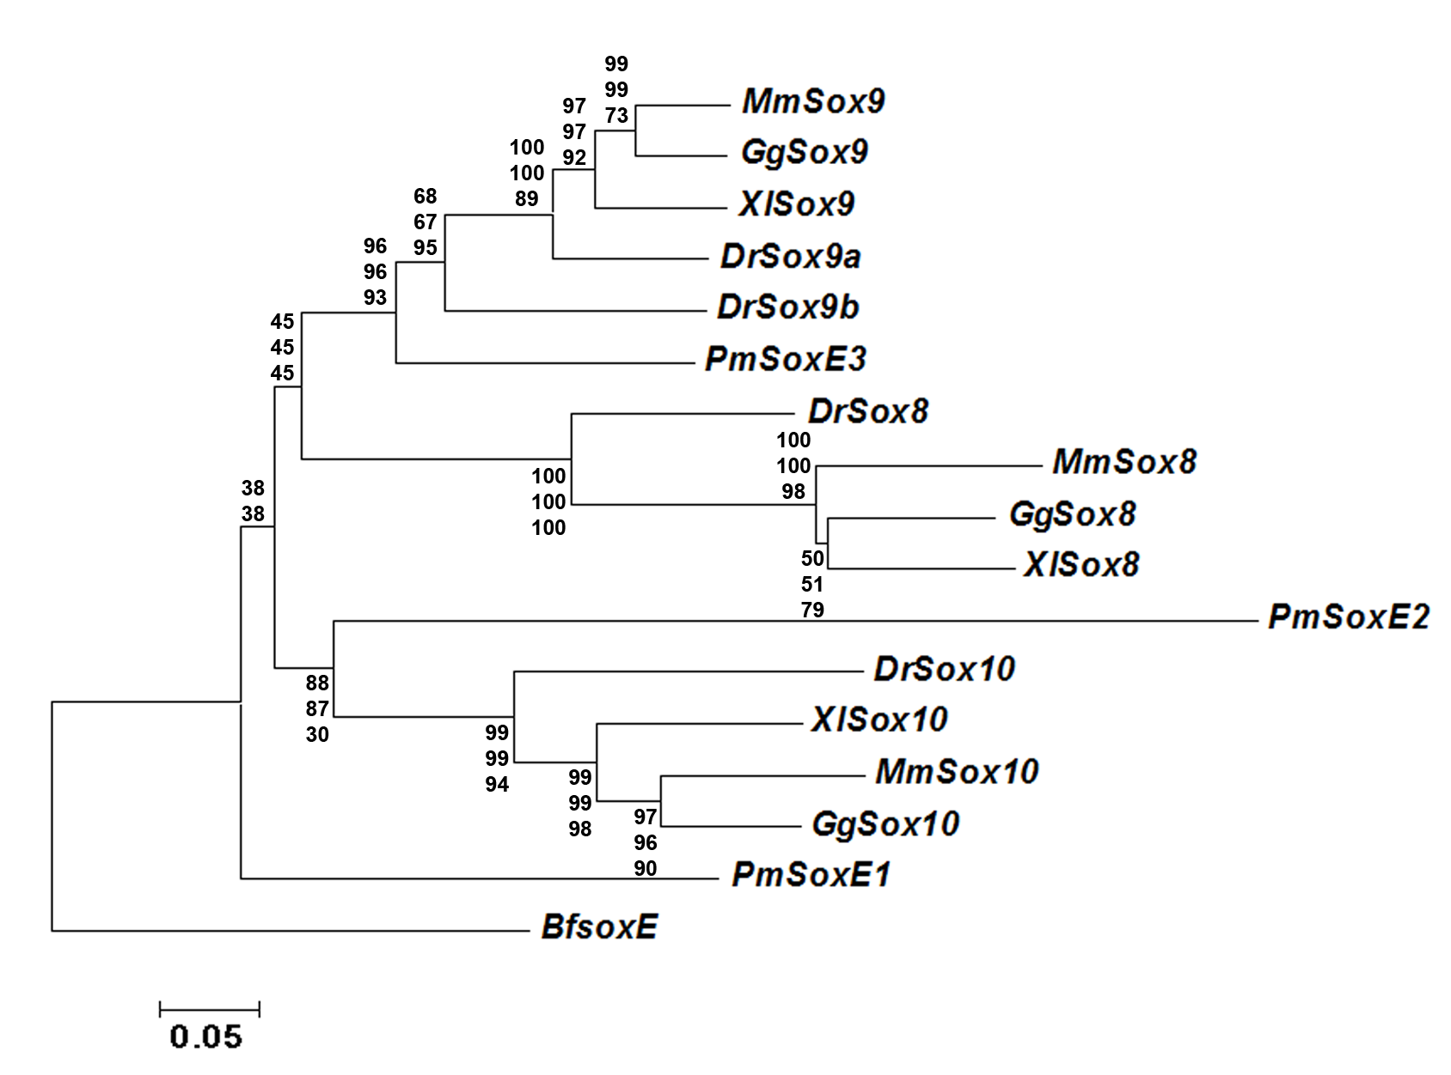
Figure 2.1. Phylogenetic analysis of chordate SoxE genes, including those used in this study. A Neighbor-Joining (NJ) tree was constructed in MEGA5 using a Clustal alignment of full length amino acid sequences from chordate SoxE genes; James-Taylor-Thornton (JTT) model with 1000 bootstrap replications and partial deletion with 30% site coverage cutoff. Phylogenies were calculated using NJ, Minimum-Evolution (ME), and Maximum-Likelihood (ML) methods. Numbers at each node represent bootstrap values for NJ, ME, and ML from top to bottom respectively.

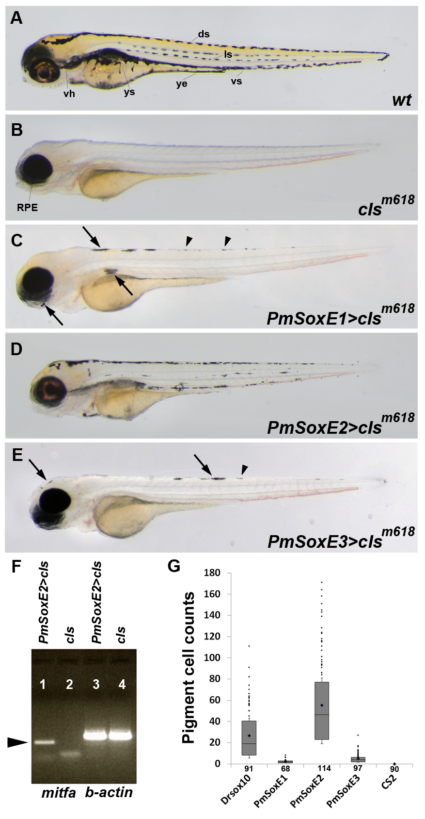
Figure 2.2. Melanogenesis in sox10^{-/-} cls mutants resulting from expression of lamprey SoxE sequences. (A – E) 96 hpf zebrafish larvae. (A) control wildtype. (B) cls mutant; RPE, retinal pigment epithelium. Expression of PmSoxE1 (C), PmSoxE2 (D), and PmSoxE3 (E) in cls mutants. (F) RT-PCR of PmSoxE2-injected cls mutants. mitfa expression in a cls mutant resulting from PmSoxE2 injection (lane 1) is absent in the control cls mutant (lane 2). β-actin internal control (lanes 3 – 4). (G) histogram showing the number of melanophores in zebrafish Drsox10 injected, lamprey PmSoxE1, PmSoxE2, and PmSoxE3 injected, and control cls mutants. Whiskers represent standard error. Each dot above the positive whiskers represents individual data points of the first quartile. Sample sizes are indicated under each bar on the X-axis. Comparisons of means among samples all resulted in statistical significance (Games-Howell, p-value<0.05). vh, ventral horn; ys, yolk sac; ye, yolk extension; ds, dorsal stripe; ls, lateral stripe; vs, ventral stripe. Arrows point to melanophores, arrowheads point to iridophores. Orientation: anterior facing left.

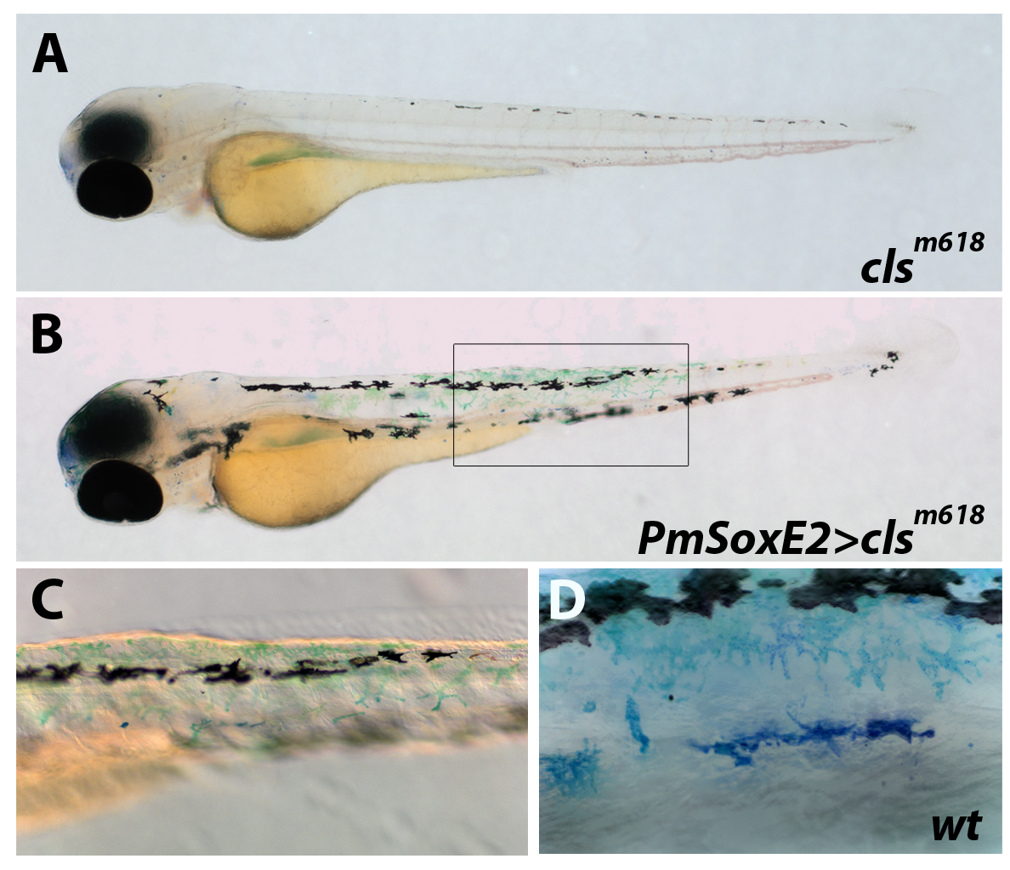
Figure 2.3. Lamprey PmSoxE2 promotes differentiation of xanthophores in sox10^{-/-} cls mutant zebrafish. (A – B) 76 hpf zebrafish embryos stained with methylene blue to detect presence of xanthophores. (A) cls mutant lacking differentiated xanthophores. (B) xanthophores in cls mutants expressing the PmSoxE2 construct. (C) inset in “B” highlights the presence of xanthophores in a cls mutant following PmSoxE2 expression. (D) morphology of xanthophores in a wildtype 76 hpf embryo. Orientation: anterior facing left.

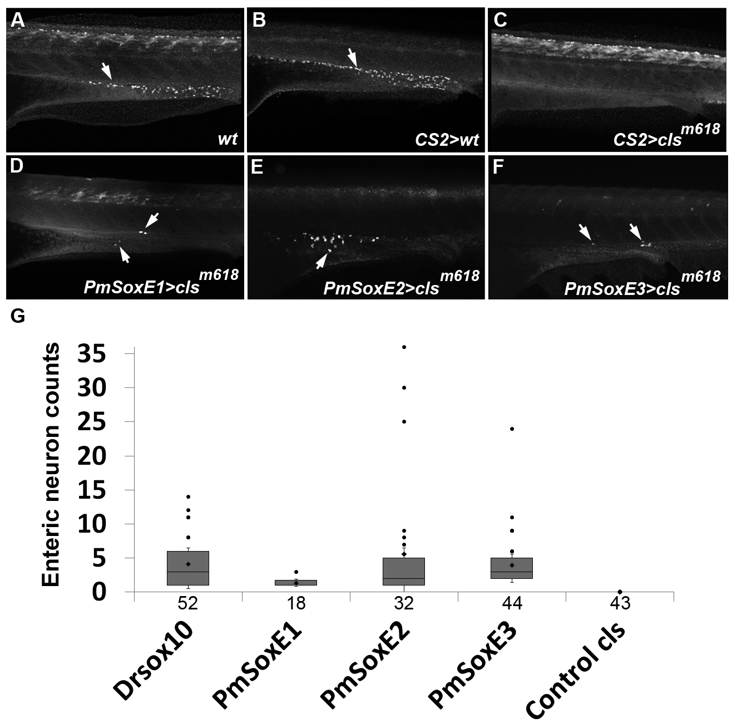
Figure 2.4. Lamprey SoxE expression promotes differentiation of enteric neurons along the larval gut in sox10^{-/-} cls mutant zebrafish. (A – F) anti-HuC/D immunofluoresence in 96 hpf zebrafish. (A) wildtype control. (B) control mock-injected wildtype and (C) cls mutant. Note the absence of HuC-positive enteric neurons (arrows) in cls mutant embryos. Enteric neurons are present in cls mutants injected with lamprey PmSoxE1 (D), PmSoxE2 (E), and PmSoxE3 (F) constructs (arrows in D-F). (G) histogram showing the number of enteric neurons in zebrafish Drsox10 injected, lamprey PmSoxE1-, PmSoxE2-, and PmSoxE3- injected, and control cls mutant embryos. Whiskers represent standard error. Each dot above the positive whiskers represents individual data points of the first quartile. Sample sizes are indicated under each bar on the X-axis. Orientation: anterior facing left.

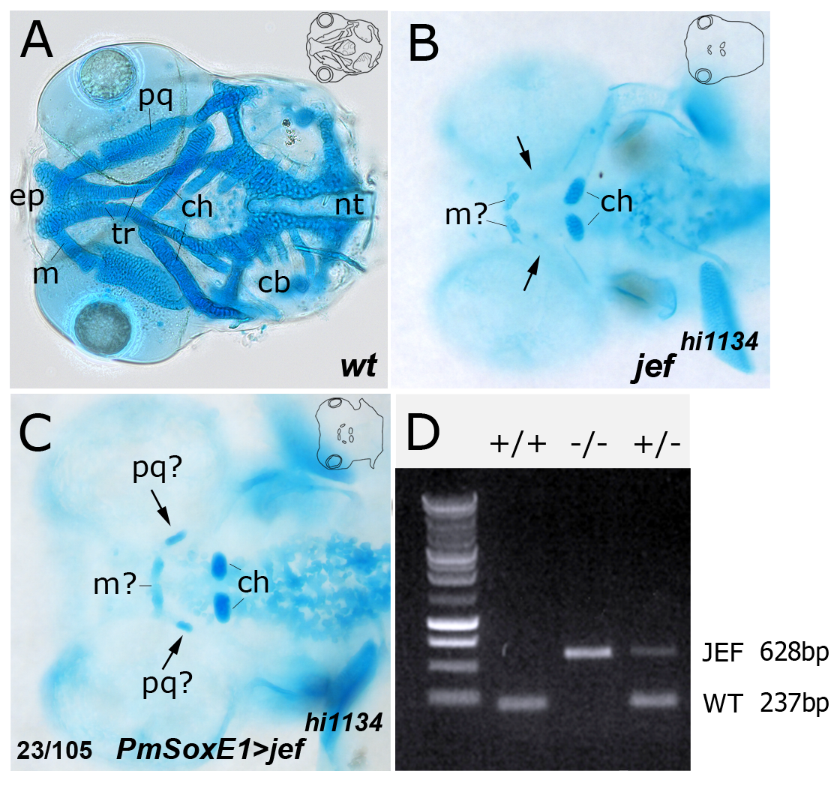
Figure 2.5. Lamprey PmSoxE1 can promote differentiation of small cartilage nodules in zebrafish sox9a^{-/-} jef mutants. (A – C) alcian blue stained 96 hpf zebrafish larvae. (A) craniofacial skeleton of a wildtype control embryo. (B) jef mutant; most elements of the craniofacial skeleton are missing. (C) expression of PmSoxE1 in the jef mutant promotes the differentiation of small cartilage nodules. (D) PCR genotyping of a homozygous wildtype (+/+), a heterozygous sibling (+/-), and a homozygous jef mutant (-/-). With the mutated Drsox9a gene as template DNA , our primer set produces a single 628 bp band, whereas the same primer set produces a single 237 bp band from wildtype Drsox9a template DNA. Template DNA isolated from heterozygous individuals results in both a 628 bp and a 237 bp band (+/- lane). ch, ceratohyal; pq, palatoquadrate; m, Meckel’s cartilage; cb, ceratobranchial; ep, ethmoid plate; tr, trabecula; nt, notochord. Insets show outlines of cartilage elements. Orientation: anterior facing left, dorsal view.

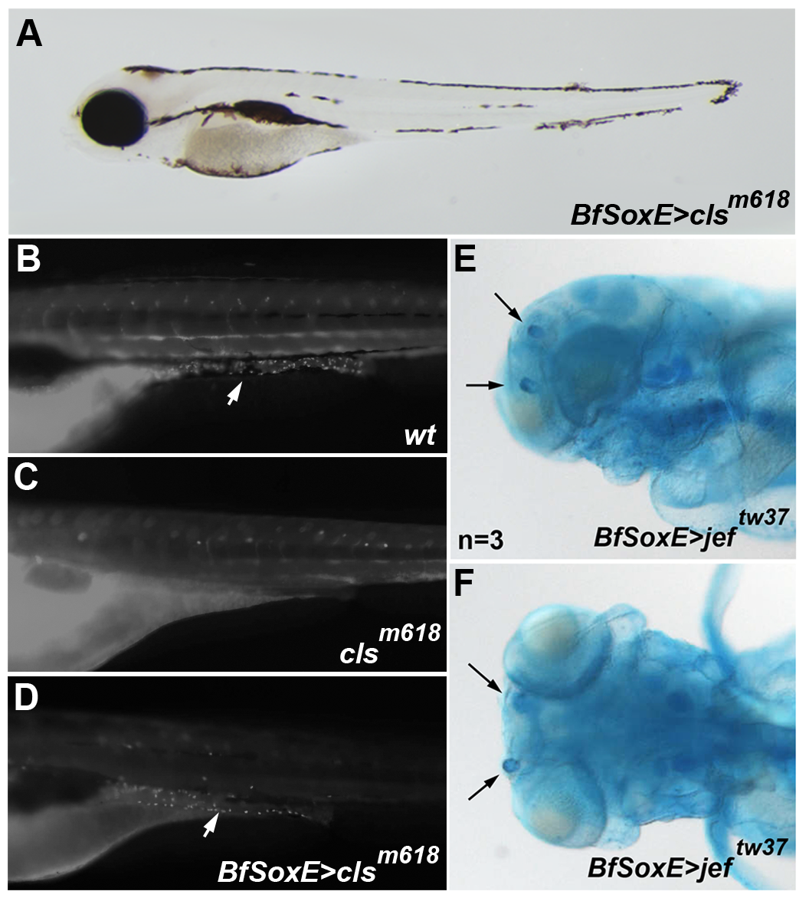
Figure 2.6. Amphioxus SoxE promotes differentiation of melanophores, enteric neurons, and cartilage nodules. (A) expression of amphioxus BfSoxE in 96 hpf cls mutants promotes differentiation of melanophores in cls mutants. (B – D) anti-HuC/D immunofluoresence in 96 hpf zebrafish. (B) control wildtype. (C) cls mutants lack HuC/D-positive enteric neurons. (D) Injection of amphioxus SoxE promotes differentiation of enteric neurons in cls mutants. (E – F) lateral (D) and dorsal (E) views of alcian blue-stained embryos reveal differentiation of cartilage nodules following injection of amphioxus SoxE into jef mutant embryos; arrows indicate ectopic cartilage elements. Orientation: anterior facing left.

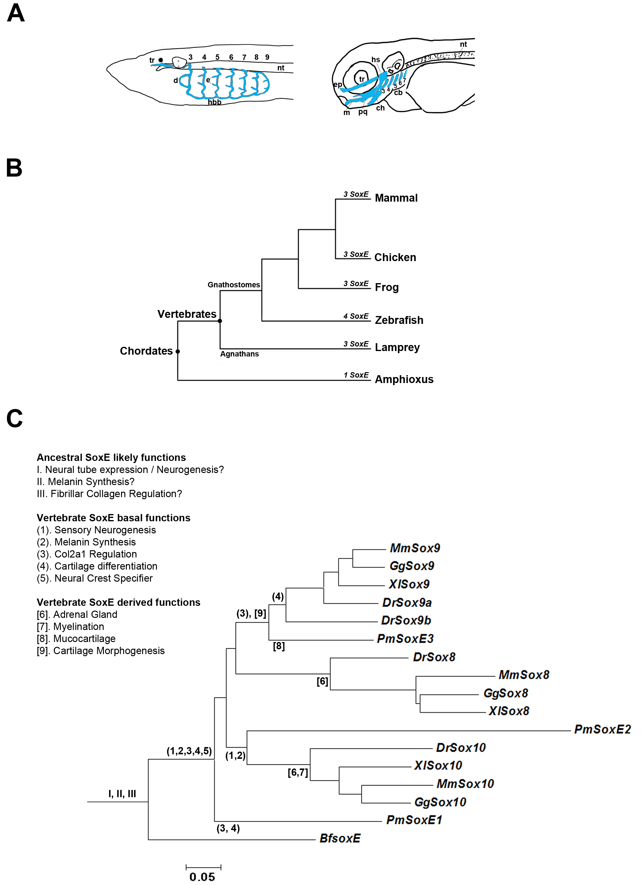
Figure 2.7. (A) both lamprey and zebrafish contain craniofacial cartilage (blue) that is dependent on expression of SoxE genes in neural crest. Left panel: the lamprey pharyngeal basket consists of 7 arches. Posterior to the d-loop element on the 3rdarch, paired epitrematic processes can be seen projecting out of 4th through 9th arches. The trabecular cartilage is situated at the anterior most aspect of the notochord. Right panel: the zebrafish craniofacial skeleton forms from elements of the first and second pharyngeal arches, with the remaining third to seventh arches acting as gill supports analogous to the lamprey pharyngeal arches. tr; trabecular, d; d-loop, e; epitrematic, nt; notochord, hbb; hypobranchial basket, m; Meckel’s cartilage, pq; palatoquadrate, ch; ceratohyal, ep; ethmoid plate, hs; hyosympletic, cb; ceratobranchials. Outline of zebrafish embryo adapted from (Kimmel et al., 1998). (B) phylogenetic relationships between all the chordates used in this study. Amphioxus represent the closest extant chordate basal to vertebrates that possess a single SoxE. Lampreys are positioned basal to all jawed vertebrates and possess three SoxE genes. Orientation: anterior facing left. (C) vertebrate SoxE functions mapped onto the SoxE phylogeny shown in Figure 1. Likely preduplication functions of ancestral SoxE are represented in roman numerals, and basal vertebrate functions are shown in parentheses. Functions specific to agnathans and gnathostomes are shown in brackets. Basal functions of vertebrate SoxE are conserved between agnathans and gnathostomes (1 – 5), while derived lineage-specific functions [6 – 9] arose independently in lampreys or gnathostomes. Adapted from Lakiza et al. 2011.

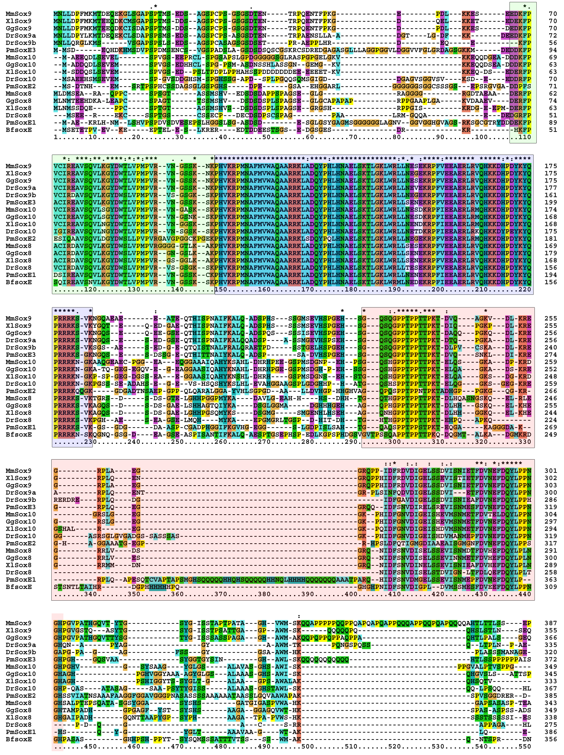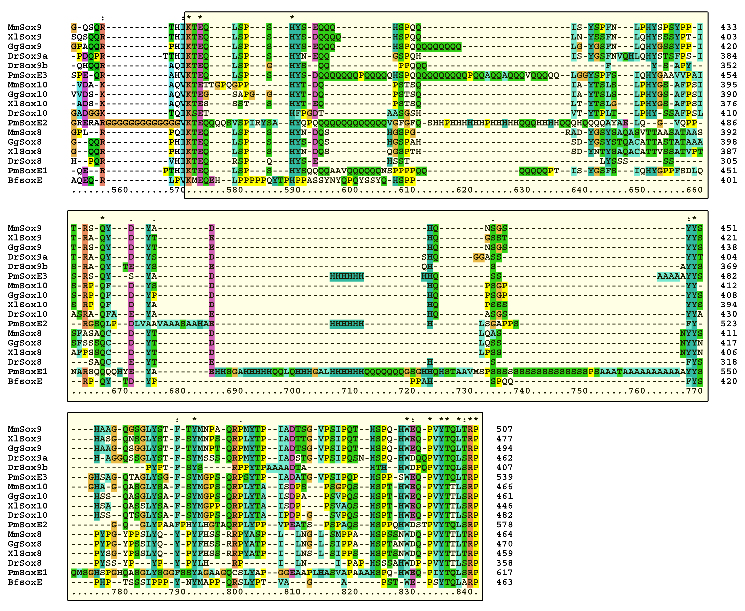
Figure 2.8. Alignment of lamprey PmSoxE1, PmSoxE2, and PmSoxE3 to gnathostome Sox8, Sox9, and Sox10 genes. DIM (green shaded box), HMG (blue shaded box), K2 (red shaded box), and TA (yellow shaded box) SoxE conserved domains. Asterisks demarcate identical amino acid residues among all sequences in the column. Clustal X was used to create a full length alignment that was manually edited using BioEdit. Accession numbers are provided in materials and methods.

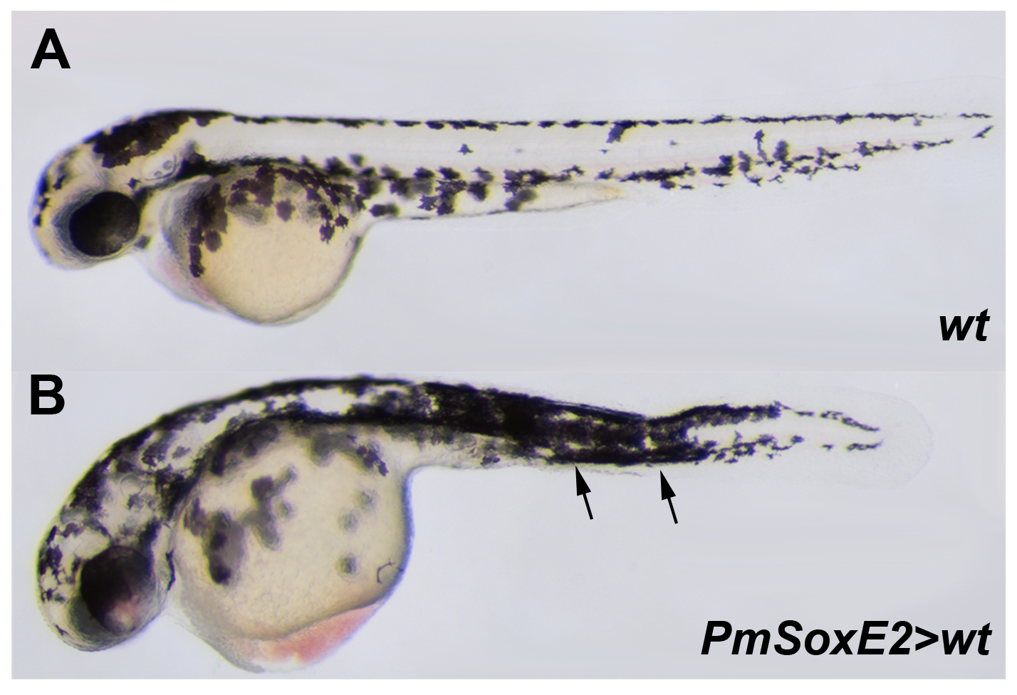
Figure 2.9. Lamprey PmSoxE2 overexpression in zebrafish promotes ectopic formation of pigment cells in a wild-type embryo. (A) wild-type 56 hpf zebrafish embryo with normal pattern of pigmentation. (B) wild-type 56 hpf zebrafish embryo injected with lamprey PmSoxE2 with the appearance of dense populations of melanophores in ectopic areas, most notably in the mid-trunk region (arrows). Orientation: anterior facing left.

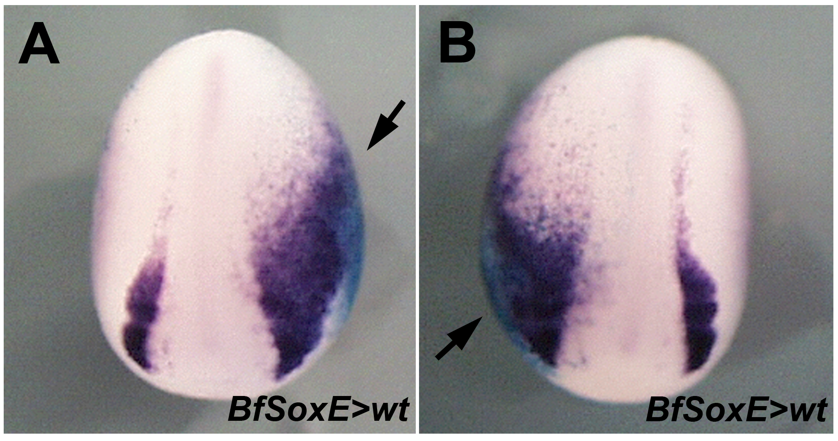
Figure 2.10. Amphioxus SoxE mRNA induces expansion of Slug expression in Xenopus. (A – B) frog (Xenopus laevis) embryos at stage 17 of development show expansion of Slug mRNA expression unilaterally only in the side of the embryo injected with BfSoxE mRNA. Arrows indicate the injected side of embryos. Compare injected (arrow) and uninjected sides. Orientation: anterior facing up. By DMM, University of Colorado, Boulder.

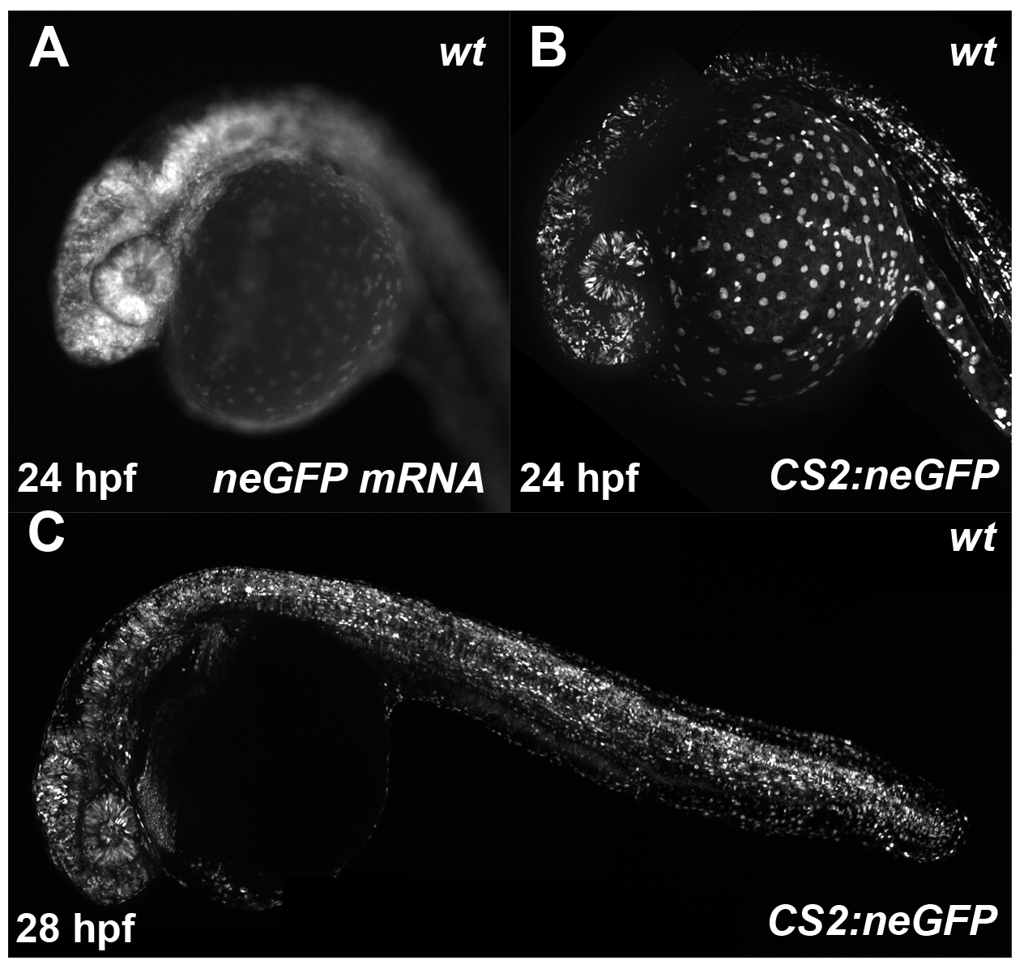
Figure 2.11. Expression of neGFP by injecting in vitro transcribed mRNA and direct injection of CS2+ plasmids into zebrafish wildtype embryos. (A – C) fluorescence imaging of GFP expressing wildtype embryos. (A) mRNA injected wildtype 24 hpf showing GFP expression. (B) CS2+ neGFP injected wildtype 24 hpf showing GFP expression. (C) CS2+ neGFP injected wildtype 28 hpf embryo showing GFP expression.

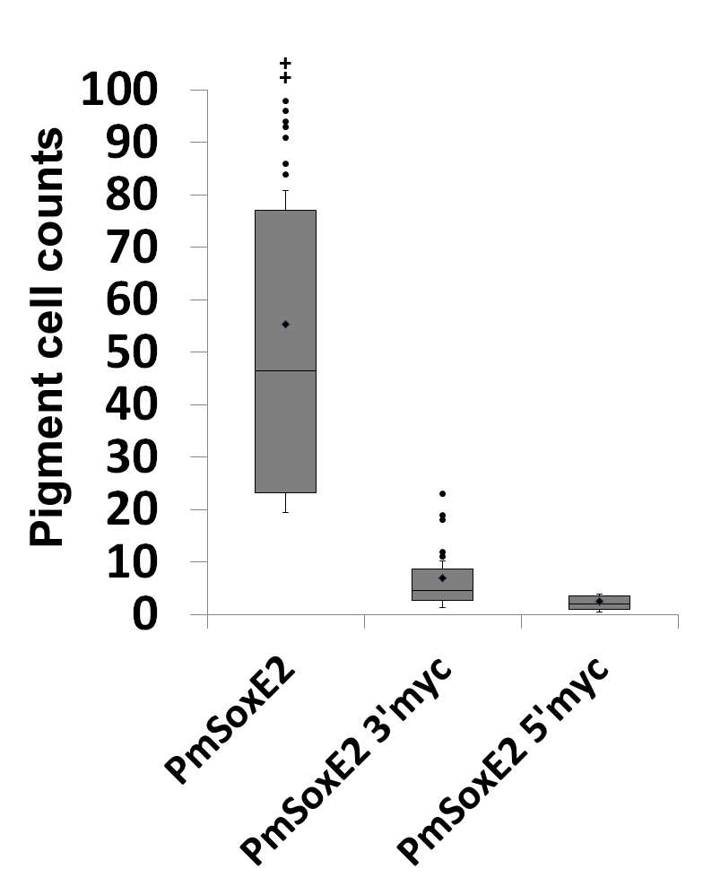
Figure 2.12. The ability of PmSoxE2 to promote melanogenesis is greater than that of 5’- or 3’- myc-tagged PmSoxE2. Induction of melanogenesis by PmSoxE2 (mean = 55, max = 171) is higher than PmSoxE2 3’myc (mean = 7, max = 23) and PmSoxE2 5’myc (mean = 2.6, max = 5). Whiskers represent standard error. Dots above positive whisker represent individual data points.

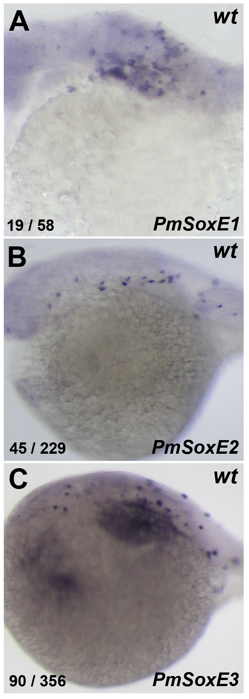
Figure 2.13. mRNA expression of PmSoxE1, PmSoxE2, and PmSoxE3 in PmSoxE1, PmSoxE2, and PmSoxE3 injected wildtype zebrafish embryos, respectively. (A – C) Wildtype 24 hpf embryos showing RNA expression of injected lamprey constructs. Numbers on bottom left corner represent number affected / number observed.

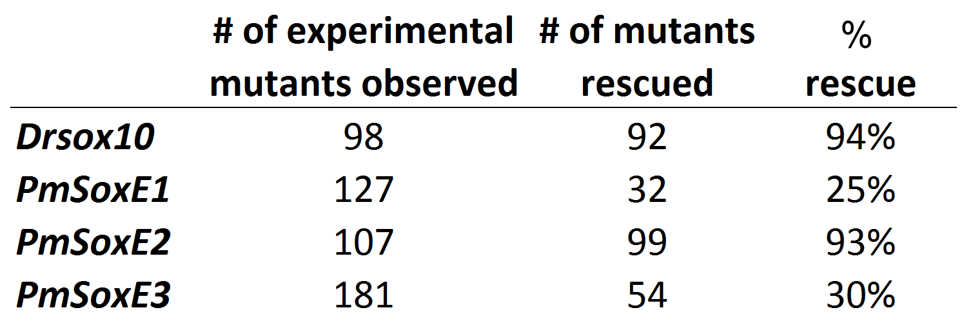
Table 2.1. Percentage of Drsox10, PmSoxE1, PmSoxE2, and PmSoxE3 injected cls larvae that exhibit at least one differentiated pigment cell. Left column indicates identity of the construct injected.

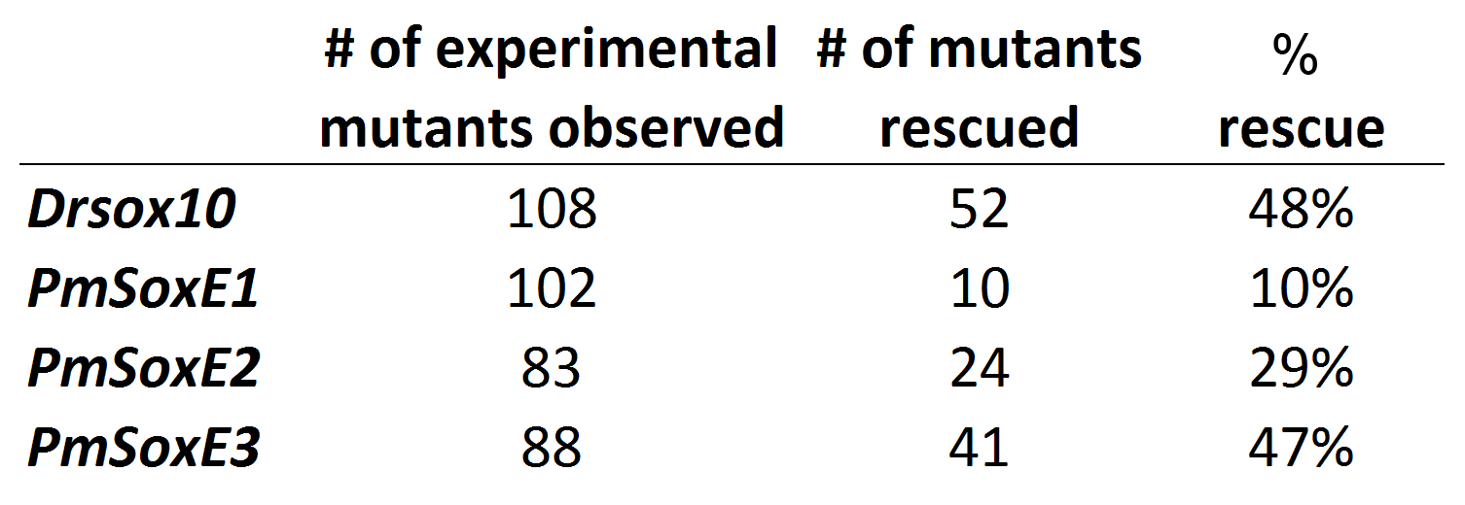
Table 2.2. Percentage of Drsox10, PmSoxE1, PmSoxE2, and PmSoxE3 injected cls larvae that exhibit at least one Hu-positive neuron in the hindgut. Left column indicates the identity of the construct injected.

Chapter 3
Evolution of SoxE protein domains across the agnathan-gnathostome boundary
Abstract
Neural crest development is orchestrated by a gene regulatory network that involves signaling molecules, transcription factors, and effector genes. SoxE proteins (Sox8, Sox9, and Sox10) originated from a single ancestral SoxE through gene duplication. These closely related proteins are transcription factors that regulate neural crest specification, survival during migration, and activation of effector genes to control differentiation of multiple cell types. Sox10 is required for differentiation of pigment cells, dorsal root ganglia, enteric neurons, and myelinated glial cells of the peripheral nervous system. The basal vertebrate sea lamprey (Petromyzon marinus) possesses three SoxE genes (PmSoxE1, PmSoxE2, and PmSoxE3). We have previously shown that when misexpressed in zebrafish cls sox10 loss-of-function mutant embryos, both Drsox10 and PmSoxE2 are able to induce differentiation of a greater number of pigment cells and enteric neurons than PmSoxE1 and PmSoxE3. This observation suggested that PmSoxE2 may be functionally equivalent to Drsox10. However, it remains unclear what confers functional differences to closely related SoxE paralogs. Here we compare the DIM, HMG, K2, and TA domains between zebrafish Drsox10 and lamprey SoxE proteins using amino acid identity and similarity matrixes. This analysis indicates that within these domains PmSoxE3, rather than PmSoxE2, is more similar to Drsox10. However, overlapping functions between Drsox10 and PmSoxE2 suggest that amino acid similarity within these domains may not be a reliable predictor of their functional specificity.
To test the function of each domain, we created a series of SoxE chimeric constructs featuring protein domains that have been replaced by homologous domains from paralogous SoxE gene sequences. Chimeric constructs were then expressed in zebrafish sox9a (jef) and sox10 (cls) loss of function mutant embryos. Injection of the SoxE1xE2TA chimeric construct into cls mutant embryos induced the differentiation of a greater number of melanophores in a higher percentage of injected animals than the full-length PmSoxE1. SoxE1xE3TA rescued a higher percentage of cls embryos compared to PmSoxE1. Conversely, SoxE3xE1TA induced the differentiation of a fewer number of melanophores than PmSoxE3, while SoxE3xE1K2TA showed both greater melanogenic activity and a greater percentage of rescue (30% vs 83%). These results suggest that both the K2 and TA domains of lamprey SoxE proteins may be required for melanocyte development. However, PmSoxE2 induced differentiation of a significantly greater number of melanophores than all of the examined chimeric constructs, suggesting that regions outside of the TA domain of PmSoxE2 may be important in the regulation of pigment cell development. Our results also suggest that the inability of PmSoxE2 to regulate cartilage differentiation is likely due to sequence outside of its TA domain. Additional SoxE protein domains may be required for activation of specific downstream target effector genes in neural crest development. Further studies with chimeric variants may elucidate our understanding of SoxE proteins, and how they have acquired divergent functions in neural crest development and evolution.
Introduction
The neural crest is a multi-potent population of cells that are found in all vertebrates. These cells arise during closure of the neural folds to form the neural tube. They undergo an epithelial-to-mesenchymal transition (EMT) and migrate to target locations. The EMT involves the reprograming of the cells to alter their shape, cell adhesion properties, and cell signaling receptors to detect surrounding cues (LeDouarin and Kalchiem, 1999; Vaglia and Hall, 1999). This migratory ability allows the neural crest to invade a multitude of cellular environments, where they can give rise to a wide array of vertebrate-specific derivatives, including craniofacial cartilage and bone, neurons and glia of the peripheral nervous system, and pigment cell lineages (Knecht and Bronner-Fraser, 2002).
Ongoing investigations in the field of vertebrate evolutionary developmental biology ask how a single cell-type, the neural crest, can give rise to multiple derivatives, and how closely related regulatory proteins have evolved to regulate different cell types arising from this homogeneous cell population (Haldin and LaBonne, 2010). The induction of the neural crest is initiated by cell signaling molecules that include FGF, Wnt, Bmp, and Notch. These signals originate from the adjacent ectoderm or paraxial mesoderm. The induction process activates the neural plate border specifier genes, Pax3, Pax7, Msx1, Zic1, and AP-2, which in turn activate downstream neural crest specification transcription factors, including Id, Sox8, Sox9, and Sox10 (Meulemans and Bronner-Fraser, 2004; Nikitina et al., 2008). Specification genes are required for maintenance of pluripotency, cell survival during migration, and activation of downstream lineage specific effector genes. Different effector genes are activated in different cell lineages and include Mitf for melanocytes, Phox2b and Ednrb for peripheral neurons, and Col2a1 for chondrocytic lineages (Elworthy et al., 2005; Leon et al., 2009; Levy et al., 2006; Zhao et al., 1997).
SoxE transcription factors (Sox8, Sox9, and Sox10) play important and widespread roles during neural crest development. They belong to the high-mobility group (HMG) family of DNA-binding transcription factors that are related by the presence of a highly conserved DNA-binding HMG domain that recognizes the consensus sequence ^{A}/_{T}^{A}/_{T}CAA^{A}/_{T}G (Laudet et al., 1993; Wegner, 1999). It has been demonstrated in a number of species, including humans, mice, Xenopus, and zebrafish, that Sox10 has a wide variety of roles during neural crest development. (Britsch et al., 2001; Dutton et al., 2001; Herbarth et al., 1998; Honore et al., 2003; Kuhlbrodt et al., 1998a; Pingault et al., 1998; Southard-Smith et al., 1998). Therefore, the disruption of Sox10 function affects a wide range of neural crest developmental features, including maintenance of pluripotency, proliferation, cell survival, cell-fate specification, and terminal differentiation (Britsch et al., 2001; Kim et al., 2003; Paratore et al., 2001; Peirano and Wegner, 2000; Sonnenberg-Riethmacher et al., 2001; Stolt et al., 2002). Studies in humans and mice have highlighted the importance of Sox10 function in the regulation of melanogenesis and neurogenesis. Sox10 haploinsufficiency can lead to partial loss of pigment cells and loss of enteric neurons of the distal colon (Herbarth et al., 1998; Southard-Smith et al., 1998). Sox10^{-/-} homozygosity leads to severe phenotypic defects, with complete loss of pigment cells and enteric neurons (Britsch et al., 2001; Herbarth et al., 1998; Kapur, 1999; Southard-Smith et al., 1998). In humans, the loss SOX10 causes Waardenburg syndrome and Hirschsprung’s disease, characterized by the loss of pigment cells and aganglionosis, respectively (Pingault et al., 1998). Waardenburg syndrome can be caused by defects in either Pax3 (type I & III), Mitf (type II), Ednrb (type IV), or Sox10 (types II & IV) (Bondurand et al., 2007; Bondurand et al., 2000; Bondurand and Sham, 2013; Jiang et al., 2011; Wang et al., 2014).
Sox10 has been shown to activate the melanocyte master regulatory gene, microphthalmia associated transcription factor (Mitf), within pigment cell lineages in a number of species including mice and zebrafish (Dorsky et al., 2000; Hou et al., 2006; Levy et al., 2006). Furthermore, in vitro studies have suggested the direct activation of Mitf by Sox10 (Bondurand et al., 2000; Elworthy et al., 2003; Lee et al., 2000; Potterf et al., 2001; Verastegui et al., 2000). Mitf in turn activates downstream genes important for melanocyte differentiation and melanin formation, including tyrosinase, tyrosine-related protein 1, and tyrosine-related protein 2 (dopachrome tautomerase, Dct/Trp2) (Goding, 2000; Ludwig et al., 2004). Teleost specific gene duplication has led to two Mitf genes, mitfa and mitfb, of which mitfa is expressed in neural crest-derived melanophores and mitfb expression is limited to the retinal pigment epithelium (Lister et al., 2001). As such, mitfa can rescue sox10^{-/-} pigment cell deficiencies in the zebrafish (Elworthy et al., 2003).
In mice, both in vitro and in vivo studies have shown that HMG domains are highly interchangeable among Sox proteins even in different subfamilies. For example, chimeric Sox9 proteins containing HMG domains from SoxB genes (Sox1/2/3) did not show altered activity (Bergstrom et al., 2000; Kamachi et al., 1999). SoxE genes share similar expression patterns during embryonic development and have similar functions, suggesting functional redundancy among paralogs (Chaboissier et al., 2004; Cook et al., 2005; Kellerer et al., 2006; Stolt et al., 2003). This raises the question of how closely related SoxE proteins that are expressed in the same cells can perform a range of lineage specific roles. Replacement of mouse Sox10 with Sox8, or with the Drosophila SoxE homolog Sox100B, rescued partial development of peripheral neurons but not melanocyte lineages (Cossais et al., 2010a; Kellerer et al., 2006). These findings suggest that SoxE regulation of neurogenesis and melanogenesis were evolved independently by using different amino acids and downstream targets.
Four SoxE conserved protein domains and the boundaries of each domain have been characterized in several species (Bondurand and Sham, 2013; Cossais et al., 2010b; Wegner, 2010). The corresponding regions in the zebrafish sox10 sequence, shown in Fig. 3.1, include the DNA-dependent dimerization (DIM; amino acids 64 - 101), DNA-binding high mobility group (HMG; amino acids 102 – 184), context-dependent transactivation (K2; amino acids 236 – 324) and the C-terminal transactivation (TA; amino acids 419 – 482) domains (Schepers et al., 2002; Wegner, 1999). The DIM domain is important for cooperative binding of two Sox10 proteins to target promoters, while the K2 domain has been shown to function as a strong transactivation domain of Sox8 (Barrionuevo and Scherer, 2010; Schepers et al., 2000) and a weak transactivation domain of Sox10 (Schreiner et al., 2007). Additionally it has been suggested that the K2 domain may also mediate other protein-protein interactions and co-factor binding (Bondurand and Sham, 2013; Wahlbuhl et al., 2012).
Previously it was suggested, based on a block alignment that included the four characterized protein domains (DIM, HMG, K2, and TA), that PmSoxE3 is the lamprey ortholog to Sox9. However, identities of PmSoxE1 and PmSoxE2 remained unclear (McCauley and Bronner-Fraser, 2006; Zhang et al., 2006). Results based on a full length sequence alignment now suggest the orthology of lamprey PmSoxE2 to gnathostome Sox10 while reconfirming the orthology of PmSoxE3 to gnathostome Sox9 (Chapter 2). Furthermore, heterospecific expression of lamprey SoxE genes in zebrafish Drsox9a and Drsox10 null backgrounds revealed conservation of function between Drsox10 and PmSoxE2. In the current chapter, I address how closely related SoxE paralogs have evolved a differential ability to promote the differentiation of pigment cell, peripheral neurons, and chondrocyte lineages. We compare the DIM, HMG, K2, and TA domains between zebrafish Drsox10 and lamprey SoxE proteins using amino acid identity and similarity matrixes. To test the importance of each domain in vivo, we generated a set of chimeric proteins in which we replaced specific domains from paralogous SoxE gene sequences and expressed them in zebrafish Drsox9a and Drsox10 loss-of-function mutants. Our results show that both the K2 and TA domains of SoxE proteins impact their ability to induce differentiation of melanophores and enteric neurons. Interestingly, while PmSoxE2 TA enhances both melanogenic and neurogenic activities, the specific identity of the TA domain is not related to chondrogenic activity. These findings suggest that the transactivation domain may mediate some lineage specific activity of SoxE genes. Future experiments that test the importance of DIM and HMG domains will be required to fully understand how SoxE proteins have evolved neural crest lineage specific activities throughout vertebrate evolution.

Materials and Methods
Protein sequence alignments and comparisons of amino acid composition
ClustalX2.1 (Larkin et al., 2007) was used to perform individual block alignments using the following sequences: sea lamprey (Petromyzon marinus) PmSoxE1 (AY830453), PmSoxE2 (DQ328983), PmSoxE3 (DQ328984), and zebrafish (Danio rerio) Drsox10 AF402677.1. The amino acid position of each domain (DIM, HMG, K2, TA) follows that of a previous publication of chick Sox10 (Cossais et al., 2010b). Aligned sequences were used to calculate amino acid identities and similarities using SIAS (http://imed.med.ucm.es/Tools/sias.html).

Construction of chimeric and truncation SoxE proteins by PCR-driven overlap extension
Sea lamprey (Petromyzon marinus) and zebrafish (Danio rerio) SoxE full length coding sequences (AY830453, DQ328983, DQ328984, and AF402677.1) were directionally cloned into EcoRI and XhoI (PmSoxE1 and PmSoxE2), and XhoI and XbaI (PmSoxE3) sites on the pCS2+ vector, after the CMV promoter. These original clones served as templates for PCR-driven overlap extension to construct chimerae as previously described (Heckman and Pease, 2007) (Table 3.1). The TA domains of PmSoxE1, PmSoxE2 and PmSoxE3 were replaced with homologous domains to construct PmSoxE1xE2TA, PmSoxE1xE3TA, PmSoxE3xE2TA, and PmSoxE3xE1TA chimerae using overlapping primers (Table 3.3). PmSoxE2 truncation proteins missing the N-terminal dimerization (PmSoxE2Δ109) and C-terminal TA domains (PmSoxE2Δ410) were constructed using internal primers listed in Table 3.3. The Dimerization and HMG domains of PmSoxE1 were replaced with the homologous domains of PmSoxE3 to construct SoxE3xE1K2TA using overlapping primers (Table 3.3). SoxE-containing pCS2+ clones were verified by gel electrophoresis and sequencing. Cloned DNA was diluted to 35 – 55 ng/µl in 0.1M KCl and stored at -20° C prior to injections.

Site directed mutagenesis
PmSoxE3 contained in the CS2+ vector was used as a template to mutate amino acid position 206 from Glycine to Valine via PCR based site direct mutagenesis as previously described (Zheng et al., 2004). The following primers were used: SoxE3G206V F 5’- GGCGGAGAAAGTCGGTCAAGAACGGCCAGAGC -3’, SoxE3G206V R 5’- GCTCTGGCCGTTCTTGACCGACTTTCTCCGCC -3’. Thermal profile: 95 °C 5 mins, repeat 18x (95 °C 50 seconds, 60 °C 50 seconds, 68 °C 6 minutes) 68 °C 7 minutes. High fidelity DNA polymerase (pfu Ultra HotStart) was used in all amplification reactions. PCR products were digested using DpnI at 37 °C for 60 minutes, inactivated by incubation at 65 °C for 20 minutes. PmSoxE3^{G206V} plasmids were transformed into XL-1 Blue competent cells and plasmid DNA isolated by column purification (Promega). Purified plasmids were sequenced, and diluted to 35 ng/ul in 0.1M KCl and stored at -20 °C prior to injections.

Microinjection and fixation of zebrafish embryos
The zebrafish colourless (cls^{m618}) mutant was a kind gift from Dr. Robert Kelsh (University of Bath) and jellyfish (jef^{hi1134}) mutants were purchased from the Zebrafish International Resource Center (University of Oregon). Zebrafish embryos were collected immediately following fertilization and pipetted into agarose troughs with the chorions intact using a controlled drop Pasteur pipette. Transgenes were injected directly into the blastomere from the yolk side. Injection volumes using the pCS2+ vector containing lamprey SoxE genes were titered to between 3 – 10 nl (105-350 pg) per embryo. Embryos were raised to the age of 96 hours post fertilization (hpf) and anesthetized using tricaine mesylate (MS-222) prior to fixation. Pigment cells were counted on anesthetized live cls embryos that were mounted on microscope slides for imaging of pigmentation, then subsequently fixed in 2% trichloroacetic acid (TCA) prior to immunostaining. jef embryos were fixed in 4% paraformaldehyde (PFA) for acid-free alcian blue staining, processed for imaging, and then genotyped by DNA extraction and PCR using primers specific for the sox9a mutational insertion as previously described (Yan et al., 2002).

Immunostaining
Anti-human neuronal protein HuC/HuD mouse monoclonal antibodies (Invitrogen) were reconstituted in 500 µl of phosphate buffered saline (PBS, pH 7.4) containing 1% bovine serum albumin (BSA). For whole mount immunostaining, zebrafish embryos were fixed in 2% TCA for 3 hours at room temperature (RT), washed in PBS, and PBT (PBS with 1% Triton-x-100). Embryos were treated in blocking solution (10% goat serum, 1% BSA) for 4 hours at RT, incubated in anti-Hu (1:100) overnight at 4° C, washed 10 x 30 minutes in PBT, then incubated in Alexa Fluor 488 (Invitrogen) secondary antibody (1:750) overnight at 4° C. Both primary and secondary antibodies were diluted in PBT containing 1% goat serum, and 1% BSA. Following removal of secondary antibody, embryos were washed 10 x 30 min with PBT, and cleared in 30% glycerol at 4°C. Z–series image stacks of immunofluorescence in whole mount embryos were photographed on a Zeiss ApoTome AxioimagerZ1 compound microscope, and maximum intensity projections (MIP) were created from relevant optically sectioned stacks using Zeiss Axiovision software (v4.8.1).

Alcian Blue staining
Zebrafish embryos were fixed in 4% paraformaldehyde (PFA) in phosphate buffer solution (PBS) for 2 hours at room temperature (RT), and serially dehydrated into 100% ethanol. Fixed embryos were stained with 0.02% Alcian blue solution in 70% ethanol and 35mM MgCl₂ for 3 hours at RT (Walker and Kimmel, 2007), then bleached (2% KOH, 30% H₂O₂, 0.002% Triton-X-100) for 1 hour at RT, digested (0.2% trypsin, 0.002% Triton-x-100, 60% sodium tetraborate) for 45 minutes at RT, then cleared (2% KOH, 0.002% Triton-x-100, 50% glycerol), and stored in 50:50 (glycerol:PBS) containing 0.1% sodium azide. Manual Z-series image stacks of stained cartilage were captured on a Zeiss DiscoveryV12 stereo microscope equipped with an Axiocam MRc camera, or with a Zeiss AxioimagerZ1 compound microscope. Image stacks were compiled using the NIH ImageJ extended focus module (Rasband). Embryos were subsequently washed in PBS and placed in DNA extraction buffer for 3 hours at 50° C. Extracted DNA was ethanol precipitated and resuspended in nuclease free water for use as template in PCR genotyping of homozygous jef mutant embryos (Yan et al., 2002).

Statistical Analysis
Pigment cell count and enteric neuron count datasets (Fig. 3.3, 3.4) were analyzed using one-way ANOVA using significance value threshold of 0.05. Levene’s test was used to evaluate homogeneity of variances, and Games-Howell was used as the post-hoc multiple comparisons test.
All experiments were performed using protocols approved by the Institutional Animal Care and Use Committee at the University of Oklahoma (R08-025, R12-017).
Results

Comparison of amino acids between zebrafish Drsox10 and lamprey PmSoxE1, PmSoxE2, and PmSoxE3
We compared amino acid sequence identities and similarities among each of the four recognized functional domains in lamprey PmSoxE1, PmSoxE2, and PmSoxE3 with zebrafish Drsox10. EMBL-EBI Clustal Omega was used to align the sequences and SIAS to perform amino acid identity and similarity matrices (Fig. 3.1). Sequence identity calculations are based on matching residues, whereas sequence similarity calculations are based on whether or not two residues fall into the same category, i.e. aromatic, aliphatic, positively charged, negatively charged, polar, and small size (Livingstone and Barton, 1993). The DIM of Drsox10 is most identical to PmSoxE3 (82%) and least identical to PmSoxE2 (53%). The amino acid similarities of PmSoxE1 (79%) and PmSoxE3 (82%) to Sox10 are also greater than PmSoxE2 (61%) (Fig. 3.1). Interestingly, while a comparison of identities reveals that the HMG domain of Drsox10 is most identical to PmSoxE1 (91%) and least identical to PmSoxE2 (88%), a comparison of similarities show that all three lamprey SoxE proteins are 94% similar to Drsox10 (Fig. 3.1). The context dependent transactivation (K2) domains are less conserved, where only PmSoxE2 and PmSoxE3 show a 50% or greater similarity to Drsox10 (Fig. 3.1). For the C-terminal TA domain, PmSoxE3 shows the highest percent identity and similarity to Drsox10 (Fig. 3.1). Examination of sequence alignments reveals that the K2 domain of PmSoxE1 contains an additional 34 amino acids, consisting of Glutamine and Histidine rich repeats not present in Drsox10 (Arrowheads, Fig. 3.2). Conversely, the K2 domains of PmSoxE2 and PmSoxE3 lack the A-S-R-S-G-L-G-V motif present in Drsox10 (Arrowheads, Fig. 3.2). A previous study specifically compared the K2 and TA domains between Drosophila Sox100B and mouse Sox10, and revealed that conservation within these domains was limited to the N-terminal and C-terminal ends of the K2 and the C-terminal end of the TA (Cossais et al., 2010a). This pattern is also found when comparing zebrafish Drsox10 with lamprey SoxE proteins, with the exception of PmSoxE3 that shares similar residues throughout much of the TA domain (Fig. 3.2).

Multiple lamprey SoxE protein domains are important for melanocyte differentiation
In Chapter Two, I showed that the ability of PmSoxE2 to rescue differentiation of melanophores lacking in cls mutant zebrafish exceeded that of Drsox10. Furthermore lamprey PmSoxE2 resulted in hyperpigmentation following over-expression in wildtype embryos (Chapter Two) while PmSoxE1 was able to rescue the differentiation of only a small number of melanophores in cls mutants. Addition of a 6x myc-epitope tag to either the N-terminal or C-terminal end of PmSoxE2 reduced melanogenic activity (Chapter Two), rendering these constructs irrelevant for this analysis. The C-terminal 66 amino acids have been identified as a strong transactivational domain of SOX10 and are highly conserved in SOX8 and SOX9 (Kuhlbrodt et al., 1998a; Kuhlbrodt et al., 1998b). These studies also showed that a truncated SOX10 lacking the TA domain led to complete loss of function (Kuhlbrodt et al., 1998a; Kuhlbrodt et al., 1998b). To test the requirement of the N-terminal DIM and C-terminal TA domains for PmSoxE2 function, we constructed truncation constructs missing those domains (PmSoxE2Δ109 and PmSoxE2Δ410). As expected from previous studies in the mouse (Kuhlbrodt et al., 1998a; Kuhlbrodt et al., 1998b), these truncation constructs were unable to induce the differentiation of pigment cells in cls mutants (Fig. 3.4K), suggesting their requirement for melanogenic activity of SoxE proteins.
Chimeric constructs were generated in which the TA domain of lamprey SoxE sequences was replaced with the homologous sequence from another lamprey SoxE paralog. We replaced the TA domain of PmSoxE1 with the homologous sequence from PmSoxE2 (SoxE1xE2TA) and expressed this chimeric sequence in cls mutant embryos. SoxE1xE2TA induced greater numbers of differentiated melanophores and enteric neurons in rescued cls embryos than PmSoxE1, both in the number of cells per embryo, and in the number of embryos that showed the partial rescue phenotype (Fig. 3.4, 3.5, 3.7, and Table 3.2, Games-Howell p < 0.05). The SoxE1xE3TA construct was able to rescue melanogenesis in cls embryos, but with reduced percentage of rescue in comparison to the PmSoxE1control (Table 3.2). The reciprocal construct (SoxE3xE1TA) induced the differentiation of fewer melanophores than PmSoxE3 (Fig. 3.4, 3.7, and Table 3.2, Games-Howell p < 0.05). Interestingly, by replacing both the K2 and TA domains of PmSoxE3 with that of PmSoxE1 (SoxE3xE1K2TA), the percentage of animals exhibiting pigment cell rescue increased from 30% to 83% of embryos injected while the average number of pigment cells rescued increased from 4.8 to 7.4 (Games-Howell p = 0.052) (Fig. 3.4, 3.7 and Table 3.2). Unexpectedly, expression of the SoxE3xE1K2TA construct in wildtype embryos induced differentiation of ectopic pigment cells, while also causing pericardial edema in both wildtype and cls mutant embryos (Fig. 3.6). A recent report showed that sox9b knockdown in wildtype zebrafish caused heart edema and reduced blood circulation (Hofsteen et al., 2013). Since PmSoxE3 is orthologous to Sox9, the SoxE3xE1K2TA chimeric construct may be acting as a sox9b dominant negative. This speculation is discussed below.

PmSoxE1xE2TA induces more enteric neurons than PmSoxE1
Previous results show that the ability of PmSoxE2 to induce differentiation of enteric neurons is greater than PmSoxE1 (Chapter Two). Therefore, we investigated the functional relevance of the PmSoxE2TA domain for neurogenic activity using the same SoxE1xE2TA construct. SoxE1xE2TA misexpression induced differentiation of enteric neurons in cls embryos (mean = 2.3, max = 6, n = 14 / 60), which was greater than PmSoxE1 (mean = 1.3, max = 3, n = 10 / 102), but less than PmSoxE2 (mean = 5.6, max = 36, n = 24 / 83) in this activity (Fig. 3.5). Comparison of enteric neuron counts using One-way ANOVA and Games-Howell post hoc multiple comparison tests revealed a statistically significant difference between PmSoxE1 and PmSoxE2 (p = 0.02) in their abilities to direct differentiation of enteric ganglia but not between PmSoxE2 and PmSoxE1xE2TA (p = 0.12) (Fig. 3.5) or PmSoxE1 and PmSoxE1xE2TA (p = 0.14) (Fig. 3.5). Interestingly, expression of Drsox10 in cls embryos revealed ectopic formation of Hu-positive neurons outside of the hindgut (Fig. 3.7). Ectopic Hu-positive neurons were also found in lamprey SoxE injected cls mutants but were not included in our data (not shown). Concerns associated with counting enteric neurons for the purposes of scoring for differences between full-length and chimeric SoxE constructs are discussed below.

The PmSoxE2 TA domain does not interfere with chondrogenic activity
Given the increased melanogenic activity of PmSoxE1xE2TA in comparison to the full-length PmSoxE1 construct (Fig. 3.4, 3.5), we asked whether chondrogenic activity is affected by the PmSoxE2 TA domain. Heterospecific expression of PmSoxE1xE2TA in jef embryos led to induction of cartilage nodule formation, but did not promote differentiation of chondrocytes (Fig. 3.8D). The number of induced cartilage nodules in both PmSoxE1 and PmSoxE1xE2TA injected jef embryos was similar, ranging from one to four, and with similar efficacies (Fig. 3.8). The lack of a significant difference in the chondrogenic activity of these constructs, suggests that the PmSoxE2 TA domain did not interfere with the chondrogenic activity of the SoxE chimeric sequence. The ability of SoxE3xE1K2TA to induce cartilage nodules has not yet been examined.

Discussion

Importance of the SoxE TA domain for induction of melanocyte differentiation
Rescue of pigment cells ranged from a single melanophore up to 111 melanophores in Drsox10-injected cls positive controls (Fig. 3.4). The high percentage of rescue (94%, Table 3.2) suggested that the wide range of rescued melanophore numbers may be influenced by the timing of integration and degree of mosaicism of injected plasmids (Lieschke et al., 2009). Therefore, data are presented in box and whisker plots, with individual representation of points near the maximum (Fig. 3.4).
Curiously, a comparison of amino acid identity between zebrafish Drsox10 and lamprey SoxE sequences reveals that the HMG domain of PmSoxE2 is least identical to Sox10 (Fig. 3.1, 3.2). Instead, amino acid residues in all four domains of PmSoxE3 are more highly conserved with Drsox10 (Fig. 3.1, 3.2). Through amino acid comparisons alone, it was difficult to determine why PmSoxE2 showed the highest while PmSoxE1 showed the lowest melanogenic and neurogenic activity. Since previous studies have highlighted the importance of the K2 and TA domains for Sox10 protein function (Aoki et al., 2003; Cossais et al., 2010b; Ludwig et al., 2004; Potterf et al., 2001; Schreiner et al., 2007), we began our functional analysis of lamprey SoxE proteins by testing the function of these two domains (Fig. 3.3).
PmSoxE1xE2TA expression resulted in differentiation of up to 57 melanophores at a rescue rate of 50%, surpassing the melanogenic activity of PmSoxE1 by both criteria (max = 8, % recued = 25%) (Fig. 3.4, Table 3.2). While the mean number of pigment cells in PmSoxE1xE2TA-injected cls embryos (mean = 6.7) is greater than that of PmSoxE1 (mean = 2.2, Games-Howell p < 0.05), it is still less than that of PmSoxE2 (mean = 55.3, Games-Howell, p < 0.05) (Table 3.1). Since the PmSoxE2 TA domain was unable to fully restore melanogenic activity to PmSoxE1, this suggests that SoxE protein sequences outside the transactivation domains may be required for complete melanogenic activity of Sox10/SoxE2. It will be interesting to determine if DrSox10xPmSoxE2 chimeric constructs are able to show greater melanogenic activity than the DrSox10 full-length sequence.

Limitations of the current assay for the rescue of peripheral neuron and cartilage differentiation in zebrafish cls and jef mutants
Injection of positive control gene sequences, Drsox10 and Drsox9a, into cls and jef mutants respectively resulted in low rescue numbers and efficacies for both ENS and cartilage (Fig. 3.5, 3.6) relative to the wildtype phenotypes. Therefore, we did not use these phenotypes to make comparisons between full-length and chimeric constructs. Additionally, we found the presence of streams or clusters of Hu-positive cells in ectopic locations of Drsox10 injected cls mutant embryos (Fig. 3.7). One possible explanation is that these Hu-positive cells are NCCs of the ENS lineage that have failed to migrate into the hindgut and have undergone premature differentiation. Alternatively, they may be NCCs of the dorsal root ganglia (DRG) lineage that have migrated to ectopic locations during development. Nonetheless, these observations suggest that migration of peripheral neuron NCCs may be perturbed in Drsox10 injected cls mutants, which could account for the reduced number of rescued ENS neurons compared to that of melanophores. Future experiments using ENS-specific or DRG-specific markers may reveal the cell-type identity of ectopic Hu-positive cells.
In contrast to melanophores that were counted along the entire length of cls embryos, analysis of ENS neurons was restricted to the hindgut. In addition, ectopic Hu-positive cells were excluded from this analysis. Unlike the short duration of Sox10 expression in melanocyte lineages, Sox10 is expressed in presumptive enteric neuron precursors prior to the onset of migration and also during their migration to the gut (Anderson et al., 2006; Southard-Smith et al., 1998). Studies have also shown that enteric neurons have a dual origin; vagal neural crest cells migrate from the neural tube near somites 1 – 7 to populate the foregut, and continue to migrate rostrally towards the hindgut. Vagal NCCs that originate from caudal regions of the neural tube populate the caudal-most region of the hindgut (Anderson et al., 2006; Durbec et al., 1996; Kapur, 2000; Wang et al., 2011). Additionally, coordination by both sacral and vagal NCCs is required for proper entry into the gut; sacral NCC arrival at the hindgut is a prerequisite for vagal neural crest to populate the caudal-most regions of the hindgut (Burns and Douarin, 1998; Kapur, 2000). Differentiation of vagal NCCs is also a complex process involving down-regulation of Sox10 and P75, maintenance of RET and Phox2b expression, and upregulation of pan-neuronal markers (Sasselli et al., 2012). Critically, overexpression of Sox10 has been shown to repress the differentiation of ENS progenitors, suggesting that spatiotemporal control of Sox10 expression levels is important for proper ENS development (Bondurand et al., 2006). These studies suggest that the regulatory mechanism of ENS development may require precise spatiotemporal control of Drsox10 that cannot be regulated using a ubiquitous promoter.
The induction of cartilage by both PmSoxE1 and PmSoxE1xE2TA is limited to small disorganized nodules with low rescue efficacies (Fig. 3.8). This limitation may also be caused by the lack of spatiotemporal context in our pCS2+ expression vector system. Sox9 transactivation of col2a1 in chondrocytes requires co-factor binding of chondrocyte specific enhancer-binding proteins (Zhou et al., 1998). Furthermore, Sox9 is required for expression of Sox5 and Sox6 (Akiyama et al., 2002; Ikeda et al., 2004), where Sox5 and Sox6 are recruited by Sox9 to help secure binding to Col2a1 and other cartilage-specific enhancers (Han and Lefebvre, 2008). Thus, the precise spatiotemporal timing of zebrafish sox9a expression may need to coincide with the expression of additional co-factors in order to initiate the full chondrogenic program in jef mutants (Cattell et al., 2011).
Post-translational modification by phosphorylation has also been shown to affect Sox9 chondrogenic activity. In particular, mouse Sox9 is phosphorylated at Sox9^{S181} by cAMP-dependent protein kinase (PKA), resulting in a phosphorylation-dependent increase in DNA-binding affinity and transcription activation potential (Huang et al., 2000). We have found that this putative PKA-dependent phosphorylation site on PmSoxE3 (PmSoxE3^{S205}) has mutated at the +1 phosphorylation site (Valine to Glycine; PmSoxE3^{G206}) but not in PmSoxE1 (PmSoxE1^{V201}) (Arrow in Fig. 3.7). The importance of post translational modifications such as phosphorylation, as well as sumoylation (Taylor and Labonne, 2005) underscore the complex nature of the chondrogenic regulatory pathway and may explain why lamprey PmSoxE1 is unable to direct morphogenesis of the gnathostome craniofacial skeleton. Restoration of a Valine residue at the +1 position of the phosphorylation site in PmSoxE3 (PmSoxE3^{G206V}) but was unable to rescue chondrogenesis jef mutants (n = 0/22, data not shown). While this is a negative result, we speculate that the mutation of the +1 phosphorylation site of PmSoxE3 from Glycine to Valine alone may not be sufficient to restore chondrogenic activity. It would be interesting to determine if mutating the homologous site in PmSoxE1 or Drsox9a affects their ability to regulate chondrogenesis. Nonetheless, despite the limitations of our assay, we are able to show that SoxE1xE2TA has the ability to induce cartilage nodule formation, suggesting that chondrogenic activity may not depend on the specific identity of the TA domain that is present on the SoxE gene sequence.

SoxE3xE1K2TA induces differentiation of ectopic melanophores and causes heart edema in wildtype and cls embryos
The number of melanophores that differentiate in SoxE3xE1K2TA injected cls embryos is greater than the number seen following misexpression of the SoxE3xE1TA construct (Fig. 3.4, 3.7). This suggests that the K2 domain of PmSoxE1 may be able to function in a melanogenic context. Furthermore, expression of SoxE3xE1K2TA results in ectopic formation of melanophores in wildtype embryos (Fig. 3.6), further supporting melanogenic activity by the K2 domain. Interestingly, SoxE3xE1K2TA also caused pericardial edema when misexpressed in both wildtype and cls mutant embryos (Fig. 3.6). This observation is similar to the effects of sox9b knockdown that were recently reported in zebrafish (Hofsteen et al., 2013). One possible explanation is that this phenotype may result from dominant negative effects by SoxE3xE1K2TA through disruption of the Drsox9b regulatory pathway. It will be interesting to determine if this is effect results from SoxE3xE1K2TA binding to Drsox9b downstream target promoters or sequestration of Drsox9b co-factor proteins.

A proof-of-concept study that opens doors for future investigations
The results of this study suggest that the differential activity of lamprey SoxE proteins to induce melanophore differentiation is in part dictated by the amino acid composition of their K2 and TA domains. A study by Schreiner et al. used hypomorphic Sox10 alleles to show that both the DNA dependent dimerization and K2 domains may be important for pigment cell development in mice (Schreiner et al., 2007), suggesting the importance of other protein-protein or cofactor-binding interactions. The next logical step is to create chimeric constructs with their DIM domains replaced with homologous domains from other SoxE proteins. Sox proteins may be able to influence the activation of downstream genes by acting as architectural proteins (Werner and Burley, 1997). When Sox proteins bind to the enhancers of downstream target genes, they cause a widening of the minor groove, which in turn introduces a strong bend in the DNA (Conner et al., 1994; Ferrari et al., 1992). Inducing multiple bends along an enhancer may influence the overall conformation of the enhanceosome to facilitate the recruitment and binding of other co-factors and assembly of the transcription activation complex (Wegner and Stolt, 2005). This hypothesis is supported by the presence of multiple binding sites in gene promoters and enhancers, including Sox9 binding sites for Col2a1, Col11a2, and Sox10 binding sites for Mitf, Dct, and Myelin protein zero (Bridgewater et al., 1998; Lefebvre et al., 1997; Ludwig et al., 2004; Ng et al., 1997; Peirano and Wegner, 2000; Wegner and Stolt, 2005). The degree to which the DNA is bent depends on whether the Sox proteins are bound as monomers or dimers (Wegner and Stolt, 2005). For dimeric binding, the cooperative binding of SoxE proteins to adjacent binding sites on the DNA is mediated by the DIM domain (Peirano and Wegner, 2000; Schlierf et al., 2002). The disruption of DIM function in the human SOX9 gene can lead to campomelic dysplasia (Bernard and Harley, 2010; Sock et al., 2003). Therefore, it is possible for the DIM domain of lamprey SoxE proteins to play an important role in the regulation of neural crest development.
While our current method of gene expression is able to promote pigment cell differentiation in cls mutants (Table 3.2), results from our attempts to induce enteric neuron and cartilage differentiation were less robust (Fig. 3.5, 3.9). One possible explanation is that the melanogenic regulatory pathway is uniquely simple in zebrafish. In mice, Sox10 expression persists in melanocyte precursors (melanoblasts) and continues to be expressed during neural crest migration and incorporation into skin (Hakami et al., 2006; Osawa et al., 2005). However in zebrafish, sox10 expression in pigment cell precursors is rapidly downregulated at the onset of migration, suggesting a diminishing role for sox10 during zebrafish melanogenesis (Dutton et al., 2001; Elworthy et al., 2003). As such, the reintroduction of mitfa expression in zebrafish sox10^{-/-} mutants can fully rescue pigment cell defects, suggesting that initial activation of mitfa by sox10 is sufficient to promote normal pigment cell development (Elworthy et al., 2003). It has been demonstrated that interspecies differences exist between mice and zebrafish, whereby Mitf expression in Sox10^{-/-} mice can only partially rescue melanocyte differentiation (Hou et al., 2006).
As demonstrated in this study, and in Chapter Two, the zebrafish melanophore lineage is amenable for rescue experiments using our current method of transient gene expression. Additionally, optical clarity of zebrafish embryos allows for counting of differentiated melanophores in rescued cls mutants without the need for cell-staining. In order to apply our method to other neural crest lineages, we will need to produce stronger peripheral neuron and cartilage rescue phenotypes in cls and jef mutants, respectively. Exciting advances in genome editing techniques may prove to be useful for future studies. The recently discovered CRISPR/Cas9 genome editing technique has been successfully adopted for use in zebrafish to induce gene knockin and replacement (Auer et al., 2014; Hruscha et al., 2013). This technique may enable us to insert lamprey SoxE coding sequences under regulation of the zebrafish Drsox9a, Drsox9b, and Drsox10 promoters to drive their expression with precise spatiotemporal control. While our current methods have yielded important insights into changes in SoxE gene functions, this new strategy may prove valuable for overcoming limitations of the current experimental design.
References
Akiyama, H., Chaboissier, M.C., Martin, J.F., Schedl, A., de Crombrugghe, B., 2002. The transcription factor Sox9 has essential roles in successive steps of the chondrocyte differentiation pathway and is required for expression of Sox5 and Sox6. Genes Dev 16, 2813-2828.
Anderson, R.B., Stewart, A.L., Young, H.M., 2006. Phenotypes of neural-crest-derived cells in vagal and sacral pathways. Cell Tissue Res 323, 11-25.
Aoki, Y., Saint-Germain, N., Gyda, M., Magner-Fink, E., Lee, Y.-H., Credidio, C., Saint-Jeannet, J.-P., 2003. Sox10 regulates the development of neural crest-derived melanocytes in Xenopus. Developmental Biology 259, 19-33.
Auer, T.O., Duroure, K., De Cian, A., Concordet, J.P., Del Bene, F., 2014. Highly efficient CRISPR/Cas9-mediated knock-in in zebrafish by homology-independent DNA repair. Genome Research 24, 142-153.
Barrionuevo, F., Scherer, G., 2010. SOX E genes: SOX9 and SOX8 in mammalian testis development. Int J Biochem Cell Biol 42, 433-436.
Bergstrom, D.E., Young, M., Albrecht, K.H., Eicher, E.M., 2000. Related function of mouse SOX3, SOX9, and SRY HMG domains assayed by male sex determination. Genesis 28, 111-124.
Bernard, P., Harley, V.R., 2010. Acquisition of SOX transcription factor specificity through protein–protein interaction, modulation of Wnt signalling and post-translational modification. The International Journal of Biochemistry & Cell Biology 42, 400-410.
Bondurand, N., Dastot-Le Moal, F., Stanchina, L., Collot, N., Baral, V., Marlin, S., Attie-Bitach, T., Giurgea, I., Skopinski, L., Reardon, W., Toutain, A., Sarda, P., Echaieb, A., Lackmy-Port-Lis, M., Touraine, R., Amiel, J., Goossens, M., Pingault, V., 2007. Deletions at the SOX10 Gene Locus Cause Waardenburg Syndrome Types 2 and 4. The American Journal of Human Genetics 81, 1169-1185.
Bondurand, N., Natarajan, D., Barlow, A., Thapar, N., Pachnis, V., 2006. Maintenance of mammalian enteric nervous system progenitors by SOX10 and endothelin 3 signalling. Development 133, 2075-2086.
Bondurand, N., Pingault, V., Goerich, D.E., Lemort, N., Sock, E., Le Caignec, C., Wegner, M., Goossens, M., 2000. Interaction among SOX10, PAX3 and MITF, three genes altered in Waardenburg syndrome. Hum Mol Genet 9, 1907-1917.
Bondurand, N., Sham, M.H., 2013. The role of SOX10 during enteric nervous system development. Developmental Biology 382, 330-343.
Bridgewater, L.C., Lefebvre, V., de Crombrugghe, B., 1998. Chondrocyte-specific enhancer elements in the Col11a2 gene resemble the Col2a1 tissue-specific enhancer. Journal of Biological Chemistry 273, 14998-15006.
Britsch, S., Goerich, D.E., Riethmacher, D., Peirano, R.I., Rossner, M., Nave, K.A., Birchmeier, C., Wegner, M., 2001. The transcription factor Sox10 is a key regulator of peripheral glial development. Genes Dev 15, 66-78.
Burns, A.J., Douarin, N.M., 1998. The sacral neural crest contributes neurons and glia to the post-umbilical gut: spatiotemporal analysis of the development of the enteric nervous system. Development 125, 4335-4347.
Cattell, M., Lai, S., Cerny, R., Medeiros, D.M., 2011. A new mechanistic scenario for the origin and evolution of vertebrate cartilage. PLoS One 6, e22474.
Chaboissier, M.C., Kobayashi, A., Vidal, V.I., Lutzkendorf, S., van de Kant, H.J., Wegner, M., de Rooij, D.G., Behringer, R.R., Schedl, A., 2004. Functional analysis of Sox8 and Sox9 during sex determination in the mouse. Development 131, 1891-1901.
Conner, F., Cary, P.D., Read, C.M., Preston, N.S., Driscoll, P.C., Denny, P., Cranerobinson, C., Ashworth, A., 1994. DNA-Binding and Bending Properties of the Postmeiotically Expressed Sry-Related Protein Sox-5. Nucleic Acids Research 22, 3339-3346.
Cook, A.L., Smith, A.G., Smit, D.J., Leonard, J.H., Sturm, R.A., 2005. Co-expression of SOX9 and SOX10 during melanocytic differentiation in vitro. Experimental Cell Research 308, 222-235.
Cossais, F., Sock, E., Hornig, J., Schreiner, S., Kellerer, S., Bosl, M.R., Russell, S., Wegner, M., 2010a. Replacement of mouse Sox10 by the Drosophila ortholog Sox100B provides evidence for co-option of SoxE proteins into vertebrate-specific gene-regulatory networks through altered expression. Dev Biol 341, 267-281.
Cossais, F., Wahlbuhl, M., Kriesch, J., Wegner, M., 2010b. SOX10 structure-function analysis in the chicken neural tube reveals important insights into its role in human neurocristopathies. Hum Mol Genet 19, 2409-2420.
Dorsky, R.I., Raible, D.W., Moon, R.T., 2000. Direct regulation of nacre, a zebrafish MITF homolog required for pigment cell formation, by the Wnt pathway. Genes Dev 14, 158-162.
Durbec, P.L., Larsson-Blomberg, L.B., Schuchardt, A., Costantini, F., Pachnis, V., 1996. Common origin and developmental dependence on c-ret of subsets of enteric and sympathetic neuroblasts. Development 122, 349-358.
Dutton, K.A., Pauliny, A., Lopes, S.S., Elworthy, S., Carney, T.J., Rauch, J., Geisler, R., Haffter, P., Kelsh, R.N., 2001. Zebrafish colourless encodes sox10 and specifies non-ectomesenchymal neural crest fates. Development 128, 4113-4125.
Elworthy, S., Lister, J.A., Carney, T.J., Raible, D.W., Kelsh, R.N., 2003. Transcriptional regulation of mitfa accounts for the sox10 requirement in zebrafish melanophore development. Development 130, 2809-2818.
Elworthy, S., Pinto, J.P., Pettifer, A., Cancela, M.L., Kelsh, R.N., 2005. Phox2b function in the enteric nervous system is conserved in zebrafish and is sox10-dependent. Mech Dev 122, 659-669.
Ferrari, S., Harley, V.R., Pontiggia, A., Goodfellow, P.N., Lovellbadge, R., Bianchi, M.E., 1992. Sry, Like Hmg1, Recognizes Sharp Angles in DNA. Embo Journal 11, 4497-4506.
Goding, C.R., 2000. Mitf from neural crest to melanoma: signal transduction and transcription in the melanocyte lineage. Genes & Development 14, 1712-1728.
Hakami, R.M., Hou, L., Baxter, L.L., Loftus, S.K., Southard-Smith, E.M., Incao, A., Cheng, J., Pavan, W.J., 2006. Genetic evidence does not support direct regulation of EDNRB by SOX10 in migratory neural crest and the melanocyte lineage. Mech Dev 123, 124-134.
Haldin, C.E., LaBonne, C., 2010. SoxE factors as multifunctional neural crest regulatory factors. The International Journal of Biochemistry & Cell Biology 42, 441-444.
Han, Y., Lefebvre, V., 2008. L-Sox5 and Sox6 drive expression of the aggrecan gene in cartilage by securing binding of Sox9 to a far-upstream enhancer. Mol Cell Biol 28, 4999-5013.
Heckman, K.L., Pease, L.R., 2007. Gene splicing and mutagenesis by PCR-driven overlap extension. Nature Protocols 2, 924-932.
Herbarth, B., Pingault, V., Bondurand, N., Kuhlbrodt, K., Hermans-Borgmeyer, I., Puliti, A., Lemort, N., Goossens, M., Wegner, M., 1998. Mutation of the Sry-related Sox10 gene in Dominant megacolon, a mouse model for human Hirschsprung disease. Proc Natl Acad Sci U S A 95, 5161-5165.
Hofsteen, P., Plavicki, J., Johnson, S.D., Peterson, R.E., Heideman, W., 2013. Sox9b Is Required for Epicardium Formation and Plays a Role in TCDD-Induced Heart Malformation in Zebrafish. Molecular Pharmacology 84, 353-360.
Honore, S.M., Aybar, M.J., Mayor, R., 2003. Sox10 is required for the early development of the prospective neural crest in Xenopus embryos. Dev Biol 260, 79-96.
Hou, L., Arnheiter, H., Pavan, W.J., 2006. Interspecies difference in the regulation of melanocyte development by SOX10 and MITF. Proc Natl Acad Sci U S A 103, 9081-9085.
Hruscha, A., Krawitz, P., Rechenberg, A., Heinrich, V., Hecht, J., Haass, C., Schmid, B., 2013. Efficient CRISPR/Cas9 genome editing with low off-target effects in zebrafish. Development 140, 4982-4987.
Huang, W., Zhou, X., Lefebvre, V., de Crombrugghe, B., 2000. Phosphorylation of SOX9 by cyclic AMP-dependent protein kinase A enhances SOX9's ability to transactivate a Col2a1 chondrocyte-specific enhancer. Mol Cell Biol 20, 4149-4158.
Ikeda, T., Kamekura, S., Mabuchi, A., Kou, I., Seki, S., Takato, T., Nakamura, K., Kawaguchi, H., Ikegawa, S., Chung, U.I., 2004. The combination of SOX5, SOX6, and SOX9 (the SOX trio) provides signals sufficient for induction of permanent cartilage. Arthritis Rheum 50, 3561-3573.
Jiang, L., Chen, H.S., Jiang, W., Hu, Z.M., Mei, L.Y., Xue, J.J., He, C.F., Liu, Y.L., Xia, K., Feng, Y., 2011. Novel mutations in the SOX10 gene in the first two Chinese cases of type IV Waardenburg syndrome. Biochem Bioph Res Co 408, 620-624.
Kamachi, Y., Cheah, K.S.E., Kondoh, H., 1999. Mechanism of regulatory target selection by the SOX high-mobility-group domain proteins as revealed by comparison of SOX1/2/3 and SOX9. Molecular and Cellular Biology 19, 107-120.
Kapur, R.P., 1999. Hirschsprung disease and other enteric dysganglionoses. Crit Rev Cl Lab Sci 36, 225-273.
Kapur, R.P., 2000. Developmental disorders of the enteric nervous system. Gut 47 Suppl 4, iv81-83; discussion iv87.
Kellerer, S., Schreiner, S., Stolt, C.C., Scholz, S., Bosl, M.R., Wegner, M., 2006. Replacement of the Sox10 transcription factor by Sox8 reveals incomplete functional equivalence. Development 133, 2875-2886.
Kim, J., Lo, L., Dormand, E., Anderson, D.J., 2003. SOX10 maintains multipotency and inhibits neuronal differentiation of neural crest stem cells. Neuron 38, 17-31.
Knecht, A.K., Bronner-Fraser, M., 2002. Induction of the neural crest: a multigene process. Nat Rev Genet 3, 453-461.
Kuhlbrodt, K., Herbarth, B., Sock, E., Hermans-Borgmeyer, I., Wegner, M., 1998a. Sox10, a novel transcriptional modulator in glial cells. J Neurosci 18, 237-250.
Kuhlbrodt, K., Schmidt, C., Sock, E., Pingault, V., Bondurand, N., Goossens, M., Wegner, M., 1998b. Functional analysis of Sox10 mutations found in human Waardenburg-Hirschsprung patients. Journal of Biological Chemistry 273, 23033-23038.
Larkin, M.A., Blackshields, G., Brown, N.P., Chenna, R., McGettigan, P.A., McWilliam, H., Valentin, F., Wallace, I.M., Wilm, A., Lopez, R., Thompson, J.D., Gibson, T.J., Higgins, D.G., 2007. Clustal W and Clustal X version 2.0. Bioinformatics 23, 2947-2948.
Laudet, V., Stehelin, D., Clevers, H., 1993. Ancestry and diversity of the HMG box superfamily. Nucleic Acids Res 21, 2493-2501.
LeDourain, N.M., Kalchiem, C., 1999. The Neural Crest. Cambridge University Press, Cambridge, UK.
Lee, M., Goodall, J., Verastegui, C., Ballotti, R., Goding, C.R., 2000. Direct regulation of the Microphthalmia promoter by Sox10 links Waardenburg-Shah syndrome (WS4)-associated hypopigmentation and deafness to WS2. Journal of Biological Chemistry 275, 37978-37983.
Lefebvre, V., Huang, W.D., Harley, V.R., Goodfellow, P.N., deCrombrugghe, B., 1997. SOX9 is a potent activator of the chondrocyte-specific enhancer of the pro alpha 1(II) collagen gene. Molecular and Cellular Biology 17, 2336-2346.
Leon, T.Y., Ngan, E.S., Poon, H.C., So, M.T., Lui, V.C., Tam, P.K., Garcia-Barcelo, M.M., 2009. Transcriptional regulation of RET by Nkx2-1, Phox2b, Sox10, and Pax3. J Pediatr Surg 44, 1904-1912.
Levy, C., Khaled, M., Fisher, D.E., 2006. MITF: master regulator of melanocyte development and melanoma oncogene. Trends in Molecular Medicine 12, 406-414.
Lieschke, G.J., Oates, A.C., Kawakami, K., 2009. Zebrafish : methods and protocols / edited by Graham J. Lieschke, Andrew C. Oates and Koichi Kawakami. Humana ; London : Springer, Totowa, N.J.
Lister, J.A., Close, J., Raible, D.W., 2001. Duplicate mitf genes in zebrafish: complementary expression and conservation of melanogenic potential. Dev Biol 237, 333-344.
Livingstone, C.D., Barton, G.J., 1993. Protein-Sequence Alignments - a Strategy for the Hierarchical Analysis of Residue Conservation. Comput Appl Biosci 9, 745-756.
Ludwig, A., Rehberg, S., Wegner, M., 2004. Melanocyte-specific expression of dopachrome tautomerase is dependent on synergistic gene activation by the Sox10 and Mitf transcription factors. FEBS Lett 556, 236-244.
McCauley, D.W., Bronner-Fraser, M., 2006. Importance of SoxE in neural crest development and the evolution of the pharynx. Nature 441, 750-752.
Meulemans, D., Bronner-Fraser, M., 2004. Gene-regulatory interactions in neural crest evolution and development. Dev Cell 7, 291-299.
Ng, L.J., Wheatley, S., Muscat, G.E.O., ConwayCampbell, J., Bowles, J., Wright, E., Bell, D.M., Tam, P.P.L., Cheah, K.S.E., Koopman, P., 1997. SOX9 binds DNA, activates transcription, and coexpresses with type II collagen during chondrogenesis in the mouse. Developmental Biology 183, 108-121.
Nikitina, N., Sauka-Spengler, T., Bronner-Fraser, M., 2008. Dissecting early regulatory relationships in the lamprey neural crest gene network. Proc Natl Acad Sci U S A 105, 20083-20088.
Osawa, M., Egawa, G., Mak, S.S., Moriyama, M., Freter, R., Yonetani, S., Beermann, F., Nishikawa, S., 2005. Molecular characterization of melanocyte stem cells in their niche. Development 132, 5589-5599.
Paratore, C., Goerich, D.E., Suter, U., Wegner, M., Sommer, L., 2001. Survival and glial fate acquisition of neural crest cells are regulated by an interplay between the transcription factor Sox10 and extrinsic combinatorial signaling. Development 128, 3949-3961.
Peirano, R.I., Wegner, M., 2000. The glial transcription factor Sox10 binds to DNA both as monomer and dimer with different functional consequences. Nucleic Acids Res 28, 3047-3055.
Pingault, V., Bondurand, N., Kuhlbrodt, K., Goerich, D.E., Prehu, M.O., Puliti, A., Herbarth, B., Hermans-Borgmeyer, I., Legius, E., Matthijs, G., Amiel, J., Lyonnet, S., Ceccherini, I., Romeo, G., Smith, J.C., Read, A.P., Wegner, M., Goossens, M., 1998. SOX10 mutations in patients with Waardenburg-Hirschsprung disease. Nat Genet 18, 171-173.
Potterf, S.B., Mollaaghababa, R., Hou, L., Southard-Smith, E.M., Hornyak, T.J., Arnheiter, H., Pavan, W.J., 2001. Analysis of SOX10 Function in Neural Crest-Derived Melanocyte Development: SOX10-Dependent Transcriptional Control of Dopachrome Tautomerase. Developmental Biology 237, 245-257.
Rasband, W.S., ImageJ, U.S. National Institutes of Health, Bethesda, Maryland, USA, http://imagej.nih.gov/ij/, 1997-2011.
Sasselli, V., Pachnis, V., Burns, A.J., 2012. The enteric nervous system. Developmental Biology 366, 64-73.
Schepers, G.E., Bullejos, M., Hosking, B.M., Koopman, P., 2000. Cloning and characterisation of the Sry-related transcription factor gene Sox8. Nucleic Acids Res 28, 1473-1480.
Schepers, G.E., Teasdale, R.D., Koopman, P., 2002. Twenty pairs of sox: extent, homology, and nomenclature of the mouse and human sox transcription factor gene families. Dev Cell 3, 167-170.
Schlierf, B., Ludwig, A., Klenovsek, K., Wegner, M., 2002. Cooperative binding of Sox10 to DNA: requirements and consequences. Nucleic Acids Res 30, 5509-5516.
Schreiner, S., Cossais, F., Fischer, K., Scholz, S., Bosl, M.R., Holtmann, B., Sendtner, M., Wegner, M., 2007. Hypomorphic Sox10 alleles reveal novel protein functions and unravel developmental differences in glial lineages. Development 134, 3271-3281.
Sock, E., Pagon, R.A., Keymolen, K.L., Lissens, W., Wegner, M., Scherer, G., 2003. Loss of DNA-dependent dimerization of the transcription factor SOX9 as a cause for campomelic dysplasia. Human Molecular Genetics 12, 1439-1447.
Sonnenberg-Riethmacher, E., Miehe, M., Stolt, C.C., Goerich, D.E., Wegner, M., Riethmacher, D., 2001. Development and degeneration of dorsal root ganglia in the absence of the HMG-domain transcription factor Sox10. Mechanisms of Development 109, 253-265.
Southard-Smith, E.M., Kos, L., Pavan, W.J., 1998. Sox10 mutation disrupts neural crest development in Dom Hirschsprung mouse model. Nat Genet 18, 60-64.
Stolt, C.C., Lommes, P., Sock, E., Chaboissier, M.C., Schedl, A., Wegner, M., 2003. The Sox9 transcription factor determines glial fate choice in the developing spinal cord. Genes Dev 17, 1677-1689.
Stolt, C.C., Rehberg, S., Ader, M., Lommes, P., Riethmacher, D., Schachner, M., Bartsch, U., Wegner, M., 2002. Terminal differentiation of myelin-forming oligodendrocytes depends on the transcription factor Sox10. Genes Dev 16, 165-170.
Taylor, K.M., Labonne, C., 2005. SoxE factors function equivalently during neural crest and inner ear development and their activity is regulated by SUMOylation. Dev Cell 9, 593-603.
Vaglia, J.L., Hall, B.K., 1999. Regulation of neural crest cell populations: occurrence, distribution and underlying mechanisms. Int J Dev Biol 43, 95-110.
Verastegui, C., Bille, K., Ortonne, J.P., Ballotti, R., 2000. Regulation of the microphthalmia-associated transcription factor gene by the Waardenburg syndrome type 4 gene, SOX10. Journal of Biological Chemistry 275, 30757-30760.
Wahlbuhl, M., Reiprich, S., Vogl, M.R., Bosl, M.R., Wegner, M., 2012. Transcription factor Sox10 orchestrates activity of a neural crest-specific enhancer in the vicinity of its gene. Nucleic Acids Res 40, 88-101.
Walker, M.B., Kimmel, C.B., 2007. A two-color acid-free cartilage and bone stain for zebrafish larvae. Biotech Histochem 82, 23-28.
Wang, H.H., Chen, H.S., Li, H.B., Zhang, H., Mei, L.Y., He, C.F., Wang, X.W., Men, M.C., Jiang, L., Liao, X.B., Wu, H., Feng, Y., 2014. Identification and functional analysis of a novel mutation in the SOX10 gene associated with Waardenburg syndrome type IV. Gene 538, 36-41.
Wang, X., Chan, A.K., Sham, M.H., Burns, A.J., Chan, W.Y., 2011. Analysis of the sacral neural crest cell contribution to the hindgut enteric nervous system in the mouse embryo. Gastroenterology 141, 992-1002 e1001-1006.
Wegner, M., 1999. From head to toes: the multiple facets of Sox proteins. Nucleic Acids Res 27, 1409-1420.
Wegner, M., 2010. All purpose Sox: The many roles of Sox proteins in gene expression. Int J Biochem Cell Biol 42, 381-390.
Wegner, M., Stolt, C.C., 2005. From stem cells to neurons and glia: a Soxist's view of neural development. Trends Neurosci 28, 583-588.
Werner, M.H., Burley, S.K., 1997. Architectural transcription factors: Proteins that remodel DNA. Cell 88, 733-736.
Yan, Y.L., Miller, C.T., Nissen, R.M., Singer, A., Liu, D., Kirn, A., Draper, B., Willoughby, J., Morcos, P.A., Amsterdam, A., Chung, B.C., Westerfield, M., Haffter, P., Hopkins, N., Kimmel, C., Postlethwait, J.H., 2002. A zebrafish sox9 gene required for cartilage morphogenesis. Development 129, 5065-5079.
Zhang, G., Miyamoto, M.M., Cohn, M.J., 2006. Lamprey type II collagen and Sox9 reveal an ancient origin of the vertebrate collagenous skeleton. Proc Natl Acad Sci U S A 103, 3180-3185.
Zhao, Q., Eberspaecher, H., Lefebvre, V., De Crombrugghe, B., 1997. Parallel expression of Sox9 and Col2a1 in cells undergoing chondrogenesis. Dev Dyn 209, 377-386.
Zheng, L., Baumann, U., Reymond, J.L., 2004. An efficient one-step site-directed and site-saturation mutagenesis protocol. Nucleic Acids Research 32.
Zhou, G., Lefebvre, V., Zhang, Z., Eberspaecher, H., de Crombrugghe, B., 1998. Three high mobility group-like sequences within a 48-base pair enhancer of the Col2a1 gene are required for cartilage-specific expression in vivo. J Biol Chem 273, 14989-14997.

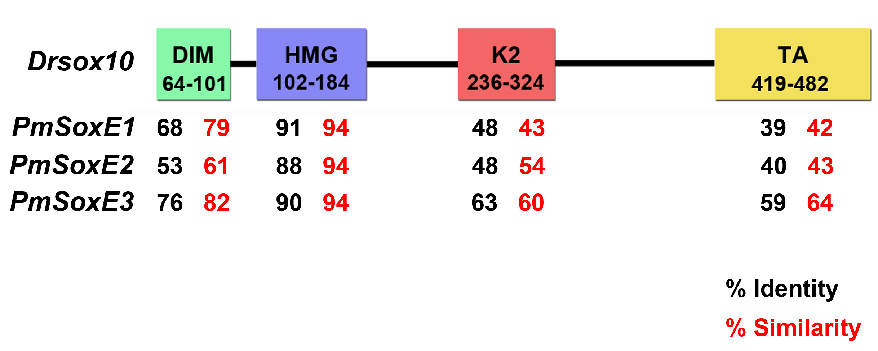
Figure 3.1. Protein identity and similarity comparison matrices between zebrafish Drsox10 and lamprey PmSoxE1, PmSoxE2, and PmSoxE3. The DIM of Drsox10 is most similar to PmSoxE3 (82%) and least similar to PmSoxE2 (61%). The HMG of Drsox10 shares a 94% similarity to the homologous domain of all three lamprey SoxE proteins. The K2 and TA domains of Drsox10 share the highest percent similarity to PmSoxE3, 60% and 64% respectively. Amino acid positions of protein domains are indicated in each box: DIM 64 – 101, HMG 102 – 184, K2 236 – 324, TA 419 – 482. Individual protein domains were compared between zebrafish Drsox10 and lamprey SoxE proteins, with the numbers (black color) representing percent identity and numbers (red color) representing percent similarity. DIM, DNA-dependent dimerization domain; HMG, high-mobility group DNA-binding domain; K2, context dependent transactivation domain; TA C-terminal strong transactivation domain.

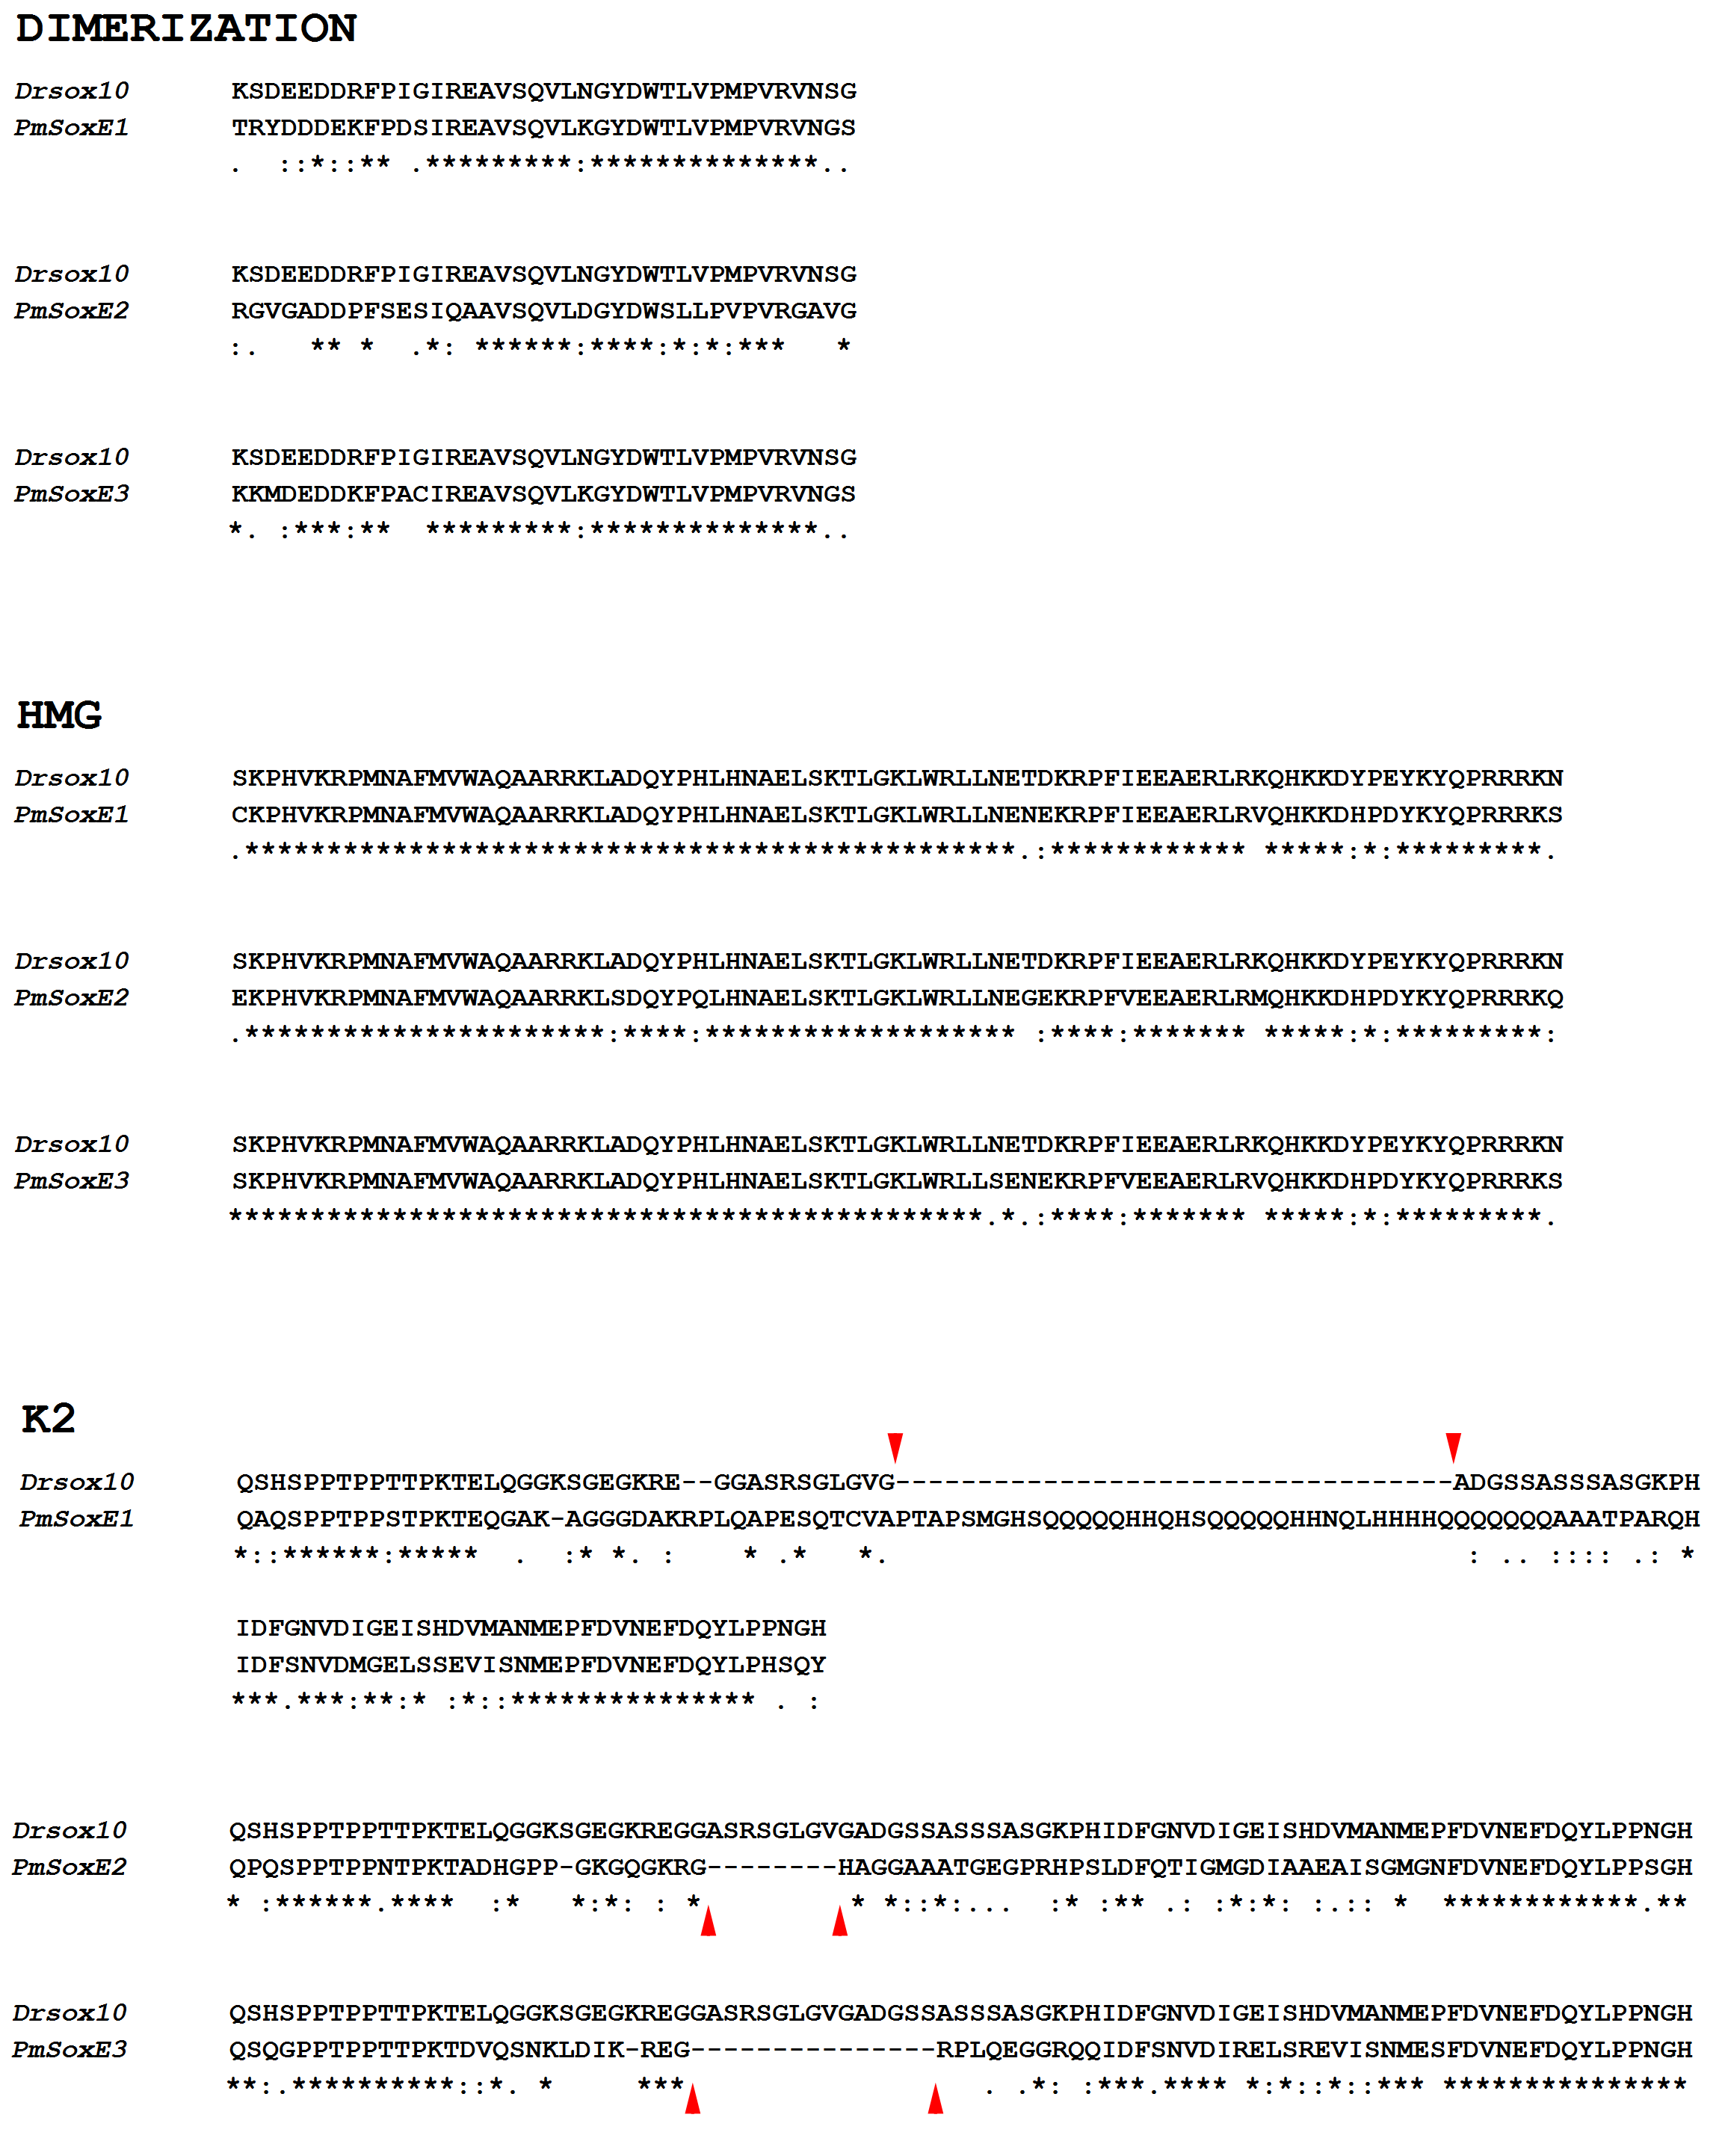
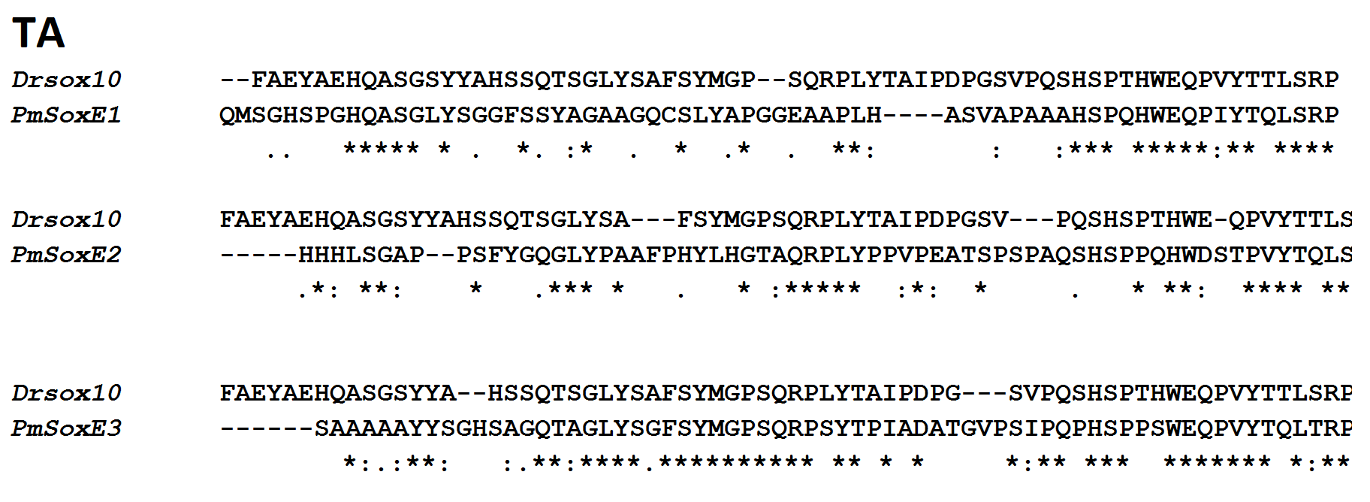
Figure 3.2. Clustal alignments of zebrafish Drsox10 with lamprey PmSoxE1, PmSoxE2, and PmSoxE3 protein domains. Amino acid positions correlate with positions listed in Figure 3.1. DIM and HMG domains show a high level of conservation between zebrafish Drsox10 and lamprey SoxE proteins. A 34 amino acid insertion is present in the K2 of PmSoxE1 causing a large gap in the alignment (downward arrowheads). The K2 domains of PmSoxE2 and PmSoxE3 lack the A-S-R-S-G-L-G-V motif that is present in Drsox10 (upward arrowheads).

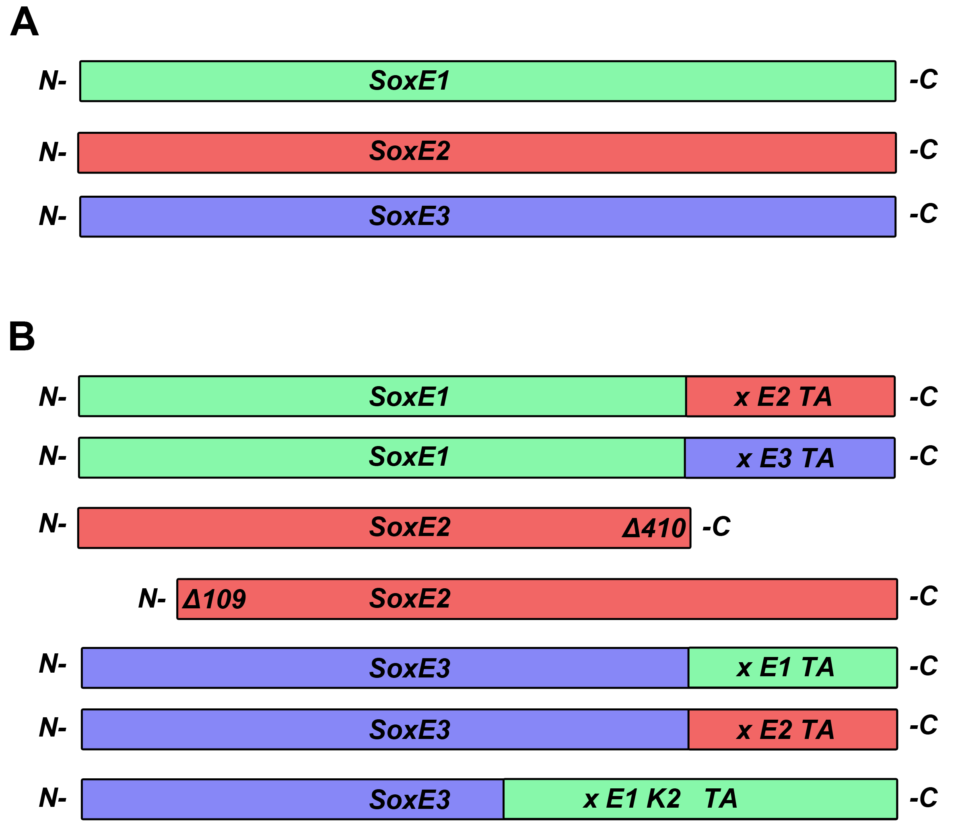
Figure 3.3. Schematic diagram of lamprey full-length PmSoxE1, PmSoxE2, and PmSoxE3 chimeric proteins. (A) PmSoxE1, PmSoxE2, and PmSoxE3 native proteins distinguished by different colors. (B) Lamprey SoxE chimeric and truncation constructs follow the same color scheme as in (A). From top to bottom: SoxE1xE2TA, SoxE1xE3TA, SoxE2Δ410, SoxE2Δ109, SoxE3xE1TA, SoxE3xE2TA, and SoxE3xE1K2TA.

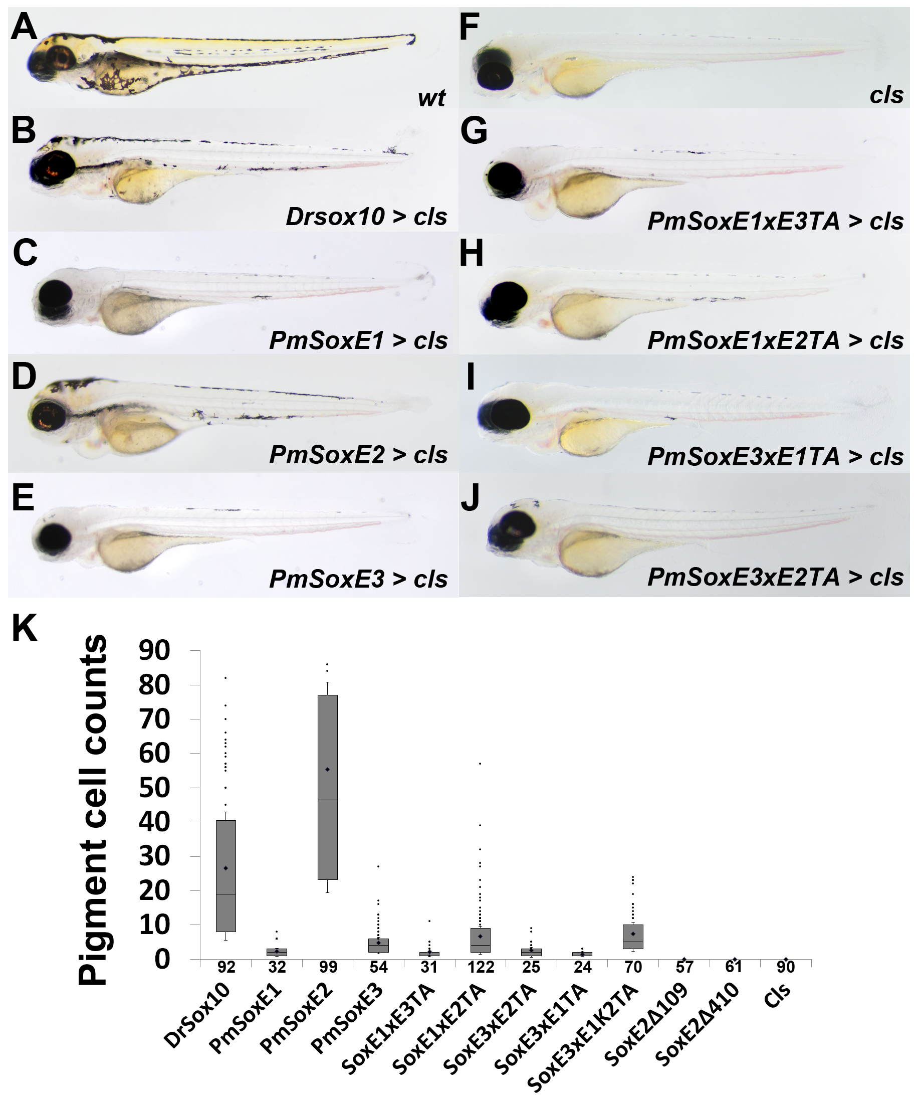
Figure 3.4. Expression of Drsox10, and lamprey SoxE native and chimeric sequences in cls mutant embryos. (A – J) zebrafish larvae 96 hpf showing differentiated melanophores in (A) wildtype control; (B) Drsox10 (mean = 26.5, max = 111); (C) PmSoxE1 (mean = 2.2, max = 8), (D) PmSoxE2 (mean = 55.3, max = 171), and (E) PmSoxE3 (mean = 4.8, max = 27) injected cls; (F) uninjected cls; (G) SoxE1xE3TA (mean = 2.1, max = 11), (H) SoxE1xE2TA (mean = 6.7, max = 57), (I) SoxE3xE2TA (mean = 2.6, max = 11), (J) SoxE3xE1TA (mean = 1.4, max = 3) injected cls. (K) Bar and whisker plot of pigment cells counted along the entire length of each larva. cls mutant larvae lacking melanophores (F). Injection of Drsox10 and PmSoxE2 into cls mutant embryos each induced a greater number of pigment cell differentiation relative to injection of chimeric constructs. Truncation of PmSoxE2 at either the N-terminal or C-terminal end resulted in loss of melanogenic activity in in cls embryos. Chimeric constructs that rescued a greater number of melanophores relative to the respective native proteins include: SoxE1xE2TA > PmSoxE1; SoxE3xE1K2TA >PmSoxE3. Dots above positive whiskers represent individual data points. Numbers on the X-axis denote sample size. Anterior is oriented to the left.

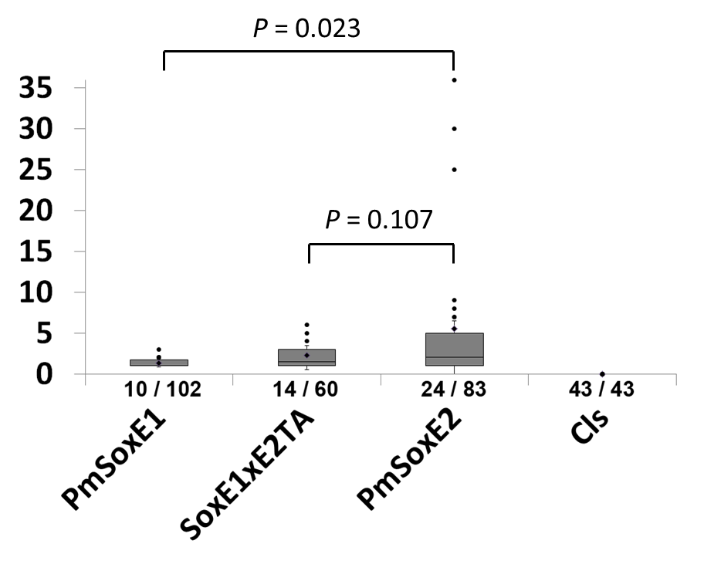
Figure 3.5. Induction of enteric neuron differentiation in cls mutants by PmSoxE1, SoxE1xE2TA, and PmSoxE2. Box and whisker plots indicate the range of Hu-positive neurons counted along the hindgut of 96 hpf cls larvae. cls mutants lack enteric neurons along the hindgut. SoxE1xE2TA (mean = 2.3, max = 6) induced the differentiation of a greater number of Hu-positive neurons than PmSoxE1 (mean = 1.3, max = 3), and a fewer number than PmSoxE2 (mean = 5.6, max = 36). Percent rescue of SoxE1xE2TA (23%) was greater than PmSoxE1 (10%) but less than PmSoxE2 (29%). Dots above the positive whiskers represent individual data points. Numbers on X-axis denote rescue efficacies (rescued / observed).

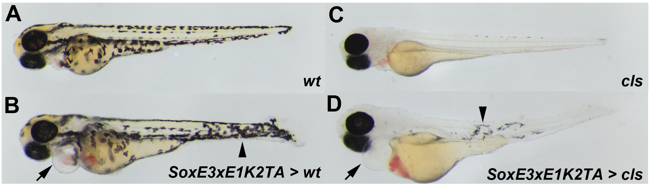
Figure 3.6. Misexpression of SoxE3xE1K2TA in wildtype and cls embryos (A – D) wildtype and cls 76 hpf embryos. (A) wildtype control. (B) ectopic melanophores (arrowhead) and heart edema (arrow) in a wildtype embryo. (C) cls mutant. (D) melanophores (arrowhead) and heart edema (arrow) in a cls embryo. Anterior is oriented to the left.

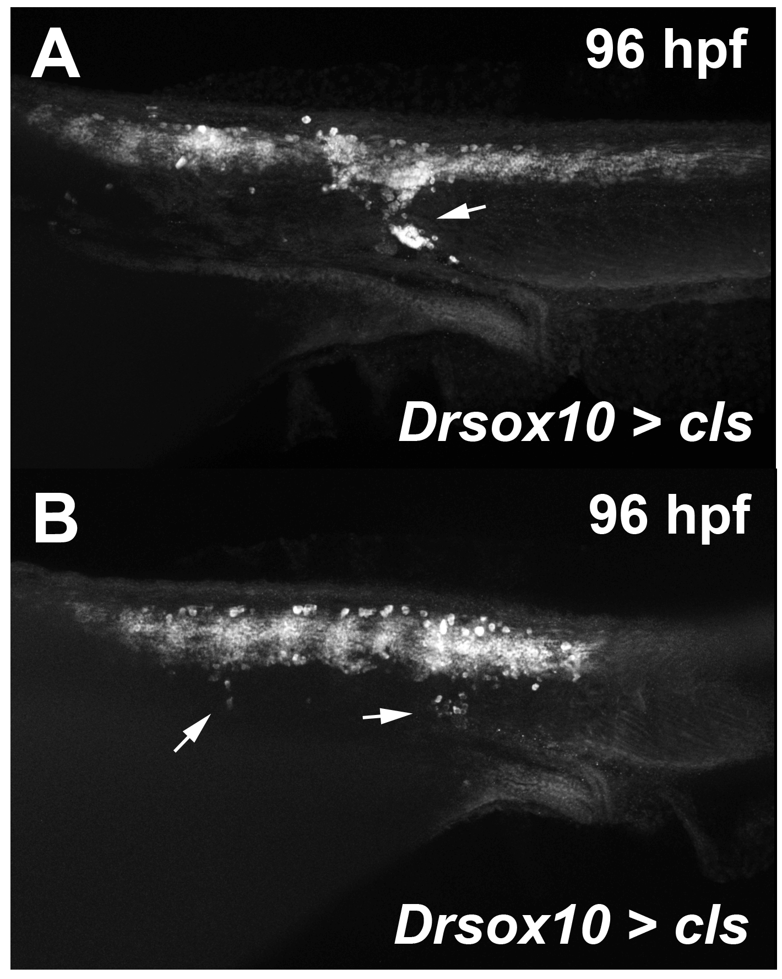
Figure 3.7. Ectopic Hu-positive cells in two cls mutant embryos following injection of the positive control Drsox10 plasmid. (A – B) Drsox10 injected cls mutant larvae stained with anti-HuC/D showing groups of Hu-positive cells located dorsal to the hindgut (arrows). Anterior is oriented to the left.

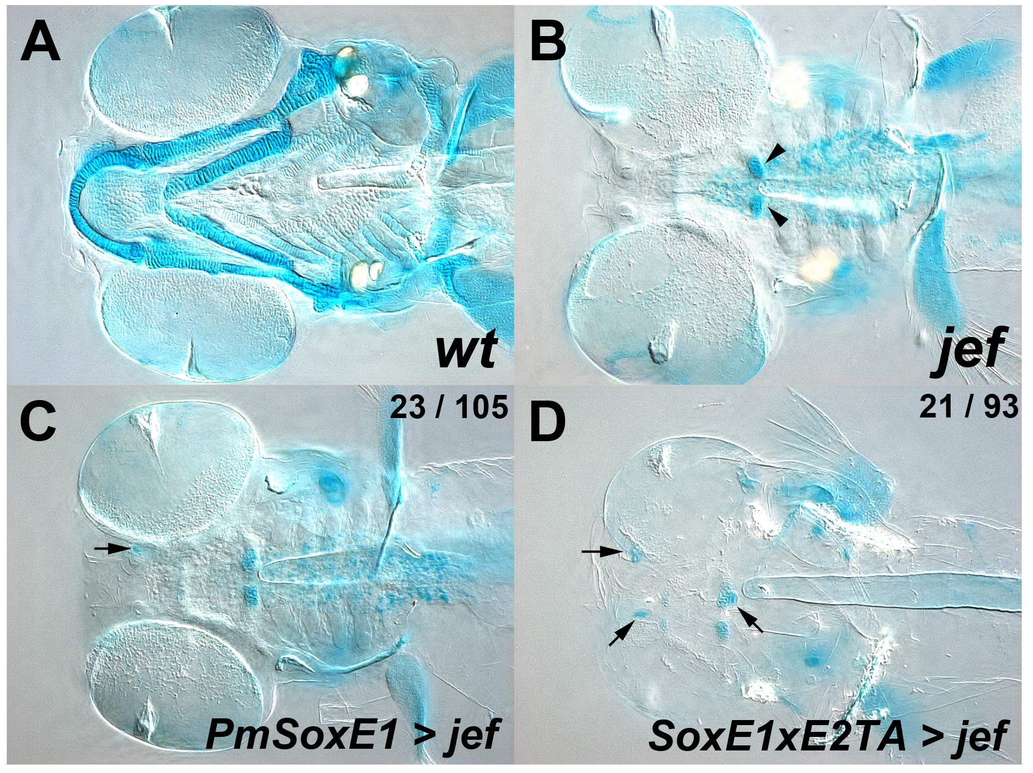
Figure 3.8. Comparison of cartilage nodules in jef mutants injected with full-length PmSoxE1 or chimeric SoxE1xE2TA constructs. (A – D) Differential interference contrast images of Alcian blue stained zebrafish larvae 96 hpf. (A) Wildtype craniofacial skeleton. (B) cartilage development is limited to two small elements in a jef mutant larva (arrowheads). (C) cartilage nodules in jef a mutant injected with PmSoxE1 (n = 23, 22%; arrow). (D) cartilage nodule formations in jef a mutant injected with PmSoxE1xE2TA (n = 21, 23%; arrows). Top right corner of (C) and (D) shows number of animals rescued / observed. Anterior is oriented to the left.

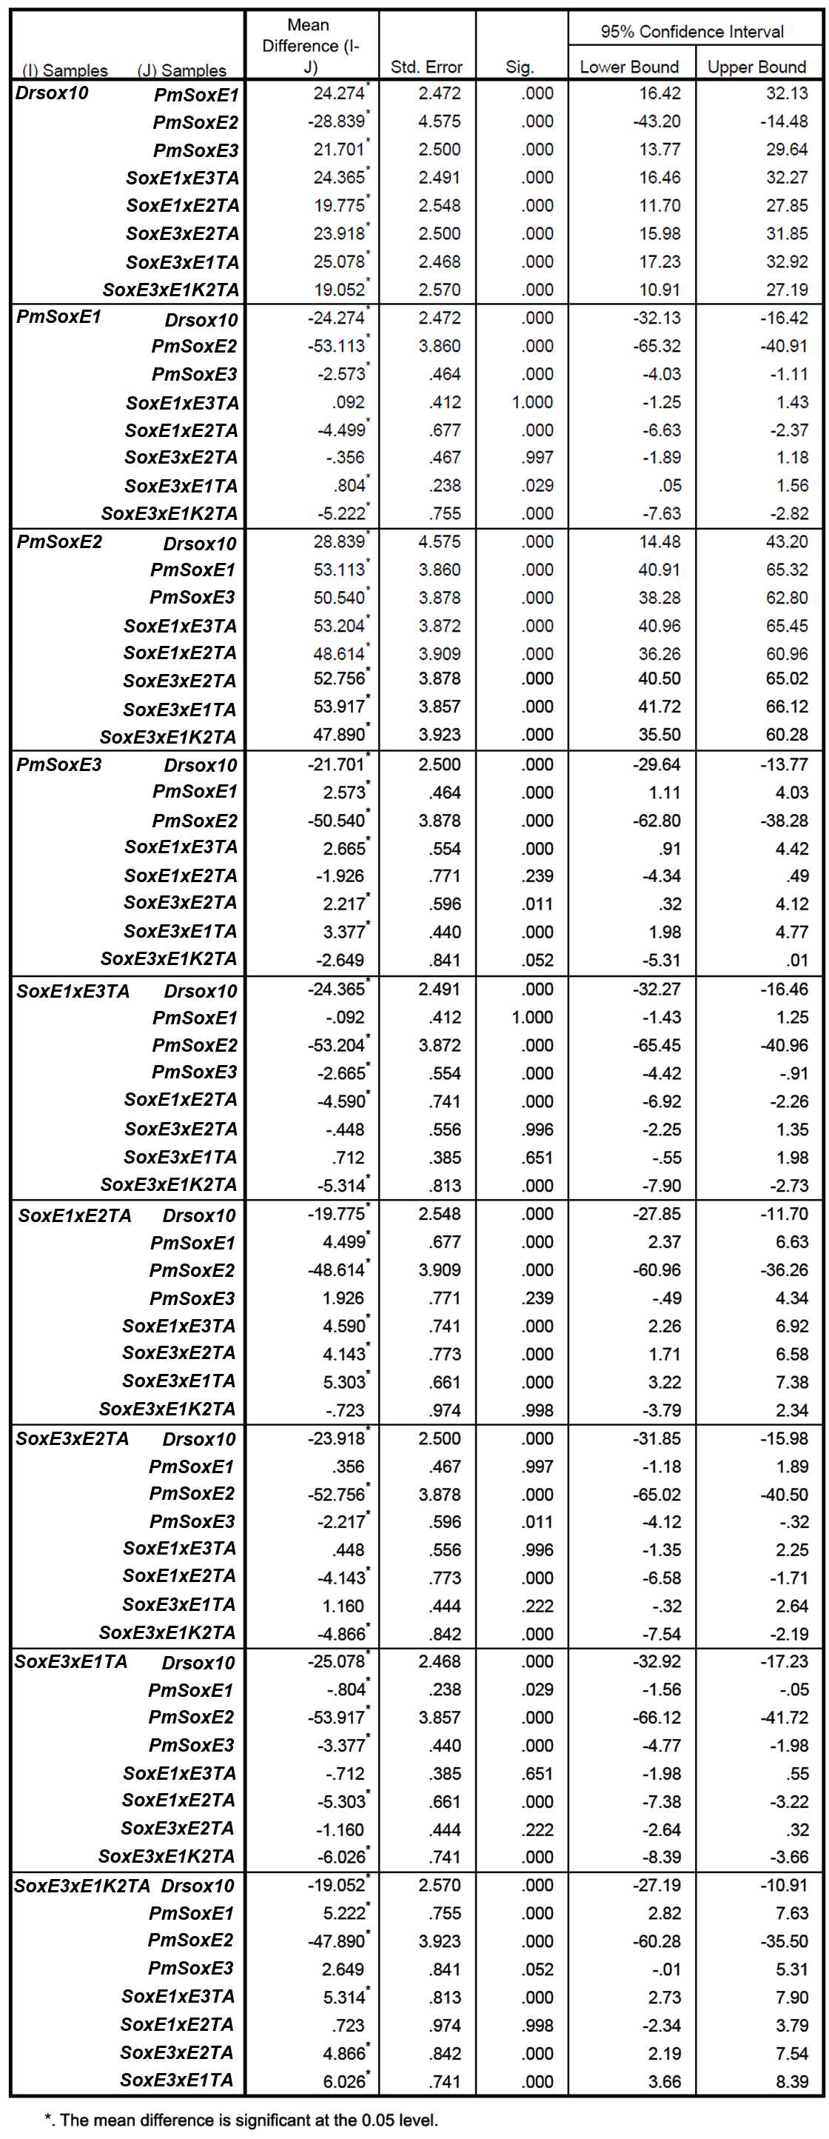
Table 3.1. Table of results from ANOVA post hoc Games-Howell multiple comparisons test; modified from IBM SPSS Statistics (ver. 20) output.

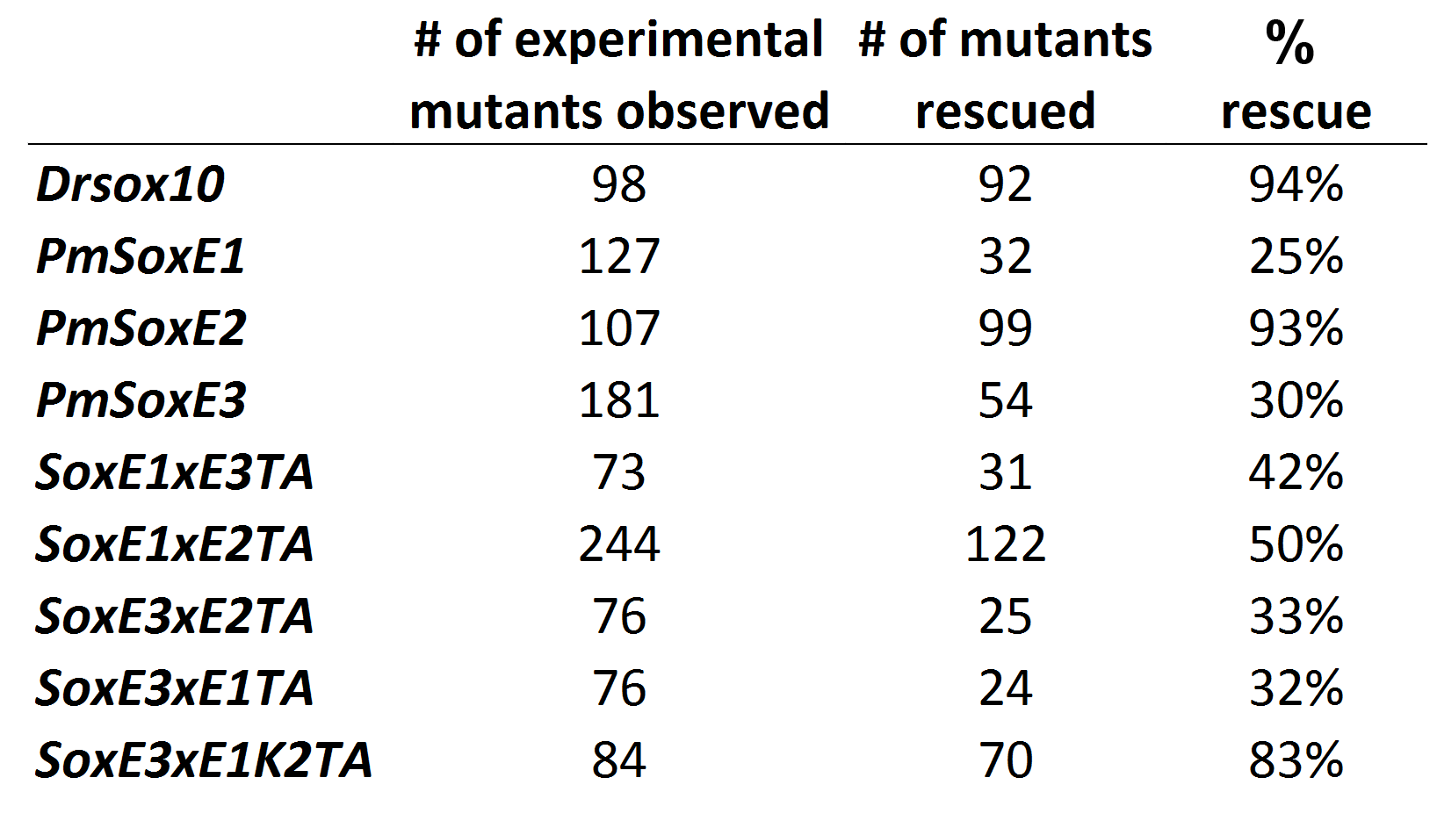
Table 3.2. Percentage of plasmid injected cls larvae that exhibit at least one rescued pigment cell. The left-most column identifies the construct injected into cls embryos. Drsox10 and PmSoxE2 both induced melanophore differentiation in more than 90% of embryos injected. Rescue efficacies in SoxE1xE2TA (50%) and SoxE1xE3TA (42%) are both greater than PmSoxE1 (25%). SoxE3xE1K2TA (83%) rescued a greater percentage of cls larvae than PmSoxE3 (30%).

Construct Name | Primer Sequences
PmSoxE1xE3TA | F: 5’- GAGCGGCCGACGCACGTCAAGACTGAGCAG -3’
 | R: 5’- CTGCTCAGTCTTGACGTGCGTCGGCCGCTC -3’
PmSoxE1xE2TA | F: 5’- GAGCGGCCGACGCACGTGAAAACTGAGCAG -3’
 | R: 5’- CTGCTCAGTTTTCACGTGCGTCGGCCGCTC -3’
PmSoxE3xE2TA | F: 5’- GAGCAGAGAGCGCATGTGAAAACTGAGCAG -3’
 | R: 5’- CTGCTCAGTTTTCACATGCGCTCTCTGCTC -3’
PmSoxE3xE1TA | F: 5’- GAGCAGAGAGCGCATATCAAGACCGAGCAG -3’
 | R: 5’- CTGCTCGGTCTTGATATGCGCTCTCTGCTC -3’
PmSoxE2Δ109 | F: 5’- AAAGAATTCATGCCCCACGTGAAG AGG -3’
PmSoxE2Δ410 | R: 5’- TTTTCTAGATTACTACTGCTCAGTTTTCAC -3’
SoxE3xE1K2TA | F: 5’- AGGCGGAGAAAGTCGGTCAAGGGCTCCGGC -3’
 | R: 5’- GCCGGAGCCCTTGACCGACTTTCTCCGCCT -3’

Table 3.3. Overlapping and internal primers used to make chimeric constructs. F: forward primer, R: reverse primer.

