THE UNIVERSITY OF OKLAHOMA
GRADUATE COLLEGE

EVALUATION OF STORMWATER TREATMENT BY VARIOUS REACTIVE MEDIA FOR BIORETENTION CELL DESIGN CONSIDERATIONS

A THESIS
SUBMITTED TO THE GRADUATE FACULTY
in partial fulfillment of the requirements for the
Degree of
MASTER OF SCIENCE IN ENVIRONMENTAL ENGINEERING

By
DERRICK XUAN NGUYEN
Norman, Oklahoma
2018

EVALUATION OF STORMWATER TREATMENT BY VARIOUS REACTIVE MEDIA FOR BIORETENTION CELL DESIGN CONSIDERATIONS

A THESIS APPROVED FOR THE
SCHOOL OF CIVIL ENGINEERING AND ENVIRONMENTAL SCIENCE

BY

___________________________
Dr. Robert Nairn, Chair

___________________________
Dr. Gerald Miller

___________________________
Dr. Jason Vogel

© Copyright by DERRICK XUAN NGUYEN 2018
All Rights Reserved.

This thesis is dedicated to my parents who were forced to leave their country and work endlessly to give me an advantage in my education, an opportunity they not were not able to have. Con yêu Má với Pá rất nhiều.

ACKNOWLEDGEMENTS
I would like to acknowledge and thank the Grand River Dam Authority for funding my research and providing the fly ash used in this research. Thank you to Peggy Jones (American Peat Technology) and Paul Eger (Global Minerals Engineering; Sovereign Consulting, Inc.) for donating APTsorb and bioAPT samples, as well as providing information and knowledge about those products. I would like acknowledge Dr. Glenn Brown who designed the laboratory column used in this research. Additionally, I want to acknowledge Quikrete as the manufacturers of the sand used in this research and U.S. Fabrics, Inc. for providing me with geotextile samples. I want to also thank Dr. David Sabatini and Dr. Teshome Lemma for their contributions to my knowledge of physicochemical processes. Thank you to members of the Center for Restoration of Ecosystems and Watersheds for assistance in the laboratory, technical knowledge, and critiques. Finally, I wanted to thank my family and circle of friends, who I basically consider family, anyway. Without their support throughout my graduate studies, I most likely would not have had the courage to finish.

TABLE OF CONTENTS
CHAPTER 1: Introduction and Literature Review 1
1.1 Introduction 1
1.2 Literature Review 3
1.2.1 Urban Stormwater Runoff 3
1.2.2 An Overview of Bioretention Cell Design 7
1.2.3 Variable Bioretention Cell Performance Issues 13
1.2.4 Reactive Media 15
1.2.5 Other Reactive Media 19
1.2.6 Nutrient Analyses Reporting 21
1.3 Hypotheses and Objectives 22
1.3.1 Hypotheses 23
1.3.2 Objectives 23
CHAPTER 2: Methods and Materials 25
2.1 Preliminary Hydraulic Conductivity Screening 26
2.2 Laboratory Column Experiments 30
2.2.1 Column Packing and Flow Rates 33
2.2.2 Synthetic Stormwater 34
2.2.3 Water Sample Collection and Preservation 35
2.2.4 Water Quality Analyses 36
2.2.5 Statistical Tests 37
2.3 Chemical Characterization of Media 37
2.4 Geotechnical Characterization of Media 39
2.5 Cost Analyses 40
CHAPTER 3: Results, Discussion, and Conclusions 44
3.1 Preliminary Hydraulic Conductivity Screening 44
3.2 Media Characterization 47
3.2.1 Toxicity Characteristic Leaching Procedure 47
3.2.2 Solids Digestion Extraction 47
3.2.3 Points of Zero Charge 48
3.3 Geotechnical Characterization 49
3.3.1 Particle-size Distribution 50
3.4 Pollutant Removal Performance 51
3.4.1 Observations of Data Below Detection Limits 51
3.4.2 Laboratory Column Physical Characteristics 52
3.4.3 Influent Synthetic Stormwater Characteristics 53
3.4.4 General Effluent Characteristics 56
3.4.5 Phosphorus 59
3.4.6 Nitrogen 72
3.4.7 Metals 86
3.5 Water Quality Criteria Exceedances 114
3.6 Cost Analyses 114
3.7 Conclusions 117
3.7.1 Summary 117
3.7.2 Concluding Remarks 120
3.7.3 Study Limitations and Recommendations 120
References 123
Appendices 138
Appendix I: Quikrete Product Data Sheets 138
Appendix II: Fly Ash Material Composition Analysis Report 148
Appendix III: American Peat Technology Product and Safety Data Sheets 149
Appendix IV: Raw In-Situ Data by Individual Sample 159
Appendix V: Raw Nutrients Data by Individual Sample 161
Appendix VI: Raw Metals Data by Individual Sample - Copper, Lead, and Zinc 163
Appendix VII: Raw Metals Data by Individual Sample - Silver, Arsenic, Cadmium, Mercury, Nickel, and Selenium 165
Appendix VIII: Raw TOC/N Data by Individual Sample and Calibration Reports 169
Appendix IX: EPA Recommended Water Quality Criteria for Aquatic Life – Hardness Adjusted Metals Limits by Individual Sample 179
Appendix X: Graphs of Points of Zero Charge by pH Drift Method 183

LIST OF TABLES
Table 1: Select water quality data for residential and mixed residential land use categories, summarized from the NSQDv4.02 (BMP Database, 2015). 5
Table 2: Summary of reactive media, sources, and descriptions. 26
Table 3: Material composition of media used in hydraulic conductivity screening percentages by mass. 27
Table 4: Column flow rates and pore volumes. 34
Table 5: Target synthetic stormwater constituent concentrations, based on typical residential runoff (BMP Database, 2015). 35
Table 6: Water quality analytical methods and instrumentation. 37
Table 7: Geotechnical parameters and associated analytical methods. 39
Table 8: Assumptions used in bioretention cell cost analysis (pricing not adjusted in this table). 42
Table 9: Variable costs of materials and hauling distances used in bioretention cell cost analysis. 43
Table 10: Summary of measured hydraulic conductivities of various media. 45
Table 11: EPA RCRA-8 metals concentrations in media and material Toxicity Characteristic Leaching Procedure extracts. 47
Table 12: Results of solids digestion extraction. 48
Table 13: Point of zero charge results in 0.01 M and 0.1 M KNO₃ electrolyte solutions. 49
Table 14: Summary of geotechnical characteristics of media and materials. 50
Table 15: Particle-size distributions by sieve analysis of course materials. 51
Table 16: Particle-size distribution by hydrometer analysis of mine drainage residuals. 51
Table 17: Percentage of below-detection-limit data for ammonia, copper, lead, and zinc samples. 52
Table 18: Summary of laboratory column physical characteristics. 53
Table 19: In-situ measurements of influent synthetic stormwater. 54
Table 20: Nitrogen and phosphorus concentrations of influent synthetic stormwater. 54
Table 21: Total and filtered metals concentrations of influent synthetic stormwater. 55
Table 22: Total organic carbon, total inorganic carbon, total carbon, and hardness concentrations of influent synthetic stormwater. 56
Table 23: Averaged results and standard deviations for in-situ characteristics of column effluents. 57
Table 24: Averaged results and standard deviations for calcium concentrations of column effluents. 58
Table 25: Averaged results and standard deviations for total organic carbon concentrations of column effluents. 58
Table 26: Averaged results and standard deviations for total inorganic carbon concentrations of column effluents. 59
Table 27: Averaged results and standard deviations for total carbon concentrations of column effluents. 59
Table 28: Averaged results and standard deviations for normalized effluent total phosphorus concentrations from each column. 60
Table 29: Averaged results and standard deviations for normalized effluent total dissolved phosphorus concentrations from each column. 60
Table 30: Averaged results and standard deviations of estimated total phosphorus mass balances of each column. 60
Table 31: Averaged results and standard deviations of estimated total dissolved phosphorus mass balances of each column. 60
Table 32: Results of Mann-Whitney U test comparing normalized effluent total phosphorus concentrations of reactive media with SAND (α = 0.10). 71
Table 33: Results of Mann-Whitney U test comparing normalized effluent total dissolved phosphorus concentrations of reactive media with SAND (α = 0.10). 72
Table 34: Averaged results and standard deviations for normalized effluent nitrate concentrations from each column. 73
Table 35: Averaged results and standard deviations of estimated nitrate mass balances of each column. 73
Table 36: Results of Mann-Whitney U test comparing normalized effluent nitrate concentrations of reactive media with SAND (α = 0.10). 79
Table 37: Summary of average ammonia concentrations and standard deviations in column effluents. 80
Table 38: Averaged results and standard deviations for normalized effluent total nitrogen concentrations from each column. 82
Table 39: Averaged results and standard deviations of estimated total nitrogen mass balances of each column. 82
Table 40: Averaged results and standard deviations for normalized effluent total copper concentrations from each column. 87
Table 41: Averaged results and standard deviations for normalized effluent filtered copper concentrations from each column. 87
Table 42: Averaged results and standard deviations of estimated total copper mass balances of each column. 87
Table 43: Averaged results and standard deviations of estimated filtered copper mass balances of each column. 87
Table 44: Results of Mann-Whitney U test comparing normalized effluent total copper concentrations of reactive media with SAND (α = 0.10). 96
Table 45: Averaged results and standard deviations for normalized effluent total lead concentrations from each column. 97
Table 46: Averaged results and standard deviations for normalized effluent filtered lead concentrations from each column. 97
Table 47: Averaged results and standard deviations of estimated total lead mass balances of each column. 97
Table 48: Averaged results and standard deviations of estimated filtered lead mass balances of each column. 97
Table 49: Results of Mann-Whitney U test comparing normalized effluent total lead concentrations of reactive media with SAND (α = 0.10). 105
Table 50: Averaged results and standard deviations for normalized effluent total zinc concentrations from each column. 106
Table 51: Averaged results and standard deviations for normalized effluent filtered zinc concentrations from each column. 106
Table 52: Averaged results and standard deviations of estimated total zinc mass balances of each column. 106
Table 53: Averaged results and standard deviations of estimated filtered zinc mass balances of each column. 106
Table 54: Number of recommended water-quality metals criteria exceedances in column effluent samples (n=12). 114
Table 55: Cost analysis of different media in bioretention cells with itemized parameters and adjusted costs. 116
Table 56: Costs of various existing bioretention cells with areas converted to square feet and costs adjusted for inflation (Coffman, 2014; Chavez, 2015). 117
Table 57: Summary of potential pollutant removal mechanisms by reactive media (Green=Removal; Red=Export; Gray=No Appreciable Change). 118
Table IV-1: Raw in-situ data by individual sample (1 of 2). 159
Table IV-2: Raw in-situ data by individual sample (2 of 2). 160
Table V-1: Raw nutrients data by individual sample (1 of 2). 161
Table V-2: Raw nutrients data by individual sample (2 of 2). 162
Table VI-1: Raw copper, lead, and zinc data by individual sample (1 of 2). 163
Table VI-2: Raw copper, lead, and zinc data by individual sample (2 of 2). 164
Table VII-1: Raw silver, arsenic, and cadmium data by individual sample (1 of 2). 165
Table VII-2: Raw silver, arsenic, and cadmium data by individual sample (2 of 2). 166
Table VII-3: Raw mercury, nickel, and selenium data by individual sample (1 of 2). 167
Table VII-4: Raw mercury, nickel, and selenium data by individual sample (2 of 2). 168
Table IX-1: Hardness adjusted EPA Recommended Water Quality Criteria for Aquatic Life for arsenic, cadmium, chromium(III), chromium(IV), and copper by individual sample (1 of 2). 179
Table IX-2: Hardness adjusted EPA Recommended Water Quality Criteria for Aquatic Life for arsenic, cadmium, chromium(III), chromium(IV), and copper by individual sample (2 of 2). 180
Table IX-3: Hardness adjusted EPA Recommended Water Quality Criteria for Aquatic Life for lead, mercury, nickel, selenium, silver, and zinc by individual sample (1 of 2). 181
Table IX-4: Hardness adjusted EPA Recommended Water Quality Criteria for Aquatic Life for lead, mercury, nickel, selenium, silver, and zinc by individual sample (2 of 2). 182

LIST OF FIGURES
Figure 1: A simplified cross-section of a typical bioretention cell showing its layers. 9
Figure 2: Falling-head permeameter packing schematic. 29
Figure 3: Falling-head permeameter for measuring hydraulic conductivity. 30
Figure 4: An acrylic column used in the pollutant removal experiments, designed by Dr. Glenn Brown. 31
Figure 5: Set-up of laboratory column experiments with synthetic stormwater sources in 20-L carboys, peristaltically pumped from bottom of packed columns (left: two FA5.0 columns; right: two MDR7.5 columns). 32
Figure 6: Effect of increasing fly ash content on hydraulic conductivity of sand. 45
Figure 7: Effect of increasing mine drainage residuals content on hydraulic conductivity of sand. 46
Figure 8: Comparison of hydraulic conductivities among all measured media. 46
Figure 9: Normalized effluent total phosphorus concentrations of SAND columns. 61
Figure 10: Normalized effluent total dissolved phosphorus concentrations of SAND columns. 62
Figure 11: Normalized effluent total phosphorus concentrations of FA5.0 columns. 63
Figure 12: Normalized effluent total dissolved phosphorus concentrations of FA5.0 columns. 63
Figure 13: Correlation scatter plot of log of calcium concentration and log of normalized effluent total phosphorus concentration. 64
Figure 14: Correlation scatter plot of log of calcium concentration and log of normalized effluent total dissolved phosphorus concentration. 64
Figure 15: Normalized effluent total phosphorus concentrations of MDR7.5 columns. 65
Figure 16: Normalized effluent total dissolved phosphorus concentrations of MDR7.5 columns. 66
Figure 17: Normalized effluent total phosphorus concentrations of APT columns. 67
Figure 18: Normalized effluent total dissolved phosphorus concentrations of APT columns. 67
Figure 19: Normalized effluent total phosphorus concentrations of BIO columns. 69
Figure 20: Normalized effluent total dissolved phosphorus concentrations of BIO columns. 69
Figure 21: Correlation scatter plot of total organic carbon concentration and normalized effluent total phosphorus concentration. 70
Figure 22: Correlation scatter plot of total organic carbon concentration and normalized effluent total dissolved phosphorus concentration. 70
Figure 23: Normalized effluent nitrate concentrations from SAND columns. 74
Figure 24: Normalized effluent nitrate concentrations from FA5.0 columns. 75
Figure 25: Normalized effluent nitrate concentrations from MDR7.5 columns. 76
Figure 26: Normalized effluent nitrate concentrations from APT columns. 77
Figure 27: Normalized effluent nitrate concentrations from BIO columns. 78
Figure 28: Correlation scatter plot of total organic carbon concentration and ammonia concentration. 81
Figure 29: Percentages of nitrate and ammonia of total nitrogen in SAND column water samples. 83
Figure 30: Percentages of nitrate and ammonia of total nitrogen in FA5.0 column water samples. 83
Figure 31: Percentages of nitrate and ammonia of total nitrogen in MDR7.5 column water samples. 84
Figure 32: Percentages of nitrate and ammonia of total nitrogen in APT column water samples. 85
Figure 33: Percentages of nitrate and ammonia of total nitrogen in BIO column water samples. 85
Figure 34: Correlation scatter plot of total organic carbon concentration and normalized effluent total nitrogen concentration. 86
Figure 35: Normalized effluent total copper concentrations of SAND columns. 88
Figure 36: Normalized effluent filtered copper concentrations of SAND columns. 89
Figure 37: Normalized effluent total copper concentrations of FA5.0 columns. 90
Figure 38: Normalized effluent filtered copper concentrations of FA5.0 columns. 90
Figure 39: Normalized effluent total copper concentrations of MDR7.5 columns. 91
Figure 40: Normalized effluent filtered copper concentrations of MDR7.5 columns. 92
Figure 41: Normalized effluent total copper concentrations of APT columns. 93
Figure 42: Normalized effluent filtered copper concentrations of APT columns. 93
Figure 43: Normalized effluent total copper concentrations of BIO columns. 94
Figure 44: Normalized effluent filtered copper concentrations of BIO columns. 95
Figure 45: Normalized effluent total lead concentrations of SAND columns. 98
Figure 46: Normalized effluent filtered lead concentrations of SAND columns. 99
Figure 47: Normalized effluent total lead concentrations of FA5.0 columns. 100
Figure 48: Normalized effluent filtered Pb concentrations of FA5.0 columns. 100
Figure 49: Normalized effluent total lead concentrations of MDR7.5 columns. 101
Figure 50: Normalized effluent filtered lead concentrations of MDR7.5 columns. 102
Figure 51: Normalized effluent total lead concentrations of APT columns. 103
Figure 52: Normalized effluent filtered lead concentrations of APT columns. 103
Figure 53: Normalized effluent total lead concentrations of BIO columns. 104
Figure 54: Normalized effluent filtered lead concentrations of BIO columns. 104
Figure 55: Normalized effluent total zinc concentrations of SAND columns. 107
Figure 56: Normalized effluent filtered zinc concentrations of SAND columns. 108
Figure 57: Normalized effluent total zinc concentrations of FA5.0 columns. 109
Figure 58: Normalized effluent filtered zinc concentrations of FA5.0 columns. 109
Figure 59: Normalized effluent total zinc concentrations of MDR7.5 columns. 110
Figure 60: Normalized effluent filtered zinc concentrations of MDR7.5 columns. 111
Figure 61: Normalized effluent total zinc concentrations of APT columns. 112
Figure 62: Normalized effluent filtered zinc concentrations of APT columns. 112
Figure 63: Normalized effluent total zinc concentrations of BIO columns. 113
Figure 64: Normalized effluent filtered zinc concentrations of BIO columns. 113
Figure I-1: Quikrete® All Purpose Sand product data sheet. 138
Figure I-2: Quikrete® All Purpose Sand safety data sheet (1 of 9). 139
Figure I-3: Quikrete® All Purpose Sand safety data sheet (2 of 9). 140
Figure I-4: Quikrete® All Purpose Sand safety data sheet (3 of 9). 141
Figure I-5: Quikrete® All Purpose Sand safety data sheet (4 of 9). 142
Figure I-6: Quikrete® All Purpose Sand safety data sheet (5 of 9). 143
Figure I-7: Quikrete® All Purpose Sand safety data sheet (6 of 9). 144
Figure I-8: Quikrete® All Purpose Sand safety data sheet (7 of 9). 145
Figure I-9: Quikrete® All Purpose Sand safety data sheet (8 of 9). 146
Figure I-10: Quikrete® All Purpose Sand safety data sheet (9 of 9). 147
Figure II-1: Fly ash material composition report. 148
Figure III-1: APTsorb product data sheet (1 of 2). 149
Figure III-2: APTsorb product data sheet (2 of 2). 150
Figure III-3: APTsorb safety data sheet (1 of 3). 151
Figure III-4: APTsorb safety data sheet (2 of 3). 152
Figure III-5: APTsorb safety data sheet (3 of 3). 153
Figure III-6: bioAPT product data sheet (1 of 2). 154
Figure III-7: bioAPT product data sheet (2 of 2). 155
Figure III-8: bioAPT safety data sheet (1 of 3). 156
Figure III-9: bioAPT safety data sheet (2 of 3). 157
Figure III-10: bioAPT safety data sheet (3 of 3). 158
Figure VIII-1: Raw TOC/N Data Report 1 (1 of 3). 169
Figure VIII-2: Raw TOIC/N Data Report 1 (2 of 3). 170
Figure VIII-3: Raw TOC/N Data Report 1 (3 of 3). 171
Figure VIII-4: Raw TOC/N Data Report 2 (1 of 5). 172
Figure VIII-5: Raw TOC/N Data Report 2 (2 of 5). 173
Figure VIII-6: Raw TOC/N Data Report 2 (3 of 5). 174
Figure VIII-7: Raw TOC/N Data Report 2 (4 of 5). 175
Figure VIII-8: Raw TOC/N Data Report 2 (5 of 5). 176
Figure VIII-9: Total carbon and total inorganic carbon calibration report. 177
Figure VIII-10: Total nitrogen calibration report. 178
Figure X-1: SAND point of zero charge graph. 183
Figure X-2: FA point of zero charge graph. 183
Figure X-3: FA5.0 point of zero charge graph. 184
Figure X-4: MDR point of zero charge graph. 184
Figure X-5: MDR7.5 point of zero charge graph. 185
Figure X-6: APT point of zero charge graph. 185
Figure X-7: BIO point of zero charge graph. 186

Abstract
Bioretention cells (BRC) can be effective at filtering particulate pollutants from stormwater runoff, but substantial removal of the dissolved pollutant fraction is challenging. Various reactive treatment media for BRCs were evaluated to address nitrate (NO₃⁻) and dissolved fractions of phosphorus (P), copper (Cu²⁺), lead (Pb²⁺), and zinc (Zn²⁺) removal in BRCs. Fly ash (FA) and iron oxyhydroxide mine drainage residuals (MDR) were blended with sand at 5% (FA5.0) and 7.5% (MDR7.5) by mass. Additionally, APTsorb (APT) and bioAPT (BIO), commercially available granulated and hardened peat products, were evaluated as treatment media, each with a sand layer to augment hydraulic retention time. Pollutant removal performance was evaluated by pumping synthetic stormwater (SS) through packed up-flow columns. 100% sand (SAND) was used as the control media. SS had target concentrations of NO₃⁻ at 1.5 milligrams per liter (mg/L) as N, phosphate (PO₄³⁻) at 0.5 mg/L as P, Cu²⁺ at 25 µg/L, Pb²⁺ at 30 µg/L, and Zn²⁺ at 100 µg/L. FA5.0 and MDR7.5 both removed over 84% of P. SAND, APT, and BIO had limited TP and TDP removal rates with BIO showing net export. All proposed media had Cu²⁺ and Zn²⁺ removal rates of over 75% and 89%, respectively. APT showed the highest Pb²⁺ removal at over 84%. FA5.0 and MDR7.5 were the most cost-effective options that did not show export of pollutants, therefore they are recommended as amendments to BRC media.

Introduction and Literature Review

Introduction
Urban stormwater management practices are typically developed to minimize flood risk by shunting water from the landscape to the nearest receiving water body using impervious surfaces, such as rooftops, pavement, and stormwater drainage systems (Walsh et al., 2012). Unlike natural surfaces that allow for infiltration, rainfall onto impervious surfaces results in greater amounts of stormwater that “runs off,” thereby increasing water volume and peak flow (Vogel and Moore, 2016). Additionally, runoff from impervious surfaces collects and conveys pollutants, which degrade downstream water quality (Liu et al., 2014). Common pollutants in urban runoff include total suspended solids (TSS), trace metals, nutrients, pathogens, and organic compounds (Liu et al., 2014).

Low-impact development (LID) technologies, such as the bioretention cell (BRC), are widely used to capture runoff, control water quantity and water quality, and decrease or negate the effects of impervious infrastructure characteristically associated with urban development (Dietz et al., 2007; Roy-Poirier et al., 2010; Payne et al., 2014; LeFevre et al., 2015; Vogel et al., 2015; Holzbauer-Schweitzer, 2016). BRCs function by capturing upstream runoff from impervious and saturated surfaces for treatment using vegetated, treatment media (usually sand-based), with a drainage layer below consisting of gravel and a drainage pipe for discharge (Payne et al., 2015). The pollutant removal performance of BRCs have been variable, ranging from high to poor pollutant removal and net production in some cases (Roy-Poirier et al., 2010; Payne et al., 2014, Holzbauer-Schweitzer, 2016). BRCs do well to remove TSS and particulate fractions of pollutants, but still leave a significant portion of the dissolved fractions to be addressed (LeFevre et al., 2015). Soils high in organic matter (OM) and incorporating compost can remove organic pollutants and the dissolved fraction of metals by forming OM-metal complexes; however, the usage of compost results in mediocre nutrient removal performance, where net production of nitrogen (N) and P is common (Roy-Poirier et al., 2010; Graves et al., 2014; Payne et al., 2014; LeFevre et al., 2015). For example, the discharge at the Trailwoods residential rain gardens in Norman, Oklahoma resulted in P export, which was attributed to residential applications of fertilizer and the compost mix of 10 percent (%) OM (Holzbauer-Schweitzer, 2016).

This study proposed the use of various reactive materials as BRC media in to address the removal of dissolved pollutants, while minimizing nutrient leaching. These reactive media included mine drainage residuals (MDR), Class C fly ash (FA), and two manufactured peat-based sorptive media, APTsorb (APT), and bioAPT (BIO). An MDR-sand mix (MDR7.5) was used at 7.5% MDR with 92.5% sand to increase hydraulic conductivity of MDRs. Similarly, the FA-sand mix (FA5.0) was composed of 5.0% FA and 95% sand. APT and BIO were not used as amendments but were used as the layer with sand as the second layer, at a one-to-three peat-to-sand ratio. This research evaluated the pollutant removal performance of the reactive media for NO₃⁻, PO₄³⁻, Cu²⁺, Pb²⁺, and Zn²⁺ in laboratory up-flow treatment columns. SS was pumped upward through columns packed with the reactive media. Performance was evaluated based on net changes in pollutant concentrations in column effluents. Results of the performance evaluation determined if the potential application of each media in BRCs could enhance water treatment performance.

Literature Review

Urban Stormwater Runoff
Runoff is excess precipitation that flows over, or “runs off,” a surface. Runoff occurs when natural surfaces have reached saturation or when precipitation falls on impervious surfaces, characteristically associated with urban development. As a result, the urban runoff volume is greater than runoff from natural or undeveloped environments (Vogel and Moore, 2016). Traditional stormwater management plans are primarily designed to minimize flood risk by quickly draining runoff directly to the nearest receiving water body, via impervious infrastructure (EPA, 1983; Walsh et al., 2012). Gutters, concrete channels, and roadways are major components of traditional drainage systems, which increase runoff volume and peak discharge into receiving water bodies (Walsh et al., 2012). Furthermore, conventional stormwater drainage is considered the chief contributor to stream degradation (Walsh et al., 2012; Liu et al., 2014; LeFevre et al., 2015). The increased water velocities in receiving streams cause channels to erode, which then increases water turbidity and sediment deposition clogs infrastructure, and suffocates aquatic biota (EPA, 1983).

In addition to physical degradation, runoff transports pollutants existing on surfaces to receiving water bodies (Liu et al., 2014). The United States Environmental Protection Agency (EPA) identifies urban runoff as nonpoint source pollution (NPS), naming it as the leading cause of water quality impairment (Dressing et al., 2016). Urban runoff affects rivers and streams, oceans and coastal waters, lacustrine waters, and wetlands (Dressing et al., 2016). Water quality degradation is attributed to runoff conveyance of sediment, nutrients, metals, pathogens, and pesticides (Liu et al., 2014; LeFevre et al., 2015; Dressing et al., 2016).

Runoff Water Quality Characterization
In 1983, the EPA released the first national urban runoff water quality characterization report, compiling five years of data collected by the EPA’s Nationwide Urban Runoff Program (NURP). Maestre and Pitt (2005), in partnership with the EPA, compiled the original National Stormwater Quality Database (NSQD) using water quality data from NURP and the EPA’s National Pollutant Discharge Elimination System (NPDES). Today, the database (NSQDv4.02) includes data from the previous versions of the NSQD, the United States Geological Survey (USGS), and the International Stormwater Best Management Practices (BMP) Database, the new base for the NSQD (BMP Database, 2015). National runoff water quality data for residential land uses are summarized in Table 1. Several additional parameters not previously discussed were documented, including total dissolved solids (TDS), five-day biochemical oxygen demand (BOD₅), chemical oxygen demand (COD), total nitrogen (TN), total Kjehldahl nitrogen (TKN), ammonia (NH₃), nitrite (NO₂⁻), total phosphorus (TP), total dissolved phosphorus (TDP), arsenic (As), cadmium (Cd), chromium (Cr), and nickel (Ni). The data are presented as mean concentrations with associated standard deviation values. This table illustrates the amount of variability in pollutant species and concentrations.
Table 1: Select water quality data for residential and mixed residential land use categories, summarized from the NSQDv4.02 (BMP Database, 2015).
Constituent | Units | Mean concentration | Standard Deviation
pH | - | 7.08 | 0.84
TDS | mg/L | 140 | 520
TSS | mg/L | 140 | 320
BOD₅ | mg/L as O₂ | 13 | 20
COD | mg/L as O₂ | 73 | 82
Fecal Coliform | colonies/100 mL | 85,000 | 350,000
TN | mg/L | 3.34 | 4.85
TKN | mg/L | 2.03 | 2.41
NH₃ | mg/L | 0.662 | 0.887
NO₃⁻ | mg/L as N | 1.2 | 1.8
NO₂⁻ | mg/L as N | 0.2 | 0.5
TP | mg/L | 0.44 | 0.72
TDP | mg/L | 0.23 | 0.54
Total As | µg/L | 5.5 | 10.4
Total Filtered As | µg/L | 7.5 | 14.0
Total Cd | µg/L | 3.2 | 15.4
Total Filtered Cd | µg/L | 0.7 | 0.8
Total Cr | µg/L | 8.9 | 12.0
Total Filtered Cr | µg/L | 3.8 | 3.5
Total Cu | µg/L | 29 | 48
Total Filtered Cu | µg/L | 13 | 18
Total Pb* | µg/L | 24 | 41
Total Filtered Pb* | µg/L | 15 | 27
Total Ni | µg/L | 10 | 10
Total Filtered Ni | µg/L | 6.3 | 5.1
Total Zn | µg/L | 135 | 380
Total Filtered Zn | µg/L | 85 | 116
*Data taken after 1984

The “first flush” refers to the phenomenon where runoff pollutant loads are typically greatest at the beginning of a storm event because surface pollutants get “flushed,” which decreases concentrations in runoff over time (Hunt and White, 2001; Maestre and Pitt, 2005). The first flush effect tends to occur in small watersheds rather than large watersheds, though the opposite observation can occur as well (Maestre and Pitt, 2005). In large watersheds, the greatest pollutant concentrations are often observed at times of peak flow, though elevated concentrations can occur after peak flow as well (Maestre and Pitt, 2005). Hunt and White (2001) generalize the first flush to be the runoff generated by the first inch of rainfall. Because of these elevated pollutant concentrations, especially in the first flush, stormwater treatment must be addressed (Walsh et al., 2012; Liu et al., 2014; LeFevre et al., 2015). Low impact development (LID) technologies are often used as alternative stormwater management, with many geared toward addressing both water quantity and quality issues (Hunt and Lord, 2006; Dietz et al., 2007; LeFevre et al., 2015; Payne et al., 2015; Vogel et al., 2015).

Low Impact Development
LID is an alternative approach to stormwater management that revolves around the goal of reproducing the pre-development hydrology of a site by alleviating the adverse effects of impervious infrastructure associated with urbanization in a cost-effective way (Dietz, 2007; Vogel et al., 2015). The implementation of green infrastructure, which integrate LID technologies such as BRCs, green roofs, and permeable pavements in the urban environment, attempts to meet this goal (Dietz, 2007; Vogel et al., 2015). The use of these LID technologies can maintain local hydrologic functionality and promote biodiversity (Vogel et al., 2015).

BRCs, which also include rain gardens, are often used in residential and commercial landscaping and have been shown to function hydrologically to decrease peak flows of one-year storm events by approximately 80% (Dietz, 2007; Payne et al., 2015). BRCs are traditionally vegetated land depressions filled with highly permeable growing media (Payne et al., 2015). BRCs are advantageous because pollutant removal can be implemented with proper vegetation and media selection (Vogel et al., 2015). As the focus of this thesis, BRCs will be discussed in greater detail later in following sections.

Green roofs are traditionally vegetated soil layers that often require additional structural support (Dietz, 2007). However, green roof technology is now using thinner and lighter media as well as a larger variety of vegetation (Dietz, 2007). Green roofs can retain about 60% to 70% of water from rain events (Dietz, 2007). More recent developments include containerized green roofs that allow for removability and flexibility, which are not present in intensive green roofs (Vogel et al., 2015).

Permeable pavements, designed with voids to allow for infiltration, include pre-cast concrete or plastic products, pervious asphalt, and pervious concrete (Dietz, 2007). Pervious asphalt and concrete are made with little or no fine-sand aggregates to provide larger pore spaces for permeability (Dietz, 2007). Permeable pavements can be designed with water treatment characteristics to address TSS, metals, and some N and P removal (Dietz, 2007; Vogel et al., 2015). Although permeable pavements can effectively decrease runoff volumes and provide some water treatment, they are easily clogged by TSS and require consistent cleaning to uphold function (Dietz, 2007; Vogel et al., 2015).

An Overview of Bioretention Cell Design

Bioretention Cell Components and Sizing
Over the past few decades, the use of bioretention systems has gained widespread attention as an alternative to traditional stormwater management (Roy-Poirier et al., 2010; Vogel et al., 2015). A BRC is a shallow depression in the landscape that was excavated and backfilled with permeable media, such as sandy soils, to allow for the infiltration of stormwater (Hunt and White, 2001, Roy-Poirier et al., 2010; Payne et al., 2015). They allow for the infiltration of stormwater, effectively decreasing runoff volumes and filtering the water (Payne et al., 2015). The BRC is strategically placed to intercept runoff at the low-point of the topography, where most of the water converges (Hunt and White, 2001, Roy-Poirier et al., 2010; Payne et al., 2015). The media is vegetated with species selected based on local origin, resistance to local environmental stresses, and aesthetics (Hunt and White, 2001; Roy-Poirier et al., 2010). The permeable media, also the water treatment layer, is often covered with a layer of mulch to keep the material in place (Roy-Poirier et al., 2010). If the parent soil at a site does not allow for adequate drainage to infiltration water within 24-48 hours, a drainage layer below the treatment media is used to allow for discharge via an underdrain (Roy-Poirier et al., 2010). A schematic of a simplified design of a BRC is shown in Figure 1.

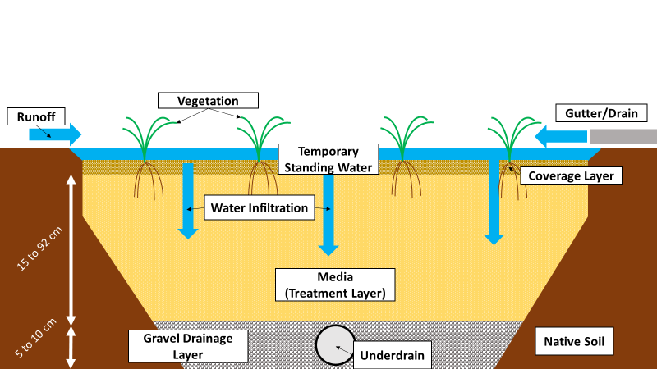
Figure 1: A simplified cross-section of a typical bioretention cell showing its layers.

Hunt and White (2001) and Chavez (2015) recommend that the area of the BRC be about 5% to 7% of the runoff area, depending on the degree of impervious coverage. Hunt and White (2001) refer to the USDA-NRCS Curve Number method, typically used for small urban watersheds, to calculate runoff produced by a given surface area:

$R=\frac{{\left(P-0.2S\right)}^{2}}{P+0.8S}$ ( 1 )
R = runoff depth in inches
P = precipitation (assume 1 inch for treatment of first flush)
S = 1,000 ÷ CN - 10
CN = curve number (standard curve number of 98 for sandy soils)

The curve number is a measure of water infiltration of a soil for a storm event (USDA, 1986). The calculated runoff depth can then be used to calculate the amount of runoff to be captured using a volume equation:

$V=A×\frac{R}{12}$ ( 2 )
V = runoff volume (ft³)
A = runoff area (ft²)
R = runoff depth (in)

The resulting volume will determine the amount of water the BRC is designed to capture (Hunt and White, 2001; Franti and Rodie, 2007a; McLemore et al., 2017). This sizing method for volume capture is consistently used across several different bioretention design manuals (Franti and Rodie, 2007a; Franti and Rodie, 2007b; ISP, 2009; Jaber et al., 2012). Although bioretention designs typically call for a nine-inch water holding depth, the depth can vary between from six up to 36 inches (Hunt and Lord, 2006; Franti and Rodie, 2007a; McLemore et al., 2017). Because bioretention systems are typically designed to treat runoff from the first flush (usually the first inch of precipitation), they will often require flow diversion to address flooding for a given geographical area (Hunt and White, 2001).

Because bioretention system research is rapidly evolving, various terminology has been used somewhat interchangeably. “Rain garden” is common terminology used by the public in the United States to refer to a BRC for residences (EPA, 2016a). Biofilters and biofiltration systems have traditionally been associated with wastewater treatment outside of the United States (Payne et al., 2015). Recently they have been extensively applied in stormwater management, becoming almost synonymous with rain gardens. Bioswales, which are like rain gardens, are vegetated channels that convey infiltrate and treat stormwater (EPA, 2016a). Bioswales are linear in design and are ideal features for streets and parking lots. These systems have coevolved through similar research, one system often developing improvements for the others.

Bioretention Cell Media Selection
BRCs are designed to hold water and to facilitate pollutant removal processes. The media used for the treatment layer of bioretention systems should balance high permeability and adequate retention (Roy-Poirier et al., 2010). Sandy loam or loamy sand textured media are suggested as fill materials for the treatment layer to provide adequate permeability (Hunt and White, 2001; Hunt and White, 2006; Payne et al., 2015). The recommended hydraulic conductivity is a minimum of approximately 2.54 centimeters (1.0 inch) per hour (Hunt and White 2001; Hunt and Lord, 2006; Chavez, 2015). Adequate drainage will also prevent disease vectors from breeding in standing water (Roy-Poirier et al., 2010). Liu et al. (2014) suggested the use of a loamy sand media with low organic content of 3% to 5% as the optimal balance to provide minimum vegetation requirements and limit nutrient leaching risks. In addition to water quantity functions, BRCs can facilitate a variety of pollutant removal processes such as settling, filtration, sorption, vegetative uptake, microbial metabolism, and redox reactions (Hunt and Lord, 2006; LeFevre et al., 2015; Payne et al., 2015).
Recent research has proven that small modifications to bioretention systems, such as using reactive amendments or adding a saturated zone, can improve and enhance the metals and nutrients treatment processes previously described (Payne et al., 2015; Vogel et al., 2015). Many types of reactive materials suggested for BRCs use have had previous success in applications involving highly concentrated pollutants (Zhang et al, 2006; Zhang et al., 2008a; O’Neill and Davis, 2012; Erickson et al., 2012; Erickson et al., 2016). For example, FA, a coal combustion byproduct, is often used as an alternative for Portland cement in concrete production but has been widely used as a P coprecipitate (due to lime content in many sources of FA) and adsorbent for trace metals in wastewater (Nairn and Mercer, 2000; Ahmaruzzaman, 2010). Pollutant removal properties of FA have been applied to stormwater applications for P, trace metals, and microbial removal (Zhang et al., 2006; Zhang et al., 2008a; Zhang et al., 2008b; Chavez, 2015; Kandel et al., 2017; Youngblood et al., 2017). This thesis studied FA and MDRs as BRC amendments, and APT and BIO as media in BRCs.

Bioretention Cell Vegetation
The best types of vegetation used for plant coverage in BRCs must withstand cycling of wet and dry periods (Hunt and White, 2001; McLemore et al., 2017). Avoiding the use of obligate wetland and obligate upland species is important to sustain vegetative life (Hunt and White, 2001). Native plants may often grow better than others because of their adaptation to local climate. The usage of native and tolerant species is an important part of BRC design because they can decrease maintenance costs and effort. An important consideration for clay soils is the relative inaccessibility to water compared to sandy soils (Hunt and White, 2001; Franti and Rodie, 2007a; McLemore et al., 2017). Clay soils are often recommended to be avoided, not just for hydraulic conductivity issues, but vegetation (Hunt and White, 2001; Franti and Rodie, 2007a; McLemore et al., 2017). Trees and shrubs with aggressive root growth will constantly attempt to grow deeper to find water, thus creating the potential to clog drainage pipes (Hunt and White, 2001). Clogged pipes will increase the required maintenance frequency. Therefore, clayey soils, soils with poor permeability, and soil compaction should be avoided with respect to vegetation.

Variable Bioretention Cell Performance Issues

Lack of Focus on Dissolved Pollutants
Pollutants are present in stormwater in the dissolved fraction or particulate fraction. Metals typically associated with stormwater are largely present in dissolved forms, where portions of Pb and Zn are both present at approximately 63% and Cu at 46% dissolved (BMP Database, 2015). Dissolved forms of P can be present in stormwater at 45% and even up to 90% (LeFevre et al., 2015). Although the proportions of pollutants in the particulate form are significant, their removal is usually associated with TSS removal via settling and filtration (Liu et al., 2014; LeFevre et al., 2015). Addressing the removal of dissolved pollutants is important because they are more bioavailable, therefore affecting receiving water bodies more quickly than particle-associated pollutants (LeFevre et al., 2015). LeFevre et al. (2015) concluded that little bioretention research has focused on removal of the soluble fraction of pollutants compared to particulate removal. However, the use of reactive media enhances the ability of BRCs to remove dissolved pollutants via sorption and precipitation processes (LeFevre et al., 2015).

Nutrient Export from Bioretention Cells
An important water quality concern in LID technologies is nutrient export (Dietz, 2007). Nutrient removal in BRCs is highly variable and often mediocre (Payne et al., 2014; LeFevre et al., 2015; Holzbauer-Schweitzer, 2016). Variability in N and P removal, in some cases including export, may be attributed to diverse properties of different soils, especially those with high OM (Payne et al., 2014; LeFevre et al., 2015). Compost or soils rich in OM are internal sources of N and P (Payne et al., 2014; LeFevre et al., 2015). Liu et al. (2014) suggested soil compositions with more than 5% OM can cause nutrient leaching problems. Although highly organic soils can effectively retain metals, nutrient leaching remains a problem (LeFevre et al., 2015). Recommendations for the use of soil mixes containing 30% to 50% compost in several bioretention design manuals may explain why increases in N and P in BRC discharges are common (Franti and Rodie, 2007a; Franti and Rodie, 2007b; ISP, 2009; Jaber et al., 2012). Ironically, the Iowa Stormwater Partnership (ISP) lists common mistakes of bioretention implementation, which include the use of fertilizer (ISP, 2009). However, they recommend soil mixtures of 50% compost and more than 5% OM.

Reactive Media

“Class C” Fly Ash Amendment
FA is a captured coal combustion byproduct produced when inorganic impurities in coal are suspended in the combustion chamber and treated, along with flue gas, for sulfur dioxide (SO₂) emissions, using flue gas desulfurization (FGD) (Kalyoncu, 2001). “Class C” FA is designated as such by meeting a total silica (SiO₂), aluminum oxide (Al₂O₃), and iron oxide (Fe₂O₃) composition between 50% and 70%; it is typically comprised of approximately 20% CaO (ASTM C618). FA has proved to be an effective BRC media amendment for Cu, Pb, Zn, and P removal using sand amended with Class C FA (Zhang et al., 2006; Zhang et al., 2008a; Zhang et al., 2008b). Zhang et al. (2006) observed 94.2% decrease in P concentrations using sand amended with FA, which comprised 5% of the total mass of the mixture. The primary removal mechanism for phosphate was coprecipitation with calcium (Ca), as hydroxyapatite (Ca₁₀(PO₄)₆(OH)₂), due to the abundance of lime in Class C FA (Zhang et al., 2006). Metals removal was attributed to sorption onto Al₂O₃ and Fe₂O₃ at circumneutral pH and precipitation as metal oxides (Zhang et al., 2008a).

The main trade-off to using FA as an amendment is the exponential drop in hydraulic conductivity as the percentage of FA composition increases (Zhang et al., 2006). Zhang et al. (2006) determined that a blend of sand should limit FA amendments at 5.8% by mass for adequate runoff infiltration. Although FA is pozzolanic and hardens in water, the 5% FA amendment still exhibited hydraulic conductivity of 0.91 centimeters per hour after 28 days of saturation (Hewlett, 2003; Zhang et al., 2006).

Iron Oxyhydroxide Mine Drainage Residuals Amendment
MDRs are comprised of several iron oxide forms, which come from a three-step process, which includes oxidation then hydrolysis, and finally precipitation (Watzlaf et al., 2004). When mine drainage is exposed to oxidizing conditions, naturally occurring pyrite (FeS₂) dissolves and releases aqueous Fe²⁺ (Watzlaf et al., 2004). Fe²⁺ oxidizes to ferric iron (Fe³⁺) in the presence of atmospheric oxygen (O₂), then hydrolyzes and precipitates as iron oxyhydroxide (FeO(OH)) (Watzlaf et al., 2004). Generally, MDRs are comprised of different forms of oxidized iron such as, but not limited to, goethite being the most common, ferrihydrite, and hematite (Wendling et al., 2013).

Iron oxides have had a great deal of attention in agricultural context because of their important role in phosphorus immobilization in soil (Fink et al., 2016). Phosphorus occurs naturally in soil primarily as apatite-group minerals and anthropogenically as PO₄³⁻ fertilizers (Fink et al., 2016). Iron oxides can occur naturally and abundantly in soil and have a high affinity for phosphorus, attributed to preferential adsorption of phosphate to the hydroxyl groups of iron oxides (Fink et al., 2016). PO₄³⁻ preferences for different iron oxide series follow the order of highest to lowest preference: ferrihydrite>goethite>hematite (Wendling et al., 2013). Kang et al. (2003) compared the performance of synthetic ferrihydrite, goethite, and hematite on treatment of wastewater effluent and synthetic P solutions in a series of batch studies. By adding 25 mg of ferrihydrite to one L of solution dose at 2.7 mg/L as P, they found greater than 60% P removal and greater than 80% P removal when adding 150 mg. Goethite removed less than 10% of P at 25 mg of Fe and greater than 40% of P at 150 mg. However, hematite removed less than 15% of P at all Fe additions.

Iron oxides are known to adsorb metals well, except for complexed species (Benjamin and Sletten, 1996). The presence of the hydroxyl group on some iron oxide forms, such as goethite, is a major adsorption site for divalent trace metals such as Cu²⁺, Pb²⁺, Cd²⁺, and Zn²⁺ (Swedlund et al., 2009). These divalent cations can form hydroxyl bridges with the surface (Forbes et al., 1976). The affinity for metals adsorption onto goethite follows, Cu>Pb>Zn>Cd (Forbes et al., 1976). These metals also follow the general trend of increased adsorption with increased system pH, with near complete removal of all metals species except Cd above pH 8.0 (Forbes et al., 1976). With decreasing pH, competition for the adsorption sites seems to increase due to increased surface charge on goethite from excess hydrogen ions (H⁺) (Forbes et al., 1976).

APTsorb and bioAPT
American Peat Technology distributes APTsorb and bioAPT, which are granular materials made from reed-sedge peat resources in Aitkin, Minnesota. Reed-sedge peat consists of mainly lignin, hemicellulose, cellulose, and humic substances, which feature an extensive list of functional groups that readily interact with metal cations (American Peat Technology, 2017a). These products are processed via “granulation and low temperature hardening,” which allows for the granulated peat to maintain structure when wetted (Eger et al., 2015a). Raw harvested peat is granulated through high pressure extrusion and extended drying, resulting in bioAPT, which is advertised as an inoculating media (American Peat Technology, 2017c; Appendix III). APTsorb is derived from bioAPT, which takes bioAPT through an additional heat treatment step (American Peat Technology, 2017c). Metals removal in peat are attributed to surface and chemical adsorption, ion exchange, complexation, and chelation (Eger et al., 2015a).

A case study used APTsorb to treat mine water at the abandoned Soudan Mine in northeastern Minnesota (Eger et al., 2015a). Water treatment consisted of pumping mine water through a pressurized tank containing APTsorb media (Eger et al., 2015a). Using APTsorb, total Cu was decreased from a range of 30 to 50 micrograms per liter (µg/L) to a range of four to 13 µg/L (Eger et al., 2015a). The effluent concentrations fell below local permit limits of 17 µg/L (Eger et al., 2015a).

At a second site, an unnamed active mine in North America, APTsorb was able to decrease total Pb from 128 to one µg/L and soluble Pb from 83 to one µg/L after a preceding sand filter step (Eger et al., 2015b). The system also decreased total Zn from 40 to 8 µg/L and soluble Zn from 45 to 17 µg/L after the preceding sand filter step (Eger et al., 2015b). However, Eger et al. (2015b) made note of an anomaly involving soluble Zn being greater than total Zn. Shiller (2003) noted common water sample filtering materials and apparatuses can contribute to metals export in filtered samples due to the manufacturing processes of rubbers and plastics. At the same site, a gravity-flow system, also using a preceding sand filter step, produced similar results and decreased total Pb and Zn below permit limits (Eger et al., 2015b). The local permit limits for total Pb and Zn at the time were 12 and 137 µg/L, respectively (Eger et al., 2015b). In the early investigation stages, American Peat Technology have not published data for nutrient removal performance (American Peat Technology, 2017b).

Although peat reserves in northern Minnesota still maintain over 90% of pre-settlement supply, it is a slow-renewable resource whose harvesting is scrutinized (Eger et al., 2015a). American Peat Technology is attempting to develop methods of increased peat accumulation rate and sustainable harvest (Eger et al., 2015a).

Other Reactive Media
Several other media have been studied for use in BRCs, many of which have been used in wastewater or agricultural drainage treatment applications. Though not an exhaustive list, several media that have been studied include biochar, granulated activated carbon (GAC), aluminum-based water treatment residuals, and iron shavings. Many of these media have been studied primarily with the focus of nutrient removal.

Biochar has become a low-cost medium for wastewater treatment for the removal of various organic, inorganic, and microbial pollutants (Hanandeh et al., 2017). Hanandeh et al. (2017) showed that amending sand with course biochar (CBC) or fine biochar (FBC), prepared from olive mill solid waste, can effectively precipitate and adsorb phosphorus. They used two sand mixtures with 8% CBC and 8% FBC to remove TP, in secondary treated wastewater, at efficiencies of 77.4% to 82.5% and 56.3% to 82.5%, respectively. The lower removal from FBC was attributed to greater negative surface charge from the smaller particle sizes, which decreased adsorption (Hanandeh et al., 2017). The CBC also had a greater number of macro-pores, which allowed for microorganism growth for biological removal (Hanandeh et al., 2017).

The most common process used to remove N in wastewater is denitrification, but it typically requires longer residence time and water storage than is provided by stormwater treatment practices (Erickson et al., 2016). GAC has been suggested for potential abiotic treatment of NO₃⁻ in stormwater due to generally high sorption and ion exchange capacities of the material (Erickson et al., 2016). Erickson et al. (2016) demonstrated limited NO₃⁻ removal of 100% for 10 pore volumes (PV) in laboratory columns, packed with 100% GAC. They suggested capture of NO₃⁻ was attributed to ion exchange on the GAC, though limited by competition from bicarbonate (HCO₃⁻).

O’Neill and Davis (2012) used columns packed with a loamy sand mixture composed of 5% aluminum-based water treatment residuals (WTR) and 3% triple-shredded hardwood bark mulch by mass to improve P removal in BRCs. The mixture was able to remove 88.5% of P. P removal was attributed to adsorption by amorphous aluminum hydroxide (Al(OH)₃) from the water treatment residuals (O’Neill and Davis, 2012).

Erickson et al. (2012) introduced the “Minnesota Filter,” which is a sand filter amended with iron shavings to focus on the removal of dissolved phosphorus species. Sand amended with 5% iron by mass removed an average of 88% phosphate in gravity-flow columns (Erickson et al., 2012). Systems that used iron amendments up to 10.7% operated for over one year without comprising hydraulic conductivity (Erickson et al., 2012).

In addition to the specifically mentioned media, Allred (2017) investigated 58 industrial byproducts of various material compositions for use in potential future studies in agricultural applications. Allred (2017) evaluated NO₃⁻ and PO₄³⁻ removal performance of the materials in batch experiments. Using 90-percent removal criteria for NO₃⁻ and PO₄³⁻, two met standards for NO₃⁻ and 37 for PO₄³⁻ (Allred, 2017). Additionally, eight of the materials showed at least 50-percent removal for both NO₃⁻ and PO₄³⁻ (Allred, 2017). The results from this study do not only provide data for various materials to be used in future research, but they also illustrate the potential for even more materials to be introduced as BRC media or amendments.

Nutrient Analyses Reporting
NO₃⁻ was selected as the primary N species of concern for this study. NO₃⁻ removal is problematic because it is highly mobile in water and is difficult to remove abiotically. Although NO₂⁻ consumption can be toxic to humans and fish, it is often found at very low concentrations in runoff (Herrera Environmental Consultants, 2007). NO₂⁻ is very unstable, especially in aerobic waters, because it rapidly transforms into NO₃⁻ in the presence of oxygen (Wolff et al., 1998). NO₂⁻ is often reported with the combination of NO₃⁻+NO₂⁻ (Herrera Environmental Consultants, 2007).

Planktonic algae and bacteria mainly uptake orthophosphate (H₂PO₄⁻, HPO₄²⁻, or PO₄³⁻), which is considered bioaccessible P (Boström et al., 1988). Dissolved reactive P (DRP) is often reported as the equivalent to orthophosphate, but the amount of available P can be variable depending on concentration (Boström, et al., 1988). Twinch and Breen (1982) found that the concentrations of available P in DRP measurements were underestimated at concentrations less than 0.01 mg/L, overestimated at concentrations more than 0.1 mg/L, and variable between 0.01 to 0.1 mg/L. Dissolved unreactive P (DUP) can interfere with DRP measurements because DUP can be made available from a small amount of organically bound fractions (Bradford and Peters, 1987).

Hypotheses and Objectives
This study aims to address the removal of the dissolved fraction of pollutants and nutrient leaching issues present in BRCs by evaluating the pollutant removal performance of FA, MDR, APT, and BIO. Each reactive media will be evaluated by flowing SS upward through laboratory treatment columns. This study will focus on the removal of Cu²⁺, Pb²⁺, Zn²⁺, NO₃⁻, and PO₄³⁻. Pollutant removal performance will be based on the net changes in pollutant concentrations from column effluents. Ideal reactive materials should not increase pollutant concentrations in infiltrating runoff. Provided the materials are inexpensive, they can also make BRCs even more cost-effective alternatives to traditional stormwater management. Basic cost analyses will be performed to evaluate the advantages and disadvantages of each reactive media against their costs. If the proposed reactive media have evidence of both improved water quality over typical sandy materials and cost effectiveness, they may be recommended for more widespread use in BRC designs.

Hypotheses
- Effluents from laboratory treatment columns of all proposed reactive media will result in net decreases in Cu²⁺, Pb²⁺, and Zn²⁺. Additionally, FA5.0 and MDR7.5 columns will result in net decreases in P.
- Effluents from APT and BIO laboratory treatment columns will result in net decreases in NO₃⁻.
- Effluents from laboratory treatment columns of APTsorb and bioAPT will result in net increases in P concentrations. Due to the high composition of OM of peat, these media may be internal sources of nutrients (Liu et al., 2014; LeFevre et al., 2015).

Objectives
- Preliminarily evaluate proposed reactive media for adequate infiltration to proceed into the primary study. Media should exhibit hydraulic conductivities of at least 2.54 centimeters per hour, per recommendations by Hunt and White (2001). This objective will also achieve optimum amendment ratios for FA and MDR.
- Evaluate each of the proposed reactive media for pollutant removal performance of Cu²⁺, Pb²⁺, Zn²⁺, NO₃⁻, and PO₄³⁻ by flowing SS upward through laboratory treatment columns. Media performance comparisons will be evaluated and compared by normalizing column effluent concentrations with influent concentrations.
- Characterize chemical and geotechnical properties of the reactive media to suggest possible removal mechanisms.
- Perform cost analyses on each proposed reactive media to determine the cost-effectiveness in BRC design context.

Methods and Materials
Sand was locally purchased under the brand-name Quikrete® and classified as ASTM C33 sand, which is a specification for use as concrete aggregate (ASTM, 2016). The sand was sieved to pass the US Sieve Series No. 10 (two-millimeter (mm) openings). The FA used in this study was provided by the Grand River Dam Authority (GRDA) from the Grand River Energy Center coal-fired power plant in Chouteau, Oklahoma. It was formerly known as the GRDA Coal Fired Complex. Prior to collection, the FA was treated via quicklime FGD scrubbers, a process by which the material gets its quicklime, or calcium oxide (CaO) content (DEQ, 2014). MDRs were harvested from the oxidation pond at the Mayer Ranch Passive Treatment System in Commerce, Oklahoma. FA and MDRs were sieved to pass the US Sieve Series No. 200 (0.075-mm openings). American Peat Technologies provided samples of APT and BIO in granular and minus 30-mesh (0.60 mm) particle sizes. APT and BIO are reed-sedge peat materials sourced and processed in Aitkin, Minnesota.

Because FA and MDRs are comprised of particles like silt or clay, they were expected to have hydraulic conductivities less than 2.54 centimeters per hour, a minimum criterion by Hunt and Lord (2006). Therefore, a preliminary hydraulic conductivity study was conducted to screen the materials for adequate infiltration, prior to conducting the pollutant removal performance study. Materials were also characterized for various geotechnical and chemical properties to provide understanding of pollutant removal performance and overall appropriateness as media for bioretention systems.

100% sand (SAND) was used as the control group. Descriptions of the proposed reactive materials and their sources are summarized in Table 2. Many of the reactive materials have been previously used in the treatment of highly concentrated waters, such as wastewater or mine drainage (Nairn et al., 2009; Eger et al., 2015a; Eger et al., 2015b). However, this study proposed these reactive media for use in BRCs to remove relatively minute pollutant concentrations.

Table 2: Summary of reactive media, sources, and descriptions.
Material | Source | General Geochemical Components
Sand¹ | Quikrete® Commercial Product | Silica
Fly Ash² | Grand River Energy Center,  Chouteau, OK | Silica,  Aluminum Oxide,  Ferric Oxide,  Calcium Oxide
Mine Drainage Residuals³ | Mayer Ranch Passive Treatment System Oxidation Pond, Commerce, OK | Ferrihydrite, Goethite,  Hematite
APTsorb⁴ | APT Peat Reserves,  Aitkin, MN | Reed-sedge Peat
bioAPT⁵ | APT Peat Reserves,  Aitkin, MN | Reed-sedge Peat
1. Appendix I
2. Appendix II
3. Neely and Nairn, 2010
4. Appendix III
5. Appendix III

Preliminary Hydraulic Conductivity Screening
Ratios for FA-sand and MDR-sand mixtures were selected based on the methods used in Zhang et al. (2006) for the FA used in that study. Zhang et al. (2006) selected various ratios of FA-sand mixtures of up to 10% FA by mass. Based on their findings, they concluded that amending sand using FA up to 5% by mass was appropriate for BRCs based on this range of mixtures meeting the minimum hydraulic conductivity criterion. MDR-sand mixtures used in the hydraulic conductivity screening included MDR amendments at 2.5%, 5.0%, 7.5%, and 10.0% by mass. Despite recommendations by Zhang et al. (2006), FA-sand mixtures were evaluated again because different sand and FA sources were used. The media and amendment mixtures selected for this screening are summarized in Table 3.

Table 3: Material composition of media used in hydraulic conductivity screening percentages by mass.
Media | Material Composition
SAND | 100% sand
APT | 100% APT (granular)
APT | 100% APT (-30 mesh)
BIO | 100% APT (granular)  100% APT (-30 mesh)
FA | 97.5% sand + 2.5% FA
FA | 95.0% sand + 5.0% FA
FA | 92.5% sand + 7.5% FA
FA | 90.0% sand + 10.0% FA
MDR | 97.5% sand + 2.5% MDRs
MDR | 95.0% sand + 5.0% MDRs
MDR | 92.5% sand + 7.5% MDRs
MDR | 90.0% sand + 10.0% MDRs

Falling-head tests (Klute 1986), were conducted on the proposed materials to measure hydraulic conductivity. The falling-head test consisted of using a permeameter to measure the change in standing water level as the water infiltrated through the media, over an elapsed time. From these data, hydraulic conductivity was calculated using the following equation provided by Klute (1986):

$K=\frac{aL}{At}ln⁡(\frac{H_{1}}{H_{2}})$ ( 3 )
K = hydraulic conductivity (cm/hr)
a = cross-sectional area of the permeameter (cm²)
L = length of media (cm)
A = cross-sectional area of the media (cm²)
t = time elapsed (hr)
H₁ = initial head (cm)
H₂ = final head (cm)

A schematic of the permeameter to be used this study apparatus is shown in Figure 2. The permeameter was packed with a 10.2-centimeter pea gravel drainage layer, a 15.2-centimeter layer of media above it, then topped with a 5.1-centimeter layer of pea gravel to limit disturbance of pouring water. Non-woven geotextile (US 425NWE), provided by US Fabrics, Inc., was placed in between each layer to limit particle migration. The permeameter used for these falling-head tests is shown in Figure 3, with packing schematic also shown in Figure 2.

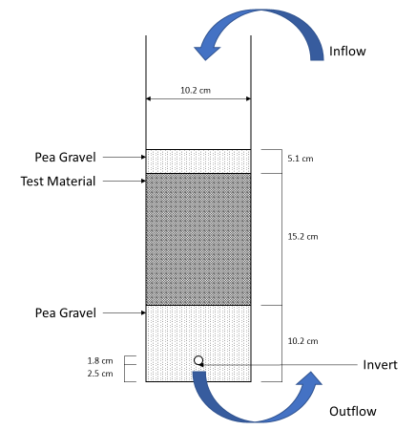
Figure 2: Falling-head permeameter packing schematic.

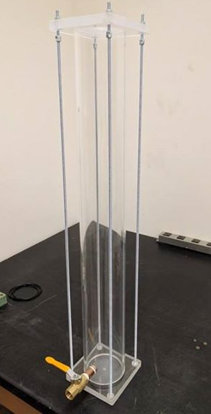
Figure 3: Falling-head permeameter for measuring hydraulic conductivity.

Laboratory Column Experiments
Based on the hydraulic conductivity screening (Section 3.1), the media selected for the laboratory column experiments included SAND, five-percent FA and 95-percent sand (FA5.0), 7.5-percent MDRs and 92.5-percent sand (MDR7.5), APT, and BIO. Dr. Glenn Brown designed the acrylic laboratory treatment columns used in this study. They are 10.2 centimeters in inner-diameter and 15.2 centimeters in length, which is also the minimum BRC media depth recommended by Hunt and White (2001). They consist of two end caps with O-rings. Additionally, nonwoven geotextile was placed at the ends to prevent material loss. Figure 4 shows a laboratory column used in this experiment with all its pieces.

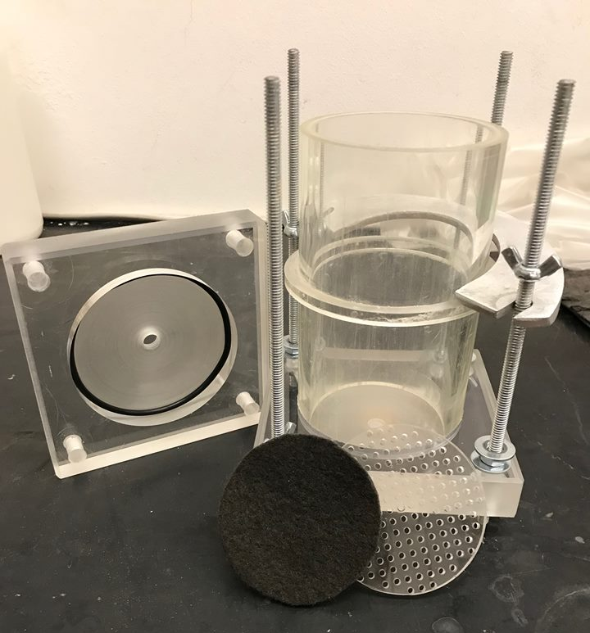
Figure 4: An acrylic column used in the pollutant removal experiments, designed by Dr. Glenn Brown.
SS was peristaltically pumped through clear, acrylic, up-flow columns packed with amendment mixtures or layered media. Water effluent samples were collected and analyzed to evaluate pollutant removal performance by normalizing effluent concentrations with influent concentrations. Normalized effluent values show net increases or decreases in pollutant concentrations to indicate media retention or export. Three replicate experiments were completed for each media for a total of 15 columns. The set-up for the column experiments is pictured in Figure 5.

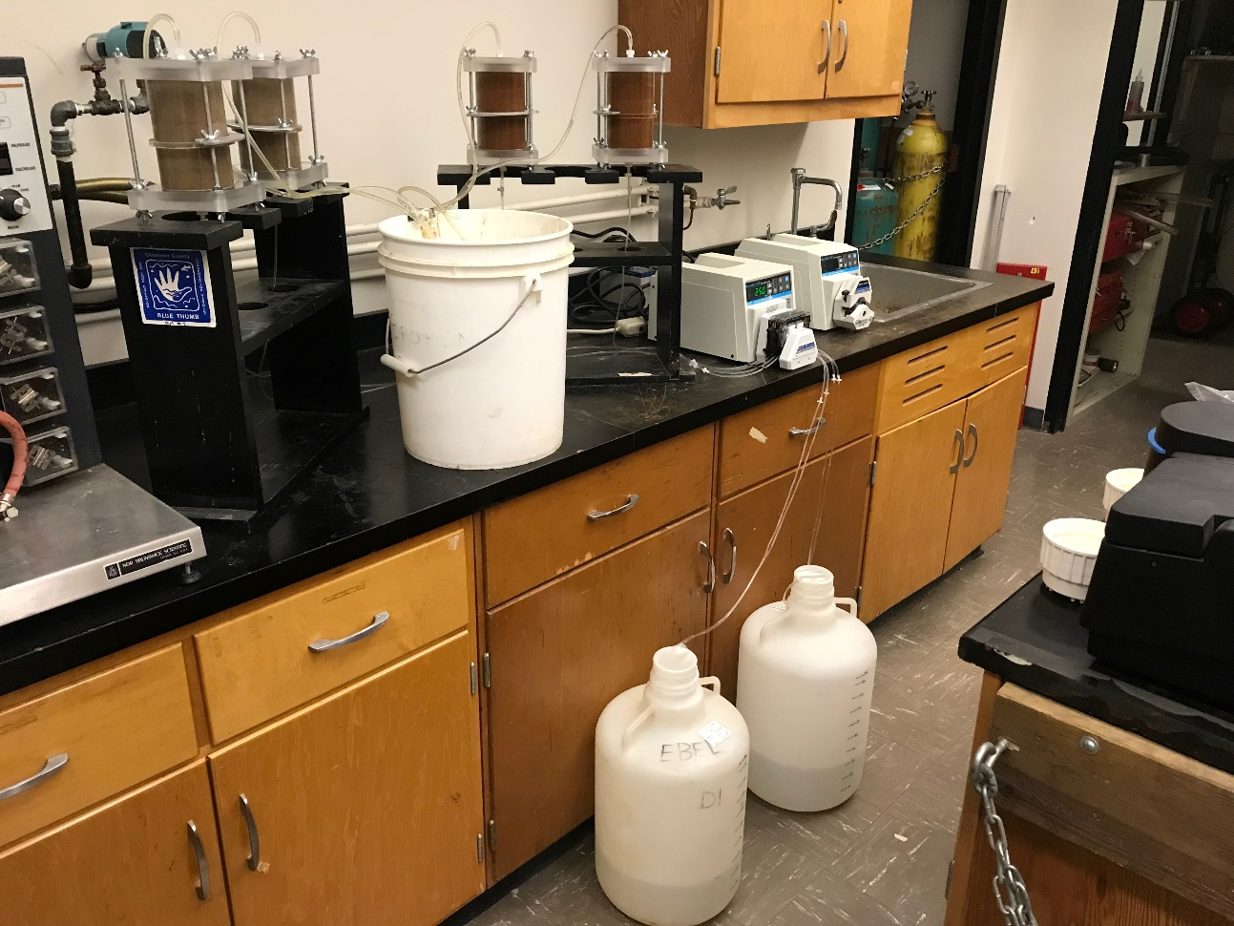
Figure 5: Set-up of laboratory column experiments with synthetic stormwater sources in 20-L carboys, peristaltically pumped from bottom of packed columns (left: two FA5.0 columns; right: two MDR7.5 columns).

Column Packing and Flow Rates
Media were wet-packed in the columns in two-inch lifts. Each lift layer was added dry, saturated with deionized (DI) water, and hand-tamped. The surface of each preceding layer was scraped in a cross-hatch pattern to achieve better packing with the succeeding layer. The hydraulic conductivities of APT and BIO were found to be greater than that of SAND. To decrease the amount of material used and to maintain appropriate hydraulic conductivity, APT and BIO columns were each packed into two layers consisting of APT or BIO and sand at 1:3 ratios. The sand was placed at the outflow-end of the column to augment the hydraulic retention time (HRT) of APT or BIO to be approximately the same as columns that would have been packed with 100% APT or BIO. Flow rates were calculated using the equations for Darcy’s velocity and seepage velocity, which is multiplied by the cross-sectional area of the laboratory column.

$v_{s}=\frac{v}{η}$ (5)
v_{s} = seepage velocity (cm/hr)
v = Darcy’s velocity (cm/hr)
η = porosity

$v=K\frac{dh}{dL}$ (6)
v = Darcy’s velocity (cm/hr)
K = hydraulic conductivity (cm/hr)
dh/dL = hydraulic gradient (1 for vertical flow)

SS was pumped at flow rates that matched the seepage flow through the media, based on the results from the hydraulic conductivity screening. Corresponding masses, flow rates, and PVs for each media are shown in Table 4.

Table 4: Column flow rates and pore volumes.
Column | Media Mass (g) | Flow Rate (mL/min) | Pore Volume (mL)
SAND1 | 1086 | 75 | 230
SAND2 | 1100 | 75 | 230
SAND3 | 1070 | 75 | 230
FA5.01 | 1130 | 6 | 270
FA5.02 | 1132 | 7.5 | 270
FA5.03 | 1078 | 8 | 270
MDR7.51 | 1001 | 6 | 300
MDR7.52 | 1000 | 6 | 300
MDR7.53 | 998 | 8 | 300
APT1 | APTsorb: 72  sand: 678 | 75 | APTsorb: 140  sand: 150
APT2 | APTsorb: 82  sand: 688 | 75 | APTsorb: 140  sand: 150
APT3 | APTsorb: 74  sand: 688 | 75 | APTsorb: 140  sand: 150
BIO1 | bioAPT: 88  sand: 664 | 75 | bioAPT: 140  sand: 150
BIO2 | bioAPT: 80  sand: 754 | 75 | bioAPT: 140  sand: 150
BIO3 | bioAPT: 84  sand: 714 | 75 | bioAPT: 140  sand: 150

Synthetic Stormwater
SS was created in the laboratory in several 20-liter (L) batches. DI water was spiked with KNO₃, KH₂PO₄, CuCl₂, PbCl₂, and ZnCl₂ laboratory salts. Target concentrations for Cu²⁺, Pb²⁺, Zn²⁺, NO₃⁻, and PO₄³⁻, are summarized in Table 5. Solutions were adjusted using one normality (N) HCl and KOH to approximately pH 7, which is typical of residential stormwater runoff (BMP Database, 2015). Because BRCs are already effective at removing TSS and particulates via physical filtration, only soluble pollutant species were included in the SS (Liu et al., 2014; LeFevre et al., 2015).

Table 5: Target synthetic stormwater constituent concentrations, based on typical residential runoff (BMP Database, 2015).
Constituent | Units | Concentration | Salt
Cu²⁺ | µg/L | 25 | CuCl₂
Pb²⁺ | µg/L | 30 | PbCl₂
Zn²⁺ | µg/L | 100 | ZnCl₂
NO₃⁻ | mg/L as N | 1.5 | KNO₃
PO₄³⁻ | mg/L as P | 0.5 | KH₂PO₄

Water Sample Collection and Preservation
Influent source water was collected at the beginning of each experiment for the same analyses as the effluent samples. Effluent water samples were collected at four different points for each column experiment: after one, three, 10, and 30 PVs had passed through. Times for these collection points were determined by a medium’s respective flow rate and PV. Water samples were collected for the analyses of nutrients (TP, TDP, TN, NO₃⁻, and NH₃), total and filtered metals, and carbon content. Carbon content includes total carbon (TC), total inorganic carbon (TIC), and total organic carbon (TC).

Water samples for filtered metals and TDP were filtered through a 0.45-micron filter upon collection prior to any acidification. Nutrient samples were analyzed within 48 hours or acidified with concentrated H₂SO₄, at two milliliters (mL) of acid to one L of sample, if timely analyses were not likely. Water samples for total and filtered metals were acidified with concentrated HNO₃ at two mL of acid to one L of sample. Carbon samples were preserved by acidification with concentrated hydrochloric acid (HCl) at two mL per one L of sample. Nutrient and TC/TIC samples were placed in refrigerated storage.

Water Quality Analyses
Water samples collected for nutrients were analyzed for TP, TDP, TN, NO₃⁻, and NH₃. TP and TDP were measured via EPA Method 365.3 using a Cole and Parmer UV/VIS SQ-2800 spectrophotometer (EPA, 1978). NO₃⁻ was measured via EPA Method 352.1 using the same spectrophotometer (EPA, 1971). NH₃ was measured immediately upon water sample collection using Hach TNTplus 830 analysis kits and Hach DR 3800 Spectrophotometer, which followed Hach Method 10205 (Hach, 2016). TN was measured using the AnalytikJena multi-N/C 2100S. Water samples collected for total and filtered metals analyses were digested via EPA Method 3015A (EPA, 2007a). Digested metals samples were analyzed via inductively coupled plasma-optical emission spectrometry (ICP-OES) using a Varian Vista-PRO simultaneous axial ICP-OES, following EPA Method 6010C (EPA, 2000b). Water samples for carbon content were also analyzed using the AnalytikJena multi-N/C 2100S. TC concentrations were calculated by difference of TC and TIC.

In addition to analyses of collected water samples, column effluents were immediately measured for pH, oxidation-reduction potential (ORP), dissolved oxygen (DO), temperature (T), and specific conductance (SC). Measurements were performed using Fisher Scientific Accumet XL600 instrumentation with appropriate electrodes. Influent source water was measured at the beginning of each experiment for the same parameters. The methods of water quality analyses and instruments used are summarized in Table 6.

Table 6: Water quality analytical methods and instrumentation.
Analyte | Method/Instrumentation
pH, ORP, DO, T, SC | Accumet XL600
TP | EPA Method 365.3
TDP | EPA Method 365.3
TN | AnalytikJena multi-N/C 2100S
NO₃⁻ | EPA Method 352.1
NH₃ | Hach Method 10205
Total Metals, Filtered Metals | EPA 6010C*
TC, TIC, TOC | AnalytikJena multi-NC 2100S
*Although measured, the following metals do not have fully developed laboratory methods: Ag, Hg, Se

Statistical Tests
Normalized effluent concentrations, effluent concentrations (C_{e}) divided by influent concentrations (C_{i}), of the reactive media were compared to the SAND control group using the Mann-Whitney U test for nonparametric data. A significance level (α) of 0.10 was used to determine statistical significances based on the p-values from the comparison tests.

Chemical Characterization of Media
Reactive media underwent various chemical characterization procedures. Chemical characterization helped determine material composition, identify hazardous materials, and suggest possible pollutant removal mechanisms. The points of zero charge (PZC) of the media were determined to deduce potential sorption based on material surface charge. The pore water pH in a medium directly impacts the material’s surface charge due to H⁺ or hydroxide ion (OH⁻) displacement. A solution pH greater than the material’s PZC will yield a net negative surface charge and vice versa for pH less than the PZC. The PZC was determined by the “pH drift method.” Media also underwent the EPA Toxicity Characteristic Leaching Procedure (TCLP), described in EPA Method 1311 (EPA, 1992). The TCLP is a chemical extraction method to simulate landfill leaching to determine proper waste disposal protocol. Pollutants from TCLP leachate that exceed EPA’s list of “D” wastes determine if the material is considered hazardous. Metals from the media were also extracted using EPA Method 3051A and analyzed via EPA Method 6010C (EPA, 2000b; EPA, 2007b). EPA Method 3051A partially decomposes the media and does not completely reflect the composition of the materials.

PZCs of column experiment media were determined using the pH drift method. This method measures compares the initial and final pH of a salt solution with the addition of material of interest. Six centrifuge tubes were filled with 50 mL of 0.1 molar KNO₃ solution and purged of carbon dioxide (CO₂) by bubbling pure nitrogen gas (N₂) for 10 minutes. The solutions were then adjusted to approximately pH 2, 4, 6, 8, 10, and 12 by 0.1 molar nitric acid (HNO₃) or 0.1 molar potassium hydroxide (KOH). The acid and base were chosen to limit the interference of other ion species. To each pH solution, 0.2 grams (g) of material were added and agitated on a shaker for 24 hours. This procedure was done on SAND, FA, FA5.0, MDR, MDR7.5, APT, and BIO for a total of 42 samples. After 24 hours, the final pH reading was taken from each sample and plotted against initial pH readings. The PZC was determined where pH curve intersected the 1:1 sloped line of equal initial and final pH. PZC determinations were repeated with 0.01 M KNO₃ for verification of PZC at different electrolyte concentrations.

Geotechnical Characterization of Media
Materials that passed the preliminary hydraulic conductivity screening underwent a series of geotechnical analyses for characterization. Media were measured for OM as loss-on-ignition (LOI) by ASTM D7348 (ASTM, 2013). Air dried materials were analyzed for moisture content by ASTM D2216 (ASTM, 2010). Sieve analyses by ASTM D6913 were performed on air dried samples to obtain particle-size distributions for each material (ASTM, 2017b). Modified sieve analyses were performed on APT and BIO to obtain particle-size distributions for expanded materials upon water saturation. APT and BIO were submerged in DI water for at least six hours and wet sieved. The fractions remaining on each sized sieve were oven dried and weighed. Additionally, the particle-size distribution of MDR was characterized using the ASTM D7928 sedimentation method (ASTM, 2017c). Particle-size distribution of FA was not characterized because the sedimentation method was not applicable to pozzolanic materials. Bulk densities of packed media were measured by ASTM D7263 (ASTM, 2009). Finally, particle densities were measured by pycnometer, following Klute (1986). A summary of geotechnical analytical methods is shown in Table 7.

Table 7: Geotechnical parameters and associated analytical methods.
Analysis | Method
Loss-on-Ignition | ASTM D7348
Moisture Content | ASTM D2216
Particle-Size Distribution | ASTM D6913
Particle-Size Distribution (Fine-Grain) | ASTM D7928
Bulk Density | ASTM D7263
Particle Density | Klute (1986)

PVs were estimated by measuring the bulk densities, moisture contents, and estimated porosities of packed and saturated media. Porosity was estimated by the following equation with the assumption of a particle density of 2.65 gram per cubic centimeter (g/cm³).

$η=\frac{1-ρ{}_{b, d}}{ρ_{p}}$ (7)
η = porosity
ρ_{b, d} = dry bulk density (g/cm³)
ρ_{p} = particle density (g/cm³)

Cost Analyses
A cost analysis with pricing per ft² were calculated for each of the proposed BRC media. Cited costs from various sources were normalized for the year 2018 and regionalized for Oklahoma. The costs of the BRCs were compared to the general pricing model, EPA Opti-Tool, the cost of the systems at the Trailwoods residential neighborhood site in Norman, Oklahoma (Coffman, 2014; EPA, 2016b). Opti-Tool estimates the general pricing of BRCs to be $15.46 per cubic feet (ft³) (in 2016 dollars) of water quality volume (WQV), which is the quantity of water storage required to treat 90% of the runoff of a given area (EPA, 2016b). This pricing was converted from ft³ to ft² based on an area similar to Trailwoods. The WQV is calculated using the following equation:

$WQV=\frac{1.5R_{v}A}{12}$ (8)
WQV = water quality volume (acre-feet)
A = total drainage area (acres)
R_{v} = 0.05 + 0.009I (I = % of impervious cover; assumed 90%)

The pricing rate also includes a 35% add-on for engineering and contingency fees. A set of assumptions were made regarding BRC construction practices, pricing, and constraints to make fair comparisons between each media. Listed pricings include bare material, equipment, and labor costs. Additionally, Norman, OK was chosen as the location for the cost estimate to be able to compare with Trailwoods. For estimates in other locations, costs can easily be adjusted by applying the appropriate regional cost adjustment factor and transportation mileages (Weiss et al., 2005). These assumptions are presented in Table 8. Costs of various BRCs using FA in Grove, Oklahoma were also presented to provide a relative cost range for systems using fly ash (Chavez, 2015).

Table 8: Assumptions used in bioretention cell cost analysis (pricing not adjusted in this table).
Parameter | Assumption
Application | Residential
Geography
Location | Norman, OK
Rainfall Zone | Zone 5
Size
Area | 3940 ft²
Total Depth | 1.5 ft
Media Depth | 0.5 ft
Construction and Materials
Excavation | $9.38 per yd³ (2016)
Fill and Spread | $2.04 per yd³ (2016)
6-Inch Layer of #57 Stone Aggregate | $32.56 per yd³ (2016)
3-Inch Layer of #89 Stone Aggregate | $24.42 per yd³ (2016)
6-Inch Perforated Pipe | $12.00 per ft (2016)
Geotechnical Fabric Liner | $1.25 per ft² (2016)
Vegetation (65% coverage) | $1.94 per ft² (2008)
Media Cover | $0.20 per ft² (2008)
Landfill | 120.21 per yd³ (2016)
Trucking Transportation | $0.17 per ton per mile (2007)
Maintenance Costs
Annual Maintenance Cost | 6% of construction cost per year
Annual Maintenance Hours | 20.7 hours
BRC Operation Time | 20 years
Cost Adjustment Factors
Average Annual Inflation | 2.00% per year (1997-2017)
Developed Area Cost Adjustment Factor | 2
Cost of Required Land Area | 5%
Zone 5 Regional Cost Adjustment Factor | 0.67
Engineering Fees & Contingencies | 35%
Sources: (EPA, 1999; Hunt and White, 2001; Weiss et al., 2005; Chavez et al., 2008; Barr Engineering Company, 2011; Coffman, 2014; EPA 2016; 2016; BTS, 2017 McLemore et al., 2017; BLS, 2018; Gordian, 2018)

It is important to note that BRC lifetime and media replacement frequencies were discounted because pollutant removal capacities were studied. The variable components, which primarily consisted of material costs and transportation are summarized in Table 9. Proportions of reactive media materials were taken from the amounts used in the laboratory columns.
Table 9: Variable costs of materials and hauling distances used in bioretention cell cost analysis.
Material | $ per ton | Miles to  Norman, OK | Source  Location
#57 Stone | See Table 8 | 28 | Quikrete,  Oklahoma City, OK
#89 Stone | See Table 8 | 28 | Quikrete,  Oklahoma City, OK
Sand (2018) | 80 | 28 | Quikrete,  Oklahoma City, OK
Fly Ash (2010) | 70 | 161 | Grand River Energy Center,  Chouteau, OK
Mine Drainage Residuals (2016) | 158 | 214 | Mayer Ranch,  Commerce, OK
APTsorb (2017) | 3200 | 931 | American Peat Technology,  Aitkin, MN
bioAPT (2017) | 3200 | 931 | American Peat Technology,  Aitkin, MN
Sources: (SHRP2, 2012; Hedin, 2016; Local purchase, 2017; Jones and Eger, 2017)

Results, Discussion, and Conclusions

Preliminary Hydraulic Conductivity Screening
A summary of all measured hydraulic conductivities is shown in Table 10. The hydraulic conductivity of SAND was 45.1 centimeters per hour. Increasing the amount of FA decreased hydraulic conductivity of sand dramatically. The trend of decreasing hydraulic conductivity with increasing FA content is shown in Figure 6. Hydraulic conductivities of 7.5 and 10.0-percent additions could not be measured using the falling-head test due no flow being observed after one day.

Increasing the amount of MDRs also decreased hydraulic conductivity of sand. However, flow through the falling-head permeameter was still observed up to 10.0%, unlike FA. The trend of decreasing hydraulic conductivity with increasing MDRs content is shown in Figure 7. The 5.0-percent FA and 7.5-percent MDR mixtures were selected to pass the screening because they met the minimum hydraulic conductivity criterion of 2.54 centimeters per hour.

Granular APT and BIO had hydraulic conductivities greater than SAND by an order of magnitude. Even the smaller -30 mesh size fractions of APT and BIO had hydraulic conductivities greater than SAND. Therefore, the -30 mesh size fractions of APT and BIO were selected to pass the screening. A comparison of hydraulic conductivities of all media is shown in Figure 8.

Table 10: Summary of measured hydraulic conductivities of various media.
Media | K (cm/hr)
Sand | 45.1
Fly Ash, 2.5% | 12.2
Fly Ash, 5.0% | 3.6
Fly Ash, 7.5% | <1 cm/day
Fly Ash, 10.0% | <1 cm/day
Mine Drainage Residuals, 2.5% | 19.1
Mine Drainage Residuals, 5.0% | 9.3
Mine Drainage Residuals, 7.5% | 3.5
Mine Drainage Residuals, 10.0% | 2.1
APTsorb, granular | 988.7
APTsorb, -30 mesh | 170.2
bioAPT, granular | 740.4
bioAPT, -30 mesh | 50.1

Figure 6: Effect of increasing fly ash content on hydraulic conductivity of sand.

Figure 7: Effect of increasing mine drainage residuals content on hydraulic conductivity of sand.

Figure 8: Comparison of hydraulic conductivities among all measured media.

Media Characterization

Toxicity Characteristic Leaching Procedure
The metals analyses of the TCLP extracts of each solids sample show that none of the materials used in this study exceeded the EPA maximum contaminant levels (MCL) of the RCRA-8 metals, which include silver (Ag), As, barium (Ba), Cd, Cr, Pb, mercury, and selenium (Se). The metals concentrations in the TCLP extracts are summarized in
Table 11, as well as available instrument detection limits (IDL). Several constituents fell below detection limits (BDL) with those data listed as ‘BDL.’ Based on these results, none of the media are considered hazardous materials.

Table 11: EPA RCRA-8 metals concentrations in media and material Toxicity Characteristic Leaching Procedure extracts.
 | Ag  (µg/L) | As  (µg/L) | Ba  (mg/L) | Cd  (µg/L) | Cr  (µg/L) | Pb  (µg/L) | Hg  (µg/L) | Se  (µg/L)
IDL | - | 2.86 | - | 0.18 | 0.31 | 3.98 | - | -
MCL | 5000 | 5000 | 100 | 1000 | 5000 | 5000 | 200 | 1000
SAND | 8 | BDL | 0.79 | 1 | BDL | 15 | BDL | BDL
FA | 214 | BDL | 1.07 | 8 | 0.20 | BDL | BDL | BDL
FA5.0 | 32 | BDL | 2.26 | 1 | 0.02 | 25 | BDL | BDL
MDR | 18 | BDL | 0.05 | 0.3 | BDL | 52 | BDL | BDL
MDR7.5 | 10 | BDL | 0.16 | 5 | BDL | 15 | BDL | BDL
APT | 15 | BDL | 0.34 | 1 | BDL | 48 | BDL | BDL
BIO | 14 | BDL | 0.37 | 1 | BDL | 46 | BDL | BDL

Solids Digestion Extraction
Table 12 summarizes the results of the ICP-OES analyses of the solids-digestion extract. The incorporation of sand in the FA5.0 and MDR7.5 mixtures showed a common decrease in concentrations, by an order of magnitude. Materials, other than Si, were found in substantial quantities, especially Ca, which was measured at 23,600 mg/kg. Extractable Ca from FA was at least an order of magnitude greater than all other materials, which was expected. However, Ca concentrations in FA5.0 were less than that of SAND. This may suggest possible heterogeneity of Ca distributed in the sand or incomplete dissolution of CaO in FA. APT and BIO also measured similar amounts of Ca, which may be naturally occurring from the peat source.

Table 12: Results of solids digestion extraction.
 | SAND | FA | FA5.0 | MDR | MDR7.5 | APT | BIO
Ag (mg/kg) | 2.7 | 12 | 3.2 | 4.0 | BDL | 3.1 | 2.8
Al (mg/kg) | 620 | 9,100 | 550 | 1,500 | 660 | 2,800 | 2,500
As (mg/kg) | BDL | 14 | BDL | 320 | 22 | BDL | BDL
Ba (mg/kg) | 63 | 730 | 430 | 39 | 36 | 110 | 110
Ca (mg/kg) | 23,600 | 235,400 | 16,800 | 25,500 | 5,700 | 27,900 | 28,700
Cd (mg/kg) | 0.4 | 3.6 | 0.4 | 25 | 2.7 | 0.8 | 0.4
Co (mg/kg) | 0.8 | 15 | 0.8 | 7.6 | 90 | 0.8 | 0.8
Cr (mg/kg) | 2.3 | 70 | 4.7 | 3.6 | 1.9 | 4.6 | 4.3
Cu (mg/kg) | 1.5 | 158 | 9.9 | 11 | 1.6 | 7.0 | 7.1
Fe (mg/kg) | 890 | 48,600 | 3,300 | 514,000 | 44,000 | 6,300 | 6,200
Hg (mg/kg) | BDL | BDL | BDL | BDL | BDL | BDL | BDL
K (mg/kg) | 460 | 4,400 | 630 | 558 | 460 | 970 | 900
Li (mg/kg) | 14 | 63 | 12 | 9.6 | 4.6 | 14 | 15
Mg (mg/kg) | 850 | 38,700 | 2,400 | 1,100 | 500 | 2,500 | 2,400
Mn (mg/kg) | 56 | 280 | 35 | 100 | 27 | 230 | 227
Na (mg/kg) | BDL | 8,900 | 510 | BDL | BDL | BDL | BDL
Ni (mg/kg) | BDL | 57 | BDL | 390 | 32 | 5.0 | BDL
Pb (mg/kg) | 7.3 | 47 | 4.7 | 10 | 3.5 | 8.9 | 6.7
S (mg/kg) | 11,800 | 6,700 | 750 | 16,000 | 1,400 | 2,800 | 2,700
Si (mg/kg) | 160 | 1,100 | 1,900 | 680 | 160 | 250 | 290
Zn (mg/kg) | 3.9 | 180 | 14 | 10,200 | 810 | 20 | 19

Points of Zero Charge
Media and material PZC solutions are summarized in Table 13. Measurements were done in 0.1 M and 0.01 M KNO₃ to verify the PZC at different electrolyte concentrations. The PZC measurements were fairly consistent between both electrolyte solutions, except where the greatest discrepancies were observed in SAND and MDR7.5, with differences of 0.5 and 0.6, respectively. The PZC of SAND was greater than expected as pure SiO₂ sand would have typically measured less than four (Kosmulski, 2009). Table 12 shows extractable Ca from SAND, which confirms that the sand was not entirely SiO₂ and CaCO₃ or CaO may be present. The presence of these Ca materials would increase the pH of a solution and measure PZC between eight to 11. The PZC of FA5.0 was nearly the same as FA, suggesting that FA may be the primary adsorptive surface. The PZC of MDR7.5 was elevated compared to MDR alone, which is likely caused by the mixing with sand.

Table 13: Point of zero charge results in 0.01 M and 0.1 M KNO₃ electrolyte solutions.
 | PZC in  0.01M KNO₃ | PZC in  0.1M KNO₃
SAND | 10.3 | 10.8
FA | 12.1 | 12.1
FA5.0 | 12.2 | 12.2
MDR | 6.8 | 6.8
MDR7.5 | 8.3 | 8.9
APT | 6.5 | 6.4
BIO | 6.5 | 6.5

Geotechnical Characterization
A summary of geotechnical characteristics of media and materials is shown in Table 14. Saturated bulk densities (ρ_{b}) were used to estimate porosity (η) and PVs of column media. The FA material analysis report, by Analytical Testing Service Laboratories, Inc. (2017), lists the particle density of FA to be 2.75 g/cm³ (Appendix II). The greatest amount of OM was observed in APT and BIO, which showed similar LOI results. The substantial amount of OM likely contributes to the 65% expansion when saturated, as well as greater porosity compared to the other materials (Appendix III). Various measurements like LOI, air-dried moisture content, and particle density were the only measurements for FA and MDR because they were not used in column experiments, therefore column parameters were not needed.

Table 14: Summary of geotechnical characteristics of media and materials.
 | SAND | FA | FA5.0 | MDR | MDR7.5 | APT | BIO
LOI (%) | 0.2 | 0.1 | 0.2 | 11.4 | 0.5 | 82.6 | 84.8
θ_{air-dried} (%) | 0.12 | 0.07 |  | 14.88 |  | 12.25 | 12.26
θ_{saturated} (%) | 14.20 |  | 12.86 |  | 16.09 | 64.28 | 70.50
ρ_{bulk, sat} (g/cm³) | 2.03 |  | 1.85 |  | 1.73 | 0.96 | 1.02
ρ_{bulk, dry} (g/cm³) | 1.78 |  | 1.64 |  | 1.49 | 0.58 | 0.60
η (%) | 32.61 |  | 38.04 |  | 43.54 | 61.31 | 57.72
Pore Volume (mL) | 230 |  | 270 |  | 300 | 430 | 400
ρ_{particle} (g/cm³) | 2.64 | 2.75 | 2.64 | 2.59 | 2.64 | 1.51 | 1.48

Particle-size Distribution
Particle-size distributions are shown in Table 15 for air-dried SAND and saturated APT and BIO. Approximately 41% of the particles were larger than 0.3 microns in diameter. Approximately 98% of the particles were at least 0.0002 microns in diameter. A particle-size distribution of FA was not obtained because the methods were deemed inappropriate due to pozzolanic characteristics. However, Analytical Testing Service Laboratories, Inc. (2017) lists material fineness where 10.20% of the particles are larger than a 325 mesh, or 0.044 mm (Appendix II). The particle sizes of SAND showed a well-graded distribution, while APT and BIO showed more uniform particle sizes with over 30% more particles larger than 0.425 mm. This may explain why the hydraulic conductivities of the APT and BIO were greater than SAND.

Table 15: Particle-size distributions by sieve analysis of course materials.
Diameter (mm) | SAND (%_{passing}) | APT (%_{passing}) | BIO (%_{passing})
9.53 | 99.62 | 100 | 100
2.00 | 96.10 | 100 | 100
0.85 | 86.77 | 100 | 94.61
0.425 | 67.16 | 35.30 | 33.89
0.250 | 34.98 | 15.78 | 16.35
0.150 | 11.17 | 8.79 | 5.83
0.105 | 4.87 | 6.69 | 3.76
0.075 | 0.00 | 4.29 | 1.68

The particle-size distribution of MDR by hydrometer analysis is shown in Table 16. Over 58% of particles were smaller than 0.024 microns. This would suggest MDR to have clayey characteristics (also because MDRs behave “putty-like” when wetted), which explains the large decrease in hydraulic conductivity when blended with sand.

Table 16: Particle-size distribution by hydrometer analysis of mine drainage residuals.
Diameter (µm) | MDR (%_{passing})
0.31878 | 58.84
0.15939 | 58.84
0.04782 | 58.84
0.02391 | 58.84
0.01194 | 58.68
0.00600 | 58.68
0.00318 | 57.69
0.00159 | 49.85
0.00080 | 32.36
0.00020 | 1.15
0.00003 | 0.34

Pollutant Removal Performance

Observations of Data Below Detection Limits
The primary constituents for which analytical data fell below detection limits (BDL) include NH₃, total and filtered Cu, total and filtered Pb, and total and filtered Zn. Although these data do not have numeric values and are not detected they are not necessarily zero. These data could range from zero to the detection limit and should be treated as such. Information was extracted from BDL data by assigning all points the value of half the detection limit (EPA, 2000a). This method is one of the most widely used methods to address BDL data for statistical tests and estimates for data sets with less than 15% BDL data (Cohen and Ryan, 1989; EPA, 2000a). Statistical comparisons were not performed on data sets with over 15% BDL data. Table 17 shows the percentage of BDL data for each analyte.

Table 17: Percentage of below-detection-limit data for ammonia, copper, lead, and zinc samples.
Analyte (n=68) | % of data BDL | BDL Treatment
NH₃ | 26.47 | None
Total Cu | 8.82 | DL/2
Filtered Cu | 19.12 | None
Total Pb | 11.76 | DL/2
Filtered Pb | 45.56 | None
Total Zn | 55.88 | None
Filtered Zn | 57.35 | None

Laboratory Column Physical Characteristics
Table 18 summarizes the physical characteristics of the laboratory columns. The table includes the names of the influent SS associated with each column, mass of sand used in each column, mass of reactive media (m_{rm}), flow rate (Q), and hydraulic retention time (HRT). Overall, APT and BIO used much less sand than FA5.0 and MDR7.5. FA5.0 and MDR7.5 had the longest HRT, while APT and BIO were similar to SAND.

Table 18: Summary of laboratory column physical characteristics.
 | Influent  Synthetic  Stormwater | m_{sand}  (g) | m_{rm}  (g) | Flow Rate  (mL/min) | Hydraulic  Retention Time  (hr)
SAND1 | SS1.03 | 1086 | 0 | 75 | 0.05
SAND2 | SS1.03 | 1100 | 0 | 75 | 0.05
SAND3 | SS2.04 | 1070 | 0 | 75 | 0.05
FA5.01 | SS1.01 | 1073 | 57 | 6 | 0.75
FA5.02 | SS1.01 | 1075 | 57 | 7.5 | 0.60
FA5.03 | SS1.05 | 1024 | 54 | 8 | 0.56
MDR7.51 | SS2.01 | 929 | 75 | 6 | 0.83
MDR7.52 | SS2.01 | 925 | 75 | 6 | 0.83
MDR7.53 | SS1.05 | 923 | 75 | 8 | 0.63
APT1 | SS2.03 | 678 | 72 | 75 | 0.06
APT2 | SS2.02 | 688 | 82 | 75 | 0.06
APT3 | SS2.03 | 688 | 74 | 75 | 0.06
BIO1 | SS1.04 | 664 | 88 | 75 | 0.07
BIO2 | SS2.02 | 754 | 80 | 75 | 0.07
BIO3 | SS1.04 | 714 | 84 | 75 | 0.07

Influent Synthetic Stormwater Characteristics
The pH of the influent SS ranged from 6.27 to 7.71, which is a range typical to urban runoff (BMP Database, 2015). SC ranged from 20.73 to 39.44 microSiemens per centimeter (mS/cm). ORP ranged from 103 to 207 millivolts. DO ranged from 5.72 to 8.74 mg/L and T ranged from 19.7 to 21.5 degrees Celsius (°C). Table 19 shows a summary of in-situ measurements of all SS batches used in this study as well as the columns into which each batch was fed.

Table 19: In-situ measurements of influent synthetic stormwater.
 | pH | SC (µS/cm) | ORP (mV) | DO (mg/L) | T (°C)
SS1.01 | 7.14 | 31.22 | 198 | 7.42 | 20.1
SS1.03 | 6.27 | 39.44 | 157 | 6.98 | 21.2
SS1.04 | 7.14 | 22.46 | 162 | 7.72 | 19.7
SS1.05 | 6.40 | 22.42 | 130 | 8.04 | 21.4
SS2.01 | 6.60 | 20.73 | 207 | 7.56 | 20.2
SS2.02 | 7.12 | 21.71 | 135 | 5.72 | 21.1
SS2.03 | 7.71 | 22.09 | 103 | 7.77 | 21.4
SS2.04 | 6.35 | 23.81 | 130 | 8.74 | 21.5

The TP and TDP concentrations were slightly elevated compared to mean concentrations in typical urban runoff, but still fell within observed ranges. Similarly, NO₃⁻ was slightly elevated compared to mean concentrations in typical urban runoff. NH₃ was observed in one batch of SS, while most showed NH₃ concentrations BDL. Although other forms of N were not dosed in the SS, all batches showed slightly greater TN concentrations than NO₃⁻. One possible explanation for these observations may be the calibration of the TN analysis instrument. Calibration of 1.0 mg/L of TN resulted in a measurement that was approximately 9% greater than the standard. Therefore, the TN measurements between 1.0 and 2.5 mg/L may report as slightly greater than what is represented. A summary of N and P nutrients from the influent SS is shown in Table 20.

Table 20: Nitrogen and phosphorus concentrations of influent synthetic stormwater.
 | NO₃⁻  (mg/L as N) | NH₃  (µg/L as N) | TN  (mg/L as N) | TP  (mg/L as P) | TDP  (mg/L as P)
SS1.01 | 1.6 | 98 | 1.91 | 0.52 | 0.51
SS1.03 | 1.4 | BDL | 1.56 | 0.56 | 0.55
SS1.04 | 1.5 | BDL | 1.82 | 0.54 | 0.54
SS1.05 | 1.4 | BDL | 1.69 | 0.55 | 0.55
SS2.01 | 1.5 | BDL | 1.80 | 0.53 | 0.53
SS2.02 | 1.6 | BDL | 1.78 | 0.63 | 0.63
SS2.03 | 1.3 | BDL | 1.74 | 0.57 | 0.57
SS2.04 | 1.6 | BDL | 1.78 | 0.54 | 0.54
Metals were dosed with chloride salts for Cu, Pb, and Zn, in which all metals would be expected to be associated with the dissolved fraction, e.g., total metals equal to filtered metals. However, measurements of filtered metals showed that this was not the case, where many filtered Cu and Pb samples did not equal total metals. Additionally, some filtered Zn samples, a fraction of total Zn, resulted in greater concentrations than the total. Shiller (2003) provides a possible explanation for these phenomena, suggesting possible issues with laboratory filtration techniques. Some adsorption of metals can affect the first 10-mL of filtered sample, where initial flushing with sample may address this issue (Shiller, 2003). Shiller (2003) also notes common plastic syringes used for filtering can be contaminated with metal oxides, especially zinc oxide (ZnO) from the manufacturing of the rubber gaskets in the syringe plunger. Overall, these filtered Pb measurements did not affect the discussion and conclusions because the SS was made with PbCl₂, which would yield only dissolved Pb. Therefore, total lead data was sufficient to draw conclusions. Table 21 represents a summary of total and filtered metals concentrations in influent SS.

Table 21: Total and filtered metals concentrations of influent synthetic stormwater.
 | Total Metals |  |  | Filtered Metals
 | Cu (µg/L) | Pb (µg/L) | Zn (µg/L) | Cu (µg/L) | Pb (µg/L) | Zn (µg/L)
SS1.03 | 25 | 30 | 100 | 23 | 19 | 104
SS2.04 | 21 | 25 | 85 | 20 | 19 | 97
SS1.01 | 27 | 24 | 98 | 24 | 8 | 96
SS1.05 | 23 | 29 | 96 | 25 | BDL | 95
SS2.01 | 31 | 30 | 101 | 24 | BDL | 102
SS2.03 | 23 | 25 | 93 | 22 | 19 | 95
SS2.02 | 23 | 29 | 99 | 23 | 20 | 101
SS1.04 | 24 | 23 | 104 | 23 | 23 | 98

Table 22 is a summary of additional measured parameters, TOC, TIC, TC, and hardness, to show ‘background’ levels in the influent SS. These data were shown to illustrate the minimization of impurities in the influent SS. None of the SS had preexisting hardness and all showed similar concentrations in TOC, TIC, and TC.

Table 22: Total organic carbon, total inorganic carbon, total carbon, and hardness concentrations of influent synthetic stormwater.
 | TOC (mg/L) | TIC (mg/L) | TC (mg/L) | Hardness (mg/L as CaCO₃)
SS1.03 | 0.89 | 0.45 | 0.95 | 0
SS2.04 | 0.88 | 0.06 | 0.94 | 0
SS1.01 | 1.85 | 0.20 | 2.05 | 0
SS1.05 | 0.99 | 0.04 | 1.03 | 0
SS2.01 | 1.41 | 0.09 | 1.50 | 0
SS2.03 | 0.97 | 0.11 | 1.08 | 0
SS2.02 | 1.28 | 0.23 | 1.51 | 0
SS1.04 | 1.01 | 0.10 | 1.11 | 0

General Effluent Characteristics
Table 23 shows a summary of average measurements and standard deviations of various in-situ parameters for PV sampling points of each column. Overall, all columns consistently showed pH values greater than 7. Elevated pH, especially in SAND and FA5.0, are important in metal hydroxide precipitation processes (Banerjee et al., 2003; Erol et al., 2005; Zhang et al., 2008a). All columns exhibited conditions that favored oxidative reactions with positive ORP measurements and abundant DO.

Table 23: Averaged results and standard deviations for in-situ characteristics of column effluents.
 | PV  # | pH | Conductivity  (µS/cm) | ORP (mV) | DO  (mg/L) | T  (°C)
SAND | 01 | 9.67 ± 0.03 | 54 ± 3 | 127 ± 17 | 7.27 ± 1.21 | 21.4 ± 0.7
SAND | 03 | 9.78 ± 0.03 | 56 ± 2 | 121 ± 7 | 7.74 ± 0.67 | 21.2 ± 0.6
SAND | 10 | 9.75 ± 0.03 | 56 ± 2 | 120 ± 7 | 7.41 ± 0.31 | 21.3 ± 0.7
SAND | 30 | 9.83 ± 0.06 | 57 ± 1 | 122 ± 6 | 7.29 ± 1.07 | 21.2 ± 0.5
FA5.0 | 01 | 11.38 ± 0.13 | 749 ± 212 | 122 ± 2 | 7.59 ± 0.43 | 19.9 ± 1.5
FA5.0 | 03 | 11.42 ± 0.18 | 681 ± 196 | 99 ± 11 | 7.65 ± 0.20 | 20.0 ± 1.4
FA5.0 | 10 | 11.24 ± 0.13 | 465 ± 87 | 91 ± 43 | 7.37 ± 0.43 | 20.1 ± 1.5
FA5.0 | 30 | 11.06 ± 0.10 | 363 ± 82 | 76 ± 30 | 7.68 ± 0.47 | 20.4 ± 1.1
MDR7.5 | 01 | 7.89 ± 0.15 | 278 ± 16 | 185 ± 24 | 4.63 ± 1.78 | 18.7 ± 2.5
MDR7.5 | 03 | 7.84 ± 0.31 | 229 ± 5 | 180 ± 2 | 5.90 ± 0.95 | 19.8 ± 1.5
MDR7.5 | 10 | 8.19 ± 0.15 | 168 ± 10 | 141 ± 34 | 6.09 ± 0.60 | 20.0 ± 1.4
MDR7.5 | 30 | 7.96 ± 0.36 | 107 ± 4 | 132 ± 18 | 6.40 ± 0.80 | 20.4 ± 1.1
APT | 01 | 8.09 ± 0.95 | 65 ± 5 | 90 ± 7 | 6.80 ± 1.30 | 21.2 ± 0.2
APT | 03 | 8.33 ± 0.88 | 56 ± 5 | 84 ± 14 | 6.90 ± 1.64 | 21.1 ± 0.2
APT | 10 | 8.28 ± 0.87 | 53 ± 6 | 96 ± 14 | 7.59 ± 0.34 | 21.0 ± 0.3
APT | 30 | 8.27 ± 1.11 | 52 ± 3 | 92 ± 5 | 7.18 ± 0.77 | 19.8 ± 0.1
BIO | 01 | 8.98 ± 0.20 | 68 ± 8 | 116 ± 7 | 6.36 ± 1.60 | 20.1 ± 0.7
BIO | 03 | 9.26 ± 0.10 | 62 ± 11 | 101 ± 6 | 6.48 ± 1.40 | 20.5 ± 0.5
BIO | 10 | 9.27 ± 0.12 | 60 ± 6 | 106 ± 7 | 7.36 ± 0.31 | 20.4 ± 0.1
BIO | 30 | 9.45 ± 0.11 | 59 ± 4 | 103 ± 6 | 6.92 ± 0.78 | 19.8 ± 0.3

Table 24 summarizes average residual Ca concentrations at each PV sampling point of each media with standard deviations. FA5.0 showed the greatest concentrations in residual Ca compared to the other columns, with MDR7.5 showing slightly lesser concentrations. SAND, APT, and BIO had similar residual Ca concentrations in the effluent. These were data were reported because the presence of Ca-materials is important in P and metals precipitation processes (Banerjee et al., 2003; Erol et al., 2005; Zhang et al., 2006; Uwamariya et al., 2016)

Table 24: Averaged results and standard deviations for calcium concentrations of column effluents.
 | PV01 (mg/L) | PV03 (mg/L) | PV10 (mg/L) | PV30 (mg/L)
SAND | 12 ± 2 | 9 ± 1 | 8 ± 0.3 | 7 ± 0.3
FA5.0 | 90 ± 20 | 76 ± 11 | 51 ± 7 | 40 ± 12
MDR7.5 | 66 ± 7 | 53 ± 6 | 34 ± 2 | 21 ± 1
APT | 16 ± 7 | 11 ± 2 | 9 ± 0.5 | 8 ± 0.7
BIO | 16 ± 4 | 14 ± 3 | 12 ± 2 | 10 ± 2

Tables 25, 26, and 27 summarize average TOC, TIC, and TC concentrations, respectively, at each PV sampling point of each media with standard deviations. These values are important because N and P are often associated with TOC (Schnitzer et al., 1983; Du et al., 2013). APT and BIO measured the greatest concentrations of TOC and TC, which was expected due to the large percentage of OM that comprised the materials (Table 14). Additionally, TOC made up much of the TC measured in APT and BIO effluent samples, while SAND, FA5.0, and MDR7.5 had little TOC. TIC concentrations were fairly similar among all effluent samples from all columns.

Table 25: Averaged results and standard deviations for total organic carbon concentrations of column effluents.
 | PV01 (mg/L) | PV03 (mg/L) | PV10 (mg/L) | PV30 (mg/L)
SAND | 1.32 ± 0.15 | 1.26 ± 0.03 | 1.19 ± 0.08 | 1.17 ± 0.03
FA5.0 | 1.94 ± 0.67 | 1.77 ± 0.55 | 1.65 ± 0.53 | 1.58 ± 0.48
MDR7.5 | 2.59 ± 0.47 | 2.50 ± 0.21 | 2.19 ± 0.09 | 1.99 ± 0.11
APT | 8.98 ± 3.49 | 6.80 ± 2.40 | 4.98 ± 1.54 | 3.65 ± 0.84
BIO | 19.04 ± 5.82 | 16.12 ± 4.89 | 12.32 ± 3.47 | 8.70 ± 1.77

Table 26: Averaged results and standard deviations for total inorganic carbon concentrations of column effluents.
 | PV01 (mg/L) | PV03 (mg/L) | PV10 (mg/L) | PV30 (mg/L)
SAND | 0.12 ± 0.04 | 0.08 ± 0.03 | 0.08 ± 0.02 | 0.07 ± 0.02
FA5.0 | 0.21 ± 0.12 | 0.14 ± 0.08 | 0.11 ± 0.03 | 0.14 ± 0.06
MDR7.5 | 1.30 ± 0.89 | 1.28 ± 0.40 | 0.67 ± 0.54 | 0.34 ± 0.24
APT | 1.00 ± 0.85 | 0.61 ± 0.42 | 0.36 ± 0.24 | 0.23 ± 0.21
BIO | 0.48 ± 0.57 | 0.31 ± 0.32 | 0.25 ± 0.23 | 0.16 ± 0.10

Table 27: Averaged results and standard deviations for total carbon concentrations of column effluents.
 | PV01 (mg/L) | PV03 (mg/L) | PV10 (mg/L) | PV30 (mg/L)
SAND | 1.45 ± 0.17 | 1.29 ± 0.11 | 1.27 ± 0.10 | 1.24 ± 0.04
FA5.0 | 2.14 ± 0.78 | 1.91 ± 0.63 | 1.76 ± 0.55 | 1.71 ± 0.53
MDR7.5 | 3.89 ± 1.33 | 3.53 ± 1.02 | 2.86 ± 0.57 | 2.33 ± 0.36
APT | 9.98 ± 2.64 | 7.41 ± 2.00 | 5.34 ± 1.30 | 3.87 ± 0.63
BIO | 19.52 ± 5.26 | 16.44 ± 4.57 | 12.57 ± 3.25 | 8.86 ± 1.67

Phosphorus
The averaged normalized effluent concentrations from each column are summarized in Table 28 for TP and in Table 29 for TDP. Additionally, mass balances of TP in Table 30 and TDP in Table 31 were estimated by assuming concentrations for water volumes that were not samples. The concentration at PV01 was assumed to be representative of the first PV. Water volumes from PV01 to PV03 assumed to have concentrations measured at PV03. Similarly, PV03 to PV10, the volumes assumed concentrations measured at PV10. Finally, volumes from PV10 to PV30 assumed concentrations measured at PV30. These mass balances were presented to described pollutant removal in terms of mass. With regard to overall mass removal, SAND removed approximately 20% of TP and TDP. FA5.0 and MDR7.5 both removed

Table 28: Averaged results and standard deviations for normalized effluent total phosphorus concentrations from each column.
 | PV01 (C_{e}/C_{i}) | PV03 (C_{e}/C_{i}) | PV10 (C_{e}/C_{i}) | PV30 (C_{e}/C_{i})
SAND | 0.31 ± 0.11 | 0.25 ± 0.06 | 0.73 ± 0.21 | 0.91 ± 0.02
FA5.0 | 0.06 ± 0.03 | 0.07 ± 0.03 | 0.12 ± 0.10 | 0.14 ± 0.09
MDR7.5 | 0.08 ± 0.06 | 0.04 ± 0.00 | 0.17 ± 0.02 | 0.12 ± 0.04
APT | 0.52 ± 0.25 | 0.69 ± 0.26 | 0.83 ± 0.05 | 0.99 ± 0.05
BIO | 0.98 ± 0.31 | 1.31 ± 0.32 | 1.36 ± 0.23 | 1.30 ± 0.24

Table 29: Averaged results and standard deviations for normalized effluent total dissolved phosphorus concentrations from each column.
 | PV01 (C_{e}/C_{i}) | PV03 (C_{e}/C_{i}) | PV10 (C_{e}/C_{i}) | PV30 (C_{e}/C_{i})
SAND | 0.21 ± 0.04 | 0.24 ± 0.05 | 0.74 ± 0.22 | 0.91 ± 0.04
FA5.0 | 0.05 ± 0.04 | 0.06 ± 0.04 | 0.12 ± 0.10 | 0.12 ± 0.10
MDR7.5 | 0.07 ± 0.06 | 0.03 ± 0.00 | 0.15 ± 0.02 | 0.12 ± 0.04
APT | 0.35 ± 0.25 | 0.60 ± 0.26 | 0.91 ± 0.05 | 0.88 ± 0.05
BIO | 0.93 ± 0.31 | 1.21 ± 0.32 | 1.27 ± 0.23 | 1.24 ± 0.24

Table 30: Averaged results and standard deviations of estimated total phosphorus mass balances of each column.
 | TP_{in} (mg) | TP_{out} (mg) | % Removed
SAND | 3.82 ± 0.08 | 3.07 ± 0.31 | 20 ± 7
FA5.0 | 4.29 ± 0.14 | 0.51 ± 0.42 | 88 ± 9
MDR7.5 | 4.83 ± 0.10 | 0.58 ± 0.18 | 88 ± 3
APT | 5.31 ± 0.31 | 4.66 ± 0.70 | 12 ± 13
BIO | 5.13 ± 0.47 | 6.62 ± 0.66 | -30 ± 24

Table 31: Averaged results and standard deviations of estimated total dissolved phosphorus mass balances of each column.
 | TDP_{in} (mg) | TDP_{out} (mg) | % Removed
SAND | 3.77 ± 0.04 | 3.02 ± 0.31 | 20 ± 7
FA5.0 | 4.24 ± 0.19 | 0.48 ± 0.45 | 89 ± 10
MDR7.5 | 4.83 ± 0.10 | 0.54 ± 0.24 | 89 ± 5
APT | 5.31 ± 0.31 | 4.15 ± 0.62 | 22 ± 10
BIO | 5.13 ± 0.47 | 6.27 ± 0.73 | -24 ± 24

SAND columns showed limited ability to remove TP and TDP, with average concentration decreases ranging between approximately 69% to 75% for TP and 76% to 79% for TDP in the first three PVs. However, overall P removal dramatically decreases after the PV03, reaching only 9% in concentration decrease after PV30. The decreasing trend in removal is shown in Figure 9 for TP and Figure 10 for TDP. The decreases in TP and TDP could be attributed to release of free Ca²⁺, which would allow for coprecipitation as a removal mechanism for SAND. TP and TDP eventually reach concentrations near equal to the influent concentrations by PV30, but at PV10, removal rates have drastically decreased. Relatively small Ca concentrations in column effluents, compared to the other media, may explain the limited ability of SAND to remove TP and TDP (Table 24).

Figure 9: Normalized effluent total phosphorus concentrations of SAND columns.

Figure 10: Normalized effluent total dissolved phosphorus concentrations of SAND columns.

FA5.0 columns decreased TP concentrations at average between 86% to 94% across all PVs. TDP decreased between 88% to 95% across all PVs. These trends can be seen in Figure 11 for TP and Figure 12 for TDP. The primary P removal mechanism in FA5.0 columns is likely coprecipitation as hydroxyapatite due to elevated CaO content and elevated pH (Zhang et al., 2006). P removal shows correlation with residual Ca in the effluent. Figure 13 displays a correlation scatter plot between the log of Ca concentration and log of normalized effluent TP concentration, showing a strong negative correlation, with a coefficient of -0.83. Figure 14 displays a correlation scatter plot between the log of Ca concentration and log of normalized TDP concentration, similarly showing a strong negative correlation, with a coefficient of -0.83.

Figure 11: Normalized effluent total phosphorus concentrations of FA5.0 columns.

Figure 12: Normalized effluent total dissolved phosphorus concentrations of FA5.0 columns.

Figure 13: Correlation scatter plot of log of calcium concentration and log of normalized effluent total phosphorus concentration.

Figure 14: Correlation scatter plot of log of calcium concentration and log of normalized effluent total dissolved phosphorus concentration.

MDR7.5 columns decreased TP concentrations by average between 92% to 96% in the first three PVs. In PV10 and PV30, removal was between 83% to 88%. Changes in TP can be seen in Figure 15. TDP was decreased by averages between 93% to 97% in the first three PVs and between 85% to 88% in PV10 and PV30 (Figure 16). Because of limited P removal in SAND columns by coprecipitation, the dominant removal mechanism in MDR7.5 is most likely adsorption to the hydroxyl groups on the iron oxides. Although, MDR7.5 produces increased residual Ca compared to SAND (Table 24) and close to that of FA5.0, P removal performance is not substantially greater than FA5.0. This may suggest that FA5.0 produces a greater amount of free Ca²⁺ as compared to MDR7.5, from CaO, resulting in similar removal performance outside of adsorption.

Figure 15: Normalized effluent total phosphorus concentrations of MDR7.5 columns.

Figure 16: Normalized effluent total dissolved phosphorus concentrations of MDR7.5 columns.

APT columns showed limited decreases in TP and TDP concentrations in the first three PVs, TP and TDP reached near influent levels by PV10. Slight export of TP was observed in one replicate column, APT1, at PV30 with a normalized concentration of 1.05. However, TDP concentrations from all APT columns were shown to be near influent levels. Although, overall removal was limited, APT columns showed some ability to retain P, especially TDP, with only one effluent sample showing in slight export. Figure 17 and Figure 18 show the average normalized effluent concentrations for TP and TDP, respectively. Decreases in both TP and TDP concentrations are seen in PV01 and PV03 with more variable concentrations than PV10 and PV30.

Figure 17: Normalized effluent total phosphorus concentrations of APT columns.

Figure 18: Normalized effluent total dissolved phosphorus concentrations of APT columns.

BIO columns resulted in overall net export of P. TP increased over 30% across PV03, PV10, and PV30 (Figure 19). TDP also increased over the same PVs at over 20% (Figure 20). Because APT is manufactured from BIO with an additional heating process to improve granular strength of the product, this might suggest that some degradation of the BIO material could contribute to P export. Additionally, BIO was found to export more TOC than APT and the rest of the media. Figure 21 and Figure 22 show TOC concentration correlations with normalized effluent TP and TDP concentrations. With an r-value of 0.71, a strong positive correlation is shown for TOC concentration and normalized effluent TP concentration. Similarly, TOC concentration and normalized effluent TDP concentration show a strong positive correlation with an r-value of 0.68. Humic and fulvic acid, common organic acids found in soil and especially peat, have been used in agricultural applications to improve nutrient uptake in crops (Du et al., 2013). The applications of P fertilizers in combination with humic and fulvic acids have been shown increase the amount of soluble P in soil, by inhibiting Ca and P coprecipitation by chelating with metals, including Ca (Wang et al., 1995; Yang et al., 2013, Du et al., 2013).

Figure 19: Normalized effluent total phosphorus concentrations of BIO columns.

Figure 20: Normalized effluent total dissolved phosphorus concentrations of BIO columns.

Figure 21: Correlation scatter plot of total organic carbon concentration and normalized effluent total phosphorus concentration.

Figure 22: Correlation scatter plot of total organic carbon concentration and normalized effluent total dissolved phosphorus concentration.

Table 32 shows the results of the Mann-Whitney U test for the TP normalized effluent concentrations, which compared FA5.0, MDR7.5, APT, and BIO to SAND with an α-value of 0.10. In PV01 and PV10, FA5.0, MDR7.5, and BIO were significantly different from SAND. In the PV03 and PV30, all media were significantly different from SAND. This means that FA5.0 and MDR7.5 showed statistically significant improvement in TP removal, while BIO showed net export.

Table 32: Results of Mann-Whitney U test comparing normalized effluent total phosphorus concentrations of reactive media with SAND (α = 0.10).
Sample | n | Mean | Median | Std. Dev. | Min | Max | p-Value
SANDPV01 | 3 | 0.21 | 0.20 | 0.04 | 0.18 | 0.26
FA5.0PV01 | 3 | 0.05 | 0.04 | 0.04 | 0.02 | 0.09 | 0.0495
MDR7.5PV01 | 3 | 0.07 | 0.04 | 0.07 | 0.02 | 0.15 | 0.0495
APTPV01 | 3 | 0.35 | 0.44 | 0.16 | 0.16 | 0.44 | 0.2752
BIOPV01 | 3 | 0.93 | 1.11 | 0.32 | 0.56 | 1.11 | 0.0495
SANDPV03 | 3 | 0.24 | 0.26 | 0.05 | 0.19 | 0.27
FA5.0PV03 | 3 | 0.06 | 0.04 | 0.04 | 0.04 | 0.11 | 0.0431
MDR7.5PV03 | 3 | 0.03 | 0.04 | 0.01 | 0.02 | 0.04 | 0.0431
APTPV03 | 3 | 0.60 | 0.70 | 0.18 | 0.40 | 0.70 | 0.0463
BIOPV03 | 3 | 1.21 | 1.30 | 0.23 | 0.95 | 1.39 | 0.0463
SANDPV10 | 3 | 0.74 | 0.78 | 0.22 | 0.50 | 0.93
FA5.0PV10 | 3 | 0.12 | 0.06 | 0.10 | 0.06 | 0.24 | 0.0463
MDR7.5PV10 | 3 | 0.15 | 0.17 | 0.05 | 0.09 | 0.18 | 0.0495
APTPV10 | 3 | 0.91 | 0.97 | 0.10 | 0.79 | 0.97 | 0.1212
BIOPV10 | 3 | 1.27 | 1.39 | 0.21 | 1.03 | 1.39 | 0.0495
SANDPV30 | 3 | 0.91 | 0.91 | 0.04 | 0.87 | 0.95
FA5.0PV30 | 3 | 0.13 | 0.08 | 0.10 | 0.06 | 0.24 | 0.0495
MDR7.5PV30 | 3 | 0.12 | 0.15 | 0.05 | 0.06 | 0.15 | 0.0495
APTPV30 | 3 | 0.88 | 0.88 | 0.002 | 0.87 | 0.88 | 0.0495
BIOPV30 | 3 | 1.24 | 1.39 | 0.25 | 0.95 | 1.39 | 0.0495

Table 33 shows the results of the Mann-Whitney U test for the TDP normalized effluent concentrations, which compared FA5.0, MDR7.5, APT, and BIO to SAND with an α-value of 0.10. In PV01, PV10, and PV30, FA5.0, MDR7.5, and BIO were statistically different from SAND. In PV03, all media were statistically different from SAND. Like their TP performance, FA5.0 and MDR7.5 showed statistically significant improvements in TDP removal, while BIO showed net export.

Table 33: Results of Mann-Whitney U test comparing normalized effluent total dissolved phosphorus concentrations of reactive media with SAND (α = 0.10).
Sample | n | Mean | Median | Std. Dev. | Min | Max | p-Value
SANDPV01 | 3 | 0.21 | 0.20 | 0.04 | 0.19 | 0.26
FA5.0PV01 | 3 | 0.05 | 0.04 | 0.04 | 0.02 | 0.09 | 0.0495
MDR7.5PV01 | 3 | 0.07 | 0.04 | 0.07 | 0.02 | 0.15 | 0.0495
APTPV01 | 3 | 0.35 | 0.44 | 0.16 | 0.16 | 0.44 | 0.5066
BIOPV01 | 3 | 0.93 | 1.11 | 0.32 | 0.56 | 1.11 | 0.0463
SANDPV03 | 3 | 0.24 | 0.26 | 0.05 | 0.19 | 0.27
FA5.0PV03 | 3 | 0.06 | 0.04 | 0.04 | 0.04 | 0.11 | 0.0463
MDR7.5PV03 | 3 | 0.03 | 0.04 | 0.01 | 0.02 | 0.04 | 0.0495
APTPV03 | 3 | 0.60 | 0.70 | 0.18 | 0.40 | 0.70 | 0.0463
BIOPV03 | 3 | 1.21 | 1.30 | 0.23 | 0.95 | 1.39 | 0.0495
SANDPV10 | 3 | 0.74 | 0.78 | 0.22 | 0.50 | 0.93
FA5.0PV10 | 3 | 0.12 | 0.06 | 0.10 | 0.06 | 0.24 | 0.0463
MDR7.5PV10 | 3 | 0.15 | 0.17 | 0.05 | 0.09 | 0.18 | 0.0495
APTPV10 | 3 | 0.91 | 0.97 | 0.10 | 0.79 | 0.97 | 0.1212
BIOPV10 | 3 | 1.27 | 1.39 | 0.21 | 1.03 | 1.39 | 0.0463
SANDPV30 | 3 | 0.91 | 0.91 | 0.04 | 0.87 | 0.95
FA5.0PV30 | 3 | 0.13 | 0.08 | 0.10 | 0.06 | 0.24 | 0.0495
MDR7.5PV30 | 3 | 0.12 | 0.15 | 0.05 | 0.06 | 0.15 | 0.0495
APTPV30 | 3 | 0.88 | 0.88 | 0.002 | 0.87 | 0.88 | 0.5066
BIOPV30 | 3 | 1.24 | 1.39 | 0.25 | 0.95 | 1.39 | 0.0463

Nitrogen

Nitrate
The averaged normalized effluent concentrations from each column are summarized in Table 34 for NO₃⁻. Additionally, mass balances of NO₃⁻ (Table 35) were estimated using the same calculations as the previous mass balances.

Table 34: Averaged results and standard deviations for normalized effluent nitrate concentrations from each column.
 | PV01 (C_{e}/C_{i}) | PV03 (C_{e}/C_{i}) | PV10 (C_{e}/C_{i}) | PV30 (C_{e}/C_{i})
SAND | 0.78 ± 0.15 | 0.83 ± 0.23 | 0.93 ± 0.07 | 0.98 ± 0.04
FA5.0 | 0.85 ± 0.03 | 0.82 ± 0.18 | 0.89 ± 0.04 | 0.89 ± 0.03
MDR7.5 | 1.00 ± 0.00 | 0.95 ± 0.08 | 1.05 ± 0.16 | 0.96 ± 0.08
APT | 0.68 ± 0.26 | 0.76 ± 0.37 | 1.06 ± 0.16 | 0.93 ± 0.20
BIO | 0.88 ± 0.23 | 1.13 ± 0.11 | 1.05 ± 0.16 | 0.91 ± 0.10

Table 35: Averaged results and standard deviations of estimated nitrate mass balances of each column.
 | NO₃⁻_{in} (mg) | NO₃⁻_{out} (mg) | % Removed
SAND | 10.12 ± 0.80 | 9.61 ± 0.35 | 5 ± 5
FA5.0 | 12.42 ± 0.94 | 9.87 ± 0.20 | 20 ± 8
MDR7.5 | 13.20 ± 0.52 | 12.04 ± 1.18 | 9 ± 12
APT | 12.60 ± 1.56 | 12.06 ± 1.40 | 4 ± 12
BIO | 13.80 ± 1.11 | 13.20 ± 1.11 | 4 ± 6

All columns showed limited ability to remove NO₃⁻. Except for FA5.0 columns, none of the columns showed appreciable and consistent decreases in NO₃⁻ concentrations after the PV10. The formation of hydroxyapatite in all columns in the presence of Ca and effluent pH above 6, where hydroxyapatite was found to be stable, may contribute to some NO₃⁻ removal, if any (Islam et al., 2010). The limited NO₃⁻ removal may be from adsorptive competition with Cl⁻, which would have come from the dissolution of Cu, Pb, and Zn salts during SS preparation and possibly preexisting in the media. When using hydroxyapatite as the adsorbent for NO₃⁻ removal, Cl⁻ was found to decrease removal by 25% by competing for adsorption sites (Islam et al., 2010). Microbial influence in NO₃⁻ removal was unlikely in all columns because measured DO in all columns showed oxic conditions, in addition to oxidation conditions with regard to ORP (Table 23).

SAND displayed some ability to remove NO₃⁻ in the first 10 PVs, shown in Figure 23. A similar trend was observed by Erickson et al. (2016) where removal of NO₃⁻ by SAND only occurred in the first 10 PVs in upflow column experiments. NO₃⁻ removal could possibly be attributed to hydroxyapatite formation in the first 10 PVs, where similar trends were observed with P removal (Figure 9 and Figure 10), likely by Ca-coprecipitation. Additionally, the pH in all SAND column effluent samples (Table 23) fell below the PZC of range of 10.3 to 10.8 (Table 13), suggesting possible removal via adsorption to positive surface charges.

Figure 23: Normalized effluent nitrate concentrations from SAND columns.

FA5.0 columns showed the greatest ability of all media to remove NO₃⁻ by decreasing concentrations by approximately 10% after PV10 and PV30, which is shown in Figure 24. The primary P removal mechanism in FA5.0 is likely Ca-coprecipitation as hydroxyapatite, which would form sites for NO₃⁻ to be adsorbed. This would also suggest FA5.0 columns may produce the greatest amounts of hydroxyapatite among all column media. However, the presence of other anions such as Cl⁻ and PO₄³⁻ from SS preparation salts may decrease NO₃⁻ removal via this mechanism, by competing for adsorption sites (Islam et al., 2010).

Figure 24: Normalized effluent nitrate concentrations from FA5.0 columns.

MDR7.5 showed almost no NO₃⁻ in all effluent sampling points, which is seen in Figure 25. Since a P removal mechanism in MDR7.5 likely included adsorption to hydroxyl groups on MDR particles, this may suggest that little to no hydroxyapatite formation occurred and that P removal was dominated by adsorption. The pH of MDR7.5 column effluent samples (Table 23) fell below the media PZC (Table 13) but did not show appreciable NO₃⁻ removal. This may suggest surface charges have a very small impact toward NO₃⁻ removal compared to other processes or that Cl⁻ and PO₄³⁻ may be competing for positively charged adsorption sites.

Figure 25: Normalized effluent nitrate concentrations from MDR7.5 columns.

Both APT and BIO columns showed some NO₃⁻ removal, though highly variable, in the first three PVs. However, NO₃⁻ showed net export on average after PV10 in both columns. However, NO₃⁻ seemed to have been flushed by PV30, with concentrations nearly equal to the influent. These trends can be seen in Figure 26 for APT and Figure 27 for BIO. The complexity and dynamic structure of peat may explain some NO₃⁻ removal as well as export at certain sampling points in the column experiments. Kleimeier et al. (2014) describes the pore structure of peat soils to have “dual-porosity,” which means they contain two porous domains with regard to solute transport: the “mobile” macropores and “immobile” micropores. The macropores are responsible for much of the hydraulic and solute transport, while some solutes diffuse into micropores. Rezanezhard et al. (2017) examined solute transport in a peat profile, showing that at the beginning of rewetting the peat, preferential flow and solute diffusion into micropores was observed. This may explain the initial NO₃⁻ removal observed in APT and BIO columns. Additionally, Kleimeier et al. (2014) observed NO₃⁻ export for the first 3.8 PVs in a flushing study. They noted the NO₃⁻ came from mineralization of N in drying activities during peat harvesting. This would explain the some NO₃⁻ export before PV30.

Figure 26: Normalized effluent nitrate concentrations from APT columns.

Figure 27: Normalized effluent nitrate concentrations from BIO columns.

Table 36 shows the results of the Mann-Whitney U test for the NO₃⁻ normalized effluent concentrations, which compared FA5.0, MDR7.5, APT, and BIO to SAND with an α-value of 0.10. Only MDR7.5 showed statistical differences with SAND PV01. In PV03, only BIO showed statistical differences with SAND. None of the media were statistically different from SAND in PV03, but FA5.0 was statistically different in PV30. This shows that none of the media showed consistent improvements to NO₃⁻ removal, compared to SAND.

Table 36: Results of Mann-Whitney U test comparing normalized effluent nitrate concentrations of reactive media with SAND (α = 0.10).
Sample | n | Mean | Median | Std. Dev. | Min | Max | p-Value
SANDPV01 | 3 | 0.78 | 0.79 | 0.15 | 0.63 | 0.93
FA5.0PV01 | 3 | 0.85 | 0.86 | 0.03 | 0.81 | 0.88 | 0.5127
MDR7.5PV01 | 3 | 1.00 | 1.00 |  | 1.00 | 1.00 | 0.0369
APTPV01 | 3 | 0.68 | 0.77 | 0.26 | 0.39 | 0.88 | 0.5127
BIOPV01 | 3 | 0.88 | 0.93 | 0.23 | 0.63 | 1.07 | 0.3758
SANDPV03 | 3 | 0.83 | 0.93 | 0.24 | 0.56 | 1.00
FA5.0PV03 | 3 | 0.82 | 0.81 | 0.18 | 0.64 | 1.00 | 1.0000
MDR7.5PV03 | 3 | 0.95 | 1.00 | 0.08 | 0.86 | 1.00 | 0.4867
APTPV03 | 3 | 0.76 | 0.77 | 0.37 | 0.39 | 1.13 | 0.8273
BIOPV03 | 3 | 1.13 | 1.07 | 0.11 | 1.07 | 1.25 | 0.0463
SANDPV10 | 3 | 0.93 | 0.94 | 0.07 | 0.87 | 1.00
FA5.0PV10 | 3 | 0.89 | 0.88 | 0.04 | 0.87 | 0.94 | 0.5002
MDR7.5PV10 | 3 | 1.05 | 1.13 | 0.16 | 0.87 | 1.14 | 0.2752
APTPV10 | 3 | 1.06 | 1.15 | 0.16 | 0.88 | 1.15 | 0.2683
BIOPV10 | 3 | 1.05 | 1.07 | 0.16 | 0.88 | 1.20 | 0.2752
SANDPV30 | 3 | 0.98 | 1.00 | 0.04 | 0.94 | 1.00
FA5.0PV30 | 3 | 0.89 | 0.88 | 0.03 | 0.88 | 0.93 | 0.0431
MDR7.5PV30 | 3 | 0.96 | 1.00 | 0.08 | 0.87 | 1.00 | 0.7963
APTPV30 | 3 | 0.93 | 0.88 | 0.20 | 0.77 | 1.15 | 0.5066
BIOPV30 | 3 | 0.91 | 0.93 | 0.10 | 0.80 | 1.00 | 0.2463

Ammonia Leaching
Even after being flushed for 10 PVs with DI water, NH₃ initially leached from all columns. However, the influent SS seemingly continued to flush the NH₃ leachate as concentrations quickly tapered off. NH₃ concentrations of column effluents at PV01, PV03, PV10, and PV30 are shown in Table 37. The source of NH₃ from SAND, FA5.0, and MDR7.5 columns, may be preexisting NH₃ in the media. The MDRs used in the MDR7.5 media were air-dried without any additional treatment. Sediments and clay from the bottom of the oxidation pond source may have preexisting NH₃, which would explain leaching from the columns. NH₃ is commonly found in sediments, form complexes with metal ions, and be associated with colloidal particles (Jermakka et al., 2015). NH₃ seems to be flushed out as leaching decreases as more water is passed through the columns. Additionally, APT and BIO columns initially leach large amounts of NH₃ but get flushed out by considerable amounts with each following sample. NH₃ from APT and BIO might be associated with organic compounds in peat. Figure 28 shows a correlation scatter plot of TOC and NH₃ concentrations, indicating strong positive correlations. When plotted separately, APT had a coefficient of 0.95, BIO had a coefficient of 0.97, and SAND, FA5.0, and MDR7.5 had a coefficient of 0.74.

Table 37: Summary of average ammonia concentrations and standard deviations in column effluents.
 | PV01  (µg/L as N) | PV03  (µg/L as N) | PV10  (µg/L as N) | PV30  (µg/L as N)
SAND | 51 ± 16 | 38 ± 8 | 25 ± 5 | 2 ± 2
FA5.0 | 11 ± 9 | 9 ± 13 | 1 ± 0 | 1 ± 0
MDR7.5 | 170 ± 110 | 120 ± 49 | 150 ± 71 | 40 ± 21
APT | 820 ± 340 | 600 ± 230 | 260 ± 77 | 49 ± 28
BIO | 610 ± 400 | 500 ± 350 | 230 ± 110 | 80 ± 78

Figure 28: Correlation scatter plot of total organic carbon concentration and ammonia concentration.

Total Nitrogen Balance
The averaged normalized effluent concentrations from each column are summarized in Table 38 for TN. Additionally, mass balances of TN in Table 39 were estimated using the same calculations as the previous mass balances. TN concentrations from SAND, FA5.0, and MDR7.5 columns did not change appreciably from the influent to each of the effluent sampling points (Table 38 and Table 39). APT and BIO showed substantial net export of TN in both concentration changes and mass differences (Table 38 and Table 39).

Table 38: Averaged results and standard deviations for normalized effluent total nitrogen concentrations from each column.
 | PV01 (C_{e}/C_{i}) | PV03 (C_{e}/C_{i}) | PV10 (C_{e}/C_{i}) | PV30 (C_{e}/C_{i})
SAND | 1.04 ± 0.02 | 0.99 ± 0.02 | 1.01 ± 0.03 | 1.03 ± 0.00
FA5.0 | 0.91 ± 0.02 | 0.93 ± 0.00 | 0.92 ± 0.01 | 0.95 ± 0.01
MDR7.5 | 0.99 ± 0.07 | 0.96 ± 0.02 | 0.97 ± 0.04 | 0.95 ± 0.02
APT | 1.52 ± 0.20 | 1.42 ± 0.17 | 1.21 ± 0.10 | 1.05 ± 0.03
BIO | 1.77 ± 0.35 | 1.55 ± 0.24 | 1.33 ± 0.11 | 1.12 ± 0.01

Table 39: Averaged results and standard deviations of estimated total nitrogen mass balances of each column.
 | TN_{in} (mg) | TN_{out} (mg) | % Removed
SAND | 11.27 ± 0.88 | 11.56 ± 0.80 | -3 ± 1
FA5.0 | 14.88 ± 1.03 | 12.52 ± 0.39 | 15 ± 9
MDR7.5 | 15.87 ± 0.57 | 14.16 ± 0.13 | 11 ± 4
APT | 15.78 ± 0.21 | 18.55 ± 1.76 | -18 ± 12
BIO | 16.26 ± 0.21 | 19.81 ± 1.24 | -22 ± 6

Because TKN was not measured, organic N cannot be assumed to be absent. NO₃⁻ and NH₃ were summed to quantify the amount of N accounted for in this study, as a part of TN. The difference between TN and the sum of NO₃⁻ and NH₃ were considered other N species, which may include organic N. Percentages of NO₃⁻ and NH₃ of TN for SAND, FA5.0, and MDR7.5 are shown in Figures 29, 30, and 31, respectively. The absence of appreciable changes in TN concentrations may suggest poor N removal abilities overall, from SAND, FA5.0, and MDR7.5.

Figure 29: Percentages of nitrate and ammonia of total nitrogen in SAND column water samples.

Figure 30: Percentages of nitrate and ammonia of total nitrogen in FA5.0 column water samples.

Figure 31: Percentages of nitrate and ammonia of total nitrogen in MDR7.5 column water samples.

APT (Figure 32) and BIO (Figure 33) show clear changes in N fractions of TN. These changes primarily show production of NH₃ and other N species. These other N species are most likely associated with organic forms, with the addition of NH₃ export. Schnitzer et al. (1983) attempted to quantify the amount of “unknown N” that are associated with the organic fraction of N. They found that approximately 98% of the TN associated with humic and fluvic acids was comprised of unknown N This may suggest organic N to be the primary form associated with any TN export observed in APT and BIO columns. Figure 34 displays a correlation scatter plot of TOC concentration and normalized effluent TN concentration, showing positive correlations. When plotted separately, APT had a coefficient of 0.95, BIO had a coefficient of 0.98, and SAND, FA5.0, and MDR7.5 had a coefficient of 0.50.

Figure 32: Percentages of nitrate and ammonia of total nitrogen in APT column water samples.

Figure 33: Percentages of nitrate and ammonia of total nitrogen in BIO column water samples.

Figure 34: Correlation scatter plot of total organic carbon concentration and normalized effluent total nitrogen concentration.

Metals

Copper
The averaged normalized effluent concentrations from each column are summarized in Table 40 for total Cu and Table 41 for filtered Cu. Values were omitted for those sample concentrations that all measured BDL. Additionally, mass balances of total Cu in Table 42 and filtered Cu in Table 43 were estimated using the same calculations as the previous mass balances.

Table 40: Averaged results and standard deviations for normalized effluent total copper concentrations from each column.
 | PV01 (C_{e}/C_{i}) | PV03 (C_{e}/C_{i}) | PV10 (C_{e}/C_{i}) | PV30 (C_{e}/C_{i})
SAND | 0.08 ± 0.04 | 0.08 ± 0.04 | 0.07 ± 0.02 | 0.03 ± 0.02
FA5.0 | 0.17 ± 0.15 | 0.17 ± 0.16 | 0.12 ± 0.10 | 0.46 ± 0.47
MDR7.5 | 0.10 ± 0.08 | 0.17 ± 0.01 | 0.16 ± 0.05 | 0.10 ± 0.08
APT | 0.13 ± 0.04 | 0.09 | 0.16 ± 0.07 | 0.06 ± 0.03
BIO | 0.13 | 0.13 | 0.08 | 0.10 ± 0.07

Table 41: Averaged results and standard deviations for normalized effluent filtered copper concentrations from each column.
 | PV01 (C_{e}/C_{i}) | PV03 (C_{e}/C_{i}) | PV10 (C_{e}/C_{i}) | PV30 (C_{e}/C_{i})
SAND | 0.05 | 0.06 ± 0.02 | 0.08 ± 0.12
FA5.0 | 0.14 ± 0.03 | 0.08 ± 0.07 | 0.08 ± 0.04 | 0.03 ± 0.02
MDR7.5 | 0.09 ± 0.09 | 0.08 ± 0.07 |  | 0.04 ± 0.07
APT | 0.12 ± 0.02 | 0.07 ± 0.03 | 0.07 ± 0.03 | 0.05 ± 0.04
BIO | 0.12 ± 0.03 | 0.12 ± 0.03 | 0.09 | 0.09 ± 0.04

Table 42: Averaged results and standard deviations of estimated total copper mass balances of each column.
 | Cu_{in} (mg) | Cu_{out} (mg) | % Removed
SAND | 0.163 ± 0.016 | 0.007 ± 0.002 | 96 ± 1
FA5.0 | 0.208 ± 0.019 | 0.065 ± 0.051 | 67 ± 29
MDR7.5 | 0.255 ± 0.042 | 0.028 ± 0.013 | 89 ± 4
APT | 0.207 | 0.022 ± 0.003 | 90 ± 1
BIO | 0.213 ± 0.005 | 0.021 ± 0.009 | 90 ± 5

Table 43: Averaged results and standard deviations of estimated filtered copper mass balances of each column.
 | Cu_{in} (mg) | Cu_{out} (mg) | % Removed
SAND | 0.152 ± 0.012 | 0.004 ± 0.005 | 97 ± 3
FA5.0 | 0.197 ± 0.005 | 0.009 ± 0.002 | 96 ± 1
MDR7.5 | 0.219 ± 0.005 | 0.008 ± 0.012 | 96 ± 5
APT | 0.201 ± 0.005 | 0.018 ± 0.007 | 91 ± 4
BIO | 0.207 ± 0.115 | 0.019 ± 0.006 | 91 ± 3

Except for FA5.0, all columns decreased total Cu concentrations by at least 85%. FA5.0 decreased total Cu by at least 83% in PV01, PV03, and PV10. However, one replicate column produced one sample at PV30 that measured total Cu that equaled the influent concentration. All columns performed similarly with over 90% removal of filtered Cu. Overall, SAND columns showed the greatest decrease in both total and filtered Cu concentrations. Total and filtered Cu concentrations were decreased by averages of over 90%. These decreases in concentration seem to be consistent across all PVs, shown in Figure 35 for total Cu and Figure 36 for filtered Cu. The primary removal mechanism is most likely precipitation, which would be promoted by alkaline pH and presence of Ca in the effluent. Uwamariya et al. (2016) observed instability of Cu²⁺ in synthetic water, with increasing Ca²⁺ and increased pH, which both increase precipitation as Cu₂(OH)₂CO₃ and Cu₃(OH)₂(CO₃)₂.

Figure 35: Normalized effluent total copper concentrations of SAND columns.

Figure 36: Normalized effluent filtered copper concentrations of SAND columns.

FA5.0 and MDR7.5 showed the smallest decreases in total Cu. The Cu removal mechanism in FA5.0 is likely precipitation, primarily due to the elevated CaO content in the FA and alkaline solution pH (Erol et al., 2005). Erol et al. (2005) observed maximum Cu removal rates of 90 to 100%, by FA in batch experiments, at pH values above 8 where Cu precipitates as hydroxides. This phenomenon is not observed for total Cu, seen in Figure 37, but is observed in Figure 38 where filtered Cu concentrations decrease by at least 92% after PV03, PV10, and PV30. This discrepancy may be explained by precipitation as Cu removal mechanism. Effluent water samples were slightly turbid, with very fine particulates seen suspended. This may suggest a combination of loss of FA particles from the columns, which may include precipitated Cu hydroxides.

Figure 37: Normalized effluent total copper concentrations of FA5.0 columns.

Figure 38: Normalized effluent filtered copper concentrations of FA5.0 columns.

MDR7.5 columns most likely remove Cu using a combination of precipitation and adsorption from the elevated Ca in the effluent, effluent pH above 8, and presence of hydroxyl groups as surface adsorption sites. Figure 39 shows average decreases in total Cu concentrations consistently ranging from 83 to 90 across all PVs. Figure 40 shows similar trends for filtered Cu with average concentration decreases ranging from 94 to 100%. Uwamariva et al. (2016) showed precipitation and adsorption to be the primary Cu²⁺ removal mechanisms by iron oxide-coated sand and granular ferric hydroxide. Ca²⁺ was found to compete with Cu²⁺ for surface adsorption sites, which decreased overall removal performance (Uwamariva et al., 2016). Even though MDR7.5 produced greater concentrations of Ca in the effluent than SAND (Table 24), adsorption inhibition may explain the lack of appreciable improvements in Cu removal.

Figure 39: Normalized effluent total copper concentrations of MDR7.5 columns.

Figure 40: Normalized effluent filtered copper concentrations of MDR7.5 columns.

APT columns were able to decrease total Cu at averages of between 84 to 94%. However, removal performance seemed to fluctuate slightly at each PV, which is reflected in Figure 41. However, removal performance of filtered Cu after PV01 was consistently over 93% (Figure 42). Removal mechanisms are most likely precipitation due to the presence of Ca, pH near 8, and various interactions with organic functional groups due to elevated organic carbon in the effluent (refer to Table 25). Gondar et al. (2006) found adsorption to humic and fulvic acids preferred Cu²⁺ over Pb²⁺, where metals binding was the greatest in humic acid.

Figure 41: Normalized effluent total copper concentrations of APT columns.

Figure 42: Normalized effluent filtered copper concentrations of APT columns.

BIO performed similarly to APT, but with slightly more consistent performance across all PVs. Total and filtered Cu concentrations decreased by 87% and 88%, respectively, in the first three PVs. After PV10 and PV30, total and filtered Cu concentrations decreased at averages of over 90%. These trends can be seen in Figure 43 for total Cu and Figure 44 for filtered Cu. The primary removal mechanisms are also suggested to be precipitation and interactions with organic functional groups.

Figure 43: Normalized effluent total copper concentrations of BIO columns.

Figure 44: Normalized effluent filtered copper concentrations of BIO columns.

Table 44 shows the results of the Mann-Whitney U test for the total Cu normalized effluent concentrations, which compared FA5.0, MDR7.5, APT, and BIO to SAND with an α-value of 0.10. FA5.0 was only statistically different from SAND in PV30, suggesting similar performance in the first 10 PVs. BIO was statistically different in the first 10 PVs but was not in PV30. None of the media showed consistent significant differences with SAND across all PVs, suggesting similar performance overall.

Table 44: Results of Mann-Whitney U test comparing normalized effluent total copper concentrations of reactive media with SAND (α = 0.10).
Sample | n | Mean | Median | Std. Dev. | Min | Max | p-Value
SANDPV01 | 3 | 0.08 | 0.08 | 0.04 | 0.05 | 0.12
FA5.0PV01 | 3 | 0.17 | 0.26 | 0.15 | 0.01 | 0.26 | 0.5066
MDR7.5PV01 | 3 | 0.10 | 0.13 | 0.08 | 0.01 | 0.16 | 0.5127
APTPV01 | 3 | 0.13 | 0.13 | 0.04 | 0.09 | 0.17 | 0.1266
BIOPV01 | 3 | 0.13 | 0.13 | 0.00 | 0.13 | 0.13 | 0.0463
SANDPV03 | 3 | 0.08 | 0.08 | 0.04 | 0.05 | 0.12
FA5.0PV03 | 3 | 0.17 | 0.19 | 0.17 | 0.005 | 0.33 | 0.5127
MDR7.5PV03 | 3 | 0.17 | 0.16 | 0.01 | 0.16 | 0.17 | 0.0463
APTPV03 | 3 | 0.09 | 0.09 |  | 0.09 | 0.09 | 0.4867
BIOPV03 | 3 | 0.13 | 0.13 | 0.003 | 0.13 | 0.13 | 0.0463
SANDPV10 | 3 | 0.07 | 0.08 | 0.02 | 0.05 | 0.08
FA5.0PV10 | 3 | 0.13 | 0.19 | 0.10 | 0.005 | 0.19 | 0.5002
MDR7.5PV10 | 3 | 0.16 | 0.13 | 0.05 | 0.13 | 0.22 | 0.0431
APTPV10 | 3 | 0.16 | 0.17 | 0.07 | 0.09 | 0.22 | 0.0463
BIOPV10 | 3 | 0.09 | 0.08 | 0.002 | 0.08 | 0.09 | 0.0431
SANDPV30 | 3 | 0.03 | 0.04 | 0.02 | 0.004 | 0.05
FA5.0PV30 | 3 | 0.46 | 0.19 | 0.47 | 0.19 | 1.00 | 0.0463
MDR7.5PV30 | 3 | 0.10 | 0.13 | 0.08 | 0.01 | 0.16 | 0.2752
APTPV30 | 3 | 0.06 | 0.04 | 0.03 | 0.04 | 0.09 | 0.2683
BIOPV30 | 3 | 0.10 | 0.08 | 0.07 | 0.04 | 0.17 | 0.1266

Lead
The averaged normalized effluent concentrations from each column are summarized in Table 45 for total Pb and Table 46 filtered Pb. Additionally, mass balances of total Pb in Table 47 and filtered Pb in Table 48 were estimated using the same calculations as the previous mass balances.

Table 45: Averaged results and standard deviations for normalized effluent total lead concentrations from each column.
 | PV01 (C_{e}/C_{i}) | PV03 (C_{e}/C_{i}) | PV10 (C_{e}/C_{i}) | PV30 (C_{e}/C_{i})
SAND | 0.78 ± 0.12 | 0.72 ± 0.05 | 0.65 ± 0.10 | 0.75 ± 0.02
FA5.0 | 0.88 ± 0.12 | 1.03 ± 0.25 | 0.76 ± 0.28 | 0.59 ± 0.45
MDR7.5 | 0.72 ± 0.07 | 0.55 ± 0.13 | 0.53 ± 0.09 | 0.29 ± 0.19
APT | 0.18 ± 0.12 | 0.17 ± 0.08 | 0.12 ± 0.05 | 0.23 ± 0.10
BIO | 0.44 ± 0.28 | 0.31 ± 0.39 | 0.50 ± 0.36 | 1.47 ± 1.30

Table 46: Averaged results and standard deviations for normalized effluent filtered lead concentrations from each column.
 | PV01 (C_{e}/C_{i}) | PV03 (C_{e}/C_{i}) | PV10 (C_{e}/C_{i}) | PV30 (C_{e}/C_{i})
SAND | 0.98 ± 0.08 | 0.67 ± 0.48 | 0.56 ± 0.39 | 0.32 ± 0.36
FA5.0 | 5.94 ± 4.87 | 2.42 ± 1.25 | 2.08 ± 1.06 | 1.46 ± 0.59
MDR7.5 | 8.54 ± 2.51 | 7.03 ± 5.25 | 6.03 ± 4.47 | 4.02 ± 2.80
APT | 0.30 ± 0.34 | 0.10 | 0.16 ± 0.09 | 0.16 ± 0.09
BIO | 0.09 ± 0.01 | 0.09 ± 0.01 | 0.12 ± 0.05 | 0.13 ± 0.07

Table 47: Averaged results and standard deviations of estimated total lead mass balances of each column.
 | Pb_{in} (mg) | Pb_{out} (mg) | % Removed
SAND | 0.196 ± 0.020 | 0.143 ± 0.018 | 27 ± 3
FA5.0 | 0.208 ± 0.023 | 0.116 ± 0.055 | 42 ± 31
MDR7.5 | 0.267 ± 0.005 | 0.093 ± 0.022 | 65 ± 8
APT | 0.237 ± 0.021 | 0.088 ± 0.062 | 63 ± 28
BIO | 0.225 ± 0.031 | 0.274 ± 0.265 | -13 ± 94

Table 48: Averaged results and standard deviations of estimated filtered lead mass balances of each column.
 | Pb_{in} (mg) | Pb_{out} (mg) | % Removed
SAND | 0.127 ± 0.004 | 0.054 ± 0.042 | 42 ± 32
FA5.0 | 0.049 ± 0.028 | 0.083 ± 0.057 | -61 ± 40
MDR7.5 | 0.018 | 0.079 ± 0.051 | -339 ± 282
APT | 0.174 ± 0.005 | 0.026 ± 0.008 | 15 ± 5
BIO | 0.198 ± 0.016 | 0.025 ± 0.013 | 13 ± 6

Figure 45 shows that SAND had some ability to remove Pb with total Pb concentrations decreasing between 22% to 35% across all PVs. Figure 46 shows filtered Pb concentrations decreasing between 44% to 68% after the first three PVs. The primary removal mechanism for Pb is likely precipitation as lead hydroxide (Pb(OH)₂) at elevated pH (Erol et al., 2005).

Figure 45: Normalized effluent total lead concentrations of SAND columns.

Figure 46: Normalized effluent filtered lead concentrations of SAND columns.

FA5.0 was able to remove between 24% to 41% of total Pb after PV03, seen in Figure 47. FA5.0 generally showed next export of filtered Pb, seen in Figure 48. The primary reason for this was that two of three FA5.0 columns showed filtered Pb concentrations as BDL in the influent water, therefore any detected Pb would show as greater than influent. The primary removal mechanism for Pb in FA5.0 was likely precipitation as Pb(OH)₂ (Erol et al., 2005). However, Erol et al. (2005) found that Pb²⁺ removal generally diminished when solution pH, in batch studies using various types of FA, was greater than 10.

Figure 47: Normalized effluent total lead concentrations of FA5.0 columns.

Figure 48: Normalized effluent filtered Pb concentrations of FA5.0 columns.

MDR7.5 was able to remove total Pb at 45% to 71% after the first PV (Figure 49). Figure 50 shows export of filtered Pb from MDR7.5 for the same reasons as FA5.0, where influent filtered Pb was BDL. The Pb removal mechanisms in MDR7.5 are likely precipitation and adsorption.

Figure 49: Normalized effluent total lead concentrations of MDR7.5 columns.

Figure 50: Normalized effluent filtered lead concentrations of MDR7.5 columns.

APT and BIO showed the greatest removal abilities for total and filtered Pb. APT was able to decrease total Pb concentrations by over 77% across all PVs (Figure 51) and over 84% for filtered Pb after the first PV (Figure 52). BIO showed at least 50% removal in the first 10 PVs but showed net export in PV30 (Figure 53). One sample showed a total Pb concentration of more than two times the influent concentration, which likely skewed the results at PV30. However, BIO was able to decrease filtered Pb concentrations between 87% to 91% across all PVs, as seen in Figure 54. The primary Pb removal mechanisms in APT and BIO are likely a variety of sorption processes with organic functional groups, such as surface adsorption, ion exchange, chelation, and complexation.

Figure 51: Normalized effluent total lead concentrations of APT columns.

Figure 52: Normalized effluent filtered lead concentrations of APT columns.

Figure 53: Normalized effluent total lead concentrations of BIO columns.

Figure 54: Normalized effluent filtered lead concentrations of BIO columns.

Table 49 shows the results of the Mann-Whitney U test for the total Pb normalized effluent concentrations, which compared FA5.0, MDR7.5, APT, and BIO to SAND with an α-value of 0.10. APT showed significant differences across all PVs, which would mean total Pb removal was improved from SAND. BIO showed no significant differences. FA5.0 and MDR7.5 did not have significant differences, except for PV30.

Table 49: Results of Mann-Whitney U test comparing normalized effluent total lead concentrations of reactive media with SAND (α = 0.10).
Sample | n | Mean | Median | Std. Dev. | Min | Max | p-value
SANDPV01 | 3 | 0.78 | 0.83 | 0.12 | 0.64 | 0.87
FA5.0PV01 | 3 | 0.88 | 0.88 | 0.12 | 0.76 | 1.00 | 0.2752
MDR7.5PV01 | 3 | 0.72 | 0.76 | 0.08 | 0.63 | 0.77 | 0.2752
APTPV01 | 3 | 0.18 | 0.16 | 0.12 | 0.08 | 0.31 | 0.0495
BIOPV01 | 3 | 0.44 | 0.44 | 0.28 | 0.17 | 0.72 | 0.1266
SANDPV03 | 3 | 0.72 | 0.73 | 0.05 | 0.67 | 0.76
FA5.0PV03 | 3 | 1.03 | 1.08 | 0.25 | 0.76 | 1.25 | 0.1266
MDR7.5PV03 | 3 | 0.55 | 0.53 | 0.13 | 0.43 | 0.69 | 0.1266
APTPV03 | 3 | 0.17 | 0.20 | 0.08 | 0.08 | 0.24 | 0.0495
BIOPV03 | 3 | 0.31 | 0.09 | 0.39 | 0.09 | 0.76 | 0.2683
SANDPV10 | 3 | 0.65 | 0.63 | 0.11 | 0.56 | 0.77
FA5.0PV10 | 3 | 0.76 | 0.83 | 0.28 | 0.45 | 1.00 | 0.5127
MDR7.5PV10 | 3 | 0.53 | 0.53 | 0.09 | 0.43 | 0.62 | 0.1266
APTPV10 | 3 | 0.12 | 0.12 | 0.05 | 0.08 | 0.17 | 0.0495
BIOPV10 | 3 | 0.50 | 0.70 | 0.36 | 0.09 | 0.72 | 0.8273
SANDPV30 | 3 | 0.75 | 0.76 | 0.02 | 0.73 | 0.77
FA5.0PV30 | 3 | 0.59 | 0.83 | 0.45 | 0.07 | 0.88 | 0.5127
MDR7.5PV30 | 3 | 0.29 | 0.40 | 0.19 | 0.07 | 0.40 | 0.0463
APTPV30 | 3 | 0.24 | 0.20 | 0.10 | 0.16 | 0.35 | 0.0495
BIOPV30 | 3 | 1.47 | 0.78 | 1.30 | 0.65 | 2.97 | 0.5127

Zinc
The averaged normalized effluent concentrations from each column are summarized in Table 50 for total Zn and Table 51 filtered Zn. Values were omitted for those sample concentrations that all measured BDL. Additionally, mass balances of total Zn in Table 52 and filtered Zn in Table 53 were estimated using the same calculations as the previous mass balances. Zn effluent masses with BDL data were assumed to be half of the DL.

Table 50: Averaged results and standard deviations for normalized effluent total zinc concentrations from each column.
 | PV01 (C_{e}/C_{i}) | PV03 (C_{e}/C_{i}) | PV10 (C_{e}/C_{i}) | PV30 (C_{e}/C_{i})
SAND |  |  | 0.06 ± 0.10 | 0.38 ± 0.66
FA5.0 | 0.07 ± 0.01 | 0.06 ± 0.00 | 0.06 ± 0.01 | 0.06
MDR7.5 | 0.07 ± 0.06 | 0.09 ± 0.09 | 0.16 ± 0.15 | 0.05 ±0.04
APT
BIO

Table 51: Averaged results and standard deviations for normalized effluent filtered zinc concentrations from each column.
 | PV01 (C_{e}/C_{i}) | PV03 (C_{e}/C_{i}) | PV10 (C_{e}/C_{i}) | PV30 (C_{e}/C_{i})
SAND |  | 0.14 ± 0.23
FA5.0 | 0.08 ± 0.02 | 0.08 ± 0.01 | 0.08 ± 0.01 | 0.07 ± 0.01
MDR7.5 | 0.07 ± 0.06 | 0.08 ± 0.07 | 0.05 ± 0.05 | 0.05 ± 0.04
APT
BIO

Table 52: Averaged results and standard deviations of estimated total zinc mass balances of each column.
 | Zn_{in} (mg) | Zn_{out} (mg) | % Removed
SAND | 0.656 ± 0.060 | 0.159 ± 0.250 | 73 ± 43
FA5.0 | 0.788 ± 0.009 | 0.045 ± 0.006 | 94 ± 1
MDR7.5 | 0.894 ± 0.026 | 0.065 ± 0.057 | 93 ± 6
APT | 0.855 ± 0.031 | 0.002 | 99
BIO | 0.921 ± 0.026 | 0.002 | 99

Table 53: Averaged results and standard deviations of estimated filtered zinc mass balances of each column.
 | Zn_{in} (mg) | Zn_{out} (mg) | % Removed
SAND | 0.702 ± 0.028 | 0.007 ± 0.010 | 99 ± 0.02
FA5.0 | 0.775 ± 0.005 | 0.051 ± 0.001 | 93
MDR7.5 | 0.897 ± 0.036 | 0.044 ± 0.036 | 95 ± 0.04
APT | 0.873 ± 0.031 | 0.002 | 99
BIO | 0.891 ± 0.016 | 0.002 | 99

SAND showed between 94% to 100% Zn removal in the first 10 PVs but declined to 62% by PV30, as seen in Figure 55. One effluent sample at PV30 had a total Zn concentration nearly equal to the influent, which skewed the average at this sampling point. SAND was also able to decrease between 86% to 100% of filtered Zn, as seen in Figure 56. The primary removal mechanism in SAND is likely precipitation due to the elevated pH. Surface adsorption may not be present due to the effluent pH being below the PZC of SAND. This would cause H⁺ to compete with Zn²⁺ for adsorption sites.

Figure 55: Normalized effluent total zinc concentrations of SAND columns.

Figure 56: Normalized effluent filtered zinc concentrations of SAND columns.

FA5.0 showed over 93% removal of total and filtered Zn across all PVs, as seen in Figure 57 and Figure 58, respectively. Zn removal mechanisms in FA5.0 may include precipitation and surface adsorption due to elevated pH. Banerjee et al. (2003) observed pH dependent precipitation of Zn, where removal increased as pH increased. Additionally, Banerjee et al. (2003) observed enhanced surface adsorption due to increased speciation of AlO⁻ and SiO⁻ on FA surfaces, which readily bind to Zn²⁺.

Figure 57: Normalized effluent total zinc concentrations of FA5.0 columns.

Figure 58: Normalized effluent filtered zinc concentrations of FA5.0 columns.

MDR7.5 was able to decrease total Zn concentrations at averages between 84% to 95% (Figure 59) and filtered Zn at averages between 92% to 95% (Figure 60). The primary removal mechanism in MDR7.5 is likely some precipitation and adsorption to the MDRs. Bolland et al. (1977) observed Zn precipitation at pH values above 7.3 as well as adsorption between pH values of five and nine. Additionally, Bolland et al. (1977) observed enhanced Zn²⁺ removal by adsorption in the presence of PO₄³⁻, as well as the other way around. PO₄³⁻ adsorbed onto hydroxyl groups on goethite, creates additional adsorption sites for Zn²⁺ and at the same time, adsorbed Zn²⁺ creates adsorption sites for PO₄³⁻ (Bolland et al. (1977). Because MDR7.5 showed great P removal, this may suggest possible enhancement of Zn removal (Tables 28, 29, 30, and 31).

Figure 59: Normalized effluent total zinc concentrations of MDR7.5 columns.

Figure 60: Normalized effluent filtered zinc concentrations of MDR7.5 columns.

APT (Figure 61 and Figure 62) and BIO (Figure 63 and Figure 64) both showed near complete removal of both total and filtered Zn. Bencheikh‐Lehocine (1988) showed Zn removal by peat was attributed to complexation with humic substances. Additionally, Zn removal was enhanced with increasing pH by introducing precipitation as a removal mechanism and enhancing Zn-humic complexation. Because a layer of sand was placed in the last two-thirds of the columns, lengthwise, the effluent pH from APT and BIO columns may not be representative of the pH within the APT or BIO peat layers. The pH within the peat is most likely more acidic. However, additional “polishing” in the form of Zn precipitation may occur in the transition zone between the peat and sand, as well as within the sand layer from increases in pH.

Figure 61: Normalized effluent total zinc concentrations of APT columns.

Figure 62: Normalized effluent filtered zinc concentrations of APT columns.

Figure 63: Normalized effluent total zinc concentrations of BIO columns.

Figure 64: Normalized effluent filtered zinc concentrations of BIO columns.

Water Quality Criteria Exceedances
Recommended maximum limits for metals are available through the EPA National Recommended Water Quality Criteria (NRWQC) for Aquatic Life (EPA, 2018). These “criterion maximum concentrations” (CMC) are set as a function of hardness. Table 54 summarizes the number of hardness adjusted metals criteria exceedances by total metals in the effluent from the columns. Cr(III) and Cr(VI) were omitted from these exceedance counts because measurements consisted of total Cr rather than differentiating between the two Cr species. Some limitations to using the EPA NRWQC CMCs include being criteria for bodies of water and not discharges. Additionally, effluent data are representative of the laboratory columns and not field-scale BRCs. Hardness values and adjusted CMC for individual samples are found in (Appendix IX).

Table 54: Number of recommended water-quality metals criteria exceedances in column effluent samples (n=12).
 | Ag | As | Cd | Cu | Pb | Hg | Ni | Se | Zn
SAND | 12 | 0 | 0 | 11 | 12 | 0 | 0 | 4 | 1
FA5.0 | 12 | 3 | 1 | 9 | 0 | 0 | 0 | 1 | 0
MDR7.5 | 7 | 3 | 0 | 10 | 0 | 0 | 0 | 1 | 0
APT | 11 | 0 | 0 | 12 | 0 | 0 | 0 | 6 | 0
BIO | 11 | 0 | 0 | 12 | 5 | 0 | 0 | 3 | 0

Cost Analyses
The cost of the rain gardens at the Trailwoods residential neighborhood site in Norman, Oklahoma was $29 per ft² in 2007. This cost is $36 per ft² when adjusted for inflation to the year 2018 (Table 8). Using the EPA Opti-tool estimated pricing, the overall cost of BRC construction was $126,083. This cost was calculated using the EPA pricing of $15.46 per ft³ ($16.08 per ft³ when converted to 2018 dollars). The WQV of 7,841 ft³ used in the cost estimate was calculated from assumptions of 2.5-acre runoff area, 90% impervious coverage, and one inch of rainfall. When converted to cost per ft², the EPA estimated cost was $32 per ft². Table 55 summarizes the results of the cost analysis of different media if used in a BRC in Norman, OK. SAND, FA5.0, and MDR7.5 came out to be $34.77, $34.83, and $35.31 per ft², respectively. Meanwhile APT and BIO came out to be $60.04 per ft², nearly twice the cost of the other media as well as Trailwoods and the EPA Opti-tool estimate. The primary reason for the large price discrepancy between APT or BIO with SAND, FA5.0, and MDR7.5 is material transportation. Additionally, the maintenance costs per year were calculated based on a constant 6% of the construction cost. While APT and BIO maintenance costs were drastically greater than the other media, these costs are likely similar in real applications. Table 56 summarizes the costs of various existing BRCs in Oklahoma. The costs of the BRCs comprised of FA varied mainly due to varying planting costs, site conditions requiring tree removal and traffic control, and flat rates on material hauling and equipment use (Chavez, 2015).

Table 55: Cost analysis of different media in bioretention cells with itemized parameters and adjusted costs.
 | SAND | FA5.0 | MDR7.5 | APT | BIO
Dimensions
Width (ft) | 5 | 5 | 5 | 5 | 5
Length (ft) | 788 | 788 | 788 | 788 | 788
Total Area (ft²) | 3,940 | 3,940 | 3,940 | 3,940 | 3,940
Total Depth (ft) | 1.5 | 1.5 | 1.5 | 1.5 | 1.5
Total Volume (ft³) | 5,910 | 5,910 | 5,910 | 5,910 | 5,910
Media Depth (ft) | 0.5 | 0.5 | 0.5 | 0.5 | 0.5
Media Volume (ft³) | 1,970 | 1,970 | 1,970 | 1,970 | 1,970
#57 Stone Depth (ft) | 0.5 | 0.5 | 0.5 | 0.5 | 0.5
#89 Stone Depth (ft) | 0.25 | 0.25 | 0.25 | 0.25 | 0.25
6-inch Pipe  Length (ft) | 788 | 788 | 788 | 788 | 788
Construction Materials
Media ($) | 7,880 | 7,890 | 8,390 | 36,800 | 36,800
#57 Stone ($) | 1,656 | 1,656 | 1,656 | 1,656 | 1,656
#89 Stone ($) | 621 | 621 | 621 | 621 | 621
6-inch Pipe ($) | 6,591 | 6,591 | 6,591 | 6,591 | 6,591
Fabric Liner ($) | 3,433 | 3,433 | 3,433 | 3,433 | 3,433
Vegetation,  65% Cover ($) | 6,243 | 6,243 | 6,243 | 6,243 | 6,243
Media Cover ($) | 644 | 644 | 644 | 644 | 644
Earthwork
Excavation ($) | 1,431 | 1,431 | 1,431 | 1,431 | 1,431
Fill & Spread ($) | 311 | 311 | 311 | 311 | 311
Excavation  Disposal ($) | 18,342 | 18,342 | 18,342 | 18,342 | 18,342
Transportation
Media ($) | 583 | 721 | 873 | 6787 | 6787
#57 Stone ($) | 391 | 391 | 391 | 391 | 391
#89 Stone ($) | 195 | 195 | 195 | 195 | 195
Pre-Adjusted Construction Total ($) | 48,321 | 48,470 | 49,122 | 83,445 | 83,445
Cost of Required Land ($) | 2,416 | 2,423 | 2,456 | 4,172 | 4,172
Adjustments & Fees
Developed Area  Adjustment ($) | 101,475 | 101,786 | 103,157 | 175,235 | 175,235
Engineering Fees and Contingency ($) | 35,516 | 35,625 | 36,105 | 61,332 | 61,332
Adjusted Construction Total ($) | 136,991 | 137,412 | 139,261 | 236,567 | 236,567
Cost ($ per ft²) | 34.77 | 34.88 | 35.35 | 60.04 | 60.04
O&M ($/year) | 3,044 | 3,054 | 3,095 | 5,257 | 5,257

Table 56: Costs of various existing bioretention cells with areas converted to square feet and costs adjusted for inflation (Coffman, 2014; Chavez, 2015).
Existing Bioretention Cell | Area (ft²) | $ per ft²
Trailwoods Neighborhood Site,  Norman, OK | 3,940 | 36
Lendonwood Gardens,  Grove, OK | 248 | 47
Private Residence 1,  Grove, OK | 1,091 | 17
Private Residence 2,  Grove, OK | 324 | 30
Early Childhood Development Center,  Grove, OK | 518 | 28
Elm Creek Plaza,  Grove, OK | 680 | 26
Cherokee Queen Riverboats,  Grove, OK | 1,253 | 15
Grove High School,  Grove, OK | 1,609 | 15
Grand Lake Association,  Grove, OK | 1,858 | 23

Conclusions

Summary
All the objectives of this thesis were completed, which provided results and discussion on pollutant removal capabilities, material characterizations, and cost estimates of the reactive media. Overall, P and trace metals removal were observed in SAND, FA5.0, and MDR7.5. Trace metals removal was observed in APT and BIO, but P removal was poor or showed export. NO₃⁻ remained difficult to remove in all columns. Table 57 is a summarizes and organizes potential pollutant removal mechanisms by the reactive media.

Table 57: Summary of potential pollutant removal mechanisms by reactive media (Green=Removal; Red=Export; Gray=No Appreciable Change).
 | SAND | FA5.0 | MDR7.5 | APT | BIO
Phosphorus | - Calcium co-precipitation | - Calcium co-precipitation | - Calcium co-precipitation  - Hydroxyl adsorption |  | - Organic acid release
Nitrate
Copper | - Hydroxide/  carbonate precipitation | - Hydroxide/  carbonate precipitation | - Negative surface charge  - Hydroxyl adsorption | - Organic sorption  - Hydroxide precipitation | - Organic sorption  - Hydroxide precipitation
Lead | - Hydroxide precipitation | - Hydroxide precipitation | - Negative surface charge  - Hydroxyl adsorption | - Organic sorption  - Hydroxide precipitation | - Organic sorption  - Hydroxide precipitation
Zinc | - Hydroxide precipitation | - Hydroxide precipitation  - AlO⁻ and SiO⁻ adsorption | - Negative surface charge  - Hydroxyl adsorption | - Organic sorption  - Hydroxide precipitation | - Organic sorption  - Hydroxide precipitation

SAND showed some P removal abilities, but quickly declined by PV10 and PV30. FA5.0 and MDR7.5 showed similar P removal performance and both were able to remove a substantial amount of P across all PVs. APT and BIO performed poorly with P removal with BIO showing net export. Poor performance is likely due to TOC leaching, which is known to mobilize P, which may also be preexisting in APT and BIO.

Except for FA5.0, none of the columns showed appreciable ability to remove NO₃⁻. FA5.0 showed some ability to remove NO₃⁻ likely due to the formation of hydroxyapatite, which NO₃⁻ has an affinity toward. However, removable was not substantial because of competition for adsorption sites between other anions such as PO₄³⁻ and Cl⁻. Most N export was associated with TOC in the form of organic N. NH₃ export was likely from preexisting NH₃ on media surfaces, which was eventually flushed or showed a decreasing trend in all cases. Some NO₃⁻ export from APT and BIO columns was suggested to be mineralized N from drying processes.

All columns showed the ability to remove at least 80% of total and filtered Cu, except for one effluent sample from FA5.0 columns. Surprisingly, SAND performed the best for Cu removal. The removal mechanism was likely precipitation, which was an important metals removal route, in general, for all columns. Among all metals, Pb was the most difficult to remove. APT performed the best with at least 77% removal of total Pb and 70% removal of filtered Pb. Filtered Pb was shown to have potential issues when sampling and analyzing. Outside of filtered Pb, MDR7.5 showed the ability to remove at least 45% of total Pb after the first PV. All columns removed a substantial amount of Zn, with APT and BIO removing nearly 100%. All other columns showed the ability to remove at least 90% of both total and filtered Zn. APT columns showed impressive ability to remove considerable amounts of all three metals that were studied. This is likely due to a variety of organic removal processes.

Although APT and BIO showed great metals removal capabilities overall, they are not suggested for BRC designs due to poor P and N removal performance and export in some cases. Because of signs of export, APT and BIO are likely to be internal sources of nutrients, which would be detrimental to runoff treatment in residential and agricultural settings. Implementing these media in BRCs would also increase construction costs by nearly double. MDR7.5 and FA5.0 showed great abilities to remove P and metals. MDR7.5 and FA5.0 contributed a great deal of effluent hardness, compared to other media, which decreases the bioavailability of the metals. Hydroxyl-group adsorption was the primary mode of pollutant removal in MDR7.5, which suggested a two-fold pollutant removal enhancement where ternary complexes may have formed for P and Zn.

Concluding Remarks
Upon completion of the thesis objectives, the hypotheses were able to be addressed. The hypotheses were revisited and determined to be accepted or rejected. Based on the results and discussion, the conclusions for the hypotheses are as followed:
- Effluents from laboratory treatment columns of all proposed reactive media will result in net decreases in Cu²⁺, Pb²⁺, and Zn²⁺. Additionally, FA5.0 and MDR7.5 columns will result in net decreases in P. ACCEPTED.
- Effluents from APT and BIO laboratory treatment columns will result in net decreases in NO₃⁻. REJECTED.
- Effluents from laboratory treatment columns of APTsorb and bioAPT will result in net increases in P concentrations. Due to the high composition of OM of peat, these media may be internal sources of nutrients (Liu et al., 2014; LeFevre et al., 2015). ACCEPTED.

Study Limitations and Recommendations
Based on the results of this research, FA5.0 and MDR7.5 showed great potential to remove nutrients and metals. The cost estimates of these media showed that their use can yield comparable construction costs to existing BRCs. APT and BIO showed great metals removal capabilities but did not retain nutrients well and exported in many cases. These media can be applied if nutrient export is not a concern (likely based on determined total maximum daily loading of a water body). Additionally, the pricing of these products drastically increased the overall construction cost estimates of BRCs. Overall, several limitations of the column experiments were identified:
- Synthetic stormwater was not created to entirely represent real stormwater water quality. This discounts for chemical interactions that may exist in the presence of other constituents such as particulate-associated pollutants, microbials, organic compounds, and other nutrients and metals.
- Pollutant removal capacities of the media were not studied. This information would provide an idea of the lifetime of these media if used in BRCs. Additionally, knowing the media lifetime can allow for recurring media replacement frequencies and costs.
- The pollutant removal data from this research is representative of columns, which were studied with more controls. Field-scale BRC experiments would account for variables that would be present in real-life BRC applications.

Based on the limitations, results, and discussion of this study, recommendations for further research were identified to provide more information to make BRC design recommendations. These recommendations include:
- Field-scale BRC experiments using the reactive media used in this study.
- Pollutant removal capacity experiments to determine pollutant breakthrough points of the reactive media.
- Experiments that investigated the pollutant removal performance of nutrients and metals under reducing conditions.
- Column experiments to investigate pollutant removal performance of the reactive media for other pollutants in urban stormwater, such as microbials and organic compounds.
- Column experiments for APT and BIO amended with FA or MDRs to potentially improve their nutrient and metals removal capabilities.

References
Ahmaruzzaman, M., “A review of the utilization of fly ash” Progress in Energy and Combustion Science, Vol. 36, No 3., pp. 327-363.
Allred, B.J., “Batch Test Screening of Industrial Product/Byproduct Filter Materials for Agricultural Drainage Water Treatment” Water, Vol. 9, No. 10, pp 791.
American Peat Technology, “History of APTsorb” American Peat Technology, LLC, Aitkin, MN, 2017a, Available online: http://americanpeattech.com/aptsorb-remediation-media/history-of-aptsorb/ (accessed on 31 July 2017).
American Peat Technology, “Research on the Horizon” American Peat Technology, LLC, Aitkin, MN, 2017b, Available online: http://americanpeattech.com/aptsorb-remediation-media/research-on-the-horizon/ (accessed on 31 July 2017).
American Peat Technology, “Plant Operations” American Peat Technology, LLC, Aitkin, MN, 2017c, Available online: http://americanpeattech.com/company/apt-in-depth/plant-operations/ (accessed on 31 July 2017).
Analytical Testing Service Laboratories, Inc., “29400-GRDA/Chouteau Fly Ash – 2000 Ton Composite – Unit 1 – 1/19-2/2/2017” Analytical Testing Service Laboratories, Inc., Joplin, MO, March 2017.
ASTM, Standard Specification for Coal Fly Ash and Raw or Calcined Natural Pozzolan for Use in Concrete, ASTM C618, 2017a, ASTM International, West Conshohocken, PA.
ASTM, Standard Specification for Concrete Aggregates, ASTM C33/C33M, 2016, ASTM International, West Conshohocken, PA.
ASTM, Standard Test Methods for Laboratory Determination of Density (Unit Weight) of Soil Specimens, ASTM D7263, 2009, ASTM International, West Conshohocken, PA.
ASTM, Standard Test Methods for Laboratory Determination of Water (Moisture) Content of Soil and Rock by Mass, ASTM D2216, 2010, ASTM International, West Conshohocken, PA.
ASTM, Standard Test Methods for Loss on Ignition (LOI) of Solid Combustion Residues, ASTM D7348, ASTM International, West Conshohocken, PA.
ASTM, Standard Test Method for Particle-Size Distribution (Gradation) of Fine-Grained Soils Using the Sedimentation (Hydrometer) Analysis, ASTM D7928, 2017c, ASTM International, West Conshohocken, PA.
ASTM, Standard Test Methods for Particle-Size Distribution (Gradation) of Soils Using Sieve Analysis, ASTM D6913, 2017b, ASTM International, West Conshohocken, PA.
Barr Engineering Company, Best Management Practices Construction Costs, Maintenance Costs, and Land Requirements¸ June 2011, Minnesota Pollution Control Agency, Minneapolis, MN.
Banerjee, S.S., Jayaram, R.V., and Joshi, M.V., “Removal of Nickel(II) and Zinc(II) from Wastewater Using Fly Ash and Impregnated Fly Ash” Separation Science and Technology, Vol. 38, No. 5, 2006, pp. 1015-1032.
Bencheikh‐Lehocine, M., “Zinc removal using peat adsorption” Environmental Technology Letters, Vol. 10, No. 1, 1989, pp. 101-108.
Benjamin, M.M. and Sletten, R.S., Metals Treatment at Superfund Sites by Adsorptive Filtration, 1996, Risk Reduction Engineering Laboratory, Office of Research and Development, U.S. Environmental Protection Agency, Cincinnati, OH.
BLS, “CPI-All Urban Consumers (1997 to 2017)” Databases, Tables & Calculators by Subject, Bureau of Labor Statistics, U.S. Department of Labor, Washington, D.C., 2018, Available online: https://www.bls.gov/data/ (accessed on 19 March 2018).
BMP Database, National Stormwater Quality Database v4.02, March 2015, International Stormwater Best Management Practices Database, Available online: http://www.bmpdatabase.org/nsqd.html (accessed on 31 July 2017).
Bolland, M.D.A., Posner, A.M., and Quirk, J.P., “Zinc Adsorption by Goethite in the Absence and Presence of Phosphate” Australian Journal of Soil Research, Vol. 15, No. 3, 1977, pp. 279-286.
Boström, B., Persson, G., and Broberg, B., “Bioavailability of different phosphorus forms in freshwater systems” Hydrobiologia, Vol. 170, No. 1, 1988, pp. 133-155.
Bradford, M.E. and Peters, R.H., “The relationship between chemically analyzed phosphorus fractions and bioavailable phosphorus” Limnology and Oceanography, Vol. 32, No. 5, 1987, pp. 1124-1137.
BTS, “Average Freight Revenue per Ton-Mile” National Transportation Statistics Datasets, Bureau of Transportation Statistics, U.S. Department of Transportation, Washington, D.C., 2018, Available online: https://www.bts.gov/content/average-freight-revenue-ton-mile (accessed on 4 April 2018).
Chavez, R.A., Brown, G.O., and Storm, D.E., “Bioretention Cell Construction” 2008 ASABE Annual Meeting, 2008, Providence, RI.
Chavez, R.A., Oklahoma Bioretention Technology Demonstration and the Effects Filter Media Heterogeneity on Performance, Dissertation, July 2015, Oklahoma State University, Stillwater, OK.
Coffman, R., Trailwoods Neighborhood Best Management Practices, C9-996100-16, December 2014, Kent State University, Kent, OH.
Cohen, N.A. and Ryan, P.B., “Observations Less than the Analytical Limit of Detection: A New Approach” JAPCA, Vol. 39, No. 3, 1989, pp. 328-329.
DEQ, “Evaluation of Permit Application No. 2009-179-C (M-3) PSD” Permit Memorandum 2009-179-C (M-3) PSD, March 2014, Air Quality Division, Oklahoma Department of Environmental Quality, Oklahoma City, OK.
Dietz, M.E., “Low Impact Development Practices: A Review of Current Research and Recommendations for Future Directions” Water, Air, and Soil Pollution, Vol. 186, No. 1, 2007, pp. 351-363.
Dressing, S.A., Meals, D.W., Harcum, J.B., Spooner, J., Stribling, J.B., Richards, R.P., Millard, C.J., Lanberg, S.A., and O’Donnell, J.G., Monitoring and Evaluating Nonpoint Source Watershed Projects, EPA 841-R-16-010, May 2016, U.S. Environmental Protection Agency, Washington D.C.
Du, Z.Y., Wang, Q.H., Liu, F.C., Ma, H.L., Ma, B.Y., and Malhi, S.S., “Movement of Phosphorus in Calcareous Soil as Affected by Humic Acid” Pedosphere, Vol. 23, No. 2, 2015, pp. 229-235.
Eger, P., Jones, P., and Green, D., “Solving mine water problems with peat-based sorption media” Proceedings of the 10th ICARD & IMWA Annual Conference, 2015a, pp. 1-10.
Eger, P., Jones, P., and Green, D., “Treating high flow discharges with a modular peat-based sorption media system” Proceedings of Mine Water Solutions in Extreme Environments, 2015b, pp. 1-11.
EPA, Guidance for Data Quality Assessment, EPA/600/R-96/084, July 2000a, U.S. Environmental Protection Agency, Washington, D.C.
EPA, Inductively Coupled Plasma-Atomic Emission Spectrometry, SW-846 Method 6010C, November 2000b, U.S. Environmental Protection Agency, Washington, D.C.
EPA, Methodology for developing estimates for Opti-Tool, Memorandum, February 2016b, U.S. Environmental Protection Agency, Region-I, Boston, MA.
EPA, Microwave Assisted Acid Digestion of Aqueous Samples and Extracts, SW-846 Method 3015A, February 2007a, U.S. Environmental Protection Agency, Washington, D.C.
EPA, Microwave Assisted Acid Digestion of Sediments, Sludges, Soils, and Oils, SW-846 Method 3051A, February 2007b, U.S. Environmental Protection Agency, Washington, D.C.
EPA, National Recommended Water Quality Criteria - Aquatic Life, U.S. Environmental Protection Agency, Washington, D.C., 2018, Available online: https://www.epa.gov/wqc/national-recommended-water-quality-criteria-aquatic-life-criteria-table (accessed on 31 March 2018)
EPA, Nitrogen, Nitrate (Colorimetric, Brucine) by Spectrophotometer, Method 352.1, 1971, U.S. Environmental Protection Agency, Washington, D.C.
EPA, Phosphorus, All Forms (Colorimetric, Ascorbic Acid, Two Reagent), Method 365.3, 1978, U.S. Environmental Protection Agency, Washington D.C.
EPA, Preliminary Data Summary of Urban Storm Water Best Management Practices, EPA-821-R-99-012, August 1999, U.S. Environmental Protection Agency, Washington, D.C.
EPA, “Results of the Nationwide Urban Runoff Program, Volume I – Final Report” Nationwide Urban Runoff Program, December 1983, Water Planning Division, U.S. Environmental Protection Agency, Washington, D.C.
EPA, Toxicity Characteristic Leaching Procedure, SW-846 Method 1311, July 1992, U.S. Environmental Protection Agency, Washington, D.C.
EPA, “What is Green Infrastructure?” Green Infrastructure, September 2016a, U.S. Environmental Protection Agency, Washington, D.C., Available online: https://www.epa.gov/green-infrastructure/what-green-infrastructure (accessed on 11 March 2017).
Erickson, A.J., Gulliver, J.S., Arnold, W.A., Brekke, C., and Bredal, M., “Abiotic Capture of Stormwater Nitrates with Granular Activate Carbon” Environmental Engineering Science, Vol. 33, No. 5, 2016, pp. 354-363.
Erickson, A.J., Gulliver, J.S., and Weiss, P.T., “Capturing phosphates with iron enhanced sand filtration” Water Research, Vol. 46, No. 9, 2012, pp. 3032-3042.
Erol, M., Küçükbayrak, S., Ersoy-Meriçboyu, A., an Ulubaş, A., “Removal of Cu²⁺ and Pb²⁺ in aqueous solutions by fly ash” Energy Conversion and Management, Vol. 46, No. 7-8, 2005, pp. 1319-1331.
Fink, J.R., Inda, A.V., Tiecher, T., and Barrón, V., “Iron oxides and organic matter on soil phosphorus availability” Ciência e Agrotecnologia, Vol. 40, No. 4, 2016, pp. 369-379.
Forbes, E.A., Posner, A.M., and Quirk, J.P., “The Specific Adsorption of Divalent Cd, Co, Cu, Pb, and Zn on Goethite” Journal of Soil Science, Vol. 27, No. 2, 1976, pp. 154-166.
Franti, T.G. and Rodie, S.N., “Rain Garden Design for Homeowners” Stormwater Management, G1758, August, 2007a, University of Nebraska-Lincoln, Lincoln, NE.
Franti, T.G. and Rodie, S.N., “Installing Rain Gardens in Your Yard” Stormwater Management, G1760, August, 2007b, University of Nebraska-Lincoln, Lincoln, NE.
Gondar, D., López, R., Fiol, S., Antelo, J.M., and Arce, F., “Cadmium, lead, and copper binding to humic acid and fulvic acid extracted from an ombrotrophic peat bog” Geoderma, Vol. 135, 2006, pp. 196-203.
Gordian, RSMeans Online, 2018, Rockland, MA, Available Online: https://www.rsmeansonline.com/ (accessed on 4 April 2018).
Graves, G.M., Vogel, J.R., Belden, J.B., Rebek, E.J., and Simpson, A.M., “Investigation of insecticide leaching from potted nursery stock and aquatic health benefits of bioretention cells receiving nursery runoff” Environmental Science and Pollution Research, Vol. 21, No. 14, 2014, pp. 8801-8811.
Hach, Nitrogen, Ammonia, Method 10205, November 2016, Hach Company, Loveland, CO.
Hach, Nitrogen, Total, Test ‘N TubeTM, Method 10071, August 1999, Hach Company, Loveland, CO.
Hanandeh, A.E., Albalasmeh, A.A., and Gharaibeh, M., “Phosphorus Removal from Wastewater in Biofilters with Biochar Augmented Geomedium: Effect of Biochar Particle Size” CLEAN – Soil, Air, Water, Vol. 45, No. 7, 2017, pp. 1-7.
Hedin, R.S., “Long-term minimization of mine water treatment costs through passive treatment and production of a saleable iron oxide sludge” Drebenstedt, C. & Paul, M.: IMWA 2016 – Mining Meets Water – Conflicts and Solutions, Freiberg, Germany, 2016, pp. 1267-1273.
Herrera Environmental Consultants, “Untreated Highway Runoff in Western Washington” White Paper, May 2017, Seattle, WA.
Hewlett, P.C., Lea’s Chemistry of Cement and Concrete, Fourth Edition, Butterworth-Heinemann, Jordan Hill, Oxford, UK, 2003, ISBN 978-0750662567, 1092 pages.
Holzbauer-Schweitzer, B.K., Evaluating Low Impact Development Best Management Practices as an Alternative to Traditional Urban Stormwater Management, M.S. Thesis, May 2016, The University of Oklahoma, Norman, OK.
Hunt, W.F. and Lord, W.G., “Bioretention Performance, Design, Construction, and Maintenance” Urban Waterways, AGW-588-05, January 2006, North Carolina Cooperative Extension Service, Raleigh, NC.
Hunt, W.F. and White, N., “Designing Rain Gardens (Bio-Retention Areas)” Urban Waterways, AG-588-3, June 2001, North Carolina Cooperative Extension Service, Raleigh, NC.
Islam, M., Mishra, P.C., and Patel, R., “Physicochemical characterization of hydroxyapatite and its application towards removal of nitrate from water” Journal of Environmental Management, Vol. 91, No. 9, 2010, pp. 1883-1891.
ISP, “Iowa Rain Garden Design and Installation Manual” Rain Gardens, October 2009, Iowa Stormwater Partnership, Ames, IA.
Jaber, F., Woodson, D., LaChance, C., and York, C., “Stormwater Management: Rain Gardens” B-6247, January 2012, Texas A&M Agrilife Extension, College Station, TX.
Jermakka, J., Wendling, L.A., Sohlberg, E., Heinonen, H., Merta, E., Laine-Ylijoki, J., Kaartinen, T., and Mroueh, U., Nitrogen compounds at mines and quarries. Sources, behaviour and removal from mine waters, VTT Technology 226, VTT, Finland, 2015, ISBN 978-951-38-8320-1.
Jones, P. and Eger, P., Personal Correspondence by Conference Call, 2017.
Kalyoncu, R.S., “Coal Combustion Products” USGS Minerals Yearbook: Volume I – Metals and Minerals, 2001, pp. 19.1-19.5.
Kandel, S., Vogel, J., Penn, C., and Brown, G., “Phosphorus Retention by Fly Ash Amended Filter Media in Aged Bioretention Cells” Water, Vol. 9, No. 10, 2017, pp. 746.
Kang, S., Choo, K., and Lim, K., “Use of Iron Oxide Particles as Adsorbents to Enhance Phosphorus Removal from Secondary Wastewater Effluent” Separation Science and Technology, Vol. 38, No. 15, 2003, pp. 3853-3874.
Kleimeier, C., Karsten, U., and Lennartz, B., “Suitability of degraded peat for constructed wetlands — Hydraulic properties and nutrient flushing” Geoderma, Vol. 228-229, 2014, pp. 25-32.
Klute, A., Methods of Soil Analysis Part 1 Physical and Mineralogical Methods – Second Edition, American Society of Agronomy, Inc. and Soil Science Society of America, Inc., Madison, WI, 1986, ISBN 978-0891188117, 1358 pages.
Kosmulski, M., “pH-dependent surface charging and points of zero charge, IV. Update and new approach” Journal of Colloid and Interface Science, Vol. 337, No. 2, 2009, pp. 439-448.
LeFevre, G.H., S.M.ASCE, Paus, K.H., Natarajan, P., Gulliver, J.S., F.ASCE, Novak, P.J., and Hozalski, R.M., “Review of Dissolved Pollutants in Urban Storm Water and Their Removal and Fate in Bioretention Cells” Journal of Environmental Engineering, 2015, Vol. 141, No. 1, pp. 1-23.
Liu, J., Sample, D.J., Bell, C., and Guan, Y., “Review and Research Needs of Bioretention Used for Treatment of Urban Stormwater” Water, Vol. 6, No. 4, 2014, pp. 1069-1099.
Maestre, A. and Pitt, R., The National Stormwater Quality Database, Version 1.1, September 2005, Department of Civil and Environmental Engineering, The University of Alabama, Tuscaloosa, AL.
McLemore, A.J., Vogel, J.R., and Taghvaeian, S., Bioretention Cell Design Guidance for Oklahoma, BAE-1536, June 2017, Oklahoma Cooperative Extension Service, Oklahoma State University, Stillwater, OK.
Nairn, R.W., Beisel, T., Thomas, R.C., LaBar, J.A., Strevett, K.A., Fuller, D., Strosnider, W.H., Andrews, W.J., Bays, J., and Knox, R.C., “Challenges in Design and Construction of a Large Multi-Cell Passive Treatment System for Ferruginous Lead-Zinc Mine Waters” Proceedings America Society of Mining and Reclamation, 2009, pp. 871-892.
Nairn, R.W. and Mercer, M.N. “Alkalinity generation and metals retention in a successive alkalinity producing system” Mine Water and the Environment, Vol. 19, No. 2, 2000, pp. 124-133.
Neely, C.A. and Nairn, R.W., “Characterization of Iron Oxides from Abandoned Mine Drainage Discharges” Proceedings America Society of Mining and Reclamation, 2010, pp. 691-721.
O’Neill, S.W. and Davis, A.P., “Water Treatment Residual as a Bioretention Amendment for Phosphorus. II: Long-Term Column Studies” Journal of Environmental Engineering, Vol. 138, No. 3, 2012, pp. 328-336.
Payne, E., Hatt, B., Deletic, A., Dobbie, M., McCarthy, D., and Chandrasena, G., Adoption Guidelines for Stormwater Biofiltration Systems, Cooperative Research Centre for Water Sensitive Cities, Clayton, VIC, 2015, ISBN 978-1-921912-27-6, 268 pages.
Payne, E.G.I., Pham, T., Cook, P.L.M., and Fletcher, T.D., “Biofilter design for effective nitrogen removal from stormwater – influence of plant species, inflow hydrology and use of a saturated zone” Water Science & Technology, Vol. 69, No. 6, 2014, pp. 1312-1319.
Rezanezhad, F., Kleimeier, C., Milojevic, T., Liu, H., Weber, T.K.D., Cappellen, P.V., and Lennartz, B., “The Role of Pore Structure on Nitrate Reduction in Peat Soil: A Physical Characterization of Pore Distribution and Solute Transport” Wetlands, Vol. 37, No. 5, 2017, pp. 951-960.
Roy-Poirier, A., Champagne, P., A.M.ASCE, and Fillion, Y., “Review of Bioretention System Research and Design: Past, Present, and Future” Journal of Environmental Engineering, Vol. 136, No. 9, 2010, pp. 878-889.
Schnitzer, M., Marshall, P.R., and Hindle, D.A., “The Isolation of Soil Humic and Fulvic Acid Components Rich in “Unknown Nitrogen” Canadian Journal of Soil Science, Vol. 63, No. 3, 1983, pp. 425-433.
Shiller, A.M., “Syringe Filtration Methods for Examining Dissolved and Colloidal Trace Element Distributions in Remote Field Locations” Environmental Science Technology, Vol. 37, No. 17, 2003, pp. 3953-3957.
SHRP2, “Chemical Stabilization of Subgrades and Base Courses” Geotechnical Solutions for Soil Improvement, Rapid Embankment Construction, and Stabilization of Pavement Working Platform, November 2012, The National Academies of Sciences, Engineering, and Medicine, Washington, D.C.
Swedlund, P.J., Webster, J.G., and Miskelley, G.M., “Goethite adsorption of Cu(II), Pb(II), Cd(II), and Zn(II) in the presence of sulfate: Properties of the ternary complex” Geochimica et Cosmochimica Acta, Vol. 73, No. 6, 2009, pp. 1548-1562.
Twinch, A.J. and Breen, C.M., “A comparison of nutrient availability measured by chemical analysis and calculated from bioassay yields” Hydrobiologia, Vol. 94, No. 3, 1982, pp. 247-255.
USDA, Urban Hydrology for Small Watersheds, TR-55, June 1986, United States Department of Agriculture, Washington, DC.
Uwamariya, V., Petrusevski, B., Lens, P.N.L., and Amy, G.L., “Effect of pH and Calcium on the Adsorptive Removal of Cadmium and Copper by Iron Oxide-Coated Sand and Granular Ferric Hydroxide” Journal of Environmental Engineering, Vol. 142, No. 9, 2016, C4015015.
Vogel, J.R., Moore, T.L., Coffman, R.R., Rodie, S.N., Hutchinson, S.L., McDonough, K.R., McLemore, A.J., and McMaine, J.T., “Critical Review of Technical Questions Facing Low Impact Development and Green Infrastructure: A Perspective from the Great Plains” Water Environment Research, Vol. 87, No. 9, 2015, pp. 849-862.
Vogel, J.R. and Moore, T.L., “Urban Stormwater Characterization, Control, and Treatment” Water Environment Research, Vol. 88, No. 10, 2016, pp. 1918-1950.
Walsh, C.J., Fletcher, T.D., and Burns, M.J., “Urban Stormwater Runoff: A New Class of Environmental Flow Problem” PLoS ONE, Vol. 7, No. 9, 2012, pp. 1-10.
Wang, X.J., Wang, Z.Q., Li, S.G., “The effect of humic acids on the availability of phosphorus fertilizers in alkaline soils” Soil Use and Management, Vol. 11, No. 2, 1995, pp. 99-102.
Watzlaf, G.R., Schroeder, K.T., Kleinmann, R.L.P., Kairies, C.L., and Nairn, R.W., The Passive treatment of Coal Mine Drainage, U.S. Department of Energy, Washington, D.C., 2004, 72 pages.
Weiss, P.T., Gulliver, J.S., and Erickson, A.J., The Cost Effectiveness of Stormwater Management Practices, MN/RC-2005-23, June 2005, Department of Civil Engineering, University of Minnesota, Minneapolis, MN.
Wendling, L.A., Blomberg, P., Sarlin, T., Priha, O., and Arnold, M., “Phosphorus sorption and recovery using mineral-based materials: Sorption mechanisms and potential phytoavailability” Applied Geochemistry, Vol. 37, 2013, pp. 157-169.
Wolff, J., Örnemark, U., Taylor, P.D.P, and De Bièvre, P., “Stability studies and purification procedure for nitrite solutions in view of the preparation of isotopic reference materials” Talanta, Vol. 46, No. 5, August 1998, pp. 1031-1040.
Yang, S., Zhang, S., Cong, L., Wang, X., and Shi, S., “Effect of fluvic acid on the phosphorus availability in acid soil” Journal of Soil Science and Plant Nutrition, Vol. 13, No. 3, 2013, pp. 526-533.
Youngblood, S., Vogel, J., Brown, G., Storm, D., McLemore, A., and Kandel, S., “Field Studies of Microbial Removal from Stormwater by Bioretention Cells with Fly-Ash Amendment” Water, Vol. 9, No. 7, 2017, pp. 526.
Zhang, W., Brown, G.O., Storm, D.E., “Enhancement of Phosphorus Removal in Bioretention Cells by Soil Amendment” 2006 ASABE Annual Meeting, 2006, Portland, Oregon.
Zhang, W., Brown, G.O., Storm, D.E. “Enhancement of Heavy Metals Retention in Sandy Soil by Amendment with Fly Ash” Transactions of the ASABE, Vol. 51, No. 4, 2008a, pp. 1247-1254.
Zhang, W., Brown, G.O., Storm, D.E., and Zhang, H., “Fly-Ash-Amended Sand as Filter Media in Bioretention Cells to Improve Phosphorus Removal” Water Environment Research, Vol. 80, No. 6, 2008b, pp. 507-516.

Appendices
- Quikrete Product Data Sheets

Figure I-1: Quikrete® All Purpose Sand product data sheet.

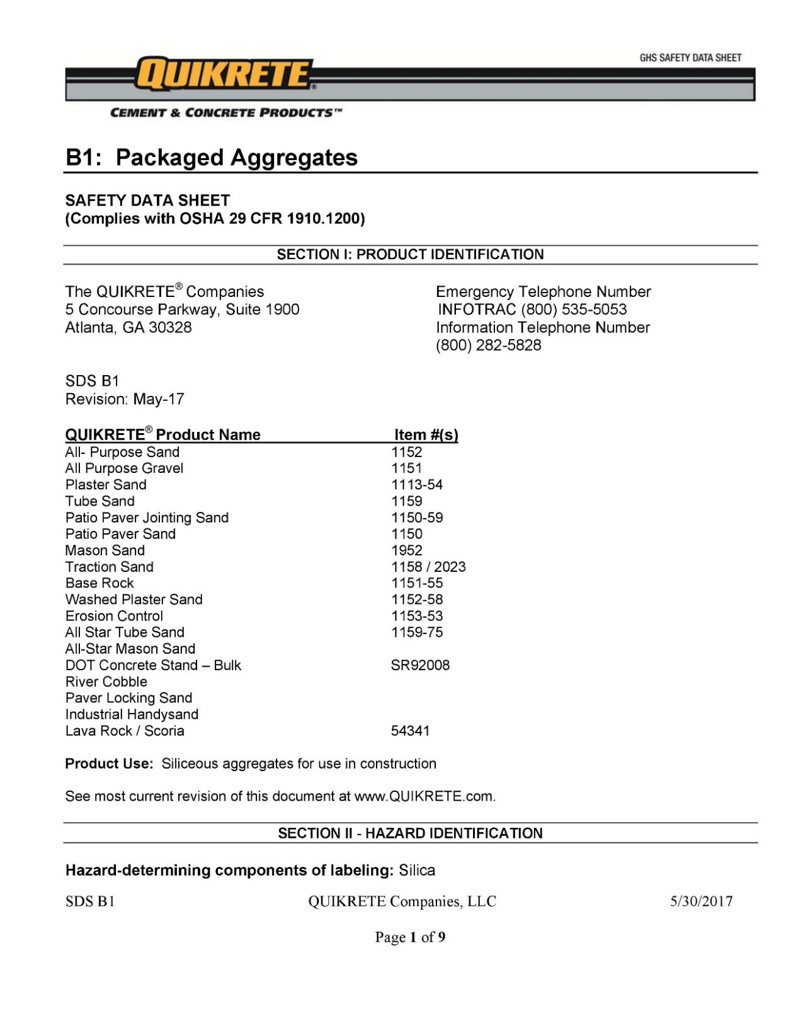
Figure I-2: Quikrete® All Purpose Sand safety data sheet (1 of 9).


Figure I-3: Quikrete® All Purpose Sand safety data sheet (2 of 9).


Figure I-4: Quikrete® All Purpose Sand safety data sheet (3 of 9).


Figure I-5: Quikrete® All Purpose Sand safety data sheet (4 of 9).


Figure I-6: Quikrete® All Purpose Sand safety data sheet (5 of 9).


Figure I-7: Quikrete® All Purpose Sand safety data sheet (6 of 9).


Figure I-8: Quikrete® All Purpose Sand safety data sheet (7 of 9).


Figure I-9: Quikrete® All Purpose Sand safety data sheet (8 of 9).


Figure I-10: Quikrete® All Purpose Sand safety data sheet (9 of 9).

- Fly Ash Material Composition Analysis Report
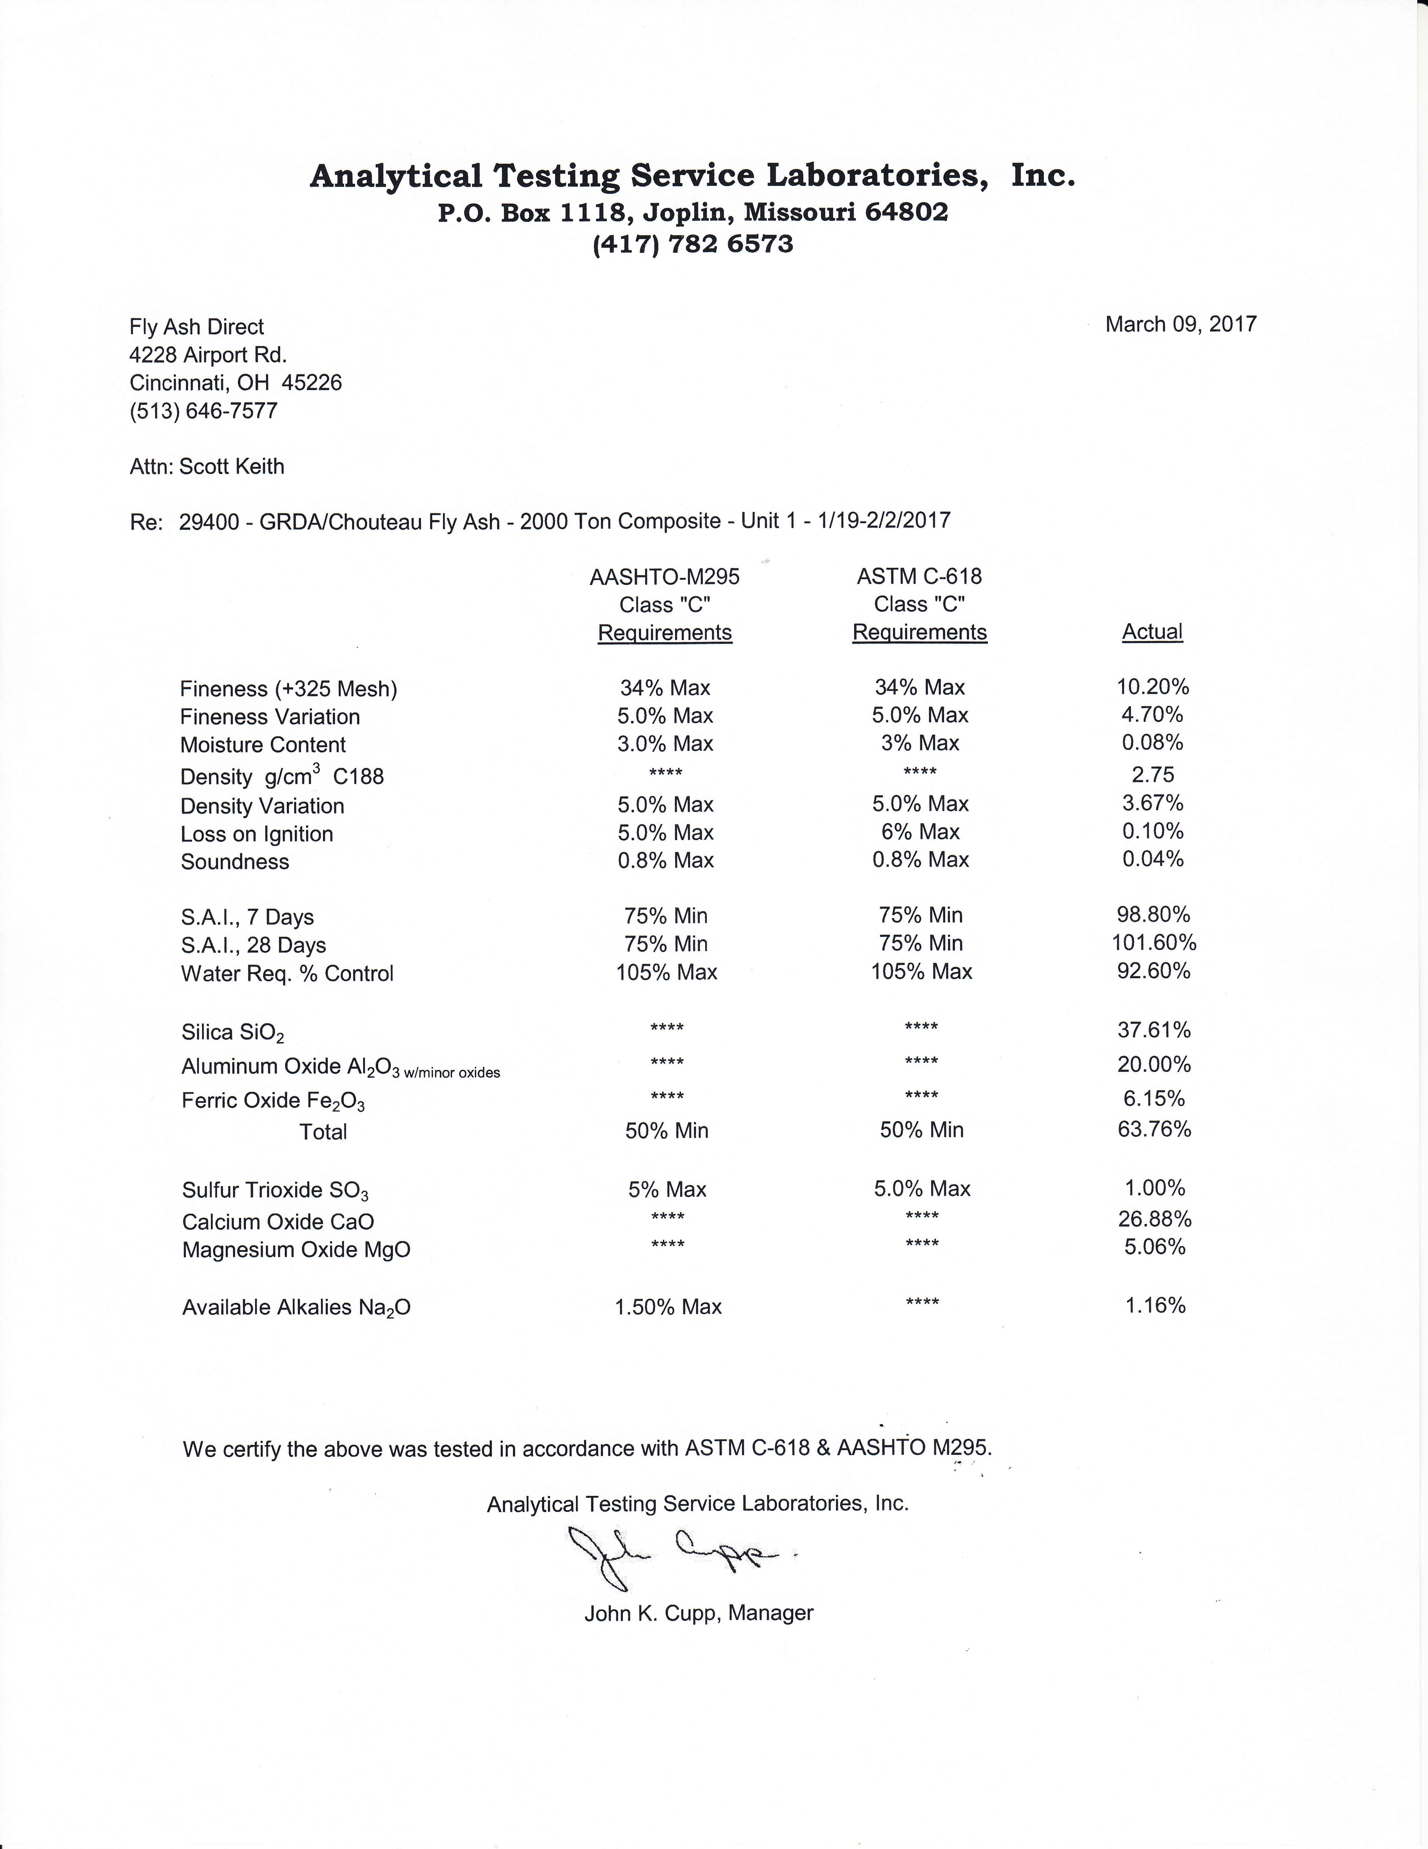
Figure II-1: Fly ash material composition report.

- American Peat Technology Product and Safety Data Sheets
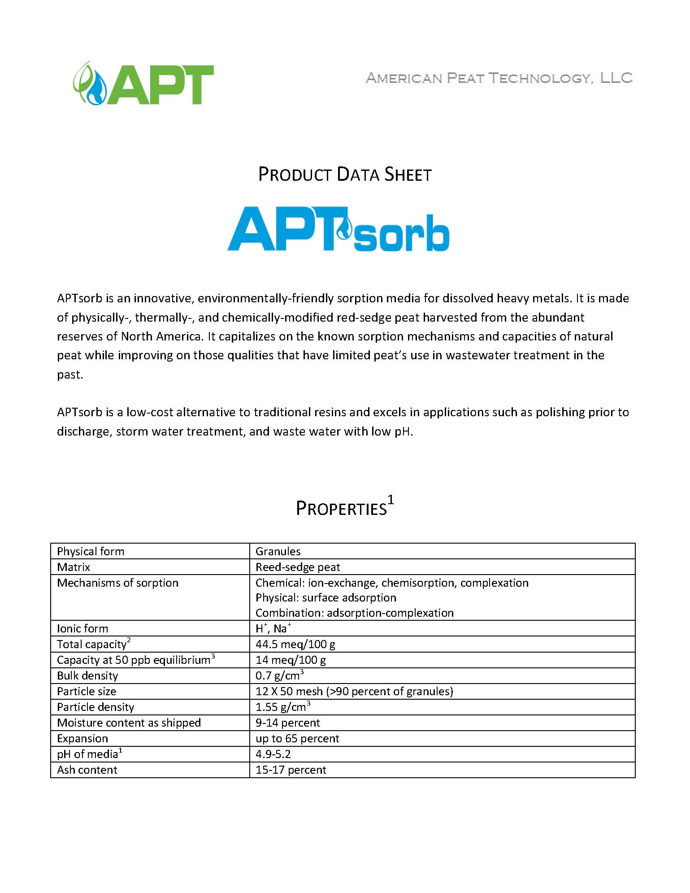
Figure III-1: APTsorb product data sheet (1 of 2).

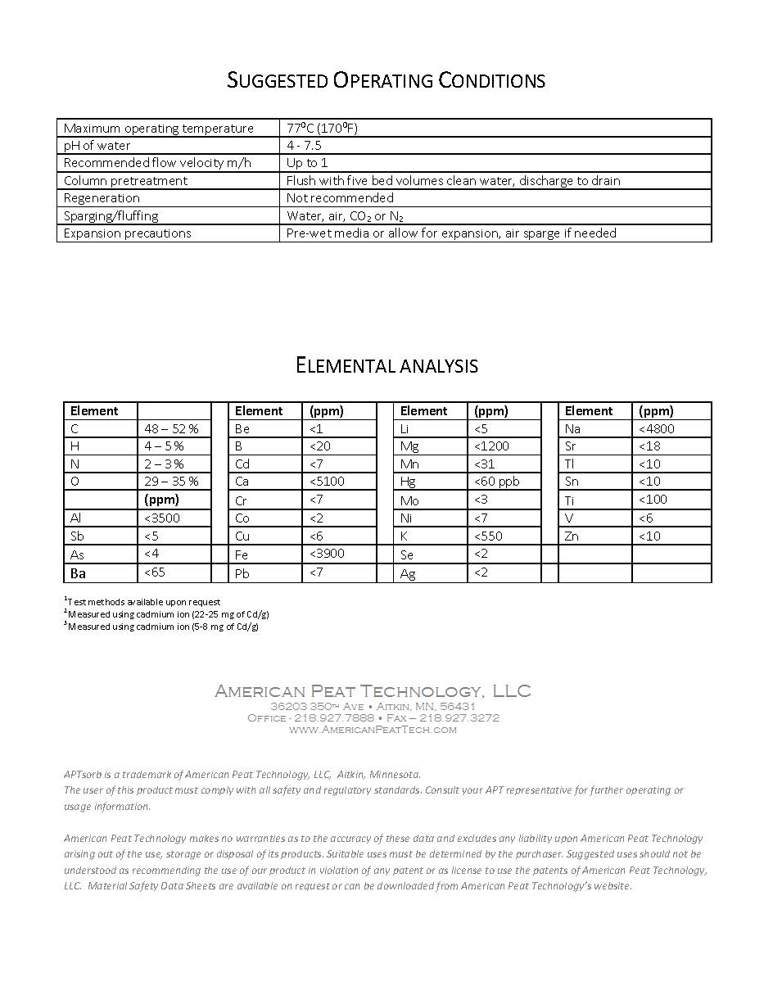
Figure III-2: APTsorb product data sheet (2 of 2).

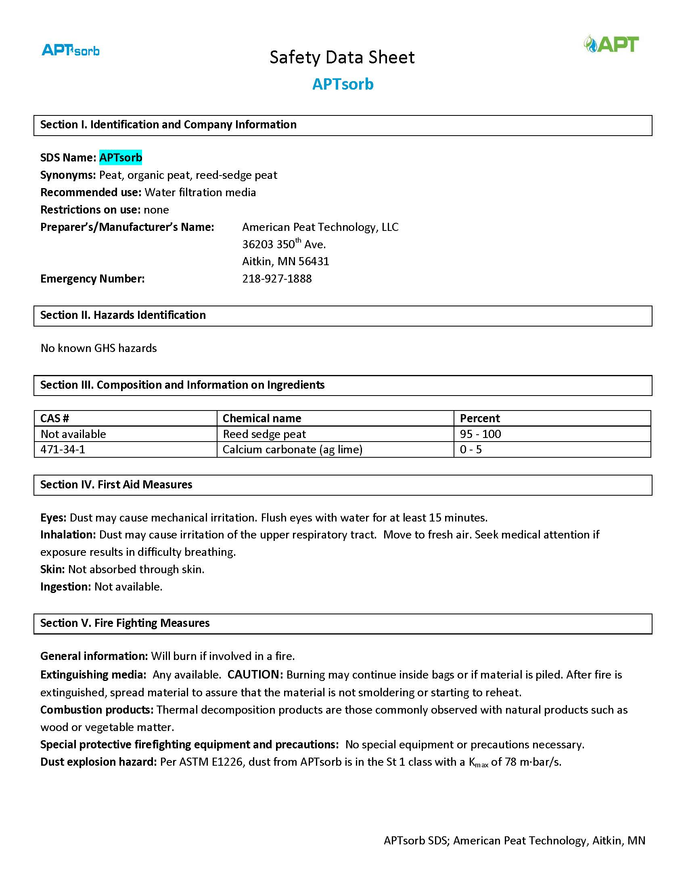
Figure III-3: APTsorb safety data sheet (1 of 3).

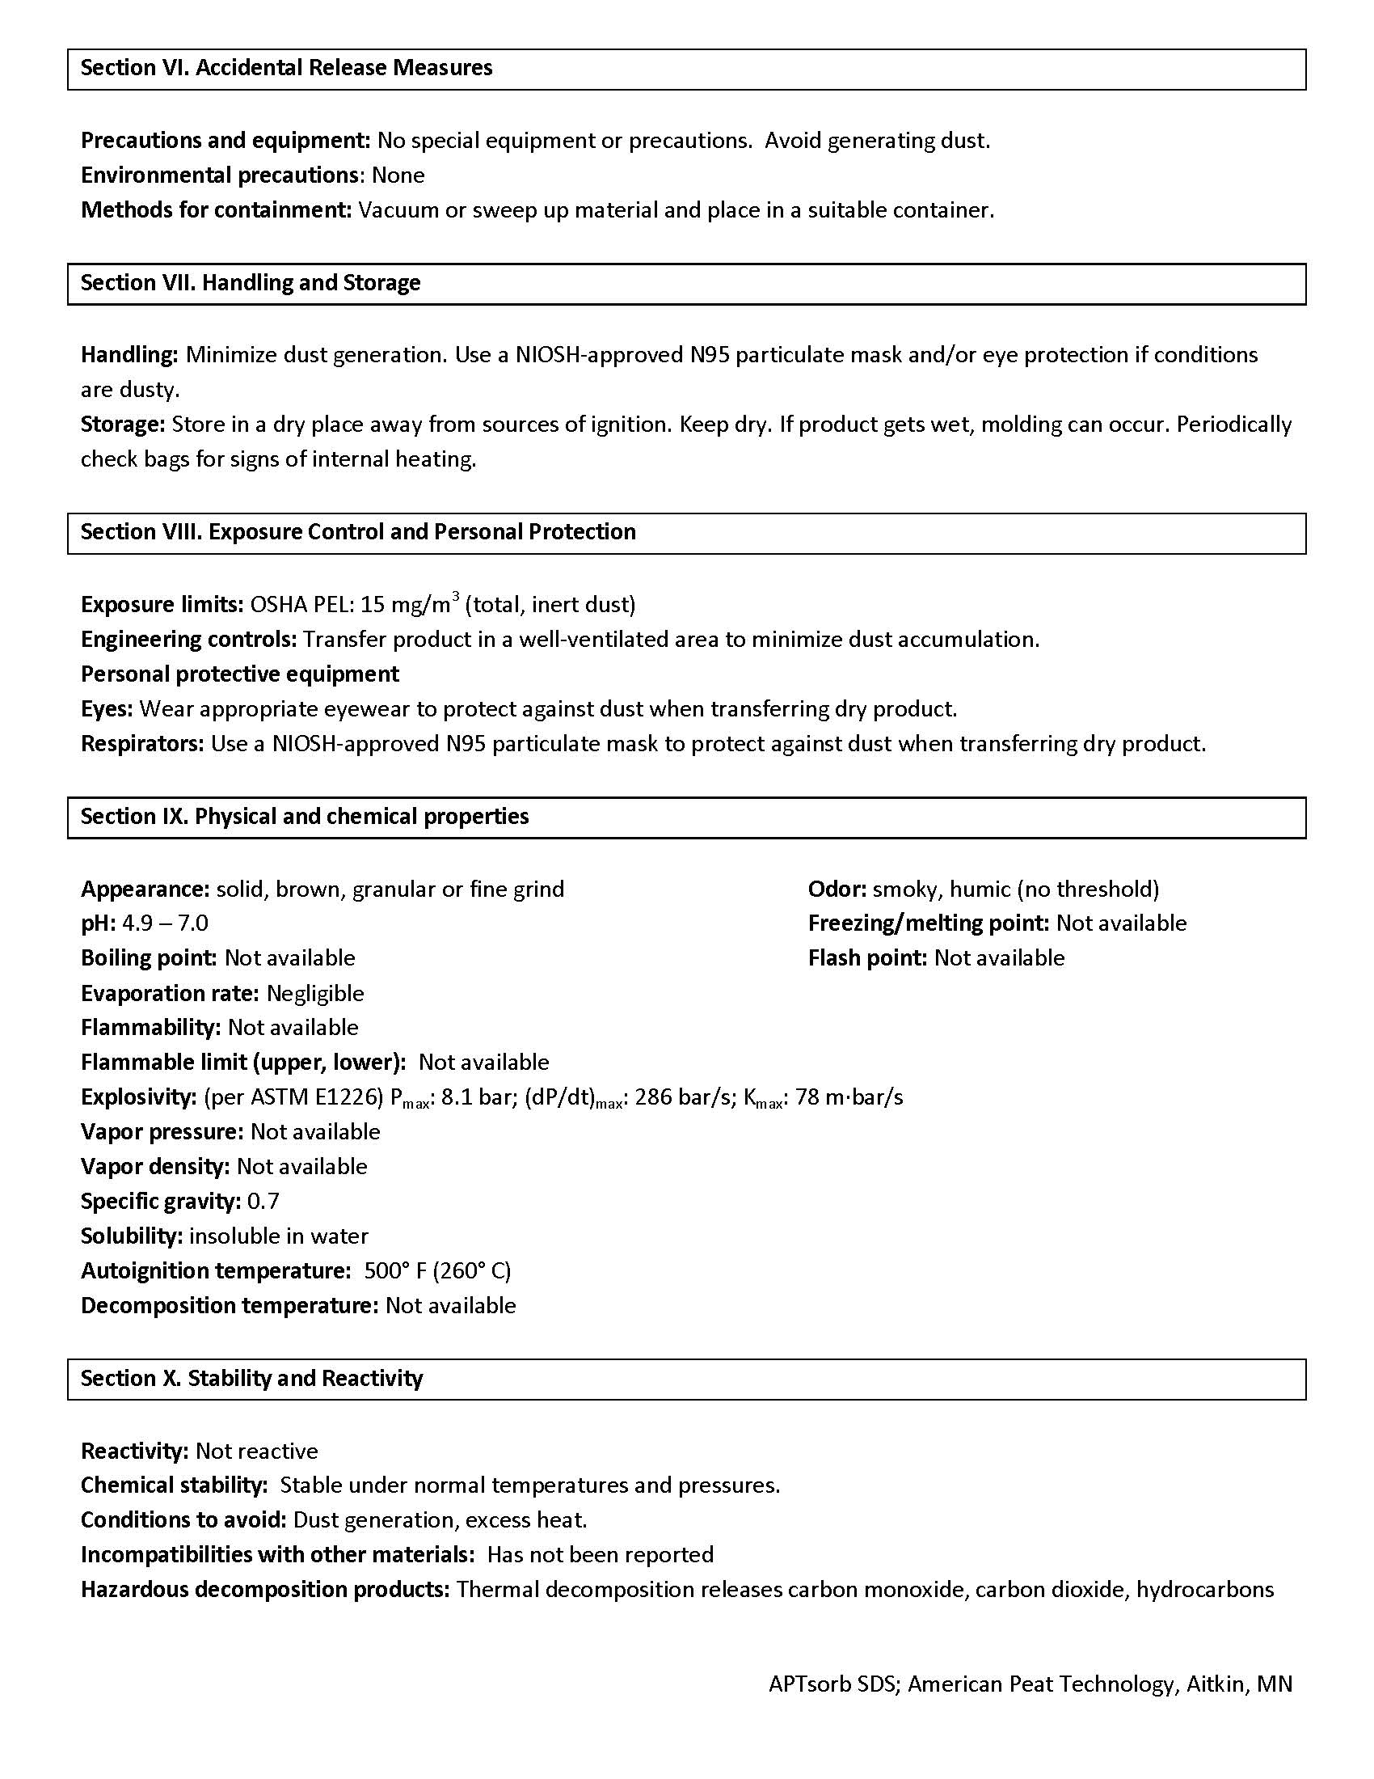
Figure III-4: APTsorb safety data sheet (2 of 3).

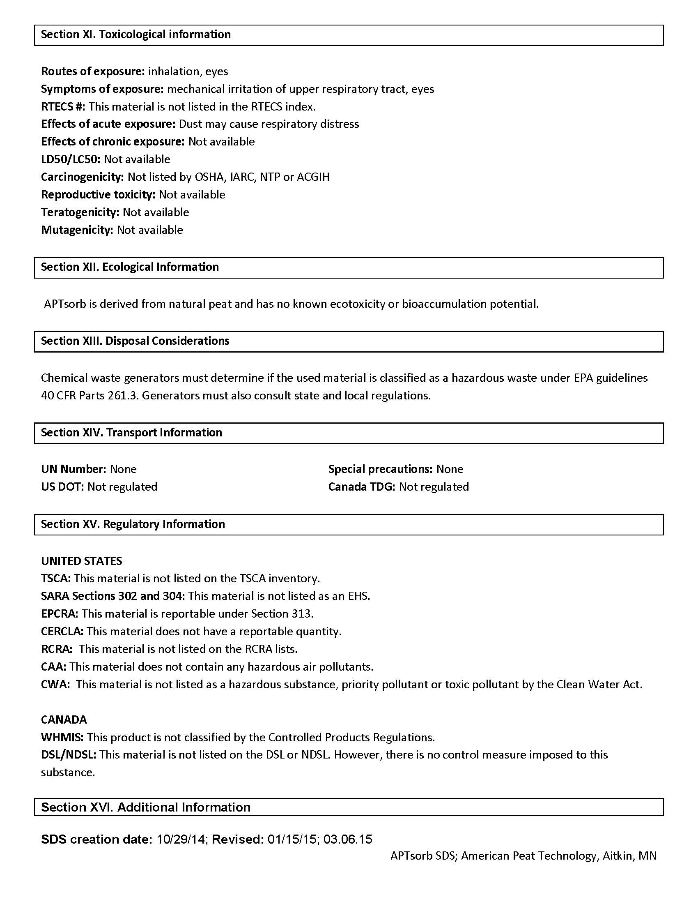
Figure III-5: APTsorb safety data sheet (3 of 3).

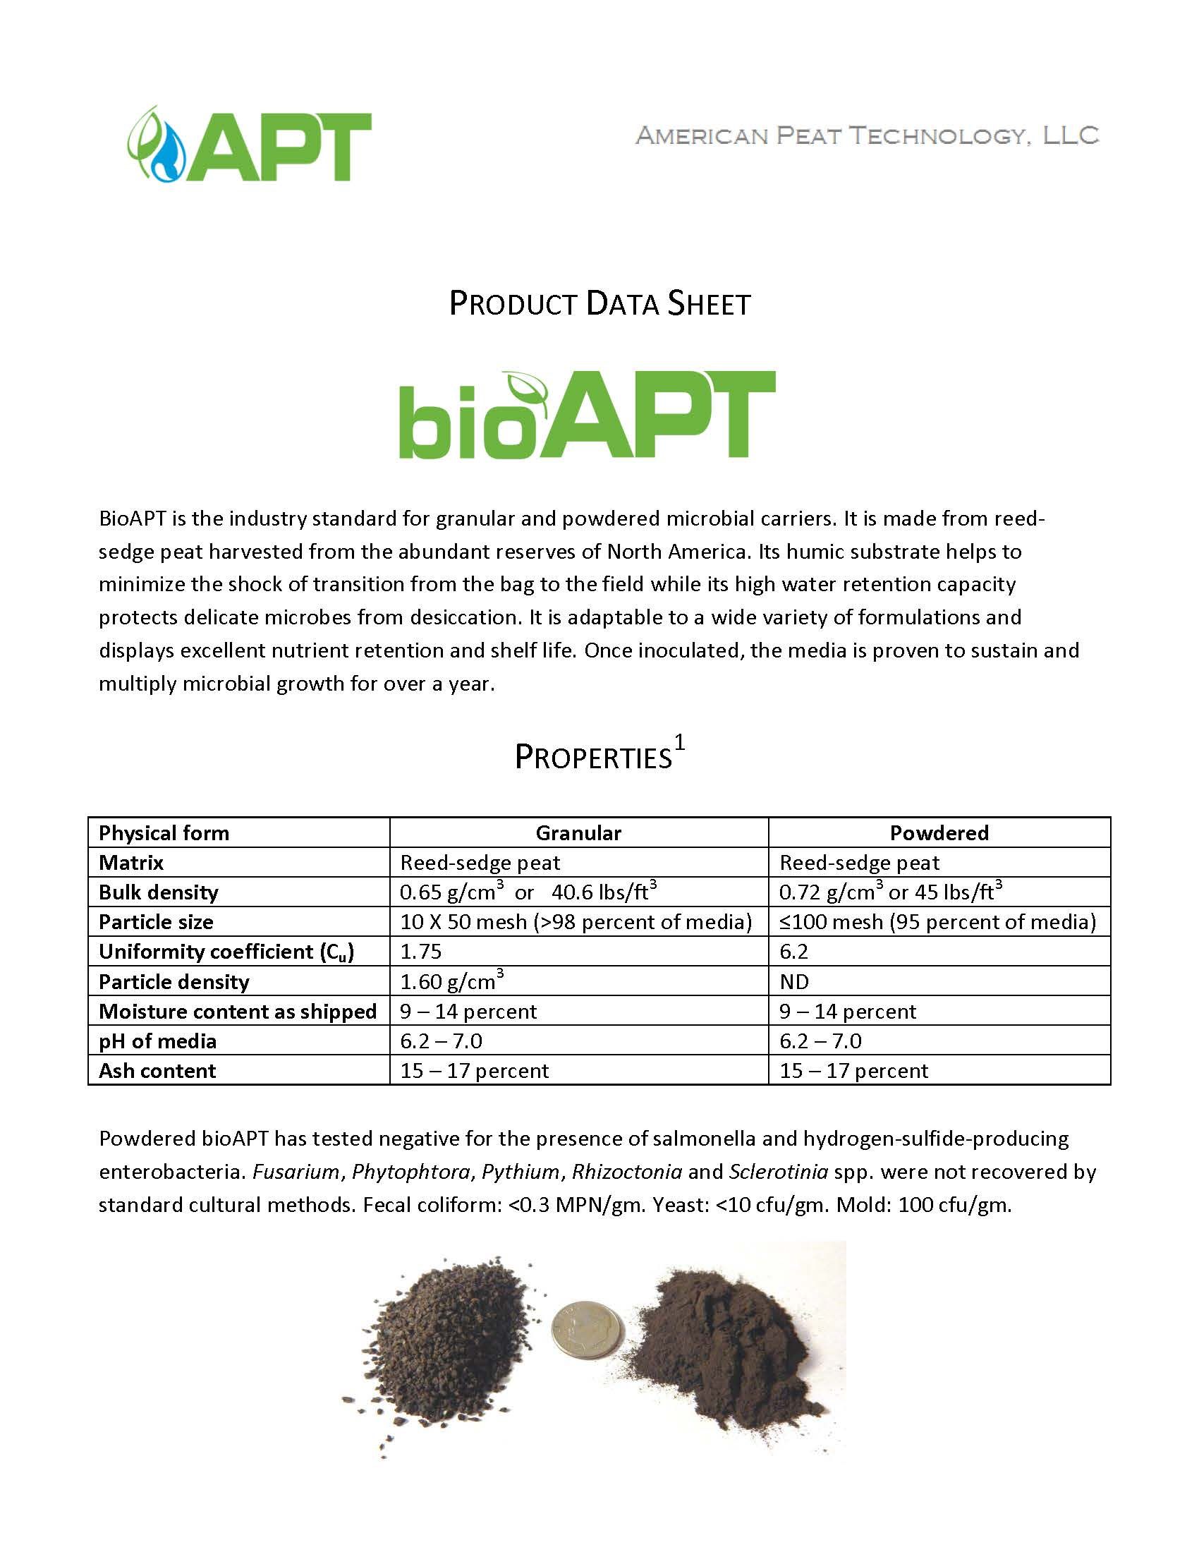
Figure III-6: bioAPT product data sheet (1 of 2).

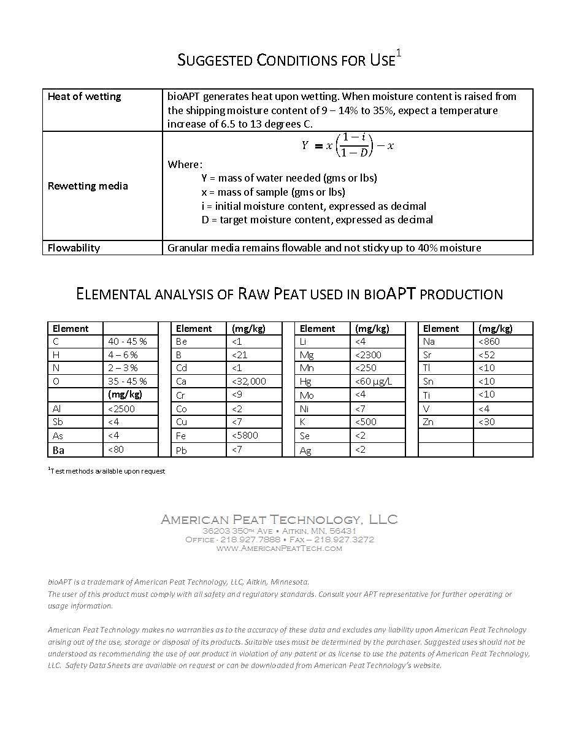
Figure III-7: bioAPT product data sheet (2 of 2).

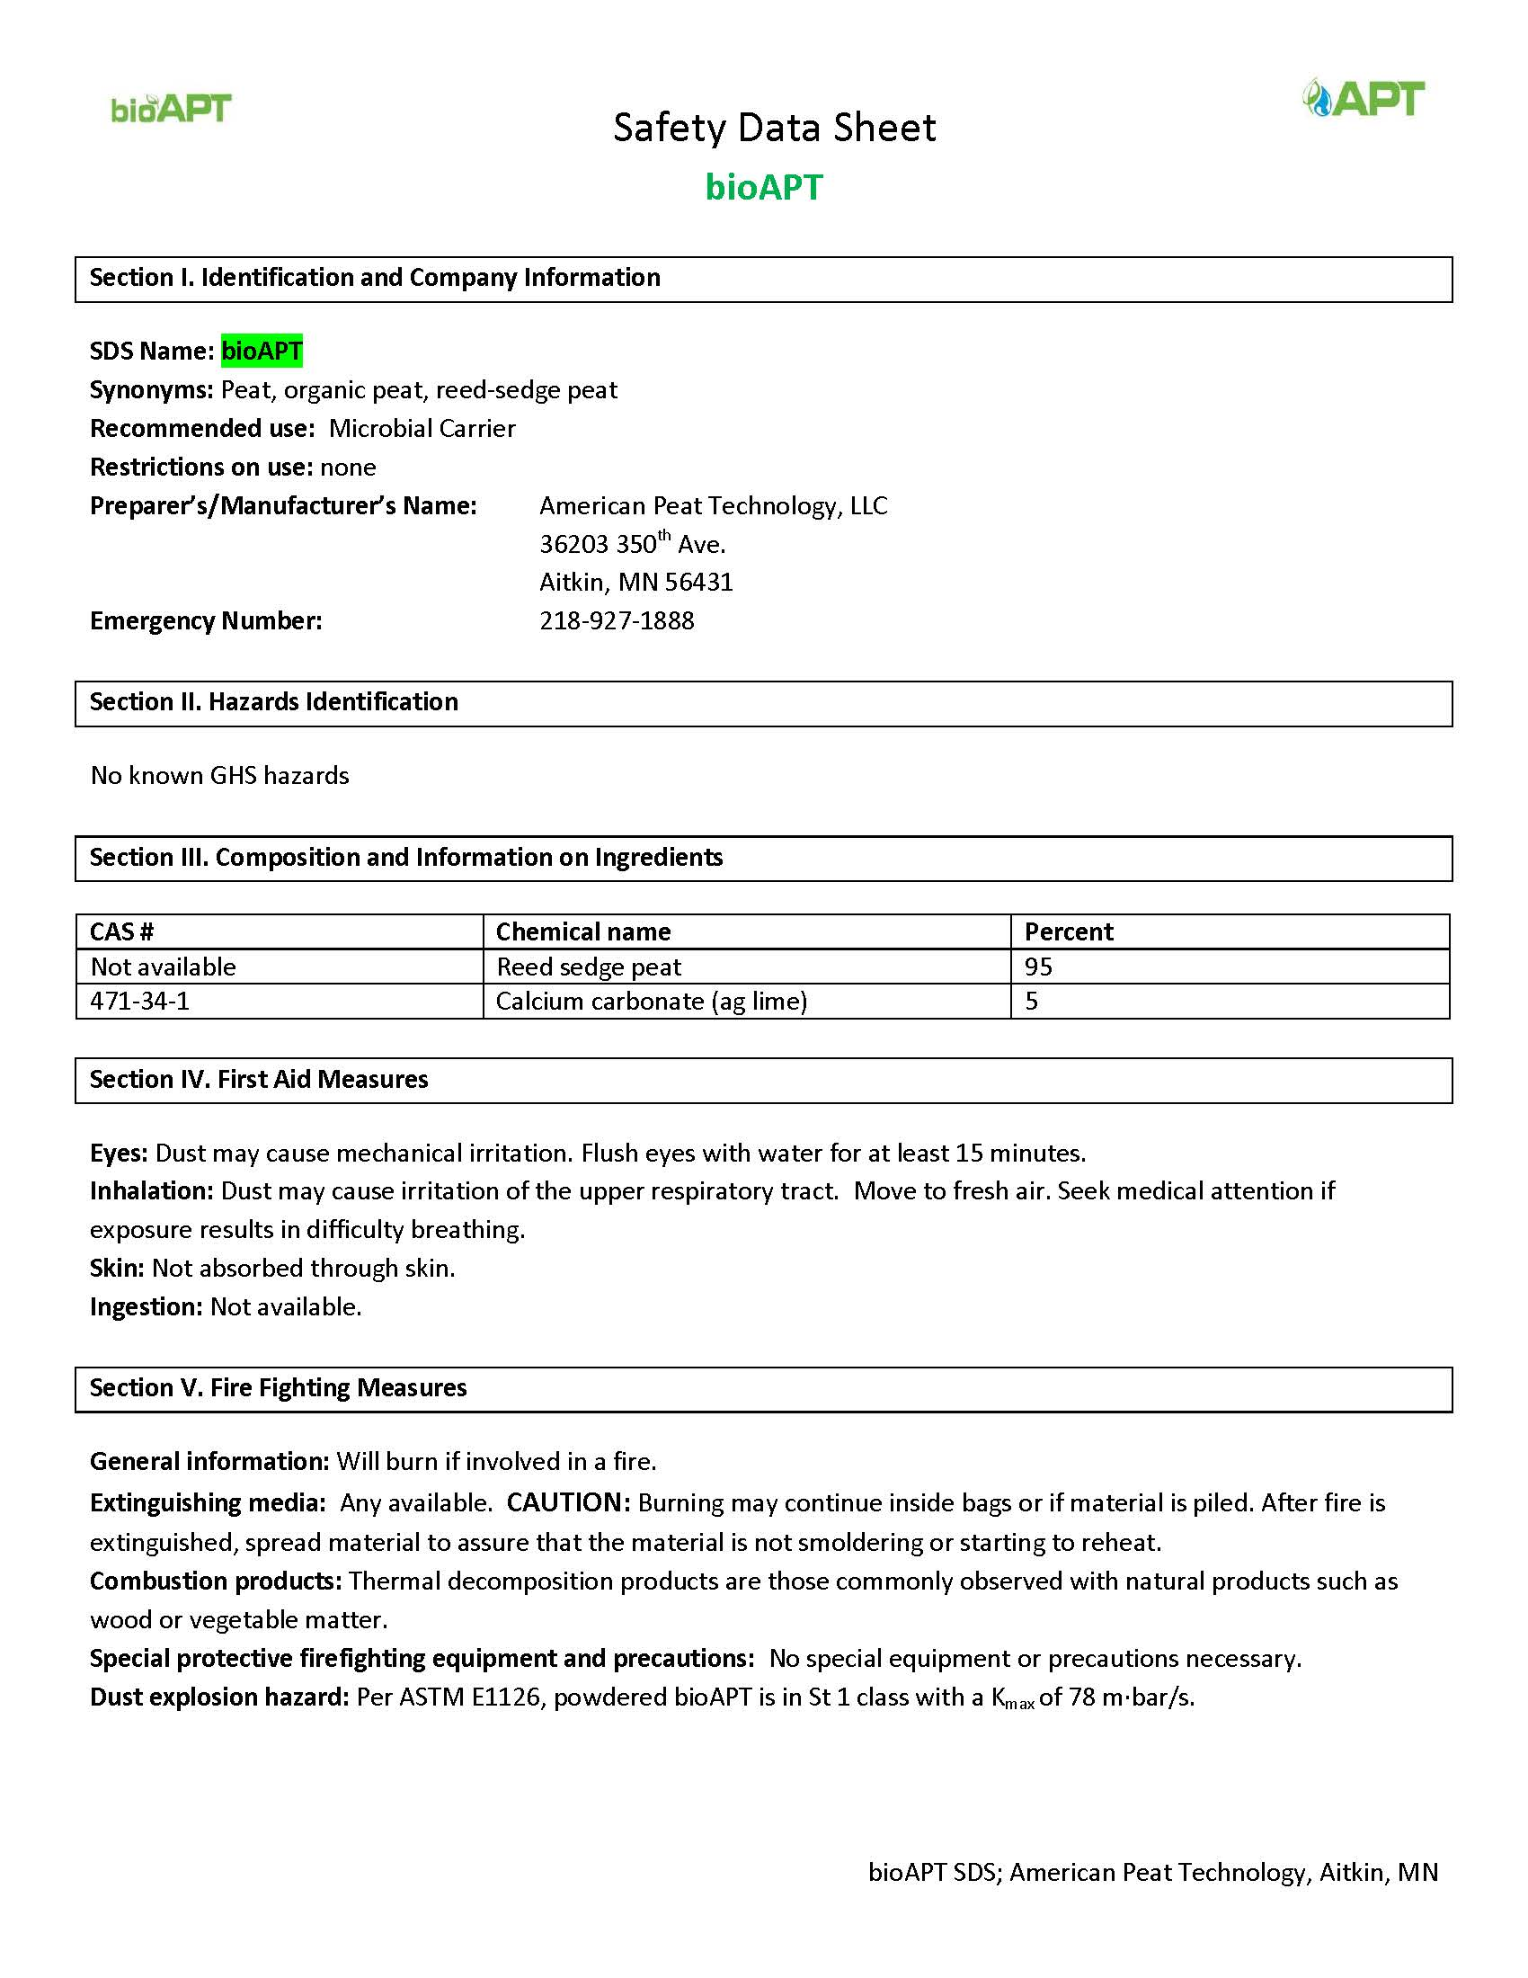
Figure III-8: bioAPT safety data sheet (1 of 3).

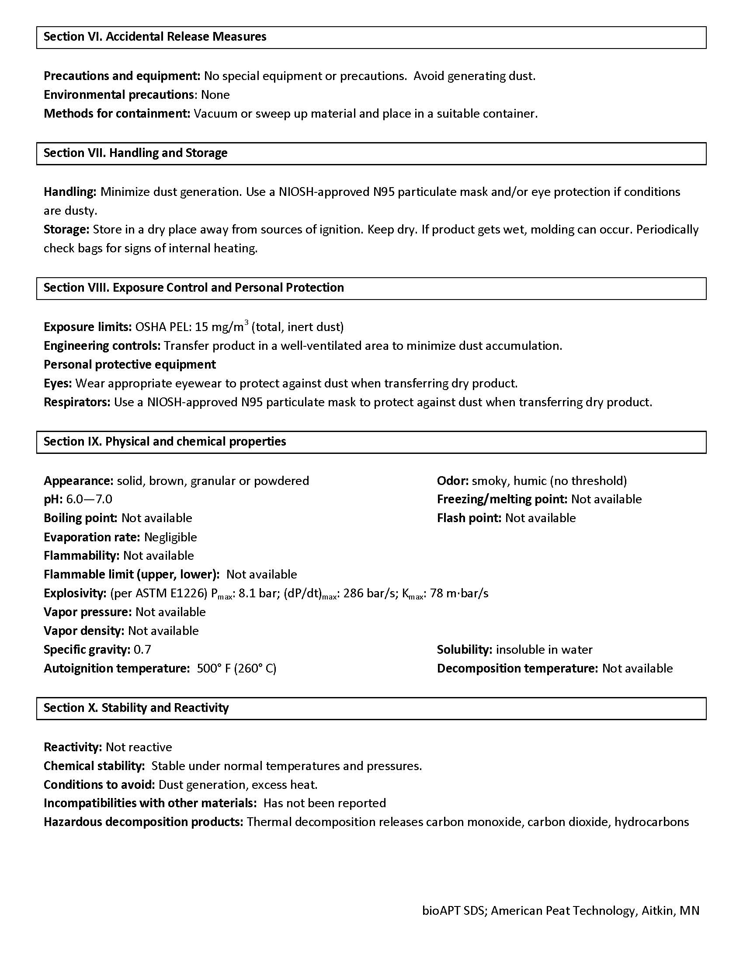
Figure III-9: bioAPT safety data sheet (2 of 3).

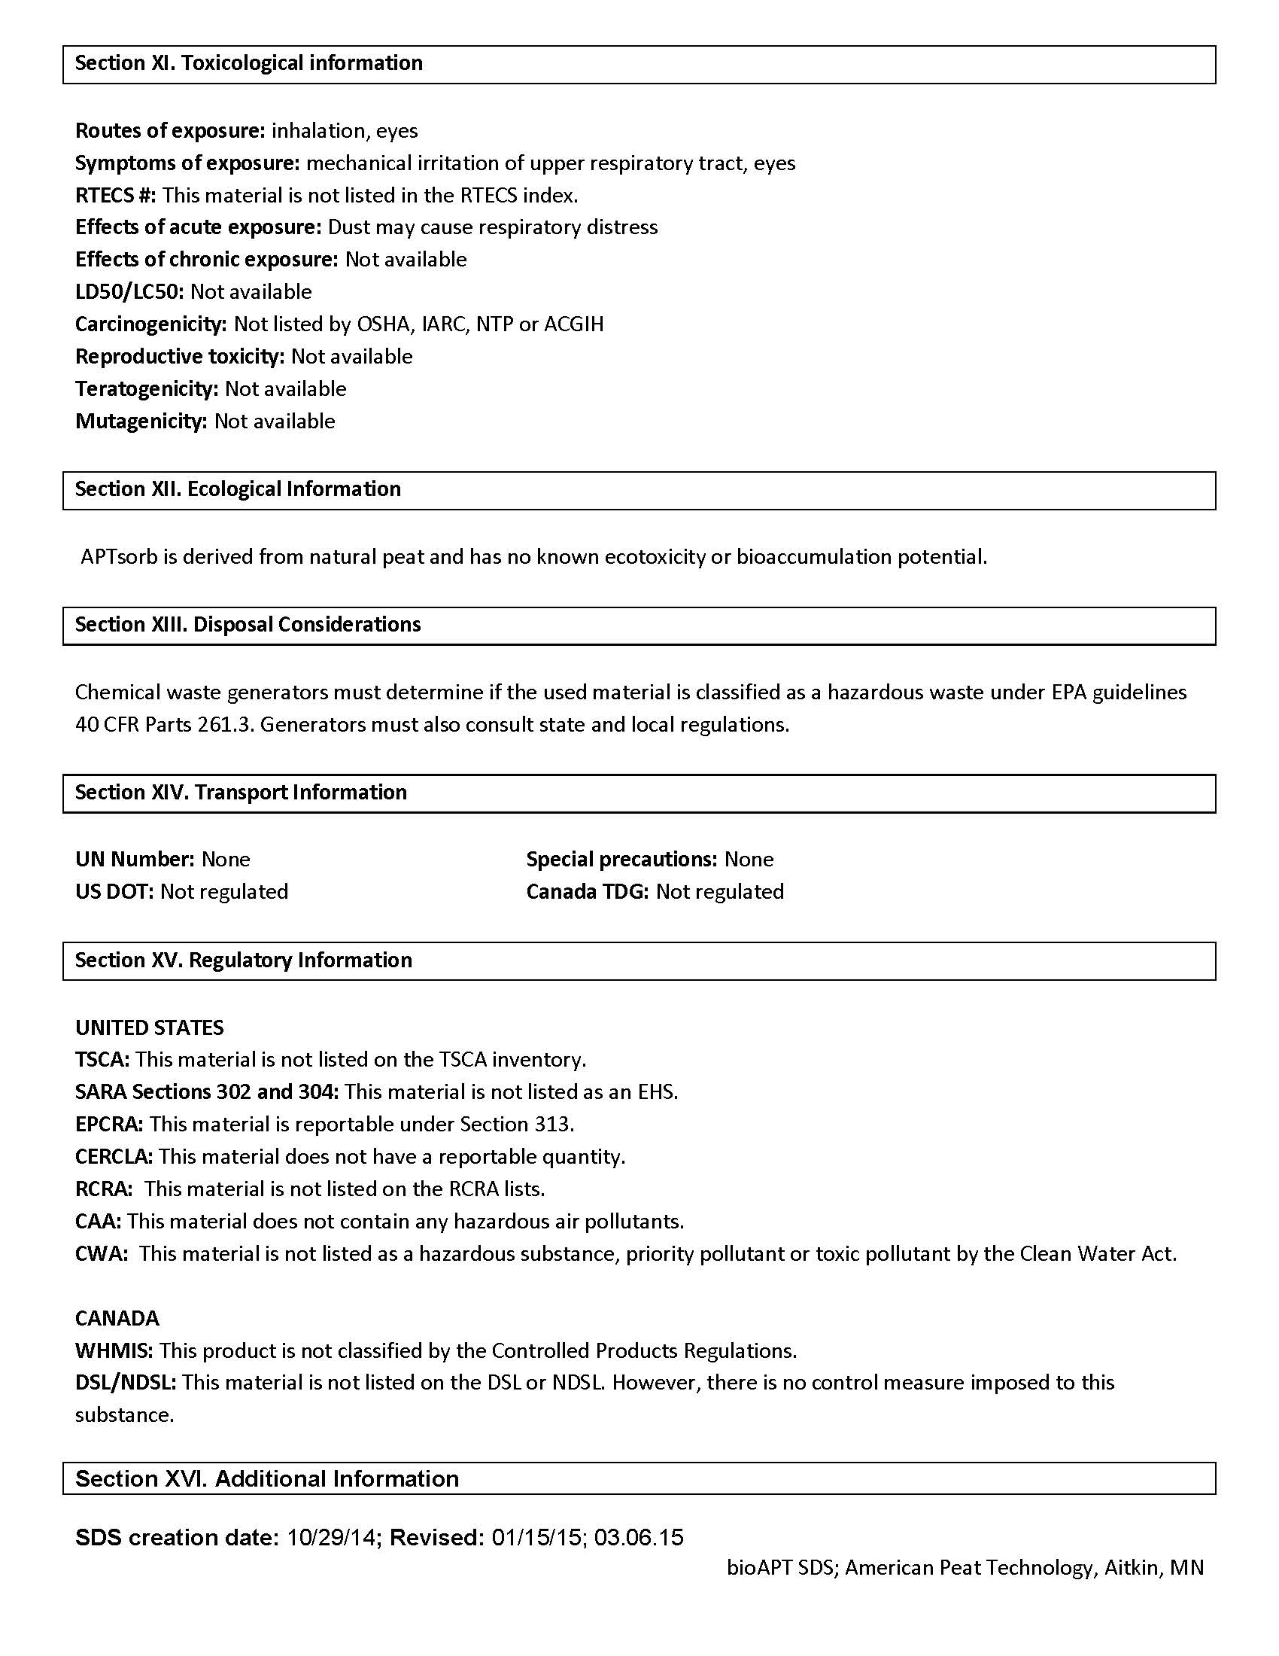
Figure III-10: bioAPT safety data sheet (3 of 3).

- Raw In-Situ Data by Individual Sample
Table IV-1: Raw in-situ data by individual sample (1 of 2).
Sample | pH | SC | ORP | DO | T
Sample | pH | (µS/cm) | (mV) | (mg/L) | (°C)
SS1.03 | 6.27 | 39.44 | 157 | 6.98 | 21.2
SAND1PV01 | 9.65 | 52.20 | 145 | 6.15 | 21.0
SAND1PV03 | 9.81 | 56.68 | 126 | 7.22 | 21.0
SAND1PV10 | 9.69 | 58.17 | 126 | 7.59 | 20.9
SAND1PV30 | 9.80 | 56.02 | 119 | 6.68 | 20.9
SAND2PV01 | 9.70 | 57.83 | 126 | 7.11 | 21.1
SAND2PV03 | 9.77 | 57.28 | 125 | 7.50 | 20.8
SAND2PV10 | 9.78 | 54.60 | 122 | 7.59 | 20.9
SAND2PV30 | 9.85 | 57.90 | 118 | 6.66 | 20.9
SS2.04 | 6.35 | 23.81 | 130 | 8.74 | 21.5
SAND3PV01 | 9.67 | 52.80 | 110 | 8.56 | 22.2
SAND3PV03 | 9.76 | 53.02 | 113 | 8.50 | 21.9
SAND3PV10 | 9.79 | 55.67 | 112 | 7.05 | 22.1
SAND3PV30 | 9.85 | 56.75 | 128 | 8.52 | 21.8
SS1.01 | 7.14 | 31.22 | 198 | 7.42 | 20.1
FA5.01PV01 | 11.36 | 759.50 | 124 | 7.41 | 19.0
FA5.01PV03 | 11.47 | 658.00 | 102 | 7.50 | 19.2
FA5.01PV10 | 11.28 | 454.90 | 73 | 7.12 | 19.3
FA5.01PV30 | 11.12 | 453.20 | 58 | 7.44 | 19.7
FA5.02PV01 | 11.52 | 956.10 | 123 | 7.27 | 19.0
FA5.02PV03 | 11.57 | 886.40 | 108 | 7.58 | 19.1
FA5.02PV10 | 11.35 | 556.30 | 60 | 7.13 | 19.1
FA5.02PV30 | 11.11 | 341.90 | 59 | 7.38 | 19.8
SS1.05 | 6.40 | 22.42 | 130 | 8.04 | 21.4
FA5.03PV01 | 11.27 | 532.80 | 120 | 8.08 | 21.6
FA5.03PV03 | 11.22 | 497.10 | 86 | 7.88 | 21.6
FA5.03PV10 | 11.09 | 382.30 | 140 | 7.87 | 21.8
FA5.03PV30 | 10.94 | 292.60 | 111 | 8.22 | 21.7
MDR7.53PV01 | 7.91 | 296.00 | 158 | 6.68 | 21.5
MDR7.53PV03 | 7.50 | 233.90 | 181 | 6.98 | 21.6
MDR7.53PV10 | 8.35 | 169.20 | 180 | 6.73 | 21.7
MDR7.53PV30 | 7.55 | 105.40 | 153 | 7.32 | 21.6

Table IV-2: Raw in-situ data by individual sample (2 of 2).
Sample | pH | Conductivity | ORP | DO | T
Sample | pH | (µS/cm) | (mV) | (mg/L) | (°C)
SS2.01 | 6.60 | 20.73 | 207 | 7.56 | 20.2
MDR7.51PV01 | 8.03 | 265.10 | 195 | 3.82 | 17.3
MDR7.51PV03 | 8.11 | 225.10 | 178 | 5.19 | 18.9
MDR7.51PV10 | 8.05 | 176.70 | 118 | 5.54 | 19.1
MDR7.51PV30 | 8.12 | 103.80 | 119 | 5.91 | 19.7
MDR7.52PV01 | 7.73 | 272.30 | 203 | 3.40 | 17.2
MDR7.52PV03 | 7.91 | 227.50 | 181 | 5.54 | 19.0
MDR7.52PV10 | 8.16 | 156.90 | 125 | 5.99 | 19.3
MDR7.52PV30 | 8.22 | 111.80 | 125 | 5.96 | 19.8
SS2.03 | 7.71 | 22.09 | 103 | 7.77 | 21.4
APT1PV01 | 7.41 | 68.11 | 90 | 7.41 | 21.3
APT1PV03 | 7.60 | 58.24 | 75 | 7.60 | 21.1
APT1PV10 | 7.71 | 56.10 | 89 | 7.71 | 21.3
APT1PV30 | 7.56 | 52.51 | 94 | 7.56 | 19.9
APT3PV01 | 7.68 | 67.98 | 84 | 7.68 | 21.3
APT3PV03 | 8.08 | 58.44 | 78 | 8.08 | 21.2
APT3PV10 | 7.85 | 55.97 | 87 | 7.85 | 20.9
APT3PV30 | 7.69 | 55.16 | 96 | 7.69 | 19.9
SS2.02 | 7.12 | 21.71 | 135 | 5.72 | 21.1
APT2PV01 | 9.17 | 59.63 | 97 | 5.30 | 20.9
APT2PV03 | 9.30 | 50.30 | 100 | 5.03 | 20.9
APT2PV10 | 9.28 | 46.21 | 112 | 7.20 | 20.7
APT2PV30 | 9.55 | 49.58 | 86 | 6.29 | 19.7
BIO2PV01 | 8.80 | 58.22 | 110 | 4.52 | 20.9
BIO2PV03 | 9.15 | 50.10 | 96 | 4.88 | 21.0
BIO2PV10 | 9.18 | 53.85 | 99 | 7.02 | 20.5
BIO2PV30 | 9.51 | 55.04 | 97 | 6.02 | 19.6
SS1.04 | 7.14 | 22.46 | 162 | 7.72 | 19.7
BIO1PV01 | 8.96 | 73.80 | 124 | 7.15 | 19.7
BIO1PV03 | 9.29 | 67.60 | 107 | 7.11 | 20.2
BIO1PV10 | 9.23 | 64.54 | 113 | 7.43 | 20.3
BIO1PV30 | 9.52 | 62.72 | 105 | 7.38 | 20.1
BIO3PV01 | 9.19 | 71.71 | 115 | 7.42 | 19.7
BIO3PV03 | 9.35 | 69.38 | 101 | 7.45 | 20.2
BIO3PV10 | 9.41 | 63.03 | 106 | 7.62 | 20.4
BIO3PV30 | 9.33 | 60.42 | 108 | 7.35 | 19.8

- Raw Nutrients Data by Individual Sample
Table V-1: Raw nutrients data by individual sample (1 of 2).
Sample | P (mg/L as P) |  | N (mg/L as N)
Sample | Total | Dissolved | NO₃⁻ | NH₃ | Total
SS1.03 | 0.56 | 0.55 | 1.4 | BDL | 1.56
SAND1PV01 | 0.16 | 0.11 | 1.3 | 0.056 | 1.64
SAND1PV03 | 0.16 | 0.15 | 1.3 | 0.041 | 1.56
SAND1PV10 | 0.44 | 0.43 | 1.4 | 0.029 | 1.59
SAND1PV30 | 0.52 | 0.52 | 1.4 | 0.005 | 1.61
SAND2PV01 | 0.24 | 0.14 | 1.1 | 0.064 | 1.64
SAND2PV03 | 0.16 | 0.14 | 1.4 | 0.044 | 1.57
SAND2PV10 | 0.51 | 0.51 | 1.2 | 0.027 | 1.60
SAND2PV30 | 0.51 | 0.50 | 1.4 | BDL | 1.62
SS2.04 | 0.54 | 0.54 | 1.6 | BDL | 1.78
SAND3PV01 | 0.12 | 0.10 | 1.0 | 0.033 | 1.80
SAND3PV03 | 0.10 | 0.10 | 0.9 | 0.029 | 1.74
SAND3PV10 | 0.27 | 0.27 | 1.5 | 0.019 | 1.74
SAND3PV30 | 0.48 | 0.47 | 1.5 | BDL | 1.84
SS1.01 | 0.52 | 0.51 | 1.6 | 0.098 | 1.91
FA5.01PV01 | 0.02 | 0.02 | 1.4 | BDL | 1.79
FA5.01PV03 | 0.03 | 0.02 | 1.3 | BDL | 1.77
FA5.01PV10 | 0.03 | 0.03 | 1.5 | BDL | 1.74
FA5.01PV30 | 0.04 | 0.03 | 1.4 | BDL | 1.81
FA5.02PV01 | 0.03 | 0.01 | 1.3 | 0.015 | 1.70
FA5.02PV03 | 0.03 | 0.02 | 1.6 | BDL | 1.78
FA5.02PV10 | 0.03 | 0.03 | 1.4 | BDL | 1.74
FA5.02PV30 | 0.05 | 0.04 | 1.4 | BDL | 1.79
SS1.05 | 0.55 | 0.55 | 1.4 | BDL | 1.69
FA5.03PV01 | 0.05 | 0.05 | 1.2 | 0.016 | 1.53
FA5.03PV03 | 0.06 | 0.06 | 0.9 | 0.024 | 1.57
FA5.03PV10 | 0.13 | 0.13 | 1.2 | BDL | 1.57
FA5.03PV30 | 0.13 | 0.13 | 1.3 | BDL | 1.62
MDR7.53PV01 | 0.08 | 0.08 | 1.4 | 0.046 | 1.54
MDR7.53PV03 | 0.02 | 0.02 | 1.2 | 0.067 | 1.60
MDR7.53PV10 | 0.10 | 0.10 | 1.6 | 0.075 | 1.57
MDR7.53PV30 | 0.08 | 0.08 | 1.4 | 0.064 | 1.59

Table V-2: Raw nutrients data by individual sample (2 of 2).
Sample | P (mg/L as P) |  | N (mg/L as N)
Sample | Total | Dissolved | NO₃⁻ | NH₃ | Total
SS2.01 | 0.53 | 0.53 | 1.5 | BDL |  | 1.80
MDR7.51PV01 | 0.03 | 0.02 | 1.5 | 0.221 |  | 1.86
MDR7.51PV03 | 0.02 | 0.02 | 1.5 | 0.146 |  | 1.76
MDR7.51PV10 | 0.09 | 0.09 | 1.7 | 0.164 |  | 1.75
MDR7.51PV30 | 0.08 | 0.08 | 1.5 | 0.028 |  | 1.75
MDR7.52PV01 | 0.02 | 0.01 | 1.5 | 0.242 |  | 1.84
MDR7.52PV03 | 0.02 | 0.01 | 1.5 | 0.156 |  | 1.73
MDR7.52PV10 | 0.08 | 0.05 | 1.3 | 0.215 |  | 1.80
MDR7.52PV30 | 0.04 | 0.03 | 1.3 | 0.027 |  | 1.70
SS2.03 | 0.57 | 0.57 | 1.3 | BDL |  | 1.74
APT1PV01 | 0.35 | 0.25 | 0.5 | 0.880 |  | 2.76
APT1PV03 | 0.50 | 0.40 | 1.0 | 0.670 |  | 2.56
APT1PV10 | 0.55 | 0.55 | 1.5 | 0.300 |  | 2.22
APT1PV30 | 0.60 | 0.50 | 1.5 | 0.068 |  | 1.87
APT3PV01 | 0.40 | 0.25 | 1.0 | 1.120 |  | 2.90
APT3PV03 | 0.45 | 0.40 | 0.5 | 0.783 |  | 2.72
APT3PV10 | 0.55 | 0.55 | 1.5 | 0.315 |  | 2.20
APT3PV30 | 0.55 | 0.50 | 1.0 | 0.061 |  | 1.86
SS2.02 | 0.63 | 0.63 | 1.6 | BDL |  | 1.78
APT2PV01 | 0.15 | 0.10 | 1.4 | 0.451 |  | 2.30
APT2PV03 | 0.25 | 0.25 | 1.8 | 0.348 |  | 2.19
APT2PV10 | 0.55 | 0.50 | 1.4 | 0.175 |  | 1.95
APT2PV30 | 0.60 | 0.55 | 1.4 | 0.017 |  | 1.81
BIO2PV01 | 0.40 | 0.35 | 1.0 | 0.156 |  | 2.44
BIO2PV03 | 0.60 | 0.60 | 2.0 | 0.136 |  | 2.29
BIO2PV10 | 0.70 | 0.65 | 1.4 | 0.108 |  | 2.14
BIO2PV30 | 0.65 | 0.60 | 1.6 | 0.018 |  | 1.97
SS1.04 | 0.54 | 0.54 | 1.5 | BDL |  | 1.82
BIO1PV01 | 0.65 | 0.60 | 1.6 | 0.886 |  | 3.67
BIO1PV03 | 0.85 | 0.75 | 1.6 | 0.825 |  | 3.17
BIO1PV10 | 0.85 | 0.75 | 1.8 | 0.325 |  | 2.58
BIO1PV30 | 0.75 | 0.75 | 1.4 | 0.168 |  | 2.06
BIO3PV01 | 0.60 | 0.60 | 1.4 | 0.801 |  | 3.52
BIO3PV03 | 0.75 | 0.70 | 1.6 | 0.552 |  | 2.96
BIO3PV10 | 0.75 | 0.75 | 1.6 | 0.261 |  | 2.49
BIO3PV30 | 0.80 | 0.75 | 1.2 | 0.055 |  | 2.03

- Raw Metals Data by Individual Sample - Copper, Lead, and Zinc
Table VI-1: Raw copper, lead, and zinc data by individual sample (1 of 2).
Sample | Cu (mg/L) |  | Pb (mg/L) |  | Zn (mg/L)
Sample | Total | Filtered | Total | Filtered | Total | Filtered
SS1.03 | 0.025 | 0.023 | 0.030 | 0.018 | 0.100 | 0.104
SAND1PV01 | 0.002 | 0.001 | 0.026 | 0.018 | BDL | BDL
SAND1PV03 | 0.003 | 0.002 | 0.022 | 0.017 | BDL | BDL
SAND1PV10 | 0.002 | 0.005 | 0.019 | 0.015 | 0.017 | BDL
SAND1PV30 | 0.001 | BDL | 0.022 | BDL | BDL | BDL
SAND2PV01 | 0.003 | 0.001 | 0.025 | 0.016 | BDL | BDL
SAND2PV03 | 0.002 | 0.001 | 0.020 | BDL | BDL | BDL
SAND2PV10 | 0.002 | BDL | 0.023 | BDL | BDL | BDL
SAND2PV30 | BDL | BDL | 0.023 | BDL | BDL | BDL
SS2.04 | 0.021 | 0.020 | 0.025 | 0.019 | 0.085 | 0.097
SAND3PV01 | 0.001 | 0.001 | 0.016 | 0.020 | BDL | BDL
SAND3PV03 | 0.001 | 0.001 | 0.019 | 0.018 | BDL | 0.039
SAND3PV10 | 0.001 | BDL | 0.014 | 0.014 | BDL | BDL
SAND3PV30 | 0.001 | BDL | 0.019 | 0.014 | 0.097 | BDL
SS1.01 | 0.027 | 0.024 | 0.024 | 0.008 | 0.098 | 0.096
FA5.01PV01 | 0.007 | 0.003 | 0.021 | 0.025 | 0.006 | 0.007
FA5.01PV03 | 0.005 | 0.003 | 0.030 | 0.023 | 0.006 | 0.009
FA5.01PV10 | 0.005 | 0.001 | 0.024 | 0.025 | 0.006 | 0.008
FA5.01PV30 | 0.005 | 0.001 | 0.020 | 0.017 | 0.006 | 0.007
FA5.02PV01 | 0.007 | 0.004 | 0.024 | 0.025 | 0.006 | 0.006
FA5.02PV03 | 0.009 | 0.003 | 0.026 | 0.027 | 0.006 | 0.007
FA5.02PV10 | 0.005 | 0.002 | 0.020 | 0.017 | 0.006 | 0.008
FA5.02PV30 | 0.005 | 0.001 | 0.021 | 0.010 | 0.006 | 0.007
SS1.05 | 0.023 | 0.025 | 0.029 | BDL | 0.096 | 0.095
FA5.03PV01 | BDL | 0.003 | 0.022 | 0.023 | 0.008 | 0.010
FA5.03PV03 | BDL | BDL | 0.022 | BDL | 0.005 | 0.008
FA5.03PV10 | BDL | 0.003 | 0.013 | BDL | 0.007 | 0.007
FA5.03PV30 | 0.023 | BDL | BDL | BDL | 0.006 | 0.006
MDR7.53PV01 | BDL | 0.005 | 0.022 | 0.012 | BDL | BDL
MDR7.53PV03 | 0.004 | 0.004 | 0.020 | BDL | BDL | BDL
MDR7.53PV10 | 0.005 | BDL | 0.018 | BDL | BDL | BDL
MDR7.53PV30 | BDL | 0.003 | BDL | BDL | BDL | BDL

Table VI-2: Raw copper, lead, and zinc data by individual sample (2 of 2).
Sample | Cu (mg/L) |  | Pb (mg/L) |  | Zn (mg/L)
Sample | Total | Filtered | Total | Filtered | Total | Filtered
SS2.01 | 0.031 | 0.024 | 0.030 | BDL | 0.101 | 0.102
MDR7.51PV01 | 0.005 | 0.001 | 0.019 | 0.017 | 0.010 | 0.009
MDR7.51PV03 | 0.005 | 0.001 | 0.016 | 0.021 | 0.018 | 0.014
MDR7.51PV10 | 0.004 | BDL | 0.013 | 0.015 | 0.030 | 0.007
MDR7.51PV30 | 0.005 | BDL | 0.012 | 0.013 | 0.008 | 0.008
MDR7.52PV01 | 0.004 | 0.001 | 0.023 | 0.022 | 0.011 | 0.011
MDR7.52PV03 | 0.005 | 0.001 | 0.013 | 0.019 | 0.010 | 0.010
MDR7.52PV10 | 0.004 | BDL | 0.016 | 0.019 | 0.018 | 0.009
MDR7.52PV30 | 0.004 | BDL | 0.012 | 0.009 | 0.007 | 0.007
SS2.03 | 0.023 | 0.022 | 0.025 | 0.019 | 0.093 | 0.095
APT1PV01 | 0.003 | 0.002 | BDL | BDL | BDL | BDL
APT1PV03 | 0.002 | 0.002 | 0.005 | BDL | BDL | BDL
APT1PV10 | 0.005 | 0.001 | BDL | BDL | BDL | BDL
APT1PV30 | 0.001 | 0.001 | 0.004 | 0.005 | BDL | BDL
APT3PV01 | 0.004 | 0.003 | 0.004 | BDL | BDL | BDL
APT3PV03 | 0.002 | 0.001 | BDL | BDL | BDL | BDL
APT3PV10 | 0.002 | 0.002 | 0.003 | 0.005 | BDL | BDL
APT3PV30 | 0.001 | BDL | 0.005 | BDL | BDL | BDL
SS2.02 | 0.023 | 0.023 | 0.029 | 0.020 | 0.099 | 0.101
APT2PV01 | 0.002 | 0.003 | 0.009 | 0.014 | BDL | BDL
APT2PV03 | 0.002 | 0.002 | 0.007 | BDL | BDL | BDL
APT2PV10 | 0.004 | 0.002 | 0.005 | BDL | BDL | BDL
APT2PV30 | 0.002 | 0.002 | 0.010 | BDL | BDL | BDL
BIO2PV01 | 0.003 | 0.003 | 0.021 | BDL | BDL | BDL
BIO2PV03 | 0.003 | 0.003 | 0.022 | BDL | BDL | BDL
BIO2PV10 | 0.002 | 0.002 | 0.021 | BDL | BDL | BDL
BIO2PV30 | 0.004 | 0.003 | 0.086 | BDL | BDL | BDL
SS1.04 | 0.024 | 0.023 | 0.023 | 0.023 | 0.104 | 0.098
BIO1PV01 | 0.003 | 0.002 | 0.004 | BDL | BDL | BDL
BIO1PV03 | 0.003 | 0.003 | BDL | BDL | BDL | BDL
BIO1PV10 | 0.002 | 0.002 | BDL | 0.004 | BDL | BDL
BIO1PV30 | 0.001 | 0.002 | 0.018 | 0.005 | BDL | BDL
BIO3PV01 | 0.003 | 0.003 | 0.010 | BDL | BDL | BDL
BIO3PV03 | 0.003 | 0.002 | BDL | BDL | BDL | BDL
BIO3PV10 | 0.002 | 0.002 | 0.016 | BDL | BDL | BDL
BIO3PV30 | 0.002 | 0.001 | 0.015 | BDL | BDL | BDL

- Raw Metals Data by Individual Sample - Silver, Arsenic, Cadmium, Mercury, Nickel, and Selenium
Table VII-1: Raw silver, arsenic, and cadmium data by individual sample (1 of 2).
Sample | Ag (mg/L) |  | As (mg/L) |  | Cd (mg/L)
Sample | Total | Filtered | Total | Filtered | Total | Filtered
SS1.03 | BDL | BDL | BDL | BDL | 0.00017 | 0.00035
SAND1PV01 | 0.004 | 0.002 | BDL | BDL | 0.00020 | 0.00019
SAND1PV03 | 0.005 | 0.004 | BDL | BDL | 0.00007 | 0.00013
SAND1PV10 | 0.003 | 0.003 | BDL | BDL | 0.00042 | 0.00031
SAND1PV30 | 0.003 | 0.002 | BDL | BDL | 0.00014 | 0.00038
SAND2PV01 | 0.004 | 0.003 | BDL | BDL | 0.00026 | 0.00018
SAND2PV03 | 0.004 | 0.003 | BDL | BDL | 0.00009 | 0.00048
SAND2PV10 | 0.003 | BDL | BDL | BDL | 0.00016 | 0.00020
SAND2PV30 | 0.002 | 0.002 | BDL | BDL | 0.00021 | BDL
SS2.04 | BDL | BDL | BDL | BDL | 0.00015 | 0.00029
SAND3PV01 | 0.003 | BDL | BDL | BDL | 0.00032 | 0.00045
SAND3PV03 | 0.003 | 0.004 | BDL | BDL | 0.00024 | 0.00012
SAND3PV10 | 0.003 | 0.002 | BDL | BDL | 0.00041 | 0.00011
SAND3PV30 | 0.003 | 0.003 | BDL | BDL | 0.00015 | 0.00012
SS1.01 | BDL | BDL | BDL | BDL | BDL | BDL
FA5.01PV01 | 0.044 | 0.038 | BDL | BDL | BDL | 0.00046
FA5.01PV03 | 0.053 | 0.034 | 0.163 | BDL | BDL | BDL
FA5.01PV10 | 0.033 | BDL | BDL | 0.149 | BDL | 0.00131
FA5.01PV30 | 0.030 | 0.020 | BDL | BDL | BDL | BDL
FA5.02PV01 | 0.066 | 0.046 | BDL | 0.150 | BDL | BDL
FA5.02PV03 | 0.050 | 0.059 | BDL | BDL | 0.00060 | BDL
FA5.02PV10 | 0.031 | 0.026 | 0.141 | BDL | BDL | 0.00249
FA5.02PV30 | 0.043 | BDL | BDL | BDL | 0.00048 | 0.00234
SS1.05 | BDL | 0.009 | BDL | BDL | 0.00017 | 0.00019
FA5.03PV01 | 0.031 | 0.029 | 0.051 | BDL | 0.00073 | 0.00051
FA5.03PV03 | 0.019 | 0.025 | BDL | BDL | 0.00054 | 0.00024
FA5.03PV10 | 0.011 | 0.017 | BDL | BDL | 0.00030 | 0.00065
FA5.03PV30 | 0.006 | 0.012 | BDL | BDL | 0.00061 | 0.00040
MDR7.53PV01 | 0.020 | 0.018 | BDL | BDL | 0.00059 | 0.00038
MDR7.53PV03 | 0.014 | BDL | BDL | BDL | 0.00103 | 0.00012
MDR7.53PV10 | 0.009 | BDL | BDL | BDL | 0.00059 | 0.00015
MDR7.53PV30 | BDL | 0.009 | BDL | BDL | BDL | 0.00031

Table VII-2: Raw silver, arsenic, and cadmium data by individual sample (2 of 2).
Sample | Ag (mg/L) |  | As (mg/L) |  | Cd (mg/L)
Sample | Total | Filtered | Total | Filtered | Total | Filtered
SS2.01 | 0.007 | BDL | BDL | BDL | BDL | 0.00013
MDR7.51PV01 | 0.036 | BDL | BDL | BDL | BDL | BDL
MDR7.51PV03 | BDL | BDL | BDL | BDL | BDL | BDL
MDR7.51PV10 | BDL | 0.034 | BDL | BDL | BDL | BDL
MDR7.51PV30 | BDL | BDL | BDL | BDL | BDL | BDL
MDR7.52PV01 | 0.045 | BDL | 0.139 | BDL | BDL | BDL
MDR7.52PV03 | 0.039 | 0.044 | 0.179 | BDL | BDL | BDL
MDR7.52PV10 | 0.024 | 0.022 | 0.157 | BDL | BDL | 0.00105
MDR7.52PV30 | BDL | BDL | BDL | BDL | BDL | BDL
SS2.03 | BDL | BDL | BDL | BDL | BDL | 0.00047
APT1PV01 | 0.004 | 0.002 | BDL | BDL | 0.00045 | 0.00010
APT1PV03 | 0.004 | BDL | BDL | BDL | 0.00049 | 0.00024
APT1PV10 | 0.004 | BDL | 0.012 | BDL | 0.00018 | 0.00017
APT1PV30 | 0.003 | BDL | BDL | BDL | 0.00032 | 0.00005
APT3PV01 | 0.007 | 0.003 | BDL | BDL | 0.00012 | 0.00012
APT3PV03 | 0.004 | BDL | BDL | BDL | 0.00016 | 0.00016
APT3PV10 | 0.004 | 0.003 | BDL | BDL | 0.00009 | 0.00009
APT3PV30 | 0.003 | 0.004 | BDL | BDL | 0.00015 | 0.00015
SS2.02 | BDL | BDL | BDL | BDL | 0.00019 | 0.00018
APT2PV01 | BDL | 0.003 | BDL | BDL | 0.00040 | 0.00013
APT2PV03 | 0.005 | 0.002 | BDL | BDL | 0.00026 | 0.00044
APT2PV10 | 0.003 | BDL | BDL | BDL | 0.00027 | 0.00020
APT2PV30 | 0.003 | BDL | BDL | BDL | 0.00038 | 0.00006
BIO2PV01 | 0.003 | 0.004 | BDL | BDL | 0.00019 | 0.00046
BIO2PV03 | 0.003 | 0.005 | BDL | BDL | 0.00019 | 0.00022
BIO2PV10 | 0.006 | 0.003 | BDL | BDL | 0.00020 | 0.00022
BIO2PV30 | 0.021 | 0.003 | BDL | BDL | 0.00058 | 0.00028
SS1.04 | BDL | BDL | BDL | BDL | 0.00019 | 0.00013
BIO1PV01 | 0.003 | 0.004 | BDL | BDL | 0.00014 | 0.00010
BIO1PV03 | 0.005 | 0.003 | BDL | BDL | 0.00037 | 0.00015
BIO1PV10 | 0.003 | 0.003 | BDL | BDL | 0.00021 | 0.00020
BIO1PV30 | 0.004 | 0.003 | BDL | BDL | 0.00015 | 0.00036
BIO3PV01 | 0.005 | 0.001 | BDL | BDL | 0.00017 | 0.00005
BIO3PV03 | 0.004 | 0.004 | BDL | BDL | 0.00041 | 0.00010
BIO3PV10 | BDL | 0.003 | BDL | BDL | 0.00014 | 0.00013
BIO3PV30 | 0.004 | 0.003 | 0.016 | BDL | 0.00013 | 0.00020

Table VII-3: Raw mercury, nickel, and selenium data by individual sample
(1 of 2).
Sample | Hg (mg/L) |  | Ni (mg/L) |  | Se (mg/L)
Sample | Total | Filtered | Total | Filtered | Total | Filtered
SS1.03 | BDL | BDL | BDL | BDL | BDL | BDL
SAND1PV01 | BDL | BDL | BDL | BDL | 0.017 | 0.015
SAND1PV03 | BDL | BDL | BDL | BDL | BDL | BDL
SAND1PV10 | BDL | BDL | BDL | BDL | BDL | BDL
SAND1PV30 | BDL | BDL | BDL | BDL | 0.018 | 0.015
SAND2PV01 | BDL | BDL | BDL | BDL | BDL | BDL
SAND2PV03 | BDL | BDL | BDL | BDL | BDL | 0.014
SAND2PV10 | BDL | BDL | BDL | BDL | 0.014 | BDL
SAND2PV30 | BDL | BDL | BDL | BDL | BDL | 0.019
SS2.04 | BDL | BDL | BDL | BDL | BDL | BDL
SAND3PV01 | BDL | BDL | BDL | BDL | 0.014 | BDL
SAND3PV03 | BDL | BDL | BDL | BDL | BDL | 0.015
SAND3PV10 | BDL | BDL | BDL | BDL | BDL | 0.013
SAND3PV30 | BDL | BDL | BDL | BDL | BDL | 0.015
SS1.01 | BDL | BDL | BDL | BDL | BDL | BDL
FA5.01PV01 | BDL | BDL | BDL | BDL | BDL | BDL
FA5.01PV03 | BDL | BDL | BDL | BDL | BDL | BDL
FA5.01PV10 | BDL | BDL | BDL | BDL | BDL | BDL
FA5.01PV30 | BDL | BDL | BDL | BDL | BDL | BDL
FA5.02PV01 | BDL | BDL | BDL | BDL | BDL | BDL
FA5.02PV03 | BDL | BDL | BDL | BDL | BDL | BDL
FA5.02PV10 | BDL | BDL | BDL | BDL | BDL | BDL
FA5.02PV30 | BDL | BDL | BDL | BDL | BDL | BDL
SS1.05 | BDL | BDL | BDL | BDL | BDL | BDL
FA5.03PV01 | BDL | BDL | BDL | BDL | BDL | 0.046
FA5.03PV03 | BDL | BDL | BDL | BDL | BDL | BDL
FA5.03PV10 | BDL | BDL | BDL | BDL | BDL | BDL
FA5.03PV30 | BDL | BDL | BDL | BDL | 0.045 | BDL
MDR7.53PV01 | BDL | BDL | BDL | BDL | BDL | BDL
MDR7.53PV03 | BDL | BDL | BDL | BDL | BDL | BDL
MDR7.53PV10 | BDL | BDL | BDL | BDL | BDL | 0.017
MDR7.53PV30 | BDL | BDL | BDL | BDL | 0.176 | BDL

Table VII-4: Raw mercury, nickel, and selenium data by individual sample
(2 of 2).
Sample | Hg (mg/L) |  | Ni (mg/L) |  | Se (mg/L)
Sample | Total | Filtered | Total | Filtered | Total | Filtered
SS2.01 | BDL | BDL | BDL | BDL | BDL | BDL
MDR7.51PV01 | BDL | BDL | BDL | BDL | BDL | BDL
MDR7.51PV03 | BDL | BDL | BDL | BDL | BDL | BDL
MDR7.51PV10 | BDL | BDL | BDL | BDL | BDL | BDL
MDR7.51PV30 | BDL | BDL | BDL | BDL | BDL | BDL
MDR7.52PV01 | BDL | BDL | BDL | BDL | BDL | BDL
MDR7.52PV03 | BDL | BDL | BDL | BDL | BDL | BDL
MDR7.52PV10 | BDL | BDL | BDL | BDL | BDL | BDL
MDR7.52PV30 | BDL | BDL | BDL | BDL | BDL | BDL
SS2.03 | BDL | BDL | BDL | BDL | 0.012 | BDL
APT1PV01 | BDL | BDL | BDL | BDL | 0.020 | BDL
APT1PV03 | BDL | BDL | BDL | BDL | 0.019 | BDL
APT1PV10 | BDL | BDL | 0.012 | BDL | BDL | BDL
APT1PV30 | BDL | BDL | BDL | BDL | 0.015 | 0.015
APT3PV01 | BDL | BDL | BDL | BDL | 0.017 | BDL
APT3PV03 | BDL | BDL | BDL | BDL | BDL | BDL
APT3PV10 | BDL | BDL | BDL | BDL | 0.014 | BDL
APT3PV30 | BDL | BDL | BDL | BDL | BDL | BDL
SS2.02 | BDL | BDL | BDL | BDL | 0.016 | 0.019
APT2PV01 | BDL | BDL | BDL | BDL | BDL | BDL
APT2PV03 | BDL | BDL | BDL | BDL | BDL | BDL
APT2PV10 | BDL | BDL | BDL | BDL | BDL | 0.014
APT2PV30 | BDL | BDL | BDL | BDL | 0.015 | BDL
BIO2PV01 | BDL | BDL | BDL | BDL | BDL | 0.017
BIO2PV03 | BDL | BDL | BDL | BDL | BDL | BDL
BIO2PV10 | BDL | BDL | BDL | BDL | BDL | 0.018
BIO2PV30 | BDL | BDL | BDL | BDL | 0.021 | BDL
SS1.04 | BDL | BDL | BDL | BDL | BDL | BDL
BIO1PV01 | BDL | BDL | BDL | BDL | 0.015 | 0.016
BIO1PV03 | BDL | BDL | BDL | BDL | BDL | BDL
BIO1PV10 | BDL | BDL | BDL | BDL | BDL | BDL
BIO1PV30 | BDL | BDL | BDL | BDL | BDL | BDL
BIO3PV01 | BDL | BDL | BDL | BDL | BDL | BDL
BIO3PV03 | BDL | BDL | BDL | BDL | BDL | BDL
BIO3PV10 | BDL | BDL | BDL | BDL | 0.017 | 0.019
BIO3PV30 | BDL | BDL | BDL | BDL | BDL | 0.017

- Raw TOC/N Data by Individual Sample and Calibration Reports
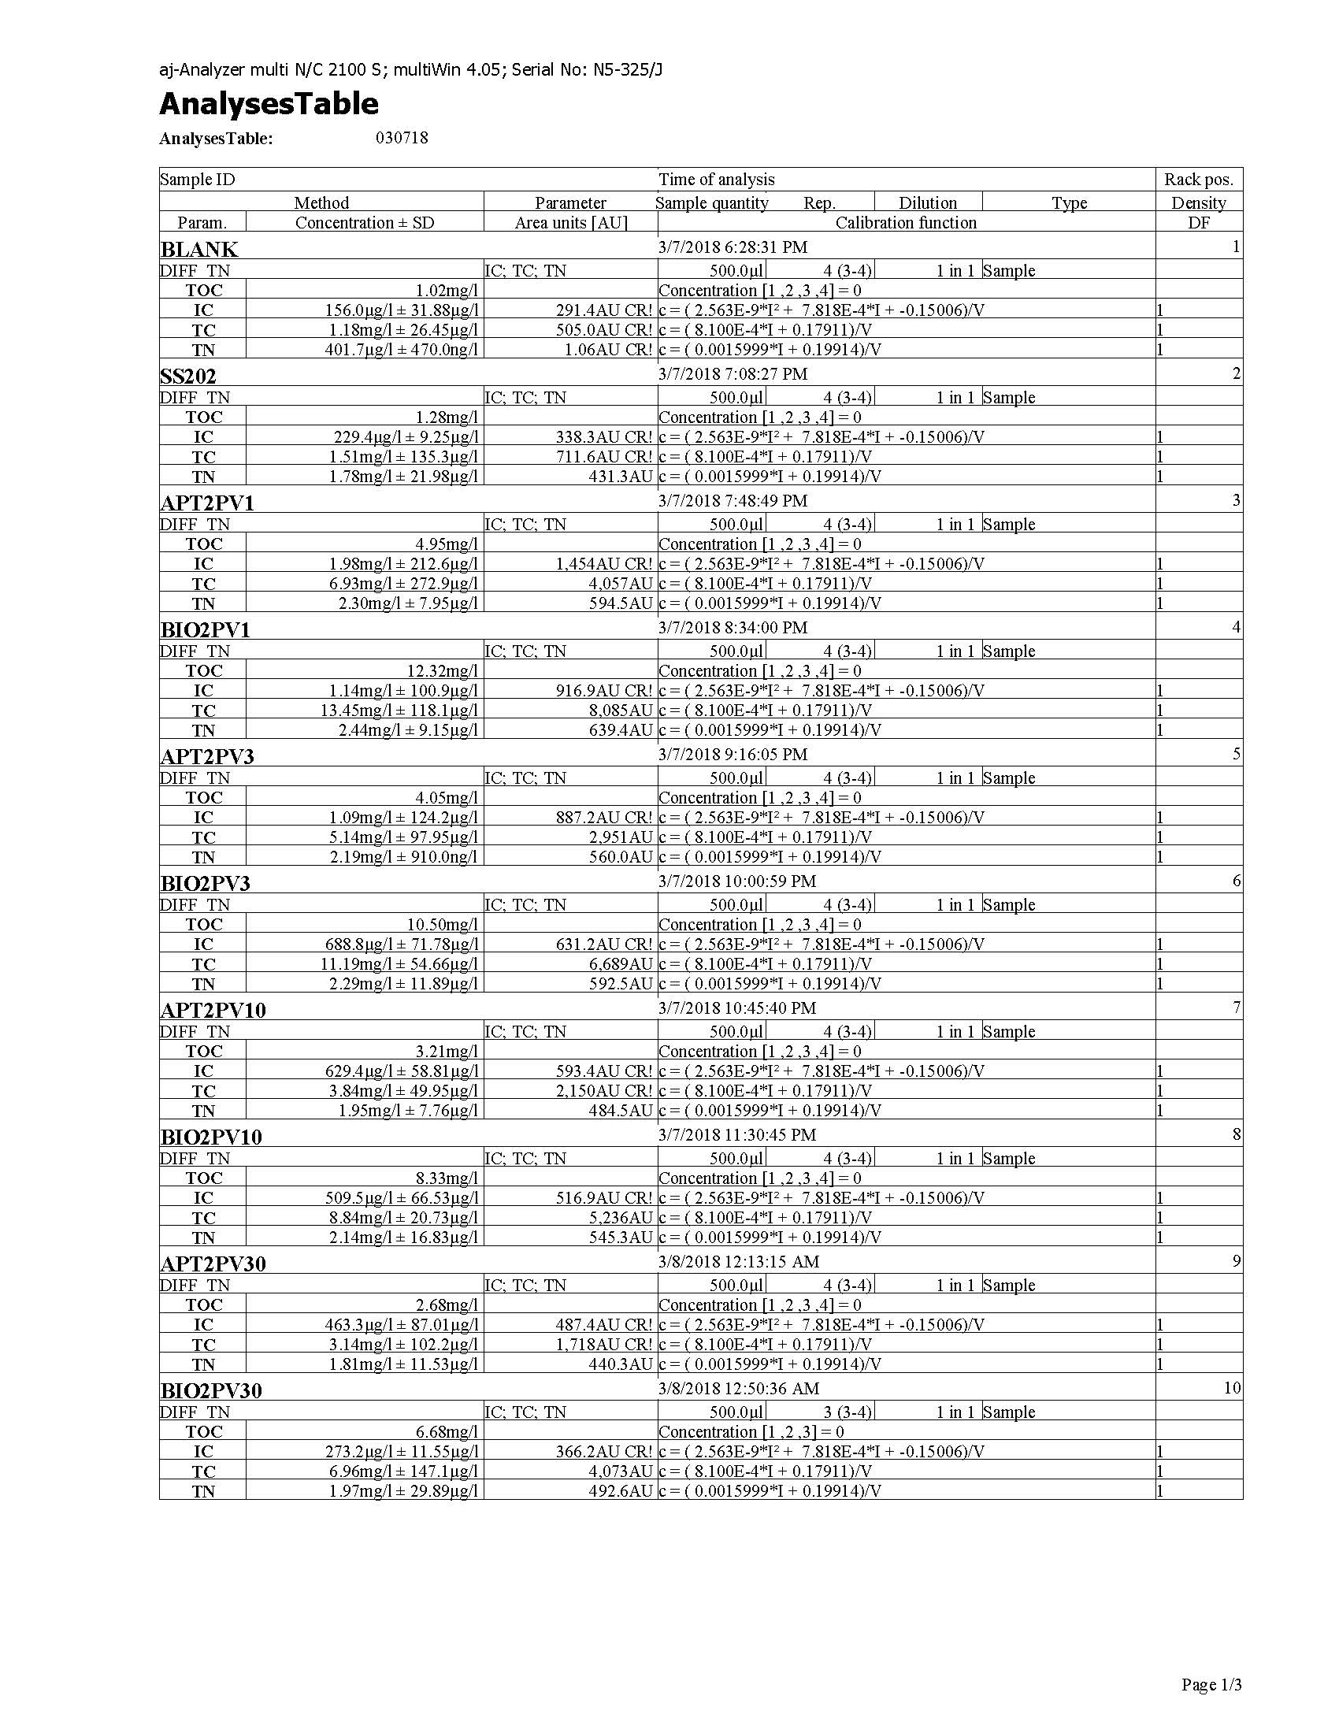
Figure VIII-1: Raw TOC/N Data Report 1 (1 of 3).

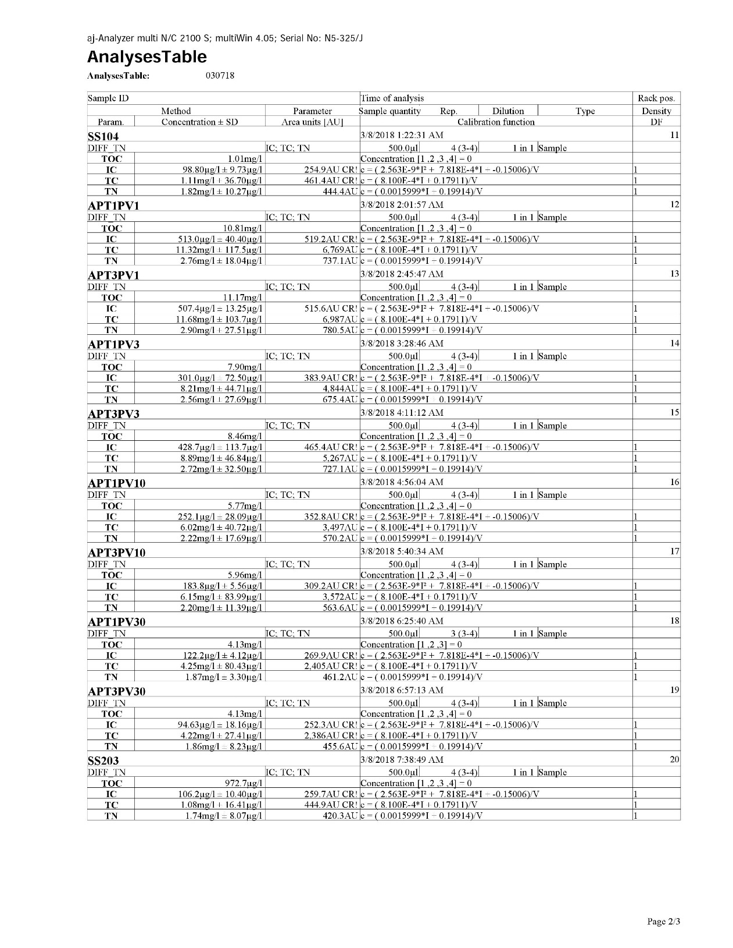
Figure VIII-2: Raw TOIC/N Data Report 1 (2 of 3).

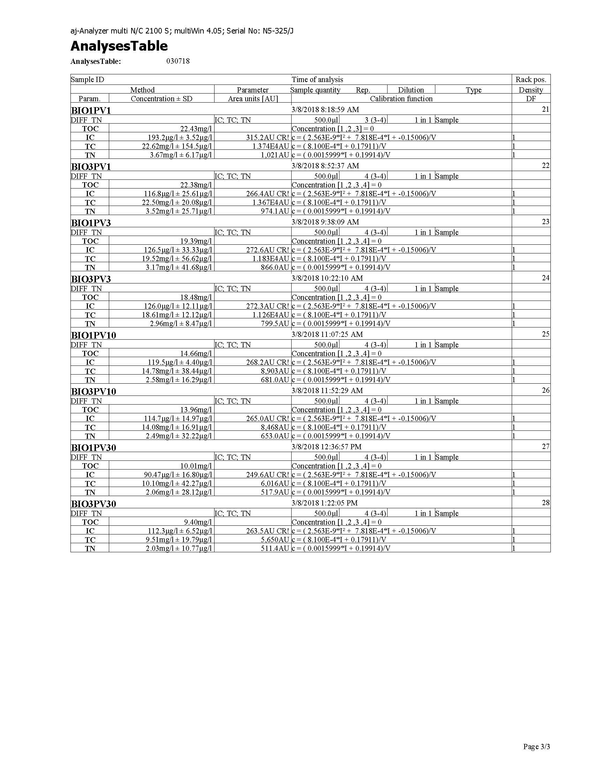
Figure VIII-3: Raw TOC/N Data Report 1 (3 of 3).

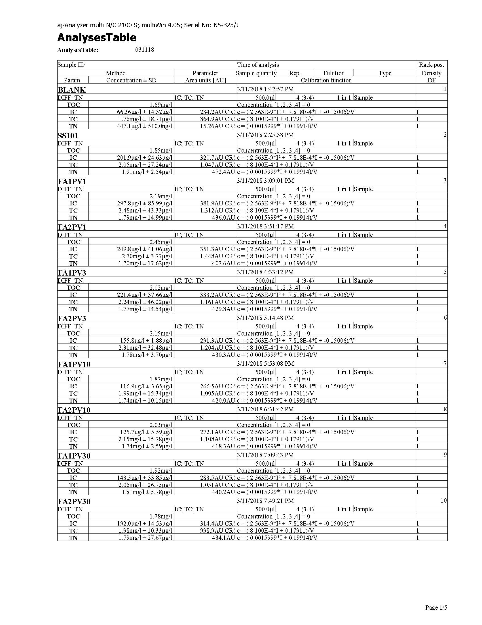
Figure VIII-4: Raw TOC/N Data Report 2 (1 of 5).

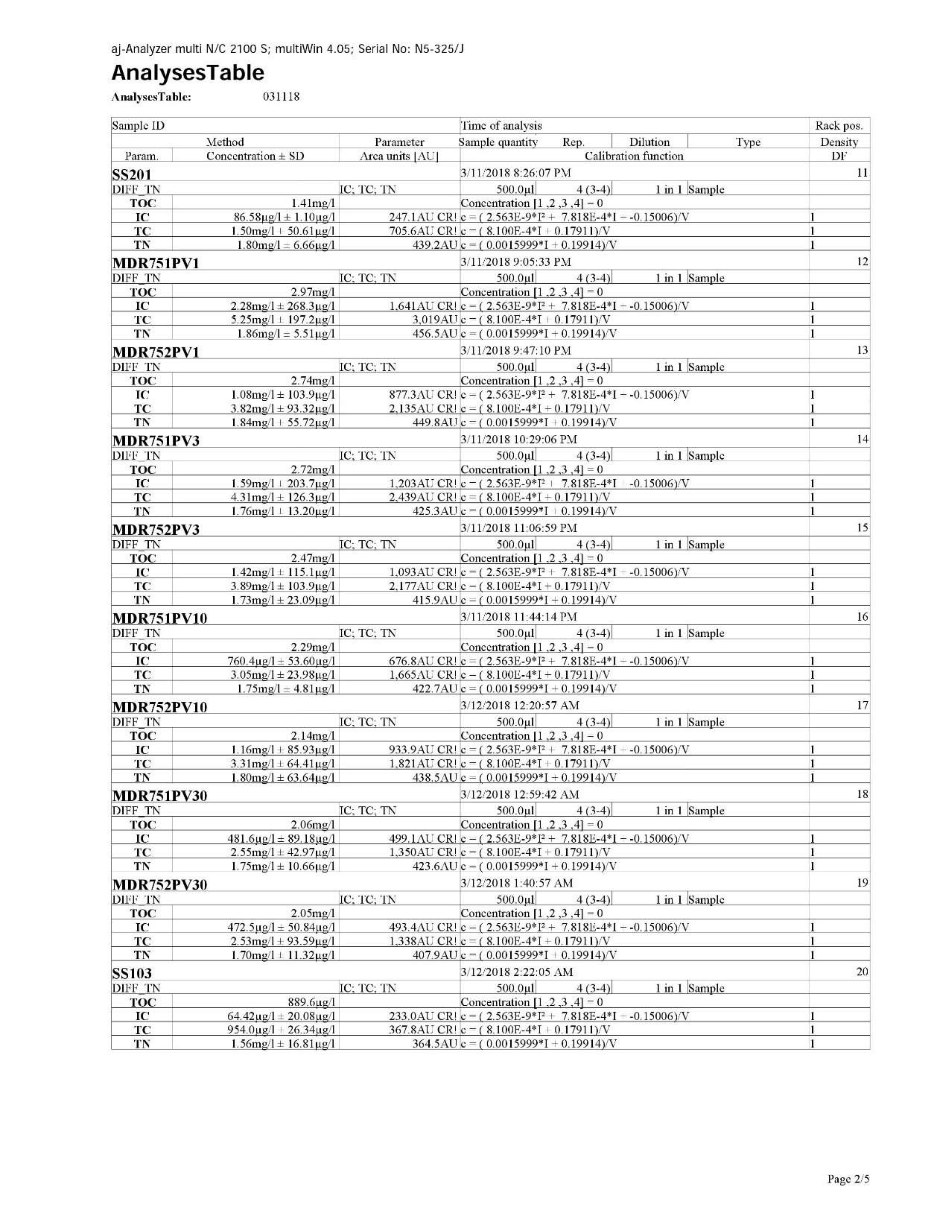
Figure VIII-5: Raw TOC/N Data Report 2 (2 of 5).

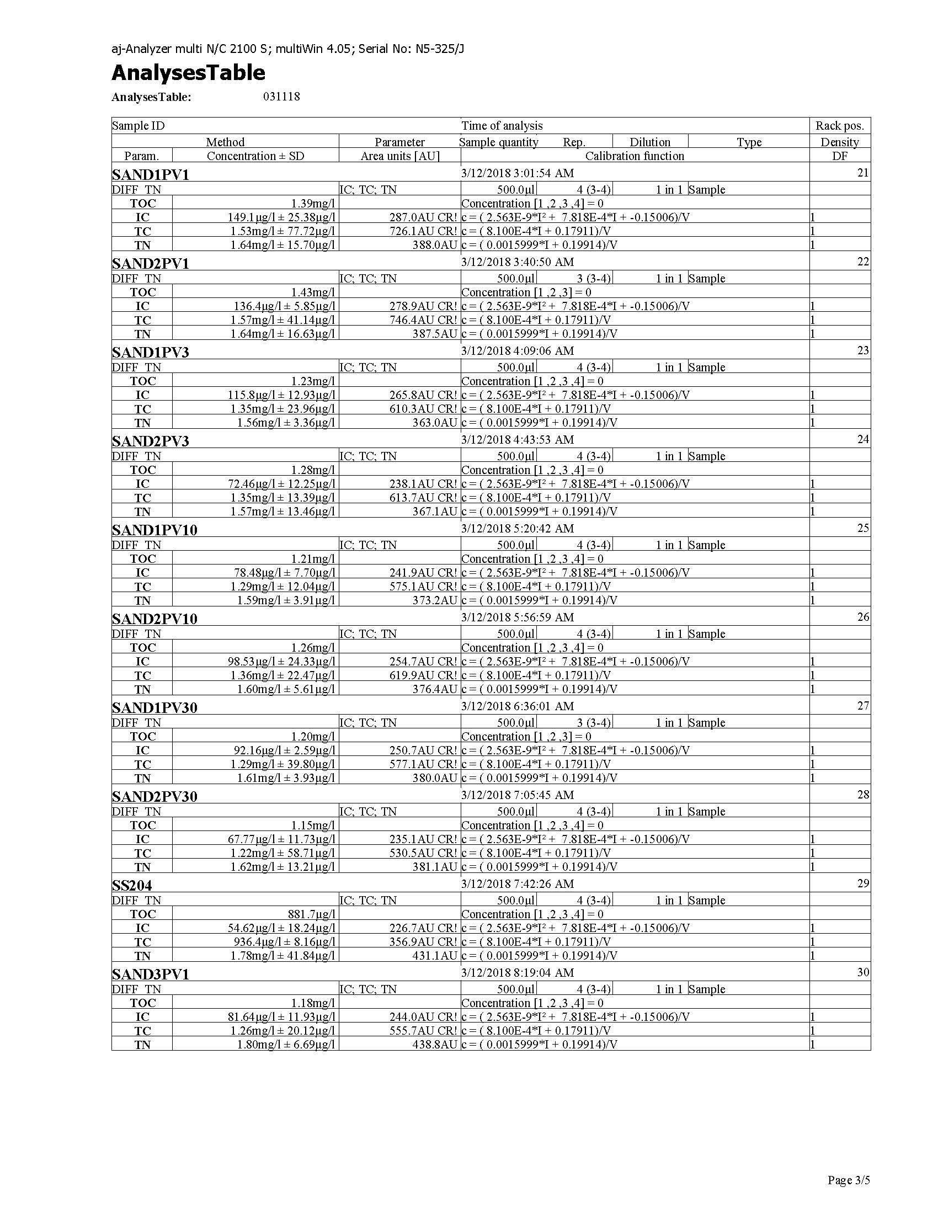
Figure VIII-6: Raw TOC/N Data Report 2 (3 of 5).

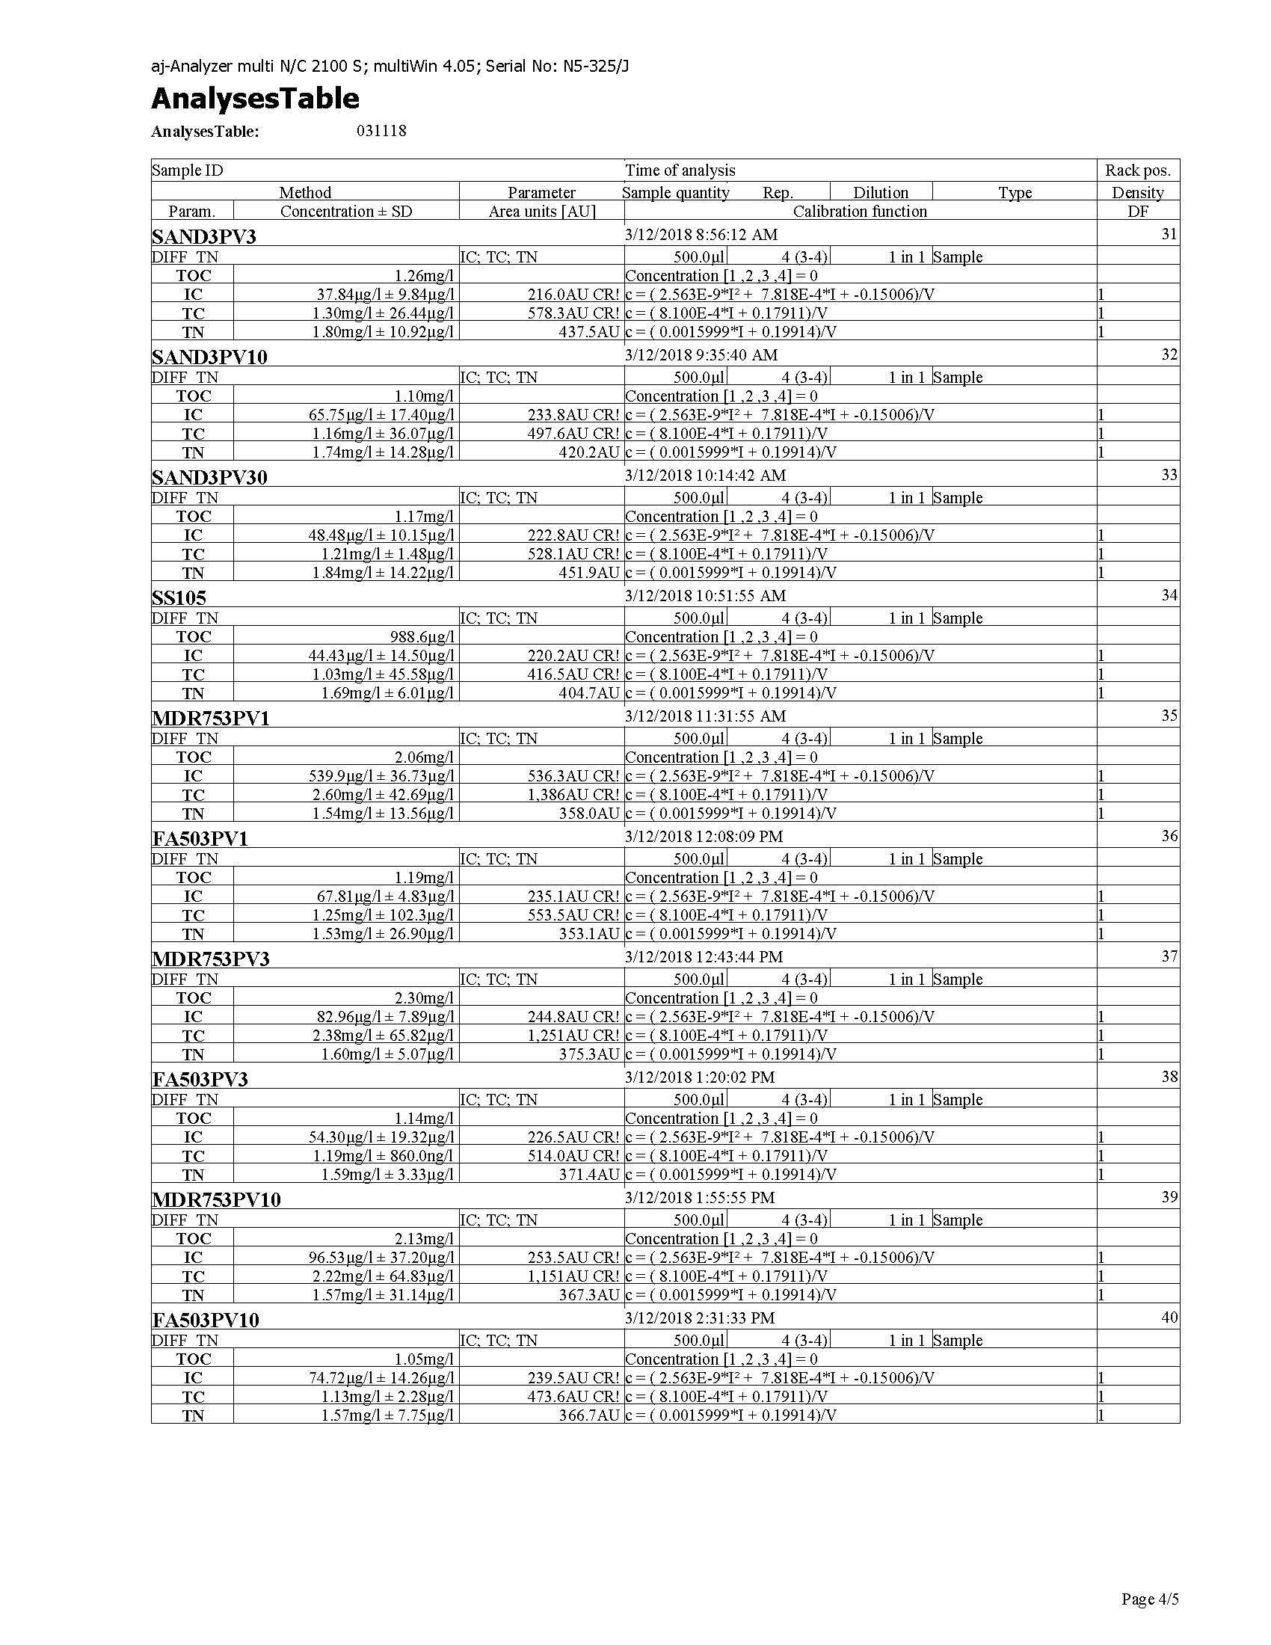
Figure VIII-7: Raw TOC/N Data Report 2 (4 of 5).

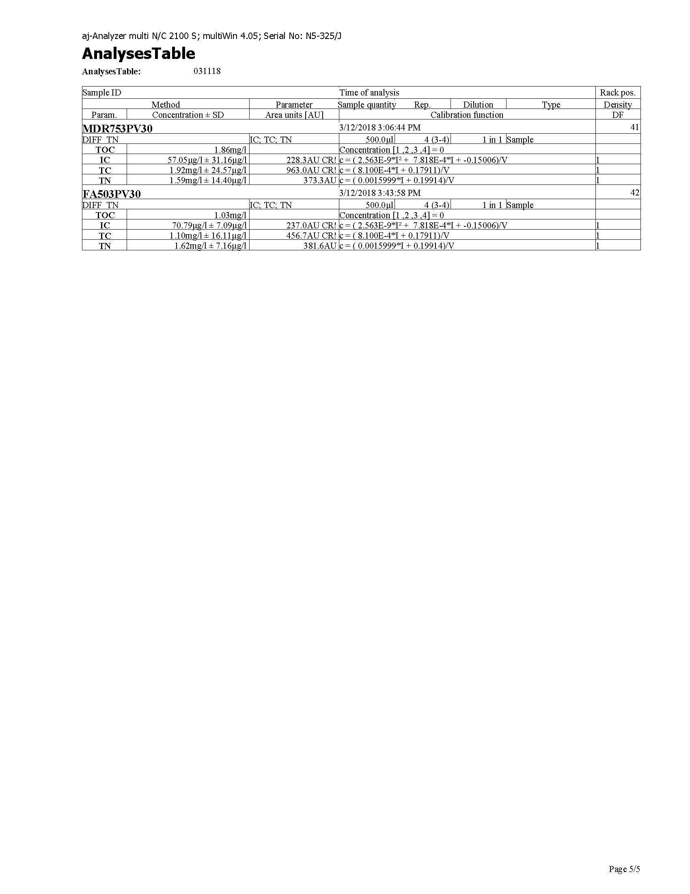
Figure VIII-8: Raw TOC/N Data Report 2 (5 of 5).

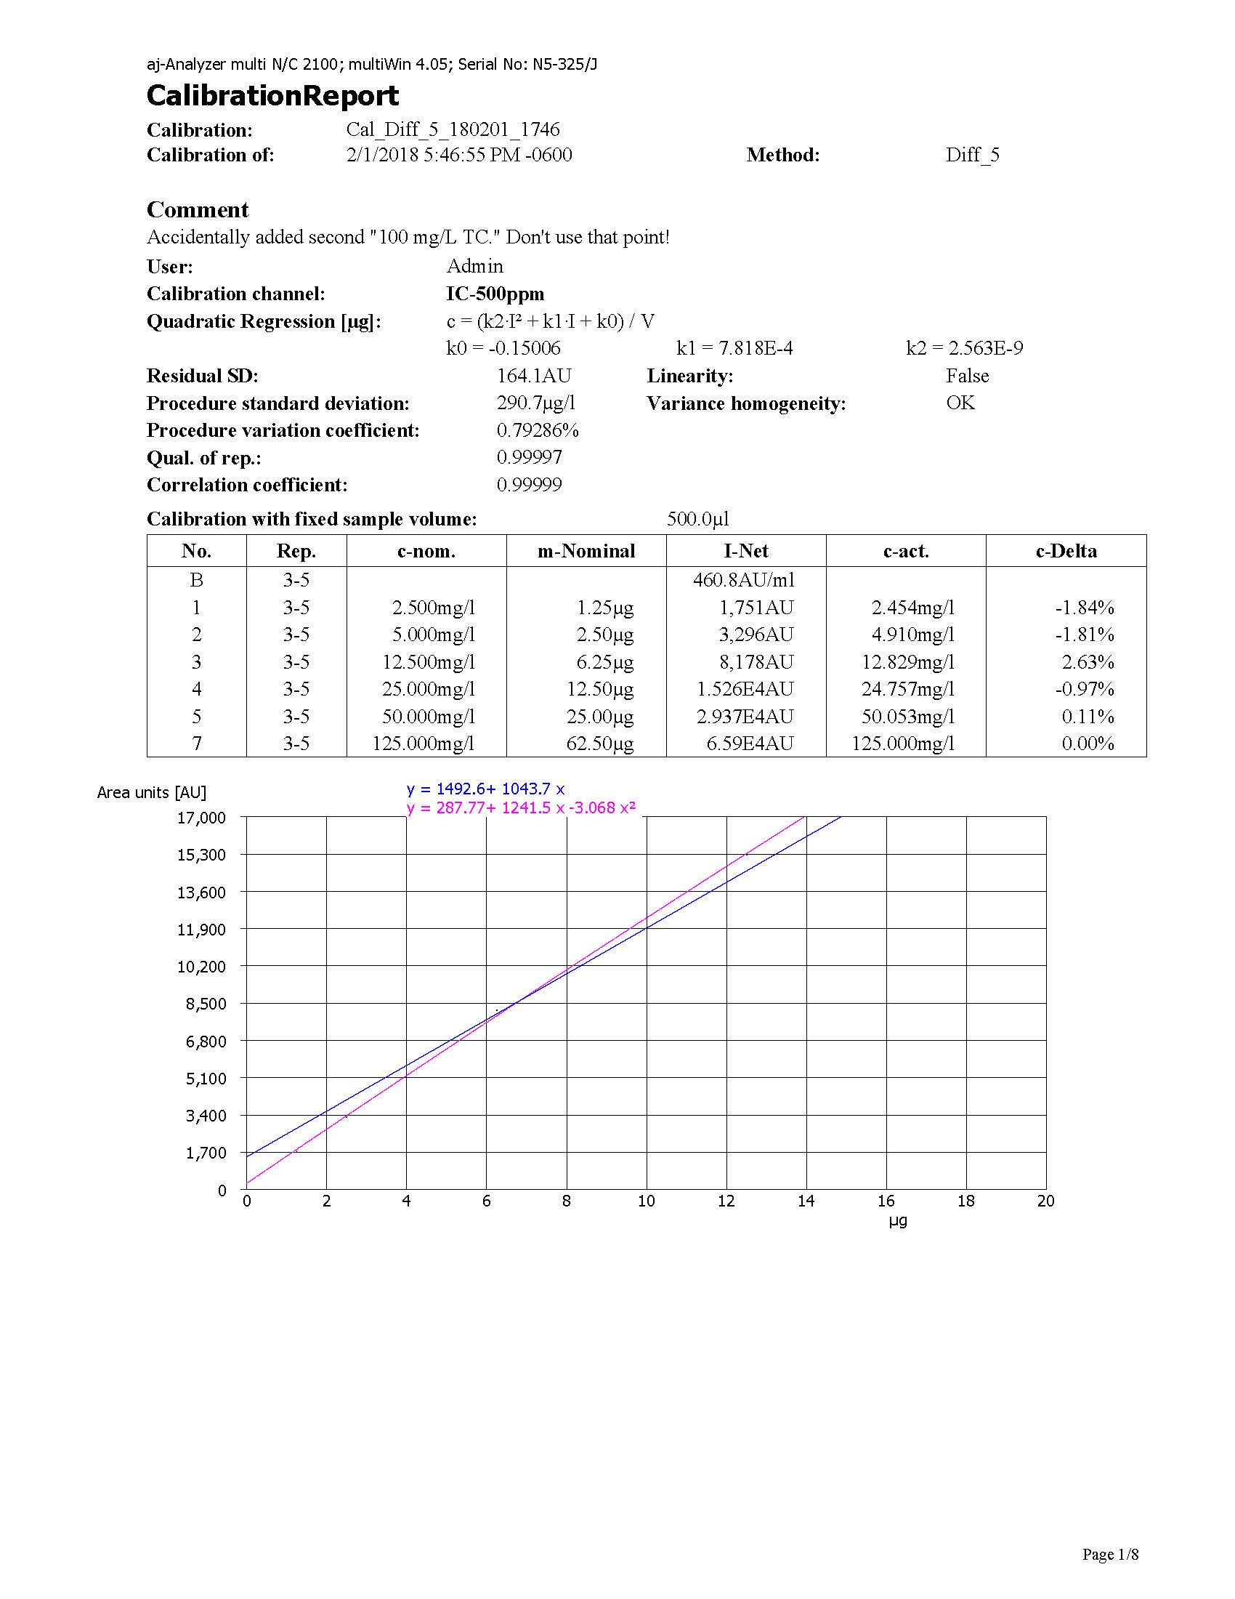
Figure VIII-9: Total carbon and total inorganic carbon calibration report.

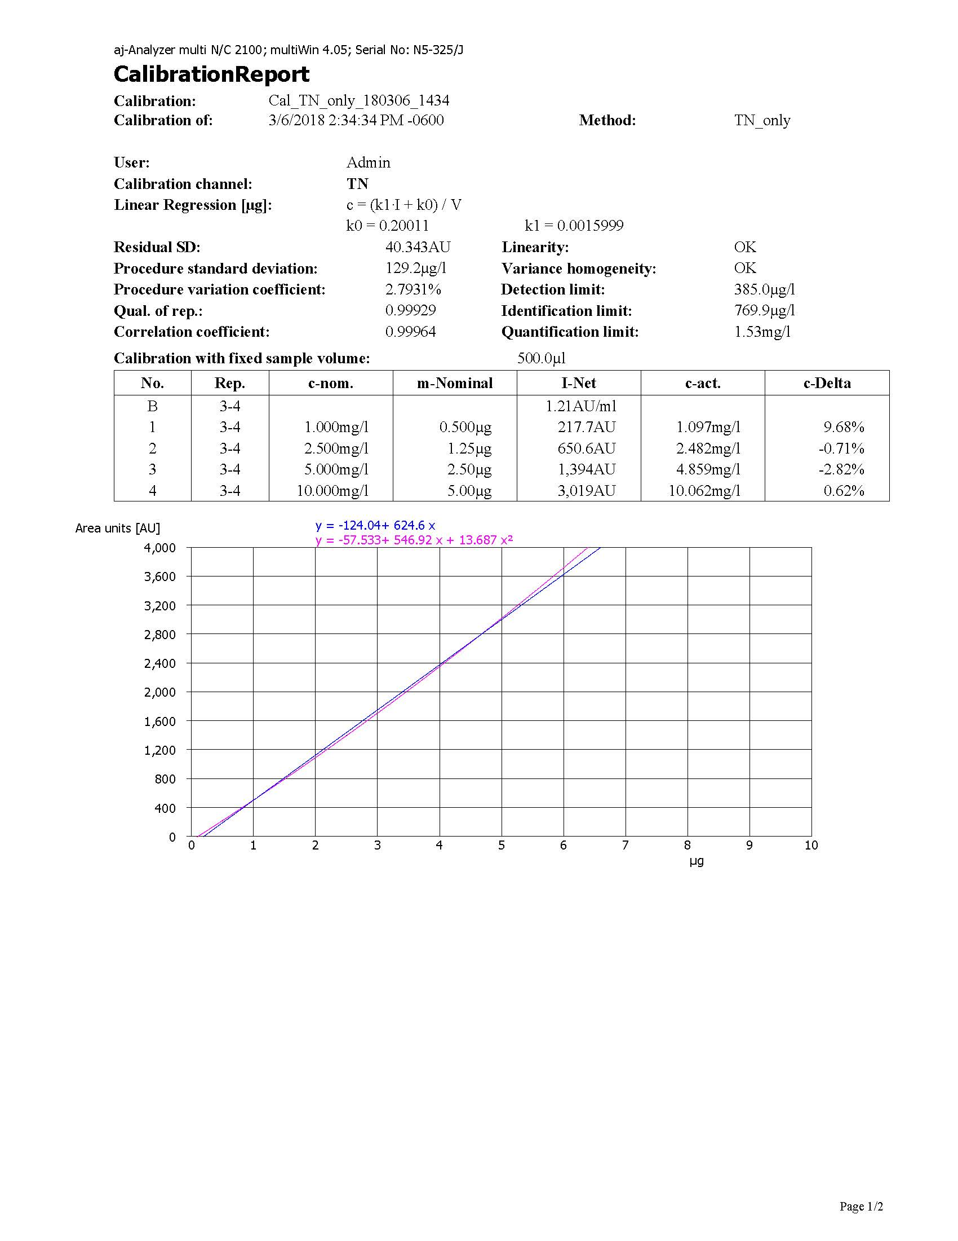
Figure VIII-10: Total nitrogen calibration report.

- EPA Recommended Water Quality Criteria for Aquatic Life – Hardness Adjusted Metals Limits by Individual Sample
Table IX-1: Hardness adjusted EPA Recommended Water Quality Criteria for Aquatic Life for arsenic, cadmium, chromium(III), chromium(IV), and copper by individual sample (1 of 2).
Sample | Hardness  (mg/L as CaCO₃) | As  (µg/L) | Cd  (µg/L) | Cr(III)  (µg/L) | Cr(VI)  (µg/L) | Cu  (µg/L)
SS1.03M | 0.00 | 0.00 | 0.00 | 0.00 | 0.00 | 0.00
SAND1PV01 | 35.55 | 0.04 | 0.68 | 244.26 | 40.75 | 0.96
SAND1PV03 | 28.67 | 124.49 | 0.56 | 204.82 | 40.75 | 0.96
SAND1PV10 | 24.43 | 4.00 | 0.48 | 179.62 | 40.75 | 0.96
SAND1PV30 | 21.03 | 5.00 | 0.42 | 158.91 | 40.75 | 0.96
SAND2PV01 | 40.04 | 1.39 | 0.76 | 269.25 | 40.75 | 0.96
SAND2PV03 | 28.84 | 7.00 | 0.56 | 205.79 | 40.75 | 0.96
SAND2PV10 | 25.11 | 76.28 | 0.49 | 183.75 | 40.75 | 0.96
SAND2PV30 | 21.31 | 9.00 | 0.42 | 160.62 | 40.75 | 0.96
SS2.04 | 0.00 | 0.00 | 0.00 | 0.00 | 0.00 | 0.00
SAND3PV01 | 27.95 | 26.63 | 0.54 | 200.56 | 40.75 | 0.96
SAND3PV03 | 23.80 | 12.00 | 0.47 | 175.81 | 40.75 | 0.96
SAND3PV10 | 23.59 | 13.00 | 0.46 | 174.56 | 40.75 | 0.96
SAND3PV30 | 19.72 | 14.00 | 0.39 | 150.74 | 40.75 | 0.96
SS1.01 | 0.00 | 0.00 | 0.00 | 0.00 | 0.00 | 0.00
FA5.01PV01 | 214.59 | 16.00 | 3.66 | 1064.86 | 40.75 | 0.96
FA5.01PV03 | 193.49 | 17.00 | 3.32 | 978.27 | 40.75 | 0.96
FA5.01PV10 | 132.52 | 18.00 | 2.33 | 717.53 | 40.75 | 0.96
FA5.01PV30 | 108.71 | 19.00 | 1.94 | 610.08 | 40.75 | 0.96
FA5.02PV01 | 279.28 | 20.00 | 4.68 | 1321.31 | 40.75 | 0.96
FA5.02PV03 | 214.86 | 21.00 | 3.66 | 1065.94 | 40.75 | 0.96
FA5.02PV10 | 144.47 | 22.00 | 2.53 | 770.12 | 40.75 | 0.96
FA5.02PV30 | 122.82 | 23.00 | 2.17 | 674.24 | 40.75 | 0.96
SS1.05 | 0.00 | 0.00 | 0.00 | 0.00 | 0.00 | 0.00
FA5.03PV01 | 182.45 | 25.00 | 3.15 | 932.31 | 40.75 | 0.96
FA5.03PV03 | 162.87 | 26.00 | 2.83 | 849.55 | 40.75 | 0.96
FA5.03PV10 | 108.87 | 27.00 | 1.94 | 610.83 | 40.75 | 0.96
FA5.03PV30 | 65.54 | 28.00 | 1.21 | 403.10 | 40.75 | 0.96
MDR7.53PV01 | 185.79 | 29.00 | 3.20 | 946.27 | 40.75 | 0.96
MDR7.53PV03 | 148.55 | 30.00 | 2.60 | 787.90 | 40.75 | 0.96
MDR7.53PV10 | 92.03 | 31.00 | 1.66 | 532.31 | 40.75 | 0.96
MDR7.53PV30 | 51.57 | 32.00 | 0.97 | 331.27 | 40.75 | 0.96

Table IX-2: Hardness adjusted EPA Recommended Water Quality Criteria for Aquatic Life for arsenic, cadmium, chromium(III), chromium(IV), and copper by individual sample (2 of 2).
Sample | Hardness  (mg/L as CaCO₃) | As  (µg/L) | Cd  (µg/L) | Cr(iii)  (µg/L) | Cr(vi)  (µg/L) | Cu  (µg/L)
SS2.01 | 0.00 | 0.00 | 0.00 | 0.00 | 0.00 | 0.00
MDR7.51PV01 | 154.30 | 34.00 | 2.69 | 812.75 | 40.75 | 0.96
MDR7.51PV03 | 117.89 | 35.00 | 2.09 | 651.99 | 40.75 | 0.96
MDR7.51PV10 | 83.61 | 36.00 | 1.52 | 492.05 | 40.75 | 0.96
MDR7.51PV30 | 52.76 | 37.00 | 0.99 | 337.47 | 40.75 | 0.96
MDR7.52PV01 | 161.26 | 38.00 | 2.80 | 842.69 | 40.75 | 0.96
MDR7.52PV03 | 135.61 | 39.00 | 2.38 | 731.19 | 40.75 | 0.96
MDR7.52PV10 | 85.74 | 40.00 | 1.55 | 502.32 | 40.75 | 0.96
MDR7.52PV30 | 56.80 | 41.00 | 1.06 | 358.52 | 40.75 | 0.96
SS2.03 | 0.00 | 0.00 | 0.00 | 0.00 | 0.00 | 0.00
APT1PV01 | 47.48 | 43.00 | 0.89 | 309.58 | 40.75 | 0.96
APT1PV03 | 33.68 | 44.00 | 0.65 | 233.69 | 40.75 | 0.96
APT1PV10 | 26.31 | 45.00 | 0.51 | 190.91 | 40.75 | 0.96
APT1PV30 | 22.61 | 46.00 | 0.45 | 168.59 | 40.75 | 0.96
APT3PV01 | 67.60 | 47.00 | 1.24 | 413.45 | 40.75 | 0.96
APT3PV03 | 37.97 | 48.00 | 0.73 | 257.81 | 40.75 | 0.96
APT3PV10 | 27.72 | 49.00 | 0.54 | 199.23 | 40.75 | 0.96
APT3PV30 | 23.80 | 50.00 | 0.47 | 175.81 | 40.75 | 0.96
SS2.02 | 0.00 | 0.00 | 0.00 | 0.00 | 0.00 | 0.00
APT2PV01 | 28.66 | 52.00 | 0.56 | 204.76 | 40.75 | 0.96
APT2PV03 | 24.78 | 53.00 | 0.49 | 181.76 | 40.75 | 0.96
APT2PV10 | 24.36 | 54.00 | 0.48 | 179.21 | 40.75 | 0.96
APT2PV30 | 19.66 | 55.00 | 0.39 | 150.35 | 40.75 | 0.96
BIO2PV01 | 33.86 | 56.00 | 0.65 | 234.69 | 40.75 | 0.96
BIO2PV03 | 30.20 | 57.00 | 0.59 | 213.73 | 40.75 | 0.96
BIO2PV10 | 26.74 | 58.00 | 0.52 | 193.43 | 40.75 | 0.96
BIO2PV30 | 22.98 | 59.00 | 0.45 | 170.85 | 40.75 | 0.96
SS1.04 | 0.00 | 0.00 | 0.00 | 0.00 | 0.00 | 0.00
BIO1PV01 | 55.43 | 61.00 | 1.03 | 351.41 | 40.75 | 0.96
BIO1PV03 | 47.05 | 62.00 | 0.89 | 307.28 | 40.75 | 0.96
BIO1PV10 | 39.24 | 63.00 | 0.75 | 264.81 | 40.75 | 0.96
BIO1PV30 | 28.86 | 64.00 | 0.56 | 205.90 | 40.75 | 0.96
BIO3PV01 | 54.67 | 65.00 | 1.02 | 347.48 | 40.75 | 0.96
BIO3PV03 | 44.27 | 66.00 | 0.84 | 292.31 | 40.75 | 0.96
BIO3PV10 | 37.57 | 67.00 | 0.72 | 255.53 | 40.75 | 0.96
BIO3PV30 | 33.22 | 68.00 | 0.64 | 231.05 | 40.75 | 0.96

Table IX-3: Hardness adjusted EPA Recommended Water Quality Criteria for Aquatic Life for lead, mercury, nickel, selenium, silver, and zinc by individual sample (1 of 2).
Sample | Pb  (µg/L) | Hg  (µg/L) | Ni  (µg/L) | Se  (µg/L) | Ag  (µg/L) | Zn  (µg/L)
SS1.03M | 0.00 | 0.00 | 0.00 | 0.00 | 0.00 | 0.00
SAND1PV01 | 20.61 | 0.85 | 195.20 | 0.00 | 0.54 | 48.79
SAND1PV03 | 16.20 | 0.85 | 162.74 | 0.00 | 0.38 | 40.66
SAND1PV10 | 13.52 | 0.85 | 142.10 | 0.00 | 0.28 | 35.50
SAND1PV30 | 11.42 | 0.85 | 125.21 | 0.00 | 0.22 | 31.27
SAND2PV01 | 23.54 | 0.85 | 215.87 | 0.00 | 0.67 | 53.96
SAND2PV03 | 16.30 | 0.85 | 163.53 | 0.00 | 0.38 | 40.86
SAND2PV10 | 13.95 | 0.85 | 145.48 | 0.00 | 0.30 | 36.34
SAND2PV30 | 11.59 | 0.85 | 126.60 | 0.00 | 0.23 | 31.62
SS2.04 | 0.00 | 0.00 | 0.00 | 0.00 | 0.00 | 0.00
SAND3PV01 | 15.74 | 0.85 | 159.24 | 0.00 | 0.36 | 39.79
SAND3PV03 | 13.13 | 0.85 | 138.99 | 0.00 | 0.27 | 34.72
SAND3PV10 | 13.00 | 0.85 | 137.96 | 0.00 | 0.27 | 34.46
SAND3PV30 | 10.62 | 0.85 | 118.57 | 0.00 | 0.20 | 29.61
SS1.01 | 0.00 | 0.00 | 0.00 | 0.00 | 0.00 | 0.00
FA5.01PV01 | 146.70 | 0.85 | 893.34 | 0.00 | 11.96 | 223.79
FA5.01PV03 | 131.43 | 0.85 | 818.41 | 0.00 | 10.01 | 204.99
FA5.01PV10 | 87.63 | 0.85 | 594.17 | 0.00 | 5.22 | 148.75
FA5.01PV30 | 70.72 | 0.85 | 502.50 | 0.00 | 3.71 | 125.77
FA5.02PV01 | 193.57 | 0.85 | 1116.40 | 0.00 | 18.82 | 279.76
FA5.02PV03 | 146.89 | 0.85 | 894.27 | 0.00 | 11.99 | 224.02
FA5.02PV10 | 96.17 | 0.85 | 639.21 | 0.00 | 6.06 | 160.04
FA5.02PV30 | 80.72 | 0.85 | 557.18 | 0.00 | 4.58 | 139.48
SS1.05 | 0.00 | 0.00 | 0.00 | 0.00 | 0.00 | 0.00
FA5.03PV01 | 123.47 | 0.85 | 778.72 | 0.00 | 9.05 | 195.04
FA5.03PV03 | 109.37 | 0.85 | 707.42 | 0.00 | 7.44 | 177.15
FA5.03PV10 | 70.83 | 0.85 | 503.13 | 0.00 | 3.72 | 125.93
FA5.03PV30 | 40.65 | 0.85 | 327.51 | 0.00 | 1.56 | 81.92
MDR7.53PV01 | 125.88 | 0.85 | 790.77 | 0.00 | 9.34 | 198.06
MDR7.53PV03 | 99.09 | 0.85 | 654.46 | 0.00 | 6.35 | 163.87
MDR7.53PV10 | 58.99 | 0.85 | 436.48 | 0.00 | 2.79 | 109.22
MDR7.53PV30 | 31.19 | 0.85 | 267.41 | 0.00 | 1.03 | 66.87

Table IX-4: Hardness adjusted EPA Recommended Water Quality Criteria for Aquatic Life for lead, mercury, nickel, selenium, silver, and zinc by individual sample (2 of 2).
Sample | Pb  (µg/L) | Hg  (µg/L) | Ni  (µg/L) | Se  (µg/L) | Ag  (µg/L) | Zn  (µg/L)
SS2.01 | 0.00 | 0.00 | 0.00 | 0.00 | 0.00 | 0.00
MDR7.51PV01 | 103.21 | 0.85 | 675.79 | 0.00 | 6.78 | 169.22
MDR7.51PV03 | 77.22 | 0.85 | 538.20 | 0.00 | 4.27 | 134.72
MDR7.51PV10 | 53.12 | 0.85 | 402.42 | 0.00 | 2.36 | 100.69
MDR7.51PV30 | 31.98 | 0.85 | 272.58 | 0.00 | 1.07 | 68.16
MDR7.52PV01 | 108.21 | 0.85 | 701.52 | 0.00 | 7.32 | 175.67
MDR7.52PV03 | 89.83 | 0.85 | 605.86 | 0.00 | 5.43 | 151.68
MDR7.52PV10 | 54.60 | 0.85 | 411.10 | 0.00 | 2.47 | 102.86
MDR7.52PV30 | 34.71 | 0.85 | 290.17 | 0.00 | 1.22 | 72.56
SS2.03 | 0.00 | 0.00 | 0.00 | 0.00 | 0.00 | 0.00
APT1PV01 | 28.46 | 0.85 | 249.35 | 0.00 | 0.89 | 62.34
APT1PV03 | 19.40 | 0.85 | 186.49 | 0.00 | 0.49 | 46.61
APT1PV10 | 14.71 | 0.85 | 151.34 | 0.00 | 0.32 | 37.81
APT1PV30 | 12.39 | 0.85 | 133.09 | 0.00 | 0.25 | 33.24
APT3PV01 | 42.06 | 0.85 | 336.20 | 0.00 | 1.64 | 84.10
APT3PV03 | 22.19 | 0.85 | 206.40 | 0.00 | 0.61 | 51.59
APT3PV10 | 15.59 | 0.85 | 158.15 | 0.00 | 0.35 | 39.51
APT3PV30 | 13.13 | 0.85 | 138.99 | 0.00 | 0.27 | 34.72
SS2.02 | 0.00 | 0.00 | 0.00 | 0.00 | 0.00 | 0.00
APT2PV01 | 16.19 | 0.85 | 162.69 | 0.00 | 0.37 | 40.65
APT2PV03 | 13.75 | 0.85 | 143.85 | 0.00 | 0.29 | 35.94
APT2PV10 | 13.48 | 0.85 | 141.77 | 0.00 | 0.28 | 35.41
APT2PV30 | 10.58 | 0.85 | 118.25 | 0.00 | 0.20 | 29.53
BIO2PV01 | 19.52 | 0.85 | 187.31 | 0.00 | 0.50 | 46.81
BIO2PV03 | 17.17 | 0.85 | 170.05 | 0.00 | 0.41 | 42.49
BIO2PV10 | 14.97 | 0.85 | 153.40 | 0.00 | 0.33 | 38.32
BIO2PV30 | 12.62 | 0.85 | 134.94 | 0.00 | 0.26 | 33.70
SS1.04 | 0.00 | 0.00 | 0.00 | 0.00 | 0.00 | 0.00
BIO1PV01 | 33.78 | 0.85 | 284.22 | 0.00 | 1.17 | 71.08
BIO1PV03 | 28.17 | 0.85 | 247.44 | 0.00 | 0.88 | 61.86
BIO1PV10 | 23.01 | 0.85 | 212.20 | 0.00 | 0.64 | 53.04
BIO1PV30 | 16.31 | 0.85 | 163.62 | 0.00 | 0.38 | 40.88
BIO3PV01 | 33.27 | 0.85 | 280.94 | 0.00 | 1.14 | 70.25
BIO3PV03 | 26.32 | 0.85 | 235.00 | 0.00 | 0.79 | 58.75
BIO3PV10 | 21.92 | 0.85 | 204.52 | 0.00 | 0.60 | 51.12
BIO3PV30 | 19.10 | 0.85 | 184.31 | 0.00 | 0.48 | 46.06

- Graphs of Points of Zero Charge by pH Drift Method

Figure X-1: SAND point of zero charge graph.

Figure X-2: FA point of zero charge graph.

Figure X-3: FA5.0 point of zero charge graph.

Figure X-4: MDR point of zero charge graph.

Figure X-5: MDR7.5 point of zero charge graph.

Figure X-6: APT point of zero charge graph.

Figure X-7: BIO point of zero charge graph.

