University of Oklahoma

Graduate College

ANALYSIS OF MEG AS RELATED TO SPATIAL TRANSFORMATION AND TOP-DOWN CONTROL OF SACCADE BEHAVIOR

A thesis

submitted to the graduate faculty

in partial fulfillment of the requirements for the

Degree of

Master of Science

By

LINDSEY R. TATE
Norman, Oklahoma
2016

ANALYSIS OF MEG AS RELATED TO SPATIAL TRANSFORMATION AND TOP-DOWN CONTROL OF SACCADE BEHAVIOR

A thesis approved for the
Department of Psychology

By

______________________________
Dr. Lauren Ethridge, Chair

______________________________
Dr. Jorge Mendoza

______________________________
Dr. Scott Gronlund

© Copyright by LINDSEY R. TATE 2016
All Rights Reserved.

Acknowledgements
My acknowledgements and sincerest thanks go to Nick Woodruff, Brett Clementz, and Lauren Ethridge for their work in data collection and preprocessing. I would like to thank Lauren Ethridge in particular for her never-ending advice, direction, and general support regarding this thesis.

Table of Contents
List of Figures | - | vi
Abstract | - | vii
Introduction | - | 1
Methods | - | 6
Results | - | 11
Discussion | - | 18
References | - | 24

List of Figures
Figure 1 | - | 7
Figure 2 | - | 12
Figure 3 | - | 13
Figure 4 | - | 15
Figure 5 | - | 17

Abstract
Preparatory brain activity can provide insight into goal-oriented action and inhibitory processes related to both motor and cognition. In the current study participants performed an interleaved prosaccade (PS) and antisaccade (AS) task in which two checkerboards located in the cue/target locations to the left and right of the focal point flickered at different frequencies (12Hz and 15Hz). Participants (n=16) were cued as to trial type (AS or PS) and direction (left or right, 30 trials each condition), immediately followed by a saccade preparatory period wherein participants fixated on the central point (7500ms). At the end of the preparatory period, participants made a memory-guided saccade to the cue location (PS) or its mirror image location (AS). Neural oscillatory power locked in time to the checkerboard oscillatory frequencies was measured in cortex over the preparatory period in two 875 ms bins to capture covert directional attention shifts related to spatial transformation from cue-to-target in AS, relative to PS in which no spatial transformation is necessary to correctly perform the task. Due to the unusually extended preparatory period of the current paradigm, there were similarities between prosaccade and antisaccade trials, including activation in the occipital and temporal cortices and the near equivalent reaction times. Specifically, left temporal power in the target frequency across the entire preparatory period predicted shorter reaction times. This confirms a previous finding regarding horizontal saccades, and may be related to memory.

Introduction
Prosaccades and Antisaccades
Prosaccades (PS) are effortful eye movements towards a stimulus in any environment, whereas antisaccades (AS) are generally a response only found in experimental settings wherein participants have been instructed to look opposite of a stimulus (see Hutton 2008 for a review of the saccade literature as it relates to cognition). In many human prosaccade/antisaccade studies, participants are given a cue (e.g., a color) to instruct them whether a particular trial is prosaccade or antisaccade. After the cue or simultaneously, a stimulus (e.g., a symbol or dot) will appear on one side of a display screen. If it is a prosaccade trial, the participant will be expected (i.e., will be performing the correct behavior) to look at the stimulus. If the trial is instead antisaccade, the participant will be expected to look at the mirrored location of the stimulus on the opposite side of the display screen (i.e., if the symbol appears on the left, the participant would look to the corresponding location on the right half of the display screen). This experimental paradigm and variations on it have been used to gain an understanding of brain area function as well as functional connections between areas. For example, in psychiatry the paradigm and its variations have been used to investigate cognitive control and executive function in such disorders as schizophrenia (Muller, Riedel, Eggert, & Straub, 1999; Ross, Olincy, & Radant, 1999), ADHD (Munoz, Armstrong, Hampton, & Moore, 2003; Goto, Hatakeyama, Kitama, Sato, Kanemura, Aoyagi, Sugita, & Aihara, 2010) and anxiety (Cornwell, Mueller, Kaplan, Grillon, & Ernst, 2012).
Preparatory brain activity preceding saccade generation
Preparatory brain activity is heavily implicated in saccade behavioral performance. In an fMRI comparison of metabolic activity across age groups during a saccade task, Alahyane, Brien, Coe, Stroman, and Munoz (2014) found that all “predictive changes were related to preparation time rather than response time.” In a study by Koval, Lomber and Everling (2011), experimenters deactivated the dorsolateral prefrontal cortex in macaques using cryoloops and found reduced preparatory neuronal activity associated with more errors and longer reaction times. Meiran and Daichman (2005) found that task errors and reaction time cost associated with task switching both decreased with preparation before a task. When Chikazoe, Jimura, Hirose, Yamashita, Miyashita, and Konishi (2009) isolated the effect of preparation to stop in a button press stop signal task, they also found that reaction time performance improved as preparation cost increased and frontoparietal areas were activated during preparation for inhibiting an action in response to the stop signal. A main goal of the current study was to analyze spatial transformations that occur during an extended preparatory period as participants plan their behavioral response for both pro- (requires no spatial transformation) and antisaccades (requires a spatial transformation to the mirror image location from the cue).
Brain areas involved in saccade generation
Multiple areas of the brain have been implicated in preparatory activity for and execution of saccades: the dorsolateral prefrontal cortex (DLPFC), ventrolateral prefrontal cortex (VLPFC), frontal eye fields (FEF), lateral intraparietal area of the inferior parietal lobule (IPL) of the posterior parietal cortex (PPC), superior colliculus (SC), and caudate nucleus of the basal ganglia (Herweg et al, 2014; Borra, Gerbella, Rozzi, & Luppino, 2015). The prefrontal cortex is thought to maintain information about task rules and provide top-down control in implementing these rules (Everling & Johnston, 2013). The superior colliculus is an oculomotor area that combines inputs from cortical areas and initiates saccades by signaling to the motor areas in the brainstem (Everling & Johnston, 2013). The caudate nucleus is associated with automatic behaviors like reflexive prosaccades. To unify these brain areas and create a saccade generation network, we reference Martinez-Conde, Otero-Millan, and Macknik (2013) who provide a review of the microsaccade literature and argue for a unified theory involving a microsaccade-saccade continuum. As part of this argument, the authors assemble evidence of a “common generator” in the brain and propose a brain circuit for microsaccade-saccade generation (Martinez-Conde, Otero-Millan, & Macknik, 2013). The areas involved in the authors’ proposed generation circuit includes the DLPFC, FEF, SEF, LIP, caudate nucleus, superior colliculus, and brainstem.
Spatial transformation in the saccadic system
The posterior parietal cortex (PPC) has been investigated in visuomotor spatial transformation. The PPC is part of the dorsal visual (aka, “where?”) pathway and is related to visuospatial attention (Herweg, Weber, Kasparbauer, Meyhöfer, Steffens, Smyrnis, & Ettinger, 2014). Because of the PPC’s mental map of the environment and its relation to attention, it is thought to be involved in the transition from visual sensory processing to motor planning-- an idea which has been given experimental support (Herweg, Weber, Kasparbauer, Meyhöfer, Steffens, Smyrnis, & Ettinger, 2014). The PPC has two component parts: the superior parietal lobule (SPL) and the inferior parietal lobule (IPL). The lateral intraparietal cortex (LIP), part of the IPL, has been shown to be particularly important in saccade behavior (Herweg et al, 2014). The LIP has visual and motor planning neurons with preferred directions (of the stimulus or the eye movement), and the visual neuron discharge precedes the motor neuron discharge (Zhang & Barash, 2000). Area LIP projects directly to the superior colliculus (SC), an oculomotor region of the brainstem (Martinez-Conde, Otero-Millan, & Macknik, 2013).
Using power in frequency spectra to map saccade-related neural activity
Time-frequency analyses are commonly used in EEG and MEG studies to study oscillatory brain activity which may or may not be locked in time to stimulus presentation or response generation. This procedure draws from Fourier’s theorem, which states that functions of time can be decomposed into frequency components. Many studies have been done in humans associating frequency bands with cognitive states. In the saccade literature, several of these associations have been found.
Hwang, Ghuman, Manoach, Jones, and Luna (2014) collected MEG during an antisaccade task and found that beta-band (18-38 Hz) activity and high alpha-band activity (10-18 Hz) are increased in the lateral prefrontal cortex and frontal eye field (FEF, area 8 of the ventrolateral prefrontal cortex or VLPFC) respectively as participants prepared for successful saccade inhibition. The authors concluded that the prefrontal beta-band activity induces the FEF alpha-band activity because of the temporal latency difference (i.e., prefrontal beta precedes FEF alpha) following an antisaccade stimulus and that the PFC is inhibiting saccade neurons in the FEF in order to perform the antisaccade (Hwang et al., 2014). Because alpha- and beta-band activity have been associated with neural representation of task distractors and beta-band activity increases with cognitive effort, Hwang and colleagues (2014) suggested that power in these frequency spectra may indicate neural suppression of goal oriented motor activity or modulation of stimulus salience.
Frequency analysis can also be used to investigate stimulus driven oscillations evoked by stimuli oscillating at given frequencies. In the current task, every stimulus presentation involved the simultaneous presentation of two checkerboards which were flickering at different frequencies (12Hz for the left checkerboard and 15Hz for the right). Previous research has shown that neural activity in the area of the brain processing the stimulus at any given time will phase lock or oscillate at the same frequency as an attended oscillating stimulus (Tallon-Baudry, Bertrand, & Pernier, 1998; Wacker, Galicki, Putsche, Milde, Schwab, Haueisen, Ligges, & Witte, 2011). Therefore, frequency analysis can be used to track which flickering stimulus a participant was covertly attending over time in order to temporally quantify goal-oriented visual spatial transformation prior to antisaccade performance.
In this thesis, a saccade task with an elongated preparatory period was used to investigate the areas involved during saccade preparation. The primary interest of the study is to use frequency analysis to investigate covert attention and spatial transformation during a saccade task via neural phase locking to flickering stimuli. Due to the delay in cue and response, it was predicted that there would be a measurable shift in attention, as indicated by frequency locking. The first hypothesis is there would be differences in locations with significant frequency power between prosaccades and antisaccades. The second hypothesis is that the directions and strengths of reaction time regression coefficients would differ between stimuli frequencies in the same trial types and brain areas, especially in regards to the interaction terms which indicate transformation between the first and second half of the preparatory period.
Methods
Participants
There were 21 total participants in the study (average age = 22.4 years; 75.0% male). The data from 16 participants was used in this analysis (average age = 22.1 years; 68.8% male). Participants were excluded from analysis if they did not have MEG recorded (n = 3) or if the data collected during their MEG was unusable due to equipment malfunction (n = 1). All participants signed a written informed consent prior to participation. This study was approved by the University of Georgia Institutional Review Board.
Stimulus description
Participants were shown two checkerboards, one on each the left and right side of the display screen with a fixation point in between (Fig. 1 displays a diagram of the behavioral paradigm). Left and right checkerboards were presented simultaneously while flickering at 12 Hz and 15 Hz, respectively. Color cues were used to indicate the type of behavioral response Prosaccade (PS) and antisaccade (AS) trials were randomly interleaved during a session, with color cues indicating the type of behavioral response required at each trial. Purple colored checkerboards indicated to participants that the trial was AS, and green colored checkerboards indicated a PS trial. Participants were first shown the two checkerboards and central fixation point for 1250ms; then, they were given a cue (i.e., one of the lateral checkerboards brightened for 1250ms) but asked to remain fixated on the point in the center until it disappeared. The central central fixation point served as a timer, and would disappear following a 5000 ms delay, at which point the participants would perform the saccade. Participants were allowed a 1250 ms time window to complete their saccade response, followed by an inter-trial interval of 5000ms. Depending on task rules (PS or AS), participants would look at or opposite the cued checkerboard they held in memory. Participants completed 60 prosaccade and 60 antisaccade trials (50% each visual side) per session, with a runtime of 27.5 minutes.
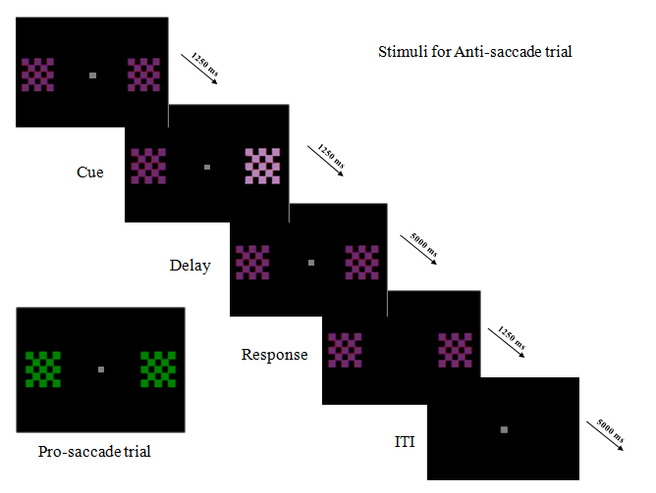
Figure 1. The behavioral paradigm. The black boxes represent individual screen displays. The times listed with accompanying arrows are the times between displays, in milliseconds. The anti-saccade (AS) trials used purple checkerboards, and the pro-saccade trials (PS) used green checkerboards. ITI = intertrial interval.

The flickering of the checkerboards at different frequencies for left and right sides of the visual space allowed for a type of analysis called frequency tagging. When a brain area is attending to a particular oscillating stimulus, the activity of the neurons in that area will oscillate at the same frequency as the attended stimulus (Ding, Sperling, & Srinivasan, 2006). If attention were to shift from one stimulus to the other (e.g., from the left/12Hz checkerboard to the right/15Hz checkerboard) then saccade-related brain area activity would show a shift from one frequency to another (from 12Hz to 15Hz in the example). This can be measured via amplitude in the steady state visual evoked potential and power over time in neural frequency bands with Fourier analysis (Ding, Sperling, & Srinivasan, 2006).
MEG Data Acquisition
Three head localization coils (at the nasion, left and right preauricular points) and four silver/silver chloride electro-oculogram (EOG) electrodes for measuring horizontal and vertical eye movements (positioned at the outer corners/canthi of each eye, as well as above and below the left eye only) were applied to the participant’s skin prior to beginning saccade trials. Magnetoencephalography (MEG) data were collected using 143-channel CTF OMEGA whole head system (CTF/VSMMedtech LTd., Coquitlam, BC, Canada) with continuous sampling at a rate of 600Hz. Polhemus Fastrak (Polhemus Inc., Colchester, VT, USA) was used to digitize head shape. Participants’ heads were secured using an inflatable head piece, and no participant moved more than 3mm in any direction from beginning to end of the session (as measured by relative distance to sensors).
Data Cleaning
Frontal electrodes have a distinctive pattern of activation during particular eye movements, and these patterns were used to delete blinks and mark saccades (the latter discussed in “Behavioral analysis” section below). Blinks and other artifacts were removed using independent components analysis (ICA), a blind source separation algorithm which allows for identification and separation of spatial patterns associated with signal and with artifact. Data cleaning was performed with Brainstorm (Tadel et al. 2011; http://neuroimage.usc.edu/brainstorm).
Behavioral analysis
Saccade reaction times were determined from the horizontal EOG electrodes (i.e., two electrodes positioned at the outer canthi of each eye). Each trial had four possible types: prosaccade to the left, prosaccade to the right, antisaccade to the left, and antisaccade to the right. The horizontal EOG determined when left or right saccades had been made via the deflection shape and direction. Stimulus event marks, placed offline at the point of sharpest slope of waveform deflection during saccade initiation, informed whether the saccade made was the correct or incorrect behavior for the trial; for example, if the trial type was a prosaccade to the right and the participant had a deflection pattern of a right saccade, then the behavior was correct for the trial. All trial types had similar reaction times (antisaccade to the right: 239.4 ± 128.1ms; antisaccade to the left: 248.4 ± 138.2ms; prosaccade to the right: 246.9 ± 141.1ms; prosaccade to the left: 236.5 ± 121.7ms), as expected from an interleaved trial design, with an extended response preparatory period, which negates the task switching cost and the inhibitory cost for antisaccades (Ethridge et al., 2009). Only trials with correct saccade performance were included in the analysis (antisaccade to the right: 85.0% correct trials; antisaccade to the left: 84.2% correct trials; prosaccade to the right: 80.0% correct trials; prosaccade to the left: 82.9% correct trials). Due to the low number of errors, error trials were not analyzed. Reaction time was calculated as the time difference between the end of the preparatory countdown and the initiation of the eye movement on the EOG channel. Behavioral data analysis was also performed with Brainstorm (Tadel et al. 2011).
Frequency analysis
Frequency analysis was conducted on all time series trial data using the 'multitaper method' (MTM) based on discrete prolate spheroidal sequences (Slepian sequences) as tapers. An 8Hz spectral smoothing box was used. Frequencies of interest were 11.5-12.5Hz and 14.5-15.5Hz in order to capture the brain’s matching oscillation to the two checkerboard stimuli (flickering at 12Hz and 15Hz respectively). The preparatory period was divided in half (first period: 1.5s to 2.375s post-cue onset; second period: 2.376s to 6.25s post-cue). Power in the two frequency ranges was obtained from each period of each trial using Fast Fourier Transform (multitaper method) with 0.5 Hz resolution and averaged within 1Hz frequency range (e.g., from 11.5 to 12.5Hz). In other words, each trial produced four power values per sensor: 12Hz in first period, 12Hz in second period, 15Hz in first period, and 15Hz in second period (564 power values total per trial). In this way, single trial information was used in the analysis and used to predict behavior. Frequency analysis was performed with FieldTrip (Oostenveld, Fries, Maris, & Schoffelen, 2011; http://www.fieldtriptoolbox.org/).
Transformation
It was hypothesized that a spatial transformation in brain activity would occur in antisaccade trials but not prosaccade trials. The delay period was split into an even first and second half beginning after the cue offset evoked potential (first period: 1.5 - 2.375s post-cue onset; second period: 2.376 - 6.25s post-cue onset), which was done in order to examine spatial transformation. Transformation was primarily examined using interaction terms between antisaccade first period and second period frequency power values in OLS regression.
Data analysis
Four least-squares regression models were run per condition: (1) power in 12Hz for the first period and power in 12Hz for the second period predicting saccade reaction times across all subjects; (2) power in 15Hz for the first period and power in 15Hz for the second period predicting saccade reaction times; (3) model 1 with an additional interaction term between the two power variables; (4) model 2 with an additional interaction term between the two power variables. Regression models were run on each individual sensor and then clusters of sensors showing significant R square values and same direction of effect were examined to determine spatial localization of neural activity predicting saccade response. To correct for multiple comparisons, a spatial clustering threshold was calculated using Monte-Carlo simulations via AlphaSim (AFNI; Cox, 1996). At least 4 spatially adjacent sensors were required to be significant at the individual sensor level of p<.003 to maintain a cluster-wise threshold of p<.01.
Results
Refer to Figures 2 through 5 for graphical display of the p-value results from each OLS regression model. Statistics reported are from the peak of each cluster.
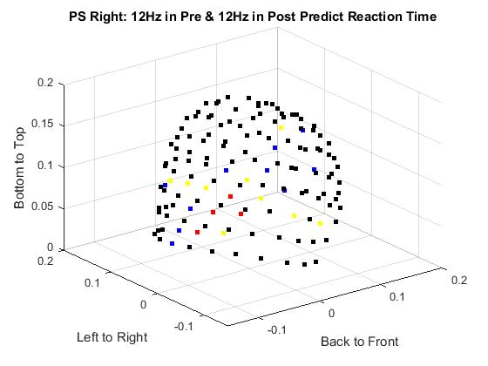 | 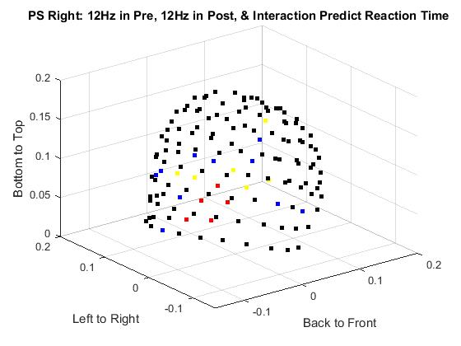
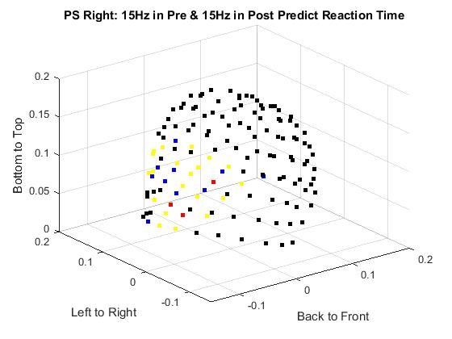 | 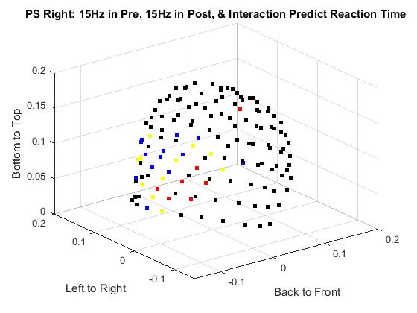
Figure 2. The p-values from four regressions on prosaccade right reaction times. Model 1 (upper left) consists of 12Hz power values from the first and second periods predicting reaction times. Model 2 (upper right) consists of 12Hz power values from the first and second periods as well as their interaction term predicting reaction times. Model 3 (bottom left) consists of 15Hz power values from the first and second periods predicting reaction times. Model 4 (bottom right) consists of 15Hz power values from the first and second periods as well as their interaction term predicting reaction times. Black > .003, blue ≤ .003, yellow ≤ .001, red ≤ .0001.

During the prosaccade right trials, participants were prompted to look right via the brightening of the 15Hz flickering checkerboard on the right side of the screen. 12Hz was the flickering frequency for the left checkerboard. When the interaction was not included in the regression of power in 12Hz on reaction times, a cluster was found only in the left temporal cortex (MLF16: $β_{0}$ = 0.19; $β_{1}$ = 2.54e-7; $β_{2}$ = 3.26e-4; $R^{2}$ = .063; p < .0001). When the interaction was included in the regression of power in 12Hz on reaction times, the same area was significant (MLF16: $β_{0}$ = 0.16; $β_{1}$ = 5.41e-5; $β_{2}$ = 5.03e-4;$β_{3}$ = -2.11e-7; $R^{2}$ = .076; p < .0001). The $R^{2}$ difference test rejected the null hypothesis that the $R^{2}$ increment between the two 12Hz models is not significantly different from zero for the left temporal peak (F = 5.29; p < .05). 15Hz was the flickering frequency for the right checkerboard. When the interaction was not included in the regression of power in 15Hz on reaction times, clusters were found in the following cortices: occipital (MRP26: $β_{0}$ = 0.22; $β_{1}$ = 5.36e-5; $β_{2}$ = 5.60e-6; $R^{2}$ = .048; p < .0001) and left temporal (MLF16: $β_{0}$ = 0.19; $β_{1}$ = 1.26e-5; $β_{2}$ = 5.49e-4; $R^{2}$ = .059; p < .0001). When the interaction was included in the regression of power in 15Hz on reaction times, the same areas were significant: occipital (MRP26: $β_{0}$ = 0.23; $β_{1}$ = 2.83e-5; $β_{2}$ = -1.23e-4;$β_{3}$ = 1.07e-7; $R^{2}$ = .054; p < .0001) and left temporal (MLF16: $β_{0}$ = 0.13; $β_{1}$ = 1.70e-4; $β_{2}$ = 9.44e-4;$β_{3}$ = -1.01e-6; $R^{2}$ = .077; p < .0001). The $R^{2}$ difference test rejected the null hypothesis that the $R^{2}$ increment between the two 15Hz models is not significantly different from zero for the left temporal peak (F = 7.48; p < .05), but it did not reject the null for the occipital peak (F = 2.47; p > .05).

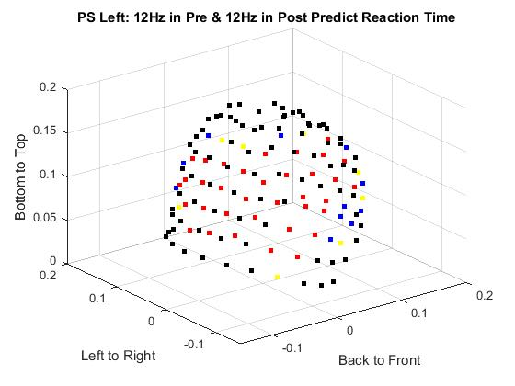 | 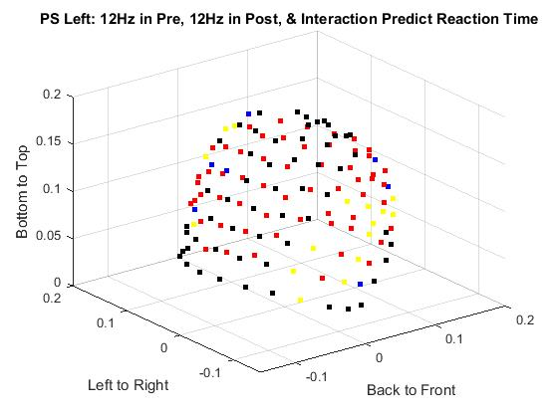
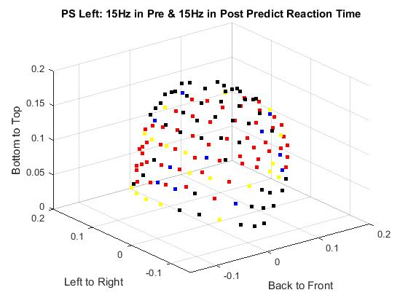 | 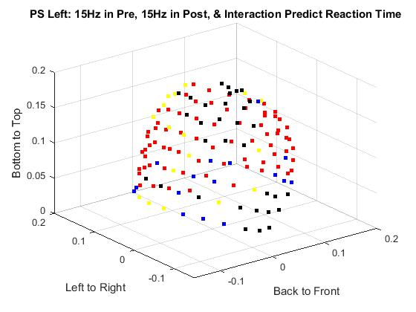
Figure 3. The p-values from four regressions on prosaccade left reaction times. Model 1 (upper left) consists of 12Hz power values from the first and second periods predicting reaction times. Model 2 (upper right) consists of 12Hz power values from the first and second periods as well as their interaction term predicting reaction times. Model 3 (bottom left) consists of 15Hz power values from the first and second periods predicting reaction times. Model 4 (bottom right) consists of 15Hz power values from the first and second periods as well as their interaction term predicting reaction times. Black > .003, blue ≤ .003, yellow ≤ .001, red ≤ .0001.

During the prosaccade left trials, participants were prompted to look left via the brightening of the 12Hz flickering checkerboard on the left side of the screen. When the interaction was not included in the regression of power in 12Hz on reaction times, a right temporal cluster was found (MRP41: $β_{0}$ = 0.19; $β_{1}$ = 6.74e-5; $β_{2}$ = 6.14e-5; $R^{2}$ = .063; p < .0001). Frontal (MMF02: $β_{0}$ = 0.19; $β_{1}$ = 1.74e-4; $β_{2}$ = 1.30e-3; $R^{2}$ = .059; p < .0001) and left temporal (MLP31: $β_{0}$ = 0.19; $β_{1}$ = 7.33e-5; $β_{2}$ = 4.26e-5; $R^{2}$ = .106; p < .0001) activity is indistinguishable as clusters. When the interaction was included in the regression of power in 12Hz on reaction times, significant frontal and left temporal activity is again indistinguishable as separate clusters, but a right temporal cluster (MRP41: $β_{0}$ = 0.20; $β_{1}$ = 4.79e-5; $β_{2}$ = 1.54e-5; $β_{3}$ = 7.37e-8; $R^{2}$ = .064; p < .0001) is apparent. The $R^{2}$ difference test failed to reject the null hypothesis that the $R^{2}$ increment between the two 12Hz models is not significantly different from zero for the right temporal peak (F = 0.41; p > .05). 15Hz was the flickering frequency for the right checkerboard. When the interaction was not included in the regression of power in 15Hz on reaction times, significant frontal, left temporal, and left occipital sensors are indistinguishable as separate clusters, but right occipital (MRP44: $β_{0}$ = 0.21; $β_{1}$ = 2.98e-5; $β_{2}$ = 2.06e-4; $R^{2}$ = .040; p < .001) and right temporal (MRP41:$β_{0}$ = 0.19; $β_{1}$ = 6.63e-5; $β_{2}$ = 2.40e-4; $R^{2}$ = .070; p < .0001) clusters were apparent. When the regression of power in 15Hz on reaction times included the interaction term, significant frontal, left temporal, left parietal, and occipital activity was indistinguishable as separate clusters; however, a right temporal cluster (MRP41: $β_{0}$ = 0.20; $β_{1}$ = 1.45e-5; $β_{2}$ = 1.72e-4; $β_{3}$ = 2.60e-7; $R^{2}$ = .072; p < .0001) was found. The $R^{2}$ difference test failed to reject the null hypothesis that the $R^{2}$ increment between the two 15Hz models is not significantly different from zero for the right temporal peak (F = 0.70; p > .05).

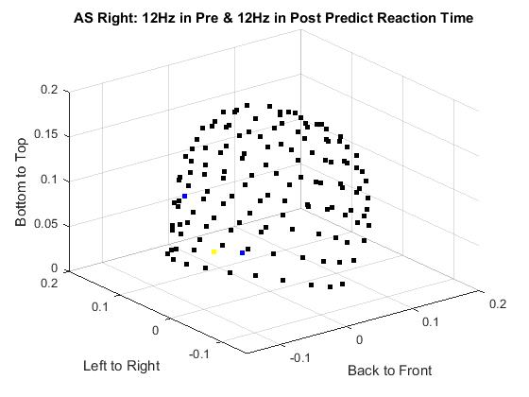 | 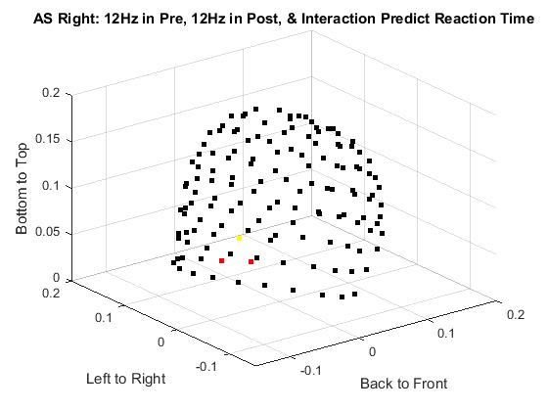
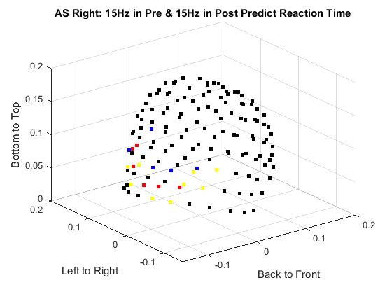 | 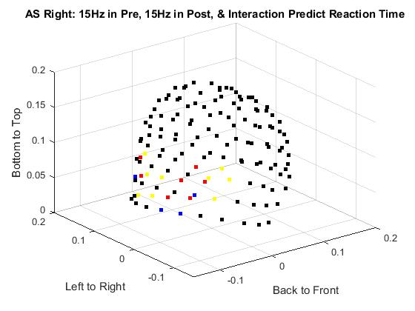
Figure 4. The p-values from four regressions on antisaccade right reaction times. Model 1 (upper left) consists of 12Hz power values from the first and second periods predicting reaction times. Model 2 (upper right) consists of 12Hz power values from the first and second periods as well as their interaction term predicting reaction times. Model 3 (bottom left) consists of 15Hz power values from the first and second periods predicting reaction times. Model 4 (bottom right) consists of 15Hz power values from the first and second periods as well as their interaction term predicting reaction times. Black > .003, blue ≤ .003, yellow ≤ .001, red ≤ .0001.

During the antisaccade right trials, participants were prompted to look right via the brightening of the 12Hz flickering checkerboard on the left side of the screen. There were no clusters of sensors in the regression of reaction times on power in 12Hz, with or without the interaction term. 15Hz was the flickering frequency for the right checkerboard (i.e., the target). When the interaction was not included in the regression of reaction times on power in 15Hz, clusters were found in the following cortices: left temporal (MLF16:$β_{0}$ = 0.18;$β_{1}$ = 3.38e-5; $β_{2}$ = 4.69e-4; $R^{2}$ = .056; p < .0001) and right occipital (MRP33:$β_{0}$ = 0.21; $β_{1}$ = 2.55e-5; $β_{2}$ = 7.19e-5; $R^{2}$ = .030; p < .01). When the interaction was included in the regression of reaction times on power in 15Hz, clusters were found in the same cortices: left temporal (MLF16:$β_{0}$ = 0.13; $β_{1}$ = 1.83e-4; $β_{2}$ = 9.53e-4; $β_{3}$ = -1.19e-6; $R^{2}$ = .073; p < .0001) and right occipital (MRP33:$β_{0}$ = 0.24; $β_{1}$ = -1.96e-5; $β_{2}$ = -8.62e-5; $β_{3}$ = 1.74e-7; $R^{2}$ = .043; p < .001). The $R^{2}$ difference test rejected the null hypothesis that the $R^{2}$ increment between the two 15Hz models is not significantly different from zero for the left temporal peak (F = 7.55; p < .05) and the right occipital peak (F = 5.44; p < .05).

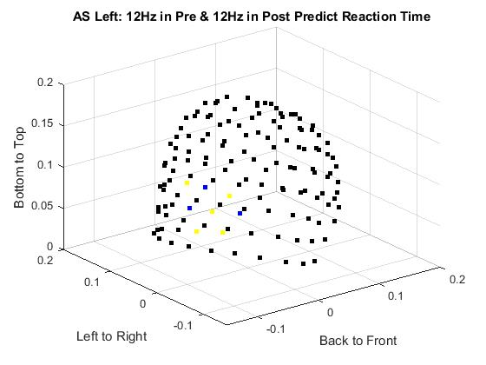 | 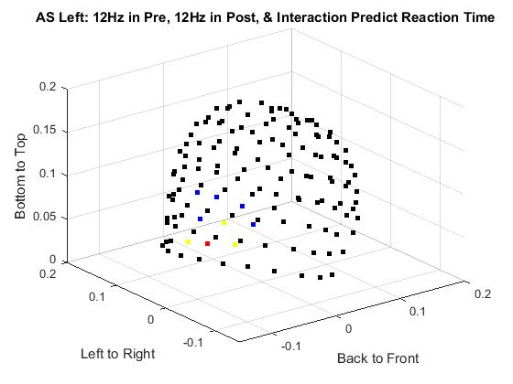
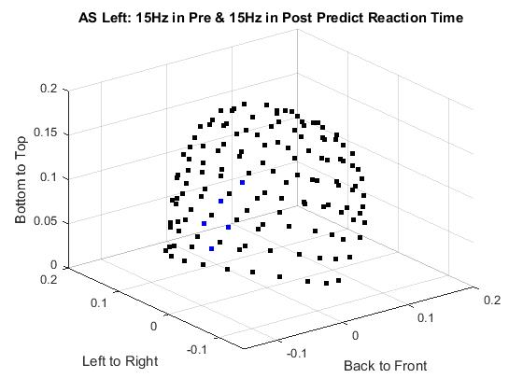 | 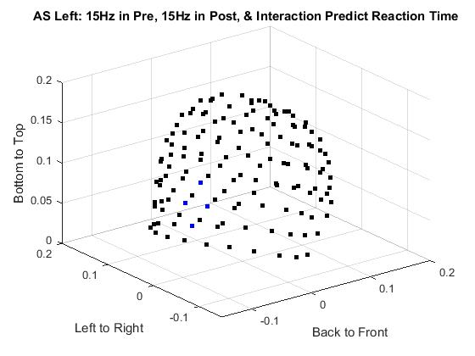
Figure 5. The p-values from four regressions on antisaccade left reaction times. Model 1 (upper left) consists of 12Hz power values from the first and second periods predicting reaction times. Model 2 (upper right) consists of 12Hz power values from the first and second periods as well as their interaction term predicting reaction times. Model 3 (bottom left) consists of 15Hz power values from the first and second periods predicting reaction times. Model 4 (bottom right) consists of 15Hz power values from the first and second periods as well as their interaction term predicting reaction times. Black > .003, blue ≤ .003, yellow ≤ .001, red ≤ .0001.

During the antisaccade left trials, participants were prompted to look left via the brightening of the 15Hz flickering checkerboard on the right side of the screen. 12Hz was the flickering frequency for the left checkerboard (i.e., the target). The regression of reaction times on power in 12Hz had a left temporal cluster without (MLF16: $β_{0}$ = 0.18; $β_{1}$ = 9.40e-6; $β_{2}$ = 3.90e-4; $R^{2}$ = .098; p < .0001) or with an interaction term (MLF16: $β_{0}$ = 0.12; $β_{1}$ = 1.04e-4; $β_{2}$ = 6.98e-4; $β_{3}$ = -3.87e-7; $R^{2}$ = .138; p < .0001). The $R^{2}$ difference test rejected the null hypothesis that the $R^{2}$ increment between the two 12Hz models is not significantly different from zero for the left temporal peak (F = 18.92; p < .05). 15Hz was the flickering frequency for the right checkerboard (i.e., the cue). The regression of reaction times on power in 15Hz had a left temporal cluster without (MLF35: $β_{0}$ = 0.20; $β_{1}$ = 2.27e-5; $β_{2}$ = 1.45e-4; $R^{2}$ = .079; p < .0001) or with (MLP21: $β_{0}$ = 0.16; $β_{1}$ = 1.02e-4; $β_{2}$ = 3.54e-4; $β_{3}$ = -2.22e-7; $R^{2}$ = .090; p < .0001) the interaction term. The $R^{2}$ difference test rejected the null hypothesis that the $R^{2}$ increment between the two 15Hz models is not significantly different from zero for the left temporal peak (F = 4.84; p < .05).
Discussion
Four regression models were compared per condition: right prosaccade, left prosaccade, right antisaccade, and left antisaccade. Left temporal activation was observed in one or more regression models across trial types. For antisaccade right trials, there were no clusters of activity for the cue frequency, but there were left temporal and right occipital clusters for the target frequency. For antisaccade left trials, both the cue and target frequencies had a cluster in left temporal cortex.
In prosaccade right trials, power in 12Hz for temporal cortex was positively predictive of reaction times for both the first and second periods, with a negative interaction term. Both higher power in the first half of the preparatory period and higher power in the second half predict longer reaction times. Having lower power in 12Hz during both periods predicted the shortest reaction times, having higher power in 12Hz during both periods predicted ~150ms longer reaction times, and having both lower first period power and higher second period power predicted the longest reaction times. For the cue and target frequency, both the occipital and temporal cortices were significantly predictive of reaction times. Power in 15Hz for left temporal cortex was positively predictive of reaction times for both the first and second periods with a negative interaction term, showing the same relationship as power in 12Hz for the same region. The regression coefficients for power in the cue/target frequency were larger than the regression coefficients for 12Hz, suggesting a larger effect on reaction times per unit change in power for cue/target frequency than for the unattended frequency for prosaccades. In occipital cortex, the direction of the second period power in 15Hz changed when the interaction term was included. With the interaction term included, power in the first period positively predicted reaction times, power in the second period negatively predicted reaction times, and the interaction term positively predicted reaction times. Higher power in 15Hz in the occipital cortex across the preparatory period predicts longer reaction times, while higher power during only the second half of the preparatory period predicts shorter reaction times. In other words, a later increase in attention to the target predicts a faster response; however the R2 difference test failed to reject the null hypothesis, so the inclusion of the interaction term did not increase the variance explained by the model.
In prosaccade left trials, only right temporal activity was identified as a separate cluster across regressions, with all positive regression coefficients. Right temporal power in both 12Hz and 15Hz was positively predictive of reaction times, across the entire preparatory period. Therefore, higher activity in the right temporal cortex predicted longer reaction times, with the longest reaction times occurring when 12Hz power or 15Hz power was high for the entire preparatory period (vice versa). For power in 15Hz, a separate right occipital cluster was apparent only when the interaction term was not included, although unclustered occipital activity was also present in the model with the interaction term. Right occipital power in 15Hz positively predicted reaction times across the preparatory period; therefore, more non-target power, interpreted as more attention to the incorrect location for this trial-type, in this area led to longer reaction times.
In antisaccade right trials, power in the cue frequency was not present in any clusters; however, power in the target frequency was present in left temporal and right occipital cortices, whether or not the interaction term was included. For the left temporal cortex, the first and second periods were positively predictive of reaction times, with larger coefficients when the interaction term was included in the regression. Low temporal target power during both periods predicted shorter reaction times, with high temporal target power during both periods leading to approximately 130ms longer reaction times. For the right occipital cortex, target power in the first and second period switched predictive direction when the interaction term was included in the regression. With the interaction term included, occipital target power in both the first and second periods predicted longest reaction times, while lower occipital target power in the first period combined with high power in the second period predicted shortest reaction times. As the absolute value of the regression coefficient for the second period is over four times as large as that for the first period, it seems to be more beneficial to switch attention to the target during the second period.
In antisaccade left trials, power in both the cue and target frequencies was predictive of reaction times in the left temporal cortex. In every regression, left temporal power during either the first or second periods positively predicted reaction times. For the target frequency, lower temporal power throughout both periods predicted the shortest reaction times, with approximately a 200ms increase in reaction time by having high power throughout the prep period. The same relationship existed for the cue power, except the increase in reaction time related to high power was approximately 120ms.
Prosaccades had longest reaction times with higher contralateral temporal cortex activity in the cue/target frequency throughout the preparatory period, suggesting temporal lateralization. The cue/target frequency had a larger effect on reaction times than the distractor checkerboard frequency. A role of the occipital cortex was indicated as shorter reactions were predicted by a later occipital increase in attention to target (PS to right), and longer reaction times were predicted by higher occipital power in the distractor frequency during either period (PS to left). Antisaccades had shorter reaction times with lower left temporal power in the target frequency, while shorter reaction times were predicted by higher occipital power in the target frequency.
Across conditions, a prominent activation in the left temporal cortex was found, with more activity in target frequency predicting longer reaction times. This activity confirms left temporal cortex activity found with MEG in both left and right saccades (Tzelepi, Lakaris, Amditis, & Zapoula, 2010). The left temporal cortex activity could reflect medial temporal activity as found bilaterally in macaque monkeys during spontaneous saccades in darkness, suggesting a mnemonic role (Sobotka & Ringo, 1997). The left temporal activation leading to longer reaction times could indicate that the more memory is involved in the behavior (i.e., the less automatic the behavior is), the slower the performance.
Also across conditions, occipital activity in the target frequency predicted shorter reaction times. For prosaccades, a later increase in occipital power predicted shorter reaction times, while for antisaccades high occipital power throughout the preparatory period predicted shorter reaction times. This difference between saccade types suggests that accurate antisaccade performance may depend on an early switch in visual attention away from the cue and towards the target to fully inhibit the competing cue saccade action, whereas for prosaccades the sustained visual attention to the cue/target location may cause a type of inhibition of return effect (Posner, Rafal, Choate, & Vaughan, 1985) that slows saccades to the already previously attended location. For prosaccades a later increase in attention to the target immediately preceding the saccade may lessen this effect.
The finding of parietal activity only during left prosaccades was unexpected, as this area was hypothesized to be active in all saccades and a possible source of spatial transformation for antisaccades particularly. Transformation was evaluated between halves of the preparatory period instead of finding an individual transformation latency for each participant. This could lead to averaging errors. Future study using source analysis to find activated Regions of Interest (ROIs) and activation in these specific areas will further clarify these unexpected findings and provide a clearer picture of neural sources in both temporal and parietal cortices as well as their contributions to saccade generation.
Effect size as measured by R-squared was fairly small (less than .20) when regression was done by sensor. In the future, the model could be refined such that power from multiple sensors is used to predict reaction times. This could be accomplished via source analysis or factor analysis. Because of these limitations, combined MEG/EEG source analysis with a method such as beamforming will be crucial to understanding brain areas of interest and the way they interact with one another to modulate behavioral performance.
The current study adds to the understanding of saccade generation in several ways. Due to the unusually extended preparatory period of the current paradigm, it was particularly interesting to note some similarities between prosaccade and antisaccade trials, including the activation in the occipital and temporal cortices and the near equivalent reaction times. Also, the presence of left temporal activity across trial types indicates a role for this area that has been previously underexplored. This finding could provide a new area for investigating neural dysfunction in clinical disorders with antisaccade behavioral abnormalities, such as schizophrenia and ADHD.

References
Alahyane, N., Brien, D.C., Coe, B.C., Stroman, P.W., & Munoz, D.P. (2014). Developmental improvements in voluntary control of behavior: Effect of preparation in the fronto-parietal network? NeuroImage, 98. 103-117.
Aydin, Ü., Vorwerk, J., Dümpelmann, M., Küpper, P., Kugel, H., Heers, M., Wellmer, J., Kellinghaus, C., Haueisen, J., Rampp, S., Stefan, H., & Wolters, C. (2015). Combined EEG/MEG can outperform single modality EEG or MEG source reconstruction in presurgical epilepsy diagnosis. PLoS One, 10(3). e0118753. doi:10.1371/journal.pone.0118753.
Bast, T. (2010). Abstracts of ICCN 2010: S10-2 Combined EEG and MEG analysis for epilepsy. Clinical Neurophysiology, 121(1). S20-S21.
Borra, E., Gerbella, M., Rozzi, S., & Luppino, G. (2015). Projections from caudal ventrolateral prefrontal areas to brainstem preoculomotor structures and to basal ganglia and cerebellar oculomotor loops in the macaque. Cerebral Cortex, 25. 748-764. doi:10.1093/cercor/bht265.
Chikazoe, J., Jimura, K., Hirose, S., Yamashita, K., Miyashita, Y., Konishi, S., (2009). Preparation to inhibit a response complements response inhibition during performance of a stop-signal task. J Neuroscience 29, 15870–15877.
Cornwell, B.R., Mueller, S.C., Kaplan, R., Grillon, C., & Ernst, M. (2012). Anxiety, a benefit and detriment to cognition: Behavioral and magnetoencephalographic evidence from a mixed-saccade task. Brain and Cognition, 78(3). 257-267.
Cox, R.W. (1996). AFNI: Software for analysis and visualization of functional magnetic resonance neuroimages. Computers and Biomedical Research, 29. 162-173.
Ding, J., Sperling, G., & Srinivasan, R. (2006). Attentional modulation of SSVEP power depends on the network tagged by the flicker frequency. Cerebral Cortex, 16. 1016-1029. doi:10.1093/cercor/bhj044.
Ethridge, L.E., Brahmbhatt, S., Gao, Y., McDowell, J.E., & Clementz, B.A. (2009). Consider the context: blocked versus interleaved presentation of antisaccade trials. Psychophysiology. 46(5):1100-7. doi: 10.1111/j.1469-8986.2009.00834.x. Epub 2009 May 28.
Everling, S., & Johnston, K. (2013). Control of the superior colliculus by the lateral prefrontal cortex. Philosophical Transactions of the Royal Society B, 368: 20130068.
Goto, Y., Hatakeyama, K., Kitama, T., Sato, Y., Kanemura, H., Aoyagi, K., Sugita, K., & Aihara, M. (2010). Saccade eye movements as a quantitative measure of frontostriatal network in children with ADHD. Brain & Development, 32(5). 347-355.
Gottlieb, J., & Goldberg, M.E. (1999). Activity of neurons in the lateral intraparietal area of the monkey during an antisaccade task. Nature Neuroscience, 2(10). 906-912.
Herweg, N.A., Weber, B., Kasparbauer, A., Meyhöfer, I., Steffens, M., Smyrnis, N., & Ettinger, U. ( 2014). Functional magnetic resonance imaging of sensorimotor transformations in saccades and antisaccades. NeuroImage, 102. 848-860.
Hutton, S.B. (2008). Cognitive control of saccadic eye movements. Brain and Cognition, 68. 327-340.
Hwang, K., Ghuman, A.S., Monoach,D.S., Jones, S.R., & Luna, B. (2014). Cortical neurodynamics of inhibitory control. J of Neuroscience, 34(29). 9551-9561. doi:10.1523/JNEUROSCI.4889-13.2014.
Koval, M.J., Lomber, S.G., & Everling, S. (2011). Prefrontal cortex deactivation in macaques alters activity in the superior colliculus and impairs voluntary control of saccades. J of Neuroscience, 31(23). 8659-8668. doi:10.1523/JNEUROSCI.1258-11.2011.
Martinez-Conde, S., Otero-Millan, J., & Macknik, S.L. (2013). The impact of microsaccades on vision: towards a unified theory of saccadic function. Nature Reviews Neuroscience, 14. 83-96.
Merriam, E.P., & Genovese, C.R. (2003). Spatial updating in human parietal cortex. Neuron, 39. 361-373.
Muller, N., Riedel, M., Eggert, T., & Straube, A. (1999). Internally and externally guided voluntary saccades in unmedicated and medicated schizophrenic patients. Part II. Saccadic latency, gain, and fixation suppression errors. European Archives of Psychiatry and Clinical Neuroscience, 249(1). 7-14.
Munoz, D.P., Armstrong, I.T., Hampton, K.A., & Moore, K.D. (2003). Altered control of visual fixation and saccadic eye movements in attention-deficit hyperactivity disorder. J of Neurophysiology, 90(1). 503-514.
Muthuraman, M., Moliadze, V., Mideksa, K.G., Anwar, A.R., Stephani, U., Deuschl, G., Freitag, C.M., & Siniatchkin, M. (2015). EEG-MEG integration enhances the characterization of functional and effective connectivity in the resting state network. PLoS One, 10(10). e0140832. doi:10.1371/journal.pone.0140832.
Oostenveld, R. (Ed.). (2015, November 27). Localizing oscillatory sources using beamformer techniques. Retrieved July 06, 2016, from http://www.fieldtriptoolbox.org/tutorial/beamformer
Oostenveld, R., Fries, P., Maris, E., & Schoffelen, J., (2011). FieldTrip: Open source software for advanced analysis of MEG, EEG, and invasive electrophysiological data. Computational Intelligence and Neuroscience, vol. 2011. doi:10.1155/2011/156869.
Posner, M., Rafal, R.D., Choate, L.S., Vaughan, J. Inhibition of return: Neural basis and function. Cognitive Neuropsychology, 2(3), 211-228.
Ross, R.G., Olincy, A., & Radant, A. (1999). Amplitude criteria and anticipatory saccades during smooth pursuit eye movements in schizophrenia. Psychophysiology, 36(4). 464-468.
Sobotka, S., & Ringo, J.L. (1997). Saccadic eye movements, even in darkness, generate event-related potentials recorded in medial septum and medial temporal cortex. Brain Research, 756(1-2). 168-173.
Tallon-Baudry, C., Bertrand, O., & Pernier, J. (1998). Evoked and induced 40-Hz visual responses in man: From feature binding to selective attention. Journal of Psychophysiology, 12. 193.
Tzelepi, A., Laskaris, N., Amditis, A., & Kapoula, Z. (2010). Cortical activity preceding vertical saccades: A MEG study. Brain Research, 1321. 105-116.
Wacker, M., Galicki, M., Putsche, P., Milde, T., Schwab, K., Haueisen, J., Ligges, C., & Witte, H. (2011). A time-variant processing approach for the analysis of alpha and gamma MEG oscillations during flicker stimulus generated entrainment. IEEE Transactions on Biomedical Engineering, 58(11). 3069-3077.
Weiler J., & Heath, M. (2014).Oculomotor task switching: alternating from a nonstandard to a standard response yields the unidirectional prosaccade switch-cost. J Neurophysiol 112. 2176–2184. doi:10.1152/jn.00352.2014.
Zhang, M., & Barash, S. (2000). Neuronal switching of sensorimotor transformations for antisaccades. Nature, 408. 971-975.

