University of Oklahoma

Graduate College

the effects of computer-supported collabortive learning on Writing performance, metacognition, and Experience of students with Writing difficulties

A Dissertation

submitted to the Graduate Faculty

in partial fulfillment of the requirements for the

Degree of

Doctor of Philosophy

By

Tracy A. Blankenship
Norman, Oklahoma
2017

The Effects of computer-supported collaborative learning on writing performance, Metacognition, and Experience of students with writing difficulties

A Dissertation approved for the
Department of Educational Psychology

By

______________________________
Dr. James E. Gardner, Chair

______________________________
Dr. Joyce Brandes

______________________________
Dr. Xun Ge

______________________________
Dr. Jeffrey Maiden

______________________________
Dr. Kendra Williams-Diehm

© Copyright by Tracy A. Blankenship 2017
All Rights Reserved.
To my beautiful children, Jonathan, Bryant, and Karyn…
We have been through so much together during this journey. You have given me light when I felt there was complete darkness and hope when I didn’t believe it existed. I love each of you with all of my heart.

To the love of my life, Clark…
Thank you for always reminding me that I am not a quitter. You always push me to be the best and never allow me to settle. You are my rock, and I thank God every day for the gift he has given me in you. I love you Sparky!

Acknowledgements
I would like to express my appreciation to my dissertation committee for your commitment, support, and direction over the course of my studies at the University of Oklahoma. In particular, I am eternally grateful to, Dr. James Gardner, chair of my doctoral committee. Your extreme patience, support, and direction are truly what helped me through the writing process. Dr. Xun Ge, thank you for first exposing me to CSCL research. It is because of you that I decided to conduct this study. Dr. Joyce Brandes and Dr. Jeffrey Maiden thank you both for agreeing to be part of my committee. I have such respect for both of you, and I feel honored to work with you on this journey. Dr. Kendra Williams-Diehm, thank you for agreeing to step in as a committee member in the later stages of my doctoral process. I am eternally grateful.
I consider myself extremely fortunate to be part of such a great school district. I am so grateful to Dr. Melani Mouse, Meggan Wilson, and Toye Mitchell. Thank you, ladies, for allowing me the opportunity to complete this process, I am so appreciative. Teachers A, B, and C, you know who you are, thank you for saying yes! Of course I cannot forget Scott McCall, Shelly Bensinger, Wendy Hagy, Amber Zumwalt, Michelle Frank, Heather Williams, my school psychologist team, and all the other Special Services Team members that checked on my progress regularly. Thank you, thank you, thank you!
Thank you to my beautiful family. My loving husband Clark, I love you. My seven amazing kiddos, Austen, Jonathan, Chelsea, Bryant, Karyn, Sierra, and Savannah, I love you. My four amazing grandkids, Carter, Kinzley, Daysha, and Brooklyn, YaYa loves you to pieces. Uncle Mike, Aunt Penny, Rush, Myka, Hannah, Johnny, Terri, Dad, Sandra, Chris, and Robin, I love you.
Finally, thank you to my family that is no longer with me and has watched me complete this process from above. Mom, Grandma, Uncle Johnny, and my sweet Eenie, I know you are watching me from heaven cheering me on to the finish line. Thank you for giving me love (Mom), strength (Grandma), drive (Uncle Johnny), and support (Eenie), making this pursuit possible.

Table of Contents

Acknowledgements iv
Table of Contents vi
List of Tables xii
Abstract xiii
CHAPTER 1: INTRODUCTION 1
Problem Statement 1
Concerns Regarding the Writing Abilities of Students with Writing Difficulties 3
Planning/Goal Setting 3
Content Development 3
Mechanical Writing 4
Revisions/Editing 4
Cognition and Metacognition 4
Cognition 4
Metacognition 5
Effective Writing Strategies and Computer Supported Collaborative Learning 6
Effective Writing Strategies 6
Computer Supported Writing 6
Computer-Supported Collaborative Learning 7
Purpose of Study 8
Research Questions 9
Summary 9
CHAPTER 2: REVIEW OF THE LITERATURE 11
Overview 11
Metacognitive Skills of Students with Writing Difficulties 11
Writing and the Writing Abilities of Students with Mild Disabilities 13
The Importance and Expectations of Writing 13
Writing Difficulties of Students with Mild Disabilities 14
Mechanical Issues in Writing 16
Metacognitive Issues in Writing 17
Planning Text 20
Writing/Content Generation of Text 21
Revising Text 21
Characteristics of Novice vs. Expert Writers 22
Strategies Used to Address Metacognitive and Cognitive Writing Difficulties of Students with Mild Disabilities 23
Computer-Supported Collaborative Learning 24
Defining Computer-Supported Collaborative Learning 24
Variations of Defining CSCL 25
CSCL Applications 26
Benefits of a Computer-Supported Collaborative Learning Environment (CSCL) 27
Theoretical Underpinnings of CSCL 28
Effective Implementations of Theories Supporting CSCL 31
Summary 36
CHAPTER 3: METHODOLOGY 37
Overview 37
Design-Based Research 37
Participants and Sample 40
Student Participants 40
Teacher Participants 42
Research Settings 42
Instruments and Measures 46
Test of Written Language 3rd edition 46
Student Interview 49
Teacher Interview 49
Teacher Observation Log 49
Primary Investigatory Observation Log and Transcriptions 50
Materials and Learning Platform 50
Learning Platform 50
Google Documents. 50
Procedures 53
Pre-Intervention 53
Week One: Days One - Five 54
Intervention 58
Week One: Days One - Five 58
Week Two: Days Six - Ten 61
Week Three: Days Eleven - Fifteen 64
Week Four: Days Sixteen – Twenty-One 67
Post-Intervention 70
Week One 70
Data Analysis 72
Qualitative Data Analysis Procedures 73
Inter-scorer Reliability 74
Summary 75
CHAPTER 4: RESULTS 77
Overview 77
Research Question One: Do Students Demonstrate Expert-Like Cognitive and Metacognitive Characteristics of the Writing Process when Working in a CSCL Environment? 77
CSCL Environment – A Steep Learning Curve for Students 78
Summary 85
Research Question Two: Does the Writing Quality of Students with Writing Difficulties who Participate in a CSCL Environment Improve Over Time? 86
Effect of Time on All Students’ Writing 87
Effect of Time and Classroom 89
Summary 93
Research Question Three: What Affordances Does the CSCL Environment Provide to Scaffold the Writing Process of Students with Writing Difficulties? 94
Peer Scaffolding 95
Teacher Scaffolding 97
Affordance of Technological Tools in a CSCL Environment 98
Summary 99
Research Question Four: What are the Experiences of Students with Writing Difficulties upon Engaging in Writing Instruction in a CSCL Environment? 100
Student Experience with Writing Individually (Dimension One) 101
Student Experience with Writing Collaboratively (Dimension Two) 103
Student Experience with Using a Computer to Write (Dimension Three) 108
Teacher Observation of Student Experiences 110
Summary 115
CHAPTER 5: DISCUSSION 117
Overview 117
Discussion of Findings 118
Research Question One: Do Students Demonstrate Expert Like Cognitive and Metacognitive Characteristics of the Writing Process When Working in a CSCL Environment? 118
Research Question Two: Does the Writing Quality of Students with Writing Difficulties who Participate in a CSCL Environment Improve Over Time? 123
Research Question Three: What Affordances Does the CSCL Environment Provide to Scaffold the Writing Process of Students With Writing Difficulties? 127
Research Question Four: What are the Experiences of Students with Writing Difficulties upon Engaging in Writing in a CSCL Environment? 130
Limitations and Implications on Future Research 134
Summary and Conclusions 136
References 139
Appendix A: Student Interview 152
Appendix B: Teacher Interview 153
Appendix C: Teacher Observation Log 154
Appendix D: Student Demographic Form 155
Appendix E: Introduce Your Students to Google Docs [Handout] 156
Appendix F: TOWL-3 Instructions (Modified) 159
Appendix G: Writing the Persuasive Essay [Handout] 160
Appendix H: Persuasive Writing Example Letters [Handout] 167
Appendix I: Notes for a Persuasive Letter Handout 169
Appendix J: List of Persuasive Essay Topics 170
Appendix K: Writing Rubric 171
Appendix L: Persuasive Writing Topic Exploration [Handout] 174
Appendix M: List of Narrative Essay Topics 175
Appendix N: Graphic Organizer for a News Article [Handout] 176
Appendix O: Students Randomly Assigned to Groups 177
Appendix P: Signed Assent Over 12 178
Appendix Q: Signed Parental Permission to Participate in Research 182
Appendix R: Signed Parental Permission to Participate in Research Addendum 187
Appendix S: Signed Consent 189
Appendix T: IRB Permission Letter 193

List of Tables

Table 1. Demographics of Participants 41
Table 2. Summary of Individual Participant Characteristics 43
Table 3. Demographics of Participating Classrooms 45
Table 4. Overview of Pre-intervention Tasks Week One: Days One - Five 55
Table 5. Overview of Intervention Tasks Week One: Days One - Five 59
Table 6. Overview of Intervention Tasks Week Two: Days Six - Ten 62
Table 7. Overview of Intervention Tasks Week Three: Days Eleven - Fifteen 65
Table 8. Overview of Intervention Tasks Week Four: Days Sixteen - Twenty-One 68
Table 9. Overview of Post-Intervention Tasks Week Three: Days One - Ten 71
Table 10. Data Analysis Summary 73
Table 11. Number of Revisions/Edits Made by Group for Persuasive and Narrative News Stories 84
Table 12. Comparison of Pre-test, Mid-test, and Post-test Scores on TOWL-3 for All Students 88
Table 13. Comparison of Pre-test, Mid-test, and post-test Scores on TOWL-3 90

Abstract
Students with writing difficulties often demonstrate a deficit in both cognitive and metacognitive skills when writing. They often struggle with task related components of writing such as mechanics, taking notes when planning, or using a graphic organizer to plan their writing. Additionally, students with writing difficulties have challenges with the processes of planning continuously when writing, developing content, and making revisions to content as opposed to just mechanics. A variety of strategies, techniques, and technological tools can be effective in supporting students with writing difficulties. A Computer Supported Collaborative Learning Environment (CSCL) is one platform that demonstrates effectiveness when used with students who struggle with writing. Although this platform is effective, more research is needed regarding the effects of a CSCL environment when working with students specifically identified as having writing difficulties.
The purpose of this design-based research study is to investigate the writing performance, metacognition, and experiences of students with writing difficulties when working in a CSCL environment. Twenty middle school students identified as having writing difficulties and three middle school special education teachers participated in this study. Results from this study expound on the potential affordances of a CSCL environment when used with students with writing difficulties, whom demonstrate cognitive and metacognitive difficulties during the writing process. The experiences of students who engage in writing instruction in a CSCL environment are also reported.

CHAPTER 1: INTRODUCTION
Writing is often used as a judge of one’s intelligence. It serves as an indicator of our non-verbal ability to communicate with others. Writing allows us to articulate our thoughts and ideas without uttering a single word. Moreover, writing allows us to record elements of our life and culture, learn across multiple disciplines, and better understand society as a whole (Freedman, Dyson, Flower, and Chafe, 1987).
Several strategies, technological tools, and technological platforms have shown to be beneficial to students when writing. Strategies that have shown to be beneficial to students when learning to write include, Self-Regulated Strategy Development (SRSD) and Cognitive Strategy Instruction in Writing (CSIW) (Graham, Harris, & MacArthur, 2006; Hallenback, 2002). These forms of strategy instruction provide students with both metacognitive and cognitive writing strategies. Technological tools afforded through a word processor outfitted with different software packages can provide students with spellcheck, grammar check, formatting features, text to speech features, and speech recognition, all of which can make the process of writing easier for students. Moreover, students can add to, modify, delete, or share there writing with others when using a word processor with greater ease (Morphy & Graham, 2012). Finally, platforms such as Google Docs, Microsoft Office Online, and Etherpad, allow students to utilize word processing features via the Web, as well as collaboratively create a writing product utilizing scaffolding and higher order thinking skills.

Problem Statement
Research indicates that many students with and without writing difficulties can benefit from strategies and technological supports when writing. However, this is not the case for all students. In this particular study, students with writing difficulties are identified under four broad groups: (1) students identified as needing intervention in writing based on the Response to Intervention (RTI) process; (2) students identified as having a mild to moderate disability with an IEP; (3) students serviced in a moderate to severe cognitive classroom identified as having an intellectual disability, autism with deficits in all content areas including writing, or orthopedic impairment with deficits in all content areas including writing; and (4) students serviced in a moderate to severe behavior classroom with deficits in all content areas including writing. All of the students mentioned have both cognitive and metacognitive difficulties, which make the process of writing challenging. Much of the difficulties these students face when writing is directly linked to a lack of higher-order cognitive skills (Wong, 1999). This lack of metacognitive skills limit students to creating writing samples that are poorly planned (MacArthur and Graham, 1987), unorganized (Graham & Harris, 1989; Monroe & Troia, 2006; Saddler & Asaro, 2007), and with several mechanical and grammatical errors (MacArthur, 1996, 1999; MacArthur & Graham, 1987; Troia, 2006). Due to this struggle, educators are constantly searching for a method or strategy that will provide this group of students with much needed assistance. Research is needed to determine more effective ways to assist students with writing difficulties to become reflective, self-regulated writers.
A Computer-Supported Collaborative Learning environment has the capability to merge multiple elements of writing that have demonstrated effectiveness when used with students who have writing difficulties. To determine which interventions work the best, educators need to mix various components of successful interventions (Graham and Perin, 2007). Furthermore, writing intervention research for students with mild disabilities continuously calls for a continued examination of the affordances of technology.

Concerns Regarding the Writing Abilities of Students with Writing Difficulties

Planning/Goal Setting
Students that effectively plan their writing should be actively considering what they will be writing about, utilizing prior knowledge about the topic they selected and organizing their ideas with a variety of tools (Lassonde and Richards, 2013). The process of planning should not be limited to the beginning stages of writing, but instead an ongoing task throughout the entire writing process. Although planning is necessary when creating a developed writing product, students with writing difficulties tend not to plan or engage in limited planning (MacArthur and Graham, 1987).

Content Development
According to the 2017 NAEP writing assessment framework, a middle school student should create content that communicates the main points of the topic with supporting details and relevant details (National Assessment Governing Board, U.S. Department of Education, 2017, p. 45). Additionally, students should provide text that is structured, with ideas that are developed and logical (National Assessment Governing Board, U.S. Department of Education, 2017, p. 45). Despite the requirements necessary to create content that is considered proficient, student with writing difficulties, struggle to develop a finished product that is coherent and organized (Graham & Harris, 1989, Monroe &Troia, 2006; Saddler & Asaro, 2007)

Mechanical Writing
Proficient writers, according to the 2017 NAEP writing assessment framework for 8th grade students, should use a range of sentence types when writing (National Assessment Governing Board, U.S. Department of Education, 2017, p. 45). Also, students’ knowledge of mechanics of writing such as spelling, grammar, usage, capitalization, and punctuation should be evident in their writing (National Assessment Governing Board, U.S. Department of Education, 2017, p. 45). Students with writing difficulties tend to have issues with the mechanics of writing, which can lead to students having less desire to write (Beringer, Mizokawa, and Bragg, 1991).

Revisions/Editing
Revising text is essential to the writing process. According to the 2017 NAEP writing assessment framework for 8th graders, students should be drafting text with minimal errors (National Assessment Governing Board, U.S. Department of Education, 2017, p. 45). Additionally, students should focus on overall text quality (Bridwell, 1980) and mechanical text features. Students with writing difficulties, tend to focus on the aesthetics of text when revising (Graham, Schwartz, & MacArthur, 1993). Revisions made by students with writing difficulties tend to have little impact on improving the overall quality of text (Graham, Harris, & Larson, 2001).

Cognition and Metacognition

Cognition
Cognition is the process of obtaining knowledge through thought. Cognitive skills are beneficial for students with such tasks such as mechanical aspects of writing. Additionally, tasks such as utilizing graphic organizers and taking notes are also cognitive writing tasks.
Students with writing difficulties tend to present concerns that are cognitive (Boyle 2001; Vaidya, 1999) in nature when writing. In regards to writing, cognition is more task related. The spectrum of difficulties students experience includes conventional errors, such as grammar, spelling, and punctuation (Graham, Harris, MacArthur, & Schwartz, 1991; Wong, 2000). Moreover, students with writing difficulties tend to have challenges with cognitive tools such as note-taking and asking questions (Vaidya, 1999) during the writing process, which can be beneficial to students.

Metacognition
Metacognition is the process of thinking about one’s own thinking (Vaidya, 1999). According to Flavell (1976), metacognitive skills are essential to individual’s success in both academic and social settings. In regards to writing, metacognition is more process related. Examples of metacognition when writing include the processes of planning (or thinking about), monitoring, organizing, reflecting, and revising text. Additionally, student awareness and understanding of the writing process would be considered a metacognitive skill (MacArthur & Graham, 1987).
Students with writing difficulties also present concerns that are metacognitive (MacArthur & Graham, 1987) in nature when writing. They tend to have issues with planning, writing, and revising text (Chalk, Hagan-Burke, and Burke, 2005; Graham et al., 1991; MacArthur, 2009; Mason and Graham, 2008). Additionally, students with writing difficulties also have challenges with metacognitive structures such as self-perception about one’s own writing, awareness and understanding of the writing process, and attitudes toward one’s own writing (MacArthur & Graham, 1987).

Effective Writing Strategies and Computer Supported Collaborative Learning

Effective Writing Strategies
In a meta-analysis conducted by Graham and Perin (2007) 11 elements of writing found to be effective for helping adolescents learn to write and to use writing as a tool for learning were identified. These elements include writing strategies, summarization, collaborative writing, specific product goals, word processing, sentence combining, prewriting, inquiry activities, process writing approach, the study of models, and writing for content learning. Over the last 30 years of writing intervention research, replication across tasks and settings can be found for each of these elements (Graham and Perin, 2007). As noted by Graham and Perin (2007) combining some or all of the 11 elements of writing can strengthen adolescents’ literacy development. However, research has shown that students with mild disabilities struggle with the concept of writing as a result of limited knowledge and understanding of the strategies used to write effectively (De La Paz & Graham, 1997; Swanson & De La Paz, 1999; Wong, 2000).

Computer Supported Writing
Research shows that some of the difficulties students with mild disabilities experience when writing, to an extent, can be overcome when using technology (Bangert-Drowns, 1993, Graham & Perin, 2007). MacArthur (1996 & 1999) identifies multiple ways technology can assist students, from the benefits of word processing features to software applications such as speech synthesis and applications that assist with planning, to multimedia to enhance writing, through graphics and extended background knowledge. For a student with mild disabilities, features such as grammar and spell check, word prediction, organizational tools, and speech recognition can lessen the barriers that make writing difficult (Hetzroni & Shrieber, 2004). Additionally, students that struggle with writing tend to produce higher quality writing samples of greater length (Bangert-Drowns, 1993).

Computer-Supported Collaborative Learning
Computer-supported collaborative learning is collaborative learning supported by technology, that enhances peer interaction and work in groups and facilitates sharing and distribution of knowledge and expertise among members of a group (Lipponen, 2002). Computer-supported collaborative learning allows for the distribution of knowledge and expertise among community members with fewer barriers. A Computer-Supported Collaborative Learning (CSCL) environment merges many elements identified by Graham and Perin (2007). CSCL affords students with an environment to collaborate with peers (Jonassen, Lee, Yang, Laffey, 2005; Koschmann, 1994, 1996; Lehtinen, Hakkarainen, Lipponen, Rahikainen, & Muukkonen, 1999; Lipponen, 2002; Pea, 1996; Scardamalia, Bereiter, & Lamon, 1994; Scardamalia & Bereiter, 1996, 2006; Stahl, Koschmann, & Suthers, 2006; Strijbos, 2004). The collaboration component of a CSCL environment also provides scaffolding (Scardamalia, 2004; Miyake, 2007) in the form of a peer or teacher providing support. Scaffolding can assist students with mild disabilities in monitoring their work, enhancing students’ metacognitive skills, and provide a guide for what comes next in a process. In a CSCL environment students can engage in in-depth inquiry over extended periods of time (Lehtinen et al., 1999). Additionally, depending on the technological platform used within the CSCL environment, students have access to word processing features such as spell check and revision history, which can be a beneficial technological feature to students with mild disabilities.

Purpose of Study
The purpose of this design-based research study was to investigate the writing performance, metacognition, and experiences of students with writing difficulties when working in a CSCL environment. Results from this study expound on the potential affordances of a CSCL environment when used with students with writing difficulties when engaging in cognitive tasks and metacognitive processes. Additionally, this study provides results regarding the experiences of students once they engaged in writing instruction in a CSCL environment.
For this study, writing difficulties was defined as students who are identified under one of the following four broad groups: (1) students identified as needing intervention in writing based on the Response to Intervention (RTI) process; (2) students identified as having a mild to moderate disability with an Individualized Education Plan (IEP) such as higher functioning autism or a learning disability; (3) students serviced in a moderate to severe cognitive classroom identified as having an intellectual disability, or more severe autism with deficits in all content areas including writing, or orthopedic impairment with deficits in all content areas including writing; and (4) students serviced in a moderate to severe behavior classroom identified as having an emotional disturbance with deficits in all content areas including writing.

Research Questions
This study consisted of four research questions. The designs of the following questions are such that they are intended to provide an empirical view of the merger of two effective writing interventions.
- Do students demonstrate expert like cognitive and metacognitive characteristics of the writing process when working in a CSCL environment?
- Does the writing quality of students with writing difficulties who participate in a CSCL Environment improve over time?
- What affordances does the CSCL environment provide to scaffold the writing process of students with writing difficulties?
- What are the experiences of students with writing difficulties upon engaging in writing in a CSCL environment?
A design-based research (DBR) approach was used for this study, with a mix of both quantitative and qualitative research methods applied to answer the four research questions. A qualitative approach was used to examine questions 1, 3, and 4. Question 2 was analyzed quantitatively.

Summary
Students with writing difficulties often struggle with the task of written language, a skill that is essential in both the educational and work setting, as well as socially when communicating with others. If students are to be successful with this necessary life skill, educators must provide students with strategies to master written language. Moreover, students must have access to resources afforded by technology that can provide scaffolds for learning and tools that will help students focus on more than just the mechanical aspects of writing, and instead focus on the writing task as a whole. Chapter 2 will provide a review of the literature that discusses both the difficulties students with mild disabilities experience when writing, as well as potential technological platforms and strategies for developing better writers.

CHAPTER 2: REVIEW OF THE LITERATURE

Overview
The purpose of this review of literature is to discuss the metacognitive skills and writing abilities of students with mild disabilities and methods that can be used to improve the quantity and quality of students writing. The areas to be reviewed are (a) metacognitive skills of students with mild disabilities, (b) writing and writing abilities of students with mild disabilities, (c) strategies used to address metacognitive and cognitive writing difficulties of students with mild disabilities, and (d) Computer-Supported Collaborative Learning (CSCL).

Metacognitive Skills of Students with Writing Difficulties
Students with writing difficulties struggle with several aspects of learning. Potential barriers such as memory problems, difficulty following directions, sustaining attention, trouble with visual and auditory perception, or visual coordination problems (Vaidya, 1999), can lead to students with mild disabilities becoming frustrated, disorganized, or overwhelmed when learning (Graham, Harris, & MacArthur, 2006; Vaidya, 1999). They also lack the self-knowledge and self-awareness to engage in strategic behaviors (Swanson & De La Paz, 1998; Vaidya, 1999). This self-understanding behavior is known as metacognition.
According to Flavell (1976), metacognition is one’s knowledge concerning one’s own cognitive process. More simply put, metacognition is the process of thinking about one’s own thinking (Vaidya, 1999). Metacognitive skills such as awareness of one’s cognitive processes, self-regulation, and knowledge about one’s cognitive strengths and weaknesses (Flavell, 1976) are essential components of academic and social success. Without these skills, students will struggle with monitoring their own performance and selecting appropriate strategies to solve problems, plan, and organize their work (Englert, Raphael, Fear, & Anderson, 1988).
Research suggest that students with mild disabilities do not have the metacognitive knowledge necessary to be successful in reading (Gersten, Fuchs, Williams, & Baker, 2001; Wong & Jones, 1982) and writing (Bakken & Whedon, 2003; Englert et al., 1988; Graham & Harris, 1989; MacArthur & Graham, 1987; Monroe & Troia, 2006; Newcomer & Barenbaum, 1991; Saddler & Asaro, 2007; Saddler, Moran, Graham, and Harris, 2004; Wong, Wong, & Blenkinsop, 1989). Swanson and De La Paz (1998), attribute this lack of success to students with mild disabilities not being able to acquire strategic reading skills. To address this issue, students with mild disabilities must rely on their teachers or normally achieving peers to develop an awareness and understanding of the strategies necessary to be academically successful.
Students with mild disabilities often struggle with the identification of effective learning strategies for different learning situations (Vaidya, 1999). Shanahan (2006) noted this could be particularly challenging for students in the areas of reading and writing, due to the connection between learning to read and write. According to Gersten et al. (2001), students with reading difficulties may not realize that they must monitor their comprehension of text. This lack of knowledge can, in turn, cause the student serious problems when writing. According to Englert et al. (1988), writing performance is dependent upon a student selecting the appropriate strategy for a given writing task. In addition, the student must monitor their writing to ensure it is comprehensible. If a student lacks the knowledge of when and how to monitor for comprehension during reading, the same difficulties can potentially occur when the student creates a writing sample. For this reason, it is essential for appropriate strategies and interventions to be in place when working with students with mild disabilities. However, before this can occur, educators working with students with mild disabilities must have a working knowledge of the strategies and tools that will assist their students with planning, monitoring, organizing, reflecting, and revising when writing.

Writing and the Writing Abilities of Students with Mild Disabilities

The Importance and Expectations of Writing
“Writing, which is often noted as one of the three “R”s (reading, writing, and arithmetic) of education, has been observed as an important curriculum area in one’s academic life” (Hayes & Ge, 2008, p.1). Although society values writing as a major component in developing thinking (Bereiter & Scardamalia, 1987), in the past it has been inferior to other content areas presented in educational systems in America (College Board, 2003). In 2003, The National Commission on Writing for America's Families, Schools, and Colleges published a report, The Neglected “R,” which highlighted the necessity for schools to acknowledge the importance of writing in school reform efforts. Recommendations from the report included: (a) comprehensive writing policies that increased writing time; (b) the teaching of writing across the curriculum; (c) an alignment of standards, curriculum and assessment in writing and other areas of the curriculum, in reality and rhetoric; and (d) assessments that require students to compose a writing piece, as opposed to multiple choice, machine score items when assessing writing (College Board, 2003). The Common Core State Standards (CCSS) for Language Arts and Mathematics released seven years later in an effort to provide high standards consistent across all states (Common Core State Standards Initiative, 2012). The CCSS standards focused on students being able to read and write (Common Core State Standards Initiative, 2012). However, some states repealed CCSS, instead of replacing the standards with their own either very similar or completely different standards. Despite who created the standard, what remained the same was the increased importance of teaching students how to be critical thinkers and successful writers.
Woven throughout many aspects of one's life is the expectation of good writing skills. From writing a book report in elementary school to writing a letter of interest for a particular job, written language serves as an indicator of academic success, the first impression of one’s character or ability, and even a potential means for financial support. Despite the expectation of good writing, it remains true that writing continues to be a challenge for all students (Male, 2003. p. 50). In particular, students with mild disabilities tend to have even more significant issues with writing, as opposed to their normally achieving peers (Graham et al., 1993; Wong, 2000).

Writing Difficulties of Students with Mild Disabilities
There are several factors that can attribute to the problems students with mild disabilities have when writing (e.g., mechanics, difficulty synthesizing important points, strategies for developing a writing sample, and poor self-perception and attitude) and can be cognitive (Boyle, 2001; Vaidya, 1999) or metacognitive in nature (Bakken & Whedon, 2003; Garcia & Fidalgo, 2008; Graham et al., 1993; Saddler et al. 2004).
Cognitive difficulties. Cognitive difficulties with writing are evident in tasks such as note taking, asking questions and filling in charts (Vaidya, 1999). Boyle (2010), found that students with learning disabilities recorded fewer total lecture notes and cued lecture points than students without learning disabilities. Also, students with learning disabilities tend to record fewer words and vocabulary when taking notes (Boyle, 2012).
Metacognitive difficulties. Metacognitive difficulties include strategies such as the process of planning, monitoring, organizing, reflecting, and revising when writing (Englert, Raphael, Anderson, Anthony, & Stevens, 1991). Unlike cognitive difficulties, which are task-oriented, metacognitive difficulties are students thinking about how they will approach a cognitive task during the planning phase of the writing process or students monitoring their writing and making changes during the content development phase of the writing process. Additional components of metacognitive knowledge include student self-perception about their own writing, awareness and understanding of the writing process, and students’ attitudes towards their own writing (MacArthur & Graham, 1987).
According to Scardamalia and Bereiter (1986), there are five areas of competence that cause issues for most students: (a) generating content, (b) creating and organizing structure for compositions, (c) formulating goals and higher level plans, (d) quickly and efficiently executing mechanical aspects of writing, and revising text and reformulating goals. Areas of writing that can be particularly problematic for many students with mild disabilities are the acts of planning, writing, and revising text (Chalk, Hagan-Burke, and Burke, 2005; Graham et al., 1991) Additionally, as students progress through school their attitude towards writing tends to get worse (Harris, Graham, Brindle, & Sandmel, 2009).

Mechanical Issues in Writing
Difficulties can also be related to the mechanics of writing (Graham, Harris, MacArthur, & Schwartz, 1991; Wong, 2000). The mechanical aspect of writing involves all of the processes that take place in getting words into print; such as handwriting, typing, spelling, capitalization, punctuation, and formatting (MacArthur, 1999). Students with mild disabilities have a significant issue with translating content to text (Macarthur, 1996; MacArthur, 1999; Troia, 2006). According to Berninger, Mizokawa, and Bragg (1991), issues related to spelling errors, poor handwriting, poor punctuation usage, and slower dictation can all lead to an unwillingness or lack of desire to write. Additionally, these issues can also hinder a student from engaging in higher order cognitive processes such as planning and content development (MacArthur & Graham, 1987).
MacArthur and Graham (1987) conducted a study that examined the effects of different methods of composing text and the effect of each on the writing process. Eleven fifth and sixth-grade students with learning disabilities composed and revised stories using handwriting, dictation and word processing (MacArthur & Graham, 1987). MacArthur and Graham (1987) found that dictated stories had fewer grammatical areas and were significantly longer, than handwritten or stories created with a word processor. This disparity between writing methods can be the result of the overemphasis that students with learning disabilities placed on handwriting, spelling, punctuation and capitalization (Graham et al., 2001; MacArthur & Graham, 1987). MacArthur and Graham (1987) also found that students with learning disabilities tend to write at a slower rate, as compared to dictation rates.
Graham (1990) conducted a study in an attempt to separate the effects of rate from mechanical errors, identified in MacArthur and Graham's (1987) study. Participants in this study included twelve fourth grade and twelve sixth grade students with learning disabilities (Graham, 1990). Each participant produced three compositions, on a different opinion essay topic, using the following modes of composition: handwriting, dictation, or slow dictation. Slow dictation involved the examiner recording what the subject said at the same rate of speed as they had composed their writing during the handwritten condition. Graham (1990) found that normally dictated essays were of higher quality than handwritten essays. Additionally, Graham (1990) found that mechanics affect the quantity of text produced by students with learning disabilities when handwriting, as opposed to an environment where students used slow dictation.
It is not uncommon for students with mild disabilities to focus on form (e.g. mechanical issues such as sentence structures, punctuation, and capitalization) instead of substantive (e.g., word changes, adding information, deleting information, revising, rewriting, and audience awareness) forms of writing (Graham, et al. 2001). The potential of losing focus on important components of writing such as planning and organizing text can easily occur if students focus on lower order skills such as mechanical errors.

Metacognitive Issues in Writing
Students with mild disabilities struggle with task-specific cognitive strategies as a result of difficulties with discerning important information (Vaidya, 1999). A problem can also arise when composing handwritten text using a cognitive writing strategy such as note taking, illegible handwriting and difficulty with writing fast enough during a lecture (Boyle, 2001). Cognitive writing strategies, such as note taking, can assist with processing information and provide clarification for confusing information (Boyle, 2001). However, this can result in students having difficulty with content and higher-order cognitive tasks.
Cognitive processing difficulties. According to Saddler et al. (2004), students with mild disabilities frequently struggle with the cognitive process needed during the execution of the writing process. Despite this struggle with necessary skills, students with mild disabilities tend to over-estimate their abilities (Bakken & Whedon, 2003; Graham et al., 1993). This inflated view of ability can lead to a multitude of problems that can deteriorate the process of writing, a student’s perception of their own writing, and a student’s knowledge of the writing process. Graham et al. (1993) interviewed elementary and middle school students with and without learning disabilities to assess students’ attitudes toward writing, their self-perception as a writer, and knowledge about composing text. Participants in their study consisted of 39 students with learning disabilities and 20 students considered normal achieving. Graham et al. (1993) found that normally achieving students had higher conceptual knowledge about writing and the process of writing than students with learning disabilities. Graham et al. (1993) also found that normally achieving students provided clear-cut answers about planning, organizing, and composing writing. In contrast, students with learning disabilities tended to provide mixed information about when to emphasize form and substantive process when writing (Graham et al., 1993).
Bakken and Whedon (2003) conducted a study to determine if students with learning disabilities could be taught a cognitive strategy via self-instruction to improve their overall writing. Questions similar to Graham et al. (1993) were presented in a pre- and post-writing inventory that assessed the cognitive knowledge of 15 ninth grade students with learning disabilities. Questions included (a) Do you enjoy writing? Why or Why not?, (b) How does writing make you feel, (c) Do you find writing difficult/hard, (d) Do you plan (think about what you want to write) before you begin writing?, (e) Do you organize your ideas before writing?, (f) Do you look for mistakes after writing your paper? How?, and (g) After finding mistakes in your paper do you make corrections? How? (Bakken & Whedon, 2003, p.18). Implementation of the writing inventory occurred before and after the cognitive strategy known as POWER (Plan, Organize, Write, Edit, Revise) (Englert, 1990). Before the intervention students indicated that they seldom planned or organized their writing, found writing to be difficult, and many failed to look for mistakes in their writing to correct when finding a mistake. Upon completion of the intervention, every student identified that they enjoyed writing, very few found writing to be difficult, and every student indicated that they plan, organize, and address mistakes in their writing. Also, the quality and quantity of every student’s writing improved.
A commonality across studies conducted by both Graham et al. (1993) and Bakken and Whedon (2003) was an acknowledgment of the many cognitive issues students with mild disabilities face when developing text. As pointed out by Graham et al. (1993) and later implemented by Bakken and Whedon (2003), students with learning disabilities can, in fact, develop their knowledge of writing, implement cognitive processes essential to writing, and develop a more accurate perception of their own writing abilities. However, it is necessary to identify common issues students have with the cognitive development of their writing—specifically, the tasks of planning text, writing text, and revising text.

Planning Text
The cognitive perspective of the writing model has gone through several different revisions over the past 30 years (Chenoweth & Hayes, 2001; Flower & Hayes, 1981; Hayes, 1996). However, the basic foundation of the writing process presented by Flower and Hayes (1981) remains constant throughout each revision—planning, translating (transcribing or writing), and revision. According to Flower and Hayes (1981), planning involves three sub-processes: (1) generating ideas; (2) organizing; and (3) goal setting. Although normally achieving students have issues with each of the sub-processes of planning to a degree, students with mild disabilities tend to experience significant issues with this stage of writing.
MacArthur and Graham (1987) posited the necessity of providing alternative methods for students with disabilities to address lower level skills such as mechanics. By doing this, students will be able to focus on learning higher level skills such as planning and organizing (MacArthur & Graham, 1987). Despite the necessity to plan, students with mild disabilities tend to bypass planning when developing text (MacArthur and Graham, 1987). This lack of planning is partly due to students with mild disabilities focusing on knowledge-telling, which is linear and non-reflective (Bereiter & Scardamalia, 1987; Flower & Hayes, 1981; Graham, Harris, & MacArthur, 2006; Scardamalia, Bereiter, & Steinbach, 1984).
According to Lassonde and Richards (2013) planning involves contemplating the task, activating one’s prior knowledge about the topic and task, considering vocabulary and language use, and organizing ideas (p. 193). Students should be planning throughout a writing assignment, as opposed to merely planning at the development stage. Planning should be a continuous process as students develop their draft. Despite the importance of planning, students often engage in little to no planning (Berninger, Whitaker, Feng, Swanson, & Abbott, 1996; Lassonde & Richards, 2013).

Writing/Content Generation of Text
Many students with mild disabilities also struggle with creating text that is coherent, organized, and finished (Graham & Harris, 1989; Monroe & Troia, 2006; Saddler & Asaro, 2007). According to MacArthur and Graham (1987), text that lacks these features is often the result of lack of planning. The struggles students with mild disabilities face when generating text can also be the result of a lack of understanding the writing process (Graham et al., 2006). Furthermore, students with mild disabilities rely on creating text from information they recall, with limited regard to organizing the text to meet the needs of the reading audience (Scardamalia & Bereiter, 1986)

Revising Text
One of the most essential components of writing is the process of revising (Saddler & Asaro, 2007). However, students with mild disabilities often fail to recognize the significance of this element of writing (MacArthur & Graham, 1987). They often concentrate on lower level revisions such as mechanical procedures and aesthetic components of the text (Graham et al., 1993). Graham et al. (1993) found that when students mention substantive revisions, they tend to be minimal suggestions such as changing words and increasing length.

Characteristics of Novice vs. Expert Writers
Planning, content generation, and revising are essential to the writing process, however, as mentioned, students who are significantly behind in the area of writing struggle with each of these areas. Nonetheless, these same tasks can be equally as challenging for an expert writer (Bryson, Bereiter, Scardamalia, & Joram, 2014; McCutchen, 2011). Despite these similar challenges, research indicates that novice and expert writers demonstrate very different strategies, or lack thereof, across stages of the writing process. Additionally, there is a difference in the execution of goal setting (Bryson et al., 2014) and problem-solving (De Beaugrande, 1984; McCutchen, 1986) during the writing process between novice and expert writers.
Novice writers tend to engage in minimal planning (Hayes & Flower, 1986), while expert writers tend plan throughout the writing process (Breuleux, 1987; Donahue & Lillis, 2014). Expert writers also tend to transform their chosen topic throughout the writing process. According to Bryson et al. (2014), the writing goals of the expert writer tend to be emergent, with goals set at the beginning and changing throughout the writing process. Whereas, novice writers, when planning, appear to elaborate on content or summarize as opposed to setting goals and subgoals (Bryson et al., 2014; Scardamalia & Paris, 1985). During the content generation stage of the writing process, expert writers tend to spend more time developing the main idea of the text (Bereiter, Burtis, and Scardamalia, 1988). Additionally, expert writers spend time transforming the overall topic (Bryson et al., 2014), as opposed to merely responding to the topic (Flower & Hayes, 1980). In regards to revisions, experts tend to make more revisions (Sommers, 1980) and focus on overall text quality (Bridwel1, 1980) as opposed to surface level text features.

Strategies Used to Address Metacognitive and Cognitive Writing Difficulties of Students with Mild Disabilities
Based on the research presented above, it is evident that students with mild disabilities have many difficulties when writing. These difficulties include lower level cognitive skills such as mechanics, punctuation, and grammatical errors. Students with mild disabilities also have limited to no higher level cognitive skills such as planning, organizing, generating, and revising text. Sitko, Laine, and Sitko (2005) point out that students struggling with these difficulties can experience self-doubt, learned helplessness, negative attributions, attitudes, and emotions (p.573). To circumvent negativity and a sense of failure among this group of students it is essential to provide an environment and strategies conducive to success.
An approach that has been argued to be effective in the area of writing, when working with students with mild disabilities, is strategy instruction. The intent of strategy instruction is to provide students with various cognitive, linguistic, and metacognitive strategies throughout the writing process (Sitko et al., 2005). Models such as Self-Regulated Strategy Development (SRSD) and Cognitive Strategy Instruction in Writing (CSIW) have shown to be effective when working with students with mild disabilities (Graham et al., 2006; Hallenback, 2002). Although there has been noted success using strategy instruction in special education, the integration of technology can even further increase the effectiveness of instruction in many cases.
Much of the earlier research in the field of special education that evaluates the affordances of technology in writing instruction focuses on one or two components of the writing program. Often, a particular tool addressing the needs of one area of writing difficulty is discussed such as a word processor to address spelling difficulties or graphic organizing software to address difficulty with planning. Although this can provide much-needed assistance to students when writing, it fails to address all areas of difficulties. One technological platform that has a more comprehensive effect on writing that has shown to be effective in general education settings, and that can address the areas of difficulty for students with mild disabilities is computer-supported collaborative learning (CSCL).

Computer-Supported Collaborative Learning

Defining Computer-Supported Collaborative Learning
A Computer-Supported Collaborative Learning (CSCL) environment provides a multitude of tools and strategies that address both low level and high-level skills. Writing in a CSCL environment affords meaningful student engagement through idea development and knowledge building through collaboratively developing text (Scardamalia & Bereiter, 2006). This type of environment provides a platform for students to collaborate with peers (Jonassen, Lee, Yang, Laffey, 2005; Koschmann, 1994, 1996; Lehtinen, Hakkaraninen, Lipponen, Rahikainen, & Muukkonen, 1999; Liponen, 2002; Pea, 1996; Scardamalia, Bereiter, & Lamon, 1994; Scardamalia & Bereiter, 1996, 2006; Stahl, Koschmann, & Suthers, 2006; Strijbos, 2004). Individuals working in a CSCL environment, primarily learn through the interactions that occur between people in the environment (Stahl, Koschmann, & Suthers, 2006, p. 2).

Variations of Defining CSCL
The research focus of CSCL has changed over time, which has impacted how the concept is defined. CSCL research falls into two categories primarily—specific systems and pedagogical supports (Strijbos, 2004). Original research of the CSCL concept focused on the impact of a network or software system such as Computer Supported Intentional Learning Environments (CSILE), also known as Knowledge Forum (Scardamalia & Bereiter, 1991, 2006), Belvedere (Suthers & Wiener, 1995), and CoVis (Pea, Edelson, & Gomez, 1994) on knowledge building and collaboration. Outside of historical reviews, later CSCL research demonstrates a shift in focus to the pedagogical support (scaffolds) offered by the environment (Strijbos, 2004).
With a change in research focus, defining principles of CSCL have also shifted. Strijbos, Kirschner, and Martens (2004) suggest that the acronym should be reversed to LCSC, or Learning Collaboratively Supported by Computers since the process of the environment is learning through collaboration. However, CSCL focuses on every aspect of the learning environment: collaboration, computers, and learning, presenting each idea as dependent and supportive of one another to build knowledge. LCSC appears to place less emphasis on the computer, therefore defining the computing environment as the process of learning collaboratively. Other research debates whether the second “C” in CSCL stands for collaborative or cooperative. Suggestions such as collective (Pea, 1996), coordinated, and cooperative (Koschmann, 1994) have surfaced in the literature. However collaborative and cooperative appear to be used interchangeably across some of the research. Based on Dillenbourg’s (1999) distinction of the terms, using the term cooperative would Change how CSCL is defined. Stahl et al., (2006), suggests cooperative learning lacks the authentic social activity of collaboration and reduces group learning to a compilation of individual learning.
Despite the variance in opinion of how CSCL should be defined, most researchers have a common interpretation of the overall intent to build a community of learners. CSCL encompasses the facilitation of learning, sharing, and building new knowledge through technology and peer interaction (Jonassen, Lee, Yang, Laffey, 2005; Koschmann, 1994, 1996; Lehtinen, et al., 199 Lipponen, 2002; Pea, 1996; Scadamalia, Bereiter, & Lamon, 1994; Scardamalia & Bereiter, 1996, 2006; Stahl et al. (2006), Strijbos, 2004). This broad definition lends itself to an extensive field that includes several models, strategies and theories.

CSCL Applications
Research shows that CSCL applications can be categorized several different ways (Koschmann, 1996). CSCL applications can take the form of a platform for knowledge building within one classroom (Hewitt, 2001; Lee, Chan, & van Aalst, 2005; Scardamalia & Bereiter, 1996; Zhang, Scardamalia, Lamon, Messina, & Reeve, 2007), across classrooms (Riel, 1996), across schools, or across nations (Ligorio & Van der Meijdent, 2008). They can be specifically for K-12 student use or for building professional development for teachers (Soloway, Krahjiack, Blumenfield, & Marx, 1996). CSCL applications can focus on a specific content area or be flexible addressing multiple content areas (Neuwirth & Wojhan, 1996; Hewitt, 2001). It can also be categorized as asynchronous or synchronous (Kapur & Kinzer, 2007).

Benefits of a Computer-Supported Collaborative Learning Environment (CSCL)
Even though collaborative writing can be carried out via paper and pencil, CSCL platforms provide additional writing and editing tools to support the writing compositions of student with writing difficulties (Hayes and Ge, 2008). These tools make the process of revising text easier and allow for a finished product with minimal errors (MacArthur, Ferretti, Okolo, and Cavalier, 2001). More recent CSCL platforms such as Google Docs allow users to plan, compose, revise and edit collaboratively, as well as access spreadsheets and presentation applications (Lamb & Johnson, 2010). Additionally, Google Docs, support synchronous and asynchronous editing and commenting by more than one user on different computers, while creating a shared document. (Blau & Caspi, 2009). Features such as this have attributed to enthusiasm in students when writing (Zheng, Lawrence, Warschauer, & Lin, 2014), increase performance (Machajewski, 2017), quality of writing (Semeraro, 2016), and increased motivation when giving peer feedback (Semeraro, 2016).
Technology has been a persistent force in educational settings for more than a decade (Honey, Culp, & Speilvogel, 2005). Moreover, society has also embraced the use of technology, with increasing evidence of it serving as a mode of communicating and knowledge building. Now more than ever, students can learn and socialize via technology. To keep up with technological trends in both the educational and societal settings, educators must prepare students to participate in a networked information society (Lehtinen, Hakkarainen, Lipponen, Rahikainen, & Muukkonen, 1999). A CSCL environment is one paradigm that has shown to be particularly promising in meeting this endeavor.

Theoretical Underpinnings of CSCL
Several theoretical movements contribute to our understanding of CSCL. According to the literature, historically, various theories contributed to the inception of CSCL (Koschmann, 1994). Some of the theories mentioned within the literature include: sociocultural theory; constructivism theory; situated cognition (Jonassen et al., 2005; Koschmann, 1994; Lehtinen et al., 1999; Stahl et al., 2006); and activity theory (Jonassen et al., 2005, Koschmann, 1994). However, three provide the intellectual foundations of the field—sociocultural theory, constructivism, and theories of situated cognition (Koschmann, 1994).
CSCL and Sociocultural Theory. CSCL, which has instructional foundation in collaborative learning (Koschmann, 1996), provides opportunities for users to problem-solve in one of the most common and natural situations in which society functions (Nelson, 1999). According to Vygotsky's (1978), sociocultural theory supports the socialization and collaboration features of CSCL. Vygotsky suggests learning occurs on two planes—interpsychological and intrapsychological (Wertsch, 1985). Based on Vygotsky’s (1978) sociocultural theory, individual cognitive gains occur first through interaction with social environments (interpsychological plane) and then are internalized by the individuals (intrapsychological plane).
Another significant component of Vygotsky’s (1978) work focuses on the zone of proximal development (ZPD). ZPD can be defined as the region of activities that one can perform with assistance from a more capable individual or social artifact (Jonassen et al., 2005; Storch, 2017; Vygotsky, 1978). A more capable individual can be either a teacher or a student. Assistance, as identified by the ZPD concept, takes the form of scaffolding, or instructional supports to help a student with a task (Obukhova & Korepanova, 2009). Removal of scaffolds and instructional supports can occur, as a student begins to master a more difficult task. In the case of a CSCL environment, the ZPD concept can be extended beyond a face-to-face setting to virtually anywhere, with additional scaffold opportunities built into the environment. Based on this view, the possibilities are potentially endless for an individual to learn and build new knowledge. However, learning and new knowledge building are dependent upon social interaction.
Based on the sociocultural theory, learning takes place through interaction, collaboration, and negotiation (Scott & Palinscar, 2013). Moreover, through these processes students can not only work together but can create new knowledge or consolidate and extend existing knowledge (Storch, 2017). According to Scott and Palinscar (2013), the goal of instruction, based on sociocultural theory, is to facilitate an environment which allows students to talk, engage in activities, and use tools consistent to the community they are being introduced such as scientist, mathematicians, or historians. Finally, from a sociocultural perspective, students can draw upon their own explorations and prior knowledge, as well as develop new knowledge through peer collaboration.
The Role of Constructivism in the CSCL Environment. The knowledge building and authentic learning experiences offered in a CSCL environment also have a constructivist foundation. Constructivism is based on the belief that knowledge is constructed from one’s own experiences with surrounding objects (Jonnassen et al., 2005; Sherman, 1995). The primary goal of constructivists is to engage learners in collaborative learning experiences that closely mirror real-world experiences (Hsiao, n.d.). In a constructivist learning environment, learners engage in shared meaning making and problem-solving efforts. These efforts are the result of the various perspectives and ideas each community member brings to an experience.
Brooks and Brooks (1993), suggest learners in a constructivist environment should be encouraged to think independently. The environment should foster responsibility for one’s own learning and higher order thinking (Brooks & Brooks, 1993). In addition, learners should be challenged to think critically and explore hypotheses they develop when learning. The foundation to students constructing their own knowledge is through dialogue and authentic learning experiences (Brooks & Brooks, 1993).
Theories of Situated Cognition. Situated cognition is based on the belief that learning is situated in authentic activity, context, and culture (Brown, Collins, & Dugid, 1989, Lave, 1988). According to situativist, learning does not occur out of the mere transmission of knowledge. Learning instead occurs through authentic tasks (Brown et al., 1989). Similar to the sociocultural theory and constructivism, social interaction is an essential component in theories of situated cognition. Learners are said to enter into a community of practice (Koschmann, 1994). Learners within the community of practice help each other, share information, and engage in authentic discussions and joint activities (Wenger, 2007).
A pedagogical design that is supported by situated cognition is cognitive apprenticeship, which is representative of Vygotsky’s ZPD concept. Cognitive apprenticeship arises from “the development of concepts out of and through continuing authentic activity” (Brown et al., 1989). According to Brown et al. (1989), this type of teaching is demonstrated through problem-solving and completing tasks within the context in which they would be used. Skills learned through cognitive apprenticeship are cognitive and metacognitive in nature as opposed to a physical nature.

Effective Implementations of Theories Supporting CSCL
Theories from which CSCL originated suggest learning should be authentic, encourage independent thinking, and facilitate knowledge building. Academic institutions build their foundation upon these exact ideas. Although students enter school with limited content-specific knowledge, the thought is that each of them comes with the desire and will to learn. Each student brings his/her own framework of previously learned knowledge and ideas, no matter how limited or developed, to share with others. For this reason, each of the theories previously discussed has shown to be effective across educational settings including regular and special education.
Palinscar and Brown (1984) conducted a series of studies evaluating reciprocal teaching, and instructional method grounded in each of the previously mentioned theories. Reciprocal teaching is an instructional method designed to engage students and their teacher in interactive dialogue that promotes comprehension of a text (Palinscar & Brown, 1984). Across one pilot and two follow-up studies, Palinscar and Brown (1984) found this instructional method to be successful in improving the comprehension skills of middle-level students (sixth – eighth grade) with and without reading problems. Students were found to gradually perform more like the adult model they were interacting with and eventually serving as a better dialogue leader (Palinscar & Brown, 1984, p.156). Palinscar and Brown (1984) also found this method of instruction to be effective in multiple settings, from one-on-one instruction to learning in dyads, to a larger more natural classroom setting.
Through the use of extensive modeling, scaffolding, and collaboration Palinscar and Brown (1984) were able to show students can eventually move from the role of novice to an expert. Diaute and Dalton (1993) followed this same concept when looking at students’ abilities as writers. However, unlike Palinscar and Brown (1984) where the teacher serves as the expert, Daiute and Dalton (1993) chose to focus on Vygotsky’s ZPD concept. Through their research, they identified the similarities between the expert-novice approach and peer collaboration. Additionally, they pointed out that regardless if their peers have the same abilities they still have their own unique experiences and knowledge to share (Daiute and Dalton, 1993, p.289). Ultimately, Daiute and Dalton (1993) found that children between the ages of seven and nine are capable of shaping each other’s knowledge during collaboration through repetition, reflection and knowledge sharing.
Hallenback (2002) was also interested in the effects of an expert-novice approach. His research investigated the nature of teacher modeling and scaffolding during writing lessons. Hallenback (2002) also wanted to know if students with learning disabilities could actively provide scaffolding for a peer’s writing performance, serving in the capacity of a “master writer.” During this study, four seventh graders engaged in an apprenticeship approach known as Cognitive Strategy Instruction in Writing (CSIW). This approach emphasizes collaborative teacher-student and student-student dialogue. CSIW allows students that are struggling to write to access the thought process of a more skilled writer and then apply these processes in their own writing. The findings of Hallenback’s (2002) study suggested that collaborative writing, teacher modeling, and scaffolding, provides students with the necessary tools to move beyond their “learned helplessness” and begin to make improvements to their own writing. According to Hallenback (2002), students began to revise thinking and ultimately revise their writing processes, ultimately serving more in the capacity of a master writer.
Hayes and Ge (2008) also conducted a study evaluating the writing of students with and without disabilities. However, unlike the previously mentioned studies, they were interested in whether or not a CSCL environment had an impact on the quality of students writing. Thirty-four students, including nine identified as having a learning disability participated in the study. The students came from two classrooms, which were designated as CSCL and non-CSCL classrooms. Additionally, every student was assigned the role of either an editor or a journalist through random assignment. Hayes & Ge (2008) found that students in the CSCL group created a better quality writing sample than their non-CSCL peers. In interviews conducted during the study, students attributed their successes to the scaffolds afforded by Knowledge Forum and their peers. Additionally, Hayes and Ge (2008) identified that meaning negotiation and knowledge construction enhanced as a result of the threaded discussion making the students’ thinking visible.
Zheng et al. (2014) conducted a study examining the collaborative writing process of middle school students using Google Docs. During this study, 257 sixth grade students participated, with five of those students identified as having an IEP. Zheng et al. (2014) found that students had positive attitudes and were enthusiastic about using Google Docs when writing, organizing, and giving and receiving feedback. According to student survey data, Google Docs extended the time that students spent on the overall writing process. Additionally, Zheng et al. (2014) noted that papers drafted by peer groups were developed more slowly and had fewer words amended across editing sessions. The findings from the Zheng et al.’s (2014) study also noted, when students used Google Docs, peer feedback typically focused on mechanics and grammar errors as opposed to content errors. Students were hesitant to edit their peers writing, except for grammar and mechanical errors, and seemed to be hesitant to others making edits to their writing.
Semeraro (2016) investigated the influence of Google Docs on the peer revision process when used by middle school students with mild disabilities. Additionally, Semeraro (2016) examined the impact Google Docs had on student motivation, and overall writing quality. Seven students with learning disabilities in the sixth grade participated in the study. Semeraro (2016) found that students did in fact use features in Google Docs such as color coding and comment features to facilitate collaboration during revision; however, students used some verbal clarification. Students also became more independent problem solvers in regards to evaluating the text they were developing. According to Semeraro (2016) students learned to evaluate criteria for informational text through practice of identifying and following the correct format during the revision process. This increase in knowledge led to more revisions of important content level details (Semeraro, 2016). Additionally, Semeraro (2016), found that all students after peer revisions showed an improvement in quality of writing. Finally, similar to Zheng et al. (2014), Semeraro (2016) found students’ were motivated to write and revise as a result of using Google Docs.
Yim, Warschauer, and Zheng (2016) conducted a case study to examine the integration process of Google Docs in the K-12 English Language Arts classrooms. Although they were interested in the overarching effectiveness which included cost efficiency, accessibility, and support for effective instruction, interesting data was drawn from the study to support the effectiveness of Google Docs as a collaborative writing environment. Yim et al. (2016) reported Google Docs appears to be a very beneficial tool as a result of the combination of synchronous and asynchronous multi-author editing, commenting, and office tools. Additionally, when properly integrated into a solid curriculum, Google Docs can enhance peer interaction (Yim et al., 2016). However, Yim et al. (2016) does caution that students can become over-reliant on technology or reluctant toward collaboration; therefore instruction on the collaborative process must be presented to students by teachers.
Kimmerle, Moskaliuk, Brendle, and Cress (2017) conducted a study examining the shared opinion process in the collaborative writing process. Specifically, Kimmerle et al. (2017) examined dyads of 10th and 12th-grade students who collaborated in writing a shared text about the topic of media violence. Three stages of collaboration emerged from their research: knowledge introduction, restructuring, and shared opinions (Kimmerle, 2017). Kimmerle et al. (2017) found that activities changed over time in the CSCL environment. For example, knowledge introduction occurred most often at the beginning of collaborative writing process, whereas restructuring occurred in the middle, while share opinion activities occurred at the end of the collaborative writing process (Kimmerle, 2017).
Finally, Machajewski (2017) conducted a study investigating peer collaboration and the commenting feature of Google docs and how each impact feedback on the writing process. Thirty-eight sixth grade Pre-AP English students participated in the study. Similar to Zheng et al. (2014) and Semeraro (2016), Machajewski (2017) students were positive about using Google Docs when writing. Additionally, students from the study indicated that they found value and purpose through the revision process using Google Docs (Machajewski, 2017). Finally, Machajewski (2017) noted an overall positive growth in writing and regard among students through the usage of Google Docs.

Summary
The focus of this chapter has been a review of the literature related to the
writing practices of students with mild to moderate disabilities, writing issues of students with mild to moderate disabilities, background of CSCL, and effective implementation of CSCL in both regular education and special education settings. Chapter 3 will focus on the research design and methodology of this dissertation study.

CHAPTER 3: METHODOLOGY

Overview
The methodology used in this study was Design-Based Research (DBR). This methodology provided a flexible yet systematic approach (Wang & Hannafin, 2005) to addressing the research questions of this study. Under this methodology, all student participants received the intervention during the study. During the intervention, students worked collaboratively in a CSCL environment - Google Docs - acting in the role of journalist and editors to create one persuasive and one narrative news article. Data collected from Google Docs history, transcriptions, and observations provided information about whether students demonstrate expert like cognitive and metacognitive characteristics of the writing process when working in a CSCL environment. The quality of students writing was measured over time using the Test of Written Language 3rd edition (Hammill & Larsen, 1996). Additionally, transcriptions and teacher observations provided information about the affordances the CSCL environment provided to scaffold the writing process of students with writing difficulties. Finally, responses from student and teacher interviews provided information about experiences of students with writing difficulties upon engaging in writing in a CSCL environment.

Design-Based Research
The methodology selected to conduct this study was Design-Based Research (DBR). DBR typically involves a mixed method approach that uses a variety of research tools and techniques (Anderson and Shattuck, 2012). This research design examines an intervention in a real educational context (Anderson and Shattuck, 2012; Brown, 1992), through an iterative cycle of design, implement, analysis, and redesign (Brown, 1992; Cobb, Confrey, diSessa, Lehrer, & Schauble, 2003; Collins, 1992; The Design-Based Research Collective, 2003; Zheng, 2015). Additionally, this research design provides for flexibility, allowing for changes to be made as issues arise or as failures occur (Wang & Hannafin, 2005). Finally, DBR is a very interactive process (Collins, 1992; Wang & Hannafin, 2005) involving collaboration among educators/participants and researchers (Cobb et al., 2003).
A DBR method focuses on more than just the design and implementation of an intervention (The Design-Based Research Collective, 2003). According to The Design-Based Research Collective (2003), a DBR method focuses on design and exploring every aspect of the designed innovation including artifacts, the structure of activities, scaffolds, curricula, and institutions. Using a DBR method for this study allowed for a broader view of the activities, daily occurrences within the research setting, and interaction between participants, as opposed to merely focusing on an intervention.
Also, as noted, a DBR method involves educators and researchers working together (Cobb et al., 2003). Anderson and Shattuck (2012) noted researchers and educators form a partnership, which negotiates the development of the study throughout the cycle of design. In the present study, the partnership element of DBR was beneficial, in the regard that the classroom teachers were very knowledgeable about the students participating in the study. As a result of this, teachers were better equipped to identify artifacts and activities based on the present needs of the students. This information was useful when identifying artifacts and activities during the pre-intervention professional development with teacher participants.
The flexibility of a DBR method was also very valuable to this particular study. Teachers received procedures for all pre-intervention, intervention, and post-intervention activities; however, they were given the flexibility to make modifications based on changes to the school calendar, unplanned school events, or student needs such as behavior. The primary investigator explained to teachers that changes could not impact the number of total days of the study or extend the length of the intervention for any one class.
Finally, as noted previously, DBR is an iterative cycle of design, implement, analysis, and redesign (Brown, 1992; Cobb, Confrey, diSessa, Lehrer, & Schauble, 2003; Collins, 1992; The Design-Based Research Collective, 2003; Zheng, 2015). Based on the findings of Zheng (2015), through multiple iterations theory in DBR, methods, and tools can be refined. Future studies should refine the design of the current study based on the results and findings and develop future iterations.
In this study, DBR methodology was applied in the following way. First, the primary investigator designed a draft of the pre-intervention, intervention, and post-intervention activities. Second, during the pre-intervention week, the participating teachers and the primary investigator reviewed the proposed procedures and identified resources that would best meet the needs of students. Once the group agreed on the suggested resource, it was shared and printed with the entire group. Third, the study design included two iterations. This design allowed teachers to make changes based on students’ needs. Week one and two covered persuasive writing and weeks three and four covered narrative writing. Additionally, the primary investigator informed the teachers that they had the flexibility to make modifications to the procedures based on changes to the school calendar, unplanned school events, or student needs such as behavior. Finally, data collected during this study allowed for a broader perspective of what took place during the intervention. The primary investigator could examine activities, daily occurrences within the research setting, and interaction between participants, as opposed to merely focusing on whether or not the intervention worked.

Participants and Sample

Student Participants
The student participants in the study were selected based on the makeup of each participating classroom. All students in the participating classrooms were either identified as having a disability and had an IEP or as needing intervention based on Response to Intervention (RTI) data collected by the site Problem Solving Team. Students were in either sixth, seventh, or eighth grade and ranged in age from 12 to 15 years.
A copy of the informed consent form was sent home with every student from the identified classrooms. Students were asked to return the informed consent form once it was read and signed by their parents or guardians. If students did not return the form, they were provided with another copy of the form to take home for a parent or guardian signature. Additionally, the classroom teacher contacted the parents or guardians of the students via phone or in person after the second copy of the informed consent form was sent home. Of the 36 students assigned to the selected classrooms, 24 students returned a signed informed consent form. Students that returned a signed informed consent form then read and signed the informed assent form if they agreed to participate in the study. The study began with 24 student participants; however, due to attrition and lack of participation, only 20 participated in the entire study. Table 1 shows the characteristics of participating students. The sample consisted of 12 males (60%) and 8 females (40%) in grades six, seven, and eight, with the majority of the students in seventh grade (70%). American Indians represented 5% of the sample, Black/African Americans constituted 25%, 10% were Hispanic, 50% were White/Caucasian, and 10% were multiracial. The majority of the students (80%) were identified as having a disability and had an IEP. The remaining (20%) were receiving intervention but did not have an identified disability. Additionally, 5% of the students were English Language Learners (ELL) identified as having a disability. Demographic information was obtained from students and also from classroom teachers to ensure accuracy. Table 2 provides a summary

Table 1. Demographics of Participants
 | n | %
Gender  Male  Female  Age  Mean(SD)  Grade  6th  7th  8th  Race/Ethnicity  American Indian  Asian  Black/African American  Hispanic  White/Caucasian  Multiracial  Disability  Intervention  ELL w/Disability | 12  8  13(1.14)  2  14  4  1  1  5  1  10  2  15  4  1 | 60% 40%  10% 70%  20%  5%  5% 25% 5% 50% 10% 75% 20% 5%

of individual participant characteristics including how each student was identified based on writing difficulty.

Teacher Participants
Five middle school principals were asked to recommend teachers that worked with students with mild to moderate disabilities or significant achievement gaps as identified during their Problem Solving Team meetings. Principals referred a total of eight teachers to participate. Of the recommended teachers, three teachers consented to participate. All of the teachers in the sample were special education teachers; however, for this study, one teacher implemented the study with a group of students during an intervention period including students with and without disabilities. The teacher from Classroom A was a 37-year-old female with nine years of teaching experience. Teacher A has taught middle school for three years and special education for eight years. The teacher from Classroom B was a 54-year-old female with fifteen years of teaching experience, with three years in regular education and twelve years in special education and middle school. The teacher from Classroom C was a 30-year-old male with two years teaching experience. Teacher C has taught middle school and special education both years. All three teachers read and signed the informed consent form before the start of the study.

Research Settings
This study took place in a suburban school district in the Midwest. The district consisted of eighteen elementary schools, five middle schools, three high schools, one alternative high school, one alternative middle school, and two offsite pre-schools. The school district employed approximately 1500 certified staff and approximately 800
Table 2. Summary of Individual Participant Characteristics

 | Student | Gender | Ethnicity | Age | Primary Disability Category | Identified Writing Difficulty
Classroom A | A | M | White/Caucasian | 13 | Autism | IEP
Classroom A | B | M | Multiracial | 13 | Intervention | PST
Classroom A | C | F | American Indian | 13 | Intervention | PST
Classroom A | D | M | White/Caucasian | 13 | Learning Disability | IEP
Classroom A | E | F | White/Caucasian | 12 | Learning Disability | IEP
Classroom A | F | F | Hispanic | 12 | Learning Disability | IEP
Classroom A | G | F | White/Caucasian | 12 | Intervention | PST
Classroom A | H | F | White/Caucasian | 12 | Intervention | PST
Classroom B | I | M | Black/African American | 14 | Intellectual Disability | IEP
Classroom B | J | M | Asian | 14 | Autism | IEP
Classroom B | K | M | Black/African American | 15 | Intellectual Disability | IEP
Classroom B | L | F | Black/African American | 14 | Intellectual Disability | IEP
Classroom B | M | F | Black/African American | 14 | Intellectual Disability | IEP
Classroom B | N | M | White/Caucasian | 14 | Orthopedic Impairment | IEP
Classroom C | O | M | White/Caucasian | 15 | Emotional Disturbance | IEP
Classroom C | P | M | White/Caucasian | 14 | Emotional Disturbance | IEP
Classroom C | Q | M | Black/African American | 15 | Emotional Disturbance | IEP
Classroom C | R | F | Multiracial | 12 | Emotional Disturbance | IEP
Classroom C | S | M | White/Caucasian | 12 | Emotional Disturbance | IEP
Classroom C | T | M | White/Caucasian | 12 | Emotional Disturbance | IEP

support staff. Approximately 20,000 students, with just over 3,000 students serviced in special education, were enrolled in the district.
The study took place at two middle schools in the district. School One housed Classroom A and School Two housed Classroom B, and C. Table 3 shows the demographics of each classroom.
Classroom A consisted of the largest participant group with a total of eight students. The sample from this classroom consisted of three males (37.5%) and five females (62.5%) in seventh grade. American Indians represented 12.5% of the sample, 12.5% of the students were Hispanic, 62.5% were White/Caucasian, and 12.5% were multiracial. In Classroom A, 37.5% received special education services under the category of mild/moderate disability, with one of those students also identified as ELL. The remaining 50% received intervention in all core content areas but were not identified as having a disability. Classroom A was the only group in this study to have a mix of students that were identified as having a mild to moderate disability (see Table 2 for the specific category) and students identified as needing interventions due to academic deficits. Classroom A was also the only group to have a student identified as ELL.
Classroom B provided services and support for students identified as having moderate to severe cognitive disabilities. All students in this classroom were identified
as having a disability. One student in this classroom also had physical disabilities and required the assistance of a teacher assistant for many activities. Students in Classroom B had the support of a classroom teacher and two classroom assistants, on most days. The sample from Classroom B consisted of four males (66.7%) and two females
Table 3. Demographics of Participating Classrooms
 | Classroom A |  | Classroom B |  | Classroom C
 | n | % | n | % | n | %
Gender
Male | 3 | 37.5% | 4 | 66.7% | 5 | 83.3%
Female | 5 | 62.5% | 2 | 33.3% | 1 | 16.7%
Grade
6th | 0 | 0.0% | 0 | 0.0% | 2 | 33.3%
7th | 8 | 100.0% | 3 | 50.0% | 3 | 50.0%
8th | 0 | 0.0% | 3 | 0.0% | 1 | 16.7%
Race/Ethnicity

American Indian | 1 | 12.5% | 0 | 0.0% | 0 | 0.0%
Asian |  |  | 1 | 16.7% | 0 | 0.0%
Black/African American | 0 | 0.0% | 4 | 66.7% | 1 | 16.7%
Hispanic | 1 | 10.0% 5 5 | 0 | 0.0% | 0 | 0.0%
White/Caucasian | 5 | 62.5% | 1 | 16.7% | 4 | 66.7%
Multiracial | 1 | 10% | 0 | 0.0% | 1 | 16.7%
Disability | 3 | 37.5% | 6 | 100.0% | 6 | 100.0%
Intervention | 4 | 50.0% | 0 | 0.0% | 0 | 0.0%
ELL w/Disability | 1 | 12.5% | 0 | 0.0% | 0 | 0.0%

(33.3%). In Classroom B, 50% of the students were in seventh grade, and 50% were in eighth grade. The racial and ethnic make-up of this classroom was 16.7% Asian, 66.7% Black/African American, and 16.7% were White/Caucasian.
Classroom C provided services and support for students identified as having moderate to severe behavioral concerns. All students in this classroom were identified as having a disability. Students in Classroom C had the support of a classroom teacher and one classroom assistant. The group consisted of five males (83.3%) and one female (16.7%). Unlike Classroom A and B, Classroom C had students from all grade levels, with 33.3% in the sixth grade, 50% in the seventh grade, and 16.7% in the eighth grade. The racial and ethnic make-up of the classroom was 16.7% Black/African American, 66.7% White/Caucasian, and 16.7% Multiracial.
For the duration of the study, student participants in Classroom A completed daily writing activities on laptops set-up at round tables in the classroom. Classroom B completed all of the activities for the first week of the study in the computer lab on desktops, however, after that another teacher was scheduled to use the lab at that time. As an alternative, students in Classroom B used iPads, within the classroom, to complete the remainder of the activities during the study. Students in Classroom C completed all daily writing activities on desktops in the computer lab at the school site.

Instruments and Measures
The following instruments and measures were used to assess students’ writing quality, student’s perception of themselves as writers in a CSCL environment, and how scaffolds of a CSCL environment impact students’ knowledge of the writing process. All seven subtests from the Test of Writing Language- 3rd edition, student interviews, teacher observation logs, primary investigator observation logs, and recording devices will be used to collect quantitative and qualitative data for this study.

Test of Written Language 3rd edition
The spontaneous subtests from the Test of Written Language 3rd edition (TOWL-3) (Hammill & Larsen, 1996) was used to examine changes in students writing from pre-intervention to post-intervention, to address research question 2. Data were collected at three points during the study, once during pre-intervention, once during the intervention, and once post-intervention, to determine overall improvement in the quality of students’ writing.
The TOWL-3 is a standardized achievement battery designed to measure the quality of written expression, identify strengths and weaknesses, and monitor improvement in writing abilities (Hammill & Larsen, 1996). The instrument is comprised of eight subtests in two formats—contrived and spontaneous. The contrived format focuses on isolated elements of writing such as vocabulary, spelling, style, logical sentences, and sentence combining (Whitaker & Rifkin, 2001; Yarger, 1996). The spontaneous format is designed to provide a measure of a student’s ability to integrate writing conventions, text organization, and written communication to create an essay (Rifkin, 2001). To best mirror everyday writing practice in a classroom and to focus on the overall quality of writing of students, the spontaneous format was selected for this study.
The three subtests of the TOWL-3 used to assess the spontaneous writing of students include contextual conventions, contextual language, and story construction. The Contextual Convention subtest measures capitalization, punctuation, and spelling. The Contextual Language subtest measures sentence structure, grammar, and vocabulary. The Story Construction subtest measures story development, sequencing, plot, character development, and reader interest (Riftkin, 2001).
Reliability of the TOWL-3. The TOWL-3 presents four different types of reliability coefficients: coefficient alpha, alternate forms, test-retest, and scorer. The coefficient alpha demonstrates the extent to which test items correlate with one another. The coefficient alpha for the TOWL-3 ranges from .70 to .90 (Hammill & Larsen, 1996, p.56). The degree to which two forms of a test are equivalent is examined by alternate forms reliability (Hammill & Larsen, 1996). The correlation between Forms A and B is .80 or higher for all subtests, except Contextual Conventions which is .71 (Hammill & Larsen, 1996, p.58). Test-retest, or time sampling, examines the extent to which a student’s test performance is consistent across repeated measurements and time (Hammill & Larsen, 1996). The correlation between two testings of the TOWL-3 range from .72 to .8 in the spontaneous composite subtests (Hammill & Larsen, 1996, p.61). The interscorer coefficient indicates the consistency in which two scorers evaluate student performance of the TOWL-3. The interscorer reliability for the TOWL-3 in the Spontaneous Writing Composite has a mean of .92 (Hammill & Larsen, 1996, p.62). A summary of the TOWL-3 reliability coefficients indicate a mean score of .90 in the Spontaneous Writing Composite, .82 in the Contextual Conventions subtest, .84 in the Contextual Language subtest, and .85 in the Story Construction subtest (Hammill & Larsen, 1996, p.63)
Validity of the TOWL-3. Test validity is examined by the degree to which a test measures what it is supposed to measure (Hammill & Larsen, 1996, p.65). Hammill and Larsen (1996) provide evidence of three different types of validity: content, criterion-related, and construct. Content validity involves determining whether the content of a test represent what is being measured (Hammill & Larsen, 1996, p.65). Three demonstrations of content validity including the rationale for selecting subtest content and formats, classical item analysis, and differential item functioning analysis, are indicated in the TOWL-3 showing little or no test bias in these areas. Criterion-related validity can be described as the extent to which the content of a test correlates to other test measuring the same content (Hammill & Larsen, 1996). The correlation between the TOWL-3 values and the writing skills of the Writing Scale on the Comprehensive Sales of Student Abilities yield an average composite of .50 (Hammill & Larsen, 1996). Construct validity refers to the degree to which the traits of a test measures the theoretical construct on which a test is based (Hammill & Larsen, 1996). Hammill and Larsen (1996), identify seven testable traits which are: age differentiation, subtest interrelationships, group differentiation, relationship to academic achievement, relationship to intelligence, factor analysis, and item validity.

Student Interview
The purpose of the Student Interview (Appendix A) was to provide additional information regarding students’ perception of themselves when writing in a CSCL and non-CSCL environment. The interviews provided descriptive data on the students’ attitudes toward writing individually, writing while collaborating with peers, and using a computer to create a writing sample. The interview consisted of 7 questions and three dimensions: two questions about student attitudes about writing, three questions about writing with a peer, and two questions about using a computer to create a writing sample. The interview was conducted individually with students post-intervention.

Teacher Interview
The Teacher Interview (Appendix B) was given post-intervention. The interview responses provide feedback and differences teachers identified in their students regarding peer interaction, quality of writing, self-efficacy, and how scaffolds in a CSCL environment impacted students’ writing. The interview consisted of five questions, with the questions divided into the same three dimensions as the student interview: one question about student attitudes about writing, three questions about writing with a peer, and one question about using a computer to create a writing sample.

Teacher Observation Log
All teachers participating in this study maintained an observation log daily (see Appendix C). Teachers received training on the format of the observation pre-intervention during the weeklong professional development. The format followed for this study was similar to the field notes described by Creswell (1998). Teachers were taught the difference between descriptive and reflective note taking, as described by Creswell (1998). Teachers were asked to document what they observed and heard including interaction and conversation between students, behaviors, and comments that reflect students’ perceptions of themselves as writers, and scaffolding techniques students used including questions, feedback, and suggestions made to peers during the study. Additionally, teachers noted when students were absent on the daily observation log.

Primary Investigatory Observation Log and Transcriptions
The primary investigator also maintained an observation log. The teacher observation log (see Appendix D) was also used by the primary investigator. Information documented included interaction and conversation between students, behaviors, and comments that reflected students’ perceptions of themselves as writers, and scaffolding techniques students used including questions, feedback, and suggestions made to peers during the study.
The primary investigator also transcribed some conversations between students and lessons delivered by teachers during the intervention (see Tables 4, 5, 6, 7, and 8). The primary investigator transcribed if there was not a recording device available.

Materials and Learning Platform

Learning Platform
Google Documents. The CSCL environment used for this study was Google Documents (Google Docs). Google Docs is one of the many tools offered by Google that allows real-time collaboration, creation, and communication (Denton, 2012; Lamb & Johnson, 2010; O’Neill, 2011) According to Vens (2010), Google Docs contains necessary components of a collaborative writing environment such as the ability:
- to simulate commercial word processors on any browser, anywhere and at any time
- to allow two or more authors co-ownership of a document, while still maintaining and protecting privacy
- to maintain a historical account of the version of each author’s writing, while tracking changes to the document, including who made the changes
- to provide awareness of each writer’s contribution to a document while working in real time.
With Google Documents, users can personalize documents with options like paint format or by selecting from the different fonts offered. Google Documents has built-in scaffolding features such as edit and comment features. Users can also collaborate in real time and chat to discuss their collaborative work. As noted by Vens (2010), users can view the revision history of a document and return to a previous version if desired. The most beneficial feature of Google Docs is that it allows students to work, collaborate, share, and publish from anywhere, which means students can synchronously collaborate with students from another classroom or school site.
Scaffolds. Students had access to multiple types of scaffolds throughout the study. Three scaffolds emerged in the data consistently: peer scaffolds, teacher scaffolds, and technological scaffolds (see Chapter 4).
Students had the benefits of several technological scaffolds through the Google Docs platform. One of the scaffolds afforded to students was basic features when writing such as auto correct, auto text, spellcheck, and grammar check. Another scaffolding feature built-in to Google Docs is the comment feature, which enables students to ask a question and provide feedback to one another during the writing process. Finally, the overall metacognitive benefits/scaffolds (Hannafin, Land, Oliver, 1999) is another technological scaffold afforded to students through the Google Docs platform.
Students also were exposed to a variety of instructional scaffolds that supported students when learning during the study. Students received handouts to support or explain lessons. They also received examples of persuasive and narrative writing samples. Teachers and teaching assistants also modeled tasks and explained or provided a review of content for students. Finally, students received a blank graphic organizer for both the persuasive and narrative essay to use when planning each essay.
In regards to peer scaffolds, students received support from each other in several ways when writing. Peers modeled the writing process for each other. Throughout the study, students engaged in discussions about writing tasks. Students planned their writing and developed ideas for their news stories in groups. Finally, students provided feedback during the editing and revision process in groups.
Typing Agent. Typing Agent (Typing Agent Inc., 2017) is a K-12 web-based keyboarding program designed to provide students with keyboarding practice in structured lessons, free write activities, and reinforcement from typing games. Also, the program offered multiple reports that provide data to track student progress.
Recording Device. Teachers’ lessons and student groups were audio recorded over the course of the study when the primary investigator was unavailable to transcribe necessary data. Classroom B utilized tape recorders and cassette tapes, while Classroom C utilized iPads to collect data.

Procedures
The procedures were designed the following way; however, teachers were flexible to make modifications based on changes to the school calendar, unplanned school events, or student needs such as behavior. Changes did not impact the number of total days of the study, nor did it extend the length of the intervention for any one class. Additionally, the primary investigator was present every day of the study in Classroom A as a result of challenges with Teacher A initially following through with tasks. As the study continued, the primary investigator continued to be present in Classroom A to provide support and ensure follow through.

Pre-Intervention
Before the study, all participating teachers participated in a four-day professional development (approximately 1.5 hours per session). On the first day, each teacher received a day by day outline of each day of the study, which included daily activities to be carried out during the study, time expectations for each activity, and expectations for collecting data including daily observation logs, possible days for collecting audio and/or transcriptions of student conversations and teacher presentations. Discussions also took place among all participants regarding possible resources and handouts for student writing activities. During the professional development, suggested resources were shared and printed when the entire group agreed on a resource.
Teachers also received training on the many features of Google Docs. This training was provided to ensure teachers had a good understanding of the platform. Additionally, the group discussed how they could address issues, questions, or problems that might arise during the study while students worked in Google Docs. Additionally, teachers received data collection training using the daily observation log. Each teacher was provided a copy of daily observation log during this portion of the training. Typing Agent was introduced to teachers; however, since student groups were not set-up yet, only the purpose of the Typing Agent activities were presented. Teachers did not review or practice using Typing Agent until the pre-intervention week after student groups were set-up by the district Director of Instructional Technology.
Once teachers completed training, all teachers received a copy of the daily schedule separated by day and grouped by pre-intervention week, intervention weeks, and post-intervention week. Each teacher received a folder for each day of the study. Each folder included the daily schedule of activities, a reminder to complete the daily observation log, whether or not student conversation or the teacher’s lesson presentation should be audio recorded (or transcribed in person by the principal investigator).

Week One: Days One - Five
Week one consisted of five days of student pre-intervention activities. See Table 4 for a fundamental overview of the pre-intervention week tasks, approximate time length allotted to each task, and data probes for each day.
Day One. The teachers first explained to their students that they would be working in groups to create newspaper articles using information based on a review of
Table 4. Overview of Pre-intervention Tasks Week One: Days One - Five
Day | Tasks | Approximate Time Spent on Task | Data Probes
1 | - Complete Demographic Sheet  - Keyboarding Practice- Typing Agent | 7.5 minutes  15 minutes | - Teacher Observation Log
2 | - Students will create Gmail account.  - Students will write a short paragraph about what they want to learn during the study.  - Keyboarding practice- Typing Agent | 7.5 minutes  7.5 minutes  15 minutes | - Teacher Observation Log
3 | - Introduce Students to Google Docs  - Keyboarding practice- Typing Agent | 15 minutes  15 minutes | - Teacher Observation Log
4 | - Continue instruction on Google Docs  - Keyboarding practice- Typing Agent | 15 minutes  15 minutes | - Teacher Observation Log
5 | - Administration of TOWL-3 Spontaneous Subtest Version –A  - Student Group assignments shared with students | 25 minutes  5 minutes | - Teacher Observation Log  - TOWL-3

the writing process. Teachers explained to students that they would be working in groups of two, with one student serving as an editor and the other as a journalist to draft, review, and revise a persuasive and narrative news article together using Google Docs. Teachers explained to students that they would conduct interviews with someone in the school, which would serve as the basis of each news article.
Next, all students completed the Student Demographic Information form (see Appendix D). The information provided on the Student Demographic Information form was used along with, input from the teachers to purposefully select student groups. This selection process was used to assure equality amongst groups.
Teacher observation logs emphasized what they observed and heard including interaction and conversations between students, behaviors, and comments that reflected students’ perceptions of themselves as writers, and scaffolding techniques students used including questions, feedback, and suggestions made to peers. Additionally, teachers noted when students were absent.
Day Two. At the start of the lesson, each student was provided with the handout, Introduce Your Students to Google Docs (National Writing Project, 2017) that explained how to create a Gmail account and provided an introduction to Google Docs (see Appendix E). All students were asked to create a Gmail account with a specific username and password. Once all students had created their Gmail account, students were given a sheet of notebook paper and asked to write a short paragraph that explains what they wanted to learn during this study. Teachers used the advertisement and consent document to remind students what the study involved.
Typing Agent (Typing Agent Inc., 2017) was introduced to students the final fifteen minutes of class. Students were instructed on how to log in and then were told to select a lesson of their choice and practice keyboarding skills. If a student mastered a lesson, the teacher would check and instruct the student to select another lesson of their choice. The teachers continued to collect data on their observation logs.
Day Three. The lesson began with students having the opportunity to ask questions about Gmail. Students were provided the handout Introduce Your Students to Google Docs (National Writing Project, 2017) from day two (see Appendix E). Next students were asked to log in to their Gmail account and locate the icon for Google Docs. The handout was used as a resource for students as they navigated through the features of Google Docs. As the teachers discussed each feature, students were asked to click on each feature and try it.
The remaining 15 minutes of class time, students practiced keyboarding skills on Typing Agent (Typing Agent Inc., 2017). The teachers continued to collect data on their observation logs.
Day Four. Students were given 15 minutes to continue exploring the features of Google Docs presented the previous day. The handout from Day two and three was provided again as a point of reference. Teachers and teaching assistants (Classrooms B and C only) were available to answer questions about the various features in Google Docs.
All students were asked to spend the remaining 15 minutes practicing their keyboarding skills on Typing Agent (Typing Agent Inc., 2017). Teachers continued to keep their observation logs.
Day Five. The first twenty-five minutes of class were allotted for students to complete the spontaneous writing composite of the TOWL-3. All students used Form A of the test. Students in Classroom A completed the test on laptops in their classroom and students in Classroom B and C completed their tests on desktops in a computer lab. Students did have access to all of the features in Google Docs. All students were allowed to complete the writing task in no more than 25 minutes. Teachers used the instructions (see Appendix F) utilized by Blair (2003, p. 170), which were a modified version of the instructions in the TOWL-3 test administration manual (Hamill & Larsen, 1996, p. 13). Students were asked to share their completed test with the primary investigator via Google Docs. Teachers provide students with the email address to share their test and all documents for the remainder of the study. Teachers A and B wrote the email address on a whiteboard in their classrooms. Teacher C wrote the email address on the whiteboard in the computer lab. Teachers left the email address on the whiteboards for the remainder of the study.
The last day of pre-intervention concluded with each student receiving a notecard with his or her group member’s name and assigned role listed on the card. Each student was either assigned the role of a journalist or editor. The primary investigator of the study assigned all groups. Teachers then explained that each student needed to select a color that they would use the remainder of the study while working in Google Docs. Students were then instructed to write the color down on their notecard. Students also shared their Gmail address with their partner so they could collaborate the remainder of the project.

Intervention
During the intervention period, all writing activities were completed in Google Docs. Classroom A used laptops in the classroom. Classroom B used iPads in the classroom, instead of desktops, due to a scheduling conflict with another classroom in the building. Classroom C used desktops in the computer lab. Each teacher completed teacher observation logs every day during intervention.

Week One: Days One - Five
See Table 5 for a fundamental overview of intervention tasks, approximate time spent on each task, and data probes for week one.

Table 5. Overview of Intervention Tasks Week One: Days One - Five
Day | Tasks | Approximate Time Spent on Task | Data Probes
1 | - Identify examples of persuasive and narrative writing in a newspaper | 30 minutes | - Teacher Observation Log
2 | - Review characteristics of persuasive writing and answer questions about examples  - Select a persuasive news story topic | 25 minutes  5 minutes | - Teacher Observation Log  - Audio recording or transcription by primary investigator of lesson provided by teachers
3 | - Write one-page persuasive essay | 30 minutes | - Teacher Observation Log  - Audio recording or transcription by primary investigator of student groups
4 | - Continue working on persuasive essay | 30 minutes | - Teacher Observation Log  - Audio recording or transcription by primary investigator of student groups
5 | - Review feedback and make edits and revisions to persuasive essay | 30 minutes | - Teacher Observation Log
Day One. Teachers provided a brief review of narrative and persuasive writing using the newspaper as an example. Students were then asked to work with their partner to identify examples of persuasive and narrative articles in the provided newspaper. After students located both articles, they were asked to log in to Google Docs and recorded the title of both articles, the mode of writing for each article, and a brief explanation of why they selected that article. Students worked together to locate the information; however, they each created their own write up in Google Docs.
Day Two. Students were provided with a handout, Writing the Persuasive Essay (n.d.), which reviewed the characteristics of persuasive handwriting (see Appendix G). Teachers reviewed the characteristics of persuasive writing including making a claim, providing evidence, responding to counterclaims, analyzing conflicting viewpoints, and providing a strong conclusion. Teachers then passed out Persuasive Writing Example Letters (Shakesby, n.d.), a handout that provided two sample persuasive letters (see Appendix H), and Notes for a Persuasive Letter (Holyoak, n.d.) a handout that helped students outline their persuasive writing (see Appendix I). Next, students were provided with a list of 25 persuasive essay topics (see Appendix J). 100 Persuasive Essay Topics (ThoughtCo., n.d.) was condensed to a list of 25 topics for students groups to select from for their persuasive news story. Teachers explained that each group would be responsible for writing a persuasive essay based on the topic they selected from the list. Each teacher’s lesson was audio recorded.
Days Three and Four. The assignments for days three and four remained the same across both days. Students worked in groups to create a one-page persuasive essay based on the topic they selected from the list during the previous class period. All essays were created in Google Docs. Teachers reminded students to select their text color, as well as, to share their document with their partner and the primary investigator. Teachers reminded students that they should have one document for each group and that partners should use the tools in Google Docs to make revisions and comments while writing. A writing rubric (see Appendix K) addressing Oklahoma Academic Standards for Writing (Oklahoma State Department of Education, 2013) and the example essay Persuasive Writing Example Letters (Shakesby, n.d.) from day two (see Appendix H) to all students for reference during this writing activity.
On days three and four of the study, either the teachers or primary investigator recorded (or transcribed) the dialogue of individual groups. This was done in addition to the teacher observation logs.
Day Five. Students were instructed to review the feedback from their partners, make edits, and final revisions on their persuasive essays. Teachers reminded students to select their text color, as well as, to share their document with their partner and the primary investigator. Additionally, students were asked to add their names to the documents. Asking students to add their name to the document was added as a precautionary measure in the event a student used the wrong text color.

Week Two: Days Six - Ten
See Table 6 for a fundamental overview of intervention tasks, approximate time spent on each task, and data probes for week two.
Day Six. Teachers began the lesson by telling students they would have the opportunity to be journalist and interview people at their school. Teachers then told students that they would create two different news articles from their interviews, one persuasive and one narrative. Students then watched the YouTube video: Day in the Life of a Journalist (Matthews, 2013) and took notes about what they learned. After the video, teachers provided additional information about a journalist’s daily work for students to add to their notes.

Table 6. Overview of Intervention Tasks Week Two: Days Six - Ten
Day | Tasks | Approximate Time Spent on Task | Data Probes
6 | - Explain student roles (journalist and editor) in creating persuasive and narrative news stories  - Watch YouTube video: Day in the Life of a Journalist  - Teachers provide additional information about a journalist’s job | 30 minutes for all tasks | - Teacher Observation Log  - Audio recording or transcription by primary investigator of lesson provided by teachers
7 | - Brainstorm storyline for persuasive story  - Brainstorm a list of ideas or topics to include in persuasive news story  - Create 5 to 10 interview questions based on brainstormed list of topics for persuasive news story  - Watch YouTube video about interviewing | 5 minutes  5 minutes  7 minutes  13 minutes | - Teacher Observation Log
8 | - Conduct face-to-face interview using interview questions with individual from school  - Take note during interview and summarize notes upon completion of the interview | 30 minutes for all activities | - Teacher Observation Log
9 | - Write first draft of persuasive news story in Google docs | 30 minutes | - Teacher Observation Log  - Audio recording or transcription by primary investigator of student groups
10 | - Continue working on first draft of persuasive news story | 30 minutes | - Teacher Observation Log  - Audio recording or transcription by primary investigator of student groups

Day Seven. Students worked with their assigned partner and brainstormed a list of storylines for a persuasive news story. Teachers then asked each group to select a storyline from their list. Next, students used the Persuasive Writing Topic Exploration (Read Write Think, 2008) graphic organizer (see Appendix L) to brainstorm a list of topics to include in their persuasive essay. Students were given five minutes to brainstorm their lists, and then each group was provided with a note card to develop five to ten interview questions based on their list. Students worked in their groups to draft their interview questions.
At the conclusion of the lesson, students watched a short video on how to conduct an interview. Teachers selected the YouTube video from a list of three options provided by the primary investigator: (a) How to Conduct an Interview for a Magazine
Article (TheBunkRoomies, 2013), (b) Tell Me Your Story- Interviewing Tips for Kids (Falstaff Productions, 2014), or (c) Journalism Jobs: How to Conduct an Interview with a Source (EHow, 2008). Students were told to take notes during the video. Before leaving class, teachers explained that students would conduct the interview for their persuasive new story during the next class period.
Day Eight. Assigned groups conducted face-to-face interviews with individuals at their school site. Students in Classroom A and B used the note cards to record the answers from their interviews. Students in Classroom C used iPads to record the responses from their interview. Teachers reminded groups prior to conducting their interviews that they would need to record their responses and summarize the final interview.
Days Nine and Ten. The assignments for days nine and ten remained the same for both days. Students worked in assigned groups and created their first draft of their persuasive news article in Google Docs. Each student worked on his or her own computer. Teachers reminded students that their news article should be based on their interview questions. Teachers provided students with another copy of the writing rubric (see Appendix K) addressing Oklahoma Academic Standards for Writing (Oklahoma State Department of Education, 2013) and the example essay Persuasive Writing Example Letters (Shakesby, n.d.) from day two (see Appendix H) to reference while writing. Additionally, teachers reminded students to select their appropriate text color, add their names to the top of the Google Doc, and to share their document with their partner and the primary investigator.
On days nine and ten, either the teachers or primary investigator of the study recorded (or transcribed) the dialogue of individual groups. The audio data was collected in addition to the teacher observation logs

Week Three: Days Eleven - Fifteen
See Table 7 for a fundamental overview of intervention tasks for week three.
Day Eleven. Teachers reminded students at the beginning of the class period that they would be revising their persuasive news article. Teachers also reminded students to check their writing for a good claim and supporting evidence. Students worked with their assigned group member to complete the revisions. Each student worked on his or her own computer. Students were reminded to use their text color, add their names to the Google Doc, and to share their work with their partner and the primary investigator.

Table 7. Overview of Intervention Tasks Week Three: Days Eleven - Fifteen
Day | Tasks | Approximate Time Spent on Task | Data Probes
11 | - Proofread persuasive news story and make edits and revisions | 30 minutes | - Teacher Observation Log  - Audio recording or transcription by primary investigator of student groups
12 | - Administration of TOWL-3 Spontaneous Subtest Version –A | 25 minutes | - Teacher Observation Log  - TOWL-3
13 | - Review characteristics of narrative writing and answer questions about examples.  - Select a narrative news story topic | 25 minutes  5 minutes | - Teacher Observation Log  - Audio recording or transcription by primary investigator of lesson provided by teachers
14 | - Write one-page narrative story | 30 minutes | - Teacher Observation Log  - Audio recording or transcription by primary investigator of student groups
15 | - Continue working on narrative story | 30 minutes | - Teacher Observation Log  Audio recording or transcription by primary investigator of student groups

On day eleven, either the teachers or primary investigator of the study recorded the dialogue of individual groups.
Day Twelve. All students were given Form A of the TOWL-3 as a mid-test. Students in Classroom A completed the test on a laptop in their classroom. Students in
Classroom B completed the mid-test on an iPad in their classroom. Classroom C students completed their test on desktops in a computer lab. Teachers provided their students with a copy of Form A of the writing prompt and read the modified instructions (see Appendix F) delivered during the pre-test. All students used Google Docs with all available tools. Students were given 25 minutes to complete their test. Students were reminded to share their test with the primary investigator of the study prior to exiting Google Docs.
Day Thirteen. Teachers reviewed the characteristics of narrative writings, and students were asked to take notes. Next, students reviewed examples of a narrative essay with practice activities and questions from the curriculum Step up to Writing (Auman, 2008). At the conclusion of the lesson, teachers provided students with a list of 25 narrative essay topics (see Appendix M). This list was condensed down to 25 from a list of 50 (K12 Reader, nd). Student groups were asked to review the list of topics together and decided on a topic. Teachers explained that each group would be responsible for writing a narrative essay based on the topic they selected from the list. Each teacher’s lesson was audio recorded.
Day Fourteen and Fifteen. The assignments for days fourteen and fifteen remained the same across both days. Students worked in groups to create a one-page narrative story based on the topic they selected from the list during the previous class period. All essays were created in Google Docs. Teachers reminded students to select their text color, as well as, to share their document with their partner and the primary investigator. Teachers reminded students that they should have one document for each group and that partners should use the tools in Google Docs to make revisions and comments while writing. Teachers provided each student with another copy of the writing rubric (see Appendix K) addressing Oklahoma Academic Standards for Writing (Oklahoma State Department of Education, 2013) and the example narrative essays provided on day 13 from the curriculum Step up to Writing (Auman, 2008) were provided to all students for reference. On days on days fourteen and fifteen of the study, either the teachers or primary investigator of the study recorded (or transcribed) the dialogue of individual groups.

Week Four: Days Sixteen – Twenty-One
See Table 8 for a fundamental overview of intervention tasks for week four.
Day Sixteen. Student groups reviewed the feedback from their partners, made edits, and final revisions on their narrative stories in Google Docs. Teachers reminded students to select their text color, add their names to the document, and share their document with their partner and the primary investigator.
Day Seventeen. Teachers explained that students would continue being journalist, but now would be creating a narrative news story. Student groups were instructed to brainstorm a list of storylines for a narrative news story. Teachers then asked each group to select a storyline from their list. Next, students used the Graphic Organizer for a News Article (Project WRITE, n.d.), a graphic organizer (see Appendix N) to brainstorm a list of ideas to include in their narrative story. Students were given five minutes to brainstorm their lists, and then each group was provided with a note card

Table 8. Overview of Intervention Tasks Week Four: Days Sixteen - Twenty-One
Day | Tasks | Approximate Time Spent on Task |  |  | Data Probes
16 | - Review feedback and make edits and revisions to narrative story |  | 30 minutes | - Teacher Observation Log  - Audio recording or transcription by primary investigator of student groups
17 | - Brainstorm storyline for narrative story  - Brainstorm a list of ideas or topics to include in narrative news story  - Create 5 to 10 interview questions based on brainstormed list of topics for narrative news story  - Watch YouTube video about interviewing |  | 5 minutes  5 minutes  7 minutes  13 minutes | - Teacher Observation Log
18 | - Conduct face-to-face interview using interview questions with individual from school  - Take note during interview and summarize notes upon completion of the interview |  | 30 minutes for all activities | - Teacher Observation Log
19 | - Write first draft of narrative news story in Google docs |  | 30 minutes | - Teacher Observation Log  - Audio recording or transcription by primary investigator of student groups
20 | - Continue working on first draft of narrative news story |  | 30 minutes | - Teacher Observation Log  Audio recording or transcription by primary investigator of student groups
21 | - Proofread narrative news story and make edits and revisions |  | 30 minutes | - Teacher Observation Log  - Audio recording or transcription by primary investigator of student groups
to develop 5 to 10 interview questions based on their list. Students worked in their groups to draft their interview questions.
At the conclusion of the lesson, students watched another short video on how to conduct an interview. Teachers selected the YouTube video from the list of options provided by the primary investigator prior to creating their persuasive news stories: (a) How to Conduct an Interview for a Magazine Article (TheBunkRoomies, 2013), (b) Tell Me Your Story: Interviewing Tips for Kids (Falstaff Productions, 2014), or (c)
Journalism Jobs: How to Conduct an Interview with a Source (EHow, 2008). Teachers were instructed to select a different YouTube video from the one shown prior to students creating their persuasive news stories. Students were told to take notes while watching the video. Before leaving class, teachers reminded students they would be conducting their interview during the next class period.
Day Eighteen. Assigned groups conducted face-to-face interviews for the narrative news article with individuals at their school site. Teachers reminded groups prior to conducting their interviews that they would need to record their responses and summarize the final interview. Students in Classroom A used the note cards to record the answers from their interviews. Students in Classroom B and C used iPads to record the responses from their interview.
Day Nineteen and Twenty. The assignments for days nineteen and twenty remained the same for both days. Students groups used the interview responses from the previous class period to create the first draft of their narrative news story in Google Docs. Each student worked on his or her own computer. Teachers passed out another
copy of the writing rubric (see Appendix K) addressing Oklahoma Academic Standards for Writing (Oklahoma State Department of Education, 2013) and examples of the narrative essays provided on day thirteen from the curriculum Step up to Writing (Auman, 2008) to each student for reference while writing. Also, teachers reminded students to select their appropriate text color, add their names to the top of the Google Doc, and to share their document with their partner and the primary investigator. On days nineteen and twenty, the teachers or primary investigator recorded (or transcribed) the dialogue of individual groups.
Day Twenty-One. Student groups received instruction to proofread and make revisions to their narrative story. Students were reminded to make revisions that were logical and natural in order and to make changes to their writing that ensured descriptive details and sensory language were included. Each student worked on his or her own computer. Teachers reminded students to use their text color, add their names to the Google Doc, and to share their work with their partner and the primary investigator. On day twenty-one, the teachers or primary investigator of the study recorded (or transcribed) the dialogue of individual groups.

Post-Intervention
The post-intervention took place over ten days. See Table 9 for a fundamental overview of post-intervention activities.

Week One
Days One and Two. The assignments for days One and Two of post-intervention remained the same. Teachers provided students with time to review the final drafts of their persuasive and narrative stories and make revisions. Teachers
Table 9. Overview of Post-Intervention Tasks Week Three: Days One - Ten
Day | Tasks | Approximate Time Spent on Task | Data Probes
1 | - Revise final drafts of persuasive and narrative stories based on teacher feedback | 30 minutes | - Teacher Observation Log  - Audio recording or transcription by primary investigator of student groups
2 | - Continue revising final drafts of persuasive and narrative stories. | 30 minutes | - Teacher Observation Log  - Audio recording or transcription by primary investigator of student groups
3 | - Administration of TOWL-3 Spontaneous Subtest Version –A | 25 minutes | - Teacher Observation Log  - TOWL-3
4-10 | - Conduct individual student interviews  - Conduct individual teacher interviews | 45 minutes per day | - Audio recording or transcription by primary investigator of each interview

reminded students to select their appropriate text color, add their names to the top of the Google Doc, and to share their document with their partner and the primary investigator of the study.
Day Three. Form B of the TOWL-3 was administered to all students. Students in Classroom A completed the post-test on laptops in their classroom. Students in Classroom B completed the post-test on an iPad in their classroom. Classroom C students completed the post-test on desktops in a computer lab. Students were provided a copy of the writing prompt, Form B, and modified instructions (see Appendix F). All students completed the test on Google Docs with all tools available. As with previous
administrations, students were given 25 minutes to complete their test. Before exiting Google Docs, teachers reminded students to share their test with the primary investigator of the study.
Day Four - Ten. The primary investigator conducted individual student and teacher interviews. Each interview was audio recorded or transcribed by the primary investigator of the study.

Data Analysis
Table 10 illustrates the quantitative and qualitative measures that were used to address the research questions in this study. Statistical data was collected from a pre-test, mid-test, and post-test using the spontaneous subtests of the TOWL-3. The Student Interview, which provided information about students’ experiences upon engaging in writing in a CSCL environment when writing individually, with peers, and when using a computer, provided descriptive data. The Teacher Interview also provided descriptive data that supported the overarching research questions for this study. An observation log used by the teachers and primary investigator provided qualitative data regarding student dialogue, student reflection, and interaction in a CSCL environment. The revision history feature of Google Docs was used to review student comments, planning, content development, and revision history for the persuasive and narrative news stories the groups created during the study. Finally, recordings and hand recorded transcriptions by the primary investigator of student dialogue and teacher presentation of lessons, yielded descriptive data regarding the cognitive and metacognitive characteristics displayed by students when working in a CSCL environment, scaffolding in a CSCL environment, and information regarding the consistency of how information was presented to students.

Qualitative Data Analysis Procedures
The primary investigator transcribed all audio data from the student group and lesson observations of Teachers A, B, and C before conducting the data analysis. Additionally, before conducting the data analysis, all of the Google Doc files were categorized by class and type of paper (either persuasive or narrative). Creswell’s (2014) description of the qualitative data analysis and interpretation process was used as reference in conducting the data analysis for this study.
Step one (Creswell, 2014), the primary investigator gathered all of the data for analysis including the transcribed observations, student interviews, teacher interviews,
Table 10. Data Analysis Summary
 | Type of Data | When is data collected
 |  | Pre- | Mid- | Post- | Daily | Other
TOWL-3 | Quantitative | x | x | x
Student Interview | Qualitative |  |  | x
Teacher Interview | Qualitative |  |  | x
Observation Log | Qualitative |  |  |  | x
CSCL Platform (Revision Feature of Google Docs) | Qualitative |  |  |  |  | Days 7-11 & Days 17-21 (Intervention)
Transcriptions | Qualitative |  |  |  |  | Throughout intervention

(2014) description of the qualitative data analysis and interpretation process was used as reference in conducting the data analysis for this study.
Step one (Creswell, 2014), the primary investigator gathered all of the data for analysis including the transcribed observations, student interviews, teacher interviews, observation logs, and Google Docs was available for reviewing student files. All of the different types of data were placed in folders and labeled.
Step two (Creswell, 2014), the primary investigator read the transcripts, student interviews, teacher interviews, observation logs, and reviewed the revision history in Google Docs for each group (to include both news story, revision history, and comments made) several times. Each data source was reviewed individually. For example, all transcriptions were reviewed several times and notes were taken when appropriate. Next, student interviews were reviewed several times and notes were taken when appropriate. This process was continually repeated for each data source.
Step three (Creswell, 2014), the primary investigator started coding the data by hand. Text that was unusual, representative of the literature, or surprising (Creswell, 2014) was highlighted and identified with a keyword on a post-it note in the margin. Keywords were written down in a notebook for all data collected in Google Docs.
Step four (Creswell, 2014), the primary investigator identified themes from the coding process. At this stage, data were grouped by question, and then themes were identified.

Inter-scorer Reliability
The primary investigator of this study and a colleague that previously scored spontaneous writing samples using the TOWL-3 scoring procedure scored all of the student writing samples created during the pre-test, mid-test, and post-test. Before scoring all writing samples, the scorers reviewed the TOWL-3 scoring procedures together. After reviewing the scoring procedures, two writing samples were randomly selected and scored first by the primary investigator for this study, then by the second scorer. The accuracy of scoring was 100%. The remaining writing samples were scored using the same process. However, if there were discrepancies in scores, both scorers checked for raw score calculation errors. If the discrepancy was not the result of a calculation error, both raters met face-to-face, scored the sample again, and arrived at a consensus. The initial scoring established an inter-scorer reliability of .9166. However, all discrepancies were rescored face-to-face and 100% inter-scorer reliability was achieved.

Summary
This chapter presented the methodologies to be used in this study to investigate the following research questions:
- Do students demonstrate expert like cognitive and metacognitive characteristics of the writing process when working in a CSCL environment?
- Does the writing quality of students with writing difficulties who participate in a CSCL Environment improve over time?
- What affordances does the CSCL environment provide to scaffold the writing process of students with writing difficulties?
- What are the experiences of students with writing difficulties upon engaging in writing in a CSCL environment?
Chapter 3 presented specifics about the research design and methodologies. Additionally, the research settings, participants, instrument and measures, materials and learning platform, intervention method, and data analysis procedures were all discussed. Chapter four will provide an analysis of the data.

CHAPTER 4: RESULTS

Overview
This chapter will report results of the four research questions investigated in this study. Question One examined whether students demonstrate expert like cognitive and metacognitive characteristics of the writing process when working in a CSCL environment. Question Two explored the quality of students’ writing when participating in a CSCL environment and whether or not there was an improvement over time. Question Three focused on the affordances a CSCL environment provides to scaffold the writing process of students with writing difficulties. Finally, Question Four explored the experiences of students with writing difficulties upon engaging in writing in a CSCL environment.

Research Question One: Do Students Demonstrate Expert-Like Cognitive and Metacognitive Characteristics of the Writing Process when Working in a CSCL Environment?
Research Question One examined students understanding of the writing process over time when working in a CSCL environment to determine if students demonstrated expert like cognitive and metacognitive characteristics of the writing process. The independent variable for this question was the CSCL environment (Google Docs served as the platform) used by students to compose their writing during the intervention period of the study. The first CSCL essay, the persuasive news story, (completed on day eleven) and the second CSCL essay, the narrative news story, (completed on day twenty-one) served as the dependent variables for evaluating whether or not students were demonstrating expert-like cognitive and metacognitive characteristics of the writing process.
Qualitative data analysis was used to determine the results of this section (see Qualitative Data Analysis Procedures – Chapter 3). To measure understanding of whether students demonstrate expert like cognitive and metacognitive characteristics of the writing process, three different points during the composing processes were focused on: planning and goal development, content development, and revision. Qualitative data was collected from the comparison of all three points of the composing process through student essays, transcriptions of student conversations, and teacher observations.

CSCL Environment – A Steep Learning Curve for Students
When working in a CSCL environment, the qualitative data collected, including student essays, transcriptions of student conversations, and teacher observations, all indicated that student groups demonstrated novice like cognitive and metacognitive characteristics of the writing process. In regards to cognitive strategies, many students failed to utilize tools such as graphic organizers during the planning process. During content development of their essay writing tasks, instead of collaborating with each other through tools afforded in Google Docs or even through direct conversation, students would quickly draft their news stories with minimal development of the main points. Finally, regarding cognitive strategies, students did not access scaffolds within the CSCL environment, such as the comment feature in Google Docs, autocorrect, spell check, or grammar check, during the revision phase as often as needed, which had a negative impact on the overall quality of writing produced by the student groups.
Regarding metacognitive strategies, students often failed to plan or engaged in minimal planning. Groups also had issues with the process of generating content that transformed the main points of the news stories and reformulation of their overall goals and ideas. Finally, during the revision phase, students focused more on correcting basic text features as opposed to thinking about reformulating their overall content. The following sections provide an overview of the data collected at each stage of the writing process.
Planning and goal development. Upon evaluating student writing samples, it was found that students were still demonstrating the characteristic of a novice writer during the planning and goal development phase of the writing process. A reoccurring theme across all groups during this phase of the writing process was for groups to engage in little to no planning. For example, (see Table 2) Group One [comprised of one student identified as having a autism with deficits in all content areas including writing (Student A) and one student needing intervention in writing (Student B)] and Group Three [comprised of one student identified as having a learning disability (Student E) and one student identified as ELL and as having a learning disability (Student F)] rarely engage in discussion with one another, and planning with each other only occurred when prompted by the teacher. Group Eight [comprised of two students identified as having an emotional disturbance (Student O and Student Q)] and Group Nine [comprised of two students identified as having an emotional disturbance (Student P and Student R)] also had difficulty planning together as a result of wanting to work alone. For example, Student O stated, “Why can’t I do it myself?” (Observation Log, TC D16). A common response to Teacher C from both members of Group Nine, when asked to work together, was “I don’t want to.” Another common response by Group Nine was, “Can’t we work alone?” The students expressed this regularly to the teacher, and this appeared to be a great hindrance to the overall planning phase of the writing process.
It was observed, Groups One, Two, Three, and Four had great difficulty with settling on simple decisions like a topic during the planning phase. Students would often brainstorm a topic, however, would change the topic more than once often at the last minute. At times, the final topic would not match the interview questions the students developed, and the students would have to recreate the interview questions during the interview. For example, Group Three selected a topic and created eight interview questions for their persuasive news story (Student Record 12/9/17). The day of their interview (Observation Log TA D14 and Observation Log PI/A D3), the group changed their topic, and as a result, had to change their questions during the interview (Google Doc Final Persuasive news story). The group continued to plan this way; however, they managed to settle on a narrative topic and interview questions before the day of their scheduled interview (Observation Log PI D4).
Group Five [comprised of two students identified as having an intellectual disability (Student I and Student K)], Group Six [comprised of students identified as having an intellectual disability (Student L and Student M)], and Group Seven [comprised of one student with autism with deficits in all content areas including writing (Student J) and one student with orthopedic impairments with deficits in all content areas including writing (Student N) all had assistance from either a teaching assistant or Teacher B when writing, as a result their overall planning strategies were somewhat better than other groups however they were still not without challenges. All three groups researched their selected topics on the Internet and identified three supporting statements for their persuasive news stories (Observation Log TB D12/6 and D12/7). All of the groups kept notes from their research in Google Docs instead of using a graphic organizer, much like all of the other groups (Observation Log PI/B D12/9). The activity of researching the three supporting statements did add to the students’ news stories. However, students did not make any additional connections to the information they found or extend their topic further. Additionally, when working on their narrative new stories, Groups Five, Six, and Seven did not engage in planning at all despite support from Teacher B or the teaching assistants.
Content development. Research suggests expert writers transform their selected topic, whereas novice writers respond to their selected topic. Additionally, expert writers are constantly developing and transforming the main points of their story, while novice writers develop their main points quickly. Based on this information, content analysis was used to report whether peer groups developed the main points of each news story and whether ideas were in response to the topic or transformed the topic. Specifically, the revision history feature of Google Docs was used to evaluate and compare the persuasive and narrative news stories
When evaluating student writing samples to determine if students demonstrated expert like cognitive and metacognitive characteristics of the writing process when working in a CSCL environment during the content development phase of the writing process, the data suggests students were still demonstrating characteristics of a novice writer. During the content development stage, all groups except Group One generated content that was limited to ideas that were in response to the main points of their stories. For example, Group Two [comprised of two students needing intervention in writing (Student C and G)] (see Table 2) and Group Three (See Planning and Goal Setting section for a description of the group) created news stories that were formatted exactly like the graphic organizers provided by their teachers. Their stories did not provide any additional information, therefore only providing basic ideas responding to the main points of the topic they selected (Google Docs Final persuasive and narrative news stories).
With the exception of students from Classroom B, all other Groups generated the main points and overall content of their news story quickly. This data was collected from the history feature of Google Docs. The primary investigator reviewed the history of development for both news stories developed by all groups. Classroom B spent more time developing the content and main points of their news stories.
Some groups did begin to demonstrate some expert like cognitive and metacognitive characteristics during the content development phase. For example, Group One (See Planning and Goal Setting section for description of group) began the process of transforming the main points of their narrative story. The initial draft the group developed, transformed a student interview into what appeared to be an old “British tale.” However, through the revision process, the students reverted the text to the initial format, which merely responded to the topic assignment (Google Docs narrative news story version 4). Group One also had elements of higher level content within their persuasive story, which demonstrated a transformation in the main points of their news story; however, this only occurred in one sentence and the group did not carry over the skill to their narrative writing (Google Docs final persuasive and narrative news stories). Group Four [comprised of one student identified as having a mild/moderate disability (Student D) and one student needing intervention in writing (Student H)] (see Table 2) also attempted to expand the main points of their persuasive news story; however unlike Group One was limited to one overarching idea within the text (Google docs persuasive news story version 3).
Revisions. Research suggests that expert writers make more revisions over time, whereas novice writers make fewer revisions over time. Based on this information, the number of edits was compared across both news stories for each peer group. Table 11 reports the revisions/edits made by each group during essay one, the persuasive news story, and essay two, the narrative news story. Research also suggests expert writers tend to make major revisions related to text quality; however, novice writers tend to focus on basic text features when revising. Based on this information, the types of revisions made were compared across essay one and essay two for each peer group.
When evaluating student writing samples to determine if students demonstrated expert like cognitive and metacognitive characteristics of the writing process when working in a CSCL environment during the revision phase of the writing process, the data suggests students are still demonstrating characteristic of a novice writer. Groups tended to focus on basic text features such as spelling, punctuation, capitalization, formatting, and spacing when revising/editing regardless of whether they were working on the persuasive or narrative news story (Google Docs persuasive and narrative news stories all versions). Groups made minimal revisions to content (Google Docs persuasive and narrative news stories all versions).
Table 11. Number of Revisions/Edits Made by Group for Persuasive and Narrative News Stories
 | Total Revisions/Edits Made
 | Peer Group | Essay One  Persuasive News Story | Essay Two  Narrative News Story | Difference
Classroom A | 1 | 6 | 25 | +19
Classroom A | 2 | 11 | 37 | +26
Classroom A | 3 | 27 | 10 | -17
Classroom A | 4 | 11 | 37 | +26
Classroom B | 5 | 113 | 156 | +43
Classroom B | 6 | 195 | 149 | -46
Classroom B | 7 | 43 | 53 | +10
Classroom C | 8 | 15 | 17 | +2
Classroom C | 9 | 10 | 12 | +2
Classroom C | 10 | 4 | 1 | -3

Typically, the revision phase of the narrative news story reflected more revisions/edits (see Table 11). For example, Groups Three and Six (described in the planning and goal setting section), and Group Ten [comprised of two students identified as having a moderate to severe behavior disability (Student S and Student T)] (see Table 2), however, made more revisions/edits during the revisions phase of their persuasive news story. Something interesting to note is Groups Five, Six, and Seven made significantly more revisions than any other group. Although research indicates that expert writers tend to make more revisions over time, it is important to note that all of these students received assistance from a teaching assistant or Teacher B when writing, unlike other students.

Summary
When evaluating student writing samples to determine if students demonstrated expert like cognitive and metacognitive characteristics of the writing process when working in a CSCL environment, the data suggests students are still demonstrating characteristic of a novice writer. This was evidenced in each stage of the writing process across all groups. Evidence at the planning stage included a reoccurrence of little to no planning across both writing samples. At the content development stage, evidence included students developing the main points and overall content of their news stories quickly and the development of ideas that were specific or in response to the assigned topic across both writing topics. Evidence at the revision stage included basic text changes such as spelling, punctuation, formatting, and limited focus on developing the overall content across writing samples. The number of revisions also was reviewed. However, it is noteworthy, that students that made more revisions made basic text changes as opposed to changes that impacted text quality.
During the planning stage, students in Classroom A and C engaged in little to no planning of their topics. Often times, these groups were indecisive about their topic, changing the topic at the last minute. Despite being provided planning tools, such as graphic organizers, to assist with the planning stage for both news stories, most groups opted not to use the resources. Students in Classroom B did engage in more intensive planning, with assistance from a teacher or teaching assistant, such as researching their persuasive topic on the internet. However, none of the groups planned for their narrative story.
During the content development stage, Groups One and Four did begin to demonstrate expert characteristics; however, both instances were limited. All other groups generated content that was limited to ideas that were in response to the main points of their stories. Additionally, all groups except those from Classroom B generated the main points and overall content of their news story quickly.
During the revision stage, students demonstrated characteristics of a novice writer across both writing samples. When revising, most groups focused on correcting basic text features such as spelling, punctuation, capitalization, and formatting. Students would either ignore issues or make few content revisions. Most groups, except Groups Three, Six, and Ten, made more revisions/edits during their second writing sample (narrative news story). However, as noted previously, the revisions/edits students made were limited to basic text revisions as opposed to changes related to improving text quality.

Research Question Two: Does the Writing Quality of Students with Writing Difficulties who Participate in a CSCL Environment Improve Over Time?
Quantitative data analysis was used to determine the results of this section. A one-way repeated measures ANOVA was conducted to determine whether there was statistical significance in the improvement of quality of students’ writing over time using the TOWL-3 as a measure. The independent variable included a within-subject variable measure of a pre-test, mid-test, and post-test. The dependent variable was the TOWL-3 spontaneous writing subtests, composite scores, and quotient scores. Additionally, a two-way repeated measures ANOVA was conducted to determine the effect of time and classroom assignment on the quality of students writing.

Effect of Time on All Students’ Writing
A one way repeated measures ANOVA was conducted on the effect of time on the quality of students’ writing. This revealed there was no significant effect of time on quality of writing in any of the subtests, composite score, or quotient score: Contextual Convention, F(2,38) = 1.452, p = .247; Contextual Language, F(2,38) = .152, p = .860; Story Construction, F(2,38) = .148, p = .863; Composite Score, F(2,38) = .452, p = .640; or the Quotient Score, F(2,38) = .240, p = .788. The effect size for each subtest, composite score and quotient score was also reviewed. The Contextual Convention subtest had a medium-sized effect (.70). All other subtests, composite score, and quotient score had a small effect size.
However further evaluation of the results, showed some percentage changes in scores between the pre-, mid-, and post-test administration of the TOWL-3 (see Table 12), although not statistically significant. On the spontaneous subtest of contextual convention, there was a 9.5% change in the quality of writing between the pre-test (M = 5.25, SD = 1.48), and the mid-test (M = 4.75, SD = 2.25), and a 16.8% change between the mid-test subtest. The Contextual Language subtest scores indicated a change of -1.7% between the pre-test (M = 8.95, SD = 3.70), and the mid-test (M = 8.80, SD = 2.98), and a 5.1% change between the mid-test and the post-test (M = 9.25, SD = 2.90). The change between the pre-test and post-test was 3.4%. On the spontaneous subtest of story construction, there was a 1.7% change from pre-test (M = 8.65, SD = 4.00) to mid-test (M = 8.80, SD = 2.59), and a 4.5% change from mid-test to post-test (M = 9.20, SD = 3.85). Additionally, there was a 6.4% change from pre-test to post-test on the Story Construction subtest. The composite score had a 0.9% change between the

Table 12. Comparison of Pre-test, Mid-test, and Post-test Scores on TOWL-3 for All Students
Measures | M (SD) | Percent of Change Across Intervals | Change (%) |  | F | ANOVA  p | η²_{p}
TOWL-3
Contextual Convention
Pre-test | 5.25(1.48) |  | 5.7% | 1.452 |  | .247 | .07
Mid-test | 4.75(2.25) | -9.5%
Post-test | 5.55(2.52) | 16.8%
Contextual Language
Pre-test | 8.95(3.70) |  | 3.4% | .152 |  | .860 | .01
Mid-test | 8.80(2.98) | -1.7%
Post-test | 9.25(2.90) | 5.1%
Story Construction
Pre-test | 8.65(4.00) |  | 6.4% | .148 |  | .863 | .01
Mid-test | 8.80(2.59) | 1.7%
Post-test | 9.20(3.85) | 4.5%
Composite Score
Pre-test | 22.75(7.53) |  | 7.5% | .452 |  | .640 | .02
Mid-test | 22.95(6.72) | .9%
Post-test | 24.45(7.86) | 6.5%
Quotient Score
Pre-test | 84.55(16.12) |  | 3.2% | .240 |  | .788 | .01
Mid-test | 85.00(14.30) | .5%
Post-test | 87.25(18.22) | 1.2%
pre-test (M = 22.75, SD = 7.53), and the mid-test (M = 22.95, SD = 6.72), and a 6.5% gain between the mid-test and post-test (M = 24.45, SD = 7.86). The change between the pre-test and post-test for the composite score was 7.5%. Finally the quotient score had almost a 1% change between the pre-test (M = 84.55, SD = 16.15), and the mid-test (M = 85.00, SD = 14.30) and 1.2% change between the mid-test and the post-test (M = 87.25, SD = 18.22). Additionally, there was a 3.2% change between the pre-test and post-test quotient scores.

Effect of Time and Classroom
A two-way repeated measures ANOVA was conducted to determine the effect of time and classroom assignment on the quality of students’ writing. This revealed there was no significant effect of time and classroom assignment on quality of writing in any of the subtests, composite score, or quotient score: Contextual Convention, F(4,34) = 2.24, p = .085; Contextual Language, F(4,34) = 2.111, p = .825; Story Construction, F(4,34) = 1.064, p = .765; Composite Score, F(4,34) = 1.487, p = .52; or the Quotient Score, F(4,34) = 1.147, p = .703. Also reviewed was the effect size for each subtest, composite score, and quotient score was also reviewed. The Contextual Language subtest had a medium-sized effect (.60). The Composite Score was nearing a medium-sized effect (.04) All other subtests, and the quotient score had a small effect size.
However, further evaluation of the results did show some percentage changes between the pre-, mid-, and post-test administration of the TOWL-3 in each classroom (see Table 13), although not statistically significant. On the spontaneous subtest of contextual convention, Classroom A had an 11.5% change in the quality of writing between the pre-test (M = 5.38, SD = 1.69), and the mid-test (M = 6.00, SD = .93), a 14.2% change between the mid-test and the post-test (M = 6.25, SD = 1.74), and a 16% change between the pre-test and the post-test. The overall percent for Classroom B did not change between the pre-test (M = 5.67, SD = 1.21), and the mid-test (M = 5.67, SD

Table 13. Comparison of Pre-test, Mid-test, and post-test Scores on TOWL-3
 | Classroom A |  |  |  |  |  | Classroom B |  |  |  |  |  | Classroom C
 |  |  |  | Change |  |  |  |  | Change |  |  |  |  |  |  |  | Change
Measures | M(SD) |  |  | Interval | Pre/Post- |  | M(SD) |  | Interval |  |  | Pre/Post Post- | M(SD) |  |  |  | Interval | Pre/Post
TOWL-3
Contextual Convention
Pre-test |  | 5.38(1.69) |  | 11.5% 4.2% |  | 16% | 5.67(1.21) |  |  |  | 8.8% |  | 4.67(1.51) |  |  |  |  | -14.3%
Mid-test |  | 6.00(1.21) |  |  |  | 16% | 5.67(1.37) |  | 0% |  |  |  | 2.17(2.14) |  |  |  | -53.5% | -14.3%
Post-test |  | 6.25(2.52) |  |  |  | 16% | 6.17(2.23) |  | 8.8% |  |  |  | 4.00(3.29) |  |  |  | 84.3% | -14.3%
Contextual Language
Pre-test |  | 11.38(2.39) |  | -4.4% 2.3% |  | -2.2% | 5.17(3.37) |  |  |  | 67.7% |  | 9.50(2.43) |  |  |  |  | -22.8%
Mid-test |  | 10.88(2.23) |  |  |  | -2.2% | 6.17(2.14) |  | 19% |  |  |  | 8.67(8.67) |  |  |  | 8.7% | -22.8%
Post-test |  | 11.13(1.73) |  |  |  | -2.2% | 8.67(3.45) |  | 40.5% |  |  |  | 7.33(7.33) |  |  |  | -15.5% | -22.8%
Story Construction
Pre-test |  | 10.13(2.64) |  | 3.7% -13% |  | -9.9% | 5.83(5.12) |  |  | 54.4% |  |  | 9.50(3.27) |  |  |  |  | 0.0%
Mid-test |  | 10.50(2.62) |  |  |  | -9.9% | 7.50(2.07) |  | 28.6% |  |  |  | 7.83(1.94) |  |  |  | -17.6% | 0.0%
Post-test |  | 9.13(2.03) |  |  |  | -9.9% | 9.00(4.94) |  | 20% |  |  |  | 9.50(5.09) |  |  |  | 21.3% | 0.0%
Composite Score
Pre-test |  | 26.75(4.83) |  | 8% -8.2% |  | -0.9% | 16.67(8.57) |  |  | 42% |  |  | 23.50(6.19) (6.19) |  |  |  |  | -4.3%
Mid-test |  | 28.88(4.58) |  |  |  | -0.9% | 19.17(4.79) |  | 15% |  |  |  | 18.83(5.04) |  |  | 19.9% |  | -4.3%
Post-test |  | 26.50(3.70) |  |  |  | -0.9% | 23.67(9.16) |  | 23.5% |  |  |  | 22.50(10.93) |  |  | 19.5% |  | -4.3%
Quotient Score
Pre-test |  | 93.13(10.56) |  | 4.8% -5.1% |  | -0.5% | 71.50(18.27) |  |  | 16.8% |  |  | 86.17(13.11) |  |  |  |  | -2.7%
Mid-test |  | 97.63(9.78) |  |  |  | -0.5% | 76.83(10.07) |  | 7.5% |  |  |  | 76.33(10.78) |  |  |  | -11.4% | -2.7%
Post-test |  | 92.63(7.89) |  |  |  | -0.5% | 83.50(23.41) |  | 8.7% |  |  |  | 83.83(23.45) |  |  |  | 9.8% | -2.7%
90

= 1.37). However, Classroom B had an 8.8% change between the mid-test and the post-test (M = 6.17, SD = 2.23) and an 8.8% change between pre-test and post-test. Classroom C had a change of -53.5%, between the pre-test (M = 4.67, SD=1.51). However, Classroom C did have an 84.3% change between the mid-test and the post-test (M = 4.00, SD = 3.29). Classroom C had an overall change of -14.3% pre-test to post-test. Classroom C was the only class that did not have a change across all administrations of the TOWL-3.
In Classroom A, (see Table 13) the spontaneous subtest of contextual language showed a change of -4.4% between the pre-test (M = 11.38, SD = 2.39) and mid-test (M = 10.88, SD = 2.39), a 2.3% change between the mid-test and the post-test (M = 11.13, SD = 1.73), and a -2.2% change between the pre-test and the post-test. Classroom B had a 19% change between the pre-test (M = 5.17, SD = 3.37), and the mid-test (M = 6.17, SD = 2.14), a 40.5% change between the mid-test and post-test (M = 8.67, SD = 3.45), and a 67.7% change overall. Classroom C had an 8.7%, change between the pre-test (M = 9.5, SD=1.51) and mid-test (M = 8.67, SD = 2.66). However, Classroom C had a
-15.5% change between the mid-test and the post-test (M = 7.33, SD = 2.39) and a
-22.8% change overall. Classroom B was the only class to have an improvement in scores when writing across the pre-, mid-, and post-test administration of the TOWL-3 and all spontaneous subtests.
The mean scores for Classroom A on the subtest for story construction had an change of 3.7% between the pretest (M = 10.13, SD = 2.64), and the mid-test (M = 10.5, SD = 2.62). However, Classroom A had a -13.0% change between the mid-test and post-test (M = 9.13, SD = 2.03) in the story construction subtest. Pre-test to post-test, Classroom A had a -9.9% change. Classroom B had a 28.6% change from the pre-test (M = 5.83, SD = 5.12) to the mid-test (M = 7.50, SD = 2.07) and an 20% change from the mid-test to the post-test (M = 9.00, SD = 4.94). Pre-test to post-test administration, Classroom B had a 54.4% change in the story construction subtest. Classroom C had an -17.6% change from the pre-test (M = 9.50, SD = 3.27) to mid-test (M = 7.83, SD 1.94). Classroom C did have 21.3% change in the mean score from mid-test to post-test (M = 9.50, SD 5.09), but did not have a change in scores from the pre-test to post-test administrations of the subtest. Classroom B was the only group to demonstrate a positive change in scores across the pre-, mid-, and post-test administrations of the subtest for story construction.
The composite scores for Classroom A reflected an 8% change from the pre-test (M = 26.75, SD- 4.83), however the group had a -8.2% change from the mid-test administration to the post-test (M = 26.50, SD =3.70) administration. Overall, Classroom A had a less than 1% change from pre-test to post-test. Classroom B had a 15% change from pre-test (M = 16.67, SD = 8.57) to mid-test (M= 19.17, SD = 4.7 and a 23.5% change from mid-test to post-test (M = 23.67, SD = 9.16). Additionally, Classroom B had a 42% gain pre-test to post-test. Classroom C also had a 19.9% change from pre-test (M = 23.50, SD = 6.19) to mid-test (M = 18.83, SD = 5.04). A 19.5% change occurred in the scores from mid-test to post-test (M = 22.5, SD = 10.93) from Classroom C. However, Classroom C had a -4.3% change from the pre-test administration to the post-test administration. Once again, Classroom B was the only classroom reflecting an improvement in scores when writing across all the pre-, mid-, and post-test administrations in composite scores.
The quotient scores for Classroom A reflected a 4.8% change from pre-test (M = 93.13, SD = 10.56) administration to post-test (M = 97.63, SD = 9.782). However, Classroom A had a -5.1% change from mid-test administration to the post-test ( M = 92.63, SD = 7.89) administration, as well as a less than 1% change from pre-test to post-test. Classroom B had a 7.5% change from the pre-test (M = 71.50, SD = 18.27) to the mid-test (M = 76.83, SD = 10.07) and an 8.7% change from the mid-test to the post-test (M = 83.50, SD = 23.41). Additionally, Classroom B had a 16.8% change from the pre-test to post-test. Classroom C had an -11.4% change from the pre-test (M = 86.17, SD = 13.11) to mid-test (M = 76.33, SD 10.78), however the class had a 9.8% change in the mean score from mid-test to post-test (M = 83.83, SD 23.45). Overall, Classroom C had a -27% change from pre-test to post-test. Classroom B was the only group to demonstrate an increase across all administrations of the TOWL-3.

Summary
When evaluating the data results, there was not a significant effect of time on the quality of writing of students participating in a CSCL environment. The Contextual Convention subtest had a medium-sized effect (.70), but all other subtests, composite score, and quotient score had a small effect size. Although there was not a significant effect, there were changes in scores across all areas of the spontaneous subtest, composite score, and quotient score. Changes, although not statistically significant, were found at all administrations of the TOWL-3 across all subtests, except the Contextual Convention and Contextual Language subtests between pre-test and mid-test administration.
Additionally, there was not a significant effect of time and classroom assignment on quality of writing of students participating in a CSCL environment. The Contextual Language subtest had a medium-sized effect (.60), and the Composite Score was nearing a medium-sized effect (.04). All other subtests and the quotient score had a small effect size. Again, changes, although not statistically significant, were found in student scores between administrations of the TOWL-3 in each classroom. In fact, Classroom B demonstrated positive changes across all administrations of the TOWL-3 in each subtest. Classroom A and C had positive changes in at least one administration of each subtest.

Research Question Three: What Affordances Does the CSCL Environment Provide to Scaffold the Writing Process of Students with Writing Difficulties?
Qualitative data was collected to respond to research question 3 (See Qualitative Data Analysis Procedures – Chapter 3). The independent variable for this question was student performance during their persuasive and narrative writing activities in the CSCL environment. Student’s feedback regarding their experiences with learning and technological scaffolds afforded to students served as the dependent variables for Question Three. Student interviews, transcriptions, and teacher observations provided the descriptive information regarding Question Three. Also examined, were the technological affordances of Google Docs utilized by students. Through the process of content analysis, three themes emerged: peer scaffolding, teacher scaffolding, and technological affordances of the CSCL environment.

Peer Scaffolding
Positive impact on writing. Students reported more than one way working with a peer positively impacted their writing over the course of this study. Some students pointed out how working with a peer helped them to develop their own writing. For instance, the following quotes accentuate this phenomena:
We can brainstorm together, agree or disagree with each other. In the end, we can make sure our writing comes out good. (Student A)

You can see what your peer writes, you know like what they write about. This helps me think about things to write. (Student K)

What my peer writes on the computer helps me to think of more things to write. (Student E)

Students also suggested that through the collaborative writing process their peers helped them to develop more or better ideas when writing. Student B stated his group member had more “imaginative ideas” and this helped him in his writing. Students F, L, and Q all suggested that together with their assigned group members they were able to “think more about what to write.” Student T noted that working with a peer enabled him to “come up with some good ideas when writing.” Some students noted how peer feedback as a whole was beneficial to improving their writing. Students F, H, and M all stated something equivalent to “peer feedback made writing easier.”
Other students focused on more specific feedback from peers such as correcting their spelling. For example, Students L and M on one occasion were recorded supporting each other with spelling corrections during a writing activity.
Student L: You didn’t spell the name right.
Student M: Where?
Student L: Right here.
Student M: Oh, okay. Thank you.
One teacher recognized the emphasis students placed on corrective feedback from a peer during the writing process. Teacher C noted in the observation log that many students from Classroom C were reluctant to continue writing until the assigned peer had reviewed the draft for spelling errors.
Negative impact on writing. Although many students provided positive instances of peer scaffolding, more than one example surfaced indicating there was a potential negative impact on students’ writing. All instances of potential negative impact occurred in Classroom C, with the majority of occurrences taking place in Groups 8 and 9.
Teacher C noted during the interview that one issue in the class was the stronger writers wanted to do all of the writing and were reluctant for the weaker students to write. This not only caused students not to want to work in pairs, but it also caused challenges for students when writing. The following quote provides an example of what Teacher C was describing in the interview:
What’s the point of him doing it, he’s only going to do it wrong, and I’ll be changing it anyway. (Student O)

The statement made by Student O lead to minimal discussion between the student and the assigned group member, Student Q. This interaction between students, lead to limited planning during writing activities, and arguing during the revision process. One example of the challenges the group had with a potentially negative impact on their writing, occurred when discussing their persuasive news story.
Student O: This looks just fine.
Student Q: You should ask a question right here.
Student O: (defensive tone) What do you mean? Are you talking about my writing?
Student Q: Yes.
Student O: (defensive tone) I’m not changing this paragraph. Why would I change it?
Student Q: Hey, you know what, it looks good.
Students P and R had the same difficulties on several occasions. Student R often indicated that working with a peer was not much help when writing. On more than one occasion Student R did not want Student P to edit their final paper or did not want to share credit for the work. The difficulties between Student R and P, limited their discussions about writing activities, planning their news stories, developing writing content, and revising and editing their drafts. The following quotes emphasize Student R’s attempt to work alone:
Student P doesn’t know what happened (Student R)
I don’t want my name associated with Student P’s name. (Student R)

Teacher Scaffolding
Some students also benefitted from teacher scaffolding that modeled the writing process or provided support in addition to peer support, or in lieu of peer support. This was most evident in Classrooms B and C. In Classroom B, on most occasions groups received support from the teacher in the form of modeling or guided questions. However, students would continue to access their peer for support. On one occasion, Teacher B suggested Students I and K use a graphic organizer called the “sandwich” after overhearing a discussion between the students that sounded like they were having trouble drafting their story. On another occasion, Teacher B used guided questions to assist Students L and M through the revision process.
Teacher B: Do you have your beginning paragraph?
Students L and M: Yeah. We are making sure we have periods.
Teacher B: Do you have your ending summary paragraph?
Students L and M: Yeah.
Teacher B: Good!
Some students were more dependent on the teacher to assist with their writing and often would ask the teacher questions instead of their assigned peer. Students in Classroom C appeared to have the greatest need for this type of scaffolding. However, it is also noteworthy that groups in Classroom B worked closely with either a teacher or teaching assistant throughout the study, yet only one occurrence was noted where a student specifically requested the teacher to provide support in lieu of a peer. In Classroom C, throughout the transcripts, students often called out for Teacher C to check their spelling, assist with formatting, read their draft, or add a picture to the story.

Affordance of Technological Tools in a CSCL Environment
Several students identified the collaborative tools in the CSCL environment as having a positive effect on their writing. Three students, Students E, F, and T, pointed out working in a CSCL environment helped them with their writing because they can “see what they are thinking.” Several other students focused on specific tools offered by the CSCL environment. Student M mentioned the historical feature of Google Docs and how it can recover work you deleted. Students B, N, and T, pointed out how Google Docs helped with spelling, auto-correct, and word generation, making their writing “better” and even making them “look good.” One student made the following comment, which focused on Google Docs as a whole:
Google Docs helps me organize my writing. It makes it easy. (Student H)
One specific feature that three groups from Classroom A utilized that had a potential positive impact was the comment feature. Groups One, Two, and Four utilized this feature at least once during the study. The students used the comment feature to make suggestions such as “needs periods,” “spelled some words wrong,” or “…switched the format to left align….” Also, students left overall feedback about the news story like, “it’s good,” “ok,” or “it needs to be longer.” Group 8, from Classroom C, did not use the comment feature, however, added comments in parenthesis within the body of text in the persuasive story. Although not as noticeable, the students did attempt to make revisions using commenting as a tool.

Summary
Students identified two overarching components of a CSCL environment that impacted their knowledge of the writing process: peer scaffolding and technological affordances. Students noted idea development and peer feedback as ways peer scaffolding was beneficial to them during the writing process. However, two groups in Classroom C struggled with the collaborative aspect of a CSCL environment; an issue Teacher C attributed to the stronger writer wanting to do all of the writing. Students identified organization, visualization of thinking, the comment feature of Google Docs, and basic tools of Google docs as valuable when writing in a CSCL environment.
Students also identified that they benefitted from teacher scaffolding. Two types of teacher scaffolding were identified that students benefitted from which were either a teacher providing support in addition to a student receiving support from a peer or a teacher providing support in lieu of a peer. In Classroom B, all groups received support from a teacher or teaching assistant when writing. This took the form of guided questions or suggestions when requested. However, students continued also to receive assistance from their peer. Conversely, in Classroom C students would request the teacher to provide support in lieu of a peer.

Research Question Four: What are the Experiences of Students with Writing Difficulties upon Engaging in Writing Instruction in a CSCL Environment?

Qualitative data was used to answer this question. The independent variable for this question was persuasive and narrative writing activities in the CSCL environment. Student interviews and teacher perspectives of student behavior through interviews provided the results of the descriptive information. Additionally, the student interviews and teacher perspectives of student behavior through interviews, both served as the dependent variables for Question Four.
A seven-question student interview regarding the experiences of students upon engaging in writing instruction in a CSCL environment provided data for this question (see Appendix A). The seven questions could be grouped into three dimensions: Student Experience with Writing Individually (questions one and five), Student Experience with Writing Collaboratively (questions two, three, and four), and Student Experience with Using a Computer to Write (questions six and seven). Content analysis (See Qualitative Data Analysis Procedures – Chapter 3) was used to examine the responses of each interview question on the Student Interview. Students’ responses were coded and grouped with like responses. Additionally, students’ responses were grouped by classroom. If a student provided more than one response to a question, both responses were noted.

Student Experience with Writing Individually (Dimension One)
Four themes emerged when reviewing the data from student interviews regarding Dimension One, Students Experience with Writing Individually. The first theme was student self-perceptions of writing ability. The second theme was autonomy when writing individually. The third theme was focus when working individually. The fourth theme was efficiency when writing individually.
Student responses to question one of the interviews were indicative of each student’s perception of their own writing ability. When students were asked, what do you think of yourself as a writer, their responses could be grouped into three broad categories: not good, okay, and good.
Three students gave responses that were within the broad category of “not good.” The following quotes reflect what each student stated:
I don’t think I’m good at writing. (Student E)
I’m not the best writer. (Student G)
Not good. (Student I)
A variety of students gave responses that were within the broad category of “okay.” Students A, H, and N made statements that reflected they were “pretty good writers.” Students B and F made statements that indicated they thought they were “okay” writers. The following quotes are examples of two students that provided more detailed responses:
I think I can do better. I think I’m average. (Student C)
I’m good but not that good. (Student P)
A group of students gave responses that were within the broad category of “good.” Several students made statements that reflected they were good writers. The following quotes accentuate this category:
I thought I wrote just fine (Student O)
I think I can write pretty good. I’m a good writer. (Student Q)
I’m good. (Student S)
One student with a learning disability gave a response that did not really fit any of the categories but was very interesting. The response given was as follows:
Before I get started [writing], it is easy, but when it is time [to write], all of the things I thought of before, I forget. I hate my handwriting. (Student D)
The remaining three themes presented when reviewing question five of the student interview. When students were asked, what if any, are some benefits to working independently when writing, the majority of answers could be grouped into three broad themes: autonomy, focus, and efficiency.
A variety of students gave responses centered on the broad theme of autonomy. The following quotes provide examples of this emerging theme:
You get to write your own story. You don’t have to go by anyone else’s story if you like your story better. (Student B)

It is easier. You won’t have to argue about what it is about. You can do the first thing that comes to your mind and do what you decide to do. (Student D)

I get to write what I want.” (Student N)
More than half the students gave responses that met the broad theme of focus. Several students made statements that reflected writing independently made it easier to focus on the assigned task. The following quotes accentuate this phenomenon:
It is quiet, and I can think more. (Student F)
When I have someone there, I have someone to talk to, and I get unfocused. When I work alone, I can focus more. (Student G)

If you’re not distracted, sometimes you can think more. (Student H)
I get to concentrate more instead of being interrupted by others. (Student K)
One student provided a response that fit the broad theme of efficiency. Student O answered the question by saying “You can work quicker and get more work done in a shorter amount of time when you work by yourself.”
Some students gave a broader response that fit into two themes: focus and autonomy. The following quotes provide examples of this:
No one is bothering me, and I get to write what I want to. (Student A)
I could have my own ideas. And besides, I don’t like to really work around loud noises. I like to work in my own space so it can be quiet. (Student C)

Not all students were able to provide a clear response that could be categorized into one of the themes. For instance, one student had a difficult time providing a response that indicated a benefit of working independently when writing. The following quote was provided by the student:
Probably it’s easier to think, but harder to write about because I don’t have any help. (Student P)

Student Experience with Writing Collaboratively (Dimension Two)
Five themes emerged when reviewing the data from student interviews regarding Dimension Two, Students Experience with Writing Collaboratively. The first theme was student preference when receiving feedback. The second theme was perception of working with peers. The third theme was benefit of the collaborative process when writing collaboratively. The fourth theme was idea building when writing collaboratively. Finally, the fifth theme was relatability amongst students when writing collaboratively.
Student responses to question two of the interview were suggestive of each student’s preference to receiving feedback during the writing process. When students were asked, if you could choose between your peer and your teacher proofreading, editing, and offering feedback about your writing, which would you choose; the responses provided by students were divided.
More than half the students answered they preferred a teacher to provide the support, while the remaining students stated they would rather work with a peer. One student stated both. When asked why, students that stated they preferred a teacher proofreading, and offering feedback about their writing gave reasons such as honesty, trust, knowledge, or the ability to explain better. The following quotes provide examples of students’ reasons for preferring a teacher:
Because they [teacher] would already know it. It would be easier because things I don’t understand they [teacher] could explain it better. (Student D)

A teacher, because the student doesn’t give you reasons why, but the teacher does. [Student L]

A teacher, because I trust them more. [Student R]

I think they [teachers] will be more honest than the students, and they [teachers] understand it more. (Student Q)

Some students made statements that reflected they would choose a teacher over a peer because they believed their teacher was smarter, more knowledgeable, or more advanced.
Students that responded they would rather work with a peer gave reasons such as they are more relatable, provide honest feedback, friendlier, more helpful, have similar ideas, more comfortable, and easier to understand. The following quotes provide examples of students’ reasons for preferring a peer:
It depends what student, because some don’t know, but depending on the student, if they will give you feedback honestly, then yeah. (Student H)

Because students make it easier for you to understand. Like when they give you feedback, we are the same age at the same school, it would be easier to help me understand what to fix. (Student E)

I’m more comfortable working with a peer. (Student N)
Several students made statements that supported they believed a peer would be more helpful than a teacher in the process, would have similar ideas, and be more relatable.
One student preferred both the teacher and peer to proofread and revise his writing. The student responded with the following quote:
Both sometimes, it depends. One day peers and one day teachers. I don’t know. I just don’t like to choose between things. (Student A)

The second theme, perception of working with peers, presented when reviewing question three of the student interview. When students were asked do you find it helpful to work with a peer when writing, they gave the following responses: yes, no, sometimes, and teacher/student the same. Several students gave a yes response to this question. When asked why, students provided the following overarching reasons: focus, providing ideas, reliability, easier, helpfulness, the revision process, and the overall collaborative process all of which could be combined under the broad theme of student perception of working with peers.
A variety of students made statements that reflected they believe working with a peer helps them think of things to write. Other students made statements that reflected support from peers. The following quotes highlight this phenomenon:
I get to see how they write and do stuff. Like I see them write about themselves or someone else and that helps me with what I write.(Student K)

If I mess up a word, she’ll tell me. If she messes up a word, I’ll tell her, and we will fix it. We can use the tools in Google Docs. (Student M)

You can do your paragraph, and they can add a paragraph, and you combine your work together. (Student L)

Some of us think the same. Like with teachers, they might try to switch it up, but, students we will work together writing a story, or something. (Student T)

When asked why, students that responded no gave the following overall responses: lack of experience, don’t like others, issues focusing, and likes to be in charge. The following quotes provide examples of overall responses:
They [peers] are just like me. They don’t have as much experience as my teacher. (Student S)

I don’t like any of the students except my friends. (Student R)

I get more done alone. (Student G)

I’m the type of person that doesn’t like to be told what to do. I get frustrated and distracted easy. I like to do stuff on my own. (Student C)

The students that responded sometimes both gave different reason. Students gave the following responses:

Sometimes, because they [peers] don’t help but sometimes they [peers] do. (Student D)

Sometimes, because they [peers] have more of the same view. (Student H)

One student responded that the peer and teacher were the same in regards to being helpful when writing. The student gave the following response:
Kind of working with a peer and teacher is pretty much all the same. (Student A)
The remaining three themes, benefits of the collaborative process, idea building, and relatability amongst students, presented when reviewing question four of the student interview. When students were asked what if any are some benefits to working with a peer when writing, the majority of students stated that there are benefits.
A variety of students gave responses centered on the broad theme of collaboration. The following quotes provide examples of this emerging theme:
You don’t have to do it by yourself. (Student I)
Students help you if things are hard. (Student J)
Sometimes they [peers] could be smarter. (Student S)
Several students gave a response that focused on the theme of building or creating new ideas. Many students made statements that reflected that their peers give them ideas, help them refresh their memory or even provide a second insight. For example:
They give me more ideas. (Student G)
They can help you with writing. Like, if you are stuck they can help you refresh your memory, like give you ideas. (Student M)

[Peers can give you] second insight. (Student N)
Some students provided multiple benefits that fit multiple themes. The following quotes provide examples:
The ideas that my peers give me and working together. (Student E)

We can come up with some good ideas and stuff, maybe. They [peers] also understand better than my teachers. (Student T)

We can brainstorm together, agree and disagree with each other, and make sure our writing comes out good. (Student Q)

Student Experience with Using a Computer to Write (Dimension Three)
Four themes emerged when reviewing the data from student interviews regarding Dimension Three, Students Experience with Using a Computer to Write. The first theme was efficiency. The second theme was technological tools offered by the CSCL platform. The third theme was preference of tool when writing. The fourth theme was ability to focus when writing.
The first theme, efficiency, presented when reviewing question six of the student interview. When students were asked, is there a difference when you use a computer to write, seventeen responded yes, and three responded no. When students responding yes were asked, if so, what is the difference, students provided a variety of answers. A group of students provided responses that focused on the theme of efficiency. The following quotes accentuate this phenomenon:
It helps with spelling, and I type faster than I write. (Student B)

I can usually type faster when I write. It helps with spelling when I’m typing. It also feels like I can think of more. (Student H)

You create words faster because you use buttons to type them. You spell correctly, with punctuation. (Student J)

I feel like it is easier to write on a computer. It is easier to type than write because the words come to me easier because I can see the letters on the keyboard. (Student Q)

When students were asked, what do you like best about using the computer when writing and what do you like least, several responses were given. Two students responded nothing when asked what they like best about using the computer and seven responded nothing when asked what they liked least.
A variety of students identified technological tools as something they liked most, as well as something they liked least. The following quotes are examples given by students providing what students like best and least:
Best
It [Google Docs] helps when I spell a word wrong, and it [Google Docs] helps with punctuation. It [Google Docs] has different fonts. (Student B)

When you are correcting it [Google Docs] helps you figure out what you are trying to spell. It [Google Docs] helps you correct your story. (Student G)

Least
I like least when I accidentally delete something. (Student B)
I hate the thought that everything can just be deleted. (Student G)
Other students made statements that focused on the theme of efficiency. For example:
Best
It [computer] ] helps me write faster. (Student J)
Sometimes your hand gets tired writing on paper. You can just type on the computer. (Student K)

Least
Having to change the color of the text to my color, like I had to do it all the time. (Student J)

Nothing. (Student K)
One student provided a response that was central to the focus and concentration afforded by a computer. The student provided a very fascinating response as to what he likes least about using the computer. His response was completely different from other students.
Best
The focus and concentration you have when using the tools in Google Docs. (Student O)

Least
How much data a child can find over the internet while researching. I’ve seen both sides the good side and the messed up side. The messed up websites children can find when researching what isn’t blocked are basically what I don’t like. (Student O)

Teacher Observation of Student Experiences
The Teacher Interview consisted of five questions. Content analysis was used to examine the responses of each interview question on the Teacher Interview. Each teacher’s response was coded and grouped with like responses, and then assigned to the appropriate theme. The questions from the interview were directly related to the overarching research questions of the study, as well as one question examining peer interaction and students’ views of themselves as writers.
Responses from the Teacher Interview could be grouped into the same three dimensions from the student interviews. Student Experience with Writing Individually (Dimension One) could be answered by question three of the teacher interview. Student Experience with Writing Collaboratively (Dimension Two) could be answered by questions one, two, and five of the teacher interview. Finally, Student Experience with Using a Computer to Write (Dimension Three) could be answered by question four of the teacher interview.
Teacher observation of dimension one. One common theme emerged when reviewing the responses from teacher interview question related to Student Experience with Writing Individually (Dimension One). The theme was students’ effort when writing. When teachers were asked what differences, if any, did you notice in students’ perception of themselves as writers when engaging in writing instruction in a CSCL and non-CSCL environment, Teachers B and C gave similar responses. Both teachers stated that they did not notice a “difference” or “change” in how students perceived themselves as writers. However, both noted a difference in effort when writing during the course of the study. For example:
Students initially stated that writing was hard, however by the end of the study they were able to hone in on the project to finish. (Teacher B)

Students were more involved with writing and concerned with their work. (Teacher C)

Conversely, Teacher A reported a different observation of how students perceived themselves as writers, linking the change to technology use when writing. The following quote was provided:
It appeared, using a computer made it easier for students. The novelty of the study made it easier for the students to write. When they learned it was going to be on the computer, over time, they felt better about themselves as writers. I truly believe that technology had something to do with it. (Teacher A)

Teacher observation of dimension two. Four common themes emerged when reviewing the responses from the teacher interview questions related to Student Experience with Writing Collaboratively (Dimension Two). The first theme was students needed less assistance from the teacher when writing collaboratively. The second theme was teachers noticed an overall improvement in students’ writing when using Google Docs. The third theme was positive communication between students when students were writing collaboratively. Finally, the fourth theme was peer support.
When teachers were asked what are the most significant differences you have noticed about students engaging in writing instruction in a CSCL environment pre to post study, Teachers A and B noted students sought less assistance from the teacher when working collaboratively. The following quotes support this phenomenon:
As the study progressed, their [students] growth and ability to communicate with each other and their ability to understand what was being asked of them was increasingly better. There weren’t as many questions at the end as there were in the beginning. They [students] didn’t need as much clarification. (Teacher A).

The most significant changes I have noticed about students engaging in writing instruction is their ability to focus when working on outside projects. They understood the importance of putting their best foot forward, most of the time if they had to work without assistance in the CSCL environment. (Teacher B)

Teacher C noted something very different than the other teachers about the students in Classroom C. Collaboration was observed as causing “friction” amongst students; however, students became “eager” to write. The following quote explains what occurred in Classroom C:
I’ve been seeing an eagerness and keenness to write more and wanting to write on the computers. Beforehand, we [students] had to write with pen, and paper and you’d get maybe a sentence if that. But, with computers, they’re [students] really keen. I’m not sure about how my class is with collaboration. It was better at the end rather than throughout the whole study. I think they would much rather write by themselves and then have someone check them after. It causes friction because they want to do it their way. (Teacher C)

When teachers were asked what differences, if any, did you notice in regards to the quality of writing of students participating in a CSCL environment as compared to peers working independently with feedback from a teacher, all teachers observed an improvement in quality of writing. However, the purpose was different for each teacher. For example:
Students’ writing improved, possibly as the result of the creative and free-thinking activities offered over the course of the study. Additionally, I feel like writing also improved as a result of students feeding off of each other when writing. They were less intimidated talking to each other than talking to a teacher. (Teacher A)

The students who received feedback from a teacher provided more fluid writing. (Teacher B)

The students took more pride in their work and put out more effort, which in turn meant they wanted extra support while writing. The instant feedback students wanted was from the computer with things like spelling and such. (Teacher C)

When teachers were asked what differences if any did you notice about the interaction and conversations between students, as well as reflective statements made by students about themselves as writers, all three teachers mentioned positive communication. For example:
I think they worked well and dialogued with people they normally wouldn’t have conversation with, so the social aspect of the study was great. (Teacher A)

Students worked well in their cooperative groups. (Teacher B)

Some students had good conversations (Teacher C)

All teachers mentioned peer support, as well. Teacher B was the only one to identify peer support as a strength. The following quotes support this theme:
The students that were identified through intervention provided feedback to special education students. This sometimes led to the critical thinking piece not being there. Students would often just note the revision or comment and accept it. (Teacher A)

Some [students] worked well in their group providing feedback during the editing process, using clarifying questions, providing peer tutoring, and engaging in lighthearted comradery. (Teacher B)

As the study progressed some partnerships that started off really well became more frustrating for the students. I believe this occurred because of a strong and weak writer dynamic. (Teacher C)

Teacher observation of dimension three. Three common themes emerged when reviewing the responses from teacher interview question related to Student Experience with Using a Computer to Write (Dimension Three). The first theme was feedback when writing. The second theme was technological tools afforded by the CSCL platform, Google Docs. Finally, the third theme peer support.
When teachers were asked how the scaffolds offered in Google Docs impact students’ knowledge of the writing process, Teachers A and C noted the benefits of different types of feedback during the writing process. The following quotes provide examples:
I think it helped them to get the feedback that wasn’t direct as opposed to hearing it directly; it was less intimidating. (Teacher A)

It [Google Docs] really engaged them in talking to each other and with the instant feedback was assistance with things like spell check and showing students they can right click to see what needed to be fixed. It really helped their confidence when writing. (Teacher C)

Teacher B and C both identified technological affordances that assisted students during the writing process. The following quote supports this phenomenon:
The computer platform provided scaffolds that worked by reinforcing the writing process itself. Students were aware of and had already practiced the process. Therefore, it provided another opportunity to apply their knowledge. Students were better able to dissect their writing when reviewing and editing their work. (Teacher B)

The computer platform was really good at scaffolding. (Teacher C)
The third theme identified, peer support, was identified by Teachers A and C. Both teachers stated peer support “helped,” however both noted a limitation of peer support for some groups. Both teachers reported the “student that did not need much assistance” or “strong person” controlled the writing activity.

Summary
In regards to the dimension, Student Experience with Writing Independently, the majority of students identified themselves as either okay or good writers. Only one teacher, Teacher A, indicated that overtime students perceived themselves as better writers as a result of technology. Teachers B and C did not notice any changes in how students perceived themselves, but both noticed a difference in students effort when writing.
In regards to the dimension, Student Experience with Writing Collaboratively, a variety of students indicated they would prefer a peer to proofread, edit and provide feedback when writing. Additionally, more than half the students indicated that it was helpful to work with a peer when writing. Moreover, the majority of students noted benefits to working with a peer when writing. Again, during the teacher interviews, teachers evidenced some positive changes such as more communication between students and “students feed off of each other.” However, Teacher C also indicated that some students would rather work alone.
Regarding the dimension, Student Experience with Using a Computer to Write, the majority of students noted that there was a difference when they used a computer when writing. Responses provided focused on efficiency, technological tools afforded by the platform when writing, preference of tool when writing, and focus. Additionally, teacher responses from the teacher interview indicated computer usage “reinforced skills” (Classroom B), lead to a “keenness to write” (Classroom C), and made “peer feedback less intimidating” (Teacher A).

CHAPTER 5: DISCUSSION

Overview
The purpose of this design-based research study was to investigate the writing performance, metacognition, and experiences of students with writing difficulties when working in a CSCL environment. Results from this study expound on the potential affordances of a CSCL environment when used with students with writing difficulties when engaging in cognitive tasks and metacognitive processes. Additionally, this study provides results regarding the experiences of students once they engaged in writing instruction in a CSCL environment.
For this study, writing difficulties was defined as students who are identified under one of the following four broad groups: (1) students identified as needing intervention in writing based on the Response to Intervention (RTI) process; (2) students identified as having a mild to moderate disability with an Individualized Education Plan (IEP) such as higher functioning autism or a learning disability; (3) students serviced in a moderate to severe cognitive classroom identified as having an intellectual disability, or more severe autism with deficits in all content areas including writing, or orthopedic impairment with deficits in all content areas including writing; and (4) students serviced in a moderate to severe behavior classroom identified as having an emotional disturbance with deficits in all content areas including writing.
The research of this study was to determine the effects of a CSCL environment on students identified as having writing difficulties by (1) investigating if students demonstrated expert like cognitive and metacognitive characteristics of the writing process when working in a CSCL environment, (2) examining if the writing quality of students with writing difficulties participating in a CSCL environment improved over time, (3) evaluating the affordances a CSCL environment provided to scaffold the writing process of students with writing difficulties, and (4) examining the experiences of students with writing difficulties once they engaged in writing instruction in a CSCL environment. Chapter 5 includes discussion of findings, limitation and implication on future research, and summary and conclusions as associated with this study.

Discussion of Findings

Research Question One: Do Students Demonstrate Expert Like Cognitive and Metacognitive Characteristics of the Writing Process When Working in a CSCL Environment?
The results for Research Question One suggest that the students in this study are not demonstrating expert like cognitive and metacognitive characteristics of the writing process when working in a CSCL environment.
When persuasive and narrative writing samples of student groups were evaluated to determine if students demonstrated expert like cognitive and metacognitive characteristics of the writing process when working in a CSCL environment, the data indicates all groups are still demonstrating characteristics of a novice writer at all stages of the writing process. Saddler et al. (2004) identified students with writing difficulties struggle with the cognitive processing needed to effectively execute the tasks that will assist them to execute elements of the writing process. The data from this study supports the findings from Saddler et al.’s (2004) study. The results reveal cognitive tasks during each phase of the writing process are a challenge for students with writing difficulties.
Inability to implement cognitive tasks and tools. Cognitive tasks which can accentuate or make the process of writing organized and less challenging, such as utilizing graphic organizers or taking notes (Vaidya 1999) when planning, or tools such as spell check, grammar check, and the comment feature during content development and revision phase, are sometimes not used by students or used sparingly. Based on the results of this study, attributing factors of students’ failure to perform these cognitive tasks could be lowered expectation and insufficient time.
It is quite possible that students could perform the cognitive tasks if classroom teachers placed greater expectations on them. Teachers provided student groups with the necessary tools (e.g., graphic organizers, rubrics, example essays, tools offered in Google Docs) and explained the tools offered. Additionally, classroom teachers modeled the tools that were provided to student groups.
The degree to which teachers enable the implementation of cognitive tasks and tools was inconsistent across classrooms. For example, Teacher B is the only teacher that mentioned using a graphic organizer and engaged student groups in taking notes while they were planning. Additionally, Teacher B expected students to research selected topics for their persuasive essays, an activity other teachers did not expect students to engage in during the planning of their writing. As a result, Students from Classroom B, demonstrated somewhat better overall planning strategies for their persuasive news stories in comparison to students from Classrooms A and C. Teacher A and C provided the tools (e.g., graphic organizer, examples, and rubrics) and modeled how to use the tools, but they did not mention the tools again to student groups when they engaged in planning and developing their news stories. Additionally, Teachers A and C did not set expectations for student groups during the planning stage to use graphic organizers or research their topics, like Teacher B. In regards to the technological tools, after the initial introduction of tools, classroom teachers did not model how to use the tools, reintroduce the tools, or place expectations on the student groups to use the tools during writing activities.
Time could also be a factor for students struggling with the cognitive tasks related to the writing process. It could be that students felt pressed for time when completing the writing tasks assigned to them. Middle school students typically have a 45 to 50 minute class period, and teachers usually have more flexibility in the development of their lessons and adjusting lessons based on student needs. For this study, each classroom was allotted 30 minutes to complete each lesson. It is quite feasible that when time is constrained students will choose to eliminate a task that is not required or expected to complete the writing task.
Despite the lack of continuous prompts and shared expectations during the study from teachers regarding the use of cognitive-based tools and tasks and the shortened class period to work on writing tasks, it is encouraging that all student groups did create the expected end product, which was a persuasive news story and narrative news stories. This finding suggests that if students are provided ongoing reminders from teachers to utilize writing tools throughout the writing process, and provided more time to complete writing tasks, there is potential for improvement in how much planning students engage in when writing.
Metacognitive confidence. Englert et al. (1991) suggested that students with writing difficulties have challenges with the process of planning, monitoring, organizing, reflecting, and revising during the writing process. Metacognitive difficulties with the writing process are process-oriented and related to students critically thinking about how they will approach the process. Scardamalia and Bereiter (1986) identified five areas of competence that cause most students issues when writing such as formulating higher level plans and goal setting, creating and organizing structure for text, generating content, quickly executing mechanical aspects of writing with efficiency, and making revisions and reformulating goals. Results from this study support the findings of Englert et al. (1991) and Scardamalia and Bereiter (1986). According to the descriptive data, students demonstrated metacognitive difficulties such as planning and formulating goals when writing, generating content that transforms the main points of a story, reformulating goals and ideas, and revising text beyond just basic mechanical errors.
The classroom environment. Although each group is very similar in the difficulties they demonstrate in the metacognitive aspects of the writing process, each classroom is different as it relates to the identification (special education category or intervention) and the level of support student groups receive. Classroom B, as a whole, consists primarily of students with intellectual disabilities (see Table 2) and more adult support in comparison to the other classrooms. Despite the differences in identification (e.g., special education category or intervention) and the level of support student groups receive, there are some fascinating findings. Student groups in Classroom B spent the most time developing the content and main points of their stories. Additionally, student groups in Classroom B made more revisions (see Table 11) to their news stories than any other Classroom. Based on Sommers (1980) research, students in Classroom B, at a glance, would appear to demonstrate the characteristics of an expert writer. However, after further review of the data, the student groups in Classroom B required additional time when writing and tended to focus on the mechanical aspects of writing. MacArthur and Graham (1987) noted that issues related to the basic mechanics of writing could be a hindrance for students when trying to engage in higher-order cognitive processes such as planning and content development. Based on this research, it is quite possible that the additional time spent by students from Classroom B in the current study, developing the content and main points of their study was the result of students struggling with writing mechanics when developing their stories.
All students with writing difficulties could benefit from increased time when writing and more practice and supports regarding the revision phase of the writing process. In particular, there should be a focus on higher level revisions such as content and idea development. Additionally, for students with lower cognitive functioning and academic functioning, students could benefit from continuous adult modeling and scaffolds throughout the writing process.
Using DBR to study cognitive and metacognitive characteristics of student with writing difficulties, writing in a CSCL environment. DBR is an iterative cycle of design, implement, analysis, and redesign (Brown, 1992; Cobb, Confrey, diSessa, Lehrer, & Schauble, 2003; Collins, 1992; The Design-Based Research Collective, 2003; Zheng, 2015). This research design provides for flexibility, allowing for changes to be made as issues arise or as failures occur (Wang & Hannafin, 2005). The design of the current study was both cyclical and flexible. Teachers were provided with day-by-day procedures to follow for pre-intervention, intervention, and post-intervention for writing activities, however, they were also given the flexibility to make changes to the activities based on student needs, student behaviors, or changes to the school calendar or day.
Each classroom teacher made small changes based on changes to the school calendar due to holidays and school activities in all classrooms. For example, all classrooms made changes to activities based on student behaviors, such as electing not to conduct activities related to the study on days when students were acting out or postponing study activities the day before or after a holiday break. Additionally, Teacher B made changes to classroom activities to reflect the needs of students such as having students research the topic of their persuasive news story. This added expectation for researching topics during the planning phase of the writing process, resulted in somewhat better planning strategies in Classroom B. As noted by The Design-Based Research Collective (2003), future iterations should focus on all aspects of the original design including artifacts, the structure of activities, scaffolds identified within this study, curricula, and the setting when redesigning.

Research Question Two: Does the Writing Quality of Students with Writing Difficulties who Participate in a CSCL Environment Improve Over Time?
There was no significant effect of time on the quality of students’ writing who participated in a CSCL environment. It appears the results of students engaging in writing activities in a CSCL environment evidence little to no improvement in their quality of writing (see Table 12). However, change across most administrations of the TOWL-3 (see Table 12), although not statistically significant, did occur. The only decrease in scores occurred on the Contextual Convention and Contextual Language subtests between the pre-test and mid-test administrations (see Table 12). Moreover, the percent of change in scores from the pre-test to post-test administration, although not significant, are demonstrated across all areas of the TOWL-3 measured (see Table 12). Also observed was a lack of a significant effect of time and classroom assignment on the quality of writing when students participated in a CSCL environment. It appears the results of students engaging in writing activities in a CSCL environment receiving writing instruction in different classrooms has little to no improvement in the quality of their writing (see Table 13).
Characteristics of classroom environments. In the current study, there were some interesting characteristics of each classroom that may have contributed to the lack of improvement over time in students writing quality, observed in Question Two. Some groups from Classroom A would not collaborate unless a teacher prompted them to complete group writing tasks, while other groups struggled with the group dynamics aspect (e.g., having to legitimately collaborate with one another or the fact that there were some dominate personalities) of the study, in regards to the stronger writer taking over the writing activity. Considering the entire study was based on collaborative writing tasks, the group component that Classroom A struggled with could have easily impacted the writing scores of students. During weeks one and three of the intervention period, groups reviewed and practiced their knowledge of persuasive and narrative writing through collaborative writing tasks. Thus if a single student dominated the group editing, it is unlikely that the passive students in the group were actively engaged in acquiring the time or ability to practice review and editing. Weeks two and four, when writing their persuasive and narrative news stories, of the intervention period allowed students to delve deeper into practicing their persuasive and narrative writing skills, as a group. Fundamentally, the challenges (e.g., limited amount of time, dominate personalities, teacher expectation, and desire to work independently) faced during the collaboration aspects of the study could have hindered the writing skills of students, ultimately reflecting in the TOWL-3 data obtained in this study.
Student characteristics. Classroom B, which was primarily composed of students identified as having an intellectual disability (see Table 2), was the only class that demonstrated an improvement in scores when writing at all administrations of the TOWL-3 across all subtests, and the composite writing and quotient scores (see Table 13). Although these changes were not statistically significant, students in Classroom B were the only group to have an improvement in their scores over time. It is presumed that these changes were reflective of the instruction, experience, and expectations provided by Teacher B.
Classroom C, similar to Classroom A had issues with group dynamics. All students in Classroom C were identified as having an emotional disturbance (see Table 2). Each student along with having difficulties with academic areas had primary issues with behavior. As a result of their behavior problems, students often struggled with collaborative writing aspect of this study. It was not unusual for students to request to work alone. Additionally, it was not uncommon for students to make comments about their desire to complete the writing tasks individually. This constant struggle with the collaborative aspect of the study could have possibly negatively impacted the writing skills of students, again reflecting in the TOWL-3 data obtained in this study.
Factors of lowered teacher expectations and insufficient time (e.g., groups only had 30 minutes to complete the activities) were identified as possible reasons why students did not demonstrate expert like cognitive and metacognitive characteristics of the writing process (Question One). It is quite possible that time constraint and teacher expectations also had an impact on the results related to Question Two. While this study was conducted over 21 days, no statistically significant effects were evidenced. A need exists for similar studies to be conducted over a longer period of time to determine if the length of time had a negative impact on the results of the current study. With regards to teacher expectations, the attributing factor to Classroom B’s improvement in scores when writing could be the level of expectation Teacher B placed on activities, as opposed to the lack of expectation placed on activities by Teachers A and C. The implications are that students would benefit from high expectations being set by teachers before any activity resulting in potential gains.
Using DBR to study improvement over time in the writing quality of students with writing difficulties participating in a CSCL environment. As noted previously, a DBR method focuses on design and exploring every aspect of the designed innovation including artifacts, the structure of activities, scaffolds, curricula, and institutions (The Design-Based Research Collective 2003). Based on the findings of research Question 2, although there was no significant effect of time or a significant effect of time and classroom assignment on the quality of students’ writing who participated in a CSCL environment, through the use of a DBR method, aspects of the educational setting, scaffolds, and activities were further explored. Again, future iterations should focus on all aspects of the original design (The Design-Based Research Collective 2003), with changes being made to the length of intervention and added professional development piece during pre-intervention for teachers covering the importance of having high expectations and using prompts to encourage students to complete tasks.

Research Question Three: What Affordances Does the CSCL Environment Provide to Scaffold the Writing Process of Students With Writing Difficulties?
The qualitative data from this study yields three CSCL components that impact students’ knowledge of the writing process: peer scaffolding, affordances of technological tools in Google Docs, and teacher scaffolding. Teacher scaffolding took the form of either teacher provided support in addition to peer support or teacher provided support in lieu of a peer support.
Peer scaffolding. According to Scardamalia and Bereiter (2006), a CSCL environment provides a platform for students to engage in knowledge building and idea development collaboratively. This study provides evidence to support their findings. A variety of students identified the positive impact of peer scaffolding in a CSCL environment, including idea development and knowledge development in regards to their own writing. Despite, the majority of students identifying a positive impact regarding peer scaffolding, it is important to point out that a negative impact was identified in Classroom C. As noted previously, the group dynamics in Classroom C were challenging in the regard that students struggled with the collaborative aspect of the study. Some groups from Classroom C would argue or minimally engage with one another, while others struggled with the stronger writer taking charge of the writing activity, with minimal participation from the weaker writer. Teacher C identified group dynamics as a concern and transcription data of student dialogue presented these factors as negative aspects of peer scaffolding.
Affordances of technological tools. One particularly interesting point noted by students about affordances of technological tools in the CSCL platform, was their thinking became visible. Hayes and Ge (2008) noted students’ visualization of their thinking as a technological affordance of a CSCL environment in their study, supporting the findings of the current study. Another interesting point to highlight was the use of Google Docs comment feature. Three groups from Classroom A utilized this feature during the revision process. The groups suggested revisions, such as mechanical errors and overall feedback regarding how the student felt about the text. Although students can use the commenting feature for in-depth revisions, such as developing more meaningful content, their efforts should not be dismissed as they used the feature for its purpose, which was to collaborate. As indicated by research conducted by Semeraro (2016), the comment feature in Google Docs can be a meaningful way for students to collaborate on the revisions they are making when writing.
Teacher scaffolding. Research also suggests teacher scaffolding can be beneficial to students when making improvements to their writing (Hallenback, 2002). The current study provides evidence to support this finding. Students from Classroom B received supports in the form of modeling or guided question from a teacher or teaching assistant on almost all occasions. Classroom B was the only classroom to receive this level of support throughout the study. Based on this information, an interesting connection to make in the results of this study is between the supports Classroom B received and the percentage change the classroom made on all measures of the TOWL-3. Although not statistically significant, Classroom B was the only classroom where students, as measured by the TOWL-3, demonstrated gains across pre, mid, and post-test scores in spontaneous writing (i.e., contextual conventions, contextual language, story construction) and the composite writing and quotient scores (see Table 13). It is also important to note, that students from Classroom C also received supports in the form of teacher scaffolding when writing. However, students in Classroom C wanted support from the teacher during the writing process in lieu of a peer. As stated previously, students from Classroom C struggled with the collaborative aspect of the study, with some students openly voicing their desire to work independently. Based on the present findings of this study, it would be worth future studies designing an intervention that moves beyond a constructivist viewpoint when working with students that have writing difficulties, as well as a need for more teacher scaffolding. Future iterations should include integration of teacher scaffolding within the CSCL environment that includes prompting from the teacher that will not only support students when writing but encourage collaboration with peers.
Using DBR to study what affordances a CSCL environment provides to scaffold the writing process of student with writing difficulties. The findings for Research Question 3, provided insight on aspects of the designed innovation (The Design-Based Research Collective 2003), including the research setting, student participants, and the CSCL environment. According, to Anderson and Shattuck (2012) and Brown (1992), a key feature of a DBR design is examining an intervention in a real educational context. The current study provided results for an intervention that took place in a true educational setting. Future iterations should consider integrating more teacher scaffolds into the CSCL environment (e.g., commenting and questioning regarding the writing process) based on the current findings of this study. Additionally, teachers could engage in prompting within the environment to encourage students to access technological components of the CSCL environment.

Research Question Four: What are the Experiences of Students with Writing Difficulties upon Engaging in Writing in a CSCL Environment?
The results of Question Four indicated the majority of students identified themselves as good writers, considered working with a peer when writing as beneficial, and found writing in a CSCL environment to be efficient, and the technological tools useful. Moreover, teachers reflected in their interviews that some students appeared to perceive themselves as better writers, began demonstrating more effort when writing, and communicated more with their peers over time. Teachers also noted computer usage encouraged writing, reinforced skills, and made the process of feedback less intimidating.
Writing individually. In this study, the most common given response from students regarding what they thought of themselves as a writer was either “okay” or “good.” It is important to note that all participants in this study are struggling writers; however, their overly positive impression of themselves as writers is not uncommon (Bakken & Whedon, 2003; Graham et al., 1993). Only one teacher, Teacher A, noted a difference in student’s perception of themselves as writers changing for the better over time.
Teacher B and C, noted a difference in effort students made when writing, as opposed to a change in their perception of themselves as writers. However, it is important to note that all of the students except one from both classrooms identified themselves as either “okay” or “good” writers. It is speculated that the effort Teacher B and C noted, was perhaps a result of students becoming more comfortable as writers, therefore reflective of the responses the students gave during their interviews. Based on the results of this study, students with writing difficulties could benefit from examples of “good writing” and specific notes or information that explains the elements of a “good” writing sample.
Writing collaboratively. According to the qualitative data in this study, several students found working with a peer to be beneficial and enjoyed the process. They noted relatability, idea building, and the overall collaborative process, as some of the overarching reasons working with a peer were beneficial. All three teachers provided statements that supported this finding, identifying at least some if not all students were collaborating.
A particularly interesting finding Teacher A and C identified was how peer support could be a weakness for some groups. Both teachers noted that peer support could become frustrating for students over time, as a result of group dynamics. Teacher A gave the example of groups that consisted of an intervention student and a student with an IEP. The intervention student was functioning at a higher level and would provide feedback to the other student. The student on the IEP would often just accept the change, without thinking about the suggestion. In both classrooms, the issue of a stronger versus weaker writer increased frustration among group members, led to some students wanting to work independently, and eliminated the critical thinking component of the writing process for the weaker student. Yim et al. (2016) suggested students receive instruction from teachers on the collaborative process when they examined the integration process of Google Docs in a K-12 setting. The results of this study support this suggestion for future studies, particularly based on the points raised by Teachers B and C concerning potential weaknesses with regards to group dynamics. Additionally, future studies should expand the professional development for teachers to include information on collaboration strategies, to ensure teachers are familiar with what is expected of students and to provide them with strategies to inform students of when working in a CSCL environment.
Using a computer to write. The results of this study showed some students with writing difficulties prefer the efficiency and tools of a computer when writing. Graham et al. (2001) suggests students with mild disabilities typically focus on mechanical issues such as sentence structure, punctuation, and capitalization as opposed to more substantive forms of writing. Interview results from the current study indicate technological tools as something they liked best about using a computer when writing. In particular, students liked that Google Docs, the CSCL platform used during the study, provided them access to spellcheck and grammar check. It is important to note, that when students made revisions to their persuasive and narrative news stories, this is a tool students used, based on the fact they made basic text revisions such as spelling, grammar, punctuation, and capitalization. This result supports findings by Graham et al. (2001).
Teachers also identified technological tools as being useful for students when writing, however, their focus was on scaffolds afforded by the CSCL platform. Teacher B and C both identified scaffolds. However, Teacher B made a quote that was particularly interesting of what she expected of her students when working in a CSCL environment:
The computer platform provided scaffolds that worked by reinforcing the writing process itself. Students were aware of and had already practiced the process. Therefore, it provided another opportunity to apply their knowledge. Students were better able to dissect their writing when reviewing and editing their work. [Teacher B]
Using DBR to study the experiences of students with writing difficulties engaging in writing in a CSCL environment. According to The Design-Based Research Collective (2003), researching tools and materials in real educational settings, we as researchers can promote innovation, as well as, novel learning and teaching environments. The primary investigator designed the current study with the hopes that it would provide a novel, yet real-world experience for students. Additionally, through the partnership developed with classroom teachers, the primary-investigator hoped to create meaningful activities that would meet the needs of students. Based on the findings from Question Three (e.g., peer scaffolding, affordances of technological tools, and teacher scaffolding), most students found the experiences they gained from the current study to be beneficial. Many students identified the benefits of the technological tools of the CSCL environment, while only some students identified the benefits of collaborating with a peer (particularly students in Classroom B). Teachers noted a difference in students’ effort when writing, changes to the learning environment as a result of the study, and differences in students’ writing after working in a CSCL environment. Based on the current findings, group dynamics should be examined closely when working in a CSCL environment. Future studies should consider pairing students with behavior problems with students in a different classroom. Additionally, students should be paired with a peer that has similar writing abilities. Moreover, additional time should be spent focusing on the full range of technological tools offered by Google Docs, as opposed to basic word processing features such as spell check and grammar check.

Limitations and Implications on Future Research
Based on the findings of the current study, seven limitations have presented and should be considered for future replications. The seven limitations pertain to teacher expectation and instruction for students and teacher about collaboration; study design; time frame allowed for study; size of population; technology used during the study; and primary investigator’s presence in Classroom A 100% of the time. Also provided for each limitation, are implications for future research.
First, teacher expectation was an area of weakness in two of the three classrooms that had an impact on the results of this study. All teachers received the same professional development regarding the expectations of the study and how to complete all tasks related to pre-intervention, intervention, and post-intervention aspects of the study. However, during the professional development, there was not a discussion about the positive impact of teacher expectation on student achievement. Considering the findings from the current study, future studies should consider providing teachers with information regarding the impact of teacher expectation on student achievement.
Second, Teacher A and C both noted that group dynamics affected students collaboration skills. Both teachers noted group dynamics could lead to either frustration or issues with the stronger writer taking over and the weaker writer simply agreeing, essentially eliminating the critical thinking component of the collaborative writing process. Future research similar to this study should consider implementing instruction for both students and teachers regarding the collaboration process in a CSCL environment to lessen frustration, reluctance to collaborate, or other issues related to group dynamics.
Third, the methodology selected to conduct this study was Design-Based Research (DBR). DBR is being used at a growing rate in k-12 settings with regards to technological interventions (Anderson & Shattuck, 2012) and demonstrating promising benefits to the field of education (Anderson & Shattuck, 2012; Zheng, 2015). However, the nature of this methodology is that of an ever-changing complex attempt to create an original strategy or practice (The Design-Based Research Collective, 2003). As a result of this dynamic factor, replication of the intervention in future studies is impossible. Future research should be conducted using the proposed procedures. In addition, DBR could be used to add further innovative practices and strategies to this current research.
Fourth, the intervention should be lengthened. The current length of 21 days did not appear to be a sufficient amount of time for students to develop their writing in a collaborative environment and effectively learn all of the features of the platform. Studies similar to this one are needed in the future, except more time should be allotted for students to not only learn the CSCL platform, but also practice the affordance of the platform before engaging in writing activities.
Fifth, twenty students participated in this study. Due to the small population, it is likely the performance of a few students influenced the results. Future studies should recruit larger sample sizes, of at least 40 to 60 students.
Sixth, the original intent of this study was for all students to use the same type of technology, however, due to unforeseen circumstances, this did not happen. Classroom A used laptops. Classroom B used desktops for one week and iPads for the remainder of the study. Classroom C used desktops. Students in Classroom A and B had access to technology in their classroom, where Classroom C had to travel to a computer lab, which did take time away from the intervention and at times could have been the root of some behavior problems that occurred amongst students. Additionally, Classroom C had trouble with computers being very slow. Thus, future studies should consider DBR research with consistent access to, and use of, the same models of desktops, laptops, or iPads readily available in the classroom.
Finally, the primary investigator was present in Classroom A every day, as a result of challenges with Teacher A initially not following through with tasks. As the study continued, the primary investigator continued to be present in Classroom A to provide support and to ensure follow through with the intervention. Although the primary investigator was also present in Classrooms B and C throughout the study, it was less than half the amount of time spent in Classroom A. It is important to note that even though the primary investigator tried very hard to maintain objectivity, subjectivity still could be an issue. Future studies should consider a more balanced approach to the primary investigator’s interaction with classrooms to maintain objectivity, such as requiring any primary investigator to distribute interaction time across all classrooms evenly.

Summary and Conclusions
Students with writing difficulties present concerns cognitive (Boyle, 2001; Vaidya) and metacognitive in nature (MacArthur & Graham, 1987) when engaging in the writing process. Additionally, students with writing difficulties tend to have a skewed perception of their writing abilities, often overestimating their abilities (Bakken & Whedon, 2003; Graham et al., 1993). Although research has provided educators with several strategies, techniques, and technological tools, students with writing difficulties continuously have the same challenges when engaging in writing activities. The purpose of this study was to investigate the writing performance, metacognition, and experiences of students with writing difficulties when working in a CSCL environment. Despite the limitations, the findings presented in this study provide relevant information related to the research questions set forth in this study.
The results show that students participating in this study are demonstrating novice like cognitive and metacognitive characteristics of the writing process when working in a CSCL environment and were unable to move toward demonstrating the characteristics of an expert writer. It is important to note that students identified benefits of a CSCL environment such as technological tools and peer scaffolding which can both provide the necessary supports to improve students’ writing. Moreover, some students demonstrated benefits from teacher scaffolding, in addition to technological tools and peer scaffolding. With proper instruction of how to use each of these supports when writing, it is possible for students to begin demonstrating some expert like cognitive and metacognitive characteristics. Future research is encouraged to further investigate this phenomenon and its effect on the development of students’ writing skills.
The findings from this study indicated there was not a significant effect of time on the quality of students’ writing when participating in a CSCL environment. However, students did demonstrate an improvement in writing scores (see Table 2). This finding is noteworthy, considering this group of students typically does not use technology, let alone a CSCL environment when engaging in the writing process. Educators should consider a CSCL environment as a possible platform for teaching the writing process to students with writing difficulties.
Results from this study also indicated the majority of students had a positive experience upon engaging in writing in a CSCL environment. In the post-intervention interview, many students indicated a positive perception of themselves as writers, found the process of working with a peer to be helpful, and identified several benefits of using a computer when writing. Although teacher observations did not always support students’ identified experiences, in many instances there were similarities. Future studies should consider weakness identified by the teachers in the current study.
In conclusion, this DBR study provides information regarding a potential platform for educators to use when working with students identified as having writing difficulties. Although there are still limitations that need to be addressed, the fact remains that a CSCL environment can equip students with tools to develop their writing skills. Future iterations and cycles of DBR should be conducted to explore the potential of a CSCL environment and the benefits it provides students with writing difficulties.

References
Anderson, T. & Shattuck, J. (2012). Design based research: A decade of progress in
education research? Educational Researcher, 41(1) 16-25. doi: 10.3102/001318911428813

Aronson, E., Stephen, C., Sikes, J., Blaney, N., & Snapp, M. (1978). The jigsaw
classroom. Beverly Hills: Sage Publications.

Auman, M. (2008). Step up to writing 3rd edition. Boston: Sopris Educational Services.

Bakken , J. P. & Whedon, C. K. (2003). Giving students with learning disabilities the
POWER to write: Improving the quality and quantity of written products. Learning Disabilities: A Multidisciplinary Journal, 12(1), 13-22.

Bangert-Drowns, R. L. (1993). The word processor as an instructional tool: A meta-
analysis of word processing in writing instruction. Review of Educational
Research, 63, 69-93.

Bereiter, C., & Scardamalia, M. (1987). The psychology of written composition.
Hillsdale, NJ: Lawrence Erlbaum.

Berninger, V.W., Mizokawa, D. T., & , Bragg, R. (1991). Theory based diagnosis and
remediation of writing disabilities. Journal of School Psychology, 29, 57-79.

Berninger, V., Whitaker, D., Feng, Y., Swanson, H., & Abbott, R. (1996). Assessment
of panning, translating, and revising in junior high writers. Journal of School Psychology, 34(1), 23-52.

Bridwell, L.S. (1980). Revising strategies in twelfth grade students' transactional
writing. Research in the Teaching of English, 14, 197-222.

Blair, R. B. (2003). The effects of story webbing and visual thinking software on the
written language performance of students with mild disabilities. (Doctoral dissertation) Retrieved from SHAREOK. (UMI No. 3093587)

Blau, I. & Caspi, A. (2009). Sharing and collaborating with Google Docs: The
influence of psychological ownership, responsibility, and students’ attitudes on outcome quality. Paper presented at the World conference on E-learning in Corporate, Government, Healthcare, and Higher Education, Vancouver, Canada. Retrieved from http://www.openu.ac.il/personal_sites/avner-caspi/download/Sharing_collaborating_Google_Docs.pdf

Boyle, J. R. (2001). Enhancing the note-taking skills of students with mild
disabilities. Intervention in School and Clinic, 36(4), 221–224.

Boyle, J. R. (2010). Note-taking skills of middle school students with and without
learning disabilities. Journal of Learning Disabilities, 43(6), 530 -540.

Boyle, J.R. (2012) Note-Taking and Secondary Students with Learning Disabilities:
Challenges and Solutions. Learning Disabilities and Research, 27(2), 90 – 101.

Breuleux, A. (1987) Expert writers planning. Paper presented at a meeting of the
American Educational Research Association (AERA), Washington D.C.

Brooks, J. G., & Brooks, M. G. (1993). In search of understanding: The case for
constructivist classrooms. Alexandria, VA: Association of Supervision and
Curriculum Development.

Brown, A. L., (1992). Design experiments: Theoretical and methodological challenges
in creating complex interventions in classroom settings. Journal of the Learning Sciences, 2(2), 141-178.

Brown, J. S., Collins, A., & Duguid, P. (1989). Situated cognition and the culture of
learning. Educational Researcher, 18(1), 32-42.

Bryson, M., Bereiter, C. Scardamalia, M. & Joram, E. (2014). Going beyond the
problem as given: Problem solving in expert and novice writers. In R. J. Sternberg & P. A. Fensch, Complex problem solving (pp. 61-84) New York: Psychology Press

Chalk, J. C., Hagan-Burke, S., & Burke, M. D. (2005). Self-regulated strategy
development and the writing process for high school students with learning
disabilities. Learning Disability Quarterly, 28, 75-87.

Chenoweth, A. and Hayes, J. (2001). Fluency in writing: Generating text in L1 and L2.
Written Communication, 18, 80-98.

Cobb, P., Confrey, J., Lehrer, R., & Schauble, L. (2003). Design experiments in
educational research. Educational Researcher, 32(1), 9-13.

College Board, (2003). The neglected “R: Report of The National Commission on
Writing in America’s Schools and Colleges. Retrieved from
http://www.writingcommission.org/prod_downloads/writingcom/neglectedr.pdf

Collins, A. (1992). Towards a design science of education. In E. Scanlon & T. O’Shea
(Eds.), New directions in educational technology (pp. 15-22). Berlin: Springer.

Common Core State Standards Initiative, 2012 English language arts standard Retrieved
from: http://www.corestandards.org/ELA-Literacy/

Creswell, J. W. (1998). Qualitative inquiry and research design: Choosing among five
traditions. Thousand Oaks, CA: Sage.

Creswell, J. W. (2014). Research design: Qualitative, quantitative, and mixed method
approaches. Thousand Oaks, CA: Sage.

De Beaugrande, R. (1984) Text production: Toward a science of composition.
Norwod:Ablex.

De La Paz, S., & Graham, S. (1997). Effects of dictation and advanced planning
instruction on the composing of students with writing and learning problems.
Journal of Educational Psychology, 89(2), 203-222.

Denton, D. W. (2012). Enhancing Instruction through Constructivism, Cooperative
Learning, and Cloud Computing. Tech Trends, 56(4), 34 – 41.

Diaute, C., & Dalton, B (1993). Collaboration between children learning to write: Can
novices be masters? Cognition and Instruction, 10, 281-333.

Dillenbourg, P. (1999). What do you mean by collaborative learning. In P. Dillenbourg
(ED) Collaborative learning: Cognitive and Computational Approaches. (pp. 1-
19). Oxford: Elsevier

Donahue, C. & Lillis, T. (2014) Models of writing and text production. In E. Jakobs
& D. Perrin, Handbook of writing and text production (pp. 55-78) Boston. Walter de Gruyter GmbH & Co. KG

EHow. (2008, November, 2). Journalism jobs: How to conduct an interview with a
Source [Video File]. Retrieved from
https://www.youtube.com/watch?v=P_an_eC37eU&feature=youtu.be&list=PL96F0763983EA1D83

Englert, C.S. (1990). Unraveling the mysteries of writing instruction through strategy
training. In T. Scruggs & B.Y.L. Wong (Eds.), Intervention research in learning disabilities (pp. 186-223). New York: Springer-Verlag.

Englert, C.S., Raphael, T.E., Fear, K.L., & Anderson, L.M. (1988). Students’
metacognitive knowledge about how to write informal texts. Learning Disability
Quarterly, 11, 18-46.

Englert, C.S., Raphael, T.E., Anderson, L.M. Anthony, H.M., & Stevens, D.D. (1991).
Making strategies and self-talk visible: Writing instruction in regular and special education classrooms. American Education Research Journal. 28(2), 337-372.

Falstaff Productions. (2014, May 13). Tell me your story-Interviewing tips for
kids [Video File]. Retrieved from
https://www.youtube.com/watch?v=SWRYIAfojqk&feature=youtu.be

Flavel, J.H. (1976) Metacognitive aspects of problem solving. In L.B. Resnick (Ed.),
The nature of intelligence (pp. 231-236). Hillsdale, NJ: Erlbaum.

Flower L. & Hayes, J.R. (1981). A cognitive process theory of writing. College
Composition and Communication, 32(4), 365-387.

Flower L. & Hayes, J. R. (1980). The cognition of discover: Defining a rhetorical
problem. College Composition and Communication, 31(1), 21-32.

Freedman, S.W., Dyson, A.H., Flower, L., & Chafe, W. (1987). Research in writing:
Past, present, and future. (Report No. 1). National Center for Writing. Retrieved
from
http://www.nwp.org/cs/public/download/nwp_file/123/TR01.pdf?x-r=pcfile_d

García, J. N. & Fidalgo, R. (2008). The orchestration of writing processes and writing
products: A comparison of 6th grade students with and without learning
disabilities. Learning Disabilities: A Contemporary Journal. 6(2), 77-98.

Gersten, R., Fuchs, L., Williams, J., & Baker, S. (2001). Teaching reading
comprehension to students with learning disabilities: A review of research.
Review of Educational Research, 71, 279-230.

Graham, S. (1990). The role of production factors in learning disabled students’
compositions. Journal of Educational Psychology, 82, 781–791.

Graham, S., & Harris, K. R. (1989). Components analysis of cognitive strategy
instruction: Effects on learning disabled students' compositions and self-efficacy. Journal of Educational Psychology, 81(3), 353-361.

Graham, S., Harris, K.R., & Larson, L. (2001). Prevention and intervention of writing
difficulties for students with learning disabilities. Learning Disabilities Research and Practice, 16, 74-84.

Graham, S., Harris, K.R., & MacArthur, C. (2006). Explicitly teaching struggling
writers: Strategies for mastering the writing process. Intervention in School
Clinic, 41, 290-294.

Graham, S., Harris, K. R., MacArthur, C. A., & Schwartz, S. (1991). Writing and
writing instruction for students with learning disabilities: Review of a research
program. Learning Disability Quarterly, 14(2), 89-114.

Graham, S., & Perin, D. (2007). Writing next: Effective strategies to improve writing of
adolescents in middle and high schools – A report to Carnegie Corporation of
New York. Washington, DC: Alliance for Excellent Education.

Graham, S., Schwartz, S., & MacArthur, C. (1993). Knowledge of writing and the
composing process, attitude toward writing, and self-efficacy for students with
and without learning disabilities. Journal of Learning Disabilities, 26, 237-249.

Hallenback, M.J. (2002). Taking charge: Adolescents with learning disabilities assume
responsibility for their own writing. Learning Disability Quarterly, 25, 227-246.

Hammill D.D., & Larsen, S.C. (1996). Test of Written Language-3 (3rd ed.; TOWL-
3). Austin, TX: PRO-ED.

Hannafin, M., Land, S., & Oliver, K. (1999). Open learning environments: Foundations,
methods, and models. In C. M. Reigeluth (Ed.),Instructional design theories and models: A new paradigm of instructional theory (Vol. II, pp. 115-140). Mahwah, NJ: Lawrence Erlbaum Associates.

Harris, K. R., Graham, S., Brindle, M., & Sandmel, K. (2009). Metacognition and
children’s writing. In D. Hacker, J.Dunlosky, & A. Graesser (Eds.), Handbook of metacognition in education (pp. 131–153). Mahwah, NJ: Erlbaum.

Hayes, J.R. (1996). A new framework for understanding cognition and affect in writing.
In C.M. Levy & S. Ransdell (Eds.), The science of writing: Theories, methods,
individual difference, and applications (pp. 1-27). Mahwah, NJ: Lawrence
Earlbaum Associates.
Hayes, J. R. and Flower, L. S. (1986). Writing research and the writer. American Psychologist, 41(10), 1106-1113.
Hayes, T. & Ge, X. (2008). The effects of computer-supported collaborative learning on
students writing performance. In Proceedings of the International Conference for the Learning Sciences 2008, Utrecht, Netherlands.

Hetzroni, O.E. & Shrieber, B. (2004).Word processing as an assistive technology tool
for enhancing academic outcomes of students with writing disabilities in the general classroom. Journal of Learning Disabilities, 37(2), 143-154.

Hewitt, J. (2001). From a focus on tasks to a focus on understanding: The cultural
transformation of a Toronto classroom. In T. Koschmann, R. Hall, & N. Miyake. (Eds.) CSCL2: Carrying forward the conversation. Mahwah, NJ/London: Lawrence Erlbaum Associates.

Honey, M., Culp, K.M., & Speivogel, R. (2005). Critical issue: Using technology to
improve student achievement. Los Angeles: North Central Regioinal Educational Laboratory. Retrieved from
http://www.ncrel.org/sdrs/areas/issues/methods/technlgy/te800.htm#top

Hsiao, J.W.D. L. (n.d.) CSCL Theories. Retrieved from http
www.edb.utexas.edu/csclstudent/Dhsiao/theories.html.

Holyoak, J. (n.d.) Notes for a persuasive letter. [handout] Retrieved from
http://www.primaryresources.co.uk/english/englishD10.htm

Jonassen, D., Lee, C., Yang, C., & Laffey, J. (2005). The collaboration principle in
multimedia learning. In R. Meyer, The Cambridge handbook of multimedia
learning (pp. 247-270). Cambridge University Press

K12 Reader (n.d.). 50 narrative essay topics [handout]. Retrieved from
http://www.k12reader.com/50-narrative-essay-topics/

Kapur, M. & Kinzer, C. (2007). The effect of problem type on interactional activity,
inequity, and group performance in a synchronous computer-supported
collaborative environment. Educational Technology, Research, and Development. 55(5), 439-459. doi:10.1007/s11423-007-9045-6.

Kimmerle, J, Moskaliuk, J., Brendle, D., & Cress, U. (2017). All in good time:
Knowldege introduction, restructuring and development of shared opinions as different stages in collaborative writing. International Journal of Computer Supported Collaborative Learning, 12 195-2013. doi:10.1007/s11412-017-9258-6
Koschmann, T.D. (1994). Toward a theory of computer support for collaborative
learning. Journal of the Learning Sciences, 3(3), 219-225.

Koschmann, T.D. (1996). Paradigm shifts and instructional technology: An
introduction. In T. Koschmann (Ed.), CSCL: Theory and practice of an emerging paradigm, (1-23). Mahwah, NJ: Lawrence Erlbaum Associates.

Lamb, A., Johnson, L., (2010). Beyond googling: Applying google tools to inquiry
based learning. Teacher Librarian, 37, 83-86.

Lassonde, C. & Richards, J.C. (2013). Best practices in teaching planning for writing.
In S. Graham, C. A. MacArthur, & J. Fitzgerald, Best practices in writing (pp. 193-214) Guilford Press

Lave, J. (1988). Cognition in Practice: Mind, mathematics, and culture in everyday life.
Cambridge, UK: Cambridge University Press.

Lee, E.Y.C., Chan, C.K.K., & van Aalst, J. (2006). Students assessing their own
knowledge advances in a knowledge building environment. In T. Koschmann, D.D. Suthers, and T. W. Chan (Eds.) Computer supported collaborative learning 2005:The next 10 years! (pp. 378-387) Mahwah, NJ: Lawrence Erlbaum Associates

Lehtinen, E., Hakkarainen, K., Lipponen, L., Rahikainen, & Muukkonen, H. (1999).
Computer-supported collaborative learning: A review of research and
Development. The J.H.G.I Griesbers reports on education, (10). Netherlands:
University of Nijmegen, Department of Educational Sciences.

Ligorio, M.B. & Vander Meijdent, H. (2008). Teacher guidelines for cross-national
virtual communities in primary education. Journal of Computer Assisted
Learning. 24(1), 11-25.

Lipponen, L. (2002). Exploring foundations for computer-supported collaborative
Learning. Proceedings of CSCL 2002, Boulder, Colorado, USA, (pp. 72-82) Retrieved from
http://www.ischool.drexel.edu/faculty/gerry/cscl.cscl2002proceedings.pdf

MacArthur, C.A. (1996). Using technology to enhance the writing process of students
with learning disabilities. Journal of Learning Disabilities, 29, 344-354.

MacArthur, C.A. (1999). Overcoming barriers to writing: Computer support for basic
writing skills. Reading & Writing Quarterly, 15, 169-192.

MacArthur, C.A. (2009). Writing disabilities: An overview. AdLit.org. Retrieved
from http://www.adlit.org/article/33079/

MacArthur, C. A., Ferretti, R. P., Okolo, C. M., & Cavalier, A. R. (2001). Technology
applications for students with literacy problems: A critical review. The
Elementary School Journal, 101, 273-301.

MacArthur, C.A. & Graham, S. (1987). Learning disabled students composing under
three methods of text production: Handwriting, word processing, and dictation.
Journal of Special Education, 21, 22-42.

Machajewski, E.R. (2017). Effects of collaboration and feedback, using google docs, on
6th grade pre-ap students’ academic writing. (Masters Thesis). Available from ProQuest Dissertations and Theses database. (UMI No. 10270493)

Male, M. (2003). Technology for inclusion. Meeting the special needs of all students
(4th ed.). Boston: Allyn & Bacon.

Mason L., & Graham, S. (2008). Writing instruction for adolescents with learning
disabilities: Programs of intervention research. Learning Disabilities Research & Practice, 23(2), p.103–112.

Matthews, R. (2013, October, 13). A day in the life of a journalist [Video File].
Retrieved from https://www.youtube.com/watch?v=JrR-yqzvYU0&feature=youtu.be

McCutchen, D. (1986) . Domain knowledge and linguistic knowledge in the
development of writing ability. Journal of Memory and Language, 25, 431-444.

McCutchen, D. (2011) . From novice to expert: Implications of language skills and
writing-relevant knowledge for memory during the development of writing skill. Journal of Writing Research, 3(1), 51-68., http://dx.doi.org/10.17239/jwor-2011.03.01.3

Miyake, N. (2007). Computer supported collaborative learning. In R. Andrews, & C.
Haythornthwaite (Eds.), The sage handbook of E-learning research. (pp. 248-
267). London: SAGE Publications Ltd.

Monroe, B.W. & Troia, G.A. (2006). Teaching writing strategies to middle school
students with disabilities. Journal of Educational Research, 100, 21-33.

Morphy, P. & Graham, S. (2012). Word processing programs and weaker
writers/readers: a meta-analysis of research findings. Reading and Writing, 25(3), 641-678.

National Assessment Governing Body, U.S. Department of Education. (2017). Writing
framework for the 2017 national assessment of educational progress. Retrieved from https://www.nagb.org/content/nagb/assets/documents/publications/frameworks/writing/2017-writing-framework.pdf

National Writing Project, (2017). Letters to the next president: Introducing your
students to google docs. Retrieved from https://www.nwp.org/cs/public/print/doc/nwpsites/writing_our_future/directions.csp

Nelson, L. (1999). Collaborative problem solving. In C.M. Reigluth (Ed.),
Instructional-design theories and models (pp. 241-292). Mahwah, NJ: Lawrence Erlbaum. Associates

Newcomer, P.L. & Barenbaum, E.M. (1991). The written composing ability of children
with learning disabilities: A review of the literature from 1980 to 1990. Journal of Learning Disabilities, 24, 578-593.

Neuwirth, C.M. & Wojhan, P. (1996). Learning to write: Computer support for a
cooperative process. In T. Koschmann (Ed.), CSCL: Theory and practice of an
emerging paradigm (pp. 147-170). Mahwah, NJ: Lawrence Earlbaum Associates.

Obukhova, L.F. & Korepanova, I.A. (2009). The zone of proximal development: New
York, Plenum Press.

Oklahoma State Department Of Education (2013). OCCT grade 8 Oklahoma academic
standards writing rubric. Retrieved from http://www.sde.ok.gov/sde/documents/2013-10-17/ccss-grade-8-trans-writing-rubric

O’Neill, J. (2011). Communication google style: Interactivity and trust. Online, 33-37.

Palinscar, A. & Brown, A. (1984) Reciprocal teaching of comprehension-fostering and
comprehension monitoring activities. Cognition and Instruction 1(2), p. 117-175.

Pea, R. (1996). Seeing what we build together: Distributed multimedia learning
environments for transformative communications. In T. Koschmann (Ed.), CSCL: Theory and practice of an emerging paradigm (pp. 171-186). Mahwah, NJ: Lawrence Earlbaum Associates.

Pea, R.D., Edelson, E. & Gomez, L. (1994) The CoVis Collaboratory: High school
science learning supported broadband educational network with scientific
visualization, videoconferencing, and collaborative commuting. Paper presented
at the Annual Meeting of the American Educational Research Association New
Orleans. April.

Project WRITE, (n.d.). Graphic organizer for a news article [handout]. Retrieved from
https://projectwritemsu.wikispaces.com/file/view/graphic+organizers.pdf

Read Write Think, (2008). Persuasive writing topic exploration [handout]. Retrieved
from http://www.readwritethink.org/files/resources/lesson_images/lesson1137/persuasive.pdf

Riel, M. (1996). Cross-classroom collaboration: Communication and education.
In T. Koschmann (Ed.), CSCL: Theory and practice of an emerging paradigm
(pp. 171-186). Mahwah, NJ: Lawrence Earlbaum Associates.

Saddler, B. & Asaro, K. (2007). Increasing story quality through planning and revising:
Effects on young writers with learning disabilities. Learning Disability Quarterly, 30(4), 223-234.

Saddler, B., Moran, S., Graham, S., & Harris, K.R. (2004). Preventing writing
difficulties: The effects of planning strategy instruction on the writing
performance of struggling writers. Exceptionality, 12, 13-17.

Scardamalia, M. (2004). CSILE/Knowledge forum. In Education and technology: An
encyclopedia (pp. 183-192). Santa Barbara: ABC-CLIO.

Scardamalia M. & Bereiter, C. (1996). Computer support for knowledge-building
communities. In T. Koschmann (Ed.), CSCL: Theory and practice of an emerging paradigm (pp. 171-186). Mahwah, NJ: Lawrence Earlbaum Associates.

Scardamalia M. & Bereiter, C. (2006). Knowledge building: Theory, pedagogy, and
technology. In K. Sawyer (Ed.), Cambridge handbook of the learning sciences
(pp. 97-118). New York: Cambridge University Press.

Scardamalia, M. Bereiter, C., & Lamon, M. (1994). Bringing the classroom into World
III. In K. McGilly (Ed.), Classroom lessons: Integrating cognitive theory and
classroom practice. Cambridge, MA: MIT Press.

Scaradamalia, M., Bereiter, C., & Steinbach, R. (1984). Teachability of reflective
processes in written composition. Cognitive Science, 8, 173-190.

Scardamalia, M., & Paris, P. (1985). The function of explicit discourse knowledge in
the development of text representations and composing strategies. Cognition and Instruction, 2(1), 1-39.

Scott, S. & Palinscar, A. (2013). Sociocultural theory. Education.com. Retrieved from
http://www.education.com/reference/article/sociocultural-theory/

Semeraro, J. (2016) Supporting peer revision using google docs. (Master Thesis)
Available from ProQuest Dissertations and Theses database. (UMI No. 10125460)

Shakesby, A. (n.d.) Persuasive writing example letters [handout]. Retrieved from
http://www.primaryresources.co.uk/english/englishD10.htm

Shanahan, T. (2006). Relations among oral language, reading, and writing
development. In C. A. MacArthur, S. Graham, et al. (Eds.), Handbook of writing research. New York: Guilford.

Sherman, L.W. (1995). A postmodern, constructivist and cooperative pedagogical
strategy for teaching educational psychology assisted by computer mediated
communication. A Paper Presentation to the Computer Support for Collaborative Learning ’95 International Conference (CSCL ’95). Bloomington, Indiana University, 17-20 October, 1995.

Sitko, M.C., Laine, C.J., & Sitko, C.J. (2005). Writing tools: Technology and strategies
for struggling writers. In D. Edyburn, K. Higgins, & R. Boone (Eds.), Handbook
of special educational technology and research. (pp.571-598). Whitefish Bay, WI: Knowledge by Design, Inc.

Soloway, E., Krajcik, J.S., Blumenfeld, P. & Marx, R.W. (1996). Technological support
for teachers transitioning to project-based science practices. In T. Koschmann
(Ed), CSCL: Theory and practice of an Emerging Paradigm. (pp. 268-305). Lawrence Erlbaum Assoc.

Sommers, N. (1980). Revision strategies of student writers and experienced adult
writers. College Composition and Communication 31(4). 378-388.

Stahl, G., Koschmann, T., & Suthers, D. (2006). Computer-supported collaborative
learning. In R. Keith Sawyer (Ed.), Cambridge handbook of the learning
Sciences (pp. 409-425). NY: Cambridge University Press.

Storch, N. (2017). Sociocultural theory in the L2 classroom. In S. Loewen and M. Sato
(Ed.), The Routledge handbook of instructed second language acquisition.
(pp.69-84). NY: Routledge.

Strijbos, J. (2004). The effects of roles on computer-supported collaborative learning.
(Doctoral dissertation, Open Universiteit Nederland, 2004). Retrieved from http://citeseerx.ist.psu.edu/viewdoc/download?doi=10.1.1.130.9298&rep=rep1&type=pdf

Strijbos, J., Kirschner, P., & Martens, R.L. (2004). What we know about CSCL: And
implementing it in higher education. Boston, MA: Kluwer Academic Publishers.

Suthers, D. & Wiener, A. (1995). Groupware for developing critical discussion skills.
In J. L. Schanse & E.L. Cunnius (Eds.), Proceedings of CSCL ’95: The First
International Conference on Computer-Support for Collaborative Learning (pp. 341-348). Mahwah, NJ: Lawrence Erlbaum Associates.

Swanson, P.N. & De La Paz, S. (1998). Teaching effective comprehension strategies to
students with learning and reading disabilities. Intervention in School and Clinic, 33, 209-218.

TheBunkRoomies. (2013, September, 28). How to conduct an interview for a magazine
article [Video File]. Retrieved from https://www.youtube.com/watch?v=6sruc1hFnAM&feature=youtu.be

The Design-Based Research Collective. (2003) Design-based research: An Emerging
Paradigm for educational inquiry. Educational Researcher, 32(1), 5-8.

ThoughtCo. (n.d.). 100 persuasive essay topics [handout]. Retrieved from
https://www.thoughtco.com/persuasive-essay-topics-1856978

Troia, G.A. (2006). Writing instruction for students with learning disabilities. In C.A.
Macarthur, S. Graham, & J. Fitzgerald (Eds.), Handbook of writing research (pp. 324-336). New York :Guilford Press.

Typing Agent Inc. (2017). Retrieved from https://app.typingagent.com/

Vaidya, S.R. (1999). Metacognitive learning strategies for students with learning
disabilities. Education, 120(1), 186-189.

Vens, T. (2010) The suitableness of Google Documents as a student collaborative
writing tool. (Masters Thesis) Retrieved from http://lib.dr.iastate.edu/cgi/viewcontent.cgi?article=2718&context=etd

Vygotsky, L. (1978). Mind in society. Cambridge, MA: Harvard University Press.

Wang, F. & Hannafin, M. J. (2005). Design-based research and technology-enhanced
learning environments. Educational Technology Research and Development 53(4). 5-23

Wenger, E. (2007). Communities of practice. A brief introduction. Retrieved from
http://www.ewenger.com/theory

Wertsch, J.V. (1985). Vygotsky and the social formation of mind. Cambridge, MA:
Harvard University Press.

Wong, B.Y.L. (1999). Metacognition in writing. In R. Gallimore, C. Bernheimer, D.
MacMillian, D. Speece, & S. Vaughn (Eds.), Developmental perspective on
children with high incidence disabilities: Papers in honor of Barbara K.
Keogh. (pp. 183-198). New Jersey: Erlbaum.

Wong, B.Y.L. (2000). Writing strategies instruction for expository essay writing for
adolescents with and without disabilities. Topics in Language Disorders, 20(4),
29-44.

Wong B.Y.L. & Jones, W. (1982). Increasing metacomprehension in learning disabled
and normally achieving students through self-questioning training. Learning
Disability Quarterly, 5(3), 228-240.

Wong, B. Y. L., Wong, R., & Blenkisop, J. (1989). Cognitive and metacognitive aspects
of learning-disabled adolescents' composing problems. Learning Disability
Quarterly, 12, 300-322.

Writing the Persuasive Essay [handout]. (n.d.). Retrieved from
http://www2.waterforduhs.k12.wi.us/staffweb/sereno/mainpages/InfoLit/

Yim, S., Warschauer, M., & Zheng, M. (2016). Google docs in the classroom: A
district-wide case study. Teachers College Record 118(9) 1-32.

Zhang, J., Scardamalia, M., Lamon, M., Messina, R., & Reeve, R. (2007). Socio-
cognitive dynamics of knowledge building in the work of 9-and 10-year-olds.
Educational Technology Research and Development, 55(2), 117–145.

Zheng, B., Lawrence, J., Warschauer, M. Lin, C. (2014). Middle school students
writing feedback in a cloud-based classroom environment. Tech Know Learn, 20, 201-229.

Zheng, L. (2015). A systematic literature review of design-based research from 2004-
2013. School of Educational Techonology 2(4), 399-420. DOI: 10.1007/s40692-015-0036z

Appendix A: Student Interview

- What do you think of yourself as a writer?
- If you could choose between your peer and your teacher proofreading, editing, and offering feedback about your writing, which would you choose? Why?
- Do you find it helpful to work with a peer when writing? Why?
- What, if any, are some benefits to working with a peer when writing?
- What, if any, are the benefits to working independently when writing?
- Is there a difference when you use a computer to write? If so, what is the difference?
- What do you like best about using the computer when writing? What do you like least?

Appendix B: Teacher Interview
- What are the most significant differences you have noticed about students engaging in writing instruction in a CSCL environment pre to post study?
- What differences, if any, did you notice in regards to the quality of writing of students participating in a CSCL environment as compared to peers working independently with feedback from a teacher?
- What differences, if any, did you notice in students’ perception of themselves as writers when engaging in writing instruction in a CSCL and non-CSCL environment?
- How did the scaffolds offered in Google Docs impact students’ knowledge of the writing process? What are some specific examples?
- What differences if any did you notice about the interaction and conversations between students, as well as reflective statements made by students’ about themselves as writers? What are some specific examples?

Appendix C: Teacher Observation Log

What I Observed | What I Heard
Include:  - interaction between students  - behaviors when working  - scaffolding techniques used when writing | Include:  - conversations between students regarding the tasks and writing environment  - comments that reflect on students’ perceptions of themselves as writers  - scaffolding techniques including questions, feedback and suggestions made to peers verbally

Appendix D: Student Demographic Form

Instructions: Please answer each of the following questions about yourself.
- What is your complete name?___________________________________________
- What is your date of birth? _____________________________________________
- Which school do you attend?____________________________________________
- What is your phone number?____________________________________________
- What is your address? _________________________________________________
___________________________________________________________________
- Who do you live with?_________________________________________________
___________________________________________________________________
- How often do you use a computer?_______________________________________
- Are you male or female?_______________________________________________
- Put a check by your ethnic group. If you need to check more than one, please do so.
____ African American
____ American Indian
____ Asian
____ Caucasian (white)
____ Hispanic

Appendix E: Introduce Your Students to Google Docs [Handout]
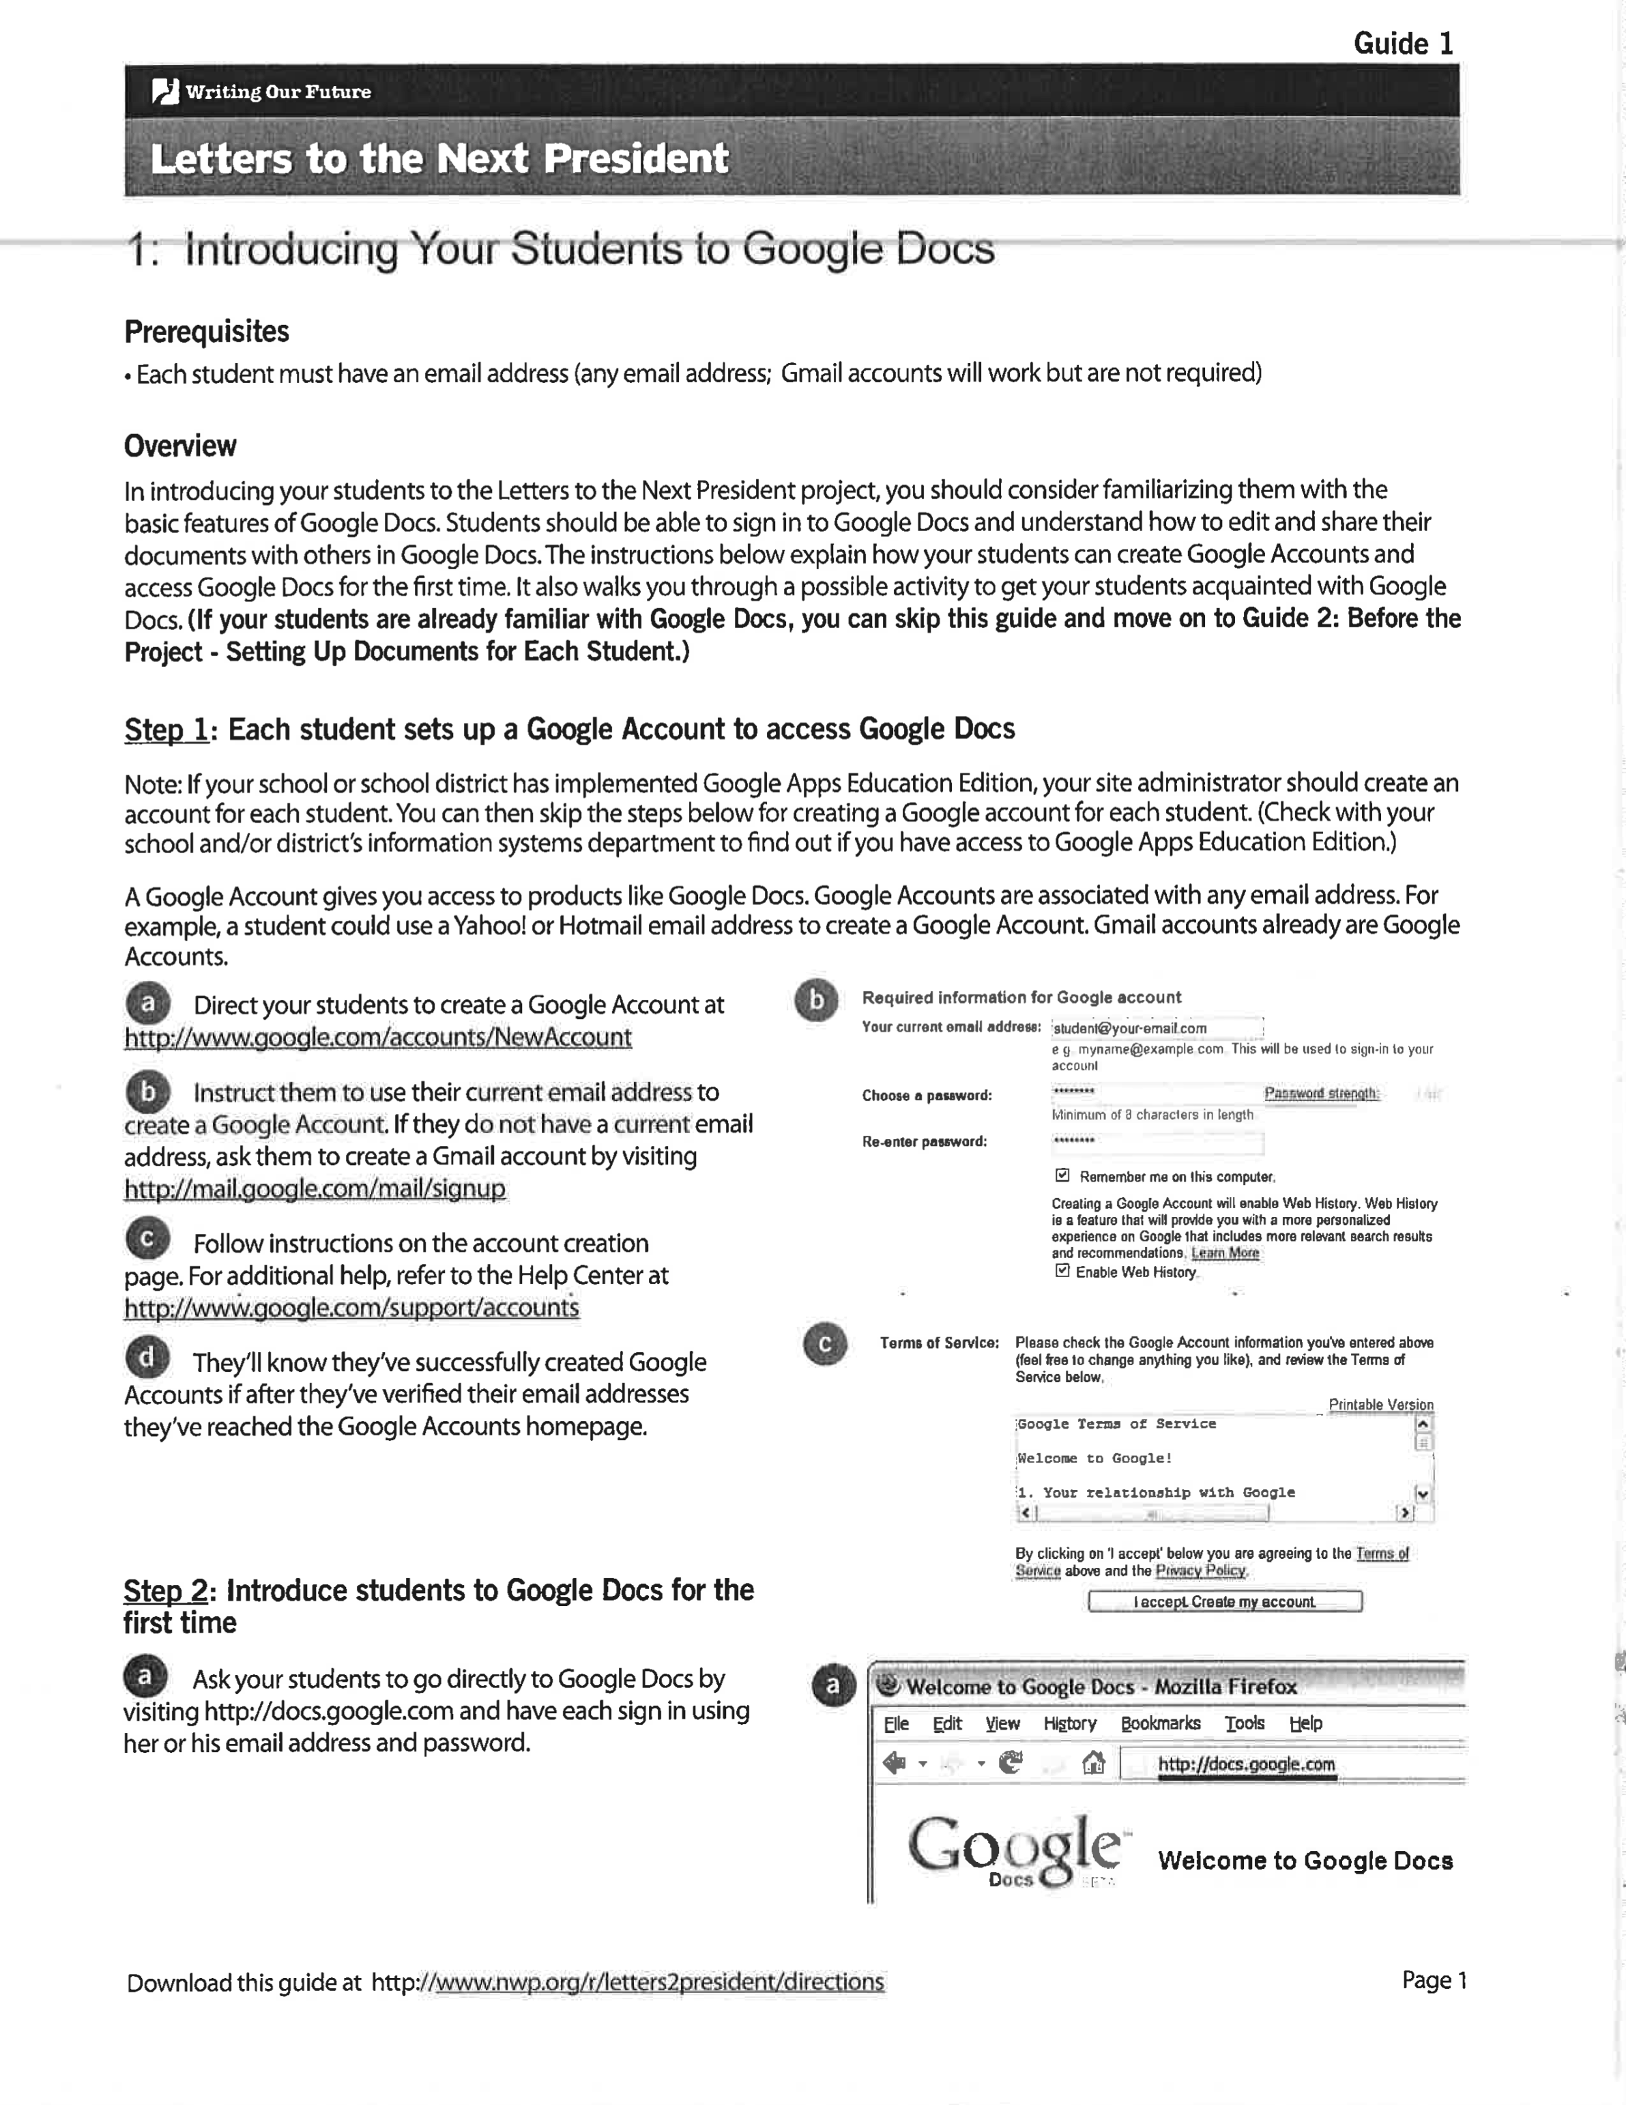
Note. Pages 153 – 155 represent a handout created from National Writing Project, (2017). Letters to the next president: Introducing your students to google docs. Retrieved from https://www.nwp.org/cs/public/print/doc/nwpsites/writing_our_future/directions.csp

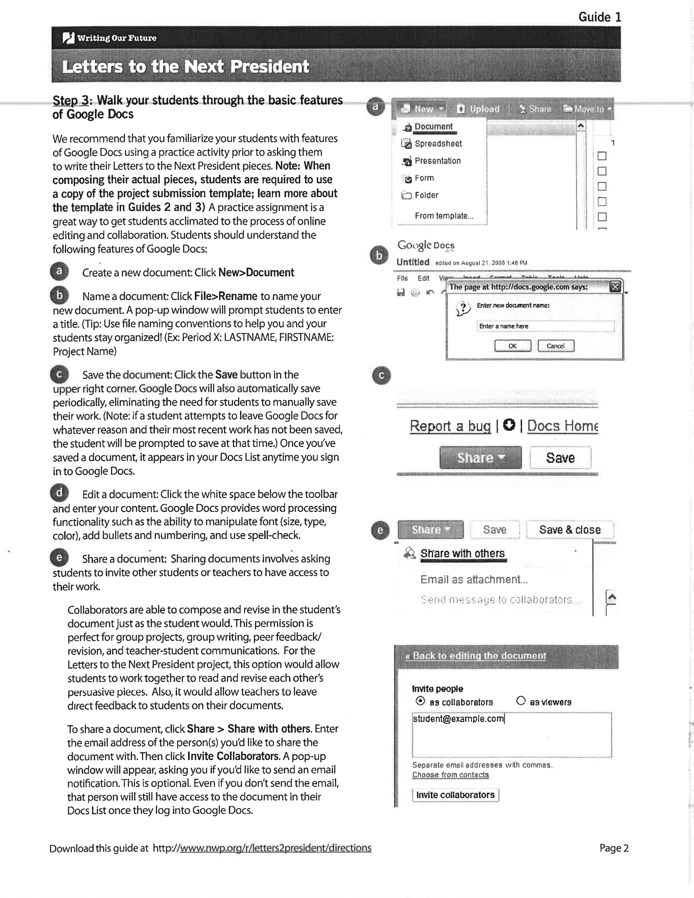

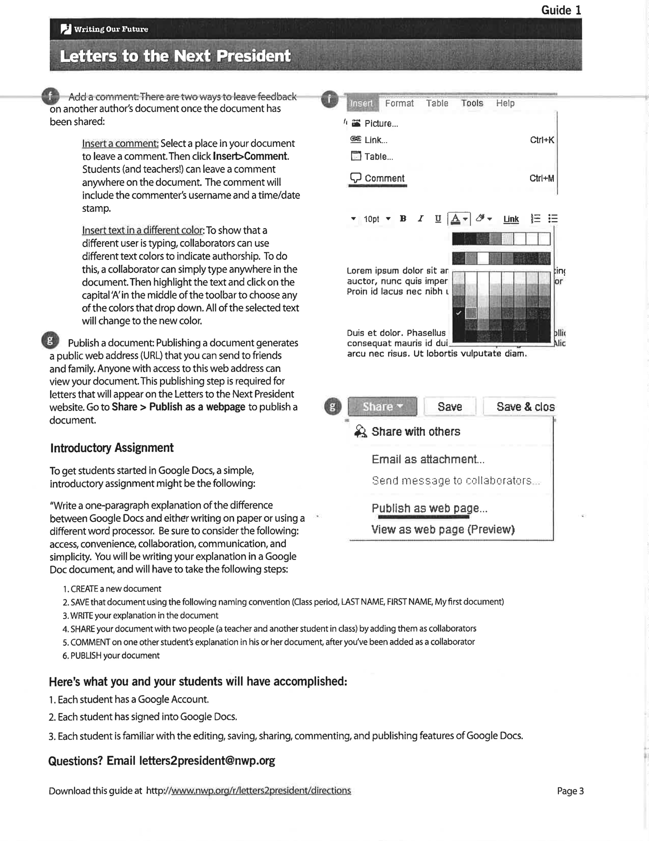

Appendix F: TOWL-3 Instructions (Modified)

“This exercise is designed to see how well you can write a story. Look at the
picture before you. You are to write a story about the picture. Before you begin
writing, you might take time to plan your story. Remember, a well-written story
usually has a beginning, middle, and end. It also has characters that have names
and perform certain actions. Correct punctuation and capitalization will make
your story easier to read. After you have made a plan for your story begin writing.
Try to write as long a story as you can. If you need anything, just let one of the
instructors know Write the best story you can. Ready? Begin.” (Modified
from Hammill & Larsen, 1996, p. 13)
Note. Instructions from Blair, R. B. (2003). The effects of story webbing and visual thinking software on the written language performance of students with mild disabilities. (Doctoral dissertation) Retrieved from SHAREOK. (UMI No. 3093587)

Appendix G: Writing the Persuasive Essay [Handout]

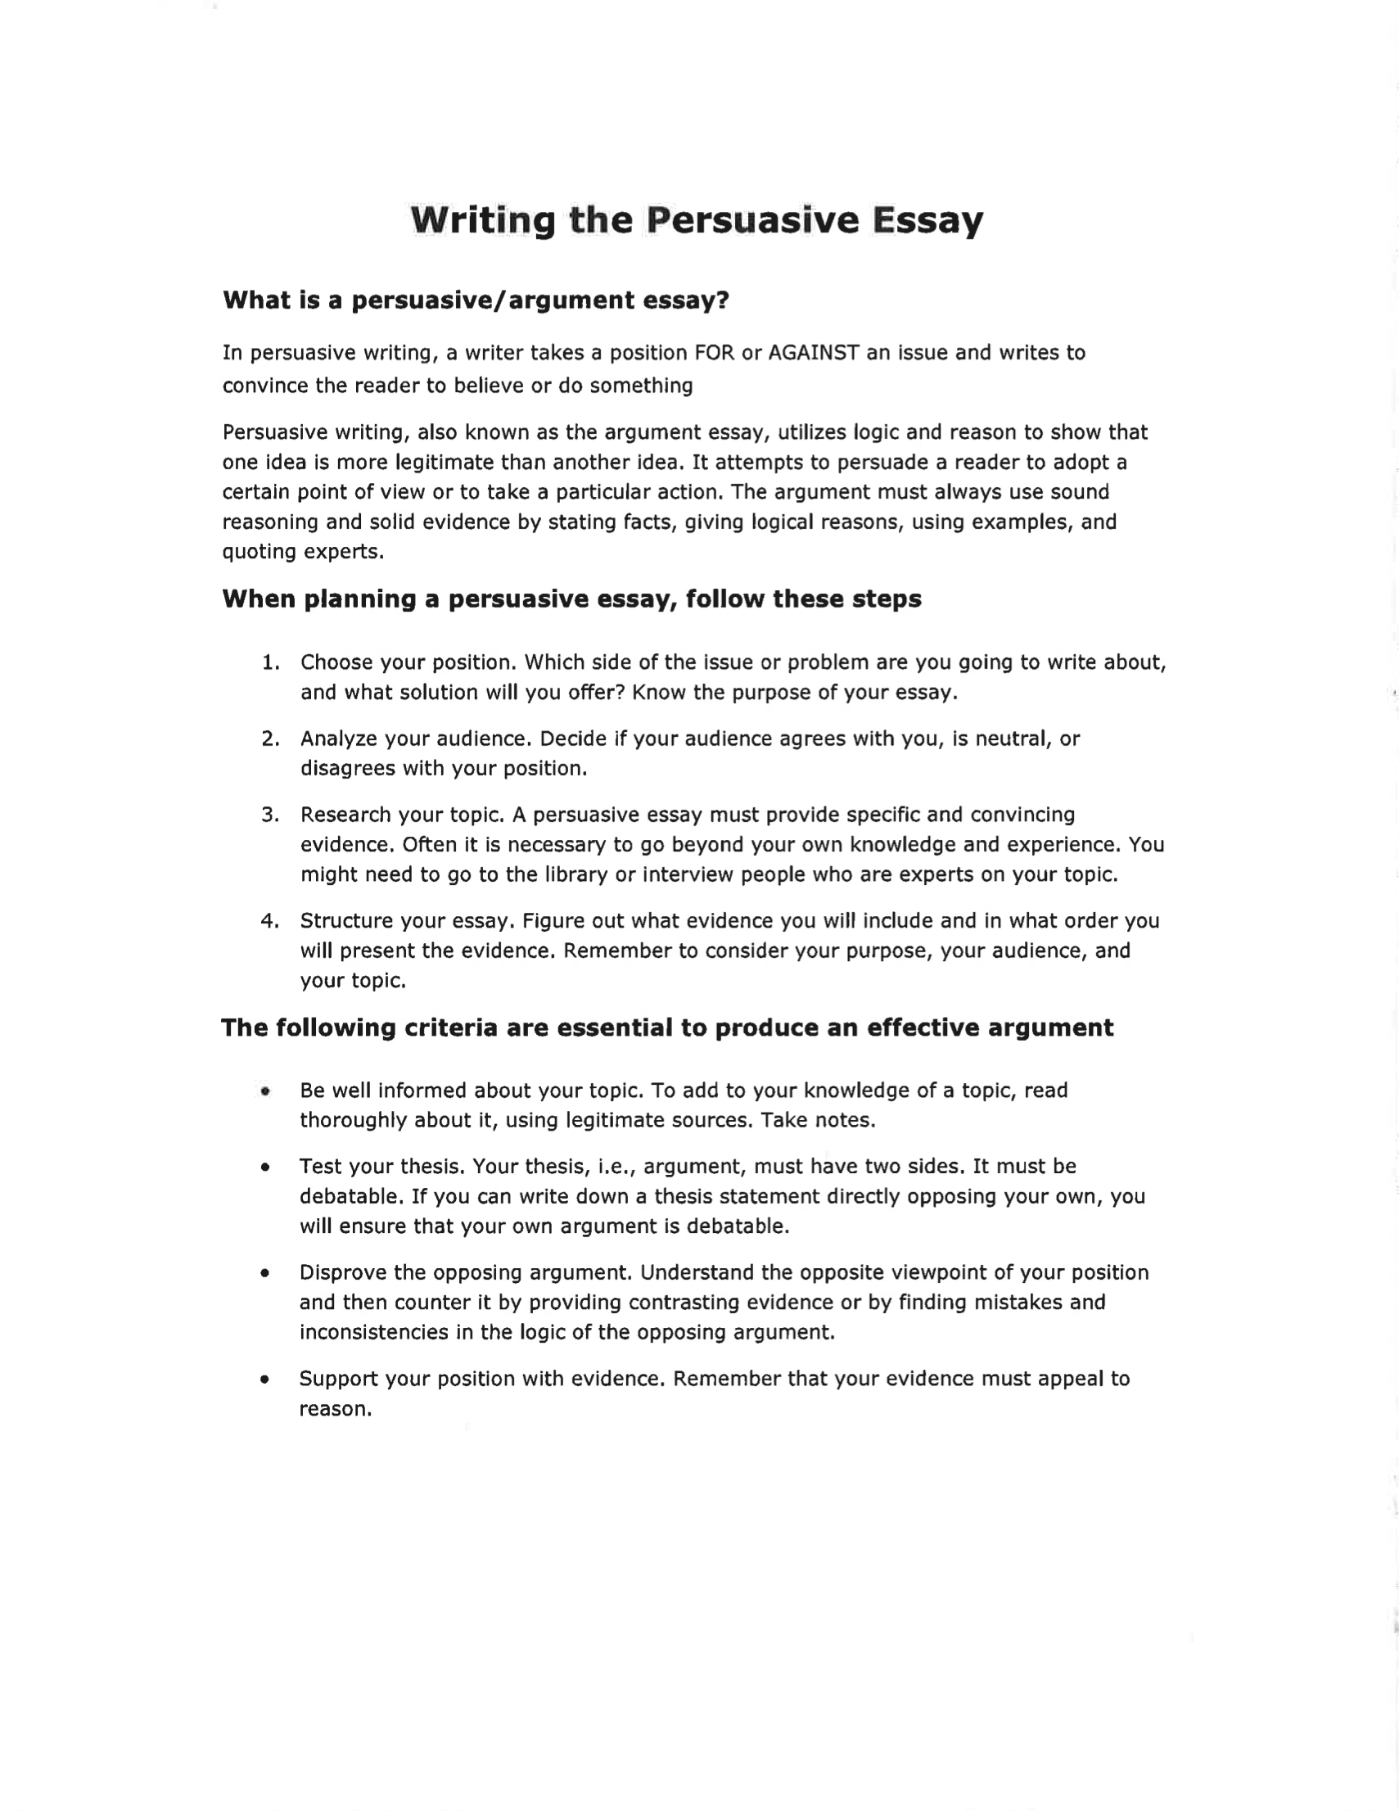
Note. Pages 157 – 163 represent a handout created by Writing the Persuasive Essay [handout]. (n.d.). Retrieved from http://www2.waterforduhs.k12.wi.us/staffweb/sereno/mainpages/InfoLit/
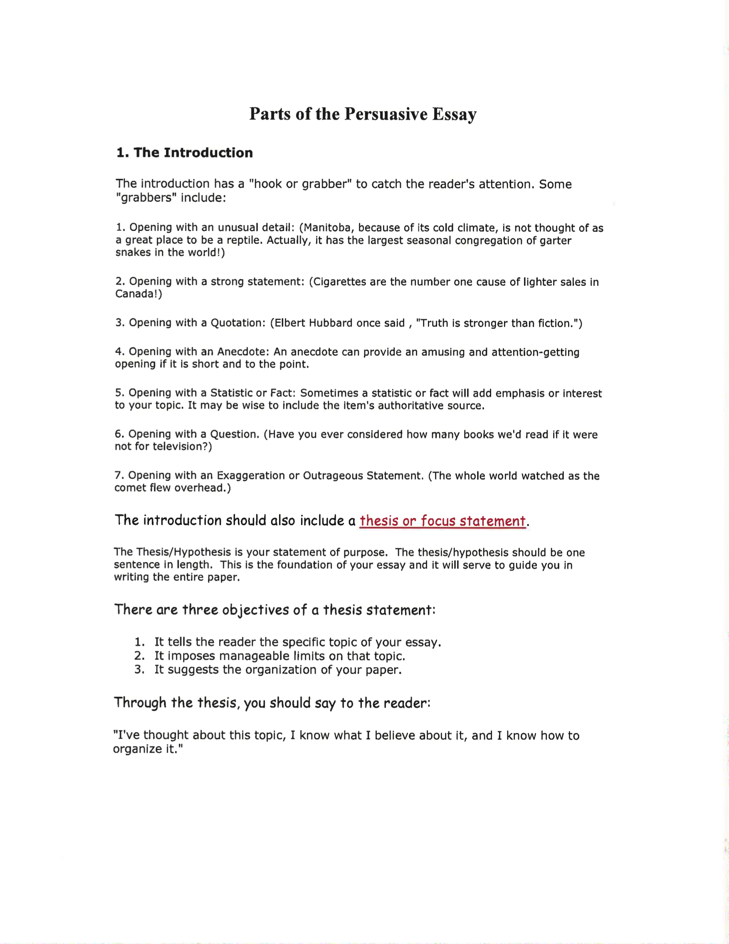

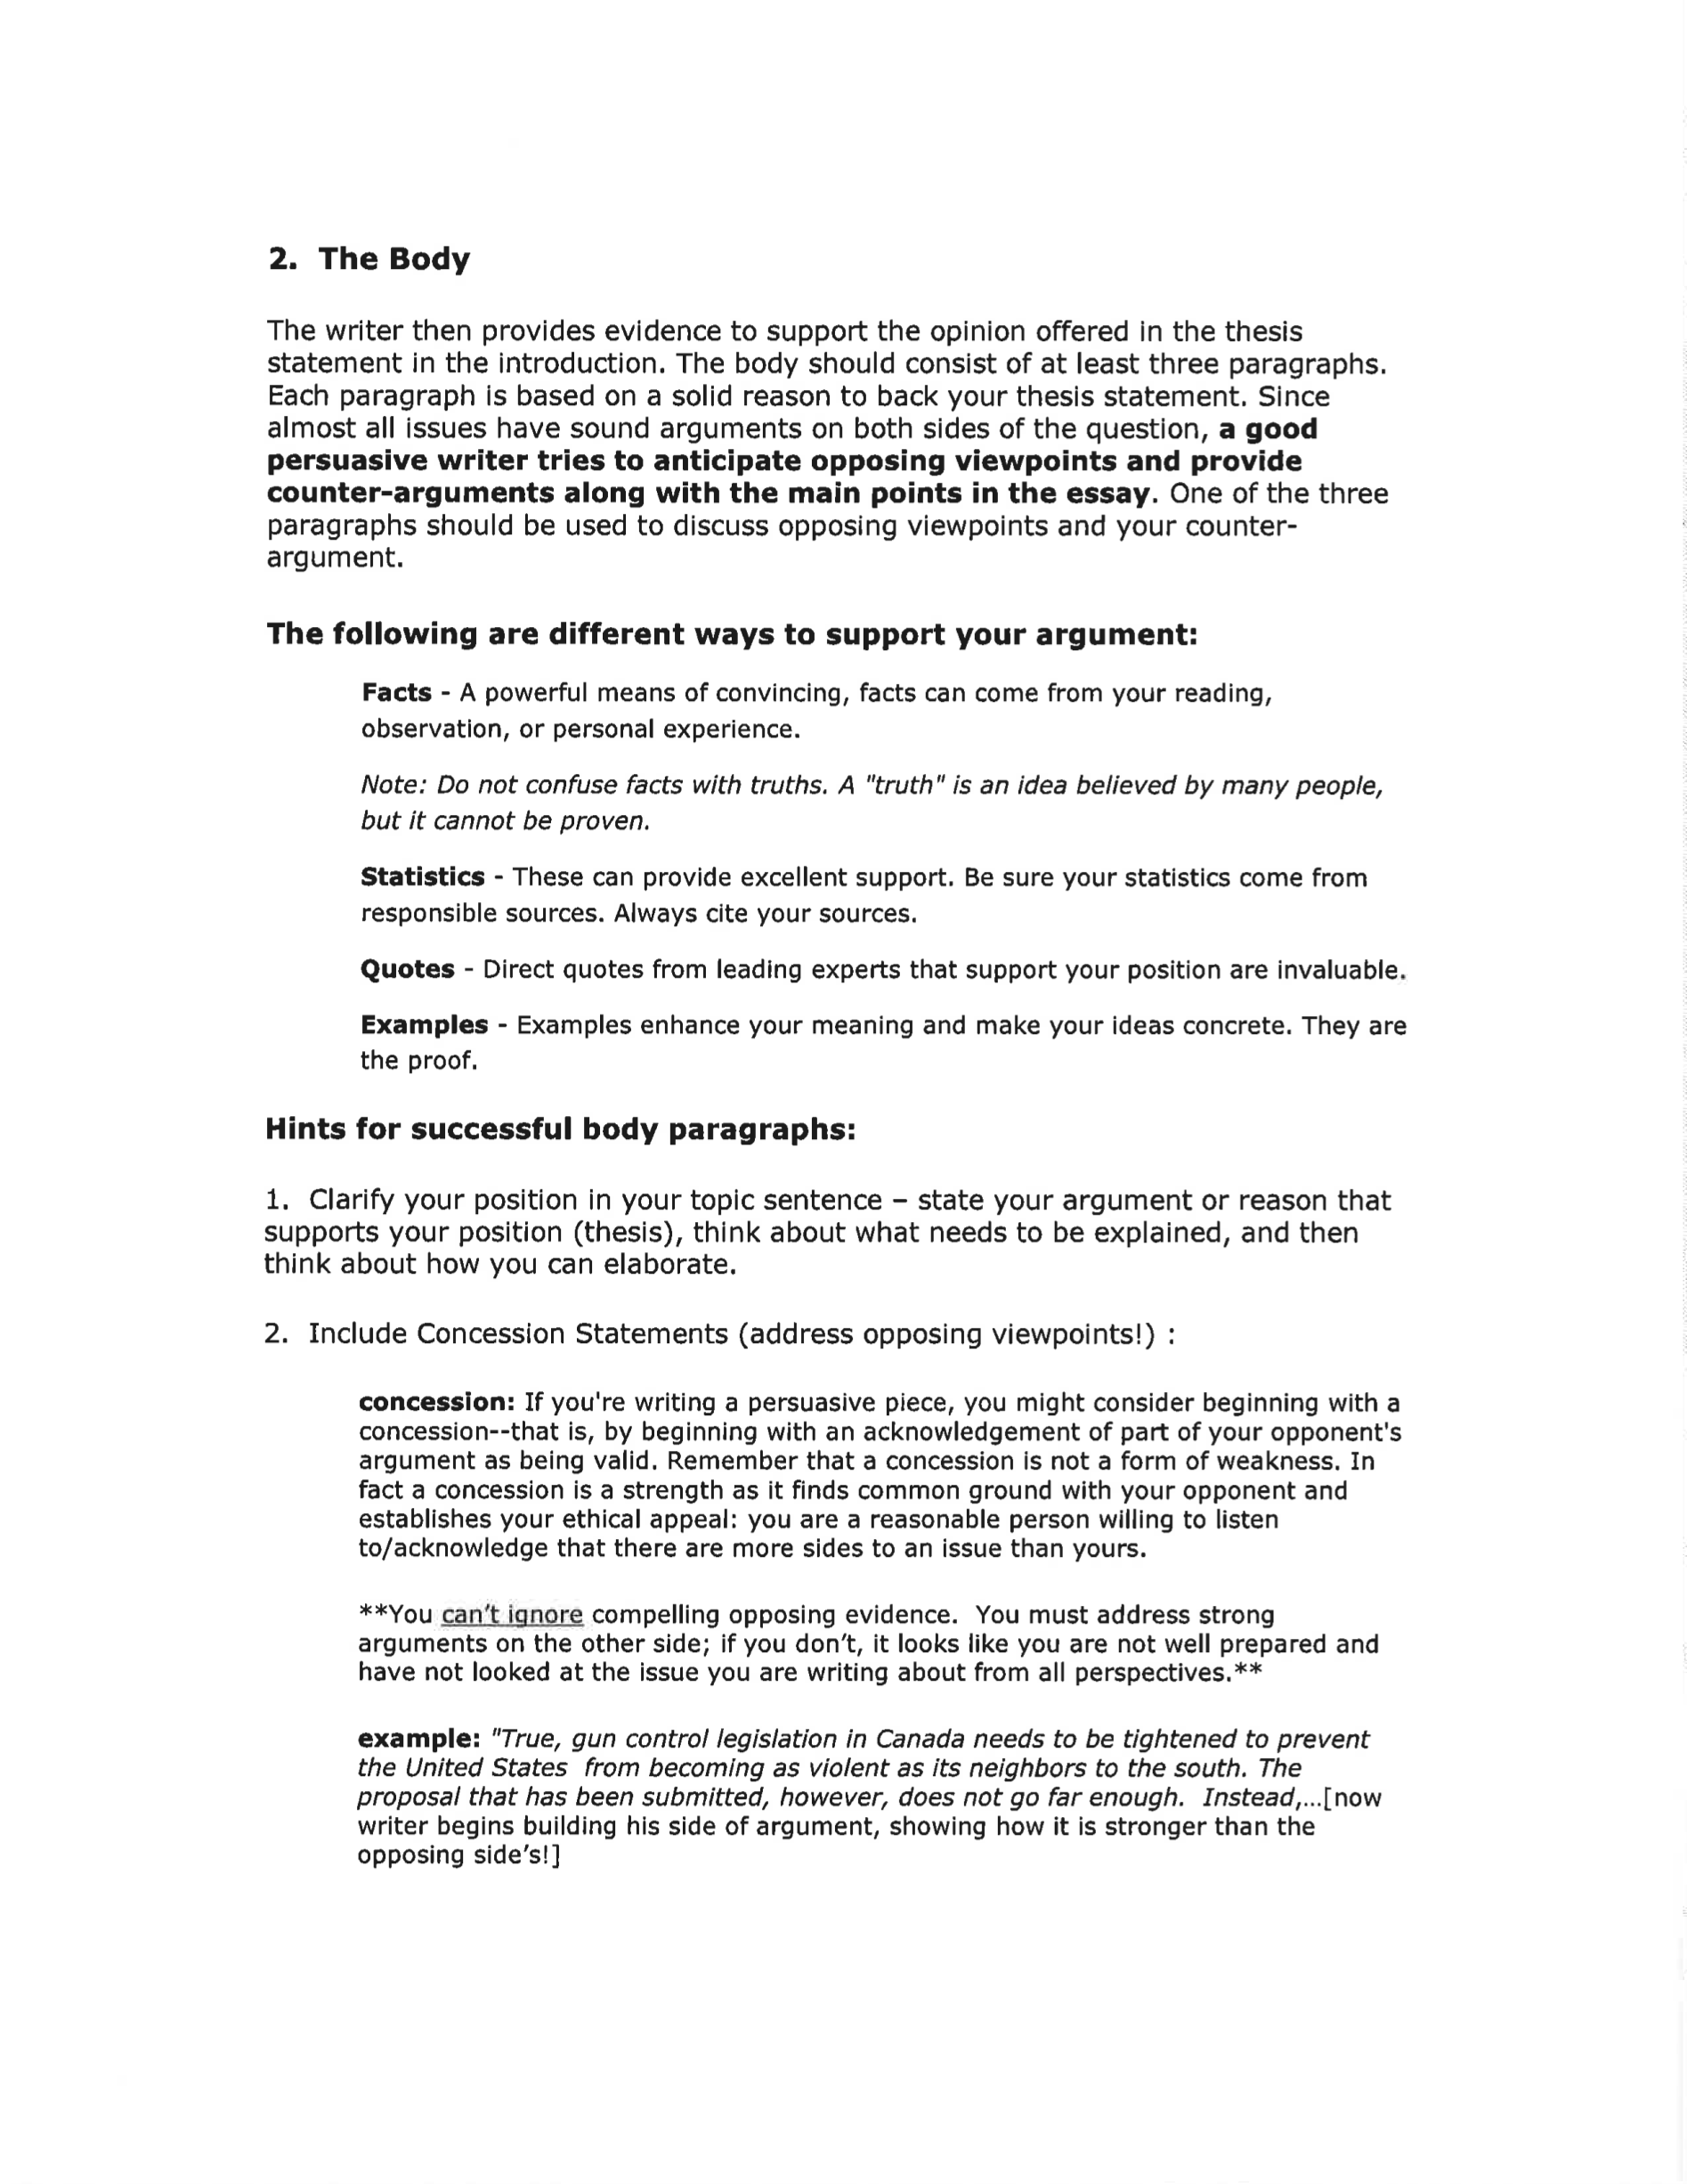

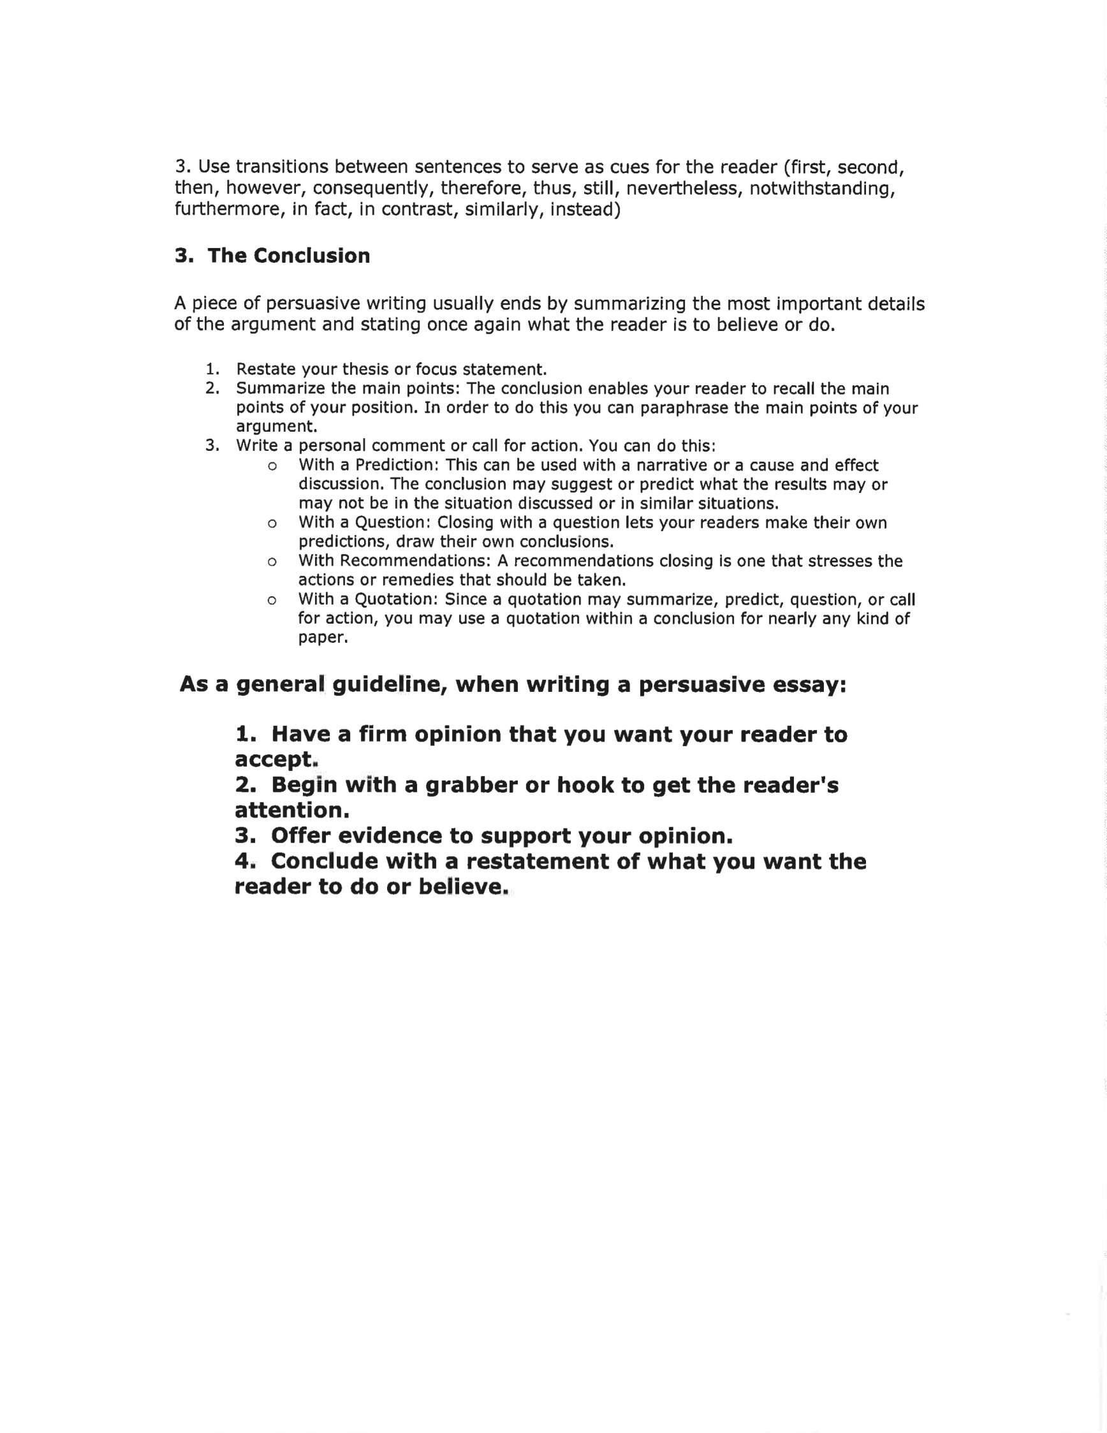

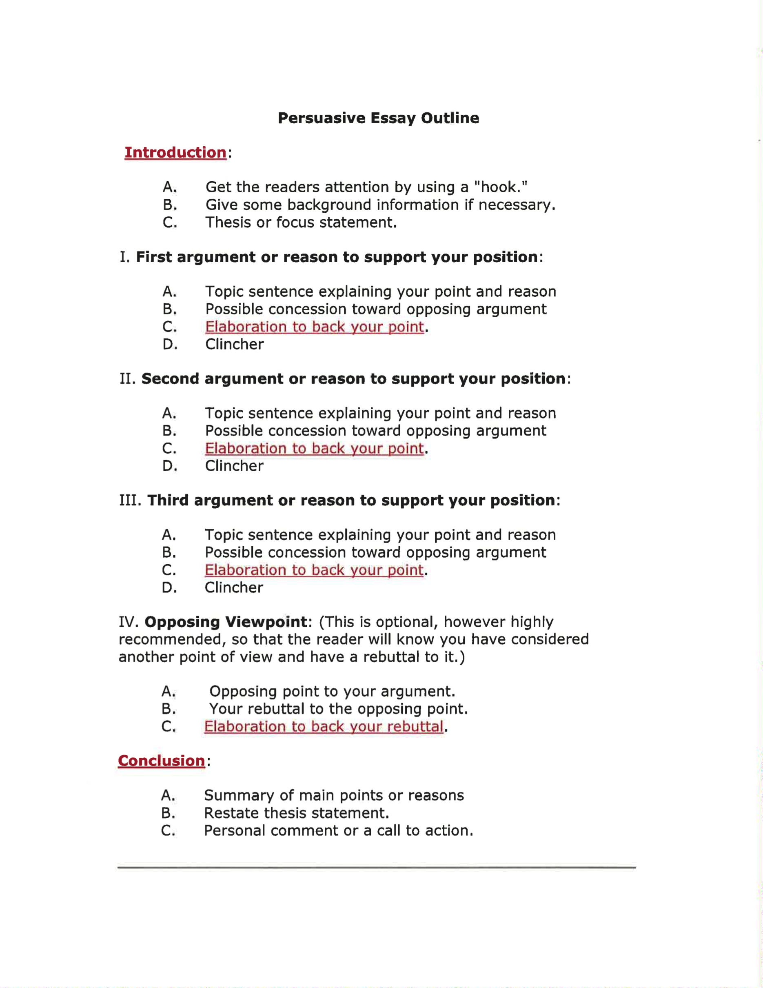

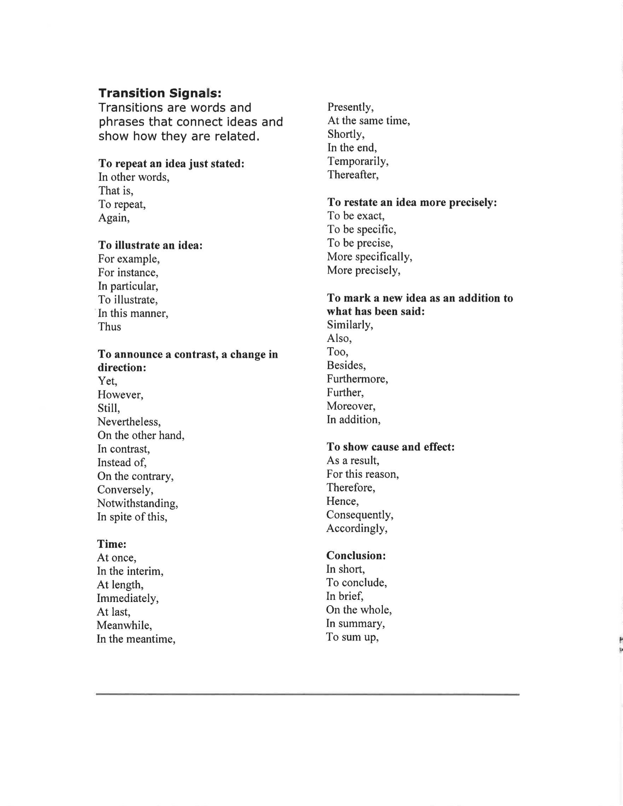

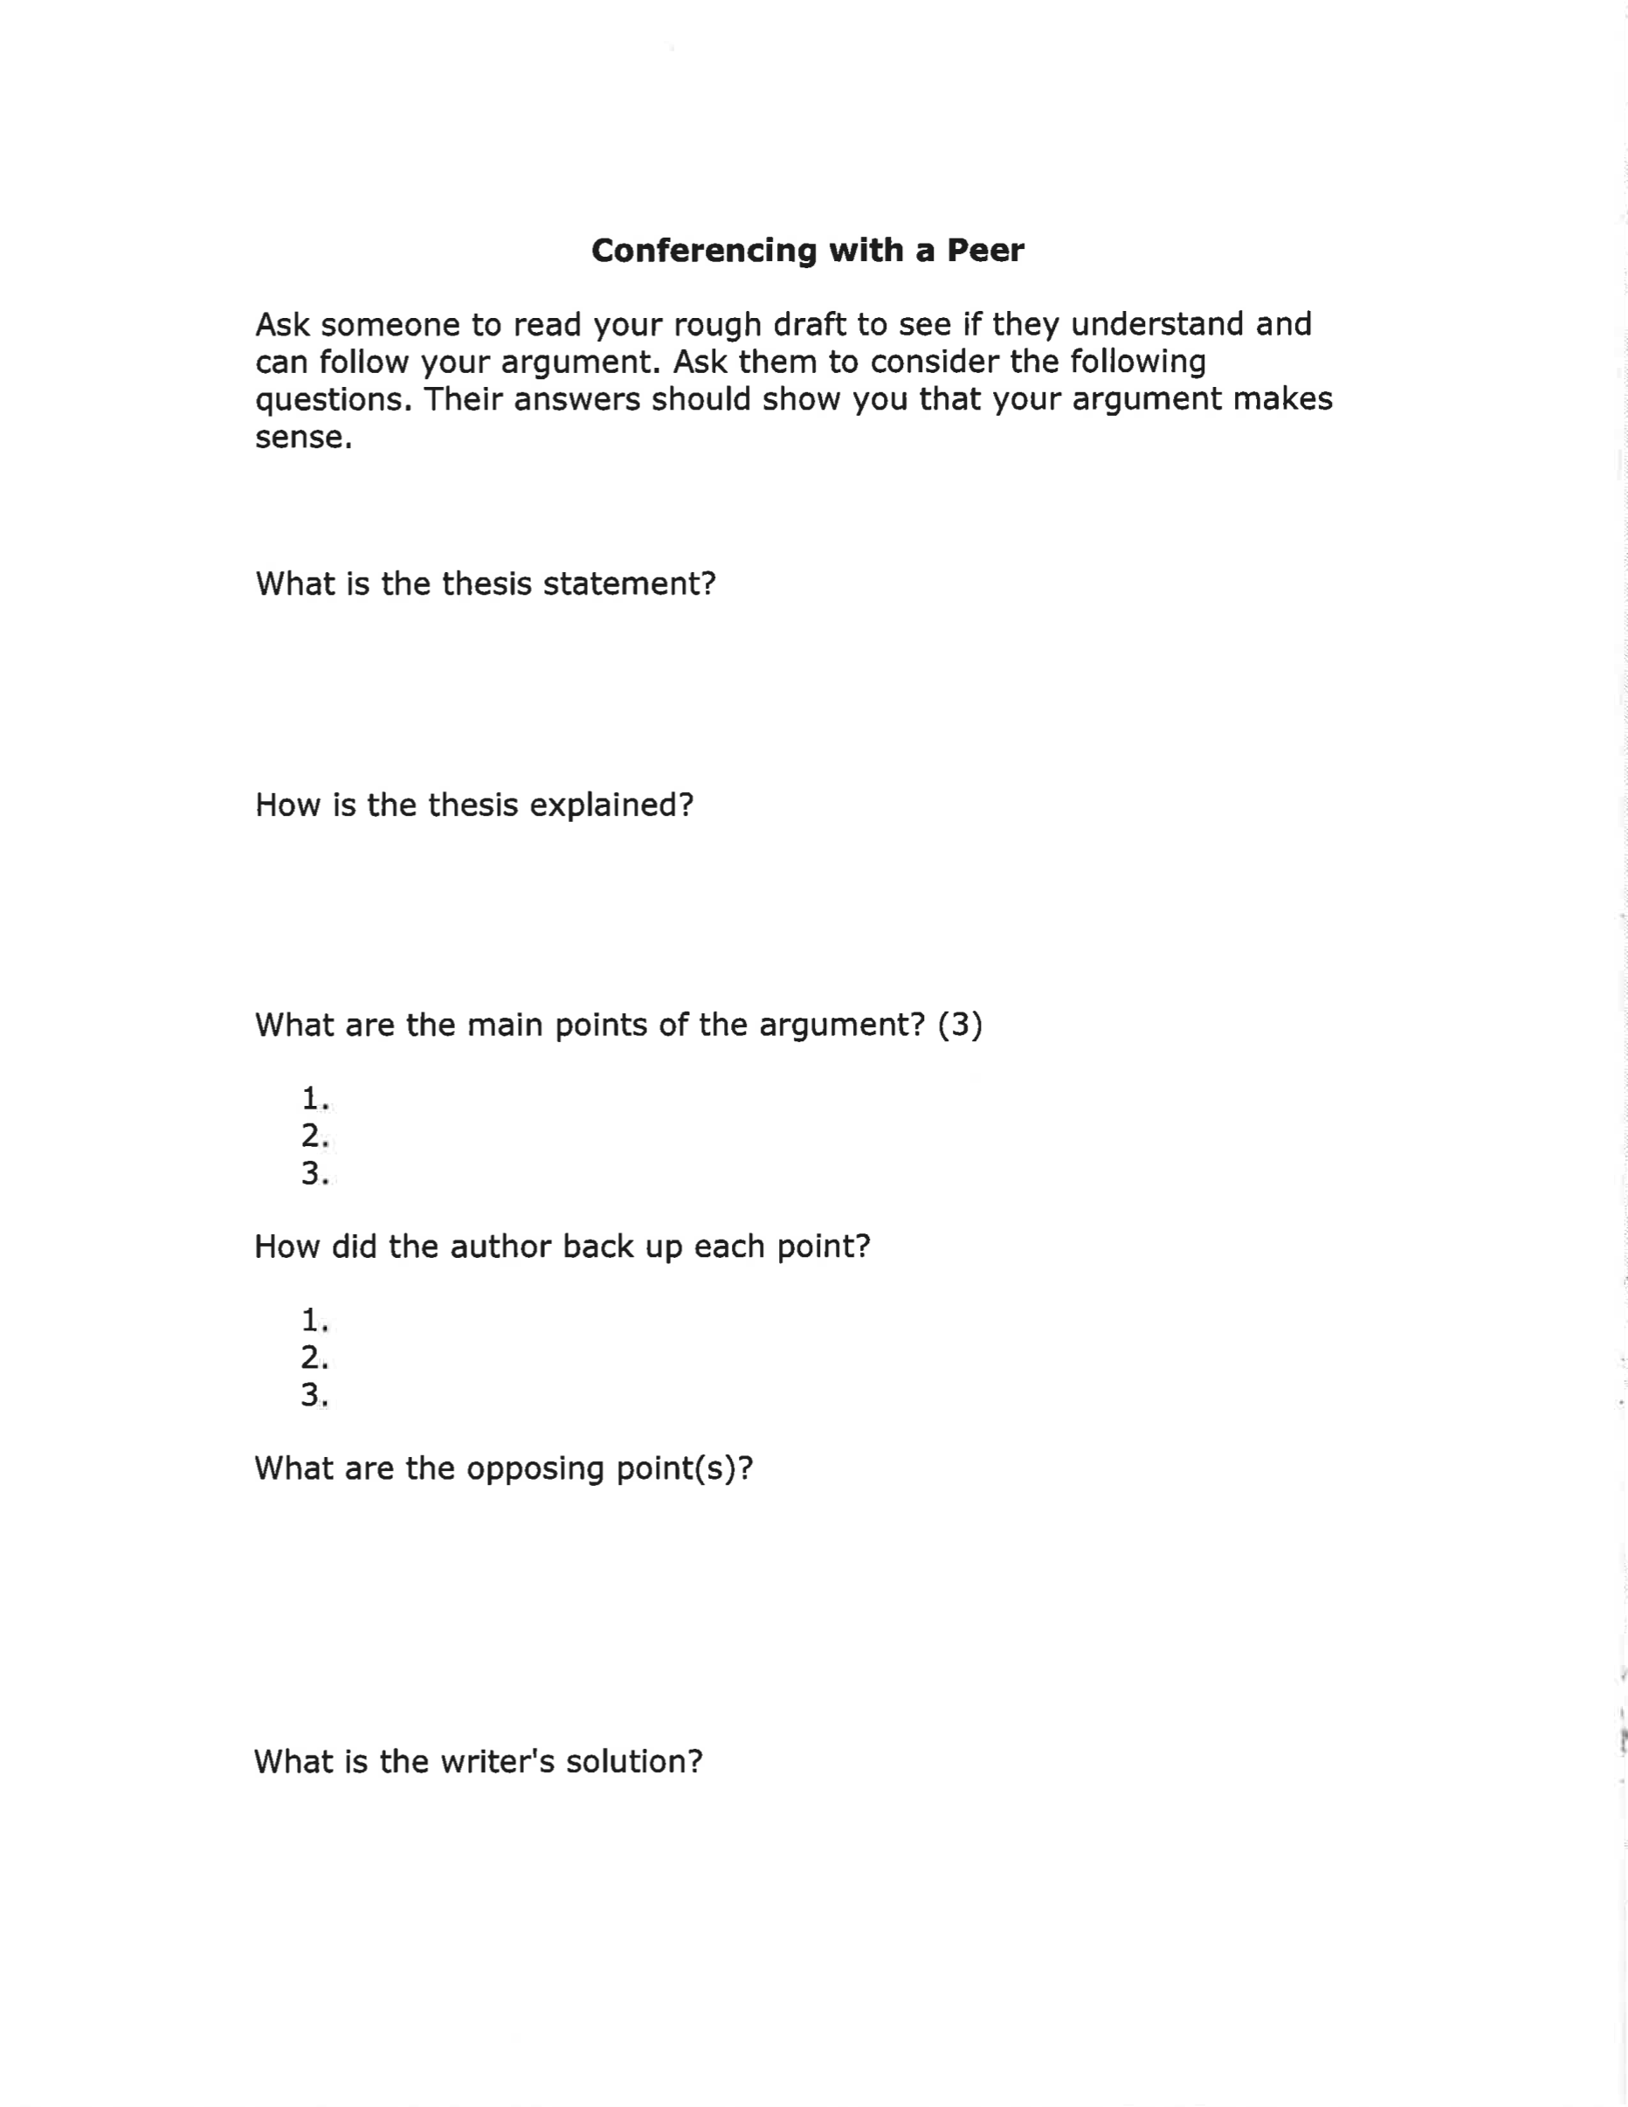

Appendix H: Persuasive Writing Example Letters [Handout]

Dear Sir,

My friends and I love skating and we are thrilled to bits that the council are thinking of building us a skate park. Until now we’ve had nowhere to go, only pavements and steps where we have to be careful not to bump into pedestrians. It would be fantastic to have proper ramps, half pipes and rails designed especially for skateboards.

I can’t wait to have somewhere I can meet up with my friends and a place where I can watch more experienced skaters and learn from them. I know that if I can practise every day, my skills will really improve and my dream of becoming a ‘pro’ might actually come true.

That is why I’d much rather be out skating than stuck indoors in front of the TV. Keeping fit is really important these days. I don’t want to become one of these obese teenagers that get no exercise. I’m sure that if we had a skate park many more young people would take up this sport.

Yours sincerely

Jade Jackson

Note. Pages 164 – 165 represent a handout created by Shakesby, A. (n.d.) Persuasive writing example letters [handout]. Retrieved from http://www.primaryresources.co.uk/english/englishD10.htm

Dear Sir,

I cannot believe that Craven Pond is going to be filled in! Don’t people realise that hundreds of different kinds of birds, amphibians, insects and fish live here? What will happen to them if their habitat is taken away? We all know that natural habitats are disappearing at a worrying rate. It is our duty to preserve as many of these as we can.

Adults are always telling us that we should use our time productively. My friends and I have spent many weekends and summer evenings studying and cataloguing the wildlife of this pond. If Craven Pond is filled in we will be forced to hang about the streets because there will be nothing to occupy our time. Is that what the adults want?

Yours sincerely

Tom Dipper

Appendix I: Notes for a Persuasive Letter Handout

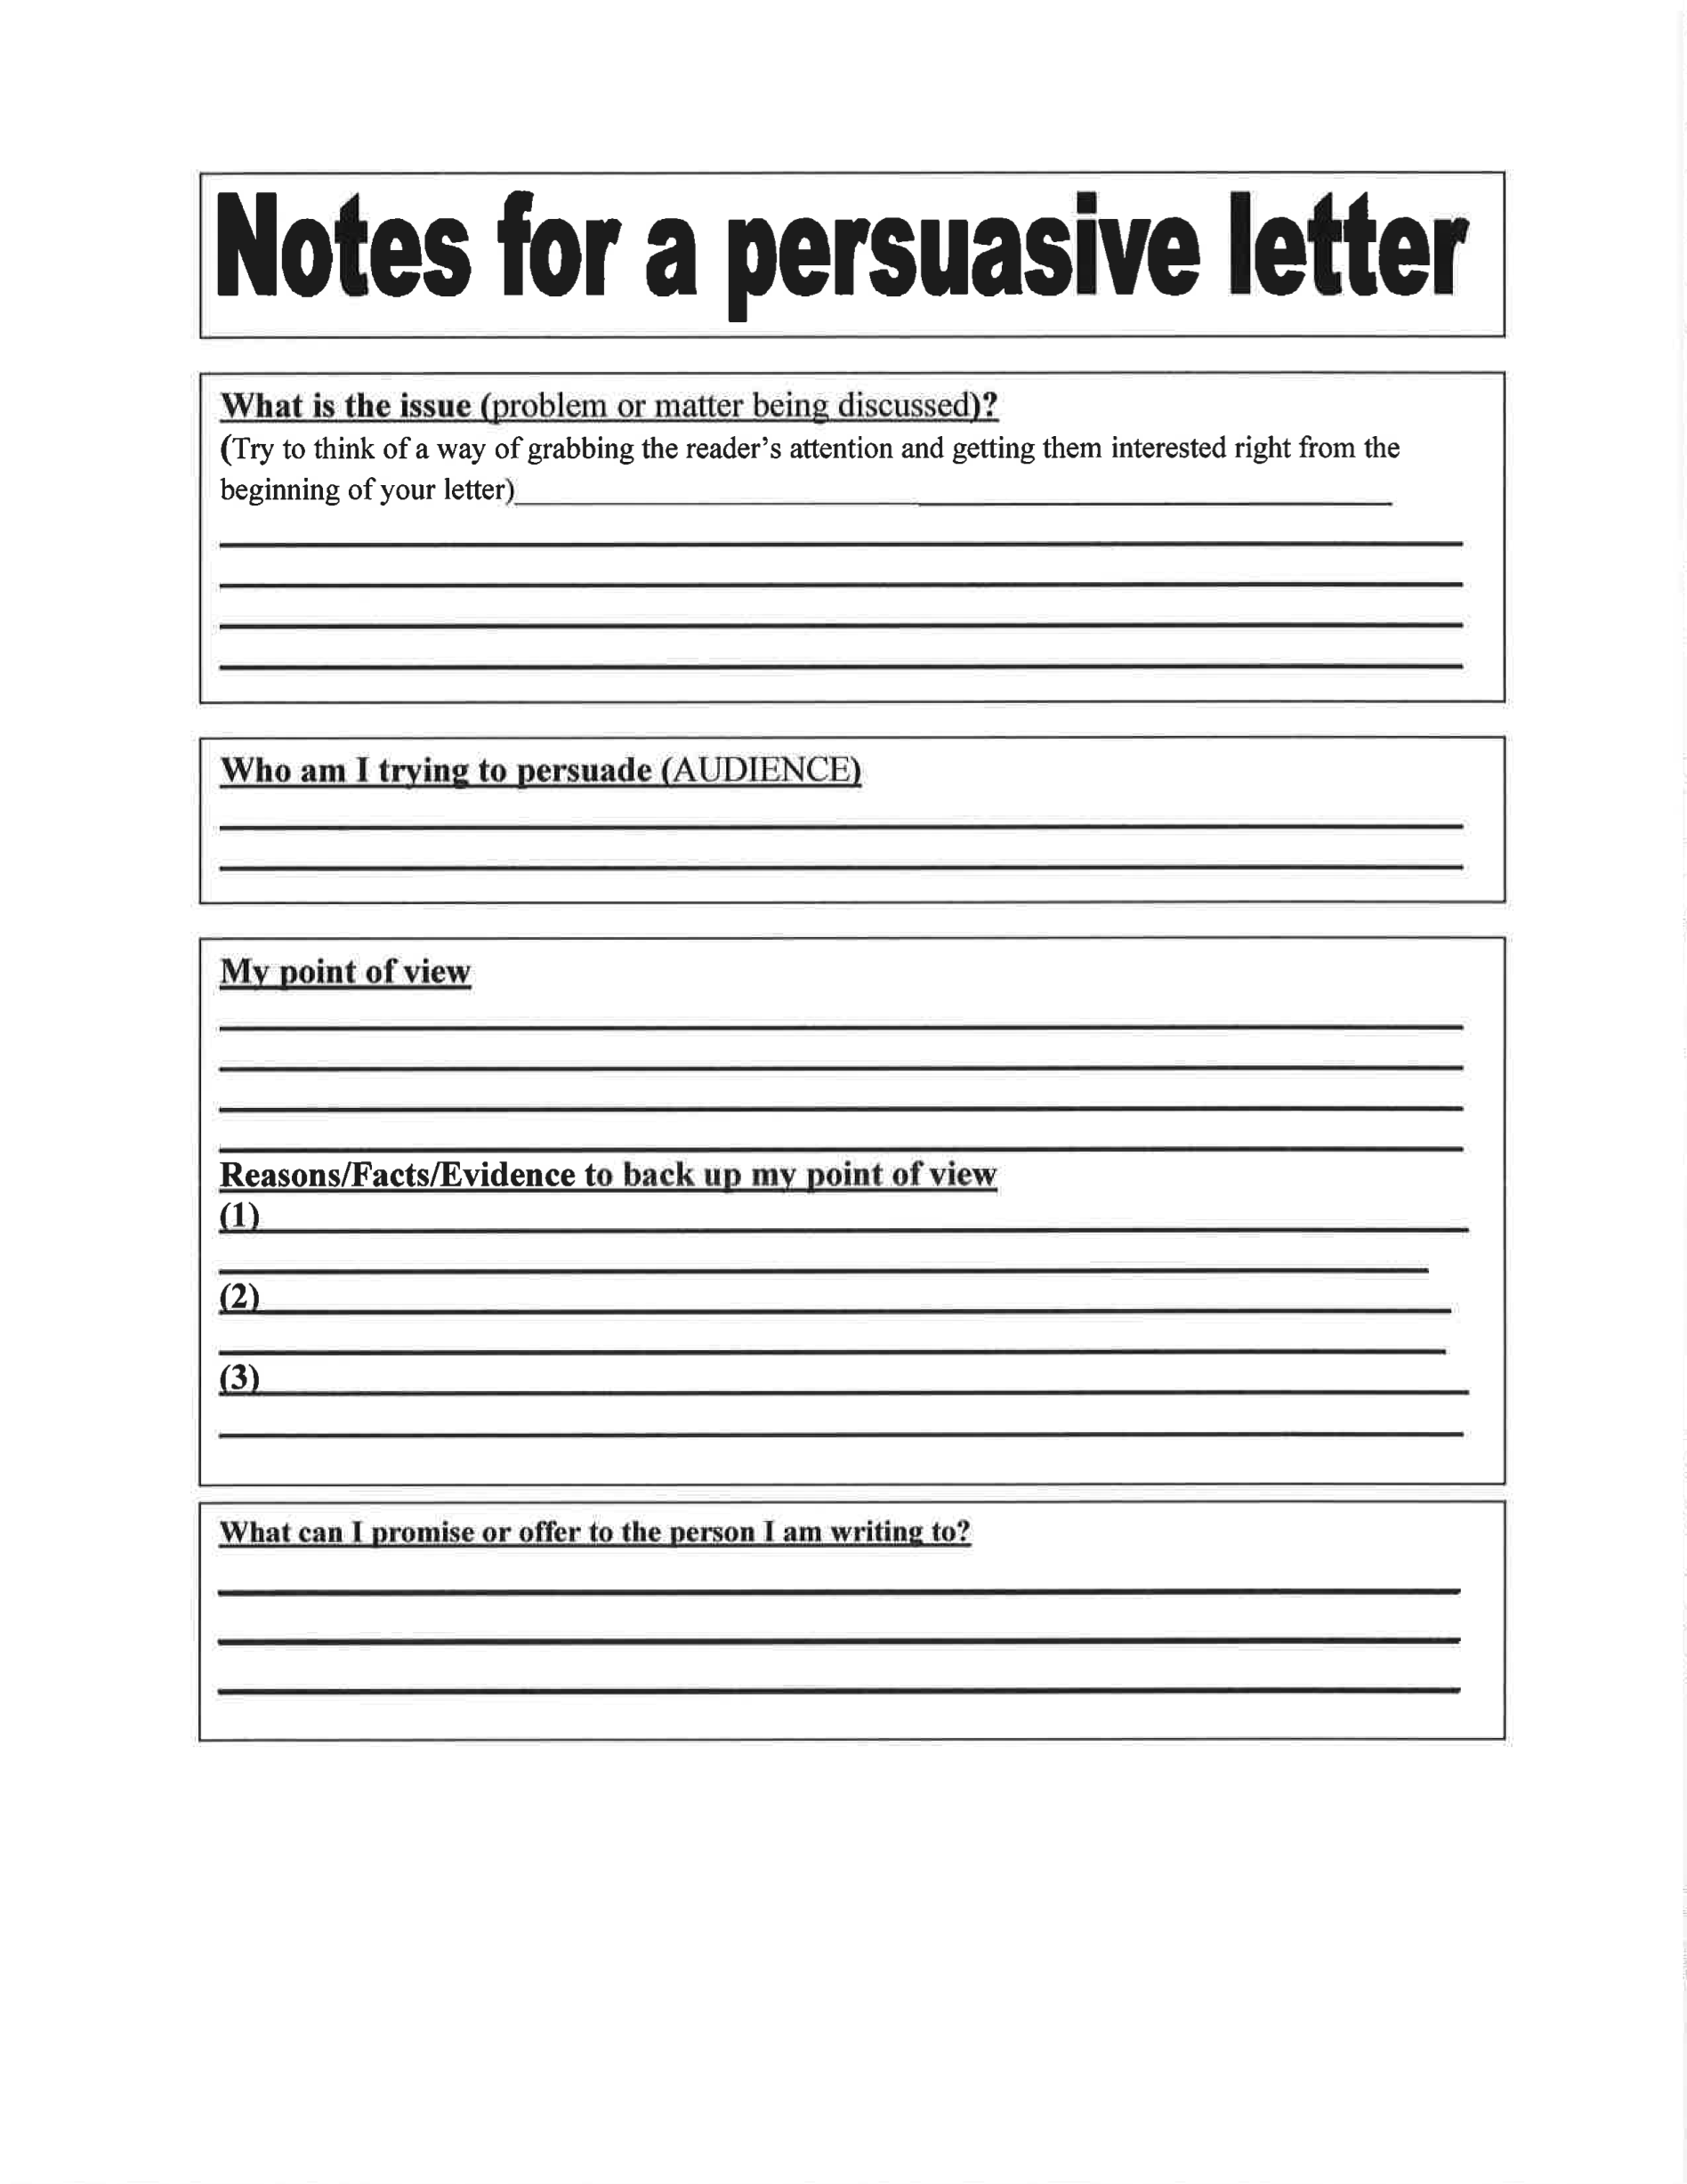
Note. Handout created by Holyoak, J. (n.d.) Notes for a persuasive letter. [handout] Retrieved from http://www.primaryresources.co.uk/english/englishD10.htm

Appendix J: List of Persuasive Essay Topics

- Snow days are great for family quality time.
- Too much money is a bad thing.
- Kids should get paid for good grades.
- Kids should have less homework.
- Penmanship is important.
- Short hair is better than long hair.
- Recycling should be mandatory for everyone.
- Children should be required to read more.
- We shouldn't have to pay for Internet access.
- Cell phones should never be used while driving.
- Bullies should be kicked out of school.
- The school year should be longer.
- School days should start later.
- All students should wear uniforms.
- Teens should be able to choose their bedtime.
- People should carpool more.
- I'm old enough to stay at home alone.
- We should all give back to our communities.
- Athletes are paid too much.
- City life is better than country life.
- Some junk foods are really health foods.
- Some health foods are really junk foods.
- Safety is more important than privacy.
- We can change the world.
- Teachers should be paid more.

Note. List adapted from ThoughtCo, (n.d.) List of persusive speech topics for students. Retrieved from https://www.thoughtco.com/list-of-persuasive-speech-topics-for-students-1857600

Appendix K: Writing Rubric

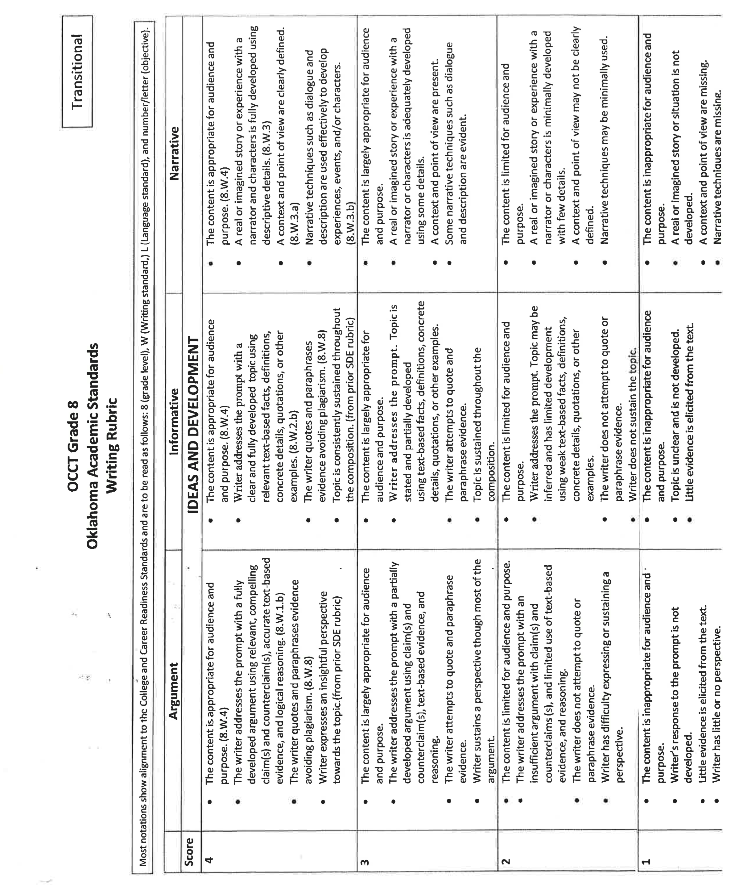
Note. Pages 168 – 170 represent a rubric created by Oklahoma State Department Of Education (2013). OCCT grade 8 Oklahoma academic standards writing rubric. Retrieved from http://www.sde.ok.gov/sde/documents/2013-10-17/ccss-grade-8-trans-writing-rubric

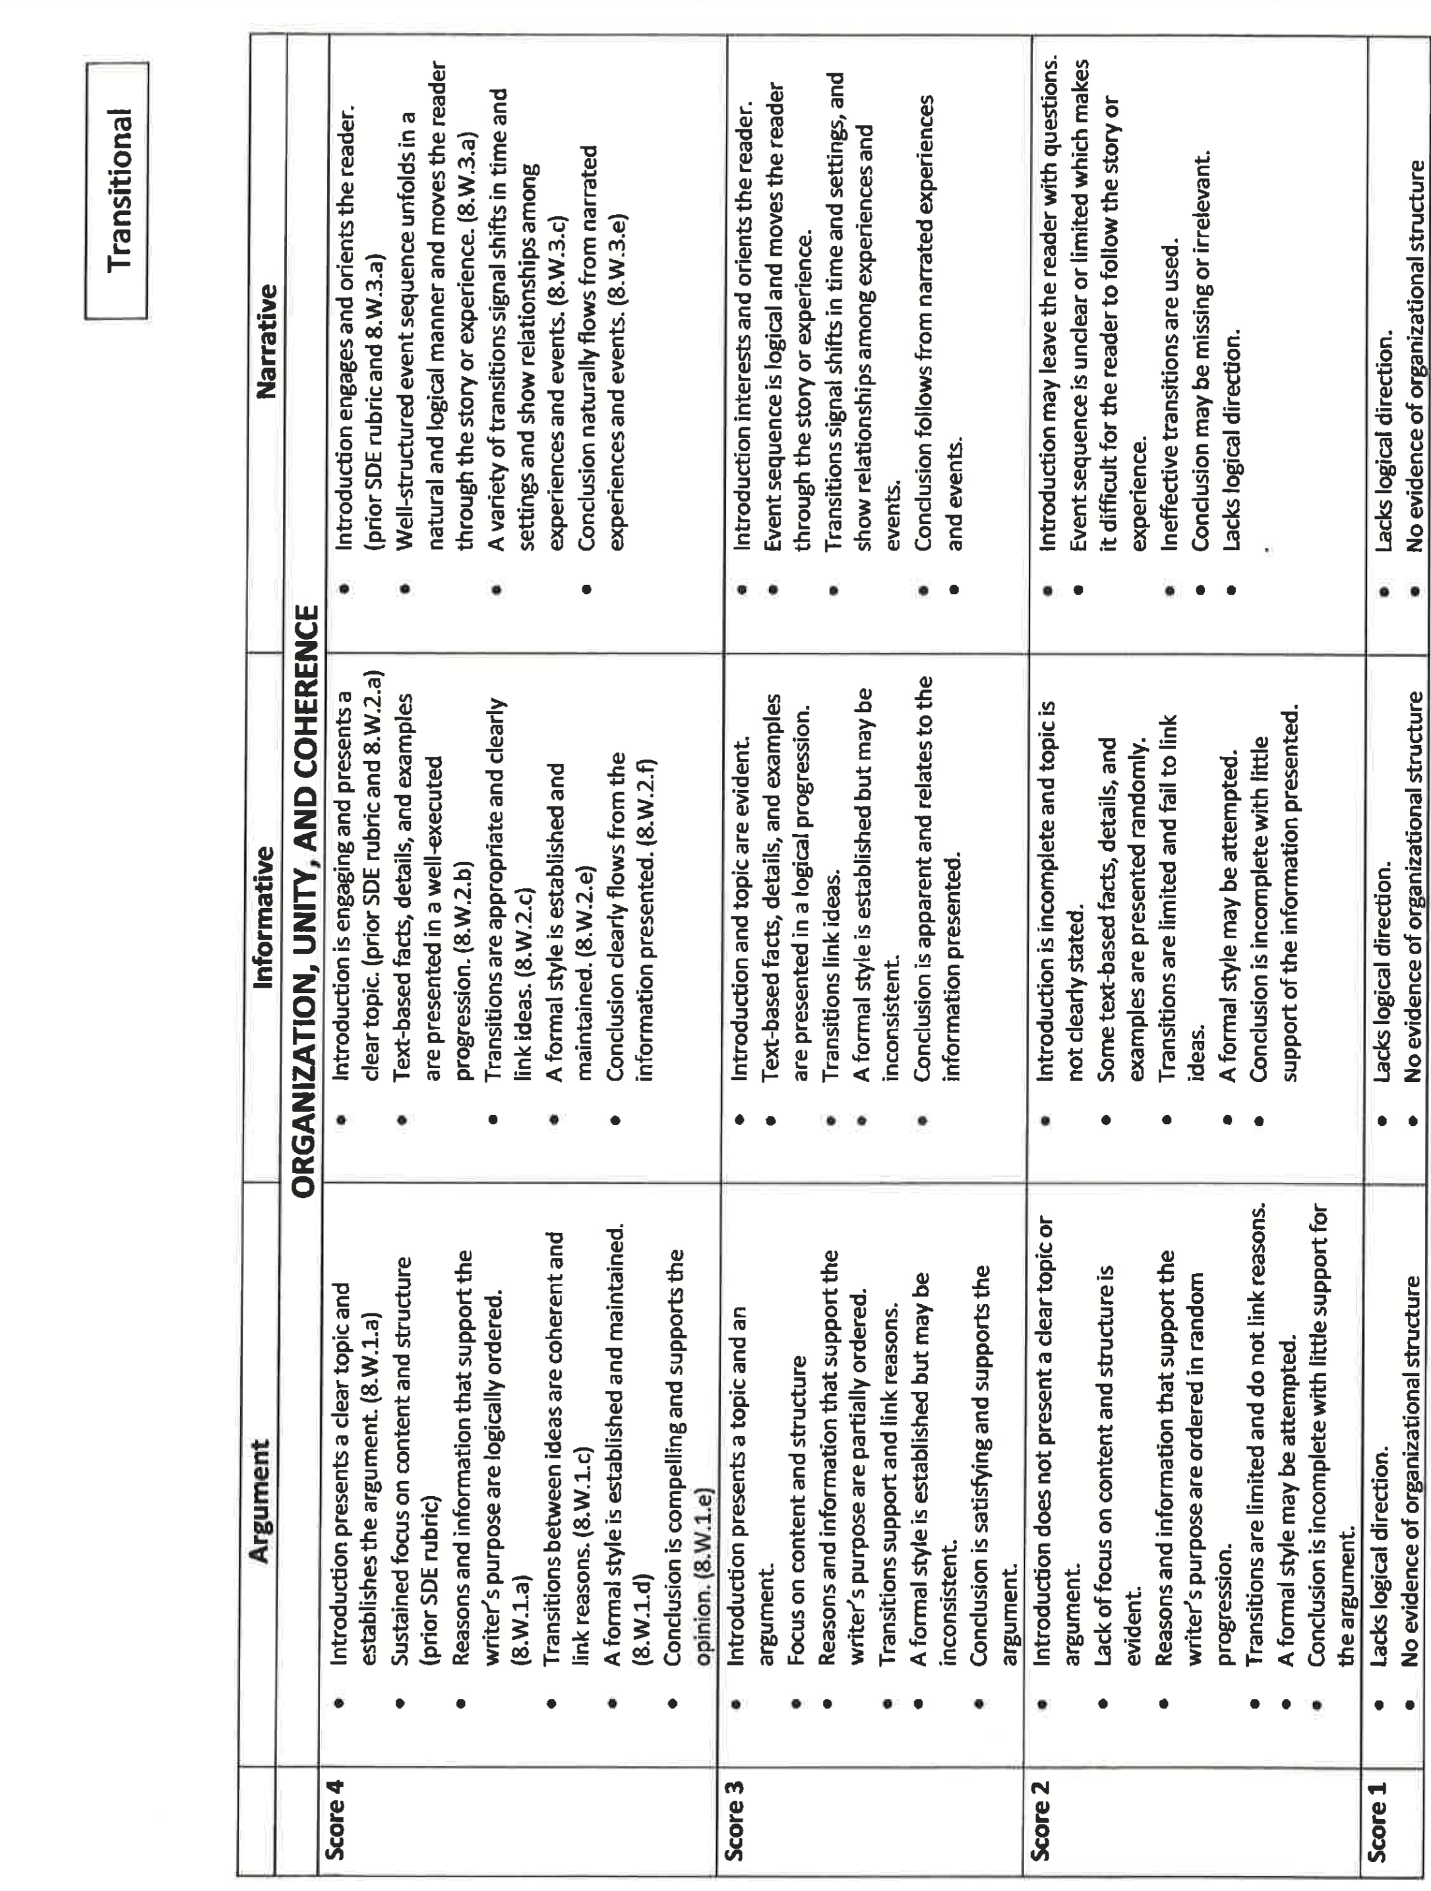

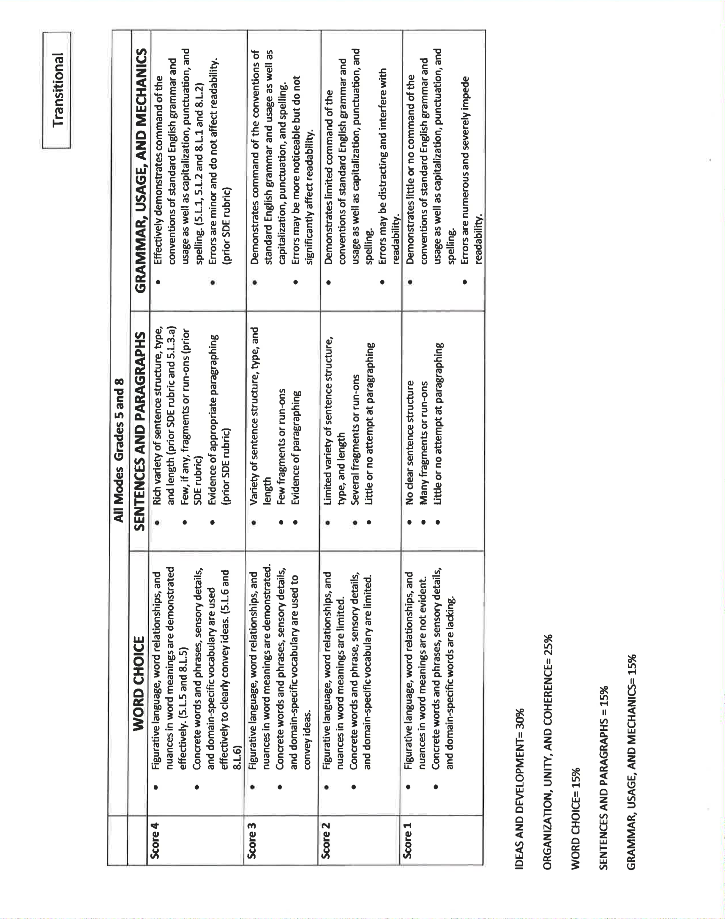

Appendix L: Persuasive Writing Topic Exploration [Handout]

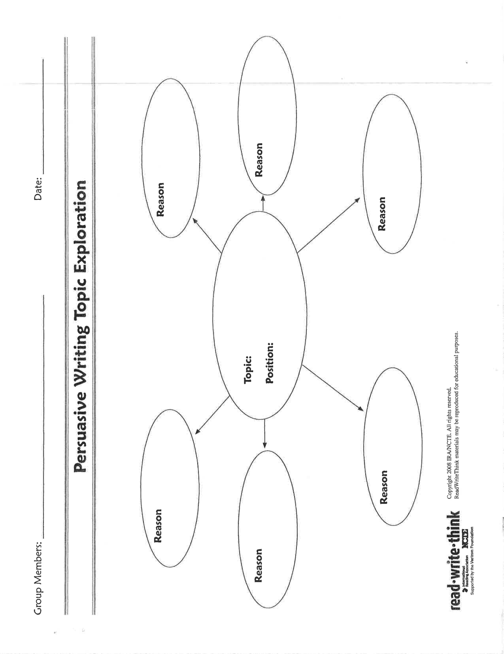

Note. Handout created by Read Write Think, (2008). Persuasive writing topic exploration [handout]. Retrieved from http://www.readwritethink.org/files/resources/lesson_images/lesson1137/persuasive.pdf

Appendix M: List of Narrative Essay Topics

- Your first day of school.
- Your most exciting day of school
- A field trip that your class took.
- Your favorite summer vacation.
- A trip that included something unexpected or surprising.
- A time that you experienced something spooky.
- A time that you experienced something truly frightening.
- A time that you learned something new that changed you in some way.
- The moment when you met someone who changed your life.
- The day that you got your first pet.
- A move from one place to another.
- Something funny that happened to you.
- Something funny that happened to one of your family members or friends.
- Something embarrassing that happened to you.
- Your favorite birthday party.
- A birthday that was disappointing.
- A big storm (rain, snow or even a tornado!).
- A time that the power went out.
- A summer day when the temperature got much higher than expected.
- A time when you went to an amusement park.
- A time when you got lost somewhere.
- A memorable experience with a favorite family member.
- A sad experience with someone about whom you care.
- Your most exciting moment playing sports.
- Your most exciting moment performing in a play, singing, playing music or dancing.

Note. List adapted from K12 Reader (n.d.). 50 narrative essay topics. Retrieved from http://www.k12reader.com/50-narrative-essay-topics/

Appendix N: Graphic Organizer for a News Article [Handout]

Note. Handout created by Project WRITE, (n.d.). Graphic organizer for a news article [handout]. Retrieved from https://projectwritemsu.wikispaces.com/file/view/graphic+organizers.pdf

Appendix O: Students Randomly Assigned to Groups

 | Peer Groups | Students
Classroom A | 1 | A and B
Classroom A | 2 | C and G
Classroom A | 3 | E and F
Classroom A | 4 | D and H
Classroom B | 5 | I and K
Classroom B | 6 | L and M
Classroom B | 7 | J and N
Classroom C | 8 | O and Q
Classroom C | 9 | P and R
Classroom C | 10 | S and T

Appendix P: Signed Assent Over 12

Would you like to be involved in research at the University of Oklahoma?
I am Tracy Blankenship from the Educational Psychology Department and I invite you to participate in my research project entitled The Effects of Computer-Supported Collaborative Learning on Students' who are Significantly Below Average in Writing Performance, Self-Efficacy, and Knowledge of the Writing Process. This research is being conducted at your middle school. You were selected as a possible participant because you meet the conditions that are set-up for this study. In order to participate in this research, you must give your assent and your parent/s must give their permission.
Please read this document and contact me to ask any questions that you may have BEFORE agreeing to take part in my research.
What is the purpose of this research? The purpose of this research is to look at whether working together with peers while using technology improves the following things: (1) your writing; (2) how you view yourself as a writer; and (3) your understanding of the writing process.
How many participants will be in this research? Up to 38 people, including up to 35 students in the sixth, seventh, and eighth grade and 3 classroom teachers, will take part in this research.
What will I be asked to do? If you agree to be in this research, you will be asked to review the writing process and the purposes of writing. You will also review the best ways to work with peers, how to interview each other, and your note taking strategies. You will be assigned to one of two larger groups. Depending on which group you are part of, you may or may not have a partner to work with. The first four sessions will be used to practice keyboarding and learn about Google Docs. Two days during the research study will be spent taking tests. You will also spend one day participating in an individual interview.
How long will this take? Your participation will take 7 weeks or 35 school days. The activities on each of these days will last approximately 30 minutes (one class period).
What are the risks and/or benefits if I participate? During this study you will participate in activities similar to some you have completed in your current classroom. The researcher does not expect that there are any risks or harm that you might experience if you participate in this study.
The benefits of being in this study may include: (1) improved writing skills; (2) increased interest in writing; (3) better understanding of the writing process
Will I be compensated for participating? You will not be reimbursed for your time and participation in this research.
Who will see my information? In research reports, there will be no information that will make it possible to identify you. Research records will be stored securely and only approved researchers and the OU Institution Review Board will have access to the records.
You have the right to access the research data that has been collected about you as a part of this research. However, you may not have access to this information until the entire research has completely finished and you consent to this temporary restriction.

Do I have to participate? No. If you do not participate, you will not be penalized or lose benefits or services unrelated to the research. If you decide to participate, you don’t have to answer any question and can stop participating at any time.
Will my identity be anonymous or confidential? Your name will not be retained or linked with your responses.
Audio Recording of Research Activities To assist with accurate recording of your responses, during lessons, activities, and student interviews may be recorded on an audio recording device. You have the right to refuse to allow such recording without penalty.
I consent to audio recording. ___ Yes ___ No
Who do I contact with questions, concerns or complaints? If you have questions, concerns or complaints about the research or have experienced a research-related injury, contact me at 405-514-9047 or thteachin@yahoo.com or my adviser Dr. James Gardner, Ph.D., can be contacted at 405-325-1533 or jgardner@ou.edu.
You can also contact the University of Oklahoma – Norman Campus Institutional Review Board (OU-NC IRB) at 405-325-8110 or irb@ou.edu if you have questions about your rights as a research participant, concerns, or complaints about the research and wish to talk to someone other than the researcher(s) or if you cannot reach the researcher(s).
You will be given a copy of this document for your records. By providing information to the researcher(s), I am agreeing to participate in this research.
Participant Signature | Print Name | Date
Your Parent’s Name

Signature of Researcher Obtaining Consent | Print Name | Date
Signature of Witness (if applicable) | Print Name | Date

Appendix Q: Signed Parental Permission to Participate in Research

Will you allow your child to be involved in research at the University of Oklahoma?
I am Tracy Blankenship from the Educational Psychology Department and I invite your child to participate in my research project entitled The Effects of Computer-Supported Collaborative Learning on Students' who are Significantly Below Average in Writing Performance, Self-Efficacy, and Knowledge of the Writing Process. This research is being conducted at your student’s middle school site. Your child was selected as a possible participant because your student met the age and academic criteria set forth for this study.
Please read this document and contact me to ask any questions that you may have BEFORE allowing your child to participate in my research.
What is the purpose of this research? The purpose of this research is to explore whether peer collaboration and technology (e.g., use of Google Docs) improves a student’s quality of writing, as well as their perception of themselves as a writer. Additionally, this research study will examine the impact, if any on students’ knowledge of the writing process.
How many participants will be in this research? About 130 people, including 125 students from the sixth, seventh, and eighth grade and 5 classroom teachers, will take part in this research.

What will my child be asked to do? If you allow your child to be in this research, s/he will be asked to review their understanding of the writing process, purposes of writing, collaborative learning strategies, interviewing strategies, and note taking strategies. Your student will be asked to use this knowledge to be part of a larger group that creates a school newspaper for the school site. Participants will be grouped in one of four groups working with either a peer as journalist partners or independently as a journalist. All students whether working with a peer or independently will have the opportunity to use Google Docs to create one newspaper article to contribute the school newspaper. At the beginning of the study your student will take a survey to gauge his or her self-perception as a writer, as well as a writing assessment. Throughout the course of the study the classroom teacher will keep a daily observation log to keep record of student interaction and conversations that would reflect upon students’ perception of themselves as writers or techniques that the students’ use when writing. At the end of the study, students will take another writing assessment to gauge growth, as well as participate in an individual student interview.
How long will this take? Your child’s participation will take place during a 7-week period. Your student will spend approximately 30 minutes of their day receiving instruction and/or completing activities associated with this research study. The first four sessions of the research study will be used to gather survey information, practice keyboarding, and familiarize participants with Google Docs. Two sessions during the study will be devoted to administering an assessment to some participants. The last seven sessions of the research study are designated for individual student interviews.

What are the risks and/or benefits if my child participates? The academic procedures that participants will be part of in this study are essentially no different from the daily practices of their current general and special education classrooms. Based on this information, there are no foreseeable or additional risks beyond those that your student may encounter during this research study.
The anticipated benefits of participation in this study include: (1) an increase in both the quantity and quality of your students writing; (2) improved student perception in regards to himself/herself as a writer; (3) more developed understanding of the writing process through scaffolds offered in a learning environment that has both peer collaboration and technology usage paired together.
Will my child be compensated for participating? Your child will not be reimbursed for her/his time and participation in this research.
Who will see my child’s information? In research reports, there will be no information that will make it possible to identify your child. Research records will be stored securely and only approved researchers and the OU Institution Review Board will have access to the records.
You have the right to access the research data that has been collected about your child as a part of this research. However, you may not have access to this information until the entire research has completely finished and you consent to this temporary restriction.
Does my child have to participate? No. If your child does not participate, s/he will not be penalized or lose benefits or services unrelated to the research. If your child does participate, s/he doesn’t have to answer any question and can stop participating at any time.
Will my child’s identity be anonymous or confidential? Your child’s name will not be retained or linked with her/his responses. The data will be destroyed at the end of the research.
Who do I contact with questions, concerns or complaints? If you have questions, concerns or complaints about the research or have experienced a research-related injury, contact me at 405-514-9047 or thteachin@yahoo.com. You may also contact Ms. Blankenship’s adviser Dr. James Gardner, Ph.D. at 405-325-1533 or jgardner@ou.edu.
You can also contact the University of Oklahoma – Norman Campus Institutional Review Board (OU-NC IRB) at 405-325-8110 or irb@ou.edu if you have questions about your child’s rights as a research participant, concerns, or complaints about the research and wish to talk to someone other than the researcher(s) or if you cannot reach the researcher(s).
You will be given a copy of this document for your records. By providing information to the researcher(s), I am allowing my child to participate in this research.

Parent’s Signature | Print Name | Date
Child’s Name

Signature of Researcher Obtaining Consent | Print Name | Date
Signature of Witness (if applicable) | Print Name | Date

Appendix R: Signed Parental Permission to Participate in Research Addendum
Audio Recording of Research Activities To assist with accurate recording of your child’s responses, during lessons, activities, and student interviews may be recorded on an audio recording device. You have the right to refuse to allow such recording without penalty.
I consent to audio recording. ___ Yes ___ No
Who do I contact with questions, concerns or complaints? If you have questions, concerns or complaints about the research or have experienced a research-related injury, contact me at 405-514-9047 or thteachin@yahoo.com. You may also contact Ms. Blankenship’s adviser Dr. James Gardner, Ph.D. at 405-325-1533 or jgardner@ou.edu.
You can also contact the University of Oklahoma – Norman Campus Institutional Review Board (OU-NC IRB) at 405-325-8110 or irb@ou.edu if you have questions about your child’s rights as a research participant, concerns, or complaints about the research and wish to talk to someone other than the researcher(s) or if you cannot reach the researcher(s).
You will be given a copy of this document for your records. By providing information to the researcher(s), I am allowing my child to participate in this research.

Parent’s Signature | Print Name | Date
Child’s Name

Signature of Researcher Obtaining Consent | Print Name | Date
Signature of Witness (if applicable) | Print Name | Date

Appendix S: Signed Consent

Would you like to be involved in research at the University of Oklahoma?
I am Tracy Blankenship from the Educational Psychology Department and I invite you to participate in my research project entitled The Effects of Computer-Supported Collaborative Learning on Students' who are Significantly Below Average in Writing Performance, Self-Efficacy, and Knowledge of the Writing Process. This research is being conducted at your middle school site, as well as the other middle school sites in your district. You were selected as a possible participant because you met the criteria set forth in this study for classroom teachers. You must be at least 18 years of age to participate in this study.
Please read this document and contact me to ask any questions that you may have BEFORE agreeing to take part in my research.
What is the purpose of this research? The purpose of this research is to explore whether peer collaboration and technology (e.g., use of Google Docs) improves a student’s quality of writing, as well as their perception of themselves as a writer. Additionally, this research study will examine the impact, if any on students’ knowledge of the writing process.
How many participants will be in this research? About 130 people, including 125 students in the sixth, seventh, and eighth grade and 5 classroom teachers, will take part in this research.
What will I be asked to do? If you agree to be in this research, you will be asked to participate in 10 hours of professional development/training that includes features of Google Docs, instruction on how to complete an observation log, and review of writing standards and expectations of the study. You will provide/complete the following over the course of this study: classroom instruction and activities pertaining to the study including writing instruction, how to use Google Docs and Typing Agent, and group activities such as surveys and pre- and post- tests. You will also maintain a daily observation log to keep record of student interaction and conversations that would reflect upon students’ perception of themselves as writers or techniques that the students’ use when writing over the course of the study. At the end of the study you will participate in an individual interview.
How long will this take? Your participation will take place during a 8-week period. You will receive 10 hours of professional development prior to the start of your work with students. The remaining seven weeks will be spent working with students for approximately 30 minutes a day, with you providing instruction and/or assigning activities associated with this research study. The first four sessions of the research study will be used to gather survey information, practice keyboarding, and familiarize students with Google Docs. Two sessions during the study will be devoted to administering an assessment to some students. The last seven sessions of the research study are designated for individual student interviews. Individual teacher interviews will take place after the last student interview.
What are the risks and/or benefits if I participate? The academic procedures that participants will be part of in this study are essentially no different from the daily practices of the current classroom setting. Based on this information, there are no foreseeable or additional risks beyond those that your student may encounter during this research study.
The anticipated benefits of participation in this study include: (1) an increase in both the quantity and quality of your students writing; (2) improved student perception in regards to himself/herself as a writer; (3) more developed understanding of the writing process through scaffolds offered in a learning environment that has both peer collaboration and technology usage paired together.
What do I do if I am injured? If you are injured during your participation, report this to a researcher immediately. Emergency medical treatment is available. However, you or your insurance company will be expected to pay the usual charge from this treatment. The University of Oklahoma Norman Campus has set aside no funds to compensate you in the event of injury.
Will I be compensated for participating? You will not be reimbursed for your time and participation in this research.
Who will see my information? In research reports, there will be no information that will make it possible to identify you. Research records will be stored securely and only approved researchers and the OU Institution Review Board will have access to the records.
You have the right to access the research data that has been collected about you as a part of this research. However, you may not have access to this information until the entire research has completely finished and you consent to this temporary restriction.

Do I have to participate? No. If you do not participate, you will not be penalized or lose benefits or services unrelated to the research. If you decide to participate, you don’t have to answer any question and can stop participating at any time.
Who do I contact with questions, concerns or complaints? If you have questions, concerns or complaints about the research or have experienced a research-related injury, contact me at 405-514-9047 or thteachin@yahoo.com. You may also contact Ms. Blankenship’s adviser Dr. James Gardner, Ph.D. at 405-325-1533 or jgardner@ou.edu.
You can also contact the University of Oklahoma – Norman Campus Institutional Review Board (OU-NC IRB) at 405-325-8110 or irb@ou.edu if you have questions about your rights as a research participant, concerns, or complaints about the research and wish to talk to someone other than the researcher(s) or if you cannot reach the researcher(s).
You will be given a copy of this document for your records. By providing information to the researcher(s), I am agreeing to participate in this research.
Participant Signature | Print Name | Date
Signature of Researcher Obtaining Consent | Print Name | Date
Signature of Witness (if applicable) | Print Name | Date

Appendix T: IRB Permission Letter
1/13/16
Office for Human Research Participant Protection
Five Partners Place
201 Stephenson Parkway, Suite 1300A
Norman, Oklahoma 73019

University of Oklahoma Human Research Participant Protection and IRB Office:
As Assistant Superintendent of Academic Services, I have given Mrs. Tracy Blankenship permission to conduct her research in our school system. I have reviewed Mrs. Blankenship’s proposal and understand the scope of her research and how she will collect and present her data. All information to be gathered will be done in a confidential and appropriate manner. I further understand that Mrs. Blankenship’s study is expected to run during the Spring 2016 semester over a 7 week period.
Should you have any questions, please feel free to contact me at (405)495-5200 ext 1238.
Sincerely,
Dr. Melani Mouse
Assistant Superintendent of Academic Services
Putnam City Schools

