University of Oklahoma

Graduate College

Co-occurrence and dispersion patterns of mussel species within beds

A thesis

submitted to the Graduate Faculty

in partial fulfillment of the requirements for the

Degree of

Master of Science

By

Kathryn a. Murphy
Norman, Oklahoma
2017

Co-occurrence and dispersion patterns of mussel species within beds

A thesis approved for the
Department of Biology

By

______________________________
Dr. Caryn Vaughn, Chair

______________________________
Dr. Edith Marsh-Matthews

______________________________
Dr. Lara Souza

© Copyright by Kathryn A. murphy 2017
All Rights Reserved.

Dedication
I would like to dedicate this thesis to my parents, Mike and Marcia Murphy, as well as my sister Maggie Murphy. Without their love and support, I would not be where I am today.

Acknowledgements
I would like to thank my advisor, Dr. Caryn Vaughn, for her support and guidance over the past few years. She has been an amazing mentor, providing me with advice about both my research as well as how to be a competent scientist. I hope to follow in her footprints and one day have a career as impressive and accomplished as hers.
I would also like to thank my other committee members, Lara Souza and Edith Marsh-Matthews. They both provided invaluable suggestions with my thesis and were more than willing to help whenever I had questions. Having three amazing women on my committee has also helped me mature and gain confidence as a woman in science. Also thanks to my lab-mates Traci Popejoy and Brent Tweedy, for their suggestions and assistance.
My work was funded by Oklahoma Department of Wildlife Conservation (SWG grant #F14F01225), the U.S. Fish and Wildlife Service (Cooperative Agreement # F14AC01058, Project #A15-0044) and the University of Oklahoma.
Finally, I would like to thank my colleague and canoe partner Patrick Olson. We logged hundreds of hours in a canoe, and handled more mussels than I thought possible. My work would not have been possible without him.

Table of Contents

Acknowledgements iv
List of Tables vi
List of Figures vii
Abstract viii
Introduction Error! Bookmark not defined.1
Methods 4
Results 8
Discussion Error! Bookmark not defined.11
Tables… 17Error! Bookmark not defined.
Figures 2Error! Bookmark not defined.4
References 37

List of Tables

Table 1. Names of species found 17
Table 2. Species used in C-score analysis 18
Table 3. C-score analysis 19
Table 4. PERMANOVA analysis 20

List of Figures

Figure 1. Map of the Little River 24
Figure 2. Detailed map of the Little River, showing bed sizes 25
Figure 3. Species Abundance 26
Figure 4. Species richness at sites 27
Figure 5. Abundance at sites 28
Figure 6. Mussel density in large beds 29
Figure 7. Regression 30
Figure 8. Packed nestedness matrix 31
Figure 9. Packed nestedness matrix 32
Figure 10. MDS all sites, influence of dominant species 33
Figure 11. MDS comparing whole communities, high vs low biomass 34
Figure 12. MDS only beds with low biomass, influence of dominant species 35
Figure 13. MDS only beds with high biomass, influence of dominant species 36

Abstract
To aid in the conservation of freshwater mussels (Bivalvia, Unionidae), a better understanding of how mussel communities are structured is needed. While we know a great deal about the distribution and abundance of mussels across rivers, we know less about community structure within rivers and within mussel beds and possible mechanisms underlying such structure. I used mussel assemblages from the Little River, Oklahoma, known for its abundant and diverse mussel fauna, to examine patterns of mussel community structure. I semi-quantitatively sampled 42 mussel beds and quantitatively sampled 12 large mussel beds in the summers of 2015 and 2016. At the river scale, I used nestedness analysis to see if the assemblages of small mussel beds were subsets of the assemblages of larger mussel beds. I then used checkerboard analysis to examine patterns of mussel species co-occurrence at two spatial scales, across sites (mussel beds) and within mussel beds. Finally, I used a permutational multivariate analysis of variance to determine if subordinate communities of mussels differed depending on what species was present in a mussel bed. I also examined communities which differed in their total standing crop biomass to determine if the importance of dominant species changed at different biomass levels. I found that mussel communities in the Little River are comprised of several dominant species (Actinonaias ligamentina, Amblema plicata, and Quadrula pustulosa) and a broad suite of less abundant (subordinate) species. These assemblages are highly nested; smaller mussel beds are subsets of larger species rich beds. While subordinate species only occur in beds that contain the dominant species, in this study the identity of the dominant species did not determine the composition of the subordinate community. Instead, the overall biomass of mussel beds determined mussel species composition, with more higher biomass beds of higher biomass supporting a different assemblage of subordinate species than smaller, less productive mussel beds. There were no significant patterns of mussel species co-occurrence either among or within mussel beds. Dominant mussel species may serve as foundation species in the Little River, creating biogenic habitat for other mussel species, and perhaps fish hosts, which leads to increased mussel biomass and species richness as the abundance of the foundation species’ increases. Understanding how mussel communities are structured should aid in conserving and managing these communities in response to climate change and other environmental stressors.

Introduction
Patterns of biodiversity vary across space and time, and most organisms live in complex communities in which species interact with one another in either positive or negative ways (Lang et al. 2013). These interactions are important because they can determine which species can successfully coexist and shape biodiversity patterns. Negative interactions, where one party is harmed, include predation, parasitism and competition, and have been intensively studied. Positive interactions, commensalism and mutualism, are also important but have received less attention.
The competitive exclusion principle, a founding principle of ecology, states that two species that compete for the same resources cannot coexist when that resource is limited (Hardin 1960), and there are many classic examples across multiple taxa showing that species with the same niche requirements cannot occupy the same location (Zaret and Rand 1971, Jaeger 1971). A “checkerboard” spatial distribution pattern, where two species never occupy the same location leading to a distribution that resembles a black and red checkerboard (Diamond 1975, Diamond et al. 2015), has been used as observational support for competition, but can also result from habitat specialization. This type of pattern is not uncommon in communities, as shown by Gotelli and McGabe’s (2002) meta-analysis of 96 presence absence matrices. More refined rules have been developed concerning seemingly similar species occupying the same location and competition for resources. The theory of limiting similarity states that for species to coexist in a stable way, they must have some level of dissimilarity in their niches (Pacala and Tilman 1994). These well documented theories have led to decades of a paradigm whereby the only way species can co-exist in a stable community is if the niche requirements of the species are very different from one another. However, recent theoretical work suggests that more similar species may coexist more easily than species with greater niche differences (Agrawal et al. 2007).
Facilitative interactions are those during which at least one party benefits from the interaction and neither is harmed. Facilitative interactions have been well documented in plant communities and can underlie patterns of co-existence between species. These types of interactions can be direct, such as when the pine species Pinus felxilis provides wind protections and shade for other plant species, allowing them to survive over several years when they would not otherwise (Baumeiser and Callaway 2006). Facilitative interactions can also be indirect, such as where small seedlings benefit from the reduced competition with herbs, due to the increased pressure placed on the herbs by the local shrubs (Cuesta et al 2010). These facilitative interactions promote the co-occurrence of species and overall higher species richness within local environments leading to a pattern opposite of the checkerboard patterns. When two species are closely linked to one another, they form a perfect opposite checkerboard, where they are always found in the same location (Robert and Stone 1990)
The relative abundance of interacting species can have a strong influence on the magnitude and direction, positive or negative, of their interactions. In most communities, a few species achieve high abundance (e.g., dominant species) while the rest of the species in the community are less abundant (subordinate species) or even rare (transient species) (Preston 1948, Magurran 2013). The abundance of a species can certainly influence the role that species plays in a community to shape its structure and function. In grassland plant communities, dominant species help to stabilize the richness and species turnover of community structure over time (Sasaki and Lauenroth 2011), as well as help to maintain ecosystems functions during periods when subordinate species are reduced or removed entirely (Smith and Knapp 2003, Mariotte 2014). Dominant species can also influence subordinate species in a more direct manor as shown by Hay (1986) in algal communities, where an increase in dominant species led to an increase in subordinate species due to the dominant species providing habitat for the subordinate species (Hay 1986).
Freshwater mussels (Unionoida) are large, long-lived (6 to 100 yrs), sedentary, filter feeding bivalves that are common in lakes and rivers of eastern North America. In most rivers, mussels occur as aggregated multispecies assemblages (mussel beds). Mussel beds can be quite dense (up to 100 ind/m²) and speciose (10 – 20 species) (Vaughn 2017). However, as with most communities, mussel assemblages are typically composed of a few dominant and many more subordinate species (Vaughn 1997, Spooner and Vaughn 2009). Mussel beds are patchily distributed in streams and are separated by long reaches where mussels do not occur or are in low abundance (Strayer 2008). Mussel beds are functionally important in these ecosystems (Atkinson and Vaughn 2015) in that aggregations of mussels provide structural habitat for other organisms and filter large quantities of water, connecting the water column with the benthos and influencing nutrient cycling and food web structure (Vaughn et al. 2008, Allen et al. 2012, Atkinson et al. 2013, Atkinson et al. 2014).
While we know a great deal about the distribution and abundance of mussels across rivers, we know less about community structure within rivers and within mussel beds, and possible mechanisms underlying such structure (Vaughn 1997, Spooner and Vaughn 2009, Haag 2012). I used mussel assemblages from the Little River, Oklahoma, known for its abundant and diverse mussel fauna, to examine spatial patterns of mussel community structure. At the river scale, I used nestedness analysis to see if the assemblages of small mussel beds were subsets of the assemblages of larger mussel beds. I then used checkerboard analysis to examine patterns of mussel species co-occurrence at two spatial scales, across sites (mussel beds) and within mussel beds. Finally, I used a permutational multivariate analysis of variance to determine if subordinate communities of mussels differed depending on what species was present in a mussel bed. I also examined communities which differed in their overall biomass to determine if the importance of dominant species changed at different overall biomass levels. Specifically, I asked the following questions: (1) Are there broad patterns of species distribution across mussel beds, (2) Are there species associations across and within beds, and (3) Are there relationships between dominant species and the subordinate communities.

Methods
Study Area and Survey Methods
I studied patterns of mussel co-occurrence in a river known for its abundant and diverse mussel fauna, the Little River, Oklahoma (Figure 1), (Vaughn and Taylor 1999). The Little River, which drains 10,720 km² in southeastern Oklahoma and southwestern Arkansas, is a major tributary of the Red River (Matthews et al. 2005). Upper reaches drain the Ouachita Uplands and middle and lower reaches flow through the Coastal Plains. Oklahoma sections of the river are influenced by two impoundments. Pine Creek Reservoir (1,644 km²) impounds the river mainstem. Broken Bow Reservoir (1,952 km²) impounds a major tributary, the Mountain Fork River (Matthews et al. 2005). Outflow from Broken Bow Reservoir enters the Little River via the Mountain Fork River 64 km downstream from Pine Creek Dam (Figure 1).
I conducted mussel surveys during low flow conditions in the summers of 2015 and 2016. My coworkers and I canoed a 110-km section of the river from directly below Pine Creek Reservoir to the state line (Figure 1). To locate mussel beds, we visually searched for signs of mussels (live individuals in the water, spent shells in the water and on shore, and general habitat that looked conducive to mussels) and we also revisited beds that were sampled in the early 1990s (Vaughn and Taylor 1999).
Once a potential bed was located, we performed a non-invasive visual inspection of the bed using snorkeling or SCUBA to determine the size of the bed. A “large” bed was defined as being longer than 50m, and a “small” bed was shorter than 50m. We performed semi-quantitative timed searches in all beds. In addition, we quantitatively sampled large beds by excavating quadrats.
Quantitative surveys were conducted first. To conduct quantitative surveys, we randomly placed from one to three, 0.25 m² quadrats along 10 transects that were evenly spaced along the length of the bed, sampling 20 total quadrats per bed. Quadrats were excavated to a depth of 15 cm (Vaughn et al 1997). All live mussels and spent shells were removed and identified to species. In addition, we recorded the lengths of live species.
Timed searches were conducted at all beds. Timed searches consisted of two to three people searching the entire mussel bed for one hour via snorkeling and/or SCUBA and collecting all live mussels that were encountered. Mussels collected during the search were then sorted by species and the lengths of a random subset of 20 individuals per species were recorded. We did not measure every mussel because of the large number of individuals found (upwards of 800 per site) and the need to return them to the substrate with the least stress possible. After the mussels were identified and recorded, all mussels (from the quadrats and the timed searches) were hand placed back into the substrate, with special care taken to place federally listed species back in the locations where they had originally been found.
We also recorded habitat conditions for large beds. We measured pH using a PCSTestr 35 probe (Oakton Instruments), temperature, conductivity, and dissolved oxygen once per site, and at the same time using a Hach HQ40 multiparemeter probe (Hach). We measured canopy cover using a spherical densiometer (Forestry Suppliers Inc.) at four points evenly spaced along the length of the bed, and in the middle of the channel. Sediment particle size was recorded using the Wolman Pebble Count method (Wolman 1954), and discharge was measured by taking flow measurements across three, evenly spaced transects using a Hach FH950 portable flow meter (Hach). All physical data were collected on the same day, if possible.

Data Analysis
I calculated the relative and absolute abundance of each species from the timed search data at each site. I used established length-biomass regressions (Vaughn et al. 2007, Vaughn unpublished data) to estimate soft tissue dry mass for the subset of 20 individuals of each species. The average was then multiplied by the total number of individuals of the species. I summed the biomass for each species and corrected it by the time spent searching to estimate total soft tissue biomass (all species combined) for each bed. I then ran a regression on the abundance of individuals of each species to the total biomass of the sites, as well as the total biomass of the site against the richness of the site.

Nestedness
Nestedness is a measure of structure in an ecological system. Nestedness occurs when the species composition of small sites are subsets of the species composition of large sites (Ulrich et al 2009). In contrast, a non-nested system is one where there is no structure, and species are distributed randomly across all assemblages. I used the metric NODF (Nestedness based on Overlap and Decreasing Fill; Ulrich 2011) to analyze nestedness. This method has been shown to lower the chances of Type 1 errors, false negatives, as well as other biases (Almeida-Neto et al 2008).

C-Score
To look for patterns of mussel species co-occurrence, I used the checkerboard score (C-score) index developed by Stone and Robert (1990). This analysis calculates the number of checkerboard units (those that form a checkerboard pattern) for all species pairs using a species-by-site presence-absence matrix. When a C-score index is significantly larger than the expected index, species are not occurring together as often as expected. This can be interpreted to mean that species are segregating or competing. If a C-score index is significantly smaller than the expected, species are co-occurring more frequently than expected. This indicates that species are found together, and an underlying mechanism for this pattern could be positive species interactions such as facilitation. I used EcoSim software v.7 (Gotelli and Entsminger 2011) to perform the C-score analysis. To test for significance, the original matrix was compared to 5000 randomly generated matrices based on the original matrix.
Patterns of species co-occurrence might vary with spatial scale. To examine this question, I ran the C-score analysis at two spatial scales. I first compared species co-occurrence at the site or whole mussel bed scale using data from the 42 sites from the timed searches. I then examined patterns of co-occurrence within mussel beds using the quadrat data from the quantitative quadrat searches. Due to the potential influence of rare species on the C-score analysis (Ribas and Schoereder 2002), those species that made up less than 1% of the abundance at a given site and across all sites were removed (Table 2).

Species composition
To test for effects of dominant species on the compositional similarity of subordinate species, I used a non-parametric permutational multivariate analysis of variance (PERMANOVA; Anderson 2001) to compare subordinate mussel assemblages from beds that had different mussel species as the dominant species in the bed. The three dominant species (A. ligamentina, A. plicata, and Q. pustulosa) were removed from the assemblage matrix to leave only the subordinate communities. I performed this test on a Bray-Curtis similarity matrix generated from the transformed (log x+1) species abundance data (Bray-Curtis 1957). This method quantifies whether the variability in community composition within and across treatments in observed data significantly differed from the variability of data which was generated by permutationally shuffling species 10,000 times to produce a pseudo F-ratio.
Similar methods were used to test for subordinate community differences between beds that had high biomass (total biomass > 1000g) and those that had low biomass (total biomass < 1000g). Biomass is a partial indicator of bed size in that high biomass beds were larger and abundance was used to estimate biomass. However, beds of different physical dimensions could have different mussel densities and mussel size distributions. Finally, the effect of dominant species on the subordinate community within the two productivity levels was tested. For these analysis, I used the software PRIMER 6 version 6.1.13 with the PERMANOVA + extension version 1.0.3 (Clarke 2006, Anderson 2005).

Results

Mussel Abundance, Richness, and Biomass
We traversed over 111 km of the Little River during the summers of 2015 and 2016 (Figure 1). We identified 12 large mussel beds (> 50 m in length) and an additional 30 small mussel beds (< 50 m in length), for a total of 42 sites (Figure 2). We quantitatively sampled the 12 large beds, and performed timed searches at all 42 sites. We sampled a total of 16,363 individual mussels and found a total of 29 species across our sampling sites (Table 1, Figure 2). The most abundant species were Amblema plicata, Quadrula pustulosa, and Actinonaias ligamentina (Figure 3). Species richness per site ranged from 2 to 21 species (Figure 4). The abundance ranged from 2 to 743 individuals encountered per hour (Figure 5). The mussel density of the 12 large beds based on the quantitative surveys ranged between 26 and 70 mussels per m² (Figure 6). The regression analysis showed a positive correlation between the total biomass of a bed and the abundance of individuals of a species. The R² value for all species was positive (Figure 7). In addition, there was a positive correlation (R²= 0.52) between the total biomass of the sites and the richness of those sites (Figure 8).
Nestedness
The packed matrix shows visual signs of nestedness, with some smaller, species poorer sites comprised of a subset of species of those found in the larger, more species rich sites (Figure 9). The nestedness analysis indicates that there is significant structured patterns occurring across the beds. The observed NODF matrix (76.23) was significantly smaller than the simulated (80.18) with a standard deviation of .53 and a Z-Value of -7.38 indicating a P value of >0.05.
C-score
Across all beds, 10 species were included in the analysis (Table 2), and the observed C-score (6.06) was not significantly different from the simulated score (5.86) indicating that there was no significant species co-occurrence patterns indicative of segregation and aggregation (Table 3). Within each bed, only one of the 12 beds (F16VAU08) had a significantly larger C-score than the simulated score. The remaining 11 beds had no significance difference between the simulated and observed scores.
Species Composition
The subordinate communities from beds that had different dominant species did differ from each other significantly (Table 4), but when total biomass was included as a covariate, the significance was lost (P= 0.171, Table 4, Figure 10). Subordinate species composition differed in beds with either high vs. low biomass levels (P = >0.001, Table 4, Figure 11). The three species contributing most to the dissimilarity between the two biomass levels were A. ligamentina, A. plicata, and Q. pustulosa. But within those biomass levels, there was no difference in subordinate communities depending on the dominant species (High biomass P = 0.299, Low biomass P = 0.1942, Table 4, Figures 12, 13).

Discussion
Mussel communities in the Little River are comprised of several dominant species (Actinonaias ligamentina, Amblema plicata, and Quadrula pustulosa) and a broad suite of less abundant species. These assemblages are highly nested; smaller mussel beds with fewer species are subsets of larger more species rich beds. While rarer species only occur in beds that contain the dominant species, in this study the identity of the dominant species did not determine the composition of the subordinate community. Rather the overall biomass of mussel beds determined mussel assemblage structure, with beds with higher standing crop biomass supporting a different assemblage of subordinate species than smaller, less productive mussel beds. There were no significant patterns of mussel species co-occurrence either among or within mussel beds.
Significant patterns of nestedness can be due to several different mechanisms. Differences in colonization rates can lead to nestedness, particularly where locations are isolated and dispersal distances are long (Honnay et al 1999, McAbendroth et al 2005). Differences in local extinction rates due to differences in specific habitat requirements between species can also lead to nestedness (Kerr et al 2000, Wethered and Lawes 2004). Finally, nestedness can also result from differences in habitat quality (Hylander 2005). It is likely that all three of these mechanisms contribute to nestedness of mussel species assemblages in the Little River.
Freshwater mussels have unique life history traits that control their dispersal abilities and have a large influence on their distribution and abundance (Vaughn 2012). Adult mussels are sedentary. Mussel dispersal is via their larvae, glochidia, which are obligate ectoparasites on fish. Mussels have a broad range of fish host preferences, from specialists that can only use a single fish species as a host to generalists that can use many species (Barnhart et al. 2008). Vaughn (1997) found significant nestedness in mussel assemblages from 16 eastern North American rivers and attributed this to hierarchical niche partitioning, where generalist species have broader niches than specialist species (Kolasa 1989). Hierarchical niche structure could be due to differences in habitat, food, or fish-host requirements. Because there are few microhabitat (Haag 2012) or feeding (Vaughn et al. 2008) differences among mussel species, Vaughn suggested that this pattern was likely the result of different fish host requirements among mussel species, and the abundance and distribution of host fishes. Rashleigh (2008) tested this hypothesis in four Tennessee Rivers by examining nestedness of both mussel and fish communities. She found that mussel assemblages were significantly nested, but that this was not related to the number of fish species used as hosts. Rather, she thought that sites with high fish host abundance may support high mussel diversity by promoting the survival of mussel species that are less able to attract and infect hosts. The patchy distribution of fish species could aid in the pattern of nestedness found in mussels.
Nestedness can also result from selective local extinction (Patterson 1987), which is why island systems and anthropogenically fragmented habitats are often highly nested (Lomolino 1998, Fernandez-Juricic 2002). Vaughn and Taylor (1999) examined patterns of mussel community nestedness in two sections of the Little River, below Pine Creek Dam and further downstream. Nestedness was significantly higher below the dam, which they attributed to an extinction gradient caused by dam-related habitat changes.
Finally, nestedness could be due to differences in habitat quality among beds (Hylander 2005). While a detailed habitat analysis was not part of my study, other recent studies in the Little River and adjacent rivers have found very few microhabitat differences among mussels (Vaughn and Pyron 1995, Atkinson et al. 2012). Rather, mussel beds are constrained to areas where substrate remains stable under high flows (Gangloff and Feminella 2007, Allen and Vaughn 2010). Mussel ecologists have long hypothesized that dense assemblages of mussels stabilize sediments, thereby improving habitat for both other mussels and other organisms (Vaughn 2017). A recent experimental study by Sansom (2017) demonstrated that mussels significantly reduce near-bed current velocity, thus living in a dense mussel assemblage (as opposed to plain sediment alone) reduced the probability that a mussel will be dislodged and swept away during high flows. The same study also found that the presence of mussels increases bed roughness, changing microcurrents (Sansom 2017), which could potentially result in higher food delivery to filter-feeding mussels. Thus, the presence of mussels themselves may improve habitat quality for other mussels. In addition, a more complex habitat provided by different mussel species in a bed, in contrast to sediment alone, may attract more and a wider diversity of fish hosts, which would lead to higher colonization of subordinate species. This hypothesis remains to be tested, but multiple studies have found strong, positive relationships between mussel abundance and richness and fish abundance and richness at the reach and larger scales (Vaughn and Taylor 2000, Schwalb et al. 2013).
Foundation species are species that create biogenic habitat for other organisms. Classic examples include single species of trees and reef-building coral (Dayton 1972), but multiple, co-occurring species can also act as foundation species. In plant communities, systems with a facilitating nurse species have high degrees of connectedness and positive interactions leading to significant levels of nestedness (Verdú and Valiente-Banuet 2008). Angelini et al. (2011) presented a conceptual model for when foundation species should compete with or facilitate with one another depending on levels of environmental stress, with facilitative interactions being more important in stressful environments and competition more important in more benign environments. Nested patterns of species assemblages are common in stressful environments where facilitation is important. In these habitats, the first foundation species does not monopolize the habitat, but creates a conducive environment for a second foundation species and so on in what is termed a “facilitation cascade” (Altieri et al. 2007). The nestedness data support this pattern. Streams are inherently disturbed systems that are governed by flow dynamics (Poff et al. 1997), and this is particularly true in rivers of the southern plains that can experience extreme flood and drought cycles (Matthews et al. 2005). I found that higher biomass mussel beds supported a richer community of subordinate species than small, lower biomass beds, but that the species identity of the dominant species was not important. Thus, dominant mussel species likely act as foundation species in the Little River, creating biogenic habitat for other mussel species, and perhaps fish hosts, which leads to increased mussel biomass and species richness as the abundance of the foundation species’ increase.
I did not find significant patterns of species co-occurrence within mussel beds, but I did find a general positive trend between the abundance of dominant and subordinate species. Of course, interactions could be occurring between particular species that I was unable to detect with my analyses. The C-scores analysis utilizes presence absence data, which is a very simplified representation of the community and excludes environmental constraints influencing species distributions (Ulrich and Gotelli 2013). Gotelli et al (2017) have recently suggested a new method for studying co-occurrence, one that utilizes trait and environmental variables to form a more in-depth idea of how and when species will occur in the same location. Future studies using these new techniques would be worthwhile.
Changes in global climate and increased human pressures are adding stressors to many systems (Sanderson et al 2002, Crain et al 2008, Halpern et al 2008), causing shifts in species ranges in those species who are mobile (Parmesan and Yohe 2003), as well as putting as many more species in danger of extirpations and extinctions (Thomas et al 2004). Freshwater mussels are a globally threatened fauna, mainly because their sedentary habit, long life spans and complex reproductive mode makes it difficult for populations to respond to habitat destruction and fragmentation in a timely manner (Haag 2012). Climate warming is a new stressor for mussel communities, and could have severe consequences for their success in the future, particularly in the southeastern and southcentral US, which is a global hotspot of mussel biodiversity (Master et al. 1998). Mussels are thermo-conformers whose metabolic processes are constrained by water temperature (Spooner and Vaughn 2008). Many species in this region are already experiencing summer temperatures that exceed their critical thermal maxima, and recent droughts have resulted in high mussel mortality, including of dominant, foundation species (Galbraith et al. 2010, Atkinson et al. 2014a, Vaughn et al. 2015). Rivers in these areas, including the Little River, are particularly vulnerable to climate warming because they are shallow with high rates of evapotranspiration and are fed predominantly by precipitation runoff (Covich et al. 1997). Mussels and their fish hosts cannot migrate north to escape climate warming because these rivers flow west-to-east (Matthews and Zimmerman 1990). Finally, extreme hydro-meteorological events such as droughts and floods are predicted to become more frequent, intense, and persistent with climate warming in this region (Vaughn et al. 2015), further stressing mussel populations. Understanding how mussel communities are structured should aid in conserving and managing these communities in response to climate change and other environmental stressors.

Table 1. The scientific and common names of all species found during the survey.
Scientific Name | Common Name
Actinonaias ligamentina | Mucket
Amblema plicata | Threeridge
Arcidens wheeleri | Quachita Rock Pocketbook
Ellipsaria lineolata | Butterfly
Fusconaia flava | Wabash Pigtoe
Lampsilis cardium | Plain Pocketbook
Lampsilis satura | Sandbank Pocketbook
Lampsilis siliquoidia | Fatmucket
Lampsilis teres | Yellow Sandshell
Lasmigona costata | Flutedshell
Leptodea fragilis | Fragile Papershell
Megalonaias nervosa | Washboard
Obliquaria reflexa | Three Horned Wartyback
Obovaria arkansasensis | Southern Hickorynut
Plectomerus dombeyanus | Bankclimber
Pleurobema rubrum | Pyramid Pigtoe
Pleurobema sintoxia | Round Pigtoe
Potamilus purpuratus | Bleufer
Ptychobranchus occidentalis | Quachita Kidneyshell
Pyganodon grandis | Giant Floater
Quadrula cylindrica | Rabbitsfoot
Quadrula fragosa | Winged Mapleleaf
Quadrula pustulosa | Pimpleback
Quadrula quadrula | Mapleleaf
Quadrula verrucosa | Pistolgrip
Strophitus undulatus | Creeper
Truncilla donaciformis | Fawnsfoot
Truncilla truncata | Deertoe
Villosa.sp.

Table 2. The species used in each of the C-score analyses. O = species found at each site. * = species that were used in the analyses, which are > 1% of the abundance at each bed and across all beds.
Table 3. Results of the checkerboard pattern analysis. There is no significant co-occurrence across beds and within beds only F16VAU06 is significantly segregated.

Table 4. The PERMANOVA indicates that the total biomass of a site explains the differences in species composition across beds, while the identity of the dominant species does not explain differences in species composition.

 | Pseudo-F | P
Between dominant species with site biomass as covariate | 1.3083 | 0.171
Between productivity levels | 7.6945 | <0.01
Within Low Productivity | 1.1 | 0.299
Within High Productivity | 1.3792 | 0.1942

Figure 1.
Map of the Little River showing the locations of the mussel beds indicated by black circles.

Figure 2.
Map of the Little River showing the locations of the mussel beds, grey circles indicate small beds and black diamonds indicate large beds. F15VAU01 is upstream of Pine Creek Reservoir and not shown here.

Figure 3.
The total abundance of all species found during the survey. The most abundant species found were Amplema plicata, Actinonaias ligamentina, and Quadrula pustulosa.

Figure 4.
The species richness of all sites. Sites are arranged from upstream to downstream.

Figure 5.
The total abundance of mussels at each site. Sites are arranged upstream to downstream.

Figure 6.
The density of mussels (individuals per m²) in the 12 large beds. Sites are arranged upstream to downstream.

Figure 7.
The regression of abundance of individuals of a species to the total site biomass.

Figure 8.
The regression of the species richness of a site and the total biomass of that site.

Figure 9.
The packed nestedness matrix with species as rows and sites as columns. Filled cells indicate the occurrence of a species within a site, an open cell indicates no occurrence. The matrix has been sorted by the number of species present at a site towards the left, and species found in the most sites at the top.

Figure 10.
The MDS of the subordinate communities, as categorized by the dominant species present in each bed.

Figure 11.
The MDS of the whole communities, categorized as having either high biomass or low biomass.

Figure 12.
The MDS of the subordinate communities from only beds that had a low biomass, categorized by the dominant species present.
Figure 13.
The MDS of the subordinate communities from only beds that had a high biomass, categorized by the dominant species present.

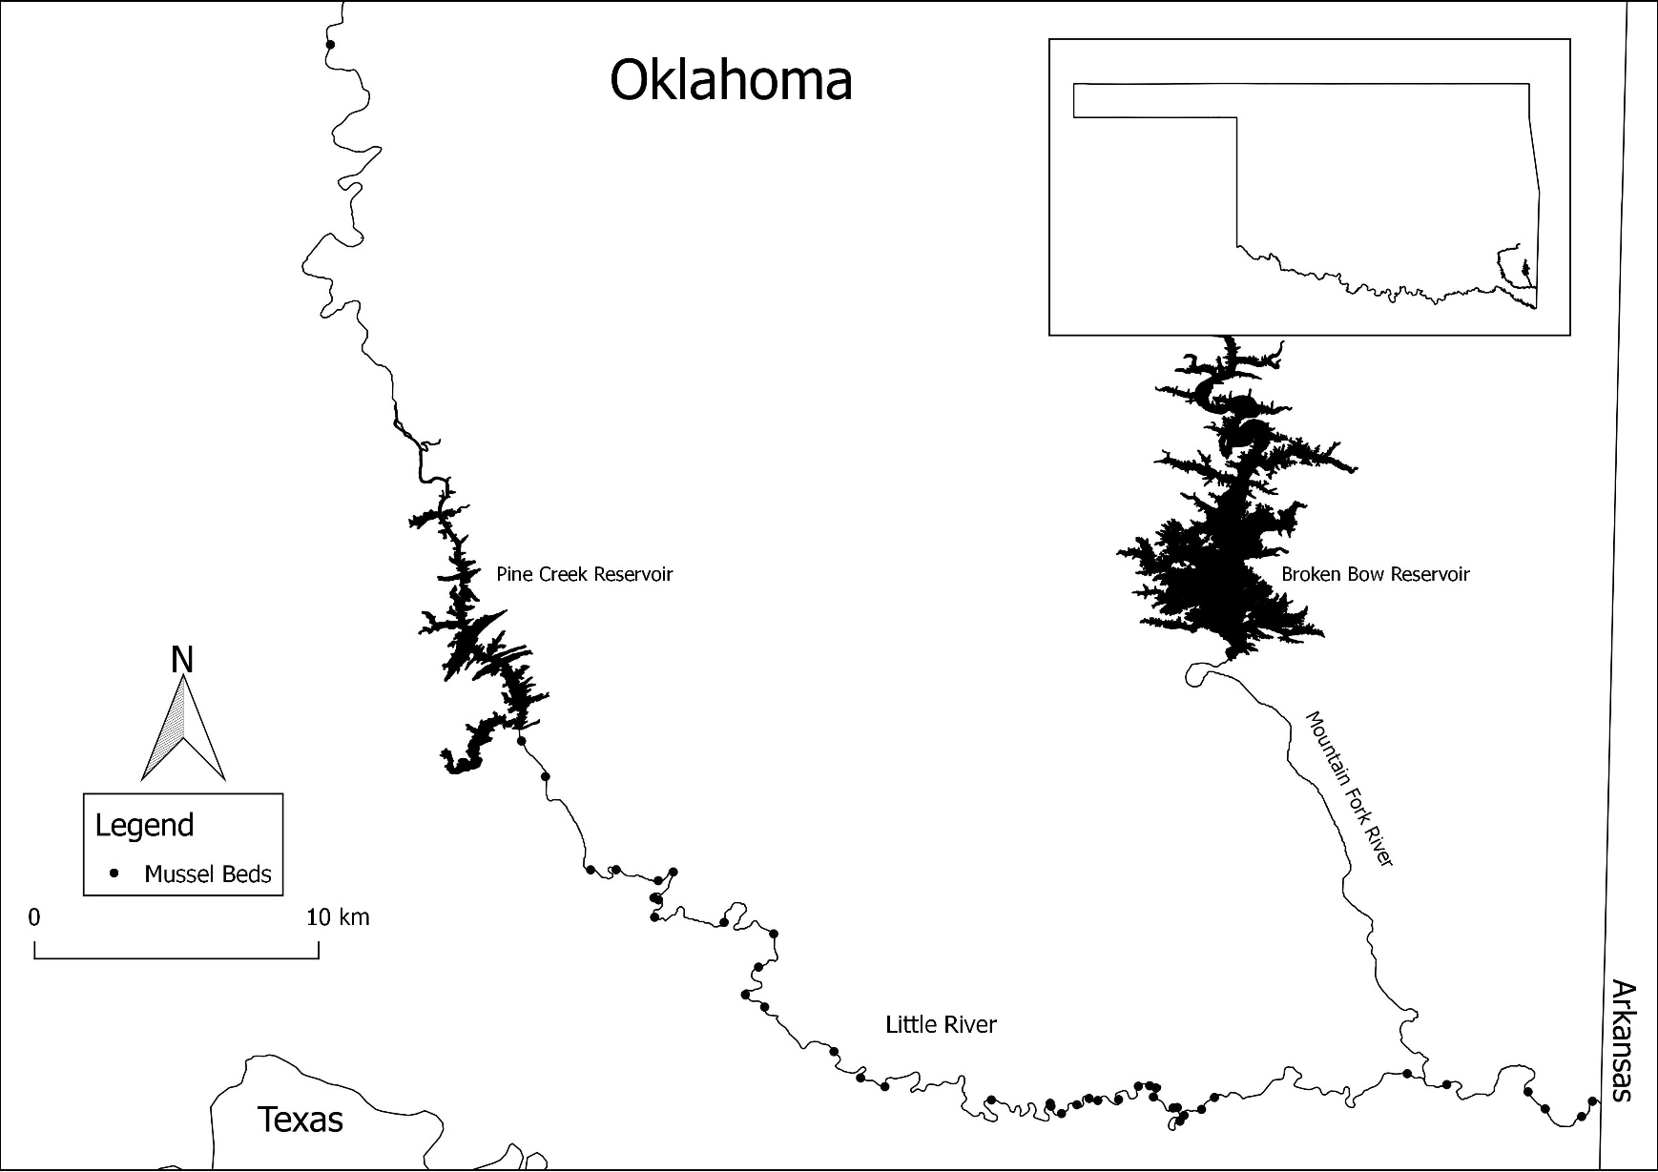
Figure 1

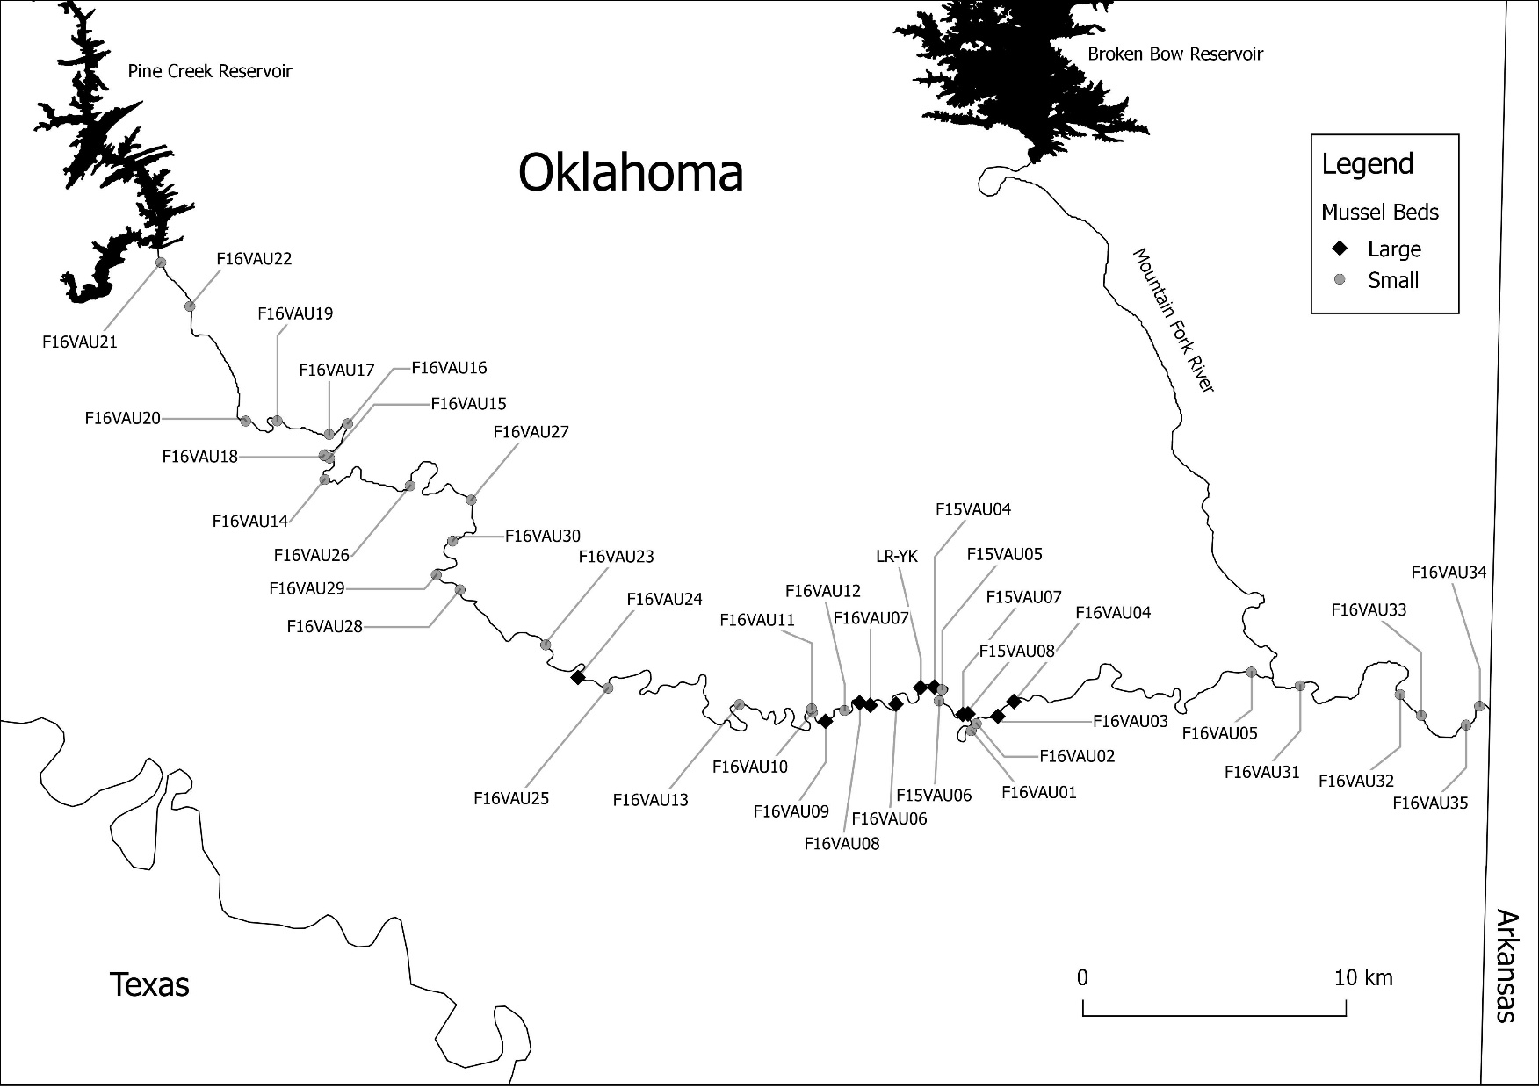
Figure 2

Figure 3

Figure 4

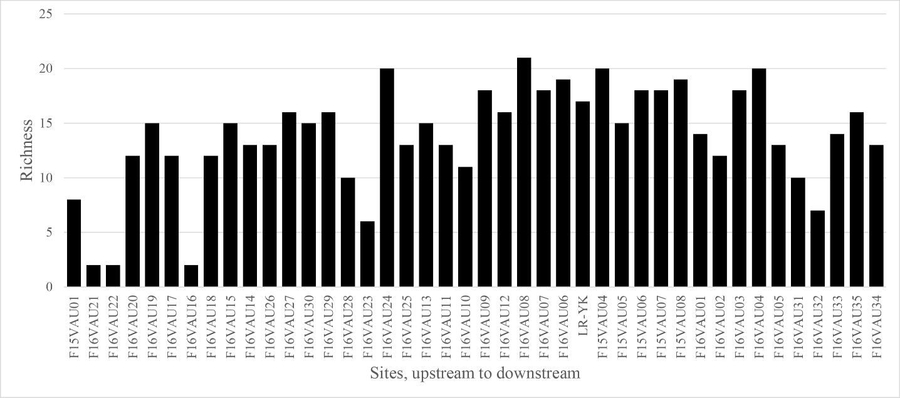
Figure 5

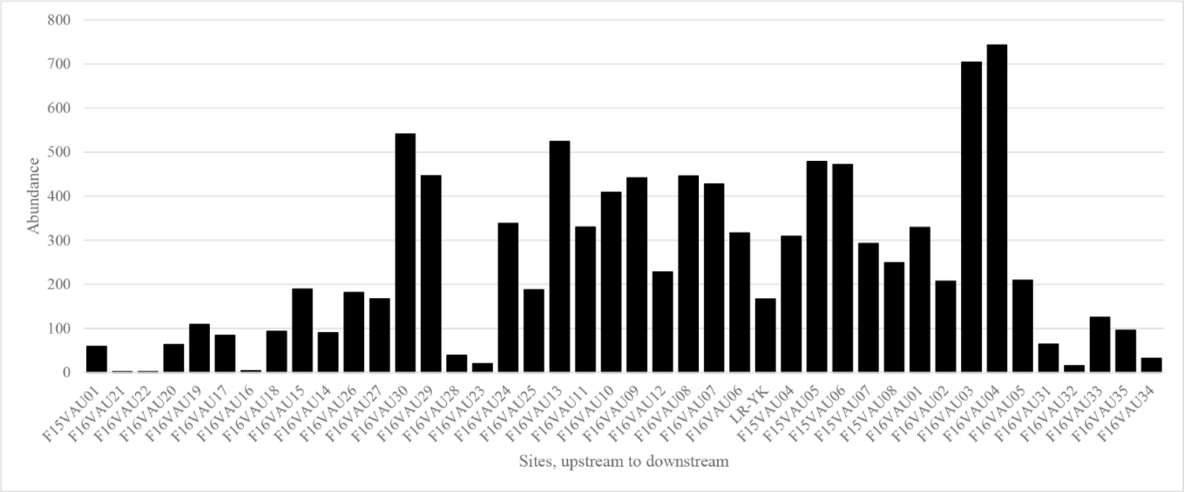

Figure 6

Figure 7
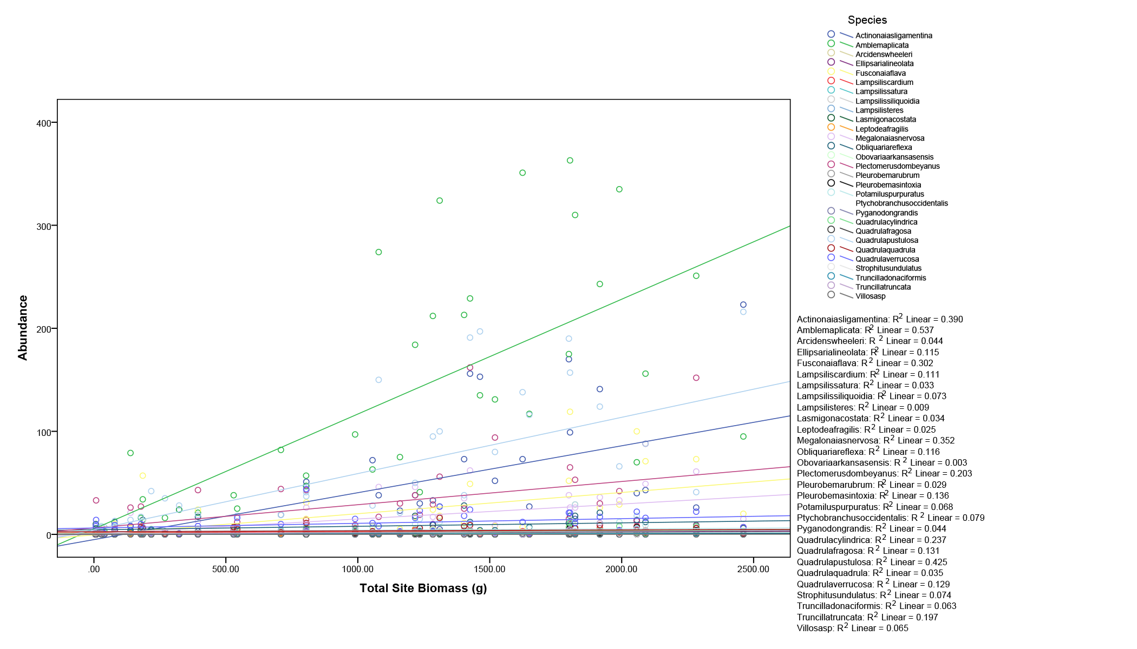
Figure 8
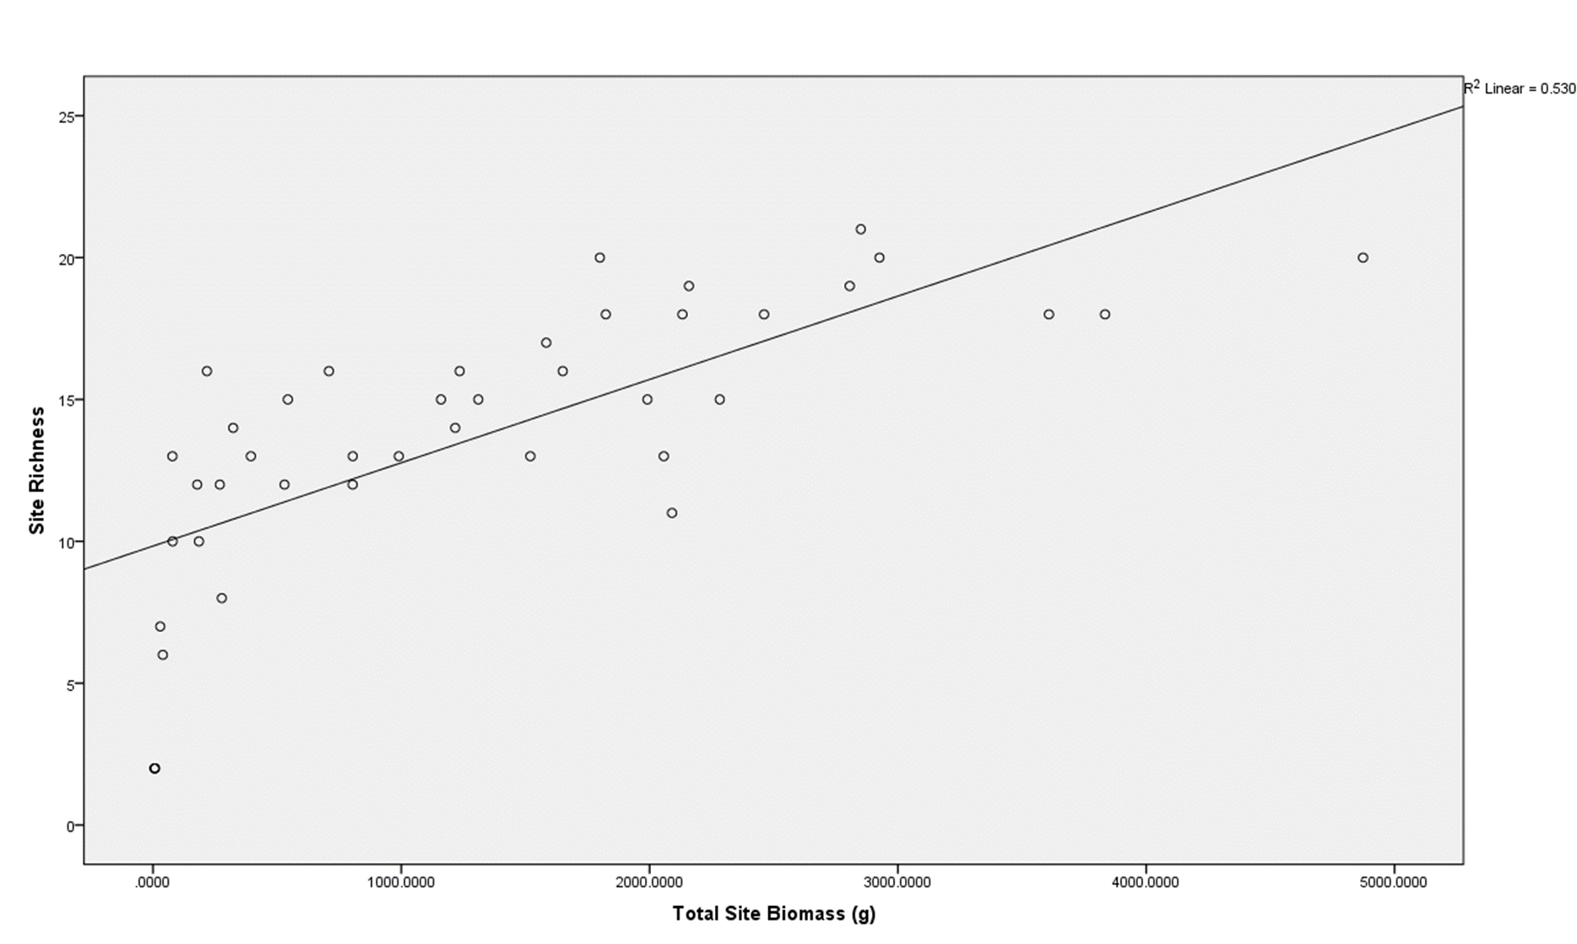
Figure 9

Figure 10
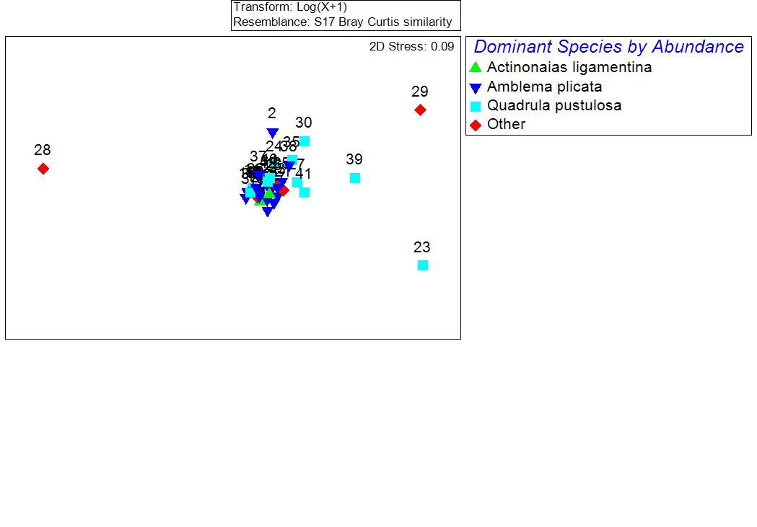

Figure 11
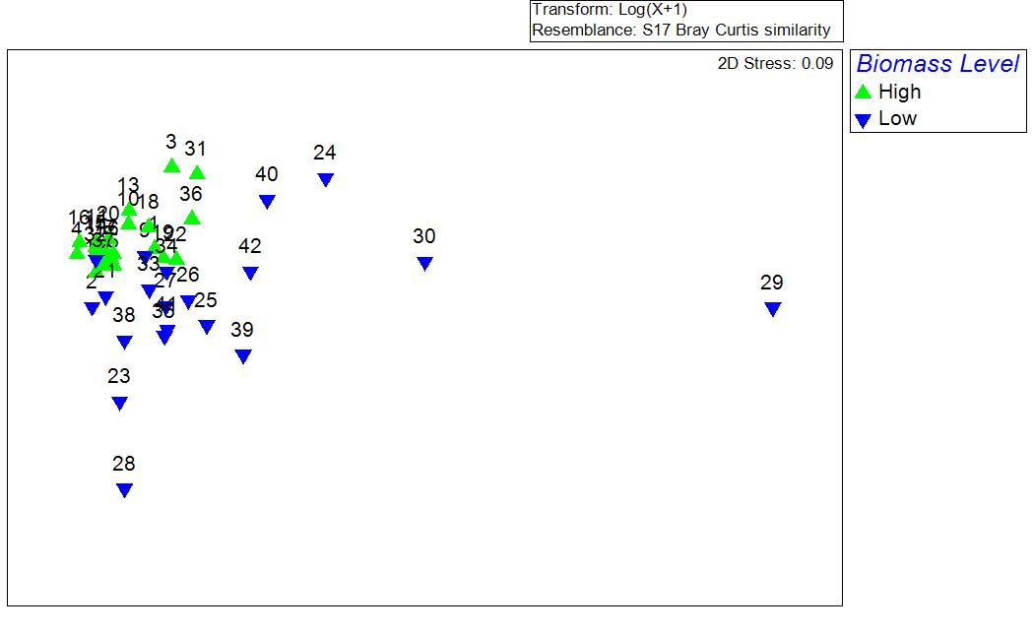

Figure 12

Figure 13
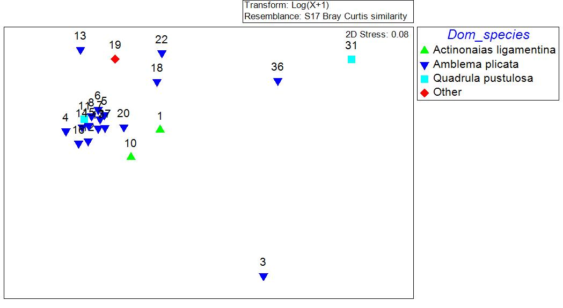

References
Agrawal, A. A., Ackerly, D. D., Adler, F., Arnold, A. E., Cáceres, C., Doak, D. F., ... & Power, M. (2007). Filling key gaps in population and community ecology. Frontiers in Ecology and the Environment, 5(3), 145-152.

Allen, D. C., and C. C. Vaughn. (2010). Complex hydraulic and substrate variables limit freshwater mussel species richness and abundance. Journal of the North American Benthological Society 29:383-394.

Allen, D. C., C. C. Vaughn, J. F. Kelly, J. T. Cooper, and M. H. Engel. (2012). Bottom-up biodiversity effects increase resource subsidy flux between ecosystems. Ecology 93:2165-2174.

Almeida‐Neto, M., Guimarães, P., Guimarães, P. R., Loyola, R. D., & Ulrich, W. (2008). A consistent metric for nestedness analysis in ecological systems: reconciling concept and measurement. Oikos, 117(8), 1227-1239.

Altieri, A. H., B. R. Silliman, and M. D. Bertness. (2007). Hierarchical organization via a facilitation cascade in intertidal cordgrass bed communities. The American Naturalist 169:195-206.

Anderson, M. J. (2001). A new method for non‐parametric multivariate analysis of variance. Austral ecology, 26(1), 32-46.
Angelini, C., Altieri, A. H., Silliman, B. R., & Bertness, M. D. (2011). Interactions among foundation species and their consequences for community organization, biodiversity, and conservation. BioScience, 61(10), 782-789.

Atkinson, C. L., and C. C. Vaughn. (2015). Biogeochemical hotspots: temporal and spatial scaling of the impact of freshwater mussels on ecosystem function. Freshwater Biology 60:563-574.

Atkinson, C. L., C. C. Vaughn, K. J. Forshay, and J. T. Cooper. (2013). Aggregated filter-feeding consumers alter nutrient limitation: consequences for ecosystem and community dynamics. Ecology 94:1359-1369.

Atkinson, C. L., J. F. Kelly, and C. C. Vaughn. (2014). Tracing Consumer-Derived Nitrogen in Riverine Food Webs. Ecosystems 17:485-496.

Atkinson, C. L., J. P. Julian, and C. C. Vaughn. (2012). Scale-dependent longitudinal patterns in mussel communities. Freshwater Biology 57:2272-2284.

Barnhart, M. C., W. R. Haag, and W. N. Roston. (2008). Adaptations to host infection and larval parasitism in Unionoida. Journal of the North American Benthological Society 27:370-394.

Baumeister, D., & Callaway, R. (2006). Facilitation by Pinus flexilis during Succession: A Hierarchy of Mechanisms Benefits Other Plant Species. Ecology, 87(7), 1816-1830.

Bray, J. R., & Curtis, J. T. (1957). An ordination of the upland forest communities of southern Wisconsin. Ecological monographs, 27(4), 325-349.

Clarke, K. R., & Gorley, R. N. (2006). PRIMER V6: user manual-tutorial. Plymouth Marine Laboratory.

Covich, A. P., S. C. Fritz, P. J. Lamb, R. D. Marzolf, W. J. Matthews, K. A. Poiani, E. E. Prepas, M. B. Richman, and T. C. Winter. (1997). Potential effects of climate change on aquatic ecosystems of the Great Plains of North America. Hydrological Processes 11:993-1021.

Crain, C. M., Kroeker, K., & Halpern, B. S. (2008). Interactive and cumulative effects of multiple human stressors in marine systems. Ecology letters, 11(12), 1304-1315.

Cuesta, B., Villar‐Salvador, P., Puértolas, J., Rey Benayas, J. M., & Michalet, R. (2010). Facilitation of Quercus ilex in Mediterranean shrubland is explained by both direct and indirect interactions mediated by herbs. Journal of Ecology, 98(3), 687-696.
Dayton, P. K. (1972). Toward an understanding of community resilience and the potential effects of enrichments to the benthos at McMurdo Sound, Antarctica. In Proceedings of the colloquium on conservation problems in Antarctica. Allen Press, Lawrence, Kansas, USA (pp. 81-95).

Diamond, J. M. (1975). The island dilemma: lessons of modern biogeographic studies for the design of natural reserves. Biological conservation, 7(2), 129-146.

Diamond, J., Pimm, S. L., & Sanderson, J. G. (2015). The checkered history of checkerboard distributions: comment. Ecology, 96(12), 3386-3388.

Ellison, A. M., Bank, M. S., Clinton, B. D., Colburn, E. A., Elliott, K., Ford, C. R., ... & Mohan, J. (2005). Loss of foundation species: consequences for the structure and dynamics of forested ecosystems. Frontiers in Ecology and the Environment, 3(9), 479-486.

Fernandez-Juricic, E. (2002). Can human disturbance promote nestedness? A case study with breeding birds in urban habitat fragments. Oecologia 131:269-278.

Galbraith, H. S., Spooner, D. E., & Vaughn, C. C. (2010). Synergistic effects of regional climate patterns and local water management on freshwater mussel communities. Biological Conservation, 143(5), 1175-1183.

Gangloff, M. M., and J. W. Feminella. (2007). Stream channel geomorphology influences mussel abundance in southern Appalachian streams, USA. Freshwater Biology 52:64-74.

Gotelli, N. J., & Entsminger, G. L. (2011). EcoSim: Null models software for ecology. Version 7. Acquired Intelligence Inc. & Kesey-Bear. Jericho, VT 05465.

Gotelli, N. J., & McCabe, D. J. (2002). Species co‐occurrence: A meta‐analysis of jm diamond's assembly rules model. Ecology, 83(8), 2091-2096.

Haag, W. R. (2012). North American freshwater mussels: natural history, ecology and conservation. Cambridge University Press, New York.

Halpern, B. S., Walbridge, S., Selkoe, K. A., Kappel, C. V., Micheli, F., D'agrosa, C., ... & Fujita, R. (2008). A global map of human impact on marine ecosystems. Science, 319(5865), 948-952.

Hardin, G. (1960). The competitive exclusion principle. science, 131(3409), 1292-1297.

Hay, M. E. (1986). Associational plant defenses and the maintenance of species diversity: turning competitors into accomplices. The American Naturalist, 128(5), 617-641.

Honnay, O., Hermy, M., & Coppin, P. (1999). Nested plant communities in deciduous forest fragments: species relaxation or nested habitats?. Oikos, 119-129.

Hylander, K., Nilsson, C., Gunnar Jonsson, B., & Göthner, T. (2005). Differences in habitat quality explain nestedness in a land snail meta‐community. Oikos, 108(2), 351-361.

Jaeger, R. G. (1971). Competitive exclusion as a factor influencing the distributions of two species of terrestrial salamanders. Ecology, 52(4), 632-637.

Kerr, J., Sugar, A., & Packer, L. (2000). Indicator Taxa, Rapid Biodiversity Assessment, and Nestedness in an Endangered Ecosystem. Conservation Biology, 14(6), 1726-1734.

Kolasa, J. (1989). Ecological systems in hierarchial perspective; breaks in community structure and other consequences. Ecology 70:36-47.

Lomolino, M. V. (1998). A Species - Based, Hierarchical Model of Island Biogeography.

Magurran, A. E. (2013). Measuring biological diversity. John Wiley & Sons.

Mariotte, P. (2014). Do subordinate species punch above their weight? Evidence from above‐and below‐ground. New Phytologist, 203(1), 16-21.

Master, L. L., Flack, S. R., & Stein, B. A. (Eds.). (1998). Rivers of life: critical watersheds for protecting freshwater biodiversity (p. 71). Arlington, Virginia: Nature Conservancy.

Matthews, W. J., C. C. Vaughn, K. B. Gido, and E. Marsh-Matthews. (2005). Southern plains rivers.in A. Benke and C. E. Cushing, editors. Rivers of North America. Academic Press.

Matthews, W. J., & Zimmerman, E. G. (1990). Potential effects of global warming on native fishes of the southern Great Plains and the Southwest. Fisheries, 15(6), 26-32.

McAbendroth, L., Foggo, A., Rundle, S. D., & Bilton, D. T. (2005). Unravelling nestedness and spatial pattern in pond assemblages. Journal of Animal Ecology, 74(1), 41-49.

Naimo, T. J. (1995). A review of the effects of heavy metals on freshwater mussels. Ecotoxicology, 4(6), 341-362.
Pacala, S. W., & Tilman, D. (1994). Limiting similarity in mechanistic and spatial models of plant competition in heterogeneous environments. The American Naturalist, 143(2), 222-257.

Parmesan, C., & Yohe, G. (2003). A globally coherent fingerprint of climate change impacts across natural systems. Nature, 421(6918), 37-42.

Patterson, B. D. (1987). The principle of nested subsets and its implications for biological conservation. Conservation Biology 1:323-334.

Poff, N. L., J. D. Allan, M. B. Bain, J. R. Karr, K. L. Prestegaard, B. D. Richter, R. E. Sparks, and J. C. Stromberg. (1997). The natural flow regime. Bioscience 47:769-784.

Preston, F. W. (1948). The commonness, and rarity, of species. Ecology, 29(3), 254-283.

Price, J. N., & Pärtel, M. (2013). Can limiting similarity increase invasion resistance? A meta‐analysis of experimental studies. Oikos, 122(5), 649-656.

Rashleigh, B. (2008). Nestedness in riverine mussel communities: patterns across sites and fish hosts. Ecography 31:612-619.

Ribas, C. R., & Schoereder, J. H. (2002). Are all ant mosaics caused by competition?. Oecologia, 131(4), 606-611.

Sanderson, E. W., Jaiteh, M., Levy, M. A., Redford, K. H., Wannebo, A. V., & Woolmer, G. (2002). The human footprint and the last of the wild: the human footprint is a global map of human influence on the land surface, which suggests that human beings are stewards of nature, whether we like it or not. BioScience, 52(10), 891-904.

Sansom, B. J., Atkinson, J. F., & Bennett, S. J. Modulation of near-bed hydrodynamics by freshwater mussels in an experimental channel. Hydrobiologia, 1-15.

Sasaki, T., & Lauenroth, W. K. (2011). Dominant species, rather than diversity, regulates temporal stability of plant communities. Oecologia, 166(3), 761-768.

Schwalb, A. N., T. J. Morris, N. E. Mandrak, and K. Cottenie. (2013). Distribution of unionid freshwater mussels depends on the distribution of host fishes on a regional scale. Diversity and Distributions 19:446-454.

Smith, M. D., & Knapp, A. K. (2003). Dominant species maintain ecosystem function with non‐random species loss. Ecology Letters, 6(6), 509-517.
Spooner, D. E., & Vaughn, C. C. (2008). A trait-based approach to species’ roles in stream ecosystems: climate change, community structure, and material cycling. Oecologia, 158(2), 307-317.

Spooner, D. E., and C. C. Vaughn. (2009). Species richness and temperature influence mussel biomass: A partitioning approach applied to natural communities. Ecology 90:781-790.

Stone, L., & Roberts, A. (1990). The checkerboard score and species distributions. Oecologia, 85(1), 74-79.

Strayer, D. L. (2008). Freshwater Mussel Ecology: A Multifactor Approach to Distribution and Abundance. University of Californina Press, Berkeley.

Strayer, D. L., Caraco, N. F., Cole, J. J., Findlay, S., & Pace, M. L. (1999). Transformation of freshwater ecosystems by bivalves: a case study of zebra mussels in the Hudson River. BioScience, 49(1), 19-27.

Thomas, C. D., Cameron, A., Green, R. E., Bakkenes, M., Beaumont, L. J., Collingham, Y. C., ... & Hughes, L. (2004). Extinction risk from climate change. Nature, 427(6970), 145-148.

Tilman, D. (1994). Competition and biodiversity in spatially structured habitats. Ecology, 75(1), 2-16.

Ulrich, W. (2011). NODF–a FORTRAN program for nestedness analysis.

Ulrich, W., & Gotelli, N. J. (2013). Pattern detection in null model analysis. Oikos, 122(1), 2-18.

Ulrich, W., Almeida‐Neto, M., & Gotelli, N. J. (2009). A consumer's guide to nestedness analysis. Oikos, 118(1), 3-17.

Ulrich, W., Kryszewski, W., Sewerniak, P., Puchałka, R., Strona, G., & Gotelli, N. J. (2017). A comprehensive framework for the study of species co-occurrences, nestedness and turnover. Oikos. doi:10.1111/oik.04166

Vaughn, C. C. (1997). Regional patterns of mussel species distributions in North American rivers. Ecography 20:107-115.

Vaughn, C. C. (2012). Life history traits and abundance can predict local colonisation and extinction rates of freshwater mussels. Freshwater Biology 57:982-992.

Vaughn, C. C. (2017). Ecosystem services provided by freshwater mussels. Hydrobiologia:DOI 10.1007/s10750-10017-13139-x.

Vaughn, C. C., and C. M. Taylor. (1999). Impoundments and the decline of freshwater mussels: a case study of an extinction gradient. Conservation Biology 13:912-920.

Vaughn, C. C., and C. M. Taylor. (2000). Macroecology of a host-parasite relationship. Ecography 23:11-20.

Vaughn, C. C., and M. Pyron. (1995). Population ecology of the endangered Ouachita Rock Pocketbook mussel, Arkansia wheeleri (Bivalvia: Unionidae), in the Kiamichi River, Oklahoma. American Malacological Bulletin 11:145-151.

Vaughn, C. C., C. M. Taylor, and K. J. Eberhard. (1997). A comparison of the effectiveness of timed searches vs. quadrat sampling in mussel surveys. Pages 157-162 in K. S. Cummings, A. C. Buchanan, and L. M. Koch, editors. Conservation and Management of Freshwater Mussels II: Initiatives for the Future.

Vaughn, C. C., D. E. Spooner, and H. S. Galbraith. (2007). Context-dependent species identity effects within a functional group of filter-feeding bivalves. Ecology 88:1654-1662.

Vaughn, C. C., S. J. Nichols, and D. E. Spooner. (2008). Community and foodweb ecology of freshwater mussels. Journal of the North American Benthological Society 27:409-423.

Vaughn, C., & Taylor, C. (1999). Impoundments and the Decline of Freshwater Mussels: A Case Study of an Extinction Gradient. Conservation Biology, 13(4), 912-920.

Verdú, M., Valiente‐Banuet, A., & Associate Editor and Editor: Monica A. Geber. (2008). The Nested Assembly of Plant Facilitation Networks Prevents Species Extinctions. The American Naturalist, 172(6), 751-760. doi:10.1086/593003

Wethered, R., & Lawes, M. J. (2005). Nestedness of bird assemblages in fragmented Afromontane forest: the effect of plantation forestry in the matrix. Biological Conservation, 123(1), 125-137.

Wolman, M. G. (1954). A method of sampling coarse river‐bed material. EOS, Transactions American Geophysical Union, 35(6), 951-956.

Zaret, T. M., & Rand, A. S. (1971). Competition in tropical stream fishes: support for the competitive exclusion principle. Ecology, 52(2), 336-342.

