University of Oklahoma

Graduate College

communicability, wellness, and rural health economics: a discourse analysis of a federally qualified health center in Eastern Oklahoma

A Dissertation

submitted to the Graduate Faculty

in partial fulfillment of the requirements for the

Degree of

Doctor of Philosophy

By

ryan edwin blanton
Norman, Oklahoma
2014

communicability, wellness, and rural health economics: a discourse analysis of a federally qualified health center in eastern oklahoma

A Dissertation approved for the
Department of Anthropology

By

______________________________
Dr. Sean O’Neill, Chair

______________________________
Dr. Katherine Hirschfeld

______________________________
Dr. Lesley Rankin-Hill

______________________________
Dr. Paul Spicer

______________________________
Dr. Thomas Burns

© Copyright by ryan edwin blanton 2014
All Rights Reserved.
This dissertation is dedicated to Julie, Cate, and Eddie. My deepest gratitude, love, and appreciation go to my wife, friend, and colleague, Julie Dinger. Without you, none of this would have been possible. Cate and Eddie, you are my inspiration, and because of you, I know that dreams are worth chasing. I hope this inspires you to chase your dreams and passion and to never give up in the face of adversity.

Acknowledgements
There are many people who have made this dissertation a reality. First and foremost, I would like to thank the administration of the Health and Wellness Center for their outstanding service to the people of eastern Oklahoma and their support of this research. I hope this research is useful to you and your mission.
To my parents, Ray and Cathy Blanton, thank you for your love, support, and encouragement. It has been a long road, and you have always guided me in the right direction. To Amanda, Melissa, Raina, Robbie, Alice, and April, thank you for believing in me. To Bob Dinger, you taught me to fight for all that is good in my life. I am deeply indebted to you all.
A special note of thanks goes to my dissertation committee and other professors at the University of Oklahoma. Dr. Lesley Rankin-Hill, Dr. Katherine Hirschfeld, Dr. Sean O’Neill, Dr. Tom Burns, and Dr. Paul Spicer, you took a young kid with broad ambitions and helped transform him into a scholar. You helped me find my strengths and passion, and were honest in your assessment. Thank you.
Dr. Tim Faltyn and Dr. Ron Ramming, thank you for your encouragement and guidance as I start the next chapter of my academic life. Lastly, thank you to all our friends and colleagues in eastern Oklahoma who have welcomed us into their communities.

Table of Contents

Acknowledgements iv
List of Tables viii
List of Figures ix
Abstract xi
Chapter 1: Introduction 1
Eastbound and Down 4
Sociolinguistic Anthropology of Health Economics and Federally Qualified Health Centers 9
Focus, Usefulness, and Praxis 11
Research Design 13
Analytic Framework 17
Presentation of Initial Findings 25
Presentation of Results 26
Chapter 2: Federally Qualified Health Center Regulation and Prior Research 31
Federally Qualified Health Center Regulatory Environment 32
Service Requirements of Federally Qualified Health Centers 33
Financial Management 34
Governance 37
Previous Academic Research of Federally Qualified Health Centers 39
General Overviews of FQHCS and Healthcare Safety Nets 40
Medical Outcomes 44
FQHC Operations 46
Towards a New Analytic 49
Chapter 3: Intertextual Anthropologies of Healthcare 51
Federally Qualified Health Centers and Anthropology 52
Medical Anthropology 53
Language and Ideology 65
Semiotic Negotiation of Social Markedness in Discourses of Rural Health 77
Chapter 4: (Re)Entextualizing Rurality in a Federally Qualified Health Center 81
Health and Place 84
Rural Health Research 87
A Brief History of HWC 95
Chronotopes of Rurality 100
A Place Worth Investing In 108
Chapter 5: Economic Return on Investment 111
Rural Health Economics Research in Oklahoma 116
Haskell County 119
Sequoyah County 120
McIntosh County 122
Le Flore County 123
The Importance of Healthcare for Rural Economies 125
The Economic Impact and Return on Investment of HWC 128
Chronotopes of the Local Economics of Healthcare 133
The Prevailing Winds of Change 144
The Interdiscursivity of Return on Investment, Rurality, and Wellness 147
Chapter 6: Beyond Economic and Physical Bodies 151
External Definitions of Health 153
Community Definitions of Health 163
Diabetes 165
Breast Cancer and Women’s Health 174
A Better Public(s) Health Return through FQHCs 183
Chapter 7: Investing in Social and Political Health 188
Enhancing Social Health 191
Social Strength through Mental Health 193
Building a Stronger Social Body through Health Insurance Outreach 200
Empowering the Public(s) through Political Health 204
Social and Political Health in the Era of Health Reform 212
Chapter 8: “We don’t want to be the Provider of Last Resort. We want to be the Provider of Choice.” 215
References 225
Appendix A: Definitions of Initialisms, Acronyms, and Abbreviations 246
Appendix B: Making the Case for CHC Return on Investment 248
Appendix C: Institution Review Board Approve Survey Instrument 265

List of Tables

Table 1: Demographic Data of Oklahoma and Region (SHDAC 2009) 7
Table 2: Required Services to be Provided by FQHCs (HRSA 2010:11-12). 33
Table 3: Income and Health Insurance Status by County. Source: U.S. Census Bureau, 2008-2012 American Community Survey. 93
Table 4: Educational Attainment and Income by County. Source: U.S. Census Bureau, 2008-2012 American Community Survey. 94
Table 5: Economic Impact of Healthcare of the HWC Medical Service Area. 130

List of Figures

Figure 1: Women’s Health Expo. 1
Figure 2: Survivor Tent. 2
Figure 3: Braving the Rain with a Pink Umbrella. 3
Figure 4: Oklahoma Regional Quarters and Central (OKC) and Tulsa Metropolitan Areas. Source: SHADAC 2009 8
Figure 5: Four Genres of Return on Investment 26
Figure 6: Map of Haskell, McIntosh, Sequoyah, and Le Flore Counties. 81
Figure 7: Ranking of County Health Outcomes in Oklahoma .92
Figure 8: Ranking of County Health Factors in Oklahoma. 92
Figure 9: Advertisement for the Sallisaw Clinic. 96
Figure 10: Percentage of Employment in Top Four Employment Sectors for Haskell County. 120
Figure 11: Percentage of Employment in Top Four Employment Sectors for Sequoyah County. 121
Figure 12: Percentage of Employment in Top Four Employment Sectors for McIntosh County. 123
Figure 13: Percentage of Employment in Top Four Employment Sectors for Le Flore County. 124
Figure 14: An advertisement for the HWC Women's Expo. 174
Figure 15: 2013 HWC Women's Expo 5K Run 175
Figure 16: Women's Expo Inside the Stigler Clinic. 179
Figure 17: Self-Examination Education at the HWC Women's Expo. 182
Figure 18: The Old Walmart Building. 199
Figure 19: The Stigler Health and Wellness Clinic after Renovation. 200

Abstract

Through an analysis of chronotopic discourses, or discourses that provide meaning in connection to time and space, focused on the (re)definition of rurality in relation to health, this dissertation examines the overall economic impact and return on investment of a Federally Qualified Health Center in eastern Oklahoma. Aside from improved access to healthcare and substantial economic impact, this Federally Qualified Health Center has positive effects on community, social, and political health within their service areas not previously identified in traditional healthcare studies. By examining the denotative negotiation of rurality and health within discourses as they pass through interdiscursive webs surrounding the Federally Qualified Health Center, it is clear that external spatiotemporally neutral biomedical discourses, or discourses that do not contextualize health within the history and place of patients, serve only to centralize healthcare outside the community, contextualizing such discourse as authoritative and tied to sociopolitical histories, and therefore incompatible with local understandings of health and wellness. Conversely, it is argued, discourses of health and wellness originating from the Federally Qualified Health Center, a position centered in the community, are contextualized within local chronotopes of rurality, place, and history. As the denotations of rurality, health, and healthcare share common chronotopic frames, these discourses empower the economic, community, social, and political health of the community. These discourses, it is argued, are shaped by, and in turn shape, spheres of communicability focused on wellness that decentralize medical authority and allow for the local production and prioritization of healthcare. It is further argued that the synthesis of a functionally oriented sociolinguistic and medical anthropology provides a new framework that contributes to broader academic discourses of rurality and rural health, especially in the era of health reform.

Chapter 1: Introduction

There is a common saying in Oklahoma that if you do not like the weather, just wait five minutes and it will change. While it was bitter cold only a week before, the weather was hot and humid in mid-October 2012. I walked into the large white and pink tent in the parking lot of the old Walmart reclaimed and repurposed by the Stigler Health and Wellness Center, a Federally Qualified Health Center (FQHC) in Stigler, Oklahoma. A friend from KiBois Community Action Agency had brought down an eight foot table for us to set up a recruiting booth for Connors State College, the local two-year college I had started working for about a year before. It was only eight in the morning, but the heat and humidity was making it quite uncomfortable inside the tent. Storm clouds began to appear on the broad, open Oklahoma horizon, threatening to rain at any minute.
Figure 1: Women’s Health Expo.

While the administration of the Health and Wellness Centers (HWC) debated removing the flaps from the side of the tent, a line of women from the local community, decked in pink accessories from head to toe, formed outside,. Sprinkled here and there were the men of their lives coming out to support their wives, sisters, mothers, and daughters affected by breast cancer. While Komen Race for the Cure events are held in the nearby metro areas of Oklahoma City, Tulsa, and Fort Smith, Arkansas, the HWC Women’s Expo is the premier event highlighting breast cancer for the surrounding area.
Figure 2: Survivor Tent.
Perhaps that is because the money raised during the event helps local women overcome the struggles of breast cancer, or maybe it is a chance to visit the local home businesses, crafters, and community and health development organizations that set up booths in the main tent. These were surely highlights of the day. As I took the bold step of walking into the survivors tent, however, I realized I was a man venturing in what quickly became clear was a woman’s space. Having attended Komen events in OKC and Tulsa in support of my mother–in-law, and recently my own mother, I noted the striking difference of being an anonymous survivor in a city of strangers versus being a survivor in a community where strangers are few.

No one left their place in line as the wind picked up and the rain began to fall. It was the second year of extreme drought in Oklahoma, and in the cattle ranch communities of eastern Oklahoma, rain is a joyous occasion. Pink and white umbrellas from the event the year before started popping open and, undeterred by the weather, more than 300 people made their way to HWC for shopping, learning, and fellowship. More significantly, they engaged in a discourse of community and health entextualized within place and history, rurality and culture. Breast cancer was interwoven into texts of the rural barriers to care, lack of health insurance, and the economic struggles resulting from the reduction of natural gas drilling in the area and the squeeze on the cattle market from the persistent drought.
Figure 3: Braving the Rain with a Pink Umbrella.
These struggles, however, were contrasted with texts of survival, of networks of support within the community that allowed them to overcome barriers to healthcare. These texts were interwoven into larger discourses of wellness in place and time, or chronotopes, which defined the people and their connection to their place and history of health in the local context. These chronotopes, which are the analytic focus of this dissertation and discussed in greater detail below, entextualized the physical and sociopolitical historical geography of eastern Oklahoma within the discourses of health access, wellness, and health economics. Discussions of cancer were intertwined and connected with explanations of fresh country air and the benefits and struggles of rural living. The analysis of these chronotopes offers new insight into the ways patterns of health inequity can be overcome in local communities.

Eastbound and Down
I entered the communities of Haskell, McIntosh, Leflore, and Sequoyah counties in eastern Oklahoma as a stranger in April of 2010. I had just finished my general exams for my Ph.D. in Anthropology from the University of Oklahoma (OU) and had recently taken a job with the Oklahoma Health Care Authority (OHCA), the state agency responsible for the administration of Medicaid, as the newly created Southeast Oklahoma Regional Outreach Coordinator. Though I grew up on military instillations all around the world as an armed forces dependent, my family was from Oklahoma, going back four generations from Durant, and I had spent the last 12 years in Oklahoma as a soldier and then a student at OU. I had crisscrossed the state doing ethnographic work with numerous cultural groups working as a research assistant, as well as conducting my own research (Blanton 2006 and 2011).
I thought, naively, that I knew the culture well and could get off to a great start with my new job. I learned quickly, however, that I was still a representative of a state agency from “The City” (Oklahoma City Metro area and state capital) and that despite my accent and knowledge of the area, no one knew my family, and breaking into the community was going to be difficult.
As the Southeast Oklahoma Regional Outreach Coordinator for the OHCA, I worked as part of the SoonerEnroll Program. The SoonerEnroll Program was a grant program funded through the United States Center For Medicare and Medicaid Services (CMS) as part of the Affordable Care Act (ACA, or political and regionally referred to as “ObamaCare”). Our mission was to develop new outreach and enrollment methods to enroll all children and adults eligible for SoonerCare (the Oklahoma Medicaid Program) who had for whatever reason not already done so. In addition, we were to communicate and train community partners on the new online enrollment program that was being initiated, as well as communicate changes in shifting enrollment from the Oklahoma Department of Human Service (DHS) to online and community based application assistance. It should be noted that the OHCA had never before had employees outside of the central offices in Oklahoma City, and that I would be covering a region of 22 rural Oklahoma counties (See Figure 4 for general boundaries of Southeast Oklahoma).
The rurality of many areas of southeast Oklahoma is quite staggering. While there are many cities in the area, such as McAlester, Hugo, Durant, and Ardmore, most of the area consists of small towns and rural roads. Several highways crisscross the region, and those towns with highway access have relatively stable service-sector employment. The Choctaw and Chickasaw Nations encompass the entirety of the southeast quarter of the state, and provide numerous employment opportunities to tribal and nontribal citizens alike. Further, the McAlester Army Ammunition Plant, Oklahoma State Penitentiary, Tyson Chicken, and other small industries offer relatively well paying jobs. For most residents, however, stable and well paying positions are difficult to find.
In small towns like Antlers, Oklahoma, small family owned businesses, service-sector, and tribal employment are the only options for residents. Even then, lack of reliable childcare and public transportation limit employment opportunities for a majority of residents. Affordable high-speed internet connection is only available at the public library for some families, but equipment is old and in need of replacement. Medical care is especially difficult to find, as most of southeast Oklahoma is chronically medically underserved, and driving distances to providers average over 15 miles. With all of these barriers, it should be no surprise that southeastern Oklahoma suffers from high rates of poverty and associated poor health outcomes.
The poverty rate in Oklahoma in 2009 was 15.8%, and the poverty rate for the southeast quarter of Oklahoma was 20% (Table 1, State Health Access Data Assistance Center (SHADAC) 2009). Rates of health uninsurance were and remain exceptionally high at 19.8% (Figure 4 (SHADAC 2009)). During the time of my research in the area, 2010-2014, the economic situation deteriorated even more. The once booming natural gas drilling industry began a rapid slowdown as supplies of natural gas outgrew demand and drilling operations shifted to western Oklahoma and Texas. Record drought also affected many families who rely on raising livestock for food supply or sale to make ends meet. More drastic
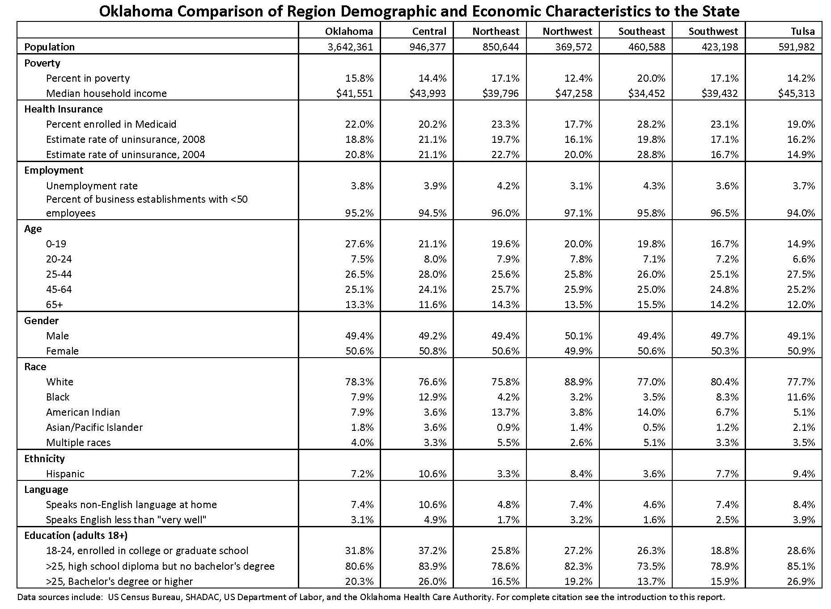
Table 1: Demographic Data of Oklahoma and Region (SHDAC 2009)

Figure 4: Oklahoma Regional Quarters and Central (OKC) and Tulsa Metropolitan Areas. Source: SHADAC 2009
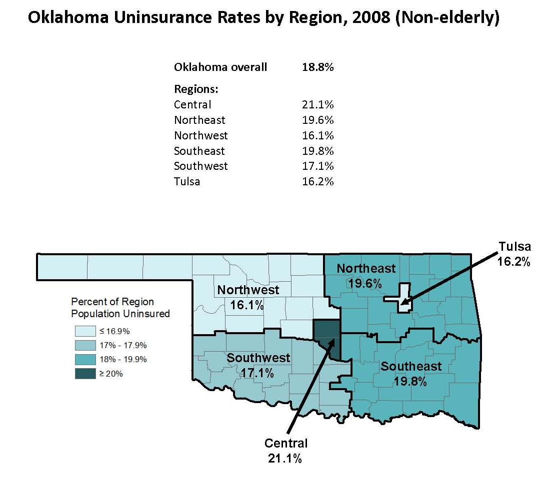
was the impact of the Great Recession on the Oklahoma economy with rising gas prices and the centralization of community, health, and social services.
The defining characteristics of Okies is their resiliency. As I began meeting with people to expand the OHCA’s outreach efforts, it became clear that what southeastern Oklahomans’ lacked in infrastructure and resources, they made up for with determination, resourcefulness, cooperation, and ingenuity. Community Action Agencies were vibrant and more effective than any I experienced in other parts of the state. Head Start, Smart Start, the Chickasaw Nation, Muscogee Creek Nation, and Choctaw Nation, schools, colleges, and FQHC’s partnered together to meet the needs of underserved residents. Where money was lacking from the state, they found it through federal and foundation grants.
It was in these groups where I was first acquainted with the FQHC system. I met Brooke Lattimore, the Chief Operating Officer of The Health and Wellness Centers (HWC) while at Carl Albert State College in Poteau, Oklahoma for the LeFlore County Coalition for Healthy Living in the spring of 2010. I spoke briefly with the group about the new OHCA SoonerEnroll Program grant project and asked for assistance in identifying local supporters. Afterward, Brooke approached me, excited that someone from OHCA would be in the area. It would turn out that Brooke and HWC would be one of our best partners in the SoonerEnroll program, and I would become increasingly involved in their operation at an academic and personal level.

Sociolinguistic Anthropology of Health Economics and Federally Qualified Health Centers
Anthropologists, to a much greater extent than other social scientists, often struggle to define their discipline within the academy. I occupy a unique space within the field, academically interested in discourse and health, but my research has been more established in the semiotic negotiation of race. My research assistant experience varied between genomic research for the International Haplotype Project, Oklahoma Freedmen, environmental racism in southern Oklahoma, and end of life issue with American Indians suffering from Alzheimer’s. When I completed my general exams, I was easily able to explain and parlay my experiences working with diverse communities into an outreach position with OHCA. Explaining my background and interests to community members in southeastern Oklahoma, however, would be much more of a challenge.
As I began recognizing the unique health and support system that was in place in the rural counties of southeastern Oklahoma, I began to imagine what an anthropological research study might look like. I was already familiar with rurality and poverty in relation to health disparities, and no doubt the county coalitions and support frameworks already in place were similar to others around the United States. I began approaching community members about my desire to conduct a research project about community based health and support programs in the area, but struggled to define how anthropology could be useful in uncovering new, and more importantly, relevant findings.
As the overwhelming health issue in these counties was the lack of medical access, I began to focus more on provider availability, affordability, and quality. The Health and Wellness Centers, at that time only operating in Eufaula, Stigler, and Sallisaw, fit those criteria, as did other FQHCs in southeastern Oklahoma. HWC, though, did more. They served their community through outreach, engagement, development, and cultural enhancement. They were not just a provider, but a community asset that returned health, economic, social, and political dividends. They were communicable (Briggs 2005:274), their message of wellness was infectious.

Focus, Usefulness, and Praxis
The voices of the communities served are not readily found in the academic discourse of FQHCs. This is an area that anthropology, specifically sociolinguistic anthropology is adept at examining. Taking this information to the administration, board, advocates, and detractors of the HWC, I solicited ideas for the type of research that would be useful to them. Aware of the criticism of ethnography from Minh-ha, “What do I want wanting to know you or me?” (1989:76), I asked them, “What do you want to know through me knowing you?” Through subject driven research design, I hoped to avoid the anthropological trap of self-indulgence and provide HWC with data useful to their own endeavors.
The result is this dissertation, a praxis oriented examination of the return o of state and federal funds invested in the health of the community through the analysis of community, economic, social, and political discursive bodies. Praxis, the process through which social theory and research is put into practice, is emphasized so that this dissertation does not stand just as an academic volume, but a tool with which FQHCs can measure their own efficacy and strategically plan to improve the health of their community.
One of the founders of social medicine, Rudolf Virchow, famously stated that “Medicine is a social science, and politics is nothing more than medicine on a grand scale” (Harvard University 2014). In the years after the passage of the Affordable Care Act (ACA), Virchow’s words seem more poignant than ever. The existence of FQHCs has been a political issues since their inception in the 1960’s as part of Lyndon Johnson’s War on Poverty, highlighted by the passage of the Economic Opportunity Act of 1964 (Kantayya and Lidvall 2010).
Both political parties, however, have supported FQHCs, even expanding their funding in “recognizing these types of centers as a cost-effective way to provide health care to a segment of the population who would otherwise have difficulties in accessing appropriate health care” (Kantayya and Lidvall 2010:685). With the passage of the ACA and the rise of conservativism dominated by fiscal restraint, the word “Federal” became a political target, and showing return on investment became a political must for all agencies receiving tax dollars. The ACA, FQHCs, and the Medicare, Medicaid, and uninsured populations who rely on them, have since come to symbolize a struggle of politics, society, and health.
Through discussion with the Health and Wellness Center administration and Board of Directors, it became clear that the most beneficial type of research would be that which demonstrates the utility of FQHCs beyond the standard biomedical and economic impact metrics. The discourse of FQHCs was beginning to shift due to the politics of the ACA, particularly in Oklahoma. The question of research, and more importantly, its presentation, then became: What other types of return on investment can FQHCs provide to their community? Everyone had their own answers, but there was no unified response to confront criticism of federally qualified healthcare delivery.

Research Design
The principle purpose of this study was to conduct ethnographic and sociolinguistic research of the sociopolitical discursive environment surrounding the operations and successes of HWC in eastern Oklahoma. Prior research on FQHCs has been largely quantitative, exploring health outcomes from an epidemiological perspective and health economic matrixes in terms of rural economic development. These studies show the positive impact of FQHCs in reducing ethnic, socioeconomic, and rural health disparities while also fostering positive economic impacts. Preliminary data from my OHCA work experience suggested that this was true in eastern Oklahoma, but the impact was not reducible only to quantitative health outcomes.
Rather, the goal of this study was to uncover the localized discourses of significant health disparity improvement, economic development, reduced public fiscal expenditures, and community engagement in personal and community health development. Discourse, the everyday analysis of social and symbolic interaction within social groups, provides a unique framework through which we can better understand how local practices, ideals, and politics interact with those generated at the regional, national, and global levels. As FQHC’s are funded in large part through federal and state healthcare dollars, the detailed exploration of their operations within their service communities warrants new qualitative analyses to understand their impact in the era of healthcare reform.
The design of this research study was based in traditional anthropological ethnographic and sociolinguistic research methods of participant observation, open-ended interviewing, and discourse analysis. Prior data had already been collected through open meetings and with acquaintances of the community and the clinic. This research investigated more thoroughly the connections of rurality, community engagement, sociopolitical history, and the connection to place that impact the health and community discourses of HWC, which now operates six FQHCs in eastern Oklahoma.
Participant observation, the practice of engaging in cultural practices with the research population, was the primary method of data collection. By participating and living with and within the community, observing cultural practices and norms, researchers gain a better understanding of the context and “everydayness” of life within the research community. My first introduction to the clinic and staff was in the spring of 2010 at Turning Point and county coalition meetings in LeFlore, McIntosh, and Haskell counties, during which time I worked for the OHCA. During public meetings, I became increasingly involved in outreach activities with the coalitions as well as with HWC. These included health fairs and other community based events, but also professional activities such as SoonerCare enrollment outreach, communicating between HWC and OHCA, and eventually becoming a patient at the clinic.
My work at OHCA also brought me into contact with other FQHCs in the region as well as statewide. Additionally, as part of the SoonerEnroll team, we coordinated with every major healthcare delivery system in the state, as well as over 125 private and public partners in southeast Oklahoma that I recruited into the SoonerEnroll partnership. During this time, my focus of research began to shift to the operational culture of HWC and the impact on their community.
In November 2011, I left OHCA and took an administrative position at Connors State College, a two-year college in Muskogee County, about 25 miles north of the Stigler HWC clinic. I remained in contact with the HWC, as well as other health professionals in the region. I became more engaged with economic development efforts in the region as well as state wide efforts to increase the training and availability of health care workers and meet provider shortages in the region. In February of 2013, the administrators at HWC invited me to serve on the Board of Directors as the McIntosh County representative (I utilize the Checotah clinic, which is closest to my residence), a position that I still, and plan to continue to, hold.
After working with the HWC to define a specialized topic for research, I moved beyond participant observation and historical and referential research. This stage of research required in-depth open ended interviews to further investigate discursive trends that had been previously identified in open meetings, public events, marketing, media, and other public forums (See Appendix C). The procedures associated with this stage of the research study were straight forward and posed no risk to participants. Many of the research participants have been identified by their real name with their consent because of their professional and community interaction with the HWC. Participants were selected from community members who interact with the clinic through community engagement and outreach, professional services, contracting, municipal and state politics, and public and private sector partnerships and administration.
Participants were asked to take part in open-ended interviews with the researcher that focused on the community involvement of the clinic administration and staff in its service areas, the operational philosophy of clinic administrators, and the cultural issues that surround health and health outcomes in rural eastern Oklahoma. Snowball sampling was also used in that participants were asked to recommend other individuals who would be likely to participate. Only adults over the age of eighteen were allowed to participate in this study. This study drew participants from the community as a whole, and no protected groups were specifically identified for participation in this study.
Interviews were not structured, but open-ended to explore localized meanings associated with chronotopes (Bakhtin 1981:84), the connection of space and time, or place and history within language forms, of health in the local context. No personal or protected health data was directly solicited with this research project, but rather concepts of health, healthcare, and healthiness were examined in the context of the FQHC’s presence in the community. No conversations were audio or video recorded. Seventeen formal interviews were conducted, and over 43 other participants participated through casual conversations, emails, and phone calls. In all stages of the research, 121 different individuals contributed to this research either through open meetings, interviews, or casual conversation.
Following the initial data gathering process, discourses were analyzed and coded for common trends associated with FQHC healthcare operations and their impacts on overall community health outcomes and health beliefs of the local community. These trends were then analyzed within the context of broader research of community health, rural health development, and quantitative analyses of FQHCs to identify new analytic models for identifying localized discourses related to return on investment and overall worthiness of tax payer support for FQHCs.

Analytic Framework
Analysis was informed, but not beholden to, a Critical Discourse Analysis (CDA) framework, which links common discourses with the sociopolitical and historical contexts in which they are created, entextualized, circulated, consumed, and re-entextualized.

Entextualisation refers to the process by means of which discourses are successively or simultaneously decontextualised and metadiscursivly recontextualized, so that they become a new discourse associated to a new context and accompanied by a particular metadiscourse which provides a sort of ‘preferred reading’ for the discourse. [Blommaert 2005:47]

Entextualization provides a powerful analytic for understanding conflict surrounding FQHCs in the larger context of healthcare delivery. “Entextualization both reflects and constitutes asymmetrical social relations…” (Silverstein and Urban 1996:4), and by understanding differential interpretations, we can begin to understand differential relations. In other words, entextualization and re-entextualization processes provide an analytical framework to understanding the intersectionality, and more importantly, intertextuality, of health care delivery in rural Oklahoma.

In its simplest form, intertextuality refers to the fact that whenever we speak we produce the words of others, we constantly cite and re-cite expressions, and recycle meanings that are already available. Thus every utterance has a history of (ab)use, interpretation, and evaluation, and this history sticks to the utterance. [Blommaert 2005:46]

CDA, with an emphasis on entextualization at its core, is well suited as an analytic method. CDA is a part of the larger critical turn in the studies of language (Blommaert and Bulcaen 2000) and ethnology in general. CDA is not defined by any one specific methodology or approach, but rather a synthesis of social theory and traditional discourse analysis. CDA is an ideal analytic method for this research in that the well developed fields of medical anthropology and linguistic anthropology can be integrated into the analysis of the “opaque as well as transparent relationships of dominance, discrimination, power and control as manifested in language” (Wodak 1995:204). Discourse, in the framework of CDA, and as exemplified by preliminary data in eastern Oklahoma, is situational, reactionary, and ever (re)entextualized within the frameworks of ideology, power, health, and other politics of sociomedical inequality. In the case of HWC, as illustrated below, their understandings of rural health are often in political competition with political and academic understandings, generating competing discourses that battle for medical legitimacy and authority.
While it has been stated that CDA is not one specific methodology, it is not without a generalized methodological framework. Fairclough (1992) provides a three-dimensional framework in which to analyze discourse (Blommaert 2005). The first dimension, discourse as text, focuses systematic attention on the analysis of specific instances of discourse (Blommaert and Bulcaen 2000). This dimension relies on the more traditional forms of linguistic analysis, examining the form, content, structure, choice, as well as affect of multiple forms of text. The second dimension outlined by Fairclough (1992), discourse as discursive practice (Blommaert and Bulcaen 2000), suggests that discursive differences, such as the differences between discourses produced from FQHCs that serve rural communities and that of health and policy administrators in other segments of the health care delivery system is due to the fact that discourse is created, exchanged, circulated, and consumed within differential structures of society.
The vast depth of contextual data that I already collected in eastern Oklahoma strongly suggested that because members of the FQHCs share a common health environment, and therefore common experiences, then the circulation of discourses essentially makes those experiences intelligible, something that can be readily understood. It provides a genre in which to understand the health care system and population around them.
Indeed, the genre, as a metadiscursive label for a class of recurrent entextualizations- each with its own interactional and denotative facets- is what appears to give substance and continuity to the social interactions in which texts are produced, and therefore, to the broader social order. [Silverstein and Urban 1996:8]

Because their shared experiences are forged in rurality, lack of health resources, and medical underservice, interpretations of the historical development of health and healthcare are dialogized within those experiences. In much the same way, other segments of the health care delivery system share a discursive community, a social organization in which discourses circulate based on shared social experiences. The texts produced and consumed by these groups are intertextualized according to their respective genre, thus cross-group communication is often affected by mistranslation, or, in relation to our third dimension, outright reentextualization.
The analysis of this research focused on Fairclough’s (1992) final dimension, the analysis of discourse as social practice (Blommaert 2005). This is perhaps the most important dimension in that it examines the “ideological effects and hegemonic processes in which discourse is a feature” (Blommaert and Bulcaen 2000:449). This dimension, in particular, draws upon medical anthropology and linguistic anthropology in examining the ways in which discourse shapes and is shaped by sociopolitical struggle.
In heteroglossic discourse communities, where competing discourses emerge from and are consumed by multiple and unequal positions of power, some voices, some knowledges, are delegitimized. Knowledge is not a homogenous entity in the discursive world. While common ideology suggests there is a true and accurate single knowledge, there are in fact multiple and often conflicting knowledges that are hierarchically ranked, with one often given an economy of truth by the position it holds within any particular hierarchy (Foucault 1980) or by its position within a linguistic market (Bourdieu 1991, Blanton 2011).
In the case of eastern Oklahoma, knowledges from sociopolitically dominate positions, such as the OHCA, CMS, Oklahoma State Department of Health (OSDH), Health Resources Service Administration (HRSA), and politicians, particularly in the discussions of the ACA, are afforded a greater economy of truth than knowledges of FQHCs serving rural communities emerging from the sociopolitically disenfranchised communities of eastern Oklahoma. To argue that these power structures alone are detrimental to the FQHC mission is to ignore that there is constant negotiation within these knowledges, as texts and discourse are in a constant process of entextualization/ reentextualization, and they are affected by dialogic phenomena. “It is not the speaker alone who offers context to statements and generates context, but the other parties in the communication process do so as well” (Blommaert 2005:43).
It is in this aspect that there has been criticism leveled against the overemphasis on subjugated populations’ complicity in reproducing power and hegemony, particularly Foucault and Gramscian concepts of such (Blommaert and Bulcaen 2000). Subjugated populations do not simply consent and reproduce their oppression. Though some members within populations might do so to in order to consolidate authority within the subjugated group, there are others who resist it and offer counter discourses. To create an imaginary of homogeny within a subjugated group is an effort to mask human agency. CDA is still useful, however, in that it frames discourse within the context it was produced, consumed, entextualized, and recirculated. As Blommaert (2005:1) argues, this is not “an analysis that reacts against power alone,” but rather “an analysis of power effects.” The analytic approach of this research takes on a much broader view of power and hegemony than those traditionally associated with CDA.
Foucault and Gramsci are no doubt important figures in the scholarship of power and their work is useful for recognizing that discourses produced from a marginalized locality are not as highly valued as those produced from authoritative positions, especially when speakers and hearers view the world in that way (Blommaert 2005). Further, Foucault (1994) offers insight for breaking through political rhetoric; a problem often faced in discourse analysis of government run programs such as FQHCs or the ACA. The approach is to find hidden and devalued knowledges, to understand them historically, and make them capable of opposition to “the scientific hierarchicization of knowledges and the effect intrinsic to their power (Foucault 1980:85).”
Gramsci (1971) defined the idea of hegemony as a complex of social, political, and cultural forces that causes one class or group to dominate others. Gramsci (1971) defined ideology as a battlefield, where groups move and acquire consciousness of their struggle, which will come “always through the intermediary of the ideological terrain where two hegemonic principles confront each other” (Mouffe 1979:186). This battlefield is where discourse and meanings of places and events are formed, shared, and controlled. Gramsci was able to show, as Mouffe (1979) points out, that ideologies have no intrinsic class properties; rather ideologies are disarticulated-rearticulated in an attempt to incorporate ideological elements between two hegemonic groups in an historical sense.
Historical development is stressed as being a departure point for analysis, but we are warned of the tendency to form historical causes, as in fact ideology is fluid and ever changing in character (Gramsci 1971). Local ideologies, then, are created and formed through local beliefs and values, and larger state and national ideologies will be changed as the hegemonic device incorporates ideologies in order to maintain influence. This change can only occur, however, when local discourses are incorporated into the larger ideology (Blanton 2006).
This research expands on these ideas, as they are noted below, intrinsically tied to the politicalization of health and healthcare, or sociopolitical medical discourses, in the United States. By examining the hidden knowledges of FQHCs in eastern Oklahoma and by understanding their historic development, circulation, and deployment, we can better understand the way in which their discourses become devalued as well as how modern political health discourses re-entextualize them to maintain their privilege.
The ways in which sociopolitical medical discourses operate are embedded in local, national, and global power relations. Understanding power and its affect on localized health discourse is central to this research project, thus the analysis of power in text is also a central concern. Using Foucault’s ideas of power, Stewart (1996:129) reads power as an effect produced through its investment in subjects and defined only by the point through which it passes. By examining the points through which culture itself is produced, through the narrativizing of places and events, and by reformulation and renegotiation of sign and meaning, the effects of power differentials can be better analyzed in text (Blanton 2006).
Particular attention is paid to places where time and space converge, where events are re-membered, meanings renegotiated, and the social realities of the present constructed (Stewart 1996). These are chronotopes, defined by Bakhtin (1981:84) as a fusion of time and space, where “space becomes charged and responsive to the movements of time, plot and history.” These are spaces where history is remembered, the present contemplated, and the future anticipated. Stewart (1996:94) further argues that these types of spaces become social texts in which the underlying political and collective unconscious become readable. In this sense, chronotopes are productive, thus, the landscape is productive through the narrative it produces (Blanton 2006 and 2011).
Finally, in analyzing the discourses surrounding FQHCs in eastern Oklahoma as social practice, the work of Bakhtin (1981), Bakhtin and Medvedev (1978), Vološinov (1973) and Bourdieu (1977, 1991) will be used to further understand the dynamic sociopolitical process of discourse interaction. Preliminary data proved healthcare in eastern Oklahoma to be a heteroglossic space (Bahktin 1981), a space where centrifugal, or expanding discourses such as efficacy and benefit of FQHCs on community health and economic development, interact with centripetal, or limiting discourses such as economically deteriorating political driven medicine. In the modern discourses of healthcare, ObamaCare dominate and centripetal, limiting centrifugal discourses of community driven, medically effective primary care through economically productive and efficient federal investment in FQHCs .

Presentation of Initial Findings
In October of 2013, The Oklahoma Primary Care Association (OKPCA), Oklahoma’s federally designated association for Community Health Centers, asked me to present my research at their annual conference (Appendix B). I presented the audience, which included administrators from every FQHC in Oklahoma, OKPCA, OHCA administrators, lobbyists, and others concerned with healthcare access, with four genres of return on investment that became evident in the analysis of discourses surrounding FQHC’s (Figure 5). I further added examples of the types of return for each genre (Appendix B), and solicited feedback in creating a dissertation that would serve as an instrument of communication for all FQHCs state wide.
The response was positive and universal: These genres are known to administrators and advocates of the FQHC mission, however, they had not been articulated in any previous research or publication from the Health Resources and Services Administration (HRSA), the federal oversight department of FQHCs, nor the National Association of Community Health Centers (NACHC), at least not as one common narrative. While the economic benefit of FQHCs to communities has been explored in the aggregate, no cumulative work had been done to show the economic impact in the lived, personal context. Further, community effects have been discussed in research, but largely as gaining access to medical care, not as a community development or social entrepreneurial agents (Farmer and Kilpatrick 2009). The cultural, social, and political effects of FQHCs at the localized level had not been effectively discussed in the literature, especially anthropological literature, though is widely expressed in the localized discourses in Oklahoma.

Figure 5: Four Genres of Return on Investment

Presentation of Results
What follows in the next chapters of this dissertation resulted from the presentation to the OKPCA and further conversation with HWC staff, my graduate committee, and other health providers and economic development professionals across the state. It should be made clear that this dissertation is not a political analysis of healthcare policy at any level, nor is it designed to explicitly advocate for FQHCs, or any one healthcare policy. Rather, it is a sociolinguistic analysis of discourse surrounding FQHCs in their present operating environment in eastern Oklahoma from their own, unique perspective: a perspective that is not heard in academic literature, and a perspective that is largely suppressed in the discourses of American healthcare delivery.
The intent here is to bring post-structuralist theories to bear on the inherent inequity of voice for FQHCs in the discourses of healthcare delivery. Post-structuralism is in many ways a return to humanism, in that it rejects universal or empirical truths, rejects totalizing discourses, and rejects the economic reductionist approach of structural economic theories (Neoliberalism, Marxism, and everything in between) that are at the heart of political rhetoric surrounding healthcare today. Post-structuralism rejects any objective and singular reality, arguing instead that heterodoxy exists and is apparent in the polyphony (multivocality) of multiple discourses that provide frameworks in which to understand the world.
In a post-structural ontology, agency is restricted by exercises of power in which structural constraints are differentially encountered, particularly through control of discourses and control of representation. Exercises of power produce texts and discourses which are afforded an economy of truth and validity. The role of the interpreter, their position within society, and the discursive practices of their particular community all shape how any text or discourse is to be interpreted. Therefore all texts, even authoritative ones, are subject to multiple interpretations and are unstable. This heteroglossia is the locus of such power struggles, and this dissertation is an archaeology of the subsumed discourses (Foucault 1980) of an FQHC that fights for equal footing in the healthcare debate.
Archaeology of subsumed discourses is an epistemological aim in that it can counter master (privileged) narratives, thus providing understanding of the ways in which power is exercised in shaping the imagined, though very powerful, “truth” of the sociopolitical healthcare world and about the ways power is differentially accessed through control of discourses. Thus, one can learn more about the people and the ways in which texts are created than what the texts themselves are meant to represent. Through this dissertation, I aim to highlight the above genres of beneficence and return on investment to the individual, social, and political bodies (Scheper-Hughes and Lock 1987) in relation to health, healthcare, rurality, and economics as entextualized by HWC.
While I use a post-structuralist approach, I also argue that this paradigm is shifting, or has shifted. The multivocality of post-structuralism has uncovered a great understanding of language and language in use, but the end result is a plethora of data extracted, not synthesized. In as much as structuralist theories were too reductive, post-structural theories are to expansive, relying so heavily on metaprgamatics, “...comments about, and references to, the way of handling language” (Blommaert 2005:48), that it is ceasing to tell us anything new about the interconnectedness of structure, form, and practice (Silverstein 2006), especially in relation to anthropological linguistics. What is needed, and attempted in this dissertation, is an examination of interdiscursive semiotics at the sociological level (Silverstein 2006). These issues are discussed in more detail in chapter three.
Lastly, Clifford and Marcus’ (1986) edited volume of work on ethnographic authority, poetics, and politics is salient to this dissertation. It must be understood that the author is himself engaged with and part of these discourses. A true objective representation of discourse is not possible, but unraveling the intertextuality of the subjective allows for an examination of the practice of discourse, which is the purpose of this dissertation. It should also be noted that this dissertation is itself a chronotopic discourse, entextualized within other contexts and discourses in a time and space of medicine, anthropology, and Oklahoma. It does not serve anthropology well to state authoritatively that this is the culture and voice of HWC. Rather, I seek to re-present a

…chronotope of refuse and refuges, the intimacy of subject and object gathered together in the work of amassing and chronicling things, the trembling space/time filled with contingency and desire in which people roam, the aggravation that stirs a relentless scanning, and the allegorical re-presentation of re-membering itself [Stewart 1996:115]

This dissertation represents some of the discourses connected to HWC, their analysis of the social order of the world around them and the impacts of outside forces in determining the state of health and wellness upon their physical, economic, social, and political bodies. It represents their refusal to be complicit in the subjugation and power of medical discourses to define them in such ways that they themselves do not. It is an ethnography of the chronotopic framing of health and rurality in lived places through the past, present, and the projected, hopeful future. It is a tool to conceptualize the effectiveness and direction of community driven health care through Federally Qualified Health Centers.

Chapter 2: Federally Qualified Health Center Regulation and Prior Research
Federally Qualified Health Centers are defined and overseen by the Center for Medicare and Medicaid Services (CMS) as entities that qualify for set reimbursement rates. Section 1905(1)(2)(B) of the Social Security Act define FQHCs as those receiving a grant, either directly or through sub recipient arrangements, under Section 330 of the Public Health Service Act (HRSA 2010:10). Additionally, FQHC Look Alikes (FQHC-LA) are those that meet the requirements of FQHCs, but do not receive federal funding. FQHCs are regulated through the Bureau of Primary Health Care: The Health Center Program of the Health Resources and Services Administration (HRSA) (Sefton at al. 2010:347).
FQHC’s date back to the 1960’s and were founded on the principle that they would be local, nonprofit, and patient driven clinics that provided primary care to low income and chronically medically underserved communities (Kantayya and Lidvall 2010:681). The Kerr-Mills measure, an amendment to the Social Security Act, provided the impetus and funding for the Migrant Health Act of 1962, and the eventual passage of the Economic Opportunity Act of 1964, considered the birth of the FQHC (Kantayya and Lidvall 2010:682). The first two clinics opened in Boston, Massachusetts and Mound Bayou, Mississippi in 1965, and since then FQHCs have proved significant in reducing health disparities, infant mortality, and chronic disease (Kantayya and Lidvall 2010:682).

Federally Qualified Health Center Regulatory Environment
FQHCs “are community-based and patient-governed organizations that provide comprehensive primary care services to medically underserved communities and vulnerable populations regardless of their ability to pay” (HRSA 2010). FQHCs must provide services to all who enter their clinic. While Medicare, Medicaid, and Private Insurance are the primary billing sources for FQHCs, they are required to provide discounted, sliding fee schedules for patients with incomes below 200 percent of the Federal Poverty Level (FPL) and full discounts for those below 100 percent FPL (HRSA 2010:12). For the HWC, the minimum payment for medical and dental services is $15 and $35 respectively. As Brooke noted, “We want people to take ownership in their healthcare, even if it’s just fifteen dollars.”
Another requirement for FQHC eligibility is that the clinic must operate and “serve, in whole or part, a Federally designated Medically Underserved Area or Medically Underserved Population” (HRSA 2010:11) Medically Underserved Areas and Medically Underserved Populations are “areas or populations designated by HRSA as having: Too few primary care providers; High infant mortality; and/or High elderly population” (HRSA 2010:11). FQHCs must provide primary care services, as well as clinical and non-clinical services listed in Table 2, either directly or through contractual and formal referral arrangements. HWC has several affiliations with providers in the region to offer the services which they cannot offer in-house.
Required Clinical Services for FQHCs
Primary Medical Care | Screenings | Diagnostic lab and x-ray
Voluntary Family Planning | Immunizations | Well Child Services
Gynecological Care | Obstetrical Care | Prenatal and Perinatal Care
Emergency Medical Services | Preventative Dental | Mental Health Services (referral)
Substance Abuse Services  (referral) | Specialty Services (referral) | Pharmacy
Required Non-Clinical Services for FQHCs
Case Management | Counseling/Assessment | Referral
Follow-up/discharge planning | Facilitated enrollment for Medicaid, CHIP, and other public insurance programs | Health Education
Transportation | Translation | Outreach

Table 2: Required Services to be Provided by FQHCs (HRSA 2010:11-12).

Service Requirements of Federally Qualified Health Centers
Increasing accessibility to healthcare is the essential function of FQHCs. They are required to provide services at times and locations that best meet access needs of their service population. Extended hours and days of operation defined by the economy of the community usually suffice to address this issue. Additionally, FQHC clinics must provide after-hours service when the clinic is closed, usually through on call providers. In eastern Oklahoma, this is a particularly important health issue, as there is a lack of urgent care clinics, and few providers with extended hours. According to one hospital administrator in the region, “We saw a lot more non-ambulatory patients coming through the emergency room before Health and Wellness opened. We still see more than we should, but it has made a great difference.”

Financial Management
In return for meeting these general requirements, FQHCs benefit from access to grant funding through Section 330 Health Center Grants that offset the cost of uncompensated medical care for patients without the means to pay. FQHCs receiving Section 330 grants for the first time may also receive “New Start” funding of up to $650,000 each year, and additional funds are also available through other funding sources (HRSA 2010:13). Kantayya and Lidvall (2010:692) note, however, that Section 330 grants are typically only a small percentage of total FQHC revenue, often less than 20 percent. In addition to federal lenders, FQHCs can also receive loan guarantees for loans from non-federal lenders for construction, renovation, and additional improvements (HRSA 201:14).
FQHCs receive Medicare reimbursements for individual patient care with encounter rates that are higher than private providers are able to submit. Medicaid encounter rates are set by the state (OHCA in Oklahoma) and is cost based, allowing FQHCs to bill higher than private providers (Kantayya and Lidvall (2010:693-694). In addition, FQHCs are guaranteed a minimum per encounter payment for Medicare and Medicaid patients (HRSA 2010:13). These rates still do not make up for the loss of absorbing reduced fees and payment from under and uninsured patients, therefore, maintaining a balanced mix of Medicare, Medicaid, self-pay, and third-party, private insurance patients is vitally important. Private insurance is usually only a small percentage of revenues received in urban settings, but in rural settings, and with FQHCS who are viewed favorably in the community for their quality of care, those rates can be significantly higher, as is the case with HWC.
Many FQHCs realize significant savings on pharmaceuticals through the federal 340B Drug Pricing Program, which provides discounted drug rates. FQHCs can then operate in-house pharmacies capable of offering prescription drugs to under and uninsured patients at affordable rates and increasing their revenue stream to offset costs of medical nonpayment. Medicare Part D and Medicaid are still handled similar to any other pharmacy. Not only is this financially beneficial for the clinic, the patient, and the community, but the “ability to provide cost-effective pharmaceutical services is absolutely key to the improvement in health outcomes, especially for those with chronic illnesses, such as diabetes or heart disease” (Kantayya and Lidvall 2010:695).
For HWC, operating a pharmacy not only ensures that patients have access to affordable medicine and are more likely to complete their course of drugs, but it also offers an opportunity to produce alternative revenue outside of the traditional medical encounter. During the course of this study, HWC began moving their pharmacy into the main Stigler clinic to provide a one-stop-shop where a patient’s prescription was ready by the time they were done checking out from their visit with the provider. This adds savings to the patient, as they no longer have to travel to pick up their medication.
Issues related to providing adequate access to medical and dental care goes well beyond offering low cost service. In rural areas, recruiting and retaining high quality providers is a constant struggle. FQHCs are able to qualify for Health Professional Shortage Area (HPSA) designation, making them eligible for Health Service Corps personnel programs which offer opportunities for health scholars, and educational loan repayments. Additionally, FQHCs may be an eligible site for J-1 Visa Waiver providers, which enable them to recruit foreign medical school graduates to fill physician vacancies (HRSA 2010:14). These programs offer financial relief from the difficulties in rural healthcare delivery as provider recruitment and retention is a significant barrier to the financial operations of FQHCs.
The greatest financial management asset that FQHCs have is federal medical malpractice coverage through the Federal Tort Claims Act (FTCA). Applied to all full-time providers within the FQHC, the FTCA increases “the availability of funds for the provision of direct primary care services by reducing administrative costs associated with malpractice insurance premiums that health centers have to fund,” (HRSA 2010:13) and provides federal protection from claims against the center. This is provided at no cost to primary care providers, but most specialists are not covered, nor are outside services covered (Kantayya and Lidvall 2010:692). The overall impact of FTCA enables FQHCs to provide quality care for all:
FTCA coverage services save the CHCs millions of dollars and are generally a positive aspect for the provider. The incidence of claims against FQHCs is lower than the general nonprofit world because fewer claims are settled outside of the courtroom and even fewer reach trial. [Kantayya and Lidvall 2010:692]

In order to maintain compliance and ensure that tax dollars are spent appropriately, all FQHCs must have an annual third-party audit of their finances that is presented to the Board of Directors and to the federal government. There are several large firms who are typically used due to their professional experience and understanding of FQHC rules and regulations (Kantayya and Lidvall 2010:695). In addition to reporting the accuracy of stated assets and liabilities, the auditing firms assist in strategic financial planning and provide direction to the Board on the regulatory and policy environment at the state and national level.

Governance
The governance of FQHCs is highly regulated to insure stringent financial and operational management standards. Regulations structure Boards of Directors in such a way that services are provided to meet the contextual and compositional health issues of the community served (Mcintyre et al. 2002). Like other federal social programs, namely Head Start, the FQHC Board of Directors is also a space to provide community engagement and agency in localized healthcare delivery. Unlike the Board of Directors of regional and system hospitals and clinics, FQHC Boards empower communities to shape healthcare relevant to their time and place.
In order to provide agency to the populations served, the majority (no less than 51 percent) of the Board of Directors for each FQHC must be patients. There are also restrictions on the percentage of board members that earn more than ten percent of their incomes from health care activities (HRSA 2010). In addition, Boards members generally reflect the composition of the community in terms of age, sex, race, and ethnicity. This is essential in providing contextual and compositional understanding of the local health needs, and provides opportunity for the centers to be focused on the primary health issues and services relevant to the community, and care to be provided in a culturally and linguistically competent manner. As will be shown below, cultural and linguistic competency goes well beyond racial, ethnic, and gender differences, but encompasses rural and regional distinctions as well.
The Boards must hold monthly meetings, approve grant applications and budgets, oversee the CEO, set long and short-range goals, overview mission and services, and establish policies. For the HWC, and other FQHCs that have expansive medical service areas, monthly meetings can become a challenge as many of the Board Members must travel an hour or more each way to attend meetings. “After a long day’s work, the thought of driving over a hundred miles gets to you,” one of the Board Members told me after a meeting. “But then you hear all the good things we’re doing, and how far we have come, and it is all worth it.”
Like most governing boards, FQHC Boards of Directors operate under a formalized structure, to include a: President, Vice-President, Treasurer, and Secretary; an executive committee; a finance committee; and ad-hoc committees for special projects. Boards must maintain fiduciary responsibility and appropriate authority over operations of the center. Due to the complicated nature of overseeing healthcare operations, especially those that receive federally regulated funds, Board members are selected for specific knowledge and skills appropriate to the clinics functions and community context. Many Board members serve because of their knowledge of business, healthcare, the community, mental health, social services, and law.
The National Association of Community Health Centers (NACHC) provides board training, and in Oklahoma, the Oklahoma Primary Care Association (OKPCA) also provides informational training bulletins once a month. Kantayya and Lidvall (2010:683) identify for key focus areas in which board members are trained: “(1) legal responsibilities and liabilities; (2) administrative/personnel policy and procedure development; (3) financial responsibility; and (4) clinical aspects of the center’s care mission”.

Previous Academic Research of Federally Qualified Health Centers
Existing academic research on FQHCs is overwhelmingly conducted through the gaze of biomedicine and healthcare administration. This is to be expected, and encouraged, as the primary mission of FQHCs is to provide healthcare opportunities to those who cannot readily access it. Focuses on the operational capabilities, ability to address health disparities, community engagement in health improvement, and early health intervention are essential to maintain and develop understanding and accountability in federally sponsored health delivery programs. None of this research, however, provides HWC with information they did not already know.
Below I provide a summary review of prior academic research from all disciplines regarding FQHCs. There are numerous government, foundation, and corporate documents and white papers that have been excluded, as they primarily deal with operational, regulatory, and financial issues surrounding FQHCs. While these are important, to treat each one would be beyond the scope of this dissertation. Additionally, I only highlight the major trends in FQHC research in order to show past and current academic discourses, and the lack of intersectionality with the local discourses provided in this dissertation.
Research is presented in general themes as it relates to the stated inquiry of the study. The themes presented below are not exhaustive or mutually exclusive, but allow a general purview of the state of research on FQHCs. Some studies are placed in more than one category as appropriate.

General Overviews of FQHCS and Healthcare Safety Nets
Kantayya and Lidvall (2010) provide the most thorough overview of FQHCs in the academic literature, and much of that work has been cited above. The work describes eight major areas that factor into the success of FQHCs: 1) patient involvement; 2) improvement of access; 3) effective chronic illness management; 4) reduction of health disparity; 5) cost effective care; 6) high quality of care; 7) prenatal outcome improvement; and 8) economic stimulus to communities (Kantayya and Lidvall 2010:686-688).
In all, Kantayya and Lidvall (2010) argue that FQHCs provide cost-effective quality medical care. In the early part of this century, FQHCs provided comprehensive care for about $1.30 per patient per day, and FQHCs could provide medical care at $250 less than office-based providers on an average annual basis (Kantayya and Lidvall 2010:687). For HWC, reducing the cost per patient is beneficial not only from a cost/revenue perspective, but a mission to keep sliding scale fees as low as possible. “Fifteen dollars is a lot of money out here,” one of the nurses at the Stigler clinic told me. “That can feed a family. We don’t want to raise our prices if we don’t have to. People will just suffer so their kids can eat.”
FQHCs are by their nature “safety-net” providers, yet they are not lacking in quality. Kantayya and Lidvall (2010:688) argue that FQHCs have shown improved outcomes or equivalent quality versus Medicaid patients in standard primary care environments, and overall satisfaction rates approaching 99%. HWC monitors their patient’s satisfaction with exit surveys, and tracks them month to month trough a goal oriented incentive program. If patient satisfaction, along with other standard clinical measures, drops below their goal, then yearend incentive bonuses for employees are in jeopardy. Quality of care is also emphasized and measured, as Gurewich et al. (2012:447), in their research, also find that FQHCs provide “as good or better care quality than other primary care providers.”
The generalized, descriptive body of research discusses size and demographics of the FQHC population as a whole. In 2006, FQHCs provided primary care for over 15 million individuals (Probst et al. 2009:2), nearly two thirds of whom were racial and ethnic minorities. Ko and Ponce (2013) found that socioeconomic and racial/ethnic composition of communities was positively associated with locations of FQHCs. Kantayya and Lidvall (2010:685) state that 20% of low income children are served by FQHCs, and approximately 70% of FQHC patient families are below FPL, 40 % are uninsured, and 36% are enrolled in Medicaid.
Economically distressed rural populations are particularly reliant on FQHCs, as access to private practice providers who accept Medicaid, Medicare, or who have sliding scale charges is greatly reduced. Hunsaker and Kantayya (2010:699) find that two-thirds of the more than 6,000 HPSAs are located in rural areas, and that FQHCs are able to directly meet their need. Regan et al. (2003) found that 8% of all rural populations received health care at FQHCs, yet the proportion of poor, minority, and underinsured patients served at the clinics was over representative of the overall demographics of rural America. All of these studies argue that while FQHCs are expanding, the healthcare safety net still has holes.
Only about ten percent of small towns, Taylor et al. (2003) argue, have access to federally funded clinics, and even fewer have primary care suitably accessible to the uninsured and underinsured and community members are much more likely to go without needed medical care. One approach they offer to remedy this is to provide private primary care providers with state and federal subsidy programs to meet the need of inadequately insured and to bolster physician income to improve retention. More important, Taylor et al. (2003) argue, is to encourage Rural Health Clinic (RHC) and FQHC development in an effort to move away from informal safety nets. Darnell (2012) finds a negative, statistically significant association between a FQHC in a county and the number of free clinics.
Informal safety nets, such as free clinics, provide limited care and often have negative economic impacts on providers. Boehm (2005) has argued, however, that neoliberal policy at the state and federal level, particularly through managed care, has increased the financial and administrative burden of rural and low income healthcare on FQHCs. By shifting administrative responsibility to local providers in order to claim payment and keep operational costs low, state Medicaid providers have in essence decentralized, and to some extent privatized, Medicaid delivery. Boehm (2005) argues that this incentivizes private providers to stop treating Medicaid patients, thus shifting the burden to FQHCs. This reduces cost at the state level by shifting responsibility to FQHCs, limiting opportunities to expand services, increasing bureaucratic translation errors, and diminishing expedited healthcare. This has been a significant issue for HWC, and will be discussed throughout the following chapters.

Medical Outcomes
The effect of FQHCs on health outcomes is understood to be quite significant, yet a clear picture of all the benefits has yet to emerge, especially in rural areas. Probst et al. (2009) conducted an ecological analysis between facility presence and county level hospitalization rates using 2002 data from eight states. Results suggest that CHCs play a useful role in providing access to primary healthcare and may help to limit county rates of hospitalization of Ambulatory Care Sensitive conditions (ACS). “At the population level, the presence of a CHC in a county was associated with lower ACS admission rates among both working age and older adult populations, when compared to counties that had neither a CHC or RHC available” (Probst et al. 2009:7). They also identify prior research findings that individuals insured by Medicaid who receive most of their care at a CHC compared with another single facility are less likely to be hospitalized or to visit an emergency room for ACS conditions (Falik et al. 2001, 2006, Epstein 2001).
Rothkopf et al. (2011) finds that Medicaid dependent patients at FQHCs are about one-third less likely than private, fee for service providers to have emergency room visits, inpatient hospitalizations, or preventable hospital admissions and suggests that public funders should work with FQHCs to improve quality and cost of care even further. Scherer (2010) finds, however, that patients with a relationship to FQHCs had higher emergency department utilization over a two year period, likely due to higher rates of comorbidity. Diabetes is a particularly significant comorbidity that FQHC patients are likely to display. Gold at al. (2009) argue that continuous health insurance and FQHC Medical Homes play a critical role in managing chronic diabetes. FQHCs do an excellent job in delivering most services to the uninsured and partially insured.

FQHCs have been able to narrow the access gap in the delivery of most services to uninsured patients. These are the patients who urgently need a “medical home,” a place where patients maintain ongoing relationships with their physician, and with a team of caregivers who work together to provide continuous, comprehensive, coordinated patient care. [Gold et al. 2009:436]

Other academic research involving the medical outcomes of FQHCs include Shaw (2005), who argues that because of their location, providers on staff, and the consumer-majority Boards of Directors, FQHCs are often times better able to provide culturally appropriate care through increased understandings of provider and patients explanatory models (EM) (Klienman 1988). Roland et al. (2013) explore similar issues regarding practices and beliefs surrounding cervical cancer screening with HPV tests in FQHC settings. The effectiveness of HWC in providing cultural appropriate and empowering healthcare, especially related to breast cancer, is explored in chapters five and six.
FQHCs also serve as a setting for improved access to healthcare programs and healthy options. Omojasola et al. (2012) indicate that FQHCs are beneficial venues for increasing awareness of Generic Drug Discount Programs. Freedman et al. (2013) and Friedman et al (2012), both describe the benefits of integrating farmers market into the FQHC to increase fruit and vegetable consumption. As fresh produce can be difficult to find, or otherwise unaffordable, in areas likely to have FQHCs, on-site farmers markets are a unique way to provide access to nutritious food. Freedman et al. (2013) examined the connection in relation to diabetics as part of a greater effort to collaborate with innovative partnerships through the South Carolina Cancer Prevention and Control Research Network.

FQHC Operations
Academic research into the operations of FQHCs has been limited, however, a few key areas have emerged: Quality Improvement (QI); Board of Directors composition and its effects; and dental provision within FQHCs. Another emergent topic is provider retention, addressed by Phillips et al. (2013), who find that providers who train in safety net clinics, such as FQHCs, have a reasonable likelihood of retuning to practice in such communities. This is good news, as Hunsaker and Kantayya (20120) also noted the need to entice providers to rural areas. HWC struggles to recruit providers, and as the full effect of the ACA looms large, there is a heightened state of concern that newly insured patients will not have adequate access to providers (Talley 2013). This has been a long standing issue in rural health and concerns linger over the quality of care.
Quality Improvement/ Quality Assurance (QI/QA) is a required process for FQHCs, and Quality Improvement (QI) is a particularly important process. Gurewich et al. (2012) argue that adapting care standards to the needs of local communities, creating performance incentive, and most importantly, a well developed QI committee, are essential to the exceptional quality of care at FQHCs. Additionally, Chien et al. (2010) find that administrators and staff at FQHCs were particularly positive about health disparity collaboratives integrating with QI programs. Eight percent of administrators, they discover, said that health care disparity collaborative increased QI programs.
Improving health quality goes well beyond QI, and recent interest in dental care improvement has been a topic of FQHC research. Le et al. (2011) suggest that dental school partnerships with FQHCs not only improve the training for future dentists, but students can make significant contributions to productivity and finances. Bailit et al. (2012) explore dental therapists and their impact on productivity and finances through school-based dental programs. Riedy et al. (2007), suggest that incorporating clinical research into FQHC dental operations may enhance jobs, draw staff closer to the community, and strengthen ability to reduce health disparities in the community.
Community empowerment through consumer majority Boards of Directors is a task of FQHCs dictated by HRSA. Wright (2012, 2013a, and 2013b) and Wright and Rickets (2013) have been prolific in the past couple of years in exploring the cost/ benefits of this provision. Wright (2012) finds that the consumer composition of the executive committee of the Board affects the breadth of services provided, though statistically, it is a small and not yet a well understood role. Wright (2013b) argues that most Boards of Directors are composed of a minority of representative consumers (FQHC consumers who most represent the population served) versus nonrepresentative consumers (those who are FQHC consumers, but may be third-party private insurance or more economical well off than the population served) and nonconsumers. Wright (2013b) also notes significant socioeconomic gaps between representative consumers and nonrepresentative consumers.
Wright (2013a) also finds that consumer governance is not without its consequences, and shows that for each ten percent increase in representative consumers on the Board of Directors, there is a 1.7% decrease in operating margins of the FQHC. Wright (2013b) argues that there are other tangible benefits to representative consumer governance, but financial performance must be considered. Wright and Ricketts (2013) also address similar issue in grant funding and uncompensated care. That there exists data that shows these trends is not surprising; managing the operations of FQHCs is a complex negotiation of finance and regulation.
Not only are finances and regulation complicated to manage, but finding opportunity to grow amid new regulation is a skill honed only through education and experience in economic endeavors. Lewis-Idema et al. (1998) describe the mechanisms to capitalize on cost reimbursement incentives, and Kantayya and Lidvall (2010) describe the acumen needed to secure capital to develop health information technology programs to utilize electronic health records (EHR), which itself is incentivized. Regulatory changes, particularly in Medicaid and Medicare also affect population access, an area in which FQHCs will either thrive or struggle.
Adams and Herring (2008) analyze the effect of managed care on the Medicaid landscape, refuting early fears associated with FQHCs, and argue instead that FQHCs have become “owners” of the new market of managed care. Given that the presence of a FQHC in a physician’s market area serves to significantly reduce the odds they will accept some Medicaid patients, FQHCs can benefit if they can increase capacity to maintain quality of care. Boehm (2005) states that in her study, FQHCs struggle to maintain that capacity because of added administrative hurdles. Below we will see that is not the case for all FQHCs, but the inability to maintain margins limits the expansion of services that are needed in the present and will be needed in states that have accepted Medicaid expansion.

Towards a New Analytic
It becomes clear through an examination of the academic research of FQHCs that a new analytic is needed to broaden the scope of understanding. I argue that this review of the literature shows an overwhelming emphasis on quantitative methodologies rooted in the positivistic ontological primacy of the biological body. Further, the context of the lived, local experience, and FQHCs’ impact on such, is absent, save studies such as Boehm (2005) and Shaw (2005) whose work is anthropologically informed and focused on the context of FQHCs to specific populations.
These lines of research, however, should be prominent. After all, access to healthcare should be measured in the aggregate where appropriate, and health disparities require a broader quantitative analysis to measure. The dilemma, however, is that health and illness are at once aggregate and discrete, social and individual, biological and cultural, lived and phenomenal. The artificial distinctions of biomedical ontology do not serve us well in understanding healthcare delivery to vulnerable populations, where social and cultural violence are most likely to compound health in a negative way.
Only through nuanced analytics have we moved beyond Cartesian dualism and understand poverty and rurality as comorbidities (Dressler et al. 2005, Evans and Kantrowtz 2002, Nguyen et al. 2003, Stewart et al. 2008). In the remainder of this dissertation, I argue that the analytic of the chronotope takes us further, allowing us to investigate the lived experience of FQHC administration, the impacts they make not only on biological and public health, but the social, economic, cultural, and political health of communities. To do so is to re-entextualize previous research as a broader social discourse, and find the intertextuality within the local.

Chapter 3: Intertextual Anthropologies of Healthcare
“What does culture have to do with what we are doing here?,” asked Lanna after a meeting of the Haskell County Coalition, “that’s what anthropology is, right?” I had just moments before asked for their permission to include the coalition in an anthropological study of healthcare. As we walked out to the parking lot, I explained “It’s not about culture like in National Geographic, really. I am a medical and linguistic anthropologist, so I want to use what we have learned about how people interact to better understand why people in Stigler do such a good job in providing healthcare.”
“You should have said that,” Lanna replied, “It would have made a lot more sense. We have to do reports for various grants and agencies,” she continued. “At first, we all thought you were just doing one of those.” I laughed a bit as we stepped out into the blazing Oklahoma heat. “No, I am doing this to finish up my Ph.D., I’m just very interested in culture and health” I said. “Truthfully, only other anthropologists will probably ever read it.” I opened my car door, letting the heat escape for a few moments before getting in.
“But,” I added, “it might start a discussion about how we understand healthcare, and how people like you guys work so hard to provide services to people, and people in the city and Washington need to hear it” She smiled, “We got a good story to tell, good people doing good things. We’ll see you next time, drive safe.” “You too,” I responded, and headed out of Stigler for the 45 minute trip home. As I drove down the two-lane highways, I began to ponder on Lanna’s question. What do FQHCs have to do with culture?

Federally Qualified Health Centers and Anthropology
Of the academic research on FQHCs reviewed in the previous chapter, only Boehm (2005) and Shaw (2005) were anthropological. Both authors have focused their studies on understanding cultural aspects of healthcare delivery. Shaw (2005) describes the trials and tribulations of a clinic struggling for federal FQHC recognition in the 1970s, aiming to provide a last-resort healthcare operation to take care of pressing health issues. Shaw (2005) then describes the reemergence of the clinic as it sought to reopen after being closed under new leadership and a mission to deliver culturally appropriate care.
Boehm (2005:48) responds to two calls for action to critique market based medicine (Ryloko-Bauer and Farmer 2002) and to identify the limits and consequences of neoliberalism (Moregen and Maskovsky 2003:332). In doing so, Boehm (2005) identifies the impacts and consequences of managed care on FQHCs in New Mexico, highlighting that managed care, as a neoliberal policy, essentially shifts administrative and financial burden upon FQHCs who must take up the slack, and, in effect, subsidize Medicaid through managed care.
Both Shaw (2005) and Boehm (2005) are excellent examples of the need for anthropologically informed studies of FQHCs, and it is this task that I have taken up in this dissertation. Anthropology is an incredibly diverse discipline, and as such, research that is anthropological in nature will be greatly divergent until more studies of FQHCs are conducted. For this study, I draw on two distinct fields within anthropology: Medical Anthropology and Anthropological Linguistics. Below I provide a very broad overview of the two fields to ensure that this dissertation is as accessible as possible to the public and academics from differing fields. These overviews should not be seen as exhaustive of the entire breadth of the two fields, but more of a history of relevant research to this dissertation.

Medical Anthropology
From its earliest inceptions, culture has played a central role in shaping the field (or fields) of medical anthropology (Foster 1974). As it arose from understandings of the cultural diversity in religious forms that dealt with issues such as health, and from early epidemiological research, culture has been a core aspect of how anthropologists understand humans and their relation to health. Fábrega (1971), in one of his early reviews of the emerging field of medical anthropology, argues that early studies of health in relation to human cultures focus too much on the biological interaction with the environment, and not the cultural adaptations that humans had developed in response to issues of health. Indeed, if one takes ecological anthropology, particularly as exemplified by Leslie White, the emphasis is on humans as biological beings, individual and collective, and their interactions with the natural world.
Many scholars felt that this was an inadequate approach. Alland (1967) and Dubos (1965, 1968) both argue that humans, because of their cultural ability to adapt, do not interact solely with the environment from a biological standpoint. White (1949) also argues that humans have the ability to adapt through cultural and social processes, but this adaptation is more focused on adapting the environment to their needs. Alland (1967) and Dubos (1965,1968) go further to argue that humans can also adapt their social systems, their culture, to meet changing environmental conditions and threats to health. They argue that humans, through culture, have the unique ability to change health and wellness practices and to adapt to new ecological and pathogenic threats.
Their outlook explores how humans adapt to ecological imbalances in the environment through cultural adaptations to maintain health. Other scholars followed this pursuit, expanding their focus on how differing cultures react to their environments through ethnomedical forms and adapt these forms as situations changed (Bennett et al. 1975, Landy 1990, and Leatherman 2005). Others, such as Fábrega (1997) and Hahn (1995), explore how cultures and societies, not only adapt their ethnomedical forms, but also the etiological assumptions of disease, how disease is framed and with what meanings and values, as well as how those meanings change overtime. Dubos and Dubos (1996) also further this research, examining the ways in which culture, particularly western, adapts to new epidemics and embed values and morality into illness events. They further contend that culture is not only reactionary to environmental exposures, but the ways in which new diseases are studied, labeled, and operationalized are also culturally constructed through theology and ideology.
As the methodology of medical anthropology expanded, such as studying linguistic forms (Briggs 1994, 2005; Kleinman 1988; Kuipers 1989; Sonatg 1990; and Waitzkin 1991) or comparative ethnomedicine (Foster 1976, Worsley 1982), it became clear that culture cannot be excluded from the study of humans in configuring health and medical systems. As descriptive accounts of ethnomedical models developed, it became clear that the interconnectedness of cultural morals, religion, and ethnoscience all convene to establish medical systems that deal directly threats against well being in unique ways cross-culturally. Further, the idea that there is a universal idea of health, or that sickness is universally understood also began to diminish. All aspects of health, then, appear to be influenced in some way by culture.
Alan Young (1976, 1982) would pursue this idea, exploring what it is to be sick. Young (1982) states that sickness is the unwanted intrusion of culturally understood homeostatic indexes of wellbeing, and that these indexes, or benchmarks if you will, are not consistent between or within different cultures, nor are they stable over time. He further conceptualizes sickness, and with it health, as the two central concepts of illness and disease. Illness, Young (1982) argues, are the signs and symptoms that are culturally recognized as being attributable to some form of sickness. Disease, on the other hand, is the objective declaration of a symptomology based on the subjective attributes of an illness. Thus, while cultures recognize symptoms of illness, such as a cough, the disease label given or derived from such illness can be different depending on the medical system in which a person belongs. These definitions became particularly important in the development of medical anthropology.
As more and more research was done on ethnomedical systems, it became clear that sickness, illness, and disease are not stable entities, nor are the ways in which medical systems react to change. As Brown (1998) argues, a new endeavor to understand cultural perspective in medicine developed; that of experiential medical anthropology. This took into consideration, as Good (1994) does, the ways in which suffers, healers, and the community at large understand illness and disease and the ways in which meanings, values, and assumptions of the natural world coincide with them. Of particular importance is recognizing the rational and phenomenological aspect of dealing with health disturbances, both on the individual and population levels. As cultures and societies change, their experience of illness and definitions of health also change. At the individual level, illness is often a subjective experience, filled not only with physiological suffering, but emotional and social suffering as well.
Arthur Kleinman (1980, 1988) and Hahn and Kleinman (1983) would further the idea that illness is a very personal and communal event, shaped by cultural perceptions of wellness, health, and illness. Often, Kleinman argues, medical systems have differing ways of approaching the subjectiveness or internal experience of illness events. Some societies see illness as a sign of internal strife, and resolution of social injury is the remedy. Other systems, however, much like the western biomedical system, have developed over time such objective standard etiologies and moral and scientific definitions that the subjective experiences of the individual or community are of less importance than identifying the pathogenic cause (the disease) and applying a therapeutic prescription to it.
Kleinman’s research started a new trend in medical anthropology; reflection on the ways in which societies at once define for themselves what health and illness are, but at the same time establish medical systems that regulate what diseases are associated with such subjectivities. In particular, researchers (Baer 1982, Conrad 1992, Estroff 1988, and Navarro 1976) look at control of medical knowledge in relationship to understanding and treating individual and community health issues.
The control of medical knowledge was a new insight into the way that health and medical systems are constructed. Kleinman (1988) is particularly interested in the ways that western biomedical doctors control medical knowledge, add validity to it through their formal education, training, and prestige, and the ways in which they dominate patient-doctor interactions. Kleinman (1988) observes that there are multiple medical knowledges that surface through explanatory models (EM’s).
In clinical interaction, Kleinman (1988) argues, authority is given to EMs that originate from biomedical pedagogy and science. The doctor, even over nurses and other health professionals, holds the prestigious EM, therefore dictating what type of medical knowledge will dominate. In explaining their illness to a provider, patients’ EMs are seen as highly subjective, uninformed, and recontextualized into “objective” medical diagnoses. Thus, Kleinman (1988) argues, even when illness and sickness are culturally defined, the dominant medical system has the power to reinterpret those definitions into the context of their disease explanatory models.
These approaches were particularly groundbreaking, and still influence much medical anthropology literature. While they support claims that culture is influential in creating medical and health systems, they question the mechanisms through which these processes occur, and also question how equitable the ability to define health is distributed within society. This proved to show a considerable weakness in cultural models of health in that they did not take into account social stratification in respect to resources to define health, wellbeing, and medical systems. Coupled with the Marxist critiques within anthropology, and the emergence of more nuanced theories of power from Foucault (1994), Bourdieu (1991), and other social theorists, the dynamics of cultural constructions of health began to be analyzed more critically.
Farmer (1999), Scheper-Hughes (2001), Lindenbaum and Lock (1993), Stinger (1995, 1996), Baer (2001), Baer et al. (2003), and Szasz (2001), to name a few, began to quickly examine the role that power relationships has in constructing health knowledge, who has the legitimacy to practice it, as well as who has the power to influence it. Further, older research such as Rosenberg (1962 and later 1992), Baer (1982), and Navarro (1976), was reexamined. These authors argue that diseases and epidemics are not just illness events, but social and cultural events as well. Researchers drew on this notion to begin to understand how social events such as cholera outbreaks, or other epidemics, relate to issues of power within a society. They are not only ecological and health events, but political events as well (Briggs 2005, Briggs and Briggs 2003, and Farmer 1999).
Baer (1982, and later 2001 and Baer et al. 2003) were particularly interested in political ecologies of health, examining how power relationships within ecologies shape when and who sickness would effect, as well as the ways in which treatment iss administered, through what authority, and in what kind of political setting. Health, they argue, cannot be placed outside of structures of power. In fact, Singer and Baer (2007:91) quote an earlier pioneer in the politics of health, Rudolf Virchow, who argued that “politics is nothing but medicine on a grand scale.”
Navarro (1976) also underscored this idea, investigating the ways in which medicine, particularly western biomedicine, is shaped by the historical processes of capitalism, perhaps one of the most influential power structures the world has seen. Waitzkin (1991) also examined the politics of the clinical encounter, and argues that because of the economic and social power that western biomedicine holds in relation to the rest of society, patients are always in the least powerful position and were at the mercy of biomedical officials to address their ailments.
These theorists describe health systems in the western context as being power laden, particularly through Marxian frameworks. The influence of French social thought (Foucault 1994, Bourdieu 1991), however, soon pushed medical anthropologist further in exploring the concept of inequality in relation to health and medical systems. The first key in this, particularly from an anthropological perspective, is to recognize that western biomedicine is also an ethnomedicine, it is no more “correct” in its application of ideology, meaning, or science to health and medicine than any other medical system. It became, and still is, however, the dominant medical system of the western world and increasingly so in developing countries. It is in this hegemonic dominance that we get a glimpse of inequality in configuring medical systems.
Foucault (1994) described in great detail the ways that social inequality gave rise to the clinic, the clinical gaze, and the social control that medicine provides for elites over their subjects. Ideas of surveillance, of defining moral values in terms of illness are widespread in western biomedical ideology. American anthropologists took these ideas and applied them to their research to examine how ethnomedical systems are often dominated by the hegemonic ethnomedical system of biomedicine. Scheper-Hughes (1993), for example, describes notions of infant health and catholic theology in relationship to biomedical assistance with highly impoverished women who have no means of supporting their infants. Despite the admonishment given by biomedical doctors, and the pain and social anguish such admonishment gave, they nonetheless continue their ethnomedical beliefs, highly tied to theology that their babies were to be taken care of by the Lord. This research shows the ways in which inequality in biomedicine interweaves moral turpitude into indigenous ethnomedical beliefs. Scheper-Hughes (2001) would also go on to research the relationship of Catholicism to Schizophrenia, and examines the social inequalities in rural Ireland that lead many younger sons to delay medical attention and change the ways that they understand the illness.
Scheper-Hughes and Lock (1987) were instrumental in examining the role of the body in constructing the western biomedical system. They argue that the individual, the collective, and the political body are divided in terms of how the medical system interacts with them. The individual is in a sense the physical body (though separate from the mind) and was the target of clinical care. The collective, is the object of mass mediated care effort, such as public health, and the political body is the subject of the medical system as a whole (again, politics as medicine on a grand scale). Arguments derived from this are particular to the role that medicine has on shaping, and surveilling, morality in terms of health.
Singer (1996), increasingly aware of the role of inequality in shaping health and medical systems, argues that anthropologists can no longer just research health inequality and health systems, but must put into action a praxis oriented anthropology that works 1), to better understand the roles of inequality, and 2), produce change within the biomedical system that allows for multiple ethnomedical understandings. The resulting Critical Medical Anthropology produced two distinct fields: Anthropology of medicine, and anthropology in medicine.
Anthropology of medicine in a sense carries on the research of medical systems and health inequality by examining the power relationships and levels of inequality that shape the biomedical system. Many approaches are taken: feminist, Marxist, gender and sexuality, racial, ethnic, phenomenological, epidemiological, to name but a few. This field has developed a well rounded literature examining the ways in which the biomedical systems, as well as other medical systems, create notions of health and well being. Of particular importance are the examinations of access for marginalized groups to the knowledge and practice of biomedicine.
One area, both inside and outside anthropology, where this continues to be well defined is in examining health inequality in relation to rurality, the topic of my own research. This body of literature directly addresses health construction in relation to place (Macintyre 2012, Manson et al. 2005, Kearns 1993, Haan et al. 1987, Carpiano 2009, and Curtis and Jones 1998) beyond the elements of the cultural composition of people residing there. It examines the contextual issues of place, such as infrastructure, availability of health foods, and access to medical care. It is widely found, for instance, that rural communities have limited access to the resources needed to maintain their cultural ideals of health and health medical systems, therefore to argue that health and medical systems are configured more by culture than inequality is missing the larger aspect of the role inequality plays in shaping culture.
The other form of inquiry, or anthropology, to arise out of Critical Medical Anthropology is: Anthropology in Medicine. This perspective, often referred to as an applied approach, seeks to understand the role of culture and inequality within the biomedical, or other ethnomedical, systems. The objective in this approach is to understand the forces that shape health production and the maintenance of power relations within the larger medical system and further take those understandings and apply them to better quality of health delivery, and to alleviate inequalities that exist.
One of the central approaches, as Dressler (1993), Dressler et al. (2005), and LeVeist (2005) advocate, is to educate future health care workers of the inequalities and cultural differences that lead to health disparities and low quality health delivery. Education begins in school, and is continued through in-service and periodic training in cultural competency and other forms of cultural and societal education. Cultural competency is problematic in that on one hand it encourages providers to be aware of cultural differences in terms of health beliefs and practices, but it also reifies stereotypes as well as allows providers to gloss over legitimate concerns of their patients as cultural difference.
In my own experience with the OHCS, applied work has proven to be quite successful. Outreach to target qualified but unenrolled children in Medicaid is helped by anthropological knowledge of healthcare politics, as well as recognition of cultural values and inequalities that are present throughout Oklahoma. Further, through the development of social networks, little structural change needs to be done in order to reach children, but the health benefit and the alleviation of inequality due to socioeconomic positioning can be minimized.
Anthropology of Medicine and Anthropology in Medicine, as well as what Brown (1998) calls the “multiple medical anthropologies,” must continue to be collaborative. While early research on the cultural configuration of health and medical systems was extremely important, it is the resulting understanding of the roles that intersectional inequality play in shaping health beliefs and medicine that are of most importance. The two models of health and medicine formation, however, should continue to work together as it becomes increasingly evident that health and medicine are socially and historically shaped by prevailing cultural ideologies and norms.
While medical anthropology has always bridged the divide between cultural and biological anthropology, linguistic anthropology has been an increasingly important contributor to deeper understandings of health and culture. Discourse and narrative research in health developed in part due to the broader linguistic turn in anthropology and the developing criticisms of overly reductionist broad social theories, particularly (neo)Marxism and structuralism. Early work in this field explored the interactions of the doctor-patient relationship, the interaction of differing epistemologies, social and professional positioning, as well as pathways, frames, and models of health explanation, internalization, and psychology.
Much of the early work suffered from not drawing on theoretical developments in linguistics, sociolinguistics, and rhetoric studies, and was often overly structural and unsophisticated in its analysis (Becker 1994, Chrisman 1989, Pollock 1996, Rubenstein 1995, and Wilce 1994). While linguistic anthropologists did contribute directly to the field in its initial development and continue to drive the field, most work in this area draws heavily from antiquated sociolinguistics and social psychology, and does not focus on the ways in which language shapes and is shaped by the production of knowledge and social relations (medicalization, urbanization, e.g.), or the ways in which discursive communities act and react to these processes. This should not be seen negatively, however, as this work is incredibly important in identifying the value of narrative in health and medicine (Wilce 2009).
A truly linguistic medical anthropology must move beyond the face-to-face, clinical narrative and examine larger discursive features and their (co)intertexuality with divergent discourses. Silverstein (2006:276) argues strongly that much linguistic anthropology research, especially focused on discourse and pragmatics, locates the struggle of langue (the structure of language, and what one can and cannot do with it) and parole (The use of language and what one chooses and attempts to communicate through it) at the individual level, when in reality it is sociocentric. Leaders in the development of a truly linguistically informed medical anthropology are Briggs (1994, 2005), Briggs and Briggs (2003), Kuipers (1989), and Mattingly and Garro (2000, 2008). Their work and influence will be discussed more thoroughly below.

Language and Ideology
Discourse and ideology are central concepts in understanding the role of language in constructing social identities, such as socioeconomic class and rurality, and in turn the inequalities that are inherent to such social distinctions. The concepts of discourse and ideology have not always been at the forefront of anthropological linguistics, or linguistics in general. Tracing back to Boas (Ball 2011), identity and language were understood as being interconnected through a shared, roughly homogenous, group of speakers who shared a common language. Language groups and taxonomies were created to understand the historical interconnectedness of cultural groups and the dispersing of humans across the globe. Language, in a sense, served as proxy for cultural identity.
Prominent linguists (as differentiated from anthropological linguists) such as Bloomfield (1984), Chomsky (1957) and Saussure (1972(1916)), relied heavily on the assumption that speakers of a language formed a roughly homogenous group, and that these groups were ideal for understanding how language is developed and learned, as well as for understanding the commonalities between them, and in a sense between cultures. Cultural identity, however, is much more complex than sharing a common language.
Silverstein (1972) countered these early assumptions, arguing that ignoring the heterogeneity within and throughout language communities leads to an overgeneralization of what language is, what it does, and how it shapes and is shaped by social and cultural forces. Silverstein 1972 is in essence, an all-out attack on Chomskyian generative grammar as a totalizing theory within linguistics. While providing a useful base, generative grammar is ultimately unable to explain many forms of language, particularly deep structure, and struggles to explain ways in which language use (parole) is itself connected with language form (langue). Silverstein 1972 serves as an instrumental piece in moving past what he calls “Post-Bloomfieldian structuralism” and formal methods, and sets out an early outline of deictic necessity which would ultimately lead to his theories of indexicality. Silverstein was also one of the first scholars to introduce Bakhtin to the English speaking world, as he was also concerned with the over structuralization of language studies (Sean O’Neill, personal communication).
Gumperz (1982) and Hymes (1974), in developing models to understand sociolinguistics, also note differences in language use and perception by members of the same cultural or social group. Phonetic, stylistic, and other pragmatic differences, it is found, play a central role in social identity within what Chomsky and other formal linguists describe as relatively homogenous groups. Gumperz (1982) and Hymes (1974) both provided direction in exploring linguistics through an ethnographic and sociocultural approach. Hymes (1974), in particular, proposed new modes of linguistic study that can locate and focus on the role of language construction and forms within the social life of communities. Of particular importance is the stress on multiple hierarchies of relations among messages and contexts
Obviously Chomsky and his followers knew of social difference within language communities, but their focus is on understanding the shared language of a society or culture overall. Saussure (1972(1916)), in his general course in linguistics, also shares this commitment. The focus of inquiry is on language, not society, ideology, or culture. This approach was structural, examining the formal qualities of language and what language does. Power, inequality, and social position are not explicitly considered.
Similar linguists, such as Austin (1962), for instance, did examine power within language, but did so through concepts of speech acts and felicity, or that some words have power to create social action (for instance, a minister saying “I now pronounce you man and wife,” or a judge saying “I sentence you to prison.”) While power is addressed, it is not conceptualized within a framework of discourse, ideologies, nor inequalities. Words themselves hold no power; it is the social position of the speaker that generates affect.
French social theorists, namely Foucault (1980) and Bourdieu (1991) argue that power and ideology are central to the work that language does. Power is addressed specifically by Foucault (1980), as is discourse. Discourses are narratives, texts, tales, and other linguistic forms that are created by, circulate in, and consumed by members of a community (parole). They carry within them meanings, interpretations, and understandings of a social or political body. They are separate from language itself (langue), yet the stylistic, pragmatic, and phonetic structure of the language(s) used to construct discourses often carries meaning within it as well. Ideology, a way of conceptualizing the world, is inherently tied to discourse in that ideologies inform the construction of meaning and interpretation within discourses.
To Foucault (1980), all social interaction, including language, must be understood within the contexts of embedded power relations, and that discourses, narratives, and social texts that circulate within society are relational to those power relations. Discourses cannot exist without circulation within a common language group, but access to use, understanding, or even acknowledging, discourse is not distributed equally to social groups within a society, Often times, discourses of or from marginalized groups, such as racial, ethnic, or religious groups, are kept out of larger national discourse (Blommaert 2005, Blommaert and Verschueren 1998, Bourdieu 1991, Bakhtin 1984).
Bakhtin (1984), in describing heteroglossia, is particularly interested in the ways that some narratives, discourses, or even languages are marginalized by centripetal forces within society that force conformity to the dominate, and shall we say hegemonic, ideology. Centrifugal forces, on the other hand, work against hegemonic discourses to express difference in perception, value, style, and identity within a speech community. Like chronotope, which Bakhtin (1981:84) defined as space-time and derived from Einstein’s Theory of Relativity, centripetal and centrifugal were all borrowed from physics. Centripetal force draws a body in a circular motion around a centralized mass. Centrifugal forces, on the other hand, work to force a body away from a centralized mass.
Heteroglossia, then, is a process, or as Bakhtin (1981) calls it, a location, or a conceptually centralized mass, where multiple discourses within a speech community are negotiated and interact within the context of larger ideological constructs. Discourses with hegemonic power are centralized, always circling the centralized mass. Discourses that challenge hegemonic power are centrifugal, forced away from the centralized mass, attempting to expand the ideological sphere. Truth (as Foucault calls it) and validity of a discourse then are largely tied to dominate ideological schema, and those discourses that do not fit within such a schema remain hidden (Stewart 1996).
Bourdieu (1991) follows this trend by examining the role of social capital, which is directly tied to issues of identity and power, argues that language itself is not powerful, but rather the social position of the speaker relative to the hearer is what give some speech acts and discourses more validity than others. In response to Saussure (1972(1916)) and Austin (1962), Bourdieu (1991) argues that the formal structure of language and how it is used is not as important as the symbolic power language derives from the social positions of its interlocutors. That is, the power to sentence someone to prison is not derived from the speech act itself, but rather from the social power and linguistic capital of the judge relative to the position of the defendant within the larger social system.
Bourdieu (1991) further argues those with more economic and social capital also have access to more linguistic capital within a speech and language community. Paying attention to French linguistic history, Bourdieu (1991) notes that the development of the French language, as standardized today, was part of a larger ideology of nationalism held by socially and economically dominate groups who forced a standardized language over the “quaint” patois of rural France. Language standardization was used to create dominance over subjects, as well as to mark those who did not conform as having less social and cultural capital. Thus, language and ideology are tied directly to issues of social identity and inequality.
Blommaert (2005) also argues that nationalistic ideologies shape language structure and use. Blommaert (2005) concerns himself more with role that power plays in shaping and validating discourses from multiple social groups. Through the use of Critical Discourse Analysis, which fundamentally acknowledges the roles of power and hegemony in shaping truth and acknowledging discourses, Blommaert (2005) argues that language cannot be studied in a vacuum, much as early linguists and anthropological linguists did. Nor can language be understood simply through speech acts and interaction. Language and in particular, discourse, must be understood within an analytic framework of the effects of power within society in regards to dominant ideologies. That is, understanding how discursive polyphony is restricted by ideological hegemony.
In terms of access to knowledge and access to agency within a language group, the above authors differentiate langue from parole in much different terms than their predecessors. Multivocality exists within all speech communities, but availability to linguistic markets and linguistic capital, and the sociopolitical capital they provide, is differentially afforded based on conformity to the hegemonic ideologies and power relations within any given society.
The concepts of ideology and discourse, as outlined above, help shed light on language in general, but also the relationship of language to inequality. Inequality, particularly related to language, exists in all human cultures and societies. Lexical items within a language system often denote social difference between bodies, individual and social, within a community. Urban (1996) has noted this in his description of metaphysical communities in that cultural identity is related to shared discourses of particular bodies in relation to others.
Scholarship of language and ideologies made significant gains since the early 1990s. Bauman and Briggs (1990) provide a critical review of the move away from formalized analyses of performative texts, moving from Searle (1969, 1976, and 1979) and Austin (1962), into more modern conceptualizations of dialogism, context, contextualization, entextualization, and (re)contextualization. Their work served more as a guide to literature on language and social life, but offered frameworks from which to begin an in-depth linguistic analysis.
Similarly, Hill and Mannhein (1992) provide an overall recounting and rereading of the Boasian/Spair/Whorfian traditions within anthropological linguistics, particularly regarding linguistic relativity. In their work, Hill and Mannheim (1992) review the move from structuralism and semiotics to the use of pragmatics, referentials, and indexing in “the science of language.” They argue that we move past earlier understandings of universalisms of form of language to characterizing the structuralization of and within culture-language-societal relations and suggest that discourse, because of its central location within this triad, should be a center for linguistic research.
Silverstein and Urban (1996) took on this challenge, advocating a research of understanding of the real life of text, or the ways in which texts, through their history, are decontextualized, contextualized, and recontextulized depending on the texts position within a sphere of social interaction. Often times, they argue, the ways in which metadiscursive practices become socialized are shaped and continue to shape all social relations. Discourses, they contend, have historical lives and are never steady, though often the discourses themselves give us clues as to their natural histories and original contextual tropes and metadiscursive practices.
Irvine (1996) points out the flaws of structuralist interpretations of language in use. Irvine (1996) asserts that finding universals, and other applicable terms for the multiple type of agents within any conversation and or discourse is reductive. Drawing upon deixis, dialogism, and framing, Irvine (1996) contends that the levels of leakage, influence, and entextualization within any given text are boundless. Summarily, Irvine (1996) argues that because structural framing and deictic forms cannot explain all possible agents within or surrounding a text, it is important to understand texts within social relations, and not just as multiply framed or dialogic, but as multiply dialogic, repeatedly and continuously entextualized.
Urban (1996) advanced the scholarship further, setting a precedent of examining power affects on language in sociocentric contexts through which they pass. Urban (1996) explores power relationships in the replication of transcribed texts and the accuracy of those replications based on the power relationships between “originator” (usually with the most cultural authenticity and therefore power) and replicator. Much like Volishinov (1979), Urban (1996) finds that asymmetrical power relationships have the most change, either phonemic, syllabic, particle, or even clausal additions or deletions, than do more egalitarian relationships. Further, the replicator does not have the sole power in transcription, depending on the setting and nature of the power relationships.
A fine example of this, and related to healthcare, is Mehan’s (1996) work on how learning disabled children are indexically labeled through a schools bureaucratic system. Overall, a teacher (low ranking status) voices a concern of a child’s progress and takes a step in creating a child’s label. Then another bureaucratic committee (administrative status) offers a suggestion, entextualizing the teachers report into a school matter. Next, a psychologist (authoritative status) is brought in, who further entextualizes the information and solidifies the child’s identity as different. Finally, a district board (legitimizing status) makes a decision based on the report given by the psychologist and the elicitations for information by the special educators to the parent and teacher. Power is evoked in this case by generating a label, learning disabled, a discursive social markedness (Urciuoli 1996, 2011). The dominant, positivistic biomedical model (psychological) prevails over the sociological (teacher) and historical (mother).
The background ideologies that shape meaning in the language and the resultant symbols of geographical, economic, ethnic, and racial difference are often not overt in discourse. As Hill (2009), Urciuoli (2011), Blanton (2011), Wirtz and Dick (2011), argue, difference marking discourses often maintain hegemonic power precisely because the ideological assumptions of such discourses are covert. Hill (2001, 2009) and Dick (2011) have both examined the ideological assumptions that shape understanding of lexical items as markers of ethnicity, class, and rurality, particularly through indexicality (Silverstein 2003, 2005). Indexicality is the process where discourses index meaning from other discourses and is closely related to ideas of dialogism discussed by Bakhtin (1984).
For Hill (2001), the use of Mock Spanish by whites indexes the inequality in the linguistic market of Spanish within the US, but it also indexes the lower social position that Hispanic and Latino ethnicities have within the US. Mock Spanish is often phonological and syntactically inaccurate, yet is not corrected by white speakers, nor do they try to learn proper usage (Hill 2001). This is shaped by a nationalistic ideology that English is the national language, and that white America is the dominate and hegemonic group. These ideological backgrounds further lead to other indexes, especially when Spanish speakers who use non Standard American English (SAE) forms are overtly and publicly criticized for not learning proper English, or not attempting to assimilate.
Identity is also negotiated quite deliberately through language and discourse by building on existing and well recognized ideologies. Bucholtz (2001) examines how white, self identified nerdy teenagers use hypercorrect SAE to construct an identity apart from racial and socioeconomic groups that are known to uses non SAE form, such as African Americans and urban and rural whites. By conforming to the stringent rules of “Hyper SAE” (Bucholtz (2001), these “nerdy” teens construct a social space and identity for themselves that often times provides them with protection from perceived threats from outsiders, as well as an ability to differentiate and demean others for their “incorrect usage,” which helps to maintain the political status quo.
Ideological backgrounds, even if they remain covert, are extremely powerful in creating and maintaining discourses of difference. Through the heteroglossic processes in which one discourse dominates others, where one voice is heard and others ignored, modern inequalities and power relations remain highly effective in constructing and marking bodies- individual, social, and political- as different. Much research has been done to understand these processes, but much more is needed in order to closes the gap in modern inequalities, particularly related to health.
The effect of being marked linguistically has real world consequences in that access to symbolic capital is restricted. Therefore, dominate discourses and ideologies within society have the power to mark others as different, based on ethnicity, class, rurality, or intelligence, and to limit their access to capital, thus shaping human symbolic (inter)action. One way symbolic action is shaped by discourse in relation to socioeconomic status and health, such as FQHC patients, is through the discursive actions of marking social and individual bodies as different and, most importantly, dangerous (Urciuoli 1996; Hill 1999, 2009).
Briggs and Mantini-Briggs (2003) detailed these processes by analyzing the media campaign of the Venezuelan government during an outbreak of cholera in indigenous remote areas of the country. Knowing that cholera, because of its outbreak in neighboring countries, was a possibility, the government warned of travel and ordered precautions to rural areas. When the outbreak first developed within Venezuela proper, it struck indigenous populations of the coast, who spoke different languages, and had yet to be “assimilated” into the larger state.
Media reports, Briggs and Mantini-Briggs (2003) argue, quickly marked the indigenous, rural population as different, and most importantly, a public health threat. Thus, the population was racialized through state discourses of public health, shaped by, and simultaneously shaping, larger nationalistic ideologies of non conformity to the norms of the state. The discourses of the rural indigenous population, particularly those discourses that addressed their lack of medical infrastructure and inequality, were ignored by national media. Because of their lack of linguistic and social capital, their discourse that sought to argue that it was not a racial issue, but a medicopolitical issue, went unnoticed within the larger metadiscourses of the state.

Semiotic Negotiation of Social Markedness in Discourses of Rural Health
As I stated in the introductory chapter, post-structural theories (relying heavily on the works of Foucault and Bourdieu, among others), have provided exceptional utility in moving beyond reductive, one dimensional structural theories. If nothing else, post-structuralism (especially, though not exclusively) through the linguistic narrative turn in anthropology, uncovered hidden knowledges by exposing pathways of interconnectedness between forms of social marking. “Inter-” has become the prefix de jour: intertextual; interdiscursive; intersectionality; intercultural; et cetera. These analyses moved us closer to better understandings of the role of power in shaping discourses of truth.
Yet, we are left largely with linguistically informed medical anthropologies focused on interactional approaches, reducing analyses to face-to-face and individual discursive events. Often times, the approach is to examine the structural interlocution from a two-party perspective, sprinkled with context here and there. Silverstein (2006) is particularly concerned with this, arguing that recent volumes in anthropological linguistics are not unifying developments in the field, and do not set a clear, theoretical approach to the tasks at hand that would be relatable to medical anthropologists. Perhaps this is why anthropological linguistics and medical anthropology so rarely coexist in a meaningful fashion.

This conceptual horizon is post-structural, processual, dialectic; a viable linguistic anthropology must integrate this into a contemporary, “functionally”- sensitive linguistics and a properly dialogic and constructivist social psychology that worries the sociocentric mind… [Silverstein 2006:277]

I attempt to outline a new approach in this dissertation, by seeking to identify new avenues of analysis that reach into broader scale discursive orders. In the case presented in this dissertation, I bring these bodies of literature together for a functional analysis of the semiotic negotiation of social markedness of rurality in healthcare, particularly through the strategic separation of the denotations of healthcare and healthiness across chronotopic frames of communities, bodies, and economics. This examines chronotopes and interdiscursivity as structures (langue) that can be acted upon (parole) to negotiate meaning.
I draw from Briggs’ proposed theoretical model of communicability, which he argues “stands along-side racialization, medicalization, and other power-laden processes as integral to schemas of hegemony, coercion, and violence” (2005:270). Briggs (2005) relies heavily on critical discourse analysis and the work of medical and linguistic anthropologists mentioned above to show the interdiscursivity of medicalizing and racializing discourse in creating spheres of communicability, particularly through discourses of epidemics. Briggs (2005) theory was instrumental in my previous research (Blanton 2006, 2008, 2011) on race and environmental health in south central Oklahoma, but my approach here differs in a few unique ways.
My approach is to provide a relevant analysis of the negotiation of discourse in and between social groups within time and space, much as I did in Blanton 2011, and examine the movement of meaning through “interdiscursive webs” (Wirtz 2011:E30), as messages of social markedness are continuously passed, yet rearticulated, through multiple structural positions within broader discursive communities (Urciuoli 2011, Wortham et al. 2011). The (re)entextualization(s) occurring throughout these webs are not always denotatively compatible, often intentionally so.
I do not seek to find the processes of coercion and hegemony, as we already know what they are. Instead, I answer, or at least attempt to, the call of Silverstein (2006) to find the functionality of negotiating meanings of rurality within particular chronotopes through their passage across interdiscursive webs and how those negotiations can empower communities through discourses of economic return on investment in FQHCs.
To argue this is the definitive approach, however, would be premature. A true accounting of the voices of FQHCs, healthcare, and rurality has yet to be done and the discourses of HWC will inevitably be different from other FQHCs across the nation, state, and even region, as they are produced within differential social structures and contexts. Polyphony (multiple voices or discourses) exists not only between FQHCs, but within them as well. The task here is to find one or two of these voices, to document them, and to understand their functional intertextuality with health and wellness.

Chapter 4: (Re)Entextualizing Rurality in a Federally Qualified Health Center

The four counties of eastern Oklahoma served by HWC are Haskell, McIntosh, Sequoyah, and Le Flore Counties. It should be noted that HWC provides care for patients from any county, and many drive in from neighboring counties for medical access. All four counties lie within the Arkansas River Valley Plains. To the northeast in Sequoyah County, the Boston Mountains, a foot hill of the Ozarks, run across the northern sections. To the southeast, in Le Flore County, the Ouachita Mountains run along the southern sections. Haskell County is bounded to the north by the South Canadian River and the San Bois Mountains run across in the south. McIntosh County is home to Lake Eufaula, the largest body of water in Oklahoma, and the landscape shifts to cross timbers in the eastern sections (Woods et al. 2005).

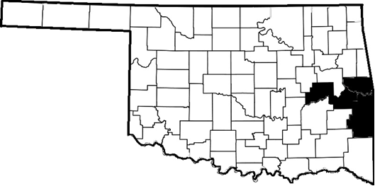
Figure 6: Map of Haskell, McIntosh, Sequoyah, and Le Flore Counties.
Historically, the four counties were home to Caddoan-Speaking Mound Builders (A.D. 850 to 1450), and Le Flore County is home to the Spiro Mounds, an archaeological site and tourist destination (O’Dell 2014). The area was also under the Osage empire, and was often a place of conflict between them, the Wichita, Caddo, Pawnee, Tonkawa, Chickasaw, and Choctaw (Burns 2004). After the removal of the Choctaw and Cherokee, along with their Freedman (Black Slaves) from their homelands to the region beginning in 1831 and 1809 respectively (Burns 2004, O’Dell 2014), the area known as Indian Territory encompassed all four counties.
White settlers had been in the area as early as the late 18th century trading furs and intermarrying with American Indians (Burns 2004), but larger influxes began in the 1850’s as Texas cattle drovers moved cattle north along the Texas Road from Texas to Kansas, more or less where the current U.S Highway 69 runs, and passes through Eufaula and Checotah in McIntosh County (Burrill 1972). In addition, settlers moved in from the east via Fort Smith, Arkansas to gain access to the fertile lands of the Arkansas Valley. Perhaps the biggest influx, however, was during the Civil War, as the Cherokee and Choctaw had sided with the Confederates. The Battle of Honey Springs was fought near present day Checotah in what would become McIntosh County on August 28, 1863 (O’Dell 2014).
After the war, there was increased migration into Indian Territories. This included a large immigration of African Americans who migrated from the southern states, as well as Freedmen, and established All-Black Towns, primarily in eastern Oklahoma (Humphrey 1973). The All-Black communities were self governed and self sufficient, a refuge and a place for political autonomy. Only 12 of the approximately 30 All-Black towns remain today (McAuley 1998), including Rentiesville, just north of Checotah in McIntosh County and home to famed author and historian John Hope Franklin (Franklin 1982).
After statehood in 1907, Haskell, and Le Flore counties were created out of the Choctaw districts, Sequoyah out of the Cherokee districts, and McIntosh out of the Muscogee Creek and Cherokee districts. All four counties had abundant coal, and mining brought in immigrants, especially Italian, German, and Irish, for menial labor (Wikett 2000). Cotton and corn were also grown in the valley, and timber production proved profitable in the more mountainous areas. During the 1905-1930 eras, Oklahoma, and parts of eastern Oklahoma, saw a rise in agrarian socialism, and a few key political offices were held by members of the Socialist Party (Bissett 1999). Additionally, the Industrial Workers of the World union was incredibly active in the region (Sellars 1998). The decline of the coal industry in the 1920s and the beginning of the Great Depression, however, would shift the economic production of the four county region.
After the plummet of cotton prices, the decline of coal mining, and the Great Depression, cattle ranching became more pronounced and is currently one of the primary economic drivers for the region, along with poultry production (O’Dell 2014). Timber and quarrying also contribute to the regional economy, as well as health care in Sequoyah County, with Fort Smith, AR in the near vicinity. The addition of Lake Eufaula in 1964 and the Robert S. Kerr Reservoir and Mclellan-Kerr Arkansas River Navigation System in 1970 generated shipping and tourism/ recreation economic opportunity, and the lake season is an important part of the regional economy (O’Dell 2014).
Oil and natural gas production has played a significant part of the modern economy; however, it is less productive than in other parts of the state. When I first arrived in eastern Oklahoma in 2010, natural gas production was booming, particularly in Le Flore County and Latimer County just to the south. Highways were overrun with natural gas equipment and fenced-off lots all along the highways were filled with parts and supplies. Within a year, however, they were gone, as natural gas supplies exceeded demand and operations moved. Agriculture, particularly beef cattle production, still remains at the center of the eastern Oklahoma economy.

Health and Place
The natural tall and low grass prairie that dominates the Arkansas Valley Plain and the Osage Cuestas make eastern Oklahoma well suited for cattle production, and most land in the area is dedicated to this enterprise, either for grazing or for hay. Not all cattle are produced on fulltime ranching land. Most cattle producers have primary employment outside of cattle production. The large amount of capital needed to produce cattle and the lingering extreme droughts of 2011 and 2012 threatened many a household.
The summer of 2012 was hot. In fact, Oklahoma set a record for the hottest month of average daily temperatures ever recorded in the United States. The year before was recorded as the hottest summer in the United States overall, and in some places, there were 100 plus days of temperatures over 100 degrees. The cattle industry was hit hard by lack of water, forage, and hay. Ranchers, and those who raise a few head here and there, were forced to sell off in order to keep afloat, and hay was being trucked in from surrounding states.
The early summer of 2013 was beginning to look better. My pond, which had dried up the year before was full of fresh spring rains, and the tall-grass prairie pasture was ready for its first cut. Our neighbor asked to cut and take the bales for his cattle, leaving a few for us, and we were happy to help. He did not recall a time when hay prices had been as high as they were last year, and he was excited about the quality of hay being produced this season. He was hoping to add a few more heifers to his heard, and this was the time to do it. He was also hiring a few guys to do some chores on his land.
His barbed wire fence that crossed the north side of his pasture had a few weak spots. It probably did not help that my dogs liked to sneak across the road and get into his pasture. We moved to our new home in eastern Oklahoma in 2010, not quite knowing how important cattle were to the economy. Within a month of moving, a cow had broken through the fence, and was standing next to our mailbox. I ventured out, not sure what I would do to keep the cow from getting in the road. Luckily, it turned out, cattle are extremely skittish, and as soon as my daughter and I approached, she bolted back into the pasture.
Over the next few years, we had several neighbors knock on the door asking permission to look around our land for loose cattle, and on more than one occasion we have been greeted by horses in the backyard. We have seen cows calve in open pastures, the calves run and play, tractors bring in hay on the coldest and iciest of days, and cattle trailers run up and down our road taking cattle to sale. Cows by far outnumber people, even after the herds had shrunk by over 11% due to the lingering drought.
The economic force of cattle production was on display as I drove down to Stigler to meet with Teresa Huggins, the CEO of HWC, to discuss the clinics history and get some additional information. Tractors, balers, and hay trailers were all about. Hay fields were being cut and baled. The farm supply stores were busy, semis pulling hay and cattle were filling up with diesel. More importantly, this was a time when men and women could earn extra money baling hay, working cattle, and performing other necessary chores. As I passed one particular ranch, I was reminded of my discussion with the owner.
“You don’t get sick when there is work to be done,” said the older gentleman, Jim, who has been ranching in the Stigler area going back to his grandfather. “We have to tend to our investment,” he continued, “cattle cost money, and you only get out of them what you put in.”
I had asked him what his thoughts were on the HWC in Stigler, and whether he supported federal money going to fund the clinic. “Well,” he started, “I know folks are sensitive to that kind of stuff.” After a pause, Jim continued, “but, a lot of folks around here would rather see tax money go to helping their neighbor.”
“I would rather pay my taxes to help the guys who help me out get their kids to the doctor, you know?” I asked him to explain a little more what he meant. “Well,” again Jim paused, taking his time as though he was feeling me out, “I can’t afford to pay for healthcare for these guys. Sometimes they only work a few days, maybe a month or two, but they work other jobs too, and they don’t get health insurance.” “Couldn’t afford it,” he continued, “they are hard working, good people.” “It ain’t right.”
I asked Jim if he, or any of the men he hired as hands, ever went without medical care. “Well sure,” he said definitively. “Like I said, you can’t get sick when there is work to be done. And these guys can’t risk paying a ton of money just to get a pill for a cold,” he added. “They take their kids to the Stigler Clinic (HWC), but they won’t go for themselves unless they feel like they won’t make it out alive.” “But,” he continued, “I tell people about the clinic, let them know what they do.” “Don’t be prideful,” Jim explained, “people have to take care of themselves, it catches up with you.”

Rural Health Research
The body of literature with rurality as a focus is quite large, especially in relation to health. Every state has an office of rural health, there are numerous academic journals, such as the Journal of Rural Health, and many an academic has made a career studying issues in rural health, or rural issues in general. The problem here, in relation to this dissertation, is that most of this research examines hospital and primary care access, and does not focus on the population health, or contextual issues surrounding rural places (Hartley 2004). In particular, much of this research, which I will discuss in the following chapters, focuses on aggregate comparisons between rural and urban areas, glossing over the tremendous variations within and between rural places (Ricketts 1999).
The concepts of place and space in relation to health were arguable lacking from research on rural health and medical anthropology, sociology, and geography until the 1990’s (Mcintyre 2002). Haan et al. 1987 stands as the benchmark research of place effects on health studies. Haan et al. (1987) compared mortality from the Human Population Laboratory in Alameda County. After adjusting for age, socioeconomic, health, and other social and physical variables, they find that differential mortality is significant between areas of poverty and those not labeled as poverty areas. This differential remains consistent and significant, even after individual and group adjustments are made to account for all other effects. In other words, living in an impoverished area had measurable health affects outside of socioeconomic status. Hann et al. (1987) was the first major study to provide significant data of place effects on health not entirely explained by individual health and risk variables.
Kearns and Joseph (1993) began a more theoretical approach to the study of place effects on health. Their article provides theoretical conceptualizations of space and place, as well as ways of defining them in contrast and in connection to one another. Kearns and Joseph (1993) argue that health studies should focus on the intermarriage of the two, particularly in terms of social theory and structuration. In their research, Kearns and Joseph (1993) use the example of Maori rural areas as being constructed as special places in terms of disease and health. This allows for the construction and influence of place as a meaningful cultural category of action and resistance, further effecting place and its reproductive effects on social relations.
Probst et al. 2004 continued the intersectional research of place by examining the relationship of rurality and race, arguing health disparities must be understood in the collective and contextual. Disparities, they argue, emerge from segregation within rural areas, as well as lack of educational and economic opportunity. Jiang et al. (2008) also find similar process at work on American Indian reservations, but add that local etiologies, or the localized way of explaining disease causation, are significant in increased rates of diabetes. Crooks (1999a and 1999b) also finds such intersectionality in poverty and rurality in relation to increased rates of overweight and obese in Kentucky.
Anthropology has not been a significant contributor to rurality in America. Given that anthropology has always been a discipline focused on the “Other,” not much interest was paid to the “otherness” within the American population, especially predominantly white “otherness.” Drew and Schoenberg (2011) are particularly attuned to this in their discussion of fatalism in their research of women’s choices in cancer diagnosis and treatment. Working with rural American Appalachian women, Drew and Schoenberg (2011) argue that though Appalachian communities are predominantly white, they are still marked as an “other.” Discourses of Appalachian life are often laden with iconic deictic forms to locate occupants in a nostalgic chronotope devoid of the modern world.
Stewart (1996) also finds this to be the case with Appalachian communities. The focus of research for Stewart (1996) is to understand the ways in which American cultures get labeled as “Other,” and the ways in which people marked as such provide their own discourses to negotiate the semiotics of markedness and carve out a discursive space in which they define themselves. Appalachian life, like much rural life, is socially marked as different, as not part of the American mainstream. I argue that Stewart’s (1996) work also shows the discursive abilities to label certain types of American “otherness” apart from the Anthropological gaze of “Otherness.”
There is no prestige in a cultural group being marked as “Other.” By definition it denotes difference from a privileged position (Min Ha 1989). On the other hand, “otherness” denotes difference within a privileged position, a markedness which bounds the difference as less significant, but still worth acknowledging. The problem here, as is evidenced in research on place and space, is that “otherness” is not seen as significant in health as “Otherness.” As Drew and Schoenberg (2011) point out, just because a community is predominantly white does not mean that “otherness” is not significant and differentiating.
Rural “otherness” is a significant social marking that does affect health regardless of other intersectional differences, such as race, gender, and class, as Probst et al. (2004) demonstrate. Rurality is a social determinant of health, and the research in rural health has shown that access to health care is a significant issue in rural areas (Hartley 2004:1676). Hartley (204:1676) points out, however, that evidence also shows that healthcare access makes up a small contribution to health outcomes. It is the list of contributing factors, such as lack of education, poor health understandings, and poor health behaviors that have the most affect. However relevant they might be, they also cause rurality to be a negative social markedness. Discursively, they semiotically mark rural populations as unsanitary and in need of intervention.
For instance, the long held view from a structural biomedical perspective that the poor, uneducated rural person would not understand the value of medical intervention, healthy choices, or mitigating risk is directly challenged by Drew and Schoenberg (2011). They argue that the contextual and historical configurations of rural places often limit agency and access to health. Further, historical relations between communities and medical systems lead to issues of trust and exposure, and localized idioms of fatalism often develop within community discourse as ways of copping and adapting to lack of health resources.
Prescribed explanations of rural behavior in terms of health are reminiscent of imperialistic explanations of cultural behaviors that took no account of emic (local, lived) perspectives. It is not doubted that rural areas, especially in Oklahoma, have: higher rates of poverty (See Table 1,3, and 4), especially intergenerational poverty (Maril 2000); poor health outcomes and health factors (See Figures 7 and 8); poor educational attainment (See Tables 3 and 4 ); and limited economic opportunities. These structural issues do indeed have negative outcomes, and I will discuss them in turn. The social labeling of rurality, however, often has negative, unreported effects on the population, such as marking them as unhealthy and incapable bodies (Briggs 2005, Briggs and Mantini-Briggs 2003).
In describing my research to other people, I have often been met with the response, “You’re working with the hillbillies?,” or, “What do they know about healthcare?” “Those hillbillies,” I argue back, “manage a multimillion dollar healthcare operation and do a much better job than anyone else ever has.” I have to admit, I take offense, not just from an anthropological perspective, but from a personal one as well. I live and work in this rural community, a community that has deep roots, deep connections to each other, and a resiliency to overcome all obstacles. This is a community that meets their own challenges and takes care
Figure 7: Ranking of County Health Outcomes in Oklahoma. HWC Service Counties are: HS, Haskell; SQ, Sequoyah; LF, LeFlore; and ML, McIntosh. Source: University of Wisconsin Population Health Institute. County Health Rankings 2011.

Figure 8: Ranking of County Health Factors in Oklahoma. HWC Service Counties are: HS, Haskell; SQ, Sequoyah; LF, LeFlore; and ML, McIntosh. University of Wisconsin Population Health Institute. County Health Rankings 2011.

Subject | Oklahoma | Haskell County | McIntosh County | Le Flore County | Sequoyah County
EMPLOYMENT STATUS | Total | Total | Total | Total | Total
Population 16 years and over | 2,924,464 | 9,907 | 16,506 | 39,266 | 32,515
In labor force | 62.7% | 50.2% | 46.2% | 54.5% | 55.8%
INCOME AND BENEFITS (IN 2012 INFLATION-ADJUSTED DOLLARS)
Median household income (dollars) | 44,891 | 37,771 | 32,669 | 36,084 | 36,191
Mean household income (dollars) | 60,788 | 49,109 | 43,010 | 46,836 | 47,998
With earnings | 77.5% | 64.2% | 60.2% | 68.8% | 68.5%
With Social Security | 30.0% | 44.0% | 48.7% | 36.9% | 38.1%
With retirement income | 17.2% | 14.5% | 22.9% | 17.8% | 16.6%
With Supplemental Security Income | 4.9% | 8.5% | 8.7% | 8.7% | 8.8%
With cash public assistance income | 3.4% | 8.4% | 4.4% | 5.1% | 5.3%
With Food Stamp/SNAP benefits in the past 12 months | 12.9% | 17.3% | 16.9% | 18.6% | 18.5%
Per capita income (dollars) | 24,046 | 19,511 | 17,729 | 18,033 | 18,641
HEALTH INSURANCE COVERAGE
Civilian noninstitutionalized population | 3,663,645 | 12,655 | 19,974 | 48,831 | 41,570
With health insurance coverage | 81.4% | 76.0% | 76.4% | 75.9% | 77.1%
With private health insurance | 62.3% | 47.1% | 46.6% | 49.2% | 47.3%
With public coverage | 31.1% | 43.3% | 45.8% | 38.1% | 40.8%
No health insurance coverage | 18.6% | 24.0% | 23.6% | 24.1% | 22.9%
Civilian noninstitutionalized population under 18 years | 925,028 | 3,203 | 4,291 | 12,275 | 10,697
No health insurance coverage | 11.1% | 16.0% | 18.2% | 16.3% | 15.4%
Table 3: Income and Health Insurance Status by County. Source: U.S. Census Bureau, 2008-2012 American Community Survey.

Subject |  | Oklahoma | Haskell County | Sequoyah County | McIntosh County | Le Flore County
 |  | Total | Total | Total | Total | Total
Population 18 to 24 years |  | 383,932 | 995 | 3,328 | 1,337 | 4,502
Less than high school graduate |  | 17.9% | 28.5% | 17.9% | 26.2% | 23.0%
High school graduate (includes equivalency) |  | 32.6% | 34.5% | 43.1% | 40.3% | 40.9%
Some college or associate's degree |  | 42.7% | 37.0% | 36.4% | 32.1% | 34.7%
Bachelor's degree or higher |  | 6.9% | 0.0% | 2.7% | 1.4% | 1.4%
Population 25 years and over |  | 2,438,321 | 8,563 | 27,905 | 14,635 | 33,270
Less than 9th grade |  | 4.7% | 8.3% | 6.1% | 6.8% | 7.5%
9th to 12th grade, no diploma |  | 9.1% | 15.7% | 12.4% | 13.8% | 12.5%
High school graduate |  | 31.7% | 34.0% | 40.8% | 37.2% | 37.2%
Some college, no degree |  | 24.3% | 19.5% | 20.4% | 23.3% | 22.0%
Associate's degree |  | 6.9% | 9.6% | 7.3% | 6.2% | 8.5%
Bachelor's degree |  | 15.6% | 9.7% | 9.4% | 8.3% | 7.6%
Graduate or professional degree |  | 7.7% | 3.3% | 3.5% | 4.4% | 4.8%
Percent high school graduate or higher |  | 86.2% | 76.0% | 81.5% | 79.4% | 80.0%
Percent bachelor's degree or higher |  | 23.2% | 12.9% | 12.9% | 12.7% | 12.4%
POVERTY RATE FOR THE POPULATION 25 YEARS AND OVER FOR WHOM POVERTY STATUS IS DETERMINED BY EDUCATIONAL ATTAINMENT LEVEL
Less than high school graduate |  | 26.4% | 23.6% | 30.3% | 26.8% | 32.2%
High school graduate (includes equivalency) |  | 14.6% | 11.7% | 16.9% | 22.3% | 18.2%
Some college or associate's degree |  | 10.7% | 13.7% | 13.5% | 19.1% | 16.3%
Bachelor's degree or higher |  | 4.1% | 3.0% | 2.9% | 1.7% | 7.0%
MEDIAN EARNINGS IN THE PAST 12 MONTHS (IN 2012 INFLATION-ADJUSTED DOLLARS)
Population 25 years and over with earnings |  | 31,452 | 28,039 | 28,737 | 26,201 | 26,254
Less than high school graduate |  | 19,265 | 18,750 | 19,087 | 16,741 | 16,105
High school graduate (includes equivalency) |  | 26,002 | 27,243 | 23,765 | 23,304 | 23,626
Some college or associate's degree |  | 30,902 | 26,034 | 30,607 | 25,024 | 27,074
Bachelor's degree |  | 42,299 | 43,608 | 39,060 | 38,571 | 37,345
Graduate or professional degree |  | 53,323 | 51,212 | 46,429 | 44,239 | 47,622
Table 4: Educational Attainment and Income by County. Source: U.S. Census Bureau, 2008-2012 American Community Survey.
of their own. This is a community that sees its way of life differently than others see them. More important, they do not view rurality as a handicap to better health, rather, they view rurality as an asset, and eastern Oklahoma as a place worth investing in.

A Brief History of HWC
“I’m going to put our history on the jump drive for you, and some advertisements,” Teresa said as she stared at her computer screen. “What else do you need?” “Anything you have,” I responded, “but can we talk about the history of Health and Wellness?” “It’s all in our grant application and some other place on here,” she replied. She looked up from her computer, sighed a bit, and said, “I just don’t think about it that much.” “I like where we are, and I am thinking about the future.” After a pause, she continued, “I want Health and Wellness to grow and become better.”
The initial planning that led to the creation of HWC began in 2001 when representatives from OSDH, the Oklahoma Board of Health, Haskell County Hospital Foundation, Haskell County Health Department, Carl Albert Mental Health Services, and various other businesses, community, and social health service agencies began a planning initiative to find solutions to address overwhelming health and poverty issues in Haskell County (HWC Policy Manual; Huggins, Personal Communication). The proposal from that initiative was to develop a proposed integrated health system that would serve as a “one-stop-shop” for health care for the under and uninsured population. It was identified that no one agency was capable of this, and a new agency would need to be created that could provided or contract the services needed to become a centralized medical home for patients who could not access conventional healthcare in the area.

The Health and Wellness Centers (HWC) was founded as a non-profit organization in 2003 and began FQHC operation in 2005 as the Stigler Health and Wellness Center. The early days of the clinic were hectic. Teresa Huggins had just been named CEO of the organization and was tasked with the “from scratch” development of the FQHC. Teresa did not have any experience in FQHCs, but some in social services, and a strong determination to learn whatever was needed to provide healthcare opportunities to her community.
Figure 9: Advertisement for the Sallisaw Clinic.
Photo 1: Grand Opening of New Checotah HWC Clinic
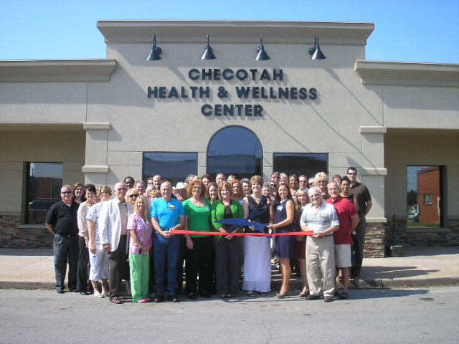
“Those first years were really tough, I don’t think they thought we could do it,” Teresa told me. “The consultant who came out before we opened, I don’t think he was too sure,” she continued, “but, when he came back last year, he was impressed, said we were a success story, that we should be a case study.”
The nine years since Teresa took the helm of HWC have been characterized by rapid growth and expansion. In 2008, HWC took ownership of the old Walmart building in Stigler, greatly expanding their capacity for patients as well as the services they can provide. Early expansion included the opening of clinics in Eufaula and Sallisaw. In 2011, HWC opened a clinic in Checotah, and in 2012, they opened a clinic in Poteau. Including the drugstore they own and operate in Stigler, HWC has a total of six service sites as of February 2014. Expansion into other underserved markets is well defined within the strategic plan of HWC.
The six service sites span the four counties, which cover a population of approximately 160,000. In 2012, HWC served over 15,000 individual patients through 63,000 clinical encounters. The last few years, HWC has been a $10-$12 million organization, employing approximately 120 health professionals. These include five doctors, twelve physician extenders (Physician Assistants, Nurse Practitioners), two dentists, 8 metal health providers, an optometrist, and three pharmacists.
HWC has a robust array of services that they provide. Mental health services are in great need in Oklahoma, and HWC provides them in house at all four clinical locations. In addition, the Stigler clinic has dental services, optometry, an optical store, and a new in-house pharmacy is currently under construction. All of the clinical locations are managed in a uniform manner, and served by an Electronic Health Record (EHR) system. HWC is also moving toward Patient Centered Medical Home (PCMH) accreditation (HWC 2013).
“When we started, we wanted to provide folks with a one-stop medical provider,” said Teresa. “A lot of times people think of FQHCs as a provider of last resort. We don’t want to be known as that,” she continued. “We want to be the provider of choice.” I asked her what kind of place she wanted the clinics to be. “We want to be a place of healthiness.”
In that effort, HWC recently revised their Mission Statement:

The Health and Wellness Center is committed to providing access to affordable quality primary and preventive health care services, in a compassionate manner, for area patients, in an effort to improve the overall health of our population.

Creating a place of healthiness is not just a slogan for Teresa and Brooke. When I first met Brooke in Poteau before they had begun operations in Le Flore County, she was discussing the HWC and their operations with the LeFlore County Coalition for Healthy Living. “You may not know this,” Brooke told the group, “but many of our patients at the Sallisaw clinic are from Le Flore County.” “I would not doubt that,” said an older gentleman from the coalition, “our residents struggle to find affordable health care.”
Brooke did not attend the coalition meeting just to inform them of the opportunities at the Sallisaw clinic. She was there to begin community development for future plans to expand operations into Leflore County. As Tables 3 and 4 show, there was clearly a need for local health access. The coalition members recognized this, and many of the group, who worked for community service agencies, the Choctaw Nation, and like myself, for state health agencies, had a long working history with HWC. During the meeting, they had nothing but praise for the work that HWC did in Haskell, Sequoyah, and McIntosh counties.
Gaining the support of the county coalition was the easy part. Gaining the support of the doctors, hospital administrators, and county leaders was more difficult. In two years time, however, they had managed to find clinic space and secure resources to open a clinic in Poteau that serves Le Flore and adjacent counties. In the interim, they had also opened a clinic in Checotah in McIntosh County. The rapid pace of growth was not just for financial reasons, but moral reasons.
“I am proud of what we do at Health and Wellness,” Brooke told the group in Poteau. “I don’t care what people think or say about it,” she continued. “All I care about is that we provide the best healthcare we can for the best cost we can and help our communities grow.” “We are all from these communities,” she stressed, “it is our responsibility to make sure we can do everything we can to make them healthy and prosperous.”
The connection of the HWC staff and administrators to their communities is not to be underestimated. In a modern health care environment where senior administrators move from hospital to hospital and from state to state, the connection to the service population and the context of their health is undervalued. Providers as well suffer from this, and some of the providers at HWC are indeed from other far off communities. The administration, and most of the nurses and frontline staff, however, call eastern Oklahoma their home, and have a deep, lived understanding of the contextual issues of health that HWC patients face. This connection is the cornerstone of their mission.

Chronotopes of Rurality
This connection is omnipresent and continuously entextualized into the discourses of wellness produced and circulated by HWC. This entextualization constructs the community as a metaphysical place of health and the HWC as its locus, tying the historical and contemporary together in unified discourses. These discourses may differ in the direct subjects being addressed, but they are always intertextualized with texts of community and wellness. These discourses carry within them chronotopes, which serve to generate meanings relevant to time, space, wellness, and healthcare.
Bakhtin (1981:84) describes chronotopes as a fusion of time and space where “space becomes charged and responsive to the movements of time, plot, and history.” The chronotope is a discursive structure in which representations of and meanings of landscapes, events, and history can be negotiated between groups and individuals. It is also an evaluative structural element of language (langue). In its usage (parole), chronotopes are indexical (Silverstein 2005); one text is brought to signal another to form an evaluative context in which interdiscursivity exists between other events and meanings across time and space to form a semiotic here and now. They create clear links between a constructed then and now within occupied places, allowing for continuity of meaning.
Chronotopes, especially when tied to landscapes and places, produce a human geography meaningful to those who occupy them (Blanton 2011:E78). As Basso (1996:74) noted, discursive chronotopes describe people in their relationship to landscapes and “how, in the fullest sense, they know themselves to occupy it.” Chronotopes both shape and are shaped by dialogic process of power relations responsible for the configurations of landscapes (Blanton 2011:E78, Massey 2000:283, and O’Reilly 2007:614). In the case of some of the discourses created and circulated by HWC, chronotopes are functional in that they are used to affect the denotation of rurality and the economics of healthcare, such as in the example below.
The following text, taken from the HWC Fiscal Year 2013 HRSA Consolidated Health Center Service Area Competition Grant Application (SAC Grant), was one of the historical documents that Teresa provided me. The text is found in the introduction to the narrative portion of the grant application where applicants explain the uniqueness of their service community. It is essentiality provides a way for FQHC applicants to entextualize the community with meaning specific to place as they compete nationally for federal FQHC Section 330 Health Center Grant Funds.
The text, taken as a whole, is a chronotope, connecting the temporality of Oklahoma as a space and locates the HWC within it. I have divided parts of it to show that even within chronotopes, multiple levels of indexicality operate to draw certain semiotic renderings of the past to stand in the present. This chronotope is created strategically to advance specific denotations of rurality that are traditionally not available in other webs of discourse, such as academic health research and federal health policy.

1) Oklahoma is not a place that breeds change for the sake of change. If
2) anything, it is a place where an "if it ain't broke, don't fix it" attitude reigns.
3) Oklahoma is home to the descendents of the pioneers and the many Native 4) American tribes who were forced here during the United States' western
5) expansion; people who through circumstance and hardship fostered a value 6) system respecting strength of purpose, of honor, and of faith. Such beliefs 7) have led to a culture that former Governor Brad Henry described as an
8) Oklahoma Standard, stating, "Resilience is woven deeply into the fabric of
9) Oklahoma. Throw us an obstacle, and we grow stronger."

In the opening of this narrative text, produced by HWC and existing within a discourse not of individuals, but a wider organizational, and even regional, discourse, Oklahoma is defined as a space of resiliency. Lines 1 through 6, in particular, draw the historical construction of Oklahoma as a space into the present. This history is devoid of the diversity of struggles from Oklahoma’s history (See Bissett 1999, Maril 2000, or Wickett 2000 for examples), rather the text brings forth a homogenized, shared history of obstacles and triumph. The glossing, primarily due to space constrictions, also serves to create an image of a culturally inclusive space, where pioneer and American Indian cultures contributed equally in the historical development of Oklahoma, and stand together in the modern struggles.
The Oklahoma Standard referenced in line 8 is, undoubtedly, a common narrative within Oklahoma. From the Dust Bowl and Great Depression, to the Oklahoma City Bombing of 1995, and the May 10th, 2003 and May 20th, 2013 tornadoes, Oklahomans have faced down harsh circumstances. Part of that Oklahoma Standard it is argued in lines 5 through 9, stem from the attachment to place and time honored values, inspiring rebuilding and an urge to conquer the land.

10) In many ways, the world does spin a little slower in Oklahoma, especially
11) in the rural areas. We speak a little slower and with a distinct drawl. We
12) continue to live our traditional values, relying less on technological
13) advances than are seen in other places. We still believe in the spirit of the 14) individual and that a handshake is as good as a contract.

In lines 10 through 14, we see the past starting to become “frozen” in place with the present (Silverstein 2005:8) through the interdiscursivity of tradition and modernity in rural Oklahoma. The markedness of rurality is directly addressed in line 11, taking ownership of non-SAE forms of speaking. There is also moral differentiation from urban communities in line 13, and more pointedly in lines 13 and 14. Here, we see tropes of honesty and hard work becoming evident, tying in to historical conceptualizations of Labor Omnia Vincit (Labor Conquers All Things), the state motto adopted in 1907. In line 15, we begin to see a focus on eastern Oklahoma, distinguishing it as a place where people come alive, interact, and make meaning of the landscape, rather than a space, a spatial designation with sociopolitical boundaries.

15) For visitors, eastern Oklahoma can be a bit like stepping back in time. If
16) you want cash for purchases, you go to the bank not the cash machine,
17) mom-and-pop stores line the main streets of many towns, and every
18) morning you can find large groups of local people at the favorite café
19) having breakfast or coffee with friends. News is not about the Fortune
20) 400 companies but about the 400 children at the elementary school
21) having a science fair or a concert. Discussions about local politics take on 22) the same importance as talk of national events. Children still play games
23) in open fields, the view stretches forever across skies dotted with fluffy
24) white clouds, doors are left unlocked, and the sounds of country music 25) can often be heard through open windows.

In lines 15 through 25 the text begins to define the rurality of eastern Oklahoma as a positive characteristic, highlighting local events and concerns (here) as more important than national (there). In line 15, which makes a clear connection of then and now within eastern Oklahoma, we also see recognition that outsiders (visitors) do not share these same values. Friends, family, and children are brought to the forefront of importance in the life of the community in lines 18 through 22. In lines 22 and 23, there is also an indexing of the safety and trust within this community as opposed to others.

26) The ability to see far across the land and out into the tree-lined horizon
27) replaces views of huge buildings and traffic jams. Almost everyone wears 28) Levis and Wranglers unless going to church, a time for folks to put on
29) their "Sunday best." Pick-up trucks and family sedans far outnumber
30) sporty vehicles and cowboy boots are often the footwear of choice. Home
31) is the wide-open blue skies, the lakes and creeks teeming with fish, the
32) church spires stretching up to heaven, the sound of raucous celebrations
33) and laughter with family and friends, and hearing people say y'all in that
34) Oklahoma drawl. It is knowing that in times of trouble, friends and
35) neighbors will be there to lend a helping hand.

In lines 26 and 27, a clear demarcation between rural and urban is made, highlighting a connection to the land, which is reinforced in lines 28 through 32. But we also see recognition of social marking, particularly through clothing in lines 26 through 29, language in line 33, vehicles in lines 29 and 30, and religion in lines 28, 29 and 32. Clear boundary work is being performed, and in many ways, this text works to define something of an ethnicity (Barth 1998 c1969). Yet, these differences never quite move beyond the boundary maintenance of cultural distinction.
Eriksen (1993:4), in an attempt to define the concept of ethnicity, argues that “it refers to aspects of relationships between groups which consider themselves and are regarded by others as being culturally distinctive.” There is a clear attempt to “divide the social world into types of people” (Eriksen 1993:24), within this text, but there is no clear distinction of the relationships between the “us” and “them” being denoted. This is an important feature of the uniqueness of the “otherness” that is being marked on rural white populations. The “otherness” is clearly defined, but the rules for interactional relationships are not (Barth 1998:17).
In lines 34 and 35, there is clear indication that the community provides support for those ‘down on their luck.’ This clearly echoes earlier discussions of Teresa and Brooke, that there is a social responsibility to provide help to “our” community members. Further, that help is not anonymous; it is from neighbors and community members (here), not centralized agencies from the city (there).

36) In our world, parents teach children to say Ma'am and Sir when speaking
37) to adults. Church socials and community festivals abound, celebrating the
38) unique aspects and the pride in the communities we call home. County
39) fairs are held all summer long- with contests for the best
40) canning/preserving and quilting still seen years after these skills ceased
41) being necessary for survival. Children and teens are involved in the
42) raising of farm animals, which will hopefully win a ribbon at the fair;
43) proof that they have fostered and fed, bathed and groomed a champion.
44) Perhaps the most anticipated events are those surrounding the rodeos;
45) these are a source of pride and bragging rights sure to ignite the
46) competitive spirit of many a cowboy and cowgirl.

Lines 36 and 37 further maintain the us/them distinction, drawing on tropes of politeness and respect, suggesting that those outside of the community do not share these values. Values of religion, community, and family are further reinforced in lines 37 through 41. A connection to the landscape, not just towns and local communities is also developed, as is the competitive nature of honoring traditions tied to the past. Pride and hard work are also indexed in lines 38-43, as they are below.

47) Say what you will, call us hicks and rednecks if you must, just understand
48) that in Oklahoma, pride runs deep. We know who we are and where we
49) came from. This sense of self is part of what makes us special. Never
50) forgotten, though rarely voiced aloud, is the recognition of and respect for
51) the lives and heritages of the many people that have come to call
52) Oklahoma home. Within the relatively short time since statehood was
53) granted, many Oklahomans have made significant contributions to the
54) nation. From astronauts to ambassadors, politicians to physicists, and
55) cowboys to Native Americans, Oklahoma's sons and daughters have
56) changed the world.

Lines 47 through 54 are perhaps the most powerful part of this text in regards to the semiotic negotiation of rurality by the HWC community. Line 47 in particular takes ownership of the pejorative labels of “hick” and “redneck,” and challenges others to renegotiate the meaning of those discursive labels. Labels such as “hick,” “redneck,” and “hillbilly” inscribe an historical “otherness” on to the occupants of a separated landscape. These destructive lexical items have historical connotations of backwardness, lack of education, and being unsanitary, which, in some contexts of public health research, is reified through the authoritative voice of science and academia.
In line 48, the chronotope expands to include all of Oklahoma, defining a place that is remembered in the present, that the struggles of the last 150 years live inside all who call Oklahoma home (Line 52). Lines 52 through 56 directly challenge the notion that Oklahomans, and rural ones in particular, are not capable of modernity. The modern and historical contributions of Oklahomans become interdiscursive with the cultural ascriptions and inscriptions of rural eastern Oklahoma and they are in turn (re)entextualized within a landscape, intertextualized with the popular notions of how Oklahomans ought to be (line 47).

A Place Worth Investing In
It should not be assumed that the above text from the HWC speaks for every resident of the four county service area. Not everyone wear cowboy boots every day, not everyone listens to country music, and not everyone shares the same Christian values that where highlighted in the text. There exists, however, the common denominator of rurality, as well as the negative stereotypes that are indexed through the term. Some residents “own” rurality, and encompass the symbols, such as language, vehicles, and clothing, to mark them as such. Others are less direct, but nonetheless there is a pride in eastern Oklahoma that permeates everyday discourse.
Sallisaw, the home of fictional character Tom Joad, from John Steinbeck’s The Grapes of Wrath, is particularly attuned to the negative connotations of rurality. Joad came to symbolize the Dust Bowl Okie, even though Sallisaw, in eastern Oklahoma, was not particularly hard hit by the Dust Bowl. The character, which to many readers across Oklahoma came across as backward, uneducated, and a problem for society, was not well received in Sallisaw, or eastern Oklahoma at large, when the book was first published. Tom Joad, of course, was meant to symbolize morality and goodness in the face of adversity, but the description left a lasting negative image of the poverty and rurality of Oklahoma. It cast the community in a negative light, and even today, the image endures (Maril 2000).
The description, however, was not entirely inaccurate. Oklahoma suffers from devastating intergenerational poverty, low wages, poor health, and poor educational outcomes. What was missing in Steinbeck’s description was the sense of pride, of hard work, dedication, and a connection to place that kept families and communities rooted in Oklahoma. That sense of pride was well constructed in Oklahoma!, the musical by Rodgers and Hammerstein. The HWC picks up on both of these issues in their text above and below, which is found later in the same document.

57) What a tragedy that in Oklahoma - home of the "wavin wheat" and
58) "corn as high as an elephant's eye" (lyrics immortalized in the musical,
59) Oklahoma) – so many people are doing without food.

There is a direct token-sourced interdiscursivity strategically employed here to bring a fictional historical representation of Oklahoma! to coexist and contrast semiotically with the actual modern Oklahoma (Silverstein 2005:9). The pride and bounty invoked in Oklahoma! is contrasted with the shame and need felt in modern day reality of Oklahoma. Through this interdiscursivity, time is absent, bringing the two images to an equivalent plane to be debated. There is a search for meaning in the discrepancy that exists, a search for an explanation of how things went so terribly wrong.
Through this chronotope, the HWC constructs a discursive world where the negative denotation of rurality is contested. They produce a discourse of health that turns its focus away from negative stereotypes of nonurban space occupied by aggregated, statistical individuals who are sick, uneducated, poor, and unsanitary. They instead create a rural place composed of proud, hard working people helping each other to overcome the structural barriers to wellness. They argue that these are not communities that need to be saved from themselves, rather, they create places of potential health and prosperity, communities worth investing in.
In the chapters that follow, four genres of return on the investment of federal and state dollars identified in discourses surrounding HWC are analyzed. Particular attention is paid to the interdiscursive webs in which these discourses travel and the semiotic negotiation of rurality as it relates to health outcomes. Further, I highlight the communicability of wellness in constructing rural places to combat the medicalization and projection of “otherness” that so often arises in biomedical discourse from without the community.

Chapter 5: Economic Return on Investment
Summer time at Lake Eufaula is a time honored tradition in Oklahoma, dating back to when the lake was first developed in 1964. The lake, which has over 600 miles of shoreline, is an ideal location for summer homes, boating, fishing, and other recreational opportunities. During the summer, the population of Eufaula expands greatly, and these months are vital to the local economy. There are concerts, festivals, and tens of thousands of out-of-towners who come in for the weekend. Traffic headed east on Interstate 40 from Oklahoma City is heavy on Fridays and Sundays during the peak of lake season. During the rest of the year, however, Eufaula is a quiet little town nestled in the hills along Highway 69.
Most that visit enjoy the small town feel of Eufaula, which has an historic looking downtown with trendy country shops and antique stores. A few diners and restaurants operate in the downtown area, and the local grocery store stays busy during the summer months. Few of the visitors, however, get a true perspective of Eufaula, the surrounding towns, or McIntosh County in general. Hidden out of site are hard working people struggling to get by at jobs that pay minimum wage or just slightly above. Those that have jobs are fortunate; the unemployment rate in December 2013 was the fourth highest of the 77 Oklahoma counties at 7.8%.
Eufaula, like the other communities in the HWC medical service area, suffers from high rates of poverty and uninsurance, especially for those under 18 years of age (Table 3). In my time with OHCA, we struggled to reach out to those without insurance, primarily because they lacked transportation or the time to visit with us. We, in turn, did not have the workforce to meet them in their homes or at work. HWC, however, took the initiative to assist in the enrollment of uninsured children in SoonerCare by installing dedicated computers in their lobbies to provide an opportunity for parents to sign up their children. They partnered with Ki Bois Community Action, the local Community Action Agency who provide much needed services to a large county service area and supplied the computers to HWC. At OHCA, we were delighted as we had recently changed to online applications for SoonerCare.
While the computers were only effective if underserved patients came in to be seen at the clinic, they were a sign of the commitment of HWC to the overall health and wellness of the McIntosh County community. The computers provided a way to lessen the administrative burden on HWC staff by letting patients apply and know immediately if they, or more likely their child(ren), was eligible for SoonerCare. This helped the patient by not having to decide over food in the fridge or medical care, and helped the clinic by knowing whether or not they could bill OHCA directly. More importantly, it brought patients into the clinic that may have otherwise gone to the hospitals in Eufaula, Muskogee or McAlester to seek medical attention through the emergency room.
The Eufaula clinic of HWC is housed in the former clinic of a private family practice provider, and is one of a few providers in the area. It is also the only one that will see patients on a sliding fee schedule. Prior to HWC opening their Eufaula Clinic, underinsured community members had limited options for seeking medical care. “We had, and still do, have families that will not get the medical care they need because they simply cannot afford it,” Susan told me as we sat in a coalition meeting at a local restaurant in Eufaula. “They would either go to the emergency room, or they would have to travel to Muskogee or McAlester, and the price of gas made that hard.”
“People take transportation for granted,” added David, who helped run a nonprofit in Eufaula that provided social services not readily available at DHS or the County Health Department and took regular part of the coalition meetings. “For some families, they may not have a car and have to rely on other family members.” “A trip to the doctor,” David continued, “could mean not having enough gas to get to work, or having to pay for it with money set aside for food or rent.”
Joy, a life-long resident of Eufaula and member of the McIntosh County Coalition was particularly concerned with kids not getting enough food to eat. “We have a program where we provide a backpack full of food for our school kids so they can eat over the weekend.” “You should see their faces,” she continued, her eyes tearing up, “they’re so happy to have the food, but you can also see the sadness, the shame. The parents don’t want to look you in the eye.” She paused for a minute before continuing. “We are hard working people out here. These families are not lazy, living off the system, or anything like that.”
“Poverty is inherited,” explained Susan as we all sat around eating lunch. “Some of these families have been living out here for three or four generations, and they can’t afford to just move or start over at college.” Susan had worked with many of these families through DHS and other programs over the last 15 years. “When families face these situations, sometimes the structure, the behavior of the family breaks down, and it is just so destructive. But, sometimes, when we get them help, counseling, like at HWC, or with our agency, we can get them on the right path and break the cycle.”
Intergenerational and persistent poverty is widespread in Oklahoma (Maril 2000). In 1960, 26.2 % of families in Oklahoma were in poverty compared to 18.4% of all U.S. families (Maril 2000:91). In 2012, the U.S. Census Bureau estimates that 19.6% of Oklahoma families live in poverty compared to 17.2% of all U.S. families (US Census 2014). While there is a significant decline in poverty, the fact that Oklahoma families are more likely to be impoverished has not changed. Further, as Maril (2000) argues, poverty is not seen as a widespread problem; there is a myth in Oklahoma that poverty is not as prevalent as it is.
From the point of view of more prosperous Oklahomans, this may seem a reality. They can zoom past impoverished communities on the interstates and highways, or in the case of Eufaula, spend time at the lake without having to witness the out of sight suffering of other Oklahomans. For a state with a rising national profile and a booming economy in the urban areas, the rural and urban poor are easily overlooked, much as they were in the oil boom era of the 1960s-1980s. In rural areas, such as McIntosh County and the other HWC service counties, the economic gains in Oklahoma of the last ten years are not as noticeable.
One afternoon in the winter of 2013, I sat with a woman who had asked me about the HWC clinic in Eufaula after a meeting with local state representatives about economic initiatives in the region. “My husband worked on the rigs for the past few years,” Jami started, clearly nervous about talking with me. “Now he is out of work, all the rigs (oil drilling operations) have shut down, and he doesn’t want to travel out west, or go to North Dakota. We had good insurance, but now we can’t afford to go to the doctor. They keep saying they will start drilling again, so he doesn’t want to leave, but we can’t wait much longer. We have to pay for his truck, because he can’t work without it…but there is no work right now.” “I keep telling him to go to the Career Tech,” Jami added, thinking he could get training for a new skill, “but that costs money too.”
I asked Jami how long it had been since he had worked. “He had all the work he wanted up until about a year ago, then he started getting less work. He monitored and fixed the equipment, but they started taking it all out of here.” “He would have to travel farther and farther, and soon it was not worth the gas to get out to the fields,” Jami continued. “And we aren’t the only ones, a lot of folks lost those good jobs…some found other work. There is not much work for someone who fixes compression equipment out here, and we can’t leave because our parents rely on us to help them. We’re stuck.”
Stuck is a good way to describe the economy of eastern Oklahoma. Agriculture, natural resources, and healthcare make up the bulk of the economy. For most urban Oklahomans, about 65 percent of the state’s population in 2010 (Census 2014), agriculture is not a normal part of their everyday life, nor is oil and natural gas. For most Oklahomans, all they perceive through the media is that both industries are a vital part of the state’s economy and provide numerous jobs and wealth. That wealth, however, is concentrated in Oklahoma City (OKC). Devon Energy just completed building the largest skyscraper in OKC, Chesapeake Energy has a sprawling campus in the metro, and Continental Resources recently relocated to OKC from Enid. What is not known to the majority of Oklahomans is the shifting dynamic of agriculture and resource extraction and their economic effects in rural areas.
With the drought and the shifting of oil and natural gas drilling, healthcare often makes the largest stable impact on eastern Oklahoma communities. This impact is so great that the Oklahoma State Department of Health Office of Rural Health and the Oklahoma State University Oklahoma Cooperative Extension Service publish regular reports on the economic impact of healthcare in rural regions through their Oklahoma Rural Health Works program. Additionally, members of this group regularly publish research through academic journals. What has become abundantly clear in this research is that without rural hospitals and clinics, the economic situation in most rural areas would likely collapse even further.

Rural Health Economics Research in Oklahoma
Oklahoma researchers, primarily from the Agricultural Economics Department at Oklahoma State University have been prolific in providing rural economic studies, particularly with an emphasis on healthcare. Healthcare, as Brooks et al. (2013) note, is an increasingly vital part of the rural economy. In 1970, healthcare made up 7.2% of the U.S. Gross Domestic Product (GDP) with average per capita costs of $356, and annual expenditures of $74.9 billion. By 2011, healthcare made up 17.9% of the GDP with per capita costs of $8,680 and annual expenditures of $2,700.7 billion. It is estimated that by 2021, healthcare will make up 19.6% of the GDP with per capita expenditures of $14,103 with annual expenditures of $4,781 billion (Brooks et al. 2013).
For rural Oklahoma counties, rising expenditures create a barrier to healthcare in that rates of uninsurance are usually much higher than urban areas. There are also fewer healthcare providers. In many ways, however, healthcare provides economic stability to rural counties as a higher than average percentage of the workforce tends to be employed in healthcare occupations. Additionally, healthcare jobs typically pay higher wages on average compared to other occupations in rural communities, even though rural healthcare wages tend to be lower on average than urban healthcare wages (Doeksen et al. 2013a, 2013b, 2013c, 2013d). As Doeksen et al. (1998) noted, healthcare contributed to approximately 14% of employment in rural Oklahoma, directly and indirectly.
Doeksen et al. (1998) has been a prominent scholar in identifying the economic impact of the health sector in Oklahoma, individual counties, and other medical service areas both nationally and internationally (Doeksen 2007, Doeksen et al. 2009, St. Clair and Doeksen 2011). The model used by Doeksen et al. (1998) expands and improves upon the input-output models developed by Miernyk (1965), which capture indirect and induced behavior of the economy (Doeksen et al. 1998:68). By defining the structural interrelationships of an economy, it is possible to determine how the overall economic activity changes through the relationships with observed economic changes (Doeksen et al. 1998:68).
For example, demand for health services in a particular community rises, so a hospital hires a new doctor for their services, and the doctor spends their income on goods and services. This creates opportunity for retail and hiring, which leads to more wages, and hence more spending. Thus, the dollar is multiplied as it moves its way through the economy. Additionally, the hospital will purchase equipment and supplies, leading to affiliated companies that will provide those services, creating more jobs, payroll, and spending. For every new job, the economic effect of the hospital becomes greater, as it generates more spending and revenue. Should one of the inputs, such as demand or ability to pay change, however, then the outputs also change. There will be decreased spending and thus decrease wages and economic opportunity.
Doeksen et al. (1998) utilized IMPLAN computing software developed by the U. S. Forest Service that can construct region input-output models and develop multipliers that describe the effect that certain economic activity will have on the overall economy. They found, for example, that in nine Oklahoma counties, the employment of one person in a hospital will lead to 0.46 additional employments in other sectors of the economy, thus there is an identified multiplier of 1.46 through direct, indirect, and induced effects of the initial employment. This means that with 65 employees at hospitals, 30 additional individuals are employed in the economy (Doeksen et al. 1998:71). Additionally, healthcare income is multiplied 1.43 times throughout an economy; $1,561,968 in hospital payroll induces an additional $885,000 in payroll across the economy (Doeksen et al. 1998:71). Doeksen and colleagues have since contributed regular health sector economic impact analyses for various regions and counties of Oklahoma.

Haskell County
The most recent report for Haskell County, Whitacre et al. 2006, shows that the economic impact of healthcare is particularly strong. Based on 2004 IMPLAN database computations, the Haskell County health sector provided 523 direct jobs with a multiplier of 1.24 for an overall economic effect of 649 jobs. The direct jobs (523) provided $16,145,228 in income with a multiplier of 1.21 for an overall economic impact of $19,518,883 annually. Additionally, retail sales from healthcare entities contributed $5,990,303 and $59,902 in one cent sales tax to the Haskell County economy in 2006 (Whitacre et al. 2006:10).
Doeksen and colleagues have also begun providing county information reports through Rural Health Works which provide much needed data to health and community developers. Figure 10 shows the percentage of the 2011 full and part time workforce employed in the top four occupations for residents of Haskell County (Doeksen et al. 2013b). These numbers represent residents of the county and their occupation, not necessarily the economic activity in the county (some residents are working in other counties). Healthcare workers residing in Haskell County generated $45,614,000 in earnings, while farm employment contributed $13,978,000, retail contributed $15,610,000 and mining contributed $19,106,000 in 2011. Despite this, Haskell County had a 6.9% unemployment rate, 20.2% persons in poverty rate, and a 31.2% children in poverty rate (Doeksen et al. 2013b).
Figure 10: Percentage of Employment in Top Four Employment Sectors for Haskell County.

Sequoyah County
The most recent report for Sequoyah County, Brooks et al. 2010b, shows that the economic impact of healthcare is much stronger than in Haskell County. Based on 2008 IMPLAN database computations, the Sequoyah County health sector provided 862 direct jobs with a multiplier of 1.26 for an overall economic effect of 1,087 jobs. The direct jobs (862) provided $35,406,716 in income with a multiplier of 1.18 for an overall economic impact of $41,836,638 annually. Additionally, retail sales from healthcare entities contributed $8,216,716 and $82,167 in one cent sales tax to the Sequoyah County economy in 2008 (Brooks et al. 2010b:25).
Figure 11: Percentage of Employment in Top Four Employment Sectors for Sequoyah County.

Figure 11 shows the percentage of the 2011 full and part time workforce employed in the top four occupations for residents of Sequoyah County (Doeksen et al. 2013d). These numbers represent residents of the county and their occupation, not necessarily the economic activity in the county (some residents are working in other counties). Healthcare workers residing in Sequoyah County generated $60,107,000 in earnings, while farm employment contributed $5,260,000, retail contributed $53,808,000 and government employment contributed $157,250,000 in 2011. Despite this, Sequoyah County had an 8.5% unemployment rate, 20.8% persons in poverty rate, and a 32.4% children in poverty rate (Doeksen et al. 2013d)

McIntosh County
The most recent report for McIntosh County, Brooks et al. 2010a, shows that the economic impact of healthcare is more comparable to Haskell County than Sequoyah County. Based on 2008 IMPLAN database computations, the McIntosh County health sector provided 332 direct jobs with a multiplier of 1.31 for an overall economic effect of 434 jobs. The direct jobs (332) provided $14,634,575 in income with a multiplier of 1.12 for an overall economic impact of $16,382,260 annually. Additionally, retail sales from healthcare entities contributed $4,292,152 and $42,922 in one cent sales tax to the McIntosh County economy in 2008 (Brooks et al. 2010a:25).
Figure 12 shows the percentage of the 2011 full and part time workforce employed in the top four occupations for residents of McIntosh County (Doeksen et al. 2013c). These numbers represent residents of the county and their occupation, not necessarily the economic activity in the county (some residents are working in other counties). Healthcare workers residing in McIntosh County generated $26,213,000 in earnings, while farm employment contributed $3,250,000, retail contributed $37,481,000 and government employment contributed $55,267,000 in 2011. Despite this, McIntosh County had an 8.6% unemployment rate, 24.5% persons in poverty rate, and a 33.6% children in poverty rate (Doeksen et al. 2013c).

Figure 12: Percentage of Employment in Top Four Employment Sectors for McIntosh County.

Le Flore County
The most recent report for Le Flore County, Brooks et al. 2013, shows that the economic impact of healthcare is more comparable to Sequoyah County than Haskell and McIntosh Counties. Based on 2011 IMPLAN database computations, the Le Flore County health sector provided 811 direct jobs with a multiplier of 1.15 for an overall economic effect of 931 jobs. The direct jobs (811) provided $43,023,551 in income with a multiplier of 1.17 for an overall economic impact of $50,344,687 annually. Additionally, retail sales from healthcare entities contributed $11,831,001 and $118,310 in one cent sales tax to the Le Flore County economy in 2011 (Brooks et al. 2013:27).
Figure 13: Percentage of Employment in Top Four Employment Sectors for Le Flore County.

Figure 13 shows the percentage of the 2011 full and part time workforce employed in the top four occupations for residents of Le Flore County (Doeksen et al. 2013a). These numbers represent residents of the county and their occupation, not necessarily the economic activity in the county (some residents are working in other counties). Healthcare workers residing in Le Flore County generated $61,501,000 in earnings (Brooks et al. 2013:7), while farm employment contributed $32,393,000, retail contributed $52,205,000 and manufacturing employment contributed $59,853,000 in 2011. Despite this, Le Flore County had a 9.5% unemployment rate, 20.4% persons in poverty rate, and a 26.7% children in poverty rate (Doeksen et al. 2013a).

The Importance of Healthcare for Rural Economies
As the above data show, healthcare is a vital element of rural eastern Oklahoma economies. At the state level, healthcare sector employment accounted for 16.8% of the total state employment for Oklahoma (Brooks et al. 2013:7). Only McIntosh County’s healthcare employment percentage, 10.8%, falls below the state percentage. Sequoyah, Haskell, and Le Flore Counties had healthcare employment percentages of 18.6%, 24%, and 28%, respectively. Haskell and Le Flore in particular had one quarter of their population employed in the health sector. Should anything happen to disrupt that employment, the results would be catastrophic to the local economies.
Healthcare, as shown above, generates economic activity well beyond the direct employment of health professionals and their payroll. Brooks and Whitacre (2010) find that Critical Access Hospitals (CAH) have a significant positive impact on rural economies. CAHs are CMS designated hospitals in rural areas with 25 beds or less that receive federal subsidies, similar to FQHCs, and provide care traditionally associated with hospitals, especially 24-hour emergency care (See HRSA 210 for more detailed discussion). Because the free market is often not able to support rural hospitals, CAHs, as designated under The Balanced Budget Refinement Act of 1999, are eligible for enhanced Medicare and Medicaid payment and other support and grant opportunities (Brooks and Whitacre 2010:30).
In Oklahoma, Brooks and Whitacre (2010:35) found that the presence of a CAH in a rural community has a positive and significant effect on retail activity. Through their empirical study of 105 rural Oklahoma communities, they found that the presence of a CAH positively impacts retail activity by up to 27.6%, similar to the positive effect, 26.5% that a Walmart store presence has on small rural towns (Brooks and Whitacre 2010:35). They argue that because CAHs provide significant return on investment, continued support of CAHs is an important economic strategy that benefits communities in both physical and financial health (Brooks and Whitacre 2010). The two together have a more significant effect on the overall wellness of a community.
CAHs, and FQHCs as well, also offer workforce development opportunities. Nelson and Wolf-Powers (2009) argue that health care based economic development through the potential of hospitals to offer low-and semiskilled workers employment and advancement opportunities is comparable to other employment sectors such as: accommodations; legal services and securities; and commodities. These opportunities for improvement of the well being for low income workers is a place for more serious attention and investment from the economic and workforce development sectors.
The effectiveness of the current CAH program, however, has come under significant scrutiny. As Lawler et al. (2003) found in their study of 15 rural Oklahoma hospitals that underwent conversion to CAHs, the financial benefits of conversion often do not fully cover losses for rural hospitals. All 15 of the hospitals studied by Lawler et al. (2003) had posted losses prior to conversion. After conversion, ten of the hospitals were still posting loses a year after converting. Most, however, were able to significantly reduce their losses, and only one hospital had a negative net change (Lawler et al. 2010:137). Ona and Davis (2010) found similar results in Kentucky.
As important as these studies are, they do not provide a complete picture of the impact of the healthcare sector on local economies. The most significant critique I have is there is a failure to incorporate FQHC clinical operations as an area of focus, relying instead on hospitals as the main economic driver. This is understandable as data are not easily separable, and in some counties of the HWC service area, a HWC clinic may not have been in operation at the time of reporting. Whitacre et al. (2006) were the only ones to include HWC in their analysis of the health sector on local economies for the HWC service region. That impact, however, was analyzed while HWC was in its infancy. In many cases hospitals may be the prime economic driver of health sector economies but as FQHCs, particularly HWC, continue to evolve, their impact must be measured in their own terms to understand their unique impact.
A second critique is the overemphasis on CAHs as the prime mechanism to measure and improve rural health’s effectiveness. This is unfortunate, as FQHCs, when managed well, can provide unique resources and flexibility to meet urgent rural health and economic needs, which I will provide an example of below. Further, it does a disservice to the academic mission of fully understanding rural health in Oklahoma. By omitting one piece of the puzzle, either willingly or unwillingly, the full picture will never be seen. There is significant evidence across the state that this focus and the effort to omit the impact of FQHCs was intentional on part of the now retired leadership of the Oklahoma Office of Rural Health, which I will discuss more thoroughly in chapter seven.
My last critique, and the one I aim to most fully address in this dissertation, is that FQHCs have not been studied from a qualitative perspective in Oklahoma. Economics and health are not only quantifiable processes; they are lived experiences, much as the opening of this chapter shows. Rural poverty and healthcare must be measured both quantitatively and qualitatively in order to make any significant progress in understanding the dynamics of place, health, and economics. In order to provide a fuller picture, below I present the economic benefit of HWC in both quantitatively and qualitatively.

The Economic Impact and Return on Investment of HWC
The economic impact of the HWC clinics has not yet been previously calculated as they stand on their own. The overall impact on the county service area is remarkable in terms of the revenue and payroll generated through clinical operations. In 2012, for instance, HWC employed approximately 104 Full Time Equivalent (FTE) positions across the four county medical service area. Those positions generated $4,276,575 in salaries and $705,407 in employee benefits, with an average salary of $42,121. The clinics generated $6,729,307 in clinical and associated revenue and $1,422,762 in pharmacy revenue. Grant revenue for the year was $2,434,670, of which $1,706,501 came from CHC Section 330 grant funds. The clinics provided 58,040 medical encounters to approximately 16,000 individual patients.
In 2011, HWC employed 101 FTE, generating $3,833,918 in salaries and $577,478 in employee benefits, with an average salary of $37,960. The clinics generated $6,016,323 in clinical and associated revenue, and $1,243,478 in pharmacy revenue. Grant revenue for the year was $1,522,971, of which $1,390,743 came from CHC Section 330 grant funds. The clinics provided 52,657 medical encounters to 14,966 individual patients.
The economic impact is quite substantial in generating higher than average salaries across the four county region, and from 2011 to 2012, HWC’s impact grew significantly. The total induce effect is even greater. As IMPLAN is cost prohibitive to this study, I will rely on the IMPLAN models provided by Brooks et al. 2010a (McIntosh County), Brooks et al. 2010b (Sequoyah County), Brooks et al. 2013 (Le Flore County), and Whitacre et al. 2006 (Haskell County). While this not ideal, these studies have been conducted recently and by professionals who specialize in this area. This provides a relatively safe estimate of the economic impacts that is suitable to the needs of this study. A more thorough examination of the economic impact of the HWC service area should be conducted in the future by a dedicated quantitative researcher.
The IMPLAN multipliers associated with Physician, Dentists, and Other Professionals is used, with the mean of the multipliers of the four counties used to estimate the effect across the entire medical service area. The multipliers identified are as follows: Brooks et al. 2010a (McIntosh County), Employment 1.31, Income 1.12; Brooks et al. 2010b (Sequoyah County), Employment 1.40, Income 1.19; Brooks et al. 2013 (Le Flore County), Employment 1.33, Income 1.18; and Whitacre et al. 2006 (Haskell County), Employment 1.27, Income 1.15. The average of Employment for the four county medical service area is 1.32, and the average for Income is 1.16.
Additionally, I have taken the revenue and pharmacy multipliers from Doeksen et al (1998:71) in an effort to show the impact of non-grant revenue and pharmacy revenue on the local community. Revenue is particularly important because it provides funding for purchase of local goods and services, tax receipts, and assets which are used to purchase land, facilities, and are invested and held in local banks. HWC has made a commitment to ensure that assets are held in local community banks. In addition, current fixed assets and long-term debts such as mortgage loans have positive impacts on the local economy. Most of HWC clinics are properties that might otherwise devalue, driving down property prices in the local areas.
Economic Impact of Health and Wellness Clinic in Medical Service Area
 | 2012 | 2011
Employment
Direct Employment | 104 | 101
Multiplier | 1.32 | 1.32
Total Employment | 137 | 133
Income
Direct Income | $4,276,575 | $3,833,918
Multiplier | 1.16 | 1.16
Total Income | $4,960,827 | $4,447,345
General Revenue
Direct Revenue | $6,729,307 | $6,016,323
Multiplier | 1.47 | 1.47
Total Revenue | $9,892,081 | $8,843,995
Pharmacy Revenue
Direct Revenue | $1,422,762 | $1,243,478
Multiplier | 1.92 | 1.92
Total Revenue | $2,731,703 | $2,387,478
Income and Revenue Total | $17,584,611 | $15,678,818

Table 5: Economic Impact of Healthcare of the HWC Medical Service Area.

As is shown in Table 5, HWCs economic impact is much larger than just direct employment and income. In 2012, HWC provided a total direct and indirect employment of 137 FTE, and a total direct and indirect income and revenue impact of $17,584,611. In 2011, the employment effect was 133 FTE and $15,678,818. In 2012, the CHC Section 330 and state grants totaled $2,434,670, from which HWC provided a return on investment of $7.22 for every $1 of grant monies. In 2011, the grant total was $1,522,971, with a return on investment of $10.29 for every $1 of grant monies. More significantly, HWC does not operate at a loss. HWC was able to increase net assets from revenue and interest over cost by $1.3 million and $527,000 in 2012 and 2011 respectively.
The difference in return on investment between 2011 and 2012 ($10.29/1 and $7.21/1, respectively) should not be seen as the HWC providing less cost effective care in 2012. There were several strategic moves in 2012 to increase the capacity of the HWC in preparation for the ACA and possible Medicaid expansion, which the Oklahoma state government ultimately rejected. The increased patient pool that is being forecasted would greatly outpace the capacity of HWC if they did not make moves to acquire more clinical space, equipment, and providers.
The return on investment, in pure economic terms, that HWC provides for federal and state funds is not to be discounted, especially as the ACA comes into full effect. As the pool of publically insured individuals grows, organizations that can operate as efficiently and provide as much community benefit as HWC will be desperately needed to maintain costs. FQHCs, when operated strategically to adapt to the ever-changing healthcare environment can offer a cost-efficient solution for providing health care to rural populations with suppressed economic opportunity and high rates of uninsurance. Additionally, as the data above show, FQHCs can provide sizable returns on investment in rural economies, generating jobs, spending, and tax income for county and municipal governments.
To this point, this chapter has provided a wealth of information to parties interested in rural healthcare and the economic effectiveness of at least one FQHC. This information, however, is still incomplete. To better understand the economic generative capacity of FQHCs in Oklahoma, scholars with more specific knowledge and ability should seek to build research programs that incorporate FQHCs within the larger healthcare economic research. Scholars such as Brooks, Doeksen, and Whitacre have already contributed significant knowledge to the rural health economic research. That research would better account for all facets of economic impacts with the cooperative efforts of social scientists.
In that effort, the following section examines the localized economic impact of HWC on their current and expanding medical service area. Not all economic impacts are recognized through quantitative research, especially as they are emerging. In addition, there are areas and avenues in which to measure return on investment, such as social, community, and political health, which have not been identified in rural health research. These avenues are more readily identified through qualitative methods. As social scientists have been weary of directly engaging in this type of research, I present these as broad areas of investigation, prime for further research.

Chronotopes of the Local Economics of Healthcare
Traditional hospitals and physicians, particularly rural ones, are at a significant disadvantage in their ability to expand capacity. As the research above pointed out, CAHs and rural hospitals typically operate with significant yearly losses (Lawler et al. 2003), thus they do not have the type of capital or credit to strategically move to acquire additional space, and recruiting budgets are low. Additionally, attracting qualified health workers is difficult in rural settings because wages are lower than in metropolitan areas (Doeksen 2013a, 2013b, 2013c, 2013d).
CAH’s and larger regional hospitals also suffer from centralization due to the need for facilities to be interconnected. This restricts growth opportunities, and in the case of hospital service areas such as Muskogee, McAlester, and Ft. Smith, Arkansas, oversaturation of the marketplace limits the competitive ability to grow. The most significant disadvantage, particularly for hospitals that are not CAHs, is the large amount of bad debt that accumulates from patient’s inability to pay and over reliance on emergency room care. As Probst et al. 2009, Falik et al. 2001, 2006, Epstein 2001, and Rothkopf et al. 2011, argue, FQHCs can help prevent this from happening. In fact, HRSA has provided guide-books as to how CAHs and FQHCs can better form partnerships to improve the quality and cost-efficiencies of care (HRSA 2010).
FQHCs are able to overcome many of the obstacles in building capacity and at the same time maintain financial health. “If we are anything, we are flexible,” Teresa told me in March 2014, as I was writing this chapter. “We saw a need in Sallisaw, we opened a clinic. We saw a need in Checotah, we opened a clinic. That clinic wasn’t big enough, so we found another building, remodeled it, and opened it up. We saw a need in Poteau, it took a while, but we opened a clinic.” “The biggest need, and the most difficult to meet” she continued, “proved to be Wilburton.”
Wilburton, located in Latimer County, just south of Haskell County is a particularly rural county, even by Oklahoma standards. The most recent unemployment data shows Latimer County to have a 9.2% unemployment rate, and the persons under poverty rate of 15.1% and a children in poverty rate of 20.2%. More significantly, the Latimer County Hospital had been struggling for years to stay economically viable, and health services to the county had diminished. This was of particular concern as Franklin Electric and British Petroleum have operational offices in Latimer County and need emergency services to stay in the county. Additionally, Eastern Oklahoma State College’s main campus is in Wilburton, and their students also need access to medical services.
My first exposure to Wilburton was in the summer of 2010, when as an outreach coordinator with OHCA I was invited to a public town hall meeting to discuss a proposal for a FQHC (unaffiliated with HWC) from outside the county to begin the process for opening a clinic in Wilburton. Representatives from the OKPCA, the FQHC, and the county health department were present as well as members from the Latimer County Hospital Board, Latimer County Commissioners, and the Wilburton community at large. The mood was stiff as the meeting began, and as I did not really know anyone, or much about FQHCs at the time, I took careful notes of the proceedings. I had been told by the FQHC director, who had invited me down, and the representative of OKPCA that Wilburton was a particularly tense situation, and that the commissioners were very disinclined to open a FQHC in the county.
The FQHC director began his presentation, and it quickly became apparent that he was not prepared. He stumbled through his notes, did not bring any handouts, and provided random data about patients’ needs and anecdotal evidence. The representative from OKPCA became nervous, realizing that this was not going to go well, and that the FQHC director who had said he had visited and engaged with the community prior to proposing a new clinic clearly did not. After he stated that the hospital could not survive if they continued to write off bad debt from patients unable, or unwilling to pay, one of the county commissioners erupted in rage.

60) How dare you come into our community and tell us what we need to
61) do. Who are you to tell us that we won’t survive. There is not a person 62) in this county going without healthcare they need. Yes, we write off
63) debt. Because we are Christian. We take care of our community. We
64) don’t rely on the government to bail us out, and we don’t appreciate
65) you city people coming down here and telling us what we ought to do.
66) We have run this hospital for a long time, a lot of history, and a lot of
67) our folks had their children there, and their grandchildren were born
68) there. It is our hospital. Latimer County’s.

The commissioner, who had been continuously elected to his position for the better part of two decades, took issue with the criticisms of the way the hospital is run. It is clear from lines 60 through 65 that he infers that the FQHC director is questioning their ability to effectively run their hospital. In lines 62 and 63, he explicitly acknowledges that they write off debt, and in line 56 explains why. Christianity, he claims, is the reason why they are willing to expose themselves financially, and also implies through the deictic use of “we,” as opposed to “you” in the previous lines, that these values are not shared by the outsiders present at the meeting. They do not want the government’s intervention into their financial affairs, even though in reality, 34% of the Latimer county population is enrolled in SoonerCare and the OHCA reported $15.7 million in Medicaid expenditures in Latimer County for state fiscal year 2013 (OHCA 2014).
Lines 60 through 68 clearly show a disdain on the part of the commissioner in outsiders coming into the community to dictate how healthcare should be delivered. More importantly, there is clear boundary marking between you/we occurring. This shapes the space of healthcare in Latimer County and defines it as separate of the city and the state. Christianity is a critical part of this definition, and so is the historical continuity of several generations of families bringing new members into the world. A specific chronotopic frame develops, and is firmly rooted in the rite of passage of childbirth. Kinship becomes the focus of the temporal analytic of the place of the hospital.
The hospital, in the commissioner’s chronotope, is not merely a space where healthcare is delivered, but a place where the process of kinship is defined and where Christian moral obligations are expressed. It is a place owned by the community, for the community, and should, in his view, be run by the community. Its rurality, as opposed to the “city” (the use of “city” indexes their rurality), is what gives it defining character, one that the commissioner implies outsiders cannot understand. The chronotopic discourse of health in Latimer County is defined in such a way that the denotation of healthcare is not able to “share discursive ground” (Urciuoli 2011:E118) with discourses from the other FQHC director and OKPCA representative in their response to the commissioner below.

69) (FQHC Director) We are not trying to tell you how to run your
70) hospital. We can help you.
71) (OKPCA Representative) They can see the patients who can’t afford to
72) pay. They just charge a small fee for those without insurance. That
73) takes pressure off of your hospital and clinics, you won’t have to see
74) as many patients who cannot pay.

In lines 69 through 74, we see that the response from the FQHC director and the OKPCA representative do not truly address the issues of the commissioner in lines 60 through 68. Instead, they focus purely on the economics of patients’ ability to pay and the fiscal health of the Latimer County Hospital. Lines 69 through 74 are a spatiotemporally neutral chronotope (Blanton 2011) that sanitizes the space of the hospital emphasizing instead the fiscal here and now. The space of the hospital is dehistoricized and decentralized. The hospital is indirectly entextualized within a broader discourse of fiscal viability within a healthcare marketplace, a metaphysical world stripped of historical continuity to place.
Healthcare economics, as a larger state and national discourse, operate in this fashion. True issues of health, wellness, and community are systematically ignored through the semiotic process of erasure (Irvine and Gal 2000) of people and place within the healthcare market, and are instead replaced by positivistic and aggregate economic conceptualizations, as the previous section of this chapter demonstrates. As articulated in lines 69 through 74, this type of discourse clearly ignores the commissioner’s acknowledgement and reasoning of why they choose to write off bad debt for those without the ability to pay. The semiotic negotiation of healthcare through two competing chronotopes, one entextualized with rurality, kinship, and Christianity, and the other with patients and finances, creates two separate denotations of healthcare economics that are not translatable across discursive lines.
Here we move towards a better understanding of the rational negotiation of the denotation of rurality and healthcare within interdiscursive webs. In the case of the commissioner, there is clear intent to centralize rurality, along with kinship and Christianity, within the chronotopic frame of healthcare economic discourse. The FQHC and OKPCA discourses, however, are spatiotemporally neutral, with a chronotopic frame of the economic hear and now, and no centralized location other than the clinic. The clinic, in their view is the place where healthcare happens. To the commissioner, healthcare happens in the place of Latimer County. His distrust, as we shall see, is because all discourses from “outside,” does not locate Latimer County as the loci of the chronotope.
The commissioner, in his response to the FQHC director and OKPCA representative, further highlights his suspicions of the FQHC and their claims that they will actual help the hospitals finances.

75) Just like in Stigler? What happened to that hospital? Ruined, that’s
76) what. No one goes without here. We see everyone. Your just wolves
77) in sheep’s clothing, trying to make our patients go to (another city’s)
78) hospital. Not going to happen, not while I am here. We live in this
79) community, we know how to best serve our community. It’s the same
80) thing over and over. City people coming in and telling us they know
81) what’s best. Well guess what? We tried all of that, and we’re no better
82) off,… its worse. Now they want to come in and take our water to have
83) their green lawns. No one in the city cares about us, they just want to
84) control us and take our resources.

The commissioner’s response shows a deep seated mistrust of centralized healthcare officials, and state officials for that matter. In lines 75 and 76, he makes clear that he does not see the economic benefit in the FQHC opening in Wilburton, and in fact sees it as a direct threat against the hospital. He reiterates in line 76 that they view the hospital as a resource available to everyone and they do not turn patients away, and this is reinforced again in lines 78 and 79. In line 76 and 77, he accuses the FQHC of trying to draw patients away to another county and hospital, and that their tactics are strategic and dishonest. The localized chronotope of the hospital is again evoked to draw clear boundaries between the “city” and the county.
The chronotope, however, is expanded to the wider place of Latimer County and the struggles the rural county has experienced as government control and focus has become increasingly centralized within Oklahoma City and Washington DC. He does not state the specifics, but as Sellars (1998), Bissett (1999), and Wickett (2000) describe, the centralization of the Oklahoma government has largely ignored rural issues, and in eastern Oklahoma, particularly within the Choctaw Nation, economic and community development programs were often enacted without local input and with poor results.
The commissioner did specifically bring up the issue of water, referring to the $42 million water contract between Oklahoma City and the State of Oklahoma, guarantying 90% of water storage rights to Sardis Lake, about 10 miles south of Wilburton. Eastern Oklahoma residents were very vocal in their opposition as the lake is critical to the local economy, and many, especially those I talked with, saw the deal as a way for OKC to steal water away from eastern Oklahoma because they were too irresponsible to manage their own water. In 2011, the Chickasaw and Choctaw Nations sued the state, claiming the deal was illegal, becoming the center of a long fought battle between sovereign American Indian nations and Oklahoma over water rights (Estus 2011). In the Commissioner’s chronotope, Latimer County is a place that has historically battled outsiders from the “city” over local control and production.
The OKPCA representative tries to diffuse the situation in response, arguing that the clinic will still benefit the local community in line 85 and 86.

85) We are not City people. This clinic will be run and employ local
86) community members.

The commissioner, however, knew he had the upper hand with the audience at the meeting. He looked around the room at fellow community members, encouraging them to join him in solidarity, and directly refuted their claims

87) Where are you from? Where is he from (the FQHC director)? I don’t
88) even know you, where are you from (addressing the author)? You
89) don’t know a thing about us, you haven’t lived a day in Latimer
90) County. We built this community and we have been good stewards.
91) We will continue to do what we are doing, and we do not want you
92) here. I am going to make darn sure it does not happen.

There was a moment of applause and the murmurs of backchannels, the communicative gestures that acknowledge a speaker and confirm reception and acceptance, such as “yeah’, “mmhmm, signaling support for the commissioner. In lines 88 through 92, he clearly demarcated the boundaries of those who know and those who intrude. The FQHC director, the OKPCA representative, and myself were clearly excluded and were marked as intruders who did not have the best interests of the community in mind. Further, the commissioner constructed a public chronotope of local solidarity, setting himself as the protagonist who at once represented the historical struggles of Latimer County and its stalwart defender in the future. He constructed a heroic genre of place in which a battle was being waged against good and evil, and he would ensure that good would prevail, as exemplified in lines 91 and 92.
From a Critical Discourse Analysis perspective, the commissioner reacted to perceived threats from a hegemonic healthcare system in which the competitive patient marketplace of centralized medical facilities was expanding. Many people in Latimer County undoubtedly sought services in Muskogee, OKC, McAlester, or Ft Smith, simply because they offer specialized services that county hospitals cannot. But at another level, there is the perceived challenge of authoritative discourses from OKPCA, OHCA, and others that causes defensive reactions. These organizations are backed by the political and social authoritative capital of CMS, OSDH, the American Medical Association, and other state and federal agencies, as well as authoritative discourses of health policy and research. In both the healthcare and linguistic market, the Commissioner was at a disadvantaged, though the FQHC director and the OKPCA representative were there in an honest effort to assist in providing locally controlled healthcare options to better serve a community that desperately needed it.
There existed a miscommunication on the part of the FQHC director and the OKPCA representative. On one hand, the FQHC director was ill prepared, and in truth, probably not able to see the other side of the commissioners concerns. This was evidenced by his observable frustration during the meeting, and the lack of subsequent effort to open a clinic through the FQHC in Wilburton. The OKPCA representative, however, was confined in her discourse by the lack of community engagement performed by the FQHC director prior to the meeting, as well as not engaging the historical elements of the Commissioners concern. She was not able to negotiate her discourse into the chronotopic frame provided by the Commissioner, and therefore they were never able to evaluate the situation on the same discursive plane (Silverstein 2005).
The commissioner, in his part, was not able to see the FQHC’s perspective for a variety of reasons as noted above. He, however eloquently he constructed his arguments against it, was also concerned with losing power. In reality, no matter how dedicated they were to ensuring everyone received the healthcare they needed, the hospital and its affiliated clinics could not survive much longer.

The Prevailing Winds of Change
The FQHC director that had approached the Latimer County community about opening a clinic in Wilburton would also not last too much longer. Apparently, the haphazard approach to community relations he took in Wilburton were the same he took in the operations of his FQHC. The need for a FQHC in Wilburton continued to develop, and the OKPCA and the HWC pressed forward with an attempt to open a clinic in Wilburton. “There is such a need, and we could provide the services and help the hospital stay open. If they shut down now, it would be devastating on the community,” said Teresa at a Board of Directors meeting in early 2013. “We have been approached by some of the doctors, and they are struggling. They have seen our success in Stigler, Sallisaw, and Eufaula. They think we are needed and are trying to drum up the support.” “What I would like from you all,” she said to the Board, “is your permission to continue looking into this as a possibility.” The Board, most aware of the hospitals situation, unanimously voted to continue to investigate.
“We got some stares driving around in the HWC car,” she told the Board a month later, discussing her and the HWC administrations vision for providing healthcare in Wilburton.

93) I think we have the support we need, it’s kind of just a wait and see
94) game at this point, but we will be ready to provide healthcare when it
95) is needed. We have been stressing to them that we are all local
96) people from eastern Oklahoma, we know the challenges, and we
97) know that we are the only ones who can meet those challenges. If
98) someone else comes in, then it will not be the kind of care that will
99) meet the local needs.

In Teresa’s negotiations with Wilburton providers and the Latimer County Hospital, she was very clear that this was a local healthcare clinic that was not going to draw patients away to other hospitals. Further, as expressed in lines 95 through 99, she made clear that HWC and its providers were local. Because HWC shares similar chronotopic frames, as expressed in Chapter 4, the denotations of place are translatable to the Latimer County Hospital Board and Latimer County Commissioners. The location of place within healthcare rather than healthcare within a space, was more compatible when negotiating what would happen to healthcare in Latimer County.
It did not take much longer for the Latimer County Hospital to admit that it needed outside support. Beginning about March 3, 2014, it became clear that the Latimer County Hospital Board would auction two of its clinic buildings in an effort to remain fiscally solvent. They had teetered on collapse previously, and hired Carter Professional Care Group to manage the clinic. As part of their strategy, they proposed to sell the Latimer County Clinic, which had been constructed in 2009 at a cost of $1.6 million to Latimer County taxpayers (Showell 2014a), as well as the Rana Clinic. The HWC administration, suspecting that such move was eminent, sought and obtained Board of Director permission at the February 2014 meeting to devote the needed funds from reserves to purchase the Latimer County Clinic.
On March 10, 2013, just after the resignation of one of the Latimer County Hospital Board members, the rest of the Board accepted HWC’s bid of $801,000 and voted to sell the Latimer County Clinic, which had appraised at $800,000. The second highest bid from McAlester Regional Health Center was about half the HWC bid (Showell 2014a). The Rana Clinic was also sold to Dr. Rana, who had already been practicing in the clinic. Immediately following the Latimer County Board meeting, two additional Board members resigned (Showell 2014b).
HWC began operations in the Clinic immediately after the Board voted to sell the clinic. Within one hour of the sell, the clinic was already seeing patients and making appointments. Both of the providers serving the new clinic are from from Wilburton and were working for HWC at other clinics. “I want to say thank you to our Board and management team, and all of our employees who have been so flexible and accommodating in helping to make this happen,” Teresa said in an email to Board members. “I know it’s a moving target—but that’s how we roll!”
While it is important that HWC is able to provide medical care to a community who desperately needs more affordable access to primary care, the most significant outcome of the sell is that HWC was able to pay $801,000 in cash, made available to the clinic by March 13, and allowed the hospital to make payroll. The hospital was near the brink, and HWC was able to assist them by agreeing to pay cash so that the hospital would remain open. In terms of economic return on investment, the HWC was able to save a hospital, which major employers such as BP and Franklin Electric require in order to continue operations in the county.
HWC positioning itself to develop capacity over the last two years allowed them to shift personnel and providers to fully staff the clinic with local personnel so that there was no interruption in service to the Latimer County community. As Ki Bois Community Action also serves Latimer County, they could also utilize the transportation and social services they already partnered to provide in their other counties. Through strategic reserves, capacity, and a clear vision of interagency cooperative healthcare, HWC is able to redefine economic return on investment in rural healthcare.

The Interdiscursivity of Return on Investment, Rurality, and Wellness
Undoubtedly the economic condition of the Latimer County Hospital was a significant reason why HWC would eventual open a clinic in Wilburton. Unlike the other FQHC director, however, HWC, as evidenced in chapter four, has constructed its own discourse of rurality and healthcare that shares many of the elements of the chronotopic frame of the Latimer County Commissioner. Rurality, moral obligations to provide healthcare and assistance, localized control and local employees, and historical connection to place are central elements to the eastern Oklahoma ethos that are shared and emphasized in both discourses. More importantly, HWC were not strangers. They made an effort to overcome distrust and difference, and they made an effort to assist.
For the HWC, success is not exclusively measured in balance sheets and profit/loss statements. While a unqualified audit and a healthy cash reserve is a primary financial goal of the administration, the interaction with the community and providing competent, culturally appropriate, affordable care to all who live and work in their service communities is at the heart and soul of what they do and what they stand for. It is in many ways part of the Oklahoma Standard; when faced with a challenge, they overcome. As Teresa wrote shortly after acquiring the Wilburton clinic, “I am super excited about this adventure and know that their community will benefit from our services for a very long time to come. This will be a good thing for all involved!”
Indeed, the move to open the clinic in Wilburton had nothing to do with broadening their economic impact, but had everything to do with partnering with organizations to insure that the rural populations of their now five county service region had access to health and wellness opportunities, no matter what their economic background. Nonetheless, the ability of HWC to open a clinic so quickly and with no interruption in services, all while providing new avenues of access to healthcare for the uninsured in Latimer County is proof that the economic impact of FQHCs can be essential to a communities overall economic health. Other medical operations, such as McAlester Regional Health System, did not have the capacity to do the same. Without the HWC, the economy of Wilburton would have been greatly exposed to job relocation, lost wages and employment, and significant loss of revenue.
Only through ethnographic and qualitative studies are these impacts ever discovered and expanded upon in the academic research. Only through engagement with communities over several years and living everyday life in the community do connections of time and space, place and health become evident. The connection of place and time within health discourses in rural communities is a heteroglossic space where the semiotics of health is negotiated. When outside discourses fail to share these elements of the chronotopic frames produced from within and between rural health providers, or are otherwise effectively erased, then the localized meanings of health cannot be shared.
If the local meaning of health is not understood in policies or research, then prescriptions for health from without will never be truly effective. This is especially true of mandated health programs arising out of centralized bureaucracies whose rational is based on aggregated and quantified data. While epidemiology, biostatistics, and IMPLAN models can tell us a great deal about health and healthcare in rural areas, they do nothing to show the true day to day impact of healthcare in everyday life. Statistics cannot locate or depict the type of events that transpired as HWC opened a clinic in Wilburton, nor can they define the true economic impact of HWC on their medical service region. Their work, however, remains important, because it is trough the aggregate and statistical that the relationships for qualitative studies are found.
The increased partnership of qualitative researchers in FQHC studies can provide nuanced descriptions of economic impact and return on investment. Further, as is explored in the following chapters, medical anthropology and linguistic anthropology can be adept at finding other types of return on investment through understanding different economies of health and wellness that are meaningful to specific populations such as social, community, and political health.

Chapter 6: Beyond Economic and Physical Bodies

Medicine must no longer be confined to a body of techniques for curing ills and of the knowledge that they require; it will also embrace a knowledge of healthy man, that is, a study of non-sick man and a definition of the model man. In the ordering of human existence it assumes a normative posture, which authorizes it not only to distribute advice as to healthy life, but also to dictate the standards for physical and moral relations of the individual and of the society in which he lives. [Foucault 1994(1963):43]

The overall impact of HWC extends far beyond providing primary healthcare. While that is their core mission, HWC, as well as other FQHCs, have significant effects on their medical service communities. Economics is clearly an important one, and one that has been well studied in Oklahoma in regards to CAHs and other medical providers. Little research, however, has been conducted on the social, community, and political affect that FQHCs can have on their medical service communities. In the discourses surrounding HWC, there are clear indications that the clinics serve to bolster community health in ways that are typically not considered as part of health and medicine.
Three genres of these types of benefits emerged in my discussion with community members and the administration of HWC. The first is community health, and the ways in which HWC allows the community to identify and prioritize their own conceptualizations of healthiness. The second, social and structural health focuses on the determinants, challenges, and opportunities for the overall health of the community as a whole. The third, political health, are discourses of political empowerment not just in healthcare, but representation within the state and nation as a whole. Each of the genres, much like economics, are expressed through discourses built within chronotopic frames that locate the community as their center, and are explicitly contrasted with the urban, similar to the HWC, Teresa, and the Latimer County Commissioner’s chronotopes.
These genres should not be considered to be universal. They are, simply, genres that have emerged in the discourses of HWC as constructions and reactions to the social world in which they circulate. The history, composition, and context of the communities are unique in their relationship to health and healthcare, and the unique efforts of the HWC to improve upon the health of the community directly affect the composition of discourse. That is, each FQHC and medical provider has different impacts on their medical service community, thus, genres of health will undoubtedly be divergent. What should be considered universal, however, is that FQHCs have the potential for significant impacts and returns on investment outside the clinical and economic.
Below, I argue that HWC provides ample return on investment in community health by enabling the community to define health and healthcare in a way that is rational and valued through the recognition of local health values and a communicability of wellness. HWC provides a place where definitions of health and healthiness can be negotiated, where functionality can be prioritized over optimality, and community members can gain the strength and support they need to face their own health challenges.

External Definitions of Health
The construction of western biomedical knowledge has from the time of Hippocrates and his students, focused its attention on the rational inspection of the body (Adams 1939, Scheper-Hughes and Lock 1987:9). Descartes would tighten that focus in the 17th century to the physical body, separating the organism from the soul (Scheper-Hughes and Lock 1987:9) and solidifying the Cartesian dualism that has shaped medical knowledge since. Unlike other cultures’ ethnomedical systems, western culture, with its emphasis on the individual, developed an ethnomedicine in which human experiences were detached from the physiology of illness, disease, and well being. It would take until the 20th century for the recognition of the “mindful body” to reemerge in western biomedicine, and still now, it remains on the fringes (Scheper-Hughes and Lock 1987).
The concepts of health and healthiness, even today, are generally not measured outside the physical body within western biomedical discourses, and the vast majority of medical research focuses on the physiological and biochemical elements of health and their outcomes. Health, in these studies, is centered in an optimal state of being. But health is much more than just the biology of our bodies. Health and disease are social constructs that vary according to the cultural definitions of any given society, intrinsically tied to other social forms outside of medicine, such as religion, kinship, education, class, gender, race, and ethnicity. Health, examined in this fashion, is an intersectional state of being spanning the body, the social, and the political.
What should be made clear in the modern day, however, is that even though biomedicine typically does not seek to understand health apart from the physical, medicine, as a sociopolitical structure, directly, and deliberately, influences society to impose an optimal health and a morality of health upon its citizens that are rooted in the social and political. Scholars such as Conrad (1992), Foucault (1994 (1963)), and Briggs (2005) have extensively noted the medicalization of all facets of life: emotion, sexuality, morals, behavior, et cetera. Medicalization works because of the authoritative integration of technology, knowledge, and power to mark upon the subject of the body. Racial, ethnic, gender, sexual, class, and rural inequality are all in some ways perpetuated by medicalization and its effects (Briggs 2005, Briggs and Mantini-Briggs 2003).
It should not be doubted that western biomedicine has built and sustains itself precisely because it can affect and effect the sociopolitical. As Foucault (1994 (1963):35-36) notes, medical knowledge became valued over all others in the science of man in the late 18th century, and as it was the privilege of the wealthy and powerful man to gain access, it became his privilege to dictate morality and normality. As the 19th century moved on, normality prioritized health and became the focus of the medical “gaze.” This gaze, the location of examination and desire to influence, extends from the physical body. It incorporates the social and political, the structural and phenomenal, the economic and philosophical. Foucault could only imagine the expanse of the gaze in modern western society.
The medical gaze in the modern western world is an everyday defining and monitoring of health through multiple communicative and reporting channels. A person cannot turn on a television, radio, or open a newspaper or magazine without happening upon medical advertisements, advice, or stories of why western biomedicine is the authority on health and wellness. Political debates center on medical care and the correct way to economize it. One is hard pressed to go a day, as I was told by a community member, without being reminded that something you are doing is bad for you.
I had happened upon Violet smoking outside a county fairgrounds barn during a health fair in the early fall of 2011 as I was walking back from my car to get more pamphlets for SoonerCare. She jokingly asked if I was going to tell on her, to which I responded that there was no ban on smoking. “It is nonstop with these people. Don’t do this, don’t do that. You’re hurting yourself. They say, you’re making healthcare so expensive cause you drink and smoke,” Violet continued, gesturing to the representatives of health agencies attending the health fair. “You’re a bad person. It’s like they are high and mighty.”
“The part that kills me is I see these people come in here and tell me I should stop smoking and want to help me and give me stuff to quit,” she said as she leaned in to whisper, “and they are like so heavy. I mean, I don’t want to judge, but if you’re going to tell me I’m not doing right, then you should look in the mirror because you’re going to get diabetes cause you can’t control yourself.” Violet shook her head a little, and ashed her cigarette before taking another drag. “I’m not a bad person, I’m just trying to get by. It’s not like I’m in there blowing it in their faces.”
Smoking and smokeless tobacco cessation is a high priority public health issue in the United States, and is particularly pronounced in Oklahoma. In 1996, Oklahoma filled a lawsuit against the tobacco industry, along with the majority of other states resulting in the Master Settlement Agreement of 1998 (TSET 2014). The agreement, which would award Oklahoma nearly $2 billion over 25 years led to a vote of the people in Oklahoma to endow portions of the settlement in the Tobacco Settlement Endowment Trust (TSET). The money earned from the trust is used to fund tobacco cessation and prevention programs, and recently they have begun other wellness initiatives as well (TSET 2014). The program has been successful, as Oklahoma tobacco use has declined from 28.7% in 2001 to 23.3% in 2012 (TSET 2014), though measurement of TSETs actual part of that decline separate from other initiatives, such a tax increases, has not been conducted.
While no one would argue that smoking is good for you, many in the HWC service area complained of the constant judgment and stigma put upon them and others because they smoke. As Violet above told me, the representatives from the county and state agencies at the health fair did not understand life where she is from.

100) We’re the only people left in America where it’s O.K. to publically
101) shame them and discriminate. I understand not smoking in schools,
102) and restaurants and all that, and I go outside to smoke. But, they
103) don’t get it. They never lived out here. I have been smoking since I
104) was a child, like 10 or 11. My mom gave them to me. Back then we
105) all did it, what were we supposed to do. I want to ask those city
106) people… You ever been hungry? You work all day, come home
107) and there’s not enough food for you and the kids? Do you ever go
108) without so the kids can eat, maybe smoke a cigarette so you don’t
109) feel the pain as much? Or you ever have no work, bills to pay,
110) mouths to feed, parents to take care of, and it all rests on your
111) shoulders? That’s how it is out here. I would love to quit. I really
112) would, but I have been smoking for 50 plus years. Just leave me
113) alone. I don’t judge you. I don’t know you. We all have our things
114) we do to get by.

There is significant animosity in lines 100 through 114 about the fact that these “outsiders” identified by “they” in lines 102 and 103, and indexed again by the deictic use of “city people” in lines 105 and 106, come to rural communities and tell them what they should and should not do. Deixis, or the act of “pointing” through language, allows speakers to mark spatial and temporal contextual distinction, such as rural versus urban. Violet explains there are reasons she began and continues to smoke, even though she knows it is not healthy and she would like to quit. The reasons Violet gives are quite tragic, not having enough food, work, stress. Those reasons, she argues in lines 106-112, are not something those from the city can understand, lines 102 and 103.
Violet’s smoking narrative, or explanatory model (Kleinman 1988), is chronotopic, it incorporates her rural location within her life course and locates stress and family in its center. Smoking as a way for Violet to cope with the stress of taking care of her family while in poverty becomes continuous from 10 years old until the present. Smoking is not something that is rational and separate, rather it is entextualized as a way to remain functional.
More important, in lines 100 and 101, as well as her narrative above, Violet views their tactics as harsh and discriminatory. Many of the community members I spoke with, both as an OHCA representative and afterward, complained about the overemphasis of tobacco cessation and the methods they used. “You can’t get away from it,” John told me. “It’s everywhere, on the TV, radio, billboards, at every fair and community event. I used to dip for a long time, but I quit. It was the hardest thing I ever did. This was before all of this stuff started. People know it’s bad. This is not the way to get them to stop, by scaring them and shaming them. You have to find out what’s going on in their life. Why are they doing it? That’s the way you help people out here.”
“I am worried about how they stopped making this about a person’s health,” John continued. John, at the time, was an educator, who has since retired. “Today, this whole stop smoking effort is about shaming people. They make them out to be bad people who don’t care about their kids, or wasting tax payer’s money in health care.” He paused for a moment, “If I would tell one of my students he was a bad kid for not studying, is that going to help him?” He waited for a response from me, as though he were my teacher. “No, it’s going to add to an already negative situation. He needs support, we need to find out what is going on that he doesn’t want to do something that will make his situation better.” He smiled a bit. “You know the President smokes, I wonder if they are going to tell him he’s a bad person.”
John and Violet both express that people know the harm and danger from smoking. Their frustration, particularly expressed from Violet in lines 100-114, is the external efforts of public health officials and affiliated agencies prioritizing smoking cessation in community health development and their construction of it as a moral issue. “Why is this all of a sudden an issue,” Violet asked. “My parents smoked, everybody smoked. They weren’t telling us how bad we were and how much money it was costing everybody back then. The state gets some money and the TSET and Turning Point people just can’t get enough out of judging everyone.”
Turning Point is a program developed by the OSDH in 1997 to strengthen community involvement in public health initiatives (Oklahoma Turning Point Council 2014). Turning Point representatives typically cover a five or six county service area, and most of eastern Oklahoma’s county coalitions were started by Turning Point. There were several representatives that I interacted with on a regular basis, and one who covered most of the eastern Oklahoma counties involved with my research. Turning Point was a great way to communicate public health initiatives with local communities and to address local concerns.
The problem, according to several members of the community, as well as those in counties surrounding the service area, was that the Turning Point program was not about collaboration, but dissemination. “Our Turning Point rep would come down here and tell us all about what the State is going to do, and how we need to call our representatives and let them know we like this bill and that bill,” Tabatha told me after a county coalition meeting in south central Oklahoma in 2011. “But they never took what we said back to the state, or at least nothing ever came of it.”
Despite the fact that most of the Turning Point representative lived in one of the counties they covered, many of the coalition members did not feel that their input made much of a difference, and that Turning Point was just a way for the State to collect information. This was particularly evident when I first entered the communities as and OHCA coordinator. I utilized my connection with Turning Point to make contacts, and most did not believe that I would take their input seriously. I had previously worked with Turning Point in Ardmore, Oklahoma (Blanton 2006, 2011), and already knew of some of these complaints.
The complaints started to intensify in late 2010 and 2011 as the OSDH and its allies began a push for a campaign called “Restore Local Rights,” aimed at repealing restrictions in the Oklahoma Smoking in Public Places and Indoor Workplaces Act (Oklahoma Turning Point Council 2014). The proposed bills generated from the campaign would remove preemptive clauses from the act that prohibited municipal governments from enacting any smoking laws more restrictive than those outlined in the state law. By claiming it restored local rights, advocates thought it would gain support of local communities.
The intent of the legislation was well received, though not a high priority for municipalities and representatives in eastern Oklahoma. What gained attention, however, was the ways in which state workers and agencies lobbied for the bill. Numerous representatives from state agencies would attend public meetings trying to influence the vote, OSDH staff openly called upon coalitions to lobby, and public meetings were organized with various health and wellness organizations, always with gifts from TSET. As a colleague and I sat down at a table for a meeting, there were leather pad folios, jump drives, and pens placed at each seat, and we were served a quite extravagant lunch. “This is what they spend their money on,” my colleague asked. “Seems like this money could go to much better use treating addiction or mental health.”
The efforts to “restore local rights” were not effective in the legislature, though they did come close. A look at the Oklahoma Turning Point Councils 2011-2013 agenda, however, shows that they have not given up the fight (Oklahoma Turning Point Council 2014). Indeed, it is listed as their first priority policy agenda, and with the Oklahoma Governors Executive order in 2012 to ban smoking and smokeless tobacco on all state property and the inclusion of e-cigarettes and vapor devices in 2013, the council is more determined than ever. This type of governmentality, Briggs (2005:273) argues, structures smokers as a health “risk group”, deviant objects open to discrimination through “proof of a moral failure to conduct oneself in a rational informed manner.”
“Restore local rights,” Violet quipped, “more like impose our will on people and waste their money.” “How much money do you think they spent on this,” she asked me as we spoke outside the health fair. She had noticed that I was interested in her story, and as the last of the kids had left and the health fair was shut down, I stayed around to ask her more questions. Before continuing, she looked at me funny. “You’re not from a church or something are you? Because I already have a church.”
“No,” I said as I laughed. “I am an anthropologists studying healthcare in eastern Oklahoma.” “I thought you worked for SoonerCare,” she replied. “I do,” I responded. “I am finishing my Ph.D. You have an interesting story, and I just want to know more about it.” She appeared surprised that someone wanted to listen. “I’m just complaining, I don’t really know too much. It’s just the way they spend money and tell us what we should do, and not even ask us, Hey, what do you guys think? They treat us like we’re dumb. I may not have gone to college, but I know these people, and smoking is the least of our concerns.”
“What are your concerns,” I asked her. “Healthcare,” Violet responded. “To afford to go to the doctor and not be judged. Every time I used to go to the doctor, and it was only when I was like really sick, they would just preach about how I need to quit smoking and eat more fruits and vegetables and lose weight and this and that. I’m like, look.. my knee hurts and I can barely walk. Just get me walking so I can work.”
“You said every time you used to go to the doctor,” I inquired. “Do you not go to the doctor anymore?” “I do, a lot more,” she responded, “I go to the Health and Wellness clinic.” “They are so nice and they know me. They know I smoke and all, but they just say, when you going to quit?” She laughed for a second, “and they move on. They treat me for what I came in for, they don’t lecture me.” She paused for a minute, “I like that, they listen. I know if I get to the point where I am ready to quit, they will help, but they don’t push too hard. They know we have other things we need to tend to.”

Community Definitions of Health
The medical gaze of biomedicine, as described above, tends to view success in medicine and public health in as the restoration and maintenance of optimal health. This may include smoking cessation, as detailed above, but this is just one example. I give this example because it was one that was repeated over and over by research participants in this study. I did not expect this to be as pertinent an issue as it was, suspecting that diabetes or hypertension would be the foci of concern. Diseases such as diabetes have been researched extensively for differences in ethnomedical explanatory models between the community and health care providers (Devlin et al. 2006, Gesler et al. 2006, and Jiang et al. 2008). Additionally, given my past research experience with Alzheimer’s in eastern Oklahoma, I was expecting issues of dementia, Alzheimer’s, and elder care to be significant as well (Henderson et al. 2012).
Surprisingly, smoking was the issue that dominated my research notes, with diabetes, breast cancer, and mental health/addiction the other significant health issues. The discourses of Violet, John, and Tabatha, however, underline the central themes of all other discourses of health that I encountered in eastern Oklahoma. The lack of resources that is traditional evoked in rural health literature was barely present in the discourses of local community members. Rather, they held well defined views of what was missing in local healthcare: lack of input and definition of healthiness, lack of understanding of the interconnectedness of rural life and family with health, lack of cultural and historical understanding of social structure, and lack of understanding of conflicting health priorities and the need for functional health.
HWC, for their part, was highly praised and highly valued by community members for their ability to address these issues. Repeatedly, the HWC’s ability to restore functional health, allowing people to keep working and tending to their responsibilities, or for the community to mobilize against health threats, was highlighted. HWC was incorporated into chronotopic discourses of health, sharing the same semiotic understandings of healthcare, rurality, and community that other health agencies did not.
Below I provide two chronotopic discourses surrounding two diseases and the HWCs intervention in them throughout the community. The first, diabetes, was the second most discussed local health issue over smoking. The second, breast cancer and women’s health, is a special emphasis of the HWC (see chapter one). Both of these diseases have rippled across the community. As Young (1982) points out, each is a disease, a biological event that disrupts the functioning of the body. Each is also an illness, a social event that impacts the lives of not only the sufferer, but family, friends, and the community as a whole.

Diabetes
Hunger forces people to make tough choices- how do you choose between food and a place to live or utility service so you can have a drink of water, take a bath, or flush a toilet? There are no easy answers. At least, not for the person having to look into the face of someone loved, knowing they are hungry and there is no food. Not for the child watching his or her friends eating while he denies being hungry (children experience real fear and embarrassment in admitting to extreme poverty or hunger, so many choose to hide the reality). Not for the senior citizen, staring into empty cupboards, knowing there is no money for food- wondering what happened to make their golden years so tarnished.

The above quote, taken from the HWC’s 2012 SAC Grant application, highlights the persistent issues of hunger and food insecurity that are faced by eastern Oklahoma families. Young and old are faced with food shortages, and even when they have the ability to purchase food, finding nutritious food is difficult. Grocery stores and Walmarts are available in Stigler, Checotah, Eufaula, Poteau, and Sallisaw, but travel to each of these cities by more rural populations can be cost prohibitive. Additionally, as the HWC narrative goes on to state:

Issues of hunger/malnutrition and/or food insecurity can lead to obesity, an already overwhelming problem in Oklahoma. The need to maximize caloric intake (high calorie intake prevents starvation), food quantity versus quality (poor quality foods cost less, so families can buy more), overeating when food is available, and the body's response to store fat in times of hunger are all components of how people who are going hungry can end up obese. While Oklahoma has very high rates of obesity, 32.0% compared to 26.9% in the U.S., the service area has an even worse problem; 37.2% of the service area population is obese. Obviously, food insecurity is not always a factor in obesity; sometimes it is nothing more than poor dietary choices. For instance, the official state meal (Oklahoma is the only state with a designated official meal) is a gastronomic nightmare for those trying to prevent obesity. The state-sanctioned official meal, consisting of foods many Oklahomans eat on a regular basis and that are available at any local restaurant and in most homes, includes: Fried okra, Barbecued pork, Chicken-fried steak, Biscuits and sausage gravy, Corn, Grits, Fried squash, Black-eyed peas, Biscuits, Pecan pie, Cornbread, and Strawberries. These traditional foods and eating habits are a huge factor in the state's obesity rate. Even the state's schools are playing a role in continuing very unhealthy dietary choices. School kids are provided with meals that are familiar, even though many choices are not encouraging good eating habits. Meals may include donuts, corn dogs, breakfast pizza, Crispitos with bean dip, biscuits and gravy, fried potatoes, and chicken fried steak with gravy. In addition to poor dietary choices in the home and schools, the service area is now saturated with numerous fast food restaurants, a type of food likely to be heavily laden with fats, sugars, and excess calories. In efforts to understand the causes of obesity in the service area, The Health and Wellness Center made a point of looking at the number of fast food restaurants in the area; in the cities of Stigler, Eufaula, Checotah, and Sallisaw there are 50 such establishments. As good nutrition is such a fundamental part of healthy lifestyles, health disparities will be hard to control unless the people of the service area can access healthy foods and in sufficient quantities to meet nutritional needs and are willing to adopt healthier lifestyles, especially in relation to food choices. As an organization looking to increase overall health of the population, The Health and Wellness Center has employed a nutritionist to offer education and support to the target population on making healthier food choices.

As the quote above points out, culturally defined eating habits, lack of quality foods at school, oversaturation of fast food restaurants, and the need to maximize calories over nutrition create an environment where health eating is difficult. It is of no surprise, HWC states, that 37.2% of their medical service population in eastern Oklahoma is obese. Additionally, according to HWC, 44.2% of the populations suffer from high blood pressure. To make matters worse, the Centers for Disease Control and Prevention (CDC 2012a) reported that in 1995, Oklahoma had a diabetes rate of 3%, but by 2010, that rate had increased 226 times to 9.8%. Gesler et al. (2006:449) also estimate that up to 35% of cases of diabetes are currently undiagnosed. Diabetes is an epidemic that has hit the south particularly hard.
Eastern Oklahoma is home to a large population of American Indians. The Cherokee Nation encompasses Sequoyah County and an eastern section of McIntosh County, the Muscogee Creek Nation encompasses the remainder of McIntosh County to the west, and the Choctaw Nation encompasses Haskell and Le Flore Counties. American Indian populations are much more likely to experience diabetes and suffer a much higher mortality rate from the disease (Jiang et al. 2008). Despite the fact that American Indians make up 16.78% of HWCs medical service population, they treat relatively few American Indians because of their access to Tribal Nation and Indian Health Service clinics and hospitals.
Diabetes prevalence nonetheless remains high within the HWC patient population, and HWC has committed itself to address the issue. “We want to meet patients where they are,” said one of the Physician Assistants (PA) at the Checotah Clinic. “It does no good to start of telling them what they need to do. It’s a much better approach to listen to them, find out their background and immediate needs, then work together to find ways to make small, positive changes. Once those are in place, we can work on the bigger lifestyle changes.”
Those lifestyle changes can be difficult, especially when they are recommended from a position of authority. “I have never been a healthy individual I guess,” Greg told me one afternoon in 2013, as we were discussing recent health trouble with his father. I had met Greg before, when I worked for OHCA, and he was interested in discussing my research. I had noticed he had lost some weight, and told him I could stand to lose a few pounds myself. “More than couple”, he joked with me.
“No, I mean, I have always been a big guy,” Greg continued. “I remember my parents always said to clean your plate, and as I got older, I just kept doing that.” He shifted in his seat a bit. “I guess I got lucky in a way, with my dad getting diabetes. It got me looking at where I was, and where I wanted to be. I don’t want the stress of that stuff. So I got myself checked out one day when I took my dad in for his appointment. I was nervous, I never did like doctors, they were always telling me I was a fat kid”
“I was border line,” Greg continued. “The doc said I came in just in time. I started making some small changes here and there, you know, eating better and moving more. Soon it just became part of life.” He smiled a bit, proud of his accomplishments. “They saw me then and there. I said, hey, can you check me too? And they had me fill out some paperwork. I was nervous, I thought it was going to be a big bill, but it was not that bad. Plus, I mean, it was worth it because I caught it (diabetes) before it could get me too.”
I asked him if he was willing to share his story with me, and he was excited to do so. He began telling me about it before I could even get my notepad out.

115) I remember you said you were working with them (HWC), and my
116) dad, all he has is Medicare, so we went over when he started getting
117) sick. He’s a crotchety old man, doesn’t trust anyone he doesn’t
118) know. I don’t think he had ever used his Medicaid. Anyway, I took
119) him over there and got him signed in and all. And there was this
120) younger girl working there, my dad knew her since she was born.
121) She came out and gave him a hug and asked how he was doing. He
122) said, I won’t ever forget, Why are you putting all my information
123) into that computer? That’s private stuff.

Greg took a minute to laugh. His dad had serious mistrust of doctors and strangers, as is evidenced in line 117 and 118. The familiarity of the staff at HWC, however, would ultimately lessen his stress, but it is clear in line 122 and 123 that the safety of his private information is an issue. Many of the older community members in the area were very suspicious of computers entering clinics, especially with Electronic Health Records (EHR). CMS, however, provides significant incentive for FQHCs, and any other clinic seeing Medicare and Medicaid patients, to utilized EHR.

124) It took them about five minutes to diagnose him with diabetes. I
125) mean they knew what it was, and then they tested to confirm. They
126) spoke to us like we were family, explained what was going on with
127) him, what we could do. You could tell his was scared, but she, the
128) girl I was talking about, she gave him a hug and said it ain’t all bad.
129) Lots of folks around here have it. We were pretty overwhelmed by
130) it all. But that young lady, she went to Walmart with us to get him
131) the stuff he needed, showed us a few snacks and stuff he could
132) have. He really appreciated that. She even said to call her after he
133) went to see the specialist, and she would help him understand what
134) he was saying. Boy, he did not like that specialist. Kept calling him
135) a “Yankee.”

“A Yankee,” I asked Greg. “When I moved home to Oklahoma after a year of college in Vermont, there were a couple of people who called me a Yankee. It made me pretty mad.” Greg laughed, “Yeah, I think he was trying to annoy the doctor. He didn’t care for him.” The deictic, and pejorative, use of “Yankee” in line 135 clearly was intended to exclude the specialist from Greg’s father’s medical narrative, to mark him as an outsider, not trusted, and not qualified to assess the context of his health. For Greg, the localized, family feel of the encounter, which he describes in lines 136 through 134, but both him and his dad at ease, especially after they helped them navigate new supplies and food they would need. That trust and familiarity, he argues below, is what helped most of all in his dad’s health.

137) But, yeah, he’s doing pretty well now. Better than I’ve seen him in
138) a long time. He told me he doesn’t want to go anywhere but HWC.
139) He has actually been doing what he needs. He even went to the
140) dentist. He said, as long as they stay honest and don’t tell him how
141) to live his life, he’ll keep up with what he’s supposed to do. They
142) need to keep that young lady. She should be running the place. If it
143) wasn’t for them, I think there would be a lot of people who
144) wouldn’t go see a doctor. A lot of the older folks, they don’t care
145) for the way they are treated. Diabetes, we have to get out in front of
146) it. HWC, they don’t make it your identity like you see with the VA.
147) You are a family there, they want to help, they want to make you
148) well.

In lines 137 through 138, Greg’s discourse of diabetes if firmly entextualized within a chronotopic frame. Like the other chronotopes constructed within discourses surrounding HWC, family is a central focus of health, tied to his father’s historical connection to the young lady (line 120) who had eased his fears and helped navigate his changing health terrain, and to his ultimate insistence that she should remain and run the facility (lines 141 and 142). More importantly, the chronotope is not just tied to denotations of health in rural places, but to the communicability of wellness within the place of HWC.
As Briggs (2005:274) defines it, communicability is process just as relevant to health and society as medicalization and racialization. Communicability seeks to address how:

…access to the production and reception of authoritative knowledges about disease is distributed, and how this communicative process is ideologically constructed in such a way as to make some people feel like producers of knowledge, others like translators and disseminators, others like receivers, and some simply out of the game. [Briggs 2005:274]

Communicability, as Briggs (2005:274) conceives it, is essential for boundary work, operating as spheres, enveloping shared epistemological and etiological ideologies that demarcate difference of health, normalcy, and morality. These spheres of communicability are also multiple, competing, and overlapping, each with its own authority and power (Briggs 2005:274) derived from the discursive, economic, and social context within which they are created and disseminated. Communicability constructs “subjectivities, organize(s) them hierarchically, and seek(s) to position people in the social spatializations they produce” (Briggs 2005:274 (changes by author)).
As was noted with the discussion on smoking, spheres of communicability originating from centralized government agencies, afforded not only authoritative knowledge, but the ability to influence and control, create subjective “risk groups” upon which morality can be enforced (Briggs 2005). Medicine, and rural health economics as well, are coexisting spheres also produced from authoritative spaces, targeting the masses through a mediated society (Briggs 2005).
Communicability, then, can be conceptualized as the operational apparatus of the medical gaze. Knowledge and the ability to communicate are centralized, unavailable to the public(s) targeted to be marked as unhealthy, deviant and immoral. Smoking, poor diet, mistrust of the medical system, all epidemiological risk factors associated with and discursively marking rurality, are situated within a spatiotemporally neutral chronotope, and organize rural populations as an unsanitary social spatialization. Thus, rurality becomes medicalized.
HWC rejects this medicalization and its antecedent implications, refusing to be just another communicative mouth piece translating and disseminating privileged authoritative knowledge. HWC, instead, takes on as its mission the advocacy of the rural and for the rural, not only through upward dissenting discourses of the healthcare status quo (discussed in the next chapter), but through a communicability of wellness that makes health knowledge and practices accessible to its medical service population. They construct an authoritative discourse based not on their position within the healthcare system, but from their position as members of the community. They do not centralize their knowledge, but make it accessible, understandable, practical, and lived.
This communicability of wellness constructs a subjectivity upon the public that limits hierarchy, one of provider and patient in partnership to build healthier lives, families and community. This communicability was entextualized within Violet’s and Greg’s discourses, forming a chronotopic frame within which the denotations of rurality and health are semiotically divergent from the discourse of medicine and rural health economics. Communicability of wellness operates productively through interdiscursive webs by structurally shifting semiotics (langue) to produce chronotopic discourses (parole) of agency within rural healthcare.

Breast Cancer and Women’s Health
“The Women’s Expo is my favorite time of year,” said Anne, the marketing and public relations coordinator for HWC. “We get people out to the clinic, we have a good time, and people learn some valuable information. Plus, there’s shopping! What more could you want.” Laughs filled the room of the Haskell County Coalition meeting at the Ki Bois office in Stigler. Anne, a regular attendee of the meeting, always shred information about HWC and what was going on, but the Women’s Expo was an anticipated event in Stigler.
“I like it so much better than Race for the Cure,” one of the ladies attending said. “It’s people you know, it doesn’t take all day, and you can relax afterward. Going up to Tulsa is an all day affair.” “Are you going to have the big pink umbrellas again this year,” another lady asked. “We should,” responded Anne. “I did not get one last year, I want to make sure I get one.”
Figure 14: An advertisement for the HWC Women's Expo.

The event is not just for women. Breast cancer and cervical cancer, especially in small towns, resonate throughout the community. In 2012, to draw more participation from the men in the community, Breast Friends, a non-profit run by the CFO of HWC, was sponsoring a “Hoot Shoot,” a skeet and trap shotgun competition to raise money. I was excited about this event, as both my mother and mother-in-law have had breast cancer, and this as a fun way for me to get involved and help local families.
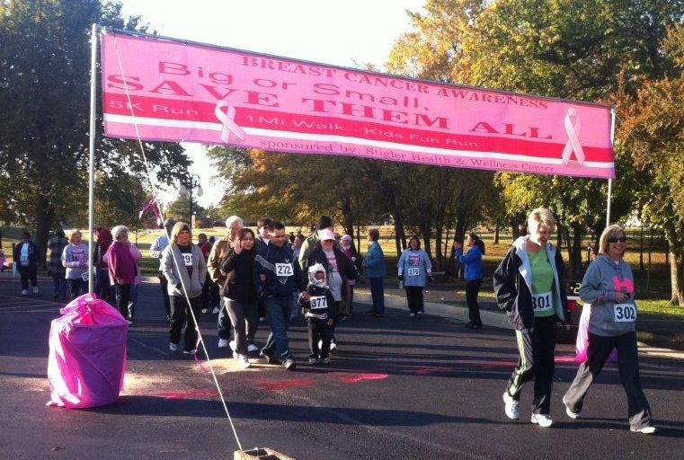
A colleague of mine from the college I work at joined me and we loaded up our shotguns and ammo into my car on a cold and rainy October Saturday and headed down to Stigler. As we drove down, I hoped the rain would pass. With a dissertation to write, it was not often I got the chance to shoot skeet, and since I figured it was participant observation, I was looking forward to the “research.” As we drove down, I explained to my colleague what an FQHC was and why an anthropologist would be studying it. “This is exactly why,” I said. “Healthcare extends beyond the clinic. For them, healthcare is a community event.” Unfortunately, the rain did not pass, and the event was canceled. Under the big white and pink tent in the parking lot of the Stigler clinic a few days later, however, the Women’s Expo went off according to plan, drawing a record crowd (see chapter one).
Figure 15: 2013 HWC Women's Expo 5K Run
In 2013, HWC added a 5k run and 1 mile walk to the Women’s Health Expo, making the day more resemble a Susan G. Komen Race for the Cure event. As one would expect, the crowd was even larger, offering not just fellowship, education, and shopping, but exercise as well. Families from across the communities came out to celebrate their loved ones, and their families’, struggles with cancer.
According to the National Cancer Institute, breast cancer incidence rates for all ages and races in Oklahoma from 2006-2010 were slightly above the U.S. national average, from the same time period, measuring 121.7 and 119.8 respectively (National Cancer Institute 2014). Surprisingly, the four county medical service area experience rates lower than the state average: Sequoyah County, 107.5; McIntosh County, 102.8; Haskell County 94.3; and Le Flore County, 94.1. The mortality rate of breast cancer over the same time period for Oklahoma was 23.9 and the U.S., 22.6. For McIntosh County the mortality rate was 29.5, Le Flore County was 28.8, and Sequoyah was 23.7, all well above the national rate. Haskell County did not have a rate calculated as there were three or fewer annual deaths from breast cancer. What should be noted from this data, is that while incidence of breast cancer are lower than the state rate in these counties, the mortality rate is significantly higher in McIntosh and Le Flore Counties, and near equal to the state rate in Sequoyah County (National Cancer Institute 2014).
The reasons for the elevated rates of mortality versus incidence are undoubtedly multiple and not well understood. One commonly cited reason is that there are low rates of diagnosis due to lack of regular mammograms after the age of 50. In 2012, HWC reported, however, that only 31.3% of women 40 years of age or older within the medical service area had not had a mammogram within the last three years. The U.S. rate of mammograms for women age 50 years or older is 72.7% (CDC 2014b). The rates are not that statistically divergent, suggesting that other causes may be at play.
Another common explanation is that rural women tend to take on fatalistic notions of cancer and therefore do not seek screening or treatment (Drew and Schoenberg 2011). In terms of the medicalization of rurality argued above, this certainly holds true. “Most studies that have drawn on fatalism as a possible explanation for health behaviors have involved populations that tend to be viewed as problematic or ignorant” (Drew and Schoenberg 2100:165), and other barriers such as lack of healthcare and insurance are never addressed. Drew and Schoenberg (2011) argue instead that rural women are often reluctant to seek medical care for cancer because of contextual issues of healthcare, such as economical constraints, ability of the family to assist, and access to trusted health professionals, among other variables.
These variables are extremely important to all healthcare in rural areas, as the chronotopic discourses already provided in this chapter show. Indeed, family, poverty, and trust have been central to every health narrative presented. What also appears in each of these health narratives is the ability of HWC to meet these needs for effective and beneficial healthcare delivery. HWC fills a gap found in Drew and Schoenberg’s (2011) research for women seeking to deal with cancer. The opportunity for wellness exists, and HWC celebrates it annually each year.
“I think the Women’s Expo is a big part of our families’ life right now,” said Kara, a resident of a county outside of the official HWC medical service area. “My mom, she went into the doctor because she was having a hard time breathing, and they asked her if she had a mammogram recently.” Kara started to tear up a little as we spoke outside of the Women’s Health Expo in 2012, during a break in the rain. “She told them that she never had one, and I think she was like 54 or 55, and they nurse said, Well, it would be a good time to get one.”
“I think she was scared to do it, because she waited like a week to get it done, but she went up to the hospital and had it done. They found a lump, it wasn’t too bad, but she needed to have surgery and chemo.” The rain had started to fall again, and we moved back into the tent. “You know we we’re all right, because she had health insurance,” Kara continued. “She is just a proud woman and does not go to the doctor unless there is something real wrong. I guess it had been a while since she went. She only came down to Stigler because she couldn’t get an appointment that day, and she heard they were a good clinic. They ended up saving her life. If she would have waited, who knows what could have happened.”

Through my nearly four year relationship with HWC, I heard many stories such as Kara’s. While HWC does not offer mammograms and specialist oncology services directly, their role in empowering women in their healthcare has saved many lives. HWC partners with various organizations, such a DHHS-Take Charge program, operated through the OSDH Breast and Cervical Cancer Early Detection Program, which offers assistance in obtaining screenings and mammograms. These programs provide a direct need to women in rural areas who might otherwise go to long without regular screenings.
The role of HWC in promoting breast health goes much further than medical intervention. They offer a place within the community where women’s health issues can be addressed, explored, and negotiated. Many rural areas are not afforded this opportunity, and consequently, many women suffer in fear, isolation, and embarrassment. Silvia, and older woman who I had met in Sequoyah County, believed that support alone, aside from the medical treatment, is what truly saves lives.
Figure 16: Women's Expo inside the Stigler Clinic.

149) I was with one of my friends every day when she went through
150) chemotherapy. I remember we we’re both so scared, because we
151) did not know much about breast cancer. When I went to school, we
152) didn’t learn about those things. I read some things here and there as
153) I got older in magazines and such, but we really didn’t know. The
154) doctor, in Ft. Smith, he was foreign, we couldn’t really understand
155) him. She just did what she was told, and I drove her back and forth
156) and took care of her. She was so sick, and it was just me and her.
157) She died fairly quickly after the first chemotherapy. She was so far
158) along, it was just too much. The doctor said she had a good chance,
159) but I think she was so scared. We just didn’t know how to cope.
160) with it.

Silvia’s narrative about breast cancer is one that resonates with many of the older women in eastern Oklahoma. Alone, scared, ill-informed; these are all topics that emerge. Women’s health issues, or sexual anatomy, were not widely taught for her generation, so when the doctor is describing anatomy in lines 150 through 155, Silvia and her friend, were “lost.” The family and community support was also missing. Like education, this is not necessarily a rural issue. The distance to Ft. Smith, Arkansas, a perceived place of health knowledge, however, is a significant issue for older women from rural areas.

161) A few years later, I heard about the Womens’ Expo. I go to the clinic
162) in Sallisaw and they had some information about it. I was still
163) grieving, and I thought, I could continue to be sad, or I could go learn
164) more about breast cancer. I thought I could help other women in my
165) church. So I went down. I learned so much, so many things I did not
166) know. There were some many places in our community that could
167) have helped us, but we didn’t know about them. When you live out
168) here, you have your family and friends, your church, and so on, but
169) you never get exposed to these sorts of things, at least at my age.

For Silvia, the Women’s Expo was not only a place to gain knowledge, but a place to heal, to transform the tragedy of her friend’s death into an opportunity to make a meaningful difference (168 through164). She also discovered, to her surprise, and her dismay, that there were resources available to assist women, but her and her friend had not heard about them. Silvia would later tell me that she and her friends do not use the internet, or watch much television other than the news and PBS. It had not been communicated to her that resources existed when her friend was diagnosed. For Silvia, whose social world revolved around family, friends, and church, exposure to women’s health was nonexistent. Her community had been missed by public health efforts.

170) I remember there was this young lady from the clinic, she had some
171) fake breasts on a table to show you how to feel for lumps. I was
172) embarrassed at first, but she was so sweet and talked to me, and told
173) me how to explain it to my friends. Now, I talk about it a lot. I would
174) have never said the word breast in front of a man before, but here I
175) am talking to you about it. It is wonderful to see our young ladies
176) taking charge of their health and educating the young girls, moms,
177) grandmas. It is what we need. The doctors, they are so scientific
178) about it. These girls, they just talk and help you understand. That’s
179) what people pay attention to, that’s what saves lives.


In lines 170 through 179, Silvia describes the powerful impact the HWCs Women’s Expo has on community health. A young, local woman took the time to teach her what she desperately wanted to know, to make her feel empowered in her own, and her friends’ health. As she describes in lines 176 through 179, the young lady did not explain breast health and self-examination, she taught it, and taught her how to teach it (172 and 173). She came away feeling in charge of her health and her body, able to discuss a topic that had once been taboo (173 and 174).
Figure 17: Self-Examination Education at the HWC Women's Expo.
Silvia’s narrative of health shares a chronotopic frame similar to those of Greg and Violet. The emphasis of knowledge, taking charge of health, rurality, and how healthiness should be defined all emerge in Silvia’s discourse. The temporality of Silvia’s discourse, however, differs from the others. While Silvia connects her education and rural past with breast cancer, the focus of her chronotopic frame is the future. This future does not focus on her exclusively. Though she plans to take the knowledge she has learned to help her friends at church, Silvia’s discourse, particularly lines 174-179 is temporally and spatially deictic, constructing a better “place,” because a new, empowered generation of women are taking charge of their health. Silvia witnessed a shift in the younger generation of women taking control of breast health and defining and explaining it in their own terms. The HWC provides a sphere of communicability surrounding wellness and women’s health that rejects the external patriarchy of clinical medicine, offering instead a localized communicative environment where women and men, doctors and patients construct discourses of wellness that empower them with knowledge and resources.

A Better Public(s) Health Return through FQHCs
As was discussed above, spheres of communicability construct subjectivities which are acted upon. In respect to biomedicine, bodies, absent of mind, are constructed upon, and which the medical gaze regulates, sorts, and classifies. The gaze, and the power it yields upon the social and political, is not accessible to those without the social and linguistic capital of the highest echelons of society. The gaze, and the spheres of communicability that support it, is thus insulated. Power is consolidated, and the public(s) upon which said power is subjected lack the authority to produce meaningful centrifugal discourses of health. The heteroglossic space of health, then, is imbalanced to a point that centripetal discourses of biomedicine overwhelmingly dominate centrifugal discourses of wellness.
Public health, whose mission it is to educate and inform, to provide wellness resources to communities, has itself been complicit in the centralization of medical knowledge and power and subjugation of publics. From the early days of racializing black American health issues (Holmes 1927, Jennings 1927, and MacDill 1927) and demonstrating the incompetence of American Indians to be healthy citizens (Carter 1916, Murphy 1911, and Hayner 1942), to the modern ascription of deviance and immorality of HIV/AIDs patients (Briggs 2005, Levinson 2004) and tobacco users, public health has done as much to subjugate certain publics as serve them.
The same can be said of rural health as well. Though the intentions are noble and meaningful, locating the “determinants of health” in such aggregated categories, without much consideration for the local lived experience, generates a body of research that reifies long held social and medically sanctioned stereotypes of rural people, their communities, and their lives. As Drew and Schoenberg (2011) and this dissertation point out, the broad inscriptions of lack of education, mistrust, and absence of hygiene on to rural publics create causal models that seldom reflect contextual reality.
To further this, the reification of rurality as an inscribed status contributes to the medicalization of rurality. Rurality is subtextually, seldom explicitly, regarded as a non-optimal state of health prime for intervention through social markedness. Some more functional and political economy inclined scholars, however, may see this as deliberate. After all, a population with less than ideal health produces a mass of workers that can be exploited (Foucault 1994(1963)) and accept the low wage work made available to them (Maril 2000). Nonetheless, as Briggs (2005:272) points out, by medicalizing rurality through spheres of communicability, their poor health outcomes can be perceived as natural, as though illness and disease “gravitate toward populations and respect social boundaries.”
This construction of rurality does not have to be so. In fact, as I have described above, HWC works to combat the overwhelming metadiscourses of biomedicine by producing and circulating their own spheres of communicability, a communicability of wellness. As the discourses of the community that comes into contact with the HWC attest, the HWC locates health and healthcare within the rural, not against it and treating it. The HWC is well aware of the rural barriers to healthcare, and the health outcomes that arise because of those barriers. Instead of prescribing treatments for rurality, they define rurality as a place of wellness, located chronotopically within a historically continuous place of lived experience.
This communicability of wellness is effective because as it travels through the interdiscursive webs of the medical service area, its chronotopic frames correlate, or are at least translatable to community members. As we saw in the previous chapter, chronotopic frames that do not share the semiotic and denotative formulations of health, place, family, history, or even Christianity, that are found in the local community are socially marked as outside, elitist, and untrustworthy. This phenomena itself traces back historically to the subjugation of rural populations (Stewart 1994), and is even marked deictically by the Commissioner in lines 79 through 92.
Communicability of wellness offers a new model for rural health, one that is both effective and culturally relevant. Locating place as an area of health is not particularly new, especially among American Indian health researchers (Adams et al. 2008, Jardine et al. 2009, and Wilson 2003). What is new is incorporating clinical services and community outreach that seeks to denotatively shift inscriptions of health from within the local production of healthcare. The place of health in this case moves away from therapeutic ecology and towards a production of health knowledge, practice, and authority relevant to the compositional and contextual organization of the public(s). That is, communicability of wellness allows opportunities for communities to define and prioritize concepts of health and wellness that are flexible to the social and historical contexts of their lived experience and social spatialization; wellness emerges from a place rather than health being prescribed from a space.
Lastly, the HWC provides evidence that the concept of return on investment of tax payer funds from FQHCs must be expanded. Not only can FQHCs have sizable and positive economic impacts on their medical service communities while providing much need access to health care, they can also empower communities to take charge of their health in ways that other medical and public health providers cannot. One of the greatest assets that FQHC’s enjoy is that they are local clinics, and are required to be governed by a majority local patient Board. This creates unique opportunities, as the HWC has shown, to involve communities in the practice of health care. The return on investment, then, can be significantly multiplied as communities shape their own health priorities to meet their greatest challenges.

Chapter 7: Investing in Social and Political Health
There is a reason most people who have never utilized a FQHC are unaware of what they are: they seldom are talked about in the media. Unless you live in a medically underserved community, chances are you will never come across an FQHC. There is even less of a chance that FQHCs are discussed anywhere other than local media sources. The fact is, FQHCs do not attract a lot of attention at the state and national levels, and this is a good thing.
FQHCs, unlike many other health and social programs, enjoy high levels of bipartisan support. Since their inception under President Johnson, FQHCs have received support and increased funding from both political party administrations (Kantayya and Lidvall 2010:68), and President Bush, in 2002, worked to increase funding for rural FQHCs (Regan et al. 2003:118). Because of the low relative cost to fund them, their ability to reduce per patient Medicare and Medicaid expenditures, and their ability to reduce healthcare costs, both parties are generally supportive of FQHCs.
That bipartisan support does not always extend to the local level, and as the political pendulum swings in state and local governments, so does political support. In Oklahoma, conservatism has come full swing. The Republican Party, for the first time in state history, has complete control of the executive and legislative branches, and holds every publically elected state wide office. Oklahoma’s government officials have been quite vocal in their opposition to the ACA and have refused Medicaid expansion, opting instead to expand the Insure Oklahoma program, though CMS has ruled that it will not qualify in FY15.
Still, political opposition to FQHC’s in Oklahoma is minimal, at least publically. There are no major news stories, and FQHCs are barely mentioned in public debate. While the opposition may be minimal, there is a clear lack of support. Many politicians either are not aware of FQHCs, especially if they represent a district that does not have one, or they have no opinion on them. On the federal side, some Representatives have taken notice of the benefits of FQHCs, especially in rural areas, and at least one Senator is supportive.
The lack of attention to FQHC’s, while beneficial in a time when the phrase “federally funded” draws extra scrutiny, is also a detrimental to FQHCs in promoting they ways in which they make a meaningful difference in the lives of people, communities, and society as a whole. Aside from providing quality healthcare at cost effective rates, promoting economic development and stability, and empowering communities in determining their own health, FQHCs can make a meaningful impact on the social and political health of their communities.
In discussing the social and political health of a community, it is important to conceptualize them not as abstract things, but as bodies of people organizing themselves and living within both the natural and built environment. Scheper-Hughes and Lock (1987) describe the social body and the body politic as subjects used not only to conceptualize the self, but also as subjects for power (in both theirs and ours case, medical power) to act upon. As I have stated in previous chapters, biomedicine is embodied within powerful social and political spaces (see above), acting upon subjugated publics to maintain its primacy as the authority of health and normality. The social body and the body politic, within these spheres of communicability, are subsequently differentiated, organized, and sorted to fill social spatializations that can be monitored and controlled (Briggs 2005:274). Unhealthy environments and social spaces never have strong political health (Blanton 2006, 2011; Stewart 1994; Willson 1987), and weak political health is a risk factor for unhealthy environments and social spaces.
The medical service area of HWC has clearly been defined as an unhealthy space, at least through the academic research, and in reality, it must be defined as an unhealthy space. For so long rural and inter-city America has been socially and politically ignored that the quality of life, economic opportunities, and overall functional health of their residents have deteriorated. They are medically underserved, educationally underserved and socially underserved. They are discursively medicalized, racialized, and ethicized to such a point that any reasonable person would see a natural reasoning as to why they are, indeed, unhealthy.
As we saw with the rejection of economic indifference and the rejection of the medicalization of rurality, it should be of no surprise that HWC works tirelessly to improve the social and political health of their medical service area. For them it is not only a matter of promoting the health of the traditionally underserved, but of promoting the social and political opportunities of their own communities- communities in which they live, work, and raise their families. They are the social bodies and the body politic through which they measure their community and their selves.

Enhancing Social Health
Eastern Oklahoma suffers from a wide variety of social health issues, many of which rise out of the lack educational, economic, and advancement opportunities. As described in chapter five, the economic situation in eastern Oklahoma is turbulent. With major employment in healthcare, agriculture, retail, government, and manufacturing, the potential for instability is high. Drought, recessions, government sequester and shut-downs, political uncertainty of healthcare, and changing dynamics in global trade have all effected the eastern Oklahoma economy in the last four years. Even the one service that is perceived to be constant, healthcare, is incredibly unstable in the region.
As was the case in Wilburton, hospital closure is always a possibility. Wilburton’s hospital is not the only one that is struggling. Poteau’s hospital, Eastern Oklahoma Medical Center is also struggling with regulatory issues in their surgical and obstetrical department, which were shut down by the Oklahoma Department of Health in February of 2014. Patients needing those services will now have to go to Ft. Smith or another hospital, increasing financial, emotional, and familial burdens.
Eufaula has also had struggles with its hospital. The EPIC Medical Center has struggled for years to maintain its financial health, and over the last three years, there have been several notices that the hospital was going to close, though through some means, the hospital has remained open. On one of those occasions, another medical group stepped in to purchase and operate the facility. In these unstable times for healthcare, HWC has continued to grow, offering primary medical service in all of their communities.
That stability is something Cory, who helps operate a social services organization for teenagers, has been thankful for. “You just have to think,” Cory said, “what am I going to do if the hospital closes? I have these kids who come in here and I need someplace to take them when they get sick or they come to us after getting abused or in a fight and they might need x-rays. You know HWC, they can do most things, and they have told us they will work with us to get these kids taken care of.”
Cory often takes in kids who have been subjected to abuse, drug addiction, or family situations where they just need to get out of the house. Sometimes the kids stay for a night or two, some stay longer. “With the poverty, the mental health issues, and the drugs,” Cory emphasized “these kids have seen some things.”

180) Health and Wellness, they are great. If we have a kid come in, and
181) we know they are on SoonerCare, but they don’t have their card, they
182) can look them up for us. It used to be we’d have to go to DHS, and 183) then it was a hassle for them and for us. This just makes things so 184) much better, easier on the kids. People come into Eufaula and they 185) think it’s just a resort town, they never lived here, experienced what 186) life is like. They just go home on Sunday. It’s hard for the kids.

As Cory explains, the HWC has provided a vital role in helping displaced youth adjust to the harsh social conditions surrounding Eufaula. The experiences of youth in small rural towns differ significantly than those in suburban areas. There is significant isolation, limited recreational opportunities, and few outlets for them to express themselves. The same holds true for their parents, and with high rates of unemployment and even higher of underemployment (Department of Commerce, personal communication), the opportunities for family violence, runaways, and adolescent trouble are significantly increased.
Cory’s discourse highlights many of the same issues as others. In lines 184-186, he deictically marks visitors to the lake spatially and psychologically, stating they are from outside the community and have never experienced the type of poverty and social disorder that is present in Eufaula. He credits the HWC as being part of the community, knowing and assisting. He, like others who have described visitors to Eufaula, argue they stay within sanitized spaces near the lake shore, and only come into town to shop and dine. Real Eufaula, located away from the tourist area, represents a different social reality. This is the reality through which HWC operates in Eufaula and the rest of their service area.

Social Strength through Mental Health
Between 2010 and 2011, HWC increased mental and behavioral health encounters by 38.7%, and for 2014, HWC has set a goal of over 18,000 encounters. “We can’t keep up with the demand for mental health”, Teresa told the Board at a meeting in late 2013. “There is so much going on in this community and such a need for it, we have to get our numbers up and increase our capacity.”
The HWC medical service region has clear access issues to mental health providers. The access has less to do with the ability to pay than the overwhelming lack of providers, especially psychiatrists. Of the HWC mental health providers, the two psychiatrists have the most significant caseloads, averaging over 400 and 200 encounters per month. Mental health needs in Oklahoma far outweigh the capacity of providers. In FY 2010, the Oklahoma Department of Mental Health and Substance Abuse Services (ODMHSAS) reported unduplicated counts of persons served through ODMHSAS-funded mental health service of 1,614 for the four county service area and ODMHSAS- funded substance abuse service for 618 (ODMHSAS 2014). It should be noted these are counts of patients, not how many times they were served in that year. Additional, the Substance Abuse and Mental Health Services Administration provided 2005 state estimates that 13.26% of all Oklahomans are under serious psychological distress, one of the ten highest ranked states (SAMHSA 2014).
High rates of prevalence and even higher rates of unmet needs create an unsustainable healthscape that threatens to destabilize other sectors of the social body. Students with unmet mental health and substance abuse needs are less likely to excel in their study so that they have the potential of economic and financial stability later in life. Added to that, families with the same unmet needs are more likely to experience turmoil, abuse, and divorce. Mental health and substance abuse are also likely to arise from and contribute to poorer socioeconomic stability and unemployment. With lack of health access, boredom, and feelings of isolation, is it any wonder that eastern Oklahoma has high rates of drug abuse, especially methamphetamine and prescription drugs.
The White House (White House N.d.:1) reports that Oklahoma was the highest rated state for prescription drug abuse for persons 12 years of age and older, and that the rate of drug induced death in Oklahoma in 2007, 19 per 100,000, was significantly higher than the national rate of 12.7. More concerning to residents in eastern Oklahoma is that after a fall in Methamphetamine lab seizures between 2003 and 2007, the rate increased 283% by 2009. Further, Sequoyah County has been identified as a High Intensity Drug Trafficking Area, with methamphetamine its principle threat (White House N.d.:4).
The eastern Oklahoma community does not need the official data to know that Methamphetamine (meth) and related substance abuse are overwhelming social problems. There are few people in here who have not encountered the consequences of meth use in some form. Many people have family members who have suffered from the drug, and almost everyone has encountered a meth addict out in the community. The effects the drug has on the body make it fairly obvious they are a user.
“Ugh, that’s so gross,” rang out Jessica as a member of law enforcement showed a slide of the before and after photos of people addicted to meth at a meeting of the Haskell County Coalition. “Those poor people, I mean, how could you do that to yourself.” “Don’t feel too bad for her,” responded the law enforcement agent, “she was doing this with a toddler in the house. We found him in diaper that hadn’t been changed in a while.” “And this is where that child was living,” he said as he changed the slide.
Pictures of a run-down trailer flashed across the screen. Agents in Hazardous Material suits were photographed taking evidence and cleaning up the dangerous materials. From the pictures, it was unimaginable that a toddler could live in the house. Trash and bottles used to cook meth were strewn on the floor and furniture. The kitchen appeared as though no one could use it to actual cook food. “When we found him,” he continued, “he was severally underweight.” “He’s in an adoptive home now, and doing pretty good. We ended up having to tear the house down. It costs us a lot of money to clean up these labs, and all they need is a coke bottle to do it now.”
“I saw on the news not too long ago that a couple had put a bottle they were cooking meth in their little girl’s backpack after they got pulled over”, said Jessica. Other people in the room, including myself, had also seen the story. One-pot cooking is a new technique for manufacturing meth that became very popular after 2009. Meth users no longer need large labs to cook it, and it can be done anywhere. The problem, much like the larger labs, is that the chemicals used to make meth are highly volatile and dangerous. “We we’re down at the lake cleaning it up with some of the kids, and we found a couple of bottles in the picnic area,” said Roger. “I told the kids to leave it alone, don’t touch it.” “That was the right thing to do,” responded the officer, “give us a call and we will come check it out.”
Meth is a serious social issue in the HWC service area, and one several of the coalitions have worked hard to combat. Jessica, who works for a non-profit agency dedicated to early childhood education and enrichment, discussed March Against Meth, a anti-drug program run through the Haskell County Coalition.

187) We have an event called March Against Meth. We get kids and
188) community members together and provide education, information on
189) assistance. We got some grant money to do it. It’s a way for us to
190) intervene and get to them before they are tempted, but it’s also a way
191) to say we are not going to tolerate this in our community. It was big
192) for a year or two, and the kind of dwindled. But now we are going
193) after it. I think the biggest asset we have now is more mental health
194) services. Stigler Health and Wellness has really done more
195) counseling, and that’s what we need. If people can get the help they
196) need, then maybe they won’t get involved with drugs. I mean meth
197) has really hurt this community, and we are just trying to change it so
198) it doesn’t continue.

Jessica’s discourse highlights the communities efforts to combat the tragic impact meth has had on the community. The program, held annually, is designed to build community awareness and support for support of substance abuse programs related to meth. Additionally, as she points out in lines 190 and 191, it is an effort to signal to those in the community who use, manufacture, and sell the drug that they are no longer going to remain quiet. It is a direct way to semiotically mark those involved with meth as unwanted and dangerous bodies that weaken the social health of the community.
The discourse also highlights, in lines 193 through 196, HWCs positive impact in combating this social ill through early intervention in mental health. Like most in the community, as well as the health professions, she views this as the most important tool in combating illicit drug abuse. The discourse, particularly in 187 and 189, also reinforces early descriptions of health as a social issue. By engaging kids with the community, they have a system of support available to them if they should need it. That sense of community is also chronotopic, engaging the historical destruction of meth with the envisioned future where it no longer impacts the community. This chronotopic frame is very similar to that of Silvia’s, who envisions an empowered community, a healthier place, because of the efforts of HWC in the present.
Healthcare deliver is the mission of HWC, but the types of healthcare delivered and their prioritization often has induced beneficial effects within the service community, similar to the economic effects in chapter five. By providing and prioritizing mental health services, HWC promotes social health in helping to overcome structural issues related to mental health. Additionally, HWC can provide mental health services at a much lower cost because they are incorporated into their existing clinical space. Other mental health providers would have to provide for their own clinical space, greatly affecting their overhead operational costs. By incorporating mental health in to the clinical space, HWC produces a place of wellness where those affected by mental health issues can become more successful in school, work, and family, thus breaking the cycle.

Not all of the social health development that HWC performs is induced. Much of it, such as health intervention work with the communities’ Head Start programs and local public schools is defined within their strategic scope of services. These types of programs provide much need early intervention to ensure that health and behavioral issues are recognized early, preventing the need for more serious medical intervention. By communicating child wellness at early stages, it potential limits the discursive marking of children as different, such as Learning Disabled (Mehan 1998), which can potentially have long term negative effects for the child’s success.
Other efforts are more practical to the structure and geography of the community, such as the reuse of old clinics and pharmacies, and the repurposing of existing infrastructure. An excellent case in point is the repurposing of the old Walmart building in Stigler. After Walmart moved from the north side of Highway 9 to a location slightly south of the highway, HWC bought the building and moved its Stigler clinical operations and administrative operations of HWC into the renovated space. Sections of the building were leased to other medical service e providers. Presently, the Stigler clinic is undergoing extensive remodels to expand capacity, bring the pharmacy in-house, and to include an in-house optical shop. This type of refuse to refuge repurposing increases the economic development potential, the aesthetics of the community, and provides a prominent place in which to host community wellness events.
Figure 18: The Old Walmart Building.

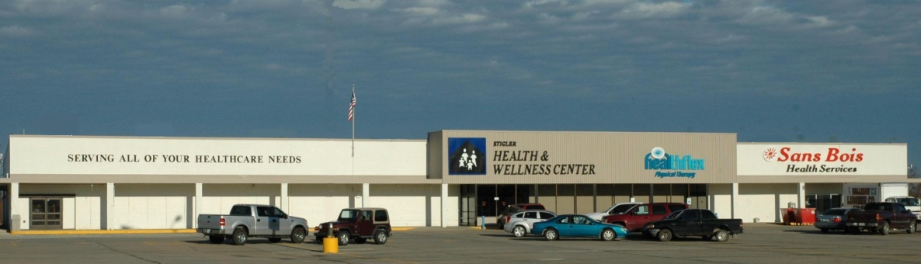
Figure 19: The Stigler Health and Wellness Clinic after Initial Renovation.

Building a Stronger Social Body through Health Insurance Outreach
Other social health efforts are more direct, aimed at health access outreach beyond the scope of their clinical services. One primary example of this, and one with which I was engaged, was health insurance outreach. My introduction to HWC, and FQHCs for that matter, was through my own outreach efforts as the OHCA Southeast Regional Outreach Coordinator as part of the SoonerEnroll grant program. My effort, concentrated in southeast Oklahoma, was aimed at offering enrollment opportunities to families and individuals who qualified for SoonerCare but had not yet enrolled. The way in which we provided these opportunities was by creating strategic partnerships with health and social service agencies that were likely to also serve individuals and families eligible for Medicaid. Once I met Teresa and Brooke, I knew I had an opportunity to build a strong and lasting partnership.
That partnership was not always smooth. When OHCA began their online enrollment program, there was significant tension between HWC and myself, as a representative of OHCA. The online enrollment roll-out coincided with the SoonerEnroll program, and as the only field representative for OHCA, I was tasked, along with my counterparts, in engaging with DHS and community partners to shift the enrollment responsibility away from DHS and onto the individual. The problem was many individuals, especially those who would qualify for SoonerCare, did not have internet access. This, in reality, shifted the enrolment process onto the provider if they wished to bill OHCA for providing care.
As one could imagine, this additional administrative task was not well received by most providers. I had already been made aware from many providers, and even librarians who were all of a sudden asked continuously by patrons how they could enroll in SoonerCare on the libraries computers, that this was not a popular change. Teresa was quite frank with me that this put a burden on her staff and she was quite frustrated. In response to these complaints, we organized regional meetings with providers to discuss their concerns with OHCA staff. Brooke attended the meeting, and was straight forward with her concerns. While we did not alleviate all of them, we we’re able to forge a relationship that was extremely beneficial to both of our causes.
Over the course of the next year, I spent a great amount of time working with Teresa, Brooke, and other members of the HWC staff. They offered my assistant and I space and time to set up in the lobby of their clinic, invited us to HWC events, and we were often at the same community events across their service region, and as I mentioned above, they placed computers in their lobbies to facilitate on-line enrollment. Teresa organized meetings between me and other FQHC directors in southeast Oklahoma so that we could work to form the same relationships. She would eventually introduce me to members of OKPCA, one representative who I had previously met in Wilburton (chapter five).
While it was advantageous for HWC to partner with OHCA to enroll individuals in SoonerCare (they could then bill OHCA instead of charging a sliding fee), they made tremendous efforts to assist our efforts across the region and state. The HWC commitment to improving the health of Oklahomans is unmatched. The assistance they provided was directly responsible for the success of the SoonerEnroll program in southeast Oklahoma and across the state.
In 2013, they expanded their health insurance outreach efforts by applying for a grant to hire two FTE Outreach and Enrollment Coordinators. They were subsequently awarded the grant and the coordinators work to assist community members navigate the health insurance marketplace, as well as conduct patient education and in-services. It should be no surprise that by January of 2014, the coordinators were the top ranked Outreach and Enrollment Coordinators in the state. Much of that had to do with the past efforts of HWC in community development and outreach and their status as a trusted organization within the community.
The decision to pursue hiring the Outreach and Enrollment Coordinators was a strategic move on the part of HWC to further develop their efforts to build the social health of their service area. It was also a strategic move to bolster the political health of the community. By assisting in health insurance enrollment, they empowered their community, but also empowered themselves. In many ways they strengthened their ability to speak authoritatively about healthcare within the community, but also at the state and national levels. By incorporating the ability and authority to provide health insurance access, both through their partnership with OHCA and with the Outreach and Enrollment Coordinators, they broadened their sphere of communicability.
Discursively, it is difficult to semiotically mark HWC as just another rural healthcare provider. No longer can they be categorically lumped into the “Physicians, Dentists, and Other Medical Professionals” category in healthcare economic impact studies (chapter five). Semiotically, that does not work. HWC are physicians, mental health providers, health educators, dentists, optometrists, outreach specialist, and health insurance authorities. They rescue clinics, empower women, empower communities in their fight against drug abuse, they repurpose infrastructure, and most importantly, they define a place of wellness in a space that is marked as unhealthy. Discursively, they are empowered, and increasingly powerful, in the process of negotiating new definitions of rurality in the heteroglossic space of health.

Empowering the Public(s) through Political Health
Community health empowerment is the ultimate measure of a FQHC’s success. Only through economic, community, and social health access improvement can a community begin to center itself within larger discourses of healthiness and healthcare. Health in eastern Oklahoma, as conceptualized through the discourses of this study, has four distinct communicative genres: economic; social; community; and political. The four genres are (re)entextualized as the pass through webs of interdiscursivity, and decontextualizing each genre becomes problematic as shifting the meaning of one discourse immediately shifts meaning in the others. This is particularly true with political health.
As biomedicine is constructed and embedded in the social and political, strategic decontextualization is incredibly powerful in limiting the political health of subjugated communities. In fact, as Briggs (2005) and Briggs and Mantini-Briggs (2003) show, this is often used intentionally to sociomedically mark and limit the political agency of threatening or troublesome populations. In the case of rural eastern Oklahoma, whose poverty, unemployment, and poor health outcomes rise well above those of the rest of the state, it is much easier to decontextualize their historical economic and social exploitation than to attempt to make any reasonable corrective action. In other words, it is easier to blame the victim for their own inequity than work to fix it.
Fixing that political inequity is a central mission for HWC as evidenced in the discourses above. Empowering the communities’ access to healthcare and health insurance, empowering the communities’ access to health determination, and empowering the communities’ economy are all intersectional with empowering the communities’ political health. These intersectional elements become entextualized within chronotopes of rurality and healthcare that define their health, as well as the inequities of rural health, as social and political processes. This is in direct contrast to authoritative and powerful biomedical discourses that speak of rural health through decontextualized, clinical, and spatiotemporal neutral chronotopes. Thus, there is miscommunication across chronotopic and denotative frames of health and healthcare.
HWC actively pursues to correct this miscommunication in several ways and across several social planes. At the local level, HWC, through its local Board of Directors, empowers community members to speak authoritatively about their communities’ health and healthcare. At the state level, participation in OKPCA, political roundtables, OHCA meetings, and other statewide events, provides HWC a platform to expand the healthcare discourse to incorporate FQHC operations as a meaningful health improvement mechanism. As FQHCs are a federal program, HWC also has access to national political venues in which to negotiate healthcare from their perspective, centralizing their medical service community in larger national discourses.
The HWC Board of Directors is comprised of service customers and professionals from within each of the counties in the HWC medical service area. This type of composition, part of the HRSA requirements to be eligible for Section 330 funding, allows for the political development of the community. Not only does it allow community members to be part of the leadership of non-profit corporations, but it allows exposure to legal, financial, and medical knowledge that is usually not available in the communities served by FQHCs. It is also an opportunity to empower communities to be advocates of their own health and healthcare needs and to define them in their own terms.
Board membership provides the community legitimacy in discussing not only health and healthcare, but social and political issues within their communities as well. There are few HWC Board Members who do not have influence in other social spheres within the community such as business, banking, social services, education, healthcare, and community development. There are even fewer who do not have influence with local, regional, and national political leaders. This composition of social networks expands the HWC’s spheres of communicability and allows for greater messaging of wellness.
In that effort, the NACHC and OKPCA regularly offer Board training to expand the ability of FQHCs to better the political health of their communities. This is clearly a secondary function of their efforts, as their first priority is to ensure that Board members share the resources available to them to make meaningful decisions in their leadership of FQHCs. Indeed, since their inception, local control of Boards of Directors was intended to politically empower the communities that FQHCs serve. The ways in which FQHC administrators utilize this structure, however, is the key to their success in this arena.
As I presented the preliminary results of this research at OKPCA Annual Conference in October of 2013, Judy Grant, the Director of Community Development for OKPCA, repeatedly stressed the importance of Board Member advocacy. That advocacy is only as strong as the Board Members’ knowledge and engagement with the FQHC and the communities they serve. HWC ensures that their Board is fully aware of all issues surrounding the financial, regulatory, and operational environment. HWC makes it a priority to engage Board members in both state and federal level training, encouraging members to attend conferences and workshops.
“Anything I get, the Board gets,” said Teresa at a recent Board of Directors meeting. “I want you guys to know everything we know, what opportunities there are and what threats there are. A Board that knows what is going on is a Board that will make good decisions.” Judy Grant made similar comments, “Knowledgeable Boards are our greatest asset for communicating the great things we do.”
HWC’s participation with OKPCA goes beyond just membership and resources. Teresa has served on the OKPCA Board of Directors and as their State Legislative Coordinator. Her position of leadership transcends the positions she has held; she is continuously engaged in an active leadership role at conferences, legislative efforts, and community development events. Other members of the HWC staff are equally engaged in the leadership of FQHCs at the financial, operations, and clinical areas as well.
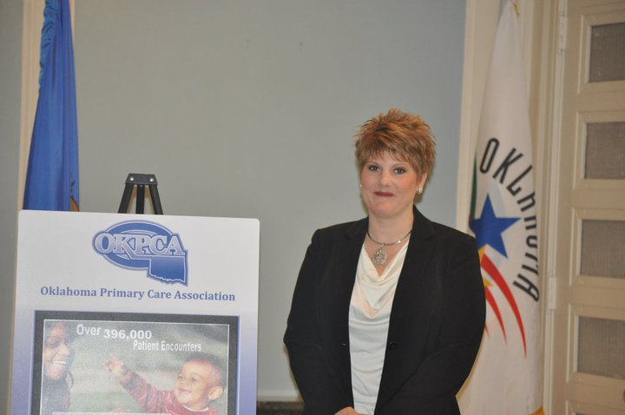
This pronounced leadership engagement has shifted the political landscape of FQHCs in Oklahoma over the past decade. While it is easy to focus on the governmental politics surrounding healthcare, the HWC and OKPCA’s impact has been much broader. I was repeatedly informed by FQHC administrators and OKPCA personnel that since the beginning of OKPCA’s presence in Oklahoma, leaders in the Oklahoma healthcare industry have been fervent detractors of FQHCs and their mission. Leadership within state hospital and rural health associations made concentrated efforts to discredit FQHCs and their ability to meet rural health needs, arguing they would steal patients away from rural health hospitals. These efforts led to stagnation of OKPCA’s ability to develop support, restricted community and political support for FQHCs, and contributed to the lack of FQHC/CAH partnerships that HRSA has called for (HRSA 2012). OKPCA and FQHC leadership did not let this deter them; they just worked harder to overcome the privileged discourses of the CAHs and private provider focus of rural health development policy makers.
Figure 20: HWC CEO Teresa Huggins at the Oklahoma State Capitol.
As this dissertation has shown, CAH and other rural hospitals cannot be the only medical establishments counted on to support rural health development. EPIC Medical Center in Eufaula has been teetering on the verge of closing for nearly five years; Poteau’s hospital, Eastern Oklahoma Medical Center, now has its surgical and obstetrics services closed; and Latimer County Hospital in Wilburton was saved, at least temporarily, by HWC purchasing their clinical operations. Haskell County Hospital did not fail as many opponents of FQHCs had predicted. It remains viable and works in partnership with HWC to provide medical services to an expansive medical service area.
Figure 21: OKPCA and FQHC Members at the Oklahoma State Capitol.
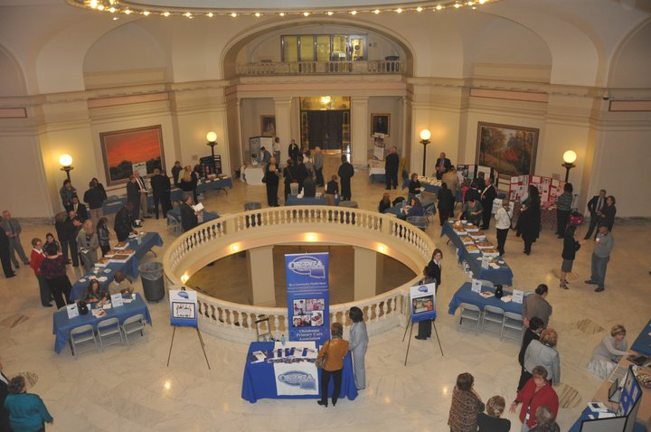
The HWC and OKPCA’s ability to negotiate the discourses of rural health development provide political voice to the communities they serve. “We’re not just people who go to the ER (Emergency Room) all the time, driving up costs, we are people who want a doctor to go see when something is wrong with us”, said Sharron during an event in Sallisaw to celebrate National Health Center Week. “They make rural people seem like we are wasting money. I go to Health and Wellness, not to the emergency room. I don’t need to go to the hospital except when I need further testing. I pay what I owe, and I let people around me know that. We don’t have to be made to feel like this.”
The overwhelming discourse surrounding rural healthcare, especially for those without insurance, is that they raise the costs of healthcare for all Americans by going to emergency rooms and either pay inflated costs or do not pay at all, leaving hospitals with bad debt. While this is true in many instances, these discourses do not incorporate the role in FQHCs in reducing that effect. FQHCs can assist in reducing emergency visits while increasing the overall health and wellness of communities (Rothkopf et al. 2011). “We are proud people out here,” Sharron continued, “we don’t want your hand outs, just a hand up when we are down.” “The clinic gives us a place where we can be treated fairly, and I think it gives us a way to say…No! We do take care of ourselves!”
Taking care of one’s self is a common narrative in rural communities, especially related to health and healthcare in the era of health reform. In Oklahoma, it is particularly pronounced given that it is one of the most conservative states in the nation. The ACA is widely unpopular, even in rural areas with limited healthcare. Yet, according to the OHCA (2014), nearly two thirds of the children born in Oklahoma each year are covered under Medicaid. These programs are seen, in Oklahoma at least, as taking care of the most vulnerable population. When given the opportunity to expand Medicaid to adults, Oklahoma’s political leadership refused.
FQHC’s are not fully funded by federal and state tax dollars. For most FQHCs, tax dollars make up a small percentage of their operational costs (Kantayya and Lidvall 2010). FQHCs generate their income from providing health services, and because of their not for profit status, the money they generate stays within the community. This give FQHC’s a unique advantage within the ACA in their political support is relatively stronger than Medicaid expansion, and FQHCs such as HWC can expand capacity to accommodate new patients who may for the first time have access to health insurance. This gives community members a particularly significant political voice in that a political attack against FQHC would be difficult to decontextualize from an attack on rural and underprivileged communities.
Much of the discourse in eastern Oklahoma surrounding ACA is that it is bad for economic development and small business. This insulates FQHCs because expenditure on them does not affect business, and as this dissertation has shown, actually promotes economic, community, and social development. This in particular makes the FQHC model an attractive piece in the health reform debate, from whichever side one approaches it. They are cost effective, relatively low risk in comparison to hospitals and broad scale insurance programs, they deliver cost effective health care for both publicly and privately insured patients, they have developed over fifty years of regulatory and performance enhancing environmental controls, and they produce returns on investment that are second to none.
The ACA recognizes the powerful impact that FQHCs have in healthcare delivery. The ACA provided $11 billion in dedicated funding for FQHCs as a way to ensure the millions of newly insured would have a medical home, and $9.5 billion of that was dedicated to operational costs (NACAC 2014). The mandatory funding period ends in FY 2015. If the funding does indeed end, it would represent a 70% decrease in appropriations for FQHC support and the National Health Service Corps and Teaching Health Center Programs will lose all appropriations (NACAC 2014). Currently, the extension of these funds is under debate, and the outcome will not be known at any predictable time.
Even without the extended funding, HWC will continue to operate. The services provided and the workforce employed by HWC, however, will be significantly reduced. Still, HWC and FQHCs in general will continue to provide a significant political voice to their communities at the local, state, and national levels. That political voice is not as well articulated when decontextualized from other discourses surrounding FQHCs and healthcare, as they are intrinsically tied to social, community, and economic discourses. The political health that HWC, and potentially other FQHCs, provide their communities should nonetheless be considered when measuring the total return on investment of federal and state funds.

Social and Political Health in the Era of Health Reform
Medical anthropology has long looked at the political economy and sociopolitical elements of health and healthcare (Baer 1982, Baer et al. 2003, and Farmer 1999). They have identified structural issues that work to compose social bodies in such a way that they are not only exposed to more health risk, but disadvantaged to healthcare access as well. There is no doubt that the modern ordering of the world generates structure that limit health and wellness at broad sociological levels, and health systems such as FQHCs can operate in ways that provide agency to the physical, social, and political bodies within these structures and can work to overcome such inequity.
It is equally important to understand, however, that social structures do not exist only at one level. Structuration is fractally recursive, that is, oppositions or structurations of one level are projected onto other levels. National discourses of medicine and healthcare exist at the national level, but also at state and local levels as well. Fractal recursivity penetrates deeper than that, as Irvine and Gal (2000:38) argue. The sociopolitical relationships between rural and urban Oklahoma are reproduced in the discourse of healthcare at every level.
The discursive clash in Latimer County is an excellent example of this. The Commissioner’s discourse, and indeed his chronotopic framing of such, entextualizes previous sociopolitical struggles within modern day discourses of healthcare. The FQHC Director and OKPCA representative’s discourses do not; perhaps because that level of structuration is not meaningful to them. The fractal recursivity of social and political unhealthiness is apparent in discourses of the disenfranchised, but not coherent to those with social and political power, whether real or perceived.
The return on investment in both social and political health for communities served by FQHCs provides an opportunity where such recursive reproductions of structuration become less important and the serious task of health improvement and health equity can begin. As shown above, the true value of FQHCs has not been understood because there has not been a realistic concept of what to understand and measure. Health cannot be judged by the optimal condition of the physical body. Health must be judged by the access to healthcare, the ownership of healthiness, understandings of localized wellness, and the viability of the social and political body.
This aim should be the start of new research programs interested in better understanding health and wellness within particular communities, not just rural, but all types of marked communities and the intersectional relationships within them. While the discourse presented herein identifies four types of genres associated with the communities’ concept of health, other communities’ concepts and genres will be different. Further, the ways in which those concepts are entextualized will also diverge. Critical Discourse Analysis, anthropological linguistics, and medical anthropology can help further understand what those differences might be and begin to form better predictive theories through which to understand them.

Chapter 8: “We don’t want to be the Provider of Last Resort. We want to be the Provider of Choice.”

Communicability suggests volubility, the ability to be readily communicated and understood transparently, and microbes’ capacity to spread from body to body. I add a new sense to the word in which communicability is infectious- the ability of messages and the ideologies in which they are embedded to find audiences and locate them socially and politically. [Briggs 2005:274]

I began this research project with a goal of understanding the differing areas in which federal and state investment in FQHC’s could produce returns for significant health improvements. It was very much a praxis oriented study to measure the effectiveness of HWC in providing quality care and to provide data that can assist FQHCs measure their own success, strategically plan for improved healthcare delivery, and advocate their value to community and government leaders.
The existing literature concerning FQHCs, and rural health in general, did not provide the tools in which to accurately measure FQHC success, particularly in Oklahoma. FQHCs were not particularly cared for by senior rural health advocates and academics in the state. Further, even if FQHCs were included in their analyses, the measures they use are not sufficient to gain an overall understanding of the total economic, social, community, and political health impacts that HWC provides and that other FQHCs across the state and nation are capable of providing as well. Academic research employing strictly quantitative measures of FQHCs and rural health development can never obtain a true picture of the status of health and healthcare in rural places.
Qualitative researchers, however, have been slow to produce rurality and rural health studies in America and communicate with quantitative studies. The two approaches cannot stand alone if real progress in rural healthcare delivery is to be realized. In that effort, I examined the localized economic impact of HWC on their current and expanding medical service area through the measurements employed by quantitative researchers, albeit not with access to their software and expertise. Nonetheless, the approximate application of their methods show that FQHCs provide significant returns on investment and FQHCs contribute greatly to the economies of their medical service areas. As a banker in Haskell County told me, “They provide jobs, they invest money locally, and more importantly, they save people money on their healthcare. That means they are saving and spending money on other things that enrich their family’s lives.”
Not all economic impacts can be recognized through quantitative research. There are areas and avenues in which to measure return on investment, such as social, community, and political, that have not been identified in rural health research, but that provide both tangible and intangible economic benefits. The return on investment in community, social, and political health, for instance, provides an opportunity for communities to negotiate recursive reproductions of structuration that mark them as unhealthy and that normalize poor health outcomes. Ownership of health fosters agency, and in return, leads to better health awareness, and the possibility for better health outcomes.
As shown throughout this dissertation, realistic concept of what to understand and measure regarding FQHC success has yet to be determined. Health cannot be judged by the optimal achievement of the absence of disease and illness. Health must be individual and community attachment to place and history. The explanatory models provided by patients are not purely subjective explanations of their symptoms, but a reflection of the objective context of the place in which health and disease happens. When the context of where health happens is entextualized with biomedical formulations of disease, much as they are for those in the social and political elite from which normal health is defined, than true measurements of economic benefit can be understood.
This dissertation provides evidence that the concept of return on investment of tax payer funds from FQHCs must be expanded. Not only does HWC have sizable and positive economic impacts on their medical service communities through the provision of much needed access to health care, they also empower their communities to take charge of their health in ways that other medical and public health providers have not. Because they are local and understand local conceptualizations of rurality in the context of health, HWC has the unique opportunity to involve communities in the practice of healthcare at the economic, social, community, and political levels. The return on investment, then, can be significantly multiplied as communities shape their own health priorities to meet their greatest challenges.
“How would I measure the success of Health and Wellness,” repeated Greg as I asked him that very question. “How do you measure the success of a hospital,” he replied, “I mean, they are a central part of our community.” “They do so much, they provide so much. There is a big difference, at least with the people I am around, since the opened in McIntosh County. We feel like we have a place to take care of us, with people who care. They make us hopeful for our kids, maybe they will stay and not move to the cities.”
A secondary concern of this study was to attempt to answer the call of Silverstein (2006) to define a functional linguistics through the analysis of process of negotiating meanings of rurality within particular discourses associated with the HWC. My approach to this problem, and a way to expand the conceptual space in which to understand the success and rural health economics of FQHCs, is to provide relevant analysis of the negotiation of discourses in and between social groups bounded within time and space. Through analytic of the chronotope and its passage across interdiscursive webs, I attempted to show how such negotiations of rurality can empower communities to define and produce health and healthcare relevant to their lives.
In seeking to identify new avenues of analysis that reach into broader scale discursive orders, I bring two bodies of literature, medical anthropology and linguistic anthropology, together for a functional analysis of the semiotic negotiation of the social markedness of rurality in the context of health. I examine the denotative features of rurality as they pass through the interdiscursive webs of subjects engaged in health and healthcare, finding that connections of time and place are centralized within their discourses of health. These conceptualizations produce four distinct genres of health discourse within the community: economic, community, social, and political.
“They will never understand us if they don’t understand that health is not just some ‘thing’ hanging out there,” said Steve, a former pharmacist from Sequoyah county, who had retired and now runs his family’s ranch full time. “It’s like our cattle. If they don’t have comfort, trust, or a feeling of security, if they are stressed, then they don’t gain weight, they don’t calve well.” “It’s the same for people,” he continued, “when they have economic stress, when their kids are on drugs, they have some issues they are dealing with emotionally, it doesn’t matter how much medicine they get. You can’t treat everything with a pill. I wish those politicians and doctors would realize that. Us cow-folk realized that a long time ago.”
“For rural people,” Steve argued, “our whole lives are intertwined with this place, the land, our communities.” “It’s not like the city, the land is my heritage, my income, my kids and grandkids future. It’s our economy, it’s the center of our social world, and our politics are centered here. When that is under control, well,” Steve paused, “then you know what healthiness is.”
Only through ethnographic and qualitative studies are these impacts ever discovered and expanded upon in the academic research, and only through linguistically informed medical anthropological research over the course of years do connections of time and space, place and health become evident. The connection of place and time within health discourses in rural communities, I argue, define a heteroglossic space where the semiotics of rurality and health is negotiated through (re)entextualization(s) occurring throughout interdiscursive webs.
Much like Steve’s discourse above, other discourses surrounding HWC strategically negotiate denotations of rurality, healthcare, and healthiness across chronotopes of communities, bodies, and economics. I argue that this provides evidence that chronotopes and interdiscursivity, as structures (langue), can be acted upon (parole) to negotiate meaning beyond interillocutionary acts. Through passage within interdiscursive webs, a metadiscursive negotiation of rurality from within the community challenges health discourses from without.
Through these chronotopes, the HWC and the communities they serve, construct a discursive world where the negative denotation of rurality is contested and reversed. Countering, they produce a discourse of a rural place composed of proud, hard working people helping each other to overcome the structural barriers to wellness. They argue that these are not communities that need medical intervention to save them. Rather, they create places of potential health and prosperity, communities that could use a little investment.
Recognizing and researching these metadiscursive chronotopic frames will lead towards better understandings of the rational negotiation of meaning within discourse. The task here was to find one or two such discursive structures and their use, to document them, and to understand their functional intertextuality with health and wellness. While chronotopes highlight the divergent denotative features of rurality and healthcare in this study, the communicability of wellness emerging from HWC is undoubtedly the most effective and powerful discursive force within the context of health in rural eastern Oklahoma.
Through spheres of communicability regarding wellness, that make health knowledge and practices accessible to its medical service population, HWC constructs an authoritative discourse that in turn shapes the chronotopic frames of those who come into contact with it. These spheres of communicability operate productively through interdiscursive webs by structurally shifting semiotics (langue) to produce chronotopic discourses (parole) of agency within rural healthcare. As they travel through the interdiscursive webs of the HWC medical service area, these chronotopic frames shape, and are in turn shaped by, those of community members. Thus, I argue that the spheres of communicability of wellness construct a rural place where subjectivities and the placement of community members within its spatialization are redefined in order to combat the medicalization and projection of “otherness” that so often arises in biomedical discourses from without the community.
These spheres of communicability of wellness, I argue, construct a subjectivity upon the public that limits hierarchy, one of provider and patient in partnership to build healthier lives, families, and community. The constructive and emergent authority of these spheres is not based in their position within the healthcare system, but from their position as members of the community. HWC does not centralize their healthcare knowledge, but makes it accessible, understandable, practical, and lived.
Spheres of communicability, whether focused on wellness or some other medical communication, offer a new model for rural health, one that is both effective and culturally relevant. As Briggs (2005) conceptualized his model of spheres of communicability around epidemics to illustrate how subjugated populations are made to occupy a diseased category, I argue that spheres of communicability can also arise from subjugated populations to offer centrifugal discourses about how they can occupy a categorically healthy social position. In other words, spheres of communicability focusing on wellness allow opportunities for marginalized communities to define and prioritize concepts of health and wellness that are flexible to the social and historical contexts of their lived experience and social spatialization; wellness emerges from a place rather than health being prescribed from a space.
“I am not sure why that doctor in Ft. Smith did not give us this same information on breast cancer that Health and Wellness did”, said Silvia. “Perhaps he didn’t want us to know so we would keep coming back to him,” she suggested. “But I will tell you, they kept an eye out on women in my younger days, we couldn’t know too much about sex, or medicine. That was for the men to know. I guess I did not realize how much the world has changed, here I am talking to you about breasts.” Silvia laughed, but you could tell in her voice she was frustrated at her own lack of knowledge and that it had been kept from her for so long. “It is so good to see these women taking charge. They share the information. It’s free! This was unheard of fifty years ago.”
It should be cautioned that the only reason that spheres of communicability can emerge and gain discursive traction in the marginalized healthcare community of eastern Oklahoma is because of the authority and power associated with HWC as a FQHC and their associated medical professionals. Their knowledge and authority is backed by academic, linguistic, political, and social capital. It is how they choose to use that capital that makes HWC so effective in empowering the communities they serve, all while providing substantial returns on the small, but significant federal and state investment in the health- economic, social, community, and political- of eastern Oklahoma.
Rural health research and studies of FQHCs should not be dominated by biostatisticians, epidemiologists, agricultural economists, public health professionals, or medical doctors. They provide a unique and important perspective, but that perspective is incomplete. Health must be understood as a social process, and while sociologists and medical geographers have engaged in rural health studies and provide excellent research, the conceptual pieces they provide do not complete the rural health puzzle. Anthropologists must become more engaged, particularly linguistic anthropologists willing to work with rural, American populations.
The increased partnership of qualitative researchers in FQHC studies can provide nuanced descriptions of health and economic impact and return on investment, developing our understanding of the differential economies of health and wellness that are meaningful to specific populations. As academics we can no longer sit by and offer critiques of modern health systems. It would have been easy just to focus on the ways that the people of eastern Oklahoma are dominated by the biomedical system through the neoliberal or progressive agendas. But, as they say in Oklahoma, “It’s time to get our hands dirty,” and contribute to lived understanding of health economics in the era of health reform. The HWC does not sit ideally and complain, they work hard to find new ways to define health and healthcare, and so should anthropology.

References

Adams, F. transl.
1939 Hippocrates: The Genuine Works of Hippocrates. 2 Vols. Baltimore: Williams
& Wilkins.

Adams, Kathleen and Bradley Herring
2008 Medicaid HMO Penetration and Its Mix: Did Increased Penetration Affect
Physician Participation in Urban Markets? Health Services Research 43(1)Part II:363-383.

Alland, Alexander Jr.
1966 Medical Anthropology and the Study of Biological and Cultural Adaptation.
American Anthropologist 68(1):40-51.

Austin, J. L.
1962 How to Do Things with Words. Oxford: Oxford University Press.

Baer, Hans A.
1982 On the Political Economy of Health. Medical Anthropology Newsletter 14(1):1-
2+13-17.

2001 Biomedicine and Alternative Healing Systems in America: Issues of Class,
Race, Ethnicity, and Gender. Madison: University of Wisconsin Press.

Baer, Hans A., Merrill Singer, and Ida Susser.
2003 Medical Anthropology and the World System. Westport, CT: Praeger.

Bailit, Howard, Tryfon Beazogulou, Judy Devitto, Teagaen Mcgowan, and Veronica
Myne-Joslin
2012 Impact of Dental Therapists on Productivity and Finances: III. FQHC-Run,
School-Based Dental Care Programs in Connecticut. Journal of Dental Education 76(8):1077-1081.

Bakhtin, M. M.
1981 The Dialogic Imagination. Four Essays by M. M. Bakhtin. Caryl Emerson and
Michael Holquist, trans. Austin: University of Texas Press.

Bakhtin, M.M., and P.N. Medvedev
1978 The Formal Method in Literary Scholarship: A Critical Introduction to
Sociological Poetics. Albert J. Wehrle, trans. Baltimore: The John Hopkins University Press.

Ball, Christopher
2011 Boasian Legacies in Linguistic Anthropology: A Centenary Review of 2011.
American Anthropologist 114(2):203-216.

Barth, Fredrik
1998 (c1969) Preface and Introduction. In Ethnic Groups and Boundaries: The Social
Organization of Difference. Fredrick Barth, ed. Prospect Heights, Illinois:
Waveland Press.

Basso, Keith
1996 Wisdom Sits in Places: Landscape and Language among the Western Apache.
Albuquerque: University of New Mexico Press.

Bauman, Richard, and Charles L. Briggs
1990 Poetics and Performances as Critical Perspectives on Language and Social Life.
Annual Review of Anthropology 19:59-88.

Becker, Gay
1994 Metaphors in Disrupted Lives: Infertility and Cultural Constructions of
Continuity. Conceptual Development in Medical Anthropology: A Tribute to M.
Margaret Clark, theme issue, Medical Anthropology Quarterly 8(4):383-410.

Bennett, Kenneth A., Richard H. Osborne, and Robert J. Miller
1975 Biocultural Ecology. Annual Review of Anthropology 4:163-181.

Bissett, Jim

1999 Agrarian Socialism in America: Marx, Jefferson, and Jesus in the Oklahoma

Countryside, 1904-1920. Norman: University of Oklahoma Press.

Blanton, Ryan
2006 Heteroglossia and Environmental Justice: Race, Discourse, and the
Environment. M.A. Thesis, Department of Anthropology, University of Oklahoma.

2008 Race, Discourse, and Environmental Justice. Anthropology News 49(3):55-56.

2011 Chronotopic Landscapes of Environmental Racism. Journal of Linguistic
Anthropology, “Racializing Discourses,” Special Edition, H.P. Dick and K. Wirtz eds. 21(S1) E76-E93.

Blommaert, Jan
2005 Discourse: Key Topics in Sociolinguistics. Cambridge: Cambridge University
Press.

Blommaert, Jan, and Chris Bulcaen
2000 Critical Discourse Analysis. Annual Review of Anthropology 29:447-466.

Blommaert, Jan, and Jef Verschueren
1998 The Role of Language in European Nationalist Ideologies. In Language
Ideologies: Practice and Theory, Bambi B. Schieffelin, Kathryn A. Woolard, and Paul V. Kroskrity, eds. Oxford Studies in Anthropological Linguistics. New York: Oxford University Press.

Bloomfield, Leonard
1984 (1933) Language. Chicago: University of Chicago Press.

Boehm, Deborah
2005 The Safety Net of the Safety Net: How Federally Qualified Health Centers
“Subsidize” Medicaid Managed Care. Medical Anthropology Quarterly 19(1):47-63.

Bourdieu, Pierre
1977 Outline of a Theory of Practice. Richard Nice, trans. Cambridge: Cambridge
University Press.

1991 Language and Symbolic Power. John B. Thompson, ed. Gino Raymond and
Matthew Adamson, trans. Cambridge: Harvard University Press.

Briggs, Charles A.
1994 The Sting of the Ray: Bodies, Agency, and Grammar in Warao Curing. The
Journal of American Folklore 107(423):139-166.

- Communicability, Racial Discourse, and Disease. Annual Review of Anthropology 34:269-291.

Briggs, Charles, and Clara Mantini-Briggs
2003 Stories in the Time of Cholera: Racial Profiling During a Medical Nightmare.
Berkley: University of California Press.

Brooks, Lara and Brian Whitacre
2011 Critical Access Hospitals and Retail Activity: An Empirical Analysis in
Oklahoma. The Journal of Rural Health 27:29-38.

Brooks, Lana, Brian Whitacre, Jack Frye, Tony Yates, Corie Kaiser, and Val Schott
2010b The Economic Impact of the Health Sector on the Sequoyah Memorial
Hospital Medical Service Area. Technical Report. Stillwater: Oklahoma State Department of Health, Office of Rural Health, and Oklahoma Cooperative Extension Service, Oklahoma State University.

Brooks, Lara, Brian Whitacre, Jack Frye, Randell Burris, Corie Kaiser, Val Schott
2010a The Economic Impact of the Health Sector on the EPIC Medical Center in
Eufaula, OK, Medical Service Area. Technical Report. Stillwater: Oklahoma State Department of Health, Office of Rural Health, and Oklahoma Cooperative Extension Service, Oklahoma State University.

Brooks, Lara, Lyndee Reese, Brian Whitacre, Danette Russell, and Corie Kaiser
2013 The Economic Impact of the Health Sector on the Eastern Oklahoma Medical
Center Medical Service Area. Technical Report. Stillwater: Oklahoma Office of Rural Health, Oklahoma State University Center for Rural Health, and Oklahoma Cooperative Extension Service, Oklahoma State University.

Brown, Peter, J., ed.
1998 Understanding and Applying Medical Anthropology. Mountain View, CA:
Mayfield.

Bucholtz, Mary
2001 The Whiteness of Nerds: Superstandard English and Racial Markedness.
Journal of Linguistic Anthropology 11(1):84-100.

Burns, Louis
2004 The History of The Osage People. Tuscaloosa: University of Alabama Press.

Burrill, Robert
1972 The Establishment of Ranching on the Osage Indian Reservation. Geographical
Review 62(4):524-543.

Carpiano, Richard M.
2009 Come Take a Walk with Me: The “Go- Along” Interview as a Novel Method
for Studying the Implications of Place for Health and Well-Being. Health & Place 15(1):263-272.

Carter, Mary E. M.
1916 Smallpox on an Indian Reservation. The American Journal of Nursing
17(2):112-117.

(CDC) Centers for Disease Control and Prevention
2012a Increasing Prevalence of Diagnosed Diabetes- United States and Puerto Rico,
1995-2010. Morbidity and Mortality Weekly Report. Electronic Document.
http://www.cdc.gov/mmwr/preview/mmwrhtml/mm6145a.htm?s_cid=mm6145a4_w. Accessed March 22, 2014.

2012b Cancer Screening-United States, 2010. Morbidity and Mortality Weekly
Report. Electronic Document. http://www.cdc.gov/mmwr/preview/
mmwrhtml/mm6103a1.htm#tab1. Accessed March 22, 2014.

Chien, Alyna, Anne Kirchhoff, Cynthia Schaefer, Elbert Huang, Sydney Brown, Loretta
Heuer, Jessica Graber, Hui Tang, Lawrence Casalino, and Marshall Chin.
2010 Positive and Negative Spillovers of the Health Disparities Collaboratives in
Federally Qualified Health Centers: Staff Perceptions. Medical Care 48(12):1050-1056.

Chrisman, Noel J.
- Dental Difficulties: Americans’ Explanations of Periodontal Disease. Anthropology Today 5(1):14-16.

Chomsky, Noam
1957 Syntactic Structures. The Hauge: Mouton.

Clifford, James, and George Marcus
1986 Writing Culture: The Poetics and Politics of Ethnography. James Clifford and
George Marcus, eds. Berkley: University of California Press.

Conrad, Peter
1992 Medicalization and Social Control. Annual Review of Sociology 18:209-232.

Crooks, D.
1999a Child growth and Nutritional Status in a High-Poverty Community in Eastern
Kentucky. American Journal of Physical Anthropology 109:129-142.

1999b Understanding Children’s Nutritional Status: Combining Anthropological
Approaches in Poverty Research. Nutritional Anthropology 22:1-4.

Curtis, Sarah and Ian Rees Jones
1998 Is There a Place for Geography in the Analysis of Health Inequality? Sociology
of Health & Illness 20(5):645-672.

Darnell, Julie
2011 What is the Role of Free Clinics in the Safety Net? Medical Care 49(11):978-
984.

Devlin, Heather, Martha Roberts, Amy Okaya, and Yer Moua Xiong
- Our Live Were Healthier Before: Focus Groups with African American,
American Indian, Hispanic/ Latino, and Hmong people with Diabetes. Health promotion Practice (1):47-55.

Dick, Hilary
2011 Making Immigrants Illegal in Small-Town USA. Journal of Linguistic
Anthropology, “Racializing Discourses,” Special Edition, H.P. Dick and K. Wirtz eds. 21(S1):E35-E55.

Dick, Hilary and Kristina Wirtz
2011 Racializing Discourses: A Special Issue of the Journal of Linguistic
Anthropology. Journal of Linguistic Anthropology, “Racializing Discourses,” Special Edition, H.P. Dick and K. Wirtz eds. 21(S1):E2-E10.

Doeksen, Gerald
- Economic Tools For Rural Health Planning. Paper presented at the 51st Annual
Conference of the Australian Agriculture and Resource Economics Society. Queenstown, New Zealand. February 13-16.

Doeksen, Gerald, Brian Whitacre, Cheryl St. Clair, Fred Eilrich, Brian Freking, and
Corie Kaiser
2013a Le Flore County Data and Information. Technical Report. Stillwater: Oklahoma
Cooperative Extension Service, Oklahoma Center for Rural Health, Oklahoma State University.

Doeksen, Gerald, Brian Whitacre, Cheryl St. Clair, Fred Eilrich, Brian Pugh, and Corie
Kaiser
2013b Haskell County Data and Information. Technical Report. Stillwater: Oklahoma
Cooperative Extension Service, Oklahoma Center for Rural Health, Oklahoma State University.

Doeksen, Gerald, Cheryl St. Clair, Fred Eilrich, Randell Burris, and Corie Kaiser
2013c McIntosh County Data and Information. Technical Report. Stillwater:
Oklahoma Cooperative Extension Service, Oklahoma Center for Rural Health, Oklahoma State University.

Doeksen, Gerald, Brian Whitacre, Cheryl St Clair, Fred Eilrich, Tony Yates, and Corie
Kaiser
2013d Sequoyah County Data and Information. Technical Report. Stillwater:
Oklahoma Cooperative Extension Service, Oklahoma Center for Rural Health, Oklahoma State University.

Doeksen, Gerald, Tom Johnson, Diane Biard-Holmes, and Val Schott
1998 A Healthy Health Sector is Crucial for Community Economic Development.
The Journal of Rural Health 14(1):66-72.

Dressler, William W., Kathryn S. Oths, and Clarence C. Gravlee
2005 Health Research: Models to Explain Disparity. Annual Review of Anthropology
34:231-252.

Drew, Elaine and Nancy Schoenberg
2011 Deconstructing Fatalism: Ethnographic Perspectives on Women’s Decision
Making about Cancer Prevention and Treatment. Medical Anthropology Quarterly 25(2):164-182.

Dubos, Rene
1965 Man Adapting. New Haven: Yale University Press.

1968 So Human an Animal. New York: Charles Scribner’s Sons.

Dubos, Rene, and Jean Dubos
1996(1952) The White Plague: Tuberculosis, Man, and Society. New Brunswick:
Rutgers University Press.

Epstein, AJ
2001 The Role of Public Clinics in Preventable Hospitalizations among Vulnerable
Populations. Health Services Research 36:405-420.

Eriksen, Thomas Hylland
1993 Ethnicity and Nationalism: Anthropological Perspectives. London: Pluto Press.

Estroff, Sue E.
1988 Whose Hegemony? A Critical Commentary on Critical Medical Anthropology.
Gramsci, Marxism, and Phenomenology: Essays for the Development of Critical Medical Anthropology, theme issue, Medical Anthropology Quarterly 2(4): 421-426.

Estus, John
2011 Oklahoma Tribes Threaten to Sue Over Sardis Lake Water Deal. Daily
Oklahoman: April 11.

Evans, Gary W., and Elyse Kantrowitz
2002 Socioeconomic Status and Health: The Potential Role of Environmental Risk
Exposure. Annual review of Public Health 23:303-331.

Fábrega, Horacio, Jr.
1971 Medical Anthropology. Biennial Review of Anthropology 7:167-229.

1997 Evolution of Sickness and Healing. Berkley: University of California Press.

Fairclough, Norman
1992 Discourse and Social Change. Cambridge: Polity.

Falik, M, J Needleman, BL Wells, and J Korb
2001 Ambulatory Care Sensitive Hospitalizations and Emergency Visits: Experiences
of Medical Patients Using Federally Qualified Health Centers. Medical Care 39:551-561.

Falik, M, J Needleman, R Herbert, B Wells, R Politzer, and MB Benedict
2006 Comparative Effectiveness of Health Centers as Regular Source of Care:
Application of Sentinel ACSC Events as Performance Measures. Journal of Ambulatory Care Management 29:24-35.

Farmer, Paul
1999 Infections and Inequalities: The Modern Plagues. Berkeley: University of
California Press.

Farmer, Jane and Sue Kilpatrick
2009 Are Rural Health Professionals also Social Entrepreneurs? Social Science and
Medicine 69:1651-1658.

Foster, George M.
1974 Medical Anthropology: Some Contrasts with Medical Sociology. Medical
Anthropology Newsletter 6(1):1-6.

1976 Disease Etiologies in Non-Western Medical Systems. American Anthropologist
78(4):773-782.

Foucault, Michel
1980 Two Lectures. In Power/ Knowledge: Selected Interviews and Other Writings
1972-1977. Colin Gordon, ed. Colin Gordon, Leo Marshall, John Mepham, and Kate Soper, trans. New York: Pantheon Books.

1994(1973) The Birth of the Clinic: An Archaeology of Medical Perception. A. M.
Sheridan Smith, trans. New York: Vintage Books

Franklin, Jimmie Lewis
1982 Journey Toward Hope. Norman: University of Oklahoma Press.

Freedman, Darcy, Suel Choi, Thomas Hurley, Edith Anadu, and James Hebert
2013 A Farmers’ Market at a Federally Qualified Health Center Improves Fruit and
Vegetable Intake among Low-Income Diabetics. Preventative Medicine 56(5):288-295.

Friedman, Daniela, Vicki Young, Darcy Freedman, Swann Adams, Heather Brandt,
Sudha Xirasagar, Tisha Felder, John Ureda, Thomas Hurley, Leepao Khang, Dayna
Campbell, and James Hebert.
2012 Reducing Cancer Disparities Through Innovative Partnerships: A Collaboration
of the South Carolina Cancer Prevention and Control Research Network and Federally Qualified Health Centers. Journal of Cancer Education 27:59-61.

Gesler, Wilbert M., Thomas A. Arcury, Anne H Skelly, Sally Nash, April Soward, and
Molly Dougherty.
2006 Identifying Diabetes Knowledge Network Nodes as Sites for a Diabetes
Prevention Program. Health & Place 12:449-464.

Gilroy, Paul
- It Ain’t Where You’re From, It’s Where You’re At… The Dialectics of Diasporic Identification. Third Text 13: 3-16.

Gold, Rachel, Jennifer DeVoe, Amit Shah, and Susan Chauvie.
2009 Insurance Continuity and Receipt of Diabetes Preventative Care in a Network of
Federally Qualified Health Centers. Medical Care 47(4):431-439.

Good, Byron J.
1994 Medicine, Rationality, and Experience: An Anthropological Perspective.
Cambridge University Press.

Gramsci, Antonio
1971 Prison Notebooks. New York: International Publishers.

Gumperz, John J.
1982 Discourse Strategies. Studies in Interactional Sociolinguistics 1.Cambridge:
Cambridge University Press.

Gurewich, Deborah, John Capitman, Jenna Sirkin, and Diana Traje
2012 Achieving Excellence in Community Health Centers: Implications for Health
Reform. Journal of Health Care for the Poor and Underserved 23(1):446-459.

Haan, Mary, George A. Kaplan, and Terry Camacho
1987 Poverty and Health: Prospective Evidence from the Alameda County Study.
American Journal of Epidemiology 125(6):989-998.

Hahn, Robert A.
- Sickness and Healing: An Anthropological Perspective. New Haven: Yale University Press.

Hahn, Robert A., and Arthur Kleinman
1983 Biomedical Practice and Anthropological Theory: Frameworks and Directions.
Annual Review of Anthropology 12:305-333.

Hartley, David
2004 Rural Health Disparities, Population Health, and Rural Culture. American
Journal of Public Health 94(10):1675-1678.

Harvard University
2014 Harvard University Library Open Collections Program. Contagion: Historical
Views of Disease and Epidemics, Rudolf Virchow, 18211902.http://ocp.hul.
harvard.edu/contagion/virchow.html, accessed January 26, 2014.

Hayner, Norman S.
- Variability in the Criminal Behavior of American Indians. The American Journal of Sociology 47(4):602-613.

Henderson, Neil, L. Carson Henderson, Ryan Blanton, and Steven Gomez
2012 Perspectives on Brain Autopsy, Diabetic Amputation, and End-of-Life Issues
among Elderly American Indian People. Anthropology and Aging Quarterly 33(1):15, 21.

Hill, Jane
1999 Language, Race, and White Public Space. American Anthropologist 100(3):680-
689.

2000 ”Read My Article”: Ideological Complexity and the Overdetermination of
Promising in American Presidential Politics. In Regimes of Language: Ideologies, Polities, and Identities, Paul V, Kroskrity, ed. School of American Research Advanced Seminar Series. Santa Fe, NM: School of American Research Press.

Hill, Jane, and Bruce Mannhein
1992 Language and World View. Annual Review of Anthropology 21:381-404.

Holmes, S. J.
- Will the Negro Survive in the North? The Scientific Monthly 27(6):557-561.

(HRSA) U.S. Department of Health and Human Services Health Resources
Administration Office of Rural Health Policy
2010 A Manual on Effective Collaboration Between Critical Access Hospitals and
Federally Qualified Health Centers. Getzville, NY: HMS Associates.

Humphery, Charles
1973 Socio-Economic Study of Six All-Black Towns in Oklahoma. Ph.D.
Dissertation, Graduate College, Oklahoma State University.

Hunsaker, Matthew, and Vivek Kantayya
2012 Building a Sustainable Rural Health System in the Era of Health Reform.
Disease A Month 56:698-705.

Hymes, Dell
- Foundations in Sociolinguistics: An Ethnographic Approach. Philadelphia: University of Pennsylvania Press.

Irvine, Judith T.
- Shadow Conversations: The Indeterminacy of Participant Roles. In Natural
Histories of Discourse. M. Silverstein and G. Urban, eds. Chicago: The University of Chicago Press.

Jardine, Cynthia, Amanda Boyd and Christopher Furgal
- Gender and Place Influences on Health Risk Perspectives in Northern Canadian
Aboriginal Communities. Gender, Place, and Culture 16(2):201-223.

Jennings, H. S.
- Public Health Progress and Race Progress—Are They Incompatible? Science,
New Series 66(1698):45-50.

Jiang, Luohua, Janette Beals, Nancy R. Whitesell, Yvette Roubideaux, Spero M,
Manson.
2008 Stress Burden and Diabetes in Two American Indian Reservation Communities.
Diabetes Care 31:427-429.

Kantayya, Vivek and Steven Lidvall
2010 Community Health Centers: Disparities in Health Care in the United States
2010. Disease-A-Month 56:681-697.

Kearns, Robin A, and Alun E Joseph
1993 Space in its Place: Developing the Link in Medical Geography. Social Science
& Medicine 37(6):711-717.

Kleinman, Arthur
1980 Patients and Healers in the Context of Culture: An Exploration of the
Borderland Between Anthropology, Medicine, and Psychiatry. Berkeley: University of California Press.

1988 The Illness Narratives: Suffering, Healing, and the Human Condition. New
York: Basic Books.

Ko, Michelle and Ninez Ponce
2013 Community Residential Segregation and the Local Supply of Federally
Qualified Health Centers. Health Services Research 48(1):253-266.

Kuipers, Joel C.
1989 “Medical Discourse” in Anthropological Context: Views of Language and
Power. Medical Anthropology Quarterly 3(2):99-123.

LaViest, Thomas
2005 Minority Populations and Health: An Introduction to Health Disparities in the
United States. San Francisco: Jossey Bass.

Landy, David
- Toward a Biocultural Medical Anthropology. “Steps Toward an Integrative
Medical Anthropology,” theme issue, Medical Anthropology Quarterly 4(3):358-369.
Lawler, Mary, Gerald Doeksen, and Val Schott
2003 Impact of Conversion to Critical Access Hospital Status for Oklahoma’s Rural
Hospitals. The Journal of Rural Health 19(2):135-138.

Lazerus, Ellen S.
1988 Theoretical Considerations for the Study of the Doctor-Patient Relationship:
Implications of a Perinatal Study. Medical Anthropology Quarterly 2(1):34-58.

Le, Huong, Tasgen McGowan, and Howard Bailit
2011 Community-Based Dental Education and Community Clinic Finances. Journal
of Dental Education 75(10):S48-S53.

Leatherman, Thomas
- A Space of Vulnerability in Poverty and Health: Political-Ecology and Biocultural Analysis: Ethos 33(1):46-77.

Levenson, Jacob
2004 The Secret Epidemic: The Story of Aids and Black America. New York:
Pantheon Books.

Lewis-Idema, Deborah, Rose Chu, Rhonda Hughes, and Bonnie Lefkowitz
1998 FQHC: Harnessing the Incentives of Cost Reimbursement. Journal of
Ambulatory Care Management 21(2):58-73.

Lindenbaum, Shirley, and Margaret Lock, eds.
1993 Knowledge, Power, and Practice: The Anthropology of Medicine in Everyday
Life. Berkley: University of California Press.

MacDill, Marjorie
1927 Will Blending of Races produce Super-Men? The science News-Letter
12(346):337-338+343.

Macintyre, Sally, Anne Ellaway, and Steven Cummins
2002 Place Effects on Health: How Can We Conceptualise, Operationalise, and
Measure Them? Social Science & Medicine 55:125-139.

Manson, Spero M., Janette Beals, Suzell A. Klein, Calvin D. Croy, and the AI-
SUPERPFP Team.
2005 Social Epidemiology of Trauma Among 2 American Indian Reservation
Populations. American Journal of Public Health 95(5):851-859.

Maril, Robert Lee
2000 Waltzing with the Ghost of Tom Joad: Poverty, Myth, and Low-Wage Labor in
Oklahoma. Norman: University of Oklahoma Press.

Massey, Doreen
2000 Entanglements of Power: Reflections. In Entanglements of Power: Geographies
of Power and Resistance. J. P. Sharp, P. Routledge, C. Philo, and R. Paddison,
eds. London: Routledge.

Mattingly, Cheryl, and Linda C. Garro, eds.
2000 Narrative and the Cultural Construction of Illness and Healing. Berkeley:
University of California Press.

2008 Reading Minds and Telling Tales in a Cultural Borderland. Ethos 36(1):136-
154.

McAuley, William
- History, Race, and Attachment to Place Among Elders in the Rural All-Black
Towns of Oklahoma. Journal of Gerontology: Social Sciences 53B(1):S35-S45.

Mehan, Hugh
- The Construction of an LD Student: A Case Study in the Politics of
Representation. In Natural Histories of Discourse. M. Silverstein and G. Urban, eds. Chicago: The University of Chicago Press.

Miernyk, W. H.
1965 The Element of Input- Output Analysis. New York: Random House.

Minh-ha, Trinh
1989 Woman, Native, Other: Writing Postcoloniality and Feminism. Bloomington:
Indiana University Press.

Morgen, Sandra and Jeff Maskovsky
2003 The Anthropology of Welfare “Reform”; New Perspectives on U.S. Urban
Poverty in the Post-Welfare Era. Annual Review of Anthropology 32:315-338.

Mouffe, Chantal
1979 Hegemony and Ideology in Gramsci. In Gramsci and Marxist Theory. C Mouffe
ed. Pp 168-204. London: Routledge.

Murphy, Joseph
- Health Problems of the Indians. Annals of the American Academy of Political and Social Science 37(2):103-109.

(NACHC) National Association of Community Health Centers
2014 Access is the Answer: Health Center Funding and Advocacy I FY2015 and
Beyond. Presentation by Department of Federal Affairs, National Association of Community Health Centers, March 21, 2014.

National Cancer Institute
2014 Oklahoma State Cancer Profile. Electronic Document. http://www.statecancerp
rofiles.cancer.gov/cgi-bin/quickprofiles/profile.pl?40&055. Accessed March 22, 2014.

Navarro, Vicente
1976 Medicine Under Capitalism. New York: Prodist.

Nelson, Marla and Laura Wolf-Powers
2010 Chains and Ladders: Exploring the Opportunities for Workforce Development
and Poverty Reduction in the Hospital Sector. Economic Development Quarterly
24(1):33-44.

Nguyen, Vinh- Kim and Karine Peschard
2003 Anthropology, Inequality and Disease: A Review. Annual Review of
Anthropology 32:447-474.

O’Dell, Larry
2014 Haskell, Le Flore, Sequoyah, and McIntosh Counties. Oklahoma Hisotrical
Society Encyclopedia of Oklahoma History and Cultures. Electronic Document.
http://digital.library.okstate.edu/encyclopedia, accessed March 5, 2014.

(ODMHSAS) Oklahoma Department of Mental Health and Substance Abuse Services
2014 Electronic Document. http://odmhsas.org/eda/simplereport. Accessed March 23,
2014.

(OESC) Oklahoma Employment Security Commission
2014 Oklahoma Unemployment Rate-December, 2013. Electronic Document.
http://www.ok.gov/oesc_web/documents/lmiokueded13.pdf. Accessed March 1, 2014.

(OHCA) Oklahoma Health Care Authority
2014 February 2014 Fast Facts. Oklahoma City: Oklahoma Health Care Authority.

Oklahoma Historical Society
2014a Encyclopedia of Oklahoma History and Culture. Electronic Document.
http://digital.library.okstate.edu/encyclopedia/entries/s/so010.html, accessed
January 28, 2014.

2014b Encyclopedia of Oklahoma History and Culture. Electronic Document.
http://digital.library.okstate.edu/encyclopedia/entries/O/OK007.html, accessed
January 30, 2014.

Oklahoma Turning Point Council
2014 Electronic Document. http://www.okturningpoint.org/about/about.html.
Accessed March 20, 2014.

Omojasola, Anthony, Mike Hernandez, Sujit Sansgiry, and Raheem Paxton
2012 Federally Qualified Health Center Patients and Generic Drug Discount
Programs. Journal of Health Care for the Poor and Underserved 23:875-883.

Ona, Lucia and Alison Davis
2011 Economic Impact of the Critical Access Hospital Program on Kentucky’s
Communities. The Journal of Rural Health 27:21-28.

O’ Reilly, Kathleen
2007 “Where the Knots of Narrative are Tied and Untied”: The Dialogic Production
of Gendered Development Spaces in North India. Annals of the Association of American Geographers 97(3):613-634.

Phillips, Robert, Stephen Peterson, and Andrew Bazemore
2013 Do Residents Who Train in Safety Net Settings Return for Practice? Academic
Medicine: Journal of the Association of American Medical Colleges 88(12):
1934-1940.

Pollock, Donald
- Training Tales: U.S. Medical Autobiography. Current Anthropology 11(3):339-361.

Probst, Janice, Charity G. Moore, Saundra H. Glover, and Michael E. Samuels
2004 Person and Place: The Compounding Effects of Race/ Ethnicity and Rurality on
Health. American Journal of Public Health 94: 1695-1703.

Probst, Janice, James Laditka, and Sarah Laditka
2009 Association between Community Health Center and Rural Clinic Presence and
County-Level Hospitalization Rates for Ambulatory Care Sensitive Conditions: An Analysis across Eight US States. BioMed Central Health Services Research 9:134-145.

Probst, Janice, Michael Samuels, James Hussey, David Berry, and Thomas Ricketts
1999 Economic Impact of Hospital Closure on Small Rural Counties, 1984 to 1998:
Demonstration of a Comparative Analysis Approach. The Journal of Rural Health 15(4):375-390.

Regan, Jerrilynn, Ashley Schempf. Jean Yoon, and Robert Politzer
2003 The Role of Federally Funded Health Centers in Serving the Rural Population. The Journal of Rural Health 19(2):117-124.

Ricketts, TC
1999 Rural Health in the United States. New York: Oxford University Press.

Riedy, Christine, Kiet Ly, Vickie Ybarra, and Peter Milgrom.
2007 An FQHC Research Network in Oral Health: Enhancing the Workforce and
Reducing Disparities. Public Health Reports 122(5):592-601.

Roland, K.B., V. B. Benard, A. Greek, N. A. Hawkins, D. Manninen, and M. Saraiya
2013 Primary Care Provider Practices and Beliefs Related to Cervical Cancer
Screening with the HPV Test in Federally Qualified Health Centers. Preventative Medicine 57(5):419-425.

Rosenberg, Charles E.
1962 The Cholera Years: The United States in 1832, 1849, and 1866. The University
of Chicago Press.

1992 Explaining Epidemics and Other Studies in the History of Medicine. Cambridge
University Press.

Rubinstein, Robert L.
1995 Narratives of Elder Parental Death: A Structural and Cultural Analysis. Medical
Anthropology Quarterly 9(2):257-276.

Rothkopf, Jennifer, Katie Brookler, Sandeep Wadhwa, and Michael Sajovetz
2011 Medicaid Patients Seen at Federally Qualified Health Centers Use Hospital
Service Less Than Those Seen by Private Providers. Health Affairs 30(7):1335-1342.

Rylko-Bauer and Paul Farmer
2002 Managed Care or Managed Inequality? A Call for Critiques of Market-Based
Medicine. Medical Anthropology Quarterly 16(4):476-502.

(SAMHSA) Substance Abuse and Mental Health Services Administration
2014 2005 State Estimates of Substance Use and Mental Health. Electronic
Document. http://oas.samhsa.gov/2k5State/OklahomaMH.htm. Accessed March 23, 2014

Sapir, Edward
1921 Language: AN Introduction to the Study of Speech. New York: Harvest.

Saussure, Ferdinand de
1972 (1916) Course in General Linguistics. Chicago: Open Court.

Scheper- Hughes
1993 Death Without Weeping: The Violence of everyday Life in Brazil. Berkeley:
University of California Press.

2001 Saints, Scholars, and Schizophrenics: Mental Illness in Rural Ireland. Twentieth
Anniversary Edition. Berkeley: University of California Press.

Scheper-Hughes, Nancy, and Margaret M. Lock
1987 The Mindful Body: A Prolegomenon to Future Work in Medical Anthropology.
Medical Anthropology Quarterly 1(1):6-41.

Scherer, Tara, and Lawrence Lewis
2010 Follow-Up to a Federally Qualified Health Center and Subsequent Emergency
Department Utilization. Academic Emergency Medicine 17(1):55-62.

Searle, John
1969 Speech Acts. Ambridge: Cambridge University Press.

- The Classification of Illocutionary Acts. Language and Society 5:1-23.

1979 Expression and Meaning. Cambridge: Cambridge University Press.

Sefton, Marlene, Emily Brigell, Charlie Yingling, and Judy Storfjell
2011 A Journey to Become a Federally Qualified Health Center. Journal of the
American Academy of Nurse Practitioners 23:346-350.

Sellars, Nigel Anthony
- Oil, Wheat, and Wobblies: The Industrial Workers of the World in Oklahoma, 1905-1930. Norman: University of Oklahoma Press.

Shaw, Susan
2005 The Politics of Recognition in Culturally Appropriate Care. Medical
Anthropology Quarterly 19(3):290-309.

Showell, Mark
2014a Hospital Sells Both Clinics. Latimer County News Tribune. March 13, 2014.

Showell, Mark
2014b Three Hospital Board Members Resign. Latimer County News Tribune. March
13, 2014.

Singer, Merrill
1995 Beyond the Ivory Tower: Critical Praxis in Medical Anthropology. Medical
Anthropology Quarterly 9(1):80-106.

Singer, Merrill and Hans Baer
- Introducing Medical Anthropology: A Discipline in Action. Lanham, MD:
AltaMira Press.

Silverstein, Michael
1972 Linguistic Theory: Syntax, Semantics, Pragmatics. Annual Review of
Anthropology 1:349-382.

2000 Whorfianism and the Linguistic Imagination of Nationality. In Regimes of
Language: Ideologies, Polities, and Identities. Paul V. Kroskrity, ed. Santa Fe: School of American Research Press.

2006 How We Look from Where We Stand. Journal of Linguistic Anthropology
16(2):269-278.

Silverstein, Michal, and Greg Urban
- The Natural History of Discourse. In Natural Histories of Discourse. M.
Silverstein and G. Urban, eds. Chicago: The University of Chicago Press.

Sontag, Susan
- Illness as Metaphor and AIDS and Its Metaphors. New York: Picador.

State Health Access Data Assistance Center (SHADAC)
2009 Oklahoma County Chartbook: County Level Estimates of Uninsurance. May
2009. Prepared for Oklahoma Health Care Authority. Minneapolis: University of Minnesota School of Public Health

St. Clair, Cheryl and Gerald Doeksen
2011 The Economic Impact of SoonerCare on Oklahoma’s Economy. Technical
Report. Stillwater: National Center for Rural Health Works, Oklahoma State
University, Oklahoma Cooperative Extension Service.

Stewart, Kathleen
1996 A Space on the Side of the Road: Cultural Poetics in an “Other” America.
Princeton: Princeton University Press.

Stewart, Miriam, Edward Makwarimba, Alison Barnfather, Nicole Letourneau, and
Anne Neufeld
2008 Researching Reducing Health Disparities: Mixed-Methods Approaches. Social
Science and Medicine 66:1406-1417.

Stigler Health and Wellness Center
2012 Stigler Health And Wellness Center Service Area Competition Grant FY13-
FY17.

Szasz, Thomas
2001 Pharmacracy: Medicine and Politics in America. Westport, CT: Praeger.

Taylor, Pat, Lynn Blewett, Michelle Brasure, Kathleen Thiede Call, Eric Larson, John
Cale, Amy Hagopian, Gary Hart, David Hartley, Peter House, Mary Katherine James, and Thomas Rickets
2003 Small Town Health Care Safety Nets: Report on a Pilot Study. The Journal of
Rural Health 19:125-134.

(TSET) Tobacco Settlement Endowment Trust
2014 Electronic Document: http://www.ok.gov/tset/Who_We_Are/History/index.
html. Accessed March 21, 2014.

Urban, Greg
1996a Entextualization, Replication, and Power. In Natural Histories of Discourse. M. Silverstein and G. Urban, eds. Chicago: The University of Chicago Press.

1996b Metaphysical Community: The Interplay of the Senses and the Intellect.
Austin: University of Texas Press.

Urciuoli, Bonnie
2011 Discussion Essay: Semiotic Properties of Racializing Discourses. Journal of
Linguistic Anthropology, “Racializing Discourses,” Special Edition, H.P. Dick and K. Wirtz eds. 21(S1):E113-E122.

Vološinov, V.N.
1973 Marxism and the Philosophy of Language. Ladislav Matejka and I.R. Titunik,
trans. Cambridge: Harvard University Press.

Waitzkin, Howard
1991 The Politics of Medical Encounters: How Patients and Doctors Deal with Social
Problems. New haven, CT: Yale University Press.

Whitacre, Brian, Cheryl St. Clair, Gerald Doeksen, Jack Frye, Brian Pugh, Corrie
Kaiser, and Val Schott
- The Economic Impact of the Health Sector on the Haskell County Hospital
Medical Service Area. Technical Report. Stillwater: Oklahoma Cooperative Extension Service, Oklahoma Center for Rural Health Policy and Research, Oklahoma State University.

White, Leslie
1949 The Science of Culture: A Study of Man and Civilization. Farrar, Straus and
Giroux.

White House, Executive Office of the President of the United States
N.d. Oklahoma Drug Control Update Electronic Document. http://www.whitehouse
.gov/sites/default/files/docs/state_profile_-_oklahoma.pdf. Accessed March 23,
2014.

Wickett, Murray R.
2000 Contested Territory: Whites, Native Americans, and African- Americans in
Oklahoma, 1865-1907. Baton Rouge: Louisiana State University.

Wilce, James M., Jr.
- “I Can’t Tell You All My Troubles”: Conflict, Resistance, and
Metacommunication in Bangladeshi Illness Interactions. American Ethnologist 22(4):927-952.

2009 Medical Discourse. Annual Review of Anthropology 38:192-215.

Wilson, Kathleen
2003 Therapeutic Landscapes and First Nations Peoples: An Exploration of Culture,
Health, and Place. Health & Place 9:83-93.

Wilson, William Julius.
1987 The Truly Disadvantaged: The Inner City, The Underclass, and Public Policy.
Chicago: University of Chicago Press.

Wirtz, Kristina
2011 Cuban Performances of Blackness as the Timeless Past Still Among Us.
Journal of Linguistic Anthropology, “Racializing Discourses,” Special Edition, H.P. Dick and K. Wirtz eds. 21(S1):E11-E34

Wodak, Ruth
- Critical Linguistics and Critical Discourse Analysis. In Handbook of
Pragmatics:204-210. J Verschueren, JO Ostman, and J Blommaert, eds. Amsterdam: Benjamins.

Woods, A.J., Omernik, J.M., Butler, D.R., Ford, J.G., Henley, J.E., Hoagland,
B.W., Arndt, D.S., and Moran, B.C.
2005, Ecoregions of Oklahoma (color poster with map, descriptive text, summary
tables, and photographs). Reston, Virginia: U.S. Geological Survey (map scale 1:1,250,000).

Worsley, Peter
1982 Non-Western Medical Systems. Annual Review of Anthropology 11:315-348.

Wortham, Stanton, Elaine Allard, Kathy Lee, and Katherine Mortimer
2011 Racialization in Payday Mugging Narratives. Journal of Linguistic
Anthropology, “Racializing Discourses,” Special Edition, H.P. Dick and K. Wirtz eds. 21(S1):E56-E75.

Wright, David Bradley
2012 Consumer Governance and the Provision of Enabling Services that Facilitate
Access to Care at Community Health Centers. Medical Care 50(8):668-675.

2013a Consumer Governance May Harm Center Financial Performance. Journal of
Primary Care and Community Health 4(3):202-208.

2013b Who Governs Federally Qualified Health Centers? Journal of Health Politics,
Policy, and Law 38(1):27-55.

Wright, Brad and Thomas Ricketts
2013 When Patients Govern: Federal Grant Funding and Uncompensated Care at
Federally Qualified Health Centers. Journal of Health Care for the Poor and Underserved 24(2):954-967.

Young, Allan
1976 Some Implications of Medical Beliefs and Practices for Social Anthropology.
American Anthropologist 78(1):5-24.

1982 The Anthropology of Illness and Sickness: Annual Review of Anthropology
11:257-285.

Appendix A: Definitions of Initialisms, Acronyms, and Abbreviations

ACA…………………………………………………………..……..Affordable Care Act
CAH……………………………………………………………..Critical Access Hospital
CDA……………………………………………………….... Critical Discourse Analysis
CHC……………………………..Community Health Center (Synonymous with FQHC)
CMS……………………………….………. Center for Medicare and Medicaid Services
DHS………………………………………….Oklahoma Department of Human Services
EHR………………………………………………………...….Electronic Health Record
EM…………………………………………………………………....Explanatory Model
FPL……………….………………………………………………..Federal Poverty Level
FTE………………………………………………………………... Full Time Equivalent
FQHC…………………………..Federally Qualified Health Center (Synonymous CHC)
FQHC-LA………………………………..Federally Qualified Health Center-Look Alike
GDP……………………………………………………………..Gross Domestic Product
HPSA……………………………………………..….Health Professional Shortage Area
HRSA………………………………………... Health Resources Service Administration
HWC…………………………………………………. The Health and Wellness Centers
NACHC……………………………National Association of Community Health Centers
OHCA ………………………………………………..Oklahoma Health Care Authority
OKPCA…………………………………………….Oklahoma Primary Care Association
OSDH…………………………………………….Oklahoma State Department of Health
RHC……………………………………………………………...….. Rural Health Clinic
SAE………………………………………………………….Standard American English
SHADAC…………………………………..State Health Access Data Assistance Center
TSET……………………………………………..Tobacco Endowment Settlement Trust
QI………………………………………………..…………………Quality Improvement

Appendix B: Making the Case for CHC Return on Investment

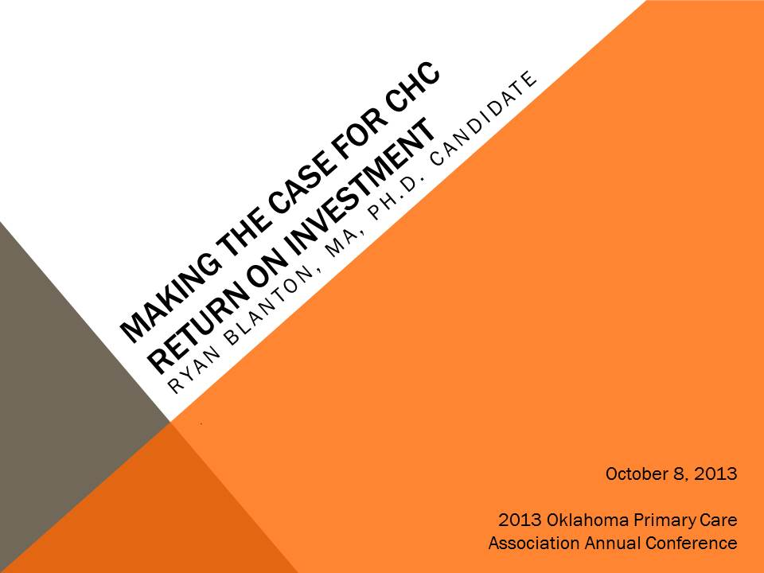

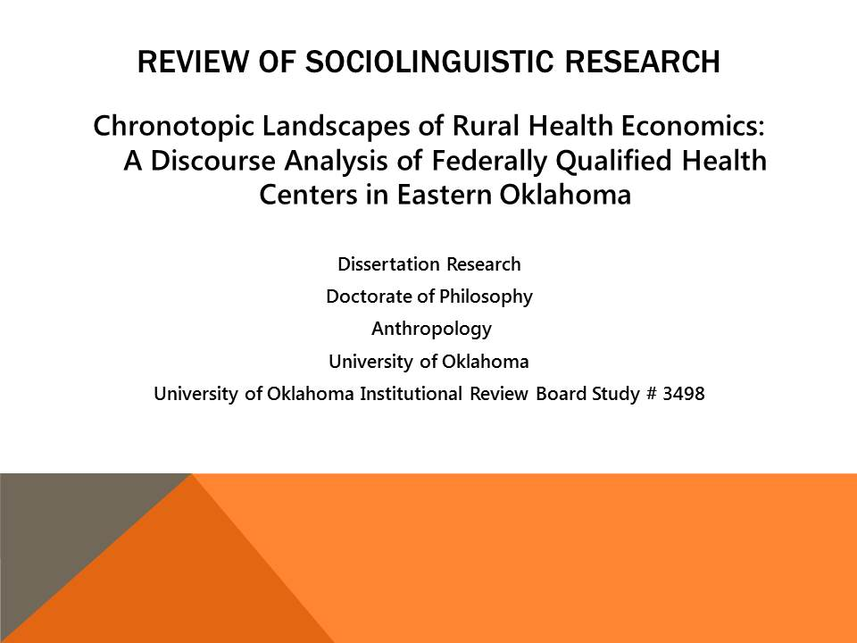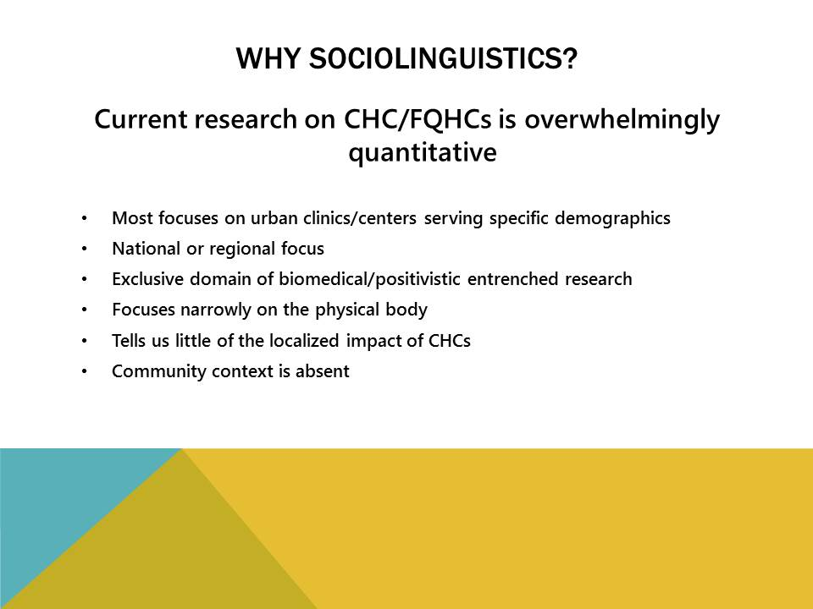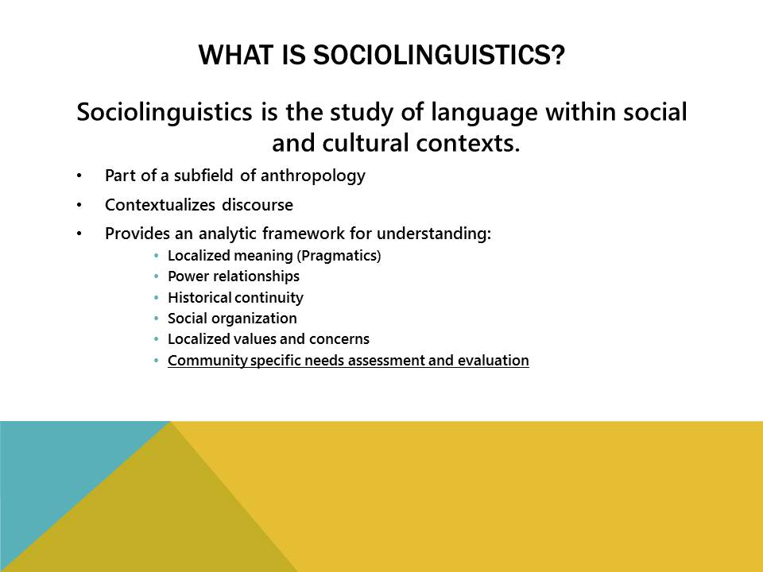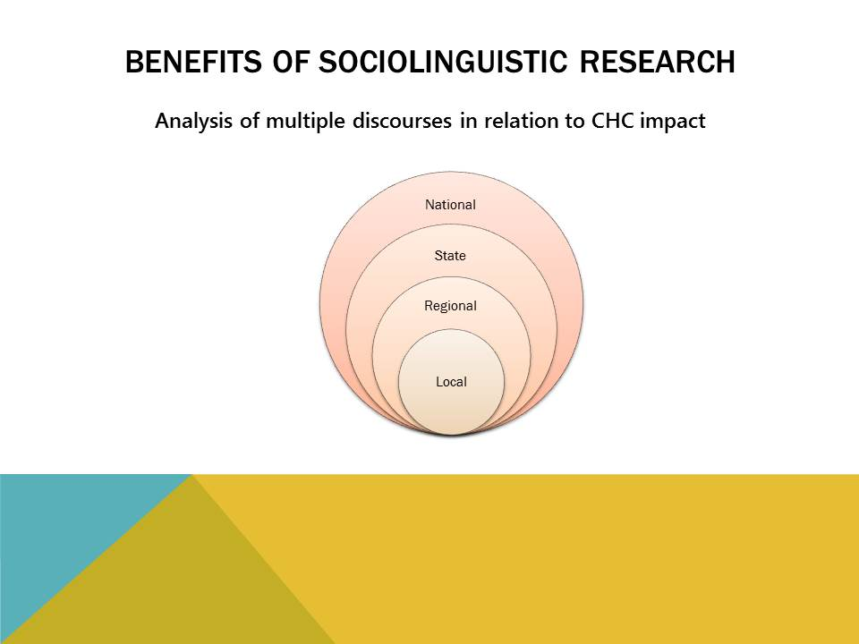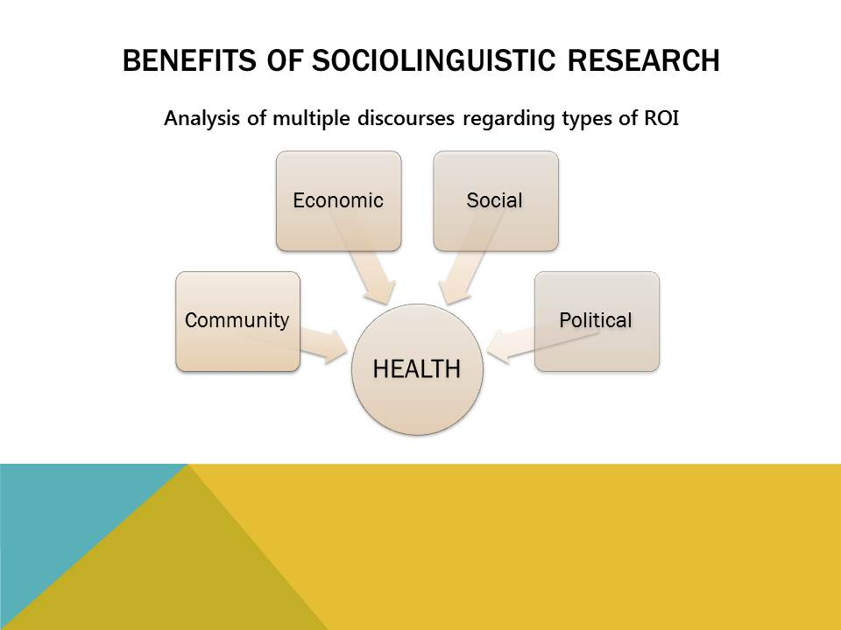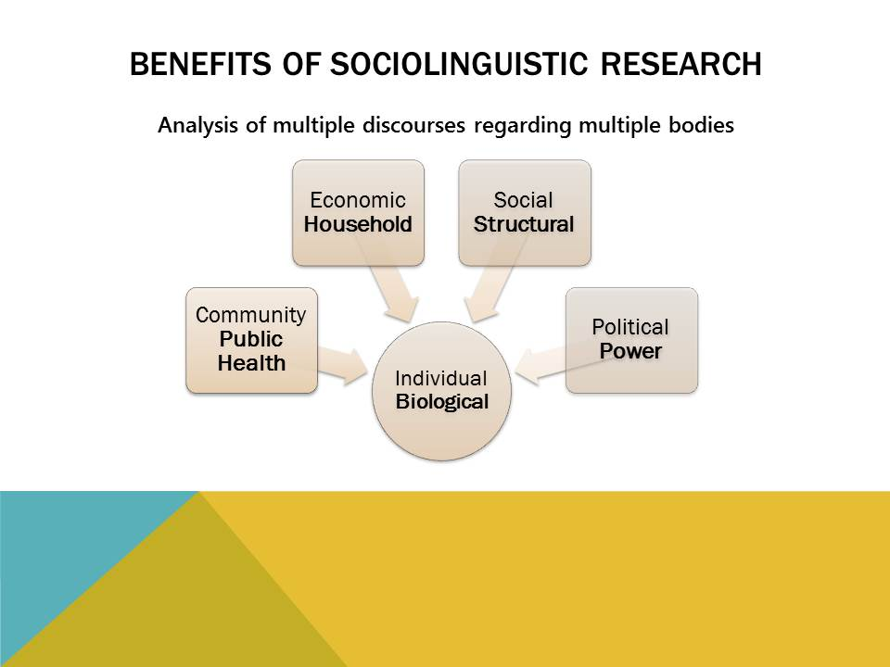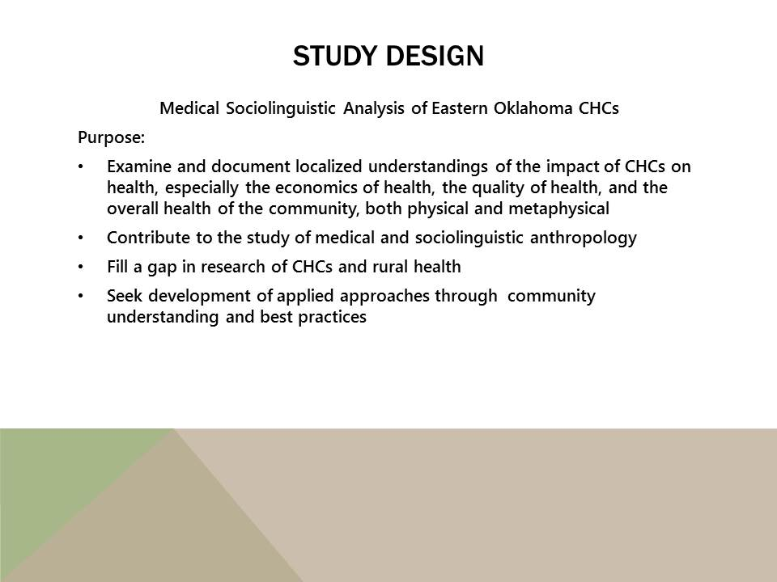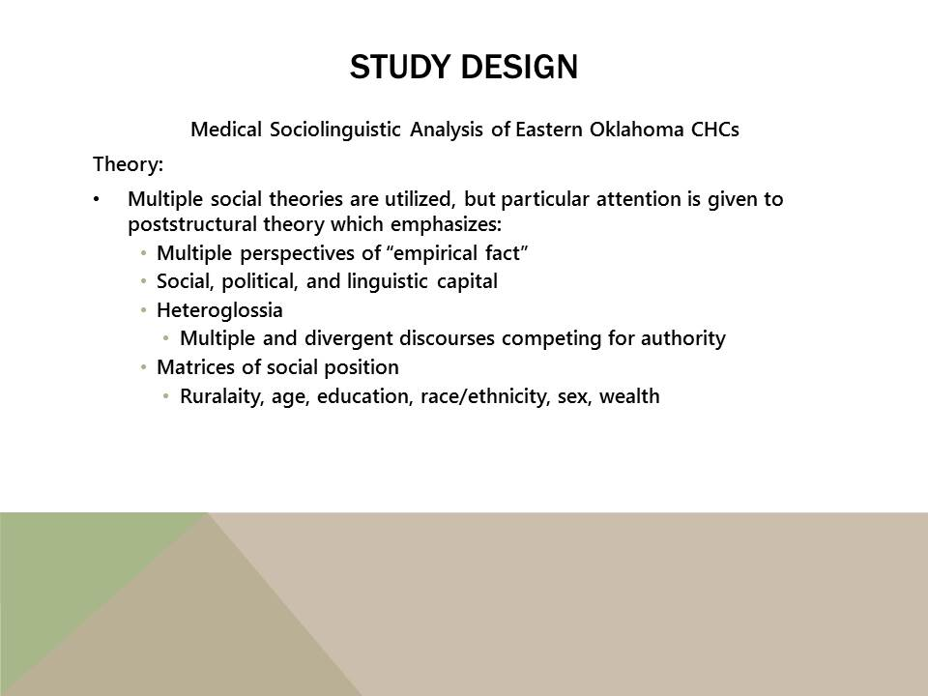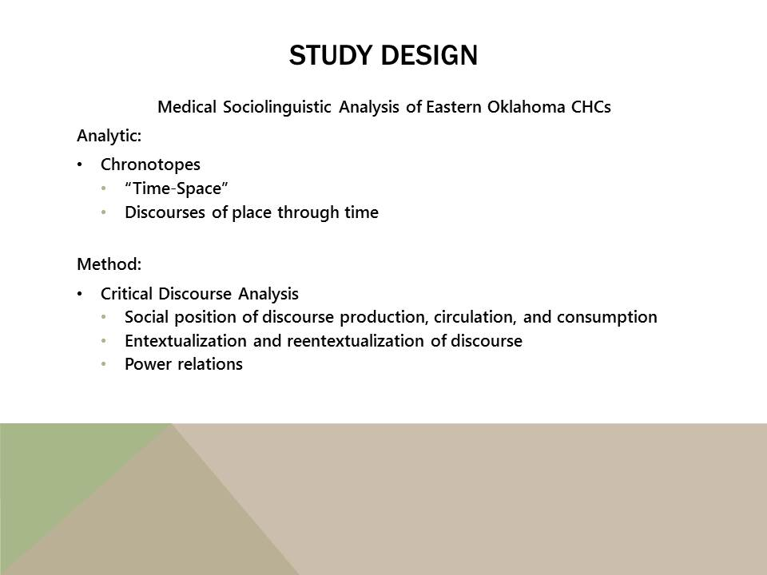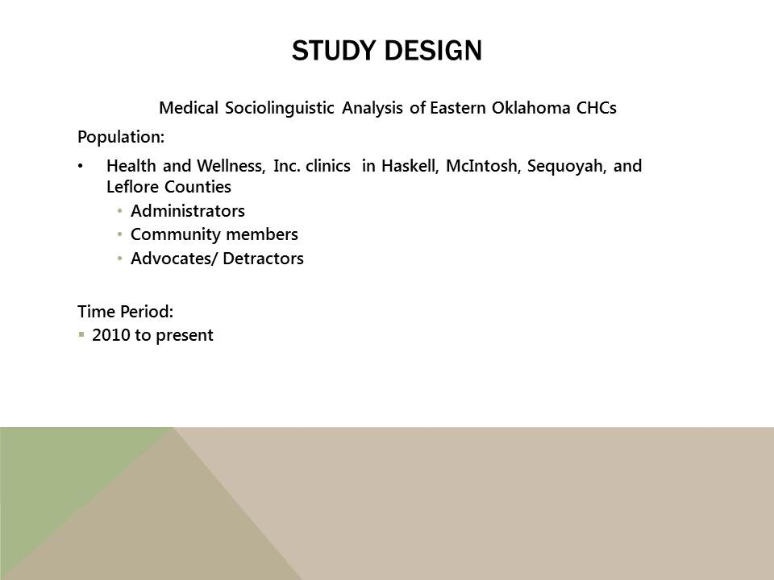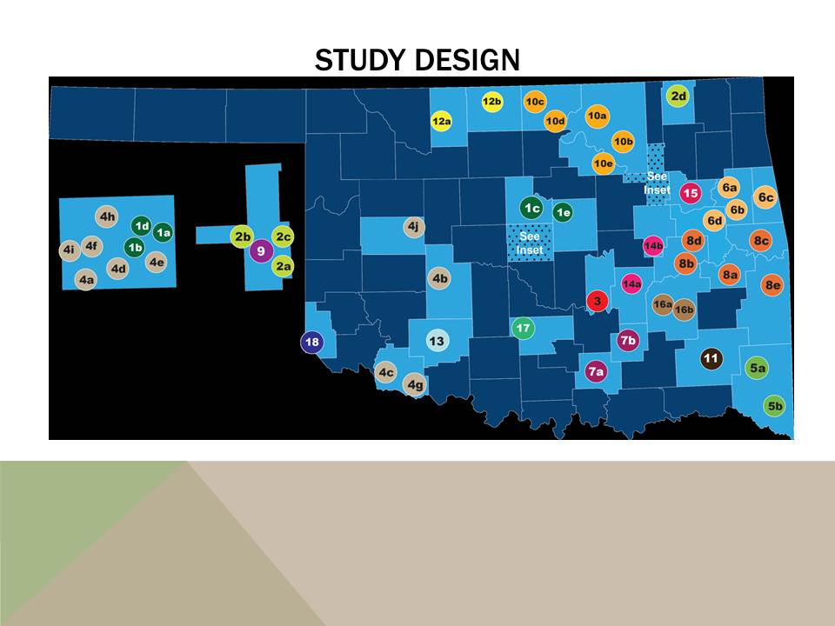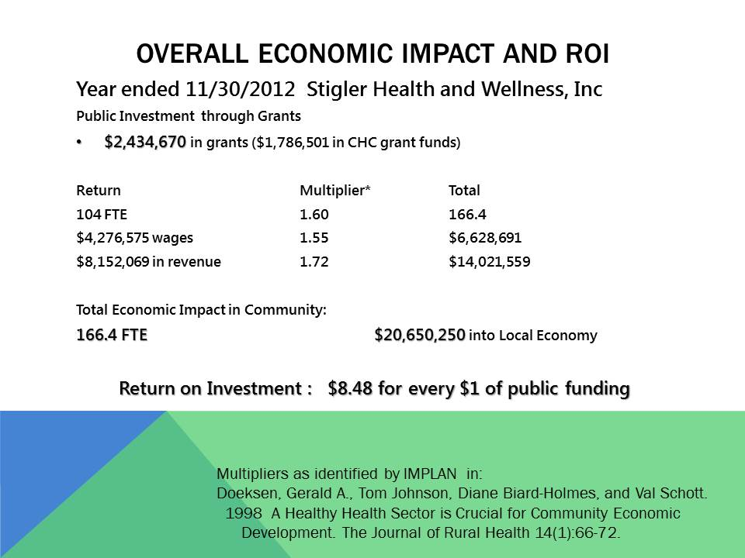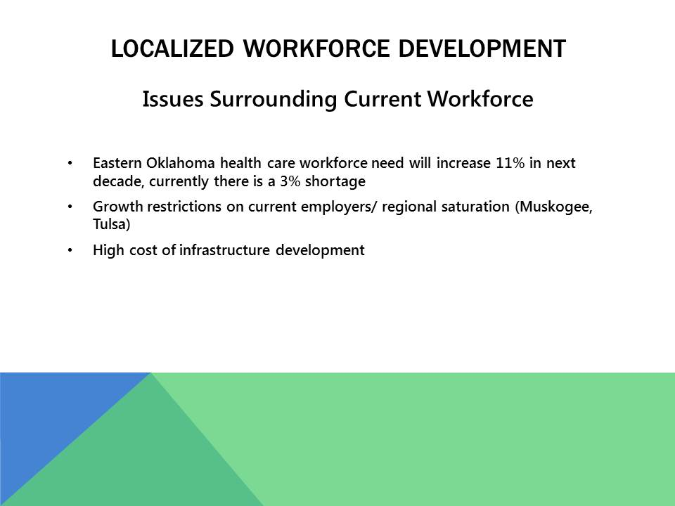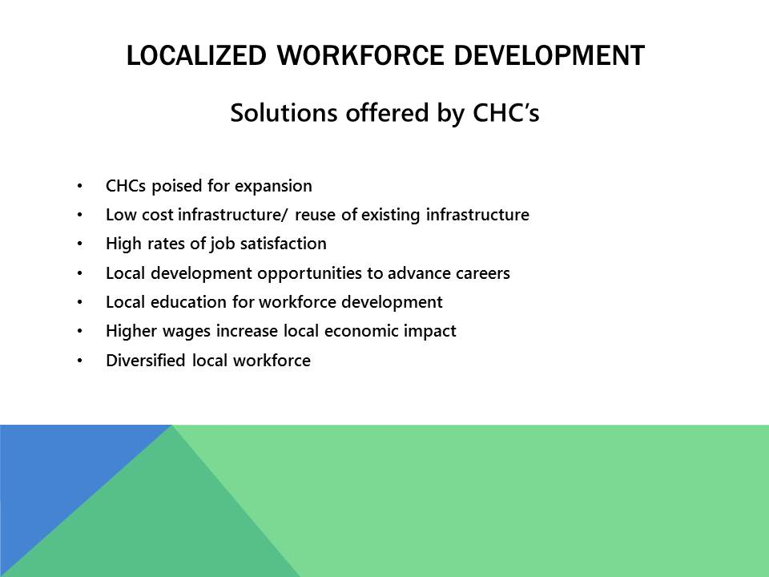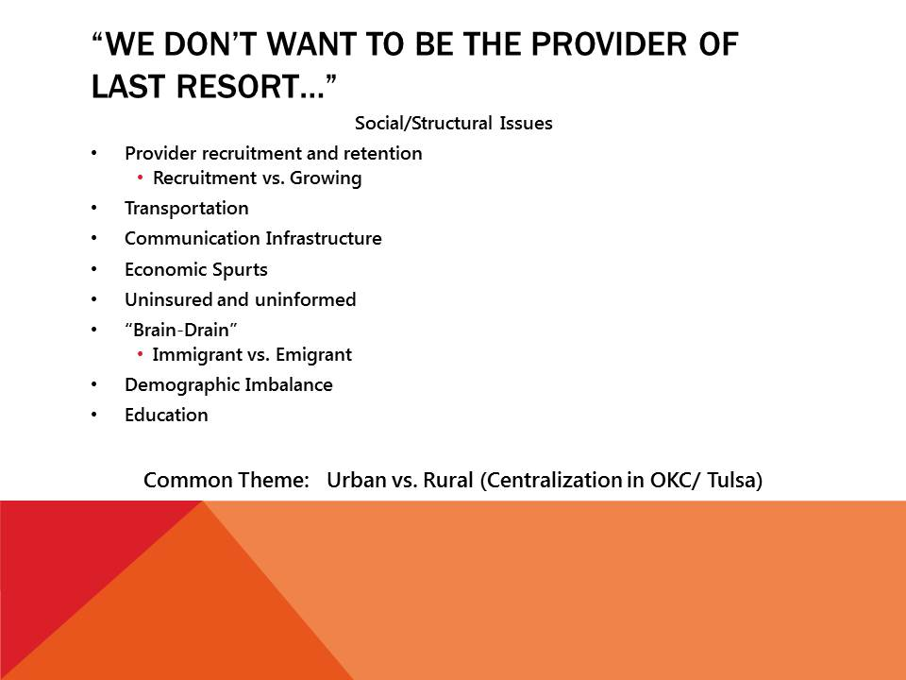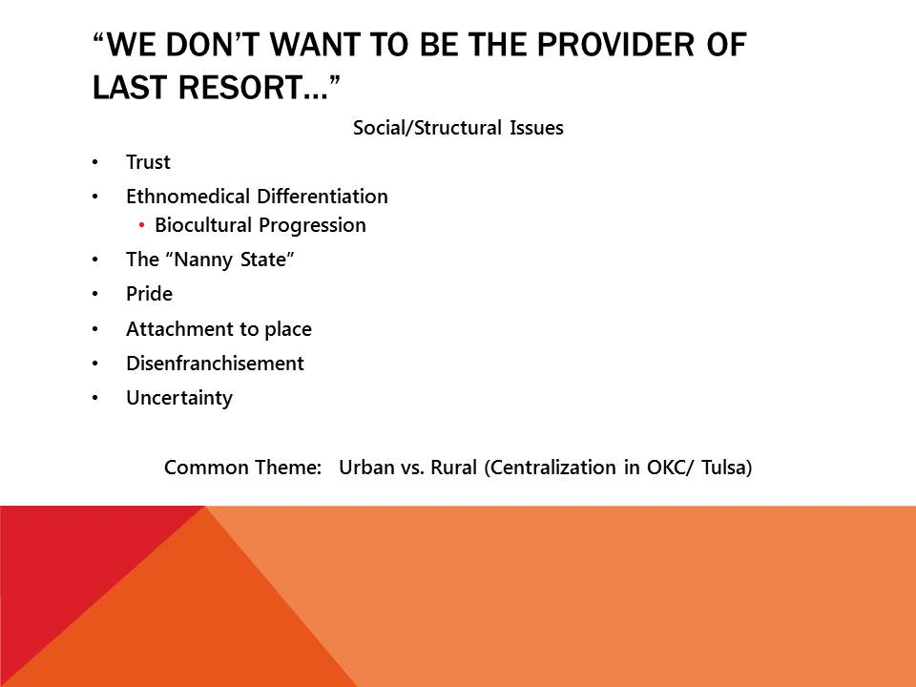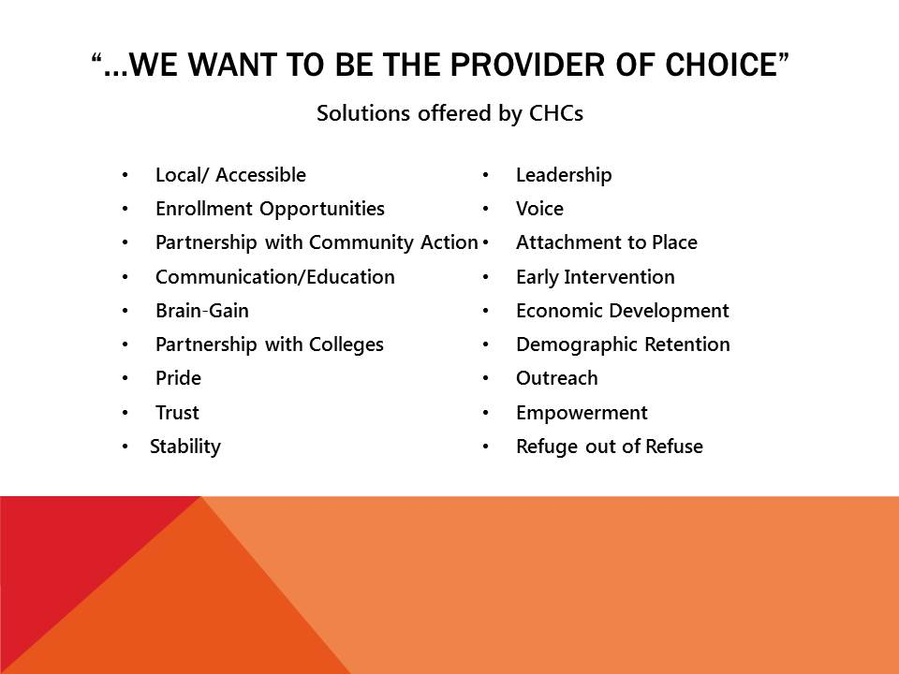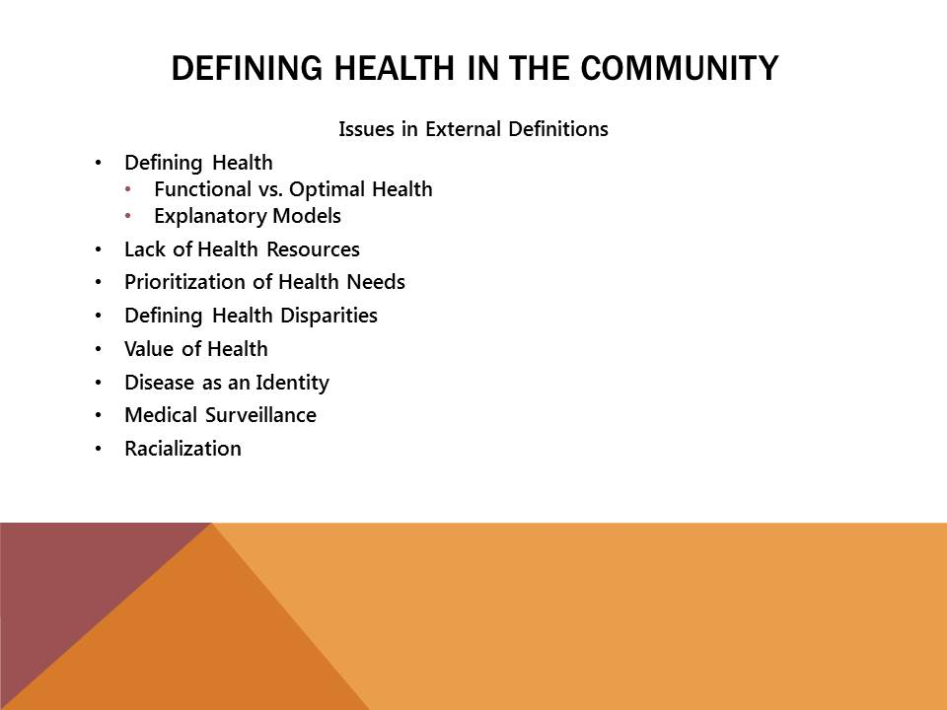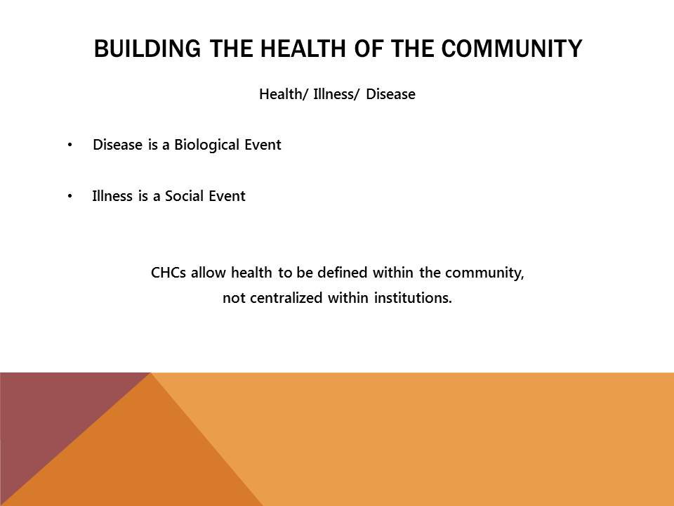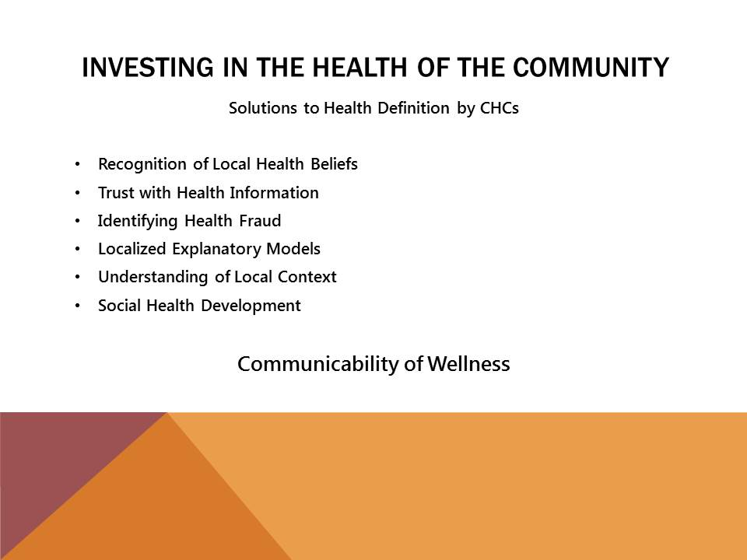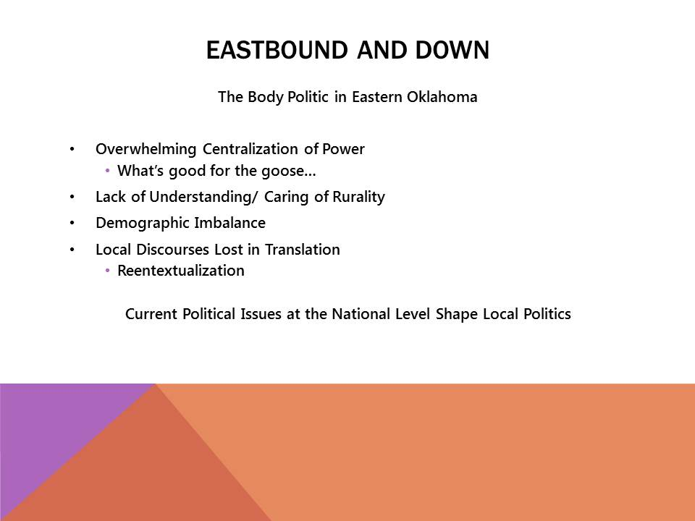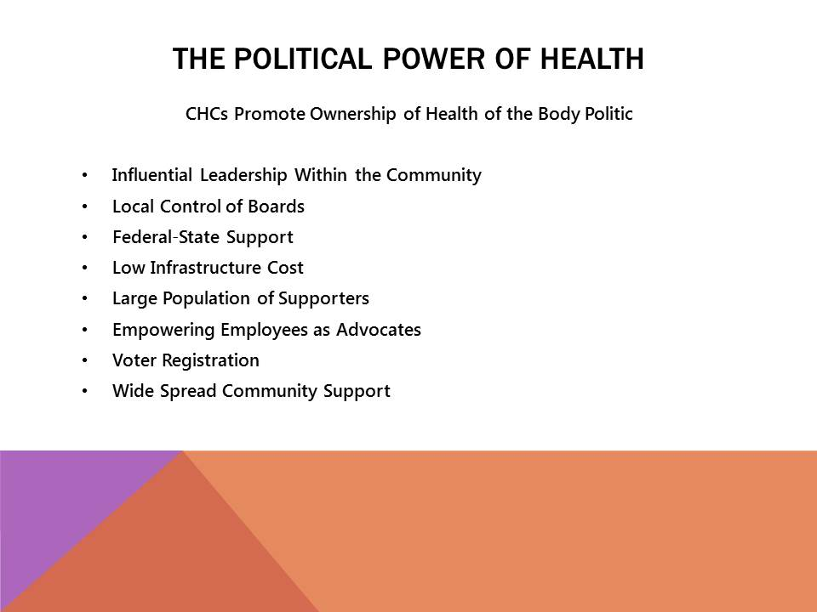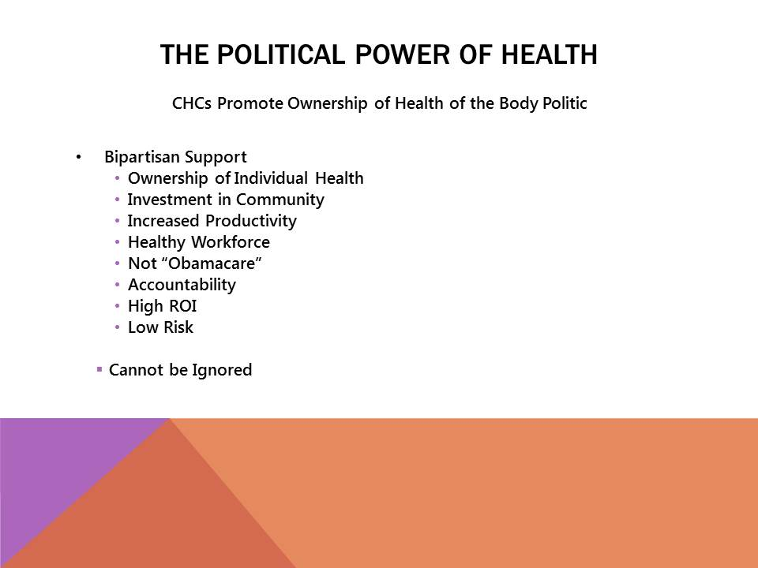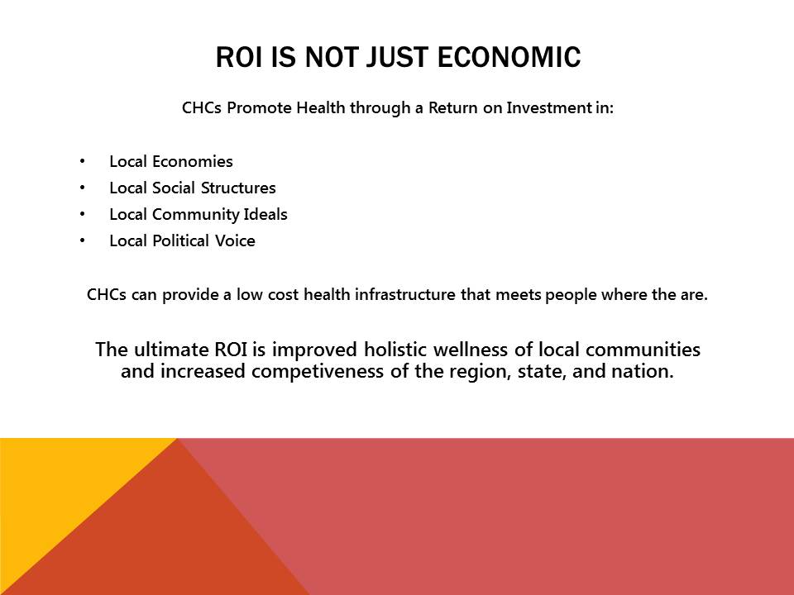

Appendix C: Institution Review Board Approve Survey Instrument
Study Survey Instrument
for
Chronotopic Discourse Analysis of Health Economics in Eastern Oklahoma
Ph.D. Dissertation Research Project

Ryan Blanton

After Informed Consent has been documented, proceed with the following general questions to open avenues of discourse.

- Please tell me about the history of your community and the availability and quality of healthcare.

- How has the Health and Wellness Clinic effected healthcare and economic development in your community?

- What role do you see Health and Wellness Clinic’s playing as healthcare reform continues?

- Why do you think it is difficult to attract healthcare providers to Eastern Oklahoma?

- What is the greatest healthcare challenge to Eastern Oklahoma?

- What other topics would you like to discuss regarding healthcare delivery in Eastern Oklahoma?

FQHC is often used interchangeably with Community Health Center (CHC). FQHCs receive U.S. federal funding under section 330 of the Public Health Service Act (42 U.S.C. 254b). A CHC is a clinic operated under the Community Health Center Program, section 330(e). Other programs included under section 330 and identified as FQHCs are: Migrant Health Centers Programs, section 330(g); Health Care for the Homeless Programs, section 330(h); and Public Housing Primary Care Programs, section 330(i). For the sake of clarity, FQHC is used throughout this dissertation, as per community use and the Health Resources and Services Administration (HRSA 2010).
The term “Sooner” originated after the Land Run of 1889. It was used to describe those who entered the Unassigned Lands before the designated time, giving them an unfair advantage in staking claim to the best land. In 1908, the University of Oklahoma made “Sooners” the mascot of their football team, and by 1920, Oklahoma was unofficially nicknamed the Sooner State (Oklahoma Historical Society 2014a).
“Okie” was a pejorative term used against white migrant farm workers, particularly during the era of the Great Depression when many Oklahoma families, most from eastern Oklahoma, moved west to California in search of work (Oklahoma Historical Society 2014b). Merle Haggard’s song Okie from Muskogee helped change the connotation of the word, and now “Okie” is a sign of pride.
Many of the participants elected to use their real names in the publication of this research. All others who did not explicitly consent to the use of their given name are reported anonymously.
I am indebted to my wife and colleague, Julie Dinger, who brought this notion to light.
Recordings were not used in interviews in an effort to reduce the potential of influencing the conversation. The discourse analysis, as outlined below, is less focused on conversation analysis and structure of spoken language, and more on broader discourse topics and processes of entextualization.
The same issues are occurring throughout the world, and there exists an intertexuality through political rhetoric tied to neoliberalism.
See Blanton (2011) for an example of this with race relations in southern Oklahoma.
In 2012, HWC had a patient payor mix of: Medicare, 12%; Medicaid, 41%; Private Insurance, 14%; and Private Pay (Including Sliding Fee), 33%.
I do so for several reasons. Medical anthropology is a diverse field, so I begin with an overview and then focus on the development of fields of inquiry relevant to this dissertation. Anthropological linguistics is similarly a complicated discipline, and language ideology and sociolinguistics is incredibly philosophical and jargonistic. My attempt here is to provide openings for an anthropological medical-linguistic research program.
A good example of this is “color-blind” racial ideology that whitewashes historical and persistent racial inequality in the United States (See Blanton 2011).
Regional dialects fall into this category as well. Accent plays an incredibly important role in providing capital and valuation of discourses of science, health, and medicine from an interlocutor and larger discourse perspective.
Haskell County was 6.8%, Sequoyah 6.9%, and Le Flore 6.7% (OSEC 2014).
Whitacre et al. 2006 provides an analysis that breaks down health sectors within the county by: Hospitals; Physicians, Dentists, and Other Professions; and Other Medical and Health Services, each with employment, income, and retail multipliers. I have provided just the sum of all categories to give an overall economic impact. I will provide the same overview for Sequoyah, McIntosh, and Le Flore Counties. I will discuss Physicians, Dentists, and Other Professions in more detail further below.
Latimer County was not included in the HWC medical service are economic impact descriptions because the clinic is an emerging market.
The commissioner is referring to the HWC opening in Stigler and its perceived effects on the Stigler hospital. The hospital is in fact still operating and has a professional and contractual relationship with HWC to provide services that HWC cannot.
Dipping refers to the use of smokeless cut tobacco or snuff, which is widely used in eastern Oklahoma. A “dip,” or “pinch” is the compacted loose tobacco pinched between the fingers and placed under the lip.
Yankee is a term used to describe an American from the northern states, primarily the northeastern states. In the south, including Oklahoma, Yankee is a pejorative.
“Coke,” in Oklahoma, refers to any type of soda beverage.

