University of Oklahoma

Graduate College

Three Diverse Works for trumpet by japanese composers: a study of THE LIVES AND works OF toru takemitsu, marcel kentsubitsch, and hisato ozawa

A Document

submitted to the graduate faculty

in partial fulfillment of the requirements for the

Degree of

Doctor of Musical Arts

By

Kana tomizono
Norman, Oklahoma
2015

three diverse works for trumpet by japanese composers: a study of THE LIVES AND works OF toru takemitsu, marcel kentsubitsch, and hisato ozawa

A Document approved for the
School of Music

By

______________________________
Dr. Karl Sievers, Chair

______________________________
Dr. Irvin Wagner, Co-Chair

______________________________
Dr. Michael Lee

______________________________
Dr. Frank Riddick

______________________________
Dr. Kurt Gramoll

© Copyright by kana tomizono 2015
All Rights Reserved.
Acknowledgements

First of all, I would like to thank Dr. Karl Sievers for all his support during my studies at the University of Oklahoma. I would also like to thank the other members of my committee: Dr. Michael Lee and Dr. Frank Riddick for all their help with profound expertise, Dr. Irvin Wagner for his support and many opportunities of performance, and Dr. Kurt Gramoll for his constructive advice from the viewpoint of outside committee member. Last but not least, I really appreciate the generous help from Dr. Mikiko Ikushima and the members of Osawa Project at Kobe College for the research on Hisato Ozawa and his Trumpet Concerto.

Table of Contents

Acknowledgements iv
List of Examples vii
List of Figures x
List of Tables x
Abstract xi
Chapter 1 Introduction 1
Purpose of the Study 1
Scope and Limitations of the Study 3
Survey of Related Literature 4
Chapter 2 Biography of Toru Takemitsu 7
Early Life 7
Formal Training 9
Major Influence 11
Career 18
Music of Takemitsu 22
Chapter 3 Paths—In Memoriam Witold Lutosławski by Toru Takemitsu 31

Background 31
Analysis 33
Chapter 4 Biography of Marcel Kentsubitsch (Naohiro Tsuken) 41
Early Life 41
Formal Training 42
Major Influence 44
Career 47
Music of Kentsubitsch 50
Chapter 5 Contest Piece by Marcel Kentsubitsch 60
Background 60
Analysis 61
Chapter 6 Biography of Hisato Ozawa 79
Early Life 79
Formal Training 81
Major Influence 82
Career 84
Music of Ozawa 90
Chapter 7 Concerto for Trumpet and Orchestra by Hisato Ozawa 104
Background 104
Analysis 106
Movement I 106
Movement II 120
Movement III 124
Chapter 8 Conclusion 134
Bibliography 136

List of Examples

2.1 Toru Takemitsu, Uninterrupted Rest, Movement II, p. 1 24

2.2 Takemitsu, Far Calls, Coming, Far! mm. 6-14 26

3.1 Takemitsu, Paths, lines 1-2, with melodic motives 34

3.2 Takemitsu, Paths, lines 1-2, with the SEA motives 34

3.3 Takemitsu, Paths, lines 3-4 35

3.4 Takemitsu, Paths, lines 5-6 36

3.5 Takemitsu, Paths, lines 7-8 36

3.6 Takemitsu, Paths, line 9 37

3.7 Takemitsu, Paths, lines 11-15 38

3.8 Takemitsu, Paths, lines 16-21 39

3.9 Takemitsu, Paths, lines 22-23 40

4.1 Marcel Kentsubitsch, Theme from Quatre Variations sur un Thème de
SE16GAN 51

4.2 Kentsubitsch, Theme and variations from Quatre Variations sur un
Thème de SE16GAN 52

4.3 Theme from The Trout Quintet by Franz Schubert and Septet “The
Salmon” by Kentsubitsch 54

4.4 Okinawan scale 57

4.5 Kentsubitsch, Legend, mm. 5-12 58

4.6 Asadoya Yunta (Okinawan folk song) 58

4.7 Kentsubitsch, Trumpet Concerto, mm. 217-226 59

5.1 Kentsubitsch, Contest Piece, mm. 1-4 63

5.2 Kentsubitsch, Contest Piece, mm. 5-12, with motives 63

5.3 Kentsubitsch, Contest Piece, mm. 5-12 64

5.4 Kentsubitsch, Contest Piece, mm. 13-16 65

5.5 Kentsubitsch, Contest Piece, mm. 18-24 66

5.6 Kentsubitsch, Contest Piece, mm. 25-27 66

5.7 Kentsubitsch, Contest Piece, mm. 28-32 67

5.8 Kentsubitsch, Contest Piece, mm. 42-45 68

5.9 Kentsubitsch, Contest Piece, mm. 46-53 68

5.10 Kentsubitsch, Contest Piece, mm. 46-61 70

5.11 Kentsubitsch, Contest Piece, mm. 62-69 71

5.12 Kentsubitsch, Contest Piece, mm. 78-88 71

5.13 Kentsubitsch, Contest Piece, mm. 88-119 72

5.14 Kentsubitsch, Contest Piece, mm. 124-128 74

5.15 Kentsubitsch, Contest Piece, mm. 144-175 75

5.16 Kentsubitsch, Contest Piece, mm. 176-190 78

6.1 Hisato Ozawa, Otemari Rondo, mm. 1-11 92

6.2 Ozawa, Otemari Rondo, mm. 20-24 93

6.3 Ozawa, Otemari Rondo, mm. 84-86 93

6.4 Ozawa, Otemari Rondo, mm. 94-96 93

6.5 Sakura 95

6.6 Ozawa, Une voix à Sakura, mm. 17-24 96

6.7 Ozawa, “Sakura” Fantasy, mm. 1-6 98

6.8 Ozawa, Piano Concert No. 3 “Kamikaze,” Movement II, mm. 9-17 100

6.9 Ozawa, Piano Concert No. 3 “Kamikaze,” Movement II, mm. 41-50 101

7.1 Ozawa, Concerto for Trumpet and Orchestra, Movement I, mm. 1-15 107

7.2 Ozawa, Concerto for Trumpet and Orchestra, Movement I, mm. 13-19 108

7.3 Ozawa, Concerto for Trumpet and Orchestra, Movement I, mm. 38-41 108

7.4 Ozawa, Concerto for Trumpet and Orchestra, Movement I, mm. 52-68 109

7.5 Ozawa, Concerto for Trumpet and Orchestra, Movement I, mm. 75-80 109

7.6 Ozawa, Concerto for Trumpet and Orchestra, Movement I, mm. 80-87 110

7.7 Ozawa, Concerto for Trumpet and Orchestra, Movement I, mm. 88-96 110

7.8 Ozawa, Concerto for Trumpet and Orchestra, Movement I, mm. 96-99 111

7.9 Ozawa, Concerto for Trumpet and Orchestra, Movement I, mm. 104-114 112

7.10 Ozawa, Concerto for Trumpet and Orchestra, Movement I, mm. 165-176 114

7.11 Ozawa, Concerto for Trumpet and Orchestra, Movement I, mm. 176-192 118

7.12 Ozawa, Concerto for Trumpet and Orchestra, Movement II, mm. 1-2 120

7.13 Ozawa, Concerto for Trumpet and Orchestra, Movement II, mm. 3-7 121

7.14 Ozawa, Concerto for Trumpet and Orchestra, Movement II, mm. 8-12 121

7.15 Ozawa, Concerto for Trumpet and Orchestra, Movement II, mm. 13-30 122

7.16 Ozawa, Concerto for Trumpet and Orchestra, Movement II, mm. 31-36 123

7.17 Ozawa, Concerto for Trumpet and Orchestra, Movement III, mm. 5-12 125

7.18 Ozawa, Concerto for Trumpet and Orchestra, Movement III, m. 18,
beat 3-m. 23 127

7.19 Ozawa, Concerto for Trumpet and Orchestra, Movement III, mm. 22-29 128

7.20 Ozawa, Concerto for Trumpet and Orchestra, Movement III, mm. 34-37 130

7.21 Ozawa, Concerto for Trumpet and Orchestra, Movement III, mm. 54-62 131

7.22 Ozawa, Concerto for Trumpet and Orchestra, Movement III, mm. 76-86 132

7.23 Ozawa, Concerto for Trumpet and Orchestra, Movement III, mm. 96-105 132
7.24 Ozawa, Concerto for Trumpet and Orchestra, Movement III, mm. 108-113 133

List of Figures

2.1 Seating Arrangement for The Dorian Horizon by Toru Takemitsu 17

2.2 Patterns of the SEA motive 28

5.1 Analytical diagram for Contest Piece by Kentsubitsch 62

7.1 Analytical diagram for Concerto for Trumpet and Orchestra, Movement
I by Ozawa 106

7.2 Analytical diagram for Concerto for Trumpet and Orchestra, Movement
III by Ozawa 124

List of Tables

5.1 Kentsubitsch, Contest Piece, sets of the diminished-seventh chords and
octatonic scales in mm. 144-174 77

Abstract

Currently, band is one of the most popular extracurricular activities in Japanese schools, and many people enjoy playing the trumpet not only as professionals but also as a hobby. As band players, trumpeters in Japan frequently have opportunities to play music by Japanese composers. Some of these compositions enjoy international popularity, especially in Asia. However, when Japanese trumpeters play the trumpet as a solo instrument, the availability of Japanese works for solo trumpet is much more limited than the Japanese works for band. The literature for solo trumpet relies heavily on works from the United States and Europe. Even though some professional trumpet players in Japan make serious efforts to discover and perform works for solo trumpet by Japanese composers, most of these Japanese works are out of the mainstream of trumpet literature in Japan. Moreover, very few of these have been performed outside of Japan.
This document focuses on three diverse works for trumpet by Japanese composers: Paths—In Memoriam Witold Lutosławski by Toru Takemitsu (1930-1996), Contest Piece by Marcel Kentsubitsch (b. 1950), and Trumpet Concerto by Hisato Ozawa (1906-1953). Each of these three pieces employs unique accompaniment or none at all; Takemitsu wrote Paths for unaccompanied trumpet, Contest Piece by Kentsubitsch is written for trumpet and piano, and Ozawa composed his Trumpet Concerto for trumpet, large jazz band, and strings. Through biographical research of these composers and analyses of their works, this document seeks to draw attention to this outstanding Japanese literature for professional performance, enjoyment for non-professional players, and pedagogical value.
Chapter 1
Introduction

Purpose of the Study

Since the Black Ships of Commodore Matthew Perry forcibly opened Japan to Western trade in 1853, Japan has rapidly absorbed Western culture. After more than 200 years of Sakoku (foreign relations policy of Japan beginning in 1639 under which no foreigners except limited Chinese people and Hollanders could enter), Japanese people were curious about almost everything from foreign countries. As a result, the lifestyle in Japan experienced rapid Westernization in the late nineteenth century.
Western music in Japan also has developed since 1853. For Japanese people who had never heard Western music, the performances of American and British military bands left a deep impression. In particular, Hisamitsu Shimazu, Daimyo of Satsuma (Satsuma is modern-day Kagoshima prefecture), was so fascinated by the sound of military bands that he established the first Japanese military band in 1869. Shimazu chose thirty band members from his soldiers and sent them to Yokohama, and John William Fenton, a bandmaster of Britain’s 10th Foot Regiment 1st Battalion, trained the band. Fenton ordered instruments to Besson in London while he taught band members music reading and theory. Shimazu spent his private property for this purchase. In 1870, the trumpet along with other wind instruments arrived in Japan.
Based on this Satsuma military band, two national military bands were established in 1870. Retired players from these bands formed some private bands and orchestras, and they played in dance halls and for parties. When Japanese music listeners began to show an interest in playing Western music in the 1920s, private schools of music were established which helped these Japanese people acquire skills as professional musicians. Currently, band is one of the most popular extracurricular activities in Japanese schools, and many people enjoy playing the trumpet not only as professionals but also as a hobby.
As band players, trumpeters in Japan frequently have opportunities to play music by Japanese composers. Some of these compositions enjoy international popularity, especially in Asia. However, when Japanese trumpeters play the trumpet as a solo instrument, the availability of Japanese works for solo trumpet is much more limited than the Japanese works for band. The literature for solo trumpet relies heavily on works from the United States and Europe. Even though some professional trumpet players in Japan make serious efforts to discover and perform works for solo trumpet by Japanese composers, most of these Japanese works are out of the mainstream of trumpet literature in Japan. Moreover, very few of these have been performed outside of Japan.
This document focuses on three diverse works for trumpet by Japanese composers: Paths—In Memoriam Witold Lutosławski by Toru Takemitsu (1930-1996), Contest Piece by Marcel Kentsubitsch (b. 1950), and Trumpet Concerto by Hisato Ozawa (1906-1953). These three works were chosen for this study for three reasons. First, even though all three works are categorized as solo trumpet literature, each employs unique accompaniment or none at all. Takemitsu wrote Paths for unaccompanied trumpet, Contest Piece by Kentsubitsch is written for trumpet and piano, and Ozawa composed his Trumpet Concerto for trumpet, large jazz band, and strings. Second, these composers came from different musical training. Takemitsu never studied in any schools of music; he mostly studied on his own and with his friends. Kentsubitsch was trained as a professional trumpeter, and he uses his expertise as a performer in his compositions. Ozawa studied composition at several schools in Boston, and in Paris. Last but not least, the reputation of each composer is diverse. Takemitsu is one of the most famous Japanese composers in the world. Kentsubitsch is still active and his works are popular among Japanese musicians. Ozawa had a successful career in the US and Europe, but after his death, his achievements had been forgotten until the beginning of this century. Through biographical research of these composers and analyses of their works, this document seeks to draw attention to this outstanding Japanese literature for professional performance, enjoyment for non-professional players, and pedagogical value.

Scope and Limitations of the Study

For each of the three works, this document provides a bibliographical study of the composer and the background and analysis for the work. Bibliographies include explanations of historical circumstances to illustrate each composer’s situation; however, this document will not deal with the detailed history of Western music in Japan. Also, social backgrounds which influenced each composer’s works will be discussed; nevertheless, the overall impact of social events on music in Japan is beyond the scope of this paper. While bibliographies emphasize the characteristic musical elements for the works in this document, in-depth studies of the elements not related to these works will not be undertaken.
This document presents analyses of form, tonal schemes, and harmonic progressions of the aforementioned three works. Analyses include observations of the difficulties and technical demands for performance, yet practical recommendations for the performance and pedagogy will not be discussed.

Survey of Related Literature

No document focusing on multiple trumpet works by Japanese composers exists. However, a few documents about Japanese works for other genres are available. Junko Ueno Garrett’s DMA document “Japanese Piano Compositions of the Last Hundred Years: A History of Piano Music in Japan and a Complete List of Japanese Piano Compositions” primarily concerns history. Garrett’s list includes some brief information about compositions, such as composer, title, year of publication, publisher, length, genre, and premiere.
Kazuo Murakami also wrote about Japanese piano works, but he focused on two sonatas. In his DMA essay “Japanese Piano Sonatas: A Discussion and Performance Guide,” he provides a brief biography of each composer followed by an analysis of each work which includes pedagogical suggestions. In the introduction, he identifies a significant lack of knowledge among US musicians regarding Japanese compositions by asking questions about Japanese musicians and composers to thirty musicians. About the results of the questionnaire, he states, “Although many of them knew of Toru Takemitsu, only eight people could name specific titles of compositions. Although many Japanese compositions are published worldwide, many musicians do not know what they sound like or how they are constructed.”
Matthew C. Howell’s DMA document “A Conductor’s Introduction to the Performance of Modern Japanese Choral Music” introduces four Japanese choral works with composers’ biographies, texts, transliterations, translations, and analyses. All of the works he chose represent different genres: a work based on a folk tune, a work for women’s chorus, a work for men’s chorus, and a composition for mixed chorus. Howell indicates that the inaccessibility or lack of contact with Japanese choral music results in limited performance opportunities outside of Japan, but he also notices the awareness of the high artistic achievements of Japanese choral composers among American conductors.
For individual composers in this document, the number of existing studies and documents is limited except for Takemitsu. No academic study about Kentsubitsch has been conducted yet, but Kentsubitsch has written essays about his life and works under his real name, Naohiro Tsuken. The serious study of Ozawa and his works began when Morihide Katayama, a political scientist and music critic, and Kenichi Fujimoto, a reporter of Kobe Shimbun (newspaper), rediscovered Ozawa’s works in 2000. Currently, the research group at Kobe College called Osawa Project continues the research into the Hisato Osawa Posthumous Collection, which was donated to Kobe College by Ozawa’s son Toshifumi Osawa in 2006.

Chapter 2
Biography of Toru Takemitsu

Without professional training at school, Toru Takemitsu experienced a hard time in his early career. Most music critics and composers in Japan harshly criticized Takemitsu’s works. Nevertheless, by the time of his death in 1996, Takemitsu had enjoyed his international fame as one of the most successful Japanese composers in the Western musical world.

Early Life

Toru Takemitsu was born in Tokyo on October 8, 1930. Only one month later, he moved to Dairen, Manchuria with his father Takeo and his mother Reiko. In Dairen, Takeo worked as an official of the Japanese government. Takemitsu did not remember any experience with Chinese music in Manchuria, but he said he had vague memories of hearing Takeo’s recordings of Dixieland jazz music.
Because Takemitsu wanted to go to school in Japan, his parents sent him to his aunt in Tokyo, and he entered Fujimae Elementary School. His aunt was an instructor of koto (Japanese 13-stringed instrument with a movable bridge under each string), but for young Takemitsu, traditional koto music sounded strange and unfamiliar compared to the jazz music he heard with his father. Takemitsu’s cousin sometimes played recordings such as Beethoven’s Moonlight Sonata and Mendelssohn’s Violin Concerto, yet Takemitsu showed little interest in these works. In school, a music teacher Kyoko Yamamoto found Takemitsu’s talent for music and taught him piano after school.
In 1943, Takemitsu went on to Keika Middle School. However, his education was interrupted by conscription into the Army in 1944 when he entered a youth regiment in Saitama. During his stay in Saitama, he had an opportunity to listen to a French chanson, and at that moment, he decided to become a musician.
After the war, Takemitsu showed symptoms of tuberculosis. In bed, he listened to the Armed Forces Radio broadcasts and learned music. He talked about this radio program as below:
毎日、午後に三時間ほどクラシック音楽を放送する進駐軍のラジオ局があって、トスカニーニやブルーノ・ワルターなどのいい演奏をたくさん聴きました。だから、僕の最初の音楽の先生はラジオでした。

The Occupation Forces broadcast classical music for about three hours every afternoon. I listened to wonderful performances of works by composers such as (Arturo) Toscanini and Bruno Walter. My first music teacher was the radio. [Author’s translation]

He rarely went to school after the war. Instead, Takemitsu started working as a band boy at an American PX in Yokohama in December 1946. The advantage of this job was that he could play the piano before the bar opened. After he quit this job, he rarely had a chance to play the piano. He used to visit any houses from which he heard the sound of the piano and asked if he could play it. In addition, he made a paper piano keyboard the same size as the real one. He brought this foldable piano with him all the time.
In 1949, Takemitsu took the entrance exams for Tokyo Ongaku Gakko (Tokyo Music School, present Tokyo University of the Arts, Department of Music). On the first day of the exams, Takemitsu met a talented boy, and their conversation convinced Takemitsu that composing music did not require any school or education. On the second day, Takemitsu skipped the exams and enjoyed watching a movie.

Formal Training

Takemitsu never received formal training at any schools of music. Nevertheless, he studied privately with two musicians.
In 1946, Takemitsu joined a choral group of Noriteru Hamada, who was one year older than Takemitsu and later became a professional conductor. In the summer 1946, Takemitsu woke up Hamada at 7 a.m. and played his own composition on the piano. Even though Takemitsu played it with one finger, this one-minute work deeply impressed Hamada. Hamada said,
ドビュッシィを聞いてびっくりしたって、時代も民族もちがうから、現実感がなかった。それなのに、私の眼の前に、天才が寝巻きを着て立っている。そういう驚きがあった

Debussy’s music amazed me, but I did not feel his existence because he belongs to a different generation and ethnic group. However, when I heard Takemitsu’s music, I was astonished and thought that there was a genius in his pajamas standing in front of me. [Author’s translation]

After this, Hamada had taught Takemitsu everything he knew about the compositional craft, such as notation, counterpoint, analysis, and harmonies. This tutoring continued for two and a half months. With the fundamentals acquired from Hamada, Takemitsu began to buy scores and books about music at secondhand bookstores, and he learned as much as possible from these scores and books.
In 1948, at the age of eighteen, Takemitsu started to study composition from Yasuji Kiyose. Takemitsu attended the second concert by Shin Sakkyokuha Kyokai (New group of composers), and he was impressed by Kiyose’s Violin Sonata No. 1. Even though they had lessons regularly, Takemitsu learned very little about compositional techniques. Instead, they spent most of their lesson time for discussions on musical aesthetics and philosophical ideas. Takemitsu mentioned about Kiyose as below:
清瀬保二氏から、私はどれだけ多くを学んだか知れない。それは具体的な音楽の技術だけではなかった。（中略）当時私は、日本には私が志向するような抽象的な器楽作品を書く作曲家は皆無なのではないかと思っていた。私は音楽の沃野にひとり立つ気概でいたが、実は私はどの方向へ歩いていいのかさえわからなかった。（中略）清瀬保二氏の「第一ヴァイオリン・ソナタ」を聞いたときに、私は自分の模索していたものが明りょうな形となって具現されていることに、言い表しようもない驚きと感銘を受けた。私は氏の音楽を通じて音の大地の豊かさを知り、そこには私ひとりが立つのではなく、多くの異る思想や感情が共にあることを知った。

It is beyond measure how much I learned from Yasuji Kiyose. It was not just musical techniques. . . . Before I met him, I did not think there were any Japanese composers who wrote abstract instrumental music which I aimed at. I was on my mettle to stand alone at the fertile plain of music, but actually, I had no idea which direction I should walk. . . . When I heard his Violin Sonata No. 1, I felt amazement and impression beyond words because this work clearly realized what I was seeking. Through his music, I learned the richness of the land of music. I also learned I was not standing alone there but coexisting with various thoughts and emotions. [Author’s translation]

Kiyose’s help was not limited to private lessons. He also introduced Takemitsu to his musical friends through participation in composers’ groups and in concerts of new music. With Kiyose’s help, Takemitsu expanded his circle of musicians and artists.
In addition to lessons from Hamada and Kiyose, Takemitsu also mentioned that working with composer Fumio Hayasaka helped him learn orchestration. Since around 1950, Takemitsu helped writing scores of film music by Hayasaka. By writing scores and hearing these works immediately in the movies, Takemitsu learned various combinations of instrumentation and how these combinations actually sounded.

Major Influence

When Takemitsu went back to Tokyo from Manchuria in 1937, life in Japan was deeply affected by militarism. The occupation of Manchuria by Japan in 1931 resulted in the withdrawal of Japan from the League of Nations in 1933. Since then, Japan had strengthened its militarism, and this policy lead to an outbreak of Second Sino-Japanese War in 1937 and participation in World War II in 1941.
The National Spiritual Mobilization Movement forced people to support the war with slogans such as “Luxury is our enemy,” “We Don’t Want until We Win,” and “One Hundred Million with One Spirit.” Military training hours were included in the school curriculum, and even elementary schools were not the exempt from this curriculum change. The Film Law of 1939 limited the themes of movies to patriotism and militarism, and the government began to censor the scripts. The government prohibited English movies in 1941, and all English films were seized by the customs office. In 1943, the government finally prohibited English and American music. The authority called English and American music hostile music. The police cracked down on performances and confiscated recordings of this banned music. Even though the ban was against only English and American music, many Japanese people also regarded French music as hostile music. Young Takemitsu was surrounded by the patriotic and militaristic music promoted by the government.
Under these circumstances, Takemitsu heard a recording of the American cabaret singer and actress Josephine Baker singing the French chanson Parlez-moi de l’amour. Takemitsu talked about this experience as below:
音楽と「出会った」と言えるのは、第二次世界大戦が終わる間際の中学生の時でした。（中略）戦争末期に聴けた外国音楽は、同盟国であるドイツやイタリアのごく一部のものに限られていました。終戦の一ヶ月程前、一人の兵隊がフランスのシャンソンを聞かせてくれたんです。（中略）「一生、音楽とかかわっていたい」と思ったのがこの時でした。

I “met” music when I was in middle school, and it was just before the end of World War II. . . . Around the end of the war, we could listen to very limited foreign music from nations in the pact such as Germany and Italy. One month before the end of the war, a soldier played the recording of French chanson. . . . That was the moment I thought, “I would like to work on music for all my life.” [Author’s translation]

Takemitsu described that this encounter of “something not Japanese” was his musical experience with the strongest impact.
His second encounter occurred after the war when the Armed Forces Radio aired Prélude, Choral et Fugue by César Franck. Takemitsu described this experience as below:
感動はジョゼフィン・ベーカーの時と同じくらい激しいものでした。私は第二の発見、器楽の、絶対音楽の発見をしたわけです。
日本では言葉と音楽は切り離すことができません。ところがその時の私は、単独で演奏され、驚くべき感覚を味わせてくる器楽を聴いたのでした。それは平和の歌、祈りのようなもの、幾多の辛酸をなめたあとの希望のようなものでした。私たち子供にとってすら、あの戦争は愚かで残酷に思えたのです。この瞬間、わたしは作曲家になろうと決心しました。

I was impressed as strongly as when I had heard Josephine Baker. I had my second discovery, and it was the discovery of instrumental and absolute music.
In Japan, music cannot exist without words. However, I heard instrumental music which was played without words yet touched me with an amazing feeling. It was like a song of peace, a prayer, and a hope after suffering many hardships. Even for kids like us, the war seemed silly and cruel. At that moment, I decided to be a composer. [Author’s translation]

Franck’s music inspired him to write abstract instrumental music, and Kiyose’s music such as Violin Sonata No. 1 reinforced Takemitsu’s musical ideas.
Another turning point for Takemitsu was his encounter with Japanese traditional music in his late twenties. Until then, music meant Western music to him. Therefore, he did not know anything about Japanese traditional music; he even disliked it because everything traditional reminded him of detestable memories of the wartime. However, bunraku (traditional Japanese puppet play, also called ningyo joruri) performance changed his mind. He said as below:
たまたま文楽を見る機会があってショックを受けました。太夫の語りと太棹の三味線の異常なまでの力強さと表出力に圧倒されました。その時から日本の伝統が気になりだしました。

I happened to have a chance to watch bunraku, and I was impressed by it. An extraordinary strength of the narration of tayu (chanter) and the sound of shamisen (three-stringed Japanese instrument) with a fat neck overpowered me. Since then, I began to have an interest in Japanese tradition. [Author’s translation]

Through this experience, he not only noticed the preciousness of Japanese culture and tradition but also understood that he could not establish his identity as a composer by avoiding the tradition of his own country. This attitude resulted in compositions such as Eclipse (1966) and November Steps (1967).
Takemitsu often named Johan Sebastian Bach and Claude Debussy as his favorite composers. Since the mid-1960s, he made a custom of playing a chorale from Bach’s St. Matthew Passion on the piano before he worked on composing. He said that playing St. Matthew Passion helped him calm down. He also quotes chorale No. 72 from St. Matthew Passion in his Folios (1974).
Takemitsu admitted that his music was developed under the influence of Debussy’s music. Takemitsu named Debussy’s Prélude à l’après-midi d’un faune as the work he was strongly influenced by. Additionally, Takemitsu often stated about Debussy in his interviews and writings:
その当時（著者注・戦争直後）、邦楽は私の心を動かしませんでした。（中略）私にとっての音楽家とはフランクやドビュッシーという名前であり、私にとっての作家はサルトルやカミュでした。

At the time just after the war, Japanese traditional music never inspired me. . . . For me, musicians were people such as Franck and Debussy, and writers for me were (Jean Paul) Sartre and (Albert) Camus. [Author’s translation]

自分では、「バタくさい、リッチな音楽を書きたい」と常々思っています。ドビュッシーみたいな官能的な響きを何とかつかまえたいと思います。

I always think, “I want to write rich music like butter.” I would like to capture the sensuous sound like Debussy. [Author’s translation]

ドビュッシーの場合は、ドイツ音楽のオーケストレーションとは違って、そこに無数の音楽的焦点が設定されている。ドビュッシーは、もちろんヨーロッパ人ですから、当然私とは感受性が違いますが、それでもドビュッシーは日本や東洋に学んで、彼の個性は独特なオーケストラの様式を創りあげました。それをまた私は学んでいます。そして自分の感受性、多くのものによって培われた自己の感受性によって、オーケストラというものと向かい合いたいし、自分なりの表現というものを手にしたいと考えています。

Different from the orchestration of German music, Debussy sets up countless musical focuses. Of course, Debussy has a different sensibility than I have because he is European. However, he learned from Japan and Asia, and his personality established his unique style of orchestration. Now I am learning his style. I would like to face to the orchestra with my sensibility which has been raised by many experiences, and I would like to acquire my own expression. [Author’s translation]

Takemitsu borrows Debussy’s instrumentation and music in some of his own works. For example, Takemitsu’s And Then I Knew ‘Twas Wind (1992) employs the same instrumentation as Debussy’s Trio Sonata. Also, Green: November Steps II (1967) is inspired by Debussy’s Prélude à l’après-midi d’un faune. Quotation of Dream—Say Sea, Take Me! is based on the quotes from both Debussy’s La Mer and Takemitsu’s earlier works related to the sea.
Another composer who influenced Takemitsu’s music is Olivier Messiaen. With his friend and composer Toshi Ichiyanagi, Takemitsu studied scores of Messiaen’s works. Also, composer Kishio Hirao presented his Japanese translation of Messiaen’s treatise “Technique de mon langage musical” to Takemitsu, and from this book, Takemitsu acquired a deep appreciation of the music of Messiaen. Messiaen spent most of his career striving to express the sound of birds in his music, while Takemitsu got inspired by nature in Japan, such as Japanese gardens, water, trees, and wind. Messiaen’s Quartet for the End of Time inspired Takemitsu to compose Quatrain (1975) with the same instrumentation (clarinet, violin, cello, piano, and orchestra), four-measure phrasing, and tonal intervals of the fourth as in Messiaen’s Quartet. In addition, Takemitsu, like Messiaen, employs rhythmic patterns and modes in his works. Yoko Narazaki indicates that Takemitsu’s Rain Tree Sketch II—In Memoriam Olivier Messiaen (1992) shows the respect to Messiaen’s use of rhythms by repeating a rhythmic pattern of six sixteenth notes.
Last but not least, John Cage also influenced Takemitsu. In August 1961, Ichiyanagi introduced Cage’s music to Japan. Since 1962, when Takemitsu participated in Sapporo Contemporary Music Festival with Cage, Takemitsu and Cage enjoyed a friendship. For a movie The Pitfall (1962), Takemitsu wrote music for two prepared pianos and a harpsichord. In addition, Takemitsu often gives specific directions for the seating of the instruments. For example, in The Dorian Horizon (1966), Takemitsu divides seventeen strings into two groups called Harmonic Pitches and Echoes, and he indicates the seating arrangement (see figure 2.1). James Siddons indicates that this idea of spacing stems from Cage’s String Quartet in Four Parts.

Figure 2.1. Seating Arrangement for The Dorian Horizon by Toru Takemitsu
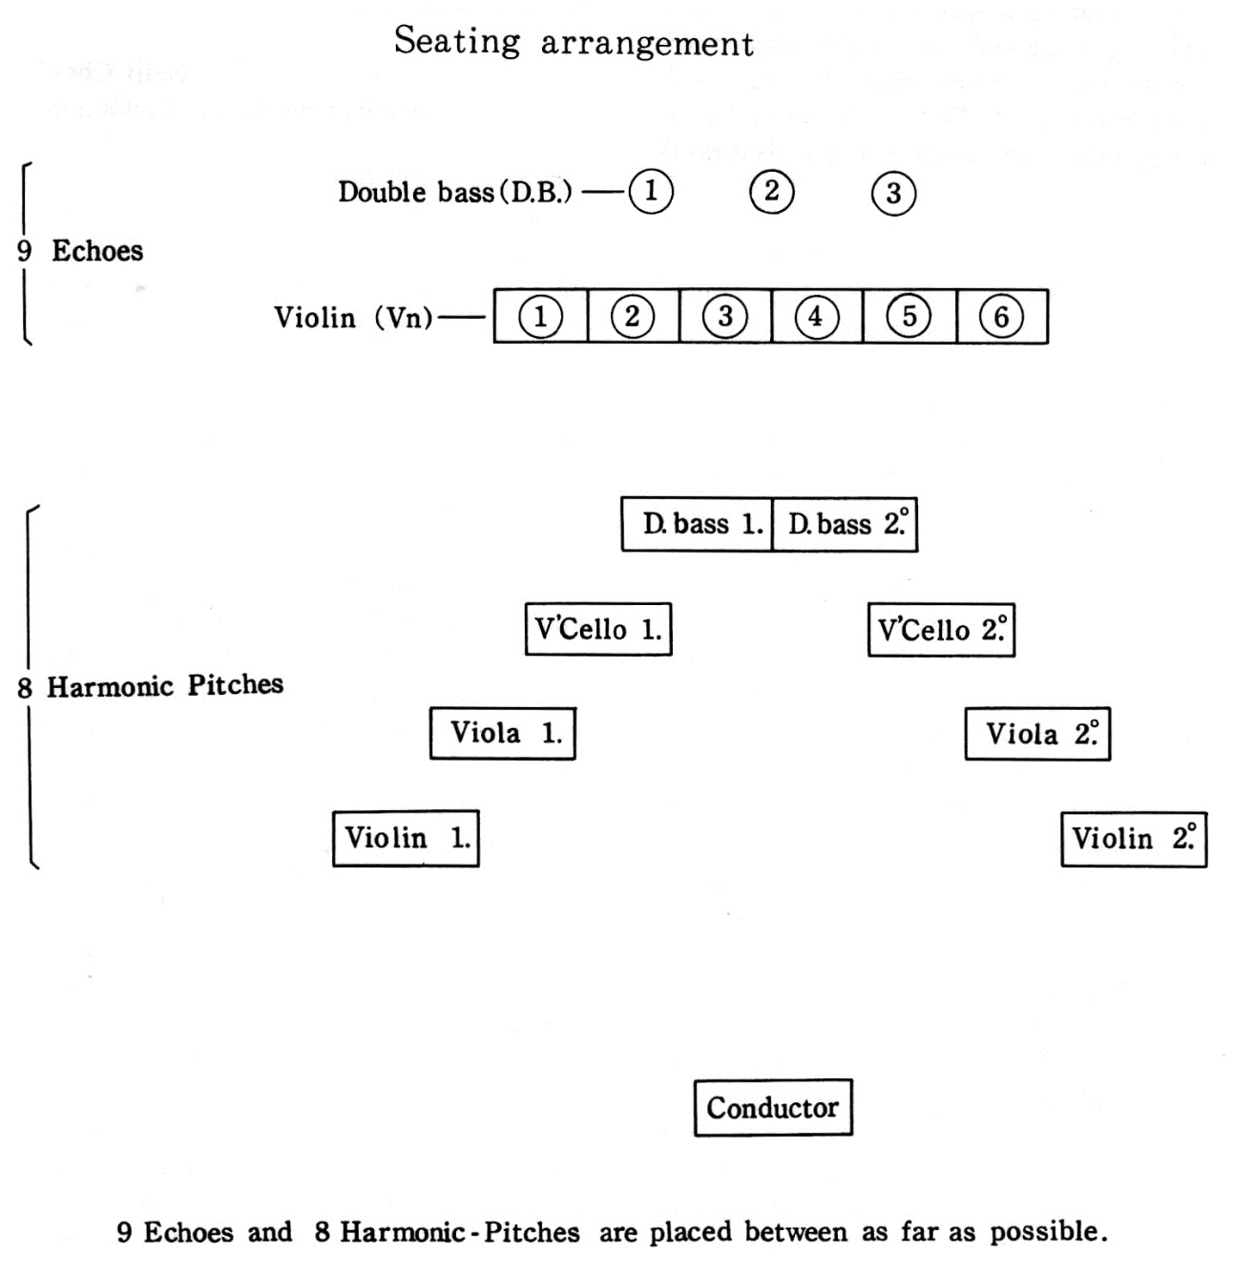

Career

In October 1950, Takemitsu joined a composers’ group called Shin Sakkyokuha Kyokai, which Kiyose established in 1946. In December 1950, at the seventh concert of this group, Takemitsu received his first public performance with the premiere of the piano piece Lento in Due Movimenti. Music critic Ginji Yamane wrote a review of this concert in Tokyo Shimbun. While he took almost a half of this review to give a favorable comment to Kiyose’s Violin Sonata No. 3, he needed only the second half of last sentence to mention that Takemitsu’s Lento in Due Movimenti was ongaku izen, meaning pre-music or less than music.
Composer Taro Hara also wrote a review in a magazine Ongaku Geijutsu. Although he noticed Takemitsu’s talent, his criticism for Lento did not give any good impression:
終始はげしい不協和音を響かせて飽きさせず、この処理が少しも唐突でないことは凡庸ならぬものを思わせる。しかしこの感覚（そもそもレントが二つおしならんでいることも含めて）は今日のものではない。日本のものとしては過去のものでもない。こういう普遍性のない、別の言葉でいえば社会性のない仕事が『芸術』であり得るのは音楽の世界だけだということに思いをいたされたい。

Dissonances sounded throughout the piece, but this piece never sounded boring. In addition, the use of these dissonances is not abrupt at all. I felt something above mediocrity in this piece. However, this sense (including the sense of putting two Lento movements back to back) does not belong to today, or it has never existed in Japan. A work like this piece, which lacks universality and socialness, can be “art” only in the musical world. [Author’s translation]

In spite of these harsh criticisms, Lento left a deep impression on young musicians such as Kuniharu Akiyama, Joji Yuasa, Kazuo Fukushima, and Ichiyanagi. These musicians cheered Takemitsu who was shocked by the criticisms.
After premiering Distance de Fée for violin and piano, which is based on a poem by Shuzo Takiguchi, musicians and artists such as Takemitsu, Akiyama, Yuasa, Fukushima, and Takiguchi formed an artists’ group called Jikken Kobo (Experimental laboratory) in 1951. While writing new works for the concerts by Jikken Kobo, Takemitsu started composing for films, plays, ballets, and dramas. He also began to work on musique concrète such as Vocalism A·I (1956) and Tree, Sky, Bird (1956).
In 1957, Takemitsu wrote Requiem for Strings for the memory of Hayasaka who died of tuberculosis. Although Japanese critics ignored this work, Igor Stravinsky happened to hear it during his stay in Japan in 1959 and made a favorable comment on the sincerity and strictness of this work. Stravinsky also expressed his astonishment that music as passionate as this should be created by a man with such short stature. Later, Takemitsu jokingly told his wife Asaka that Stravinsky was also short but wrote music such as The Rite of Spring. With Stravinsky’s remarks, Takemitsu gained international recognition.
In the 1960s, Takemitsu wrote music for more films than before. His most prolific year for film music was 1964; he composed for twelve films such as The Assassin, Kwaidan, and Woman in the Dunes. On the other hand, his Textures (1964) won the first prize of the International Society for Contemporary Music in 1965. Takemitsu also began to use Japanese traditional instruments in his works. After using biwa (Japanese short-necked fretted lute) and shakuhachi (Japanese end-blown flute) in some films, he wrote Eclipse for biwa and shakuhachi in 1966. This unusual combination of instruments impressed conductor Seiji Ozawa, and he talked about this work to Leonard Bernstein. As a result, the New York Philharmonic Orchestra commissioned Takemitsu to compose for its 125th anniversary, and he wrote November Steps for biwa, shakuhachi, and orchestra in 1967. After the premiere of this work, Takemitsu’s works began to be performed overseas, especially in the US and Canada.
While composing for various genres and traveling abroad for music festivals and lectures, Takemitsu organized an annual contemporary music festival called Kyo no Ongaku (Music today) in 1973. For twenty years, he had provided contemporary works by fabulous composers including himself with performances of outstanding musicians. Additionally, Takemitsu started to write works for his musician friends in the 1970s. His wife Asaka assumes that Takemitsu learned how to use instruments in his work from the excellent performances of these musicians. She also mentions these players inspired Takemitsu to write works for them. Takemitsu stated as below:
僕は自分の音楽をよくわかってくれる人のために曲を書いています。例えば指揮者では小澤征爾や岩城宏之のために書く。ピアノ曲だとアメリカのピーター・ゼルキン、フルートなら誰々というふうに。室内楽のような小さい編成のものを書く時は、いつでも頭の中に演奏者の顔が浮かんでくるぐらい彼らと近い状態にあります。いわば彼らへの個人的な贈り物のつもりで曲を書いています。

I compose for people who understand my music very well. For example, I write for conductors such as Seiji Ozawa and Hiroyuki Iwaki, pianists such as American Peter Serkin, and so on. When I write for small ensembles like chamber orchestra, I always get so close to the performers that I can imagine their faces anytime. In other words, my works are my personal gifts to them. [Author’s translation]

Takemitsu wrote Eucalypts (1970) for flutist Aurèle Nicolet and oboist Heinz Holliger. For Holliger, Takemitsu also composed Distance (1972). He dedicated Waves (1976) and Fantasma/Cantos (1991) for a clarinetist Richard Stoltzman. Riverrun (1984) and Les Yeux clos II (1989) are written for Serkin.
From Far Calls, Coming, Far! (1980), Takemitsu’s works began a shift from a dry, percussive style to a sonorous, melodious style. Additionally, in the 1980s, he wrote works inspired by nature such as rain, gardens, and trees more often than before. Rain-related works include Rain Coming (1982), Rain Spell (1982), and Rain Dreaming (1986), and works based on gardens include Dream/Window (1985), A Minneapolis Garden (1986), and A String Around Autumn (1989). Rain Tree (1981), Rain Tree Sketch (1982), and Tree Line (1988) are related to trees.
Takemitsu spent a busy year in 1990 with many concerts and festivals which celebrated his sixtieth birthday. He was invited to the Stockholm New Music Festival in Sweden, Leeds Festival in England, and Festival d’Avignon in France as a Composer-in-Residence. In addition, the University of Leeds and the University of Durham awarded an Honorary Doctorate of Music degree to Takemitsu. Several concerts celebrating Takemitsu’s sixteenth year were held in London, San Francisco, and Tokyo.
In the 1990s, Takemitsu kept answering commissions from all over the world, such as From Me Flows What You Call Time (1990) for Carnegie Hall, Ceremonial: An Autumn Ode (1992) for Saito Kinen Festival, and Family Tree (1992, premiered in 1995) for New York Philharmonic Orchestra. In 1994, he wrote film music for Rising Sun, his first film score for a Hollywood movie. He also showed an interest in composing an opera titled Madrugata, and American writer Barry Gifford had almost finished writing the libretto in spring 1995. However, Takemitsu was diagnosed with colon cancer and hospitalized in April 1995. He was discharged from the hospital in October 1995 and wrote In the Woods for guitar and Air for flute. These pieces became his last works. Without composing any music for the opera Madrugata, he was re-hospitalized in January 1996, and he passed away on February 20, 1996 for acute pulmonary edema caused by collagen disease.

Music of Takemitsu

西洋音楽は、たとえば壁と絵のようなものだ。壁は間仕切りのためにあるし、絵は額縁の中に閉じこめられる。規格とか枠の中に収まっている。武満のは日本間の襖であり掛軸である。襖はとり払って部屋をひろげることができるし、掛軸は生け花との調和によって見るひとの美意識を拡大する。西洋音楽はひとつの音に集約させようとし、武満の音楽はひとつの音に宇宙的なひろがりを持たせようとする

Western music is like walls and paintings. Walls are for dividing rooms, and paintings are shut in frames. Western music fits in standards and limits. Takemitsu’s music is like fusuma (a prepared sliding door) and kakejiku (a hanging picture scroll) in traditional Japanese rooms. We can extend the room by removing fusumas, and a kakejiku expands viewers’ aesthetic senses by the harmony with a ikebana (flower arrangement). Western music goes toward a single note, but Takemitsu’s music gives universal expansion to a single note. [Author’s translation]

Japanese composer Yasushi Akutagawa described Takemitsu’s music as above. As Akutagawa explained, Takemitsu’s music does not fit in standards or limits of traditional Western music in several ways.
Firstly, Takemitsu hardly ever employs the traditional forms of Western music. He mentioned that he preferred to compose music without a clear formal structure since early in his career. For example, he described his Requiem for Strings that he cut out a certain part of the river of music flowing through this world, and this river had no beginning or end. Therefore, he said that this idea could not be realized with any Western musical forms. Also, he explained the form of his Quatrain as something like an emaki (picture scroll) without clear separation of scenes.
Secondly, Takemitsu sought a freedom from pulse and musical time. In his Romance (1949), a work from his earliest career, Takemitsu already tried to weaken the sense of pulse by using ties frequently. Also, he wrote Uninterrupted Rest (Movement 1: 1952, Movement 2 and 3: 1959) without time signatures or bar lines (see example 2.1).
Thirdly, as Akutagawa described, Takemitsu’s music expands from one note. In A Flock Descends into the Pentagonal Garden (1977), he assigns F♯ a role of a black bird which leads the flock. He creates a pentatonic scale C♯ E♭ F♯ A♭ B♭ by adding two notes below F♯ and two notes above F♯. Then, he expands the music by creating other pentatonic scales from C♯, E♭, A♭, and B♭, while F♯ remains like a drone.

Example 2.1. Toru Takemitsu, Uninterrupted Rest, Movement II, p. 1
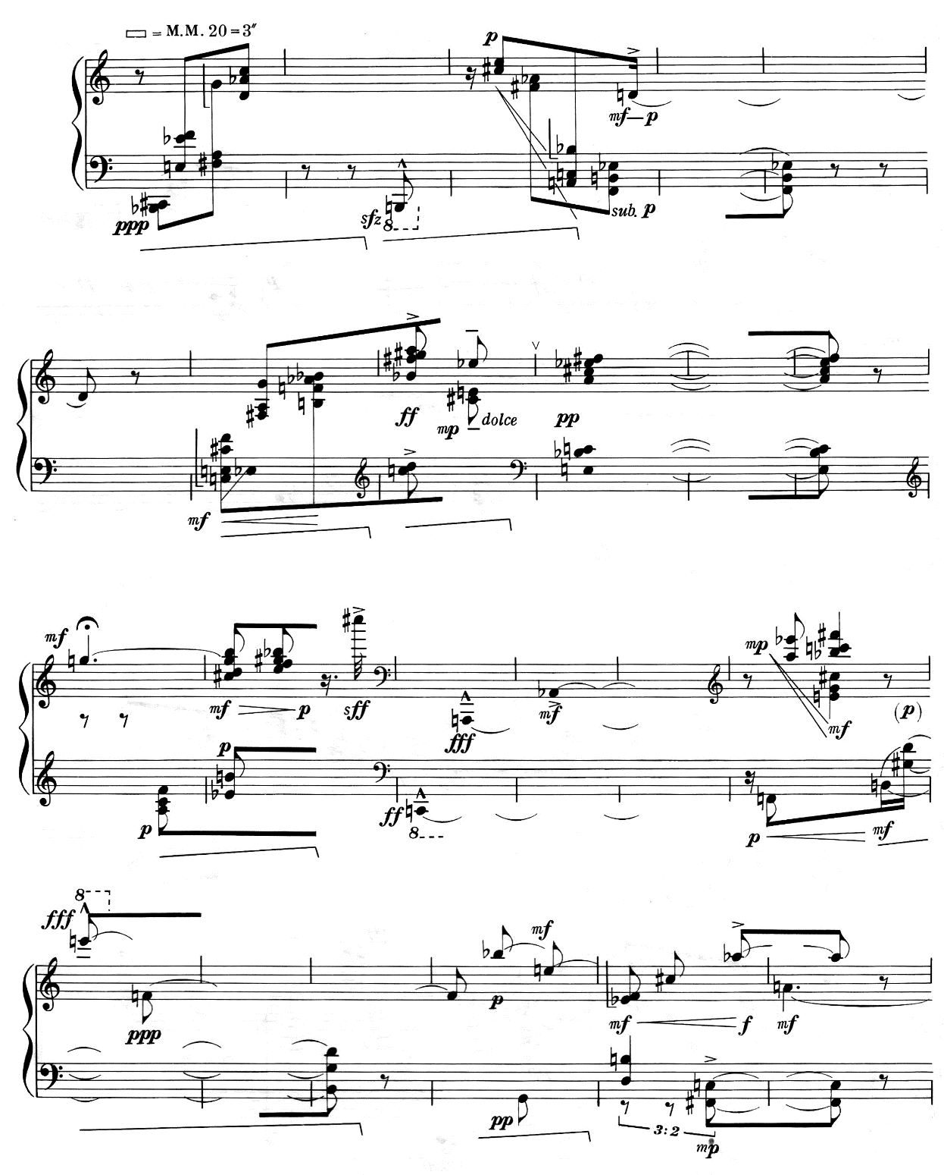

In addition to these characteristics related to Akutagawa’s description, Takemitsu’s works display some other significant characteristics. One of these characteristics is the use of the SEA motive, which consists of E♭ (Es in German), E, and A. In 1996, Takemitsu wrote about this motive:
Ｅ♭、Ｅ、Ａの三つの音は、ここ十五年程の、私の、音楽発想の基調音となっている。（中略）この音程はあくまでも私の音感が択んだもので、海という象徴的音名は偶然に過ぎない。

E♭, E, and A has been the base of my musical ideas for about fifteen years. . . . These pitches were chosen by my musical sense, thus the symbolic name of the SEA is no more than an accident. [Author’s translation]

As he wrote, the SEA motive does not express the image of water. He employs this motive not only in his works on the themes of rain and waterscape but also in his compositions on other themes and concepts.
The SEA motive first appeared in Far Calls, Coming, Far! for solo violin and orchestra. Example 2.2 shows the SEA motives in this piece. Takemitsu adds C♯, F, and A♭ above the SEA motive to create a hexatonic figure, which appears at rehearsal B (m. 10) in example 2.2. Its inversion also occurs in m. 13. The inversion of the SEA motive and the hexatonic figure are marked as SEA-i and hexatonic-i respectively. This hexatonic figure includes two major triads, A major (E A C♯) and D♭ major (C♯ F A♭), while its inversion has two minor triads, G minor (G D B♭) and E♭ minor (B♭ F♯ E♭). Takemitsu controls these figures and chords to create a “pantonal sea” with many consonances. He also employs the SEA motive in A Way A Lone (1981) for string quartet. In this work, he uses more inversions of this motive than in Far Calls.
Example 2.2. Takemitsu, Far Calls, Coming, Far! mm. 6-14
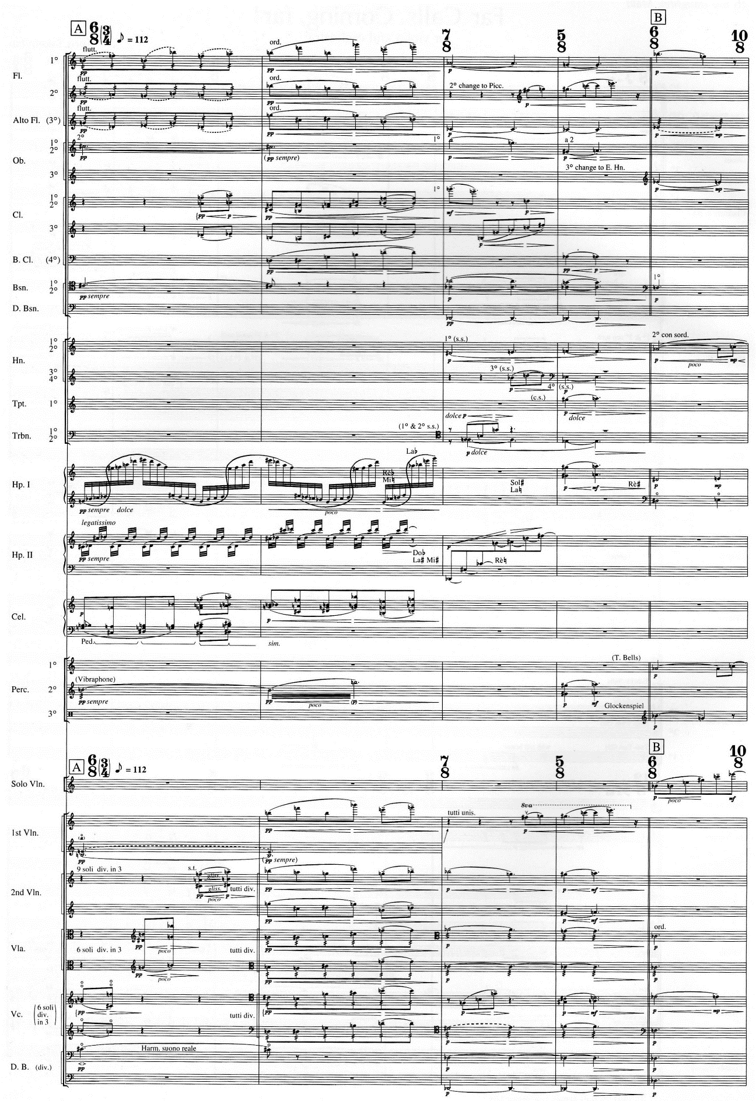
hexatonic
SEA
Example 2.2—Continued
SEA-i
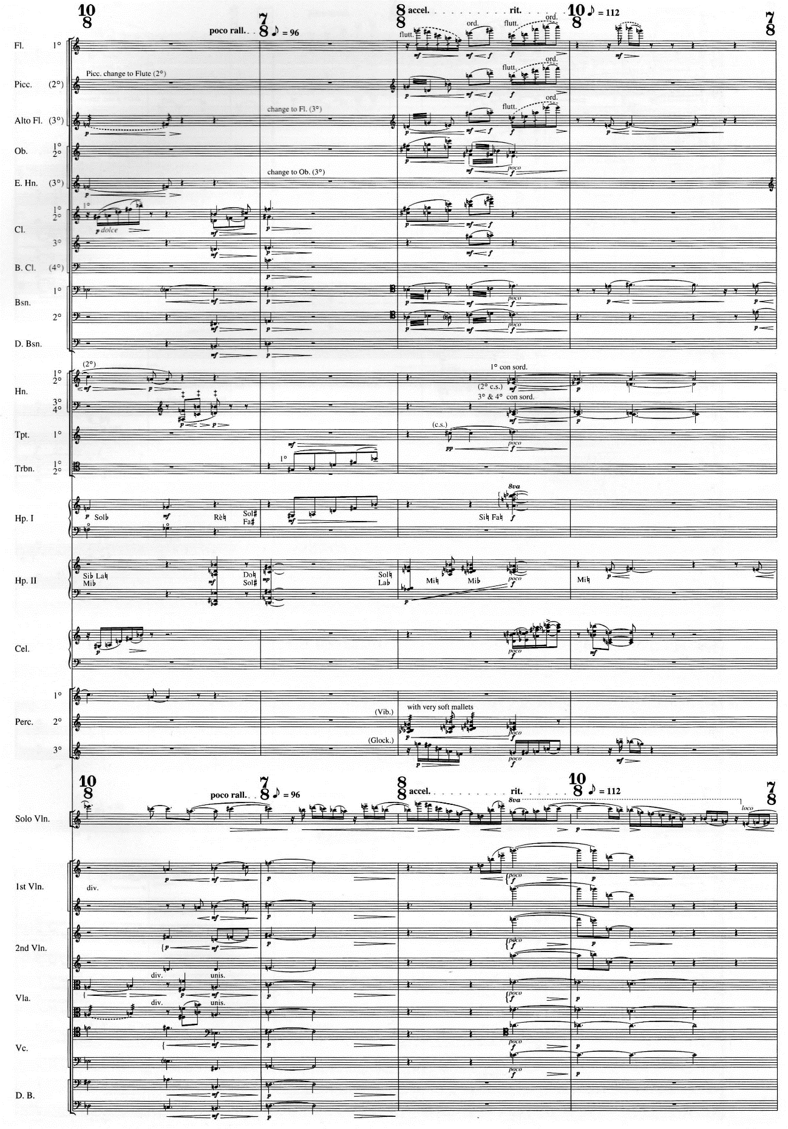
SEA
hexatonic-i
SEA
SEA
SEA
SEA-i
SEA-i
Tomoki Jiromaru introduces various patterns of the SEA motive. She defines the basic pattern of the SEA motive as a three-note motive in which the second note goes up either a minor or major second, and the third note ascends a minor third or more. She illustrates several patterns based on this basic pattern (see figure 2.2). Narazaki indicates that the SEA motive enables Takemitsu to express diverse textures from cluster-like sounds to tonal harmonies.

Figure 2.2. Patterns of the SEA motive
δ’. Retrograde of δ
γ’. Retrograde of γ
β’. Retrograde of β
α’. Retrograde of α
δ. Second note goes down
Third note goes down
γ. Second note goes down
Third note goes up
β. Second note goes up
Third note goes down
Minor Third or larger
Major or Minor Second
α. Second note goes up
Third note goes up
Another characteristic of Takemitsu’s music is the concept of nature. For example, Takemitsu derives musical ideas from Japanese gardens, especially the gardens made by Zen Buddhist Muso Soseki (1275-1351). Takemitsu talked about Japanese gardens and his music as below:
音楽を作曲する（形づくる）際に、私は、日本の庭園の作庭の仕方から随分多くのヒントを得ている。特に（中略）夢窓がしつらえた庭（西芳寺、天龍寺、瑞泉寺等）からは、その形成の深さと拡がりによって、つねに汲み尽くせぬほどの多様な啓示を受けている。
庭は、自然そのもののようでありながら、だが或る意味では、きわめて人工的なものである。人為によって、自然は、さらに奥深い、無限ともいえる、変化の様態を顕わす。人間の眼にはその人為の痕跡はかならずしも明瞭ではないのだが、仔細に観察すれば、どの隅々にも作者の認識が及んでいるのが分かり、その認識の深さに応じて空間の質、密度もそれぞれ異なったものになっている。この場合作庭者の認識とは、人間の生・死はもちろん、時間や歴史の推移を含む、万象に向けられた思慮というものである。（中略）
ヨーロッパ庭園の多くが、幾何学的シンメトリを尊重しているのとは違って、日本の庭は、一見、アシンメトリな不均衡を作庭の基本に置いているようだが、どの隅々も明晰で、小さな石の配置ひとつにも、広大な宇宙の仕組みを暗示するような仕掛けがほどこされている。自然の中に設けられた別の人為的空間によって、その全体が示す多義性は、私たち人間に、庭がたんに美しいものであるという以上の感慨をもたらしている。
私は、自分が作曲する音楽が少しでもそういうものに近いものでありたいと思い、機会ある度に、夢窓の庭を訪ねている。

When I compose (or form) music, I have gotten quite a few ideas from how to make Japanese gardens. Especially . . . gardens made by Muso (Saiho-ji, Tenryu-ji, Zuisen-ji, etc.) always inspire me diversely with their depth and expanse of formations.
Although gardens seem to be the nature itself, these are extremely artificial in a certain sense. With the work by human beings, nature shows deeper, or even infinite, diversity. The trace of artificial work is not always obvious in front of our eyes, but with a closer look, we can find gardener’s understanding in every detail. The quality and density of the space depends on the depth of the gardener’s understanding. In this case, the gardener’s understanding means not only the birth and death of human beings but also the consideration toward everything in nature including the change of time and history. . . .
While many European gardens respect geometrical symmetry, Japanese gardens seem to be based on asymmetric disproportion. However, every detail is clear, and even the positioning of one pebble implies the structure of vast outer space. An ambiguity created by the artificial space within nature gives us deeper emotion than the feeling that the garden is simply beautiful.
I would like to compose music which gives impressions as close as the impressions of these gardens, and that is why I visit Muso’s gardens as often as possible. [Author’s translation]

The formal structure of Fantasma/Cantos is inspired by Japanese gardens. In the program notes, Takemitsu explained about the structure as below:
立ち止まり、思索しながら小道を歩き、いつかまた、元へ戻る。だがそれは、同じ、元の場所ではない。

The music walks through the path. Sometimes it halts, and sometimes it is deep in contemplation. Then, it comes back. But the place is not the same as where the music starts. [Author’s translation]

Hideaki Onishi analyzes Fantasma/Cantos in his dissertation. He points out the first fifteen measures of this piece recur at the end, but the minor differences from the beginning section give this recurrence a completely different meaning from the original appearance. Thus, this recurrence at the end of the piece describes that this place is not the same spot any more.
Takemitsu’s music is free from solid walls which clearly divide the sections to build formal structures. Also, his music is not always in the frames of beats or bar lines. Yet, his music creates a harmonious atmosphere like traditional Japanese rooms. Despite all the difficulties in his early career, he never stopped seeking his own expression for his musical ideas. Eventually, the beauty of Takemitsu’s music successfully captured audiences internationally, and the popularity of his music never fades even after his death.

Chapter 3
Paths—In Memoriam Witold Lutosławski by Toru Takemitsu

Background

Takemitsu composed Paths—In Memoriam Witold Lutosławski in 1994. This 5-minute work for unaccompanied trumpet was premiered on September 21, 1994 at the “Hommage à Witold Lutosławski” concert of the Warsaw Autumn Festival. Takemitsu dedicated this piece to Håkan Hardenberger who premiered it. In the program notes for Paths, Takemitsu wrote as below:
トランペット独奏のための『径』は、ヴィトルド・ルトスワフスキの死の報せを受け、ほどなくして作曲された。
ルトスワフスキの死を悼んでのファンファーレである。
一九九二年の春、ワルシャワでルトスワフスキと会った際に、かれが、「私たち（現代の）作曲家はもっと旋律のことを真剣に考えるべきだし、新しい旋律を生むための努力を惜しんではならない」と語っていたのが、強い印象として残っていた。
『径』では、単純な（旋律的）動機が、ちょうど庭園の小径のように、風景の微妙な変化のなかを進んで行く。

I composed Paths for solo trumpet right after I heard the news about the death of Witold Lutosławski.
This piece is a fanfare to lament the death of Lutosławski.
In the spring 1992, when I saw Lutosławski in Warsaw, he said, “As (contemporary) composers, we should think about the melody more seriously, and we should make an effort to create new melodies without sparing ourselves.” This conversation strongly impressed me.
In Paths, simple (melodic) motives walk through subtle changes of the scenery just like paths of a garden. [Author’s translation]

The tempo, or the pace of walking through the “garden,” remains slow throughout the piece. The trumpet interchanges the tempi of about 60 and 68 quarter notes per minute, and the tempo decreases in the last two lines to about 52 quarter notes per minute.
The notation for Paths contains remarkable features. First, this piece has no meter or bar lines. Second, many triplets and quintuplets are frequently used. These triplets and quintuplets are complicatedly subdivided and tied in order to notate subtle differences of the length between notes. Japanese trumpeter Kiyonori Sokabe assumes that Takemitsu tried to notate the subtle change of the tempo, as if the trumpet had played in tempo rubato, without using ritardandos, tenutos, or accelerandos.
Because Paths is written for unaccompanied trumpet, the trumpet keeps playing throughout the piece without long rests. Moreover, the register ranges from F♯ below the staff to C♯ above the staff. Therefore, this piece requires endurance enough to keep playing in a wide register for five minutes.
The trumpet plays phrases with a harmon mute (without a stem) and phrases without a mute by turns. In order to enhance this conversational effect, Takemitsu instructs the player to put on and take off a mute quickly; the quickest attachment and removal of a mute occur during an eighth rest. For these quick mute changes, some trumpeters play this piece with a slower tempo than the tempo indicated by Takemitsu, while other trumpeters fix their mutes to the stands and move their trumpet bells to the fixed mutes when they need muted sound.
Among the solo trumpet literature by Japanese composers, Paths is one of the most performed works both in Japan and overseas. Also, this piece is chosen as a set piece and elective piece for competitions such as Japan Wind and Percussion Competition in 1999 and International Philip Jones Competition in France in 2005.

Analysis

Like most music by Takemitsu, Paths is not based on any traditional form. As his program notes mention, Takemitsu employs some recurring phrases and melodic motives to build the “garden” in this piece. However, these melodic motives hardly ever recur with the same rhythm as the previous ones. This subtle difference of the rhythm describes the gradual change of the scenery. In addition, Sokabe says that the use of a harmon mute enables the player to express distance from the scenery.
The first two lines show three melodic motives (see example 3.1). Motive 1 is the most frequently used among these three motives. Motive 2, which answers motive 1, is almost a retrograde of motive 1. A six-note motive at the beginning of line 2 is a fragment of motive 2, which is derived from the last six notes of motive 2 (marked as 2-f). Both 2-f and the last six notes of motive 2 consist of two three-note sets both (0 1 6), and the first three-note sets in both figures are inversionally related. Mostly, motive 2-f appears as two sets of descending three notes or ascending three notes as an inversion. Motive 3 appears less frequently than other motives. All three motives consist of nine notes. Motives 1 and 3 share the same set (0 1 3 4 6 7 8 9). The set for motive 2 is (0 1 3 4 6 8 9), which is a subset of motives 1 and 3.

Example 3.1. Takemitsu, Paths, lines 1-2, with melodic motives
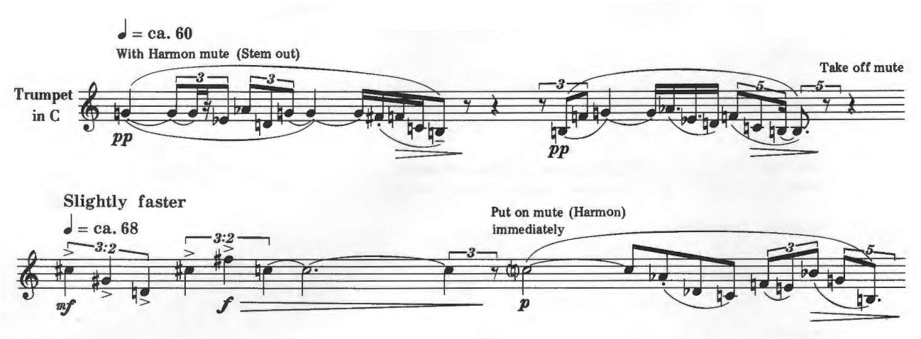
(0 1 6)
(0 1 6)
(0 1 6)
(0 1 6)
3 (0 1 3 4 6 7 8 9)
2-f
2 (0 1 3 4 6 8 9)
1 (0 1 3 4 6 7 8 9)

In these three melodic motives, Takemitsu frequently employs the SEA motive. Example 3.2 shows the SEA motives in the first two lines. In this piece, the SEA motive is arranged not only in the forms of retrograde (marked as SEA-r) and inversion (marked as SEA-i) but also as a three-note set which has the same set as the SEA motive and its inversion (marked as SEA-set and SEA-set-i).

Example 3.2. Takemitsu, Paths, lines 1-2, with the SEA motives
SEA-set
SEA-set
SEA-set-i
SEA-r
SEA-r
SEA-i
SEA-set
SEA-set-i
The trumpet begins this piece with G, the tonal center in the first line. Takemitsu asserts tonal centers by assigning longer note values. At the middle of line 2, the tonal center changes to C. In line 3, motive 1 and motive 2-f appear with the tonal center of C. Line 4 does not include any melodic motives, but the trumpet plays a five-note motive in the middle and repeats it one step lower (see example 3.3).

Example 3.3. Takemitsu, Paths, lines 3-4
2-f
1
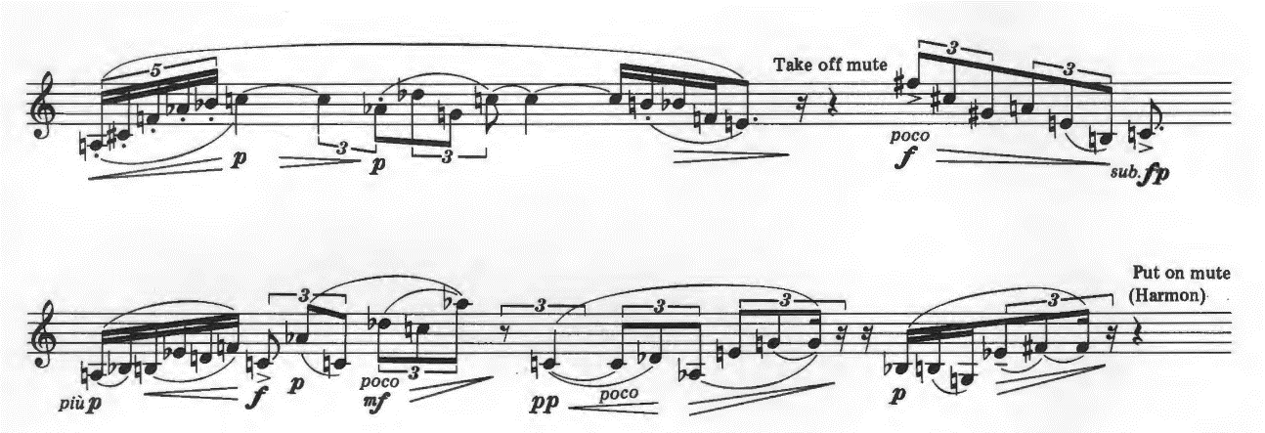
motive
sequence

In line 5, motive 1 and motive 2-f reappear. This time, motive 2-f is inverted (marked as 2-f-i). The trumpet plays the SEA motives in line 6 and reaches to the first climax with C above the staff (see example 3.4).

Example 3.4. Takemitsu, Paths, lines 5-6
2-f-i
1
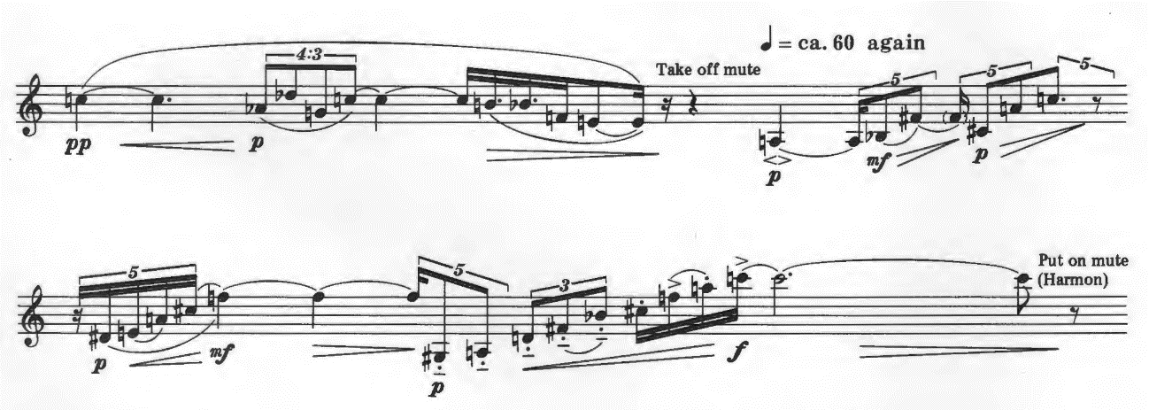
SEA
SEA

Line 7 starts with motive 3 followed by motive 2. In line 8, the trumpet plays a three-note motive consisting of F♯, D, and B♭, followed by the diminution of the same motive. Then another three-note motive of F♯, C♯, and G appears, which also immediately reappears with the diminution. The normal order of this second motive is [1 6 7], which is the inversion of the SEA motive (see example 3.5).

Example 3.5. Takemitsu, Paths, lines 7-8
2
3
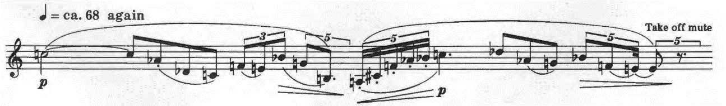
repetition (dim)
repetition (dim)
motive
motive
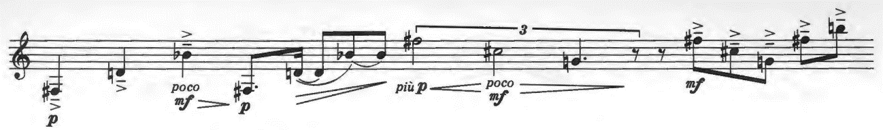
SEA-set-i
SEA-set-i

In line 9, the tonal center changes to F, and the trumpet plays motive 3 (see example 3.6). From line 11 to line 13, three melodic motives appear one after another. C♯ is the tonal center in lines 13 and 14, but in line 15, the tonal center becomes ambiguous. In lines 14 and 15, the trumpet plays with glissando and flutter tonguing to show another aspect of the scenery in the “garden” (see example 3.7). In the middle of line 15, another six-note motive, ascending three notes followed by a retrograde of the SEA motive, appears (marked as 4). This motive 4 frequently appears until line 21.

Example 3.6. Takemitsu, Paths, line 9
3
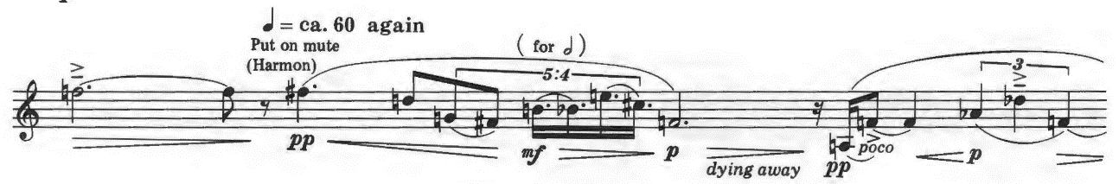

Example 3.7. Takemitsu, Paths, lines 11-15
1
2-f-i
2-f
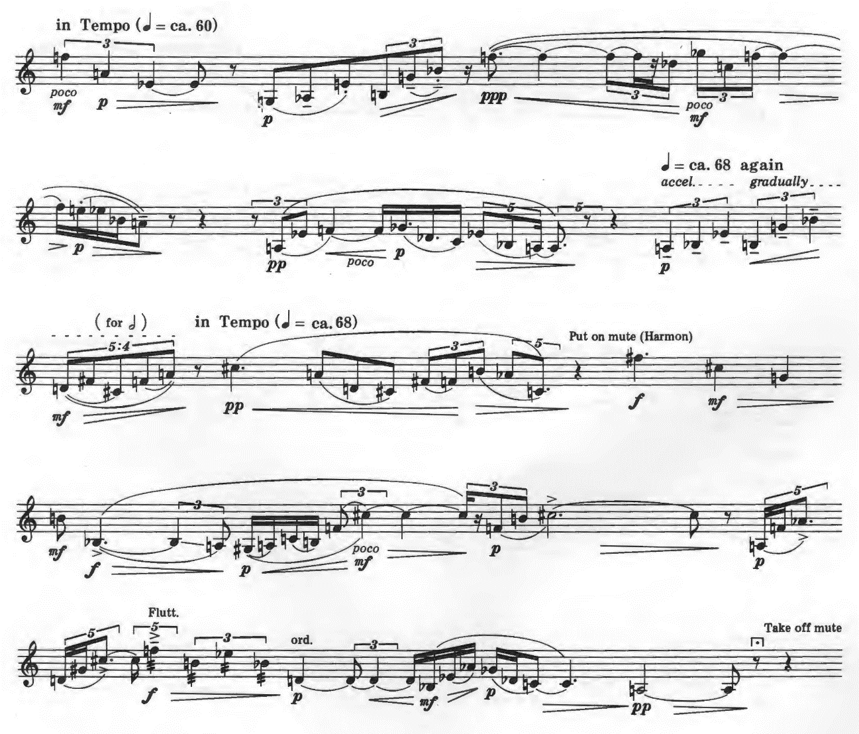
SEA-r
4
2-f
SEA-set-i
2-f-i
SEA-set
2-f
3
2-f-i
SEA
2-f-i
2

A short motive occurs with a sequence in lines 16, followed by motive 4 and its sequence. Another motive appears with repetition in line 17. Until line 21, motive 4 and the fragment of motive 1 (marked as 1-f), 2, and 4 (marked as 4-f) occupy the most of the melody. The tonal center remains ambiguous in this section. At the end of line 21, after repeating motive 4-f four times, the trumpet reaches the climax with C♯ in fortissimo (see example 3.8).

Example 3.8. Takemitsu, Paths, lines 16-21
4
motive
sequence
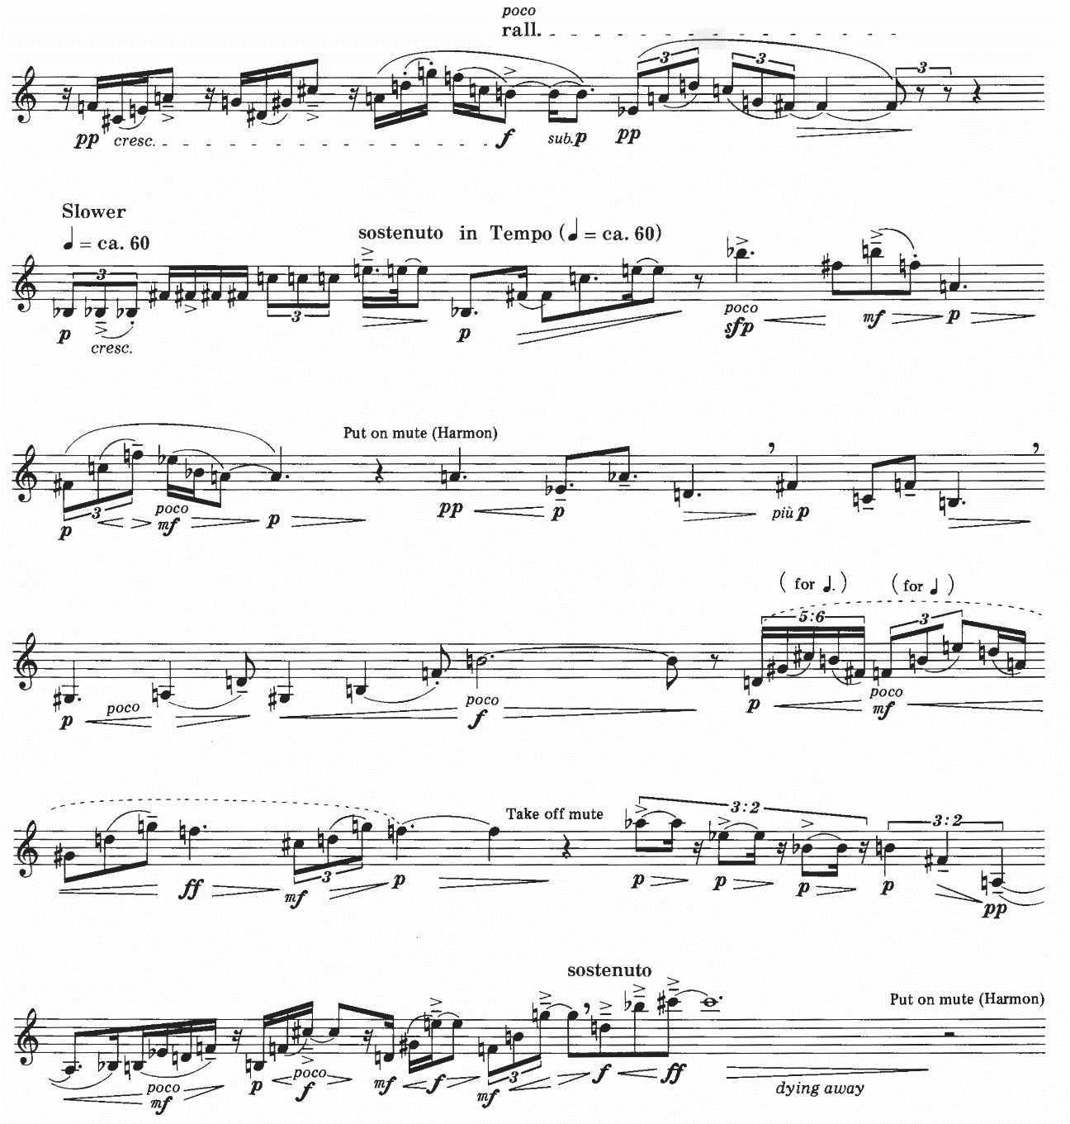
4-f
4-f
4-f
4-f
2-f
4-f
4-f
4
4
2-f-i
1-f
1-f
4
1-f
repetition
motive
4

After C♯ dies away, the trumpet plays motive 1 quietly. This occurrence of motive 1 is only a fragment. The trumpet plays the sequence of the last two notes from this fragment, then the trumpet plays these two notes again with the first note one octave below. Another fragment of motive 1 appears, and the trumpet quietly closes the piece with pianissimo (see example 3.9).
Example 3.9. Takemitsu, Paths, lines 22-23
1-f
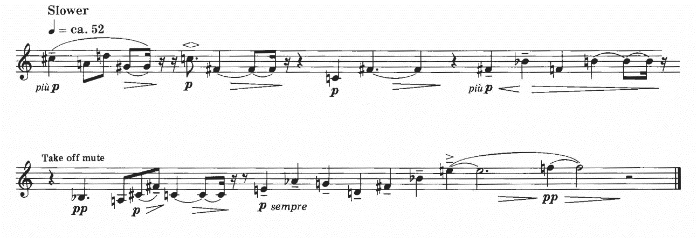
SEA-i
SEA-set
1-f
repetition
sequence
motive

Chapter 4
Biography of Marcel Kentsubitsch (Naohiro Tsuken)

Most Japanese trumpeters who play Marcel Kentsubitsch’s works know that this composer’s name is the pseudonym for Naohiro Tsuken, one of the most prestigious Japanese trumpeters. And some trumpeters, even not Japanese, can easily guess this pseudonym is based on French Composer Marcel Bitsch who wrote trumpet etudes used by serious trumpeters worldwide. Like his pseudonym, Kentsubitsch’s music shows both his humor and experience as a trumpeter.

Early Life

Tsuken was born in 1950 in Okinawa as the youngest of seven children in the Tsuken family. His experience playing music began in a drum and fife corps in the fifth grade. He mentioned that he had a chance to learn the piano one year before joining the corps, but his shy and unadventurous personality prevented him from this offer. In the drum and fife corps, he mainly played the cymbals and occasionally played the glockenspiel. He also learned to play the accordion. He wanted to expand his interest in music by learning violin, which his sister had learned. He visited her violin teacher to ask if he could study violin, but the violin teacher did not accept him as a student because he was too old to start learning violin.
When he entered Naha Junior High School, he had several choices for extracurricular activities. He almost chose track and field, but the low sound of the clarinet from the rehearsal room fascinated him. This beautiful sound made him join school band immediately. But the band director Masanobu Oshiro assigned him to the trumpet because the clarinet part already had enough players. After two months, Tsuken played the trumpet well enough to play the first trumpet part. While Tsuken played there for three years, Naha Junior High School Band kept winning the annual Okinawa Band Competition and advancing to the Western Regional Band Competition (semi-final for the National Band Competition).
Tsuken continued to play the trumpet in Shuri High School Band which also won the Okinawa Band Competition every year. In Shuri High School Band, he served not only as a trumpeter but also as a captain and an arranger. In his last year in high school, he experienced his first solo competition. In spite of his excellent performance of the first movement from Joseph Haydn’s Trumpet Concerto, he was disqualified because his performance exceeded the time limit. His accompanist stopped twice during the introduction due to stress, and it caused a longer performance than the time limit.

Formal Training

In 1968, Tsuken left Okinawa and entered Kunitachi College of Music in Tokyo. He followed Oshiro’s advice to choose this school; however, he also admitted he did not know of any other music schools. In his interview in 1983, he explains his ignorance of school auditions and formal training. For example, he never considered private lessons to assist in his performance for the school audition. When he went to Tokyo for the audition, his friend scolded him for the lack of preparation, and his friend quickly arranged some last-minute private lessons for him. Another example is that Tsuken did not know the Arban’s Method, the basic etudes for trumpet, until he began to study at college.
At college, Tsuken learned trumpet from Genzo Kitamura, then principal trumpet in NHK Symphony Orchestra. Meanwhile, his fundamental compositional skills had been built not at college but in Japan Shinsei Symphony Orchestra (this orchestra merged into Tokyo Philharmonic Orchestra in 2001) for which he had played since its establishment in 1969. He helped Fumio Akahori, a viola player in Japan Shinsei Symphony Orchestra and a professional arranger, to copy scores. From this experience, Tsuken learned the art of arranging orchestral music, and he found it enjoyable to write musical notes and even a single bar line. Then, he began to arrange music for Japan Shinsei Symphony Orchestra. For example, he arranged music called Urutora Tanuki (Ultra raccoon dog), which is a 40-second piece for the brass section to introduce instruments in school tours. Its humorous combination of a popular hero song, children’s song, and commercial song always captured the hearts of students. Tsuken began his career as a composer about 20 years later, but this piece already represents one of the characteristics of Marcel Kentsubitsch’s music: music with humor.
In 1983, he won the scholarship from the Agency for Cultural Affairs and went to Munich, Germany. He studied with Paul Lachenmeier, principal trumpet in the Bavarian State Opera, for one year. Germany had attracted Tsuken since his college time; especially, the tradition from Baroque music had strongly captured him. He believed studying in Germany would help him comprehend the world of music, not only within the small area of trumpet performance but also as a whole. During his stay there, he concentrated on this goal and mainly studied rotary trumpet.

Major Influence

Tsuken says Oshiro gave him basic ideas of trumpet playing. Oshiro himself learned trumpet performance at Ryukyu University, and he often played the trumpet during band rehearsals to show his musical ideas. Especially, Oshiro’s vibrato influenced Tsuken’s playing. When Tsuken was in the eighth grade, he felt like he suddenly became a much better player. He thought the reason for his feeling that he had improved was that he acquired vibrato by himself. However, in April 1999, Tsuken heard Oshiro’s trumpet performance and realized he definitely inherited Oshiro’s vibrato from the experience of band rehearsals. Oshiro also advised Tsuken to study at Kunitachi School of Music, because Oshiro had audited classes there and told Tsuken that Kunitachi was good school to study wind instruments.
For his trumpet sound, Tsuken says Soviet Russian Trumpeter Timofei Dokschitzer inspired him. Tsuken talks about Dokschizer as below:
僕はロシア系が好きなんですよ。（中略）歌うのが好きなんですよ。（中略）もちろん、ハーセス、アンドレとかも聴いていましたけど、アンドレは、真似出来ないですね、あのアタックとかは。全体に明るいでしょ。演歌のように陰があるドクシツェルのほうが僕には近い感じがします。

I like Russian music. . . . I like to sing. . . . Of course, I have listened to Adolph Herseth, Maurice André, and others, but I cannot imitate André. I cannot copy his pronunciations. It is entirely brilliant, isn’t it? I think Dokschizer’s dark style like enka (popular songs with elements of traditional Japanese music) is closer to my style. [Author’s translation]

Not only in Tsuken’s trumpet playing but also in Kentsubitsch’s compositions, he prefers cantabile style. He has an interest in pieces by composers who also play the trumpet and/or cornet, especially Germans and Russians. He mentions he is charmed by pieces such as Trumpet Concerto and Russian Dance by Oskar Böhme, two Concert Pieces by Vassily Brandt, Hungarian Melodies by Vincent Bach, and Slavonic Fantasy by Carl Höhne.
Another influence on Kentsubitsch’s works is the frequent quotation from Okinawan music, especially Okinawan folk songs. Okinawan music, which was born from the prayers of harvest and health, has been an essential part of Okinawan culture for centuries. After the founding of the Ryukyu Kingdom in 1429, Okinawan court music was developed among the upper-class people. When the Ryukyu Kingdom dissolved in 1879, Okinawan court music mingled with Okinawan folk music. During the American administration of Okinawan Islands after World War II, the American government tried to promote Okinawan traditional culture. As a result, Okinawan music absorbed American culture, such as rock music. In the 1990s, Okinawan pop music, known as Okinawan Pops, became popular with a unique blend of Okinawan folk music and Western music heard around American military bases. Under these circumstances, it was natural that Kentsubitsch began to respect Okinawan music. Most of his compositions refer to melodies or scales from Okinawan music.
Lastly, the strong wish for peace among Okinawan people affects Kentsubisch’s music. Okinawa experienced the Battle of Okinawa in 1945, and a quarter of the civilian population died. After the war, along with Amami Islands, Okinawa was under the American administration. In Okinawa, World War II and the aftermath planted a strong wish for peace in people’s heart, just like the experience of atomic bombs did to people in Hiroshima and Nagasaki. Among Kentsubitsch’s works, Legend shows his thoughts toward the war and Okinawa most. He composed Legend for virtuoso euphonium player Shoichiro Hokazono. Originally, Kentsubitsch wrote this work for solo euphonium and piano; later he arranged it for solo with orchestra and band. Through this work, Kentsubitsch expresses that Okinawa restored peace after the total destruction by the war. He also mentions that this work tells the story how Okinawa experienced the war, but the natural environment has remained. In this work, the melody of an Okinawan folk song appears to describe the peace in Okinawa. Then both Japanese and the US national anthems are played above the anxious sound of harmonies, indicating the tension between two nations. After depicting the violence of the Battle of Okinawa, this work goes back to peace. Hokazono played this work in Marcel Kentsubitsch Music Festival in Okinawa on August 15, 2010 (the anniversary of the end of World War II), and the audience cheered after his performance. This highly virtuosic work is rarely performed by other euphonium players, but Hokazono has frequently played this work not only in Japan but also in the United Kingdom and France.

Career

In 1969, his freshman year at Kunitachi College of Music, Tsuken joined Japan Shinsei Symphony Orchestra as one of the original members. Then in September 1975, he entered Tokyo Symphonic Orchestra. Three years later, he joined NHK Symphony Orchestra as principal trumpet. In NHK Symphony Orchestra, he also performed as a soloist for works such as trumpet concerti by Haydn and Johann Nepomuk Hummel, Piano Concerto No. 1 by Dmitri Shostakovich, Septet by Camille Saint-Saëns, and Brandenburg Concerto No. 2 by Johann Sebastian Bach. He had played in NHK Symphony Orchestra until his retirement in February 2010. In 1984, while studying in Munich, he played The Magic Flute, Lohengrin, and Ein Heldenleben in Bavarian State Orchestra with the conductor Wolfgang Sawallisch.
Besides playing in orchestras, Tsuken joined the Tokyo Brass Ensemble as an original member in October 1974. He also established trumpet quintet The Trumpets 5 in November 1987. Other than playing for concerts, radio, and TV, these ensembles released recordings: one three-record set by Tokyo Brass Ensemble and two compact discs by The Trumpets 5. Twice with Tokyo Brass Ensemble and once with The Trumpets 5, he performed in the US (in 1978 and 1981 with Tokyo Brass Ensemble, and in 1989 with The Trumpets 5).
His enthusiasm for trumpet extends not only to playing but also to teaching. He has mainly taught at the Tokyo College of Music as an associate professor. Also, he teaches at Senzoku Gakuen College of Music and Kunitachi College of Music as an associate professor. As an instructor, he teaches at Shobi University as well. Besides teaching in the Tokyo area, he has put a great effort into teaching in his home, Okinawa. Other than teaching at Okinawa Prefectural University of Arts as an instructor, he has hosted an annual trumpet camp in Okinawa since 1986.
He has enjoyed a friendship with internationally renowned trumpeter André Henry since 2000. When Henry had a master class at the Tokyo College of Music, Henry and Tsuken found that they shared a similar pedagogy of trumpet performance. In 2008, they collaborated to teach in trumpet camps in Nagano and Okinawa.
While enjoying his successful career as a trumpeter, Tsuken started to compose in 1994. Before he tried composing, he had believed he could not compose. However, when he tried it, he found out he could. His first composition Quatre Variations sur un Thème de SE16GAN was written for trumpet quintet. He employed the theme from the trumpet fanfare in the TV commercial for Seirogan, a longtime seller of digestive medicine. This catchy fanfare has been used in the commercial for such a long time that all generations in Japan easily imagine the medicine from listening to this fanfare. This piece was recorded by The Trumpet 5 and quickly became popular among Japanese trumpeters. He named this piece after Marcel Bitsch’s piece for trumpet and piano Quarte Variations sur un Thème de Domenico Scarlatti, and he came up with the idea of his pseudonym from this composer: combination of Marcel Bitsch and Kentsu as an anagram of Tsuken.
Kentsubitsch’s trumpet pieces are written mostly for his students. For example, he wrote Der Mythos and Tasogare (Twilight) for Osamu Kumashiro’s solo recital. His first Trumpet Concerto is written for Osamu Takahashi, principal trumpet for Tokyo Metropolitan Symphony Orchestra. For Hiroki Tochimoto who formerly played in NHK Symphony Orchestra, Kentsubitsch composed Fantasy. Contest Piece and Finale were written not for his students with professional skills but for his students with technical problems at Senzoku Gakuen College of Music and Tokyo College of Music respectively.
Furthermore, he has written works for his friends who play instruments other than the trumpet. Shimantui (Okinawan Birds) is composed for Jun Sugawara, a flutist in NHK Symphony Orchestra, for Sugawara’s compact disc. Kentsubitsch dedicated Legend and Euphonium Concert “Emperor” to virtuoso euphonium player Shoichiro Hokazono. Another example is Ballade written for Yoshiki Hakoyama, former principal trombone in Japan Philharmonic Orchestra.
For chamber works, Kentsubitsch also explores the realms of both trumpet ensemble and other chamber ensembles. Other than Quatre Variations, he composed Kisōkyoku (Capriccio) for trumpet quintet. Moreover, Kentsubitsch wrote pieces for bigger trumpet ensemble such as Jippon no toranpetto no tameno gensōkyoku (Fantasia for ten trumpets) and Shukuten fanfāre (Festival fanfare) for fifteen trumpets. Besides pieces for trumpet ensemble, he wrote Einen Posaunen Simfonie for Tokyo Trombone Quartet and Septet “The Salmon” for the same instrumentation as Saint-Saëns’s Septet: piano, flute, clarinet, trumpet, viola, cello, and contrabass.
Since 2010, Kentsubitsch has hosted Marcel Kentsubitsch Music Festival annually in Tokyo. This festival is a three-part concert consisting of exclusively Kentsubitsch’s works: first part for solo pieces, second part for ensemble pieces, and third part for concerti. In 2010, he also held this festival in Okinawa.

Music of Kentsubitsch

Kentsubitsch mainly composes for solo instrument with piano, chamber ensemble, and concerto. Because he is a trumpeter, he composes most works for trumpet, but he also writes for other instruments, especially for winds.
Some of his works show the sophisticated combination of artistic quality and his sense of humor. Quatre Variations is one of the good examples for this type of Kentsubitsch’s work. Example 4.1 shows the original fanfare from the Seirogan TV commercial. The theme section starts from this famous fanfare followed by “Seirogan tachi no kōshin (March of Seirogans).” In Variation 1, the meter changes from duple to triple for the Waltz called “Warutsu o odoru Seirogan (Seirogan dances waltz).” Then the meter returns to duple in Variation 2 “Seirogan tachi no tenko no jikan (Time for the roll call for Seirogans).” In this section, each trumpet plays one note of the fanfare in turn. Variation 3 “Hitori omoi ni fukeru Seirogan (Seirogan being lost in thought alone)” shows Kentsubitsch’s beautiful singing style. The last variation is called “Geri-gun to tatakau Seirogan (Seirogan fights against the army of diarrhea),” and trumpets play the phrases with highly technical double tonguings (see example 4.2 for variations). As a whole, even with a humorous source for the theme and titles for variations, this piece requires both musicality and technical skills.

Example 4.1. Marcel Kentsubitsch, Theme from Quatre Variations sur un Thème de SE16GAN

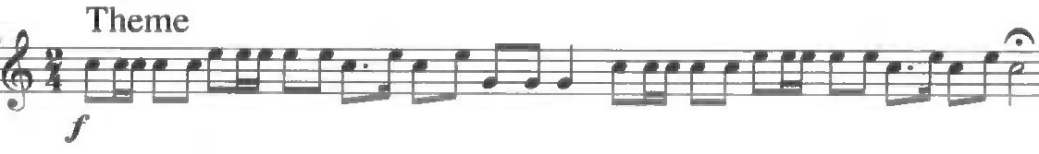

Example 4.2. Kentsubitsch, Theme and variations from Quatre Variations sur un Thème de SE16GAN

Seirogan tachi no kōshin (March of Seirogans)
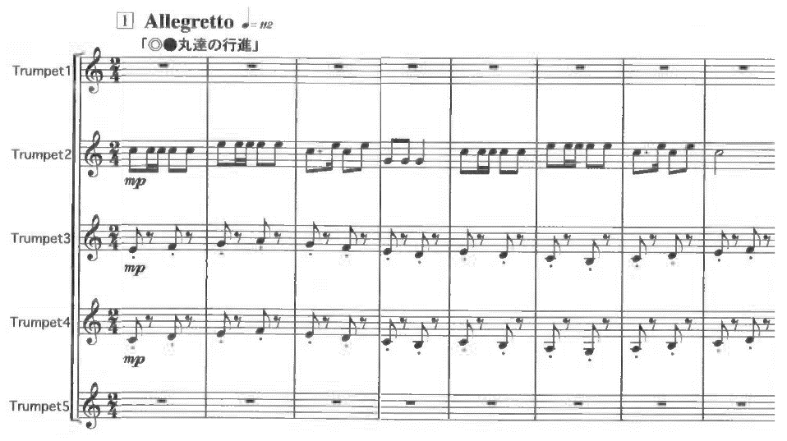

Variation 1
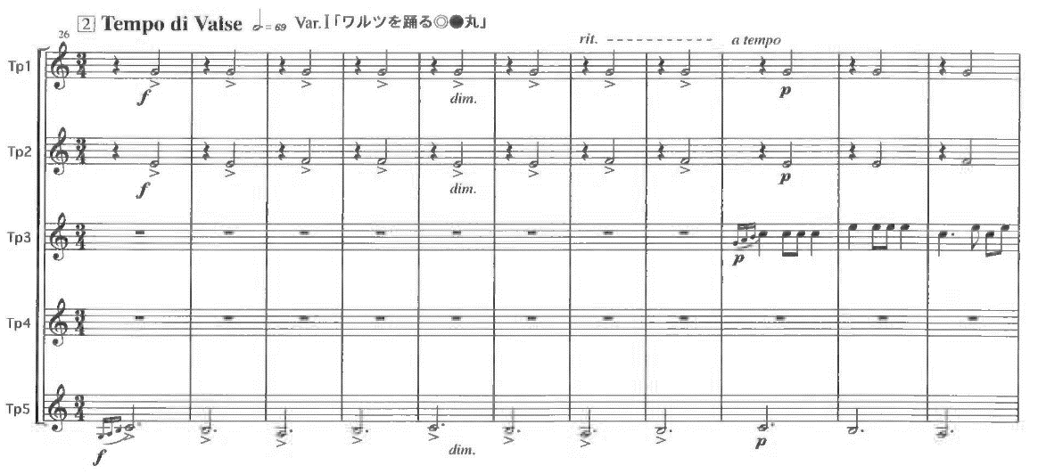

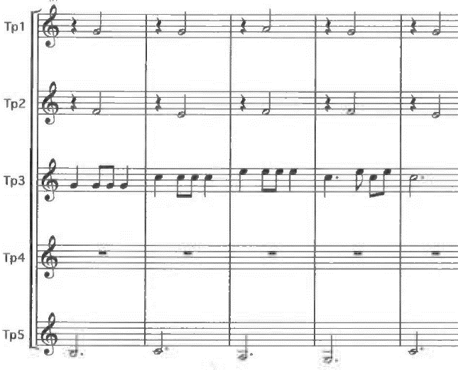
Example 2—Continued
Variation 2
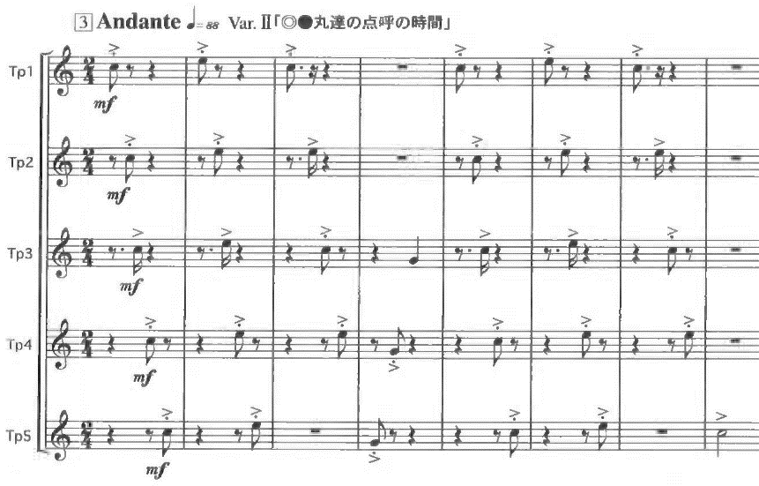
Variation 3
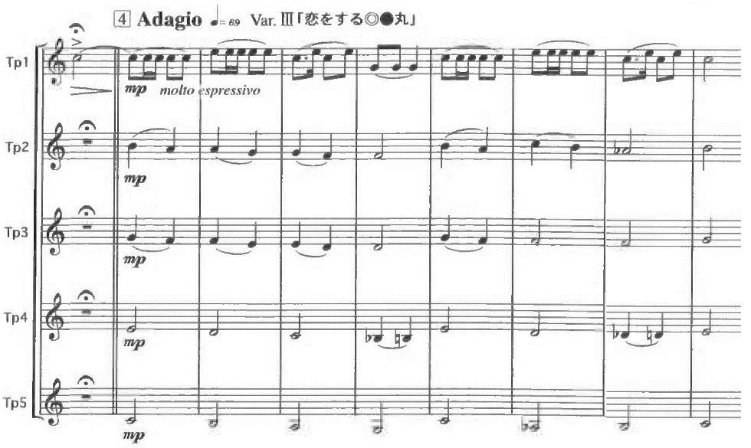

Variation 4
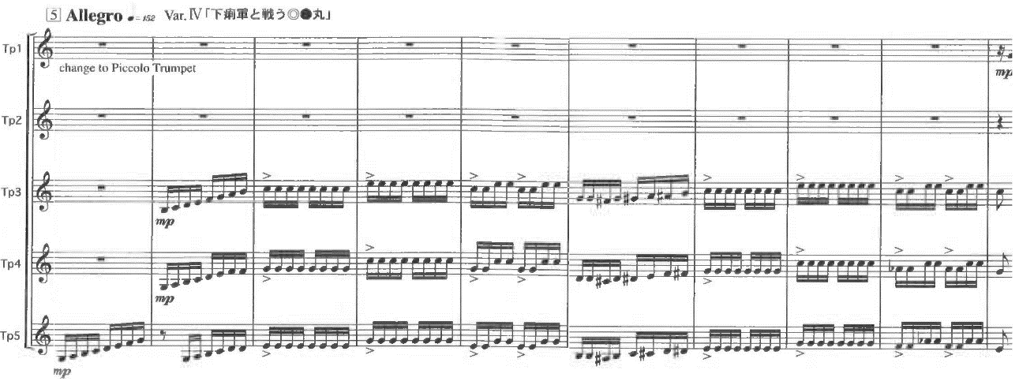
Another example of his composition with humor is his Septet “The Salmon.” When he hosted a concert to play Saint-Saëns’s Septet, he planned to set The Trout Quintet by Franz Schubert in the first half of the concert and play Septet in the second half. But he wanted one more piece to make the concert longer and more interesting. Then he jokingly suggested that he would compose the Salmon septet with the same instrumentation of Saint-Saëns’s Septet, and the ensemble members enthusiastically supported his idea. In this piece, Kentsubitsch employs the theme from the fourth movement of The Trout and inverts it (see example 4.3).

Example 4.3. Theme from The Trout Quintet by Franz Schubert and Septet “The Salmon” by Kentsubitsch

The Trout

The Salmon
When he composes, he first builds up the story, or “pictures” as he calls them, for the piece. Kentsubitsch talks about his compositional process:
僕の場合、作曲するときに「絵」も一緒に頭に浮かぶんです。（中略）どうして作曲できるようになったかというと、今までにいろいろなものを見てきたからでしょう。それこそテレビの映像でもいいんですが、そういう「絵」の蓄積が音になって曲を生むような感じです。

For me, when I compose, “pictures” occur to me with the music. . . . The reason why I can compose is, I guess, because I have seen various kinds of things. Even the images from TV have accumulated as “pictures,” and these pictures turn into the sounds, then these sounds become compositions. That is how I feel like. [Author’s translation]

He gives an example of how “pictures” built his composition when he talks about The Salmon:
僕の場合、作曲するときに「絵」も一緒に頭に浮かぶんですね。たとえば「鮭」では、卵から稚魚が生まれて川を泳いで海に出て、また川に戻ってくる・・・というように。初演のときも「情景が目に見えてきますね」と、共演した人たちに言われたりしました。

For me, when I compose, I also think of “pictures.” For The Salmon, small fry are born from spawns, and they swim the river, then they reach the ocean. Finally, they come back to the river. Players for the premiere said, “I can see the picture.” [Author’s translation]

For some pieces, his “pictures” construct serious stories such as The Salmon and Legend. However, for other works, he employs “pictures” with humor. For example, his first Trumpet Concerto tells the story of Takahashi. Takahashi transferred from the community college to the school of music with a scholarship, but he had difficulty in getting along with trumpet students older than him. Then Takahashi was in distress during the trumpet camp in Okinawa. Kentsubitsch employs the “pictures” of Takahashi which he had collected while teaching Takahashi. For the scene in Okinawa, Kentsubitsch uses an Okinawan scale and folk song in order to remind Takahashi of his anguish.
Another example of “pictures” with humor appears in Einen Posaunen Simfonie. This trombone quartet piece depicts a day in the life of an orchestral trombonist in Tokyo; this trombonist does not have any particular model. The day starts at midnight with the trombonist’s loud snore. In the morning, he goes to the orchestra rehearsal. After a brief warm-up and tuning, the rehearsal starts with Tannhäuser Overture. During the lunch break, he eats with girls from the string section with a waltz as the background music. In the afternoon rehearsal, he beautifully plays the solo from Ravel’s Boléro. For dinner, he enjoys Okinawan food with a female orchestral player. Then he returns home and talks to his family. Finally, he goes to bed, and this time he sleeps without snoring.
In his works, Kentsubitsch often borrows music from other composers. The Salmon borrows the theme from The Trout, and Einen Posaunen Simfonie employs melodies from Wagner and Ravel. Furthermore, Kentsubitsch uses the beginning of Beethoven’s Piano Concerto No. 5 in his Euphonium Concerto “Emperor,” and his Trumpet Concert No. 2 “Eroica” quotes the theme from Beethoven’s Symphony No. 3.
More than from classical music, Kentsubitsch borrows melodies from Okinawan folk songs. He talks about using Okinawan folk songs in his composition as below:
クラシック音楽にも例えば作曲家・バルトークがハンガリーの音階を取り入れて作曲するなど、民俗音楽を取り込んだ例はたくさんある。沖縄音階は素晴らしい。それをいかしたクラシックを作りたい。

In classical music, there are many works which employ folk music. For example, Béla Bartók composed using Hungarian minor scale. The Okinawan scale is fantastic. I would like to compose classical music with the Okinawan scale. [Author’s translation]

Most Okinawan folk music is characterized by the Okinawan scale (also called the Ryukyuan scale). The Okinawan scale is basically a pentatonic scale consisting of C E F G B (see example 4.4), and occasionally D is added. Okinawan folk songs are accompanied with string instrument sanshin (shamisen-like instrument which uses snake skin instead of cat and dog skin), castanet-like percussions called sanba and yotsutake, and various kinds of taiko (drums).

Example 4.4. Okinawan scale

Kentsubitsch employs Okinawan music in some of his works. In Legend, Okinawan music indicates the peace in Okinawa (see example 4.5). In Einen Posaunen Simfonie, trombones play Okinawan music to describe dinner time at an Okinawan restaurant. In his first Trumpet Concerto, Kentsubitsch quotes an Okinawan folk song called Asadoya Yunta (see example 4.6). He uses this song to depict Takahashi’s experience in the trumpet camp in Okinawa (see example 4.7). Tasogare is a slow ballad which illustrates the tranquil sunset in Okinawa with beautiful melodies in the Okinawan scale.

Example 4.5. Kentsubitsch, Legend, mm. 5-12
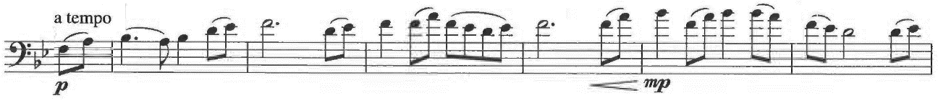
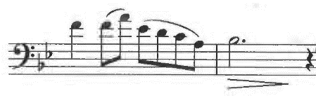

Example 4.6. Asadoya Yunta (Okinawan folk song)

Example 4.7. Kentsubitsch, Trumpet Concerto, mm. 217-226
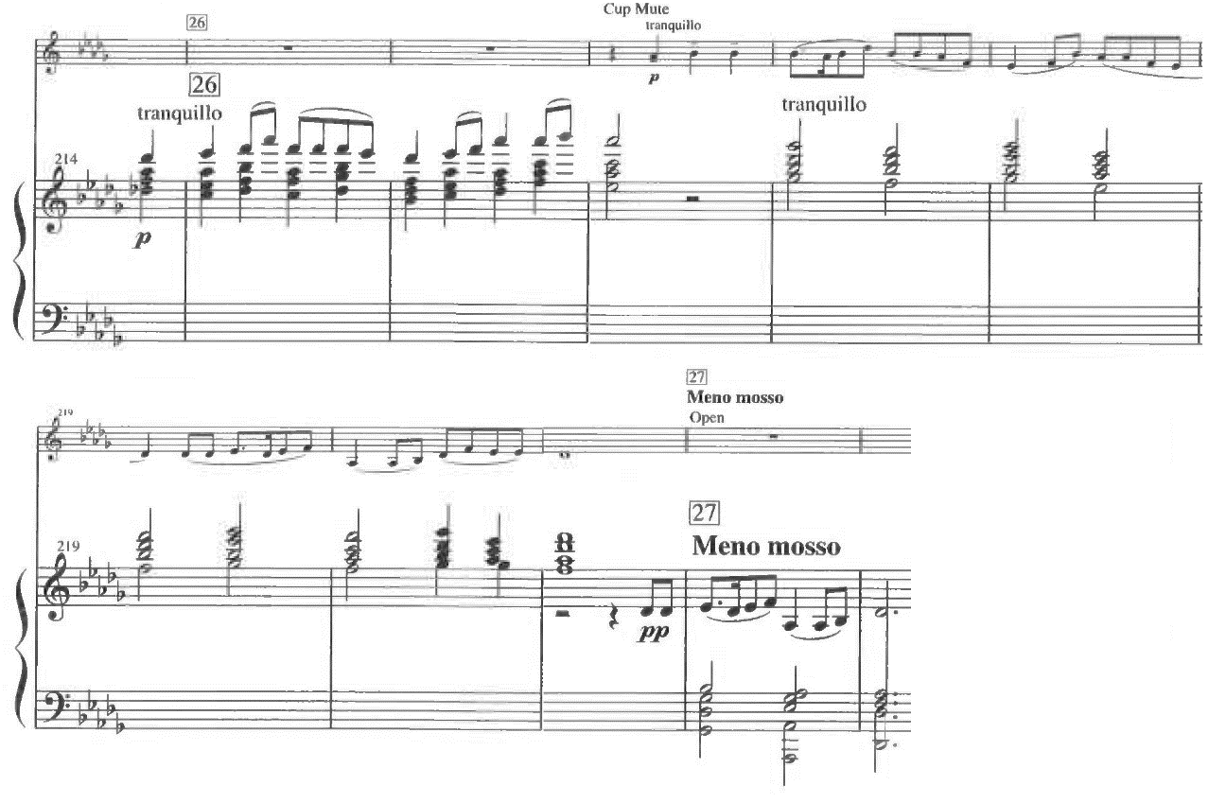
Overall, the works of Kentsubitsch show several characteristics: musical ideas with humor, beautiful melodies, depictions of stories throughout works, and the use of Okinawan music and scale. Furthermore, as a trumpet player himself, Kentsubitsch never fails to employ technical challenges such as multiple tonguings in his works for trumpet and other brass instruments. All these components fascinate players both musically and technically; therefore, some of his works became popular and have been played widely in Japan.

Chapter 5
Contest Piece by Marcel Kentsubitsch

Background

Kentsubisch composed Contest Piece in December 1996 for one of his trumpet students at Senzoku Gakuen Uozu Junior College. At this school, all performance major students play a single piece as a graduation exam. As the exam approached, this student could not play the notes above the staff. Kentsubitsch describes this student:
とても性格が良くていい子なのだが、ラッパがヘタで困っている。奏法に難があり高い音が苦手でその上楽譜を読むのも遅い。（中略）試験でやる曲も音域に問題があって、なかなかいい曲がない状態だ。

He has a good personality, and he is nice, but I am in trouble teaching him because he cannot play the trumpet very well. He is not good at high notes because he has difficulty with his way of playing. Moreover, he is slow to read music. . . . Because of his limited range, it is hard to find good pieces for the exam. [Author’s translation]

To accommodate this student’s needs, Kentsubitsch wrote Contest Piece for trumpet and piano without notes higher than concert E. Even though this piece consists of a limited range, Kentsubitch composed this piece to be technically challenging with phrases which require multiple tonguings and difficult fingerings in order to suit the exam. Contest Piece was premiered in 1997 by this student in the graduation exam at Senzoku Gakuen.
Because of the limited range, this piece is widely played in Japan by not only advanced and professional players but also intermediate trumpeters. Kentsubitsch mentions this piece when he talks about his compact disc, which includes Contest Piece:
そういった子たちが吹ける曲が、そもそもないんですね。フランスのコンクールピースみたいな難しい曲ばっかりで。困ってる子はたくさんいます。僕のこのCDを聴いて、やりたいと思ってもらえればいいと思うけれど。

After all, there is no piece for students like him, and meanwhile there are many difficult works like French competition pieces. Many students have trouble finding suitable pieces. I hope these students will listen to this compact disc and have an interest in playing this piece. [Author’s translation]

Kentsubitsch also composed Finale with the same concept as Contest Piece. The main range in Finale is limited to concert C♯ on the second highest space of the staff; above C♯, only two concert Ds and one concert E♭ are employed in this piece. However, like Contest Piece, phrases which require triple tonguings add a technical challenge to this piece.
Kentsubitsch employs no Okinawan music in Contest Piece, but this piece includes his cantabile style in melodies. He mentions this piece may sound like Japanese enka, but he admits it cannot be helped because he is Japanese.

Analysis

Kentsubitsch explains his compositional techniques as below:
僕の使う和音は限られていて、構成も単純なんだけど、でも大体の曲って、循環して終わりますからね。

I use limited harmonies. And the structure is simple. But most classical pieces circulate to the end. [Author’s translation]

Contest Piece follows this idea with tonal voice leading and binary form with a coda.
Figure 5.1 shows the formal structure of this piece. As a whole, this piece employs binary form with a coda: Introduction (mm. 1-4), A section (mm. 5-45), B section (mm. 46-175), and Coda (mm. 176-190). Moreover, both A and B sections contain ternary form. The A section consists of a-b-a (mm. 5-17, 18-27, and 28-45 respectively). The B section basically consists of c-d-c, but this section is more complicated than the A section, with a transition before the d section, and a retransition after the second c section. Furthermore, the first c section shows another ternary form indicated as c-c’-c in figure 5.1. As Kentsubitsch says, he combines simple forms to build up this piece, and the recurring themes make circulations in each section and through the entire piece.

Figure 5.1. Analytical diagram for Contest Piece by Kentsubitsch

B Theme 2
C major
Introduction
A Theme 1
A minor
(mm. 62-69)
(mm. 46-61)
c’
c
(mm. 28-45)
a
b (Cadenza)
(mm. 18-27)
(mm. 1-4)
a
(mm. 5-17)

Retransition

Theme 2
C major/A minor
Theme 1 (Waltz)
F major
Transition

c
d
c
(mm. 144-175)
(mm. 128-143)
(mm. 88-127)
(mm. 78-87)
(mm. 70-77)
Theme 2
(motive 2)

Coda Theme 1
A major
a
(mm. 183-190)
(mm. 176-182)

The Introduction and A section represent Kentsubitsch’s cantabile style in a slow tempo. The piano starts the piece with a four-measure introduction which chromatically modulates from D minor to G minor, and then to A minor (see example 5.1). The piano increases the dynamics toward m. 5, then the trumpet enters in fortissimo and presents Theme 1 in A minor. Kentsubitsch makes this introduction remarkable by starting with D minor, subdominant of A minor for Theme 1.

Example 5.1. Kentsubitsch, Contest Piece, mm. 1-4
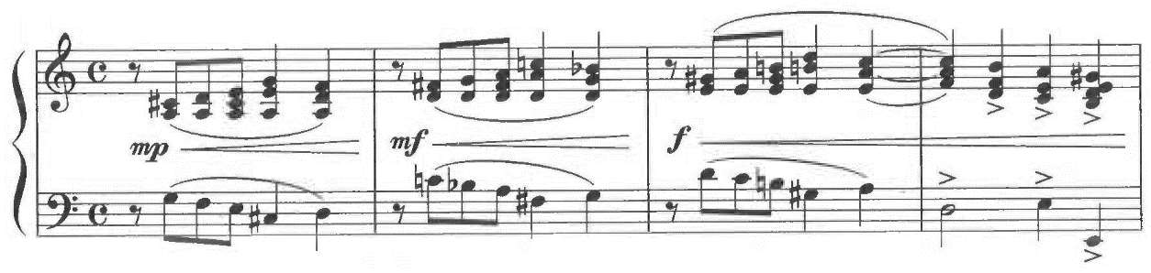
a: V⁴
i⁶
₂
V⁶
₄
V⁶
₅
i
iv⁷
ii°⁶
i⁶
₄
V⁷
g: V⁴
i⁶
₂
V⁶
₄
V⁶
₅
i
d: V⁴
i⁶
₂
V⁶
₄
V⁶
₅
i

As example 5.2 shows, motive 1 and an arpeggio construct most of Theme 1. Motive 1 appears in mm. 5-7, and the first four notes in this motive are inverted in mm. 9-10 (indicated as motive 1-i). In m. 11, the first four notes of motive 1 are augmented (indicated as 1-aug). An E major arpeggio occurs in m. 8 and mm. 11-12.

Example 5.2. Kentsubitsch, Contest Piece, mm. 5-12, with motives
arpeggio
1
1
1
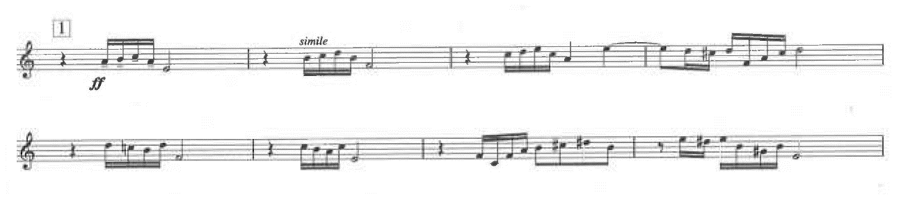
1-aug
arpeggio
1-i
arpeggio
1-i
The harmonization for Theme 1 mostly follows traditional voice leading (see example 5.3). As Kentsubitsch says, he utilizes limited harmonies: major and minor triads and seventh chords. He employs two secondary dominants in measures 7 and 11. Tremolo in the right hand of the piano thickens the texture to give a dramatic effect. At m. 13, the piano restates Theme 1 while the trumpet plays an arpeggio-based countermelody (see example 5.4).

Example 5.3. Kentsubitsch, Contest Piece, mm. 5-12
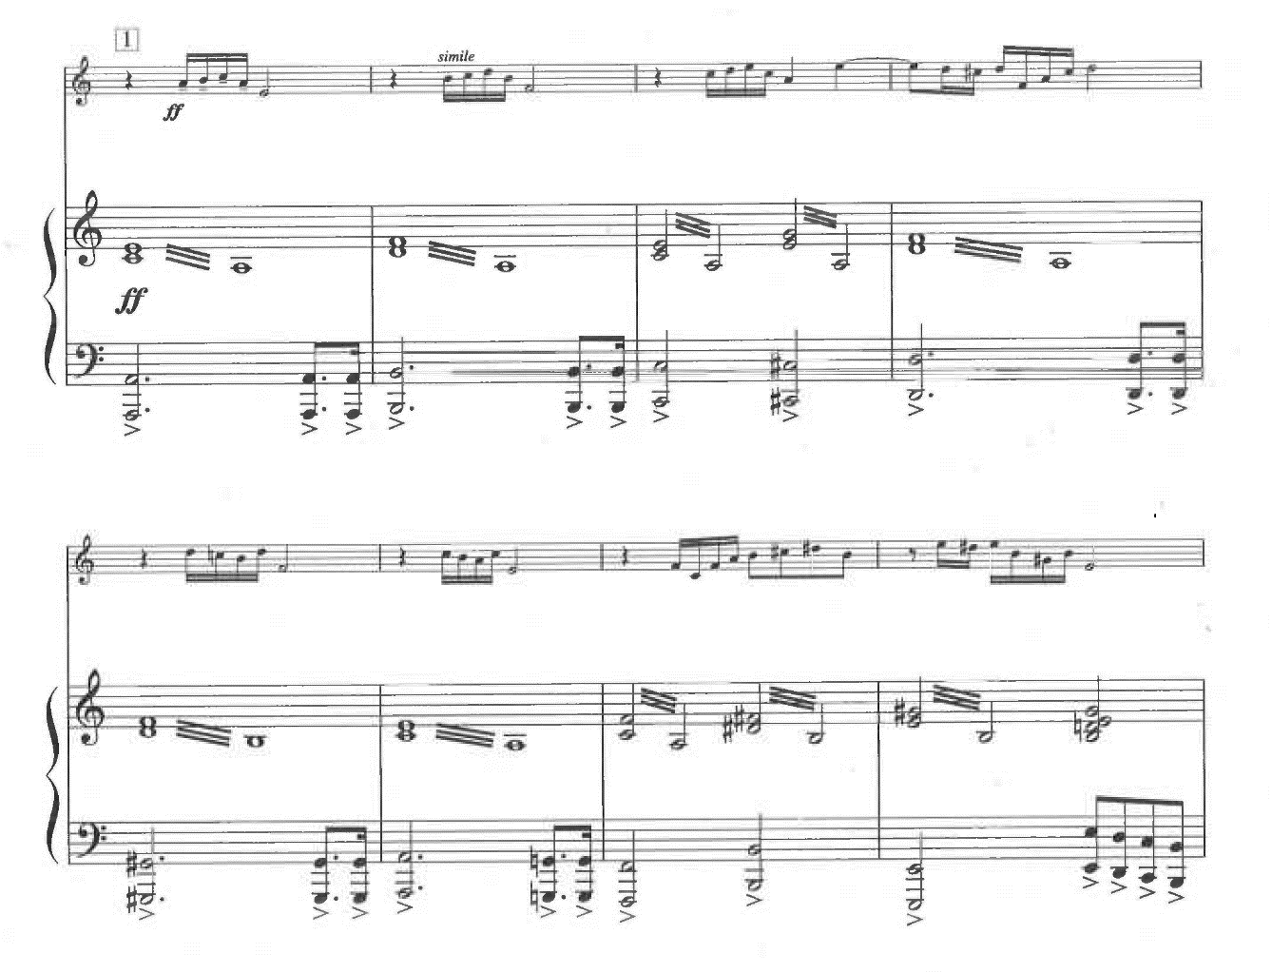
i
VI
V/V
V
vii°⁷
i⁴
₂
V⁷
ii^{ø7}
i⁶
V/iv⁶
₅
iv
a: i

Example 5.4. Kentsubitsch, Contest Piece, mm. 13-16
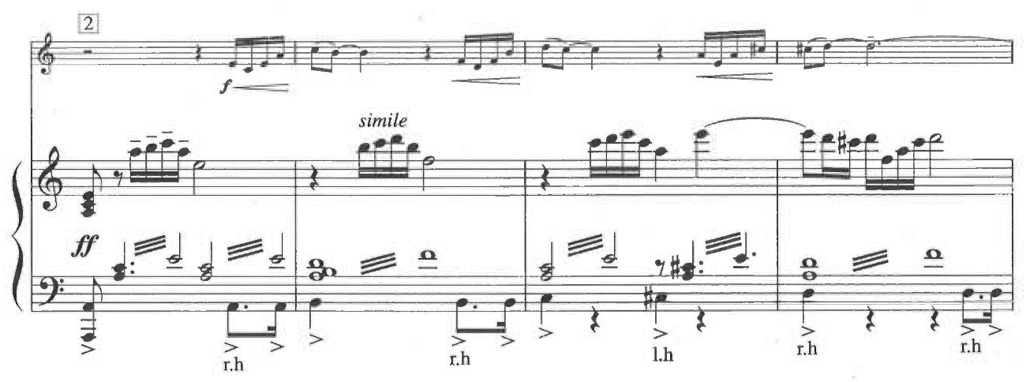

At m. 18, the trumpet and piano start trading the rhythm consisting of dotted-eighth and sixteenth notes followed by a half or a dotted-half note (see example 5.5). This rhythm originally appears in the piano in m. 5. In mm. 22-24, the trumpet plays three measures of arpeggios on a B diminished chord, supertonic in A minor, which leads to the cadenza. Example 5.6 shows the cadenza by the trumpet. In this cadenza, Kentsubitsch employs the elements in previous measures. This cadenza begins with the combination of motive 1 followed by the rhythm of dotted-eighth and sixteenth notes. At the point in the cadenza that Kentsubitsch marked poco piu, arpeggios based on a diminished-seventh chord occur. After the first fermata, the trumpet presents an arpeggiated A minor chord and B diminished chord. After these arpeggios, the tempo increases with a sixteenth-note passage, which includes fragmented inversions of motive 1.

Example 5.5. Kentsubitsch, Contest Piece, mm. 18-24
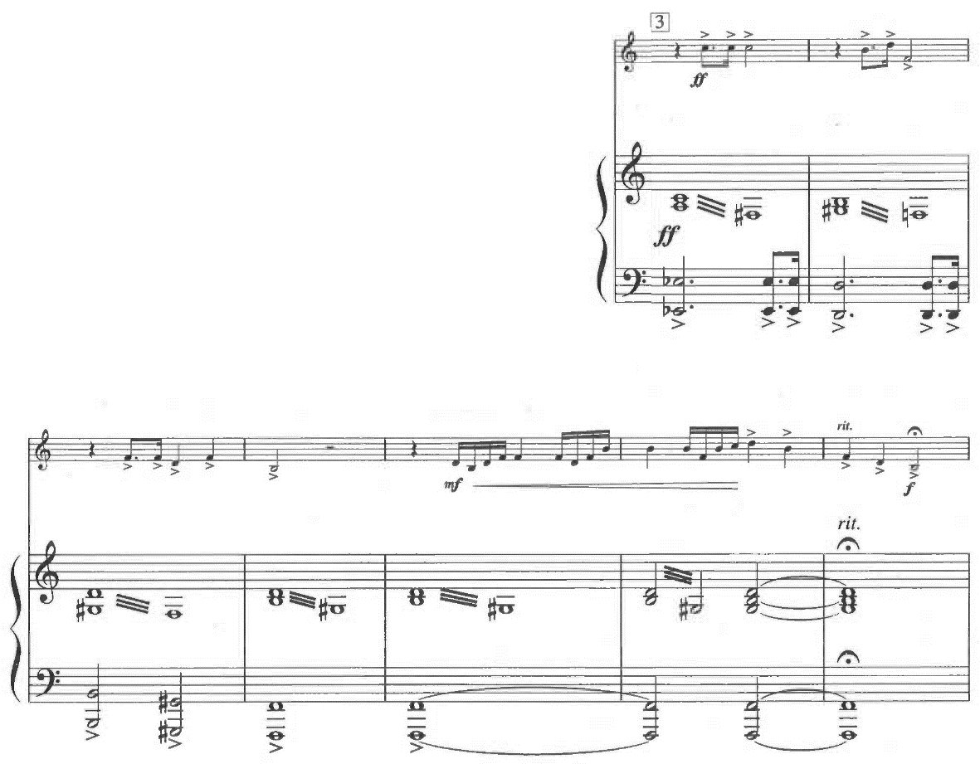
Example 5.6. Kentsubitsch, Contest Piece, mm. 25-27
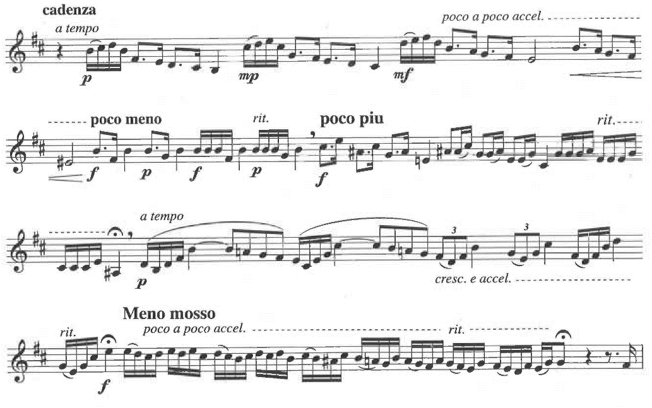
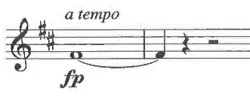
At m. 28, Theme 1 recurs in the piano (see example 5.7). In contrast to the first appearance of Theme 1 in m. 5, the dynamic for this recurrence is piano. The trumpet repeats the theme with a cup mute in m. 36. The piano keeps playing arpeggios throughout this section and reaches a perfect-authentic cadence in m. 43 (see example 5.8). In mm. 45, the key chromatically changes from A minor to the relative major.

Example 5.7. Kentsubitsch, Contest Piece, mm. 28-32
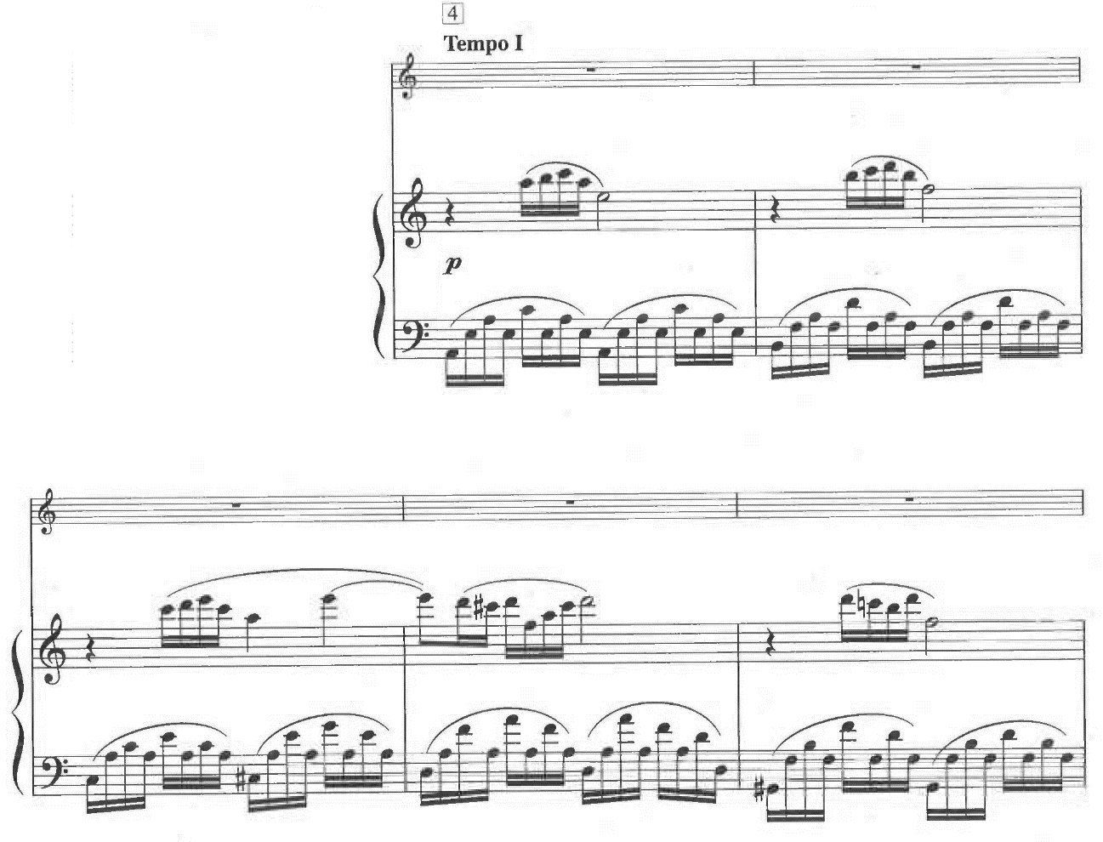

Example 5.8. Kentsubitsch, Contest Piece, mm. 42-45
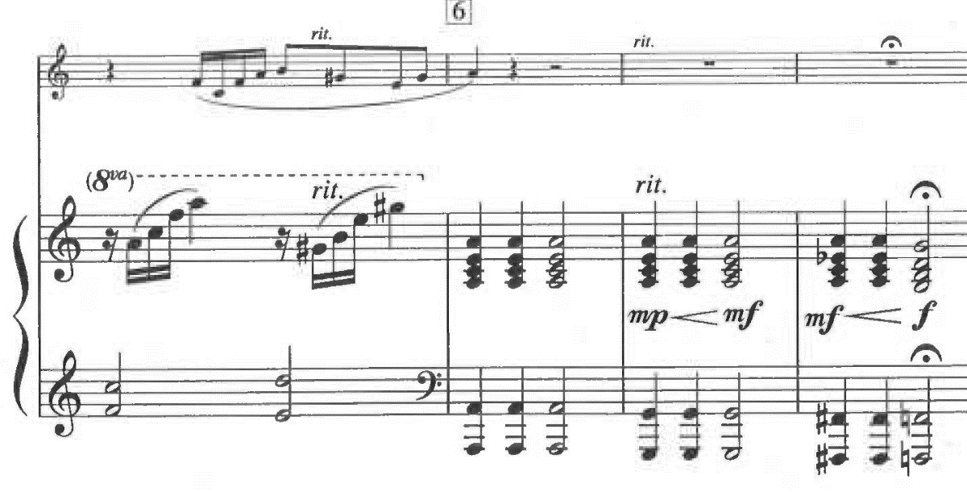
V⁷
i
a: VI
i⁴
₂
V⁴
vii°⁷/V
C:
₂

In m. 46, the tempo changes to allegro, and the trumpet begins the B section with Theme 2 in triple meter (see example 5.9). Theme 2 consists of motive 2: two eighth notes followed by a longer note which is a fourth, fifth, or sixth higher than the eighth notes. An inversion of motive 2 is employed in measures 48 and 51 (indicated as 2-i).

Example 5.9. Kentsubitsch, Contest Piece, mm. 46-53

2-i
2

2-i
2
2
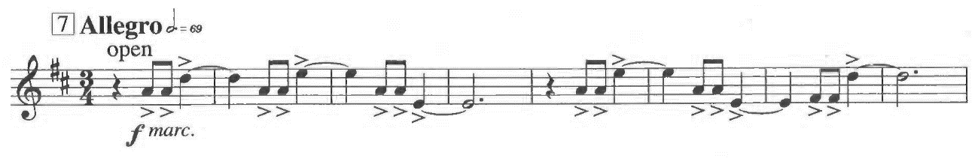
2

The piano restates Theme 2 in m. 54, and the trumpet plays the rhythm of motive 2 (see example 5.10). From rehearsal 7 (m. 46) until m. 61, when the trumpet plays, the piano rests or plays long notes, and vice versa. Furthermore, the piano never plays chords until m. 61. As a result, the beginning of the B section shows a thinner texture than the A section.
At m. 62, the trumpet starts playing a different phrase from Theme 2, but this phrase continues to apply motive 2 (see example 5.11). This time, the interval between two eighth notes and the following note ranges from a third to a sixth. In m. 66, two eighth notes are changed to triplets, which requires triple tonguings for the trumpet. Theme 2 recurs in m.70, and the piano starts a transition at m. 78. Arpeggios based on a C major triad in mm. 78-83 change to an arpeggiated C augmented triad in mm. 84-87 (see example 5.12). This C augmented chord plays the role of altered dominant of F major.

Example 5.10. Kentsubitsch, Contest Piece, mm. 46-61
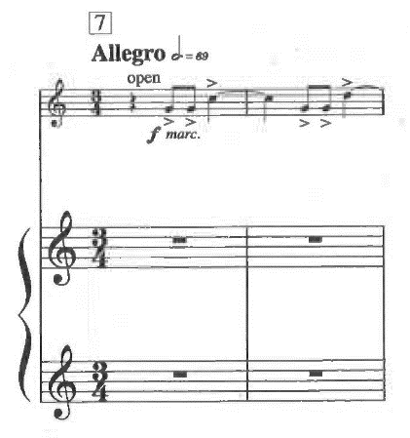
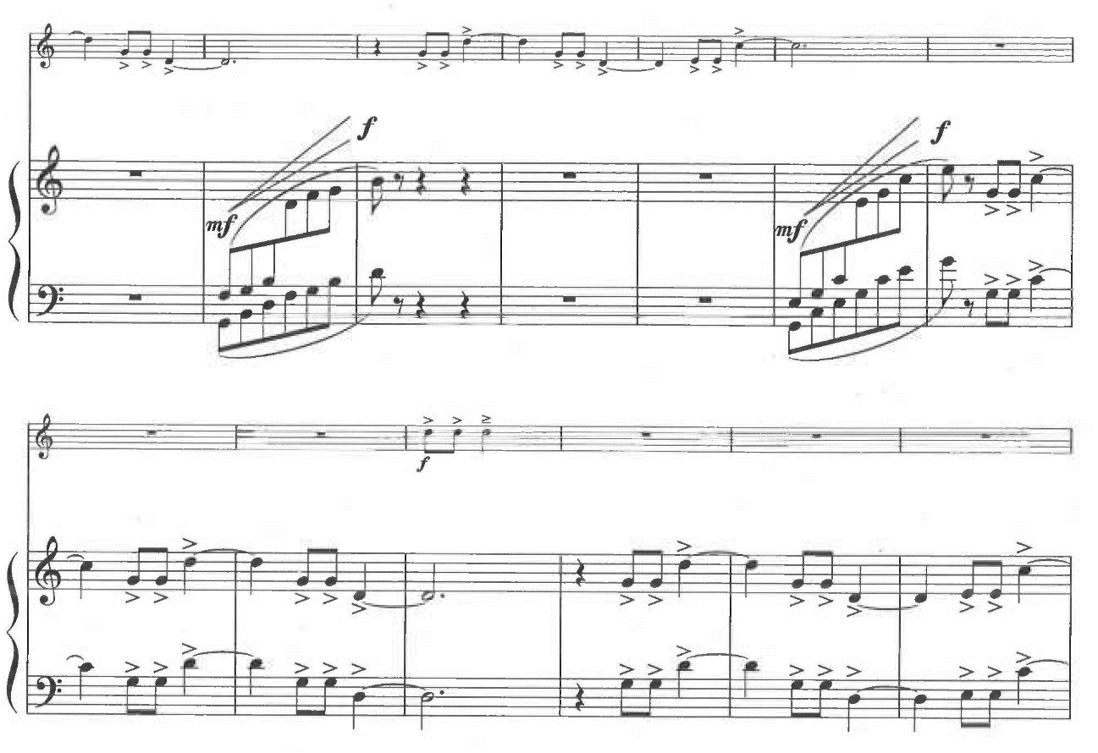
2 (rhythm)
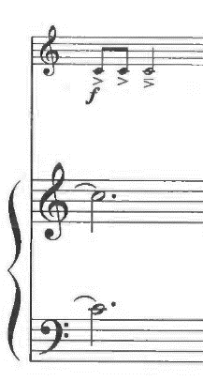
2 (rhythm)
Example 5.11. Kentsubitsch, Contest Piece, mm. 62-69
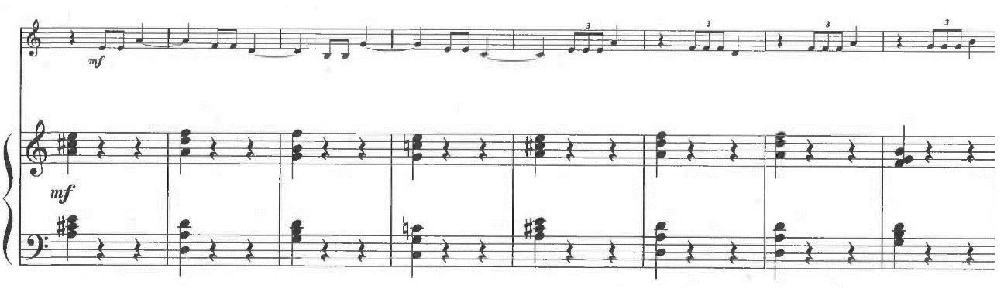

Example 5.12. Kentsubitsch, Contest Piece, mm. 78-88
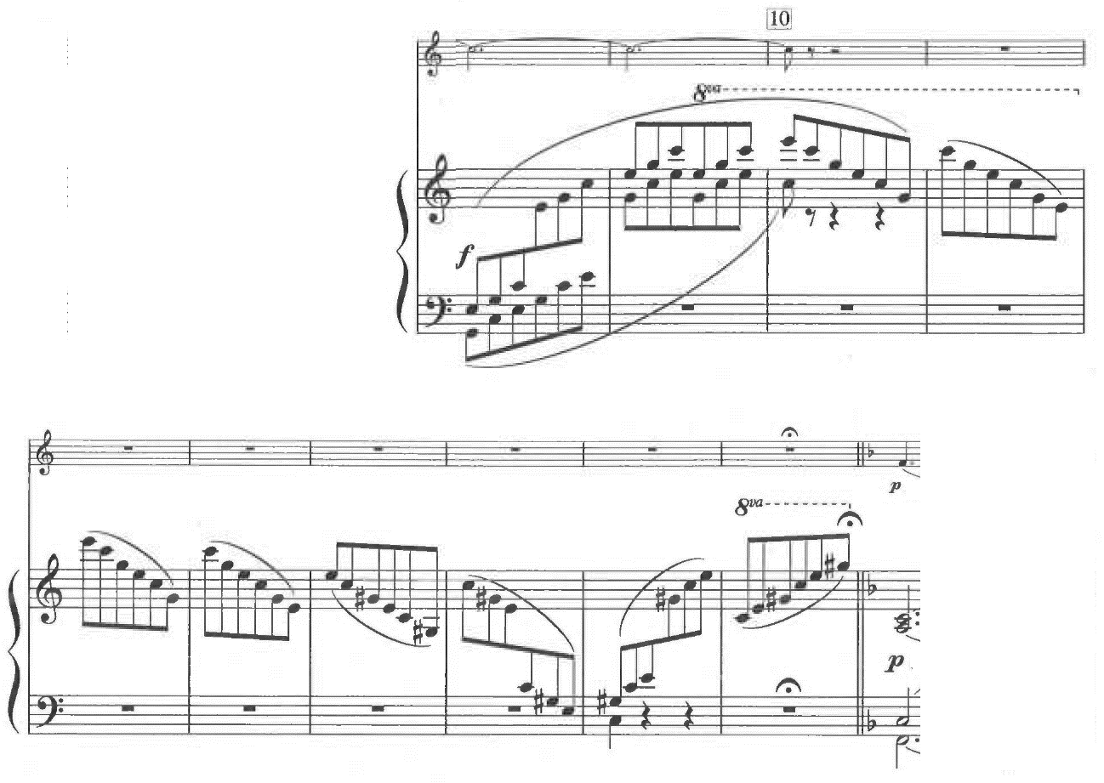
F: I
F: V⁺
C: I⁺
C: I

In m. 88, the tempo decreases, and Theme 1 appears in waltz style in F major (see example 5.13). The trumpet plays the theme first, then the piano restates it while the trumpet accompanies by playing motives 1 and 2. For the first three appearances, the last note of motive 1 goes up (indicated as 1’). This waltz section ends with a perfect-authentic cadence in mm. 126-127 (see example 5.14). In m. 128, the tempo goes back to Tempo I, and the key returns to C major. Theme 2 recurs in the trumpet first, then the piano repeats it in A minor.

Example 5.13. Kentsubitsch, Contest Piece, mm. 88-119
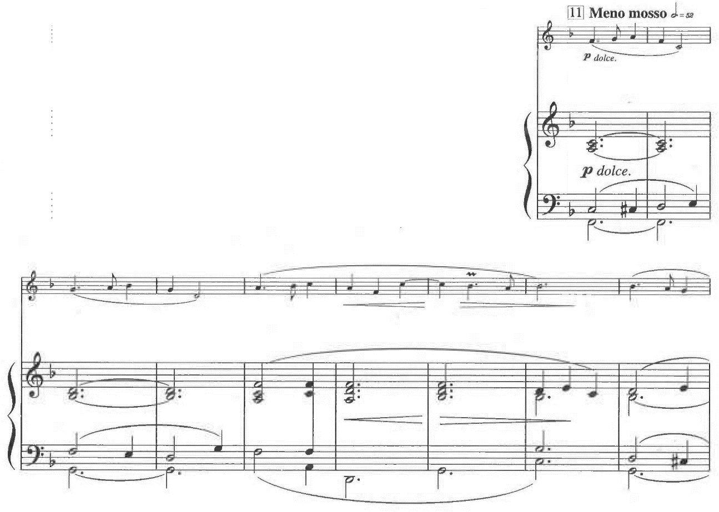

Example 5.13—Continued
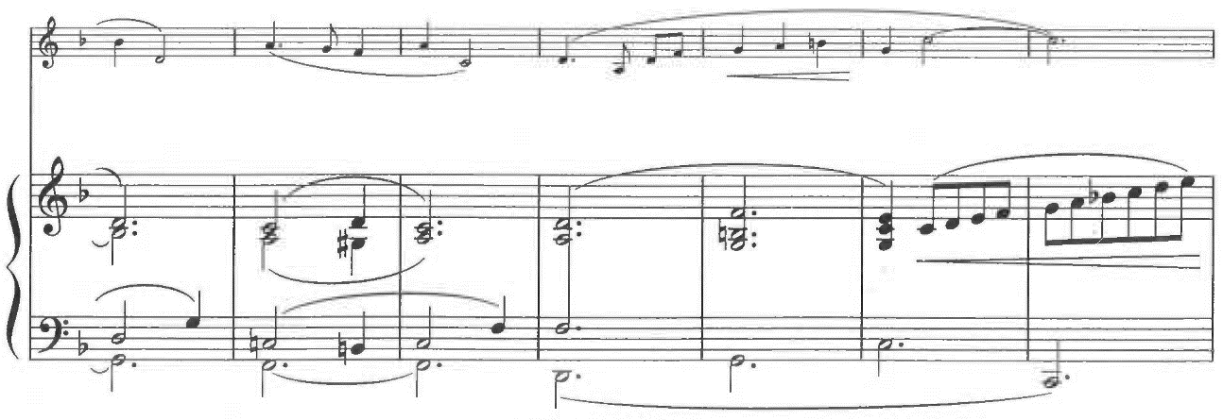
1’
1’
1’
1-i
1-i
2
2-i
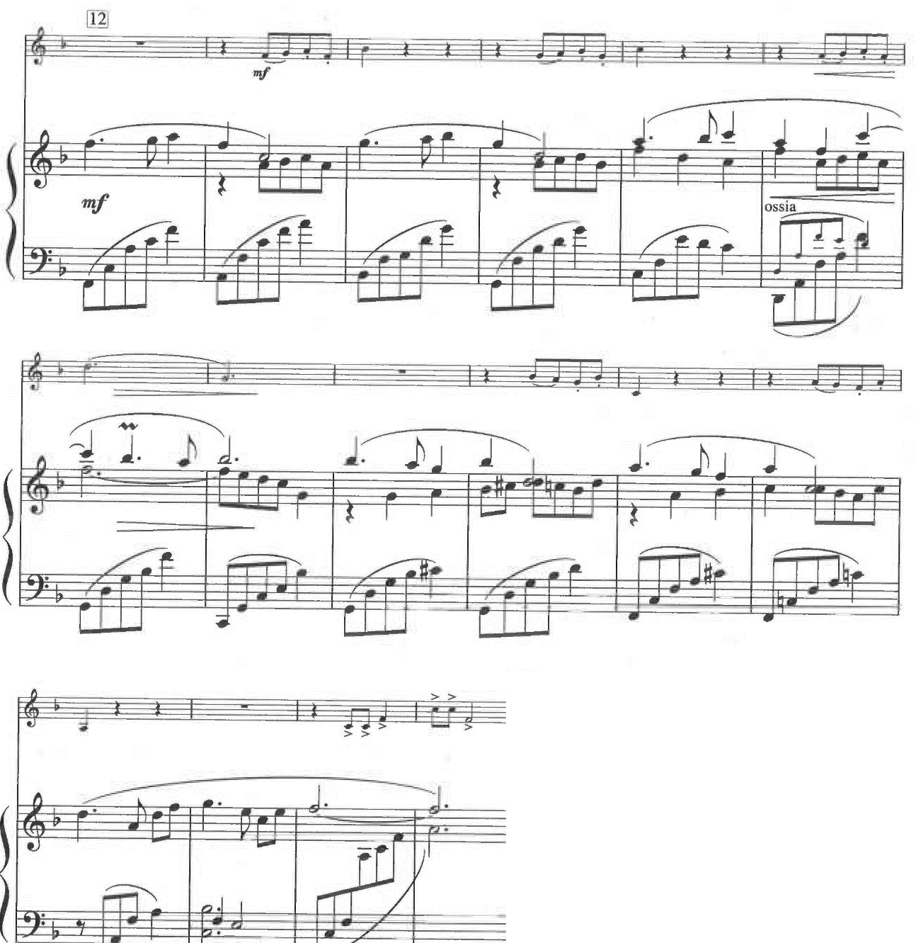
Example 5.14. Kentsubitsch, Contest Piece, mm. 124-128
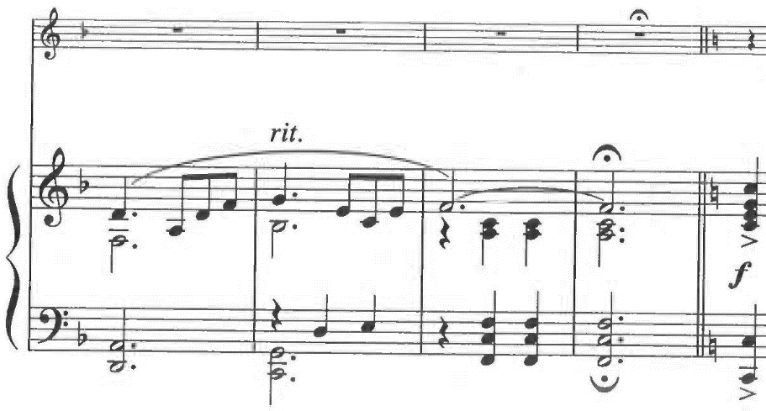
C: I
I
F: vi
V⁷

At m. 144, the piano begins the retransition with motive 1 (see example 5.15). Tremolo in the left hand is reminiscent of the accompaniment of Theme 1 in the A section. Meanwhile, the trumpet plays the rhythm from motive 2, and from m. 168 on, two eighth notes are replaced by triplets. The retransition section solely consists of diminished-seventh chords except the last measure of the section (m. 175), and the piano presents all three versions of the octatonic scale, which complement the diminished-seventh chords. The fragment of motive 1 is indicated as 1-f. Table 5.1 shows the sets of diminished-seventh chords and octatonic scales in mm. 144-174. Each diminished-seventh chord is complemented by the octatonic scale for the next chord: the first chord by the second scale, the second chord by the third scale, and the third chord by the fourth scale. In m. 175, at the very end of the retransition section, F in the diminished-seventh chord goes a half step down to E, and the diminished chord chromatically changes to a dominant seventh chord of A major. The dynamics start from piano in m. 144 and gradually increases toward fortissimo in m. 176, at the beginning of the Coda.
Example 5.15. Kentsubitsch, Contest Piece, mm. 144-175
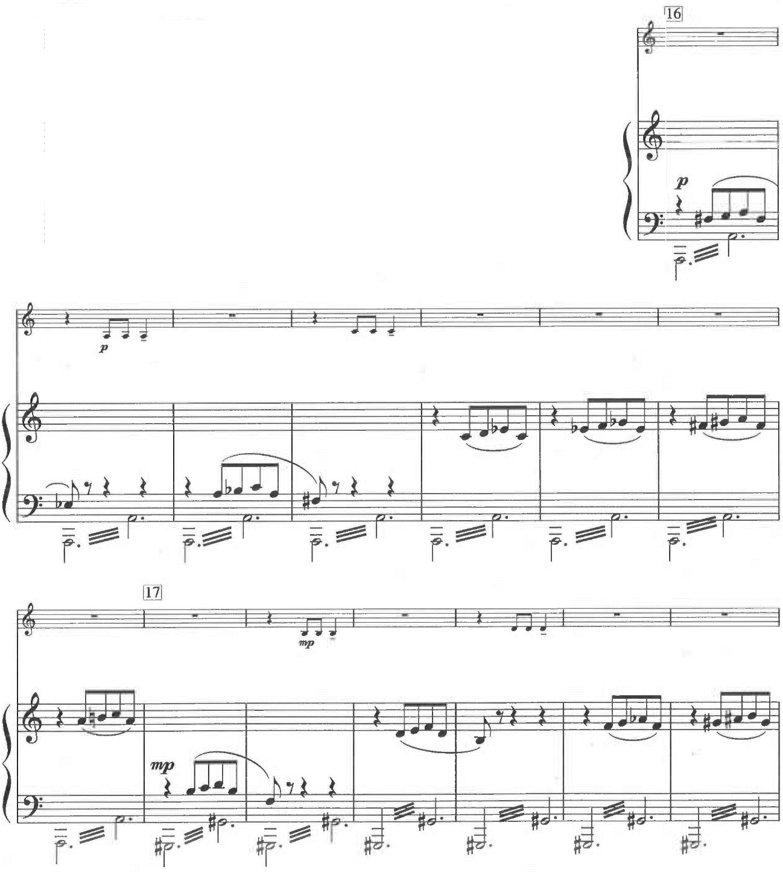
OCT_{1,2}
1
OCT_{2,3}
1-f
2
(rhythm)
2
(rhythm)
1

OCT_{1,2}

Example 5.15—Continued
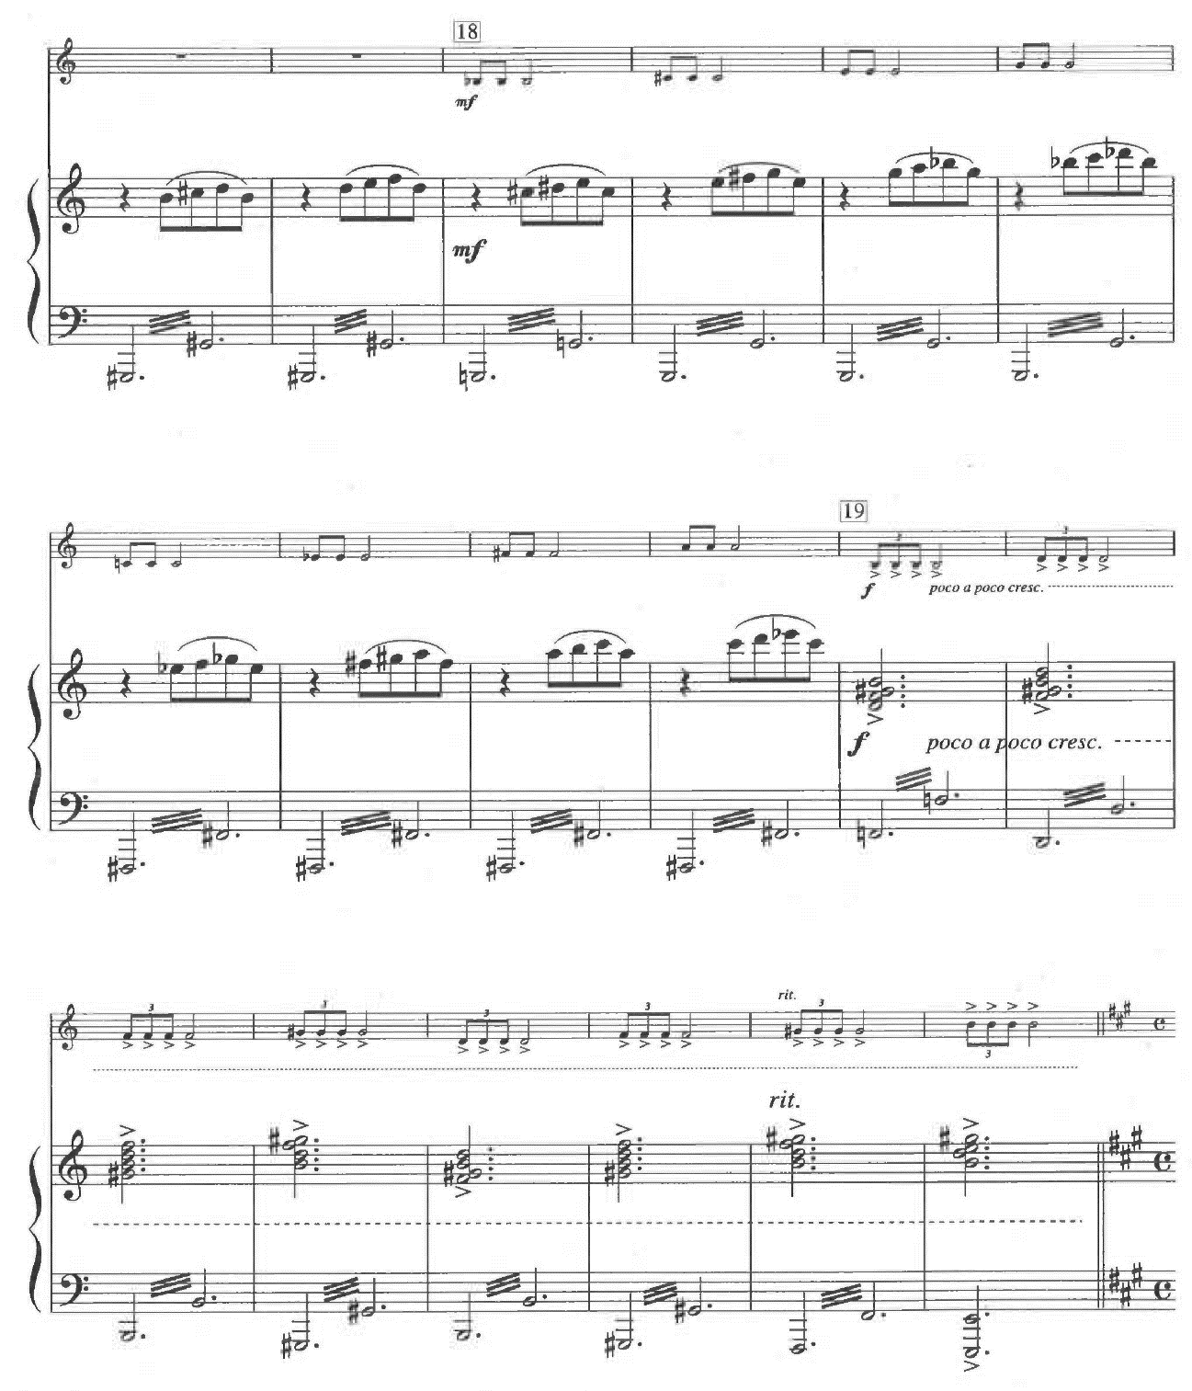
A: V⁷
OCT_{2,3}
OCT_{0,1}

Table 5.1. Kentsubitsch, Contest Piece, sets of the diminished-seventh chords and octatonic scales in mm. 144-174

Measures | Chords | Scales
144-147 | [0 3 6 9]
148-151 | [0 3 6 9] | 0 2 3 5 6 8 9 E
152-155 | [2 5 8 E]
156-159 | [2 5 8 E] | 1 2 4 5 7 8 T E
160-163 | [1 4 7 T] | 0 1 3 4 6 7 9 T
164-167 | [0 3 6 9] | 0 2 3 5 6 8 9 E
168-174 | [2 5 8 E]

In the Coda section from m. 176, the trumpet presents Theme 1 in A major, parallel major of A minor (see example 5.16). The countermelody in the piano also contains motive 1. This return to Theme 1 continues only for seven measures, and the piece ends with motive 2 derived from Theme 2.

Example 5.16. Kentsubitsch, Contest Piece, mm. 176-190
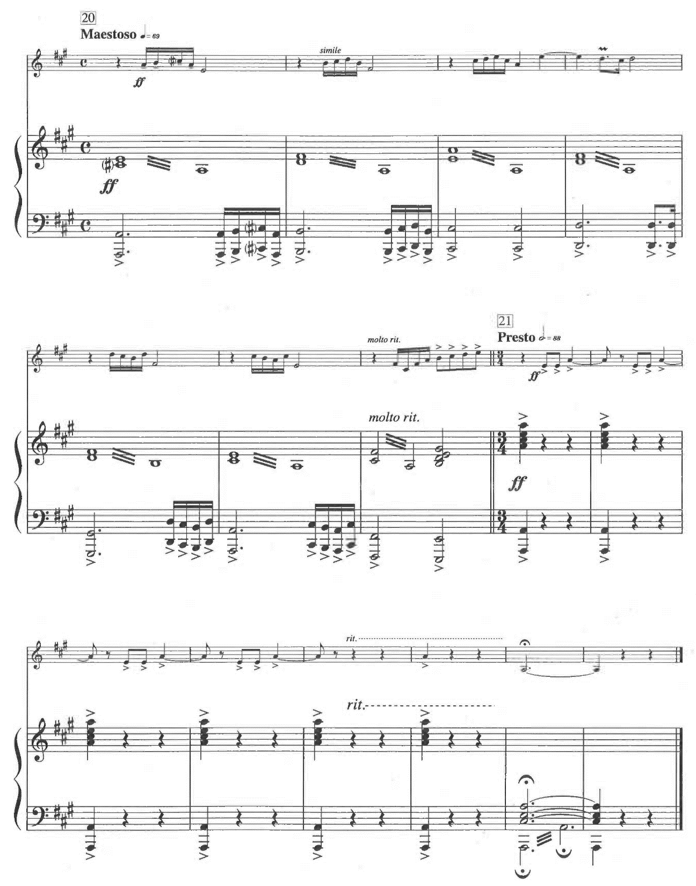

Chapter 6
Biography of Hisato Ozawa

In spite of his brilliant career, Hisato Ozawa had been undeservedly ignored in the Japanese musical world since his death in 1953. However, Katayama and Fujimoto rediscovered Ozawa’s works in 2000, and Orchestra Nipponica performed Ozawa’s Symphony No. 3 “Symphony of the Founding of Japan” and Piano Concerto No. 3 “Kamikaze” in 2003. Katayama also supervised a compact disc including Ozawa’s Symphony No. 3 and “Kamikaze.” This compact disc received an award from the Agency for Cultural Affairs in 2004. These activities grew recognition of Ozawa’s music. Approximately 70 works by Ozawa were known in 2006, but as of August 2011, more than 950 works have been found.

Early Life

Ozawa was born on August 1, 1906 in Kobe, Japan. His father Jutaro studied iron manufacturing in England and founded Kobe Steel (a major Japanese steel manufacturer operating worldwide under the brand name KOBELCO) with other investors. His Christian mother Tomi loved Western music and enjoyed playing the piano. Ozawa’s family’s wealth and understanding of Western culture enabled Ozawa to study music from his early childhood. Besides learning the piano from Tomi, he enjoyed opportunities to learn the organ and to sing in a choir.
Ozawa entered Kwansei Gakuin in 1921 and studied there for five years. Because Kwansei Gakuin was an American mission school, students frequently experienced church music, and they actively participated in performances at church. Ozawa belonged to a glee club as a composer, arranger, conductor, piano accompanist, and soloist. From his third year at Kwansei Gakuin, he assumed the post of director, conductor, and accompanist at the school church.
He continued to study at Kwansei Gakuin College of Commerce until 1930, and he kept playing, composing, arranging, and conducting music in the glee club and school orchestra. In addition, he learned the piano from European musicians in Kobe: Russian pianist Alexander Lyutin and Spanish pianist Pedro Villaverde. According to Osawa Project, Ozawa started to learn from them either when he entered Kwansei Gakuin or when he studied at college. He also studied music theory on his own.
During his high school years, Ozawa started to extend his musical activity to off-campus. He founded Kobe Oratorio Society and participated as a composer and conductor. Moreover, in 1929, he held a concert in Osaka in which he conducted Mozart and Haydn piano concerti from the keyboard. Through these activities, he was well known in Kobe as a student almost of professional standard. Immediately after his graduation from Kwansei Gakuin College of Commerce in 1930, Ozawa left Japan by ship to Boston.

Formal Training

In Boston, he studied at Boston University College of Music. Additionally, he entered New England Conservatory of Music in 1932. He studied composition, music theory, piano, conducting, and orchestration mainly from Frederick Converse. In 1933, Ozawa also began to study at Malkin Conservatory in Boston with Arnold Schoenberg and his assistant Roger Sessions. Although Ozawa started learning composition from the fundamentals, he rapidly improved his skills. During his last two years in Boston, Ozawa composed approximately 900 pages of scores. Converse and other instructors thought highly of Ozawa’s talent and helped him to win scholarships which enabled him to hold recitals of his own chamber works and songs in Boston.
In the summer 1934, Ozawa left the US for London. After spending about one month there, he went to Paris in October. He brought a letter of recommendation from the US to have lessons from Nadia Boulanger at Ecole Normale de Musique, but he also wanted to learn from another famous composer in Paris. He heard that Paul Dukas was one of the most renowned teachers in Paris, and he decided to learn from Dukas. Ozawa expected to learn Dukas’s sophisticated colors of impressionism and unusual musical ideas. However, Dukas said that his ears could not immediately recognize that Ozawa’s works were beautiful, even though Dukas found Ozawa’s works interesting. Dukas respected the classical style, and he thought that young students should learn the beauty of classical music which most young musicians thought already dead. Because Dukas passed away in May 1935, Ozawa studied with him for a very short period.
On the other hand, Boulanger, a renowned pedagogue who taught Aaron Copland and Virgil Thomson, had a favorable interest in Ozawa’s Piano Concerto No. 2, and she advised Ozawa to keep in mind that he was Japanese. She also had given advice on his other compositions for his Paris debut. The purposes of Ozawa’s short stay in Paris were to finalize his compositional study and to test his ability in the Western musical world. After his concert with the Pasdeloup Orchestra, he went back to Kobe in February 1936.

Major Influence

Ozawa initially concerned himself with various music fields. However, he decided to study composition when he went to a recital by French pianist Henri Gil-Marchex in 1925. In October and November, Gil-Marchex held six recitals in Tokyo, and his repertoire included Japanese premieres of the pieces by French composers such as Préludes and Estampes by Claude Debussy, Pavane pour une infant défunte and Gaspard de la nuit by Maurice Ravel, Trois mouvements perpétuels by Francis Poulenc, and Saudades do Brazil by Darius Milhaud. After recitals in Tokyo, Gil-Marchex went to western Japan and held a recital at Kwansei Gakuin. These latest works from France deeply impressed Ozawa. After this recital, he wanted to study modern music and utilize it in his compositions. When Ozawa studied in Paris, he had an opportunity to meet Gil-Marchex and formed a friendship. Gil-Marchex premiered Ozawa’s Piano Concert No. 2 in Paris, and he also played for Ozawa’s concert in Tokyo in 1937.
In Boston, the Boston Symphony Orchestra had provided Ozawa various inspirations. In the 1930-31 season, the Boston Symphony celebrated its fiftieth anniversary and premiered Symphony of Psalms by Stravinsky and Symphony No. 1 by Arthur Honegger. Ozawa held a season ticket for the orchestra from 1931 to 1934, and in these three seasons, the Boston Symphony presented 16 world premieres and 14 US premieres. Ozawa heard the latest modern music in Boston Symphony Hall. Furthermore, he built a friendly relationship with the orchestra; the orchestra permitted him to audit the rehearsals, and eventually he conducted the orchestra in a performance of his own work. Mikiko Ikushima infers that this experience boosted Ozawa’s rapid progress of compositional skills and directly affected the modern style of his music.
Dukas pointed out in his class that Ozawa’s music showed an influence of Debussy, even though Ozawa thought he had already finished studying Debussy’s music and sought to be an ultra-modernist. Dukas also indicated the influence of Schoenberg on Ozawa's music. Katayama describes influences on Ozawa’s music from other composers such as neo-classicism of Ravel, the expressionism of Schoenberg and Bartók, the polytonality of Milhaud, and toccata-like music of Prokofiev.

Career

Ozawa started his career as a composer in Boston with support from William Cameron Forbes, ambassador to Japan from 1930 to 1932. On January 2, 1933, the Japan Society of Boston held Concert Auspices of Japan Society of Boston Original Compositions by Hisato Ozawa. The program for this concert consisted exclusively of Ozawa’s works: The Three Sisters, Solitaire, Sakura, Sonata for Cello and Piano in G Major, and Theme and Variations for Pianoforte. This concert was successful with a full audience including some standees, and this success gave him confidence as a composer.
On June 12 of the same year, he graduated from Boston University with a bachelor’s degree. That evening, he conducted the Boston Pops Orchestra in a performance of his Little Symphony in D Major for Flute, French Horn and Strings. The connection with the Boston Symphony Orchestra enabled him to become the first Japanese musician to conduct this orchestra. After his graduation, he stayed in Boston for another year and held two more concerts. In addition, he composed Concerto for Double-Bass and Orchestra and dedicated it to Sergei Koussevitzky, then music director of the Boston Symphony Orchestra.
During his short stay in England, Ozawa tried to gain a foothold in the European musical world. He met composer Arthur Bliss, conductors Henry Wood and Adrian Boult, and people in the broadcasting and publishing industries. In Paris, he expanded his connection to Honegger, Ibert, and Gil-Marchex. On November 8, 1935, Ozawa premiered his Symphony No. 2, Piano Concerto No. 2, and Une voix à Sakura conducting the Pasdeloup Orchestra. This concert was the first instance of a Japanese composer performing his own works with an orchestra in Paris. Gil-Marchex not only helped Ozawa hold this concert but also performed Piano Concerto No. 2 as a soloist. This performance of his concerto was aired on the radio throughout Europe. Many famous musicians in Paris such as Honegger, Milhaud, Ibert, Charles Koechlin, and Alexander Tcherepnin attended this concert. In the review, Ibert praised Ozawa as a gift with freshness and excellent sense. Another review titled “Dawn” admitted that Ozawa wrote music of the Parisian school. This review also mentioned that Ozawa’s music was already in the level of Tcherepnin who founded a Tcherepnin Award for compositions by Japanese composers. Ozawa won such a high evaluation from this concert, and he went back to Japan in 1936 with great confidence.
Ozawa planned to stay in Japan temporarily and go back to the international musical world as soon as possible. He planned to compose his third symphony in Paris and premiere it there. In Japan, he tried to show Japanese audiences what he had learned in the US and Europe. As soon as he returned to Japan, Ozawa conducted his own works in Tokyo with New Symphony Orchestra (present NHK Symphony Orchestra) and in Osaka with Takarazuka Symphony Orchestra. However, he failed to win the same acclaim as he had in Paris. One review criticized Ozawa’s works which won applause in Paris:
外人のあらゆる賛辞にも拘わらず、遺憾ながら私としては同様の賛辞を呈するわけ には参らぬ。…大澤氏は…一個の大きな統一された内容にまで、発展させ…ることができない。

In spite of all praises from foreigners, I regret that I cannot give him the same kind of praise. . . . Mr. Ozawa . . . cannot . . . develop the music to the point of one large united concept. [Author’s translation]

Katayama points out two reasons for this unfavorable reaction. First, Ozawa’s works were technically too difficult for Japanese orchestras of the time because he wrote for ensembles in Boston and Paris with virtuoso skills. Second, audiences in Japan found Ozawa’s music too modern and alien to understand. Therefore, his abilities and aesthetics nurtured in the contemporary musical world failed to find a place in the immature Japanese musical environment.
Meanwhile, the Second Sino-Japanese War began in 1937, and World War II broke out in 1939. This gradually deteriorating international situation prevented Ozawa from returning to the US and Europe. Under this circumstance, he had no choice but to stay in Japan and continue his career there. Thus, Ozawa decided to compromise with the underdeveloped musical world of Japan. He began to simplify his orchestration and reduce the modern elements in his works. This shift started from his Symphony No. 3 “Symphony of the Founding of Japan” and Piano Concert No. 3 “Kamikaze.” Katayama describes the difference between Ozawa’s Second and Third Symphonies, “If Symphony No. 2 is on the lines of Stravinsky or Hindemith, No. 3 looks back at Roussel and Myaskovsky and leans towards late romanticism.” Katayama also points out that the relation between Ozawa’s Second and Third Symphonies is similar to that between Shostakovich’s Fourth and Fifth Symphonies.
Ozawa premiered these works in 1938, but again, this concert resulted in harsh criticisms. The review for “Kamikaze” mentioned as below:
際物的な標題が、一層この作品を冗らない物にして了った。神風応援歌の一節位は期待していた聴衆は、唖然としていた。

The topical title made this piece even more worthless. Audiences who expected a phrase of Kamikaze fight song were dumbfounded. [Author’s translation]

Ozawa wrote this concerto for the civil airplane called Kamikaze, which was made of all Japanese parts. People knew well of this plane because of its flight from Tokyo to London. However, the word kamikaze also means the wind of God which has helped Japan win the battles against foreign countries since the thirteenth century. In time of war, people’s expectations went towards supernatural power which had saved Japan rather than the civil plane.
After this criticism, he understood that the Japanese people would not comprehend his music unless the standards of musicians and audiences were raised. In addition, large-scale art music such as a symphony were the last thing people wanted in wartime. All the Japanese government wanted was patriotic music: patriotic songs, background music for patriotic stories on the radio, and music for patriotic musicals and movies. Therefore, he lived through the days of the war as a prolific craftsman; he stopped composing large-scale symphonies and concerti, and he wrote music that would meet social demands.
During the war, the government strictly banned music from the US and the United Kingdom. With such a restriction, however, Ozawa’s creativity never died. In 1940, he wrote two large yet plain cantatas for the 2600th anniversary of the Emperor of Japan. Also, he composed light patriotic pieces. He wrote many musicals for the theater, orchestral music with narrator for radio, light entertainment music, and music for films. In addition to the patriotic songs, he composed songs for children. When he was in the US and Europe, he studied popular music as well, and this experience paid off for these works.
After the war, people continued to request Ozawa write music for various genres, and he remained a prolific composer. In addition to numerous film scores, he worked on many popular songs. Ozawa already employed jazz elements in “Kamikaze,” but as World War II occurred and the government officially banned jazz music in 1943, he had to quit using jazz elements until the end of the war. The lifting of a ban for Western music enabled him to employ jazz elements again, and he wrote concerti with jazz elements for saxophone and trumpet.
At the same time, Ozawa started to work vigorously to realize his ambition to raise contemporary musical standards in Japan. In the interview, he talked about the importance of middle class music. Between classical music and popular music, he wished to nurture middleclass music with quality: approachable for everyone, yet with artistic quality. He thought middleclass music with high quality would result in raising musical standards in Japan.
His orchestra and radio program helped to realize this idea. He organized his own orchestra modelled on the Boston Pops and Kostelanetz Orchestra. His orchestra appeared in his weekly radio program called Shirubā taimu (Silver time) from May 1951 to June 1952 and ABC shinfonetto awā (ABC symphonet hour) from September 1952 to October 1953. Besides airing his own music, he introduced modern music by Debussy, Ravel, Falla, Schoenberg, Stravinsky, Poulenc, Hindemith, and Shostakovich along with Classical and Romantic popular pieces. Additionally, he wrote family songs and aired these songs in another daily radio program called ABC hōmu songu (ABC home song).
Ozawa also tried to raise the musical standards through music education. Since 1937, he had taught at Kobe College School of Music. Unlike other colleges in Japan, this school kept teaching music even during the war. He taught voice leading, counterpoint, composition, and chorus. Some of his students performed with his orchestra for his radio programs. Despite his busy schedule for composing, recording, and performing, he rarely canceled his classes.
In his later years, Ozawa was extremely busy composing, performing, and teaching. In October 1953, he composed two songs for his radio programs, three school songs, music for two movies, and an opera. On October 28, 1953, at the age of 47, Ozawa suddenly died of cerebral hemorrhage. With his busy schedule, he never had a chance to write even a single note for his fourth symphony for which he wrote only a title page.

Music of Ozawa

In his writing, Shinnosuke Matsui divides Ozawa’s musical style into two periods: prewar and wartime/postwar. Matsui describes Ozawa’s prewar music as modern music with neoclassicism, expressionism, bitonality, and atonality. Also, Ozawa employs elements from popular music such as jazz in his prewar music. Matsui points out that Ozawa achieved a combination of complex modern techniques and Japanese traditional elements by not clearly displaying but implying Japanese color. Therefore, Ozawa successfully sublimated his music into not superficial exoticism but universal idea. Trumpeter Osamu Kumashiro also explains Ozawa’s prewar music:
大澤の作風は、ガーシュインやジャズの嗜好が底流に流れ、ドビュッシー、ラヴェル、シェーンベルク、バルトーク、ストラヴィンスキー、プロコフィエフ、ヒンデミットらの影響を受けている。しかし大澤の真骨頂は、それらを消化した上で、彼の日本的感性を見事に織り込み、何の違和感も抱かせないという域に達したところにあるだろう。まさに「大澤ワールド」とも言うべき独自のスタイルを、この時期すでに確立させていたのである。

Ozawa’s style is based on the taste of Gershwin and jazz, and Ozawa’s music is influenced by Debussy, Ravel, Schoenberg, Bartók, Stravinsky, Prokofiev, and Hindemith. However, his true worth is that he achieved to interweave his Japanese sense with all these influences, and the audiences never feel them as incongruous. At that time, he already established his own style which should be called “Ozawa world.” [Author’s translation]

For example, Ikushima points out that Ozawa shows his ability to mix chromaticism, whole-tone scales, and dissonance with Japanese elements in his Piano Concerto No. 1 (1933). In the first movement, Ozawa employs a short motive which sounds like Japanese festival music, and this motive is developed in sonata form. The second movement starts with a motive which consists of three whole tones, and this motive recurs with the piano’s highly technical performance. This concerto ends with the third movement which employs a small rondo form.
In his wartime/postwar works, Ozawa presents less complication and technical difficulty than his prewar period. In the wartime/postwar period, he wrote light pieces to meet the demands in Japan instead of composing for his own sake. Matsui comments on Ozawa’s wartime/postwar works as being based on the needs of the time too much. Nevertheless, Ozawa never forgot to blend Western and Japanese elements. In Otemari Rondo for piano (1943), he uses a small rondo form with plain expression. Meanwhile, he blends traditional Japanese children’s song and the pentatonic scale with the Western chromatic scale, whole-tone scale, and modes. This piece begins with a rhythmic ostinato on D which depicts a bouncing ball, then a chromatic scale begins at m. 3 (see example 6.1). Above the rhythmic ostinato, a Japanese pentatonic children’s song starts at m. 20 (see example 6.2). In mm. 84-86, Ozawa combines four notes of whole-tone scale and four notes of the Gypsy scale (see example 6.3). The Dorian mode appears in mm. 94-96 (see example 6.4).
Example 6.1. Hisato Ozawa, Otemari Rondo, mm. 1-11
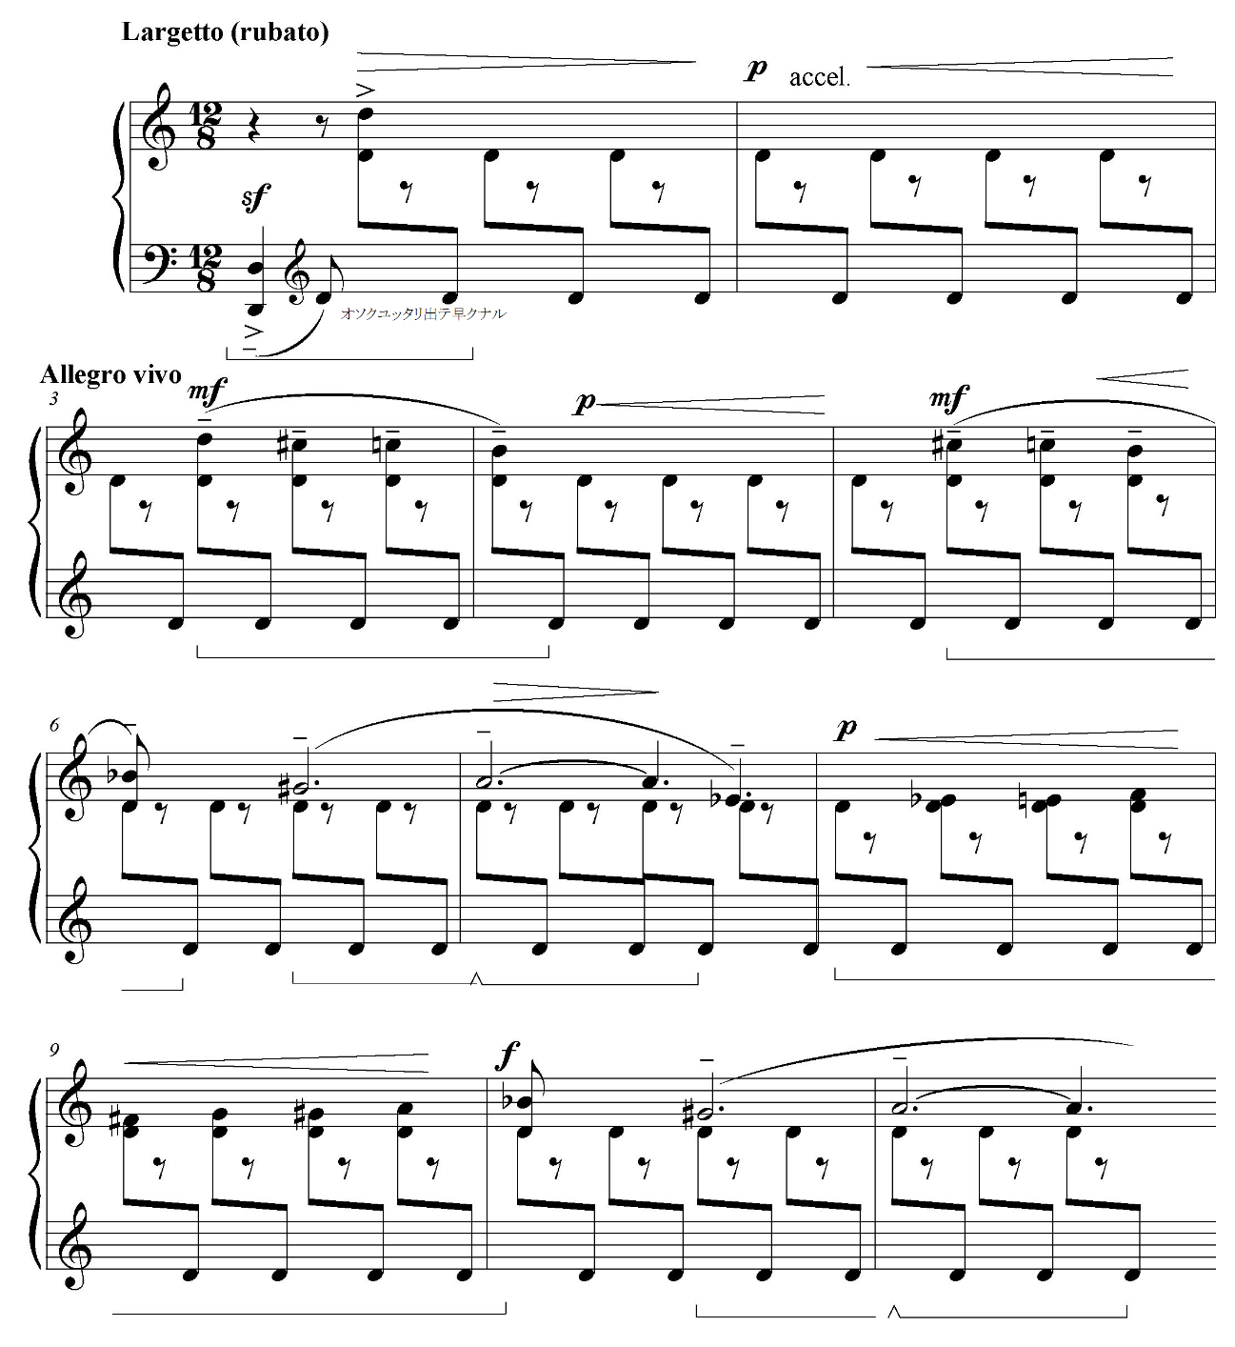

Example 6.2. Ozawa, Otemari Rondo, mm. 20-24
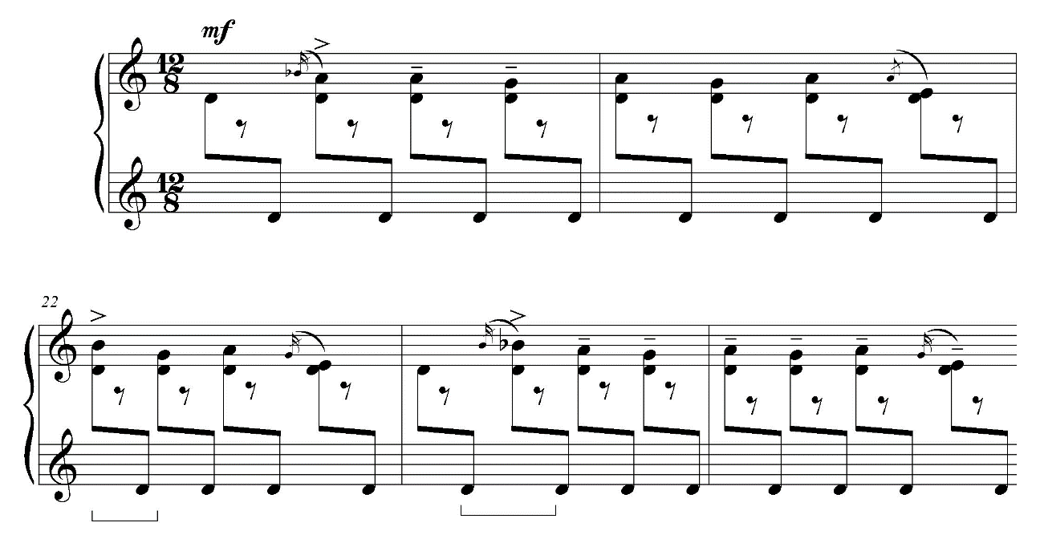

Example 6.3. Ozawa, Otemari Rondo, mm. 84-86
Gypsy scale (fragment)
Whole-tone scale (fragment)

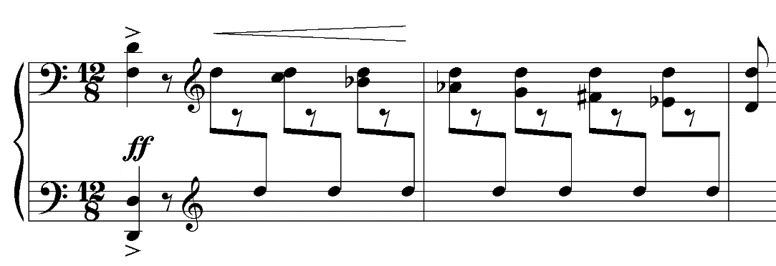

Example 6.4. Ozawa, Otemari Rondo, mm. 94-96
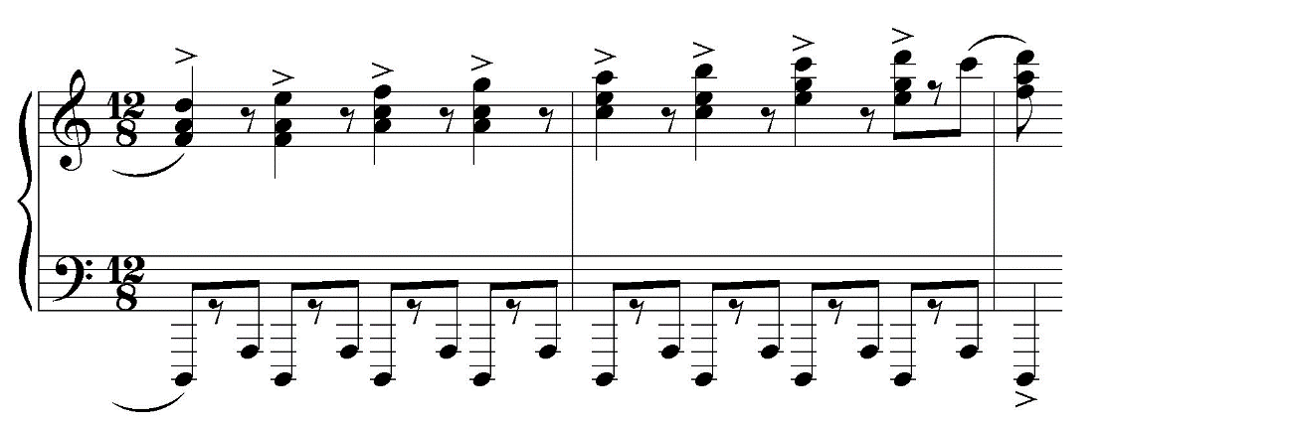
Ozawa loved to quote the melody from a Japanese traditional song Sakura (Cherry blossoms, see example 6.5). In 1933, he arranged this song for voice and piano and performed in Concert Auspices of Japan Society of Boston. In Paris, he composed Une voix à Sakura for soprano (or tenor) solo and orchestra with a melody from Sakura and lyrics in Japanese (see example 6.6). Ozawa continued quoting Sakura in his works after he came back to Japan. Katayama insists that the brief motive (F F G) in the third movement of Symphony No. 3 is drawn from the opening of Sakura. In 1946, Ozawa wrote “Sakura” Fantasy for piano and orchestra (see example 6.7). Ikushima assumes that Ozawa treats Sakura as such a special symbol of Japan that he employs this song for the milestones in his life: in the US, in Paris, at his return to Japan, and at the end of the war.

Example 6.5. Sakura
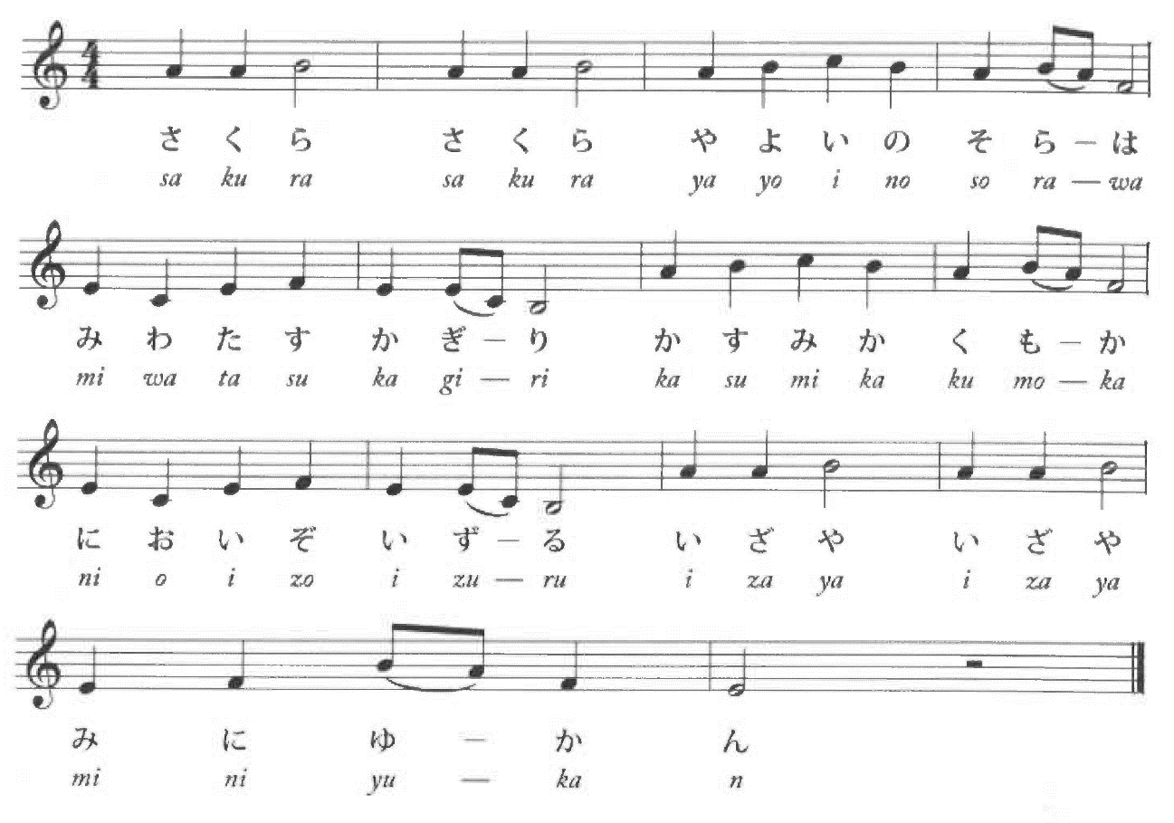

Example 6.6. Ozawa, Une voix à Sakura, mm. 17-24
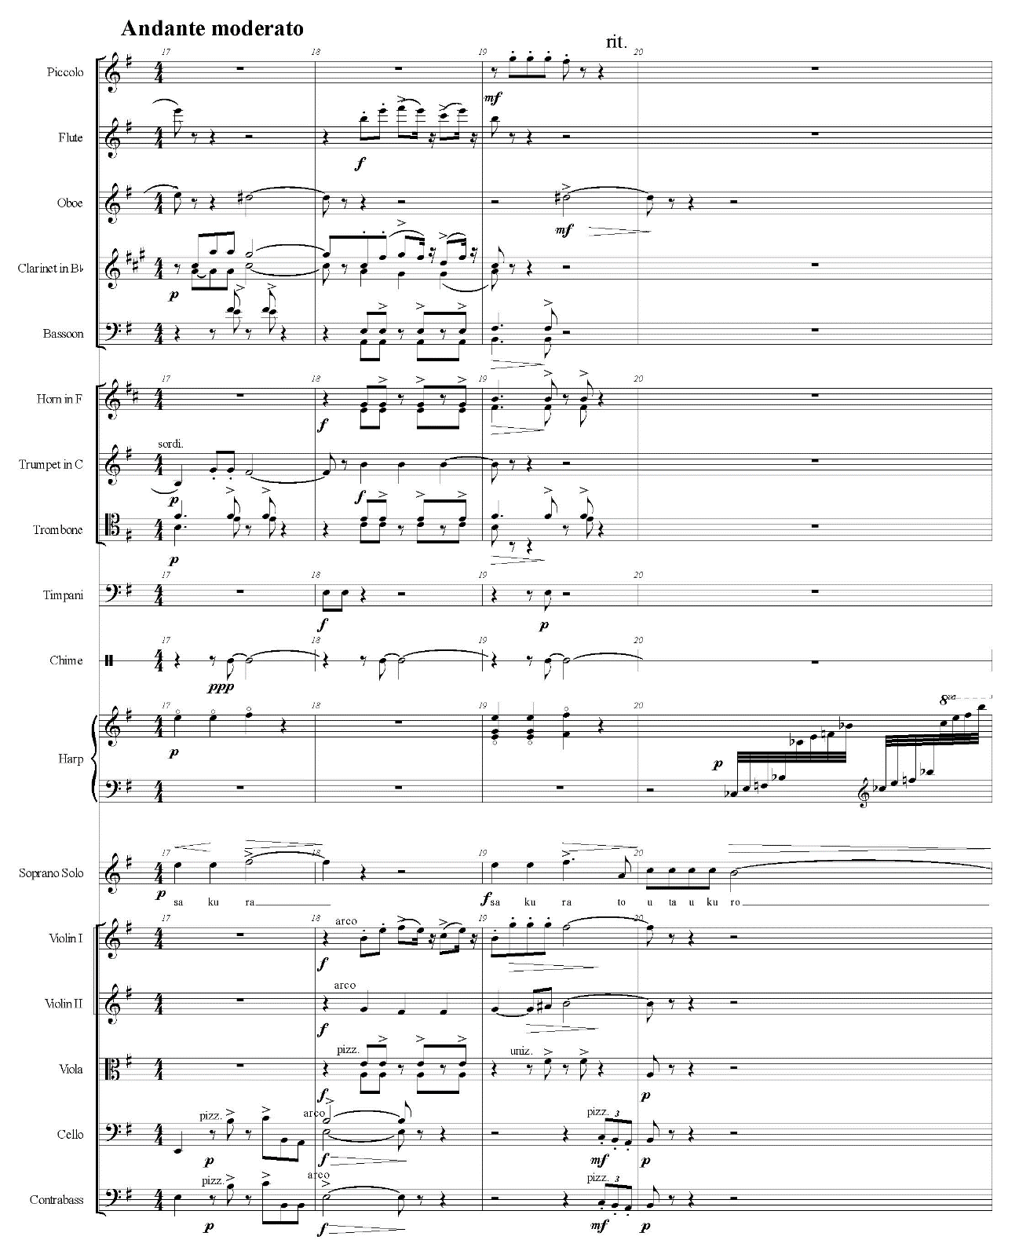

Example 6.6—Continued
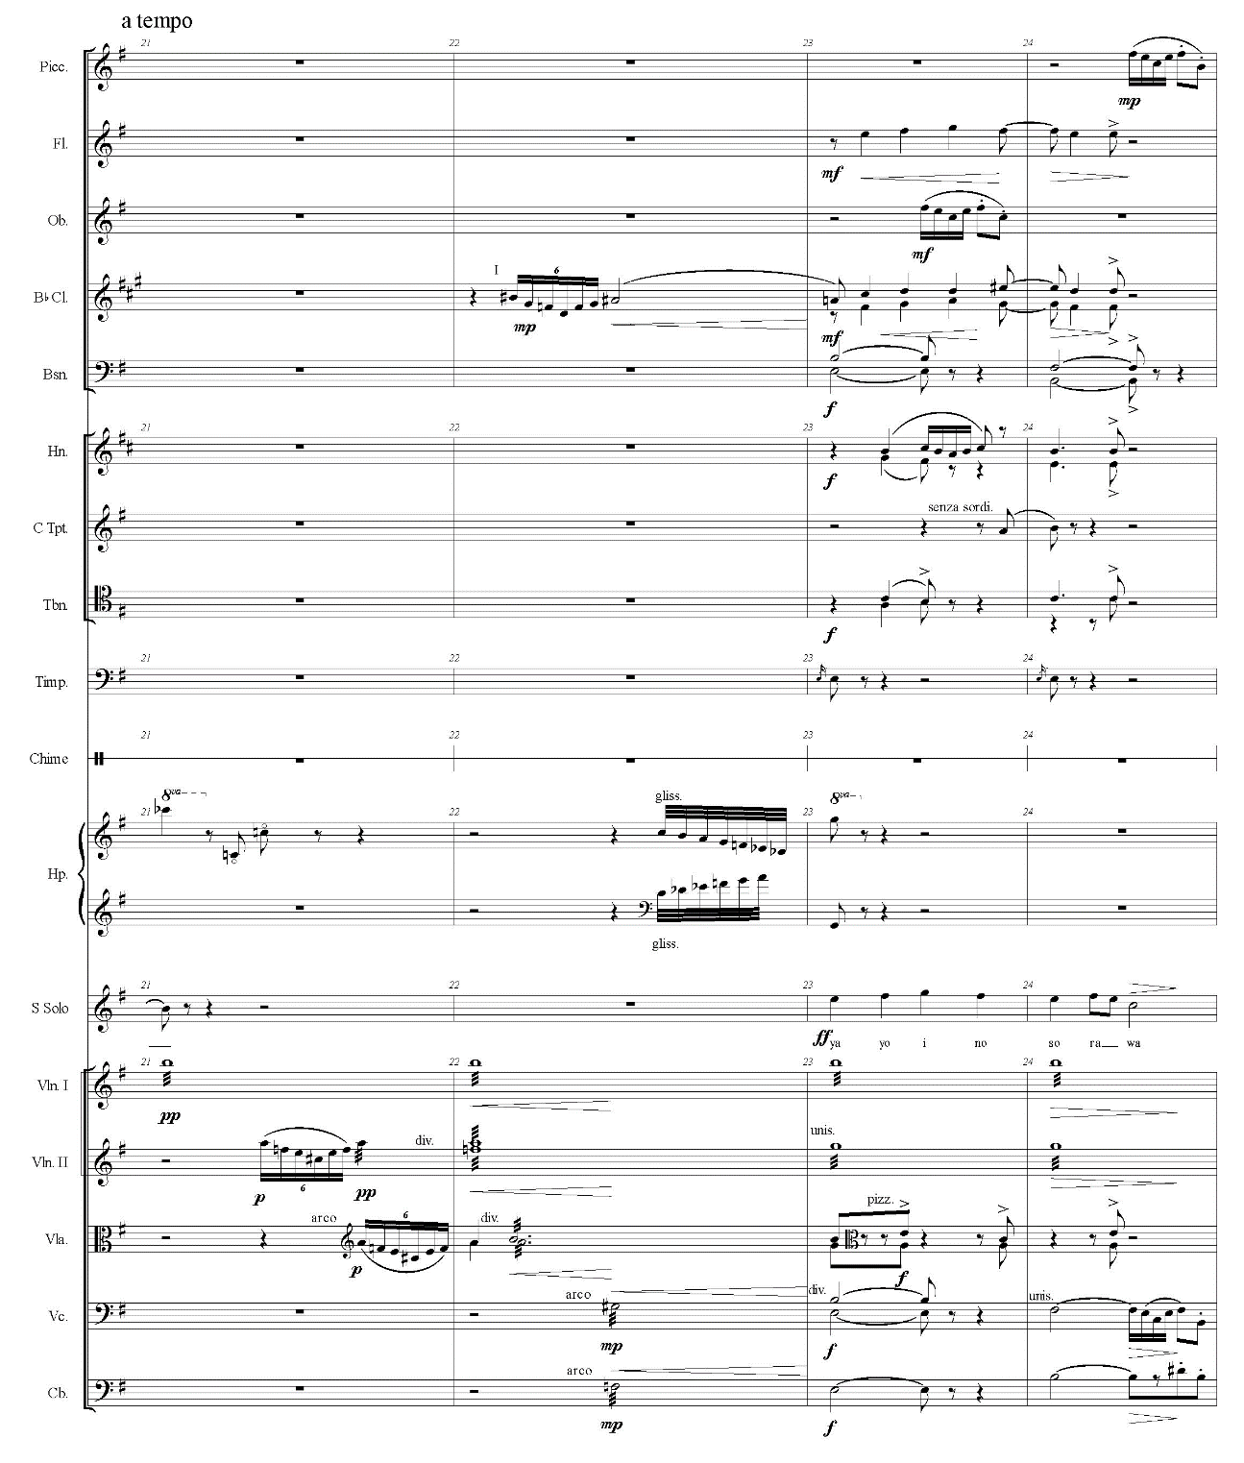

Example 6.7. Ozawa, “Sakura” Fantasy, mm. 1-6
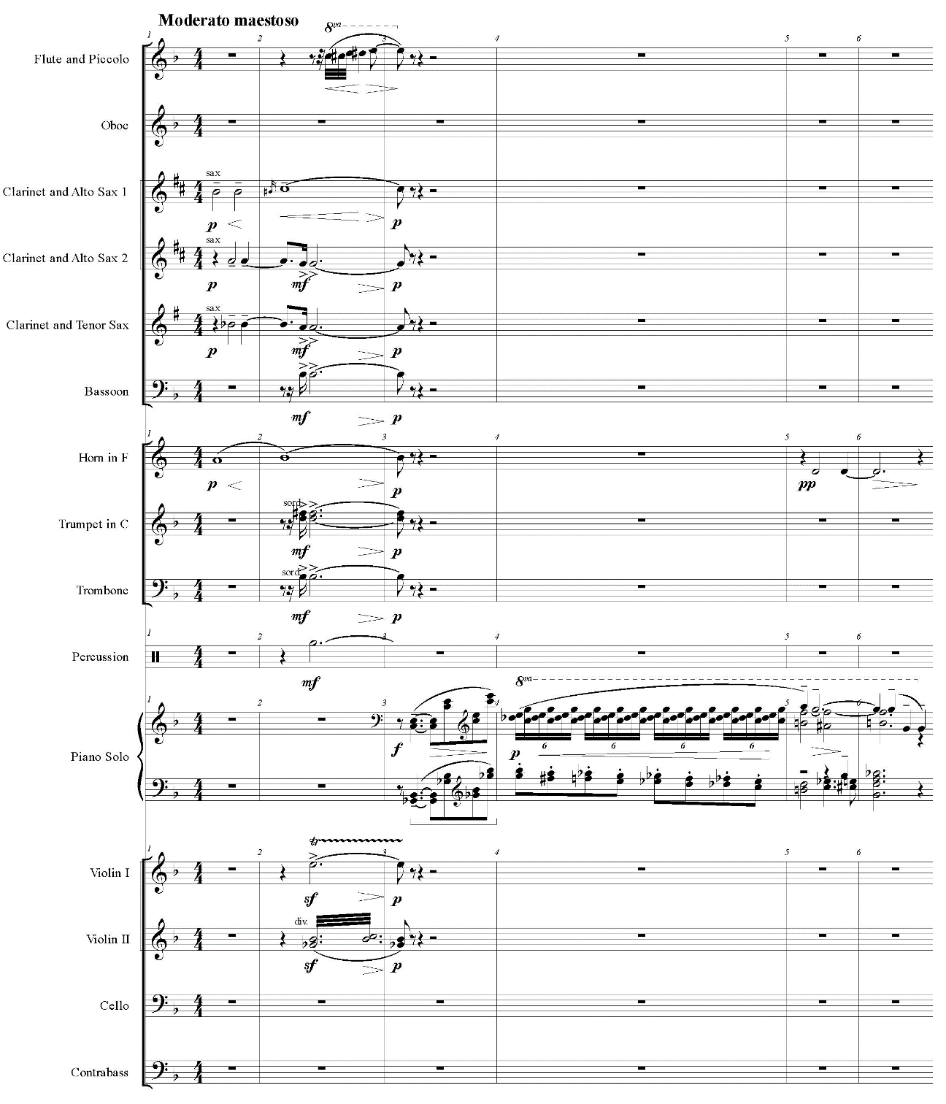

On the other hand, jazz had remained Ozawa’s favorite foreign element throughout his career. For instance, the second movement of “Kamikaze” depicts a night time flight with jazz. The first section starts with a mellifluous blues-like introduction (see example 6.8), and it leads to the middle section, a brisk dance with syncopation and jazzy feelings (see example 6.9).
During the war, the ban on jazz music kept Ozawa’s works away from jazz elements. However, as soon as the war ended, he returned to his jazz vocabulary. He wrote Chōchō no uta jazu hensōkyoku (Song of butterfly: jazz variation) for jazz quintet and orchestra (1947), Silver Images for orchestra (1951), and concerti for saxophone and trumpet (1947 and 1950 respectively). For his postwar jazzy works, he preferred to orchestrate for large jazz band, flute, clarinet, and strings.
Ozawa changed the style of his works from highly technical modern music in the prewar period to simple sentimental music in the wartime/postwar period. However, throughout his career, Ozawa presented a sophisticated combination of Japanese and Western elements. While his works were forgotten after his death, the standards of Japanese musicians and audiences had been raised enough to understand Ozawa’s music. Since the rediscovery of Ozawa’s music in 2000, more and more Japanese people have enjoyed Ozawa’s music with deep understanding.

Example 6.8. Ozawa, Piano Concert No. 3 “Kamikaze,” Movement II, mm. 9-17
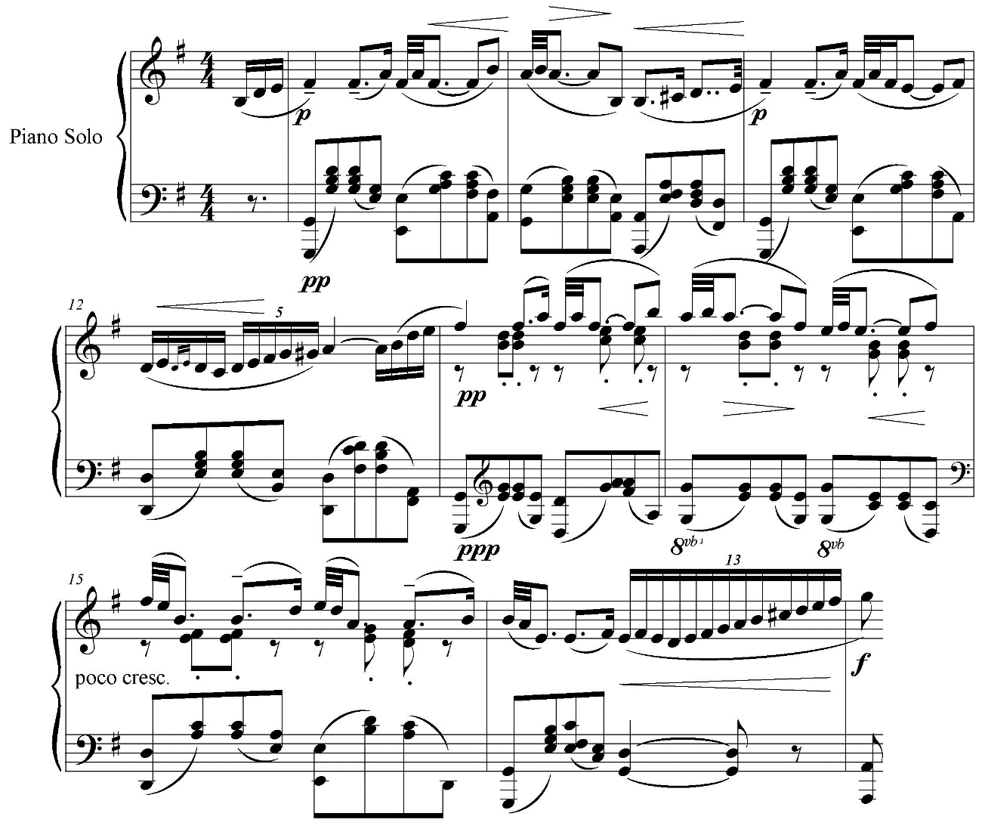

Example 6.9. Ozawa, Piano Concert No. 3 “Kamikaze,” Movement II, mm. 41-50
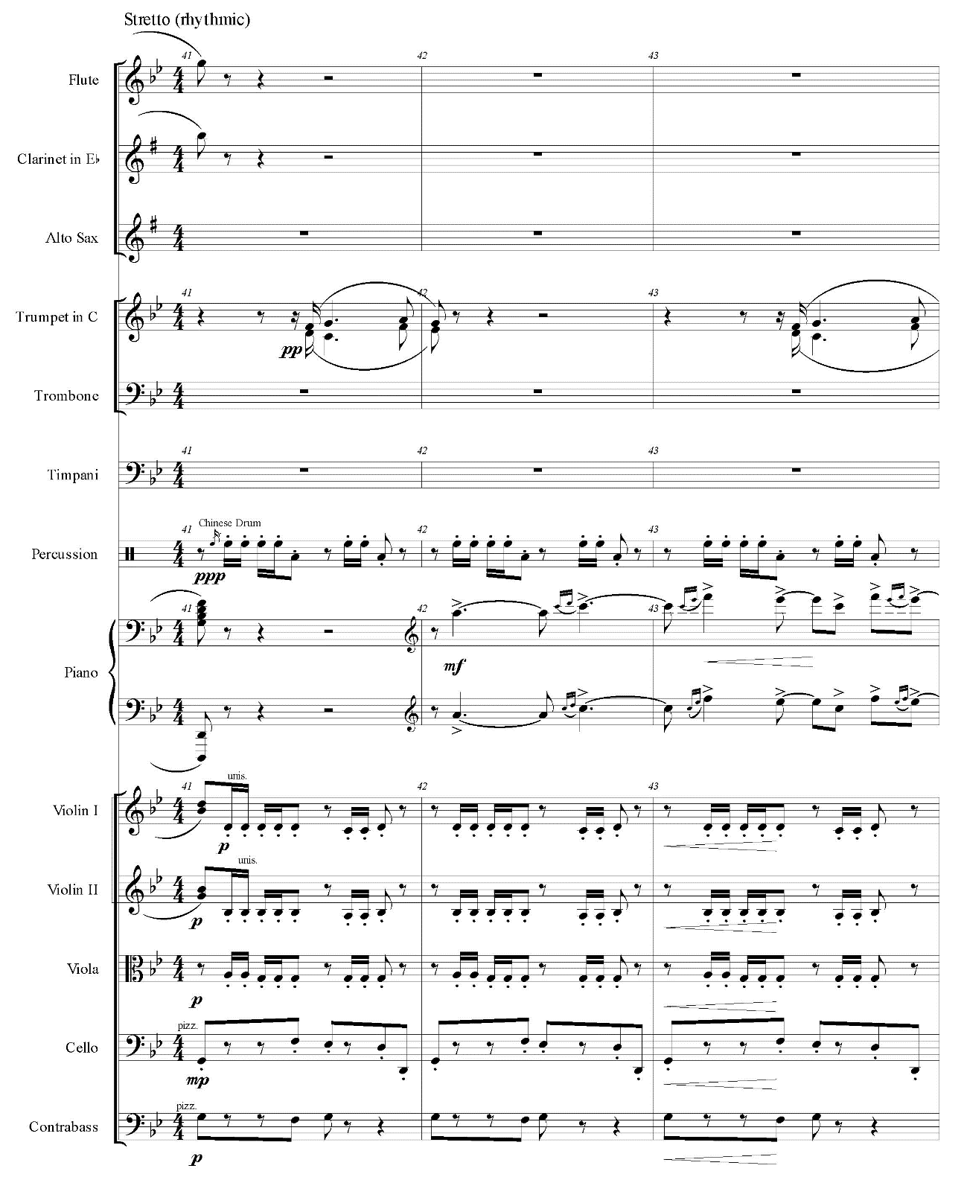

Example 6.9—Continued
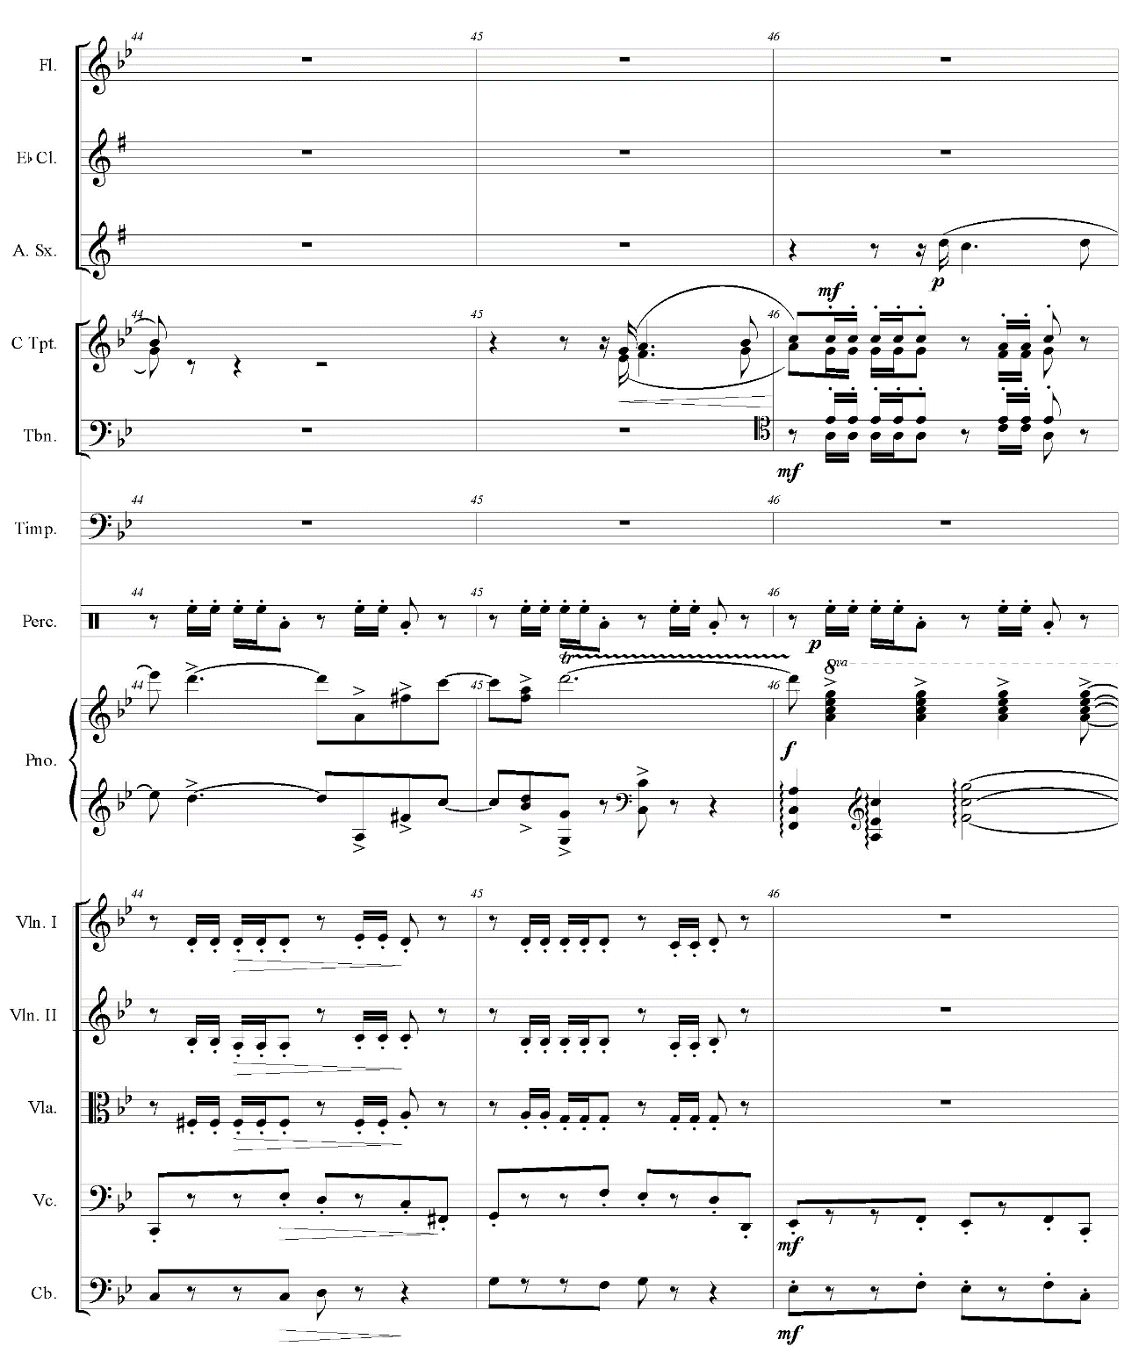

Example 6.9—Continued
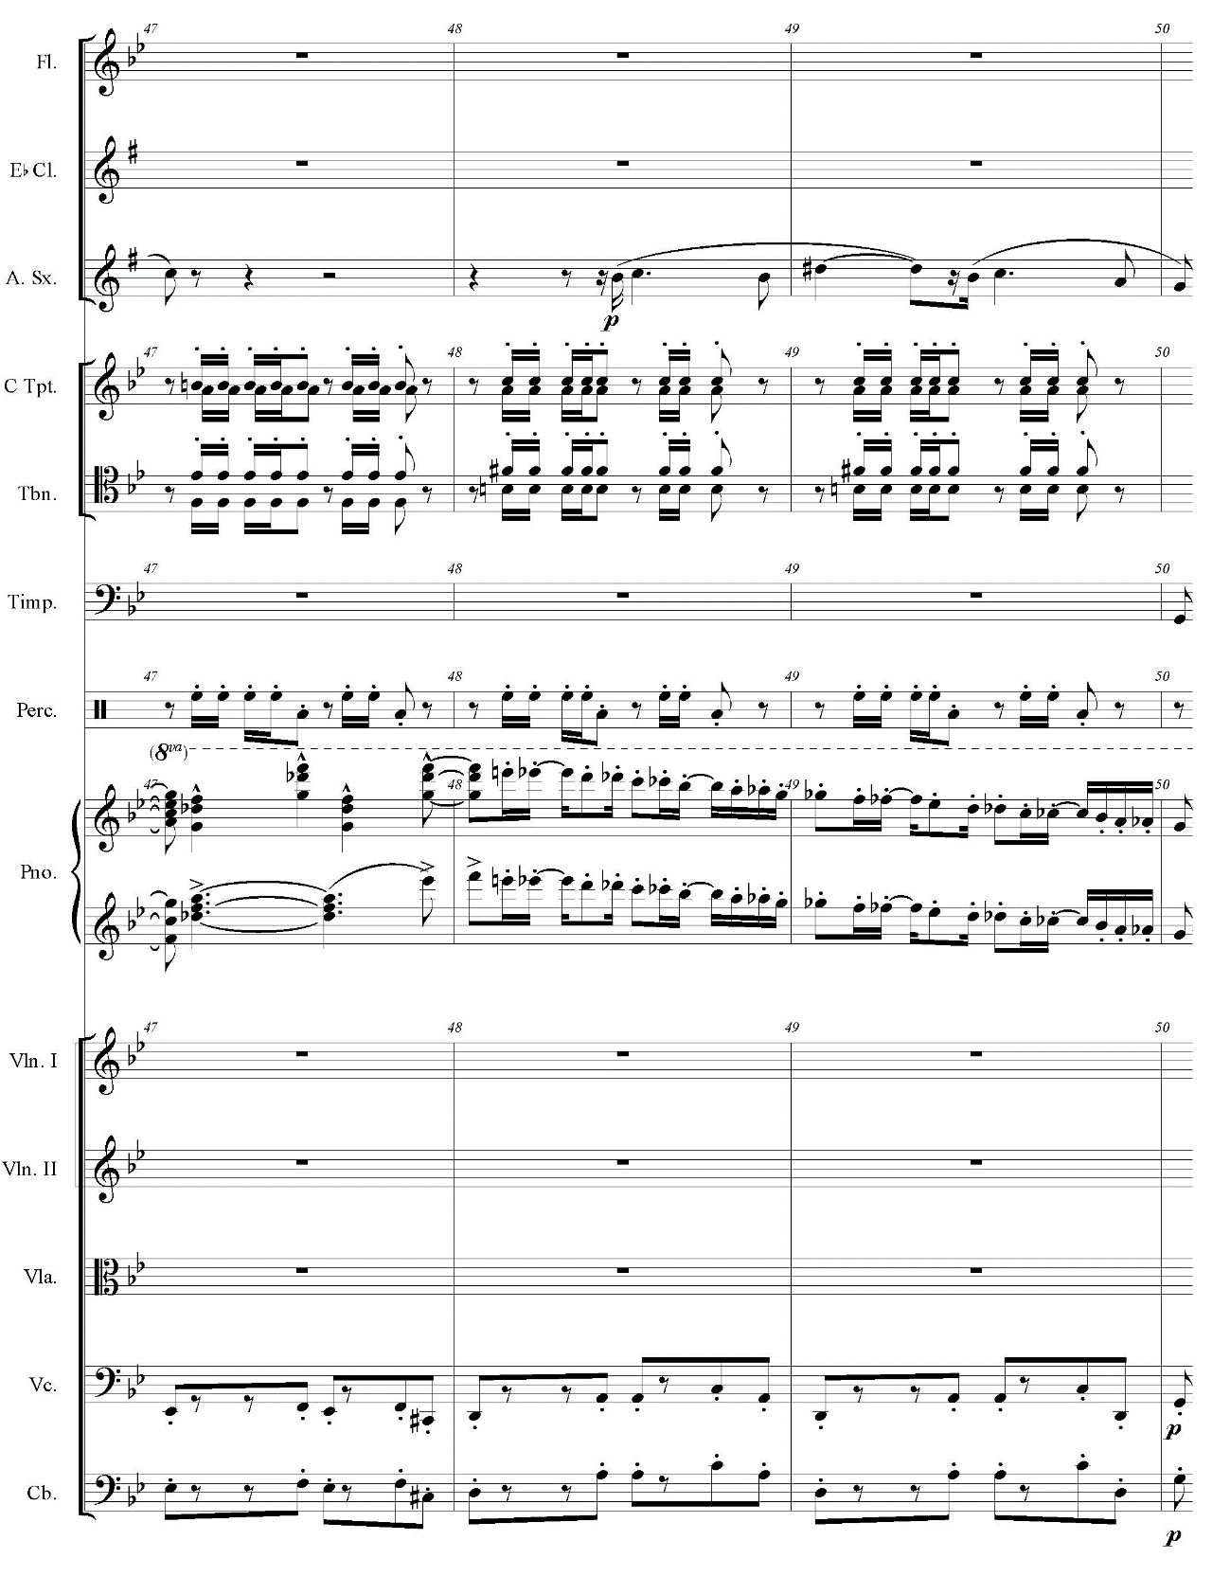

Chapter 7
Concerto for Trumpet and Orchestra by Hisato Ozawa

Background

In March 1950, Ozawa composed Concerto for Trumpet and Orchestra, the first trumpet concerto by a Japanese composer. The first performance of this concerto was broadcast on October 22, 1950 on Ozawa’s radio program called BK shinfonetto (BK symphonet) with Shizuo Adachi on solo trumpet. According to the research by Kumashiro, Ozawa recorded this piece again with a soloist Kazuo Kurotani (or Jiro Kurotani) and aired it in another radio program Shirubā taimu (Silver time) on September 16, 1951. After Ozawa’s unexpected death in 1953, this concerto had been forgotten with other works by Ozawa until Kumashiro rediscovered and recorded it in 2009.
Kumashiro supposes that Ozawa’s direct motive of writing this technically challenging concerto is for Ozawa’s radio program. However, in the article on Nihon Keizai Shimbun, Ikushima indicates Ozawa’s hidden ambition in this piece. She explains that Ozawa often tried unusual ideas in his music, and she assumes Ozawa made this concerto unusual by employing the trumpet for the leading role because not many composers have written trumpet concerti compared to ones for violin and piano. In addition to this concerto, Ozawa wrote concerti for saxophone and contrabass. Therefore, Ikushima concludes that Ozawa’s Trumpet Concerto exemplifies the characteristics of his music.
Like other postwar jazz works by Ozawa, this concerto displays his sophisticated compositional skills in the realm of not only jazz but also classical music. Furthermore, he orchestrated this work for large jazz band (4 trumpets, 4 trombones, 4 saxophones doubling on clarinets, piano, and 2 drums), flute doubling on piccolo, oboe, and strings. Kumashiro introduces this concerto in his essay:
この曲の作風は、ジャズ、新古典主義、あるいは未来派・騒音主義的な響きと日本情緒を見事に組み合わせたもので、同時代の日本だけでなく、世界の作品の中でも異彩を放っている。オーケストラの編成が（中略）ビッグバンドと弦楽合奏という特異なものであるとこからも推察されるように、大澤がその豊かな作曲技法を余すところなく注ぎ込んだ知られざる傑作である。

Ozawa marvelously combines jazz, neoclassicism, and the sound of futurism or noise music with Japanese atmosphere in this piece. Thus, this concerto stands out among not only contemporary Japanese works but also contemporary pieces worldwide. This work is a hidden masterpiece into which Ozawa pours all his plentiful compositional skills such as unusual orchestration . . . for big band and strings. [Author’s translation]

Even though Ozawa composed this piece in his postwar period, this concerto requires virtuosity with the range of three octaves. Before World War II, jazz music was really popular in Japan, and some virtuoso jazz trumpeters actively performed. These players restarted their careers after the war, and they had enough technique and musicianship to play this virtuosic concerto. Kumashiro describes this concerto as below:
全曲を通して、独奏トランペットは（中略）究極のテクニックと耐久力、表現力が要求されている。古今のトランペット作品の中でも屈指の難曲と言えるだろう。

Throughout the piece, the solo trumpet . . . requires ultimate techniques, endurance, and expressions. This concerto seems to be one of the most difficult trumpet pieces in all ages. [Author’s translation]

Analysis
Movement I

The first movement consists of AA binary form with a coda. Figure 7.1 shows the formal structure of this movement. Each section is subdivided into two sections, indicated as A and B. Kumashiro describes the form of this movement as sonata form without a development section. Except temporary accelerando and rallentando, the tempo stays moderato (on solo trumpet part, Ozawa also marks quasi andantino in parentheses).

Figure 7.1. Analytical diagram for Concerto for Trumpet and Orchestra, Movement I by Ozawa
A Theme 1
A minor

D minor

A minor
b Trumpet
a Orchestra
a Orchestra
b Trumpet
a Orchestra
(mm. 1-12)
(mm. 13-19)
(mm. 20-31)
(mm. 32-43)
(mm. 44-51)
Retransition

C minor
B Theme 2
C major

C major

A minor
c Orch./Trpt.
Cadenza
(Trumpet)
c Orchestra
Trumpet
d Trumpet
(mm. 75-79)
(mm. 96-103)
(mm. 88-95)
(mm. 52-74)
C major-A minor
a-dim. Trumpet
(mm. 104-113)
(mm. 80-87)
A Theme 1
A minor
(mm. 114-121)
a Orchestra
(mm. 138-164)
a Orchestra
(mm. 130-137)
b Trumpet
(mm. 122-129)

D minor

D minor
a-dim. Trumpet

Figure 7.1—Continued
Retransition

C major-F major
B Theme 2
C major
Coda Theme 1

C major
a Orchestra
c Orchestra
d Trumpet
c Orch./Trpt.
Trumpet
(mm. 96-103)
(mm. 165-175)
(mm. 176-192)
(mm. 88-95)
(mm. 80-87)

At the beginning of the A section, the viola, cello, and contrabass present Theme 1 (see example 7.1). This theme employs the Gypsy scale; this scale and augmented second interval frequently appear throughout this movement.

Example 7.1. Ozawa, Concerto for Trumpet and Orchestra, Movement I, mm. 1-15
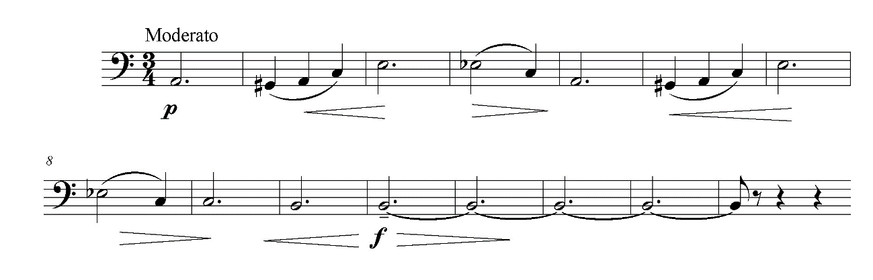

After the orchestra plays a dominant chord of A minor, the solo trumpet enters at the anacrusis of m. 13 (see example 7.2). Even though Ozawa writes this phrase with bar lines, this phrase sounds like cadenza because of the lack of accompaniment. An augmented second interval appears in mm. 17-18, then the solo trumpet ends the phrase in m. 19 with written E (concert D). This note works as the pivot note to D minor.

Example 7.2. Ozawa, Concerto for Trumpet and Orchestra, Movement I, mm. 13-19
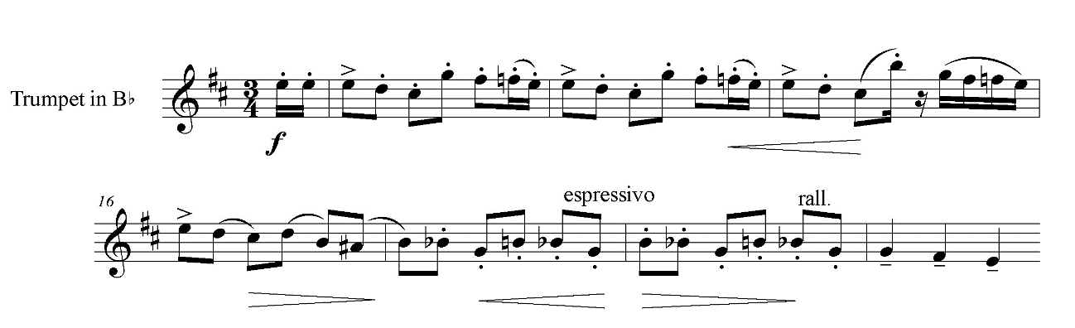
From m. 20 on, the low strings play Theme 1 in D minor followed by the second cadenza-like phrase by the solo trumpet. This phrase by the solo trumpet is longer than the first time, and the woodwinds answer the solo trumpet from m. 38 to the downbeat of m. 41 (see example 7.3). The solo trumpet ends the phrase with written B (concert A) which brings back to A minor in m. 44. This time the first trombone presents Theme 1.

Example 7.3. Ozawa, Concerto for Trumpet and Orchestra, Movement I, mm. 38-41
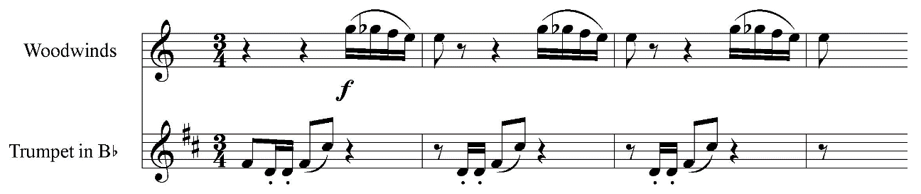

At m. 52, the solo trumpet begins the diminution of Theme 1 in A minor (see example 7.4). This diminution of the theme is not only with shorter note values but also with more embellishments than the original Theme 1. Frequent use of an augmented second interval gives exotic and romantic characteristics to this melody. This section ends with cadenza by the solo trumpet (see example 7.5).

Example 7.4. Ozawa, Concerto for Trumpet and Orchestra, Movement I, mm. 52-68
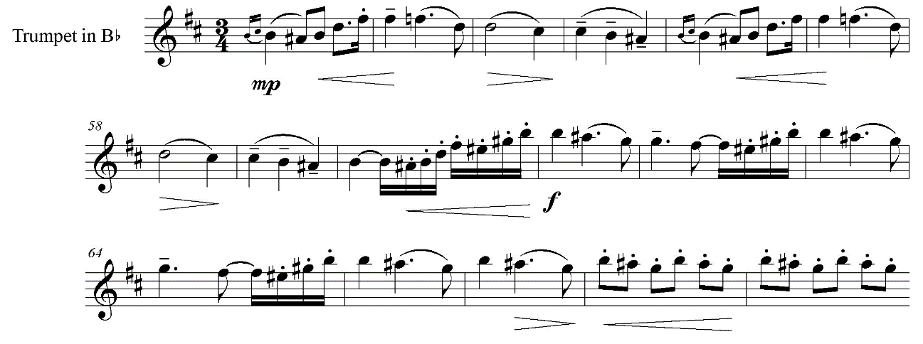
Example 7.5. Ozawa, Concerto for Trumpet and Orchestra, Movement I, mm. 75-80
（早く せいて）
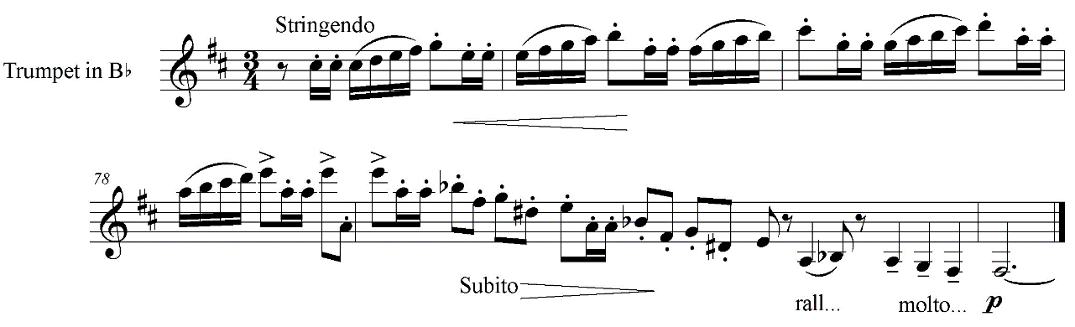
（早く）
The B section begins in m. 80 with the first violin and flute playing Theme 2 in C major (see example 7.6). The oboe joins to play this theme in m. 82, then the tenor saxophone and the trumpet section are added in m. 84. Ozawa marks warutsu no kanji nite on the score and warutsu no fū on the solo trumpet part (both mean “like waltz”) for this theme.

Example 7.6. Ozawa, Concerto for Trumpet and Orchestra, Movement I, mm. 80-87
a tempo （ワルツの感じにて）
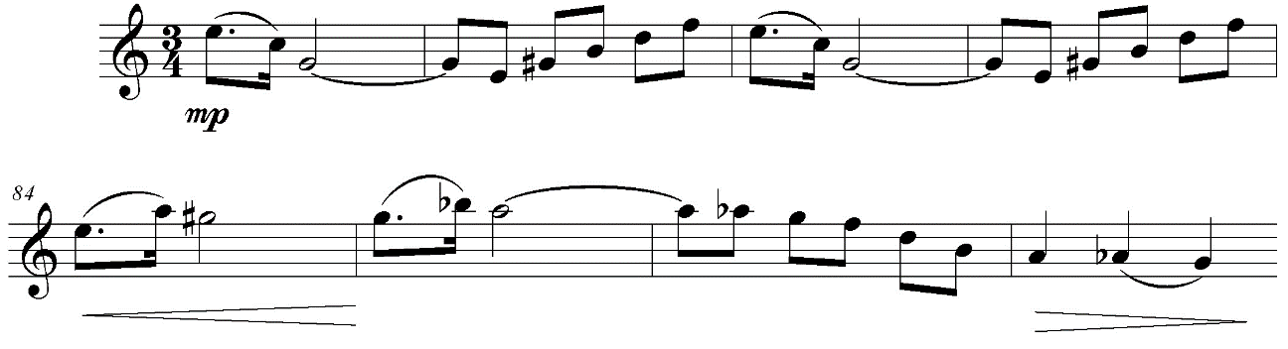

At the anacrusis of m. 88, the solo trumpet starts a melody based on the Gypsy scale (see example 7.7). This melody consists of the sequence of a two-measure phrase in the circle of fifths. The first statement starts with written A (concert G), then the second statement begins with written D (concert C) in m. 90. The third statement, starting with written G (concert F), occurs in mm. 92-93. In m. 94, the fourth statement starts with written C (concert B♭). In this measure, the piano plays an embellished half diminished-seventh chord. This chord is non-functional but leads to an enharmonic German sixth chord in m. 95. This German sixth chord resolves to a C major chord in m. 96.

Example 7.7. Ozawa, Concerto for Trumpet and Orchestra, Movement I, mm. 88-96
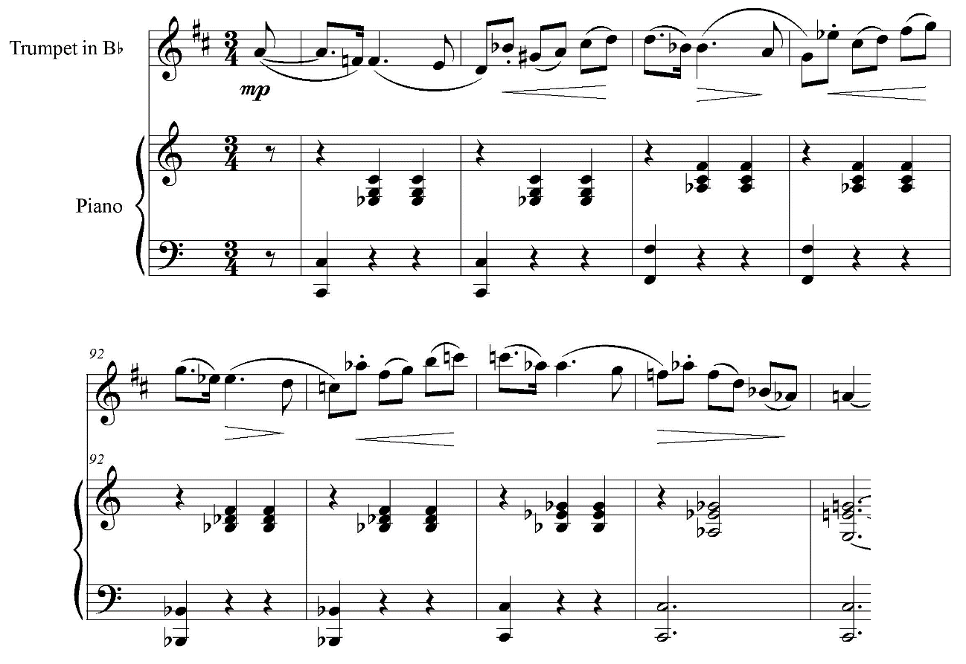
iv
c: i
Example 7.7—Continued
C: I
♭vii
Gr⁶
emb^{ø7}

In mm. 96-99, the solo trumpet intertwines Theme 2 with the woodwinds (see example 7.8). Then, the solo trumpet reaches to the climax with descending scale in m. 104. In m. 108, the key changes back to A minor in order to close the B section (see example 7.9).

Example 7.8. Ozawa, Concerto for Trumpet and Orchestra, Movement I, mm. 96-99
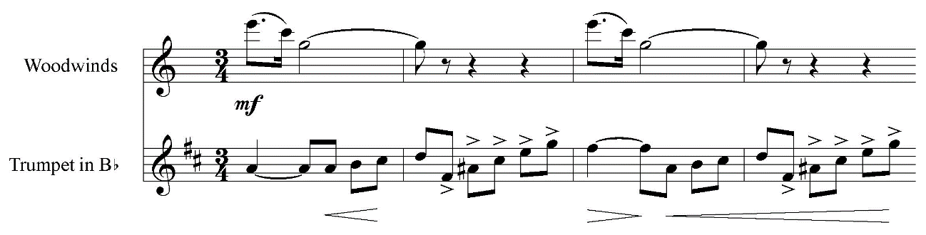

Example 7.9. Ozawa, Concerto for Trumpet and Orchestra, Movement I, mm. 104-114
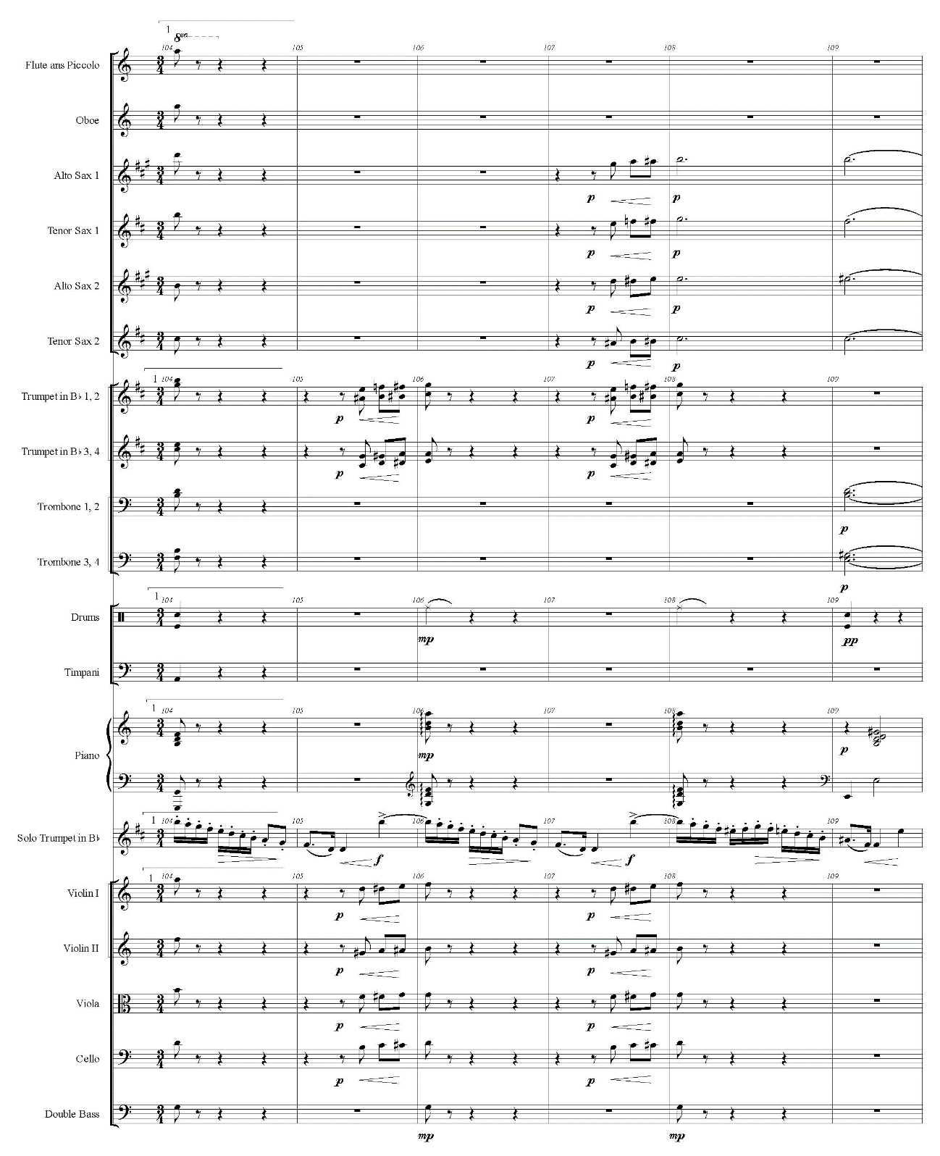

Example 7.9—Continued
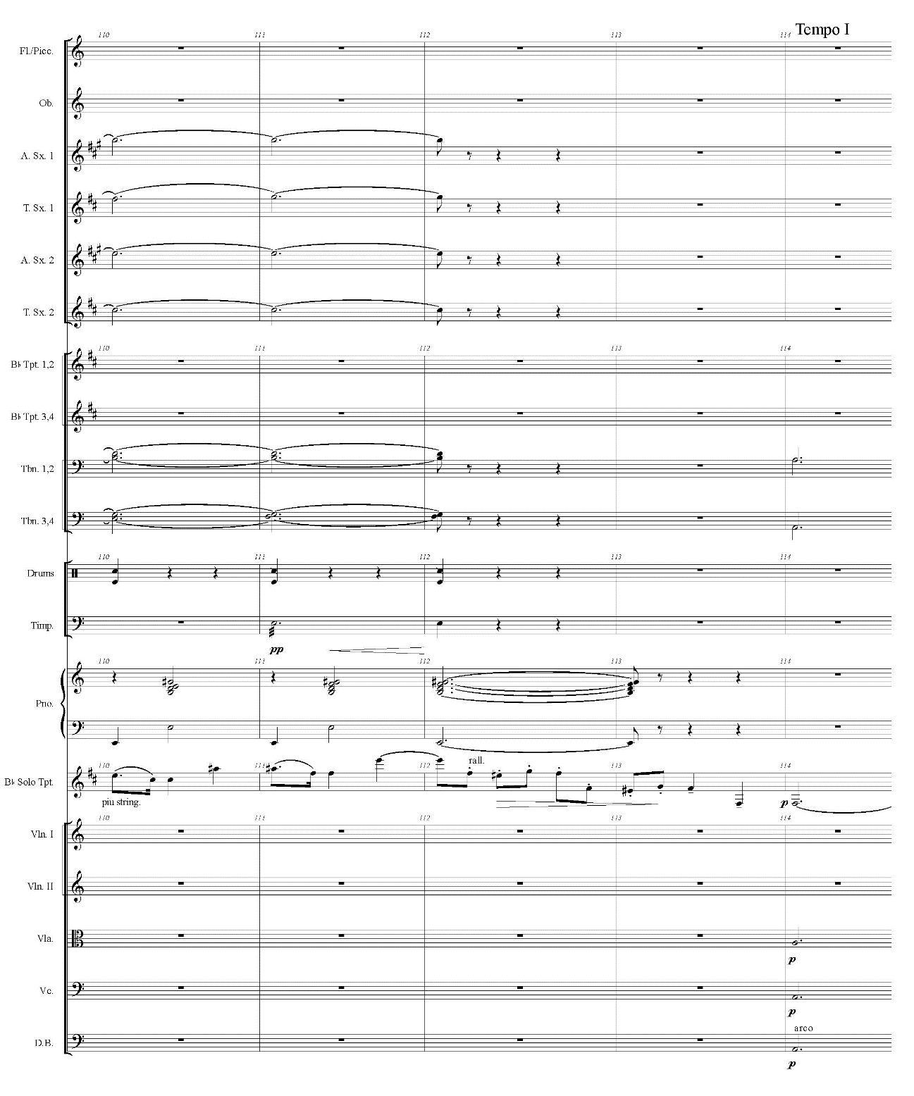

Example 7.10. Ozawa, Concerto for Trumpet and Orchestra, Movement I, mm. 165-176
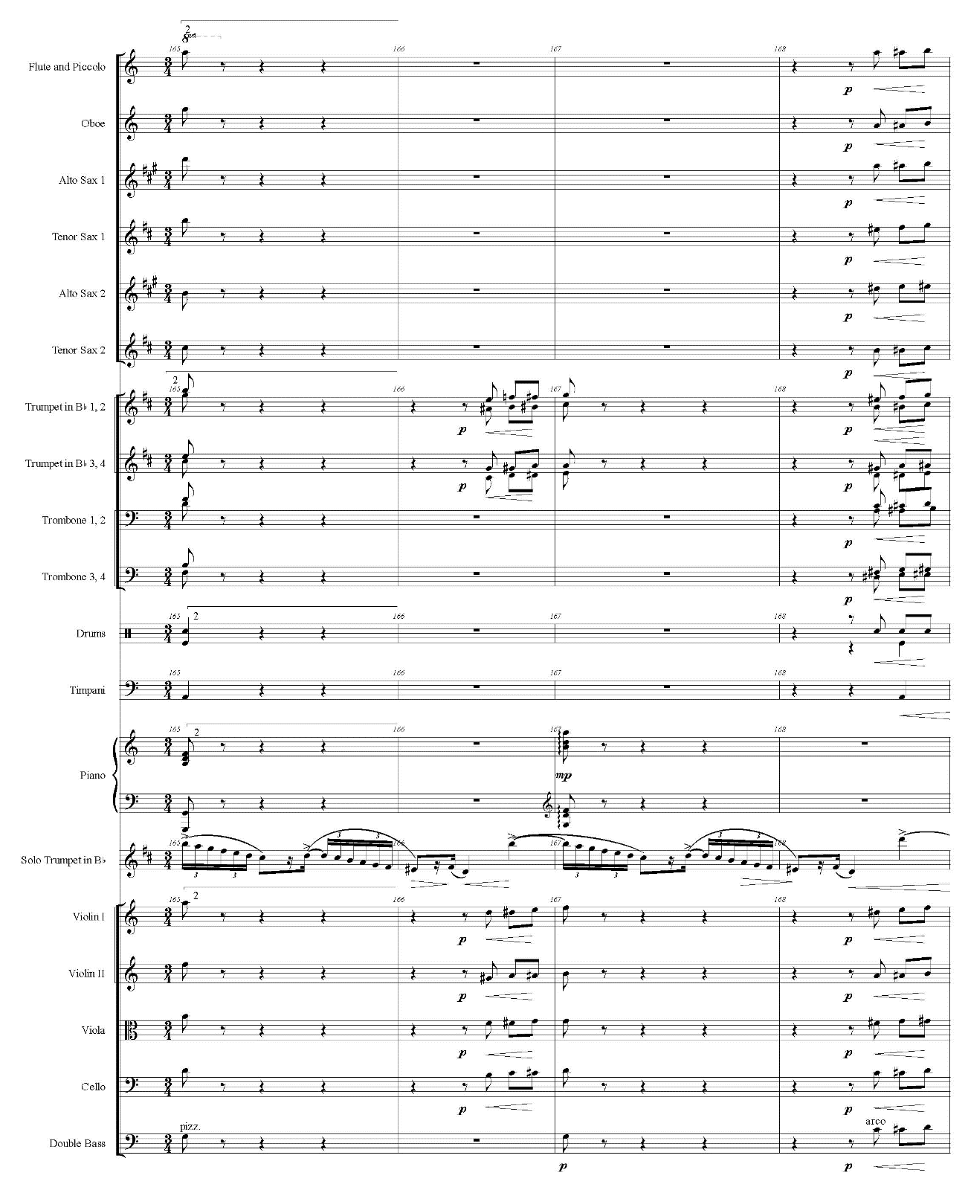

Example 7.10—Continued
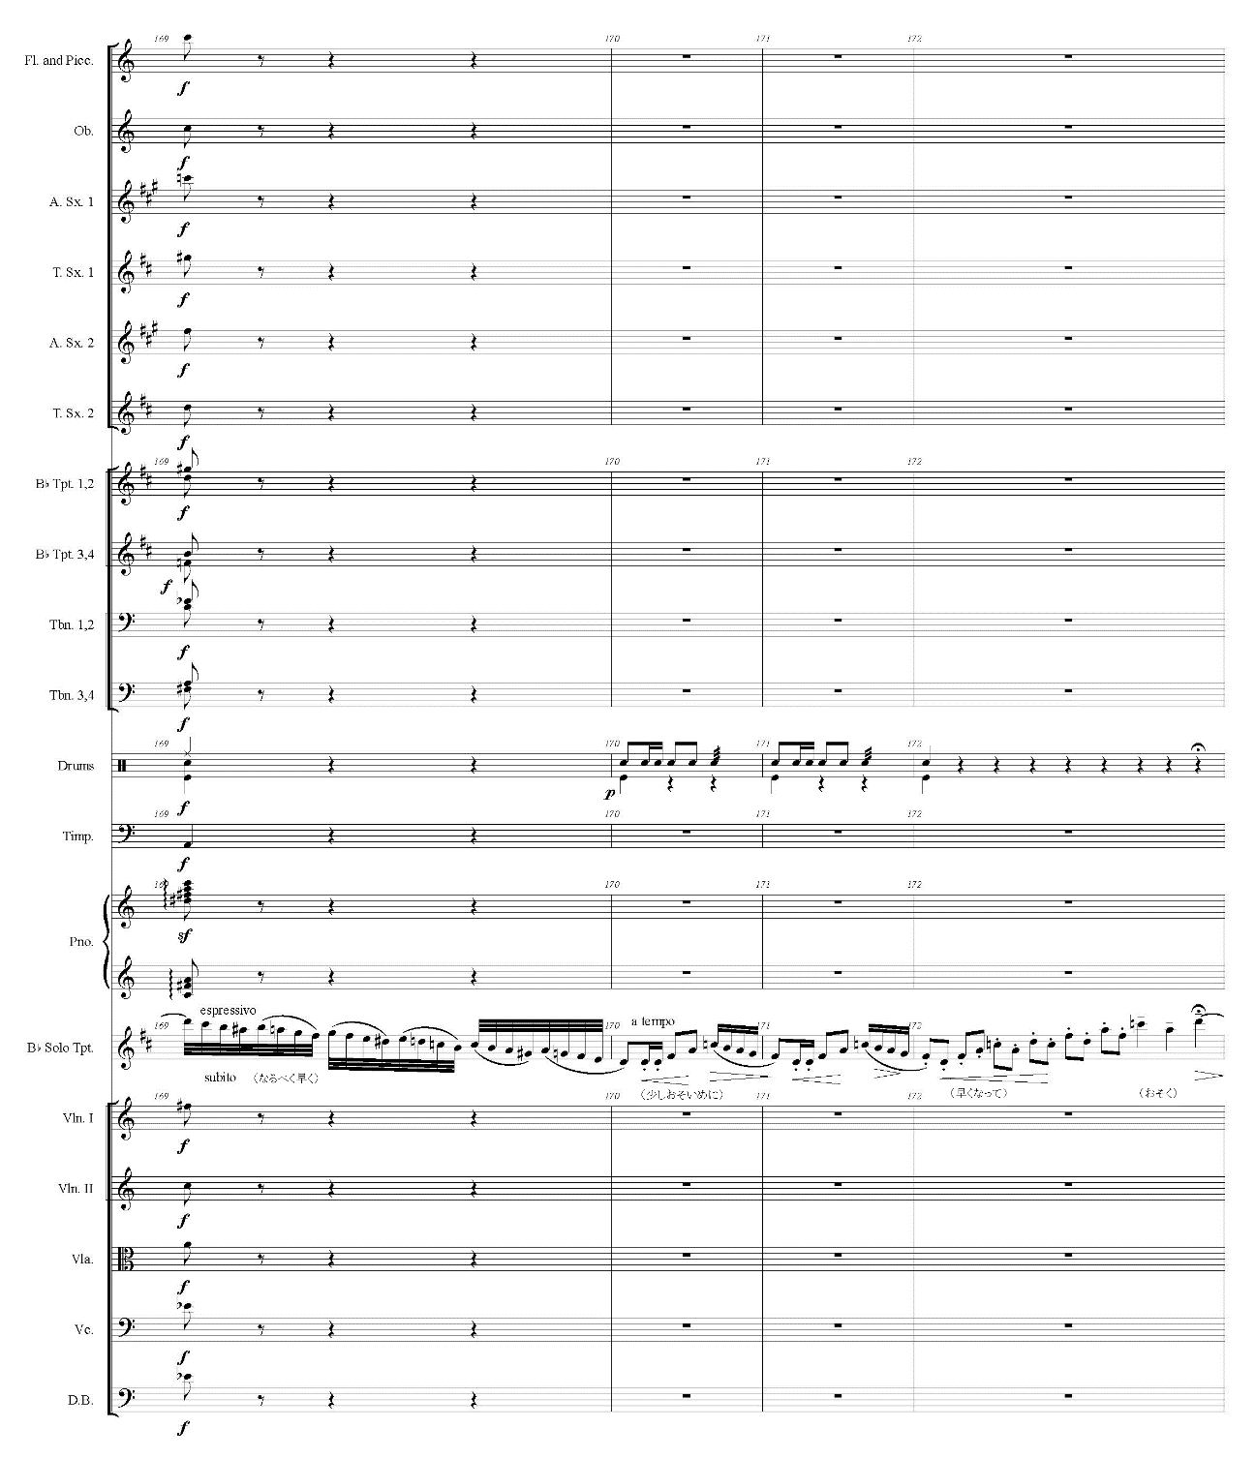

Example 7.10—Continued
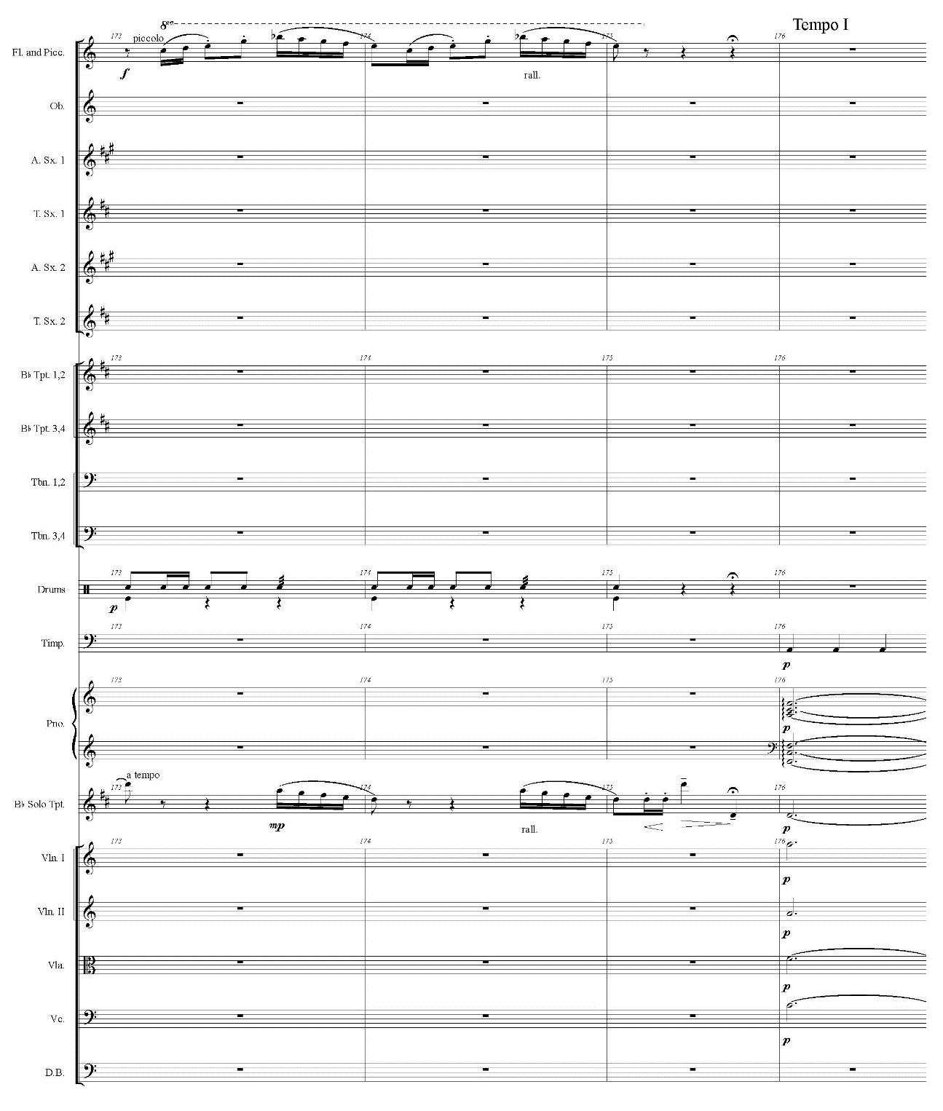

The second A section starts in m. 114. Like the first A section, the second appearance of Theme 1 modulates to D minor. However, the key never returns to A minor, and the solo trumpet starts the diminution of Theme 1 in D minor at m. 138.
The second B section follows the A section without cadenza. The first half of the second B section is exactly the same as the first B section; the solo trumpet and orchestra plays from m. 80 to m. 103 again. At the climax from m. 165, the solo trumpet plays more embellished descending scales than the first B section (see example 7.10). In the middle of m. 169, the solo trumpet implies the key change to F major by playing written C (concert B♭) in the scale, and the melody indicates the dominant seventh chord of F major in mm. 170-175. The phrase in mm. 38-41 (see example 7.3) reappears in mm. 170-172 and mm. 173-175.
In m. 176, the beginning of the coda, the dominant seventh resolves to an F major chord, but this section shows ambiguous tonality. Example 7.11 shows the coda section in mm. 176-192. The F major chord in m. 176 proceeds to half diminished-seventh in m. 178, and this chord resolves to an F major chord. On the other hand, the orchestra plays Theme 1 in A minor. At m. 183, the solo trumpet starts descending with A Gypsy scale and reaches to A (written B) to end the movement, while the orchestra plays a C major chord with added sixth.

Example 7.11. Ozawa, Concerto for Trumpet and Orchestra, Movement I, mm. 176-192
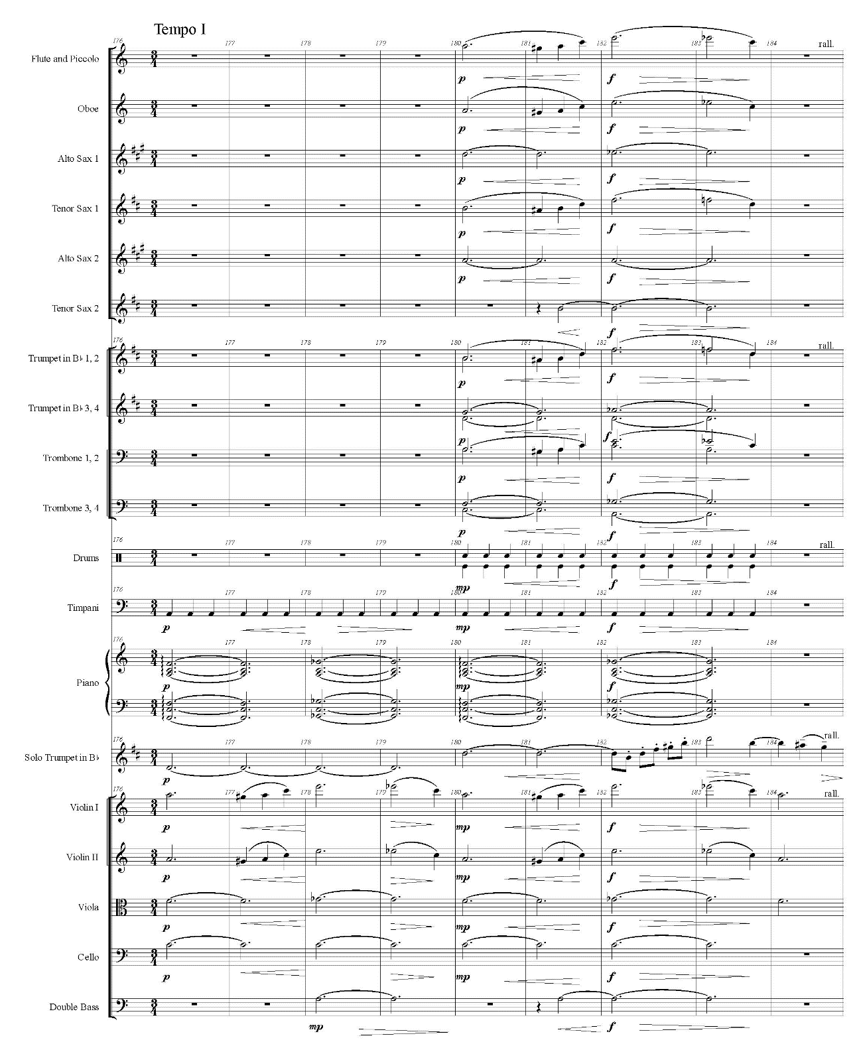

Example 7.11—Continued
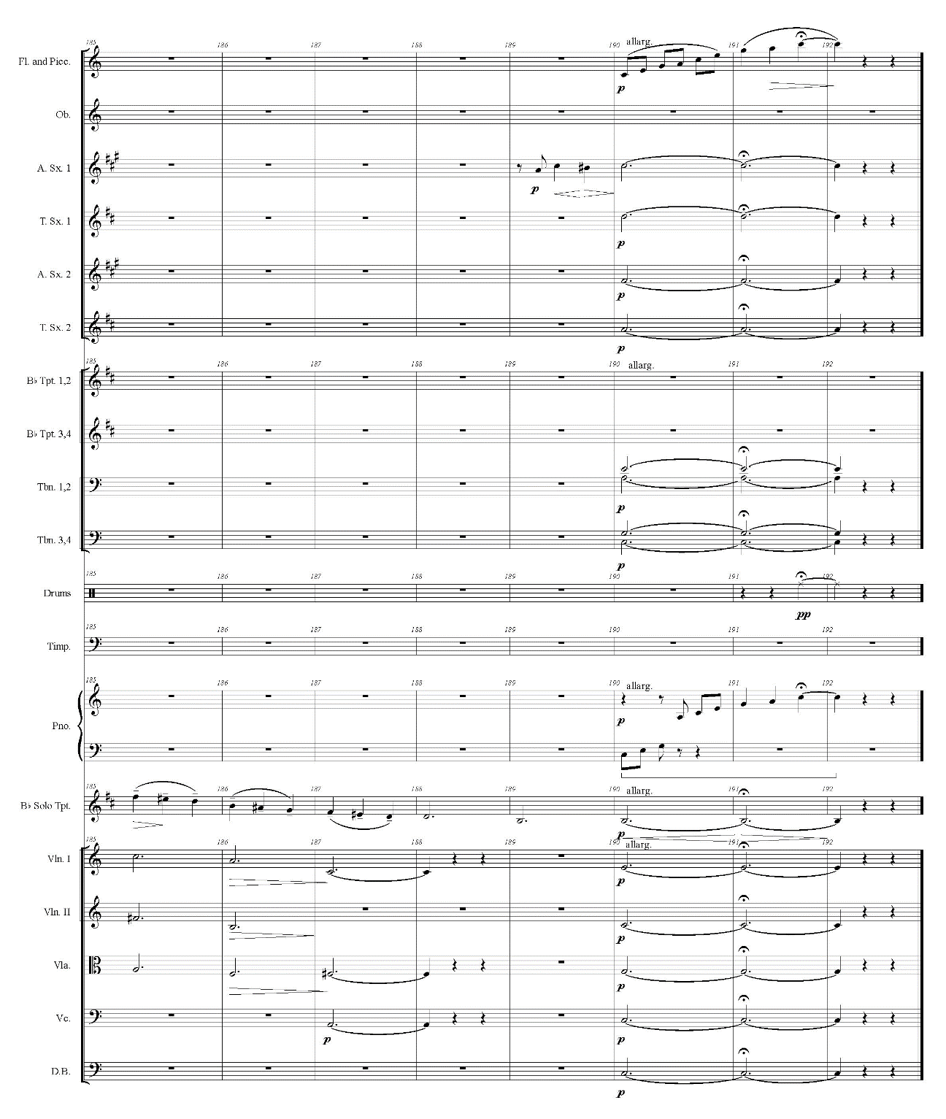

Movement II

As Ozawa indicates Blues fū (like blues), the second movement displays his jazz style, one of the significant characteristics of his works. This 36-measure movement takes less than two minutes; therefore, Kumashiro describes this movement as intermezzo.
With a slow tempo of Largetto non troppo, the muted solo trumpet plays a through-composed melody in D minor. The melody consists of phrases which are mostly two or three measures in length, and most of these phrases are in pairs.
This movement starts with the ostinato played by the cello and contrabass with pizzicato (see example 7.12). The piano joins to play this ostinato in m. 6, and this ostinato continues until the downbeat of m. 31. The rhythm of this ostinato stays the same, while the pitches keep changing.

Example 7.12. Ozawa, Concerto for Trumpet and Orchestra, Movement II, mm. 1-2
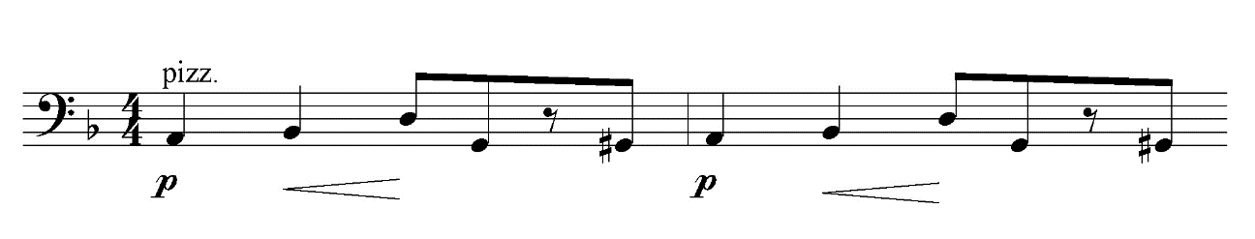

At m. 3, the solo trumpet begins the melody with syncopations and triplets (see example 7.13). This melody flows above the ostinato without lining up. From m. 8 on, the solo trumpet and orchestra line up more than in mm. 3-7. Example 7.14 shows the phrase in mm. 8-12 and three motives in this phrase. Motive 1, along with its fragment, is the most frequently used in this movement. For example, the solo trumpet plays the rhythm of motive 1 in m. 3 and plays motive 1 in m. 4 (see example 7.13). In addition, the orchestra plays motive 1 between the phrases by the solo trumpet in measures 21 and 23. In measures 25 and 27, the orchestra also plays motive 2 between the phrases.

Example 7.13. Ozawa, Concerto for Trumpet and Orchestra, Movement II, mm. 3-7
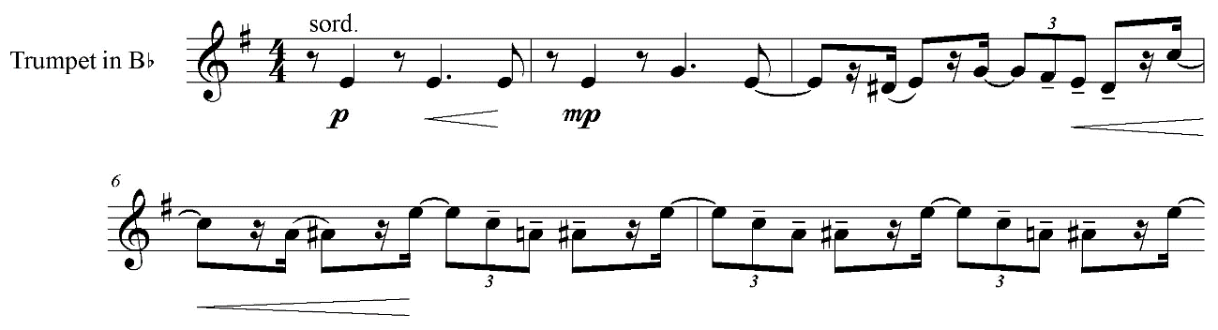

Example 7.14. Ozawa, Concerto for Trumpet and Orchestra, Movement II, mm. 8-12
3
2
1
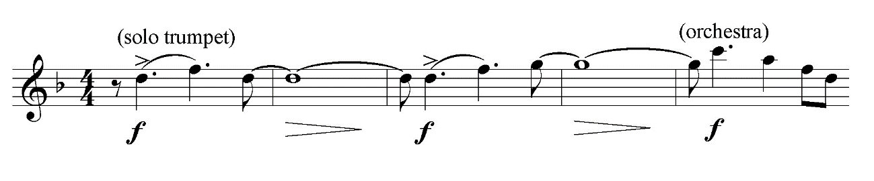
Example 7.15 shows three pairs of phrases in mm. 13-30. The motives in these phrases are also marked in this example. Like the beginning of this movement, these phrases include many syncopations and triplets. In m. 28, when motive 3 recurs, the melody comes to the climax, and two fragments of motive 1 (marked as 1-f) lead to the closing section.

Example 7.15. Ozawa, Concerto for Trumpet and Orchestra, Movement II, mm. 13-30
1
3
1-f
1-f
1-f
1-f
1-f
Phrase a
Phrase a’
Phrase b
Phrase b’
Phrase c
Phrase c’

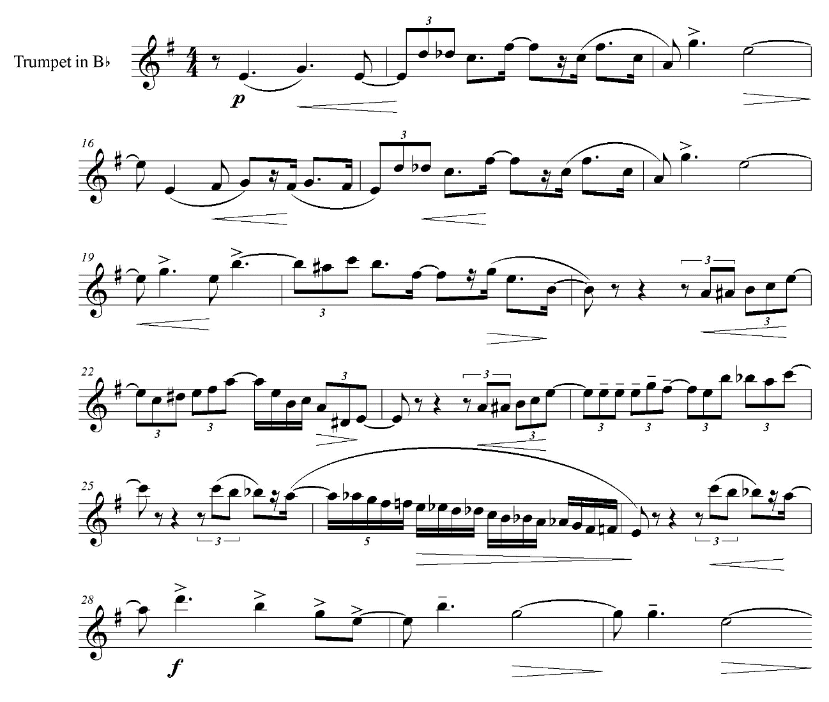

At m. 31, the closing section starts with three sets of triplets played by the solo trumpet. Example 7.16 shows the closing section. The dynamics for the melody in the solo trumpet decrease toward the end and reach pianissimo in m. 34. Nevertheless, unlike the first movement which ends with piano, the orchestra concludes this movement forte.

Example 7.16. Ozawa, Concerto for Trumpet and Orchestra, Movement II, mm. 31-36
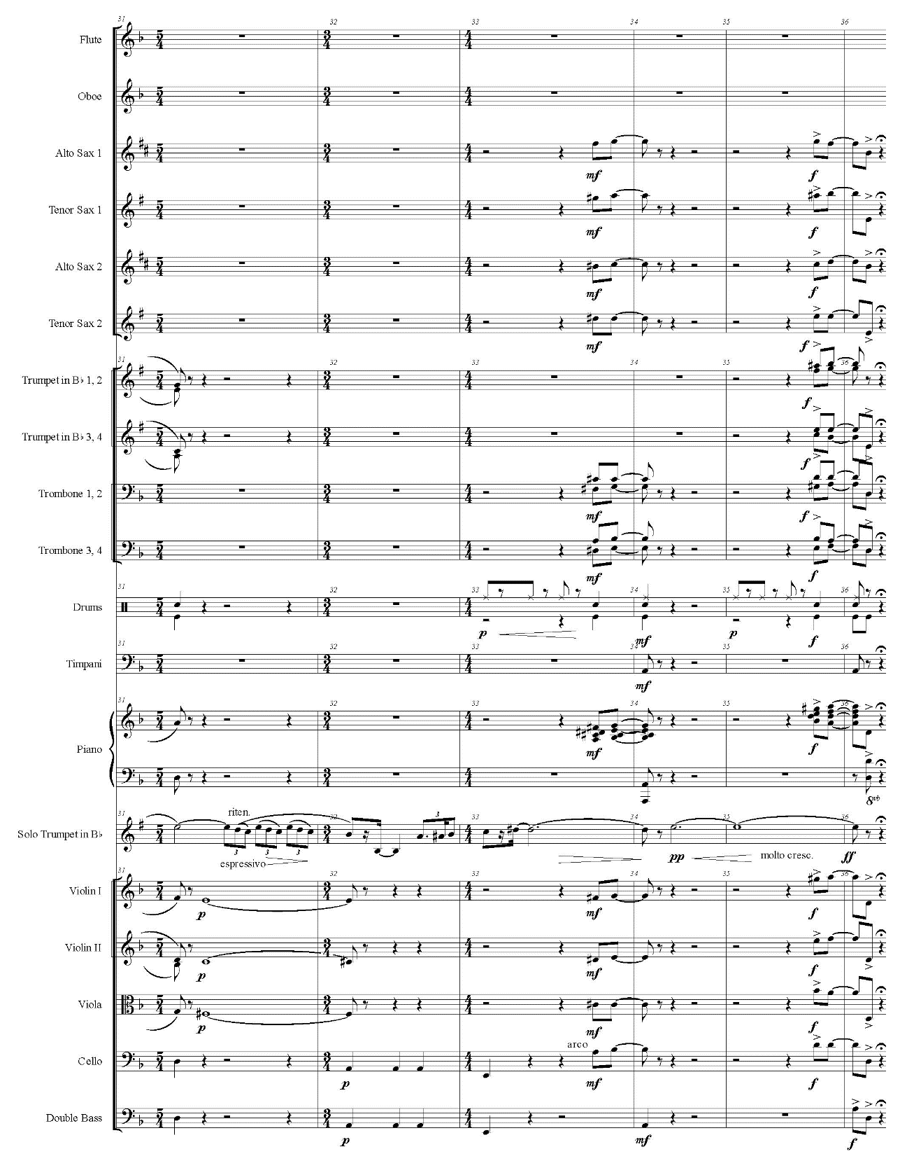

Movement III

Figure 7.2. Analytical diagram for Concerto for Trumpet and Orchestra, Movement III
by Ozawa
B Episode 1
G minor

F major
A Refrain
B♭ major

B♭ major
Retransition
(mm. 38-41)
(mm. 22-37)
(m. 18, beat 3-
m. 21)
Transition
Theme (allegro deciso)
(m. 5-
m. 18, beat 2)
Introduction (maestoso)
(mm. 1-4)

C Episode 2
E♭ major/C minor/E♭ major
A Refrain (Development)
B♭ major

E♭ major/B♭ major/E♭ minor/F major

E♭ major

(mm. 42-53)
Theme
Development (ritenuto-a tempo)
Theme
(mm. 76-87)
(mm. 72-75)
(mm. 54-71)

B♭ major

B♭ minor
A Refrain
E♭ major/B♭ major
(mm. 88-107)
Theme

Closing (a tempo vivo)
(mm. 112-113)
Movement I, Theme 1 (maestoso andante)
(mm. 108-111)

Figure 7.2 describes a structure of the last movement. This movement consists of ABACA form. This form is similar to small rondo form, but this movement shows some differences with works in traditional small rondo form. For example, the theme appears in different ways in all refrain sections. In the first refrain, the theme starts with a motive of minor second interval (motive 1), while the second refrain begins with the motive of ascending scale (motive 3). The third refrain starts with motive 1, but the key is not original B♭ major but E♭ major. Additionally, the theme is developed in the second refrain.
The main tonality of this movement is B♭ major. This movement modulates to the keys such as relative minor (G minor), subdominant (E♭ major), and supertonic (C minor).
After a short introduction, the solo trumpet plays the theme to start the A section (see example 7.17). This theme includes some motives which recur in other sections. Motive 1 consists of two sixteenth notes with minor second. Motive 2 appears as a rhythmic motive in both episodes. Motive 3 is a one-octave ascending scale with sixteenth notes. Motive 4 consists of three notes with a syncopated rhythm. Frequent use of sixteenth notes gives lilting characteristics to this theme.

Example 7.17. Ozawa, Concerto for Trumpet and Orchestra, Movement III, mm. 5-12
2
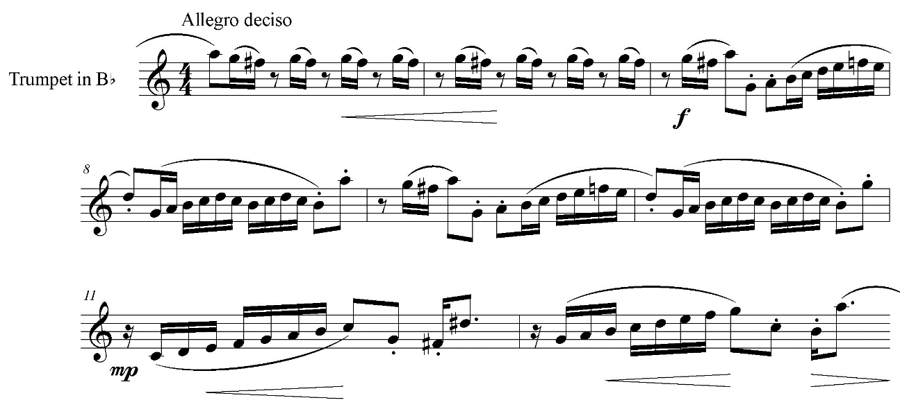
1
3
4

Beginning on beat 3 of m. 18, the orchestra plays ascending scales to make a transition to the B section (see example 7.18). These ascending scales are based on motive 3, but F♯ on the bottom and F on the top make the tonality ambiguous. At m. 22, the solo trumpet begins the B section with a retrograde of motive 1 (marked as 1-r, see example 7.19). Also, rhythmic motive 2, marked as 2 (rhythm), appears in the solo trumpet. The tonality remains ambiguous with an emphasis on B♭ and E, which implies tritone. The solo trumpet plays E (written F♯) frequently, while the low strings sustain B♭. Moreover, the melody on the solo trumpet has this tritone interval. In m. 34, the tonality settles in G minor with a G minor sixth chord (see example 7.20).
At m. 38, the flute and clarinet start the retransition to the second A section by playing motive 3 in F major. In m. 42, the solo trumpet modulates back to B♭ major to begin the second A section with motive 3. In this section, the theme starts developing at m. 54 (see example 7.21). The solo trumpet plays arranged motive 3 in E♭ major, and this arranged theme shows characteristic of jazz music with triplets and lowered seventh degree. Motive 4 occurs in measures 55 and 57, and this motive modulates in the circle of fifths in measures 59 and 61. Ozawa develops the theme with the repetition of motive 4 and triplets, and the original theme recurs in m. 72 to close this section.

Example 7.18. Ozawa, Concerto for Trumpet and Orchestra, Movement III, m. 18,
beat 3-m. 23
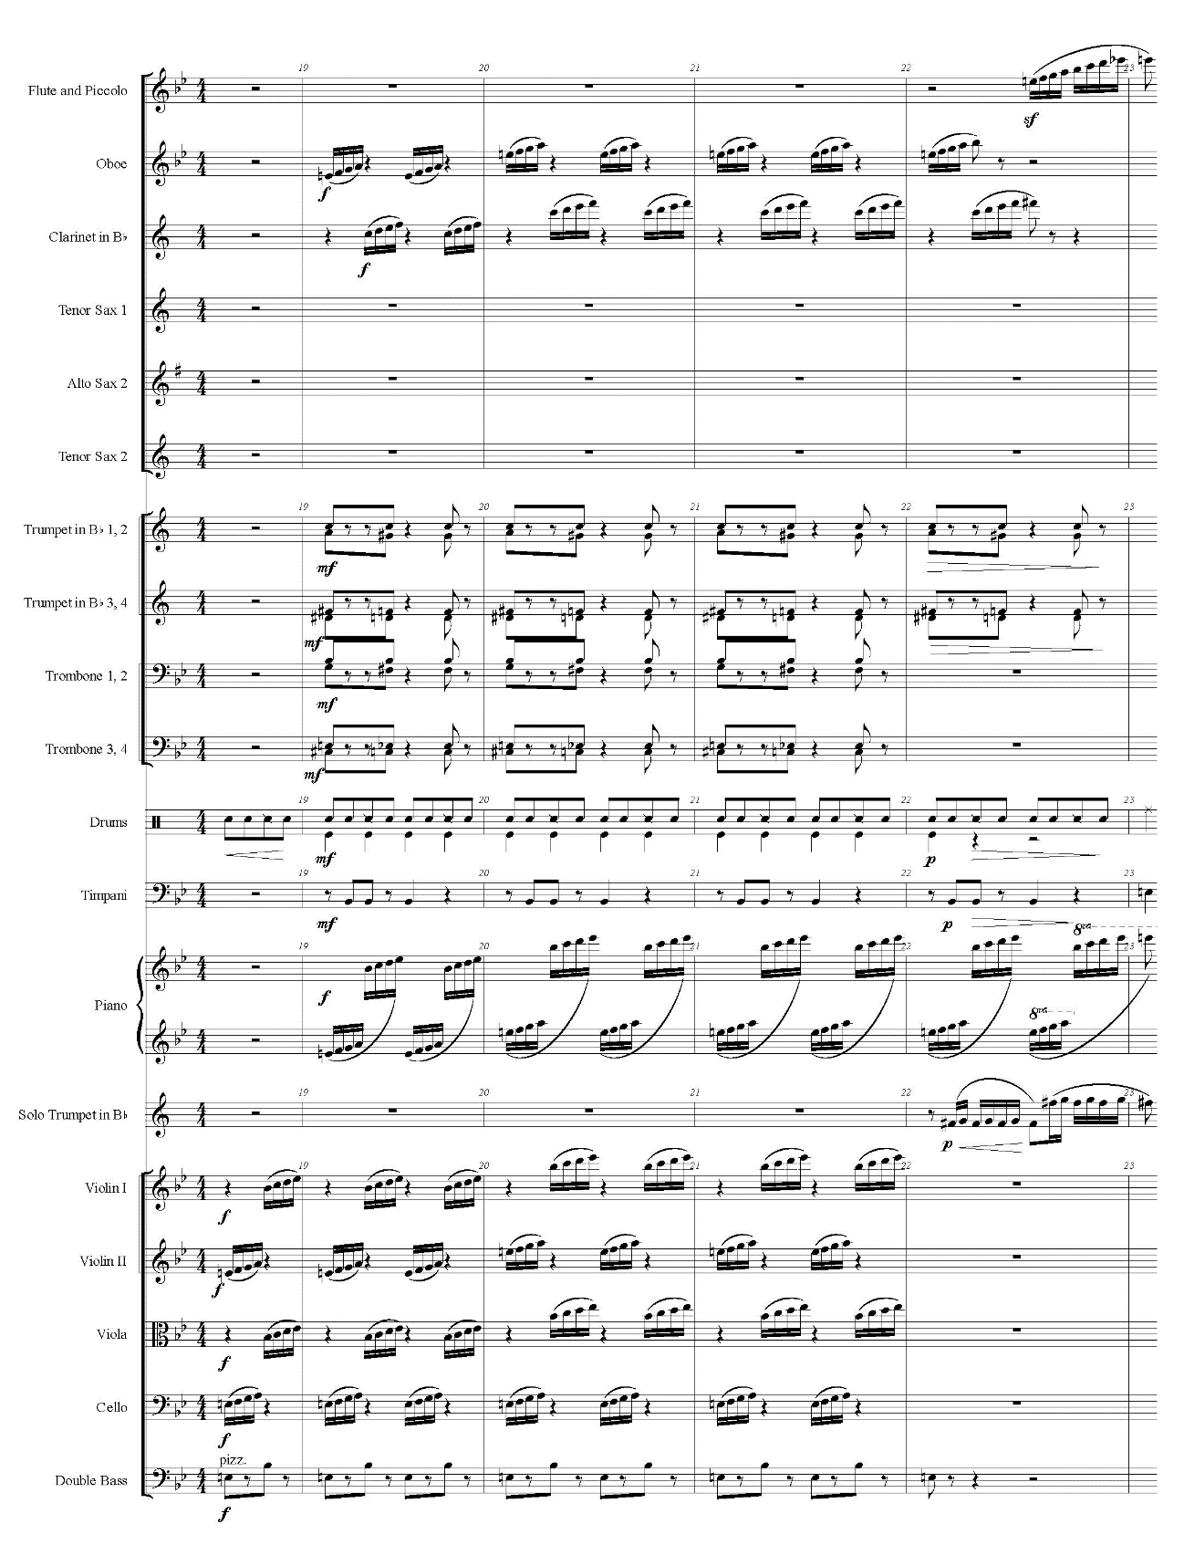

Example 7.19. Ozawa, Concerto for Trumpet and Orchestra, Movement III, mm. 22-29
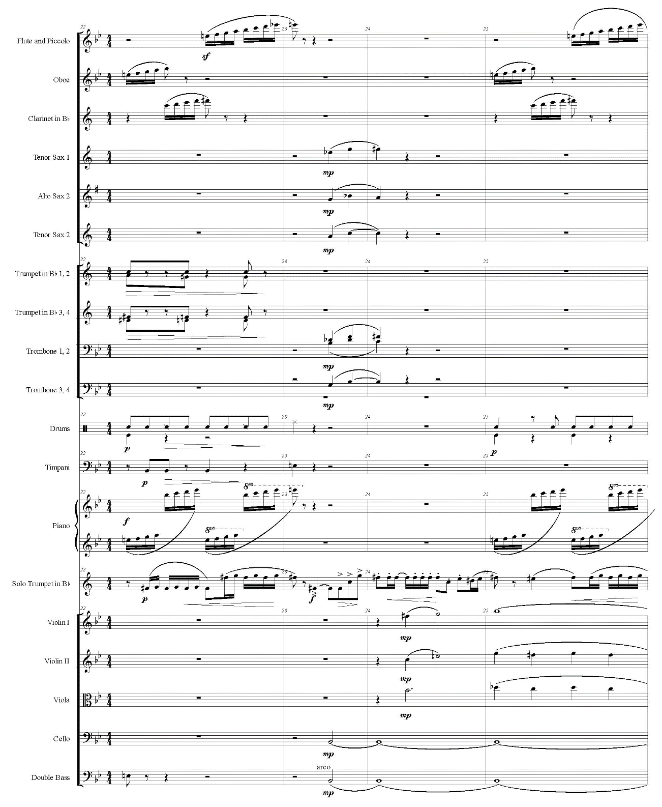
1-r
1-r
2 (rhythm)
tritone

Example 7.19—Continued
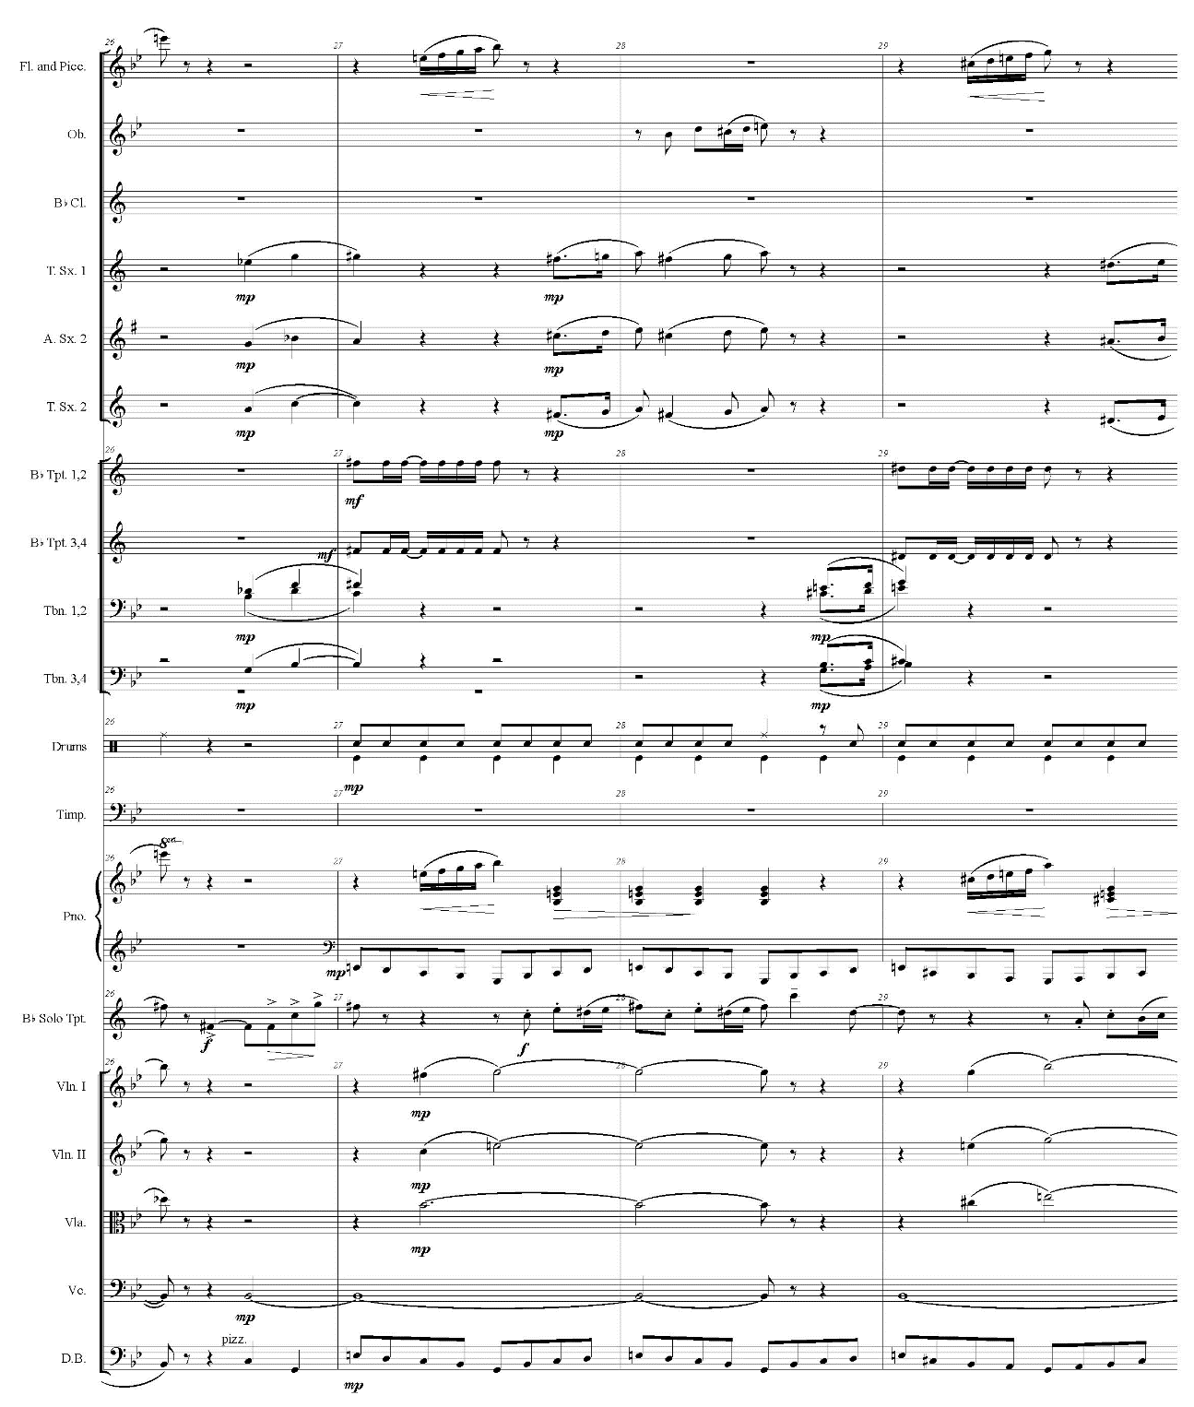
2 (rhythm)
tritone

Example 7.20. Ozawa, Concerto for Trumpet and Orchestra, Movement III, mm. 34-37
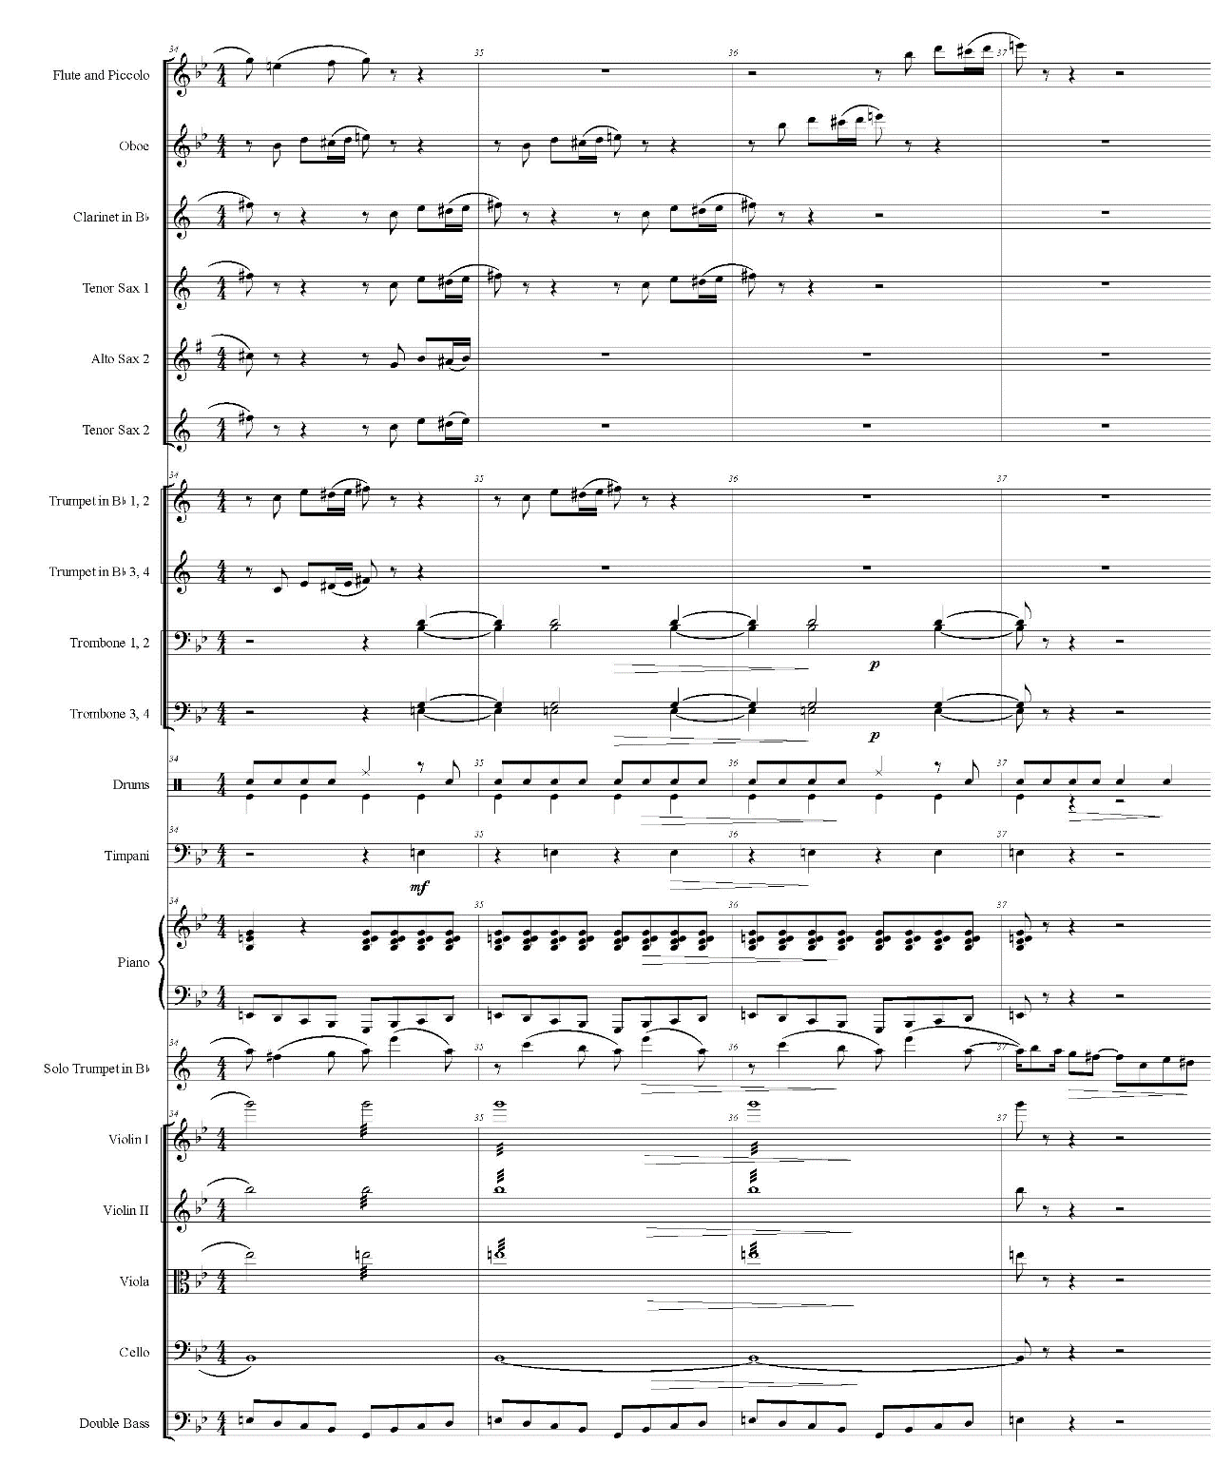

Example 7.21. Ozawa, Concerto for Trumpet and Orchestra, Movement III, mm. 54-62
3 (arranged)
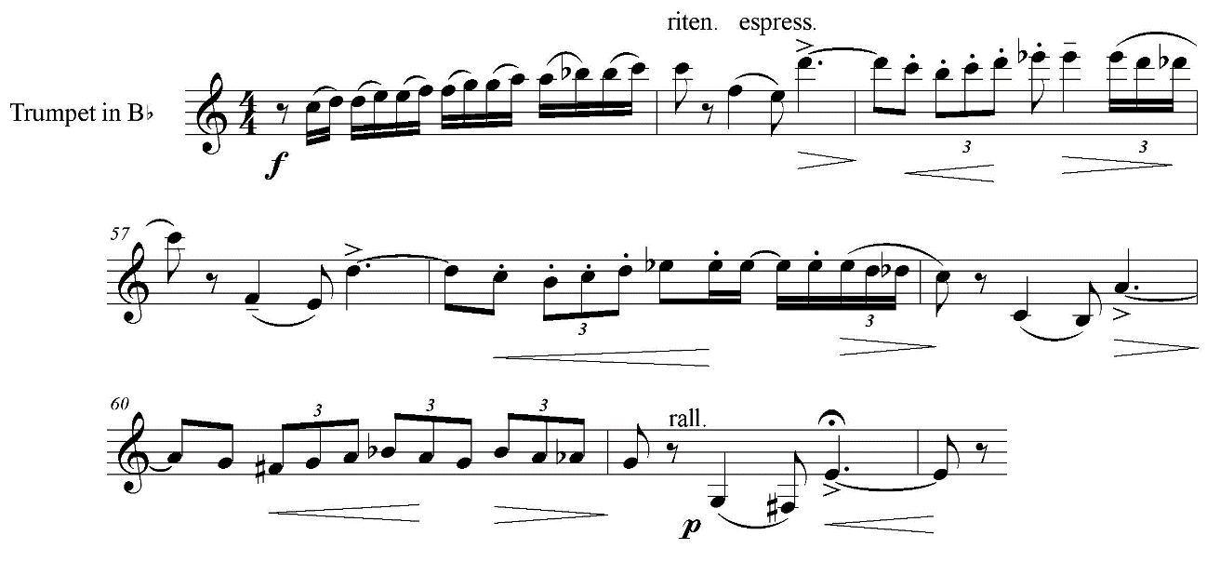
4
4
4
4

The C section starts at m. 76 (see example 7.22). The melody in the solo trumpet is based on motive 3 and rhythmic motive 2, and the melody modulates from E♭ major to C minor in m. 80. At the climax of this section, the solo trumpet plays glissando up to C (written D). Then, the key changes back to E♭ major, and the solo trumpet maintains this key to start the last A section with motive 1. The key returns to B♭ major in m. 93 when the strings play motive 2. At m. 96, the solo trumpet starts ascending chromatically with syncopated rhythm (see example 7.23). After another glissando, the solo trumpet reaches concert E♭ (written F), the highest note in this concerto. This climactic moment is interrupted by a sudden appearance of Theme 1 from the first movement. After this brief reminiscence of the first movement, the third movement concludes with a two-measure closing based on a C major chord with added sixth (see example 7.24).

Example 7.22. Ozawa, Concerto for Trumpet and Orchestra, Movement III, mm. 76-86
2 (rhythm)
2 (rhythm)
3
3
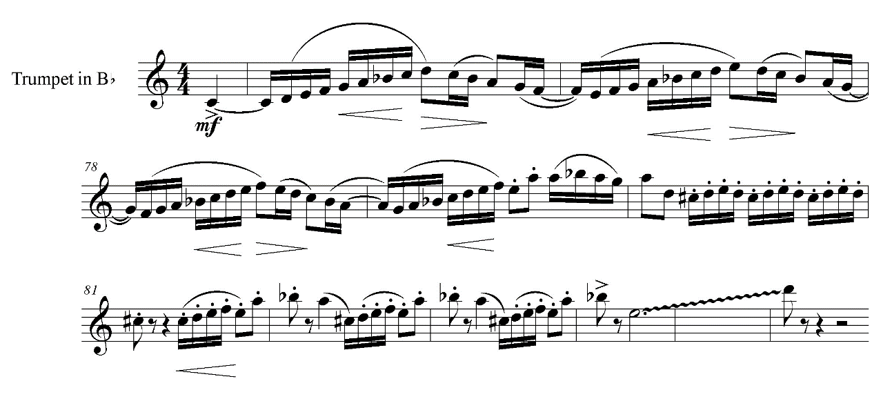
2 (rhythm)
3
3

Example 7.23. Ozawa, Concerto for Trumpet and Orchestra, Movement III, mm. 96-
105
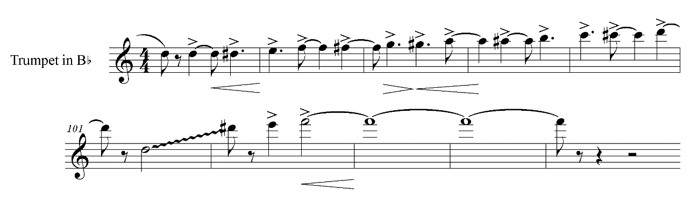

Example 7.24. Ozawa, Concerto for Trumpet and Orchestra, Movement III, mm. 108-
113
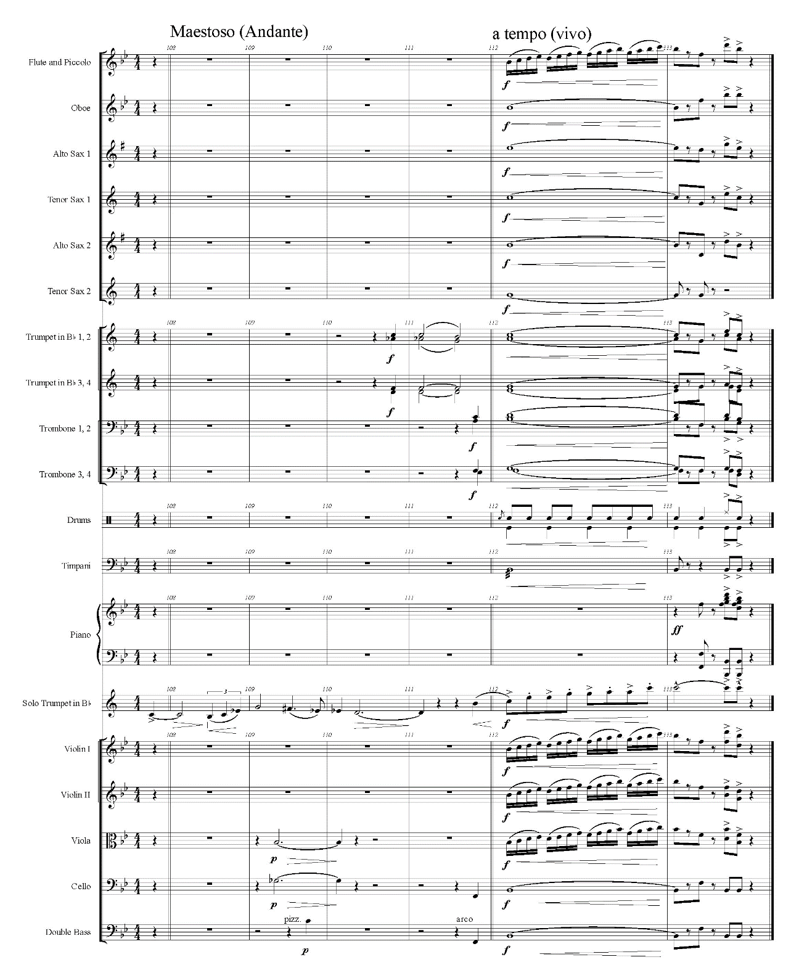

Chapter 8
Conclusion

Through bibliographical study and analyses of three diverse Japanese works for solo trumpet by Takemitsu, Kentsubitsch, and Ozawa, this document reveals the characteristics of these three outstanding works. In Paths, Takemitsu’s concept of strolling in a garden is realized with free time and subtle differences in recurring motives. This unaccompanied piece will add a uniqueness to the repertoire for advanced trumpeters. Kentsubitsch’s Contest Piece contains beautiful melodies with simple structure and limited register. This work can be an excellent addition to the repertoire for intermediate players. Ozawa successfully combined Romantic style with jazz elements in his Trumpet Concerto. With a unique instrumentation of adding a large jazz band to the orchestra, this concerto has great potential to attract trumpeters and audience not only in Japan but also internationally.
However, the difficulty of attaining scores and recordings for these works hinders international awareness. The score and recordings for Paths can be easily accessed worldwide. The score for Contest Piece is published in Japan, and Kentsubitsch recorded his own performance of this piece on a compact disc. The compact disc is available in the US, but the score is sold only in Japan. The score for Ozawa’s Trumpet Concerto is not published; the score is available exclusively from Hisato Osawa Posthumous Collection at Kobe College. Kumashiro recorded this concerto for his compact disc Trumpet Japonesque, but this compact disc is not available worldwide. In order to draw attention from trumpeters worldwide, the recordings and scores for these works need to be accessible.
In addition to these three works, there are other excellent works for solo trumpet by Japanese composers which are available only in Japan or remain unpublished. For example, some other works by Kentsubitsch are published in Japan, but his works such as Finale and Tasogare are not published. Also, Kumashiro commissioned solo trumpet pieces from other Japanese composers for Trumpet Japonesque. These commissioned works include Junk Mood for trumpet, piano, marimba and percussion by Kaori Nabeshima, and A-UN for trumpet and percussion by Tetsunosuke Kushida, both of which also remain unpublished.
The three works studied in this document, along with other solo trumpet pieces by Japanese composers, display exceptional quality. These Japanese works for solo trumpet have the great potential to give diversity to the repertoire. The international availability of scores and recordings will help these outstanding Japanese works spread widely.

Bibliography

“Andore Anri × Tsuken Naohiro toranpetto shidōhō no tsubo! [André Henry and Naohiro Tsuken, the art of trumpet teaching].” Pipers, May 1, 2008, 90-94.

Burt, Peter. The Music of Toru Takemitsu. Cambridge: Cambridge University Press, 2001.

Chinen, Masanao. “NHK kōkyō gakudan teinen, 32-nen furikaeru kenshusshin Tsuken Naohiro [Naohiro Tsuken from Okinawa retires NHK Symphony Orchestra, lookin back upon his 32-year career].” Ryukyu Shimpo, March 9, 2010. Accessed August 8, 2013. http://ryukyushimpo.jp/news/storyid-158965-storytopic-6.html.

Garrett, Junko Ueno. “Japanese Piano Compositions of the Last Hundred Years: A History of Piano Music in Japan and a Complete List of Japanese Piano Compositions.” DMA diss., Rice University, 1998. Accessed October 21, 2014. ProQuest Dissertations & Theses.

Hara, Taro. Review for the seventh concert of Shin Sakkyokuha Kyokai. Ongaku Geijutsu, February, 1951. Quoted in Yoko Narazaki, Takemitsu Tōru. Tokyo: Ongaku no Tomo Sha, 2005.

Howell, Matthew C. “A Conductor’s Introduction to the Performance of Modern Japanese Choral Music.” DMA diss., University of Arizona, 2008. Accessed October 22, 2014. ProQuest Dissertations & Theses.

Ikushima, Mikiko. Foreword to Kirameki no kiseki II: Kōbe Jogakuin shozō shiryō “Ōsawa Hisato isaku korekushon” shōsai mokuroku [Hisato Osawa, trajectory of his brilliance: detailed catalog of Kobe College Hisato Osawa Posthumous Collection], edited by Osawa Project, ii-iv. Kobe, Japan: Kobe College, 2011.

———. “Kirameki no kiseki, tashika naru genten [Hisato Osawa: trajectory of his brilliance and its solid origin].” In Ōsawa Hisato Supekutakuru I [Hisato Osawa spectacle I], edited by Osawa Project, 11-18. Kobe, Japan: Osawa Project, 2009.

———. “Ōsawa Hisato no ‘soto’ naru seiyō to ‘uchi’ naru nihon [Outer occident and inner Japan in Hisato Osawa].” In Ōsawa Hisato Supekutakuru II [Hisato Osawa spectacle II], edited by Osawa Project, 11-22. Kobe, Japan: Osawa Project, 2010.

———. “Ōsawa Hisato: sensēshon o yobu sakkyokuka [Hisato Osawa: a composer who causes a sensation].” Saundo, January 2012, 28-31.

Jiromaru, Tomoki. “Takemitsu Tōru sakuhin ni okeru ongaku gohō no hensen: SEA motyīfu o chūshin ni [Transition of the musical idiom in Toru Takemitsu’s works: focusing on the motif “SEA”].” Jinbun Kagaku Kenkyu, no. 8 (March 2012): 27-40.

Katayama, Morihide. Foreword to Piano Concerto No. 3 A♭ major “Kamikaze,” by Hisato Osawa, 4-7. Kobe, Japan: Toshifumi Osawa, 2004.

———. Liner notes for Hisato Ohzawa: Piano Concerto No. 2, Symphony No. 2. Translated by Sorel. Conducted by Dmitry Yablonsky. Recorded with Ekaterina Saranceva (piano) and Russian Philharmonic Orchestra, March 16-19, 2006. Naxos DDD 8.570177, 2008. CD.

———. Liner notes for Hisato Ohzawa: Piano Concerto No. 3 “Kamikaze,” Symphony No. 3 “Symphony of the Founding of Japan.” Translated by Sorel. Conducted by Dmitry Yablonsky. Recorded with Ekaterina Saranceva (piano) and Russian Philharmonic Orchestra, October 7-11, 2003. Naxos DDD 8.557416, 2004. CD.

Kohata, Issei. Interview with Naohiro Tsuken in liner notes for Naohiro Tsuken Plays Kentsubitsch, 1-2. Recorded with Naohiro Tsuken (trumpet), August 29, October 1-2, and November 19, 2002. Exton OVCL-00094, 2003. CD.

Kumashiro, Osamu. “Hakkutsu! Nihonjin hatsu no toranpetto kyōsōkyoku [Discovery! First trumpet concerto by Japanese composer].” Pipers, May 1, 2009, 10-15.

Kusayanagi Daizo. Shinshin jutsuryokusha no jōken [Conditions to be influential people, vol. 3]. Tokyo: Bungei Shunju, 1972.

Matsui, Shinnosuke. “Hanshinkan modanizumu ga umidashita futari no ongakuka: Kishi Kōichi to Ōsawa Hisato [Two musicians produced by Hanshinkan Modernism: Koichi Kishi and Hisato Osawa].” Kakuzan Ronso, March 31, 2011, 35-56.

Miyagi, Etsujiro. Okinawa senryō no 27 nenkan: Amerika gunsei to bunka no henyō [27 years of administration of Okinawa: US military administration and the change of culture]. Tokyo: Iwanami Shoten, 1992.

Murakami, Kazuo. “Japanese Piano Sonatas: A Discussion and Performance Guide.” DMA essay, University of Iowa, 2011. Accessed October 21, 2014. ProQuest Dissertations & Theses.

Nakaji, Yukika. “Tsuken Naohiro kokyō eno itsukushimi kome Kentsubicchi Ongakusai [Marcel Kentsubitsch Music Festival: Naohiro Tsuken, with the love for his home].” Ryukyu Shimpo, August 17, 2010. Accessed August 9, 2013. http://ryukyushimpo.jp/news/storyid-166430-storytopic-6.html.

Narazaki, Yoko. Takemitsu Tōru. Tokyo: Ongaku no Tomo Sha, 2005.

Okamatsu, Takuya. “Ōsawa Hisato, saihyōka no kiun [Hisato Osawa: time for reevaluation].” Nihon Keizai Shimbun, March 8, 2010. Accessed July 19, 2013. http://www.nikkei.com/article/DGXNASIH25001_S0A300C1AA1P01.

Okinawa Prefectural Board of Education. “Chronology.” Ryukyu Cultural Archives. Accessed December 8, 2014. http://rca.open.ed.jp/web_e/music/chronicle/index.
html.

Ongaku Kenkyujo. “Okinawa no ongaku [Okinawan music].” Last modified July 20, 2003. Accessed September 18, 2014. http://www.asahi-net.or.jp/~HB9T-KTD/music/Japan/Research/Genre/Ethnic/okinawan.html.

Onishi, Hideaki. “Toru Takemitsu’s Japanese Gardens: An Application of Superset/Subset Networks to the Analysis of Three Orchestral Compositions.” PhD diss., University of Washington, 2004. Accessed October 20, 2014. ProQuest Dissertations & Theses.

Osawa, Hisato. “Pouru Dūka no omoide: shi to shiteno [Memory of Paul Dukas: as my instructor].” Essay, 1938. Hisato Osawa Posthumous Collection. Kobe College, Kobe, Japan.

Osawa Project, ed. Kirameki no kiseki II: Kōbe Jogakuin shozō shiryō “Ōsawa Hisato isaku korekushon” shōsai mokuroku [Hisato Osawa, trajectory of his brilliance: detailed catalog of Kobe College Hisato Osawa Posthumous Collection]. Kobe, Japan: Kobe College, 2011.

“Paipāzu intabyū: Tsuken Naohiro [Pipers interview: Naohiro Tsuken].” Pipers, August 1, 1983, 15-25.

Siddons, James. Toru Takemitsu: A Bio-Bibliography. Westport, CT: Greenwood Press, 2001.

Sokabe, Kiyonori. “Takemitsu Tōru ‘Michi’ ni kansuru ichi kōsatsu [A speculation on Paths by Toru Takemitsu].” Last modified February 4, 1998. Accessed August 11, 2014. http://www.jade.dti.ne.jp/~ebakos/michi/michi1.html.

Takemitsu, Asaka. Sakkyokuka Takemitsu Tōru tono hibi o kataru [A Memoir of Toru Takemitsu]. Tokyo: Shogakkan, 2006.

Takemitsu, Toru. Takemitsu Tōru chosakushū [Writings of Toru Takemitsu]. Vol. 5. Tokyo: Shinchosha, 2000.

———. Toki no entei [Gardener of the time]. Tokyo: Shinchosha, 1996.

———. Watakushitachi no mimi wa kikoete iru ka [Can our ears hear?]. Tokyo: Nihon Tosho Sentā, 2000.

Tsuken, Naohiro. Liner notes for Naohiro Tsuken Plays Arutiunian. Recorded with Naohiro Tsuken (trumpet), July 15-18, 2003. Exton OVCL-00139, 2003. CD.

———. Liner notes for Naohiro Tsuken Plays Kentsubitsch. Recorded with Naohiro Tsuken (trumpet), August 29, October 1-2, and November 19, 2002. Exton OVCL-00094, 2003. CD.

———. “Toranpetto afutā 5, dai 22 kai [Trumpet after 5, No. 22].” Pipers, March 1, 2000, 51.

———. “Toranpetto afutā 5, dai 34 kai [Trumpet after 5, No. 34].” Pipers, March 1, 2001, 51.

———. “Toranpetto afutā 5, dai 40 kai [Trumpet after 5, No. 40].” Pipers, September 1, 2001, 49.

———. “Toranpetto afutā 5, dai 41 kai [Trumpet after 5, No. 41].” Pipers, October 1, 2001, 51.

“Utau! Kentsubicchi: Tsuken Naohiro-san jisaku jien soro arubamu o kataru [Kentsubitsch sings! Naohiro Tsuken talks about his solo album composed and played by himself].” Pipers, March 1, 2003, 90-91.

Yamane, Ginji. Review for the seventh concert of Shin Sakkyokuha Kyokai. Tokyo Shinbun, December 12, 1950. Quoted in Yoko Narazaki, Takemitsu Tōru. Tokyo: Ongaku no Tomo Sha, 2005.

Scores

Kentsubitsch, Marcel. Contest Piece. Sagamihara, Japan: Superkids, 2006.

———. Legend. Sagamihara, Japan: Superkids, 2006.

———. Quatre Variations sur un Thème de SE16GAN. Sagamihara, Japan: Superkids, 2006.

———. Trumpet Concerto. Sagamihara, Japan: Superkids, 2006.

Osawa, Hisato. “Concerto for Trumpet and Orchestra.” 1950. Hisato Osawa Posthumous Collection. Kobe College, Kobe, Japan.

———. “Otemari Rondo.” 1943. Hisato Osawa Posthumous Collection. Kobe College, Kobe, Japan.

———. Piano Concerto No. 3 A♭ major “Kamikaze.” Kobe, Japan: Toshifumi Osawa, 2004.

———. “‘Sakura’ Fantasy.” 1946. Hisato Osawa Posthumous Collection. Kobe College, Kobe, Japan.

———. “Une voix à ‘Sakura.’” 1935. Hisato Osawa Posthumous Collection. Kobe College, Kobe, Japan.

Schubert, Franz. Quintet in A major (the “Trout” Quintet). Edited by Arnold Feil. New York: Bärenreiter, 1987.

Takemitsu, Toru. The Dorian Horizon. Tokyo: Ongaku no Tomo Sha, 2000.

———. Far Calls, Coming Far! Mainz, NY: Schott, 1981.

———. Paths—In Memoriam Witold Lutosławski. Tokyo: Schott Japan, 1994.

———. Pause Ininterrompue. Paris: Editions Salabert, 1962.

Junko Ueno Garrett, “Japanese Piano Compositions of the Last Hundred Years: A History of Piano Music in Japan and a Complete List of Japanese Piano Compositions” (DMA diss., Rice University, 1998), accessed October 21, 2014, ProQuest Dissertations & Theses.
Kazuo Murakami, “Japanese Piano Sonatas: A Discussion and Performance Guide” (DMA essay, University of Iowa, 2011), accessed October 21, 2014, ProQuest Dissertations & Theses.
Ibid., 3.
Matthew C. Howell, “A Conductor’s Introduction to the Performance of Modern Japanese Choral Music” (DMA diss., University of Arizona, 2008), accessed October 22, 2014, ProQuest Dissertations & Theses.
Ibid., 14-15.
Ozawa’s last name is also spelled as Osawa, Ohsawa, and Ohzawa in publications. Although his last name is actually pronounced Ohsawa and spelled as Osawa in Japan, he preferred to spell it as Ozawa on his works. Kobe College Osawa Project chooses to use Osawa based on the real spelling. This document employs Ozawa because that is how he spelled his name throughout his career in the US and Europe.
Toru Takemitsu, Watakushitachi no mimi wa kikoete iru ka [Can our ears here?] (Tokyo: Nihon Tosho Sentā, 2000), 10.
James Siddons, Toru Takemitsu: A Bio-Bibliography (Westport, CT: Greenwood Press, 2001), 2.
Yoko Narazaki, Takemitsu Tōru (Tokyo: Ongaku no Tomo Sha, 2005), 18.
Asaka Takemitsu, Sakkyokuka Takemitsu Tōru tono hibi o kataru [A memoir of Toru Takemitsu] (Tokyo: Shogakkan, 2006), 246.
Toru Takemitsu, Toki no entei [Gardener of the time] (Tokyo: Shinchosha, 1996), 108.
Daizo Kusayanagi, Shinshin jitsuryokusha no jōken [Conditions to be influential people, vol. 3] (Tokyo: Bungei shunju, 1972), 210.
Kusayanagi, 216.
Narazaki, 21.
Siddons, 4.
Toru Takemitsu, Watakushitachi, 45.
Asaka Takemitsu, 77-78.
Toru Takemitsu, Toki, 108.
Ibid., 109.
Toru Takemitsu, Watakushitachi, 11.
Ibid., 12-13.
Toru Takemitsu, Toki, 109.
Ibid., 57.
Asaka Takemitsu, 217.
Narazaki, 148-189.
Toru Takemitsu, Watakushitachi, 11-12.
Toru Takemitsu, Toki, 109-110.
Toru Takemitsu, Takemitsu Tōru chosakushū [Writings of Toru Takemitsu] (Tokyo: Shinchosha, 2000), 5:33.
Siddons, 8.
Narazaki, 195.
Siddons, 46.
Toru Takemitsu, The Dorian Horizon (Tokyo: Ongaku no Tomo Sha, 2000), 14.
Ginji Yamane, review for the seventh concert of Shin Sakkyokuha Kyokai, Tokyo Shinbun, December 12, 1950, quoted in Yoko Narazaki, Takemitsu Tōru (Tokyo: Ongaku no Tomo Sha, 2005), 15.
Taro Hara, review for the seventh concert of Shin Sakkyokuha Kyokai, Ongaku Geijutsu, February, 1951, quoted in Yoko Narazaki, Takemitsu Tōru (Tokyo: Ongaku no Tomo Sha, 2005), 16.
Peter Burt, The Music of Toru Takemitsu (Cambridge: Cambridge University Press, 2001), 71.
Asaka Takemitsu, 46-47.
Ibid., 125-126.
Toru Takemitsu, Toki, 113
Siddons, 11.
Kusayanagi, 207.
Hideaki Onishi, “Toru Takemitsu’s Japanese Gardens: An Application of Superset/Subset Networks to the Analysis of Three Orchestral Compositions” (PhD diss., University of Washington, 2004), 72, accessed October 20, 2014, ProQuest Dissertations & Theses.
Narazaki, 41.
Ibid., 115.
Ibid., 10.
Ibid., 121-122.
Toru Takemitsu, Toki, 128.
Toru Takemitsu, Chosakushū, 5:29-30.
Tomiki Jiromaru, “Takemitsu Tōru sakuhin ni okeru ongaku gohō no hensen: SEA motyīfu o chūshin ni [Transition of the musical idiom in Toru Takemitsu’s works: focusing on the motif “SEA”],” Jinbun Kagaku Kenkyu, no. 8 (March 2012): 35-36.
Narazaki, 131.
Jiromaru, 36.
Toru Takemitsu, Toki, 121.
Toru Takemitsu, Chosakushū, 5:433.
Onishi, 214-215.
Toru Takemitsu, Chosakushū, 5:440.
Kiyonori Sokabe, “Takemitsu Tōru ‘Michi’ ni kansuru ichi kōsatsu [A speculation on Paths by Toru Takemitsu],” last modified February 4, 1998, accessed August 11, 2014, http://www.jade.dti.ne.jp/~ebakos/michi/michi1.html.
Ibid.
Naohiro Tsuken, “Toranpetto afutā 5, dai 22 kai [Trumpet after 5, No. 22],” Pipers, March 1, 2000, 51.
Ibid.
“Paipāzu intabyū: Tsuken Naohiro [Pipers interview: Naohiro Tsuken],” Pipers, August 1, 1983, 17.
Ibid., 17-18.
Ibid.
Ibid., 18.
Ibid., 24.
Tsuken, “Toranpetto afutā 5, dai 34 kai [Trumpet after 5, No. 34],” Pipers, March 1, 2001, 51.
“Paipāzu intabyū,” 17.
“Utau! Kentsubicchi: Tsuken Naohiro-san jisaku jien soro arubamu o kataru [Kentsubitsch sings! Naohiro Tsuken talks about his solo album composed and played by himself],” Pipers, March 1, 2003, 90.
Tsuken, “Toranpetto afutā 5, 22,” 51.
“Utau! Kentsubicchi,” 91.
Ibid.
Okinawa Prefectural Board of Education, “Chronology,” Ryukyu Cultural Archives, accessed December 8, 2014, http://rca.open.ed.jp/web_e/music/chronicle/index.html.
Etsujiro Miyagi, Okinawa senryō no 27 nenkan: Amerika gunsei to bunka no henyō [27 years of administration of Okinawa: US military administration and the change of culture] (Tokyo: Iwanami Shoten, 1992), 35-37.
Okinawa Prefectural Board of Education.
Yukika Nakaji, “Tsuken Naohiro kokyō eno itsukushimi kome Kentsubicchi Ongakusai [Marcel Kentsubitsch Music Festival: Naohiro Tsuken, with the love for his home],” Ryukyu Shimpo, August 17, 2010, accessed August 9, 2013, http://ryukyushimpo.jp/news/storyid-166430-storytopic-6.html.
Issei Kohata, interview with Naohiro Tsuken in liner notes for Naohiro Tsuken Plays Kentsubitsch, recorded with Naohiro Tsuken (trumpet), August 29, October 1-2, and November 19, 2002, Exton OVCL-00094, 2003, CD, 2.
“Andore Anri × Tsuken Naohiro toranpetto shidōhō no tsubo! [André Henry and Naohiro Tsuken, the art of trumpet teaching],” Pipers, May 1, 2008, 90.
Kohata, 1.
Tsuken, liner notes for Naohiro Tsuken Plays Kentsubitsch, recorded with Naohiro Tsuken (trumpet), August 29, October 1-2, and November 19, 2002, Exton OVCL-00094, 2003, CD, 6.
“Utau! Kentsubicchi,” 91.
Kohata, 1.
“Utau! Kentsubicchi,” 91.
Tsuken, “Toranpetto afutā 5, dai 40 kai [Trumpet after 5, No. 40],” Pipers, September 1, 2001, 49.
Tsuken, “Toranpetto afutā 5, dai 41 kai [Trumpet after 5, No. 41],” Pipers, October 1, 2001, 51.
Masanao Chinen, “NHK kōkyō gakudan teinen, 32-nen furikaeru kenshusshin Tsuken Naohiro [Naohiro Tsuken from Okinawa retires NHK Symphony Orchestra, looking back upon his 32-year career],” Ryukyu Shimpo, March 9, 2010, accessed August 8, 2013, http://ryukyushimpo.jp/news /storyid-158965-storytopic-6.html.
Ongaku Kenkyujo, “Okinawa no ongaku” [Okinawan music], last modified July 20, 2003, accessed September 18, 2014, http://www.asahi-net.or.jp/~HB9T-KTD/music/Japan/Research/Genre/ Ethnic/okinawan.html.
Tsuken, liner notes for Naohiro Tsuken Plays Arutiunian, recorded with Naohiro Tsuken (trumpet), July 15-18, 2003, Exton OVCL-00139, 2003, CD, 4.
Tsuken, liner notes for Naohiro Tsuken Plays Kentsubitsch, 5.
“Utau! Kentsubicchi,” 90.
Tsuken, liner notes for Naohiro Tsuken Plays Kentsubitsch, 6.
“Utau! Kentsubicchi,” 91.
Mikiko Ikushima, foreword to Kirameki no kiseki II: Kōbe Jogakuin shozō shiryō “Ōsawa Hisato isaku korekushon” shōsai mokuroku [Hisato Osawa, trajectory of his brilliance: detailed catalog of Kobe College Hisato Osawa Posthumous Collection], ed. Osawa Project (Kobe, Japan: Kobe College, 2011), ii-iv.
Osawa Project, ed., Kirameki no kiseki II: Kōbe Jogakuin shozō shiryō “Ōsawa Hisato isaku korekushon” shōsai mokuroku [Hisato Osawa, trajectory of his brilliance: detailed catalog of Kobe College Hisato Osawa Posthumous Collection] (Kobe, Japan: Kobe College, 2011), 299.
Morihide Katayama, liner notes for Hisato Ohzawa: Piano Concerto No. 3 “Kamikaze,” Symphony No. 3 “Symphony of the Founding of Japan,” trans. Sorel, conducted by Dmitry Yablonsky, recorded with Ekaterina Saranceva (piano) and Russian Philharmonic Orchestra, October 7-11, 2003, Naxos DDD 8.557416, 2004, CD, 2.
Ibid.
Hisato Osawa, “Pouru Dūka no omoide: shi to shiteno [Memory of Paul Dukas: as my instructor],” Hisato Osawa Posthumous Collection, Kobe College, Kobe, Japan.
Katayama, liner notes for Hisato Ohzawa: Piano Concerto No. 2, Symphony No. 2, trans. Sorel, conducted by Dmitry Yablonsky, recorded with Ekaterina Saranceva (piano) and Russian Philharmonic Orchestra, March 16-19, 2006, Naxos DDD 8.570177, 2008, CD, 2.
Ikushima, “Ōsawa Hisato: sensēshon o yobu sakkyokuka [Hisato Osawa: a composer who causes a sensation],” Saundo, January 2012, 30.
Katayama, foreword to Piano Concerto No. 3 A♭ major “Kamikaze,” by Hisato Osawa (Kobe, Japan: Toshifumi Osawa, 2004), 4.
Shinnosuke Matsui, “Hanshinkan modanizumu ga umidashita futari no ongakuka: Kishi Kōichi to Ōsawa Hisato [Two musicians produced by Hanshinkan Modernism: Koichi Kishi and Hisato Osawa],” Kakuzan Ronso, March 31, 2011, 48.
Ikushima, “Ōsawa Hisato: sensēshon,” 29.
Osawa, 3-4.
Katayama, liner notes for Hisato Ohzawa: Piano Concerto No. 2, 2.
Ikushima, “Kirameki no kiseki, tashika naru genten [Hisato Osawa: trajectory of his brilliance and its solid origin],” in Ōsawa Hisato supekutakuru I [Hisato Osawa spectacle I], ed. Osawa Project (Kobe, Japan: Osawa Project, 2009), 16.
Ikushima, “Ōsawa Hisato: sensēshon,” 30.
Katayama, liner notes for Hisato Ohzawa: Piano Concerto No. 3, 2-3.
Ibid., 4.
Katayama, foreword to Piano Concerto No. 3, 5.
Ikushima, “Ōsawa Hisato: sensēshon,” 30-31.
Ikushima, “Ōsawa Hisato no ‘soto’ naru seiyō to ‘uchi’ naru nihon [Outer occident and inner Japan in Hisato Osawa],” in Ōsawa Hisato supekutakuru II [Hisato Osawa spectacle II], ed. Osawa Project (Kobe, Japan: Osawa Project, 2010), 19.
Ibid., 21-22.
Osawa Project, 299.
Matsui, 51.
Osamu Kumashiro, “Hakkutsu! Nihonjin hatsu no toranpetto kyōsōkyoku [Discovery! First trumpet concert by Japanese composer],” Pipers, May 1, 2009, 11.
Ikushima, “Ōsawa Hisato no ‘soto’ naru,” 18.
Ikushima, “Kirameki no kiseki,” 18.
Matsui, 52.
Ikushima, “Kirameki no kiseki,” 14.
Katayama, liner notes for Hisato Ohzawa: Piano Concerto No. 3, 5.
Ikushima, “Kirameki no kiseki,” 16.
Katayama, foreword to Piano Concerto No. 3, 7.
Kumashiro, 14. According to Kumashiro, the live recording has a soloist’s name Kazuo Kurotani, but another record names a soloist as Jiro Kurotani.
Ibid.
Takuya Okamatsu, “Ōsawa Hisato, saihyōka no kiun [Hisato Osawa: time for reevaluation].” Nihon Keizai Shimbun, March 8, 2010, accessed July 19, 2013, http://www.nikkei.com/article/ DGXNASIH25001_S0A300C1AA1P01.
Kumashiro, 12.
Ibid., 14.
Ibid., 12.
Ibid., 13.

