UNIVERSITY OF OKLAHOMA
GRADUATE COLLEGE

ON THE USE OF ODONATA AS ECOLOGICAL INDICATORS

A THESIS

SUBMITTED TO THE GRADUATE FACULTY

in partial fulfillment of the requirements for the

Degree of

MASTER OF SCIENCE

By

EMILY HJALMARSON
Norman, Oklahoma
2018

ON THE USE OF ODONATA AS ECOLOGICAL INDICATORS

A THESIS APPROVED FOR THE
DEPARTMENT OF BIOLOGY

BY

Dr. Michael Patten, Chair

Dr. Jeffrey Kelly

Dr. Eli Bridge

© Copyright by EMILY ANN HJALMARSON 2018
All Rights Reserved.

Acknowledgements
I would like to thank everyone who has contributed to the amazing Oklahoma odonata database. With more than 52,000 records and 300,000 individuals (and still growing), it is an incredible resource to work with. Utmost thanks go to Dr. Michael Patten and Brenda Smith-Patten, the founders of this statewide project who have conducted field surveys since 2003 and created a detailed database of odonate records from multiple sources. I would also like to thank Jim Arterburn, David Arbour, Bill Carrell, Victor Fazio III, and numerous citizen scientists who also contributed valuable records.
Thanks again to Dr. Michael Patten for being a wonderful advisor and providing guidance throughout my entire project. I always enjoyed our conversations whether they were technical identification help, comparing field stories to see who got the latest county record (usually you) and who had the most encounters with police while surveying (usually me), or data analysis advice. Thanks to Dr. Jeffrey Kelly and Dr. Eli Bridge for serving on my committee and supporting me throughout this process. Despite being caught in the clutches of the Odonata, rest assured that birds are still a passion of mine.
Thanks to my lab mates for their support as well. Although our lab meeting topics sometimes diverged towards cannibalism and the current political climate, my fellow “grumpy conservationists” and I had a good time making progress together. Thanks to the many friends and colleagues, current and former, who have been there for me academically and socially (R.I.P. BioHazards, it was a good run). Thanks to my family, for always being there throughout this sometimes-bumpy road. I always appreciate advice and suggestions.
Finally, thanks to the love of my life, Brett Roberts. He has been the best partner in every way: by giving teaching advice, providing emotional support, being my cooking buddy, and helping with field work, especially by netting countless odonates (sometimes with an almost guillotine-like precision). Without you, I could not have achieved this. To many more years of bug hunting, bird watching, and beer drinking!

Table of Contents

Acknowledgements iv
List of Tables vii
List of Figures viii
Abstract ix
Chapter 1: Determining indicators of local species residency 1
Introduction 1
Methods 4
Datasets: Explanation and Processing 4
Occupancy Modeling 10
Piecewise Linear Model 10
Bayesian Modeling to Determine Thresholds 10
Results 11
Suborder Thresholds 11
Family Thresholds 11
Genus Thresholds 13
Discussion 15
Chapter 2: Odonate abundance and diversity patterns at urban sites 23
Introduction 23
Methods 24
Results 26
Discussion 28
References 41

List of Tables

Table 1. 8
Table 2. 9
Table 3. 12
Table 4. 22
Table 5. 32
Table 6. 33
Table 7. 36

List of Figures

Figure 1. 13
Figure 2.. 14
Figure 3.. 15
Figure 4.. 20
Figure 5.. 20
Figure 6. 21
Figure 7. 33
Figure 8.. 34
Figure 9. 35
Figure 10. 37
Figure 11. 37
Figure 12. 39
Figure 13. 38
Figure 14.. 40

Abstract
The insect order Odonata, the dragonflies and damselflies, is unique to use as an ecological indicator for water quality because of its close relationship with aquatic ecosystems and relative ease of observation and species-level identification. My goal was to explore ways in which odonates can respond to, and therefore indicate, sites with higher water quality.
Determining where odonates breed as opposed to where they “merely” occur is key to an understanding of the importance of water quality. It has been asserted that one should conclude that an odonate species breeds if and only if physical (exuvia, tenerals) or behavioral (tandem pairing, oviposition) evidence is obtained, yet gathering such evidence requires specialized observational and technical skills. In contrast, reliable observations and counts of adults can be had readily, creating a dilemma over which data to use. For my first chapter, I examined whether adult surveys and reproductive behaviors could predict breeding residency status, represented by presence of tenerals (newly emerged odonates), using a large, multi-year dataset from across Oklahoma. Using an occupancy model combined with piecewise regression, I found thresholds and associated Bayesian credible intervals for a suite of odonate taxa. I found similar general thresholds across species but found specific indicator thresholds exist when examining groups on the family and genus level. Thresholds differed among taxonomic groups and decreased in models that included counts of females rather than just of counts of adults any (or unknown) sex. My results can guide future survey protocol: adult observations can remain the primary focus, which broadens the scope of potential observer skill levels (e.g., citizen scientists) while indirectly ensuring breeding to identify sites for water quality surveys.
For my second chapter, I examined odonate biodiversity at urbanized water features to determine factors that promote species diversity and abundance, with a goal of using findings to make beneficial improvements to park management to increase water quality. I conducted surveys April–October 2016–2017 at 14 urban sites in central Oklahoma that varied in human use and habitat structure. I compared diversity and species composition among sites and tested which features best predicted higher abundance and species totals. Several variables were good predictors but use of a site for fishing purposes was an overarching indicator of both high species richness and high odonate abundance. Despite higher human use, presence of infrastructure, and increased management of these sites (which are typically negatively associated with biodiversity), odonates (and humans) benefit from maintaining them and ensuring proper water quality persists (i.e., if it is good for fish, it is good for insects).

Chapter 1: Determining indicators of local species residency

Introduction
A central question in ecology is what causes patterns of species’ occurrences at particular locations? Typically, there are many interacting combinations of abiotic (e.g., the environment) and biotic (e.g., species coexistence) factors that shape an organism’s spatial distribution, and these factors vary greatly depending on aspects of a species’ ecology, such as the organism’s needs at that time (Moore & Gillingham 2006). Having a specialized breeding habitat is a well-known example of a need that drives a species to use potentially different environments than they would during other times of their life cycle.
Global climate change and habitat loss are increasing the urgency to more fully understand these drivers and how they are interconnected. Organisms will experience drastically different environmental conditions and interspecific interactions in coming decades, which, if they unable to adapt rapidly, would disrupt their current spatial distributions.
Although these changes affect many different ecosystems, aquatic ecosystems are particularly negatively affected by numerous anthropogenic stressors such as agriculture, urbanization, and suburban development, along with climate change (Palmer et al. 2009).
The insect order Odonata, the dragonflies and damselflies, offers a unique study system to use for answering these types of space-use questions. It has been well established that invertebrates are useful in the biological monitoring of aquatic ecosystems (Cairns & Pratt 1993; Hodkinson & Jackson 2005), and due to the close relationship that odonates have with aquatic ecosystems, they are especially good choices as bioindicators (Samways 2008; Oertli 2008). Presence/absences, species abundance, and species diversity of odonates can hint at the health of the aquatic ecosystem in terms of numerous factors such as water quality (Catling 2005), quality of the aquatic habitat structure itself (Müller et al. 2003), and connectivity between aquatic sites (Tockner et al. 1999).
Odonates have a complex life cycle that consists of discrete larval and adult life stages that differ drastically in how much they depend on aquatic ecosystems. Nymphs, which hatch from eggs laid in aquatic plant tissue or directly in the water, are exclusively aquatic and remain so for the duration of their molting periods (~10 molts) up until metamorphosis and eventual emergence to enter the adult stage, which is after several months or years, depending on the species (Corbet 1999). Adults are entirely terrestrial, and aerial as well, meaning that their relationship with specific aquatic features is less fixed, since they often disperse away from water to forage, and some even migrate or eventually reproduce at water bodies other than their natal site (Corbet 1999; Stoks & Cordoba-Aguilar 2012). Because most of their lives transpire as nymphs, it has been suggested that the nymphal stage is more affected by ecological change than is the adult stage (Bried et al. 2015); however, obvious mobility restriction of nymphs prevent them from being as useful as indicators of ecological conditions not directly in the water, such as habitat that surrounds a breeding site (Tangen et al. 2003). Conversely, the adult stage is not considered to be a useful indicator in cases where vagility is high (Raebel et al. 2010).
Citizen science is a powerful emerging means to gather extensive data (Bonney et al. 2009), yet for Odonata we confront several difficulties gathering data on life stages other than for the adult. Surveying other life stages requires stricter methodology due to the specific types of searches needed to find them. For example, finding exuviae requires rigorously scouring vegetation along a water feature and determining specific protocol such as a consistent distance to “wade out” to ensure accurate detection of species. This issue makes opportunistic style surveys not suited for finding exuviae.
Moreover, detection differences between adult and exuviae surveys can be extreme (Bried et al. 2011), and so can detection differences between species as a result of morphology (e.g., bigger species are easier to find), behavior (e.g., some species emerge in more conspicuous locations) , timing (e.g., exuviae can disappear relatively quickly, and this can be taxon-dependent), and location (DuBois 2015; Bried et al. 2011; Aliberti Lubertazzi & Ginsberg 2009).
Accurate identification presents a more vexing problem. Technical, microscopic examination of features is required to get identifications to species-level (MDP 2015). In some cases, it can be impossible to identify exuviae to species because larvae identification requires study of the mouth or details of the gills, and those features are not visible on exuviae.
These problems can severely limit the usefulness of databases. For example, records of adult odonates for Oklahoma greatly outnumber those for another life stage, such as the teneral (the soft-bodied phase that lasts from emergence to however long it takes, but < 1 day, for the exoskeleton to harden and wings to inflate and dry). In the specific case of the teneral stage, records are substantially sparser with regard to species diversity and both spatial and temporal ranges (i.e., there were many fewer sites and fewer years in which they were adequately surveyed).
A recent approach to the goal of differentiating which species or sites are involved in successful breeding found that there is a link between adult occurrence and exuviae presence, which was used as a representative indication of breeding success at a site (Bried et al. 2015), akin to detection of fledgling birds in ornithology. Both adults and exuviae were surveyed directly, and the authors found that a species could be considered a successful breeder if: a) it was found on >4 surveys, b) >2 tenerals were found, and c) >20 adults were found (Bried et al. 2015). These findings suggest we can use survey data of adults, as from citizen science efforts, and nonetheless classify which species are the most ecologically meaningful because of their status as resident breeders.
I aimed to test the criteria found by Bried et al. (2015) using a different approach to see how well relationships held. First, I used a larger, albeit messier, dataset without standardized protocol for each survey. Relaxing protocol restrictions allowed me to include a great deal of citizen-science style data. Second, I used tenerals as indicators of breeding success, so teneral presence at a site was sufficient evidence to conclude that successful breeding occurred: tenerals cannot fly far, so it is fair to assume that if they are found at a site it is their emergence site (Bried et al. 2015; Angelibert & Giani 2003). Third, my study includes species in both suborders of Odonata, Anisoptera (dragonflies) and Zygoptera (damselflies), which can respond differently to habitat (Raebel et al. 2012). I also analyzed data at the taxonomic levels of family and genus. I aimed to determine how many instances of metrics of adult occurrence (e.g., abundance or tandem pairs) at a site are needed to confidently say that a site is occupied by breeding odonates, as indicated by teneral presence.

Methods

Datasets: Explanation and Processing
I compiled a database of >20,000 georeferenced Odonate occurrence records from 2013 – 2017 across Oklahoma, USA. I limited the study to these 5 years because intensive effort was made during recent years to note details for each occurrence. For example, these recent records often are accompanied by field notes or supporting photographs that provide details such as sex, age, and breeding behavior occurrences. Most of these data come from field surveys conducted by the Oklahoma Biological Survey during all five years that were compiled into a “master database.” Surveys by other individuals, including citizen scientists, contributed numerous records throughout the state, especially in more recent years (see Acknowledgments).
These additional, valuable contributions were compiled from OdonataCentral.org and iNaturalist.org, two websites that allow submission of citizen-science style records, but also require accompanying evidence photographs for each sighting. OdonataCentral requires the vetting of each observation by a designated expert, so I added each “confirmed” record that was not already present in the “master database” manually while noting features mentioned previously (sex, age, and whether any breeding behavior was evident). For iNaturalist.org, the vetting process comes from a community-style agreement (each record requires a majority “vote” to rule it “research grade”). I examined each record and included only those that were positively identified to species. I also recorded features mentioned previously from each accompanying photo.
I removed records lacking specific coordinates (e.g., those with only county centroids) or specific dates. I assigned each record the most specific taxonomic classification that I could confidently determine based on the type of record. I manually examined numerous records for “false duplicates”, meaning cases that the records were duplicated for database purposes and were not actually the result of sampling the same species at the same site on the same date.

Spatial Autocorrelation
A key assumption of occupancy modeling (see below) is the independence of the sampling sites. Closely spaced sites, which are numerous in the data set I used here, violate this assumption. The spatial autocorrelation that exists between these types of closely spaced sites is likely to make the detection of species at one site influence the probability of detection at another site. By taking this autocorrelation into account, I addressed the assumption of independence. Instead of defining a site by its own specific geographic coordinates, I defined a “site” as a 1 km × 1 km grid cell. I chose this size to ensure independence and avoid pseudoreplication (Foote & Hornung 2005), because it is a reasonable estimate of maximum distance that adult odonates typically fly in general (Conrad et al. 1999).
I created the 1 km × 1 km grid cell layer using ArcMap across Oklahoma. Using Python, I overlaid the grid cell layer onto a layer of the original coordinates of each Odonate record. Records were “collapsed” so that the centroid of that grid cell would represent all points that fell within that cell. Maximum “values” of the records were retained (e.g., for max adult counts or number of pairs). This process condensed the number of independent sites to 1105.

Flight Season Restrictions
Multiple seasons often are sampled when the objective focuses on dynamics of the occupancy state over time, such as colonization and extirpation. Because such questions were not central to my study, and given the messiness of the dataset, I developed single-season occupancy models. Even so, this choice required addressing the assumption of a “closed” system, meaning that species present at site at one time are assumed to be there for the duration of the sampling period, and that occupancy probabilities are similar across surveys and sites. Seasonality of odonates can cause violations of these assumptions if not addressed properly and truncating potential visit dates to a taxa’s flight season is recommended (Bried et al. 2012). A species can be marked “absent” during a survey, but the meaning of that “absence” changes depending on whether that survey was conducted during that species’ flight season. Therefore, I distinguished between whether a species was missed due to low detectability or if it was missed due to the species not being present due to seasonality. For example, it does not make sense to assume species that flies only early, such as Gomphaeschna furcillata, which occurs in Oklahoma as an adult from mid-March to early May, can be present in an October survey, so counting it as absent then is a “false negative.”
I used the earliest and latest known flight dates for each species in Oklahoma (B. D. Smith-Patten and M. A. Patten unpubl. data). I used this information to find early and late dates for the other taxonomic divisions as well. For example, when looking across suborders, there is a species in each suborder known to fly (more or less) year-round (Sympetrum corruptum and Enallagma civile).

Response Variable: Teneral Presence/Absence
I created a site × year matrix for each taxon division. Each site (grid cell) has presence/absence data (1=presence, 0=absence) for each of the 5 years (2013-2017). Since these data are opportunistic and not the product of a strict sampling regime, many sites were not visited consistently each year, so NA values were used in those cases, and in the cases where the site was visited during a time of year in which that taxa could not possibly be flying.

Table 1. Predictor variables used in modeling
Group | Abbreviation | Explanation (per site)
Adults (Overall) | A_max | Maximum number of adults
 | A_tot | Total number of adults
 | A_mean | Mean number of adults recorded at that site
 | A_mode | Mode of abundance category*
Adults (By Sex) | Male_max | Maximum number of males
 | Fem_max | Maximum number of females
 | Male_mean | Mean number of males
 | Fem_mean | Mean number of females
Breeding | Pair_tot | Total number of pairs (tandem with or without copulatory wheel)
 | Pair_max | Maximum number of pairs (tandem with or without copulatory wheel)
 | Ovi_tot | Total number of females ovipositing (laying) eggs (with or without male presence)
 | Ovi_max | Maximum number of females ovipositing (laying) eggs (with or without male presence)
 | Guar_tot | Total number of males “mate guarding” females (with or without females ovipositing)
 | Guar_max | Maximum number of males “mate guarding” females (with or without females ovipositing)
Size | Body_size | Maximum body size category**
* there were four different abundance categories (1-5, 6-20, 21-100, >100 individuals) following Bried et al (2005). **See text for explanation of body size assignments.

Taxon | Common Name | Taxon | # of Species | Body Size Category (Mode) | Sites
Suborder | Dragonflies | Anisoptera | 107 | 3 | 1105
Suborder | Damselflies | Zygoptera | 57 | 1 | 1105
Family | Darners | Aeshnidae | 12 | 3 | 1105
Family | Broad-winged Damselflies | Calopterygidae | 3 | 2 | 1103
Family | Narrow-winged Damselflies | Coenagrionidae | 45 | 1 | 1105
Family | Spiketails | Cordulegastridae | 2 | 3 | 860
Family | Emeralds | Corduliidae | 12 | 3 | 1086
Family | Clubtails | Gomphidae | 21 | 3 | 1101
Family | Spread-winged Damselflies | Lestidae | 9 | 2 | 1105
Family | Skimmers | Libellulidae | 54 | 3 | 1105
Family | Cruisers | Macromiidae | 5 | 3 | 1100
Family | Petaltails | Petaluridae | 1 | 3 | 845
Genus | Dancers | Argia | 14 | 1 | 1101
Genus | Spinylegs | Dromogomphus | 2 | 3 | 1015
Genus | Bluets | Enallagma | 15 | 1 | 1103
Genus | Pondhawks | Erythemis | 4 | 2 | 1103
Genus | Baskettails | Epitheca | 6 | 3 | 1045
Genus | Forktails | Ischnura | 10 | 1 | 1103
Genus | King Skimmers | Libellula | 12 | 3 | 1099
Genus | Dashers | Pachydiplax | 1 | 1 | 1099
Genus | Common Clubtails | Phanogomphus | 4 | 2 | 1010
Genus | Meadowhawks | Sympetrum | 7 | 1 | 1103
Table 2. Taxonomic information & sample size for each division

Predictor Variables: Adults, Breeding, and Body Size
I used a suite of predictors of occupancy (Table 1). I log-transformed each variable (except abundance and size categories) to prevent skew based on high frequency of very low values (there were many 1’s) and based on a few instances of very high values (over 1000).
I incorporated mean body length for each taxon as a covariate for detection probability. I calculated the median from the minimum and maximum values for both sexes in Needham et al. (2014). I divided species into three classes (small, medium, and large) using the medians and following recommendations from Beard (2015) to place certain species into certain groups. The divisions were small=1 (<41 mm; e.g., Perithemis tenera), medium=2 (41mm-51mm, e.g., Erythemis simplicicollis), and large=3 (>51mm, e.g., Brachymesia gravida). When there were unknowns, I chose the average size category for that group (Table 2).

Occupancy Modeling
I used the package unmarked in R (Fiske & Chandler 2011) to fit occupancy models across each taxonomic subgroup beginning with separating the two suborders (Anisoptera and Zygoptera), followed by family, and working down to include genera for which I had sufficient data. I assessed several combinations of models to estimate values for occupancy, first testing naïve occupancy with no covariates and then testing covariates singly and combined. I used AIC-based model selection to determine the best estimate, and the results from the “top” models were used to build the logistic curve of probability of occupancy across predictor values, which in turn was assessed in the piecewise regression model. I included all the families for comparison purposes, but I only included genera with sufficient data, since there were 50 with insufficient sample size.

Piecewise Linear Model
After building a logistic model using the estimates of occupancy previously mentioned, I used the package segmented in R (Muggeo 2008) to find an initial estimate of a breakpoint or threshold in a two-segment piecewise regression. This initial estimate was then used in the next step to narrow down the correct thresholds (Toms & Lesperance 2003).

Bayesian Modeling to Determine Thresholds
I used the estimated breakpoint from the previous step as an initial value for fitting a Bayesian model written in JAGS, as run via the rjags package in R (Martyn et al. 2018), to determine the threshold value and its associated uncertainty for teneral presence for a given predictor. I used 3 Markov chains and an adaption phase (“burn in”) of 30,000, followed by running a diagnostic analysis to assess the output of the MCMC sampler using 50,000 iterations. For models with proper mixing in the tracer plot (evident by consistent chain trajectory, rather than spots where it stays in the same place too long, or advances many steps in one direction), I calculated the threshold as the mean of the posterior distribution and the uncertainty as the 95% highest density interval.

Results
A total of 22 taxonomic groups were included in analyses, with 2 suborders, 10 families, and 10 genera (
Taxon | Prop. of Occu. Sites¹ | Prop. of Occu. Sites w Sex² | Naïve Teneral Occu.³ | Teneral Pres.⁴ | Total Adults | Males | Females | Breed⁵
Anisoptera | 0.88 | 0.78 | 0.567 | 234 | 76981 | 39375 | 11979 | 2440
Zygoptera | 0.72 | 0.66 | 0.58 | 174 | 103107 | 47917 | 19683 | 9112
Aeshnidae | 0.35 | 0.28 | 0.455 | 9 | 4469 | 1853 | 568 | 232
Calopterygidae | 0.25 | 0.22 | 0.687 | 5 | 7093 | 2437 | 994 | 39
Coenagrionidae | 0.68 | 0.62 | 0.612 | 153 | 94150 | 44219 | 18132 | 8907
Cordulegastridae | 0.03 | 0.02 | 0.714 | 5 | 52 | 35 | 8 | 1
Corduliidae | 0.29 | 0.23 | 0.945 | 29 | 2682 | 869 | 352 | 63
Gomphidae | 0.45 | 0.40 | 0.445 | 96 | 3609 | 2408 | 761 | 136
Lestidae | 0.20 | 0.18 | 0.909 | 31 | 1859 | 1260 | 556 | 166
Libellulidae | 0.74 | 0.66 | 0.475 | 140 | 65696 | 33942 | 10205 | 1982
Macromiidae | 0.13 | 0.10 | 0.433 | 3 | 435 | 235 | 81 | 26
Petaluridae | 0.01 | 0.01 | 0.155 | 0 | 37 | 32 | 4 | 0
Argia | 0.51 | 0.47 | 0.202 | 57 | 24066 | 13862 | 4931 | 2245
Dromogomphus | 0.18 | 0.15 | NA | 22 | 693 | 445 | 147 | 30
Enallagma | 0.46 | 0.42 | 0.482 | 92 | 49380 | 21370 | 7438 | 6033
Erythemis | 0.36 | 0.31 | NA | 22 | 10631 | 3553 | 2329 | 146
Epitheca | 0.27 | 0.21 | 0.005 | 22 | 2140 | 706 | 190 | 47
Ischnura | 0.40 | 0.37 | 0.395 | 40 | 19579 | 8100 | 5534 | 507
Libellula | 0.46 | 0.42 | 0.223 | 44 | 13072 | 7206 | 2107 | 260
Pachydiplax | 0.33 | 0.28 | 0.988 | 28 | 14444 | 7341 | 1229 | 91
Phanogomphus | 0.19 | 0.17 | 0.155 | 52 | 781 | 541 | 280 | 26
Sympetrum | 0.23 | 0.20 | 0.277 | 45 | 4085 | 1767 | 776 | 429
Table 3 and Table 4).

Suborder Thresholds
In general, Zygoptera (Damselflies) thresholds were smaller than those of Anisoptera (Dragonflies) (Figure 1). For Zygoptera, counts of total females plus breeding behaviors gave the best (lowest AIC) models (11-16), and for Anisoptera, counts of total adults plus total females gave the best models (20-29)

Family Thresholds
Eight out of the ten families had sufficient data to be included in the estimates of thresholds; Macromidae and Petaluridae did not have sufficient sample size for teneral presence (N=3 and 0) to be included. I included the results for several models for each family where it was relevant to compare the meaning behind the different results (Figure 2). The model that included females plus breeding, while also considering size category, was the lowest threshold estimated for Aeshnidae (8-10). Female Calopyterigidae count was the best predictor, (10-12), which was a lot lower estimate than overall adults.

Taxon | Prop. of Occu. Sites¹ | Prop. of Occu. Sites w Sex² | Naïve Teneral Occu.³ | Teneral Pres.⁴ | Total Adults | Males | Females | Breed⁵
Anisoptera | 0.88 | 0.78 | 0.567 | 234 | 76981 | 39375 | 11979 | 2440
Zygoptera | 0.72 | 0.66 | 0.58 | 174 | 103107 | 47917 | 19683 | 9112
Aeshnidae | 0.35 | 0.28 | 0.455 | 9 | 4469 | 1853 | 568 | 232
Calopterygidae | 0.25 | 0.22 | 0.687 | 5 | 7093 | 2437 | 994 | 39
Coenagrionidae | 0.68 | 0.62 | 0.612 | 153 | 94150 | 44219 | 18132 | 8907
Cordulegastridae | 0.03 | 0.02 | 0.714 | 5 | 52 | 35 | 8 | 1
Corduliidae | 0.29 | 0.23 | 0.945 | 29 | 2682 | 869 | 352 | 63
Gomphidae | 0.45 | 0.40 | 0.445 | 96 | 3609 | 2408 | 761 | 136
Lestidae | 0.20 | 0.18 | 0.909 | 31 | 1859 | 1260 | 556 | 166
Libellulidae | 0.74 | 0.66 | 0.475 | 140 | 65696 | 33942 | 10205 | 1982
Macromiidae | 0.13 | 0.10 | 0.433 | 3 | 435 | 235 | 81 | 26
Petaluridae | 0.01 | 0.01 | 0.155 | 0 | 37 | 32 | 4 | 0
Argia | 0.51 | 0.47 | 0.202 | 57 | 24066 | 13862 | 4931 | 2245
Dromogomphus | 0.18 | 0.15 | NA | 22 | 693 | 445 | 147 | 30
Enallagma | 0.46 | 0.42 | 0.482 | 92 | 49380 | 21370 | 7438 | 6033
Erythemis | 0.36 | 0.31 | NA | 22 | 10631 | 3553 | 2329 | 146
Epitheca | 0.27 | 0.21 | 0.005 | 22 | 2140 | 706 | 190 | 47
Ischnura | 0.40 | 0.37 | 0.395 | 40 | 19579 | 8100 | 5534 | 507
Libellula | 0.46 | 0.42 | 0.223 | 44 | 13072 | 7206 | 2107 | 260
Pachydiplax | 0.33 | 0.28 | 0.988 | 28 | 14444 | 7341 | 1229 | 91
Phanogomphus | 0.19 | 0.17 | 0.155 | 52 | 781 | 541 | 280 | 26
Sympetrum | 0.23 | 0.20 | 0.277 | 45 | 4085 | 1767 | 776 | 429
Table 3. Summary statistics and covariate information for each taxon division.
¹The proportion of sites for which that taxon, at any life stage, was observed at least once out of all the possible visited sites in which a species could be seen.
²This excludes several sites that did not have sex level information; for example, individuals may be assigned as “unsexed” for many surveys, so it narrows sites to those where sex-level information was recorded. It is important to note that there are differences in sample sizes for models that do not include sex (larger sample size) versus models that do include sex data (slightly smaller sample size).
³Occupancy estimate with no covariates.
⁴Number of presence records for tenerals of each taxon across the five years.
⁵Sum of pairs, ovipositing and mate guarding events recorded.

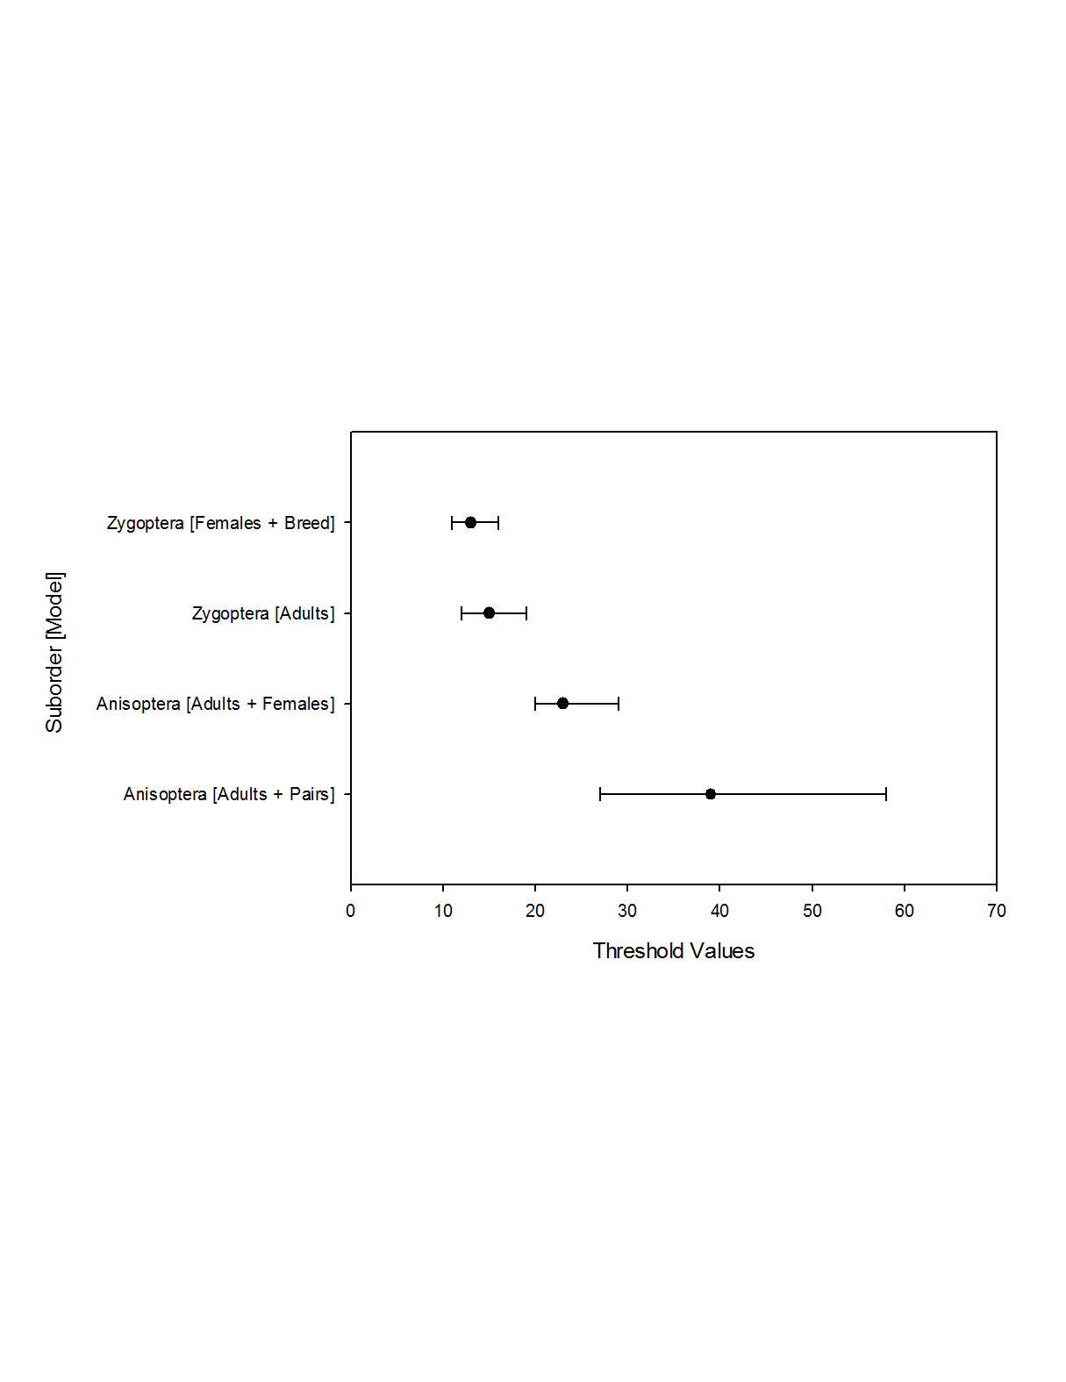
Results for Coenagrionidae varied because the three best models yielded different, but all relatively close, thresholds depending on the combination of covariates. Cordulegastridae and Corduliidae had only one model that yielded a good estimate (17-20 and 14-18, respectively). The lowest threshold for Gomphidae included a combination of total adults plus females (8-10), although two other models of note were produced. Including the size covariate, Lestidae’s thresholds were quite close for both females and total adults (ranging from 6-13). Finally, Libellulidae had a large range in threshold estimation, so it made so it made for interesting model comparison, but the best overall was female count (1-10).
Figure 1. Threshold values for both suborders, with Bayesian highest density credible intervals.

Genus Thresholds
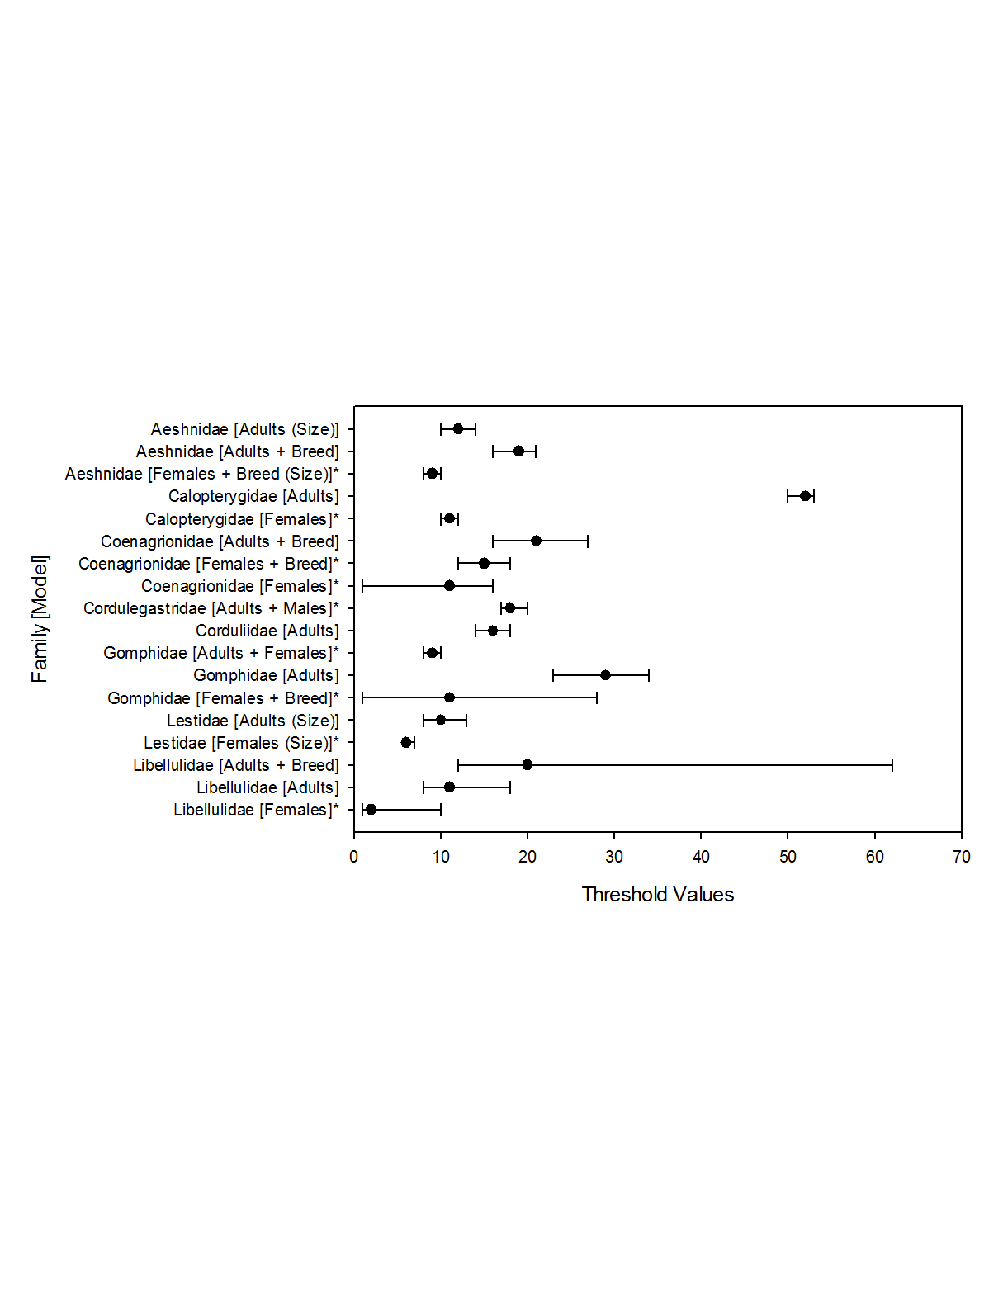
Nine out of the 50 genera assessed had sufficient data to be included in the estimates of thresholds. Others that potentially had a sufficient sample size for the response variable, tenerals, lacked sufficient data for the other covariates, or otherwise yielded poor chains in the MCMC algorithm. Dromogomphus and Erythemis had poor naïve occupancy results, but modes including covariates had improved fits (Figure 3).
Figure 2. Threshold values for 8 families, with Bayesian highest density credible intervals. * indicates models that included sex covariates, which included fewer sites.
For Argia, I found that the threshold lowered and narrowed with the addition of more specific covariates (moving from overall total adults, to females, and then to females plus breeding) for a best estimate of 9-12. Adult counts provided the best threshold estimate for Dromogomphus (20-29), Epitheca (13-18), and Phanogomphus (15-20). Enallagma had a spread of 10-23 with the best fit being a combination of females and breeding behaviors, with size considered. Similar, Ischnura had two best fits with adults and females plus breeding behaviors, with size considered (13-18, and 12-15 respectively). Females indicated the best threshold for Libellula with 14-18. Both Pachydiplax and Erythemis had top fits for total adults (10-15 and 6-9 respectively), while also yielding high fit for females (9-12 and 13-16 respectively)

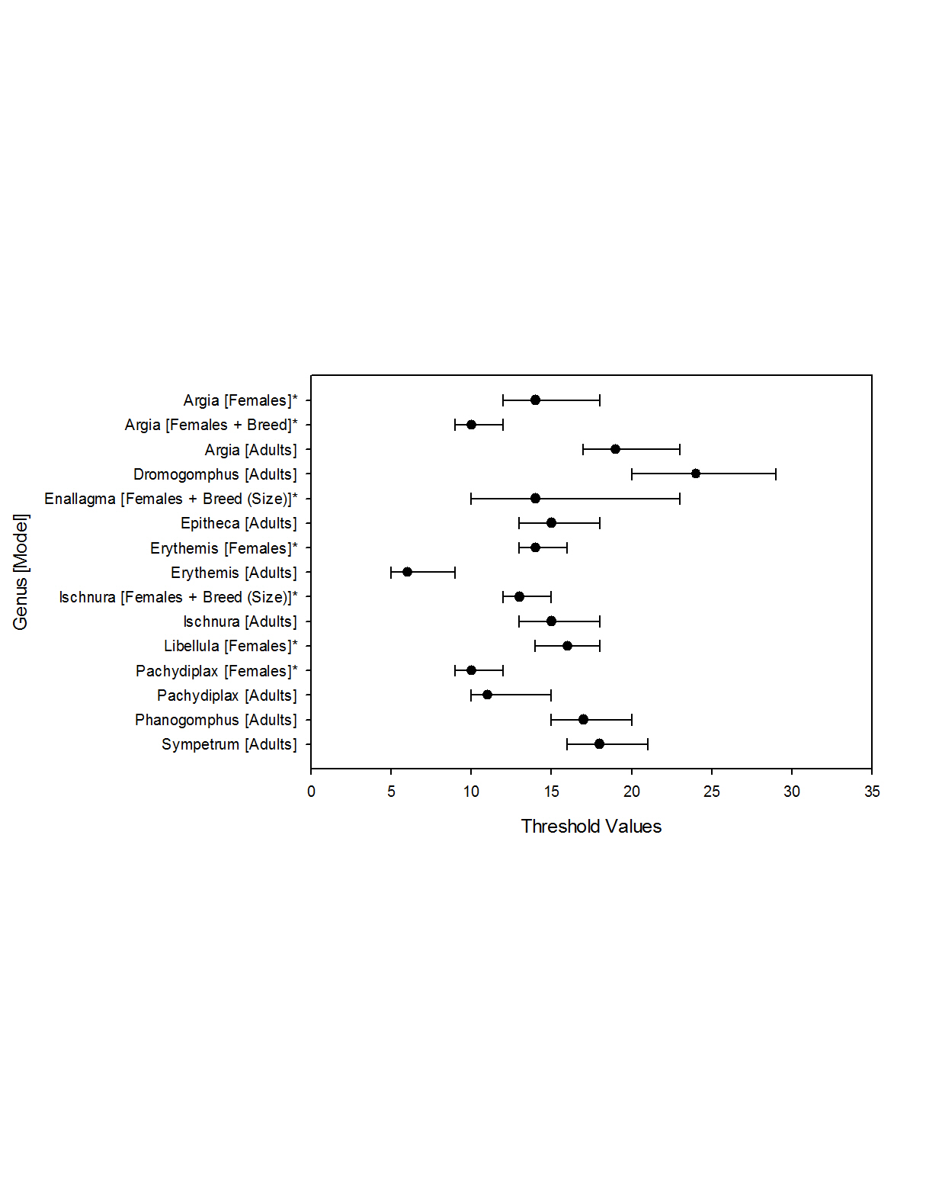
Figure 3. Genus level Threshold Values, with Bayesian highest density credible intervals. * indicates models that included sex covariates, which included fewer sites.

Discussion
I found valid criteria in terms of thresholds that accurately indicate breeding success at a site for various taxonomic divisions of odonates. I conclude that it is possible to use opportunistic data sets on adult odonates, such as those from citizen science efforts, to inform us which odonate taxa breed at a site rather than merely occur there to forage or as transients. But there was no single threshold of, say, number of adults that predicted breeding; instead, thresholds varied greatly by taxonomic division.
Covariates that appeared most commonly in best-fit models were adult abundance, number of females, and breeding behaviors (usually instances of tandem pairs and ovipositing combined). Often, estimated thresholds decreased after adding either females or breeding behavior, which makes sense because both imply an effort to reproduce. Citizen science data in which sex was noted and in which breeding behaviors were recorded would decrease the number of adults that need to be counted to conclude with high confidence that a species breeds at a site. Interpreting results from a model with only one covariate, such as total adult abundance, is more intuitive because it gives a straightforward threshold of how many need to be seen, yet combined models can be informative if one bears in mind how to interpret them, even if heuristically rather than mathematically. Treating the thresholds as “instances” of each covariate is a good way to interpret the values. For example, a threshold of 20 “instances” of Total Adults + Breeding means that any combination of these instances must occur. It could be 1 adult + 19 breeding instances, vice versa, or something in between.
Most threshold estimates were not unreasonable given the biology of the taxa. For example, Enallagma’s threshold of 10-23 instances of females and breeding behaviors is frequently observed because they often gather at high densities where these behaviors can be viewed easily, such as congregation of 500 pairs at a single water body. Even among families such as Corduliidae that include species seen infrequently, a threshold of 14 – 18 is not impossible given the tendency for some species in the family such as baskettails and emeralds to form large feeding swarms in the spring and late summer. Nevertheless, although one might expect there to be a difference in threshold based on species abundance, with a decrease in the threshold for species that are seen less frequently, I did not find this to be the case. Comparing the total adult abundance for the taxa after a log transformation to the log transformed thresholds for both adults and for female-related thresholds yielded no relationship (Figure 4).
I expected that body size would correlate with threshold estimates given the negative relationship between organism body size and abundance, especially for large predatory species, plus there a fewer species toward the larger end of the body size continuum (Kozlowski & Gawelczyk 2002; Woodward et al. 2005). Even so, this expectation was not met, and there was no obvious pattern when comparing body size among the taxa to the estimated thresholds, either for total adults or the thresholds based on females, breeding or a combination of both (lowest) (Figure 5). There was a wide spread of variation in the body sizes for each threshold that probably caused this lack of a pattern.
Most threshold models were improved (decreased) by adding females and female-related characteristics such as breeding behaviors. Comparing estimates for several families and genera to an expectation of the same threshold for both adult and adult + female totals (Figure 6), all but one of the thresholds fall below this expected line, indicating that surveys targeted towards recording females would be more informative than general species surveys. Surveys that aim to find more females might target different parts of the wetland landscape. Males often are found closer the water feature than females, which tend to congregate in adjacent vegetation away from the water bodies (Bried & Ervin 2006). Females and immature males tend to spend more time in these habitats compared to adult males, and these habitats differ in structure (e.g., more shaded) and are used for different behaviors (e.g., foraging rather than breeding), but often these other habitats are not as well studied or well surveyed (De Marco 1998). For these data, total males observed was 2.7× higher than female abundance across all taxa together, perhaps partially reflecting this issue of a higher tendency to survey sites closer to water features and a higher tendency of males to gather at those types of sites. Including nearby vegetation and adjacent areas could decrease this male bias, especially for certain species. For example, Erythemis simplicicollis has one of the lower sex ratios for all taxa and the lowest among Anisoptera (Table 4); females can easily outnumber males (N=238 records, the highest among all taxa), and I have found that this is especially true if one looks in the appropriate habitats. Perhaps this explains why Erythemis genus threshold was the single taxa that was not decreased by the addition of female abundance.
Sample size and observer effort likely affected estimates for some groups more than others. There were several differences between the proportion of records that contained sex-level information across taxa. For example, despite the relative ease of distinguishing male and female Libellulids, only 67% had sex data among this well-sampled group. Among the much sparser Lestidae, which had 98% sex data, so although many fewer individuals were seen compared to other families, a high percentage had complete records of all covariates. This is perhaps a result of their relative infrequence compared to other Zygopterans, and their “percher” behavior (Corbet 1980) lending them more easily to more careful observation and therefore recording of sex. In contrast, Libellulidae’s high abundance and “flier” tendencies often make this type of careful observation more difficult.
Knowing that these thresholds are vastly different between taxa and knowing that recording details such as sex and age can greatly reduce the thresholds, I recommend integrating protocols to improve the already impressive amount of citizen-science sourced data for numerous species of odonates. For example, on the National Biodiversity Network (NBN) Atlas, there are >1.3 million odonate records, OdonataCentral.org has ~175 thousand, all vetted by experts, and on iNaturalist.org there are >320 thousand and 80% of them are “research grade,” meaning a verifiable photo is included and was agreed to be correct by at least two observers. Recently, the latter website made it easier to add sex and age to any record with the click of a button, and the advanced interface on smartphones as well as computers enables participants to quickly upload observations with ease. Their computer vision model uses machine learning to provide image-recognition based identifications that draw on spatio-temporal information from the database to improve accuracy, so this can at least set people on the right track for narrowing down their photos to species-level identification. The Migratory Dragonfly Partnership (MDP) has a successful citizen-science based program that requires participants to record sex, age, and breeding behaviors using standardized, but relatively simple and straightforward, protocol for five common migratory species centered upon observing a particular water body site (MDP 2014).
The importance of a cooperative approach to conservation issues, such as between amateurs and professional odonatists in outreach campaigns, has been emphasized repeatedly (Bried & Mazzacano 2010). Odonata have an established role as indicator taxa (Bried et al. 2015, this study), have charismatic appeal (Hassal 2015), are relatively easy to photographically document, and have several user-friendly databases in which records can be submitted, so there is great potential to maximize the use of citizen-science resources to establish breeding success from opportunistic based adult records. There already is “infrastructure” in place that could be expanded to involve more citizen scientists; for example, observers could be urged to focus on a wider array of species in more than just a certain wetland habitat (e.g., ensure adjacent vegetation is sampled to increase the probability of recording females). Such efforts will aid in our efforts to monitor freshwater wetlands, some of the most threatened habitats on earth (Collen et al. 2014; Garcia-Moreno et al. 2014).

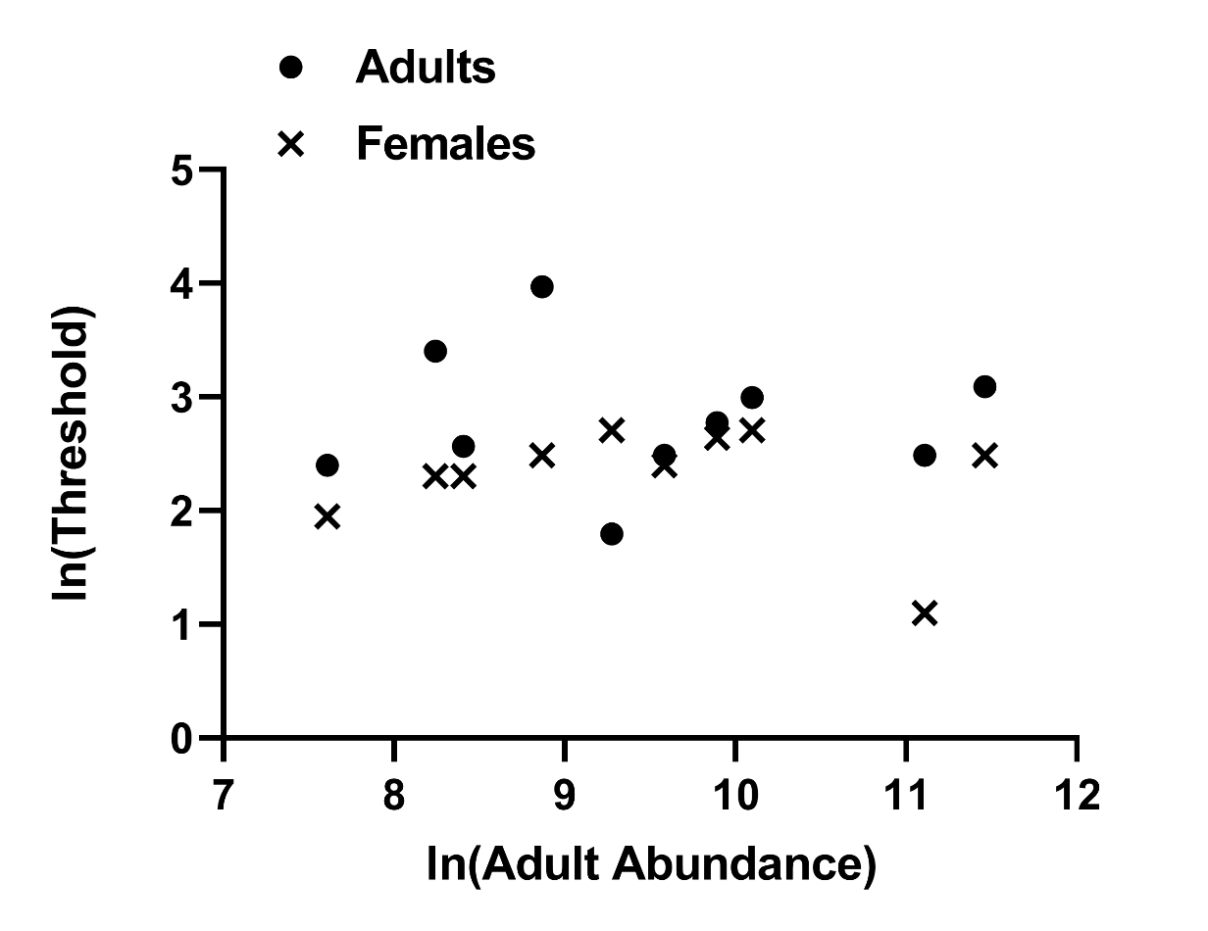
Figure 4. No relationship between the log transformed adult abundance and the threshold estimates for adults and for females across various taxa.

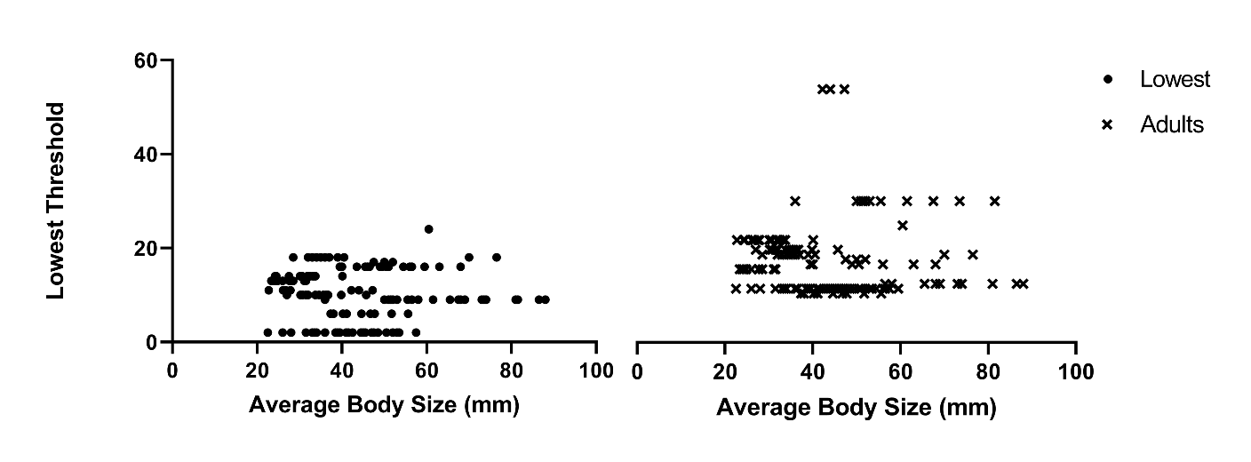

Figure 5. Comparison of average body size and the threshold estimates.

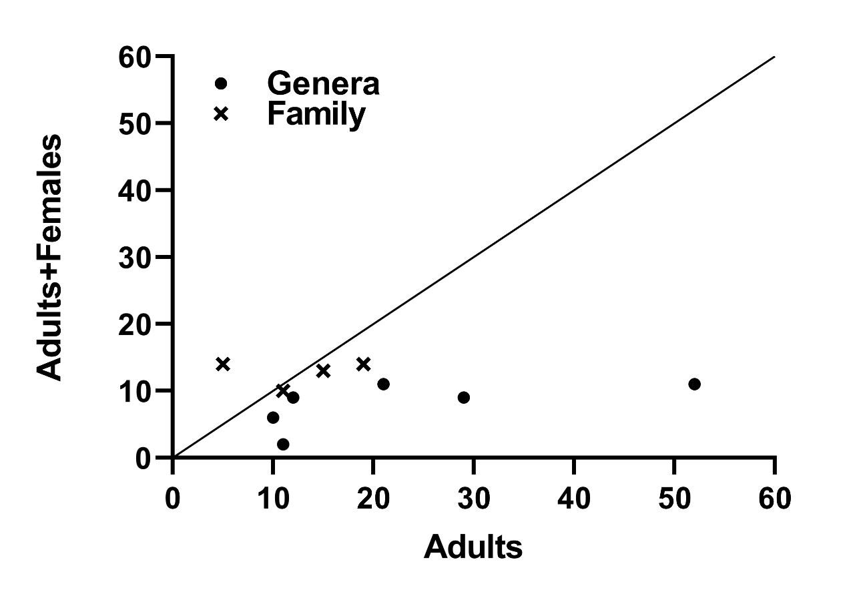
Figure 6. Comparison of median adult threshold to median adult plus female threshold. Black line illustrates the 1:1 comparison if both types of thresholds were equal. Black dots are family-level thresholds and blue dots are genus-level. Most threshold fall below the line, indicating they are decreased by the addition of female covariates.

Table 4. Sample size information for each taxon.
Taxon | Prop. Teneral of Total Indiv. | Prop. of Sexed Total Indiv. | Prop. Males of Total Indiv. | Prop. Females of Total Indiv. | Sex Ratio
Anisoptera | 0.003 | 0.67 | 0.51 | 0.16 | 3.29
Zygoptera | 0.002 | 0.66 | 0.46 | 0.19 | 2.43
Aeshnidae | 0.002 | 0.54 | 0.41 | 0.13 | 3.26
Calopterygidae | 0.001 | 0.48 | 0.34 | 0.14 | 2.45
Coenagrionidae | 0.002 | 0.66 | 0.47 | 0.19 | 2.44
Cordulegastridae | 0.096 | 0.83 | 0.67 | 0.15 | 4.38
Corduliidae | 0.011 | 0.46 | 0.32 | 0.13 | 2.47
Gomphidae | 0.027 | 0.88 | 0.67 | 0.21 | 3.16
Lestidae | 0.017 | 0.98 | 0.68 | 0.30 | 2.27
Libellulidae | 0.002 | 0.67 | 0.52 | 0.16 | 3.33
Macromiidae | 0.007 | 0.73 | 0.54 | 0.19 | 2.90
Petaluridae | 0.000 | 0.97 | 0.86 | 0.11 | 8.00
Argia | 0.002 | 0.78 | 0.58 | 0.20 | 2.81
Dromogomphus | 0.032 | 0.85 | 0.64 | 0.21 | 3.03
Enallagma | 0.002 | 0.58 | 0.43 | 0.15 | 2.87
Erythemis | 0.002 | 0.55 | 0.33 | 0.22 | 1.53
Epitheca | 0.010 | 0.42 | 0.33 | 0.09 | 3.72
Ischnura | 0.002 | 0.70 | 0.41 | 0.28 | 1.46
Libellula | 0.003 | 0.71 | 0.55 | 0.16 | 3.42
Pachydiplax | 0.002 | 0.59 | 0.51 | 0.09 | 5.97
Phanogomphus | 0.067 | 1.05 | 0.69 | 0.36 | 1.93
Sympetrum | 0.011 | 0.62 | 0.43 | 0.19 | 2.28

Chapter 2: Odonate abundance and diversity patterns at urban sites

Introduction
The need to identify how urbanization and human disturbances are affecting ecosystems has become of utmost importance in light of rapid habitat changes induced by these processes, such as construction and converting land to agricultural use, leading to habitat fragmentation, loss of species richness, and degradation of the ecosystem functions (Hill & Wood 2014; Monteiro-Júnior et al. 2015; Santangelo et al. 2018). There are multitudes of studies that attempt to answer this question in several ways among different taxa and degrees of urbanization, and their findings vary considerably. For example, bird species richness decreased in highly urban settings (Cam et al. 2000), medium levels of urban sprawl have been found to increase species richness in butterflies (Blair & Launer 1997) and dragonflies (Goertzen & Suhling 2013), while Monteiro-Júnior et al. (2015) noted overall negative richness trends across invertebrates with increasing urbanization. When considering freshwater urban systems specifically, such as ponds within urban matrices, they can provide valuable macroinvertebrate habitat and diversity levels comparable to non-urban water features in some cases (Hassall & Anderson 2015), but in other cases, such as when the connectivity between the ponds decreases, species richness was negatively affected (Gledhill et al. 2008). Some of the other effects of urbanization that could play a negative role in aquatic ecosystems include increased sediment and pollutant inflow, vegetation reduction, loss of stability from bank erosion, increased water temperatures, higher mechanical disturbances from human management, among others (Monteiro-Júnior et al. 2015; Brans et al. 2018).
Hill & Wood (2014) pointed out the deficiency of knowledge about what effects water features in fully urban areas, such as city parks and personal gardens, have on species assemblages. Urban water features can act as “biodiversity refuges” among highly disturbed areas, if managed properly (Hill & Wood 2014). These authors also noted the popularity of urban water features to city dwellers, which would likely mean less resistance if management suggestions were proposed to improve the features – with mutual benefits on biota and humans.
Therefore, there is a need to examine biodiversity at urbanized water features explicitly to determine factors promoting species diversity and abundance, and this was my objective here, with the goal of using these findings to make beneficial improvements to park management. I included a variety of sites across the spectrums of lentic versus lotic habitats, low versus high urbanization, and small versus large extent of aquatic features to get a complete perspective of different types parks in a collective urban setting. As mentioned before (Chapter 1), odonates are suitable candidates to examine community diversity given their ease of observation, possession of an aquatic and terrestrial stage that can allow them to represent an aquatic community comprehensively, and applicability of serving as a biological indicator for wetland health (Samways 2008; Kutcher & Bried 2013).

Methods
I conducted surveys at 14 urban sites throughout the years of 2016-2017 during April – October. These sites represented lentic, lotic, and a mix of both habitats and a gradient of human influence and disturbance. I used a fixed-transect method and recorded all odonate species observed, along with abundance counts (I log transformed to ensure the visual results were not skewed by several single occurrence records and by rare occurrences of very high abundance), sex counts, age-level information, and breeding behaviors. Any species that could not be identified in the field were captured, photographed, or both, for later determination. Any species that could not be positively identified was left as “unknown” and not included in further analysis. On average I visited each site 11 times and recorded time of day and length of each survey, along with any other notable occurrences.
I compiled site-level covariates using a combination of resources, including my own observations throughout each survey, and data from the city of Norman regarding each park (Halff Associates 2009; Table 5). To characterize general park statistics, I recorded size of the entire park area (area designated by the city as “developed” for the purposes of the park), and the area of the water features present, and the distance of the survey transect (which remained mostly consistent, expect when unavoidable obstacles prevented travel). To characterize features inside the parks, I used the city’s designation of “active features”, “passive features,” and “infrastructure” and included totals for each site. Active versus passive facilities differ based on how they are used by or attract humans, such as a basketball court (active) versus a bench (passive), whereas infrastructure included major modifications to the site. I classified each site based on several more subjective and dynamic features as well. For example, “fishing site” characterized sites based on the degree of use for fishing, which I treated differently that overall human activity since some sites were specifically managed by the city for this purpose, such as those part of the “Close to Home Fishing” program started by Oklahoma Department of Wildlife Conservation that stocks ponds with certain fish species. Since the degree of use changed throughout the season, I tried to assign a fair estimate to characterize overall use, despite the high variation, across the months I surveyed the site. “Impact” is perhaps the most difficult category to estimate because it includes direct management practices such as mowing, trimming vegetation, emptying trashcans, stocking fish, water treatment, water level management, or patrolling park rangers, but I attempted fair estimates based on personal experience and city park literature.
I conducted classification and regression tree (CART) analyses using the rpart package in R (Therneau et al. 2015) to measure the effects of the site variables on the number of species observed on each survey and on the species abundance totals observed on each survey. For each model, I began by including all variables and “pruned” each tree to minimize the cross-validation error and ensuring it was within one standard error of the minimum. I ran the same models using the party package because it can be argued that model is more capable of handling a variety of data types in a non-parametric manner while providing results about the statistical significance of the splits in the trees (Hothorn et al. 2006). Using ctree function in that package, I generated additional trees using the species count and the abundance total for each site.
To compare species diversity among sites, I calculated the Shannon’s Diversity Index for each site, which accounts for both species abundance and evenness, and I converted to the effective number of species. To compare diversity of sites along with species composition, I used non-metric multidimensional scaling (NMDS) in the vegan package using a Bray-Curtis dissimilarity matrix calculated with species abundance at each site, and I assessed fit using a Shepard plot and by inspecting the “stress” (goodness of fit) levels to ensure they were not too high (Oksanen 2015). This enabled comparison of the clusters for species and for sites. To visually compare species compositions across each site further, I created a heat map plot using gplots (Warnes et al. 2016). I compared presence/absence of each species and log-transformed abundance.

Results
I found 63 total species across all sites and a total of 21,664 individuals. Northeast Lions and Woodcreek had the highest richness of 36, while Timberdell had the lowest with 20; the highest abundance was Kevin Gottshall with 3658 individuals, while Cherry Creek had the lowest with 254 individuals (Table 6). However, mean species number across all the surveys at a site shifts to Kevin Gottshall with 16.22. Timberdell remained the lowest for mean species number with 5.9. Regarding effective species diversity using the Shannon Index, Cherry Creek was the highest with 21.79, while Thunderbird had the lowest score of 3.26.
When comparing presence/absence of species across each site, I found several differences between the sites, which illustrated that patterns were more complicated than just simple metrics of abundance and diversity (Figure 7). There were 7 species seen at all 14 sites, and 18 species seen only at one site (Table 7), which explains some of the groupings in the heat map. However, there are groupings comprised of multiple species that were mostly seen at one site; for example, Cherry Creek has a cluster of five species seen only there. Similarly, the comparison of abundances also showed many differences that contributed to different groupings (Figure 8). For example, Ruby Grant through Kevin Gottshall make up a block of sites with consistently high abundance for the common species, while other sites had generally lower abundance for most species, with the occasional higher values for one or two species.
NMDS results also demonstrate a clustering of sites and species, with several overlaps (Figure 9). Sites such as Timberdell, Stanley Draper, and Woodcreek were the furthest away from the center cluster, while several species such as Archilestes grandis, Progomphus obscurus, Stylurus plagiatus and Sympetrum vicinum were also far from the center of the species cluster.
CART analysis of the species abundance and number of species seen on each survey using rpart agreed that size of the water feature within the site explained each variable the best, representing the first split in each tree (Figure 10; Figure 11). Smaller water features had generally fewer individuals and fewer species. To explain species abundance at larger water features, a second split occurred for number of passive facilities, where fewer facilities yielded lower abundance. For sites with fewer facilities, degree of use was the next split, with less use correlating with fewer individuals. For sites with more facilities, degree of site heterogeneity was the next split, with high heterogeneity indicating the highest abundance. Number of species was associated with several splits. Lower species numbers at smaller water features were first split based on survey length, with the shortest surveys having the fewest number of species. Heterogeneity represented the next split for species totals ranging from 8.3 – 10.5. For larger water features, degree of human impact was the next split, and larger values indicated a greater species total. A lesser impact degree led to another split described by the amount of infrastructure present in at the site, with more infrastructure leading to higher species totals.
The trees produced using the party package estimated fewer splits for both species abundance and species totals (Figure 12; Figure 13). Degree of use for fishing purposes represented the main factor dividing the sites for both models. For abundance, this was followed by infrastructure and degree of impact, both of which explained much less of the variation. For species, this was followed by the size of the overall park area and the degree of impervious surfaces present (typically parking lots).

Discussion
I identified several characteristics of each urban site that affected the diversity and abundance of odonate species. Water feature size was the main branch for both CART trees that led to increased species total and increased abundance. Other studies have found mixed results regarding the correlation between habitat size and diversity, with some being positive (Oertli et al. 2002) and some being negative (Goertzen & Suhling 2013); however, these were between lentic sites, not a mix of both lentic and lotic. In the case of my sites, those with the smallest area of water features were lotic sites (e.g., Timberdell) with much less water than the larger lakes (e.g., Thunderbird), and they were also geographically smaller as well, so perhaps it was a combination of the amount of overall water and the general concept that a larger physical area might permit higher species and abundance that was causing an effect.
Despite having fewer species, some smaller sites had different species compositions compared to other sites. For example, Thunderbird had a low diversity overall, but had the highest total species seen on a single survey, and Northeast Lions had the highest species count overall (both sites are in the top 3 for total size), but Cherry Creek had a different suite of species seen. Importantly, these species were usually seen consistently at Cherry Creek, in comparison to sites that had a high diversity driven by rare species (Brandt, with Erythrodiplax berenice) or uncommon species, that appeared infrequently (Northeast Lions, with Phyllogomphoides stigmatus and Enallagma traviatum). Sites can also be separated further when I used criteria from Chapter 1 to determine what taxa are likely breeders at a site (Figure ). Although this is a conservative estimate, because some sites are within 1 km of each other and could therefore be pooled together, it is important to note that some sites such as Draper that have moderate levels diversity have a very low number of suspected breeder taxa.
My findings indicated that usage of a site for fishing purposes was the major determinant in increasing species abundance and diversity of these sites. Although fishing use was not directly found as part of the CART approach results, it makes sense that it is a good metric because it incorporates the other variables that were found in those analyses. For example, a fishing hotspot needs to have other features present as well (infrastructure, impact in terms of regular maintenance, passive facilities) that attract people to the site, since increased facility development is associated with site choice among anglers (Hunt 2005), and odonates were not negatively affected by the presence of these types of features, nor were they decreased by human use. Most importantly, given that fishing sites with higher water quality are preferred by anglers compared to other sites (Hunt 2005), and given that odonates also benefit from higher water quality, it would be mutually beneficial to direct management strategies towards maintaining the water quality that can sustain both fish and odonates, and ultimately be more attractive to human visitors as well.
Vegetation has been found to be a major determinant in previous studies of odonate diversity at urban sites, likely due to the role that plant cover plays for larval stages, such as shelter, foraging, and emergence, and for adults, such as ovipositing and perching (Goertzen & Suhling 2013; Remsburg & Turner 2009). Surprisingly, I did not find vegetation to be as important here explicitly; however, my estimate of vegetation directly was about the quantity of emergent and littoral cover, whereas my estimate for heterogeneity considered the variation in vegetation across all zones among other factors, and heterogeneity was an important factor in both CART models. Riparian, emergent, and littoral vegetation can drive odonate assemblage structure (Remsburg & Turner 2009), so it is important to maintain vegetation as part of ensuring habitat heterogeneity, which might be easier to manage than other aspects of the habitat.
These findings suggest that odonates can be used as indicators of the health of urban sites, especially given the increased abundance and diversity at sites managed for anglers, and management practices should aim to promote well-being of odonate populations. For example, despite the negative impact that fishing stands have been found to have on odonate richness (Müller et al. 2003), ensuring that there is wide spacing between any future stands along with promoting vegetative grown on the non-degraded shoreline areas in between can likely counteract the negative effects. Because odonates can tolerate some human usage and infrastructure, management should not focus on reducing these factors per se, but rather ensuring habitat heterogeneity persists by creating different pond types with various vegetation structures, perhaps in addition to the water features used regularly by humans (Goertzen & Suhling 2013). Because improving landscape connectivity between urban water features, even for stormwater retention ponds and highway ponds, is crucial to maintaining higher biodiversity (Le Viol et al. 2009), non-park ponds (e.g., Victory Church) that are not prioritized for management due to their lack of human use should still be treated in a similar manner to city parks. For example, the vegetation around these ponds is often mowed completely to maintain the common perspective that this means they are “clean” and more attractive; however, studies suggest that keeping a smaller area trimmed while leaving buffer strips around water features will establish an “impression of care” (Nassauer 2004) that can both satisfy human aesthetics while ensuring the feature can maintain its biodiversity. Successfully creating a network of properly managed urban water features will hopefully promote odonate population health, which could lead to improvements of urban parks for humans as well given odonates’ role in the food web: their larvae can help sustain the fish populations, while their adults can help suppress annoying pests such as mosquitoes.

Table 5. Variables used in site modeling
Group | Abbrev. | Explanation (per site)
Habitat | Hab | Lentic, lotic or a mix of both
Vegetation Cover | Veg | Amount of shoreline vegetation cover
Heterogeneity | Het | Variation in the habitat structure
Human Use | Use | Degree of use for any human activities
Fishing Site | Fish | Degree of use/management for fishing activities
Human Impact | Impact | Degree of regular direct management occurrence
Population Density | Pop | Estimated density of human inhabitants in the surrounding area
Impervious Surface | Parking | Degree of impervious surfaces (parking lots or other concrete areas)
Active Facilities | ActFac | Number of active facilities (basketball courts, disk golf, soccer fields, etc.)
Passive Facilities | PassFac | Number of passive facilities (benches, pavilions, picnic tables, etc.)
Infrastructure | Infra | Number of features that modify the area significantly (bridges, docks, restroom buildings, etc.)
Total Size | Size | Total area designated as included in the park
Water Feature | Water | Total area of the water features at the site
Survey Route | Survey | Total length of survey route

Table 6. Summary statistics for each site, including effective number of species
Site | #of Spp | Total Abund | Mean Spp | Mean Abund | Effective Number of Species (Shannon’s Diversity)
Brandt | 30 | 2459 | 13.17 | 15.56 | 8.53
Cherry Creek | 32 | 254 | 8.42 | 2.51 | 21.79
Colonial Estates | 28 | 1161 | 11.63 | 9.07 | 7.38
Deerfield | 27 | 3218 | 13 | 18.93 | 8.24
Griffin | 23 | 1231 | 12.11 | 11.29 | 9.76
Kevin Gottshall | 34 | 3658 | 16.22 | 24.88 | 7.42
Northeast Lions | 36 | 1350 | 14.45 | 8.49 | 14.87
Ruby Grant | 24 | 1236 | 10.45 | 10.74 | 7.56
Stanley Draper | 27 | 587 | 10.5 | 5.75 | 8.52
Thunderbird | 34 | 1925 | 12.33 | 19.64 | 3.26
Timberdell | 20 | 408 | 5.9 | 6.28 | 5.94
Victory Church | 23 | 877 | 10.54 | 7.51 | 10.54
William Morgan | 26 | 2449 | 8.27 | 19.75 | 4.81
Woodcreek | 36 | 851 | 9.95 | 4.6 | 12.93

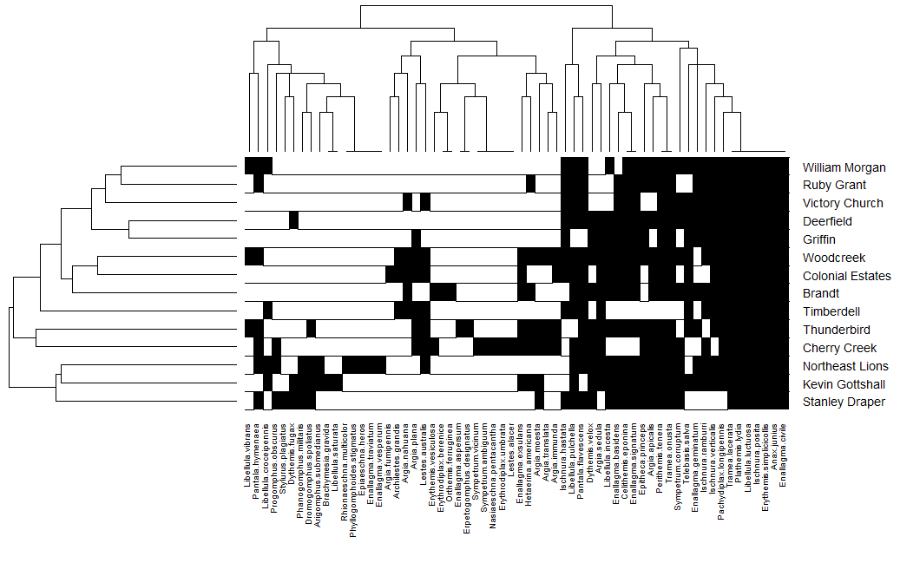
Figure 7. Heat map showing the presence/absence of species for each site, along with dendrograms showing the clustering for both.

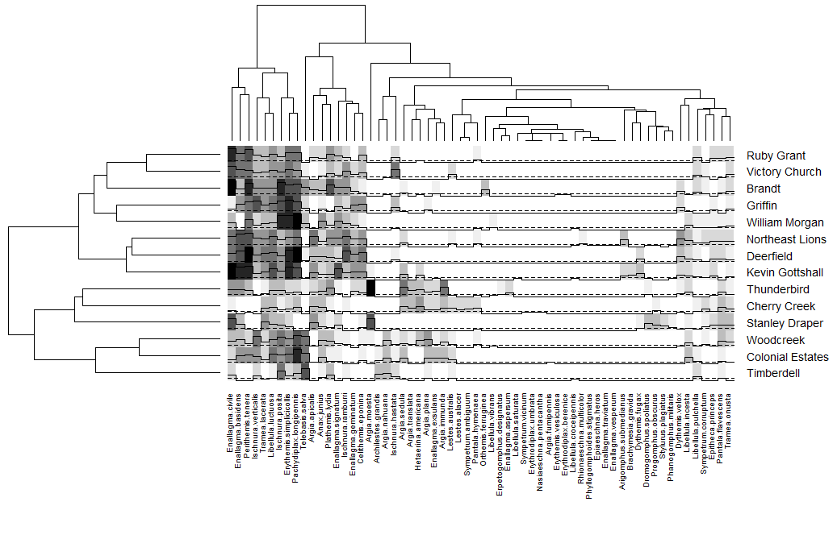
Figure 8. Heat map showing the presence/absence of species for each site, along with dendrograms showing the clustering for both.

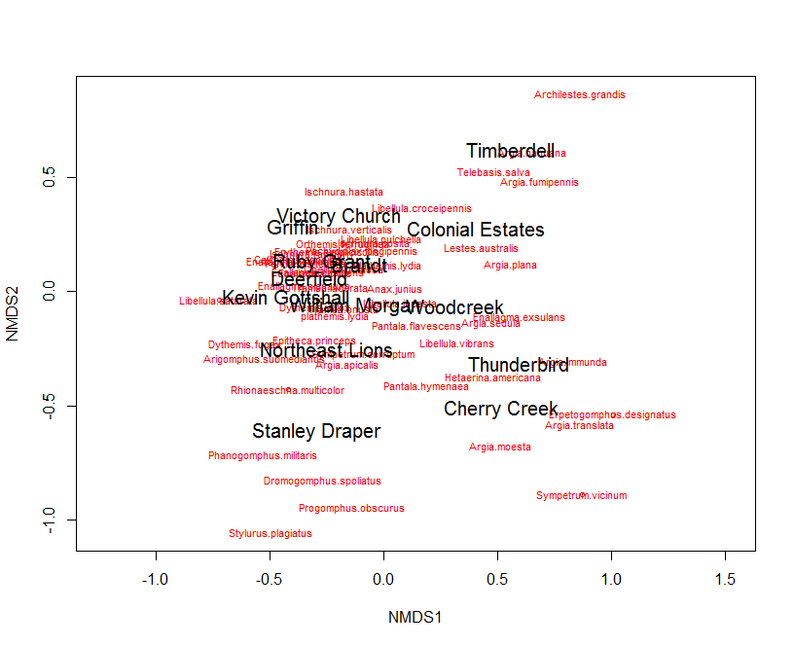
Figure 9. NMDS plot comparing the clustering of species and sites

Table 7. Observed frequency of each species observed. Frequency is given per site (how often was the species seen at each site, N=14) and per survey (how often was the species seen on each survey, N=163).
Species Name | Site | Survey
Anax junius | 1.00 | 0.37
Enallagma civile | 1.00 | 0.48
Erythemis simplicicollis | 1.00 | 0.67
Ischnura posita | 1.00 | 0.67
Libellula luctuosa | 1.00 | 0.56
Plathemis lydia | 1.00 | 0.46
Tramea lacerata | 1.00 | 0.58
Pachydiplax longipennis | 0.93 | 0.72
Perithemis tenera | 0.93 | 0.55
Tramea onusta | 0.93 | 0.26
Celithemis eponina | 0.86 | 0.27
Enallagma signatum | 0.86 | 0.37
Ischnura verticalis | 0.86 | 0.48
Libellula pulchella | 0.86 | 0.13
Pantala flavescens | 0.86 | 0.26
Argia apicalis | 0.79 | 0.31
Enallagma basidens | 0.79 | 0.48
Ischnura ramburri | 0.79 | 0.34
Argia sedula | 0.71 | 0.20
Epitheca princeps | 0.71 | 0.17
Libellula incesta | 0.71 | 0.18
Telebasis salva | 0.71 | 0.32
Dythemis velox | 0.64 | 0.20
Enallagma geminatum | 0.64 | 0.21
Ischnura hastata | 0.64 | 0.17
Sympetrum corruptum | 0.64 | 0.09
Lestes australis | 0.50 | 0.10
Pantala hymenaea | 0.50 | 0.08
Argia plana | 0.43 | 0.14
Enallagma exsulans | 0.43 | 0.10
Hetaerina americana | 0.43 | 0.10
Species Name | Site | Survey
Argia moesta | 0.36 | 0.15
Argia nahuana | 0.36 | 0.11
Argia immunda | 0.29 | 0.07
Dromogomphus spoliatus | 0.29 | 0.07
Libellula croceipennis | 0.29 | 0.02
Archilestes grandis | 0.21 | 0.06
Argia translata | 0.21 | 0.03
Dythemis fugax | 0.21 | 0.04
Libellula vibrans | 0.21 | 0.02
Phanogomphus militaris | 0.21 | 0.02
Progomphus obscurus | 0.21 | 0.05
Arigomphus submedianus | 0.14 | 0.04
Erythemis vesiculosa | 0.14 | 0.01
Argia fumipennis | 0.07 | 0.01
Brachymesia gravida | 0.07 | 0.01
Enallagma aspersum | 0.07 | 0.01
Enallagma traviatum | 0.07 | 0.01
Enallagma vesperum | 0.07 | 0.01
Epiaeschna heros | 0.07 | 0.01
Erpetogomphus designatus | 0.07 | 0.01
Erythrodiplax berenice | 0.07 | 0.01
Erythrodiplax umbrata | 0.07 | 0.01
Lestes alacer | 0.07 | 0.01
Libellula saturata | 0.07 | 0.01
Nasiaeschna pentacantha | 0.07 | 0.01
Orthemis ferruginea | 0.07 | 0.03
Phyllogomphoides stigmatus | 0.07 | 0.01
Rhionaeschna multicolor | 0.07 | 0.01
Stylurus plagiatus | 0.07 | 0.03
Sympetrum ambiguum | 0.07 | 0.03
Sympetrum vicinum | 0.07 | 0.01

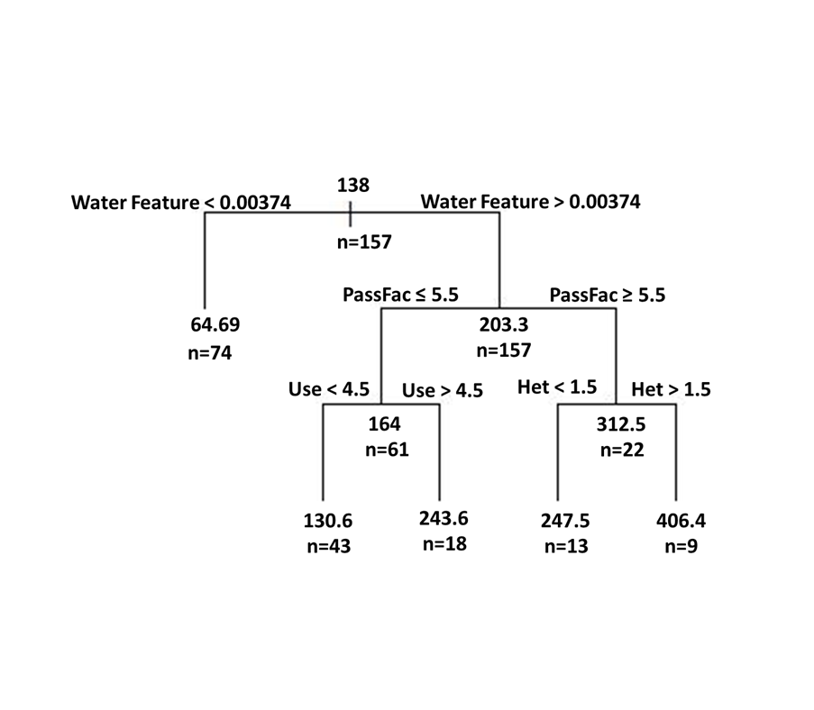
Figure 10. CART analysis using the species abundances on each survey
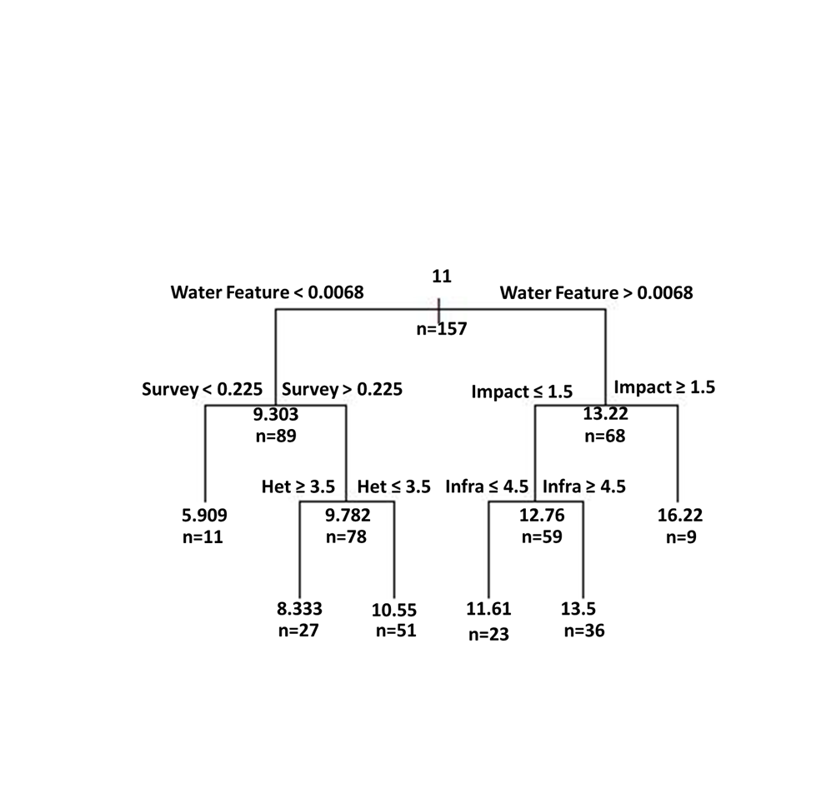
Figure 11. CART analysis using the species totals on each survey

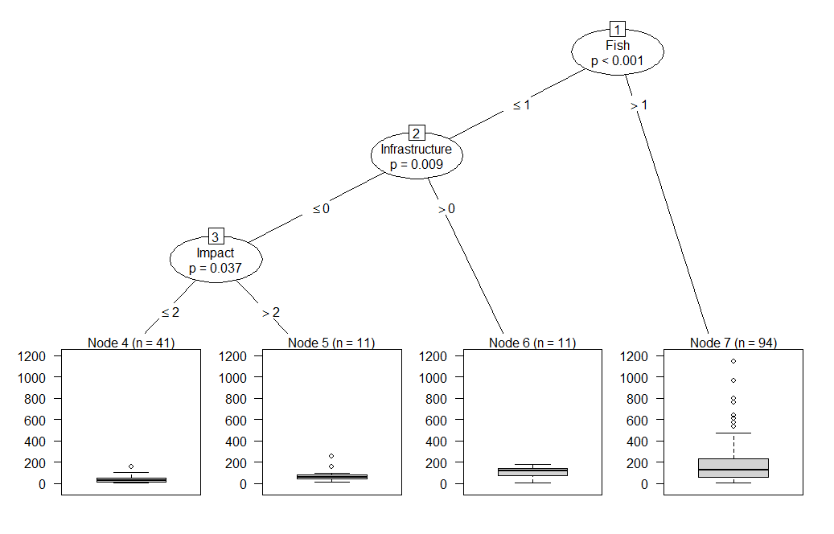
Figure 12. Recursive partitioning using species abundance totals

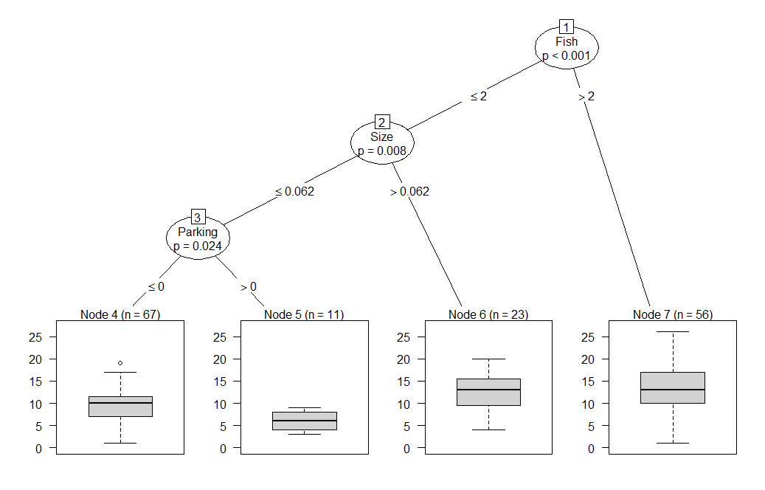
Figure 13. Recursive partitioning using species number totals

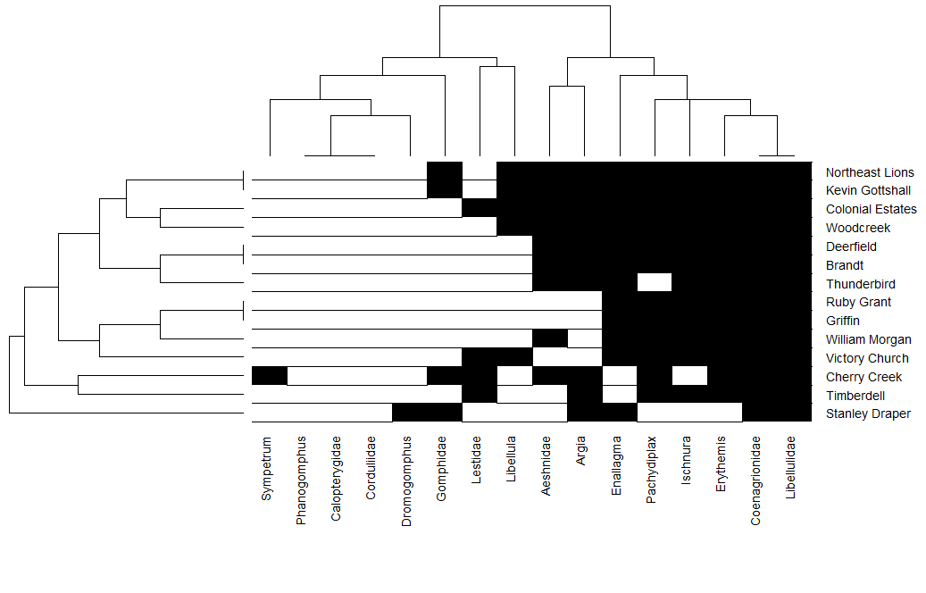
Figure 14. Heat map showing whether each taxonomic group likely breeds at a site (black shading = yes, white = no) according to thresholds estimated in Chapter 1.

References

Aliberti Lubertazzi, M. A., & Ginsberg, H. S. (2009). Persistence of dragonfly exuviae
on vegetation and rock substrates. Northeastern Naturalist, 16(1), 141-147.
Angelibert, S., & Giani, N. (2003). Dispersal characteristics of three odonate species in
a patchy habitat. Ecography, 26(1), 13-20.
Brans, K. I., Stoks, R., & De Meester, L. (2018). Urbanization drives genetic
differentiation in physiology and structures the evolution of pace-of-life syndromes in the water flea Daphnia magna. Proceedings of the Royal Society B, 285(1883), 20180169.
Beard, J. L. (2015). Perch Selection by Male Dragonflies (Odonata, Anisoptera)
Related to Competitive Ability and Species Composition (Doctoral Dissertation). Old Dominion University.
Blair, R. B., & Launer, A. E. (1997). Butterfly diversity and human land use: Species
assemblages along an urban gradient. Biological conservation, 80(1), 113-125.
Bried, J. T., & Ervin, G. N. (2006). Abundance patterns of dragonflies along a wetland
buffer. Wetlands, 26(3), 878.
Bried, J. T., & Mazzacano, C. A. (2010). National review of state wildlife action plans
for Odonata species of greatest conservation need. Insect Conservation and Diversity, 3(2), 61-71.
Bried, J. T., D’Amico, F., & Samways, M. J. (2012). A critique of the dragonfly
delusion hypothesis: why sampling exuviae does not avoid bias. Insect Conservation and Diversity, 5(5), 398-402.
Bried, J. T., & Samways, M. J. (2015). A review of odonatology in freshwater applied
ecology and conservation science. Freshwater Science, 34(3), 1023-1031.
Bonney, R., Cooper, C. B., Dickinson, J., Kelling, S., Phillips, T., Rosenberg, K. V., &
Shirk, J. (2009). Citizen science: a developing tool for expanding science knowledge and scientific literacy. BioScience, 59(11), 977-984.
Cairns, J., & Pratt, J.R. (1993). A history of bio- logical monitoring using benthic
macroinvertebrates. Pp. 10-27 in D. M. Rosenberg and V. H. Resh, eds. Freshwater biomonitoring and benthic macroinvertebrates. Chapman & Hall,
New York.
Cam, E., Nichols, J. D., Sauer, J. R., Hines, J. E., & Flather, C. H. (2000). Relative
species richness and community completeness: birds and urbanization in the Mid‐Atlantic States. Ecological Applications, 10(4), 1196-1210.
Catling, P. M. (2005). A potential for the use of dragonfly (Odonata) diversity as a
bioindicator of the efficiency of sewage lagoons. The Canadian Field-Naturalist, 119(2), 233-236.
Collen, B., Whitton, F., Dyer, E.E., Baillie, J.E., Cumberlidge, N., Darwall, W.R., Pollock, C., Richman, N.I., Soulsby, A.M., & Böhm, M. (2014). Global patterns of freshwater species diversity, threat and endemism. Global ecology and Biogeography. 23:40-51.
Conrad, K. F., Willson, K. H., Harvey, I. F., Thomas, C. J., & Sherratt, T. N. (1999).
Dispersal characteristics of seven odonate species in an agricultural landscape. Ecography, 22(5), 524-531.
Corbet, P.S. 1980. Biology of Odonata. Annual Review of Entomology, 25(1), 189-217.
Corbet, P.S. 1999. Dragonflies: Behaviour and Ecology of Odonata. Comstock Publishing Associates, New York.
De Marco, P. (1998). The Amazonian Campina dragonfly assemblage: patterns in
microhabitat use and behaviour in a foraging habitat (Anisoptera). Odonatologica, 27(2), 239-248.
DuBois, R. B. (2015). Detection probabilities and sampling rates for Anisoptera exuviae
along river banks: influences of bank vegetation type, prior precipitation, and exuviae size. International Journal of Odonatology, 18(3), 205-215.
Fiske, I., & Chandler, R (2011). unmarked: An R Package for Fitting Hierarchical
Models of Wildlife Occurrence and Abundance. Journal of Statistical Software, 43(10), 1-23. URL http://www.jstatsoft.org/v43/i10/.
Foote, A. L., & Hornung, C. L. R. (2005). Odonates as biological indicators of grazing
effects on Canadian prairie wetlands. Ecological Entomology 30: 273–283.
Garcia-Moreno, J., Harrison, I.J., Dudgeon, D., Clausnitzer, V., Darwall, W., Farrell, T.,
Savy, C., Tockner, K., & Tubbs, N. (2014). Sustaining freshwater biodiversity in the Anthropocene. In: Bhaduri, A., Bogardi, J., Leentvaar, J., & Marx, S. (Eds.), The Global Water System in the Anthropocene. Springer, Cham Heidelberg/New York/Dordrecht/London, pp. 247-270.
Gledhill, D. G., James, P., & Davies, D. H. (2008). Pond density as a determinant of
aquatic species richness in an urban landscape. Landscape Ecology, 23(10), 1219-1230.
Goertzen, D., & Suhling, F. (2013). Promoting dragonfly diversity in cities: major
determinants and implications for urban pond design. Journal of Insect Conservation, 17(2), 399-409.
Halff Associates. (2009). A Legacy for the Next Generation: The Norman Park and
Recreation Master Plan. <www.normanok.gov/parks/parks-recreation-master-plan>. Accessed 11 Nov 2018.
Hassall, C. (2015). Odonata as candidate macroecological barometers for global climate
change. Freshwater Science, 34(3), 1040-1049.
Hassall, C., & Anderson, S. (2015) Stormwater ponds can contain comparable
biodiversity to unmanaged wetlands in urban areas. Hydrobiologia, 745, 137-149.
Hill, M.J., & Wood, P.J. (2014). The macroinvertebrate biodiversity and conservation
value of garden and field ponds along a rural-urban gradient. Fundamental and Applied Limnology. 185:107-119.
Hodkinson, I. D., & Jackson, J. K. (2005). Terrestrial and aquatic invertebrates as
bioindicators for environmental monitoring, with particular reference to mountain ecosystems. Environmental management, 35(5), 649-666.
Hothorn, T., Hornik, K., & Zeileis A. (2006). Unbiased Recursive Partitioning: A
Conditional Inference Framework. Journal of Computational and Graphical Statistics, 15(3), 651-674.
Hunt, L. M. (2005). Recreational fishing site choice models: insights and future
opportunities. Human Dimensions of Wildlife, 10(3), 153-172.
iNaturalist.org (2018). iNaturalist Computer Vision Explorations.
https://www.inaturalist.org/pages/computer_vision_demo. Accessed 2018-11-10.
iNaturalist.org (2018). iNaturalist Research-grade Observations. Occurrence dataset
https://doi.org/10.15468/ab3s5x. Accessed via GBIF.org on 2018-11-11.
Kozłowski, J., & Gawelczyk, A. T. (2002). Why are species’ body size distributions
usually skewed to the right?. Functional Ecology, 16(4), 419-432.
Le Viol, I., Mocq, J., Julliard, R., & Kerbiriou, C. (2009). The contribution of motorway
stormwater retention ponds to the biodiversity of aquatic macroinvertebrates. Biological Conservation, 142(12), 3163-3171.
Martyn, P., Stukalov, A., & Denwood, M. (2018). rjags: Bayesian Graphical Models using MCMC. R package version 4-8. https://cran.rproject.org/web/packages/rjags/index.html.
Migratory Dragonfly Partnership. (2014). Monitoring Dragonfly Migration in North
America: Protocols for Citizen Scientists. <http://www.migratorydragonflypartnership.org/uploads/_ROOT/File/MDP-Monitoring_Protocols.pdf>. Accessed 4 Nov 2018.
Monteiro-Júnior, C. D. S., Juen, L., & Hamada, N. (2015). Analysis of urban impacts
on aquatic habitats in the central Amazon basin: adult odonates as bioindicators of environmental quality. Ecological Indicators, 48, 303-311.
Moore, J. A., & Gillingham, J. C. (2006). Spatial ecology and multi-scale habitat
selection by a threatened rattlesnake: the eastern massasauga (Sistrurus catenatus catenatus). Copeia, 2006(4), 742-751.
Muggeo, V.M.R. (2008). segmented: an R Package to Fit Regression Models with
Broken-Line Relationships. R News, 8/1, 20-25. URL https://cran.r-project.org/doc/Rnews/.
Müller, Z., Jakab, T., Tóth, A., Dévai, G., Szállassy, N., Kiss, B., & Horváth, R. (2003).
Effect of sports fisherman activities on dragonfly assemblages on a Hungarian river floodplain. Biodiversity & Conservation, 12(1), 167-179.
Nassauer, J. I. (2004). Monitoring the success of metropolitan wetland restorations:
cultural sustainability and ecological function. Wetlands, 24(4), 756.
NBN Atlas website at http://www.nbnatlas.org. Accessed 10 November 2018.
Needham, J. G., M. J. Westfall, & May, M. L. 2014. Dragonflies of North America.
3rd edition. Scientific Publishers, Gainesville, Florida.
Oertli, B., Joye, D.A., Castella, E., Juge, R., Cambin, D., & Lachavanne, J.B. (2002) Does size matter? The relationship between pond area and biodiversity. Biological Conservation. 104(1):59–70.
Oertli, B. (2008). The use of dragonflies in the assessment and monitoring of aquatic
habitats. Dragonflies and damselflies: model organisms for ecological and evolutionary research. Oxford University Press, Oxford, 79-95.
Oklahoma Department of Wildlife Conservation. (2018). Close to Home Fishing.
<https://www.wildlifedepartment.com/fishing/close-to-home>. Accessed 18 Nov 2018.
Oksanen, J. (2011). Multivariate analysis of ecological communities in R: vegan
tutorial. < http://cc.oulu.fi/~jarioksa/opetus/metodi/vegantutor.pdf>. Accessed 15 Nov 2018.
Palmer, M. A., Lettenmaier, D. P., Poff, N. L., Postel, S. L., Richter, B., & Warner, R.
(2009). Climate change and river ecosystems: protection and adaptation
options. Environmental management, 44(6), 1053-1068.
Raebel, E. M., Merckx, T., Riordan, P., Macdonald, D. W., & Thompson, D. J. (2010).
The dragonfly delusion: why it is essential to sample exuviae to avoid biased surveys. Journal of Insect Conservation, 14(5), 523-533.
Remsburg, A. J., & Turner, M. G. (2009). Aquatic and terrestrial drivers of dragonfly
(Odonata) assemblages within and among north-temperate lakes. Journal of the
North American Benthological Society, 28(1), 44-56.
Samways, M.J. (2008). Dragonflies as focal organisms in contemporary
conservation biology. In: Córdoba-Aquilar, A. (Ed.), Dragonflies and Damselflies: Model Organisms for Ecological and Evolutionary Research. Oxford University Press, Oxford, UK, pp. 97–108.
Santangelo, J.S., Rivkin, L.R., & Johnson, M.T.J. (2018). The evolution of City Life:
The evolution of city life. Proceedings of the Royal Society. 285(1884), 20181529.
Stoks, R., & Cordoba-Aguilar, A. (2012). Evolutionary ecology of Odonata: a complex
life cycle perspective. Annual review of entomology, 57, 249-265.
Tangen, B. A., Butler, M. G., & Ell, M. J. (2003). Weak correspondence between
macroinvertebrate assemblages and land use in prairie pothole region wetlands, USA. Wetlands, 23(1), 104-115.
Therneau, T., Atkinson, B., & Ripley, B. (2015). rpart: Recursive Partitioning and
Regression Trees. R package version 4.1-13. https://CRAN.R-project.org/package=rpart.
Tockner, K., Schiemer, F., Baumgartner, C., Kum, G., Weigand, E., Zweimüller, I., &
Ward, J. V. (1999). The Danube restoration project: species diversity patterns across connectivity gradients in the floodplain system. River Research and Applications, 15(1‐3), 245-258.
Toms, J. D., & Lesperance, M. L. (2003). Piecewise regression: a tool for identifying
ecological thresholds. Ecology, 84(8), 2034-2041.
Warnes, G.R, Bolker, B., Bonebakker, L., Gentleman, R., Liaw, W.H.A., Lumley, T.,
Maechler, M., Magnusson, A., Moeller, S., Schwartz, M., & Venables, B. (2016) gplots: Various R Programming Tools for Plotting Data. R package version 3.0.1.
Woodward, G., Ebenman, B., Emmerson, M., Montoya, J. M., Olesen, J. M., Valido,
A., & Warren, P. H. (2005). Body size in ecological networks. Trends in ecology & evolution, 20(7), 402-409.

