University of Oklahoma

Graduate College

Combining text analysis and concept mapping for conceptual model development

A thesis

submitted to the Graduate Faculty

in partial fulfillment of the requirements for the

Degree of

MASTER OF SCIENCE IN GEOGRAPHY

By

Kyndra Hanson
Norman, Oklahoma
2020

Combining text analysis and concept mapping for conceptual model development

A thesis approved for the
Department of Geography and Environmental Sustainability

BY THE COMMITTEE CONSISTING OF

Dr. Jennifer Koch, Chair

Dr. Scott Greene

Dr. Darren Purcell

© Copyright by Kyndra Hanson 2020
All Rights Reserved.

Acknowledgements
I would first like to thank my thesis advisor, Dr. Jennifer Koch, of the Department of Geography and Environmental Sustainability at the University of Oklahoma. Dr. Koch was always there for guidance and introduced me to interdisciplinary studies. She is the reason I even contemplated graduate school and I am forever thankful for that. I would also like to thank the members of my committee, Dr. Scott Greene and Dr. Darren Purcell, who have been supportive and have always offered help when I needed it.
I would also like to acknowledge Dr. Stephanie Paladino and Dr. Jack Friedman, who are the environmental anthropologists in the USGS-funded project Improving Resilience for the Rio Grande Coupled Human-Natural System (Grant No. G15AP00132). The have encouraged me throughout the entire research project and have always been willing to share their knowledge with me. Thank you for being patient with me during my multiple iterations of text analysis.

Table of Contents
Acknowledgements iv
List of Tables vii
List of Figures viii
Abstract x
Chapter 1: Introduction 1
Chapter 2: Background 5
The Need for Stakeholder Involvement 5
Text Analysis 8
Gensim 10
Topic Modeling 10
Latent Dirichlet Allocation 11
Text Preprocessing 13
Visualization 13
Concept Mapping 16
Chapter 3: Materials and Methods 19
Study Area 19
Input Data 20
Implementation of the Text Analysis 22
Concept Mapping 22
Text Analysis 24
Compare and Contrast 25
Analysis Design 26
Chapter 4: Results 28
Concept Mapping 28
Text Analysis 32
Test 1-1 32
Test 1-5 32
Test 5-1 33
Test 5-5 34
Test 10-1 36
Test 10-5 38
Test 37-5 40
Test 10-5a 43
Combining the Text Analysis with the Concept Map 49
Chapter 5: Discussion 52
Concept Map 53
Text Analysis 53
Combing Concept Map and Text Analysis 55
Topics Found Only in the Text Analysis 55
Topics Found Only in the Concept Map 57
Topics Found in Text Analysis and Concept Map 57
An Argument for Test 37-5 58
Chapter 6: Conclusion 62
References 64
Appendix A 75

List of Tables
Table 1: The Naming Convention for the Sensitivity Analysis Runs. 27
Table 2: List of the Concept Map Components, their Type, Category, and Network Metrics. 31
Table 3: Topic and Term Output for the Test 1-1 Text Analysis Run. 32
Table 4: Topic and Term Output for the Test 1-5 Text Analysis Run. 33
Table 5: Topic and Term Output for the Test 5-1 Text Analysis Run. 33
Table 6: Topic and Term Output for the Test 5-5 Text Analysis Run. 35
Table 7: Topic and Term Output for the Test 10-1 Text Analysis Run. 37
Table 8: Topic and Term Output for the Test 10-5 Text Analysis Run. 39
Table 9: Topic and Term Output for the Test 37-5 Text Analysis Run. 41
Table 10: List of Words Omitted from Adjusted 10-5a Text Analysis Run. 43
Table 11: Topic and Term Output for the Adjusted 10-5a Text Analysis Run. 44

List of Figures
Figure 1 The graphical model representation for Latent Dirichlet Allocation (Blei & Lafferty, 2009) 13
Figure 2: Example of the Interactive Visual Output Created with pyLDAvis (Cheng et al., 2018). 15
Figure 3: The Rio Grande/Río Bravo River Basin Study Area. 20
Figure 4: Conceptual Map for the Rio Grande/Río Bravo Coupled Human-Natural System. 30
Figure 5: The Visual Output for the Test 5-1 Run of the Sensitivity Analysis. 34
Figure 6: The Inter-distance Topic Map for the Test 5-5 Run of the Sensitivity Analysis. 36
Figure 7: The Inter-topic Distance Map for the Test 10-1 Run of the Sensitivity Analysis. 38
Figure 8: The Inter-topic Distance Map for the Test 10-5 Run of the Sensitivity Analysis. 40
Figure 9: The Inter-topic Distance Map for the Test 37-5 Run of the Sensitivity Analysis. 42
Figure 10: The Inter-topic Distance Map for the Adjusted 10-5a Text Analysis Run. 45
Figure 11 The Inter-topic Distance Map and 30 Most Relevant Terms for Topic 2 using the Adjusted 10-5a Text Analysis Run. 46
Figure 12 The Inter-topic Distance Map and 30 Most Relevant Terms for Topic 7 using the Adjusted 10-5a Text Analysis Run. 47
Figure 13 The Inter-topic Distance Map and 30 Most Relevant Terms for Topic 9 using the Adjusted 10-5a Text Analysis Run. 48
Figure 14 The Inter-topic Distance Map and 30 Most Relevant Terms for Topic 10 using the Adjusted 10-5a Text Analysis Run. 49
Figure 15 Comparison of the Original Concept Map with the Additional Topics Identified with the Text Analysis. Topics that were inferred from Test 10-5a are in purple and topics inferred from Test 37-5 are in teal. 51

Abstract
The Rio Grande/Río Bravo River (RGB) stretches through Colorado, New Mexico, Texas and Mexico before it reaches the Gulf of Mexico, spanning a politically, socio-economically, and environmentally diverse region. Management decisions in this highly complex coupled human-natural system (CHANS) may lead to unintended outcomes throughout the basin, upstream and downstream. The interactions between the river, the basin’s landscape, and the people that rely on these land and water resources have not been addressed in a whole-basin and spatially explicit modeling approach, which has left a gap in knowledge regarding plans for managing changes in water availability due to climate change. To address this, collaborators (Drs. Paladino and Friedman) conducted a multitude of in-person interviews with water managers, large agricultural water users, and non-governmental actors charged with water management decisions in the RGB. The resulting interviews provided the underlying information used to explore and analyze the social processes that are behind those decisions. A concept map was developed to be used as a tool to visually document the local knowledge on decision making in the RGB and to support the development of a simulation model of the RGB CHANS. Since the RGB basin is large and environmentally and culturally heterogeneous, I tested an approach to reduce the time needed to analyze the interview data and develop the concept map: an automated text analysis, based on a topic model approach. By implementing a topic model on the interviews, I tested whether a topic model had the potential to reduce the time needed for concept map development and/or if the topic model would be able to support the concept mapping process. In this document, I briefly discuss the concept map and its development process, since they form the basis of this research. Then I introduce text analysis and the topic modeling approach specifically, followed by the identification of topics and their relationship to the concept maps. The results from the topic modeling analysis show a large overlap with the topics identified in the context of the concept mapping process. However, the text analysis also identified several topics not covered in the concept map, including (water) rights and regional and local variations. My research displays that while an automated text analysis approach has the potential to support interdisciplinary research on supporting computer simulation model development and parameterization with qualitative information from stakeholder interviews, it also has considerable limitations and is, at this point, not suitable to replace interdisciplinary research efforts.

Chapter 1: Introduction
Many of today’s environmental problems have become so complex that different disciplines have to work together and use an interdisciplinary approach to address these problems. Interdisciplinary approaches bring together two or more disciplines to investigate research problems and rely on the collaboration of researchers to successfully reach a shared research goal (Graybill et al., 2006). Interdisciplinary research is not easily performed. It requires a commitment from all participating researchers to invest the time necessary to learn and understand multiple aspects of these research projects (van Rijnsoever & Hessels, 2011). However, with sufficient time and invested effort, these types of research projects not only have the potential to improve our understanding of complex socio-ecological problems, but they also provide the opportunity to develop more diverse research questions in the future (Jakeman et al., 2006).
Models are a common tool to improve our understanding of socio-ecological systems, and many definitions exist that define what characterizes a model. In this document, the focus is on models representing the social component of coupled human-natural systems (Liu et al., 2007). According to Gilbert (2008, p. 79), a model is “a simplified representation of some social phenomenon. Executing or ‘running’ the model yields a simulation whose behavior is intended to mirror some social process or processes.” While modeling is often associated with prediction, the importance of modeling goes beyond prediction (Epstein, 2008). A model can help explain how a system works based on data and previous knowledge of the system because a simplified version of the existing area under study is the basis of model design (Jakeman et al., 2006; Maria, 1997). Not only can models help explain specific dynamics of the studied system, but they also aid in the development of new research questions (Epstein, 2008). A model may originally be developed to answer a set of questions, but during the modeling process, new research questions and new research opportunities can emerge (Jakeman et al., 2006). Furthermore, developing a model can also help researchers identify data gaps and direct future research towards obtaining the missing information (Epstein, 2008). Simulation models in some ways both explain and predict as the training data interprets the past to predict the future (Sargent, 2013).
A common method used for modeling social processes and for analyzing questions of natural resources management is participatory modeling (Voinov & Gaddis, 2008; Voinov & Bousquet, 2010; Voinov et al., 2016; Prell et al., 2007). Participatory modeling is a modeling approach that relies on stakeholder input to build and integrate models (Prell et al., 2007). Typically, modelers work with local experts and stakeholders to gather insights and local knowledge on how decisions are made under certain conditions (Purnomo et al., 2005; Simon & Etienne, 2010; Voinov et al., 2016; Voinov & Bousquet, 2010; Voinov & Gaddis, 2008). According to Grimble & Wellard (1997, p. 175) stakeholders are defined as “any group of people organized, who share a common interest or stake in a particular issue or system.” Through participation by stakeholders, objectives from different stakeholders and stakeholder groups can be aligned with the model development process so that the model purpose addresses the problem (Gray et al., 2012; Prell et al., 2007). The integration of knowledge that stakeholders offer can increase the detail and better represent socio-ecological systems (Gray et al., 2012). Additionally, stakeholder participation in the model development process increases trust of the stakeholders in simulation results and research outcomes (Luyet et al., 2012). The success that participatory modeling has had in water resource management has been positive and the models developed through this process can provide more useful information to stakeholders and decision makers (Voinov & Gaddis, 2008).
One way of including stakeholder representation during model development is through cognitive mapping (Gray et al., 2015). Cognitive mapping, or concept mapping, is a way of visualizing the thought process of a person when thinking about a problem. It is a good way to begin the conceptual model development phase in interdisciplinary work by bridging the knowledge gap between team members (van Vliet et al., 2010). Concept maps are often developed in group stakeholder workshops (Gray et al., 2018) and represent the subjective world of a group of stakeholders (Gray et al., 2012). By using concept maps, it is possible to gain insights on stakeholders’ personal attributes, such as their expertise and values, applicable to the research on and model of the system under study (Elsawah et al., 2015). While the use of concept maps adds complexity to the modeling process by making it more integrated (Voinov & Shugart, 2013), the input and representation of stakeholders can lead to more beneficial and accepted model results (Eden, 2004; van Vliet et al., 2010).
Including stakeholders in the modeling process does also come with disadvantages. Stakeholder participation increases the time and cost of model development (Gray et al., 2012). Participatory modeling can be especially expensive when stakeholder involvement occurs throughout the entire modeling process (Bailey & Grossardt, 2010). While highly desirable, this type of stakeholder involvement increases the complexity and decreases the ability of stakeholders to interpret outcomes (Gray et al., 2012). Involving stakeholders for large-scale studies would take too much time and resources to complete or underrepresent the stakeholders present (Bailey & Grossardt, 2010; Luyet et al., 2012)
Here, I present research that used information from in-person interviews analyzed with a topic model as a means to represent stakeholder views for model development and to represent decision-making processes in conceptual models and ultimately simulation models for coupled human-natural systems. I present the results of a study that aims to combine the results of a text analysis conducted on transcribed interviews with a concept map developed by a research team to represent stakeholders’ interpretation of the processes that drive the Rio Grande/Río Bravo River Basin to aid in conceptual model development. Specifically, I examined whether a text analysis could identify additional topics to those identified in an interdisciplinary approach to aid in the development of a conceptual (or cognitive) map for the RGB coupled human-natural system.
In Chapter 2, I provide an overview of how including local stakeholder knowledge can affect the model development process in coupled human-natural systems. I also introduce the themes text analysis and concept mapping. Chapter 3 describes the Rio Grande/Río Bravo River Basin and the ethnographic fieldwork conducted by Drs. Friedman and Paladino as inputs for a text analysis. The resulting concept map, the results of the text analysis, and the connections made between the two methods are detailed in Chapter 4. The discussion of how each text analysis ran became an iterative process and the connections that could be made between the text analysis results and the concept map concludes Chapter 5. In Chapter 6, I discuss how my results could be implemented in concept mapping practices and how interdisciplinary research can be difficult but rewarding.

Chapter 2: Background

The Need for Stakeholder Involvement
In 2011, at the Dresden International Conference on Integrated Water Resource Management, experts concluded that the implementation of integrated water resource management processes was behind expectations, and urged those in the field to expedite their efforts (Hering & Ingold, 2012). Hering & Ingold (2012) also recognized the need to provide guidelines on how to integrate water resource management practices and how to approach the inclusion of stakeholders representing the unique perspective of water users and policy makers in water resource management research. The coupled human-natural systems approach (Liu et al., 2007) provides a new way to conceptualize water-scarce systems; coupled human-natural systems are complex systems that require multiple perspectives to represent (and simulate) stakeholder interest throughout the system under study (Gray et al., 2012). Some modelers have begun to include stakeholders and decision makers in the process of developing solutions to complex environmental problems that can be understood by all, are streamlined for a specific area, and are also scientifically sound (Voinov & Gaddis, 2008). This inclusive way of model development is referred to as participatory modeling.
Participatory modeling uses stakeholder input in the iterative modeling process (An, 2012). Stakeholders participate in the modeling process, for example, by informing the modelers on what decision they would make under the given circumstances (An, 2012; Borowski & Hare, 2007; Voinov & Bousquet, 2010). Voinov & Bousquet (2010) suggest that any model focusing on coupled human-natural systems would benefit from including human and social processes since humans impact the environment through management of natural resources.
There has been a push for providing model-based tools that scientists and stakeholders can use to understand how processes affect and influence each other (Borowski & Hare, 2007). Many of the tools previously developed to analyze these relations did not meet the needs of the stakeholders; collaboration with the target audience of the tools could improve the development process (Borowski & Hare, 2007). Understanding the need for better integration and communication with stakeholders, Luyet et al. (2012) worked in the Third Rhône Correction Project aimed at flood protection and enhancing environmental and socio-economic functions of the Rhône River in Switzerland. The authors conducted a qualitative analysis of 49 different stakeholder interviews to determine what new knowledge stakeholders had acquired during project workshops and their interpretation of issues surrounding the project. Based on their findings, the research team was able to improve their technical solutions suggested to stakeholders in the study area (Luyet et al., 2003, 2012). Hence, communication and collaboration with regional and local stakeholders in the research process in general, and in the model development process specifically, does allow researchers to access important information on human decision making, while also leading to the development of more useful models and decision support tools.
While including stakeholders in the modeling process is the key mechanism in participatory modeling, the mode and degree of this inclusion can vary. According to Voinov et al. (2016) the participation of stakeholders during model development can range from informing modelers through extractive use of information and knowledge from local stakeholders to full engagement throughout the entire model development process. Modelers can work with individuals representative for decision makers in the study area to gather insights on decision making under certain conditions, or to develop agent typologies and decision rules for agent-based models (An, 2012; Purnomo et al., 2005; Simon & Etienne, 2010). Within any given area, there can be a multitude of different types of stakeholders and stakeholder groups and each stakeholder represents a different attitude or perception present in the study area. By communication and participation from stakeholders, a variety of objectives from different stakeholder groups can be aligned with the model development process (Gallego-Ayala & Juízo, 2014).
Many studies exist that show how participatory modeling has improved the model development process and the outcomes of modeling studies. For example, Borowski & Hare (2007) sought to link stakeholders and modeling for integrated water resource management by hosting policy workshops with different target groups, such as water managers. It was during these meetings that the researchers identified that water managers felt that the communication between them and researchers was lacking and should be addressed in the future. Gallego-Ayala & Juizo (2014) used questionnaire responses from stakeholder groups to infer stakeholder preferences regarding water resource management. The authors found that utilizing the questionnaire responses allowed water resource management plans to be developed in a way that is more connected to stakeholder groups and more geared towards the stakeholder preferences (Gallego-Ayala & Juízo, 2014). To summarize, many different modes of stakeholder inclusion in the modeling process exist, ranging from extractive use of knowledge from stakeholders to complete integration of stakeholders in the modeling process. There is a general agreement that including stakeholders better informs modeling developers of social processes and those benefits outweigh the risks in modeling coupled human-natural systems.

Text Analysis
Text analysis is a broad term used across disciplines to describe different research approaches analyzing text. The level of detail that is required in each research approach defines what text actually is. In practice, text can be classified as individual words, documents or sentences as well as other defined sections such as abstracts of journal articles (Miner et al., 2012). Examples of the different types of text analysis include text classification, information extracting, or concept extracting (Miner et al., 2012). Text classification is the grouping of texts into categories (Grimmer & Stewart, 2013). Information extracting is defined by the identification of relationships or facts from unstructured text whereas concept extraction groups words or phrases into groups that have similar meanings (Miner et al., 2012). Although many different methods of text analysis exist, one common trend in text analysis is to conduct a quantitative analysis of text (Gaffield, 2018).
Another type of text analysis is topic modeling. Topic modeling extracts a set or group of words from the underlying document(s) that together form a general topic (Eickhoff & Neuss, 2017). That means a topic model will reflect the core topics and terms associated from the analyzed document(s) (Eickhoff & Neuss, 2017). Topic modeling, or any type of text analysis, is performed on a set of documents, referred to as corpus. The corpus is the entire set of text documents that the analysis will be conducted on (Blei et al., 2003; Řehůřek, 2011). Text documents can be as small as paragraphs, sentences, or phrases but also as large as articles. One advantage that topic modeling has is that it can be utilized with large archives of documents that humans do not have the power to analyze (Jannidis et al., 2017), or that would take much longer to be analyzed by humans directly.
The advantages of using a text analysis is the ability to work with a large corpus, i.e., a set of texts, without requiring large amounts of funding (Grimmer & Stewart, 2013). For example, Google would not be able to produce useful results to user searches within a reasonable time frame, without some form of text analysis (Miner et al., 2012). Text analysis typically also provides tools to create different, often interactive, visualizations to communicate the characteristics of the identified topics (Yang et al., 2008). Hence, by applying text analysis via topic modeling, text can be transformed into useful visuals for better understanding the content of the analyzed corpus (Karpovich et al., 2017). While a quantitative method for analyzing text cannot replace humans, the ability to analyze a large corpus of information via text analysis enables users to identify topics that otherwise would be overlooked, validate existing theories, or focus research efforts (Grimmer & Stewart, 2013).
Computational text analysis software is available in different programming languages such as R, Java, or Python. For each programming language there are packages readily available to conduct a text analysis. Many software packages for text analysis are free to use and open source. Within R, the 'tidytext' package was developed to run many text analysis processes (Silge & Robinson, 2016). A popular text analysis package implemented in Java is Mallet. Mallet was developed at the University of Massachusetts-Amherst and performs natural language processing, information extraction, and other text analysis approaches (McCallum, 2002). In the Python programming language, the Natural Language Toolkit platform provides modules and functions for analyzing natural language text (Loper & Bird, 2002). One tool that uses the Natural Language Toolkit and is compatible with other visual output packages is Gensim (Řehůřek & Sojka, 2010).

Gensim
Gensim is a Python package that was developed by Radim Řehůřek (Řehůřek & Sojka, 2010). The Gensim package can be used to extract semantic topics from documents automatically and is user friendly while also being highly efficient (Řehůřek, 2011). The statistical semantics hypothesis states that “statistical patterns of human word usage can be used to figure out what people mean” (Turney & Pantel, 2010, p. 146). Although broad, the statistical semantics hypothesis is a philosophical way of moving towards quantitative instance approaches and is an underlying assumption in the bag-of-words hypothesis used in Latent Dirichlet Allocation (LDA) (Řehůřek, 2011). According to Řehůřek (2011, p. 7) “in information retrieval, the bag-of-words hypothesis states that word frequency vectors can be used to assess the semantic relevance of documents.” A multiset or bag, is a set of values or variables where duplicates are allowed. The order does not matter for sets but the frequency of values or variables does.

Topic Modeling
Topic modeling, one of the many types of text analysis, has many different applications for describing documents in a corpus; examples include document classification (Wang, 2017) and data discovery (Blei, 2012). Topic modeling can be used to discover the hidden statistical regularities in text data in supervised, unsupervised, or semi-supervised methods, all in the context of natural language processing (Wang, 2017). Supervised, unsupervised and semi-supervised methods are classified based on the level of human input. A supervised method is used when human coders classify a sample of documents into user defined categories. Those classifications are then used to train the topic model to classify the remaining documents (Grimmer & Stewart, 2013). Unsupervised methods use the properties of the text within documents and modeling assumptions to categorize documents (Grimmer & Stewart, 2013). Semi-supervised methods use both user categorized and uncategorized documents to train the model to categorize documents (Keyvanpour & Imani, 2013).
There are multiple methods that can be used to design a topic model, two of the most widely used being Latent Semantic Indexing (LSA) and Latent Dirichlet Allocation (LDA) (Eickhoff & Neuss, 2017). There are two layers within a topic model, documents and tokens. Documents are pieces of text, such as a manuscript, article, or a subset thereof. Tokens are the individual words in the documents. The size of document vectors determines the number of tokens in the corpus vocabulary (Řehůřek, 2011).

Latent Dirichlet Allocation
The simplest topic modeling approach is the Latent Dirichlet Allocation, which assumes documents to be comprised of multiple topics (Blei, 2012). According to Blei et al. (2003, p. 1), “Latent Dirichlet Allocation (LDA) is a generative probabilistic model of a corpus.” The term “generative” describes the underlying model assumption that documents are random mixtures of latent topics (Blei, 2012). Hence, when using a generative probabilistic model, the data is assumed to come from a generative process that can include hidden variables (Blei, 2012). Topic modeling with LDA is completely unsupervised, meaning that the model infers the content of the data rather than assume the topics (Roberts et al., 2014). The LDA process works to find the groupings of co-occurring words through two steps: 1) for each individual document, allocate words to a few topics and 2) for each topic, assign a high probability to only a few terms. With these goals working against each other, LDA comes to topic-term distributions (Blei, 2012).
The topic’s that are extracted by an LDA analysis can be interpreted as a probability distribution over words and are inferred from the training corpus (Řehůřek & Sojka, 2010). The LDA algorithms used in Gensim are distributed, streamed, and incremental. This is important because it is usable with more computers because of the linear distribution, runs in constant memory from being streamed, and can update an existing model with new training data (making the algorithm incremental) so new data can continue to be processed (Řehůřek, 2011).
In text analysis, LDA assumes each document is a random mixture of topics and each topic is a distribution over words. The process displayed in Figure 1 is a graphical way, known as a plate diagram, to visualize how the LDA process works. If there are D documents, each document d consists of N_{d} words and in Figure 1 is labeled as w_{d,n}, or each observed word. LDA starts with η, the topic parameter, and α, the proportions parameter (Blei et al., 2003; Hoffman et al., 2013). Both of these are priors that can be set or inferred by the LDA model and must be a positive number greater than zero (Wallach et al., 2009). The α parameter corresponds with the mixture of topics in a document and the closer to zero it is the less of a mixture of topics. Meanwhile, the η parameter corresponds to the mixture of words in topics and a higher η results in topics having more specific word distribution. Both θ and β follow Dirichlet distributions where β is a distribution over the vocabulary of words and θ is a distribution over topics. A Dirichlet distribution is a probability distribution that samples a probability simplex (numbers that together add up to 1) and assumes that components (topics) are nearly independent (Blei & Lafferty, 2009). This means that it is assumed that the presence of one topic does not correlate to the presence of another topic. The process of producing the LDA is created by the interaction of the documents and the topic structure. β and θ are represented as matrices. In the matrix θ, documents define the rows and topics define the columns. Matrix β has topics defining the columns and words defining the rows. Z is the number of topics for each document or the per-word topic assignment.

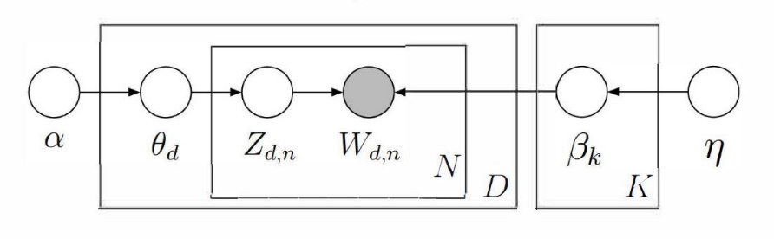
Figure 1 The graphical model representation for Latent Dirichlet Allocation (Blei & Lafferty, 2009)

Text Preprocessing
Before a text analysis can be performed on the corpus, the documents making up the corpus must first be preprocessed. The preprocessing of the corpus includes the following process steps: (1) eliminate common or frequently used words (Řehůřek, 2011) by using a corpus containing words like the, also and a, for example, was the NLTK Python package called ‘stopwords’ (Bird, 2002); (2) tokenization of documents to split the documents into lists of individual words and remove punctuation (Řehůřek, 2011); and (3) token normalization, which is ignoring case variations (Řehůřek, 2011).

Visualization
Visual output for the text analysis with LDA can be produced using the pyLDAvis package, implemented in Python (Sievert & Shirley, 2014). The visual contains two interactive components (Figure 2). The panel to the left displays the topics plotted in two dimensions based on a multidimensional scaling algorithm described in Chuang et al. (2012). The multidimensional scaling algorithm is used because the LDA analysis derives several topics, based on the input, and each of those topics consists of a multinomial distribution of words from the corpus (Chuang et al., 2012).
The plot created is labeled the Inter-topic Distance Map and is the result of using a multidimensional scaling algorithm, Principal Component Analysis (PCA), on a distance matrix derived using the Jensen-Shannon divergence on the topic-term distributions (Figure 2). The Jensen-Shannon divergence is a method used in probability theory and statistics to measure the similarity between two probability distributions (Tong & Zhang, 2016) and is used here to compare the spatial distribution of words in the original document and the distribution in the overall corpus (Mehri et al., 2015). The individual topics are represented by circles and the size of each circle is proportional to the relative prevalence of the topic within the corpus. Topics that contain similar words appear closer and the more dissimilar topic descriptors are, the father apart they are in the plot.
Each topic circle is also selectable to further investigate each topic individually. When there is no topic selected, the plot on the right is a bar chart showing the top salient terms of the corpus. The saliency of a term is a measure of how frequently the term is found throughout the corpus and how individualized it is in characterizing the different identified topics. Saliency of each topic is calculated using the word frequency and the conditional probability distribution of the subject in the vocabulary (Xie et al., 2018). Once a topic is selected, the bar chart will change to show the most relevant terms within the selected topic. These lists of terms are what is useful in interpreting the topic.
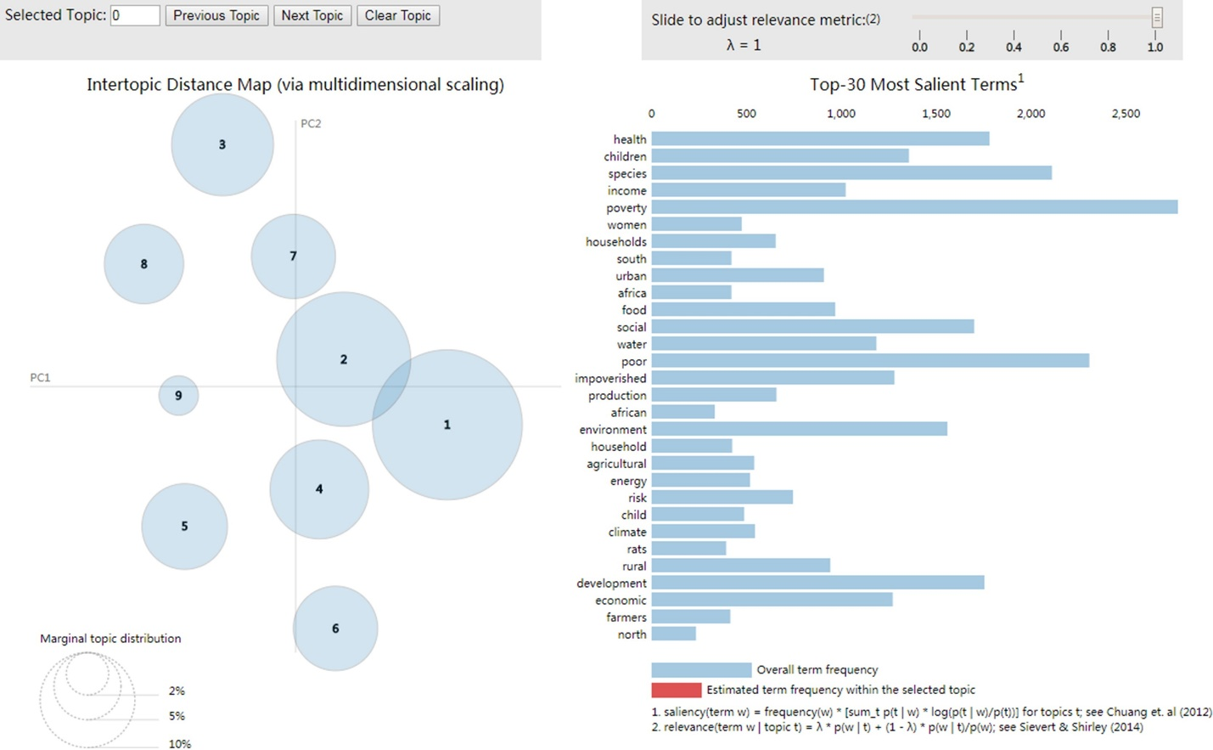
Figure 2: Example of the Interactive Visual Output Created with pyLDAvis (Cheng et al., 2018).

The relevancy of a term to a topic is calculated using λ, which is the weight given when calculating the probability of a term occurring within a topic (Sievert & Shirley, 2014). The value of λ can be changed with a slider in the range between 0.0 and 1.0 (Figure 2). A λ value of 1.0 ranks terms in decreasing order according to their probability within the topic selected for being displayed in the bar chart (Sievert & Shirley, 2014). A λ value of 0.0 will rank the term’s by the ratio of the terms probability within a topic to its probability across all topics (Taddy, 2011).

Concept Mapping
As part of the USGS-funded project titled Improving Resilience for the Rio Grande Coupled Human-Natural System, I was involved in the development of a concept map for the RGB coupled human-natural system (Koch et al., 2019). This concept map forms an important basis for the research presented here. Concept maps are variations of influence diagrams. Influence diagrams represent the relevant system structure’s influence through direct relationships (Bossel, 2007, p. 65). These maps are developed by determining the core elements that represent the system. These elements are also called nodes and often displayed as boxes, with one box representing an individual element. Arrows then connect the nodes of the system, representing the influences and relationships between the nodes. A sign of relationship is then determined for each arrow, representing the directionality of the relationship. A positive sign assigned to the arrow indicates that if the value of an element represented by a node changes in one direction, these changes cause the connected node to change in the same direction. Changes can be both, positive and negative. A negative sign means that as the value of one element changes, the value of the element it influences (or vice versa) changes in the opposite direction (Bossel, 2007, pp. 66–67).
Concept maps allow researchers to communicate about a system under study by describing its basic structure. This structured and visual mode of collaboration helps to clarify topics and to share knowledge between members of a research group (Novak & Cañas, 2008). The development of concept maps requires each group member to share their knowledge of the system under study to create a shared representation of the knowledge on a system. This also helps to connect the disciplines involved and adds systems understanding in model development (van Vliet et al., 2010).
Originally developed by a research program at Cornell University to understand specific changes in childrens’ understanding of science concepts, Novak (1990) developed concept maps to transform twelve years’ worth of fifteen to twenty-page transcribed interview data into a workable one-page summary for each interview. This allowed the researchers to visualize how different students connected scientific knowledge, and how that knowledge changed from year one to year twelve (Novak, 1990; Novak & Cañas, 2006). Hossard et al. (2013) used concept maps to work with stakeholders on developing different scenarios of cropping systems. Stakeholders were interviewed and asked to, with the help of concept maps, illustrate different aspects of the cropping system that would ultimately be used as inputs to a simulation model. Concept maps are also widely used in the medical research community. For example, Green & Aarons (2011) used concept mapping to compare two groups of stakeholders’ perceptions of the barriers to implementing services for mental health. Rather than having the stakeholders illustrate their individual beliefs and perceptions, Green & Aarons (2011) used concept maps to have the stakeholder place supplied topics into groups and make connections between those topics.
Mental Modeler is a framework and software tool designed for the development of conceptual maps. The Mental Modeler interface allows the user to develop components and give each component a weight of influence (Gray et al., 2013). Furthermore, the components can also influence each one another and Mental Modeler has many ways of representing these relationships. The relationships between components can be either positive, negative or with no directionality of relationship being defined (Gray et al., 2013). Mental Modeler can also transform the visual information into a matrix for quantitative analysis. The matrix informs the user how many nodes or components are defined in the model. Connections are defined as how many connections each node has with other nodes and are used to calculate the degrees in, degrees out, and centrality of each node. The degrees in to each node is calculated by adding the incoming arrows to each node. Degrees out is the sum of how many arrows are leaving each node. Centrality represents the total number of degrees in and degrees out for each node. These measures are used to classify each node as driver, receiver, or ordinary node. Driver nodes are those that only influence other nodes. A receiver node is only influenced by other nodes while an ordinary node both influences and is influenced by other nodes. Here, we used the Mental Modeler software to implement a conceptual map.

Chapter 3: Materials and Methods

Study Area
The World Wildlife Fund (WWF) has classified the RGB as one of the most endangered transboundary rivers in the world (Wong et al., 2007). With a length of 3,059 km, the RGB is the 5th longest river in North-America. Split nearly evenly between the United States and Mexico, the RGB basin covers an area of 552,382 km² (Figure 3). According to GlobeLand30, cultivated area covers only 3.5% of the area in the basin (Jun et al., 2014), yet agricultural activities are estimated to use 83% of the water (estimate based on U.S. Geological Survey, 2010 and National Water Commission of Mexico, 2010). The basin has a diverse climate including mountainous, semi-arid to arid, and subtropical regions that affect the river’s streamflow both spatially and temporally. A multitude of dams, reservoirs, and canals were established in the RGB basin to help meet the needs of the estimated 10.5 million people that the basin serves (population estimate based on Sandoval-Solis et al., 2013). Over-allocation of water has put a strain on water availability in the basin and resulted in multiple bi-national and interstate agreements for the distribution of the scarce water resources.

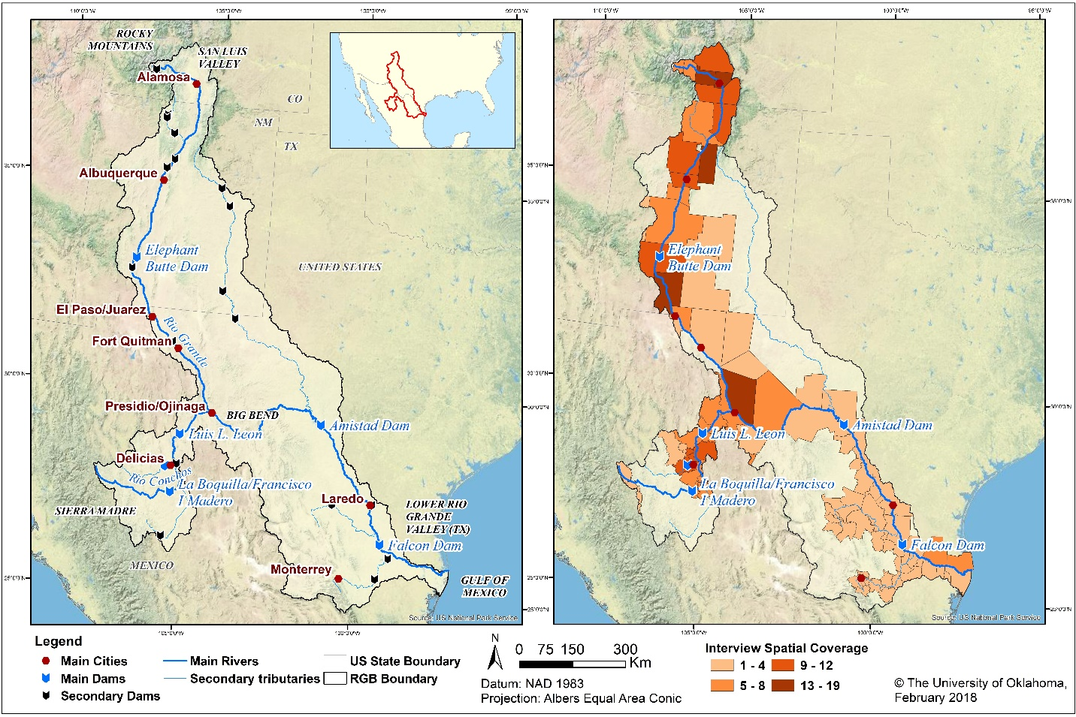
Figure 3: The Rio Grande/Río Bravo River Basin Study Area.
The panel on the left displays the Rio Grande/Rio Bravo basin outlines as well as the major tributaries, cities, and dams. The panel on the right displays the spatial coverage of interviews (Koch et al., 2019).

Input Data
The input for the text analysis presented here consisted of the text output from interviews conducted as part of an interdisciplinary research project on the RGB coupled human-natural system. The interviews were part of the ethnographic fieldwork conducted by two environmental anthropologists, Drs. Friedman and Paladino. In the context of her fieldwork, Dr. Paladino relocated to the study area for thirteen months. This relocation was to conduct interviews and participant observations of stakeholders in the RGB study area (Figure 3). Study participants were selected by initially using purposive sampling (Tongco, 2007) of key informants, or stakeholders, followed by a snowball sampling of recommended informants. After completing the initial research visit to the RGB basin, Dr. Paladino returned for multi-week visits in the Conchos River Basin, Chihuahua, Mexico and New Mexico, USA to continue and expand her ethnographic fieldwork and to achieve a better coverage of the RGB study area. Dr. Friedman also undertook multiple trips to the study area to conduct in-person interviews and participant observations, which complemented those of Dr. Paladino. The interviewed stakeholders were farmers, water managers, and representatives of water associations (Figure 3, panel on the right). The numerical values for interview spatial coverage represents how many times that individual county was represented by an interviewee. Some stakeholders have decision domains spanning more than one county; therefore, the interview spatial coverage values do not represent the location of the interviewees. The interviews were semi-structured in nature; while they all followed the same general layout, not all interviewees would be asked the same questions or the same number of questions. Rather, the interviews were designed around open-ended questions and provided the flexibility to deepen the discussion around interesting points raised by the interviewees.
In total, the ethnographic fieldwork resulted in 53 transcribed interviews. While more interviews were conducted as part of the fieldwork, not every interview was transcribed (e.g., due to some interviewees choosing to not have their interviews recorded). Overall, the ethnographic fieldwork produced about 104 hours of recorded interviews and over 2,500 pages of transcribed documents. These transcriptions are the input -- or corpus -- of the text analysis described as part of this research. Each transcribed interview was saved into an individual document. The interview documents were then converted into text documents with a ‘.txt’ file extension. The format transition eliminated any formatting or special characters and left a document that included only the bare text, meeting the required input format for the Gensim software (see Chapter 2).

Implementation of the Text Analysis
I did not have access to the transcribed interviews, which required a close collaboration with Dr. Paladino for carrying out the text analysis. Since the Institutional Review Board (IRB) approval process was carried out before I joined the project, and, hence, I did not have approval to access the interview transcripts directly, I worked with Dr. Paladino to test, debug, and carry out the text analysis in an iterative manner. I started by providing a detailed step-by-step description of how to preprocess the data and sent it to Dr. Paladino. I furthermore implemented all the Python scripts and debugged the scripts based on her feedback. Once the final, running script was developed, I completed the setup for the different tests, and then passed it to the Dr. Paladino, who ran it on her computer. After the completion of the processing, I was provided with the raw output of the Python script, which I then analyzed and evaluated. By following this iterative setup, I was able to implement the analysis without accessing protected information. At the same time, this collaborative approach allowed me to communicate with the anthropologists on the team on the feasibility and usefulness of text analysis of interview data.

Concept Mapping
As part of the RGB research process, we developed a concept map describing the RGB coupled human-natural system. The concept map was a first step towards developing a computer simulation model for the RGB. The process of developing the concept map for the RGB was an interdisciplinary research process, and was carried out as a joint effort with the modeling team and environmental anthropologists (Koch et al., 2019). Unlike the modelers on the project team, the environmental anthropologists conducted research in the field and visited the study area for extended periods of time. The concept mapping process was an important part of our interdisciplinary research for several reasons: (1) Since the novel aspect of the RGB research project was to provide a simulation model for the coupled human-natural system, the social processes in the study area were critical to understand how water resources were used. The concept mapping process represented one way to transfer the knowledge on social processes in the study area from the anthropologists to the modelers of the research team; (2) The concept mapping process was furthermore an excellent way to establish a deep working relationship and trust between the members of the project team, which had not collaborated on a project before; and (3) Aside from describing the important social processes in the study area, the concept mapping also provided a way to describe the system components and their relationships as described and discussed by the interviewees – representatives of the stakeholders in the RGB study area.
Beginning in June 2016, meetings were held to develop the concept map an average of two times per month until October 2017. The meetings typically took between 2-4 hours each. Defining the model purpose was the first step to developing a concept map for the basin, since the concept mapping was one step of the larger model development process. Defining the model purpose is typically carried out in an iterative manner and - although we loosely defined the model purpose in the early stages of concept map development we refined and redefined it as the concept map developed (Koch et al., 2019).
The concept map was developed to visualize the main topics and concerns that were identified during the interviews conducted in the RGB study area for the purpose of adjusting the final simulation model to stakeholder needs. During the development process, we emphasized that the intention of the concept map was not to represent how the RGB system works, but rather represent how those interviewed perceive the system to work. This is crucial as it forms the basis for their decision making. During our regular meetings, we started by identifying three important topics from the interviews conducted in the field: irrigation, environmental flows, and evapotranspiration. It is important to mention that the number of topics was not limited, but decided on by the anthropologists. We then developed individual concept maps around each topic to understand in more detail how the interviewees perceived the make-up and relationships of the respective sub-systems. During the entire concept mapping process, the modelers of the project team served as facilitators of the mapping exercise and provided supporting information, e.g., in the form of maps or statistics, while the content of the process was driven by the anthropologists and their knowledge derived from fieldwork in the study area.
Once it was agreed upon that each individual concept map was a good representation of the interviews, we combined the three individual concepts maps for irrigation, environmental flows, and evapotranspiration into one final, comprehensive concept map. The process of combining the three individual concept maps into one involved more than simply combining the three maps. Careful consideration to our model purpose was taken and more components, such as the direction of influence, type of influence, and classification, of each topic were discussed and implemented.

Text Analysis
Due to my experience with the Python programming language, I focused on tools and packages that could be implemented using Python. After conducting a comparison of the vast amount of available text analysis software and programming methods, I determined that I would use the Gensim Python package. One major reason for choosing Gensim was that Gensim was built for topic modeling in the scope of natural language processing (Řehůřek & Sojka, 2010). Also, since Gensim is a Python package, I could use the Natural Language Toolkit for preprocessing the input data (Loper & Bird, 2002). Gensim also has the compatibility needed to produce visual output that complements the concept maps and allows for a visual analysis of the results. When using Gensim to identify topics within a corpus of text, it is possible to specify how many terms will be given in the output as well as how many topics that will arise from the analysis.
I was interested most in the topics that would arise out of the interviews. Gensim was designed for topic modeling and can be used to analyze the individual interviews, as text documents, and find relationships between words then use those relationships to identify topics and categorize documents (Ebeid & Arango, 2016). It is also possible to adjust the number of topics inferred. I needed to use a topic modeling approach that would not require a training dataset of classified documents, an unsupervised approach, to eliminate the need for me to directly access the interviews and reduce bias from user defined classifications. This is relevant, because the goal was to identify topics that we were not aware of after going through the conceptual mapping exercise. Hence, I chose the LDA algorithm, which is an excellent fit for analyzing text with no metadata and is useful in exploratory settings.

Compare and Contrast
The concept mapping processing and the text analysis are different approaches to conceptualizing the system under study based on interview data for a model development process. Concept mapping allowed us to understand, summarize, and visualize the knowledge the anthropologists had gathered from interviews and it helped us to get a better understanding of the RGB study area and to find topics that need to be included in the model that would be otherwise overlooked. While not a replacement for the collaborative conceptual mapping process, the text analysis allows us to further analyze the interviews in an unbiased manner, without having to see the physical transcription of data and to quantify topics. Hence, the analysis aimed to compare the topics discovered in the concept mapping exercises with the topics discovered through the text analysis. The interesting outcome of this analysis are topics that are found in the text analysis, but not in the concept mapping exercise. We plan to use those to start further discussions with the research team to improve our systems understanding and model representation of the RGB.

Analysis Design
Since the topic model is unsupervised, the only input parameters that the user can designate are the number of topics and the number of terms those topics will contain. I carried out six initial analyses to test how the topic model performed under different input conditions and to better understand the results of the text analysis and their implications. These initial analyses included the following pairings of number of topics/terms: one topic/one term, one topic/five terms, five topics/one term, five topics/five terms, ten topics/one term, and ten topics/five terms. The tests that only were set for one topic ran successfully, but given that there was only one topic determined, there was no visual output. Therefore, I eliminated both one topic outputs from possible contention. I conducted an additional test on 37 topics with five terms. I selected 37 topics to match the number of topics identified in the concept map developed with the interdisciplinary team. The eight different combinations of topics and terms, Table 1, were used as a sensitivity analysis to determine the best topic-term combination that fit the interview dataset.

Table 1: The Naming Convention for the Sensitivity Analysis Runs.
The topics column shows the number of topics that were to be identified in each run. The terms column displays the number of terms that make up each topic.
Test | Topics | Terms
Test 1-1 | 1 | 1
Test 1-5 | 1 | 5
Test 5-1 | 5 | 1
Test 5-5 | 5 | 5
Test 10-1 | 10 | 1
Test 10-5 | 10 | 5
Test 37-5 | 37 | 5
Test 10-5a | 10 | 5

In the following chapters, each run of the text analysis displayed in Table 1 is described. Together, these runs make up the sensitivity analysis. There are eight different runs with differing amounts of topics and terms as the differing parameters in each run (Table 1).

Chapter 4: Results
In this chapter I describe the results of both, the concept map development and the text analysis. I briefly describe the concept map itself along with the topics identified in the process of developing the concept map. Furthermore, I present each text analysis run tested as part of the sensitivity analysis. Finally, I describe the text analysis run selected as most representative from all the runs conducted in the context of the sensitivity analysis. I describe this text analysis run in further detail, include samples from the interactive features of the text analysis, and compare and contrast the results to the concept map.

Concept Mapping
The concept map was developed as part of the USGS-funded project Improving Resilience for the Rio Grande Coupled Human-Natural System (Award Number G19AC00102). The approach to, the context of, and the results from the concept mapping exercise are described in detail in Koch et al. (2019). I was part of the team developing the concept map, and I am a co-author of the corresponding publication.
The final concept map (Figure 4) was developed in the Mental Modeler software (Gray et al., 2013). The map includes 37 components representing the core topics identified from stakeholder interviews. The 37 components are represented by boxes, which are connected by a total of 86 connections (arrows). Altogether, the components and those connections result in a density score of 6.8% (Table 2). In general, components fall into three categories: ordinary components, driver components, or receiver components. Ordinary components have both, outgoing and incoming connections. Driver components only have outgoing components, i.e., they only influence other components. Receiver components only have incoming components, i.e., they are only influenced by but do not influence other components. The concept map for the RGB has 23 ordinary components with both outgoing and incoming connections (Table 2). Nine of the remaining components are considered drivers and only influenced by other components. The final four components are only influenced by other components. To improve the visual representation and the system understanding, the interdisciplinary team categorized the components as either mixed, human, hydrology, ecosystem, or environment components (Figure 4).
Table 2 provides a detailed list of the components identified in the concept map and their categorization. The type and the network metrics of degree in, degree out and centrality were derived from the Mental Modeler software (Gray et al., 2013). Included in these components that were not influenced by other components, rainfall was the highest influencer affecting ten other components (Table 2). Rainfall also had the second highest centrality which means that even though it was not influenced by other components identified, its influence was prominent enough to be a major factor in the concept map. The only other component with a higher centrality was streamflow, which was influenced by seven other components but influenced eight different components (Table 2).
Human components were also identified in the concept map. Irrigation had the highest centrality score of all of the components categorized as human. Multiple other human components identified focused on how people visit and use the RGB. The Endangered Species Act was identified as a driver of other components, but only influenced two other components.
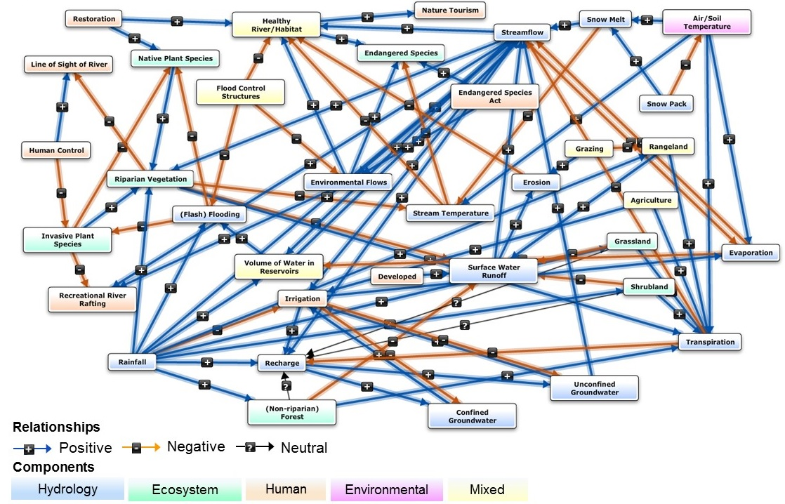
Figure 4: Conceptual Map for the Rio Grande/Río Bravo Coupled Human-Natural System.
The concept map was developed as part of the USGS funded project Improving Resilience for the Rio Grande Coupled Human-Natural System (Koch et al., 2019). The concept map consists of 23 ordinary components, nine driver components, and four receiver components.

Table 2: List of the Concept Map Components, their Type, Category, and Network Metrics.
The type and network metrics (degree in, degree out, centrality) were generated with the Mental Modeler software (Gray et al., 2013).
Component | Degree In | Degree Out | Centrality | Type | Category
Agriculture | 0 | 2 | 2 | Driver | Mixed
Developed | 0 | 1 | 1 | Driver | Mixed
Endangered Species Act | 0 | 2 | 2 | Driver | Human
Flood Control Structures | 0 | 3 | 3 | Driver | Mixed
Grazing | 0 | 2 | 2 | Driver | Mixed
Human Control | 0 | 2 | 2 | Driver | Human
Rainfall | 0 | 10 | 10 | Driver | Hydrology
Restoration | 0 | 2 | 2 | Driver | Human
Snow Pack | 0 | 2 | 2 | Driver | Hydrology
(Flash) Flooding | 3 | 2 | 5 | Ordinary | Hydrology
(Non-riparian) Forest | 1 | 2 | 3 | Ordinary | Ecosystem
Air/Soil Temperature | 1 | 4 | 5 | Ordinary | Environment
Confined Groundwater | 2 | 1 | 3 | Ordinary | Hydrology
Environmental Flows | 3 | 3 | 6 | Ordinary | Hydrology
Erosion | 2 | 1 | 3 | Ordinary | Hydrology
Evaporation | 3 | 2 | 5 | Ordinary | Hydrology
Grassland | 1 | 2 | 3 | Ordinary | Ecosystem
Healthy River/Habitat | 6 | 2 | 8 | Ordinary | Mixed
Invasive Plant Species | 2 | 3 | 5 | Ordinary | Ecosystem
Irrigation | 5 | 4 | 9 | Ordinary | Human
Native Plant Species | 3 | 1 | 4 | Ordinary | Ecosystem
Rangeland | 2 | 2 | 4 | Ordinary | Mixed
Recharge | 4 | 2 | 6 | Ordinary | Hydrology
Riparian Vegetation | 4 | 4 | 8 | Ordinary | Ecosystem
Shrubland | 1 | 2 | 3 | Ordinary | Ecosystem
Snow Melt | 2 | 2 | 4 | Ordinary | Hydrology
Stream Temperature | 3 | 2 | 5 | Ordinary | Hydrology
Streamflow | 7 | 8 | 15 | Ordinary | Hydrology
Surface Water Runoff | 6 | 2 | 8 | Ordinary | Hydrology
Transpiration | 7 | 2 | 9 | Ordinary | Hydrology
Unconfined Groundwater | 2 | 2 | 4 | Ordinary | Hydrology
Volume of Water in Reservoirs | 3 | 2 | 5 | Ordinary | Mixed
Endangered Species | 4 | 0 | 4 | Receiver | Ecosystem
Line of Sight of River | 2 | 0 | 2 | Receiver | Human
Nature Tourism | 1 | 0 | 1 | Receiver | Human
Recreational River Rafting | 3 | 0 | 3 | Receiver | Human

Text Analysis
In this section, I describe the results for the sensitivity analysis, consisting of eight different runs for the text analysis (Table 1). For each run, I provide a table with the topic(s) and the key word term(s) comprising the topic. Where applicable, I also present the visual output created with the pyLDAvis package (Sievert & Shirley, 2014). Furthermore, I describe the key differences between the various text analysis runs.

Test 1-1
Test 1-1 is the first text analysis run of the sensitivity analysis. I set the topic and term variables to one in order to get an overall topic and term. The term know was the resulting topic/term (Table 3). Since the number of topics was set to one, no visual output was created. This is because the visual output requires more than one topic to show the differences between topics.

Table 3: Topic and Term Output for the Test 1-1 Text Analysis Run.
Topic | Key Word Terms
Topic 1 | know

Test 1-5
Test 1-5 text analysis run resulted in one topic, but the number of terms that make up that topic was set to five terms (Table 4). In addition to the term know (echoing the result from Test 1-1), this topic also displayed the terms water and think. The topic could be interpreted as a ‘water knowledge’ topic; however, know and think are words that can be used in many different contexts. It is important to note the terms hmm and mm, which will be discussed in the section for Test 10-5a. Since the number of topics was set to one, no visual output was created.

Table 4: Topic and Term Output for the Test 1-5 Text Analysis Run.
Topic | Key Word Terms
Topic 1 | know | hmm | mm | water | think

Test 5-1
Test 5-1 produced five topics with one term each (Table 5). Since this run has more than one topic, it was the first run of the sensitivity analysis to produce a visual output (Figure 5). Again, know and water were topics identified by this analysis run (Table 5). Additionally, the test run identified the term go and the term ve. The term ve may have become a key word term because of formatting within the text documents, the preprocessing that was required before the topic model was conducted, or some other unknown element introduced during the transcription process. Because of the limitations on viewing input data, I can only hypothesize why ve was identified.

Table 5: Topic and Term Output for the Test 5-1 Text Analysis Run.
Topics | Key Word Terms
Topic 1 | ve
Topic 2 | water
Topic 3 | mm
Topic 4 | know
Topic 5 | go

Figure 5 displays the inter-topic distance map. Circles on the map represent the topic-term relationship of how similar and/or distinct the topics are, for Test 5-1. A Principal Component approach was used to project the distance between topics in two dimensions. Topic 1 (ve), topic 2 (water), and topic 4 (know) were distinctly different from one another, whereas topic 3 (mm) and topic 5 (go) overlap, i.e., they were highly similar and would be found together in each document.

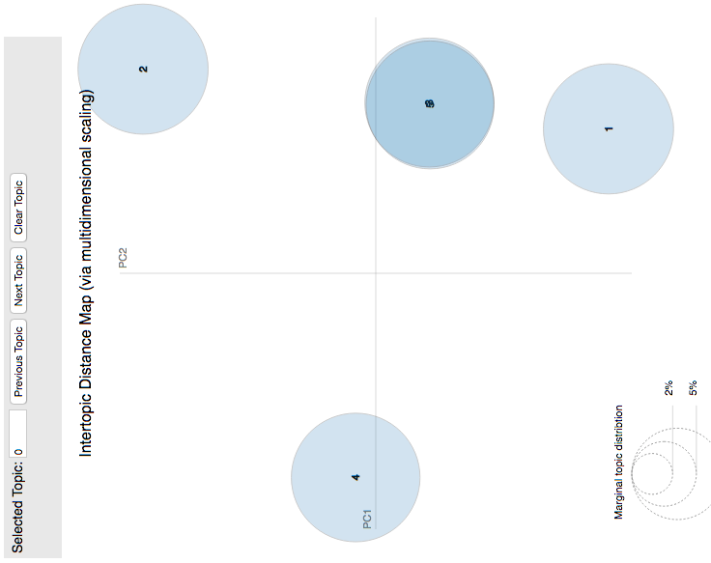
Figure 5: The Visual Output for the Test 5-1 Run of the Sensitivity Analysis.

Test 5-5
The Test 5-5 run comprised five topics combined with five key-word terms. As also seen with the Test 1-5 run, increasing the number of key terms provided a more detailed description of the individual topics. The terms water, know, and go – identified in the test runs described above – continued to appear in the key word terms (Table 6). However, this run identified several new terms that made their first appearance including right for Topic 1, issue for Topic 2, and think for Topic 4 (Table 6). There were furthermore two terms identified in Table 6 that have an unclear meaning: ve, which was also identified in Test 5-1, and gd. These terms with unclear meanings will be discussed further in later sections.

Table 6: Topic and Term Output for the Test 5-5 Text Analysis Run.
Topic | Key Word Terms
Topic 1 | know | ve | person | get | right
Topic 2 | word | accent | issue | actually | try
Topic 3 | water | kind | work | come | way
Topic 4 | think | go | okay | thing | lot
Topic 5 | hmm | mm | gd | mean | project

The inter-topic distance map for Test 5-5 (Figure 6) provided a more distributed pattern for the topic similarity as compared to Test 5-1. Topic 1 (know, ve, person, get, right), Topic 3 (water, kind, work, come, way) and Topic 5 (hmm, mm, gd, mean, project) were distinctly different from Topics 2 and 4, with the latter two having slightly overlapping circles in Figure 6. Test 5-5 was the first test to identify terms that could be used to infer a topic meaning such as right, issue, and project. Topics were not distinctly identifiable in Test 5-5 so I increased the topic output for the following tests.
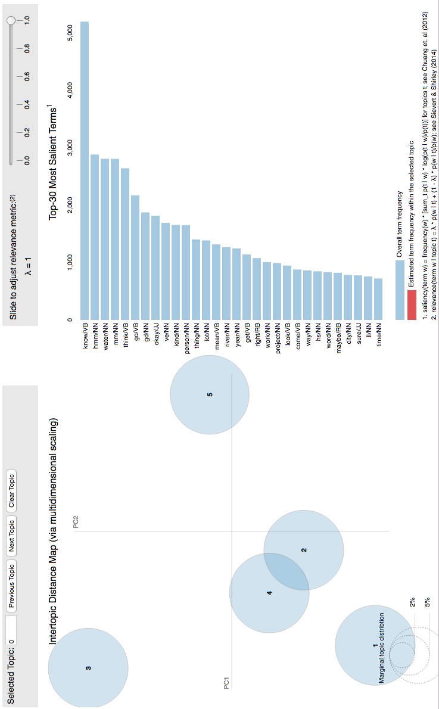
Figure 6: The Inter-distance Topic Map for the Test 5-5 Run of the Sensitivity Analysis.

Test 10-1
The Test 10-1 run encompassed ten topics with one key-word term. Similar to Test 5-1, for this run, the topic coherence relied on only one term to describe the topic. The terms water and know continued to be identified in Test 10-1 key word terms (Table 7). Topic 1 introduced the term river to the key word term outputs. Additionally, year had not been a key word term in any of the previous runs. Test 10-1 identified another singular topic in Table 7 with no clear or obvious meaning, hs.

Table 7: Topic and Term Output for the Test 10-1 Text Analysis Run.

Topic | Key Word Terms
Topic 1 | river
Topic 2 | ve
Topic 3 | hmm
Topic 4 | know
Topic 5 | hs
Topic 6 | mm
Topic 7 | thing
Topic 8 | water
Topic 9 | year
Topic 10 | lot

The inter-topic distance map for Test 10-1 (Figure 7) grouped all but three topics: Topic 1, Topic 7 and Topic 8. Topic 1 (river), Topic 7 (thing) and Topic 8 (water) were distinctly different from other topics as seen in Figure 7. One of the distinctly different topics, topic 1 (river), was a new key word term that had not been identified on pervious runs. Without additional terms to describe the identified topics, it is difficult to infer topic meanings and all inference would need to come from term frequencies within a topic.
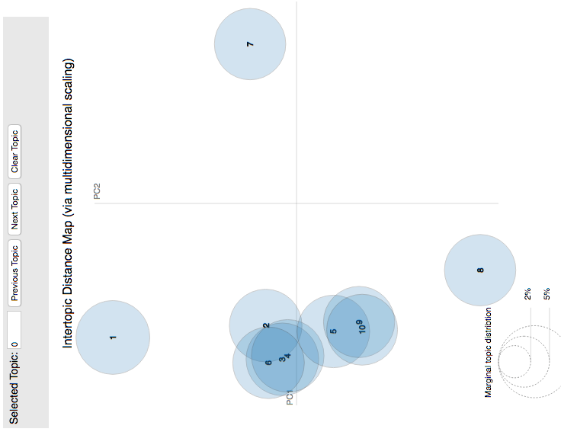
Figure 7: The Inter-topic Distance Map for the Test 10-1 Run of the Sensitivity Analysis.

Test 10-5
Test 10-5 text analysis run resulted in ten topics but used five terms to describe those topics (Table 8). In addition to know, which was also present in all previous tests, water, think¸ and go were terms appearing in many previous tests. Multiple terms reappear in Test 10-5 that can be used to infer a topic, such as project and right. For the first time, terms that were indicative of areas, such as rio, city, and community were included as key word terms (Table 8). Topic 1 had impact as a key word term that is noted for importance in the project. The term year was the first term to suggest a topic could have a temporal component. Additionally, work was included in the key word terms for two topics (Topic 5 and Topic 10).

Table 8: Topic and Term Output for the Test 10-5 Text Analysis Run.
Topic | Key Word Terms
Topic 1 | need | good | new | impact | use
Topic 2 | gd | thing | theme | want | xml
Topic 3 | person | year | probably | definitely | rule
Topic 4 | project | word | maybe | 11 | city
Topic 5 | ve | mean | way | rio | work
Topic 6 | know | think | go | kind | little
Topic 7 | hmm | lot | river | come | hs
Topic 8 | right | stuff | big | great | talk
Topic 9 | water | okay | look | talk | community
Topic 10 | mm | get | work | different | help

The inter-topic distance map for Test 10-5 (Figure 8) continued to show many topics grouped together. Compared to Test 10-1, Test 10-5 showed the topics that were similar would appear even closer together in the documents by having even more overlap of topic circles. Topic 5 (ve, mean, way, rio, work) and Topic 9 (water, okay, look, talk, community) were the topics identified as not being similar to the others.

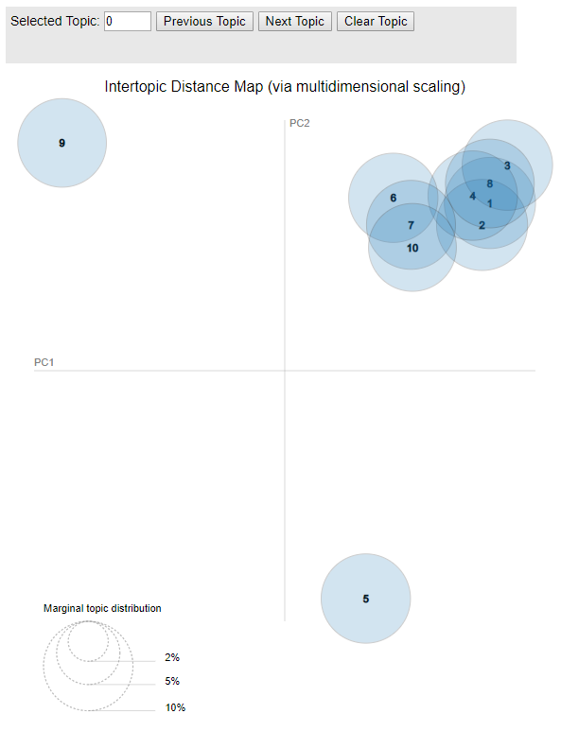
Figure 8: The Inter-topic Distance Map for the Test 10-5 Run of the Sensitivity Analysis.

Test 37-5
Test 37-5 was conducted to match the number of topics identified in the concept maps, namely 37 topics (see Table 1 and Figure 4). Of the 37 topics, ten included a majority of two letter word combinations that made the topic difficult to interpret (Table 9). The details of the remaining topics revealed multiple terms that appeared for the first time including farmer, irrigation, fish, land, and flood. Locations of influence were also found for the first time in many of the topic term outputs, such as mexico, colorado, alamosa, subdistrict, valley, and community. The only term to repeat in every test was know. This test run also identified key word terms that referred to infrastructure in the highly regulated RGB, including well, ditch, diversion, or pump. Furthermore, several key word terms pointing to actors in the RGB coupled human-natural system were identified, such as farmer, landowner, community, or guy.

Table 9: Topic and Term Output for the Test 37-5 Text Analysis Run.
Topic | Key Word Terms
Topic 1 | river | rio | restoration | far | flow
Topic 2 | think | stuff | mexico | summer | term
Topic 3 | mean | theme | little | irrigation | farmer
Topic 4 | definitely | pu | uq | yk | ai
Topic 5 | big | issue | haven | call | day
Topic 6 | lot | get | need | land | structure
Topic 7 | word | talk | accent | probably | tx
Topic 8 | mm | kx | mh | sp | qm
Topic 9 | city | ki | wh | oi | lq
Topic 10 | sure | talk | landowner | hear | plant
Topic 11 | gd | hs | hb | qc | wq
Topic 12 | hmm | person | year | subdistrict | service
Topic 13 | have | cj | eo | stream | hp
Topic 14 | community | great | study | xmlpk | sort
Topic 15 | arsenic | let | valley | level | high
Topic 16 | basin | xml | colorado | fish | user
Topic 17 | right | good | see | concern | start
Topic 18 | look | way | ditch | place | yx
Topic 19 | time | use | guess | west | make
Topic 20 | run | guy | foot | watersh | half
Topic 21 | come | different | grande | sense | change
Topic 22 | say | impact | flood | pump | levee
Topic 23 | well | quality | remember | move | sz
Topic 24 | project | try | wx | farm | ul
Topic 25 | area | bit | compact | yes | able
Topic 26 | know | pretty | document | *** | hx
Topic 27 | ll | help | rule | couple | end
Topic 28 | ve | ask | oq | ag | thememanager
Topic 29 | drought | job | iw | live | company
Topic 30 | go | microsoft | engineer | alamosa | property
Topic 31 | okay | kind | thing | work | new
Topic 32 | gdm | nb | sv | rt | gb
Topic 33 | kpk | zm | lh | pm | huge
Topic 34 | actually | meet | interesting | dry | group
Topic 35 | water | maybe | want | rel | district
Topic 36 | work | diversion | management | sound | gy
Topic 37 | percent | xe | pay | corps | ib
***This entry was a first name and was removed to guarantee confidentiality and de-identifications.

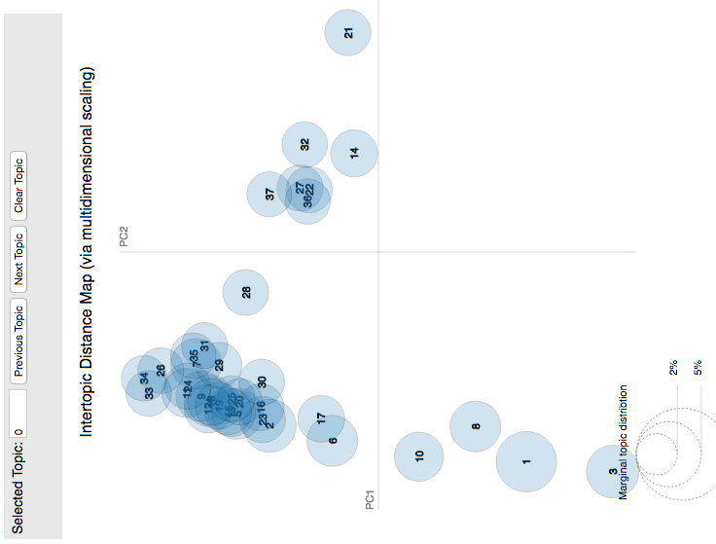
Figure 9: The Inter-topic Distance Map for the Test 37-5 Run of the Sensitivity Analysis.

Test 37-5 showed more variation in differences between topics, but had three general areas that the topics fall into (Figure 9). Topic 1 (river, rio, restoration, far, flow), Topic 3 (mean, theme, little, irrigation, farmer), Topic 8 (mm, kx, mh, sp, qm) and Topic 10 (sure, talk, landowner, hear, plant) were shown to be differing, individual topics found within the documents (Figure 9). Additionally, Topic 14 (community, great, study, xmlpk, sort), Topic 21 (come, different, grande, sense, change), Topic 28 (ve, ask, oq, ag, thememanager), Topic 32 (gdm, nb, sv, rt, gb), and Topic 37 (percent, xe, pay, corps, ib) were individual topics that differed from the other topics identified. Topic 37 had some distributional similarities to the ground containing Topic 22, Topic 27, and Topic 36 but is minimal.

Test 10-5a
Test 10-5a is an edited version of Test 10-5. For Test 10-5a, multiple terms were stored in a dictionary and the program was set up to ignore the entries in this dictionary. The terms added to the dictionary were all identified from previous runs of the text analysis and are listed in Table 10. These terms were previously left in the text analysis runs because I was unable to view the transcribed documents and determine where they were being introduced or how they were being used. I decided to create this dictionary of ignored words because I wanted to determine if I could eliminate these words and produce better results that would be more representative of the interviews. During transcription, the transcribers noted when there was audible thinking occurring either by the interviewer or the interviewee. The term mm, which appeared in many previous tests, could represent the sound of audible thinking. Although it is interesting to note that this act of thinking is considered a key word topic in the initial Test 10-5 (Table 8), I chose to ignore mm in a final output in order to get more meaningful sets of key word terms. I did, however, leave hmm as a term to analyze in the text analysis to represent thought.

Table 10: List of Words Omitted from Adjusted 10-5a Text Analysis Run.
The list of omitted words includes 41 words that were identified to routinely appear in outputs.
Omitted Words
*** | mm | ll | hs | ve | gd | pk | og | wc | ul | gk
zn | hd | ot | wq | aj | uq | yk | hz | xp | fk | kx
pu | mh | zg | np | oj | jo | yv | po | xe | ru | ib
qj | ua | lh | ow | cj | kj | rz | vk | fp | lv

Table 11 shows the topics and their key word terms that were the result of controlling the text analysis for the unidentifiable terms in Table 10. By adding a processing step to the text analysis, the resulting key word terms add more descriptors that can help to identify the topic meaning. However, hb was not a term that was controlled for because it had not appeared in previous test and subsequently appeared in the key word terms for topic 9. I decided not to re-run Test 10-5a with hb added to the omitted word list because it could become an iterative process of continually eliminating unknown terms. This limitation will be further addressed in the discussion chapter. Terms that were identified in Test 10-5a that are not included in Test 10-5 included see, time, well, district, and percent. As with Test 10-5, work is a term identified in two topics, topic 7 and topic 8.

Table 11: Topic and Term Output for the Adjusted 10-5a Text Analysis Run.
Topic | Key Word Terms
Topic 1 | really | mean | look | way | rio
Topic 2 | get | river | right | see | time
Topic 3 | lot | well | sure | little | probably
Topic 4 | something | make | definitely | always | meet
Topic 5 | go | hmm | kind | come | want
Topic 6 | know | okay | person | also | district
Topic 7 | water | think | work | project | need
Topic 8 | stuff | work | big | put | help
Topic 9 | accent | hb | percent | guess | term
Topic 10 | thing | year | say | maybe | city

The visual output that Test 10-5a produced is displayed in Figure 10. Excluding the terms listed in Table 10 had only a small effect on the overall Inter-topic Distance Map (Figure 10). In Test 10-5a, topic 7 and topic 8 shifted closer to topic 10. It is still clear that there are three general clusters of topics but the grouping the top right quadrant is not as tight. Topic 10 (thing, year, say, maybe, city) and topic 9 (accent, hb, percent, guess, term) are two completely differing topics. Topic 1 (really, mean, look, way, rio) can also be differentiated from the other topics because of its minimal overlap with neighboring circles.
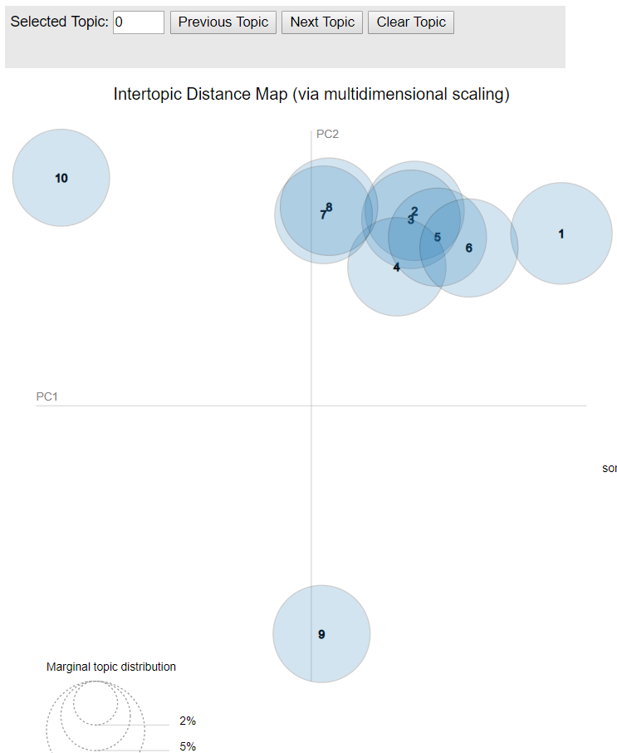
Figure 10: The Inter-topic Distance Map for the Adjusted 10-5a Text Analysis Run.

To further understand topic 2, looking at some of the terms that frequently appeared can improve overall coherence. Many of the key word terms comprising this topic can be used in a variety of ways. For example, right can be referred to as a direction, the answer to a question, or the ownership over water – such as in water right. Using the top- 30 relevant terms for topic 2 (Figure 11, right panel), terms such as see, landowner, and structure are all frequent terms. With both the five key-word terms (get, river, right, see, time) and seeing the associated relevant terms for topic 2, I classified this topic as an ownership topic. The ownership may cover both landownership, water rights, and the value placed on the view from their land.
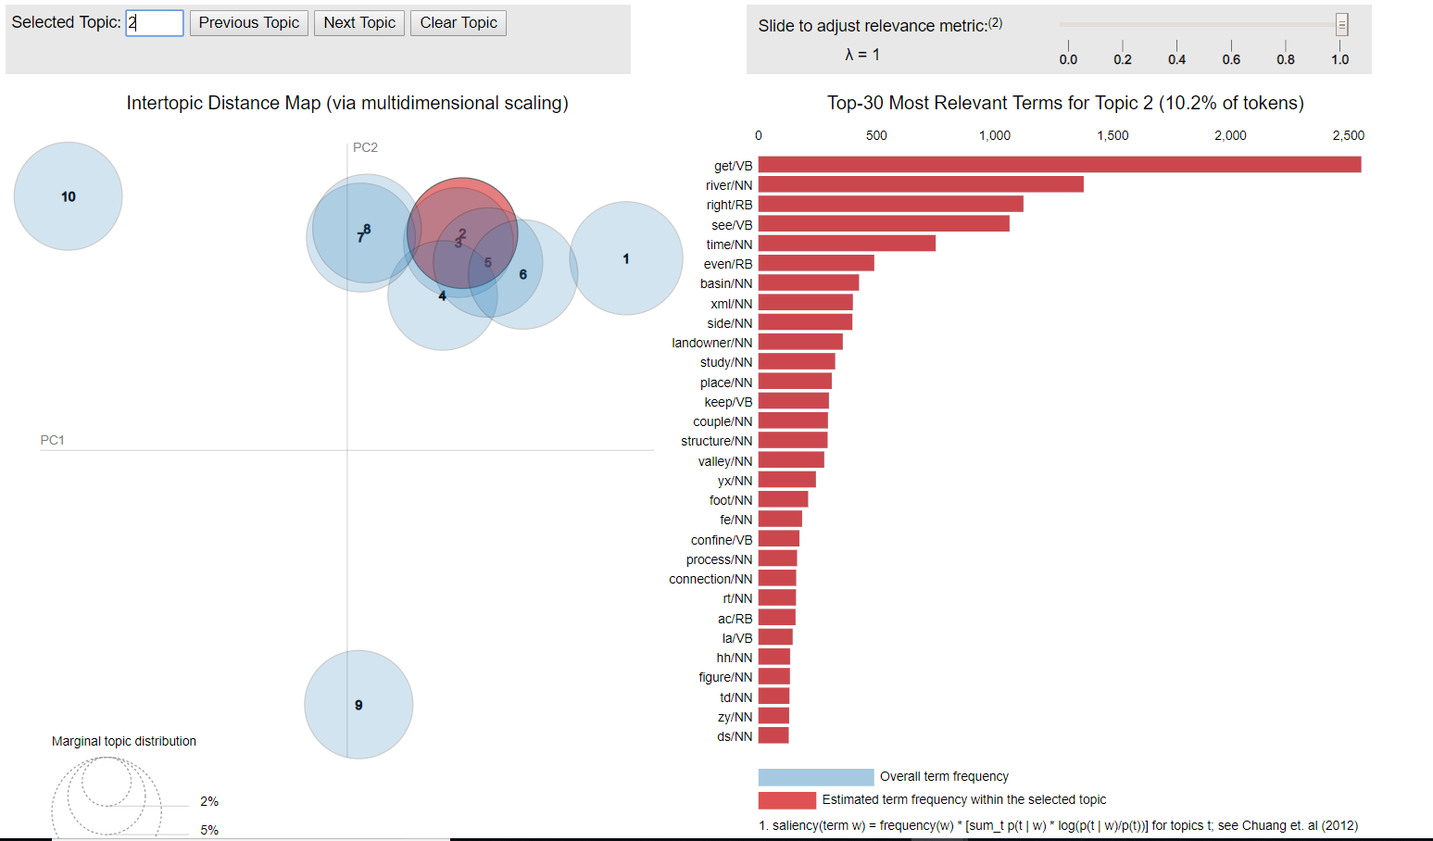
Figure 11 The Inter-topic Distance Map and 30 Most Relevant Terms for Topic 2 using the Adjusted 10-5a Text Analysis Run.

Figure 12 displays Test 10-5a with topic 7 selected. The key-word terms used to describe topic 7 are water, think, work, project and need. The top- 30 relevant terms for topic 7 (Figure 12, right panel), include terms such as engineer, treatment, and role. With both the five key-word terms and the associated relevant terms for topic 7, I classified this topic as a human alteration topic. Human alteration, in this setting, can include topics about how the RGB is engineered through projects and work being done throughout the basin.

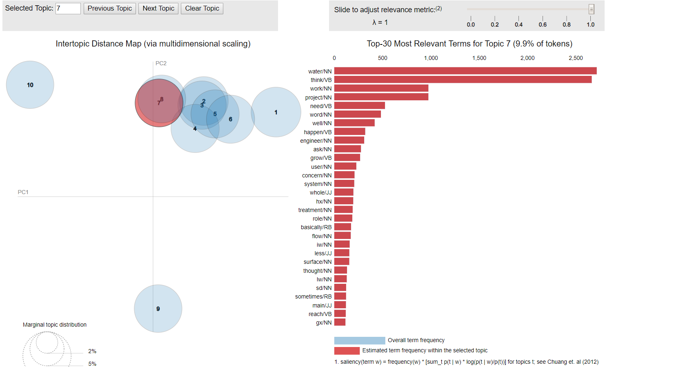
Figure 12 The Inter-topic Distance Map and 30 Most Relevant Terms for Topic 7 using the Adjusted 10-5a Text Analysis Run.

Figure 13 displays Test 10-5a with topic 9 selected. Looking at the top 30 most relevant terms, I determined the topic to be one that is focused on the aesthetics of the river. Terms such as restoration, look and drought lead me to the conclusion that the topic restoring the river to a previous state was discussed.
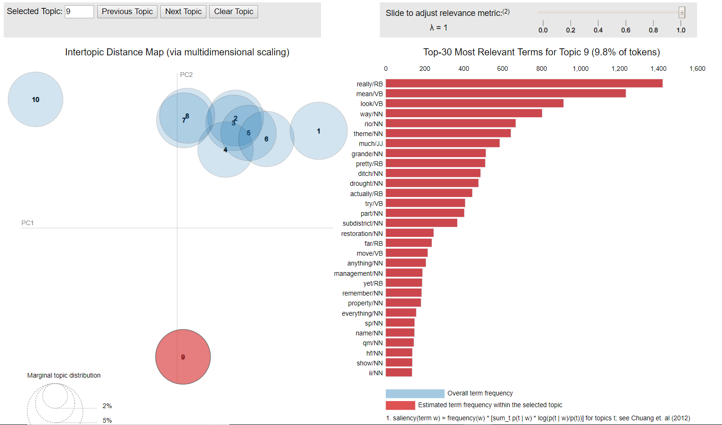
Figure 13 The Inter-topic Distance Map and 30 Most Relevant Terms for Topic 9 using the Adjusted 10-5a Text Analysis Run.

Figure 14 displays Test 10-5a with Topic 10 selected. The top 30 terms were helpful in determining that this topic was either seasonally or regionally focused. Terms such as year, Colorado, recreation and south show that the topic was not only focused on how the river may be used but also that this topic was regionally based.
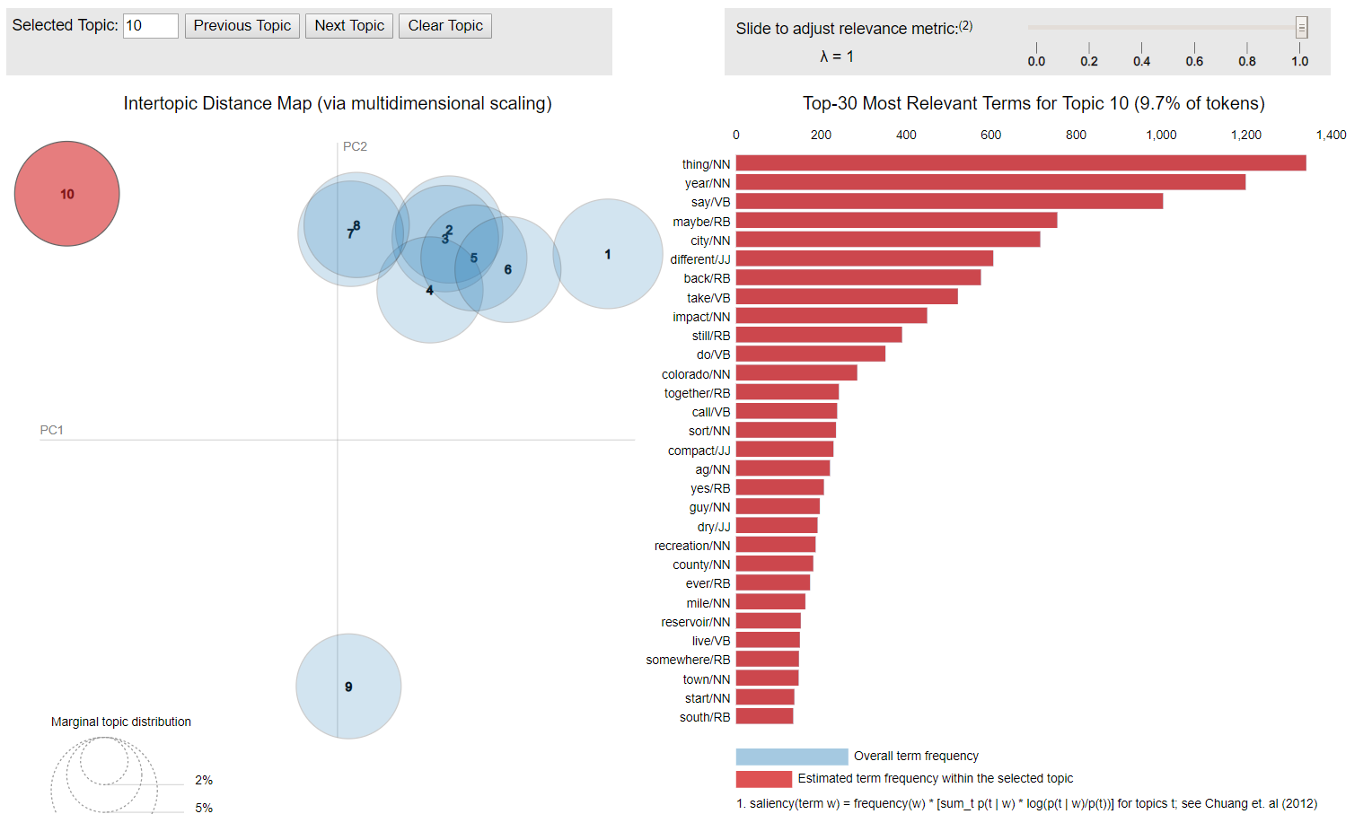
Figure 14 The Inter-topic Distance Map and 30 Most Relevant Terms for Topic 10 using the Adjusted 10-5a Text Analysis Run.

Combining the Text Analysis with the Concept Map
Figure 15 displays both, the original concept map and they key terms and topics identified through the text analysis (Table A – 1). The run Test 10-5a is the adjusted run selected and modified based on the outcomes of the sensitivity analysis. Test 37-5 was selected to represented the number of components (i.e., 37 components) represented in the original concept map. Based on Test 10-5a, I identified two terms that were not represented in the original concept map, but were identified through the text analysis: seasons/regions and water rights (Figure 15). All other topics and terms identified through the text analysis were to some degree and in some form (it may not have been the exact terms, but a synonym) already represented in the original concept map. Test 37-5 helped to identify an additional four terms, that are not present in the original concept map: arsenic, well, management, and water district (Table A – 2).
It is worth mentioning that three of the newly identified terms referred to water governance in the RGB basin. These terms were management, water rights, and water district. While these topics and themes were not represented in the concept map, during the development of this map, these topics were addressed and it was decided that including the complex relationships on water governance in the map was beyond the scope of the research (Koch et al. 2019). This left the three terms arsenic, seasons/regions, and wells as truly new topics that were not covered specifically in the concept mapping process.

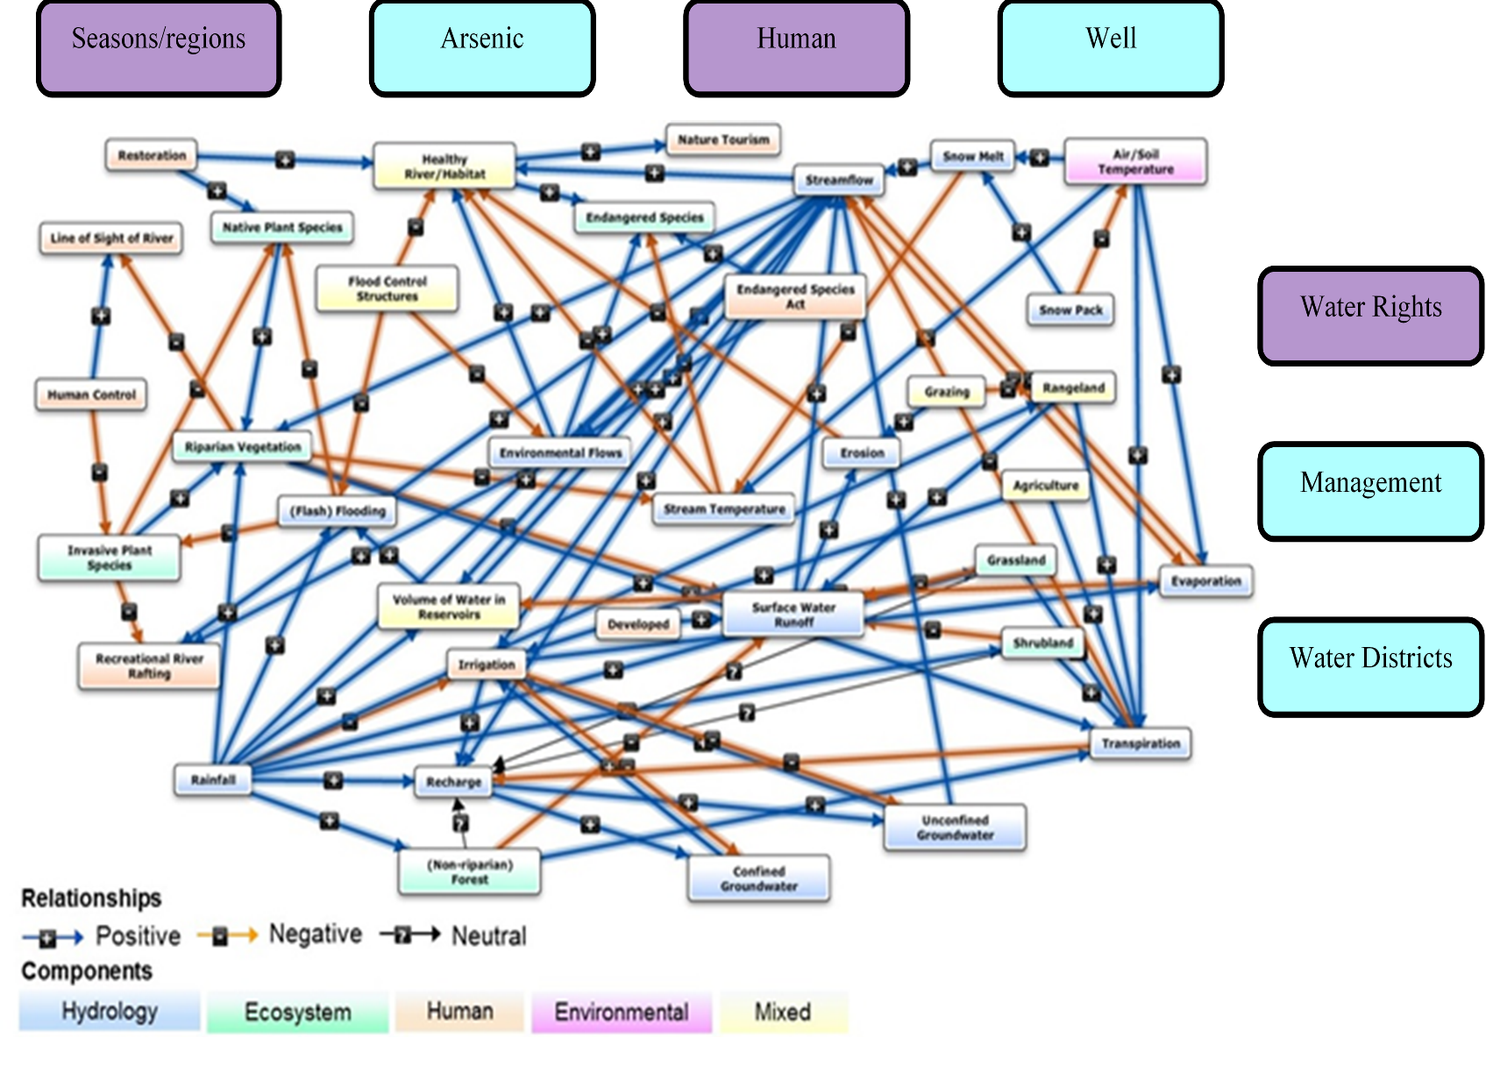
Figure 15 Comparison of the Original Concept Map with the Additional Topics Identified with the Text Analysis. Topics that were inferred from Test 10-5a are in purple and topics inferred from Test 37-5 are in teal.

Chapter 5: Discussion
Including local knowledge and information from stakeholders in model development is necessary to better understand and model coupled human-natural systems. Many different approaches exist that facilitate the inclusion of this knowledge in the modeling process (Gray et al., 2012, 2018; Voinov & Bousquet, 2010). In my research, I explored a method that aimed to combine the results of a text analysis with a concept map developed in an interdisciplinary manner. This method aimed at identifying the processes that drive the Rio Grande/Río Bravo River coupled human-natural system and, ultimately, support the development of a computer simulation model. Specifically, I examined whether text analysis could identify additional topics to those identified in an interdisciplinary approach to producing a conceptual map for the RGB coupled human-natural system.
While many participatory modeling exercises heavily rely on stakeholder workshops and focus groups to achieve the inclusion of local input (Gallego-Ayala & Juízo, 2014; Luyet et al., 2003), these approaches come with disadvantages. Examples of these disadvantages include ‘stakeholder fatigue’ (Bracken et al., 2015) and considerable time commitments and costs for conducting or participating in stakeholder workshops (Korfmacher, 2001; Luyet et al., 2003) – especially when developing a simulation model for a study region. This research was motivated by trying to use existing information from ethnographic fieldwork to inform the concept mapping process via indirect stakeholder involvement.
Ultimately, I was interested in conducting a text analysis on interviews to determine if this alternative type of participatory modeling approach could be used to support the time-consuming concept mapping process by automatically identifying topics important to stakeholders in the study area. Using topic model-based text analysis was useful to have alongside the concept mapping, but could not replicate or replace the thoroughness of the interdisciplinary collaboration and the process of building the concept maps. Rather, utilizing the text analysis showed that interdisciplinary research that works towards modeling complex socio-environmental problems should not replace the thorough ethnographic research with an automated process. In the following sections, I discuss the results that lead me to this conclusion.

Concept Map
The concept map that was developed for the RGB was a collaborative effort and is discussed in Koch et al. (2019). By developing the concept map to represent stakeholder perceptions on system functioning and natural resource management, important decision-making components were identified by the project team. Other studies have shown the potential of group concept mapping for finding solutions to managing complex systems (Hassmiller Lich et al., 2017). Using the concept mapping method allowed us to identify key social processes typically not included in models of the RGB. However, the non-spatial approach of concept mapping was found insufficient for representing regional differences in social, political and temporal dynamics in the RGB, which are relevant for finding management trade-offs.

Text Analysis
I started the text analysis with a sensitivity analysis because there was no obvious best choice for the parameter settings of the text analysis. The sensitivity analysis was aimed at determining which combination of topics and key word terms should be used, and it consisted of eight different runs (Table 1), with varying numbers for topics and key word terms. The tests with only one topic were not considered for the final text analysis because there was no visual output and no meaningful results were produced but were conducted as part of the sensitivity analysis to analyze the change in topics and terms. Furthermore, tests with only one key word term to describe the topics were also not considered in the final analysis, because sets of key word terms turned out to be more meaningful than individual key word terms. For example, Test 5-1 has two topics (topic 3: mm, topic 5: go) that were identified as having similar vocabulary composition distributions (Table 5). With only one term, all context clues were lost and terms such as mm and go had no obvious meaning and more terms are necessary in all further tests. This shows how using only one term to describe topics is problematic when analyzing transcribed spoken interviews.
After eliminating tests that did not produce visual output or only had one key word term per topic, there were three remaining test runs: Test 5-5, Test 10-5, and Test 37-5. The RGB study area is large and, hence, covers an environmentally and culturally diverse region. Since the final goal was to have as complete as possible representation of the RGB coupled human-natural system, I also ruled out using Test 5-5. Test 5-5 includes five topics (Table 6) which was too limiting to represent the diversity of such a complex coupled human-natural system. Without access to the individual interviews, I utilized these small incremental increases in topics and terms in order to test the ability of the text analysis to determine topics and therefore was necessary to the overall analysis. However, using only five topics in this study would misidentify and underrepresent stakeholder values.
Comparing Test 10-5 and Test 37-5, Test 37-5 produced topic outputs that were easier to interpret from the key word terms (Table 8). However, the number of 37 topics came as a result of a significant amount of time being spent developing the concept map for the basin. If I were to argue that a topic model-based text analysis was intended to support (or be carried out in parallel) to the concept mapping development, the number 37 would not be able to be identified until the conclusion of the concept map development. Therefore, I chose to select Test 10-5 for further analysis because the number of topics was high enough to get a general understanding of the complex system under study, while not being dependent upon the concept maps for the selection of topic amount.
Test 10-5 was selected as the preferable combination of topics and terms from the sensitivity analysis. However, the topics included key word terms such as gd, ve, hs and 11 which were artifacts from transcribing the interviews and had limited meaning for improving our understanding of the RGB system. Hence, I decided to adjust Test 10-5 and conduct a text analysis with identical settings for numbers of topics and terms, but exclude any of those artifact terms (Table 10). This was done after consulting with Dr. Paladino and concluding that these terms had no specific meaning during the interviews. Test 10-5a is the adapted version of Test 10-5.

Combing Concept Map and Text Analysis

Topics Found Only in the Text Analysis
One topic that was only found in the text analysis was right; either right or rights was found in multiple different tests of the text analysis. The meaning of the term right varies based on the usage of the term so the assumption is made that in this study, given the background knowledge of the RGB, any form of right is understood as pertaining to water rights. Water rights, their use and trade of water rights, is a highly relevant issue in the RGB (De Mouche et al., 2011; Leidner et al., 2011; Skaggs et al., 2011). Those with water rights can use a specific amount of water. Water rights was a topic that was discussed thoroughly during concept mapping sessions. Although it did not directly make it into the concept map as a topic, it is understood that water rights are a major factor that regulate when and how much water can be used by different entities in the RGB.
Interestingly, the need for further understanding of water rights was identified as an outcome and necessary steps forward from the concept mapping development process. Water rights dictate how much water a landowner may withdraw from the river, but recently municipalities in the RGB have begun to buy land and leave it vacant in order to acquire the water rights to meet their water needs (Chang & Griffin, 1992). These types of decisions are an example of a decision an agent could make in an agent-based model and should be representative of the actual stakeholder decision making process of a simulation model for the RGB. Hence, the text analysis identified one of the key topics regarding water management as human intervention in the RGB.
Another topic that I found to be present in the text analysis but not in the concept map was the idea of regions or seasons. In Figure 14, Topic 10 was selected for further evaluation and shows that terms that are relevant to the topic terms (thing, year, say, maybe, city) include Colorado, town, county and south. Each of these terms can be used to describe an area within the RGB. The RGB is not confined to a small region, rather runs through three U.S. states and five Mexican states (Figure 3). These regions are socially, politically and environmentally diverse. Climate was covered in the concept map but the idea of specific regions or states was not as clearly defined. However, regions are difficult to define because it is difficult to determine a precise border and regions in coupled human-natural systems, and developing approaches for delineating boundaries of socio-ecological systems is an active field of research (Koch et al., 2019; Martín-López et al., 2017). Again, the text analysis identified a key topic of the discussions and innovations around the modeling of the RGB.

Topics Found Only in the Concept Map
There were many topics that were only present in the concept map (Figure 15). This was to be expected because in developing the concept map, no set number of topics was identified as being the correct number of topics whereas the text analysis is initialized with a user defined number of topics. Of those that were only found in the concept map were various climate topics, endangered and invasive species, and different types of land cover categories. The concept map was a very time intensive creation. Large amounts of time, effort, and thought from all participants were invested to deduce not only major general topics, but also their relationships as well as the more intricate topics that were not identified by the text analysis. Dedicating a significant amount of resources to concept map development resulted in a concept map that not only identified stakeholder identified topics but also the connections that stakeholders made between topics (Figure 4). The connections and direction of influence those topics had is not included in a text analysis nor are the categorization of topics. Also, there is no approach available to generate these relationships through automated text analysis.

Topics Found in Text Analysis and Concept Map
Many of the relevant terms used to describe topics were represented in both the concept map that was created as a team project (Figure 4) and the supplemental text analysis (Figure 10). Both exercises captured the recreational and tourism aspects of the river as well as various aspects of human control over the river. One of the easily identifiable topics from Test 10-5a was that of human intervention or human control over the river. In the concept map, topics like Flood Control Structure, Developed and Human Control can be associated with the topic terms and relevant topic terms in Test 10-5a such as project (Table 11), engineer, and treatment (Figure 12). This echoes the current reality of the RGB as a highly engineered system with structured implemented to flood control and for distributing water resources according to international and inter-state water agreements (Llewellyn & Vaddey, 2013).

An Argument for Test 37-5
Despite Test 37-5 not being considered an ideal final text analysis for this study, Test 37-5 did identify multiple topics that were easy and useful to interpret. It also had multiple valuable topic terms that could be important elements to include in the model development process. For example, one topic (Topic 15) consists of the terms arsenic, let, valley, level, and high. Arsenic was not a topic that was included in the concept map but the topic of pollution from multiple sources was thoroughly discussed and cut from the final concept map due to modeling constraints (water quality modeling requires high-resolution spatial input). Topic 22 (say, impact, flood, pump, levee) was clearly a topic surrounding engineering of the river through pumps and levees and the impacts that they create. There were more useful topics in Test 37-5 than in Test 10-5a. Although the goal was to have one text analysis that would serve as the primary for analysis, the more suitable solution is a combination of Test 10-5a and Test 37-5 in order to produce more meaningful text analysis results.
Test 37-5 had multiple topics that were able to be identified despite including the terms Test 10-5a ignored (Table 10). Four more topics were identified for addition to the concept map (Figure 10): arsenic was identified directly from the topic terms, more specifically the high levels of arsenic since both high and arsenic are terms used to describe a topic, topic 15. Despite the term well having multiple potential meanings based on how it is used in a sentence, I decided also to include this as a topic. Terms associated with well such as move imply that the type of water source (groundwater versus surface water) is an important topic in this context (Table 9). The concept map process led to the conclusion that groundwater should be subdivided into unconfined groundwater and confined groundwater in addition to surface water, as represented in Figure 4, but does not directly call out extraction of water (Table 2). Although this could also be included in the Human Intervention topic already in the concept map, discussions should be made with the concept mapping team as to whether Human Intervention could be divided into multiple other topics because Test 10-5a also identified the same topic. Figure 10 was the result of adding the identified topics from Test 10-5a with topics from Test 37-5.
Test 10-5a is a good example of how the limitations to my study hindered the production of more valuable result from the text analysis. I was not involved, nor qualified, to assist in the ethnographic fieldwork. Also, I did not transcribe or see any of the interviews conducted by Drs. Friedman and Paladino. This resulted in many reiterations of the text analysis to not only run on Dr. Paladino’s computer but also create output of meaningful result. Since Dr. Paladino volunteered her time to support my research, I wanted to limited the number of text analysis runs.
Test 10-5a was the result of attempting to remove any non-word terms that were discovered in the sensitivity analysis. These terms could have been from formatting differences or shorthand used by different transcribers. Excluding terms from the text analysis automatically was also complicated by the fact that I could not ignore all two letter terms because of acronyms, such as RG for Rio Grande or SW for southwest, that were possibly used during the transcription process. Removing all two letter words from the analysis would lead to the possibility of misrepresenting topics or missing important keyword terms to aid in topic coherence. Even after removing 41 terms, there are still some that were not eliminated because the topic model was already becoming over processed, i.e., the text analysis output was heavily dependent on the parameterization settings.
In general, topic modeling utilizing LDA is known to have results that are difficult to interpret (Chang et al., 2009) and my results support this finding. When the text analysis results include terms such as right or see, topics are difficult to decipher. In the context of the RGB, I interpreted right to be associated with water rights or the rights that landowners have to utilize water. It could, however, be the answer to a question – meaning correct. Hence, there is the intrinsic danger of aggregating the different meanings of a specific term such as right.
I interpreted see as an aesthetic term. This is because the discussions that led to the development of the concept map included the value that some stakeholders had on the visual aesthetics of the river (e.g., in the context of the Big Bend National Park). Ultimately, including the human element of interpreting interviews and living within the study area will supersede topic modeling outcomes. Without the knowledge gained from the relationships made during the interview process, the risk of misrepresenting stakeholder viewpoints by focusing on individual (or groups of) terms and then losing the trust of stakeholders in model development increases. An example of this is a study conducted by Gale et al., (2014) when the draft plan of the Murray-Darling Basin Plan was released to the public. The relationships and understanding developed as part of the ethnographic fieldwork, allowed Drs. Paladino and Friedman to understand social influences beyond what a topic model could decipher.
Topic modeling and text analysis are an iterative process. Although many iterations were conducted in order to produce more meaningful results, more iterations could have been conducted if time and data accessibility had not been a factor. If I had complete data accessibility, I could have identified additional text preprocessing steps necessary to eliminate many of the coherence issues identified as well as optimized the topic model to automatically identify the best number of topics that could be identified from the documents. The text analysis might have been more useful if it had been conducted for a smaller study area. By scaling the topic model to regions, more topics may have been identified at those levels. The large study area, however, required the knowledge gained from living in the field and learning directly from stakeholders. Without an understanding of the social dynamics and stakeholder influence in the basin, any region selected for study could have skewed any result to a biased regional selection such as a political boundary.

Chapter 6: Conclusion
The aim of this research was to test whether a text analysis would be able to identify topics that stakeholders discussed during semi-structured interviews, and to test the usefulness of text analysis as a supporting element for interdisciplinary approaches to concept mapping. Based on my findings, for a large spatial area such as the RGB, using interdisciplinary and collaborative concept mapping can help represent stakeholder views and better inform model developers of necessary input data to better represent the stakeholder perceptions in model development. While the text analysis was able to identify key topics of relevance for the RGB coupled human-natural systems, almost all of them had already been raised during the development of the concept map.
First, a sensitivity analysis was implemented in order to find the best possible combinations of topics and terms. Then, the text analysis was conducted to eliminate terms that were found to have no importance or meaning in the interviews. Finally, I compared the concept map developed by Koch et al. (2019) with the text analysis. In general, interdisciplinary research is time consuming and requires trust amongst those involved (Adams, 2014). In a large study area, such as the Rio Grande River Basin, this investment of time and allocating sufficient funds can be difficult. Therefore, I was researching whether a text analysis could be used to produce similar results or support the interdisciplinary concept mapping, with the goal of testing the potential for reducing the resources invested in developing a conceptual map.
Topic modeling is known to create topics that can be difficult to interpret and that was the case in this study. Discovering the hidden topics that were associated with the overall topic terms identified by the topic model was perhaps more useful than the topic term outputs of the model. Many of these topics were actually discussed during the concept mapping development process and although they were important factors in the RGB, they were determined to be outside the scope of the concept mapping exercise. The relevant terms that describe each topic did, however, reinforce the need for a spatially explicit modeling approach that could represent the regional differences that are important to the RGB coupled human-natural system. Implementing a topic model on the data has the potential to accompany a concept map and provoke further discussion of topics prior to the model development process, but it was not deemed even remotely suitable for replacing the interdisciplinary concept mapping exercise.
My research showed the limitations of automated text analysis as compared to the interdisciplinary approach applied to develop the concept map. By bringing in their research expertise from the field of anthropology, Drs. Friedman and Paladino were able to make connections with stakeholders and discover the deeper connections and perceptions of stakeholders in the RGB. However, by conducting the topic modeling I tested its potential and limitations. It was reassuring that the time investment that went into the development of the concept map was well worth it. My combination of text analysis and concept mapping for conceptual model development may have had its limitations but new research in similar applications have begun and hope to utilize natural language processing for agent classification (Runck et al., 2019).

References
An, L. (2012). Modeling human decisions in coupled human and natural systems: Review of agent-based models. Ecological Modelling, 229, 25–36. https://doi.org/10.1016/j.ecolmodel.2011.07.010
Bailey, K., & Grossardt, T. (2010). Toward Structured Public Involvement: Justice, Geography and Collaborative Geospatial/Geovisual Decision Support Systems. Annals of the Association of American Geographers, 100(1), 57–86. https://doi.org/10.1080/00045600903364259
Bird, S. (2002). Nltk: The natural language toolkit. In Proceedings of the ACL Workshop on Effective Tools and Methodologies for Teaching Natural Language Processing and Computational Linguistics. Philadelphia: Association for Computational Linguistics.
Blei, D. M. (2012). Probabilistic topic models. Communications of the ACM, 55(4), 77. https://doi.org/10.1145/2133806.2133826
Blei, D. M., & Lafferty, J. D. (2009). Topic Models. In Test Mining Classification, Clustering, and Applications (pp. 71–93). Chapman & Hall/CRC.
Blei, D. M., Ng, A. Y., & Jordan, M. I. (2003). Latent Dirichlet Allocation. Journal of Machine Learning Research, 3, 30.
Borowski, I., & Hare, M. (2007). Exploring the Gap Between Water Managers and Researchers: Difficulties of Model-Based Tools to Support Practical Water Management. Water Resources Management, 21(7), 1049–1074. https://doi.org/10.1007/s11269-006-9098-z
Bossel, H. (2007). Systems and Models: Complexity, Dynamics, Evolution, Sustainability. Books on Demand.
Bracken, L. J., Bulkeley, H. A., & Whitman, G. (2015). Transdisciplinary research: Understanding the stakeholder perspective. Journal of Environmental Planning and Management, 58(7), 1291–1308. https://doi.org/10.1080/09640568.2014.921596
Chang, C., & Griffin, R. C. (1992). Water Marketing as a Reallocative Insitution in Texas. Water Resources Research, 28(3), 879–890. https://doi.org/10.1029/91WR02677
Chang, J., Gerrish, S., Wang, C., Boyd-graber, J. L., & Blei, D. M. (2009). Reading Tea Leaves: How Humans Interpret Topic Models. In Y. Bengio, D. Schuurmans, J. D. Lafferty, C. K. I. Williams, & A. Culotta (Eds.), Advances in Neural Information Processing Systems 22 (pp. 288–296). Curran Associates, Inc. http://papers.nips.cc/paper/3700-reading-tea-leaves-how-humans-interpret-topic-models.pdf
Cheng, X., Shuai, C., Liu, J., Wang, J., Liu, Y., Li, W., & Shuai, J. (2018). Topic modelling of ecology, environment and poverty nexus: An integrated framework. Agriculture, Ecosystems & Environment, 267, 1–14. https://doi.org/10.1016/j.agee.2018.07.022
Chuang, J., Ramage, D., Manning, C., & Heer, J. (2012). Interpretation and trust: Designing model-driven visualizations for text analysis. Proceedings of the 2012 ACM Annual Conference on Human Factors in Computing Systems - CHI ’12, 443. https://doi.org/10.1145/2207676.2207738
De Mouche, L., Landfair, S., & Ward, F. A. (2011). Water Right Prices in the Rio Grande: Analysis and Policy Implications. International Journal of Water Resources Development, 27(2), 291–314. https://doi.org/10.1080/07900627.2011.571041
Ebeid, I. A., & Arango, J. M. (2016). Mallet vs GenSim: Topic Modeling Evaluation Report. University of Arkansas at Little Rock. http://rgdoi.net/10.13140/RG.2.2.19179.39205/1
Eden, C. (2004). Analyzing cognitive maps to help structure issues or problems. European Journal of Operational Research, 159(3), 673–686. https://doi.org/10.1016/S0377-2217(03)00431-4
Eickhoff, M., & Neuss, N. (2017). Topic Modeling Methodology: Its Use In Information Systems And Other Managerial Disciplines. Proceedings of the 25th European Conference on Information Systems (ECIS), 1327–1347. https://aisel.aisnet.org/ecis2017_rp/86
Elsawah, S., Guillaume, J. H. A., Filatova, T., Rook, J., & Jakeman, A. J. (2015). A methodology for eliciting, representing, and analysing stakeholder knowledge for decision making on complex socio-ecological systems: From cognitive maps to agent-based models. Journal of Environmental Management, 151, 500–516. https://doi.org/10.1016/j.jenvman.2014.11.028
Epstein, J. M. (2008). Why Model? Journal of Artificial Societies and Social Simulation, 11(4), 12.
Filatova, T., Verburg, P. H., Parker, D. C., & Stannard, C. A. (2013). Spatial agent-based models for socio-ecological systems: Challenges and prospects. Environmental Modelling & Software, 45, 1–7. https://doi.org/10.1016/j.envsoft.2013.03.017
Gaffield, C. (2018). Words, Words, Words: How the Digital Humanities Are Integrating Diverse Research Fields to Study People. Annual Review of Statistics and Its Application, 5(1), 119–139. https://doi.org/10.1146/annurev-statistics-031017-100547
Gale, M., Edwards, M., Wilson, L., & Greig, A. (2014). The Boomerang Effect: A Case Study of the Murray-Darling Basin Plan: The Boomerang Effect. Australian Journal of Public Administration, 73(2), 153–163. https://doi.org/10.1111/1467-8500.12051
Gallego-Ayala, J., & Juízo, D. (2014). Integrating Stakeholders’ Preferences into Water Resources Management Planning in the Incomati River Basin. Water Resources Management, 28(2), 527–540. https://doi.org/10.1007/s11269-013-0500-3
Gray, S. A., Chan, A., Clark, D., & Jordan, R. (2012). Modeling the integration of stakeholder knowledge in social–ecological decision-making: Benefits and limitations to knowledge diversity. Ecological Modelling, 229, 88–96. https://doi.org/10.1016/j.ecolmodel.2011.09.011
Gray, S. A., Gray, S., Cox, L. J., & Henly-Shepard, S. (2013). Mental Modeler: A Fuzzy-Logic Cognitive Mapping Modeling Tool for Adaptive Environmental Management. Proceedings of the 46th Hawaii International Conference on System Sciences, 965–973. https://doi.org/10.1109/HICSS.2013.399
Gray, S. A., Gray, S., De Kok, J. L., Helfgott, A. E. R., O’Dwyer, B., Jordan, R., & Nyaki, A. (2015). Using fuzzy cognitive mapping as a participatory approach to analyze change, preferred states, and perceived resilience of social-ecological systems. Ecology and Society, 20(2), art11. https://doi.org/10.5751/ES-07396-200211
Gray, S. A., Voinov, A., Paolisso, M., Jordan, R., BenDor, T., Bommel, P., Glynn, P., Hedelin, B., Hubacek, K., Introne, J., Kolagani, N., Laursen, B., Prell, C., Schmitt Olabisi, L., Singer, A., Sterling, E., & Zellner, M. (2018). Purpose, processes, partnerships, and products: Four Ps to advance participatory socio‐environmental modeling. Ecological Applications, 28(1), 46–61. https://doi.org/10.1002/eap.1627
Graybill, J. K., Dooling, S., Shandas, V., Withey, J., Greve, A., & Simon, G. L. (2006). A Rough Guide to Interdisciplinarity: Graduate Student Perspectives. BioScience, 56(9), 757. https://doi.org/10.1641/0006-3568(2006)56[757:ARGTIG]2.0.CO;2
Grimmer, J., & Stewart, B. M. (2013). Text as Data: The Promise and Pitfalls of Automatic Content Analysis Methods for Political Texts. Political Analysis, 21(3), 267–297. https://doi.org/10.1093/pan/mps028
Hassmiller Lich, K., Urban, J. B., Frerichs, L., & Dave, G. (2017). Extending systems thinking in planning and evaluation using group concept mapping and system dynamics to tackle complex problems. Evaluation and Program Planning, 60, 254–264. https://doi.org/10.1016/j.evalprogplan.2016.10.008
Hering, J. G., & Ingold, K. M. (2012). Water Resources Management: What Should Be Integrated? Science, 336(6086), 1234–1235. https://doi.org/10.1126/science.1218230
Hoffman, M. D., Blei, D. M., Wang, C., & Paisley, J. (2013). Stochastic Variational Inference. Journal of Machine Learning Research, 14, 1303–1347.
Jakeman, A. J., Letcher, R. A., & Norton, J. P. (2006). Ten iterative steps in development and evaluation of environmental models. Environmental Modelling & Software, 21(5), 602–614. https://doi.org/10.1016/j.envsoft.2006.01.004
Jannidis, F., Pielstrom, S., Schoch, C., & Vitt, T. (2017). Making Topic Modeling Easy: A programming library in Python. Digital Humanities.
Jun, C., Ban, Y., & Li, S. (2014). Open access to Earth land-cover map. Nature, 514(434). https://doi.org/10.1038/514434c
Karpovich, S., Smirnov, A., Teslya, N., & Grigorev, A. (2017). Topic model visualization with IPython. 2017 20th Conference of Open Innovations Association (FRUCT), 131–137. https://doi.org/10.23919/FRUCT.2017.8071303
Keyvanpour, M. R., & Imani, M. B. (2013). Semi-supervised text categorization: Exploiting unlabeled data using ensemble learning algorithms. Intelligent Data Analysis, 17(3), 367–385. https://doi.org/10.3233/IDA-130584
Koch, J., Friedman, J. R., Paladino, S., Plassin, S., & Spencer, K. (2019). Conceptual modeling for improved understanding of the Rio Grande/Río Bravo socio-environmental system. Socio-Environmental Systems Modelling, 1, 16127. https://doi.org/10.18174/sesmo.2019a16127
Korfmacher, K. S. (2001). The Politics of Participation in Watershed Modeling. Environmental Management, 27(2), 161–176. https://doi.org/10.1007/s002670010141
Leidner, A. J., Rister, M. E., Lacewell, R. D., & Sturdivant, A. W. (2011). The Water Market for the Middle and Lower Portions of the Texas Rio Grande Basin1: The Water Market for the Middle and Lower Portions of the Texas Rio Grande Basin. JAWRA Journal of the American Water Resources Association, 47(3), 597–610. https://doi.org/10.1111/j.1752-1688.2011.00527.x
Liu, J., Dietz, T., Carpenter, S. R., Alberti, M., Folke, C., Moran, E., Pell, A. N., Deadman, P., Kratz, T., Lubchenco, J., Ostrom, E., Ouyang, Z., Provencher, W., Redman, C. L., Schneider, S. H., & Taylor, W. W. (2007). Complexity of Coupled Human and Natural Systems. Science, 317(5844), 1513–1516. https://doi.org/10.1126/science.1144004
Llewellyn, D., & Vaddey, S. (2013). West-Wide Climate Risk Assessment: Upper Rio Grande Impact Assessment. U.S. Department of the Interior, Bureau of Reclamation.
Loper, E., & Bird, S. (2002). NLTK: The Natural Language Toolkit. ArXiv:Cs/0205028. http://arxiv.org/abs/cs/0205028
Luyet, V., Iorgulescu, I., Arborino, T., & Schlaepfer, R. (2003). A Framework For The Participative Process In A Large Environmental Project: The Third Rhone Correction (Switzerland). WIT Transactions on Ecology and the Environment, 67. https://doi.org/10.2495/SPD030061
Luyet, V., Schlaepfer, R., Parlange, M. B., & Buttler, A. (2012). A framework to implement Stakeholder participation in environmental projects. Journal of Environmental Management, 111, 213–219. https://doi.org/10.1016/j.jenvman.2012.06.026
Maria, A. (1997). Introduction to Modeling and Simulation. Proceedings of the 29th Conference on Winter Simulation, 7–13. https://doi.org/10.1145/268437.268440
Martín-López, B., Palomo, I., García-Llorente, M., Iniesta-Arandia, I., Castro, A. J., García Del Amo, D., Gómez-Baggethun, E., & Montes, C. (2017). Delineating boundaries of social-ecological systems for landscape planning: A comprehensive spatial approach. Land Use Policy, 66, 90–104. https://doi.org/10.1016/j.landusepol.2017.04.040
McCallum, S. K. (2002). MALLET: A Machine Learning for Language Toolkit. http://mallet.cs.umass.edu/
Mehri, A., Jamaati, M., & Mehri, H. (2015). Word ranking in a single document by Jensen–Shannon divergence. Physics Letters A, 379(28–29), 1627–1632. https://doi.org/10.1016/j.physleta.2015.04.030
Miner, G., Delen, D., Elder, J., Fast, A., Hill, T., & Nisbet, R. (2012). The Seven Practice Areas of Text Analytics. In Practical Text Mining and Statistical Analysis for Non-structured Text Data Applications (pp. 29–41). Elsevier. https://doi.org/10.1016/B978-0-12-386979-1.00002-5
Novak, J. D. (1990). Concept mapping: A useful tool for science education. Journal of Research in Science Teaching, 27(10), 937–949. https://doi.org/10.1002/tea.3660271003
Novak, J. D., & Cañas, A. J. (2006). The Origins of the Concept Mapping Tool and the Continuing Evolution of the Tool. Information Visualization, 5(3), 175–184. https://doi.org/10.1057/palgrave.ivs.9500126
Novak, J. D., & Cañas, A. J. (2008). The Theory Underlying Concept Maps and How to Construct and Use Them, Technical Report IHMC CmapTools 2006-01 Rev 01-2008 (p. 37). Florida Institute for Human and Machine Cognition.
Prell, C., Hubacek, K., Reed, M., Quinn, C., Jin, N., Holden, J., Burt, T., Kirby, M., & Sendzimir, J. (2007). If you have a hammer everything looks like a nail: Traditional versus participatory model building. Interdisciplinary Science Reviews, 32(3), 263–282. https://doi.org/10.1179/030801807X211720
Purnomo, H., Mendoza, G. A., Prabhu, R., & Yasmi, Y. (2005). Developing multi-stakeholder forest management scenarios: A multi-agent system simulation approach applied in Indonesia. Forest Policy and Economics, 7(4), 475–491. https://doi.org/10.1016/j.forpol.2003.08.004
Řehůřek, R. (2011). Scalability of Semantic Analysis in Natural Language Processing [Thesis]. Masaryk University.
Řehůřek, R., & Sojka, P. (2010). Software Framework for Topic Modelling with Large Corpora. Proceedings of the LREC 2010 Workshop on New Challenges for NLP Frameworks, 45–50. https://radimrehurek.com/lrec2010_final.pdf
Roberts, M. E., Stewart, B. M., Tingley, D., Lucas, C., Leder‐Luis, J., Gadarian, S. K., Albertson, B., & Rand, D. G. (2014). Structural Topic Models for Open-Ended Survey Responses. American Journal of Political Science, 58(4), 1064–1082. https://doi.org/10.1111/ajps.12103
Runck, B. C., Manson, S., Shook, E., Gini, M., & Jordan, N. (2019). Using word embeddings to generate data-driven human agent decision-making from natural language. GeoInformatica, 23(2), 221–242. https://doi.org/10.1007/s10707-019-00345-2
Sandoval-Solis, S., Teasley, R. L., McKinney, D. C., Thomas, G. A., & Patiño-Gomez, C. (2013). Collaborative Modeling to Evaluate Water Management Scenarios in the Rio Grande Basin. JAWRA Journal of the American Water Resources Association, 49(3), 639–653. https://doi.org/10.1111/jawr.12070
Sargent, R. G. (2013). Verification and validation of simulation models. Journal of Simulation, 7(1), 12–24. https://doi.org/10.1057/jos.2012.20
Sievert, C., & Shirley, K. (2014). LDAvis: A method for visualizing and interpreting topics. Proceedings of the Workshop on Interactive Language Learning, Visualization, and Interfaces, 63–70. https://doi.org/10.3115/v1/W14-3110
Silge, J., & Robinson, D. (2016). tidytext: Text Mining and Analysis Using Tidy Data Principles in R. The Journal of Open Source Software, 1(3), 37. https://doi.org/10.21105/joss.00037
Simon, C., & Etienne, M. (2010). A companion modelling approach applied to forest management planning. Environmental Modelling & Software, 25(11), 1371–1384. https://doi.org/10.1016/j.envsoft.2009.09.004
Skaggs, R., Samani, Z., Bawazir, A. S., & Bleiweiss, M. (2011). The Convergence of Water Rights, Structural Change, Technology, and Hydrology: A Case Study of New Mexico’s Lower Rio Grande. Natural Resources Journal, 51(1), 95–117.
Taddy, M. A. (2011). On Estimation and Selection for Topic Models. ArXiv:1109.4518 [Stat]. http://arxiv.org/abs/1109.4518
Tong, Z., & Zhang, H. (2016). A Document Exploring System On LDA Topic Model For Wikipedia Articles. 13.
Tongco, Ma. D. C. (2007). Purposive Sampling as a Tool for Informant Selection. Ethnobotany Research and Applications, 5, 147. https://doi.org/10.17348/era.5.0.147-158
Turney, P. D., & Pantel, P. (2010). From Frequency to Meaning: Vector Space Models of Semantics. Journal of Artificial Intelligence Research, 37, 141–188. https://doi.org/10.1613/jair.2934
van Rijnsoever, F. J., & Hessels, L. K. (2011). Factors associated with disciplinary and interdisciplinary research collaboration. Research Policy, 40(3), 463–472. https://doi.org/10.1016/j.respol.2010.11.001
van Vliet, M., Kok, K., & Veldkamp, T. (2010). Linking stakeholders and modellers in scenario studies: The use of Fuzzy Cognitive Maps as a communication and learning tool. Futures, 42(1), 1–14. https://doi.org/10.1016/j.futures.2009.08.005
Voinov, A., & Bousquet, F. (2010). Modelling with stakeholders☆. Environmental Modelling & Software, 25(11), 1268–1281. https://doi.org/10.1016/j.envsoft.2010.03.007
Voinov, A., & Gaddis, E. J. B. (2008). Lessons for successful participatory watershed modeling: A perspective from modeling practitioners. Ecological Modelling, 216(2), 197–207. https://doi.org/10.1016/j.ecolmodel.2008.03.010
Voinov, A., Kolagani, N., McCall, M. K., Glynn, P. D., Kragt, M. E., Ostermann, F. O., Pierce, S. A., & Ramu, P. (2016). Modelling with stakeholders – Next generation. Environmental Modelling & Software, 77, 196–220. https://doi.org/10.1016/j.envsoft.2015.11.016
Voinov, A., & Shugart, H. H. (2013). ‘Integronsters’, integral and integrated modeling. Environmental Modelling & Software, 39, 149–158. https://doi.org/10.1016/j.envsoft.2012.05.014
Wallach, H. M., Mimno, D. M., & McCallum, A. (2009). Rethinking LDA: Why Priors Matter. In Y. Bengio, D. Schuurmans, J. D. Lafferty, C. K. I. Williams, & A. Culotta (Eds.), Advances in Neural Information Processing Systems 22 (pp. 1973–1981). Curran Associates, Inc. http://papers.nips.cc/paper/3854-rethinking-lda-why-priors-matter.pdf
Wang, J. S. (2017). Topic Modeling: A Complete Introductory Guide. 34.
Wong, C., Williams, C., Pittock, J., Collier, U., & Schelle, P. (2007). World’s top 10 rivers at risk. At Risk, 53.
Xie, T., Qin, P., & Zhu, L. (2018). Study on the Topic Mining and Dynamic Visualization in View of LDA Model. Modern Applied Science, 13(1), 204. https://doi.org/10.5539/mas.v13n1p204
Yang, Y., Akers, L., Klose, T., & Barcelon Yang, C. (2008). Text mining and visualization tools – Impressions of emerging capabilities. World Patent Information, 30(4), 280–293. https://doi.org/10.1016/j.wpi.2008.01.007

Appendix A
Table A - 1: Topic and Term Output Analysis for the Adjusted 10-5a Text Analysis Run.
The key word terms for each topic are highlighted if they appeared in any other text analysis run. Additionally, if core topics were able to be identified they are listed in the Topic column.
Test 10-5a | Key Word Terms |  |  |  |  | Topic
Topic 1 | really | mean | look | way | rio
Topic 2 | get | river | right | see | time | Rights
Topic 3 | lot | well | sure | little | probably
Topic 4 | something | make | definitely | always | meet
Topic 5 | go | hmm | kind | come | want
Topic 6 | know | okay | person | also | district
Topic 7 | water | think | work | project | need | Human intervention- engineering - modification
Topic 8 | stuff | work | big | put | help
Topic 9 | accent | hb | percent | guess | term
Topic 10 | thing | year | say | maybe | city | Seasonality/region

Table A - 2: Topic and Term Output Analysis for the Test 37-5 Text Analysis Run.
The key word terms for each topic are highlighted if they appeared in any other text analysis run. Additionally, if core topics were identified they are listed in the Topic column.
Test 37-5 | Key Word Terms |  |  |  |  | Topic
Topic 1 | river | rio | restoration | far | flow | restoration/flow
Topic 2 | think | stuff | mexico | summer | term
Topic 3 | mean | theme | little | irrigation | farmer | irrigation/farmer
Topic 4 | definitely | pu | uq | yk | ai
Topic 5 | big | issue | haven | call | day
Topic 6 | lot | get | need | land | structure
Topic 7 | word | talk | accent | probably | tx
Topic 8 | mm | kx | mh | sp | qm
Topic 9 | city | ki | wh | oi | lq
Topic 10 | sure | talk | landowner | hear | plant
Topic 11 | gd | hs | hb | qc | wq
Topic 12 | hmm | person | year | subdistrict | service
Topic 13 | have | cj | eo | stream | hp
Topic 14 | community | great | study | xmlpk | sort
Topic 15 | arsenic | let | valley | level | high | high level arsenic
Topic 16 | basin | xml | colorado | fish | user
Topic 17 | right | good | see | concern | start
Topic 18 | look | way | ditch | place | yx
Topic 19 | time | use | guess | west | make
Topic 20 | run | guy | foot | watersh | half
Topic 21 | come | different | grande | sense | change
Topic 22 | say | impact | flood | pump | levee | flood, impact, levee, pump
Topic 23 | well | quality | remember | move | sz | well, quality, move
Topic 24 | project | try | wx | farm | ul
Topic 25 | area | bit | compact | yes | able
Topic 26 | know | pretty | document | *** | hx
Topic 27 | ll | help | rule | couple | end
Topic 28 | ve | ask | oq | ag | thememanager
Topic 29 | drought | job | iw | live | company
Topic 30 | go | microsoft | engineer | alamosa | property
Topic 31 | okay | kind | thing | work | new
Topic 32 | gdm | nb | sv | rt | gb
Topic 33 | kpk | zm | lh | pm | huge
Topic 34 | actually | meet | interesting | dry | group
Topic 35 | water | maybe | want | rel | district | water district
Topic 36 | work | diversion | management | sound | gy | management, diversion
Topic 37 | percent | xe | pay | corps | ib

Table A - 3: Key Word Term Appearances.
The key word terms for each topic are counted for each time they appear in a test.
Appearances | Terms
8 | know
7 | water | work
6 | hmm
5 | think | go | lot | thing
4 | river | year | person | get | right | kind |way |okay | mean | project

