UNIVERSITY OF OKLAHOMA
GRADUATE COLLEGE

DISPARITIES WITHIN K-12 EDUCATIONAL BUILDING ENVIRONMENTS: A FRAMEWORK FOR DESIGNING EDUCATIONAL SPACES FOR HEALTH & WELLBEING IN AND OUT OF THE CLASSROOM

A THESIS
SUBMITTED TO THE GRADUATE FACULTY
in partial fulfillment of the requirements for the
Degree of
MASTER OF SCIENCE

By
ANTHONY H. WASHINGTON
Norman, Oklahoma
2024

DISPARITIES WITHIN K-12 EDUCATIONAL BUILDING ENVIRONMENTS: A FRAMEWORK FOR DESIGNING EDUCATIONAL SPACES FOR HEALTH & WELLBEING IN AND OUT OF THE CLASSROOM

A THESIS APPROVED FOR THE
CHRISTOPHER C. GIBBS COLLEGE OF ARCHITECTURE

BY THE COMMITTEE CONSISTING OF

Dr. Yeji Yi, Chair
Dr. Dawn Loraas
Dr. Amy C. Bradshaw

© Copyright by ANTHONY H. WASHINGTON 2024
All Rights Reserved.

Contents
List of Tables vi
List of Figures vii
Abstract viii
Chapter 1 – Introduction 1
Problem Statement 1
Background 2
Research Purpose 3
Research Question 4
Significance of Study 4
Delimitations 5
Conclusion 6
Chapter 2 – Literature Review 8
Introduction 8
Disparities of Youth in Academia 8
Educational Facilities Connection to Different Socio-Economic Backgrounds 9
School Design and its Impact on Student Well-Being and Academic Performance 10
Academic Performance 11
Student Mental Health & Well-Being 12
Conclusion 14
Chapter 3 – Methods 24
Introduction 24
Theoretical Framework 24
Study Design 26
Data Sample 26
Procedure 26
Measurement 27
Variables 27
Instrumentation 28
Data Analysis 29
Chapter 4 – Results 31
Introduction 31
Description of Sample 31
Mental Health in Educational Setting 32
Barriers to Students’ Mental Health 33
Strategies for Students’ Mental Health 36
Conclusion 38
Chapter 5 – Discussion 41
Research Questions 42
Validity and Reliability 45
Limitations 45
Conclusion 46
References 48
Appendix A 53
Appendix B 56
Appendix C 58

List of Tables
Table 1. 15
Table 2. 28
Table 3. 39

List of Figures
Figure 1. 25
Figure 2. 33
Figure 3. 35
Figure 4. 37
Figure 5. 42

Abstract
Introduction: Students endure social, economic, and environmental impacts that affect their behavior, mental health, and cognitive development. Evidence-based research and design are required to provide proficient design strategies as students continue their education. These strategies should ensure positive mental health environments. This study obtains multiple perspectives from professionals within varying fields of design and education to address the disparities in and out of the classroom. This will allow designs to be redeveloped to achieve improved student mental well-being in K-12 settings.
Literature Review: The reviewed literature explores the gaps that lie within existing research regarding the disparities of youth in academia, educational buildings connection to socio-economic status, and school design’s impact on student well-being and building performance. The literature gap highlights the need for interdisciplinary research to implement equitable mental health resources through design strategies within school buildings.
Methods: To gain insight on professional perspective from those who design and teach in K-12 buildings a qualitative study was conducted. Total of 18 professionals, including ten experienced designers with experience in K-12 design and eight K-12 educators participated in a 20-minute online questionnaire via Qualtrics Survey Software. The survey consisted of 20 questions, including demographic, Likert-scale, and open-ended questions. This allowed for an inductive thematic analysis to be performed, gathering keywords using NVivo 14 software. A biopsychosocial (BPS) theoretical model was used throughout the study that aids in the interdisciplinary approach that addresses inclusivity and equity. To ensure professionals experiences are represented, an online survey was implemented.
Results: A thematic analysis identified overarching themes that were prevalent in improving mental health within K-12 environments. Key themes included: community, trauma-informed design, inclusive design, student motivation, special needs, and engagement modes. Connections were formed between themes found within existing research and those obtained from the survey in comparison to whether or not participants agreed with specific notions that could affect student mental health.
Conclusion: Design strategies should not be implemented as last minute options; however, should prioritize ideas that provide users the option to choose spaces and design elements that adhere to biological, social, psychological, and environmental needs. This requires all stakeholders to understand that mental health differs for each student along with the various barriers that several students face on a daily basis. Learning environments could incorporate adequate strategies that allow students to feel comfortable and understood. Designers must reinforce the importance of collaboration and ongoing evaluation in implementing design strategies and note each school and student requires different needs and none are exactly the same.
Keywords:
Mental Health
Interior Design
Architecture
K-12 Education
Disparities in Academia

Chapter 1 – Introduction
Learning environments include a multitude of characteristics and conditions that impact individuals whether they are in attendance as a learner or educator. These characteristics and conditions include the physical environment, availability of resources/materials, and varying environmental factors, interior and exterior, that potentially promote creative skills in children and young people (Davies et al., 2013). Unfortunately, an abundance of learning environments display inequalities such as racism, sexism, and classism, which facilitate how students experience school differently (Access to Education, n.d.). Inequality and inequity in our society are prevalent and considerations are required to combat such disparities in environments that users such as K-12 students cannot 100% control due to not being fully aware of or capable of addressing them. Though there is research regarding the disparities in and out of the classroom, there is a gap in research exploring how these can be addressed by focusing on the design elements of educational environments.

Problem Statement
A student’s behavior, mental health, and cognitive abilities are affected by their classroom and household environments as well as other ecological and social environmental factors within the student's life (Evans, 2003). Students must endure the social, economic, and environmental impacts, which affect their behavior, mental health, and cognitive development as they continue their education. These impacts are long term, affecting students in and out of their learning environments. Learning environments can be designed to create better opportunities for students who face disproportionate resources, access, and assistance. These beneficial opportunities reflect the importance of continued education, which is mandated by the U.S. Redefining the relationship between the student and their built and natural environments is required to understand how to promote positive learning experiences, as the built environment naturally utilizes societal standards to promote cultural experiences that connect with people (Opoku, 2015). This effort will also help diminish the negative social and environmental factors, such as SES, racial and ethnic inequality and inequity, poor indoor environmental quality, poor building performance, and lack of resources. In turn, the core values of self-awareness will affect their mental health, behavior, and cognitive abilities constructively.

Background
Under law of the majority of states within the U.S., children and young adolescents are mandated to begin and continue school before a certain age where it is their decision to continue their education or not (National Center for Education Statistics, 2018). The mandates vary from each state, enforcing parental responsibility, age of compulsory school attendance, and punishment for students who are chronically absent (Reyes, 2020). Though required to attend school for the majority of their youth, students are forced to deal with socio-economic inequalities both in and out of the classroom.
Research shows that there is an association between social disadvantage and stress among adolescents. There is increased stress when students are disadvantaged by race/ethnicity or their socio-economic status (SES) (Goodman et al., 2005; Mendelson et al., 2008). Complications worsen when race/ethnicity and/or SES exist with the addition of gender/sexuality and intersections. In consequence, academic (e.g., test scores, cognitive development, cognitive flexibility, resources, etc.) and non-academic outcomes (e.g., bullying, discrimination, stigmatization) are outcomes that could negatively affect students within K-12 environments (Bécares & Priest, 2015). Understanding how one’s status and identity in society are correlated with the patterns of academic and non-academic outcomes could assist with addressing possible pathways for redeveloping the learning environment.
Additionally, schools with good building performances and designs (e.g., lighting, acoustical control, climate control, modernized and refurbished buildings, and aesthetically appealing) have positive relationship with students’ academic performance (Uline et al., 2010). Studies show that schools of high poverty are least likely to have good indoor environmental quality and overall good building performance along with less access to advanced courses and resources as opposed to low poverty schools. High poverty schools consist of predominantly Black (37%) and Hispanic (38%) students, with White and Asian students having a lower attendance at 7% and 13, respectively (National Center for Education Statistics, 2023). High poverty schools are unfunded and lack the necessary resources and design implications that could potentially aid in improving their academic and mental development. The lack of funding and evidence-based research for school design has increased the lack of innovation in classroom design and decreased students’ connection to their community, classroom culture, and motivation to learn. Learning environments require new development and more empirical research, focused to conceptualize disassociating negative stigma (self, social, and systemic) and educational inequality from students’ growth and development long-term, ensuring awareness of the negative detriments that present itself to individuals.

Research Purpose
Though the students cannot control their learning environments, studies can be made to ensure that these educational settings are designed adequately to promote positive conditions for learning, mental health, and development. Specifically, this research explores how the built environment structures K-12 students’ education, behavior, equality, and equity, in addition to their health and well-being. As society and U.S. governments continue to emphasize the importance of education, there needs to be more awareness regarding students’ mental health and well-being as important public health issues. Furthermore, securing students’ physical and mental health at an earlier age is crucial since it is difficult for individuals to manage their mental health as they age (Behnaz Sarrami, 2022).
As students spend their time in schools, several components within their environments influence how they will develop. If the goal is to support the continuation of education amongst young adolescents, designers of the built environments must consider multiple perspectives. This study (1) defines the importance of psychology regarding interior design in learning spaces, (2) develops a comprehensive framework that explores interior design, architecture, and instructional design perspectives, and (3) provides specific implications of design strategies that promote academic achievement while ensuring social and mental improvement.

Research Question
This research answers the following questions to guide redeveloping educational built environments:
- How is mental health defined within educational settings?
- What are the barriers that design faces to bring focus to mental health?
- What are programmatic design strategies that can promote self-worth and positive mental health?

Significance of Study
The aspects of schools that are built are unique environments that could be beneficial to students’ mental health and cognitive abilities, also being vulnerable to environmental hazards (i.e., bullying, poor environmental quality, crowded classrooms, gang violence, mass shootings, etc.) (Dannenberg et al., 2011, p. 216). The design of school buildings should incorporate ideas to combat such hazards to allow students to develop without fear of regression. The application of design strategies that encourage well-being and self-value could potentially assist students develop positive mental health attitudes and cognitive development. Over than past 10+ years, adolescent depression has increased roughly 8% (Wilson & Dumornay, 2022), and 30-80% of people within the world do not seek treatment or have access to it (World Health Organization, 2001). Access to care, especially within schools, is a continual barrier in a society where young adolescents are required to attend school for the majority of their childhood. The focus must include social, emotional, and mental development within these educational facilities, as design elements that affect social and material conditions heavily impact mental health (Brown & Reavey, 2019). Developing educational environments that acknowledge social and environmental disparities can accommodate positive learning and establish positive health and well-being.

Delimitations
As this study focuses on mental health, socioeconomic status, and well-being, it is important to define such variables for positive learning environments. An environment can be deemed positive if it displays psychological safety, a positive self-image, feelings of belonging, purposeful behavior, and a sense of personal competence for students (Georgia Department of Education, 2014). Ensuring mental health will be fundamental to reach such a goal. The World Health Organization (2022) identifies mental health as “a state of mental well-being that enables people to cope with the stresses of life, realize their abilities, learn well and work well, and contribute to their community.”
As previously noted, student depression for K-12 adolescents is increasing, whereas this will invalidate the press release from the U.S. Department of Education (2023) stating the benefits of diverse schools include “helping to foster performance and success through improved academic achievement, social mobility, civic engagement, empathy, and understanding.” SES distinguishes connections with education along with social and environmental factors that affect it. SES is not defined by a single factor, rather exposes the opportunities and privileges afforded to people – educational attainment, financial security, income, and subjective perceptions of social status and social class affect overall human development and functioning (American Psychological Association, n.d.). As connections begin to show between an individual’s socio-economic status and mental health, well-being encompasses individuals’ feelings (i.e., depression & happiness) and judgments of life satisfaction and comfortability (Center for Disease Control and Prevention, 2018).

Conclusion
Evidence-based research and improved design elements will address disparities in the classroom by allowing teachers to improve transitions, facilitate differentiated instruction, and motivate and engage students more effectively (Terada & Merrill, 2023). With increased access to space and opportunities within all school design, the existing barrier in education and development can decrease and avoid additional equity detours. In existing studies, there is a gap in knowledge addressing beneficial design strategies of the classroom environment in addition to redeveloped instructional and physical resources that can be provided for young adolescents. While it’s apparent how students are impacted by their environments and required to be in school, it’s substantially more difficult to properly develop built and natural environments to fit social and emotional needs into this phenomenon. This study was reliant on literature and research to address academic achievement, efficient learning, mental health and well-being, and social inequity and inequality.

Chapter 2 – Literature Review

Introduction
Components of educational buildings and classroom layouts are typically implemented structured around instruction, active learning, motivation, and a range of adaptable spaces to support changes in pedagogy (Adedokun et al., 2017; Rands & Gansemer-Topf, 2017). For better functionality and implementation of supportive adaptability within these environments, there must be literature that addresses beneficial design strategies of the classroom environment. The current literature regarding educational building and classroom design lack development to promote positive academic and cognitive progress in addition to overall well-being. This section provides an analysis of evidence-based research regarding (1) disparities of youth in academia, (2) the connection between educational facilities and various socio-economic backgrounds and (3) school design’s impact on student wellbeing and academic performance.

Disparities of Youth in Academia
Access to resources affects students in and out of school, as achievement gaps have been studied in relation to students’ gender, socio-economic status (SES), race, and even their parents’ education attainment (Hung et al., 2020). There are growing concerns when considering the various opportunities, financially, academically, and socially, that present themselves to students based on identifiable parameters set in place by the same society that offers such opportunities. Looking the historical aspects of academia, it was illegal for enslaved Africans to become educated, women were trained to be no more than caretakers, and as society progressed, schools became segregated but showed no signs of equality (Dupree & Boykin, 2021). The impacts individuals face due to the lack of resources along with adverse social situations highly affect one’s cognitive skills in addition to previously highlighted increased feelings of loneliness and isolation, victimization, and negative and disruptive behaviors.
Low-income students typically attend high poverty schools that lack adequate funds and resources for quality education. Studies show that low-income student typically comprise of African American and Latinx students (Flores, 2007; Hung et al., 2020). Asian and White students in the U.S. attend low poverty schools that are modernized and consistently maintained – physically and academically. The gaps within education, displays the nation’s systematic racism and inequality as it affects individuals regardless of their age as it impacts students of color (Love, 2023). This displays how systematically they are not provided with equal and equitable opportunities for growth and development within the U.S. School design must start considering accessibility, as access should reference more than just physical aspects (Moore & Ellsworth, 2014). There should be inclusive and accessible spaces for those who do not have the same resources (i.e., social, physical, technological, educational, mental, etc.) once they leave school. When designing learning environments, history displays the importance of inclusion, equity, equality, and diversity as the built environment should consider everyone’s feelings, perceptions, and needs.

Educational Facilities Connection to Different Socio-Economic Backgrounds
Though there is an abundance of evidence demonstrating the connection between indoor environments, productivity, and mental health and well-being, many educational institutions do not offer the same spatial designs and resources as others do. Schools across the U.S. require updates and modernized to fit the current needs of students and teachers; however, many lack funding, resources, and technology to promote quality education. Evidence shows that state and local funding are the main source of assistance for schools but has been “inadequate and inequitable” due to districts, cities, and states having varying poverty/income levels (Allegretto et al., 2022). More than 90% of schools receive funding from state and local sources, federal funding is lacking which can mitigate inequitable education systems. When given access to innovative, flexible, and modernized spaces, students tend to show significant improvement in the classroom, and teachers are less stressed due to interior pitfalls and resource barriers that exist in high poverty areas (Barrett et al., 2019).
Earthman (1998) acknowledges how equity heavily influences students’ opportunities for education as it would be more beneficial to distribute more funds to improve schools’ building performance and design rather than the instructional material itself. There should not be such disproportionate funding where sacrifices to instructional material are required to gain the result of better building conditions for schools’ users. Students and teachers cannot control the built environment; however, stakeholders such as architects, interior designers, instructional designers and state and federal legislators should be held accountable to consistently improve the environments that are forced upon to individuals by law which affect their social, cognitive, and life skills.

School Design and its Impact on Student Well-Being and Academic Performance
Engagement in the classroom amongst students and teachers aids in the promotion of academic achievement, reduced dropout rates, and increased life satisfaction and cognitive engagement (Bundick et al., 2014). Classroom settings require more than just its social aspects of human engagement. Classroom spaces rely on the addition of strong physical components as they motivate students, affecting their thought processes, self-worth, and self-reflection regarding their environment and situations (Malik & Rizvi, 2018). If designed poorly, there will be a lack of motivation of students which takes away the needed academic engagement required to further youths’ development in the classroom. Additionally, spaces within learning requirements require social and physical engagement, affecting students’ social, mental, and emotional wellbeing.

Academic Performance
Students require a support system and a physical learning environment that is designed to cater to the needs that are not always met by their social support systems. Barrett et al. (2015) demonstrate that incorporating individualism, stimulation, and naturalness in learning spaces creates progress in students’ learning. Spaces that are flexible and functional to accommodate for group and individual learning show results of improved environmental satisfaction and productivity amongst students and teachers (Hong et al., 2022). However, when students are within unsafe environments (i.e., violence, the influence of substance use, bullying, gang activity, school shootings, harassment) their cognitive, character, and moral development is deterred (Luiselli et al., 2005). Luiselli et al. (2005) stated that these environments require spaces that host “intervention and prevention-focused programs to improve character and moral development, promote exemplary social skills, reduce antisocial behaviors, and strengthen academic competencies” (p.184). Incorporating outdoor spaces is just as valuable as green landscapes have been shown to aid in reducing students’ ability to become mentally exhausted, and depressed (Kweon et al., 2017).
Indoor environmental factors (e.g., ergonomics, layout & design, air quality, lighting & views, and thermal comfort) significantly impact individuals’ mood, behavior, and productivity regardless of whether the scenario involves a student in their classroom or an employee in their office. Due to the nature of the design study, it is typically difficult to measure how individuals perceive their environment from a mental and physical standpoint. There is also significantly more evidence regarding higher education learning environments and wellbeing in comparison to K-12. Therefore, it is important to clarify that there is little evidence that suggests academic performance is affected by school design, but there is evidence nevertheless that shows a close relationship between the built environment and student productivity (Earthman & Lemasters, 1996).

Student Mental Health & Well-Being
The built environment can have a significant impact on any individual's health, behavior, and wellbeing; therefore, it is imperative to incorporate design strategies which aid in promoting positive wellbeing among students. Schools are ideal places to promote mental health and wellbeing as student are spending hours there while developing themselves socially, mentally, and cognitively (Hornby & Atkinson, 2003). Students often inflict adverse situations that impact their mental health and wellbeing daily (i.e., academic pressure, bullying, global events, personal and family struggles). As students enter within these learning environments which promote learning and development, they should not have to carry the additional burden of stress and anxiety that the physical learning environments present.
This study defines the physical learning environment as any aspect of formal school settings that include spaces where instruction occurs (e.g., classrooms, playground, outdoor learning spaces, library, gymnasiums, etc.) (Sylvestre, 2020). Sources of stress within this context include environmental quality, developmental misalignment, limited personalization, sensory factors, in addition to the given perception of safety and emotional freedom (Corgan, 2022b). To counterbalance these sources of stress and improve student development, learning environments require designs focused om improving light, temperature, air quality, ownership, flexibility, complexity and color (Kariippanon et al., 2018). Students should have access to various environments, where the design includes “and scenarios” rather than “or scenarios” which is seen in today’s schools as each have different resources and quality design implications. School designs with windows that provide views to nature, flexible spaces, outdoor learning, and quiet areas can aid in school buildings feeling less like prisons and transform them into facilities that students will be engaged and comfortable in (Stanford & Baker, 2023).
Considering indoor and outdoor school safety parameters (i.e., violence, the influence of substance use, bullying, gang activity, school shootings, and harassment), learning environments require areas for students to engage or disengage to deal with their emotions and personal life. Quiet areas can be placed for students who are overwhelmed or need to cope, while safe rooms can aid in safety from external violent situations. Incorporating flexible spaces and common areas would aid in the promotion of social activity among students (Corgan, 2022a). Additionally, schools with a fear of outdoor activity or lack of outdoor green spaces can be designed with interiors that incorporate thus supporting mental and emotional well-being. If the plan in the U.S. is to promote the continuation of education for young adolescents, the environment that provides the education requires fundamental elements that decrease levels of stress, anxiety, and feelings of isolation.
It is challenging for some students to continuously transition to new settings (i.e., primary to secondary), and Lester & Cross (2015) stated “the change in school and social structures can result in increased feelings of loneliness and isolation, victimization, and negative and disruptive behaviors,” (p.2). Changes in school structures include students shifting from being taught by one teacher throughout their school day in primary school to switching classes and having a different teacher for each school subject in high school. Additionally, as schools intend to have their student continue their education, primary school typically prepares its students for high school, while high school prepares students for college and college prepares students for internships and starting their career. Students also have to balance the change in the social structure as they continue their education, as class sizes increase in addition to having different peers withing varying classes in secondary education. Though the reviewed literature discusses how the learning environment impacts learners and educators, they do not explore how these environments can promote positive mental health in an equitable way. Physical learning environments can be designed to accommodate the rapid and constant changes students endure, possibly decreasing negative mental health and wellbeing effects while increasing feelings of being physically and mentally healthy along with confidence gained from academic achievement.

Conclusion
Creating meaningful opportunities involving inclusive and modern learning environments requires assistance from the community of practice that is learning instruction (i.e., teacher, students, parents, interior designers, instructional designers, legislators, etc.) By focusing on design strategies that are fundamental to the development of young adolescents, it can demonstrate inspiring and equitable learning environments for all students. Studies shown in Table 1, suggest that students require opportunities to better themselves mentally, socially, and cognitively without setbacks of their physical environment, mental state, SES, race/ethnicity, or gender. However, they do not elaborate how we can effectively implement equitable mental health resources through design strategies within school buildings, regardless of the school’s demographic population, location, and funding. The development of society and what is needed within school setting requires interdisciplinarity as this study suggests crucial fundamentals for designing school communities.

Table 1.
Findings of the Reviewed Sources
Author (year) | Study Design (Type) | Study design detail - structure | Participants  (Age, Number) | Comparison | Intervention (Independent Variable) | Outcome  (Dependent Variable) | Framework
Adedokun et al. (2017) | Mixed method study |  | 25 students enrolled in Purdue Polytechnic Institute experimental cohort program in the fall semester of 2014. | Traditional classroom setting | 21st century learning space, learning studio in the HDLR that is equipped with 60 seats representing a variety of styles and functionalities | Increased physical comfort, interest in attending class and learning. (90% and 88% of students categorized the 21st century classroom as better than traditional classrooms in terms of opportunities for instructor-student interactions and student-student interactions, respectively. 92% thought the classroom was better regarding physical comfort) | Theoretical (Environmental Psychology- behavior setting theory)
Rands & Gansemer-Topf  (2017) | Qualitative case study | Data from faculty members were collected in one focus group and one individual interview. Data were collected from students via three focus groups. | Students & faculty who had taught or taken at least one course in the ALC in spring 2013, fall 2013 and/or spring 2014 semesters were participants - Four instructors and nine students | NA | Classroom design and condition | Student Engagement. Open & flexible spaces allow for movement and interaction while various forms of technology (i.e. audiovisual tools) increased student engagement and assisted faulty in checking for students' understanding | Theoretical (Ecological Systems Theory)
Hung et al.  (2020) | Correlational Research Design | Data for this study were obtained from the Stanford Education Data Archive | six grade levels (grades third to eighth, which typically include students aged 8 years-14 years) and two different test subjects (math and English language) | NA | Student race (black or white), SES | Student achievement gaps - racial and economic inequality contribute to an achievement gap even in the presence of similar educational opportunity within the U.S. | Theoretical (Critical Theory)
Dupree & Boykin (2021) | Historical Research Design |  | NA | NA | Race & ethnicity | Systematic racism and inequality is heavily affecting academic systems requiring a need for new policies and policy-based remedies for academia | Theoretical (Critical Theory)
Flores  (2007) | Correlational Research Design |  | NA | NA | Race & ethnicity, SES | Student achievement and opportunity gaps - There is a problem of unequal funding within districts. Relationships with family, friends, and teachers are especially important for students' academic success. The lack of access to the low income and low performing students have a correlation due to the lack of access to resources that contribute to the success of more privileged student. | Theoretical (Psychosocial)
Love  (2023) | Expert Opinion |  | NA | NA | Race & ethnicity, SES | Though evidence show educational and opportunity gaps for students, there is lack of acknowledgement of racism, anti-Blackness, discrimination, or capitalism as an explanation for these disparities in education | Theoretical (Psychosocial)
Moore & Ellsworth (2014) | Philosophical Research Design |  | NA | NA | Existing research on ethics in educational technology | design-oriented ethics framework for educational technology | Philosophical (Ethics)
Allegretto et al. (2022) | Systematic Review |  | NA | NA | Public education funding in the U.S. | The current system for funding public schools shortchanges students, particularly low-income students. Increased federal spending on education after recessions helps mitigate funding shortfalls and inequities. | Philosophical (Ethics)
Barrett et al  (2019) | Systematic Review |  | NA | NA | The accessibility of the school; Safety and health; Optimal spaces for learning; Synergy with the pedagogy and community; The effective implementation of the school project. | Students' academic outcomes | Theoretical (Ecological Systems Theory)
Earthman  (1998) | Systematic Review |  | NA | NA | Building Condition | Students' achievements - the ability to control the thermal environment, proper illumination, adequate space, and the availability of equipment and furnishings all heavily influence learning. However, there is a problem with equity of educational opportunity when certain students attend school buildings of lesser quality. | Theoretical (Environmental Psychology- behavior setting theory)
Bundick et al  . (2014) | Correlational Research Design |  | NA | NA | classroom environment - the student, the teacher, and the content | The promotion of student engagement within the classroom rely heavily on the core interactions student–teacher relationships, student–content relevance, and teacher–content | Philosophical (Socio-cultural)
Malik & Rizvi  (2018) | Exploratory Research Design | Questionnaire | 24 randomly selected schools - 516 10th grade students from 27 Mathematics classrooms were selected randomly |  | Student perception - Student cohesiveness, teacher support, involvement, autonomy, cooperation, equity, personal relevance | Students' academic outcomes - "Investigation and Equity" are negatively correlated with students' academic achievement in Mathematics, while autonomy has insignificant role towards students' academic achievement and `Involvement', `Emphasis on understanding' and `Personal relevance' are major factors effecting students' academic achievement. | Theoretical (Educational Psychology)
Hornby & Atkinson (2003) | Systematic Review |  | NA | NA | School Climate, school goals and approach, classroom practice | The designed framework displays various methods that schools can incorporate and/or consider to promote mental health for their students | Theoretical (Educational Psychology)
Sylvestre  (2020) | Systematic Review |  | NA | NA | school environment - negative impacts | pedagogical practices | Philosophical (Ethics)
Corgan  (2022a) | Case Study |  | NA | NA | Sensory Environment, social and emotional environment | Learning environments need to be restorative spaces that provide safety & security and mental and physical health promotion which will aid in students' self-development | Theoretical (Socio-ecological)
Kariippanon et al. (2018) | Exploratory Research Design | Open-ended interviews, focus group interviews | 12 schools; 5 primary and 7 secondary participants who served as either school principals, deputy principals or head teachers. 18 primary and 17 secondary school teachers; 16 student focus groups involved 5 - 6 students each. The primary sample contained 45 students, (42% female, 58% male) from Years 5–6 (aged 9–11 years); The secondary student sample comprised 40 students (53% female, 47% male) from secondary school Years 7–11 (aged 11–17 years). | Traditional Classrooms | Flexible learning spaces | Modified physical learning environments which accommodate a variety of furniture options, layouts and resources were perceived to be beneficial to teaching, learning and students’ social, emotional and physical wellbeing. | Theoretical (Environmental Psychology-place attachment theory)
Stanford & Baker (2023) | Expert Opinion |  | NA | NA | School Design | Student Well-being and mental health | Theoretical (Environmental Psychology-place attachment theory)
Corgan  (2022b) | Case Study |  | NA | NA | Sensory Factors, Environmental Quality, Developmental misalignment, limited personalization, perception of safety & cleanliness, emotional allowance | Integrating nature into design have benefits for our physical health, our mental and emotional wellbeing, cognitive performance, and learning outcomes. This also aids in decreasing stress among students and staff. The physical learning environment can be an effective tool for supporting students’ health, well-being, and academic performance. | Theoretical (Environmental Psychology-place attachment theory)
Lester & Cross (2015) | Cohort Research Design |  | data in this study were collected as part of a larger group randomized control (longitudinal) study, called the Supportive Schools Project (SSP) conducted in Perth, Western Australia. | NA | School climate - safety at school, connectedness to teachers, connectedness to school, and peer support | Student perceptions of school climate have been found to contribute to positive academic, social and emotional outcomes (Students' perception of safety at school, feeling connected to school and teachers, and peer support dropped after transitioning into secondary school.) | Theoretical (Educational Psychology)
Barrett et al.  (2015) | Cohort Research Design |  | data in this study was overall collected from 30 schools in the UK | NA | Naturalness (i.e., daylight, acoustics air quality, temperature, etc.); Individualization (i.e., ownership, flexibility of room layout, etc.) Level of stimulation (i.e., classroom color, and room diversity) | naturalness factors account for around 50% of the impact on learning, with individuality and appropriate level of stimulation factors accounting for roughly a quarter each. | Theoretical (Environmental Psychology-attention-restoration theory)
Hong et al.  (2022) | Case Study | survey and measured objective IEQ criteria | A total of 70 responses were collected |  | satisfaction with IEQ factors and the overall environmental satisfaction | There are improvements of collaborative and individual learning when traditional academic library spaces are repurposed or converted into interaction and collaboration promoting spaces. | Theoretical (Socio-ecological)
Luiselli et al.  (2005) | Case Study | 3-year span study - preintervention, intervention, follow-up | 550-666 students from an urban community's elementary school (grades K–5) |  | Positive behavior support (PBS) | Student discipline and academic achievement measures - Student discipline problems decreased, and academic performance improved following a PBS intervention at an urban elementary school. | Theoretical (Behaviorism)
Kweon et al.  (2017) | Correlational Research Design |  | Data in this study were collected referencing The District of Columbia Public Schools, consisting of 219 public elementary and secondary schools and learning centers in the 2010–2011 academic year |  | Trees and connection to nature | Trees and green environments are an essential part of healthy living and schools with a higher percentage of green spaces display greater academic performance. However, there is a disparity found as non-Hispanic white children have more green spaces while Hispanic children have fewer at their schools. | Theoretical (Environmental Psychology-attention restoration theory)
Earthman & Lemasters  (1996) | Systematic Review |  |  |  | Building Condition - Building age, thermal factors, visual factors, color, hearing factors, amount of space, open space, amount/size of windows, building maintenance, etc. | Student achievement and behavior are both affected by the built environment. There is a close relationship between the built environment of how well learners and instructors perform as thermal comfort, proper illuminance, adequate space, and availability of resources were the most influential | Theoretical (Environmental Psychology-behavior setting theory)

Chapter 3 – Methods

Introduction
This study aimed primarily to implement redeveloped design strategies within educational environments, promoting positive learning and mental health. Exploratory research was conducted to address the phenomenological study pertaining to school design’s impact on students’ mental health, well-being, and academic performance, targeting to minimize disparities of youth in academia. The gap presented within the literature review demonstrated a need for an in-depth study of school facilities, designers’ methods, and educators’ instructional requirements.

Theoretical Framework
Due to the complex integration of biological, psychological, and social factors, a biopsychosocial (BPS) theoretical model was used. BPS models acknowledges several aspects which could affect an individual’s mental health, considering bodily health activities, social interactions, and mental and emotional wellness as shown in Figure 1. Due to the complex nature of students’ lives and each individual’s experiences, BPS theoretical models have been implemented in courses to help develop cognitive abilities, empathy, and awareness of struggles within their lives as well as others (Cappon & Kennette, 2022). Using a BPS model in classrooms and design could bring awareness to student’s biological, psychological, and social/cultural influences as a learner while also allowing for it to be addressed within the design setting itself.
The BPS model allows the researcher to understand multiple perspectives and factors to create a comprehensive approach that addresses inclusivity and equity (Borrell-Carrio et al., 2004). This framework encourages interdisciplinarity to understand mental health, academic outcomes, socioeconomic status (SES), and human desires and development. The biological and psychological analysis of students will aid in learning how to best design to increase the necessary support for mental health in schools and understand how it is defined. The model will effectively complement the research questions in Chapter 1 along with the variables later defined in Appendix C. As this study incorporates different disciplines to design a framework for school design, the BPS model is required aid in recognizing which other disciplines relevant and will be most effective (Michael A. Westerman, 2008).
Figure 1.
Biopsychosocial Theory Model Diagram
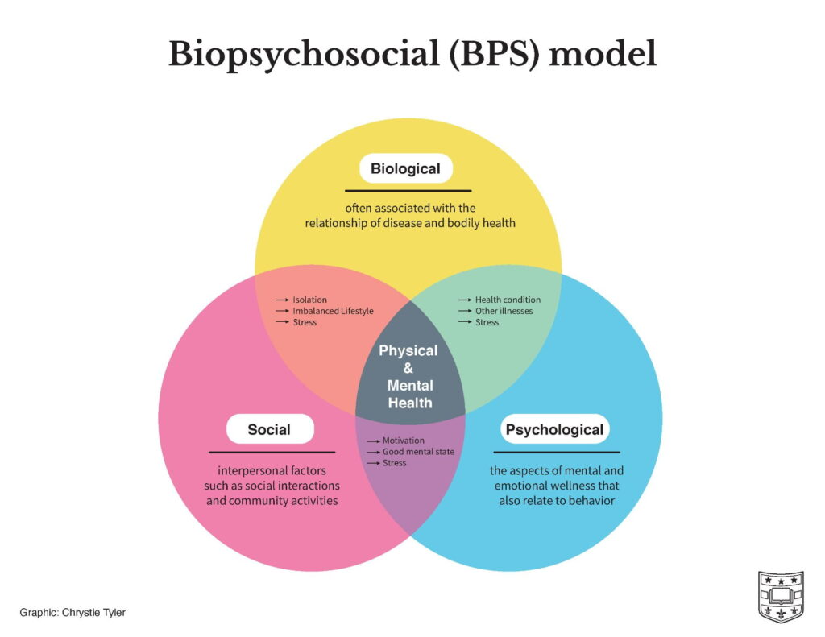
(Three Aspects of Health and Healing: The Biopsychosocial Model in Medicine, 2021)

Study Design
This study implements a qualitative study allowing for the researcher to analyze themes and multiple perspectives on each measure (Creswell, 2013). The exploration of how to implement equitable mental health resources through design strategies within school buildings incorporated a combination of questionnaires, observations, and literature research. The researcher gathered expert information in diverse disciplines including architecture, interior design, interior architecture, and instructional learning sciences. The central assumption is that the equitable redevelopment of interior and exterior spatial layouts and programming can improve mental, psychological, and cognitive functions of K-12 students regardless of their social identity that society creates and financial capabilities to access resources.

Data Sample
The participant sample consists of 10 experienced architects and interior designers with experience in K-12 design, in addition to 9 K-12 educators, all from the United States. The inclusion criteria of participants for the study must ensure individuals have 5 years of professional experience or more in K-12 Education Design or instruction.

Procedure
After the OU Institutional Review Board (IRB) approved this study, participants were recruited using convenience and snowball sampling methods on a voluntary basis. The survey was voluntary, where initial recruitment was via email, allowing recipients to forward the recruitment statement to known individuals who may meet the inclusion criteria. The studied phenomenon seeks to use these sampling methods as they are beneficial to understanding how diverse individuals varying in age, professional experience, profession, etc., view the researched topic (Benoot et al., 2016). Due to this qualitative study being unable to be generalizable, the validity is critical. Gaining multiple perspectives from participants with 5+ years of experience in education or design will aid in the validity of this study in addition to the researcher analyzing the data from multiple angles themselves (Chetty, 2020).
The data analysis of participants’ responses consisted of reading through the transcripts several times to obtain full comprehension, identifying significant words, phrases, or sentences, formulating meanings and creating themes common to all responses, and tying the results back to previous research to validate the findings and maintain reliability (Creswell, 2013). The questionnaires were sent to educators from Universities in the U.S. and recruitment emails specified recipients to forward the email to individuals that meet the inclusion criteria. The same recruitment method occurred for designers once the initial email has been sent using the design and construction firms listed at the university’s career fair. All participants had the option to have anonymity.

Measurement

Variables
The variables in this study, shown in Table 2, were measured and analyzed regardless of participants being an educator or designer. Due to the difference in profession, the provided questions vary while still incorporating the following themes – Design Strategies, Accessibility, and Curriculum/Instruction. User satisfaction was classified as perceived mental health among students, evaluating how it is impacted by design strategies, curriculum, and access to certain design elements. The educators and designers acknowledged each theme, determining whether it is lacking, not implemented, or heavily focused. This theoretical framework helped inspect any connection between mental health and the following variables presented within Table 2.
Table 2.
Research variables for Students’ Mental Health
Themes | Variables
Accessibility | Availability of flexible furniture | Access to nature/outdoor environments | Universal Design | -
Design Strategies | Collaborative Spaces | Flexible Spaces | Technology Integration Rooms | Career Focus Rooms/Classes
Curriculum/Instruction | Student Support Services | Classroom Management | Gaps in the Classroom | -

Instrumentation
A 20-minute online questionnaire was used via Qualtrics Survey Software. The survey, The Implementation of Wellbeing for School Buildings Survey (Appendix A), consisted of the following categories: Design Strategies, Accessibility, and Curriculum/Instruction. Each participant who has experience designing learning environments was asked to discuss projects that emphasize design strategies that promote positive learning environments or mental health and well-being. The gathered information was analyzed to determine the best methods for redeveloping school design with consideration of previous studies.
A questionnaire was used to collect experts’ opinions on design strategies in relation to students’ mental health, wellbeing, and academic performance. The questionnaire consisted of 20 questions, (3 demographic, 3 Likert-scale, and 14 open-ended), evaluating participants’ methods of design and instruction. The Likert- scale was added in order to evaluate participants’ perception on school buildings connection to students’ mental health. Open and closed-ended questions were incorporated to collect and interpret accurate insights for K-12 education building design.

Data Analysis
After all responses were gathered, keywords were extracted using NVivo 14 software to emphasize relevant words and expressions from the participants. This inductive thematic analysis highlighted reoccurring ideas or concepts that emerge from the provided questions using existing knowledge, research, and/or theory to find value in the data. Once responses were received, the researcher was able to thoroughly review them several times and extract significant words and phrases via inductive coding and they were analyzed to explore any connections or disassociation with the reviewed literature and the gaps within. Once collected, those extracted were placed under subcategories or categories/themes and comparing the emerged coding's clusters together (Vaismoradi et al., 2013).
Due to the survey questions varying from short response, essay prompt, and Likert scale, not all responses can pull key words and phrases. Those responses that stem from the Likert scale survey questions was averaged using numeric values (1-5) to understand the extent of agreement or disagreement participants have for the statements liked in Appendix A.
After generating initial codes, defining and naming themes, reviewing themes, and searching for themes, they were compared with the categories implemented within the survey. The three categories implemented in the survey were used to measure school design strategies that should be or have already been implemented and compared to post occupancy surveys and existing literature to identify the most effective design strategies. The results of this survey displayed commonalities within K-12 design, perception among users and designers, and potential relationships between the found themes. This study implemented descriptive statistical analysis which will potentially aid in determining the best design framework for K-12 environments to be implemented as the new basis of design.

Chapter 4 – Results

Introduction
The objective of this study is to aid in redeveloping K-12 educational environments. To develop a basis of design for K-12 settings, the Implementation of Wellbeing for School Buildings Survey was sent to both design and education professionals. This chapter will review how the survey questions presented in Appendix A were answered in relation to the research questions discussed in Chapter 1. Appendix C breaks down how each survey question corresponds with this study’s research questions which will be further analyzed based on participants’ corresponding answers.

Description of Sample
The collection of data began on February 13, 2024, consisting of a total of 34 participants. The data collection tool, Qualtrics, was closed after one month of recruitment on March 14, 2024. Sixteen responses were excluded due to their low response quality; for example, they only answered the first 2-5 questions from the Implementation of Wellbeing for School Buildings Survey. Finally, the remaining 18 responses were included in the data analysis. They answered the majority of questions with the highest amount unanswered being 3 questions of the 20 presented in the survey. Out of those 18 participants, 10 described themselves as educators, while the others (8) were designers ranging from Architects, Educational Design Specialists, Interior Designers, and Educational Market Leaders. The responses given by these participants offered personal and professional experience that aided in further understanding how to bridge the gap within our school environments.

Mental Health in Educational Setting
This section answers research question 1, “how is mental health defined within educational settings?” In analyzing the open-ended responses, several key themes emerged regarding the importance of addressing systemic inequities and advocating for policy changes to promote educational equity for all K-12 students. One prominent theme was “community,” as participants noted the importance of developing a connection to the school community for students to have a better sense of belonging and desire to learn. For instance, one participant noted, “it is more important to have a facility that culturally reflects the community. Build community and cultural pride. Celebrate what makes them unique,” also noting that “mental health also plays into security and a sense of belonging.” Designers and educators bring insight into the importance a community has on students’ learning process while advocating ways mental health can be improved to better assist the student’s learning process.
When analyzing the theme of community, the participants began to illustrate what mental health consists of within K-12 environments. Mental health in schools means creating an environment that has a “connection that promotes a sense of belonging and support.” The environment needs “consideration for the needs of students,” and to understand the amount of “comfort and support” each student needs as they vary.
On a Likert scale from 1 (strongly disagree) to 5 (strongly agree), the question “Do you agree if the following aspects improve students’ mental health” averaged a score of 4.3, 4.6, and 4.4 when referencing dedicated collaboration spaces, equal access to resources, and access to biophilic design, respectively. These averages, shown in Figure 2, suggest that most participants agree that K-12 students can benefit mentally from the addition of K12 environments having dedicated collaboration spaces, equal access to resources, and access to biophilic design. Designers and educators translate the needs for spaces for this to happen, where one participant notes there should be “a variety of types and sizes of space for students to work in teams as is done in the real-world job environment.” An additional benefit could come to students who already understand the subject and could possibly use the varying spaces to further learn individually or lead to cooperative learning where students can assist their peers who still struggle with the material.
Figure 2.
Factors Improving Student Mental Health: Access to Spaces and Resources
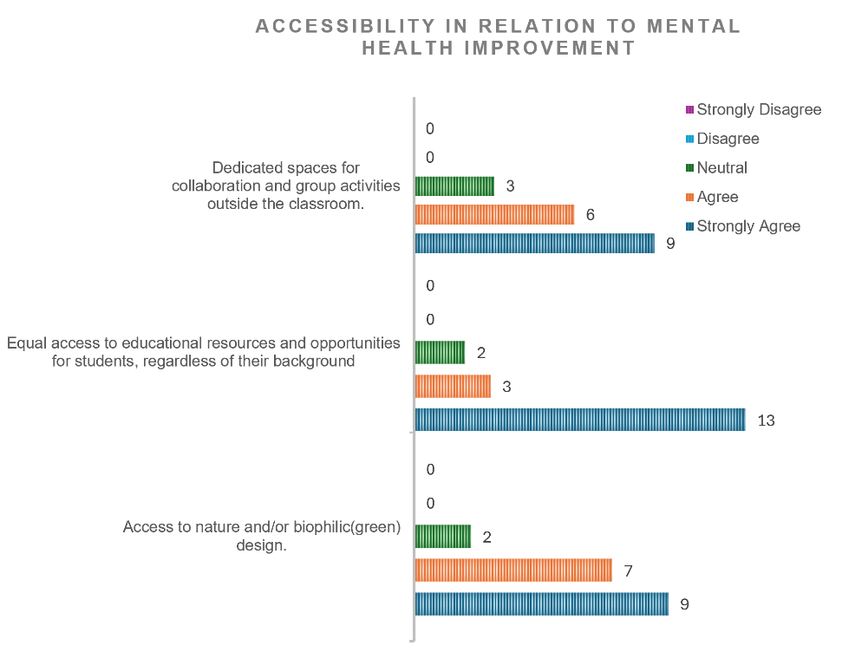
Note. N = 18

Barriers to Students’ Mental Health
Continuing to address research questions, this section answers research question 2, “what are the barriers that design faces to bring focus to mental health?” After anaylzing the term “mental health” within educational settings, the findings can be used when assessing participants’ responses regarding what barriers hinder the way design can bring focus to mental health. After being directly asked what has hindered designers and educators from promoting equity and inclusivity in K-12 buildings/classrooms, the overarching terms that appeared within the majority of answers were funding and resources. Figure 2 displays how both designers and educators agree equal access to educational resources and opportunities for students, regardless of their background could be beneficial to improve student mental health. However, they feel that funding is a major issue that should be addressed stating “funding is a policy issue and is one that needs to be spoken about with the district,” and “not all schools have the same types of funding as others” which was a highlighted issue in Chapter 2.
Utilizing the same Likert scale method previously mentioned ranging from “Strongly Agree (5)” to “Strongly Disagree (1),” it is evident that barriers within design and K12 environments emerge as a significant concern. Figure 3 shows a notable proportion of respondents expressing agreement with the statement that disparities within design and academia, socioeconomic status, and low access to resources outside of school settings affect perceived student mental health. This is also represented as respondents voice a noticeable gap in education due to cognitive methods, techniques, learning gaps and language barriers, in addition to, the communication gap between the user group and designers.
Moreover, while quantitative responses emphasize the prevalence of concerns regarding disparities within design and academia, these particular statements got the most amount of disagreement in comparison to others within the survey. Further insights from participants' short-answer survey responses reveal nuanced perspectives, with individuals citing that the statements insinuate schools with more funding, or “rich kids,” have numerous adequate resources outside of school. The participant suggested that while schools should have the appropriate resources to aid in education, “design must overcompensate as an affirmative action to those schools where students have unstable home life and less supports outside of the school.” The comments emphasizes the multifaceted nature of the issue, still highlighting the concern surrounding issues such as disparities within academia and gaps in access to resources outside of school settings shown in Figure 3.
Figure 3.
Barriers Affecting K-12 Setting and Student Mental Health
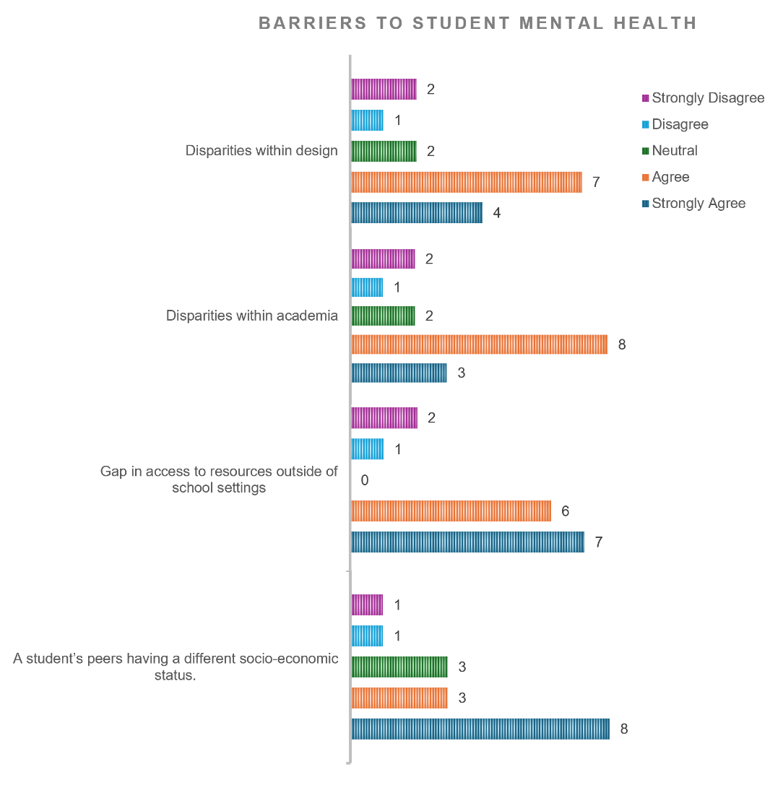
Note. N = 18
To address other barriers, one participant mentions “architects can help with this by outlining projects over 5-10 years in a master plan,” also stating architects could put “facility assessment information together with educational adequacy assessments and then later post-occupancy and educational commissioning.” The responses confirm the literature and start to fill in the gaps by providing ideas that could possibly mitigate the funding issues caused by “socio-economic status,” “competing priorities,” “unconscious discrimination.” Participants describe actions such as prioritizing schools ranked further from educational justice for design and collaborating varying with building leaders and teachers to respond to their needs. The needs considered should be not just the educators or the boards, as a participant stated, so that goals of all participants can be identified and understood earlier.

Strategies for Students’ Mental Health
Research question 3, “what are the barriers that design faces to bring focus to mental health?” will be answered in this section. In recognizing the challenges and barriers identified by designers and educators regarding students' mental health, it becomes evident that proactive measures and strategic interventions are necessary to address these issues effectively. Student access to resources in and out of the school is perceived to be a continual barrier addressed by participants and researched studies alike. Building upon the insights gained from the discussions on the barriers to students’ mental health, the focus shifts towards exploring strategies to promote positive mental well-being with accommodation for all stakeholders. Participants have articulated various obstacles, still offering valuable suggestions and ideas as an average Likert scale score of 4.4, 4.7, 4.3, and 4.2, respectively, indicating strong agreement with the notion that spaces promoting collaboration, gender-equal school design, commonality across K-12 school buildings irrespective of demographics, and technology integration can significantly improve students' mental health. However, Figure 4 represents the number of participants who felt more neutral with the notion.

Figure 4.
Design Strategies to Improve Student Mental Health in K12 Settings
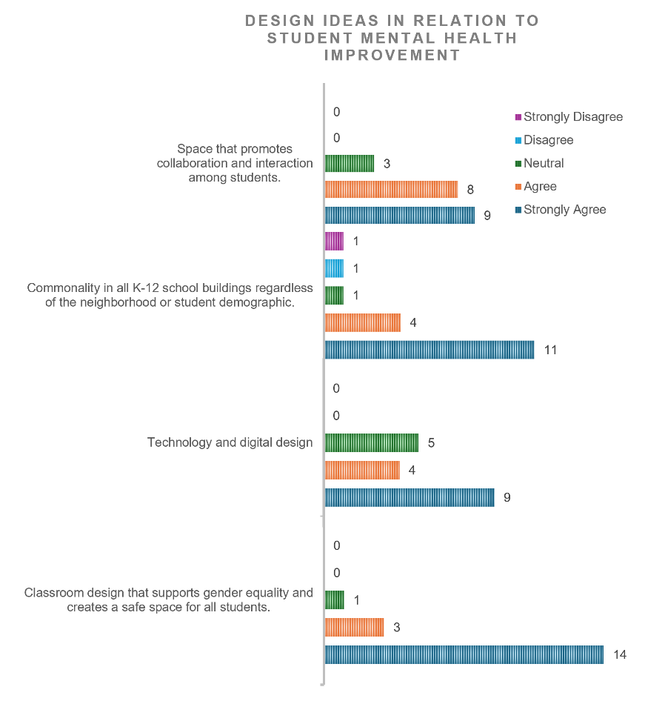
Note. N = 18
These participants have addressed that their experiences and observations within their professional careers has displayed “an amazing misallocation of resources.” Strategies such as implementing technology can be useful only if used adequately by the users (i.e., exploration of engagement and cognitive processes, teaching trades, mitigate student struggle from those with learning deficits). It was stated that technology should not be the only option, ensuring the building is not “crowded” with things that are not certain to have longevity.
To further explore the “misallocation of resources” and focus on longevity, one participant had an interesting perspective regarding classroom size, stating “Why talk about the size of a box, when you should talk about the needs of the space to provide the proper environment?” This statement has a strong connection to the literature in Chapter 2, where stakeholders should focus on what individual schools need rather than comparing them as stated previously by the participant who discussed the “rich kid” ideology. In addition, educators noted that smaller classrooms are not necessarily a bad thing, as it allows for “better opportunity to address each student’s needs” and “foster a more intimate learning environment.”
As the discussion has highlighted the challenges surrounding resource allocation and classroom size, it becomes imperative to shift the focus towards the critical role of design in shaping educational environments that prioritize student well-being and learning outcomes. Participants have voiced to focus on not just immediate needs, but also ensure longevity and effectiveness where resources are available “just in time, not just in case.” This aligns with the overarching themes of design, needs, and learning, encompassing codes such as trauma-informed design, design quality, and inclusive design, among others such as student, teach, community and diverse needs and flexible learning spaces. While exploring these codes, the aim is to consider multiple perspectives from all stakeholders and further develop strategies that passively and actively accommodate physical needs all students in addition to supporting them psychologically and emotionally.

Conclusion
This section highlights insights extracted from various professionals with experience as a designer and teaching in K12 environments. The participants bring attention to varying perspectives on resource allocation, classroom size, and design that consist of the multifaceted construct that is mental health. The promotion of mental health relies on all stakeholders to consider where persistence is required when discussing the interaction of biological, psychological, social, and environmental factors, all of which have been addressed by participants and researched literature. The insights, aggregated and directly referenced from both NVivo 14 analysis and existing literature, have illuminated key themes that culminate the critical role of design in shaping inclusive and supportive learning environments as shown in Table 3. Moving forward, Chapter 5 will discuss the findings further, drawing connections to existing literature and theoretical frameworks such as the BPS model.
Table 3.
Design Strategies by Existing/Emerging Themes
Theme | Design Strategy
Community | - Provided laundry and shower facilities, food, pantries, community gathering spaces.  - Incorporate design elements that build community and cultural pride, celebrating what makes them unique.  - Provide open and inclusive spaces that create a sense of belonging.
Trauma-Informed Design | - When large gatherings and performances (assembly, play, music, dance, pep rally, etc.) are occurring give traumatized students an alternative setting from which to watch and listen without being in the large space.  - walls and floors designed to help stressed students find balance and self-awareness.  - Recognize hypertension, triggering, withdrawal, and “acting out”
Inclusive Design | - Using ADA as a set of minimums, but as a guiding principle on how individuals experience a space
Student Motivation | - Creating mental health rooms/inviting counseling suites.  - Offer collaborative spaces.  - Perimeter benches where a student could drop away from active participation without having to leave the space.  - Incorporate biophilic design.  - Incorporate flexible learning spaces where students and/or teachers can easily move furniture.  - Use colors strategically to evoke specific emotions and stimulate creativity and productivity
Special Needs | - Including playground equipment for special needs students.  - Consideration of the placement of specialized classrooms  - Incorporate space that address the cause of certain behaviors to reduce if needed (i.e., “bad behavior”).  - Additional spaces for students who need additional help due to language barriers (bilingual teachers would be a valuable addition).
Engagement Modes/Cognitive Methods | - Creating maker spaces  - Transforming library into a space not only for books but for learning about technology  - Incorporate small and large conference/meeting rooms

Chapter 5 – Discussion

Though the results section aiding in the highlighting design-related themes within educational settings for K12, the aim is to now offer practical guidance for educators, policymakers, and designers. This interdisciplinary study allows multiple perspectives to bring insight on the necessary adjustments needed to influence student well-being in a positive manner within educational settings. Drawing upon the existing research and theories, the findings help simplify the complex interplay of biological, psychological, and social factors to encourage an array of design strategies to aid in student mental health as shown in Figure 5. By examining the themes, codes, and Likert-scale responses, connections can be made while considering the existing literature and design strategies.
Figure 5.
Design Strategies to Corresponding BPS Model Components
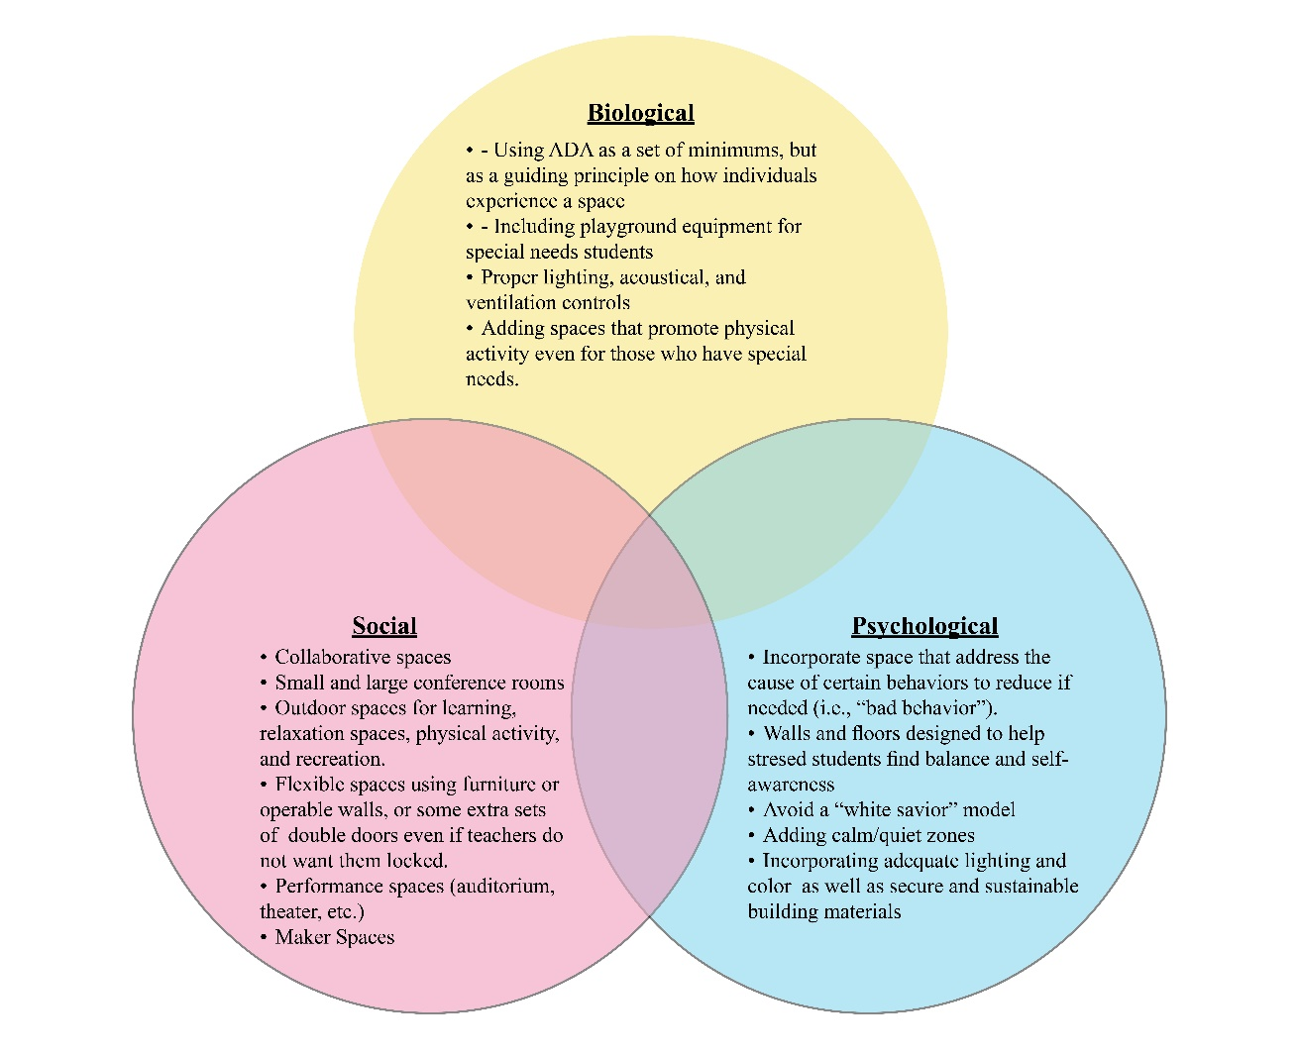
(Washington, 2024)

Research Questions
The component of the BPS model emphasizes the importance of considering holistic approaches to education and design that also are efficient and effective. The multifaceted relationship between educational design and student health needs the structure the BPS model allows to adequately explore, define, and create ideas guided by this study’s research questions. Firstly, mental health could be defined utilizing existing literature and the perspectives gained from participants responses. As complex as mental health is, designers and educators want to make it as simple as possible for students to develop adequately in the classroom as well as within their social life (i.e., home, future jobs, friendships, etc.).
It is essential that designers understand that mental health is different for everyone, which is why it is often difficult to define. Designers are encouraged to consider all stakeholders, incorporate evidence-based design, and adopt learner centered and learning experience focused perspectives to design learning spaces that can support all learners. Tools such as Gardener's 9 types of intelligence can be utilized to “understand how different people learn to then be able to think about different learning spaces where everyone could thrive - because it won't be the same for everyone” as stated by a participant. Incorporating the use of more evidence-based design encourages designers to research further to have designs that meet the needs of the specific environment where the buildings are located. This will affect the views, access to daylight, and acoustical levels required to effectively improve mental health. In addition, offering communal and open spaces with the appropriate aesthetic will aid in creating an environment the promotes a sense of belonging along with additional spaces to adhere to the support required based on students’ needs. Mental health is the state of mental well-being, considering student and staff comfort, security, and support which can be developed through spaces that facilitate social interaction and connection.
Developing the spaces to address mental health often meets the continual barrier that is funding and lack of resources to further develop and maintain these spaces overall. The barriers that affect design and education are connected, as socio-economic disparities have been tied to resource allocation challenges and low budget for design. Policymakers must make it a higher priority to create the necessary changes to the design and funding problems that affect students’ mental health. If there are laws where children are obligated to attend schools, then policymakers should be obligated to fund them appropriately to address the concerns of educators, designers, and those identified through this study’s literature review. Participants emphasized the need for strategies that provide choice and autonomy for students to support mental health, especially since laws forcing students to attend school takes students’ autonomy away. This allows students to self-regulate, utilizing spaces such as quiet rooms, meditation areas, play areas, outdoor spaces, among others.
With or without policymakers making the necessary steps to improve education and educational design, a shift is required to programmatic design strategies that have the potential to promote self-worth and positive mental health among students. This study examined the need for evidence-based design, in addition to discussing social-emotional learning programs and trauma-informed design principles. The programs developed as designers begin to retrofit or create new educational buildings require them to address the identified barriers and foster the needs of students, faculty and staff, parents, and anyone involved in education settings and that would impact students’ mental health in the duration of their continued education. This could look like classroom/ school “bunkers”/safe rooms, mental health rooms, inviting counseling suites, maker spaces, small and large study spaces as well as teaching spaces, and many other ideas as highlighted by existing literature and practices and the insights from this study’s findings. Table 3 in Chapter 4 displays design strategies and this study highlights numerous programmatic ideas that can be implemented, but it is up to designers to understand which would be feasible for the educational building they are working on. Ongoing evaluation and adaptation will be necessary to ensure their effectiveness and sustainability in diverse educational settings as we strive to improve and implement positive mental health environments for students.

Validity and Reliability
In addition to addressing practical implications for educators, policymakers, and designers, it's imperative to underscore the validity and reliability of this study's findings. This refers to refers the extent to which this study accurately measures or reflects the concepts it intends to assess, while pertaining to the consistency and dependability of the research procedures and outcomes. Gaining multiple perspectives from participants with 5+ years of experience in education or design significantly enhanced the credibility of our research, as emphasized by Chetty (2020). This approach ensured that the data collection process captured a diverse range of perspectives related to K-12 education, mental health, and design. The analysis of participants' responses involved a rigorous process of repeated transcript reviews to ensure full comprehension and identification of significant themes in relation to the study’s variables. By employing a multidisciplinary approach minimized the risk of bias and ensured the consistency and trustworthiness of the findings, as advocated by Creswell (2013). By incorporating these insights with existing literature, validates the findings and contributes to the authenticity and fluency of the multifaceted discussion regarding design and student well-being within educational settings. The following section will discuss the limitations of this study, as researchers and designers alike can further enhance the understandings of the relationship between student mental health and educational environments.

Limitations
Though this study provided valuable insights into the relationship between educational design and student mental health through the guide of its research questions and utilization of the BPS model, limitations are present in the methodology, data collection, and analysis. It is imperative to discuss the limitations presented within this study to further advance future research and design related to K12 education. This includes sample size due to time constraints. The number of participants not only needs to be increased, but also more stakeholders should be considered when discussing strategies that will affect them all. Policymakers, parents/guardians, and possibly students should be included to allow for full transparency of requirements and expectations for optimal learning and development with implications of positive mental health experiences. The survey created also proved to be an issue as multiple open-ended responses might have thwarted participants from completing the survey. Respondents may not all be skilled or available to use online survey, in addition, they may prefer to complete questionnaires that require direct interaction with another person (Reja et al., 2003). Moving forward, future research should aim to address these limitations and build upon this study’s findings to further investigate the constant complexity surrounding the construct of mental health in education. The following conclusion will reflect the implications of the study and offer recommendations for stakeholders in education and design.

Conclusion
To sum up, this study highlights significant findings from existing research and professional experiences. This aided in featuring design parameters that influence positive mental health in K12 settings. The themes and codes and their corresponding design strategies allow for future designers and researchers to expand on conversations needed by all stakeholders to enhance the learning environments for students. Though it is designers’ responsibility to create effective and efficient environments to meet the users’ needs, all stakeholders are responsible for providing insight that will aid in addressing barriers to students’ mental health, strategies for positive mental health, and understanding the value positive spaces have on an individual mental health and development. Despite encountering limitations, prioritizing strategies that provide choice and autonomy that adhere to biological, social, psychology, and environmental needs could pave the way for environments that foster positive mental health outcomes for all students.

References
Access to Education: The Impact Of Inequality On Education. (n.d.). Retrieved September 14, 2023, from https://www.graygroupintl.com/blog/impact-of-inequality-on-education-access-and-quality
Adedokun, O. A., Parker, L. C., Henke, J. N., & Burgess, W. D. (2017). Student Perceptions of a 21st Century Learning Space. Journal of Learning Spaces, 6(1).
Allegretto, S., García, E., & Weiss, E. (2022, July 12). Public education funding in the U.S. needs an overhaul: How a larger federal role would boost equity and shield children from disinvestment during downturns. Economic Policy Institute. https://www.epi.org/publication/public-education-funding-in-the-us-needs-an-overhaul/
American Psychological Association. (n.d.). Education and Socioeconomic Status. Https://Www.Apa.Org. Retrieved September 15, 2023, from https://www.apa.org/pi/ses/resources/publications/education
Barrett, P., Davies, F., Zhang, Y., & Barrett, L. (2015). The impact of classroom design on pupils’ learning: Final results of a holistic, multi-level analysis. Building and Environment, 89, 118–133. https://doi.org/10.1016/j.buildenv.2015.02.013
Barrett, P., Treves, A., Shmis, T., Ambasz, D., & Ustinova, M. (2019). The Impact of School Infrastructure on Learning: A Synthesis of the Evidence. Washington, DC: World Bank. https://doi.org/10.1596/978-1-4648-1378-8
Benoot, C., Hannes, K., & Bilsen, J. (2016). The use of purposeful sampling in a qualitative evidence synthesis: A worked example on sexual adjustment to a cancer trajectory. BMC Medical Research Methodology, 16(1), 21. https://doi.org/10.1186/s12874-016-0114-6
Borrell-Carrio, F., Suchman, A., & Epstein, R. (2004). The Biopsychosocial Model 25 Years Later: Principles, Practice, and Scientific Inquiry. The Annals of Family Medicine, 2(6), 576–582. https://doi.org/10.1370/afm.245
Brown, S. D., & Reavey, P. (2019). Vital spaces and mental health. Medical Humanities, 45(2), 131–140. https://doi.org/10.1136/medhum-2018-011609
Bundick, M. J., Quaglia, R. J., Corso, M. J., & Haywood, D. E. (2014). Promoting Student Engagement in the Classroom.
Cappon, A., & Kennette, L. N. (2022, December 16). Applying the Biopsychosocial Model to Teaching and Learning. Society for the Teaching of Psychology -. https://teachpsych.org/E-xcellence-in-Teaching-Blog/13028319
Center for Disease Control and Prevention. (2018, November 5). Well-Being Concepts | HRQOL | CDC. https://www.cdc.gov/hrqol/wellbeing.htm
Chetty, S. T., Priya. (2020, January 27). How to establish the validity and reliability of qualitative research? Knowledge Tank. https://www.projectguru.in/how-to-establish-the-validity-and-reliability-of-qualitative-research/
Corgan. (2022a, October 20). Designing with Empathy. https://www.corgan.com/news-insights/2022/designing-with-empathy
Corgan. (2022b, October 20). Is the School Building Causing Stress for Students and Teachers? https://www.corgan.com/news-insights/2022/is-the-school-building-causing-stress-for-students-and-teachers
Creswell, J. (2013). Qualitative Inquiry & Research Design Choosing Among Five Approaches (3rd ed.). SAGE Publications.
Dannenberg, A. L., Frumkin, H., Krieger, J., & Jacobs, D. E. (2011). Making Healthy Places: Designing and Building for Health, Well-being, and Sustainability. In R. J. Jackson (Ed.), Making Healthy Places: Designing and Building for Health, Well-being, and Sustainability (pp. 170–187). Island Press/Center for Resource Economics. https://doi.org/10.5822/978-1-61091-036-1_11
Davies, D., Jindal-Snape, D., Collier, C., Digby, R., Hay, P., & Howe, A. (2013). Creative learning environments in education—A systematic literature review. Thinking Skills and Creativity, 8, 80–91. https://doi.org/10.1016/j.tsc.2012.07.004
Dupree, C. H., & Boykin, C. M. (2021). Racial Inequality in Academia: Systemic Origins, Modern Challenges, and Policy Recommendations. Policy Insights from the Behavioral and Brain Sciences, 8(1), 11–18. https://doi.org/10.1177/2372732220984183
Earthman, G. I. (1998). THE IMPACT OF SCHOOL BUILDING CONDITION AND STUDENT ACHIEVEMENT, AND BEHAVIOR.
Earthman, G. I., & Lemasters, L. (1996). REVIEW OF RESEARCH ON THE RELATIONSHIP BETWEEN SCHOOL BUILDINGS, STUDENT ACHIEVEMENT, AND STUDENT BEHAVIOR.
Evans, G. W. (2003). The built environment and mental health. Journal of Urban Health: Bulletin of the New York Academy of Medicine, 80(4), 536–555. https://doi.org/10.1093/jurban/jtg063
Flores, A. (2007). Examining Disparities in Mathematics Education: Achievement Gap or Opportunity Gap? The High School Journal, 91(1), 29–42.
Goodman, E., McEwen, B. S., Dolan, L. M., Schafer-Kalkhoff, T., & Adler, N. E. (2005). Social disadvantage and adolescent stress. Journal of Adolescent Health, 37(6), 484–492. https://doi.org/10.1016/j.jadohealth.2004.11.126
Hong, S., Link to external site, this link will open in a new tab, Kim, Y., Yang, E., & Link to external site, this link will open in a new tab. (2022). Indoor environment and student productivity for individual and collaborative work in learning commons: A case study. Library Management, 43(1/2), 15–34. https://doi.org/10.1108/LM-06-2021-0055
Hornby, G., & Atkinson, M. (2003). A Framework for Promoting Mental Health in School. Pastoral Care in Education, 21(2), 3–9. https://doi.org/10.1111/1468-0122.00256
Hung, M., Smith, W. A., Voss, M. W., Franklin, J. D., Gu, Y., & Bounsanga, J. (2020). Exploring Student Achievement Gaps in School Districts Across the United States. Education and Urban Society, 52(2), 175–193. https://doi.org/10.1177/0013124519833442
Kariippanon, K. E., Cliff, D. P., Lancaster, S. L., Okely, A. D., & Parrish, A.-M. (2018). Perceived interplay between flexible learning spaces and teaching, learning and student wellbeing. Learning Environments Research, 21(3), 301–320. https://doi.org/10.1007/s10984-017-9254-9
Kweon, B.-S., Ellis, C., Lee, J., & Jacobs, K. (2017). The link between school environments and student academic performance. Urban Forestry & Urban Greening, 23. https://doi.org/10.1016/j.ufug.2017.02.002
Lester, L., & Cross, D. (2015). The Relationship Between School Climate and Mental and Emotional Wellbeing Over the Transition from Primary to Secondary School. Psychology of Well-Being, 5(1), 9. https://doi.org/10.1186/s13612-015-0037-8
Love, B. L. (2023, August 18). Stop Talking About ‘Gaps’ in Education—Talk About Harm. Education Week. https://www.edweek.org/leadership/opinion-stop-talking-about-gaps-in-education-talk-about-harm/2023/08
Luiselli, J. K., Putnam, R. F., Handler, M. W., & Feinberg, A. B. (2005). Whole‐school positive behaviour support: Effects on student discipline problems and academic performance. Educational Psychology, 25(2–3), 183–198. https://doi.org/10.1080/0144341042000301265
Malik, R. H., & Rizvi, A. A. (2018). Effect of Classroom Learning Environment on Students’ Academic Achievement in Mathematics at Secondary Level. Bulletin of Education and Research, 40(2), 207–218.
Megan. (2021, October 10). Three Aspects of Health and Healing: The Biopsychosocial Model in Medicine. https://surgery.wustl.edu/three-aspects-of-health-and-healing-the-biopsychosocial-model/
Mendelson, T., Kubzansky, L. D., Datta, G. D., & Buka, S. L. (2008). Relation of female gender and low socioeconomic status to internalizing symptoms among adolescents: A case of double jeopardy? Social Science & Medicine, 66(6), 1284–1296. https://doi.org/10.1016/j.socscimed.2007.11.033
Michael A. Westerman. (2008). Integrating the Parts of the Biopsychosocial Model. Philosophy, Psychiatry, & Psychology, 14(4), 321–326. https://doi.org/10.1353/ppp.0.0134
Moore, S. L., & Ellsworth, J. B. (2014). Ethics of Educational Technology. In J. M. Spector, M. D. Merrill, J. Elen, & M. J. Bishop (Eds.), Handbook of Research on Educational Communications and Technology (pp. 113–127). Springer New York. https://doi.org/10.1007/978-1-4614-3185-5_10
National Center for Education Statistics. (2018, January 8). State Education Practices (SEP). National Center for Education Statistics; U.S. Department of Education. https://nces.ed.gov/programs/statereform/tab5_1.asp
National Center for Education Statistics. (2023, May). COE - Concentration of Public School Students Eligible for Free or Reduced-Price Lunch. https://nces.ed.gov/programs/coe/indicator/clb/free-or-reduced-price-lunch#suggested-citation
Opoku, A. (2015). The Role of Culture in a Sustainable Built Environment. In A. Chiarini (Ed.), Sustainable Operations Management: Advances in Strategy and Methodology (pp. 37–52). Springer International Publishing. https://doi.org/10.1007/978-3-319-14002-5_3
Rands, M. L., & Gansemer-Topf, A. M. (2017). The Room Itself Is Active: How Classroom Design Impacts Student Engagement. Journal of Learning Spaces, 6(1).
Reja, U., Manfreda, K. L., Hlebec, V., & Vehovar, V. (2003). Open-ended vs. Close-ended Questions in Web Questionnaires.
Reyes, A. (2020). Compulsory School Attendance: The New American Crime. Education Sciences, 10(3), Article 3. https://doi.org/10.3390/educsci10030075
Stanford, L., & Baker, L. (2023, April 6). 5 Tips for Designing School Spaces That Support Students’ Mental Health. Education Week. https://www.edweek.org/leadership/5-tips-for-designing-school-spaces-that-support-students-mental-health/2023/04
Sylvestre, N. (2020). Physical Learning Environment and Teaching Practices: The Case of Grand’Anse Schools. https://scienceetbiencommun.pressbooks.pub/handicaphaitienglish/chapter/physical-learning-environment-and-teaching-practices-the-case-of-grandanse-schools/
Terada, Y., & Merrill, S. (2023, November 2). The Science of Classroom Design. Edutopia. https://www.edutopia.org/article/the-science-of-classroom-design/
Uline, C. L., Wolsey, T. D., Tschannen-Moran, M., & Lin, C.-D. (2010). Improving the Physical and Social Environment of School: A Question of Equity. Journal of School Leadership, 20(5), 597–632. https://doi.org/10.1177/105268461002000504
U.S. Department of Education. (2023, May 19). U.S. Department of Education Releases Report on State of School Diversity, Announces New Grant Opportunity | U.S. Department of Education. https://www.ed.gov/news/press-releases/us-department-education-releases-report-state-school-diversity-announces-new-grant-opportunity
Vaismoradi, M., Turunen, H., & Bondas, T. (2013). Content analysis and thematic analysis: Implications for conducting a qualitative descriptive study. Nursing & Health Sciences, 15(3), 398–405. https://doi.org/10.1111/nhs.12048
Wilson, S., & Dumornay, N. M. (2022). Rising Rates of Adolescent Depression in the United States: Challenges and Opportunities in the 2020s. The Journal of Adolescent Health : Official Publication of the Society for Adolescent Medicine, 70(3), 354–355. https://doi.org/10.1016/j.jadohealth.2021.12.003
World Health Organization. (2022, June 17). Mental health. https://www.who.int/news-room/fact-sheets/detail/mental-health-strengthening-our-response

Appendix A

Implementation of Wellbeing for School Buildings Survey
- What is your job title?
- How many years have you taught K-12?
- How many years have you designed K-12?
Accessibility
- In what ways can learning environments demonstrate accessibility other than ADA?
- In what ways have you promoted equity and inclusivity in K-12 buildings/classrooms?
- What disparities exist within academia and how can design strategies address these inequities to ensure equal access to educational resources and opportunities for all students?
- What has ever hindered you from promoting equity and inclusivity in K-12 buildings/classrooms?
Design Strategies
- What are some ways K-12 buildings can incorporate flexibility within their design?
- Do you agree if the following aspects improve students’ mental health (1-strongly disagree, 2-slightly disagree, 3-neutral, 4-fairly agree, 5-strongly agree)?
    - dedicated spaces for collaboration and group activities outside the classroom.
    - equal access to educational resources and opportunities for students, regardless of their background.
    - access to nature or biophilic(green) design.
- Do you agree if the following aspects improve students’ mental health (1-strongly disagree, 2-slightly disagree, 3-neutral, 4-fairly agree, 5-strongly agree)?
    - Space that promotes collaboration and interaction among students.
    - Classroom design that supports gender equality and creates a safe space for all students.
    - Commonality in all K-12 school buildings regardless of the neighborhood or student demographic.
    - Technology and digital design
- How can design strategies in the built environment support mental health?
- How can design strategies in the built environment contribute to student motivation and positive educational outcomes?
- What are some design strategies/elements you wished were implemented more in K-12 buildings?
- How do you believe technology and digital design can be better integrated into educational spaces to enhance learning?
Curriculum/Instruction
- Based on your knowledge and experience, how does the size of classrooms and the school impact the ability to teach and maintain student engagement?
- What social or cultural factors regarding education spaces affect student outcomes?
- What are the key goals when developing the learning environment for students?
- What are some effective instructional strategies have you found most beneficial to increase student achievement and overall satisfaction?
- Do you agree if the following aspects influence mental health (1-strongly disagree, 2-slightly disagree, 3-neutral, 4-fairly agree, 5-strongly agree)?
  - Disparities within design
  - Disparities within academia
  - Gap in access to resources outside of school settings
  - A student’s peers having a different socio-economic status.
- What spaces, features, or elements do you believe are essential for directly contributing to career readiness as well as cognitive and noncognitive skills?

Appendix B

Consent to Participate in Research (approved by IRB)
University of Oklahoma

You are invited to participate in research about the impact school design and instructional resources have on student mental health.

If you agree to participate, you will complete a 20-minute online survey. The survey will cover any ongoing disparities of K-12 students acknowledging accessibility, design strategies, and curriculum/instruction.

You will be asked to complete an online survey as part of this research. The organization hosting the data collection platform has its own privacy and security policies for keeping your information confidential. There is a risk that the external organization, which is not part of the research team, may gain access to or retain your data or your IP address which could be used to re-identify you. No assurance can be made as to their use of the data you provide for purposes other than this research.
You will be asked to provide demographic information that describes you. We may also gather information about your geographic location in this research. This will include the city and/or state of your job setting gathered during recruitment. Different combinations of personal and geographic information may make it possible for your identity to be guessed by someone who was given, or gained access, to our research records. To minimize the risk of deductive re-identification, we will not combine identifying variables nor analyze and report results for small groups of people with specific demographic characteristics.

There are no benefits for participating in this research.

Your participation is voluntary, and your responses will be anonymous.

We might share your identified data with other researchers or use it in future research without obtaining additional assent from you.
The research data, variables only, may be uploaded to an online data repository platform where it would be publicly available for anyone interested in using it.
Even if you choose to participate now, you may stop participating at any time and for any reason.

If you have questions about this research, please contact:
Anthony Washington, ahw2@ou.edu and Ye Ji Yi, yeji.yi@ou.edu.

You can also contact the University of Oklahoma – Norman Campus Institutional Review Board at 405-325-8110 or irb@ou.edu with questions, concerns or complaints about your child’s rights as a research participant, or if you don’t want to talk to the researcher.

Please print this document for your records. By providing information to the researcher(s), I am agreeing to participate in this research.

Are you 18 years of age or older? ___ Yes ___ No (If no- cannot participate)
Do you have 5 years or more experience ___ Yes ___ No (If no–cannot participate)
designing or teaching K-12

IRB #_______________ IRB Approval Date________________

Appendix C

Constructs (Theoretical Definition) | Measures (Operational Definition) | Relevant Survey Question | Relevant Research Question | Thematic Analysis Codes
Accessibility (Access refers to what individuals can obtain or get to, while accessibility refers to the quality of how easy it is for that individual to reach or get to something.) | Availability of flexible furniture - the amount of furniture and workstations/areas that can be adapted to fit different locations and positions as needed | Q7, Q19.1 | RQ3 | social
 | Access to nature/outdoor environments - Incorporation of open-air space where program activities take place and sustainable greenspace | Q10.3, Q19.1 | RQ3 | social & psychological
 | Universal Design - the concept that promotes accessibility in the design of buildings, products or environments for all people | Q4, Q19.1 | RQ3 | social & biological
Design Strategies (plan or approach that that guides the overall concept, spatial organization, material selection, sustainability goals, and other key aspects of the building or structure.) | Collaborative Spaces - workspaces and environments where individual spaces can be arranged together or initially designed for group work/conversation | Q9.1 & Q10.1, Q19.1, Q19.4 | RQ3 | social
 | Flexible Spaces - furniture and workstations/areas that can be adapted to fit different locations and positions as needed | Q8, Q19.1 | RQ3 | social
 | Technology Integration Rooms - spaces incorporating technology-based resources, devices, and practices (i.e., learning with mobile devices, whiteboards, online tools, computer labs/classes, etc.) | Q10.4 & Q14, Q19.1 | RQ3 | social

 | Career Focus Rooms/Classes - spaces/programs that allow students to focus, learn, and train for one particular career field | Q19.1, Q19.2, Q20 | RQ3 | social & psychological
Curriculum/Instruction (reference to the materials used to teach students and the methods used to teach the material to improve learning and development) | Student Support Services - spaces/programs provides opportunities for academic & cognitive development as well as financial and health (physical, mental, and emotional) counseling | Q10, Q17, Q19.2, Q19.3 | RQ1 | social & psychological
 | Classroom Management - actions taken to create and maintain an inclusive learning environment and manage expectations and behaviors | Q5 & Q9.2, Q18, Q19.2, Q19.4 | RQ3 | social
 | Gaps in the Classroom - a break in continuity between learners' understanding, resources, and well-being | Q6, Q7, Q9.2, Q10.3, Q15, Q16, Q18, Q19.2, Q19.3, Q19.4 | RQ2 | social & psychological
 |  | Q11, Q12 & Q13, Q14 | RQ3 | psychological

