UNIVERSITY OF OKLAHOMA GRADUATE COLLEGE

ANNOTATIONS FOR SELECTED ETUDES FROM THÉO CHARLIER’S 32 ETUDES DE PERFECTIONNEMENT ANALOGOUS TO THOSE EXTANT IN HIS TRENTE-SIX ETUDES TRANSCENDANTES FOR THE PURPOSE OF DEVELOPING MUSICIANSHIP

A DOCUMENT

SUBMITTED TO THE GRADUATE FACULTY

in partial fulfillment of the requirements for the Degree of
DOCTOR OF MUSICAL ARTS

By

JACE THOMAS VICKERS
Norman, Oklahoma 2018

ANNOTATIONS FOR SELECTED ETUDES FROM THÉO CHARLIER’S 32 ETUDES DE PERFECTIONNEMENT ANALOGOUS TO THOSE EXTANT IN HIS TRENTE-SIX ETUDES TRANSCENDANTES FOR THE PURPOSE OF DEVELOPING MUSICIANSHIP

A DOCUMENT APPROVED FOR THE SCHOOL OF MUSIC

BY

_______________________________
Dr. Karl Sievers, Chair

_______________________________ Mr. Brian Dobbins, Co-Chair

_______________________________
Dr. Matthew Stock

_______________________________
Dr. Roland Barrett

_______________________________
Dr. Judith Pender

© Copyright by JACE THOMAS VICKERS 2018 All Rights Reserved.

Table of Contents

List of Figures vi
Abstract x
Part One: Intent and Scope of Project 1
Chapter 1: Introduction… 2
Chapter 2: Significance and Purpose 6
Chapter 3: Review of Related Literature 8
Part Two: Analysis of Annotated Items from Trente-Six Etudes Transcendantes…….10 Chapter 4: Annotated Works in Etude No. 1 “De L’Articulation” 11
Chapter 5: Annotated Works in Etude No. 2 “Du Style” 14
Chapter 6: Annotated Works in Etude No. 3 “Intervalles: les tierces” 23
Part Three: Supplementary Materials for 32 Etudes de Perfectionnement 28
Chapter 7: Supplementary Materials for Etude No. 2 “Du Style” 29
Chapter 8: Supplementary Materials for Etude No. 3 “de l’Arpege” 34
Chapter 9: Supplementary Materials for Etude No. 5 “Tierces et Triolets” 39
Chapter 10: Supplementary Materials for Etude No. 10 “Intervalles: les Octaves” 43
Chapter 11: Supplementary Materials for Etude No. 13 “de Gammes et fioritures” 47
Chapter 12: Supplementary Materials for Etude No. 17 “Trilles et ornament” 53
Chapter 13: Supplementary Materials for Etude No. 21, “1st Etude Concertante” 58
Chapter 14: Supplementary Materials for Etude No. 11, “Etude chromatique” 63
Chapter 15: Conclusion and Further Study… 68
Bibliography… 70

Appendix: An index of all etudes and associated supplemental material 73

List of Figures

Figure 1: Etude No. 1 from Trente-Six Etudes Transcendantes, mm. 1-23… 11

Figure 2: Etude No. 1 from Etudes Practiques by Rene Laurent, mm. 1-16… 12

Figure 3: Study No. 4 from Etudes Nouvelles by Maxime Alphonse, mm. 1-15… 12

Figure 4: Etude No. 2 from Trente-Six Etudes Transcendantes, mm. 1-26… 14

Figure 5: Study No. 4 from Methode Complete by G. Balay, mm. 1-13… 16

Figure 6: Study No. 8 from Methode Complete by G. Balay, mm. 1-19… 17

Figure 7: Study No. 13 from Methode Complete by G. Balay, mm. 1-20… 17

Figure 8: Study No. 23 from 25 Characteristic Studies by A. Chavanne, mm. 1-9…..17 Figure 9: Study No. 2 from Complete Conservatory Method by J.B. Arban, mm.
1-10…………………………………………………………………………………..17

Figure 10: Study No. 8 from Complete Conservatory Method by J.B. Arban, mm.

1-14…………………………………………………………………………………..18

Figure 11: Study No. 12 from Complete Conservatory Method by J.B. Arban, mm.

1-18…………………………………………………………………………………..18

Figure 12: Study No. 4 from Grand Methode Complete by A. Petit, mm.

1-22…………………………………………………………………………………..19

Figure 13: Study No. 8 from Grand Methode Complete by A. Petit, mm.

1-24…………………………………………………………………………………..19

Figure 14: Study No. 13 from Methode Complete by G. Balay, mm. 35-42… 19

Figure 15: Etude No. 3 from Trente-Six Etudes Transcendantes, mm. 1-20… 23

Figure 16: Study No. 1 from Methode Complete by G. Balay, mm. 1-15… 25

Figure 17: Study No. 15 from Methode Complete by G. Balay, mm. 1-17… 25
Figure 18: Study No. 1 from 25 Characteristic Studies by A. Chavanne, mm.
1-17…………………………………………………………………………………..25
Figure 19: Etude No. 1 from Etudes Pratiques by R. Laurent, mm. 1-16… 26
Figure 20: Etude No. 5 from Etudes Pratiques by R. Laurent, mm. 1-16… 26
Figure 21: Etude No. 2 from 32 Etudes de Perfectionnement, mm. 1-35… 29
Figure 22: Study No. 42 from Flow Studies by David Vining, mm. 1-8… 30
Figure 23: #49, Arpeggio Study from Complete Conservatory Method by J.B. Arban, ed. J. Alessi and B. Bowman, pg 162… 31
Figure 24: Largo from Sonata in A minor by G.P. Telemann, edited K. Brown, mm.
1-10…………………………………………………………………………………..32
Figure 25: Allegro from Sonata in A minor by G.P. Telemann, edited K. Brown, mm. 1-9… 32
Figure 26: Etude No. 3 from 32 Etudes de Perfectionnement, mm. 1-40… 34
Figure 27: Daily Routines by David Vining, pg. 40… 35
Figure 28: Daily Routines by David Vining, pg. 41… 36
Figure 29: Basics Plus by Wolfgang Guggenberger, pg. 62… 36
Figure 30: Overture to “The Italian in Algiers” by Rossini, arr. Moses-Tobani, mm.
40-58……………………………………………………………………...………….37
Figure 31: Etude No. 5 from 32 Etudes de Perfectionnement, mm. 1-25… 39
Figure 32: “Lip Flips” from The Brass Gym, pg. 82… 40
Figure 33: Scale and Arpeggio Routines, pg. 22… 41

Figure 34: Concerto for Euphonium, Mvt. 3 by Eric Ewazen, mm. 1-21… 42
Figure 35: Etude No. 10 from 32 Etudes de Perfectionnement, mm. 1-50… 43
Figure 36: Arban Complete Conservatory Method, No. 8, pg. 147… 44
Figure 37: Arban Complete Conservatory Method, No. 9, pg. 147… 44
Figure 38: Daily Drills by Max Schlossberg, No. 41, pg. 16… 45
Figure 39: Daily Drills by Max Schlossberg, No. 42, pg. 17… 45
Figure 40: Nobles of the Mystic Shrine by J.P. Sousa, mm. 1-24… 46
Figure 41: Etude No. 13 from 32 Etudes de Perfectionnement, mm. 1-23… 47
Figure 42: Exercise 61 from Second Book of Practical Studies for Tuba 49
Figure 43: Daily Scale Routine by William Bell, mm. 1… 50
Figure 44: Concerto by David Gillingham, Movement 3, mm. 1-19… 51
Figure 45: Concerto by David Gillingham, Movement 2, mm. 38-42… 52
Figure 46: Etude No. 17 from 32 Etudes de Perfectionnement, mm. 1-36… 53
Figure 47: Exercise #81 from Technical Studies 54
Figure 48: Etude #17 from 32 Etudes de Perfectionnement, mm. 48-74… 55
Figure 49: Exercise 7 from Lip Flexibilities 56
Figure 50: Pineapple Poll by Arthur Sullivan, mm. 1-40… 57
Figure 51: Etude No. 21 from 32 Etudes de Perfectionnement, mm. 1-30. 58
Figure 52: Mastering the Tuba by Roger Bobo, page 40… 59
Figure 53: Mastering the Tuba by Roger Bobo, page 41… 60
Figure 54: Studies on the Gruppetto by J.B. Arban, #25… 60

Figure 55: Euphonium Concerto by Vladmir Cosma, Mvt. 1, rehearsal mark C 61
Figure 56: Euphonium Concerto by Vladmir Cosma, Mvt. 2, rehearsal mark A 62
Figure 57: Etude No. 11 from 32 Etudes de Perfectionnement, mm. 1-25… 63
Figure 58: Study 1 from Technical Studies by Herbert Clarke 64
Figure 59: Chromatic Exercise #25 from Arban’s Complete Conservatory Method…65 Figure 60: Overture to the “Flying Dutchman”, standard excerpt 66

Abstract

One of the benefits of working out of the 1946 edition of Théo Charlier’s Trente-Six Etudes Transcendantes includes the annotations of supplementary material found at the conclusion of each etude. The study of this supplementary material creates a new dimension of context to the 36 etudes. Charlier’s 32 Etudes de Perfectionnement for trombone and French tuba contains etudes in the style of his 36 etudes for trumpet, but written specifically for low brass instruments.
This document has three major goals. The first is to analyze the annotations provided in Trente-Six Etudes Transcendantes in order to see what skill sets are common between the etudes and the cited material. The second is to provide similar supplementary material for 32 Etudes de Perfectionnement to facilitate mastery and more widespread use of these etudes. The third is to list commonly used pieces from the standard euphonium repertoire of solo and excerpt literature that have skill sets in common with the 32 etudes and supplementary material. The overall goal here is for the student to be able to progress his or her skill sets from fundamental preparatory material to the context of the Charlier etude to the standard euphonium literature. This will on a practical level promote mastery over not only Charlier’s sets of 36 and 32 etudes, but also the standard literature for euphonium.

Part One:

Intent and Scope of Project

Chapter 1: Introduction

One of the most well-known and often-performed etude books ever written for any brass instrument is Trente-Six Etudes de Transcendantes by Théo Charlier (1868-1944), originally composed for trumpet. In the decades since the publication of these etudes, they have been performed on all brass instruments as study material, for auditions, and as recital pieces. Upon playing the etudes, the reason for their popularity becomes clear; they address both technical and expressive elements of playing, often in the same etude. The etudes were originally published in 19261, but an edition of
Trente-Six Etudes Transcendantes published in 1946 contains annotations provided by editors (likely French trumpet player and teacher Roger Delmotte)2 that lists
supplementary material the student can practice in addition to the etude itself. The 1946 edition also changes the order of the etudes. If one compares the Charlier etudes to the works cited in their annotations, one indeed sees similar concepts presented. The supplementary works are sometimes more rudimentary than the etude itself, and sometimes an augmentation of concepts in the etude.
Charlier later composed3 another book of etudes, this one for low brass

instruments, entitled 32 Etudes de Perfectionnement. This book bears many similarities to the earlier book, as 32 Etudes contains etudes that have both lyrical melodies and etudes based on technical ideas. However, in the book for low brass instruments, there are no annotations of the sort that exist in his book of etudes for trumpet. In an attempt

1 Agnès Klingenberg, e-mail correspondence with publisher, September 26, 2017. 2 Agnès Klingenberg, e-mail correspondence with publisher, September 27, 2017. 3 Composed in 1940 and published in 1946

to encourage increased use of these etudes, this document will create practical references similar to what exists in Trente-Six Etudes de Transcendantes for 32 Etudes de Perfectionnement. As this is meant to take into account a practical rather than historical context, the scope of the material used in the references for the 32 Etudes de Perfectionnement will not be limited to material available during Charlier’s time, but instead materials that span from the birth of the instrument up to present day. It is the author’s hope that these references will provide for low brass instrumentalists the benefit of a rich context of preparatory and supplementary material that for so long has been explicitly available only to those utilizing Trente-Six Etudes de Transcendantes.
A note on the instruments for which 32 Etudes de Perfectionnement was
written: the book is subtitled “Pour Trombone En Si♭ a 4 Pistons Ou Tuba”. This translates to “Trombone in B-flat and Tuba with four pistons”. Due to the tessitura of the etudes and factors described below, the “tuba” that Charlier references in the subtitle is the French tuba pitched in C. This instrument is one foot shorter than the modern euphonium pitched in B-flat and would have had four or six valves. Around 1840, the French tuba with four valves began to supplant the ophicleide in French and Belgian orchestras, and in 1892 the six-valved model was introduced, allowing the French tuba to play contrabass tuba parts. In 1944, shortly before Charlier published 32 Etudes de Perfectionnement, a tuba studio was established at the Paris Conservatory with Paul Bernard as the professor.4 Due to the range of the four-valve French tuba in C (being

pitched near the tenor trombone and euphonium) and the presence of the instrument in

4 Vivio, Chris. “The Concours: A Guide to Tuba Solo Literature from the Paris Conservatoire from 1987 to 2007.” DMA diss., University of Memphis, 2008.

the musical scene during Charlier’s time, it is possible to definitively conclude that this is the tuba Charlier had in mind.
Additionally, examples of skill sets presented in the Charlier etudes and supplementary material will be highlighted in commonly used solo literature and excerpts in the euphonium repertoire. The purpose here is to highlight how skill sets from preparatory material are connected to Charlier’s etudes and then to literature used in performances and auditions throughout the world.

A Note on Chapter Format

In order to keep the analysis and presentation of etude annotations organized, consistent, and concise, a similar analytical structure will be used for each chapter.
For chapters 4-6, the structure will be thus:

- Etude number and title

- Short excerpt from the etude

- Description of etude including large scale form, key centers, and other pertinent concepts
- Material listed in the annotations for this etude

- Short excerpt from the annotated item(s)

- Description of the annotated item(s)

- Discussion of the skill sets that are common between the annotated items and the etude, and ways in which the annotated item(s) prepare the student for the etude

For chapters 7-12, the structure will be thus:

- Etude number and title

- Short excerpt from the etude

- Description of etude including large scale form, key centers, and other pertinent concepts
- A short excerpt and description of two proposed preparatory exercises and/or etudes from the standard low brass canon and discussion of how the preparatory exercises apply to the etude
- A short excerpt and description of one excerpt from the standard repertoire of solo and excerpt literature for euphonium
- Discussion of the skill sets that are common between the Charlier etude, study material, and the literature excerpt

Chapter 2: Significance and Purpose

A vital aspect of teaching brass is selecting material which will develop both musical expression and fundamental skill sets. Often, creating this balance entails the teacher pairing meaningful and challenging etudes, solo literature, and excerpts with complementary fundamentals (scales, arpeggios, articulation, flexibility, tone, etc.) that will help the student develop in many aspects of playing. In short, it is the responsibility of the teacher not to simply show the student the mountain that must be traversed, but also to provide the student with the tools with which to climb it. The student and/or teacher striving to strike this delicate balance is for whom this project is intended. By having annotations for 32 Etudes de Perfectionnement (of the same type which exist in Trente-Six Etudes Transcendantes), not only will students and teachers have the etudes for low brass instruments written by Charlier, but they will be able to easily locate preparatory and supplemental material that will help ensure success.
On its own merit, 32 Etudes de Perfectionnement is certainly a work worthy of this type of scrutiny and scholarship. The book is included on many lists of recommended or required study for low brass musicians, including the Euphonium Music Guide by Earle Louder and David Corbin5 and Euphonium Study Materials by
David Miles6. The book is also listed in Guide to the Euphonium Repertoire by Lloyd

Bone7. Although 32 Etudes de Perfectionnement is well-known in euphonium and

trombone circles, the work is less well-known than Charlier’s trumpet book, Trente-Six

5 Earle L. Louder, and David R. Corbin. Euphonium Music Guide. Evanston, IL: Instrumentalist Co., 1978.
6 David Miles. Euphonium Study Materials. Tuba-Euphonium Press, 1992.
7 Lloyd E. Bone, Eric Paull, and R. Winston. Morris. Guide to the Euphonium Repertoire the Euphonium Source Book. Bloomington: Indiana University Press, 2007.

Etudes Transcendantes. By studying 32 Etudes de Perfectionnement with equal scrutiny as Trente-Six Etudes Transcendantes, the author’s intention is for low brass musicians to have available to them the same contextual content available for users of Trente-Six Etudes Transcendantes.

Chapter 3: Review of Related Literature

While the two primary texts in this proposed study have been written about somewhat extensively, there has until now been no scholarship on the comparison of annotations appearing in the 1946 edition of Trente-Six Etudes Transcendantes and 32 Etudes de Perfectionnement. In his thorough dissertation entitled An Historical and Practical Guide to the Trente-Six Etudes Transcendantes Pour Trompette Cornet a Pistons, Ou Bugle B-flat by Théo Charlier (1868-1944)8, John Brian Anthony includes
historical data on the etudes as well as performance and practice suggestions, but the annotations receive no mention. There are numerous other publications on Charlier (for example, “A Grand Master: Théo Charlier” by Rosario Macaluso9), but none that
discuss the aforementioned annotations and little on his writing for low brass. Charlier’s etudes for low brass, while still in use among low brass performers and teachers, have a smaller body of scholarship associated with them than Charlier’s trumpet etudes. There are passing mentions of 32 Etudes de Perfectionnement in documents such as “A Critique of Etudes and Method Books for Advanced Euphoniumists: Status Quo and Recommendations” by Mitsuru Saito10 and “A
theoretical historical and comparative analysis of preferred collegiate trombone and euphonium methods of books” by Ryan Moore11. Both of these studies list 32 Etudes

8 John Brian Anthony. An Historical and Practical Guide to the Trente-Six Etudes Transcendantes Pour Trompette Cornet a Pistons, Ou Bugle B-flat by Théo Charlier (1868-1944). DMA diss., University of Georgia, 2007.
9Rosario Macaluso (Author), and Jeffrey Agrell (Translator). 2001. "A grand master: Théo Charlier." International Trumpet Guild Journal 25, no. 4: 30-36. (accessed September 25, 2017). 10Mitsuru Saito. “A Critique of Etudes and Method Books for Advanced Euphoniumists: Status Quo and Recommendations.” DMA diss., University of North Texas, 2008.
11Ryan Moore. “A theoretical historical and comparative analysis of preferred collegiate trombone and euphonium methods of books.” DMA diss., University of Kentucky, 2013.

de Perfectionnement as one of the most oft-used pieces of literature in modern low brass studios.
Interestingly, in some low-brass focused documents, such as “Pedagogical Materials for the College-Level Trombone Student” by Bradley Edwards12, Trente-Six
Etudes Transcendantes is mentioned as a oft-used material, while 32 Etudes de Perfectionnement is not. “Arnold Jacobs, Methods and Materials of Pedagogy” by David Kutz13 also mentions Trente-Six Etudes Transcendantes as a favorite etude book
of Arnold Jacobs, but not 32 Etudes de Perfectionnement.

One work that must be mentioned which was published while work on this document was underway is Thirty-Six Plus: The Transcendental Studies of Theo Charlier, published by qPress Music Publishing14. This book is similar in scope to some
aspects of the research in this volume and has proved quite useful. It is a compilation of the 36 etudes and all of the annotated materials cited in the 1946 edition. It also contains commentary from many high-profile trumpet players and teachers on the Charlier etudes. Although Thirty-Six Plus is not analytical in nature and contains no information on Charlier’s 32 Etudes de Perfectionnement, it is highly recommended for anyone studying the 36 etudes. Additionally, since Thirty-Six Plus contains re-engraved music for both the 36 etudes and the annotated materials, many of the musical examples in this document come from that source.

12Brad Edwards. “Pedagogical Materials for the College-Level Trombone Student.” DMA diss., Peabody Conservatory of Music, 1999.
13David William Kutz. “Arnold Jacobs, Methods and Materials of Pedagogy.” DMA diss., Northwestern University, 2002.
14 Ed. Ranger, Lou, et al. “Thirty-Six Plus: The Transcendental Studies of Theo Charlier.” qPress Music Publishing, 2017.

Part Two:

Analysis of Annotated Items from Trente-Six Etudes Transcendantes

Chapter 4: Etude No. 1 “De L’articulation”

- Etude number and title:

Etude No. 1 “De L’articulation”15

- Short excerpt from the etude:
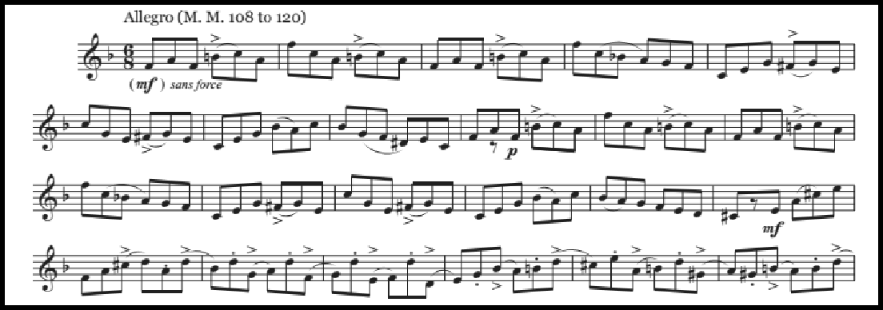

Figure 1: Etude No. 1 from Trente-Six Etudes Transcendantes, mm. 1-23

- Description of etude including large scale form, key centers, and other pertinent concepts:
As indicated in the etude’s title and evidenced in Figure 1, articulation is a major focal point of this etude. Throughout the etude there is a wide variety of articulations, including staccati, accents, and slurs. The large scale form of the piece is ABA; the A section is initially presented in mm. 1-17 in the key of F major. The B section is presented in mm. 17-62. During this extended section material goes through several harmonic changes yet retains the eighth-note focused rhythmic feel seen in Figure 1. The A section is restated in mm. 63-82; this closes out the etude.

15Théo Charlier. Trente-Six etudes Transcendantes Pour Trompette, Cornet à Pistons Ou Bugle Si ♭. A. Leduc, 1946.

- Material listed in the annotations for this etude:

  - Etude No. 1 from Etudes Practiques by Rene Laurent16

  - Study No. 4 from Etudes Nouvelles by Maxime Alphonse17

- Short excerpt from the annotated item(s):
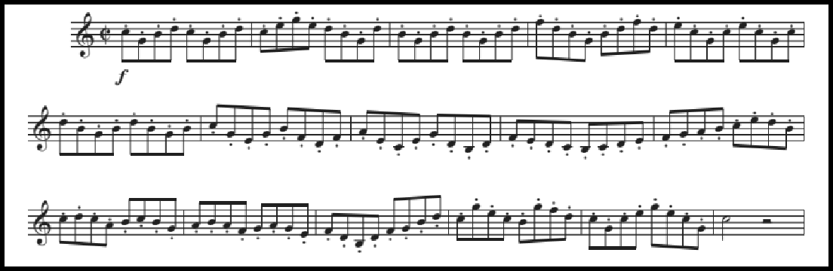

Figure 2: Etude No. 1 from Etudes Practiques by Rene Laurent, mm. 1-16

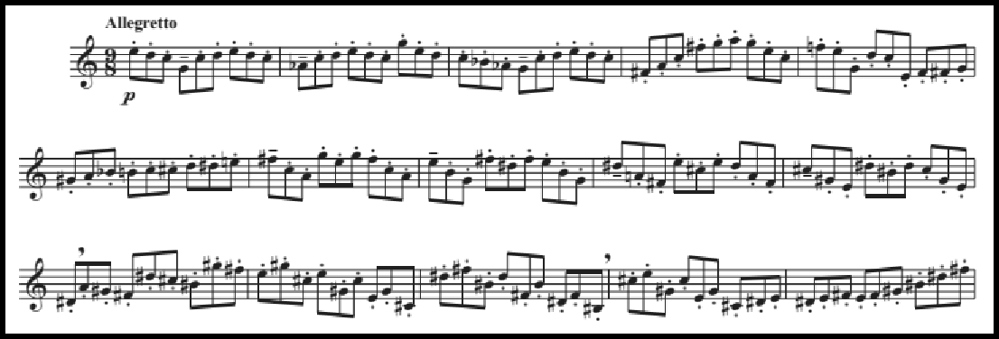

Figure 3: Study No. 4 from Etudes Nouvelles by Maxime Alphonse, mm. 1-15

16Rene Laurent. Etudes pratiques : pour trompette chromatique en ut et si ♭, cornet à pistons et saxhorns. Paris: Alphonse Leduc, 1923.
17Maxime Alphonse. Etudes nouvelles pour trompette, cornet et saxhorn. Paris: A. Leduc, 1920.

- Discussion of the skill sets that are common between the annotated items and the etude, and ways in which the annotated item(s) prepare the student for the etude or augment concepts presented in the etude:
One challenging aspect of Charlier No. 1 is the stamina required both mentally and physically to complete the etude. The near-constant stream of eighth notes in addition to the frequent harmonic and articulation changes make staying mentally focused the highest priority.
With the Laurent etude (Figure 2), the student may begin to master this concept of mental concentration. In the Laurent, there are only a handful of accidentals throughout the entire two-page etude. This, coupled with an approachable key signature and unchanging articulation markings, allows the student to master staying mentally focused through extended passages of continuous eighth notes (similar to the Charlier).
The Alphonse study (Figure 3) is closer in difficulty to the Charlier. Unlike the Laurent, the Alphonse varies articulation markings (though still less varied than the Charlier) and contains numerous accidentals. The Alphonse is more scalar melodically than the Charlier, and has fewer large leaps. The Alphonse is similar to the Laurent in its use of a near-constant stream of eighth notes, yet is similar to the Charlier in its use of compound meter.

Chapter 5: Annotated Works in Etude No. 2 “Du Style”

- Etude number and title:

Etude No. 2 “Du Style”18

- Short excerpt from the etude:
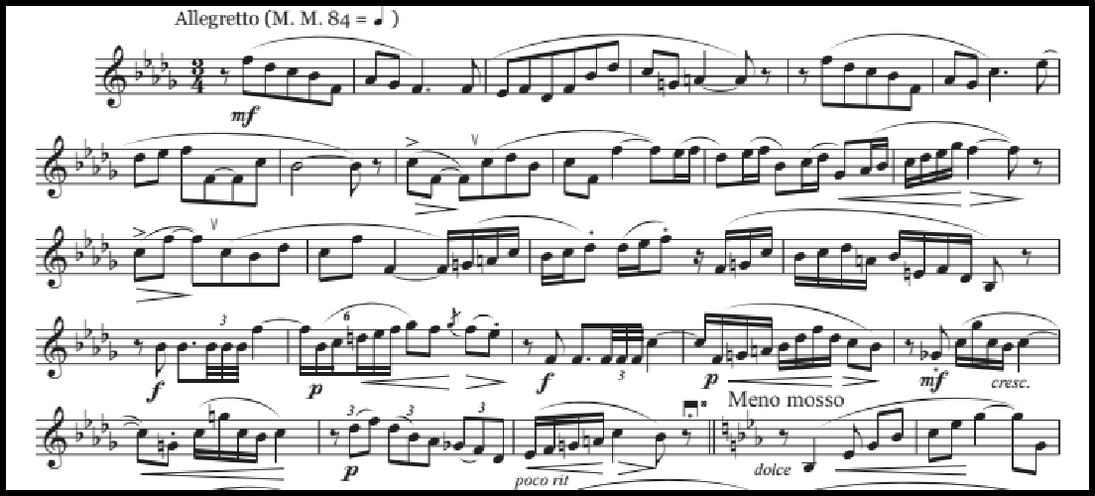

Figure 4: Etude No. 2 from Trente-Six Etudes Transcendantes, mm. 1-26

- Description of etude including large scale form, key centers, and other pertinent concepts:
Like Etude No. 1, this etude is in ABA format. The initial A section can be seen in its entirety in Figure 4. The haunting A section is in the key of B-flat minor, the more optimistic B section (mm. 25-63) is in E-flat major, and the A section returns from mm. 64-75. This etude is extremely varied both stylistically and technically.
Stylistically, there are cantabile melodies (e.g. mm. 1-8), fanfare themes (e.g. mm. 17 & 19), and recitative-like sections (e.g. mm. 36-44). To use the analogy of a movie, a

18Théo Charlier. Trente-Six etudes Transcendantes Pour Trompette, Cornet à Pistons Ou Bugle Si ♭. A. Leduc, 1946.

musician must be mature in their interpretive abilities to portray all of the characters in this etude. Technically, there are sections that would require triple-tonguing, sections with wide intervals, rapid scalar figures, and the piece also has a fairly wide range (F3
to B♭5). These considerations, both stylistic and technical, account for the popularity

of this etude.

- Material listed in the annotations for this etude:

  - Study Nos. 4, 8, and 13 from Methode Complete by Guillaume Balay19

  - Study No. 23 from 25 Characteristic Studies by Antoine Chavanne20

  - Study Nos. 2, 8, and 12 from Complete Conservatory Method by J.B. Arban21
  - Study Nos. 4 and 8 from Grande Methode Complete by Alexandre Petit22
- Short excerpt from the annotated item(s):

19Guillaume Balay. Method Complete de Cornet a Pistons, ou de Trompette, ou de Saxhorn.
Alphonse Leduc, 1914.
20Antoine Chavanne. Vingt-cinq etudes caracteristiques : pour trompette, cornet à pistons, et tous les saxhorns clé de sol. Leduc, 1951.
21Jean-Baptiste Arban, ed. E.F. Goldman and W.M. Smith. Arban's Complete Conservatory Method for Trumpet (Cornet) of E Flat Alto, B Flat Tenor, Baritone, Euphonium and B Flat Bass in Treble Clef/ Edited by Edwin Franko Goldman and Walter M. Smith. C. Fischer, 1936.
22Alexandre Petit. Grande méthode complète de cornet a pistons : bugle trompette & d
́instruments a pistons. Paris: Editions Salabert. Date of publication not identified.

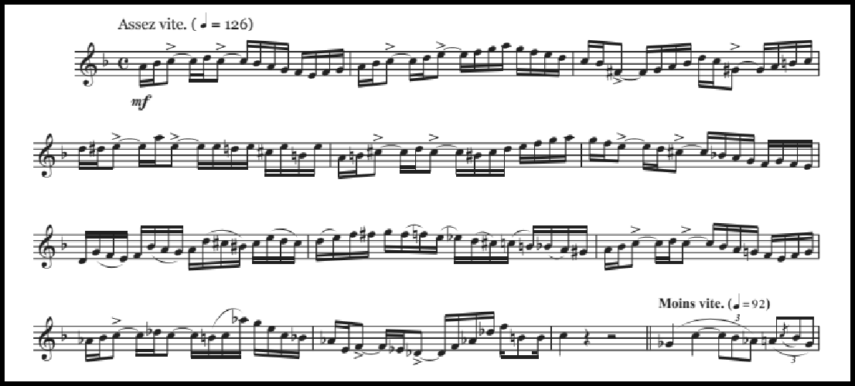

Figure 5: Study No. 4 from Methode Complete by G. Balay, mm. 1-13
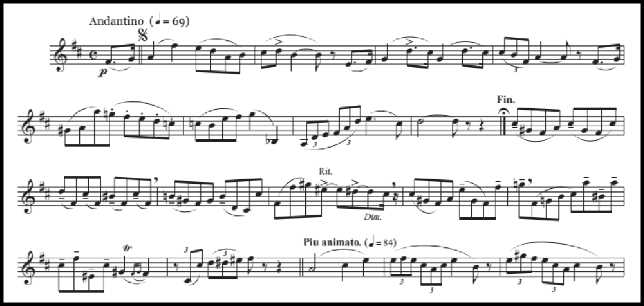

Figure 6: Study No. 8 from Methode Complete by G. Balay, mm. 1-19

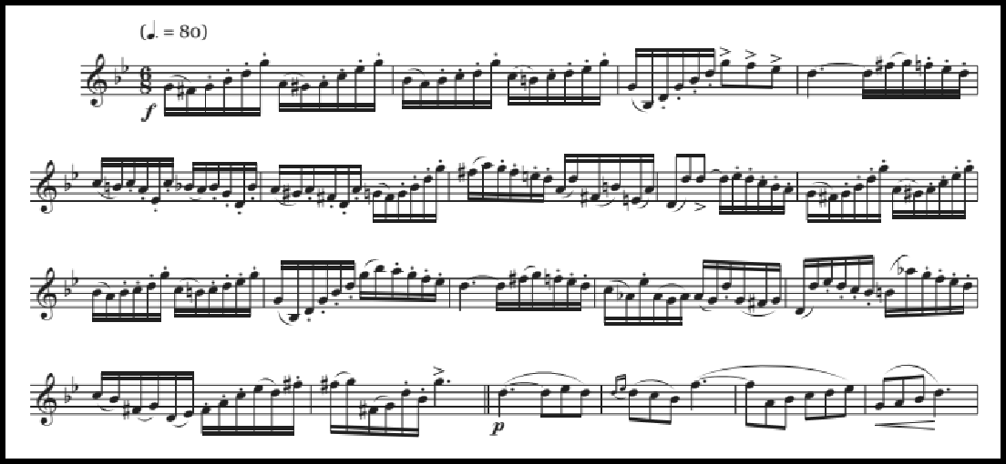

Figure 7: Study No. 13 from Methode Complete by G. Balay, mm. 1-20
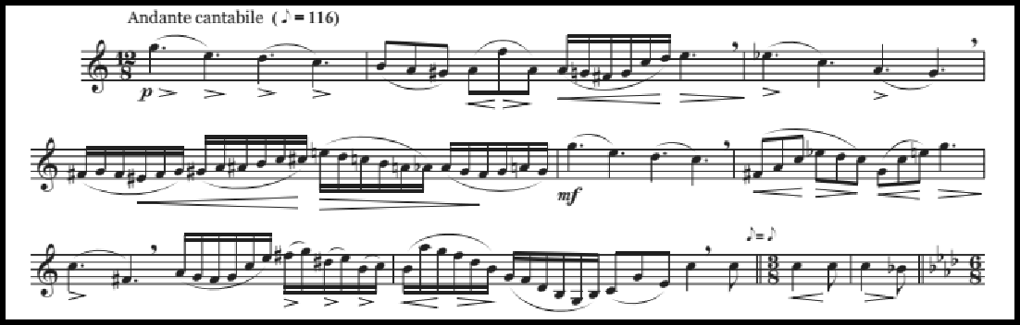

Figure 8: Study No. 23 from 25 Characteristic Studies by A. Chavanne, mm. 1-9
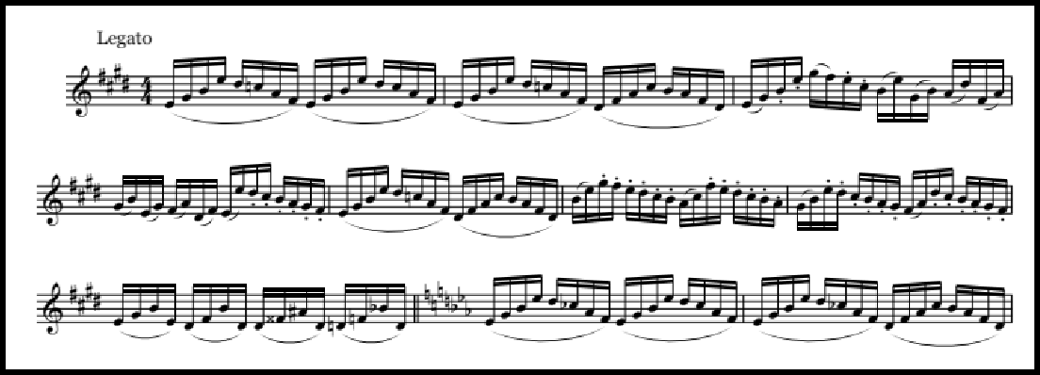

Figure 9: Study No. 2 from Complete Conservatory Method by J.B. Arban, mm. 1-10

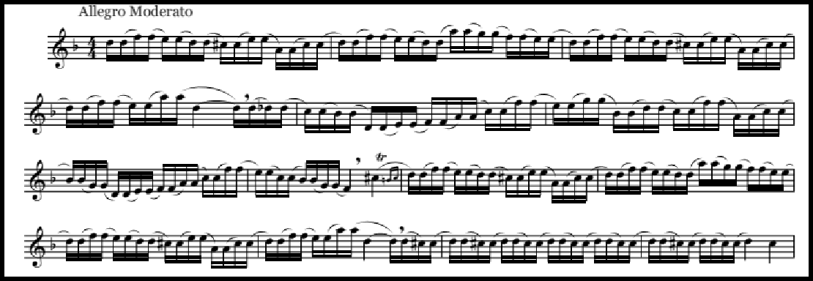

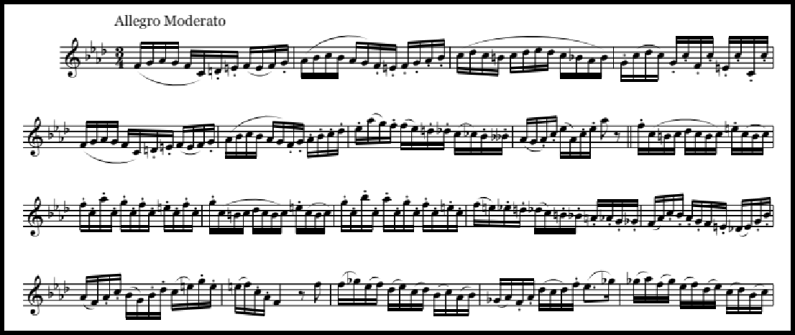
Figure 10: Study No. 8 from Complete Conservatory Method by J.B. Arban, mm. 1-14

Figure 11: Study No. 12 from Complete Conservatory Method by J.B. Arban, mm. 1-18

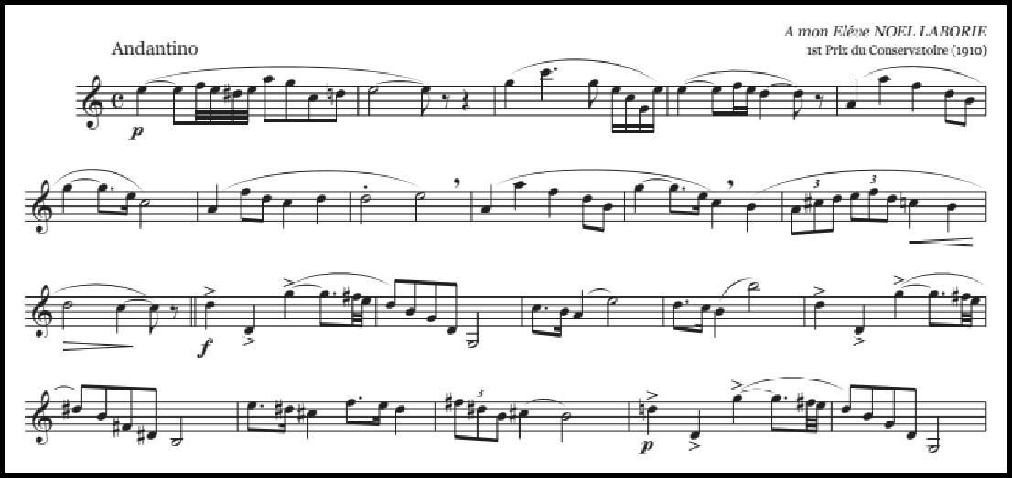

Figure 12: Study No. 4 from Grand Methode Complete by A. Petit, mm. 1-22
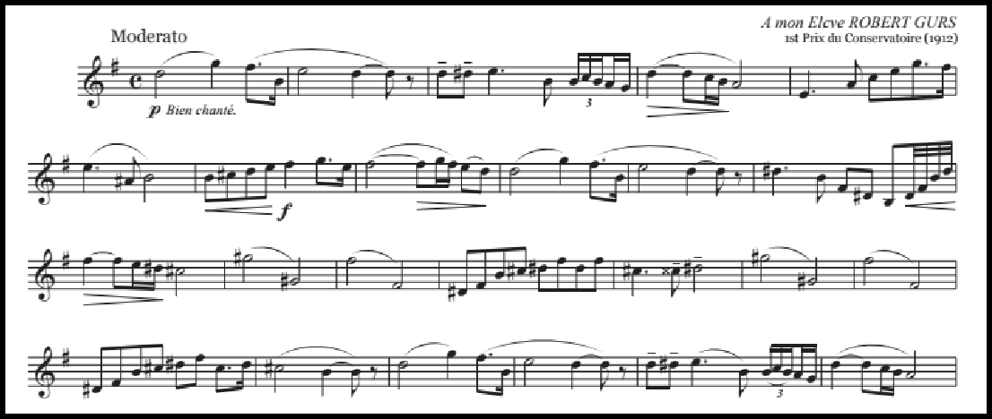

Figure 13: Study No. 8 from Grand Methode Complete by A. Petit, mm. 1-24
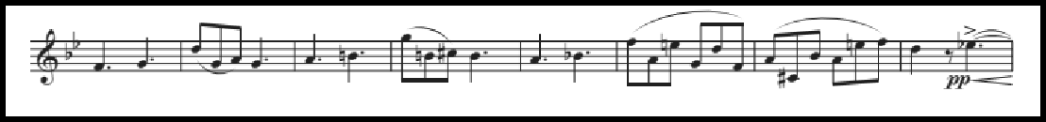

Figure 14: Study No. 13 from Methode Complete by G. Balay, mm. 35-42

- Description of the annotated items and discussion of the skill sets that are common between the annotated items and the etude, and ways in which the annotated item(s) prepare the student for the etude:

The etudes above are mentioned in Charlier’s etudes Nos. 2, 4, and 6 (all with the designation of “Du Style”). This suggests that the studies above were considered useful style and technique builders in general, rather than specific to Etude No. 2. The large number of preparatory studies listed for Etude No. 2 also alludes to the numerous challenges within the work.
Study No. 4 by Balay (Figure 5) can be seen as a study in rhythm. It contains prominent passages with syncopation, tied values that obscure the beat, and a mixture of duple and triple rhythms. Charlier makes use of a wide variety of rhythms in his Etude No. 2 (for example, mm. 22-23 contain eighth notes, triplets, and sixteenth notes).
Mastery of Study No. 8 from Balay (Figure 6) will improve a student’s cantabile playing. It is less rhythmically homogenous than many of the other studies annotated for Charlier’s Etude No. 2, with (for example) eighth notes and triplets occurring in the same phrase. Balay’s Study No. 8 is essentially melodic and song-like, which will aid the student in the lyric sections of Charlier’s Etude No. 2.
Balay’s Study No. 13 (Figure 7) has two major sections. The first section (mm. 1-16) is quite technical in nature. This section is rhythmically homogenous (made up almost entirely of running sixteenth notes) and will exercise the student’s ability to execute arpeggiated and scalar passages. The second half of the etude is more directly applicable to Charlier’s No. 2. It contains a more lyrical section (see Figure 14 below) with wide intervals that is quite similar to mm. 41-54 of the Charlier. Mastery of the

wide intervals in Balay No. 13 will aid greatly with mastery of similar sections in Charlier.
Study No. 23 by Chavanne guides the student towards concepts in Charlier No.

2 in several ways. Both begin with a similar melodic outline (beginning on a higher note and then descending), and both excerpts also contain several fairly wide leaps, up to an octave in both. The two are also formally similar; both state one section of music in one key, then this material is developed, the key changes, and then the original material returns to end the piece. There are several differences that make the Chavanne excerpt more approachable for a student, preparing him or her for the Charlier. Most fundamentally, the Chavanne is in a key more accessible to the young student than the Charlier, and also tends to be more melodically predictable than the Charlier. The Chavanne is based in chromatic and scalar patterns, while sections of Charlier No. 2 contain wide, unexpected melodic leaps. For these reasons, Chavanne No. 23 is a good choice for supplemental study material along with Charlier Etude No. 2.
The three Arban Characteristic Studies cited (Nos. 2, 8, and 12) build technique that would benefit the student in many ways. Taken together, they are also quite complementary, and will be discussed together in this paragraph. Characteristic Study No. 2 is useful for contextualizing the arpeggio studies that appear earlier in the Arban book. This is then applicable to much music, including Charlier No. 2 in mm. 29, 33, 37, 39, and more. The Arban Study No. 8 is based on scalar motion rather than arpeggiated motion. It drills flexibility and smoothness in slurs between the close intervals of major and minor seconds and thirds. The Arban Study No. 12 covers

similar concepts as Studies 2 and 8, but adds in the navigation of wider intervals (fifths, sixths, sevenths, and octaves). While not as specific to Charlier No. 2 as some of the other etudes listed, the Arban etudes that Charlier lists are useful for building overall technique that will aid the student in the mastery of much of Western music.
The final two etudes cited for Charlier’s Etude No. 2 are Studies Nos. 4 and 8 by Alexandre Petit (Figures 12 and 13, respectively). These two studies reinforce similar concepts. Both are essentially lyrical melodies rather than studies in technique, and both contain wide ranges and wide intervallic leaps. Study No. 4, for example contains pitches from F3 to C5, and Study No. 8 has prominent octave slurs within its phrases.

Chapter 6: Annotated Works in Etude No. 3 “Intervalles (Les Tierces)”

- Etude number and title

Etude No. 3 “Intervalles (Les Tierces)”23

- Short excerpt from the etude
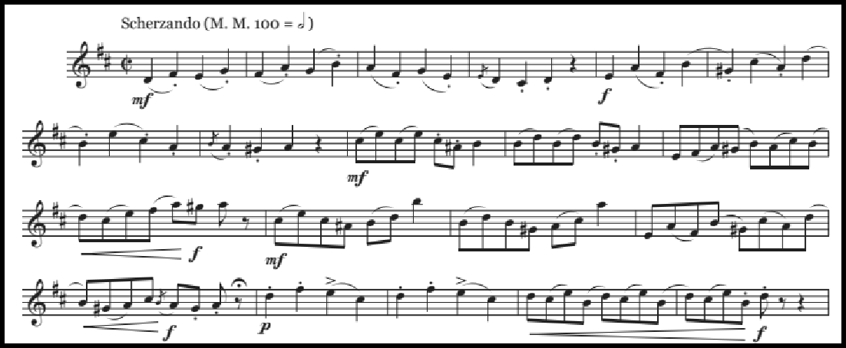

Figure 15: Etude No. 3 from Trente-Six Etudes Transcendantes, mm. 1-20

- Description of etude including large scale form, key centers, and other pertinent concepts:
As the title indicates, Charlier’s Etude No. 3 emphasizes melodic intervals of a third. Charlier often crafts etudes that emphasize certain intervals in both Trente-Six Etudes Transcendantes and 32 Etudes de Perfectionnement; this is the first such etude in Trente-Six Etudes Transcendantes. Even though the title indicates that this etude was crafted with emphasis on a technical skill (ease of execution of both major and minor

23Théo Charlier. Trente-Six etudes Transcendantes Pour Trompette, Cornet à Pistons Ou Bugle Si ♭. A. Leduc, 1946.

thirds) the etude is not as “dry” or purely technical as a other etudes based on technical ideas (for example, Kopprasch24). Instead, Etude No. 3 is a fully developed musical
piece. After a chipper introduction that initially emphasizes the D major scale in thirds, a change of key to G minor is indicated in mm. 35. This section is marked Meno mosso and is comprised of short motives that emphasize third relationships. A much more lyrical and sustained section marked ben cantabile begins in mm. 51, and this section transitions to a section of music marked Tempo 1 at mm. 67. This section is can be thought of as the etude’s powerful finale; cascades of eighth notes marked stringendo lead to the conclusion of this etude.
- Material listed in the annotations for this etude:

- Study Nos. 1 and 15 from Methode Complete by Guillaume Balay25

- Study No. 1 from 25 Characteristic Studies by Antoine Chavanne26

- Etudes Nos. 1 and 5 from Etudes Pratiques by Rene Laurent27

- Short excerpt from the annotated item(s)

24Georg Kopprasch. Sixty Selected Studies for Trombone. New York: C. Fischer, 1950. 25Guillaume Balay. Method Complete de Cornet a Pistons, ou de Trompette, ou de Saxhorn. Alphonse Leduc, 1914.
26Antoine Chavanne. Vingt-cinq etudes caracteristiques : pour trompette, cornet à pistons, et tous les saxhorns clé de sol. Leduc, 1951.
27Rene Laurent. Etudes pratiques : pour trompette chromatique en ut et si ♭, cornet à pistons et saxhorns. Paris: Alphonse Leduc, 1923.

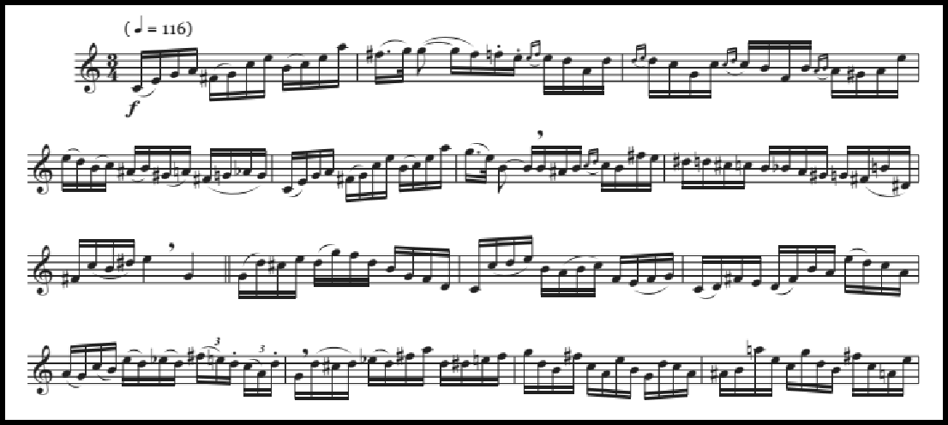

Figure 16: Study No. 1 from Methode Complete by G. Balay, mm. 1-15
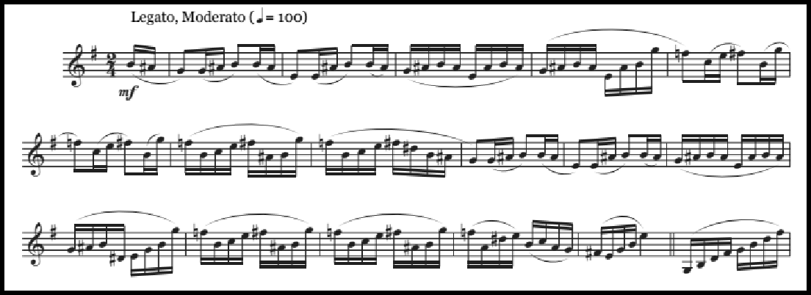

Figure 17: Study No. 15 from Methode Complete by G. Balay, mm. 1-17
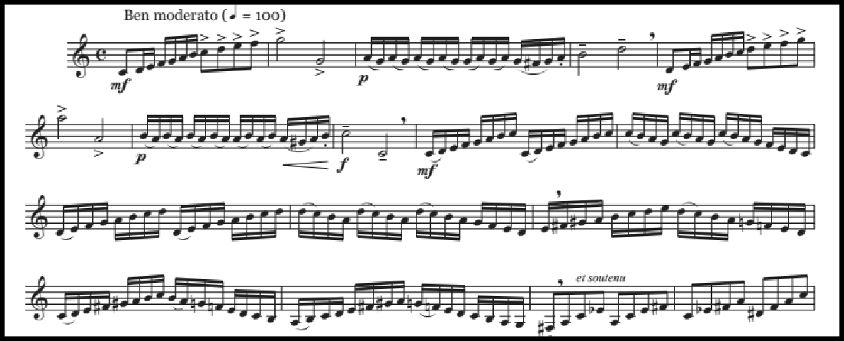

Figure 18: Study No. 1 from 25 Characteristic Studies by A. Chavanne, mm. 1-17

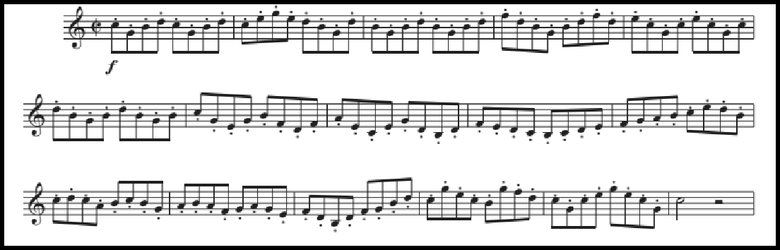

Figure 19: Etude No. 1 from Etudes Pratiques by R. Laurent, mm. 1-16
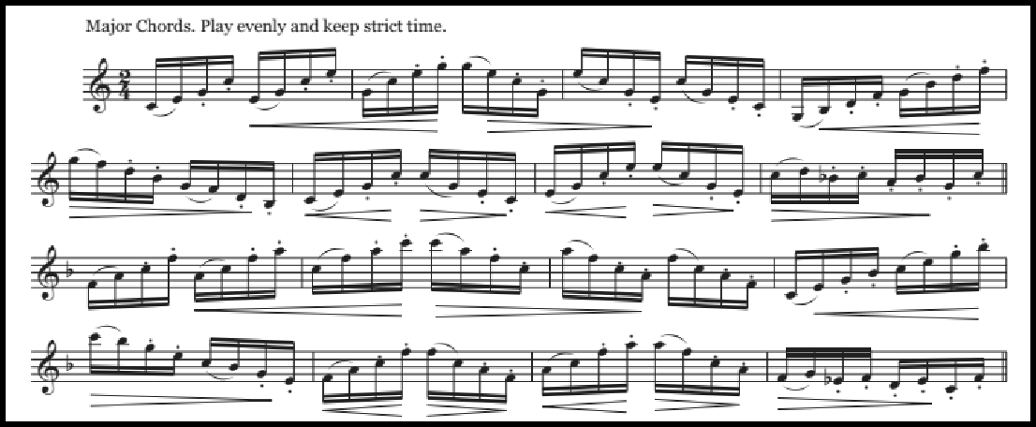

Figure 20: Etude No. 5 from Etudes Pratiques by R. Laurent, mm. 1-16

- Description of the annotated item(s):

The annotated items for Charlier Etude No. 3 are more purely technical than those for Etude No. 2, perhaps because of the more technical focus of No. 3. The Laurent Etude No. 5, for example, (seen in Figure 20) is a study in major chords with no melodic content at all. The other Laurent Etude (No. 1, Figure 19) also focuses on intervals of a third, which would certainly be of aid to a student working up the Charlier. The two Balay studies cited (Nos. 1 and 15, Figure 16 and 17) are less purely

technical than the Laurent studies, and the Balay studies are also useful in that they stray outside of the written key signature more than the Laurent studies, resulting in more accidentals. The skill of reading accidentals easily will be of use to the student as they master the Charlier (and of course, music in general). Finally, the Chavanne study cited (No. 1, Figure 18) will be useful to the student as they master rapid scalar passages.

Part Three:

Supplementary Materials for 32 Etudes de Perfectionnement

Chapter 7: Supplementary Materials for Etude No. 2 “Du Style”

- Etude number and title:

Etude No. 2 “Du Style”28

- Short excerpt from the etude:
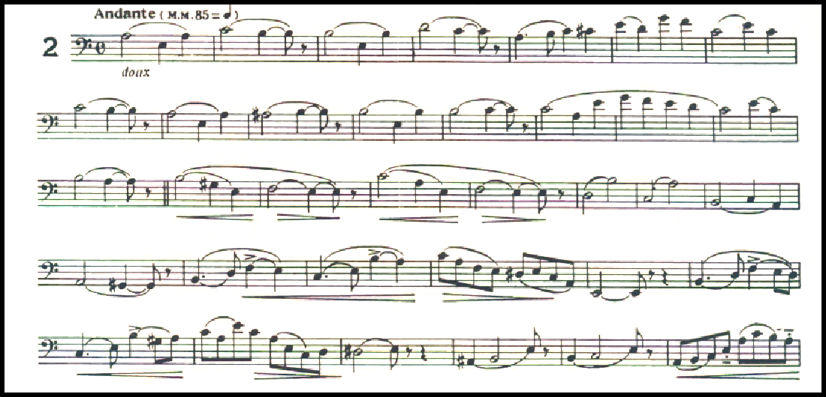

Figure 21: Etude No. 2 from 32 Etudes de Perfectionnement, mm. 1-35

- Description of etude including large scale form, key centers, and other pertinent concepts:
Etude No. 2 from 32 Etudes de Perfectionnement is primarily in the key of A minor. It is through-composed; there are no sections repeated verbatim. The etude begins with a plaintive melody with longer note values (half notes and quarter notes) and as the piece continues, rhythms become more rapid.

28Theó Charlier. 32 etudes De Perfectionnement Pour Trombone En Si♭ a 4 Pistons Ou Tuba.
Henry Lemoine &amp; Cie., 1946.

- A short excerpt and description of two proposed preparatory exercises and/or etudes from the standard low brass canon and discussion of how the preparatory exercises apply to the etude:
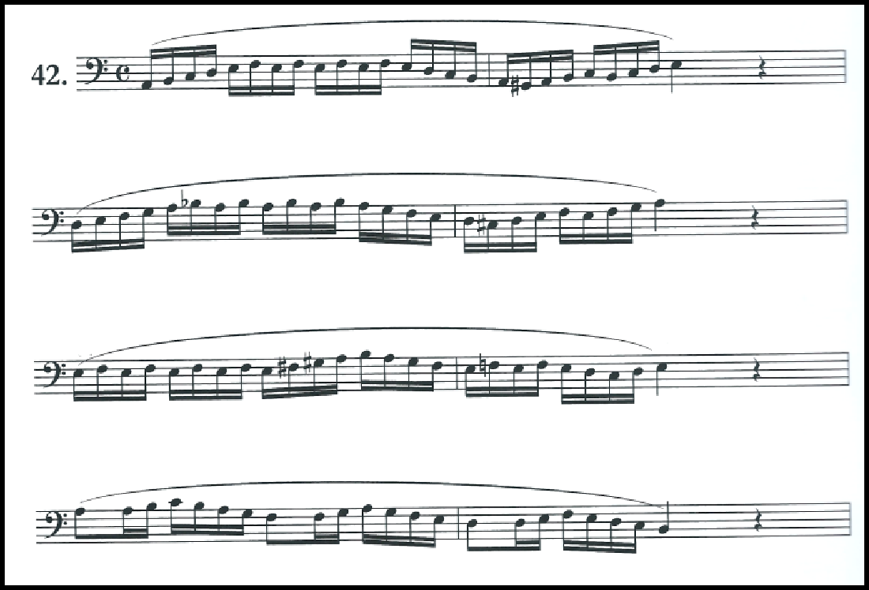
A challenge associated with Etude No. 2 is keeping air energized and flowing through the phrases. The etude remains lyrical, even as the note values transition from longer to shorter. One excellent way to cultivate this concept would be to utilize David Vining’s Flow Studies for Euphonium29.

Figure 22: Study No. 42 from Flow Studies by David Vining, mm. 1-8

The above exercise is in the same key as the etude (A minor) and provides the student a means of cultivating constant airflow throughout the duration of a phrase.

29David Vining. “Flow Studies for Euphonium.” Flagstaff, AZ: Mountain Peak Music, 2009.

Additionally, the exercise prepares for the nuances involved with playing in the key of A minor (fingering patterns, common accidentals, etc). Vining’s Flow Studies contains three sections: “Slow Flow Studies” with primarily half-note and quarter-note values, “Medium Flow Studies” with primarily quarter-note and eighth-note values, and “Fast Flow Studies” with primarily eighth-note and sixteenth-note values, which is particularly useful when working up this etude since it progresses from longer note values (half-notes and quarter-notes) to shorter values (running eighth notes).
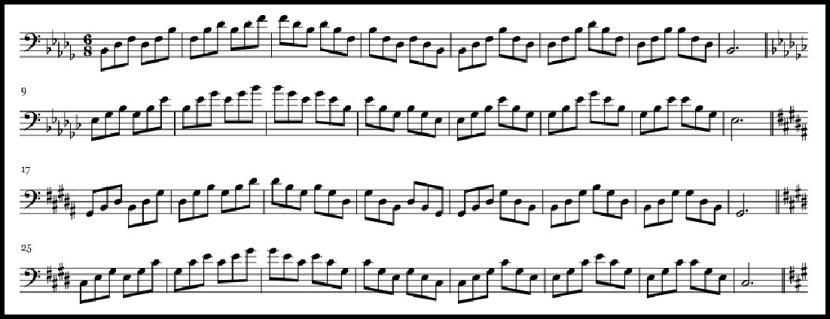
Charlier’s No. 2 also contains a many arpeggiated figures in the middle section of the etude. For this concept, the student could utilize the arpeggio studies from the Complete Conservatory Method by Arban30.

Figure 23: #49, Arpeggio Study from Complete Conservatory Method by J.B. Arban, ed. J. Alessi and B. Bowman, pg 162

30Jean-Baptiste Arban, ed. J. Alessi and B. Bowman. Complete Method for trombone and euphonium. Troy, MI: Encore Music Publishers, 2002.

Again, since the Charlier etude is in the key of A minor, the section on minor arpeggios cited above will familiarize the student with finger patterns required to execute the etude.
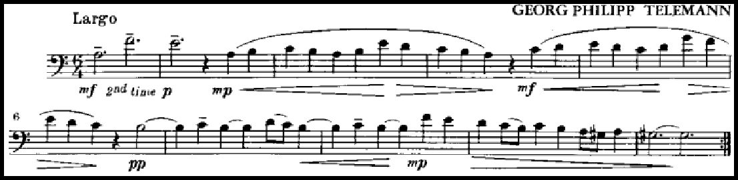
- A short excerpt from the standard repertoire of solo and excerpt literature for euphonium:

Figure 24: Largo from Sonata in A minor by G.P. Telemann, edited K. Brown, mm. 1-10

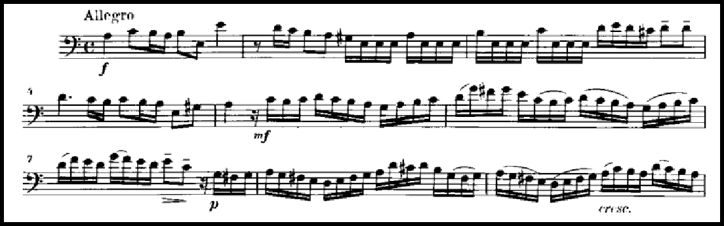

Figure 25: Allegro from Sonata in A minor by G.P. Telemann, edited K. Brown, mm. 1-9

- Discussion of the skill sets that are common between the Charlier etude, study material, and the literature excerpt:

Mastery of the concepts presented in the Charlier etude and the preparatory material will enable to student to efficiently prepare and perform the Telemann sonata cited above. The piece, Sonata in A minor31, is a standard in the repertoire and will
allow a student of the euphonium (an instrument which, in its modern form, has only existed since c. 1876) valuable experience with Baroque performance practice.
Similarities between this piece, the Charlier etude, and preparatory material abound. The piece, like the etude, is in the key of A minor, and is comprised of four movements. The first movement (Figure 24) contains lengthy phrases with longer note values, similar to the opening of the Charlier. The second movement (Figure 25) contains sixteenth-note passages with both scalar and arpeggiated passages in the key of A minor. Practicing the Charlier etude with the suggested preparatory material not only sets up the student for performance success, but also makes meaningful connections across the concepts of fundamentals, etudes, and performance literature.

31Georg P. Telemann, ed. K. Brown. “Sonata in A minor.” New York City: International Music Company, 1966.

Chapter 8: Supplementary Materials for Etude No. 3 “De l’Arpege”

- Etude number and title:

Etude No. 3 “De l’Arpege”32

- Short excerpt from the etude:
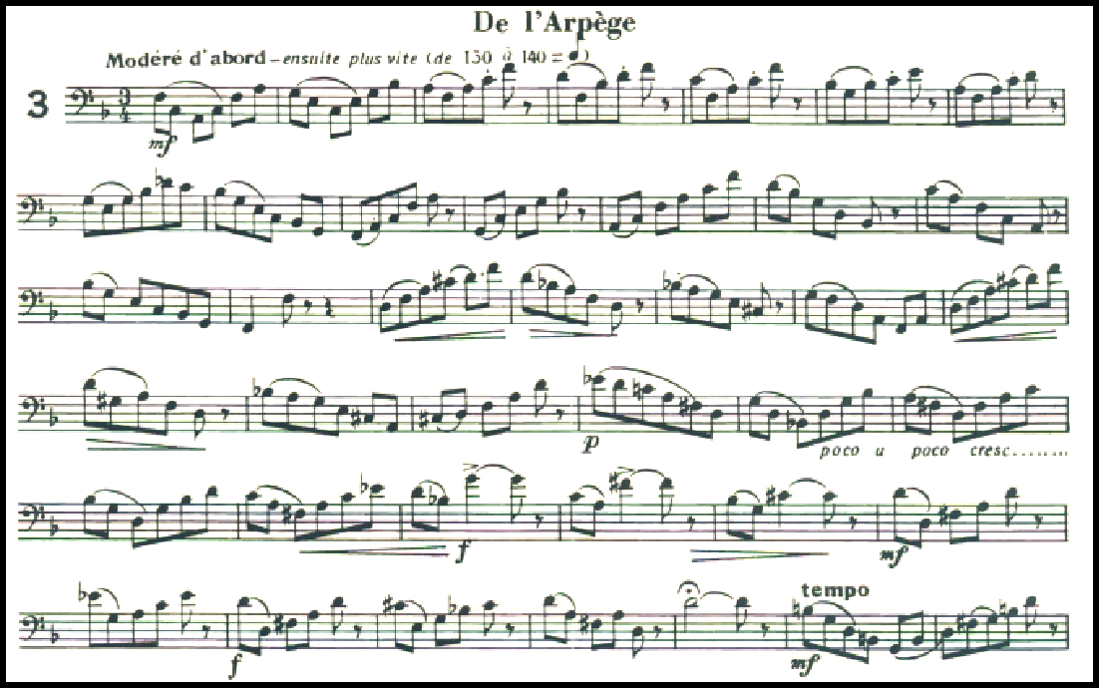

Figure 26: Etude No. 3 from 32 Etudes de Perfectionnement, mm. 1-40

- Description of etude including large scale form, key centers, and other pertinent concepts:
This etude is in ABA form. It begins in the key of F major, transitions into D minor for the B section, and restates the A section in F major. The etude is largely

32Theó Charlier. 32 etudes De Perfectionnement Pour Trombone En Si♭ a 4 Pistons Ou Tuba.
Henry Lemoine &amp; Cie., 1946.

monorhythmic; it is made up almost entirely of eighth notes. As the title suggests, the focus of the etude is arpeggiated figures.
- A short excerpt and description of two proposed preparatory exercises and/or etudes from the standard low brass canon and discussion of how the preparatory exercises apply to the etude:
In addition to being obviously geared toward arpeggios, this etude is excellent for practicing dynamic contrast within a musical line. If the musician pays close attention to the written dynamics and emphasizes both soft and loud extremes of range, this etude can be quite useful. David Vining’s Daily Routines33 contains sections
dedicated to emphasizing dynamics in the practice of fundamentals.
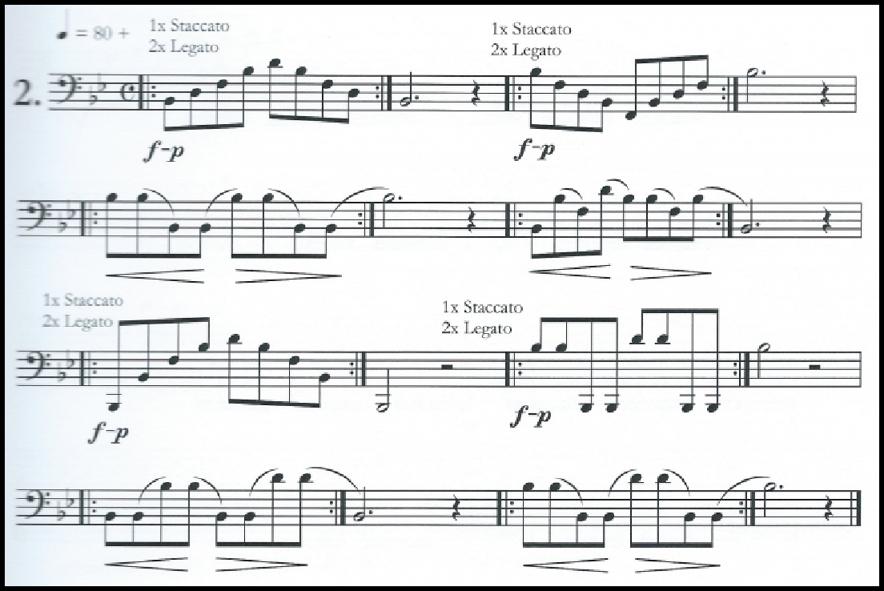

Figure 27: Daily Routines by David Vining, pg. 40

33David Vining. “Daily Routines for Euphonium.” Flagstaff AZ: Mountain Peak Music, 2009.

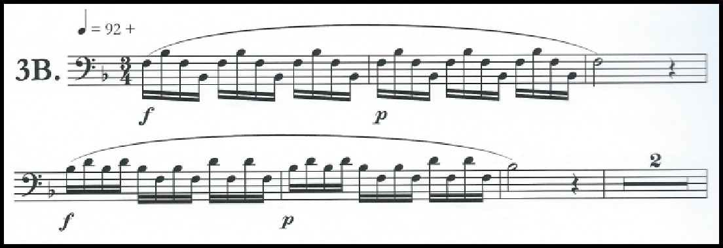

Figure 28: Daily Routines by David Vining, pg. 41

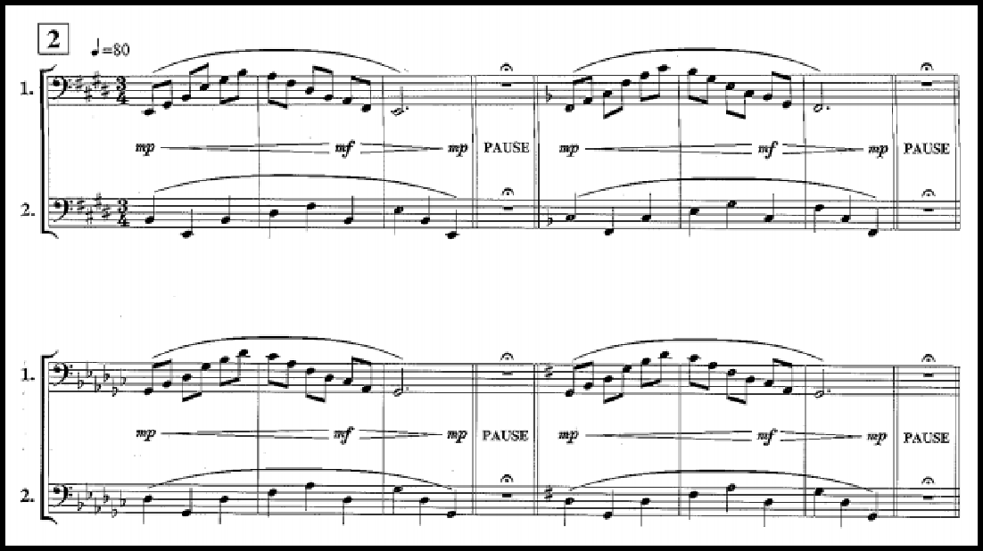
This etude is also heavily based on arpeggiated figures. In addition to the material from Arban listed in Chapter 7, the student could consult pages 60-63 from Basics Plus by Wolfgang Guggenberger34.

Figure 29: Basics Plus by Wolfgang Guggenberger, pg. 62

34Wolfgang Guggenberger. “Basics Plus.” Rot an der Rot: Rundel, 2007.

The arpeggio figures are similar to those in the Charlier (covering a span of more than an octave), and may because of this be more useful than Arban material for this particular etude.
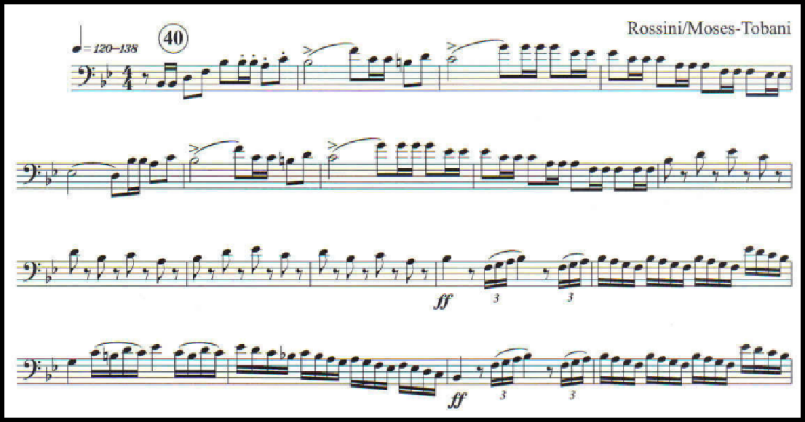
- A short excerpt and description of one excerpt from the standard repertoire of solo and excerpt literature for euphonium:

Figure 30: Overture to “The Italian in Algiers” by Rossini, arr. Moses-Tobani, mm. 40-58

- Discussion of the skill sets that are common between the Charlier etude, study material, and the literature excerpt:
Once the student has mastered the concepts from the Charlier etude and supplemental exercises, he or she will be very well-prepared to tackle an excerpt based on these concepts. A commonly requested excerpt that exemplifies these concepts is the

Overture to “The Italian in Algiers”35 excerpt. Beginning in mm. 40, this excerpt has

many arpeggio-based musical lines. Additionally, the student must possess excellent volume control to deliver the cello-like sixteenth note passage in mm. 52 at a true fortissimo.

35Gioacchino Rossini, Theo M. Tobani, and H. R. Kent. The Italian in Algiers: Overture. New York, N.Y.: C. Fischer, 1949.

Chapter 9: Supplementary Materials for Etude No. 5 “Tierces et Triolets”

- Etude number and title:

Etude No. 5 “Tierces et Triolets”36

- Short excerpt from the etude:
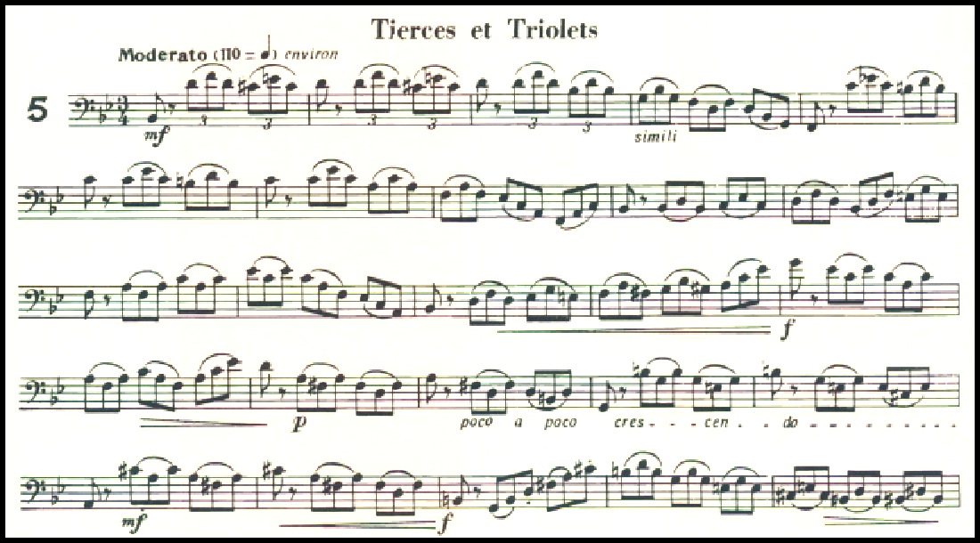

Figure 31: Etude No. 5 from 32 Etudes de Perfectionnement, mm. 1-25

- Description of etude including large scale form, key centers, and other pertinent concepts:
The title of this etude translates to “Thirds and Triplets”, and a cursory look will show that it is indeed replete with both concepts. The “thirds” in the title refers to melodic major and minor thirds that comprise the melody, and the “triplets” refers to the primary rhythmic values used in the etude. The etude is also in triple meter and in

36Theó Charlier. 32 etudes De Perfectionnement Pour Trombone En Si♭ a 4 Pistons Ou Tuba.
Henry Lemoine &amp; Cie., 1946.

ABA` form, further emphasizing its ternary focus. The piece begins in B-flat major, and makes forays into G minor and D major before returning to B-flat major to conclude the etude.
- A short excerpt and description of two proposed preparatory exercises and/or etudes from the standard low brass canon and discussion of how the preparatory exercises apply to the etude:
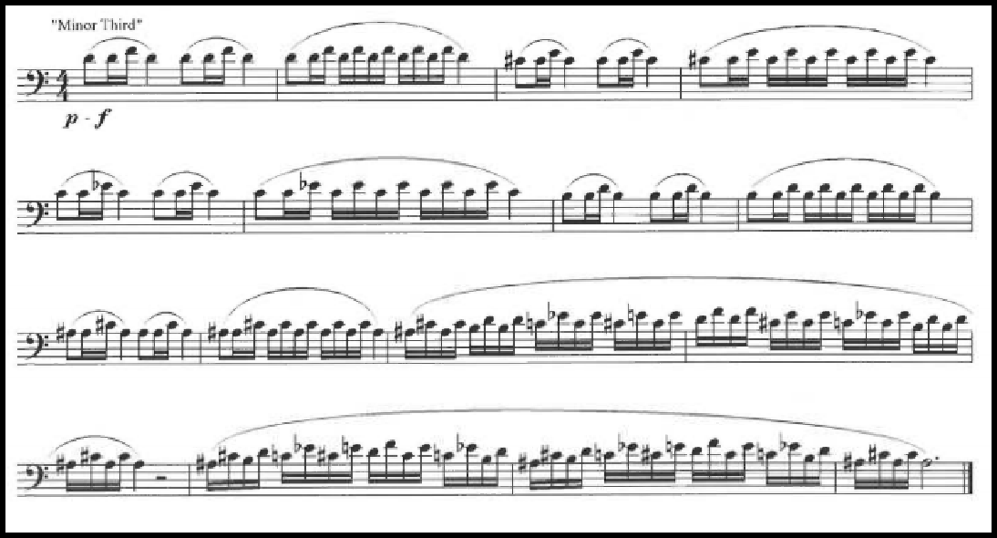
Any euphonium player surveying the opening measures of Charlier 5 will notice the necessity of excellent flexibility. Several sets of three notes in the opening measures and throughout the piece (for example, D - F and C-sharp - E) exist on the same partial series, and must therefore be played with the same fingering with excellent flexibility or the player must use alternate fingerings. It is the author’s suggestion that natural slurs be used so that the player can cultivate his or her ability in this area. To this end, the student will need to possess excellent flexibility. A great exercise to practice the type of flexibility found in Charlier 5 can be found in The Brass Gym.

Figure 32: “Lip Flips” from The Brass Gym, pg. 8237

With the exercise above, the student can practice clean and temporally even slurs with the same sets of notes used in the Charlier etude.
Another skill set that would benefit the student would be navigating the scalar thirds found throughout this particular Charlier. A thorough treatment of scalar thirds can be found in Scale and Arpeggio Routines by Milt Stevens and Brian Bowman.

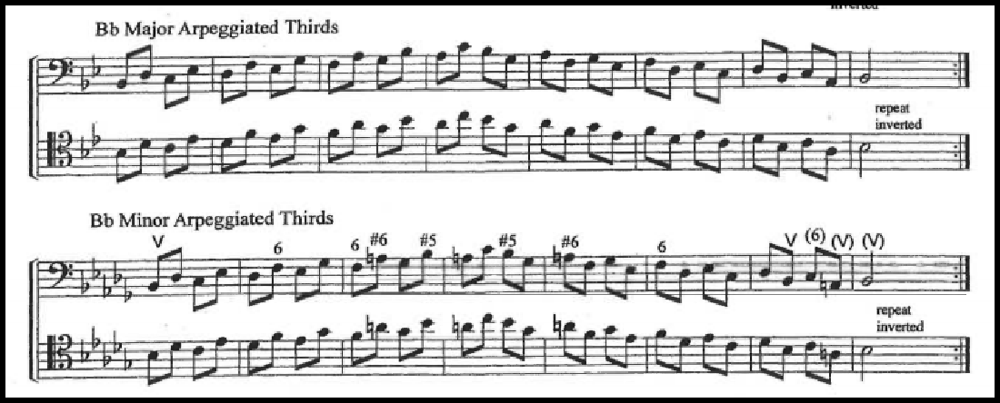

Figure 33: Scale and Arpeggio Routines, pg. 2238

Another useful aspect of Scale and Arpeggio Routines for both the teacher and student is its layout. The book is designed for use as a complete college scale curriculum, and contains sections progressing from freshman through doctoral level.
- A short excerpt and description of one excerpt from the standard repertoire of solo and excerpt literature for euphonium:

37Sam Pilafian and Pat Sheridan. The Brass Gym. Mesa, AZ: Focus on the Music Publications, 2006.
38Milt Stevens and Brian Bowman. Scale and Arpeggio Routines for Trombone and Euphonium.
Falls Church, VA: Stevens Desk Top Publishing, 2005.

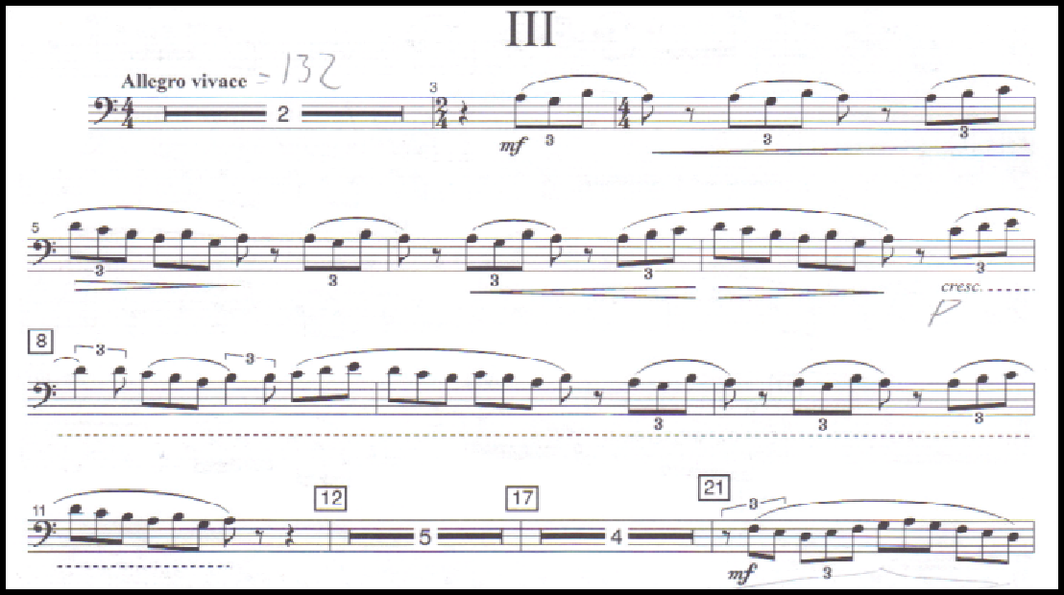

Figure 34: Concerto for Euphonium, Mvt. 3 by Eric Ewazen, mm. 1-21

- Discussion of the skill sets that are common between the Charlier etude, study material, and the literature excerpt.
A student preparing the third movement of Eric Ewazen’s Concerto for Euphonium39 for performance will find the above materials highly useful. In the
opening of the third movement, the euphoniumist must execute a fast, clean natural slur from G to B. In the author’s experience, alternate fingerings are of little use in this instance; natural slurs are much less clumsy. As a result, the student must have excellent slurring technique, and both the Charlier and Brass Gym flexibility will cultivate this.
Strong technique with scalar thirds will also be helpful later on in the movement.

39Eric Ewazen. Concerto for euphonium and wind ensemble. San Antonio, Tex. : Southern Music Company. 2009.

Chapter 10: Supplementary Materials for Etude No. 10 “Intervalles: les Octaves”

- Etude number and title:

Etude No. 10 “Intervalles (les octaves)”40

- Short excerpt from the etude:
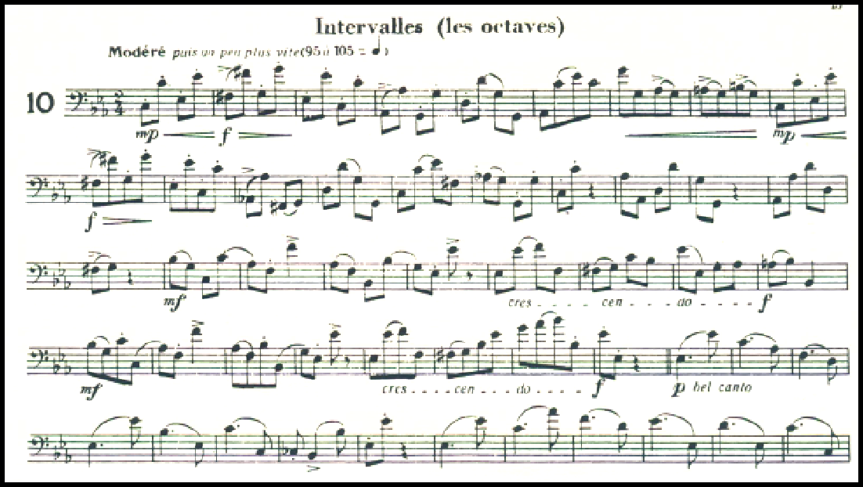

Figure 35: Etude No. 10 from 32 Etudes de Perfectionnement, mm. 1-50

- Description of etude including large scale form, key centers, and other pertinent concepts:
This etude begins in the key of C minor with a technical section based on intervals of an octave. This section is quite rhythmically homogenous; it is made up of eighth notes almost exclusively. Beginning in measure 37, a more lyrical theme is

40Theó Charlier. 32 etudes De Perfectionnement Pour Trombone En Si♭ a 4 Pistons Ou Tuba.
Henry Lemoine &amp; Cie., 1946.

presented in E-flat major. The interval of an octave is still emphasized in this section, but the rhythm is now based around pairs of dotted quarter and eighth notes. After a brief section in C major that mixes both dotted rhythms and running eighth note rhythms, the etude closes by repeating the opening theme.
- A short excerpt and description of two proposed preparatory exercises and/or etudes from the standard low brass canon and discussion of how the preparatory exercises apply to the etude:
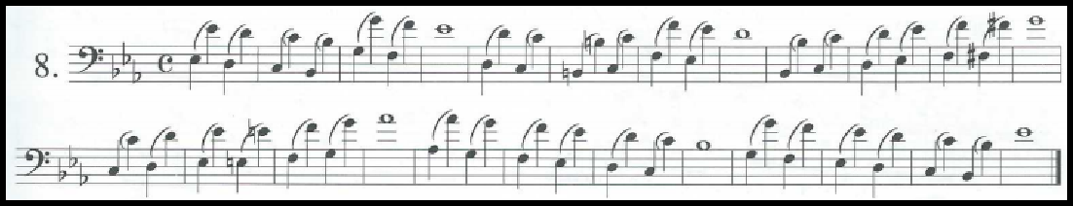
This etude is primarily based around the interval of an octave, and there are several passages in Arban41 that focus on this interval. See figures below:

Figure 36: Arban Complete Conservatory Method, No. 8, pg. 147

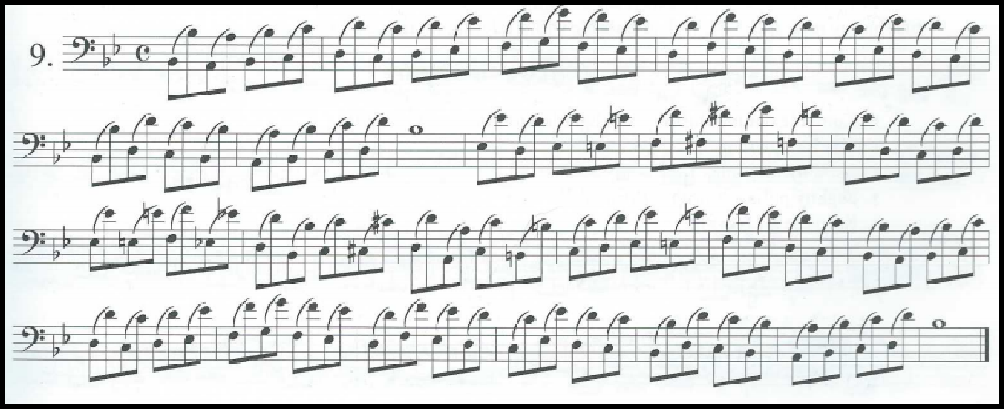

41Jean-Baptiste Arban, ed. J. Alessi and B. Bowman. Complete Method for trombone and euphonium. Troy, MI: Encore Music Publishers, 2002.

Figure 37: Arban Complete Conservatory Method, No. 9, pg. 147

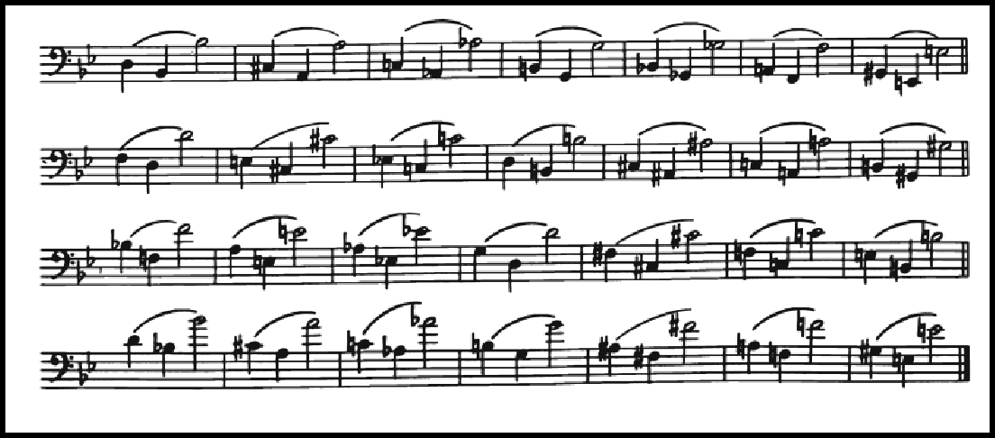
Another prominent concept in the etude (particularly beginning in measure 37) is the ability to navigate wide intervals with a smooth and lyrical approach. To this end, there are several relevant sections from Schlossberg’s Daily Drills42.

Figure 38: Daily Drills by Max Schlossberg, No. 41, pg. 16

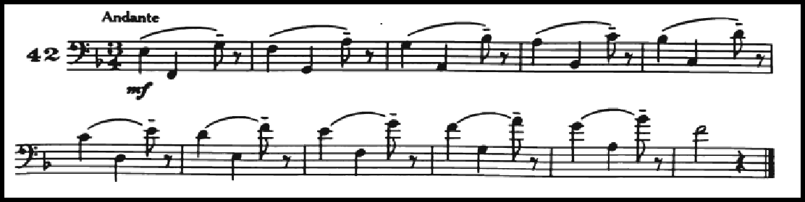

Figure 39: Daily Drills by Max Schlossberg, No. 42, pg. 17

- A short excerpt and description of one excerpt from the standard repertoire of solo and excerpt literature for euphonium:

42Max Schlossberg. Daily Drills and Technical Studies for Trombone. New York: M. Baron, 1947.

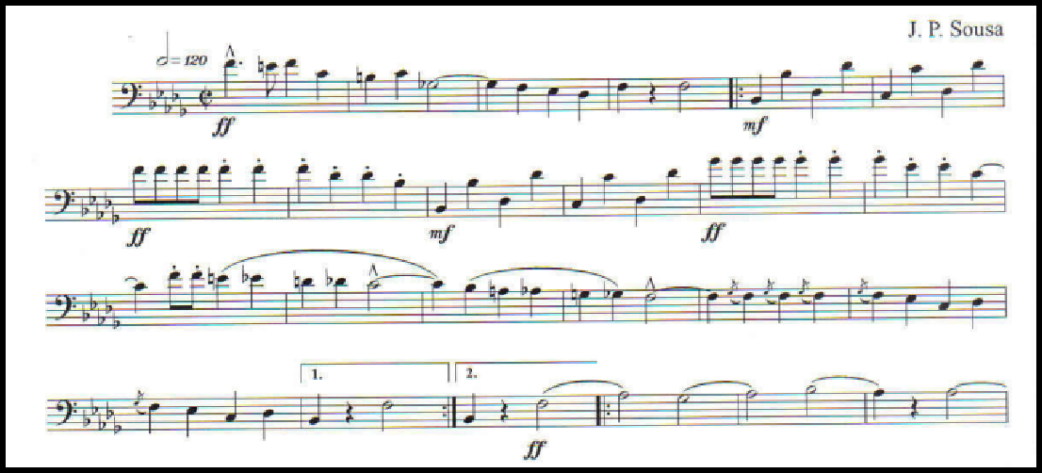

Figure 40: “Nobles of the Mystic Shrine” by J.P. Sousa, mm. 1-24

- Discussion of the skill sets that are common between the Charlier etude, study material, and the literature excerpt:
One commonly used band excerpt commonly asked for on euphonium auditions is “Nobles of the Mystic Shrine” by John Philip Sousa43. As evidenced in
Figure 38, the excerpt contains several instances of prominent octave intervals in the first strain, and this theme continues later in the piece as well. By gaining a firm grasp on octaves and wide intervals through study of the Charlier and supplementary materials, the student will be able to quickly and efficiently master this excerpt.

43John Philip Sousa. Nobles of the Mystic Shrine: March. New York: Fox, 1972.

Chapter 11: Supplementary Materials for Etude No. 13 “de Gammes et fioritures”

- Etude number and title:

Etude No. 13, “Des Gammes et Fioritures”44

- Short excerpt from the etude:
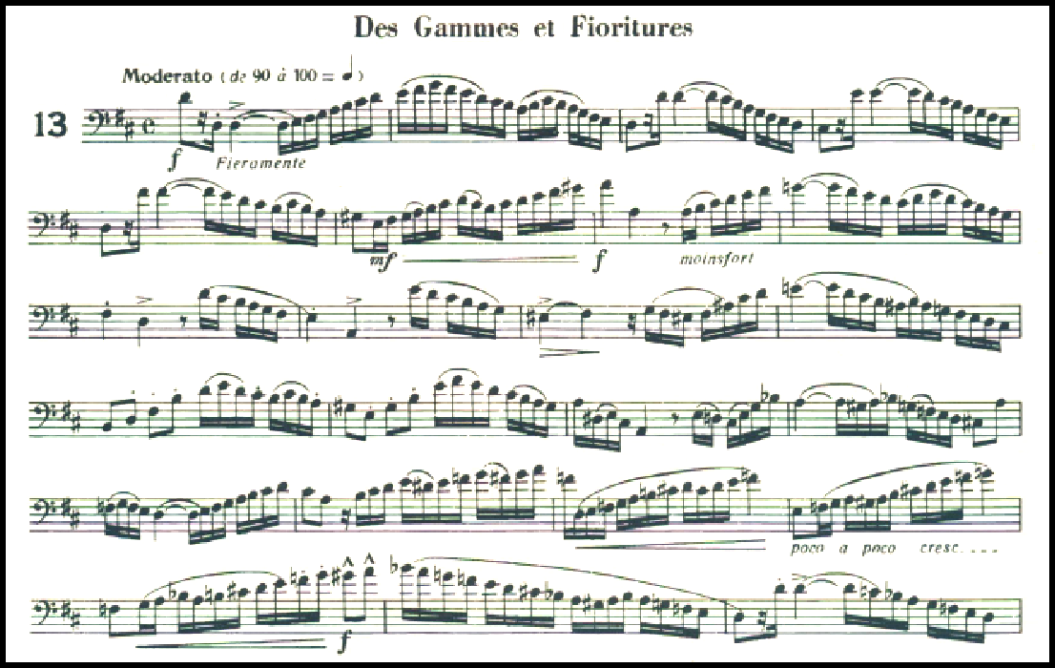

Figure 41: Etude No. 13 from 32 Etudes de Perfectionnement, mm. 1-23

- Description of etude including large scale form, key centers, and other pertinent concepts:
Etude No. 13 is based primarily on ascending and descending scalar passages, but contains more rhythmic and motivic variety than, for example, Etude 10. The etude

44Theó Charlier. 32 etudes De Perfectionnement Pour Trombone En Si♭ a 4 Pistons Ou Tuba. Henry Lemoine &amp; Cie., 1946.

begins in the key of D major, and makes forays into C major and F major before returning to D major. The etude is through-composed.
- A short excerpt and description of two proposed preparatory exercises and/or etudes from the standard low brass canon and discussion of how the preparatory exercises apply to the etude:
A prominent rhythmic gesture used in this etude is the eighth note coupled with a sixteenth rest and then a sixteenth note. As evidenced in Figure 39, it is arguably the defining rhythmic gesture in the first few bars of the piece, and it is used throughout the rest of the etude as well. It is likely the case that Charlier wrote the rhythm as he did (rather than as, say, a dotted eighth note and a sixteenth note) in order to encourage clarity in the execution of this rhythm. In addition to clarity, another consideration when executing dotted rhythms is temporal accuracy. Often, students will neglect to ensure that the correct rhythmic proportion of 3 to 1 is being executed, instead slipping into a proportion of 2 to 1 (triplet) or 4 to 1 (a proportion approaching that of an appoggiatura). A supplemental study that clearly and concisely outlines how students should subdivide these rhythms may be found in Getchell and Hovey’s Second Book of Practical Studies for Tuba45.

45Robert W. Getchell and Nilo W. Hovey. Second book of practical studies for tuba. Van Nuys, CA: Alfred, 2014.

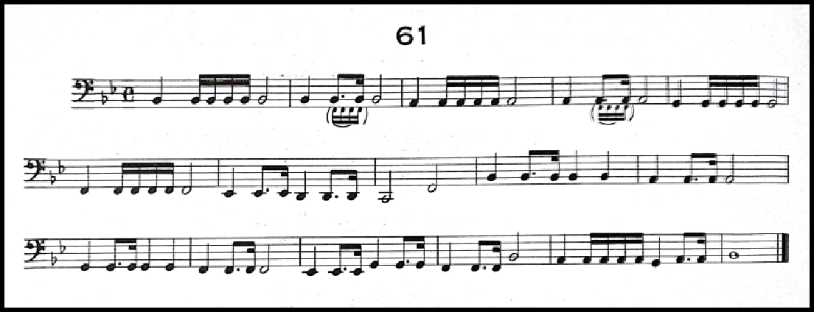

Figure 42: Exercise 61 from Second Book of Practical Studies for Tuba

With the addition of the parenthetical sixteenth notes, Getchell and Hovey illustrate how the student should mentally subdivide the dotted rhythm. By playing similar figures back-to-back with sets of four sixteenths and dotted rhythms substituted (for example, measures 1 and 2), students can practice this concept, and then successfully apply it to all dotted rhythms, including the Charlier etude.
Another prominent concept worth isolating in this etude is its scalar passages.

Oftentimes, the term “scalar” is not specific enough to be useful when selecting supplementary content. For example, some passages are scalar, but cover a quite narrow range (for example, Study No. 2 from Herbert Clarke’s Technical Studies46).
Other scalar passages cover a wide range, and the Charlier discussed here is a good example of this. In this etude, scalar lines frequently cover over an octave both (ascending and descending) and contain other modal scalar forms in addition to the “pure” major or minor forms. To practice this concept, William Bell’s Daily Scale Routine is invaluable for the student.

46Herbert L. Clarke, Claude Gordon, and William B. Knevitt. Technical Studies: for Bass Clef Instruments. Carl Fischer, 1912.

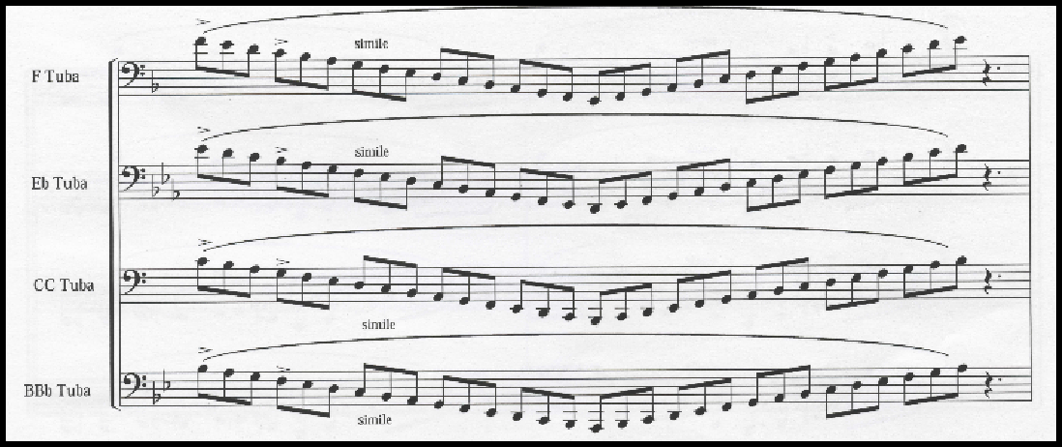

Figure 43: Daily Scale Routine by William Bell, mm. 1

William Bell’s Daily Scale Routine47 is written with the tuba in mind, and

contains four staves throughout (one each for B-flat, C, E-flat, and F tuba). The author practices from the F tuba line on euphonium, and finds it well-suited for both high and low range on euphonium. All of the exercises in the Daily Scale Routine cover a range of two octaves, and covers the following forms of scales:
  - Major with a triplet subdivision

  - Major with a sixteenth subdivision

  - Harmonic minor with a triplet subdivision

  - Chromatic with a triplet subdivision

  - Major arpeggio with a triplet subdivision

  - Dominant arpeggio with a sixteenth subdivision

  - Diminished arpeggio with a sixteenth subdivision

  - Minor arpeggio with a triplet subdivision

47William Bell, Abe Torchinsky, and Wesley Jacobs. Daily Routine and Warm-Up for Tuba. Troy, MI: Encore Music Publishers, 2009.

  - Augmented arpeggio with a triplet subdivision Additionally, each key alternates between the typical
ascending-then-descending pattern and a descending-then-ascending pattern, adding to its comprehensiveness. The wide tonal range of the William Bell Daily Scale Routine coupled with the wide array of scale forms makes it ideal for practicing concepts present in the Charlier etude.
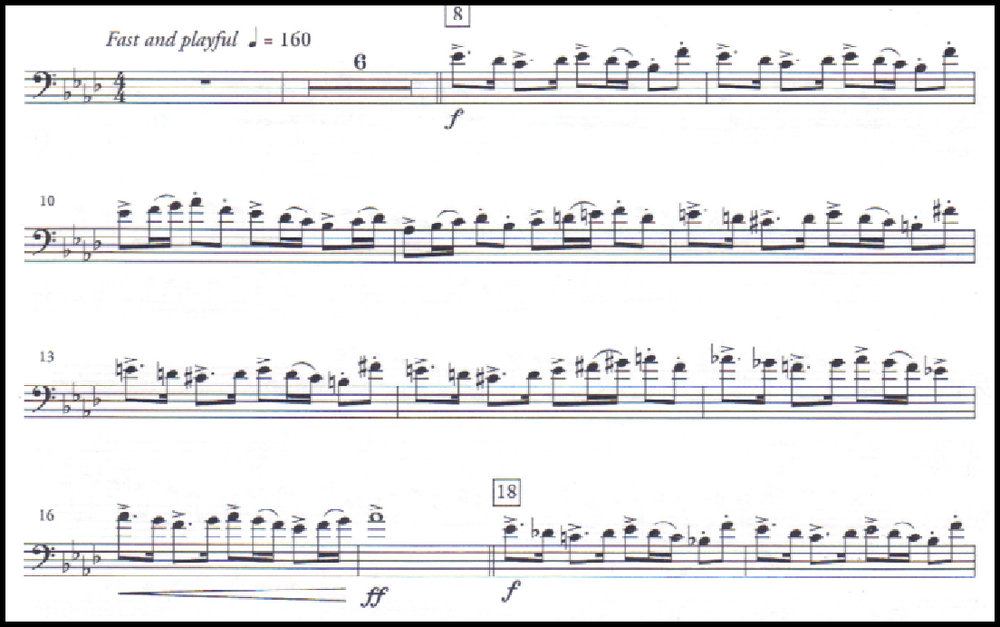
- A short excerpt and description of one excerpt from the standard repertoire of solo and excerpt literature for euphonium:

Figure 44: Concerto by David Gillingham, Movement 3, mm. 1-19

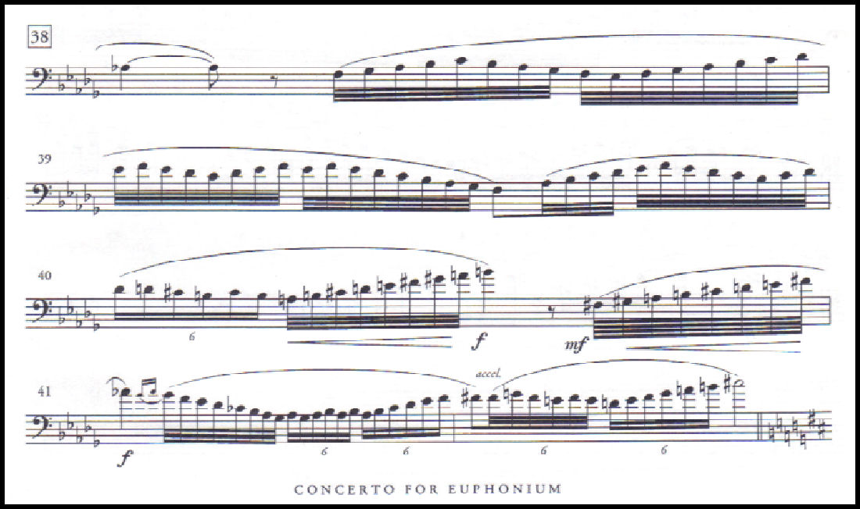

Figure 45: Concerto by David Gillingham, Movement 2, mm. 38-42

- Discussion of the skill sets that are common between the Charlier etude, study material, and the literature excerpt:
Once the student has mastered the concepts outlined in the Charlier etude and the supplementary material, he or she will be well-prepared to commence study of a masterwork of the euphonium repertoire, David Gillingham’s Concerto for Euphonium
48. As seen in Figure 42, the third movement of the Concerto contains highly rhythmic

figures with frequent dotted rhythms. Additionally, the second movement contains rhapsodic scalar figures that frequently cover a range of more than an octave. By practicing the Charlier and supplementary concepts outlined above, the student will be well-prepared to tackle this challenging piece.

48David Gillingham. Concerto for euphonium, winds & percussion: Summer of 2008.
Greensboro, N.C.: C. Alan Publications, 2009.

Chapter 12: Supplementary Materials for Etude No. 17 “Trilles et ornament”

- Etude number and title:

Etude No. 17, “Trilles et Ornements”49

- Short excerpt from the etude:
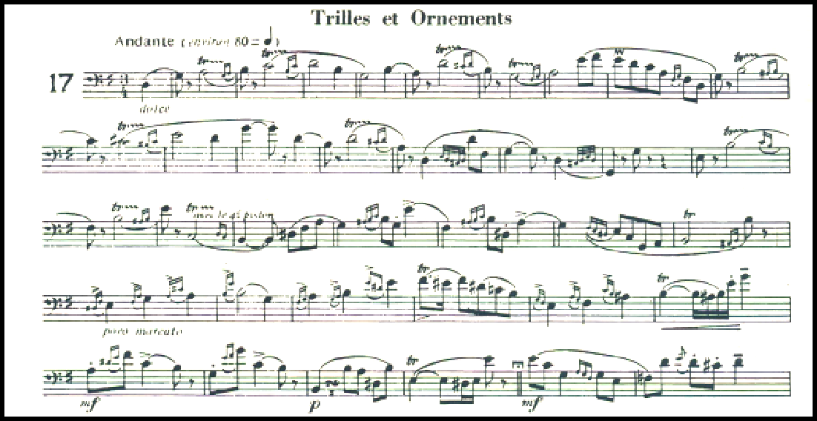

Figure 46: Etude No. 17 from 32 Etudes de Perfectionnement, mm. 1-36

- Description of etude including large scale form, key centers, and other pertinent concepts:
Etude #17 from 32 Etudes de Perfectionnement, entitled “Trilles et Ornements” contains (as the title suggests) a large number of whole tone trills, half tone trills, and appoggiaturas. The etude is in ¾ time and the first major section (measures 1-34) is made up of short motivic fragments rather than lengthy melodies. The key in this

49Theó Charlier. 32 etudes De Perfectionnement Pour Trombone En Si♭ a 4 Pistons Ou Tuba.
Henry Lemoine &amp; Cie., 1946.

opening section centers around G major, and then shifts to E minor and then E major before returning to G major. The amount of ornaments in this etude is incredibly dense, with hardly a measure without multiple incidences of trills or appoggiatura.
- A short excerpt and description of two proposed preparatory exercises and/or etudes from the standard low brass canon and discussion of how the preparatory exercises apply to the etude:
In the author’s experience, the whole tone trill in particular is often clumsily executed by students. A recommended supplemental study would be the “Fourth Study” from Herbert Clarke’s Technical Studies50. Due to the extensive coverage of
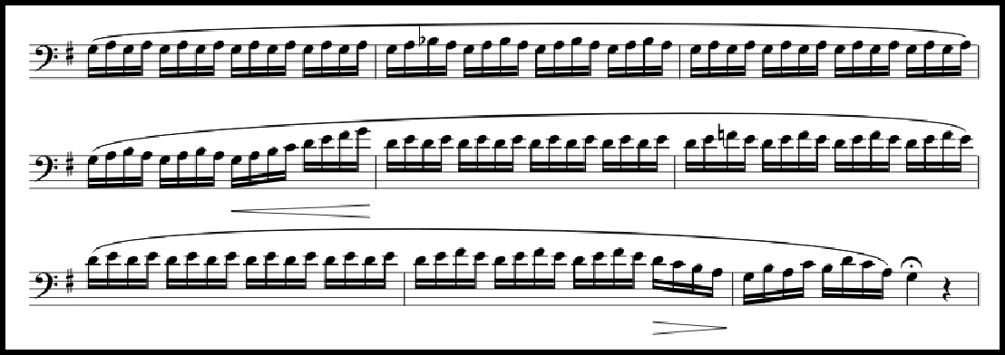
whole tone trills in the Fourth Study, the student will be well-prepared for “Trilles et Ornements” after its completion. Clarke presents this exercise in all major keys from E2 to B♭3. See excerpt of the Clarke below beginning on G3:

Figure 47: Exercise #81 from Technical Studies

50Herbert L. Clarke, Claude Gordon, and William B. Knevitt. Technical Studies: for Bass Clef Instruments. Carl Fischer, 1912.

Mastery of Etude #17 and the Fourth Study from Clarke will render the student able to execute audition excerpts that prominently feature both whole tone intervals and rapid, flowing sixteenth notes.
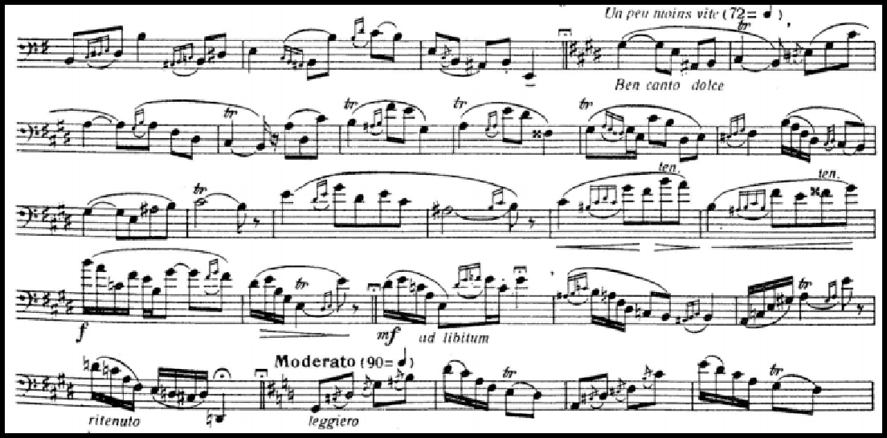
An additional challenge of Etude #17 is the presence of wider intervals in the slower middle section:

Figure 48: Etude #17 from 32 Etudes de Perfectionnement, mm. 48-74

One possible approach could be for the student to practice navigating wider intervals in the form of a slur. A recommended exercise would be #13 from Lip Flexibilities by Bai Lin51:

51Bai Lin. Lip Flexibilities for all brass instruments. Balquidder Music, 1996.

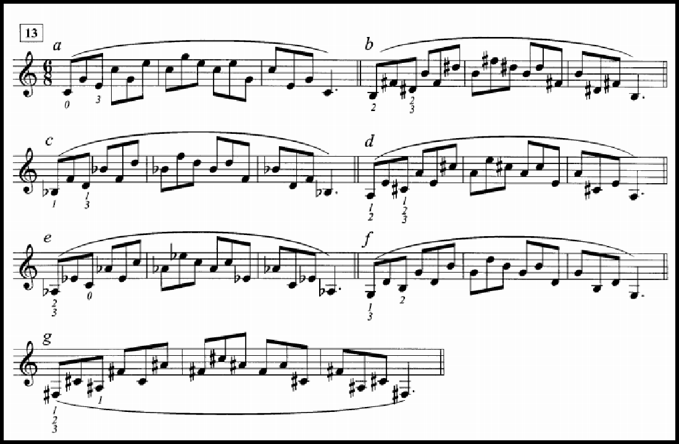

Figure 49: Exercise 13 from Lip Flexibilities by Bai Lin

Once the wider intervals in the above exercise are mastered, the student will be much more prepared for the intervals in Etude #17.
- A short excerpt and description of one excerpt from the standard repertoire of solo and excerpt literature for euphonium:

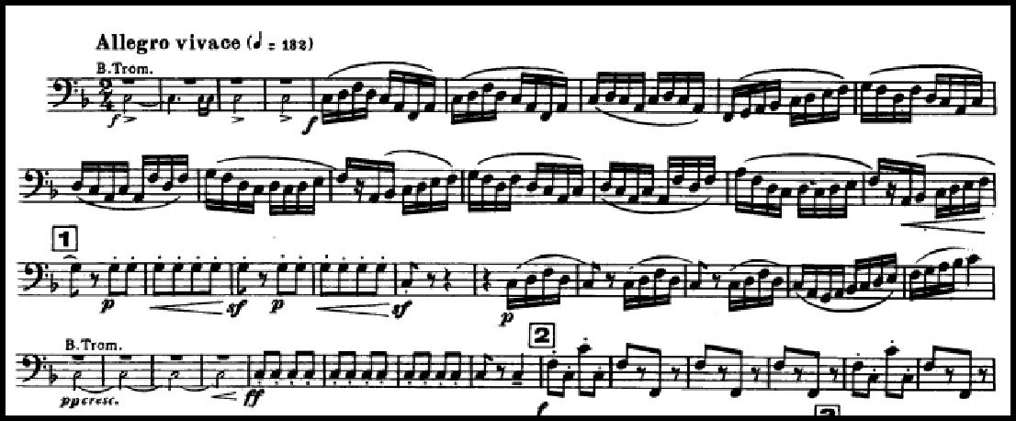

Figure 50: Pineapple Poll by Arthur Sullivan, mm. 1-40

- Discussion of the skill sets that are common between the Charlier etude, study material, and the literature excerpt:
Whole tone intervals and rapid, flowing sixteenth notes abound in Pineapple Poll by Arthur Sullivan52. This excerpt appears on most military band auditions, and is
a great way to test fourth valve coordination and clarity when moving from note to note at high speeds. Mastery of the Charlier etude and Clarke study will set the student up for success in the opening section (beginning to rehearsal 1). Additionally, wider intervals (up to an octave) begin in rehearsal 2 and continue throughout the rest of the piece; mastery of the Bai Lin material will aid in these sections as well.

52Arthur Sullivan and Charles Mackerras. Pineapple Poll. London: Chappell, 1951.

Chapter 13: Supplementary Materials for Etude No. 21, “1st Etude Concertante”

- Etude number and title:

Etude No. 21, “1st Etude Concertante”53

- Short excerpt from the etude:
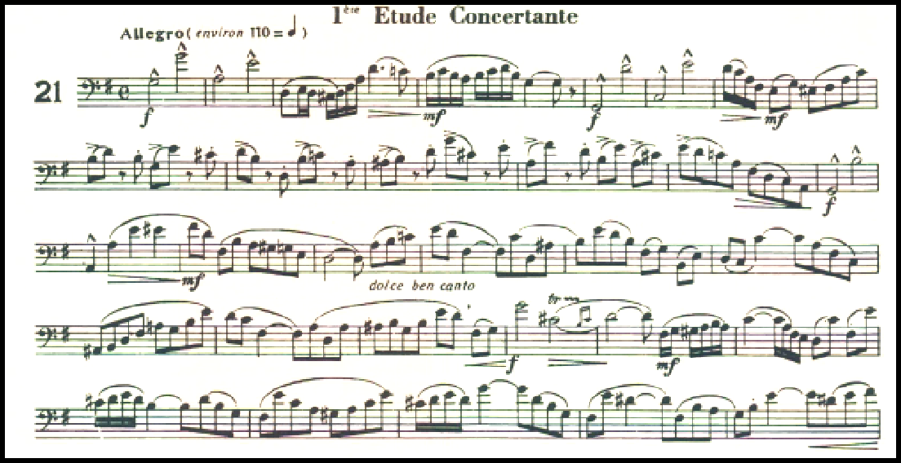

Figure 51: Etude No. 21 from 32 Etudes de Perfectionnement, mm. 1-30

- Description of etude including large scale form, key centers, and other pertinent concepts:
This etude is one of two in Etudes de Perfectionnement entitled “Etude Concertante”, suggesting that Charlier thought it would be appropriate to perform at a concert setting in addition to its pedagogical value. It’s easy to imagine why Charlier thought an audience would enjoy this piece; its wide melodic leaps, rhapsodic sixteenth note passages and varied rhythms provide plenty of thrills and drama. Like most of

53Theó Charlier. 32 etudes De Perfectionnement Pour Trombone En Si♭ a 4 Pistons Ou Tuba.
Henry Lemoine &amp; Cie., 1946.

Charlier’s etudes from this book, it is through-composed, with no sections being repeated verbatim. The piece begins in the key of G major, and although it does wander into different tonalities, these wanderings never last long enough to be fully realized.
Unlike some of Charlier’s other etudes in this book, it is quite rhythmically varied, with many different values and rhythms being presented.
- A short excerpt and description of two proposed preparatory exercises and/or etudes from the standard low brass canon and discussion of how the preparatory exercises apply to the etude:
A challenge associated with this piece is the accuracy required in the upper range throughout the piece. Students must learn not only to execute wider intervals, but to execute them (particularly the octave) with good intonation. An excellent set of studies on accuracy appear in Roger Bobo’s Mastering the Tuba54. By lengthening the written
pitch of an eighth note and using an electronic tuner, the student can get a good grasp on the intonation tendencies of the octaves on their instrument. By utilizing the written rhythmic value at a quick tempo, accuracy will be developed.

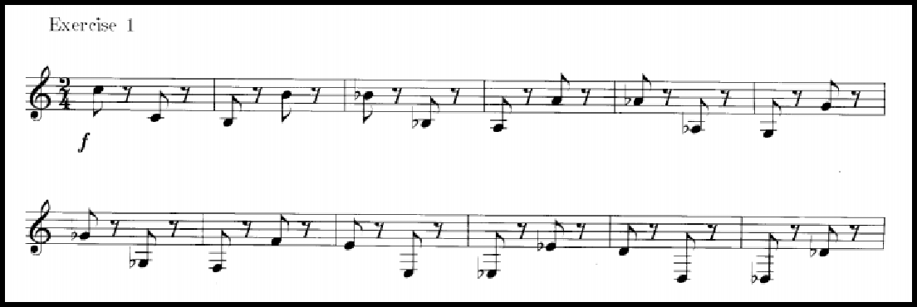

54Roger Bobo. Mastering the Tuba: Complete Book. Vuarmarens, Switzerland: Éditions Bim, 2003.

Figure 52: Mastering the Tuba by Roger Bobo, page 40

Bobo also places the exercise above in the higher octave.
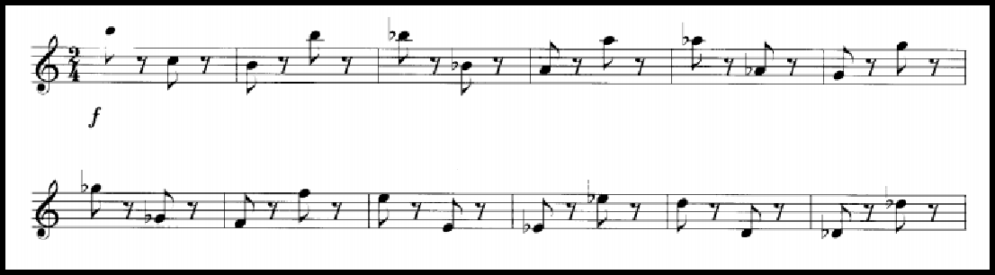

Figure 53: Mastering the Tuba by Roger Bobo, page 41

Another concept present in Charlier 21 is the turn. Although not written with the

symbol, there are many instances of turns in this piece that are instead written

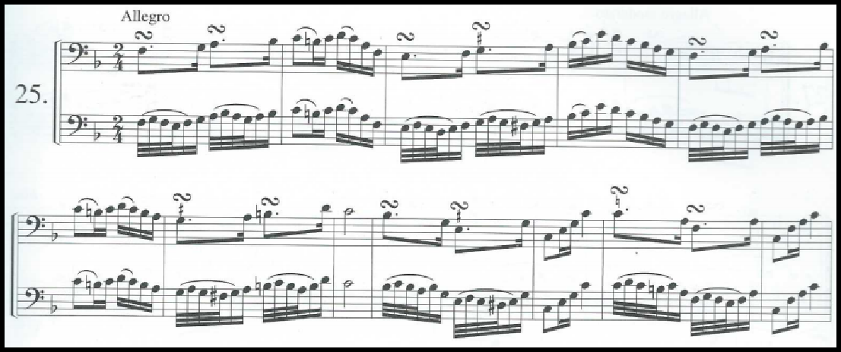
out as sixteenth notes. An excellent resource for practicing turns (also called gruppetto) is the Complete Conservatory Method by J.B. Arban55.

Figure 54: Studies on the Gruppetto by J.B. Arban, #25

55Jean-Baptiste Arban ed. J. Alessi and B. Bowman. Complete Method for trombone and euphonium. Troy, MI: Encore Music Publishers, 2002.

Since the turns appearing in the Charlier etude are sets of sixteenth notes the begin on a strong beat, the above exercise (and ones like it from Arban) will translate most directly.
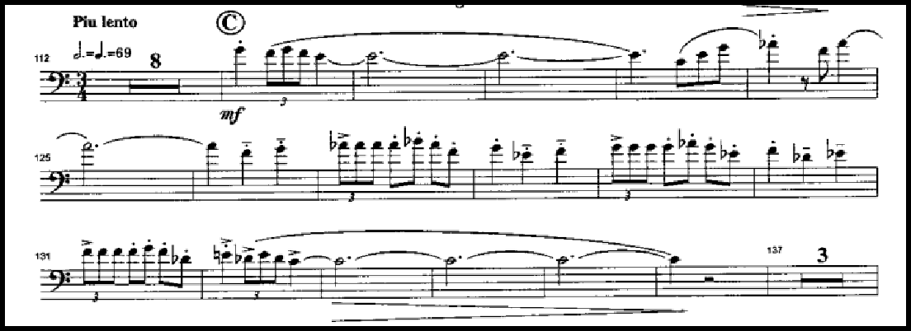
- A short excerpt and description of one excerpt from the standard repertoire of solo and excerpt literature for euphonium:

Figure 55: Euphonium Concerto by Vladimir Cosma, Mvt. 1, rehearsal mark C

- Discussion of the skill sets that are common between the Charlier etude, study material, and the literature excerpt.
One of the most challenging pieces in the euphonium repertoire is the Euphonium Concerto by Vladimir Cosma56. Cosma is primarily known as a film
composer, and his Concerto reflects his cinematic roots, with breathtaking themes and drama between the solo and accompaniment. As evidenced by the figure above, the Cosma has numerous passages where accuracy in the high and low ranges is a must, as

56Vladimir Cosma. Euphonium Concerto. Charnay-les-Macon: Robert Martin, 2007.

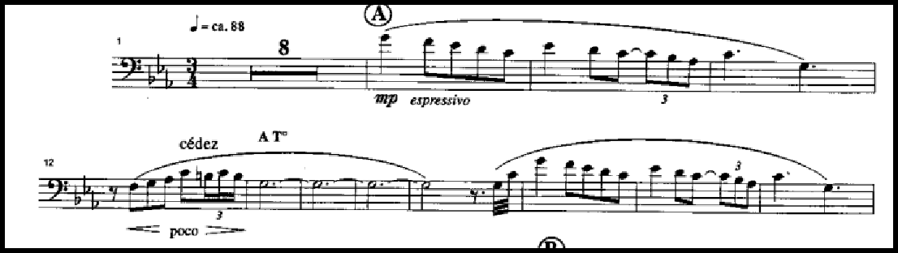
well as rapid turn-like figures. The figure above is from a faster section of the concerto; an excerpt from the slower second movement may be seen below.

Figure 56: Euphonium Concerto by Vladimir Cosma, Mvt. 2, rehearsal mark A

The figure above evidences how accuracy and turn-like figures are present in the slower movement of this piece as well. Studying the Charlier etude as well as the material by Arban and Bobo will aid the student in his or her preparation.

Chapter 14: Supplementary Materials for Etude No. 11, “Etude chromatique”

- Etude number and title:

Etude No. 11 “Etude Chromatique”

- Short excerpt from the etude:
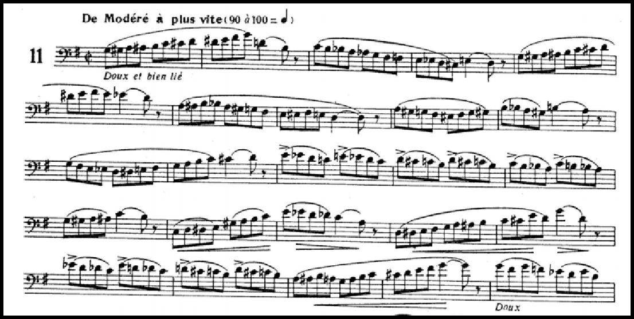

Figure 57: Etude No. 11 from 32 Etudes de Perfectionnement, mm. 1-25

- Description of etude including large scale form, key centers, and other pertinent concepts:
As the title suggests, this etude is replete with chromaticism. It features many pure chromatic lines, many of which span an octave or more. It also contains melodic fragments which combine chromatic passages with fragments of major or minor scales and other patterns; this contributes to the etudes’ difficulty. The range spans from the G on the bottom of the bass clef staff to the C two octaves and a fourth above. The etude is mostly monorhythmic, with eighth note runs being the primary rhythmic figure in addition to some longer note values.

- A short excerpt and description of two proposed preparatory exercises and/or etudes from the standard low brass canon and discussion of how the preparatory exercises apply to the etude:
Obviously, an excellent grasp on chromatic patterns will make this etude much more approachable for a student. There are several good sources of material on chromatic patterns, most notably in Technical Studies by Herbert Clarke57 and the
Complete Conservatory Method by J.B. Arban58.
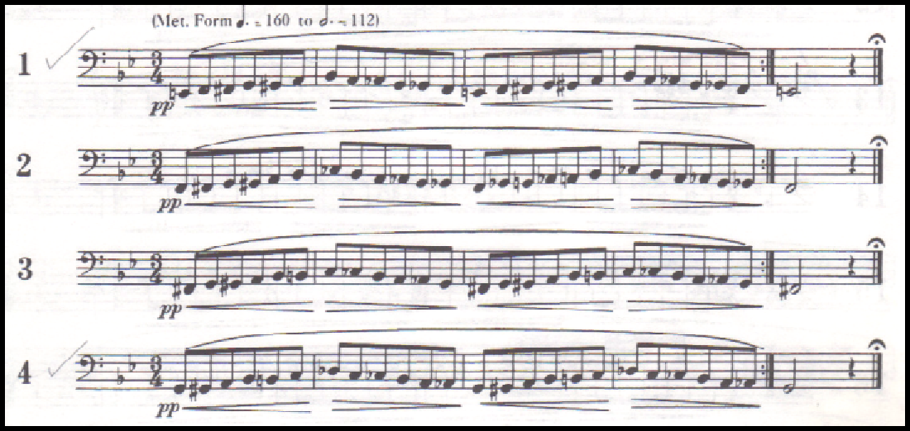

Figure 58: Study 1 from Technical Studies by Herbert Clarke

The chromatic studies by Clarke can be seen above. These studies are excellent for cultivating fluency in chromatic patterns, and they are also useful for developing healthy air support. Clarke believed that long tones had the potential to lead to a stagnated flow of air; he thought of his technical studies as a way to not only build technical fluency, but also as a way to develop an energized, flowing airstream.

57Herbert L. Clarke, Claude Gordon, and William B. Knevitt. Technical Studies: for Bass Clef Instruments. Carl Fischer, 1912.
58Jean-Baptiste Arban ed. J. Alessi and B. Bowman. Complete Method for trombone and euphonium. Troy, MI: Encore Music Publishers, 2002.

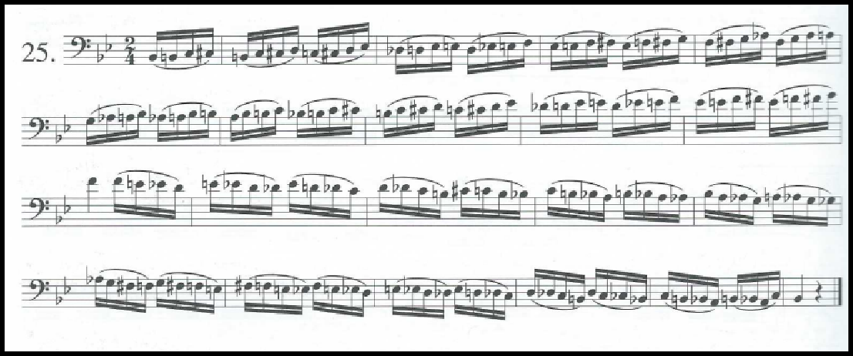
The chromatic studies from Arban are more comprehensive than those in Clarke. The section on chromatic scales in Arban covers ascending lines, descending lines, and lines that both ascend and descend. Additionally, Arban covers chromatic fragments as well as intact scales.

Figure 59: Chromatic Exercise #25 from Arban’s Complete Conservatory Method

In the figure above, one can see how Arban arranges chromatic fragments so that a student must master the chromatic pattern while navigating intervals that are not chromatic. This pattern is quite like those found in sections of the Charlier.
- A short excerpt and description of one excerpt from the standard repertoire of solo and excerpt literature for euphonium:

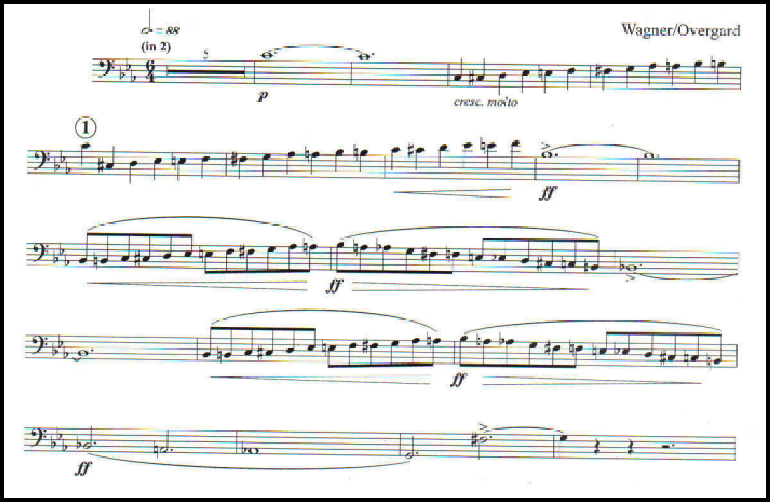

Figure 60: Overture to the “Flying Dutchman”, standard excerpt

- Discussion of the skill sets that are common between the Charlier etude, study material, and the literature excerpt:
A standard excerpt for euphonium is the Overture to the “Flying Dutchman” by Richard Wagner arr. Overgard. This piece of music is the famous overture arranged for wind band. The opera is replete with otherworldy and supernatural themes, and the music transcribed by Overgard reflects these themes. In this excerpt, the euphonium part simulates the rolling up-and-down motion of a vessel at sea; this is manifested in the use of chromatic lines in the excerpt. In order to convey these musical ideas, the performer must be able to execute fluid, connected chromatic lines at both a slower and faster speed. The Charlier discussed in this chapter and the supplementary material from

Arban and Clarke will provide excellent groundwork from which the student will have success with the excerpt.

Chapter 15: Conclusion and Further Research

In a way, this document distills down to the concept of building mastery. Editors of the 1946 edition of Trente-Six Etudes Transcendantes knew that to master Charlier’s etudes, students would need to master certain fundamental concepts of trumpet playing, and the annotations reflect that. By showing how to apply these concepts to 32 Etudes Perfectionnement (and commonly used solo and excerpt literature), the student can hopefully see not only beneficial practice strategies, but also concepts of building mastery that transcend music practice.
Regarding further research, there are many possibilities based on ideas that are discussed in this document. The low brass world could likely benefit from a
high-quality transcription of Charlier’s Trente-Six Etudes Transcendantes into bass clef. Learning to read treble clef fluently is a must for any well-trained low brass musician, but a transcription would likely make the etudes more widely used and appreciated in the low brass community.
Chapter 1 from this document touches on the history of the etudes, and makes allusions to the founding of the tuba studio at the Paris Conservatory. There is likely much to be explored in this area of scholarship. Music publishers (for example, A-R Editions) are now beginning to circulate pieces from the Conservatory, which remain worthy of study, even by today’s standards. A worthy project might be to catalog brass music from as early as possible in the Conservatory’s history to today.
Additionally, a performance practice study as it relates to the instruments used in different geographies and time periods would be interesting. For example, Charlier had

the French C tuba in mind when he composed his 32 Etudes Perfectionnement. The French C tuba has a much different timbre than the modern day German-style instruments commonly used in American orchestras. For which literature should tubists consider a smaller, lighter horn? When the tuba studios in Charlier’s time were founded, was the French C tuba used exclusively? When did other horns (saxhorn, German-style horns, euphonium) begin to supplant the French C tuba? These are questions of historical interest that also have potential consequences for performance practice.

Bibliography

Alphonse, Maxime. Etudes nouvelles pour trompette, cornet et saxhorn. Paris: A. Leduc, 1920.

Anthony, John Brian. An Historical and Practical Guide to the Trente-Six Etudes Transcendantes Pour Trompette Cornet a Pistons, Ou Bugle B-flat by Théo Charlier (1868-1944). DMA diss., University of Georgia, 2007.

Arban, Jean-Baptiste, ed. E.F. Goldman and W.M. Smith. Arban's Complete Conservatory Method for Trumpet (Cornet) of E Flat Alto, B Flat Tenor, Baritone, Euphonium and B Flat Bass in Treble Clef/ Edited by Edwin Franko Goldman and Walter M. Smith. C. Fischer, 1936.

Arban, Jean-Baptiste, ed. J. Alessi and B. Bowman. Complete Method for trombone and euphonium. Troy, MI: Encore Music Publishers, 2002.

Balay, Guillaume. Method Complete de Cornet a Pistons, ou de Trompette, ou de Saxhorn. Alphonse Leduc, 1914.

Bell, William, Abe Torchinsky, and Wesley Jacobs. Daily Routine and Warm-Up for Tuba. Troy, MI: Encore Music Publishers, 2009.

Bobo, Roger. Mastering the Tuba: Complete Book. Vuarmarens, Switzerland: Éditions Bim, 2003.

Bone, Lloyd E., Eric Paull, and R. Winston. Morris. Guide to the Euphonium Repertoire the Euphonium Source Book. Bloomington: Indiana University Press, 2007.

Charlier, Theó. 32 etudes De Perfectionnement Pour Trombone En Si♭ a 4 Pistons Ou Tuba. Henry Lemoine &amp; Cie., 1946.

Charlier, Théo. Trente-Six etudes Transcendantes Pour Trompette, Cornet à Pistons Ou Bugle Si ♭. A. Leduc, 1946.

Chavanne, Antoine. Vingt-cinq etudes caracteristiques : pour trompette, cornet à pistons, et tous les saxhorns clé de sol. Leduc, 1951.

Clarke, Herbert L., Claude Gordon, and William B. Knevitt. Technical Studies: for Bass Clef Instruments. Carl Fischer, 1912.

Cosma, Vladimir. Euphonium Concerto. Charnay-les-Macon: Robert Martin, 2007.

Getchell, Robert W., and Nilo W. Hovey. Second book of practical studies for tuba.
Van Nuys, CA: Alfred, 2014.

Gillingham, David. Concerto for euphonium, winds & percussion: Summer of 2008.
Greensboro, N.C.: C. Alan Publications, 2009.

Guggenberger, Wolfgang. “Basics Plus.” Rot an der Rot: Rundel, 2007.

Edwards, Brad. “Pedagogical Materials for the College-Level Trombone Student.” DMA diss., Peabody Conservatory of Music, 1999.

Ewazen, Eric. Concerto for euphonium and wind ensemble. San Antonio, Tex. : Southern Music Company, 2009.

Kopprasch, G. Sixty Selected Studies for Trombone. New York: C. Fischer, 1950.

Kutz, David William. “Arnold Jacobs, Methods and Materials of Pedagogy.” DMA diss., Northwestern University, 2002.

Laurent, Rene. Etudes pratiques : pour trompette chromatique en ut et si ♭, cornet à pistons et saxhorns. Paris: Alphonse Leduc, 1923.
Lin, Bai. Lip Flexibilities for all brass instruments. Balquidder Music, 1996. Louder, Earle L., and David R. Corbin. Euphonium Music Guide. Evanston, IL:
Instrumentalist Co., 1978.

Macaluso, Rosario, (Author), and Jeffrey, (Translator) Agrell. 2001. "A grand master: Théo Charlier." International Trumpet Guild Journal 25, no. 4: 30-36. RILM Abstracts of Music Literature (1967 to Present only), EBSCOhost (accessed September 25, 2017).

Miles, David. Euphonium Study Materials. Tuba-Euphonium Press, 1992.

Moore, Ryan. “A theoretical historical and comparative analysis of preferred collegiate trombone and euphonium methods of books.” DMA diss., University of Kentucky, 2013.

Petit, Alexandre. Grande méthode complète de cornet a pistons : bugle trompette & d
́instruments a pistons. Paris: Editions Salabert. Date of publication not identified.

Pilafian, Sam and Sheridan, Pat. The Brass Gym. Mesa, AZ: Focus on the Music Publications, 2006.

Rossini, Gioacchino, Theo. M. Tobani, and H. R. Kent. The Italian in Algiers: Overture. New York, N.Y.: C. Fischer, 1949.

Saito, Mitsuru. “A Critique of Etudes and Method Books for Advanced Euphoniumists: Status Quo and Recommendations.” DMA diss., University of North Texas, 2008.

Schlossberg, Max. Daily Drills and Technical Studies for Trombone. New York: M. Baron, 1947.
Sousa, John Philip. Nobles of the Mystic Shrine: March. New York: Fox, 1972. Sullivan, Arthur, and Charles Mackerras. Pineapple Poll. London: Chappell, 1951. Stevens, Milt and Bowman, Brian. Scale and Arpeggio Routines for Trombone and
Euphonium. Falls Church, VA: Stevens Desk Top Publishing, 2005.

Telemann, G.P., ed. K. Brown. “Sonata in A minor.” New York City: International Music Company, 1966.

Vining, David. “Daily Routines for Euphonium.” Flagstaff AZ: Mountain Peak Music, 2009.

Vining, David. “Flow Studies for Euphonium.” Flagstaff, AZ: Mountain Peak Music, 2009.

Vivio, Chris. “The Concours: A Guide to Tuba Solo Literature from the Paris Conservatoire from 1987 to 2007.” DMA diss., University of Memphis, 2008.

Appendix

The following is a concise chart outlining the material put forward in this document as supplementary studies for selected etudes from Charlier’s 32 Etudes de Perfectionnement. The purpose of presenting the information in this condensed format is to provide a reference for a student or teacher seeking to consult these materials. Full publication details for the materials listed below may be found in the bibliography.
Etude from 32 Etudes de Perfectionnem ent | Supplemental Material Item 1 | Supplemental Material Item 2 | Literature Excerpt or solo
No. 2, Du Style | Flow Studies by David Vining, #42 | Complete Conservatory Method by J.B. Arban, study on arpeggios | Sonata in A Minor by G.P. Telemann, edited by K. Brown
No. 3, De  l’Arpege | Daily Routines by David Vining, pg. 40 | Basics Plus by Wolfgang Guggenberger, pg. 62 | The Italian in Algiers excerpt by Rossini, mm.  40-58
No. 5, Tierces et Triolets | The Brass Gym by Pilafian & Sheridan; “Lip Flips” | Scale and Arpeggio Routines by Stevens and Bowman, pp.  22 | Concerto for Euphonium by Eric Ewazen, movement 3
No. 10,  Intervalles: les Octaves | Complete Conservatory Method by J.B. Arban, study on octaves | Daily Drills by Max Schlossberg, No. 41  & 42 | Nobles of the Mystic Shrine by  J.P. Sousa
No. 13, Des Gammes et Fioritures | Second Book of Practical Studies for Tuba by Robert Getchell, No. 61 | Daily Scale Routine  by William Bell | Concerto for Euphonium by David Gillingham, movement 3
No. 17, Trilles et Ornements | Technical Studies by Herbert Clarke, fourth | Lip Flexibilities by Bai Lin, No. 13 | Pineapple Poll by Arthur Sullivan,

 | study |  | standard excerpt
No. 21, 1st Etude Concertante | Mastering the Tuba by Roger Bobo, pg. 40-41 | Complete Conservatory Method by J.B. Arban, study on the gruppetto | Euphonium Concerto by Vladmir Cosma, movement 1
No. 11, Etude Chromatique | Technical Studies by Herbert Clarke, Study 1 | Complete Conservatory Method by J.B. Arban, chromatic studies | Overture to the “Flying Dutchman” by Wagner/Overgard

