University of Oklahoma
Graduate College

A novel scaffold for generation of 3D tumor constructs

A thesis
submitted to the Graduate Faculty
in partial fulfillment of the requirements for the
Degree of
Master of Science

By
alison jalanti
Norman, Oklahoma
2017

A novel scaffold for generation of 3D tumor constructs.

A thesis approved for the
Stephenson School of Biomedical Engineering

By

______________________________
Dr. Vassilios Sikavitsas, Chair

______________________________
Dr. Roger Harrison

______________________________
Dr. Matthias Nollert

© Copyright by alison jalanti 2017
All Rights Reserved.

Acknowledgements
I would like first to thank my thesis advisor Dr. Vassilios Sikavitsas of the Stephenson School of Biomedical Engineering at the University of Oklahoma for giving me the opportunity to work on this project and his continual support. He consistently allowed this paper to be my own work, but steered me in the right direction whenever he thought I needed it.
I would also like to thank the experts who were involved in the validation survey for this research project: Dr. Harrison and Dr. Nollert. I would also like to extend my gratitude to the ever-approachable faculty and staff of the Stephenson School of Biomedical Engineering.
I am grateful to my French committee members for their interest and patience towards this project: Gwendoline Christophe, Philippe Michaud and Jane Roche and finally Christian Larroche for making this exchange program available.
Special thanks to my lab mates and peers Julien Arrizabalaga, Sandra Bonhoure, Chelsea Coffey, Jin Liu, Patrick McKernan, Zach Musset, Melissa Narum, James Patrick Buerck, Aaron Simmons, Cortes Williams and Needa Virani for their support, interesting remarks or guidance and for making this time at the University of Oklahoma an amazing and unforgettable experience. This work couldn’t have been done with the moral support of my work team at the couch cafeteria: Betsy, Bird, Chef, Levi, Maalvyn and Westlee. Their sage wisdom and flexible scheduling policies made it a lot easier for me to combine working on my thesis and earning a living.

I must express my very profound gratitude to my mother Catherine Cuchet and my father Lauri Jalanti for making my American dream possible and their support in all the decisions I ever make.
Finally, I would also thank my significant other, Benjamin Douglas, for his support and patience, as well as his family for their encouragements and attention. I would like to thank my friends for providing me with unfailing encouragement throughout my years of study and through the process of researching and writing this thesis. This accomplishment would not have been possible without them.

Thank you.

Table of Contents
Acknowledgements iv
Table of Contents vi
List of Tables ix
List of Figures x
Abstract xii
1. Introduction 1
1.1 Cancer 1
1.2 Existing therapy 2
1.2.1 Surgery 2
1.2.2 Radiation 3
1.2.3 Chemotherapy 3
1.2.4 Immunotherapy and vaccines 3
1.2.5 Targeted therapy 4
1.2.6 Hormone therapy 4
1.2.7 Stem cell transplants 4
1.2.8 Precision medicine 5
1.2.9 Summary of existing therapies 5
1.3 Tumor construct 5
1.3.1 Multicellular Tumor Structures 6
1.3.2 Engineered Scaffold 7
1.3.3 3D-tissue engineered scaffold 9
1.4 Research motivations 11
1.4.1 Breast Cancer 11
1.4.2 Prostate Cancer 12
1.4.3 The Matrix: Human Umbilical Cord 12
1.5 Research objectives 13
1.5.1 Hypothesis 13
1.5.2 Objective 1 13
1.5.3 Objective 2 14
2. Materials and methods 15
2.1 Cancer cells used in this thesis 15
2.1.1 Cell line 15
2.1.2 Media 15
2.1.3 Cell culture and expansion 16
2.1.4 MDAs and PC3s cultured in a 6-well plate 17
2.2 Seeding and culturing on decellularized construct 18
2.2.1 Scaffold preparation 18
2.2.2 Seeding 20
2.2.3 Species measurement methods 21
2.3 Verification of the decellularization process 22
2.3.1 Fresh cords 22
2.3.2 Decellularized cords 23
2.3.3 Species measurement methods 23
2.4 Verification of the non-effect of the Pizzabox on cellularity 23
2.4.1 Pizzabox characteristic 23
2.4.2 Seeding 25
2.4.3 Species measurement methods 25
2.5 Seeding and culturing on non-decellularized construct 26
2.5.1 Scaffold preparation 26
2.5.2 Seeding 26
2.5.3 Samples 27
2.6 Cellularity via dsDNA Quantification 27
2.6.1 Tissue samples preparation 27
2.6.2 Cell samples preparation 27
2.6.3 DNA assay 27
2.7 Histology 29
3. Results and Discussion 30
3.1 6-well culture 30
3.2 Seeding and culturing on decellularized construct 31
3.2.1 DNA Assay 31
3.2.2 Histology 40
3.3 Seeding and culturing on non-decellularized construct 48
3.3.1 DNA Assay 48
4. Conclusion 52
5. Future directions 54
References 55
Appendix A: List of Acronyms 58
Appendix B: Preparation of PBS for vein decellularization 59
Appendix C: Paraffin embedment protocol 60
Appendix D: Hematoxylin and eosin staining protocol 61

List of Tables
Table 1: Porosity of control and HUV/MDA construct. 40
Table 2: Porosity of control and HUV/PC3 construct. 44

List of Figures
Figure 1: Schematic illustration of a typical tumor microenvironment [6]. 2
Figure 2: A schematic diagram [29]. 9
Figure 3: Representation of a HUC [24].. 12
Figure 4: The process of cancer metastasis in which HA-associated molecules play a role in the steps. 13
Figure 5: Microscope Images PC3 CRL-1435 [44]. 17
Figure 6: 2.0 to 2.5 cm piece of HUV prior to decellularization. 19
Figure 7: Draining the HUVs. 19
Figure 8: 3D printed scaffold holder “The Pizzabox”. 24
Figure 9: Pictures of the Blue and White Pizzabox. 24
Figure 10: Cellularity of the PC3s and MDAs cultured in 6-well culture coated plate.. 30
Figure 11: Amount of DNA representing the PC3s and MDAs cultured in 6-well culture coated plate. 31
Figure 12: Construct HUV seeded with MDA Day 1 – 6. 32
Figure 13: Construct HUV seeded with MDA Day 1 – 10. 33
Figure 14: Construct HUV seeded with PC3 Day 1 – 6. 34
Figure 15: Construct HUV seeded with PC3 Day 1 – 10. 35
Figure 16: Comparison of the cellularity results after the different decellularization steps. 37
Figure 17: Pizzabox seeded with MDA Cellularity Day 1 – 6. 38
Figure 18: Pizzabox seeded with PC3 Cellularity Day 1 – 6. 39
Figure 19: Histology Images MDA seeded construct Day 1 – 10 at 4x magnification. 42
Figure 20: Histology Images MDA seeded construct Day 1 – 10 at 10x magnification. 43
Figure 21: Histology Images PC3 seeded construct Day 1 – 10 at 4x magnification. 45
Figure 22: Histology Images PC3 seeded construct Day 1 – 10 at 10x magnification. 46
Figure 23: Histology Images of decellularization process. 47
Figure 24: Cultured-scaffold seeded with MDA Day 1 – 6. 49
Figure 25: Cultured-scaffold seeded with PC3 Day 1 – 6. 51

Abstract
Cancer is the second most common cause of death in the United States, leading to over $440 million in annual funding for research and yet anticancer drug development is an unmet need. In order to find a more effective way to prevent, detect and treat this disease, new cancer therapies are studied. Human Umbilical Cords (HUC) have been used as a scaffold in various tissue engineering approaches including tissue engineered blood vessels, tissue engineered tendons among many. The decellularized HUCs have been shown to support the growth of a variety of cell types including mesenchymal stem cells, smooth muscle cells, endothelial cells. To have a complete 3D in-vitro model for cancer research, it is necessary to seed and grow tumor cells on the outside part of the cords called the Wharton’s jelly. This work attempts to show if cancer cells can attach and proliferate on the Wharton’s jelly side of the decellularized and non-decellularized (ideally fresh but 5 days old cords in this study) HUC. Two different types of cancer have been tested in this project: Breast and Prostate cancer. Two main hypothesis have been tested; first, that the cancer cells would adhere and proliferate to the decellularized Wharton’s jelly of the HUC and second, that the cancer cells would adhere and proliferate to the non-decellularized Wharton’s jelly of the HUC.
DNA assays have been performed at specific point time (6 hours, Day 2, 6 and 10) to observe the cellularity of the different constructs and histology images have been recorded to examine their tissue structures. The decellularized Wharton’s jelly of the HUC has not shown conclusive results due to a potential contamination during the decellularization protocol. On the other hand, the attachment on non-decellularized constructs shows promising results, especially with the study using the prostate cancer cell line. Further analysis is needed to confirm those results.

Introduction

Cancer
One in every four deaths in the United States is due to cancer-related diseases, which place cancer as the major cause of death worldwide [1]. The invasive potential from a normal growth control characterized the main issue of cancer research on the cellular level. Close interactions with the surrounding environment, like cells, are maintained by the malignant cells during the cancer progression and metastasis previously described (Fig.1). The tumor complex environment comprises numerous stromal cells, including endothelial cells of the blood and lymphatic circulation, stromal fibroblasts and innate and adaptive infiltrating immune cells [2]. These environmental components collectively contribute to the tumor-stromal interaction and tumor progression. Cells bind to the components of the stromal ECM such as collagen, glycosaminoglycans and proteoglycans with the help of a dynamic growth factor-mediated tumor-stromal cell crosstalk [3] and integrin-mediated tumor-ECM interactions [4]. This induces a metastatic process or a cell migration through a vastly different microenvironment from the stroma, to the blood vessel endothelium, to the vascular system to finally reach tissues as a secondary site [5], leading to the progression of the disease.
Figure 1: Schematic illustration of a typical tumor microenvironment [6].
A complex microenvironment surrounds the cancer cells, which contributes to the tumor-stromal interaction and tumor progression

Existing therapy
According to the National Cancer Institute (NCI), there are as many types of cancer treatment as types of cancers.

Surgery
Surgery to treat cancer is used to remove the tumor, but sometimes some healthy tissue and their surroundings are also removed, depending on cancer type and potential side effects. There are three main stages during which this treatment can be selected. First when the surgeon oncologist needs to remove a partial or total tumor in order to identify or observe more precisely the stage of the tumor. It is often coupled with staging to figure the size and spread of the tumor. From there the decision of removing the tumor completely or partially (debulking) is considered and most of the time induce the removal of some healthy surrounding tissue called margin. In order to minimalize side effects, palliative surgery can be considered for improving quality of life for patients [7]. After any type of cancer treatment, a reconstruction surgery might be considered to reconstruct or restore the appearance and function of the previous cancer location. Other type of therapy like radiation or chemotherapy (described in section §1.2.2 and §1.2.3) can be combined with this technique.

Radiation
Radiation therapy uses high radiation to destroy the cancer cells in the human body [8]. Two types of radiation can be used to treat cancer: an internal or external beam. The external beam radiation therapy to treat cancer is focused on one specific location of the human body and focuses on sending radiation from many directions to this specific site. The internal beam radiation is inserted in the human body via solid, brachytherapy, or liquid phase via intravenous delivery. The phases focus on damaging the DNA of cancer cells to stop their cellular division [9].

Chemotherapy
Chemotherapy is the use of drugs to kill cancer [8]. This technique is often used in combination with other treatment to reduce the size of the tumor before surgery or destroy remaining cancer cells after treatment or destroy recurrent cancer cells.

Immunotherapy and vaccines
Immunotherapy consists of using biomaterials substances to help the human immune system fight cancer as the regular immune system would fight infections or other disease. This treatment focus on targeting the cancer cells with markers to be able to detect them. Monoclonal antibodies, cytokines or vaccines are examples of markers [10].

Targeted therapy
Targeted therapy uses the changes in cancer cell to detect their presence and target them. This technique is like immunotherapy because it is targeting specific cancer cells to mark and destroy them with the use of small molecule drugs or monoclonal antibodies [11]. This therapy targets the cancer cells but also their surroundings in order to stop them from growing and signaling by interfering in the cellular process.

Hormone therapy
Hormone therapy consists of slowing or destroying the cancer cells that use hormones to proliferate like breast and prostate cancers [8]. To do so, blocking the hormone production or interfering with the behavior of those hormones in the human body are the focus on this technique. Hormone therapy is often combined with other therapy as a preliminary treatment to reduce the tumor size or lower the risk that cancer will come back after treatment.

Stem cell transplants
After chemotherapy or radiation therapy, blood stem cells have been destroyed to remove tumors and blood stem cells transplants focuses on their regeneration. Blood-forming stem cells induce the formation of different types of cells essential for the immune system, oxygen formation and blood clot [12]. This technique generally does not work directly on tumors but as recovery therapy. In case of allogenic transplants (receiving cells from a donor) a graft-versus-tumor effect can happen when high-dose treatments with white-blood cells from the donor can target the remaining cancer cells in the patient’s body. For example, it has been studied in certain types of leukemia.

Precision medicine
Based on a genetic understanding of the disease, treatments can be selected by doctors [13]. A year-long study established that treating people with the same type and stage of cancer with the same treatment is inefficient on certain patients. This demonstrated that patient’s tumor grew depending on genetic changes. Potential drugs used in precision medicine are still in clinical trials since researchers have not yet discovered all the genetic changes or mutations that can induce cancer in the human body. The discovery of those mutations will then help on finding appropriate drugs that can target a specific mutation and finally be able to test the drugs in clinical trials. In addition, a phenomenon of drug resistance has been observed during the few stages of research, limiting the study of precision medicine [8].

Summary of existing therapies
It is common that a cancer treatment combines different therapies to cure cancer and minimize side effects. They have been showing promising results, but those techniques do not only target cancer cells, they also destroy the healthy cells, which possess the same capacity of fast division inducing a numerous side effects. Anemia, loss of appetite, fatigue, hair loss and nausea are some of them. Finding new treatment to avoid or minimize those side effects is one of the focus of some research.

Tumor construct
Models are created to provide mechanistic insight into tumor growth/proliferation, migration, invasion, matrix remodeling, dormancy, extravasation, angiogenesis and drug delivery. A focus on 3D vascularization system for in vitro testing of therapeutic drugs or for studying the behavior of the cancer cells of patients converges with the approaches used in tissue bioengineering. Even though the use of conventional 2D constructs have been well established, phenotypic differences between 2D cultures and cells residing in the original tumor location create the need to explore new ways to culture cancer cells in vitro with 3D systems being the most promising one [14]. During the initial synthesis, new drugs are generally first tested in 2D before moving into an in vivo model. However, cells behave differently in a 3D environment by expressing different surface receptors, proliferation rates and metabolic functions. Clinically speaking, the creation of in vitro models that can closely align with in vivo conditions is still needed as the ability to grow large tumors that contain functional vasculature. Researchers are still looking for an efficient way to prevent, detect and treat cancer. As mentioned previously, drug testing is a vital part of new cancer drug therapy development. Poor cell proliferation and distribution have been observed over the study of in vitro models.

Multicellular Tumor Structures
The use of multicellular cancer spheroids have been widely used over the years in research [15][16]. Those spheroids are interesting as everyone represents a section of tissue that must be penetrated during drug delivery. Multicellular sheet constructs composed of stacks of cell monolayers on top of a vascular network is another method used in vascularization tumor models, which has also been successful used in cancer research [17]. Those spheroids can be created in suspension bioreactors or in 3D matrices to represent both cell-cell and cell-matrix interactions in vivo. Size is one of the limitation of those constructs (400-600 μm) but also other limitations include a limited oxygen input and nutrients availability for a successful mimic of a natural environment in situ.
When rotated slowly (50 rpm), cancer cell lines form naturally multicellular spheroids in a humidified environment.
Multicellular Construct Tumors (MCTs) have been essentially used in the test of chemotherapeutic agents, and more precisely in novel drug delivery systems, in order to create a mapping response to a treatment. Promising results in the treatment of breast cancer have been shown using MCTs from a MCF7 breast cancer cell line using positron emission tomography tracers [18][19]. One of the most effective drug delivery systems studied has been the encapsulation of the cancer chemotherapeutic Doxorubicin in a polymeric micelle [20].
Bioreactors have been well established in the study of cancer cell interactions, especially with stromal cells [21][22]. A bioreactor-based on a co-culture system has been developed to study the early stages of metastatic colonization [23]. Osteoblastic tissue (OT), by itself, and OT have been co-cultured with metastatic breast cancer cells in a compartmented bioreactor. Different stages of interaction and development have been observed in this clinical trial such as cancer cell adhesion, penetration and colony formation demonstrating high similarity to an osteoblast development and metastasis cancer colonization.

Engineered Scaffold
Engineering scaffolds for the in vitro study of cancer cell growth in metastasis requires the maintenance of most critical interactions occurring in vivo. According to Lee et al. (2007) [24], the replication of the in vivo cell-cell and cell-ECM interactions are possible via the culture of cancer cells with specific ECM constituents. The epithelium and endothelium are lined and supported by a thin layer of specific ECM components called the base membrane. This base membrane also contains proteins responsible for the cell-matrix interactions regulating migration, attachment, repair and spread of cells in tumorigenesis such as laminin, collagen IV and entactin. Matrigel, a commercial available hydrogel made of the deposited basement membrane proteins of a Engelbreth-Holm-Swarm (EHS) tumor cell culture has been used for both cancerous and non-cancerous human prostate epithelial cell line cultures [25]. Cell-matrix interactions are favored via the Matrigel constituent, which also promotes cell proliferation and differentiation.
The composition of the Matrigel does not reflect the native in vivo tumor completely since this matrix is not composed with the same elements. Some of the native proteins essential for the cell behavior such as collagen type I or hyaluronan are essential components for the proliferation of the ECM’s tumors and can affect the structure of the construct, if missing. Shekhar et al. (2001) [26] studied the co-cultured of breast preneoplastic epithelial cells with tumor-associated fibroblasts since they constitute a major component for tumor invasiveness by degrading the basement membrane. Other alternative approaches have been explored to mimic the native in vivo tumor microenvironment such as fibroblast-derived 3D matrix inducing desmoplastic characteristics, one of the markers responsible for ECM secretion [27]. The disadvantage of this matrix concerns the poor growth efficiency, especially with the breast cancer cell line MCF-10A [28]. The fibroblast-derived 3D matrix is a great model for cell-matrix interactions but does not fully demonstrate the composition and structure of the tumor microenvironment.

3D-tissue engineered scaffold
The goal of 3D-tissue engineered research is to provide a temporary structure to support a cell culture that can eventually be incorporated into the tissue. In order to investigate cell proliferation, growth and migration scaffold properties have been studied in order to mimic a tumor environment to replicate the native geometry unlike 2D cell monolayers (Fig. 2). Two main scaffolds belong to this category: natural and synthetic scaffolds.
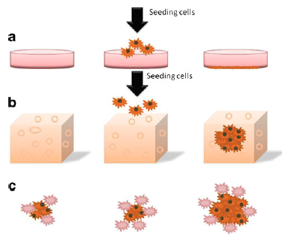

Figure 2: A schematic diagram [29].
(a) 2D cell culture on plastic (b) 3D cell culture in a porous scaffold; (c) in vivo tumor growth with supporting stromal cells.

Natural Scaffold
The main natural scaffolds used today are hydrogels composed of a natural polymer that has the capacity to swell and incorporate many times its weight with water. Hydrogels can be made of proteins such as collagen type I, laminin or hyaluronic acid. Hydrogels possess many advantages: give the cells the ability to remodel the hydrogel, increase the matrix density, align the cells [30]. Rapidly the construct of an in vitro organotypic breast cancer model has been built from hydrogels using three different cell types [31]. Holliday et al. demonstrated the co-existence of different cell types resulting in a cellular network that mimicked the tumor and the pivotal role of tumor stroma fibroblasts in cancer progression. However, the network gives the cells a solid support to proliferate but it is still at a very low density to support adequately the residing cells. Recent technologies developed biomimetic scaffolds which increase the cell and collagen density [32]. Cell growth and morphology can be affected by the stiffness of collagen in the scaffold as demonstrated with the human tumorigenic mammary cell line (HMT352 MECs) culture [33]. This matrix stiffness potentially increased the malignant cell growth through the modulation of integrin adhesions.
Another example of natural scaffolds is hydrogels composed with hyaluronic acid which is naturally present in the ECM and help in malignant tumor proliferation [34]. Mandal and Kundu [35] used a silk protein coming from a silkworm because they have great tensile and elasticity properties but also mechanical strength. Human breast cancer cells showed promising results with the integrin binding motif created.

Synthetic Scaffold
Most of the synthetic scaffolds are made from polymer such as polylactide (PLA), polyglocolide (PGA) and co-polymers constituted from both of those. Those components are biodegradable and can be shape differently: mesh, fibers, sponge which is an asset when looking to mimic a biomolecular structure [24]. Even if poor cell adhesion has been observed, this network is mechanically stronger than natural scaffold which encourages researchers to explore surface modification approaches to improve the cell attachment [36]. Bulk modification approaches have been also tested as a means for synthetic polymer functionalization [37].
The functionalization of a polyethylene glycol (PEG) with peptides such as RGD have been demonstrated increasing cell-cell and cell-ECM interactions [38]. An example of this successfully designed has been done by Loessner et al. [39] when ovarian cancer cells have been encapsulated in a PEG-based hydrogel scaffold. A structure similar to an in vivo mass composed with small compact spheroids has been obtained.
A biodegradable scaffold can be created by using and modifying a combination of porous PLGA/PLA micro-particles. Those particles possess a large surface area to encourage cell attachment and proliferation. Sahoo et al. [40] incorporate various materials in the particles previously mentioned and showed that the human breast cancer cells MCF-7 adhere to the PLA particles when incorporated with vinyl alcohol (PVA).

Research motivations
Breast and prostate cancer are currently two of the most studied cancers in research. As previously described, the use of 3D engineered scaffolds has shown promising results. The Human Umbilical Cord has been chosen as a scaffold for a new 3D tumor construct system in this study.

Breast Cancer
Approximately one every eight women diagnosed with cancer. It can take from five to 30 years to develop and it has been shown that it excessed 10-15 years to follow the development of breast carcinoma in situ and its progression.

Prostate Cancer
Compared to breast cancer, one in every seven men is diagnosed with prostate cancer and one man in 39 will die [8]. Cancer begins when the cells present in the prostate gland start to grow uncontrollably. Most of the prostate cancers are called adenocarcinomas because they are formed with the gland cells.

The Matrix: Human Umbilical Cord
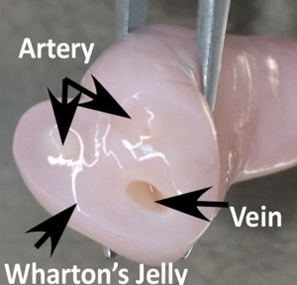
A HUC is a conduit that delivers oxygen and nutrient-rich blood from the placenta to the fetus via its vein and reject deoxygenated, nutrient-depleted blood via its two arteries (Fig. 3). The human umbilical vein endothelial cells (HUVECs) have been used as a vascular model system since 1973 and still in use today [41]. The HUC’s ECM is in the Wharton’s jelly and is rich in collagen and largely made of mucopolysaccharides (hyaluronic acid and chondroitin sulfate). Fibroblasts and macrophages are also present in this gelatinous substance [42]. Hyaluronic acid promotes cell adhesion and migration and might be involved in malignant tumor progression [43] (Fig.4). The synthetization of HA plays a role at all stages of cancer metastasis.
Figure 3: Representation of a HUC [24].
A Human Umbilical Cord is composed of two arteries, one vein covered by Wharton’s jelly.

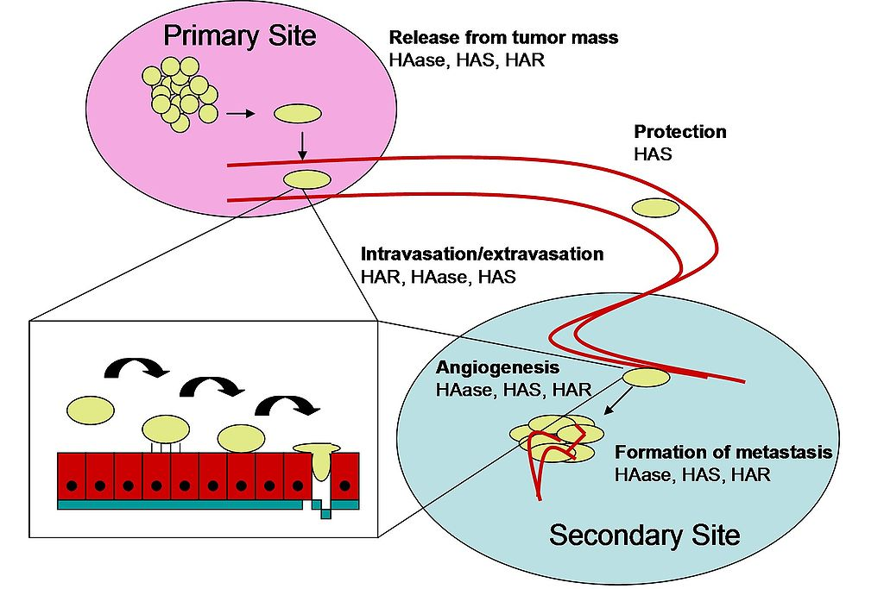
Figure 4: The process of cancer metastasis in which HA-associated molecules play a role in the steps.
Abbreviations: hyaluronic acid (HA), hyaluronic acid synthase (HAS), hyaluronic acid receptor (HAR), hyaluronidase (HAase/HYAL) by Lgurski - Own work, Public Domain, https://commons.wikimedia.org/w/index.php?curid=6881835).

Research objectives

Hypothesis
Due to the HUC properties presented above, the HUC is a potential scaffold for generation of tumor constructs. The vein isolated from of a HUC may be used as a vascular system. The drug delivery would be done from the vein and through the Wharton’s Jelly where cancer cell would be seeded beforehand. This paper is focused on the first part of the 3D model that involves the study of the potential adhesion of cancer cells on the Wharton’ Jelly as described in the following objectives.

Objective 1
It has been hypothesized that cancer cells can adhere and develop on the ECM of the decellularized Wharton’s jelly of a HUC on Wharton’s jelly or luminal side. This objective has been conducted via new established methods (as outlined in Materials and Methods, Seeding and culturing on decellularized construct, Section 2.2). Additionally, two baseline constructs are produced as controls: a non-seeded decellularized HUC and a cancer cell culture conducted in a 6-well plate that act as a positive control with regards to adhesion and growth.

Objective 2
It has been hypothesized that cancer cells can adhere better to a non-decellularized HUC’s Wharton’s jelly with the assistance of the existing Wharton’s Jelly stem cells to eventually create a microenvironment that contain cancer and mesenchymal cells in order to study mesenchymal cancer cells interactions and the growth of cancer cells in the presence of mesenchymal cells. This objective has been conducted via new established methods (as outlined in Materials and Methods, Seeding and culturing on non-decellularized construct, Section 2.3). Additionally, two baseline constructs are to be produced as controls: a non-seeded fresh Wharton’s Jelly construct and a cancer cell culture conducted in a 6-well plate that act as a positive control with regards to adhesion and growth.

Materials and methods

Cancer cells used in this thesis

Cell line
Two types of human adenocarcinoma cell lines derived from the metastatic site of the tumor have been utilized: MDA-MB-231 (ATCC® CRM-HTB-26™) and PC3 (ATCC® CRL-1435™). The MDA cells originate from a female human mammary gland breast tissue and the PC3s come from a male human prostate tissue. Following the ATCC® directions, the cells are stored in liquid nitrogen until needed. Cells were thawed at room temperature and gently mixed separately with their respective L-15 and F-12K media (described in section §2.1.2) before being split into two T-75 cell culture flasks (Corning; Ref. # 430641U), which were then brought to a total volume of 13mL with fresh media. The following day, the flasks were rinsed with 3 to 5mL of Dulbecco’s Phosphate Buffered Saline (PBS; Gibco; Ref. # 21600-010) and 13mL of fresh media was added to each flask. This step removed any non-adherent cells such as hematopoietic stem cells and erythrocytes.

Media
In order to follow the culture conditions established by the ATCC®, two types of cell media were used: L-15 medium for the breast cancer cell line and F-12K medium for the prostate cancer cell line. The L-15 medium was prepared from Leibovitz's L-15 Medium powder (Gibco; Lot. #1665614) and the F-12K medium was prepared from the nutrient mixture F-12 ham powder (Sigma Aldrich; Lot. #SLBG0236V) with 1.18g of sodium bicarbonate (Sigma Aldrich; Cat. #S5761).
For both sets of media the pH of the reconstituted powder was adjusted to 7.2-7.4 and filter-sterilized with a 0.22μm bottle-top vacuum filter (Sigma Aldrich; Cat. #CLS430769). 10% vol/vol fetal bovine serum (FBS; Atlanta Biologics; Cat. # S11150) and 1% vol/vol antibiotic-antimitotic (Gemini Bio-Products; Cat. #400-101) were added to the solution.
At the beginning of each experiment, new media was prepared and automatically replaced after one month of storage at 4°C or reaching a pH outside of the range of 7.2-7.4.

Cell culture and expansion
The MDA cells (MDAs) were kept in an incubator at 37°C supplemented with 0% ${CO}_{2}$ and the PC3 cells (PC3s) were kept in an incubator at 37°C supplemented with 5% ${CO}_{2}$. Their respective medium (L-15 for MDAs and F-12K for PC3s) were changed every two days. Cells were passaged once the T-75 flasks reached 70-80% confluency (Fig.5).
The cells were lifted from their T-75 cell culture flask by first vacuuming the media and rinsing each flask with 4mL of PBS. 3 mL of Trypsin-EDTA (Sigma; Ref. # T4049) was added to each flask and placed in the incubator for 5 min before placing the cells with excess media in a falcon tube. This tube was then centrifuged at 1100 rcf for five minutes to create a cell pellet. The media and the trypsin contained in the supernatant were removed, and the cell pellet resuspended into fresh media. Each new sterile T-75 flasks was given fresh media for a total volume of 13mL resulting in a cell concentration of 375,000 to 1 million.
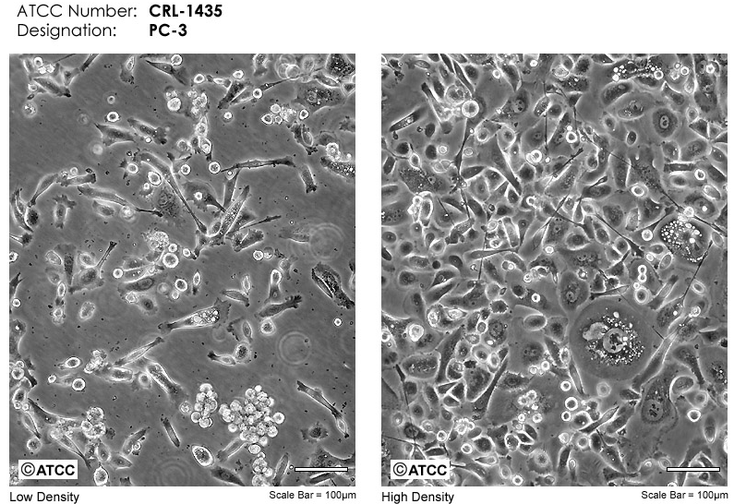
Figure 5: Microscope Images PC3 CRL-1435 [44].
Top views of PC3 culture in T-75 cell culture flask. Scale bar is 100 μm. a – Low density of culture (30%) b – High density of culture (90%).

MDAs and PC3s cultured in a 6-well plate
In order to compare the cell attachment across experiments conducted in this paper, it has been necessary to culture the MDAs and PC3s in a 6-well cell culture treated plate (Costar, Lot. # 3391601). Cells were lifted from their T-75 culture flasks as described in section §2.1.3 and resuspended to have a cell concentration of about 50,000 cells into each well for a total volume of 5mL, complete with fresh media. As for the cell culture expansion, the media was changed every two days.
The determination of cellularity (via dsDNA quantification) was assessed. The cells were lifted from the bottom of the well by first vacuuming the media and rinsing each well with 2mL of PBS. 1mL of Trypsin-EDTA was added into each well, and the plate was placed in the incubator for five minutes before placing the cells with excess media in a falcon tube. This tube was then centrifuged at 1100 rcf for five minutes to pelletize the cells. The media and the trypsin contained in the supernatant were then removed to resuspend the pellet of cells in fresh media to have a final volume of 1mL. This volume can be store in the freezer at -20°C and prepared for the assay, when needed.
Samples were collected after six hours, two days, six days of culture. After six days of culture, the cells were more than 90% confluent and no further samples were taken. It has been assumed that the cellularity inside the 6-well plate would remain constant after six days of this experiment due to the seeding concentration chosen (about 50,00 cells/well).

Seeding and culturing on decellularized construct

Scaffold preparation
Human Umbilical Cords (HUC) were collected from Norman Regional Hospital (Norman, OK) with the approval of the local Institutional Review Board. Using personal proper equipment (PPE) the cords were rinsed with distilled water and cut to 7.5 cm in length.
The HUC were then mounted on a steel mandrel and frozen at -80°C overnight and kept for up to two weeks. A computerized lathe was used to isolate the Human Umbilical Vein (HUV) from the frozen tissue mounted on the steel mandrel. The lathe removes the extraneous Wharton’s jelly, leaving a tissue thickness of 0.75 mm for a diameter of 6.75 ± 0.25mm designed for this experiment (this parameter is adjustable). Prior to decellularization, the HUVs were cut to an approximate size of 2.0 to 2.5 cm length (Fig.6) to fit in the 6-well plate.
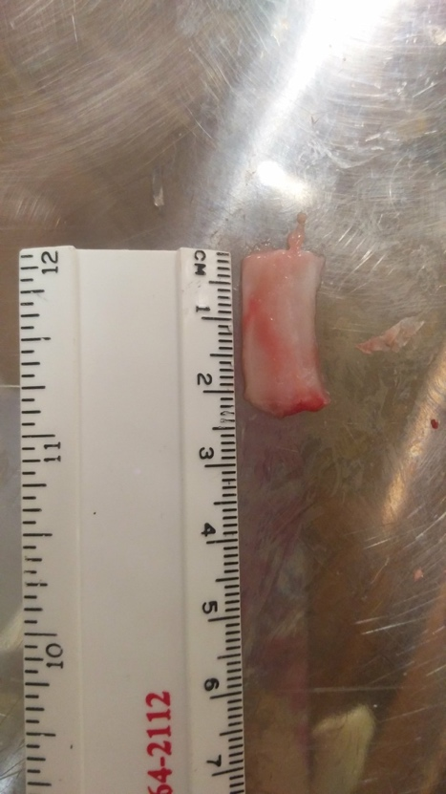
Figure 6: 2.0 to 2.5 cm piece of HUV prior to decellularization.
The decellularization process consists of different washes on a shaker. To make the washes simpler to the operator, a stain steel sink strainer is placed on top of a 1L baker to drain the HUVs (Fig.7).
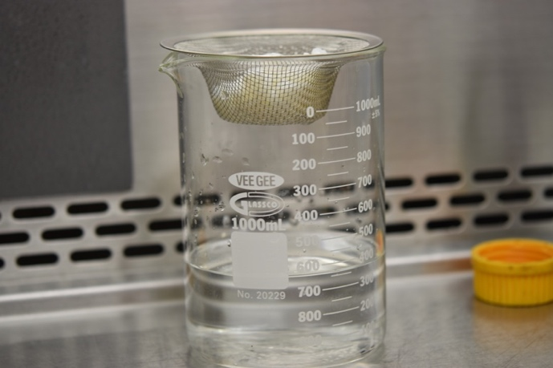

Figure 7: Draining the HUVs.
The first wash is made in 1% Sodium Dodecyl Sulfate (SDS; JT Baker, CAS 151-21-3) for 24 hours. Then the HUVs are washed in 70% ethanol for another 24 hours to remove any SDS residue on the interior of the veins. The next step consists of 10, 20 and 30 minute washes of DI water, then two hours of 0.2% per-acetic-acid (Sigma Aldrich, St. Louis, MO) which leads to the sterilization of the HUVs. The following washes must be processed under sterility. Another 10, 20, 30 minute and 24 hours washes in DI water are processed to remove any acid residue before a last 24-hour wash in a phosphate buffer (Appendix B) of 7.2-7.4 pH. The pH is controlled to be between 7.2-7.4 or the HUVs are washed for another 24 hours in new phosphate buffer before being stored for no longer than a week at 4°C before cell seeding.
In a sterile environment, the scaffolds were cut open, flattened and placed in a 6-well tissue-culture plate (non-cell culture-treated) with the Wharton’s jelly facing up and the vein side facing down. This scaffold is called HUV for the rest of the experiment.

Seeding

Preliminary experiment
MDAs were lifted from their T-45 cell culture flask as described in section 2.1.3. and 200µL were pipetted from a cell suspension containing the desired concentration of cells (about 50,000 cells/200µL) dispersed in the appropriate media and placed on the top of the scaffold with care to conserve the surface tension. The plates were then placed in the incubator at 37°C and 0% of CO₂ for two and a half hours, and 5mL of the appropriate media was added into each well. As for the cell culture expansion, the media was changed every two days.
After this first test experiment, with MDAs only, the scaffolds were observed floating with no significant cell attachment or presence. It has been hypothesized that those results could be due to the significant movement of the scaffolds inside the well. To fix this issue, a 3D printed part was inserted into the system to maintain the scaffold on the bottom of the well. More detail about this piece, called the Pizzabox, is described in section §2.4.

Final experiment
First, the HUV scaffolds were placed in a 6-well tissue culture plate (non-cell culture-treated) with the Pizzabox on top of it. Both MDAs and PC3s were lifted as previously described in section §2.2.2.1 and dispersed in the appropriate media at the desired concentration of approximately 50,000 cells/200µL. The Wharton’s jelly side of the HUV scaffolds were seeded with PC3s and MDAs separately with the help of the inside ring of the 3D printed part and care was taken to conserve the surface tension. Those samples are called seeded HUV.
Control samples have been established by placing the HUV scaffold at the bottom of the well toped with the Pizzabox. 200µL of the appropriate media has been deposited on the Wharton’s jelly of the HUV scaffold with the help of the inside ring of the 3D printed part and care was taken to conserve the surface tension. Those samples are called decellularized HUV.
The seeded and decellularized HUV scaffolds were then placed for two and a half hours at 37°C in an incubator supplemented with 0% CO₂ for the scaffold seeded with MDA and in the incubator supplemented with 5% CO₂ for the scaffold seeded with PC3 in order to help the cancer cells attach to the scaffold. Each well was then filled with 5mL of the appropriate media: L-15 for MDA and F-12K for PC3 with care and by the side of the well. As for the cell culture expansion, the media was changed every two days.

Species measurement methods
Various means have been investigated in this experiment. Two types of samples were used for determination of the cellularity (via dsDNA quantification) and examination of the tissue structure (via histology with Hematoxylin and Eosin staining). First, media was discarded and the samples were separated from their Pizzabox. Second, the samples were cut in a circle of 1.3 cm diameter corresponding to the size of the inside ring circle of the Pizzabox where cells were seeded to maintain the size sample’s homogeneity. For cellularity, the samples were placed in 500µL up to 1mL of nanopure water prior to be stored in the freezer at -20°C before being prepared for the assay. For the examination of the tissue structure, the samples were fixed in 10% formalin overnight before being washed in 70% ethanol and stored in the refrigerator at 4°C in 70% ethanol up to several weeks.
Samples were collected after six hours, two days, six days of culture for the first experiment and an additional sample was collected after 10 days of culture for the second experiment. Every time, three to five samples were collected to process a dsDNA quantification and two samples were collected for histology from decellularized and seeded HUV.

Verification of the decellularization process

Fresh cords
HUCs were collected from Norman Regional Hospital (Norman, OK) with the approval of the local Institutional Review Board. Using personal proper equipment, the cords were washed with warm water and Wharton’s jelly pieces were extracted and placed for a few days (until their weight remained constant) in a vacuum chamber. Dry pieces were then weighed and placed in 1mL of nanopure water prior to be stored in the freezer at -20°C. Piece weights varied from 0.0229 to 0.0467g.

Decellularized cords
The decellularized samples were processed as described in the section §2.2.1 and placed for a few days (until their weight remain constant) in a vacuum chamber. Dry pieces were then weighed and placed in 1mL of nanopure water prior to being stored in the freezer at
-20°C. Pieces weighed from 0.0455 to 0.0929g.

Species measurement methods
Various means have been investigated in this experiment. Two types of samples were sacrificed to determine the cellularity (via dsDNA quantification) and examination of the tissue structure (via histology with Hematoxylin and Eosin staining). For the examination of the tissue structure, the samples were fixed in 10% formalin within 24h hours before being washed in 70% ethanol and stored in the fridge at 4°C in 70% ethanol up to several weeks. Five samples of fresh and five samples of decellularized cords were collected to process a dsDNA quantification and two samples of fresh and two samples of decellularized cords were collected for histology. After each step of the decellularization process three samples were collected to process a dsDNA quantification step by step.

Verification of the non-effect of the Pizzabox on cellularity

Pizzabox characteristic
The “Pizzabox,” created by Patrick McKernan (Fig. 8-a) and improved by Chelsea Coffey (Fig. 8-b) to have stronger spikes and a faster 3D printing time is presented in Fig. 8.
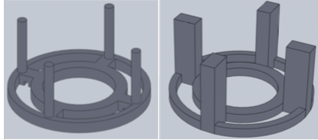
bB
a

Figure 8: 3D printed scaffold holder “The Pizzabox”.
a - Patrick McKernan piece, b - Chelsea Coffey modified piece used in this experiment

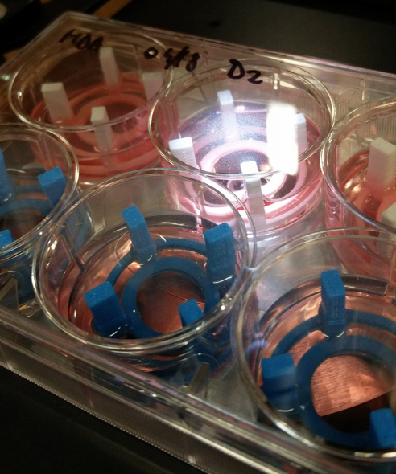
Double rings have been created, an inside “seeding ring” which helps maintain surface tension during the seeding process and an outside ring leaving a gap to facilitate the media change without touching and potentially damaging or contaminating the construct. The weight of a flat double ringed construction has been observed to not be heavy enough to hold down the scaffold at the bottom of the wells. “Legs” were then added to this construct, giving it its name, due to its similarity with a Pizzabox holder. Those legs are necessary to hold down the scaffold with the weight of the 6-well plate’s lid.

Figure 9: Pictures of
the Blue and White Pizzabox.

Two different 3D printing materials were used to 3D print the Pizzabox in this research (Fig.9). The white wire (Makerbot PLA MP05780) has been used for the six-day experiment of both MDA and PC3 seeded constructs and the blue one (Makerbot PLA MP005776) for the 10-day experiment of both MDA and PC3 seeded construct. Both have been tested to see if they influenced the cellularity of the experiment.

Seeding
The Pizzabox was placed inside the well of the 6-well cell culture-treated plate. The cells were lifted from their T-45 cell culture flask as described in the section §1.5.3. and 200µL were pipetted from a cell suspension containing the desired concentration of cells (about 50,000 cells/200µL) dispersed in the appropriate media and placed at the bottom of the well through the inside ring of the Pizzabox with care to conserve the surface tension. Those samples have been called Blue and White Pizzabox for the cells respectively cultured with the blue and white Pizzabox.
Control samples have been established as described in the section §2.1.4 consisting of a regular cell culture in a 6-well culture seeded plate.
The plates were then placed in the incubator at 37°C with 0% of CO₂ for the MDA culture and with 5% of CO₂ at two and a half hours and 5mL of the appropriate media was added into each well. As for the cell culture expansion, the media was changed every two days.

Species measurement methods
Only the determination of cellularity (via dsDNA quantification) was assessed. The Pizzabox was removed from the well and discarded. The cells were then lifted with the same method described in section §2.1.4 and stored in the freezer at -20°C before being prepared for the assay.

Seeding and culturing on non-decellularized construct

Scaffold preparation
HUCs were collected from Norman Regional Hospital (Norman, OK) with the approval of the local Institutional Review Board. Using personal proper equipment, the cords where washed with warm water and Wharton’s jelly pieces were extracted and weighed. Piece weights varied from 0.0244 to 0.0708g.
In order to amplify the number of Wharton’s jelly cells already present on the cord, the pieces were placed in a 24-well plate for tissue culture in a growth media and cultured for 48 hours. Those scaffolds are named cultured-scaffolds.

Seeding
After transferring the scaffold previously cultured for 48 hours into a new well, MDAs and PC3s were lifted from their T-45 cell culture flask as described in the section §2.1.3. and re-suspended in their appropriate media. Different volumes were pipetted to have a seeding concentration of 72,602.67 MDA cells / g of tissue and 110,324.34 PC3 cells / g of tissue and were placed on the top of the cultured-scaffold with care, to conserve the surface tension. Those concentrations correspond to the one already measured on the cultured-scaffolds.
Control samples have been established by adding the requisite volume of media to maintain the surface tension on top of the cultured-scaffold.
The plates were then placed in the incubator at 37°C with 0% of CO₂ for the MDA culture and with 5% of CO₂ at two and a half hours and 5mL of the appropriate media was added into each well. As for the cell culture expansion, the media was changed every two days.

Samples
Only the determination of cellularity (via dsDNA quantification) was assessed. First, samples were taken after the Wharton’s jelly cells expansion culture on the cultured-scaffolds and then after six hours, two days and six days of cancer cells seeding on top of the Wharton’s jelly cells.

Cellularity via dsDNA Quantification

Tissue samples preparation
Measurements of double-stranded DNA (dsDNA) were made in the solution of constructs immersed in nanopure water and subjected to sonicate for five seconds. Then 200µL of Trypsin was added to the solution before being vortexed for five seconds and incubated at 37°C for one hour. Constructs were finally sonicated for 10 seconds before applying three freeze-thaw cycles, wherein the constructs were sequentially frozen solid at -20 °C, thawed at room temperature and vortexed for five seconds prior to re-freezing.

Cell samples preparation
Measurements of double-stranded DNA (dsDNA) were made in the solution of cells immersed in 1 mL of the appropriate media and subjected to three freeze-thaw cycles wherein the constructs were sequentially frozen solid at -20 °C, thawed at 25 °C and vortexed for 5 seconds prior to re-freezing.

DNA assay
DsDNA content utilizing a Quant-iT™ PicoGreen® dsDNA assay kit (Invitrogen; Cat. #P11496) was measured on the previous resulting cell lysate. Five standards over the range of 0.1 to 3µg/mL were prepared from a 100µg/mL λ-DNA furnished in the kit. 257µL of a buffer solution (10 mM Tris-HCl, 1 mM EDTA, 1.3 μL PicoGreen® reagent, pH 7.5) were placed at the bottom of an opaque 96-well plate and topped with 43µL aliquots of all standards and samples. After incubation at room temperature for five minute, fluorescence at 480/520nm excitation/emission wavelengths was measured on a Synergy 50 HT Multi-Mode Microplate Reader. The standard curve was used to quantify the concentration of the samples from the intensity values measured to obtain the content of dsDNA per sample. Triplicate of standards and samples were run to ensure the replicability of the experience.
To convert the intensity measured to a quantity of dsDNA in sample in $μg$, the following calculations were applied to each measure:
$$Quantity of dsDNA in sample \left(pg\right)= C (μg/mL) × V_{frozen sample}(mL)$$

For some of the experiments, a cell quantity was necessary to obtain and was calculated as followed:
$$Quantity of dsDNA in sample \left(pg\right)= C (μg/mL) × V_{frozen sample}(mL)×{10}^{6}$$

$$Quantity of cells=\frac{{Quantity}_{dsDNA in sample} (pg)}{{Quantity}_{ds DNA in one cell} (pg/cell)}$$

The quantity of dsDNA in one cell is known from performing the same assay on known quantities of cells culture in a T-75 flasks previously counted with a hemocytometer. For this experiment, the quantity of dsDNA in one MDA cell is equivalent to 7.05pg and the quantity of dsDNA in one PC3 cell is equivalent to 6.75pg.

Histology
Samples were removed from the storage solution and cut into 0.5 cm section. They were then placed in increasing concentrations of ethanol to be dehydrated and in Clear Rite 3 (Thermo Scientific, ref#6901) to be finally embedded in paraffin for tissue embedding (Sigma, #145686-99-3) More details of this protocol can be found in Appendix C: Paraffin embedment protocol. 7μm thick slices of tissue embedded in paraffin were sliced using a microtome and were mounted on Selectfrost Microscope Slides (Fisher Scientific, cat#12-550-003). Gill-1 Hematoxylin (Thermo Scientific, ref. 72411) and Eosin-Y (Thermo Scientific, ref. 71311) were used to stain the slides to observe ECM quality and possibly to visualize the number of cells present on the scaffold. More details can be found in Appendix D: Hematoxylin and Eosin staining protocol. An optical microscope (Nikon Eclipse E800), ImageJ software and the FibrilTool plug-in were used to analyze lateral sections of the construct. It has been checked that the microscope’s settings remained unchanged for the recording of each histology image.
The porosity was also roughly measured with ImageJ and the analyzer of particles via:

$$Porosity=\frac{Sum of particles area measured}{Total sample area}$$

Results and Discussion

6-well culture
Figure 10 represents the cellularity of both the PC3s and MDAs cultured in a 6-well culture coated plate. For both the MDAs and PC3s the cells proliferate exponentially. It has been observed under the microscope that both cell lines reach the maximum occupancy of the 6-well plate and after six days the number of cells present remain constant and stop increasing due to a lack of space. From about 50,000 cells seeded originally, there are about 450,000 PC3s and about 260,000 MDAs cultured after six days.
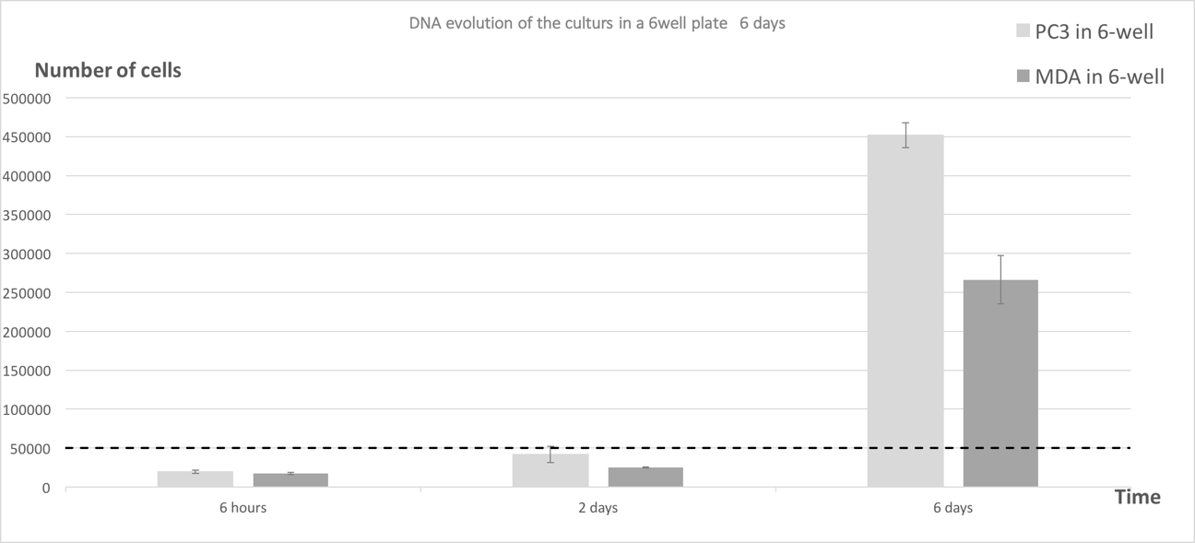
Figure 10: Cellularity of the PC3s and MDAs cultured in 6-well culture coated plate.
Dashed line indicates initial seeding density of about 50,000 cells/well.

For the purpose of this study, it has been necessary to calculate the amount of DNA present in those cultures with:
$${Quantity}_{dsDNA in one cell} (μg)=\frac{{Quantity of cells × Quantity}_{dsDNA in sample} (pg/cell)}{{10}^{6}}$$
Figure 11 represents the conversion in $μg$ of DNA of the PC3s and MDAs cultured with the same observations done with Figure 10 over 6 days.
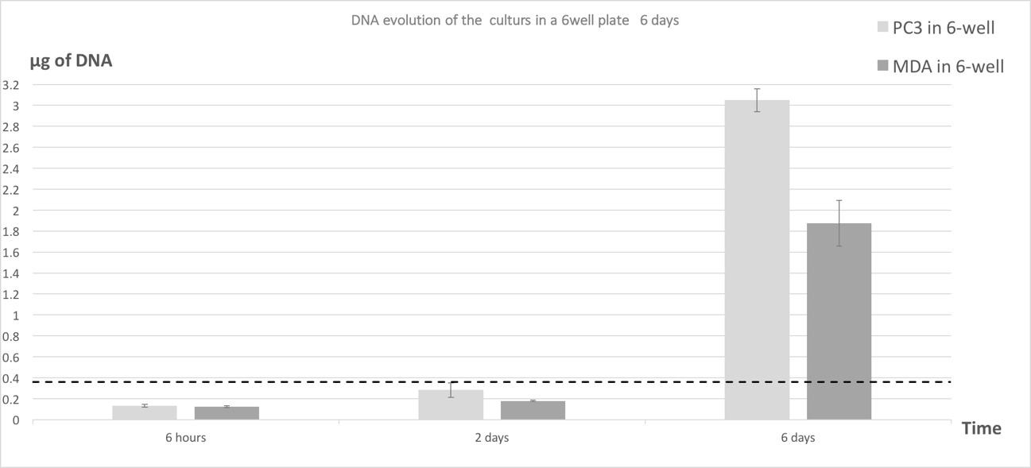
Figure 11: Amount of DNA representing the PC3s and MDAs cultured in 6-well culture coated plate.
Dashed line indicates initial seeding density of about 0.38μg of DNA.

Seeding and culturing on decellularized construct

DNA Assay
Cellularity has been studied for the MDA-seeded HUV and for the PC3-seeded HUV over a period of six to 10 days to observe the cell evolution on the different constructs. The p-values have been established according to a one-way ANOVA with post-hoc Tukey HSD test.

MDA
Figure 12 shows the amount of DNA present with the decellularized HUV seeded with MDA construct for a duration of six days. Compared to the 6-well culture, the seeded HUV is statistically different as well as the decellularized HUV after six hours and six days of culture. After two days of culture, the content in DNA decreases for the seeded and decellularized HUV and drops significantly to almost zero. There is no statistical difference between the seeded and decellularized HUV at any time of the experiment.
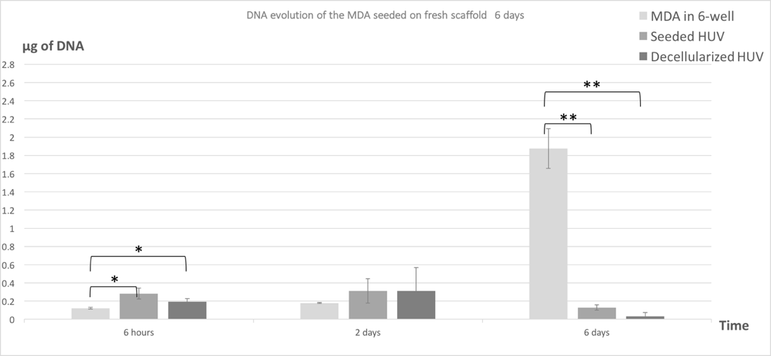
Figure 12: Construct HUV seeded with MDA Day 1 – 6.
DNA content of HUV seeded with MDA as a function of the duration has been presented in this figure for a period of six days. * indicates p-value<0.05 ** indicates p-value < 0.01 compared to the cells cultured in the 6well culture plate. Data represented as mean ± standard deviation. A sample size of n = 3 was used. Dashed line indicates initial seeding density of about 50,000 cells/construct or about 0.36μg of DNA.
Figure 13 represents the evolution of the quantity of DNA per construct during a 10-days experiment. Compared to the culture in the 6-well plate, the seeded and decellularized HUV are statistically different at all times. The amount of seeded and decellularized HUV remain non-statistically different during the whole experiment. There is an increasing amount of DNA after two days of experiments to finally decrease over time and reach 0.1 μg of DNA after 10 days of culture.

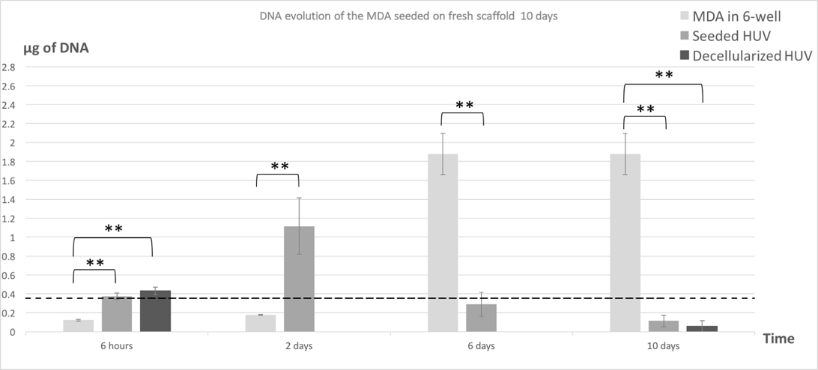
Figure 13: Construct HUV seeded with MDA Day 1 – 10.
DNA content of HUV seeded with MDA as a function of the duration has been presented in this figure for a period of 10 days. ** indicates p-value<0.01 compared to the cells cultured in the 6well culture plate. Data represented as mean ± standard deviation. A sample size of n = 5 was used. Dashed line indicates initial seeding density of 50,000 cells/construct or about 0.35μg of DNA.
Looking at the samples measured in two different experiments (Figure 12 and Figure 13) the DNA content for day 2 is around 0.3 μg of DNA in the first experiment and 1.1 μg of DNA for the second experiment concerning the seeded construct. A similar difference is noticed for the six days’ sample.

PC3
Figure 14 shows the amount of DNA present with the decellularized HUV seeded with PC3 construct for a duration of six days. Compared to the 6-well culture, the seeded HUV is statistically different as well as the decellularized HUV after six hours and six days of culture. After two days of culture, the content in DNA increased for the seeded and decellularized HUV and dropped to almost zero at the end of the experiment. There is no statistical difference between the seeded and decellularized HUV at any time of the experiment.
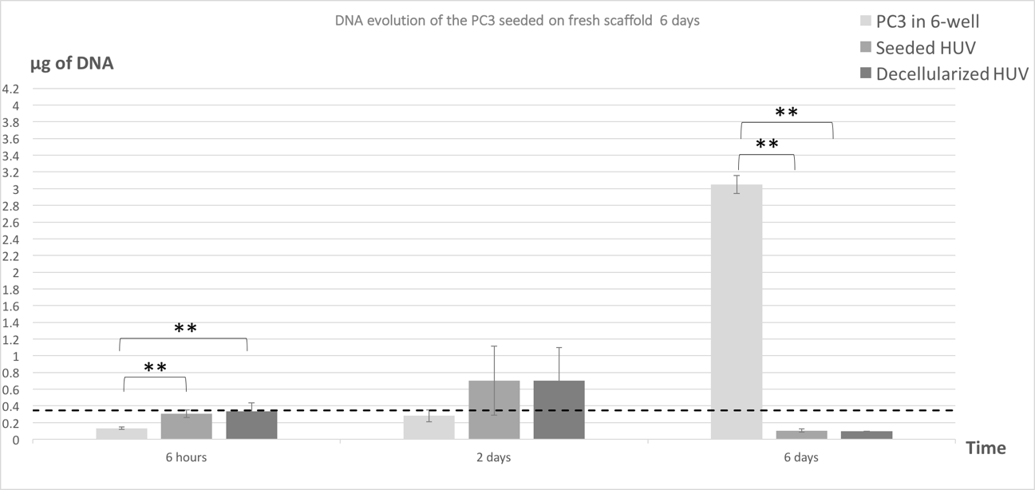
Figure 14: Construct HUV seeded with PC3 Day 1 – 6.
DNA content of HUV seeded with PC3 as a function of the duration has been presented in this figure for a period of 6 days. ** indicates p-value <0.01 compared to the cells cultured in the 6well culture plate. Data represented as mean ± standard deviation. A sample size of n = 3 was used. Dashed line indicates initial seeding density of about 50,000 cells/construct or about 0.34μg of DNA.
Figure 15 represents the evolution of the quantity of PC3 per construct during a 10-days experiment. Compared to the culture in the 6-well plate, the seeded and decellularized HUV are statistically different at any time. The amount of seeded and decellularized HUV remain non-statistically different during the whole experiment except after 10 days of culture even if the DNA content remains relatively close to zero.
There is an increasing amount of DNA for the seeded HUV after two days of experiment to finally decrease over the time and reach 0.1 μg of DNA after six days of culture and remain constant after 10 days.
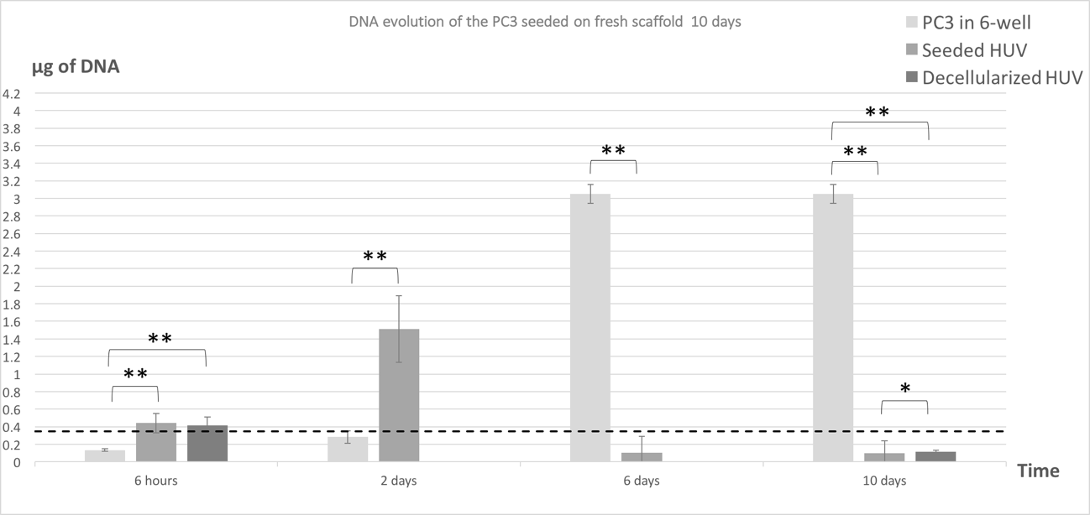
Figure 15: Construct HUV seeded with PC3 Day 1 – 10.
DNA content of HUV seeded with PC3 as a function of the duration has been presented in this figure for a period of 10 days. * indicates p-value <0.05 ** indicates p-value <0.01 compared to the cells cultured in the 6well culture plate or between the seeded and non-seeded construct. Data represented as mean ± standard deviation. A sample size of n = 5 was used. Dashed line indicates initial seeding density of about 60,000 cells/construct or about 0.42μg of DNA.
Looking at the samples measured in two different experiments (Figure 14 and Figure 15) there is one value around 0.3 μg of DNA and another one at 1.1 μg of DNA for seeded construct. The similar difference is noticed for the six days’ sample.
To conclude, in both MDA and PC3 studies, the 10-days experiments have been conducted to confirm the previous observations but also go further in the eventual cellular development. It is clearly shown that there is no growth even on a longer time frame and that the reproducibility of the experiment is questionable. After the experiments conducted on the cell-tissue attachment with both MDA and PC3 cell lines, it is also hypothesized that the decellularized cords might have been contaminated prior to those experiments. Consequently, the decellularization process needs to be investigated further and those past experiments are unfortunately not conclusive.

Decellularization process
A dsDNA assay has been processed on five different samples coming from different decellularization procedures and the average DNA amount in the fresh cords was measured at 9.43 ± 3.75µg DNA / g of dry tissue and decellularized cords at 12.24 ± 5.32µg DNA / g of dry tissue, which is under the limit of 50µg DNA / g of dry tissue [45].
Figure 16 shows the cellularity of three different constructs from three different decellularization processes after different decellularization steps. The fresh cord results are not significantly different from the ones listed above, as well as the decellularized HUV or cords stored in PBS DNA content values (p-values>>0.05).
From fresh cord samples at 11.69 ± 1.49µg DNA / g of dry tissue the quantity of DNA has been reduced to 0.40 ± 0.03µg DNA / g of dry tissue after the last DI water wash before transferring the HUV to PBS where the DNA content detected was 15.43 ± 4.27µg DNA / g of dry tissue after two days of storage. This graph demonstrates that the decellularization process has successfully been conducted respecting the limit of 50µg DNA / g of dry tissue.

Figure 16: Comparison of the cellularity results after the different decellularization steps.
Fresh stands for samples taking on a fresh cord, lathe after lathe procedure, SDS after the SDS wash, EtOH after the EtOH wash, Peracetic for after the peracetic wash, DI for after the DI washes and PBS for after few days stored in PBS and decellularized. ** indicates p-value<0.01 compared to the fresh HUV. Data represented as mean ± standard deviation. A sample size of n = 3 was used. The dashed line indicates the limit for demonstrating that the decellularization is satisfying regarding immune reactions and graft rejection risks (=50μg DNA/g of dry tissue).
It is hypothesized that the PBS storage solution induces an increase of DNA quantity even if the measurements are still under the established limit. This might come from a bacterial or fungi contamination.
It has been previously pointed out that the design of the experiment is questionable due to its non-repeatability. It is important to study the potential effect of the Pizzabox on the cellularity of a regular cell culture in a 6-well culture coated plate to confirm its use in further studies.

Pizzabox
Figure 17 represents the cellularity of MDAs cultured in different conditions. The dash lines represent the initial cell seeding of about 50,000 cells / well. All the MDA cultured with both Pizzabox types are statistically different to the MDAs cultured in a 6-well culture coated plate. Cells are proliferating with the presence or absence of the Pizzabox at any time of culture. The MDAs cultured with the Pizzabox are growing slower than the MDAs by themselves after six days of culture, and there is a higher cellularity with the blue Pizzabox than the white one.

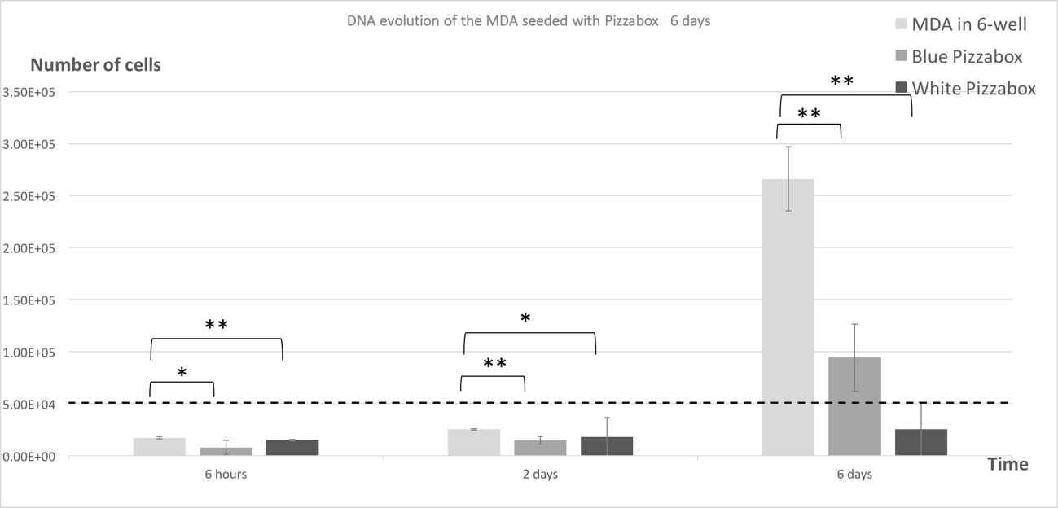
Figure 17: Pizzabox seeded with MDA Cellularity Day 1 – 6.
Cellularity of Pizzabox seeded with MDA only (no scaffold) as a function of the duration. Blue Pizzabox stands for MDAs cultured with the blue Pizzabox and White Pizzabox stands for MDAS cultured with the white Pizzabox. * indicates p-value <0.05 ** indicates p-value <0.01 compared to the cells cultured without Pizzabox. Data represented as mean ± standard deviation. A sample size of n ≥ 3 was used. Dashed line indicates initial seeding density of about 50,000 cells / well.

Figure 18 represents the cellularity of PC3s cultured in different conditions. The dashed line represents the initial cell seeding of 50,000 cells / well. All the PC3s cultured with any kind of Pizzabox have been shown statistically different to the PC3s cultured in a 6-well culture coated plate except after three days of culture. Cells are proliferating with the presence or absence of the Pizzabox at any time of culture. The PC3s cultured with the Pizzabox are growing slower than the PC3s by themselves after six days of culture.
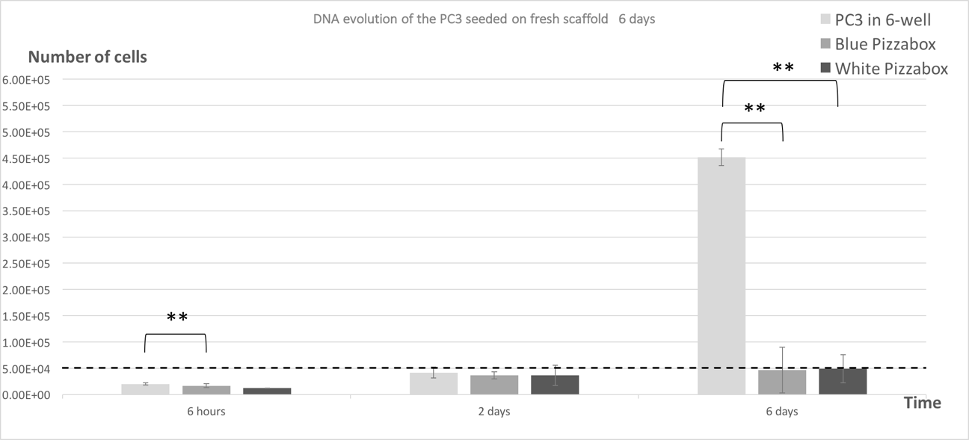
Figure 18: Pizzabox seeded with PC3 Cellularity Day 1 – 6.
Cellularity of Pizzabox seeded with PC3 only (no scaffold) as a function of the duration. Blue Pizzabox stands for PC3s cultured with the blue Pizzabox and White Pizzabox stands for PC3s cultured with the white Pizzabox. ** indicates p-value<0.01 compared to the cells without Pizzabox at each time. Data represented as mean ± standard deviation. A sample size of n = 3 was used. Dashed line indicates initial seeding density of about 50,000 cells / well or about 0.34μg of DNA.
The results show that both the blue and white Pizzabox inhibit the cell proliferation compared to cultures without Pizzabox. The Pizzabox might be leaching toxic chemicals coming from the colored filament used to build it or mechanically damaging the cells. It is important to note that the Pizzabox was not completely stable in the 6-well plate as it was with the HUV and it is also possible that the piece might have slid inside the well even if care was taken to manipulate the plates. It has also been noticed that after six days of experiment for the cells only, the well was almost at 80% confluency and reached its maximum cellularity.

Summary of cell-tissue attachment cellularity analysis
Overall, the above graphs demonstrated a successful decellularization below the limit of 50µg DNA / g of dry tissue. It has been hypothesized that even if the decellularization process stay way below the established maximum limit, there is a remnant amount of DNA present on the HUVs after the storage in the PBS solution that based on the DNA content of the cords prior their storage it must come from a potential contamination.
Studying the structure of the cords would show if cells have been removed during the decellularization process and if there is a modification in the properties of the matrix.

Histology
Histology images have been treated via the software Image J and a porosity estimation has been made from three samples from three different constructs with the analysis particles tools. It is important to note that only the 10-day experiment is presented due to high similarities with the six’ days culture regarding the histology images and the porosity calculated.

MDA experiment
Table 1 represents the porosity of both control and HUV/MDA construct after 10 days of culture. The control porosity is relatively close to the HUV/MDA construct porosity except after two days and six days of culture where the control possess a smaller porosity.

 | 6 hours | 2 days | 6 days | 10 days
Control | 38.4% ± 11.1 | 16.1% ± 1.9 | 31.1% ± 6.17 | 45.14% ± 5.95
HUV/MDA | 45.1% ± 2.11 | 33.1% ± 2.1 | 60.5% ± 3.79 | 41.2% ± 2.82
Table 1: Porosity of control and HUV/MDA construct.

Coupling those results to Figure 19, which shows the control and HUV/MDA construct histology images at x4 magnification, there is a higher fiber organized structure on the control after two days of experimenting (Fig.19-c) than in the HUV/MDA construct (Fig.19-d). The slight difference in porosity after six hours of culture between control and HUV/MDA is not clear on the histology images at this magnification (Fig19-a, b). Mainly, the control images seem to have darker coloration than the HUV/MDA construct, which potentially shows no significant difference regarding the cell quantification present on those scaffolds.
Figure 20 is composed by the histology images of the control and HUV/MDA construct after 10 days of culture at x10 magnification. The difference of porosity observed previously between the control and HUV/MDA construct after six hours is more evident at this magnification (Fig19-a, b), the fiber also appears more aligned and organized on the control after six hours (Fig.20-a). Over the course of the experiment, the HUV/MDA construct’s porosity observed on the histology images (Fig.20-b, d, f, h) seemed to increase, but it is not verified statistically in Table 1. There is still no clear evidence of presence of cells at this magnification or at any greater magnification.
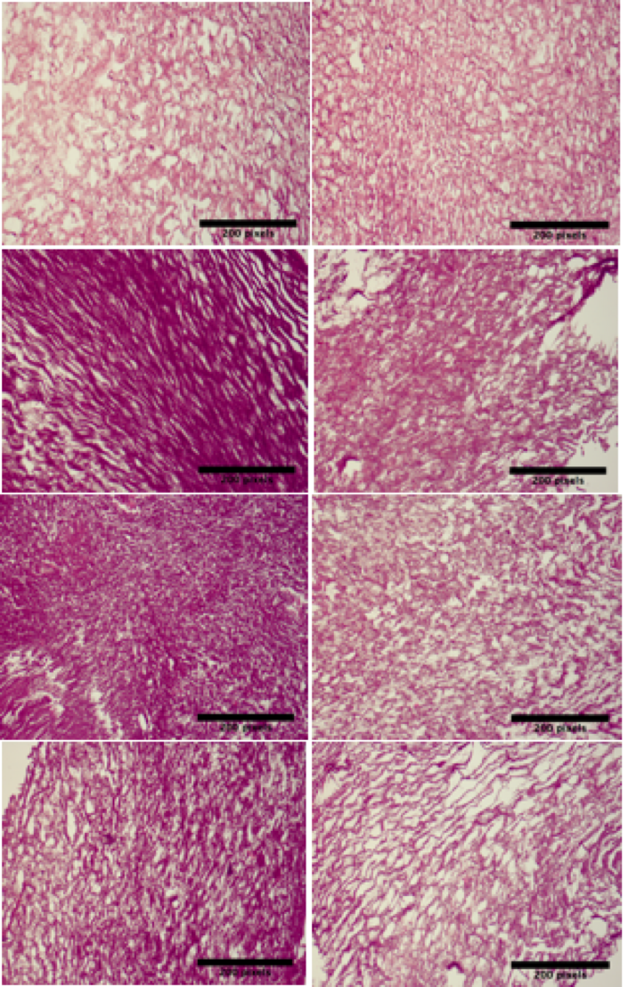
a b

c d

e f

g h

Figure 19: Histology Images MDA seeded construct Day 1 – 10 at 4x magnification.
Cross-sectional views of the tissue samples. Scale bar is 200 μm. a – 6 hour non-seeded HUV controls, b – 6 hour seeded HUV samples, c – 2 day non-seeded HUV controls, d – 2 day seeded HUV samples, e – 6 day non-seeded HUV controls, f – 6 day seeded HUV samples, g – 10 day non-seeded HUV controls, h – 10 day seeded HUV samples.

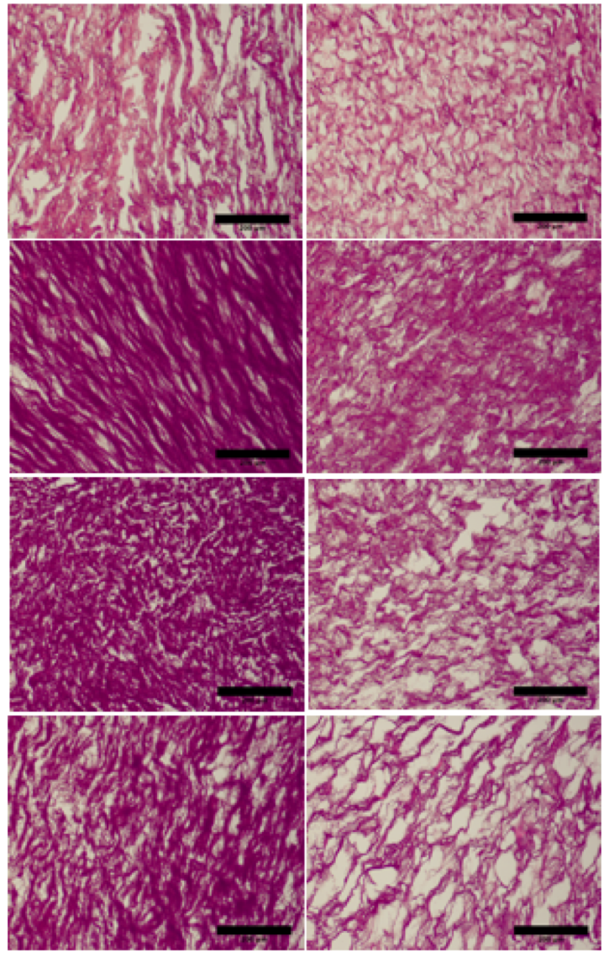
a b

c d

e f

g h

Figure 20: Histology Images MDA seeded construct Day 1 – 10 at 10x magnification.
Cross-sectional views of the tissue samples. Scale bar is 200 μm. a – 6 hour non-seeded HUV controls, b – 6 hour seeded HUV samples, c – 2 day non-seeded HUV controls, d – 2 day seeded HUV samples, e – 6 day non-seeded HUV controls, f – 6 day seeded HUV samples, g – 10 day non-seeded HUV controls, h – 10 day seeded HUV samples.

PC3 experiment
Table 2 represents the porosity of both control and HUV/PC3 construct after 10 days of culture. The control porosity is relatively constant except after six days of culture. On the opposite, the HUV/PC3 construct’s porosity seems to slightly increase over time.
 | 6 hours | 2 days | 6 days | 10 days
Control | 39.0% ± 8.19 | 39.3% ± 0.54 | 44.9% ± 0.82 | 38.74% ± 2.72
HUV/PC3 | 37.6% ± 1.93 | 44.2% ± 2.33 | 43.5% ± 3.75 | 46.84% ± 3.1
Table 2: Porosity of control and HUV/PC3 construct.

Coupling those results to Figure 21, which shows the histology images of the control and HUV/PC3 construct at x4 magnification corresponding, the control sample after six days of culture (Fig.21-e) seems lighter than the other control samples. There is no significant increase of porosity on the HUV/PC3 construct (Fig.21-b, d, f, h) at this magnification. The control samples do not seem more organized and fibers more aligned than for the HUV/PC3 construct.
Figure 22 is composed by the histology images of the control and HUV/PC3 construct after 10 days of culture at x10 magnification. The porosity increases of the HUV/PC3 construct (Fig.22-b, d, f, h) is more evident at this magnification. There is no evidence of presence of cells on any scaffolds.

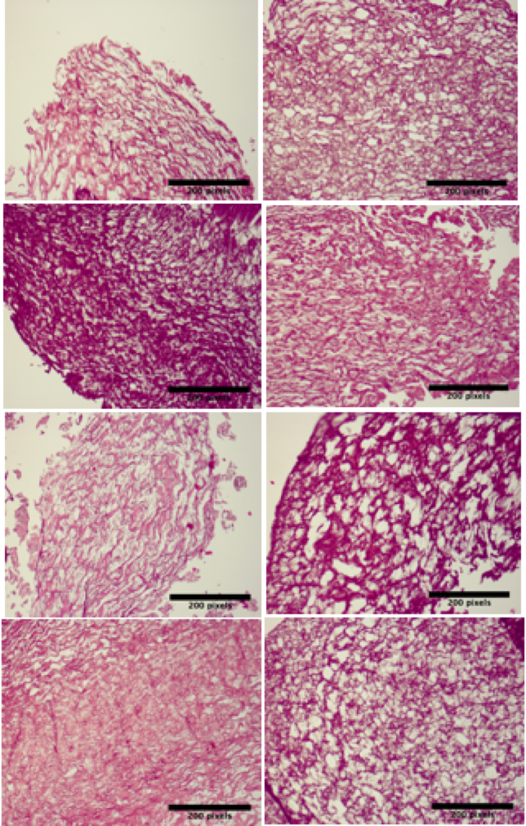
a b

c d

e f

g h

Figure 21: Histology Images PC3 seeded construct Day 1 – 10 at 4x magnification.
Cross-sectional views of the tissue samples. Scale bar is 200 μm. a – 6 hour non-seeded HUV controls, b – 6 hour seeded HUV samples, c – 2 day non-seeded HUV controls, d – 2 day seeded HUV samples, e – 6 day non-seeded HUV controls, f – 6 day seeded HUV samples, g – 10 day non-seeded HUV controls, h – 10 day seeded HUV samples.
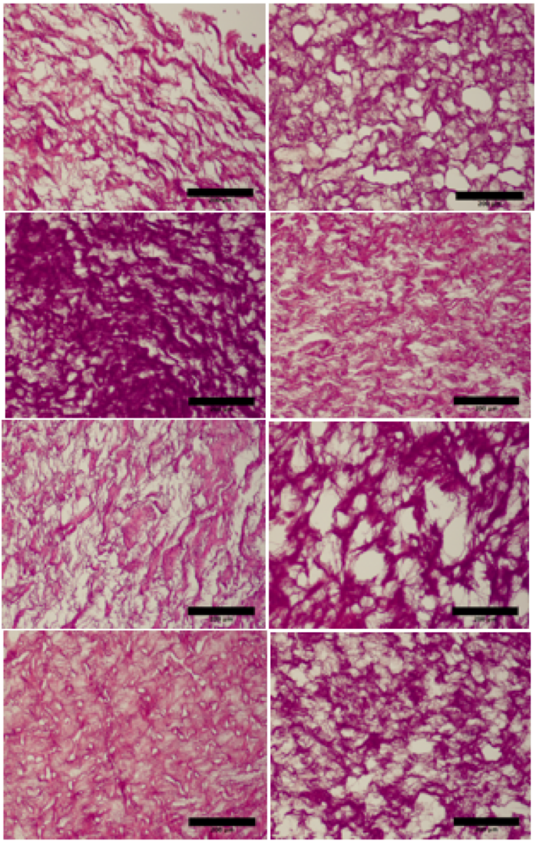
a b

c d

e f

g h

Figure 22: Histology Images PC3 seeded construct Day 1 – 10 at 10x magnification.
Cross-sectional views of the tissue samples. Scale bar is 200 μm. a – 6 hour non-seeded HUV controls, b – 6 hour seeded HUV samples, c – 2 day non-seeded HUV controls, d – 2 day seeded HUV samples, e – 6 day non-seeded HUV controls, f – 6 day seeded HUV samples, g – 10 day non-seeded HUV controls, h – 10 day seeded HUV samples.

Fresh and decellularized HUV
The fresh HUV’s porosity has been roughly established at 49.6%±1.39 compared to 62.2%±1.37 for a decellularized HUV. It is hypothesized that the agents used during the decellularization modify the structure of the scaffold.
Figure 23 represents the histology images of a fresh and decellularized HUV on the Wharton’s jelly side. The fibers are aligned and the network seemed organized in both samples. There is no evidence of any cell presence on the fresh cord or removed on the decellularized one.
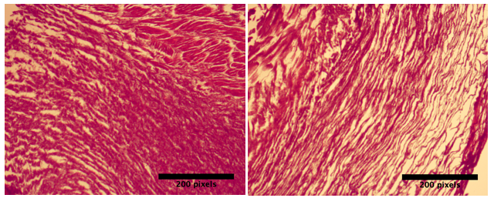

Figure 23: Histology Images of decellularization process.
Cross-sectional views of the tissue samples at 4x magnification. a – Images of Fresh HUV, b – Decellularized HUV at x4 magnification.

Summary of cell-tissue attachment histology images and porosity analysis
The porosities of the MDA and PC3 constructs are similar and close to the porosity of the fresh and plain decellularized HUV. The histology pictures show a general idea of a more organized and aligned fiber network on the MDA control images than on the HUV/MDA construct’s one. The decellularized and fresh HUV doesn’t demonstrate a porosity difference. The organization and fiber alignment network is conserved and there is no evidence of any cell removal during the decellularization process on those histology images.

Seeding and culturing on non-decellularized construct

DNA Assay
The amount of DNA has been studied for the Wharton’s Jelly/MDA construct and for the Wharton’s Jelly/PC3 construct over a period of six days to observe the DNA evolution of the different constructs. It is good to remember as enounced in section §2.6.3 that the amount of DNA measured in those experiments can be associated with a quantity of cells via:
$${Quantity}_{ds DNA in one cell} \left(μg\right)=Quantity of cells × \frac{{Quantity}_{dsDNA in sample} (pg/cell)}{{10}^{6}}$$
The p-values have been established according to a one-way ANOVA with post-hoc Tukey HSD test. After 48 hours of culture, the fresh Wharton’s jelly pieces have been estimated containing 1.55 ± 0.083µg of DNA.

MDA
Figure 24 shows the amount of DNA present on the cultured-scaffold construct, (Wharton’s Jelly cultured for 48 hours in order to amplify the amount of Wharton’s Jelly cells present on the construct (described in section §2.5.1)), seeded with MDA as a function of a duration for six days. The amount of DNA measured for the Wharton’s Jelly/MDA remain constant and under the dashed line representing the amount of DNA seeded (originally cells seeded) on top of the cultured-scaffold during the entire experiment. On the contrary, the amount of DNA measured for the cultured-scaffold decreases after two days of the experiment. Those two different scaffolds are statistically different after six hours and two days of experiment. This demonstrates that the MDAs seeded don’t proliferate on top of the cultured-scaffold and the Wharton’ Jelly cells don’t proliferate under the parameters of culture of this experiment. In addition, the amount of DNA measured from the Wharton’s Jelly/MDA construct is significantly lower after two and six days of culture than the amount of DNA measured from the MDA culture in a 6-well plate. This last one increases exponentially over the time of the experiment. This confirms that the MDAs added on top of the cultured-scaffold don’t proliferate where they have been seeded on.
Consequently, there is no significant cell adhesion or cell proliferation for the Wharton’s Jelly/MDA construct or the cultured-scaffold. This matrix and parameters of culture doesn’t give the network and proper conditions for MDAs attachment and proliferation.
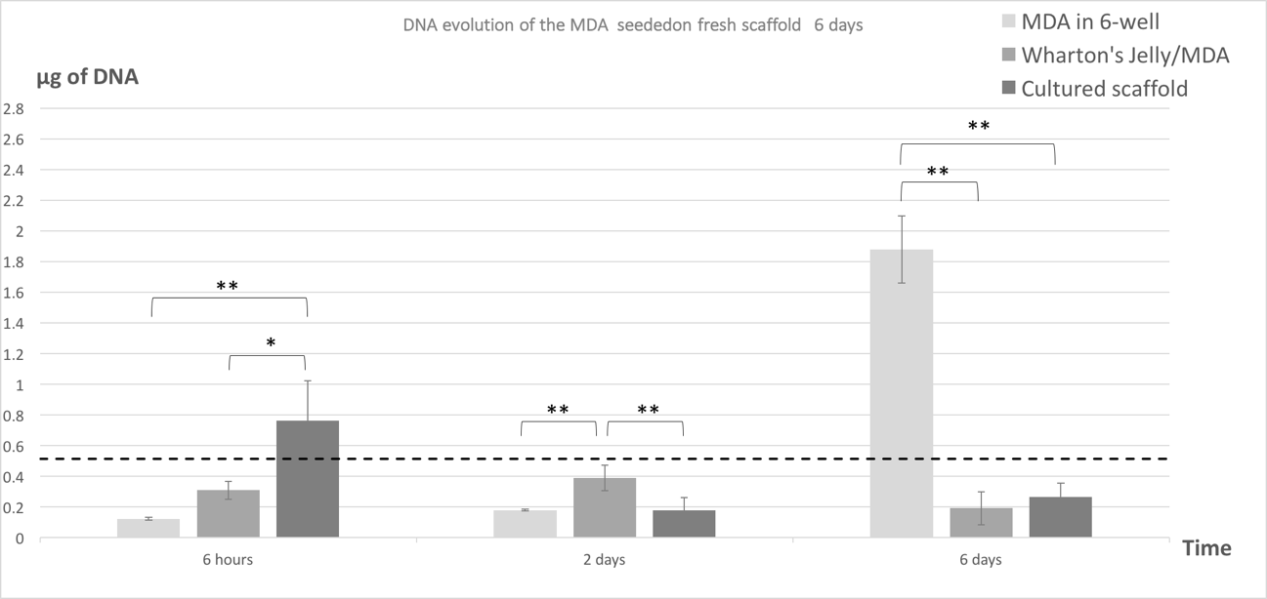
Figure 24: Cultured-scaffold seeded with MDA Day 1 – 6.
DNA content of Wharton’s Jelly/MDA (which stands for the cultured-scaffold seeded with MDA) as a function of the duration. * indicates p-value<0.05 and ** indicates p-value<0.01 compared to the cultured-scaffold at each time. Data represented as mean ± standard deviation. A sample size of n = 3 was used. Dashed line indicates initial seeding density of about 70,000 cells / g of tissue or about 0.52μg of DNA.

PC3
Figure 25 shows the amount of DNA present with the cultured-scaffold (Wharton’s Jelly cultured for 48 hours in order to amplify the amount of Wharton’s Jelly cells present on the construct (described in section §2.5.1)), seeded with PC3 as a function of a duration for six days. The amount of DNA decreases after two days of culture and increases back after six days of culture for the seeded Wharton’s Jelly and over the dashed line representing the amount of DNA seeded (originally cells seeded) on top of the cultured-scaffold during the entire experiment. On the other hand, the amount of DNA measured for the cultured-scaffold decreases over the time of the experiment. Those two different scaffolds are statistically different after six days of experiment. Those observations demonstrate that some of the PC3s seeded on top of the cultured-scaffold adhered after two days of culture and start proliferating after six days, and the Wharton’ Jelly cells don’t proliferate under the parameters of culture of this experiment. In addition, the amount of DNA measured from the Wharton’s Jelly/PC3 construct is statistically different at any time of culture compared to the amount of DNA measured from the PC3 culture in a 6-well plate. This shows that the cells don’t proliferate as well as when cultured in a 6-well plate.
Consequently, it is observed that this matrix and conditions of the culture give a necessary network and conditions for a moderate cell adhesion and proliferation of PC3s seeded on top of a cultured-scaffold (cell growth still appears much lower than the PC3 culture in 6-well plate).
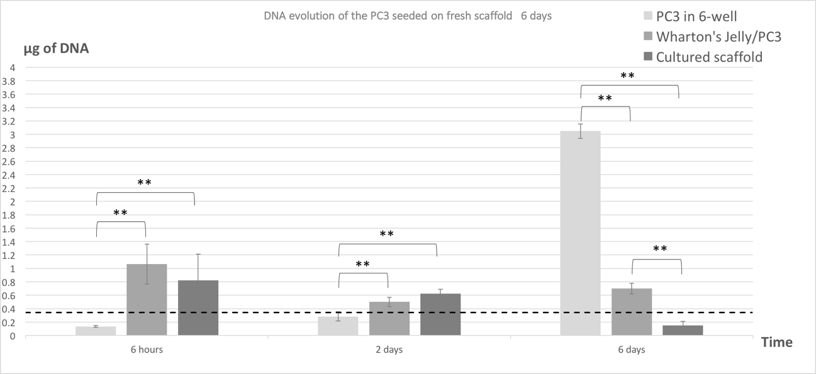
Figure 25: Cultured-scaffold seeded with PC3 Day 1 – 6.
DNA content of Wharton’s Jelly/PC3 (which stands for the cultured-scaffold seeded with PC3) as a function of the duration. ** indicates p-value<0.01 compared to the cultured-scaffold at each time. Data represented as mean ± standard deviation. A sample size of n = 3 was used. Dashed line indicates initial seeding density of about 110,000 cells / g of tissue or about 0.4μg of DNA.

Conclusion
The studies presented above have shown different aspects of the decellularized HUV and decellularized HUV/cancer cells constructs, as well as some aspects of the fresh Wharton’s jelly pieces and Wharton’s jelly/cancer cells constructs.
First, the cell-tissue attachment was studied via DNA assays and histology images coupled with a rough estimation of porosity. Analyzing the DNA assays, both the six or 10-day experiments on both cell lines showed a high quantity of DNA measured after six hours of incubation on the decellularized scaffold. This demonstrates a contamination coming from the decellularized cord storage process. It was then necessary to verify that the decellularization process has been conducted properly. The decellularized cords are at 15.43 ± 4.266µg DNA / g of dry tissue, which is under the limit established by McFetridge et al. to be considered decellularized properly. Looking more precisely to each steps of this process, the storage in the PBS in the fridge has increased the quantity of DNA from after the water bath at 0.4 ± 0.03µg DNA / g of dry tissue to 15.43 ± 4.266. Consequently, further analysis on any cell-tissue attachment wasn’t been possible. It is hypothesized that the contamination is coming from a bacterial or fungal development when the PBS solutions have been stored in the fridge. In order to have a complete analysis of the elements in the experiment, the impact of the Pizzabox on the cellularity was studied. The Pizzabox slows the cell proliferation after six days of culture. Further studies are necessary, but it seems that the Pizzabox was not responsible for the non-cell proliferation of the experiment. It is not clear that either the dye from the PLA used to build the Pizzabox is responsible or the friction with the bottom of the well is responsible.
The observations of histology images show that the porosity and organized network of the HUV remain the same after decellularization and that the chemicals used in the process don’t change the matrix properties. No cells were observed on any scaffold and at any time, which highly reinforced the bacterial or fungi contamination suspected.
Second, the seeding on a non-decellularized construct was studied with DNA assay only. Both cultured-scaffolds (Wharton’s Jelly cultured for 48 hours prior both MDA and PC3 experiments) show a decreased amount of DNA and a decreased amount of cellularity over the time of culture. While the Wharton’s Jelly/MDA seeded, construct has not demonstrated any cell development (defined by any increase of amount of DNA); the Wharton’s Jelly/PC3 seeded construct possessed a development. The amount of DNA detected has always been superior to the amount of DNA seeded (or cells seeded) and increased after six days of culture.
This preliminary study could then show a Wharton’s Jelly cells - PC3 attachment and possibly a cell proliferation if studied with a longer culture period.

Future directions
Even though the decellularized HUV cellularity is under 50µg DNA / g of dry tissue, a deeper study would need to be conducted to identify what is detected on the dsDNA quantification more precisely, especially after the storage solution step. It is hypothesized that it is bacterial or fungi DNA and this storage solution needs to be improved or deleted from the process. The Pizzabox slowed the cellularity of the two cancer cell lines of this study. In order to solve this issue in future studies, there might be a different Makerbot filament (material used by the 3D printer utilized in this experiment) with different properties, which would not affect cell cultures, or another Pizzabox could be built with a stainless material, which has already shown effectiveness on cell culture. The weight of this piece needs to be carefully observed in order to keep the ECM properties of the scaffolds. The study of the cell-tissue attachment would be then properly designed and could be conducted first over two days of experiment in order to study the cell attachment and further on a 10-days experiment to see if the cancer cells are able to develop on this matrix.
The seeding on a non-decellularized construct demonstrated more promise, especially for the PC3 cell line. Longer culture times should be conducted to confirm those results and different cell lines could be tested to verify the matrix compatibility.

References
[1]Siegel R, Naishadham D, Jemal A. “Cancer statistics.” 2012.
[2]Douglas Hanahan and Robert A. Weinberg. “Hallmarks of Cancer: The Next Generation: Cell.” 2011.
[3]Murata T, Mizushima H, Chinen I, Moribe H, Yagi S, Hoffman RM, Kimura T, Yoshino K, Ueda Y, Enomoto T, Mekada E. “HB-EGF and PDGF mediate reciprocal interactions of carcinoma cells with cancer-associated fibroblasts to support progression of uterine cervical cancers.” Cancer Res., 2011.
[4]Desgrosellier JS, Cheresh DA. “Integrins in cancer: biological implications and therapeutic opportunities.” Nat Rev Cancer., 2010.
[5]Moriah E. Katt, Amanda L. Placone, and Peter C. Searson. “In Vitro Tumor Models: Advantages, Disadvantages, Variables, and Selecting the Right Platform.” 2016.
[6]Lauren C. Kimlin, Giovanna Casagrande, and Victoria M. Virador. “In Vitro Three-Dimensional (3D) Models in Cancer Research: An Update.” 2013.
[7]“What is Cancer Surgery? | Cancer.Net.” Available at: http://www.cancer.net/navigating-cancer-care/cancer-basics/what-cancer (Accesed May 2017)
[8]“American Cancer Society.” Available at: https://www.cancer.org/content/cancer/en_header.html (Accessed May 2017)
[9]“Radiation Therapy Basics.” Available at: https://www.cancer.org/treatment/treatments-and-side-effects/treatment-types/radiation/basics.html (Accessed May 2017)
[10]“WHO | Diagnosis and Treatment.” Available at: http://www.who.int/en/ (Accessed May 2017)
[11]“Understanding Targeted Therapy | Cancer.Net.” Available at: http://www.cancer.net/navigating-cancer-care/how-cancer-treated/personalized-and-targeted-therapies/understanding-targeted-therapy (Accessed May 2017)
[12]“Stem cell transplants | Cancer in general | Cancer Research UK.” Available at: http://www.cancerresearchuk.org/about-cancer/cancer-in-general/treatment/bone-marrow-stem-cell-transplants/stem-cell-transplants (Accessed May 2017)
[13]Alberts B, Johnson A, Lewis J, Martin Raff, Keith Roberts, and Peter Walter. Molecular Biology of the Cell. 4th edition., Garland Science. New York, 2002.
[14]Kim JB. “Three-dimensional tissue culture models in cancer biology.” Seminars in Cancer Biology, vol. 15, 2005.
[15]Ruei-Zeng Lin, and Hwan-You Chang Dr. “Recent advances in three-dimensional multicellular spheroid culture for biomedical research.” Biotechnology Journal, vol. 3, 2008.
[16]Franziska Hirschhaeuser, Heike Menne, Claudia Dittfeld, Jonathan West, Wolfgang Mueller-Klieser, Leoni A. Kunz-Schughart. “Multicellular tumor spheroids: An underestimated tool is catching up again.” Biotechnology Journal, vol. 148, 2009.
[17]Sutherland RM, Inch WR, McCredie JA, Kruuv J. “Multi-component radiation survival curve using an in-vitro tumour model.” vol. 18, 1970.
[18]Monazzam A, Razifar P, Ide S, Rugaard JM, Josephsson R, Blomqvist and C, Langstrom B, Bergstrom M. “Evaluation of the Hsp90 inhibitor NVP-AUY922 in multicellular tumour spheroids with respect to effects on growth and PET tracer uptake.” Nuclear Medicine and Biology, 2009.
[19]Monazzam A, Razifar P, Simonsson M, Qvarnstrom F, Josephsson R, Blomqvist C, Langstrom B, Bergstrom M. “Multicellular tumour spheroid as amodel for evaluation of [18F]FDG as biomarker for breast cancer treatment monitoring.” Cancer Cell International, 2006.
[20]Kim TH, Mount CW, Gombotz WR, Pun SH. “The delivery of doxorubicin to 3-D multicellular spheroids and tumors in a murine xenograft model using tumor-penetrating triblock polymeric micelles.” Biomaterials, 2010.
[21]Krishnan V, Shuman LA, Sosnoski DM, Dhurjati R, Vogler EA, Mastro AM. “Dynamic interaction between breast cancer cells and osteoblastic tissue: comparison of two- and three-dimensional cultures.” Cellular Physiology Journal, 2011.
[22]Yates C, Shepard CR, Papworth G, Dash A, Beer Stolz D, Tannenbaum S. “Novel threedimensional organotypic liver bioreactor to directly visualize early events in metastatic progression.” Advance in Cancer Research, 2007.
[23]Dhurjati R, Krishnan V, Shuman LA, Mastro AM, Vogler EA. “Metastatic breast cancer cells colonize and degrade three-dimensional osteoblastic tissue in vitro.” Clinical and Experimental Metastasis, 2008.
[24]Lee GY, Kenny PA, Lee EH, Bissell MJ. “Three-dimensional culture models of normal and malignant breast epithelial cells.” Nature Methods, 2007
[25]Kleinman HK, Martin GR. “Matrigel: basement membrane matrix with biological activity.” Seminar in Cancer Biology, 2005.
[26]Shekhar MP, Werdell J, Santner SJ, Pauley RJ, Tait L. “Breast stroma plays a dominant regulatory role in breast epithelial growth and differentiation: implications for tumor development and progression.” Cancer Research Journal, 2001.
[27]Amatangelo MD, Bassi DE, Klein-Szanto AJ, Cukierman E. “Stroma-derived three-dimensional matrices are necessary and sufficient to promote desmoplastic differentiation of normal fibroblasts.” American Journal of Pathology, 2005.
[28]Castello-Cros R, Khan DR, Simons J, Valianou M, Cukierman E. “Staged stromal extracellular 3D matrices differentially regulate breast cancer cell responses through PI3K and beta1- integrins.” BMC Cancer, 2009.
[29]Agata Nyga & Umber Cheema & Marilena Loizidou. “3D tumour models: novel in vitro approaches to cancer studies.” Journal of Cell Communication and Signaling, 2011.
[30]Cheema U, Yang SY, Mudera V, Goldspink GG, Brown RA. “3-D in vitro model of early skeletal muscle development.” Cell Motility and Cytoskeleton, 2003.
[31]Holliday DL, Brouilette KT, Markert A, Gordon LA, Jones JL. “Novel multicellular organotypic models of normal and malignant breast: tools for dissecting the role of the microenvironment in breast cancer progression.” Breast Cancer Res, 2009.
[32]Brown RA, Wiseman M, Chuo C-B, Cheema U, Nazhat SN. “Ultrarapid engineering of biomimetic biomaterials and tissues: fabrication of nano- and microstructures by plastic compression.” Advanced Functional Material, 2005.
[33]Paszek MJ, Zahir N, Johnson KR, Lakins JN, Rozenberg GI, Gefen A, Reinhart-King CA, Margulies SS, Dembo M, Boettiger D, Hammer DA, Weaver VM. “Tensional homeostasis and the malignant phenotype.” Cancer Cell, 2005.
[34]Gurski LA, Jha AK, Zhang C, Jia X, Farach-Carson MC. “Hyaluronic acid-based hydrogels as 3D matrices for in vitro evaluation of chemotherapeutic drugs using poorly adherent prostate cancer cells.” Biomaterials, 2009.
[35]Mandal BB, Kundu SC. “A novel method for dissolution and stabilization of non-mulberry silk gland protein fibroin using anionic surfactant sodium dodecyl sulfate.” Biotechnology and Bioengineering, 2007.
[36]Cunliffe D, Pennadam S, Alexander C. “Synthetic and biological polymers merging the interface.” European Polymer Journal, 2004.
[37]Chen G, Sato T, Ushida T, Hirochika R, Shirasaki Y, Ochiai N, Tateishi T. “The use of a novel PLGA fiber/collagen composite web as a scaffold for engineering of articular cartilage tissue with adjustable thickness.” Journal of Biomedical Materials Research Part A, 2003.
[38]Villanueva I, Weigel CA, Bryant SJ. “Cell-matrix interactions and dynamic mechanical loading influence chondrocyte gene expression and bioactivity in PEG-RGD hydrogels.” Acta Biomateriala, 2009.
[39]Loessner D, Stok KS, Lutolf MP, Hutmacher DW, Clements JA, Rizzi and SC. “Bioengineered 3D platform to explore cell-ECM interactions and drug resistance of epithelial ovarian cancer cells.” Biomaterials, 2010.
[40]Sahoo SK, Panda AK, Labhasetwar V. “Characterization of porous PLGA/PLA microparticles as a scaffold for three dimensional growth of breast cancer cells.” Biomacromolecules, 2005.
[41]Huang CC, Pan WY, Tseng MT, Lin KJ, Yang YP, Tsai HW, Hwang SM, Chang Y, Wei HJ, Sung HW. “Enhancement of cell adhesion, retention, and survival of HUVEC/cbMSC aggregates that are transplanted in ischemic tissues by concurrent delivery of an antioxidant for therapeutic angiogenesis.” Biomaterials vol. 74, pp. 53–63, 2016.
[42]“Whonamedit - dictionary of medical eponyms.” Available at: http://www.whonamedit.com (Accessed May 2017)
[43]Robert Stern. Hyaluronan in cancer biology 1st edition, 2009.
[44]“ATCC: The Global Bioresource Center.” Available at: https://www.atcc.org (Accessed May 2017)
[45]Peter M. Crapo, Thomas W. Gilbert, Stephen F. Badylak. “An overview of tissue and whole organ decellularization processes.” Biomaterials vol. 32, pp. 3233–3243, 2011.

Appendix A: List of Acronyms
ATCC | American Type Culture Collection
DI | Distilled water
ECM | Extra-cellular matrix
FBS | Fetal Bovine Serum
HA | Hyaluronic Acid
HUC | Human Umbilical Cord
HUV | Human Umbilical Vein
HUVECs | Human Umbilical Vein Endothelial Cells
MCTs | Multicellular tumor spheroids (MCTs)
NCI | National Cancer Institute
PBS | Phosphate Buffer Saline
PLA | Poly-lactic-L-Acid
PPE | Personal Protective Equipment
rcf | Relative Centrifugal Force
SDS | Sodium Dodecyl Phosphate
vol | Volume

Appendix B: Preparation of PBS for vein decellularization

- PBS has the same concentration of salts as cells. Thus, by washing the cells with it instead of water we prevent osmosis

Supplies
• Sodium Phosphate Monobasic Monohydrate ${NAH}_{2}{PO}_{4}H_{2}O$
• Sodium Phosphate Dibasic Anhydrous ${NAH}_{2}{PO}_{4}$
• Beaker

Protocol

- Quantity prepare a total of 1000ml of PBS @ 150mM and PH=7.4
- Put Beaker on magnetic stirrer and place magnet inside beaker
- Add about 800mL of distilled water
- Turn stir to about 6
- Add 3.94 g Monobasic Monohydrate ${NAH}_{2}{PO}_{4}H_{2}O$
- Wash boat with extra 100 ml of water
- Add 16.77 g Dibasic Anhydrous ${NAH}_{2}{PO}_{4}$
- Wash weighing boat with the remaining 100 ml of water
- Pour PBS in bottle and autoclave

Appendix C: Paraffin embedment protocol

- If a step is done repeatedly, use new solution each time
- Glass vials work well to hold solutions
- Use 95% ethanol to make diluted ethanol solutions
- Make sure 100% ethanol is sealed well to maintain purity

Supplies
• Glass vials
• 95% Ethanol
• 100% Ethanol
• Formalin
• Clear Rite 3
• Paraffin
• Molds
• Cassettes

Protocol

1. Place tissue in 10% Formalin for 1 hour
a. If not processing immediately, leave tissue in formalin overnight and store in refrigerator in 70% ethanol for long term storage
2. Place tissue in 85% ethanol for 1 hour
3. Place tissue in 95% ethanol for 1 hour
4. Place tissue in 95% ethanol for 1 hour
5. Place tissue in 100% ethanol for 45 minutes
6. Place tissue in 100% ethanol for 45 minutes
7. Place tissue in 100% ethanol for 45 minutes
8. Place tissue in Clear Rite 3 for 1 hour at 45oC
9. Place tissue in Clear Rite 3 for 1 hour at 45oC
10. If not already in a cassette, place tissue in cassette
11. Place tissue in Paraffin for 2 hours at 60oC in heated vacuum chamber in D211
a. Stir every half hour to ensure mixing and thorough penetration of paraffin
12. To prepare for embedding, place a small layer of melted paraffin in mold and allow to stiffen, but not completely harden
13. Take tissue out of paraffin bath and cassette. Place tissue in desired orientation in the mold, using the stiff paraffin to hold it.
14. Fill mold with paraffin
15. Place cassette base in mold securely
16. Let sample cool and section with a microtome (7μm thick)
17. Place at 60 °C for 24 hours. The sample is ready for staining.

Appendix D: Hematoxylin and eosin staining protocol

Supplies
• Histology jars (containing 200-250 ml of solution)
• Glass slide holders
• Clear Rite
• Clear Rite/Ethanol 50/50 solution
• 100% Ethanol
• 95% Ethanol
• DI Water
• Tap Water
• Hematoxylin
• Eosin
• Mounting Medium
• Coverslips
• Chemwipes

Protocol
- Clear Rite 3 for 3 minutes
- Clear Rite 3 for 3 minutes
- Clear Rite 3 for 3 minutes
- Clear Rite/Ethanol 50/50 solution for 1 minute
- 100% ethanol for 1 minute
- 23. 95% ethanol for 1 minute
- 24. 85% ethanol (made from 95% ethanol) for 1 minute
- 75% ethanol (made from 95% ethanol) for 1 minute
- DI Water for 1 minute
- Hematoxylin for 5 minutes
- Tap Water Rinse for 1 minute
- Eosin for 1 minute
- DI Water rinse for 1 minute
- 95% ethanol for 1 minute
- 95% ethanol for 1 minute
- 100% ethanol for 1 minute
- 100% ethanol for 1 minute
- Clear Rite/Ethanol 50/50 solution for 1 minute
- Clear Rite 3 for 1 minute
- Clear Rite 3 for 1 minute
- Blot away excess clear rite 3 with chemwipe
- Place a drop of mounting medium on sample
- Place coverslip on slide

