University of Oklahoma

Graduate College

musical mannerism: a recurring stylistic phenomenon
in Keyboard Variations by J.S. Bach, Beethoven, and Liszt

A document

submitted to the Graduate Faculty

in partial fulfillment of the requirements for the

Degree of

doctor of musical arts

By

charles b. Lahan Jr.
Norman, Oklahoma
2016

musical mannerism: a recurring stylistic phenomenon
in Keyboard Variations by J.S. Bach, Beethoven, and Liszt

A document approved for the
school of music

By

______________________________
Dr. Jane Magrath, Chair

______________________________
Dr. Paula Conlon

______________________________
Dr. Barbara Fast

______________________________
Dr. Judith Pender

______________________________
Dr. Frank Riddick

© Copyright by charles b. Lahan Jr. 2016
All Rights Reserved.
TABLE OF CONTENTS
LIST OF FIGURES v
ABSTRACT vi
CHAPTER I: INTRODUCTION TO THE STUDY 1
Purpose of the Study 3
Need for the Study 3
Limitations of the Study 6
Design and Procedures 6
Related Literature 7
CHAPTER II: OVERVIEW OF MANNERISM 11
From Vasari through the Nineteenth Century 12
Twentieth Century Art Historians on Mannerism 21
Mannerism in Music 30
Mannerism as a Recurring Stylistic Phenomenon 39
CHAPTER III: ANALYSIS OF BACH’S GOLDBERG VARIATIONS 44
Bach as Mannerist 44
Formulas and Intellectual Constructivism 47
Imitation of Past Styles and Manners 51
Artificial Intricacy 53
Expressionism and Surrealism 56
Refinement and Preciosity 60
CHAPTER IV: ANALYSIS OF BEETHOVEN’S DIABELLI VARIATIONS 63
Beethoven as Mannerist 63
Formulas and Intellectual Constructivism 66
Imitation of Past Styles and Manners 70
Artificial Intricacy 77
Expressionism and Surrealism 80
Refinement and Preciosity 84
CHAPTER V: ANALYSIS OF LISZT’S VARIATIONS
ON A THEME OF BACH, WEINEN, KLAGEN, SORGEN, ZAGEN 88
Liszt as Mannerist 88
Formulas and Intellectual Constructivism 90
Imitation of Past Styles and Manners 94
Artificial Intricacy 96
Expressionism and Surrealism 99
Refinement and Preciosity 101
CHAPTER VI: SUMMARY AND CONCLUSIONS 104
Suggestions for Further Research 106
BIBLIOGRAPHY 111
APPENDIX A: IRB RELEASE FORM 115
APPENDIX B: G. HENLE PUBLISHERS RELEASE 116

LIST OF FIGURES

Figure 1. Handel, Chaconne avec 62 variations, mm. 1-8 51
Figure 2. Bach, Goldberg Variations, Variation 2, mm. 1-9 54
Figure 3. Bach, Goldberg Variations, Variation 28, mm. 5-6 54
Figure 4. Bach, Goldberg Variations, Variation 12, mm. 1-3; Variation 15, mm. 1-3 55
Figure 5. Bach, Goldberg Variations, Variation 25, mm. 1-3 56
Figure 6. Bach, Goldberg Variations, Variation 25, mm. 20-25 58
Figure 7. Bach, Goldberg Variations, Variation 25, mm. 1-3 58
Figure 8. Bach, Goldberg Variations, Variation 30, mm. 1-3 59
Figure 9. Bach, Goldberg Variations, Variation 27, mm. 1-3 61
Figure 10. Beethoven, Diabelli Variations, Variation 25, mm. 1-3 68
Figure 11. Beethoven, Diabelli Variations, Variation 22, mm. 1-4 71
Figure 12. Beethoven, Diabelli Variations, Variation 23, mm. 1-2; Cramer, Pianoforte-Method, No. 1, mm. 1-2 72
Figure 13. Beethoven, Diabelli Variations, Variation 24, mm. 1-6 74
Figure 14. Beethoven, Diabelli Variations, Variation 29, mm. 1-3; Bach, E-flat minor Prelude, WTC. I, mm. 12-14 75
Figure 15. Beethoven, Diabelli Variations, Variation 31, mm. 3-4; Bach, Goldberg Variations, Variation 25, mm. 1-3 75
Figure 16. Beethoven, Diabelli Variations, Variation 32, mm. 1-6 76
Figure 17. Beethoven, Diabelli Variations, Variation 33, mm. 1-4 77
Figure 18. Beethoven, Diabelli Variations, Theme, mm. 20-25 81
Figure 19. Beethoven, Diabelli Variations, Variation 5, mm. 16-28 82
Figure 20. Beethoven, Diabelli Variations, Variation 9, mm. 22-27 82
Figure 21. Beethoven, Diabelli Variations, Variation 12, mm. 25-28 83
Figure 22. Beethoven, Diabelli Variations, Variation 14, mm. 10-12 83
Figure 23. Beethoven, Diabelli Variations, Variation 30, mm. 12-13 83
Figure 24. Beethoven, Diabelli Variations, Variation 20, mm. 9-13 85
Figure 25. Beethoven, Diabelli Variations, Variation 32, mm. 161-166 85
Figure 26. Liszt, Weinen, Klagen Variations, ms. 195 91
Figure 27. Liszt, Weinen, Klagen Variations, mm. 16-18 91
Figure 28. Liszt, Weinen, Klagen Variations, mm. 170-2 92
Figure 29. Liszt, Weinen, Klagen Variations, mm. 215-230 92
Figure 30. Liszt, Weinen, Klagen Variations, mm. 319-23 93
Figure 31. Bach, Cantata: BWV 12, Chorus: Lento, mm. 1-5 94
Figure 32. Liszt, Weinen, Klagen Variations, mm. 18-22 95
Figure 33. Liszt, Weinen, Klagen Variations, mm. 324-30 95
Figure 34. Liszt, Weinen, Klagen Variations, mm. 1-9 97
Figure 35. Liszt, Weinen, Klagen Variations, mm. 18-29 98
Figure 36. Liszt, Weinen, Klagen Variations, mm. 199-202 100

ABSTRACT

Mannerism was an artistic style that flourished in the sixteenth century between the High Renaissance and the emergence of the Baroque era. Originating in Rome and Florence in the 1520s, Mannerism eventually spread throughout Europe. Important Mannerist painters include Michelangelo, Pontormo, Parmigianino, Rosso, Bronzino, and El Greco.
Mannerism as an artistic style was not limited to painting and the visual arts. Mannerism thrived throughout the sister arts as well. Notable examples of Mannerism can be found in architecture, literature, and music. In music, the Italian madrigal is the purest expression of the Mannerist style.
From roughly 1600 until 1900, the dominant critical view of Mannerism was negative. Mannerism was viewed as a degradation of the virtuous style of the Renaissance. As a result, Mannerism was largely ignored by critics and scholars. However, in the early twentieth century, this view began to change as scholars from across the artistic disciplines began studying Mannerism with renewed interest. A common goal amongst many of these scholars was to imbue Mannerism with positive qualities.
As scholars began to focus on this neglected style, ideas about Mannerism proliferated. One such idea that has gained traction across disciplines is that Mannerism is a recurring stylistic phenomenon not necessarily isolated to the sixteenth century. A proponent of this idea in the field of music was Canadian musicologist Maria Rika Maniates.
This document seeks to expand on Maniates’ arguments concerning recurring Mannerism. Specifically, this document will provide an overview of the history of Mannerism and analysis of keyboard works using Maniates’ criteria for recurring Mannerism. The keyboard works are J.S. Bach’s Goldberg Variations, Ludwig van Beethoven’s Diabelli Variations, and Franz Liszt’s Variations on a Theme of Bach, Weinen, Klagen, Sorgen, Zagen.

CHAPTER I: INTRODUCTION TO THE STUDY

Mannerism is a style of art that dominated Western Europe for much of the sixteenth century. While the term “Mannerism” originated in the visual arts, Mannerism is applicable to all branches of art, including literature and music. The style flourished between the High Renaissance and the emergence of the Baroque era. In painting and the visual arts, Mannerism is generally dated back to the death of Raphael in 1520 and lasting until the end of the century. In music, Mannerism is closely linked to the Italian madrigal. Musicologist Maria Rika Maniates dates the Age of Mannerism in music as lasting from 1530-1630.
The Italian word maniera is inseparably linked to Mannerism. Giorgio Vasari, the sixteenth century artist and writer, identified maniera as one of the five qualities displayed by the best artworks of the Renaissance. To Vasari, maniera meant style or stylishness and was a positive descriptor of art.
The Baroque era brought stylistic changes, favoring naturalism and emotional urgency over stylization and intellectual caprice. In the Baroque era, the connotation associated with maniera changed from the positive attribute originally intended by Vasari to a derogatory one. Still today, words like “mannered” and “mannerism” carry the negative meanings that began to be applied to them during the Baroque era.
It is important to remember that words like Gothic and Baroque formerly carried similarly negative connotations. Yet, through revisionism and reevaluation, the meaning of those terms has changed to neutral or even positive descriptors. A similar process of revision has been underway in the twentieth century concerning Mannerism.
The “rediscovery” of Mannerism in the twentieth century has brought a proliferation of ideas on the topic. In writings about Mannerism, it is remarkable how consistently authors begin by noting the complexity, controversy, and general lack of agreement on the subject. One of the most controversial and intriguing contentions is that stylistic evolution is cyclical and that Mannerism is a phase in this cycle. This idea forms the basis for the analysis in this document.
The greatest proponent of this idea in music was Maria Rika Maniates. In her article “Musical Mannerism: Effeteness or Virility?,” she posits five criteria by which to evaluate the recurrence of musical Mannerism. The five criteria are the domination of formulas and intellectual constructivism, the exaggerated imitation of past styles and manners, an artificial intricacy, an expressionistic ecstasy and demonic surrealism, and a sense of refinement and preciosity.
This document will evaluate three sets of variations for keyboard that display such characteristics and thus qualify as examples of recurring musical Mannerism. These pieces are J.S. Bach’s Goldberg Variations, Beethoven’s Diabelli Variations, and Liszt’s Variations on a Theme of Bach, Weinen, Klagen, Sorgen, Zagen. In addition to these analyses, the intellectual history of Mannerism from the sixteenth century to the present will be examined.

Purpose of the Study
The purpose of this study is two-fold: first, to provide a historical overview of Mannerism; second, to analyze three major keyboard works as examples of recurring Mannerism.
The first part of the study will present an historical overview of the genesis and development of Mannerism. From the sixteenth century to the present, the connotations associated with Mannerism have greatly changed. Originally an art historical term, Mannerism in the twentieth century has been adopted by various academic fields including music and literature. Furthermore, Mannerism has been expanded beyond the confines of the sixteenth century to include other historical eras. Musicologists like Seaton, Apel, and Maniates contend that Mannerism is a recurring phenomenon within the arts.
The second part of the study will analyze three major keyboard works written at different points within the common practice period as examples of historically recurring Mannerism. The works will be analyzed for stylistic consistencies that are typical of Mannerism. This study will add to the available literature concerning Mannerism as a recurring stylistic phenomenon and will provide a novel analysis of major keyboard works.

Need for the Study
In a work titled The Meaning of Mannerism, art historian Franklin Robinson questions the use of the term, Mannerism, and its validity amongst the various artistic disciplines. He writes:
Some scholars maintain the term should be used only in referring to visual works of art, or even just to painting and prints, while others would apply it to all the arts and even to social phenomena. There is no question, then, that serious debate on Mannerism is needed; this fact, in itself, would justify the present volume … This book raises, implicitly and sometimes explicitly, a fundamental question: Is it possible—or desirable—to have valid insights and interpretations of an interdisciplinary nature?

In the opinion of this author, the answer to the question posed in The Meaning of Mannerism is “yes.”
In addition, the need for the present study is made evident by art historian Richard Studing’s bibliography of Mannerism, compiled in 1979. The bibliography separates disciplinary categories: art, exhibitions and related publications, literature, music, and interdisciplinary publications. The section of music entries is paltry, only about two complete pages worth (most of which are in German). This is in comparison to 29 pages of art related entries and ten pages of literature. Mannerism in music simply deserves more scholastic attention.
Indeed, though several sources across disciplines mention the possibility that Mannerism is a recurring phenomenon, most choose not to address that particular concern. Maniates is the only author to address musical Mannerism as a recurring phenomenon with any specificity and this document depends on her contribution. Yet, while Maniates discusses recurring Mannerism and lists criteria by which to judge it, she does not subject any music to analysis. As such, this document will be the first to analyze musical compositions in support of her contentions. If Maniates’ writings have merit and Mannerism is, in fact, a recurring stylistic phenomenon, this document will provide validation.
In addition, as this document will show, scholarship amongst the artistic disciplines has not always been so specialized. Today, students and scholars often focus on theory, history, pedagogy, or performance. While this approach surely produces its share of experts, students and scholars alike can benefit from a broader approach. The subject of Mannerism necessitates a more universal outlook as it relates to art, literature, and music as well as philosophy, aesthetics and criticism. John Shearman, an art historian, addresses the interdisciplinary issue in his book Mannerism, pointing out that sixteenth century intellectuals worked across disciplines (Michelangelo was a poet as well as an architect). He writes, “a study of sixteenth century literature and music not only provides illustrations of such similarities but also reflects a little light back on to the concept of Mannerism in the visual arts.” Or, if one prefers the words of literature specialist Ernst Curtius: “The historical disciplines will progress wherever specialization and contemplation of the whole are combined and interpenetrate. The two require each other and stand in a complementary relation. Specialization without universalism is blind. Universalism without specialization is inane.” Concerning Mannerism, both universalism and specialization are appropriate.
To further argue that the approach to this document must take other artistic disciplines into account, let us imagine the converse in which they are not taken into consideration. In such a document, the focus would be both narrow and specific: Mannerism is a recurring stylistic phenomenon in music history. This would deprive the reader of valuable historical and stylistic context. Indeed, only a Mannerism expert could possibly understand writing on such a narrow topic. This necessitates a full accounting of Mannerism that discusses the style from its intellectual origins with Vasari to the more recent writings of Maniates.

Limitations of the Study
Three pieces of keyboard music are subjected to analysis using the criteria for recurring Mannerism developed by Maniates. The three pieces are J.S. Bach’s Goldberg Variations, Beethoven’s Diabelli Variations, and Liszt’s Variations on a Theme of Bach, Weinen, Klagen, Sorgen, Zagen. As will be explained, all three pieces are sets of variations, a genre particularly amenable to recurring Mannerism. Also, these pieces represent late examples from the three phases of the common practice period: the Baroque, the Classical, and the Romantic. While these limitations are somewhat arbitrary, they will help to facilitate clear comparisons and deductions.

Design and Procedures
The study is comprised of six chapters, a bibliography and two appendices. Following the introductory chapter, the second chapter presents an historical overview of Mannerism. This discussion begins with artist and historian Giorgio Vasari’s writing in the sixteenth century and progresses chronologically until the present day. In addition, this chapter surveys important ideas about Mannerism by examining the writing of art historians and musicologists. This discussion culminates with the musicologists who argue that Mannerism is a recurring stylistic phenomenon. In particular, the writing of Maniates is integral to the following analyses. Maniates asserts five criteria for the recurrence of Mannerism. These criteria are as follows: domination of formulas and intellectual constructivism, exaggerated imitation of past styles and manners, artificial intricacy, expressionistic ecstasy and demonic surrealism, and refinement and preciosity. Chapters three through five present analyses of the works mentioned above using the criteria developed by Maniates. Chapter six consists of a summary, conclusions, and recommendations for further research.

Related Literature
In researching Mannerism, one must start at the beginning: the sixteenth century. Giorgio Vasari, often considered one of the first art historians, is quoted and analyzed in most works on the subject. In particular, the prefaces to the three parts of his Lives of the Artists are useful for their general information and frequent use of the Italian word maniera, from which Mannerism gets its name. Art historian Liana Cheney’s book, Vasari’s Prefaces, is also of interest. In addition to Vasari, the Baroque art historian, Giovan Pietro Bellori, wrote a similar work that reflects the historical change in connotation concerning maniera that transpired after Vasari.
As Mannerism was initially used as a term in art history, the writing of various art historians is pertinent to this document. It is often mentioned that the early twentieth century fostered a “rediscovery” of Mannerism within that field. Walter Friedlaender’s essay, “The Anti-Classical Style,” argued that Mannerism was a reactionary movement against the Classicism of the High Renaissance. Sydney Freedberg, in his article “Observations on the Painting of the Maniera,” argues that the distinction between the High Renaissance and Early Mannerism is less distinct than the break that occurs around 1540. Freedberg refers to this mature Mannerist style as the Maniera. Arnold Hauser’s book, Mannerism, argues that the stylistic break that happened in 1520 was caused by a series of historical, religious, and economic crises. He calls this break the “crisis of the Renaissance.” John Shearman’s book, also named Mannerism, finds fault with Friedlaender and Hauser. Shearman argues that Mannerism was neither reactionary nor born out of crisis. Craig Hugh Smyth’s essay “Mannerism and Maniera” argues that Mannerism cannot be correctly understood as simply anti-classical. This is because Mannerist artists frequently copied the most available ancient (hence Classical) art available to them, Roman sarcophagi from the second to fourth century. He also points to the similarity between the Maniera style and that of the late Gothic, suggesting cyclicity. Another work, compiled by Liana Cheney, entitled Readings in Italian Mannerism, presents the viewpoints of notable scholars (such as the ones mentioned above) through a series of essays. Her own contribution, “Stylistic Problems in Mannerism and Maniera,” provides the reader with a succinct list of qualities associated with this type of art.
From the field of literature, Curtius’ European Literature and the Latin Middle Ages provides a view of Mannerism consistent with this study. The following quote illustrates that Mannerism as a recurring phenomenon has credibility across disciplines. Curtius writes:
[Mannerism is] the common denominator for all literary tendencies which are opposed to Classicism, whether they be pre-classical, post-classical, or contemporary with any Classicism. Understood in this sense, Mannerism is a constant in European literature. It is the complimentary phenomenon of the Classicism of all periods … The polarity of Classicism and Mannerism is far more useful as a conceptual instrument and can illuminate connections which it is easy to overlook.

Mannerism has not been given the attention it deserves in the global musical community. In fact, most of the attention has come from German writers. Yet, several writers have made significant contributions to the subject in English. Musicologist James Haar’s essay “Classicism and Mannerism in Sixteenth Century Music” argues that Josquin, rather than Palestrina, is the model of High Renaissance Classicism in music. He also examines the purely musical Mannerisms that can be found in Italian madrigals of the time. Musicologist Glenn Watkin’s examination of Gesualdo contains a most interesting chapter, entitled “The Question of Mannerism.” Numerous ideas from this chapter are pertinent to the analyses of the later chapters in this document. Musicologist Willi Apel’s article, “French Secular Music of the Late Fourteenth-Century,” uses the term Mannerism to describe the rhythmic complexities that developed toward the end of the Middle Ages. Musicologist Douglas Seaton’s textbook, Ideas and Styles in the Western Musical Tradition, defines Mannerism as a recurring stylistic phenomenon that occurs (as Apel also notes) towards the end of a style period. The most prolific writer on the subject of musical Mannerism is Maria Rika Maniates. Her book, Mannerism in Italian Music and Culture, 1530-1630, seeks to provide a total picture of Mannerism, one that includes art, literature and music. In addition, two of her essays are of importance. In “Mannerist Composition in Franco-Flemish Polyphony” and “Musical Mannerism: Effeteness or Virility?,” Maniates argues that Mannerism is a constantly recurring phenomenon. This document seeks to elaborate on her conclusions.

CHAPTER II: OVERVIEW OF MANNERISM

The reader will benefit from a detailed analysis of Mannerism. A context for understanding Mannerism can be developed through a discussion of the term and its use in scholarly literature. The problematic nature of the term Mannerism necessitates such an analysis. Indeed, every contemporary source on the topic contains such a discussion and references to the primary sources that gave the term its origin. This document should be no different.
The problematic nature of the term Mannerism is multifaceted. Most obviously, the term was used pejoratively for roughly three hundred years. While viewed more favorably by twentieth and twenty first century critics, it has yet to completely shed the negative connotations associated with it. Aside from the changing connotations associated with Mannerism, there is also a disciplinary complication. Mannerism was initially associated with art history. In the twentieth century, it has been applied to literature and music. In addition, Mannerism has begun to be used to describe what some see as a recurring stylistic phenomenon that is not necessarily isolated to the sixteenth century style that flourished between the High Renaissance and the Baroque periods.
To address these problems, Chapter II will analyze the term Mannerism and its use in scholarly sources from the sixteenth century until the present. This analysis will begin with the most important primary source on the topic, Giorgio Vasari’s The Lives of the Artists. The analysis will continue with Bellori’s work, reflecting the change in connotations associated with the term. The writings of twentieth century critics and historians will then be reviewed to show the changing attitudes towards Mannerism by contemporary audiences. The disciplinary problem will then be examined in the works of pertinent musicologists. Lastly, works that advocate the use of the term Mannerism as a recurring phenomenon will be reviewed.

From Vasari through the Nineteenth Century
Analysis of Mannerism often refers to the writings of Giorgio Vasari. Though often considered the first important art historian, Vasari was a prominent painter and architect of the sixteenth century, who lived from 1511-1574 and worked mostly in Florence and Rome, the centers of Mannerism. His contribution to art history is his book, The Lives of the Artists, where the origins of Mannerism as a term are found.
Vasari’s Lives is divided into three sections, each preceded by a preface. Vasari states in the preface to the second section: “I have divided the artists into three sections or, shall we say, periods, each with its own recognizably distinct character, running from the time of the rebirth of the arts to our own times.” Vasari likens these three periods to the growth of a living organism. He describes these stages as infancy, adolescence and maturity. The infancy stage corresponds to the beginning of the Renaissance and the painting of Giotto, Cimabue and others. The adolescent stage is represented by later fifteenth century artists like Masaccio, Botticelli, and Donatello. The mature stage begins with Leonardo and reaches a climax with Michelangelo. Each section contains biographies of the individual artists that represent each stage, including the ones mentioned and many more.
Each of the three sections of Lives begins with a preface. It is in these prefaces that the most salient writing concerning Mannerism can be found. This is because the information in the prefaces is more general than the specific biographies given later. As Vasari writes: “in my biographies I have spent enough time discussing methods, skills, particular styles, and the reasons for good, superior, or preeminent workmanship so here I shall discuss the matter in general terms, paying more attention to the nature of the times than to the individual artists.”
In an important passage from the preface to the third section of Lives, Vasari identifies five stylistic qualities found in great works of art:
Those excellent masters we have described up to this point in the Second Part of these Lives truly made great advances in the arts of architecture, painting, and sculpture, adding to the accomplishments of the early artists rule, order, proportion, design, and style (maniera), and if they were not perfect in every way, they drew so near to the truth that artists in the third group, whom we shall now discuss, were able, through that illumination, to rise up and reach complete perfection, the proof of which we have in the finest and most celebrated modern works. But to clarify the quality of the improvements that these artists made, it will not be out of place to explain briefly the five qualities I mentioned above and to discuss succinctly the origins of that true goodness which has surpassed that of the ancient world and rendered the modern age so glorious.

The last of these stylistic qualities, style or ‘maniera’, and Vasari’s use of the term is of particular importance to this document as it provides the term still used, Mannerism.
The Italian word that Vasari uses is maniera. Vasari uses the term in three ways: as a technique or method of working, as the style of an individual, school, or period, and as a qualitative judgment. For example, the following statement uses the term both as a technique or method and as a qualitative judgment:
“And then the most beautiful style (maniera) comes from constantly copying the most beautiful things, combining the most beautiful hands, heads, bodies, or legs together to create from all these beautiful qualities the most perfect figure possible, and using it as a model for all the figures in each of one’s works; and on account of this, it is said to be the beautiful style (bella maniera).”

Here is an example of its use relating to a particular individual: “Giotto was the first to express the emotions, so that in his pictures one can discern expressions of fear, hate, anger, or love. He evolved a delicate style (maniera) from one which had been rough and harsh.”
Like Vasari’s metaphorical comparison of an artistic period with a living organism, his use of maniera suggests chronological progress. For example, Vasari does not use the word in the preface to the first section on the earliest artists of the Renaissance. The term is used more and more frequently in the prefaces to the second and third sections as his conception of maniera becomes more evident in the evolving style. Here, Vasari describes the emergence of Renaissance art as progressing from the Gothic style: “Thus the old Byzantine (Gothic) style was completely abandoned—the first steps being taken by Cimabue and followed by Giotto and a new manner took its place: I like to call this Giotto’s own style, since it was discovered by him and his pupils and was then generally admired and imitated by everybody … He evolved a delicate style from one which had been rough and harsh.” The transition from the first period to the second exhibited a similar progression: “Then, in the second period there was clearly a considerable improvement in invention and execution, with more design, better style (maniera), and a more careful finish and as a result artists cleaned away the rust of the old style, along with the stiffness and disproportion characteristic of the ineptitude of the first period.” Likewise, in the preface to the third section, Vasari writes glowingly of his favorite artist, Michelangelo, showing the mature stage of stylistic development: “If their work were put side by side, the heads, hands, arms, and feet carved by Michelangelo being compared with those made by the ancients, his would be seen to be fashioned on sounder principles and executed with more grace and perfection: the effortless intensity of his graceful style (maniera) defies comparison.” These quotes show that Vasari conceived of stylistic development as improving through history. Cimabue and Giotto began the rebirth of art from the depths of the Middle Ages. Donatello, Brunelleschi and others improved on earlier developments. Art continued to progress through Leonardo and Raphael until a climax was reached with Michelangelo, who Vasari lionized. Embedded in this evolution of progress is the fundamental problem that Mannerist artists must face: how can art continue to progress once a level of perfection has been achieved?
Related to this idea of continuing historical progress is the imitation of nature, a fundamental component of Renaissance and Mannerist aesthetics. According to Vasari, Renaissance art becomes more realistic in its depiction of nature, particularly the human form, as times moves forward. Vasari excoriates Gothic art for lacking maniera, instead depicting the human figure with “staring eyes, feet on tiptoe, sharp hands, and absence of shadow” as well as lacking any emotional expression. The first generation of Renaissance artists improved on this depiction of the human form though “there was not the perfection of finish, because, although they made an arm round and a leg straight, the muscles in these were not revealed with that sweet and facile grace which hovers midway between the seen and the unseen, as is the case with the flesh of living figures.” The second generation of Renaissance artists “began to show in their works, at the sight of which people ran like madmen to, this new and more lifelike beauty, for it seemed to them quite certain that nothing better could ever be done.” The third generation of Renaissance artists improved further in this regards beginning with Leonardo. Vasari credits Leonardo with having “endowed his figures with motion and breath” and “all the minutenesses of nature exactly as they are.” The zenith of this progression is reached with Michelangelo. “This man surpasses and triumphs over not only all those artists who have almost surpassed Nature but even those most celebrated ancient artists, modern artists, and even Nature herself.” Thus, Michelangelo’s imitation of nature is the quintessence of maniera.
The previous quote is revealing of the Mannerist attitude because the timeframe of Vasari’s conception of progress does not begin necessarily with the demise of the Gothic style and end with the High Renaissance of Michelangelo. Vasari sees the evolution of the Renaissance as also regaining the qualities of the ancients, especially concerning the imitation of nature in human forms. In the third preface, Vasari lists a canon of ancient works and a description of their positive attributes:
The artisans who followed them succeeded after seeing the excavation of some of the most famous antiquities mentioned by Pliny: the Laocoon, the Hercules, the great torso of Belvedere, the Venus, the Cleopatra, the Apollo, and countless others, which exhibit in their softness and harshness the expressions of real flesh copied from the most beautiful details of living models and endowed with certain movements which do not distort them but lend them motion and the utmost grace.

Vasari often mentions that bella maniera, especially regarding the imitation of nature, can be attained by artists through imitative practice. The progression of the Renaissance was reached by “constantly copying the most beautiful things, combining the most beautiful hands, heads, bodies, and legs together to create from all these beautiful qualities the most perfect figure possible.” In architecture, the architects were to take “measurements from antiquities and study the ground plans of ancient edifices for the construction of modern buildings.” Artists of the Renaissance “began by seeking to make their figures more studied and to display in them a greater sense of design along with the kind of imitation that would achieve a greater similarity to natural objects, they did not attain that level of perfection which displays even greater confidence. However, they were moving in the right direction, and their works might well have been praised in comparison with the works of the ancients.” These quotes show that Vasari and his contemporaries were preoccupied with imitation, progress, and their place within the historical canon.
One last element of Vasari’s maniera that will be important to this document concerns technique or technical facility. The Mannerist artist should possess tremendous technical facility in his craftsmanship. Indeed, Vasari saw this development in technical virtuosity in evolutionary terms as well. “Whereas those early masters took six years to paint one panel, our modern masters can paint six in one year, as I can testify with the greatest confidence both from seeing and from doing and our pictures are clearly much more highly finished and perfect than those executed in former times by masters of account.” Of course, Vasari saves his loftiest writing on technical virtuosity for Michelangelo:
And alone he has triumphed over ancient artists, modern artists and even Nature herself, without ever imagining anything so strange or so difficult that he could not surpass it by far with the power of his most divine genius through his diligence, sense of design, artistry, judgment, and grace. And not only in painting and coloring, categories which include all the shapes and bodies, straight and curved, tangible and intangible, visible and invisible, but also in bodies completely in the round.

The Mannerist painter Parmigianino perfectly summarizes the Mannerist towards technical virtuosity as well as the previous quote in his Self-Portrait in a Convex Mirror. Parmigianino’s conception of his self-portrait is revolutionary, strange, and difficult. Yet, he overcomes this difficulty through his genius and technique. He paints his own reflection as he would see it in a convex mirror. In the foreground of the painting, his right hand, the instrument through which his amazing technical virtuosity flows, is proudly exhibited.
In summary, Vasari is considered the first art historian. Mannerism, a term first used to describe the visual arts of the sixteenth century, can be traced to his consistent use of maniera in his book about Renaissance artists. There are a few conclusions that can be drawn from his usage. First, to Vasari and his contemporaries, maniera was a positive quality. Secondly, Vasari conceptualized the Renaissance as progressing and improving towards the bella maniera of the High Renaissance. Third, a key component of this improving maniera was the imitation and the eventual surpassing of Nature. Fourth, Vasari and his contemporaries were self-consciously preoccupied with their place in the historical canon. And, lastly, Vasari saw art as progressing towards technical ease and virtuosity.

Vasari died in 1574 and Mannerism as a stylistic period began to wane in the last decades of the sixteenth century. El Greco, often considered Mannerism’s last exponent, died in 1614. In the meantime, a new style began to emerge in Italy starting around 1585. The artists associated with this emerging style were Caravaggio and Annibale Carraci. This style would develop into what is still called Baroque.
As the Baroque style emerged, opinions within the art historical community changed concerning sixteenth century art after the High Renaissance. Put simply, Vasari’s positive notion of maniera became a negative to Baroque critics. These later critics saw Mannerist art not as evolving logically from the Renaissance masters that preceded them. In contrast, Mannerist art was seen as devolving away from Renaissance ideals. This opinion would continue to thrive amongst artists and art historians throughout the nineteenth century.
An important figure in art history after Vasari is Giovanni Bellori, who lived from 1613-1696. Like Vasari, he wrote a book called The Lives of the Modern Painters, Sculptors and Architects, published in 1672. This work shows the change in attitude that occurred over the previous hundred years since Vasari.
Interestingly, Bellori’s description of the progression of the Renaissance is reminiscent of Vasari. He uses lofty speech and an evolutionary conception of style that culminates in the High Renaissance:
It was then that painting attained men’s greatest admiration and appeared to have descended from heaven, when the divine Raphael, with the supreme lineaments of art, increased its beauty to sublime heights, reinstating it in the ancient majesty of all those graces and enriching it with those merits that once rendered it glorious among the Greeks and Romans.

In contrast to Vasari, Bellori saw Raphael as the pinnacle of the High Renaissance and Michelangelo as the beginning of the decline. The following quote shows this new conception of the sixteenth century along with the changed connotation of the word maniera that Vasari had used as a positive descriptor:
But because things below on earth never maintain one same state, and those that have reached the heights must perforce revert again to falling, in perpetual alternation, the art that from Cimabue and Giotto had advanced gradually over the long course of two hundred and fifty years, was soon seen to decline, and from a queen it became lowly and common. And so, that blessed age having come to an end, in a short time every one of its forms vanished; and artists, abandoning the study of nature, corrupted art with the maniera, by which we mean the fantastic idea, based on artistic practice and not on imitation. This vice that destroyed painting began at first to germinate in masters of honored repute, and took root in the schools that followed; from there it is incredible to recount the extent to which they degenerated, not only from Raphael but from the others who initiated the maniera.

This conception of Mannerism and maniera would begin to change in the first few decades of the twentieth century. But until then, “the concept of Mannerism that had prevailed in the nineteenth century had scarcely begun to change. The nineteenth century’s concept was based, as we know, on the seventeenth century’s view of ‘la maniera’ as a vice that had caused the decline of sixteenth century painting, the view we find in Bellori.”

Twentieth Century Art Historians on Mannerism
Although ignored for much of the previous three hundred years, there was a resurgence of interest in Mannerism in the early decades of the twentieth century that has continued to the present. If there is one common theme amongst more recent scholarship, it is the concession that Mannerism is problematic and controversial. Indeed, ideas and arguments on the subject abound. Here is a list of controversial questions concerning Mannerism addressed by twentieth century scholars: to what extent did Mannerism represent a continuation of Renaissance stylistic traditions or a break from them? What language should we use to refer to this style? Was the Mannerist style caused by crisis? When did the Age of Mannerism begin and end? Are there different chronological phases of Mannerism? What were the positive qualities that sixteenth century artists saw in the art they created? What is the relationship of Mannerist art to late Gothic or early twentieth century art? To what extent is Mannerism applicable to other artistic disciplines, especially literature and music? This section will address some of these questions in a way that shows how Mannerism underwent a critical reevaluation during the twentieth century.
One of the first art historians to reevaluate Mannerism was Walter Friedlaender. In two essays published in 1925 (but delivered as a lecture as early as 1914), Friedlaender addressed many of the issues listed above. For example, the first essay was titled “The Anticlassical Style,” a term he preferred to Mannerism. In his words:
In using the expression “anticlassical” as a label of the new style around 1520, I have not overlooked the purely negative character of this term. However, the contrast of this term to the “Classicism” of the High Renaissance seemed to me justified in order to describe the beginning of the new period. It is well known that the usual term “Mannerism” originally had a derogative meaning, so that it by no means embraces the essence of the new movement. Yet a decided tendency away from this pejorative attitude has occurred even with the word “manneristic,” just as happened in the cases of the terms “Gothic” or “Baroque”—a tendency which seems to indicate a greater and more general understanding of the positive values of the style.

As the quote suggests, Friedlaender argues that Mannerism was a reaction against the classical style of the High Renaissance rather than a continuation. He dates Mannerism as beginning in 1520, with the death of Raphael. He describes the transition to the Baroque in similar terms in the second essay, “The Anti-Mannerist Style.” This view of history is both negativistic and retrospective in character and looks at stylistic changes as “the tendency of a generation to revolt against the principles and teachings of its fathers and to take up the ideals of its grandfathers.” Other art historians disagree with this contention, as will be shown.
Friedlaender also suggested an idea that is crucial to this study: that stylistic evolution is cyclical. In his essay, he relates Mannerist style with the late Gothic and suggests a certain cyclicity: “In this pure subjectivism, the Mannerist anti-classical current is similar to the attitudes of the late Gothic. The verticalism, the long proportions, are common to both tendencies, in contrast to the standardized balance of forms in the Renaissance.”
In his article “Observations on the Painting of the Maniera,” Sydney Freedberg addresses the chronology of Mannerism as well as the terminology associated with it. Writing in 1965, Freedberg argued that there are two distinct stylistic phases of Mannerism. The first, lasting from roughly 1520-1540, could be called Early Mannerism and is represented by artists like Pontormo, Rosso, and Parmigianino. Freedberg uses the term Maniera (Vasari’s maniera with a capitol letter) to describe the period from 1540-1585 and is represented by artists like Bronzino, Vasari himself, and Salviati. Disagreeing with Friedlaender, a main argument in his essay is that the distinction between the High Renaissance and Early Mannerism is less distinct than that between Early Mannerism and the Maniera.
In his article, Freedberg articulates how the conception of maniera changed between the High Renaissance and the Maniera. This change concerns imitation. For High Renaissance artists, the concept of maniera involved the realistic presentation of nature within a plausible setting combined with an affecting sense of emotion. Maniera artists, on the other hand, did not look directly to nature. They looked instead to “idealized precedents of art.” They imitated works of art from the historical canon that seemed to perfectly imitate nature rather than try to observe nature directly. For instance, they might look to a painting by Raphael for a point of imitation. This led to an abstraction from how things actually appear to the eye and explains the evolution towards the purposefully artificial and implausible appearance of much Maniera art. Freedberg explains the idea thusly: “Then, to base one’s forms on idealizations already made by others is to take them one step farther from experience of nature, and nearer to a realm of aesthetic abstraction. The very principles by which the Maniera artist professed his allegiance to the classical standards compelled him to betray them.”
Another point that Freedberg makes about the abstraction and stylization of Maniera artists concerns detail and surface features. Whereas High Renaissance art was interested in harmonious unity, artists of the Maniera were concerned with the minute depiction of detail. These details, scrubbed of their realism and imperfections, are painted with a virtuosic technique. Freedberg uses the verb “aestheticized” to describe this:
There is hardly a descriptive factor that has not been painstakingly reworked. This fine, pervasive, aesthetic deliberation is communicated in a perfectly controlled technique, as if to make it explicit that there is no place, in this mode, for accidents. In this technique the surfaces of things, as well as their shapes, are worked to smooth and arbitrary perfection. The muted sensuousness of the figures in a classical picture is no longer evident; instead, the surfaces have been translated into a limbo between flesh and tinted stone, or porcelain whose glazes evoke, but only faintly, a quality like that of life.

Freedberg makes a case for the positive virtues of Mannerist art. Whereas High Renaissance art aimed at the unification of meaning, Mannerism fractured this unity into many different layers of meanings. Indeed, this sophisticated intellectualization was intended for the most educated of society, those that patronized Mannerist artists:
There is a systematic scheme by which we can connect the multivalences, and the multiplicities of levels of meaning, we have found in Maniera images with Maniera’s immediate antecedents in the history of art. The classical style of the High Renaissance worked with meanings of form and content in such a way as to fuse them in a synthetic unity. The immediate successors of the classical generation, who were also the immediate predecessors of the Maniera, fractured this synthetic unity, in some cases dedicating themselves to the development of separate strands deduced from it, in others seeking, deliberately, the effects antithesis could achieve. The Maniera pushed this process farther, to make an artistic principle of multiplicity and multivalence. In the same schematic vein, we may say that in its most sophisticated examples the Maniera work consists of accumulated strata of form and meaning, which sometimes intersect but are more often kept disjunctive, weaving among themselves a web of tensions. The quality of tension is, most often, precious or even exquisite. It emanates a strained, finespun, unquiet grace. The multiple, disjunctive strands of meaning are presented to the spectator simultaneously, and it is for his swift and sophisticated response to make a single tissue of his experience of the whole. I suggest that the kind of matter in these pictures and the kind of apprehension they require are very like those of contemporary polyphonic music. In Maniera, the spectator, not the artist, may be regarded as the agent who affects a synthesis.

Arnold Hauser’s Mannerism contends that the stylistic changes that occurred around 1520 were caused by the “crisis of the Renaissance.” In his book, Hauser argues that a historical perspective can explain the emergence of Mannerism. Several distinct crises affected artists in the early sixteenth century. Hauser further explains that a similar series of crises occurred at the beginning of the twentieth century, linking modern art to Mannerism.
Hauser states that the crisis of the Renaissance was an amalgam of philosophical, political, scientific, economic and religious upheaval. Hauser describes this combination:
The crisis and partial disintegration of humanism in Italy set in with the Reformation in progress in distant Germany, and at home the Roman Catholic reform movement, foreign invasion, the sack of Rome and the ensuing chaos, the preparation and progress of the Council of Trent, the reorientation of trade routes and economic revolution throughout Europe, and economic crisis in the Mediterranean area. The good relations between the Church and the humanists were permanently shattered. The ideas that they spread became more anti-dogmatic and anti-authoritarian, and an increasing rationalism and a strong anti-intellectual bias existed side by side.

Hauser believes that Mannerism is best described, as the previous quote suggests, as a series of paradoxical tensions between two opposing forces. This is in sharp contrast to Friedlaender who saw Mannerism as essentially anti-classical. Hauser says of this tension:
It is only a half-truth to describe Mannerism as unnaturalistic and formalistic, or irrational and bizarre, for it possesses as many naturalistic as unnaturalistic features, and its rational elements are no less important than its irrational elements. A proper understanding of Mannerism can be obtained only if it is regarded as the product of tension between Classicism and anti-Classicism, naturalism and formalism, rationalism and irrationalism, sensualism and spiritualism, traditionalism and innovation, conventionalism and revolt against conformism; for its essence lies in this tension, this union of apparently irreconcilable opposites.

However, John Shearman disagrees both with the notion that Mannerism is reactionary and also that it was a style born from crisis. Specifically, Shearman contends that Friedlaender’s conception of Mannerism as a style in reaction to the High Renaissance is anachronistic. In analyzing the writing of Vasari and others, Shearman argues that the use of the term Mannerism has become too broad and its definition too unfocused. For Shearman, maniera, as it was used by Vasari, simply meant ‘style’. Here is Shearman’s explanation:
No historical concept of Mannerism exists in the sixteenth century, but it is then that maniera was most appreciated in works of art. Manierismo (Mannerism) was never a movement, in the post-Romantic sense, and I think we must fix its limits by asking ourselves at what points maniera begins and ceases to characterize a style. The nature of stylistic changes in the pre-Romantic period is never violent or reactionary, but is a complex, gradual process: at a certain point one feels that the ingredients and objectives have changed in their relative proportion, so that a new set of values predominates.

Similarly, Shearman also disputes Hauser’s claim that Mannerism was caused by a crisis of historical events. Shearman points to Venice. In the 1520s, Mannerism flourished in Rome and Florence but never developed in Venice. Yet, Venice was subjected to similar conditions of warfare, religious upheaval, plague, economic collapse, and other crises-inducing factors as its two neighbors. Why were Venetian artists immune to the circumstances compelling other artists to embrace Mannerism? Shearman would answer that crisis had nothing to do with the matter.
Other scholars agree with Shearman and disagree with the conception of Mannerism as a sudden anti-classical break from the High Renaissance. Craig Hugh Smyth is one such scholar. Rather than seeing an abrupt break with the Renaissance tradition around the time of Raphael’s death in 1520, Smyth argues there is development towards the characteristics of the Maniera throughout the Renaissance. In particular, Smyth argues that Mannerism could not be a break from High Renaissance Classicism because the conventions of maniera were influenced by antique (that is, Classical) relief sculpture. His book Mannerism and Maniera describes in detail how Roman sarcophagi of the second to fourth centuries have similarities to Maniera paintings. These sarcophagi were the most available antique art to artists of the Renaissance who, in turn, copied and imitated them in their own artworks. Smyth lists several ways that these ancient relief sculptures prefigured the characteristics of maniera:
The flattening of figures (especially keeping both shoulders en face), their action in two dimensions, the isolation of principal figures and groups of figures, the role of light and shade in emphasizing the separation, the way the forms catch the light and its flatness on their forward planes, the simplified contours, the frequent emphasis on arms and legs and the system of linear composition with its stress on diagonals in the pattern of figures and members agitated movement, the lack of compositional focus, the surface patterns that have little to do with the action, the “copiousness” in figures and by no means least, the impression that faces, forms, and movements are more or less alike. The characteristics of the most available antique art prefigured the convention of maniera. In maniera, their more extreme manifestations were followed, modernized, and exaggerated.

Smyth also argues that Mannerism was not the result of a definitive break from Classicism in 1520. The conventions of maniera, influenced by the imitation of Roman relief sculpture, had begun to develop much earlier but appeared with increasing frequency starting around 1520 and culminating at mid-century. Smyth finds “Neo-Gothic” and antique elements in Botticelli, a new “vocabulary” of posture, gesture, and light in Leonardo, and calls the anticipations of maniera conventions in Michelangelo “inescapable.” An early example from Michelangelo’s oeuvre is a painting of Lazarus contributed to another artists’ work (Michelangelo only painted the Lazarus in Sebastiano’s “Raising of Lazarus.”) The conventions of maniera evident in the Lazarus are the flatness of the figure and its difficult contrapposto. “Seen from the maniera standpoint, the Lazarus was a ground-breaking figure and a perfect model to other painters for modernizing the Antique into maniera.”
Though Smyth differs with others on the extent that Mannerism deviates from Classicism, he agrees that there are problems with the term. Smyth argues that Mannerism should only be used for artworks that demonstrate the fundamentals of maniera. He uses Pontormo as an example, arguing that it might be completely appropriate for one work and not another. He states, “maniera is not equally in evidence in all works, even by the same master. The less so, the less appropriate the term Mannerism seems to be.”
Liana Cheney’s essay, “Stylistic Problems in Mannerism and Maniera,” published in 1997, begins with the assertion that the period called Mannerism has been variously referred to as “Anti-Renaissance, Late Renaissance, Counter-Renaissance, and Pre-Baroque” in the past. She asserts that the resurgence in interest in sixteenth century Italian art was likely provoked by trends in early twentieth century art, namely Expressionism, Cubism, and Surrealism. “Studies on these styles indicate the radical changes that occur in form and content in terms of the use of color for emotional moods, abstraction and decomposition of the form for artificiality, and esoteric subject matter for intellectualism.” These traits share an affinity with Mannerism.
Cheney’s essay also ends with perhaps the clearest and shortest description of Mannerist art (though it is quite lengthy). She writes:
A general characterization of Mannerist style is as follows. Form is characterized by an emphasis on the exaggerated expression of the human body—serpentine or twisted poses by a concern to elongate the human body, thus distorting the figure and limiting its spatial relation by using bright, acid, sharply contrasting colors for the purpose of emotionality by abruptly heightening or diminishing light effects, thus creating visual disturbances by grouping the figures in a shallow or deep illusionistic space, thus creating a disjointed relationship between the space of the canvas and the painting and by depicting rich, elaborate, and exotic textures and creating a highly polished and decorative surface. The composition is central, unbalanced, over-rhythmical, and devoid of physical harmony. The organic unity of the form is separated by the strong emphasis on creating tension and paradoxical relationships through use of the elements of design.

In a Mannerist painting, the content is emotional, subjective, irrational, and ambiguous. The narrative is represented with elaborate, unclear, or abstruse allegorical conceits in order to tease or confuse the viewer, and its meaning is intended for the enjoyment of a selective and capricious audience.

As the writing of Friedlaender, Freedberg, Hauser, Shearman, Smyth, Cheney and others shows, opinions on Mannerism are numerous and often contradictory. However, there are a few generalities that can be agreed upon. First, Mannerism as a historical style developed after the High Renaissance in Rome and Florence and spread throughout Europe during the sixteenth century. Maniera, the Italian word for style, was used by contemporary writers like Vasari to describe a positive quality of this art. From the Baroque era to the early twentieth century, maniera evolved into a derogatory usage to describe sixteenth century art after the High Renaissance. In the early twentieth century, scholars have reexamined Mannerism in terms of its positive qualities yielding a wide range of views. Some of these conflicting views have been presented here. As Shearman humorously states in the first paragraph of his book:
This book will have at least one feature in common with all those already published on Mannerism; it will appear to describe something quite different from what all the rest describe. It is as well to be frank about this from the start. Such is the confusion in our present usage of the term that one perfectly natural reaction, to be found even among art historians, is that Mannerism does not exist.

Mannerism in Music
As a term, Mannerism was first applied to the visual arts by art historians. In the early twentieth century, a cross-fertilization across several disciplines led to Mannerism being applied to other fields. Shearman believes that though problematic, this transference “is not artificial, for equivalents really do exist; and a study of sixteenth century literature and music not only provides illustrations of such similarities but also reflects a little light back on to the concept of Mannerism in the visual arts.”
Musicologist James Haar discusses fifteenth and sixteenth century writers on music similarly to the previous discussion of Vasari’s writing. Tinctoris, writing in the 1470s, identifies Dunstable as the progenitor of a rebirth in music at the beginning of the 15th century. “After Tinctoris, almost all theorists wrote of the music of their time as part of a renaissance.” In general and like Vasari, fifteenth and sixteenth century musicians and critics viewed the most recently written music as being the best. In the 1550s, Zarlino wrote of Willaert, and later in the 1570s, Vincento Galilei wrote of Cipriano de Rore as being the greatest living composer. This shows a similar historical consciousness and linear progression that their contemporary Vasari did in writing of visual artists.
Aside from historical consciousness and progression, another element of Mannerism can also be found in the music of the sixteenth century. A prerequisite for Mannerism is that it must follow a “high” style. Shearman and Haar write about this phenomenon in similar terms. Shearman says: “True Mannerism was such a thing, and, since the meaning of the word is that it is extravagantly accomplished, it must have fed upon a previous period of supreme accomplishment.” Likewise, Haar writes that “there was a generally recognized moment of classical balance in the early sixteenth century, a moment we may be justified in calling the High Renaissance in music, (which) seems clear both from the nature of the music itself and from what contemporaries thought of it.” The music itself could be called classically balanced because of these features: rounded melodic lines, smooth counterpoint with carefully regulated dissonance, equal melodic interest in all four voices, balanced phrases with clear points of articulation, and careful attention to the accents and meaning of the text.
As Vasari had Michelangelo, musicians of the sixteenth century also had their champion. Josquin des Prez is the musical analogue to Michelangelo. Glareanus, writing in 1547, referred to Josquin’s music as the ars perfecta. In other words, Josquin represented the High Renaissance for musicians as Michelangelo had for artists.
Art music of the sixteenth century was predominantly vocal. Thus, it is not surprising that trying to define Mannerism in music would involve the relationship between text and music. The vehicle for the expression of sixteenth century musical Mannerism is the madrigal. The Italian madrigal originated in the 1520s (the same time the first generation of Mannerist painters were flourishing in Rome and Florence). The madrigal was a secular, vocal composition, usually written for performance by three to six voices. The poetry of madrigals was written in the Italian vernacular, Petrarch being the favorite poet of madrigal composers. Haar describes the interdependence of text and music as a literary Mannerism: “the creation of a Manneristic rhetoric in music has been seen as the result of attempts to give greater verisimilitude and greater expressiveness to madrigalian verse. Behind these attempts lay a widespread belief in the applicability of a concept enormously popular in the sixteenth century: imitazione della natura. Music imitates nature through the medium of words.” This concept was equally important in sixteenth century visual arts.
Aside from what he calls a literary Mannerism, the relation of text to music, Haar describes several common features of madrigals as purely musical in their Mannerism, even referring to them as “painterly.” One of these features is the use of imitation. He compares the imitation of Gombert to the precedent of Josquin. In Josquin’s music, points of imitation often occur at the beginning of important phrases with the four voices balanced in pairs of two. In the music of Gombert and other later madrigal composers, these points of imitation are more frequent, more closely spaced, and the paired voices disappear in favor of fuller textures. This is a purposeful stylization of Josquin’s model of imitation. Haar writes: “Whether we call it Manneristic or not, this is music showing a maniera based on elements of a recognized ars perfecta ….The comparison with the self-conscious elegance, deliberate distortions, and artifice of painters like Pontormo and Parmigianino in the generation after the death of Raphael seem to me a rather close one.”
Haar finds other examples of purely musical Mannerism as well. In the 1530s and 1540s, there existed in rhythm a tendency to mix shorter values with longer values producing a “fussy declamatory and ornamental” style that was inconsistent with the rhythmic balance of classical polyphony. This was often combined with syncopated imitative entries. Another musical Mannerism was the development of triadic, almost chordal writing. The last musical Mannerism that he examines is the use of chromaticism. Whereas other writers connect this chromaticism with text declamation and expression, Haar argues that there are examples that are unrelated to the text. He uses Orlando di Lasso’s Prophetiae Syballarum as an example of chromatic maniera. He concedes that “Lasso’s settings contain some madrigalisms, but on the whole they are chromatic in an inexpressive way—chromaticism for the sake of style, or maniera.
Curiously, until the twentieth century, Palestrina was regarded as the standard bearer of Renaissance polyphonic Classicism. Revisionists like Haar have argued more recently that Mannerist tendencies can be found in Palestrina’s music. In comparing Palestrina to Josquin, there are numerous features that suggest a virtuosically rendered stylization of the earlier style. For example, melodic lines are more predictable and emphasize chord tones in a way that is tonally cast (as if they were in the major mode). Palestrina’s treatment of dissonance is even more careful than Josquin’s. Imitation in Palestrina is more pervasive. Phrases are articulated with more overlap and dovetailing. Text setting is perfect, nearly “pedantic” as Haar sees it. “In other words, Palestrina’s Classicism is based on that of Josquin but includes, in moderate form, all the extensions and modifications of High Renaissance style that I have termed Mannerisms.”
Glenn Watkins devotes a whole chapter of his book on Gesualdo to answer “The Question of Mannerism.” A brilliant chapter indeed, Watkins examines many of the issues facing scholars of Mannerism from the perspective of a musicologist. Watkins addresses chronology and labels first. Feeling it overly broad to label the whole of 1400-1600 as the “Renaissance,” Watkins argues that the period from 1520-1620 (accounting for some years of stylistic overlaps) are “sufficiently rich to have inspired an abundant and diverse literature” and “possess a clearly perceivable orientation and an identifiable stylistic character—that of an Age of Mannerism.” Watkins finds no objection to the term and embraces it. He argues that the pejorative connotations of “Mannerism” are no different and represent the same stylistic judgments as either “high” or “late” would suggest. Furthermore, it is not the fault of present-day historians that Renaissance theorists viewed “art in terms of a pattern of progress toward an ideal of perfection,” from which all of the associative problems flow.
Watkins explains that the original association of ‘style’ with the word ‘maniera’ provides the “fundamental ingredient for a definition of Mannerism.” ‘Style,’ in this usage, means basically taste and elegance. But as the sixteenth century progresses, Watkins sees this sense of style as becoming more and more contrived. This progressive contrivance suggests the characterization often associated with Mannerism, the “stylish style.” Watkins explains this contrived sense of style as follows:
Clearly related to this is the artist’s preoccupation with style, which causes him to be more concerned with the way he expresses his idea than with the idea to be expressed. This does not imply that he is unconcerned with his subject, that there are no recurrent themes which the Mannerist favors; but the themes which serve him best are those which admit a wide range of personal responses as well as a large catalogue of references from the arcane to the obvious. While he retains identifiable portions of a classic language as a mode of speech, and while he may have strong ties with his immediate past, the Mannerist no longer considers the canon of nature immutable. He may, in fact, strive for the ‘unnatural’—not just to be perverse, but because it serves his artistic purposes more directly. Subjectivity replaces objectivity, the personal vision of the artist counterbalances the scientific view of an ordered universe, and irrationality, if it does not snuff out the rationality of the High Renaissance, achieves a new status and stands proudly alongside it.

These words will figure strongly in the analysis of the variation sets to follow.
In the pages recounting the relationship between nature and genius, Watkins elucidates another idea related to the following analyses. The Age of Mannerism was the first to view certain individuals as artistic geniuses, exercising a complete mastery of their craft. Through the High Renaissance, the artistic goal was to faithfully imitate nature’s perfection. This caused the crisis of Mannerism as it seems to necessitate a decline once that perfection is reached. Rather than conceding to this inevitable decline, Mannerist theorists (like Vasari) argued that nature could be surpassed. The way to surpass nature was to imitate the best examples from ancient Greece and Rome. In the previous discussion of Vasari, we remember that Michelangelo conquered both nature and the ancient precedents with his artwork. Watkins argues that during this time period, the value placed on the creative personality “intensified, even exaggerated, the creator’s individuality and power.” The composer no longer needed to fear a so-called ars perfecta or the historical canon. The composer could devise a new ideal and surpass what came before him. Watkins’ further explains:
Recognition of the composer’s genius is thus associated with the development of an expressive style first attained in the Age of Mannerism. It assumed man’s capacity to conquer Nature and attain an indisputable technical perfection. When he transcended the mastery of craft and infused its application with a powerfully individual control and an unmistakable, sometimes even eccentric, personal vision, his genius was recognized.

The composer as genius, an idea originating in the sixteenth century, is pertinent to the works to be analyzed in later chapters of this document.
Watkins generalizes all Mannerist art, whether visual or musical, as being essentially aristocratic in nature. Madrigals by composers like Gesualdo were written for performance at court and were performed by the finest performers of the time. As he states, “the Mannerist composer writes not only ‘new music,’ incorporating the most recent speculative advances of the theorists, but also ‘virtuoso music’—music for virtuoso listeners as much as for virtuoso performers.” Again, this idea will apply later in this document.
Watkins’ list of specific features that are “indisputably Mannerist” is useful as well. He identifies five features common to sixteenth century madrigals, especially those of Gesualdo. The first concerns the choice of text. The most important part of the text is that there are key words that necessitate a musical response, often referred to as a madrigalism. Aside from this, texts are often ambiguous and “abound in oxymora and other imagery which are capable of contrasting musical treatment.” Secondly, the style can be described as disruptive, alternating between a diatonic allegro and a chromatic adagio. Watkins likens this to Hauser’s “juxtaposition of irreconcilable elements.” Thirdly, the chromaticism employed is both rational and irrational. Some parts can be reconciled with traditional modal harmony (or even a developing tonal harmony) while some parts defy any explanation at all. The fourth feature is related: “portions of works vacillate tonally, and clearly defined cadences are lacking for considerable stretches of time. Floating tonality, or key drifting, sometimes replaces true modulation. Thus, the tonal situation, too, has a characteristically Mannerist ambiguity.” The fifth feature of the Mannerist madrigal concerns the totality of the finished product (again, similar to the variation sets to be analyzed):
The finished product, the madrigal, though brief and limited in subject, is marked by a density of idea, complexity of relationship, and persistent diversity born of a reflection of attendant literary meraviglie. The result is an overload. Precisely because abundant gesture and allusion is accompanied by compactness of form, the clarity and precision of countless details are ultimately rendered obscure by their very profusion in so tight a space. Yet the fascination resides not only in the labyrinthine dimension of such a tiny cosmos but also in its flickering iridescence and tentative stability.

In the most encompassing work on the subject, Maria Rika Maniates analyzes Mannerism as a major style period rather than a transitional phase between the High Renaissance and the Baroque period. Mannerism in Italian Music and Culture, 1530-1630 is the most comprehensive book on the subject as it seeks to draw together scholarship from art history, literary criticism, music theory and musicology. Maniates brings together “phenomena noted by historians into a network of factors contributing to a Mannerist outlook. Because specialists work in isolated fields, few have made such a synthesis and none to my knowledge under the rubric of Mannerism.”
In arguing for Mannerism as a major style period, Maniates identifies four fluid stages of development in the polyphonic madrigal. The first stage is restrained in its use of current and new features. The second stage is marked by harmonic audacities. The third stage of madrigal development is characterized by what she calls the mosaic madrigal. In this stage, the harmonic audacity of the second stage is “absorbed into the arsenal of imitative-affective devices,” becoming a further stylization. She argues that in the fourth stage madrigalisms become essentially conventional, necessitating the invention of more novel techniques. The solo and concerted madrigal begin to appear in this stage, pointing the way towards monody, opera, and the Baroque era.
Like other scholars, Maniates reminds the reader that Mannerism stems from the word maniera, a term extensively used in the sixteenth century. She makes clear that Mannerism and “mannered” must be kept separate; “the latter indicates an aesthetic judgment while the former indicates a historic-stylistic category.” In this book, Maniates succeeds in fusing all of the disparate elements of Mannerism (artistic, literary, and musical) into a cohesive thesis: the Age of Mannerism “presents us with some of the most original, unique and boldest creations of the human spirit” and deserve to be understood as such.

Mannerism as a Recurring Stylistic Phenomenon
The last section of this chapter will discuss an idea related to Mannerism that will be directly pertinent to the following analyses. The existence of such an idea would not be possible if not for the “rediscovery” of Mannerism in the first decades of the twentieth century by art historians. As nearly every author on the subject admits, the profusion of interest in Mannerism has caused a flurry of new and sometimes voguish ideas on the subject. As the previous sections suggest, scholars disagree on many aspects of Mannerism. Indeed, terminology and even whether Mannerism exists are still debated. One of these ideas is this: Mannerism is a recurring phenomenon in the evolution of styles.
The idea that Mannerism is not a distinctly sixteenth century phenomenon and could be perceived at various points throughout history had its origins in literary criticism. Ernst Curtius wrote a book in 1953 called European Literature and the Latin Middle Ages. Using the term borrowed from art history, Curtius defines “moments of Mannerism” in all phases of European literature going back to antiquity. Style is constantly oscillating either towards Classicism or away from it in moments of Mannerism. Shearman, who was discussed previously, believes this idea is widely applicable:
This is a valuable concept, for all the arts are prone to such tendencies. In music, for example, there exist a number of compositions from the end of the Gothic period, around 1400, of a highly complex notation and rhythm that can scarcely have been performable but were, rather, intellectual caprices. Similarly there was a moment, around 1200, of extreme sophistication in the evolution of the Byzantine icon. To such things the application of our term is legitimate.

The idea of recurring Mannerism in stylistic evolution has gained traction in the years since. As such, the idea has found mainstream acceptance to the extent that it is even included in undergraduate music history textbooks (this is where the author first learned of the idea). Douglas Seaton, in his textbook Ideas and Styles in the Western Musical Tradition, first describes the term in connection with the ars subtilior movement of the late fourteenth century. Seaton defines Mannerism as a “stage that occurs toward the end of the life span of a style, when creative artists seem to have attained such great facility with the techniques of the style that indulgence of technique becomes an end in itself.” The following analysis will rely partly on Seaton’s contention that Mannerism occurs towards the end of a stylistic cycle.
One of the first musicologists to use the term Mannerism in reference to stylistic evolution outside the sixteenth century was Willi Apel. Apel is the scholar to which Seaton is certainly referring in his textbook. His article “French Secular Music of the Late Fourteenth Century” sought to explain the dynamic stylistic changes that took place between Machaut and Dufay. Apel divides the years 1350-1400 into three periods allowing for some overlap. The period from 1350-1370 he calls the ‘Machaut style,’ from 1370-1390 the ‘Manneristic style,’ and from 1390-1400 the ‘modern style.’ The ‘Machaut style’ and ‘Manneristic style’ differ in ways that resemble the break from the High Renaissance that occurred around 1520. In terms of rhythm, Apel describes Machaut’s rhythmic style as “wholly integrated and unified.” In this respect, “Machaut is the last representative of the development which started, in the late twelfth century, with Leonin and Perotin.” In describing the difference between the ‘Machaut style’ and that of the ‘Manneristic style,’ the former is “wholly integrated” while the latter is a “style of deliberate diversification, extravagance, and utmost complexity.” He continues: “The result of all these rhythmic complexities is a most peculiar texture, such is without parallel in the history of music. It is a texture of utmost subtleness and refinement.” The reader should be reminded that art historians have often found such similarities in the visual arts between the late Gothic style and Mannerism, much like Apel.
Another similarity between Apel’s use of Mannerism and that of art historians concerns the twentieth century. He writes:
Again one cannot help noticing the similarity of this method to present-day practice. Stravinsky has used the term ‘polar attraction’ in order to describe a phenomenon characteristic of his own style, and essentially identical with that to be observed in the style of the late fourteenth century. While it goes without saying that he and other living composers go much beyond the old masters in the field of dissonance, the opposite statement is true in regard to the rhythmic aspect. Indeed, if rhythmic independence of the single line is considered the main prerequisite for true polyphony, one will have to concede that the polyphonic ideal was never more fully approximated than in the late fourteenth century.

If the conclusions of the Middle Ages and the Renaissance were marked by Mannerism, subsequent phases of musical history must have as well. Perhaps the only composer of the Baroque age that could possibly be labeled a Mannerist is J.S. Bach. Seaton and Maniates agree that the late works of Bach represent “such delight in the techniques of the style that technique becomes an end in itself,” an idea consistent with Mannerism. The Art of the Fugue, The Musical Offering, and The Goldberg Variations are such pieces. It could be argued that numerous works by Beethoven and Schubert are examples of a Mannerist phase in the Classical era. The late string quartets of Beethoven are probably the most obvious examples. The Romantic era abounds with examples of musical Mannerism. As a style, Romanticism was surprisingly durable though seemingly in decline after Wagner’s Tristan und Isolde all the way through Rachmaninoff’s conservative style in the twentieth century. Works that might represent a Mannerist phase of Romanticism are the operas of Wagner and Strauss, Mahler’s symphonies, or the songs of Hugo Wolf.
Assuming that Mannerism is indeed a recurring phenomenon in the evolution of style, it should follow that a piece of music could be analyzed as containing features consistent with such a phenomenon. So, the question that this document proposes to answer is: what are the features that a piece of music would need to exhibit to qualify as recurring Mannerism? In addition to Seaton’s contention that Mannerism occurs in the late stages of stylistic evolution, Glenn Watkins and Maria Maniates, both mentioned previously, give some overlapping insight into this question.
Watkins, in a surprisingly succinct footnote, answers the question this way: “Mannerism has come increasingly to be viewed as a recurring phenomenon involving an anti-classic reaction, yet dependent in part upon selectivity and reliance upon its immediate past, prizing difficulty and preciosity as well as artificiality, affection, and refinement.” Thus, Watkins has three qualifications. Recurring Mannerism must be anti-classic, must rely on the immediate past, and must exhibit a few qualities typically associated with Mannerism.
In a fascinating article entitled “Musical Mannerism: Effeteness or Virility?,” Maniates lists the qualifications for recurring Mannerism in five bullet points:
1. domination of formulas and intellectual constructivism
2. exaggerated imitation of past styles and manners
3. artificial intricacy
4. expressionistic intimacy and demonic surrealism
5. refinement and preciosity
These qualifications account for the stylistic grounds of analysis given in Chapter 1 and to be utilized in the following analyses.
The following three chapters will analyze keyboard music that can be understood as examples of recurring Mannerism. Each piece represents a Mannerist phase in the three recognized styles of the common practice period: Baroque, Classical, and Romantic. Each piece is a set of variations, a genre particularly amenable to Mannerism. The pieces will be analyzed as displaying the qualifications given by Watkins, Seaton, and Maniates for recurring Mannerism. The pieces to be analyzed are J.S. Bach’s Goldberg Variations, Beethoven’s Diabelli Variations, and Liszt’s Variations on a Theme of Bach, Weinen, Klagen, Sorgen, Zagen.

CHAPTER III: ANALYSIS OF BACH’S GOLDBERG VARIATIONS

Chapters III through V present analyses of three variation sets for keyboard that exhibit Maniates’ criteria for recurring Mannerism. Each analysis is preceded by a section that makes a chronological argument. Specifically, it will be shown that the composer was writing at a time after the height of their particular style and was thus susceptible to the tendencies of Mannerism. Then, each piece is analyzed as exhibiting the five criteria for recurring Mannerism given by Maniates. These five criteria are as follows: formulas and intellectual constructivism, imitation of past styles and manners, artificial intricacy, expressionism and surrealism, and refinement and preciosity. By exhibiting each of these characteristics, the work in question can be considered an example of recurring Mannerism.

Bach as Mannerist
The Middle Ages concluded with a stage of stylistic evolution that has been described as Mannerist. Likewise, the end of the Renaissance developed into sixteenth century Mannerism. Because the Baroque style began as a reaction against sixteenth century Mannerism, it should not be surprising that a Mannerist stage toward the end of the Baroque era would be less pronounced than in previous or subsequent styles. (Friedlaender even referred to the Baroque style as “anti-Mannerism.”) Yet, such a phase of Baroque stylistic development does exist.
Both Seaton and Maniates make the same concession: little Baroque music can be classified as Mannerist. However, both also agree that many of the late works of J.S. Bach are the exception to this rule. During the 1730s and 1740s, Bach produced a number of works that “seem to be deliberately intended to serve as paradigmatic models of the styles of Baroque music, laid out according to clear governing plans.” In 1731, the six partitas for harpsichord were published as the first volume of the Clavierübung, essentially cataloguing the possibilities within the Baroque keyboard suite. The second volume was published in 1735 and exemplified works in contrasting national styles (the Italian Concerto and the French Overture). The third volume represented the German organ heritage in a collection of “chorale preludes framed by a great prelude and fugue.” The fourth part of the Clavierübung is the subject of this chapter, the Goldberg Variations. Taken as a whole, Seaton writes:
The four parts of Bach’s Clavierübung emerged as a systematic and complete survey of the art of keyboard music as seen from Bach’s perspective. First, he included music specifically for the most important keyboard instruments: one-manual harpsichord (part I), two-manual harpsichord (parts II and IV), and large organ as well as organ without pedals (part III). Second, the leading national styles (part II) are complemented by an enormously rich spectrum of other styles, both retrospective and modern (parts III and IV); we find religious hymns (part III) and even a burlesque quodlibet (part IV). In the end, all the standard genres, forms, and categories are represented: suite, concerto, prelude, fugue, chorale settings of all kinds, and variations. All fundamental compositional methods are to be found, from free-voiced improvisatory pieces to imitative polyphony, cantus firmus technique, and strict canon.

Aside from these works for keyboard, Bach wrote other pieces during this period that could serve as compositional paradigms as well. Compiled between 1747-49, the Mass in B minor codifies the possibilities for writing sacred vocal music within the Baroque style. As a Lutheran, it is inconceivable that Bach intended the work for performance as the Mass is part of the Catholic liturgy. Instead, it was an intellectual, compositional exercise. The same can be said for The Musical Offering and The Art of the Fugue, both conceived in the late 1740s. Maniates points to these works and the Goldberg Variations as being the main examples of Baroque Mannerism, writing:
The contrapuntal and canonic artifices in Bach’s late works, The Musical Offering and The Art of the Fugue, as well as the earlier Goldberg Variations, are examples of constructivism in its highest sense. And the late works were written at a time when counterpoint was already frowned upon by the young upstarts of the style galant.

Chronologically, these late works by Bach, including the Goldberg Variations, fulfill the criteria for recurring Mannerism. As per the limitations given by Seaton and Haar, the Goldberg Variations are sufficiently late within the Baroque era and were written well after an integrated “high” style had been achieved. Allowing for some overlap, the “High” Baroque could be considered as lasting for roughly two decades at the beginning of the eighteenth century. The years 1705-1725 are a reasonable approximation of a fully integrated “High” Baroque style. Completed in 1741, the Goldberg Variations exemplify a chronologically late stage in Baroque style that can be considered Mannerist.
Additionally, the Goldberg Variations differ in comparison with other variation sets written by Baroque composers. Indeed, Bach’s predecessors and contemporaries wrote numerous variation sets, many of which could suffice as a Baroque model for variation sets. Bach, on the other hand, wrote few sets of variations that seem typical of Baroque procedures. Williams concurs:
The Goldberg Variations as a whole is certainly to be seen as contributing to the repertory of keyboard music in a new way, by bringing into the public domain the idea of the unrepeatable or ‘one-off variation cycle’, complex variations of an unusual kind, clearly models in some sense and yet hardly imitable. One could not make such points about other variations then in print, by Handel, Couperin and Rameau, to name only the best. Though the polished work of gifted composers, their variations could conceivably have been matched by other sets of a similar kind, and Handel alone included nine examples in the seventeen suites of his first two books.

In other words, Bach’s Goldberg Variations are an abstraction from or a stylization of a typical Baroque variation set. Thus, the Goldberg Variations are an example of recurring Mannerism.

Formulas and Intellectual Constructivism
The late works of J.S. Bach, particularly the Goldberg Variations (as well as the Art of the Fugue and the Musical Offering) are dominated by formulas and intellectual constructivism to an extent largely unparalleled in the history of music. Musicologist Peter Williams sees formulas at work on two different levels, one conceptual and one perceptual. The following analysis will focus on the conceptual plan as it is the one most related to intellectual constructivism. The conceptual plan is that which is perceivable only through analysis of the score (but not perceptible to the listener). On the other hand, the perceptual plan can be perceived by the listener (but not by the analyst). He writes of this duality: “There was really no precedent for the overall plan, which can be found to be more complex than perhaps the composer intended, for so often what Bach wittingly plans can also unwittingly create various levels of pattern. Thus one can speak of two shapes for the Goldberg Variations.” The conceptual plan for the Goldberg Variations is dominated by formulas and perfectly illustrates Maniates’ criteria of intellectual constructivism.
The conceptual plan of the Goldberg Variations has at least three formulaic layers. As a whole, the piece consists of an Aria (functioning as a theme), followed by thirty variations, with the Aria to be repeated at the end. Thus, there are thirty-two discrete parts to the Goldberg Variations.
The first formulaic layer to the conceptual plan concerns the thirty variations. These variations are arranged into ten groups of three variations. The first variation in each group of three is a dance or “genre piece.” An example of such a dance or genre piece is a passepied (Var. 4), fughetta (Var. 10), or French overture (Var. 16). The second piece in a group of three variations is described by various authors as a duet, an arabesque, or a pièce croisée. Regardless of the terminology, the second piece in a group of three is a bright, virtuosic variation making use of hand crossing technique on two manuals of the harpsichord. The third variation in a group of three utilizes canon.
The second formulaic layer to the conceptual plan concerns the third piece in each group of three, those with canonic imitation. The canonic variations are arranged in order by the interval of canonic imitation starting from the smallest interval. Thus, Variation 3 is a canon at the unison, Variation 6 is a canon at the second, Variation 9 is a canon at the third, and so on. The pattern continues through Variation 27, a canon at the ninth.
A third formulaic layer to the conceptual plan concerns the overall design of the whole set. Variation 16 is marked “Overture” and is written in the French Overture style (consistent with its status as a genre piece). This is significant as Variation 16 marks the beginning of the second half of the work if it were split evenly into two. Tovey describes the significance of Variation 16:
But in this sixteenth variation Bach gives us a bolder reproduction of large independent art forms than we should have thought conceivable within the limits of his theme. He actually works out its two halves as separate movements in contrasted tempi, the whole forming a classical ‘French Overture.’ Thus the new chapter in the great work is ushered in with all the pomp and circumstance with which Handel would open an oratorio or opera.

Williams also finds the division of the Goldberg Variations at Variation 16 important. It creates a large design similar to an “arch form with the biggest movement in the middle.” Thus, the large-scale plan is symmetrical: Aria-Overture-Aria. These three layers form the conceptual plan of the Goldberg Variations.
Another recurring formula at work within the Goldberg Variations is perhaps more aurally recognizable than the conceptual plan discussed above. In particular, the formulaic harmonic scheme of the Aria is held intact throughout all of the variations. The Aria is 32 measures long and is in binary form. Each half of the binary form is sixteen measures long. Again, each sixteen-measure section can be divided into eight measure phrases ending with a cadence. The first and last eight-measure phrases end with cadences to the tonic, G major. The second eight-measure phrase ends by modulating to the dominant, D major. The third eight-measure phrase (beginning the B section) ends with a cadence to the relative minor, E minor. This tonal scheme or formula is followed systematically throughout the Goldberg Variations. Indeed, this tonal scheme featuring a strong internal cadence first to the dominant then a second internal cadence to the relative minor is a ubiquitous formula in Baroque music. Williams describes this eight-measure formula as follows: “the plan could hardly be simpler and is easily preserved even when for three variations it moves to minor, ensuring a compulsive logic throughout thirty-two movements, a monument to the natural strength of diatonicism as it had evolved.”
This conceptual plan perfectly illustrates Maniates first criteria for recurring Mannerism: domination of formulas and intellectual constructivism. This is because the conceptual plan is not aurally recognizable. While a sophisticated listener could conceivably perceive the formulaic modulatory scheme at work within the recurring binary forms, the other layers of the formula are essentially inaudible. Or, to put it another way, it is unlikely that a listener could perceive that every third variation is a canon at an interval one step larger than the previous canon. These compositional details can only be perceived by the analyst studying the score. Schulenberg describes it this way: “perhaps the threefold pattern, like the series of widening intervals of imitation involved in the canons, is a purely constructive device, intellectually satisfying but largely irrelevant to the way in which one plays or hears the work.” Thus, the conceptual plan for the Goldberg Variations is an example of intellectual constructivism of the highest order.

Imitation of Past Styles and Manners
The Goldberg Variations imitate past styles by incorporating the harmonic scheme of a passacaglia into a set of discrete variations. The Aria of the Goldberg Variations and the subsequent variations are organized harmonically around a repeating ostinato bass line. This is the typical procedure of a passacaglia. Curiously, the melody of the Aria never returns (except for the repeat of the Aria at the end) in a variation; only the repeating bass line is used. This has led some analysts to describe the Aria itself as a variation rather than the theme.
The same repeating bass line of the Goldberg Variations had been used by several composers in the past. A few of these composers are Muffat, Purcell, and Handel. Both Purcell’s Ground in Gamut, Z 645, and Handel’s Chaconne avec 62 variations, HWV 442, are based on the Goldberg ostinato. The following example shows the similarities to the Goldberg Variations:
Figure 1. Handel, Chaconne avec 62 variations, mm. 1-8
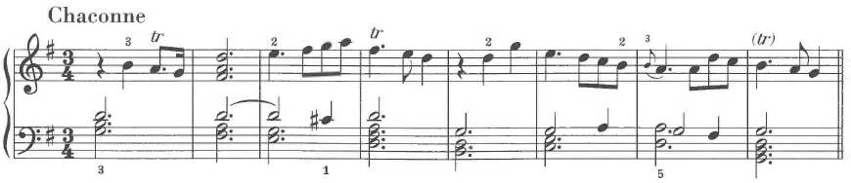
It is important to remember that use and reuse of compositional material was a common practice during this time. Yet from the perspective of recurring Mannerism, it seems important that Bach’s variations are quite different stylistically and historically from these earlier examples. Handel’s Chaconne dates from 1703-1706 and was published in his Suites de Pieces pour le clavecin of 1733. Purcell’s work was written even earlier. Thus, Bach’s Goldberg Variations represent a Mannerist stylization of a historical model. Williams describes the Goldberg Variations as “dialoguing with past music” and as “a deliberate attempt on the composer’s part to raise the standard then current.” Furthermore:
In Bach’s 32-bar structure the traditional dance-style and idiosyncrasies of chaconnes are now quite lost, and none of the variations resembles in any respect a chaconne of the kind underlying Purcell’s variations. . . .I imagine this was deliberate, and Bach cannot have been the only composer to feel that such a common-property bass required him to make an original gesture with it.

In addition to this “dialoguing with past music,” the Goldberg Variations also reflect the influence of contemporary keyboard practices. Domenico Scarlatti published his first book of keyboard sonatas in 1738. Williams points out the coincidence that Scarlatti’s pieces are entitled Essercizi, a word synonymous with the German Übungen, and also contains thirty “highly characterized” pieces, the same number as the Goldberg Variations. Yet, more importantly, the technical style of Domenico Scarlatti is clearly imitated in the Goldberg Variations. In particular, the technical challenges required by the second piece in each group of three variations, the pièce croisée, were pioneered by Scarlatti. Williams continues saying “it cannot be out of the question that the Goldberg Variations was in part a response to that book of Scarlatti, whose fabulous musicianship and playing technique are nevertheless clear enough from it.”
The Goldberg Variations imitate both past styles and contemporary harpsichord technique. In particular, the ostinato bass line of the Goldberg Variations was used extensively by other Baroque composers including Muffat, Purcell, and Handel. As is typical of Mannerism, Bach sought to improve on this model. In addition, Bach also imitates the technical writing of Domenico Scarlatii in the recurring arabesques making use of hand crossing techniques. Wolff even questions whether Schiebe’s famous attack on Bach (basically calling him “old fashioned”) was the catalyst for Bach’s assimilation of Scarlatti’s contemporary technical idiom in the last few years of his life. Along with historical and stylistic consciousness, Wolff’s contention suggests self-consciousness, an important psychological component of Mannerism.

Artificial Intricacy
Symmetries and formulas are common in the Goldberg Variations making it a work of considerable intricacy. Yet, Bach purposefully breaks these symmetries and formulas on occasion. These irregularities seem planned and composed, imparting a sense of artificiality to its intricacy.
One such example of such a calculated irregularity involves the first and last group of three variations. The sequence normally is as follows: genre piece, pièce croisée, canon. Yet, Variation 1 contains hand crossing and Variation 2 is a genre piece. Curiously, Variation 2 sounds more canonic than the actual canonic variation, Variation 3.

Figure 2. Bach, Goldberg Variations, Variation 2, mm. 1-9
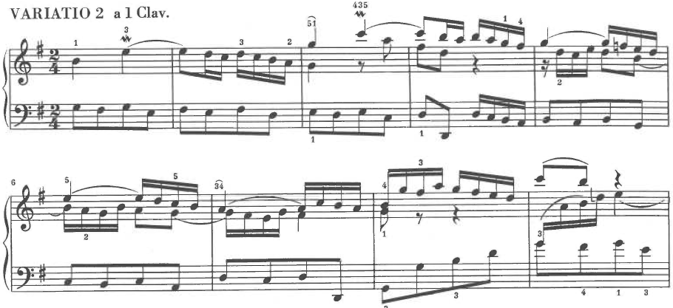
Even more curiously, the final group of three variations contains similar irregularities. Likewise, Variation 28 contains hand crossing while Variation 29 is the genre piece, a toccata.
Figure 3. Bach, Goldberg Variations, Variation 28, mm. 5-6
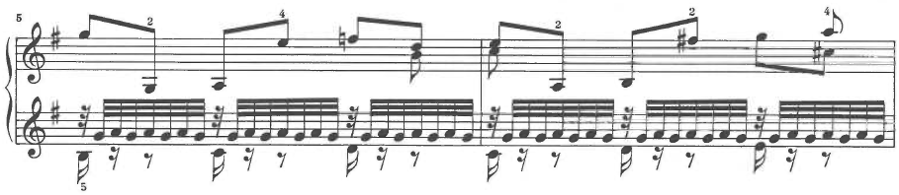
Perhaps Bach planned these irregularities to account for the final anomaly, Variation 30. Variation 30 is a quodlibet (a Baroque mash-up) rather than the expected canon at the tenth. Thus, even though the groups of variations that begin and end the set are irregular in comparison to the overall work, these irregularities are still symmetrical. Perhaps no better example of artificial intricacy exists in music.
Other curious irregularities are common within the Goldberg Variations. Another example concerns the canons at the fourth and the fifth, Variations 12 and 15.
Figure 4. Bach, Goldberg Variations, Variation 12, mm. 1-3; Variation 15, mm. 1-3
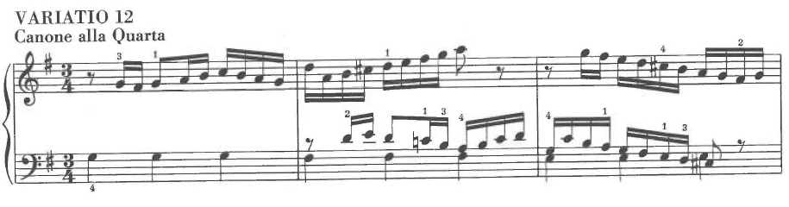
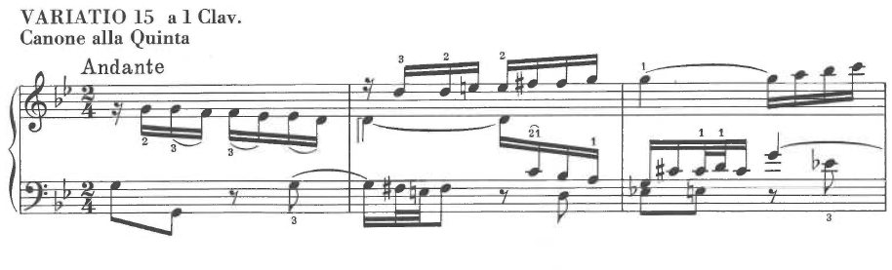
Both canons are in inversion whereas the previous three had been in similar motion. Williams points out that the next canon at a perfect interval, the octave, does not continue with this trend as if the two canons in inversion are a calculated irregularity. While this is true, perhaps if the first canon at a perfect interval is taken into consideration, the result is another uniquely calculated symmetry. Thus, Variations 3 and 24 are canons at the unison and the octave in similar motion and Variations 12 and 15 are canons in inversion, creating symmetry amongst the canons at perfect intervals. Indeed, the idea that a symmetrical construction could be uniquely irregular seems hyperbolically Baroque, perhaps to a Mannerist extent.
Another calculated irregularity is the placement of the minor variations. They seem to confound the symmetrical plan as it was conceived. Variations 15, 21, and 25 are in the parallel minor. This placement does not seem to correspond to the division of variations into groups of threes or with the division of the whole set into two halves. The same can be said for the placement of the slow variations. The minor variations and the slow variations intrude upon the symmetrically rather than contribute to it.

Expressionism and Surrealism
Of Maniates’ five criteria for recurring Mannerism, expressionism and surrealism is the least compatible with Baroque aesthetics in general and the Goldberg Variations in particular. Mannerist art tends to polarize either towards sophisticated intellectualism or overt emotionalism. In the author’s opinion, the Goldberg Variations fall in the former category of Mannerist art. For example, the Aria adequately portrays an affect, as Baroque art should. The affect could be described as grace or serenity. Indeed, the extent that the affect is portrayed is beautiful, perhaps perfect. Yet, it lacks the extreme emotionalism that seems necessary to qualify as expressionism.
Perhaps only two variations might qualify under this category. The first is the final minor variation, Variation 25. This variation is the emotional centerpiece of the entire set of variations. Bach achieves in Variation 25 a level of pathos that is profound and quintessentially Baroque.
Figure 5. Bach, Goldberg Variations, Variation 25, mm. 1-3
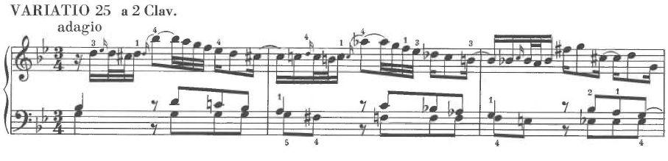
There are several ways that Bach achieves such a heightened level of emotionality, all concerning chromaticism. The first way is that the ostinato bass line becomes fully chromaticized. In the major variations, the bass line simply steps down from G to F# to E to D. In Variation 25, the steps are filled in with chromatic half steps. In addition, measures 2 and 3 feature a dissonant suspension, creating the Baroque convention often called the “sigh” or “tear drop” figure. Indeed, this fully chromaticized bass line with “tear drop” motive is reminiscent of Purcell’s famous aria When I am Laid in Earth from Dido and Aeneas.
Another way that Bach’s writing contributes a heightened sense of emotionality to Variation 25 is in the modification of the recurring harmonic scheme required by minor mode variation. The third phrase, mm. 17-24, modulates to the submediant, E minor, in the major mode variations. The minor mode requires that this phrase modulate to E flat major instead. Yet, in Variation 25, the contrapuntal texture is so overloaded with mode mixture (notice the profusion of G flats, C flats, D flats, and even F flats) that the modulation appears to be progressing towards the exceedingly distant key of E flat minor. Tovey calls this modulation “a fact that we should refuse to believe even of Bach, if we had not the passage before us to prove and justify it.” At ms. 24, a resolution to G natural (as a Piccardy third) preserves the expected E flat major just in time.

Figure 6. Bach, Goldberg Variations, Variation 25, mm. 20-25
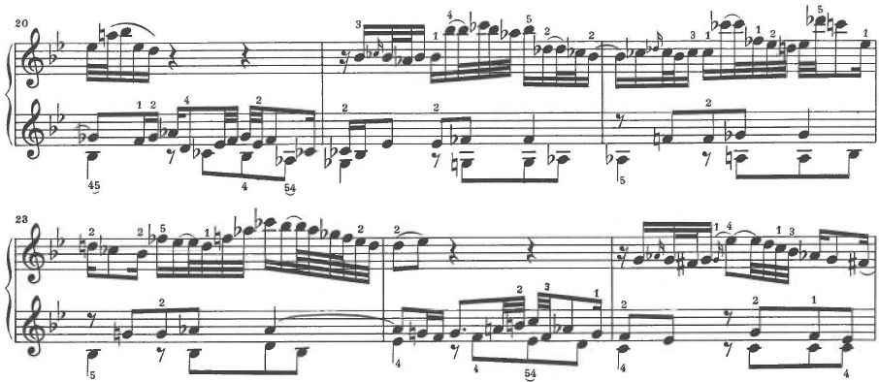
Indeed, this profusion of chromaticism, particularly to the flat side, contributes greatly to the sense of pathos emanating from Variation 25. As a result, the music progresses quite naturally through extremely distant tonal regions. For example, as early as ms. 2, a startling leap up to a dissonant A-flat in the melody necessitates a passing progression through the key of F minor.
Figure 7. Bach, Goldberg Variations, Variation 25, mm. 1-3
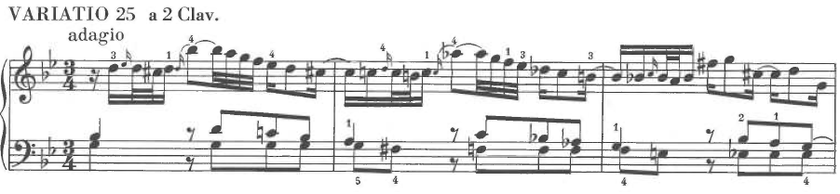
On the other hand, the concluding variation, the Quodlibet, is a joyous final climax before the repetition of the Aria. Indeed, this variation might be the only piece in Bach’s oeuvre that might be appropriately described as bawdy. A quodlibet is a piece of music that combines several melodies, often popular tunes, in counterpoint. The quodlibet was a centuries old tradition at this point and one that the Bach family particularly enjoyed. Forkel, an early Bach biographer, recounts how the Bach family would create such quodlibets:
As soon as they were assembled a chorale was first struck up. From this devout beginning they proceeded to jokes which were frequently in strong contrast. That is, they then sang popular songs partly of comic and also partly of indecent content, all mixed together on the spur of the moment. … This kind of improvised harmonizing they called a Quodlibet, and not only could laugh over it quite whole-heartedly themselves, but also aroused just as hearty and irresistible laughter in all who heard them.

Variation 30 contrasts greatly with the pathos of Variation 25 and provides a fitting and joyous climax to the overall set.
Figure 8. Bach, Goldberg Variations, Variation 30, mm. 1-3
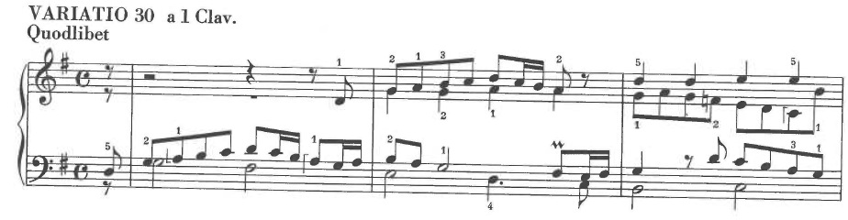
From a Mannerist perspective, ending with the raucous quodlibet fulfills the qualifications of an effetti meravigliosi, a marvelous or astonishing effect. It is as if to say, not only can Bach compose variations using every contrapuntal difficulty, he can even disguise this difficulty by incorporating well-known tunes. Whether these variations qualify as expressionism is debatable. Yet, these two variations clearly articulate the nadir and apex of the emotional range.

Refinement and Preciosity
Bach’s Goldberg Variations reach a level of refinement that can be appropriately described with the word preciosity. The virtuosic rendering of details and minutiae was an especially important component of sixteenth century Mannerist painting. The same can be said of Bach’s treatment of the canonic variations and other aspects of the Goldberg Variations.
The compositional variety in the canonic variations is extraordinary. The first way that Bach creates this variety concerns the entry of the canonic voices. As the bass line must preserve the ostinato, the upper and middle voices contain the canon. Incidentally, this creates a trio-sonata type of texture amongst the voices in the canonic variations. An important detail that is consistently varied throughout the Goldberg Variations is the order of the voice entries. Of the nine canonic variations, four begin with the upper voice (Variations 3, 9, 12, and 24), four begin with the middle voice (Variations 6, 16, 18, and 21), and one is exceptional (Variation 27). Another detail that is consistently varied concerns the time frame of the second voice entry, the answer. Six of the nine canonic variations feature a canonic answer exactly one measure after the initial presentation. Two variations (18 and 21) answer a half measure later. Variation 24 answers after two measures. Another detail that is varied amongst the canons is the time signatures. Indeed, the nine canons utilize eight different time signatures. While both Variations 9 and 21 are written in common time, discrepancies in surface rhythm still suggest a different tempo be taken in these two variations. The various treatment of these details in the canonic variations (especially taking into account the directional inversion of two of these variations discussed previously) suggest that Bach was “aiming at a survey” of canonic possibilities.
The last canonic variation, Variation 27, is exceptional in several ways. It is the only canon that is not written in three voices (resembling a trio sonata).
Figure 9. Bach, Goldberg Variations, Variation 27, mm. 1-3
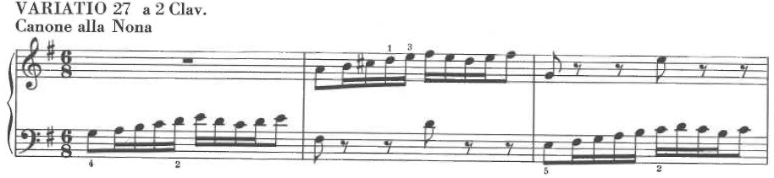
Because Variation 27 has only two voices, Bach must overcome the additional difficulty of incorporating the ostinato bass line into the lower voice of the canon. Also, Variation 27 is both redundant and isolated. The canons complete the octave cycle in Variation 24. This has led some to believe that the Goldberg Variations were originally conceived as a set of twenty-four variations rather than thirty. Thus, Variation 27, a canon at the ninth, falls outside the octave cycle. Also, Bach does not continue with the pattern by writing a canon at the tenth for the finale, further isolating Variation 27. Furthermore, Variation 27 could be considered redundant as it merely repeats the canon at the second from Variation 6, only an octave higher.
The Goldberg Variations are refined to the point of preciosity in ways other than those concerning the detailed nature of the canonic variations. There is a repeated emphasis on numerology, especially twos and threes within the variations. Some of these have been previously mentioned (especially the groups of three variations). There are other levels though, especially concerning the number two. The set begins with an Aria, played twice (once at the beginning and then again at the end). There are two halves to the work: Variation 16 begins the second half with a grand French Overture. Each movement is in exactly two halves, each to be played twice. The phrasing and cadential pattern consistently divide each section of the binary form into two. Both modes (major and minor) of the tonic key are utilized. Indeed, with the Italian Concerto and the partitas, the Goldberg Variations are one of only a few pieces that Bach wrote specifically for a two-manual harpsichord. The importance of these details contributes a profound sense of refinement to the work.

CHAPTER IV: ANALYSIS OF BEETHOVEN’S DIABELLI VARIATIONS

Beethoven as Mannerist
As Maynard Solomon writes in Late Beethoven: “the issue of Beethoven’s place in the turn from Classicism to Romanticism not only has been the subject of some controversy but has undergone several extreme pendulum swings over the course of time. The question is by no means settled.” In The Classical Style, Charles Rosen argues that “with all Beethoven’s declared independence from preceding influences, and his evident resentment of Haydn, there was in his career no radical movement away from the style of Mozart and Haydn comparable to the break with the past made by the generation of Schumann and Chopin.” Thus, this document will offer the novel solution to Solomon’s question (in partial agreement with Rosen) by arguing that Beethoven represents a chronologically late stage in the development of eighteenth century Classicism consistent with recurring Mannerism. The Diabelli Variations, op. 120, will be analyzed to further this argument using the criteria for recurring Mannerism given by Maniates.
Seaton and Haar make concurring points concerning Mannerism that are relevant to this discussion of Beethoven. For Seaton, Mannerism occurs at the end of a stylistic cycle. For Haar, Mannerism occurs after a model or a completely integrated “high” style has been recognized. These conditions are met with Beethoven, particularly within the style of his last compositional period. Indeed, it can be argued that the “high” Classical style was achieved for roughly two decades at the end of the eighteenth century. The dates 1775-1795 seem appropriate as they encompass most of Mozart’s mature writing. Beethoven, completing the Diabelli Variations in 1823, was writing within this style nearly three decades after its zenith.
Mozart wrote at least fourteen sets of piano variations. For the purposes of this argument, any of these sets could serve as models for “high” Classical variations. Stewart Gordon describes the basic features:
They represent his more ‘popular’ side by standards of his own day. Thus, the themes used as a basis for the variations are quite simple and melodious. The structures retain a stereotyped pattern, and slow variations depend upon ingenious melodic ornamentation for effect rather than profound emotional expression. Most of them are based on borrowed themes, some operatic, some from lighter theater music, a few from folk sources or other composers’ works.

Beethoven wrote variation sets just like those of Mozart, light, popular, and melodious. However, Beethoven began experimenting with variations early in his career. The Eroica Variations, op. 35 are an example of such experimentation. This experimentation continued and culminated in the Diabelli Variations, as well as the concluding movements of the piano sonatas, op. 109 and op. 111. Kirby writes:
What is important in these sets of themes and variations, however, is the general interpretation of the category, and it is here that the originality to which Beethoven himself refers (in connection with op. 35) doubtless really lies. In the hands of Beethoven’s contemporaries and immediate predecessors (Mozart, for instance), this genre was regarded largely as a popular and galant form. And, while in many of Beethoven’s sets as we have seen, this character was preserved, it is emphatically broken in these works, which become serious major compositions. This can certainly be regarded as an important innovation.

What Kirby calls an “important innovation” could also be described in terms consistent with recurring Mannerism. With Mozart’s variation sets serving as a model, Beethoven both imitated and innovated within the style he inherited from Mozart. Thus, Beethoven’s late variations sets (and his late style in general) can be seen as an abstraction or stylization of a Classical model.
Hauser described sixteenth century Mannerism as resulting from the “crisis of the Renaissance.” A combination of religious, political, and intellectual upheaval contributed to the dissolution of the Classicism of the Renaissance and to the arrival of Mannerism. Interestingly, Beethoven’s compositional style is often referred to in the context of biographical crises (at least in popular culture). The second, or “heroic,” period is often dated as beginning with the “Heiligenstadt Testament” of 1802. His Third Symphony was written two years later in 1804. Likewise, his late style is often associated with his complete deafness and increasing social isolation. The Piano Sonata, op. 101, dates from this period. From a Mannerist perspective, these two stages represent a progressive stylization of Classicism attenuated by personal crises.
A consistent contention of this document is that history and how it is viewed is fluid. Opinions are always changing. New scholars are revising perceived historical knowledge. Today, especially amongst pianists, the common wisdom is that Beethoven was a universally beloved composer throughout the course of the nineteenth century. Yet, some argue that this is far from the case. Indeed, Rosen argues that Beethoven was “not an inspiration but a dead weight in the style of those who immediately followed him.” In this view, the only work by Beethoven that had any influence on the first generation of Romantics was the song cycle, An die ferne Geliebte, a truly anomalous part of his oeuvre. Chopin, who made many disparaging comments about Beethoven, seems to echo Bellori’s critique of the sixteenth century Mannerists in comparison with Raphael: “Beethoven is obscure and seems lacking in unity … the reason is that he turns his back on eternal principles; Mozart never.”
Popular culture aside, it is certain that Beethoven’s music is an expression of the Classical style of Mozart and Haydn. Yet, a clear evolution is evident. This evolution is consistent with the stylization and abstraction that signifies recurring Mannerism as the following analysis will demonstrate.

Formulas and Intellectual Constructivism
Mannerism depends upon a recognized model or “Classic” form which can be subjected to abstraction or stylization. The Diabelli Variations are an example of this type of abstraction or stylization concerning variation form. If Mozart’s variation sets are taken as such a model, there is a consistent formula. Each variation is based on a specific melodic figure or harmonic progression. There is usually one minor variation. The penultimate variation is slow and lyrical. The final variation is either climactic and virtuosic or it recapitulates the theme. In the Diabelli Variations, Beethoven takes this formula for variation sets and essentially stylizes or “classicizes” the variation form. Indeed, in Beethoven’s hands, the variation form begins to resemble the classical form par excellence: the sonata.
Kindermann gives an overview of several historical analyses of the Diabelli Variations. He writes: “Is there some unifying equivalent of larger sections or movements that embrace groups of these variations? This is a question that has preocuupied numerous critics and analysts, including von Bülow, Halm, Geiringer, Uhde, Porter, Butor, and Münster.” There is surprising agreement amongst analysts concerning the first grouping (or exposition) of variations. The first ten variations constitute a first section.
The disagreement concerns the middle variations (or development). Kinderman finds the various analyses problematic and proposes his own solution. In his analysis, Variations 11-24 form a second group. He argues that the “extreme diversity and contrast between the successive variations” is what unifies them and that this juxtaposition of extremes provides the kind of internal conflict that one finds in the development section of a sonata. He writes:
Significant in this connection is the fact that very little tonal contrast is utilized by Beethoven; only the penultimate Fugue leaves the tonality of the tonic major or minor. In the absence of sustained modulation, this work still achieves a sense of large-scale contrast through the diversity of variations in its middle section. The extremity of contrasts can be gauged by Beethoven’s juxtaposition of the three slow variations (Nos. 14, 20, 24) with three swift parodies, Vars. 15, 21, and 25. Contrast is practically axiomatic towards the centre of this immense work.

It is tempting to venture an analogy with sonata form, or the kind of psychological progression embodied in the sonata style. Standard procedure in this style is to maximize contrast towards the centre of the movement, and to consolidate the form beginning at the recapitulation, approximately two-thirds of the way through…We can see that Op. 120 consists of one large form with three distinct regions. The opening variations remain close to basic parameters of the theme and show gradually increasing freedom, which at last turns into dissociation toward the centre of the work, in increasingly radical juxtapositions.

Throughout this central region, however, a sense of progression is evident, not only toward differentiation, but toward abstraction, epitomized in the Andante, Var. 20. Vars. 21-24, passing beyond abstraction, reaffirm the concrete by absorbing a set of external contexts from the world, still seemingly disjointed.

Kinderman’s analysis continues by arguing that Variations 25-33 constitute a final grouping analogous to the recapitulation of a sonata form. Variation 25 presents Diabelli’s theme as a simple dance, yielding the sense of return expected in a recapitulation.
Figure 10. Beethoven, Diabelli Variations, Variation 25, mm. 1-3
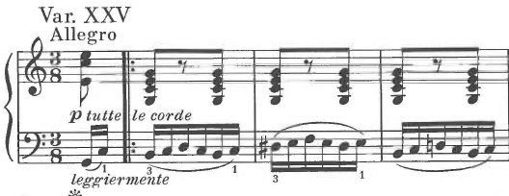
Variations 25-28 differ from the preceding variations of the middle group. If the middle group variations are best characterized by dissociation and juxtaposition, Variations 25-28 are unified in their sense of progression towards a goal. This is achieved through rhythmic diminution. This is consistent with the idea that groups of variations act as formal structures and represent a stylization of typical variation form. As Kinderman explains:
In the Diabelli Variations, the effect of the progressive rhythmic intensification is not contemplative or exploratory, but dramatic. In four stages (Vars. 25-8), a surrogate for the waltz is presented, gradually transformed, and finally obliterated by the sheer blind energy which is the outcome of foreshortening of rhythm and accent. The culmination of this process, in turn, generates energy that makes possible a transition to the set of slow minor variations, and hence to the conclusion of the entire work. The rhythmic progression in the four variations beginning with the last thematic parody (Vars. 25-8) is thus a keystone in the overall structure, and it has not only formal but dramatic and indeed almost programmatic implications.

Similarly, Variations 29-31 constitute a structural group, a set of minor variations. In order to maintain Classical proportions, Beethoven enlarges the typical minor variation into a group of three. This group of minor variations is the emotional centerpiece of the whole set as they make possible the sense of spiritual transcendence achieved in the last two variations. This sense of spiritual transcendence is the hallmark of Beethoven’s late compositional style. In addition, the historical reference in the first and last of these variations is unmistakable and will be dealt with in the following section.
Variation 32 is a grand triple fugue. This variation is a stylization of climactic final variations in the Classical style. In typical Mannerist fashion, this variation sets up a difficulty to be overcome through sheer compositional (and pianistic) virtuosity. Beethoven transforms Diabelli’s modest theme into three subjects that can be played simultaneously. After this fitting climax, Variation 33 brings the work as a whole to a transcendent denouement. Again, this variation is a stylization of typical variation procedure. There are two ways classical variation sets end: with a climactic final variation or a recapitulation of the theme. Beethoven’s ending has the emotional effect of recapitulating the theme. Yet, instead of a verbatim repetition of Diabelli’s theme, the naïve waltz with which the set begins is stylized into another dance: a minuet of truly Mozartian charm.
The previous discussion, making use of Kinderman’s structural analysis, shows that the Diabelli Variations contain all of the elements found in typical variation sets. Yet, Beethoven treats them in such a way that they take on features of the sonata form. In particular, the Diabelli Variations can be organized into three groups that fulfill a similar psychological progression to that found in sonata form. Thus, Beethoven has taken the formula given to him in a variation set and subjected it to a classicizing stylization. Rosen concurs, stating that “the variation form loses its additive character, and conforms to the dramatic and almost spatially conceived figures of sonata style…With this movement it is possible at last to say that the variation set has become a classical form.”

Imitation of Past Styles and Manners
Historical consciousness, even self-consciousness, is a fundamental ingredient of Mannerism. Vasari documented this phenomenon at length as it pertained to sixteenth century Mannerists. Artists learned their craft by constantly copying artworks from the historical canon. They measured themselves against the works of the great masters, particularly Raphael and Michelangelo. They viewed history as a process of evolution leading to their own time. A similar sense of historical consciousness is plainly evident in the late works of Beethoven, particularly the Diabelli Variations.
That parody is an essential element of the Diabelli Variations is well known. But, different kinds of parody are at work within the variations. Mostly, Diabelli’s theme is subjected to parody. The opening variation is such an example. This type of parody is utilized to articulate the form of the variations and to provide an intellectual narrative that describes their course. But, parody of particular styles and composers is also a technique that Beethoven utilizes in the Diabelli Variations. In particular, this type of parody concerns Variations 22-24. Kindermann writes:
After this variation (No. 21) a new sense of parody is evident, not merely as caricature of the theme, but as the evocation of styles and idioms that absorb an almost encyclopedic range of contexts, historical and contemporary. Towards its close, the subject of the Diabelli Variations ceases to be merely the waltz, or even its possibilities of formal transformation, and becomes the entire musical universe as Beethoven knew it.

Variation 22 is based explicitly on Mozart’s Don Giovanni. Beethoven gives the tempo indication “Allegro molto alla ‘Notte e giorno faticar’ di Mozart.”
Figure 11. Beethoven, Diabelli Variations, Variation 22, mm. 1-4
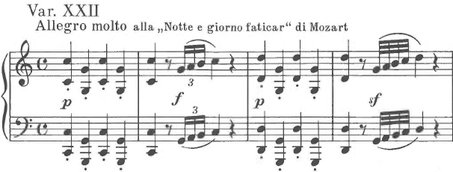
This parody of Mozart’s Don Giovanni shares important melodic features with Diabelli’s theme, namely the descending fourth and fifth found at mm. 1 and 5 of the theme. Indeed, the thematic similarity between the two is humorous in itself. Yet, this allusion to Mozart could be interpreted in several ways, contributing to what Freedberg called “multivalence of meaning.” Some biographers have suggested that this quotation of Leporello represents Beethoven’s reaction to pressure from Diabelli to finish composing the variations as Leporello’s words translate “Night and day I slave for one who does not appreciate it.” On a deeper level, this quotation suggests a psychological affinity between Beethoven and Leporello. Kindermann explains:
This is because Leporello shares a psychological trait usually developed to a considerable degree by great artists—a capacity for ironic detachment. A quotation from Leporello fits the work whereas a quotation from the Don, or virtually any other character from the opera, would not: Beethoven’s relationship to his theme, like Leporello’s relationship to his master, is critical but faithful. And like Leporello, his variations now gain the capacity for disguise, as if they were not what they seem to be. With uncanny wit, this variation expands the scope of the set beyond the formalistic limits of art.

Thus, Variation 22 contains at least three layers of parody. First, Diabelli and Leporello’s theme are aurally similar. Second, there is a biographical element that connects Beethoven to Leporello’s complaint. And third, Beethoven and Leporello both display the quality of ironic detachment. This layering (especially in a parody of a past style) is exactly what Freedberg meant by “multivalence of meaning.”
Variation 23 also parodies a specific piece of music, the first study of Johann Baptist Cramer’s Pianoforte-Method. The following figure shows their similarity:
Figure 12. Beethoven, Diabelli Variations, Variation 23, mm. 1-2; Cramer, Pianoforte-Method, No. 1, mm. 1-2
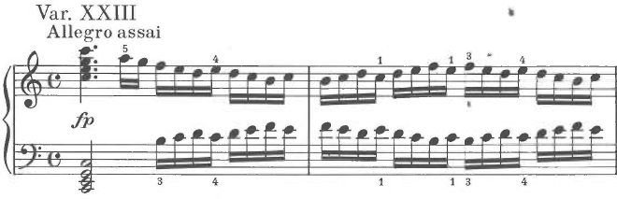
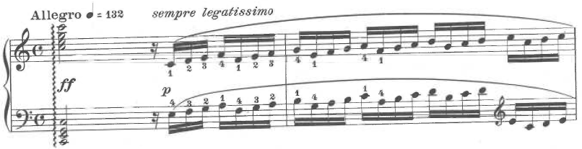
Like the parody of Variation 22, Variation 23 also suggests multiple layers of meaning. The first and most obvious is that Beethoven’s variation represents the propensity for piano etudes to showcase empty technical facility rather than musical content. Secondly and perhaps without irony, Beethoven was known to admire Cramer and to use his exercises in his teaching. Variation 23 could simply be homage to Cramer. Thirdly, Beethoven might be criticizing the banality of Diabelli’s variation compilation project. One could imagine Beethoven sarcastically pondering, “ Out of fifty variations, how many will be as boring as this one?” Or, it could simply be interpreted as “parody of pianistic virtuosity in general.” Regardless, the variation suggests multiple nuanced meanings and seems artificially placed between variations that also parody other composers.
Variations 23 and 24 are an example of the drastic juxtapositions that occur consistently throughout the Diabelli Variations (particularly in the middle section). Yet, they are similar in that both are parodies, this time of J.S. Bach’s fugal style.

Figure 13. Beethoven, Diabelli Variations, Variation 24, mm. 1-6
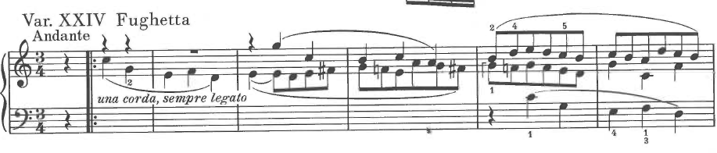
This Fughetta contrasts sharply with other fugues in Beethoven’s output. Variation 32, the fugue from the Eroica Variations Op. 35, and the first movement development of Op. 106 make this clear. One writer described this Fughetta in nearly religious terms as “simultaneously cool and warm; as like a phenomenon of nature and yet much more than a symbol for that; as consolation, solace; as serious and objective and full of love.” Indeed, the contrast that the Fughetta makes with the preceding variation suggests an important aspect of Mannerist art: discontinuity and the fracturing of meaning.
Variation 29 and 31 are also imitations of Bach’s style and were perhaps even inspired by specific pieces. Variation 29 treats Diabelli’s theme differently than most variations. Rather than mockingly parodistic, the character of Variation 29 is mournful and noble. The tone and texture of this variation invites comparison to the E flat minor Prelude from the first volume of Bach’s Well-Tempered Clavier.

Figure 14. Beethoven, Diabelli Variations, Variation 29, mm. 1-3; Bach, E-flat minor Prelude, WTC. I, mm. 12-14
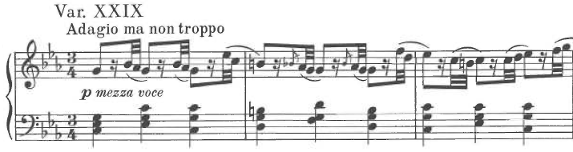
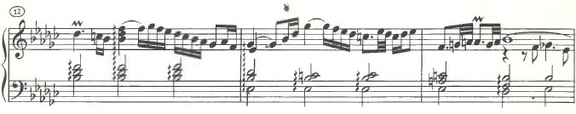
Variation 31 of the Diabelli Variation is based on Variation 25 of Bach’s Goldberg Variations. Indeed, though there is no evidence to document Beethoven’s knowledge of the Goldberg Variations, the overwhelming similarity between these two variations suggests that he most certainly was. Both display a highly ornamented Baroque aria-like melody over simple, chordal accompaniment.
Figure 15. Beethoven, Diabelli Variations, Variation 31, mm. 3-4; Bach, Goldberg Variations, Variation 25, mm. 1-3
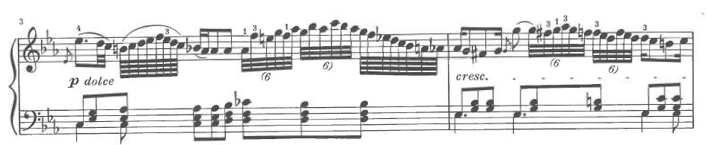
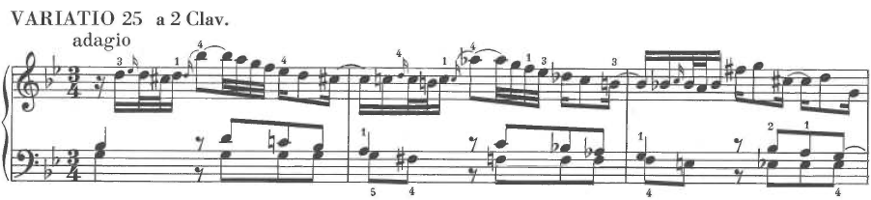
Interestingly, the climactic fugue, Variation 32, is often compared to Handel rather than J.S. Bach. Indeed, both Kinderman and Rosen make this assertion. Kinderman writes that the fugue subject is “endowed with Handelian breadth and Beethovenian energy.”
Figure 16. Beethoven, Diabelli Variations, Variation 32, mm. 1-6
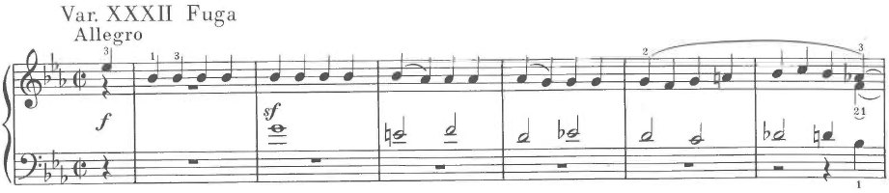
The Fugue theme uses the descending fourth and repeated notes from Diabelli’s waltz. This is easily apparent from an aural perspective and contributes to the sense of transcendence in the final group of variations. Kinderman writes “the almost constant presence of these thematic motives in the Fugue provides it with an important synthetic function in which the head of the waltz melody, although immediately recognizable, is entirely abstracted from the banality of its original context.” Not only is Beethoven writing in a Handelian style, the fugue theme itself is an abstraction of Diabelli’s waltz. Imitation of style and abstraction from a model are consistent indicators of Mannerism.
The concluding variation transforms Diabelli’s rustic German waltz into a refined and graceful minuet. Rosen explains it thusly: “the dance returns—not Diabelli’s simple waltz any longer, but the most delicate and complex of minuets, with a lavish play of sonorities that Beethoven rarely permitted himself. In the Diabelli, Beethoven attained the witty combination of lyricism and irony that was part of Mozart’s natural grace, and that Haydn was too good-humored to imitate.”
Figure 17. Beethoven, Diabelli Variations, Variation 33, mm. 1-4
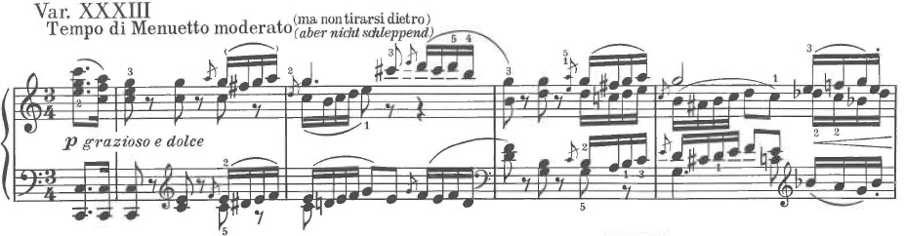
Of the various criteria for recurring Mannerism, the Diabelli Variations exhibit profound historical consciousness. Variations 24, 29, and 31 are allusions to the style of J.S. Bach. Variations 22 and 33 either imitate Mozart or quote him directly. Variation 23 parodies the piano etudes of Cramer. Variation 32, the grandiose triple fugue, recalls Handel. Beethoven’s absorption of historical styles and the self-consciousness suggested by it is indicative of Mannerism.

Artificial Intricacy
The previous sections demonstrate the intricacy of the Diabelli Variations to a sufficient degree. But to what extent is that intricacy artificial? The word, artificial, means that something is created by man rather than found in nature. Beethoven’s variations exhibit this kind of artificial intricacy when the chronology of their creation is taken into account.
The genesis of the Diabelli Variations is a well-known story. The music publisher, Anton Diabelli, composed a waltz and invited fifty composers of the Austrian Empire to write one variation each. The fifty variations would be compiled into a set and sold as sheet music.
Diabelli received his first contribution to the project in May of 1819. The first contributor was Carl Czerny, Beethoven’s former pupil. This implies that Beethoven was probably familiar with Diabelli’s waltz as early as the first few months of 1819. Yet, Beethoven’s Diabelli Variations were not completed until the spring of 1823 over four years later.
The first chapter in Kinderman’s analysis traces the chronology of Beethoven’s work on the Diabelli Variations by examining sketchbooks. Kinderman contradicts several biographers that have argued Beethoven’s initial conception of the set was small, perhaps as few as six or seven variations and that the scale of the composition expanded during the process of composition. This conception is incorrect as about two thirds of the variations, including the penultimate fugue, were conceived in 1819. Then, Beethoven stopped working on the set for as long as two years. During this time, Beethoven worked on other projects such as the Missa Solemnis and the last piano sonatas, Opp. 110 and 111. Beethoven returned to the Diabelli Variations in 1822 and completed them in 1823.
The interruption of the compositional process in itself is not important. What is important, though, is the way that the variations composed later affect the form of the set as a whole. Indeed, most of the “added variations” are those that articulate the form and contribute to the transcendental effect of the closing group of variations.
For example, Variations 1-2 were two of the last written. The sketchbooks from 1819 reveal that Variation 3 was originally intended as the first variation. The problem with beginning the set with Variation 3 is that it is too far removed from Diabelli’s theme. It would set apart Diabelli’s theme rather than making the theme part of the fabric pervading the entire work. By preceding Variation 3 with two variations that directly parody the theme, Beethoven is announcing from the beginning that Diabelli’s theme will be an integral part of the composition.
One of the most curious added variations is Variation 15. The tempo indication is Presto scherzando. As a result, it is one of the briefest variations in the set. As was mentioned before, the middle variations increase the dramatic tension of the set through drastic juxtapositions. This is certainly true of Variations 14-15 as Variation 14 is one of the slowest, longest, and most profound while Variation 15 is one of the fastest, briefest, and most mocking of all the variations. Thus, the added Variation 15 contributes to the sense of juxtaposition in the middle group of variations while also rearticulating Diabelli’s theme in parody, much like Variation 1.
Most of the variations written after 1819 are found at the end of the set. These include Variations 23, 24, 25, 26, 28, 29, 31, and 33. Variations 23 and 24, both direct historical parodies of Cramer and J.S. Bach were added to enlarge the sense of historical parody begun with the Don Giovanni parody of Variation 22. In particular, Variation 25 shares similarities with Variations 1 and 15. In particular, it initiates the final group of variations by recapitulating the theme. Variations 29 and 31, both parodies of J.S. Bach, enlarge into a group of minor variations along with the previously written Variation 30. And, obviously, Variation 33 provides a fitting denouement.
The previous discussion shows that Beethoven’s conception for the Diabelli Variations was grand, even in 1819. But more importantly, the added variations contribute to the form. Kinderman explains:
When Beethoven expanded his draft of the whole work in 1822-3, he left his older variation order internally intact for the most part, but opened with two new variations (the present Vars.1 and 2), added many more variations towards the end, and inserted one at the middle of the set. As we shall see, these added variations contribute substantially to the form of the whole work, imposing not a symmetrical but an asymmetrical plan, an overall progression culminating in the last five variations.

The Diabelli Variations are undeniably different from other sets of classical variations. Indeed, the compositional process just examined is wholly different than the genesis of typical variation sets. During that era, variation sets were essentially extemporaneous improvisations that were then written down. Beethoven and Mozart in particular were known for their improvisational skills. Yet, the Diabelli Variations were not conceived through improvisation, the natural genesis of most variation sets. Rather, the Diabelli Variations were man-made, resulting from a grand conception over a lengthy four-year time span. That the Diabelli Variations are compositionally intricate seems obvious. But it is an intricacy marked by the artificiality of a lengthy compositional process. This artificial intricacy is a criteria for Mannerism.

Expressionism and Surrealism
Of expressionism and surrealism, expressionism seems the more appropriate descriptor in reference to Beethoven. Although, one could argue that certain variations, perhaps Variation 20, evoke timelessness in a way that might be considered surreal. Expressionism, on the other hand, seeks to evoke “subjective emotions rather than to portray objective reality.”
In the Diabelli Variations, there is a particular way that Beethoven achieves a sense of heightened emotional expression consistent with expressionism. Indeed, this particular way is Manneristic because it also abstracts a specific detail of Diabelli’s theme, the harmony of mm. 23-4.
Figure 18. Beethoven, Diabelli Variations, Theme, mm. 20-25
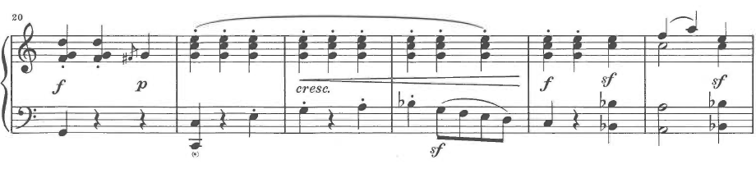
The harmony in question is a dominant seventh chord that tonicizes the subdominant. This is a common harmony in tonal music, especially at a point roughly towards the end of a composition. Interestingly, though this is a common harmony, Beethoven’s variations almost never recreate it at the comparable point within a variation. Instead, Beethoven substitutes more dissonant harmonies that fulfill the same harmonic function. The two harmonies that Beethoven substitutes are a fully diminished seventh chord, E-G-B flat-D flat, or a full minor-ninth chord, adding a D flat to Diabelli’s harmony. “Placement of either of these dissonant sonorities at this position in the form considerably increases the musical tension, and some of the most dramatic passages in the variations depend upon the ambiguity of this diminished seventh and the C-D flat semitone conflict embodied in the minor ninth chord. This effect, heightening the emotional tension, is consistent with expressionism.
For example, in Variation 5, the dissonance of the minor ninth chord eventually propels the music into D flat major, briefly tonicizing the Neapolitan harmony.
Figure 19. Beethoven, Diabelli Variations, Variation 5, mm. 16-28
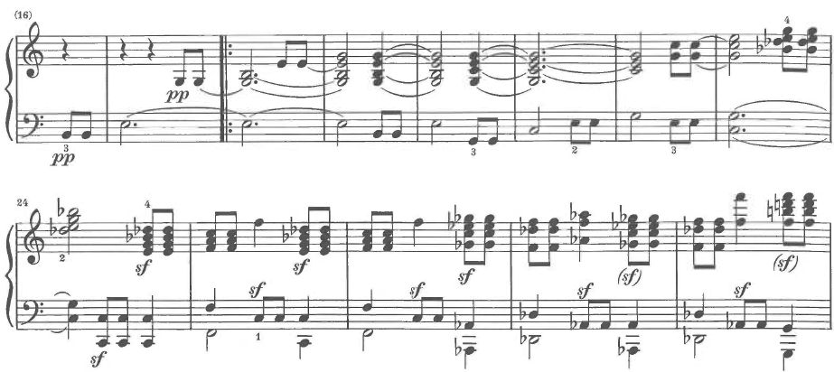
Similarly, Variation 9 contains a more extended modulation to D flat that utilizes the ambiguities of the fully diminished seventh chord with its multiple goals of resolution and potential for enharmonicism.
Figure 20. Beethoven, Diabelli Variations, Variation 9, mm. 22-27
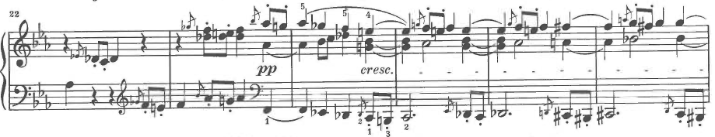
In Variation 12, the sense of progression stops as the bass repeats a turn figure for several measures exploiting the dissonant relationship between C and D flat.

Figure 21. Beethoven, Diabelli Variations, Variation 12, mm. 25-28
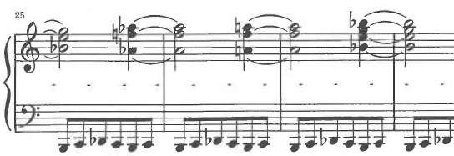
The climax of Variation 14 is created after the dominant seventh harmony is prolonged for two measures. The bass note C surprisingly moves up a half step to C sharp.
Figure 22. Beethoven, Diabelli Variations, Variation 14, mm. 10-12
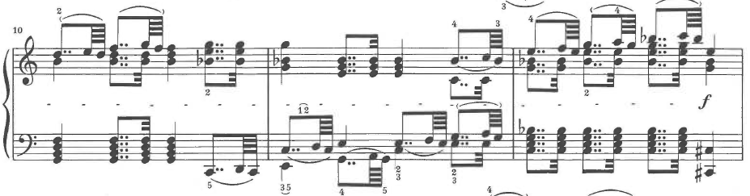
The beginning of the second half of Variation 30 also utilizes the diminished seventh harmony to tonicize the subdominant.
Figure 23. Beethoven, Diabelli Variations, Variation 30, mm. 12-13
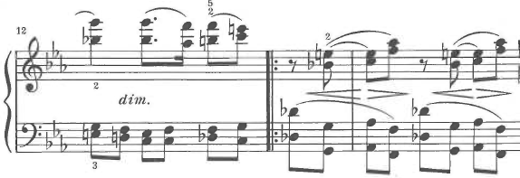
These slight alterations to the harmonic scheme of Diabelli’s theme contribute an emotional intensity to the music. Indeed, the analogous spot in Beethoven’s variations is often the point of harmonic climax. This abstraction of Diabelli’s theme and its expressionistic use is consistent with Mannerism.

Refinement and Preciosity
As was mentioned in Chapter II, the virtuosic rendering of detail is a fundamental aspect of Mannerist art. These details are often executed to such a refined degree that preciosity is a more appropriate term. In much Mannerist art, this attention to detail is exhibited in two different ways. In the first way, an object or body part is executed with such a degree of perfection that it loses its sense of reality. Freedberg uses the term “aestheticized” to describe such details. Admittedly, this type of refinement is more characteristic of J.S. Bach’s late music than Beethoven’s. The other way that this attention to detail exhibits itself in Mannerist art is in the inclusion of details that seem best described as bizarre. Bronzino’s Portrait of a Young Man is an example (although these details abound in Mannerist art). The young man’s right eye stares directly at the viewer while his left seems to be focused in an anatomically impossible direction. Also, two pieces of furniture are exquisitely decorated with grotesque masks. The effect of these strange details is ponderous. They seem to pose questions that are not easily answerable. Several details from Beethoven’s Diabelli Variations exhibit a similarly bizarre or irrational effect.
One such example can be found in Variation 20, one of the most emotionally profound of the set. In this variation, the slow tempo and long note values combined with canonic entrances of the theme melody contribute to a sense of timelessness or other-worldliness. The following figure contains mm. 9-13.
Figure 24. Beethoven, Diabelli Variations, Variation 20, mm. 9-13
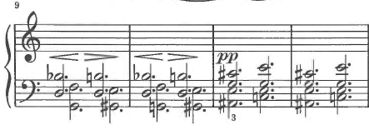
The hairpins at mm. 9 and 10 are baffling from an interpretive perspective. They are just as impossible or unreal as many anatomical features of Mannerist art. The hairpins seem to ask interpretive questions of the performer for which an answer is difficult to arrive it. From a theoretical perspective, the two measures that follow are just as opaque. While the A# fully diminished seventh chord and the C major chord share two common tones, these two chords lack the sense of progression required by tonal music. The effect is almost coloristic and contributes to the other-worldliness of the variation. It is a curious detail as the variation, though extremely chromatic, never again loses its sense of tonal progression.
Beethoven again conjures a sense of other worldliness in the transition from Variation 32 to Variation 33. Like Variation 20, the emotional quality seems to be predicated on a brief, detailed suspension of typical tonal harmonic progression.
Figure 25. Beethoven, Diabelli Variations, Variation 32, mm. 161-166
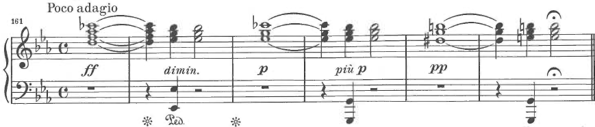
Through the use of augmented triads, enharmonic reinterpretation, and common tones, the music arrives at an E minor triad in first inversion. This chord then acts like an altered dominant propelling the music into the C major of the final variation. Like Variation 20, this short suspension of traditional tonality has a particular emotional effect. The words bizarre or ponderous could be used to describe either.
Solomon’s analysis contains other examples of irregular details as well. The lengthy quote that follows points to one in Variation 4. But, attention should be given to words that beg comparison with Mannerism. Solomon writes:
Several of these early variations contain a calculated irregularity or a surprising or anomalous feature; thus, part one of Variation 4 is a measure short (fifteen measures), providing an elliptical jolt that opens a momentary space of indeterminacy until part two reverts to its full quota of measures; elsewhere there are touches of capriciousness and whimsy, a jesting spirit, asymmetries, strange progressions, or jagged inversion. We don’t know what Beethoven intended by these touches; they are unlike the deliberate flecks of strangeness by which an artist sometimes articulates a sense of beauty’s indefinable sake, or a provisional defeat of Gestalt-like expectations in order subsequently to restore a magnified sense of wholeness. But these touches of weirdness may also be read as emblems of difficulty on an implied narrative route, of obstacles on the path to virtue, salvation, or a safe resting-place. Ironically, a composer who, because of his departures from a presumed (and ill-defined) classical model, had often unfairly, been charged with bizarrerie by uncomprehending listeners, hidebound critics, and classicizing competitors, has now chosen actually to represent the bizarre, the grotesque, the undecorous, the unbeautiful, the incomplete, finding these essential to his larger purposes.

This quote from Solomon is remarkable in its accuracy despite the fact that he is mistaken in at least one respect. While Solomon states that these anomalies are unlike similar bewildering techniques by artists, these anomalies or bizarre details are exactly consistent with Mannerism. He even uses much of the same language needed to define it. For example, “departure from a presumed classical model” is nearly a complete definition of Mannerism! Fairly or unfairly, Mannerism is often described with the following terms: irregular, surprising, anomalous, capricious, weird, difficult, bizarre, and grotesque. Thus, these bizarre details in the Diabelli Variations beg for comparison to similar details in Mannerist art. Indeed, these details yield an over-refined quality, preciosity, that is fundamental to Mannerism.

CHAPTER V: ANALYSIS OF LISZT’S VARIATIONS

ON A THEME OF BACH, WEINEN, KLAGEN, SORGEN, ZAGEN

Liszt as Mannerist
The Romantic era in music poses one problem while solving another problem concerning Mannerism as a recurring phenomenon. The previous chapters presented analyses of variation sets that are undeniably well known and are staples of the standard piano repertoire. They also happen to be excellent examples of recurring Mannerism. Unfortunately, the Romantic era does not present such an obvious counterpart in piano literature to the Goldberg and Diabelli Variations. Part of this problem is that variation sets were composed less frequently by the nineteenth century. The two sets of Romantic variations for the piano that come most readily to mind, Mendelssohn’s Variations Sérieuses and Brahms’ Variations on a Theme by Handel, exhibit few signs of recurring Mannerism. While there are numerous examples of late Romantic music marked by Mannerism, little of this music is written for the piano. Though less well known, Liszt’s Variations on a Theme of Bach, Weinen, Klagen, Sorgen, Zagen (hereafter “Weinen, Klagen Variations”) fulfill the requirements for recurring Mannerism while also alleviating a problem. While neither the Goldberg nor the Diabelli Variations are perfect examples of Maniates’ fourth criteria (expressionism) for recurring Mannerism, Liszt’s Weinen, Klagen Variations appear to be such an example.
Romanticism in music was a durable style. While the first generation of Romantic composers (Liszt included) came of age in the 1830s, composers like Rachmaninoff and others continued to write in this style well into the twentieth century. If one were to speculate on a cohesive, integrated “high” Romantic style, it would be difficult to label such a period with a specific date. This is complicated by the fact that the functional tonal system that governed harmonic practices began to come apart during this time. Wagner’s Prelude to the opera Tristan und Isolde is often associated with this harmonic phenomenon. Written in the late 1850s and premiered in 1865, it seems appropriate to reason that a “high” Romantic style was achieved before that important work. Thus, it is reasonable to estimate that the “high” Romantic style was achieved in the 1840s and first half of the 1850s. Liszt’s Weinen, Klagen Variations were written shortly after this period in 1862. From a chronological standpoint, the Weinen, Klagen Variations are sufficiently past the apex of Romanticism to qualify as a Mannerist expression of the style.
In addition, Liszt’s compositional output is often categorized as either being early or late in his career. Rosen argues that 1850 is the dividing point in Liszt’s compositional career. He writes: “ Written in 1852, the Sonata in B Minor is a pivotal work between Liszt’s early and late style. With the first Mephisto Waltz, it is the only piece to be conceived entirely after 1850 to remain a basic part of the piano repertory (although at least two beautiful late works merit equal respect: the Weinen, Klagen Variations and the Jeux d’eaux a la Villa d’Este).”
Rosen’s quote elucidates another important point concerning the compositions of Franz Liszt. Put simply, Liszt’s output is qualitatively uneven, more so than other great composers. Another way of saying this is that Liszt wrote masterpieces as well as many forgettable works. Indeed, this critical judgment has dogged Liszt since the nineteenth century. The following quote exemplifies this judgment:
The issue (critics) pursued Liszt into old age. During a masterclass held in June 1885, August Stradal was playing Liszt’s Weinen, Klagen Variations. Liszt turned to the class and remarked: “If you want a bad criticism, you must play this. It will then be said: “the young artist is not lacking in talent—it remains only to regret that he made such a poor choice of piece.”

Not only do Liszt’s own words exemplify the widespread opinion that his output is uneven, they point to a psychological component important to Mannerism: self-consciousness.

Formulas and Intellectual Constructivism
In the previous discussion of Bach’s Goldberg Variations, it was mentioned that Mannerist art tends to polarize either towards sophisticated intellectualism or overt emotionalism. The Goldberg Variations are an example of the former. The formulaic nature of Bach’s composition contributes a profound sense of intellectual constructivism. On the other hand, Liszt’s compositions are a better example of the tendency towards overt emotionalism. The Weinen, Klagen Variations exemplify this tendency as well as any piece by Liszt.
Yet, Liszt’s music is certainly dominated by formulas. As the foremost piano virtuoso of the nineteenth century, Liszt’s piano music is dominated by specific examples of piano technique that are ubiquitous in his oeuvre, becoming formulaic as a result. These formulaic examples of technical writing contribute to the emotional intensity of the work. Indeed, these Lisztian technical formulas could even be described as mannerisms in the lower-case sense of the word. They are habitual gestures or idiosyncracies. The Weinen, Klagen Variations contain numerous examples of Liszt’s technical formulas.
Unison passages between the hands are one of the most common techniques that Liszt exploits consistently in his piano music. These passages are typically arpeggios or scales. As they are meant to heighten the emotional expression of the music, fully diminished seventh chords and chromatic scales are especially common. Measure 195 of the Weinen, Klagen Variations arpeggiates a fully diminished seventh chord in unison and covers the whole range of the piano.
Figure 26. Liszt, Weinen, Klagen Variations, ms. 195
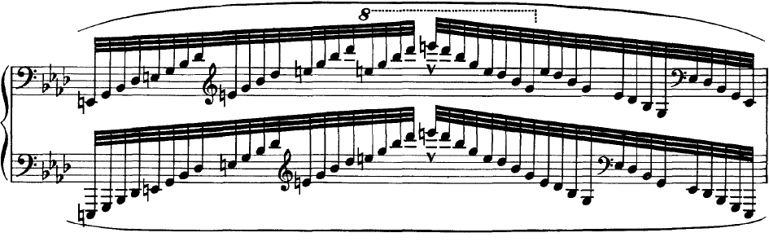
The Introduction (mm. 1-18) also ends with such a unison passage. The chromatic descent of the passacaglia theme is foreshadowed by the expressive chromatic scale played in unison, finally resting on the tonic note, F.
Figure 27. Liszt, Weinen, Klagen Variations, mm. 16-18
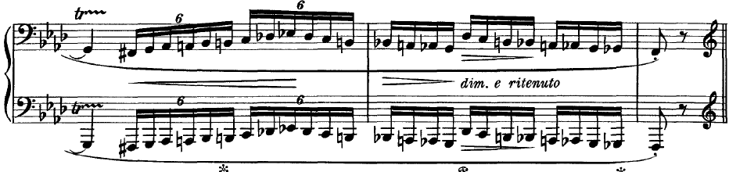
Another common technical formula that Liszt consistently utilizes concerns octave technique. Perhaps the most idiosyncratic way Liszt writes octaves is to stagger the hands and play a chromatic scale so that the thumbs of each hand are basically interlocking. Measures 171-2 are an example of a chromatic scale with interlocking thumbs.
Figure 28. Liszt, Weinen, Klagen Variations, mm. 170-2
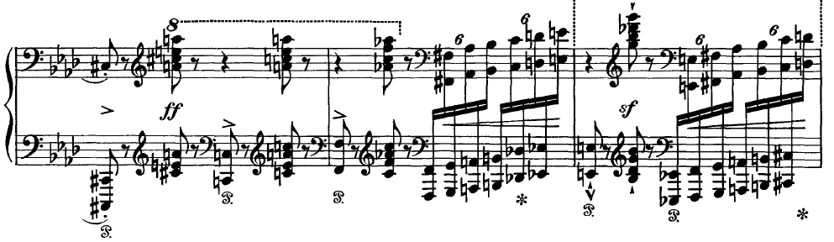
Perhaps the most ubiquitous feature of Liszt’s piano music is the tendency for the momentum to halt and devolve into a lengthy section that imitates the vocal recitative of opera. This is a habitual gesture in Liszt’s piano music and the Weinen, Klagen Variations are no exception. For example, a lengthy section marked “Lento Recitativo” is initiated after a grand pause in ms. 216.
Figure 29. Liszt, Weinen, Klagen Variations, mm. 215-230
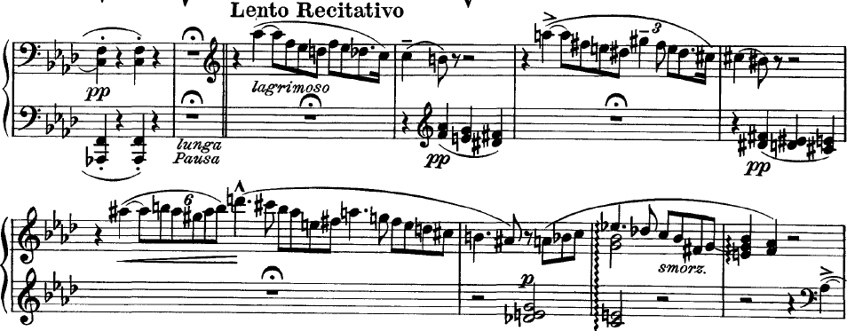
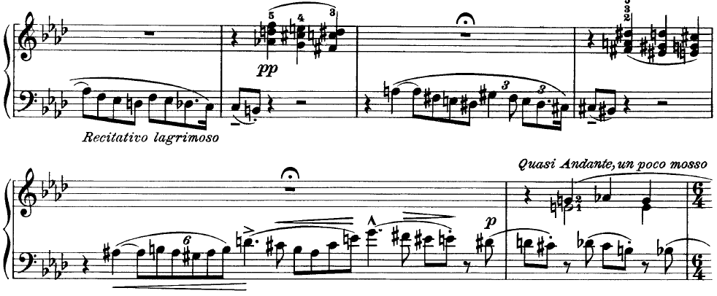
A related feature in Liszt’s piano music is cadenza-like passages. These passages are typically notated in smaller type and are often performed with rhythmic abandon. Such an example acts as a transition to the chorale finale of the Weinen, Klagen Variations.
Figure 30. Liszt, Weinen, Klagen Variations, mm. 319-23
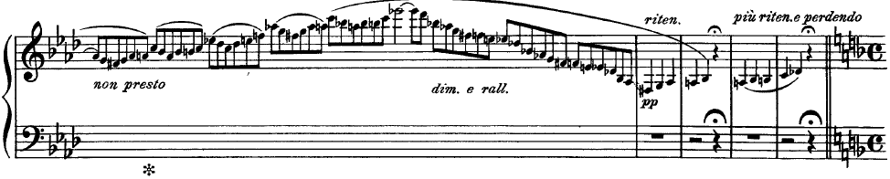
These examples illustrate a few of the technical and expressive formulas that Liszt uses consistently in the Weinen, Klagen Variations and his piano music generally. Numerous additional examples making use of octaves, repeated notes, repeated chords, double notes, register leaps, and other technical devices abound in Liszt’s piano music. Those shown in this analysis, however, are especially common.

Imitation of Past Styles and Manners
As the full title suggests, Liszt’s Weinen, Klagen Variations are indebted to J.S. Bach and Baroque variation procedures. The Weinen, Klagen Variations, unlike the other variation sets in this document, is a passacaglia. The variations are continuous rather than discrete and are based on a recurring bass line.
Liszt’s variations are based on the bass line used by Bach in his cantata by the same name, Weinen, Klagen, Sorgen, Zagen, BWV 12. This cantata, one of Bach’s earliest, was first performed in Weimar in 1714. There are seven movements to the cantata. The bass line used in Liszt’s variations comes from the second movement, a chorus marked Lento. Incidentally, the same bass line (transposed) is also used in the Crucifixus movement of the Mass in B minor. The following example shows the bass line as given in the continuo part of the cantata.
Figure 31. Bach, Cantata: BWV 12, Chorus: Lento, mm. 1-5
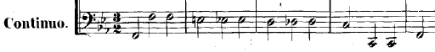
The initial presentation of the bass line in Liszt’s Weinen, Klagen Variations is subtly altered. While the rhythm and meter are largely preserved, the quarter note is given the beat rather than the half note. Also, it is played one octave higher and there is no repetition of notes. Liszt adds accents and slurs as well, accentuating the sighing effect of the descending chromatic motion.

Figure 32. Liszt, Weinen, Klagen Variations, mm. 18-22
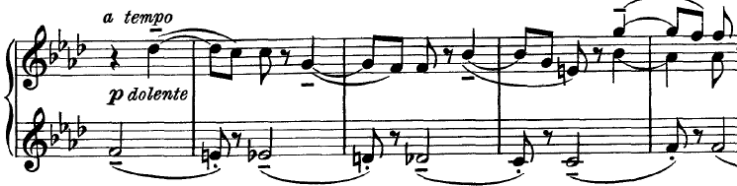
In addition to Baroque variation procedures utilizing a recurring ostinato bass line, Liszt’s variations end with a triumphant coda. This coda also references Bach’s cantata. The seventh piece of Bach’s cantata is a chorale titled Was Gott tut, das ist wohlgetan, which translates “What God does, that is well done.” Liszt’s chorale setting begins simply, in four-part harmony, but quickly starts to exploit more complex aspects of piano technique. The score also prints the words to the chorale above the score, making the reference to Bach’s chorale explicit.
Figure 33. Liszt, Weinen, Klagen Variations, mm. 324-30
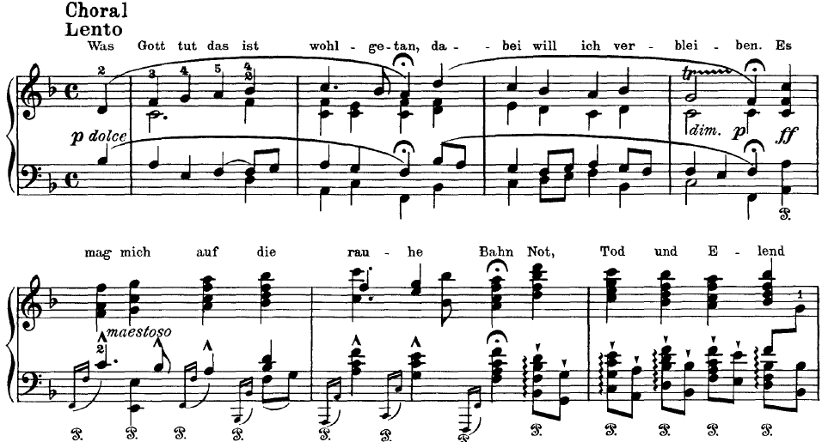
Considering how faithfully Liszt adheres to the structure of a Baroque passacaglia, the Weinen, Klagen Variations clearly imitate the Baroque style. Yet, despite these Baroque practices, the Weinen, Klagen Variations are quintessentially Romantic in their harmonies and exploitation of piano technique. Mannerism has a peculiar tendency both to look backwards at previous ages while also remaining current or even progressive. Liszt’s Weinen, Klagen Variations are an example of this tendency of Mannerist art.

Artificial Intricacy
The Weinen, Klagen Variations are artificial in that they assimilate specific aspects of Bach’s cantata into the form and texture of the work. Indeed, the two works share more than a recurring bass line. A close examination of both works shows that Liszt’s composition adapts certain formal and textural components of the cantata. This appropriation imparts an artificiality to Liszt’s work that is a common feature of Mannerist art.
Bach’s cantata, written early in his career, contains seven movements. The first movement is an instrumental Sinfonia. The second is a choral passacaglia from which the bass line is appropriated. The third is a recitative. The fourth, fifth, and sixth movements are arias. And the final movement is a chorale.
Liszt’s Weinen, Klagen Variations borrow more than just the bass line from the passacaglia movement of Bach’s cantata. In addition, the formal layout of the set is constructed to resemble Bach’s cantata. For example, Liszt’s Weinen, Klagen Variations can be analyzed as dividing into seven sections with a design similar to the cantata movements.
Bach’s cantata begins with an introductory Sinfonia. Liszt’s variations also begin with an introductory section before the passacaglia proper begins. The Andante, mm. 1-18, acts as an introduction to the work. Here, the melody of the introduction, rather than the bass, utilizes the ostinato bass line. And in true late Romantic fashion, Liszt uses a series of sequences to explore distant tonal areas from the outset. Beginning on the submediant harmony in second inversion, these sequences emphasize C-flat major and B-double flat major before circling back to the submediant, though in the minor mode.
Figure 34. Liszt, Weinen, Klagen Variations, mm. 1-9
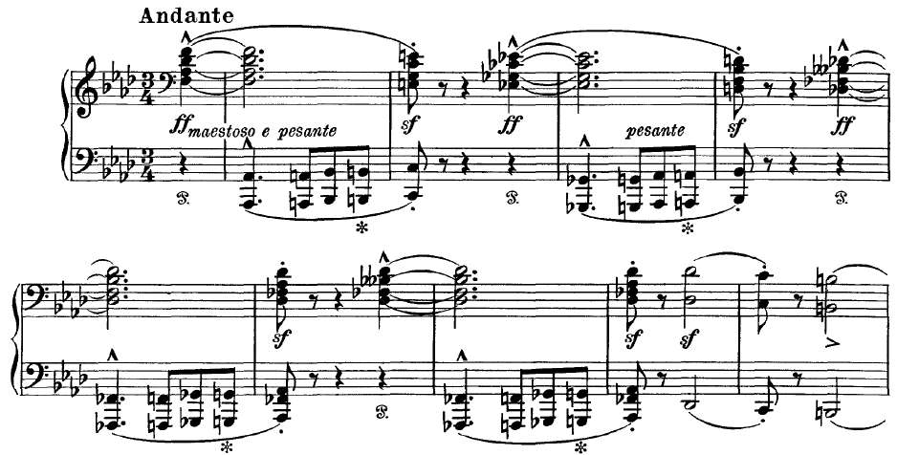
The second section of the Weinen, Klagen Variations is also related to the formal layout of Bach’s cantata. The second movement of Bach’s cantata is the passacaglia. Likewise, the second section of Liszt’s work begins the passacaglia proper. Furthermore, the textural addition of voices in the first three iterations of the recurring bass line imitates the vocal entries in Bach’s cantata, causing chains of dissonant suspensions.

Figure 35. Liszt, Weinen, Klagen Variations, mm. 18-29
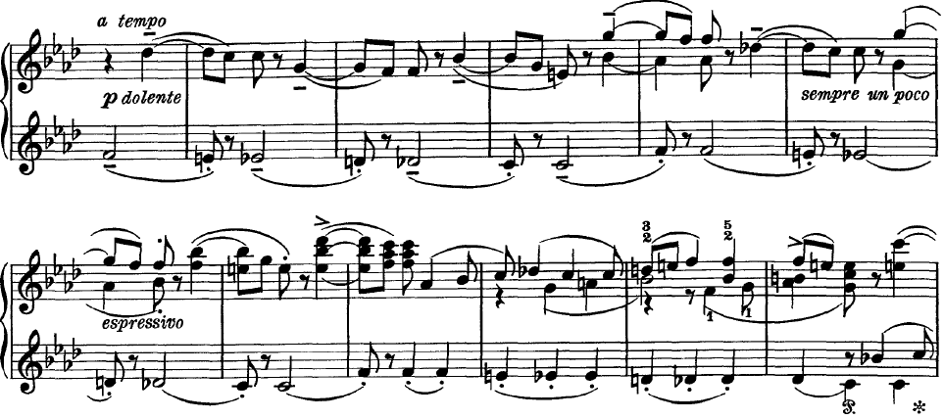
Both Bach’s cantata and Liszt’s Weinen, Klagen Variations contain a section of recitative. In Bach’s cantata, the recitative is the third movement while in Liszt’s work the recitative is the fourth section. While these parts do not line up as perfectly as in the others mentioned, the inclusion of a section of recitative around the midpoint suggests that Liszt was indeed basing his work on Bach’s.
The last section of Liszt’s Weinen, Klagen Variations also is clearly related to Bach’s example. The final movement in the cantata is a chorale based on the hymn, Was Gott tut, das ist wohlgetan. Liszt’s Weinen, Klagen Variations also end with a chorale-like presentation of the hymn.
Thus, Liszt’s work is structurally based on Bach’s cantata. Both works contain the same number of movements or sections, seven. The first is an introduction. The second is the passacaglia (or begins the passacaglia in the case of Liszt’s piece). Both contain a section of recitative in the middle. And the seventh movement or section is a chorale based on Was Gott tut, das ist wohlgetan.

Expressionism and Surrealism
Liszt’s Weinen, Klagen Variations are a stronger example of Maniates’ fourth criteria for recurring Mannerism, expressionism and surrealism, than were the other variation sets analyzed in this document. From a stylistic perspective, Baroque and Classical works generally are not prone to expressionism. Those styles simply lack the exaggeration required for expressionism. Romanticism, on the other hand, can be quite expressionistic. This is especially true of late Romantic music.
A simple translation of the text from Bach’s cantata yields another explanation for why this particular work is marked by expressionism. Weinen, Klagen, Sorgen, Zagen means “weeping, wailing, mourning, trembling.” It is not surprising that such a text would yield a work of profound expressionism by such a late Romantic composer as Franz Liszt.
It is also not surprising that the impetus for writing such a work would be autobiographical. Liszt, a deeply religious man, had just suffered the loss of two of his children, one in 1859 and another in 1862. Walker writes of the Weinen, Klagen Variations:
The emergence of such a piece in the second half of 1862 was not accidental. It is best understood as a symptom of the grieving process, and like so much else in Liszt’s output this music is really autobiographical. Liszt found in the first movement of Bach’s cantata Weeping, Wailing, Mourning, Trembling a wonderful vehicle for his grief. He composed his own variations on its ground bass.

Liszt and later composers for the piano were able to achieve such an exaggerated emotionalism in their music because they dramatically increased the technical range of the instrument. Liszt, considered one of the greatest virtuosos of the nineteenth century, was able to increase the emotional range capable of piano music. Rosen describes the way Liszt, influenced by Paganini, made expressionism possible:
On a much larger scale, Liszt did for the piano what Paganini had done only a few years previously for the violin. Listeners were impressed not only with the beauty of Paganini’s tone quality but also with its occasional ugliness and brutality, with the way he literally attacked his instrument for such dramatic effect. Liszt made a new range of dramatic piano sound possible, and in so doing he thoroughly overhauled the technique of keyboard playing.

The Weinen, Klagen Variations are similar to many pieces by Liszt in that they exploit the most difficult and innovative of technical passages to achieve a broader range of emotion. Indeed, the examples from the Weinen, Klagen Variations are too numerous to list completely. Dramatic registral changes, thunderous chords, and arpeggios that sweep across the entire keyboard contribute to the expressionism of the work, as the following example demonstrates.
Figure 36. Liszt, Weinen, Klagen Variations, mm. 199-202
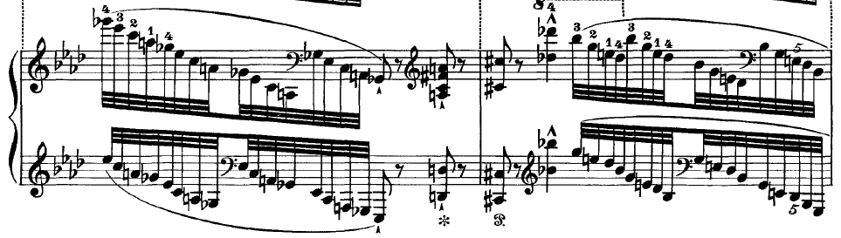
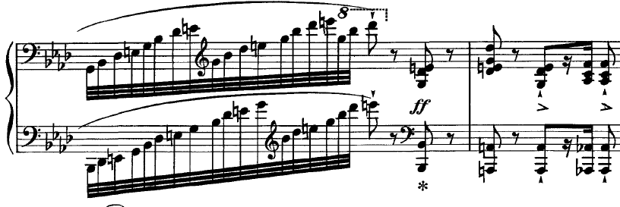
Aside from advancements in piano technique, Liszt was also able to expand the emotional range of his compositions because of the extended tonal harmonic practices common in the latter part of the nineteenth century. The most obvious example of this extension is the pervasive chromaticism found in the work. Indeed, this pervasive chromaticism is suggested by the chromatic descent of the recurring bass line. One analyst, Michele Tannenbaum, argues that Liszt utilizes the most extreme elements of Bach’s style, in order to arrive at the most extreme elements of his own. She writes:
Thus, the elements of Bach’s score that represented the extreme limits of chromaticism in 1714 come to represent the extreme limits of chromaticism in 1862. Having formed the germinal material of this project, Liszt goes on to generate a substantial formal structure with some similarity to Bach’s, yet unique unto itself. For all the remarkable innovations of both structure and local detail, particularly sonority, Liszt depends on ancient contrapuntal practices of sequence, imitation, augmentation and diminution, melodic embellishment, cantus firmus, and voice exchange to accomplish this.

Written after the death of two of his children, the Weinen, Klagen Variations are an example of a greatly exaggerated emotionalism that is consistent with expressionism. Deeply indebted to Bach’s cantata, the piece is built around one of the most expressive devices from Baroque music, the chromatic descending ostinato. Liszt imparts his own sense of expressionism through a dramatic increase in the capacities for technical writing for the piano and a bold extension of tonal harmonic practices.

Refinement and Preciosity
The Weinen, Klagen Variations are not a typical variation set for the piano. The most obvious way that they diverge in comparison to others is that they are based on the procedures of the Baroque passacaglia. Indeed, Tannenbaum calls the title a “terminology of convenience.” The Weinen, Klagen Variations differ from typical variation sets in several additional ways. For example, variation sets are not typically preceded by an introduction. They also are not concluded with a coda, especially a coda that is musically unrelated to the preceding variations. But aside from these digressions from typical variation procedures, Tannenbaum further argues that the Weinen, Klagen Variations “assimilate elements of both variation technique and symphonic poem.” This assimilation of both variation and symphonic poem suggests a highly refined composition.
Liszt is the composer most associated with the symphonic poem, an orchestral piece usually consisting of one movement with a programmatic element. For example, a symphonic poem might evoke the content of a certain poem or painting. Liszt scholar Humphrey Searle describes Liszt’s symphonic poems as follows:
In the symphonic poems Liszt wished to expound philosophical and humanistic ideas which were of the greatest importance to him, and many of them were connected with his personal problems as an artist … He was not interested in the minute pictorialism into which the symphonic poem later degenerated, nor in the first place, in “telling a story” in music; the story, if any, to him was merely the symbol of an idea.

Liszt’s Weinen, Klagen Variations are like a symphonic poem in that they are contained in one continuous movement. They are built almost exclusively from the descending, chromatic motion borrowed by Bach. But most importantly, like Bach’s cantata, they symbolize the transformation of grief into redemption, as the final section achieves a powerful climax in the tonic major. By combining elements of the Baroque passacaglia with contemporaneous symphonic procedures, Liszt’s Weinen, Klagen Variations achieve a sophisticated level of refinement.

CHAPTER VI: SUMMARY AND CONCLUSIONS

As this document shows, the criteria for recurring Mannerism given by Maniates can be used as the basis for analysis of music. In doing so, the argument can be made that certain pieces are, therefore, examples of recurring Mannerism. Furthermore, this document argues that Bach’s Goldberg Variations, Beethoven’s Diabelli Variations, and Liszt’s Weinen, Klagen Variations are examples of such recurring Mannerism by exhibiting those criteria.
All style periods are related to both the past and the future, retaining elements of previous styles and imparting them to subsequent styles. The philosopher Giorgio de Santillana expressed this idea similarly: “All periods are of transition, but some are more transitional than most.” This seems especially true of Mannerism.
Indeed, recognizing that Mannerism is especially Janus-faced helps to reconcile some of the disagreements found amongst notable scholars. Friedlaender argues that Mannerism is anti-Classical and forward looking. On the other hand, Shearman asserts that Mannerism emerges seamlessly from the past through imitation and stylization. Taken together, one arrives at Hauser’s “juxtaposition of irreconcilable opposites.”
The transitional nature of Mannerism is evident in each of the works analyzed in this document. For example, Bach’s Goldberg Variations are based on the chaconne, a centuries old variation form. Indeed, numerous composers used the same bass line that Bach used in the Goldberg Variations during the Baroque era. Yet, the Goldberg Variations are also progressive. In particular, the recurring periodic phrase structure of the Aria (eight-measure phrases with conclusive cadences) and its continuous use in the subsequent variations anticipates the Classical style of Haydn and Mozart. In fact, this phraseology makes the Goldberg Variations atypical of the Baroque era. Williams writes: “Also by no means as typical of music of the High Baroque as one might suppose is the conspicuously clear two-, four- and eight-bar phraseology in every movement. It is very striking throughout the Goldberg, and yet the composer is not dominated by it, nor is the continuity of each movement ever threatened.” Thus, the Goldberg Variations look back on the Baroque era while still anticipating the stylistic developments of the Classical era.
Likewise, Beethoven’s Diabelli Variations catalogue the style of various composers of the previous century. From Handel, to Bach, to Mozart, to Cramer, Beethoven imitates the styles and manners of the past and incorporates them into his own unique late style. Yet, the Diabelli Variations also anticipate the forthcoming Romantic style in certain respects. For example, the near suspension of tonal progression that occurs in the transition to the final variation is a harbinger of the breakdown of functional tonality that occurred throughout the nineteenth century. In addition, Beethoven’s stylization of the variation form anticipates the way later Romantic composers would approach large forms. Although reminiscent of a sonata, the form of the Diabelli Variations is more asymmetrical than a sonata as the climax occurs so near the end of the piece (rather than in the central development section). Rosen uses the term “telescoping” to describe this shift of the climax from the middle of the movement to as near the end as possible. Rosen finds this “telescoping” in all four of Chopin’s Ballades, the Polonaise-Fantaisie and the Barcarolle. In these works, “maximum tension is placed very near the end, and final resolution is powerfully compressed. . . . This implies that some important aspects of Classical harmony have been cast aside, along with Classical proportions.” Beethoven’s Diabelli Variations points the way towards those later works by Chopin.
In addition, Liszt’s Weinen, Klagen Variations are steeped in Baroque procedures and indebted to the past. Of the three variation sets analyzed in this document, the Weinen, Klagen Variations are the only one that uses Baroque passacaglia procedure. Yet, in their pervasive chromaticism, tonal ambiguity, assimilation of aspects of the Romantic symphonic poem, and demonic piano technique, the Weinen, Klagen Variations are quintessentially Romantic. Rosen agrees, writing that “many of these late piano works are experimental, foreshadowing the music of Debussy and the atonal composers of the early twentieth century.”

Suggestions for Further Research
Although successful in its attempt at using Maniates’ criteria for recurring Mannerism in analysis, this document made no attempt to parse the categories that were given. In the article these criteria were taken from, Maniates never attempted to define each criteria precisely. A useful future study could do just that: define each of the criteria with precision.
Indeed, there seems to be considerable overlap between at least three of the categories. In particular, intellectual constructivism, artificial intricacy, and refinement and preciosity are quite similar. This makes it difficult to determine under which category a certain feature should be placed. For example, the canonic pattern in the Goldberg Variations could be considered an example of intellectual constructivism, artificial intricacy, or preciosity.
The other two categories deserve attention as well. For example, to what extent does a piece of music need to imitate a past style or manner to be consistent with Mannerism? A piece like the Diabelli Variations certainly seems an obvious choice. Yet, nearly all art music is historically conscious to a certain extent.
Lastly, the analytical category concerning expressionism and surrealism is problematic. Indeed, some art historians, John Shearman in particular, disagree with the notion that Mannerism is at all reminiscent of expressionism. Certain pieces of music that seem to fulfill the other requirements quite well, like the Goldberg Variations, express few signs of expressionism and no signs of surrealism. Yet, other pieces, particularly those written closer to the late nineteenth or early twentieth century seem consistent with expressionism, like the Weinen, Klagen Variations. Put simply, a future study could parse the verbiage of Maniates’ criteria for recurring Mannerism, define each one precisely, and identify the best examples of each category. This could be a helpful aid for future analysts of this phenomenon.
The methodology of the present study was contingent on the “rediscovery” of Mannerism by art historians in the early twentieth century. In particular, Chapter II progressed forward through history until this rediscovery and began with the scholarship of art historians before proceeding to music. If the intention of the art historians who rediscovered Mannerism was to imbue Mannerism with positive values and descriptors, as they claimed, a future study could reverse the flow of the methodology described above. Put simply, the works analyzed in the present study never suffered from the negative evaluations that sixteenth century Mannerism endured for centuries. Indeed, the Goldberg and Diabelli Variations have been viewed as masterworks for much of their existence. Thus, a persevering researcher might be able to start from a point in the future with a work exhibiting the qualities of recurring Mannerism (e.g. the Diabelli Variations) and work backwards chronologically to argue for the positive qualities of sixteenth century Mannerism in the visual arts.
Another suggestion for further research is an interdisciplinary study of the early twentieth century as viewed by artists in comparison to musicians. It has been mentioned that many art historians in the early twentieth century became interested in sixteenth century Mannerism because of similarities with contemporaneous Expressionism. On the other hand, musicians (especially music theorists) tend to categorize the analogous musical style, namely Arnold Schoenberg and the Second Viennese School, as a recurrence of Classicism. Indeed, set theory and twelve-tone techniques abound with rationality, clarity, and order, values antithetical to Mannerism. Perhaps a researcher could investigate this divergence amongst the sister arts. Is this divergence real? Does the duality of Classicism and Mannerism break down between the sister arts in the early twentieth century? The answers to these questions could be fascinating.
The music of the sixteenth century and the nineteenth century exhibit particular similarities. Notably, the established harmonic systems of both centuries began to implode from within. Maniates’ book chronicles the progression by which the modal harmonic system of the sixteenth century devolved, continually pressed by Mannerist tendencies. In a cycle fueled by the rise of the printing press, a composer would introduce a certain harmonic audacity that would then be imitated and copied by other composers. Thus, what had begun as an audacity quickly became a cliché, necessitating the need for further audacities. This Mannerist feedback loop eventually destroyed the centuries old modal system and led to the development of functional tonality. The evolutionary process by which tonality devolved in the nineteenth century is similar. Indeed, there are many similarities between sixteenth century Mannerism and nineteenth century Romanticism. An analyst with specialized knowledge of both sixteenth and nineteenth century harmonic practices could compare and contrast the process by which the modal and tonal harmonic systems changed and eventually ended.
Because of the specialization of the author, the focus of this document has been recurring Mannerism in keyboard literature. Indeed, this focus caused certain problems that could be alleviated by an analyst capable of taking a broader approach. For the sake of brevity, an effort was made to facilitate comparisons across the three styles of the common practice era. This was achieved by analyzing works that exhibited the criteria for recurring Mannerism, while also being similar in form. This methodology was problematic in that there are few works written during the Romantic period that are within the standard keyboard repertory, in the Germanic-Austrian tradition, and exhibit the features of recurring Mannerism. Liszt’s Weinen, Klagen Variations fit these criteria although they lack the reputation of the sets by Bach and Beethoven. Put simply, there are better examples of Mannerist music within the Romantic style but these examples are outside the expertise of the author.
An analyst could reproduce this study without the focus on keyboard music and certainly show better examples of recurring Mannerism within the Romantic style. For example, if there is a classic model for the Romantic lied, numerous examples could be found by Schubert and Schumann. Lieder by Hugo Wolff, written toward the end of the nineteenth century, certainly seem Mannerist in comparison. Or, the symphonic song cycles by Richard Strauss or Gustav Mahler would be appropriate. The same could be said to a lesser extent of the Classical era. While the Diabelli Variations and other late Beethoven piano works are appropriate examples of recurring Mannerism, the late string quartets might be an even better example of this phenomenon.
To take this idea further, there is no reason to confine this phenomenon to the common practice era. Certainly, there are examples of recurring Mannerism in the twentieth and twenty-first centuries. The avant-garde composers that met in Darmstadt, Germany in the 1950s and 1960s, particularly Pierre Boulez and Karlheinz Stockhausen, might represent a Mannerist stage in the development of the style of the Second Viennese School. Another possible example of recurring Mannerism that comes to mind deserves comparison to the sets in this study. Frederic Rzewski’s The People United Will Never Be Defeated!, written in 1975, recalls both the Goldberg and Diabelli Variations in its breadth and scope. Thus, an analyst could replicate this study with similar conclusions utilizing examples outside of the keyboard repertory or the common practice era.

BIBLIOGRAPHY
Books

Badura-Skoda, Paul. Interpreting Bach at the Keyboard. Oxford: Oxford University
Press, 1993.

Bellori, Giovan Pietro. The Lives of the Modern Painters, Sculptors and Architects.
Trans., Alice Wohl. Cambridge: Cambridge University Press, 2005.

Cheney, Liana. Giorgio Vasari’s Prefaces. New York: Peter Lang, 2012.

------. Readings in Italian Mannerism. New York: Peter Lang, 1997.

Cooper, Martin. Beethoven: The Last Decade. London: Oxford University Press, 1970.

Curtius, Ernst. European Literature and the Latin Middle Ages. Princeton: Princeton
University Press, 1967.

Forkel, Johann Nikolaus. Johann Sebastian Bach: His Life, Art, and Work. Boston: Da Capo Press, 1970.

Freedberg, Sydney. “Observations on the Painting of the Maniera.” In Readings in
Italian Mannerism. Edited by Liana Cheney, 113-135. New York: Peter Lang,
1997.

______. Painting in Italy: 1500-1600. Baltimore: Penguin, 1970.

Friedlaender, Walter. Mannerism and Anti-Mannerism in Italian Painting. New York: Schocken Books, 1965.

Gerig, Reginald. Famous Pianists and Their Technique. Washington: Robert Luce, 1974.

Goldberg, Laurette. The Goldberg Variations Reader. Berkeley: MusicSources,
2002.

Gordon, Stewart. A History of Keyboard Literature. Belmont: Schirmer, 1996.

Hamilton, Kenneth. “Liszt’s Early and Weimar Piano Works.” In The Cambridge
Companion to Liszt. Edited by Kenneth Hamilton, 57-85. Cambridge:
Cambridge University Press, 2005.

Hauser, Arnold. Mannerism: The Crisis of the Renaissance and the Origin of Modern Art. New York: Alfred Knopf, 1965.

Kanwischer, Alfred. From Bach’s Goldberg to Beethoven’s Diabelli. Lanham: Rowman and Littlefield, 2014.

Kinderman, William. Beethoven’s Diabelli Variations. Oxford: Clarendon Press, 1987.

Kirby, F. E. A Short History of Keyboard Music. New York: Free Press, 1966.

Maniates, Maria Rika. Mannerism in Italian Music and Culture, 1530-1630. Chapel Hill: University of North Carolina Press, 1979.

Robinson, Franklin. The Meaning of Mannerism. Hanover: University Press of New England, 1972.

Rosen, Charles. The Classical Style. New York: Norton, 1971.

______. The Romantic Generation. Cambridge: Harvard University Press, 1995.

Samson, Jim. Chopin. New York: Schirmer, 1996.

Santillana, Giorgio de. The Age of Adventure: The Renaissance Philosophers. New
York: The New American Library, 1964.

Schulenberg, David. The Keyboard Music of J.S. Bach. New York: Schirmer, 1992.

Searle, Humphrey. The Music of Liszt. New York: Dover Publications, 1966.

Seaton, Douglas. Ideas and Styles in the Western Musical Tradition. New York:
McGraw-Hill, 2007.

Shearman, John. Mannerism. London: Penguin, 1967.

Smart, Alistair. The Renaissance and Mannerism in Italy. London: Thames and Hudson, 1971.

Smyth, Craig Hugh. Mannerism and Maniera. Locust Valley: J.J. Augustin Publishers, 1960.

Solomon, Maynard. Beethoven. New York: Schirmer, 1977.

______. Late Beethoven: Music, Thought, Imagination. Berkeley: University of California Press, 2003.

Stokstad, Marilyn. Art History. Upper Saddle River: Pearson, 2008.

Studing, Richard, ed. Mannerism in Art, Literature and Music: a Bibliography. San
Antonio: Trinity Press, 1979.

Tovey, Donald Francis. Essays in Musical Analysis. London: Oxford University Press, 1944.

Uhde, Jurgen. Beethovens Klaviermusik, vol. 1. Stuttgart: Reclam, 1968.

Vasari, Giorgio. The Lives of the Artists. Translated by Julia and Peter Bondanella.
New York: Oxford University Press, 1991.

Walker, Alan. Franz Liszt: The Final Years, 1861-1886. Ithaca: Cornell University
Press, 1996.

Watkins, Glenn. Gesualdo: The Man and His Music. Oxford: Oxford University Press,
1991.

Williams, Peter. Bach: The Goldberg Variations. Cambridge: Cambridge University Press, 2001.

Wollf, Christoph. Johann Sebastian Bach: The Learned Musician. New York: Norton,
2000.

Articles

Apel, Willi. “French Secular Music of the Late Fourteenth Century.” Medieval
Academy of America 55 (1950): 1-39.

Cooper, Barry. “Beethoven’s Use of Silences.” The Musical Times 152, no. 1914 (2011): 25-43.

Haar, James. “Classicism and Mannerism in 16th Century Music.” International Review of the Aesthetics and Sociology of Music 25, (1994): 5-18.

Harran, Don. “’Mannerism’ in the Cinquecento Madrigal?” Music Quarterly 55 (1969): 521-544.

Herzog, Patricia. “The Practical Wisdom of Beethoven’s Diabelli Variations.” The Music Quarterly 79, no. 1 (1995): 35-54.

Kliemann, Julian and Antonio Manno. "Vasari." Grove Art Online. Oxford Art Online. Oxford University Press, accessed May 16, 2016.

Maniates, Maria Rika. “Mannerist Composition in Franco-Flemish Polyphony.” The Music Quarterly 52, no. 1 (1966): 17-36.

______. “Musical Mannerism: Effeteness or Virility?” The Music Quarterly 57, no. 2 (1971): 270-293.

Moevs, Robert. “Mannerism and Stylistic Consistency in Stravinsky.” Perspectives of
New Music 9 (1971): 92-103.

Tannenbaum, Michele. “Liszt and Bach: ‘Invention’ and ‘Feeling’ in the Variations on a Motive of Bach.” Journal of the American Liszt Society 41 (1997): 49-87.

Dissertations

Maniates, Maria Rika. “Combinative Techniques in Franco-Flemish Polphony: A Study of Mannerism in Music from 1450-1530,” diss., Columbia University, 1965.

Scores

Bach, Johann Sebastian. Goldberg-Variationen. München: G. Henle Verlag, 1978.

______. “Praeludium VIII, BWV 853,” in Das Wohltemperierte Klavier: Teil I. München: G. Henle Verlag, 1978.

Beethoven, Ludwig van. Diabelli-Variationen. München: G. Henle Verlag, 1989.

Cramer, Johann B. “Etude No. 1,” in 60 Studi Scelti Per Pianoforte. Milan: Ricordi, 1988.

Handel, G. F. “Prelude und Chaconne, HWV 224,” in Klaviersuiten un Klavierstücke. München: G. Henle Verlag, 1998.

Liszt, Franz. “Variationen uber das Motiv van Bach,” in Piano Works, Vol. 10. Leipzig: Peters.

APPENDIX A: IRB RELEASE FORM
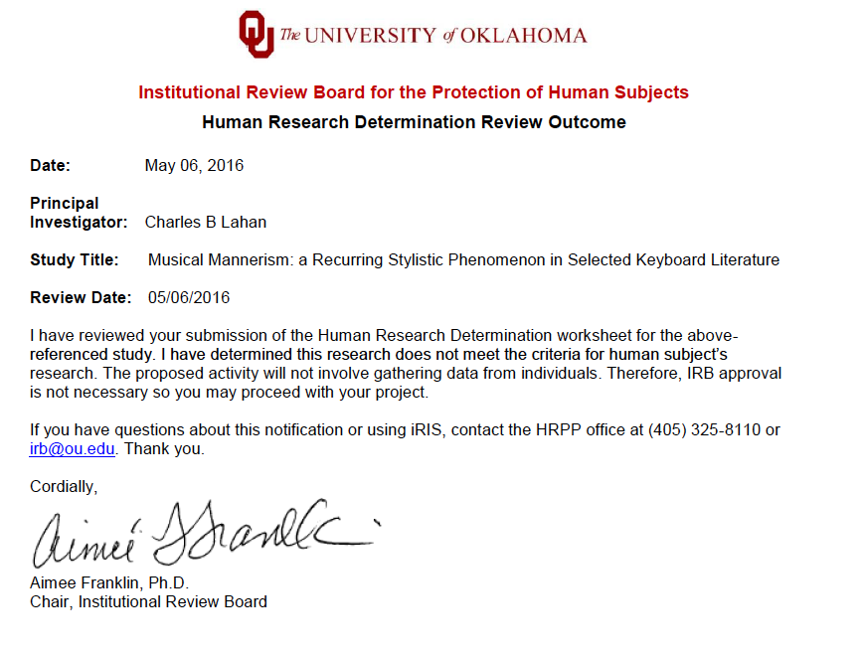

APPENDIX B: G. HENLE PUBLISHERS RELEASE

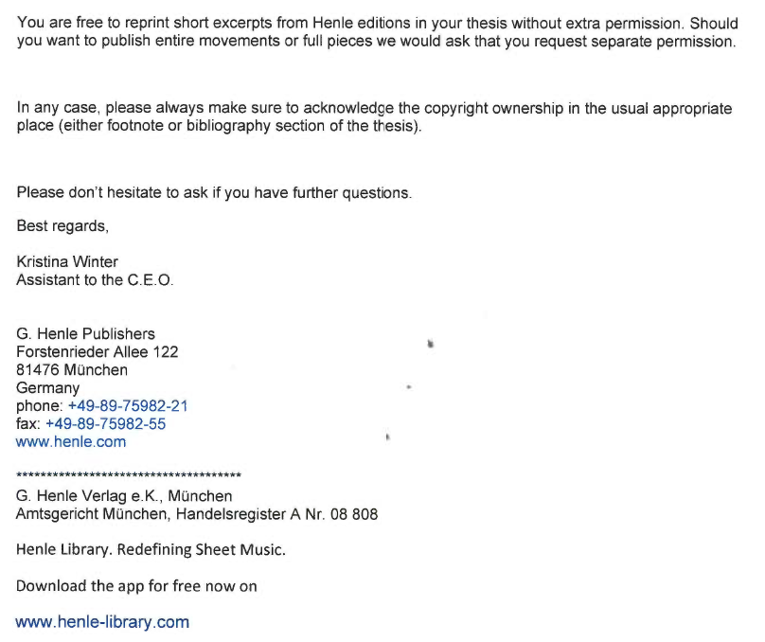

Maria Rika Maniates, Mannerism in Italian Music and Culture, 1530-1630 (Chapel Hill: University of North Carolina Press, 1979), 1.
Maria Rika Maniates, “Musical Mannerism: Effeteness or Virility?,” The Music Quarterly 57, no. 2 (1971): 278-9.
Franklin Robinson, The Meaning of Mannerism (Hanover: University Press of New England, 1972), 3.
Richard Studing, ed., Mannerism in Art, Literature and Music: a Bibliography (San Antonio: Trinity Press, 1979), 1.
John Shearman, Mannerism (London: Penguin, 1967), 32.
Ernst Curtius, European Literature and the Latin Middle Ages (Princeton: Princeton University Press, 1967), xxv.
Maniates, “Musical Mannerism: Effeteness or Virility?,” 278-9.
Julian Kliemann and Antonio Manno. "Vasari." Grove Art Online. Oxford Art Online. Oxford University Press, accessed May 16, 2016.
Giorgio Vasari, Lives of the Artists, trans. by Julia and Peter Bondanella (New York: Oxford University Press, 1991), 1.
Liana Cheney, Giorgio Vasari’s Prefaces (New York: Peter Lang, 2012), 1.
Giovan Pietro Bellori, The Lives of the Modern Painters, Sculptors and Architects, trans. Alice Wohl, (Cambridge: Cambridge University Press, 2005), 1.
Walter Friedlaender, Mannerism and Anti-Mannerism in Italian Painting (New York: Schocken Books, 1965), 1.
Sydney Freedberg, “Observations on the Painting of the Maniera.” In Readings in Italian Mannerism, edited by Liana Cheney, (New York: Peter Lang, 1997), 113-135.
Arnold Hauser, Mannerism: The Crisis of the Renaissance and the Origin of Modern Art (New York: Alfred Knopf, 1965), 1.
Shearman, Mannerism, 49.
Craig Hugh Smyth, Mannerism and Maniera (Locust Valley: J.J. Augustin Publisher, 1960), 14.
Liana Cheney, Readings in Italian Mannerism (New York: Peter Lang, 1997), 1.
Curtius, European Literature and the Latin Middle Ages, 273.
James Haar, “Classicism and Mannerism in 16th Century Music.” International Review of the Aesthetics and Sociology of Music 25 (1994): 5-18.
Glenn Watkins, Gesualdo: The Man and His Music (Oxford: Oxford University Press, 1991), 1.
Willi Apel, “French Secular Music of the Late Fourteenth Century.” Medieval Academy of America 55, (1950): 1-39.
Douglas Seaton, Ideas and Styles in the Western Musical Tradition (New York: McGraw-Hill, 2007), 1.
Maniates, Mannerism in Italian Music and Culture, 1530-1630, 1.
Maria Rika Maniates, “Mannerist Composition in Franco-Flemish Polyphony.” The Music Quarterly 52, no. 1 (1966): 17-36.
Maniates, “Musical Mannerism: Effeteness or Virility?,” 270-293.
Vasari, The Lives of the Artists, 48.
Cheney, Readings in Italian Mannerism, 11.
Vasari, The Lives of the Artists, 48.
Ibid., 277.
Vasari, The Lives of the Artists, 277-278.
Ibid., 52-53.
Ibid., 53.
Vasari, The Lives of the Artists, 49.
Ibid., 282.
Ibid., 52.
Vasari, The Lives of the Artists, 279.
Ibid., 280.
Ibid.
Ibid., 281-282.
Vasari, The Lives of the Artists, 279.
Ibid., 277-278.
Ibid., 278.
Ibid., 279.
Vasari, The Lives of the Artists, 281.
Ibid., 282.
Bellori, The Lives of the Modern Painters, Sculptors and Architects, 71.
Ibid.
Smyth, Mannerism and Maniera, 2.
Friedlaender, Mannerism and Anti-Mannerism in Italian Painting, 5-6.
Ibid., xvii.
Ibid., 10.
Freedberg, Observations on the Painting of the Maniera, 187.
Freedberg, Observations on the Painting of the Maniera, 191.
Freedberg, Observations on the Painting of the Maniera, 193.
Cheney, Readings in Italian Mannerism, 129.
Hauser, Mannerism, 1.
Ibid., 8.
Hauser, Mannerism, 12.
Shearman, Mannerism, 22.
Ibid., 40.
Smyth, Mannerism and Maniera, 14.
Smyth, Mannerism and Maniera, 18-19.
Ibid., 19.
Ibid., 30.
Cheney, Readings in Italian Mannerism, 1.
Ibid., 7.
Shearman, Mannerism, 15.
Ibid., 32.
Haar, “Classicism and Mannerism in 16th Century Music,” 9.
Shearman, Mannerism, 35.
Haar, “Classicism and Mannerism in 16th Century Music,” 8.
Haar, “Classicism and Mannerism in 16th Century Music,” 11.
Haar, “Classicism and Mannerism in 16th Century Music,” 11.
Ibid., 12.
Haar, “Classicism and Mannerism in 16th Century Music,” 15.
Watkins, Gesualdo, 95-110.
Ibid., 95.
Ibid., 101.
Watkins, Gesualdo,102.
Watkins, Gesualdo, 105.
Ibid., 107.
Watkins, Gesualdo, 108.
Ibid.
Maniates, Mannerism in Italian Music and Culture, xv.
Ibid., 9.
Shearman, Mannerism, 35.
Seaton, Ideas and Styles in the Western Musical Tradition, 93-94.
Apel, “French Secular Music of the Late Fourteenth Century,” 10.
Apel, “French Secular Music of the Late Fourteenth Century,” 11.
Ibid.
Seaton, Ideas and Styles in the Western Musical Tradition, 237.
Maniates, “Musical Mannerism: Effeteness or Virility?,” 278-9.
Friedlaender, Mannerism and Anti-Mannerism in Italian Painting, 47.
Seaton, Ideas and Styles in the Western Musical Tradition, 253.
Ibid.
Christoph Wolff, Johann Sebastian Bach: The Learned Musician (New York: Norton, 2000), 375-6.
Maniates, “Musical Mannerism: Effeteness or Virility?,” 287.
Peter Williams, Bach: The Goldberg Variations (Cambridge: Cambridge University Press, 2001), 29-30.
Williams, Bach: The Goldberg Variations, 39-40.
Williams, Bach: The Goldberg Variations, 40.
Donald Francis Tovey, Essays in Musical Analysis (London: Oxford University Press, 1944), 56.
Williams, Bach: The Goldberg Variations, 40.
Williams, Bach: The Goldberg Variations, 38.
David Schulenberg, The Keyboard Music of J.S. Bach (New York: Schirmer, 1992), 321.
Williams, Bach: The Goldberg Variations, 54.
Wolff, Johann Sebastian Bach: The Learned Musician, 378.
Williams, Bach: The Goldberg Variations, 37.
Ibid., 39.
Ibid., 29.
Wolff, Johann Sebastian Bach: The Learned Musician, 1.
Tovey, Essays in Musical Analysis, 68.
Johann Nicholas Forkel, Johann Sebastian Bach: His Life, Art, and Work (Boston: Da Capo Press, 1970), 34.
Williams, Bach: The Goldberg Variations, 47.
Maynard Solomon, Late Beethoven: Music, Thought, Imagination (London: University of California Press, 2003), 27.
Charles Rosen, The Classical Style (New York: Norton, 1971), 380.
Stewart Gordon, A History of Keyboard Literature (Belmont: Schirmer, 1996), 139-140.
F. E. Kirby, A Short History of Keyboard Music (New York: Free Press, 1966), 227.
Rosen, The Classical Style, 379.
Jim Samson, Chopin (New York: Schirmer, 1996), 66.
William Kinderman, Beethoven’s Diabelli Variations (Oxford: Clarendon Press, 1987), 108.
Ibid., 110.
Kinderman, Beethoven’s Diabelli Variations, 110.
Kinderman, Beethoven’s Diabelli Variations, 112.
Rosen, The Classical Style, 438-9.
Kinderman, Beethoven’s Diabelli Variations, 103-104.
Martin Cooper, Beethoven: The Last Decade (London: Oxford University Press, 1970), 208.
Kinderman, Beethoven’s Diabelli Variations, 104.
Reginald Gerig, Famous Pianists and Their Technique (Washington: Robert Luce, 1974), 61.
Kinderman, Beethoven’s Diabelli Variations, 105.
Jurgen Uhde, Beethovens Klaviermusik, vol. 1. (Stuttgart, 1968), 545.
Kinderman, Beethoven’s Diabelli Variations, 118.
Rosen, The Classical Style, 439.
Kinderman, Beethoven’s Diabelli Variations, 122.
Rosen, The Classical Style, 439.
Kinderman, Beethoven’s Diabelli Variations, 3.
Ibid., 4.
Kinderman, Beethoven’s Diabelli Variations, xviii.
Marilyn Stokstad, Art History (Upper Saddle River: Pearson, 2008), 1037.
Kinderman, Beethoven’s Diabelli Variations, 79.
Solomon, Late Beethoven: Music, Thought, Imagination, 186.
Charles Rosen, The Romantic Generation (Cambridge: Harvard University Press, 1995), 480.
Alan Walker, Franz Liszt: The Final Years, 1861-1886 (Ithaca: Cornell University Press, 1996), 16.
Walker, Franz Liszt: The Final Years: 1861-1886, 51.
Rosen, The Romantic Generation, 492.
Michele Tannenbaum, “Liszt and Bach: ’Invention’ and ‘Feeling’ in the Variations on a Motive of Bach,” Journal of the American Liszt Society 41 (1997): 83.
Tannenbaum, “Liszt and Bach: ‘Invention’ and ‘Feeling’ in the Variations on a Motive of Bach,” 49.
Ibid.
Humphrey Searle, The Music of Liszt (New York: Dover Publications, 1966), 76-77.
Giorgio de Santillana, The Age of Adventure: The Renaissance Philosophers (New York: New American Library, 1964), 19.
Hauser, Mannerism, 12.
Williams, Bach: The Goldberg Variations, 45.
Rosen, The Romantic Generation, 321.
Ibid., 474.
Maniates, “Musical Mannerism: Effeteness or Virility?” 270.

