UNIVERSITY OF OKLAHOMA
GRADUATE COLLEGE

EXPERIENCE, NEIGHBHORHOODS, AND HABITATS: BREEDING DISPERSAL OF MALE BLACK-CAPPED VIREOS (VIREO ATRICAPILLA)

A THESIS
SUBMITTED TO THE GRADUATE FACULTY
in partial fulfillment of the requirements for the
Degree of
MASTER OF SCIENCE

By
PAULA MAE CIMPRICH
Norman, Oklahoma
2019

EXPERIENCE, NEIGHBHORHOODS, AND HABITATS: BREEDING DISPERSAL OF MALE BLACK-CAPPED VIREOS (VIREO ATRICAPILLA)

A THESIS APPROVED FOR THE
DEPARTMENT OF BIOLOGY

BY

Dr. Jeff Kelly, Chair

Dr. Caryn Vaughn

Dr. Michael Patten

© Copyright by PAULA MAE CIMPRICH 2019
All Rights Reserved

Acknowledgements

It has been my great fortune to have the guidance, kindness, patience, and good humor of my advisor, Jeff Kelly, throughout my thesis research. I thank you for your support, encouragement, and top-notch editing skills. You are admired by a great many students for your wisdom and tolerance, and I am lucky to work with you. I also extend my gratitude to my committee for your research guidance and reviewing my thesis.
The idea of my project laid dormant for several years and would not have taken life without the support of Joe Grzybowski, who provided the people-power and local knowledge I needed to effectively complete this project. Your expertise was most instructive.
Big thanks to Kate Goodenough, because without lending me the radio receivers the first year, I’d be in big trouble for data collection. Thank you also to the numerous graduate students, who shared their triumphs and headaches as we all go through our self-inflicted growth in advancing our careers in science. Your comradery has been invaluable, and I am happy to have known you. I’ve learned something from each of you, even if our time together was brief.
For those I consider the true champions during this project, the field biologists that were out banging your knees on rocks and sweating climbing up hills with me, I cannot thank you enough. Your dedication made me confident of the patterns and results I’ve uncovered. Trischa, you were a rock during that first field season and I’m glad that we got to laugh together even when we were frustrated beyond any compare. Thank you for motivating me to go out on days when I didn’t want to go out and pulling me back when I got a bit crazy. You went always went above and beyond. Josh and Kashmir, it was amazing to work with highly trained biologists (especially since you had already worked with vireos!) and I am truly grateful for your advice and suggestions. Chris, thank you for your cheerful attitude, enthusiasm related to my research questions and your all your help at the end of the field season! You, John, and James really made the last season fly by. Thank you guys for your can-do spirit and all your hard work.
Thanks to my parents, and many aunts and uncles, who trusted me enough to give me free reign to do what I love and worry only appropriately as needed. It is truly amazing to be supported by a group of people who value their connection to the land and wildlife. It seems no wonder that I’ve ended up where I am now, due in part to my early and continued exposure to your respect and wonder of nature. Thank you especially to David and Sandy. You gave me an opportunity, from which I have developed long-lasting friendships, a love of birds, and a skillset that has opened numerous doors for my career in conservation.

Table of Contents
Acknowledgements iv
ABSTRACT vii
Chapter 1. 1
INTRODUCTION 1
METHODS AND MATERIALS 6
Study system and field observations 6
Sampling effort 8
Vegetation Sampling 10
Analyses 11
RESULTS 14
DISCUSSION 15
REFERENCES 22
FIGURES AND TABLES 29

ABSTRACT

1. Mechanisms driving breeding dispersal are complex and potentially interactive. These mechanisms are of general interest because dispersal strongly links individual fitness to population dynamics. We examine the relative importance of personal information, neighborhood effects, and structural habitat characteristics in determining an individual’s propensity for breeding dispersal.
2. To document dispersal events in 2017 and 2018, we individually marked and radio tagged male black-capped vireos in Southwestern Oklahoma. We used a classification tree analysis to explore ten potential factors that individuals used as information to evaluate for emigration. We used the correlation between arrival date and habitat structure to determine habitat preference.
3. Older and younger age classes that reproduced successfully did not disperse, but younger age class individuals that failed to reproduce were more likely to disperse than older individuals. Dispersal events among young males were significantly related to the proportion of their neighbors that successfully reproduced. More individuals dispersed from neighborhoods of fewer, less successful neighbors. Male black-capped vireos did not disperse due to the vegetation structure of their habitat, though there was a trend for young males to be located in habitats with structure less preferred by older males.
4. Breeding dispersal propensity among black-capped vireos, like many other avian species, depended mostly on their personal breeding experience, but also on reproductive information gleaned from their neighbors. In this Oklahoma population, black-capped vireos of different ages were spatially segregated into habitats of differing structure, which may further influence neighborhood quality and the degree to which age group participates in breeding dispersal.
5. Our results indicate localized, neighborhood effects are important to breeding dispersal, which has implications for the genesis of new populations or a population to become stabilized within a metapopulation. The creation of preferred habitat will be needed to produce rates of nest success that support healthy metapopulation dynamics. These preferred habitats are needed to balance potential high rates of breeding dispersal out of habitats with low neighborhood quality for this species. Future studies focused on the spatio-temporal aspects of breeding dispersal would be valuable. Especially useful would be studies of search behaviors of dispersing individuals and processes involved in selecting new habitat after leaving their initial territory. In general, further study is needed on interactions of multiple dispersal cues and how spatial structuring influences the evaluation of these cues by potential dispersers.

Chapter 1.

INTRODUCTION

Dispersal is a fundamental process in ecology and evolution that affects abundance, spatiotemporal distributions, and gene flow (Clobert, Danchin, Dhondt, & Nichols, 2001). Many complex aspects of population biology, such as metapopulation dynamics, emerge from dispersal made by actively or passively mobile individuals. Mechanisms governing the temporal frequency and spatial domain of dispersal are often complex and potentially interactive. However, studying individual dispersal behaviors remains among the most logistically feasible approaches to understanding the role of dispersal in population dynamics.
With respect to reproduction, individual movements of vertebrates can be broadly thought of as two processes: dispersal from the natal site to the first site of reproduction (hereafter natal dispersal) and dispersal between reproductive attempts (hereafter breeding dispersal). Magnitude of natal and breeding dispersal often differ strongly among individuals of specific age and sex classes (Greenwood & Harvey, 1982). In general, natal dispersal occurs over larger spatial domains than breeding dispersal and strongly impacts gene flow among populations. Breeding dispersal is often predominant within a breeding population and plays a strong role in maximizing the fitness of individuals that move to better habitats (Blancher & Robertson, 1985; Robertson et al., 2018). However, the propensity for breeding dispersal varies widely among species. In some species, breeding dispersal is uncommon, with most individuals instead maintaining high site fidelity between breeding attempts. Breeding dispersal (vs. site fidelity) is tightly linked to population dynamics and potential for species to track rapid environmental change, but the degree to which population dynamics and environmental tracking constrains these relationships is not known. Understanding dispersal cues, subsequent habitat selection, and the consequences of those selections is an integral first step to understanding these relationships.
Dispersal is described as having three phases: initial departure, followed by a transient or prospecting stage involving searching and information gathering, and finally settlement (Clobert et al., 2001). During each of these phases, the main factors that have the most influence on dispersal are related to (1) phenotypic individual conditions, such as competitive ability and (2) environmental conditions, such as conspecific density, resource availability, and landscape patterns (Danchin, Boulinier, & Massot, 1998; Clobert et al., 2001). An individual’s experience and knowledge are a culmination of these two factors. Most studies of breeding dispersal of birds have evaluated factors independently (Bowler & Benton, 2005). However, integration of several cues may best explain the behavior of departure (Dobson & Jones, 1985; Boulinier & Danchin, 1997; Clobert et al., 2001). In this study, we focus on identifying factors birds may integrate and use to inform departure from their breeding territory.
Breeding dispersal studies have only relatively recently started to disentangle information sources used by dispersers (Clobert et al., 2001). Individual reproductive success (i.e. breeding experience) is a key positively correlated covariate of site fidelity where individuals that successfully raise young tend to return to the same breeding location in subsequent breeding attempts and individuals that fail to reproduce tend to disperse (Switzer, 1997). Relocation after a failed nesting attempt is more common among younger birds and is also often sex-biased (Middleton, 1979; Beletsky & Orians, 1987). However, unsuccessful individuals may rely on more than a simple win-stay lose-switch hypothesis for breeding dispersal. External information such as predation and perceived risk of predation (Koleček et al., 2015) and general measures of habitat quality like appropriate habitat structure and food resources also may influence dispersal (Bollinger & Gavin, 1989; Orians & Wittenberger, 1991; Joos, 2013). Interestingly, there is growing evidence that breeding individuals observe their neighbor’s reproductive activities to inform their dispersal departure (Danchin et al., 1998; B. Doligez, 2002; Lagrange et al., 2017; Ponchon et al., 2013). Prospectors using a neighborhood’s current reproductive success as an indicator of future reproductive success during transience and settlement phases of dispersal has much support (Blandine Doligez, Pärt, Danchin, Clobert, & Gustafsson, 2004; Arlt & Pärt, 2008; Pärt, Arlt, Doligez, Low, & Qvarnström, 2011), but there are fewer examples of it being used as to initiate emigration (but see Blancher & Robertson, 1985).
We examine the relative roles of phenotypic and environmental conditions on the departure phase of breeding dispersal. Specifically, we test the hypothesis that the primary function of breeding dispersal is to move to a territory of better quality (the habitat quality hypothesis of breeding dispersal). We predict that: (1) personal information about breeding experience should be the primary source of information influencing breeding dispersal; (2) neighborhood quality (reproductive success of adjacent neighbors) should influence dispersal behavior, with males dispersing from lower quality neighborhoods to higher quality neighborhoods (this prediction is also consistent with the performance based conspecific attraction hypothesis (Danchin et al., 1998)); and (3) habitat characteristics provide supplemental cues for breeding dispersal with males dispersing from habitat dissimilar to preferred habitat. To test these predictions, we examine patterns in age and body size, neighborhood effects, and habitat characteristics as measures of habitat quality.
We studied the North American songbird, the black-capped vireo (Vireo atricapilla). Black-capped vireos are small (8 to 9 gram) migratory passerines in the family Vireonidae that defend breeding territories in patchy, mixed deciduous shrubland habitat in Oklahoma, Texas and Northern Mexico (Grzybowski, 1995). Black-capped vireos were included on the endangered species list from 1987 to 2018, with brood parasitism by brown-headed cowbirds (Molothrus ater) and habitat loss as primary contributors to decreased population sizes. Males arrive first on the breeding grounds to establish territories followed by females, who after pairing with a male, will act aggressively towards both intruder males and females (PMC pers. obs.). This species will attempt multiple nests within a breeding season if a nest fails. Females regularly exhibit breeding dispersal when a nesting attempt fails, they also are more difficult to detect than males because of their secretive behavior and infrequent vocalization (PMC pers. obs.). Both sexes build the nest, incubate, provision nestlings, and care for fledglings.
Natal dispersal of black-capped vireos has been documented through genetic (Athrey, Lance, & Leberg, 2012) and incidental band and recapture methods, while long-term breeding season monitoring studies show that site fidelity is relatively high for territorial male vireos (Graber, 1961; Grzybowski, 1995; Walker, Marzluff, & Cimprich, 2016). To our knowledge, only the Puerto Rican Vireo (Vireo latimeri) has been the subject of a non-genetic breeding dispersal study in the family Vireonidae (Woodworth, Faaborg, & Arendt, 1998), finding a 7.1 to 29% breeding dispersal rate among male vireos. However, this study used recapture and re-sighting techniques between years and could not completely distinguish between dispersal and mortality events. Furthermore, they did not examine factors influencing breeding dispersal. Our study of detailed breeding dispersal factors combined with known fate dispersal events provides new empirical evidence. Anecdotal observations suggest breeding dispersal of adult male black-capped vireos can occur during the post-breeding period (Dittmar et al. 2014, pers. obs.), but no study yet has quantified breeding dispersal of marked individuals.
The post-breeding period may provide an appropriate time frame for individuals to collect information for breeding dispersal for many reasons. Breeding season phenology constrains the opportunities for prospecting by fledglings and second-year age class vireos (yearling first-time breeders, hereafter SY vireos). To maximize survival in their hatching year, vireo fledglings tended to use habitats for survival that differ from breeding habitats (Dittmar, Cimprich, Sperry, & Weatherhead, 2014), which could limit their knowledge of available and quality breeding habitat. For fledglings that survive to return as SY vireos, reproductive success is influenced by how quickly they begin nesting; early nests fare better than late nests (Joos, Thompson, & Faaborg, 2014). This temporal effect suggests a tradeoff between time invested in first-year nest success and time spent prospecting for habitats suitable for breeding dispersal. SY males face the additional challenge of arriving later than older (after second-year, hereafter ASY) vireos that outcompete them for good quality habitat (Johnson & Gaines, 1990; Joos et al., 2014). Consequently, SY males may initially settle into marginal breeding habitat (Johnson & Gaines, 1990; Reed et al., 1999; Joos et al., 2014). The post-breeding period allows unsuccessful vireos access to both resources and conspecific social information to evaluate breeding habitat quality and inform breeding dispersal (Reed et al., 1999).
We used a multi-factorial approach to study breeding dispersal of male black-capped vireos at the first stage of breeding dispersal, departure from the original territory. We monitored the breeding dispersal of males (ASY and SY) in our study. Among these males, we focused preferentially on SY males and tracked them with radio telemetry for two reasons. First, SY individuals are first time breeders and should have low reproductive success and a relatively high (compared to ASY males) propensity towards breeding dispersal when nesting attempts fail. Second, radio telemetry allows us to precisely quantify dispersal events because the detectability of the individual is high. Our objectives were to 1. Determine whether age classes of male vireos differed in their propensity to disperse from their breeding territory, 2. Examine correlates of departure from their breeding territory of factors related to personal, neighborhood, and habitat characteristic information.

METHODS AND MATERIALS

Study system and field observations
We conducted our study on the Fort Sill Military Installation in Southwest Oklahoma, USA where black-capped vireos are present from April to September for two field seasons (2017 and 2018). The Fort Sill Military Installation (roughly 38,000 ha), with adjacent Wichita Mountain National Wildlife Refuge (23,885 ha) form a contiguous track of the Wichita Mountain ecoregion in Oklahoma. In vireo habitat, common vegetation included patches of short stature (one to three meters in height) black-jack and post oaks (Quercus marilandica, Qurecus stellata respectively), skunkbush (Rhus triolobata), flame-leaf sumac (Rhus lanceolata), and tall stature oak woodland (1 to 10 meters in height) commonly having hackberry (Celtis occidentalis) in the understory. Riparian and bottomland areas included a mixture of Eastern persimmon (Diospyros virginiana), black walnut (Juglans nigra), pecan (Carya illinoinesis), Eastern red cedar (Juniperus virginiana), and hackberry (Celtus occidentalis), American elm (Ulmus americana) as canopy. These same species are found in the understory accompanying greenbrier (Smilax spp.), buttonbush (Cephalanthus occidentalis), and roughleaf dogwood (Cornus drummondii). Surrounding grasslands were irregularly scattered with honey mesquite (Prosopis glandulosa), sand plum (Prunus angustifolia), and flame leaf sumac (Rhus lanceolata).
To sample the gradient of vegetation structure used by black-capped vireos, we selected two main study sites with dominant vegetation structures that differed primarily in percent canopy cover. On the main study sites, we monitored territories and nests during the breeding period from April to July. Quanah study site was located in the western parcel of Fort Sill (on Quanah Range) and represented 49 ha of predominantly oak woodland habitat. Sherman study site was located in the central parcel of Fort Sill (on West Range) and represented 42 ha of short stature oak habitat. In these study sites, we attempted to monitor all territorial males. From May to July, we sampled a limited number of additional males around the Sherman study area that amounted to an area of 245 hectares in 2017 and 422 hectares in 2018.
During April, we attempted to capture and mark all individuals within the Quanah and Sherman study areas with a USGS issued aluminum numerical band and unique combination of colored leg bands. We captured vireos using six-meter length, 30mm mesh mist-nets while broadcasting black-capped vireo songs, scolds, heterospecific scolds, and eastern screech owl calls. We determined sex, age, wing length, amount of black of the cap, and mass for each vireo. Age is most accurately determined by feather wear between the greater and primary coverts, and sex was determined by the presence or absence of a full brood patch (Pyle, 1997). Plumage characteristics are also diagnostic for sex as black-capped vireos are the only members in their family that are sexually dimorphic.
In addition to colored leg bands and a USGS band, we deployed radio tags (JDJC corps, .26mg) on some individuals beginning May 15th using the backpack method with an elastic thread degradable within 30 to 60 days (Rappole & Tipton, 1991). SY males began to establish territories the last week of April, however, they did not begin to depart their territory for breeding dispersal until early June (PMC unpubs. data). Transmitters were necessary to track prospecting movements and increase detectability of males as singing rate decreases in late June (PMC pers. obs.). Once vireos were fitted with telemetry equipment, we attempted to collect at least one point per day, but up to five while the male defended a territory. We located radio tagged males using a hand-held three-element Yagi antenna and receiver (Model R4000, Advanced Telemetry Systems, Inc., Isanti, MN) and employed the homing method. Transmitters weighed less than 4% of an individual’s body mass and had a battery life that ranged from 28 to 50 days, if it didn’t fall off.

Sampling effort
Beginning early April, we recorded arrival dates for territorial males. Study sites were surveyed on at least four days in each seven-day period to detect new individuals. Observers spent 20 minutes in each prospective territory to detect individuals. We either visited both study sites in a single day or regularly alternated visiting sites to reduce effort bias. Since male black-capped vireos sing frequently to attract a mate and to defend their territory, we were confident that new individuals were located effectively.
We gathered location data from April to July for territorial males in the main study sites and individuals fitted with radio transmitters by visiting territories at least once a week. To determine territory size and productivity on the main study sites, we followed territorial males and recorded their locations using GPS (Garmin Rhino 650). A male was considered territorial if we found the same individual within 25 meters of a previous point where it had been singing or displaying other acts of area defense for three consecutive visits. The observer followed individuals only as closely needed to sight leg bands, but not closer than 10 meters. We marked the GPS location of the vireo only after the vireo had moved voluntarily to avoid biasing movements based on the observer. Locations were taken no less than five minutes apart with no more than five locations per day to capture the full size of the breeding territory while the vireos were actively nesting. Preliminarily analyses suggest that for the period April to June, estimates of territory size did not change after 10 locations. Territory size was computed through minimum convex polygons from these points using QGIS (QGIS Development Team, 2019).
Territories were monitored until nesting activity ceased in that territory. Nests were mainly located using behavioral cues. We chose Julian date 181 (June 30) as a cut off for the primary breeding season because by this point, preliminary data indicate 98% (n = 172) of nests were completed either as successful or failed, and territories were not initiating new nests (PMC unpubs. data).
We monitored 130 territories in 2017 and 2018 within the study sites. Across years we estimate that we banded ~90% of territorial males. Reproductive success differed between the sites, with 13.8 % more territories producing offspring on the Sherman site than on the Quanah site in both years. Both Sherman and Quanah territories experienced more success in 2017 than 2018. Compared to 2017, 27% fewer territories were successful at Sherman and 17% fewer territories were successful at Quanah in 2018. An early April frost in 2018 likely explains the difference in success between years. Budding oak leaves were killed and did not fully redevelop until late April of 2018, which, delayed nesting and also likely reduced time for subsequent nesting following failed attempts (PMC unpubs. data).
Within the study sites, 11.5% (n = 15) of the territories were defended by SY males. Therefore, territories of 18 additional SY males were located and monitored outside of the main study sites. We found these individuals by randomly capturing males in territories and by identifying late arriving males with less black in their cap (subadult male plumage). In 2018 at Quanah, three individuals suspected of being SY males (due to subadult plumage) disappeared before we attempted to capture them.
We had sufficient data to calculate the territory size for 66 ASY males, and therefore used these as a subset of all monitored ASY males; two of these ASY territories were outside the main study sites. All 33 SY territories and 66 ASY territories were used for general comparison analyses and classification tree analysis to detect any age-based difference between age groups. However, we omitted two SY males and two ASY males for the classification tree analysis that investigated dispersal propensity. We omitted these males because we could not determine whether they were alive at the end of the sampling period. Of all males that dispersed from their breeding territories for at least three successive days (n = 20), none returned to their original territory within that breeding season or the following year.

Vegetation Sampling
We sampled vegetation structure in breeding territories for which we had at least 10 locations (n = 57). We chose ≥ three random location points that were ≥ 30 meters apart to systematically sample vegetation. We followed the vegetation sampling protocol of two recent black-capped vireo studies (Dittmar et al., 2014; Walker, 2015) using three measures of vegetation structure: foliage density, shrub cover, and canopy cover. Using a 30 meter transect with the central point as the initial location of the bird and two opposite points 15 meters from the center, we sampled and averaged foliage density at three locations using a Robel pole. The direction to the opposite points were determined by randomly choosing a cardinal direction from the center for the first point. The Robel pole was divided into 10, 10cm sections. If foliage covered at least 50% of a 10 cm section, it was counted. Canopy cover was calculated as a percent by averaging the percent of 10 points at which canopy was detected. Points were three meters apart along the 30 meter transect and we used an ocular tube to narrow the field of vision when looking up. Shrub cover was also calculated as a % by averaging the detection of shrubs at 10 points three meters apart along the transect using the detection of vegetation within 60 cm of the 2-meter-tall Robel pole. We also collected vegetation samples at locations of telemetered vireos that were followed throughout the summer added more vegetation samples (n = 720). We added random points using a 100 by 100-meter grid to sample different habitat types as well (n = 614). Random points were stratified by habitat classes indicated by Oklahoma ArcGIS polygon layers (Diamond & Elliot, 2015). We condensed similar vegetation classes to six common types found on Fort Sill: Low Stature, Woodland oak, Riparian, Grassland, Ruderal, and Forest. We omitted bare rock and agriculture classes because vireos do not use these habitats.
To determine if there was a relationship between arrival date (ordinal date) and habitat structure as a measure of habitat structure preference, we fitted a multiple linear regression in program R (R Core Team, 2018). Territories used in this analysis were those of males with known arrival dates that had at least three GPS locations taken in their territory (n = 84). We included separate averages for measures of foliage density, canopy cover, and shrub cover from those territory locations as covariates in this model. There was a significant relationship between arrival date and canopy cover (p < 0.01), and shrub cover (p = 0.03). The adjusted R² was 0.06, and the data met assumptions of homogeneity of variance and linearity and the residuals were normally distributed. We then assumed that lower percent canopy cover was more preferred by black-capped vireos as this habitat structure was occupied earlier than higher percent canopy cover.

Analyses
Because we wanted to test the relative importance of several factors that may influence dispersal, we used a classification tree base (binary recursive partitioning) to test dispersal propensity as a binary response of Yes, dispersed, or No, remained on territory ,from our subsample of territories in which we excluded unknown dispersal fates (Table 1). We also used a classification tree to test factors that were significantly different among the two age groups, SY and ASY males, in which we included all males for which we had calculated territory size (n = 99). The classification tree used a P ≤ 0.05 to make splitting decisions. We first tested all factors, then tested only foliage density, canopy cover, shrub cover, and territory size to uncover any habitat differences that may have been masked by the other variables. Classification trees are nonparametric tests that allow for powerful comparisons of categorical and continuous data simultaneously (see De’ath & Fabricus, 2000 for detailed explanation). Classification trees have the advantage of avoiding overfitting data and producing easily interpretable graphs. We used the ctree function in package party (Hothorn, Hornik, & Zeileis, 2006) and partykit (Hothorn & Zeileis, 2015) in program R (R Core Team, 2018).
We included personal reproductive success, total number of neighbors, number of successful neighbors, percent successful neighbors, territory size, age, the product of wing length and mass, and mate pairing success as factors in our classification tree analysis to represent personal information and neighborhood information. We considered a territory successful if it produced at least one fledgling. Our focus on territory success and not overall productivity was motivated by two factors. First, we assumed vireos would not count number of offspring, a measure that is more normally used to determine productivity of an area, but instead would access success simply as presence of fledglings or not. We also assumed the perceived range of breeding success as only including adjacent neighbors because we found little evidence that territorial male black-capped vireos wandered out of their territories during April and May (PMC unpubs data). We defined the total number of neighbors as a count of adjacent neighbors. Males often had singing matches with neighbors, making them easy to identify. The number of successful neighbors was determined by summing the successful neighbors. We calculated percent successful neighbors by dividing the number of neighbors producing at least one fledgling during the time the individual of focus was present and actively defending its territory by the total number of neighbors. Mate pairing success was considered at three levels. Successful mate pairing was any pairing with a female that led to a nest with at least one egg, a transient mate was any female observed in a territory for at least two days that disappeared before completing a nest, and no pairing was when we observed no female in the territory for more than one day.
In addition to personal and neighborhood information factors, we also included three measurements of habitat characteristics in the classification tree analysis: percent cover of foliage density, canopy cover, and shrub cover. These three measures of habitat structure were treated separately in our classification tree analysis. We characterized average habitat for territories by interpolating values from the points at which we conducted vegetation samples. Interpolations were done separately for each measure of vegetation structure using QGIS (QGIS Development Team, 2019). We grouped points based on our previously defined habitat classes: Low Stature, Woodland oak, Riparian, Ruderal, and Grassland following a modified vegetation map produced by the Oklahoma Department of Wildlife Conservation (Diamond & Elliot, 2015). Forest was a sixth class in which we randomly sampled points, however, we recorded no vireo points within a forest boundary and we excluded this class from our analyses. We grouped points from specific habitats to ensure that the closest relevant points from that particular habitat were influencing interpolation. We sampled the raster layers at each territory location point and averaged the measures of vegetation structure to obtain one averaged sample per territory for foliage density, canopy cover, and shrub cover.
We conducted this study in accordance with the University of Oklahoma Institutional Animal Care and Use Committee permit number R17-010, and Federal Permit number TE35163A-0, Federal Bird Banding Permit Number 20930.

RESULTS

Of the 10 explanatory variables measured, the classification tree analysis identified two that best explained whether males dispersed from their original territory (Figure 1): age and percent neighbor success. Age was the first best explanatory variable, while percent neighbor success branched only from the SY age class group. Of all 130 males monitored within the main two study areas, 20 (15%) had confirmed dispersal events, while 16 additional individuals (12%) disappeared before June 30th with an unknown status of deceased or dispersed.
Consistent with the 1st prediction of the habitat quality hypothesis – No vireo dispersed that had reproduced successfully, regardless of age. Only four (12%) of all 33 SY males monitored were successful in producing offspring, whereas 35% of ASY males produced offspring (compared to 45% successful of all ASY territories monitored (n = 102)). Of the 20 males that did disperse, 16 (80%) were SY males, representing 52% of all the SY males monitored.
Consistent with our 2nd prediction from the habitat quality hypothesis, we detected an effect of neighborhood on dispersal propensity. More SY males dispersed from their territories if 25% or less of their neighbors successfully fledged offspring. We did not detect enough ASY male breeding dispersal to determine any relevant factors within the time period that we monitored for dispersal. For individuals of both age classes that were failed breeders (n = 68), we still find age is the best predictor of dispersal, and SY males dispersal corresponded again with percent neighbor success (Figure 2). SY males were less likely to secure a mate, had fewer total neighbors, and they were also more likely to disperse than ASY males (Figure 3). Percent territory nest success was also positively correlated with total number of neighbors (t = 6.1613, df = 92, p-value = 1.88e-08, cor = 0.54).
In contrast to prediction 3 from the habitat quality hypothesis, no vegetation characteristic alone explained differences in dispersal and no covariates predicted an individual’s reproductive success. When using the classification tree method to explore differences in vegetation, we find that SY males and ASY males differed in the amount of canopy cover in their territory, with SY males having more canopy cover (Figure 4). Canopy cover mean (0.2912) was used to split territories into two groups regardless of age, low canopy cover (n = 69) and high canopy cover (n = 30). We find that low canopy territories were more successful than high canopy cover territories by 10%.
We additionally found areas occupied by SY males in 2017 tended to remain occupied by SY males in 2018. Of the 16 total SY territories monitored in 2017, six individuals returned to their territories in 2018. Of the 11 remaining areas that SY males defended in 2017, 45% (n = 5) were also defended by SY males in 2018. Only one of these 11 areas were actively occupied by a new ASY male, while four were annexed into territories held by ASY males that were neighbors to the SY territory in 2017. We failed to capture and reliably determine age of the remaining territorial male.

DISCUSSION

Our results align with our main hypothesis and the results of several studies that support multiple factors determining breeding dispersal as individuals move to increase fitness. In general, we found a hierarchical effect of covariates correlated with departure for dispersal, where an individual’s reproductive outcome and age contributed the main effects. Successful males did not disperse within the breeding season, likely because successfully breeding males remain territorial while helping care for fledglings that remain dependent on parents until around 40 days old (Grzybowski, 1995). The majority of ASY males did not abandon their territory early to disperse. Site fidelity of older males could be linked to past successful breeding experience, females continuing to choose ASY male territories to initiate late season nests, or potentially that ASY males have a different temporal prospecting window than SY males. Of individuals that reproduced unsuccessfully, SY males had a higher dispersal propensity than ASY males. This result supports the hypothesis proposed by Holmes et al. (1996) that the return rate of yearling males could be explained by dispersal and not mortality in lower quality habitats. Additionally, like Doligez et al. (2004), we found that emigration was less simple for SY age class males than older males. Most SY males reproduced unsuccessfully, however, not all dispersed like expected if only personal information determined habitat quality. Instead, our study indicates localized neighborhood reproductive success best explained dispersal propensity. When we directly compared covariates of SY males to ASY males, we found that SY males were less likely to attract and maintain a mate and also have fewer total neighbors.
To address our first prediction that personal information is used primarily to inform breeding dispersal, we must first account for the demographic spatial structuring we found in our study system, where age and vegetation characteristics were correlated. We hypothesize this pattern results as a consequence of habitat saturation. Evidence for habitat saturation for this population of black-capped vireos is supported only by indirect evidence. Gryzbowski et al. (1994) found that ASY and SY age class males used similar types of habitat at the Wichita Mountains. This pattern contrasts with the age-based habitat differences documented in central Texas by the same study, where SY males occupied areas less similar to ASY males and more similar to non-vireo species (Grzybowski, Tazik, & Schnell, 1994). At this time of that research, the population size at the Wichita Mountains was smaller than in Central Texas, compared to the current and substantially larger population now found at Fort Sill and Wichita Mountain National Wildlife Refuge. Second, nearly half the of areas defended by a SY male in 2017 were defended by an SY male in 2018 while the other half were annexed into neighboring 2017 ASY male territories in 2018. This pattern suggests that these are areas of lower quality and are not preferred by males with more breeding experience. Finally, we found fewer SY males in our main study sites than was expected. For example, a monitored population in central Texas recorded 22% of territories monitored were held by SY males (Cimprich & Cimprich, 2015). In conclusion, the current Fort Sill population structure suggests habitat saturation coupled with high site fidelity by ASY males likely forces SY males to occupy areas in periphery marginal habitat with lower densities of conspecifics if SY males are poor competitors (see Matthysen, 1990). This pattern is also consistent with the ideal dominance distribution model, where better competitors occupy the highest quality habitat (Fretwell & Lucas, 1969). There are likely multiple interacting causes for the lower reproductive success coupled with higher propensity for breeding dispersal propensity among SY males. That is, SY males may be subject to indirect effects of external factors (conspecific density and site fidelity of older males), which may also interact with an individual’s phenotype.
SY males also had less success attracting a mate than ASY males. Females may not pair with SY males because they are intrinsically lower quality mates than older males (the good genes hypothesis), though this may be compounded by their occupation of lower quality habitat (Holmes, Marra, & Sherry, 1996). SY males settled in territories later than ASY males and may have little to no familiarity with the habitat quality, leading to several possible repercussions for their personal reproductive success. For example, SY males are outcompeted by ASY males because ASY males were in better body condition and ASY male familiarity with their breeding site likely increases their aggression against intruders (Stoddard, Beecher, Horning, & Willis, 1990; Hughes, Searcy, Hyman, & Nowicki, 2004; Piper, 2011; Joos et al., 2014). While we could not support this argument with our results, it may be that body size and mass were not good predictors of internal condition for this species.
We found support for our second prediction that more males would disperse from neighborhoods with low local reproductive success, but for SY males only. This prediction follows from both the habitat quality hypothesis and the conspecific attraction hypothesis. While the total number of neighbors was not a factor contributing directly to breeding dispersal, neighbor success was positively correlated with total number of neighbors. Why SY males had fewer neighbors can be attributed to the landscape pattern of suitable patches, as this age class was more likely to occupy areas that were on the periphery of patches (PMC unpubs. data). A higher density of conspecific neighbors in this species likely confers multiple benefits to individuals. For example, access to females may increase when there are more neighboring males as females frequently exhibit breeding dispersal. Males may also increase their chances of extra-pair fertilization in areas of higher concentrations of females. Furthermore, females searching for a mate may be more attracted to higher quality males (the good genes hypothesis) that also tend to be in high-quality neighborhoods and thus infrequently search low quality neighborhoods. If time is a main limiting factor for a successful nesting season, spending the shortest amount of time searching for a new mate would be ideal. If males are clustered in high density neighborhoods, then females can increase their mate choice along with decreasing their mate search time (Dale, Rinden, & Slagsvold, 1992).
For a species with high site fidelity after successful reproduction, it may not be surprising that individuals who are new to a neighborhood gather information from their neighbors. Gleaning relatively low risk, reliable information from neighbors provides a logical first step in evaluating habitat quality (Chabrzyk & Coulson, 1976; Boulinier & Danchin, 1997; Danchin et al., 1998; Lagrange et al., 2017). The costs of searching for a new territory could be high. If dispersal isn’t necessary to eventually achieve reproductive success at its current location, searching for a new territory may have a negative effect on fitness (Stamps, Krishnan, & Reid, 2005). A male may be unsuccessful in finding a better territory or a territory at all. Unfamiliarity with the neighbors may also make integration into or successful mate competition at a new neighborhood more difficult when a place is selected (Stamps, 1987; Stoddard et al., 1990; Hughes et al., 2004; Joos, 2013).
We found no direct support for our third prediction that habitat structure directly influences breeding dispersal behavior. This was indicated by no significant habitat differences between successful and unsuccessful males and also by successful SY males remaining on their territories regardless of the habitat structure. However, habitat structure may have underlying effects in building good neighborhoods, though we did not test these (but see Holmes et al., 1996; Cline et al., 2013). Territories of SY males had significantly more canopy cover than ASY males and ASY males tend to arrive earlier in lower canopy cover habitat. Territories in lower canopy cover (partitioned using mean canopy cover) habitat had increased nesting success by 10% and neighbor success was 8% higher than in high canopy cover. However, it was beyond the scope of our study to determine if nesting success was due to decreased predation or if more re-nesting attempts were successful. We also could not determine if preference for low canopy cover over high canopy cover was due to increased food resources. Alternative explanations for why we did not find a connection between dispersal and habitat structure is that our measurements were 1. Interactive in a way we did not account for, or 2. Irrelevant to the structure measures black-capped vireos use to assess habitat. For example, SY male territories were often located close to edges of habitat that bordered large expanses of grasslands. Other studies that have found similar age-based spatial patterns have suggested that low habitat quality areas act as a reservoir for the younger age class while waiting to fill in better habitat as those territory holders do not return or are outcompeted (Holmes et al., 1996).
The findings of our study may have implications for how black-capped vireos expand their range if current suitable and protected habitat is occupied. Natal dispersal can help to colonize new areas, however, if breeding dispersal tends to counteract colonization because of low success, then natal dispersal is unrealized and gene flow events are limited. Based on our findings of low pairing success of SY males in places with low conspecific densities, the potential for Allee effects, where low densities of populations experience slow or declining growth, ought to be considered. However, it is interesting to note that breeding dispersal from these areas could counteract realized Allee effects since those same individuals could be filling spaces in good neighborhoods the following breeding cycle. Another consideration for black-capped vireos is the ability of this species to appropriately track environmental change. While black-capped vireos inhabit early successional shrubland, the relatively high degree of site fidelity suggests long patch quality consistency. Since our study identifies neighbor reproductive success and not simply conspecific density as a strong breeding dispersal factor, unsuccessful individuals have the opportunity to shift to presumably better-quality habitat. This should be achieved best by younger individuals and perhaps also by those that have yet to successfully reproduce.
Parasitism by brown-headed cowbirds (Molothrus ater) and habitat loss remain two of the greatest threats to black-capped vireos. While continued cowbird control at large populations on federal lands likely help make these populations sources of dispersing individuals, fringe habitats and smaller isolated populations tend not to have these same protections because private land owners and other stake holders do not have the same obligations to protect vireos (Walker et al., 2016). Appropriate land management techniques, including implementing cowbird control, can help establish successful neighborhoods can further boost population numbers and create a more secure subpopulation within in a metapopulation. This would also mean creating or maintaining the suitable short stature habitat preferred by vireos.
Future studies of this system would benefit from using an experimental approach to manipulate neighborhood success to more clearly define the mechanisms driving breeding dispersal decisions. Special attention to the timing and spatial extent of cues used to inform breeding dispersal remain important topics of study. While our results indicate individuals pay attention to their neighbors, how exactly information is gathered is not well studied. Telemetered black-capped vireos were rarely observed outside their territory until about a week before they made final long-distance movements from which they did not return (PMC unpubs, data). One possibility is that prospectors observe fledglings, which tend to be loud as they beg for food from adults, who in turn tend to vocalize when they provision (PMC pers. obs.). Late season vocalization of adults was in fact a correlated factor of habitat selection during the settlement phase in a study of black-throated blue warbler breeding dispersal (Betts, Hadley, Rodenhouse, & Nocera, 2008). The temporal component of information gathering is a key aspect for continued study, as individuals must be able to detect and evaluate cues in addition to navigating space appropriately to be reproductively successful (Blandine Doligez et al., 2004; Thomson, Sirkiä, Villers, & Laaksonen, 2013). We focused on the movements and decisions of first-time breeding males; however, we did detect breeding dispersal of older males. Return rates to our study sites averaged ~50 %, meaning that most of the open territories were filled by males at least three years old. Knowing when and how these males prospect is would provide further insight into breeding dispersal mechanisms. As we concentrated on the factors used to inform the departure phase of dispersal, studies of the transience and settlement stages of dispersal would complement our research and be invaluable to understanding the whole cycle of dispersal of this species and its role in population level regulation.

REFERENCES
Arlt, D., & Pärt, T. (2008). Post-breeding information gathering and breeding territory shifts in northern wheatears. Journal of Animal Ecology, 77(2), 211–219. doi: 10.1111/j.1365-2656.2007.01329.x
Athrey, G., Lance, R. F., & Leberg, P. L. (2012). How far is too close? restricted, sex-biased dispersal in black-capped vireos. Molecular Ecology, 21(17), 4359–4370. doi: 10.1111/j.1365-294X.2012.05694.x
Beletsky, L. D., & Orians, G. H. (1987). Territoriality among male red-winged blackbirds. Behavioral Ecology and Sociobiology, 20, 21–34.
Betts, M. G., Hadley, A. S., Rodenhouse, N., & Nocera, J. J. (2008). Social information trumps vegetation structure in breeding-site selection by a migrant songbird. Proceedings of the Royal Society B: Biological Sciences, 275(1648), 2257–2263. doi: 10.1098/rspb.2008.0217
Blancher, P. J., & Robertson, R. J. (1985). Site Consistency in Kingbird Breeding Performance: Implications for Site Fidelity. The Journal of Animal Ecology, 54(3), 1017. doi: 10.2307/4394
Bollinger, E. K., & Gavin, T. A. (1989). The Effects of Site Quality on Breeding-Site Fidelity in Bobolinks. The Auk, 106(4), 584–594.
Boulinier, T., & Danchin, E. (1997). The use of conspecific reproductive success for breeding patch selection in terrestrial migratory species. Evolutionary Ecology; London, 11(5), 505–517. doi: http://dx.doi.org.ezproxy.lib.ou.edu/10.1007/s10682-997-1507-0
Bowler, D. E., & Benton, T. G. (2005). Causes and consequences of animal dispersal strategies: relating individual behaviour to spatial dynamics. Biological Reviews, 80(2), 205–225. doi: 10.1017/S1464793104006645
Chabrzyk, G., & Coulson, J. C. (1976). Survival and Recruitment in the Herring Gull Larus argentatus. The Journal of Animal Ecology, 45(1), 187. doi: 10.2307/3774
Cimprich, D. A., & Cimprich, P. M. (2015). Monitoring of the black-capped vireo (Vireo atricapilla) during 2015 on Fort Hood Military Installation, Fort Hood, Texas. In 2015 United States Fish and Wildlife Service Annual Report: Endangered Species Monitoring and Management on Fort Hood Military Installation, Fort Hood, Texas. Fort Hood, Texas USA: Fort Hood, Directorate of Public Works, Natural and Cultural Resources Management Branch.
Cline, M. H., Strong, A. M., Sillett, T. S., Rodenhouse, N. L., & Holmes, R. T. (2013). Correlates and consequences of breeding dispersal in a migratory songbird. The Auk, 130(4), 742–752. doi: 10.1525/auk.2013.12244
Clobert, J., Danchin, E., Dhondt, A., & Nichols, J. D. (Eds.). (2001). Dispersal. New York: Oxford University Press.
Dale, S., Rinden, H., & Slagsvold, T. (1992). Competition for a mate restricts mate search of female pied flycatchers. Behavioral Ecology and Sociobiology, 30(3–4), 165–176. doi: 10.1007/BF00166699
Danchin, E., Boulinier, T., & Massot, M. (1998). Conspecific Reproductive Success And Breeding Habitat Selection: Implications For The Study Of Coloniality. Ecology, 79(7), 2415–2428. doi: 10.1890/0012-9658(1998)079[2415:CRSABH]2.0.CO;2
De’ath, G., & Fabricus, K. (2000). Classification And Regression Trees: A Powerful Yet Simple Technique For Ecological Data Analysis. Ecology, 81(11), 3178–3192.
Diamond, D. D., & Elliot, L. F. (2015). Oklahoma ecological systems mapping interpretive booklet: Methods, short type descriptions, and summary results. Norman, Oklahoma: Oklahoma Department of Wildlife Conservation.
Dittmar, E. M., Cimprich, D. A., Sperry, J. H., & Weatherhead, P. J. (2014). Habitat selection by juvenile black-capped vireos following independence from parental care: Habitat Selection by Juvenile Black-Capped Vireos. The Journal of Wildlife Management, 78(6), 1005–1011. doi: 10.1002/jwmg.738
Dobson, F. S., & Jones, W. T. (1985). Multiple Causes of Dispersal. The American Naturalist, 126(6), 855–858. doi: 10.1086/284457
Doligez, B. (2002). Public Information and Breeding Habitat Selection in a Wild Bird Population. Science, 297(5584), 1168–1170. doi: 10.1126/science.1072838
Doligez, Blandine, Pärt, T., Danchin, E., Clobert, J., & Gustafsson, L. (2004). Availability and use of public information and conspecific density for settlement decisions in the collared flycatcher. Journal of Animal Ecology, 73(1), 75–87. doi: 10.1111/j.1365-2656.2004.00782.x
Fretwell, S., & Lucas, H. (1969). On territorial behavior and other factors influencing habitat distribution in birds. Acta Biotheoretica, (19), 16–36.
Graber, J. W. (1961). Distribution, Habitat Requirements, and Life History of the Black-Capped Vireo (Vireo atricapilla). Ecological Monographs, 31(4), 313–336. doi: 10.2307/1950756
Grzybowski, J. A. (1995). Black-capped Vireo (Vireo atricapilla). In A. F. Poole & F. B. Gill (Eds.), The Birds of North America (Version 2.0). Ithaca, NY, USA: Cornell Lab of Ornithology.
Grzybowski, J. A., Tazik, D. J., & Schnell, G. D. (1994). Regional Analysis of Black-Capped Vireo Breeding Habitats. The Condor, 96(2), 512–544. doi: 10.2307/1369333
Holmes, R. T., Marra, P. P., & Sherry, T. W. (1996). Habitat-Specific Demography of Breeding Black-Throated Blue Warblers (Dendroica caerulescens): Implications for Population Dynamics. The Journal of Animal Ecology, 65(2), 183. doi: 10.2307/5721
Hothorn, T., Hornik, K., & Zeileis, A. (2006). Unbiased Recursive Partitioning: A Conditional Inference Framework. Journal of Computational and Graphical Statistics, 15(3), 651–674.
Hothorn, T., & Zeileis, A. (2015). partykit: A Modular Toolkit for Recursive Partytioning in R. Journal of Machine Learning Research, 16, 3905–3909.
Hughes, M., Searcy, W. A., Hyman, J., & Nowicki, S. (2004). Individual Variation in the Strength of Territory Defense in Male Song Sparrows: Correlates of Age, Territory Tenure, and Neighbor Aggressiveness. Behaviour, 141(1), 15–27. doi: 10.1163/156853904772746574
Johnson, M. L., & Gaines, M. S. (1990). Evolution of Dispersal: Theoretical Models and Empirical Tests Using Birds and Mammals. Annual Review of Ecology and Systematics, 21, 449–480.
Joos, C. J. (2013). Influence of habitat selection and habitat quality on the demography of a neotropical migrant songbird, the Bell’s Vireo (Vireo bellii) (Ph.D., University of Missouri - Columbia). Retrieved from http://search.proquest.com/docview/1461742911/abstract/4546F1405D694E86PQ/4
Joos, C. J., Thompson, F. R., & Faaborg, J. (2014). The role of territory settlement, individual quality, and nesting initiation on productivity of Bell’s vireos Vireo bellii bellii. Journal of Avian Biology, 45(6), 584–590. doi: 10.1111/jav.00400
Koleček, J., Jelínek, V., Požgayová, M., Trnka, A., Baslerová, P., Honza, M., & Procházka, P. (2015). Breeding success and brood parasitism affect return rate and dispersal distances in the great reed warbler. Behavioral Ecology and Sociobiology, 69(11), 1845–1853. doi: 10.1007/s00265-015-1997-7
Lagrange, P., Gimenez, O., Doligez, B., Pradel, R., Garant, D., Pelletier, F., & Bélisle, M. (2017). Assessment of individual and conspecific reproductive success as determinants of breeding dispersal of female tree swallows: A capture–recapture approach. Ecology and Evolution, 7(18), 7334–7346. doi: 10.1002/ece3.3241
Matthysen, E. (1990). Behavioral and Ecological Correlates of Territory Quality in the Eurasian Nuthatch (Sitta europaea). The Auk, 107, 86–95.
Middleton, A. L. A. (1979). Influence of Age and Habitat on Reproduction by the American Goldfinch. Ecology, 60(2), 418–432. doi: 10.2307/1937669
Orians, G. H., & Wittenberger, J. F. (1991). Spatial and Temporal Scales in Habitat Selection. The American Naturalist, 137, S29–S49. doi: 10.1086/285138
Pärt, T., Arlt, D., Doligez, B., Low, M., & Qvarnström, A. (2011). Prospectors combine social and environmental information to improve habitat selection and breeding success in the subsequent year: Prospecting and breeding site choice. Journal of Animal Ecology, 80(6), 1227–1235. doi: 10.1111/j.1365-2656.2011.01854.x
Piper, W. H. (2011). Making habitat selection more “familiar”: a review. Behavioral Ecology and Sociobiology, 65(7), 1329–1351. doi: 10.1007/s00265-011-1195-1
Ponchon, A., Grémillet, D., Doligez, B., Chambert, T., Tveraa, T., González‐Solís, J., & Boulinier, T. (2013). Tracking prospecting movements involved in breeding habitat selection: insights, pitfalls and perspectives. Methods in Ecology and Evolution, 4(2), 143–150. doi: 10.1111/j.2041-210x.2012.00259.x
Pyle, P. (1997). Identification guide to North American Birds Part I: Columbidae to Ploceidae. Bolinas, California: Slate Creek Press.
QGIS Development Team. (2019). QGIS Geographic Information System. Retrieved from http://qgis.osgeo.org
R Core Team. (2018). R: A language and environment for statistical computing. Vienna, Austria: R Foundation for Statistical Computing.
Rappole, J. H., & Tipton, A. R. (1991). New Harness Design for Attachment of Radio Transmitters to Small Passerines (Nuevo Diseño de Arnés para Atar Transmisores a Passeriformes Pequeños). Journal of Field Ornithology, 62(3), 335–337.
Reed, J. M., Boulinier, T., Danchin, E., & Oring, L. W. (1999). Informed Dispersal: Prospecting by birds for breeding sites. Current Ornithology, 15, 189–259.
Robertson, E. P., Fletcher, R. J., Cattau, C. E., Udell, B. J., Reichert, B. E., Austin, J. D., & Valle, D. (2018). Isolating the roles of movement and reproduction on effective connectivity alters conservation priorities for an endangered bird. Proceedings of the National Academy of Sciences, 115(34), 8591–8596. doi: 10.1073/pnas.1800183115
Stamps, J. A. (1987). The effect of familiarity with a neighborhood on territory acquisition. Behavioral Ecology and Sociobiology, 21(5), 273–277. doi: 10.1007/BF00299964
Stamps, J. A., Krishnan, V. V., & Reid, M. L. (2005). Search Costs and Habitat Selection by Dispersers. Ecology, 86(2), 510–518. doi: 10.1890/04-0516
Stoddard, P. K., Beecher, M. D., Horning, C. L., & Willis, M. S. (1990). Strong Neighbor-Stranger Discrimination in Song Sparrows. The Condor, 92(4), 1051. doi: 10.2307/1368741
Switzer, P. V. (1997). Past reproductive success affects future habitat selection. Behavioral Ecology and Sociobiology, 40(5), 307–312. doi: 10.1007/s002650050346
Thomson, R. L., Sirkiä, P. M., Villers, A., & Laaksonen, T. (2013). Temporal peaks in social information: prospectors investigate conspecific nests after a simulated predator visit. Behavioral Ecology and Sociobiology, 67(6), 905–911. doi: 10.1007/s00265-013-1513-x
Walker, L. E. (2015). Population Dynamics of the Endangered Black-capped Vireo (Vireo atricapilla) (Ph.D.). University of Washington.
Walker, L. E., Marzluff, J. M., & Cimprich, D. A. (2016). Source-sink population dynamics driven by a brood parasite: A case study of an endangered songbird, the black-capped vireo. Biological Conservation, 203, 108–118. doi: 10.1016/j.biocon.2016.09.016
Woodworth, B., Faaborg, J., & Arendt, W. (1998). Breeding and Natal Dispersal in the Puerto Rican Vireo (Dispersión Reproductiva y Natal en Vireo latimeri). Journal of Field Ornithology, 69(1), 1–7.

FIGURES AND TABLES

Table 1. Subset of territories used in the classification tree analysis for dispersal propensity with known dispersal fates and grouped according to age classes and study sites.
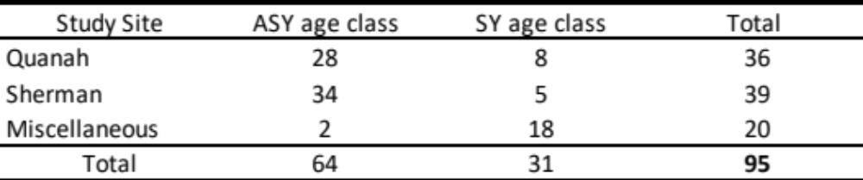

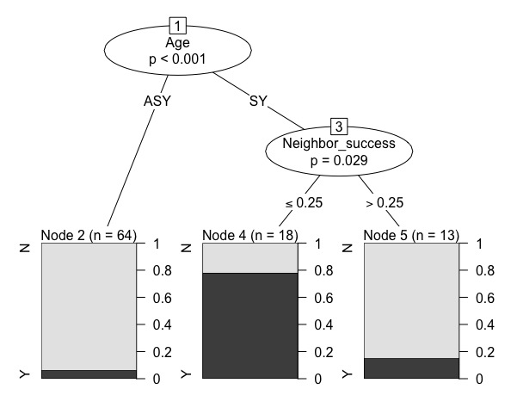
Figure 1. Classification tree analysis of 10 covariates for successful and unsuccessful males (n = 95), with a Node 2 classification error of 6.2%, Node 4 classification error of 22.2%, and Node 5 classification error of 15.4%.

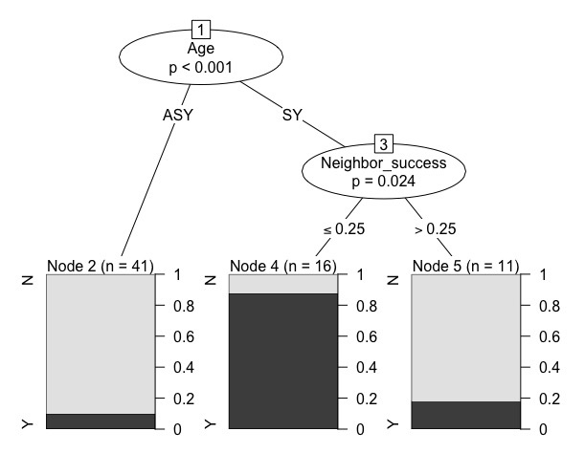
Figure 2. Classification tree analysis of 10 covariates for only unsuccessful males (n = 68). Node 2 had a classification error of 9.8%, Node 4 a classification error of 12%, and Node 5 a classification error of 18.2%.

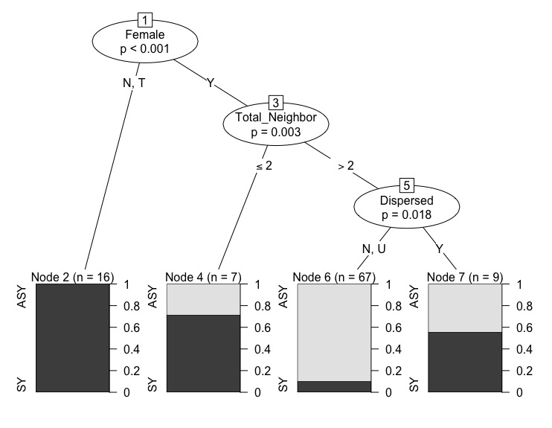
Figure 3. A classification tree analysis determining differences between ASY males and SY males using 10 covariates. Node 2 has 0% error grouping no female attained (N) and transient female (T) territories together. Node 3 divided males by the number of territories adjacent to their own. Node 4, after splitting on the dispersal behavior, has 37.5% error, Node 6 grouped No dispersal (N) and Unknown fate (U) territories with a 10.6% error, and finally node 7 had a 44.4% error rate.

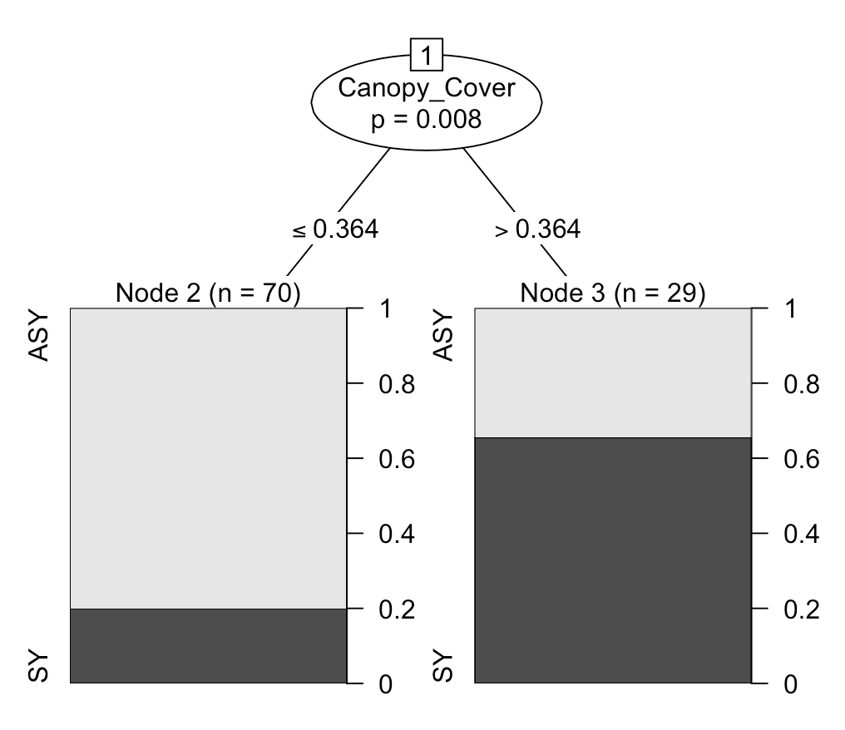
Figure 4. A classification tree determining age using canopy cover, shrub cover, foliage density, and territory size as covariates. Canopy cover was the only significant grouping factor, with Node 2 having an error rate of 20% and Node 3 error at 34.5%.

