University of Oklahoma

Graduate College

A tale of two sites: a lithic analysis examining possible Nūche emergence on the uncompahgre plateau, colorado

A thesis

submitted to the Graduate Faculty

in partial fulfillment of the requirements for the

Degree of

master of arts

By

delaney stephannie cooley
Norman, Oklahoma
2017

A tale of two sites: a lithic analysis examining possible Nūche emergence on the uncompahgre plateau, colorado

A thesis approved for the
department of anthropology

By

______________________________
Dr. Bonnie Pitblado, Chair

______________________________
Dr. Patrick Livingood

______________________________
Dr. Sarah Trabert

© Copyright by delaney stephannie cooley 2017
All Rights Reserved.

Acknowledgements
First, I would like to express my deepest appreciation and gratitude to the members of my committee: Bonnie Pitblado, Patrick Livingood, and Sarah Trabert. Their encouragement, honest feedback, and patience have been invaluable throughout my research and writing. I am a better scholar and person because of their support and guidance. I would also like to extend my gratitude to the faculty and staff at the Department of Anthropology and Oklahoma Archeological Survey for their invaluable support and advice. My sincerest thanks also go to Matthew E. Hill and Margaret Beck. My love for archaeology first began at the University of Iowa under their guidance, and I would not have started on this path without their encouragement.
I would also like to extend my appreciation to Tracy Murphy and Bridget Ambler at the Anasazi Heritage Center for providing access to Buckles’s collections and documents. Without their assistance, this project would not have been possible. A special thanks to Neil and Teri Hauser. They welcomed me to the Uncompahgre Plateau with open arms and have continued to provide vital information and encouragement. I was also fortunate enough to have several undergraduate and graduate students assisting me in the laboratory. My heartfelt thanks to Matt Oliver, Taylor Emory, Chelsy Heiny, Allison Brown, and Daniel Quintela for their time and companionship.
This research would not have been possible without the financial support from the University of Oklahoma Department of Anthropology, Colorado Council of Professional Archaeologists, and the University of Oklahoma Graduate Student Senate. I am incredibly grateful to these organizations for their contributions.
To all of my friends and fellow students in the Department of Anthropology, I would like to express my deepest appreciation for the advice, late night writing sessions, laughs, and tea. I could not have asked for a more supportive, kind, and generous community to share this experience with. I would also like to thank my friends and family outside of Norman whose friendship and encouragement kept me sane.
Finally, I would like to thank my parents, Steve and Darcy Cooley, and my sister, Kaitlyn Cooley, for their unwavering faith in me. They are my greatest inspiration to be the best I can be, and I cannot express how much their unconditional love and support has meant to me. Thank you for giving me the courage to further my education and pursue archaeology as a career.

Table of Contents

Acknowledgements iv
Table of Contents vi
List of Tables ix
List of Figures xi
Abstract xii
Chapter 1: Introduction 1
Chapter 2: Regional Background 9
Geology 9
Environment 12
Cultural Chronology 12
Paleoindian 13
Archaic 14
Formative Period 15
Protohistoric and Historic 16
Past Archaeological Work 18
The Ute Prehistory Project 19
Buckles’s Methods 20
Archaeological Sites 21
Christmas Rockshelter (5DT2) 22
Shavano Spring (5MN40) 24
Buckles’s Conclusions 25
Summary 28
Chapter 3: Methods 29
Qualitative Analysis 30
Quantitative Analysis 34
Artifact Retouch 35
Raw Material Identification 36
Obsidian Sourcing 37
Observational and Statistical Analysis 38
Summary 40
Chapter 4: Results 41
Projectile Points 41
Bifaces. 45
Tools… 48
Cores… 49
Debitage 50
Raw Material Analysis 53
Summary 64
Chapter 5: Discussion and Conclusion 65
Improvements for the Future 68
Conclusion 71
References 73
Appendix A: Projectile Point Coding Guide 80
Appendix B: Biface Coding Guide 82
Appendix C: Non-Projectile Point Tool Coding Guide 84
Appendix D: Core Coding Guide 87
Appendix E: Debitage Coding Guide 89
Appendix F: Raw Material Coding Guide 91
Appendix G: Obsidian Sourcing Report 92

List of Tables
Table 1 Qualitative Attributes Recorded for Each Artifact Type 30
Table 2 Tool Types and Definitions Adopted from Andrefsky (2005) 32
Table 3 Quantitative Attributes Recorded for Each Artifact Type 34
Table 4 Excavation Levels and Associated Time Periods for Christmas Rockshelter 39
Table 5 Excavation Levels and Associated Time Periods for Shavano Spring 39
Table 6 Projectile Point Qualitative Variables at Christmas Rockshelter 43
Table 7 Projectile Point Qualitative Variables at Shavano Spring 43
Table 8 Summary of Statistically Significant Projectile Point Attributes 45
Table 9 Biface Quantitative Variables at Christmas Rockshelter 46
Table 10 Biface Quantitative Variables at Shavano Spring 46
Table 11 Summary of Statistically Significant Biface Attributes 47
Table 12 Summary of Statistically Significant Tool Attributes 49
Table 13 Summary of Statistically Significant Core Attributes 50
Table 14 Debitage Qualitative Variables at Christmas Rockshelter 51
Table 15 Debitage Qualitative Variables at Shavano Spring 52
Table 16 Summary of Statistically Significant Debitage Attributes 53
Table 17 Distribution of Raw Material Types at Christmas Rockshelter 55
Table 18 Distribution of Raw Material Types at Shavano Spring 56
Table 19 Distribution of Lithic Color at Christmas Rockshelter 59
Table 20 Distribution of Lithic Color at Shavano Spring 61
Table 21 Distribution of Heat-Treated Lithics at Christmas Rockshelter 62
Table 22 Distribution of Heat-Treated Lithics at Shavano Spring 63
Table 23 Summary of Statistically Significant Raw Material Attributes 64

List of Figures
Figure 1 Historic distribution of Numic speakers 2
Figure 2 Historic Nūche territory and hunting grounds 3
Figure 3 Map of the Uncompahgre Plateau 10
Figure 4 Photograph of Uncompahgre Plateau 10
Figure 5 Geological formations 11
Figure 6 Desert Side-notched and Cottonwood Triangular projectile points 18
Figure 7 Photograph of Christmas Rockshelter (5DT2) 22
Figure 8 Map of Shavano Spring (5MN40) 24
Figure 9 Uncompahgre Complex phases and projectile points 27
Figure 10 Attribute analysis procedure by artifact type 31
Figure 11 Variants of longitudinal and transverse cross-section forms 33
Figure 12 Retouch ratio procedure for tools 36
Figure 13 Material types common to the Uncompahgre Plateau 37
Figure 14 Differences in projectile point production 42

Abstract
To explain the historic distribution of Numic (Uto-Aztecan) speakers across the American West, researchers hypothesized a largescale movement of people occurring between A.D. 900 and 1300. This migration, otherwise known as the Numic Expansion, argues people moved across the Intermountain West from an area in the Southwestern Great Basin. Despite a growing body of evidence to support this narrative, it remains difficult to see this shift in specific populations like the Nūche (Ute) of the Colorado Plateau and Rocky Mountains. This research expands on previous investigations by re-examining two excavated sites from western Colorado: Christmas Rockshelter (5DT2) and the open occupation Shavano Spring (5MN40). Together, the two sites chronologically encompass the Paleoindian period through historic times. In my analysis, I compare the chipped stone procurement and production strategies through time and between the two sites to characterize the degree of continuity of lack thereof. My results identify aspects of projectile point and biface production and raw material selection strategies that are unique to occupations occurring during and after the Numic Expansion. I argue these differences represent changes in the area and broader region and may reflect the movement of people, development of new communities, and exchange of materials, ideas, and knowledge.

Chapter 1: Introduction
From the beginning of the discipline, archaeologists have been interested in human migrations across landscapes and understanding when, through what processes, and why people chose to move into unfamiliar territory. This is especially true in western North America where Numic (Uto-Aztecan) speakers occupied and still occupy a vast area (Figure 1). While many researchers argue a widespread migration across the Intermountain West led to the historic distribution of Numic speakers, this narrative contradicts Nūche (Numic speakers) beliefs that they have always lived on the Colorado Plateau and Rocky Mountains. I explore this conflicting narrative and the archaeological evidence for the Numic Expansion by examining the lithic assemblages at two archaeological sites that span the history of human occupation on the Uncompahgre Plateau.
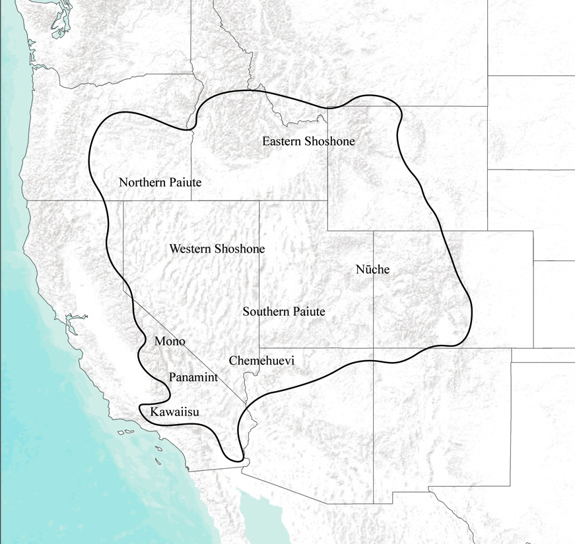
Figure 1 Map showing historic distribution of Numic speakers in western North America. Adapted from Madsen and Rhode (1994).

Nūche are Numic speakers who traditionally lived in a large region extending from the Colorado Plateau through the Rocky Mountains (Figure 2). Today, most Nūche live on one of three reservations in Colorado and Utah, each corresponding with one of the three major Nūche tribal divisions: Northern, Southern, and Ute Mountain. However, these cultural and geographic distinctions are the product of European colonization and the active demographic manipulation by the American government. Prior to the reservation-era, Nūche organized themselves as bands with loosely integrated political relationships sharing close social, economic, and kinship ties (Conetah 1982; Pettit 1990; Simmons 2000; Smith 1974; Steward 1938; Stewart 1942).

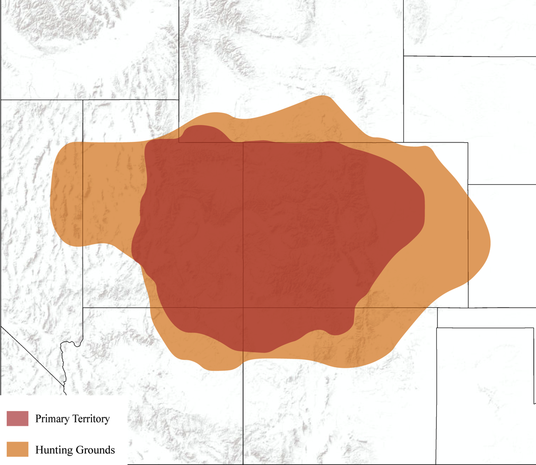
Figure 2 Map showing historic Nūche territory and hunting grounds over modern state boundaries.

Although there is a rich ethnographic record of recent Nūche culture, researchers have struggled to extend this knowledge into the past. In particular, archaeologists have devoted decades to attempting to identify Nūche-affiliated archaeological sites, yet the dearth and homogeneity of the archaeological data has left researchers with more questions than answers (Baker 2013, 2016; Brunswig n.d.; Buckles 1971; Eddy et al. 1984; Grady 1984; Guthrie et al. 1984; Jennings 1978; Nickens 1988; Reed 1994). Most of the sites in North American are small-scale scatters of lithic tools and debris, but few archaeologists have utilized lithics (with the exception of projectile points) as a means to assign cultural affiliation. A notable exception is William G. Buckles’s (1971) dissertation exploring Nūche archaeology and cultural continuity in the Uncompahgre Plateau of west-central Colorado. Upon completion of the “Ute Prehistory Project,” Buckles (1971) concluded it was impossible to link lithics to Nūche without the presence of other, more diagnostic lines of evidence. Because of this assessment, Buckles and others have struggled or declined to comment on the arrival or continuity of Nūche culture.
Nearly 45 years after the completion of Buckles’s dissertation, I revisit and expand on his original effort to identify continuity (or a lack of thereof) between historic-era Nūche bands and their Pre-Contact counterparts. Specifically, I study the stone tools and debitage from two archaeological sites discussed in Buckles’s research: Christmas Rock Shelter (5DT2) and the Shavano Spring site (5MN40). Combined, these sites contain evidence for human occupation of the Uncompahgre Plateau from the Paleoindian era to Historic times. Although Buckles did not conclusively identify the more recent occupations as Nūche affiliated, the Uncompahgre Plateau is at the heart of traditional Nūche territory, and historic accounts indicate they were the only indigenous people living in the area during European contact (Bolton 1950; Hill 1930; Schroeder 1965; Stewart 1966). My research reports the results of an in-depth attribute analysis of all the provenienced lithic artifacts from both sites to identify any and all patterns that may be unique to Nūche behavior and technology. In so doing, I address the following questions: 1) What is the extent of lithic variability at Christmas Rockshelter and Shavano Spring? Are there changes in production techniques and use of technology over time? 2) Are there any changes in raw material procurement strategies over time? Do people show a preference for specific material types?
My analysis is influenced by and reinforces the understanding that people have socially reinforced knowledge that informs and is reproduced through daily practices (Bourdieu 1977, 1990; Dornan 2002; Giddens 1984, 1986, 1993; Ortner 1984). These socially constructed norms, also known as Bourdieu’s (1977, 1990) habitus, reflect how people choose to organize their space and define how household activities should be carried out. However, unlike Bourdieu, I apply a more modern approach to practice theory that accounts for both conscious and unconscious behaviors. These cultural or community-based systems of doing are then reflected in the decisions people make as they procure, produce, use, maintain, and discard technology through the steps of a chaîne opératoire, a “succession of mental operations and technical gestures, in order to satisfy a need (immediate or not), according to a preexisting project” (Perlès 1987:23, as cited in Sellet 1993). The attributes of lithics (i.e., size, retouch, platform preparation, etc.) respond to the stylistic and technical choices people make, reflecting the individuality of cultural groups (Bar-Yosef 1991; Sellet 1993). People have their own understanding of what a lithic toolkit should be, how it will be used, and the steps needed to create it.While some of these decision-making processes such as raw material procurement may be tied to specific landscapes, it is unlikely people will abandon all social preferences or procedures when moving into unfamiliar areas.
Applying practice theory to the production of material culture has its own set of challenges. Often stages of chaîne opératoire are subject to varying degrees of variability as stylistic decisions may reflect more individuality than functional actions. However, by looking at the entire spectrum of lithics and their features, it is possible to examine variability for commonalities. Additionally, there is very rarely a one to one correspondence between material culture and culture areas (Worth 2017), in part because people choose to maintain, alter, or abandon practices for any number of reasons (Hodder 1982; Sackett 1990). Often people will respond to internal or external change in a community by redefining their practices. This is true when groups interact, leading to the adoption of blending of practices (e.g., Bernard 2008, Graesch et al. 2010; Lightfoot 2003; Lightfoot et al. 1998; Voss 2005). During the Numic Expansion, Nūche moved across unfamiliar territories and interacted with other groups living throughout the Intermountain West. While they would have had their own unique approaches to lithic technology, it is also possible they adopted new practices through interactions with people already living on the Colorado Plateau and Rocky Mountains.
Despite the flexibility of practice and lithic technology, it should still be possible to see changes that reflect new communities of learning, and I hypothesize that new communities arriving onto the Uncompahgre Plateau will bring their own unique chaîne opératoire, resulting in changes to material culture left behind. Pitblado’s (2003) research examining the earliest people to arrive in the Rocky Mountains reveals that there were raw material, morphological, and typological differences in the lithic technology between regions, and these differences persisted when people moved across vastly different landscapes. Although Nūche encountered far more people than travelers during the Paleoindian, I expect these differences will still occur, though perhaps in a less pronounced way. Therefore, if Nūche migrated into the area as part of a larger Numic expansion, I predict the following:
1) The morphology, retouch, and/or frequency of both formal and informal tool types will shift at the time of the Numic Expansion. Lithic debris will show evidence for alternative or varied strategies in the platform preparation, striking, or extent of reduction. Preferences for specific material types or features may persist as a cultural norm over time.
2) Raw material frequencies will increase or decrease based on availability, familiarity, and preference. Migrants will at first be restricted to more readily available materials because of their unfamiliarity with the region and materials in it. There is a higher potential for people transporting or exchanging nonlocal materials from the West. Nūche arriving in the area may have a preference for familiar materials such as obsidian and basalt, which are more common in the Great Basin.
If Nūche culture developed in-situ in the Uncompahgre Plateau, I predict the following:
1) Formal and informal tool technology will appear consistent or show gradual change over time. Debitage will show evidence for similar or gradually changing preparation and reduction techniques across time.
2) Raw material frequencies will stay similar or show a gradual change over time.

My work seeks to expand current understanding of Nūche past, commenting on the timing of their arrival into the region. Toward this end, Chapter 2 provides a regional background and cultural chronology that focuses on Nūche occupation of the Uncompahgre Plateau. I briefly discuss Buckles’s fieldwork and conclusions from the Ute Prehistory Project before introducing the two sites I re-examined in this thesis: Christmas Rock Shelter and the Shavano Spring site. Chapter 3 details the materials and methods I used to complete my research, and Chapter 4 explores the results from the attribute analysis and compares the two sites to identify patterns in chipped stone tools and debitage material and morphology. Chapter 5 discusses the implications of the results and their broader applications for archaeology. I end by providing a summary of this work, concluding remarks, and suggested avenues for future research.

Chapter 2: Regional Background
In this chapter, I provide the background information necessary to contextualize my research by providing relevant information about the Uncompahgre Plateau, Buckles’s excavations, and contributions through the Ute Prehistory Project. I begin the chapter by describing the environment and geology of the Uncompahgre Plateau before discussing human occupation of the region across deep time. Additionally, I discuss the research archaeologists completed in the region. I finish focusing on the Ute Prehistory Project and its relevance to my research.

Geology
The Uncompahgre Plateau is a domed uplift in west-central Colorado (Figure 3). The landscape is a mosaic of flat mesas cut by a series of large canyons (Figure 4). One of the lower plateaus in the region, elevations in the area rarely surpass 3,000 m (Chronic and Williams 2002). Prominent canyons relevant to this research include Dry Creek, Cushman, Coal, Shavano, and Roubideau canyons (inset map, see Figure 3). The plateau is bounded by the San Juan Mountains to the south, the San Miguel and Dolores Rivers to the west, the Colorado River to the north, and the Gunnison and Uncompahgre Rivers to the east. Exposures of Cretaceous, Jurassic, and Triassic rocks form the plateau itself, with the Jurassic and Cretaceous periods dominating the formation (Figure 5) (Taylor 1999). These Mesozoic rocks lie directly above the Precambrian formation because massive erosion completely removed the Paleozoic layer. Jurassic and Cretaceous formations include the Dakota, Burro Canyon, and Morrison (Brushy Basin and Salt Wash) (Gerhardt 2001; Hauser 2008). These formations offer often high-quality lithic raw material sources (Hauser 2008; Miskell-Gerhardt 2013).
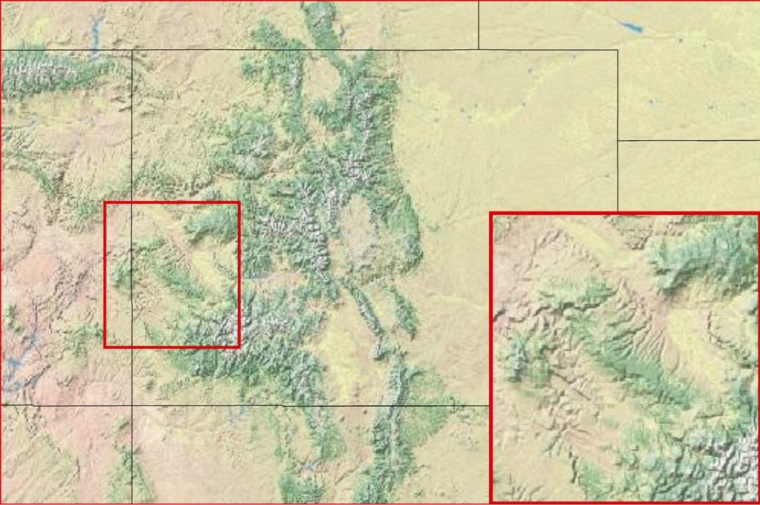
Figure 3 Map of the Uncompahgre Plateau.

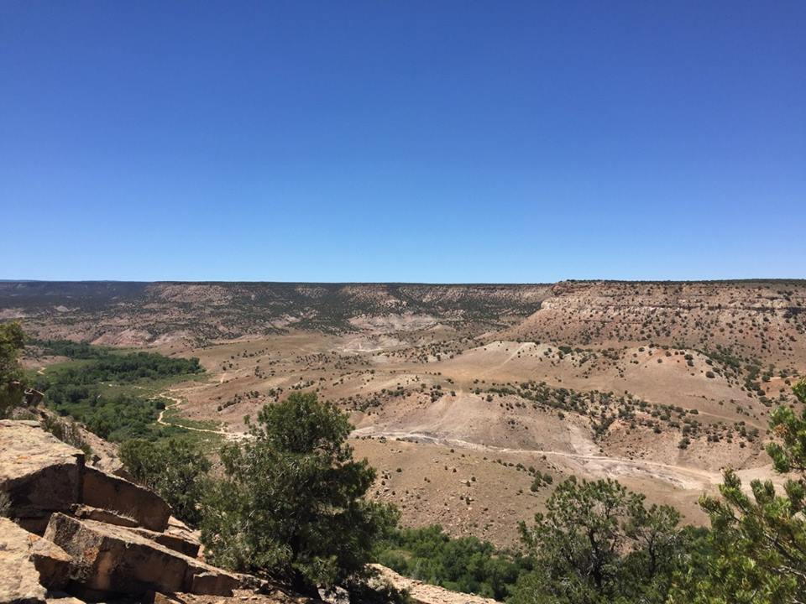
Figure 4 Photograph of Uncompahgre Plateau.
Silicified sandstone, silicified volcanic ash, and nodular chert are the primary sources of lithic raw materials available in the Uncompahgre Plateau (Reed and Metcalf 1999). Relatively small outcrops of silicified sandstone occur in the upper division of the Burro Canyon Formation (Gerhardt 2001). However, the main sources of knappable lithic materials are in the Brushy Basin level of the Morrison Formation and the Burro Canyon Formation that lies between the Morrison Formation and the Dakota Formation (Miskell-Gerhardt 2013).
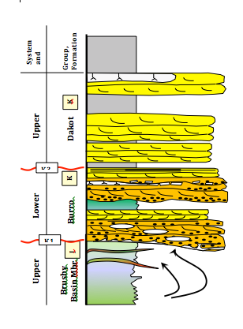
Figure 5 Geological formations applicable to the Uncompahgre Plateau. Used with permission from Miskell-Gerdhart (2013).

Environment
The climate in the Uncompahgre Plateau has remained relatively uniform for the past 2,000 years (Stone 1999). Today, the average temperature of the Uncompahgre Plateau oscillates between -2° C in winter to 21° C during the peak of summer (Reed et al. 2001). Precipitation at lower elevations (1,400-2,000 m) in the Uncompahgre Plateau ranges between 200 and 310 mm, with low humidity. Precipitation is heaviest during the growing season (May-September), which is approximately 140-150 days long at lower elevations and 50 days at higher altitudes greater than 2,000 m (Reed et al. 2001).
The vegetation in the region responds to local climates, and the altitudes for vegetation zones fluctuate depending on temperature and average precipitation. Currently, salt brush and sagebrush flats occupy the lower elevations (1,400-2,000 m) of the Uncompahgre Plateau (Hauser 2008; Stone 1999). Pinyon-juniper, Gamble Oak, and Ponderosa Pine all occur at higher elevations between 2,000 and 2,900 m. Aspen, spruce, and fir trees dominate the highest elevations of the Uncompahgre Plateau, ca. 2,900 m to 3,100 m (Reed and Metcalf 1999; Stone 1999).

Cultural Chronology
While many researchers argue Nūche arrived as part of the Numic Expansion from the Great Basin between A.D. 900 and A.D. 1400, Nūche oral traditions support a long occupation of the Colorado Plateau and Rocky Mountains, leaving the timing of Nūche arrival uncertain. Although my research focuses on identifying changes to lithic technology beginning at that time, I compare artifacts from earlier occupations to identify patterns of similarity or difference in production and procurement strategies. For this reason, I include a brief description of the Paleoindian and Archaic time periods before emphasizing traditions or patterns that coincide with the Numic Expansion or are specific to Nūche occupation. The cultural chronology I present below encompasses the Northern Colorado River Basin in its entirety to provide a more complete understanding of the history of the region.

Paleoindian
Evidence for early human occupation of the Northern Colorado River Basin is scarce (there is currently no evidence for a Pre-Clovis occupation), but a growing archaeological database has slowly enhanced the visibility of people during the Paleoindian Period. In their summary of archaeology in the Northern Colorado River Basin, Reed and Metcalf (1999) proposed that the Paleoindian period lasted from 13,400 to 7,500 cal. B.P. Evidence across the larger region includes projectile points consistent with Clovis, Goshen, Folsom, Angostura, and Cody traditions. During this time, occupants of the Colorado Plateau lived as highly mobile hunter-gatherers, often moving among resources rather than settling in more long-term base camps (Pitblado 2003). Pitblado’s (2003) research indicates people living on the Colorado Plateau shared similar technology and foraging strategies to those across the Great Basin rather than those living in the Rocky Mountains to the east. It is probable, however, that people living on the Plateau sporadically ventured to the nearby mountains. While new research continues to shed light on Paleoindian occupation of the Northern Colorado River Basin, archaeologists still know very little about occupation of the Uncompahgre Plateau during this time. Christmas Rock Shelter remains the only Paleoindian site (recognized by the discovery of a Midland projectile point at a lower occupation) recorded on the Uncompahgre Plateau.

Archaic
The Archaic Period dates to 8,400-2,000 cal. B.P. (Reed and Metcalf 1999). Like the Paleoindian era, however, archaeologists’ understanding of this period is limited; although there are far more recorded Archaic sites on the Northern Colorado River Basin than is the case for Paleoindian time. While the Archaic Period is well-known for its cultural continuity with the preceding Paleoindian period, there are several key points of difference in the region. The Early Archaic is well known for co-occurring with the Altithermal, a warming period across North America, which caused environmental pressures and subsequent shifts in subsistence strategies for people in nearby areas such as the Great Plains (Meltzer 1999). However, it is unclear to what extent the Altithermal impacted the way people lived on the Uncompahgre Plateau and Northern Colorado River Basin.
Janetski and colleagues’ (2012) research from the North Creek Shelter in southern Utah, an area that shares a similar environment with the Northern Colorado River Basin, reveals that people living during the Archaic focused more on large game and plant foods than their Paleoindian predecessors. Residential mobility similarly decreased in comparison with the Paleoindian, and people began staying longer before switching locations. Later in the Archaic, people also began to invest more in non-lithic technologies such as ceramics and baskets, whether by trade or their own production (Skibo et al. 2008). Overall, the Archaic showed a shift in subsistence, mobility, and technology in comparison with the Paleoindian, in part as a response to early environmental change due to the Altithermal and increasing population pressures.

Formative Period
The Formative Period extended from 400 B.C. to A.D. 1300 in the Northern Colorado Plateau (Reed and Metcalf 1999). Archaeologically, there are few differences between the Archaic and Formative periods within the Northern Colorado River Basin; however, notable differences between the two periods include a shift to bow and arrow technology and use of ceramics. Archaeologists widely accept that people began replacing the dart and atlatl with bow and arrow technology by A.D. 300 (Geib and Spurr 2002; Holmer 1980). Ceramics also appeared in the region ca. A.D. 550 as a result of trade with neighboring groups such as Ancestral Puebloans and Fremont (Arthur et al. 1981; Spangler 1995).
Archaeologists most frequently associate the end of Formative Period with arrival of the Nūche into the region as part the Numic Expansion (Bettinger 1994, Brunswig et al. 2001, Elinoff 2002). Widely popularized by Sydney Lamb (1958), the Numic Expansion proposes a large-scale migration of Numic (Uto-Aztecan) speakers out of Southeastern California, across the Intermountain West. While the origin and timing of this expansion continue to be debated among researchers, the general consensus of linguistic, ethnographic, biological, and archaeological evidence suggests the Numic Expansion was responsible for the distribution of historic populations of Numic speakers and occurred between A.D. 1000 and A.D. 1400 (Bettinger 1994; Bettinger and Baumhoff 1983; Cabana, Hunley, Kaestle 2007; Elinoff 2002; Kaestle and Smith 2001; Sutton and Rhode 1994; Young and Bettinger 1992). Archaeologists studying Nūche history have predominately accepted this timing (cf. Baker 2013, 2016); however, radiocarbon dates associated with Nūche affiliated ceramics, Uncompahgre Brownware, place this arrival as early as A.D. 900 (Brunswig 2005; Greubel 1989; McPherson 1983; Metcalf and Reed 1999; Pool 1997; Reed 1994).

Protohistoric and Historic
The Protohistoric time period followed the Formative Period but preceded the American government’s removal of Native Americans to formalized reservations ca. A.D. 1881 (Kappler 1904). Archaeologists recognize the beginning of the time period by the widespread introduction of locally made Uncompahgre Brownware ceramics and complete adoption of the bow and arrow. By the early 1600s, the Spanish arrived in the Colorado Plateau, which increased the availability of European trade goods and horses. Within the next 50 years, indigenous people in the area had adopted a fully equestrian lifestyle, increasing their mobility and their interactions with neighboring groups from the Southwest and Great Plains. While Shoshone, Comanche, and Navajo peoples may have resided in the Northern Colorado River Basin for brief periods of time, Nūche are the only tribe known to have lived in the Uncompahgre Plateau historically (Buckles 1971; Schroeder 1965; Tyler 1951).
Prior to the reservation-era, Nūche organized themselves as bands with loosely integrated political relationships and close social, economic, and kinship ties (Conetah 1982; Pettit 1990; Simmons 2000; Smith 1974; Steward 1938; Stewart 1942). The fluid nature of their group membership and high mobility made it difficult for outsiders to recognize specific bands. Scholars, however, typically identify 11 to 13 groups that occupied Western Colorado and Eastern Utah at the time of contact and during the following century (Conetah 1982; Simmons 2000; Steward 1938; Stewart 1942). The Taviwach of the Northern Ute Tribe occupied the Uncompahgre Plateau during the ethnographic past.
Archaeologists associate Nūche occupation with a suite of material culture traits including wickiups, peeled trees, ceramics, and projectile point styles. Nūche were highly mobile hunter-gatherers who predominantly lived in rockshelters and wickiups, lean-to structures made from large branches and covered with brush or grass (Buckles 1971; Martin 2016). During the spring, ponderosa pines begin their new yearly growth in the form of an edible inner bark known as cambium (Stone 1999). Nūche harvested this growth during times of resource scarcity for both food and medicinal purposes (Martorano 1988; Stone 1999). Additionally, Nūche made coiled, wide-mouth ceramic jars with pointed bases, low shoulders, and flared rims (Brunswig 2005; Buckles 1971; Reed and Metcalf 1999). The ceramics were typically brown or gray in color and textually smooth or finger imprinted.
Finally, Nūche created small, triangular Desert Side-notched (DSN) and Cotton Triangular projectile points (Figure 6). While Nūche manufactured such artifacts, this material culture overlaps closely with many of the tribes living in the Colorado Plateau, Rocky Mountain, Great Basin, Southwest, and Great Plains regions (Bettinger and Bauhoff 1982; Brown et al. 1991; Frison 1991; Gunnerson 1987; Holmer 1986; Jennings 1957, 1974, 1978; Kearns 1996; Wedel 1961). This was due in part to fluid cultural relationships prior to European contact and similar adaptations to the environment.
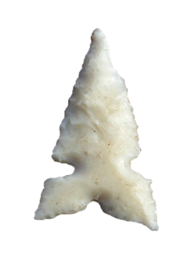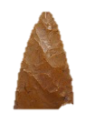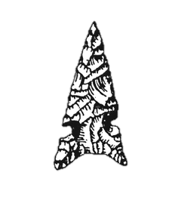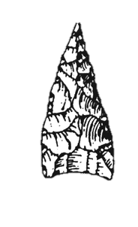
Figure 6 Desert Side-notched (left) and Cottonwood Triangular (right) projectile points.

Past Archaeological Work
Archaeologists have worked sporadically on the Uncompahgre Plateau since the first formal investigations in the 1930s by Wormington and Lister (1956). Most archaeological research has occurred on the eastern and western boundaries of the plateau, leaving most of the area largely unexplored by formal archaeological survey. Archaeological investigations slowed until Lister and his graduate student William G. Buckles’s work in the early 1960s with the “Ute Prehistory Project.” This resulted in the formal identification of 75 sites and greatly expanded knowledge of the region. Archaeological research was sparse for the next several decades until a large cultural resource management project traversed the area. Archaeologists surveyed across the plateau and excavated two sites, MN3859 and MN2628 for the Trans-Colorado Natural Gas Pipeline (Reed et al. 2001).
Members of the Chipeta Chapter of the Colorado Archaeological Society have been active participants in local archaeology since the society’s inception in 1935 (Colorado Archaeological Society 2016). Avocationals survey the area both independently and as volunteers on formal projects such as the Ute Prehistory Project. The Bureau of Land Management Office in Montrose has worked with local residents and members of the society since 2001 in a large-scale effort to record sites in the Uncompahgre Plateau (Hauser 2008). This work includes extensive research efforts such as Chuck Richey and Neil Hauser’s (2008) investigation of Flint Cave (MN7429) to better illuminate quarry use and chronology in the region.
The Ute Prehistory Project remains by far the largest and most comprehensive archaeological study of the Uncompahgre Plateau. Buckles disseminated the results of the project in his dissertation (1971), and his conclusions continue to impact archaeology on the Uncompahgre Plateau and beyond to the greater Colorado Plateau and Rocky Mountain regions. Archaeologists regularly refer back to his work when referencing Nūche archaeology across Colorado and Utah. The continued relevance of his work is the reason I chose to re-examine two of his sites in my thesis.

The Ute Prehistory Project
In the late 1950s and early 1960s, anthropologists in Colorado and Utah began a rigorous effort to better understand the prehistory of Nūche. They hoped to clarify the archaeological sequence and evaluate whether there was evidence for cultural continuity between historic Nūche and the prehistoric occupants of the area. In 1961, Robert Lister of the University of Colorado founded the “Ute Prehistory Project” to answer these questions. Through the project, he and his colleagues explored and compared archaeological sites across the Uncompahgre Plateau. Because Nūche were the only tribe known to have occupied the plateau in historic times, Lister deemed the area an ideal location to apply the direct historical approach to establish Nūche cultural chronology (Buckles 1971). The direct historical approach is a technique that works “backwards,” by using historic records, oral traditions, and archaeological data to interpret earlier times. Soon after the project began, Lister’s graduate student William G. Buckles began directing field operations and laboratory work. The results of three field seasons of work formed the foundation for Buckles’s doctoral dissertation. Totaling nearly 1,600 pages, The Uncompahgre Complex: Historic Ute Archaeology and Prehistoric Archaeology on the Uncompahgre Plateau in West Central Colorado presented the results of the Ute Prehistory Project. In the following sections, I describe Buckles’s approach to the field and analysis methods, relevant background information about the sites I chose for my analysis, and his overall conclusions, which continue to inform archaeological understandings of Nūche lives in the Colorado Plateau and Rocky Mountains.

Buckles’s Methods
With the help of the local Chipeta Chapter of the Colorado Archaeological Society, Buckles conducted fieldwork across the Uncompahgre Plateau in the summers of 1961, 1962, and 1963. His team identified 75 sites and excavated 39 of them over the course of the project. Excavations varied from test pits to block excavations. After completing field work, Buckles performed three kinds of artifact analysis: functional, typological, and attribute. The functional level of analysis grouped artifacts according to their inferred function. He defined 23 groups, including lithic and non-lithic artifacts such as ceramics, perishables, and historic materials. The typological analysis identified morphological variations within the functional groups. Finally, the attribute analysis recorded traits as present/absent or entailed measuring artifacts. When analyzing the collections, Buckles initially ignored provenience and pooled the artifacts into one dataset. This allowed him to mitigate bias and base his types as strictly as possible on qualitative and quantitative analysis. He later analyzed artifacts according to their provenience to explore quantitative and qualitative patterns across time and space.

Archaeological Sites
The 75 sites the Ute Prehistory Project investigated spanned the ca. 11,000-year-long occupation of the plateau and ranged in type from pictographs to sheltered occupations. In his dissertation, Buckles (1971) specified the Christmas Rock Shelter (5DT2) and open-air Shavano Spring site as the two most extensive and enlightening sites of the Ute Prehistory Project. Because of their continuous occupation and Buckles’s comprehensive excavations of those two sites, I likewise focused my investigation on them.

Christmas Rockshelter (5DT2)
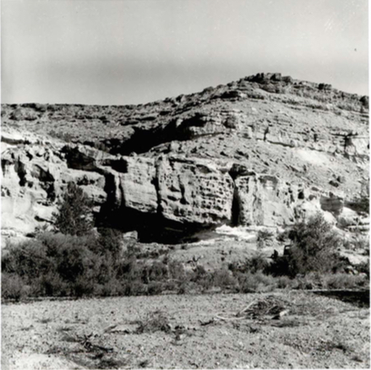
Figure 7 Photograph of Christmas Rockshelter (5DT2) from Buckles (1971).

Buckles’s survey team investigated Christmas Rock Shelter in the summer of 1963, although local residents knew of the site long before the Ute Prehistory Project’s inception. Located on the western side of Roubideau Canyon on the northeastern edge of the Plateau, the rock shelter faces the southeast from the base of a sandstone outcrop and measures ca. 12 m long by 4 m deep. The site lies along a nearby tributary of Roubideau Creek just above the floodplain. Road construction in the twentieth century disturbed a portion of the site and limited access to the rock shelter, but enough of the area remained to piece together a full chronology for the site (Buckles 1971).
Excavations began when Buckles and a crew of local volunteers opened 19 units at the Christmas Rock Shelter. They identified 11 cultural levels at the site, several of which Buckles subdivided further, ultimately concluding that occupation had begun in Paleoindian time and continued through the historic era. It should be noted that the stratigraphy at the site complicated Buckles’s ability to assess change over time; however, through comparisons with other sites in the Uncompahgre Plateau, he remained confident in his relatively dated chronological assignments. He hypothesized that the fourth occupational level (Level 4) represents occupation of the site during the Formative era, with all the preceding levels representing more recent time. These levels likely represent Nūche occupation at the site and across the Uncompahgre Plateau. Christmas Rock Shelter is the only Paleoindian site so far documented on the Uncompahgre Plateau. A lower stratum yielded a Midland projectile point and several associated artifacts. The early component of the site also contained flake tools, backed tools, burins, and an adze. Similar tools occurred throughout the site; however, materials from higher strata differed from lower levels in projectile point morphology and a greater number of scrapers. Buckles (1971) proposed that technological similarities in assemblages reflected similar adaptations to the region throughout time. However, he also concluded that the artifacts did not (or at least did not necessarily) indicate cultural continuity (Buckles 1971).

Shavano Spring (5MN40)
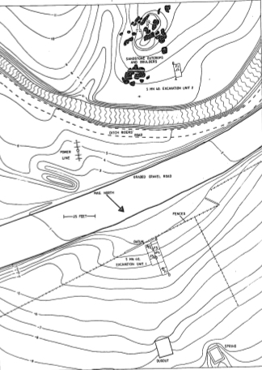
Figure 8 Map of Shavano Spring (5MN40) from Buckles (1971).

Curator of the Colorado State Historical Museum, J.A. Jeacons (1926) first described the Shavano Spring site (5MN40) while discussing petroglyphs in the Uncompahgre Plateau area. Modern construction had heavily impacted the site, but at the time of excavation, Buckles suspected some of it remained undisturbed. He estimated that the site in its entirety covers 1372 square meters. Buckles excavated two trench units at Shavano Spring, the first (Unit 1) east of an irrigation ditch near the spring and the second (Unit 2) west of the spring. The distance between units (approximately 135 ft.) and variation in ground disturbance led to several differences between the strata and assemblages of the two excavation blocks. Whereas Buckles identified nine individual strata in Unit 1, he only recorded seven in Unit 2. After the fieldwork, however, he reconciled the two and identified seven distinct cultural components across the site as a whole (Buckles 1971). These cultural components differed from other assemblages associated with rock shelters on the Uncompahgre Plateau because they showed more evidence for hunting activities. Flake and blade tools were uncommon at Shavano Spring, whereas hunting tools (i.e., projectile points, knives, and expedient cutting tools) occurred in higher numbers. Based on comparisons with other sites, Buckles concluded that the first two cultural levels (Levels 1 and 2) reflect a recent occupation at the site, likely beginning during the late Formative period or early Protohistoric era. If correct, these cultural levels represent Nūche occupation at the site. Buckles (1971) noted that limited excavations restricted his conclusions, because only a small portion of the site was fully excavated.

Buckles’s Conclusions
Through his excavations, Buckles (1971) developed an archaeological sequence for the area, encompassing time frames ranging from the Paleoindian through Historic eras. Based largely on the projectile point assemblage from 15 sites and several associated radiocarbon dates, he expanded on Wormington and Lister’s (1956) Uncompahgre Complex and its projectile point typology (Figure 9). For simplicity and consistency with contemporary archaeological practices, I will continue to use the time periods described at the beginning of this chapter instead of the phases Buckles described in the Uncompahgre Complex. Buckles identified a trend in projectile points from lanceolate, stemmed, and corner-notched during the Paleoindian and Archaic periods to smaller side-notched points beginning in the Formative period and continuing to the end of the Protohistoric era (Buckles 1971). He attributed major change in projectile point morphology to the adoption of the bow and arrow at the beginning of the Formative period (Buckles 1971). Technological changes also included a gradual trend toward thinner knives over time; an ebb and flow in the utilization of adzes, gravers, ground stone tools, and chopping tools; and the introduction of ceramics and European goods (Buckles 1971). Overall, however, Buckles (1971) concluded that people in the area lived homogenously, both behaviorally and technologically, from the Paleoindian period through the mid-1800s, although again, he argued this did not necessarily coincide with cultural continuity. Rather he proposed that the entire archaeological record reflected foraging and technological strategies well adapted to the area.

Phases | Estimated Dates | Associated Projectile Points
Escalante | A.D. 1500 - 1800 | 
Camel Back | A.D. 1300 - 1500 | 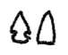
Coal Creek | A.D. 700 - 1300 | 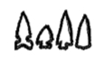
Ironstone | A.D. 0 - 700 | 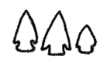
Dry Creek | A.D. 0 - 700 | 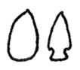
Horse Fly | 500 B.C. - A.D. 0 | 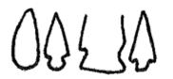
Roudideau | 3,000 - 500 B.C. | 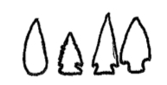
Shavano | 7,000 - 3,500 B.C. | 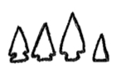
Monitor Mesa | 3,500 - 1,500 B.C. | 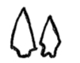
Buttermilk | 8,000 - 3,000 B.C. | 

Figure 9 Uncompahgre Complex phases and projectile points. Adapted from Buckles (1971).

Although Buckles avoided assigning cultural affiliation to archaeological material from any time period, his observations of Nūche material culture and the Uncompahgre Complex have remained the foundation for Ute archaeology in the Great Basin and Rocky Mountain regions (Cassells 1997; Reed and Metcalf 1999; Stone 1999; Woods 1999). Although his hesitation to commit to a cultural affiliation resounded strongly throughout his dissertation, scholars continue to reference his descriptions of material culture as representative of Nūche material culture.

Summary
The Uncompahgre Plateau is well suited for studying whether it is possible to see evidence for the Numic Expansion in Nūche archaeology. The region has a long history of human occupation, extending from the Paleoindian period to current occupants and is at the heart of traditional Nūche territory. Because of this continual occupation as well as the abundance of past lithic material culture and history of archaeological exploration by Buckles (1971) and others, I chose the Uncompahgre Plateau to explore change through time, specifically at two of the archaeological sites Buckles investigated: Christmas Rockshelter and Shavano Spring. Although both sites lack an absolute chronological control, the timeline Buckles created provides a well-established relative chronology to guide my analysis. In Chapter 3, I discuss the methods I used to study the lithic artifacts from these two sites.

Chapter 3: Methods
For this study, I analyzed the lithic assemblages from Buckles’s excavations of the Christmas Rock Shelter and the Shavano Spring site. To gain a detailed understanding of changes in technology and, ideally, behavior over time, I recorded a series of qualitative and quantitative attributes for each provenienced artifact. The assemblages contained a total of 10,230 chipped stone artifacts with provenience information, 8,500 from Christmas Rockshelter and 1,730 from Shavano Spring. I recorded the data using coding guides (Appendices A-F) created by Bonnie Pitblado (University of Oklahoma) to analyze other hunter-gatherer lithic assemblages from sites in the Colorado Rockies. Due to the success of her system in similar and nearby environmental contexts (e.g., Pitblado 2003), I chose to apply her approach rather than alternatives. The attributes I recorded for each artifact depended on the artifact type: projectile point, biface, tool, core, or debitage (Tables 1 and 3). Attributes recorded for projectile points and other bifaces varied slightly from other formal tools to better capture morphology and retouch of those chronologically diagnostic artifacts. In the remainder of this chapter, I describe the attributes included in the study and the statistical approaches used to identify trends in the data.

Qualitative Analysis
Table 1 Qualitative Attributes Recorded for Each Artifact Type
Qualitative | Projectile Points | Bifaces | Tools | Cores | Debitage
Percentage of Cortex | x | x | x | x | x
Condition (Completeness) | x | x | x | x | x
Platform Type |  |  | x |  | x
Platform Condition |  |  |  |  | x
Platform Lipping |  |  |  |  | x
Eraillure |  |  |  |  | x
Bulb of Percussion |  |  |  |  | x
Longitudinal Cross-Section | x | x | x |  | x
Transverse Cross-Section | x | x
Tool/Core Type |  |  | x | x
Type of Retouch |  |  | x | x
Location of Retouch |  |  | x | x
Orientation of Retouch |  |  | x | x
Angle of Retouch |  |  | x | x
Notching | x
Basal Grinding | x
Basal Condition (Concavity) | x
Flintknapping Imperfections | x | x | x | x

Table 1 lists the qualitative attributes I evaluated for each artifact analyzed. I recorded the variables either as either present/absent or as belonging to one of multiple variants, depending on the variable. For all artifacts, I recorded the percentage of cortex as intervals of 0%, 1-24%, 25-49%, 50-74%, or 75-100%. I noted the condition of each piece as either complete or not and further identified flakes as broken (platform present), fragment (platform absent), split (broken along striking axis), or debris (platform absent, cannot discern interior from exterior surface). When analyzing flakes, I focused on the platform and recoded the type as single, dihedral-, or multi-faceted. I coded platform lipping, the bulb of percussion, and eraillure scars as present or absent (Figure 10).
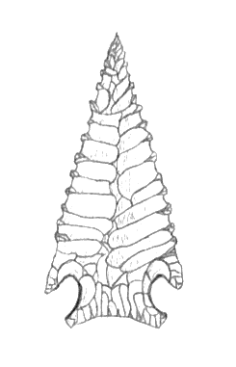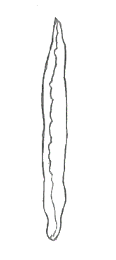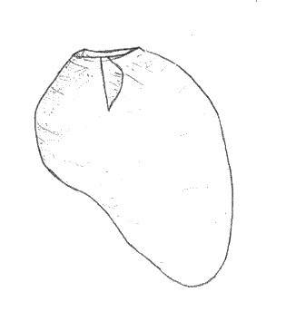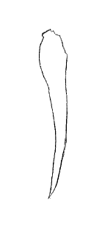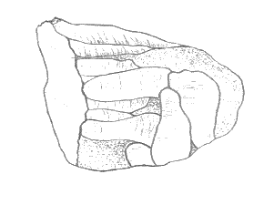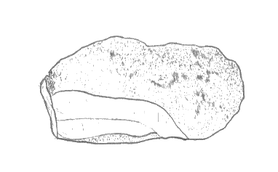
Notching
Technical
Width
Technical
Thickness
Technical Length
Basal Condition
(Concavity)
Platform
Technical Length
Bulb of
Percussion
Lipping
Eraillure
Technical
Width
Technical
Thickness
Maximum
Length
Technical
Width
Maximum
Thickness
Flake Scar
Figure 10 Attribute analysis procedure by artifact type. Illustrations by J. Matthew Oliver.

For tools and cores, I recorded the type and morphology for each piece. I assigned tools to artifact types including projectile points, bifaces, scrapers, drills, burins/gravers, or choppers to better tailor recorded attributes to specific morphologies and understand the diversity of tool kits at each site. The tool types and definitions for my analysis are from Andrefsky (2005) listed in Table 1. In addition, I commented on any flintknapping problems or imperfections I could discern (e.g., repeated hinges or step terminations, non-renewable platform, outré-passé (overshot) flaking, crazing due to heating or freezing, inherent faults in the material, or exhaustion).

Table 2 Tool Types and Definitions Adopted from Andrefsky (2005)
Tool | Definition
Projectile Point | Bifacially flaked tool that contains has a haft element and is used as projectile points (i.e., arrow, dart, and spear points).
Biface | Tool with marginal retouch extending across both faces of the piece (i.e., knife). Bifaces may also be further categorized into the other tool types.
Scraper | Flake tool with steep retouch (60 to 90 degrees) along at least one edge.
Drill | Flake or biface tool with long, narrow projection or tip.
Burin/Graver | Flake tool with a narrow and sharp edge. Produced from the removal of several flakes at right angles to one another.
Chopper | Cobble tool with large, single edge formed from the removal of large flakes.

I recorded additional qualitative attributes for projectile points and bifaces including biface shape, longitudinal cross-section, and transverse cross-section. I recorded biface shapes as one of seven types including triangular, square, cone-shaped with squared end, pointed oval, large oval, small and round, or amorphous. The longitudinal cross-section included six classifications: asymmetrical, twisted, ovoid-robust, ovoid-slender, and d-shaped (Figure 11, a-e). I later collapsed these categories to asymmetrical and symmetrical. Transverse cross-section had five categories: lenticular, diamond, parallelogram, d-shaped, or other (Figure 11, f-j).
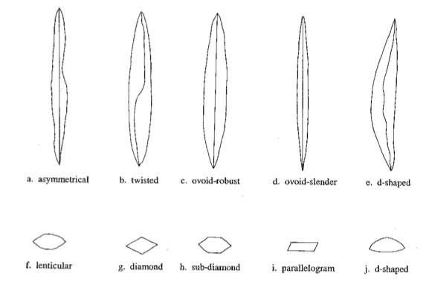
Figure 11 Variants of longitudinal cross-section and transverse cross-section forms (Pitblado 2003).

When examining projectile points, I recorded an additional three qualitative variables specific to the hafting implement or base including the presence or absence of basal grinding, the presence and location of basal notching, and the direction of basal concavity. I recorded whether grinding was present on the base, sides, both base and sides, or absent, but I later collapsed the categories to grinding present or absent. For notches, I recorded the results in classes including side-notched, corner-notched, basal notched, notched in more than one of these locations, or no notches. Last, I examined the shape of the base and recorded the results as concave, convex, or straight.

Quantitative Analysis
Table 3 Quantitative Attributes Recorded for Each Artifact Type
Quantitative | Projectile Points | Bifaces | Tools | Cores | Debitage
Length, Technical (mm) | x | x | x |  | x
Width, Technical (mm) | x | x | x | x | x
Thickness, Technical (mm) | x | x | x |  | x
Maximum Length (mm) | x | x | x | x | x
Maximum Thickness (mm) | x | x | x | x | x
Weight (g) | x | x | x | x | x
Number of Dorsal Scars | x | x | x | x | x
Number of Retouch Scars | x | x | x | x
Extent of Retouch (ratio mm) |  |  | x | x
Maximum Length of Flake Scars (mm) |  |  | x | x

Table 3 lists the metric attributes I recorded. For every artifact, I measured maximum dimension, maximum thickness, technical length, technical width, and technical thickness. Maximum dimension was the longest distance across each artifact, while maximum thickness was the widest section perpendicular to the maximum dimension. Technical measurements, on the other hand, depended on the type of artifact.
For projectile points, bifaces, and drills, I recorded technical measures by first determining the orientation of the artifact using Pitblado’s (2003) technique of creating a baseline (horizontal line aligned with artifact’s base) that formed a right angle with the midline of the piece (Figure 10). For flakes and flake tools (e.g., flakes, scrapers, and burins/gravers), I oriented the piece according to the platform and direction of force. Technical length was perpendicular to the center of the platform, following the direction of force on the piece. Finally, I measured the maximum dimension of cores and choppers as the technical length. For each artifact type, I measured technical width perpendicular to technical length, halfway down the artifact. Technical width was at the intersection of the preceding measurements.

Artifact Retouch
I recorded the extent of retouch using both qualitative and quantitative values. For each artifact, I recorded the presence or absence of retouch. For flakes and cores, I did not record the extent of retouch as a standardized attribute but did comment on the type and extent of retouch. I was most concerned with capturing the extent of retouch on formal tools (i.e., projectile points, bifaces, scrapers, drills, burins/gravers, and choppers). To do so, I recorded the type, location, number, orientation, and angle of retouch. I treated the angle of retouch as a categorical variable, with variants representing intervals of 15° between 0° and 90°. My analysis also included the average length of retouch scars. For bifaces, projectile points, tools, and cores, I measured three retouch flake scars and averaged the lengths. I also calculated the extent of retouch as the ratio of the length of retouch (mm) to the total length of the tool’s edge (Figure 12).
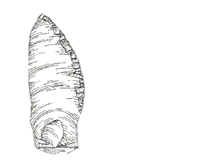
Length of Retouch
Length of Tool’s Edge
Figure 12 Retouch ratio procedure for tools. Figure adapted from Andrefsky (2005).

Raw Material Identification
The diversity of the geology of the Uncompahgre Plateau and surrounding regions (see Chapter 2) makes it difficult for anyone to recognize lithic raw materials based solely on macroscopic properties. Therefore, I recorded a suite of qualitative attributes to characterize the raw material in the collections. Variables included general material type (e.g., chert, chalcedony, or silicified sandstone), color, and material texture (Figure 13). I also noted whether or not artifacts showed evidence for possible heat-treatment, which can include changes in rock color, transparency, and texture (Figure 13). To better understand the local materials available to Nūche knappers, I visited several documented quarries in the Uncompahgre Plateau before beginning my analysis. In addition, Neil and Teri Hauser, archaeologists who work in the area, generously provided me with a comparative source collection for my research. Although I did not attempt a formal sourcing analysis for all of the artifacts, I made additional comments when analyzing artifacts based on my understanding of the locality, accessibility, and abundance of lithic materials. These descriptions and comments on raw materials in the assemblage helped create a foundation for more in-depth sourcing analysis in the future.

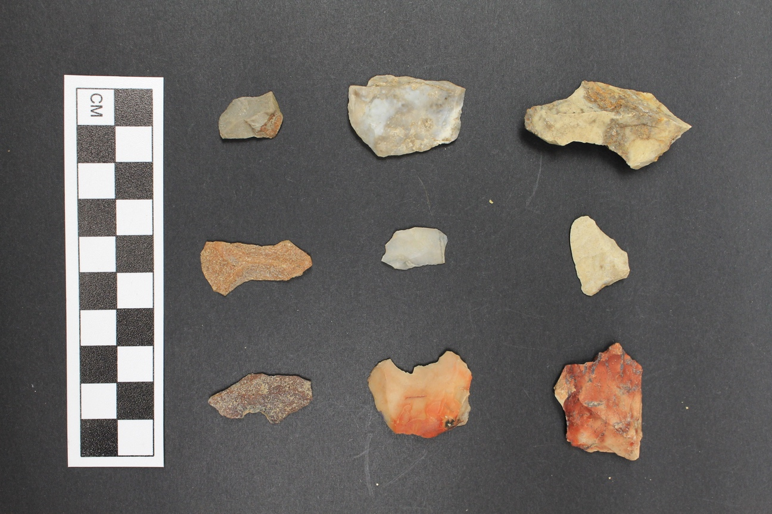
Figure 13 Material types common to the Uncompahgre Plateau including chert, chalcedony, and silicified sandstone. Heat-treated materials are present on the bottom row.

Obsidian Sourcing
I sent all obsidian artifacts to the Geoarchaeological XRF Laboratory located in Albuquerque, New Mexico, for energy dispersive x-ray florescence (XRF) analysis. XRF is a non-destructive technique used to determine the elemental composition of raw materials by examining the secondary (fluorescent) x-rays from a material exposed to a primary (high-energy) source (Shackley 2005). Shackley (Appendix G) compared the data to known values to determine the origins of the piece.

Observational and Statistical Analysis
I began my analysis by examining trends in single variables across time through graphic exploration. This included exploring the data broken down by excavated level and broader time periods. For example, at each site I combined levels based on Buckles’s assigned time period and widely accepted dates for the Numic Expansion (A.D. 900 – 1400). Christmas Rockshelter had levels dating to Nūche, Expansion, and Pre-Expansion time periods (Table 4). During my exploration of the data, I further combined Nūche and Expansion levels to compare against earlier, Pre-Expansion lithics. In the results, I present the data for Christmas Rockshelter as Nūche and Pre-Expansion unless there are notable differences between Nūche and Expansion era lithics. Shavano Spring did not have dates corresponding closely to Expansion era occupation; therefore, I only examined two broad time periods: Nūche and Pre-Expansion (Table 5). Buckles’s dates for the stratigraphic levels and occupation of the sites are based on relative and comparative dating across the Uncompahgre Plateau (see Chapter 2), I apply his dates in my analysis due to his thorough examination of the cultural chronology of the sites and region as well as the lack of alternatives for more precise dating at this point in my research.

Table 4 Excavation Levels and Associated Time Periods for Christmas Rockshelter
Time Period | Dates | Level(s)
Nūche | A.D. 700 - 1880 | 1
Expansion | A.D. 700 -1300 | 2-4
Pre-Expansion | 3500 - 500 B.C. | 5-11
Time Period | Dates | Level(s)
Nūche | A.D. 700 - 1880 | 1-4
Pre-Expansion | 3500 - 500 B.C. | 5-11

Table 5 Excavation Levels and Associated Time Periods for Shavano Spring
Time Period | Dates | Level(s)
Nūche | A.D. 1300 - 1880 | 2
Pre-Expansion | 3000 B.C. - A.D. 700 | 3-6

After exploring the data for patterns, I tested differences in single variables among broad time periods for statistical significance. For qualitative attributes (i.e., general material type, platform type, and cortex), I used Pearson’s chi-square tests of significance (p < .05) to determine whether there were significant differences among time periods. When examining quantitative data, I compared time periods using t tests or Kruskal-Wallis one-way analysis of variance (ANOVA) depending on the number of time periods I examined. Although I compared statistical analysis to compare levels within each site, I did not compare Christmas Rockshelter and Shavano Spring statistically due to the aforementioned inconsistencies in exaction levels and lack of control for absolute chronology.

Summary
My analysis takes a shotgun approach to recording any and all attributes that have a high probability of responding to technological change in style, production, and use. During the first step of my analysis, I classified each artifact into one of five types: projectile point, biface, tool, core, or debitage. I then recorded a series of qualitative and quantitative attributes specifically tailored to each type. For each artifact, I finished by recording details about the raw material including type, color, texture, and evidence for heat-treatment. The analysis compares the variability in artifact types before discussing change in raw material selection. The results discussed in the following chapter are presented in this order.

Chapter 4: Results
In the following sections, I present the results from my lithic analysis of the 10,230 artifacts recovered from Christmas Rockshelter (n = 8500) and Shavano Spring (n = 1730). My analysis identifies changes in technology by discussing the findings from the attribute analysis by artifact type (projectile points, bifaces, non-biface tools, cores, or debitage) and patterns in raw material selection over time. Although I recorded 118 variables among the artifact types, I only present significant or relevant data in the sections below.

Projectile Points
This section examines the projectile point variability across time between the two research sites. In total, there were 107 projectile points at Christmas Rockshelter (n = 61) and Shavano Spring (n = 46). From the data, there was a significant decrease in quantitative measurements over time (Figure 14). The data also from the analysis indicated an increase in asymmetry and straight bases and a decrease in notching; however, these changes were not statistically significant. Evidence for grinding, projectile point shape, and flintknapping problems did not vary or varied in a way that did not convey long-term patterns or change at either location. I discuss the statistically significant quantitative variables in more detail below.
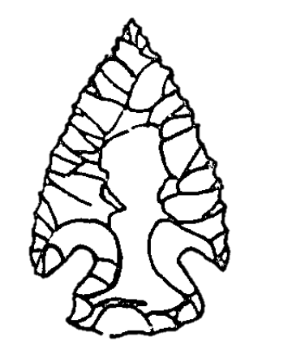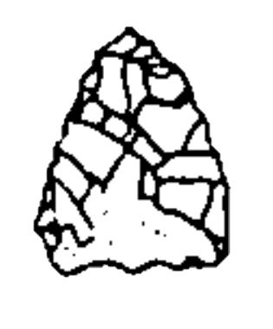
Pre-Expansion
Dimension: 29.3 mm
Width: 18.2 mm
Thickness: 5.0 mm
Weight: 2.5 g
Nūche
Dimension: 20.2 mm
Width: 14.75 mm
Thickness: 3.5 mm
Weight: 1.1 g

Figure 14 Differences in projectile point production between Pre-Expansion and Nūche era occupations.

While the overall size of projectile points varied over time, there was a distinct difference in mean measured values between Nūche and Pre-Expansion era lithics. At Christmas Rockshelter, the maximum dimension, length, width, thickness, and weight of Nūche era Projectile Points were all smaller in comparison with those from the Pre-Expansion. Of these, maximum dimension, length, thickness, and weight were all statistically significant (Table 6). Shavano Spring also showed a decrease in the overall size of the projectile point. The difference in measurements between time periods was statistically significant for all these variables (Table 7).
Table 6 Summary Statistics and Significance for Projectile Point Qualitative Variables at Christmas Rockshelter (n = 61)
 | Nūche (mean) | Pre-Expansion (mean) | T Ratio | Prob
Maximum Dimension (mm) | 22.8 | 29.6 | 2.8 | 0.01
Maximum Length (mm) | 20.5 | 28.3 | 3.1 | 0
Maximum Width (mm) | 16.9 | 18.3 | 0.8 | 0.44
Maximum Thickness (mm) | 4 | 5.1 | 4.1 | 0
Number of Scars - Face 1 | 1.4 | 2.1 | 1.2 | 0.22
Number of Scars - Face 2 | 1.3 | 1.6 | 0.5 | 0.65
Number of Finishing Scars - Face 1 | 17.4 | 20.9 | 1.4 | 0.17
Number of Finishing Scars - Face 2 | 17.9 | 20.8 | 1.1 | 0.27
Maximum Flake Scar Length - Face 1 (mm) | 10.7 | 9.6 | -1.1 | 0.29
Maximum Flake Scar Length - Face 2 (mm) | 10.1 | 10 | -0.1 | 0.94
Weight (g) | 1.6 | 2.5 | 2 | 0.04

Table 7 Summary Statistics and Significance for Projectile Point Qualitative Variables at Shavano Spring (n = 46)
 | Nūche (mean) | Pre-Expansion (mean) | T Ratio | Prob
Maximum Dimension (mm) | 17.5 | 29 | 3.7 | 0.00
Maximum Length (mm) | 16.7 | 26.7 | 2.9 | 0.01
Maximum Width (mm) | 12.6 | 18.1 | 3.4 | 0.00
Maximum Thickness (mm) | 2.9 | 4.8 | 5.6 | 0.00
Number of Scars - Face 1 | 1.5 | 2.4 | 1.6 | 0.11
Number of Scars - Face 2 | 0.6 | 2.6 | 1.9 | 0.07
Number of Finishing Scars - Face 1 | 12.8 | 18.5 | 1.7 | 0.1
Number of Finishing Scars - Face 2 | 8 | 18 | 3.4 | 0.00
Maximum Flake Scar Length - Face 1 (mm) | 6.5 | 9.9 | 2.3 | 0.03
Maximum Flake Scar Length - Face 2 (mm) | 3.9 | 9.1 | 3.7 | 0.00
Weight (g) | 0.6 | 2.4 | 3.1 | 0.00

The mean number of flake scars also decreased across time at both Christmas Rockshelter and Shavano Spring; however, these values were only statistically significant at Shavano Spring (Table 7). The mean maximum length of the flake scars decreased at Christmas Rockshelter and increased at Shavano Spring. Shavano Spring was the only site with statistically significant changes in this particular variable.
To summarize, there was a change in the production of projectile points over time, specifically between Nūche and Pre-Expansion levels (Table 8). The size of projectile points differs in a statistically significant way between Nūche and Pre-Expansion era occupations. The smaller size in projectile points could indicate a shift in technology. Prior to the Numic Expansion, people began to favor the bow and arrow over atlatl technology (Geib and Spurr 2002; Holmer 1980), which resulted in smaller, more expedient technology (Railey 2010). Asymmetrical projectile points are often an indication of a flake rather than bifacial blank, which could reflect less investment in bifacial technology in favor of more expedient production (Pitblado 2003). While the data at the two sites does not indicate a statistically significant shift to asymmetrical artifacts, and thus more expedient production, the shift to smaller projectile point size does suggest increasing popularity of bow and arrow technology after the Numic Expansion. Additionally, Stewart (1942) spoke about Nūche tendencies to curate artifacts from earlier time periods, so it is possible smaller projectile point sizes may be consistent with this tendency to reuse existing artifacts.

Table 8 Summary of Statistically Significant Projectile Point Attributes
 | Christmas Rockshelter | Shavano Spring
Percent of Cortex
Condition
Longitudinal Cross-Section
Transverse Cross-Section
Notching
Basal Grinding
Basal Condition (Concavity)
Flintknapping Imperfections
Maximum Dimension (mm) | x | x
Maximum Length (mm) | x | x
Maximum Width (mm) |  | x
Maximum Thickness (mm) | x | x
Number of Scars - Face 1
Number of Scars - Face 2
Number of Finishing Scars - Face 1
Number of Finishing Scars - Face 2 |  | x
Maximum Flake Scar Length - Face 1 (mm) |  | x
Maximum Flake Scar Length - Face 2 (mm) |  | x
Weight (g) | x | x

Bifaces
Buckles and his crew recovered 214 bifaces with provenience from Christmas Rockshelter (n = 130) and Shavano Spring (n = 84). At Christmas Rockshelter, Levels 4 (Nūche), 6 (Pre-Expansion), and 8 (Pre-Expansion) had the most bifaces (n = 28, 46, and 13 respectively), while Level 6 (Pre-Expansion) at Shavano Spring had the highest number of bifaces (n = 32).
The overall morphology of bifaces (longitudinal cross-section, transverse cross-section, and appearance of flintknapping problems) did not change in a way that suggested long-term patterns or change. Rather, there are no major discernable differences throughout time. Although the qualitative data from both sites did not show significant differences among levels, people on average did make smaller bifaces in more recent time. A comparison in the dimensions, number of flake scars, and weight of bifaces showed that Pre-Expansion and Expansion era bifaces were consistently larger than Nūche era artifacts; however, it should be noted that bifaces from Expansion levels were larger than those prior to and after that time period (Tables 9 and 10).

Table 9 Summary Statistics and Significance for Biface Quantitative Variables at Christmas Rockshelter (n = 130)
 | Nūche (mean) | Expansion (mean) | Pre-Expansion | F Ratio | Prob
Maximum Dimension (mm) | 36.6 | 49.7 | 43.9 | 5.1 | 0.01
Maximum Length (mm) | 33.3 | 45.8 | 38.4 | 3.5 | 0.03
Maximum Width (mm) | 27.1 | 32.1 | 31 | 1.6 | 0.21
Maximum Thickness (mm) | 7.4 | 10 | 9.3 | 4.5 | 0.01
Weight (g) | 10.1 | 14 | 14.3 | 1.1 | 0.33

Table 10 Summary Statistics and Significance for Biface Quantitative Variables at Shavano Spring (n = 84)
 | Nūche (mean) | Pre-Expansion (mean) | t Ratio | Prob
Maximum Dimension (mm) | 25.4 | 30.8 | 2 | 0.05
Maximum Length (mm) | 22.5 | 27.8 | 1.7 | 0.09
Maximum Width (mm) | 18.8 | 21.3 | 1.4 | 0.15
Maximum Thickness (mm) | 5.7 | 6.4 | 1.2 | 0.23
Weight (g) | 3.1 | 4.7 | 1.4 | 0.16

Although the differences in maximum dimension, length, and thickness at Christmas Rockshelter and maximum dimension measurements at Shavano Spring did not meet the p < .05 threshold I set to establish significant differences, the values are close enough to suggest there may be a difference, which should be pursed in future research. This inclination to produce smaller bifaces corresponds with a tendency for people during Nūche occupation to produce smaller projectile points and likely reflects an overall shift in biface production.

Table 11 Summary of Statistically Significant Biface Attributes
 | Christmas Rockshelter | Shavano Spring
Percent of Cortex
Condition
Longitudinal Cross-Section
Transverse Cross-Section
Flintknapping Imperfections
Maximum Dimension (mm) | x
Maximum Length (mm) | x
Maximum Width (mm)
Maximum Thickness (mm) | x
Number of Scars - Face 1
Number of Scars - Face 2
Number of Finishing Scars - Face 1
Number of Finishing Scars - Face 2
Maximum Flake Scar Length - Face 1 (mm)
Maximum Flake Scar Length - Face 2 (mm)
Weight (g)

Tools
In total, I analyzed 21 non-biface/non-projectile point tools at Christmas Rockshelter (n = 15) and Shavano Spring (n = 6), making this the smallest artifact category. Christmas Rockshelter had 6 scrapers, 4 burins or gravers, 2 choppers, and 3 informal/indeterminate tool types. Level 6 had the highest number of tools (2 choppers, 2 gravers, 3 scrapers). Two of the scrapers had steep retouch on the distal end, while the remaining four had steep retouch on at least one lateral edge. Buckles only found one scraper from Nūche occupation levels. There are no qualitative or quantitative differences among the sites or levels across time (Table 12).
There were 6 tools at Shavano Spring including 2 drills, 2 gravers, 1 scraper, and 1 chopper. Tools were restricted to Levels 2, 3, and 5 at the site. Level 2 had the highest number of tools (n = 3) including an end scraper, drill, and graver. The dearth of tools at the site made it impossible to discern long-term patterns or changes at the site in either the qualitative or quantitative data.

Table 12 Summary of Statistically Significant Tool Attributes
 | Christmas Rockshelter | Shavano Spring
Percent of Cortex
Condition
Platform Type
Longitudinal Cross-Section
Tool Type
Type of Retouch
Location of Retouch
Orientation of Retouch
Angle of Retouch
Flintknapping Imperfections
Length, Technical (mm)
Width, Technical (mm)
Thickness, Technical (mm)
Maximum Length (mm)
Maximum Thickness (mm)
Weight (g)
Number of Dorsal Scars
Number of Retouch Scars
Extent of Retouch (ratio mm)
Maximum Length of Flake Scars (mm)

Cores
There were 83 cores at Christmas Rockshelter (n = 63) and Shavano Spring (n = 20). While cores were evenly distributed among the levels at both sites, the number of cores at Level 6 (Pre-Expansion) of Christmas Rockshelter was elevated in comparison at 27 artifacts. The cores varied in type, size, flintknapping problems, and the amount of cortex; however, the data was not distributed among the levels in a way that revealed long-term patterns or change. Overall, most were bifacial (n = 24, 28.9 percent), globular (n = 17, 20.2 percent), or flake cores (n = 16, 19.0 percent) and showed evidence of repeated hinging or step fracture terminations. The evidence does not indicate significant change in core technology or reduction strategies over time (Table 13).

Table 13 Summary of Statistically Significant Core Attributes
 | Christmas Rockshelter | Shavano Spring
Percent of Cortex
Condition
Core Type
Type of Retouch
Type of Retouch
Location of Retouch
Orientation of Retouch
Angle of Retouch
Flintknapping Imperfections
Width, Technical (mm)
Maximum Length (mm)
Maximum Thickness (mm)
Weight (g)
Number of Dorsal Scars
Number of Retouch Scars
Extent of Retouch (ratio mm)
Maximum Length of Flake Scars (mm)

Debitage
I analyzed 9,805 pieces of debitage from Christmas Rockshelter (n = 8,230) and Shavano Spring (n = 1575). The total number of artifacts I examined for each attribute fluctuated due to the high number of incomplete artifacts (n = 8069, 82.3 percent). At Christmas Rockshelter, Levels 4 and 6 had the most flakes (n = 1661 and n = 3184 respectively), while Levels 1, 2, 10, and 11 each did not have numbers greater than 100 pieces of debitage. Shavano Spring had a more even distribution of flakes among all the levels.
Overall, flakes typically had plain (n = 2149, 47.1 percent) and unmodified (n = 3270, 70.9 percent) platforms. Most had no evidence for impact fractures (n = 3707, 78.6 percent) and showed no evidence for cortex (n = 8880, 90.7 percent). Over half of the flakes had lipped platforms (n = 2631, 56.8 percent), lacked bulbs of percussion (n = 2420, 51.2 percent), and had flat lateral cross-sections (n = 4431, 51.3 percent). The presence and frequency of these attributes remained consistent across time at both archaeological sites. Notable exceptions include high frequencies of multifaceted platforms at Levels 3 and 8 at Christmas Rockshelter.
While there were no qualitative trends in the data, the debitage from Nūche levels at both Christmas Rockshelter (Level 1) and Shavano Spring (Level 2) had larger means for the following measurements: platform width, platform depth, length, width, thickness, maximum dimension, maximum thickness, and weight. Tables 14 and 15 show the difference in means for the flake dimensions during each time period at Christmas Rockshelter and Shavano Spring.

Table 14 Summary Statistics and Significance for Debitage Qualitative Variables at Christmas Rockshelter (n = 8230)
 | Nūche (mean) | Expansion (mean) | Pre-Expansion (mean) | F Ratio | Prob
Platform Width (mm) | 14.8 | 10.5 | 12.2 | 18.2 | 0.00
Platform Depth (mm) | 6.9 | 3.4 | 4.1 | 24.1 | 0.00
Length (mm) | 26.7 | 20.7 | 23.5 | 8.2 | 0.00
Width (mm) | 24.2 | 17.2 | 19.3 | 7.8 | 0.00
Thickness (mm) | 5.6 | 4.2 | 4.8 | 5.0 | 0.00
Maximum Dimension (mm) | 29.7 | 22.7 | 26.7 | 69.0 | 0.00
Maximum Thickness (mm) | 6.8 | 5.2 | 6.1 | 20.4 | 0.00
Weight (g) | 7.2 | 2.9 | 4.5 | 14.7 | 0.00

Table 15 Summary Statistics and Significance for Debitage Qualitative Variables at Shavano Spring (n = 1575)
 | Nūche (mean) | Pre-Expansion (mean) | T Ratio | Prob
Platform Width (mm) | 13 | 9.3 | -4.7 | 0.00
Platform Depth (mm) | 4.8 | 3.2 | -5.3 | 0.00
Length (mm) | 26.1 | 20.8 | -2.6 | 0.01
Width (mm) | 24.3 | 17 | -4.7 | 0.00
Thickness (mm) | 6.6 | 4.1 | -4.7 | 0.00
Maximum Dimension (mm) | 29.1 | 22.9 | -7.1 | 0.00
Maximum Thickness (mm) | 7.5 | 4.9 | -8.6 | 0.00
Weight (g) | 5.4 | 2.2 | -8.2 | 0.00

Overall, there do not appear to be any significant morphological patterns or changes in the debitage at either Christmas Rockshelter or Shavano Spring. However, quantitative attributes show that the flakes are typically larger at the most recent occupation at both sites (Table 16). Measurements prior to these levels do not vary significantly over time. The appearance of fewer, larger flakes in more recent occupations can also be indication people were relying less on bifacial technology and instead utilizing expedient production strategies.
Table 16 Summary of Statistically Significant Debitage Attributes
 | Christmas Rockshelter | Shavano Spring
Percent of Cortex
Condition
Platform Type
Platform Condition
Platform Lipping
Eraillure
Bulb of Percussion
Longitudinal Cross-Section
Flintknapping Imperfections
Platform Width (mm) | x | x
Platform Depth (mm) | x | x
Length (mm) | x | x
Width (mm) | x | x
Thickness (mm) | x | x
Maximum Dimension (mm) | x | x
Maximum Thickness (mm) | x | x
Number of Dorsal Scars
Weight (g) | x | x

Raw Material Analysis
This section examines the raw material variability across time and between the two sites. I assigned each artifact to one of eight raw material types: chert (n = 6062, 59.3 percent), silicified sandstone (n = 1869, 18.3 percent), chalcedony (n = 1852, 18.1 percent), basalt (n = 80, 0.8 percent), obsidian (n = 1, 0.1 > percent), indeterminate (n = 327, 3.2 percent), or other (n = 120, 1.2 percent). The sole piece of obsidian was a projectile point from Pre-Expansion levels at Shavano Spring. Based on the energy dispersive x-ray florescence (XRF) analysis, the obsidian sources to Government Mountain in the San Francisco Volcanic Field of northern Arizona. Between the two sites, chert was the most frequent material type, while chalcedony and silicified sandstone were moderately represented. Due to the low frequency of basalt and obsidian, I joined these with the category other (condensed: n = 327, 3.2 percent).

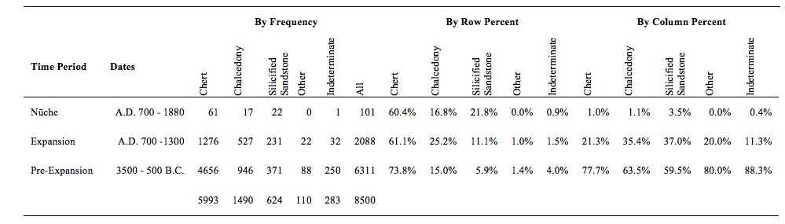
Table 17 Distribution of Raw Material Types at Christmas Rockshelter (n = 8500)

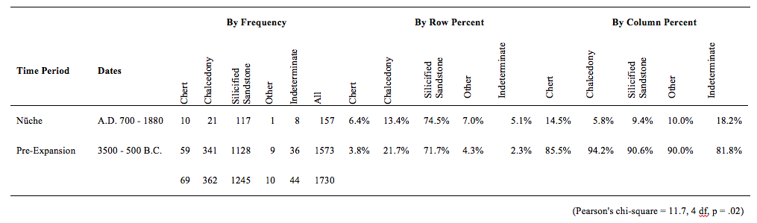
Table 18 Distribution of Raw Material Types at Shavano Spring (n = 1730)

Chert and silicified sandstone dominated the collections from both sites in each excavation level. At the Shavano Spring site, silicified sandstone contributed to over 70% of the artifacts at each level. Chalcedony and chert similarly represented lower frequencies with no levels having more than 40%. Material types that were indeterminate or otherwise classified made up relatively small portions of the collections at less than 10% combined, with exceptions for Level 2 (12.11%) at Shavano Spring and Level 7 (15.76%) at Christmas Rockshelter.
The data show there are changes in the frequency of material type over time. At Christmas Rockshelter, the percent by level of chalcedony increases during the time of the Numic Expansion, while the frequency of chert slowly decreases over time (Table 17). This difference in material types among Nūche, Expansion, and Pre-Expansion era levels is significant (Pearson’s chi-square = 249.9, p < .00). The frequencies of chalcedony and silicified sandstone are significantly higher during Nūche era levels than the levels prior to the Numic Expansion (Pearson’s chi-square = 231.3, p < .00).
At Shavano Spring, the difference in material type frequencies between Nūche and Pre-Expansion levels is also significant (Pearson’s chi-square = 11.7, p = .02); however, the patterns differ from Christmas Rockshelter. The frequencies of silicified sandstone, chert and other materials increased, whereas the frequency of chalcedony was lower than Pre-Expansion lithics (Table 18).
The frequency of raw material color also changed over time. At Christmas Rockshelter, the frequency of black material increased in the Nūche and Expansion era levels (Table 19). Red artifacts also become more common during Expansion levels but decreased to lower frequencies during Nūche occupation. The difference in raw material color among time periods is significant (Pearson’s chi-square = 183.2, p < .00) and remains significant when only Expansion and Pre-Expansion levels are compared (Pearson’s chi-square = 130.1, p < .00). At Shavano Spring, the difference between Pre-Expansion and Nūche levels is also significant (Pearson’s chi-square = 12.6, p = .03). Black, grey, and red lithics are more common during Nūche occupation than Pre-Expansion lithics (Table 20).

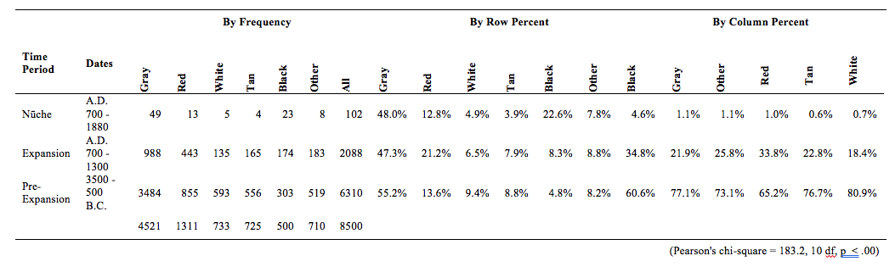
Table 19 Distribution of Lithic Color at Christmas Rockshelter (n = 8500)
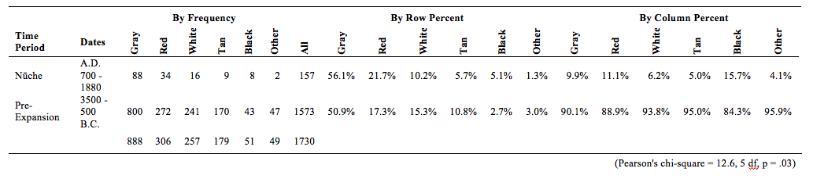
Table 20 Distribution of Lithic Color at Shavano Spring (n = 1730)
Christmas Rockshelter has a greater number of heat-treated and burnt lithics during the Expansion and Nūche era than earlier levels. The different frequencies of heat-treated, burnt, and non-heated materials is significant among Nūche, Expansion, and Pre-Expansion time periods (Pearson’s chi-square = 118.0, p < .00) and the condensed Nūche and Pre-Expansion levels (Pearson’s chi-square = 100.0, p < .00). There are no significant differences in the frequency of heat-treated materials among time periods at Shavano Spring (Pearson’s chi-square = 2.3, p = .32).

Table 21 Distribution of Heat-Treated Lithics at Christmas Rockshelter (n = 8500)
 |  | By Frequency |  |  |  | By Row Percent |  |  | By Column Percent
Time Period | Dates | Burnt | Heat Treated | Unburnt | All | Burnt | Heat Treated | Unburnt | Burnt | Heat Treated | Unburnt
Nūche | A.D. 700 - 1880 | 31 | 25 | 38 | 94 | 33.0% | 26.6% | 40.4% | 2.8% | 0.7% | 1.2%
Expansion | A.D. 700 -1300 | 387 | 871 | 660 | 1918 | 20.2% | 45.4% | 34.4% | 34.3% | 25.0% | 20.7%
Pre-Expansion | 3500 - 500 B.C. | 709 | 2583 | 2486 | 5778 | 12.3% | 44.7% | 43.0% | 62.9% | 74.3% | 78.1%
 |  | 1127 | 3479 | 3184 | 7790
(Pearson's chi-square = 118.0, 4 df, p < .00)

Table 22 Distribution of Heat-Treated Lithics at Shavano Spring (n = 1730)
 |  | By Frequency |  |  |  | By Row Percent |  |  | By Column Percent
Time Period | Dates | Burnt | Heat Treated | Unburnt | All | Burnt | Heat Treated | Unburnt | Burnt | Heat Treated | Unburnt
Nūche | A.D. 700 - 1880 | 13 | 88 | 39 | 140 | 9.3% | 62.9% | 27.9% | 10.9% | 8.1% | 10.3%
Pre-Expansion | 3500 - 500 B.C. | 106 | 995 | 341 | 1442 | 7.4% | 69.0% | 23.7% | 89.1% | 91.9% | 89.7%
 |  | 119 | 1083 | 380 | 1582
 |  | (Pearson's chi-square = 2.3, 2 df, p = .32)

In sum, Christmas Rockshelter showed statistically significant differences in material type, lithic color, and heat-treatment among levels associated with Nūche, Expansion, and Pre-Expansion levels (Table 23). There were also significant differences in material type and lithic color at Shavano Spring between Nūche and Pre-Expansion levels. Differences in raw material properties suggest people used alternative procurement strategies or preferences during and after the Numic Expansion.

Table 23 Summary of Statistically Significant Raw Material Attributes
 | Christmas Rockshelter | Shavano Spring
Raw Material Type | x | x
Color | x | x
Texture
Heat-Treatment | x

Summary
In this section, I examined the qualitative and quantitative attributes for all of the provenienced artifacts at Christmas Rockshelter and Shavano Spring in order to examine whether the lithics changed over time. The data show that there are slight differences in the way people produced artifacts among Nūche, Expansion, and Pre-Expansion time periods; however, these changes are more apparent in specific artifact types such as projectile points, bifaces, and debitage than tools or cores. The most significant differences across time are in the length and weight of artifacts; however, the appearance of raw material in the levels also varies over time and indicates people differentiated selected for material types at a time that coincides with the Numic Expansion. In the following chapter, I will discuss the implication of these results.

Chapter 5: Discussion and Conclusion
Central to this research has been the question whether Nūche arrived in the Uncompahgre Plateau as part of the larger Numic Expansion (A.D. 900 – 1100) across Western North America. I hypothesized that new people arriving in the area would bring with them their own socially reinforced techniques and preferences that would influence and guide their chaîne opératoire; the procurement, use, and discard of technology. Nūche arriving in the area from the Great Basin and Southern California region at the time of the Numic Expansion would then have unique inclinations for their approach to lithic technology – differences that should be apparent in the type, style, and frequency of formal and informal tools, production patterns visible on debitage, and use of raw material.
My results show that there are both continuities and discontinuities in the lithics that coincide with the Numic Expansion. By looking at the occupation of Christmas Rockshelter (5DT2) and Shavano Spring (5MN40) through time, I identified changes in projectile point, biface, and debitage size as well as raw material selection among the dates Nūche lived on the Uncompahgre Plateau and potentially arrived in the area as part of the Numic Expansion as well as those preceding the Numic Expansion. However, while I was able to identify changes in the way people created and selected for some aspects of lithic technology, there were no discernable patterns in the production and use of tools and cores, and the morphology of bifaces and debitage remained fairly consistent.
It should not be surprising that projectile points, bifaces, and raw material selection showed the most variation across time. Projectile points and formal bifaces typically go through a number of transformations during their production and use that are imbued with style, social meaning, and cultural norms (Wiessner 1983, 1985; Wobst 1977). Therefore, the differences in lithic size over time may represent changes to the approaches people took to lithic technology. Projectile points and bifaces both were smaller during Nūche occupation than Pre-Expansion occupation on the Uncompahgre Plateau. As an overarching pattern, projectile points do tend to get smaller in more recent times (Andrefsky 2005; Railey 2010), so it is expected that the same would be true at Christmas Rockshelter and Shavano Spring. Buckles (1971) attributed this change in size to adoption of the bow and arrow during the Formative Period (400 B.C. – A.D. 1300). In the debitage at Christmas Rockshelter, the mean size of artifacts decreased during the time of the Numic Expansion before again increasing in more recent times. This smaller size could represent changes in production; however, there were no other discernable changes in the platform preparation or type of percussion to indicate people significantly changed the way they manufactured tools. The increase in debitage size during more recent Nūche occupation may indicate people invested less time and energy in the production of formal tools at this time.
The last significant change in lithic technology was raw material selection. Over time, people consistently used the locally available chert and silicified sandstone at higher frequencies than other material types. However, during the Numic Expansion, people living in the Uncompahgre Plateau shifted the way they selected for raw materials. At Christmas Rockshelter, people began to use chalcedony and silicified sandstone at higher frequencies than they had previously. They also began to select for more black materials. If Nūche arrived in the area as part of the Numic Expansion, I suggest that ancestral Nūche, living in the Great Basin, preferred obsidian and sought materials with similar qualities after arriving on the Uncompahgre Plateau. Locally available chalcedony could have become a more readily accessible substitute, and these preferences could have persisted as cultural norms in more recent time.
While patterns of raw material selection also changed at Shavano Spring, they did so in different ways than Christmas Rockshelter. The frequency of silicified sandstone increased as did the number of chert and other material types. These changes do not mirror Christmas Rockshelter but may suggest new people arrived in the area, bringing in nonlocal materials and relying on the abundant and easily accessible silicified sandstone and chert. While new populations moving into the area could explain this change in material culture, it is also possible that situational circumstances impacted the selection of raw material during Nūche occupation such as restricted access to material types through population increases, seasonality, or location and preferred quarry sites. People may have naturally shifted their preferences over time as well.
While significant, these changes do not prove without a doubt that Nūche arrived in the area as part of the Numic Expansion. People choose to maintain, alter, and abandon cultural practices, often reflected in material culture, for an unlimited number of reasons (Hodder 1982; Sackett 1990). Therefore, change or continuity in one aspect of culture does not necessarily indicate the replacement of one cultural group with another. However, people likely changed aspects of their chaîne opératoire in response to a dynamic social landscape that occurred on the landscape during that time.
As Larson and Kornfeld (1994) point out in their discussion of Shoshone history and Numic Expansion, the wide dispersal of a language group does not necessarily equate to a complete replacement of one cultural group in favor of another. Instead, it is reasonable to assume that the Numic Expansion represented a complex meeting and exchange of people, material goods, language, and knowledge. In these settings, people negotiate and restructure the norms that guide their daily practices. The Uncompahgre Plateau likely represented an area inhabited by multiple groups of people including Numic speakers. Differences in lithic technology between Christmas Rockshelter and Shavano Spring during Nūche occupation could represent these different groups or varying negotiations or responses to new migrants into the area.
To summarize, the lithic evidence supports that people living on the Uncompahgre Plateau did alter their lithic procurement and production practices at the time that Numic cultures were expanding across the West. It is possible Nūche arrived during this time and interacted closely with the local inhabitants.

Improvements for the Future
Although these results provide a foundation to address when Nūche arrived in the region, I propose several changes to improve the success of the research. While Buckles did an exceptional job creating a relative chronology for Christmas Rockshelter, Shavano Spring, and other sites on the Uncompahgre Plateau, my study would have benefited from better temporal control of the excavated materials. Buckles (1971) dated one carbon sample at the Christmas Rockshelter site to 6,650 +/- 200 rcybb. Examining more artifacts with associated absolute dates would provide a more accurate chronology for assessing change within a site. Obtaining better chronological control, either through additional dating or finding existing data, will increase confidence in cross-site, and later regional, comparisons. Finding and comparing other sites across Nūche territory, increasing the comparable number of artifacts, will also help determine the legitimacy of my results. Moving forward, comparisons with other Numic and non-Numic groups from the same time period will help archaeologists better establish what changes to lithic production are specific to Numic speaking groups including Nūche and how migrating across new areas and interacting with the local inhabitants affected aspects of their technological and social life.
Additionally, this research presumed that Nūche are responsible for the most recent indigenous occupations of Christmas Rockshelter and Shavano Spring. While Nūche were the primary group living in the region at contact, historic records imply European and indigenous traders frequently visited or moved through the Plateau as part of larger exchange networks (Bolton 1950; Hill 1930; Schroeder 1965; Stewart 1966). It is possible that a visiting group lived at either one of the sites and was responsible for the artifacts we see today. To account for a diverse social landscape, which is an issue not only for the Uncompahgre Plateau and Nūche territory but across North America, I suggest using multiple lines of evidence to bolster the association between Nūche and the sites archaeologists associate with them. This includes selecting sites that have historical documentation, oral traditions, and multiple artifact types (e.g., Uncompahgre brownware, wickiup structures, culturally scarred trees, or rock art), which can increase confidence of Nūche affiliation when found together.
Moving forward, it will also be beneficial to record evidence for curation or reuse of lithic artifacts. Stewart’s (1942) ethnographic work revealed historic Nūche would often use tools from Pre-Contact contexts and use or rework them for their own purposes. My research did not look for evidence of curation, so I am unable to comment on the presence of this practice on the Uncompahgre Plateau. However, the reuse of earlier artifacts could influence the size, shape, and frequency of lithics in more recent contexts. Reworked tools would decrease morphological differences over time and produce smaller artifacts. By examining artifacts for evidence of curation, it will be possible to comment this practice as a technological strategy over time and investigate whether curation contributes to apparent continuity in the lithic artifacts over time.
I dealt with material type variability using qualitative attributes for comparable analysis. While this approach worked well for identifying general material type selection, it masked the importance of specific material types, especially nonlocal materials at the sites. Nūche were highly mobile and frequently interacted with neighboring communities (see Chapters 1 and 2), and so it is only reasonable that sourcing studies will further illuminate mobility and exchange relationships in the past. Igneous materials (particularly obsidian and basalt) are relatively easy to identify and should be pursued more rigorously in the future, but there are also several promising techniques for sourcing heterogeneous materials (e.g., silicified sandstone, chert, and chert) such as petrography, ultraviolet fluorescence ultraviolet fluorescence (UVF), wavelength dispersive X-ray fluorescence (WD-XRF), instrumental neutron activation analysis (INAA), and inductively coupled plasma mass spectrometry (AD-ICP-MS and LA-ICP-MS) (Hauser 2008; Luedtke 1978, 1979; Lyons et al. 2003; Pitblado 2008). Recently Pitblado and colleagues (2009, 2011; Dalpra and Pitblado 2016) study successfully used petrography and both methods of ICP-MS to discriminate among silicified sandstone sources in the Upper Gunnison Basin, Colorado, an area only 90 km east of the Uncompahgre Plateau. Conducting similar sourcing techniques and reaching out to neighboring regions will help archaeologists identify patterns of selection (as preference and competition impact them), mobility, and trade.

Conclusion
Similar to Buckles’s (1971) original conclusions, I do not believe I have amassed enough evidence to conclusively relate changes in the material culture to one specific cultural group entering the Uncompahgre Plateau. However, differing techniques in projectile point and biface production as well as raw material selection lead me to conclude that there were changes in and around the region that coincide with the Numic Expansion. It is possible these differences represent changes in the social landscape – the movement of people into area, development of new communities, and exchange of materials, ideas, and knowledge – that people have responded to by diversifying their chaîne opératoire.
Differences during the recent occupations at the two sites I studied, Christmas Rockshelter and Shavano Spring, provide evidence that the Uncompahgre Plateau was likely home to multiple groups of people negotiating new social norms and practices. If Nūche culture arrived in the area as part of the larger Numic Expansion, it did not occur as a complete replacement of one group for another. Instead, the Numic Expansion was in all likelihood a complex social transformation across the North American West that represented exchange and negotiation with communities living into the area prior to this movement. Many aspects of traditional Nūche culture could have developed from these interactions and those that followed.
Moving forward, my research will serve as a model or comparative dataset for understanding the Numic Expansion and its impact on Nūche culture. Archaeologists should compare these results to other archaeological sites both in and beyond the Uncompahgre Plateau to gain a better understanding of Nūche affiliated sites and how they relate to sites associated with other Numic speakers as well as their neighbors. Because raw material sources have the potential to reveal culturally reinforced preferences, I suggest applying in-depth sourcing studies to future research. Additionally, archaeologists have a responsibility to the descendent communities we study. In the future, I want to collaborate with Nūche tribes to incorporate their knowledge and expand on and apply this research in a way that is meaningful to them.
Ultimately, this research demonstrates that it is possible to identify lithic variability at Nūche affiliated archaeological sites that corresponds chronologically, at least, with the Numic Expansion. While understanding whether Nūche culture arrived as part of this larger movement or developed in situ requires further investigation, I propose an alternative to explore the complex social interactions of Numic migrants and local inhabitants facilitated the transformation, development, and negotiation of practices and beliefs unique to Nūche culture.

References
Arthur, Christopher S., Jeffrey L. Brower, Susan M. Collins, J. Earl Ingmanson, Calvin H. Jennings, George J. Krause, and Laura M. Viola
1981 Archaeological Investigations Along the Colowyo Coal Company Railroad Spur in Moffat County, Colorado. Reports of the Laboratory of Public Archaeology, No. 52. Colorado State University, Fort Collins.

Baker, Steven G.
1996 Numic Archaeology on the Douglas Creek Arch, Rio Blanco County, Colorado: Ute Rancherias and the Broken Blade Wickiup Village (5RB3182). Centuries Research, Inc., Montrose, Colorado. Prepared for the Bureau of Land Management, Meeker, Colorado.

2013 Considering Ute Archaeological Culture: An Essay on Potentials. Southwestern Lore 79(3): 5-26.

Baker, Steven G., Jeffrey S. Dean, and Ronald H. Towner
2016 Prehistory: A Progress Report. Southwestern Lore 82(3): 12-33.

Bar-Yosef, O.
1991 The Search for Lithic Variability Among Levantine Epi-Palaeolithic Industries." Rencontres Internationales d’Archéologie et d'Histoire d'Antibes. 11.

Bettinger, Robert L., and Martin A. Baumhoff
1982 The Numic Spread: Great Basin Cultures in Competition. American Antiquity 47(3): 485-503.

Bolton, Herbert E.
1950 Pageant in Wilderness: The Story of the Escalante Expedition to the Interior Basin, 1776; Including the Diary and Itinerary of Father Escalante. Utah Historical Quarterly 18(1): 1+265.

Bourdieu, Pierre
1977 Outline of a Theory of Practice. Cambridge University Press, Cambridge.

1990 The Logic of Practice. Stanford University Press, Stanford.

Brunswig, Robert H.
2005 Prehistoric, Protohistoric, and Early Historic Native American Archeology of Rocky Mountain National Park: Volume 1-Final Report of System-wide Archaeological Inventory Program Investigations by the University of Northern Colorado (1998-2002). Prepared for the National Park Service; Rocky Mountain National Park. Anthropology Program, University of Northern Colorado, Greeley.

Brunswig, Robert H., Sally McBeth, and Louise Elinoff
2010 Re-Enfranchising Native Peoples in the Southern Rocky Mountains: Integrated Contributions of Archaeological and Ethnographic Studies on Federal Lands. In Post-Colonial Perspectives in Archaeology. Chacmool Archaeological Association, Calgary: 55-69.

Buckles, W. G.
1971 The Uncompahgre Complex: Historic Ute Archaeology and Prehistoric Archaeology of the Uncompahgre Plateau, West Central Colorado. Ph.D. dissertation, Department of Anthropology, University of Colorado Boulder.

Cassells, E. Steve
1983 The Archaeology of Colorado. Johnson Publishing Company, Boulder.

Chronic, Halka and Felicie Williams
2002 Roadside Geology of Colorado. Mountain Press Publishing Company Missoula.

Clark, Jeffery J.
2004 Tracking Cultural Affiliation: Enculturation and Ethnicity. In Identity, Feasting, and the Archaeology of the Greater Southwest: 42-73.

Colorado Anthropological Society
2016 Chapters. Electronic document, http://www.coloradoarchaeology.org, accessed September 19th, 2016.

Conetah, Fred A.
1982 A History of the Northern Ute People. Uintah-Ouray Ute Tribe.

Crane, C. J.
1977 A Comparison of Archaeological Sites on the Uncompahgre Plateau and Adjacent Areas. Master's thesis, Eastern New Mexico University.

Dongoske, Kurt E., Michael Yeatts, Roger Anyon, and T.J. Ferguson
1997 Archaeological Cultures and Cultural Affiliation: Hopi and Zuni Perspectives in the American Southwest. American Antiquity 62(4): 600-608.

Dornan, Jennifer
2002 Agency and Archaeology: Past, Present, and Future Directions. Journal of Archaeological Method and Theory 9(4):303-329.

Eddy, Frank W., Allen E. Kane, and Paul R. Nickens
1984 Southwest Colorado Prehistoric Context. State Historical Society of Colorado, Denver.

Elinoff, Louise
2002 Oral Tradition and the Archaeological Record: an Integral Partnership in Understanding Human Past of the Rocky Mountain National Park Region. Unpublished Master’s thesis, Department of Anthropology, University of Colorado, Denver.
Grady, James
1984 Northwest Colorado Prehistoric Context. State Historical Society of Colorado, Denver.

Giddens, Anthony
1984 Central Problems in Social Theory: Action, Structure, and Contradiction in Social Analysis. University of California Press, Berkeley.

1986 The Constitution of Society: Outline of the Theory of Structuration. Vol. 349. University of California Press, Berkeley.

1993 New Rules of Sociological Method. Stanford University Press, Stanford.

Goss, James A.
1999 "The Yamparika–Shoshones, Comanches, or Utes–or Does It Matter." Julian Steward and the Great Basin: The Making of an Anthropologist: 74-84.

Guthrie, Mark R., Powys Gadd, Renee Johnson, and Joseph J. Lischka
1984 Colorado Mountains Prehistoric Context. State Historical Society of Colorado, Denver.

Hauser, Neil R.
2008 Informing Prehistoric Foragers' Perspectives: Why Create a Bedrock Mine in a Material Rich Environment? Master's thesis, University of Colorado Denver.

Hill, Joseph J.
1930 Spanish and Mexican Exploration and Trade Northwest from New Mexico into the Great Basin, 1765-1853. Utah Historical Quarterly 3(1): 1-26.

Holmer, R. N.
1986 Common Projectile Points of the Intermountain West. In Anthropology of the Desert West, Essays in Honor of Jesse D. Jennings, edited by C. J. Condie and D. D. Fowler, pp. 89-115. Anthropological Papers No. 110. University of Utah, Salt Lake City.

Janetski, J. C., Bodily, M. L., Newbold, B. A., & Yoder, D. T.
2012 The Paleoarchaic to Early Archaic Transition on the Colorado Plateau: the Archaeology of North Creek Shelter. American Antiquity 77(1): 125-159.

Jeacons, Jean Allard
1926 Pictographs of Colorado. Colorado Magazine 3: 33-45.

Jennings, J.D.
1957 Danger Cave. Society for American Archaeology Memoir 14.

1974 Prehistory of North American (second ed.). McGraw-Hill, New York.

1978 Prehistory of the Eastern Great Basin. University of Utah Anthropological Papers.

Kearns, Timothy M.
1996 Protohistoric and Early Historic Navajo Lithic Technology in Northwest New Mexico." The Archaeology of Navajo Origins, University of Utah Press, Salt Lake City: 109-145.

Larson, Mary Lou, and Marcel Kornfeld
1994 Betwixt and between the Basin and the Plains: the limits of Numic expansion. Across the West: Human Population Movement and the Expansion of the Numa: 200-210.

Liebmann, Matthew and Uzma Z. Rizvi
2008 Archaeology and the Postcolonial Critique. Rowman Altamira.

Lightfoot, Kent G.
2003 Russian Colonization: The Implications of Mercantile Colonial Practices in the North Pacific. Historical Archaeology 37(4):14-28.

Lightfoot, Kent G., Antoinette Martinez, Anne M. Schiff
1998 Daily Practice and Material Culture in Pluralistic Social Settings: An Archaeological Study of Culture Change and Persistence from Fort Ross, California. American Antiquity 63(2):199-222.

Meltzer, David J.
1999 Human Responses to Middle Holocene (Altithermal) Climates on the North American Great Plains. Quaternary Research 52(3): 404-416.

Miskell-Gerhardt, Kimberlee J.
2013 Siliceous Cementation of Mezozoic Strata in the Four Corners Area: Evidence for Lacustrine Carbonates in the Jurassic, Morrison Formation and Silcretes in the Cretaceous, Burro Canyon Formation. AAPG Rocky Mountain Section Meeting, September 22-24, Salt Lake City.

Nickens, Paul R.
1988 Archaeology of the Eastern Ute: A Symposium. Colorado Council of
Professional Archaeologists.

Ortner, Sherry B.
1984 Theory in Anthropology Since the Sixties. Society for Comparative Study of Society and History 26(1):126-166.

Perlès, Catherine.
1987 Les Industries Lithiques Taillees de Franchthi, Argolide: Presentation Generale et Industries Paleolithiques. Indian University Press, Terre Haute.

Pettit, Jan
1982 Utes: the Mountain People. Colorado Springs: Century One Press.

Pitblado, Bonnie L.
2003 Late Paleoindian Occupation of the Southern Rocky Mountains. University of Colorado Press, Boulder.

Railey, Jim A.
2010 Reduced Mobility or the Bow and Arrow? Another Look at “Expedient” Technologies and Sedentism. American Antiquity 75(2): 259-286.

Reed, A. D.
1984 West Central Colorado Prehistoric Context. State Historical Society of Colorado, Denver.

1997 The Gateway Tradition: A Formative Stage Culture Unit for East-Central Utah and West-Central Colorado. Southwestern Lore 63(2):19-26.

Reed, A. D. and M. D. Metcalf
1999 Colorado Prehistory: A Context for the Northern Colorado River Basin. Colorado Council of Professional Archaeologists.

Reed, A. D., C. J. Zier and J. C. Horn
2001 The TransColorado Natural Gas Pipeline Archaeological Data Recovery Project Western Colorado and Northwestern New Mexico. Alpine Archaeological Consultants, Inc. and Centennial Archaeology, Inc.

Schroeder, Albert H.
1965 A Brief History of the Southern Ute. Southwestern Lore 30(4): 53-78.

Sellet, Frederic
1993 Chaîne Opératoire; the Concept and its Applications. Lithic Technology 18: 106-112.

Skibo, James M., Michael B. Schiffer, and Eric Blinman
2008 The Origins of Pottery on the Colorado Plateau." People and Things: A Behavioral Approach to Material Culture: 37-52.

Simmons, Virginia McConnell
2000 The Ute Indians of Utah, Colorado, and New Mexico. University Press of Colorado.

Smith, Anne M. Cooke
1974 Ethnography of the Northern Ute. Museum of New Mexico Papers in Anthropology 17. Santa Fe.

Steward, Julian H.
1938 Basin-Plateau Aboriginal Sociopolitical Groups. Bureau of American Ethnnology Bulletin 120. Washington.

Stewart, Omer C.
1942 Culture Element Distributions, XVIII: Ute – Southern Paiute. University of California Anthropological Records 6(4): 231-356.

1966 Ute Indians: Before and After White Contact. Utah Historical Society Quarterly 34(1): 38-61.

Stone, T.
1999 The Prehistory of Colorado and Adjacent Areas. University of Utah Press, Salt Lake City.

Taylor, A. M.
1999 Guide to the Geology of Colorado. Cataract Lode Mining Company, Golden, Co.

Voss, Barbara L.
2005 From Casta to Californio: Social Identify and the Archaeology of Culture Contact. American Anthropologist 107(3): 461-474.

Walker Jr, Deward E.
1999 "A Revisionist View of Julian Steward and the Great Basin Paradigm from the North." In Julian Steward and the Great Basin: The Making of an Anthropologist, edited by Richard O. Clemmer, L. Daniel Myers, and Mary Elizabeth Rudden: 60-84.

Welch, John R., and T.J. Ferguson
2007 Putting Patria Back into Repatriation: Cultural Affiliation Assessment of White Mountain Apache Tribal Lands. Journal of Social Archaeology 7(2): 171-198.

Wormington, H. M. and R. H. Lister
1956 Archaeological Investigations on the Uncompahgre Plateau in West Central Colorado. In Proceedings of the Denver Museum of Natural History No. 2, Denver.

Worth, John
2017 What's in a Phase? Disentangling Communities of Practice from Communities of Identity in Southeastern North America. In Forging Southeastern Identities: Social Archaeology and Ethnohistory of the Mississippian to Early Historic South, edited by Gregory A. Waselkov and Marvin T. Smith. University of Alabama Press.

Appendix A: Projectile Point Coding Guide

Completeness (CND)
- 100%
- 50-100%
- less than 50%

General Biface Shape (BLC - Complete Biface only)
- Square
- Cone-shaped with squared-off end
- Pointed Oval Shape
- Large, Wide Oval Shape
- Small, Round
- Amorphous (uneven, no symmetry)

- Broken Biface

Longitudinal Cross Section (LX)
- D-shaped/asymmetrical
- Symmetrical ovoid, slender
- Symmetrical ovoid, fat
- Twisted
- Uneven, lumpy
- Indeterminate, too little to tell

Transverse Cross Section (TX)
- Lenticular
- Diamond
- Parallelogram/beveled
- D-shaped
- Other
- Indeterminate

Basal Grinding (GR)
- Sides only (or “at least” if base missing)
- Base only
- Both sides and base
- Neither
- A single side (with or without grinding of base)
- Unknown, base missing

Flintknapping Problems (PROB)
1. Repeated hinges or step terminations
2. Inherent fault in material
3. Exhausted or nearly so
4. Platform non-renewable (rounded)
5. Central “mesa”1
6. Outré passé
7. Crazing due to heating or freezing
8. Spalled off of a hammerstone
9. Two problems, one of which is “3” (exhausted core)
10. Two problems, excluding “3”
11. Three problems, one of which is “3” (exhausted core)
12. Three problems, excluding “3”
13. Four problems, one of which is “3” (exhausted core)
14. None

Notches (NTS)
- Absent
- Side
- Corner
- Basal
- Multiple locations
- Indeterminate
- Stemmed

Concavity (CD)
- Convex
- Concave
- Straight

Metrics
DMAX: Maximum dimension (not technical length)
MAXL: Maximum length
MAXW: Maximum width, (taken perpendicular to Max length)
MAXT: maximum thickness of biface
SCF1: Number of retouch scars, face 1.
SCF2: Number of retouch scars, face 2.
DMAX of major scar size, face 1
DMAX of major scar size, face 2
WT: weight (grams) of biface

Appendix B: Biface Coding Guide

Completeness (CND)
- 100%
- 50-100%
- less than 50%

General Biface Shape (BLC - Complete Biface only)
- Square
- Cone-shaped with squared-off end
- Pointed Oval Shape
- Large, Wide Oval Shape
- Small, Round
- Triangular
- Amorphous (uneven, no symmetry)

- Broken Biface

Longitudinal Cross Section (LX)
- D-shaped/asymmetrical
- Symmetrical ovoid, slender
- Symmetrical ovoid, fat
- Twisted
- Uneven, lumpy
- Indeterminate, too little to tell

Transverse Cross Section (TX)
- Lenticular
- Diamond
- Parallelogram/beveled
- D-shaped
- Other
- Indeterminate

Flintknapping Problems (PROB)
1. Repeated hinges or step terminations
2. Inherent fault in material
3. Exhausted or nearly so
4. Platform unrenewable (rounded)
5. Central “mesa”1
6. Outrepasse
7. Crazing due to heating or freezing
8. Spalled off of a hammerstone
9. Two problems, one of which is “3” (exhausted core)
10. Two problems, excluding “3”
11. Three problems, one of which is “3” (exhausted core)
12. Three problems, excluding “3”
13. Four problems, one of which is “3” (exhausted core)
14. None

Metrics
DMAX: Maximum dimension (not technical length)
MAXL: Maximum length
MAXW: Maximum width, (taken perpendicular to Max length)
MAXT: maximum thickness of biface
SCF1: Number of retouch scars, face 1.
SCF2: Number of retouch scars, face 2.
DMAX of major scar size, face 1
DMAX of major scar size, face 2
WT: weight (grams) of biface.

Appendix C: Non-Projectile Point Tool Coding Guide
Condition of tool (CD)
1. Proximal or base
2. Medial segment
3. Distal or tip
4. Complete
5. Lateral segment (e.g., a side)
6. Indeterminate small fragment
7. Broken, but greater than 80% present
8. Complete via refitting
9. Biface base/tip (can’t designate one or the other)

Percent cortex present (CTX)
1. 0
2. 1-10
3. 11-50
5. 51-99
6. 100

#ed Number of “edge units” (edges reworked or used as tools). Note: if there is one
continuous edge around the circumference of the tool, code as 9. Tools can have 1-5utilized edges, but “9” is not referring to an actual number.

Tool type. This can be coded for up to two “edge units” only. (Typ1, Typ2)
1. Informally retouched edge (can be on a biface; i.e., blank = biface)
2. Biface/preform, early-middle stage
3. Scraper
4. Drill
5. Graver
6. Chopper
7. Notch
8. Burin
9. Utilized edge (no retouch at all)
10. “Handle” or “Finger-rest”
11. Scraper plane
12. Denticulate (series of spokeshaves)
13. Spokeshave

Type of retouch characterizing 1st and 2nd edge units (Rtyp1, Rtyp2)
1. Continuous nibbling
2. Utilization damage only
3. Flat
4. Steep
5. Stepped/undercut
6. Notch or demi-notch (as to make a quick graver)
7. Burin blow
8. Combination flat-steep, single edge
9. None

Form of retouched edge units 1 and 2 (Edf1, Edf2)
1. Convex, smooth
2. Subconvex, smooth
3. Straight, smooth
4. Subconcave, smooth
5. Concave, smooth
6. Concavo-convex, smooth
7. Convex, denticulate
8. Straight, denticulate
9. Concave, denticulate
10. Pointed, edges intersect at an acute angle
11. Pointed, adj. notches/demi-notches
12. Intersection of two straight sides at an oblique angle
13. Completely retouched (approx. 360°), e.g., biface or portion thereof
14. Burinated (“l”-shaped)

Location of retouched edge units 1 and 2 (Loc1, Loc2)
1. Lateral, entire (or nearly entire) edge
2. Lateral, proximal only
3. Lateral, medial only
4. Lateral, distal only
5. Distal end
6. Distal, both sides of a point
7. Lateral, both sides of a point
8. Proximal/platform end
9. Circumference of tool
10. Unorientable (as on debris, or a whole biface)
11. Lateral, unknown how much (broken through flake scars)
12. Back/dorsal surface(s)
13. Combination of 1-5

Orientation of retouched edge units 1 and 2 (Or1, Or2)
1. Simple (dorsal side of flake)
2. Inverse (ventral side of flake)
3. Bifacial
4. Alternating flake scars (not necessarily perfect alternation)
5. Utilization damage
6. One side of a biface blank (e.g., scraper on a biface)
7. Alternating sections of a single edge
8. Unorientable
9. Non ventral, non dorsal surface (e.g., burin blow along side)

Edge angle of edge units 1 and 2 (An1, An2)
1. 0-15°
2. 16-30°
3. 31-45°
4. 46-60°
5. 61-75°
6. 76-90°
7. Substantially different (e.g., graver with one steep, one shallow angle)

Metrics
Lgth Technical, in case of flakes
Wdth Technical, in case of flakes
Thck Technical, in case of flakes
Dmax Maximum dimension (measure for all tools)
MT Maximum thickness (measure for all tools)
Pwp Platform width (for tools made on flakes with platforms still present)
Pdp Platform depth (for tools made on flakes with platforms still present)
Wgt Weight (nearest .1 g)
DS Number of dorsal scars
RS Number of scars comprising retouch edge units 1 and 2
SL Average scar length of scars comprising retouch edge units 1 and 2
LRet Length of edge units 1 and 2
TLR Total length of edge of which edge units 1 and 2 are a part
Rat Ratio of LRet1/2:TLR1/2

Appendix D: Core Coding Guide
Condition (CND)
1. Fragmentary
2. Complete
3. Indeterminate

Cortex (CTX)
1. Yes
2. No

Type of Core (CTyp)
1. Tested/casual (1-3 scars)
2. Proto-biface
3. Biface
4. Globular
5. Single platform
6. Opposed platforms
7. Biconical/centripetal
8. Hammerstone spall
9. Protocentripetal
10. Indeterminate fragment
11. Flake core
12. Hammerstone (no flake removal)Flintknapping Problems (PROB)
1. Repeated hinges or step terminations
2. Inherent fault in material
3. Exhausted or nearly so
4. Platform unrenewable (rounded)
5. Central “mesa”1
6. Outrepasse
7. Crazing due to heating or freezing
8. Spalled off of a hammerstone
9. Two problems, one of which is “3” (exhausted core)
10. Two problems, excluding “3”
11. Three problems, one of which is “3” (exhausted core)
12. Three problems, excluding “3”
13. Four problems, one of which is “3” (exhausted core)
14. None

Nosc Number of scars (not counting retouching)

Nopl Number of platforms/negative bulbs of percussion

Orpl Platform orientation
1. Opposed
2. Perpendicular
3. Non-perpendicular
4. Single platform
5. Blows struck inward from circumference of core (bifacial)
6. Indeterminate

Metrics
DMax Maximum dimension of core
MW Maximum width of core (measured perpendicular to DMax)
MT Maximum thickness of core (measured at intersection of DMax and MW)
SL1 Maximum length of longest flake scar (not necessarily along striking axis)
SL2 Maximum length of second longest flake scar
SL3 Maximum length of third longest flake scar
WGT Weight (to nearest 0.1 g)

Appendix E: Debitage Coding Guide
Flake type (FKTY)
- Complete
- Broken
- Fragment
- Split
- Debris
- Potlid/heat spall
- Retouched

Platform Type (PLTY)
- Cortical
- Plain
- Dihedral
- Faceted
- Crushed
- Single point or line
- Missing

Condition of Platform (PLCN)
- Unmodified/un-impacted
- Worn
- Ground or nibbled
- Missing or crushed

Platform Lipping
- Present
- Absent

Eraillure (ERA)
- Present
- Absent
- Impact Fracture

Bulb of Percussion (BULB)
- Prominent
- Semi-prominent
- Flat

Longitudinal Cross-section (XSECT)
- Curved
- Flat
- Indeterminate

Percent of Cortex on Dorsal Surface (CRTX)
- 0%
- 1-25%
- 26-50%
- 51-75%
- 76-99%
- 100
- Indeterminate

Metrics
DRSC Number of dorsal scars
PLWD Platform width (mm)
PLDP Platform depth (mm)
LGTH Length, technical (mm)
WID Width, technical (mm)
THK Thickness, technical (mm)
DMAX Maximum dimension (mm)
THMAX Maximum thickness (mm)
WT Weight (g)

Appendix F: Raw Material Coding Guide
Material (MAT)
- Silicified Sandstone or Quartzite
- Chert
- Rhyolite
- Basalt
- Obsidian
- Dacite
- Other
- Unknown
- Chalcedony
- Quartz

Color (COL)
- Tan
- Gray
- Red/Maroon
- White
- Butterscotch
- Black
- Mottled
- Purple
- Brown
- Orange
- Blue
- Green

Grain (GRAIN)
- Very fine
- Fine
- Coarse
- Very coarse

Heat Treatment (HT)
- Unburnt
- Burnt
- Heat-treated
- Indeterminate

Appendix G: Obsidian Sourcing Report


A GREEN SOLAR FACILITY

GEOARCHAEOLOGICAL X-RAY FLUORESCENCE SPECTROMETRY LABORATORY
8100 Wyoming Blvd., Ste M4-158 Albuquerque, NM 87113 USA

LETTER REPORT

AN ENERGY-DISPERSIVE X-RAY FLUORESCENCE ANALYSIS OF STONE ARTIFACTS FROM WESTERN COLORADO

13 July 2017

Delaney Cooley
Oklahoma Archaeological Survey
111 Chesepeake St, Room 102
Norman, OK 73019-5111

Dear Delaney:

You were correct; three of the samples are not obsidian. Unexpectedly, however, the one obsidian point is from the Government Mountain source in the San Francisco Volcanic Field, northern Arizona. Additionally, and although the point base is missing, it is not only elementally similar to Government Mountain, it looks morphologically similar to Cohonina points from northern Arizona that are contemporaneous with the Sedentary period (ca. AD 1000-1150; Shackley 2005:168; see Table 1 and Figures 1-2).).

Specific instrumental methods can be found at http://www.swxrflab.net/anlysis.htm, and Shackley (2005). Source assignment was made by comparison to source standard data in the laboratory. Analysis of the USGS RGM-1 standard indicates high machine precision for the elements of interest (Table 1 here).

Sincerely,

M. Steven Shackley, Ph.D.
Director

VOICE: 510-393-3931
INTERNET: shackley@berkeley.edu
http://www.swxrflab.net/

REFERENCES CITED

Shackley, M.S.
2005 Obsidian: Geology and Archaeology in the North American Southwest. University of Arizona Press, Tucson.

Table 1. Elemental concentrations for the archaeological samples and USGS RGM-1 rhyolite standard. All measurements in parts per million (ppm).

Sample | Ti | Mn | Fe | Zn | Rb | Sr | Y | Zr | Nb | Ba | Pb | Th | Source
FS196B | 776 | 162 | 5483 | 36 | 4 | 44 | 9 | 22 | 5 | 150 | 10 | 4 | not obsidian
FS390 | 1847 | 18305 | 6585 | 90 | 0 | 635 | 13 | 27 | 18 | 6284 | 27 | 12 | not obsidian
FS427 | 767 | 164 | 5600 | 74 | 1 | 39 | 4 | 23 | 2 | 26 | 10 | 4 | not obsidian
FS433D | 11288 | 498 | 9745 | 88 | 105 | 82 | 25 | 86 | 53 | 436 | 29 | 12 | Government Mtn, AZ
RGM1-S4 | 1463 | 294 | 13230 | 44 | 148 | 111 | 23 | 219 | 8 | 836 | 23 | 16 | standard

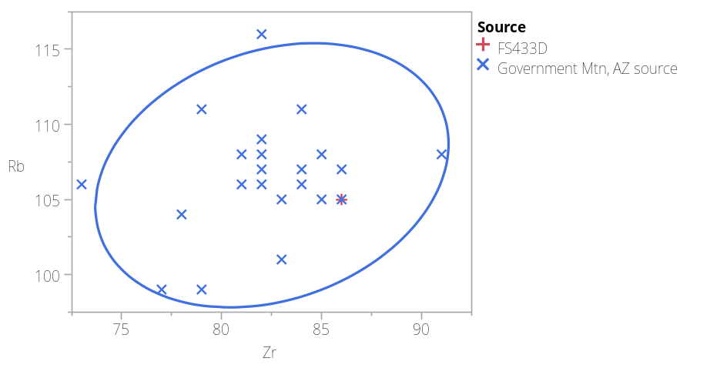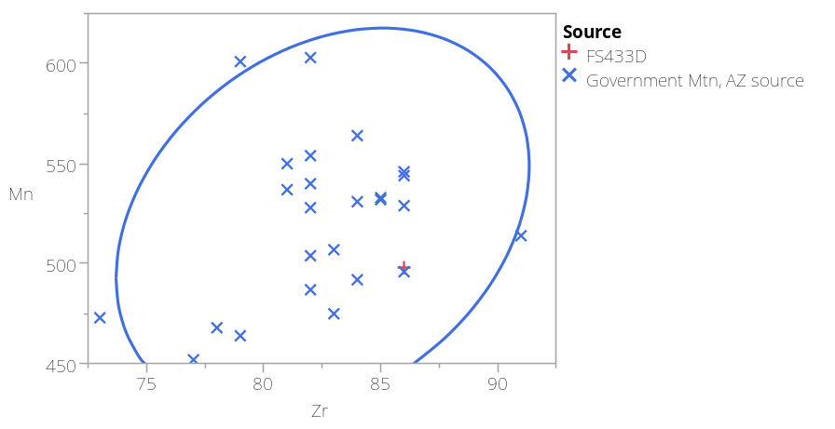

Figure 1. Zr versus Rb bivariate plot of the samples (left); Zr versus Mn bivariate plot of the samples (right). Ellipses at 95% confidence intervals.

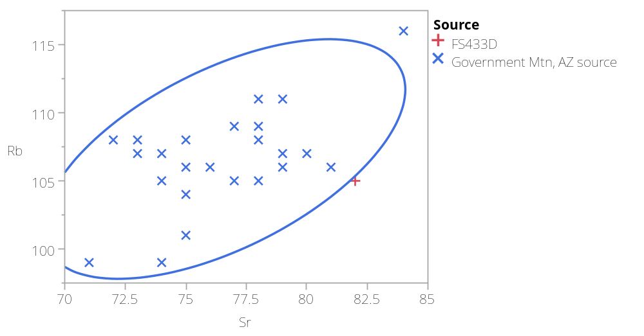

Figure 2. Sr versus Rb bivariate plot of the samples. Ellipses at 95% confidence intervals.

Ute people refer to themselves as Nūche (pronounced Nooch), the people.

