University of Oklahoma

Graduate College

COMPONENTS OF EPISODIC MEMORY: CONNECTING HUMAN BEHAVIOR AND ELECTROPHYSIOLOGY TO A RODENT MODEL

A thesis

submitted to the Graduate Faculty

in partial fulfillment of the requirements for the

Degree of

Master of Science

By

LISA ANN DE STEFANO
Norman, Oklahoma
2017

COMPONENTS OF EPISODIC MEMORY: CONNECTING HUMAN BEHAVIOR AND ELECTROPHYSIOLOGY TO A RODENT MODEL

A thesis approved for the
Department of Psychology

By

______________________________
Dr. Michael Wenger, Chair

______________________________
Dr. Scott Gronlund

______________________________
Dr. Lauren Ethridge

© Copyright by LISA ANN DE STEFANO 2017
All Rights Reserved.

Table of Contents
List of Tables v
List of Figures vi
Abstract vii
Introduction 1
Memory for “what” 2
Memory for “where” 3
Memory for “when” 5
What-when-where 7
Method 10
Participants 10
Materials 10
Design 10
Procedure 11
EEG recording 13
EEG processing and analysis 13
Results 14
Behavior 14
ERP analysis 16
Trial-by-trial regression 17
Discussion 19
References 25

List of Tables
Table 1. Repeated Measures ANOVA for old items, AB x SD x CU 29
Table 2: Repeated Measures ANOVA for old items within Room A: SL x SD x CU 30

List of Figures

Figure 1. Brain circuits hypothesized to support episodic memory 31
Figure 2. Example of spatial locations 32
Figure 3. Example encoding sequence 33
Figure 4. Example test judgment 35
Figure 5. Left-parietal old/new effect: old/new, stationary/displaced 36
Figure 6. Regression results: when 37
Figure 7. Regression results: where 38
Figure 8. RT & ERP: new, old-stationary, old-displaced 39

Abstract
Episodic memory encoding and retrieval rely on integration of information about what an item was, as well as when and where it was encountered. Previous research from animal lesion studies using a novelty preference paradigm found that the hippocampus and medial prefrontal cortex were critical for different aspects of recollection of episodic events (DeVito & Eichenbaum, 2010). The present study attempts to adapt this paradigm to assess these components behaviorally and electrophysiologically in humans using a memory recognition task. Participants studied two virtual “rooms” containing images of women, with each image presented consecutively in a random location for 5 s. Between rooms, participants engaged in a go/no-go distractor task for either 15 s (“short” retention interval) or 3 m (“long”). After both rooms were studied, participants made old/new judgments with half of the items being new. Half of the images appeared in the same location as during the study phase (“stationary”) with the others appearing in a new location (“displaced”). Behavioral results showed no difference in reaction time (RT) between old and new items, but significantly longer RTs for displaced items relative to stationary, and significantly longer RTs for items seen before long retention intervals than short. Electrophysiological (EEG) results show no main effect of old/new status in a memory-related ERP in the left parietal area, but did show a main effect of displacement, with items that were displayed eliciting smaller amplitudes than items that were stationary. Additionally, trial-by-trial regression analyses uncovered sets of electrodes that were responsive to manipulations in retention interval and study room (memory for “when”), as well as displacement at test (“where”).

Introduction
Episodic recollection can be characterized as the memory for a unique experience and its associated components, including “what,” the item or subject of the experience; “where,” the spatial context in which it occurred; and “when,” its place in time. The subjective experience of episodic recollection requires that these aspects be conjoined as a single representation at encoding (Allen & Fortin, 2013).
A model has been suggested for the medial temporal lobe in which the integration of these components relies on several lines of communication with the hippocampus (Eichenbaum, Sauvage, Fortin, Komorowski & Lipton, 2012; see Figure 1). The hippocampus receives inputs from the parahippocampal region, which contains entorhinal cortex, parahippocampal cortex, and perirhinal cortex. Each of these areas, which have been implicated in the different components of episodic memory, then communicates with the hippocampus to form a distinct neural representation that binds them together as an episode.
Upon retrieval, the reinstatement of part of the memory trace is believed to spur activation in the hippocampus, which subsequently causes the reactivation of cortices that originally contributed to the memory trace (Rugg, Johnson, Park & Uncapher, 2008). However, little is known about computational nature of the memory representation post-retrieval. It is plausible that the components of memory are independent, parallel streams of information. Alternatively, reactivation may invoke separate but dependent streams of information, or a single conjoined or coactive stream, and the distortion of one component may also impact the other components. Any successful analysis of these computational alternatives for episodic memory requires both the ability to selectively manipulate these components experimentally, and the ability to measures their effects, separately and in concert.

Memory for “what”
In this model, visual information about item identity (“what”) enters the hippocampus through perirhinal cortex, which receives most of its input from the ventral visual pathway by way of occipital then inferior temporal cortex (Wixted & Squire, 2011). Perirhinal cortex then communicates directly with the hippocampus, or indirectly through activation of the lateral entorhinal area. The importance of perirhinal cortex for item memory has been shown in studies conducted in rhesus monkeys using delayed nonmatching-to-sample tasks (Meunier et al., 1993). In these tasks, monkeys had to displace an object to attain a food reward, then they were shown the same item and a novel item, which they could displace to receive another food reward. Monkeys that received lesions to perirhinal cortex took longer to relearn the task post-operatively, and showed performance decrements compared to animals that received no lesions or only entorhinal cortex lesions. Additionally, a study in rats that used lidocaine to temporarily disrupt perirhinal cortex function found negative impacts on both encoding and retrieval of object information (Winters & Bussey, 2005). It is important to note that it is believed that perirhinal cortex can support identification of an object through direct communication with cortex, leading to a feeling of familiarity (Eichenbaum, Yonelinas & Ranganath, 2007). However, its communication with the hippocampus is thought to be required for the reinstatement of associative details that lends to the subjective experience of episodic memory (Eichenbaum, Yonelinas & Ranganath 2007).

Memory for “where”
Information about an item’s location (“where”) is encoded separately from item information, being transmitted through the dorsal visual pathway, by way of occipital then parietal cortex, to parahippocampal cortex (Khan, Martin-Montanez, & Baxter, 2011). Parahippocampal cortex then projects directly to the hippocampus or communicates indirectly through interaction with medial entorhinal cortex (Eichenbaum, 2012). The role of parahippocampal cortex in spatial memory has been supported in humans by data from an fMRI study that showed bilateral activation during a task that involved learning new spatial routes from a first-person perspective, but also from an overhead-view perspective (Shelton & Gabrieli, 2002). The reliability of activation in parahippocampal cortex across both task conditions indicates that it has a general role in encoding spatial relationships. Additionally, a study of epilepsy patients with lesions to the right hippocampus or right parahippocampal cortex showed that both groups had impaired performance on object-location tasks, underscoring the importance of both the right hippocampus, and right parahippocampal cortex as an input pathway (Bohbot et al., 1998).
Other brain areas have also been shown to be important for spatial memory, both during encoding and retrieval. Some researchers have emphasized the importance of medial prefrontal cortex (mPFC) in memory formation and retrieval, specifically its role in context-dependent memory selection (Preston & Eichenbaum, 2013). According to this view, the “what” and “where” pathways converge in the hippocampus, forming a memory coded by neurons in the posterior hippocampus. Concurrent activity in the anterior hippocampus, which connects directly to mPFC, allows for closely related events to be distinguished. During retrieval, activity in mPFC allows for the activation of the most context-relevant memory. While perirhinal lesions prior to encoding have been found to have no impact on general spatial memory performance within rats (Machin, Vann, Muir & Aggleton, 2002), lesions to mPFC or perirhinal cortex prior to encoding have been shown to impact exploration times of objects that switched locations with other previously encountered objects, leading the authors to conclude that these brain regions support object-location associations (Barker, Bird, Alexander & Warburton, 2007).
The hippocampus itself contains “place cells” that have been shown to fire when an animal is located at a particular spatial location, providing what has been suggested to be a cognitive map (O’Keefe & Conway, 1978). Additionally, medial entorhinal cortex, parahippocampal cortex’s main input pathway to the hippocampus, has been shown to contain to contain grid cells in monkeys that fire in response to the location of the eye’s gaze during a visual exploration task (Killian, Jutras & Buffalo, 2012). A study of spatial and episodic memory in which epilepsy patients were implanted with intracranial electrodes while they navigated through a video game found cells within the entorhinal cortex, hippocampus, and amygdala, but not parahippocampal gyrus, that increased their firing rates whenever participants visited certain virtual locations (Miller et al., 2013). The video game locations were divided into three areas, and when items displayed in these areas were free recalled, the activity of these place-responsive cells correlated with their activity during encoding in a graded manner: the highest correlation was with encoding activity in the nearest locations, and the lowest correlation was with encoding activity in the farthest locations. The authors interpreted this as evidence that free recall of item information provoked the reinstatement of the spatial context in which it was encountered, and suggest that it may cue temporal context reinstatement as well. This is consistent with the hypothesis that one component of memory can cue others (Rugg et al., 2008), and that successful recognition of a presented stimulus may cause context reinstatement.

Memory for “when”
Much less is known about memory for temporal context (“when”). Many areas of the brain have the capacity to encode and express information about when an item was encountered, but the definitive source of the hippocampus’s time information is still unresolved. Additionally, the definition of “time” often varies between studies, with some authors considering spatiotemporal context (Lipton, White & Eichenbaum, 2007), others focusing on judgments of elapsed time (Bakhurin et al., 2017; Leon & Shadlen, 2002), while others consider temporal context (Barker et al, 2007; Davachi & DuBrow, 2017).
Eichenbaum (2012) suggests that medial entorhinal cortex takes part in separating memories that overlap in spatial context but have different temporal context. This is supported by a study in rats in which activity in the hippocampus or medial entorhinal area was recorded while they traversed a T-maze (Lipton et al., 2007). Rats were rewarded if they correctly alternated between turning left and turning right at the end of the central corridor of the maze. Data from trials in which the rats “remembered” the correct turn were analyzed separately for left- and right-turn trials, and activity patterns within the medial entorhinal area and hippocampus were used to differentiate between them. Place-sensitive neurons in the hippocampus responded to small spatial locations regardless of trial type, while neurons in the medial entorhinal area responded to larger spatial locations but differentiated between trial types. This led the authors to suggest that the medial entorhinal area provides some information about the temporal context of an event to the hippocampus that is then combined to form a memory representation.
The hippocampus itself has been shown to contain cells that are responsive to temporal context. “Time cells” fired to signal elapsed time as rats ran on a treadmill, and some of the same cells were shown to have place fields when the rats were instead allowed to explore a maze (Kraus et al., 2013). This indicates that “place cells” and “time cells” are the same cells, acting to encode the context of the animal’s experience (Eichenbaum, 2014). Other areas have also been implicated in timekeeping. Within mice trained to lick after a time interval to obtain a reward, activity within the striatum and orbitofrontal cortex signaled time elapsed, with medium spiny neurons in the striatum showing greater accuracy than those in orbitofrontal cortex (Bakhurin et al., 2017). Cells that respond to time have also been found in the parietal cortices of rhesus monkeys trained to saccade in different directions if a stimulus was longer or shorter in duration than a certain learned time (Leon & Shadlen, 2002).
Memory for time has also been considered in terms of temporal order. Barker et al. (2007) examined the impact of lesions to mPFC and perirhinal cortex in rats, and found that while control animals preferred to explore items that were less recently seen, animals with lesions to either brain region showed no preference. Research in humans has implicated the hippocampus in memory for temporal order, but also points to activity in prefrontal cortex and striatum as possibly relevant as well (Davachi & DuBrow, 2015). This leaves the option that multiple pathways are involved in providing temporal context, both in terms of pure time-elapsed-since-encoding and temporal order in which an item was occurred.

What-when-where
DeVito and Eichenbaum (2010) adapted a novelty preference paradigm originally created by Dere (2005) to look at the “what,” “when,” and “where” components of episodic memory. Rats with hippocampal, prefrontal, or sham lesions first explored a rectangular apparatus containing four identical items arranged in the shape of a triangle, termed “Room A,” for five minutes. After a 50-minute delay, they explored a room with four new identical items arranged in each of the corners to make a square, termed “Room B,” for five minutes. Fifty minutes later, the animals were returned to the room, which now contained items in each of the four corners. Of the items presented during this test phase, two were originally presented in Room A, and two were originally presented in Room B. One of the Room A items was displaced from its original location, while another of the Room A items remained in its original position. One of the Room B items was in a location that had been shared with a Room A item, and one of the Room B items was placed in a unique location only it had occupied.
This stimulus arrangement allowed DeVito & Eichenbaum (2010) to analyze novelty preference using ratios of time spent exploring different items to index impairment across spatial, temporal, and item aspects of memory. They found that control animals showed no memory impairment, preferring items that had been less recently explored to items more recently explored (“what”), items that were displaced into novel locations over items presented in the same location (“where”), and items that were experienced less recently in the same location (“when”). Animals with prefrontal lesions were blunted to the effect of object displacement, showing no preference for the displaced item compared to the item in its original location. Animals with hippocampal damage, on the other hand, displayed impaired memory for all aspects, showing no preference for less recently explored items relative to more recently explored items (“what”), no preference for items that were displaced relative to stationary items (“where”), and no preference for objects less recently experienced in the same location (“when”), underscoring the importance of the hippocampus in episodic memory. However, they noted that spatial and temporal components of memory were not completely isolated, because they were required to be retrieved in relation to other components of memory.
This body of research, including DeVito and Eichenbaum (2010), carries with it the implication that memory for items and specific aspects of their context can be manipulated in a potentially separable manner. The present experiment is an attempt to modify the DeVito and Eichenbaum (2010) protocol for use in humans, with the goal of examining the effect of systematic manipulations of item, spatial context, and time on behavior.
Additionally, concurrent electroencephalography (EEG) will allow us to examine the time course at which manipulations of the components of episodic memory affect neural activity during recognition. Currently, EEG research into the nature of memory utilizes event-related potentials (ERPs), particularly a positive-going potential between 400-800 ms post-stimulus onset known as the left-parietal old-new effect (LPONE). This ERP feature is generally found to be most positive for items that are successfully remembered, and to be modulated by the amount of information recollected (Rugg et al., 1998; Murray, Howie & Doanldson, 2015).
Rugg et al. (1998) varied the duration of study time for words to manipulate the depth of processing during tasks in which ERPs and positron emission topography (PET) scans were acquired. They found that more deeply encoded words produced a higher amplitude LPONE, supporting the hypothesis that this ERP indexes not just recognition, but also associated information. PET scans showed increased activation in the hippocampal formation for words that were more deeply encoded, as well as widespread areas throughout temporal and prefrontal cortex. Because previous studies showed that hippocampal activation does not have a significant effect when measured at the scalp, the authors hypothesized that the ERP reflects the result of "hippocampally driven cortical activity that constitutes the neural basis of episodic retrieval."
Similarly, Vilberg & Rugg (2009) manipulated the study time for complex scenes during task in which they collected fMRI and EEG. They found that for “remember,” judgments, which they considered recollection-based, activity in the left lateral parietal cortex was greater for items studied 6 s than 1 s, as were the amplitude of left parietal activity and the number of details remembered during a surprise post-test. The authors suggested that content used to make “remember” judgments was represented within the left lateral parietal cortex.
There is general support for the hypothesis that different parts of the brain contribute to different components of memory (Eichenbaum et al., 2012), and that successful retrieval leads to reactivation of the regions that were active at the same of encoding (Rugg et al., 2008). However, the current state of EEG literature does not give insight into architecture of the network that combines and reinstates these differing streams of information. The protocol used by DeVito & Eichenbaum (2010) offers a promising opportunity to separably manipulate and measure these components of episodic memory.

Method

Participants
Thirty undergraduate students (22 female, mean age 21.9 years) at the University of Oklahoma were paid $8/hour to complete four days of experimental sessions, with 24 contributing analyzable EEG data (i.e., data without excessive artifacts). Participants were required to be between the ages of 19 and 55, and to have normal or corrected-to-normal vision and unencumbered use of both hands.

Materials
Eight hundred pictures of women in similar frontal poses, taken from dating web sites were adapted to have a blue background and resized to 75 x 100 pixels. They were blurred slightly to prevent edge effects, and intensity was standardized across all images. Stimuli were presented on a 56 cm widescreen LCD monitor using a display resolution of 1024 x 768 by E-Prime 2.0 (Psychology Software Tools, Inc.). Participants used a chinrest placed 91.44 cm from the screen, resulting in a viewing angle for each image of 2.18° for width and 2.48° for height.

Design
Participants engaged in an episodic memory task with manipulations to examine the contribution of memory for “what,” or the face itself; two variations on “where,” the spatial location in which the face was seen, and whether it was the only image seen in that location; and two variations of “when,” retention interval between encoding and test, and the list in which the item was encountered. The task was designed as an 2 (item status: old, new) x 2 (location relative to study: stationary, displaced) x 2 (location relative to other items: common, unique) x 2 (retention interval: short, long) x 2 (presentation room: A, B) incomplete factorial, in which all factors were manipulated within-subjects and in which the four latter factors were manipulated for old items. Four sessions were conducted, each consisting of eight blocks of eight trials, with each session lasting approximately 90 min.

Procedure
Each trial consisted of two phases: one in which participants were presented with lists of faces (encoding phase) and a second subsequent phase in which they made judgments of memory about whether items had been seen (test phase). During the encoding phase, faces of women were displayed randomly in one of eight locations on the screen (see Figure 2). Participants were told to watch carefully because they would be asked questions about the faces later. Each block of trials contained two sequences of four faces that were displayed sequentially for 5 s each, with one face appearing on the screen at a time. Each sequence played through twice, for a total presentation time of 10 s per image. The first half of the encoding phase was referred to as Room A. Figure 3A shows an example sequence for Room A.
Next, the participant engaged in an interpolated go/no-go task for either 15 s (short retention interval) or 3 min (long retention interval). In each trial, participants watched a fixation cross (550 ms) then saw either a vertical or horizontal line (300 ms). Participants were instructed to watch for either the horizontal or vertical stimulus (randomly assigned) and press a key when it appeared (20% of the time), but to ignore the other stimulus. After the retention interval, participants began the second half of the encoding phase, referred to as Room B. Another set of four faces was displayed sequentially, twice, for 5 s each time and a total of 10 s per face. Some of these images appeared in new locations that were not used in the same trial (unique) and others appeared in locations that were shared with faces in Room A (common). Figure 3B shows an example sequence for Room B, in which the items in the top left (position 1) and bottom middle (position 7) share locations with images shown during Room A.
After the second half of the encoding phase, participants again engaged in an interpolated go/no-go task for 15 s. They then began the test phase, in which they were shown eight faces and asked to make old/new judgments. Half of the faces used during the test period were old, with some presented in the same location at test as they were during encoding (stationary location). Others were moved to a new location on the screen (displaced). Participants were given 1.5 s to respond with an old/new judgment, after which they entered their confidence on a scale of 1-7, with 1 as “not at all confident,” and 7 as “most confident.” Trials on which participants did not respond before the 1.5 s deadline received as feedback a message that said “Too Slow” and these trials (mean of 16 per participant) were marked as errors and removed prior to analysis. Figure 4 shows an example of two trials in which items from the previous examples are stationary or displaced during the test phase. When all eight old/new judgments and confidence judgments were completed, participants were then presented with each of the old images. These were presented at the center of the screen and participants indicated by button press on the numeric keypad the location in which the face had originally been presented.

EEG recording
Concurrent EEG was acquired during the test phase. Data were collected in an electrically-shielded room while participants used a chinrest to maintain a constant viewing distance and to minimize movement artifacts. EEG was sampled at 250 Hz using a 128-channel electrode net (Electrical Geodesic, Inc., Eugene, OR). Impedance values were kept below 75 kΩ and checked and adjusted as needed between each block. Data were recorded unfiltered and referenced to Cz during acquisition.

EEG processing and analysis
Raw data were examined in EEGLAB (Delorme & Makeig, 2004) and digitally filtered from .5 to 90 Hz. Line noise was removed at 60 Hz using CleanLine (Mullen, 2012). Due to excessive movement artifacts, sensors around the neck and face area were removed from analysis. Blinks, saccades, heart rate and muscle artifact were removed using independent component analysis. Data were re-referenced to the average of all remaining sensors and then lowpass filtered at 40 Hz.
Epochs were created for all correct trials, running from 500 ms prior to stimulus presentation to 1200 ms after, and were then baseline corrected. Epochs with values greater than 75 microvolts or less than -75 microvolts were excluded from analysis, leaving an average of 89 correct old and 90 correct new trials per participant. ERP analysis was done in ERPLAB (Lopez-Calderon & Luck, 2014).

Results

Behavior
Accuracy was high across subjects (mean of 89%), with little variability across conditions that would allow for informative analysis. Correct trials were used to examine reaction time (RT, calculated as the median RT for each level of the design for each participant) differences between old and new items using a paired samples t-test, which showed no significant difference (t(24) = 0.40, p = .69, old RT = 834 ms, new RT = 836 ms). Because Room B items were always studied 15 s before test, the manipulation of retention interval applied only to items that appeared in Room A, so two sets of repeated measures ANOVAs were run: one set that contained when---presentation room, as well as the where manipulations, without when---short long; and one set that used only Room A items and contained when---retention interval, as well as the where manipulations. This allowed us to look at interactions between both aspects of when and where.
RT data for correct responses to old items were analyzed using a 2 (when---presentation room: A, B) x 2 (where---location at test relative to study: stationary, displaced) x 2 (where---location relative to other study items: common, unique) repeated-measures ANOVA, with all factors being within subjects. These results are summarized in the top portion of Table 1. There was a main effect of presentation room, with items seen in the earlier Room A having longer RTs (852 ms) than those seen in the more recent Room B (817 ms). There was also a main effect of location at test relative to location at study, with items that were in the same location at study and test having shorter RTs (791 ms), than items that were displaced at test (878 ms). There was no significant effect of location relative to other items (common RT = 839 ms, unique RT = 829 ms). More interestingly, there was a significant interaction between presentation room and displacement at test, with RTs for displaced items showing no difference between Room A (878 ms) and room B (877 ms), while stationary items did differ (826 ms for Room A, 756 ms for Room B). There were no other significant interactions (all ps > .2).
Because Room B items were always studied 15 s before test, the manipulation of retention interval applied only to items that appeared in Room A. These results are summarized in the top portion of Table 2. RTs for Room A items were analyzed using a 2 (when---retention interval: short, long) x 2 (where---location at test relative to study: stationary, displaced) x 2 (where---location relative to other study items: common, unique) repeated measures ANOVA, with all factors being within-subjects. There was a main effect of retention interval, with items encoded before a short RI having a shorter RT (839 ms) than those encoded before a long retention (875 ms). There was also a main effect of displacement, with items that were in the same location at study and test having shorter RTs (829 ms) than those that were displaced (885 ms). There was no significant effect of location relative to other items (common location, 864 ms; unique, 850 ms). However, there was a significant interaction between retention interval and displacement, with displaced items showing a smaller effect of retention interval (short, 879 ms; long, 891 ms) than stationary items (short, 799 ms; long, 858 ms). There was little difference in RT on the basis of shared (common) location or unique location in the case of a short retention interval (common location, 839 ms; unique, 840 ms), but in the case of a long retention interval, RTs were shorter for items in unique locations (861 ms) than in common locations (890 ms).

ERP analysis
ERP analysis examined the mean amplitude in the left-parietal area between 400 and 800 ms post-stimulus onset and averaged across a group of seven electrodes around electrode P3 (Figure 5A, in red). A repeated measures t-test found no significant difference between old and new amplitudes (t(24) = 1.17, p = .25; old amplitude, 1.04 μV, new amplitude, 0.90 μV, see Figure 5B).
As with the behavioral data, mean amplitudes were analyzed using a 2 (when---presentation room: A, B) x 2 (where---location at test relative to study: stationary, displaced) x 2 (where---location relative to other study items: common, unique) repeated-measures ANOVA, with all factors being within subjects. These results are summarized in the bottom portion of Table 1. The main effect of room was not significant, nor was the main effect of location relative to other items. However, there was a main effect of displacement, with stationary items having greater amplitudes than their displaced counterparts (stationary, 1.29 μV ; displaced, 0.74 μV; see Figure 5C). There were no significant interactions (all ps > .4).
Because retention interval only applied to items appearing in Room A, mean amplitudes for Room A items were analyzed using a 2 (when---retention interval: short, long) x 2 (where---location at test relative to study: stationary, displaced) x 2 (where---location relative to other study items: common, unique) repeated measures ANOVA, with all factors being within-subjects. These results are summarized in the bottom portion of Table 2. There was a marginally significant effect of retention interval, with items that had longer retention intervals having larger left-parietal amplitudes (short, 0.80 μV; long, 1.07 μV). Additionally, there was a significant effect of displacement, with stationary items having larger amplitudes than displaced items (stationary, 1.21 μV; displaced, 0.66 μV). There was no significant effect of location relative to other objects (common, unique) or any interactions (all ps > .5).

Trial-by-trial regression
Amplitudes at each time point were regressed onto each predictor (when--- retention interval: short, long; when---study room: A, B; where---location at test relative to location at study: stationary, displaced; where---location at study relative to other items: common, unique) separately for each electrode to examine the time-course of each experimental manipulation. Amplitudes were regressed onto each predictor independently, without interactions, due to the low number of trials for which the interactions would apply. The average number of trials analyzed by each model was 89, except in the case of the retention interval (short, long) data. Because all Room B items were seen 15 s before test trials, the retention interval manipulation only applied to items encountered in Room A, so the average number of trials for retention interval analysis was 45.
Data were examined for each participant to identify clusters of electrodes and time periods that were responsive to a given predictor, with a minimum criterion of R² ≥ 0.05. No single electrode was found to be responsive for a given manipulation across all participants, so responsive electrodes were logged separately for each participant, then organized roughly into region. The region with the majority of responding participants was examined for each when manipulation (room: A, B; retention interval: short, long), and two regions were uncovered related to where---location at test relative to location at study (stationary, displaced). No regions were found that routinely corresponded with where—location relative to other items (common, unique), so this comparison was excluded. Estimated βs, p-values, and R² values for responsive electrodes were averaged across clusters for each person, then averaged across included participants to form grand averaged time courses, and are presented in Figures 6 and 7.
Fourteen participants contributed 1-7 (average 2.9) frontocentral electrodes (see Figure 6D) that differed significantly on the basis of when---retention interval, as measured in Room A items. The time course of the R² values indicate maximal influence of retention interval between 400-600 ms after stimulus onset, with trials that occurred further away in time leading to more negative amplitudes in these electrodes (see Figure 6, red lines).
Nineteen participants contributed 1-5 (average 2.2) central electrodes (see Figure 6E) that differed significantly on the basis of when---study room. For this comparison, seven participants had negative β values while 12 participants had positive β values. Analyzed separately, this led to two identical time courses for p-values and R², and time-courses for β values that were mirror images of one another. Because valence can be altered due to the location of the reference electrode, p-values and R² values for these seven participants were averaged, and the absolute value of the β values were averaged across participants (see Figure 6, black lines).
The influence of when---study room---appears to influence electrical activity measured at central electrodes, with maximal influence between 300-600 ms after the initiation of recognition, based on p-values. R² values peak close to 600 ms, and β values remain high for the entire interval.
Examination of the data for where---location at test relative to location at study (stationary, displaced), revealed two clusters of participants with significant activity in different sets of electrodes. The data for these groups of electrodes are presented separately.
Five participants contributed 3-7 (mean 4.6) frontocentral electrodes (see Figure 7D). R² values indicate that displacing the studied image at test has its peak impact on frontal activity between 300-600 ms after stimulus onset (Figure 7A, red line), with p-values pointing to the most significant influence occurring near 600 ms (Figure 7B). Recognition trials in which the item was displaced from its original location had more negative amplitudes than trials in which the image was stationary (Figure 7C).
Fifteen participants contributed 1-4 (mean 2) left-parietal electrodes that responded to the where---location at test relative to location at study manipulation (see Figure 7E). These electrodes had significant overlap with those used to examine the left-parietal old new effect. Maximal influence was reach approximately 700 ms after stimulus onset (Figures 7A and 7B, black lines), with displaced trials having more lower amplitudes than stationary trials (Figure 7C).

Discussion
This study explored the extent to which distinct impacts of manipulating what, when, and where could be found in behavioral and electrophysiological data. Our findings suggest that this is possible. While RTs did not show a significant effect of old/new, they were influenced by most of the manipulations, including where---location at test relative to study---with RTs for stationary items quicker than those for new items, and both quicker than displaced items (see Figure 8A). RTs were also influenced by when---retention interval and when---study room, with the effects of these manipulations blunted by an interaction with where---location at test relative to location at study: RTs for stationary items showed larger differences due to when than displaced items. No effects of where---location relative to other items---were found. This may be a result of the nature of the comparison: common locations contained items in both Room A and Room B, with unique locations only used once during each encoding session. Over the course of 32 sessions, all locations were used multiple times, leaving no location genuinely “unique.” It is possible that items that share locations across different sessions are subject to interference at retrieval (Murnane & Shiffrin, 1991), blunting the effect of this manipulation.
Similar to RT, no differences in ERP amplitude were found for old/new, but significant differences were found for where---location at test relative to study---with LPONE amplitude for stationary items significantly larger than for displaced, and ordinally larger than new (Figure 8B). No other significant effects were found for ERP amplitude. It is possible that the post-judgment location test encouraged reliance on spatial location more than the other manipulations, though the LPONE has been shown to be modified by remembered information even without the intent of retrieval (Curran, 1998). However, during a short-term memory paradigm, LPONE amplitude was found to be insensitive to recency (Danker et al, 2008).
We found (spatially-constrained) sets of electrodes for each participant that revealed the time-course of the effects of our primary manipulations.
The regression results show a pattern of frontal involvement in time. This is consistent with research that found modulations of amplitude based on recency in the FN400 (Danker et al., 2008), a more controversial frontocentral ERP that is thought to index item familiarity (Rugg & Curran, 2007), but has been criticized as indistinct from an ERP related to semantic processing, the N400 (Voss & Federmeier, 2011). Both Room B items and items seen before a short retention interval had larger amplitudes, and the effect appeared slow and enduring. The effects were not identical, however: in the when---retention interval--- comparison, the responsive electrodes were generally found to be more frontal than those used in the when---study room---comparison. Previous research has found that when task demands call for responses related to memory, and do not require semantic processing, the FN400 appears to have a more frontal distribution than the N400 (Strozak, Abedzadeh, & Curran, 2016), which may indicate that the effect of retention interval found in our data is more memory-related than the effect of study room.
The when---study room---analysis carries with it the caveat that seven participants in this comparison displayed orderings that were not consistent with the other subjects or with the literature (higher amplitudes for Room A items than Room B). The electrodes used for this comparison were primarily located adjacent to the electrode that was used to reference the data during collection, and its valence may have been influenced by shifts in reference placement between individuals. Thus, the absolute value of the estimated β s for these participants were averaged. The time course and magnitude of the regression results for these seven participants was identical to the twelve they were averaged with. Still, the hypotheses that these seven participants were using different strategies or their data has different neural generators than the other twelve participants cannot be excluded. Critics of the FN400 argue that frontal negativity indexes not familiarity of an item but semantic processing (Voss & Federmeier, 2011), and others have found that the FN400 and N400 may be confounded if the task engages semantic processing (Strozak, Abedzadeh & Curran, 2016). It is possible that the seven participants with negative β values utilized a more semantic approach to correctly recognize faces that appeared in room A, which were further away in time.
Regression results for where---location at test relative to study---found two responsive regions that contained different participants. Five participants had significant activity in a diffuse frontocentral area, with peak significance occurring prior (300-600 ms) to the effect found in participants whose most responsive electrodes were in the left parietal area (600-800 ms). This frontocentral involvement is consistent with reports of modulation of both the FN400 and LPONE based on spatial source memory (Mollison & Curran, 2012). Because only the most responsive electrodes were chosen for each participant, it is possible that participants in the left parietal group also had frontocentral significance of a lesser magnitude. This activity would have been overlooked in favor of the area with larger effects.
This study is novel in that it attempts to systematically examine different aspects of episodic memory. The results are consistent with different time courses and spatial properties of information being integrated during recognition, similar to the dissociable impacts found in DeVito & Eichenbaum (2010). Our manipulations of where and when significantly impacted RTs and showed separable effects on physiological activity. Future studies can capitalize on these impacts to further characterize the relationships between these components, such as the interaction between spatial context and temporal context found in RTs. Source analysis techniques, in conjunction with regressions, can further our understanding of the brain regions that show significant effects.
This study is limited in that only 24 participants contributed usable data, and accuracy was high, which did not allow us to look at differences in RT or neural activity due to misses or false alarms. Additionally, the large number of manipulated factors left only 16 trials per participant in each cell of the design, which led to the omission of interactions in the regression models. The selective impact of when---retention interval--- on Room A items (because Room B items were always 15 s before test) led to underpowered results for this manipulation. Future studies that would like to use a similar protocol can rectify some of these limitations by using fewer sessions with more trials before a test phase. This would increase the difficulty of the task, which would induce misses and false alarms that would make useful comparisons. The use of one long session with only one instance of Room A and one Room B would also assist in teasing apart the impact of when---study room---and when---retention interval.
Additionally, future experiments would be served by utilizing not only a spatial location post-test, but judgment-in-time post-tests that encourage attention to temporal detail. The inclusion of post-tests that asked in which encoding room an item was seen, or how long ago it was seen, would provide added assurance that all memory components received equal attention and allow for comparison between participants who did and did not have high post-test accuracy.
The goal of this study was to examine whether separable streams of information that contribute to episodic recollection could be manipulated and identified. Regression results promisingly point to dissociable time courses and spatial topographies for each manipulation. The present data suggests that this approach is promising, and that future studies can use similar paradigms to examine the computational architecture that underlies episodic retrieval.

References

Allen, T. A., & Fortin, J. J. (2013). The evolution of episodic memory. Proceedings of the National Academy of Sciences of the United States of America, 110, 10379 – 10386. doi: 10.1073/pnas.1301199110

Bakhurin, K. I., Goudar, V., Shobe, J. L., Claar, L. D., Buonomano, D. V., & Masmanidis, S. C. (2017). Differential encoding of time by prefrontal and striatal network dynamics. The Journal of Neuroscience, 37(4), 854 – 870. doi: 10.1523/JNEUROSCI.1789-16.2017

Barker, G. R. I., Bird, F., Alexander, V., & Warburton, E. C. (2007). Recognition memory for objects, place, and temporal order: A disconnection analysis of the role of the medial prefrontal cortex and perirhinal cortex. The Journal of Neuroscience, 27 (11), 2948 – 2957. doi: 0.1523/JNEUROSCI.5289-06.2007

Bohbot, V. D., Kalina, M., Stepankova, K., Spackova, N., Petrides, M., & Nadel, L. (1998). Spatial memory deficits in patients with lesions to the right hippocampus and to the right parahippocampal cortex. Neuropsychologia, 36(11), 1217 – 1238.

Curran, T. (1999). The electrophysiology of incidental and intentional retrieval: ERP old/new effects in lexical decision and recognition memory. Neuropsychologia, 37, 771 – 785.

Danker, J. F., Hwang, G. M., Gauthier, L. Geller, A., Kahana, M. J., & Sekuler, R. (2008). Characterizing the ERP old-new effect in a short-term memory task. Psychophysiology, 45(5), 784 – 793. doi: 10.1111/j.1469-8986.2008.00672.x

Davanchi, L., & DuBrow, S. (2015). How the hippocampus preserves order: The role of prediction and context. Trends in Cognitive Science, 19(2), 92 – 99. doi: 10.1016/j.tics.2014.12.004

Delorme, A., & Makeig, S. (2004). EEGLAB: an open source toolbox for analysis of single-trial EEG dynamics including independent component analysis. Journal of Neuroscience Methods, 134(1), 9-21.

Dere, E., Huston, J. P., De Souza Silva, M. A. (2005). Episodic-like memory in mice: simultaneous assessment of object, place and temporal order memory. Brain Research Protocols, 16, 10-19.

DeVito, L. M., & Eichenbaum, H. (2010). Distinct contributions of the hippocampus and medial prefrontal cortext to the “what-where-when” components of episodic-like memory in mice. Behavioural Brain Research, 215(2), 318 – 325. doi: 10.1016/j.bbr.2009.09.014

Eichenbaum, H. (2014). Time cells in the hippocampus: a new dimension for mapping memories. Nature Reviews Neuroscience, 15(11), 732 – 744. doi: 10.1038/nrn3827

Eichenbaum, H., Sauvage, M., Fortin, N., Komorowski, R., & Lipton, P. (2012). Towards a functional organization of episodic memory in the medial temporal lobe. Neuroscience and Biobehavioral Reviews, 36, 1597 – 1608. doi: 10.1016/j.neubiorev.2011.07.006

Eichenbaum, H. Yonelinas, A. P., & Ranganath, C. (2007). The medial temporal lobe and recognition memory. Annual Review of Neuroscience, 30, 123 – 152. doi: 10.1016/j.neubiorev.2011.07.006

Khan, Z.U., Martín-Montañez, E., & Baxter, M. G. (2011). Visual perception and memory systems: From cortext to medial temporal lobe. Cellular and Molecular Life Sciences, 68, 1737 – 1754. doi: 10.1007/s00018-011-0641-6

Killian, N. J., Jutras, M. J., & Buffalo, E. A. (2012). A map of visual space in the primate entorhinal cortex. Nature, 491(7426), 761 – 764. doi: 10.1038/nature11587

Kraus, B. J., Robinson II, R, J., White, J. A., Eichenbaum, H., & Hasselmo, M. E. (2013). Hippocampal “time cells”: Time versus path integration. Neuron, 78, 1090 – 1101. doi: 10.1016/j.neuron.2013.04.015

Leon, M. L., & Shadlen, M. N. (2003). Representation of time by neurons in the posterior parietal cortex of the macaque. Neruon, 38, 317 – 327.

Lipton, P. A., White, J. A., & Eichenbaum, H. (2007). Disambiguation of overlapping experiences by neurons in the medial entorhinal cortex. The Journal of Neuroscience, 27(21), 5787 – 5795. doi: 10.1523/JNEUROSCI.1063-07.2007

Lopez-Calderon, J., & Luck, S. J. (2014). ERPLAB: An open-source toolbox for the analysis of event-related potentials. Frontiers in Human Neuroscience, 8, 213.

Manchin, P., Vann, S. D., Muir, J. L., & Aggleton, J. P. (2002). Neurotoxic lesions of the rat perirhinal cortex fail to disrupt the acquisition or performance of tests of allocentric spatial memory. Behavioral Neuroscience, 116(2), 232 – 240. doi: 10.1037//0735-7044.116.2.232

Meunier, M., Bachevalier, J., Mishkin, M., & Murray, E. A. (1993). Effects on visual recognition of combined and separate ablations of the entorhinal and perirhinal cortex in rhesus monkeys. The Journal of Neuroscience, 13(12), 5418 – 5432.

Millder, J.F., Neufang, M., Solway, A., Brandt, A., Trippel, M., Mader, I., Hefft, S., Merkow, M., Polyn, S. M., Jacobs, J., Kahana, M. J., & Schulze-Bonhage, A. (2013). Neural activity in human hippocampal formation reveals the spatial context of retrieved memories. Science, 342(6162), 1111 – 1114. doi: 10.1126/science.1244056

Mollison, M. V., & Curran, T. (2012). Familiarity in source memory. Neuropsychologia, 50(11), 2546 – 2565. doi: 10.1016/j.neuropsychologia.2012.06.027

Mullen, T. (2012). CleanLine EEGLAB plugin. San Diego, CA: Neuroimaging Informatics Tools and Resources Clearinghouse (NITRC).

Murnane, K., & Shiffrin, R. M. (1991). Interference and the representation of events in memory. Journal of Experimental Psychology: Learning, Memory, and Cognition, 17(5), 855 – 874. doi: 10.1037//0278-7393.17.5.855

Murray, J. G., Howie, C. A., Donaldson, D. I. (2015). The neural mechanism underlying recollection is sensitive to the quality of episodic memory: Event related potentials reveal a some-or-none threshold. NeuroImage, 120, 298-308.

O’Keefe, J., & Conway, D. H. (1978). Hippocampal place units in the freely moving rat: Why they fire where they fire. Experimental Brain Research, 31, 573 – 590.

Preston, A. R., & Eichenbaum, H. (2013). Interplay of hippocampus and prefrontal cortex in memory. Current Biology, 23, R764 – R773. doi: 10.1016/j.cub.2013.05.041

Rugg, M. D., & Curran, T. (2007). Event-related potentials and recognition memory. Trends in Cognitive Sciences, 11(6), 251 – 257. doi: 10.1016/j.tics.2007.04.004

Rugg, M. D., Johnson, J. D., Park, H., Uncapher, M. R. (2008). Encoding-retrieval overlap in human episodic memory: a functional neuroimaging perspective. Progress in Brain Research, 169, 339-352.

Rugg, M. D., Walla, P., Schloerscheidt, A. M., Fletcher, P. C., Frith, C. D., & Dolan, R. J. (1998). Neural correlates of depth of processing effects on recollection: Evidence from brain potentials and positron emission tomography. Experimental Brain Research, 123, 18 – 23.

Shelton, A. L., & Gabrieli, J. D. E. (2012). Neural correlates of encoding space from route and survey perspective, The Journal of Neuroscience, 22(7), 2711 – 2717.

Stróżak, P., Abedzadeh, D., & Curran, T. (2016). Separating the FN400 and N400 potentials across recognition memory experiments. Brain Research, 1635, 41 – 60. doi: 10.1016/j.brainres.2016.01.015

Vilberg, K. L., & Rugg, M. D. (2009). Functional significance of retrieval-related activity in lateral parietal cortex: Evidence from fMRI and ERPs. Human Brain Mapping, 30(5), 1490 – 1501. doi: 10.1002/hbm.20618

Voss, J. L., & Federmeier, K. D. (2011). FN400 potentials are functionally identical to N400 potentials and reflect semantic processing during recognition testing. Psychophysiology, 48(4), 532 – 546. doi: 10.1111/j.1469-8986.2010.01085.x

Winters, B. D., & Bussey, T. J. (2005). Transient inactivation of perirhinal cortex disrupts encoding, retrieval, and consolidation of object recognition memory. The Journal of Neuroscience, 25(1), 52 – 61. doi: 10.1523/JNEUROSCI.3827-04.2005

Wixted, J. T., & Squire, L. R. (2011). The medial temporal lobe and attributes of memory. Trends in Cognitive Science, 15(5), 210 – 217. doi: 10.1016/j.tics.2011.03.005

Table 1. Repeated Measures ANOVA for old items, AB x SD x CU
Comparison of median RT and mean amplitude within old items, When---study room (Room A, Room B) x Where---location at test relative to study (stationary, displaced) x Where---location relative to other items (common, unique) repeated measures ANOVA.
DV | Comparison |  |  | F |  | df | MSE
Reaction time | Room A, Room B (AB) |  |  | 24.10*** |  | 1 | 2508
 | Stationary, Displaced (SD) |  |  | 55.26*** |  | 1 | 6497
 | Common, unique (CU) |  |  | 2.92 |  | 1 | 1538
 | AB x SD (interaction) |  |  | 24.40*** |  | 1 | 2422
 | AB x CU (interaction) |  |  | 0.69 |  | 1 | 1811
 | SD x CU (interaction) |  |  | 0.03 |  | 1 | 1717
 | AB x SD x CU (interaction) |  |  | 1.37 |  | 1 | 1472
Amplitude | Room A, Room B (AB) |  |  | 1.25 |  | 1 | 1.03
 | Stationary, Displaced (SD) |  |  | 8.46** |  | 1 | 1.73
 | Common, unique (CU) |  |  | 0.01 |  | 1 | 0.39
 | AB x SD (interaction) |  |  | 0.00 |  | 1 | 0.84
 | AB x CU (interaction) |  |  | 0.33 |  | 1 | 0.88
 | SD x CU (interaction) |  |  | 0.48 |  | 1 | 1.31
 | AB x SD x CU (interaction) |  |  | 0.30 |  | 1 | 1.16
⁺ = 0.10 > p ≥ .05, < .10; * = p < .05; ** = p < .01; *** = p < .001

Table 2: Repeated Measures ANOVA for old items within Room A: SL x SD x CU
Comparison of median RT and mean amplitude within old items studied in Room A, When---retention interval (short, long) x Where---location at test relative to study (stationary, displaced) x Where---location relative to other items (common, unique) repeated measures ANOVA.
DV | Effect |  | F |  | Df | MSE
Reaction time | Short, Long (SL) |  | 12.21** |  | 1 | 5076
 | Stationary, Displaced (SD) |  | 14.82*** |  | 1 | 10272
 | Common, unique (CU) |  | 2.32 |  | 1 | 4104
 | SL x SD (interaction) |  | 7.51* |  | 1 | 3525
 | SL x CU (interaction) |  | 2.57 |  | 1 | 4239
 | SD x CU (interaction) |  | 1.17 |  | 1 | 3159
 | SL x SD x CU (interaction) |  | 0.16 |  | 1 | 3979
Amplitude | Short, Long (SL) |  | 3.44⁺ |  | 1 | 1.10
 | Stationary, Displaced (SD) |  | 8.72** |  | 1 | 1.67
 | Common, unique (CU) |  | 0.18 |  | 1 | 1.32
 | SL x SD (interaction) |  | 0.00 |  | 1 | 1.34
 | SL x CU (interaction) |  | 0.06 |  | 1 | 1.51
 | SD x CU (interaction) |  | 0.69 |  | 1 | 2.75
 | SL x SD x CU (interaction) |  | 0.10 |  | 1 | 1.18
⁺ = 0.10 > p ≥ .05, < .10; * = p < .05; ** = p < .01; *** = p < .001

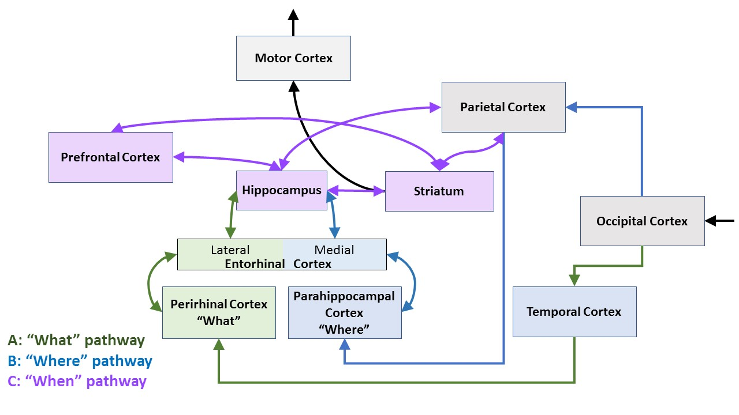
Figure 1. Brain circuits hypothesized to support episodic memory
(a) “What” information travels through occipital cortex, temporal cortex, perirhinal cortex, and lateral entorhinal cortex before reaching the hippocampus. (b) “Where” information travels through occipital cortex, parietal cortex, parahippocampal cortex, and medial entorhinal cortex before reaching medial entorhinal cortex. (c) “When” information is expressed within the hippocampus, but there are mechanisms to keep time within many brain regions, including the striatum, prefrontal cortex, and parietal cortex.

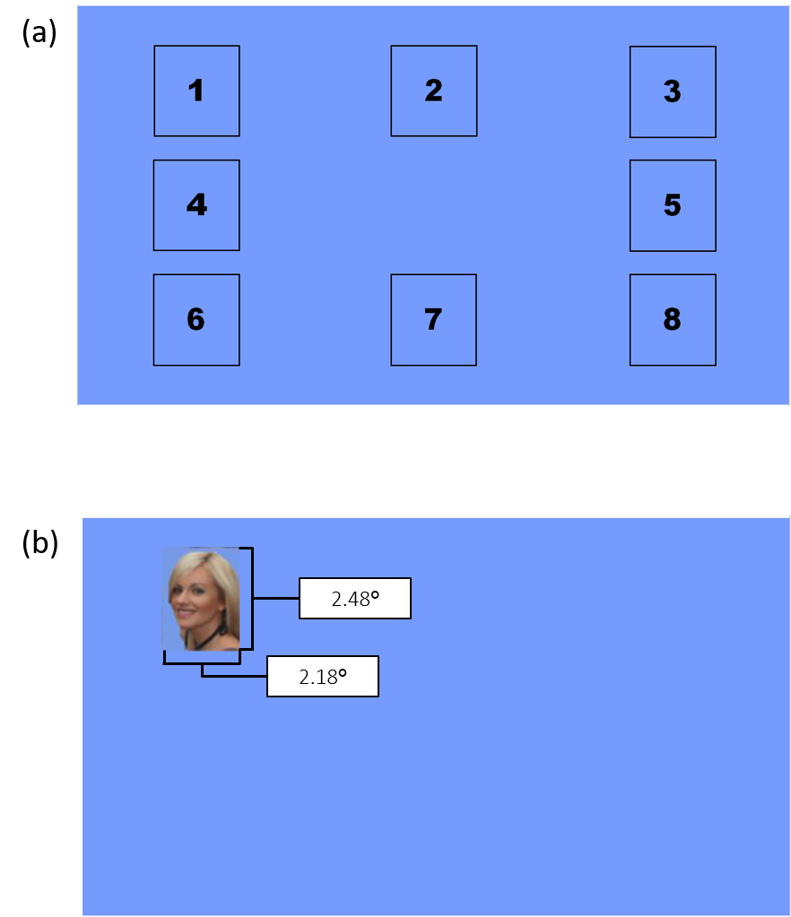
Figure 2. Example of spatial locations
(a) Example of the eight spatial locations in which stimuli could appear during encoding or at test. (b) Example of a stimulus in position 1, with size in degrees of visual angle when viewed from a distance of 91.44 cm.

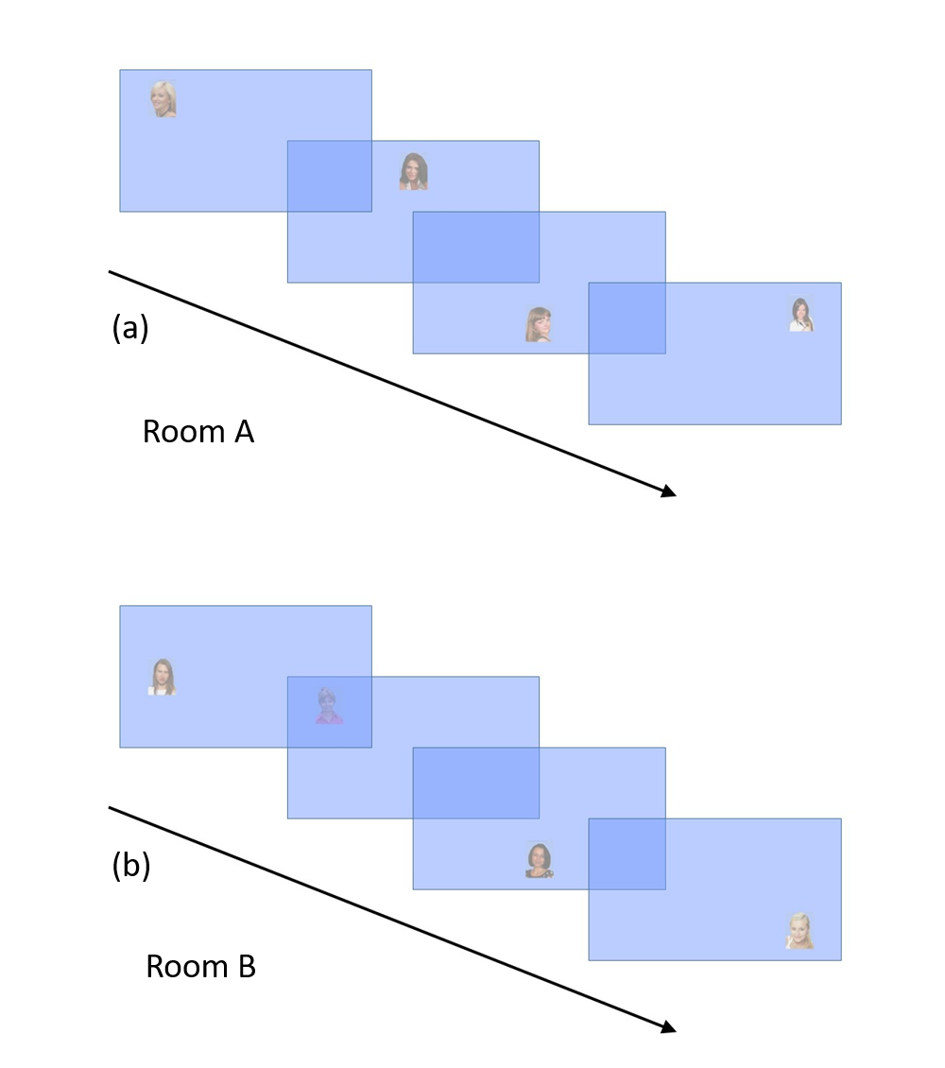
Figure 3. Example encoding sequence
(a) An example sequence for Room A, which repeated twice with the same images in the same locations. After Room A, participants engaged in a distractor task for either 15 seconds (“short” retention interval) or three minutes (“long” retention interval). (b) An example sequence for Room B, which repeated twice with the same images in the same locations. In this example, the items in locations 1 and 7 shared a common location with another image that appeared in the other sequence in the same block. The items that appeared in locations 2, 3, 4, and 8 appeared in unique locations that did not have another image appear in the other sequence during the same block.

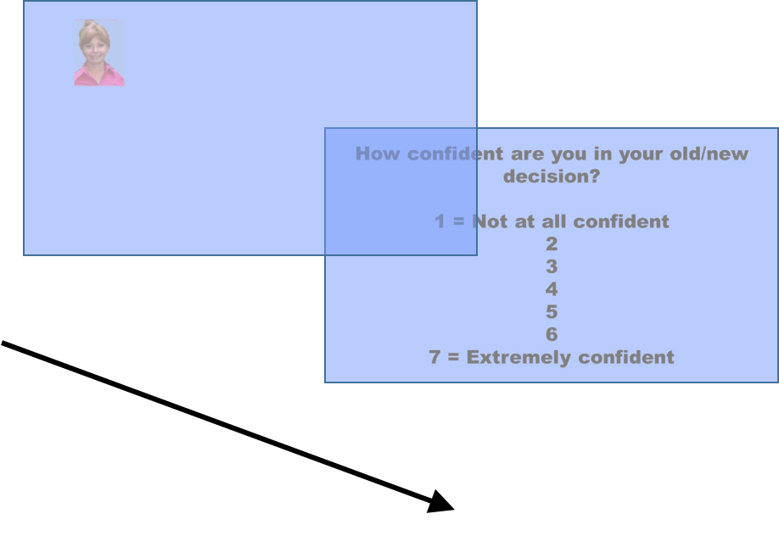
Figure 4. Example test judgment
At test, participants were shown old and new images and asked whether they were old or new. After each decision, they were asked to rate their confidence. This image is in the same location during test as it was during encoding, “stationary.” It was original presented in “Room B” and it shared a location with another image during encoding, “common.” The text in this figure was enlarged for readability.

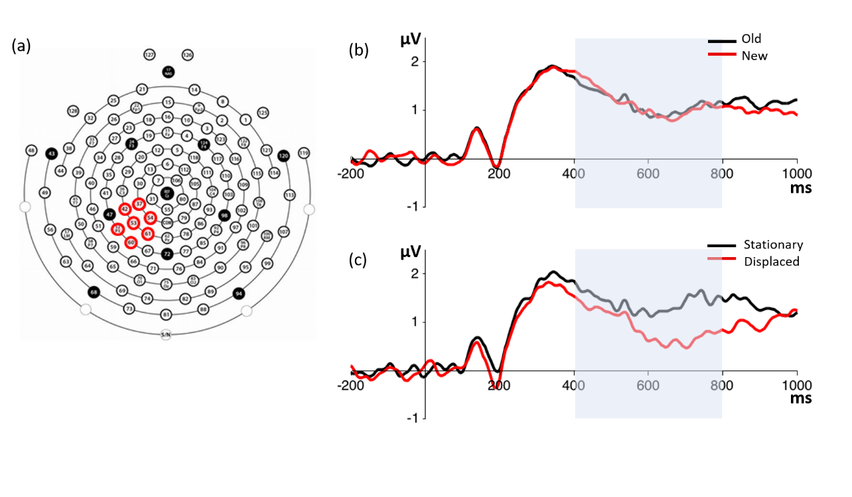
Figure 5. Left-parietal old/new effect: old/new, stationary/displaced
(a) Sensors included in ERP comparisons of the left-parietal old/new effect. (b) Left-parietal ERP for comparison of old and new items (shown in electrode P3). Statistics were performed for the shaded time period. (c) Left-parietal ERP for comparison of stationary and displaced items.

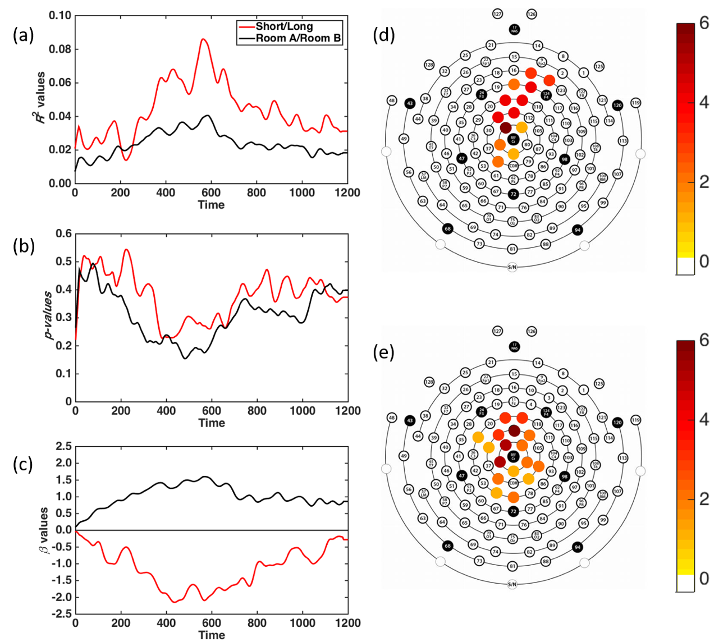
Figure 6. Regression results: when
Grand average of all donor electrodes that responded to the when---retention interval (short, long)---manipulation (red) and when---room (A, B)---manipulation (black). (a) R² values. (b) p values. (c) β values. (d) Electrodes used for when---retention interval---comparison. (e) Electrodes used for when---study room---comparison.

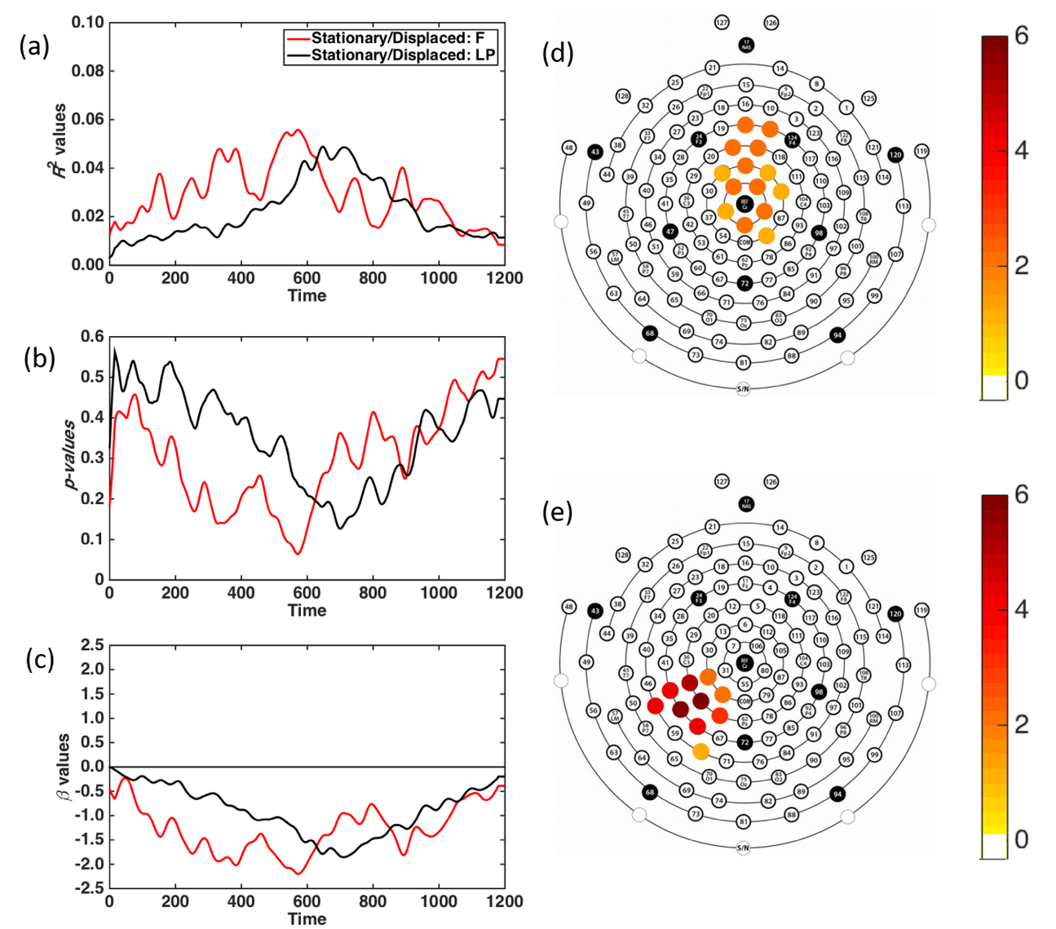
Figure 7. Regression results: where
Grand average of all donor electrodes that responded to the where---location at study relative to location at test (stationary, displaced)---manipulation in either the frontocentral (red) or left-parietal (black) areas. (a) R² values. (b) p-values. (c) β−values. (d) Electrodes used from the frontocentral area. (e) Electrodes used from the left parietal area.

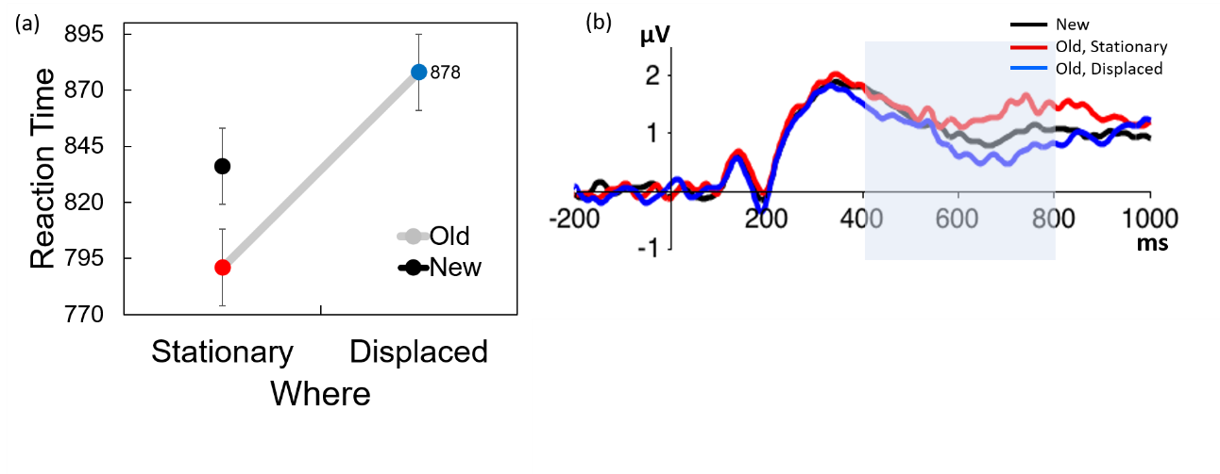
Figure 8. RT & ERP: new, old-stationary, old-displaced
(a) RTs for new items compared to RTs for old items that were appeared in the same location at study and test (stationary) and RTs for old items that appeared in different locations at study and test (displaced). (b) Left-parietal ERP for comparison of old (stationary, red; displaced, blue) and new (black) items (shown in electrode P3).

