University of Oklahoma

Graduate College

THE GREEN LOOP: CONNECTING PEOPLE AND PLACE

A thesis

submitted to the Graduate Faculty

in partial fulfillment of the requirements for the

Degree of

MASTER OF SCIENCE IN ARCHITECTURE

By

LAYNE FERGUSON
Norman, Oklahoma
2016

THE GREEN LOOP: CONNECTING PEOPLE AND PLACE

A thesis approved for the
MASTER OF SCIENCE IN ARCHITECTURE

By

______________________________
Dr. Stephanie Pilat, Chair

______________________________
Mr. Hans Butzer

______________________________
Mr. Shane Hampton

______________________________
Mr. Blair Humphreys

______________________________
Ms. Marjorie Callahan

© Copyright by LAYNE FERGUSON 2016
All Rights Reserved.

Acknowledgements
It’s hard to believe my time as a student at the University of Oklahoma is coming to an end. This thesis is the accumulation of a year and a half of my wonderful time as a graduate student at OU’s College of Architecture.
The completion of this thesis would have not been possible without the help of many people. First and foremost, I would like to thank my thesis advisor, Dr. Stephanie Pilat. She has been a constant encourager and mentor to me during this process. She has made me a better writer, student, and designer.
Thank you to Shane Hampton for always allowing me to interrupt him in his office to ask a question and for helping guide me through my time as a graduate student. Thank you for challenging me and always pushing me to do my best.
Thank you to Deborah Richards for allowing me to work on this project in her studio, and guiding me through the design process for this project.
Thank you to my Graduate Liaison, Marjorie Callahan, as well as the other members on my thesis committee, Hans Butzer and Blair Humphreys. Oklahoma City would not be the city it is today with- out you two and I am grateful to have had the opportunity to learn from you both.
Thank you to my friends and family members for your encouragement throughout this process and for allowing me to tell you more than you ever wanted to know about this project.
Thank you to my parents and grandparents. Abraham Lincoln said, “I like to see a man proud of the place in which he lives. I like to see a man live so that his place will be proud of him.” No one embodies this quote more than they do. Thank you for instilling in me your passion for investing in the community you live. Thank you for always making it your responsibility to make the city you live in the best it can be. So much of my love for cities comes from you.
Finally, thank God for His provision and guidance, and for putting these people in my life.

Table of Contents
Acknowledgements iv
List of Figures vii
Abstract viii
Chapter 1: Introduction…...……………………………………...………………………1
Chapter 2: Atlanta BeltLine……………………………………...………………………3
Chapter 3: New York High Line………………………………………….……………13
Chapter 4: Analysis……………………………………………………………….……21
Chapter 5: Present Day Oklahoma City………………………………………….…….23
Chapter 6: The Green Loop…………………………………………………………….31
References…………………………………………………...…………………………46
List of Figures
Figure 1………………………………………………………………….………………3
Figure 2…………………………………………………………………………………12
Figure 3…………………………………………………………………………………12
Figure 4………………………………………………………………...……………….12
Figure 5……………………………………………………………………………...….15
Figure 6…………………………………………………………………………………15
Figure 7…………………………………………………………………………………17
Figure 8…………………………………………………………………………...…….17
Figure 9……………………………………………………...………………………….20
Figure 10………………………………………………………………………………..20
Figure 11…………………………………………………………………………...…...29
Figure 12………………………………………………………………………………..30
Figure 13…………………………………………………………………...…………...30
Figure 14………………………………………………………………………………..32
Figure 15………………………………….…………………………………………….36
Figure 16…………………………………………………………………….…….……37
Figure 17…………………………………………………………………….…….……37
Figure 18…………………………………………………………………….…….……37
Figure 19…………………………………………………………………….…….……37
Figure 20…………………………………………………………………….…….……38
Figure 21…………………………………………………………………….…….……39
Figure 22…………………………………………………………………….…….……39

Abstract
What makes a great city? People. We must design our cities so that people can thrive. We must design a city that people want to live in. Oklahoma City is not the city it was 20 years ago. The built environment is changing and the city is on the verge of becoming the best version of itself it can possibly be. To make that happen, the people of Oklahoma City deserve the opportunities to use and experience their city without having to rely on an automobile. By studying innovative projects such as the Atlanta BeltLine and the New York High Line, which are transforming the way people use their cities, I am proposing a pedestrian and bike network that will connect Oklahoma City and give pedestrians and cyclists the opportunity to bike or walk efficiently and safely in Oklahoma City. The name of this project is The Green Loop. By studying the process and the design of the Atlanta BeltLine and the New York High Line, I will identify the needs of Oklahoma City and what it would take to create a pedestrian and bike loop that will benefit the people of Oklahoma City.

Chapter 1: Introduction
“Do not go where the path may lead, go instead where there is no path and leave a trail.” – Ralph Waldo Emerson
When Ralph Waldo Emerson said this, I do not think the built environment was on his mind. Nevertheless, when applied to the built environment, he couldn’t have been more right. Without even realizing it, we experience where we live based on the pathways given to us. Pathways determine the way we move around our city. They determine our mode of transportation and influence the type of development that will be built around them. They establish the value and worth we give areas of our city. Sadly, most of the pathways in our cities have been built and designed for cars and not people. Because of this, we have seen the consequences of declining pedestrian activity in our urban cores. Fortunately, cities are fighting back. As the demand for more pedestrian-friendly cities has risen, cities are adjusting and changing the way people live by offering new pathways for residents to experience their city in new ways. By reclaiming outdated infrastructure and enhancing it to better fit the needs of people today, cities can build a foundation for how people in the 21st century experience their city. Two examples of this are the Atlanta BeltLine and the New York City High Line.
Both of these infrastructure redevelopment projects have enhanced the public experience of the cities they are in. They are pathways that have improved the lives of the people that use them. Although they are now lively pathways established in their built environment, the implementation of these pathways was not easy. To understand how these developments were created and the impact they play in their neighborhoods, we must look at their coalition of support and funding, the process of implementation, and their design.

Chapter 2: Atlanta BeltLine
The greatest urban renaissance in the modern history of Atlanta can be traced back to one man’s graduate thesis from Georgia Tech written in 1999. His name is Ryan Gravel, and what started out as a school project, has blossomed into a transformative urban project for Atlanta. Two years after his thesis proposal, Gravel sensed an opportunity for Atlanta to take on a major project and started circulating his BeltLine proposal, which would build a 22-mile pathway encompassing the entire urban core of Atlanta.
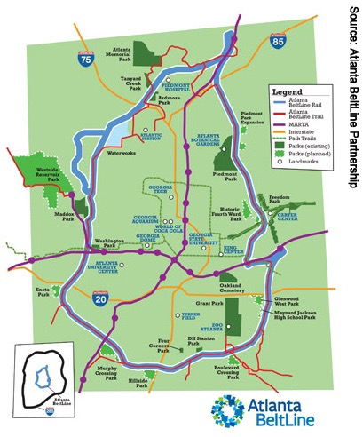
Figure 1

The Atlanta BeltLine, that was originally envisioned by Gravel’s graduate school thesis project, is now being implemented in Atlanta. It is a pedestrian, bike, and light rail transit loop that connects 45 Atlanta neighborhoods. The purpose of the project is to connect the Atlanta metropolitan area through one pathway that gives Atlanta’s residents a new way to live in their city without having to rely on getting around their city in a car. The project includes the initial 22-mile connecting pathway, which was once a railroad, as well as 33 miles of multi-use trails, which will follow this pathway and branch off from it. At the time of Gravel’s proposal, the current state of the BeltLine was an abandoned railroad surrounded by unused land and brownfield sites that created little hope for development. Gravel’s vision for the BeltLine would create more opportunity for development, but most importantly, it will change the way people live in Atlanta. Gravel hoped that by creating this infrastructure, residents would have the option to live in an Atlanta where they would not have to deal with car traffic and could have the option to bike or walk, something that is hard to do in Atlanta’s current state. His vision was to change the way people live in Atlanta.

Process of Implementation
Upon graduation from Georgia Tech, Ryan Gravel sought to turn his project into a reality by sending his BeltLine thesis to 24 city leaders. One of those recipients, Cathy Woolard, who later became chair of Atlanta’s City Council bought into the idea of the BeltLine, and helped Gravel gain more publicity for his idea. The two started a grassroots movement and began spreading the idea to residents by presenting at neighborhood association meetings. “The neighborhoods just instantly fell in love with it. It’s a pretty exciting city to be in when you can live in a house with a yard a couple of blocks from a much larger building with shopping and access to transit” said Gravel on the public’s participation with the BeltLine. Developers were also excited about the possibility of this project and the possibility of developing property in areas of the city that were currently had no property value. Many developers bought land among the proposed site to sell to the city and to prepare for new projects to take place alongside this new pathway.
From 2001 to 2005, the BeltLine grew more popular among residents and community leaders, in 2005 the Mayor of Atlanta formed the Atlanta BeltLine Partnership to engage interest and conduct a feasibility study to determine whether or not the BeltLine was a project the City could afford to take on, how it would be funded, and the impact it would create. The Atlanta BeltLine Partnership and the Trust for Public Land’s Emerald Necklace Study by Alexander Garvin outlined a realistic and connected park and transit system along the BeltLine. The Emerald Necklace Study outlined a comprehensive plan for the future of Atlanta. The study showed how hundreds of acres of green space could be developed with the completion of the BeltLine project. The study also determined that a Tax Allocation District (TAD) would be feasible and could cover 60% of the cost of the construction of the BeltLine. Finally, the Metropolitan Atlanta Rapid Transit Authority’s (MARTA) Inner Core Feasibility Study, examined several new transit options for the City of Atlanta and recommended the Atlanta BeltLine for inclusion in its future Alternatives Analysis Study. The study resulted in the Atlanta BeltLine Redevelopment Plan, which was completed in 2005. This plan includes the initial proposal to combine green space, protected walking trails, transit, and new development along the 22-mile pathway of the BeltLine to connect Atlanta’s urban core. The plan also provided a complete outline of the infrastructure needed to complete the project as well as plans to form the development into a Tax Allocation District, which would secure funding needed to create and maintain the BeltLine.
After the success of feasibility studies, Atlanta BeltLine Inc. (ABI) was created in 2006 to begin work on the project. Based on the feasibility study findings, City leaders proposed a Tax Allocation District that would help fund the majority of BeltLine. According to Invest Atlanta, a Tax Allocation District (TAD) is established for the purpose of encouraging investment by financing specific redevelopment opportunities in underdeveloped or impaired areas of the city using public dollars. Redevelopment costs are financed through the guarantee of future incremental increases in property taxes generated by the resulting new development. TADs are usually implemented when there are vacant commercial and residential properties, blighted conditions or numerous vacant buildings that are in need of significant environmental remediation. In many cities across the country, a TAD is known as Tax Increment Financing (TIF). The TAD proposal was met with resistance from some leaders among the region. “I think it’s a good project for Atlanta, and I hope they move forward with it, but I don’t think it’s something that ought to be financed with a regional tax,” said Mayor Jere Wood, City of Roswell, a suburb of Atlanta. Although the BeltLine was a great investment for the City of Atlanta, leaders in the suburbs felt like they would not see its benefits. This led to an uncertainty for if a Tax Allocation District would be the best way to finance the project.
The problem was, the City of Atlanta was running out of time to make a decision on what infrastructure they would build and needed to decide if the BeltLine was going to be a part of its future. The city was experiencing an unprecedented growth in population and needed to move quickly to create a vision for the future of planning for the city. Atlanta was to grow by 2.5 million people in the next decade and the city’s current state of transportation could not sustain the anticipated growth. This made the BeltLine more appealing because it relieved the burden of the amount of cars that the city would have to prepare for. “We sold the BeltLine to many residents because we convinced them that they won’t want all the new people moving to Atlanta to be driving on the highways...they would help keep congestion down by using the BeltLine” said Gravel. The popularity of the BeltLine grew and Mayor Franklin asked city council to move forward with this project even though action plans had not been completely settled. “Despite the sense of unreadiness, the opportunity to create the BeltLine will slip away if we don’t act now,” said Mayor Shirley Franklin. The City followed her leadership and gained support from organizations such as The Trust for Public Space and other developers who took the risk on the project and bought pieces of the BeltLine with the intent of selling the right-of-ways to the City.
The overall cost of the BeltLine was expected to be $2.8 Billion when finished. The City and ABI were able to convince enough voters of the overall effect the BeltLine would provide the region and were able to gain funding through this form of tax. The City of Atlanta and ABI continue to promote for the sustainability of the BeltLine by way of this public tax, bonds, and private donations to be able to continue to move forward with the implementation plan of the project.

Design and the User Experience
The BeltLine is the largest pedestrian-friendly corridor ever created in the city of Atlanta, and one of the largest urban developments being built in the country right now. It is open to any form of non-motorized transportation. Its overlaying zoning district spans each side of the pathway for half a mile in each direction. This was planned to build a sense of continuity through the entire corridor and create more opportunity for development along the pathway. The project will also clean up 1,100 acres of brownfield sites and create 1,300 acres of parks, opportunities for public art and preserve historic buildings. It is expected to create 5,600 units of affordable housing upon completion. The project is currently in the middle of its strategic comprehensive plan and is opening segments of the trail upon their completion.
When designing urban space, it is important to think about the people who will be using it. This is what creates ‘place’ for city dwellers. Edward McMahon, a Senior Fellow for Sustainable Development for the Urban Land Institute defines place as,
A unique collection of qualities and characteristics – visual, cultural, social, and environmental – that provide meaning to a location. Sense of place is what makes one city or town different from another, but sense of place is also what makes our physical surroundings worth caring about.

The BeltLine is an example of how place was created through a pathway in the city of Atlanta. Three ways in which this development has enhanced the public experience through design are safety, public art, and mobility.
The Atlanta BeltLine is transforming neighborhoods and residents’ lives with new green space and more opportunity for mobility. In the process, it is also creating the chance for healthier and more economically prosperous lives for the people who use it. Through this pathway, Atlantans are gaining greater access to jobs, fresh foods, and healthcare. The project also gives Atlantans opportunities for pet friendly and non-motorized transit. As the project is being implemented, programming art, cultural, and fitness events and activities have attracted more people to the BeltLine and activated the open segments of the BeltLine.
For the BeltLine to create a place that is utilized by the public, it must first make users feel safe. A place that is meant for people to use at all times of the day must create a perception of safety for its users. The BeltLine has been designed to do this by limited access points, visible security cameras, mile markers and a great amount of lighting. Security cameras on the trail are controlled and watched closely by Atlanta’s Police Department. Mile markers have also been marked on all areas of the trail to let users know exactly where they are at all times. These markers are tied into the 911 system so first responders will know exactly where to go in case of an emergency. Lighting is prominent in most existing areas of the BeltLine and will be implemented in future plans as well.
Although the BeltLine was designed for safety for its users, there is only so far design can go to create a completely safe space, especially in an area that was once used only as a railroad. In its first few months of 2.25 miles of the BeltLine opening, three armed robberies were reported. Each crime had the common theme to steal iPhones from people who were using them while running. The City of Atlanta and ABI encourage users to leave valuables at home and to always walk in numbers when using the BeltLine. They also want users to keep in mind what times of day would be safest to use the trail. Though there have only been a few reports of crimes, public view of danger can keep people from wanting to use the trail due to a fear of crime.
With a span of 22-miles, there is no shortage of space for art to be displayed along the Atlanta BeltLine. The BeltLine has curated art through murals along the pathways and through sculptures that give each section of the trail its own uniqueness. It also holds an annual lantern festival where it releases thousands of lanterns that draws thousands or attendees. As the development continues to grow, it will create more forms of visual art to create a culture of art and community on the BeltLine. Public art give users more incentive to experience and use the pathway and gives the BeltLine a stronger identity in the city.
The BeltLine creates an outdoor experience for Atlanta that is new for the city. Atlantans have the ability to exercise by walking, running, biking, or any other source of non-motorized transportation. Not only can residents use the BeltLine as a form of exercise, but also as a form of transportation. Chia404, a Trip Advisor reviewer says:
As long as it’s not raining, you’ll see hundreds of people walking, riding bikes, riding skateboards, running, taking their dogs and/or kids for walks. It’s a healthy way to get around and is often nearly as quick to get somewhere depending on traffic.

This shows the popularity the trail is among Atlantans and proves that the BeltLine is doing exactly what Ryan Gravel and the City of Atlanta told people it would do. It has changed the way they live.

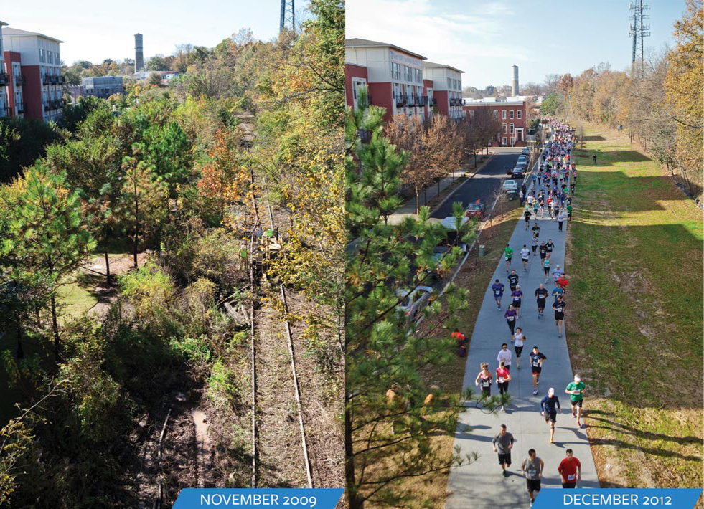
Figure 2

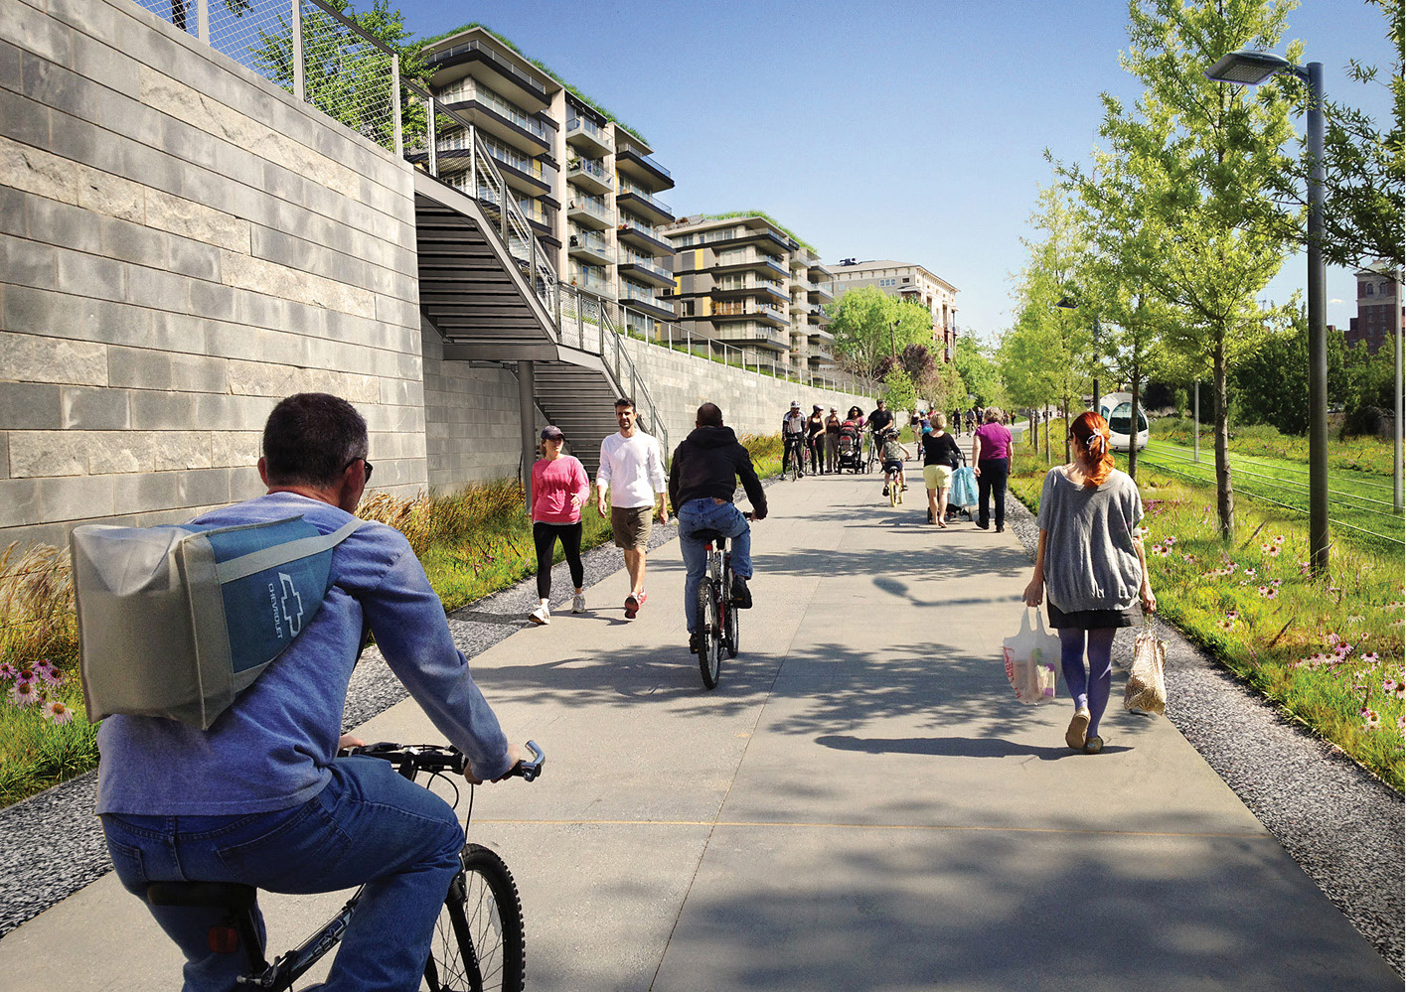
Figure 3

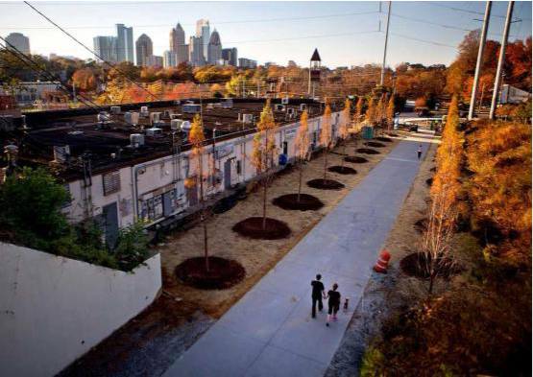
Figure 4

Chapter 3: New York High Line
965 miles north of Atlanta, in New York City, an abandoned, elevated railroad, the High Line, was scheduled for demolition before two neighbors decided to do something about it. The High Line was created in 1934 as an elevated railroad in Manhattan to carry freight. As a line on the Central Railroad, it was known as the West Side Lane. It is unique in design because instead of running in the same direction as traffic, it passed through buildings in the district to drop off and load food.
The High Line is 1.45 miles in length and is entirely elevated. It runs from Gansevoort Street in the Meatpacking District, through Chelsea, to the northern edge of the West Side Yard on 34th Street. As trucking became a more efficient form of transporting freight, railroads became underutilized leaving this rail line with no purpose. This led to final train on the High Line in November of 1980. As the High Line sat without any purpose, it deteriorated into an eyesore. Over twenty years passed before Mayor Rudy Giuliani proposed the demolition of the infrastructure to create more room for development. This created mixed emotions among New Yorkers, but no one was as passionate as Joshua David and Robert Hammonds who formed the ‘Friends of the High Line’ nonprofit to advocate for the preservation of the High Line.

Process of Implementation
Joshua David and Robert Hammonds had no prior relationship and neither had any experience or connection with nonprofits, railroads, or even the High Line. David was a freelance magazine writer and Hammonds was an entrepreneur who started a watch company. They both were passion- ate about the idea of preserving the almost two-mile railroad and repurposing it rather than tearing it down. They were lucky enough to have happened to sit next to each other at a community board meeting where angry business owners demanded for the structure to be torn down. They knew after that meeting that they needed to start a grassroots effort to save the High Line from demolition. They formed ‘Friends of the High Line’ a non-profit that advocates for the preservation of the over 75-year-old structure. “I fell in love with the very thing most people were complaining about, this rusty eyesore from the city’s industrial past, I saw this as a once-in-a-lifetime opportunity to preserve a mile and a half of Manhattan as an uninterrupted walkway and vantage point for people to enjoy on their own terms.” said Hammonds.
Although the power of money and business was not on their side, nature was. Since the High Line’s decline in the 80s, the structure began growing wildflowers and other natural forms of nature. This inspired Hammonds and David to repurpose the structure into a garden. They hired a photographer to take pictures of what the High Line had become and inspired a vision among the public of what the future of the High Line could be if it was saved.

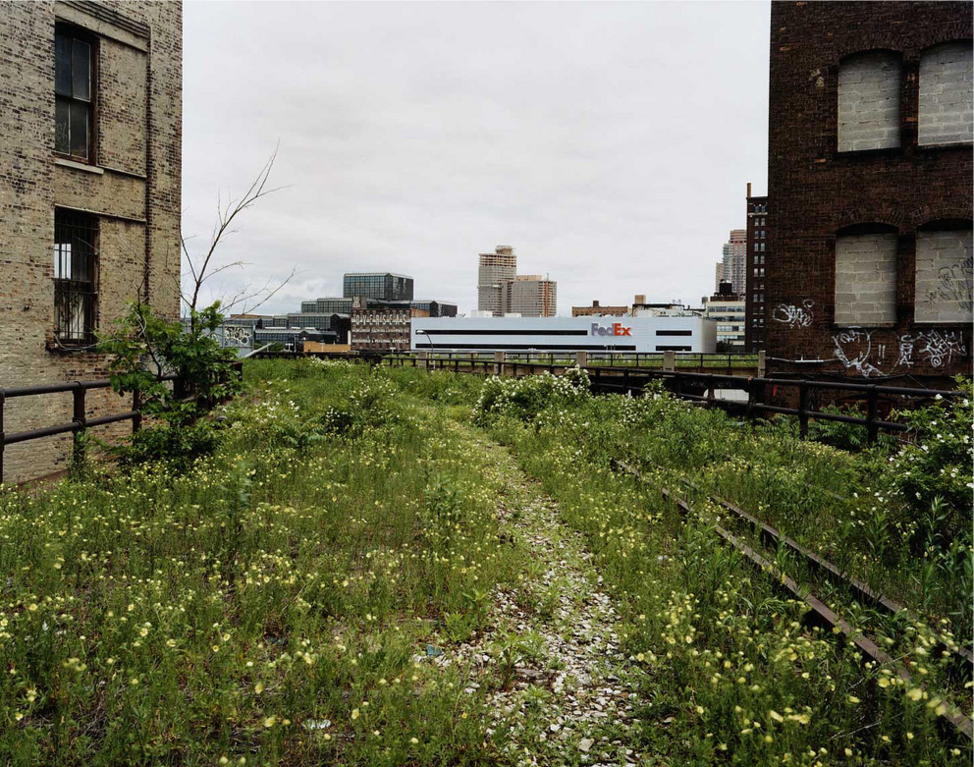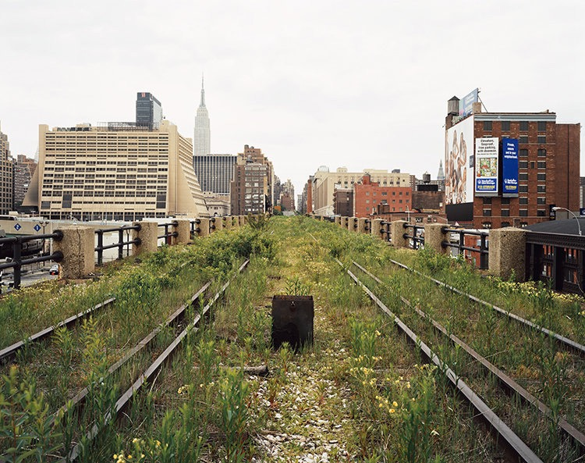
Figure 5 Figure 6

Through marketing the concept of an elevated park in Manhattan, they were able to share their vision to give New Yorkers a new way to experience while preserving a historic piece of the city. The railway’s owner, CSX Transportation, Inc., was so excited about the possibility of preserving the railway that they donated the High Line to the city of New York in the hopes that the City would not be demolished. They believed that the idea to turn the High Line into a linear park would also preserve the history of railroads in New York City. David and Hammond’s passion to keep a nearly 2 mile walkway that was away from the hustle and bustle of Manhattan won over Manhattan residents and the New York City government, gave Hammond’s and David’s nonprofit the power the oversee the development and implementation of the High Line.
Friends of the High Line created an open ideas competition to generate support and design ideas for the High Line. After selecting an architecture firm for the project and earning millions of dollars in private support for the preservation and redevelopment of the High Line, Mayor Michael Bloomberg committed $50 million to the redevelopment of the High Line to repurpose the rail- road into a garden and walkway for all to enjoy. Years of planning, community input, and work by some of the city’s most inventive designers were required to turn the rundown railway into an urban masterpiece. Not only did the planning take a long process, but also construction took two years per section to complete the High Line’s improvements. Planners rezoned the area surrounding the High Line to better suit the new attraction for citizens and tourists. Since the rezoning of the areas sur- rounding the High Line, a total of 1,374 new housing units have been built. 500,000 square feet of commercial office space has also been completed since the transformation of the High Line. Hous- ing, office space, retail, restaurants, and art galleries have all improved along the High Line due to the economic development it has created.
The first phase of the High Line opened in 2009. The nonprofit that Hammonds and David created still exists and continues to develop and steward the High Line today. The nonprofit raises millions of dollars for the High Line every year. The High Line is also a part of an Improvement District Tax, which makes property owners along the High Line pay a small tax every year to generate sustainable funding for the physical upkeep of the structure. The nonprofit, Friends of the High Line, manages the direction and operation of the High Line and remains operated by David and Hammonds, who continue to promote the High Line in New York City, which attracts 6 million visitors a year.

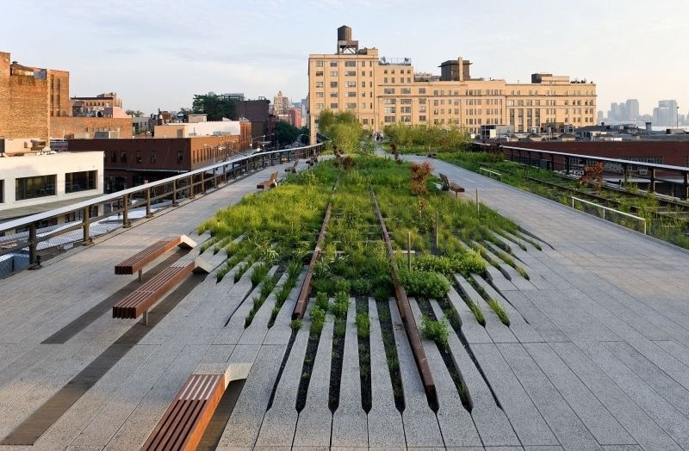
Figure 7
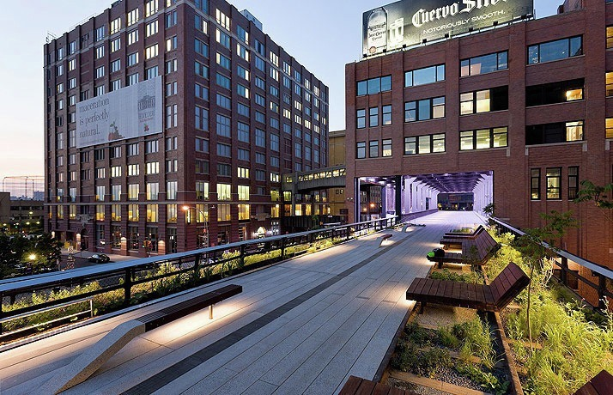
Figure 8

Design and User Experience
As an elevated park, the High Line is unique in design and user experience. The development curves through Manhattan and gives residents an opportunity to escape from the usual bustle of downtown to enjoy a walk through a curated and thoughtful park. The park closes every night at 11pm and has strict rules for pedestrians that use it. Some policies that have been put into place include no pets, no alcohol, and no source of transportation outside of walking. Friends of the High Line have established these policies to ensure the best experience for all users.
Since its existence, the New York High Line has reported zero major crimes. Many believe this is due to the fact that the park closes at night. Other possible explanations for the lack of crime is the park’s elevated design and the large amount of people that use the park. Unlike the BeltLine, the High Line closes its gates every night and has police constantly securing the facility. Officers can fine users that are violating any of the policies of the High Line. The High Line uses Jane Jacob’s theory of ‘eyes on the streets’ to help make users feel more comfortable. Many buildings that border the High Line have windows facing the park.
Because the park closes at 11pm every night, there is usually a high volume of people on it at all times of the day. The fact that the park is elevated also plays a role in the lack of crime reported on the park. “A thief would have to plan carefully for a getaway using an elevator or a staircase...it’s not like they can jump off” said City Council Speaker, Christine Quinn. The height of the High Line creates a disadvantage for criminals and puts the park eye level with many Manhattan towers. With the High Line gaining more popularity among tourists and residents, crime will continue to remain low.
Users of the High Line not only have the Manhattan skyline to enjoy on their journey, but can also enjoy murals and gardens. As the park has gotten more popular, artists have used it as an opportunity to create murals and sculptures for the users of the High Line to admire. Art is a defining characteristic of both the BeltLine and the High Line. It creates a stronger sense of place and revitalization within these pathways.
Perhaps the biggest difference between the High Line and the BeltLine is that the High Line is only designed for people that are walking. Users can make their way up to the elevated structure by stairway or elevator. The trail was designed to give pedestrians a relaxing experience that includes plenty of benches, shaded areas, and beautiful gardens to enjoy. The design also gives users an experience that they have probably never had before. Pedestrians have the ability to imagine what it would feel like to walk on air. Removing pedestrians from street level gives them a secure form of exercise and transportation from one part of the city to the other. The elevation of the pathway also gives users a new urban experience and potentially a greater appreciation for the space away from the crowded streets.

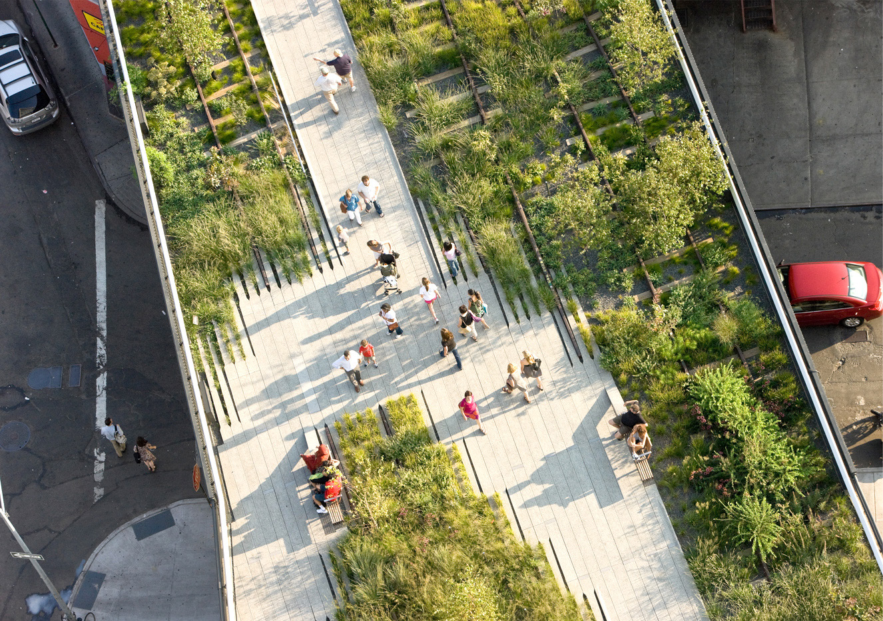
Figure 9
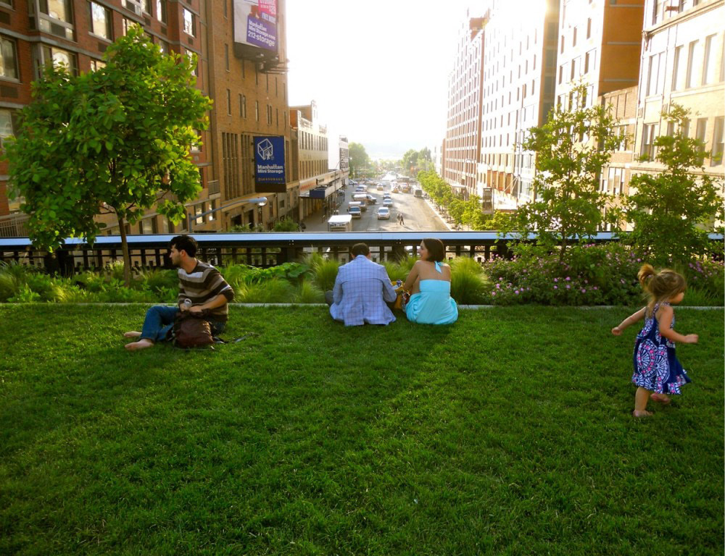
Figure 10

Chapter 4: Analysis
Both the High Line and the BeltLine create new urban experiences that have built a sense of place for the people that use them. Their greatest difference is their design. One is elevated and the other is not. Elevation for the New York High Line limits how the structure can be used, but gives the user an experience of being off the ground that the BeltLine cannot. The High Line is able to give the user the experience of ‘walking on the clouds’ instead of the normal sidewalks. The Belt- Line on the other hand is able to create not only beautiful park for Atlantans, but also a new way of traveling through neighborhoods in the city and new opportunities for exercise and recreation. The size of the BeltLine shows the transformative power pathways can have on cities. The two pathways show that safety, art, and mobility are all important characteristics to successful pathways.
These projects are creating new opportunities for development in their cities. Atlanta’s opening of the first phase of the BeltLine has already inspired new restaurants, retail and housing developments. Developments such as Ponce City Market, which was redeveloped on the East Side Trail into a mixed-use development, have boosted the economy and brought more people to downtown Atlanta. Developers have the opportunity to create trail-oriented development, something that would not be possible if it were not for the BeltLine. It is creating more jobs and accessibility to resources in the urban core of the city. The economic impact that this pathway will provide for the city is unmatched by any other urban project in Atlanta since the 1996 Olympic games. The High Line, being built in an already prosperous area, has added even more value to Manhattan. It has provided the City with a unique attraction and has been able to spark new commercial and residential space that enriches life in the Big Apple.
Finally, these pathways create an impact in the city in which they are located. They are part of what makes New York City and Atlanta unique. The people who use them can find identity in them and be proud of the impact it provides their city. Tourists want to experience the rareness of these places. The economic impact and the design of the pathways are both benefactors of the personality that they provide their communities. They both show the value of pathways in creating a sense of place for urban dwellers.
Both of these developments are projects that prove that pathways can revive the urban experience and change the way people live. Other cities should study the High Line and the BeltLine and see where there is possibility for similar developments in their own city. With the right funding, planning, and design, they can transform our cities.

Chapter 5: Present Day Oklahoma City
Oklahoma City was built around the automobile. This automobile-focused urban design has negative consequences for the economy, public health, and the environment. As of 2016, 99% of OKC residents travel to work in an automobile. The average household in central Oklahoma City spends over $8,500 a year on their car. This price includes the cost of gas, car repair, and car payments.
Not only must Oklahoma City residents rely on the automobile, but the city’s deficient road and bridge conditions cost residents more on top of what they are already spending on their car. According to TRIP, a national transportation research group, 81% of major roads in Oklahoma City’s urban core are in poor or mediocre condition. This costs the average driver an additional $2,242 each year in extra vehicle operating costs. These costs include enhanced vehicle depreciation, extra repair costs, and increased fuel consumption due to congestion and tire wear. Not only does car dependency hurt residents financially; it also has negative public health and environmental consequences.
Oklahoma ranks as the 45th least healthy state in the nation. Choosing to walk or bike can give residents the opportunity to exercise by traveling to work or to a destination. Walking and biking also helps people keep a healthy heart rate and reduces the likelihood for elderly to develop poor mental health.
Automobiles pollute cities through carbon monoxide emissions, odors, and smog. Driving creates numerous environmental hazards that damage the beauty and health of a city. By creating opportunities for residents to walk and bike, Oklahoma City can improve air quality and reduce hazardous effects of automobiles.

Urban Design Poses Challenges for Biking and Walking
The option to bike or walk in Oklahoma City is improving, but is still a difficult task even if someone is choosing this mode of transportation. Obstacles that pedestrians and cyclists face include:
- Oversized lanes and streets. Oversized roads are unfortunately the norm in Oklahoma City. They make it tough for pedestrians and cyclists to cross streets. Specific roads in Oklahoma City that create an obstacle for cyclists and pedestrians in urban core neighborhoods are Classen Boulevard and Lincoln Boulevard. Both of these boulevards connect destinations and neighborhoods and are able to carry a large amount of cars. According to the National Association of City Transportation Officials (NATCO), lanes in urban areas should be 10 feet wide.50 Classen and Lincoln Boulevard vary from 11 to 12 foot lanes. Both streets have 6 to 8 lanes, which create barriers for people to get to destinations or neighborhoods when biking or walking. According to walkability expert Jeff Speck, streets with multiple and wide lanes encourage drivers to move faster which creates a dangerous situation for pedestrians to cross the street.
- A lack of bicycle infrastructure. Oklahoma City neighborhood streets run on a grid system, which gives users an easy and efficient tool for navigation. Although most of these streets have a low enough traffic count for cyclists to feel comfortable enough to use the street, there are streets with high traffic volume that do not accommodate cyclists or pedestrians that would make the average resident feel unsafe to bike or walk. The only designated bike lanes outside of the downtown area are located on Shartel and NW 39th. There is also a designated bike lanes on South Grand Boulevard in Southwest Oklahoma City. Bike lanes are an important consideration for bicycle infrastructure because they improve bike ridership. After protected bike lanes were installed on Pennsylvania Avenue in Washington D.C., bicycle volume on that street increased by 200%. After buffered bike lanes were installed on two streets in Philadelphia, bike traffic on those streets rose by 95% and the number of cyclists that bike on the sidewalk dropped by 22%.
- Not enough green space. A lack of green space and vegetation on Oklahoma City sidewalks make the choice to walk harder for pedestrians, especially due to a lack of shade in the summer heat. Street trees create safer walking environments, increase security, and provide shelter from weather. Green space creates a more interesting walk for pedestrians and can improve the beautification of a city.
- A lack of sidewalks. Many of Oklahoma City’s streets were built without sidewalks. Due to this, there is a lack of connectivity of sidewalks between neighborhoods. Today, developers are required to provide sidewalks in new developments and the City is adding sidewalks to streets that were originally built without them.
- Low density and sprawl. Cities that are built around cars such as Oklahoma City tend to be spread out and have low density. This makes trips harder for cyclists and pedestrians that want to make short trips to destinations. Many buildings in Oklahoma City are setback from the street so that cars can park in front of the buildings. This creates an uninteresting and less desirable walk for pedestrians.
As is the case with other cities that suffer from sprawl, Oklahoma City lacks connectivity. Oklahoma City has become district-driven with bustling districts such as the Plaza District, Paseo, Bricktown, Automobile Alley, and Midtown. Each district is unique and has it’s own charm. Our city is investing in lively districts, but the lack of connectivity between these destinations make Oklahoma City feel like a collection of small towns, each with their own center, rather than a connected metropolis.

Some Neighborhoods Bike More than Others
In central Oklahoma City, the largest number of cyclists lives in northeast and southwest Oklahoma City. 3.2% of residents in northeast Oklahoma City bike to work on a regular basis, and 8.6% of residents in southwest Oklahoma City bike to work on a daily basis. In neighborhoods just north of downtown and midtown in what would be considered more bike friendly areas, the percent of residents that bike to work varies from 1-3%. Other than a few designated bike lanes in the downtown area, bike route signs that show the streets deemed to be more safe for bikers, and a protected bike lane on south Grand Boulevard, little bike or pedestrian infrastructure has been created to ensure safety and efficiency for people biking or walking in these areas of the city.

City Taking Actions to Increase Biking and Walking
The City is currently creating new ways to help people move around the city by improving street conditions, connectivity, multi-modal transportation options, and access management. In their comprehensive plan, Oklahoma City’s Planning Department states that, “A connected street system benefits cyclists and pedestrians. Shorter, more direct trips make alternative modes of travel viable and often, the more desirable choice. This further reduces congestion and has a multitude of public health benefits.” Creating a connected network of transportation for cyclists and pedestrians can enhance the percentage of residents choosing to walk or bike as a travel option. As Oklahoma City continues to create new ways to build a connected street system, other infrastructure that is planned for the future of Oklahoma City is an improved bus system, a bus rapid transit, modern streetcars, and a commuter rail.

Important Considerations to Further Increase Biking and Walking
For Oklahoma City to enhance the biking and walking experience for residents, infrastructure must be created to enhance connectivity for cyclists and pedestrians. Pedestrians and cyclists should feel safe while traveling and should be able to travel around the city efficiently through an intentionally designed network of protected bike and walking paths. New infrastructure can form new destinations so that more people are within a short trip of a destination. This will create a more interesting walk or bike ride and give residents a new experience in their city. Building new infrastructure for pedestrians and cyclists can also enhance the beautification of a city and provide more green space that would improve public spaces. A signature-connected pathway can transform the culture for pedestrian and bicycle activity in Oklahoma City. It will improve the current street and sidewalk network of Oklahoma City as well as create new opportunities for sustainable practices, way-finding, and new destinations.
Other cities are starting to adopt signature pathways that encourage biking and walking. In Portland, Loop PDX is an urban design concept that proposes a 6-mile signature linear park and active transportation path that will bring new life and energy to the urban core. This concept will promote more walking, biking, jogging and public transit trips while helping contribute to a smaller citywide carbon footprint. The Indianapolis Cultural Trail is an 8-mile urban bike and pedestrian path in downtown Indianapolis, Indiana. The Cultural Trail connects neighborhoods, cultural districts and entertainment amenities. These projects, as well as the Atlanta BeltLine and New York High Line challenge the status quo of how we experience our cities and offer residents the opportunity to bike or walk efficiently in their city.

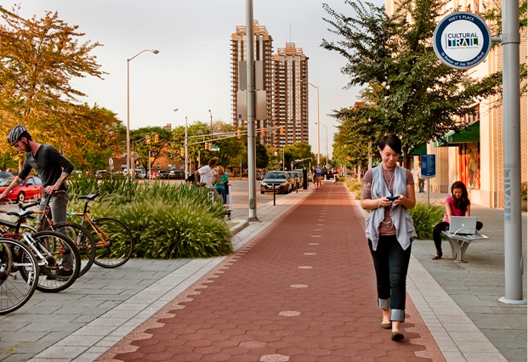
Figure 11
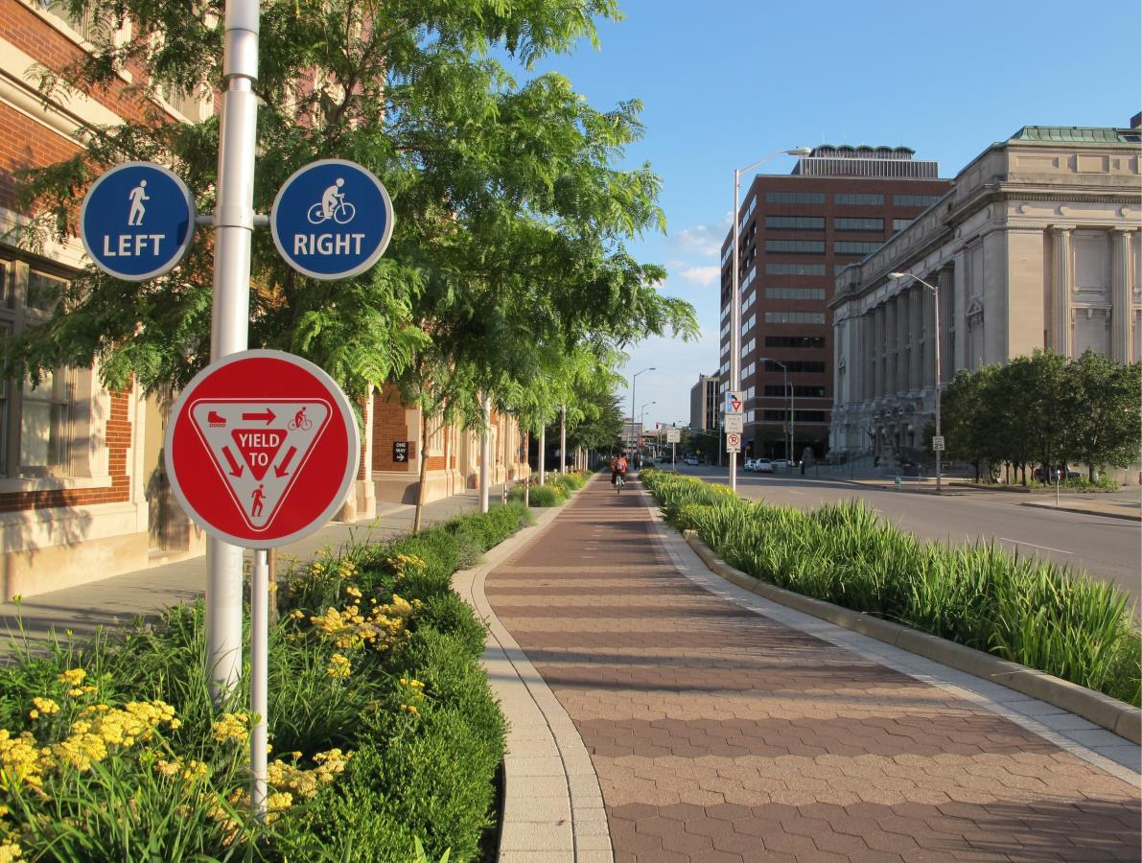
Figure 12
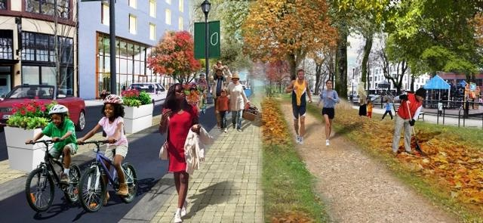
Figure 13

Chapter 6: The Green Loop
Oklahoma City is expected to be the home to 810,883 residents by 2040, which would average a growth of 10,000 new residents per year for the next twenty years. As Oklahoma City continues to grow, it is more vital than ever to re-envision a way to connect people to places. Oklahoma City needs a connected linear park and bike path with the purpose of connecting Oklahoma City’s districts and linking neighborhoods to the urban core. A way to do this is through The Green Loop.
The Green Loop is a pathway that connects Oklahoma City’s urban core with protected bike lanes, pedestrian walkways, green space, and redevelopment of existing places.
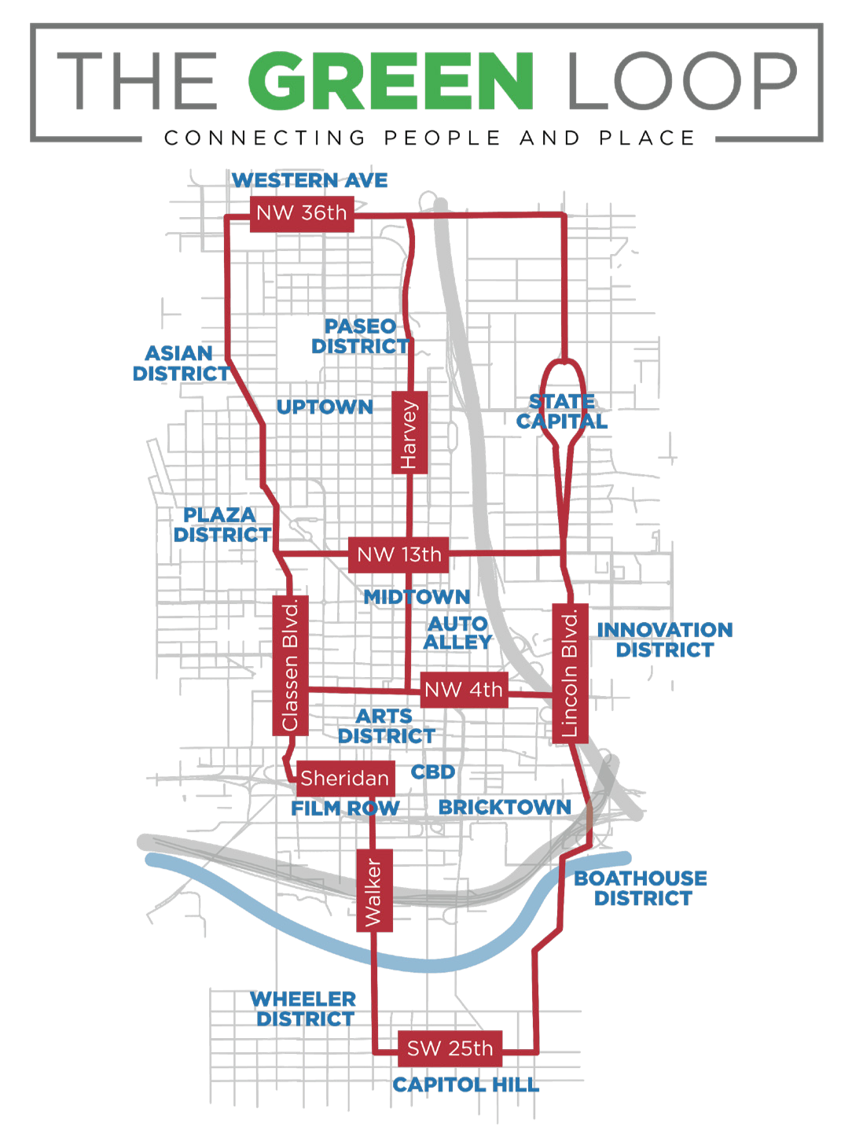
Figure 14
Creating a signature pathway will give pedestrians and cyclists a new experience when walking or cycling from their home to a destination. The loop seeks to create more green space in Oklahoma City and promote a more active lifestyle for people getting around the city. It will also create new opportunities for development and redevelopment on streets that are in need of investment.
Every city has infrastructure that has become out-of-date to the goals and use of the city and can be redeveloped to better accommodate people. For Atlanta and New York City, this was an old railroad. Although Oklahoma City does not have an out-of-use elevated railroad or an abandoned railway that circles the city, it does have streets that can be downsized.

What streets will be used?
Streets like Classen and Lincoln Boulevard create barriers for residents in nearby neighborhoods. According to NACTO and the Institute for Transportation Engineers, a street that carries 32,000 cars a day only needs 4 lanes and a left turn lane to move efficiently. Both Classen and Lincoln average 12,000 to 25,000 cars per day yet have 6-8 lanes. Engineering aside, neither Classen nor Lincoln were ever designed to accommodate pedestrians. They were designed to move cars through the city. When a city is only designed for cars, it hurts pedestrians, cyclists, and even the drivers of the cars. Other streets such as 36th, 13th, 4th, and SW 25th, are streets that can drive more economic activity if they were designed to balance transportation modes.
These streets could be reconfigured along with others to create a connected and protected bike and pedestrian loop. By putting these streets on a diet and redesigning them to include bike lanes and sidewalks that are protected by trees and green space, we can move towards a more walkable and bikeable city.
Unlike the Atlanta BeltLine and the New York High Line, the Green Loop would use streets with car activity. One reason for this is based on the safety issues that have occurred on the Atlanta BeltLine. When there isn’t activity on the street, there is a higher possibility for crime. People should feel safe when biking or walking and to do that, there needs to always be people using the street, and this includes cars. Another benefit of using already established streets is the increase in real estate value and business value it can bring. The Indianapolis Cultural Trail, a protected bike lane and walking path in Indianapolis has increased the property value of buildings within a block from it by over 100%. Not only do bike lanes increase property value, but they also increase business. A portion of York Avenue in Los Angeles, California received a road diet that replaced car lanes with bike lanes. After the road diet, the section with the bike lane reported sales tax revenue of $1,116,574 while the section without the bike lane reported revenue of $574,558.
To preserve what’s here now, a signature pathway should respond to the development that it interacts with. In urban areas, The Green Loop should allow pedestrians the ability to easily cross the street and create opportunities for retail to be closer to the street. Segments of the loop would allow a linear parkway that would give users a new experience in Oklahoma City and provide more green space. Some pieces of the loop are meant to bring cyclists from Point A to Point B. And in residential areas that have little traffic with low traffic; cyclists and pedestrians should have priority over cars on the street.
The Green Loop will be designed block by block to accommodate the needs of the street it is on. Oklahoma City has unique and thriving entertainment and art districts. The distinct identities and conditions of each district will help determine the design and placemaking strategies for the loop’s different segments, creating a variety of experiences. Pathway design will respond to the present context of each street, helping to contribute and strengthen the distinct identities of each segment and destination.
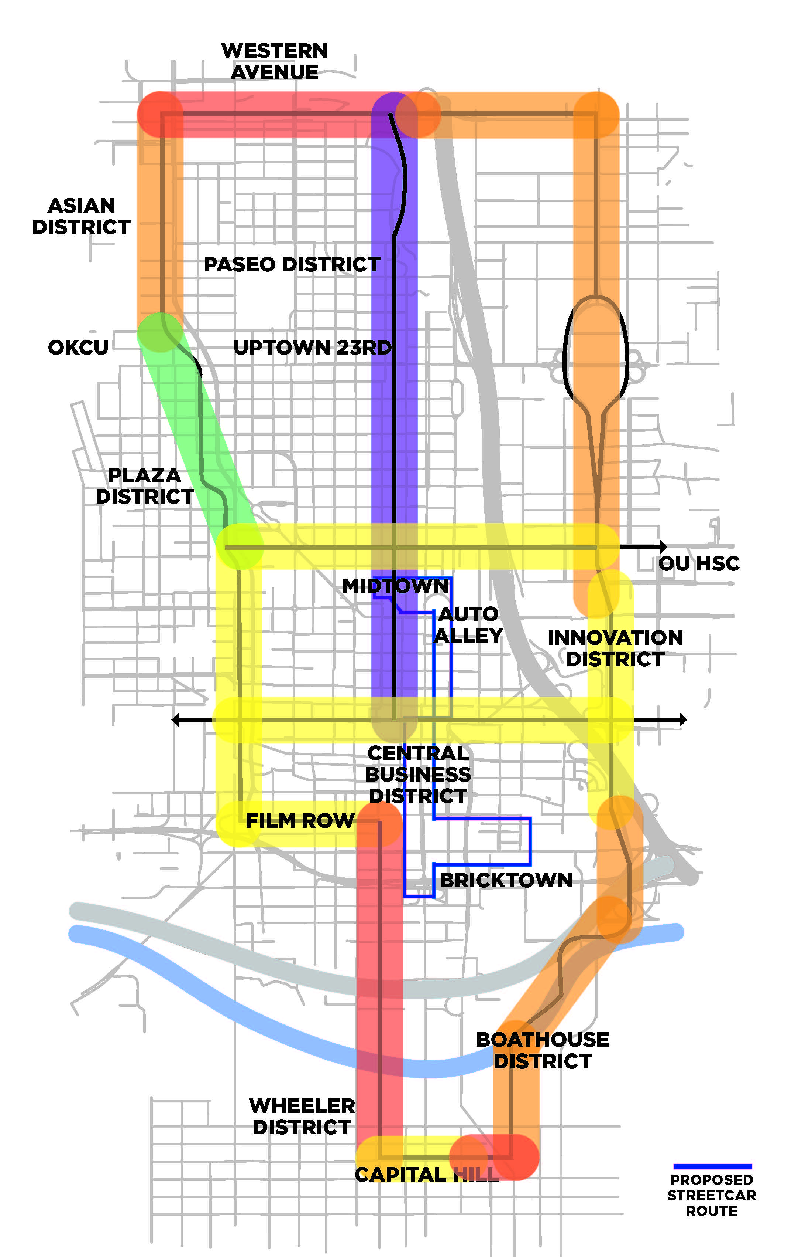
Figure 15
Orange – Movement Area
Yellow - Urban Area
Purple - Bike Boulevard
Red - Residential Development
Green - Linear Park

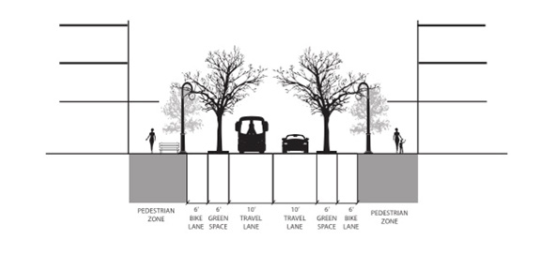
Figure 16
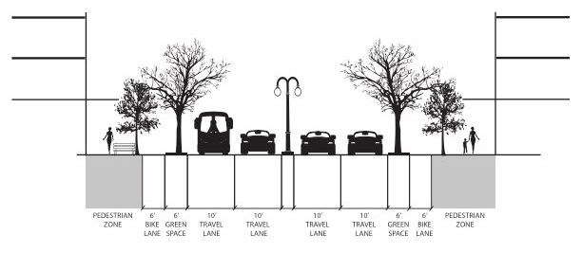
Figure 17

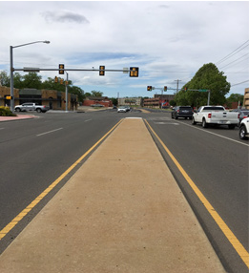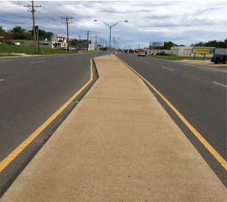
Figure 18 Figure 19
The yellow segments represent urban areas where the loop will take into consideration a design that will accommodate and encourage higher density and more pedestrian activity. Figure 1 shows a depiction of 4th Street and 13th Street, while Figure 2 depicts Classen Boulevard.

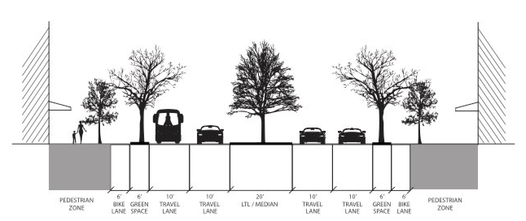
Figure 20
The orange segments on the map represent areas of the loop that are designed to get people from Point A to Point B. These segments are currently barriers for pedestrians and cyclists that try to cross them. There should be a protected bike lane and sidewalks to move cyclists and pedestrians through these areas with little interruption to their walk or ride. While designed for movement, buildings and green space should still accommodate for pedestrians and cyclists.
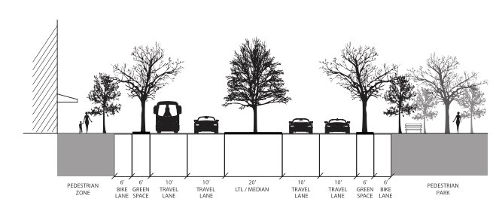
Figure 21
The green segment represents a linear park that will connect the Plaza District to Uptown on 23rd Street and end at Military Park on 25th Street. The entire loop will create more green space and include trees, but this segment will include a designated linear park. Above are examples of cities that have reclaimed parts of the street to create a linear park.
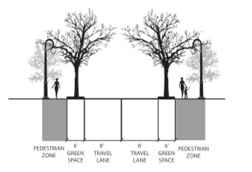
Figure 22
The purple segment represents a bike boulevard that will act as the spine of the loop on Harvey. A bike boulevard gives priority to the cyclist and pedestrian over the driver. This street runs through a residential neighborhood and has one of the lowest volumes of cars of any street in the city. This street connects pedestrians and cyclists to many destinations, including: the Central Business District, Myriad Gardens. the Oklahoma City National Memorial and Museum, Midtown, Uptown 23rd Street, Paseo Arts District, and Edgemere Park.

Design Principles
- Building Orientation
- The current buildings along Classen and Lincoln Boulevard react to the oversized boulevards that are currently in place. Most buildings have large surface parking lots in front of them and the sidewalk does not connect the entire street. New development and redevelopment of what currently exists would be encouraged to engage pedestrians by putting parking in the back, adding retail space that faces the street, and creating outdoor spaces that invite pedestrians.
- Pedestrian and Bike Path
- In all areas of the Green Loop there will be designated paths for pedestrians and cyclists. This will create a connected bike and pedestrian network in Oklahoma City. Pedestrians zones should be shaded and should offer street furniture, lighting, and public art.
- Physical Separation
- One of the key aspects of the Green Loop is creating a pedestrian and bike path that is physically separated from cars. Research shows that non-cyclists are 75% more likely use a bike lane if it is physically separated from cars. To create a useful bike and pedestrian networks, cyclists and pedestrians must feel safe and must not have to compete with cars.
- Green Space
- In areas that allow it, a connected tree canopy will create a physical separation from cyclists and pedestrians between cars. This will not only create a separation, but also will provide shade and improve the quality of air in Oklahoma City as well as other environmental benefits. Green space should also be used as a key source for defining place and way-finding along the loop.
- Branding and Way-finding
- A key aspect of the Green Loop is creating an identity for it that appeals to a variety of people so that users feel connected to the loop and feel comfortable using it. Branding as well as the added green space will make it easy for users to know they are on the loop. Distinctive characteristics as well as placemaking will help users recognize where they are on the loop and what destinations are close by.

Since the development of similar projects such as the Atlanta BeltLine and Indianapolis Cultural Trail, new development that accommodates pedestrians and cyclists have been built. An example of this is the Ponce City Market in Atlanta, a mixed-use redevelopment that is adjacent to the BeltLine. The development incorporates numerous features that accommodate active transportation such as bike storage, a bicycle valet service, elevators that accommodate bikes, showers for bike commuters, and more. As people adapt to active transportation, development should begin to accommodate for these people. For more examples of Trail Oriented Development, see ULI’s Active Transportation and Real Estate.66

Benefits of The Green Loop
There are several benefits to a connected bike and walking path.
- The Green Loop supports businesses. People that are biking or walking, have a greater view of the street and travel at a slow enough speed that it is easier for them to see and stop at a businesses. The Green Loop also creates new opportunities for development in blighted areas of the city.
- The Green Loop fosters social equity. By connecting people from different backgrounds, cultures, and economic status, we can create an inclusive city that allows everyone the same opportunity to for people of all areas of the city to walk or bike to work or to destinations. The highest bike ridership in Oklahoma City is in Northeast and Southwest Oklahoma City, which are also the poorest areas of the city. Oversized roads with limited ability to cross the street endanger pedestrians and cyclists everyday.
- The Green Loop saves people money. As mentioned earlier, the average household in Oklahoma City spends $8,500 on transportation per year. Imagine if families could save even half of that by going from two cars to one. If every family in the urban core of Oklahoma City were able to downsize to one car, that would create more than $300 million in excess income.
- The Green Loop creates green space. By using trees as a barrier from cars and as a shade for cyclists and pedestrians, we can beautify our streets and reduce our carbon footprint. Street trees also have the ability to cool down an area by 20 degrees. This would make the option to bike or walk more appealing to Oklahoma City residents.
- The Green Loop encourages a healthier city. As one of the least healthy states in the nation, Oklahoma City can continue being the driving force to make Oklahoma a healthier and more active state. Campaigns by Oklahoma City’s mayor and local non-profits have motivated the people of Oklahoma City to become a more active city, but our built environment should offer citizens more opportunities to move around the city without having to rely on a car.

Hot Spots
The Green Loop would connect and create hot spots. By connecting Oklahoma City’s districts it would also add to these destinations by creating hot spots using urban design techniques to create a sense of place along the loop. A hot spot along the Green Loop would be a placemaking instrument to signify destinations that the loop connects. It would create more livable spaces that are open to everyone in the city. This would also serve as a way-finding tool for people using the loop. The hot spots will be located in areas that are already destinations. For example, a hot spot would be located on NW 16th and Classen Boulevard to show that you are near the Plaza District. This will give each part of the loop a uniqueness to better identify with the area of the city it is connecting.
Not only would hot spots be used as a way-finding tool, but also they would create more value and pedestrian friendly spaces in areas of the city that do not currently accommodate pedestrian activity.

Connection
Finally and most importantly, The Green Loop connects. A connected pathway makes it easier to shop, live, work and play while also preserving Oklahoma City’s unique neighborhoods and commercial districts. By connecting the urban core of Oklahoma City, we are providing people with better access to jobs, giving people a new way to move around the city, creating more opportunities for development, and eliminating barriers that give priority to cars instead of pedestrians and cyclists.
For Oklahoma City to enhance its biking and walking experience, infrastructure must be built to create connectivity for cyclists and pedestrians. The City of Oklahoma City’s Comprehensive Plan addresses the need for a connected pedestrian and bike network. It addresses that cyclists and pedestrians should feel safe when walking or biking in their city. It also addresses that in Oklahoma City’s current state, biking and walking is not an efficient way to get around. The Green Loop is a solution to these problems.
It might be hard for people to imagine Oklahoma City as a walkable and bike-friendly city, but the same could have been said about Atlanta. Bikeable and walkable cities improve people’s health, save people money, supports businesses, and helps the environment. By intentionally reclaiming infrastructure, cities can create pathways that connect pedestrians and cyclists to destinations. These pathways can give people a new experience, and improve the way they live.

Future Direction
The next step in the process of The Green Loop is to seek input from the community. A way to do this is through presenting this project at neighborhood association meetings, community service groups, and other clubs and organizations that would have an interest or benefit from The Green Loop. Through gaining more input and refinement from the community, The Green Loop can become a piece of infrastructure that all Oklahoma City residents feel like they have ownership of.
Just as every block of the loop should be designed to best fit its environment, it should also be designed to fulfill the needs and benefit the people it serves. The design of The Green Loop should be a reflection of the communities it connects. People should have the right for their voice to be heard on the streets that they use everyday. This will produce greater civic identity and further the loop’s development of greater social equity.
Through the input and support from the community and city leaders, The Green Loop can improve the daily lives of the people of Oklahoma City.

References
“Atlanta Beltline Eastside Trail (GA): Address, Tickets & Tours, Attraction Reviews – TripAdvisor.” Atlanta Beltline Eastside Trail (GA): Address, Tickets & Tours, Attraction Reviews - TripAdvisor. N.p., n.d. Web. 22 Nov. 2015.
“Beltline Experiencing Crime.” Beltline Experiencing Crime. Atlanta Journal- Constitution, n.d. Web. 3 Dec. 2015.
“Beltline’s Presence on Transportation List Spurs Resistance.” Atlanta Journal- Constitution. N.p., n.d. Web. 2 Dec. 2015.
Bicycle Usage Up 95% on Spruce and Pine Bike Lanes. (2009, December 10). Bicycle Coaltion of Greater Philadelphia.
Brownson R, Boehmer T, Luke D. Declining rates of physical activity in the United States: what are the contributors? Annu Rev Public Health 2005; 26: 421– 43.
City of Oklahoma City Comprehensive Plan. /www.okc.gov/departments/planning/comprehensive-plan
Despite recent improvements, deficient, congested roadways cost average OKC driver $2,242 annually. (2016, April 6). Retrieved from www.tripnet.org
Dewan, Shaila. “The Greening of Downtown Atlanta.” The New York Times [New York City] 6 Sept. 2006: n. pag. Print.
Finn, Robin. “Two Friends, and the Dream of a Lofty Park Realized.” The New York Times. The New York Times, 10 July 2008. Web. 22 Nov. 2015.
Gravel, Ryan. “Belt Line – Atlanta: Design of Infrastructure” Georgia Tech University [Atlanta, Georgia] December 1999
Gravel, Ryan. Atlanta BeltLine: Reclaiming Infrastructure. University of Oklahoma, Oklahoma City, Oklahoma: 6 September 2016
Jacobs, J. (1964). The Death and Life of Great American Cities. Pelican Books. Joshua David and Robert Hammond, High Line: The Inside Story of New ork City’s
Park in the Sky (New York: Farrar, Straus and Giroux, 2011).
“Looking Back at The History of The High Line in NYC, New Video from Blueprint.” Untapped Cities RSS. N.p., 01 Apr. 2015. Web. 2 Dec. 2015.
Lopate, Phillip. “Above Grade: New York City’s High Line.” Places Journal. Places, n.d. Web. 22 Nov. 2015.
Mehrotra, Karishma. “Atlanta’s Popular BeltLine Trail Still Has Miles to Go.” WSJ. Wall Street Journal, n.d. Web. 2 Dec. 2015.
Mccubbin, D. R., & Delucchi, M. A. (2003). The Health Effects of Motor Vehicle- Related Air Pollution. Handbook of Transport and the Environment Handbooks in Transport, 411-427. doi:10.1108/9781786359513-022
McCormick, Cullen. “York Boulevard: The Economics of a Road Diet.” Luskin School of Public Affairs, University of California, Los Angeles, CA.
Parks, J., & Ryus, P. (2012, April). District Department of Transportation Bicycle Facility Evaluation. Retrieved from http://ddot.dc.gov/
Population estimates, July 1, 2015, (V2015). (n.d.). Retrieved September 21, 2016, from http://www.census.gov/quickfacts/table/PST045215/4055000
Speck, J. (2012). Walkable city: How downtown can save America, one step at a time. New York: Farrar, Straus and Giroux.
“Tax Allocation Districts.” InvestAtlanta: Atlanta’s Development Authority. Invest Atlanta.
“The Atlanta BeltLine, Where Atlanta Comes to Grow.” Atlanta BeltLine. Atlanta BeltLine Inc., n.d. Web. <http://beltline.org>.
“The High Line.” The High Line. Friends of the Highline, n.d. Web. 22 Nov. 2015. <http://www.thehighline.org/>.
“The High Line.” NYCEDC. New York City Economic Development Center, n.d. Web. 2 Dec. 2015.
Thomas, K. (2016). Metro Atlanta expected to grow by 2.5 million people. Retrieved August 27, 2016, from http://www.wsbtv.com/news/local/atlanta/metro-atlanta-ex- pected-to-grow-by-25-million-people/249220307
United Health Foundation 2015 Annual Report; www.americashealthrankings.org
U.S. Census Bureau, Census 2010 Summary File 1. Esri forecasts for 2015 and 2020
Urban Street Design Guide - National Association of City Transportation Officials. (n.d.). Retrieved April 19, 2016, from http://nacto.org/publication/urban-street-design-guide/ “Why Sense of Place Is Worth Caring About.” Planetizen: The Urban Planning, Design, and Development Network. N.p., n.d. Web. 9 Dec. 2015.
Wilson, M. (2011, June 10). The Park Is Elevated. Its Crime Rate Is Anything But. The New York Times.

Ryan Gravel. “Belt Line – Atlanta: Design of Infrastructure” Georgia Tech University [Atlanta, Georgia] December 1999
Shaila Dewan. “The Greening of Downtown Atlanta.” The New York Times [New York City] 6 Sept. 2006: n. pag. Print.
“The Atlanta BeltLine, Where Atlanta Comes to Grow.” Atlanta BeltLine. Atlanta BeltLine Inc., n.d. Web. <http://beltline.org>.
Shaila Dewan. “The Greening of Downtown Atlanta.” The New York Times [New York City] 6 Sept. 2006: n. pag. Print.
Ibid.
The Atlanta BeltLine, Where Atlanta Comes to Grow.” Atlanta BeltLine. Atlanta BeltLine Inc., n.d. Web. <http://beltline.org>.
The Atlanta BeltLine, Where Atlanta Comes to Grow.” Atlanta BeltLine. Atlanta BeltLine Inc., n.d. Web. <http://beltline.org>.
Ibid.
Ibid.
“Tax Allocation Districts.” InvestAtlanta: Atlanta’s Development Authority. Invest Atlanta.
“Beltline’s Presence on Transportation List Spurs Resistance.” Atlanta Journal-Constitution. N.p., n.d. Web. 2 Dec. 2015.
K. Thomas. (2016). Metro Atlanta expected to grow by 2.5 million people. Retrieved August 27, 2016, from WSBTV
Ryan Gravel. Atlanta BeltLine: Reclaiming Infrastructure. University of Oklahoma, Oklahoma City, Oklaho- ma: 6 September 2016.
Shaila Dewan. “The Greening of Downtown Atlanta.” The New York Times [New York City] 6 Sept. 2006: n. pag. Print.
Ibid.
“The Atlanta BeltLine, Where Atlanta Comes to Grow.” Atlanta BeltLine. Atlanta BeltLine Inc., n.d. Web. <http://beltline.org>.
“Why Sense of Place Is Worth Caring About.” Planetizen: The Urban Planning, Design, and Development Network. N.p., n.d. Web. 9 Dec. 2015.
Karishma Mehrotra. “Atlanta’s Popular BeltLine Trail Still Has Miles to Go.” WSJ. Wall Street Journal, n.d. Web. 2 Dec. 2015.
“Beltline Experiencing Crime.” Beltline Experiencing Crime. Atlanta Journal-Constitution, n.d. Web. 3 Dec. 2015.
“The Atlanta BeltLine, Where Atlanta Comes to Grow.” Atlanta BeltLine. Atlanta BeltLine Inc., n.d. Web. <http://beltline.org>.
“Beltline Experiencing Crime.” Beltline Experiencing Crime. Atlanta Journal-Constitution, n.d. Web. 3 Dec. 2015.
“The Atlanta BeltLine, Where Atlanta Comes to Grow – Art on the BeltLine.” Atlanta BeltLine. Atlanta BeltLine Inc., n.d. Web. <http://beltline.org>.
“Atlanta Beltline Eastside Trail (GA): Address, Tickets & Tours, Attraction Reviews - TripAdvisor.” Atlanta Beltline Eastside Trail (GA): Address, Tickets & Tours, Attraction Reviews - TripAdvisor. N.p., n.d. Web. 22 Nov. 2015.
“Looking Back at The History of The High Line in NYC, New Video from Blueprint.” Untapped Cities RSS. N.p., 01 Apr. 2015. Web. 2 Dec. 2015.
“The High Line.” The High Line. Friends of the Highline, n.d. Web. 22 Nov. 2015. <http://www.thehighline. org/>.
“Looking Back at The History of The High Line in NYC, New Video from Blueprint.” Untapped Cities RSS. N.p., 01 Apr. 2015. Web. 2 Dec. 2015.
“The High Line.” The High Line. Friends of the Highline, n.d. Web. 22 Nov. 2015. <http://www.thehighline. org/>.
Finn, Robin. “Two Friends, and the Dream of a Lofty Park Realized.” The New York Times. The New York Times, 10 July 2008. Web. 22 Nov. 2015.
Ibid.
“Looking Back at The History of The High Line in NYC, New Video from Blueprint.” Untapped Cities RSS. N.p., 01 Apr. 2015. Web. 2 Dec. 2015.
“The High Line.” NYCEDC. New York City Economic Development Center, n.d. Web. 2 Dec. 2015.
Joshua David and Robert Hammond, High Line: The Inside Story of New ork City’s Park in the Sky (New York: Farrar, Straus and Giroux, 2011).
“The High Line.” The High Line. Friends of the Highline, n.d. Web. 22 Nov. 2015. <http://www.thehighline. org/>.
“The High Line.” NYCEDC. New York City Economic Development Center, n.d. Web. 2 Dec. 2015.
Joshua David and Robert Hammond, High Line: The Inside Story of Nework City’s Park in the Sky (New York: Farrar, Straus and Giroux, 2011).
M. Wilson. (2011, June 10). The Park Is Elevated. Its Crime Rate Is Anything But. The New York Times.
Ibid.
Jane Jacobs. (1964). The Death and Life of Great American Cities. Pelican Books.
M. Wilson. (2011, June 10). The Park Is Elevated. Its Crime Rate Is Anything But. The New York Times.
Ibid.
Phillip Lopate. “Above Grade: New York City’s High Line.” Places Journal. Places, n.d. Web. 22 Nov. 2015
Population estimates, July 1, 2015, (V2015). (n.d.). Retrieved Summer, 2016
U.S. Census Bureau, Census 2010 Summary File 1. Esri forecasts for 2015 and 2020
Despite recent improvements, deficient, congested roadways cost average OKC driver $2,242 annually. (2016, April 6). Retrieved from www.tripnet.org
Ibid.
Jeff Speck. (2012). Walkable city: How downtown can save America, one step at a time. New York: Farrar, Straus and Giroux.
United Health Foundation 2015 Annual Report; www.americashealthrankings.org
Brownson R, Boehmer T, Luke D. Declining rates of physical activity in the United States: what are the con- tributors? Annu Rev Public Health 2005; 26: 421– 43.
Jeff Speck. (2012). Walkable city: How downtown can save America, one step at a time. New York: Farrar, Straus and Giroux.
Urban Street Design Guide - National Association of City Transportation Officials. (n.d.). Retrieved April 19, 2016, from http://nacto.org/publication/urban-street-design-guide/
Jeff Speck. (2012). Walkable city: How downtown can save America, one step at a time. New York: Farrar, Straus and Giroux.
City of Oklahoma City Comprehensive Plan. /www.okc.gov/departments/planning/comprehensive-plan
People for Bikes
Bicycle Usage Up 95% on Spruce and Pine Bike Lanes. (2009, December 10). Bicycle Coalition of Greater Philadelphia.
Dan Burden. (2006). 22 Benefits of Urban Street Trees. Glatting Jackson and Walkable Communities, Inc
Jeff Speck. (2012). Walkable city: How downtown can save America, one step at a time. New York: Farrar, Straus and Giroux.
Population estimates, July 1, 2015, (V2015). (n.d.). Retrieved September 21, 2016, from http://www.census. gov/
Ibid.
City of Oklahoma City Comprehensive Plan. /www.okc.gov/departments/planning/comprehensive-plan
City of Oklahoma City Comprehensive Plan. /www.okc.gov/departments/planning/comprehensive-plan
City of Portland Planning and Sustainability Concept Report
Indianapolis Cultural Trail, Inc.
Jane Jacobs. (1964). The Death and Life of Great American Cities. Pelican Books.
Indianapolis Cultural Trail, Inc.
Cullen McCormick. “York Boulevard: The Economics of a Road Diet.” Luskin School of Public Affairs, University of California, Los Angeles, CA.
April 19, 2016, from http://nacto.org/publication/urban-street-design-guide/ Urban Street Design Guide - National Association of City Transportation Officials. (n.d.). Retrieved

