University of Oklahoma

Graduate College

Exploring professional learning
through the eyes of oklahoma social studies teachers

A thesis

submitted to the graduate faculty

in partial fulfillment of the requirements for the

Degree of

Master of Education

By

DALTON CLAY SAVAGE
Norman, Oklahoma
2019

EXPLORING PROFESSIONAL LEARNING
THROUGH THE EYES OF OKLAHOMA SOCIAL STUDIES TEACHERS

A thesis approved for the
Department of Instructional Leadership and Academic Curriculum

By THE COMMITTEE CONSISTING OF

Dr. Kristy Brugar, Chair

Dr. Neil Houser

Dr. Aiyana Henry

© Copyright by DALtON CLAY SAVAGE 2019
All Rights Reserved.

Table of Contents
Chapter 1: Introduction 1
Chapter 2: Theoretical Framework and Literature Review 4
Chapter 3: Methodology 16
Chapter 4: findings 23
Teacher Characteristics 25
Student Characteristics 28
Diversity 29
Student Needs 30
Curriculum Characteristics 32
Curricular Choice 32
Content Specific 34
Presenter Expectations 36
Chapter 5: DISCUSSION 42
references 49
appendix a: interview protocol 51
appendix b: oklahoma professional development requirements 52
appendix C: musings from focus group interview 55

Abstract
Professional development encompasses school-based professional learning, school district based professional learning and then outside of school-based professional learning. Through the use of case study, I explore what could be learned from Oklahoma social studies teachers in regard to their professional learning experiences. A focus group interview was used to collect data from an Oklahoma public school social studies department. The focus group interview was conducted in a manner that asked opened-ended questions along with follow-up questions which encouraged group think and led participants to reflect on their professional development experiences. Participant responses to this focus group suggested three dimensions to consider when choosing effective professional development for teachers: student characteristics, teacher characteristics and curriculum characteristics (Hochberg & Desimone, 2010). At the end of this paper, I explore the implications for myself and other social studies teachers in pursuing and presenting in professional learning contexts.

Chapter 1. Introduction
I went into this study to gain a better understanding of professional development experiences for social studies teachers. I, myself, have participated in a plethora of professional development which I believe has helped make me a better educator. I have participated in on-site professional development at the school where I teach, including a presentation by teachers in my building on effective strategies for the ACT along with the school where I previously taught for two years that included a presentation on how to effectively implement literacy skills into the classroom, and the school where I student taught that included a PD on how to implement strategies for how to reach students on IEPs. In addition, I have participated in professional development at the district level that included a vertical alignment meeting with 8th grade U.S. history teachers to learn strategies they were using in their classrooms.
This gave me a chance to see what other educators in my school community are doing to reach students in their own classrooms. And then I have made it a priority to attend social studies specific off-site professional learning. In this, I have attended workshops in the state such as the Oklahoma Council for Social Studies, the Summer Institute for Teachers on Oklahoma History and the Social Studies Summer Academy. I have met some of the best educators in my state. This has helped me to be part of a community of like-minded people outside of my community at the University of Oklahoma and the school where I teach.
For teachers in Oklahoma, professional development is required by state law. Teachers are required to complete 75 professional development hours over a five-year period in order to renew their teaching certificate (Oklahoma State Department of Education, 2019). Throughout the school year, educators meet these requirements by participating in professional learning from school districts across the state. Schools provide site-based and district-based professional development. However, some teachers go beyond site-based professional development and seek off-site opportunities. Since professional development is mandated by the state government, I feel it is important that teachers are engaging in meaningful professional learning experiences.
Effective professional development is structured professional learning that results in changes to teacher knowledge and practices, and improvements in student learning outcomes. Professional learning is conceptualized as a product of both externally provided and job-embedded activities that increase teachers’ knowledge and help them change their instructional practice in ways that support student learning. Thus, formal professional development represents a subset of the range of experiences that may result in professional learning (Darling-Hammond, et al., 2017, pg. 2)
From my experiences, and the experiences of my colleagues across my school district, I have found that teachers are not experiencing professional development that is meaningful to them. One can infer this is because of the on-going conversations I have had regarding professional development. During these conversations, social studies teachers within my department will constantly complain about even the idea of having to attend on-site and in-district professional development training. This lack of effective professional development is a major problem because it directly contradicts the purpose of professional development: to help teachers grow and develop in their profession. Effective professional development results in changes in teacher practices and improvements in student learning outcomes (Darling-Hammond, Hyler & Gardner, 2017).
What about content-specific professional development? To start, before investigating social studies professional development my view of social studies PD was the role of state-based social studies organizations and how in my state they serve as a resource for social studies teachers. For the past five years, I have attended the Oklahoma Council for Social Studies annual conference. It is a day-long social studies content related professional learning experience for social studies teachers across the state of Oklahoma. This workshop is where I first engaged in effective professional development for social studies teachers. In addition, I have attended workshops over the Tulsa Race Massacre, American Indian removal, state social studies organizations and the state standards for social studies.
The purpose of this study was to understand the experiences of social studies teachers who participate in professional development. I wanted to gain a better understanding of professional development in social studies. How do high school social studies teachers describe professional development experiences? In order to better understand these experiences, I conducted a focus group interview with four social studies teachers at Lincoln Johnson High School, a suburb of a small urban center.

Chapter 2: Theoretical Framework and Literature Review
For me, professional development and teaching are like two peas in a pod. But, I understand that professional development (PD) is often thought differently by others. At the last school where I taught, I often heard one of my colleagues go on and on about, “well crap, we have another PD to attend… I would much rather be in my classroom working with my teaching partner actually participating in PD that will benefit me and my students.” While another teacher, me - a newbie, was ecstatic about getting some more professional development. I often wondered if it would be social studies-related PD or another type of professional development that I could use in my class to better reach all of my kiddos. I remember joking one time that we should go out to the wheat field behind the school and learn how to farm because that is the background of a lot of our students. This would have been professional learning that would have helped me better understand my students at my last school and I could probably have tied it into my curriculum about agriculture in the South. The way in which I understand and have grown to love professional development is part of my perspective. My colleagues and other teachers around the state or world could have the same ideas as me or they could think something completely different. This would be part of their overall perspective on professional development.
In my research report, a case study was selected for presenting purposeful information regarding professional development in social studies. I selected a case study because I wanted to focus on a single case that I would have been able to have conducted a focus group interview structured in a conversation format with open-ended questions. I felt this would be the best method to better understand social studies professional development experiences. I selected Lincoln Johnson High School for my case study.
In this chapter, I will describe the theoretical framework I employ for this study: contextual factors of the accountability context for effective professional development (Hochberg & Desimone, 2010). These factors included teacher characteristics, student characteristics and curriculum characteristics. Following the explanation of my theoretical framework, I will describe my process for reviewing the literature. Then, I share the literature I found about social studies and professional development which I have organized into two categories. First, I included a section within my paper discussing professional learning. And then the other section included professional development as it directly related to social studies.
Theoretical Framework
To better understand professional development the theoretical framework that I employ for this study is the contextual factors of the accountability context for effective professional development (Hochberg & Desimone, 2010). Teacher characteristics are described as contextual factors, including prior experiences, content knowledge, and epistemological beliefs. Student characteristics was the second contextual factor described in the study. This includes elevating the achievement of all students, especially students from historically low-achieving subgroups. The third contextual factor describes the curriculum. This includes content and standards teachers use in their classrooms. Hochberg and Desimone (2010) call teacher characteristics, student characteristics and curriculum characteristics aspects of contextual factors and suggest that these components of a local school or district contexts can moderate the relationships among professional development activities, teacher and instructional changes, and student achievement.
My Process for Reviewing the Literature
In order to investigate my research question, I draw from the literature on professional development and social studies education. For this, I began trying to better understand professional development by conducting a simple “Google search” for professional development. Several links came up describing professional development opportunities for teachers. This was fine and dandy, yet I knew I needed more. Specifically, I needed to search for professional development and social studies. For this, I began by reviewing articles I had read from classes I had taken in the Jeannine Rainbolt College of Education. I had read several articles so I started narrowing down the search to professional development and social studies. I was able to find quality research about professional learning - for example, I depended on top social studies journals like Theory and Research in Social Education and Journal of Social Studies Research. In addition, and because professional development transcends social studies education and impacts educational policies, I referenced several journals for those interested in education, more generally like the American Educational Research Association and The Journal of Educational Research.
Moreover, while searching for relevant articles about professional development and socials studies I felt it was important to search for articles about teaching and learning. This led me to classroom practice articles and then into what local, state and national organizations are doing to support social studies teachers in the field. Are they offering professional development opportunities? Throughout my reading I found researchers to use the following terms interchangeably: professional development (PD), professional learning, and professional experiences. I will follow suit to use these interchangeably.
Professional Development
In today’s 21st century classroom, when a student is asked a question he or she may often use Google to find the answer to an unknown question. If an individual was to search Google to find out what the words “Teacher Professional Development” mean they will find a plethora of links to websites and articles about effective teacher professional development, national organizations for the advancement of professional learning, state organizations for the advancement of professional learning and much more related to professional development and teachers. Professional development is some form of education for teachers that can enhance or better their teaching or classroom environment. In reality, professional encompasses so much more than links found on Google. In professional development, teachers should have a decisive voice at every stage of planning, implementation, and evaluation (Desimone, 2019). This helps teachers better connect to the professional learning experience.
In the United States, there are traditional professional development models such as conferences and workshops for teachers to access in order to engage in professional learning. In addition, there are non-traditional professional development conferences models. One such model is the unconference model. In this type of professional development, the sessions are free and organized by the attendees, without a previously determined agenda; they are known as Edcamps. They are more learner-centered than most traditional school in-services (Whitlock, 2016).
Often times I attend various professional development workshops and conferences including Advanced Placement Summer Institutes (APSI), Engage Oklahoma, Ignite Oklahoma and Inquiry Design Model (IDM) to name a few. Research shows certain types of professional development opportunities can lead to growth in teachers by means of dynamic conferences that integrate subject-based content, successful pedagogies, and that provide ways to effectively integrate classroom technology skills (Beriswell et al., 2016). Additionally, professional development can be supportive when it considers the needs, concerns, and interests of individual teachers, along with those of the school or district. Examples of these considerations include teachers’ personal and professional needs, individual learning preferences, and input regarding how and what they will learn (Hunzicker, 2011). For me, this became evident when my professors at the University of Oklahoma asked me about my teaching philosophy. Throughout my four years of being a classroom teacher, there is not a day that goes by where I do not think about some aspect of my teaching philosophy. I do not want to engage in professional learning if it does not fit into my teaching philosophy.
How do we know why teachers engage in professional development? In a research study by Avidov-Ungar (2016) looking at professional development, forty-three teachers from Israeli schools participated to help better understand their teachers’ perceptions about their professional development. The study pointed to two dimensions that teachers referred to in their professional development stories: professional development motivation and types of aspirations. Using these dimensions, four patterns for professional development emerged (See Figure 1). These patterns are identified as Hierarchically Ambitious, Hierarchically Compelled, the Laterally Ambitious and the Laterally Compelled (Avidov-Ungar, 2016).

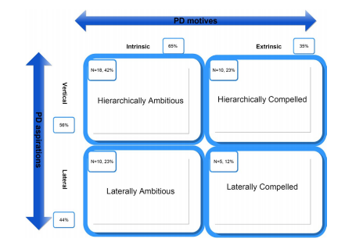

Figure 1: The types of professional development. Adapted from Avidov-Ungar, Orit (2016) A model of professional development: teachers’ perceptions of their professional development, Teachers and Teaching, 22:6, 653-669. Copyrighted 2016 by Teachers and Teaching.

The patterns shown above in Figure 1: Hierarchically Ambitious, Hierarchically Compelled, Laterally Ambitious, and Laterally Compelled can be used to further identify motivations and aspirations in regards to professional learning. The majority of teachers (42%) from the study were intrinsically motivated to pursue vertical professional development, while the minority of teachers (12%) indicated an interest in lateral development related to extrinsic motivation as shown in Figure 1. One teacher who had been teaching for thirteen years described her love for the profession and her intrinsic motivation to develop professionally (Avidov-Ungar, 2016). It is important to recognize through these patterns that different teachers learn and are motivated by different factors.
Furthermore, a significant amount of research has been done to better understand professional development and teaching. How does professional development impact teaching? Kennedy’s (2016) literature review included research from twenty-eight educational studies that show how professional development impacts teaching. She explained how successful professional development programs are based on different theories of how students learn.
Kennedy (2016) went on to explain the ways in which PD is also problematic. For example, mandated professional development creates a problem for professional development developers, which is comparable to the problem teachers oftentimes face; attendance is mandatory, but learning is not. In addition, the slow and incremental way in which teachers incorporate new ideas into their ongoing practices is a challenge. Professional learning itself cannot tell us whether teachers merely just comply with program recommendations as long as they have to, whether they continue building on the professional development sessions ideas over time, or whether the original intent of the professional learning opportunity dissolves or changes completely (Kennedy, 2016). Professional development continues to have problems in a study by Polly and Hannafin (2011). The enacted and espoused practices of two elementary school teachers were examined during a yearlong professional development project and in their analysis they found teachers’ enacted practices revealed a lack of alignment between teachers’ observed practices and those emphasized during workshops. Essentially what teachers were teaching in the classroom did not align with the professional development they were receiving.
Other professional development models of teaching included Desimone’s (2008) proposal of a basic model to use in all studies of professional development. In particular, this model could be used within social studies specific professional development. The model shown in Figure 2 represented interactive, non-recursive relationships between the critical features of professional development, teacher knowledge and beliefs, classroom practice and student outcomes.

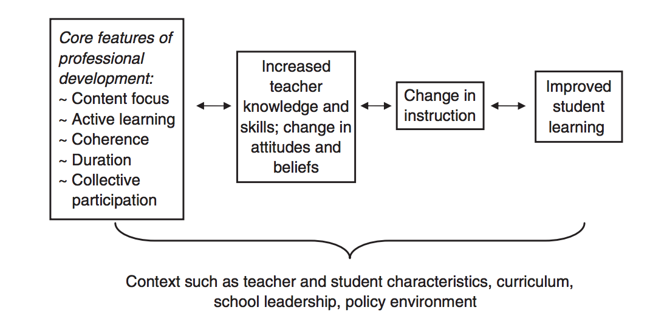Figure 2: Proposed core conceptual framework for studying the effects of professional development on teachers and students. Adapted from Desimone, L. M. (2008). Improving Impact Studies of Teachers’ Professional Development: Toward Better Conceptualizations and Measures. Educational Researcher, 38(3), 181–199. doi: 10.3102/0013189x08331140. Copyrighted 2008 by the Educational Researcher.

As shown in Figure 2, according to Desmione (2008) the core features of professional development included content-focused, active learning, coherence, duration, and collective participation. These features were used to increase teacher knowledge and skill, and changes in attitudes and beliefs which change instruction and improve student learning. As Mundry and Loucas-Horsley (1999) stated, the ultimate goal of all effective professional development for teachers was that its improved student achievement.
In order to improve student achievement, we must know our students. In Educating for Critical Consciousness, hook (2017) describes how students seem more eager to enter energetically into classroom discussions when they perceive it as pertaining directly to them. Seeing themselves in the curriculum requires teachers to take a step back and see the type of curriculum they are implementing in their classrooms.

Professional Development in Social Studies
To better understand how targeted ambient professional development impacts social studies classroom practices I turned to Thomas-Brown, Shaffer, & Werner (2016). Their analysis of how building a collaborative community of professional social studies teachers through targeted ambient professional development brought insight into the impact on social studies classroom practices. The results of their study supported the use of intensive, sustained, and content-specific professional development to improve teacher content, knowledge, pedagogy, and the development of skills and strategies when teaching social studies (Thomas-Brown, et al., 2016). They explained how measuring the impact of professional development must encompass multiple layers of data collection including professional development content focus, duration, coaching, mentoring, teacher growth in knowledge and skills, pedagogy, instructional approach, attitudes, and beliefs, and learning (Thomas-Brown, et al., 2016). In addition, their year-long study began the formation of a Collaborative Community of Professional Teachers (CCPT). It evolved as teachers examined, theorized, and reported on their perceptions of how the project impacted their social studies classroom practices. The idea of a Collaborative Community of Professional Teachers (CCPT) relates to Palmer’s (1998) Communities of Congruence. The idea is that people discover each other and join in a community for mutual support.
This is noted as teachers are from all backgrounds, races, ethnicities, and orientations. Teaching Communities of learning are diverse and that diversity is prized, not viewed as a problem. These communities include people who reflect differences in age, gender, aspirations, and abilities. Communities of learners are marked by an emphasis on cooperation and collaboration rather than competition
For me, it was important to look at multiple factors that go into professional development experiences. Each factor can have an effect on the overall effectiveness of particular experiences. Professional development in historical investigation and interpretation must deliberately and transparently reconcile the school-contextual constraints that challenge its effectiveness on practice (Meuwissen, 2017). Teachers’ openness to change as discussed by Meuwissen (2017), as a contextual factor of professional development, rested on observing particular interactions between subject matter and students. Being open to change becomes an important factor when discussing professional development and teachers are more open to change if their students are connecting to the subject matter. Moreover, teachers with idiosyncratic beliefs about teaching and learning tend to live in their immediate context, engage in instruction grounded in personal experience, value autonomy, and favor individuality (Howell & Saye, 2016). The degree to which the teachers viewed teaching and learning idiosyncratically directly impacted their willingness to engage in an emerging professional teaching knowledge culture (Howell & Saye, 2016).
There has been a significant amount of research on professional development. There are studies that describe different types of professional development (Kennedy, 2016). And professional development that integrates technology (Beriswell et al., 2016) along with new forms of professional learning such as the unconference model (Whitlock, 2016). In addition, there is professional development that looks into teacher perceptions (Avidov-Ungar, 2016), teacher needs (Hunzicker, 2011) and teacher practice (Polly & Hannafin, 2011).
All the academic research conducted thus far is beneficial in learning more about professional development and professional development in social studies education, but there are certain gaps in the research that needs to be further examined. There is an insufficient amount of research in regards to a better understanding of professional development as of recent in social studies. There have been only a few studies conducted within the last 5-7 years. In particular, there is a lack when it comes to secondary professional development. Meuwissen (2017) has been the only study to describe professional development in high school social studies teachers within the last five years. I wonder what professional development experiences are high social studies teachers having? How are they describing their professional development experiences in regards to their own characteristics, their students’ characteristics and their curriculum characteristics? The questions unanswered became important to try to better understand through my focus group interview. I believe it is important to gain a better understanding of some possible answers to my questions because ultimately, I want to learn more about professional development in social studies to aid teachers in identifying positive experiences that shape their classroom practices. In addition, I want to be able to learn all I can about professional development in regards to social studies so that when I present to social studies teachers I can include material and strategies that will be taken and implemented in their classrooms to impact students across the state.

Chapter 3. Methodology
Teachers are required to complete professional development, and school districts incorporate this within their school calendar to ensure each employee completes the minimum number of hours. How do high school social studies teachers describe professional development experiences? Basic qualitative research, as employed in this study, creates an inquiry that is used to explore a social or human problem (Creswell & Poth, 2018). In order to frame my thinking and conversations with those, I interviewed, I considered the following questions to frame our conversation: How are these professional learning experiences beneficial for teachers? How is professional development impacting classroom instruction? How is professional development impacting teacher collaboration? What experiences do teachers have with professional development outside of their school districts required training? How are teachers hearing about professional development outside of their institutions?
In order to explore present my findings, I employed a case study. Case Study research begins with the identification of a specific case that will be described and analyzed (Creswell & Poth, 2018). For this study, the case I chose was the experiences of four social studies faculty members at Lincoln Johnson High School who participated in professional development. Cases can be fact-driven when there is a correct answer or they can be context driven where multiple solutions are possible. My case is context driven where multiple solutions are possible. And noteworthy case studies typically have the following features: they tell a story, include dialogue, create empathy and are relevant (Barnes, Christensen, & Hansen, 1994). This case study was designed to help me better understand professional development as it relates to these four social studies teachers.
Context and Participants
Lincoln Johnson High School is one of three high schools located in a suburban school district in a southern state. There are approximately 2800 students, grades 9-12. Within this school district, Lincoln Johnson High School is considered the most diverse - having students from various racial and ethnic groups as well as various socio-economic situations (see Table 1).
Table 1.
Lincoln Johnson High School Demographics
Ethnic Group | Makeup (%)
White  Black  Hispanic  Two or More Races  Asian  American Indian | 50  20  10  10  8  2

Data & Statistics, by Oklahoma Department of Education (https://sde.ok.gov/documents/2019-01-25/2018-19-site-enrollment-genderethnicity)
The social studies department consists of twenty-five teachers. All teachers with social studies responsibilities were invited via email to participate in this study. They were deemed eligible for this study because they were social studies teachers at Lincoln Johnson High School. I obtained their contact information from their school’s website. Of those invited, four social studies teachers agreed to participate. There were two female and two male participants. Two of the participants were mentor teachers in that they provide guidance to their colleagues based on their own experiences and understanding of best practices. One of the teachers was a veteran teacher in that she has been teaching for more than fifteen years. She taught on level world history. Another participant in the study was one of the lead teachers in Advanced Placement for social studies at the school. He taught AP Human Geography and AP World History. In addition, one of the teachers taught on-level U.S. history and coached sports. And the last participant was a new teacher to the district and taught AP World History (See Table 2.).

Table 2.
Participant Demographics
Name | Years of Service | Courses Taught | Distinguishing Features
Carol | 22 | World History | Veteran Teacher  Mentor Teacher
Hannah  Trent | 9  6 | AP World History  AP Human Geography  AP World History | New to District  AP Teacher  Lead AP Teacher  Mentor Teacher
Justin | 4 | U.S. History | On Level Teacher  Sports Coach

This focus group interview took place at Lincoln Johnson High School during their professional learning community (PLC) time of their planning period. This PLC time takes place once a week. The interview took place in a meeting room at their school. The setting was one of comfort for the participants. This was intentional so that the participants would be more open to discussing their professional learning experiences. A focus group interview was chosen as the primary interview method. This was chosen because I wanted the interview to be more of a conversation. And because of the idea that if a participant were to mention a thought that could spark someone else into thinking about their own experiences. Also, the mentioning of professional development in a group setting could allow for the possibility of another teacher to learn about a unique professional learning experience they may want to participate in at a later date. The focus group interview was conducted for approximately thirty-five minutes. During this time, participants engaged in a meaningful conversation about their own professional development experiences at their school (site-based), school district (district-based) and off-site (outside experiences).
Data Sources and Analysis
The data for this study included the audio recordings and transcriptions of the focus group interview (See Appendix A for Interview Protocol) and field notes taken during the interview (See Appendix C for the Musings from the Focus Group Interview). As the interview was being conducted I had a scratch piece of paper in front of me to highlight information that frequently appeared. I wrote down things that popped up consistently in conversation. For example, choice and professional organizations, including the Oklahoma Council for Social Studies and the Document-Based Questions Project were discussed.
Organizing data for analysis. According to Creswell and Poth (2018), data analysis in quantitative research consists of preparing and organizing data for analysis, reducing data into themes through coding and then representing the data in figures, tables or a discussion. In order to prepare and organize this data, first I listened to the audio recording of my focus group interview from start to end. Next, I listened to my focus group interview while I annotated my field notes. I circled words on my field notes that were emphasized by individuals in the focus group interview such as, choice and buy-in. After I finished annotating I listened once more and transcribed my focus group interview. I used a computer application known as Transcriptions to transcribe my focus group interview from Lincoln Johnson High School. This program allowed me to type and listen side by side on the same screen. Following the transcription process, I listened again, but this time for edits/amendments to my transcript. At this point, I read through the transcripts with attention to potential or possible themes. According to Creswell and Poth (2018), themes are overarching ideas that help one organize the words and ideas of those interviewed. I looked through the transcript to note possible ideas. These ideas included choice and buy-in. Once I identified these two overarching concepts, I re-read the transcriptions and identified further examples.
Reflexivity
Researchers “position themselves” in their study. The researcher’s background, how it informs their interpretation of the information in a study and what there is to gain from the study is known as reflexivity (Creswell & Poth, 2018). In this study on professional development in social studies, it is important to discuss my reflexivity. I am a classroom teacher in Oklahoma. I teach social studies and I engage in professional development. The information in the study will quite possibly help inform classroom practice for me. In the focus group interview, hypothetically if I were to hear of a positive learning experience I might be inclined to further research the event and possibly attend. On the other hand, if I hear of a negative experience this might lead me astray from a potential professional learning experience. Discussion in the focus group interview may inform my classroom practice if strategies I feel are valuable are discussed. I could begin critically thinking about the conversation and later implement some of what was discussed in my own classroom.
Positionality
A researcher’s positionality can be discussed by identifying the ways in which they are related to the context and setting of the research. Social position, personal experiences, and political and professional beliefs are considered (Creswell & Poth, 2018). In this study on professional development in social studies, it is important to discuss my positionality.
I have been teaching social studies in Oklahoma for four years. During this time, I have met a plethora of individuals in the field which are included in my personal and professional experiences. In relation to this study, it is important to mention one of the participants, Trent, and I have spent extensive amounts of time together; I was his student observer and student-teacher. His philosophy on teaching education has influenced my overall outlook on teaching social studies. I look up to him as an example of what it means to be a mentor teacher. For example, he and I communicate on a weekly basis and his strong convictions about social studies education has influenced my beliefs. We serve on a history related teacher organization, the Oklahoma Council for History Education, were my views are influenced by his actions because I think highly of his outlook on education.
In addition, my political and professional beliefs are related to the setting and context of my research. First, I teach in the school district where I conducted the study; I am an employee of Lincoln Public Schools. And because of this I interact with the same curriculum coordinator for social studies and I participate in similar district-based professional development. Also, it is noteworthy that in regards to my political beliefs, I believe professional development is critical to the success of the classroom teacher. I wholeheartedly support the implementation of effective professional learning experiences in school, in the district and outside too. This is part of my professional beliefs on social studies education.

Chapter 4. Findings
In this chapter, I use data from my focus group interview to establish an understanding of how high school social studies teachers navigate through professional development while focusing on implications for their classroom practices. How do high school social studies teachers describe professional development experiences? While analyzing the conversation between the four participants, two thoughtful notions were evident. These were notions of choice and buy-in. Throughout the conversation on professional development, the participants contextualized their comments often to classroom practice. Participants discussed their students and their needs, indicating a need for approaches to reach minority students. In addition, participants discussed the curriculum. They discussed the curriculum being employed in their own classrooms and as well as what was being implemented in professional development. All four teachers came from different walks of life as introduced in the previous chapter. However, all were able to hone in on evidentiary experiences that helped influence their perceptions of professional learning.
To better understand teachers’ thoughts on professional learning, I employed my theoretical framework. Hochberg and Desimone (2010) describe the contextual factors of effective professional development for the accountability context. Their work on the accountability context of professional development through contextual factors including teacher characteristics, student characteristics, and curriculum characteristics will be used as a way to frame and explain the findings from the focus group interview. These contextual factors suggest that these components of local school or district contexts can moderate the relationships among professional development activities, teacher and instructional changes, and student achievement.
The first contextual factor described is teacher characteristics. This includes prior experiences, content knowledge, and epistemological beliefs. The second contextual factor describes is student characteristics. This includes elevating the achievement of all students, especially students from historically low-achieving subgroups. The third contextual factor describes the curriculum. This includes content and standards teachers use in their classrooms. Each factor will include choice and buy-in.
With my focus group participants, I discussed professional development experiences on-site, in the district, and outside experiences, which focused on professional development that influences classroom practice. In this case study, I define on-site as within the confines of Lincoln Johnson High School. District-wide professional development is defined as colleagues from schools within the school district, in this case, Lincoln Public Schools, attending professional development together. At these district trainings, teachers from different buildings attend a variety of sessions together. Outside experiences are for professional development that happens outside the confines of the school and school district. In this case, the professional development training would have to have been held outside of Lincoln Johnson High School and Lincoln Public Schools. The professional learning experience would be completely isolated from the school and school district. To interview begin with:
Me: “First, with a show of hands, how many people in this room have been to professional development?

Participants: All four teachers raise their hands.

Me: Has that been school-based, district-based, or has that been outside professional development? And that question will be left up to anyone who wants to answer.”

These experiences were reflected upon with the overarching question looming above, “How do high school social studies teachers describe professional development experiences?” The accounts of these experiences are discussed below in three categories: teacher characteristics, student characteristics, and curriculum characteristics.
Teacher Characteristics
My interview involved teacher participants, as a result, I will begin unpacking my findings with a description of teacher characteristics (Hochberg & Desimone ,2010). This includes prior experiences, content knowledge, and epistemological beliefs. This can influence how teachers approach reform-oriented practice. It required professional development activities to address teacher characteristics and if the PD was productive, reform-aligned change in instructional practice occurred (Hochberg & Desimone, 2010). In the interview teacher’s characteristics were front and center. Carol described a characteristic of hers for teacher-buy in for professional development. Carol shared her prior experience as:
sometimes we are told to be professional in the classroom and then when we go to a PD meeting the people who are running it… are not. And so that is really irritating that if they were coming to our classrooms and the same things happened they would be going “you’re on a plan of improvement because you are crap today.”

Carol has been teaching in the district the longest of all my participants. She has been there to see changes. She says, “some changes have been good, others have not.” Her veteran status as a teacher in the district help to describe her teacher characteristics. She, along with Justin, Trent and Hannah had strong feelings when it came to their own expectations for professional development and what Lincoln Johnson Public School has done to inhibit some of their individuals wants as teachers.
My focus group participants described their sense of autonomy as part of their teacher characteristics when describing their professional development experiences. Teacher characteristics encompass epistemological beliefs such as teacher autonomy, agency, and input (Hochberg & Desimone, 2010). When asked about what he wanted in professional development, Justin confirmed several times that he wanted choice. Choice is part of his autonomy, “choice... the kids want the same thing. They don’t like you giving them a blueprint of this is exactly how it has to be. They want to use their creativity.” After Justin spoke about choice, Hannah and Trent chimed with part of their epistemological beliefs in regards to professional learning. When talking about professional learning, Trent suggested:
maybe it’s even where I know that we have PD committees that choose PD, but it’s almost that we need to like submit a form that if you in your dream world what would be a session that you would need.

This idea clicked in Hannah’s head and being as this is her first year at Lincoln Johnson High School she made a connection back to her previous school. She said:
we had to submit our goals if you wanted to teach a PD course. And you had to submit your objectives. You had to have a lesson plan for your professional development. We had professional development that had 20 different options for every hour and then we chose what we wanted to go to. What I liked about that was if you are struggling.. and ours had to be based on our professional focus.. in classroom management then these were the PDs you’d go to for classroom management. If your professional focus was this or that then there were PDs for that. So our PDs were very intentional.

Intentional professional development speaks to Hannah’s epistemological beliefs of what PD should be. She believes this is part of her agency as a teacher, to attend PDs that are intentional. Justin joined in by making note that all teachers have a skill that could be used to help others. He said he is not good content, but he is good at relationships and some teachers maybe need something like that. He said he does it on a daily basis.
A sense of agency connects back to Hunzicker (2011) where considerations include teachers’ personal and professional needs, individual learning preferences, and input regarding how and what they will learn. For example, Hannah mentions professional developments she attends outside of school have been more beneficial because she has a higher interest in them. She said she signed up to go to it and they want her there so they are willing to wine and dine you into being there. In addition, this connects with the theme of teacher buy-in.
While Hannah prefers professional development outside of school, Justin does not care where he goes as long as the presenter creates buy-in for the PD. This type of teacher experience was referring to his epistemological beliefs. Justin said he likes going to PDs where:
its like a manager or someone that is in the business world. I think a big buzz word right now is facilitator, but then all we ever do is get teachers who don’t know how to facilitate. I like reading books of like successful businessmen, CEOs, stuff like that because they are big on buy-in and getting group think. I think sometimes when you get a group of teachers together and I’m super guilty of this it becomes a whine-fest so I like bringing in outside people who have something to contribute… if we are moving towards bring in somebody then I would like them to show here is how I got buy-in from my employees. Like here is what that looks like.

This connects to a part of Deismone’s (2008) understanding of professional development. She believes teachers should have a decisive voice at every stage of planning, implementation, and evaluation. Another example of this within the focus group interview was when Trent discussed his experience at Education Camp. This type of experience was an epistemological belief and prior experiences with professional learning. Trent described the professional experience as:
I know Ed. Camp is big for PD, but I hate Ed. Camp because I hate where it’s just like umm we are going to wing PD… if someone feels like they are going to teach a class today then they are going to teach a class today. And it’s not planned. It’s like that is more a forum which could be helpful where you share stories, but that’s not professional development. There is no lesson in it.

Trent describes his experience with the unconference model (Whitlock, 2016) as a negative experience. He prefers certain types of professional development opportunities that can lead to growth in teachers by means of dynamic conferences that integrate subject-based content and successful pedagogies (Beriswell et al., 2016).
Another aspect of teacher experience is with epistemological beliefs that speak to the importance one has with teacher collaboration and connection. Connection is the mindset of connecting with others. This bodes true for Hannah when she was discussing outside district experiences. Hannah explained: “You are meeting people you don’t know and networking with people from other districts across the state. I have met some really good teachers that way. I have built good connections with that I don’t have in-district.” And Hannah went on to explain these connections have impacted her classroom. She said people can reach out to her found community when she is struggling with something. She says it’s been helpful.
This connects Hannah’s thoughts with Palmer’s (1998) communities of congruence, an idea that people discover each other and join in a community for mutual support. In addition, her thoughts connected with this connected with Thomas-Brown, Shaffer and Werner’s (2016) study that describes the formation of a collaborative community of professional teachers (CCPT). Teacher participants in my study relied on prior experience, content knowledge, and epistemological beliefs when discussing teacher characteristics.
Student Characteristics
While the role of teacher characteristics was important in learning more about teachers’ belief systems, the role of student characteristics became evident as we navigated through our conversation on professional development in social studies. Student characteristics describe elevating the achievement of all students, especially students from historically low-achieving subgroups (Hochberg & Desimone 2010). In this case, the subgroup most often discussed was African American students. Therefore, professional development that will enable teachers to facilitate improved achievement among their own students will address the learning needs of the particular students served by teachers in a school or district. In essence, the ability of professional development to be effective depends on students’ receptiveness to teachers’ instructional practices. (Hochberg & Desimone 2010).
Diversity. When describing her school, Lincoln Johnson High School, Carol discussed the impact of her school’s diversity because her school is 50% White students and 50% of minority students (Table 1). Data in the table was provided by the Oklahoma Department of Education (2019). She said her school’s diversity is what makes them. And she really appreciates that aspect of Lincoln Johnson High School. The high school is the most diverse of the three high schools in the Lincoln Public Schools.
In regards to the importance of diversity, Justin spoke and as he did the whole room nodded in agreement, “I think teachers have the same questions that kids do when they walk into the classroom. “Why does it matter? How are you going to get me to buy into this PD.” Often times it is important to remember that students may be having these same thoughts in the classroom.
All students seem more eager to enter energetically into classroom discussions when they perceive it as pertaining directly to them. Students may be well-versed in a particular subject and yet be more inclined to speak confidently if that subject directly relates to their experience (hooks, 2017, p. 87).
This speaks to the student’s characteristics as part of the contextual factors. Teachers must be able to incorporate and respond to students’ cultural knowledge (Howell & Saye, 2016) and academic and social strengths in order to foster new knowledge (Hochberg & Desimone, 2010).
When trying to learn the needs and cultural knowledge of the diverse students at Lincoln Johnson High School, the administration brought in a guest speaker to create a dialogue. Carol described the experience as of great impact, Justin agreed. This experience spoke to the student characteristics aspect of professional learning because it was seen as a way to elevate the achievement of all students, especially the African-American students at Lincoln Johnson High School. Carol said that Lincoln Johnson High School has:
had PDs that have helped us. We started talking about something walk.. sorry.. umm you were like in the gym and they would say if you ever had a book read to you step forward. Hannah said: “privilege walk?” And that made the connection for Carol. It was really insightful because you don’t realize that maybe a parent reading a book or maybe having a library card may be things the kids in your class don’t have. So that was very impactful.

The idea of privilege became impactful for Carol because it spoke to her sense of place in a 50 percent White and 50 percent minority school. She was a White female trying to reach the needs of all of her students. Carol felt it was important to recognize her own privilege.
The article White Privilege describes the daily effects of white privilege. One such privilege has stuck with me and I think of it quite often… the notion of the band-aid. I can walk into a store and buy a band-aid “flesh color” and it will match the color of my skin (McIntosh, 1989, p. 12).
Student Needs. As Hochberg & Desimone (2010) discuss, as part of the second identifier, teachers will address the learning needs of the particular students as part of the student characteristics aspect by teachers in a school or district. As part of the conversation about professional development, Trent discussed the impact of professional development in terms of student needs. He focused on a previous school district where he taught and then connected it to where he teaches now Lincoln Johnson High School. Trent mentioned how:
one year when I taught in another suburb of a small metropolitan city in the South, they were really big one year on a particular topic. They were like we are going to teach about differentiation so everything was about differentiation. They had all the different curriculum people come by and they would teach these different things and like we are going to do more technology so all the PD was about technology.

He then goes on to mention teaching in Lincoln Public Schools:
you know here at Lincoln Johnson High School we are more into STEM (Science, Technology, Engineering and Math) and I have yet to find anything where STEM has been beneficial. I know our last PD we worked with robots. Like yeah that’s good for math and technology, but not for like social studies or English.

Trent describes both experiences in relation to elevating the achievement of all students. In the first example where he spoke on differentiation, he was explaining the need to reach his students with an emphasis on differentiation. Similarly, in his second example, he mentions STEM as a need to reach his students, however in this example, did not fit in with his teacher wants and needs for himself although he does acknowledge STEM helps to reach all students, including minority students in other disciplines. Both of these experiences for Trent connect back to Mundry and Loucas-Horsley (1999) where they stated, the ultimate goal of all effective professional development for teachers is that it improves student achievement. In both of these cases, student achievement is being addressed by engaging in professional development such as differentiation and STEM.
Furthermore, Trent mentions for the next professional learning experience at his school he wants “the pre-AP English teachers and AP history teachers to meet up and that way they can share how do you teach writing in English versus how do I teach writing in history and how do those mesh.” This choice option would allow teachers from different disciplines to engage in meaningful conversations. Teachers can build trust to promote the diffusion of initiatives across the school organization (Hochberg & Desimone, 2010). Trent’s curricular expectations for teachers. He believes reaching out to teachers from other disciplines will help his and their curriculum needs.
While the examples I’ve shared focus on academic experiences, student characteristics are inclusive of the health and well-being of students. Hannah and her colleagues shared experiences around a safety PD. She described one of the best PDs she has ever attended that of a safety PD. She said they brought in blanks and shot up the school. She described it as intense, but good PD. Trent agreed with Hannah that it was good PD, but only because it was intentional though. This had me think about an experience I had this semester with professional development and safety. I think all but three of my colleagues were on their cell phone texting or surfing the web rather than engage in the safety PD. I believe this is because our safety PD was not intentional. It was something put together last minute to check a box on the PD chart.
Curriculum Characteristics
My findings from my focus group interview thus far have included notions of teacher characteristics and student characteristics, while these are important the third characteristic, the curriculum helps to further describe my participants’ experiences in PD. It is essential for PD experiences to align with the curricular expectations for teachers and these must address in their work with students. Professional development initiatives involving the use of next or existing curriculum need to focus on specific curriculum, embedded practices to enable change in practice to occur (Hochberg & Desimone, 2010).
Curricular Choice. In this case study, the curricular choices the school district chose to have their social studies teachers engage with were not always seen as applicable for all the participants. Justin spoke at lengths about his displeasure with the professional development he is required to attend at Lincoln Johnson High School and with the way in which PD is chosen by the school administration. He described several of his PD experiences to be unfulfilling. He said, “maybe that’s just me, but I don’t feel like there is a lot I go to and I’m just like, oh yeah I could use this tomorrow… I go a great idea, wouldn’t work.” His displeasure with on-site professional development remained consistent throughout the interview. As an example of a curricular desire for expectations of professional learning, one experience Justin described was the Document-Based Question Project. A Document Based Question is a student’s constructed response to a series of short answer questions in reference to sources.
He said the material is 25 pages long. And he said he gets one day in class to cover that particular topic. Again, he says, “great idea, wouldn’t work.” This was profound in that this professional learning experience was social studies content specific, but it did not fall into what he saw as beneficial curricular expectations for himself as a social studies teacher.
And this idea discussed by Justin relates to Polly and Hannafin (2011) where the espoused practices did not meet enacting the content in the classroom. He attended a professional experience, the Document-Based Question Project workshop, where he was given social studies content-related material, but he failed to implement this in his classroom. He saw that the length of the documents did not align with his curricular expectations.
Choice is another way of understanding the participants ideas on curriculum characteristics. An example of this indicator came from the focus group interview when Justin discussed an experience he has with on-site professional development. Justin related his belief in professional development activities and the local curriculum in accordance with his ability to accept reform approaches as something feasible and worthwhile. He describes one curricular experience as:
if we are going to be stuck here I mean all of us could come up with a class we could teach and choose there are 30 options or 20 or 10.. but they just keep giving us the same options every year.. how to co-teach, how to work your email.. like crap like that.. I could have learned it by watching a two minute You-Tube clip.

Justin’s want for choice comes from the lack of specific curriculum characteristics for professional learning. He is saying if teachers are given choices as to what professional development sessions it would be more beneficial than just sitting in a room going over things that do not impact his practice and could be watched on a two-minute YouTube clip.
When asked about school-based professional learning, Justin stated, “I would say the school ones we have here are not beneficial.” While the man sitting next to him, Trent, would go on to say it is like “we are meeting a quota.” The curricular expectations for Justin and Trent are not being met by the current professional development onsite at Lincoln Johnson High School. As an example, Justin discusses the local curriculum expectations of professional development at his school. Justin said, “The only professional development in school I have benefited from is the Canvas training solely because they wanted us to start using it.” The local curriculum itself as part of the accountability context requires custom-tailoring of professional development to ensure consistency between the content of professional development and the standards teachers must address in their teaching (Hochberg & Desimone, 2010).
Content Specific. As part of the curriculum characteristics described by Hochberg and Desimone (2010), the characteristics of the professional development experience need to focus attention on specific curriculum, embedded practices to enable the desired reform-oriented practices to take root in the appropriate ways. As described in the teacher characteristics, Hannah’s discussion of PD that is intentional follows the ideas of a specific curriculum that enables reform practice to take place. She describes the experience as:
we had to submit our goals if you wanted to teach a PD course. And you had to submit your objectives. You had to have a lesson plan for your professional development. We had professional development that had 20 different options for every hour and then we chose what we wanted to go to. What I liked about that was if you are struggling.. and ours had to be based on our professional focus.. in classroom management then these were the PDs you’d go to for classroom management. If your professional focus was this or that then there were PDs for that. So our PDs were very intentional.

She speaks to the notion of being intentional as a curriculum characteristic because it enables reform practice to take place. The ability for you to choose your PD lets it be intentional which can enable reform as part of the curriculum.
Curriculum characteristics of social studies professional development include relevant content as shared by the participants in my study. I have always been geared towards content-specific professional development because I want to be able to take an activity directly from the workshop and put it in my classroom to impact kids.
Trent describes his favorite type of PD to be social studies oriented as well. As an example of this Trent explains:
I think kinda echoing earlier you know any type of professional development that’s history or social studies oriented like when you go to an AP conference or whatever this is.. something similar. That’s the most helpful to me because its more my thing.

For Trent, professional development experiences that are content-specific practices enable him to implement them in his social studies classroom. Essentially, if its social studies content, he will be more likely to implement what he is learning at the professional learning experience in his classes. This is related to the Thomas-Brown, et. al., (2016) study because it too supports the use of intensive, sustained, and content-specific professional development to improve teacher content, knowledge, pedagogy, and the development of skills and strategies when teaching social studies (Thomas-Brown, Shaffer, & Werner 2016).
Content is powerful when it is presented by professionals to professionals as illustrated in our conversation (Meuwissen, 2017). When asked what makes social studies specific professional learning powerful, Trent referred to buy-in. He discussed the power of a strong presentation to support professional learning. This relates to the alignment with curricular expectations for teachers. For example, Trent discussed Advanced Placement as part of my focus group interview. He was asked, “What makes Advanced Placement workshops beneficial?” And Trent then went on to explain:
Umm, I think its where those teachers are actually.. they are teachers, not professors. They are actually doing the work. Umm and then the really good ones are the ones that are actually writing the tests. They are actually behind the scenes. I mean AP Human Geography I spent time with the guy that wrote the AMSCO book. So it’s just kinda hard to explain. I mean with him like it was kinda a foundations of a course. It wasn’t just the practicalities of it. It was teaching with a true purpose and like building a foundation which was almost like a masters class. Umm and then just being with them. I was talking with teachers like, how do you do tests? How do you do quizzes? What textbook do you use? The practicalities that you don’t get with other things and then obviously the resources you get. I mean I have way more resources you get than I would ever even use in a million years. But its just being able to pick through what fits my personality and the group that I’ve got. It’s huge.

In a study by Desimone (2008), it was found that one of the core features of professional development includes it being content focus. This enables the teacher to hone in on the specific curriculum practices as part of the professional development so that they can be used for classroom practice.
Presenter Expectations. Curricular expectations can have a greater chance of being met as discussed by Trent if there is a quality presenter giving the presentation. This leads me to the discussion about presentations in professional learning. Trent describes an example of a quality presentation that aligned with his curricular expectations for his classroom by going on to describe the effectiveness of the presenter. Trent enjoyed the quality of the presenter at his AP Human Geography conference. He described the impact of his presenter while reflecting on his own understanding of how to be an effective presenter. Trent said:
There is one line that always stays with me. That whenever you go and present at a PD that you.. and you’ll know who told me this… that a lot of times when teachers go and present to adults they present it like they would kids, but presenting to adults is way more difficult and you should… like when you’re ready for your best class you need to take it up even another notch. And I think teachers do a bad job of doing it. And I think thats where we get the buy-in from the presentation doesn’t click in because its on the back burner because we are all busy but its like thats where the quality doesn’t come in.

The idea presented by Trent of the presenter being professional speaks to the notion of PD through curriculum characteristics. In order for specific curriculum, embedded practices to enable change in practice to occur one must create a quality presentation.
Following Trent’s remarks, Hannah spoke to this notion of the need for quality presenters. She too aligned a quality presenter with curricular expectations she had for herself because of the desire for the practices to take root in the appropriate ways in her classroom. Hannah described her understanding of teaching effectively in a PD setting as:
I was always told to teach a PD in a way that you would have to engage your most difficult students because your teachers are typically the most difficult students. So if you can engage your most difficult students then thats the way you should teach your PD because thats the only way you’re going to engage teachers.

This statement opened up an opportunity for Carol to share a meaningful professional learning experience she had from previous years. She seemed agitated that a professional development workshop she loved was gone. This too aligns with Carol’s curricular expectations for herself. While discussing a professional learning experience she loved she makes a cry for effective professional development that addresses her curricular expectations. Carol explained how:
they used to have every I think January or February at OU at the Post Office thing and I think it was for Pre-Advanced Placement teachers but any history teacher could go and for two days you would go to these different classes and that was the best re-charge every year. I loved it. Because by January or February you’re like “Am I even talking anymore?” and you would go there and you would see these awesome things and that would have your brain percolate and come up with new things for your own classroom. Yeah it was wonderful. It was a Friday and a Saturday. You could miss Friday and go on Saturday too. But it was like in the dead of Winter, but it was so good. And I really always looked forward to that because it was just awesome. The people that they brought in to train and umm.. it was incredible and I wish they did that again.

The social studies experience as described by Carol exemplifies a positive experience she had with professional learning. It was one that was social studies oriented it used content-specific professional development to improve teacher content, knowledge, pedagogy, and the development of skills and strategies when teaching social studies (Thomas-Brown, et al., 2016). The Pre-Advanced Placement Workshop and the AP Summer Institute were both workshops geared towards curriculum characteristics for social studies teachers.
Trent finished up the conversation about social studies specific professional development experiences by mentioning his perspective on professional development as an early career social studies teacher. This aligns with his curricular expectations for himself because it further explains what he finds most helpful to impact his social studies curricular practices. Trent explains:
I think going to OCSS is probably the most helpful because it was like the first time once again.. okay I am teaching this content or I am teaching geography whatever, I am more of a history person by nature so its kinda getting ideas of what should a geography class be like and also being with teachers who are in the same situation as me was probably the most helpful.

Trent’s notion of being with teachers in the same situation and them being helpful leads me to connect this type of professional learning with Palmer (1998). In particular, the idea that there are these built communities of congruence to help understand the experiences of teachers who support one another. At the Oklahoma Council for Social Studies Conference he described the large number of social studies teachers looking to learn more about their content and how this helped create a community for him.
To finish, Hochberg & Desimone (2010) emphasize the curriculum used by a school or district may require custom-tailoring of professional development to ensure consistency between the content of professional development and the standards teachers must address in their teaching. “The professional development here is very different from where I taught before. The district where I was before professional development was very intentional,” says Hannah. “It used to be here too,” says Carol as she rolled her eyes.
School officials serve as social studies curriculum gatekeepers (Thornton, 1989). The administrative leadership within a school describes its contextual facilitator role within the accountability context of professional development (Hochberg & Desimone, 2010). This includes the entire leadership team and the professional development committee.
Professional Development Committee. In the focus group interview, Justin spoke at length about the professional development committee at Lincoln Johnson High School. This committee is supposed to be used to ensure curricular needs are being met for social studies teachers. While discussing his role as a member of the professional development committee he hones in on the inability for him to be able to get effective professional learning experiences added to the schedule. He said:
we have a PD committee that we have for PDs and I’m on it. Its basically like here is our agenda and oh we have some changes…. oh we aren’t going to make changes. So I am on it but I don’t ever go because I am not going to waste my time. They have a committee that we are supposed to talk about this is whats supposed to happen at the PD, but its more like here is the agenda tell me that its good rather than criticism and Trent is like you need to go and I am like its a complete waste of my time and there is backlash if you say something. There is drama in the front office if you bring up anything that goes against their blueprint and there is backlash for it. And I can’t keep my mouth shut. I already have enough backlash as it is.. so yeah I go with what Carol said. The problems trickle down with the top and there is not a whole lot constructive at the top.

Following Justin’s negative comments about the ability to get effective professional development added to onsite PD, Carol described her understanding of the administration at her school’s approach to professional development. This is related to curriculum characteristics because the need to focus on specific curriculum, embedded practices to enable change in practice to occur needs administration leadership to allow these experiences to occur. She does not feel like her desire for social studies PD that aligns with her expectations is heard or valued. Carol describes the selection of onsite professional learning as:
You know so I feel like we do not get the respect we deserve from them when we have PD meetings. I feel like its like oh crap on Monday after Fall Break we have a PD meeting what are we going to do?? You talk about this and I will talk about that and you talk a long time and you have three hours. It used to be different here, but lately it has not been good.
Curriculum characteristics include what is being included in the school curriculum for professional development and what is being left out of the school’s curriculum for professional learning.
Summary of Findings
After analyzing this data, I was able to consider the focus group conversation in accordance with Hochberg & Desimone’s (2010) framework used to describe the contextual factors of effective professional development as part of the accountability context. The focus group findings were classified under these three contextual factors: teacher characteristics, student characteristics, and curriculum characteristics.
The teacher context component included teachers’ prior experiences, content knowledge, and epistemological beliefs. An example of teacher characteristics from the focus group was Carol sharing her prior experience with professional learning as it compared to what today’s PD looked like at Lincoln Johnson High School. This leads to the next contextual factor used to classify social studies teacher’s experiences with professional learning, student characteristics. Student characteristics include elevating the achievement of all students, especially students from historically low-achieving subgroups. For this study, Lincoln Johnson High School’s most recognized minority subgroup was African Americans. An example Carol gave for elevating the achievement for all students was when she mentioned the privilege walk professional learning experience she took part in at Lincoln Johnson High School. She even went as far as saying, “our diversity is what makes us.” The last contextual factor describes the curriculum. This includes content and standards teachers use in their classrooms. Curriculum, in particular, social studies content, was described by Trent throughout. He references back to the impact the AP social studies curriculum has impacted his classroom. Throughout each of the three contextual factors, choice and buy-in was profound.

Chapter 5. Discussion
To begin, my case study of Lincoln Johnson High School, included a plethora of responses to professional learning experiences. Each participant brought their own sense of self when discussing teacher characteristics, understanding of student characteristics and ideas on curricular characteristics as part of Hochberg and Desimone’s (2010) framework for PD in accountability contexts. For Carol, the factor of student characteristics was most profound as she discussed the need to elevate the achievement of all students, especially students from historically low-achieving subgroups (Hochberg & Desimone 2010). She said her school’s diversity is what makes them. The subgroup most profound at Lincoln Johnson High School was the African-American demographics (see Table 1) as provided by Public School Review (2016).
For Hannah, the most recurring of all three contextual factors component of the accountability context for effective professional development was curriculum characteristics. An example was when Hannah discussed the emphasis on PD that was intentional. She said, “what I liked about that was if you are struggling.. and ours had to be based on our professional focus.. in classroom management then these were the PDs you’d go to for classroom management. If your professional focus was this or that then there were PDs for that. So our PDs were very intentional.” This spoke volumes to the need for a specific type of curriculum that would enable reform practices to take place. Because of the need of content specific curriculum, the type of PD Hannah describes could take place and be intentional. As for Trent, he too had a curriculum characteristic focused mindset. For example, he continuously harped on the fact that PD experiences must align with the curricular expectations for teachers as he described his experiences at Advanced Placement professional development summer institutes. And Trent then went on to explain:
Umm, I think its where those teachers are actually.. they are teachers, not professors. They are actually doing the work. Umm and then the really good ones are the ones that are actually writing the tests. They are actually behind the scenes. I mean AP Human Geography I spent time with the guy that wrote the AMSCO book.

Lastly, Justin’s experiences relied heavily upon the teacher characteristics element of the accountability context. For example, Justin would reference his epistemological beliefs about professional development. One such explanation Justin gave when discussing his thoughts on PD is that it is his belief that PD should include professionals from outside education who are able to teach buy-in to him and his colleagues. Each component of the accountability context for professional learning was met by a participant in my focus group conversation.
This research helps to contribute to the conversation being had about the impact of professional development on teacher practice. The want for effective professional learning approaches was evident throughout the conversation. Carol, Hannah, Trent, and Justin all spoke to notions of effective professional development. Effective professional development relates to structured professional learning that results in changes to teacher knowledge and practices, and improvements in student learning outcomes. (Darling-Hammond, et al., 2017, pg. 2). Justin brought up the idea of having teachers at his school teach these PD sessions for his colleagues to attend. Justin said, “All of us have a skill that maybe we could help. I’m not good content but I am good at relationships. Some teachers maybe need something like that. This is what I do on a daily basis.” Through the idea of choice, he was empowering himself. Could this possibly have the same effect on other teachers?
This study speaks to social studies teachers are not satisfied with the professional development they are receiving. They want professional development that speaks to their characteristics as a teacher. Professional development that addresses their prior experiences, content knowledge, and epistemological beliefs (Hochberg & Desimone 2010). The degree to which the teachers viewed teaching and learning idiosyncratically directly impacted their willingness to engage in an emerging professional teaching knowledge culture (Howell & Saye, 2016).
Avidov-Ungar (2016) found that the majority of teachers were intrinsically motivated to pursue vertical professional development. This seems to hold true for the participants in this study. Time after time the participants relied on their epistemological views which are intrinsic to influence the type of PD they wanted to attend. While most of these cases support Avidov-Ungar’s (2016) findings, this can become problematic because relying too much on your own views or your naturalistic approaches can have you be blind to approaches that may be different than what you’re used to. For example, the unconference approach as discussed by Whitlock (2016) which is geared towards more learner-centered than most traditional school in-service professional development, may be seen as something against one's epistemological view.
Additionally, the participants, specifically Hannah, Trent, and Justin explained how professional development can be problematic as discussed by Kennedy (2016). Mandated professional development creates a problem for professional development developers, which is comparable to the problem teachers oftentimes face; attendance is mandatory, but learning is not. A lot of the professional learning done on-site has not been found to be valuable by most of the participants in the study. Carol relayed her frustrations she felt at the people who were conducting the PD. Carol said, “you’re on a plan of improvement because you are crap today.” She really did feel that if she was conducting the PD in her own classroom and her students were the participants she would be put on a plan of improvement because of the in-effectiveness of the experience. They see the professional development to be against the curricular characteristics they find to be of value. As part of the curriculum characteristics described by Hochberg and Desimone (2010), the characteristics of the professional development experience need to focus attention on specific curriculum, embedded practices to enable the desired reform-oriented practices to take root in the appropriate ways. Carol, Hannah, and Trent have found these types of content-specific curriculum that enables reform-oriented practice to take shape in outside district experiences such as the pre-AP and AP conferences.
The impression of professional development on a social studies teacher’s ability to collaborate as a group was evident throughout my conversation with the participants and it becomes explained through Palmer’s (1998) communities of congruence, an idea that people discover each other and join in a community for mutual support. And too with Thomas-Brown, Shaffer and Werner’s (2016) study that describes the formation of a collaborative community of professional teachers (CCPT). Teacher participants in my study relied on prior experience, content knowledge, and epistemological beliefs when discussing teacher characteristics, they deemed to be important such as their belief in the power of community. The idea of teachers from the same school discovering each other and joining in on a community for mutual support would be of great impact not just for teachers, but for students too. And administration at the school and district levels.
High-quality PD creates space for teachers to share ideas and collaborate in their learning, often in job-embedded contexts. By working collaboratively, teachers can create communities that positively change the culture and instruction of their entire grade level, department, school and/or district (Hunzinke,r 2011). High-quality professional learning was found to be of real importance for all the participants. They wanted a say in the professional learning they were getting. A sense of autonomy, agency, and/or input connects back to Hunzicker (2011) where considerations include teachers’ personal and professional needs, individual learning preferences, and input regarding how and what they will learn. This is important because individual preferences lead to investment in professional learning. School districts could take note of the ideas that they should allow teachers to be involved in the process of choosing PD. Justin confirmed several times that he wanted choice. Choice is autonomy, “choice... the kids want the same thing. They don’t like you giving them a blueprint of this is exactly how it has to be. They want to use their creativity.” After Justin spoke about choice, Hannah and Trent chimed with part of their epistemological beliefs in regards to professional learning. When talking about professional learning, Trent suggested:
maybe it’s even where I know that we have PD committees that choose PD, but it’s almost that we need to like submit a form that if you in your dream world what would be a session that you would need.

The ability to have choice within the curriculum context becomes powerful in of itself.
Limitations
While this study was limited because it was a case study for one school in one community, it still is meaningful. The information was self-reported and there were only four participants in the study, but the conversations in the focus group were thoughtful and could lead to a greater understanding of the impact of professional development in social studies.
Conclusion
I have been a classroom teacher for nearly four years. I have created some pretty engaging and thoughtful lessons that have impacted my students. While at the same time I have taught some lessons that were less impactful because I was either tired from the night before or because I did not put the time and effort into the lesson needed to make it effective. For the times I presented at professional development conferences I felt as though I did a good job for about 90% of them. There was one experience, in particular, that was defining for me as a classroom teacher. A few years ago, I presented Google Field Trips at the Oklahoma Council for Social Studies annual conference. I had about thirty people attend my session. For this experience, I spent a significant amount of time thinking it through and how I could present the material in a way that would impact teachers and then in hopes have them teach it in their classrooms to impact students.
The idea of teachers leading on-site professional learning could be impactful for more than just Justin’s school. This idea makes me think of the school where I teach. We have some incredibly gifted teachers. If given the chance, I would love to attend professional development sessions from teachers in my school because of the knowledge they bring to the table. I would hope that I could take ideas from them and implement them directly into my classroom. Having the ability to elevate your game when presenting in PD is challenging, but important if you want it to be an effective experience for your participants. The notion of effective professional development in terms of the presenter was explored in this study but needs to be further explored. In addition, I was not expecting to provide choice to have such a profound impact of teacher empowerment as was discussed by several of my participants.
Future research should focus on how to better understand social studies teachers’ professional development wants and needs as part of their past experiences in other school districts where they taught if applicable. In regards to professional development, Teachers from my study are frustrated with the current professional development system at a site-based level and district level. Is this the same across other districts? Frustration can have negative effects on teachers and their ability to reach students. More research needs to be done in regards to choice of teacher empowerment. If the choice is empowering teachers would schools be more likely to implement more choices for teachers in regards to professional development?

References

Apple, M. W., Beane, J. A., Apple, M. W., Beane, J. A., Brodhagen, B. L., Meier, D., … Steinberg, A. (1995). Democratic schools. Alexandria Va: Association for Supervision and Curriculum Development (US) (ASCD).

Avidov-Ungar, Orit (2016) A model of professional development: teachers’ perceptions of their professional development, Teachers and Teaching, 22:6, 653-669.

Barnes, L. B., Christensen, C. R., & Hansen, A. (1994). Teaching and the case method (3rd ed., Vol. 1 & 2). Boston, MA: Harvard Business School Press.

Beriswill, J. E., Bracey, P. S., Sherman-Morris, K., Huang, K., & Lee, S. J. (2016). Professional development for promoting 21st century skills and common core state standards in foreign language and social studies classrooms. TechTrends, 60(1), 77–84.

Creswell, J. W. & Poth, C. N. (2018). Qualitative Inquiry and Research Design: Choosing Among Five Approaches. Thousand Oaks, CA.: Sage.

Darling-Hammond, L. E., Hyler, M. E., & Gardner, M. E. (2017). Effective teacher professional development. Retrieved from https://learningpolicyinstitute.org/product/effective-teacher-professional-development-report.
Desimone, L. M. (2008). Improving impact studies of teachers’ professional development: toward better conceptualizations and measures. Educational Researcher, 38(3), 181–199. doi: 10.3102/0013189x08331140

Feiman-Nemser, S. (2001). From preparation to practice: designing a continuum to strengthen and sustain teaching. Teachers College Record, 103(6), 1013–1055.

Hammer, D., & Berland, L.K. (2014). Confusing claims for data: a critique of common practices for presenting qualitative research on learning. Journal of the Learning Sciences, 23(1), 37–46.

Hochberg, E. D., & Desimone, L. M. (2010). Professional development in the accountability context: building capacity to achieve standards. Educational Psychologist, 45(2), 89–106.

hooks, b. (2017). Teaching to transgress: education as the practice of freedom. New York: Routledge.

Howell, J. B., & Saye, J. W. (2016). Using lesson study to develop a shared professional teaching knowledge culture among 4th grade social studies teachers. The Journal of Social Studies Research, 40(1), 25–37. doi: 10.1016/j.jssr.2015.03.001

Hunzicker, Jana (2011) Effective professional development for teachers: A Checklist, Professional Development in Education, 37:2, 177-179.

Kennedy, M. M. (2016). How does professional development improve teaching? Review of Educational Research, 86(4), 945–980.

McIntosh, P. (1989). White privilege: unpacking the invisible knapsack. Peace and Freedom Magazine, 10-12.

Meuwissen, K. (2017). "Happy professional development at an unhappy time”: learning to teach for historical thinking in a high-pressure accountability context. Theory & Research in Social Studies Education, 45(2), 248–285.

Mundry, S., & Loucas-Horsley, S. (1999). Context factors influencing professional development. NISE Brief, 3(1), 1–8.

National Education Association. (2019). Professional development, Retrieved from http://www.nea.org/home/30998.htm.

Oklahoma State Department of Education. (2019). 2018-19 Site enrollment by gender/ethnicity. Retrieved from https://sde.ok.gov/documents/2019-01-25/2018-19-site-enrollment-genderethnicity.

Oklahoma State Department of Education. (2019). Professional development. Retrieved from https://sde.ok.gov/professional-development.

Palmer, P. J. (1998). The courage to teach. Jossey Bass.

Polly, D., & Hannafin, M. (2011). Examining how learner-centered professional development influences teachers’ espoused and enacted practices. The Journal of Educational Research, 104, 120–130.

Thomas-Brown, K., Shaffer, L., & Werner, S. (2016). An analysis of how building a collaborative community of professional social studies teachers through targeted ambient professional development impacts social studies classroom practices. Journal of Education and Training Studies,4(11).

Thorton, S. J. (1989). Aspiration and practice: teacher as curricular-instructional gatekeeper in social studies. American Educational Research Association, 3–15.

U.S. Department of Education (2019). Teacher professional and career development.

Whitlock, A. M. (2016). Two days at edcamp: what educators take away from the unconference model. Journal of Continuing Education and Professional Development, 3(1), 1–13. doi: 10.7726/jcepd.2016.1001

Appendix A: Interview Guide

1. Introduce myself as a member of their community. Ask, how many participants participate in professional development.
2. Have they participated in school-based / district-based? If so, tell me about those experiences. Have those experiences been good opportunities to change practice or impact their classrooms?
3. How many have gone to professional development outside of school-based professional development? Tell us about it. What was memorable? If it impacted your classroom, how so? Has anyone else has the same experience?
4. Tell me about an experience that was positive.
5. We talk about a lot of positive experiences, but not all professional development is created equally. Does anyone have a horror story or a professional development experience they wish they do have?
6. What are the opportunities that you wish you had to develop professionally?

Appendix B: Oklahoma Professional Development Requirements
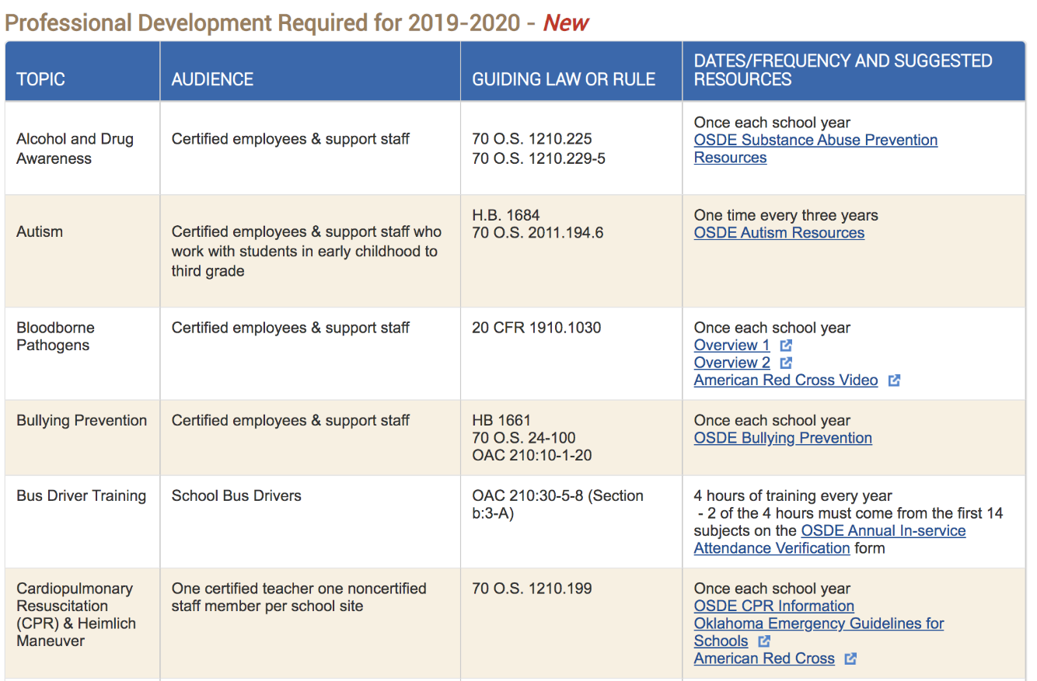
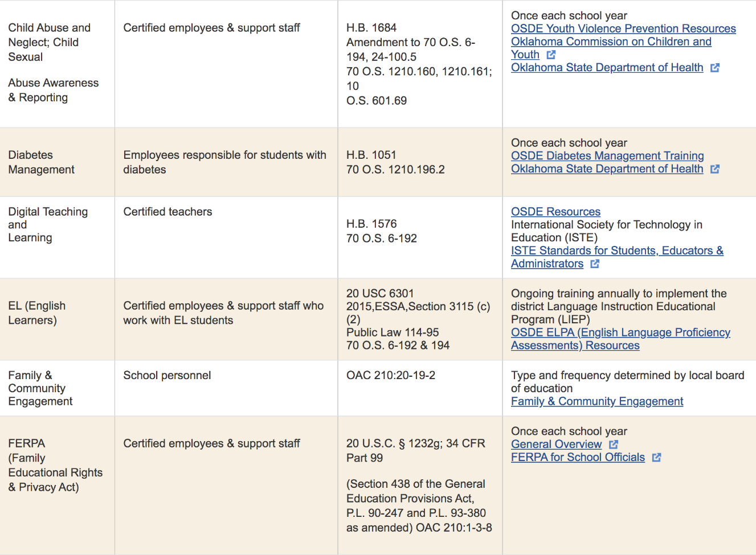
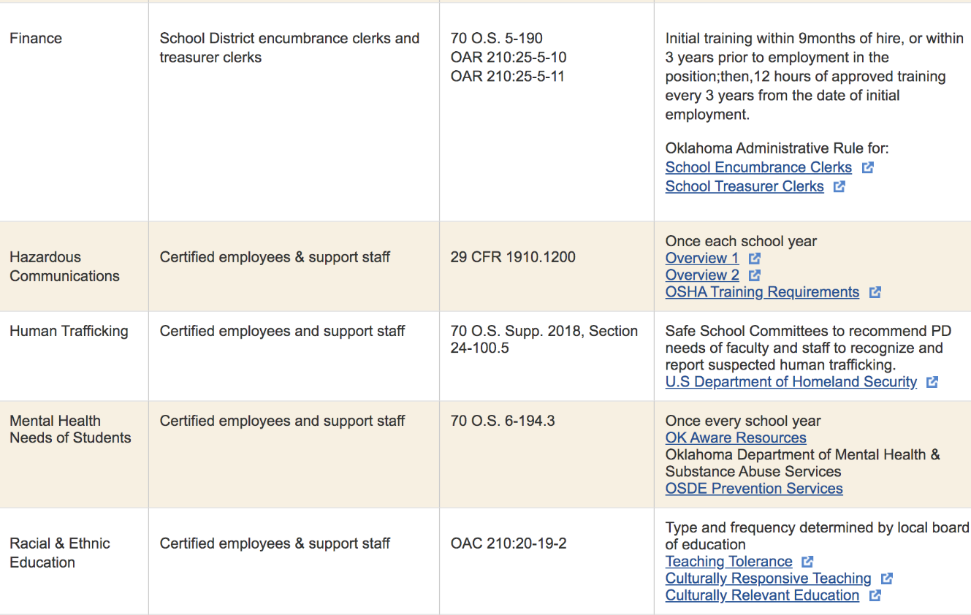
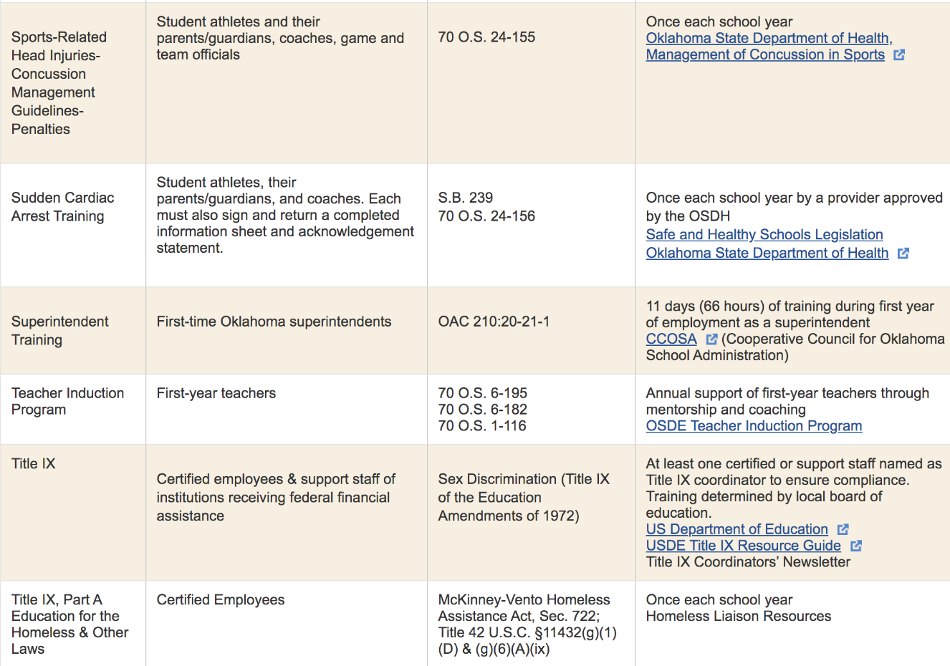

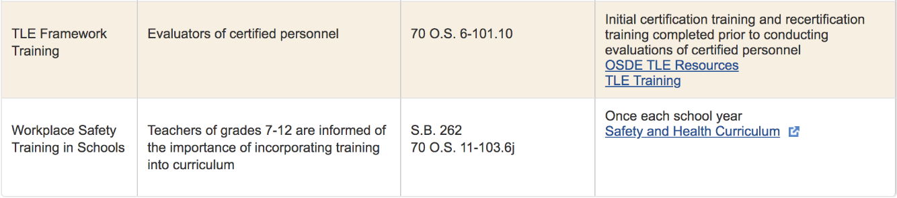

Appendix C: Musings from Focus Group Interview



