University of Oklahoma

Graduate College

experimental characterization of Brine in crude oil emulsions and its performance in artificial lift Systems

A thesis

submitted to the Graduate Faculty

in partial fulfillment of the requirements for the

Degree of

Master of science

By

Sergio A. Gomez M.
Norman, Oklahoma
2018

experimental characterization of Brine in crude oil emulsions and its performance in artificial lift systems

A thesis approved for the
Mewbourne School of Petroleum and Geological Engineering

By

Dr. Fahes Mashhad, Chair

Dr. Zulfiquar Reza

Dr.Xingru Wu

© Copyright by Sergio A. gOMEZ m. 2018
All Rights Reserved

To my family, friends and professors.

Acknowledgment
I would like to mention my sincere gratitude to my advisor Dr. Mashhad Fahes for her constant support and guidance. I could not have imagined a better mentor and advisor. I would also like to thank my committee members Dr. Wu and Dr. Reza for serving in my thesis committee and for their feedback. Besides my advisor, I would like to thanks Gary Stowe and Mohamed Mansi for their insightful remarks and encouragement.

Table of Contents
Acknowledgment v
List of Tables ix
List of Figures x
Abstract xiii
I INTRODUCTION 1
1.1 Objectives 2
1.2 Outline of the Thesis 3
II LITERATURE REVIEW 4
2.1 Basic Principles of Emulsions 4
2.2 Formation of Emulsion 5
2. 3 Emulsion Stability 7
2.3.1 Crude Oil Heavy Fractions 7
2.3.2 Solids 8
2.3.3 Temperature 9
2.3.4 Water Salinity 10
2.3.5 pH 10
2.3.6 Total Acid and Base Number 11
2.3.6 Droplet Size 12
2.4 Emulsion Rheology 13
2.4.1 Factors Affecting Emulsion Rheology 14
2.4.2 Rheometry 15
2.4.3 Models and Correlations 16
2.5 Artificial Lift Systems and Emulsions 18
2.5.1 Gas Lift 19
2.5.2 Dynamic Displacement Pumps 21
2.6 Demulsification 23
2.7 Phase Inversion 24
III QUANTIFYING THE NON-MONOTONIC EFFECT OF SALINITY ON WATER IN CRUDE OIL EMULSIONS 25
3.1 Introduction 25
3. 2 Methodology 26
3.2.1 Materials 26
3.2.2 Emulsion Preparation and Characterization 26
3.2.3 Droplet Size Measurements 28
3.3 Results 29
3.3.1 The Effect of Water Fraction 29
3.3.2 Effect of Salt in Emulsion Stability 31
3.3.3 Effect of Salt in Emulsion Viscosity 36
3.3.4 Effect of Salt on Emulsion Droplet Size Distribution 41
3.3.5 Discussion 45
3.4 Conclusion 47
IV METHODS FOR ARTIFICIAL LIFT OF WATER IN OIL EMULSIONS 48
4.1 Introduction 48
4.2 Methodology 49
4.2.1 Materials 49
4.2.2 Emulsion Mixing for Gas Exposure 49
4.2.3 Emulsion Mixing using a centrifugal pump 50
4.2.4 Emulsion Stability Determination 51
4.3 Results and Analysis 51
4.3.1 Gas Injection Effect on Emulsions 51
4.3.2 Impact of Centrifugal Pumps in Emulsions 58
4.4 Conclusion 60
V CONCLUSIONS AND RECOMMENDATIONS 61
5.1 Conclusion 61
5.2 Recommendation 63
References 64

List of Tables
Table 1. Properties of crude oils used at 25 °C. 26
Table 2. Equivalent wt% values for the brine concentrations used in this research. 27
Table 3. Emulsion viscosity at different water fraction for two types of crude oil. 30

List of Figures
Figure 1. Schematic of crude oil production from the reservoir to surface facilities (Umar, Saaid, Sulaimon, & Pilus, 2018) 1
Figure 2. Water in Crude Oil Emulsion and Crude Oil in Water Emulsion. (Moradi, Alvarado, & Huzurbazar, 2011) 4
Figure 3. Water droplet size distribution for different emulsions stabilities (Kokal, 2005). 12
Figure 4. Gas lift schematic concept (Economides, Hill, Economides, & Zhu, 2013). 20
Figure 5. Electrical submersible pump schematic concept (Economides, Hill, Economides, & Zhu, 2013). 22
Figure 6. Instrumentation used to mix and characterized water in crude oil emulsion: (A) Dynamic Model No 420063 centrifuge, (B) IKA Ultra Turrax T18 and (C) Cannon Fenske capillary viscometer. 28
Figure 7. Keyence microscope used (A) and microscope glass slide with two droplets of emulsion (B). 29
Figure 8. Relative viscosity of water in crude oil emulsions, plotted against water fraction for two different crude oils. 31
Figure 9. Separation for 10 % water fraction emulsion with crude oil A from centrifugation. 32
Figure 10. Separation for 10 % water fraction emulsion with crude oil B from centrifugation. 32
Figure 11. Separation for 30 % water fraction emulsion with crude oil A from centrifugation. 33
Figure 12. Separation for 30 % water fraction emulsion with crude oil B from centrifugation. 34
Figure 13. Separation for 50 % water fraction emulsion with crude oil A from centrifugation. 35
Figure 14. Effect of salt and surfactant stability on 30 % water cut emulsions with crude oil A. 36
Figure 15. Impact of different NaCl concentrations on emulsion viscosity as a function of water fraction, for crude oil A. 37
Figure 16. Impact of different CaCl₂ concentrations on emulsion viscosity as a function of water fraction, for crude oil A. 38
Figure 17. Impact of different NaCl and CaCl₂ concentration on emulsion viscosity as a function of water fraction, for crude oil B. 38
Figure 18. Separations of emulsion formed with crude oil A as a function of initial viscosity. 39
Figure 19. Viscosity change over time for 10% water cut emulsion for crude oil A. 40
Figure 20. Viscosity change over time for 30% water fraction emulsion for crude oil A. 40
Figure 21. Viscosity change over time for 50% water fraction emulsion for crude oil A. 41
Figure 22. The effect of centrifugation on droplet size distribution for 50 % water fraction emulsion formed with crude oil A. 42
Figure 23. The effect of centrifugation on droplet size distribution for 30 % water fraction emulsion formed with crude oil A. 42
Figure 24. The influence of CaCl₂ in droplet size distribution for a 50% water fraction emulsion formed with crude oil A. 43
Figure 25. Change in droplet size distribution for three different water fraction emulsions mixed with CaCl₂ brine with a concentration of 8.55 mMol/L. 44
Figure 26. Droplet size distribution change for 30% water fraction at two different CaCl₂ concentrations. 45
Figure 27. Schematic diagram of the gas lift setup. 50
Figure 28. Schematic diagram of emulsion mixing using a centrifugal pump. 51
Figure 29. Observed effect of viscosity change in a 30% water fraction emulsion for different gas rates and times of exposure. 52
Figure 30. Change in kinematic viscosity of emulsions at different water fractions. 53
Figure 31. Viscosity change of 50% water fraction in emulsion exposed to two different gases. 54
Figure 32. Stability of three different water in crude oil emulsions, before and after gas exposure. 55
Figure 33. Well schematic used in water in crude oil emulsion flow simulations. 57
Figure 34. Production summary of software simulation for 50 % water fraction emulsion. 58
Figure 35. Effect of mixing in different water cut emulsions. 59
Figure 36. Function principle of the dispersing tool of the IKA T18 mixer (A) (IKA Works manual, 2018) and operating principle of the centrifugal pump (B) (Grundfos, 2018). 59

Abstract
Understanding the behavior of water in oil emulsions can prevent flow assurance problems and the conditions at which these two fluids can mix. The stability and rheology of water in crude oil emulsions was studied for three different factors. First, the effect of different concentrations of dissolved NaCl and CaCl₂ in the aqueous phase is examined. Second, the effect of gas injection at different rates and exposure times is studied. Third, the effect of mixing using a centrifugal pump at different rates is investigated. Crude oils from wellheads in Midland, Texas were used and a non-ionic surfactant (Span 85) was utilized in some cases to stabilize the emulsion.
The results for brine in oil emulsions show different effects of salt on stability and viscosity for different water fractions. This effect can vary from a stability being proportional to the salt concentration in one case, to inversely proportional to the salt concentration in another case, including a case where a non-monotonic impact is registered. The viscosity increased in some cases with higher salt concentrations. As for gas lift, the results indicate that water in oil emulsions can be destabilized and its viscosity lowered after gas exposure. The effect of gas injection on the emulsion was linked to the initial conditions of the emulsion as well as the gas type, injection rate and time of exposure. Finally, a centrifugal pump resulted in creating stable emulsions at low water cuts, while it was not able to stabilize emulsions at high water fractions.
This research provides a comprehensive and exhaustive set of experiments on various measurements relating the water in oil emulsions. In some cases, it exhibits similar trends to what is described in the literature and in some cases contradicts them. This brings into question some of the theories that are used to explain this behavior given the complexity of water in crude oil emulsions.

I INTRODUCTION
Understanding the behavior of emulsions is essential to determine the long-term effect on crude oil production. All hydrocarbon reservoirs contain brine, which is produced along with crude oil as free water, or in an emulsion. An emulsion is a mixture of two or more phases that are usually immiscible. The formation of an emulsion requires the presence of a surfactant that allows one phase to disperse in another under certain mixing conditions. Whether it is in the reservoir, or simply in the surface facility, emulsions can form in any part of the production system (Figure 1). Emulsions may cause pressure drops in pipelines due to its high viscosity, reduction in the effective permeability of the reservoir rock, reduction in hydrocarbon production rate, and damage to downhole and/or surface equipment (Kokal, 2005). Emulsions usually form in the later stages of a reservoir’s life when the amount of water production increases.
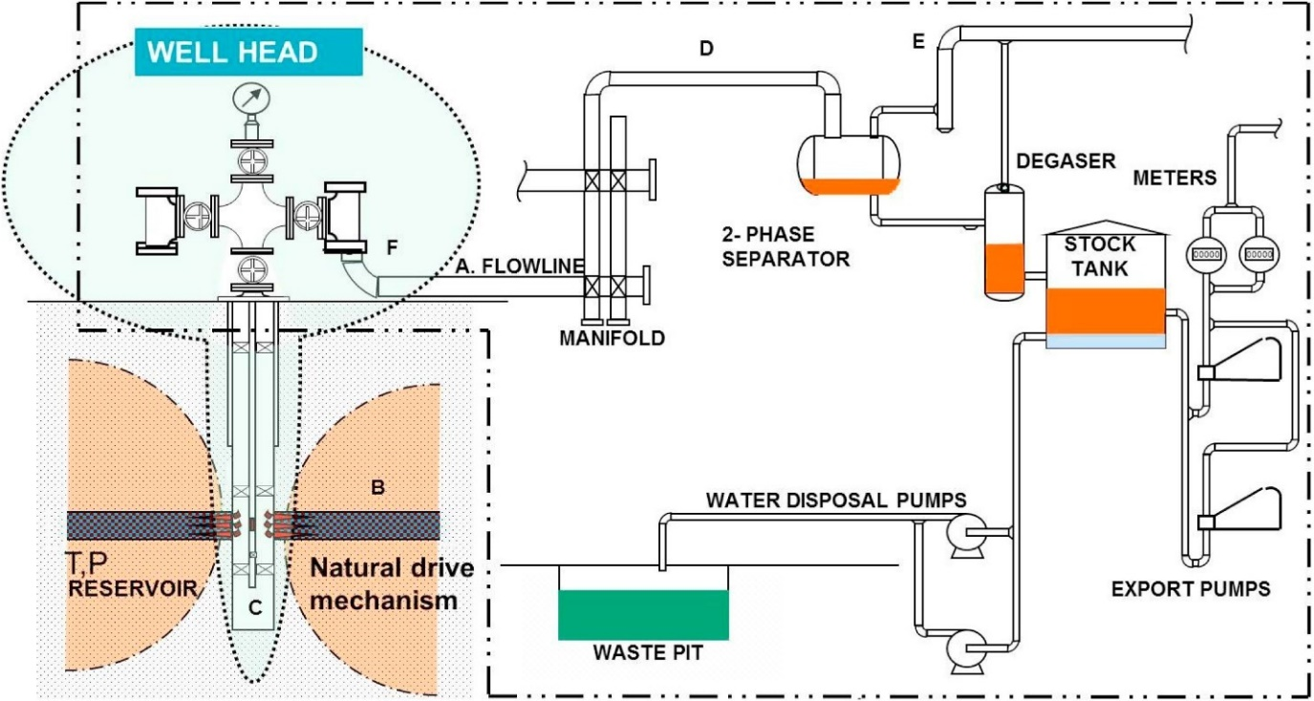
Figure 1. Schematic of crude oil production from the reservoir to surface facilities (Umar, Saaid, Sulaimon, & Pilus, 2018)

Numerous factors influence the stability and rheology of emulsions such as heavy crude oil components, the viscosity of the continues phase, temperature changes, mixing conditions, pH of the dispersed phase, the salinity of the brine and droplet size distribution. Several publications attribute the stability of water in oil emulsion to the presence of heavy fractions in the crude oil such as asphaltenes and resin, but other factors also contribute to the stability, such as salinity of the aqueous phase. This research attempts to understand three different factors that affect rheology and stability of water-in-crude oil emulsions. First, the effect of different concentrations of dissolved NaCl and CaCl₂ in the aqueous phase is examined. Second, the effect of gas injections at different rates and exposure times is studied. Third, the effect of mixing using a centrifugal pump at different rates is investigated.

1.1 Objectives
The broader scale objective of this work is to expand the knowledge and understanding of the stability and rheology of water in crude oil emulsions. This thesis intends to verify some theoretical concepts related to water in oil emulsions through experimental work. These concepts include stability, viscosity and droplet size distribution under different circumstances.
The various objectives of this work can be classified as follows:
- To study the effect of dissolved NaCl and CaCl₂ in the aqueous phase on the formation, stability, rheology and droplet size distribution for two different types of crude oils at various water fractions.
- To investigate the effect of gas injection on the stability and rheology of water in crude oil emulsions.
- To study the effect of a centrifugal pump on the formation, stability, and viscosity of water in crude oil emulsions.

1.2 Outline of the Thesis
The creation of crude oil emulsions could lead to expensive problems, both in operational cost and crude oil production lost. This thesis characterizes different factors that affect water in crude oil emulsions based on stability and rheology.
Following this first introductory chapter, the second chapter of this thesis presents a review of the fundamental concepts to characterize water in crude oil emulsions and some of the previous work in relation to this topic. The topics that are addressed are conditions for the formation of emulsions, rheology, stability, demulsification, phase inversion, and artificial lift systems in relation to emulsions. The third chapter investigates the non-monotonic impact of salinity on the properties of the water-oil interface. The fourth chapter describes the behavior of water-in-oil emulsions in artificial lift systems, mainly through gas lift exposure. Finally, chapter five summarizes the key points of the research and suggested recommendations for future work. Every emulsion investigated was water in crude oil emulsion. Dead oil samples at room pressure and temperature with no dissolved gases were used.

II LITERATURE REVIEW

2.1 Basic Principles of Emulsions
Colloids, most commonly known as emulsions, are a mixture of two or more liquids that are normally immiscible. One liquid disperses insoluble droplets into the continuous phase. The most common examples of emulsions are milk, mayonnaise, and ice cream. The most common emulsions in the oil and gas industry can be classified into three different groups: oil in water, water in oil and complex emulsions (Kilpatrick, 2012). Crude oil in water emulsions are comprised of oil droplets in a continuous water phase, and water in crude oil emulsions are water droplets in a continuous crude oil phase (Figure 2). The most common type of emulsion encountered in the field is water in crude oil emulsions.
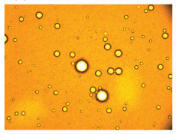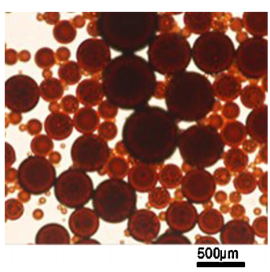
Figure 2. Water in Crude Oil Emulsion and Crude Oil in Water Emulsion. (Moradi, Alvarado, & Huzurbazar, 2011)

Complex emulsions consist of droplets suspended in bigger droplets that are suspended in a continuous phase. Two types of emulsions are considered complex, water-in-oil-in-water, and oil-in-water-in-oil. Multiple factors influence the type of emulsion to be formed. One of the main factors affecting the type of emulsion being formed is the ratio between water and oil. As a rule of thumb, the liquid with a higher volume will be the continuous phase, however there are multiple situations in which this does not apply.
Another way to classify emulsions is by their droplet size distribution. Droplets with sizes smaller than 0.1 μm are considered microemulsions, which are commonly considered thermodynamically stable. On the other hand, droplets bigger than 0.1 μm are macroemulsions, which are the focus of this thesis (Dalmazzone, Noik, & Komunjer, 2005). Most emulsions encountered in the field are water in crude oil macroemulsion which are essentially different from microemulsions in their stability and creation.

2.2 Formation of Emulsion
Emulsions require three basic components in order to be formed. First, two immiscible liquids, such as crude oil and water, must be in contact. Second, an emulsifying agent, such as surfactants, asphaltene or organic acids needs to be present. Third, in order to disperse one liquid into another, mixing is required. The mixing breaks the dispersed phase into droplets and if there is enough surfactant, the droplets will stabilize by interfacial films which prevent coalescence and flocculation of droplets. Surfactants cause steric or electrostatic repulsion to prevent droplets from coalescing (Maodong, Jianzhong , & Xiaomei , 2018).
Shear energy is one of the main factors determining the size of the droplet. The more energy introduced to the mixing, the smaller the droplet size, and therefore the tighter the emulsion. During crude oil extraction, there are multiple points in which mixing can occur, such as in the reservoir, wellbore, pipes, valves, fittings and surface equipment.
Emulsifying agents stabilize emulsions, some examples are solids, artificial surfactants, and active crude oil components. Fine particles act as mechanical stabilizers by surrounding the droplets and acting as a barrier. Some examples of fine solids are: clay, sand, and silt. The success of fine solids in stabilizing emulsions is subject to multiple factors such as, particle interaction, particle size, and wettability of particles (Tambe & Sharma, 1993).
Surfactant agents lower the interfacial tension between fluids, minimizing the energy required to form emulsions. Surfactants are organic or inorganic compounds containing hydrophobic and hydrophilic groups, which means that they contain water soluble and insoluble components. Critical micelle concentration quantifies the amount of surfactant required to stabilize the droplets in the emulsion. Surfactants are classified according to their charged group in their molecule head. The two most common types of surfactant classifications are nonionic and ionic which is related to their polar head group. Nonionic surfactants do not possess any charged group in their heads. On the other hand, ionic surfactants contain a positive or negative charge in their heads. Within ionic surfactants, cationic surfactants contain a positive charge and anionic surfactants contain a negative charge.
Identifying the correct amount and type of surfactant is difficult since the liquid composition differs from one emulsion to another. Multiple experimental correlations have been proposed to identify the type of surfactant, however the most known experimental correlation is Hydrophilic-Lipophilic Balance (HLB) developed by Dr. Griffin in 1949. The HLB value of a surfactant is determined by the ratio between hydrophilic and lipophilic groups. The range of HLB value is from 0 to 20. Lipophilic substances are characterized by HLB value below 9, while hydrophilic substances are characterized by high HLB numbers. Surfactants with low HLB values are crude oil soluble and usually form water in oil emulsions, while high HLB values are soluble in water and create oil in water emulsions (ICI Americas Inc, 1984).
In order to identify the correct concentration of surfactant required to achieve a stable emulsion, critical micelle concertation (CMC) is measured. The CMC is the surfactant concentration in which micelles are created. The surface tension below the CMC decreases with increasing surfactant concentrations, until an equilibrium is reached, in which the surface tension is constant at values above the CMC. Measuring the changes in surface tension in the continuous phase with surfactant concentration will determine the concentration required. As the concentration increases, the surface tension decreases until it reaches a minimum value.

2. 3 Emulsion Stability
Oilfield emulsions tend to separate into their original components since these are unstable systems. In order to achieve separation, the stabilizing factors need to be neutralized to allow the dispersed phase droplets to coalesce. Multiple factors affect the stability of water in crude oil emulsions such as heavy fractions in crude oil, solids, temperature changes, pH, etc. Emulsion stability is defined as the volume of crude oil and water that separates as a percentage of the total initial volume of the emulsion over time.
For example, Kokal (2005) classified three different types of emulsions in his literature review: loose emulsion separates in a few minutes after mixing, medium emulsions tend to separate in ten minutes or more and tight emulsions separate in hours or even days. Other researchers argue that emulsions can be stable for weeks or even months (Almeida, Larentis, & Ferraz, 2015). In order to assess the stability of emulsions, multiple tests have been developed. The two most common tests are bottle tests and droplet size distribution.

2.3.1 Crude Oil Heavy Fractions
Most studies suggest that polar fractions in crude oil such as resins, asphaltenes, organic bases, and acids are the main factor in stabilizing droplets of the dispersed phase by creating interfacial films. While most studies indicate that water in crude oil emulsions are stabilized by heavy fractions, there is a significant discussion on the precise component. Some studies suggest that asphaltenes are the main component of heavy fractions to contribute to stable emulsions. Asphaltenes are organic compounds that are commonly defined as soluble in aromatics and insoluble in alkanes. The main components in asphaltene structure are hydrogen, carbon, nitrogen, sulfur, and oxygen, as well as some metals such as nickel and vanadium. Others suggested that the interaction between resins and asphaltenes is the main factor contributing to emulsions stability (McLean & Kilpatrick, 1997). It is believed that resins and asphaltenes will form a micelle which stabilizes the droplets of the disperse phase. However, most recent studies show that only certain kinds of asphaltenes, commonly known as interracially active, are responsible for stabilizing emulsions (Yang & Tchoukov, 2014). Some other investigations suggest that waxes alone do not contribute to the formation of stable emulsions.

2.3.2 Solids
Emulsions can be stabilized by solid particles, which can accumulate at the droplet interface preventing coalesces. Pickering (1907) was the first scientist to report the effect of solids in water-in-oil emulsions stability. His study concluded that fine-grained solids in significant quantities will help to emulsify and stabilize emulsions. Fine solid particles will reside at droplet interface, thus preventing coalescence. On the other hand, some different geometries of solids such as crystalline solids do not stabilize emulsions. Furthermore, Mukerjee and Srivastava (1956) quantified the effect of clays on emulsions stability. In their studies, they concluded that colloidal clays can enhance emulsion formation and stability. Multiple studies credit the presence of inorganic and organic particles to cause emulsion stability. Theories demonstrate that solids are capable of stabilizing emulsions, since particles attach to the liquid interface, achieving a more effective stabilization than surfactants.
Most recent studies on emulsion stability using solids focus on solid particle size, surface roughness, shape and hydrophobicity since it has been determined as the main stability factors within solids (Ngai & Bon, 2014). For example, Yan et al. (2001) studied the effect of kaolinite clay, colloidal silica, latex microspheres and dry powders in water in oil emulsions stability. It was concluded that any solid particle with hydrophobicity enhances water in oil emulsion stability. The oil used was mineral oil commonly known as Bayol-35. The water fraction used was 12.6% by weight.

2.3.3 Temperature
Temperature affects the stability of emulsions since it affects the physical properties of the fluids, interfacial tension and solubility of surfactants. Temperature increase affects the rate of droplets collision since there is an increase in thermal energy. Furthermore, the interface of the phases, commonly known as interfacial films, weaken, enhancing droplet coalescence (Jones, Neustadter, & Whittingham, 1978). Nevertheless, at high temperatures, some emulsions exhibit a kinetic block to droplet coalescence due to solids or heavy fractions within the interfacial film (Kokal, 2005).
Jones et al. (1978) studied the effect of temperature on interfacial film behavior in crude oil in water emulsions for twenty different types of crude oils. Increasing the temperature of an emulsion will destabilize the interphase between the phases. However, at temperatures higher than 65°C, a kinetic barrier appears which prevents demulsification. Additionally, at a high temperature, light components of the crude oil degas, leading to significant changes in the interfacial film. This change will result in incompressible and non-relaxing films, which results in highly stable emulsions. (Jones, Neustadter, & Whittingham, 1978).

2.3.4 Water Salinity
Produce water most of the times comes with dissolved salts. Ionic compounds can affect emulsion rheology and stability. Most research papers concluded that high ionic concentrations in water can potentially destabilize water in crude oil emulsions. Subramanian et al. (2017) quantified the consequence of salts (NaCl and CaCl₂) on the stability of emulsions. Seven different types of crude oils were used, the lightest crude oil used had an SG of 0.82 and viscosity of 0.0043 Pa.s at 27°C while the heaviest crude oil had an SG of 1 and viscosity of 560 Pa.s at 27°C. He concluded that salt concentrations dissolved in water between 4 and 30 wt% destabilize water in crude oil emulsions. However, this behavior was only observed with lighter crude oil, since ions hydration is more evident. Furthermore, Wang and Alvarado (2012) concluded that high concentrations of salt dissolved in water destabilize emulsions. The salts used were NaCl and CaCl₂ at concentrations of 3.8 wt%, 0.38 wt%, and 0.038 wt%. Two different crude oils were used, their properties are: SG of 0.86 and viscosities of 0.016 and 0.017 Pa.s at 22 °C.
On the contrary, Aman et al. (2015) determined that NaCl concentration in water increased emulsion stability. The concentrations used were from 1 wt% to 10 wt%. The crude oil used in this study had a viscosity of 0.0047 Pa.s at 22°C and SG of 0.85. Similarly, Rocha et al. (2016) reported that salt concentrations between 0.02 wt% and 0.1 wt% increased the stability of water in bitumen oil emulsions. The salts used were: KCl, NaSO₄, CaCl_{2,} and Na₂CO₃. Salt addition decreased the mean droplet size, interfacial tension and the adhesion between the disperse phase droplets.

2.3.5 pH
The pH of the aqueous phase contributes to emulsion stability. Inorganic bases and acids affect the ionization of the interfacial films and could potentially change the physical properties. Low pH brines are associated with water in crude oil emulsions while high pH is usually associated with crude oil in water emulsions. For example, Subramanian et al. (2017) studied the effect of acidic and basic properties of the crude oil and aqueous phase on the stability of emulsions in seven different types of crude oils. It was concluded that aqueous solutions with low pH values enhance the stability of water in crude oil emulsions. On the contrary, Daaou and Bendedouch (2012) suggested that a neutral medium pH would generate the most stable water in oil emulsion since no water separation was observed.
Some other studies suggest that each oil - brine system exhibits a pH range in which the interfacial film is most stable. For example, Strassner (1968) argued that each crude oil – brine system has a range of pH in which the interfacial films exhibits minimum contacted properties. In his study, he used eight different types of crude oil and seven types of brine concentrations. The properties of the crude oils were very diverse from an API value of 34.6 and a viscosity of 1 cP at 20°C to API value of 13.2 and viscosity of 10000 cP. Also, the range of salinity concentrations in the water was from 0.44 wt% to 10 wt% NaCl.

2.3.6 Total Acid and Base Number
In addition to pH changes, Total Acid Number (TAN) and Total Base Number (TBN) also affect emulsion stability. Acid groups within the crude oil include carboxylic acids, hydroxyl, pyrrole and thiol acids. Basic groups within the crude oil comprise of pyridines and quinolines. These acid and basic groups are complex mixtures of organic compounds with diverse chemical and physical properties. In the last decade, studies have started to understand what role these organic groups play in stabilizing emulsions. Multiple scientists have concluded that interfacial films are comprised mainly of heavy fractions, acid and basic groups of molecules (Kilpatrick, 2012). Subramanian et al. (2017) concluded through experimental work that emulsion stability is strongly related to the acid-base interaction with active components in crude oil, such as asphaltenes. The asphaltenes will accumulate around the aqueous droplet, stabilizing the emulsion within a certain range between acid and base groups. The stability of the emulsion will be enhanced in acidic environments. Furthermore, Brandal et al. (2006) conducted multiple experimental trials in which he removed the acid groups of the crude oil through liquid extraction. It was determined that low acid concentrations in the crude oil increase the stability of the emulsion by a decrease in the interfacial tension (Brandal, et al., 2006).

2.3.6 Droplet Size
Droplet size distribution of the disperse phase is commonly associated with the stability of emulsions. Oilfield emulsions droplet size normally falls between 0.1 um and 50 um (Kokal, 2005). Multiple factors determine the size of these droplets, however, one of the main factors is the shear rate applied during mixing. (Figure 3).
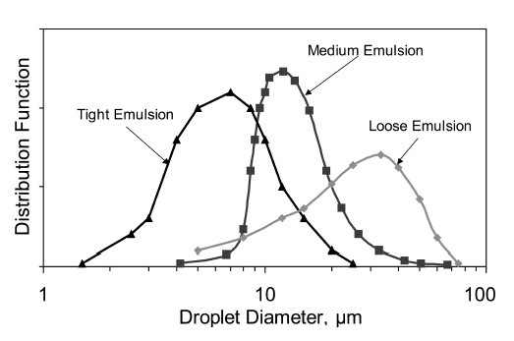
Figure 3. Water droplet size distribution for different emulsions stabilities (Kokal, 2005).

In order to break down the interface between two fluids and create droplets of the disperse phase, mixing is required. By increasing the shear rate and mixing speeds, the size of the droplets will decrease. In order to understand the droplet size distribution of an emulsion, it is necessary to study the mixing style and speed. During crude oil production, fluids are exposed to a variety of mixing environments, such as centrifugal pumps. Most studies suggest that the most stable emulsions have the smallest droplet size distribution mean. For example, Bellary et al. (2017) studied the effect of emulsions in the performance of centrifugal pumps. One of his conclusions was that centrifugal pumps enhance emulsion formation by decreasing its mean droplet size distribution and could potentially decrease pump efficiency by 67%. The properties of the crude oil used were: API of 44.3 and viscosity of 2.47 cP at room temperature (Bellary et al., 2017).

2.4 Emulsion Rheology
Understanding the flow properties of water in crude oil emulsions under certain conditions is known as rheology, and it is one of the most studied physical attributes. Rheology is the study of the flow of any material and its deformation under an applied shear stress. Emulsion rheology can exponentially increase with minimum changes to its composition, causing multiple flow assurance issues. For example, emulsion viscosity can change by a magnitude of 10 by increasing the water fraction by 10% (Kokal, 2005). The rheological properties of an emulsion can be classified as non-Newtonian or Newtonian. A Newtonian fluid viscosity remains constant with changing shear stress at a constant temperature. In other words, the relationship between shear rate and shear stress is linear. On the other hand, non-Newtonian fluids are classified in four different ways: dilatant, pseudoplastic, rheopectic and thixotropic. For a dilatant fluid, the viscosity increases as the shear rate increases. For pseudoplastic, the higher the shear rate the, lower the viscosity. For rheopectic fluids, the viscosity would increase with time and shear rate. Thixotropic fluids viscosity would decrease with time and shear rate. The rheological behavior of oilfield emulsions can be either Newtonian or non-Newtonian, contingent upon its composition (Pal, Yan, & Masliyah, 1992). At low water cut values, emulsions tend to show Newtonian behavior. Arirachakaran et al. (1989) concluded that water in crude oil emulsions showed Newtonian flow up to 40% water fraction by volume. Furthermore, emulsions with higher water fraction are expected to behave as pseudoplastic non-Newtonian fluids.

2.4.1 Factors Affecting Emulsion Rheology
Emulsion rheological properties depend on multiple factors such as the viscosity of dispersed phase, the viscosity of continues phase, ratios between phases, temperature changes, shear rate, droplet size, heavy components of the crude oil, brine composition and pressure. Zaki (1997) studied various factors affecting viscosity in surfactant-stabilized emulsions; he concluded that higher crude oil fraction, higher temperatures and lower speed of mixing will decrease the dynamic viscosity of emulsions (Zaki, 1997). Ronningsen (1995) experimentally investigated the relationship between eight different crude oils and their viscosity with defined aqueous phase cuts. He concluded that the viscosity increased linearly with lower water fractions and exponentially with higher water fractions (Rᴓnningsen, 1995).
Ionic compounds present in the aqueous phase affect the rheological properties of emulsions. Numerous studies have quantified the effect of ions on emulsion rheology, but there is not a common agreement regarding its effect. Bamikole and Aliyu (2017) concluded that ionic compounds in the aqueous phase of water in crude oil emulsions can increase the emulsion viscosity, at concertation of 2% wt of NaCl the viscosity was twice as with deionize water. Furthermore, Al-Yaari et al. (2013) concluded that NaCl presence in water can increase emulsion viscosity while conducting flow loop experiments with water in crude oil emulsions. On the other hand, Zahid et al. (2011) report an insignificant change in the viscosity of water in oil microemulsions. He used three different types of crude oil with properties of: API value of 37 and viscosity values from 8.8 to 24.4 cP at room temperature. The composition of the synthetic brine had different salts: KCl, NaHCO₃, NaCl, CaCl₂, MgCl_{2,} and Na₂SO₄ with an overall concentration of 3.4 wt% (Zahid, Sandersen, Stenby, Solms, & Shapiro, 2011). Moreover, Perles et al. (2012) concluded that ions in the aqueous phase have no direct impact on the rheological behavior of the emulsion.

2.4.2 Rheometry
Rheometry refers to the experimental method used to determine different rheological properties of materials. The rheology of the fluid can be measured in multiple ways. The two most common methods are: rotational viscometer and capillary viscometer. Capillary viscometers work on the principle of gravitational forces as the drive mechanism. In simple words, by knowing the size of the capillary and by measuring the time it takes the liquid to travel from two defined points, viscosity can be calculated. It is assumed that the fluid follows a laminar flow and it can be related to the Poiseuille's equation and Navier Stokes. The kinematic viscosity is described by the equation below:
$$v=p\left[{\left(\frac{1}{b}\right)}^{2}\left(\frac{g}{8}\right)a^{4}\left(\frac{1}{k}+\frac{1}{h}\right)\right]t$$

Where p is density, g is gravity, b is the capillary radius, k is capillary tube length, h is the distance between measured points and t is travel time between these points.
Capillary viscometers are the most simple and common viscometers used to measure viscosity. Its simplicity is considered as its main strength since it only requires gravity forces to work. On the other hand, it is not designed to measure high viscosities and several capillaries are required to cover the extensive range of viscosities. Another drawback is that capillary viscometers only measure the viscosity of Newtonian fluids.
Rotational viscometers measure the torque of an upright shaft that rotates a spindle. The spindle is submerged in the liquid and the viscosity of the fluid is calculated based on the shaft impediment to rotate. The speed of the spindle produces a torque that must be enough to overcome the viscous forces of the fluid. There are different measuring bobs for rotational viscometers. In general terms, the relationship between the fluid and the bob design is inversely proportional. The higher the viscosity, the smaller the shaft. Rotational viscometer is widely used in the industry since it offers a fast measurement and a wide range of viscosity measurements. Since rotational viscometers shear the fluid, it could potentially change some of its rheological properties.

2.4.3 Models and Correlations
The viscosity of water in crude oil emulsions depends on numerous factors such as volume fraction of aqueous phase, viscosity of the crude oil, viscosity of the aqueous phase, shear rate, temperature, droplet size distribution, concentration of emulsifying agent, type of emulsifying agent and presence of solids in the emulsion (Johnsen & Ronningsen, 2003). Some of these factors have minimal effect on the viscosity of water in crude oil emulsions, such as the viscosity of the aqueous phase. Most studies focus on the size and distribution of the droplets of the dispersed phase since its relationship to rheological properties has been proven. Pal (1996) concluded that there is an inversely proportional relationship between viscosity and droplet size. The smaller the droplet of the disperse phase, the higher the viscosity of the emulsion.
Most of the early correlations for the viscosity of emulsions are related to the viscosity of the continuous phase and to the dispersed phase volume fraction. The two most popular correlations used today in the oil and gas industry are based on Richardson (1933) and Pal and Rhodes (1989) (Johnsen & Ronningsen, 2003). Both of these equations are based on Einstein studies in which he argues that the viscosity of a homogeneous mixture is a function of the volume of the dispersed phase. Richardson (1933) was the first to report the change from a Newtonian to a non-Newtonian fluid as the fraction of the disperse phase increased. As the dispersed phase fraction increased, the viscosity exhibits non-linear dependency with that fraction until it reaches the inversion point of the emulsion. Richardson developed the resulting equation based on theoretical work:
$$In n_{r}=k∅$$
Where k is a constant based on each system and $∅$ is the water fraction of the emulsion.
It was not until 1985 that shear rate effect was incorporated into viscosity models by Pal and Rhodes. They developed the following equation based on experimental work to correlate the viscosity of non-Newtonian and Newtonian emulsions:
$$η_{r}={\left(1+\frac{\frac{ϕ}{K_{2}}}{1.187-\frac{ϕ}{K_{2}}}\right)}^{2.5}$$

Where K2 is the dispersed phase volume fraction in which the relative viscosity becomes 100 and $∅$ is the water fraction of the emulsion. This constant accounts for system variations. Pal and Rhodes (1989) developed a simpler correlation. This equation was more accurate since it accounted for droplet flocculation and hydration effect. The equation is:

$$η_{r}={\left(1-K_{0}K_{f}(y)∅\right)}^{-2.5}$$
Where $K_{0}$ is the hydration factor which is constant for each emulsion and $K_{f}$ is the flocculation factor which depends on the shear rate.
Another famous correlation develop for stable water in oil emulsions was created empirically by Ronningsen (1994). This equation accounts for temperature and droplet size changes.
$$ln η_{e}=k_{1}+k_{2}T+k_{3}ϕ+k_{4}Tϕ$$

Where k₁ - k₄ are constants based in shear rates. This empirical equation was established using different types of crude oil from North Sea fields. This correlation does not need any experimental data to be used, becoming one major advantage.
In recent years, scientists have focus in heavy fractions of crude oil to develop viscosity correlations. These models take into account asphaltene, resin, aromatics and saturate content to predict viscosity changes. Malkin et al. (2016) developed a correlation using 200 different crude oils from Russia and Norway. It was concluded that asphaltene at low concentration will enhance higher viscosities. Additionally, resins and aromatics increase viscosity at high concentrations. The following correlation relates viscosity as a function of asphaltenes and resins:
$$η_{r}={100}^{\left(6±0.2\right)C}$$
Where c is the concentration of asphaltenes and resins in weight fraction (Malkin, et al., 2016).

2.5 Artificial Lift Systems and Emulsions
Understanding the behavior of emulsions is necessary to determine the long-term effect on crude oil production. Electrical submersible pumps (ESPs) and gas lift are commonly used separately in lifting liquids from wells. However, the presence of emulsions can cause inefficiencies in these systems. The use of downhole equipment and instruments such as ESPs or jet pumps can result in the mixing of water and crude oil, ultimately causing the formation of emulsions. The pressure required to lift emulsion is greater than the pressure required to lift non-emulsified liquids. Emulsions require greater kinetic energy to lift, decreasing the pressure drawdown capabilities, lowering production rate, increasing the weight on the equipment, shortening life expectancy and may result in equipment damage. ESPs can potentially increase the problems caused by emulsions by increasing emulsion viscosity and stability through mixing, thereby resulting in lower production rates and shorter life expectancy of the ESP.
Combined artificial lift methods are considered more efficient since they can reduce equipment size, consequently reducing capital investment and reducing operational cost. Saputelli (1997) studied the application of using two artificial lift methods; gas lift and ESP. They concluded that dual artificial lift would minimize total energy requirements by 15-20%. Additionally, they could extend the life of equipment, reducing capital expenditure and operating cost (Saputelli, 1997). In the same way, Borja and Castano (1999) tested gas lift and ESP in an oil well in Colombia. He concluded that combined artificial lift systems generate cost saving and increase oil production. Both studies did not address the emulsion issues in their work. Procedures and equipment which reduce the load on the pump are desirable and formation of emulsion should be taken into consideration.

2.5.1 Gas Lift
Gas lift consists of injecting gas through the production tubing, reducing the density of the fluids resulting in a reduction in bottom hole pressure. Additionally, the injected gas increases liquid flow rates, resulting in higher fluid rates. Its system consists of multiple valves installed at numerous depths along the production tubing and a compressor at the surface (Figure 4).

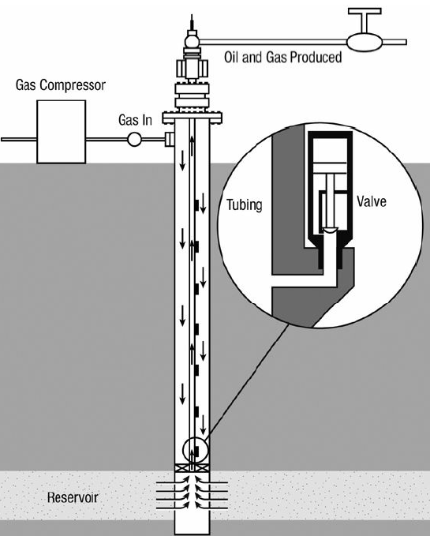
Figure 4. Gas lift schematic concept (Economides, Hill, Economides, & Zhu, 2013).

Gas lift injection mechanisms are usually divided into two main categories: continuous gas injection or intermittent gas injection. Continuous gas injection is the most common method of gas lift used today. In this method, gas is injected nonstop into the wellbore through the tubing at a designated point of injection. By doing so, the pressure gradient will decrease allowing the fluid to flow into the wellbore and subsequently to the surface. Continuous flow is usually used in high flow rates wells and high bottom hole pressure wells. The biggest disadvantage of this method is the surface equipment required, such as high-end compressors. Another disadvantage is the constant gas supply needed through the life of the injection period.
Second, intermittent gas injection, as its name implies, comprises of irregular gas injection times. This type of gas injection is recommended for wells with low producing rates and low bottom hole pressure. However, this method is limited to low volume wells. In order to maximize the use of intermitted gas injection, there is a maximum gas-liquid ratio in which the ratio of pressure gradient and the friction pressure drop is optimal for maximum fluid production.

2.5.2 Dynamic Displacement Pumps
Electrical Submersible Pumps (ESPs) are one type of dynamic displacement pumps widely used in the oil and gas industry. ESPs are comprised of centrifugal pumps and an electric motor. ESPs are commonly deployed at the bottom of the production tubing. It is considered one of the most expensive artificial lift methods, however, it has a versatile range of operations allowing it to be adaptable to changing well conditions. It can produce high volumes of fluid, can be used in deeper wells than sucker rod pumps and can handle free gas.
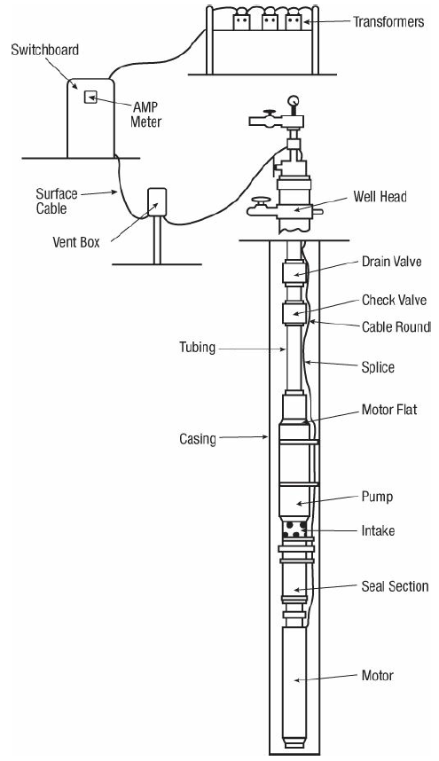
Figure 5. Electrical submersible pump schematic concept (Economides, Hill, Economides, & Zhu, 2013).

The electric motor is situated in the lowest point of the ESPs so that the produced fluids cool the motor. Centrifugal pumps do not displace a constant volume of fluid, as positive displacement pumps, but create a constant pressure increase in the liquid flow. This pressure increase is commonly called pumping head, which determines the increase in the flow rate.

2.6 Demulsification
Demulsification is the process of separating an emulsion into its original components. In the case of water in crude oil emulsion, it would be to separate the crude oil from the water. The first step during demulsification is for water droplets to flocculate or/and aggregate or/and agglomerate or/and coagulate. Droplets will cluster together forming aggregates. The flocculation rate depends on multiple factors such as dispersed phase volume fraction, temperature, the viscosity of the phases and density difference between the fluids. The second step in demulsification is coalescence, were dispersed phase droplets fuse forming larger droplets. Coalescence is enhanced by high temperatures, low continues phase ratio, high rate of flocculation, low interfacial viscosities and high interfacial tension.
Demulsification of water in crude oil emulsion is a crucial topic of study in the oil and gas industry since in most cases the crude oil must be separated from the water before the crude oil can be transported or processed. Four methods are used for demulsification in the oil and gas industry: chemicals, thermal, electrical and mechanical. Thermal methods consist of introducing heat into the system to increase the temperature. Ultimately, the viscosity of the emulsion will decrease and the water droplets settling rates will increase. However, increasing the temperature is a costly procedure and it could result in the loss of light components of the crude oil. Additionally, temperature changes increase the tendency of deposition and increase the likelihood of corrosion. Mechanical methods include separators, desalters and settling tanks. Electrical methods consist of applying high voltage electricity to emulsions. The electric field is perpendicular to the direction of the liquid flow. The internal energy of the droplet will increase resulting in higher speeds, causing droplets to collide with each other. Additionally, the interfacial film weakens by rearranging the polar molecules. Chemical methods are the most common methods of demulsification treatment. Demulsifiers neutralize the effect of emulsifying agents by weakening the rigid film at the oil/water interface.

2.7 Phase Inversion
Phase inversion of water in crude oil emulsions is commonly defined as the transition of the aqueous phase from being dispersed to continuous. Phase inversion is capable of drastically changing some of the properties of the emulsion, such as decreasing the viscosity by many orders of magnitude. In order to achieved phase inversion, multiple factors are required, such as higher volume percentage of the disperse phase. Arirachakaran et al. (1989) was one of the first scientists to study emulsion phase inversion. He concluded that during phase inversion dispersed phase droplets become more concentrated and coalescence increases. As the disperse phase droplets are coalescing, they entrap the continues phase until phase inversion happens. Coalescence is affected by multiple factors such as the material in which the emulsion is contained (Arirachakaran et al., 1989). Additionally, emulsifying agents play a significant role during phase inversion in water in crude oil emulsions. Brooks and Richmond (1991) concluded that phase inversion could be affected by mixing conditions, temperature, surfactant concentration, surfactant type, and volume ratios.

III QUANTIFYING THE NON-MONOTONIC EFFECT OF SALINITY ON WATER IN CRUDE OIL EMULSIONS

3.1 Introduction
All hydrocarbon reservoirs contain water, as the oil production declines the water production usually increases. and emulsion formation is possible. Quantifying ionic compounds present in water may lead to a better understanding of the formation, stability and rheology behavior of water in crude oil emulsions. Formation water contains different chemicals at multiple concentrations. In the United States, it has been reported brines containing up to 460,000 total dissolve solids of ions such as sodium, chloride, calcium, bicarbonate, magnesium, bicarbonate, sulfate, iron, etc (Dresel and Rose, 2010). The three most common ions found in reservoir brines are sodium, chloride, and calcium. Therefore, this chapter focuses on a detailed and comprehensive set of experiments to understand the effect of different salts and concentration on the formation, stability and rheology behavior of different water cuts of water in crude oil emulsions.
In this study, the crude oils used are from wellheads in Midland County, Texas. In order to obtain a stable emulsion, an emulsifier agent was used (SPAN – 85) in one of the crude oils. The emulsion formation was achieved using a homogenizer IKA Ultra- Turrax. The results of this study indicate a non-monotonic effect of NaCl and CaCl₂ at different concentrations in the rheology and stability of water in crude oil emulsions. This effect varied from emulsion stability being proportional to salt concentration in one case, to being inversely proportional to salt concentration in the other.

3. 2 Methodology

3.2.1 Materials
Water in crude oil emulsions used in this study were formed with crude oils from Midland, Texas. Some basic crude oil properties of the oils are shown in Table 1. Deionized water was used as the base aqueous phase, with a density of 0.997 g/cc at 24°C and a dynamic viscosity of 1 cP at 25°C. In order to ensure a stable emulsion Span 85 was the surfactant used to stabilize the emulsion with crude oil A. Span 85 is nonionic in nature, has a density of 956 kg/m³ at 25°C and an HLB value of 1.8. Two different salts were used: sodium chloride (NaCl) and calcium chloride (CaCl2).
Table 1. Properties of crude oils used at 25 °C.

Name | Density (g/cc) | Viscosity (cP) | TAN (mgKOH/g) | TBN (mgKOH/g)
Crude A | 0.909 | 62 | 0.451 | 1.02
Crude B | 0.849 | 70 | 0.110 | 1.04

3.2.2 Emulsion Preparation and Characterization
Water in crude oil emulsions were prepared systematically to guarantee reproducibility. The first step was to dissolve the emulsifier into the crude oil. The volume of emulsifier used was 1% of the total volume of the emulsion. Second, a known amount of crude oil with a given amount of surfactant was mixed at 10000 rpm for 30 seconds. Third, brine was slowly added into the mixture for 30 seconds at 10000 rpm. Finally, the mixture was mixed at 20,000 rpm for 2 min. Three different volume ratios of brine were used: 10%, 30%, and 50% of the total emulsion volume. Crude oil B did not require the addition of an external surfactant. Three salt concentrations were used 8.55, 85.5 and 855 mMol/L NaCl or CaCl2 were dissolved in deionized water and used as the brine. The weight percentage and ionic strength values of salt concentration used are presented in Table 2.
Table 2. Equivalent wt% values for the brine concentrations used in this research.

mMol/L | NaCl Solutions, % | CaCl₂ solutions, %
8.55 | 0.05 | 0.0646
85.5 | 0.5 | 0.646
855 | 5 | 6.46

After the emulsion was formed it was divided into several test tubes for stability and viscosity measurements. Viscosity measurements were done using Cannon Fenske capillary viscometer. Stability measurements are conducted using a Dynamic Model No 420063 centrifuge. The centrifuge was used at 2790 rpm for different times intervals of 1, 2, 5, 10, 12 and 15 min for a cumulative time of 45 min. After each time interval, the separation for the brine and crude oil phase was recorded. The instruments used in this research are presented in Figure 6.

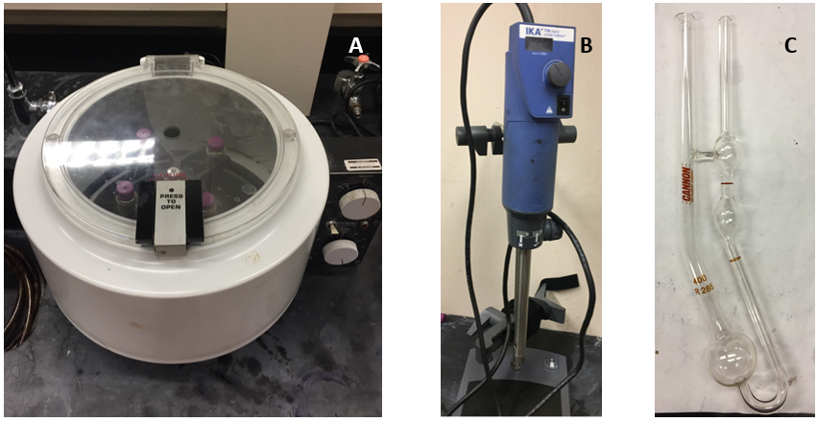
Figure 6. Instrumentation used to mix and characterized water in crude oil emulsion: (A) Dynamic Model No 420063 centrifuge, (B) IKA Ultra Turrax T18 and (C) Cannon Fenske capillary viscometer.

3.2.3 Droplet Size Measurements
Droplet size was measured using a 3D optical laser scanning Keyence profiler microscope. The range of the microscope used was from 1 to 300 um. Two droplets of each emulsion were placed in a glass slide after mixing. In order to observe the emulsion in the microscope the emulsion needed to be thin enough to let light through (Figure 7. B). Multiple pictures of each emulsion were taken and later analyzed using ImageJ software. Approximately 10 images were taken per emulsion, and 400 – 500 droplets were measured to obtain the droplet size distribution. The droplet size distribution standard deviation did not change significantly after 350 counted droplets.
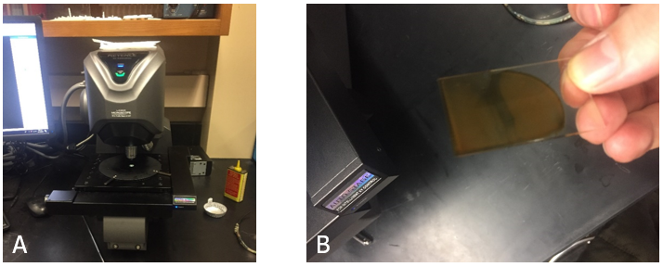
Figure 7. Keyence microscope used (A) and microscope glass slide with two droplets of emulsion (B).

3.3 Results
The results on the characterization of water in crude oil emulsions at multiple water fractions for two different crude oils and the impact of two different salts at different concentrations on emulsion stability and viscosity are presented in this section.

3.3.1 The Effect of Water Fraction
Both crude oils had similar viscosities; crude oil A had a viscosity of 62 cP and crude oil B of 70 cP. Three different water fractions were used in the creation of emulsions for both crude oils. In order to quantify the effect of salt in the aqueous phase, deionized water was used as the control value. The viscosities for 10 %, 30% and 50% water fraction are presented in Table 3.

Table 3. Emulsion viscosity at different water fraction for two types of crude oil.
Water Fraction (%) | Emulsion Viscosity (cSt)  Crude oil A | Emulsion Viscosity (cSt)  Crude oil B
10 | 92 | 84
30 | 216 | 478
50 | 454 | N/A

Relative viscosity was calculated as a function of water fraction in order to compare the difference of emulsion viscosity for both crude oils. Relative viscosity is the ratio of emulsion to crude oil viscosity; it measures the exponential increase of viscosity with the increase of water fraction. Crude oil A emulsions viscosities exhibit a semi-exponential behavior while crude oil B viscosities behaves exponentially as shown in Figure 8.

Figure 8. Relative viscosity of water in crude oil emulsions, plotted against water fraction for two different crude oils.

3.3.2 Effect of Salt in Emulsion Stability
The stability of each emulsion was measured using a centrifuge as described in the methodology section. The ratio of the separated volume over the total volume is recorded as the emulsions were centrifuged. Figure 9, 11 and 13 show the total separation of emulsions prepared with crude oil A for 10 %, 30%, and 50 % water fractions respectively. Figure 10 and 12 show the total separation for emulsions prepared with crude oil B for 10 % and 30% water fractions.
For 10 % water fraction emulsions mixed using crude oil A with NaCl or CaCl₂ added to the aqueous phase resulted in an increased in emulsion stability as shown in Figure 9. The different salt concentrations show a monotonic impact on its stability. The most stable emulsion was observed at the highest concentration for both salts. However, CaCl2 at 855 mMol/L exhibits the highest stability with less than 1 % total separation. On the other hand, emulsions formed with crude oil B with a water cut of 10 % showed the opposite trend, in which the most stable emulsions were achieved with the lowest salt concentration for both salts.

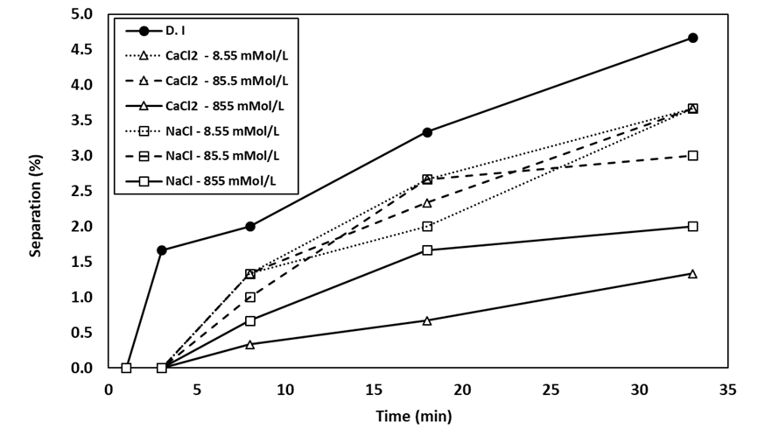
Figure 9. Separation for 10 % water fraction emulsion with crude oil A from centrifugation.

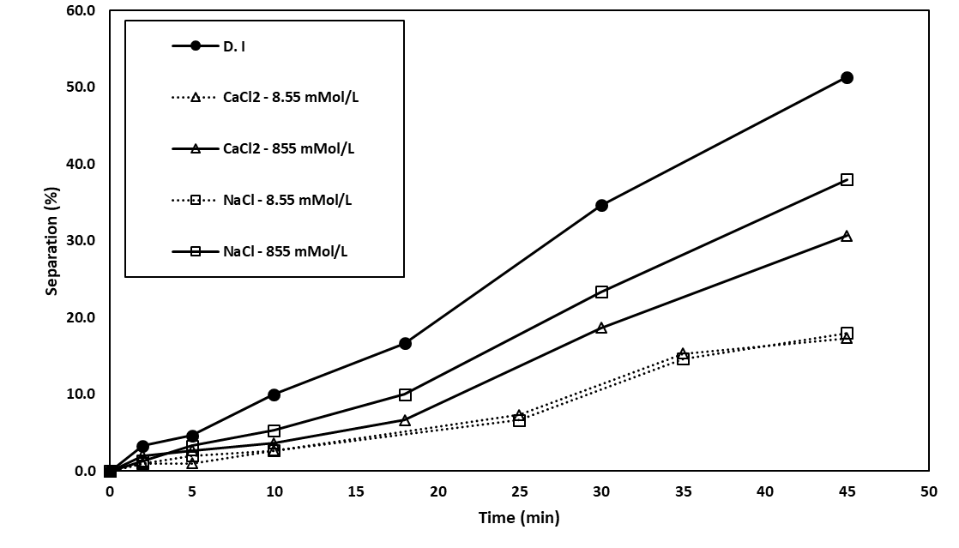
Figure 10. Separation for 10 % water fraction emulsion with crude oil B from centrifugation.

For the case of 30% water fraction emulsion, adding salt to the aqueous phase increased the stability for both crude oils. For crude oil A, the most stable emulsions were achieved with a salt concentration of 85.5 mMol/L of either salt, which reflects a non-monotonic relationship. On the contrary, crude oil B emulsions mixed using CaCl₂ were more stable for all concentrations compared to NaCl.
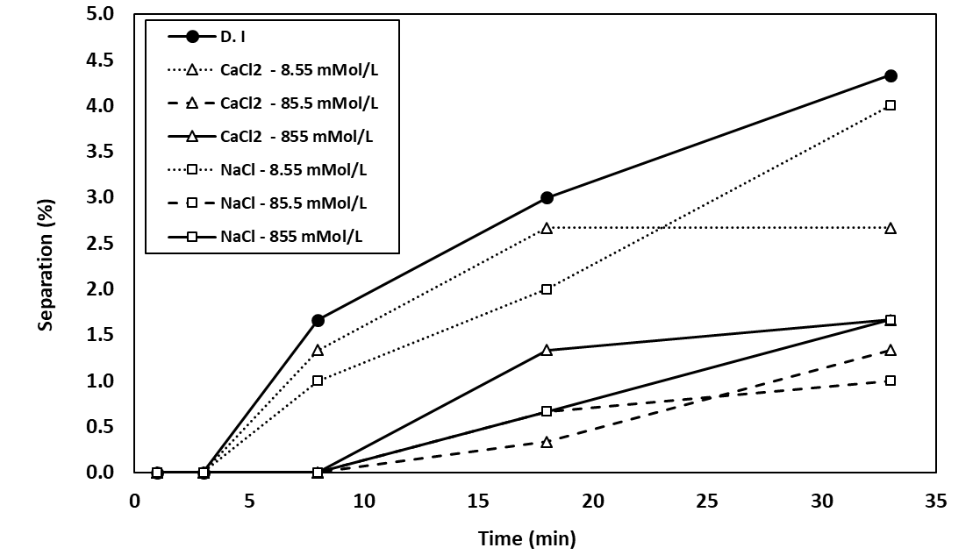
Figure 11. Separation for 30 % water fraction emulsion with crude oil A from centrifugation.

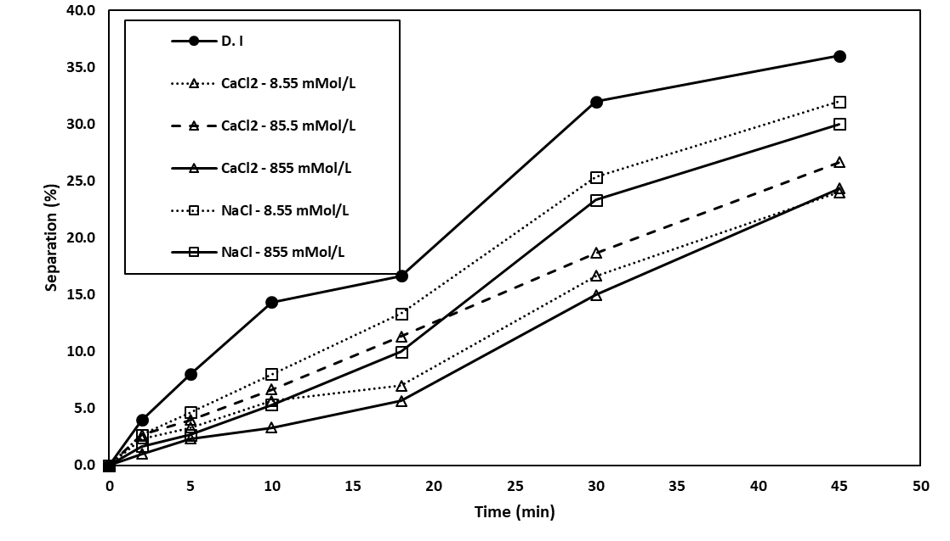
Figure 12. Separation for 30 % water fraction emulsion with crude oil B from centrifugation.

For the case of 50% water fraction for crude oil A, the presence of salt destabilized the emulsion in most cases, apart from NaCl at 8.55 mMol/L. The most unstable emulsion was recorded for the highest concentration of CaCl₂ which had a stability value of 25% compared to 5% of deionized water. Emulsions with water fraction of 50% showed an opposite trend in stability compared with 10% water cut. In the case of 50%, the most stable emulsions were achieved with the lowest salt concentration. Crude oil B emulsions showed a similar trend to the emulsion observed with crude oil A.
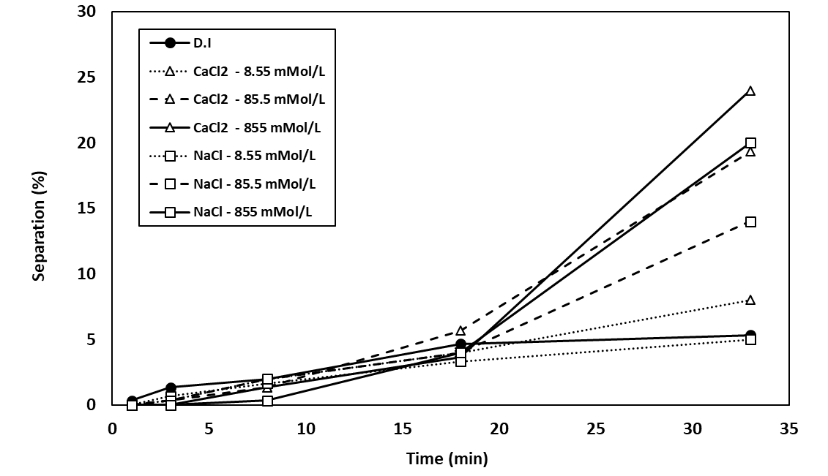
Figure 13. Separation for 50 % water fraction emulsion with crude oil A from centrifugation.

Salinity affects each emulsion system in a unique way, which makes it difficult to find general trends. It is believed that at the crude oil-water-surfactant interface the salt concentration at which the interfacial tension between the fluids and the surfactant in equal renders an optimal salt concentration which is the breaking point of the system (Zolfaghari et al. 2016). At this optimal point, it is expected to find maximum phase separation where the interfacial tension, apparent viscosity, and surfactant loss it at its lowest. However, it can be concluded from this work that each emulsion has a different optimal point which depends on different factors such as the crude oil composition and water fraction.
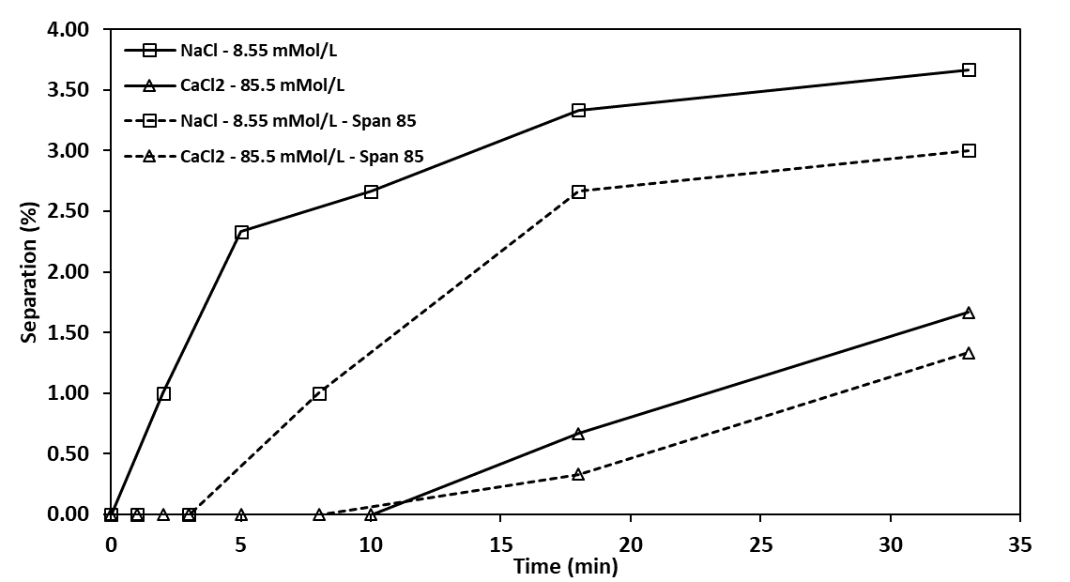
Figure 14. Effect of salt and surfactant stability on 30 % water cut emulsions with crude oil A.

The presence of ionic compounds was able to replace the need for external surfactants for the case of crude oil A. Figure 14 shows the difference in stability between emulsions with and without the addition of external surfactant. The presence of salt in the aqueous phase of the emulsions increased the stability of the emulsion by approximately 20 times more than deionized water. It is believed that the active components of the crude oil were enhanced by the presence of ions, causing the formation of stable micelles around water droplets.

3.3.3 Effect of Salt in Emulsion Viscosity
The impact of salt concentration on emulsion viscosity for both crude oils is shown in Figure 15 and 16 for crude oil A and Figure 17 for crude oil B. There is a direct positive relationship between salt concentration and viscosity in most cases. The emulsion viscosity increased significantly with higher salt concentrations in some cases, for example, CaCl₂ at 855 mMol/L at 50 % water cut showed a viscosity of more than four times its value than D.I water. However, small concentrations of salts such as the case of 8.55 mMol/L did not have a significant impact on the viscosity for crude oil A emulsions. On the other hand, crude oil B emulsions with 8.55 mMol/L concentrations of salt were able to increase the viscosity of the emulsion up to 2 times its value with D.I water for 10 % water cut. For crude oil B emulsions with a water cut of 50 % were not measurable due to instrument limitation of high viscosity range.

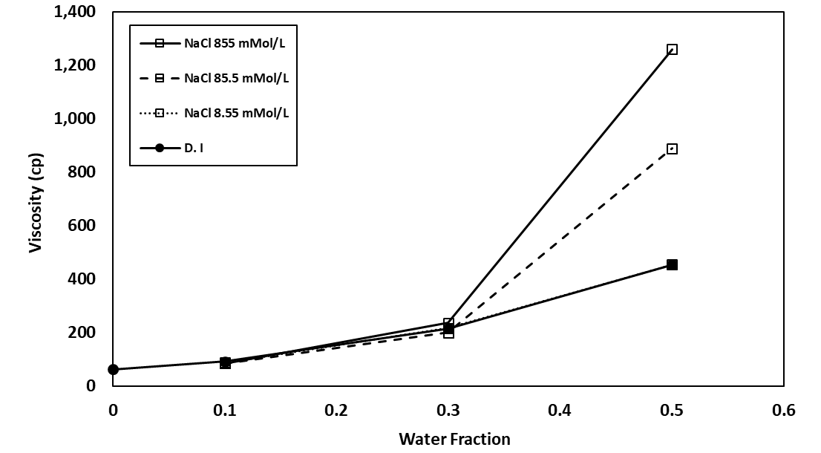
Figure 15. Impact of different NaCl concentrations on emulsion viscosity as a function of water fraction, for crude oil A.

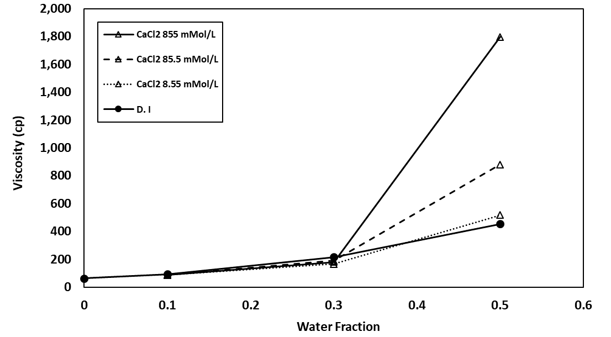
Figure 16. Impact of different CaCl₂ concentrations on emulsion viscosity as a function of water fraction, for crude oil A.

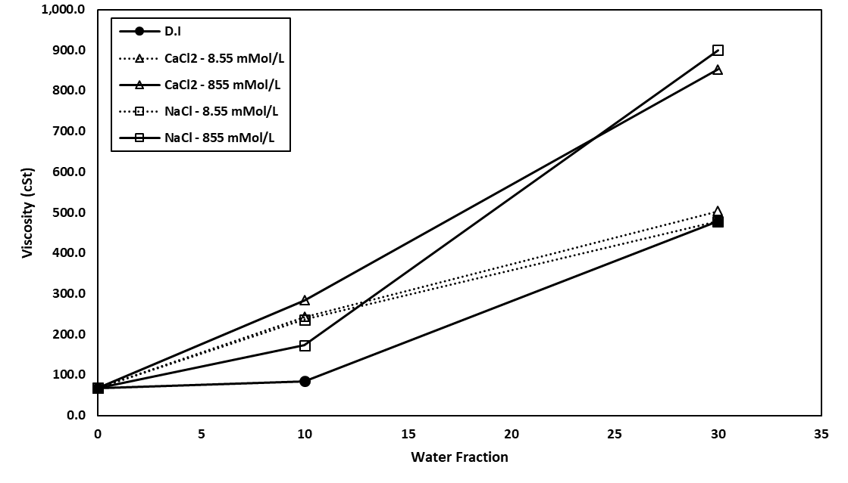
Figure 17. Impact of different NaCl and CaCl₂ concentration on emulsion viscosity as a function of water fraction, for crude oil B.
The relationship between stability and viscosity of the emulsions for crude oil A is shown in a cross plot (Figure 18). Emulsions with the highest total separation presented the highest viscosity which are the 50 % water fraction.
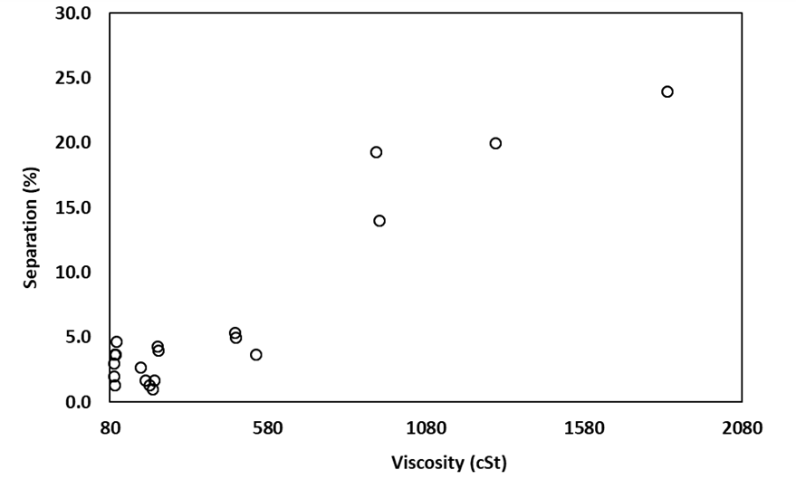
Figure 18. Separations of emulsion formed with crude oil A as a function of initial viscosity.

The viscosity change of the emulsion was monitored for several days. Changes in viscosity are commonly related to the stability of the emulsion – as the emulsion starts to separate the viscosity tends to decrease. For the case of 10 % water fraction, the viscosity did not change for most of them. The highest change was recorded for 85.5 mMol/L NaCl which experienced a change of 10 % decrease over a period of 8 days for crude oil A. In the case of 30 % water cut emulsions, the reduction on viscosity was greater than 10 % water cut. The biggest change was observed in 30 % water cut was for D.I water which decreased its viscosity by 25 %. In the case of 50 %, water fraction the biggest decreased in viscosity was recorded for the most unstable emulsion which was CaCl₂ at 855 mMol/L.
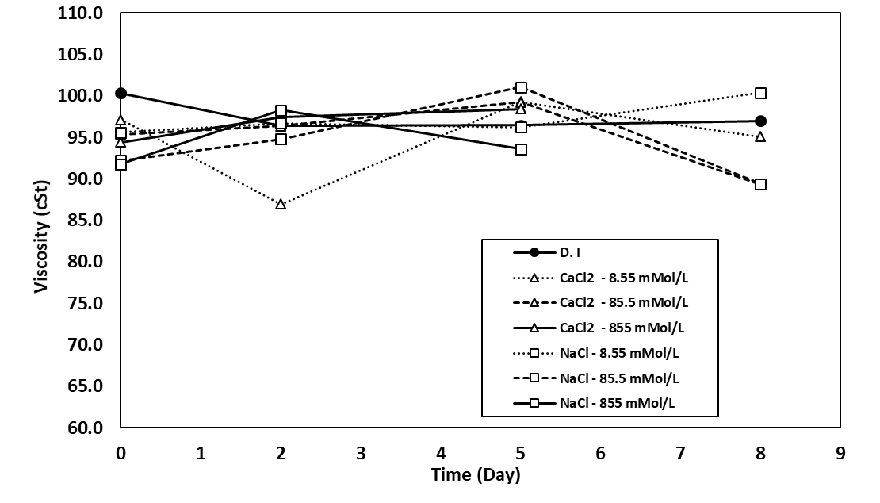
Figure 19. Viscosity change over time for 10% water cut emulsion for crude oil A.

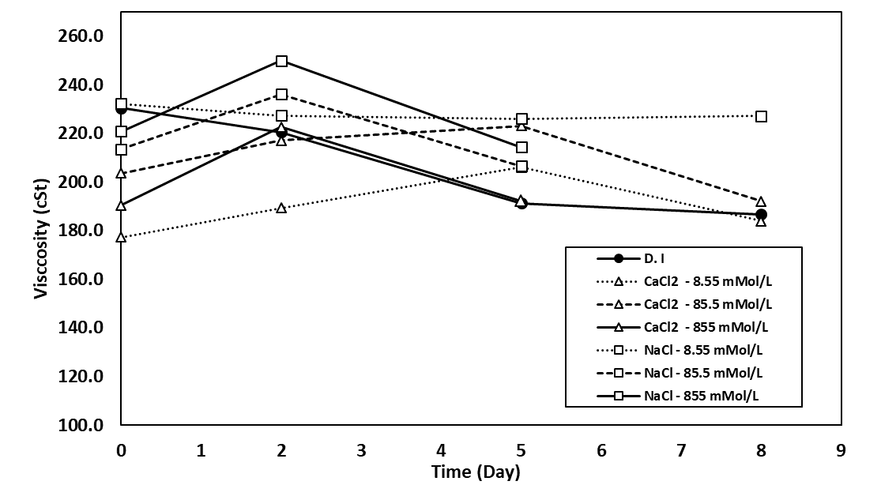
Figure 20. Viscosity change over time for 30% water fraction emulsion for crude oil A.

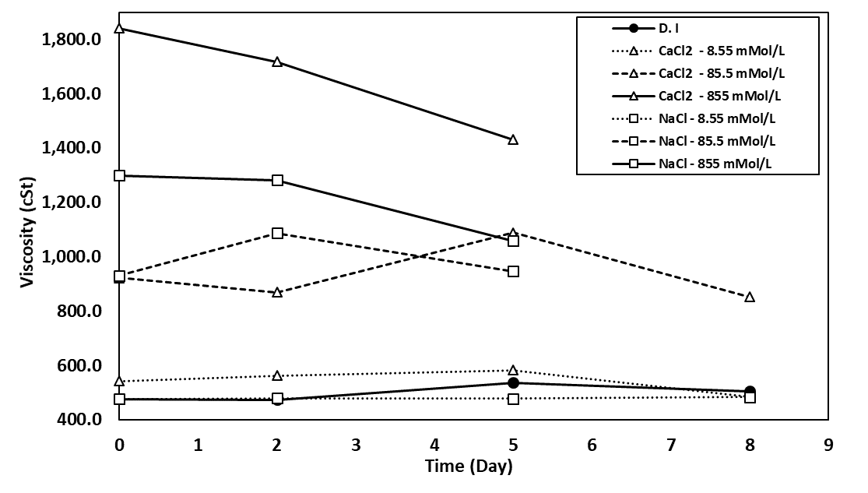
Figure 21. Viscosity change over time for 50% water fraction emulsion for crude oil A.

3.3.4 Effect of Salt on Emulsion Droplet Size Distribution
Droplet size distribution (DSD) was measured for multiple emulsions. The difference in droplet sizes can be associated with the difference in emulsion stability and viscosity. Figure 22 and Figure 23 illustrate the effect of centrifugation on emulsion DSD for 30 % and 50 % water cut for crude oil A. The droplet sizes of water increased as the emulsion was subject to centripetal force.
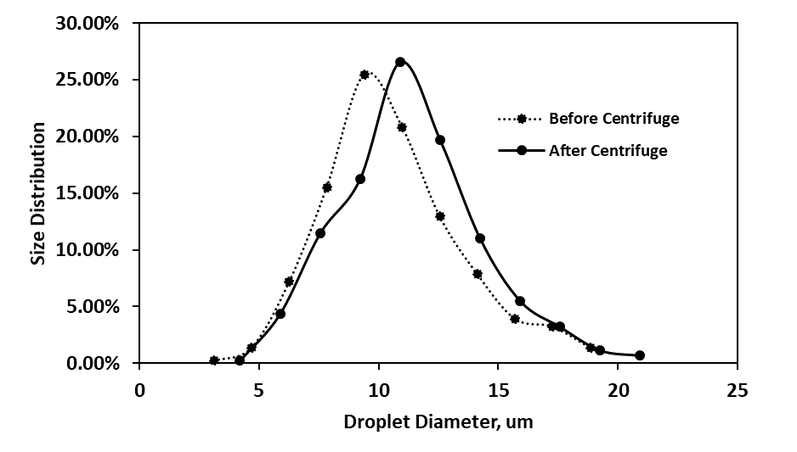
Figure 22. The effect of centrifugation on droplet size distribution for 50 % water fraction emulsion formed with crude oil A.
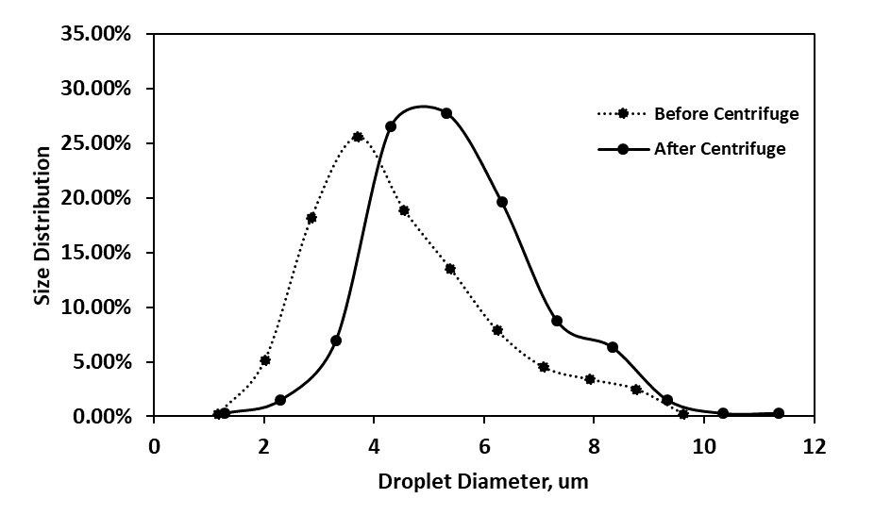
Figure 23. The effect of centrifugation on droplet size distribution for 30 % water fraction emulsion formed with crude oil A.

DSD was measured for the emulsion with the greatest change in viscosity and separation in comparison with D.I water in the case of emulsions created with crude oil A. CaCl₂ at 855 mMol/L for 50% water cut experienced an increase of viscosity of almost 3 times and was 4 times more unstable than the case of 50% D.I water. It is evident that that DSD has a wider range of droplet sizes which could be explained by the increase in viscosity and the bigger droplets sizes account for the decrease in stability.
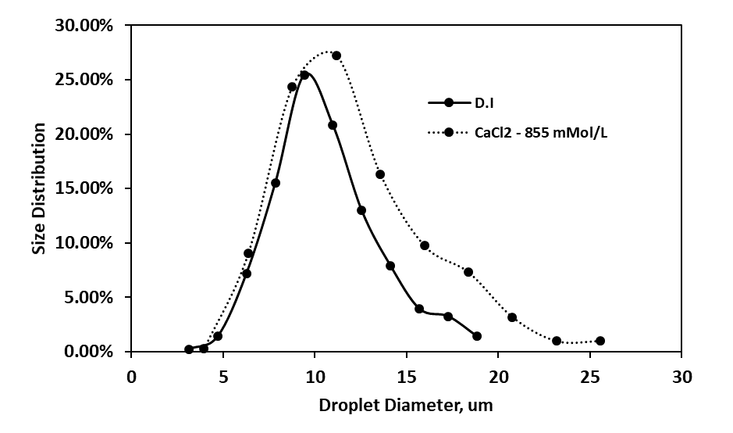
Figure 24. The influence of CaCl₂ in droplet size distribution for a 50% water fraction emulsion formed with crude oil A.

In the case of crude oil B emulsions mixed with CaCl₂ brine were chosen for DSD measurements due to its similarity with NaCl emulsion in terms of viscosity and stability. The changes in DSD for three different water cut emulsions with CaCl₂ at a concentration of 8.55 mMol/L is shown in Figure 25. The DSD shifts to right as we expected since the viscosity is the major change between these three emulsions. The DSD for 50% water cut was the widest in terms of range since it was the most viscous emulsion.
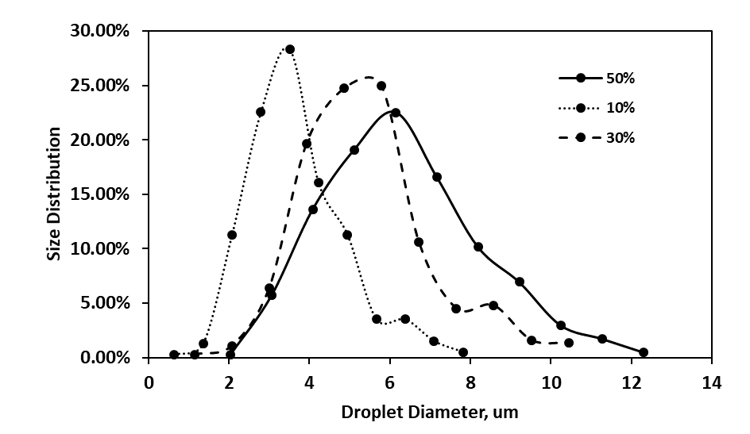
Figure 25. Change in droplet size distribution for three different water fraction emulsions mixed with CaCl₂ brine with a concentration of 8.55 mMol/L.

In order to assess the change in DSD based on salinity three emulsions with different concentration of CaCl₂ at the same water cut were measured. Figure 26 shows the effect of salinity on DSD on a 30 % water cut emulsions prepared with crude oil B. Once again, the emulsion with the highest viscosity had the widest range of droplet size distribution. At high enough ionic strength concentrations in the water, brine droplets increase their size sooner due to coalescence and aggregation making the emulsion more unstable.
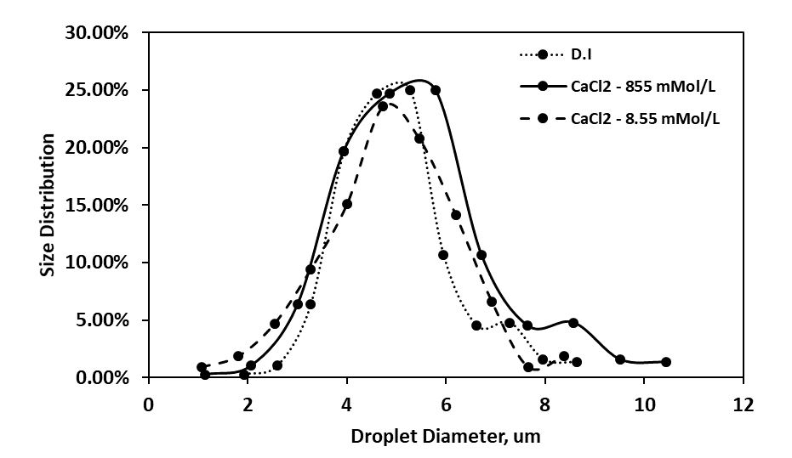
Figure 26. Droplet size distribution change for 30% water fraction at two different CaCl₂ concentrations.

The observed change in emulsion viscosity and in emulsion stability can be due to multiple reasons. First, the hydrodynamic interaction between water droplets increases as the mean droplet size increases causing the distance between the water droplets to decrease. Second, the tendency of droplets to flocculate could be due to van del Waals attraction forces between the droplets and Brownian collision between particles as they get bigger.

3.3.5 Discussion
Multiple studies suggested that there is an optical ionic strength for each brine-oil system in which the interfacial tension decreases to an optimal value. The interfacial tension decreases as the salt concentration increases until it reaches a minimum value and then as the salt concentration keeps increasing the interfacial tension increases. Moeini et al. (2014) claims as the salt concentration increases below the ideal level of the system, the polar components heads in the crude oil are ionized. This ionization of the water-oil interface results in lower interfacial tension due to a higher concentration of surfactant in the interface. On the other hand, as the salt concentration of the system increases beyond the optical level the droplets of the disperse phase are not able to withhold the polarity and charge of surfactant or ions. Consequently, the surfactant concentration in the interface is reduced. The increase of salt concentration above the optimal ionic strength is commonly called the salt out effect. Additionally, beyond the salt of effect, the hydrophilic head charge of the surfactant is reduced as a result of the high salinity concentration (Cao, et al., 2012).
The increase in viscosity of the emulsion is due to the presence of ions and its interaction with hydrophilic groups. There are two main theories that might explain this behavior. First, the interaction of the salt ions with the polar components of the crude oil. Second, the ions might change the orientation of the polar groups through modification of the environment. Some studies suggested that NaCl could modify the solution by polar forces such as monopole-dipole and monopole-monopole (Chattopadhyay et al., 1992). Finally, the distribution of anions or/and cations at the droplet interface is different for each system. Thus, the viscosity of the emulsion will increase when the ions of the salt change the density of the surface acting components at the micelle, making droplets closer together creating more viscous solutions.
Ion micelle interaction is a complex topic to understand, based on the results obtained in this study. It is believed that for crude oil A the micelle is composed by a polar group, in this case, the external surfactant used. On the other hand, in crude oil B the micelle is composed of charged groups in this case the active components of the crude oil. The interaction between these polar/non-polar groups with the salt ions is unique to each system. These ions are repelled or attracted to the micelle based on their charge. Ions with the same charge as the micelle will are repelled, decreasing their concentration in the micelle. On the contrary ions with an opposite charge from the micelle are attracted, increasing their concentration in the micelle (Umebayashi et al., 2006).

3.4 Conclusion
The work presented in this chapter quantifies the effect of two different types of salt at multiple concentrations dissolved in water on the stability and rheology of water in crude oil emulsions. The following conclusion can be drawn from the presented study:
- At high water fraction, salt concentration tends to destabilize the emulsion, while at low water fraction salt can stabilize the emulsion.
- Non- monotonic trends in emulsion stability were observed for both crude oils at 30 % water fraction.
- The presence of salt in the water yields higher viscosity values for all water cuts studied. At higher water cuts and high salt concentration, the effect on the viscosity increase was greater.
- The viscosity did not change significantly over several days, the greatest decrease was observed for higher water cut emulsions.
- The most stable emulsions resulted in the smallest mean for the droplet size distribution, while unstable emulsions can be related to bigger droplet sizes.

IV METHODS FOR ARTIFICIAL LIFT OF WATER IN OIL EMULSIONS

4.1 Introduction
Most reservoirs’ production rates tend to decline as the pressure inside the reservoir decreases. Artificial lift methods are commonly used to maintain production or increase current production rates. Gas lift and electrical submersible pumps are two commonly used artificial lift methods. The use of these artificial lift methods can result in the mix of brine and crude oil resulting in viscous emulsions. Emulsions can decrease pressure drawdown, ultimately decreasing production rates and shortening the life expectancy of the equipment.
The present chapter discusses the behavior of water in crude oil emulsions in artificial lift systems, primarily using gas lift. Methods and systems for both gas lift and ESP were analyzed to improve and simplify gas lift operations of water in crude oil emulsions. The current work is based on preliminary results that indicate gas injection will reduce the viscosity of water in crude oil emulsions. Additionally, the present disclosure quantifies the effect of a centrifugal pump in the emulsion formation.
Limited literature review is available regarding these topics. Mohmoosdian et al. (2007) studied the gas effect on water in crude oil emulsion in a P.V.T cell. He concluded that higher gas volumes injected into the emulsion, decreasing the separation time of the emulsion. On the other hand, few studies have been made in the effect of ESPs on the formation and behavior of water in oil emulsions. Donato (2016) studied the effect of a commercial 8 stages ESP in the formation of water in mineral oil emulsions at different water fractions. Through a droplet size distribution study, he concluded that ESPs are capable of forming stable emulsions.
As described in the following sections, a stable synthetic water in crude oil emulsion was created in the laboratory. The crude oil used is from a well in Midland County, Texas. In order to obtain a stable emulsion, an emulsifier agent was used (Span – 85). The emulsion formation was achieved using a high-speed homogenizer, IKA Ultra- Turrax. The results of this study indicate that water in crude oil emulsions can be destabilized and subsequently decrease its viscosity under gas injection. Additionally, a centrifugal pump is capable of forming emulsions at low water fractions.

4.2 Methodology

4.2.1 Materials
Water in crude oil emulsions was created using dead crude oil, deionized water, and a synthetic surfactant used for emulsification. The crude oil was obtained from a wellhead in Midland, Texas. Some physical properties of the crude oil are its density of 0.884, g/cc and viscosity of 19 cP at room temperature. The deionized water has a density of 0.997 g/cc and viscosity of 1 cP at room temperature. The surfactant used was a non-ionic Span-85 provided by Sigma Aldrich; its molecular weight is 957 g/mol and Hydrophile-Lipophile Balance value is 1.8. The composition of the gas injected was pure ethane for the ethane injection and 78% nitrogen, 21 % oxygen, and 1 % other gases for the air injection.

4.2.2 Emulsion Mixing for Gas Exposure
Emulsions were formed by mixing known amounts of crude oil with 1% surfactant by weight of total emulsion volume. Deionized water was introduced to the mixture while being stirred for 30 seconds at 10000 rpm. Finally, an IKA Ultra-Turrax homogenizer was used for 2 minutes at 20000 rpm to mix the mixture. After mixing and obtaining a stable emulsion, its viscosity and stability was measured. Cannon Fenske capillary viscometers were used for viscosity measurements and test tubes were used to determine stability. Afterward, the water in oil emulsion was exposed to gas ( Figure 27).
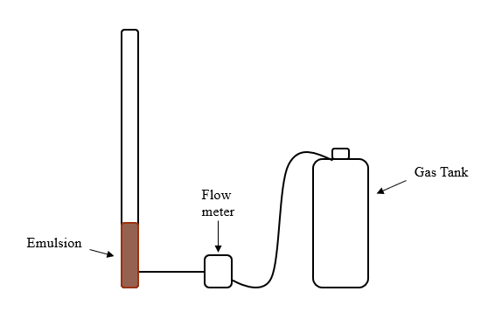
Figure 27. Schematic diagram of the gas lift setup.

4.2.3 Emulsion Mixing using a centrifugal pump
Emulsions were formed using a conventional centrifugal pump. Crude oil and deionized water were introduced to the inlet of the pump at desired rates( Figure 28). Two D-series syringe ISCO pumps were used along two accumulators filled with crude oil and deionized water to inject desire liquid ratios. Crude oil was mixed with the surfactant before mixing. After mixing the emulsions, viscosity was measured using Cannon Fenske capillary viscometers and stability was measured using test tubes.

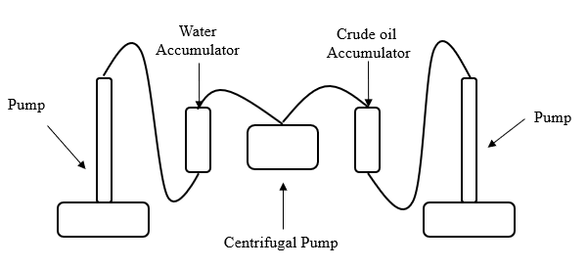
Figure 28. Schematic diagram of emulsion mixing using a centrifugal pump.

4.2.4 Emulsion Stability Determination
In order to measure the stability of water in crude oil emulsions, test tubes were used to measure the phase separation between the fluids. In this study, the separation was defined as the percentage of the volume of water and crude oil divided by the total volume of the emulsion.

4.3 Results and Analysis
Results are presented in two sections. The first portion contains the results obtained on the effect of gas injection on the stability and viscosity of water in crude oil emulsions. The second portion contains the results of water in crude oil emulsions mixing using a centrifugal pump.

4.3.1 Gas Injection Effect on Emulsions
Six different water fractions were used to created emulsions; its range was from 30 % to 65 %. Emulsions were exposed to gas injection in a vinyl tube in order to simulate gas injection in a wellbore. Multiple gas injection rates and times of exposure were tested. The range of gas rate used was from 2 L/min to 15 L/min. The range of time injection was from 3 min to 15 min. The optimal gas injection rate and time was determined to be 5 L/min for 8 minutes, since there was no evidence that higher times and rates had an effect on higher emulsion viscosity change. These parameters were experimentally identified as ideal since the effect on the emulsion was quantifiable. The change of viscosity at different gas injection times and gas rates is shown in Figure 29 for a 30% water cut emulsion.
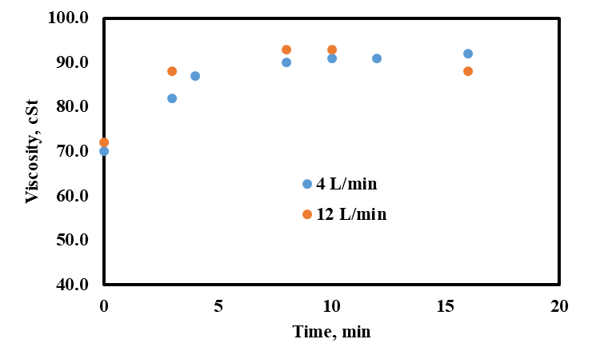
Figure 29. Observed effect of viscosity change in a 30% water fraction emulsion for different gas rates and times of exposure.

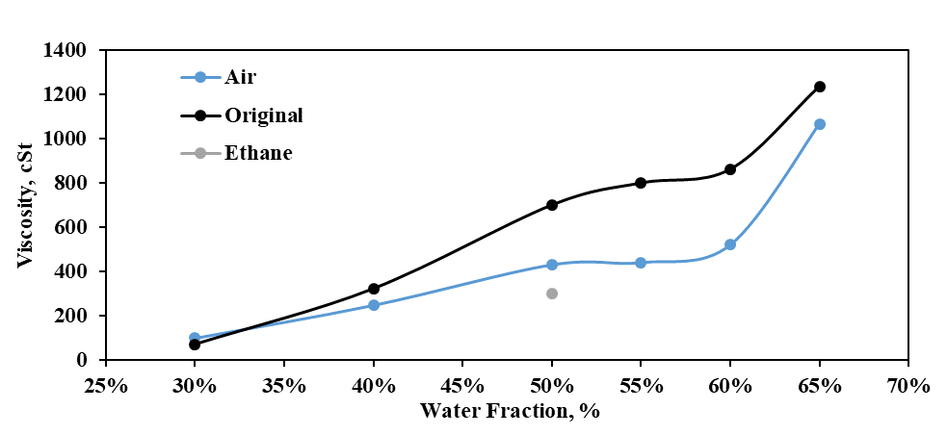
Figure 30. Change in kinematic viscosity of emulsions at different water fractions.

Emulsion viscosity was measured before and after gas exposure. Figure 30 shows the changes in viscosity of different water fractions. It was observed that emulsions with water fractions below 35% experienced an increase in viscosity after gas injection. Viscosity increased by 28% for a 30 % water cut emulsions after gas injection. On the contrary, emulsion viscosity at greater water fraction decreased. The biggest change in viscosity was recorded at 55% water fraction with a decrease of almost 50 %. Furthermore, the impact of the injection of different gases was explored such as the injection of ethane. The resulted viscosity change due to ethane was greater than air injection, however, it was only tested for one water fraction. Ethane reduced the viscosity of a 50 % water fraction emulsions by 57%, 16 % more than air injection.
In order to corroborate the lasting effect of gas exposure in emulsion viscosity, its change was recorded over a period of 24 hours of exposure (Figure 31). The viscosity change for air and ethane injected emulsions was minimum during a twenty-four hours period which demonstrates the lasting effect of the gas injection.

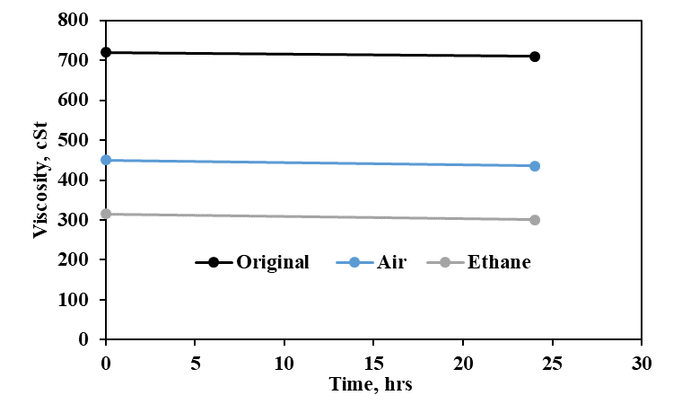
Figure 31. Viscosity change of 50% water fraction in emulsion exposed to two different gases.

For the purpose of validating the effect of gas injection, stability was measured. Stability was measured for 55 %, 60 % and 65 % water fraction emulsions before and after air injection( Figure 32). The stability of the emulsions after twenty-four hours before air injection was similar for all water cut emulsions. However, the separation was greater after gas exposure for all three water fractions. The lowest water fraction in which stability was measured exhibited the greatest change in separation after gas exposure, following the same trend as viscosity. Water in crude oil emulsion viscosity tends to decrease as its stability decreases. It is believed that gas injection affects the interfacial film between the water droplets and the crude oil interface, since it is the only way to destabilized emulsions. Certain water droplets are believed to coalesce as gas is injected, therefore decreasing viscosity and destabilizing the emulsion.
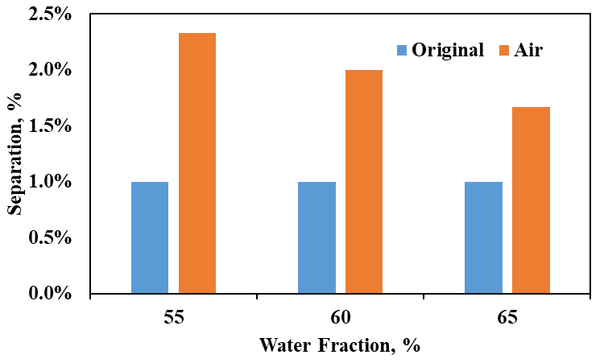
Figure 32. Stability of three different water in crude oil emulsions, before and after gas exposure.

Studies performed with non-ionic surfactants, like the one used in this study, suggest that the presence of gas might degrade the effectiveness of the surfactant due to oxidation of some of its components. Karthikeyan and Ranjith (2007) studied the effect of oxidation processes in anionic and non-ionic surfactants and concluded that after 75 min of exposure, the non-ionic surfactant was able to degrade by 90 %.
Flow simulations were performed using a commercial software used in the oil and gas industry (PipeSim) to quantify the effect on crude oil production in a vertical well. The correlation of Hagedorn and Brown was used by the software to predict flow rate based on the provided data. Hagedorn and Brows is an experimental correlation based on experimental data conducted in 1500 ft well with multiple pipe diameters and fluid viscosities. The equation of state used to account for fluid properties change was Beggs and Robinson. Beggs and Robinson is an empirical correlation to determine the viscosity of crude oil.
The well schematic used in the flow simulations is shown in Figure 33. A conventional 10,000 ft vertical well was used in the simulation with a production tubing ID of 3 in and a roughness of 0.001 in ( Figure 33). The bottom hole pressure of the well was set to 3500 psi and the outlet pressure at the wellhead at 200 psi for all simulations. The fluids used in the simulation match the crude oil used in our experimental study by having a density of 0.884, g/cc and viscosity of 19 cP at room temperature. The emulsions used in the simulation have the same rheological properties as the ones created in the experimental portion. Four different simulations were done for each water fraction used in the experimental portion. The first simulation included the daily production achieved with only the pressure difference and the driving mechanism. The second simulation included the addition of an artificial lift method, an electrical submersible pump (ESP). On the third simulation, the artificial lift method used was changed to gas lift. The last simulation scenario included both gas lift and ESP as the artificial lift methods used.
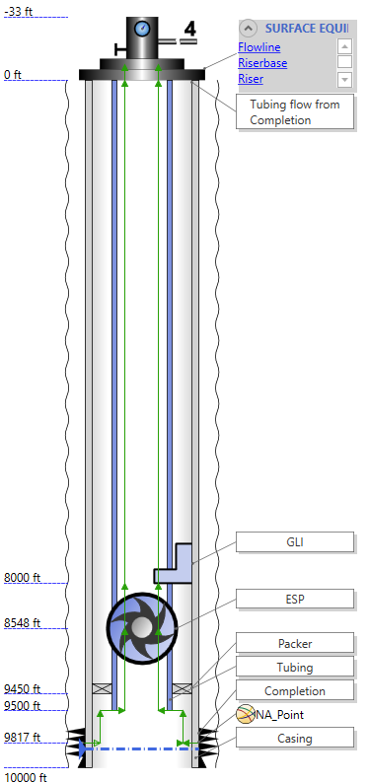
Figure 33. Well schematic used in water in crude oil emulsion flow simulations.

The liquid production difference for a 50% water cut emulsion with two different values of viscosity can be seen in Figure 34. The reduction of viscosity of the emulsion due to gas injection can be seen with an increase of production. This is due friction reduction needed to move the liquid, for less energy is required with lower viscosity values.

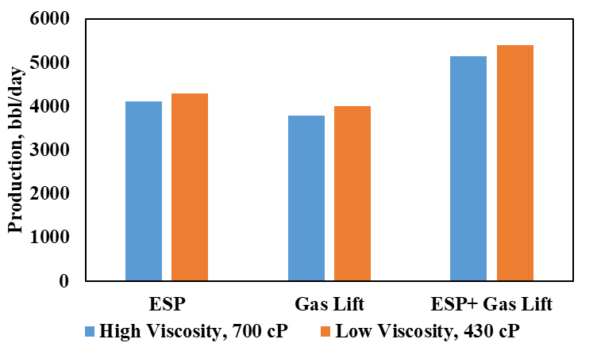
Figure 34. Production summary of software simulation for 50 % water fraction emulsion.

4.3.2 Impact of Centrifugal Pumps in Emulsions
Electrical submersible pumps are mainly composed of multiple centrifugal pumps lined in a parallel manner. In this study, we used a single centrifugal pump to study the mixing effect in water in crude oil emulsions at different water fractions. The centrifugal pump used had a variable speed range from 90 to 9000 rpm with 0.13 horsepower. The used ten different speeds were spread evenly within the range of the pump. None of the speeds were able to achieve the formation of a water in oil emulsion as stable and viscous as the homogenizer used in the gas lift experiments. The most stable and viscous emulsions were achieved at the highest speed of the centrifugal pump. At low water fraction, the emulsion is similar at the ones created with the homogenizer. However, as the water fraction of the emulsion increases, the gap difference increases. The results of the viscosity as a function of water fraction can be seen in Figure 35.
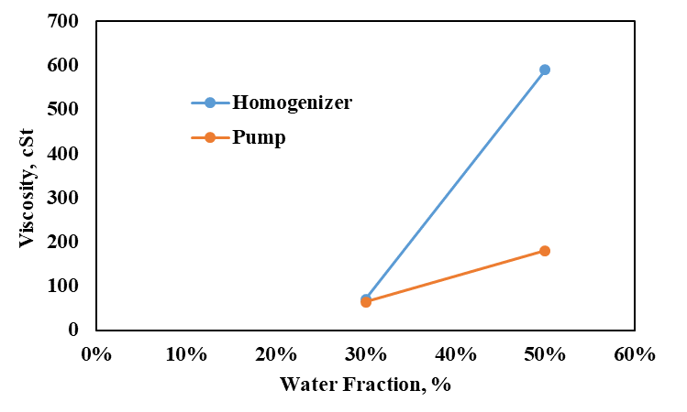
Figure 35. Effect of mixing in different water cut emulsions.

High shear is required to achieve the necessary mechanical energy to break the disperse phase into small enough droplets to achieve emulsification. The homogenizer IKA Ultra-Turrax is able to produce high shear forces in comparison to the centrifugal pump used. This is due to the high circumferential speed used and the minimal gap between the stator and rotor (Figure 36).

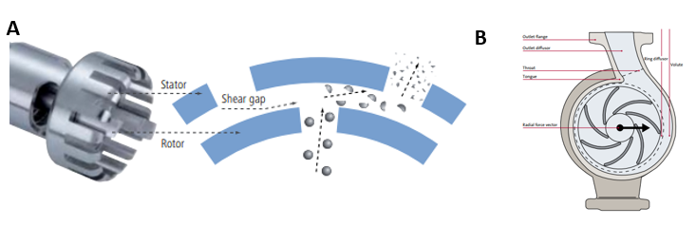
Figure 36. Function principle of the dispersing tool of the IKA T18 mixer (A) (IKA Works manual, 2018) and operating principle of the centrifugal pump (B) (Grundfos, 2018).

4.4 Conclusion
The work presented in this chapter explores the effect of gas injection and a centrifugal pump in the formation, viscosity, and stability of water in crude oil emulsions. According to the presented results, the following conclusions were drawn:
- Gas injection reduces the viscosity of water in crude oil emulsions when the water fraction is higher than 35%. Otherwise, it could increase the viscosity at lower water fractions.
- Ethane gas injection was more effective than air in decreasing the emulsion viscosity for 50% water fraction.
- The optimal gas rate for our system was determined to be 5 L/min and the optimal time of exposure was 8 minutes.
- Centrifugal pumps are capable of creating emulsions due to its high revolution speed. However, the stability or viscosity is not comparable to emulsions created with the IKA Ultra-Turrax homogenizer.

V CONCLUSIONS AND RECOMMENDATIONS

5.1 Conclusion
The rheology and stability of water in crude oil emulsions were measured and characterized over various scenarios. First, the effect of different salt concentrations in the aqueous phase was quantified. Second, the impact of gas lift on emulsion was studied. Third, the formation of emulsion using a variable speed centrifugal pump was reported. The following conclusion can be made from the brine effect on emulsions:
- At 50% brine fraction, salt concentration tends to destabilize the emulsion, while at 30% and 10% brine fraction, salt can stabilize the emulsion for both crude oils. Non- monotonic trends in emulsion stability were observed for both crude oils at 30% water fraction.
- The presence of ions in the aqueous phase of emulsions enhances the viscosity of emulsions. The highest viscosity recorded was at 50% water cut for both salts at 855 mMol/L salt concentration.
- The most unstable emulsion exhibits a greater decrease in viscosity over a period of 8 days.
- The presence of ionic compounds in the water can stabilize the emulsion without the need for external surfactant as it was the case of crude oil A.
- Emulsion stability decreases with an increase in mean droplet size diameter.
- Higher emulsion viscosities exhibit a wider range in droplet size distribution while emulsion with lower viscosity exhibits a monosized behavior curve.
The following conclusion can be made from gas injection effect on emulsions:
- Air injection reduced the viscosity of water in crude oil emulsions when the water fraction was higher than 35% while at lower water cut the viscosity increased.
- Ethane gas injection was more effective than air in decreasing the emulsion viscosity for 50% water fraction.
- The optimal gas injection rate for the downscaled system was determined to be 5 L/min and the optimal time of exposure was 8 minutes.
- The viscosity changed due to gas injection was maintained over a period of 25 hours.
- Emulsion stability was reduced during gas injection. The emulsion that exhibited the greatest change in stability was 55% water fraction in which the stability decreased by half its original value.
The following conclusion can be made from the formation of emulsions with a centrifugal pump:
- Centrifugal pumps are able to provide sufficient mixing to create emulsions. Pumps with higher revolution speed achieved more stable emulsions.
- Low water fraction emulsion required less energy to be formed and emulsions mixed with a centrifugal pump or high-speed homogenizer exhibit similar rheological properties.

5.2 Recommendation
The following recommendations are recommended for the non-monotonic effect of salinity on water in crude oil emulsions study:
- Investigate the interaction of surface acting components of the crude oil with the ionic compounds of salt in relation to emulsion stability and rheology.
- Study the effect of higher salt concentration and different ions in emulsion stability and rheology.
- Use a wider range of crude oil types in order to determine the effect of crude oil composition in the stability and rheology of crude oil emulsions.
The following recommendations are recommended for gas lift of water in crude oil emulsions:
- Investigate the effect of gas injection in emulsions using crude oils with different chemical properties to create the emulsions
- Study the effect of higher gas rates in emulsions in order to simulate rates used in the oilfield.
- Explore the effect on different types of gases on emulsions stability and rheology.
The following recommendations are recommended for the formation of emulsions using a centrifugal pump:
- Investigate the formation of emulsions under different number of centrifugal pump stages.
- Use a wider range of crude oil types in order to determine the behavior of emulsions.
- Study the effect of higher mixing rates in the stability and rheology of emulsions.

References
Almeida, T. C., Larentis, A. L., & Ferraz, H. C. (2015). Evaluation of the Stability of Concentrated Emulsions for Lemon Beverages Using Sequential Experimental Designs. PLoS One, 10.
Al-Yaari, M., Hussein, I. A., Al-Sarkhi, A., Abbad, M., & Chang, F. (2013). Pressure Drop Reduction of Stable Emulsions: Role of Aqueous Phase Salinity. Saudi Arabia Section Technical Symposium and Exhibition. Al-Khobar, Saudi Arabia: SPE.
Arirachakaran, S., Oglesby, D. K., Malinovsky, M. S., Shoharn, O., & Brill, J. P. (1989). An Analysis of Oil/Water Flow Phenomena in Horizontal Pipes. SPE Production Operations Symposium (pp. 155-170). Oklahoma City: SPE.
Bellary, S. A., Siddique, M. H., Samad, A., & Sangwai, J. S. (2017). Effects of crude oil-water emulsions at various water-cut on the performance of the centrifugal pump. Int. J. Oil, Gas and Coal Technology, 71-88.
Borja, H., & Castano, R. (1999). Production Optimization by Combined Artifical Lift Systems and Its Application in Two Colombian Fields. Latin American and Carribbean Petroleum Engineering Conference. Caracas: Society of Petroleum Engineers .
Brandal, O., Hanneseth, A. D., Hemmingsen, P. V., Sjoblom, J., Kim, S., Rodgers, R., & Marshall, A. (2006). Isolation and Characterization of Naphthenic Acids from a Metal Naphthenate Deposit: Molecular Properties at Oil‐Water and Air‐Water Interfaces. Journal of Dispersion Science and Technology , 295-305.
Brooks, B., & Richmond, H. (1991). Dynamic of Liquid-Liquid Phase Inversion Using Non-ionic Surfactants. Colloid and Surfaces, 131-148.
Cao, Y., Zhao, R., Zhang, L., Xu, Z., Jin, Z., Luo, L., & Zhao, S. (2012). Effect of electrolyte and temperature on interfacial tensions of alkylbenzene sulfonate solutions. Energy Fuels, 2175– 2181.
Chattopadhyay, A., Ghaicha, L., Shah, D., & Oh, S. (1992). Salt Effects on Monolayers and Their Contribution to Surface Viscosity . The Journal of Physical Chemistry, 6509-6513.
Daaou, M., & Bendedouch, D. (2012). Water pH and surfactant addtion effects on the stability of an Algerian crude oil emulsion. Journal of Saudi Chemical Society, 333-337.
Dalmazzone, C., Noik, C., & Komunjer, L. (2005). Mechanism of Crude-Oil/Water Interface Destabilization by Silicone Demulsifiers. Society of Petroleum Engineers.
Donato, M. (2016). Experimental Study of Water-Oil Two-Phase Flow in an 8-Stage Electrical Submersible Pump. Campinas: Universidade Estadual de Campinas.
Dresel, E., & Rose, A. (2010). Chemistry and Origin of Oil and Gas Well Brines in Western Pennsylvania. Pennsylvania Geologoical Survey.
Economides, M. J., Hill, D. A., Economides, E. C., & Zhu, D. (2013). Petroleum Prodction Systems - Second Edition . Westford: Prentice Hall.
Gafonova, O. V., & Yarranton, H. W. (2001). The Stabilization of Water-in-Hydrocarbon Emulsions by Asphaltenes and Resins. Journal of Colloid and Interface Science, 469-478.
Gomez, S., Mansi , M., & Fahes, M. (2018). Quantifying the Non-Monotonic Effect of Salinity on Water-in-Oil Emulsions towards a Better Understanding of Low-Salinity-Water/Oil/Rock Interactions. Abu Dhabi International Petroleum Exhibition & Conference, 12-15 November, Abu Dhabi, UAE. Abu Dhabi: Society of Petroleum Engineers.
Griffin, W. (1949). Classification of surface-active agents by HLB. J. Soc. Cosmet, Chem, 311-326.
Grondfos. (2018, October 22). The Centrifugal Pump. Retrieved from Grundfos: http://machining.grundfos.com
Henríquez, C. J. (2009). W/O Emulsions: Formulation, Characterization and Destabilization. Technischen Universität Cottbus zur Erlangung, Caracas.
ICI Americas Inc. (1984). The HLB System: A Time-saving Guide to Emulsifier Selection. Wilmington, Delaware: CHEMMUNIQUE.
Johnsen, E. E., & Ronningsen, H. P. (2003). Viscosity of ‘live’ water-in-crude-oil emulsions: experimental work and validation of correlations. Journal of Petroleum Science and Engineering , 23-36.
Jones, T. J., Neustadter, E. L., & Whittingham, K. P. (1978). Water-In-Crude Oil Emulsion Stability And Emulsion Destabilization By Chemical Demulsifiers. Journal of Canadian Petroleum Technology, 100-108.
Jones, T. J., Neustadter, E. L., & Whittingham, K. P. (1978). Water-in-crude oil emulsion stability and emulsion destabilization by chemical demulsifiers . Jcpt.
Karthikeyan, S., & Ranjith, P. (2007). Degradation Studies on Anionic and Non-Ionic Surfactants by Ozonation . Journal of Industrial Pollution Control, 37-42.
Kilpatrick, P. K. (2012, May 30). Water-in-Crude Oil Emulsion Stabilization: Review and Unanswered. Energy & Feuls, 26(7), pp 4017–4026. doi:10.1021/ef3003262
Kokal, S. L. (2005). Crude Oil Emulsions: A State-Of-The-Art Review. Society of Petroleum Engineers.
Kumari, A. (2016). Brief Information About Non-Newtonian Fluids and Their Properties. Retrieved from Buzzle: http://www.buzzle.com/articles/brief-information-about-non-newtonian-fluids.html
Mahmoodian, H., Fasih, M., Moosavi, M., Nalchi, M., Ghalyagizadeh, R., Farkhani, D., . . . Arzpayma, A. (2007). Study of Emulsion Problem Due to Gaslift and Choose Optimum Gas Rate and Suitable Type and Rate of Demulsifier. R. I. P. I. - E&P - P. V. T. Departament .
Malkin, A. Y., Rodionava, G., Simon, S., Iiyin, S. O., Arinina, M. P., & Kulichikhin, J. (2016). Some Compositional Viscosity Correlations for Crude Oils from Russia and Norway . Moscow: Institute of Petrochemical Synthesis, Russian Academy of Sciences.
Maodong, X., Jianzhong , J., & Xiaomei , P. (2018). Novel Oil‐in‐Water Emulsions Stabilised by Ionic Surfactant and Similarly Charged Nanoparticles at Very Low Concentrations. Angewandte Chemie, 7738-7742.
McLean, J., & Kilpatrick, P. (1997). Effects of asphlatene aggregation in model heptane-toluene mixtures on stability of water-in-oil emulsions. Colloid Interface, 23-34.
Mohammed, S. (2009). Characterization and Rheology of Water-in-Oil Emulsion from Deepwater Fields. MSc. Thesis, Rice University, Department of Chemical Engineering, Houston.
Mooney, M. (1951). The Viscosity of a Concentrated Suspension of Spherical Particle. Journal of Colloid Science, 6, pp 162-170.
Moradi, M., Alvarado, V., & Huzurbazar, S. (2011). Effect of Salinity on Water-in-Crude Oil Emulsion: Evaluation through Drop-Size Distribution Proxy. Energy & Fuels, 260-268.
Ngai, T., & Bon, S. A. (2014). Particle-Stabilized Emulsions and Colloids: Formation and Applications. Cambridge, UK: The Royal Society of Chemistry.
Pal, R. (1996). Effect of Droplet Size on the Rheology of Emulsions . AIChE Journal, 3181-3190.
Pal, R., Yan, Y., & Masliyah, J. (1992). Emulsions Fundamentals and Application in Petroleum Industry. Washington: Schramm L.L.
Pena, A. (2004). Dynamic aspect of emulsion stability,PhD thesis. Rice University Houston.
Perler, C., Onofrio, P., & Bombard, J. (2012). Study of the Cation and Salinity Effect on Electrocoalescence of Water/Crude Oil Emulsions. Energy & Fuels, 6914-6924.
Petroleum Engineering Handbook. (n.d.). In J. R. Fanchi, & L. Lake (Eds.). Society of Petroleum Engineers.
Pickering, S. U. (1907). CXCVI.—Emulsions. Chemical Society, Transactions, 2001-2021.
Richardson, E. (1933, April 28). Über die Viskosität von Emulsionen. Kolloid-Zeitschrift, 65(1), pp 32-37. doi:10.1007/BF01428855
Rocha, J., Baydak, E., Yarranton, H., Sztukowski, D., Ali-Marcano, V., Gong, L., . . . Zeng , H. (2016). Role of Aqueous Phase Chemistry, Interfacial Film Properties, and Surface Coverage in Stabilizing Water-in-Bitumen Emulsions. Energy & Fuels, 5240-5252.
Rᴓnningsen, H. (1995). Correlations for predicting viscosity. SPE International Symposium on Oilfield Chemistry. Texas: Society of Petroleum Engineers.
Salager, J.-L. (2002). Surfactant: Types and Uses. Merida VENEZUELA: Laboratorio FIRP Escuela de INGENIERIA QUIMICA UNIVERSIDAD de Los ANDES.
Salahshoor, S., Fahes, M., & Teodoriu, C. (2017). A review on the effect of confinement on phase behavior in tight formations. Journal of Natural Gas Science and Engineering.
Saputelli, L. (1997). Combined Artifical Lift System - An innovative Apprach . Latin American and Caribbean Petroleum Engineering . Rio de Janeiro: Socierty of Petroleum Engineers .
Silset, A. (2008). Emulsions (w/o and o/w) of Heavy Crude Oils Characterization, Stabilization,Destabilization and Produced Water Quality. PhD Thesis, Norwegian University of Science and Technology, Trondheim,.
Strassner, J. E. (1968). Effect of pH on interfacial films and stability of crude oil–water emulsions. Journal of Petroleum Technology, 303-312.
Subramanian, D., May, N., & Firoozabadi, A. (2017). Functional Molecules and the Stability of Water-in-Crude Oil Emulsions. Energy & Fuels, 8967-8977.
Tambe , D., & Sharma, M. (1993). Factors Controlling the stability of Colloid-Stabilized Emulsions. Colloids and Interface Science, 244-253.
Umar, A. A., Saaid , B. M., Sulaimon , A. A., & Pilus, R. B. (2018). A review of petroleum emulsions and recent progress on water-in-crude oil emulsions stabilized by natural surfactants and solids. Journal of Petroleum Science and Engineering, 673-690.
Umebayashi, Y., Shin, M., Kanzaki, R., & Ishiguro, S. (2006). Metal Ion Complexation in Sufactant Solutions. Encyclopedia of Surface and Colloid Science, 3632-3642.
Yan, N., Gray, M. R., & Masliyah, J. H. (2001). On water-in-oil emulsions stabilized by fine solids. Colloids and Surfaces, 97-107.
Yang, F., & Tchoukov, P. (2014). Asphaltenes subfractions responsable for stabilizing water-in-crude oil emulsions. Energy Fuels, 6897-6904.
Zahid, A., Sandersen, S. B., Stenby, E. H., Solms, V., & Shapiro, A. (2011). Advanced Waterflooding in Chalk Reservoirs: Understanding of Underlying mechanisms. Colloids and Surfaces A: Physicochemical and Engineering Aspects, 281-290.
Zahra, U. (2012). Modelling Emulsions and Correlations. TRC-Q PROJECT STATUS REPORT.
Zaki, N. (1997). Surfactant stabilized crude oil-in-water emulsions for pipeline transportation of viscous crude oils. Colloids and Surfaces A: Physicochemical and Engineering Aspects, 19-25.
Zolfaghari, R., Fakhru-Razi, A., Abdullah, L., Elnashaie, S., & Pendashteh, A. (2016). Demulsification techniques of water-in-oil and oil-in-water emulsions in petroleum industry. Separation and Purification Technology, 377-407.

