UNIVERSITY OF OKLAHOMA
GRADUATE COLLEGE

IDENTIFYING WHEELCHAIR USER NEEDS IN HIGHER EDUCATION ENVIRONMENTS RELATED TO THE ADA ACCESSIBLE DESIGN STANDARDS IMPLEMENTED IN HIGHER EDUCATION ENVIRONMENTS

A THESIS
SUBMITTED TO THE GRADUATE FACULTY
In partial fulfillment of the requirements for the
Degree of
MASTER OF SCIENCE IN INTERIOR DESIGN

By
P. NICKOLE HENKE
Norman, Oklahoma
2019
IDENTIFYING WHEELCHAIR USER NEEDS IN HIGHER EDUCATION ENVIRONMENTS RELATED TO THE ADA ACCESSIBLE DESIGN STANDARDS IMPLEMENTED IN HIGHER EDUCATION ENVIRONMENTS

A THESIS APPROVED FOR THE
CHRISTOPHER C. GIBBS COLLEGE OF ARCHITECTURE

BY

Elizabeth Pober, Chair
Dr. Suchismita Bhattacharjee
Tracy Howard

© Copyright by P. NICKOLE HENKE 2019
All Rights. Reserved.
Table of Contents

List of Figures…………………………………………………………………………....vi
List of Tables……………………………………………………………………………vii
Definitions and Terms…………………………………………………………………viii
Abstract……………………………………………………………………………….......x
Chapter 1: Introduction……………………………………………………………….....1
Background and Problem Statement……………………………………………....1
Research Goal………………………………………………………………..……2
Research Objective………………………………………………………………...3
Research Strategy……………………………………………………………….....4
Research Methodology and Outcome…………………………………………..….4
Limitations and Delimitations……………………………………………………..6
Chapter 2: Literature Review…………………………………………………………...8
Americans with Disabilities Act…………………………….…………………..…8
The Accessibility Gap……………………………………………………………11
Chapter 3: Data Methodology………………………………………………………….15
The Study Area…………………………………………………………………...15
Online Survey…………………………………………………………………….16
Field Measurements……………………………………………………………...23
Chapter 4: Results………………………………………………………………………25
Demographics……………………………………………………………………25
Views of Accessibility……………………………………………………………27
Campus Building Selection………………………………………………………32
Design Component Selection…………………………………………………….37
Accessible Design Standard Adherence………………………………………….42
Chapter 5: Conclusions…………………………………………………………………49
Exterior Accessible Entrances……………………………………………………49
Accessible Routes………………………………………………………………..53
Toilet Rooms……………………………………………………………………..54
Additional Future Research Needs……………………………………………….58
Chapter 6: Discussion………………………………………………………………..…60
References……………………………………………………………………………….62
Appendix A: IRB Consent Form………………………………………………………65
Appendix B: Online Survey……………………………………………………….……66
Appendix C: Applicable Design Standards……………………………………………76
Appendix D: Campus Building Field Measurements…………………………………79

Lists of Figures
Figure 1: Applicable Design Standards for New Construction and Alterations…………10
Figure 2: Exterior Accessible Entrances –Environmental Categories……………...........28
Figure 3: Accessible Routes – Environmental Categories……………………………….29
Figure 4: Elevators and Platform Lifts – Environmental Categories…………………….30
Figure 5: Toilet Rooms – Environmental Categories……………………………………31

List of Tables
Table 1: Participant Demographics and Background Information………………………26
Table 2: Exterior Accessible Entrances –Accessibility Ratings…………………………28
Table 3: Accessible Routes – Accessibility Ratings……………………………………..29
Table 4: Elevators and Platform Lifts – Accessibility Ratings…………………………..30
Table 5: Toilet Rooms – Accessibility Ratings………………………………………….31
Table 6: Campus Building Frequency…………………………………………………...33
Table 7: Campus Building Applicable Design Standards………………………………..36
Table 8: Main Public Areas – Design Components……………………………………...38
Table 9: Toilet Rooms – Design Components…………………………………………...39
Table 10: Maneuvering Clearance – Standard Adherence………………………………43
Table 11: Door Threshold – Standard Adherence……………………………….………44
Table 12: Door Weight – Standard Adherence……………………………………..……44
Table 13: Door or Doorway Width – Standard Adherence……………………………...45
Table 14: Pathway Width – Standard Adherence………………………………………..45
Table 15: Maneuvering Clearance – Standard Adherence………………………………46
Table 16: Pathway Width – Standard Adherence………………………………………..47
Table 17: Turning Clearance – Standard Adherence…………………………………….47
Table 18: Toilet Location to Side Wall – Standard Adherence………………….………48
Table 19: Lavatory Clear Floor Space – Standard Adherence…………………………..48

Terms and Definitions
The following terms are defined by both, the ADA National Network and the 2010 ADA Standards for Accessible Design handbook.
Accessible – A site, building, facility, or portion thereof that complies with this part.
Accessible means of egress – A continuous and unobstructed way of egress travel from any point in a building or facility that provides an accessible route to an area of refuge, a horizontal exit, or a public way.
Alteration – A change to a building or facility that affects or could affect the usability of the building or facility or portion thereof. Alterations include, but are not limited to, remodeling, renovation, rehabilitation, reconstruction, historic restoration, resurfacing of circulation paths or vehicular ways, changes or rearrangement of the structural parts or elements, and changes or rearrangement in the plan configuration of walls and full-height partitions. Normal maintenance, reroofing, painting or wallpapering, or changes to mechanical and electrical systems are not alterations unless they affect the usability of the building or facility.
Architectural barrier – Obstacles or other features in the built environment that impede individuals with disabilities from gaining full and complete access to the goods and services being provided. Also known as an environmental barrier.
Assistive technology – Any item, piece of equipment, or product system that is used to increase, maintain, or improve functional capabilities of individuals with disabilities. Examples include message boards, screen readers, refreshable Braille displays, keyboard and mouse modifications, and head pointers.
Disability – A physical or mental impairment that substantially limits one or more major life activities, a record of such an impairment, or being regarded as having such an impairment.
Entrance – Any access point to a building or portion of a building or facility used for the purpose of entering. An entrance includes the approach walk, the vertical access leading to the entrance platform, the entrance platform itself, vestibule if provided, the entry door or gate, and the hardware of the entry door or gate.
Impairment – A physical impairment is a physiological disorder or condition, cosmetic disfigurement or anatomical loss affecting one or more of the body systems. A mental impairment is any mental or psychological disorder.
Path of travel – A continuous, unobstructed way of pedestrian passage.
Universal design – Also known as "inclusive design" and "design for all," this is an approach to the design of products, places, policies and services that can meet the needs of as many people as possible throughout their lifetime, regardless of age, ability, or situation.

Abstract
The Americans with Disabilities Act (ADA) is one of the most influential civil rights acts that prohibits the discrimination of persons with disabilities. Throughout history persons with disabilities have experienced discrimination, exclusion, and segregation, therefore, the ADA has provided disabled individuals the opportunity to become active and contributing members of today’s society (Henderson, & Bryan, 2011). Higher education institutions have experienced an increase in the enrollment of students with physical disabilities as a result of ADA policy and accessible design standards; therefore, colleges and universities encounter an increase of wheelchair users and other mobility device users on campus (Paul, 1999). Despite the implementation of accessible design standards mobility device users continue to experience environmental barriers within the built environment (Sherman & Sherman, 2012). Environmental barriers within higher education environments prevent students using mobility devices from accessing campus building areas or exhibit some level of physical difficulty when accessing such areas. Therefore, environmental barriers can either deny or limit the participation of mobility device users on campus.
The purpose of this study was to identify the relationship between accessible design standards and environmental barriers within higher education indoor environments. This study introduces the accessibility gap which describes the lack of cohesion between design standards and current views of accessibility when using or assisting with a mobility device. The two-part research methodology includes an online survey and field measurements from the selected study area consisting of several campus buildings from the University of Oklahoma Norman campus.
An online survey was used to collect qualitative data from mobility device users and persons who assisted mobility device users’ regarding their perceptions on accessibility within the 3 major building areas of the selected study areas; 1) exterior accessible entrances, 2) accessible routes, and 3) toilet rooms. The survey was designed to determine if building areas were perceived as an environmental barrier or facilitator based on the survey responses. If respondents identified a building area as an environmental barrier then they were asked to select design components contributing to their response.
The identified design components associated with a building area viewed as an environmental barrier were then measured within the selected campus buildings for quantitative data collection. Field measurements were compared to a campus building’s applicable accessible design standards, 1991 ADA Accessible Design Standards or 2010 ADA Accessible Design Standards, and then used to determine the overall adherence level of campus buildings regarding design standards. The analysis of quantitative data carefully examines the relationship between field measurements and a campus building’s adherence to accessible design standards within the 3 major building areas.
Results indicated that some participants perceive some current accessible design standards as environmental barriers and identified the need for implementation of additional design standards. Some environmental barriers indicated that field measurements adhere to the applicable design standards, the 1991 ADA Accessible Design Standards or 2010 ADA Accessible Design Standards, which suggests that minimum design standards need to be enhanced. Finally, the study findings introduce future research needs to further investigate building areas where there are no current design standards required which mobility device users perceive as environmental barriers.

Chapter 1: Introduction
“Now, days like today are a celebration of our history. But they’re also a chance to rededicate ourselves to the future – to address the injustices that still linger, to remove the barriers that remain.”
– President Barack Obama, the 25th Anniversary of ADA

Background and Problem Statement
The Americans with Disabilities Act (ADA) is one of the most influential civil rights acts that prohibits the discrimination of persons with disabilities. Throughout history persons with disabilities have experienced discrimination, exclusion, and segregation, therefore, the ADA has provided disabled individuals the opportunity to become active and contributing members of today’s society (Henderson & Bryan, 2011). The act was first implemented by President George H.W. Bush in 1990. The ADA consists of 5 titles: Title 1 Employment, Title II Public Services, Title III Public Accommodations and Services Operated by Private Entities, Title IV Telecommunications Relay Services, and Title V Miscellaneous Provisions. In 2010, the Department of Justice introduced a revised set of accessible design standards known as the 2010 ADA Standards for Accessible Design. These standards represent a minimum set of design requirements for newly constructed or altered State and local government facilities, public accommodations, and commercial facilities to be readily accessible to and usable by individuals with disabilities (Department of Justice, 2010).
The ADA’s Title II introduces accessible design standards for higher education institutions. Title II presents the nondiscrimination on the basis of disability regarding public services which includes all services, programs, and activities provided by or made available by state and local governments. Higher education institutions have experienced an increase in the enrollment of students with physical disabilities as a result of ADA policy and design standards; therefore, colleges and universities encounter an increase of wheelchair users on campus (Paul, 1999). Students with physical impairments continue to experience many obstacles within higher education institutions. These obstacles represent both social and environmental barriers; many social barriers are often a result of certain environmental barriers. Environmental barriers within higher education environments prevent students using wheelchairs or other mobility devices from accessing certain campus building areas or exhibit some level of physical difficulty when accessing these areas. Therefore, environmental barriers can either deny or limit the participation of mobility device users on campus. The removal of environmental barriers within higher education environments increases the visibility of students with physical impairments and promotes social interaction among all persons, regardless of their abilities (Livingston, 2000). Hence, the presence of environmental barriers can negatively impact the social and academic experience of students using wheelchairs or other mobility devices.

Research Goal
The purpose of this qualitative and quantitative study is to identify the relationship between current accessible design standards and environmental barriers or facilitators in higher education indoor environments. The scope of the study identifies 3 major building areas; 1) exterior accessible entrances, 2) accessible routes, and 3) toilet rooms. Each major building area consists of a number of accessible design standards. Although these building areas adhere to the 1991 ADA Accessible Design Standards or 2010 ADA Accessible Design Standards, wheelchair users and other mobility device users may still perceive building areas as environmental barriers.
Despite the implementation of accessible design standards, wheelchair users and other mobility device users within the built environment continue to experience environmental barriers (Meyers, Anderson, Miller, Shipp, & Hoenig, 2002). This study introduces the accessibility gap within higher education indoor environments by identifying the lack of cohesion between implemented accessible design standards and current perceptions of accessibility by users of mobility devices and by assistants of mobility device users.
The goal of this study is to introduce a research method the connects current accessible design standards with mobility device users’ perceptions of accessibility regarding the 3 major building areas within higher education indoor environments. To understand the degree to which current accessible design standards facilitate accessibility for mobility device users within higher education indoor environments, it is necessary to start research with the following question: How do the Americans with Disabilities Act (ADA) accessible design standards affect mobility device users in higher education indoor environments?
The objectives below introduce the framework of this study and help to determine this study’s research question.

Research Objective
The following objectives will be achieved to fulfill the above-mentioned research goal:
- Identify ADA accessible design standards that are applicable to wheelchair users’ daily activities in higher education indoor environments.
- Conduct an online survey to identify participants’ perceptions of the effectiveness and impact of campus building’s accessible designs.
- Identify the highest frequency of campus buildings and correlating design components associated with environmental barriers based on survey results.
- Conduct field measurements of identified campus buildings and design factors and determine if measurements meet (or exceed) required minimum ADA accessible design standards.
- Provide an integrated analysis to determine the relationship between ADA accessible design standards and wheelchair user perceptions of campus building accessibility.

Research Strategy
The study’s research design introduces a mixed methods approach. An online survey is selected to understand how mobility device users and mobility device assistants perceive accessibility when accessing higher education interior environments. Also, the survey is used to determine what design components associated with campus buildings areas that mobility device users and mobility device assistants identify as being a difficulty; thus, denying or limiting their access to the interior environment. Finally, field measurements of the identified building areas which are perceived as environmental barriers are then collected to determine campus building adherence level to a building’s applicable accessible design standards, 1991 ADA Accessible Design Standards or 2010 ADA Accessible Design Standards. The collection of field measurements is used to determine a building’s adherence to accessible designs standards related to the measured design components which belong to the major building areas to determine if these design components that are associated with a high degree of difficulty meet accessible designs standards. Additionally, if design components meet the accessible design standards then the study’s results introduce the need to update or further investigate standards.

Research Methodology and Outcome
The research methodology uses an online survey for qualitative data and field measurements from the building areas identified as environmental barriers for quantitative data. Following data collection, an integrated analysis then illuminates the relationship between collected qualitative and quantitative data.
An online survey collected mobility device users and persons who assisted mobility device users’ perceptions regarding accessibility within the 3 major building areas of campus buildings belonging to the selected higher education institution. The 3 major building areas include 1) exterior accessible entrances, 2) accessible routes, and 3) toilet rooms. The survey was designed to determine if a building area is perceived as an environmental barrier or facilitator. If the participants identified a building area as an environmental barrier then they were asked to select design components from the building area which contributed to their response.
Following the qualitative data analysis, the identified design factors associated with the main building area viewed as an environmental barrier were measured within the identified campus buildings. Field measurements were compared to a building’s applicable accessible design standards, 1991 ADA Accessible Design Standards or 2010 ADA Accessible Design Standards, and then used to determine the overall adherence level of each campus building. The analysis of quantitative data carefully examines the relationship between field measurements and a campus building’s adherence to accessible design standards within the 3 major building areas.
Finally, an integrated analysis examines both qualitative and quantitative findings to examine the relationship between participants’ perceptions of accessibility and the overall adherence to design standards. Results suggest that some participants perceive accessible design standards as environmental barriers and introduce a potential need to update current accessible design standards. Additionally, the study findings introduce future research needs to further investigate building areas where there are no current design standards required which mobility device users perceive as environmental barriers.

Limitations and Delimitations
Individual perceptions of accessibility can differ based on many factors, such as an individual identifying either as a mobility device user or mobility device assistant, the user’s type of physical disability, the length of time using or assisting with a mobility device, and the age of mobility device user or mobility device assistant. Wheelchair users and other mobility device users may have differing needs for environmental accommodations; therefore, the built environment is not designed to fit every users’ needs (Meyers et al., 2002). User needs and their perceptions of the built environment are a direct result of the individual characteristics each user may possess.
Survey responses represent 2 different environmental categories regarding accessibility; the identification of an indoor environment as an environmental barrier or environmental facilitator. The investigation of both environmental categories (barriers and facilitators) is beyond the scope of this study. This study focuses only on the design components associated with environmental barriers. A complete analysis of all design components contributing to the respondent’s view of each major building area as an environmental barrier was also not accomplished with this study. Only a select number of design components were analyzed for the further examination of field measurements due to the limited time to complete this study.
This study is applicable only in higher education environments similar to this study’s selected study area; the University of Oklahoma – Norman campus. Hence, analyzing and making recommendations for built environments that support other public services or programs is beyond the scope of this study. The selected higher education institution consists of many older buildings that are large in scale and vary in end-use. A full analysis of all campus buildings was not completed as only a select number of campus building were analyzed for this study. Only 3 major building areas were studied within each building included in the study. As previously mentioned, the 3 major building areas focused on for this study included; 1) exterior accessible entrances, 2) accessible routes, and 3) toilet rooms.

Chapter 2: Literature Review
This review of literature introduces background information significant to this study including information related to the Americans with Disabilities Act (ADA) and the accessibility gap. Brief background history of the ADA and accessibility design standards are included. Previous works of literature introducing specific attributes linked to the accessibility gap are also introduced.

Americans with Disabilities Act
History

“Persons with disabilities have a long history of discrimination, exclusion, and segregation. Throughout history, disabled people have been regarded as incomplete human beings or “defective” (Mayerson, 1991). The Americans with Disabilities Act (ADA) is one of the most influential pieces of legislation that aims to eliminate the discrimination of persons with disabilities (Henderson & Bryan, 2011). The ADA was first introduced in 1990 by President George H.W. Bush. The original implementation of the ADA supported the disabled community and acknowledged the ongoing segregation and discrimination that persons with disabilities were currently facing within the United States (Henderson & Bryan, 2011).
Following the original implementation, the ADA has experienced several revisions. In 2008, the government acknowledged issues with the original policy and made major revisions. These revisions are known as the ADA Amendments Act (ADAAA) of 2008. The main intention of the ADAAA was to enhance the protection of persons with disabilities (DOJ, 2010). Revisions involved updating the official definition of disability in order to broaden the protection of persons with disabilities (Henderson & Bryan, 2011). The ADAAA ensures that entities covered under the ADA continue to fulfill their obligations and rid the notion that entities should question if a person meets the definition of disability (Bowman, 2011).
The ADA Title II Regulations (2016) presents the amended definition of disability. Disability means, with respect to an individual:
- A physical or mental impairment that substantially limits one or more major life activities of such individual;
- A record of such an impairment; or
- Being regarded as having such an impairment
Title II Public Services
The ADA includes 5 titles: Title 1 Employment, Title II Public Services, Title III Public Accommodations and Services Operated by Private Entities, Title IV Telecommunications Relay Services, and Title V Miscellaneous Provisions. Title II presents the nondiscrimination on the basis of disability regarding public services which includes all services, programs, and activities provided by or made available by state and local governments (Henderson & Bryan, 2011). Title II covers roughly all services, programs, or activities conducted by a public entity ranging from adult and higher education to prisons to public healthcare (Bowman, 2011). Therefore, Title II introduces accessibility requirements for higher education indoor environments.
Accessible Design Standards
In September of 2010, the Department of Justice published a set of revised regulations for Title II and Title III which included the adoption of new accessible design standards. Therefore, replacing the original 1991 ADA Accessibility Guidelines. The new standards are known as the 2010 ADA Standards for Accessible Design. These design standards apply to fixed or built-in elements of buildings, structures, site improvements, and pedestrian routes or vehicular ways located on a site. “The 2010 Standards set minimum requirements – both scoping and technical -- for newly designed and constructed or altered State and local government facilities, public accommodations, and commercial facilities to be readily accessible to and usable by individuals with disabilities” (DOJ, 2010).
Building Compliance
Buildings may comply to either 1991 or 2010 design standards depending on a building’s construction date or alteration date. Buildings must comply to 2010 Standards if construction or alterations take place on or after March 15, 2012. If construction or alterations take place after July 26, 1992, but before September 15, 2010, then buildings must comply with either the UFAS or the 1991 Standards. Finally, if construction or alterations take place on or after September 15, 2010, and before March 15, 2012, then buildings must comply with one of the following: the 2010 Standards, UFAS, or the 1991 Standards (DOJ, 2010). Figure 1 helps illustrate these compliance dates related to applicable design standards.
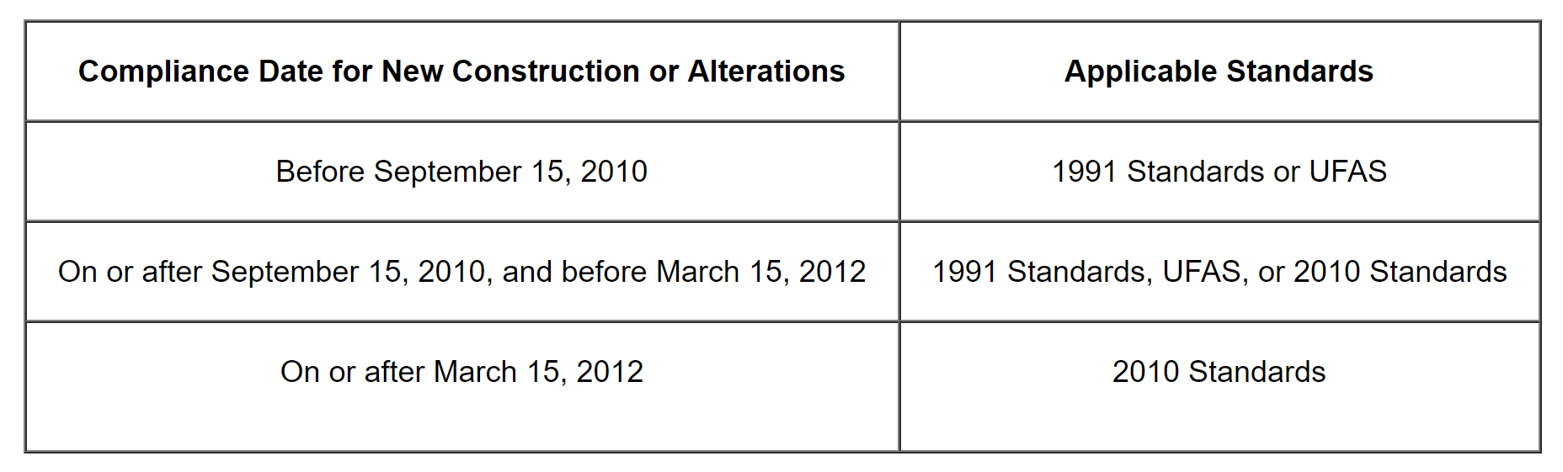
Figure 1. Applicable Design Standards for New Construction and Alterations (Department of Justice, 2010)
The Spirit of ADA
In addition to policy, the spirit of ADA promotes empowerment for persons with disabilities. Empowerment is described as the opportunity to function and achieve to the maximum of one’s abilities, physical, mental or a combination, therefore, gaining more control over the decisions that affect one’s life (Henderson & Bryan, 2011; McClain, Medrano, Marcum, & Schukar, 2000). ADA accessible design standards compel empowerment by working towards the elimination of environmental barriers and, as a result, enhance the integration and participation of persons with disabilities. Empowerment can form a new level of confidence for persons with disabilities needed to achieve personal as well as make new personal goals they never thought they could achieve before (Henderson & Bryan, 2011). Bryan & Henderson (2011) suggests that empowerment not only benefits persons with disabilities but also benefits society. The authors explain, “no society can maintain high standards of living and reach an even higher level of functioning when it has a group of people who are willing and capable of making contributions to its society but who are treated as underclass people of society.”

The Accessibility Gap
Higher Education Environments
Higher education institutions have experienced an increase in the enrollment of students with physical disabilities; therefore, colleges and universities have encountered an increase in wheelchair users on campus (Paul, 1999). Paul (1999) explored the campus life of six students who used a wheelchair while attending school. The study’s participants suggested that they continued to experience many obstacles on campus. These obstacles represent both social and environmental barriers, and many social barriers are often a result of certain environmental barriers. The identified barriers included older campus buildings, the small number of wheelchair users on campus, and the lack of knowledge from faculty and other students in regard to wheelchair user needs. The author concludes that the removal of environmental barriers within higher education environments increases the visibility of students using wheelchairs and encourages social interaction among all individuals on campus, regardless of their abilities (Paul, 1999).
Livingston (2000) states, “If the built environment were modified to accommodate people with various abilities, almost anyone could live independently and travel to jobs or schools without having to rely on the “mercy” of others for assistance.” Environmental barriers either deny or limit the participation of wheelchair users and other mobility device users on campus (Livingston, 2000). Hence, the presence of environmental barriers can negatively impact the social and academic experience of students using wheelchairs or other mobility devices. Leake and Stodden (2014) suggest there is an opportunity for higher education institutions to develop leadership roles which promote inclusive and welcoming campus environments that serve as improved models for the wider society.
Types of Barriers
McClain et al. (2000) suggest that “because communities are physically and socially complex and each individual’s experience is full of twists and turns.” Therefore, wheelchair users and other mobility device users may not encounter the same environmental barriers. Meyers et al. (2002) examined a wide range of barriers and facilitators in which wheelchair users identified being a part of their daily activities. The study’s results suggest that as participants reached specific destinations, they encountered an array of internal, interpersonal, and external environmental barriers; some of which participants were able to overcome while other barriers could not. Internal barriers represent wheelchair users own personal struggles such as illness or physical fitness, interpersonal barriers represent social barriers such as rudeness or help from other individuals, and external environment represent barriers from the built environment (known as environmental barriers). In addition to the identification of barriers, wheelchair users also received various human, environmental, and technological support known as facilitators (Meyers et al., 2002). Meyers et al. (2002) suggest that term disability is a result from interactions between individuals and environments which consists of complicated arrays of social, cultural, political, climatic, topographic, architectural, and technologic components. Finally, the authors introduce the idea that the social and physical environments define disabilities, not the individual. When environments, both social and physical, do not allow participation then that individual becomes disabled as a result (Meyers et al., 2002).
Participation
McClain et al. (2000) state, “When an individual is unable to participate in the community, a large aspect of the human experience is lost.” Environmental barriers influence the participation of wheelchair users; thus, it is important to continue the identification and understanding of environmental barriers in order to provide the necessary intervention (McClain et al., 2000). The absence of participation resulting from environmental barriers can negatively impact the health of wheelchair users and other mobility device users due to lack of physical activity (Rimmer, Riley, Wang, Rauworth, & Jurkowski, 2004). Rimmer et al. (2004) suggest that people with disabilities are far less likely to engage in physically active lifestyles than are people without disabilities. Hammel et al. (2015) examined how some environmental factors influenced the everyday participation of persons with disabilities. Environmental factors include built environment, natural environment, assistive technology, transportation, information and technology access, social support and attitudes, systems and policies, and economics. Each factor was examined at 3 different environmental categories or levels: micro (individual), mesa (community), and macro (societal). The authors conclude, “the intersection of environmental factors and levels can result in positive participation outcomes, such as improved participation engagement, choice and control, and resiliency/ability to manage everyday life” (Hammel et al., 2015). In addition, the influence of environmental factors can be negative or disabling, which results in the disengagement, segregation, social isolation, societal disenfranchisement, discrimination, and oppression for persons with disabilities (Hammel et al., 2015).
Views of Accessibility
Sherman and Sherman (2012) state that the ADA impacts up to 20% of the American population and affects several different professions including architects, interior designers and others that are responsible for designing the built environment. Persons with and without disabilities are continually redefining the meaning of disability for themselves through interaction and interpretation (Sherman & Sherman, 2012). Hence, everyone, regardless of abilities, possesses different views of accessibility. Sherman and Sherman (2012) suggest that people with disabilities view the ADA as a civil right which allows building access, while other individuals view ADA and accessible design standards as unnecessary regulations which are costly and limit creativity. These conflicting views of accessibility result in a disconnect between how designers view and comply with ADA design standards based on their lack of understanding of the intent and spirit behind the civil rights act (Sherman & Sherman, 2012). Professionals of the built environment need to learn from the people with disabilities which are affected by the final building design. When accessibility standards are applied in the correct approach in mind with the spirit and overarching goals of ADA policy then successful accessible environments can be achieved (Sherman & Sherman, 2012).

Chapter 3: Data Methodology
This chapter introduces the research design which consists of a mixed methods approach. The research methodology uses an online survey for qualitative data and field measurements from the building areas identified as environmental barriers for quantitative data. Following data collection, an integrated analysis then illuminates the relationship between collected qualitative and quantitative data.

The Study Area
The selected study area is the University of Oklahoma, Norman campus. The University of Oklahoma resides in Norman, Oklahoma. The university was founded in 1890 and currently supports an approximate undergraduate population of 20,000 students (The University of Oklahoma, 2019). Today’s campus consists of many different building types such as classroom buildings, recreational facilities, dormitories, dining halls, office buildings, research facilities, and libraries. The construction dates of campus buildings vary. Several buildings are older and well-aged; however, most buildings or parts of buildings have encountered alterations following initial construction dates.
This university was selected based on 4 primary reasons, listed below:
- The state university is a higher education institution which persons with disabilities are protected under ADA’s Title II.
- The University of Oklahoma welcomes diversity and is supportive of students and faculty with disabilities.
- All campus buildings are easily accessible for the researcher.
- The university has an available Architecture and Engineering Services (AES) Department in the case that any additional information regarding campus buildings was needed for data collection.
As previously discussed, the implementation of the1991 ADA Accessible Design Standards or the 2010 ADA Accessible Design Standards are determined by the building’s construction or alteration date. Refer to figure 1 to see an illustration of building compliance dates related to the applicable design standards. The University of Oklahoma provides informational plaques on the exterior of each campus building which provides brief histories of each building along with the original construction date and any major building additions and renovations. The university also includes plaques within the interior of a building area which has undergone a major alteration. This information was used to determine campus building construction dates and any alteration dates regarding the 3 major building areas identified for this study (exterior accessible entrances, accessible routes, and toilet rooms). Next, the applicable design standards were determined based on construction and alteration dates. In the case that construction or alteration dates were not provided for a campus building on the building plaques, the missing information was provided by the University of Oklahoma’s AES Department.

Online Survey
Introduction
An online survey was selected for this study’s qualitative approach. As previously mentioned, the online survey was selected to understand how mobility device users and mobility device assistants perceive accessibility when accessing higher education interior environments. Also, the survey was used to identify the design components associated with the campus buildings areas which mobility device users and mobility device assistants perceived as being a difficulty; thus, denying or limiting their access to the interior environment. The survey presented four building areas within a campus building in which mobility device users and mobility device assistants may encounter; 1) exterior accessible entrance, 2) accessible routes, 3) elevators and platform lifts, and 4) toilet rooms. The survey inquired how participants perceive the accessibility of each area when using or assisting with a mobility device. Accessibility ratings are based on the Likert scale which introduced 5 different options for participants to choose from; extremely easy, somewhat easy, neutral, somewhat difficult, and extremely difficult. The online survey consisted of 3 sections; 1) participant demographics and background information, 2) campus building accessibility ratings, and 3) selecting building area design components. All 3 sections of the online survey help identified the perceptions of mobility device users and mobility device assistants. The data from the online survey was analyzed to determine the building areas within campus buildings being perceived as an environmental barrier by the survey participants. The results from this study identified 3 major building areas being perceived as environmental barriers which were further examined with field measurements. These building areas identified included 1) exterior accessible entrances, 2) accessible routes, and 3) toilet rooms.
Participants
Participants for the study include all individuals that currently interact with one or more campus building. The study sample consisted of students, both graduate and undergraduate, staff and faculty members. In addition, the participants were required to have the first-hand experience using a mobility device or assisting a person using a mobility device. Individuals that identify as assisting a person using a mobility device are known as mobility device assistants in this study. The types of mobility devices applicable to the study findings include a manual wheelchair, power-assist wheelchair, or scooter. Some participants identified using or assisting with more than one of the applicable mobility devices. Some participants identified other mobility devices in addition to using or assisting one of the applicable mobility devices, such as braces and crutches. The study sample consisted of 26 total participants; 11 mobility device users and 15 mobility device assistants.
Method of Contact
Following IRB approval, a recruitment email with the online survey URL was sent out to all students and faculty members of OU Norman Campus. See Appendix A.
Section 1: Background information
The first section of the online survey gathered participant demographics and background information. Background information determined if the survey respondents met the study sample criteria; mobility device user or mobility device assistant. Following the validation of the survey’s respondents, additional questions were introduced pertinent to this study.
Background information inquired about the following information:
- Type of mobility device used (wheelchair, power-assist wheelchair, scooter or other)
- Length of time using a mobility device
- Campus role (student or faculty member)
- Age of respondent
See Appendix B for the online survey’s section 1.
Section 2: Environmental barriers
Environmental barriers are associated with a high degree of difficulty when accessing a campus building because they limit or deny full and complete access to the goods and services being provided for an individual. In contrast, environmental facilitators are associated with a low degree of difficulty when accessing a campus building because they help facilitate access to goods and services being provided for an individual. The second section of the online survey examined mobility device users and mobility device assistants’ campus building accessibility rating regarding the four building areas. Each participant’s response help determined if each of the building areas was perceived as an environmental barrier or facilitator. The participants could identify more than one campus building. Accessibility ratings were based on the Likert scale: extremely easy, somewhat easy, neutral, somewhat difficult, or extremely difficult. The Likert scale determines if accessibility ratings are environmental barriers or facilitators.
Accessibility ratings related to an environmental barrier included:
- Somewhat difficult
- Extremely difficult
Accessibility ratings related to an environmental facilitator included:
- Somewhat easy
- Extremely easy
See Appendix B for the online survey’s section 2.
Section 3: Design Components
The online survey’s section 3 is integrated into section 2. After participants rated the accessibility of a building area then they were asked to select one or more building area design component associated with their response. Design components represent the built-in characteristics of a building area. Participants were only required to select a design component(s) when they perceived a barrier within a building area by choosing a somewhat difficult or extremely difficult rating.
This study used a weighted calculation to determine the difference between a somewhat difficult response and extremely difficult response. For example, a participant’s response of an extremely difficult rating to a building area implies there is a higher level of difficulty when compared to another participant’s response of a somewhat difficulty rating to the same building area. Thus, extremely difficult represents a higher degree of difficulty. Each response was given a numerical weight value: somewhat difficult (1) and extremely difficult (2). Extremely difficult was given a higher weight value to distinguish the higher degree of difficulty.
The following steps represent how this study’s weighted calculation was used to determine the degree of difficulty of each design component:
Step 1: Organize responses of each design component associated with environmental barriers by rating (somewhat difficult or extremely difficult) and determine the total number of responses.
Example: Exterior Accessible Entrance – Maneuvering Clearance
Somewhat Difficult (SD) Response Total = 11
Extremely Difficult (ED) Response Total = 7
Step 2: Multiply each rating’s response total by the applicable numerical weight value to determine each rating’s weighted response total.
Example: Exterior Accessible Entrance – Maneuvering Clearance
Weighted SD Response Total: 11 x 1 = 11
Weighted ED Response Total: 7 x 2 = 14
Step 3: Add the weighted somewhat difficult response total to the weighted extremely difficult response total to determine the weighted design component response total.
Weighted SD Response Total + Weighted ED Response Total = Weighted Design Component Total

Example: Exterior Accessible Entrance – Maneuvering Clearance
(11 x 1) + (7 x 2) = 25
Step 4: Divide the weighted design component response total by a total number of weighted responses and multiply by 100 to determine the design components' degree of difficulty.
(Design Component Weighted Response Total ÷ Total Weighted Responses) x 100 = Design Component Degree of Difficulty (%)
Example: Exterior Accessible Entrance – Maneuvering Clearance
(25 ÷ 172) x 100 = 9%
The weighted calculations represent a ranking order of the selected building area design component which mobility device users and mobility device assistants associated with an environmental barrier. Using this ranking order, the top 10 design components are selected from the four identified building areas; 5 from exterior accessible entrances, accessible routes, and elevators and platform lifts; and 5 from toilet rooms.
Below is a list of design components included in the online survey:
- Exterior Accessible Entrances
  - Door or doorway width
  - Maneuvering clearance
  - Door threshold
  - Door hardware height
  - Door weight
- Accessible Routes
  - Pathway width
  - Interior ramp
  - Turning route width
- Elevators and Platform Lifts
  - Control height
  - Clear floor space
  - Door opening width
- Toilet Rooms
  - Accessible Entrance
    - Door or doorway width
    - Maneuvering clearance
    - Door threshold
    - Door hardware height
    - Door weight
  - Accessible Route
    - Pathway width
    - Turning clearance
  - Wheelchair Accessible Bathroom Stall
    - Stall door opening width
    - Clear floor space
    - Toilet location to the side wall
    - Toilet seat height
    - Grab bar(s) location to toilet
    - Grab bar(s) height
  - Hand-washing station (Lavatory)
    - Sink height
    - Clear floor space (approach space, knee clearance, toe clearance)
    - Reach to faucet
See Appendix B for the online survey’s section 3 and illustrations of each building area design component for more clarification.

Field Measurements
Introduction
Field measurements from a select number of campus buildings were selected for this study’s quantitative approach. The 10 identified design components from the online survey are for quantitative data collection. Field measurements were conducted to determine if the campus buildings meet applicable accessible design standards. Field measurements also illustrate an adherence level of each design standard.
Building Selection
The selection of campus buildings used for field measurements was based on the highest level of frequency from the total number of responses. A total number of 5 campus buildings were selected. Campus buildings vary in building type; therefore, the intended use of each building is different. A campus building’s end-use can strongly influence the type of daily activities that occur within the indoor environment and the frequency of individuals visiting or interacting with an indoor environment during different times of the day. As previously mentioned, the identified campus buildings represent differ in construction and alteration dates.
Accessible Design Standard Adherence
This study referenced both, 1991 ADA Accessible Design Standards and 2010 ADA Accessible Design Standards because the 5 measured campus buildings consist of buildings required to meet one or the other. Design standard adherence consisted of 3 different ratings; greater than (>), equal to (=), or less than (<). Field measurements that meet but do not exceed minimum design standards are identified as equal to. Measurements that exceed minimum design standards are identified as greater than, and measurements that do not meet minimum design standards, therefore, they are given a less than rating. The final analysis of design standard adherence carefully examined the relationship between campus buildings and the building’s applicable design standards, 1991 ADA Accessible Design Standards or 2010 ADA Accessible Design Standards. As previously mentioned, the collection of field measurements is used to determine a building’s adherence to accessible designs standards related to the measured design components which belong to the major building areas to determine if these design components that are associated with a high degree of difficulty meet accessible designs standards. See Appendix C.

Chapter 4: Results

Demographics
The online survey responses consist of 26 individuals; 11 mobility device users and 15 mobility device assistants. Majority of respondents identified as students between 18 to 24 years of age. Only 1 respondent identified as a staff member. Both, mobility device users and mobility device assistants were asked to select the type of mobility device used or assisted with, and they had the option to select one or more mobility device. From the 26 respondents, the use of 38 mobility devices were identified. Hence, some respondents selected using or assisting with more than one mobility device. Additionally, 3 respondents selected using other mobility devices in addition to using a manual wheelchair, power-assist wheelchair, or scooter. The other devices used included braces (1) and crutches (2). The majority of mobility device users selected using a mobility device for less than one year. Other mobility device users selected using a mobility device between 1 to 4 years and 5 to 9 years. The length of time while using a mobility device selected by respondents suggested that mobility device users experienced a short-term physical disability or are new to using a mobility device. The following table illustrates the frequency of participant demographics and background information. See table 1.

Table 1: Participant Demographics and Background Information

Variables | Description | Frequency | Percent
Campus Role | Student | 24 | 92%
Campus Role | Staff | 1 | 4%
Campus Role | Other | 1 | 4%
Campus Role | Total | 26 | 100%
Age | 18 to 24 | 22 | 85%
Age | 25 to 34 | 2 | 8%
Age | 35 to 44 | 1 | 4%
Age | 45 to 64 | 1 | 4%
Age | 65 or more | 0 | 0%
Age | Total | 26 | 100%
Mobility Device User Type | Mobility Device User | 11 | 42%
Mobility Device User Type | Mobility Device Assistant | 15 | 58%
Mobility Device User Type | Total | 26 | 100%
Length of Time - Mobility Device User Only | Less than 1 year | 9 | 82%
Length of Time - Mobility Device User Only | 1 to 4 year | 1 | 9%
Length of Time - Mobility Device User Only | 5 to 9 years | 1 | 9%
Length of Time - Mobility Device User Only | 10 years or more | 0 | 0%
Length of Time - Mobility Device User Only | Total | 11 | 100%
Type of Mobility Device - Select More Than One | Manual Wheelchair | 14 | 37%
Type of Mobility Device - Select More Than One | Scooter | 15 | 39%
Type of Mobility Device - Select More Than One | Power-Assist Wheelchair | 6 | 16%
Type of Mobility Device - Select More Than One | Other | 3 | 8%
Type of Mobility Device - Select More Than One | Total | 38 | 100%

Views of Accessibility
Responses from the online survey present the accessibility ratings of campus buildings which introduced four building areas within a campus building in which mobility device users and mobility device assistants may encounter; 1) exterior accessible entrance, 2) accessible routes, 3) elevators and platform lifts, and 4) toilet rooms. As previously discussed, accessibility ratings were based on the Likert scale: extremely easy, somewhat easy, neutral, somewhat difficult, or extremely difficult. The Likert scale determines if accessibility ratings identify as environmental barriers or facilitators. Environmental barriers are associated with a somewhat difficult or extremely difficult rating and environmental facilitators are associated with a somewhat easy or extremely easy rating. The tables and figures in the following sections illustrate the frequencies and percentages of accessibility ratings for each building area.

Exterior Accessible Entrances
The majority of the online survey participants view exterior accessible entrances as an environmental facilitator. These responses total 54% which consists of a 28% somewhat easy rating and 26% extremely easy rating. A total of 43% of respondents identified exterior accessible entrances as an environmental barrier including a 26% somewhat difficult rating and 17% extremely difficult rating. See table 2 and figure 2.
Table 2: Exterior Accessible Entrances - Accessibility Ratings

 | Frequency | Percentage (%)
Extremely Easy | 14 | 26%
Somewhat Easy | 15 | 28%
Neutral | 2 | 4%
Somewhat difficult | 14 | 26%
Extremely Difficult | 9 | 17%
Total Number of Responses | 54 | 100%

Figure 2: Exterior Accessible Entrances – Environmental Categories

Accessible Routes
The majority of online survey participants view accessible routes as an environmental facilitator. These responses total 70% which consists of a 56% somewhat easy rating and 15% extremely easy rating. Only 28% of respondents identified accessible routes as an environmental barrier including a 7% somewhat difficult rating and 15% extremely difficult rating. See table 3 and figure 3.
Table 3: Accessible Routes - Accessibility Ratings

 | Accessible routes | Percentage (%)
Extremely Easy | 8 | 15%
Somewhat Easy | 30 | 56%
Neutral | 4 | 7%
Somewhat difficult | 4 | 7%
Extremely Difficult | 8 | 15%
Total Number of Responses | 54 | 100%

Figure 3: Accessible Routes – Environmental Categories

Elevators and Platforms
The majority of online survey participants view elevators and platform lifts as an environmental facilitator. These responses total 52% which consists of a 26% somewhat easy rating and 26% extremely easy rating. A total 31% of respondents identified elevators and platform lifts as an environmental barrier including a 30% somewhat difficult rating and 2% extremely difficult rating. See table 4 and figure 4.
Table 4: Elevators and Platform Lifts - Accessibility Ratings

 | Elevators and platform lifts | Percentage (%)
Extremely Easy | 14 | 26%
Somewhat Easy | 14 | 26%
Neutral | 9 | 17%
Somewhat difficult | 16 | 30%
Extremely Difficult | 1 | 2%
Total Number of Responses | 54 | 100%

Figure 4: Elevator and Platform Lifts – Environmental Categories

Toilet Rooms
Table 5: Toilet Rooms – Accessibility Ratings

 | Accessible entrance | Accessible route | Wheelchair accessible toilet compartment | Hand- washing station | Frequency | Percentage (%)
Extremely Easy | 9 | 3 | 13 | 22 | 47 | 22%
Somewhat Easy | 19 | 13 | 15 | 7 | 54 | 25%
Neutral | 5 | 10 | 7 | 6 | 28 | 13%
Somewhat difficult | 12 | 18 | 8 | 11 | 49 | 23%
Extremely Difficult | 9 | 10 | 11 | 8 | 38 | 18%
Total Number of Responses | 54 | 54 | 54 | 54 | 216 | 100%
The majority of online survey participants view toilet rooms as an environmental facilitator. These responses total 47% which consists of 25% somewhat easy rating and 22% extremely easy rating. A total 40% of respondents identified toilet rooms as an environmental barrier including a 23% somewhat difficult rating and 18% extremely difficult rating. See table 5 and figure 5.

Figure 5: Toilet Rooms – Environmental Categories

Campus Building Selection
This study selected 5 campus buildings to conduct field measurements. Campus building selection was based on the highest frequency of responses from the total number of online survey responses. Out of the 26 respondents from survey results, a total of 54 campus buildings were identified. The identified campus buildings vary in building type. The selected campus buildings include Bizzell Memorial Library, Dale Hall, Gould Hall, Oklahoma Memorial Union, and Physical Sciences Center. The following table illustrates the frequency and percentage of the identified campus buildings. The most identified campus building was the Bizzell Memorial Library which suggests the majority of participants interact with this campus building. See table 6 for campus building frequency.

Table 6: Campus Building Frequency

Campus Building Name | Frequency | Percentage
Bizzell Memorial Library | 7 | 13%
Gould Hall | 5 | 9%
Dale Hall | 4 | 7%
Oklahoma Memorial Union | 4 | 7%
Physical Sciences Center | 3 | 6%
Adams Hall | 2 | 4%
Carson Energy Center | 2 | 4%
Catlett Music Center | 2 | 4%
Felgar Hall | 2 | 4%
Gaylord Hall | 2 | 4%
George Lynn Cross Hall | 2 | 4%
Sarkey's Energy Center | 2 | 4%
Anne and Henry Zarrow School of Social Work | 1 | 2%
Buchanan Hall | 1 | 2%
Burton Hall | 1 | 2%
Chemistry Building Annex | 1 | 2%
Collings Hall | 1 | 2%
Copeland Hall | 1 | 2%
Creative Making Lab | 1 | 2%
Disability Resource Center | 1 | 2%
Gaylord Family Oklahoma Memorial Stadium | 1 | 2%
Goddard Health Center | 1 | 2%
Nuclear Engineering Laboratory | 1 | 2%
Old Science Hall | 1 | 2%
Price Business college | 1 | 2%
Rawl Engineering Practice Facility | 1 | 2%
Richards Hall | 1 | 2%
Sutton Hall | 1 | 2%
Wagner Hall | 1 | 2%
Total Number of Response | 54 | 100%

Following the identification of the 5 campus buildings for field measurements, this study provides below brief background information and building levels selected for field measurements related to each campus building:
- Bizzell Memorial Library
  - The Bizzell Memorial Library is the Norman campus library. The campus building houses important books, archives, and other documents. Additionally, the campus building provides study areas, offices, a computer laboratory and other technology areas, a coffee shop, and the student collaborative learning center.
  - The field measurements are collected within the library’s 1951 addition level 1 and lower level 1.
- Gould Hall
  - Gould Hall is home of the University’s College of Architecture. The campus building consists of class and lecture rooms, design studios, a computer laboratory, faculty offices, student lounge, architecture library, and a large gallery space.
  - The field measurements are collected within the building’s level 1.
- Dale Hall
  - Dale Hall is a classroom building. The building consists of classrooms and large lecture halls.
  - The field measurements are collected within the building’s level 1.
- Oklahoma Memorial Union
  - The Oklahoma Memorial Union is a campus building available to all Norman campus students, faculty, staff, and visitors. The Union consists of food businesses, large amounts of seating for dining or studying, stores with small inventory (food, technology, coffee), postal service, study lounges, conference rooms, auditorium, university offices, and many other student service spaces.
  - The field measurements are collected within the building’s level 1.
- Physical Sciences Center
  - The Physical Sciences Center is the previous home of the University’s College of Arts and Sciences until the College changed to a newly constructed building. The Physical Sciences Center is currently a classroom building. The building consists of classrooms, lecture halls, and research laboratories.
  - The field measurements are collected within the building’s level 2.
The 5 identified campus buildings differ regarding the applicable accessible design standards; 1991 ADA Standards for Accessible Design or 2010 ADA Standards for Accessible Design. The following table illustrates each campus building’s original constructed date and the most recent alteration date if applicable. These dates then determine the applicable accessible design standards for each campus building. See table 7.

Table 7: Campus Building Applicable Design Standards

Building Name/Level | Constructed Date | Most Recent Alteration Date | Applicable Design Standards
Bizzell Memorial Library
1st Floor | 1958 Addition | 2015 | 2010
Lower Level 1 | 1956 | 2014/2017 | 2010
Dale Hall
1st Floor | 1967 | NA | NA
Gould Hall
1st Floor | 1956/1966 Addition | 2011 | 1991 or 2010
Oklahoma Memorial Union
1st Floor | 1929 | 1997 | 1991
Physical Sciences
2nd Floor | 1969 | 2012 | 2010

Design Component Selection
Participants were asked to select the design components related to each building area only when they perceived a building area to be an environmental barrier. Environmental barriers were associated with the somewhat difficult or extremely difficult responses. As previously discussed, this study used a weighted calculation to determine the difference between response types. Each response type was given a numerical weight value: somewhat difficult (1) and extremely difficult (2). Extremely difficult was given a higher weight value to distinguish the higher degree of difficulty. Using the weighted calculations, the 10 design components were selected for field measurements. The top 5 design components were selected from the building areas associated with campus building main public areas; exterior accessible entrances, accessible routes, and elevators and platform lifts. The top 5 design components that were identified belonged to 2 out of the 3 building areas; exterior accessible entrances and accessible routes. Thus, eliminating the elevators and platform lifts building area for field measurements. These results related to the elimination of the elevators and platform lifts building area suggests majority of participants perceived the design components associated with this building area with little difficulty when compared to the exterior accessible entrances and accessible routes. Following, the top 5 design components were selected from the toilet rooms. As a result, the identification of the 10 design components introduces the 3 major building areas investigated within this study: 1) exterior accessible entrances, 2) accessible routes, and 3) toilet rooms. The following tables illustrate the degree of difficulty for each identified design component from the online survey responses. See figure 8 and 9.
See Appendix C for the applicable accessible design standards related to each building area design component.
Table 8: Main Public Areas - Design Components

 | Somewhat Difficult |  | Extremely Difficult |  | Frequency |  | Percentage (%)
Exterior Accessible Entrance(s) | Actual | Weighted | Actual | Weighted | Actual | Weighted | Weighted
Maneuvering clearance | 11 | 11 | 7 | 14 | 18 | 25 | 15%
Door threshold | 11 | 11 | 6 | 12 | 17 | 23 | 13%
Door weight | 12 | 11 | 5 | 10 | 17 | 21 | 12%
Door or doorway width | 10 | 10 | 2 | 4 | 12 | 14 | 8%
Other: please specify | 2 | 2 | 5 | 10 | 7 | 12 | 7%
Door hardware height | 3 | 4 | 2 | 4 | 5 | 8 | 5%
Accessible Route(s)
Pathway width | 3 | 3 | 8 | 16 | 11 | 19 | 11%
Interior ramp | 1 | 1 | 5 | 10 | 6 | 11 | 6%
Turning route width | 4 | 4 | 3 | 6 | 7 | 10 | 6%
Other: please specify | 1 | 1 | 1 | 2 | 2 | 3 | 2%
Elevator(s) and Platform Lift(s)
Other: please specify | 7 | 7 | 1 | 2 | 8 | 9 | 5%
Door opening width | 8 | 8 | 0 | 0 | 8 | 8 | 5%
Clear floorspace | 6 | 6 | 0 | 0 | 6 | 6 | 3%
Control height | 3 | 3 | 0 | 0 | 3 | 3 | 2%
Total Number of Responses | 82 | 82 | 45 | 90 | 127 | 172 | 100%

Table 9: Toilet Room - Design Components

 | Somewhat Difficult |  | Extremely Difficult |  | Frequency |  | Percentage (%)
Accessible Entrance | Actual | Weighted | Actual | Weighted | Actual | Weighted | Weighted
Maneuvering clearance | 11 | 11 | 9 | 18 | 20 | 29 | 9%
Door threshold | 6 | 6 | 8 | 16 | 14 | 22 | 7%
Door weight | 5 | 9 | 5 | 10 | 10 | 19 | 5%
Door or doorway width | 9 | 5 | 4 | 8 | 13 | 13 | 5%
Other: please specify | 1 | 0 | 1 | 2 | 2 | 2 | 3%
Door hardware height | 0 | 1 | 5 | 10 | 5 | 11 | 1%
Accessible Route
Pathway width | 12 | 12 | 9 | 18 | 21 | 30 | 9%
Turning clearance | 18 | 18 | 10 | 20 | 28 | 38 | 12%
ADA Bathroom Stall
Toilet location to side wall | 6 | 6 | 9 | 18 | 15 | 24 | 7%
Clear floor space | 7 | 7 | 7 | 14 | 14 | 21 | 6%
Stall door opening width | 7 | 7 | 6 | 12 | 13 | 19 | 6%
Grab bar(s) location to toilet | 7 | 7 | 3 | 6 | 10 | 13 | 4%
Grab bar(s) height | 6 | 6 | 2 | 4 | 8 | 10 | 3%
Toilet seat height | 5 | 5 | 2 | 4 | 7 | 9 | 3%
Other: please specify | 0 | 0 | 2 | 4 | 2 | 4 | 1%
Handwashing Station
Clear floor space | 9 | 9 | 7 | 14 | 16 | 23 | 7%
Reach to faucet | 7 | 7 | 7 | 14 | 14 | 21 | 6%
Sink height | 5 | 5 | 7 | 14 | 12 | 19 | 6%
Other: please specify | 0 | 0 | 0 | 0 | 0 | 0 | 0%
Total Number of Responses | 121 | 121 | 103 | 206 | 224 | 327 | 100%

The following design components are defined by the New England ADA Center (2016):
- Exterior Accessible Entrances
Maneuvering clearance: The required space for opening and passing thru doors or doorways when using a mobility device. Space requires floor and ground area to be level and clear. Adherence to design standards is determined using design standard maneuvering clearance table. Standards are determined by approach direction when opening a door, type of physical movement (pull or push), space perpendicular to the doorway (floor clearance) and space parallel to latch side of the door.
Door threshold: The raised floor threshold between doors or doorways. Door threshold should not be greater than the specified height determined type of threshold (beveled or flat) and construction or alteration date.
Door weight: The maximum weight limit associated with the human force required to open a door. Door weight is not considered the initial force needed to overcome door seal resulting from unequal pressure. Exterior doors do not have a design standard related to door weight due to external factors that may contribute to proper door closure.
Door or doorway width: The width from the door stop to the face of the door at an opening of 90 degrees. Obstructions of within a specific height (34”) which interfere with clear width are not permitted. In the case of a double door or 2 door leaves, each door must operate independently and at least one of the 2 doors is required to meet the clear width and maneuvering clearance.
- Accessible Routes
Pathway width: The main component of accessible routes that require a minimum width of corridors, doorways, ramps, and other walking surfaces. Minimum pathway width varies based on the length of the walking surface and turning clearance.
- Toilet Rooms
Accessible entrance – Maneuvering clearance: The required space for opening and passing thru doors or doorways when using a mobility device. Space requires floor and ground area to be level and clear. Adherence to design standards is determined using design standard maneuvering clearance table. Standards are determined by approach direction when opening a door, type of physical movement (pull or push), space perpendicular to the doorway (floor clearance) and space parallel to latch side of the door.
Accessible route – Pathway width: The main component of accessible routes that require a minimum width of corridors, doorways, ramps, and other walking surfaces. Minimum pathway width varies based on the length of the walking surface and turning clearance.
Accessible route – Turning clearance: The clear floor space available for a person in a wheelchair to turn around. Turning clearance can be circular or T-shaped.
Wheelchair accessible bathroom stall – Toilet location to side wall: Determines the measure from the centerline of the toilet to the side wall.
Hand washing station – Clear floor space (approach space, knee clearance, toe clearance): The clear floor space with a forward approach to the lavatory. Clear floor space must be extended under lavatory so a wheelchair user can get close enough in order to reach the faucet. Additionally, appropriate clearance is required from the floor to the bottom of the lavatory that extends under lavatory for knee clearance.

Accessible Design Standard Adherence
This study uses the 5 selected campus buildings and 10 selected design components to conduct field measurements. Field measurements are conducted to determine if the campus buildings meet applicable accessible design standards. Field measurements also illustrate an adherence level of each applicable accessible design standard; 1991 ADA Standards for Accessible Design or 2010 ADA Standards for Accessible Design. Accessible design standard adherence level consists of 3 different ratings; greater than (>), equal to (=), or less than (<). Field measurements that meet but do not exceed minimum design standards are identified as equal to. Measurements that exceed minimum design standards are identified as greater than, and measurements that don’t meet minimum design standards are given a less than rating. It is important to note that some design components may consist of more than one measure, therefore the measure with the lowest standard adherence determines the final adherence rating. For example, if a design component consists of 3 measures and 1 measure is equal to the applicable design standard and the other 2 measures are greater than, then the final adherence rating is equal to. The following tables illustrate the accessible design standard adherence level of each of the 10 identified design components.
See Appendix D for this study’s conducted field measurements and the identified accessible design standard adherence related to each building area design component.
Exterior Accessible Entrances
The 5 campus buildings consist of a total of 23 exterior accessible entrances. Some entrances are part of a vestibule. Therefore, a vestibule consists of a separate exterior access door and interior access door. The following tables illustrate the frequency of the accessible design standard adherence level of each design component within the 5 measured campus buildings.
Maneuvering clearances consist of more than one measurement to determine the overall adherence level of the design component. The approach direction of the door will determine the applicable standard measurements. Field measurements determine that all 23 entrances (100%) are greater than the minimum required maneuvering clearance; therefore, the majority of the entrances exceed the accessible design standard. See table 10.
Table 10: Maneuvering Clearance - Standard Adherence

 | Frequency | Percentage
Greater Than | 23 | 100%
Equal To | 0 | 0%
Less Than | 0 | 0%
Total Number of Measures | 23 | 100%

Majority of campus building exhibits a beveled door threshold type with an overall threshold height of ½-inch. With the exception that 1 door threshold measurement displayed a 0-inch threshold height; therefore, the measure was greater than the required standard. Field measurements determine that 22 entrances (96%) are equal to the minimum door threshold requirement and 1 entrance (4%) is greater than. Therefore, the majority of entrances are equal to the accessible design standard. See table 11.

Table 11: Door Threshold - Standard Adherence

 | Frequency | Percentage
Greater Than | 1 | 4%
Equal To | 22 | 96%
Less Than | 0 | 0%
Total Number of Measures | 23 | 100%

The 2010 ADA Accessible Design Standards limit the opening force of an interior door to a maximum of 5 pounds. However, there is not a maximum weight limit for exterior doors. Additionally, the 1991 ADA Accessible Design Standards do not require an interior door weight limit. This study still compares exterior door weight to the 2010 minimum design standard based on the participant’s perceptions of the design component regarding the high degree of difficulty. Field measurements determine that 17 entrances (74%) are less than the minimum door weight requirement (over the maximum weight limit) and 6 entrances (26%) are equal to. Therefore, the majority of entrances to not meet the accessible design standard. See table 12.
Table 12: Door Weight – Standard Adherence

 | Frequency | Percentage
Greater Than | 0 | 0%
Equal To | 6 | 26%
Less Than | 17 | 74%
Total Number of Measures | 23 | 100%

Door or doorway width measures consist of 2 measurements. Additionally, the design requirements for 1991 ADA Accessible Design Standards and 2010 ADA Accessible Design Standards represent the same standard. Standards require a 32-inch clear width between the door stop and face of the door and each door opening must have a 90-degree opinion. Field measurements determine that 18 entrances (78%) are greater than minimum door or doorway width requirement and 5 entrances (22%) are equal to. Therefore the majority of entrances exceed the accessible design standard. See table 13.
Table 13: Door or Doorway Width - Standard Adherence

 | Frequency | Percentage
Greater Than | 18 | 78%
Equal To | 5 | 22%
Less Than | 0 | 0%
Total Number of Measures | 23 | 100%

Accessible Routes
The 5 campus buildings consist of a total of 41 accessible routes. Each campus building consists of a different layout, therefore each campus building had different amounts of accessible routes. The following tables illustrate the frequency of the accessible design standard adherence level of each design component within the 5 measured campus buildings.
Pathway width requirements vary based on accessible route type. The campus buildings represent accessible route types such as single person pathways, interior ramps, and passing spaces. Field measurements determine that all 32 accessible routes (78%) are greater than the minimum pathway width requirement and 9 accessible routes (22%) are equal to. Therefore, the majority of accessible routes exceed the accessible design standard. See table 14.
Table 14: Pathway Width – Design Standard Adherence

 | Frequency | Percentage
Greater Than | 32 | 78%
Equal To | 9 | 22%
Less Than | 0 | 0%
Total Number of Measures | 41 | 100%

Toilet rooms
The selected toilet rooms within the 5 identified campus buildings consist of 7 unisex toilet rooms and 5 public toilet rooms. Some older campus buildings that can’t alter existing public toilet rooms to meet accessible design standards are required to include a unisex toilet room in order to accommodate mobility device users; therefore, this study did not measure public toilet rooms that were not ADA accessible. The following tables illustrate the frequency of the accessible design standard adherence level of each design component within the 5 measured campus buildings.
Like exterior accessible entrances, toilet rooms maneuvering clearances consists of more than one measurement to determine overall adherence level of the design component. The approach direction of the toilet room door will determine the applicable standard measurements. Field measurements determine that 9 entrances (75%) are greater than, 1 entrance (8%) is equal to, and 2 entrances (17%) are less than the minimum maneuvering clearance requirement. Therefore, the majority of toilet room entrances exceed maneuvering clearance design standard. See table 15.
Table 15: Maneuvering Clearance - Design Standard Adherence

 | Frequency | Percentage
Greater Than | 9 | 75%
Equal To | 1 | 8%
Less Than | 2 | 17%
Total Number of Measures | 12 | 100%

Pathway widths differed between toilet room types. Public toilet rooms accommodate more than one user, therefore the public toilet room type and typical are greater in size compared to unisex toilet rooms. As a result, public toilet rooms consist of more pathways. Field measurements determine that 7 accessible routes (58%) are greater than, 4 routes (33%) are equal to the standard and 1 route (8%) is less than the minimum pathway width requirement. Therefore, the majority of toilet room routes exceed pathway width design standard. See table 16.
Table 16: Pathway Width - Design Standard Adherence

 | Frequency | Percentage
Greater Than | 7 | 58%
Equal To | 4 | 33%
Less Than | 1 | 8%
Total Number of Measures | 12 | 100%

Like pathway widths, toilet room turning clearances differed between toilet room type. Public toilet rooms greater capacity for individuals result in more than one area where a turning clearance is required, whereas unisex toilet rooms only need one. Based on the interior layout of the toilet room, standards require either a circular turning space or t-shaped turning space. Field measurements determine that 6 routes (50%) are greater than the minimum turning clearance design standard and 6 routes (50%) are equal to the minimum pathway width requirement. Therefore, an equal amount of toilet room accessible routes exceed turning clearance design standard compared to routes equal to the accessible design standard. See table 17.
Table 17: Turning Clearance - Design Standard Adherence

 | Frequency | Percentage
Greater Than | 6 | 50%
Equal To | 6 | 50%
Lesser Than | 0 | 0%
Total Number of Measures | 12 | 100%

Toilet location to the side wall is similar for all toilet room types. The 2010 ADA Accessible Design Standards require a minimum of 16-inches and maximum 18-inches from the center of the toilet to the side wall, whereas the 1991 ADA Accessible Design Standards require 18 inches. Field measurements determine that 10 toilet rooms (83%) are greater than the minimum toilet location to sidewall requirement, and 2 toilet rooms (17%) are less than. design standard. Therefore, the majority of toilet room adhere to the accessible design standard. See table 18.
Table 18: Toilet Location to Side Wall - Design Standard Adherence

 | Frequency | Percentage
Greater Than | 0 | 0%
Equal To | 10 | 83%
Lesser Than | 2 | 17%
Total Number of Measures | 12 | 100%

Handwashing station, also called lavatory, clear floor space differs between toilet room type. As previously mentioned, public toilet rooms accommodate more than one user; therefore, the public toilet rooms will typically have more than one lavatory. A toilet room’ lavatory clear floor space design component consists of more standard including floor approach space clearance, knee clearance, and toe clearance. Field measurements determine that 7 lavatories (58%) are greater than the minimum clear floor space requirements and 5 lavatories (42%) are equal to. Therefore, the majority of toilet room lavatories exceed the accessible design standards. See table 19.
Table 19: Handwashing Station Clear Floor Space - Design Standard Adherence

 | Frequency | Percentage
Greater Than | 7 | 58%
Equal To | 5 | 42%
Lesser Than | 0 | 0%
Total Number of Measures | 12 | 100%

Chapter 5: Conclusions
This chapter introduces conclusions derived from the study’s results. Conclusions represent an integrated analysis of the study’s online survey and field measurements in which the relationship between participants’ perceptions of accessibility and the adherence level of accessible design standards related to each major building area (exterior accessible entrances, accessible routes, and toilet rooms) within the 5 selected campus buildings are analyzed. While conclusions support that mobility device users and mobility device assistants perceive specific design components within higher education interior environments with a high degree of difficulty, conclusions also introduce future research needs to further investigate these design components and the accessible design standards specific to them in order to make the necessary changes. Additionally, this study represents a smaller study sample size; therefore, conclusions were drawn within the study’s findings, but also introduce future research needs to investigate a larger study sample size.

Exterior Accessible Entrances
The 5 measured campus buildings exhibited a total number of 23 exterior accessible entrances used for field measurements. Some campus buildings consisted of more than one exterior accessible entrance, while other campus buildings only had one exterior accessible entrance. Several exterior accessible entrances also featured a vestibule entrance in which the accessible entrance consists of a series of doors; the exterior door which connects the exterior environment to the vestibule area, and the interior door which connects the interior environment to the vestibule area. Majority of online survey participants identified campus building exterior accessible entrances as an environmental facilitator. Additionally, the majority of field measurements regarding exterior accessible entrance design components exceeded the applicable accessible design standards. Therefore, the field measurements conducted for the exterior accessible entrance design components support the online survey results in which participants perceived the building area as an environmental facilitator. However, several of the top identified design components linked with a high degree of difficulty when using or assisting with a mobility device belonged to the exterior accessible entrances building area. Results introduce a future research need to investigate why some exterior accessible entrance design components are associated with a high degree of difficulty if the overall exterior accessible entrances building area was identified as an environmental facilitator.
Maneuvering Clearance
The field measurements determined that the majority of exterior accessible entrances’ maneuvering clearance exceed the applicable accessible design standard within the measured campus buildings. Despite the level of adherence to accessible design standards, mobility device users and mobility device assistants perceived maneuvering clearance with a having high degree of difficulty when accessing the interior environment. The applicable design standard regarding the door maneuvering clearance design component is determined by identifying the maneuvering clearance type. The maneuvering clearance type is based on several characteristics such as approach direction to door (front, side, hinge side, latch side), floor clearance perpendicular to door or doorway, and floor clearance parallel to door or doorway. Following the identification of the applicable standard, the adherence level of the design component was determined. The study’s findings suggest that majority exterior accessible entrances adhere to the applicable accessible design standards related to maneuvering clearance despite the design component being perceived with a high degree of difficulty by participants. However, the field measurements related to door maneuvering clearance could not determine if accessibility ratings regarded only specific maneuvering clearance types. The study’s findings suggest that the difference in maneuvering clearance type may influence mobility device users and mobility device assistants view on accessibility. Results introduce a future research need to investigate the accessible design standards related to door maneuvering clearance and determine if the degree of difficulty when accessing an exterior accessible entrance is contingent on maneuvering clearance type.
Door Threshold
Field measurements determined that majority exterior accessible entrances’ door thresholds are equal to the applicable accessible design standard within the measured campus buildings. Majority of campus buildings displayed a beveled edge as a door threshold type. The height of the door threshold is limited to 1/2-inch in new construction and the edge must be beveled 1:2 maximum above a height of 1/4-inch. In addition, a maximum height of 3/4-inch is accepted for existing or altered thresholds if they have a beveled edge on each side with a slope not steeper than 1:2 (DOJ, 2010). The study’s findings suggest that exterior accessible entrances adhered to accessible design standards; however, mobility device users and mobility device assistants continue to perceive this design component with a high degree of difficulty. Results introduce the potential need to update current accessible design standards related to the exterior accessible entrances door threshold.
Door Weight
Field measurements determined that majority exterior accessible entrances’ door weight are less than the applicable accessible design standard within the measured campus buildings. As previously mentioned, the 2010 ADA Accessible Design Standards require the opening force of an interior door to not exceed 5 pounds, and the 1991 ADA Accessible Design Standards do not address interior or exterior door weight limit. Therefore, there is no current standard addressing the maximum weight limit for the opening force of an exterior door. This study continued to compare exterior door weight to the design standard related to the interior door weight requirement because participants identified door weight of exterior accessible entrances with having a high degree of difficulty when entering a higher education interior environment. The U.S. Access Board (2015) states, “that difficult opening manual entrance doors is a common complaint.” This statement supports this study’s findings. The U.S. Access Board recommends the automation of exterior doors where opening force is likely to be significant, however, it is not required (United States Access Board, 2015). Despite the recommendation of assistive technology, mobility device users and mobility device assistants continue to perceive door weight of exterior accessible entrances as an environmental barrier. Results introduce future research needs to examine the lack of accessible design standards regarding exterior door weight.
Door or Doorway Width
The study’s field measurements display that most of the exterior accessible entrances’ door or doorway width exceeds the applicable accessible design standard within the measured campus buildings. As previously mentioned, the 1991 ADA Accessible Design Standards and 2010 ADA Accessible Design Standards require a minimum of a 32-inch clear width between the door stop and face of the door and door openings must have a 90-degree opening (DOJ, 2010). Despite the level of adherence to accessible design standards, mobility device users and mobility device assistants perceived exterior accessible entrances door or doorway width with a high degree of difficulty. Results introduce the potential need to change current accessible design standards related to exterior accessible entrances door or doorway width.

Accessible Routes
The measured campus buildings displayed different interior layouts. Therefore, the field measurements within each campus building differed in the total number of accessible routes. As a result, a total number of 41 accessible routes were selected for field measurements. Majority of the online survey participants identified a campus building’s accessible routes as an environmental facilitator. Only one of the top identified design components associated with a high degree of difficulty belonged to the accessible routes building area; therefore, field measurements were collected for this design component. The field measurements conducted for the identified accessible routes design component support the online survey results in which participants perceived accessible routes building area as an environmental facilitator. Like exterior accessible entrances, results introduce a future research need to investigate why accessible route pathway width was associated with a high degree of difficulty if the overall accessible routes building area was identified as an environmental facilitator.
Pathway Width
Field measurements determined that most of the accessible routes’ pathway width exceed the applicable accessible design standard within the measured campus buildings. Despite the level of adherence to accessible design standards, mobility device users and mobility device assistants perceived exterior accessible entrances pathway width with a high degree of difficulty.
The applicable design standard regarding the pathway width design component is based on the type of pathway. The pathway type is based on several characteristics such as interior minimum route width, interior ramp minimum route width, the slope of an interior ramp, passing spaces, and clear width at turns. Following the identification of the applicable standard, the adherence level of the design component can be determined. Additionally, a building’s end-use can strongly influence the type of daily activities that occur within a specific indoor environment and the frequency of individuals visiting or interacting within that interior environment during different times of the day. The 5 measured campus buildings varied in end-use. For example, the Oklahoma Memorial Union is a campus building available to all Norman campus students, faculty, staff, and visitors. The Union consists of food businesses, large amounts of seating for dining or studying, stores with small inventory (food, technology, coffee), postal service, study lounges, conference rooms, auditorium, university offices, and many other student service spaces. Due to the wide range of spaces, the building attracts a large number of end-users. Therefore, mobility device users and mobility device assistants may perceive pathway width with a high degree of difficulty due to the high frequency of individuals within the space. The study’s findings suggest that accessible routes pathway width adhere to the applicable accessible design standards, but participants perceived this design component with a high degree of difficulty. However, the field measurements of the pathway width design component could not determine if accessibility ratings only specific pathway types or dependent on the frequency of individuals within the space. Results introduce a need to further examine the relationship between the number of individuals using specific interior environments during peak hours to different pathway types to determine how it influences accessibility views of accessible route pathway widths.

Toilet Rooms
Toilet room field measurements represent measurements collected from different toilet room types; 7 unisex toilet rooms and 5 public toilet rooms. Therefore, the majority of toilet room field measurements are collected from unisex toilet rooms. Majority of the online survey participants identified campus building toilet rooms as an environmental facilitator. Despite the overall perception of toilet rooms as an environmental facilitator, 5 design components associated with a high degree of difficulty were selected for field measurements. Majority of field measurements regarding these 5 toilet room design components exceeded the applicable accessible design standards. The collected field measurements supported the online survey results in which participants perceived the toilet room building area as an environmental facilitator. Results introduce a future research need to investigate why toilet room design components were associated with such a high degree of difficulty if the overall toilet room building area was identified as an environmental facilitator.
Accessible Entrance - Maneuvering Clearance
Field measurements determined that the majority of toilet rooms maneuvering clearance exceed the applicable accessible design standard within the measured campus buildings. Similar to exterior accessible entrance maneuvering clearance, the applicable design standard regarding the toilet room maneuvering clearance design component is determined by identifying the maneuvering clearance type. The maneuvering clearance type is based on several characteristics such as approach direction to door (front, side, hinge side, latch side), floor clearance perpendicular to door or doorway, and floor clearance parallel to door or doorway. Majority of toilet rooms displayed similar maneuvering clearance type; therefore, the results display that the different in maneuvering clearance type did not play a major role regarding mobility device users and mobility device assistants view on accessibility within a campus building toilet rooms. Following the identification of the applicable standard, the adherence level of the design component can be determined. The study’s findings suggest that toilet rooms adhere to the applicable accessible design standards regarding maneuvering clearance, however, participants perceive this design component with a high degree of difficulty. Results introduce the potential need to change current accessible design standards related to toilet room maneuvering clearance.
Accessible Route - Pathway Width
The study’s field measurements display that most of the toilet room pathway widths exceed the applicable accessible design standard within the measured campus buildings. Despite the level of adherence to accessible design standards, mobility device users and mobility device assistants perceived toilet room pathway width with a high degree of difficulty. As previously mentioned, campus building field measurements consist of 7 unisex toilet rooms and 5 public toilet rooms. The measurements related to pathway width differ based on the toilet room type; however, the perceived degree of difficulty to the design component doesn’t distinguish if the accessibility ratings only apply to one toilet room type or both toilet room types. For example, public toilet rooms are designed for more than one user compared to unisex toilet rooms which are designed for one user; therefore, there is a noticeable difference between the layout of public toilet rooms and unisex toilet rooms and frequency of individuals within the space. The study’s findings suggest that the difference in toilet room interior layouts may influence mobility device users and mobility device assistants view on accessibility. Results introduce future research needs to determine if the degree of difficulty associated with pathway width depend on toilet room type.
Accessible Route - Turning Clearance
The study’s field measurements determine that an equivalent number of toilet room turning clearances are equal to the accessible design standard or exceed accessible design standards within the measured campus buildings. Both, the 1991 ADA Accessible Design Standards and 2010 ADA Accessible Design Standards require a minimum 60-inch diameter circular turning space; however, in the case that a toilet room interior layout cannot provide a circular turning space then a T-shape turning space is required. Despite the level of adherence to accessible design standards, mobility device users and mobility device assistants perceived toilet rooms’ turning clearance with a high degree of difficulty. The type of turning clearance differed based on the toilet room type. Some toilet rooms displayed a circular turning space while other toilet rooms did not have a large enough space, so they displayed a T-shaped turning space. Hence, the perceived high degree of difficulty with the design component could not be distinguished if accessibility ratings only applied to one turning clearance type or both turning clearance types. The study’s findings suggest that the difference in turning clearance type may influence mobility device users and mobility device assistants view on accessibility related to toilet rooms. Results introduce future research needs to determine if the degree of difficulty depends on turning clearance type and introduce the potential need to change current accessible design standards related to toilet rooms’ turning clearance.
Wheelchair Accessible Toilet Compartment - Toilet Location to Side Wall
Field measurements determined that most of the toilet rooms’ toilet location to the side wall are equal to the applicable accessible design standard within the measured campus buildings. As previously mentions, the 2010 ADA Accessible Design Standards require a minimum of 16-inches and maximum 18-inches from the center of the toilet to the side wall, whereas the 1991 ADA Accessible Design Standards require 18 inches (DOJ, 2010; DOJ, 1994). The study’s findings suggest that most toilet rooms adhered to accessible design standards; however, mobility device users and mobility device assistants continue to perceive this design component with a high degree of difficulty. Results introduce the potential need to update current accessible design standards related to toilet rooms’ toilet location to the side wall.
Handwashing Station (Lavatory) - Clear Floor Space
Field measurements determined that the majority of toilet rooms’ lavatory clear floor space exceeded the applicable accessible design standard within the measured campus buildings. The overall adherence to accessibility standards regarding toilet room’ lavatory clear floor space design component consists of more than accessible design standards such as floor approach space clearance, knee clearance, and toe clearance. Following the identification of the applicable standards, the overall adherence level of the design component is determined. The study’s findings suggest that toilet rooms adhere to the applicable accessible design standards regarding lavatory clear floor space, however, participants perceive this design component with a high degree of difficulty. The field measurements of the design component could not determine if accessibility ratings were one of the specific standards associated with the lavatory clear floor space (floor approach space, knee clearance or toe clearance). The study’s findings suggest that the specific design standard related to the design component may influence mobility device users and mobility device assistants view on accessibility. Results introduce a future research need to investigate the accessible design standards related to lavatory clear floor space and introduce the potential need to update one or more of the accessible design standards related to toilet room lavatory clear floor space.

Additional Future Research Needs
Participant demographics and background information influence individual perceptions when a mobility device user or mobility device assistants is accessing an interior environment. This study’s sample consists mostly of mobility device assistants; also, most identified mobility device users included short-term mobility device users based on a participant’s selected length of time using a mobility device. Additionally, the majority of participants were between 18 to 24 years of age which presents a young user group. This study represents a limited study sample regarding the diversity of mobility device users and mobility device assistants. Therefore, this study introduces future research to investigate a larger and more diverse study sample in which participants still identify as mobility device users or mobility device assistants to understand varied user perceptions related to the accessibility of interior environments.
The measured campus buildings differ in building type as well as end-use of interior environments; as a result, each campus building varied in size. Based on the smaller scope of this study 10 design components within 3 major building areas were further investigated using field measurements. Field measurements represent 10 design components that were associated with a high degree of difficulty and identified as an environmental barrier. The scope of this study only examined environmental barriers due to the study’s time constraints. Other studies can use a similar method to examine environmental facilitators or expand the scope of research and analyze both, environmental barriers and facilitators. Therefore, this study is a pilot study that provides a framework to further investigate additional design components associated with environmental barriers or facilitators. The scope of this study only examined environmental barriers due to the study’s time constraints. The study introduces future research needs to further investigate the influence of environmental facilitators.

Chapter 6: Discussion
Enable the Disabled; Translate Disability into Ability; Capability, a winning Opportunity-Indeed a Reality"
- Dr. Veena Kumari

The scope of this study identifies 3 major building areas; 1) exterior accessible entrances, 2) accessible routes, and 3) toilet rooms. Results conclude that the online survey participants perceived these 3 major building areas as an environmental facilitator; however, specific design components belonging to each building area represent a high degree of difficulty when mobility device users or mobility device assistants access a higher education interior environment. As previously mentioned, McClain et al. (2000) suggest that “because communities are physically and socially complex and each individual’s experience is full of twists and turns.” Therefore, wheelchair users and other mobility device users do not encounter the same type of difficulties within an environment. Field measurements from the 5 identified campus buildings represent that most building areas adhere to or exceed accessible design standards. Although these building areas adhere to the applicable design standards, wheelchair users and other mobility device users still have difficulty when accessing these higher education interior environments due to specific design components. Results suggest that some participants still associate current accessible design standards as environmental barriers and introduce the need to update current accessible design standards. Also, the study findings introduce future research needs to further investigate building areas where there are no current design standards required which wheelchair users perceive as environmental barriers.
This pilot study introduces a research method which provides a strategy to investigate and analyze the relationship between perceptions of mobility device users and mobility device assistants regarding environmental barriers or environmental facilitators. Through the continuation of research related to accessible design standards within higher education environments and understanding how these standards affect students and other individuals with disabilities, we can work towards successful accessible interior environments and as a result enhance student’s academic and social experience.

References
ADA National Network. (n.d.). “Glossary of ADA terms.” ADA National Network. Retrieved May 20, 2019, from https://adata.org/glossary-terms.
Bowman, L. (2011). Americans with Disabilities Act as amended: Principles and practice. New Directions for Adult and Continuing Education, (132), 85-95.
Department of Justice. (October 11, 2016). “ADA Title II Regulations.” United States Department of Justice Civil Rights Division. Retrieved May 20, 2019, from https://www.ada.gov/regs2010/titleII_2010/titleII_2010_regulations.htm#a35104
Department of Justice. (July 1, 1994). “1991 ADA standards for accessible design.” United States Department of Justice Civil Rights Division. Retrieved May 20, 2019, from https://www.ada.gov/1991standards/adastd94-archive.pdf.
Department of Justice. (September 15, 2010). “2010 ADA standards for accessible design.” United States Department of Justice Civil Rights Division. Retrieved May 20, 2019, from https://www.ada.gov/regs2010/2010ADAStandards/2010ADAstandards.htm.
Hammel, J., Magasi, S., Heinemann, A., Gray, D. B., Stark, S., Kisala, P., . . . Hahn, E. A. (2015). Environmental barriers and supports to everyday participation: a qualitative insider perspective from people with disabilities. Archives of Physical Medicine and Rehabilitation, 96(4), 578-588. doi:10.1016/j.apmr.2014.12.008
Henderson, G., & Bryan, W. V. (2011). Psychosocial aspects of disability (4th ed.. ed.). Springfield, Ill.: Springfield, Ill. : Charles C. Thomas.
Leake, D. W., & Stodden, R. A. (2014). Higher education and disability: Past and future of underrepresented populations. Journal of Postsecondary Education and Disability, 27(4), 399-408.
Livingston, K. (2000). When architecture disables: Teaching undergraduates to perceive ableism in the built environment. Teaching Sociology, 28(3), 182-191. doi:10.2307/1318988
Mayerson, A. (1991). The Americans with Disabilities Act—an historic overview. The Labor Lawyer, 7(1), 1-9.
McClain, L., Medrano, D., Marcum, M., & Schukar, J. (2000). A Qualitative assessment of wheelchair users' experience with ADA compliance, physical barriers, and secondary health conditions. Topics in Spinal Cord Injury Rehabilitation, 6(1), 99-118. doi:10.1310/ENAP-Y4E7-RG05-6YV5
Meyers, A. R., Anderson, J. J., Miller, D. R., Shipp, K., & Hoenig, H. (2002). Barriers, facilitators, and access for wheelchair users: Substantive and methodologic lessons from a pilot study of environmental effects. Social Science & Medicine, 55(8), 1435-1446. doi:https://doi.org/10.1016/S0277-9536(01)00269-6
New England ADA Center. (2016). “ADA checklist for existing facilities.” Institute for Human Centered Design. Retrieved May 20, 1019, from https://www.adachecklist.org/doc/fullchecklist/ada-checklist.pdf
Paul, S. (1999). Students with disabilities in post-secondary education: the perspectives of wheelchair users. Occupational Therapy International, 6(2), 90-109. doi:10.1002/oti.91
Rimmer, J. H., Riley, B., Wang, E., Rauworth, A., & Jurkowski, J. (2004). Physical activity participation among persons with disabilities: Barriers and facilitators. American Journal of Preventive Medicine, 26(5), 419-425. doi:10.1016/j.amepre.2004.02.002
Sherman, S., & Sherman, J. (2012). Design professionals and the built environment: encountering boundaries 20 years after the Americans with Disabilities Act. Disability & Society, 27(1), 51-64. doi:10.1080/09687599.2012.631797
United States Access Board. (July 2015). “United States Access Board technical guide: Entrances, doors, and gates.” United States Access Board. Retrieved May 20, 1019, from https://www.access-board.gov/attachments/article/1752/entrances.pdf
The University of Oklahoma. (May 17, 2019). “About OU.” The University of Oklahoma. Retrieved May 20, 2019, from http://www.ou.edu/web/about_ou

Appendix A: IRB Consent Form
Consent to Participate in Research at the University of Oklahoma
OU-NC IRB Number: 10496 Approval Date: 03/13/2019

You are invited to participate in research about the accessibility level of the University of Oklahoma Norman Campus indoor facilities based on the Americans with Disabilities (ADA) minimum accessible design standards.

If you agree to participate, you will complete this online survey.

There are no risks or benefits.

If you participate, you will receive this compensation: You will not be reimbursed for your time and participation in this research.

Your participation is voluntary, and your responses will be: anonymous

We will not share your data or use it in future research projects.

Even if you choose to participate now, you may stop participating at any time and for any reason.

Data are collected via an online survey system that has its own privacy and security policies for keeping your information confidential. No assurance can be made as to their use of the data you provide.
If you have questions about this research, please contact:
Student Principle Investigator: Pamala Henke, 580-370-8145 or pnhenke@ou.edu
Or Faculty Advisory: Suchismita Bhattacharjee, 405-325-2548 or suchi@ou.edu

You can also contact the University of Oklahoma – Norman Campus Institutional Review Board at 405-325-8110 or irb@ou.edu with questions, concerns or complaints about your rights as a research participant, or if you don’t want to talk to the researcher.

Please print this document for your records. By providing information to the researcher(s), I am agreeing to participate in this research.

Are you 18 years of age or older? ___ Yes ___ No (If no- cannot participate)

Appendix B: Online Survey

Section 1: Background Information

1-0c Are you 18 years of age or older?
- Yes
- No

1-1 Please select your current role at the University of Oklahoma - Norman Campus.
- Student
- Faculty
- Staff
- Other: Please specify ________________________________________________

1-2 What is your age?
- 18 to 24 years
- 25 to 34 years
- 35 to 44 years
- 45 years to 64 years
- 65 years or more

1-3a Have you ever used a mobility device (wheelchair, scooter, walker, etc.) on campus?
- Yes
- No

1-3b Have you ever assisted anybody on campus who used a mobility device (wheelchair, scooter, walker, etc.)?
- Yes
- No

1-4 Select the length of time you previously used or currently use a mobility device.
- Less than 1 year
- 1 to 4 years
- 5 to 9 years
- 10 years or more

1-5 Select the type of mobility device. Select all that apply.
- Manual wheelchair
- Scooter
- Power-assist
- Other: Please specify ________________________________________________

End of Section 1: Background Information

Section 2 & 3: Campus Building Accessibility Ratings

2-1 Please identify a campus building you visit. Example: Bizzell Memorial Library, Dale Hall, Gould Hall
________________________________________________________________

2-2 Please select the campus building's accessibility level you experience when maneuvering in the following areas.
Main public areas:
 | Extremely easy | Somewhat easy | Neutral | Somewhat difficult | Extremely difficult
Exterior accessible entrances
Accessible routes (hallways, aisles, pathways, etc.)
Elevator or platform lift

2-2a Based on your response...
Please select the design factors that affect your experienced accessibility. Select all factors that apply. Click on the image for more information.
Main public areas: Exterior accessible entrances
- Door or doorway width 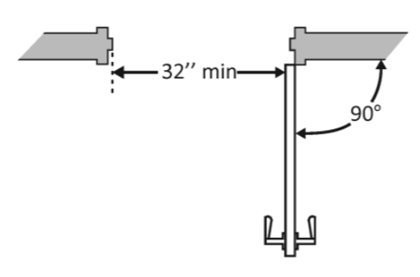
- Maneuvering clearance 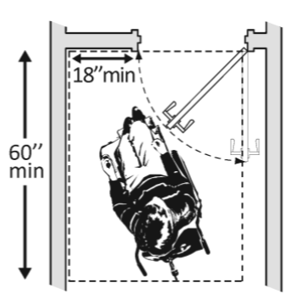
- Door threshold 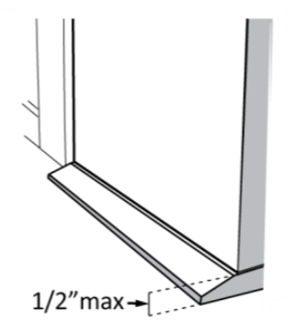
- Door hardware height 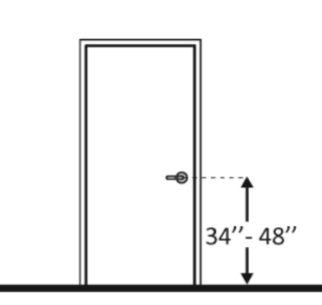
- Door weight 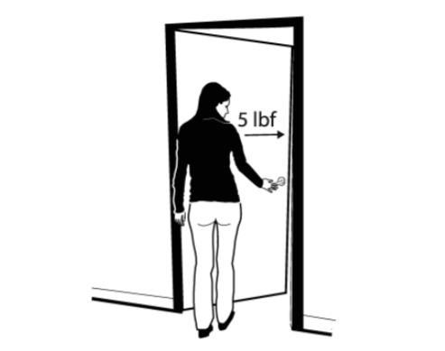
- Other: Please specify ________________________________________________

2-2b Based on your response...
Please select the design factors that affect your experienced accessibility. Select all factors that apply. Click on the image for more information.
Main public areas: Accessible routes (hallways, aisles, pathways, etc.)
- Access route width 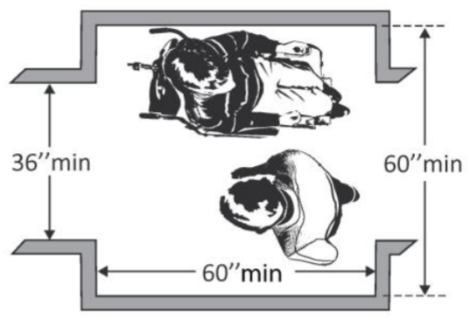
- Interior ramp 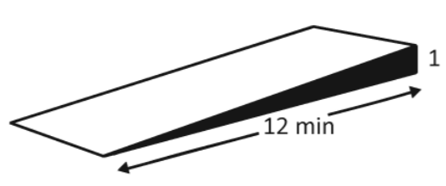
- Turning route width 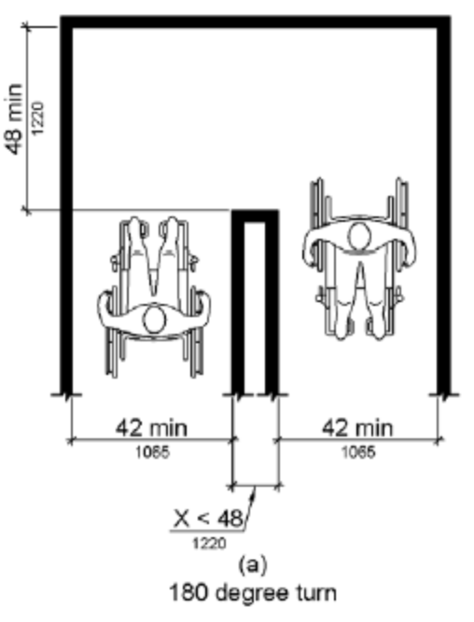
- Other: Please specify ________________________________________________

2-2c Based on your response...
Please select the design factors that affect your experienced accessibility. Select all factors that apply. Click on the image for more information.
Main public areas: Elevator or platform lift
- Control height 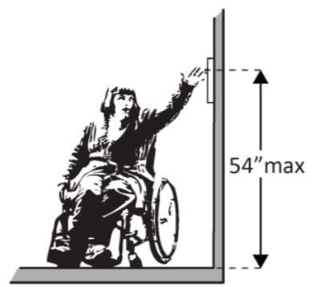
- Clear floor space 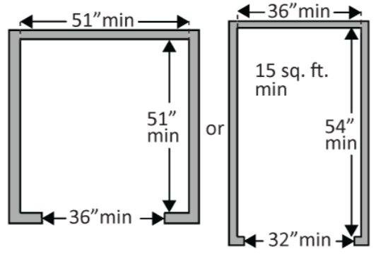
- Door opening width
- Other: Please specify ________________________________________________

2-3 Please select the campus building's accessibility level you experience when maneuvering in the following areas.
Toilet room(s):
 | Extremely easy | Somewhat easy | Neutral | Somewhat difficult | Extremely difficult
Accessible entrance
Accessible route
Wheelchair accessible bathroom stall
Hand washing station

2-3a Based on your response...
Please select the design factors that affect your experienced accessibility. Select all factors that apply. Click on the image for more information.
Toilet room(s): Accessible entrance
- Door or doorway width
- Maneuvering clearance
- Door threshold
- Door hardware height
- Door weight
- Other: Please specify ________________________________________________

2-3b Based on your response...
Please select the design factors that affect your experienced accessibility. Select all factors that apply. Click on the image for more information.
Toilet room(s): Accessible route
- Pathway width 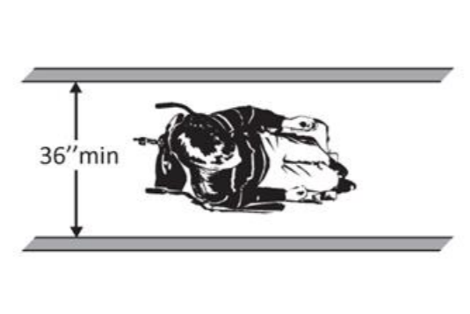
- Turning clearance 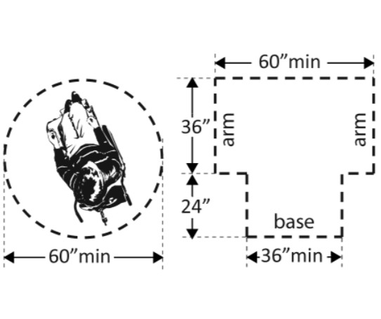
- Other: Please specify ________________________________________________

2-3c Based on your response...
Please select the design factors that affect your experienced accessibility. Select all factors that apply. Click on the image for more information.
Toilet room(s): Wheelchair accessible bathroom stall
- Stall door opening width 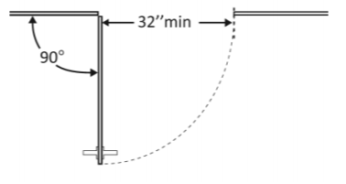
- Clear floor space 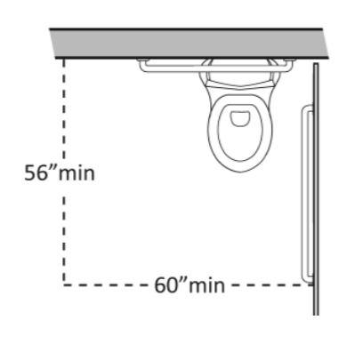
- Toilet location to side wall(s) 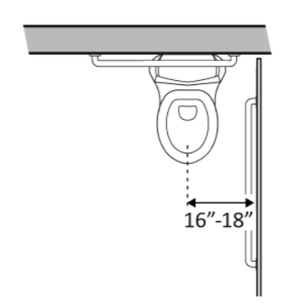
- Toilet seat height 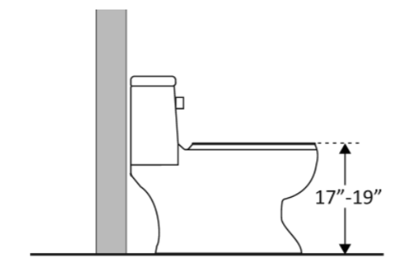
- Grab bar(s) location to toilet 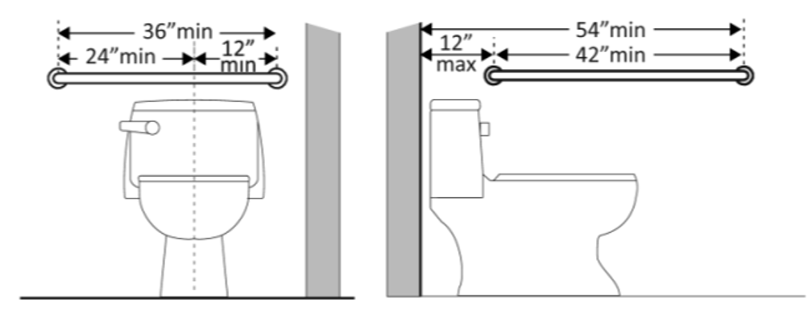
- Grab bar(s) height 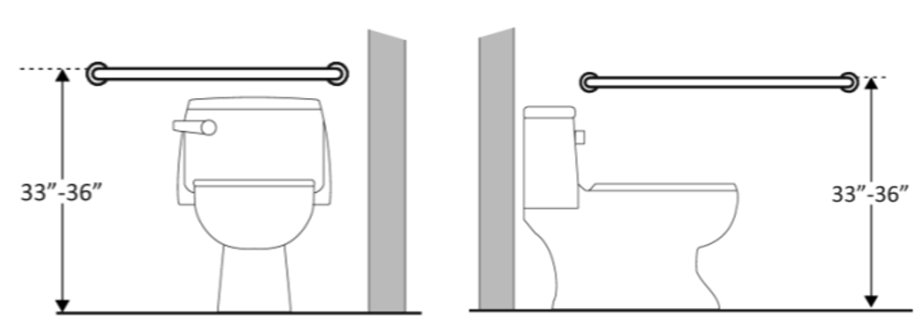
- Other: Please specify ________________________________________________

2-3d Based on your response...
Please select the design factors that affect your experienced accessibility. Select all factors that apply. Click on the image for more information.
Toilet room(s): Hand washing station
- Sink height 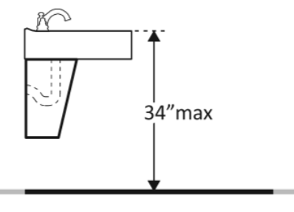
- Clear floor space 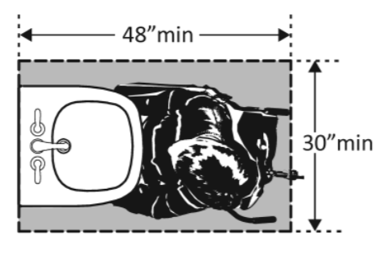
- Reach to faucet 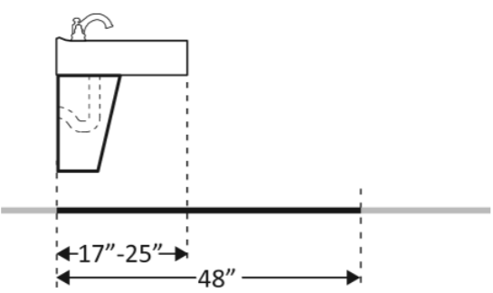
- Other: Please specify ________________________________________________

3-0 Is there another campus building you would like to identify?
- Yes
- No

End of Section 2 & 3: Campus Building Accessibility Ratings

Appendix C: Applicable Accessible Design Standards

Table C1: Exterior Accessible Entrances – Applicable Accessible Design Standards
 | 2010 Standards | 1991 Standards
Maneuvering Clearance
Maneuvering through doorway | See figure 7 | See figure 6
Door in series | 48" min | 48" min
Door Threshold
Beveled threshold height | 0-1/2" or 0-3/4" | 0-1/2" or 0-3/4"
Door Weight
Interior door | 5 lb. max | NA
Exterior door | NA | NA
Doorframe Width
Width from the stop to the face of door | 32" min | 32" min
Door opening | 90° min | 90° min

Table C2: Accessible Routes – Applicable Accessible Design Standards
 | 2010 Standards | 1991 Standards
Pathway Width
Interior minimum route | 36" min | 36" min
Interior ramp minimum route | 36" min | 36" min
Passing space per 200 feet | 60" min or 48" min T-shaped | 60" min or 36" min T-shaped
180° turn, 36" min corridor | 60" min | 60" min or 36"min x 48" min
180° turn, 42" min corridor | 48" min | 48" min

Table C3: Toilet Rooms – Applicable Accessible Design Standards
 | 2010 Standards | 1991 Standards
Maneuvering Clearance
 | See figure 7 | See figure 6
Turning Clearance
Circular | 60" min | 60" min
T-shaped | 36" min | 36" min
Pathway Width
To toilet compartment | 42" min | See figure 6
Unisex, beyond door swing | 30" min x 48" min | NA
Toilet compartment | 60" min x 59" min | 60" min x 59" min
Toilet Location to Side Wall
Water closet centerline | 16" min - 18" max | 18"
Lavatory, Clear Floor Space
Approach Space | 30" min x 48" min | 30" min x 48" min
Knee Space | 27" height min x 8" depth min | 27" height min x 8" depth min
Reach to Faucet | 19” max | 19” max
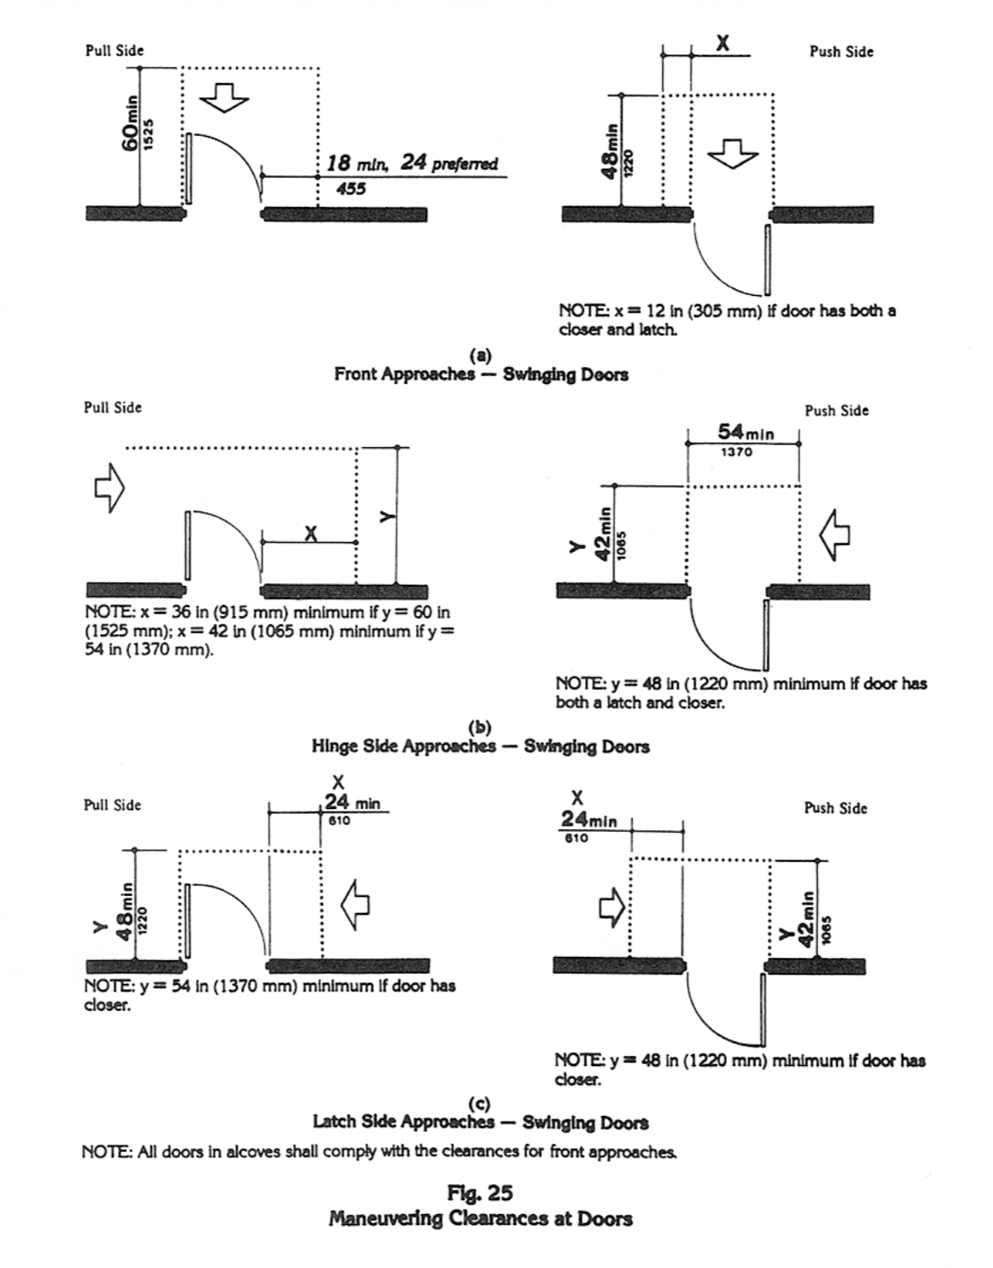
Figure C1: 1991 Accessible Design Standard for Maneuvering Clearance (DOJ, 1994)

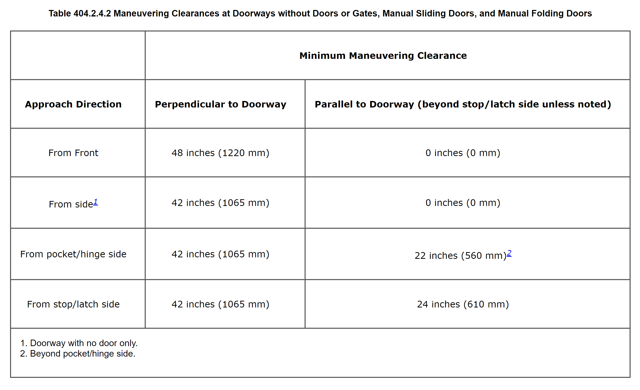
Figure C2: 2010 Design Standard for Maneuvering Clearance (DOJ, 2010)

Table D1a: Exterior Accessible Entrances - Maneuvering Clearance

Name | Approach Direction | Interior Door Side | Perpendicular to Doorway | Parallel to Doorway | Assistive Technology | Design Standard Adherence
Bizzell Memorial Library
DR 1 | Front | Push | 176" | 56" | Yes | >
DR 2 | Front | Push | 90" | 56" | Yes | >
Dale Hall
DR 1 | Front | Push | > 60" | Double Leaf | Yes | >
DR 2 | Front | Push | > 60" | Double Leaf | Yes | >
DR 3 | Front | Push | > 60" | Double Leaf | Yes | >
Gould Hall
DR 1 | Front | Push | 90" | Double Leaf | Yes | >
DR 2 | Front | Push | 82" | Double Leaf | Yes | >
DR 3 | Front | Push | 99" | Double Leaf | Yes | >
DR 4 | Front | Push | > 60" | Double Leaf | Yes | >
DR 5 | Front | Push | 168" | Double Leaf | Yes | >
DR 6 | Front | Push | > 60" | Double Leaf | Yes | >
DR 7 | Front | Push | 94" | Double Leaf | Yes | >
DR 8 | Front | Push | > 60" | Double Leaf | Yes | >

Appendix D: Campus Building Field Measurements

Table D1b: Exterior Accessible Entrances - Maneuvering Clearance

Name | Approach Direction | Interior Door Side | Perpendicular to Doorway | Parallel to Doorway | Assistive Technology | Design Standard Adherence
Oklahoma Memorial Union
DR 1 | Front | Push | 98" | Double Leaf | Yes | >
DR 2 | Front | Push | 162" | Double Leaf | Yes | >
DR 3 | Front | Push | > 60" | Double Leaf | Yes | >
DR 4 | Front | Push | 96" | Double Leaf | Yes | >
DR 5 | Front | Push | 60" | Double Leaf | Yes | >
DR 6 | Front | Push | > 60" | 44" | Yes | >
DR 7 | Front | Push | 192" | Double Leaf | Yes | >
DR 8 | Front | Push | 132" | Double Leaf | Yes | >
Physical Sciences Center
DR 1 | Front | Push | 98" | Double Leaf | Yes | >
DR 2 | Front | Push | 147" | Double Leaf | Yes | >

Table D2: Exterior Accessible Entrances - Door Threshold

Name |  | Type |  | Overall Height |  | Design Standard Adherence
Bizzell Memorial Library
DR 1 |  | Beveled |  | 0-1/2" |  | =
DR 2 |  | Beveled |  | 0-1/2" |  | =
Dale Hall
DR 1 |  | Beveled |  | 0-1/2" |  | =
DR 2 |  | Beveled |  | 0-1/2" |  | =
DR 3 |  | Beveled |  | 0-1/2" |  | =
Gould Hall
DR 1 |  | Beveled |  | 0-1/2" |  | =
DR 2 |  | Beveled |  | 0-1/2" |  | =
DR 3 |  | Beveled |  | 0-1/2" |  | =
DR 4 |  | Beveled |  | 0-1/2" |  | =
DR 5 |  | Beveled |  | 0-1/2" |  | =
DR 6 |  | Beveled |  | 0-1/2" |  | =
DR 7 |  | Beveled |  | 0-1/2" |  | =
DR 8 |  | Beveled |  | 0-1/2" |  | =
Oklahoma Memorial Union
DR 1 |  | Beveled |  | 0-1/2" |  | =
DR 2 |  | Beveled |  | 0-1/2" |  | =
DR 3 |  | Beveled |  | 0-1/2" |  | =
DR 4 |  | Beveled |  | 0-1/2" |  | =
DR 5 |  | Beveled |  | 0-1/2" |  | =
DR 6 |  | Beveled |  | 0-1/2" |  | =
DR 7 |  | Beveled |  | 0-1/2" |  | =
DR 8 |  | - |  | 0" |  | >
Physical Sciences Center
DR 1 |  | Beveled |  | 0-1/2" |  | =
DR 2 |  | Beveled |  | 0-1/2" |  | =
Table D3: Exterior Accessible Entrances - Door Weight
Name | Average Weight (lbs.) |  | Interior Door |  | Assistive Technology |  | Design Standard Adherence
Bizzell Memorial Library
DR 1 | 6 lbs. |  | No |  | Yes |  | <
DR 2 | 8 lbs. |  | Yes |  | Yes |  | <
Dale Hall
DR 1 | 9 lbs. |  | No |  | Yes |  | <
DR 2 | 9 lbs. |  | No |  | Yes |  | <
DR 3 | 9 lbs. |  | No |  | Yes |  | <
Gould Hall
DR 1 | 9 lbs. |  | No |  | Yes |  | <
DR 2 | 8 lbs. |  | Yes |  | Yes |  | <
DR 3 | 9 lbs. |  | No |  | Yes |  | <
DR 4 | 8 lbs. |  | Yes |  | Yes |  | <
DR 5 | 9 lbs. |  | No |  | Yes |  | <
DR 6 | 8 lbs. |  | Yes |  | Yes |  | <
DR 7 | 9 lbs. |  | No |  | Yes |  | <
DR 8 | 8 lbs. |  | Yes |  | Yes |  | <
Oklahoma Memorial Union
DR 1 | 9 lbs. |  | No |  | Yes |  | <
DR 2 | 7 lbs. |  | NO |  | Yes |  | <
DR 3 | 5 lbs. |  | Yes |  | Yes |  | =
DR 4 | 5 lbs. |  | No |  | Yes |  | =
DR 5 | 5 lbs. |  | No |  | Yes |  | =
DR 6 | 5 lbs. |  | No |  | Yes |  | =
DR 7 | 10 lbs. |  | No |  | Yes |  | <
DR 8 | 5 lbs. |  | Yes |  | Yes |  | =
Physical Sciences Center
DR 1 | 7 lbs. |  | No |  | Yes |  | <
DR 2 | 5 lbs. |  | Yes |  | Yes |  | =

Table D4: Exterior Accessible Entrances - Door or Doorway Width
Name | Width | Angle | Design Standard Adherence
Bizzell Memorial Library
DR 1 | 39" | 90° | >
DR 2 | 39" | 90° | >
Dale Hall
DR 1 | 33" | 90° | >
DR 2 | 33" | 90° | >
DR 3 | 33" | 90° | >
Gould Hall
DR 1 | 32" | 90° | =
DR 2 | 34" | 90° | >
DR 3 | 32" | 90° | =
DR 4 | 34" | 90° | >
DR 5 | 32" | 90° | =
DR 6 | 34" | 90° | >
DR 7 | 32" | 90° | =
DR 8 | 34" | 90° | >
Oklahoma Memorial Union
DR 1 | 33" | 90° | >
DR 2 | 39" | 90° | >
DR 3 | 39" | 90° | >
DR 4 | 39" | 90° | >
DR 5 | 34" | 90° | >
DR 6 | 33" | 90° | >
DR 7 | 34" | 90° | >
DR 8 | 34" | 90° | >
Physical Sciences Center
DR 1 | 32" | 90° | =
DR 2 | 34" | 90° | >

Table D5a: Accessible Routes - Pathway Width
Name | Minimum Pathway Width | Design Standard Adherence
Bizzell Memorial Library
RT 1 | 72" | >
RT 2 | 73" | >
RT 3 | 80" | >
RT 4 | 84" | >
RT 5 | 72" | >
RT 6 | 72" | >
RT 7 | 72" | >
RT 8 | 60" | =
RT 9 | Ramp 72" | >
RT 10 | 90" | >
RT 11 | 69" | >
RT 12 | 54" | =
RT 13 | 45" | =
RT 14 | 90" | >
Dale Hall
RT 1 | 144" | >
RT 2 | Ramp 36" | =
RT 3 | 120" | >
RT 4 | 192" | >
RT 5 | 120" | >
RT 6 | 120" | >
RT 7 | 168" | >
Gould Hall
RT 1 | 48" | =
RT 2 | 48" | =
RT 3 | 39" | =
RT 4 | 96" | >
RT 5 | 60" | =
RT 6 | 86" | >

Table D5b: Accessible Routes - Pathway Width
Name | Minimum Pathway Width | Design Standard Adherence
Oklahoma Memorial Union
RT 1 | 68" | >
RT 2 | 77" | >
RT 3 | 44" | =
RT 4 | 76" | >
RT 5 | 78" | >
RT 6 | 168" | >
Physical Sciences Center
RT 1 | 147" | >
RT 2 | 192" | >
RT 3 | 121" | >
RT 4 | 85" | >
RT 5 | 132" | >
RT 6 | 94" | >
RT 7 | 70" | >
RT 8 | 70" | >

Table D6: Toilet Rooms, Accessible Route - Pathway Width
Name | Type | Pathway Width | Design Standard Adherence
Bizzell Memorial Library
TR 1 | Unisex | 73" x 118" | >
TR 2 | Unisex | 73" x 118" | >
TR 3 | Unisex | 73" x 118" | >
TR 4 | Unisex | 73" x 118" | >
Dale Hall
TR 1 | Women's Public | 64" | >
TR 2 | Unisex | 63" x 100" | >
Gould Hall
TR 1 | Women's | 42" | =
TR 2 | Unisex | 60" x 76" | =
TR 3 | Unisex | 60" x 76" | =
Oklahoma Memorial Union
TR 1 | Women's Public | 48" | >
TR 2 | Women's Public | 42" | =
Physical Sciences Center
TR 1 | Women's Public | 40" | <

Table D7: Toilet Rooms, Accessible Route – Turning Clearance
Restroom Name | Restroom Type | Turning Clearance |  | Design Standard Adherence
Bizzell Memorial Library |  | Circular | T-Shape
TR 1 | Unisex | 73" x 60" | NA | =
TR 2 | Unisex | 73" x 60" | NA | =
TR 3 | Unisex | 73" x 60" | NA | =
TR 4 | Unisex | 73" x 60" | NA | =
Dale Hall
TR 1 | Women's Public |  | NA | >
TR 2 | Unisex | 63" x 100" | NA | >
Gould Hall
TR 1 | Women's | 70" x 90" | NA | >
TR 2 | Unisex | 60" x 89" | NA | =
TR 3 | Unisex | 60" x 89" | NA | =
Oklahoma Memorial Union
TR 1 | Women's Public | NA | 45" base x 39" arm x 45" arm x >60" | >
TR 2 | Women's Public | 64" x > 60" | NA | >
Physical Sciences Center
TR 1 | Women's Public | >60" x >60" | NA | >

Table D8: Toilet Room, Accessible Entrance - Maneuvering Clearance

Name | Type | Approach Direction | Interior Door Side | Perpendicular to Doorway  (Floor Clearance) | Parallel to  Doorway | Design Standard Adherence
Bizzell Memorial Library
TR 1 | Unisex | Front | Pull | 120" | 6" | >
TR 2 | Unisex | Front | Pull | 120" | 6" | >
TR 3 | Unisex | Front | Pull | 80" | 4" | >
TR 4 | Unisex | Front | Pull | 80" | 4" | >
Dale Hall
TR 1 | Women's Public | Front | Pull | 99" | 19" | >
TR 2 | Unisex | Front | Pull | 56" | 47" | >
Gould Hall
TR 1 | Women's | Latch Side | Pull | 52" | >24" | >
TR 2 | Unisex | Front | Pull | 56" | 46" | <
TR 3 | Unisex | Front | Pull | 56" | 46" | <
Oklahoma Memorial Union
TR 1 | Women's Public | Front | Pull | 60" | 12" | =
TR 2 | Women's Public | Latch Side | Pull | 53" | 64" | >
Physical Sciences Center
TR 1 | Women's Public | Front | Pull | 81" | 18" | >

Table D9: Toilet Rooms, Wheelchair Accessible Toilet Compartment - Toilet Location
Name | Type | Toilet Center to Wall | Design Standard Adherence
Bizzell Memorial Library
TR 1 | Unisex | 18" | =
TR 2 | Unisex | 18" | =
TR 3 | Unisex | 18" | =
TR 4 | Unisex | 18" | =
Dale Hall
TR 1 | Women's Public | 18" | =
TR 2 | Unisex | 18" | =
Gould Hall
TR 1 | Women's | 18" | =
TR 2 | Unisex | 18" | =
TR 3 | Unisex | 18" | =
Oklahoma Memorial Union
TR 1 | Women's Public | 21" | <
TR 2 | Women's Public | 19" | <
Physical Sciences Center
RR 101 | Women's Public | 18" | =

Table D10: Toilet Rooms, Handwashing Station - Clear Floor Space
Name | Type | Approach Space | Reach to faucet | Knee Space | Design Standard Adherence
Bizzell Memorial Library
TR 1 | Unisex | 30" x 72" | 14" | 32" x 9" | >
TR 2 | Unisex | 30" x 72" | 14" | 32" x 9" | >
TR 3 | Unisex | 30" x 72" | 14" | 32" x 9" | >
TR 4 | Unisex | 30" x 72" | 14" | 32" x 9" | >
Dale Hall
TR 1 | Women's Public | 30" x 125" | 16" | 30" x 10" | >
TR 2 | Unisex | 30" x 100" | 16" | 30" x 10" | >
Gould Hall
TR 1 | Women's | 30" x 90" | 19" | 29" x 8" | =
TR 2 | Unisex | 30" x 89" | 19" | 29" x 8" | =
TR 3 | Unisex | 30" x 89" | 19" | 29" x 8" | =
Oklahoma Memorial Union
TR 1 | Women's Public | 45" x 64" | 19" | 28" x 14" | =
TR 2 | Women's Public | 30" x 90" | 19" | 29" x 14" | =
Physical Sciences Center
TR 1 | Women's Public | 30" x 120" | 15" | 28" x 10" | >

