University of Oklahoma

Graduate College

Internal Curing of calcium sulfoaluminate cement concrete using lightweight aggregate

A thesis

submitted to the Graduate Faculty

in partial fulfillment of the requirements for the

Degree of

Master of Science

By

Stephen Daniel Tanksley
Norman, Oklahoma
2018

Internal Curing of calcium sulfoaluminate cement concrete using lightweight aggregate

A thesis approved for the
School of Civil Engineering and Environmental Science

By

______________________________
Dr. Royce W. Floyd, Chair

______________________________
Dr. Christopher C. Ramseyer

______________________________
Dr. Jeffery S. Volz

© Copyright by Stephen daniel tanksley 2018
All Rights Reserved.
This is dedicated to my loving and supportive parents, Dan and Melissa.

Acknowledgements
I would like to thank the CEES Department at the University of Oklahoma, especially my thesis committee members, Dr. Chris Ramseyer and Dr. Jeff Volz. I would like to thank Dr. Royce Floyd, for taking a chance on me and giving me the opportunity to further my academic career. I do not believe I would be where I am today without the help and support he has continued to show me. I will always remember the time I spent studying under him and will seek advice from him for the rest of my life, whether it be professional or just general life advice. I would also like to thank Mike Schmitz for dealing with me, guiding me, and assisting me in work that needed to be done at Fears Structural Engineering Laboratory.
I would like to thank Dr. Cameron Murray, who was a Ph.D. candidate when I first started my research for graduate school. He was very helpful in my studies and research, despite not having any obligation to help me. His dedication to research and work ethic set great examples for me and I hope the best for him as he begins his career in academics. I would also like to thank Connor Casey, Chandler Funderburg, and Chetan Koundinya for all their help with batching, measurements and testing. Without the help I received from my fellow students I would never have been able to batch any concrete for my experiment.
Last but certainly not least, I must thank my parents, without them I would not have been able to go to college at all. They have supported me through the years and instilled the importance of science and math in my mind at an early age. My parents and brothers mean so much to me, and I am forever grateful to them for always being there even when times were extremely tough.

Table of Contents
Acknowledgements iv
List of Tables viii
List of Figures x
Abstract xiv
Chapter 1: Introduction 1
Chapter 2: Literature Review 3
2.1 Internal curing of concrete 3
2.2 Calcium sulfoaluminate cement 7
2.3 Autogenous shrinkage in concrete 10
2.4 Summary 12
Chapter 3: Methodology 13
3.1 Overview of testing program 13
3.2 Mixing procedure 15
3.3 Lightweight fine aggregate for internal curing 19
3.4 Mix designs used for testing 21
3.4.1 Buzzi CSA cement 21
3.4.2 Rapid Set® cement 23
3.4.3 Komponent® cement 25
3.4.4 Conventional portland cement 26
3.5 Specimen Testing 27
3.5.1 Compressive strength 27
3.5.2 Rapid chloride ion permeability (RCIP) 29
3.5.3 Length change 34
Chapter 4: Results and Discussion 38
4.1 General batch information 38
4.1.1 Buzzi CSA cement 38
4.1.2 Rapid Set® cement 40
4.1.3 Komponent® cement 41
4.1.4 Conventional portland cement 42
4.2 Compressive strength 44
4.2.1 Buzzi CSA cement 44
4.2.2 Rapid Set® cement 47
4.2.3 Komponent® cement 50
4.2.4 Conventional portland cement 52
4.3 Rapid chloride ion permeability 55
4.3.1 Buzzi CSA cement 57
4.3.2 Rapid Set® cement 60
4.3.3 Komponent® cement 63
4.3.4 Conventional portland cement 67
4.4 Length change 69
4.4.1 Buzzi CSA cement 70
4.4.2 Rapid Set® cement 75
4.4.3 Komponent® cement 80
4.4.4 Conventional portland cement 90
Chapter 5: Summary, Conclusions, and Recommendations 96
5.1 Summary 96
5.2 Conclusions 96
5.3 Recommendations 98
References 100
Appendix A: Compressive Strength Test Results 103
Appendix B: General Batch Information 107

List of Tables
Table 1: Sample identification, cement type and amount of internal curing water for each batch 14
Table 2: Final mix designs for CSA cement batches 22
Table 3: Final mix designs for Rapid Set® cement batches 24
Table 4: Final mix designs for Komponent® cement batches 25
Table 5: Final mix designs for portland cement batches 27
Table 6: Fresh concrete properties and LWA moisture content for the Buzzi CSA cement batches 38
Table 7: Fresh concrete properties and LWA moisture content for the Rapid Set® cement batches 40
Table 8: Fresh concrete properties and LWA moisture content for the Komponent® cement batches 41
Table 9: Fresh concrete properties and LWA moisture content for the portland cement batches 43
Table 10: Average compressive strength results for CSA samples 45
Table 11: Average compressive strength results for the Rapid Set® cement samples 48
Table 12: Average compressive strength results for the Komponent® cement samples 50
Table 13: Average compressive strength results for the portland cement samples 53
Table 14: Chloride ion permeability classification based on charge passed in RCIP testing 56
Table 15: CSA compressive strengths 103
Table 16: Rapid Set® compressive strengths 104
Table 17: Komponent® compressive strengths 105
Table 18: Conventional portland cement compressive strengths 106
Table 19: Batch weights and aggregate moisture contents for the Buzzi CSA cement batches 107
Table 20: Batch weights and aggregate moisture contents for the Rapid Set® cement batches 107
Table 21: Batch weights and aggregate moisture contents for the Komponent® cement batches 107
Table 22: Batch weights and aggregate moisture contents for the conventional portland cement batches 108

List of Figures
Figure 1: Aerial view of Pantheon in Rome (Architexts 2016) 4
Figure 2: Cured zones in externally cured concrete versus internally cured concrete (Weiss 2011) 5
Figure 3: How presoaked LWA effects concrete before and after hardening (ESCSI 2010) 6
Figure 4: Geokon Model 4200 VW strain gage tied in cylinder prior to batching 18
Figure 5: Forney machine used for compressive strength testing 28
Figure 6: 2 in. (50-mm) tall cylinder used in RCIP testing cells 30
Figure 7: Vacuum chamber used in the RCIP tests 31
Figure 8: PROOVE'it testing cell for the RCIP test 32
Figure 9: The Germann Instruments box used to apply the required voltage and run the PROOVE'it software used for the RCIP test 33
Figure 10: C157 testing apparatus for length change with the reference bar in place 35
Figure 11: C157 specimen in testing 36
Figure 12: Average compressive strengths for CSA samples 45
Figure 13: Compressive strength trend lines for CSA 46
Figure 14: Average compressive strengths for Rapid Set® cement samples 48
Figure 15: Compressive strength trend lines for Rapid Set® cement 49
Figure 16: Average compressive strengths for Komponent® cement samples 51
Figure 17: Compressive strength trend lines for Komponent® cement 52
Figure 18: Average compressive strengths for portland cement samples 54
Figure 19: Compressive strength trend lines for portland cement 55
Figure 20: Maximum, minimum and average charge passed for CSA at 28-days 58
Figure 21: Maximum, minimum and average charge passed for CSA at 90-days 59
Figure 22: Average charge passed for CSA cement samples at 28-days and 90-days 60
Figure 23: Maximum, minimum and average charge passed for Rapid Set® at 28-days 61
Figure 24: Maximum, minimum and average charge passed for Rapid Set® at 90-days 62
Figure 25: Average charge passed for Rapid Set® cement samples at 28-days and 90-days 63
Figure 26: Maximum, minimum and average charge passed for Komponent® at 28-days 64
Figure 27: Maximum, minimum and average charge passed for Komponent® at 90-days 65
Figure 28: Average charge passed in Komponent® cement samples at 28-days and 90-days 66
Figure 29: Maximum, minimum and average charge passed for portland cement at 28-days 67
Figure 30: Maximum, minimum and average charge passed for portland cement at 90-days 68
Figure 31: Average charge passed for portland cement samples at 28-days and 90-days 69
Figure 32: ASTM C157 length change over time for CSA cement with 0 lb of internal curing water 70
Figure 33: ASTM C157 length change over time for CSA cement with 5 lb of internal curing water 71
Figure 34: ASTM C157 length change over time for CSA cement with 7 lb of internal curing water 72
Figure 35: ASTM C157 length change over time for CSA cement with 10 lb of internal curing water 73
Figure 36: ASTM C157 average length change over time for CSA cement specimens 74
Figure 37: ASTM C157 length change over time for Rapid Set® cement with 0 lb of internal curing water 76
Figure 38: ASTM C157 length change over time for Rapid Set® cement with 5 lb of internal curing water 77
Figure 39: ASTM C157 length change over time for Rapid Set® cement with 7 lb of internal curing water 78
Figure 40: ASTM C157 length change over time for Rapid Set® cement with 10 lb of internal curing water 79
Figure 41: ASTM C157 average length change over time for Rapid Set® cement specimens 80
Figure 42: ASTM C157 length change over time for Komponent® cement with 0 lb of internal curing water 81
Figure 43: ASTM C157 length change over time for Komponent® cement with 5 lb of internal curing water 82
Figure 44: ASTM C157 length change over time for Komponent® cement with 7 lb of internal curing water 83
Figure 45: ASTM C157; length change over time for Komponent® cement with 10 lb of internal curing water 84
Figure 46: ASTM C157 average length change over time for Komponent® cement specimens 85
Figure 47: VWSG readings for the Komponent® cement batches 86
Figure 48: Strain gage readings from the two Komponent® batches with 7 lb of internal curing water 88
Figure 49: Visible height expansion of sample *ST210 89
Figure 50: Visible expansion of the base with stretch marks on the mold for *ST210 90
Figure 51: ASTM C157 length change over time for portland cement with 0 lb of internal curing water 91
Figure 52: ASTM C157 length change over time for portland cement with 5 lb of internal curing water 92
Figure 53: ASTM C157 length change over time for portland cement with 7 lb of internal curing water 93
Figure 54: ASTM C157 length change over time for portland cement with 10 lb of internal curing water 94
Figure 55: ASTM C157 average length change over time for portland cement specimens 95

Abstract
Calcium sulfoaluminate (CSA) cement is a very rapid setting, hydraulic cement that releases approximately half as much carbon dioxide during production as conventional portland cement. CSA cement produces concrete with high early strength, excellent durability, and limited shrinkage. This cement also requires approximately twice as much water as conventional portland cement for proper hydration. The introduction of internal curing water from presoaked lightweight aggregate into the mix design allows more time for hydration during the curing process. The additional time for hydration provided by internal curing has the potential for positive effects on the performance of CSA cement concrete. The work described in this thesis examined three CSA cements and portland cement with 0 lb, 5 lb, 7 lb, and 10 lb of internal curing water per 100 lb of cement added to each mix design through the use of presoaked lightweight aggregate. Concrete specimens cast from each mix design were tested for compressive strength, permeability through the Rapid Chloride Ion Permeability test, and length change to measure shrinkage of the concrete. It was determined that the compressive strength of the Buzzi CSA cement concrete was impacted most positively by adding 5 lb of internal curing water. The Komponent® cement concrete exhibited the most improvement in performance from adding internal curing water; it showed an improvement in compressive strength and permeability results and reduced shrinkage. In general, the addition of 7 lb of internal curing water reduced shrinkage for all CSA cements examined. The conventional portland cement was the only cement tested that did not exhibit clear benefits from the addition of internal curing water.

Chapter 1: Introduction
Calcium sulfoaluminate (CSA) cement yields high strengths at an early age and is used as an alternative to conventional portland cement. Besides yielding higher strengths at earlier ages, CSA is known for producing less CO₂ than portland cement. CSA cement has been being studied since the late 1960’s, and is known for requiring more water for proper hydration than portland cement (ACI committee 223 1970). With that being said there has been very little to no research introducing internal curing water into CSA cement concrete for longer hydration. Internal curing of concrete can be dated back to Roman times when a lightweight aggregate (LWA) was introduced into concrete to reduce the weight and build taller structures (Bremner & Ries 2009).
The study described in this thesis was conducted to further investigate the effects of introducing internal curing water on the performance of CSA cement concrete through incorporating presoaked LWA into the mix design, thereby extending the hydration time in the concrete. The increased water demand of CSA cements necessitates proper curing for best results, but curing is not always done correctly in the field. Internal curing has the potential to provide required curing water within the concrete which can reduce the impact of improperly applied external wet curing techniques after the concrete sets. With CSA cement requiring approximately twice as much water as portland cement, the introduction of internal curing water should have a positive effect on the concrete performance for any external curing condition.
Internal curing was introduced into the mix designs of three CSA cements (Buzzi CSA, Rapid Set®, Komponent®) and conventional portland cement. The ultimate objective of this project is to examine how adding presoaked LWA for internal curing affects the performance of three CSA cement concrete mixtures in terms of compressive strength, length change, and permeability of internally cured CSA cement concrete. These particular properties were chosen for evaluation because they are important measures of performance for CSA based cements and are affected by curing conditions.

Chapter 2: Literature Review

2.1 Internal curing of concrete
The American Concrete Institute (ACI) defines internal curing as “the process by which the hydration of cement occurs because of the availability of additional internal water that is not part of the mixing water” (ACI 308 2016). This definition changed in 2013; prior to then, LWA was the only material used for internal curing. Recently researchers have begun experimenting with other materials. Since the research described in this thesis only pertains to internal curing using LWA, other materials that have recently been discovered for use in place of the LWA will not be included in further discussion.
The concept of internally curing concrete is not a new one, however there is still much to learn about this method of curing. Internal curing of concrete aims to increase the amount of time that the water has to react with the cement without (or in addition to) applying external water, which is done by introducing presoaked LWA, typically fine aggregate, that slowly releases water into the concrete. The importance of reducing the density of concrete, while maintaining durability and strength, has been recognized for a very long time. This was done by using LWA, through which the builders may have inadvertently introduced internal curing. Examples of LWA in concrete can be dated back to Roman times, with one of the most notable structures being the Pantheon in Rome. Figure 1 shows the dome of the Pantheon in Rome.
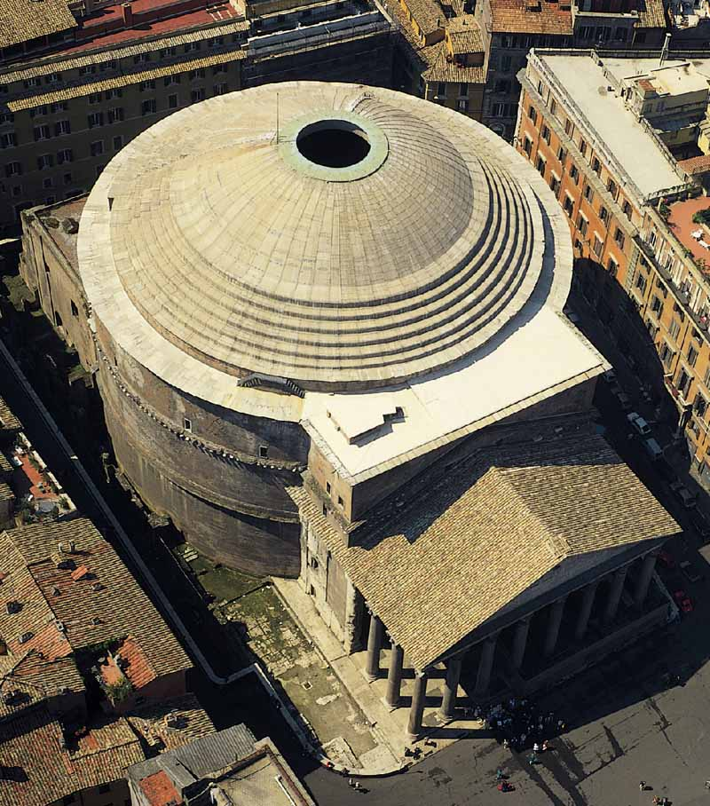
Figure 1: Aerial view of Pantheon in Rome (Architexts 2016)
The dome of the Pantheon was constructed using lightweight concrete with vesicular aggregates (such as pumice and scoria), which were hand-sorted according to density. Doing so allowed the density of the concrete to be reduced as the height of the dome increased (Bremner & Ries 2009). Any significant loss in durability, if any, of concrete using LWA is not an issue with this structure dating back almost 2000-years.
Internal curing differs from typical external curing by including a presoaked LWA, typically fine aggregate, into the mix design. The current research uses presoaked expanded shale LWA, which is similar to the method discussed in section 2.3 based on an article written by Bentur in 2001 (Bentur 2001). The water stored internally in the LWA particles is then available for hydration of cement. The amount of water available for curing is calculated by using the known absorption for the aggregate and the amount of aggregate added to the mix design. Free water of the aggregate is accounted for in the mix design by determining the moisture content of the presoaked LWA and subtracting the free water on the outside of the aggregates from the required mixing water, just like for other aggregates in the concrete mixture. Adding presoaked fine LWA reduces the amount of sand included in the mix design (because the LWA replaces it) as compared to a conventional externally cured concrete. The reason for using internal curing versus typical curing methods is that it allows for a greater depth of water penetration in concrete with low permeability. The presoaked aggregate provides trapped moisture inside the concrete whereas external curing only applies water at the surface, which limits the amount of water that penetrates into the specimen. These concepts are illustrated in Figure 2, taken from Weiss (2011).
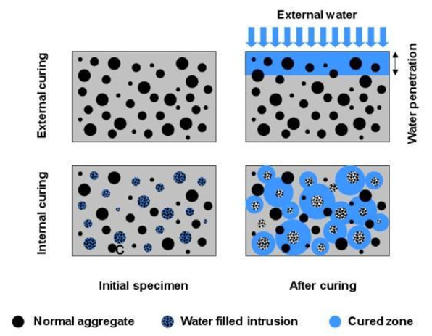
Figure 2: Cured zones in externally cured concrete versus internally cured concrete (Weiss 2011)
The top two specimens in Figure 2 show externally cured samples and the bottom two specimens show internally cured samples. External curing water only penetrates the specimen to a certain depth, on the order of 3-mm of movement after 18-hrs, resulting in properly cured zones only near the top of the specimen (Weiss 2011). The benefit of trapping the water inside the cured concrete is that it allows a longer time for the cement and water to react. Introducing the presoaked LWA into the specimen allows cured zones throughout the entire specimen, whereas the externally cured concrete has properly cured zones that only penetrate to a certain depth. One of the leading organizations for LWA aggregate producers in the United States is the Expanded Shale, Clay, and Slate Institute (ESCI). Figure 3 was obtained from ESCI regarding how presoaked LWA affects concrete while in the fresh and hardened states with and without LWA.
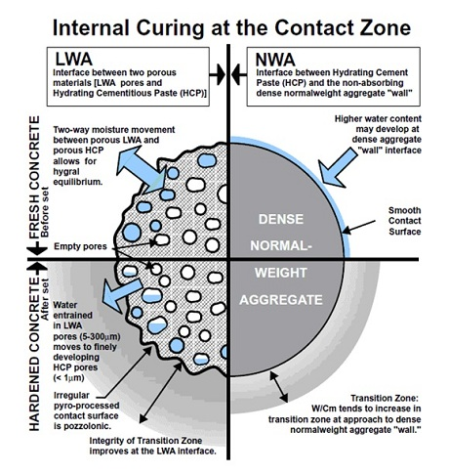
Figure 3: How presoaked LWA effects concrete before and after hardening (ESCSI 2010)
Figure 3 shows where the water is stored inside of LWA, how it releases into the concrete, and how it continues to release even after the concrete has hardened. Concrete with no LWA does not have the water available to soak into the pores of the hardened concrete like the LWA concrete does.
The mix proportion used for internal curing is an important consideration and can be designed using an understanding of internal curing and the LWA aggregates used. In his seminal article, Mixture Proportioning for Internal Curing, Bentz (2005) uses his knowledge of internal curing and years of research experience to explain how to select a mix design for internal curing. His paper set the standard for the proportioning of each material in a mix design that is easy to work with and experiences internal curing.

2.2 Calcium sulfoaluminate cement
Over the past few decades the issue of climate change due to global warming has been a rising concern, and greenhouse gas emissions are primarily to blame for this phenomenon. Production of portland cement accounts for approximately 5% of global man-made CO₂ released into the world’s atmosphere and 3% of annual energy consumption globally (Gartner 2004; Damtoft et al 2008). The demand for cement is rapidly increasing, especially in developing countries; these countries saw an increase by 55% in the 1990’s alone. By 2020, the global demand is expected to be 115-180% of what it was in the 1990’s and is predicted to rise by 400% by the year 2050 (Damtoft et al 2008). With this drastic increase in demand over the past few decades, scientists and engineers have been studying alternative cements that are more environmentally friendly than traditional portland cement.
CSA cement is one alternative to portland cement which emits less greenhouse gas during production of the cement. CSA cement clinker is produced at kiln temperatures of approximately 1250 °C, which is approximately 200 °C less than portland cement kiln temperatures. The conversion of limestone to calcium oxide accounts for about 48% of CO₂ emissions in production of portland cement. CSA cement requires approximately 35-40% less limestone in production than portland cement (Chaunsali 2015). Therefore, CSA is a good alternative cementitious binder relative to CO₂ emissions.
Like portland cement clinker, CSA cement clinker requires limestone and calcium sulfate (gypsum or anhydrate) in production. However, CSA cement requires another source of alumina such as bauxite. CSA cements are composed of calcium sulfoaluminate, or ye’elimite (C₄A₃S), and belite (C₂S). The hydration of ye’elimite in the presence of calcium sulfate occurs quickly to form ettringite and monosulfate (Winnefeld & Lothenbach 2010). This rapid formation of ettringite results in CSA cements having quick setting times and high early compressive strengths when compared to portland cement (Sharp et al 1999).
CSA cements are useful for bridge, and roadway repair because this binder is rapid setting and exhibits high early compressive strengths or produces controlled expansion that can be used to offset drying shrinkage depending on the chemical formulation. Besides being used as a binder, CSA cements are used as an expansive compound in shrinkage-compensating cements. Rapid setting CSA cements demonstrate very good performance relative to shrinkage, due in part to two reasons. The first is that in order to achieve proper hydration CSA cements require approximately 50% more water than portland cement. Most of the mix water is used to meet the proper hydration requirements for CSA cements, leaving less excess water that could cause drying shrinkage over time. The second reason is that the very fast strength gain can help prevent shrinkage cracking because the strength of the concrete increases faster than the tensile stresses in the concrete due to shrinkage (Winnefeld & Lothenbach 2010).
The experiment described in this thesis investigated three types of CSA cements, Buzzi CSA cement, Rapid Set® cement, and Komponent® cement. Buzzi Unicem USA produces a pure CSA cement that is ye’elimite based and is designed to increase the strength, shorten set times, add durability, and decrease shrinkage when added to standard concrete mix designs. Rapid Set® cement is the trademarked name of a belite based CSA cement produced by CTS Cement Manufacturing. Rapid Set® cement is a true cement; it does not need to be combined with any other binder. Rapid Set® cement is added to sand, gravel and water the same way portland cement is added to those ingredients to make concrete. Buzzi’s CSA cement is more like an additive. It must be blended with portland cement, sand, gravel, and water to produce concrete. Rapid Set® cement is produced using pure CSA clinker that is blended with portland cement clinker and fired in a kiln. The high temperature in the kiln, combines the CSA and portland cement clinker and forms this Rapid Set® cement, leaving behind no portland cement (CTS 2016).
Type K cement, marketed as Komponent® cement by CTS Cement Manufacturing, is an expansive CSA cement-based additive, typically replacing a portion of the cement in a portland cement mix design. ASTM C845 the Standard Specification for Expansive Hydraulic Cement, defines Type K cement as an expansive cement containing anhydrous calcium sulfoaluminate (4CaO·3Al₂ O₃·SO₃), calcium sulfate, and uncombined calcium oxide. Komponent® is typically used for its shrinkage compensating purposes which help minimize drying shrinkage cracking. The CSA cement hydration mechanism in the Komponent® cement reduces drying shrinkage by eliminating excess bleed water. This happens during the hydration process when water molecules become bound within the ettringite crystals. The rapid growth of the crystals due to the CSA reactions produces expansion that can counteract the shrinkage that does occur and can lead to high early strengths (CTS 2016).
Belite hydrates slowly over time to form calcium silicate hydrates (CSH), whereas ye’elimite hydrates very quickly to form ettringite crystals. Since the Rapid Set® cement is a belitic CSA cement, the performance over time is accredited to the belite forming CSH and the rapid set time and strength gain is due to the ye’elimite forming ettringite. The Buzzi CSA cement and Komponent® cement were both mixed with portland cement in the mix design. The late age performance of these two mixes is due to the alite in the portland cement reacting to form CSH over time and not from belite. The rapid set time, strength gain of these mixes at early ages, and expansion of the Komponent® cement concrete is due to ye’elimite forming ettringite, similarly to the Rapid Set® batches (Londono-Zuluaga 2017).

2.3 Autogenous shrinkage in concrete
One major issue with conventional concrete is that it begins to shrink a few minutes after the concrete is set. This shrinkage comes from two sources: autogenous shrinkage and drying shrinkage. The term autogenous shrinkage is another term for chemical shrinkage and occurs in concrete with water-cement ratios less than 0.42 (Bentz 2005). Autogenous shrinkage begins when the cement reacts with the water; the cement absorbs water and creates very fine voids in the specimen. The surface tension in all of these voids leads to the autogenous shrinkage, which can cause cracking (Bentz 2004). Drying shrinkage happens because the water added while mixing settles out and evaporates, and the volume decreases since there is no remaining water in the concrete. Internal curing has been shown to decrease concrete shrinkage (Cusson 2008). As presoaked LWA is added, extra water is released as the internal relative humidity decreases from 100%. The relative humidity inside the concrete will decrease with the formation of capillary pores. The extra water inside the presoaked LWA will move out and immediately fill the capillary pores in the cement paste. This will decrease the rate of reduction of the internal relative humidity in the concrete. As this occurs it is expected that the shrinkage driving force (capillary stress) will decrease and reduce the shrinkage strain of the concrete (Zhang 2015).
In the 1990’s and early 2000’s Bentur studied how to prevent autogenous shrinkage in concrete using LWA; particularly those samples with LWA in the saturated surface dry (SSD) condition (Bentur 2001). The term SSD refers to the state at which the surface of an aggregate is dry but the aggregates’ internal voids are completely saturated. Bentur’s results state, “[w]hen the LWA was in the SSD state, the concrete exhibited a rapid expansion during the first few hours. Thereafter, it continued to show a slight expansion” (Bentur 2001). This means that his results show that autogenous shrinkage was prevented when using the SSD LWA in his mix. Work by Philleo (1991) suggested “incorporating saturated lightweight fine aggregate (LWFA) into the concrete mixture to provide an internal source of water necessary to replace that consumed by chemical shrinkage during hydration (curing). As the cement hydrates, this extra water is drawn from the relatively ‘large’ pores in the LWFA into the much smaller ones in the cement paste” (Philleo 1991).

2.4 Summary
Internal curing of concrete is known to have many benefits, but little to no research has been performed relating to internal curing in CSA cement. The additional water required for the CSA cement reaction and importance of curing on performance makes CSA cements likely to benefit from internal curing.

Chapter 3: Methodology

3.1 Overview of testing program
Overall, a total of 16 batches were conducted to cast the specimens required for each desired variable combination and to obtain an adequate amount of data for comparison of the effects of different amounts of internal curing water on the behavior of CSA cement concrete. Four cements were used in this research, and each cement was used for four batches combined with either no LWA added or enough LWA to provide 5 lb, 7 lb or 10 lb of internal curing water per 100 lb of cement. The limestone (coarse aggregate) and the sand have very small absorption capacities of less than 1%. Even so, all of the batches included some amount of water absorbed in the limestone and sand. Moisture content adjustments were made so that the limestone had a constant amount of absorbed water between batches. Similar moisture content adjustments were made for the sand, but the total amount of water absorbed in the sand in each batch changed as sand was replaced with lightweight aggregate. However, the amount was much smaller than the amount added through LWA. A summary of the material quantities used for each batch, including weights of each material and moisture content of the limestone and sand is provided in Appendix B. When referring to the amount of internal curing water provided in a particular mix design throughout this thesis, the identifiers 0 lb, 5 lb, 7 lb, and 10 lb, refer to the amount of internal curing water from the presoaked LWA alone; it does not include water absorbed in the other aggregates. Water in normal weight aggregates is typically not considered in the amount of internal curing water, which refers only to the water added through including presoaked LWA. The four cements tested in this research included Rapid Set®, Buzzi CSA, Komponent®, and Type I portland cement. Each cement is described in detail in section 3.4. The batch identification, cement type, and amount of internal curing water per 100 lb of cement for each batch is shown in Table 1. All of the batching and testing took place at Donald G. Fears Structural Engineering Laboratory at the University of Oklahoma.

Table 1: Sample identification, cement type and amount of internal curing water for each batch
Cement Type | Batch ID | Internal Curing Water From LWA  (lb/100lb of cement)
Rapid Set® | ST100 | 0
Rapid Set® | ST110 | 5
Rapid Set® | ST120 | 7
Rapid Set® | ST130 | 10
CSA | ST150 | 0
CSA | ST160 | 5
CSA | ST170 | 7
CSA | ST180 | 10
Komponent® | ST190 | 0
Komponent® | ST200 | 5
Komponent® | ST220 | 7
Komponent® | ST230 | 10
Type I portland | ST240 | 0
Type I portland | ST250 | 5
Type I portland | ST260 | 7
Type I portland | ST270 | 10

Specimens were cast from each batch to test compressive strength, length change, and Rapid Chloride Ion Permeability (RCIP) All specimens were cast based on the requirements presented in ASTM C192. Specimens from each batch were then tested and the results examined to determine which amount of internal curing water was the most effective for each cement and how the results from different cements compared to each other. Each batch included 4 in. diameter by 8 in. in height concrete cylinders to test the compressive strength using ASTM C39. The same size cylinders were also used for the RCIP testing. Three rectangular prisms were cast for each batch in accordance with ASTM C-157 to measure the length change over time. The Komponent® cement batches also included one 6 in. diameter by 12 in. in height cylinder with a single vibrating wire strain gage (VWSG) placed inside the cylinder to record the strain over time. Temperature, unit weight, and slump were measured for each batch as well.

3.2 Mixing procedure
All of the mixes were prepared and test specimens cast according to ASTM C192/C192M-16a Standard Practice for Making and Curing Concrete Test Specimens in the Laboratory. All materials for each batch were prepped the day before batching, except for the lightweight fine aggregate. The LWA was gathered two days prior to casting and was completely submerged in water for 48-hrs to allow the particles to reach a consistent internal moisture content as determined by aggregate testing. The procedure for soaking and draining off the water from the presoaked LWA and adjusting for surface moisture is discussed in more detail in Section 3.3. A moisture content sample of the LWA was collected when the LWA was finished draining off the excess water after being allowed to soak for 48-hrs. The presoaked sample was then placed in the oven for 24-hrs and the moisture content was calculated the same way as the limestone and sand. The moisture content of the LWA for each batch was then calculated and used to examine consistency of the aggregate moisture content. Gathering the coarse aggregate (limestone), and normal weight sand the day before batching allowed the moisture content of each material to be determined before batching so the amount of mixing water could be adjusted as needed. The moisture content of the sand and limestone was determined by gathering a 2-3 lb sample of each aggregate, placing the specimens in an aggregate drying oven, and allowing the samples to dry for 24-hrs. The calculation of moisture content was done in accordance with ASTM C566 – 13; Standard Test Method for Total Evaporable Moisture Content of Aggregate by Drying.
An electric rotating drum mixer was used for mixing all of the materials together for every batch. A slump test performed according to ASTM C143, Standard Test Method for Slump of Hydraulic Cement Concrete, was conducted to measure the workability of the concrete. Temperature readings were taken of each batch according to the specifications of ASTM C1064/C1064M – 17, the Standard Test Method for Temperature of Freshly Mixed Hydraulic-Cement Concrete. The thermometer was placed in the freshly mixed concrete, after the concrete was poured from the mixer to the wheel barrow, with at least 3 in. of cover in each direction. The temperature reading was then taken between 2-min and 5-min after placing the thermometer in the freshly mixed concrete. A unit weight test was run according to ASTM C138, Standard Test Method for Density (Unit Weight), Yield, and Air Content (Gravimetric) of Concrete, as well. This was done by filling an air content bucket by thirds of approximately equal depths rodded 25 times each with a 5/8-inch rod, striking off the top, and weighing the full bucket. The unit weight was calculated by subtracting the weight of the empty bucket from the weight of the bucket filled with concrete, then taking the difference and dividing it by the volume of the bucket, 0.25 ft³.
All 4 in. diameter by 8 in. tall cylinder molds were filled using two layers of approximately equal depths and each layer was rodded 25 times using a 3/8 in. rod. The two rapid setting cements, CSA and Rapid Set®, each required 22 of this size cylinders to be cast for the required compressive strength and RCIP tests, while the conventional portland cement and Komponent® cement batches only required 16 cylinders of this size. The Komponent® cement batches also included a 6 in. diameter by 12 in. tall cylinder which was filled using three layers of approximately equal depths and each layer was rodded 25 times using a 5/8 in. rod. The 6 in. by 12 in. cylinders included a VWSG inside each mold that was fixed in place, so it stayed in the center of each specimen while curing and after the concrete had set. A Geokon Model 4200 VWSG was positioned in the cylinder mold using cable ties before casting, as shown in Figure 4.
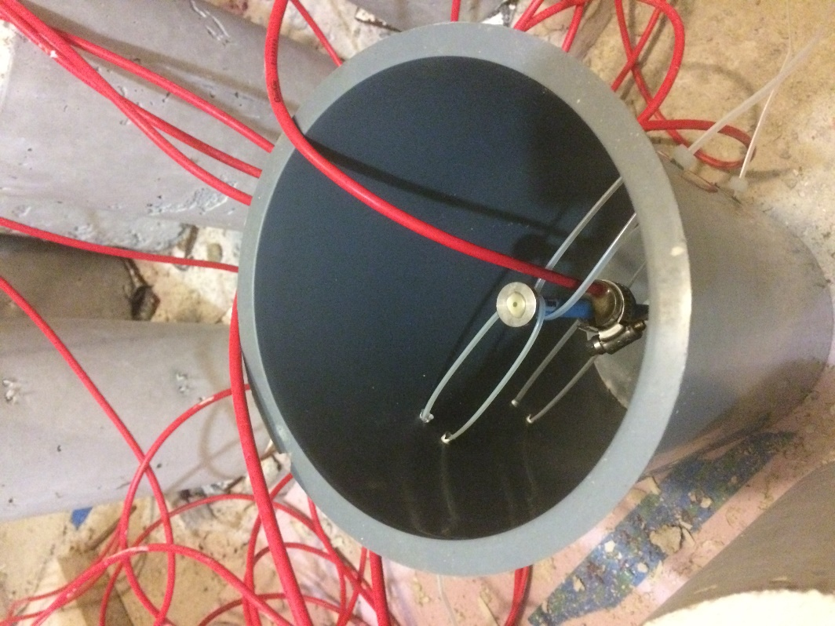
Figure 4: Geokon Model 4200 VW strain gage tied in cylinder prior to batching
When tying the strain gage into place in the 6 in. by 12 in. cylinder mold it was important to not tie the strain gage too tight, potentially restricting the strain gage from gathering accurate readings once set. It was also important to tie the strain gage tight enough to keep the strain gage vertically in the center of the cylinder. The VWSG was then attached to a Geokon Datalogger which was programmed to take a reading every 10 min.
The C157 rectangular prism shaped molds were filled by halves of approximately equal depths and each layer was rodded 33 times using a 3/8 in. diameter rod.
Once all of the cylinders and other molds were filled they were transported into the environmental chamber at Fears Laboratory to keep the curing conditions the same for all 16 batches. The specimens for the two rapid setting cements, CSA and Rapid Set®, were demolded at 2-hours while the Komponent® and portland cement specimens were demolded at 24-hours after completion of casting. To maintain constant curing conditions for each batch the materials were placed in the environmental chamber before batching and then placed back into the environmental chamber immediately after finishing casting for each batch. The environmental chamber stays within the temperature range stated in ASTM C192 of 73.5 ± 3.5°F and at a relative humidity of approximately 50%. The use of the environmental chamber for storage of materials prior to batching and for curing the concrete after batching helped reduce variables between batching. The environmental chamber at Fears Lab does have some problems which could have affected the curing, and in turn, the behavior of specimens. Throughout the testing program another student was wet curing samples in the chamber, which caused the humidity in the chamber to increase higher than expected. In addition, the southwest corner of the chamber is where the air conditioner blows and can cause specimens to dry more quickly, which could affect the shrinkage readings. Without knowing which specimens were placed in that corner or when the humidity rose in the chamber it is not possible to determine whether these conditions affected the curing process.

3.3 Lightweight fine aggregate for internal curing
Expanded shale fine aggregate manufactured by Buildex Inc. was used for the LWA on this project because it is porous aggregate that absorbs a substantial amount of water and is frequently used for internal curing in the field. According to Buildex Inc., the manufacturing process for the LWA meets grading specifications stated in ASTM C330/C330M-17a, the Standard Specification for Lightweight Aggregates for Structural Concrete. The lightweight fine aggregate meeting ASTM C330 is all material passing a No. 4 (4.75mm) sieve.
The absorption capacity and specific gravity of the LWA were determined using the pycnometer method in accordance with ACI 211.2 (1998). Absorption and specific gravity tests were run on LWA that had been soaked for 24-hrs, 48-hrs, and 72-hrs in covered buckets inside of an environmentally controlled chamber inside of Fears lab. Moisture contents were taken using the oven at each for each of these soaking times and after pycnometer testing. These samples needed to be surface dried before being placed in the oven to obtain the correct absorption. This was done by pouring the wet LWA into a pan with brown paper towels. The aggregate was then moved around within the pan and paper towels were replaced until the towels were no longer absorbing water from the aggregate. The brown paper towels absorbed the water while removing a very small amount of fine particles. Once the aggregate reached the surface dry point, the sample was placed in the oven for drying. The results of each test were very similar for each soaking time, and the average absorption for all the times tested was 11%. The absorption for aggregate soaked 24-hrs was slightly less than the average, at 48-hrs the results were within 0.1% percent of the average, and at 72-hrs the absorption was 0.5% larger than the average. Based on these results, the 48-hrs soaking time with an absorption of 11% was used when calculating the mix design and batching the concrete. The amount of LWA for each batch was determined by taking the 11% absorption of the LWA and applying it to calculated the weight of aggregate required for each amount of internal curing water relative to the amount of cement in that mix design. The specific gravity was determined to be 1.66 through testing, and was incorporated into the mix design.
For each batch the expanded shale LWA was gathered 2 days before batching and soaked exactly 48-hrs before batching began. Allowing the LWA to soak the same amount of time for each batch provided more consistent moisture concrete for the presoaked LWA and therefore a more consistent w/c for the concrete. After allowing the aggregate to soak for 48-hrs a drying technique had to be used to allow excess water to run off while keeping the aggregate saturated and producing a consistent moisture content each batch. A number of trials were run and tested that output a similar moisture content after each test. The aggregate drying and preparation was done by attaching a woven geosynthetic material, that acts like a sieve and only allows very fine particles and water to pass, to a rectangular bin and dumping the aggregate onto the geosynthetic, which allowed water to drain out of the bottom. Allowing the aggregate to drain for 15 min and then removing and immediately taking the moisture content generated a very consistent moisture content of 25% for the LWA. This aggregate preparation method and moisture content were used for each batch that included LWA for internal curing, while the actual moisture content for each batch was also recorded.

3.4 Mix designs used for testing

3.4.1 Buzzi CSA cement
The rapid setting pure CSA cement used in this project (designated CSA) was provided Buzzi Unicem USA. The mix design for the CSA cement specimen batches was an adapted version of the one used for the research done by Floyd and Ramseyer (2016) for a different type of CSA cement. The w/c remained the same at 0.48 while the HRWR dosage was decreased to reduce the slump. The citric acid levels were increased to 1.5 times the amount used in Floyd and Ramseyer’s (2016) work. The batches including the CSA cement contained by weight, half portland cement and half Buzzi Unicem CSA cement, based on trial batches done to match the strength gain of the Rapid Set® mixture used. The presoaked LWA was added to the mix design by balancing the LWA volumetrically with the sand, i.e. as more LWA was added the amount of sand was decreased. The sand is much denser than the LWA so the weight of sand removed from the mix design and replaced with LWA was higher than the weight of LWA added, but the total volume of fine aggregate remained the same. Table 2 shows the differences between the mix designs for each batch of the CSA cement.
Table 2: Final mix designs for CSA cement batches
Material | Internal Curing Water from LWA/100 lb of Cement
Material | 0 lb | 5 lb | 7 lb | 10 lb
Portland Cement (lb/yd³) | 329 | 329 | 329 | 329
CSA Cement (lb/yd³) | 329 | 329 | 329 | 329
Lightweight Agg. (lb/yd³) | 0 | 332 | 465 | 664
Limestone (lb/yd³) | 1806 | 1806 | 1806 | 1806
Sand (lb/yd³) | 1174 | 648 | 438 | 122
Water (lb/yd³) | 316 | 316 | 316 | 316
w/c | 0.48 | 0.48 | 0.48 | 0.48
HRWR (fl. oz/cwt.) | 2 | 2 | 2 | 2
Citric Acid (lb/lb cement) | 0.0015 | 0.0015 | 0.0015 | 0.0015

The CSA and Rapid Set® cements are both rapid setting cements so Glenium 7920 high range water reducer (HRWR) was used to increase the workability for a given amount of water while maintaining the desired level of stability. The HRWR acts as a dispersant which temporarily separates the particles in the concrete and keeps it fluid for longer while not decreasing the final strength of the concrete. The rapid setting batches also included anhydrous citric acid to increase the setting time, which was especially important in the case of high ambient temperature. The addition of these two chemicals allowed a longer time of workability for the concrete while casting test specimens.
When batching the CSA cement mixes it was important to work quickly to avoid the concrete setting too quickly, not allowing enough time to make all the samples that were necessary. The first batch of CSA cement, which did not include any LWA, experienced this problem and the HRWR amount was doubled and citric acid was added to the mix design before redoing this CSA batch with no LWA. These new adjusted levels allowed the concrete to have a longer working time while not causing the concrete to segregate or produce an overly high slump. Only the final quantities from the revised mix are presented in Table 2. CSA being a rapid setting cement meant that demolding of all test specimens and the first compressive strength tests for each batch occurred 2-hrs after casting. Another compressive strength test was conducted 6-hrs after casting as well.

3.4.2 Rapid Set® cement
Rapid Set® cement is a rapid setting CSA based cement including belite (often referred to as a CSA-B cement), and was obtained from CTS Cement Manufacturing Corporation for this project. This is a commonly used rapid setting cement with fast strength gain, and it is a good comparative cement to the Buzzi CSA because both are rapid setting cements. However, unlike the CSA mixture, the mix design containing Rapid Set® cement was not a mixture with portland cement. The presoaked LWA was added to the mix design by balancing the LWA volumetrically with the sand, i.e. as more LWA was added the amount of sand was decreased. The sand is much denser than the LWA so the weight of sand removed from the mix design and replaced with LWA was higher than the weight of LWA added, but the total volume of fine aggregate remained the same. Table 3 shows the mix designs used for all of the batches of Rapid Set® cement.
Table 3: Final mix designs for Rapid Set® cement batches
Material | Internal Curing Water from LWA/100 lb of Cement
Material | 0 lb | 5 lb | 7 lb | 10 lb
Rapid Set® Cement (lb/yd³) | 658 | 658 | 658 | 658
Lightweight Agg. (lb/yd³) | 0 | 332 | 465 | 664
Limestone (lb/yd³) | 1782 | 1782 | 1782 | 1782
Sand (lb/yd³) | 1182 | 656 | 446 | 130
Water (lb/yd³) | 316 | 316 | 316 | 316
w/c | 0.48 | 0.48 | 0.48 | 0.48
HRWR (fl. oz/cwt.) | 0 | 0 | 0 | 2
Citric Acid (lb/lb cement) | 0.001 | 0.001 | 0.001 | 0.001

The w/c was the same as for the CSA mix design, while the citric acid amount was slightly less than for the CSA batches. HRWR was only used in the final batch of Rapid Set®, it was determined it needed to be added after the batch with 7 lb of internal curing water was hard to work with and hardened quickly. The total amount of cement used was the same as for the CSA cement mix design, so the amount of LWA needed in each batch to achieve the desired internal curing water amount remained the same as for the CSA cement batches. The batches for the two rapid setting cements, CSA and Rapid Set®, were very similar. The two cements had similar setting times as well as the amounts of materials in the mix designs. The quick setting time of the Rapid Set® cement batches allowed for demolding to occur at 2-hrs after casting and compressive strength tests to be conducted at that time as well as at 6-hrs after casting.

3.4.3 Komponent® cement
Komponent® cement is different from the two rapid setting cements in that the concrete takes a longer time for adequate strength gain, and the setting time for the concrete is similar to that of typical portland cement concrete. Komponent® cement is a CSA based expansive Type K cement designed to compensate for shrinkage in concrete, and was used as a partial replacement of typical portland cement. The Komponent® cement used in this research was obtained from CTS Manufacturing Corportation and a 15% replacement by weight of cement was used for all batches. The presoaked LWA was added to the mix design by balancing the LWA volumetrically with the sand, i.e. as more LWA was added the amount of sand was decreased. The sand is much denser than the LWA so the weight of sand removed from the mix design and replaced with LWA was higher than the weight of LWA added, but the total volume of fine aggregate remained the same. The mix designs for all of the batches of Komponent® cement are shown in Table 4.
Table 4: Final mix designs for Komponent® cement batches
Material | Internal Curing Water from LWA/100 lb of Cement
Material | 0 lb | 5 lb | 7 lb | 10 lb
Portland Cement (lb/yd³) | 493 | 493 | 493 | 493
Komponent® Cement (lb/yd³) | 87 | 87 | 87 | 87
Lightweight Agg. (lb/yd³) | 0 | 249 | 348 | 497
Limestone (lb/yd³) | 1780 | 1780 | 1780 | 1780
Sand (lb/yd³) | 1345 | 950 | 793 | 557
Water (lb/yd³) | 316 | 316 | 316 | 316
w/c | 0.5 | 0.5 | 0.5 | 0.5

It can be noticed that the w/c was higher than that used for the first two cements and that no HRWR or citric acid was used in any of the batches containing Komponent® cement. Also, the total amount of cement was not the same, therefore the amount of LWA needed in each batch differed from the rapid setting cement mixes. These amounts of LWA were the least of all the mix designs used in this research because this mix design had less cement by weight than the others.

3.4.4 Conventional portland cement
Portland cement is the most used cement worldwide, so it was chosen as the cement for the conventional mix design used for comparison. The conventional concrete used in this project was made with a Type I portland cement obtained from Dolese Bros. in Oklahoma City. The presoaked LWA was added to the mix design by balancing the LWA volumetrically with the sand, i.e. as more LWA was added the amount of sand was decreased. The sand is much denser than the LWA so the weight of sand removed from the mix design and replaced with LWA was higher than the weight of LWA added, but the total volume of fine aggregate remained the same. These mix designs had the same w/c ratio and cement content as the Rapid Set® and CSA cement mix designs, and are shown in Table 5.

Table 5: Final mix designs for portland cement batches
Material | Internal Curing Water from LWA/100 lb of Cement
Material | 0 lb | 5 lb | 7 lb | 10 lb
Portland Cement (lb/yd³) | 658 | 658 | 658 | 658
Lightweight Agg. (lb/yd³) | 0 | 332 | 465 | 664
Limestone (lb/yd³) | 1806 | 1806 | 1806 | 1806
Sand (lb/yd³) | 1190 | 664 | 453 | 138
Water (lb/yd³) | 316 | 316 | 316 | 316
w/c | 0.48 | 0.48 | 0.48 | 0.48

HRWR and citric acid were not needed for any of the conventional portland cement batches since portland cement is not a rapid setting cement. All specimens were allowed to cure for 24-hrs before demolding. The conventional portland cement mix design called for the same weight of cement as the two rapid setting cements and the amounts of LWA needed to provide the correct amount of internal curing water remained the same as for the two rapid setting cements.

3.5 Specimen Testing

3.5.1 Compressive strength
The compressive strength testing for this research was performed on 4 in. by 8 in. cylinders using the Forney compression machine at Fear Lab. The compression testing was done in accordance with ASTM C39/C39M – 17b Standard Test Method for Compressive Strength of Cylindrical Specimens. All cylinders were ground on each end to produce the surface planeness required by ASTM C39 and were tested with a loading rate of 28-42 psi/s. Specimens from all of the batches were tested for compressive strength at 24-hrs, 7-days, 28-days, and 90-days after casting. Specimens cast using the two rapid setting cements, CSA and Rapid Set®, had two additional testing times. The rapid setting cements were demolded 2-hrs after casting and the first compression tests were run then and again at 6-hrs after casting. Shown in the Figure 5 is a cylinder in the Forney compression machine prior to being tested.
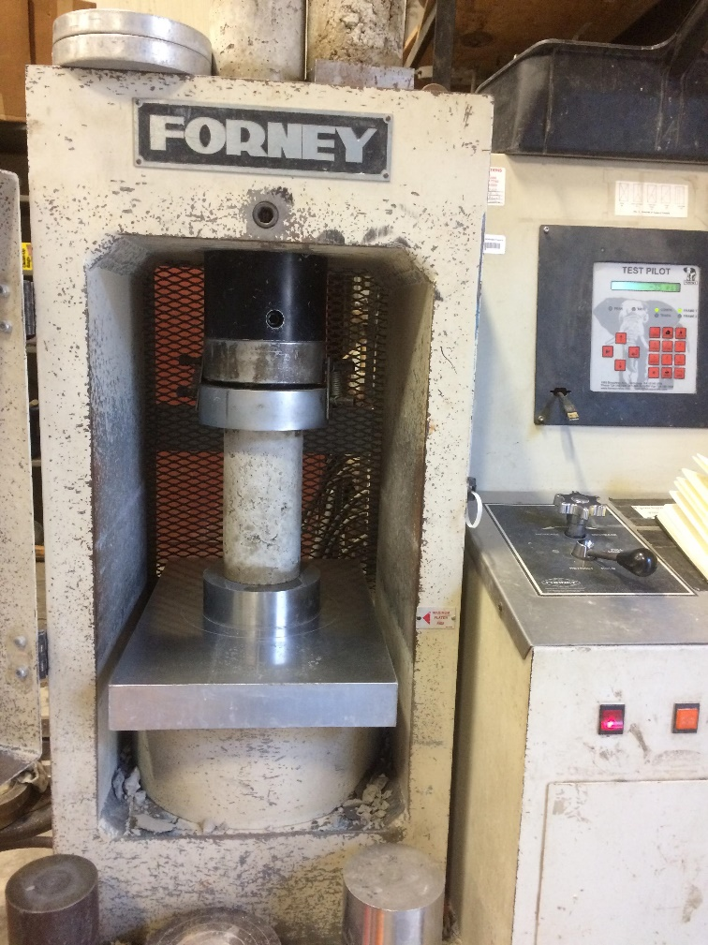
Figure 5: Forney machine used for compressive strength testing
All cylinders were moved directly into the environmental chamber as soon as casting was completed and allowed to sit in the chamber until time of testing. When it came time to run compression tests, the cylinders that were to be tested were removed from the environmental chamber and the cylinder end grinder was used on the top and bottom of the cylinder to create flat surfaces on each end meeting the required specifications.

3.5.2 Rapid chloride ion permeability (RCIP)
The Rapid Chloride Ion Penetration (RCIP) test was used to provide a comparative evaluation of concrete permeability and was run in accordance with ASTM C1202 – 12 Standard Test Method for Electrical Indication of Concrete’s Ability to Resist Chloride Ion Penetration. This testing method provides a “determination of the electrical conductance of concrete to provide a rapid indication of its resistance to the penetration of chloride ions” (ASTM C1202). The test does not actually measure permeability; rather it measures resistivity and is only appropriate for comparison of different concrete mixtures. “Theoretical and experimental studies indicate a correlation between concrete resistivity and chloride ingress. In general, the chloride diffusion coefficient is inversely proportional to the concrete resistivity. Within a particular structure, more permeable zones will have a comparatively lower resistivity and higher chloride penetration” (Ramezanianpour, 2011). The resistivity is measured by monitoring the amount of electrical current passing through 2 in. (50-mm) tall cylinder slices, like the one pictured in Figure 6, when a 60 V dc potential difference is applied across the specimen for 6-hrs.
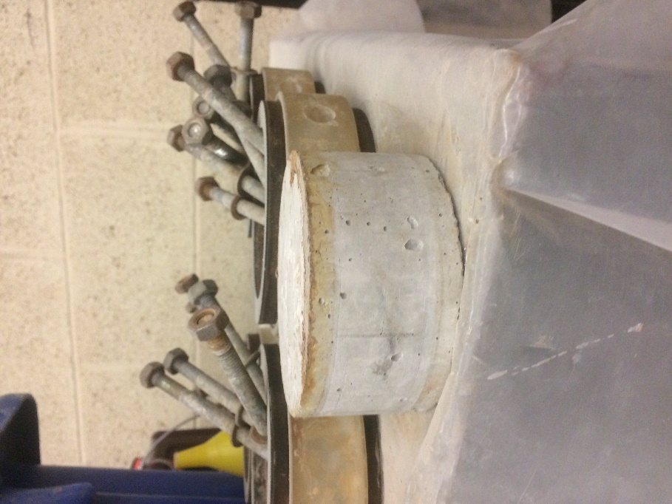
Figure 6: 2 in. (50-mm) tall cylinder used in RCIP testing cells
The RCIP test was run at 28-days and 90-days after casting on specimens from each batch, but preparation for the test began on the 27th and 89th days after casting. For each RCIP test two of the 4 in. by 8 in. cylinders were cut into four 2 in. (50-mm) thick specimens using a water-cooled diamond saw blade and then the surfaces were ground flat if needed. The four 2 in. (50-mm) tall cylinders used for each test were cut from the top and bottom of the cylinders. The four specimens were then placed into a vacuum desiccator (shown in Figure 6) with a pump system capable of maintaining vacuum pressure of less than 50-mm Hg.
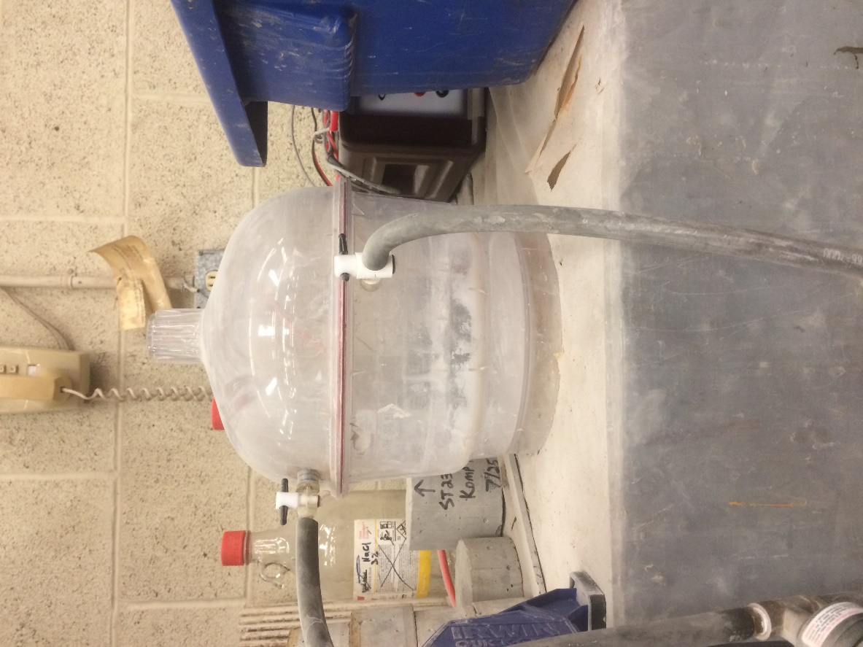
Figure 7: Vacuum chamber used in the RCIP tests
The vacuum pump was then allowed to run for 3-hrs with the dry specimens inside of the vacuum desiccator. After running for 3-hrs, deionized water was pumped into the vacuum desiccator and the vacuum pump was run for another hour with the specimens completely submerged. The pump was then turned off and the desiccator left sealed for 18-hrs plus or minus 2-hrs. After the 18-hrs period it was then the 28th or 90th day after casting and the specimens were ready to begin the test.
The final step was to mix a NaCl solution of 3.0% by mass and an NaOH solution of 0.3N. Both solutions were made using deionized water and laboratory grade dry reagents. Once the two solutions were mixed, the 2 in. (50-mm) concrete specimens were removed from the vacuum desiccator and placed in the testing cells of an RCIP test machine made by Germann Instruments, which ran in conjunction with a computer software called PROOVE’it. A picture of one of the test cells is shown in Figure 8.
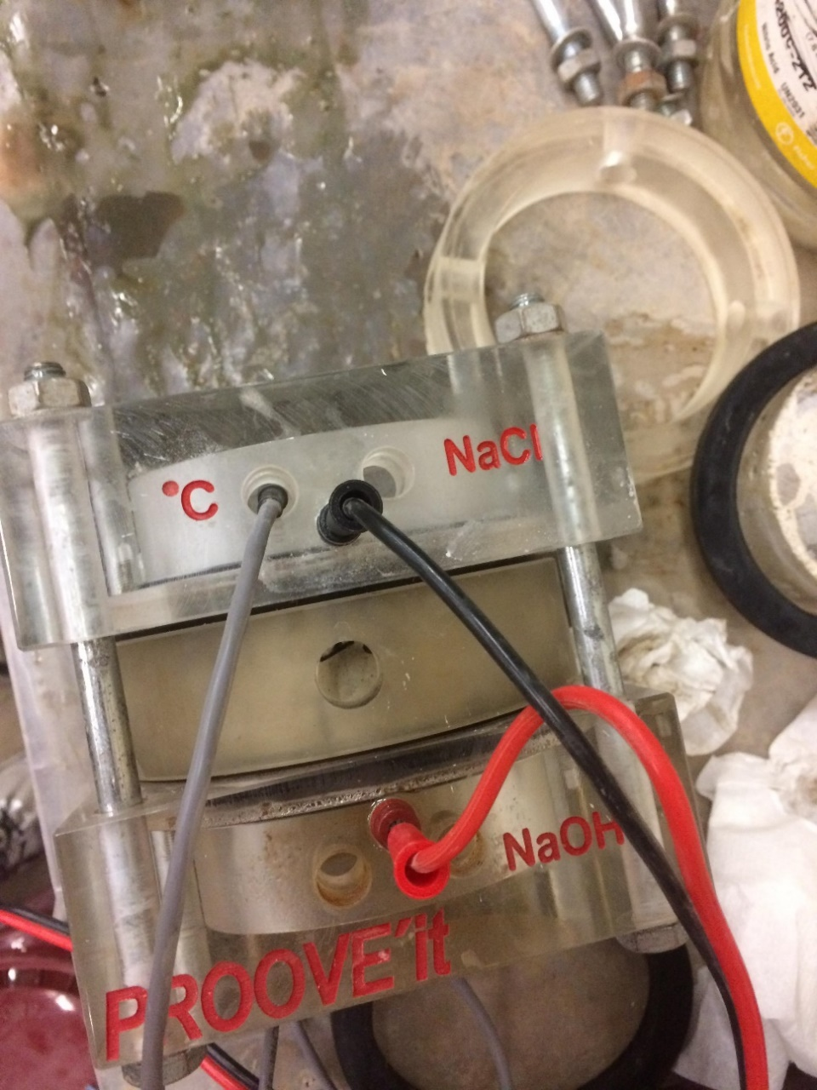
Figure 8: PROOVE'it testing cell for the RCIP test
The concrete specimen was placed inside the circular piece in the middle of the two halves of each cell, rubber gaskets and silicone were then used to seal around the edges of the specimen, each side of the cell was placed in contact with the concrete specimen, and the cell bolts were tightened. The two solutions were placed in the respective sides of the cells labeled with that solution. This setup allowed each solution to be in direct contact with one side of the concrete specimen throughout testing. Once the cells were prepared they were connected with a positive wire, negative wire, and a temperature probe to the Germann Instruments box shown in Figure 9.
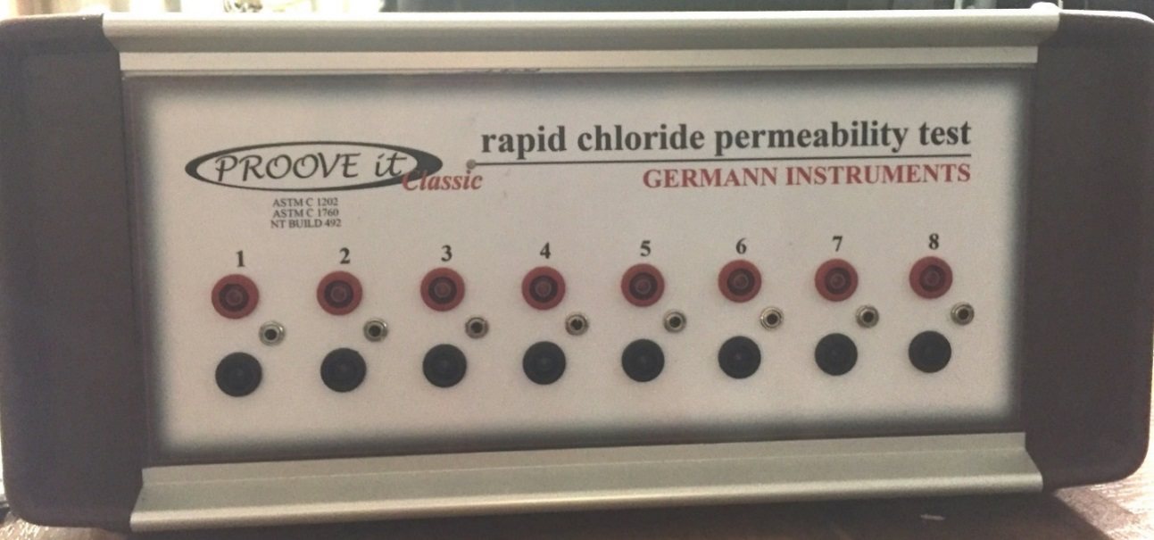
Figure 9: The Germann Instruments box used to apply the required voltage and run the PROOVE'it software used for the RCIP test
The computer software was then turned on and default settings were used: a testing duration of 6-hrs, concrete specimen diameter of 4 in. (100-mm), maximum temperature of 90 degrees Fahrenheit, and a maximum voltage of 60 V. The PROOVE’it software was used to gather the amount of total charged passed in coulombs. According to Thomas and Jones 1996 publication, A Critical Review of Service Life Modeling of Concretes Exposed to Chlorides, there are two main criticisms to this test:
- The current passed is related to all ions in the pore solution not just the chloride ions
- The high voltage applied leads to an increase in temperature, which further increases the charge passed (Thomas and Jones 1996).
Temperature rise in the concrete is related to the product of the current and voltage. Caijun Shi states “the permeability of concrete depends on the pore structure of concrete, while electrical conductivity or resistivity of concrete is determined by both pore structure and chemistry of pore solution. Factors that have little to do with the transport of chloride can have great effects on electrical conductivity of concrete” (Shi, 2004). So, this test has multiple inherent variables which could play into the results, but was chosen due to the relatively short time required to run the test.

3.5.3 Length change
Two tests were used to measure shrinkage and expansion of the concrete mixtures. The first length change test was run in accordance with ASTM C157 Length Change of Hardened Hydraulic-Cement Mortar and Concrete. Three 3 in. by 3 in. by 11 in. long specimens were measured for all mix designs tested. A comparator was used to measure the length change of these specimens after demolding. Specimens for all cements also had readings taken every 24-hrs for the first week after casting and then once a week after that. The two rapid setting cement batches had two additional readings at 2-hrs and 6-hrs after casting. There are, however, some issues that may occur when using this testing method. One issue is that the recorded measurements can have a user bias. To counteract this, specimens were always tested by the same person and rotated at the same speed in the same direction. A second issue that may occur is the sensitivity of the reference bar, shown in Figure 10.
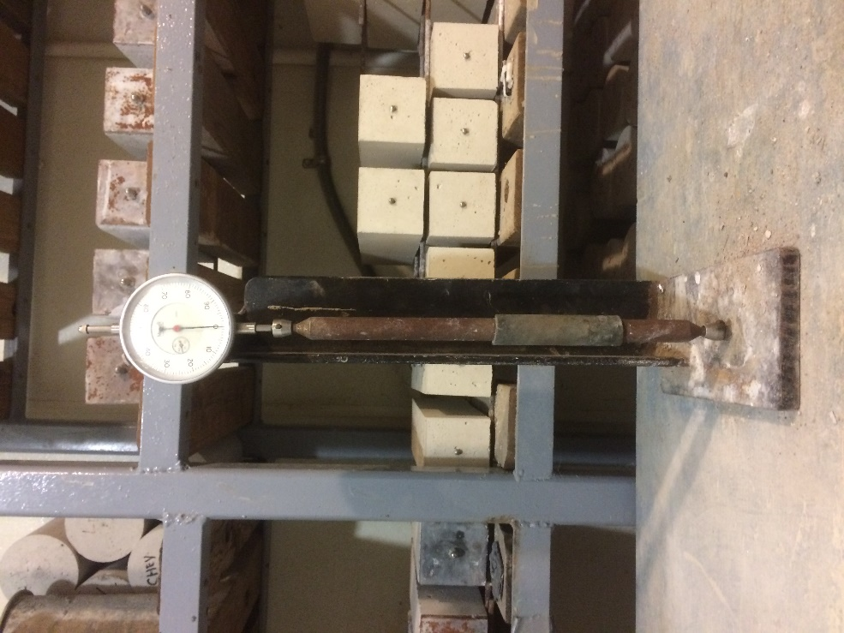
Figure 10: C157 testing apparatus for length change with the reference bar in place
This reference bar is very sensitive to temperature and just touching the bar can cause the length of the bar to change. When performing the test, the length of the reference bar was recorded and then a C157 concrete specimen was placed into the testing apparatus and the measurement recorded as shown in Figure 11.
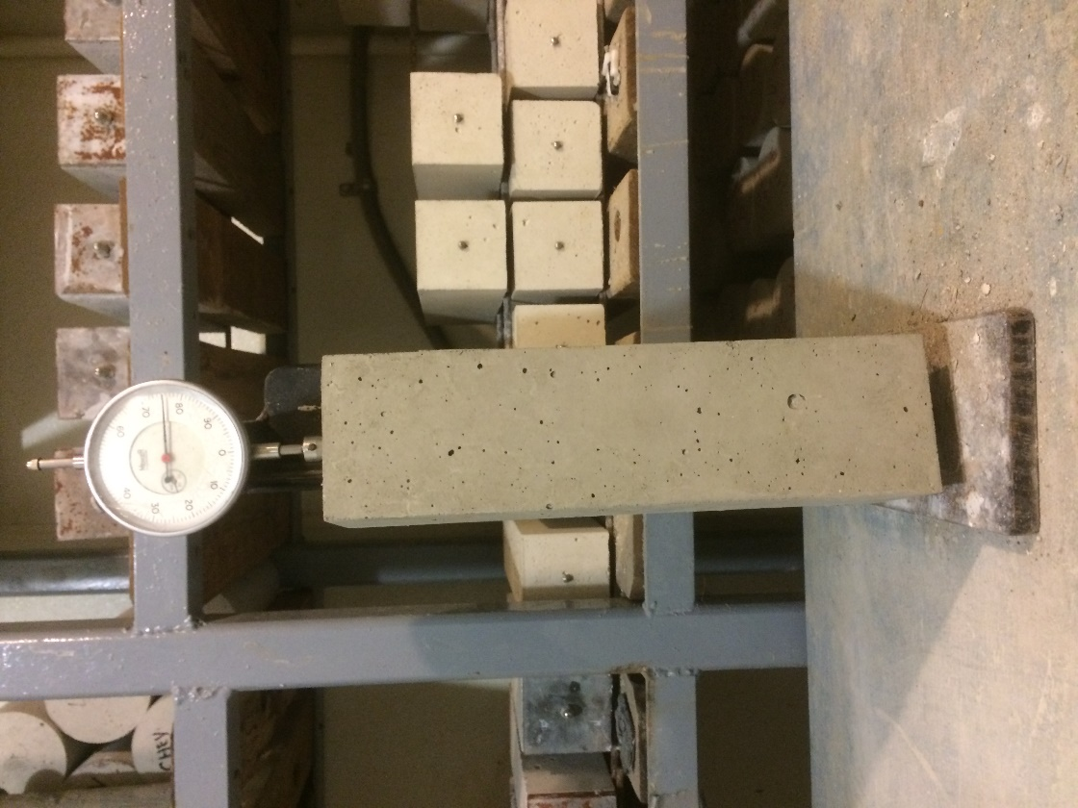
Figure 11: C157 specimen in testing
It is very important to always place the specimen into the apparatus in the same orientation, and to spin the specimen at the same speed and in the same direction in order to reduce any bias.
The batches containing 15% Komponent® replacement for portland cement were also tested for length change using a strain gage placed directly in the center of a 6 in. by 12 in. cylinder. However, problems were experienced with the datalogger either running out of battery or the memory filling up and leaving voids in recorded data. The data that were recorded still had a noticeable trends and missing data points were filled by interpolating with a straight line between recorded data points. The VWSG not only measures the length change in microstrain but also records the temperature at each reading. The data from the VWSGs is output directly as microstrain and had to be converted into apparent change in microstrain over time. This conversion also took the temperature correction into account. The conversion into apparent microstrain over time was determined by:
$${με}_{apparent}=\left(R_{1}-R_{0}\right)B+\left(T_{1}-T_{0}\right)\left(C_{1}-C_{2}\right)$$
where R₀ is the initial reading, R₁ is the current reading from the datalogger at any time, B is the batch gage factor (which was not considered because it was already included by the datalogger for all readings), T₀ is the initial temperature, T₁ is the current temperature at any time, C₁ is the coefficient of thermal expansion of steel (taken as 17.3 microstrain/ºC), and C₂ is the coefficient of thermal expansion of concrete (taken as 10 microstrain/ºC).

Chapter 4: Results and Discussion

4.1 General batch information
All the casting of the concrete specimens for this project took place outside underneath the overhang at the northeast corner of Fears Laboratory. Multiple tests were run on the wet concrete while casting took place, including slump, temperature and the unit weight of the concrete. The batches which included LWA for internal curing also had samples of the soaked LWA weighed and placed in the oven for 24-hrs. The dry weight was then collected after 24-hrs and the moisture content of the LWA was calculated.

4.1.1 Buzzi CSA cement
Table 6 presents the fresh concrete properties from the tests run while casting the CSA cement batches along with the estimated and actual moisture contents for the lightweight fine aggregate.
Table 6: Fresh concrete properties and LWA moisture content for the Buzzi CSA cement batches
Buzzi CSA cement
Sample ID | Internal Curing Water (lb/100lb of cement) | Assumed M.C. of LWA (%) | Actual M.C. of LWA (%) | Slump (in.) | Temp. (⁰F) | Theoretical Unit Weight (lb/ft³) | Unit Weight (lb/ft³)
ST150 | 0 | N/A | N/A | 1 | 90 | 146.5 | 147.5
ST160 | 5 | 25 | 24.83 | 9 | 73 | 139.3 | 144.2
ST170 | 7 | 25 | 27.00 | 8 | 75 | 136.4 | 147.0
ST180 | 10 | 25 | 28.70 | 4.25 | 86 | 132.1 | 144.0

The slump test results for these batches fluctuated, but the mix temperature was not consistent from batch to batch. This temperature variation could be a factor in the different slump test results, because each CSA batch had the same amounts of HRWR and citric acid. The two lower slumps were measured for batches ST150 and ST180, which had 0 lb and 10 lb of internal curing water respectively and these two batches had higher concrete temperatures than the other two batches. The difference in the assumed moisture content and the actual moisture content did not appear to be a factor in the slump test results. The change in unit weight with the addition of LWA for the CSA cement batches was reasonable except for the ST160 batch, which included 5 lb of internal curing water. The expectation for the unit weight results was that they would decrease as more LWA was added with increasing amounts of internal curing water. One possible reason for this inconsistency in unit weight was that the actual moisture contents of the LWA rose higher than the value of 25% used in calculating the mix design for all batches except ST160. The measured unit weight was larger than the theoretical value for all batches. Batch ST150 with 0 lb of internal curing water had the closest actual unit weight to the theoretical value, which could be due to the LWA potentially having a different specific gravity than what was measured and subsequently used in the calculations. The Section 4.1.2 shows the concrete properties of the other CSA cement tested in this experiment, Rapid Set®. These two cements had the same amount of cement for each batch, so the amount of LWA was the same for each batch with same amount of internal curing water. So, it was interesting to see that the unit weights of Rapid Set® cement were all lower than the Buzzi CSA cement unit weights for their respected amounts of internal curing water.
The results for the batch with no internal curing water shown in Table 6 are the results from the second attempt for this mix design. The first attempt was discarded because the concrete hardened in less than 10 min and only 4 cylinders could be made out of the 22 that were needed. To fix this problem for the subsequent CSA batches, citric acid was introduced into the mix design, and the HRWR was doubled to 2 fl. oz/cwt, from the first failed attempt with 1 fl. oz/cwt. This provided much more time before the concrete set up and made the concrete easier to work with.

4.1.2 Rapid Set® cement
Table 7 presents the fresh concrete properties that were measured for the Rapid Set® cement batches along with the estimated and actual moisture contents for the lightweight fine aggregate.
Table 7: Fresh concrete properties and LWA moisture content for the Rapid Set® cement batches
Rapid Set ® cement
Sample ID | Internal Curing Water (lb/100lb cement) | Assumed M.C. of LWA (%) | Actual M.C. of LWA (%) | Slump (in.) | Temp. (⁰F) | Theoretical Unit Weight (lb/ft³) | Unit Weight (lb/ft³)
ST100 | 0 | N/A | N/A | 7.25 | 83 | 145.9 | 146.2
ST110 | 5 | 25 | nd | 1.25 | 75 | 138.7 | 143.1
ST120 | 7 | 25 | 23.80 | 0.75 | 77 | 135.8 | 142.8
ST130 | 10 | 25 | 25.33 | 0.25 | 75 | 131.5 | 139.8
Note: nd indicates no data
The actual moisture content of the LWA for sample ST110 is missing because the sample was removed from the oven by an unknown party. The temperature for these batches remained relatively consistent staying in a range between 75 and 83 ⁰F. The slumps for the Rapid Set® batches became much smaller with the addition of LWA and continued to decrease as the amount of internal curing water increased. This remained the case even with the ST130 batch which had HRWR added to the mix design, and no additional citric acid was added to counteract this effect. The LWA is very angular and could have played a factor in decreasing slump test results as the amount of LWA increased. While casting it was noticed that the overall workability of the concrete decreased, and the concrete became stiffer much more quickly when LWA was added. The change in unit weight with the addition of LWA for the Rapid Set® batches behaved as predicted and the unit weight decreased as the amount of internal curing water increased. This is due to the addition of more LWA to achieve a higher internal curing amount. The addition of LWA reduced the amount of sand in the mix and has a lower density than the sand it replaced. In all cases, the measured unit weight was greater than the theoretical value. Batch ST100 with 0 lb of internal curing water had the closest actual unit weight to the theoretical value, this could indicated that the LWA had a different specific gravity than what was measured and used in the calculations.

4.1.3 Komponent® cement
Table 8 presents the fresh concrete properties that were measured for the Komponent® cement batches along with the estimated and actual moisture contents for the lightweight fine aggregate.
Table 8: Fresh concrete properties and LWA moisture content for the Komponent® cement batches
Komponent ® cement
Sample ID | Internal Curing Water (lb/100lb of cement) | Assumed M.C. of LWA (%) | Actual M.C. of LWA (%) | Slump (in.) | Temp. (⁰F) | Theoretical Unit Weight (lb/ft³) | Unit Weight (lb/ft³)
ST190 | 0 | N/A | N/A | 2.5 | 85 | 147.9 | 149.7
ST200 | 5 | 25 | 30.00 | 2.75 | 82 | 142.6 | 147.2
ST220 | 7 | 25 | 21.25 | 1.75 | 82 | 140.4 | 145.6
ST230 | 10 | 25 | 25.00 | 1.25 | 89 | 137.2 | 140.9

The consistent temperature for these batches was very good for comparison of the slumps, which all stayed within a 2 in. range. The moisture content for the LWA was greater than or less than expected for the ST200 sample and the ST220 sample, respectively, which resulted in the amount of internal curing water being slightly off from the expected 5 lb and 7 lb. The LWA moisture content for the ST230 sample for 10 lb of internal curing water batch was exactly the same as the assumed value of 25% so this batch had the correct amount of 10 lb of internal curing water. The largest slump was measured for batch ST200 which had a higher LWA moisture content than expected, however the batch with the smallest slump had no error in LWA moisture content. The unit weights of the Komponent® cement batches behaved as predicted, decreasing as more LWA was added into the mixes, but all measured values were larger than the theoretical unit weights. Batch ST190 with 0 lb of internal curing water had the closest actual unit weight to the theoretical value, which could be indicate that the LWA had a different specific gravity than what was measured and used in the calculations.

4.1.4 Conventional portland cement
Table 13 presents the fresh concrete properties and LWA moisture content for the conventional portland cement batches.

Table 9: Fresh concrete properties and LWA moisture content for the portland cement batches
Portland Type I cement
Sample ID | Internal Curing Water (lb/100lb of cement) | Assumed M.C. of LWA (%) | Actual M.C. of LWA (%) | Slump (in.) | Temp. (⁰F) | Theoretical Unit Weight (lb/ft³) | Unit Weight (lb/ft³)
ST240 | 0 | N/A | N/A | 6 | 88 | 147.0 | 149.2
ST250 | 5 | 25 | 26.70 | 6.5 | 84 | 139.8 | 144.2
ST260 | 7 | 25 | nd | 2.75 | 86 | 137.0 | 144.7
ST270 | 10 | 25 | 21.50 | 2.75 | 77 | 132.7 | 140.4

The moisture contents for the LWA in the conventional portland cement batches differed from the assumed moisture content by as much as 3.5% of the aggregate weight. Also, the actual LWA moisture content for batch ST260 was not available due to the sample being removed from the oven by an unknown party during the 24-hr drying period. The concrete temperatures measured for the portland cement batches stayed within 10 ⁰F of each other, and did not seem to be a factor in slump test results. The lowest slump test results were in the two batches with the highest amount of LWA in them, the angularity of the LWA could have factored into the lower slump results. The unit weight results for these batches behaved as expected with addition of LWA except that batches ST250 and ST260 for the 5 lb and 7 lb of internal curing water, respectively, had very similar unit weight results. However, in all cases the measured unit weights were less than the theoretical values. Batch ST240 with 0 lb of internal curing water had the closest measured unit weight to the theoretical value, which could indicate that the LWA had a different specific gravity than what was measured and used in the calculations. As more LWA was introduced into the mix design the gap between theoretical unit weight and measured unit weight became larger. With the moisture content of the LWA being unknown for the 7 lb of internal curing water batch (ST260), it is possible that the moisture content of the LWA could have caused the unit weights to be so similar between these two batches.

4.2 Compressive strength
All compressive strength tests were run using the Forney compression machine in the northeast corner of Fears lab, all specimens tested for compressive strength were 4 in. by 8 in. cylinders. The compressive strength test results presented in the following subsections are the average compressive strength for 2-3 specimens tested at each time. The recorded strengths for each specimen used in determining an average are included in Appendix A.

4.2.1 Buzzi CSA cement
Specimens from the CSA batches were tested for compressive strength at 2-hrs, 6-hrs, 24-hrs, 7-days, 28-days and 90-days. The test at 2-hrs was performed immediately after demolding, while the specimens used for later testing times were placed back into the environmental chamber after demolding for a constant and steady curing environment. A list of the average compressive strengths is provided in Table 10.

Table 10: Average compressive strength results for CSA samples
Sample ID | Amount of Internal Curing Water (lb/100 lb) | Average Compressive Strength (psi)
Sample ID | Amount of Internal Curing Water (lb/100 lb) | 2-hrs | 6-hrs | 24-hrs | 7-days | 28-days | 90-days
ST150 | 0 | 1880 | 2440 | 3180 | 3410 | 3580 | 5170
ST160 | 5 | 1690 | 2460 | 2950 | 4340 | 5600 | 8830
ST170 | 7 | 1760 | 2340 | 3160 | 3380 | 3450 | 4700
ST180 | 10 | 1310 | nd | 2360 | nd | 2900 | nd
Note: nd indicates no data
Not have enough cylinders were made for the 10 lb of internal curing water batch when casting which is why the 6-hrs, 7-days, and 90-days results are missing from this table. The missing samples were due to the fact that the ST180 batch became unworkable before all cylinders could be filled. Figure 12 shows a comparison of the compressive strengths for each amount of internal curing water.

Figure 12: Average compressive strengths for CSA samples
This figure shows how the compressive strength changed with time and whether it differed for each amount of internal curing water. Figure 13 shows trend lines of how each amount of internal curing water affected the strength over time.

Figure 13: Compressive strength trend lines for CSA
The 2-hrs compressive strengths were all within 200 psi of each other apart from the ST180 samples with 10 lb of internal curing water. The strengths at other ages for sample ST180 remained below the average values for all the other samples. This indicates that 10 lb of internal curing water with this CSA cement had a negative effect on compressive strength of the concrete. The lower compressive strengths may have been caused by the large replacement of sand with weaker LWA. The ST160 samples with 5 lb of internal curing water showed a large strength gain after the 7-day testing, likely due to the water still releasing from the presoaked LWA. The ST170 samples with 7 lb of internal curing water remained consistent with the ST150 samples with no internal curing water. The LWA in ST170 had a higher moisture content than assumed, so the w/c ratio was higher than the other batches and could have led to this batch being weaker. Therefore, 5 lb of internal curing water provided the greatest increase in strengths while 7 lb of internal curing water resulted in strengths even with those with no internal curing water and 10 lb had a negative impact on the strength. It would have been helpful to have 10 lb samples at the other testing ages to further investigate the effect on compressive strength, but the results obtained from the 2-hrs, 24-hrs, and 28-days tests were all lower than for the samples from the other mix designs tested at those times. However, if the mix design with 10 lb of internal curing water were investigated further it would require higher amounts of HRWR and citric acid. This batch set up much quicker than any of the other CSA batches. It likely set up so quickly because the temperature while batching was high compared to the other batches.

4.2.2 Rapid Set® cement
The Rapid Set® cement batches were tested for early compressive strengths like the CSA batches. The testing times following completion of casting were at 2-hrs, 6-hrs, 24-hrs, 7-days, 28-days, and 90-days. The 2-hrs compressive strength tests were run immediately following demolding and the rest of the specimens were placed back into the environmental chamber for curing until the specified testing times. A list of the average compressive strengths at each age for each batch of the Rapid Set® cement is provided in Table 11, a complete list of the compressive strengths for all specimens can be found in Appendix A.

Table 11: Average compressive strength results for the Rapid Set® cement samples
Sample ID | Amount of Internal Curing Water (lb/100 lb) | Average Compressive Strength (psi)
Sample ID | Amount of Internal Curing Water (lb/100 lb) | 2-hrs | 6-hrs | 24-hrs | 7-days | 28-days | 90-days
ST100 | 0 | 3590 | 4090 | 4960 | 5570 | 5590 | 5310
ST110 | 5 | 3630 | 4260 | 5040 | 5710 | 5810 | 5190
ST120 | 7 | 2880 | 3790 | 5210 | 6110 | 5980 | 5550
ST130 | 10 | 3150 | 4080 | 5060 | 6450 | 6570 | 5960

The compressive strengths were similar for the different amounts of internal curing water added with the ST130 (10 lb) batch having the highest compressive strength at 7-days and later ages. Figure 14 is a bar chart comparing the strengths for each amount of internal curing water at each time of testing.

Figure 14: Average compressive strengths for Rapid Set® cement samples
While the sample containing 10 lb of internal curing water did not have the highest early age compressive strength it surpassed all the other samples by day 7 of testing and remained the strongest out to the final test at 90-days. Figure 15 shows trend lines for how the compressive strength changed over time.

Figure 15: Compressive strength trend lines for Rapid Set® cement
The Rapid Set® cement batches all followed a similar strength gain pattern over time. The two samples with the highest amounts of internal curing water, 7 lb and 10 lb, had the largest compressive strengths. The strengths for these two samples were higher than the samples with 0 lb and 5 lb of internal water after the 7-day testing. Based only on the compressive strength results, the Rapid Set® samples which included 10 lb of internal curing water proved to be the strongest at 28-days and had a slight decline in compressive strength at 90-days. One similarity between all the Rapid Set® cement batches was that their peak compressive strength occurred at 7-days and the compressive strength slowly declined after that. The ST110 samples were an exception, but only that the compressive strength remained approximately the same from 7-days to 28-days.

4.2.3 Komponent® cement
The batches containing the expansive Komponent® cement had a 15% replacement of portland cement with the Komponent® cement in the mix design. This cement is not a rapid setting cement, so unlike the previous two cements discussed previously, demolding took place 24-hrs after casting and compressive strength tests were performed at 24-hrs, 7-days, 28-days, and 90-days after casting. The 24-hrs compressive strength tests were taken immediately following demolding and the remaining cylinders were placed back in to the environmental chamber for curing until their respective times for testing. Included in Table 12 are the average compressive strengths of the Komponent® cement samples with varying amounts of internal curing water at the different testing times. A complete table with the recorded compressive strength test results for all specimens tested is provided in Appendix A.
Table 12: Average compressive strength results for the Komponent® cement samples
Sample ID | Amount of Internal Curing Water (lb/100clb) | Average Compressive Strength (psi)
Sample ID | Amount of Internal Curing Water (lb/100clb) | 24-hrs | 7-days | 28-days | 90-days
ST190 | 0 | 2220 | 4520 | 5240 | 5650
ST200 | 5 | 2070 | 5130 | 7040 | 7170
ST220 | 7 | 2480 | 5290 | 6970 | 7110
ST230 | 10 | 2430 | 4850 | 4600 | 4820

The compressive strengths for the different Komponent® samples were similar until 28-day testing when samples ST200 and ST220, with 5 lb and 7 lb of internal curing water, continued to increase while the other two samples did not exhibit as much change in compressive strength. Figure 16 is a bar chart showing a comparison of compressive strengths for all the amounts of internal curing water at each testing time.

Figure 16: Average compressive strengths for Komponent® cement samples
From the bar chart, the increase in compressive strengths for samples ST200 (5 lb) and ST220 (7 lb) at 28 days is very noticeable. In contrast, the compressive strengths of the samples including 10 lb of internal curing water were smaller than for the samples containing no internal curing water at all. This decrease in compressive strength in the ST230 batch could be due to the large amount of sand being replaced by more of the weaker LWA than any other batches. Figure 17 shows the trends of compressive strength over the period of testing for each amount of internal curing water for the Komponent® cement samples.

Figure 17: Compressive strength trend lines for Komponent® cement
This chart clearly shows the increase in compressive strengths for the Komponent® samples. Based only on compressive strength, the samples including 5 lb and 7 lb of internal curing water performed the best and followed almost the exact same trend over time. These two samples plateaued at 28-days and did not lose nor gain much strength from the test at 28-days to the test at 90-days. Sample ST190 (0 lb) showed an increasing trend over time which began to plateau after day 28, but it did not achieve the compressive strengths of samples ST200 (5 lb) and ST220 (7 lb). Batch ST230 containing 10 lb of internal curing water behaved strangely, losing strength between 7-days and 28-days before gaining a small amount of strength between 28-days and 90-days of testing.

4.2.4 Conventional portland cement
The conventional portland cement batches were tested for compressive strengths at the same time intervals as the Komponent® cement samples. This was also due to the fact that portland cement is not a rapid setting cement. The first compression test was run 24-hrs after finishing casting the mix, immediately after all the specimens were demolded. The specimens to be tested later were placed back into the environmental chamber until tested at the appropriate times. Listed in Table 13 are the average compressive strengths for the portland cement samples at each testing age. A complete list of all the compressive strengths used to calculate the averages shown in Table 13 are included in Appendix A.
Table 13: Average compressive strength results for the portland cement samples
Sample ID | Amount of Internal Curing Water (lb/100clb) | Average Compressive Strength (psi)
Sample ID | Amount of Internal Curing Water (lb/100clb) | 24-hrs | 7-days | 28-days | 90-days
ST240 | 0 | 2180 | 4010 | 4450 | 4580
ST250 | 5 | 2150 | 4350 | 4920 | 5340
ST260 | 7 | 2440 | 4780 | 5650 | 4040
ST270 | 10 | 2730 | 4340 | 5530 | 5620

The portland cement samples all had similar strengths at the same times and never reached a compressive strength over 5650 psi, which is approximately 2000 psi lower than the max strength achieved for the Komponent® mix designs. The results between these two cements are not directly comparable because the portland cement batches had higher cement content and lower w/c ratios than the Komponent® cement. It is interesting that the Komponent® batches results produced stronger compressive strength specimens because this mix design had a higher w/c ratio than the other batches. Figure 18 shows a bar chart comparing the compressive strengths of the portland cement samples with different amounts of internal curing water over time.

Figure 18: Average compressive strengths for portland cement samples
The strongest specimens at 90-days were the ST270 samples which included 10 lb of internal curing water. The ST260 (7 lb) specimens were slightly stronger than the ST270 specimens at 28-days but the strength declined from 28-days to 90-days. While the ST260 specimens became weaker, the ST250 (5 lb) samples became stronger by the 90-day test and were the second strongest of the portland cement samples. Figure 19 shows a trend line of how the strengths changed over time.

Figure 19: Compressive strength trend lines for portland cement
Figure 19 clearly shows how the strength decreased for batch ST260 after the 28-day tests. The other three samples behaved as expected and appear to plateau after the 28-day tests. From the compressive strength testing in this experiment it appears that including 10 lb and 5 lb of internal curing water in a portland cement mix design with a typical w/c will produce higher compressive strengths than for portland cement mix design with no internal curing water. The reasoning for the ST260 sample decreasing in strength from 28-days to 90-days could be due to some individual test results that lowered the average compressive strength. These compressive strengths can be seen in Appendix A, where one reading would fit nicely on the trend line in the figure above while the other two data points were much lower and caused the average to drop.

4.3 Rapid chloride ion permeability
Rapid chloride permeability testing for all the batches was conducted 28-days and 90-days after casting. The testing was performed in accordance to ASTM C1202 and used the Germann Instruments PROOVE’it system, described in the Chapter 3. So, when referring to the concrete permeability results in this section it is actually the resistivity of the concrete, this is explained in Section 3.5.2 of the methodology chapter. The recorded charge passed (coulombs) for the RCIP test was classified in one of five categories shown below in Table 14.
Table 14: Chloride ion permeability classification based on charge passed in RCIP testing
Charge Passed (coulombs) | Chloride Ion Permaebility
> 4000 | High
2000-4000 | Moderate
1000-2000 | Low
100-1000 | Very Low

The classification of the chloride ion permeability can be used to assess the permeability of the concrete. Although this testing method has been adopted as a standard there have been criticisms of it as well. More porous concretes allow a greater current than low porosity concrete. Therefore, high porosity concretes have a rise in temperature because of the high current passing through and as the temperature rises it accelerates the growth in current passing through the sample. The heating of the concrete that is experienced when charge is passed through is inconsistent with what would be experienced if the temperature remained constant. The mix designs in this experiment called for w/c ratios of 0.48 for Rapid Set®, CSA, and portland cements and a w/c ratio of 0.50 for the Komponent® cement batches. These w/c ratios could result in more porous concrete which could have affected the results from the RCIP testing discussed in the following subsections. With the criticisms of the RCIP test, which are discussed in the methodology chapter, the measured resistivity of concretes cannot be used as a direct indication of their permeability, but it can and was used for comparison of different concrete mixtures in this experiment. This test was performed to gain a general idea of how adding presoaked LWA to the mix design affects the permeability of a particular concrete mix design and should not be used solely to judge the permeability of the concrete.

4.3.1 Buzzi CSA cement
The RCIP testing for the CSA cement batches experienced some problems. The sample ST180 containing 10 lb of internal curing water failed on all four channels at both 28-days and 90-days. This could have been due to the higher amounts of presoaked LWA making the concrete more porous. Another factor could have been due to the outside temperature; the tests were first run in the main high bay area at Fears Laboratory where the temperature was not controlled. The tests were moved into a controlled temperature room once the failures were noticed to correspond to very high outside temperatures. Once the RCIP test was moved into a temperature-controlled room, there were fewer failures when testing. Figure 20 shows the maximum, minimum and average charge passed from the RCIP test on the CSA samples at 28-days.

Figure 20: Maximum, minimum and average charge passed for CSA at 28-days
The range of charge passed in samples ST150 and ST170 were very large meaning the average may not be the best representation of the permeability for these samples. The ST160 sample containing 5 lb of internal curing water had a much more precise data range making the average a more accurate representation of the charge passed. This sample also had the lowest average charge passed at 28-days and the lack of overlap between the measurement ranges indicates that the difference in charge passed between the 0 lb and 5 lb of internal curing water was significant. Figure 21 shows the results of the RCIP test at 90-days.

Figure 21: Maximum, minimum and average charge passed for CSA at 90-days
These results varied from the 28-day results, with samples ST150 (0 lb) and ST170 (7 lb) having a more precise data range while the ST160 (5 lb) samples had a large data range leading to an average charge passed that is not as accurate of a portrayal of behavior as the other two samples. The overlap of data ranges for the three mixtures may indicate similar performance. With that being said, Figure 22 shows a side by side comparison of the average charge passed in each sample at 28-days and 90-days.

Figure 22: Average charge passed for CSA cement samples at 28-days and 90-days
Figure 22 shows that the average charge passed at 28-days was less for the mixtures with internal curing water, while the opposite was true at 90-days. For the ST150 and ST170 batches the amount of charge passed decreased from 28-days to 90-days, which is reasonable since the concrete would be expected to improve over time. As stated above, the data ranges for ST150 and ST170 at 28-days and ST160 at 90-days were large. The results from the more precise data ranges produced values of average coulombs passed in the moderate class of chloride ion permeability.

4.3.2 Rapid Set® cement
The results from the RCIP tests run on the Rapid Set® cement samples were much more precise than the results of the CSA cements. Of the 32 individual Rapid Set® specimens tested, only one failed prior to the 6-hrs test completion time. The one failed test was on sample ST110 containing 5 lb of internal curing water at 28-days. The other three results at 28-days on sample ST110 were precise and had a small range, so an accurate average could still be calculated. Figure 23 shows the maximum, minimum, and average charge passed from the RCIP test at 28-days.

Figure 23: Maximum, minimum and average charge passed for Rapid Set® at 28-days
At 28-days, all mix designs with internal curing had lower values of average charge passed than the base mix design. The overlap of the data ranges for the three samples with internal curing may indicate similar behavior even though the averages for the 7 lb and 10 lb mixes were less than for the 5 lb mix. The average coulombs passed for samples ST100 (0 lb) and ST110 (5 lb) would classify them as high in chloride ion permeability. Samples ST120 (7 lb) and ST130 (10 lb) had values of average coulombs passed that would classify them as having moderate chloride ion permeability. These two also had maximum charge passed for individual specimens that surpassed 4000 coulombs, which would be classified as high chloride ion permeability. The results from the RCIP tests run at 90-days on the Rapid Set® cement specimens are shown in Figure 24.

Figure 24: Maximum, minimum and average charge passed for Rapid Set® at 90-days
The data point ranges for the 90-days results were precise with the exception of the ST100 samples that included no LWA for internal curing. The ST110 and ST120 samples with 5 lb and 7 lb of internal curing water, respectively, exhibited a higher average value of charge passed than the sample with no internal curing water. However, the results show a trend of decreasing average charge passed with increasing internal curing water and the ST130 sample with 10 lb of internal curing water had the lowest value of charge passed. The average coulombs passed for ST100 still classified the concrete as having high chloride ion permeability, but the range in data points was too large to use just the average to classify this sample. The other three samples, (ST110, ST120 and ST130) all produced results with much smaller data ranges meaning the average coulombs passed was a more accurate representation of the permeability behavior. The average coulombs passed from samples ST110 (5 lb) and ST120 (7 lb) classified them as high chloride ion permeability while the average coulombs passed for ST130 (10 lb) classified it as moderate permeability. Shown in Figure 25 is a side by side comparison of the average coulombs passed for each Rapid Set® sample at 28-days and 90-days.

Figure 25: Average charge passed for Rapid Set® cement samples at 28-days and 90-days
The Rapid Set® specimens which included presoaked LWA all had an increase in average coulombs passed from 28-days to 90-days. From these results it appears that adding presoaked LWA may have a lingering effect on the permeability and may cause it to increase from 28-days to 90-days. In contrast, the average amount of coulombs passed for the batch without internal curing decreased in that time frame.

4.3.3 Komponent® cement
The RCIP testing performed on the expansive Komponent® cement specimens went well except for the 28-day results for specimens from the ST230 batch with 10 lb of internal curing water; these test results are missing. The results for these specimens are missing because due to a user error and due to a scheduling conflict, they were not tested at 28-days. The other 28-day test results are shown in Figure 26.

Figure 26: Maximum, minimum and average charge passed for Komponent® at 28-days
The average charge passed for each of the mixes with internal curing at 28-days was less than for the mixture without internal curing. The overlap of the data range for the two internal curing mixes indicates similar behavior. All results from the 28-day testing fit in the high chloride ion permeability class; the minimum charge passed for each batch was nearly 4000 coulombs. In fact, ST190 (0 lb) samples did not have any data results out of the high classification category, while, samples ST200 (5 lb) and ST220 (7 lb) each had one specimen test result in the moderate chloride ion permeability class. The results of the RCIP test at 90-days are shown in Figure 27.

Figure 27: Maximum, minimum and average charge passed for Komponent® at 90-days
The average charge passed for each of the mixes with internal curing at 90-days was less than for the mixture without internal curing. The overlap of the data range for the three internal curing mixes indicates similar behavior. The range for the ST190 (0 lb) specimens is large due to one channel recording a very low charge passed while the other three channels recorded charge passed in the high chloride ion permeability class. The ST200 sample with 5 lb of internal curing water had an average charge passed in the moderate chloride ion permeability class, but had one specimen with a charge passed in the high permeability class. The ST200 sample had a tight range and the results were right on the borderline between the high and moderate categories of chloride ion permeability. The ST220 (7 lb) sample had a large range of results, but the average charge passed resulted in a classification of high chloride ion permeability. The results sample ST230 (10 lb) were the most precise and had the smallest range. The average was slightly over 4000 coulombs classifying it has high chloride ion permeability, but these specimens also had individual test results in the moderate range. A side by side comparison of the Komponent® RCIP test results at 28-days and 90-days is shown in Figure 28.

Figure 28: Average charge passed in Komponent® cement samples at 28-days and 90-days
The averages for the ST190 sample with 0 lb of internal curing water had the largest decrease in charge passed from 28-days to 90-days but still remained in the high chloride ion permeability class. The average charge passed in ST200 (5 lb) samples was in the moderate category by 90-days. The results at 28-days and 90-days for the ST200 specimens also had more precise ranges so the average can be interpreted as more representative than the results for the other batches. The ST220 sample with 7 lb of internal curing water had results that remained almost constant from 28-days to 90-days and were classified as having high chloride ion permeability. Without the 28-day results for batch ST230 (10 lb) it was not possible to tell how the amount of charge passed over time changed. The results at 90-days classified the batch as having high chloride ion permeability, but the result was just slightly over the lower limit of this classification. From these results it appears the addition of presoaked LWA in the Komponent® cement batches had a positive effect on the resistivity over time.

4.3.4 Conventional portland cement
The conventional portland cement produced RCIP test results that were in the high chloride ion permeability class for all cases. Only a few of the specimens had a charge passed of less than 4000 coulombs. The 28-day results from the RCIP test on the conventional portland cement concrete batches are shown in Figure 29.

Figure 29: Maximum, minimum and average charge passed for portland cement at 28-days
The overlap of the data ranges for each portland cement batch at 28-days indicates similar behavior. Batch ST240 (0 lb) had the most precise range of data at 28-days, but the minimum recorded charge passed on this batch was over 5000 coulombs, classifying these samples as having high chloride ion permeability. Batch ST250 (5 lb) had an average charge passed over 5000 coulombs classifying it as high chloride ion permeability, but this batch had a one specimen with a value in the moderate category as well. The entire data range batch ST260 with 7 lb of internal curing water stays in the high chloride ion permeability class. Batch ST270 with 10 lb of internal curing water had an average charge passed in the high chloride permeability class. While the range of data from this batch at 28-days was large, three out of four channels recorded charge passed in the high permeability class, with only one channel recording a result slightly below 4000 coulombs, barely in the moderate category. The RCIP test results for the conventional portland cement batches at 90-days are shown below in Figure 30.

Figure 30: Maximum, minimum and average charge passed for portland cement at 90-days
The RCIP test for batch ST260 (7 lb) failed on all channels at 90-days. The results at 28-days for this batch were higher than any of the other batches indicating a possible explanation for the results at 90-days. Figure 31 shows that the average charge passed for each batch of portland cement concrete did not change much from the 28-day test to the 90-day test. If this were also true for batch ST260, the high charge passed may explain the failure of these test specimens. Only a slight decrease in average result is visible for the batches with data from both ages.

Figure 31: Average charge passed for portland cement samples at 28-days and 90-days
All portland cement batches had average charge passed results in the high chloride ion permeability class. The addition of 10 lb of internal curing water had the most noticeable effect and caused the largest drop in charge passed between 28-days and 90-days, but the results still remained in the high chloride ion permeability class. Of the four cements tested, the addition of internal curing water seemed to have the smallest effect on the chloride ion permeability of the conventional portland cement batches. It should be noted again that the RCIP test is actual measuring resistivity, which is inversely related to permeability, and that there are issues with directly applying the results of this test.

4.4 Length change
For this experiment all batches were measured for length change over time following the guidelines given in ASTM C157 and the Komponent® mixes were also tested using a vibrating wire strain gage (VWSG) embedded in a 6 in. by 12 in. cylinder.

4.4.1 Buzzi CSA cement
The length change for the Buzzi CSA cement with portland cement mixture was tested according to ASTM C157 with the first reading taken 2-hrs after casting. The specimens were demolded and then immediately tested. They were then tested again at 6-hrs and then every 24-hrs after completion of batching for the first week. After the first week the specimens were only tested once a week. Each batch had three specimens to test for each amount of internal curing water. The length change in microstrain for all three specimens from batch ST150 with 0 lb of internal curing water is shown in Figure 32. For all graphs a negative strain indicates concrete shrinkage whereas a positive strain indicates expansion.

Figure 32: ASTM C157 length change over time for CSA cement with 0 lb of internal curing water
All specimens exhibited a general trend of shrinkage over time. The readings were skewed at 28-days, this could have been from the reference bar being touched accidentally or grit getting in the measuring device. The trend picked back up after that and continued to show shrinkage before measurements were stopped at 112-days.
The length change of the three CSA cement specimens containing 5 lb of internal curing water are shown in Figure 33. The CSA cement specimens with 5 lb of internal curing water stayed steady for the first 24-hrs before steadily shrinking until about day 77 when the recorded length change began to flatten out.

Figure 33: ASTM C157 length change over time for CSA cement with 5 lb of internal curing water
The ASTM C157 length change results for the CSA cement specimens containing 7 lb of internal curing water is shown in Figure 34. These samples had a large initial shortening, stayed relatively steady for about the first 5-days, and then exhibited steady shrinkage for about 70-days at which time the length change slowed. The maximum measured shrinkage for the CSA cement samples containing 7 lb of internal curing water were approximately 100 microstrain less than the other CSA cement batches.

Figure 34: ASTM C157 length change over time for CSA cement with 7 lb of internal curing water
The length change results for CSA cement specimens containing 10 lb of internal curing water are shown in Figure 35. These CSA samples had a large measured shrinkage within the first week after casting and then exhibited shrinkage at a fairly low rate for the remaining measurements. It is possible that the high initial shrinkage for the specimens containing 10 lb of internal curing water was due to this batch having more water than expected because the LWA moisture content was higher than assumed while batching. The trend for all of these specimens was very similar, but there could be an error in the measurements based on the large range of readings on the first day. The shrinkage over time is referenced back to the initial reading, which could be the reason the magnitude of shrinkage for each specimen varies as much as it did but the trend for each specimen was very similar. The range in the initial readings for each specimen could have caused the different magnitudes.

Figure 35: ASTM C157 length change over time for CSA cement with 10 lb of internal curing water
In order to compare the length change for specimens with different amounts of internal curing water an average was taken for the three specimens from each batch. The average length change for the CSA specimens is plotted in Figure 36 below.

Figure 36: ASTM C157 average length change over time for CSA cement specimens
As mentioned previously, the CSA cement specimens with 7 lb of internal curing water had the smallest recorded length change and flattened out more quickly than the other amounts of internal curing water. The average length change for the specimens containing 10 lb of internal curing water indicated much more shrinkage initially than the other samples but steadied out after the first week and trended with the samples containing 0 lb and 5 lb of internal curing water. The samples with 0 lb, 5 lb and 10 lb of internal curing water all had final average length changes within 30 microstrain of each other. While the CSA cement specimens with 7 lb of internal curing water had the smallest overall length change and exhibited a decreased shrinkage rate at the earliest age.

4.4.2 Rapid Set® cement
The batches of Rapid Set® cement were tested for length change according to ASTM C157 at the same times as the CSA cement batches. The first reading was taken immediately after demolding at 2-hrs, a reading was then taken at 6-hrs, 24-hrs, then once a day for the first week, and then once a week after the first week. With Rapid Set® being a CSA-belite cement, the shrinkage for these batches was very important for comparison with the Buzzi CSA cement batches.
The first batch of Rapid Set® cement had no presoaked LWA. The C157 length change results for the three specimens containing 0 lb of internal curing water are shown in Figure 37. For all graphs a negative strain indicates concrete shrinkage whereas a positive strain indicates expansion. The Rapid Set® specimens with 0 lb of internal curing water exhibited a large amount of shrinkage in the first week for all three specimens. After the first week the specimens continued to shrink but at a slower pace than in the first week after casting.

Figure 37: ASTM C157 length change over time for Rapid Set® cement with 0 lb of internal curing water
The C157 results for the Rapid Set® cement mix design with 5 lb of internal curing water are shown in Figure 38. The addition of 5 lb of internal curing water slowed the sudden shrinkage that occurred in the first week for the specimens containing 0 lb of internal curing water. Figure 38 shows that shrinkage of the specimens with 5 lb of internal curing water did not slow until about 3-weeks after casting. The total shrinkage measured for these specimens was larger than for the Rapid Set® specimens with no internal curing water.

Figure 38: ASTM C157 length change over time for Rapid Set® cement with 5 lb of internal curing water
The C157 length change results for the Rapid Set® mix design with 7 lb of internal curing water are shown in Figure 39. These specimens exhibited less total shrinkage than the specimens with 5 lb of internal curing water. They had similar total shrinkage to the batch containing 0 lb of internal curing water. However, the specimens from this batch shrank at a slower pace before beginning to reach a relatively constant value between 91 and 98 days. These specimens had large shrinkage for about 3 weeks instead of the 1 week observed for the Rapid Set® specimens with no internal curing water. It is likely that the addition of the internal curing water maintains the hydration process, slows down the drying process, and thereby reduces shrinkage immediately after casting. The Buzzi CSA cement and Rapid Set® cement batches with 5 lb of internal curing water displayed very similar shrinkage patterns, and final length change measurements of approximately 300 microstrain shrinkage.

Figure 39: ASTM C157 length change over time for Rapid Set® cement with 7 lb of internal curing water
The C157 length change results for the final batch of Rapid Set® containing 10 lb of internal curing water are shown in Figure 40. This set of specimens had the second largest total shrinkage of the batches for Rapid Set® cement. One specimen exhibited a slight expansion at the 6-hrs test, but the specimens began to shrink rapidly for the first week before slowing down and shrinking at a slower pace. The rapid shrinkage at early ages for these specimens was more similar to the batch including 0 lb of internal curing water that to the shrinkage for the batches with 5 lb and 7 lb of internal curing water.

Figure 40: ASTM C157 length change over time for Rapid Set® cement with 10 lb of internal curing water
The average length change for each batch of Rapid Set® is shown in Figure 41. On average, the mix design including 7 lb of internal curing water experienced the least overall shrinkage at just over 220 microstrain. For all the Rapid Set® batches the most rapid shrinkage occurred in the first week after casting. At 7-days, the batch with no internal curing water had the lowest shrinkage, but after that it appeared to shrink at a higher rate than the other batches. The final reading was a higher shrinkage than the batch including 7 lb of internal curing water.

Figure 41: ASTM C157 average length change over time for Rapid Set® cement specimens

4.4.3 Komponent® cement
The Komponent® cement mix designs were tested according to ASTM C157 just like the rest of the cements, but these batches were also tested for length change using a VWSG which was cast into a 6 in. by 12 in. concrete cylinder. The C157 length change results are discussed first followed by the VWSG results and then a comparison between the C157 and VWSG results. The Komponent® cement is an expansive Type K shrinkage-compensating cement, and at the 15% replacement rate used, it was expected to see a slight growth in the C157 specimens before they began to shrink. However, the C157 and strain gage results did not show this to be true. It should be noted that the C157 readings were not begun until 24-hrs of age, however, which could potentially miss some very early age behavior.
The C157 results for the 15% Komponent® cement mix including 0 lb of internal curing water are shown in Figure 42. The overall length change for this mix design was much higher than the CSA and Rapid Set® batches. A similar pattern of a high shrinkage rate in the first 7 days with a reduced shrinkage rate after that time was observed for all specimens, but the shrinkage did not level out by the time of the last measurements.

Figure 42: ASTM C157 length change over time for Komponent® cement with 0 lb of internal curing water
The results of the addition of presoaked LWA to contribute 5 lb of internal curing water are shown in Figure 43. The shrinkage in the first week after casting was slightly less when including 5 lb of internal curing water. This batch showed the highest shrinkage rate in the first week just like the batch with 0 lb of internal curing water. The overall shrinkage was also about 85 microstrain less on average than the batch containing no presoaked LWA.

Figure 43: ASTM C157 length change over time for Komponent® cement with 5 lb of internal curing water
The C157 results for the mix design with 7 lb of internal curing water are shown in Figure 44. Increasing the internal curing water level to 7 lb had the most positive effect on the shrinkage of the concrete. This batch exhibited its highest shrinking rate in the first week and then the rate slowed for all three specimens until taking the final readings. The shrinkage measured for this batch was the smallest of all the Komponent® cement batches. The specimens with 7 lb of internal curing water had the smallest length change in the first week after casting, indicating that the addition of 7 lb of internal curing water slowed the initial shrinkage as well. These specimens exhibited an average total shrinkage 30 microstrain less than the batch with next closest total shrinkage, the batch with 5 lb of internal curing water.

Figure 44: ASTM C157 length change over time for Komponent® cement with 7 lb of internal curing water
The final batch of Komponent® cement concrete included 10 lb of internal curing water and the C157 length change results for these specimens are shown in Figure 45. The specimens with 10 lb of internal curing water had reduced shrinkage compared to the batch containing no internal curing water. However, these specimens exhibited greater shrinkage when compared to the batches containing 5 lb, and 7 lb of internal curing water.

Figure 45: ASTM C157; length change over time for Komponent® cement with 10 lb of internal curing water
The average length change for the three specimens from each of the four batches is shown in Figure 46. All four of these batches exhibited their largest shrinkage rates in the first week after casting. As stated previously, the batch containing 7 lb of internal curing water had the largest reduction in shrinkage compared to the batch with no internal curing water. The batch with no internal curing water experienced the most shrinkage in the first week and overall. The two batches with the most internal curing water showed less initial shrinkage within the first week after casting. The addition of presoaked LWA had a positive effect on total measured shrinkage for all batches including Komponent® cement. For all three levels of internal curing water the shrinkage appeared to level out after approximately 98 days, while the batch without internal curing still exhibited the same shrinkage trend.

Figure 46: ASTM C157 average length change over time for Komponent® cement specimens
The mix designs containing 15% Komponent® replacement for portland cement were also tested for length change using a VWSG placed directly in the center of a 6 in. by 12 in. cylinder. Figure 47 displays the recorded readings from the strain gages.

Figure 47: VWSG readings for the Komponent® cement batches
The initial readings in Figure 47 were taken 24-hrs after completion of batching, which was also when the last two specimens were demolded. The first two specimens and the specimen with the strain gage that broke, which is discussed in the paragraph below, were not demolded. After the broken strain gage was noticed the last two specimens cast were demolded to try to avoid that happening again. The VWSG datalogger did not start recording data until day 12 for the ST230 sample with 10 lb of internal curing water so the corrected readings are based on an initial reading at day 12 for that specimen. This is not an accurate way to correct this sample for total shrinkage, but it does show how the specimen changed over time. The other three specimens all exhibited some expansion at a very early age, before 5 days of age, before beginning to shrink. Just like the results from the C157 testing for this cement, the addition of 7 lb of internal curing water had the largest positive effect on shrinkage. Batches ST190 (0 lb internal curing water) and ST200 (5 lb internal curing water) had very similar trends of shrinkage over time, with the batch containing no internal curing water exhibiting slightly more shrinkage.
An error occurred when batching sample ST210 with 7 lb of internal curing water, the results of which are not shown in Figure 48. A hole was discovered in the water bucket after batching had begun. The amount of water lost is unknown, and the concrete set so quickly that the batch had to be abandoned, but not before the 6 in. by 12 in. cylinder with embedded VWSG had been filled. Since the cylinder had already been cast, it was decided to continue to record the data from the strain gage. The cylinder experienced rapid expansion that exceeded the strain capacity of the VWSG and caused the gage to break in under 6-days. Figure 48 shows the change in microstrain over time for the two samples with 7 lb of internal curing water. It should be noted that the loss of water for batch ST210 only affected the amount of mixing water, not the available internal curing water. This effectively reduced the w/c of the batch to an unknown value.

Figure 48: Strain gage readings from the two Komponent® batches with 7 lb of internal curing water
The measurements recorded for ST220 had a gap in data starting just before 48-hrs after casting, but the slope of the expansion for the*ST210 batch was significantly steeper for the points where data were available for both, and the slope remained constant up to the strain gage failing. The cylinder also experienced a visible growth in height, which was determined to be 0.296 in. taller than the 12 in. mold at 5-months of age, but the growth was visible as early as approximately 28-days of age. This average height increase was calculated by measuring the increase in height at four points around the circumference of the top of the cylinder. The height expansion for *ST210 is shown in Figure 49.
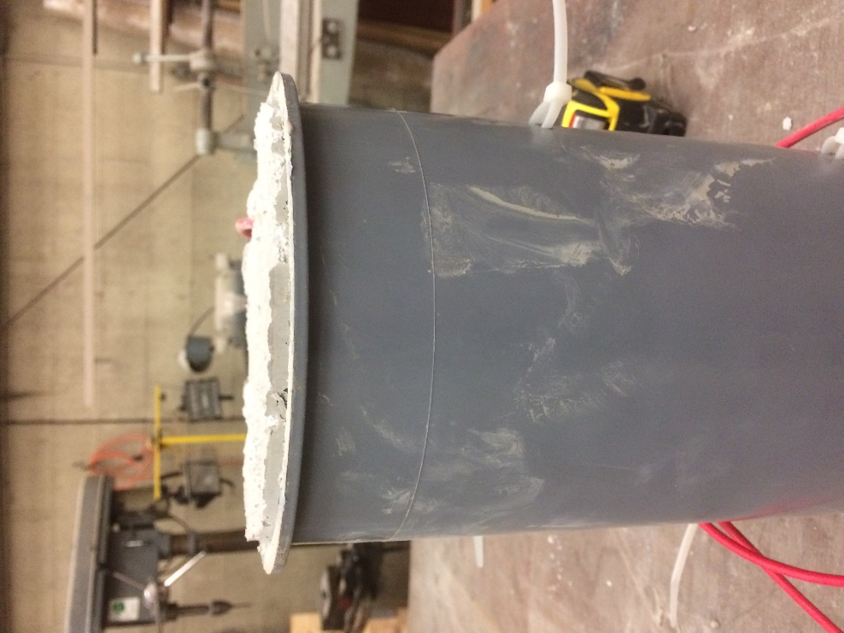
Figure 49: Visible height expansion of sample *ST210
The cylinder also had visible expansion outwards at the base of the specimen mold, shown in Figure 50. There were stretch marks on the outside of the mold, which can be seen in the Figure 50 as well. These stretch marks went all the way around the circumference of the base of the mold. With the actual amount of water added to this sample being unknown it is hard to tell why this sample experienced such large expansion that led to the strain gage breaking. It did have 7 lb of internal curing water and produced interesting results that may indicate a very different behavior for mix designs with smaller w/c ratios.
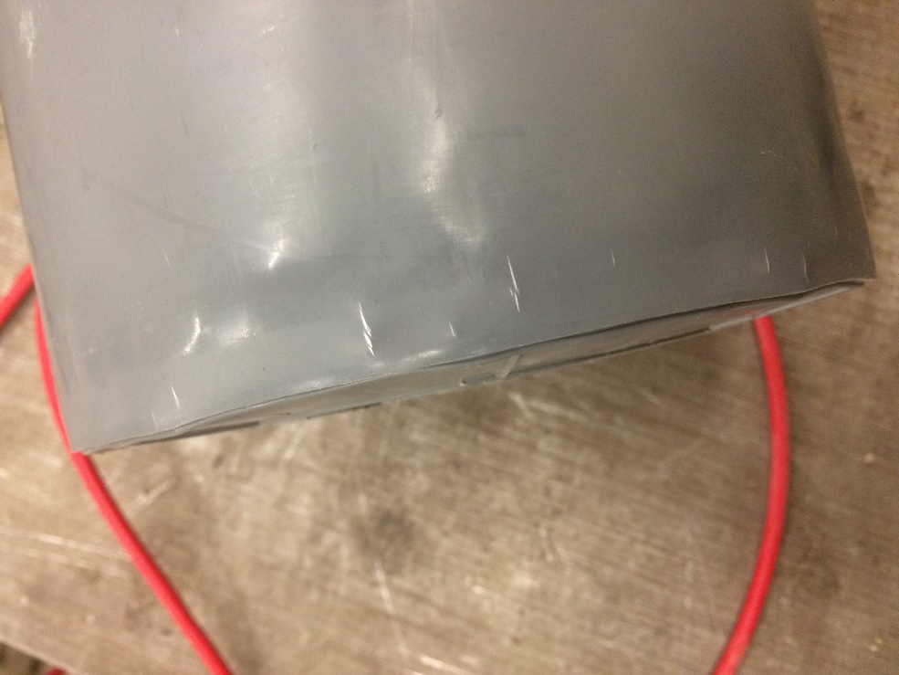
Figure 50: Visible expansion of the base with stretch marks on the mold for *ST210

4.4.4 Conventional portland cement
The conventional type I Portland cement batches were tested for length change according to ASTM C157. These batches were first tested at 24-hrs immediately following demolding, then again, every 24-hrs for the first week and then once a week after 7-days. The C157 length change results for the control portland cement batch with no internal curing water are shown in Figure 51. The length change results of the specimens from this batch show shrinkage of approximately 200 microstrain in the first week after casting. After the first week the rate of shrinkage slowed significantly, and each specimen only shrank about another 200 to 300 microstrain over the next 16 weeks.

Figure 51: ASTM C157 length change over time for portland cement with 0 lb of internal curing water
The next portland cement batch introduced enough presoaked LWA to achieve 5 lb of internal curing water. The length change results over time for its three C157 specimens are included in Figure 52. The three specimens including 5 lb of internal curing water exhibited similar patterns of shrinkage to the control mix with a higher initial shrinkage rate that reduced over time, but these specimens exhibited greater overall shrinkage. They shrank approximately 350 microstrain in the first week, which is more than any of the control batch specimens shrank in the first 4-weeks. Each specimen had slower shrinkage after the first week and leveled out more than the mix with no internal curing water, but still reached at least 500 microstrain shrinkage.

Figure 52: ASTM C157 length change over time for portland cement with 5 lb of internal curing water
The length change results for the C157 specimens for the portland cement mix design containing 7 lb of internal curing water are shown in Figure 53. The shrinkage during the first week of curing for these specimens only reached 225 microstrain, which was less shrinkage than the first two portland cement batches experienced during the first week. After the first week the shrinkage was similar to the batch containing no LWA.

Figure 53: ASTM C157 length change over time for portland cement with 7 lb of internal curing water
The shrinkage results for the C157 portland cement specimens containing 10 lb of internal curing are shown in Figure 54. During the first week after casting the maximum shrinkage for any specimen from this batch was less than 175 microstrain. This was the least amount of shrinkage in the first week of any of the batches. All three specimens from this batch had values of final shrinkage ranging between 350 and 375 microstrain. The specimens from this batch experienced the slowest rate and least shrinkage of all the portland cement batches.

Figure 54: ASTM C157 length change over time for portland cement with 10 lb of internal curing water
Figure 55 displays the average length change for each portland cement batch. This figure clearly shows how different amounts of internal curing water in portland cement concrete affected shrinkage results in C157 length change testing described previously. The specimens with 10 lb of internal curing water had the smallest shrinkage of all portland cement concrete specimens indicating a positive effect on shrinkage for this level of internal curing water. The batch containing 7 lb of internal curing water had approximately the same shrinkage and rate of shrinkage as the control batch of portland cement concrete with 0 lb of internal curing water. The batch containing 5 lb of internal curing water experienced the fastest and most shrinkage of the portland cement batches. This batch had a much higher moisture content in the normalweight sand than the other batches of portland cement. Even with the moisture content being taken into account before batching by adjusting the amounts of materials in the batch, it is possible that the high moisture content of the sand contributed to such large shrinkage results compared to the other batches.

Figure 55: ASTM C157 average length change over time for portland cement specimens

Chapter 5: Summary, Conclusions, and Recommendations

5.1 Summary
The research project described in this thesis focused primarily on how internally curing concrete made with four types of cement (three CSA cements and typical portland cement) affects the concrete performance. This was examined by performing three tests on each mix design; compressive strength over time, Rapid Chloride Ion Permeability (RCIP), and measuring the length change over time. The Komponent® Type K shrinkage-compensating cement and portland cement specimens were tested for compressive strength at 24-hrs, 7-days, 28-days, and 90-days. The two rapid setting cements, Buzzi CSA cement and Rapid Set® cement, were tested for early compressive strengths at 2-hrs and 6-hrs in addition to the testing times for the other cements. The RCIP test does not actually measure permeability but measures resistivity which can be related to permeability, and was performed at 28-days and 90-days after batching. The length change of each mix design was tested according to ASTM C157 and tracked the shrinkage, and in some cases expansion, of the concrete specimens over time. The results from each test on each mix design were compared with the results for the same cement with different amounts of internal curing water. The following sections provide several conclusions and recommendations based on these results.

5.2 Conclusions
The following conclusions can be drawn from the results of the work described in this thesis and are only directly applicable in similar situations.
- The compressive strength of the CSA cement concrete was positively affected when 5 lb of internal curing water from LWA per 100 lb of cement was included through the introduction of presoaked LWA. Other amounts of internal curing water did not produce observable differences.
- The compressive strength of the Rapid Set® cement batches was highest with 10 lb of internal curing water from LWA per 100 lb of cement, but the compressive strengths for all batches were within 1000 psi of one another at 28 and 90 days.
- The compressive strength in the Komponent® cement concrete was positively affected when adding 5 lb and 7 lb of internal curing water from LWA, which each resulted in the same compressive strengths.
- The Rapid Set® and portland cements compressive strengths were affected the least by introducing internal curing water into the mix design. The conventional concrete mix design only showed minor improvement in compressive strength from the addition of internal curing water.
- The CSA cement concrete exhibited the largest compressive strength at 90-days out of all four cements tested. Komponent® cement concrete had the next largest compressive strengths, followed by the Rapid Set® and then portland cement. This is interesting because the portland cement had more cement and a lower w/c ratio than the Komponent® mix design.
- The addition of 7 lb of internal curing water from LWA led to the least shrinkage from C157 testing for the CSA cement concrete, Rapid Set® concrete and expansive Komponent® cement concrete.
- The length change of the portland cement and Komponent® cement batches displayed the largest amounts of shrinkage recorded from the C157 testing, while the CSA cement and Rapid Set® cement batches showed the least shrinkage and had very similar final readings.
- The data from the RCIP test exhibited large ranges for almost all of the batches, making these results inconclusive. However, some of the cements did have results that indicated that the addition of internal curing water reduced the permeability of concrete.
- The Komponent® cement concrete showed the most overall improvement from the introduction of internal curing water on compressive strength, permeability and length change.

5.3 Recommendations
The following recommendations are made for additional research and modifications to the methods used in this study if used for future research.
- In general, 7 lb of internal curing water from LWA per 100 lb of cement should be used for internal curing of CSA cement concrete if no additional data are available.
- The influence of citric acid and HRWR dosage on set time of different CSA cements for various temperatures should be investigated further.
- The effects of internal curing on permeability of CSA cements should be investigated further using a different test. The RCIP test results produced in this study had large ranges of data, making them inconclusive.
- A more accurate and replicable way of soaking and measuring the moisture content of the LWA should be further investigated.
- Care should be taken to check the Geokon datalogger more often to make sure it is recording data to avoid large data gaps in the strain gage readings.
- VWSGs should be used to measure the length change for all cements and not just the Komponent® cement concrete. These strain gages are more accurate and easier to use than the C157 test, which can have user bias when taking readings.
- A further investigation into internal curing of Komponent® cement with different w/c ratios should be conducted. The specimen with the strain gage that broke in the Komponent® cement batch with 7 lb of internal curing water from LWA actually had a different w/c ratio than was designed for, which may have influenced that result.
- With the results from the Komponent® cement being the most promising, further investigation should go into combining internal curing water with different replacement amounts of Komponent® than the 15% investigated in this research.

References
ACI Committee 211.2. (1998) Standard Practice for Selecting Proportions for Structural Lightweight Concrete (ACI 211.2-98) and Commentary. American Concrete Institute.
ACI Committee 223. (1970). “Expansive Cement Concretes-Present State of Knowledge,” ACI Journal, 67(8): 583-610.
ACI Committee 308. (2016) Guide to External Curing of Concrete (ACI 308R-16) and Commentary. American Concrete Institute.
Architetxs. “Viste? É Para Isso Mesmo Que a Aplicação é Perfeita.” Architetxs., 25 Oct. 2016, architetxs.tumblr.com/post/152287868906/a-arquitetura-de-peso-tem-como-principal.
ASTM C39/C39M-17b. (2017) Standard Test Method for Compressive Strength of Cylindrical Concrete Specimens. West Conshohocken, PA.
ASTM C157/C157M-08. (2014) Standard Test Method for Length Change of Hardened Hydraulic-Cement Mortar and Concrete, ASTM International, West Conshohocken, PA.
ASTM C192/C192M-16a. (2016) Standard Practice for Making and Curing Concrete Test Specimens in the Laboratory, ASTM International, West Conshohocken, PA,.
ASTM C511 – 13. (2013) Standard Specification for Mixing Rooms, Moist Cabinets, Moist Rooms, and Water Storage Tanks Used in the Testing of Hydraulic Cements and Concretes, ASTM International, West Conshohocken, PA.
ASTM C566 – 13. (2012) Standard Test Method for Total Evaporable Moisture Content of Aggregate by Drying, ASTM International, West Conshohocken, PA,.
ASTM C845/C845M – 12. (2012) Standard Specification for Expansive Hydraulic Cement, ASTM International, West Conshohocken, PA.
ASTM C1202/C1202M-12, (2016) Standard Test Method for Electrical Indication of Concrete’s Ability to Resist Chloride Ion Penetration, ASTM International, West Conshohocken, PA.
ASTM C1064/C1064M-17. (2017) Standard Test Method for Temperature of Freshly Mixed Hydraulic-Cement Concrete, ASTM International, West Conshohocken, PA.
ASTM C1761/C1761M-15. (2015) Standard Specification for Lightweight Aggregate for Internal Curing of Concrete, ASTM International, West Conshohocken, PA.
Bentur, A., Igarashi, S., and Kovler, K. (2001) "Prevention of autogenous shrinkage in high-strength concrete by internal curing using wet lightweight aggregates." Cement and Concrete Research, 31(11): 1587-1591.
Bentz, D. P., Lura, P., and W. Roberts, J. W. (2005) "Mixture proportioning for internal curing." Concrete International, 27(2): 35-40.
Bentz, D. P., and Jensen, O. M. (2004) "Mitigation Strategies for Autogenous Shrinkage Cracking." Cement and Concrete Composites, 26(6): 677-85.
Bremner, T., and Ries, J. (2009) “Stephen J. Hayde: Father of the Lightweight Concrete Industry,” Concrete International, 31(8): 35-38.
Chaunsali, P. and Mondal, P. (2015) "Influence of Calcium Sulfoaluminate (CSA) Cement Content on Expansion and Hydration Behavior of Various Ordinary Portland Cement‐CSA Blends." Journal of the American Ceramic Society, 98(8): 2617-624. Web.
CTS Cement Rapid Set Construction Cement (2016) “Building a Better World for Generations to Come.” Retrieved April 2, 2018, from https://www.ctscement.com/
Cusson, D. and Hoogeveen, T. (2008) "Internal curing of high-performance concrete with pre-soaked fine lightweight aggregate for prevention of autogenous shrinkage cracking." Cement and Concrete Research, 38(6): 757-765.
Damtoft, J. S., Lukasik, J., Herfort, D., Sorrentino, D., and Gartner, E. M. (2008) "Sustainable development and climate change initiatives." Cement and concrete research, 38(2): 115-127.
Londono-Zuluaga, D., Tobón, J.I., Aranda, M.A.G., Santacruz, I., De la Torre, A.G. (2017) “Clinkering and hydration of belite-alite-ye´elimite cement,” Cement and Concrete Composites, 80: 333-341,
Expanded Shale, Clay and Slate Institute(ESCI) (2010) “Internal Curing.” Retrieved April 2018, from http://escsi.staging.bostrom.com/ContentPage.aspx?id=205
Gartner, E. (2004) "Industrially Interesting Approaches to "low-CO 2" Cements." Cement and Concrete Research, 34(9): 1489-498.
"Internal Curing of Concrete applying Light Expanded Clay Aggregate." LECA: Light Expanded Clay Aggregate. N.p., 2011. Web. 21 Mar. 2017.
Kyllästinen, Karri. "Internal curing of concrete." (2015).
Philleo, R. (1991) Concrete science and reality, in: J.P. Skalny, S. Mindess (Eds.), Materials Science of Concrete II. American Ceramic Society. Westerville, OH., pp. 1-8.
Sharp, J., Lawrence, C., & Yang, R. (1999) “Calcium Sulfoaluminate Cements-Low-Energy Cements, Special Cements of What?,” Advances in Cement Research, 11(1): 3-13.
Weiss, Jason. (2011) "Improving Concrete Bridge Decks with Internal Curing." Concrete Bridge Views-Then and Now. Web. 21 Mar. 2017.
Winnefeld, F., and Lothenbach, B. (2010). “Hydration of Calcium Sulfoaluminate Cements – Experimental Findings and Thermodynamic Modelling.” Cement and Concrete Research, 40: 1239-1247.
Zhang, J., Luoson, Y., Wang, J., and Han, Y. (2015) “Shrinkage of High-Strength Calcium Sulfoaluminate Cement Concrete with Impact of Pre-Soaked Lightweight Aggregate Internal Curing.” Magazine of Concrete Research, 67(22): 1204-1213.

Appendix A: Compressive Strength Test Results
Table 15: CSA compressive strengths
Sample ID | ST150 | ST160 | ST170 | ST180
Internal Curing Water (lb/100 lb) | 0 | 5 | 7 | 10
2-hrs (psi) | 1850 | 1675 | 1740 | 1600
2-hrs (psi) | 1880 | 1665 | 1775 | 1170
2-hrs (psi) | 1920 | 1725 | 1775 | 1170
6-hrs (psi) | 2415 | 2285 | 2400 | N/A
6-hrs (psi) | 2405 | 2530 | 2280 | N/A
6-hrs (psi) | 2485 | 2555 | 2325 | N/A
24-hrs (psi) | 3135 | 2915 | 2995 | 2290
24-hrs (psi) | 3215 | 3005 | 3335 | 2485
24-hrs (psi) | 3195 | 2940 | 3155 | 2290
7-day (psi) | 3285 | 4340 | 3620 | N/A
7-day (psi) | 3370 | 4265 | 3350 | N/A
7-day (psi) | 3580 | 4420 | 3170 | N/A
28-day (psi) | 3575 | 5525 | 3310 | 2810
28-day (psi) | 3530 | 5755 | 3590 | 2835
28-day (psi) | 3625 | 5510 | 3460 | 3040
90-day (psi) | 5220 | 8560 | 4915 | 2735
90-day (psi) | 5110 | 8405 | 3530 | 2965
90-day (psi) | N/A | 9525 | 5655 | N/A

Table 16: Rapid Set® compressive strengths
Sample ID | ST100 | ST110 | ST120 | ST130
Internal Curing Water (lb/100 lb) | 0 | 5 | 7 | 10
2-hrs (psi) | 3445 | 3610 | 2880 | 2860
2-hrs (psi) | 3745 | 3645 | 2935 | 3390
2-hrs (psi) | 3590 | N/A | 2815 | 3195
6-hrs (psi) | 4285 | 4205 | 3740 | 4170
6-hrs (psi) | 4215 | 4320 | 3650 | 3730
6-hrs (psi) | 3755 | 4260 | 3975 | 4330
24-hrs (psi) | 4915 | 5110 | 5400 | 4855
24-hrs (psi) | 4865 | 4890 | 5025 | 5255
24-hrs (psi) | 5105 | 5105 | N/A | N/A
7-days (psi) | 5625 | 5620 | 6115 | 6275
7-days (psi) | 5415 | 5800 | 6105 | 6300
7-days (psi) | 5660 | 5715 | N/A | 6760
28-days (psi) | 5465 | 5765 | 6430 | 6890
28-days (psi) | 5515 | 5710 | 5465 | 6525
28-days (psi) | 5780 | 5945 | N/A | 6290
90-days (psi) | 5210 | 5325 | 5635 | 5915
90-days (psi) | 5335 | 5240 | 5840 | 5790
90-days (psi) | 5390 | 4995 | 5185 | 6185

Table 17: Komponent® compressive strengths
Sample ID | ST190 | ST200 | ST220 | ST230
Internal Curing Water (lb/100 lb) | 0 | 5 | 7 | 10
24-hrs (psi) | 2285 | 2070 | 2385 | 2460
24-hrs (psi) | 2195 | 2020 | 2505 | 2380
24-hrs (psi) | 2185 | 2125 | 2535 | 2450
7-days (psi) | 4515 | 4775 | 5475 | 5190
7-days (psi) | 4535 | 5195 | 5405 | 4900
7-days (psi) | 4505 | 5425 | 5000 | 4450
28-days (psi) | 5250 | 7145 | 6990 | 4565
28-days (psi) | 5030 | 6950 | 7100 | 4515
28-days (psi) | 5445 | 7015 | 6830 | 4730
90-days (psi) | 5435 | 7260 | 7220 | 4770
90-days (psi) | 5865 | 7175 | 7215 | 4860
90-days (psi) | 5650 | 7060 | 6905 | 4830

Table 18: Conventional portland cement compressive strengths
Sample ID | ST240 | ST250 | ST260 | ST270
Internal Curing Water (lb/100 lb) | 0 | 5 | 7 | 10
24-hrs (psi) | 2095 | 2085 | 2415 | 2705
24-hrs (psi) | 2275 | 2190 | 2430 | 2690
24-hrs (psi) | 2175 | 2170 | 2470 | 2795
7-days (psi) | 4010 | 4440 | 4820 | 3995
7-days (psi) | 4005 | 4305 | 4795 | 4635
7-days (psi) | N/A | 4315 | 4730 | 4375
28-days (psi) | 4400 | 3855 | 5670 | 5645
28-days (psi) | 4450 | 5350 | 5610 | 5550
28-days (psi) | 4490 | 5565 | 5665 | 5395
90-days (psi) | 4555 | 5390 | 5795 | 5740
90-days (psi) | 4540 | 5210 | 3910 | 5575
90-days (psi) | 4645 | 5405 | 2405 | 5530

Appendix B: General Batch Information
Table 19: Batch weights and aggregate moisture contents for the Buzzi CSA cement batches
Batch ID | ST150 | ST160 | ST170 | ST180
Portland cement (lb) | 30.5 | 30.5 | 30.5 | 30.5
Buzzi CSA cement (lb) | 30.5 | 30.5 | 30.5 | 30.5
Limestone (lb) | 166.6 | 166.8 | 166.2 | 166.1
Sand (lb) | 111 | 85.8 | 75.4 | 60.3
LWA (lb) | 0 | 17.5 | 24.5 | 35.0
Water (lb) | 27.6 | 26.2 | 26.5 | 25.9
M.C. Sand (%) | 2.76 | 2.32 | 1.75 | 1.12
M.C. Limestone (%) | 0.48 | 0.59 | 0.24 | 0.17

Table 20: Batch weights and aggregate moisture contents for the Rapid Set® cement batches
Batch ID | ST100 | ST110 | ST120 | ST130
Rapid Set® cement (lb) | 60.9 | 60.9 | 60.9 | 60.9
Limestone (lb) | 163.8 | 163.9 | 164.1 | 163.9
Sand (lb) | 111.7 | 111.4 | 112 | 111.4
LWA (lb) | 0 | 34.8 | 48.7 | 69.6
Water (lb) | 28.8 | 24.9 | 22.5 | 20.9
M.C. Sand (%) | 2.26 | 1.95 | 2.51 | 1.95
M.C. Limestone (%) | 0.12 | 0.12 | 0.3 | 0.17

Table 21: Batch weights and aggregate moisture contents for the Komponent® cement batches
Batch ID | ST190 | ST200 | ST220 | ST230
Portland cement (lb) | 36.5 | 36.5 | 36.5 | 36.5
Komponent (lb) | 6.4 | 6.4 | 6.4 | 6.4
Limestone (lb) | 130.9 | 130.9 | 130.9 | 130.9
Sand (lb) | 99.4 | 70.5 | 59.5 | 41.4
LWA (lb) | 0 | 21.0 | 29.4 | 42.0
Water (lb) | 22.6 | 19.7 | 17.9 | 16.5
M.C. Sand (%) | 0.52 | 0.83 | 1.96 | 0.94
M.C. Limestone (%) | 0.13 | 0.15 | 0.25 | 0.69

Table 22: Batch weights and aggregate moisture contents for the conventional portland cement batches
Batch ID | ST240 | ST250 | ST260 | ST270
Portland cement (lb) | 48.7 | 48.7 | 48.7 | 48.7
Limestone (lb) | 132.8 | 133.7 | 133.2 | 132.8
Sand (lb) | 88.3 | 50.2 | 34.1 | 10.3
LWA (lb) | 0 | 28.0 | 39.3 | 56.1
Water (lb) | 24.2 | 19.0 | 18.6 | 17.4
M.C. Sand (%) | 0.85 | 2.80 | 2.39 | 1.58
M.C. Limestone (%) | 0.16 | 0.80 | 0.40 | 0.17

