University of Oklahoma

Graduate College

an experimental evaluation of central pain processing following covid-19 infection

A dissertation

submitted to the graduate faculty

in partial fulfillment of the requirements for the

Degree of

DocTOR OF Philosophy

By
Jessica ann peterson
Norman, Oklahoma
2021

an experimental evaluation of central pain processing following covid-19 infection

a disseratation approved for the
Department of Health and Exercise Science

By THE COMMITTEE CONSISTING OF

Dr. Christopher D. Black, Chair

Dr. Michael Bemben

Dr. Rebecca D. Larson

Dr. Hugo Pereira

Dr. Howard Michael Crowson

© Copyright by Jessica ann peterson 2021
All Rights Reserved.
ACKNOWLEDGEMENTS
I would like to take the time to acknowledge the many people in my life that have gotten me through the doctoral process and the completion of this dissertation. I would like to firstly thank my advisor, Dr. Chris Black. Thank you so much for taking a chance on me 5 years ago, advocating for me when I needed help, allowing me the space and opportunity to grow my research mind without judgement. Thanks for being not only a great advisor, but a mentor too, therapist, life coach, colleague and friend. Second, thanks to my other members of my committee, Dr. Rebecca Larson, Dr. Mike Bemben, Dr. Hugo Periera, and Dr. Michael Crowson; your teaching and mentorship over the past few years has been greatly appreciated and has been invaluable to my success. Many thanks go to the whole HES dept. they have made these past five years some of most memorable years of my life. Thanks to my lab mates in the Sensory and Muscle Function lab; helping me develop my research ideas and grow into an independent researcher. Thanks to Grant for helping me complete my second dissertation and being an awesome collaborator. Thanks to Taylor and Chris for emotionally supporting me through comps. Thanks to the boys in my cohort for keeping me motivated and aiming high. Furthermore, I would like to thank my friends Randi-Leigh, Josh, and Katy for being shoulders to cry on and being there for me during my happy days and my sad moments and never giving up on me and always believing in me. I would like to thank my mum, sister, and Nanna P for their continued support from thousands of miles away and an ocean divided. And finally, thanks to my dad for supporting me and investing in me and allowing me to flourish independently and not holding me back.
TABLE OF CONTENTS
LIST OF TABLES viii
ABSTRACT vx
CHAPTER 1- Introduction 1
Introduction 1
Gaps in Literature 4
Purpose 5
Significance 5
Research Questions 6
Research Hypotheses 7
Delimitations 8
Limitations 9
Assumptions 9
Operational Definitions 10
CHAPTER 2 – Literature Review 12
COVID-19 Introduction 12
Signs and symptoms of COVID-19 12
Pathophysiology of COVID-19 13
COVID-19 and the Nervous System 15
COVID-19 Interaction on Pain Symptoms 16
The Story of Pain 17
Pain Transduction 17
Pain Transmission 19
Pain Perception 21
Pain Modulation 22
Experimental Pain Modulation 24
Sensitization 27
Peripheral Sensitization 28
Central Sensitization 29
Inflammation and Pain 30
Qualitative Nociceptive Testing 34
Quantitative Nociceptive Testing 34
Chronic Impacts of COVID-19 on the Nervous System 37
Respiratory illnesses/conditions and pain sensitivity 37
Viral Infections and Pain Sensitivity 38
Myalgia: a Symptom of COVID-19 and previous research in Myalgia 38
Headaches: a Symptom of COVID-19 and previous research in Headaches 39
COVID-19 and Pain Modulatory Function 40
CHAPTER 3- Methodology 44
Introduction 44
Sample Population 44
Exclusion/Inclusion Criteria 45
Pre-screening and recruitment 46
Experimental Protocol 47
Questionnaires 50
Antibody Testing 52
Body Composition 53
Pain Outcome Measures 55
Pain Modulatory Function 56
Statistical Analysis 58
CHAPTER 4 – Results 60
Participant Characteristics 60
Group Demographic differences 60
Reliability in PPT’s between Visits 63
Differences in Pressure Pain Sensitivity 63
Differences in Normalized Pressure Pain Sensitivity to Limb Specific Fat/Lean Mass 64
Differences in Pain Modulation 64
Differences in Pain Sensitivity in Individuals 0-6 and 6-12 Months Post Exposure 67
Differences in Pain Modulation in Individuals 0-6 and 6-12 Months Post Exposure 68
Symptomatic COVID-19 symptomology 70
Relationships between COVID-19 symptomology and pressure pain sensitivity 71
Relationships between COVID-19 symptomology and pain modulatory function 71
Relationships between EIH and CPM 72
Discussion 74
Similarities in Pressure Pain Sensitivity 74
Differences in CPM Response 75
Similarities in EIH Response 80
COVID-19 Symptomology 81
COVID-19; Long term effect 82
Differences and similarities in Questionnaires 83
CHAPTER 5 – Conclusion 85
Purpose 85
Hypothesis 85
Sub-hypothesis 86
Limitations 88
Significance of findings 90
Conclusions 91
Future directions 91
WORKS CITED 92
APPENDIX: 124

LIST OF TABLES AND FIGURES
Table 1: Descriptive Statistics for all Participants 60
Table 2: Group descriptive for symptomatic, asymptomatic, and control groups 62
Table 3: Pearson and Point-biserial correlations showing relationships between common COVID-19 symptoms and Pain/Pain Modulation measures 73

Figure 1: Group differences in pressure pain threshold between symptomatic COVID-19, asymptomatic COVID-19, and control groups. 63
Figure 2: Group differences in Condition Pain Modulation between symptomatic COVID-19, asymptomatic COVID-19, and control groups in the leg. 65
Figure 3: Group differences in Condition Pain Modulation between symptomatic COVID-19, asymptomatic COVID-19, and control groups in the arm. 66
Figure 4: Group differences in Exercise Induced Hypoalgesia between symptomatic COVID-19, asymptomatic COVID-19, and control groups in the leg. 66
Figure 5: Group differences in Exercise Induced Hypoalgesia between symptomatic COVID-19, asymptomatic COVID-19, and control groups in the arm. 67
Figure 6: Group differences in pressure pain sensitivity between groups who had symptomatic COVID-19 0-6 months ago, and 6-12 months ago. 68
Figure 7: Group differences in conditioned pain modulation between groups who had symptomatic COVID-19 0-6 months ago, and 6-12 months ago. 69
Figure 8: Group differences in exercise induced hypoalgesia between groups who had symptomatic COVID-19 0-6 months ago, and 6-12 months ago. 69
Figure 9: Common symptoms experienced/reported in symptomatic COVID-19 participants 70
Figure 10: Relationship between CPM in the leg and EIH in the leg 73
Figure 11: Relationship between CPM in the arm and EIH in the arm 73

ABSTRACT

Neurological symptoms, including pain, have been increasingly recognized as an area of concern in symptomatic patients of COVID-19. COVID-19 initiates an inflammatory response that can sensitize and activate nociceptors leading to painful symptoms. Localized and systemic inflammation has been suggested to play a role in the impaired pain modulation. Dysfunction of endogenous pain-modulatory mechanisms such as conditioned pain modulation (CPM) and exercise-induced hypoalgesia (EIH) have been found across a host of chronic pain conditions. It is unknown whether the COVID-19 virus has had an impact on pain sensitivity and pain modulation. PURPOSE: The purpose of this study was to examine and compare pressure pain sensitivity and pain modulatory function in individuals who have been previously exposed to COVID-19, both symptomatically and asymptomatically, to a control group who have not been exposed to the virus. METHODS: Pressure pain thresholds (PPT) of 59 participants were assessed in the vastus lateralis (VL) and brachioradialis (BR) using a pressure algometer on the dominant side of the body before and after submersion of their feet in an ice bath (2ºC) for 1min and an isometric knee extension, time to failure task based off of 25% of maximal contraction. The difference between post and pre measures was defined CPM response (ice bath) and EIH response (exercise condition). RESULTS: PPT’s were not different between groups when normalized to lean body mass. CPM response was attenuated both locally and remotely in individuals who have had symptomatic COVID-19 compared to asymptomatic COVID-19 and control group. No differences were found in EIH response in individuals who have been exposed to COVID-19 and those who have not. CONCLUSION: CPM was impaired in individuals who had symptomatic COVID-19 and there were no differences found in individuals who had symptomatic COVID-19 up to 6 months ago and 6 to 12 months ago. No differences between groups were found in pressure pain sensitivity when normalized to lean mass, and no differences between groups were found in EIH response. COVID-19 exposure may have a long term impact on pain modulation, placing individuals who have had COVID-19 at risk increase for chronic pain.

CHAPTER I
INTRODUCTION
Severe acute respiratory syndrome coronavirus 2 (SARS-CoV-2), the pathogen responsible for the coronavirus disease 2019 (COVID-19), has resulted in morbidity, mortality, and an unprecedented global pandemic. This novel coronavirus was initially associated with an upper respiratory infection and individuals who presented with clinical manifestations of COVID-19 showed symptoms similar to that of influenza. It was initially characterized by fever and cough (1-3) with symptoms developing after an incubation period of around 4–7 days (3). As more people became infected with the virus, more severe signs and symptoms were reported across a host of biological systems, including the nervous system.
Neurological symptoms of COVID-19 may include myalgia and fatigue, which are seen in about 50% of COVID-19 cases (4), anosmia (loss of the sense of smell) and ageusia (loss of the sense of taste) have been common early detection symptoms (5, 6). Sore throat and headache were also regularly reported symptoms (3, 7). In addition to acute symptomology of COVID-19, a growing number of scientific and clinical articles have demonstrated that subacute and long-term effects of COVID-19 may lead to nervous system and psychiatric impairments (8). A growing number of COVID-19 survivors have reported a post-viral syndrome consisting of chronic malaise, diffuse myalgia, depressive symptoms and non-restorative sleep (9, 10) similar to that of a chronic post-SARS syndrome that was observed following the SARS pandemic of 2003 and similar to chronic fatigue syndrome (CFS) (11). Other post-acute neurological manifestations of COVID-19 include migraine-like headaches (12) and late-onset headaches (10).
As neurological complications have been increasingly recognized as an area of concern during acute infection with COVID-19 and in the preliminary named post-acute COVID-19 syndrome or “long COVID”, special attention must be made to how COVID-19 may impact the nervous system both acutely and chronically. A common neurological manifestation of COVID-19 that has been reported is pain. Pain from symptoms is likely originating from SARS-CoV-2, one of the major causative agents of COVID-19, whereby cytokines are released by SARS-CoV-2 affected cells and then an immune/inflammatory response negatively affects other cells both locally and remotely (13, 14). Cytokines are released by cells affected by SARS-CoV-2 leading to an inflammatory response (13, 14). Pro-inflammatory cytokines sensitize and/or activate nociceptors and transmit painful stimuli to the brain (15). The surface expressed angiotensin converting enzyme 2 (ACE2) has been found to be main receptor for uptake of SARS-CoV-2 spike protein (16). Evidence indicates that ACE2 expressing sensory neurons synapse with spinal and brainstem central nervous system (CNS) neurons leading to neurological effects, including headache and nerve pain (17, 18). Additionally, viral infections can cause localized and systematic inflammation leading to tissue damage and the onset of pain.
Pain can be classified into nociceptive and non-nociceptive pain. Nociceptive pain occurs when noxious stimuli of mechanical, thermal, chemical, or electrical origin activate sensory receptors, known as nociceptors that signal to the brain to be perceived as painful, and elicit a pain response. On the other hand, non-nociceptive pain is thought to be by triggered by functional or structural abnormalities of the peripheral and/or central nervous system (CNS), leading to neuropathic pain and chronic pain with the absence of an obvious external nociceptive signal. It is possible that SARS-CoV-2 could play a role in acute nociceptive pain and could lead to long term impairments of neurons thus leading to dysregulation of pain processing in the CNS. Pain signaling pathways can be both pro-nociceptive and anti-nociceptive (19). The primary afferent nerves that contain nociceptors are either A delta fibers, which are large and myelinated and responsible for acute sharp pain, or C fibers, which are small and unmyelinated and responsible for slow-onset, dull, lingering, or achy pain (20). These nerves can be excited (activated) or sensitized (lower threshold) by a plethora of stimuli including the pressure from edema and/or noxious chemicals such as pro-inflammatory cytokines that can bind to the nociceptor (21). Once activated, the nociceptor afferents send signals to the brain (ascending pathway) where they can be interpreted as painful (22). Modulation is the way the brain (descending pathway) alters the intensity of the signal traveling up the ascending pathway depending on the circumstance surrounding the initiation of the nociceptive signal and could block pain (23).
Endogenous modulation of pain, a phenomenon whereby the CNS and/or peripheral nervous system function to attenuate the perception of pain was originally described by Sherrington and Sowton in 1915 (24). One of the most widely accepted measures of endogenous pain inhibition uses the psychophysical paradigm of conditioned pain modulation (CPM), often termed “pain inhibits pain” (25). In this model of modulation, an initial painful stimulus (the conditioning stimulus) leads to an attenuated pain response to a second stimulus (the test stimulus) (25). CPM is based on mechanisms originally tested by La Bars et al. (26) in rat models. In these rats, there was a spino-bulbo-spinal loop, in which spinal dorsal horn neurons receive a noxious conditioning stimulus from a particular area of the body. This noxious signal ascends to the claudal medulla which then sends widespread descending inhibition to the spinal secondary neurons. Some findings indicate that the CPM response does not exclusively involve a spino-bulbo-spinal pathway, and that physiological and psychological pathways also interact with this phenomenon (27) and that there may be an interaction between CPM and the cardiovascular system (28). However, the underlying mechanisms of CPM, especially in humans, and are still incompletely understood. Another commonly employed measure of endogenous pain modulation occurs in response to exercise—termed exercise-induced hypoalgesia (EIH) (29, 30). EIH is typically characterized by elevations in pain thresholds or tolerances, including reductions in pain intensity ratings during and after a bout of resistance, isometric, or aerobic exercise (31). Both CPM and EIH have been consistently demonstrated in young, healthy, pain-free populations (31-33). However, reduced CPM responses have been shown in chronic pain conditions such as fibromyalgia (34), osteoarthritis (35), and pancreatitis (36) . Additionally, exercise often leads to sensitization to painful stimuli, rather than EIH in a host of chronic pain conditions including fibromyalgia (37), chronic whiplash disorder (38) and Gulf War syndrome (39). The reason(s) for dysfunction in these groups is not well understood. Chronic inflammation as well as emotional trauma have been suggested to play a role in the dysfunction of CPM and EIH in these groups although there is little experimental evidence in support of these ideas. Since dysfunction of the CPM and EIH systems has been shown in groups (e.g. fibromyalgia and Gulf War Syndrome) who present with many of the same neurological symptoms as long COVID, it seems plausible that COVID infection might also impact pain modulation.
Gaps in the literature:
Based upon the novelty of COVID-19, little research has been conducted on how this acute virus impacts pain processing. Calls for grants and papers from major funding sources and high impact journals have been made to due to this lack of information. Very few studies have examined the effects of an acute respiratory virus and its influence on pain processing mechanisms. Using data from other chronic pain conditions that mimic some of the potential long term effects of SARS-CoV-2 exposure, it is believed that pain and pain modulation may be impacted in a negative fashion by the virus. The research question that we wish to address is; has COVID-19 had an effect on pain and pain modulation in individuals who have been infected by the virus versus those who have not. By addressing this question, we can begin to make inference on how individuals perceive pain and modulate pain in COVID-19 survivors and can have important implications on how we examined pain processing and chronic pain in the wake of COVID-19.
Purpose
The purpose of this dissertation project was to examine and compare pressure pain sensitivity and pain modulatory function in individuals who have been previously infected by COVID-19, both symptomatically and asymptomatically, to a control group who have not been infected by the virus (i.e. do not have the COVID-antibodies).

Significance
The COVID-19 pandemic has resulted in unprecedented morbidity and mortality globally and has resulted in large-scale research efforts to understand the impacts of the virus. It has highlighted the importance and challenges of real-time pandemic research in many research avenues. As pain has been highlighted as one of the symptoms of COVID-19, as well as many other coronavirus type infections, it is important to address and examine the impact this virus has on the nociceptive system and whether there are any potential long term repercussions.

Additionally, chronic pain is the leading cause of long term disability in the United States affecting upwards of 100 million people and costing an individual $6000 more a year in medical bills than the average person (40). It is the most commonly reported reason for visiting a doctor and reduces both physical function and quality of life to those suffering from long term ailments. Prescription pain medicine and opioids are often prescribed to overcome pain barriers. However, more than 130 people in the United States die per day from opioid overdose. Inflammation is a common denominator in many chronic pain conditions and can be triggered by a viral infection. Our goal is to better understand the nociceptive system with regards to pain associated with an acute viral infection to improve treatment for acute and chronic infections that have supplementary pain symptoms often associated with local and systemic inflammation.

Research Questions
- Does previous infection with COVID-19 alter pain sensitivity assessed using pressure pain thresholds?
- Does previous infection with COVID-19 alter pain modulation assessed via conditioned pain modulation and exercise-induced hypoalgesia?

Sub Questions
- Do relationships exist between different symptoms of COVID-19 and pain sensitivity?
- Do relationships exist between different symptoms of COVID-19 and measures of pain modulation?
- Is there a difference between people who have had symptomatic COVID-19 in the past 6 months and people who have had COVID-19 in the past 6-12 months in pressure pain sensitivity?
- Is there a difference between people who have had COVID-19 in the past 6 months and people who have had symptomatic COVID-19 in the past 6-12 months in pain modulatory function assessed via CPM and EIH?

Hypotheses
- H₀: Pressure pain thresholds will not be different between groups.

H₁: Pressure pain thresholds will be different between groups; with symptomatic COVID-19 having lower pain thresholds than control and asymptomatic groups
- H₀: The CPM response will not be different between groups

H₁: The CPM response will be different between groups; with symptomatic COVID-19 having a reduced CPM response than control and asymptomatic groups.
- H₀: The EIH response will not be different between groups

H₁: The EIH response will be different between groups; with symptomatic COVID-19 having a reduced EIH response than control and asymptomatic groups.

Sub-Hypotheses
- H₀: There will be no relationship between common symptoms of COVID-19 and pressure pain sensitivity.

H₁: There will be a relationship between common symptoms of COVID-19 and pressure pain sensitivity.
- H₀: There will be no relationship between symptoms of COVID-19 and pain modulatory function assessed via CPM and EIH.

H_{1:} There will be a relationship between symptoms of COVID-19 and pain modulatory function assessed via CPM and EIH.
- H₀: People who have had COVID-19 in the past 6-12 months will not be different from those who have had COVID-19 in the past 0-6 months in pressure pain sensitivity

H_{1:} People who have had COVID-19 in the past 6-12 months will be different from those who have had COVID-19 in the past 0-6 months in pressure pain sensitivity
- H₀: People who have had symptomatic COVID-19 in the past 6-12 months will not be different from those who have had symptomatic COVID-19 in the past 0-6 months in pain modulatory function assessed via CPM.

H_{1:} People who have had symptomatic COVID-19 in the past 6-12 months will be different from those who have had symptomatic COVID-19 in the past 0-6 months in pain modulatory function assessed via CPM.
- H₀: People who have had symptomatic COVID-19 in the past 6-12 months will not be different from those who have had symptomatic COVID-19 in the past 0-6 months in pain modulatory function assessed via EIH.

H_{1:} People who have had symptomatic COVID-19 in the past 6-12 months will be different from those who have had symptomatic COVID-19 in the past 0-6 months in pain modulatory function assessed via EIH.

Delimitations
- The findings from this study will be applicable to people that have had COVID-19 with symptoms, without symptoms, and who have not had COVID-19 at all.
- Participants will be familiarized to PPT measurements, MVC protocols, and the EIH protocol to limit training effects.
- Participants will be free from injury and free from any chronic musculoskeletal pain for >3months.
- Participants will not be currently using NSAIDS and other over the counter pain medications
- Participants will not be currently using ergogenic nutritional supplements, recreational drug use, prescription pain or psychiatric medications (including medication for ADHD) for >3months prior to the start of the study
- Participants will complete questionnaires confirm they fit the criteria to participate in the experiment.
- Participants will be without multiple risk factors for cardiovascular disease as determined by IPAQ questionnaire.

Limitations
- Participants will be between the ages of 18-35 with no prior medically diagnosed chronic pain and will be recruited within Norman, OK.
- PPTs are subjective and cannot control for dishonest readings.
- Participants will be asked to refrain from taking pain medication during the experiment, but the daily routines of the participants cannot be controlled.
- As testing will occur on multiple testing visits, day to day variation in mood and fatigue may differ between visits

Assumptions
- Participants are without any symptoms of chronic pain.
- Participants are honest on the perception of the onset of pain.
- Participants are honest when completing questionnaires
- Participants are honest when completing health history and medical information
- Participants will give maximal effort during MVC protocols and time to task failure protocols for EIH.
- Participants are compliant with the directions and guidelines provided prior to testing visits. This includes refraining from exercise, medication use, caffeine, and maintaining adequate hydration status.
- The exercise protocol and method used for EIH and CPM are sufficient to produce the desired response.

Operational Definitions
- Algesia: Sensitivity to noxious stimuli.
- Antibody: a protein component of the immune system that circulates in the blood, recognizes foreign substances, and neutralizes them. After exposure to a foreign substance, called an antigen, antibodies continue to circulate in the blood, providing protection against future exposures to that antigen.
- Body fat percentage: The percentage of total body composition that is fat
- Catastrophize: to imagine the worst possible outcome of an action or event
- Conditioned pain modulation: A decrease in pain sensitivity to noxious stimuli by administering noxious stimuli to separate locations
- COVID-19 – Coronavirus disease is a virus that has been identified as the cause of an outbreak of respiratory infection first identified in Asia in late 2019 that has since spread globally into a pandemic.
- Exercise-induced hypoalgesia: A decrease in the perception of pain from noxious stimuli following a bout of exercise.
- Hypoalgesia: A decrease in the perception of pain from noxious stimuli.
- Inflammation: when a physical factor triggers an immune reaction causing edema, redness, heat, loss of function, and pain.
- Maximal Voluntary Contraction (MVC): the highest force that can be produced during a maximal isometric contraction
- Physical activity: Body movement that requires additional caloric expenditure
- Pressure pain threshold: The minimum amount of pressure required to interpret stimuli as painful.
- SARS-coV-2 - Severe acute respiratory syndrome coronavirus 2
- Total body fat mass: The total amount of fat mass within an individual.
- Total body lean tissue mass: The total amount of lean muscle mass within an individual.

CHAPTER II
LITERATURE REVIEW
COVID-19 introduction:
Coronavirus disease 2019 (COVID-19) is an acute respiratory illness caused by the novel coronavirus severe acute respiratory syndrome coronavirus 2 (SARS-CoV-2). While the virus primarily attacks the lungs, it causes the human body to produce an overactive immune response leading to increased inflammation throughout the body. Risk factors for COVID-19 appear to include close contact with someone who has COVID-19 (less than 6feet) and being coughed and/or sneezed on my an infected individual (41, 42). The virus is spread by small droplets/aerosols that can stay in the air for minutes to hours indicating an airborne transmitted virus(41, 42). Transmission can also include surfaces and objects that have the virus on it, and if an individual touches the surface that has been contaminated with the virus and then touches their mouth, nose, or eyes then they can be infected by the virus(41, 42). Approximately, more than half of COVID-19 transmission was via asymptomatic individuals, with 59% of all transmission coming from asymptomatic people, comprising 35% from pre-symptomatic individuals and 24% from individuals who never develop symptoms (43) indicating that identifying and isolating individuals with symptomatic COVID-19 alone will not and does not stop the spread of the virus.
Signs and symptoms of COVID-19
Some individuals who are in contact with the SARS‐CoV‐2 infection remain asymptomatic, but others can exhibit mild to moderate COVID‐19 disease and COVID‐19 pneumonia, leading some patients to require intensive care support and, in some cases, to death, especially in older adults and individuals with pre-existing conditions (44). People with mild COVID‐19 might experience cough, sore throat, high temperature, diarrhea, headache, muscle or joint pain, fatigue, and loss of sense of smell and taste (45). More severe COVID-19 symptoms associated with COVID-19 pneumonia dyspnea at rest, loss of appetite, confusion, pressure and/or pain in chest, and elevated temperature (45)..
Common laboratory abnormalities among hospitalized patients include lymphopenia (83%), elevated inflammatory markers (erythrocyte sedimentation rate, C-reactive protein, ferritin, tumor necrosis factor-α, IL-1, IL-6) (46), and abnormal coagulation parameters (eg, prolonged prothrombin time, thrombocytopenia, elevated D-dimer, low fibrinogen)(47).
Common radiographic findings of individuals with COVID-19 include bilateral, lower-lobe predominate infiltrates on chest radiographic imaging and bilateral, peripheral, lower-lobe ground-glass opacities and/or consolidation on chest computed tomographic imaging (48).
Pathophysiology of COVID-19
Coronaviruses are large enveloped, single-stranded RNA viruses. The current virus is the novel coronavirus severe acute respiratory syndrome coronavirus 2 (SARS-CoV-2), but previous coronaviruses that caused severe disease was severe acute respiratory syndrome (SARS), and the coronavirus-caused Middle East respiratory syndrome (MERS) (49). SARS-CoV-2 that causes COVID-19 symptoms has a diameter of 60 nm to 140 nm and distinctive spikes, ranging from 9 nm to 12 nm (50). Coronaviruses can adapt to and infect new hosts through genetic recombination and variation and bats and pangolins have been considered natural reservoirs for SARS-CoV-2 (51). It is important to understand where these viruses originate to prevent reinfection and reemergence of SARS and other novel viruses.
During the initial infection, the SARS-CoV-2 spike protein targets cells in the respiratory tract, such as the nasal and bronchial epithelial cells and pneumocytes, and binds to the angiotensin-converting enzyme-2 (ACE2) receptor (16). The presence of ACE2 has also been demonstrated in the brain, kidney, vascular smooth muscle, and skeletal muscles (52, 53). The host cell has a type 2 transmembrane serine protease (TMPRSS2) which allows viral uptake by cleaving ACE2 and activating the SARS-CoV-2 spike protein giving the coronavirus opportunity to enter into the host cell (16). Alveolar epithelial type II cells have high expression of ACE2 and TMPRSS2 receptors which, when SARS-CoV-2 infects the host cell and enters via these signaling pathways, induces a viral inflammatory response (54). Individuals with COVID-19 and SARS-CoV-2 can expect to experience a similar response to other respiratory viral diseases (influenza), whereby lymphopenia may occur whereby the virus infects and kills T lymphocyte cells(55). The viral inflammatory response can also impair lymphopoiesis and increase lymphocyte apoptosis.
As the infection progresses, viral replication increases and the epithelial-endothelial barrier of the lung tissue becomes compromised (56). SARS-CoV-2 can invade pulmonary capillary endothelial cells, accentuating the inflammatory response by triggering an influx of monocytes and neutrophils to try and fight the antigens entering circulation (56). Interstitial mononuclear inflammatory infiltrates and edema develop furthering the inflammatory response (57). At this stage opacities can be seen on computed tomographic imaging (58). Pulmonary edema fills alveolar sacs leading to early-phase acute respiratory distress syndrome (ARDS) (58). With disruption of the endothelial barrier, a reduced dysfunctional alveolar-capillary oxygen transmission, and impaired oxygen diffusion capacity due to the inflammation caused by the immune response, we now have the characteristic features of COVID-19 (56).
If a COVID-19 patient develops severe infection characteristics, they can expect coagulation and consumption of clotting factors to occur(59). These are caused by inflamed lung tissues and pulmonary endothelial cells. This pathology results in microthrombus formation which can lead to thrombotic complications, such as deep venous thrombosis, pulmonary embolism, and thrombotic arterial complications including limb ischemia, ischemic stroke, and myocardial infarction(60). Furthermore, viral sepsis could develop leading to organ dysfunction, multi-organ failure and possibly death (61). There is some evidence in patients who have recovered from COVID-19 that have reported the persistence of at least 1 symptom, particularly fatigue and dyspnea (62).
COVID-19 and the Nervous System
The SARS-CoV-2 virus may affect the entire nervous system, including the brain, spinal cord and nerves as well as the muscles. There are many different ways COVID-19 can cause neurological dysfunction and as COVID-19 has been shown to affect multiple organs (lung, kidney, heart); the brain may also suffer from lack of oxygenation or from clotting disorders that may lead to ischemic or hemorrhagic strokes. In addition, the virus may cause direct infection of the brain and meninges. Finally, the reaction of the immune system to the infection may cause inflammation that can damage the brain and nerves. In a study of 214 patients 78 had neurological symptoms, accounting for 36.4% of all confirmed COVID‐19 patients(17). The neurological signs and symptoms caused by the SARS‐CoV‐2 infection can be divided into three main clinical presentations: (a) central nervous system presentations, such as headache, dizziness, consciousness disturbances, and acute cerebrovascular disease; (b) peripheral nervous system presentations, such as neuralgia, myalgia, and decreased taste, smell, and appetite; and (c) skeletal muscle injury presentations (63). Patients with severe COVID‐19 were more likely to develop neurologic symptoms, such as acute cerebrovascular disease, impaired consciousness, and skeletal muscle injury (17, 64).
COVID-19 interaction on pain symptoms
It is clear that COVID-19 is associated with painful symptoms including myalgia, abdominal pain, headache, sore throat and oral pain, even in those who are not admitted into the ICU. In these instances of being in an intensive care environment pain and chronic pain prevalence is reported by patients in up to 77% of cases.
Several neurological manifestations and complications linked to SARS-CoV-2 have been reported along with well-known respiratory pathology. One of the most common symptoms of COVID-19 is pain likely originating from SARS-CoV-2, a causative agent of COVID-19, whereby cytokines are released by affected cells and negatively affects other cells (13, 14). Pro-inflammatory cytokines can sensitize or activate nociceptors; pain sensory neurons, and transmit painful stimuli to the brain (15). The surface expressed angiotensin converting enzyme 2 (ACE2) has been found to be main receptor for uptake of SARS-CoV-2 spike protein (16). Evidence indicates that ACE2 expressing sensory neurons synapse with spinal and brainstem central nervous system (CNS) neurons leading to neurological effects, including headache and nerve pain (17, 18). Neuropilin-1 receptor (NRP-1) is an additional pathway that may trigger viral entry of SARS-CoV-2 spike protein (65). Both spike protein and vascular endothelial growth factor-A (VEGF-A) bind to NRP-1 leading to pro-nociceptive events. Moutal (65) reduced pain signaling by blocking VEGF-A/NRP-1 signaling. Activation of these signaling pathways have been suggested as a mechanism as to why certain individuals may or may not be asymptomatic to COVID-19 (65). In addition to these pathways, a viral infection may cause localized and systematic inflammation which can lead to tissue damage and the onset of pain.
Pain related symptoms of COVID-19 include: headaches, myalgia, and sore throat.

The Story of Pain
Pain has been defined by the international Association for the Study of Pain as “an unpleasant sensory and emotional experience associated with actual or potential tissue damage”. By this definition, pain indicates that tissue damage is about to occur or is about to occur if the stimulus continues, therefore pain is a necessary function that protects the human body from potential or actual damage. Physiological pain occurs as a result of tissue injury and it is associated with an inflammatory response that promotes healing. This pain subsides once tissue has healed. Pathophysiological pain persists after tissue has healed and it is thought that alterations in peripheral and central nervous system contributes to this form of pain and it is believed these alterations lead to chronic pain conditions.
There are four phases of pain;
- Transduction
- Transmission
- Perception
- Modulation
Pain Transduction
When a nociceptor detects a noxious stimulus from the skin or from an internal organ that is large enough to evoke pain, then a signal can be transmitted. Nociceptors are silent in the absence of tissue injury or the potential for injury, but when activated through injury, their rate of discharge increases in proportion to the amount of damage incurred (66). If actual injury occurs, certain substances are released from tissue injury and in turn can activate (if threshold potential is met) or sensitize (reduce threshold potential) nociceptors. These include; globulin and protein kinases which are active pain producing substances, histamine which is released from mast cells and excites nociceptors, arachidonic acid which is metabolized into prostaglandins which block potassium efflux released from nociceptors following injury causing additional depolarization making the nociceptor more sensitive, nerve growth factor which is released during inflammation and actives nociceptors, substance P and calcitonin gene-related peptide are also released during inflammation and these substances not only excite nociceptors - they can also cause vasodilation increasing edema around the damage site that can activate certain nociceptors called mechanoreceptors by increasing intracellular and extracellular pressure, potassium which is released during tissue damage, and serotonin, acetylcholine, low pH, ATP, and lactic acid, which are metabolic bi-products, all excite nociceptors (67).
Nociceptor peripheral terminals and their respective ion channels and receptor mechanisms can detect pain causing stimuli such as electrical, thermal, mechanical and compressive stimuli as well pain associated with tissue damage and injury (21). Many stimuli activate ion channels present on nociceptor terminals. These act as molecular transducers to depolarize neurons, thereby setting off nociceptive impulses along the pain pathways (68, 69). Channels involved in the detection of pain include the TRP, PX2 and ASIC channels (70). TRP channels are not specific to pain only but also enable individual cells to sense changes in their local environment (71). TRP receptors are cationic channels that are permeable to Ca²⁺ allowing these channels to participate in a wide range of physiological processes that require Ca²⁺ signaling. TRPV, TRPM, TRPA are TRP subfamilies in mammals. TRPV1 is a noxious heat–activated channel and enables afferent nociceptors to detect temperature changes (72). In TRPV1 knockout mice, the mice demonstrated deficits in acute thermal nociception which could be indicative of TRPV1’s role in heat evoked pain. TRPV1 is also incredibly important as a cellular signaling mechanism through injury that evokes thermal hyperalgesia thus providing a protective mechanism to prevent further injury to the affected tissue (73). TRPM8 is activated through cooling agents and cold thermal stimuli. TRPM8 knockout mice demonstrated complete loss of cold sensitivity and profound deficits in injury invoked cold sensitivity were observed. TRPA1 is different from TRPV1 and TRPM1 in that it is a chemoreceptor for environmental irritants rather than a thermoreceptor. It is activated by “pungent agents” such as wasabi and mustard (74) as well as other environmental irritants which can promote neurogenic inflammation that can be used a protective mechanism, such as those with asthma (75). PX2 is involved in pain processing and P2X3 ion channel is a ligand gated ion channel that is activated by extracellular ATP. ATP is the primary energy source in cellular reactions such as muscle contraction and protein synthesis, but emerging information is demonstrating ATP’s role as an activator of pain receptors. ATP released from damaged cells or cells that have become inflamed can activate the P2X3 receptor to initiate nociceptive signals. Using a non-nucleotide antagonist to the P2X3 receptor, Jarvis et al. (76) found a reduction in nociceptive pain and injury in rats that could define this particular channels’ role in mediating pain and be viewed as a possible target channel when developing analgesic agents. Tissue acidosis is related with inflammation and injury and has been described as painful. Acid Sensing Ion Channels (ASIC) are activated when pH decreases causing extracellular acidosis to occur. ASIC are voltage-insensitive sodium channels activated by extracellular protons permeable to Na⁺ (77). In humans ASIC3, contributes to hyperalgesia and allodynia in inflamed tissue.
Pain Transmission
Free nerve endings at the peripheral terminals detect the initial onset of pain and send nociceptive signals via primary afferent neurons to second order neurons located in the dorsal horn or trigeminal sub nucleus caudalis in spinal cord that are transmitted to the brain via the spinothalamic tracts. Propagating electrical signals between periphery and spinal cord (or brainstem) follow a direct axonal pathway, and therefore the risk of conduction failure is reduced (78). There are two distinct categories of nociceptive specific neurons; C fibers and A-Delta fibers. They are classified based upon their conduction velocity and sensitivity and threshold to various types of noxious stimuli (20). Nociceptive neurons that respond to thermal, chemical, and mechanical are the mostly polymodal, C-fiber type, and A-Delta fibers are mechanosensitive and also respond to heat stimuli. C-fibers are unmyelinated with small diameter axons and central processes project to superficial rexed laminae I and II, and A-Delta are myelinated and project to superficial rexed laminae I and V (79). These receptors at the dorsal horn of the spinal cord and brainstem are able to transmit the pain signal as sensory information to various regions of the brain (79).
The afferent receptor terminals release excitatory neurotransmitters which transmit the pain signals via the spinothalamic tract to nuclei in the thalamus. These ascending pathways that mediate pain have two main separate tracts – the neospinothalmic, and the paleospinothalmic (22). The first order neurons are located in the dorsal root ganglion for all three of the pathways however the three tracts originate in differing spinal cord regions and terminate in different brain regions. A-delta fibers reach the DRG and synapse onto rexed laminae I and V. A cascade of interneuron synapses using glutamate as the primary neurotransmitter; occur until the impulse crosses onto the contralateral side of the spinal cord and travels up the anterolateral side of the spinal cord via the neospinothalamic tract to the thalamus (22). C fibers reach the DRG and synapse onto rexed laminae I and II using substance P as the primary neurotransmitter, second order neurons cross onto the contralateral side of the spinal cord (although some collateral from c-fibers stay ipsilateral) and then travels up the anterolateral side of the spinal cord via the paleospinothalamic tract to the reticular formation and to the thalamus (22).
Pain Perception
These third order neurons continue this ascending pathway to the somatosensory cortex and periaqueductal grey matter where the noxious afferent signal will be perceived, processed, and then terminated. There are two other well-known ascending pathways however; they are thought to be involved in the expression and regulation of emotion during painful experiences (80). The spinoreticular tract projects to the reticular formation at the level of the pons and medulla, to the medial thalamus, then to the nucleus parigigantocellularis, and finally projecting to locus coeruleus. The locus coeruleus connects with the limbic system which regulates mood and emotion. The spinomesencephalic tract ascends from the lamina I and V to the pons and the medulla, and then on to the thalamus, periaqueductal grey, and the hypothalamus that form indirect pathways to the amygdala and the anterior cingulate cortex (22). There structures in the brain have roles in the expression of pain behaviors such as freezing or hypervigilance. Stressful environments can increase pain thresholds, and cause freezing in animal studies and stress/fear induced hypoalgesia is blocked when lesions of the amygdala exist indicating its role in regulating pain behaviors (81).
Both excitatory and inhibitory neurotransmitters are critical in pain processing and modulation; when an excitatory neurotransmitter acts without an inhibitory system then pain will be elicited. Nociceptors are excitatory neurons and release glutamate as their primary neurotransmitter (22). Other neurotransmitters, including peptides (e.g., substance P, calcitonin gene-related peptide, and somatostatin) are also important in both central synaptic signaling and efferent signaling of noxious stimuli (22, 82). Glutamate transmits pain by binding to ligand gated ion channels located on myelinated a-delta afferents (83). Glutamate is involved in the rapid transmission of acute pain that is associated with mechanical or heat stimuli that produces a quick, sharp pain. Glutamate as neurotransmitter in the brain is more complex in that it can be both nociceptive (thalamus and trigeminal regions) and anti-nociceptive (periaqueductal grey and ventrolateral medulla). Substance P, another common pain associated neurotransmitter, is released from nerves, and inflammatory cells and binds to neurokinin-1 receptors that are located on unmyelinated primary c-fiber afferents (84). Substance P has a slow excitatory connection so transmission of noxious stimuli via this axonal pathway results in duller, prolonged pain and is often associated with chronic pain conditions (67, 84, 85).
Pain sensation can be classified into three major descriptors; pricking, dull, and pressing (86). Pricking pain elicits a short, sharp, stinging pain that is carried by high velocity A-delta fibers. It is also localized and of short duration making permits discrimination. Dull and pressing pain is carried by C-fibers and is more of a diffuse type pain that is slower at onset and longer in duration. This kind of pain is harder to localize and discriminate where the initial pain is coming from.
Pain Modulation
There can be a delayed response to pain especially in high stress environments (23) therefore a mechanism must be in place for altering and/or reducing the pain signal. Endogenous circuits of pain modulation can inhibit or enhance the perception of noxious stimuli. Inhibitory mechanisms are collectively termed endogenous analgesia. Modulation of pain has been examined from as far back as Sherrington and Sowton in 1915 (24). They were able to demonstrate a flexion reflex increase following a rat spinal cord transection suggesting a presence of tonic inhibition that must descend from the brainstem. In 1965, Melzack and Wall (87) proposed a theory in which activation of nerves which do not transmit pain signals can interfere with signals from nociceptors, thereby inhibiting pain. This was termed the “gate control theory”. The excitation of A-beta fibers, which are larger in diameter than A-delta and C fibers, can reduce the activity of spinothalamic tract neurons, thus reducing pain transmission. This proposed mechanism acts as a “gate” to allow or not allow transmission of nociceptive signals due to the override of the larger diameter fibers.
The brain is also heavily involved in pain modulation through various pathways known as the descending pain modulating system. This system is compromised of the periaqueductal grey matter (PAG) which is located in the midbrain, the rostral ventral medulla (RVM), and an endogenous opioid system. These three components of the descending pain modulating system collectively exert effects on descending signals to the sub nucleus caudalis and the dorsal horn of the spinal cord.
In addition to the gate control theory and descending pain modulation there are other mechanisms that can prevent pain perception. One of which is the release of endogenous opioids (88). An example of how endogenous opiates work involves brainstem descending pathways that excite interneurons in the spinal cord. This causes interneurons to release a neurotransmitter, encephalin; an opiate that inhibits the spinothalamic neuron thus diminishing transmission (89). Encephalin not only inhibits signaling back to the brain, it can also bind on the presynaptic nerve terminal which blocks the release of substance P - the main neurotransmitter released by primary afferents that excite the spinothalamic tract neurons (90). When the release of substance P is reduced, this causes a reduction of excitatory input to the spinothalamic tract neuron, limiting nociceptive input to higher centers of the brain.

Experimental Pain Modulation
Experimentally, endogenous analgesia can be obtained by using the psychophysical paradigm of conditioned pain modulation (CPM), which is tested using different “pain inhibits pain” models (25). CPM is based on mechanisms originally tested by La Bars et al. (26) in rat models. In these rats, there was a spino-bulbo-spinal loop, in which spinal dorsal horn neurons receive a noxious conditioning stimulus from a particular area of the body. This noxious signal ascends to the claudal medulla which then sends widespread descending inhibition to the spinal secondary neurons. This particular phenomenon is termed diffuse noxious inhibitory control (DNIC) when observed in animal models and termed CPM when experiments are used to understand human behavior (25).
Nir and Yarnisky (91) declared CPM as a reliable test, and that various protocols to induce CPM have been validated. When examining the methodologies of CPM protocols, type of conditioning stimulus, location of conditioning stimulus, type of pain outcome measure, and location of outcome measure have to be addressed. Pressure pain thresholds in the fingers (92), the masseter muscle (93), forearm (93), tibialis anterior (93), the knee (94), the quadriceps (95) and the trapezius (92) have been measured using test-retest measures in healthy populations. Contact heat pain on the thenar eminence (96) and forearm (97), and nociceptive flexion reflex on the biceps femoris (98, 99) have also been used as outcome measures. The intrasession reliability of using PPT versus contact heat stimuli versus NFR varied. PPT (5 studies; good to excellent) and NFR (2 studies; good to excellent) were greater that contact heat pain (2 studies; poor to fair). Klyne et al. (100) used two outcome measures, PPT and suprathreshold heat test following a conditioning stimulus and concluded that PPT would be a more valid test on assessing CPM. This study, unlike the previously discussed studies used ipsilateral sites and homotopic site to see a general and localized response to CPM. The multi-site testing model is also widely examined in the literature to assess endogenous inhibitory function from both a local and global perspective.
Dysfunctional CPM has been found in multiple chronic pain conditions when compared to healthy controls. These conditions include myalgia, fibromyalgia, temporomandibular disorder, irritable bowel syndrome, migraines, tension type headaches, and low back pain, among others. CPM efficiency was found to predict chronic postthoracotomy pain; patients with less efficient CPM had higher risk to develop chronic pain and vice versa. The findings of this study were replicated by Wilder-Smith et al.,⁸⁹ in their study on chronic pain after abdominal surgery. These longitudinal studies reasonably establish causative relations, suggesting less efficient CPM to be a pathogenetic factor for future clinical pain. Thus, having a less efficient CPM when being pain-free, suggests that upon a pain-generating event, such as surgery, the person is at a higher risk to develop pain than subjects showing an efficient CPM at baseline. These findings, however, do not rule out the possibility that CPM itself can change during, and possibly due to, the presence of chronic pain. To further support this argument, a systematic literature review compared the efficacy of CPM between chronic pain and healthy populations and concluded that CPM is impaired in populations with chronic pain. CPM is reduced with age and is more impaired in females with chronic pain conditions compared to males with chronic pain conditions.
Another form of endogenous pain modulation that can be induced experimentally is exercise induced hypoalgesia (EIH). EIH is typically characterized by elevations in pain thresholds or tolerances, including reductions in pain intensity ratings during and after an exercise bout. EIH has been consistently demonstrated in healthy, pain-free populations, (31) with both aerobic and resistance exercise reducing several different measures of pain sensitivity including pressure and thermal pain thresholds, (31). Aerobic exercise elicits a greater EIH response at higher intensities (101). Both dynamic and isometric resistance exercise induce EIH, with isometric loads as low as 10-30% of maximum voluntary contraction capable of inducing EIH. The greatest effects have been demonstrated using pressure pain thresholds following isometric exercise to task failure (31).
While the mechanism of EIH has yet to be elucidated, it is thought that exercise induces the release of endogenous opioids at peripheral, spinal and/or central sites and thus modulating pain (102). It is thought that muscle contractions deform high threshold mechanoreceptors which allow the influx of Na+ ions into the afferent neuron. This activates A-delta and C fibers in skeletal muscle which in turn engages the endogenous opioid system (102). Elevated levels of beta-endorphins in the blood have been reported following exercise (102) suggesting that stimulation of peripheral afferents may modulate pain by activating inhibitory mechanisms. However, Koltyn et al. (101) examined the opioid and endocannabinoid mechanisms of EIH and while EIH occurred in the tested population, they concluded that there is a non-opioid mechanism in EIH following isometric exercise since an administration of an opioid antagonist or a placebo were not different with regards to the changes of pain sensitivity ratings. The results from this study did show that EIH occurred following isometric exercise in conjunction with significant elevations in circulating concentrations of endocannabinoids. The human body has an endocannabinoid system, which is a neuromodulatory organization composed of cannabinoid receptors (e.g., CB1, CB2), their endogenous ligands (the endocannabinoids (N-arachidonylethanolamine (AEA) and 2-arachidonoylglycerol (2-AG)), and proteins responsible for their metabolism. CB receptors have been found throughout the body in the brain, spinal cord, sensory neurons, muscles, endothelial cells, lungs. As CB receptors have been found in the processing areas of the brain and spinal cord in rats (103, 104) and this suggests that endogenous cannabinoids may play a role in the control of pain transmission in the central nervous system (105, 106). Endocannabinoids AEA and 2-AG are arachidonic acid derivatives. Assumed targets of endocannabinoid analogs, PEA, is the TRPV1 channel (107) and 2-OG binds to G-coupled receptors (108). Neurophysiological evidence demonstrates cannabinoids suppresses nociceptive processing and when CB1 receptors are blocked there is a hypersensitivity to pain (105). An inhibitory arterial baroreceptor mechanism has been proposed as a further potential mechanism for the hypoalgesic response to exercise (109). Exercise stress increases blood pressure which activates arterial baroreceptors which can increase supraspinal inhibition. This could be seen as an extension of the gate control theory; one neural input will inhibit the propagation of another.
Dysfunction of endogenous pain-modulatory mechanisms such as conditioned pain modulation (CPM) and exercise-induced hypoalgesia (EIH) have been observed in various chronic pain conditions such as arthritis (110) pancreatitis (36), musculoskeletal pain (111, 112), and fibromyalgia (113, 114). CPM and EIH have been showed to correlate (115, 116).
Sensitization
Inflammation and some states of chronic pain, nociceptive and non-nociceptive sensory afferents can become sensitized and sometimes pain signals and pain modulation can be altered to elicit pain hypersensitivity. When this sensitization occurs in the peripheral nervous system it is known as peripheral sensitization, and when sensitization occurs in the central nervous system it is known as central sensitization.

Peripheral sensitization
Nociceptor peripheral terminals become “sensitized” after injury, thus reducing their threshold at the site of injury where the terminal was exposed to inflammatory modulators. This is known as primary hyperalgesia (117) and it is a contributor to inflammatory pain hypersensitivity (118). Hyperalgesia can be defined as an increase in the painfulness of a noxious stimulus and a reduced threshold for pain (119). Whereas primary hyperalgesia is enhanced pain felt at the site of injury, secondary hyperalgesia is felt at a site remote from the original injury. If this primary hyperalgesia is prolonged, it is often termed peripheral sensitization which is a prolonged increased sensitivity to noxious stimuli (120). Once tissue becomes injured and/or experiences cell damage, a flare is produced in response to nociceptors releasing neuropeptides. This increases sensitivity to heat and touch stimuli which are referred to as primary hyperalgesia, or primary allodynia. This can occur as a result of inflammation (117, 121). Chemical mediators of inflammation such as histamine, bradykinin, prostaglandins and serotonin are released and stimulate neurons making them depolarize and/or reduce threshold potential and therefore sensitizing the afferent neurons (122). When chemical mediators stimulate the receptors on the nociceptive terminals an intracellular cascade up-regulates ion channels and sodium specific nociceptive channels resulting in an increased sensitivity to the chemical mediators leading to an influx of ions (120). This influx of ions stimulates an action potential which propagates to the brain and 'pain' is perceived. This hypersensitivity following an injury allows the injured tissue to heal. However, when this hypersensitivity becomes prolonged it develops into peripheral sensitization and provides the body with no benefit and is usually evident in states of chronic pain.

Central Sensitization
It was previously thought that the CNS was a passive neural relay of encoded action potentials, until Melzack and Wall in 1965 highlighted that this sensory relay system could be modulated in the spinal cord by inhibitory controls; the gate control theory (87). From this discovery, greater research emphasis was placed on identifying what was modulating pain in the CNS, rather than what may be exciting it. It was not until 1983 when Woolf provided evidence of a central component of post-injury pain hypersensitivity (123). He used electrophysiological analysis using flexor reflexes in decerebrate rats following a peripheral injury. An increase in excitability of the flexion reflex was found showing that changes in the activity of the spinal cord may prolong duration of pain from an injury. A-delta and C stimulation even began to evoke responses post-injury that had not been present before the injury. These efferent neurons exhibited an expansion of their receptive fields to the contralateral foot. When using local anesthetic to produce a complete sensory block at the site of the injury, the contralateral receptive fields remained present and the sural evoked response remained above pre-injury levels. This suggested that peripheral injury does therefore trigger an increase in the excitability of the spinal cord. Since then, the term central sensitization was coined (124) and an explanation as to why dynamic tactile allodynia, the temporal summation of pain, or secondary hyperalgesia are experienced following a peripheral injury. Central sensitization changes the CNS, distorts or amplifies pain, increases the degree, duration, and spatial extent in a manner that does not reflects the specific qualities of peripheral noxious stimuli, but rather the functional aspects in the CNS (125). Nociceptive pain reflects the perception of noxious stimuli; however when pain is experienced without damaging stimuli this is no longer nociceptive pain and a noxious stimulus is not necessary to produce pain. This pain reflects a state of induced pain hypersensitivity, with almost exactly the same “symptom” profile to that found in many clinical conditions (125). In human research, capsaicin, a TRPV1 receptor activator, has been used to cause localized pain that “spreads” inducing tactile allodynia and secondary hyperalgesia (126, 127). La Motte and colleagues (126) found that pain remained in the areas surrounding the injection site, but not at the injection site, following local anesthetic indicating this pain sensitivity was not due to local spread of capsaicin or a peripheral mediator but an increased sensory inflow to the CNS. Torebjork et al. (127) also used intradermal injection of capsaicin to induce an area of tactile allodynia. Using a lidocaine on the stimulated fiber did not reverse the pain, showing that this was not peripheral in origin. A nerve block revealed that while the capsaicin and heat pain was carried by C fibers, the mechanical allodynia was transferred to the CNS by low threshold myelinated fibers further demonstrating central sensitization.
Inflammation and Pain
Inflammation is the immune systems response to harmful stimuli; it is adaptive and elicits physiological responses that promote healing. During acute bouts of inflammation, cellular and molecular interactions occur to minimize further injury and aid the body to return to homeostasis. One of these mechanisms to protect from further damage is pain. Inflammatory pain is a subset of nociceptive pain that results from activation and sensitization of nociceptors by inflammatory mediators (128, 129). This is usually a resultant of tissue damage. Inflammatory pain does not serve as an alarm to impending damage but it is a delayed response as a remainder of recent injury, thus discouraging activities that might increase risk of re-injury. Under these sensitized circumstances, a typically innocuous stimulus can be perceived as painful, termed allodynia, and a noxious stimulus is exaggerated in both amplitude and duration, termed hyperalgesia. This hypersensitivity to stimuli does not reflect neuronal changes, instead decreased threshold potential of mechanical and thermal nociceptors play a key role the sensitivity changes. Although the inflammatory response process depends on where in the body did the injury occur, the nature of the initial stimulus, and extent of the damage, the mechanism remains similar and share a common mechanism: 1) cell receptors recognize harmful stimuli; 2) inflammatory pathways are activated; 3) inflammatory markers are released; and 4) inflammatory cells are recruited (130).
- Cell receptors recognize harmful stimuli
Pathogen-associated molecular patterns trigger the inflammatory process by activating germline-encoded pattern-recognition receptors that are expressed in both immune and nonimmune cells (131, 132) . The pattern-recognition receptor that sense tissue or cell damage is referred to as danger associated molecular patterns (132). Signaling through pattern-recognition receptors, specifically toll-like receptors, activates an intracellular signaling cascade, leading to nuclear translocation of transcription factors such as activator protein 1, NF-KB, or interferon regulatory factor 3 (133).
- Inflammatory pathways are activated;
Inflammatory stimuli which include cytokines such as interleukin 1 –beta (IL-1B), interleukin 6(IL-6), tumor necrosis factor-alpha (TNF-alpha), activate intracellular signaling pathways and mediate inflammation through the interaction with toll-like receptors (134). Activation of these receptors triggers the cascade of intracellular signaling pathways; mitogen-activated protein kinase (MAPK) pathway (135), nuclear factor kappa-B (NF-κB) pathway (136), and Janus kinase (JAK) signal transducer and activator of transcription (STAT) pathway (137).
- Inflammatory markers are released;
Cytokines such as IL-1B, IL-6, TNF-alpha are released from monocytes, macrophages, and lymphocytes and modulate the immune response (138). Inflammatory proteins, including c-reactive protein, haptoglobin, serum amyloid A, fibrinogen, and alpha 1-acid glycoprotein aid in the restoration of homeostasis and reduce microbial growth following trauma to prevent infection (139). Additionally, some enzymes are released, including cyclooxygenase (COX)-2, play a key role in inflammation (140). COX-2 indirectly influences the pain pathways associated with inflammation as it increases the rate of metabolism of arachidonic acid to prostaglandins which sensitizes nociceptors.
- Inflammatory cells are recruited
The first cells recruited to the site of the injury are neutrophils, followed by monocytes and lypmphocytes, including NK cells, T-cells, and B-cells, finally followed by mast cells. Mast cells are most likely responsible for inflammatory pain as they release a host of inflammatory mediators including prostaglandins, cytokines, proteases, histamine, bradykinin, and leukotrienes. Some of these biochemicals excite and/or sensitize nociceptors to prevent further damage while the healing process is underway.
Arachidonic acid is released from a phospholipid molecule following tissue damage for signaling purposes during inflammation. Cyclooxygenase metabolizes arachidonic acid to prostaglandins and cytokines. Prostaglandins exert their effects by activating G-protein-coupled receptors. PGE2 is involved in all processes leading to the classic signs of inflammation: redness, swelling and pain. Increased blood flow increases redness and edema within the inflamed tissue through PGE2-mediated augmentation of arterial dilatation and increased microvascular permeability (141, 142). This can indirectly cause hyperalgesia through the activation of high threshold mechanoreceptors due in to increase intracellular pressure which may deform voltage gated channels and induce an influx of Na+ into the cell. Pain caused more directly by prostaglandins, results from the action of PGE2 on peripheral sensory neurons and on central sites within the spinal cord and the brain which elicits a hyperalgesic effect (142).
Kininogens are precursors of bradykinin which is assembled along cell surfaces in the events following tissue damage (143). Bradykinin acts locally to the site in which it was formed. The effects produced by bradykinin are due to activation of bradykinin receptors; B1 and B2. The acute activation of nociceptors are mediated through the B2 receptor which cause an immediate depolarization of nociceptive fibers due to an increased permeability to Na⁺ (144). Bradykinin not only activates nociceptors, it also sensitizes nociceptors that lead to more long term pain from damage (145). BK stimulates the production and release of a number of endogenous substances including prostaglandins from cells and sympathetic neurons, and from cytokines IL-1 and IL-6 and TNF-alpha from macrophages which induce sensitization of nociceptors (145). The activation of sensory fibers from bradykinin also causes the release of neuropeptides such as substance P and calcitonin gene-related peptide (CGRP) (146). Substance P activates nociceptors. It is also involved in localized vasodilation by releasing nitric oxide, thus increasing blood flow resulting in edema which in turn indirectly activates mechanoreceptors (145). Substance P and neurokinin A may also induce degranulation of mast cells and release histamine, another pro-inflammatory mediator. In addition to this, serotonin (147) and ATP (148) gain access to nociceptors and contribute to sensitization for example, low doses sensitizes neurons to bradykinin, so less bradykinin is needed to reach threshold potential and depolarize the neuron. Serotonin in large doses activates nociceptors.

Qualitative Nociceptive Testing
Pain scales provide information on how an individual perceives pain. There are different pain scales such as a visual analogue scale (VAS) (149), verbal rating scale , numerical rating scale (150), and descriptor differential scale (54) which have been used in previous studies to assess DOMS. The rating of pain intensity using different scales has been used to quantify muscle pain by applying stimuli that could evoke pain such as muscle contraction, palpation, or hypertonic saline injection (151, 152). VAS is most commonly used for pain assessment (153) with a certain length of line (usually 100 mm) in which one end of the line indicates no pain and the other end indicates extreme pain. Huskisson concluded that VAS is a sensitive, simple, reproducible and universal self-rating pain scale and Price et al. reported the VAS to be a reliable measure to assess musculoskeletal pain (154). It is important to note that VAS is often criticized because the pain sensation can vary among subjects and the ambiguity in the palpation procedure as the pressure applied to the muscle an also vary (155).
Quantitative Nociceptive Testing
The quantification of pain in human research has been achieved through 4 main types of procedures. 1) Pain thresholds using psychophysical methods, 2) pain ratings where participants rate their perception of pain, 3) magnitude estimation procedures where by direct judgments of stimulus intensity or quality are made by the participant, 4) measurements of performance behavior on tasks to detect pain (156, 157). More recently, quantitative sensory testing (QST) has been of use in pain research in that we can examine somatosensory function in humans. Rolke et al. (158) presented a QST protocol for somatosensory function to be used in the clinical setting by using mechanical (pressure) stimuli and thermal (hot and cold) stimuli. Quantitative sensory tests are psychophysical in nature, with an objective physical stimulus but use a subjective report from a subject as the response. Quantitative sensory testing is used for the noninvasive assessment and quantification of sensory nerve function of the somatosensory system. Multiple tests are used to evaluate the function of c-fibers, A-delta fibers, and A-beta fibers. To determine the sensitivity of each subject, different procedures are often utilized. For example; examining the method of levels whereby a stimulus is applied above and below the perception of the pain threshold repeatedly. Participants are asked to rate their perception of the stimulus as painful or not until threshold is detected. However, repeated measures to determine threshold could lead to sensitization and repeated measures also leads to a longer protocol. Alternatively, method of limits could be utilized whereby pain threshold is measured as the first identified stimulus under increasing stimulus intensities. However, this method sometimes over-estimates the actual threshold due to reaction time artifact.
Pressure pain thresholds measure mechanical sensitivity of peripheral origin. Pressure pain threshold is a single point method to detect pain threshold, the minimum stimulus required to evoke pain, by using a pressure algometer. Previous studies (159-161) documented that the stimulating area (size of the probe), the skin sensitivity, muscle and subcutaneous tissue thickness also influence the PPT assessments. Using a larger stimulating area reduces the cutaneous sensitization during measurement due to the spread of pressure over a larger area of the tissue (159). Caution has to be used when using PPT’s as skin pressure sensitivity influences and muscle thickness can cause variability in PPT values. Despite these concerns, PPT has been demonstrated to be reliable for measuring pain threshold (162) and has been utilized to assess DOMS following eccentric contractions (163, 164).
Thermal pain threshold measures sensitivity to temperature. Thermal testing examines the function of the c-fibers and A-delta fibers. Hyperalgesia to heat on the skin could be due to a decrease in deafferentation and an increase in peripheral sensitization. With regards to central sensitization, sensitivity remains unchanged with heat stimuli; however this has not be adequately studied. Hyperalgesia to cold on the skin could be due to a decrease in deafferentation and an increase central sensitization as a possible underlying neurobiological mechanisms however central sensitization needs further review as it has not be adequately studied with regards to cold. Temperature is transmitted along both c-fibers and A-delta fibers and these neurons originate in the tissue as free nerve endings. Ion channel sensors in the plasma membrane of axon terminals, called transient receptor potential (TRP) proteins, are the actual temperature sensors. Different isoforms of TRP channels have gates that open in different temperature ranges. TRPV1 senses temperature above 43ºC, TRPM8 senses cooler temperatures, and TRPA1 senses temperatures below 17 ºC. Once activated by a stimulus, these channel types allow an inward flux of Na⁺, which depolarizes the receptor and initiates action potentials in the afferent neuron.
Quantitative sensory tests are psychophysical in nature, with an objective physical stimulus but a subjective report from the subject as the response. The nociceptive flexion reflex (NFR) objectively measures pain by using a noninvasive electrophysiological technique which targets A-Delta fibers (165) and can be used as a measure of central sensitization (125). NFR assessment involves determining the amount of electrical stimulus required to evoke a reflex (166). Pain researchers have been interested primarily in two dependent measures that can be obtained during NFR testing – the threshold and the amplitude. The most commonly reported NFR measure is the R-III reflex threshold. The strong association between pain intensity ratings and the R-III reflex has led to the consideration of the R-III reflex objective measure of pain(167). The NFR has not been widely used by researcher’s interested relationships between pain and physical activity and adds rigor and innovation to any study that chooses to use it.
Chronic Pain Impacts of COVID-19 on Nervous System
Chronic pain conditions can be initiated by psychosocial stressors or organ-specific biological factors, often occurring in patients with a delicate stress response system (168, 169) and the fear of the COVID-19 pandemic alongside actually contracting the virus could trigger both central and peripheral sensitization. Myalgia and fatigue are often symptoms that are present with acute viral illnesses as seen in previous pandemics (170, 171). While these outcome have focused mostly on the immediate care of patients, one study found that those infected during the SARS epidemic, a chronic post-SARS syndrome consisting of fatigue, diffuse myalgia, depression, and nonrestorative sleep persisted for almost 2 years (11).
Respiratory illnesses/conditions and pain sensitivity
During the initial infection, the SARS-CoV-2 spike protein targets cells in the respiratory tract and induces inflammation; in turn this inflammation may play a role in pain symptoms. However, little is understood about how previous and current SARS-CoV infections influence any alterations in pain sensitivity. Very limited research has examined the effects of acute illnesses of the respiratory tract effect pain sensitivity. Similarly in chronic respiratory conditions, little attention has been drawn towards. One study that examined respiratory movement and pain thresholds in airway environmental sensitivity, asthma and COPD patients found that the groups differed in lung function, respiratory rate and pain sensitivity. Using pressure pain thresholds with an algometer, pressure was applied to multiple points of the thumb, knee, chest, shoulder, and back. Pressure pain thresholds were significantly higher in the control group compared to the asthmatic group, the COPD group, and the airway sensory hyperactivity group at all pressure points except from the distal thumb. Chest pain and discomfort are common symptoms of these three chronic conditions; despite this, limited data exist on pain sensitivity differences. The authors suggested that the lowered pain thresholds in the three patient groups may be due to up-regulation of TRP channels in the nervous system. These lowered pain thresholds and potential sensitization could develop further complications of the pre-existing conditions.
Viral Infections and pain sensitivity
While there is limited research with regards to viral infections that affect the respiratory system, similarly to COVID-19, it is still widely accepted that viral infections cause an inflammatory response, regardless to which physiological system they propagate. Though somewhat rare, viral infections can induce a neuropathy and/or neuroinflammation. Neuropathies result in damage to the nerves outside of the central nervous system and can induce peripheral sensitization, whereas neuroinflammation can drive central sensitization. It has been recently demonstrated that COVID-19 is affecting both the central and peripheral nervous system causing neuroinflammation and neuropathies. While initially this is an acute effect of the SARS-CoV-2 virus, it is unknown if there are any lasting effects on the nervous system, and the function of nociception. There has been no definitive study that assesses this specifically.
Myalgia: a symptom of COVID-19 and previous pain research in myalgia
Myalgia reflects generalized inflammation and cytokine response and can be the onset symptom of 36% of patients with COVID-19 and throughout the duration of infection myalgia is reported in patients up to 61%. Myalgia is mostly caused by local or systemic infection that initiates muscle pain and/or discomfort. Myalgia during a viral infection is often mediated by IL-6 or muscle injury caused by inflammation. The typical response of myalgia is diffuse rather than localized and can cause referred pain in other locations of the body. Myalgia can negatively affect quality of life.
Headache: a symptom of COVID-19 and previous pain research in headaches.
Up to 33.9% of people who have contracted COVID-19 will experience headaches as a symptom. While the mechanism of COVID-induced headache remains unclear, it is thought that the higher level of cytokines (TNF-a, IL-2, and granulocyte macrophage stimulating factor) found in the serum of patients who have contracted COVID-19 were released by immune cells in response to the virus are to blame. These cytokines can activate pain receptors and initiate pain. An additional mechanism that may induce headache like pain in COVID-19 patients is hypoxia. When the virus enters the lung tissue, it is possible that gas exchange in the alveoli becomes compromised, which may reduce O2 transport to the brain and initiate anaerobic metabolism of mitochondria which in turn will lead to accumulation of metabolites. This phenomenon may lead to obstruction of blood flow, cerebrovascular dilation and increased swelling of neurons which in turn can cause headaches. Due to other neurological manifestations of COVID-19 including dizziness, nausea, and concentration difficulties, it is plausible that SARS-CoV-2 may directly infiltrate the brain via the blood brain barrier. SARS- CoV-2 has been detected in the cerebrospinal fluid in COVID-19 patients, and autopsies have revealed congestion and edema of brain tissue, leading to apoptosis of neurons in the brain. Previous studies in past pandemic research on mice have shown that MERS and SARS virus’ can also invade the nervous system via the olfactory bulb. The primary route of transmission of SARS-CoV-2 is via close contact and droplet contagion which reach the nasal muscosa, and bind to the ACE-2 receptors located on the olfactory nerves.
COVID-19 and pain modulatory function
Localized and systemic inflammation has been suggested to play a role in the dysfunction of CPM and EIH although there is little experimental evidence to support this idea. Furthermore, minimal research has been conducted examining the effect of short term respiratory conditions such as flu, bronchitis, and COVID-19 on CPM, EIH and pressure pain sensitivity. Further examination is warranted to identify whether asymptomatic or minimally symptomatic individuals have naturally higher pain thresholds or have enhanced endogenous pain-modulatory function that enables them to remain unaffected by SARS-CoV-2, thus appearing asymptomatic or minimally symptomatic, and therefore increasing the risk of COVID-19 transmission.
A chronic post-SARS syndrome was characterized by persistent fatigue similar to that of individuals with Chronic Fatigue Syndrome (CFS), diffuse myalgia similar to that of individuals with fibromyalgia and myalgia, depression, headaches, and sleep disturbances (11). It would be beneficial to examine the link of some of these potential long term symptoms associated with the post SARS syndrome and pain modulation to generate a hypothesis on how central sensitization may play a role following COVID-19 exposure.
The onset of CFS is sometimes due to exposure to an infectious disease (172) or can be preceded by negative, stressful life events (173, 174), both of which can be attributed to the current pandemic. Some patients with CFS show evidence for infectious agents in their blood (175), which could be due to altered immune functioning (176). Stress aggravated CFS could be a malfunctioning of the short-term (autonomic nervous system) and long-term (hypothalamus– pituitary–adrenal axis) stress response systems (177, 178).
When examining how CFS impacts CPM, Ullrich et al (179) used 15 sets of twins with one serving as a control to the other having CFS and assessed tolerance and VAS pain ratings before and following a cold pressor test. Although pain tolerance following the CPT was slightly lower in twins with CFS these differences failed to reach statistical significance. Subjective ratings of pain were also made at multiple time points during the experimental protocol and the twins that had CFS demonstrated higher ratings of pain and fatigue than the control twins. Schmaling et al (2011) examined pain perception using a cold pressor test, pain thresholds, and the McGill Pain Questionnaire in patients with CFS, major depression and healthy controls. No differences were found between the groups for pain threshold or intolerance levels following cold pressor tests. However, CFS and depressed subjects endorsed significantly more self-reported pain complaints than did control subjects. Generalized hyperalgesia in CFS was found to be amplified, rather than decreased, following noxious heat pain (180). Furthermore, Meeus et al (181) found that following a submersion of the dominant arm into hot water, individuals with CFS demonstrated an increase in pain perception and a delayed activation of pain modulation.

Exercise usually increases pain thresholds in healthy participants. A study from Van-Oosterwick et al (182) showed that pain thresholds decreased following a submaximal exercise test and a self-paced exercise test, both on a cycle ergometer, in patients with CFS, while pressure pain thresholds increased in the control group indicating that people with CFS had impairment in pain inhibition. They also demonstrated a heightened symptom complex following exercise, indicating a post-exertional malaise in CFS patients. Another study (183) used the McGill pain scale, rather than PPT’s to assess pain following physical activity (cycle ergometer) in patients with CFS and found that CFS patients had increases in their symptoms of pain, at various times post-exercise compared to controls. a study from Cook et al (184) examine d the neural consequences of acute exercise using functional brain imaging and required CFS participants and controls to complete30 min of submaximal exercise on a cycle ergometer and found that ratings of muscle and joint pain were higher following exercise whereas the control group exhibited rated muscle and joint pain lower following the bout of exercise. Using VAS scales, a pilot study (185) examined the effect of aerobic exercise on pain and fatigue symptoms in multiple sclerosis and CFS and found that individuals with CFS had an increase in pain 30mins, 2 hours and 24hours following a 15min bout of cycling. PPT’s and treadmill exercise were used in one study (186) and found that PPT’s increased in control subjects following exercise while it decreased in the CFS subjects. Increased pain and/or fatigue after exercise may be indicative of a dysfunction of pain modulation in CFS patients.
Both active cases of COVID-19 and post SARS syndrome have been associated with myalgia and joint pain. Furthermore, Moldofsky (11) compared symptoms of post SARS syndrome to symptoms of fibromyalgia, therefore examining how fibromyalgia has an impact on pain modulation would be beneficial to understand.
Conditioned pain modulation has been shown to be deficient in fibromyalgia but the extent and even the presence of impairment is inconsistent. Using ischemia as the conditioning stimulus and PPT’s as the test stimulus, Kosek et al (187) found that individuals with fibromyalgia had an impaired CPM response compared to controls. This impairment was also observed following a CPT as the conditioning stimulus and heat pain thresholds with pain ratings as the test stimulus in several studies (34, 188-190). However, this finding was not consistent due to conflicting findings in other studies that found no impairment when using heat as a conditioning stimulus, and a noxious electrical stimulus for the testing measure (189) and thermal test stimulus with pain ratings (113).
When examining the effects of aerobic exercise in individuals with fibromyalgia, Stoud et al., (191) found following arm ergometry to failure that PPT’s and heat pain thresholds were no different to that of the control group. Conversely, Vierck et al (192) found heat pain sensations using VAS scales were reported higher compared to the control group following treadmill exercise to failure. Kosek et al., (193), Tour et al., (194), Lannerston et al., (195) and Kadetoff et al., (196) used isometric leg extension to exhaustion and PPT’s to assess EIH, however only Kosek et al., (193) and Lannerston et al., (195) found that pain sensitivity was higher in fibromyalgia patients compared to controls indicating conflicting findings. Using a handgrip exercise at 30% to failure, it was demonstrated that pain sensitivity using PPT’s and heat pain intensity were higher in fibromyalgia group than control group, indicating a heightened sensitivity to pain (197). Ge et al., (198) and Lannerston et al., (195) used a shoulder resistance exercise and PPT’s to elicit an EIH response and Ge et al., (198) found that fibromyalgia patients were more sensitive to PPT’s than controls following exercise remotely and no change locally, similar to that of controls. Lannerston et al., (195) found no change following exercise in the fibromyalgia group whereas the control group was less sensitive to pain.

CHAPTER III
METHODS
Introduction
The following chapter presents the methodology and justification of the instruments that were used to evaluate differences in pain sensitivity and pain modulation following COVID-19 exposure. This includes the participants that were recruited for this study, the inclusion and exclusion criteria, the study design, the data collection procedures, the instrumentation that were used and the justification on why these methods were the most appropriate and most feasible for this study, and how we analyzed the data.
Sample Population
All participants for this experiment were recruited within the University of Oklahoma and the extended area of Norman, OK. By conducting a priory power analysis based upon findings from Black et al. (199), and using an effect size of 0.5 SD, with an alpha level of 0.05, and power of 0.8 we estimated that a total of 42 participants (14 participants in each of the symptomatic, asymptomatic, and control groups) were needed to achieve the power required to detect a clinically meaningful difference. To further minimize the likelihood of type II error, and account for participant attrition, 20 participants per group were targeted for recruitment.
A total of 64 individuals were screened and began testing, however 4 were excluded as they had recently been vaccinated and therefore tested positive for COVID-19 antibodies, and one was excluded because they were unable to complete the DXA scan due to a positive pregnancy test. A final total of 59 participants were included in the analysis; 26 in the symptomatic COVID-19 group, 13 in the asymptomatic COVID-19 group, and 20 in the no detectable previous infection control group.
Exclusion/Inclusion Criteria
There were certain inclusion/exclusion criteria associated with this study to determine eligibility;
- Both males and females aged 18-35.
- Females were not pregnant and provided a negative in-house pregnancy test during the visit that assessed body composition (conducted prior to the DXA scan).
- Participants self-reported being free from any chronic pain conditions.
- Participants self-reported being free from any lower body injury or any condition that could impair their ability to perform the knee extension exercise protocol.
- Participants were instructed to refrain from resistance training, consuming NSAIDS and other pain medications, or using other pain treatment modalities and/or therapies over the duration of the study, failure to comply resulted in the removal from the study.
If the participants met the criteria listed above, we grouped participants by whether they met one of the following criteria:
- A non-infected control group that was determined by providing both a negative IgG antibody test indicating no infection within the previous 6-9 months, no self-reported symptoms during the pandemic up to the time of testing, and a negative PCR test immediately prior to the onset of testing.
- A group that self-reported being symptomatic with COVID-19, and who were able to provide evidence of a positive IgG antibody test and/or a positive PCR test to confirm infection previous infection.
- A group that self-reported no COVID-19 symptoms, and could provide a positive IgG antibody test, and/or a positive PCR test to confirm previous infection.
Pre-Screening and Recruitment
All participants for this experiment were recruited within the University of Oklahoma and the extended area of Norman, OK. Participants were recruited through direct contact, in-class announcements, committee meetings, recruitment flyers, and mass emails sent by the primary co-investigators. Flyers were placed throughout the Norman campus of the University of Oklahoma and contained a brief overview of the study, the co-primary investigator contact information, and IRB approval number. OU mass email was utilized multiple times over a 6 week period to communicate the project with potential participants. Potential participants were then pre-screened via email, calls and text messages to ensure that they were eligible for the study. Participants were asked pre-screening questions regarding their:
- Age
- Medical history including prescription, OTC, and recreational drug use
- Exercise history
- Previous injuries
- COVID-19 status
- Whether they had/or hadn’t had a vaccine
If they were eligible, participants were provided more information on the nature and duration of the study, they were informed that participation is voluntary and they will be invited to the laboratory for visit one for consent, additional screening and familiarization.

Experimental Protocol
This study employed a cross-sectional study design, comparing three groups at a single point in time. Participants were placed one of three groups; 1) symptomatic COVID-19 infection, 2) asymptomatic COVID-19 infection or a 3) no evidence of previous infection control group. The experiment consisted of three visits with each visit lasting roughly 30 minutes occurring over the course of seven days.
On the first visit, written and verbal description of the experiment and all procedures was given and any questions were answered. Written informed consent was completed. Following consent, female participants of child bearing potential completed a pregnancy test. A physical activity readiness questionnaire (PAR-Q), menstrual and drug history questionnaire, International Physical Activity Questionnaire (IPAQ), and a COVID-19 symptom review survey were completed. Potential participants deemed eligible for the study were asked to orally state to the researchers what they will be expected to do in the study and explain the risks and benefits of the study to confirm they understand the procedures, time commitment, freedom to withdraw, and risk and benefits of study participation. Following consent and preliminary questionnaires, the participants then completed a battery of psychological/pain questionnaires: 1) profile of mood states (POMS), 2) pain catastrophizing scale (PCS), 3) pain attitudes questionnaire-revised (PAQ-R), and 4) current pain location questionnaire.
Participants were familiarized with the procedure for pressure pain threshold (PPT) testing. PPT assessment involves determining the amount of applied pressure (force) required to evoke “pain.” Progressively increasing amounts of pressure (30kPa’s per second) were applied to the vastus lateralis and brachioradialis using the TSA-II pressure algometer. Participants were instructed to press a button when they deem the applied pressure first “hurts.” Three assessments were taken on each muscle. This was completed on the participant’s dominant leg and the ipsilateral arm.
During visit two, participants had their height and weight measured and completed a whole body DXA scan to determine body composition (Lunar Prodigy Advance; GE-Medical Systems, Madison, WI). A urine sample was taken prior to the DXA scan to assess urine specific gravity. Participants lay in a supine position with their arms resting against the sides of the body. A triangular block was positioned between their feet and the participants were instructed to maintain a stationary position for the duration of the scan. DXA equipment was calibrated on a daily basis following the protocol provided by the manufacturer.
Following the DXA scan, CPM was assessed using a cold pressor test (CPT) where the participants submersed their dominant foot into room temperature water for one minute. Following the room temperature water, ten minutes of quiet rest was completed, whereby PPT’s were measured three times in the dominant vastus lateralis, and three times in the ipsilateral brachioradialis. Once ten minutes of rest were completed, the participants were instructed to submerse their dominant foot into ice water (2ºC) for one minute and PPT’s were measured at two additional time points following the CPT; immediately after the cold water submersion, and 15minutes post. Participants were asked to rate the pain intensity of the CPT 30-40seconds into the trial.
During visit three, EIH was measured using PPT’s before, immediately after, and 15 minutes following an exercise task using an isometric leg extension exercise that first involved three maximal voluntary contractions (MVC), followed by a time to task failure (TTF) procedure of contacting the quadriceps at 25% of the highest MVC. An isometric dynamometer (KinCom; Goleta, CA, USA) was used to measure MVC’s. The participants were seated with their dominant knee at 110 degrees (full leg extension being 180 degrees) for both the TTF and MVC protocols. The ankle of each leg was secured against the end of an immobile lever arm. The force signal was digitalized with Biopac MP-150 converter. The signals were instantly displayed to participants via acknowledge software and recorded for analysis. Initially, three MVC’s were performed by kicking against the locked isokinetic dynamometer as forcefully as possible for a 3s bout. Three minutes of rest were provided between attempts. The highest value was taken as their MVC and used to calculate the target force for the time to task failure exercise bout. Participants were instructed to hold 25% of their MVC until volitional exhaustion or when the participant could no longer produce the force required. Verbal encouragement was provided to the participants. The pre PPT’s during visit 2 and 3 served as baseline pain sensitivity measures for PPT’s (200).

We attempted to test each participant at the same time of the day at every visit throughout the duration of the study. Participants were asked to abstain from caffeine, exercise, pain medications, alcohol, and marijuana for 24 hours prior to visit 1 and were asked to refrain from consuming the aforementioned substances until the completion of visit 3. While it is has been found that the menstrual cycle phase may not play a significant role of pain perception following exercise (201), we collected information regarding menstrual history and tested females in the luteal phase. As we collected data in college aged individuals we attempted to avoid testing during stressful times such as mid-terms and finals. Most students scheduled visits when they were less busy during the semester. We did gather data on mood by utilizing the POMS questionnaire to assess any negative moods the participants may have and aimed to control for that.
Questionnaires
Several questionnaires were utilized to screen participants to see if they meet inclusion/ exclusion criteria, to assess their health, to help control for inter-subject variations, and to assess pain perception.
- PAR-Q
Questions on the PAR-Q are designed to uncover any potential health risks associated with exercise. The most serious potential risk of intense exercise is that of a heart attack or other sudden cardiac event in individuals that may have undiagnosed heart conditions. This will be used as a tool to assess if the participants are healthy enough to complete intense exercise.
- COVID-19 Symptom Checklist
All participants who had tested positive for COVID-19 were instructed to complete a symptom checklist of common COVID-19 symptoms. Asymptomatic COVID-19 individuals also were asked to complete this form and were determined asymptomatic if they did not check any of the symptoms of the form. This form included space to add in additional symptoms experienced, date of symptom onset, and when they tested positive for COVID-19.
- Menstrual History Questionnaire
Menstrual history questionnaire will be completed by females only. It will ask constructs relating to period onset, age of menarche, date of last period, and any birth control the participant may be on. Date of last period and birth control method will ensure that we can potentially control for cycle phases. While it is has been found that the menstrual cycle phase may not play a significant role of pain perception following exercise (201), we still collected information regarding menstrual history.
- Pain Location Questionnaire
The pain location questionnaire asks the participant if they are experiencing pain, and if so to shade or circle specific locations on a diagram of two cross sections of a human body (posterior/anterior). It then asks the participant how intense that pain is, and what is the most pain that they have ever experienced on a scale of 1-10. This was used to see if the participant was experiencing any additional pain from the interventions.
- Pain Catastrophizing Scale
PCS quantifies an individual's pain experience, asking questions regarding how they feel and what they think about when they are in pain however the individual does not need to be in pain while completing it. Pain catastrophizing affects how individuals experience pain. Sullivan et al. (202) explained that people who catastrophize tend to do three things; ruminate about their pain, magnify their pain and feel helpless to manage their pain. This questionnaire measures all three of these dimensions. We used this measure to assess catastrophic thinking related to pain among adults with or without chronic pain and to compare this catastrophic thinking between the three COVID-19 groups.
- Pain Attitudes Questionnaire
Yong et al. (203) developed a pain attitudes questionnaire (PAQ) assessing the constructs of stoicism and cautiousness relevant to pain perception. Stoicism and cautiousness have been claimed to influence pain perception in older adults. It is important to understand pain attitudes as there may be reluctance to label a sensation as painful in individuals. We used this measure to assess attitudes towards pain and to compare pain attitudes between the three COVID-19 groups.
- Profile of Mood States
The amygdala, insula, prefrontal cortex, anterior cingulate cortex, posterior cingulate cortex and posterior parietal cortex are involved in both the perception and regulation of mood and pain. This common circuit explains a lot about the direct relationship between persistent depression and stress with persistent pain. Tang et al. (204) found that the induction of depressed mood resulted in significantly higher pain ratings at rest and lower pain tolerance. Therefore identifying mood of the participants and how it relates to pain sensitivity will give us a comprehensive understanding of their mood from the past 7 days and whether or not previously having COVID-19 has influenced mood. The Profile of Mood States (POMS) questionnaire is a standard validated psychological test (205). The POMS questionnaire is available as full-length (65 items) and short versions (35 items). We used the 35 item questionnaire. The questionnaire contains a series of descriptive words/statements that describe feelings people have. Subjects self-report on each of these areas using a 5-point Likert scale. The scoring is from 0-4; 0 being not at all and 4 being extremely. A Total Mood Disturbance (TMD) score is calculated by summing the totals for the tension, depression, fatigue, confusion, anger and then subtracting the totals for vigor and esteem-related affect.
- IPAQ
The International Physical Activity Questionnaires (IPAQ) includes 5 activity domains asked independently (206). The purpose of the questionnaires is to provide a common instrument to obtain comparable data on health–related physical activity (PA) for use in young and middle aged adults (15-69 year olds). This was used as a tool to assess and control for physical activity level as well as examine group differences in walking, moderate PA, vigorous PA, time spent sitting, and total PA.
Antibody testing
Due to the asymptomatic nature of some COVID-19 disease cases, we required every participant who had not been diagnosed with COVID-19 to receive an antibody test through Norman Regional Health System. If the participant had been exposed to COVID-19 or had been vaccinated, they would produce antibodies as part of the immune response to SARS-CoV-2. Serology tests look for antibodies in the participant’s blood to determine if they had a past infection with the SARS-CoV-2. Antibodies testing for the current study were out sourced to Normal Regional Health system and the serologic test that they used was an enzyme-linked immunosorbent assay (ELISA)-based test to detect SARS-CoV-2 antibodies in serum or plasma components of blood. The ELISA test uses purified SARS-CoV-2 S protein (no live virus) as antigen. This test was originally designed to minimize cross-reactivity to antibodies generated to other common coronaviruses that cause less severe illnesses, such as colds. The serologic test has a specificity of greater than 99% and a sensitivity of 96% based on performance evaluations. It can be used to identify past SARS-CoV-2 infection in people who were infected at least 1 to 3 weeks previously and up to 8 months following exposure.
The SARS-CoV-2 IgM/IgG serological test is an enzyme-linked immunosorbent assay (ELISA)-based test for the qualitative detection and differentiation of Immunoglobulin M(IgM) and Immunoglobulin G(IgG) antibodies to SARS-CoV-2 in human serum, plasma (heparin, dipotassium EDTA, and sodium citrate), and venous whole blood (heparin, dipotassium EDTA, and sodium citrate). It is possible that false positive results for SARS-CoV-2 IgM/IgG Antibody Test Kit may occur due to cross-reactivity from pre-existing antibodies or other possible causes. The SARS-CoV-2 IgM/IgG serological test assesses both IgM and IgG antibodies. IgM antibodies show up earlier following a COVID-19 infection, and IgG antibodies are more likely to show up later following COVID-19 infection.
Body Composition:
Height was collected prior to body composition data collection as the DXA requires height and weight to normalize the data. The literature to date that has assessed the relationship between pain and “fatness” has used body mass index (BMI) as the measure to categorize groups. BMI is a derivative of height and weight and does not actually measure fat mass. Our study added rigor and transparency to the current literature in that we indirectly measured fat mass and muscle mass using DXA.
- Height
Height was measured using a stadiometer (Seca model 242, Chino, CA). The participants were asked to remove their shoes, and to stand with their heels together and against the wall. They took a deep breath in, stood up tall with shoulders back, and their head aligned in the sagittal plane with neutral spine, not extending the cervical spine upwards or outwards.
- Body Mass and Body Mass Index
Body mass was measured using a digital electronic scale (Tanita Model WB-627A, Tokyo Japan). The participants were asked to remove their shoes, and remove excess weight from pockets before stepping onto the digital scale. Body Mass Index (BMI) was calculated by dividing body mass in kilograms by height in meters squared.
- Dual Energy X-ray Absorptiometry
Total body composition was measured using a whole body Dual Energy X-ray Absorptiometry (DXA) Scanner (Lunar Prodigy Advance; GE-Medical Systems, Madison, WI) and corresponding analysis software (enCore 2011, version 13.60, GE-Healthcare, Madison, WI) for the following variables; tissue (% fat), fat mass (kg), lean mass (kg) and bone mineral density (g/cm²). Custom regions of interest (ROI) boxes were drawn for the two specific sites and were identified by using the enCore DXA analysis software by drawing quadrilateral shapes around the forearm with intersects occurring at the coronoid process and the styloid process, and in the thigh with intersects occurring at the neck of the femur and at the intercondylar notch. Body composition has been shown to affect pain sensitivity so we want to ensure this does not confound our results. Participants lay in a supine position with their arms resting against the sides of the body. A block was placed between their feet to provide better clarity for thigh composition during the scans. DXA equipment was calibrated on a daily basis using manufacturer produced phantom of a known density to ensure day to day accuracy. Pre-scan calibration quality assurance indicates a low correlation of variance (<0.2%). Participants will be required to wear loose and light fitted clothing, without metal pieces (such as bra underwire, buttons, zippers, and belts), hair loose if long, and tied up, and jewelry and eyewear were removed.
Pain Outcome Measures
To measure pain sensitivity changes in CPM and EIH, we used a quantitative sensory testing measure; pressure pain threshold. Whereas questionnaires are formal assessments of a participant’s pain history; quantitative sensory testing (QST) is a more direct examination of somatosensory function. Rolke and collegeues (158) designed a QST protocol for somatosensory function to be used in the clinical setting. One of these tests is pain threshold testing for mechanical pain.
- Pressure Pain Thresholds
Pressure pain thresholds (PPT) were assessed using the Medoc Algomed software (Medoc Ltd., Ramat Yishai, Israel) and a FDIX Force One Pressure Algometer (Wagner Instruments, Greenwich, CT), which has a 1-cm rubber tip. Pressure pain thresholds were performed over the belly of the dominant vastus lateralis muscle while the participant sat with their feet flat on the ground, quadriceps relaxed, and knees flexed at approximately 90°. Pressure pain threshold were also taken on the ipsilateral forearm, on the belly of the brsachioradialis muscle. Participants were requested to stay relaxed during the measure. Both algometer placement sites were marked, and remarked to ensure the measures were taken from the same location each time throughout the study. If the participant bruised from the stimulus, we moved away from the original testing site by no more than 1cm from the original site. Pressure was applied to the muscle by the investigator at a rate of 30 kilopascals (kPa) per second with the algometer placed perpendicular, pressing into the muscle belly of the vastus lateralis and brachioradialis. Participants indicated when the pressure became painful by pressing a handheld button that stopped the data collection software, informing the investigator to quit applying pressure, and record the associated pressure value. Three trials were made on the vastus lateralis and brachoradialis, and then averaged to provide the PPT. The pressure stimulus increased in pressure intensity, and the indication of PPT was the moment when the pressure goes from a pressure sensation to a painful sensation. This was completed in both muscle groups, three times through.
Endogenous Pain Inhibitory Function
To measure inhibitory pain function, cold water submersion and an isometric exercise to fatigue were used to as a conditioning stimulus (pain inhibits pain) and to see if descending pain pathways were effected by COVID-19 exposure.
- Exercise-Induced Hypoalgesia
Exercise-induced hypoalgesia (EIH) is characterized by a reduction in sensitivity to painful stimuli, lasting up to 30 minutes following a single bout of exercise (31). EIH is usually quantified as a calculation of pre and post measures by applying a painful stimulus to the body before and after a defined dose of exercise and measuring the change in pain sensitivity such as pain thresholds or reduced pain intensity. EIH has been consistently demonstrated in healthy, pain-free populations, (31) with both aerobic and resistance exercise reducing several different measures of pain sensitivity including pressure and thermal pain thresholds, (31).
Aerobic exercise elicits a greater EIH response at higher intensities (101). Both dynamic and isometric resistance exercise induce EIH, with isometric loads as low as 10-30% of maximum voluntary contraction capable of inducing EIH. The greatest effects have been demonstrated using pressure pain thresholds following isometric exercise to task failure (31).
Therefore, in order to produce EIH, we used an isometric leg extension exercise protocol that was performed using the dominant leg. Time-to- task failure will be performed at 25% of each participant’s pre-determined MVC. During the time-to-task failure exercise bout, participants were able to see the required force value by a line marked in the Biopac program and participants were asked to contract with a force equal to the mark and maintain this force for as long as possible. Using the same protocol from the PPT description, pre measurements of PPTs in the dominant vastus lateralis and the ipsilateral brachioradialis were made prior to the performance of three MVC’s and the time to task failure protocol. Post measures of PPT’s in both the arm and leg were made immediately following failure of force maintenance or volitional fatigue and again fifteen minutes following the cessation of the exercise task. The difference between the pre and post values will determine the exercise induced hypoalgesic response.
- Conditioned Pain Modulation Test
Conditioned pain modulation (CPM) has the potential to reflect states and changes in central pain processing, and cold water submersion is the most commonly used to elicit CPM (33, 94). The noxious stimulus, which is measured before and after the application of the conditioning stimulus, is referred to as the test stimulus. The test stimulus can be thermal, electrical or tactile. Tactile stimulus, such as pressure, is often used as the testing stimulus. As pressure pain activates mechanoreceptors in the muscle, this would be the most appropriate test stimulus to use when measuring pain associated with potential myalgic effects of COVID-19. The conditioning stimulus typically consists of either a cold or hot water bath applied to a distal extremity.
A cold water stimulus was used during this study as this is more commonly seen in the literature. When the participants came into the lab, they removed the shoe and sock of their dominant foot and submerged it into room temperature water, in an attempt to control for additional sensitivity related to submerging feet. This lasted for one minute followed by 10minutes of quiet rest. Using the same protocol from the PPT description, pre measurements of PPTs in both the dominant vastus lateralis and ipsilateral brachioradialis were made prior to the submersion of the dominant foot into a cold ice bath for one minute (< 3ºC). Post measures of PPT’s in both legs were made immediately following the removal of the foot from the ice bath and again fifteen minutes post. The difference between the pre and post values will determine the conditioned pain modulatory response.
Statistical Analysis
The data collected during the experiment was analyzed using SPSS 26. Alpha was set at <0.05 for statistical significance. Averages of three trails were taken for the PPT’s in both the arm and the leg measures. Day-to day-reliability was measured using single measures intraclass correlations coefficients (ICC’s) to assess consistency. Percent changes from pre-values were calculated for CPM and EIH responses using the pre and post measures (immediately post and 15-min post).
One-way ANOVA was performed to assess differences among the 3 groups on participant characteristics (height, weight, age, DXA measures) and self-reported physical activity, pain attitudes, pain catastrophizing, and profile of mood states questionnaires. A 3 group (symptomatic, asymptomatic, and control) x 2 time points (immediately post and 15-min post) mixed model ANOVA was performed to assess differences in the CPM and EIH responses. Significant interactions were followed up by performance of one-way ANOVAs to assess differences over time and among the groups. If the group one-way ANOVA was significant simple comparisons were made using a Tukey post-hoc test. A 3 group (symptomatic, asymptomatic, and control) x 3 time points (pre/baseline, immediately post and 15-min post) mixed model ANOVA was performed to assess differences in PPT in the CPM and EIH protocols. Significant interactions were followed up by performance of one-way ANOVAs to assess differences over time and among the groups. If the group one-way ANOVA was significant simple comparisons were made using a Tukey post-hoc test. Additional exploratory analysis was performed by splitting COVID-19 symptomatic group into two groups: 1) 0-6 months since initial symptom onset (N=12) and 2) 6-12 months since initial symptom onset (N=14). Independent samples t-tests were run between the two groups to assess differences among the groups. Pearson’s correlations were used to determine relationships between CPM, EIH, and pressure pain measures. Pearson correlations were also used to determine relationships between CPM, EIH, and pressure pain measures with questionnaire results. Point-biserial correlations were used to identify relationships between common COVID-19 symptoms and PPT, CPM, or EIH.
CHAPTER IV
RESULTS
Participant characteristics:
The total sample resulted in 59 eligible participants that were split into three groups based upon whether they had tested positive for COVID-19 with symptoms (N=26, 53% female), tested positive for COVID-19 without symptoms or had tested positive for antibodies (N=13; 66% female), or had tested negative for COVID-19 and had tested negative for present antibodies (N=20; 44% female). Descriptive statistics for the sample that we had collected are shown in table 1. Differences in height, weight, BF%, lean mass, and PPT’s in both arm and leg were found between men and women.
Table 1: Descriptive Statistics (means ± SD’s) for all Participants (N=59)
 | Mean |  | Females (N=34) | Males (N=25) | P-value
Age | 22.8 ± 3.7 |  | 22.4 ± 3.11 | 23.40 ± 4.41 | 0.33
Height (in) |  | 68.2 ± 3.6 | 66.31 ± 2.87 | 70.75 ± 3.00* | 0.00
Weight (lbs) |  | 164.2 ± 31.4 | 150.27 ± 24.77 | 183.06 ± 29.79* | 0.00
BMI |  | 24.8 ± 4.0 | 24.04 ± 3.92 | 25.72 ± 3.99 | 0.11
BF% |  | 29.9 ± 11.1 | 35.04 ± 8.85 | 22.82 ± 10.14* | 0.00
Fat mass total (g) |  | 21472 ± 10070 | 23438 ± 9321 | 18799 ± 10614 | 0.08
Lean mass total (g) |  | 48730 ± 13165 | 41471 ± 4944 | 58602 ± 14459* | 0.00
PPT leg (kPa) |  | 555.2 ± 241.2 | 472.60 ± 208.24 | 667.65 ± 241.08* | 0.00
PPT arm (kPa) |  | 407.5 ± 200.5 | 352.52 ± 169.38 | 482.34 ± 218.05* | 0.01

Group Demographic differences (One-Way ANOVAS):
One way ANOVAS with Tukey post hoc analysis were run to determine group differences for symptomatic COVID-19 (N=26), asymptomatic COVID-19 (N=13), and control (N=20) groups (table 2). There were differences in age (One-way ANOVA; P=0.042; ηp2=0.107) between the symptomatic group and the control group (P=0.034). There were no group differences for height (P=0.308; ηp2=0.041), weight (P=0.331; ηp2=0.038), BMI (P=0.344; ηp2=0.037), Body fat% (P=0.079; ηp2=0.086), and total fat mass (P=0.262; ηp2=0.047). There were differences between groups (One-way ANOVA; P=0.048; ηp2=0.102), with the control group having significantly greater lean mass than the asymptomatic group (P=0.047).
Physical activity
Regarding self-report physical activity within the past seven days prior to the commencement of the study, no differences were found between any of the groups in all dimensions of the IPAQ including walking (P=0.647; ηp2=0.016), moderate exercise (P=0.334; ηp2=0.039), vigorous exercise (P=0.453; ηp2=0.028), time spent sitting (P=0.509; ηp2=0.024), and total physical activity (P=0.522; ηp2=0.023).
Pain Questionnaires
The PCS was used to determine group differences in pain catastrophizing and no differences were found among the three groups (P=0.09; ηp2=0.082). Furthermore, no differences were found in the stoic fortitude (P=0.697; ηp2=0.014), stoic concealment (P=0.341; ηp2=0.04), stoic superiority (P=0.933; ηp2=0.003), and cautious reluctance (P=0.800; ηp2=0.009) dimensions of the pain attitudes questionnaire with the exception of one dimension; cautious self-doubt (One-way ANOBA; P=0.034; ηp2=0.122), which demonstrated differences between asymptomatic and control groups (P=0.027).
Profile of Mood States
There were no group differences in all dimensions of the profile of mood states questionnaire including tension (P=484; ηp2=0.026), anger (P=0.776; ηp2=0.009), fatigue (P=0.645; ηp2 =0.016), vigor (P=0.449; ηp2 =0.028), confusion (P=0.681; ηp2 =0.014), depression (P=0.607; ηp2 = 0.018), and total mood disturbance (P=0.396; ηp2 = 0.033).

Table 2: Group descriptive for symptomatic, asymptomatic, and control groups (means ± SD's)
 | Symptomatic COVID-19 (N=26) | Asymptomatic COVID-19 (N=13) | Control (N=20) | P-value | Partial-Eta squared
Age | 21.6 ± 2.5 | 23.2 ± 3.2 | 24.3 ± 4.8# | 0.04 | 0.11
Height (in) | 67.9 ± 3.4 | 67.2 ± 3.8 | 69.1 ± 3.8 | 0.31 | 0.04
Weight (lbs) | 166.8 ± 23.2 | 152.7 ± 38.5 | 168.2 ± 35.2 | 0.33 | 0.04
BMI | 25.5 ± 4.1 | 23.5 ± 4.2 | 24.6 ± 3.6 | 0.34 | 0.04
BF% | 32.8 ± 12.6 | 30.8 ± 9.5 | 25.5 ± 9.0 | 0.08 | 0.09
Fat mass total (g) | 23770.2 ± 10859.3 | 208292 ± 10056.5 | 18904.0 ± 8721.6 | 0.26 | 0.05
Lean mass total (g) | 46005.0 ± 13451.8 | 45237.1 ± 11307.8 | 54544.9 ± 12496.2^ | 0.05 | 0.10
PPT leg (kPa) | 566.9 ± 198.9 | 424.36 ± 150.4 | 625.2 ± 306.8 | 0.06 | 0.10
PPT arm (kPa) | 396.5 ± 151.5 | 312.7 ± 127.1 | 483.6 ± 264.3^ | 0.05 | 0.10
IPAQ Walking (MET/mins) | 3286.7 ± 5711.6 | 2923.3 ± 3171.4 | 2077.3 ± 2089.6 | 0.65 | 0.02
IPAQ Moderate (MET/mins) | 1769.6 ± 1949.9 | 2432.3 ± 3170.4 | 1285.8 ± 1375.6 | 0.33 | 0.04
IPAQ Vigorous (MET/mins) | 3639.7 ± 5001.8 | 2450.0 ± 2742.2 | 2280.8 ± 2452.6 | 0.45 | 0.03
IPAQ Time Sitting (hours) | 44.0 ± 17.4 | 46.3 ± 19.6 | 50.4 ± 18.7 | 0.51 | 0.02
IPAQ Total (MET/mins) | 8696.0 ± 11013.0 | 7805.3 ± 8595.5 | 5643.8 ± 8832.2 | 0.52 | 0.02
PCS | 10.9 ± 5.7 | 10.6 ± 6.5 | 15.6 ± 10.3 | 0.09 | 0.08
PAQ SF | 16.6 ± 4.6 | 15.7 ± 3.2 | 15.8 ± 3.4 | 0.70 | 0.01
PAQ SC | 12.0 ± 3.5 | 12.4 ± 3.2 | 13.4 ± 2.7 | 0.34 | 0.04
PAQ SS | 13.7 ± 4.4 | 14.1 ± 2.4 | 14.1 ± 3.7 | 0.93 | 0.00
PAQ CSD | 16.4 ± 5.2 | 13.2 ± 4.0 | 17.8 ± 4.3^ | 0.03 | 0.12
PAQ CR | 13.6 ± 3.7 | 13.1 ± 3.2 | 14.0 ± 3.0 | 0.80 | 0.01
POMS Tension | 6.1 ± 4.0 | 5.2 ± 3.4 | 4.7 ± 4.7 | 0.48 | 0.03
POMS Anger | 3.2 ± 2.9 | 3.6 ± 3.0 | 2.8 ± 4.4 | 0.78 | 0.01
POMS Fatigue | 7.8 ± 4.9 | 7.4 ± 5.5 | 6.5 ± 3.9 | 0.65 | 0.02
POMS Vigor | 8.1 ± 4.1 | 9.4 ± 2.4 | 9.4 ± 4.4 | 0.45 | 0.03
POMS Confusion | 4.3 ± 3.4 | 3.8 ± 3.4 | 3.6 ± 2.4 | 0.68 | 0.01
POMS Depression | 4.4 ± 4.2 | 4.2 ± 3.8 | 3.3 ± 3.6 | 0.61 | 0.02
POMS TMD | 17.8 ± 15.7 | 14.9 ± 15.9 | 11.2 ± 16.3 | 0.40 | 0.03
*difference between symptomatic vs asymptomatic, # difference between symptomatic and control, ^ difference between asymptomatic and control. BMI = Body mass index, BF% = body fat percentage, PPT = pressure pain threshold, IPAQ = international physical activity questionnaire, PCS = pain catastrophizing scale, PAQ = Pain attitudes questionnaire, SF = stoic fortitude, SC = stoic concealment, SS = stoic superiority, CSD = cautious self-doubt, CR – cautious reluctance, TMD = total mood disturbance

Reliability in PPT’s between Visits (Intraclass Correlation Coefficient)
Intraclass Correlation Coefficient (ICC) statistics were run among baseline PPT’s across all three visits. ICC’s indicated that PPT’s in the leg, across all three visits, were consistent and demonstrated high reliability (ICC = 0.965). ICC’s indicated that PPT’s in the arm, across all three visits, were consistent and demonstrated high reliability (ICC = 0.940).
Differences in Pressure Pain Sensitivity:
No differences were found in pre/baseline PPT’s between groups in the leg (P=0.059; ηp2=0.096), even though a moderate effect was seen, however group differences were found in the arm (P=0.050; ηp2=0.101) with the control group having significantly higher baseline PPT’s than asymptomatic group (P=0.042) but no differences were observed between symptomatic and asymptomatic COVID-19 (P=0.415) and symptomatic COVID-19 and control groups (P=0.292)
*

Figure 1: Group differences in pressure pain threshold between symptomatic COVID-19, asymptomatic COVID-19, and control groups. *denotes significance (P<0.05) between asymptomatic and control group.

Differences in Normalized Pressure Pain Sensitivity to Limb Specific Fat/Lean Mass:
When PPT’s were normalized to site specific lean mass, no group differences were seen in the arm (P=0.563) or the leg (P=0.586). However, when normalized to fat mass, group differences were observed in the arm (P=0.019) but not the leg (P=0.285). Using Tukey’s, the difference between normalized PPT to limb specific lean mass was seen between COVID-19 symptomatic and control (P=0.044) and between asymptomatic and control (P=0.037).
Differences in Pain modulation:
A significant group x time interaction was observed for CPM in both the leg (P=0.008) and the arm (P=0.001). Follow up post-hoc testing demonstrated a significant effect of group immediately following the ice bath in the leg (P=0.02) and arm (P<0.001). The magnitude of CPM differed between the symptomatic and asymptomatic groups in the leg (12.8% ± 22.0 vs 33.8% ± 28.2; P=0.014), but not between the symptomatic and control (12.8% ± 22.0 vs 18.1% ± 14.1; P=0.678), or the asymptomatic and control groups (33.8% ± 28.2 vs 18.1% ± 14.1; P=0.107) (Figure 1). In the arm significant differences were observed between symptomatic and asymptomatic groups (-1.0% ± 20.3 vs 33.3% ± 26.2; P<0.001), between the symptomatic and control group (-1.0% ± 26.2 vs 23.4% ± 28.2; P=0.004), but not between the asymptomatic and control groups (33.3% ± 26.2 vs 23.4% ± 28.2; P=0.504) (Figure 2). There were no group differences observed at 15-min post ice bath in the leg (P=0.15) or arm (P=0.70). Within groups, no change in CPM was observed between the immediately post time point and 15-min post in the symptomatic group (P=0.75), however, significant reductions in the magnitude of CPM were observed in the asymptomatic group (P=0.014) and control group (P=0.01). Similar findings were observed in the legs with no change in the symptomatic group (P=0.18), with reductions observed in the asymptomatic (P=0.0002) and control groups (P= 0.008).
The group by time interaction for EIH in the leg was not significant (P=0.94), but there was a main effect for both group (P=0.04) and time (36.1% vs. 20.8% for immediately post and 15-min post; P<0.001) (Figure 3). Main comparisons for groups demonstrated differences between the asymptomatic and symptomatic (P=0.02) and control (P=0.03), but not symptomatic and control (P=0.91). No differences were observed in the arm (P=0.82 for the interaction, P=0.63 for main effect for group, and P=0.39 for time).
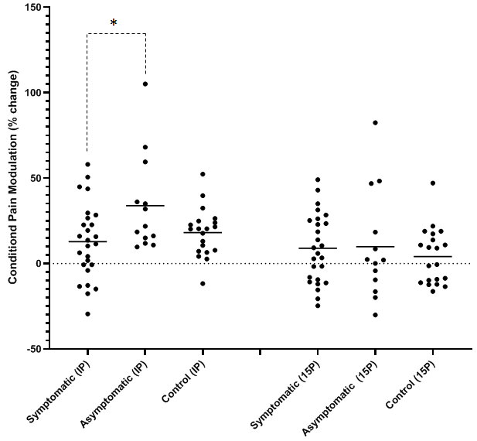
Figure 1: Group differences in Condition Pain Modulation between symptomatic COVID-19, asymptomatic COVID-19, and control groups in the leg. *denotes significant difference between symptomatic and asymptomatic. IP = immediately post, 15P = 15minutes post.

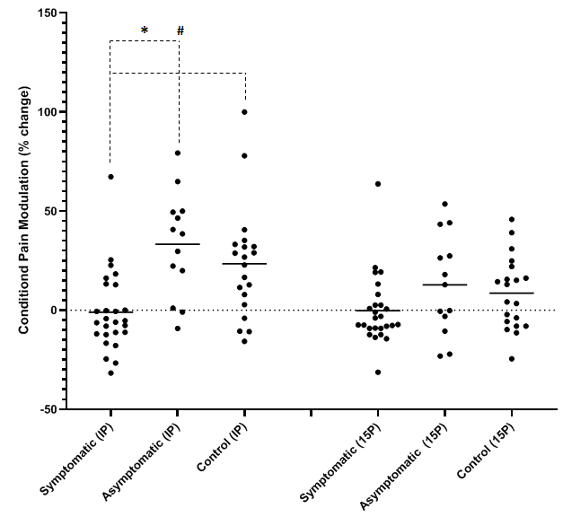
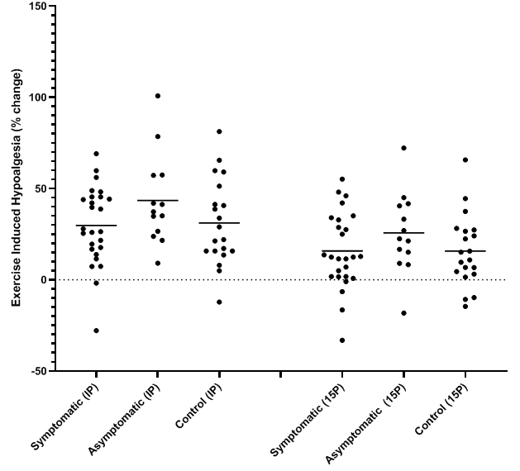
Figure 3: Group differences in Condition Pain Modulation between symptomatic COVID-19, asymptomatic COVID-19, and control groups in the arm. *denotes significant difference between symptomatic and asymptomatic. # denotes significant difference between symptomatic and control group.
Figure 4: Group differences in Exercise Induced Hypoalgesia between symptomatic COVID-19, asymptomatic COVID-19, and control groups in the leg.

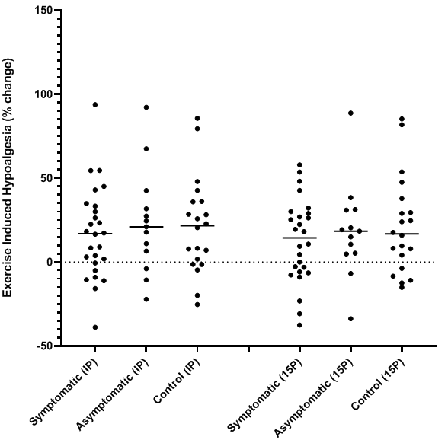
Figure 5: Group differences in Exercise Induced Hypoalgesia between symptomatic COVID-19, asymptomatic COVID-19, and control groups in the arm.

Time Post Infection:
Mean values for COVID-19 infected individuals split by <6months and 6-12months since infection can be found in Table 2. There were no group differences for age (P=0.15; d=0.62), height (P=0.43; d=0.32), weight (P=0.16; d=0.58), BMI (P=0.42; d=0.32), BF% (P=0.98; d= 0.01), total fat mass (P=0.71; d=0.14) and total lean mass (P=0.88; d=0.06). No differences were found among the groups in all dimensions of the IPAQ including walking (P=0.98; d=0.01), moderate exercise (P=0.06; d=0.074), vigorous exercise (P=0.29; d=0.42), time spent sitting (P=0.81; d=0.09), and total exercise (P=0.42; d=0.32). No differences in PCS were found among the three groups (P=0.19; d=0.53). No differences were found in in all dimensions of the PAQ including stoic fortitude (P=0.53; d=0.25), stoic concealment (P=0.74; d=0.25), stoic superiority (P=0.34; d=0.39), cautious reluctance (P=0.98; d=0.01), and cautious self-doubt (P=0.11; d=0.67). There were no group differences in all dimensions of the POMS questionnaire including tension (P=484; η_{p}² =0.026), anger (P=0.776; η_{p}² =0.009), fatigue (P=0.645; η_{p}² =0.016), vigor (P=0.449; η_{p}² =0.028), confusion (P=0.681; η_{p}² =0.014), depression (P=0.607; η_{p}² = 0.018), and total mood disturbance (P=0.396; η_{p}² = 0.033). Differences were found between individuals who were infected within the past 6 months and 6-12 months since infection in total number of total symptoms (P=0.04; d=0.87) and number of neurological symptoms (P=0.04; d=0.86) with <6 months having more symptoms. No differences were found in total number of respiratory symptoms (P=0.29; d=0.43) and total number of GI symptoms (P=0.38; d-0.35) between groups.

Differences in pain sensitivity in individuals 0-6 months post exposure and 6-12 months post exposure:
The COVID-19 symptomatic group were split into two groups; 0-6 months since initial symptom onset (N=12) and 6-12 months since initial symptom onset (N=14). Using an independent samples t-test, this study found that there were no differences between the 0-6 month group (604.4kPa ± 247.3) and the 6-12 month group (564.3kPa ± 193.1) in pressure pain sensitivity in the leg (P=0.647; d=0.181). There were also no differences found between the 0-6 month group (406.0kPa ± 195.7) and the 6-12 month group (432.1kPa ± 177.6) in pressure pain sensitivity in the arm (P=0.725; d=0.140).

Figure 6: Group differences in pressure pain sensitivity between groups who had symptomatic COVID-19 0-6 months ago, and 6-12 months ago.

Differences in pain modulatory function in individuals 0-6 months post exposure and 6-12 months post exposure:
There were no differences between the 0-6 month group (9.3% ± 26.3) and the 6-12 month group (15.7% ± 18.1) in the CPM response in the leg (P= 0.475; d=0.283). There were also no differences found between the 0-6 month group (-6.6% ± 13.1) and the 6-12 month group (3.8% ± 24.4) in CPM in the arm (P=0.199; d=0.531). Additionally, there were no differences between the 0-6 month group (22.3 ± 25.0) and the 6-12 month group (36.1% ± 16.2) in the EIH response in the leg (P=0.102; d=0.655). There were also no differences found between the 0-6 month group (10.9% ± 25.4) and the 6-12 month group (22.6% ± 29.2) in EIH in the arm (P=0.291; d=0.428).
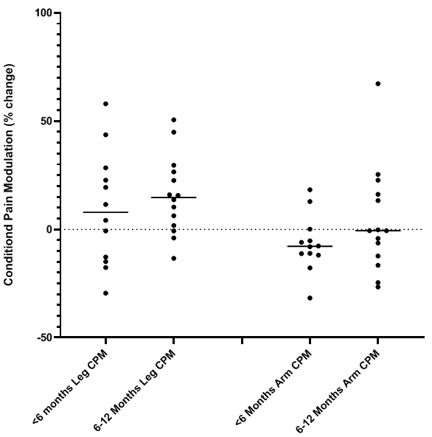
Figure 7: Group differences in conditioned pain modulation between groups who had symptomatic COVID-19 0-6 months ago, and 6-12 months ago.
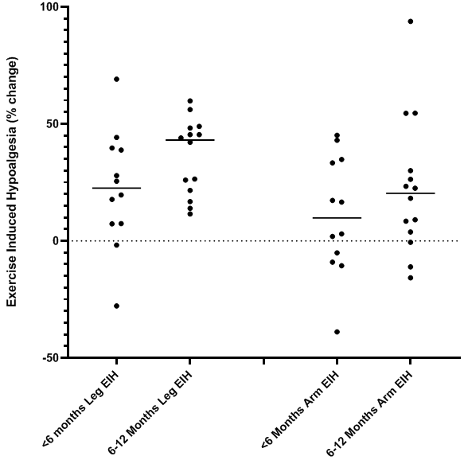
Figure 8: Group differences in exercise induced hypoalgesia between groups who had symptomatic COVID-19 0-6 months ago, and 6-12 months ago.

Symptomatic COVID-19 symptomology (Descriptive data):
Individuals who had tested positive for COVID-19 filled out a symptom checklist (figure 9). Fever was seen in 60% of participants (N=15) who experienced symptomatic COVID-19. Regarding respiratory symptoms, cough was experienced in 60% (N=15), hemoptysis in 4% (N=1), congested nose in 80% (N=20), phlegm in 68% (N=17), and 72% experienced some shortness of breath (N=18). All but one individual experienced at least one respiratory symptom of COVID-19. Every individual who had symptomatic COVID-19 (N=26; 100%) developed at least one neurological symptom. Fatigue and headaches were seen in 84% of asymptomatic COVID-19 participants (N=21), myalgia in 72% (N=18), anosmia in 60% (N-15), angeusia in 56% (N=14), sore throat in 48% (N=12), 44% had difficulties in concentration (N=11) and jaw/facial pain was experienced in 12% (N=3). Gastrointestinal manifestations of COVID-19 were less common (N=14; 56%), with 44% experiencing diarrhea (N=11) and 28% experiencing nausea (N=7).
Figure 9: Common symptoms experienced/reported in symptomatic COVID-19 participants (%)
Relationships between COVID-19 symptomology and pressure pain sensitivity:
When running a biserial correlation between number of symptoms and PPT’s (table 3) there no correlations found between total number of symptoms and leg (r=0.081; P=0.694) and arm PPTs (r=-0.021; P=0.917). Likewise no relationship was found between total number of respiratory symptoms, and total number of neurological symptoms. However, there was a negative relationship found between total number of GI symptoms and both leg (r=-0.414; P=0.036) and arm (r=-0.467; P=0.016) PPT’s.
When examining individual symptoms, a biserial correlation was run and there were no relationships found between leg PPT’s and individual symptoms with the exception of fever, which demonstrated a positive correlation (r=0.461; P=0.018). A negative relationship between congestion and arm PPT’s were found (r=-0.416; P= 0.035), and concentration difficulties and arm PPT’s (r=-0.407; P= 0.039). However, no other symptom correlated with arm PPT’s.

Relationships between COVID-19 symptomology and pain modulatory function (Biserial correlations):
When running a biseral correlation between number of symptoms and the CPM response (table 3) there were no correlations found between total number of symptoms and leg and arm CPM. Likewise no relationship was found between total number of respiratory symptoms, total number of neurological symptoms, total number of GI symptoms and both leg and arm CPM.
When examining individual symptoms, biserial correlations were run and there were no relationships found between leg CPM and individual symptoms. A negative relationship between nausea and arm CPM were found (r=-0.405; P=0.040). However, no other symptom correlated with arm CPM.
Biserial correlations were run between number of symptoms and the EIH response (table 3) there were no correlations found between total number of symptoms and leg EIH. However, there was a relationship between arm EIH and total number of symptoms (r=0.474; P=0.015). Likewise a relationship was found between total number of respiratory symptoms (r=0.462; P=0.018), total number of neurological symptoms (r=0.446; P= 0.022) in the arm, but no relationship was demonstrated in total number of GI symptoms and both leg (r=-0.358; P= 0.073) and arm EIH (r=0.090; P= 0.661). No relationship was demonstrated in total number of respiratory symptoms (r=0.102; P= 0.621) and total number of neurological symptoms (r=-0.230; P= 0.258) in leg EIH.
When examining individual symptoms, biserial correlations were ran and there were no relationships found between leg EIH and individual symptoms. However positive relationships were found between myalgia and arm EIH (r=0.445; P=0.016), jaw pain and arm EIH (r=0.469; P=0.023), and hemoptysis and arm EIH (r=0.566; P=0.003). However, no other symptom correlated with arm EIH.
Relationship between EIH and CPM:
The CPM response in the leg correlated with CPM in the arm (r=0.265; P=0.43). EIH in the leg correlated with EIH in the arm (r=0.433; P=0.001). CPM in the leg did not correlate with EIH response in the leg (r=0.201; P=0.127) (Figure 10) or with EIH in the arm (r=0.154; P=0.244). CPM in the arm correlated with EIH response in the arm (r=0.359; P=0.005) (Figure 11) and EIH response in the leg(r=0.339; P=0.009).
Figure 10: Relationship between CPM in the leg and EIH in the leg.

Figure 11: Relationship between CPM in the arm and EIH in the arm.

Table 3: Pearson and Point-biserial correlations showing relationships between common COVID-19 symptoms and Pain/Pain Modulation measures.
 | Leg PPT | Arm PPT | Leg CPM | Arm CPM | Leg EIH | Arm EIH
Total # of Symptoms | 0.08 | -0.02 | 0.14 | -0.21 | -0.23 | 0.47*
Total # of Respiratory Symptoms | 0.01 | 0.08 | 0.01 | -0.15 | 0.10 | 0.46*
Total # of Neurological Symptoms | 0.38 | 0.24 | 0.00 | -0.31 | -0.23 | 0.45*
Total # of GI Symptoms | -0.41* | -0.47* | 0.26 | -0.18 | -0.36 | 0.09
Fever | 0.46* | 0.37 | 0.05 | -0.03 | 0.12 | 0.06
Cough | 0.23 | 0.05 | -0.02 | 0.10 | -0.04 | 0.14
Hemoptysis | -0.19 | -0.20 | 0.01 | -0.05 | 0.15 | 0.57**
Congestion | -0.16 | -0.42* | -0.15 | -0.24 | -0.05 | 0.19
Phlegm | -0.23 | -0.23 | -0.08 | -0.29 | 0.09 | 0.07
Shortness of Breath | 0.20 | -0.13 | -0.04 | 0.35 | -0.02 | 0.21
Headache | -0.03 | -0.12 | 0.15 | 0.03 | -0.21 | 0.15
Sore Throat | 0.14 | -0.11 | 0.04 | 0.01 | 0.01 | 0.12
Jaw and Facial Pain | 0.08 | -0.17 | 0.18 | 0.34 | 0.00 | 0.45*
Myalgia | 0.34 | 0.26 | -0.11 | 0.05 | 0.14 | 0.47*
Fatigue | 0.08 | -0.12 | -0.17 | -0.38 | -0.22 | 0.08
Concentration Difficulties | -0.17 | -0.41* | -0.24 | -0.29 | -0.33 | 0.27
Anosmia | -0.15 | -0.20 | -0.15 | -0.04 | -0.17 | 0.10
Aguesia | 0.27 | 0.12 | -0.02 | 0.05 | 0.02 | 0.12
Nausea | 0.26 | 0.18 | -0.03 | -.41* | 0.09 | 0.24
Diarrhea | 0.35 | 0.08 | 0.23 | -0.08 | 0.12 | 0.17
*significance at p<0.05, ** significance at p<0.01

DISCUSSION:
This study aimed to assess group differences in pressure pain sensitivity and pain modulatory function in individuals who have had symptoms of COVID-19, were infected but asymptomatic, and control groups with no COVID-19 infection.
The primary findings of the study were that 1) pressure pain sensitivity did not differ between symptomatic COVID-19 and control group, 2) the magnitude of EIH response was similar between groups, and 3) the CPM response in symptomatic COVID-19 was significantly lower than the asymptomatic group in the leg, and the magnitude of the CPM response in the arm was significantly lower than both the asymptomatic group and COVID-19 group, whereby the symptomatic COVID-19 group showed a lack of CPM response. Furthermore, when symptomatic COVID-19 individuals were split between the past 6 months and 6-12 months since COVID-19 infection, there was no difference in CPM response between the two-time frames.
Similarities in Pressure Pain Sensitivity:
Our finding that pressure pain sensitivity was higher (e.g. requiring less force application) in asymptomatic COVID-19 compared to symptomatic COVID-19 in the arm but not the leg was not expected. It was hypothesized that COVID-19 groups would be to pain than the control group, our results show that this was not the case.
The asymptomatic group had a slightly higher proportion of females to males. Sex differences in clinical and experimental pain have been well established (207-210). Women are, in general, more sensitive to pain (207-210) and are at higher risk of developing chronic pain conditions compared to their male counterparts (207, 211-214). It is widely accepted that males and females have whole body and site-specific differences in fat mass, with higher fat mass favoring females (24, 29) and higher lean tissue favoring males. A recent, unpublished study from our lab has demonstrated that there were sex differences between males and females in PPT’s but when PPT’s were normalized to whole body lean mass, the sex difference disappeared. When examining sex differences in the current study, there were significant differences between males and females. When normalized to limb specific lean mass, the sex differences in PPT’s were eliminated. Furthermore, when we normalized to limb specific lean mass, the group difference was eliminated. This suggests that sex does play a role in pressure pain sensitivity and sex differences should be considered during pressure pain sensitivity analysis.
Differences in CPM response
CPM response was attenuated both locally (in the leg) and remotely (in the arm) in individuals who had symptomatic COVID-19 compared to asymptomatic COVID-19 and controls. Individuals who had symptomatic COVID-19 had a dysfunctional CPM response in a remote location; the forearm. The mean arm CPM response was - 1% in the symptomatic COVID-19 group compared to the control group and the asymptomatic group both of which increased their pain thresholds following the cold pressor test (CPT) by 33% and 26% respectfully. The approximated magnitude of CPM evoked in studies using healthy controls was 29% (215). The included studies in this review used CPT (32, 113, 216-221), heat (113, 221-223), ischemia (224-227), and chemical stimuli (198, 228-230) as the conditioning stimulus, with the most common being CPT (215). Our finding in the symptomatic COVID-19 group was similar to those who have been diagnosed with chronic pain conditions such as fibromyalgia (34, 187, 188, 190), tension type headache (231-234), arthritis (35, 110, 235), irritable bowel syndrome (236, 237) among others (238, 239) whereby the CPM response magnitude was significantly lower compared to the control groups.
One emerging hypothesis as to whether an individual would become symptomatic for COVID-19 is that the SARS-CoV-2 spike protein binds to Neuropilin-1 receptor (NRP-1). Usually vascular endothelial growth factor-A (VEGF-A) binds to NRP-1 and elicits pro-angiogenic, and pro-nociceptive effects (240), however initial data (65) has demonstrated that SARS-CoV-2 Spike protein disrupts VEGF-A/NRP-1 pro-nociceptive signaling. While there have been reported increases in VEGF-A levels in COVID-19 patients (241), Moutal et al (65) found that SARS-CoV-2 spike protein hijacks NRP-1 signaling to dampen VEGF-A mediated pain. Activation of this particular signaling pathway has therefore been suggested as a mechanism as to why certain individuals may or may not be asymptomatic to COVID-19 (65). It does not however, explain why so many other individuals experience varying symptoms of COVID-19. NRP-1 is a neuropilin that is located on neurons, and expression level of these proteins could be a potential mechanism as to why asymptomatic COVID-19 individuals have a more robust CPM response compared to symptomatic COVID-19 in both the arm and leg.
Another potential for COVID-19 related effects on pain involves ACE-2 receptor expression. Surface expressed ACE-2 has been found to be main receptor for uptake of SARS-CoV-2 spike protein (16). Evidence indicates that ACE-2 expressing sensory neurons synapse with spinal and brainstem central nervous system (CNS) neurons and can lead to symptoms such as headache and nerve pain (5, 6) which are evident in many COVID-19 cases. Therefore, individuals who have an increased number of ACE-2 receptors could be at risk of experiencing increased symptomology compared to those with less ACE2 expression, especially with regards to neurological symptoms such as pain. The role of ACE2 and NRP-1 in EIH and CPM

Enhanced excitability in the central nervous system is a common phenomenon observed in people with chronic pain (242-245). Central sensitization is the persistent state of high reactivity to nociceptive inputs and amplified pain due to this enhanced excitability and can lead to a dampened CPM response. CPM has been used as a measure descending tract functions that contribute to the control and modulation of pain perception. The periaqueductal grey (PAG), locus coeruleus (LC) and rostral ventromedial medulla (RVM) are key nuclei that project nociceptive information to the dorsal horn; the RVM is considered the last relay point by which modulatory (facilitatory or inhibitory) stimuli pass to the spinal cord. A noxious stimulus applied in one part of the body can inhibit pain in another part of the body, by activating the descending inhibitory system via a spino-bulbo-spinal loop; spinal dorsal horn neurons receive a noxious conditioning stimulus from a particular area of the body. During normal functioning of the descending pain modulatory system, these painful stimuli exert inhibitory effects over subsequent painful stimuli. CPM assessments provide ways to measure the functional status of the patient’s pain modulatory system and identify the risk of a chronic pain trajectory and likelihood of developing central sensitization. Accumulating evidence suggests that central sensitization may be driven by neuroinflammation in the CNS and peripheral nervous system (PNS) (246). A characteristic feature of neuroinflammation is the activation of glial cells, such as microglia and astrocytes in the spinal cord and brain leading to the release of pro-inflammatory cytokines and chemokines (246). Recent studies suggest that central cytokines and chemokines are powerful neuromodulators and play a role in inducing hyperalgesia (increased sensitivity to painful stimuli) and allodynia (pain from normally innocuous stimuli) (246, 247). Sustained increase of cytokines and chemokines in the central nervous system may also contribute to chronic widespread pain that can affect multiple body sites (246). Based upon this hypothesis, neuroinflammtion may be driving widespread chronic pain via central sensitization. Furthermore, acute systemic inflammation initiated by SARS-CoV-2 can induce mast cell activation, psychological stress, cytokine storm, and neuro-inflammation (248), a perfect recipe for pain sensitization. Symptoms of neuro-inflammation include headache, myalgia, concentration difficulties, nausea, and fatigue among others. These symptoms of neuroinflammation are analogous to the neurological symptoms of COVID-19 infection. As neuroinflammation can drive central sensitization, COVID-19 induced neuroinflammation may have an impact on the central nervous system and could be a mechanism by which symptomatic COVID-19 group had a dysfunctional CPM response compared with the other two groups.
In 2003, a Severe Acute Respiratory Syndrome (SARS) emerged from South East Asia and became a global health issue that affected mostly health care workers in North America. This original SARS was considered controlled by June 2003 as no new cases appeared. However, one year after hospitals returned to normalcy, a set of SARS-survivors remained disabled and unable to return to work. They had symptoms of myalgia (muscle pain), weakness, fatigue, shortness of breath, and sleep disturbances that persisted for up to two years following infection onset (11). A larger study cohort of 107 patients from Toronto, (249) had shown that, after one year, patients continued to describe problems with pain, reduced vitality, physical, mental, and social functioning. Only 14 (13%) were asymptomatic, leaving 93 patients (87%) symptomatic, where 18 (17%) had not returned to work, and 10 (9%) had returned to modified work. The disabling chronic fatigue, variable non-specific myalgia and sleep disturbances in patients associated with Post-SARS syndrome were similar to those experienced by patients with Chronic Fatigue Syndrome (CFS) (250) and Fibromyalgia Syndrome (FMS) (251). A comprehensive review suggests that the pattern of CPM inefficiency is most overtly expressed in patients with fibromyalgia, among other chronic pain conditions such as irritable bowel syndrome, temporomandibular disorders, and tension-type headache (25). Due to the similarities of this post-SARS syndrome and fibromyalgia, it is plausible that a component observed in both of these conditions could be contributing to the dysfunctional CPM response observed in this current study. Additionally, myalgia has demonstrated a dysfunctional CPM response (187, 188, 190). Pro-inflammatory cytokine levels (i.e. IL-1RA, IL-6, and IL-8) and chemokine levels have been found to be increased in patients with fibromyalgia. Cytokine and chemokine involvement has also been observed in hyperinflammation in post SARS-CoV2 infection. Leow et al. (252) describe a post‐SARS (severe acute respiratory syndrome) condition characterized by mild sickness syndrome manifestations (malaise, concentration difficulties, fatigue, myalgia). Sickness syndrome is usually a response to a peripheral infection, whereby innate immune cells produce pro-inflammatory cytokines (IL-1, IL-6, and TNF-alpha) that act on the brain to cause sickness behavior (253). This cytokine involvement in the CNS could have an impact on pain modulation.
Another potential explanation as to why symptomatic COVID-19 survivors have a dysfunctional CPM response is that it has a direct effect on ACE-2 receptors. ACE-2 receptors are a part of renin–angiotensin–aldosterone system (RAAS). Elevated levels of ACE-2 are associated with cardiovascular disease; however downregulated ACE-2 receptors can impact the RAAS system and blunt the blood pressure (BP) response due to RAAS involvement as a central regulator of BP (61). It has been shown that a positive linear association exists between blood pressure and magnitude of CPM (28, 254). If the RAAS system becomes impaired due to damage to the ACE-2 receptor caused by the SARS-CoV-2 pathogen then blood pressure responses may become dysregulated. The blood pressure response following a cold pressor test could lead to a blunted CPM response (28). This is a phenomenon that should be further explored as we did not examine BP changes before or after the CPT.
A final potential mechanism that may explain why CPM response was lower in individuals who had symptomatic COVID-19 is a fear response known as “amygdala hijack” (255). Images of an intensive care unit correlated with a stronger activation of bilateral amygdala than did other tasks indicating that the COVID-19 pandemic has disrupted normal psychological functioning. The amygdala is an important brain center for the emotional-affective dimension of pain and for pain modulation, including CPM. Changes in neuronal plasticity in this limbic area could play a role in a dysfunctional CPM response. RVM, PAG, and Amygdala are key brain locations for descending inhibition of pain. While some case study reports have demonstrated amygdala activity changes, no research has examined COVID-19 and its influence on RVM and PAG areas of the brain.
In summary, a dysfunctional CPM response in COVID-19 survivors may be due to neuroinflammation caused by a cytokine storm induced by SARS-CoV-2 leading to central sensitization, a chronic post-COVID-19 syndrome that may have similar effects to fibromyalgia, a cardiovascular response mechanism due to RAAS and ACE-2 dysregulation, or an amygdala hijack due to emotional and psychological consequences of the pandemic.
Similarities in EIH response between groups:
Despite our findings of differences in CPM among groups, we found no differences in the EIH response in individuals who have had COVID-19 and those who have not. CPM and EIH have been shown to correlate (115, 116), however in younger adults, this relationship has been found less often (256). As our symptomatic COVID-19 group demonstrated a dysfunctional CPM response in the arm it would be plausible to believe that the symptomatic COVID-19 group might also have a dysfunctional EIH response in the arm. However, this was not the case. A possible explanation on why there might have been no differences among groups, was that our sample, other than COVID-19 infection status, was relatively homogenous. There were no differences in age and physical activity amount between groups—both of which have been previously shown to influence EIH. Endogenous opioids (101), hemodynamics (257), pro-inflammatory cytokines(258), and distraction (259) have been proposed as possible mechanisms underlying the EIH response. Our findings seem to indicate that COVID infection does not seem to alter this pathway(s). This further highlights existing evidence (260) that CPM and EIH do not necessarily modulate pain sensitivity using the same shared pathways.
COVID-19 symptomology
In our sample, the most common symptoms experienced were fatigue (84%), headaches (84%), congestion (80%), myalgia (72%) and shortness of breath (72%). Three of the top five symptoms experienced were neurological manifestations of COVID-19. 100% of our sample population experienced at least one neurological symptom of COVID-19. Since headaches, myalgia, and fatigue have been associated with impaired modulatory function (25, 182, 185, 189, 191, 223, 231, 232, 234, 238, 261, 262), we sought to examine the relationship between symptoms and pain sensitivity and symptoms and modulatory function. Using biserial correlations, it was found that there was a strong, negative relationship between the number of GI symptoms and baselines PPT’s in the arm and the leg indicating that individuals who had more GI symptoms had lower PPT’s on average (more sensitive to pain). There was a strong positive correlation between individuals who had a fever and leg PPT’s, and negative relationships were found between congestion and concentration difficulties in arm PPT’s. No other relationships were found in symptomology and pain sensitivity. The only relationship observed between COVID-19 symptomology and CPM was nausea, which demonstrated a negative relationship. Due to our results with regards to symptomatic COVID-19 diagnosis and CPM, it was thought that CPM may have correlated with some of the symptoms associated with reduced CPM such as myalgia, headaches, and fatigue. However, that was not the case in our sample but it is difficult to draw definitive conclusions due to our relatively small sample. No symptoms of COVID-19 correlated with leg EIH, however the total number of symptoms, total number of respiratory, and total number of neurological symptoms all had a positive relationship with arm EIH. Additionally, hemoptysis, facial pain, and myalgia had a positive relationship with arm EIH. This indicates that the more symptoms an individual had, the more robust the EIH response was.
COVID-19; long term effect
When we split the symptomatic COVID-19 group into two groups, 0-6 months since positive symptomatic diagnosis, and 6-12 months post positive symptomatic diagnosis we found that there were no differences between groups in baseline PPT, CPM, and EIH. This finding is quite concerning as it indicates a potential long term effect on modulatory functioning in terms of CPM response, and could further indicate the development central sensitization following COVID-19 initial infection and during recovery.
CPM response in the leg was on average lower in the 0-6 months compared to 6-12 months. CPM in the arm, the remote location and a biomarker for central sensitization, was - 8% indicating dysfunction; however the trend seemed to improve in the 6-12 month group with the percent change above baseline at approximately 3%. While this was not significantly different, there was a moderate effect. Regardless, the CPM response in symptomatic COVID-19 survivors was still much lower than the control group and asymptomatic group.
Group differences and similarities in questionnaires:
The modified Profile of Mood States (POMs) assessed six different mood states; energy (vigor), fatigue, tension, depression, anger, and confusion. No differences in the dimensions of the POMS were found between groups. This could be explained by the overall extent of the pandemic, albeit our TMD score from the POMS data was, on average, lower than other studies that have measured mood disturbances in younger populations’ during the pandemic (263). While there is evidence that suggests that contracting COVID-19 can lead to depression, depressive symptoms can also stem from stressful events, such as loss of a loved one and economic difficulties which have been evident from the duration of the pandemic. Due to the COVID-19 pandemic countries all over the globe adopted social distancing mandates to slow the transmission of the disease, negative mental health outcomes including depression and anxiety have been associated with social distancing and/or social isolation(263). A study we conducted in 2021 found that across multiple time points during the pandemic the sample population had significantly higher rates of depressive symptoms compared to rates before COVID-19(263). The Centers for Disease Control and Prevention (CDC) reported that 8.1% of adults in the US over the age of 20 had depressive symptoms (264) and research examining social isolation during the SARS-epidemic, found that 31.2% of participants had depressive symptoms (265).
As previously mentioned physical activity in terms of walking, moderate intensity, vigorous intensity, and total weekly physical activity did not differ between groups. The five dimensions of pain attitudes did not differ between groups. While there were no differences in pain catastrophizing between the three groups; there were similarities between symptomatic and asymptomatic groups. When we collapsed the COVID-19 groups and compared them to the control group, a difference appeared whereby the control group had a higher pain catastrophizing score. While the pain catastrophizing scale does not necessarily measure overall catastrophizing, it could be a reason as to why the control group did not get COVID-19.

CHAPTER VI
CONCLUSION
Purpose
The purpose of this dissertation project was to examine and compare pressure pain sensitivity and pain modulatory function in individuals who have been previously exposed to COVID-19, both symptomatically and asymptomatically, to a control group who have not been exposed to the virus (i.e. do not have the COVID-antibodies).
Hypothesis:
- Pressure pain thresholds will be different between groups; with symptomatic COVID-19 having lower pain thresholds than control and asymptomatic groups.

The asymptomatic COVID-19 group was more sensitive to pressure pain in the arm but not the leg than controls and symptomatic COVID-19. The asymptomatic group had a higher ratio of females to males, and when normalized to lean body mass, the difference in pain sensitivity between groups was eliminated.
- The CPM response will be different between groups; with symptomatic COVID-19 having a reduced CPM response than control and asymptomatic groups.
CPM response was attenuated both locally and remotely in individuals who have had symptomatic COVID-19 compared to asymptomatic COVID-19 and control group. The finding of less efficient CPM prevailing in COVID-19 exposed individuals calls for an explanation, which, theoretically, poses a “chicken and egg” question suggesting that either a) participants had a normal CPM efficiency, but the virus had disturbed their pain inhibition capacity because of an effort to overcome the neurological effects of the virus or b) that patients had a less efficient CPM to begin with. A dysfunctional CPM response in COVID-19 survivors may be due to neuroinflammation caused by a cytokine storm induced by SARS-CoV-2 leading to central sensitization, a chronic post-COVID-19 syndrome that may have similar effects to fibromyalgia, a cardiovascular response mechanism due to RAAS and ACE-2 dysregulation, or an amydala hijack due to emotional and psychological consequences of the pandemic.
This impairment was apparent in individuals who had been exposed to COVID-19 up to 12 months since initial infection.
- The EIH response will be different between groups; with symptomatic COVID-19 having a reduced EIH response than control and asymptomatic groups.
No differences were found in EIH response in individuals who have been exposed to COVID-19 and those who have not. Regular physical activity across all three groups may attribute to the COVID-19 groups not having an impaired EIH response following SARS-CoV-2 exposure as exercise elicits an anti-inflammatory mechanism that may reduce artifact of COVID-19. EIH and CPM typically correlate yet the COVID-19 symptomatic group had an impaired CPM response and a normal EIH response when compared to the other groups. This suggests that different underlying mechanisms of EIH and CPM exist.

Sub-Hypotheses
- There will be a relationship between common symptoms of COVID-19 and pressure pain sensitivity.
There was a strong, negative relationship between number of GI symptoms and PPT’s in the arm and the leg indicating that individuals who had more GI symptoms had lower PPT’s on average, however the individual GI symptoms did not correlate. There was a strong positive correlation between individuals who had a fever and leg PPT’s, and negative relationships were found between congestion and concentration difficulties in arm PPT’s. No other relationships were found in symptomology and pain sensitivity.

- There will be a relationship between common symptoms of COVID-19 and pain modulatory function assessed via conditioned pain modulation and exercise induced hypoalgesia.

The only relationship observed between COVID-19 symptomology and CPM was nausea, which demonstrated a negative relationship. Due to our results with regards to symptomatic COVID-19 diagnosis and CPM, it was thought that CPM may have correlated with some of the symptoms associated with reduced CPM such as myalgia, headaches, and fatigue. However, that was not the case. This may have been due to the acuteness of the disease and that there may not be any chronic overlap in this sense.
- People who have had COVID-19 in the past 6-12 months will be different from those who have had COVID-19 in the past 0-6 months in pressure pain sensitivity

We found that there were no differences between 0-6 months and 6-12 months since COVID-19 exposure groups. Since there was no difference between symptomatic, asymptomatic, and control groups in PPT’s, this finding did not warrant further exploration.
- People who have had symptomatic COVID-19 in the past 6-12 months will be different from those who have had symptomatic COVID-19 in the past 0-6 months in pain modulatory function assessed via conditioned pain modulation.
We found no difference in the two time groups since the onset of symptomatic COVID-19. This finding shows promise of a potential long term effect on modulatory functioning, and could indicate the development central sensitization following COVID-19 exposure. CPM in the leg was on average lower in the 0-6 months compared to 6-12 months and both were greater than baseline levels. CPM in the arm, the remote location and a biomarker for central sensitization, decreased approximately 8% from baseline indicating dysfunction; however the trend seemed to improve in the 6-12 month group with the percent change above baseline at approximately 3%. While this was not significantly different, there was a moderate effect. Regardless, the CPM response in symptomatic COVID-19 survivors was still much lower than the control group and asymptomatic group.
- People who have had symptomatic COVID-19 in the past 6-12 months will be different from those who have had symptomatic COVID-19 in the past 0-6 months in pain modulatory function assessed via exercise induced hypoalgesia.

We found that there were no differences in EIH between 0-6 months and 6-12 months since COVID-19 exposure groups. Since there was no difference between symptomatic, asymptomatic, and control groups in EIH response, this finding did not warrant further exploration.
Limitations
While our study design measured what was intended to measure, there were several limitations to the study. The essence of studying a pandemic type disease is to measure disease occurrence and make comparisons between population groups, however cross-sectional research designs make it difficult to determine whether the outcome followed exposure or exposure resulted from the outcome. While we were able to see a potential impact of COVID-19 on pain modulation, we also cannot be certain that dysfunctional pain modulatory functioning in our sample was the reason why individuals developed symptomatic COVID-19 or whether COVID-19 led to a dysfunctional CPM response. An ideal study would have utilized a longitudinal study design by measuring pain sensitivity and pain modulation pre SARS-CoV-2 exposure, then following up with the study participants while they had COVID-19, when they were no longer sick with COVID-19, and then have monthly/ quarterly follow ups to see if there was a long term effect of COVID-19.
Our sample population was younger and COVID-19 disease progression has had differing effects on people of various ages with people who are older having more severe and life threatening symptomology which has led to ICU admission(266). While our sample did not exclude those who may have had hospital care, we did not have anyone who was admitted. This may been seen as a controlled variable rather than a limitation, as ICU admission can result in an increase in developing post intensive care syndrome which can lead to physical, cognitive, and psychological dysfunction, regardless of COVID-19 symptoms (267). Estimates of chronic pain prevalence in ICU discharges ranges from 14-77% (268, 269). Furthermore, more data has been collected within the hospital setting with more severe symptoms than those who are at home and are not seen by professionals.
CPM can be measured in several different ways. While we chose to use CPT in a single foot to match the dominant leg used for isometric leg extension with PPT’s as the testing stimulus, others have used CPT as the conditioning stimulus in the upper extremity rather than lower extremity(34, 188, 219), ischemia as the conditioning stimulus (187), conditioning heat stimuli, and chemical stimuli (239) as the conditioning stimulus. Each of these produced different responses in different chronic pain populations (270) and therefore further research is warranted on different measures of CPM in populations who have survived COVID-19 exposure.
We chose isometric leg extension as our conditioning stimulus for our EIH protocol. Other studies have utilized aerobic exercise (38, 181, 182, 191, 192, 238), and isometric grip(37), and shoulder exercise(195, 198) as the exercise conditioning protocol to induce EIH.
Testing stimulus and location could have had an impact on EIH response and therefore other methods should be examined such as upper body exercise and possibly aerobic exercise.
We did not control for time of day when we ran the PPT testing as our schedule offered participants the option to come in from 8am until 8pm. It has been suggested that time of day is a contributing factor to pain sensitivity; however, inconsistent findings have been found at which time participants were most sensitive to pain at its peak (271, 272). To limit this potential limitation and maximize time, we tested the same participants at a similar time of day at each of the three visits.
As more COVID-19 data came out on psychological and neurological impacts of the disease, we had already reached the half way point on data collecting. Additional questionnaires relating to anxiety and depression would have been beneficial. While we do have data on some anxiety and depressive symptoms from certain dimension of the POMS questionnaire, a more comprehensive analysis of current mental health in our population and how it related to pain thresholds would have strengthened some of our discussed points.
Significance of Findings
Based upon the novelty of COVID-19, little research to date has been conducted on how this acute virus impacts pain processing. Calls for grants and papers from major funding sources and high impact journals have been made due to this lack of information. Very few studies have examined the effects of an acute respiratory virus and its influence on pain processing mechanisms. The research question that we addressed was simple; has COVID-19 had an effect on pain and pain modulation in individuals who have been exposed to the virus versus those who have not. By addressing this question, we were able to make inference on how individuals perceive pain and modulate pain in COVID-19 survivors and can have important implications on how we examined pain processing and chronic pain in the wake of COVID-19. Having an impaired CPM response indicates a potential long term effect of COVID-19 and could be an indicator of chronic pain development in the future of these individuals. As EIH response was remained unaffected by COVID-19 exposure, the role of physical activity needs further exploration. Understanding
Conclusions
The results from the study indicate conditioned pain modulatory functioning was impaired in individuals who had symptomatic COVID-19 and there were no differences found in individuals who had symptomatic COVID-19 up to 6 months ago and 6 to 12 months ago. No differences between groups were found in pressure pain sensitivity when normalized to lean mass, and no differences between groups were found in exercise induced hypoalgesia. Impaired CPM response could be an indication on whether or not COVID-19 exposure may have a long term impact on pain modulation and risk increase of chronic pain.
Future Research Directions
Further research is warranted to examine additional noxious stimuli on pain sensitivity measures following COVID-19 exposure. CPM seemed to be effected by COVID-19 with the EIH response remaining unaffected by COVID-19 exposure; the exact mechanisms of CPM and EIH need further exploration especially with regards to acute systematic inflammation. This study used younger adults who were not admitted into the ICU; additional research in older adults and those who had more severe symptoms of COVID-19 is warranted. This study serves as a great pilot study for future grants and understanding the long term implications of COVID-19 and its influence on pain and pain modulation.

WORKS CITED
1. Guan W-j, Ni Z-y, Hu Y, Liang W-h, Ou C-q, He J-x, et al. Clinical Characteristics of Coronavirus Disease 2019 in China. New England Journal of Medicine. 2020;382(18):1708-20.
2. Wang D, Hu B, Hu C, Zhu F, Liu X, Zhang J, et al. Clinical characteristics of 138 hospitalized patients with 2019 novel coronavirus–infected pneumonia in Wuhan, China. Jama. 2020;323(11):1061-9.
3. Tian S, Hu N, Lou J, Chen K, Kang X, Xiang Z, et al. Characteristics of COVID-19 infection in Beijing. Journal of infection. 2020;80(4):401-6.
4. Nepal G, Rehrig JH, Shrestha GS, Shing YK, Yadav JK, Ojha R, et al. Neurological manifestations of COVID-19: a systematic review. Critical Care. 2020;24(1):1-11.
5. Hopkins C, Surda P, Kumar N. Presentation of new onset anosmia during the COVID-19 pandemic. Rhinology. 2020;58(3):295-8.
6. Vaira LA, Salzano G, Deiana G, De Riu G. Anosmia and ageusia: common findings in COVID‐19 patients. The Laryngoscope. 2020;130(7):1787-.
7. Wang H-Y, Li X-L, Yan Z-R, Sun X-P, Han J, Zhang B-W. Potential neurological symptoms of COVID-19. Therapeutic advances in neurological disorders. 2020;13:1756286420917830.
8. Berger JR. COVID-19 and the nervous system. Journal of neurovirology. 2020;26:143-8.
9. Nordvig AS, Fong KT, Willey JZ, Thakur KT, Boehme AK, Vargas WS, et al. Potential Neurologic Manifestations of COVID-19. Neurology: Clinical Practice. 2021;11(2):e135-e46.
10. Nalbandian A, Sehgal K, Gupta A, Madhavan MV, McGroder C, Stevens JS, et al. Post-acute COVID-19 syndrome. Nature medicine. 2021:1-15.
11. Moldofsky H, Patcai J. Chronic widespread musculoskeletal pain, fatigue, depression and disordered sleep in chronic post-SARS syndrome; a case-controlled study. BMC neurology. 2011;11(1):37.
12. Belvis R. Headaches during COVID‐19: My clinical case and review of the literature. Headache: The Journal of Head and Face Pain. 2020;60(7):1422-6.
13. Su S, Cui H, Wang T, Shen X, Ma C. Pain: A potential new label of COVID-19. Brain, Behavior, and Immunity. 2020.
14. Zhang X, Tan Y, Ling Y, Lu G, Liu F, Yi Z, et al. Viral and host factors related to the clinical outcome of COVID-19. Nature. 2020;583(7816):437-40.
15. Zhang J-M, An J. Cytokines, inflammation and pain. International anesthesiology clinics. 2007;45(2):27.
16. Hoffmann M, Kleine-Weber H, Schroeder S, Krüger N, Herrler T, Erichsen S, et al. SARS-CoV-2 cell entry depends on ACE2 and TMPRSS2 and is blocked by a clinically proven protease inhibitor. Cell. 2020.
17. Mao L, Jin H, Wang M, Hu Y, Chen S, He Q, et al. Neurologic manifestations of hospitalized patients with coronavirus disease 2019 in Wuhan, China. JAMA neurology. 2020;77(6):683-90.
18. Montalvan V, Lee J, Bueso T, De Toledo J, Rivas K. Neurological manifestations of COVID-19 and other coronavirus infections: A systematic review. Clinical Neurology and Neurosurgery. 2020;194:105921.
19. Yarnitsky D, Granot M, Granovsky Y. Pain modulation profile and pain therapy: between pro-and antinociception. Pain. 2014;155(4):663-5.
20. Torebjörk HE, Hallin RG. Responses in human A and C fibres to repeated electrical intradermal stimulation. Journal of Neurology, Neurosurgery & Psychiatry. 1974;37(6):653-64.
21. Dubin AE, Patapoutian A. Nociceptors: the sensors of the pain pathway. J Clin Invest. 2010;120(11):3760-72.
22. Millan MJ. The induction of pain: an integrative review. Progress in neurobiology. 1999;57(1):1-164.
23. Beecher HK. Preparation of battle casualties for surgery. Annals of surgery. 1945;121(6):769.
24. Sherrington CS, Sowton S. Observations on reflex responses to single break‐shocks. The Journal of physiology. 1915;49(5):331-48.
25. Yarnitsky D. Conditioned pain modulation (the diffuse noxious inhibitory control-like effect): its relevance for acute and chronic pain states. Curr Opin Anaesthesiol. 2010;23(5):611-5.
26. Le Bars D, Dickenson AH, Besson J-m. Diffuse noxious inhibitory controls (DNIC). II. Lack of effect on non-convergent neurones, supraspinal involvement and theoretical implications. Pain. 1979;6(3):305-27.
27. Nir R-R, Yarnitsky D, Honigman L, Granot M. Cognitive manipulation targeted at decreasing the conditioning pain perception reduces the efficacy of conditioned pain modulation. PAIN. 2012;153(1):170-6.
28. Chalaye P, Devoize L, Lafrenaye S, Dallel R, Marchand S. Cardiovascular influences on conditioned pain modulation. PAIN. 2013;154(8):1377-82.
29. Koltyn KF. Analgesia following exercise: a review. Sports Med. 2000;29(2):85-98.
30. Koltyn KF. Exercise-induced hypoalgesia and intensity of exercise. Sports Med. 2002;32(8):477-87.
31. Naugle KM, Fillingim RB, Riley JL, 3rd. A meta-analytic review of the hypoalgesic effects of exercise. J Pain. 2012;13(12):1139-50.
32. Edwards RR, Fillingim RB, Ness TJ. Age-related differences in endogenous pain modulation: a comparison of diffuse noxious inhibitory controls in healthy older and younger adults. Pain. 2003;101(1):155-65.
33. Nir RR, Yarnitsky D. Conditioned pain modulation. Curr Opin Support Palliat Care. 2015;9(2):131-7.
34. Potvin S, Larouche A, Normand E, de Souza JB, Gaumond I, Marchand S, et al. No relationship between the ins del polymorphism of the serotonin transporter promoter and pain perception in fibromyalgia patients and healthy controls. European Journal of Pain. 2010;14(7):742-6.
35. Kosek E, Ordeberg G. Lack of pressure pain modulation by heterotopic noxious conditioning stimulation in patients with painful osteoarthritis before, but not following, surgical pain relief. Pain. 2000;88(1):69-78.
36. Olesen SS, Brock C, Krarup AL, Funch–Jensen P, Arendt–Nielsen L, Wilder–Smith OH, et al. Descending inhibitory pain modulation is impaired in patients with chronic pancreatitis. Clinical gastroenterology and hepatology. 2010;8(8):724-30.
37. Staud R, Robinson ME, Price DD. Isometric exercise has opposite effects on central pain mechanisms in fibromyalgia patients compared to normal controls. Pain. 2005;118(1-2):176-84.
38. Van Oosterwijck J, Nijs J, Meeus M, Van Loo M, Paul L. Lack of endogenous pain inhibition during exercise in people with chronic whiplash associated disorders: an experimental study. The Journal of Pain. 2012;13(3):242-54.
39. Cook DB, Stegner AJ, Ellingson LD. Exercise alters pain sensitivity in Gulf War veterans with chronic musculoskeletal pain. The Journal of Pain. 2010;11(8):764-72.
40. Gaskin DJ, Richard P. The economic costs of pain in the United States. J Pain. 2012;13(8):715-24.
41. Control CoD. COVID-19 (Coronavirus Disease) 2020 [Available from: https://www.cdc.gov/coronavirus/2019-ncov/hcp/faq.html#COVID-19-Risk.
42. Chu DK, Akl EA, Duda S, Solo K, Yaacoub S, Schünemann HJ, et al. Physical distancing, face masks, and eye protection to prevent person-to-person transmission of SARS-CoV-2 and COVID-19: a systematic review and meta-analysis. The Lancet. 2020.
43. Johansson MA, Quandelacy TM, Kada S, Prasad PV, Steele M, Brooks JT, et al. SARS-CoV-2 Transmission From People Without COVID-19 Symptoms. JAMA Network Open. 2021;4(1):e2035057-e.
44. Song J-W, Zhang C, Fan X, Meng F-P, Xu Z, Xia P, et al. Immunological and inflammatory profiles in mild and severe cases of COVID-19. Nature communications. 2020;11(1):1-10.
45. Struyf T, Deeks JJ, Dinnes J, Takwoingi Y, Davenport C, Leeflang MM, et al. Signs and symptoms to determine if a patient presenting in primary care or hospital outpatient settings has COVID‐19 disease. Cochrane Database of Systematic Reviews. 2020(7).
46. Lippi G, Plebani M. Laboratory abnormalities in patients with COVID-2019 infection. Clinical Chemistry and Laboratory Medicine (CCLM). 2020;58(7):1131-4.
47. Levi M, Thachil J, Iba T, Levy JH. Coagulation abnormalities and thrombosis in patients with COVID-19. The Lancet Haematology. 2020;7(6):e438.
48. Shi H, Han X, Jiang N, Cao Y, Alwalid O, Gu J, et al. Radiological findings from 81 patients with COVID-19 pneumonia in Wuhan, China: a descriptive study. The Lancet Infectious Diseases. 2020.
49. Zhu N, Zhang D, Wang W, Li X, Yang B, Song J, et al. A novel coronavirus from patients with pneumonia in China, 2019. New England Journal of Medicine. 2020.
50. Goldsmith CS, Tatti KM, Ksiazek TG, Rollin PE, Comer JA, Lee WW, et al. Ultrastructural characterization of SARS coronavirus. Emerging infectious diseases. 2004;10(2):320.
51. Morens DM, Breman JG, Calisher CH, Doherty PC, Hahn BH, Keusch GT, et al. The origin of COVID-19 and why it matters. The American journal of tropical medicine and hygiene. 2020;103(3):955-9.
52. Echeverría-Rodríguez O, Gallardo-Ortíz IA, Del Valle-Mondragón L, Villalobos-Molina R. Angiotensin-(1-7) participates in enhanced skeletal muscle insulin sensitivity after a bout of exercise. Journal of the Endocrine Society. 2020;4(2):bvaa007.
53. Kucuk A, Cure MC, Cure E. Can COVID-19 cause myalgia with a completely different mechanism? A hypothesis. Clinical Rheumatology. 2020:1.
54. Zou X, Chen K, Zou J, Han P, Hao J, Han Z. Single-cell RNA-seq data analysis on the receptor ACE2 expression reveals the potential risk of different human organs vulnerable to 2019-nCoV infection. Frontiers of medicine. 2020:1-8.
55. Azkur AK, Akdis M, Azkur D, Sokolowska M, van de Veen W, Brüggen MC, et al. Immune response to SARS‐CoV‐2 and mechanisms of immunopathological changes in COVID‐19. Allergy. 2020;75(7):1564-81.
56. Wiersinga WJ, Rhodes A, Cheng AC, Peacock SJ, Prescott HC. Pathophysiology, transmission, diagnosis, and treatment of coronavirus disease 2019 (COVID-19): a review. Jama. 2020;324(8):782-93.
57. Li L, Huang Q, Wang DC, Ingbar DH, Wang X. Acute lung injury in patients with COVID‐19 infection. Clinical and Translational Medicine. 2020;10(1):20-7.
58. Xu Z, Shi L, Wang Y, Zhang J, Huang L, Zhang C, et al. Pathological findings of COVID-19 associated with acute respiratory distress syndrome. The Lancet respiratory medicine. 2020;8(4):420-2.
59. Tang N, Li D, Wang X, Sun Z. Abnormal coagulation parameters are associated with poor prognosis in patients with novel coronavirus pneumonia. Journal of thrombosis and haemostasis. 2020;18(4):844-7.
60. Klok F, Kruip M, Van der Meer N, Arbous M, Gommers D, Kant K, et al. Incidence of thrombotic complications in critically ill ICU patients with COVID-19. Thrombosis research. 2020.
61. Ingraham NE, Barakat AG, Reilkoff R, Bezdicek T, Schacker T, Chipman JG, et al. Understanding the renin–angiotensin–aldosterone–SARS-CoV axis: a comprehensive review. European Respiratory Journal. 2020;56(1).
62. Carfì A, Bernabei R, Landi F. Persistent symptoms in patients after acute COVID-19. Jama. 2020;324(6):603-5.
63. Zheng KI, Feng G, Liu WY, Targher G, Byrne CD, Zheng MH. Extrapulmonary complications of COVID‐19: A multisystem disease? Journal of Medical Virology. 2021;93(1):323-35.
64. Herman C, Mayer K, Sarwal A. Scoping review of prevalence of neurologic comorbidities in patients hospitalized for COVID-19. Neurology. 2020;95(2):77-84.
65. Moutal A, Martin LF, Boinon L, Gomez K, Ran D, Zhou Y, et al. SARS-CoV-2 Spike protein hijacks VEGF-A/Neuropilin-1 receptor signaling to induce analgesia. bioRxiv. 2020.
66. Woolf CJ, Ma Q. Nociceptors—noxious stimulus detectors. Neuron. 2007;55(3):353-64.
67. Mense S. Algesic agents exciting muscle nociceptors. Exp Brain Res. 2009;196(1):89-100.
68. Costigan M, Woolf CJ. Pain: molecular mechanisms. The Journal of Pain. 2000;1(3):35-44.
69. Price DD. Psychological and neural mechanisms of the affective dimension of pain. Science. 2000;288(5472):1769-72.
70. Gohar O. Contribution of ion channels in pain sensation. system. 2005;12:14.
71. Venkatachalam K, Montell C. TRP channels. Annu Rev Biochem. 2007;76:387-417.
72. Julius D. From peppers to peppermints: natural products as probes of the pain pathway. Harvey lectures. 2005;101:89.
73. Basbaum AI, Bautista DM, Scherrer G, Julius D. Cellular and molecular mechanisms of pain. Cell. 2009;139(2):267-84.
74. Jordt S-E, Bautista DM, Chuang H-h, McKemy DD, Zygmunt PM, Högestätt ED, et al. Mustard oils and cannabinoids excite sensory nerve fibres through the TRP channel ANKTM1. Nature. 2004;427(6971):260.
75. Caceres AI, Brackmann M, Elia MD, Bessac BF, del Camino D, D'Amours M, et al. A sensory neuronal ion channel essential for airway inflammation and hyperreactivity in asthma. Proceedings of the National Academy of Sciences. 2009;106(22):9099-104.
76. Jarvis MF, Burgard EC, McGaraughty S, Honore P, Lynch K, Brennan TJ, et al. A-317491, a novel potent and selective non-nucleotide antagonist of P2X3 and P2X2/3 receptors, reduces chronic inflammatory and neuropathic pain in the rat. Proceedings of the National Academy of Sciences. 2002;99(26):17179-84.
77. Wu L-J, Duan B, Mei Y-D, Gao J, Chen J-G, Zhuo M, et al. Characterization of acid-sensing ion channels in dorsal horn neurons of rat spinal cord. Journal of Biological Chemistry. 2004;279(42):43716-24.
78. Amir R, Devor M. Electrical excitability of the soma of sensory neurons is required for spike invasion of the soma, but not for through-conduction. Biophysical journal. 2003;84(4):2181-91.
79. Mense S. Nociception from skeletal muscle in relation to clinical muscle pain. Pain. 1993;54(3):241-89.
80. Almeida TF, Roizenblatt S, Tufik S. Afferent pain pathways: a neuroanatomical review. Brain research. 2004;1000(1-2):40-56.
81. Amit Z, Galina ZH. Stress-induced analgesia: adaptive pain suppression. Physiological reviews. 1986;66(4):1091-120.
82. DeLeo JA. Basic science of pain. J Bone Joint Surg Am. 2006;88 Suppl 2:58-62.
83. M Wozniak K, Rojas C, Wu Y, S Slusher B. The role of glutamate signaling in pain processes and its regulation by GCP II inhibition. Current medicinal chemistry. 2012;19(9):1323-34.
84. De Felipe C, Herrero JF, O'Brien JA, Palmer JA, Doyle CA, Smith AJ, et al. Altered nociception, analgesia and aggression in mice lacking the receptor for substance P. Nature. 1998;392(6674):394.
85. Lembeck F, Donnerer J, Colpaert F. Increase of substance P in primary afferent nerves during chronic pain. Neuropeptides. 1981;1(3):175-80.
86. Beissner F, Brandau A, Henke C, Felden L, Baumgartner U, Treede RD, et al. Quick discrimination of A(delta) and C fiber mediated pain based on three verbal descriptors. PLoS One. 2010;5(9):e12944.
87. Melzack R, Wall PD. Pain mechanisms: a new theory. Science. 1965;150(3699):971-9.
88. Willer JC, Dehen H, Cambier J. Stress-induced analgesia in humans: endogenous opioids and naloxone-reversible depression of pain reflexes. Science. 1981;212(4495):689-91.
89. Guillemin R, Ling N, Burgus R, Bloom F, Segal D. Characterization of the endorphins, novel hypothalamic and neurohypophysial peptides with opiate-like activity: evidence that they induce profound behavioral changes. Psychoneuroendocrinology. 1977;2(1):59-62.
90. Meintjes AF, Nóbrega AC, Fuchs IE, Ally A, Wilson LB. Attenuation of the exercise pressor reflex: effect of opioid agonist on substance P release in L-7 dorsal horn of cats. Circulation research. 1995;77(2):326-34.
91. Nir R-R, Yarnitsky D. Conditioned pain modulation. Current opinion in supportive and palliative care. 2015;9(2):131-7.
92. Cathcart S, Winefield AH, Rolan P, Lushington K. Reliability of temporal summation and diffuse noxious inhibitory control. Pain Research and Management. 2009;14(6):433-8.
93. Oono Y, Nie H, Matos RL, Wang K, Arendt-Nielsen L. The inter-and intra-individual variance in descending pain modulation evoked by different conditioning stimuli in healthy men. Scandinavian journal of pain. 2011;2(4):162-9.
94. Lewis GN, Heales L, Rice DA, Rome K, McNair PJ. Reliability of the conditioned pain modulation paradigm to assess endogenous inhibitory pain pathways. Pain Research & Management. 2012;17(2):98-102.
95. Olesen SS, van Goor H, Bouwense SA, Wilder-Smith OH, Drewes AM. Reliability of static and dynamic quantitative sensory testing in patients with painful chronic pancreatitis. 2012.
96. Valencia C, Kindler LL, Fillingim RB, George SZ. Stability of conditioned pain modulation in two musculoskeletal pain models: investigating the influence of shoulder pain intensity and gender. BMC musculoskeletal disorders. 2013;14(1):182.
97. Wilson H, Carvalho B, Granot M, Landau R. Temporal stability of conditioned pain modulation in healthy women over four menstrual cycles at the follicular and luteal phases. PAIN®. 2013;154(12):2633-8.
98. Manresa JAB, Fritsche R, Vuilleumier PH, Oehler C, Mørch CD, Arendt-Nielsen L, et al. Is the conditioned pain modulation paradigm reliable? A test-retest assessment using the nociceptive withdrawal reflex. PloS one. 2014;9(6):e100241.
99. Jurth C, Rehberg B, von Dincklage F. Reliability of subjective pain ratings and nociceptive flexion reflex responses as measures of conditioned pain modulation. Pain Research and Management. 2014;19(2):93-6.
100. Klyne DM, Schmid AB, Moseley GL, Sterling M, Hodges PW. Effect of types and anatomic arrangement of painful stimuli on conditioned pain modulation. The Journal of Pain. 2015;16(2):176-85.
101. Koltyn KF, Brellenthin AG, Cook DB, Sehgal N, Hillard C. Mechanisms of exercise-induced hypoalgesia. J Pain. 2014;15(12):1294-304.
102. Thorén P, Floras JS, Hoffmann P, Seals DR. Endorphins and exercise: physiological mechanisms and clinical implications. Medicine & science in sports & exercise. 1990.
103. Tsou K, Brown S, Sanudo-Pena M, Mackie K, Walker J. Immunohistochemical distribution of cannabinoid CB1 receptors in the rat central nervous system. Neuroscience. 1998;83(2):393-411.
104. Herkenham M, Lynn AB, Johnson MR, Melvin LS, de Costa BR, Rice KC. Characterization and localization of cannabinoid receptors in rat brain: a quantitative in vitro autoradiographic study. Journal of Neuroscience. 1991;11(2):563-83.
105. Guindon J, Hohmann AG. The endocannabinoid system and pain. CNS & Neurological Disorders-Drug Targets (Formerly Current Drug Targets-CNS & Neurological Disorders). 2009;8(6):403-21.
106. Hohmann AG, Suplita RL. Endocannabinoid mechanisms of pain modulation. The AAPS journal. 2006;8(4):E693-E708.
107. Ambrosino P, Soldovieri MV, Russo C, Taglialatela M. Activation and desensitization of TRPV1 channels in sensory neurons by the PPARα agonist palmitoylethanolamide. British journal of pharmacology. 2013;168(6):1430-44.
108. Hansen KB, Rosenkilde MM, Knop FK, Wellner N, Diep TA, Rehfeld JF, et al. 2-Oleoyl glycerol is a GPR119 agonist and signals GLP-1 release in humans. The Journal of Clinical Endocrinology & Metabolism. 2011;96(9):E1409-E17.
109. Ring C, Edwards L, Kavussanu M. Effects of isometric exercise on pain are mediated by blood pressure. Biological psychology. 2008;78(1):123-8.
110. Arendt-Nielsen L, Nie H, Laursen MB, Laursen BS, Madeleine P, Simonsen OH, et al. Sensitization in patients with painful knee osteoarthritis. Pain. 2010;149(3):573-81.
111. Vaegter HB, Handberg G, Graven-Nielsen T. Hypoalgesia after exercise and the cold pressor test is reduced in chronic musculoskeletal pain patients with high pain sensitivity. The Clinical journal of pain. 2016;32(1):58-69.
112. Heneweer H, Vanhees L, Picavet HSJ. Physical activity and low back pain: a U-shaped relation? Pain. 2009;143(1-2):21-5.
113. Staud R, Robinson ME, Vierck Jr CJ, Price DD. Diffuse noxious inhibitory controls (DNIC) attenuate temporal summation of second pain in normal males but not in normal females or fibromyalgia patients. Pain. 2003;101(1-2):167-74.
114. de Souza JB, Potvin S, Goffaux P, Charest J, Marchand S. The deficit of pain inhibition in fibromyalgia is more pronounced in patients with comorbid depressive symptoms. The Clinical journal of pain. 2009;25(2):123-7.
115. Vaegter HB, Handberg G, Graven-Nielsen T. Similarities between exercise-induced hypoalgesia and conditioned pain modulation in humans. Pain. 2014;155(1):158-67.
116. Lemley KJ, Hunter SK, Bement MK. Conditioned pain modulation predicts exercise-induced hypoalgesia in healthy adults. Med Sci Sports Exerc. 2015;47(1):176-84.
117. LaMotte RH, Thalhammer JG, Torebjork H, Robinson CJ. Peripheral neural mechanisms of cutaneous hyperalgesia following mild injury by heat. Journal of Neuroscience. 1982;2(6):765-81.
118. Binshtok AM, Wang H, Zimmermann K, Amaya F, Vardeh D, Shi L, et al. Nociceptors are interleukin-1β sensors. Journal of Neuroscience. 2008;28(52):14062-73.
119. Bonica J. Clinical importance of hyperalgesia. Hyperalgesia and Allodynia, Raven Press, New York. 1992:17-43.
120. Bolay H, Moskowitz MA. Mechanisms of pain modulation in chronic syndromes. Neurology. 2002;59(5 suppl 2):S2-S7.
121. LaMotte RH, Thalhammer JG, Robinson CJ. Peripheral neural correlates of magnitude of cutaneous pain and hyperalgesia: a comparison of neural events in monkey with sensory judgments in human. Journal of Neurophysiology. 1983;50(1):1-26.
122. Gangadharan V, Kuner R. Pain hypersensitivity mechanisms at a glance. Disease models & mechanisms. 2013;6(4):889-95.
123. Woolf CJ. Evidence for a central component of post-injury pain hypersensitivity. Nature. 1983;306(5944):686.
124. Woolf C, Thompson S, King A. Prolonged primary afferent induced alterations in dorsal horn neurones, an intracellular analysis in vivo and in vitro. Journal de physiologie. 1988;83(3):255-66.
125. Woolf CJ. Central sensitization: implications for the diagnosis and treatment of pain. Pain. 2011;152(3):S2-S15.
126. LaMotte RH, Shain CN, Simone DA, Tsai E. Neurogenic hyperalgesia: psychophysical studies of underlying mechanisms. Journal of neurophysiology. 1991;66(1):190-211.
127. Torebjork HE, Lundberg LE, LaMotte RH. Central changes in processing of mechanoreceptive input in capsaicin-induced secondary hyperalgesia in humans. J Physiol. 1992;448:765-80.
128. Kosek E, Cohen M, Baron R, Gebhart GF, Mico JA, Rice AS, et al. Do we need a third mechanistic descriptor for chronic pain states? Pain. 2016;157(7):1382-6.
129. Vardeh D, Mannion RJ, Woolf CJ. Toward a Mechanism-Based Approach to Pain Diagnosis. J Pain. 2016;17(9 Suppl):T50-69.
130. Chen L, Deng H, Cui H, Fang J, Zuo Z, Deng J, et al. Inflammatory responses and inflammation-associated diseases in organs. Oncotarget. 2018;9(6):7204-18.
131. Brusselle G, Bracke K. Targeting immune pathways for therapy in asthma and chronic obstructive pulmonary disease. Annals of the American Thoracic Society. 2014;11(Supplement 5):S322-S8.
132. Gudkov AV, Komarova EA. p53 and the carcinogenicity of chronic inflammation. Cold Spring Harbor perspectives in medicine. 2016;6(11):a026161.
133. Akira S, Takeda K, Kaisho T. Toll-like receptors: critical proteins linking innate and acquired immunity. Nature immunology. 2001;2(8):675.
134. Kaminska B. MAPK signalling pathways as molecular targets for anti-inflammatory therapy—from molecular mechanisms to therapeutic benefits. Biochimica et Biophysica Acta (BBA)-Proteins and Proteomics. 2005;1754(1-2):253-62.
135. Kyriakis JM, Avruch J. Mammalian mitogen-activated protein kinase signal transduction pathways activated by stress and inflammation. Physiological reviews. 2001;81(2):807-69.
136. Henríquez-Olguín C, Altamirano F, Valladares D, López JR, Allen PD, Jaimovich E. Altered ROS production, NF-κB activation and interleukin-6 gene expression induced by electrical stimulation in dystrophic mdx skeletal muscle cells. Biochimica et Biophysica Acta (BBA)-Molecular Basis of Disease. 2015;1852(7):1410-9.
137. Hendrayani S-F, Al-Harbi B, Al-Ansari MM, Silva G, Aboussekhra A. The inflammatory/cancer-related IL-6/STAT3/NF-κB positive feedback loop includes AUF1 and maintains the active state of breast myofibroblasts. Oncotarget. 2016;7(27):41974.
138. Turner MD, Nedjai B, Hurst T, Pennington DJ. Cytokines and chemokines: at the crossroads of cell signalling and inflammatory disease. Biochimica et Biophysica Acta (BBA)-Molecular Cell Research. 2014;1843(11):2563-82.
139. Eckersall P, Bell R. Acute phase proteins: Biomarkers of infection and inflammation in veterinary medicine. The veterinary journal. 2010;185(1):23-7.
140. Murakami A, Ohigashi H. Targeting NOX, INOS and COX‐2 in inflammatory cells: chemoprevention using food phytochemicals. International journal of cancer. 2007;121(11):2357-63.
141. Tilley SL, Coffman TM, Koller BH. Mixed messages: modulation of inflammation and immune responses by prostaglandins and thromboxanes. The Journal of clinical investigation. 2001;108(1):15-23.
142. Funk CD. Prostaglandins and leukotrienes: advances in eicosanoid biology. science. 2001;294(5548):1871-5.
143. Kaplan AP, Joseph K, Silverberg M. Pathways for bradykinin formation and inflammatory disease. Journal of allergy and clinical immunology. 2002;109(2):195-209.
144. Burgess GM, Mullaney I, McNeill M, Dunn PM, Rang HP. Second messengers involved in the mechanism of action of bradykinin in sensory neurons in culture. Journal of Neuroscience. 1989;9(9):3314-25.
145. Dray A, Perkins M. Bradykinin and inflammatory pain. Trends in neurosciences. 1993;16(3):99-104.
146. Geppetti P, Tramontana M, Santicioli P, Del Blanco E, Giuliani S, Maggi C. Bradykinin-induced release of calcitonin gene-related peptide from capsaicin-sensitive nerves in guinea-pig atria: mechanism of action and calcium requirements. Neuroscience. 1990;38(3):687-92.
147. Rueff A, Dray A. 5-Hydroxytryptamine-induced sensitization and activation of peripheral fibres in the neonatal rat are mediated via different 5-hydroxytryptamine-receptors. Neuroscience. 1992;50(4):899-905.
148. Taiwo Y, Levine J. Serotonin is a directly-acting hyperalgesic agent in the rat. Neuroscience. 1992;48(2):485-90.
149. Zainuddin Z, Newton M, Sacco P, Nosaka K. Effects of massage on delayed-onset muscle soreness, swelling, and recovery of muscle function. J Athl Train. 2005;40(3):174-80.
150. Newham DJ, Jones DA, Clarkson PM. Repeated high-force eccentric exercise: effects on muscle pain and damage. J Appl Physiol (1985). 1987;63(4):1381-6.
151. Brockett CL, Morgan DL, Proske U. Human hamstring muscles adapt to eccentric exercise by changing optimum length. Med Sci Sports Exerc. 2001;33(5):783-90.
152. Gibson W, Arendt-Nielsen L, Graven-Nielsen T. Delayed onset muscle soreness at tendon-bone junction and muscle tissue is associated with facilitated referred pain. Exp Brain Res. 2006;174(2):351-60.
153. Bajaj P, Graven-Nielsen T, Arendt-Nielsen L. Post-exercise muscle soreness after eccentric exercise: psychophysical effects and implications on mean arterial pressure. Scand J Med Sci Sports. 2001;11(5):266-73.
154. Price DD, McGrath PA, Rafii A, Buckingham B. The validation of visual analogue scales as ratio scale measures for chronic and experimental pain. Pain. 1983;17(1):45-56.
155. Bendtsen L, Jensen R, Jensen NK, Olesen J. Muscle palpation with controlled finger pressure: new equipment for the study of tender myofascial tissues. Pain. 1994;59(2):235-9.
156. Olsen S, Nolan MF, Kori S. Pain measurement. An overview of two commonly used methods. Anesthesiol Rev. 1992;19(6):11-5.
157. Chapman CR, Casey KL, Dubner R, Foley KM, Gracely RH, Reading AE. Pain measurement: an overview. Pain. 1985;22(1):1-31.
158. Rolke R, Baron R, Maier C, Tolle TR, Treede RD, Beyer A, et al. Quantitative sensory testing in the German Research Network on Neuropathic Pain (DFNS): standardized protocol and reference values. Pain. 2006;123(3):231-43.
159. Andersen H, Arendt-Nielsen L, Danneskiold-Samsoe B, Graven-Nielsen T. Pressure pain sensitivity and hardness along human normal and sensitized muscle. Somatosens Mot Res. 2006;23(3-4):97-109.
160. Kosek E, Ekholm J, Hansson P. Pressure pain thresholds in different tissues in one body region. The influence of skin sensitivity in pressure algometry. Scand J Rehabil Med. 1999;31(2):89-93.
161. Fischer AA. Pressure algometry over normal muscles. Standard values, validity and reproducibility of pressure threshold. Pain. 1987;30(1):115-26.
162. Chesterton LS, Sim J, Wright CC, Foster NE. Interrater reliability of algometry in measuring pressure pain thresholds in healthy humans, using multiple raters. The Clinical journal of pain. 2007;23(9):760-6.
163. Slater H, Theriault E, Ronningen BO, Clark R, Nosaka K. Exercise-induced mechanical hypoalgesia in musculotendinous tissues of the lateral elbow. Man Ther. 2010;15(1):66-73.
164. Lau WY, Nosaka K. Effect of vibration treatment on symptoms associated with eccentric exercise-induced muscle damage. Am J Phys Med Rehabil. 2011;90(8):648-57.
165. Kimura S, Honda M, Tanabe M, Ono H. Noxious stimuli evoke a biphasic flexor reflex composed of Aδ-fiber-mediated short-latency and C-fiber-mediated long-latency withdrawal movements in mice. Journal of pharmacological sciences. 2004;95(1):94-100.
166. Rhudy JL, France CR, Bartley EJ, McCabe KM, Williams AE. Psychophysiological responses to pain: further validation of the nociceptive flexion reflex (NFR) as a measure of nociception using multilevel modeling. Psychophysiology. 2009;46(5):939-48.
167. Willer JC. Comparative study of perceived pain and nociceptive flexion reflex in man. Pain. 1977;3(1):69-80.
168. Yavne Y, Amital D, Watad A, Tiosano S, Amital H, editors. A systematic review of precipitating physical and psychological traumatic events in the development of fibromyalgia. Seminars in arthritis and rheumatism; 2018: Elsevier.
169. Crettaz B, Marziniak M, Willeke P, Young P, Hellhammer D, Stumpf A, et al. Stress-induced allodynia–evidence of increased pain sensitivity in healthy humans and patients with chronic pain after experimentally induced psychosocial stress. PloS one. 2013;8(8):e69460.
170. Campbell A, Rodin R, Kropp R, Mao Y, Hong Z, Vachon J, et al. Risk of severe outcomes among patients admitted to hospital with pandemic (H1N1) influenza. CmAJ. 2010;182(4):349-55.
171. Hui D, Chan M, Wu A, Ng P. Severe acute respiratory syndrome (SARS): epidemiology and clinical features. Postgraduate medical journal. 2004;80(945):373-81.
172. Naess H, Sundal E, Myhr KM, Nyland HI. Postinfectious and chronic fatigue syndromes: clinical experience from a tertiary-referral centre in Norway. In vivo (Athens, Greece). 2010;24(2):185-8.
173. Theorell T, Blomkvist V, Lindh G, Evengård B. Critical life events, infections, and symptoms during the year preceding chronic fatigue syndrome (CFS): an examination of CFS patients and subjects with a nonspecific life crisis. Psychosom Med. 1999;61(3):304-10.
174. Hatcher S, House A. Life events, difficulties and dilemmas in the onset of chronic fatigue syndrome: a case-control study. Psychol Med. 2003;33(7):1185-92.
175. Nijs J, Nicolson GL, De Becker P, Coomans D, De Meirleir K. High prevalence of Mycoplasma infections among European chronic fatigue syndrome patients. Examination of four Mycoplasma species in blood of chronic fatigue syndrome patients. FEMS Immunology & Medical Microbiology. 2002;34(3):209-14.
176. Levine PH, Whiteside TL, Friberg D, Bryant J, Colclough G, Herberman RB. Dysfunction of natural killer activity in a family with chronic fatigue syndrome. Clinical immunology and immunopathology. 1998;88(1):96-104.
177. Cleare AJ. The HPA axis and the genesis of chronic fatigue syndrome. Trends in endocrinology and metabolism: TEM. 2004;15(2):55-9.
178. Newton JL, Sheth A, Shin J, Pairman J, Wilton K, Burt JA, et al. Lower Ambulatory Blood Pressure in Chronic Fatigue Syndrome. Psychosomatic Medicine. 2009;71(3).
179. Ullrich PM, Afari N, Jacobsen C, Goldberg J, Buchwald D. Cold Pressor Pain Sensitivity in Monozygotic Twins Discordant for Chronic Fatigue Syndrome. Pain Medicine. 2007;8(3):216-22.
180. Geisser ME, Gracely RH, Giesecke T, Petzke FW, Williams DA, Clauw DJ. The association between experimental and clinical pain measures among persons with fibromyalgia and chronic fatigue syndrome. Eur J Pain. 2007;11(2):202-7.
181. Meeus M, Nijs J, Van de Wauwer N, Toeback L, Truijen S. Diffuse noxious inhibitory control is delayed in chronic fatigue syndrome: an experimental study. Pain. 2008;139(2):439-48.
182. Van Oosterwijck J, Nijs J, Meeus M, Lefever I, Huybrechts L, Lambrecht L, et al. Pain inhibition and postexertional malaise in myalgic encephalomyelitis/chronic fatigue syndrome: an experimental study. J Intern Med. 2010;268(3):265-78.
183. Shukla SK, Cook D, Meyer J, Vernon SD, Le T, Clevidence D, et al. Changes in Gut and Plasma Microbiome following Exercise Challenge in Myalgic Encephalomyelitis/Chronic Fatigue Syndrome (ME/CFS). PLOS ONE. 2015;10(12):e0145453.
184. Cook DB, Light AR, Light KC, Broderick G, Shields MR, Dougherty RJ, et al. Neural consequences of post-exertion malaise in Myalgic Encephalomyelitis/Chronic Fatigue Syndrome. Brain, Behavior, and Immunity. 2017;62:87-99.
185. Learmonth YC, Paul L, McFadyen AK, Marshall-McKenna R, Mattison P, Miller L, et al. Short-term effect of aerobic exercise on symptoms in multiple sclerosis and chronic fatigue syndrome: a pilot study. Int J MS Care. 2014;16(2):76-82.
186. Whiteside A, Hansen S, Chaudhuri A. Exercise lowers pain threshold in chronic fatigue syndrome. Pain. 2004;109(3):497-9.
187. Kosek E, Hansson P. Modulatory influence on somatosensory perception from vibration and heterotopic noxious conditioning stimulation (HNCS) in fibromyalgia patients and healthy subjects. Pain. 1997;70(1):41-51.
188. Potvin S, Larouche A, Normand E, de Souza JB, Gaumond I, Grignon S, et al. DRD3 Ser9Gly polymorphism is related to thermal pain perception and modulation in chronic widespread pain patients and healthy controls. The Journal of Pain. 2009;10(9):969-75.
189. Lautenbacher S, Rollman GB. Possible deficiencies of pain modulation in fibromyalgia. The Clinical journal of pain. 1997;13(3):189-96.
190. Normand E, Potvin S, Gaumond I, Cloutier G, Corbin J-F, Marchand S. Pain inhibition is deficient in chronic widespread pain but normal in major depressive disorder. The Journal of clinical psychiatry. 2010;72(2):219-24.
191. Staud R, Robinson ME, Weyl EE, Price DD. Pain Variability in Fibromyalgia Is Related to Activity and Rest: Role of Peripheral Tissue Impulse Input. The Journal of Pain. 2010;11(12):1376-83.
192. Vierck CJ, Staud R, Price DD, Cannon RL, Mauderli AP, Martin AD. The effect of maximal exercise on temporal summation of second pain (windup) in patients with fibromyalgia syndrome. The Journal of Pain. 2001;2(6):334-44.
193. Kosek E, Ekholm J, Hansson P. Modulation of pressure pain thresholds during and following isometric contraction in patients with fibromyalgia and in healthy controls. Pain. 1996;64(3):415-23.
194. Tour J, Löfgren M, Mannerkorpi K, Gerdle B, Larsson A, Palstam A, et al. Gene-to-gene interactions regulate endogenous pain modulation in fibromyalgia patients and healthy controls—antagonistic effects between opioid and serotonin-related genes. Pain. 2017;158(7):1194.
195. Lannersten L, Kosek E. Dysfunction of endogenous pain inhibition during exercise with painful muscles in patients with shoulder myalgia and fibromyalgia. PAIN. 2010;151(1):77-86.
196. Kadetoff D, Kosek E. The effects of static muscular contraction on blood pressure, heart rate, pain ratings and pressure pain thresholds in healthy individuals and patients with fibromyalgia. European Journal of Pain. 2007;11(1):39-47.
197. Staud R, Robinson ME, Price DD. Isometric exercise has opposite effects on central pain mechanisms in fibromyalgia patients compared to normal controls. Pain. 2005;118(1):176-84.
198. Ge H-Y, Madeleine P, Arendt-Nielsen L. Sex differences in temporal characteristics of descending inhibitory control: an evaluation using repeated bilateral experimental induction of muscle pain. Pain. 2004;110(1-2):72-8.
199. Black CD, Tynes BK, Gonglach AR, Waddell DE. Local and Generalized Endogenous Pain Modulation in Healthy Men: Effects of Exercise and Exercise-Induced Muscle Damage. Pain Med. 2016;17(12):2422-33.
200. Black CD, Pickowitz KE. Day-to-day reliability of pressure pain threshold and pain ratings in college-aged men. International Journal of Rehabilitation Research. 2015;38(3).
201. Hoeger Bement MK, Rasiarmos RL, DiCapo JM, Lewis A, Keller ML, Harkins AL, et al. The role of the menstrual cycle phase in pain perception before and after an isometric fatiguing contraction. Eur J Appl Physiol. 2009;106(1):105-12.
202. Sullivan M, Bishop S, Pivik J. The pain catastrophizing scale: development and validation. Psychological Assessment. 1995;7(4):524-32.
203. Yong HH, Gibson SJ, Horne DJ, Helme RD. Development of a pain attitudes questionnaire to assess stoicism and cautiousness for possible age differences. J Gerontol B Psychol Sci Soc Sci. 2001;56(5):P279-84.
204. Tang NK, Salkovskis PM, Hodges A, Wright KJ, Hanna M, Hester J. Effects of mood on pain responses and pain tolerance: an experimental study in chronic back pain patients. Pain. 2008;138(2):392-401.
205. Grove JR, Prapavessis H. Preliminary Evidence for the Reliability and Validity of an Abbreviated Profile of Mood States. International Journal of Sport Psychology. 1992;23(2):93-109.
206. Craig CL, Marshall AL, Sjostrom M, Bauman AE, Booth ML, Ainsworth BE, et al. International physical activity questionnaire: 12-country reliability and validity. Medicine and Science in Sports and Exercise. 2003;35(8):1381-95.
207. Bartley EJ, Fillingim RB. Sex differences in pain: a brief review of clinical and experimental findings. British journal of anaesthesia. 2013;111(1):52-8.
208. Racine M, Tousignant-Laflamme Y, Kloda LA, Dion D, Dupuis G, Choiniere M. A systematic literature review of 10 years of research on sex/gender and experimental pain perception - part 1: are there really differences between women and men? Pain. 2012;153(3):602-18.
209. Berkley KJ. Sex differences in pain. Behavioral and Brain Sciences. 1997;20(3):371-80.
210. Unruh AM. Gender variations in clinical pain experience. Pain. 1996;65(2-3):123-67.
211. Fillingim RB, King CD, Ribeiro-Dasilva MC, Rahim-Williams B, Riley III JL. Sex, gender, and pain: a review of recent clinical and experimental findings. The journal of pain. 2009;10(5):447-85.
212. Bartley EJ, King CD, Sibille KT, Cruz-Almeida Y, Riley JL, 3rd, Glover TL, et al. Enhanced Pain Sensitivity Among Individuals With Symptomatic Knee Osteoarthritis: Potential Sex Differences in Central Sensitization. Arthritis Care Res (Hoboken). 2016;68(4):472-80.
213. Tsang A, Von Korff M, Lee S, Alonso J, Karam E, Angermeyer MC, et al. Common chronic pain conditions in developed and developing countries: gender and age differences and comorbidity with depression-anxiety disorders. The journal of pain. 2008;9(10):883-91.
214. Andersson HI, Ejlertsson G, Leden I, Rosenberg C. Chronic pain in a geographically defined general population: studies of differences in age, gender, social class, and pain localization. The Clinical journal of pain. 1993;9(3):174-82.
215. Pud D, Granovsky Y, Yarnitsky D. The methodology of experimentally induced diffuse noxious inhibitory control (DNIC)-like effect in humans. Pain. 2009;144(1-2):16-9.
216. Larivière M, Goffaux P, Marchand S, Julien N. Changes in pain perception and descending inhibitory controls start at middle age in healthy adults. The Clinical journal of pain. 2007;23(6):506-10.
217. Serrao M, Rossi P, Sandrini G, Parisi L, Amabile GA, Nappi G, et al. Effects of diffuse noxious inhibitory controls on temporal summation of the RIII reflex in humans. Pain. 2004;112(3):353-60.
218. Tousignant-Laflamme Y, Pagé S, Goffaux P, Marchand S. An experimental model to measure excitatory and inhibitory pain mechanisms in humans. Brain research. 2008;1230:73-9.
219. Potvin S, Stip E, Tempier A, Pampoulova T, Bentaleb LA, Lalonde P, et al. Pain perception in schizophrenia: no changes in diffuse noxious inhibitory controls (DNIC) but a lack of pain sensitization. Journal of Psychiatric Research. 2008;42(12):1010-6.
220. Washington LL, Gibson SJ, Helme RD. Age-related differences in the endogenous analgesic response to repeated cold water immersion in human volunteers. Pain. 2000;89(1):89-96.
221. Granot M, Weissman-Fogel I, Crispel Y, Pud D, Granovsky Y, Sprecher E, et al. Determinants of endogenous analgesia magnitude in a diffuse noxious inhibitory control (DNIC) paradigm: do conditioning stimulus painfulness, gender and personality variables matter? Pain. 2008;136(1-2):142-9.
222. Lautenbacher S, Rollman G. Possible deficiencies of pain modulation in fibromyalgia. The Clinical journal of pain. 1997;13(3):189-96.
223. Pielsticker A, Haag G, Zaudig M, Lautenbacher S. Impairment of pain inhibition in chronic tension-type headache. Pain. 2005;118(1-2):215-23.
224. France CR, Suchowiecki S. A comparison of diffuse noxious inhibitory controls in men and women. Pain. 1999;81(1-2):77-84.
225. Fujii K, Motohashi K, Umino M. Heterotopic ischemic pain attenuates somatosensory evoked potentials induced by electrical tooth stimulation: diffuse noxious inhibitory controls in the trigeminal nerve territory. European Journal of Pain. 2006;10(6):495-504.
226. Campbell CM, France CR, Robinson ME, Logan HL, Geffken GR, Fillingim RB. Ethnic differences in diffuse noxious inhibitory controls. The Journal of Pain. 2008;9(8):759-66.
227. Reinert A, Treede R-D, Bromm B. The pain inhibiting pain effect: an electrophysiological study in humans. Brain research. 2000;862(1-2):103-10.
228. Graven-Nielsen T, Babenko V, Svensson P, Arendt-Nielsen L. Experimentally induced muscle pain induces hypoalgesia in heterotopic deep tissues, but not in homotopic deep tissues. Brain research. 1998;787(2):203-10.
229. Arendt-Nielsen L, Sluka KA, Nie HL. Experimental muscle pain impairs descending inhibition. Pain. 2008;140(3):465-71.
230. Svensson P, Hashikawa CH, Casey KL. Site-and modality-specific modulation of experimental muscle pain in humans. Brain research. 1999;851(1-2):32-8.
231. Sandrini G, Rossi P, Milanov I, Serrao M, Cecchini A, Nappi G. Abnormal modulatory influence of diffuse noxious inhibitory controls in migraine and chronic tension-type headache patients. Cephalalgia. 2006;26(7):782-9.
232. Cathcart S, Winefield AH, Lushington K, Rolan P. Noxious inhibition of temporal summation is impaired in chronic tension‐type headache. Headache: The Journal of Head and Face Pain. 2010;50(3):403-12.
233. Drummond PD, Knudsen L. Central pain modulation and scalp tenderness in frequent episodic tension‐type headache. Headache: The Journal of Head and Face Pain. 2011;51(3):375-83.
234. Perrotta A, Serrao M, Sandrini G, Burstein R, Sances G, Rossi P, et al. Sensitisation of spinal cord pain processing in medication overuse headache involves supraspinal pain control. Cephalalgia. 2010;30(3):272-84.
235. Leffler A-S, Kosek E, Lerndal T, Nordmark B, Hansson P. Somatosensory perception and function of diffuse noxious inhibitory controls (DNIC) in patients suffering from rheumatoid arthritis. European Journal of Pain. 2002;6(2):161-76.
236. Wilder-Smith CH, Robert-Yap J. Abnormal endogenous pain modulation and somatic and visceral hypersensitivity in female patients with irritable bowel syndrome. World journal of gastroenterology: WJG. 2007;13(27):3699.
237. Wilder-Smith C, Schindler D, Lovblad K, Redmond S, Nirkko A. Brain functional magnetic resonance imaging of rectal pain and activation of endogenous inhibitory mechanisms in irritable bowel syndrome patient subgroups and healthy controls. Gut. 2004;53(11):1595-601.
238. Leffler A-S, Hansson P, Kosek E. Somatosensory perception in a remote pain-free area and function of diffuse noxious inhibitory controls (DNIC) in patients suffering from long-term trapezius myalgia. European journal of pain. 2002;6(2):149-59.
239. Tommaso Md, Sardaro M, Pecoraro C, fruscolo OD, Serpino C, Lamberti P, et al. Effects of the remote C fibres stimulation induced by capsaicin on the blink reflex in chronic migraine. Cephalalgia. 2007;27(8):881-90.
240. Llorián-Salvador M, González-Rodríguez S. Painful understanding of VEGF. Frontiers in pharmacology. 2018;9:1267.
241. Long Q-X, Tang X-J, Shi Q-L, Li Q, Deng H-J, Yuan J, et al. Clinical and immunological assessment of asymptomatic SARS-CoV-2 infections. Nature medicine. 2020;26(8):1200-4.
242. Clauw DJ, Williams D, Lauerman W, Dahlman M, Aslami A, Nachemson AL, et al. Pain sensitivity as a correlate of clinical status in individuals with chronic low back pain. Spine. 1999;24(19):2035.
243. Hüppe A, Brockow T, Raspe H. Chronic widespread pain and tender points in low back pain: a population-based study. Zeitschrift fur Rheumatologie. 2004;63(1):76-83.
244. Jensen OK, Nielsen CV, Stengaard-Pedersen K. Low back pain may be caused by disturbed pain regulation: a cross-sectional study in low back pain patients using tender point examination. European Journal of Pain. 2010;14(5):514-22.
245. Pollard LC, Ibrahim F, Choy EH, Scott DL. Pain thresholds in rheumatoid arthritis: the effect of tender point counts and disease duration. The Journal of rheumatology. 2012;39(1):28-31.
246. Ji R-R, Nackley A, Huh Y, Terrando N, Maixner W. Neuroinflammation and central sensitization in chronic and widespread pain. Anesthesiology. 2018;129(2):343-66.
247. Gao Y-J, Ji R-R. Chemokines, neuronal–glial interactions, and central processing of neuropathic pain. Pharmacology & therapeutics. 2010;126(1):56-68.
248. Kempuraj D, Selvakumar GP, Ahmed ME, Raikwar SP, Thangavel R, Khan A, et al. COVID-19, mast cells, cytokine storm, psychological stress, and neuroinflammation. The Neuroscientist. 2020;26(5-6):402-14.
249. Herridge MS, Cheung AM, Tansey CM, Matte-Martyn A, Diaz-Granados N, Al-Saidi F, et al. One-year outcomes in survivors of the acute respiratory distress syndrome. New England Journal of Medicine. 2003;348(8):683-93.
250. Fukuda K, Straus SE, Hickie I, Sharpe MC, Dobbins JG, Komaroff A. The chronic fatigue syndrome: a comprehensive approach to its definition and study. Annals of internal medicine. 1994;121(12):953-9.
251. Wolfe F, Smythe HA, Yunus MB, Bennett RM, Bombardier C, Goldenberg DL, et al. The American College of Rheumatology 1990 criteria for the classification of fibromyalgia. Arthritis & Rheumatism: Official Journal of the American College of Rheumatology. 1990;33(2):160-72.
252. Leow MKS, Kwek DSK, Ng AWK, Ong KC, Kaw GJL, Lee LSU. Hypocortisolism in survivors of severe acute respiratory syndrome (SARS). Clinical endocrinology. 2005;63(2):197-202.
253. Vollmer-Conna U, Fazou C, Cameron B, Li H, Brennan C, Luck L, et al. Production of pro-inflammatory cytokines correlates with the symptoms of acute sickness behaviour in humans. Psychological medicine. 2004;34(7):1289.
254. Chalaye P, Goffaux P, Bourgault P, Lafrenaye S, Devroede G, Watier A, et al. Comparing pain modulation and autonomic responses in fibromyalgia and irritable bowel syndrome patients. The Clinical journal of pain. 2012;28(6):519-26.
255. Morelli N, Rota E, Immovilli P, Spallazzi M, Colombi D, Guidetti D, et al. The Hidden Face of Fear in the COVID-19 Era: The Amygdala Hijack. European neurology. 2020:1.
256. Peterson JA, Schubert DJ, Campbell J, Bemben MG, Black CD. Endogenous Pain Inhibitory Function: Endurance-Trained Athletes vs Active Controls. Pain Med. 2019;20(9):1822-30.
257. Fuller A, Robinson M. A test of exercise analgesia using signal detection theory and a within-subjects design. Perceptual and motor skills. 1993;76(3_suppl):1299-310.
258. Kami K, Tajima F, Senba E. Exercise-induced hypoalgesia: potential mechanisms in animal models of neuropathic pain. Anatomical science international. 2017;92(1):79-90.
259. Fillingim RB, Roth DL, Haley WE. The effects of distraction on the perception of exercise-induced symptoms. Journal of Psychosomatic Research. 1989;33(2):241-8.
260. Ellingson LD, Koltyn KF, Kim JS, Cook DB. Does exercise induce hypoalgesia through conditioned pain modulation? Psychophysiology. 2014;51(3):267-76.
261. Graven-Nielsen T, Arendt-Nielsen L. Induction and assessment of muscle pain, referred pain, and muscular hyperalgesia. Curr Pain Headache Rep. 2003;7(6):443-51.
262. Issberner U, Reeh PW, Steen KH. Pain due to tissue acidosis: a mechanism for inflammatory and ischemic myalgia? Neuroscience letters. 1996;208(3):191-4.
263. Peterson JA, Chesbro G, Larson R, Larson D, Black CD. Short-Term Analysis (8 Weeks) of Social Distancing and Isolation on Mental Health and Physical Activity Behavior During COVID-19. Frontiers in Psychology. 2021;12(738).
264. Brody DJ, Pratt LA, Hughes JP. Prevalence of depression among adults aged 20 and over: United States, 2013-2016. 2018.
265. Hawryluck L, Gold WL, Robinson S, Pogorski S, Galea S, Styra R. SARS control and psychological effects of quarantine, Toronto, Canada. Emerging infectious diseases. 2004;10(7):1206.
266. Karagiannidis C, Windisch W, McAuley DF, Welte T, Busse R. Major differences in ICU admissions during the first and second COVID-19 wave in Germany. The Lancet Respiratory Medicine. 2021;9(5):e47-e8.
267. Needham DM, Davidson J, Cohen H, Hopkins RO, Weinert C, Wunsch H, et al. Improving long-term outcomes after discharge from intensive care unit: report from a stakeholders' conference. Critical care medicine. 2012;40(2):502-9.
268. Kemp HI, Laycock H, Costello A, Brett SJ. Chronic pain in critical care survivors: a narrative review. British journal of anaesthesia. 2019;123(2):e372-e84.
269. Kemp HI, Corner E, Colvin LA. Chronic pain after COVID-19: implications for rehabilitation. British journal of anaesthesia. 2020;125(4):436-40.
270. Lewis GN, Rice DA, McNair PJ. Conditioned pain modulation in populations with chronic pain: a systematic review and meta-analysis. J Pain. 2012;13(10):936-44.
271. Aviram J, Pud D, Shochat T. Pain sensitivity in healthy young men is modified by time-of-day. Sleep Medicine. 2013;14:e265.
272. Aviram J, Shochat T, Pud D. Pain perception in healthy young men is modified by time-of-day and is modality dependent. Pain Medicine. 2015;16(6):1137-44.

APPENDIX A: IRB Approval Letter, Informed Consent, and Research Privacy Form
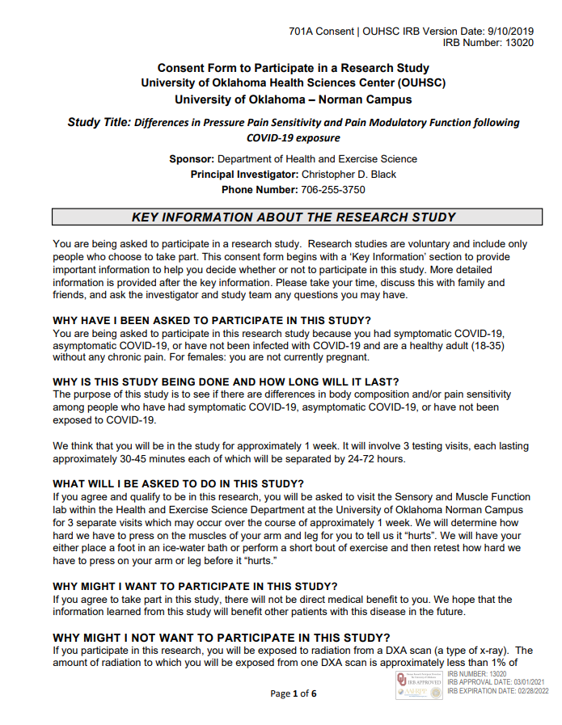
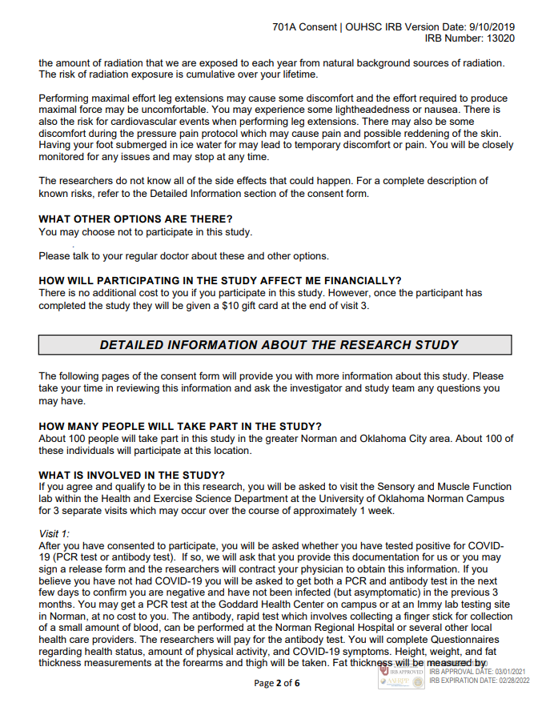
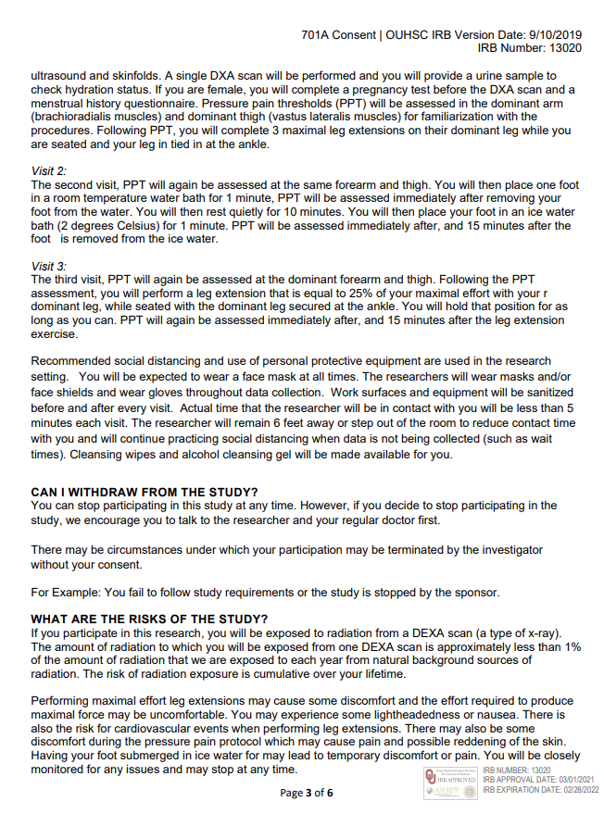
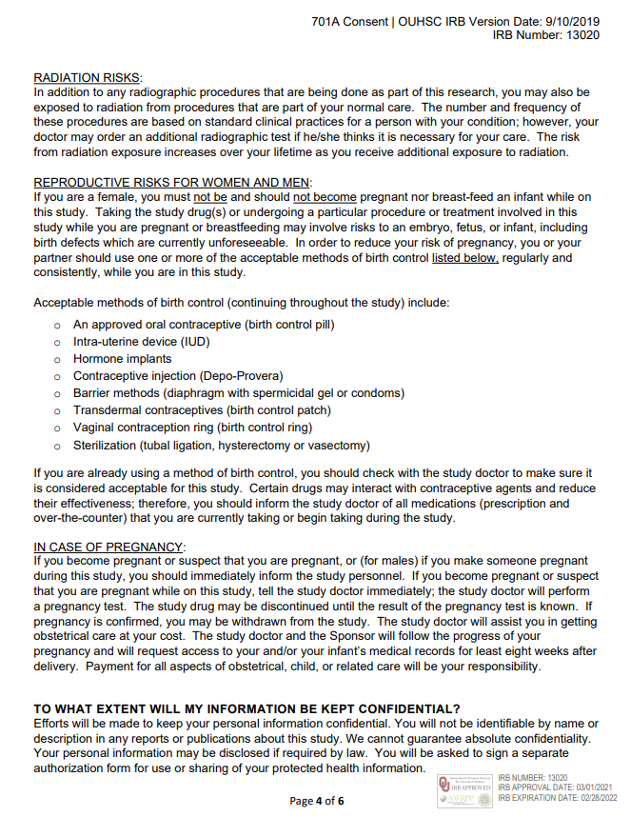
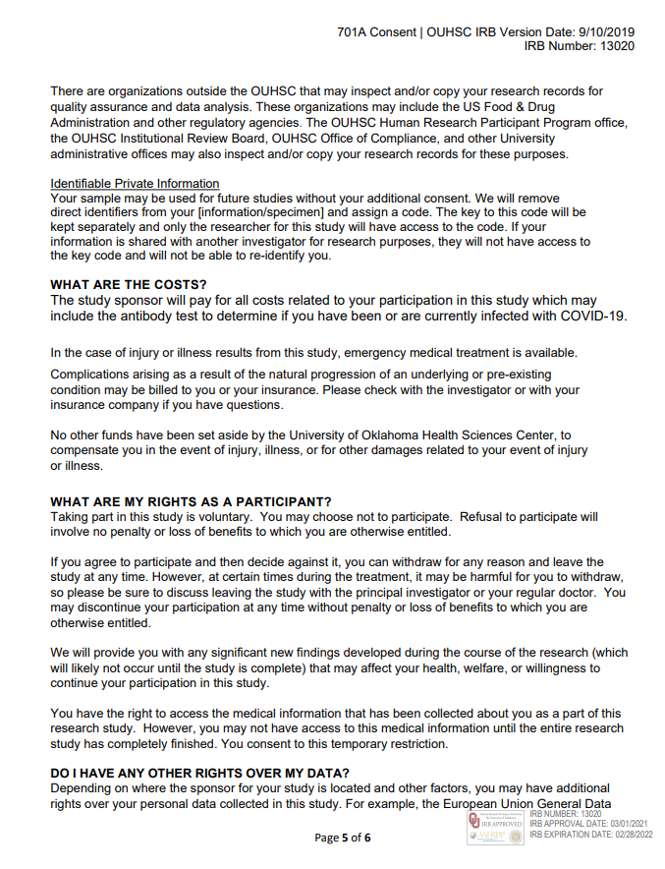
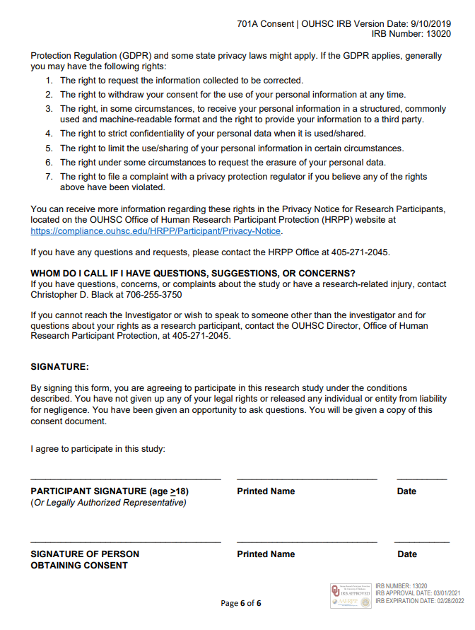
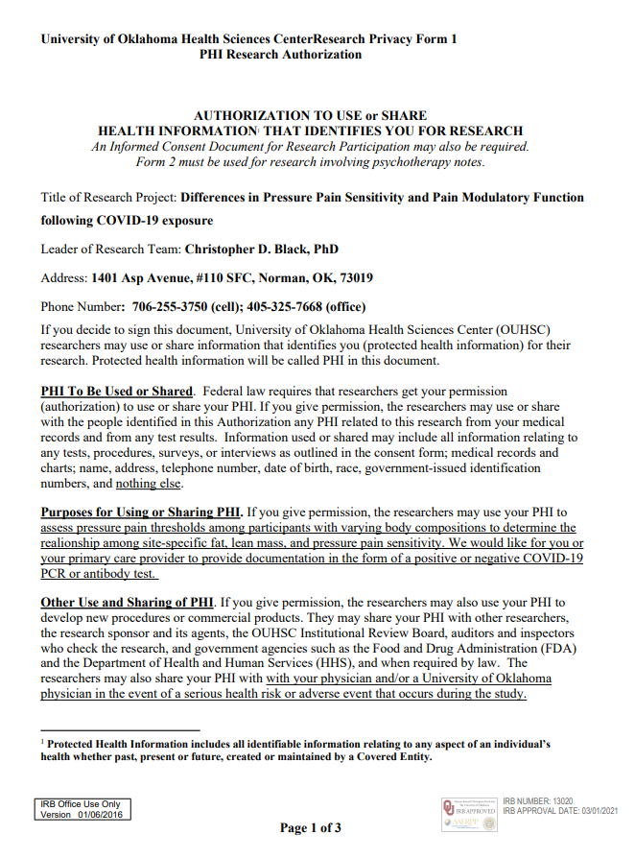
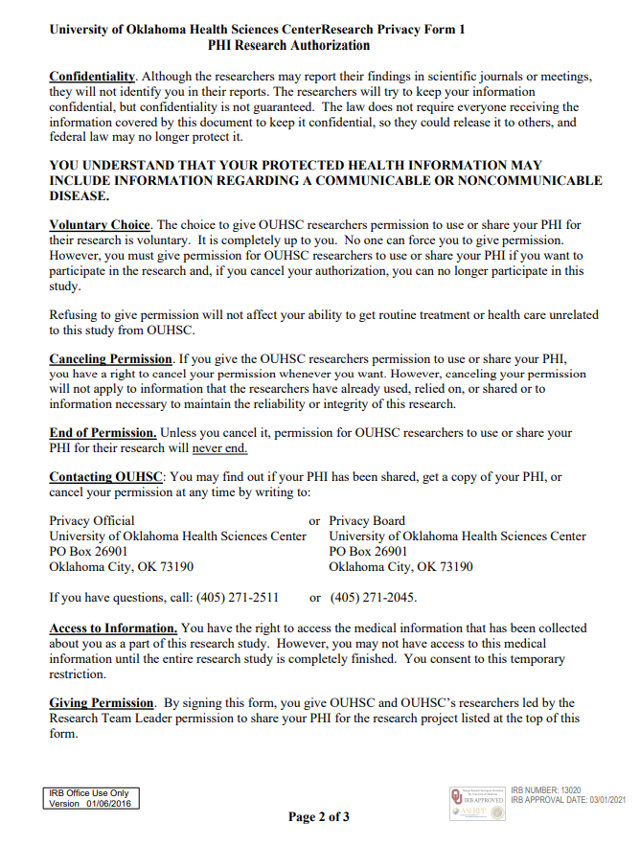
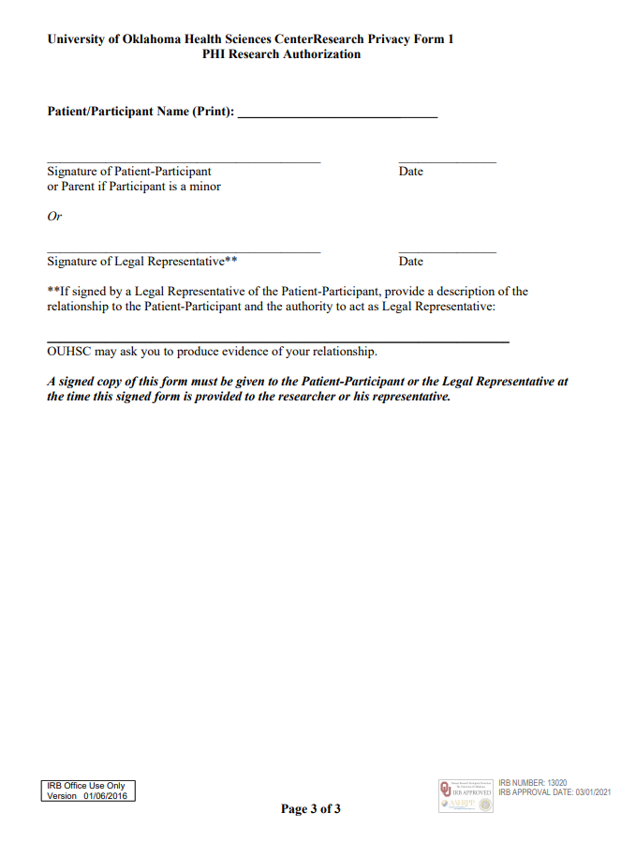
APPENDIX B: PAR-Q, Menstrual History, and Symptom Checklist
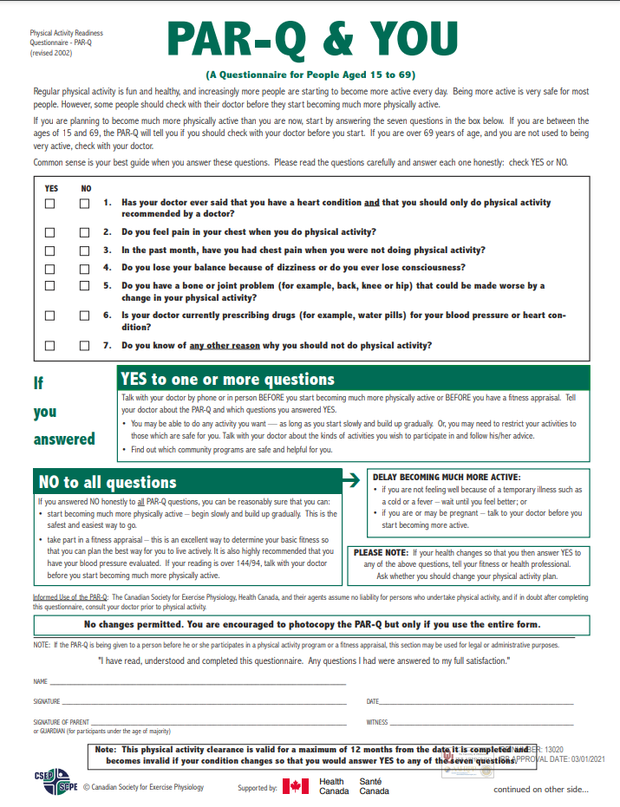
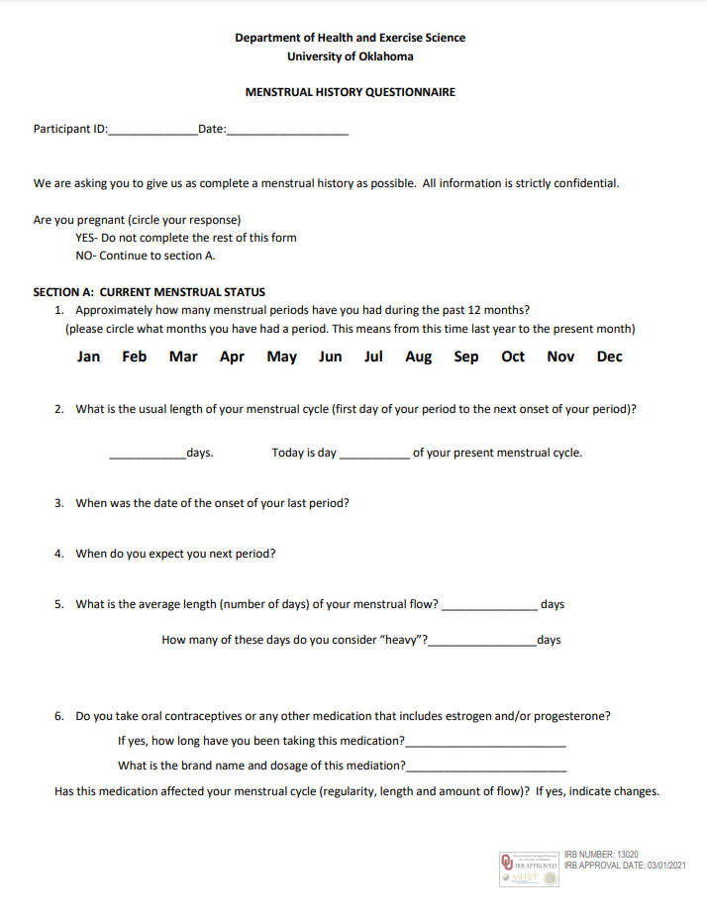
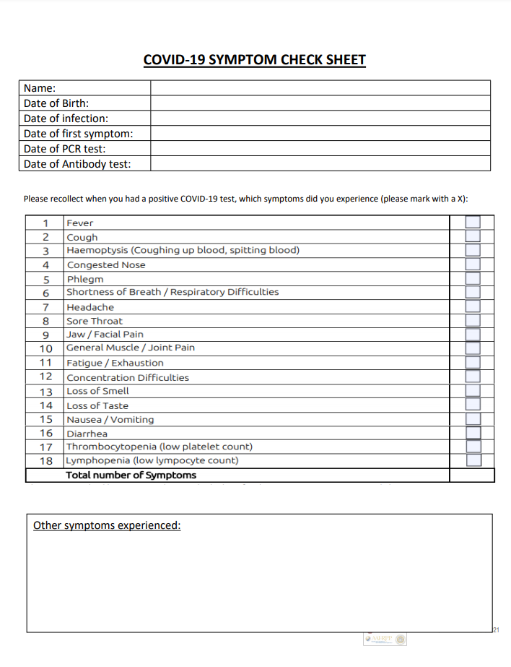

APPENDIX C: Pain, Psychometric, Physical Activity Questionnaires
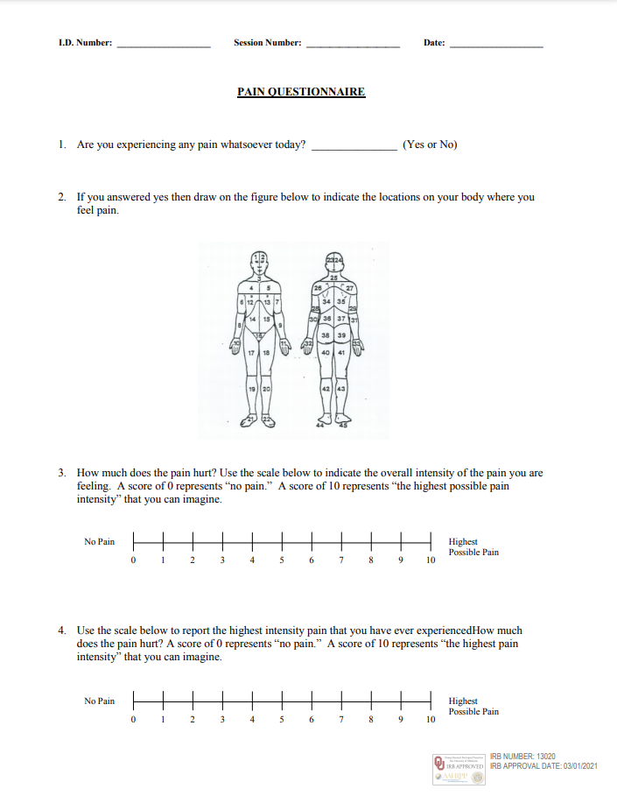
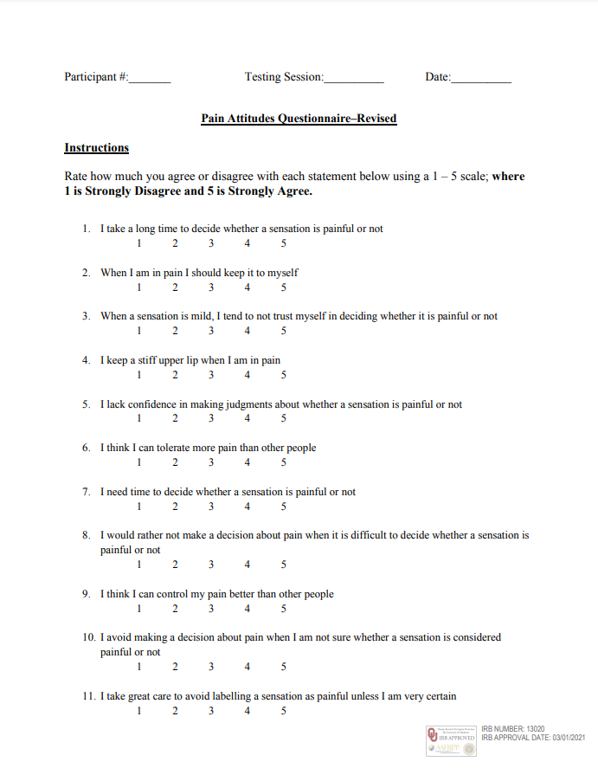
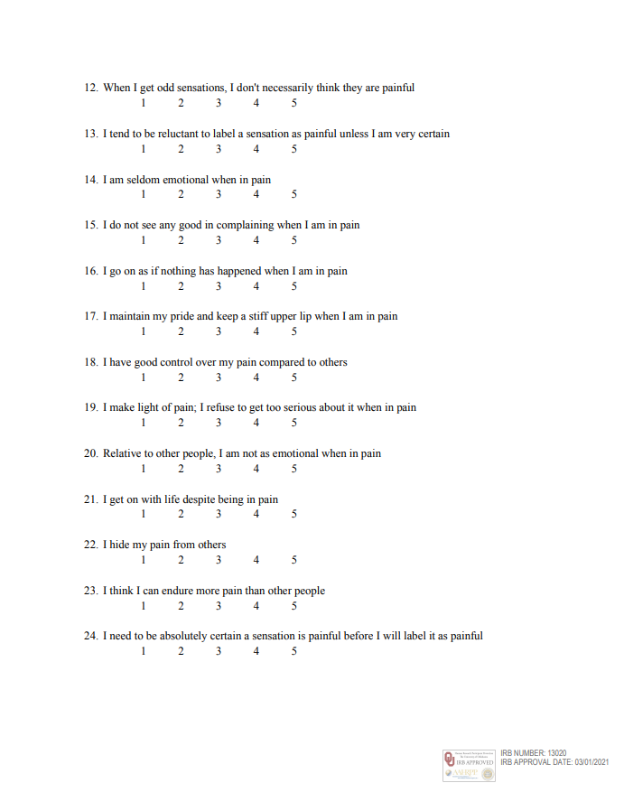
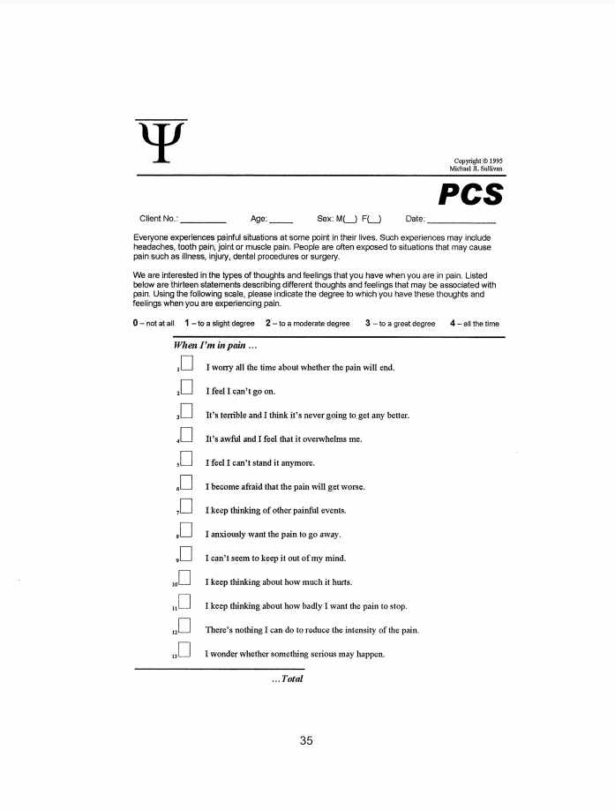
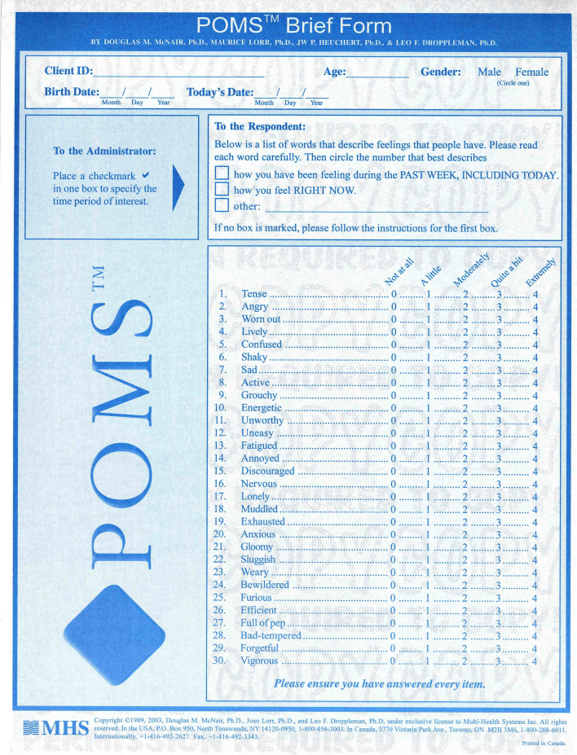
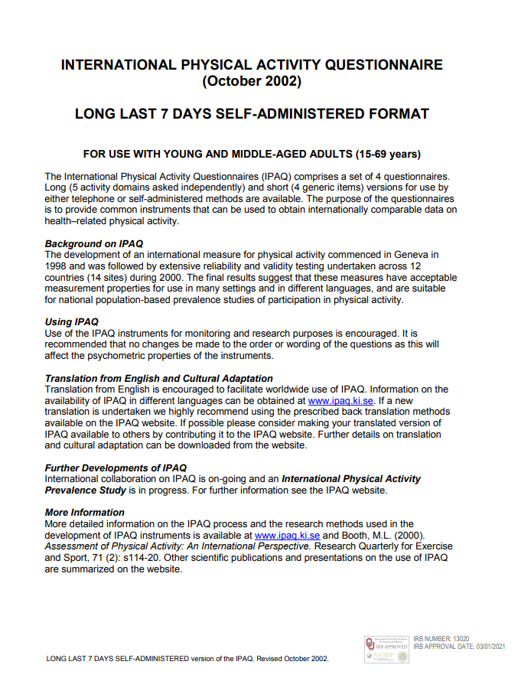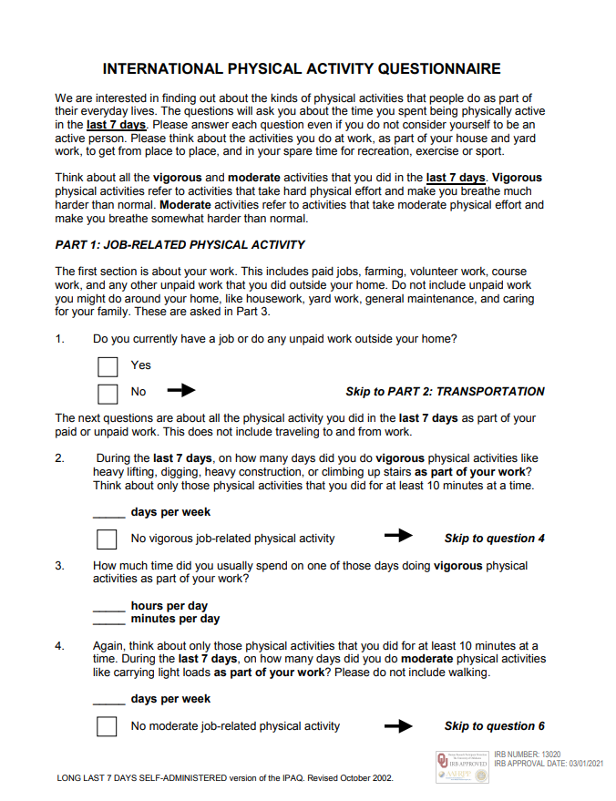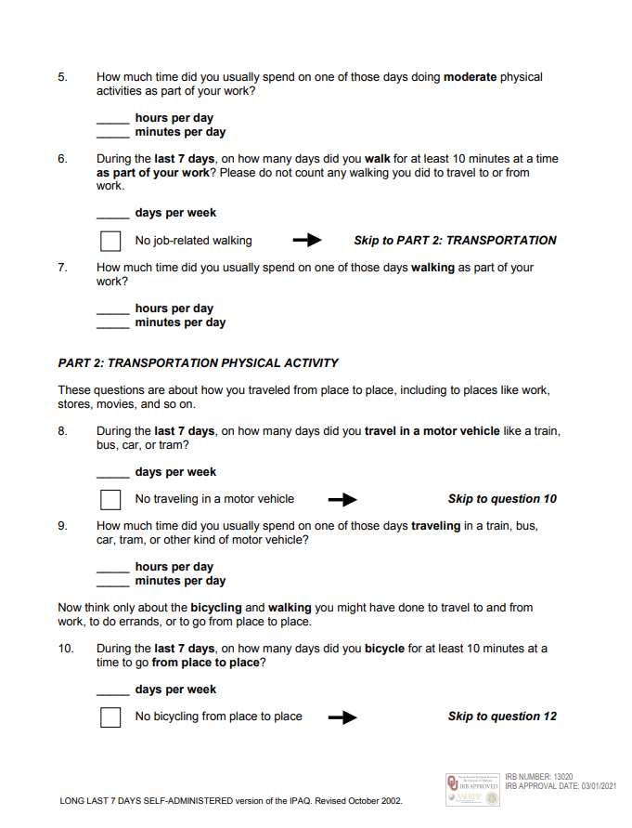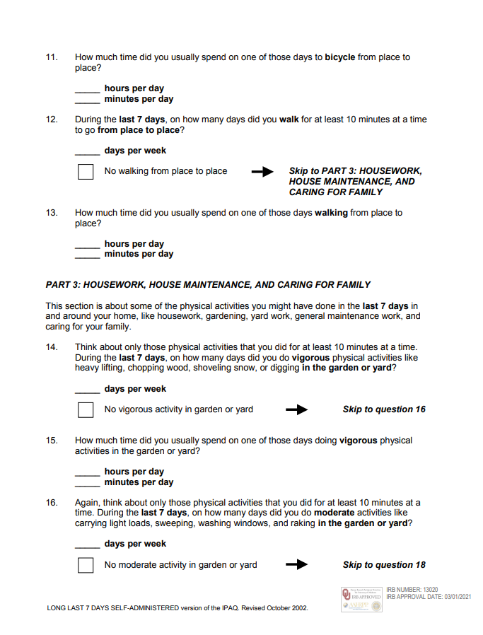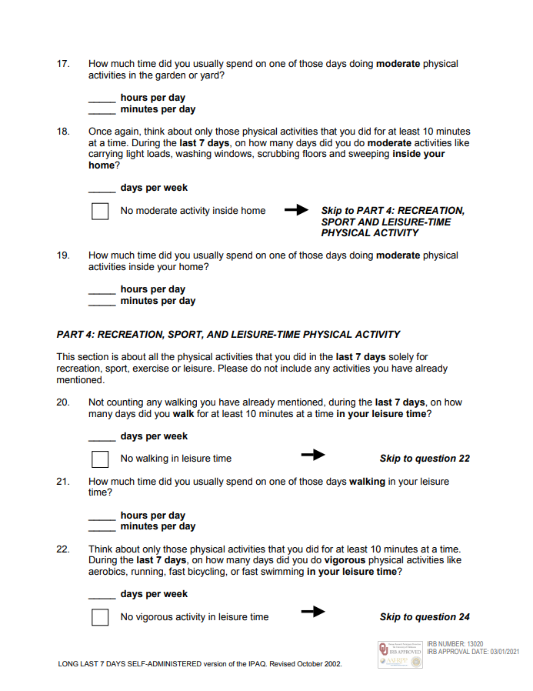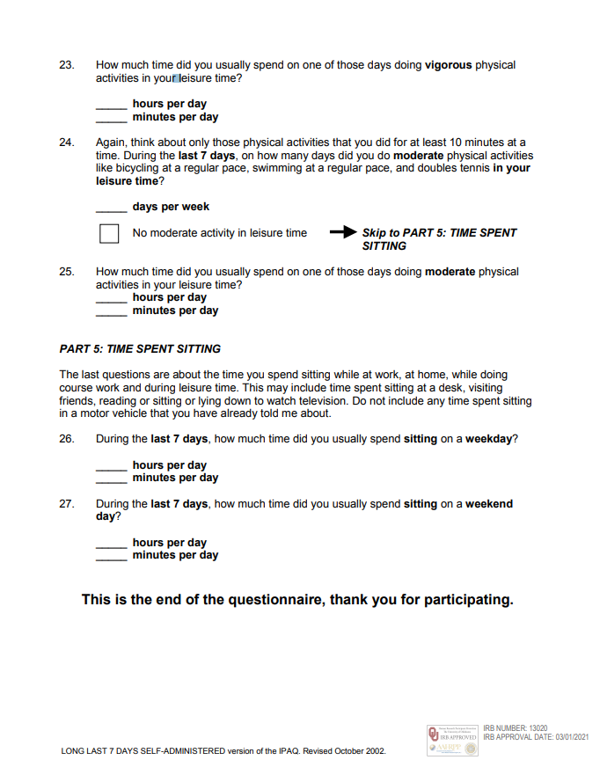

APPENDIX D: Recruitment Materials
