UNIVERSITY OF OKLAHOMA
GRADUATE COLLEGE

IS THERE A RELATIONSHIP BETWEEN SEXUAL ORIENTATION AND PERCEIVED SCHOOL SAFETY AMONG TEACHERS?

A DISSERTATION
SUBMITTED TO THE GRADUATE FACULTY
in partial fulfillment of the requirements for the Degree of Doctor of Education

By
Lindsay Joann Smith
Norman, Oklahoma
2022

IS THERE A RELATIONSHIP BETWEEN SEXUAL ORIENTATION AND PERCEIVED SCHOOL SAFETY AMONG TEACHERS?

A DISSERTATION APPROVED FOR THE EDUCATIONAL LEADERSHIP AND POLICY STUDIES

BY THE COMMITTEE CONSISTING OF

Committee Chair- Dr. Daniel Hamlin
Committee Member- Dr. Curt Adams
Committee Member- Dr. Timothy Ford
Committee Member- Dr. David Blatt

©Copyright by Lindsay Smith 2022
All Rights Reserved.
Acknowledgments

First, I want to acknowledge my dissertation chair, Dr. Daniel Hamlin. Without his support, intellect, and expertise, this research would not have been possible. I would also like to thank the outstanding faculty and staff at OU-Tulsa. Their unwavering commitment to quality education in Oklahoma is unmatched. They show constant care and support for their students while maintaining a high academic bar that all students strive to reach.
I would also like to remember the amazing work of Dr. Keith Ballard. Dr. Ballard was the ultimate encourager- he believed in me and showed me how to have hope, gratitude, and a vision for success.
I want to thank my family for their continued support during this process. I hope to set an example of accomplishment for my two children.
Lastly, I want to thank all the LGBTQIA+ Educators. You teach in a complicated and complex environment wrought with political, religious, and personal influences. However, your work matters, who you are matters, and you should have the freedom to be yourself, feel safe, and teach.

Table of Contents
Acknowledgments………………………………………………………………………………. iv
List of Tables………………………………………………………………………………….... vii
List of Figures……………………………………………………………………………………. x
Abstract………………………………………………………………………………………….. xi
Chapter 1: Introduction…………………………………………………………………………... 1
Purpose of the Study...…………………………………………………………………… 4
Conceptual Framework……………………………………………………………...…… 4
Analytical Methods…………………………………………………………...………..… 5
Overview of Chapters…………………………………………………………….……… 6
Chapter 2: Review of the Literature……………………………………………………………… 9
Historical Contexts…………………………………………………………………..…… 9
Trends in School Safety………………………………………………………………… 22
Measuring Perceptions of School Safety……………………………..………………… 29
LGB Experience and Safety…………………………………………………….……… 41
LGB Teachers’ Perceptions of School Safety…………………………………..……… 43
Chapter 3: Conceptual Framework……………………………………………………..….…… 46
Conceptual Framework #1……………………………………………………………… 47
Conceptual Framework #2……………………………………………………………… 49
Conceptual Framework #3……………………………………………………………… 50
Chapter 4: Methods………………………………………………………………...…………… 54
Defining Terms: Sexual Orientation……………………………………………….…… 54
Research Design………………………………………………………………………... 56
Data Collection……………………………………………………………...………….. 58
Survey Design……………….……………………………………………….………… 59
Survey Population and Sample………………………………………………………… 61
Variable Descriptions………………………………………………………………….. 70
Data Analysis………………………………………………………………………….... 76
Limitations……………………………………………………………………… 84
Chapter 5: Results………………………………………………………………………….…… 86
Individual Factors……………………………………………………………….……… 88
District-Level Factors…………………………………………………………….…….. 91
Neighborhood Factors…………………………………………………………….……..97
Perceived Physical Safety……………………………………………………..….…….. 97
Teacher Victimization…………………………………………………………….…… 100
Perceived Emotional Safety …………………………………………………….…… 103
Sexual Orientation Status……………………………………………………………… 105
Chapter 6: Discussion………………………………………………………………….……… 112
The LGB Teacher……………………………………………………………...……… 113
Emotional Safety…………………………………………………….………….114
Physical Safety ……………………………………………………………...… 115
Victimization………………………………………………………………...… 116
The Experienced Teacher………………………………………………………...…… 117
Implications and Limitations…………………………………………………...……... 117
Contributions and Recommendations……………………………………………….… 119
Conclusion…………………………………………………………………..………… 120
Appendices………………………………………………………………………………..…… 123
References……………………………………………………………………………...……… 161

List of Tables

Table 1: Examples of Visible Security Measures………………………………………..………24
Table 2: Control Factors…………………………………………………………………………48
Table 3: Variables, Research Questions, and Items on a Survey………….…..…………………60
Table 4: Self-Identified Sexual Orientation Status………………………………………………62
Table 5: Percent Comparison Individual Factors …………..……………………………………64
Table 6: Descriptive Statistics: Control Factors…...………………...…………….……….……65
Table 7: Sociodemographic comparison of survey sample to total districts in Oklahoma………………………………………………………………………………………...66
Table 8: Geographic comparison of survey sample to total school districts in Oklahoma …...…68
Table 9: Neighborhood Descriptors…………………………………………………………..….70
Table 10: Cronbach’s Alpha for Dependent Variables………………….……………………….71
Table 11: Composite Variables…………………………………….………………………….....87
Table 12: Composite Variables and Gender T-Test………...………………………………..….88
Table 13: Analysis of Variance with Years of Experience and Dependent Variables…………..89
Table 14: Analysis of Variance for Threats and Attacks by Less than Three Years…………….90
Table 15: Analysis of Variance for Threats and Attacks by Teachers With More Than 20 Years’ Experience………………………………………………………………………………………91
Table 16: Independent Samples T-Tests…………………………………………………………93
Table 17: Regression Analysis of Teacher Victimization and District Size …………………….95
Table 18: District Demographic Data and Composite Variables ………………………………..96
Table 19: Regression Models Predicting Perceived Physical Safety…………………………….99
Table 20: Regression Models Predicting Teacher Victimization and LGB Status……………..102
Table 21: Regression models predicting perceive emotional safety and LGB status…………..104
Table 22: LGB Distribution…………………………………………………………………….105
Table 23: LGB Awareness……………………………………………………………………...108
Table 24: Outness and perceptions of school safety…………………………………………....109
Table 25: Regression model predicting teacher victimization and LGB awareness…………...110
Table 26: T-Test of Job Security and LGB Status……………………………………………...110
Table 27: Feeling Safe Among LGB and Non-LGB Teachers…………………………………111

List of Figures
Figure 1: Litigation and LGB Teachers………………………………………………………….13
Figure 2: Oklahoma Districts Response Analysis……………………………………………….58
Figure 3: LGB “Outness” Among School Staff…………………………………………………106
Figure 4: LGB “Outness” Among Students …………………………………………………….107

Abstract
A teacher’s perception of safety is a critical component of school safety. A substantial body of scholarship explores factors related to a teacher’s perception of school safety, underscoring individual, school, neighborhood, and state-level factors that may contribute to how safe teachers feel in school. However, empirical research examining how a teacher’s sexual orientation may relate to school safety perceptions is underdeveloped in the school safety literature. Filling this gap is important because the lesbian, gay, and bisexual (LGB) community comprise 10% of the nation’s teachers, but there is only anecdotal evidence that LGB educators may not feel as safe in schools as their peers. This study examined the relationship between LGB status among teachers and how safe they feel in school, controlling for a range of individual, school, and neighborhood characteristics. For data collection, a survey was administered to public-school teachers in Oklahoma that yielded a sample of 1,605 teachers, including 113 LGB teachers. Results indicated that with controls for individual, school, and neighborhood level factors, LGB status does not have a statistically significant relationship with a teacher’s perceptions of physical and emotional safety or self-reported incidents of victimization. The results also indicated that LGB teachers who had disclosed their sexual orientation status reported statistically significant lower rates of teacher victimization. This study contributes to the literature on teachers and school safety by offering an analysis of LGB educators’ perceptions of school safety on three key measures. Findings also offer suggestive evidence that complex selection mechanisms may be underlying the patterns observed in this study.

Chapter 1
Although feeling safe and being safe are fundamental to the organization of schools (Cornell & Mayer, 2010), school safety is a complex and multilayered concept that is well-publicized and often scrutinized (Egan, 2001; Hobbs, 2019; Wong, 2019). Researchers have identified a number of individual, school, neighborhood, and societal factors associated with school safety. Individual factors tend to consist of an array of sociodemographic background characteristics of students, teachers, and schools (Curran et al., 2017; Fisher & Kettl, 2003; Gerberich et al., 2011; Taie & Goldring, 2017; Williams & Corvo, 2005). School factors are thought to comprise school size, student grade level, school climate, and parental involvement (Baird et al., 2017; Curran et al., 2017; Gottfredson et al., 2005; Thapa et al., 2013) whereas neighborhood factors point to neighborhood safety as a critical consideration (Hamlin & Li, 2020; Mowen, 2015). These influential factors are well documented in the school safety literature although most existing research has focused on students’ perceptions of their own safety (Akiba et al., 2002; Bosworth et al., 2011; Hamlin, 2017; Lacoe, 2015; Mowen & Freng, 2019).
As knowledge of school safety has evolved, researchers have highlighted the critical importance of classroom teachers in understanding school safety (Astor et al., 2010). Teachers have a vital and significant presence in schools, with over three million teachers in the United States’ K–12 public education system (Snyder, 2018). They also seem to occupy a unique position in schools in relation to safety. For example, extensive evidence indicates that how teachers respond, react, and manage safety concerns may greatly influence school and student safety (Connell, 2018; Curran et al., 2019; Gottfredson et al., 2005; Skiba et al., 2004). However, teachers’ perceptions of their own safety have received less attention in the literature, and consequently, there are critical gaps in the literature examining teachers’ perceptions of safety (Fisher & Kettl, 2003). Many national-level analyses of the safety perceptions of teachers are derived from survey data administered by the Department of Education, which asks teachers to identify a range of personal factors, including race and ethnicity, marital status, and income. Consistently absent from any federal research and highly limited within current empirical literature is how a teacher’s sexual orientation influences their perceptions of school safety. This knowledge gap is worth addressing, given the importance of teachers and the potential influence they have on school safety (Chetty et al., 2014; Goldhaber et al., 2015; Rockoff et al., 2011). Moreover, understanding various factors associated with school safety may shed light on school safety needs and strategies for developing effective school safety policies and practices.
The lack of data on LGB teachers and school safety is partly attributable to gaps in identification. There is currently little empirical data on the number of teachers identifying as lesbian, gay, or bisexual in the American public education system. Current estimates suggest that between 5% and 10% of the teaching population is lesbian or gay (Conron & Goldberg, 2019; Harbeck, 1997). There is empirical data on the number of LGB youth in the American public education system. The most current estimate is that approximately 9.5% of the total population of youth ages 13–17 in the United States identify as LGB. The trend data related to lesbian, gay, bisexual, or transgender youths reveal higher rates of victimization and harassment (Ferfolja, 2010; Musu-Gillette et al., 2018; Smith et al., 2008; Wright & Smith, 2015). These findings suggest that individual, family, and school environments are essential influencers that may mitigate the well-documented negative safety experiences of LGBTQ youth in schools (Gower et al., 2018). In addition, this research suggests additional inquiry is needed into the experiences of LGB teachers (Smith et al., 2008).
LGB Teachers and School Safety
The literature indicates that teachers need to feel safe and be physically safe to form a positive perception of school safety (Gottfredson, 2001; Gottfredson et al., 2005; Thapa et al., 2013). From the perspective of an LGB educator, the limited empirical evidence suggests that feeling safe is achieved through the school climate, job security, and supportive policies (Connell, 2012; Sears, 2002; Toledo & Maher, 2021). Similar research suggests when LGB educators experience threats to feeling safe, it is likely a result of homophobia. The only known quantitative analyses of LGB teachers’ perceptions of school climate are the three iterations of climate surveys developed by Wright and Smith (Smith et al., 2008; Wright & Smith, 2015; Wright et al., 2019). Their work highlighted the challenges and methodological gaps in surveying the LGB teacher. First, they argued that a valid random sample of LGB educators is not possible. Second, the surveys focused solely on LGB teachers and did not include heterosexual participants. However, despite the limited number of national survey participants, the research highlighted four domains related to the LGB teacher experience: homophobia, perceived job safety, outness, and perceived support.
There is a need to contribute empirically to better understand an LGB educator’s experience. As noted by the comprehensive research project at UCLA, there is limited empirical evidence of how experiences are changed based on sexual orientation (Badgett et al., 2009). This study suggests that a teacher’s self-identified sexual orientation may be crucial to their school safety perceptions.

Purpose of the Study
There are comprehensive national surveys that measure perceptions of safety among teachers. However, no known quantitative study of school safety asks teachers to self-identify their sexual orientation status to analyze the relation between sexual orientation and school safety. This literature gap led this study to the following research question:
Research Question. Is there a relationship between a teacher’s identified sexual orientation and perceived school safety (i.e. physical school safety, emotional safety, and teacher victimization), controlling for individual, school, neighborhood, and societal factors?
The researcher constructed a self-identification protocol that allowed teachers completing the survey to self-identify whether they were heterosexual or straight, gay or lesbian, or bisexual (Badgett et al., 2009). In addition, teachers were asked to self-identify their school district, race or ethnicity, gender, and years of experience. All data collected in the survey were kept entirely confidential. The survey was conducted among public school teachers in Oklahoma. The researcher used convenience and snowball sampling as methods for data collection. The survey adapted questions from prevalent school safety research surveys: the National Teacher and Principal Survey (NCES Survey, 2021) and the School Survey on Crime and Safety, 2017 (SSOCS, 2017). Because the participants identified their school district, the researcher was able to access publicly available data to collect information on the previously identified individual, district, and neighborhood factors.
Conceptual Framework
Feeling safe is a basic human need (Maslow, 1943). When individuals feel safe and have limited chronic stressors, there are mental and physical health benefits (Cassem, 1995; Kessing et al., 2003; Stanton et al., 2001). By feeling a sense of competency and developing relationships with their colleagues and students, teachers can feel emotionally safe (Ryan et al., 1995; Ryan & Deci, 2000). Although the research is limited, the data suggest that teachers who identify as LGB may feel unsafe in their environments and need greater support than non-LGB teachers (Jackson, 2007; Smith et al., 2008; Wright, 2010). However, the research has not focused on understanding the relationship between a teacher’s sexual orientation and perceived safety in school. This gap in the literature presented an essential next step for school safety research.
The framework for the study reviewed three key concepts:
- Reviewing factors previously identified empirically and their relationship with school safety (Akiba et al., 2002; Curran et al., 2017; Gottfredson et al., 2005; Mowen, 2015).
- Understanding how school disorder and teacher victimization influence perceptions of safety for teachers who identify as LGB (Furlong et al., 2005; Skiba et al., 2004).
- Examining how a supportive school environment with supportive relationships and job security relates to individual perceived school safety (Connell, 2012; Jackson, 2007; Wright, 2010).
Within the three concepts, teachers’ perceptions of school safety were categorized by their perception of physical safety, incidences of teacher victimization, and perception of emotional safety.
Analytical Methods
The sample generated was compared to the entire population of teachers in Oklahoma and an empirically aligned estimate of the LGB teacher population in the state. The previously identified factors were analyzed using descriptive statistics and served as controls when comparing the sample of LGB and non-LGB respondents to the population data. The three composite variables generated through the conceptual framework were perceptions of physical safety, incidents of teacher victimization, and perceptions of emotional safety. The regression analyses compared the three composite variables between LGB and non-LGB while including the previously identified factors within the individual, school, neighborhood, and societal characteristics.
Scholarly Contributions
The concept of school safety has been empirically studied for decades. Student perceptions of school safety are a well-studied aspect of school safety literature. Teacher perceptions of school safety, although not as extensive as students’ perceptions, contribute to the overall empirical findings on school safety. However, consistently absent from the research on teachers’ perceptions of school safety is considering the sexual orientation status of teachers. Teachers are asked to provide personal information on nationally representative surveys but are not directly asked about their sexual orientation. Should researchers care about the personal life of a teacher? The answer is complicated. However, when a teacher’s personal life comes with concerns about job security, hinders personal relationships at work, or presents an increased risk of victimization, it is necessary to analyze personal aspects. Furthermore, LGB teachers are part of the teaching force. When teacher vacancies are high in many school districts across the country, understanding how LGB teachers’ perceptions of safety may differ is an important consideration for policymakers and school leaders.
Overview of Dissertation Chapters
The literature review is divided into five sections: historical contexts, trends in school safety, empirical findings of perceptions of school safety, measuring perceptions of school safety, and LGB teachers and safety. Section 1 will explore the historical context of LGB teachers and school safety. The review will address how different institutions within the United States have interpreted sexual orientation and how those institutions have used policy to respond to breaches in school safety. Section 2 of the literature review highlights trends in school safety, including visible security measures and recent school safety incidents. Section 3 focuses on the empirical understanding of perceptions of school safety. This section provides an expanded definition of school safety and a brief overview of the previous findings in school climate and teacher victimization research. Section 4 outlines how research has measured the perceptions of school safety through parents, students, and teachers. Finally, section 5 provides an empirical analysis of the current LGB experience within schools.
Chapter 3, the conceptual framework, explores how previously identified factors, school disorder, teacher victimization, relationships, and job security, influence perceptions of safety among teachers. The conceptual framework also outlines the empirical importance of the three composite variables used for analyses: perceptions of physical safety, incidents of teacher victimization, and perceptions of emotional safety. Chapter 4, methods, outlines the definitions used by the researcher for sexual orientation status. The methods chapter also provides an overview of the research design, the data population and sample, data collection procedures, and methods used for data analyses. Chapter 5, results, relies on the conceptual framework and previous empirical findings related to perceptions of school safety to highlight the research study’s results. Finally, Chapter 6, the discussion, highlights the findings of the research through five key areas:
- the LGB teacher
- the LGB teacher and emotional safety
- the LGB teacher and physical safety
- the LGB teacher and victimization
- the experienced teacher

Chapter 2: Literature Review
Section 1 of the literature review expands on the historical context of two key components of the research question: LGB teachers and school safety. The historical context of both phenomena provides insight into how current policies, litigation, and practices came to be.
The Historical Context
LGB Teachers and School Safety
The past is complicated for people who identify as LGB. Before analyzing how being nonheteronormative in a school setting is connected to perceptions of safety, it is essential to provide context on how different institutions within the United States interpret sexual orientation—the history is complex, concerning, and rapidly changing. The institutions of medicine and psychiatry, federal and state governments, and the justice system have all grappled with the question of sexual orientation, employment, and discrimination.
The Institutions of Medicine and Psychiatry. Understanding the historical context of LGB teachers may explain the lack of focused empirical research on being LGB and an educator. Thirty years ago, the American Psychiatric Association (APA) removed any references to sexual orientation as a disorder from their Diagnostic and Statistical Manual of Mental Disorders (DSM). The concept of same-sex behaviors had been analyzed by famous theorists resulting in competing theories and broad misrepresentations. During the mid-20th century, Sandor Rado claimed that heterosexuality was the norm and dismissed “homosexuality” or bisexuality (Dresher, 2015). These views were interpreted, along with those of other theorists who claimed the possibility of “curing” one of homosexual behaviors and accepted within the professional community of psychiatrists (Dresher, 2015). In 1952, the APA published the first edition of the widely used DSM and listed “homosexuality” as a “sociopathic personality disturbance” (American Psychiatric Association, 1952). The second edition, published in 1968, declassified homosexuality as a “sexual deviation” (American Psychiatric Association, 1968).
It is important to note that these “classifications” in the APA manuals lacked the backing of scientific theory or empirically tested hypotheses. Researchers did contradict the APA publications. In 1948 and 1953, Kinsey published two reports that found “homosexuality” was not as “rare” as previously believed in the general population (Kinsey et al., 1945; Kinsey et al., 1953). In 1951, Ford and Beach found that the act of homosexuality was regularly found in nature (Ford & Beach, 1952). In 1957, Evelyn Hooker studied an equal number of gay and heterosexual men and found no significant difference between the two (Hooker, 1957). Dresher (2015) noted that this study refuted the belief that “all gay men had severe psychological disturbances,” a commonly held belief in the 1950s (p. 570).
It took the APA until 1987 to finally remove all language from its manual related to sexual orientation (American Psychiatric Association, 1987). Dresher (2015) noted that this change resulted in a shifting debate around sexual orientation that moved “away from medicine and psychiatry” and toward political and religious realms (p. 572).
The Federal Government. Not only was the APA guilty of large-scale stigmatization of the LGB community, the federal, state, and local governments were keen on discrimination against any individual who did not subscribe to heteronormative behavior. In the early 1950s, during the “Red Scare,” there was a phrase coined known as the “Lavender Scare.” The Lavender Scare was the systematic oppression and attempted removal of openly gay men serving within the federal government. This discrimination was codified into law by executive order 10450 by Dwight D. Eisenhower (Exec. Order No. 10450, 1953). This executive order remained in effect for 6 decades and was finally revoked by President Barack Obama in 2014 (Hudson, 2014; Executive Order 11246, 2014). Beyond the “Lavender Scare” was the federal policy that required members of the armed services to be discharged if they engaged in “homosexual acts” (House of Representatives, Congress, 2010).
State and Local Governments. In the 1970s, national polling data showed that more than 70% of Americans agreed with this statement: “Homosexuals are dangerous as teachers or youth leaders because they try to get sexually involved with children” (De Boer, 1978, p. 265). This polling data was reflected in local governments’ attempts to bar LGB educators from schools and deny them the benefits of antidiscrimination protections. Three historical events helped shape much of the rhetoric involving LGB teachers. First was the campaign called “Save our Children” in Dade County, Florida. This campaign, led by Anita Bryant, sought to overturn the city’s antidiscrimination laws for government employees in 1977 (Ayres, 1977). Bryant campaigned for a candidate who ultimately decided to support gay rights in Dade County, Florida (Harbeck, 1997). After this defeat, Bryant, along with others in her church community, established the “Save Our Children” campaign, which ultimately received national attention and is credited with weaponizing false attacks on the gay and lesbian community in Florida and a multistate effort to codify discrimination of gay and lesbian individuals (Harbeck, 1997; Williams, 1977). Bryant’s efforts were successful, and city ordinances with nondiscrimination protections for lesbian and gay individuals were overturned in St. Paul, Minnesota; Wichita, Kansas; and Eugene, Oregon (Harbeck, 1997).
Efforts initiated in Florida eventually landed in California. A state-level initiative known as California Proposition 6 targeted removing teachers who identified as lesbian or gay in all California classrooms (Harbeck, 1997; California Proposition 6, 1978). With the help of former Governor Ronald Reagan, Proposition 6 was defeated by a 2-to-1 margin (Harbeck, 1997). Although the proposal in California failed, the next state to take up a similar legislative decision was Oklahoma, the setting for this research study (California Proposition 6, 1978; Board of Education v. National Gay Task Force, 1985).
Litigation. One way to conceptualize litigation targeting LGB teachers is using a Venn diagram. In one circle, there are three critical components of education-related litigation:
First Amendment rights, contractual obligations, and the definition of immorality. The second circle contains two issues that entangle every case concerning the rights of gays and lesbians: the Court’s definition of sex and the constitutional interpretation of privacy. The third circle is the idea that teachers are role models for children. Finally, the overlapping circle is how all these can be applied when analyzing the litigation history of LGB teachers (Figure 1).

Figure 1
Litigation and LGT Teachers
LGB Teacher
First Amendment. The initial application of First Amendment rights in public schools primarily dealt with the concept of freedom of religion and the limits schools have in advancing one religious practice over another (Engel v. Vitale, 1962; Lemon v. Kurtzman, 1971). Following religious expression, schools addressed the application of freedom of speech. In Tinker v. Des Moines Independent Community School District, the question at hand was whether students should be allowed to wear armbands to protest the Vietnam War (Tinker v. Des Moines Independent Community School District, 1969). Supreme Court Justice Fortas wrote in his majority opinion for the court,
First Amendment rights, applied in light of the special characteristics of the school environment, are available to teachers and students. It can hardly be argued that either students or teachers shed their constitutional rights to freedom of speech or expression at the schoolhouse gate.
Another case explicitly focusing on the freedom of speech for teachers was Pickering v. Board of Education. A teacher was fired after writing a letter to the editor expressing concerns about a failed proposal to increase school taxes. In an 8-to-1 decision, the Supreme Court determined that the firing was unconstitutional and upheld the right of a teacher to speak out on critical issues (Pickering v. Board of Education, 1968).
First Amendment rights for LGB teachers were argued in Acanfora v. Board of Education (1974). Acanfora concerned an eighth-grade science teacher who was transferred to a nonteaching position after the Board of Education in Montgomery, Maryland, was made aware of his sexual orientation. After the teacher spoke to the news media, his contract was not renewed. The lower court ruled in favor of the school district, but the Court of Appeals reversed the ruling because there was no disruption or impairment to teaching and the teacher’s statements to the media were protected by the First Amendment (Acanfora v. Board of Education, 1974; Lavine, 1980).
Contractual Obligations and Immorality. The next aspect of teachers and litigation is contractual obligations. In 1974, the Supreme Court weighed in on a decision made by a local Cleveland school board that demanded teachers stop working during the fifth month of their pregnancy (Cleveland Board of Education v. LaFleur, 1974). The Supreme Court determined that the policy violated the Fourteenth Amendment due process clause. Contract laws and teacher due process laws are complicated; but in most situations, legal scholars agree that due process is a must when considering the dismissal of an employee (FindLaw, 2016; Fletcher & Lawrence, 2015).
Most contracts contain an “immorality” clause, and most current teaching contracts include some version of the language that teachers can be dismissed if they engage in “immoral behavior.” For example, current teacher contracts in Oklahoma follow the provisions of the Teacher Due Process Act of 1990 that state a teacher may be dismissed for “commission of an act of moral turpitude” (Teacher Due Process, 1990, p. 1).
Sex and Privacy. The courts have also contended with the concepts of sex and privacy. In Griswold v. Connecticut (1965), the court authored the opinion that protected the right to privacy in marriages; and although the Constitution itself does not specifically mention a right to privacy, the court agreed that the concept is implied in the Bill of Rights. For the act of sex, the courts took longer to apply their privacy application to private sex acts. In 1986, the court ruled against a police officer charged with a crime after he was “caught” having consensual sex in his private residence (Bowers v. Hardwick, 1986). It was not until 2003 that the court ruled that it cannot be a crime for two people to engage in consensual intimate sexual acts in the privacy of their home (Lawrence v. Texas,2003). The Lawrence decision was predicated on the argument that a right to privacy is a part of the Constitution, particularly the Fourteenth Amendment.
Teachers as Role Models. The morality clauses still found in teacher contracts lay the groundwork for the concept of teachers as role models. The Supreme Court recognized teachers as role models in Ambach v. Norwick (1979), and Supreme Court Justice Powell stated that “a teacher serves as a role model for his students, exerting a subtle but important influence over their perceptions and values” (p. 441). Lower courts have contended that schoolteachers are considered the “moral example for the students” (Board of Education v. Wood, 1986, p. 839). Another case noted that a teacher’s actions are given “greater scrutiny than that given to the activities of the average person” (Chicago Board of Education v. Payne, 1981, p. 748).
LGB Teachers. The overlapping focal points in such litigation set the stage for a series of Supreme Court decisions related to sexual orientation and teaching. First, the litigation began in Oklahoma, the setting for this research study. Following the defeat of the aforementioned California Proposition 6, the Oklahoma legislature attempted to enact a state statute that required school boards to dismiss or suspend teachers who engaged in “homosexual activity or conduct” (Oklahoma Statue Ann. Tit. 70 & 6-103.14 – West Supp., 1984). This law was challenged in court by an outside organization called The National Gay Task Force, and the district court of Oklahoma upheld the state statute. However, the National Gay Task Force appealed to the Tenth Circuit Court of Appeals, and that court held that the law itself was too broad because it included components that violated freedom of speech protections (Fitch, 1985). The case was ultimately appealed to the United States Supreme Court and resulted in a split decision, allowing the Tenth Circuit Court decision to let it stand (Fitch, 1985; Harbeck, 1997).
Issues of privacy, sex, morality, or contractual obligations notwithstanding, the United States Supreme Court did not address employment discrimination based on sexual orientation until 2019 (Valenti, 2021). First, in 2015, the Supreme Court ruled in Obergefell v. Hodges that same-sex marriage would be legal in all 50 states. Although this ruling presented a watershed moment for gay rights in the United States, it would be short-sighted to believe it created a new equal environment for nonheteronormative individuals who now had the same rights as heteronormative individuals. Justice Kennedy, the swing vote, wrote in the majority opinion, “Many States condemned same-sex intimacy as immoral, and homosexuality was treated as an illness. Later in the century, cultural and political developments allowed same-sex couples to lead more open and public lives” (Obergefell v. Hodges, 2015). Kennedy surmised that same-sex couples could lead more open and public lives.
The first test of the possibility of LGB teachers leading more open and public lives was in the Supreme Court ruling of Bostock v. Clayton County (2020). Mr. Bostock was a state child-welfare worker who joined a gay softball league and helped promote an organization he worked with that provided outside advocates for children in the court system (Bostock v. Clayton County, 2020). However, when his sexual orientation became known by his state employer, his work was soon under audit, ultimately leading to his termination because of conduct unbecoming a county employee (Bostock v. Clayton County, 2020; Valenti, 2021). As a result, Bostock filed a lawsuit under Title VII for sex discrimination based on sexual orientation (Valenti, 2021). In a complicated series of events with multiple appeals and circuit court decisions, the case made its way to the Supreme Court. The Supreme Court ruled in favor of Bostock, with Judge Gorsuch writing for the majority opinion: “It is impossible to discriminate against a person for being homosexual or transgender without discriminating against that individual based on sex” (Bostock v. Clayton County, 2020, p. 1741).
However, landmark rulings from the Supreme Court do not result in immediate societal changes. For example, Brown v. Board of Education was decided in 1954; and three years later, President Eisenhower had to dispatch federal troops to assist in desegregation efforts in Little Rock, Arkansas (Brown v. Board of Education, 1954). Litigation focused on desegregation efforts in public schools related to the Brown ruling continued until the late 1970s.
The Bostock ruling established a legal precedent regarding protecting LGB teachers from discrimination. Moreover, this ruling added to precedent that had shaped a more robust legally protected environment for LGB teachers: the right to privacy in Lawrence v. Texas and due process and equal protection in Obergefell v. Hodges. However, Supreme Court Justice Thomas wrote in the minority opinion in Lawrence v. Texas (2003), “I can find (neither in the Bill of Rights nor any other part of the Constitution) a general right of privacy or as the Court terms it today” (Lawrence v. Texas, 2003). Twenty years later, in the majority opinion, Justice Thomas echoed concerns similar to those he expressed in Lawrence v. Texas (2003) and noted that “we should reconsider all of this Court’s substantive due process precedents, including Griswold, Lawrence, and Obergefell. Because any substantive due process decision is ‘demonstrably erroneous,’ and we have a duty to ‘correct the error’ established in those precedents” (Dobbs v. Jackson Women’s Health Organization, 2022). Despite years of litigation, legal precedent appears to be unsettled, and there is no clear precedent on the protection and rights of LGB teachers.
School Safety
U.S. Policy Response. Similar to the complex and complicated history of LGB teachers in America, the federal policy history of school safety in the United States is also multifaceted. In 1978, the first large-scale school safety survey noted concerns regarding acts of vandalism, violence due to desegregation efforts, student victimization, and declining student perceptions of safety (National Institute of Education, 1978). In addition, several presidential administrations since the late 1970s haves had a varied policy response to school safety. The Regan administration, known for its war on drugs, focused on schools and student drug use by establishing the Drug-Free Schools and Communities Act and starting school-based drug prevention programs. The first Bush administration utilized its Department of Justice to launch the National Crime Victimization Survey for schools and reauthorized funding focused on gang activity (Bastian and Taylor, 1991; Brock et al., 2017). Finally, the Clinton administration made two critical legislative moves directly related to school safety: The Gun-Free Schools Act of 1994 and the Safe Schools Act of 1994. Gun-Free Schools placed federally mandated requirements on school districts to ban guns and introduced the concept of “zero tolerance” for any student bringing a weapon to school (H.R. 987, 1993). The Safe Schools Act of 1994 created opportunities to apply for additional grant funding for supporting a safe school (H.R. 2455, 1994).
These efforts focusing on school safety were challenged following four well-publicized mass rampage-style attacks on schools between 1998 and 1999 (Fieldstadft, 2019; Green, A, 2019; Zambroski & Wohller, 1998). Then-President Clinton prompted the U.S. Departments of Education and Justice to prepare, for the first time, a joint annual report on school safety and asked for an “early warning guide to help … adults reach out to troubled children quickly and effectively” (Dwyer et al., 1998, p.1; Furlong et al., 2003). Following the well-publicized Columbine shooting in 1999, schools responded with a significant increase in “visible” security measures like locked entrances, metal detectors, x-ray inspection, clear-backpack policies, drug-sniffing dogs, school resource officers, staff training, student drills, restricting access to buildings, and telephones in the classroom (Addington, 2009; Green, 1999; Kupchik & Ward, 2014; Mowen, 2015;). Post-Columbine federal action included a partnership between the Departments of Education and the U.S. Secret Service. Together, they launched the Safe Schools Initiative, which analyzed 37 significant targeted acts of school violence (Brock et al., 2017). The School Emergency Response to Violence (Project SERV) was also created in response to Columbine and intended to support schools’ recovery efforts following a traumatic event (Brock et al., 2017). In addition, former President Clinton pledged $60 million for schools to hire law enforcement as School Resource Officers and ultimately created a program that provided over $800 million in grants to law enforcement agencies from 1999 to 2005 (Brock et al., 2017; Juvonen, 2001). Finally, the Clinton administration added a federal program, the Safe Schools/Healthy Students Initiative, which, during its tenure from 1999 through 2012, received more than $2 billion in funding, representing a shift in federal policy away from visible measures toward a more comprehensive school safety approach and focusing on students’ experiences within schools (Brock et al., 2017).
Post-Columbine mass violence events and additional school shootings have led to a broader expansion of efforts to ensure schools are safe and secure. During the George W. Bush administration, Congress created three programs: Secure our Schools, Project Sentry, and Readiness and Emergency Management for Schools. These programs supported hardening facilities, limiting firearm access to juveniles, supporting crisis plans, and ensuring a faster emergency response protocol (Brock et al., 2017). Unfortunately, while these programs were being developed, two additional tragic school shootings occurred in Lancaster, Pennsylvania, where an assailant killed five school children, and at Virginia Tech University, which resulted in the loss of life of 33 victims (Hauser & O’Connor 2007; Kocieniewski & Gately, 2006).
Following these horrific events, President Barack Obama focused on school safety issues around victimization in the forms of bullying and cyberbullying. As a result, the Federal Bullying Prevention Steering Committee was established. Notably, the “zero-tolerance” policy initiated in 1994 caused concern in communities disproportionately affected by harsh disciplinary policies (Noguera, 2003). President Obama addressed this through the Supportive School Discipline Initiative (Brock et al., 2017).
When the tragic school shooting occurred at Sandy Hook Elementary School in Newtown, Connecticut, the policy conversations and public perceptions surrounding school safety and security were expanded to include gun laws and mental health assessments (Altimari, 2019). Public sentiment around assault rifles and semi-automatic weapons shifted in support of the ban, with 54% of Americans responding in favor one month after Sandy Hook and 67% over 5 years later. Despite the grassroots efforts and changing American sentiment, there were no significant federal policy changes to school safety or gun laws following the tragedy at Sandy Hook. The only notable change was establishing the Comprehensive School Safety Initiative, a grant from the National Institute of Justice awarded for research on the potential root causes and consequences of school violence and safety (Brock et al., 2017). From 2010 through the tragedy at Sandy Hook Elementary, it is essential to note that congressional monetary support for an abundance of school safety programs and initiatives began to decline substantially (Brock et al., 2017). However, in 2018, in response to the Marjory Stoneman Douglas High School shooting in Parkland, Florida, the Commission on School Safety recommended a framework to prevent, protect, mitigate, respond, and recover in response to school violence (DeVos et al., 2018).
Each well-publicized school shooting represented a pivotal moment in school safety that led to changes in policies and practices. Like the tragedy in Columbine, Parkland represented a complicated situation that highlighted multiple layers of failure to respond or, as the Federal Government noted, the inability of a school to prevent, protect and mitigate, respond, and recover in response to school violence. Although the narrative post-Parkland focused on gun violence, there were complex issues falling under the guise of school safety that Parkland highlighted, similar to Columbine1s tragedy. Most recently, the STOP School Violence Act of 2018, although communicated as a piece of new legislation, was a reallocation of existing school safety funds, specifically the Comprehensive School Safety Initiative (Blad, 2018; Kiely, 2018). This legislation focused on visible security measures and emergency notification technologies (Parkinson, 2018). Notably, this particular piece of funding eliminated federal research on school safety (Blad, 2018; Brock et al., 2017). The historical context of federal school safety policies represents reactions to breaches of school safety. Narrowing the focus to teachers signals less of a compilation of reactions to breaches in safety than an undercurrent of increased concern related to teacher victimization and increased student behavior (Curran et al., 2017).
Trends in School Safety
There is evidence of trends in school safety that may influence teacher perceptions. Section 2 of the literature review identifies visible security measures and recent school safety incidents. These measures underscore how school safety is defined and perceived. In some measures, like visible security measures, teachers are largely absent from consideration.
Visible Security Measures
Visible security measures have grown into a multibillion-dollar industry (DeAngelis et al., 2011). The U.S. Secret Service and the U.S. Department of Education launched a collaborative effort, the Safe Schools Initiative, to address how schools could develop plans for potential acts of school violence and prevention efforts (Vossekuil, 2004). The first Safe Schools Initiative report examined 37 incidents of targeted school violence from December 1974 through May 2000. The report identified ten key findings that likely generated many of the current safe school practices implemented and supported by state and local school districts today:
- Incidents of targeted violence at school were rarely sudden, impulsive acts.
- Prior to most incidents, other people knew about the attacker’s idea and/or plan to attack.
- Most attackers did not threaten their targets directly prior to advancing the attack.
- There is no accurate or useful “profile” of students who engaged in targeted school violence.
- Most attackers engaged in some behavior prior to the incident that caused other concerns or indicated a need for help.
- Most attackers had difficulty coping with significant losses or personal failures. Moreover, many had considered or attempted suicide.
- Many attackers felt bullied, persecuted, or injured by others prior to the attack.
- Most attackers had access to and had used weapons prior to the attack.
- In many cases, other students were involved in some capacity.
- Despite law enforcement responses, most shooting incidents were stopped by means other than law enforcement.
An updated report, released in 2018, focused on behavioral threat assessment analysis (National Threat Assessment Center, 2018).
Visible security measures such as metal detectors and security guards used to be reserved for “problematic schools” or large urban city schools (Crews & Counts, 1997). However, these visible security measures are now commonplace (Table 1). For example, the percentage of public schools reporting security cameras has increased from 19% in 1999–2000 to 83% in 2017–2018 (Wang et al., 2020).

Table 1. Examples of Visible Security Measures
Category of Security Measures | Examples
Limiting access to the school building | Identification cards (students/staff)  Locked school entrances during the day  Gated campuses  Visitor sign-in requirement  Campus design changes
Limiting weapons on campus | Metal detectors (walk-through or handheld wands)  X-ray inspection of student bags and purses  Clear-backpack policies  Lockless student lockers  Removal of student lockers  Random sweeps for contraband
Increasing surveillance of students | Security cameras  School resource officers (local law enforcement)  Private security guards  Staff training (drills, lockdown procedures)
Reacting to a crisis or violent incident | Student drills  Duress alarms  Telephones in classrooms
Addington (2009); Green (1999); U.S. Department of Education (2007).

The literature consistently shows that little is known about whether any of the security measures listed above are effective (Addington, 2009; Astor et al., 2010). The measures in Table 1 are often combined with discipline control policies such as zero tolerance interventions (Astor et al., 2010). Like the listed security measures, zero-tolerance interventions dominate school discipline and assume that stricter consequences will deter students from making choices like bringing weapons or drugs to school (American Psychological Association Zero Tolerance Task Force, 2008). School districts offer programs that include reducing violence and drug abuse, supporting mental health development, preventing crime, and reducing bullying (Astor et al., 2010). However, according to researchers, “There is a glaring absence of rigorous school safety studies that explore how school districts … implement school safety programs, and in carefully controlled studies, most school programs do not appear to work” (Astor & Benbenishty, 2005).
Recent School Safety Incidents
Gallop’s polling data suggest that parents’ fears fluctuate depending on the most recent school security breach (Jones, 2018). Most school safety research uses the five tragic school shootings in 1998 as a starting point for analysis. Cornell and Mayer (2010) contended that mass violence events quickly fade from the public’s memory and note that the worst mass murder in a U.S. school is commonly not included in research. This 1927 school safety incident resulted in the death of 45 people and caused by an angry board member and a proposed tax on the community intended to build a new school building (Boissoneault, 2017). Another event that researchers believed was “almost-forgotten” occurred in 1966 when a student at the University of Texas killed 16 students and injured 31 from the top of a tower overlooking the campus (Wallenfeldt, 2020). These two events are rarely mentioned in research on school safety. Even the most recent publication from the Federal Commission of School Safety only provided a brief chronological list of random school violence incidents, notably omitting these two incidents.
Elass et al. (2016) underscored the problem regarding “mediatized” school shootings and noted that previous literature has concluded that an event that lasts for 10 minutes or fewer sometimes results in months-long media coverage (Muschert, 2002; Schildkraut, 2014; Schildkaut and Muschert, 2014). In addition, an isolated incident can sometimes lead to sweeping changes in school safety policy and response.
School Safety and Teachers
Teachers may be absent from analyses of trends in school safety and various security measures. However, the third section of the literature review starts with an expanded definition of school safety that has become prevalent in recent literature. Along with the expanded definition, the concept of school safety has grown to include an understanding of the importance of school climate. Finally, the experience, and more specifically, the treatment of teachers, are also important themes within the vast literature on school safety.
School Safety: An Expanded Definition
Previous school safety research noted that “day-to-day disruptions” instead of more extensive serious violations contribute to forming perceptions of school safety (Skiba et al., 2004). One application of these “day-to-day disruptions” proposed by Skiba et al. (2004) is the concept of school disorder. Cornell and Mayer (2010) applied this concept of school disorder and safety in a summary article noting that school disorder includes student misbehavior. Cornell and Mayer determined that although larger-scale school shootings are traumatic events, there is evidence that “low-level incivility” is a component of school safety perceptions (p. 8). The expanded definition most likely reflects teachers’ perceptions of safety and their current practices.
School Climate
The burgeoning set of school safety concerns points to the complexity of school safety research, particularly the connection it has with school climate (Bryk et al., 2010). Multiple research studies combine school climate and safety perceptions (Blum et al., 1989; Furlong et al., 1991; Furlong et al., 2005; Skiba et al., 2004). Researchers who study school climate and safety have attempted varying degrees of categorization, including rules and norms, the fairness of rules, and clarity of rules (Gottfredson et al., 2005; Thapa et al., 2013). One aspect of school climate research and safety is determining a sense of physical and social-emotional safety (Astor et al., 2010; Gottfredson et al., 2005; Thapa et al., 2013). Broader empirical studies on climate and school stakeholder groups have indicated that school conditions, order and discipline, school staffing, and relationships influence safety (Bosworth et al. 2011; Lacoe, 2015).
To address organizational safety, it is vital to understand the complex and dynamic social structure of a school and the perceptions of safety of all stakeholders. Current research frames perceptions of safety from the perspective of the classroom teacher and identifies factors such as the demographics of teacher and students, gender, years of experience, or overall student achievement in terms. An additional missing component closely tied to school climate and culture is a better understanding of how a teacher’s sexual orientation may relate to perceptions of school safety.
School Safety: Teacher Victimization
The current literature on teacher-directed violence and teacher victimization present concerning and varying data trends. The APA task force on teacher violence stated that violence directed toward teachers had reached record levels (Espelage et al., 2013). This statement was taken from survey data suggesting that nationally, 7% of teachers reported being threatened or assaulted by students, or both; 8% reported being victims of school violence; and 11% of principals admitted students were verbally abusive to their teachers (Dinkes et al., 2007). For comparison, a web-based survey of 2,998 K–12 teachers from 48 states noted that 8 of 10 teachers reported at least one form of pre-determined victimization within the last two years (Mcmahon et al., 2014). This survey identified three categories of “offenses”: harassment, property, or physical offense. The subsections were obscene remarks, obscene gestures, verbal threats, intimidation, internet victimization, property theft, personal property damage, objects thrown, physical attacks, and weapons threats (McMahon et al., 2014). These results showed a much higher level of teacher-directed violence than indicated by the National Center for Education Statistics data in 2008 (Dinkes et al., 2008). More recently, data revealed that 20% of public-school teachers reported being verbally abused, 10% reported being physically threatened, and 5% reported being physically attacked in schools. Gottfredson et al. (2005) defined teacher victimization as damage to personal property, theft, being physically attacked with medical attention required, being physically attacked without medical attention required, being the object of obscene remarks or gestures from a student, being verbally threatened by a student, or experiencing a student brandishing a weapon (p. 438). It is essential to note that the various studies on teacher-directed violence in schools vary in their categorization and analysis of different types of violence (Longobardi et al., 2018). For example, research on the relation between teacher turnover and teacher victimization used the Schools and Staffing Survey, which asked teachers the following two questions: “Has a student from this school threatened to injure you in the past 12 months?” and “Has a student from this school physically attacked you in the past 12 months?” (Curran et al., 2017). Curran et al. (2017) noted that this survey’s wording was highly restrictive and severe compared to other teacher victimization surveys. Their analysis of 1999–2000, 2003–2004, and 2007–2008 found that 8% of teachers surveyed had experienced threats of physical injury and 4% had experienced a physical injury. Curran et al. (2017) found additional factors that contributed to an increased likelihood of experiencing victimization: that females were more likely to be attacked whereas males were more likely to report an attack; the demographic make-up of the students; and that elementary school teachers were more likely to be assaulted than middle or high school teachers. Huang et al. (2020) used 2011–2012 Schools and Staffing Survey (SASS) results to measure rates of teacher victimization combined with an analysis of school climate indicators focused on the principal’s enforcement of the rules. The findings of Huang et al. (2020) were consistent with previous findings that noted statistically significant differences in female teachers experiencing victimization at a higher rate than their male counterparts. In addition, Huang et al. (2020) noted that more experienced teachers were less likely to report incidents of teacher victimization. Omitted from the research was the sexual orientation of the teacher. Other research suggests that when students report fair rules and well-managed discipline, there is less “disorder,” but that trend does not hold for teacher-victimization (Gottfredson et al., 2005). Although the research varies on teacher victimization levels, it is empirically true that incidents of teacher-directed violence are occurring within schools. How these incidences of violence relate to forming a teacher’s perception of safety will be explored later in the literature review.
Measuring Perceptions of School Safety
Section 4 of the literature review focuses on a critical aspect of school safety—measuring perceptions of safety. Empirically, measuring school safety is a common practice in education research. Various stakeholder perceptions are portrayed by measuring the attitudes of parents, students, and teachers. However, there are currently no studies that measure an LGB teacher’s perception of safety or that use sexual orientation as a contributing factor when analyzing perceptions of safety.
School Safety Surveys
There are abundant resources available to researchers who are interested in measuring school safety. The National Center for Education Statistics (NCES) has a wealth of data sets related to school safety:
- Campus Safety and Security Survey
- Early Childhood Longitudinal Study, Kindergarten Class of 2010–11
- EDFacts
- Fast Response Survey System
- K–12 School Shooting Database
- National Crime Victimization Survey
- National Vital Statistics System
- The School-Associated Violent Death Surveillance System
- School Crime Supplement to the National Crime Victimization Survey
- School Survey on Crime and Safety
- Teaching and Learning International Survey
- Youth Risk Surveillance System
Additional publications from the NCES related to school safety include the following:
- The Condition of Education 2020
- Expulsion From School as a Disciplinary Action
- U.S. Public Schools Students Enrolled in Schools with Violent Incidents and Hate Crimes
- Digest of Education Statistics 2018
- Student Victimization in U.S. Schools
These surveys garner personal information ranging from gender, age, and years of experience to marital status. None of the surveys provide the option for teachers to identify their LGB status but consistently provide the option for students to self-identify their sexual orientation status. In 2015, the Youth Risk Behavior Survey added a question that asked 9th- through 12th-grade students to identify their sexual orientation (Kann et al., 2016). The survey results noted that students who identified as LGB reported more incidents of threats or injury with weapons than students who identified as heterosexual (Kann et al., 2016). Available within the literature are additional surveys created to measure school safety perceptions. The California School Climate and Safety Survey (Furlong et al., 1991) is a student self-report questionnaire created to measure overall school climate and student-identified personal safety experiences. Furlong et al. (2005) reviewed the 1991 survey and streamlined three sections while including a social desirability check to aid in the analysis of student responses. Their survey features three main sections related to school safety: perceptions of school danger, school climate perceptions, and reports of victimization. School danger is intended to measure activities like drug use, vandalism, and carrying weapons. These were derived from another survey created to measure youths, the Minnesota Adolescent Health Survey (Blum et al., 1989). The school climate section measured feelings of safety, respect, support, and interpersonal relationships at school. Finally, the school victimization section asked students about first-hand personal experience with bullying, personal injury, and verbal harassment. Another popular school safety survey is the SRS Safe Schools Survey from Skiba et al. (2004). This survey focused on connection and climate, incivility and disruption, personal safety, and delinquency/significant safety issues. This study underscores the importance of school climate and its relationship to students’ perceptions of school safety.
The National Crime Victimization Survey, School Crime Supplement Data Sets, was analyzed by Mayer (2009). This structural analysis highlighted the change in surveys around perceptions of safety. Mayer (2009) focused their analysis on low-level school behaviors: general intimidation, bullying, and hate language. Using the National Crime Victimization Survey and School crime supplemental data sets, Mayer recoded items using three different models, adding incivility to isolate low-level school disorder and personal crime. The analysis resulted in a clearer understanding of the school’s role in reducing school disorder and communicating the rules and consequences within schools to students (Mayer, 2009). Mayer also drew an essential conclusion within the realm of school safety research regarding the need to focus more on day-to-day events rather than on higher-profile responses to school security.
There were several control variables employed in these studies. Most studies asked teachers to identify their race, gender, and years of experience. The surveys sponsored by the National Center for Education Statistics also asked teachers to identify their marital status. Currently, there are no widely distributed teacher surveys that ask teachers to identify their sexual orientation.
Measuring Parent Perceptions of Safety
Since 1977, the Gallop polling group has asked parents if they feared for their child’s safety at school (Jones & Saad, 2018). Gallop’s polling data suggested that parents’ fears fluctuate depending on the most recent school security breach (Jones, 2018). For example, in June 1998, before the well-publicized school shooting at Columbine High School, 37% of parents reported they feared for their child’s safety at school. In April 1999, after the school shooting at Columbine, 55% of parents reported being afraid for their child at school (Carroll, 2007). The trend was the same following the school shooting in Parkland, Florida. Before the incident, 24% of parents reported they feared for their child’s safety at school; after the school shooting, 35% of parents reported fearing for their child’s safety at school (Jones, 2018).
In addition to measuring parents’ perceptions of school safety, parental involvement levels are related to school safety and security (Addington, 2009; Hamlin & Li, 2020; Mowen, 2015; Mowen & Freng, 2019). As cited in Addington (2009), a USA Today article noted that 57% of parents asked about security measures at their child’s school following the school shooting in Columbine (“Parents’ Reaction,” 2000). Additional research shows that parents have demanded to provide or been asked to provide input on school security measures at their child’s school (Jekielek et al., 2007; Snell et al., 2002). Some studies suggest that security measures reduce parents’ perceptions of safety (Mowen & Freng, 2019). Factors like school building conditions, stricter disciplinary responses, and neighborhood crime helped frame urban parents’ perceptions of safety in charter and public schools (Hamlin, 2020). At the crossroads of this research is how a teacher’s sexual orientation influences the parent’s perception of school safety. Polling data suggest that at least one-third of parents are not comfortable with an LGBT teacher in their child’s classroom and 40% of LGBT teachers noted concerns for their children’s safety within their school community GLAAD/Harris Poll, 2019; Smith et al., 2008).
Measuring Student Perceptions of Safety
Students’ perception of safety is a well-researched and critical indicator of school climate and academic achievement (Gottfredson et al., 2005). Multiple studies have revealed how students perceive school safety as different from teachers within the same school (Booren et al., 2011; Hernandez et al., 2010). Lacoe (2015) examined students’ perception of safety and the influence of race and ethnicity while broadening the scope of safety to include their school and neighborhood. This study revealed gaps in safety perceptions by race that varied with schools and, in some cases, within the same classroom. Kupchnik and Ward (2014) found that exclusionary security measures are predominately used at schools with “more racial/ethnic minority and low-income students,” and the use of metal detectors was more likely to be in schools that served “large numbers of youth of color” (p. 348). These findings underscore the importance of adequately measuring perceptions of safety through an understanding of implicit bias.
Another well-researched aspect of students’ perceptions of school safety is bullying and student victimization, which have been surveyed since the first school safety survey in 1978 (National Institute of Education, 1978). The Safe Schools Initiative Joint Reports found that individuals who commit school shootings are typically bullying victims in their schools (Vossekuil, 2004). More concerning is data that 60% of students who identified as lesbian, gay, bisexual, transgender, or questioning their sexual orientation report feeling unsafe at school (Suicide Prevention Resource Center, 2008). Birkett et al. (2008) found in their county-wide study of over 7,000 middle school youth that a positive school climate and scant homophobic teasing had a positive relation to outcomes of LBG youth.
Measuring Teacher Perceptions of Safety
Most studies on teacher perceptions of safety analyze the perception of safety among teachers and students while comparing within-school differences (Booren et al., 2011; Hernandez et al., 2010). The research is typically smaller-scale studies with relatively small sample sizes that present various inconsistencies (Finley, 2003; Fisher & Kettl, 2003).
For example, a qualitative study of teachers in rural Michigan revealed perceptional inconsistencies related to safety-related changes, staff responses to safety changes, and the handling of violent incidences (Finley, 2003). Using a comprehensive survey and incorporating Ferraro’s (1995) fear model, Ricketts (2007) measured ecological characteristics, school policies, perceived risk, and fear among 447 teachers within one school district. These results highlighted the complexity of measuring a teacher’s perception of school safety and showed that a teacher’s fear is more related to their perceived risk of victimization than school policy or procedures (Rickets, 2007).
Factors Associated With Teacher Perceptions of Safety
There are previously researched factors related to perceptional data on school safety. Individual, school, and neighborhood factors have been analyzed through the perceptional lens of school safety. The literature identifies several important factors to consider when researching teachers’ perception of school safety: gender, years of experience, race and ethnicity of the teacher and students, socioeconomic status, overall student achievement, school size, parental involvement, and neighborhood crime. Consistently absent from the empirical studies is the teacher’s sexual orientation although this factor is regularly studied when applied to students. This section of the literature review will expand on the current research related to each factor previously studied within perceptions of school safety.
Gender. A teacher’s gender may matter in terms of its relationship to perceptions of school safety. According to current survey data, there was no measurable difference between males and females concerning threats of injury by a student, but a higher percentage of females reported being physically attacked by a student (Fisher & Kettl, 2003; Taie & Goldring, 2017). Gerberich et al. (2011) noted that males were less likely to experience violence in education than females. Williams and Corvo (2005) found gender differences in the description of fears. In their survey of 74 teachers in a suburban school district, Fisher and Kettl (2003) noted that female staff felt less prepared to help disruptive students and experienced a substantial increase in fear of outsiders entering the building than their male colleagues. Females account for over 77% of public-school teachers in the United States (Taie & Goldring, 2017). From a criminology standpoint, Ferraro (1995) found that women are typically more afraid of crime. Moon and McCluskey (2020) surveyed 1,628 middle and high school teachers in one school district in the Southwest and found that gender mattered in reporting victimization of sexual harassment and that females were more likely to report than their male colleagues. Previous research confirms this same trend regarding females (Gerberich et al., 2011). As noted earlier, Huang et al. (2020), using a national data set, found that females were more likely to report being attacked than males although males were more likely to report threats than females. None of the research cited in this section considered the sexual orientation of teachers as one of their variables.
Years of Experience. When analyzing perceptions of LGB teachers’ school safety, it is essential to determine whether experience in the classroom is a contributing factor. Survey data show that teachers with fewer than three years of experience reported a greater influence on student misbehavior, contributing to the effectiveness of their teaching (Taie & Goldring, 2017). Additional research supports that less teaching experience can contribute to a greater likelihood of teacher victimization (Moon & McCluskey, 2020). Albeit based on a small sample size, Williams and Corvo (2005) found that inexperienced teachers have more significant concerns regarding their safety than experienced teachers. Conversely, within the research on discriminatory practices, younger professionals were more likely to be aware of explicit bias than older professionals (Boysen et al., 2009). Another data set showed that LGB teachers with 5–11 years of experience reported a higher level of perceived safety than teachers with less than five years of experience.
Race and Ethnicity of the Teacher. Race and ethnicity present a complex problem in the realm of school safety. National data indicate racial disparities in behavior incidents across public schools. Perpetrators of mass school violence are predominately White although Black children, in particular, are the subject of the harshest forms of school discipline (National Threat Assessment Center, 2018; U.S. Department of Education, 2016). An overwhelming majority, 80%, of teachers are White compared with 7% Black and 9% Hispanic (U.S. Department of Education, 2018). Using data from the 2003–2004 Schools and Staffing Survey restricted-use data and analyzing a substantial subset of variables specifically focused on how a school’s racial compositions relate to teachers’ perceptions of student problems, Martinez (2020) examined the perceptions of more than 21,000 teachers. The study’s findings suggest that the teachers’ peer groups within a school matter when White teachers perceive student problems. When a White teacher has a majority of colleagues representing people of color, Martinez found that White teachers perceive more student problems. Adding to the complexity, Fairchild et al. (2012) noted the significance of teacher job satisfaction related to teacher-student racial congruence. The stronger the agreement, the higher the job satisfaction ratings. These studies may suggest a widespread problem within cultural differences and a misunderstanding of those cultural expressions (Gay, 2006). Gregory, Skiba, and Noguera (2010) cautioned against drawing a simplistic conclusion from the current research relating specifically to discipline data among racial groups, asking researchers to take a more nuanced approach to the analysis.
One nuanced approach may be in the literature that approaches the disparity within school discipline by noting that teachers have implicit bias levels concerning the behavior expectations and discipline of children (Dee, 2005; Farkas et al., 1990). The brain is wired for bias levels because it needs to be efficient instead of accurate. As our brains receive information and categorize information based on experiences and familiarity, thoughts and feelings occur “outside of conscious awareness” and “shape social perception, judgment, and action” (Bargh & Chartrand, 1999, p. 462). This occurred during the study by Gilliam et al. (2016) of 135 early educators working in preschool classrooms. The authors’ use of the scientific process of analyzing teachers’ gaze when reviewing free play video clips found that teachers spend significantly more time gazing at Black boys than other children. The researchers also had teachers review a behavior vignette and found a significant difference when presenting the family background to teachers. Black teachers with family background information on a student would reduce their behavioral severity, and White teachers would increase the behavioral severity. Okonofua and Eberhardt (2015) found that teachers are more likely to view multiple behavior “infractions” as a pattern when the student is Black as opposed to White (p. 620).
Beyond the understanding of implicit bias in teacher victimization research, the teacher’s race and ethnicity also seem to result in similar findings compared with similar studies analyzing discipline data and perceptions of safety. McMahon et al. (2014) found significant differences in reporting victimization experiences across racial groups, finding that Black teachers reported fewer incidents of victimization than White teachers. In a large-scale study using nationally representative data from the Schools and Staffing Survey, Curran, Viano, and Fisher (2019) noted within their descriptive statistics analysis that Black teachers were slightly more likely to experience victimization (p. 25). In a recent meta-analysis of 24 studies on student violence toward teachers, Longobardi et al. (2019) noted that most of the studies included did not report demographic information like the teacher’s experience, age, ethnicity, or sexual orientation. Another study revealed that as schools experienced problems, the perception, particularly school climate, varied between teachers and students within the same school instead of in other schools (Gottfredson et al., 2005). These studies suggested that a simplified application of racial congruence may be misleading. Renzulli, Parrot, and Beattie (2011) indicated that a school’s organizational structure and other organizational factors might influence a teacher’s perceptions of their students, as previous studies find on racial congruence.
School Size. A school’s size has been found to affect rates of crime and violence (Baird et al., 2017). Research suggests that schools, particularly middle and high schools, with large students enrollments (< 600 students) have a higher statistical probability of falling victim to a school shooting (Devoe et al., 2003; de Apodaca, et al., 2012; Kaiser, 2006; Musu-Gillette et al., 2016). Other studies have also suggested that school size matters in terms of student victimization (Gottfredson, 2001). It would be wise to caution against the simplistic conclusion of school size and potential violence but instead focus on what school size means in terms of its relationship to the perception of safety. School climate, a key component to feeling safe in school, could explain that larger school size may result in more challenges building relationships with students, feelings of order, etc. (Bosworth et al., 2011; Lacoe, 2015 ). In terms of teacher victimization rates, Curran, Viano, and Fisher (2019) reviewed teacher victimization and its relationship to teacher turnover. Enrollment was identified as an independent variable but did not end up being statistically significant in the analysis. In another study, school size was used as an anecdotal variable and did not contribute to any findings (Hernandez et al., 2010).
Neighborhood Factors. Neighborhood factors were identified by sampling previous empirical research on disadvantaged urban neighborhoods (Hamlin & Li, 2020; Sampson, 2012). Variables included in the analysis of “neighborhood factors” were selected social conditions, a school district’s county-level crime data, and selected economic conditions. For this study, the “neighborhood” concept is defined by local school zoning. This research is limited to school districts only and does not include identifying local schools within a school district. However, it is important to review the current research on how a given neighborhood, although broadly applied to this research, influences school safety perceptions.
Neighborhood factors include parental involvement rates and the overall crime/safety ratings of the surrounding neighborhood. Shumow and Lomax (2001) made a case for connecting the concept of neighborhood quality with perceived feelings of safety. They used Kozul’s (1991) work to support the hypothesis that parents who lived in poor-quality neighborhoods felt their school was worse in terms of education and order than schools in higher quality neighborhoods. The Survey of Parents and Children in 1990 found that neighborhood characteristics matter in terms of predicting perceptions of safety garnered from parents and students (Shumow & Lomax, 2001). Other studies showed no statistically significant relationship between reported neighborhood crimes and perceived school safety among students (Akiba et al., 2002; Hamlin, 2017). However, for educators, perceptions of school safety may be different from perceptions of their own personal safety. For LBG educators, where they lived mattered in reporting on personal safety (Wright, 2010). The theory is that states that are legislatively and culturally more accepting of the LGBT community in general may contribute to a greater sense of personal safety (Wright, 2010).
Parental Involvement. Parental involvement is one variable that has been empirically studied within the realm of school safety perceptions. Specifically, parental involvement has been quantified and used to analyze the use of specific security measures deployed within schools. In addition, previous research on parental involvement has noted it matters in terms of perceptions of school safety (Hamlin & Li, 2020; Kupchik & Ward, 2014; Mowen, 2015). The challenge of including the concept of parental involvement as a variable in studying school safety perceptions is how parental involvement is defined and ultimately measured empirically. Parental involvement is a complex term within the qualitative world and is equally complex as a quantified variable. Kupchik and Ward (2014) relied on a simplified definition of the percentage of parents who participated in either conferences or other open-house events. Kupchik and Ward researched how certain variables influenced school security and found that higher levels of parental involvement in high school resulted in more occasions of a police officer being present compared with elementary schools and was connected to a reduced likelihood of metal detectors. Similar to the dichotomous analysis of race and ethnicity influencing a teacher’s perception of safety, parental involvement has more to do with overall school climate and influencing school policies.
The LGB Experience and Safety
The final section of the literature review highlights the present state of affairs for LGB teachers and their potential perceptions of school safety. Empirically, a student’s sexual orientation is a well-researched area within school safety. In particular, bullying continues to be a problem reported by students, and homophobia is considered a pervasive bully–victim behavior that leads to high numbers of LGBT students experiencing feelings of being unsafe at school (Birkett et al., 2009; Suicide Prevention Resource Center, 2008). Sexual orientation has been researched within the national research data set on school safety under the guise of hate crimes on college campuses. A recent survey in 2017 found that race, religion, and sexual orientation were the main categories of motivating bias associated with hate crimes (Wang et al., 2020).
The Present State of Affairs for LGB Teachers
Before the Bostock ruling, one analysis cited Oklahoma as one of five states that allows someone to be fired for being gay (Machado, 2014). Another analysis showed that of the 8.1 million LGBT workers in the United States, approximately 3.9 million live in areas that do not have “statutory protections against discrimination based on sexual orientation or gender identity in employment (Conron and Goldberg, 2019, p. 1). But to further complicate matters, Valenti (2021) noted that the Equal Employment Opportunity Commission (EEOC) and the Department of Justice (DOJ) hold different opinions about how Title VII applies to LGB employees. Both agencies appear to be easily influenced on their stands on gay rights by whoever occupies the federal government’s executive branch.
When reviewing the history of LGB teachers and school safety, it is important to be mindful of the recent Supreme Court Decision in Bostock, which will likely result in some state changes. Wald et al. (2002) identified 123 school districts across 101 U.S. cities and 25 counties that had antidiscrimination legislation that protected gays in 1993. Their survey asked specifically about openly gay or lesbian individuals who had the position of school board member, school administrator, or teacher (Wald et al., 2002). Their findings showed that the board seats and administrative positions held by openly gay or lesbian individuals were rare (8% and 16%, respectively). More common were self-identified gay teachers, who were represented in nearly 40% of the school districts.
There is literature on the implications of teachers sharing their sexual orientation with their students and the support systems in place for them. Khayatt (1997) explored the struggles she experienced when debating “coming out” to her students. Gray (2013) elaborated on what she identified as a “phenomenon unique to LGB people,” the concept of “coming out.” (p. 703). Using a series of interviews, including a semistructured life-history interview and follow-up interviews, 20 participants located in London, England were asked about their experiences. Although Gray (2013) failed to control for any confounding variables such as grade level, age of participants, or local ordinances or policies, she found a scenario similar to that described by Khayatt (1997), that the concept of negotiating one’s sexual orientation in the classroom is a complicated process. Connell (2012) did seek to control for what she deemed “gay-friendly” policies in California and “gay-hostile” policies in Texas. Connell (2012) had a larger sample size of 45 gay and lesbian teachers and administrators and six allies covering the two aforementioned states. Moving away from previous analysis that relied on “coming out” as a binary process, Connell posited that the process is more complex and based on what she coded as “degrees of outness” (p. 1730). Connell concluded that the occupational context of teaching and the professional demands of teaching, in addition to the individual school’s microculture matter in terms of shaping how comfortable a teacher may feel regarding their sexual expression. Sears (2002) analyzed data from a sample size of 104 lesbian, gay, and bisexual educators in higher education and their perceptions of their institutional climate using a variety of variables to reflect dimensions of their institution: personal support, institutional provisions, anticipatory discrimination, institutional discrimination, lesbian and gay curriculum in education, support for gay/lesbian research; support for gay/lesbian faculty. These dimensions were compared with five aspects of institutional climate characterized by the following: gay affirmative, gay tolerant, gay neutral, gay intolerant, gay hostile (Sears, 2002). Although based on a small sample size, Sears’ (2002) study represented an innovative approach to analyzing an environmental perception by a particular self-identified group.
Toledo and Maher (2021) conducted a case study of two preservice teachers who identified as gay and lesbian during their year-long student teaching placement. Using a qualitative analysis, the theoretical frameworks of queer theory, and the fluid and social nature of identity, the researchers found that both teachers had anxiety around their identify as gay or lesbian and concerns about protections available to them.
LGB Teachers’ Perceptions of School Safety
Studies have focused explicitly on the factor of a teacher’s sexual orientation, and discussion of safety is rare. One reason is likely that the United States is a predominately heteronormative society and heterosexuality is the standard (Cooper et al., 2019; Loutzenheiser & MacIntosh, 2004; Schilt & Westbrook, 2009). In fact, more than a dozen states currently have or plan to propose legislation barring any discussion of sexual orientation or gender identity in any classroom setting (Jones & Franklin, 2022).
Nearly three decades ago, Juul and Repa (1993) conducted the first quantitative study on the identity of LGB educators’ “outness” and job satisfaction. The study surveyed 892 LGB educators using snowball sampling through memberships in gay teacher organizations. The analysis found that LGB teachers being open about their sexual orientation suggested higher satisfaction rates and less stress. However, the study cautioned the reader by stating that although certain LGB educators were more “open” about their personal lives, in 1993, it was not recommended to “come out,” and the authors stated, “Those lesbian and gay teachers who are out in states which evoke or instigate new anti-gay laws may suffer extreme consequences” (p. 25). In a more recent study, Smith et al. (2008) surveyed 514 LGBT teachers nationally, modeling their survey on the GLSEN School Climate Survey to understand the current workplace climate for LGBT educators. Their attempts to persuade LGBT teachers to take their survey revealed large amounts of fear and mistrust prevalent in the LGBT teaching community although their study specifically focused on school climate perceptions within certain identified factors: homophobia, principal support, policies regarding bullying language, policies regarding human rights, job safety, personal safety, and outness. The analysis also included personal and school characteristics. The result showed that 35% of the teachers felt unsafe based on their sexual orientation, 42% noted that the school community’s attitude toward LGBT people was unsafe, and approximately 30% of the LGBT teachers had experienced harassment or deliberate property damage (Smith et al., 2008).
The initial findings and warnings from Juul and Repa (1993), coupled with the marked hesitancy of the survey participants of Smith et al. (2008), point to a need to increase the amount of research focused on LGB educators. Leithwood and McAdie (2007) found higher rates of teacher efficacy among those teachers who felt safe. Recent surveys on LGBT students found that nearly 60% of LGBTQ students felt unsafe at school because of their sexual orientation (Kosciw et al., 2020). In addition, LGBTQ students reported higher rates of harassment and physical assault compared with their non-LGBTQ peers (Kosciw et al., 2020). At this point, it is an unknown variable whether LGB teachers’ experience increases teacher victimization or decreases perceptions of safety because of their sexual orientation status. This research advances previous research by analyzing a potential relationship between a teacher’s perceived safety and sexual orientation.

Chapter 3: Conceptual Framework
Maslow’s (1943) hierarchy of needs theorized that individuals must feel safe and secure to reach their fullest potential. This concept of safety can be understood through the lens of physical and emotional safety. Physical and emotional safety are critical factors in understanding how a teacher perceives school safety (Curran et al., 2017; Gottfredson et al., 2005; Thapa et al., 2013; Wright, 2010). This research expanded on the previous conceptualization of teacher perceptions of school safety and identified three composite measures derived from the literature: teacher victimization, teacher perceived physical safety, and teacher perceived emotional safety. In addition, this research added an individual factor, LGB status of teachers, to the analyses of school safety perceptions. LGB status is a commonly explored individual factor in student safety perceptional research but is absent from teacher safety perceptional research. Therefore, this study aimed to understand the relationship between teachers’ sexual orientation and their perceived school safety.
The conceptual framework was designed using previously studied social ecological frameworks. Bronfenbrenner’s (1977) ecological system theory identified complex, interrelated systems that shape an individual. A variation of Bronfenbrenner’s model, Belsky (1980) identified individual, family, social, and cultural influences that contributed to child abuse. The CDC has adapted Bronfenbrenner’s (1977) and Belsky’s (1980) models and developed a four-level social ecological model to demonstrate the interplay between individual, relationship, community, and societal factors that contribute to experiencing or perpetrating violence (Dahlberg et al., 2002). This study structured the conceptual framework around these previously used social ecological models and the three composite measures used for the study: teacher perceived physical safety, teacher victimization, and teacher perceived emotional safety. The conceptual framework analyzed these three composite measures through individual, relational, and organizational contexts.
Conceptual Framework #1
The first part of the framework highlights empirically tested individual, school, neighborhood, and societal factors. These factors serve as controls to evaluate the relationship a teacher’s self-identified sexual orientation status may have with their perception of school safety. The factors also highlight the individual and organizational contexts that have empirically contributed to developing a teacher’s perception of school safety. The individual factor of a teacher’s sexual orientation is absent from the current literature as it relates to a teacher’s perception of safety.

Table 2. Control Factors
Individual Factors

Factor: | Relationships With School Safety Perceptions | Research Studies
Gender | Females reported a higher number of physical attacks, experiences of violence, lack of preparedness, and sexual harassment. | Taie & Goldring (2017); Fisher & Kettl (2003); Williams & Corvo (2005); Gerberich et al. (2011); Curran et al. (2017); Moon & McCluskey (2020)
Years of Experience | Teachers with fewer than 3 years’ experience reported behavior of students negatively influenced their teaching; less experience may contribute to teacher victimization and increased concerns about safety. | Taie & Goldring (2017); Moon & McCluskey( 2020); Williams & Corvo (2005)
Race/Ethnicity of Teacher | White teachers without a majority of white colleagues perceived more student problems; White teachers approached discipline issues differently compared with Black teachers; Black teachers were less likely to report victimization than White teachers; Black teachers were more likely to experience victimization; race may contribute to a different perception of shared experiences within the same school. | Martinez (2020); Gilliam et al (2016); Okonofua & Eberhardt (2015); McMahon (2014); Curran et al., (2019); Gottfredson et al., (2005).
School Factors
Factor: | Relationships With School Safety Perceptions | Research Studies
School Size | Larger school size has been found to contribute to higher rates of crime and violence, including school shooting events. | Baird et al., (2017); Devoe et al., (2002); Kaiser (2006); de Apodaca et al. (2012); Gottfredson (2001)
Grades | Elementary school teachers were more likely to be assaulted. | Curran et al. (2017)
School Climate | Student perceptions of “fair rules” and norms | Gottfredson et al. (2005); Thapa et al. (2013)
Parental Involvement | Increased levels of parental involvement led to increased positive perceptions of school safety. | Hamlin & Li (2020); Kupchik & Ward (2014); Mowen (2015)
Neighborhood Factors
Factor: | Relationships With School Safety Perceptions | Research Studies
Crime Rates | Neighborhood quality relates to feelings of safety. No relationships were identified between reported crimes and perceived safety among students. | Shumow & Lomax (2001); Hamlin (2017); Akiba et al., (2004)
Societal Factors
Factor: | Relationships With School Safety Perceptions | Research Studies
Recent Incidents | “Mediatized” school shootings and quickly fading from memory | Jones (2018); Cornell & Mayer (2010); Muschert (2002); Schildkraut (2014)

Conceptual Framework #2
Social ecological theories posits that various factors, processes, organizational structures, and policies can influence outcomes and behaviors (Bronfenbrenner, 1977; Belsky, 1980; McLeroy et al., 1988). The second part of the conceptual framework attempts to untangle key concepts within the literature on perceptions of a teacher’s physical safety. A teacher’s perception of physical safety is one of the three composite measures used in this study and is interwoven within the literature around school climate. An aspect of school climate related to school safety is the empirically measured concept of school disorder. School disorder is more broadly identified within an organizational context that may influence the development of perceptions. However, a teacher’s perception of physical safety, should not be limited to an organizational context. The second composite measure used in this study, teacher victimization, is defined as an individual context that likely influences perceptions of safety among teachers.
School Disorder
Previous research on school safety was developed from the criminal justice literature and focused more on large scale violent offenses (Furlong et al., 2000). Empirically, crime and violence inside and outside the school environment have negative effects on students’ perceptions of safety (Bowen & Bowen, 1999). However, the definition of school safety had expanded to include low-level events or day-to-day disruptions (Cornell & Mayer, 2010). Skiba et al. (2004) analyzed the comprehensive Safe and Responsive Schools Survey and noted that school climate and connection questions had the greatest significance in predicting perceptions of school safety from students thus leading to the empirical conclusion that school climate and school safety research are interconnected (Blum et al., 1989; Bryk et al., 2010; Furlong et al., 1991; Furlong et al., 2005; Skiba et al., 2003). School climate is considered a product of interactions between teachers and students. National school safety research studies measure a specific component of school climate research, the concept of order and control (Gottfredson, 2005). Order and control, conceptually, are related to school climate in terms of overall control of the environment and student behavior (Welsh, 2000). Pearson and Toby (1991) noted that student behavior may be influenced by perceptions of school disorder. Previous research suggests that within an organizational context, school disorder influences the perception of physical safety for teachers who identify as LGB (Furlong et al., 2005; Huang et al., 2020; Skiba et al., 2004).
Teacher Victimization
The second composite measure used in this study, teacher victimization, is considered an individual context that likely influences perceptions of safety among teachers. Teacher victimization is defined in the literature as teachers receiving threats from students or experiencing physical harm (Dinkes et al., 2007; Espelage et al., 2013). Teachers report rates of victimization within schools, and although there is competing evidence on the actual rates of incidences, the research confirms it is a necessary factor to consider in teacher safety research (Curran et al., 2017). Teachers’ sexual orientation status has been a missing individual factor in teacher victimization and school climate research. Research indicates that students who identify as LGBTQ experience higher rates of victimization than their non-LGBTQ peers (Ferfolja, 2009; Gates, 2006; Gray, 2013; Lineback et al., 2016; Musu-Gillette et al., 2018; Smith et al., 2008; Wright & Smith, 2015). This research aimed to explore if experiences of LGBTQ students were the similar to experiences of LGB teachers.
Conceptual Framework #3
Social ecological models highlight the influence of formal and informal networks on behavior (McLeroy et al., 1988). Other theories suggests that relationships with peers, partners, and family can influence a person’s behavior and their perceived experiences (Dahlberg et al., 2001). The third composite measure developed for this study—a teacher’s perception of emotional safety—is another key component within school safety literature. Emotional safety, or the concept of feeling safe, can be analyzed through the construct of self-determination theory (SDT). SDT suggests that when teachers have a sense of emotional safety, they likely feel competent, have autonomy, and feel a sense of relatedness (Ryan & Deci, 2000; Ryan et al., 1995). Increased competencies and relatedness are key factors in helping teachers manage student behavior, thwart potential threats of victimization, and create a positive school climate (Astor et al., 2010; Gottfredson et al., 2005; Martin et al., 1999; Thapa et al., 2013). This research uses organizational, relational, and individual contexts to measure perceptions of emotional safety among LGB teachers. A supportive school environment is identified as both an organizational and relational context. Perceptions of job security is identified as an individual context.
Supportive School Environment
Previous research on the LGB community at large, combined with school climate research, suggests that a supportive school environment is a key component of a teacher’s perceived emotional safety (Bosworth et al., 2011; Connell, 2012; Lacoe, 2015; Sears, 2002; Smith, et al., 2008). Teaching is not intended to be an isolated profession; it is intended to be collaborative. Previous research on LGB teachers has suggested that teachers are not “open” to their colleagues about their sexual orientation status (Juul and Repa, 1993; Smith et al., 2008; Toledo & Maher, 2021). Keeping one’s sexual orientation undisclosed has been shown to increase depression, anxiety, and other poor health outcomes (Cole et al., 1996; Juster et al., 2013; Pennebaker & Chung, 2011; Schrimshaw et al., 2013). Through the framework of SDT, Legate et al. (2017) examined the environment for individuals who disclose their sexual identity. Their research suggested individuals who perceived others as accepting had higher rates of autonomy, relatedness, and increased mental and physical health.
Job Security
Job security is another aspect of a supportive school environment. Varying research on the LGB teacher community regularly notes that teachers may be “fearful” of losing their jobs due to their sexual orientation (Connell, 2012; Kosciw et al., 2020; Jackson, 2007; Wright, 2010). In a small qualitative study, Hooker (2018) found that the idea of “fear” was the emerging theme of LGB educators in public and Catholic schools in varied school settings. Adding to that analysis, if a teacher feels their sexual orientation is a threat to their job or they must attempt to hide their sexual orientation while performing their job, how does that experience affect their perception of safety? The prevailing narrative, curricula, and social stigmatization may place LGB educators in positions in which they feel they must remain silent about their sexual identity (Hooker, 2018; Macintosh, 2007; Russo, 2006). If being LGB increases anxiety about job security and hiding their personal life from others, how does that experience manifest in perceptions of safety?
The current scope of the literature on school safety perceptions of teachers and the experiences of LGB teachers support the development of the conceptual framework used in this research. First, robust research findings support the individual, school, neighborhood, and societal factors of school safety perceptions (Table 2). These factors serve as controls when measuring perceptions of safety among LGB teachers within the three composite measures. Second, school climate, a key organizational context, and increasing rates of teacher victimization, a key individual context, suggests this is an essential aspect of analyzing a teacher’s perceived physical safety (Gottfredson et al., 2005; McMahon et al., 2014). Finally, a teacher’s sexual orientation status creates a complex narrative around perceptions of emotional safety within a school environment. Organizational, relational, and individual contexts are essential to consider when analyzing a teacher’s perception of emotional safety. Research and current litigation underscore the concerns LGB teachers may have about being “open” within their school environments (Mallory & Sears, 2018; Wright, 2010). Job security concerns are consistently cited as issues among the LGB workplace community at large (Gruberg et al., 2020). Local and state policies related to the LGB community are also part of the complex narrative (Connell, 2012; Wald et al., 1999). Due to the lack of empirical research around LGB teachers and school safety, it is difficult to determine whether LGB status influences perceived physical or emotional safety.

Chapter 4: Methods
There is growing research investigating teachers’ perceptions of school safety (Curran et al., 2017; Fisher & Kettl, 2003; Furlong et al., 2005; Hamlin, 2020; McMahon et al., 2014). However, exploring the potential relationship between sexual orientation status and perceptions of school safety has a minimal empirical footprint. Therefore, this study was meant to examine how teachers’ self-identified sexual orientation status related to their perception of school safety while controlling for previously identified individual, district, and neighborhood factors.
The first section of the methods chapter identifies terms used throughout the research that provide parameters for the research question related to sexual orientation. Next, the chapter outlines the selected research design and ethical considerations employed throughout the study. Then the chapter outlines the population parameters and the sample of teacher respondents. The researcher then details the instrumentation and data collection procedures used. Last, the chapter outlines the data analyses, statistical tests utilized, and the limitations found within the study.
Defining Terms: Sexual Orientation
To examine the association between sexual orientation and perceived school safety, it was necessary to establish parameters around the concept of sexual orientation. Sexual orientation is the scientific term for an individual’s “physical, romantic and/or emotional attraction to members of the same and/or opposite sex, including lesbian, gay, bisexual, and heterosexual (straight) orientations” (GLADD, n.d.a.). In their comprehensive research of surveys, the Williams Center at UCLA characterized the term “sexual orientation” as having three major dimensions: self-identification, sexual behavior, and sexual attraction (Williams Institute Scholars, 2020). Several terms are used interchangeably within popular culture and media commentary regarding lesbian, gay, bisexual, and transgender people (GLAAD, n.d.a.). This research project focused solely on sexual orientation through the construct of self-identification. Participants were asked the same series of questions commonly found in surveys measuring participants’ sexual orientation status:
Do you consider yourself to be
    - heterosexual or straight;
    - gay or lesbian; or
    - bisexual?
The terms used in the research project were defined by the APA Dictionary of Psychology (2015) and GLAAD (n.d.a.).
- Gay: The adjective used to describe people whose enduring physical, romantic, and/or emotional attractions are to people of the same sex
- Lesbian: Sometimes the preferred term used for women whose enduring physical, romantic, and/or emotional attractions are to people of the same sex
- Bisexual: A person who has the capacity to form enduring physical, romantic, and /or emotional attractions with those of the same gender or those of another gender
The study did not collect information on individuals who identified as transgender. Transgender is considered an “umbrella” term that includes people whose gender expression defies social expectations (Mallory & Sears, 2019). More specifically, they are people whose gender identity and/or gender expression differ from what is typically associated with the sex they were assigned at birth (GLAAD, n.d.a.). It is important to note that a person who may identify as transgender may not have changed their physical appearance or have undergone medical procedures to change their external anatomy (GLAAD, n.d.a.). Sexual orientation and gender identity are not the same.

Research Question
Is there a relationship between a teacher’s identified sexual orientation and their perceived school safety, controlling for individual, school, neighborhood, and societal factors?
The study was designed to conceptualize individual teacher perceptions of school safety using three lenses: (1) perceived physical safety, (2) teacher victimization, and (3) perceived emotional safety. Then using the three lenses, the researcher explored whether there are any statistically significant differences between LGB and non-LGB teachers when controlling for the vast number of variables already empirically found within the realm of research on school safety.
Research Design
Cresswell and Cresswell (2014) explained that survey design research is intended to describe a population by studying a sample of that population. For this research study, the population was identified as educators in Oklahoma, and the sample included Oklahoma educators who self-identified as LGB or non-LGB. The primary purpose of this survey research design was to empirically evaluate whether sexual orientation status is related to individual teacher perceptions of school safety. Perceptions of school safety were categorized as incidents of teacher victimization, perceived physical safety, and perceived emotional safety. The survey was designed using the conceptual framework developed for this study, which highlighted three concepts:
- Reviewing empirically tested factors that relate to conceptual understanding of school safety
- Understanding how the concept of school disorder and reported incidents of teacher victimization influence perceptions of physical safety
- Examining how a supportive school environment relates to perceptions of emotional safety
The study used a single-stage sampling procedure to select survey respondents (Creswell, 2020). The selection process for the survey was consistent with a random sampling procedure. All current Oklahoma teachers were sent emails asking them to participate in a survey on their perceptions of school safety (Appendix B). Emails were sent individually to groups of teachers within the same district through Qualtrics. The researcher used some aspects of stratification during the data collection phase (Cresswell, 2020; Fowler, 2014). However, the research intended to collect a sample of Oklahoma teachers representing the entire state. Therefore, the researcher monitored survey respondents and maintained a list to determine the response levels of school districts. If districts were not responsive, the teachers identified in the district would receive an additional email asking them to complete the survey. Figure 2 shows a reasonably representative sample of Oklahoma school districts whose teachers responded to the survey.

Figure 2
Oklahoma Districts Response Analysis
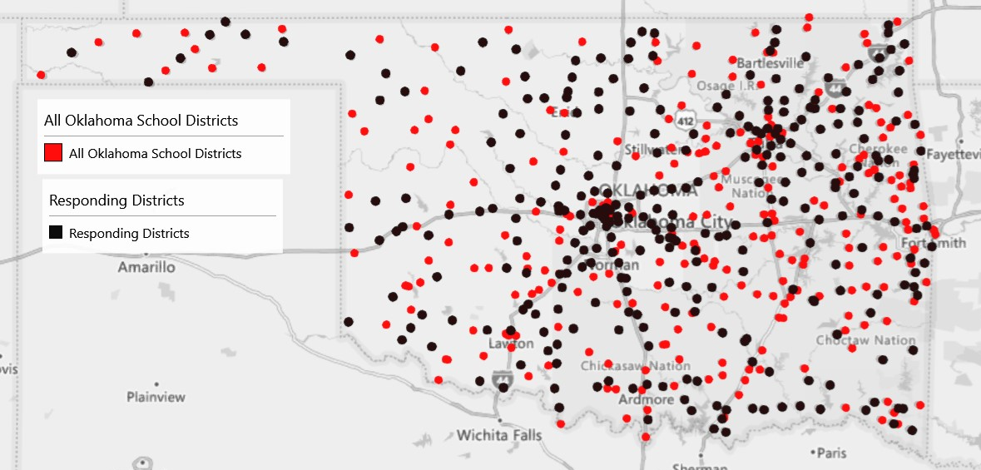
Data Collection
Permission to collect data was obtained from the University of Oklahoma Institutional Review Board (IRB) (Appendix H). Although this was a voluntary survey, maintaining high levels of confidentiality was a great concern. Therefore, during the IRB process, there was full disclosure that self-reported sexual orientation status was part of the collection process and was reported in the privacy and confidentiality of the IRB application (Appendix I). Survey participants were notified of this in the online consent form and through email notification:
The survey should only take 10 minutes and is intended to measure individual perceptions of school safety. The survey will ask you to share your years of experience as a teacher, your school district, gender, race and ethnicity, and self-identified sexual orientation status. Your responses will be confidential, and under no circumstances will any information about you or your school district be disclosed.
The researcher ensured the confidentiality of survey respondents by limiting identifiable information. The only identifiable information asked of survey respondents was to identify their school district. All data were collected using a secure portal in Qualtrics, and all data were transferred via a secured network connection and encrypted files. All research records were coded and reviewed using a private internet connection. All electronic data were accessed via a secure password and stored on a secured network. The survey was open for responses from October 17, 2021, to January 18, 2022. The survey sample recorded 1,867 teacher responses from 299 school districts. The data clean-up process resulted in a final sample size of 1,605 teacher responses.
Survey Design
The survey questions included sampled items from The National Teacher and Principal Survey, The Schools and Staffing Survey, and the Survey on School Crime and Safety (U.S. Department of Education, 2017). In addition, the variables were selected from previous literature on school safety (see Table 2). Table 3 outlines the variables selected for analysis, their relationship to the research questions, and the items found on the survey.

Table 3. Variables, Research Questions, and Items on a Survey
Variable Name | Research Question | Item on Survey
Control variable: Gender | Is there a relation between a teacher’s identified sexual orientation and perceived school safety, controlling for individual, school, neighborhood, and societal factors? | See section on Demographic Questions, Item 3.
Control variable: Years of experience | Is there a relation between a teacher’s identified sexual orientation and perceived school safety, controlling for individual, school, neighborhood, and societal factors? | See section on Demographic Questions, Item 1.
Control variable: Race/ethnicity | Is there a relation between a teacher’s identified sexual orientation and perceived school safety, controlling for individual, school, neighborhood, and societal factors? | See section on Demographic Questions, Item 2.
Independent variable: Sexual orientation | Is there a relation between a teacher’s identified sexual orientation and perceived school safety, controlling for individual, school, neighborhood, and societal factors? | See section on Demographic Questions, Item 4.
Control variable: School district | Is there a relation between a teacher’s identified sexual orientation and perceived school safety, controlling for individual, school, neighborhood, and societal factors? | See Block 5, Item 2.
Composite variable: Perceived physical safety | Is there a relation between a teacher’s identified sexual orientation and perceived school safety, controlling for individual, school, neighborhood, and societal factors? | See section on Perceived Physical Safety, Items 1, 2, 3, 4, and 5.
Composite variable: Teacher victimization | Is there a relation between a teacher’s identified sexual orientation and perceived school safety, controlling for individual, school, neighborhood, and societal factors? | See section on Teacher Victimization, Items 1, 2, 3, 4, 5, and 6.
Composite variable: Perceived emotional safety | Is there a relation between a teacher’s identified sexual orientation and perceived school safety, controlling for individual, school, neighborhood, and societal factors? | See section on School Environment, Items 1, 2, 3, and 4.  See Block 5, Item 1.

Survey Population and Sample
LGB Status
The population of this study was all Oklahoma public school teachers who identified as both LGB and non-LGB. To determine whether the sample in the survey of LGB teachers was representative of the population of LGB teachers in Oklahoma, the research had limited empirical findings that defined the population of LGB teachers. The widely used General Social Survey has asked survey respondents to self-report their sexual orientation status since 2008; however, the U.S. Census does not ask participants to report sexual orientation status or anything beyond binary gender options of male or female (Wang, 2017). Nationally, however, in July 2021, the U.S. Census Bureau did begin to include questions regarding sexual orientation and gender identity on the Household Pulse Survey (HPS) and noted that 4.4% of respondents identified as bisexual and 3.3% of respondents identified as gay or lesbian (Anderson et al., 2021). Before the HPS, Gallop polling estimated that about 4.5% of the U.S. population identified as LGBT, with 5.1% of women identifying compared with approximately 3.9% of men (Newport, 2018). For a state-level analysis, Mallory and Sears (2019) reported that approximately 114,000 adults reported being LGBT, or 3% of the population in Oklahoma.
To define a representative sample, the researcher used the statistical information from Gallop’s 2017 polling data, the HPS survey (2021), and the Mallory and Sears calculation (2019) combined with Harbeck’s (1997) theory and determined that teachers within Oklahoma who likely identified as LGB was approximately 1,900 to 4,200 teachers, or 3%–9% of the teaching population (Newport, 2018). The sampled respondents maintained similar results as those previously theorized or statistically analyzed population samples (see Table 4). The raw survey data resulted in 6.8% of respondents identifying as lesbian, gay, or bisexual. When all missing responses were removed, the results indicated that 7% of respondents were LGB (Table 4).
Table 4. Self-Identified Sexual Orientation Status
 | n | %
Straight | 1492 | 92.96
Gay/lesbian/bisexual | 113 | 7.04

Teacher Sample
Gender, years of experience, and race and ethnicity were all self-reported variables. The survey sample was compared to statewide and national variables of public-school teachers (Table 6). The self-reported variable of years of experience was recategorized using a similar categorical structure by the National Center for Education Statistics (National Teacher and Principal Survey, 2021) (Table 6):
- Fewer than 3 years of teaching experience
- Three to 9 years of teaching experience
- Ten to 20 years of experience
- More than 20 years of experience
Most survey respondents reported having 3–9 years of experience (M = 0.32) or ten to twenty years (M = 0.33). The smallest sample in the study were teachers with fewer than three years of experience (M = 0.07). Survey respondents were also asked to self-identify their racial background. The survey allowed teachers to self-select from a standard list of races and ethnicities or write “other.” A significant amount of data clean-up was needed to use this item for analysis because the selection was not limited to one; instead, the survey respondent could have selected multiple items. First, the researcher recoded the responses (see Appendix C), then conducted an analysis to determine the predominant categories reported. Next, the researcher identified responses as “White” in any category and responses that did not include “White.” Then the researcher created dummy variables for teachers who identified as (1) White and teachers who identified as (0) non-White (Table 6).

Table 5. Percent Comparison Individual Factors
 | Survey Sample | Oklahoma Population | U.S. Population
Individual Factors | % | % | %
Gender
Female | 80.4 | 78.3 (-2.1) | 76.49 (-3.91)
Male | 19.0 | 21.7 (+2.7) | 23.51 (+4.5)
Years of Experience
Fewer than 3 years | 6.9 | 9.8 (+2.9) | 9.9 (-3)
3 to 9 years | 32.3 | 33.01 (+0.71) | 28.3 (-4)
10 to 20 years | 32.6 | 36.9 (+4.3) | 39.2 (+6.6)
Over 20 years | 28.2 | 23.3 (-4.9) | 22.5 (-5.7)
Race and Ethnicity
Non-White | 21.2 | 19.9 (-1.3) | 20.6 (-0.6)
White | 78.5 | 79.8 (+1.3) | 79.3 (+0.8)
Note: Average difference between the survey and U.S. +/- 3.6%; average difference between the survey and Oklahoma +/- 2.5%
U.S. Department of Education (2017); U.S. Department of Education (2021); U.S. Department of Education (2018).

Table 6. Descriptive Statistics: Control Factors
 | n | % | M | SD
Years of Experience | 1605 |  | 14.7 | 10.26
Fewer than 3 years | 111 | 6.9 | 0.07 | .25
3-9 Years | 518 | 32.3 | 0.32 | .47
10 to 20 Years | 524 | 32.6 | 0.33 | .47
21 Years or More | 452 | 28.2 | 0.28 | .45
Teacher’s Race/Ethnicity
Non-White Respondents | 340 | 21.2
White Respondents | 1260 | 78.5
Teachers & Locale
Urban teachers | 446 | 27.8
Suburban teachers | 396 | 24.7
Rural teachers | 763 | 47.5
District Enrollment (students)
Greater than 10,000 | 723 | 67.5 | 0.45 | 0.50
Fewer than 250 | 39 | 3.6 | .02 | 0.15
Fewer than 1,000 | 309 | 28.8 | 0.19 | 0.39
Note: Five respondents abstained from identifying their race/ethnicity.
District Sample
Survey respondents were asked to self-identify their school district. This identification allowed the researcher to obtain publicly available data on Oklahoma school district demographics: student race and ethnicities, total enrollment, reading remediation, percentage of English learners, percentage of special education students, drop-out percentages, and free and reduced lunch percentages (Oklahoma School Profiles, 2020).

Table 7. Sociodemographic comparison of survey sample to total districts in Oklahoma
 | Survey Sample |  |  |  |  |  | Total Oklahoma Districts
 | n |  | Min | Max | M | n |  | Min | Max | M
Variables | 300* |  |  |  |  | 518*
White |  |  | 0.9 | 87.7 | 52.9 |  |  | 0.0 | 448.6 | 54.10
Black |  |  | 0.0 | 84.7 | 3.81 |  |  | 0.0 | 84.70 | 3.10
Asian |  |  | 0.0 | 14.2 | 0.98 |  |  | 0.0 | 14.20 | 0.79
Hispanic |  |  | 0.0 | 94.8 | 12.7 |  |  | 0.0 | 116.3 | 11.20
Native American |  |  | 0.0 | 87.4 | 19.5 |  |  | 0.0 | 89.90 | 21.80
Two or more |  |  | 0.0 | 31.5 | 9.44 |  |  | 0.0 | 39.70 | 9.51
Total enrollment |  |  | 74 | 35,897 | 1971.08 |  |  | 32 | 35,897 | 1278.21
Reading Remediation (%) |  |  | 0 | 100 | 38.83 |  |  | 0 | 100 | 38.72
Drop-Out Rates (%) |  |  | 0 | 33 | 6.68 |  |  | 0 | 44 | 6.50
EL Students |  |  | 0 | 50 | 4.2 |  |  | 0 | 57.1 | 3.3
Special Education Students |  |  | 4.4 | 39.8 | 18.45 |  |  | 4.4 | 43.2 | 19.78
Free & Reduced Lunch |  |  | 8 | 100 | 66.10 |  |  | 8 | 100 | 70.10
Note: Some districts were EC-8 or did not report to the Oklahoma State Department of Education
The researcher used NCES ratings to analyze all ten types of districts and compare the survey results with the total population of districts in Oklahoma (Table 8). The researcher recoded the NCES identifiers to the three main types: rural, suburban, and urban. These results were compared with the total population of public-school districts in Oklahoma (Table 8).
Also, total district enrollment was analyzed using NCES groupings (Appendix K), using three dummy variables of less than 250 students, fewer than 1,000 students, and more than 10,000 students. Descriptive statistics were generated for each variable (Table 7).

Table 8. Geographic comparison of survey sample to total school districts in Oklahoma
 |  |  | Survey Sample Districts |  |  | Oklahoma School Districts
 | n | % | M | SD | n | % | M | SD
NCES Descriptors | 299 |  | 7.39 | 2.345 | 541 |  | 7.62 | 2.275
City large | 12 | 4.0 |  |  | 24 | 4.4
City small | 1 | 0.3 |  |  | 2 | 0.4
Suburban large | 19 | 6.3 |  |  | 25 | 4.6
Suburban midsize | 2 | 0.7 |  |  | 4 | 0.7
Town remote | 24 | 8.0 |  |  | 32 | 5.9
Town distant | 38 | 12.7 |  |  | 48 | 8.9
Town fringe | 10 | 3.3 |  |  | 11 | 2.0
Rural remote | 62 | 20.7 |  |  | 137 | 25.3
Rural distant | 94 | 31.3 |  |  | 196 | 36.2
Rural fringe | 37 | 12.3 |  |  | 62 | 11.5
Locale Comparisons
Urban | 13 | 4.3 |  |  | 17 | 3.3
Suburban | 21 | 7.0 |  |  | 24 | 4.6
Rural | 266 | 88.7 |  |  | 477 | 92.1

Neighborhood Sample
Neighborhood factors were identified by sampling previous empirical research on disadvantaged urban neighborhoods (Hamlin & Li, 2020; Sampson, 2012). Variables included in the analysis of “neighborhood factors” were selected social conditions, a school district’s county-level crime data, and selected economic conditions. One of the selected social conditions identified was the construct of parental involvement information obtained using two data points within the Oklahoma Educational Quality Reports. First, districts were asked to report the percentage of parents attending parent/teacher conferences. Second, districts were asked to report the ratio of patrons’ volunteer hours per student. These two datasets represent one narrow measure of the larger concept of “parental involvement.” Using this narrow dataset, the researcher generated summary statistics for each variable and a comparison chart (Tables 9).
The other selected social condition was educational attainment. Educational attainment data were generated using the U.S. Census Bureau, 2016–2020 American Community Survey 5-Year Estimates. Education attainment measured in the dataset reflected residents residing in the school district boundaries who had received less than a 9th-grade education, received a high school diploma or GED, completed their associate degree, and completed a graduate or professional degree (Table 9).
A school district’s county-level crime data were selected from the FBI database. First, the researcher combined all reported crimes by county and generated a variable that represented all reported FBI crimes by county per 1,000 residents. Next, the researcher identified violent crimes (murder and non-negligent manslaughter, rape, robbery, aggravated assault, property crime, burglary, larceny–theft, motor vehicle theft, and arson) and generated a second variable that summed up violent crimes by county per 1,000 residents (Table 9).
Two selected economic conditions were used for analysis and were generated by data from the U.S. Census Bureau, 2016–2020 American Community Survey 5-Year Estimates. First, the economic conditions measured in the dataset reflected residents residing in the school district boundaries’ median and mean income levels. Therefore, means and standard deviation data were generated for these conditions (Table 9). Next, the researcher added the previously identified district-level factor of students receiving free and reduced lunch and added it to one of the economic factors explored in the economic conditions within neighborhoods. It is notable that there were school districts with no data associated with their district; the researcher used available data in the next closest school district within the county for analysis.
Table 9. Neighborhood Descriptors
 | M | SD
Parental Involvement
Parent/Teacher Conferences Attendance (%) | 70.70 | 11.40
Patron Volunteer hours per student | 1.72 | 2.02
Educational Attainment
Less than 9th grade | 4.00 | 2.75
High school diploma | 87.21 | 4.62
Associate degree | 8.13 | 2.21
Graduate/professional degree | 9.80 | 5.30
Income Levels
Median Income | $51,868 | $13,753
Mean Income | $67,585 | $16,126
Crime Data
FBI Violent Crimes | 1.73 | 1.27
FBI All Crimes | 0.66 | 7.53
Note: Survey districts are represented in this data set.
Variable Descriptions
Dependent variables
Teacher Perceived Physical Safety. Survey language available in the School Survey on Crime and Safety (SSOCS) used a 5-point Likert scale of happens daily, once a week, once a month, on occasion, or never happens to measure disciplinary problems and actions (U.S. Department of Education, 2018a). This research survey sampled language from three of the 11 disciplinary problems and actions identified on the SSOCS:
(1) student verbal abuse of teachers
(2) student acts of disrespect of teachers other than verbal abuse
(3) widespread disorder
The National Teacher and Principal Safety Questionnaire used a 4-point Likert scale measuring agreement on statements related to school climate and teacher attitudes (U.S. Department of Education, 2021). This survey sampled two of the seventeen questions for this section of the conceptual framework:
(1) The level of student misbehavior in this school (noise; horseplay; or fighting in the halls, cafeteria, or student lounge) interferes with my teaching.
(2) Rules for student behavior are consistently enforced by teachers in this school, even for students who are not in their classes.
Validity and reliability. I combined responses from the three sample questions from SSOCS and the two sample questions from the National Teacher and Principal Survey to construct the composite variable of Teacher Perceived Physical Safety. The Cronbach’s alpha was 0.84, supporting combining these items into a single measure (Table 10).
Table 10. Cronbach’s Alpha for Dependent Variables
Scale | No. of Items | α | Lower Boundary | Upper Boundary
Teacher perceived physical safety | 5 | 0.84 | 0.83 | 0.85
Teacher victimization | 4 | 0.78 | 0.77 | 0.80
Teacher perceived emotional safety | 5 | 0.71 | 0.69 | 0.73

Teacher Victimization. The survey sampled questions from Section 7 of the NTPS to measure teachers’ experiences related to threats or physical assaults from students (National Teacher and Principal Survey, 2021). The questions asked teachers to respond yes or no to threats or physical injury incidents:
- During your career as a teacher, has a student ever threatened to injure you?
- Has a student from your current school threatened to injure you?
- During your career as a teacher, has a student ever physically attacked you?
- Has a student from your current school physically attacked you?
Validity and reliability. The researcher combined these variables to create the composite variable of teacher victimization and used historical and current incident reports to adequately measure the potential rates of victimization experienced by teachers. The first subset of responses restricted attacks or threats within the current school; the second subset of responses removed the restrictive language and allowed teacher respondents to report any incidents of victimization during their careers (Curran et al., 2017). Construct validity was established through factor analysis and was at an adequate level, with a Cronbach’s alpha of 0.78, providing support for combining these results into a single measure (Table 10).
Perceived Emotional Safety. Empirically, the concept of school climate is interrelated with the broad conceptual application of school safety and teacher perceptions (Blum et al., 1989; Furlong et al., 1991; Furlong et al., 2005; Skiba et al., 2004). Therefore, the third section of the conceptual framework used for this research survey focused on measuring aspects of social-emotional safety, support received from stakeholder groups, and relationships as additional components of perceptions of school safety (Bosworth et al., 2011; Lacoe, 2015). The survey design set out to measure the third composite variable of teacher-perceived emotional safety and the application of “supportive relationships” and applied it to the concept of “outness” expressed by LGB teachers (Connell, 2012; Gray, 2013; Jackson, 2007; Juul & Repa, 1993; Khayatt, 1997; Wright, 2010; Wright & Smith, 2015).
The survey design sampled language from a series of questions from Section 7 of the NTPS focusing on school climate and teacher attitudes using a 5-point Likert scale:
- I receive a great deal of support from parents for the work I do.
- I am generally satisfied with being a teacher at this school.
The survey design used the same question measuring support from parents and substituted the stakeholder parent with the stakeholder teacher (Appendix A):
- I receive a great deal of support from teachers for the work I do.
The research survey design sampled language from the NTPS survey related to the concept of job security. The NTPS survey asked teacher respondents to react to the statement,
- I worry about the security of my job because of the performance of my students or my school on state and/or local tests.
The survey research design sampled the question stem by surveying teacher respondents to measure whether they are concerned about the concept of job security and removed the language related to performance on state testing:
- I worry about the security of my job.
The final question of the survey design used to create the composite variable of emotional safety was a straightforward question related to “feeling safe at school” (Appendix A). This question stemmed from the comprehensive analysis of the literature on measuring teacher perceptions of school safety and LGB teachers’ perceptions of school safety. Previous studies have shown a great deal of inconsistency and complexity when measuring teacher perceptions of safety (Finley, 2003; Fisher & Kettl, 2003; Ricketts, 2007). However, “feeling safe” is central to measuring a teacher’s perception of emotional safety (Astor et al., 2010; Gottfredson et al., 2005; Martin et al., 1999; Thapa et al., 2013).
Validity and reliability. The researcher combined the responses to the questions that measured perceived emotional safety to create the third composite variable. The reliability statistic showed adequate validity with a Cronbach’s alpha of 0.71, providing support for combining these results into a single measure (Table 10).
Independent variables
The survey was designed to collect data on the demographic characteristics of respondents to analyze individual factors previously explored within school safety perceptions (see Table 2). First, the survey asked participants to self-identify what the researcher had selected as individual control factors: gender, years of experience, race/ethnicity, and sexual orientation (Appendix A). For this research, sexual orientation was used as the independent variable. Gender identity was a control factor explored because it had been used in previous research, but the survey asked for gender identity in four ways: male, female, other, or prefer not to answer. The fourth option, “prefer not to answer,” was not intended to analyze gender identity related to transgender identification but served as an optional step for participants to further protect their anonymity and privacy.
School-level factors were identified as control factors. However, the researcher took steps to maintain the anonymity and privacy of the survey participants and only asked them to identify their school district instead of their school. Although this resulted in a limitation of the analysis, the researcher had to weigh the concerns of ensuring LGB teachers felt comfortable responding to the survey and ensuring that all identifiable information was protected. Therefore, this change resulted in analyzing district-level factors instead of school-level factors. The factors considered possible control variables for district analysis were obtained using publicly available district data (Oklahoma School Profiles, 2020):
- total district enrollment
- type of district
- student race and ethnicity
- free and reduced lunch percentages
- percentage of students identified as English learners
- percentage of students identified as receiving special education services
- percentage of parents attending conferences per district
- percentage of students identified as drop-outs within a 4-year cohort
- reported discipline offenses tracked by the Office of Civil Rights Data Collection
Neighborhood factors were conceptualized using previous research structures (Hamlin & Li, 2020; Sampson, 2012). The researcher combined county-level and district-level data to select the neighborhood control variables. The neighborhood control factors selected were identified through publicly available data sets (Federal Bureau of Investigation, 2019; U.S. Census Bureau, 2020):
- educational attainment averages per district
- median and mean household income per district
- calculation of all crimes by county per 1,000 residents
- calculation of selected “violent crimes” by county per 1,000 residents
The research question also identified a final control factor of societal factors. However, this survey collected responses from October 2021 through January 2022. During this time, no significant or “mediatized” school shooting occurred in Oklahoma or nationally (Elsass et al., 2015; School Shootings, 2022).
LGB Outness. Previous research on the experiences of LGB teachers suggests that teachers are not “open” with their colleagues about their sexual orientation status (Juul and Repa, 1993; Smith et al., 2008; Toledo & Maher, 2021). However, research suggests supportive relationships are a vital component of teacher emotional safety within a school setting (Bosworth et al., 2011; Connell, 2012; Lacoe, 2015; Sears, 2002; Smith, et al., 2008). Although empirical studies are limited, this study set out to measure whether self-identified LGB teachers are “open” about their sexual orientation status and whether this “openness” relates to an increase in perceptions of support by asking two questions related to participants’ levels of “outness” if participants selected gay, lesbian, or bisexual as an option (Connell, 2012; Gray, 2013; Jackson, 2007; Juul & Repa, 1993; Khayatt, 1997; Wright, 2010; Wright & Smith, 2015).
These “outness” measures were intended to determine how many teachers or school staff know about their sexual orientation and how many students know about their sexual orientation (Appendix A). The survey responses were separated into five categorical options:
- (0) No teachers or students are aware.
- (1) One teacher or student is aware.
- (2) Between two and five teachers or students are aware.
- (3) Between six and ten teachers or students are aware.
- (4) More than ten teachers or students are aware of their sexual orientation status.
Data Analysis
As previously noted, the conceptual framework served as the research design and statistical analysis conduit. The researcher used the IBM software of SPSS to perform all statistical tests on the data. A series of regression models were performed to examine the associations between LGB status and the three dependent variables- perceived physical safety, perceived emotional safety, and teacher victimization- controlling for individual, district, and neighborhood factors.
Teacher Perceived Physical Safety
This study set out to measure whether there was a difference in LGB and non-LGB teachers’ perceptions of physical safety. First, the composite variable of teacher perceived physical safety was generated by standardizing the five survey responses. Then the researcher combined all standardized survey responses to create the composite variable of teacher-perceived physical safety and generated summary statistics (Table 11). The composite dependent variable of perceptions of physical safety should be interpreted with the understanding that the greater the mean, the more positive the perceptions of physical safety.
Teacher Victimization
In this study the researcher set out to measure whether there was a difference between LGB and non-LGB teachers’ experiences with teacher victimization. First, the researcher generated the composite variable of teacher victimization by standardizing the four survey responses. Then, the researcher combined all standardized survey responses to create the composite variable of teacher victimization and generated summary statistics (Table 11). The composite dependent variable of teacher victimization should be interpreted with the understanding that the greater the mean, the greater the incidents of victimization.
Teacher Perceived Emotional Safety
In this study the researcher set out to measure whether there was a significant difference between LGB and non-LGB teachers’ perceived emotional safety. To measure this, the researcher needed to generate the third composite variable. First, the researcher standardized the five survey responses related to emotional safety. Next, the researcher combined all five standardized variables to create the composite variable of teacher-perceived emotional safety and generated descriptive statistics (Table 11). The composite dependent variable of teachers’ perceptions of emotional safety should be interpreted with the understanding that the greater the mean, the more positive the perception of emotional safety.
Descriptive Analysis
Individual Factors
Gender. The researcher conducted an independent sample t-test to compare the means of the perceptions of physical safety, teacher victimization, and emotional safety of males and females (Table 12). The researcher tested the empirical consistency of previous studies that found differences in perceptions of school safety between males and females (Fisher & Kettl, 2003; Moon & McCluskey, 2020; Taie & Goldring, 2017; Williams & Corvo; 2005). The literature suggests that females report more physical attacks and violence than their male counterparts (Gerberich et al., 2011; Huang et al., 2020).
Years of Experience. Survey respondents were asked to self-report their years of experience as a teacher. Using the categorical structure of the National Center for Education Statistics, the researcher created dummy variables for each experience level and generated descriptive statistics for analysis (see Table 6). The researcher conducted an ANOVA test to determine whether there was any variable in the mean responses of each experience category and the three composite variables (Table 13).
The researcher tested the empirical consistency of previous research studies that hypothesized that less experienced teachers would report more teacher victimization than more experienced teachers and would have lower rates of perceived physical and emotional safety (Moon & McCluskey, 2020; Taie & Goldring, 2017; Williams & Corvo, 2005). A separate ANOVA analysis was completed to analyze the variance between each survey item that constructed the composite variable of teacher victimization to the teacher’s years of experience (Tables 14, 15).
Race and Ethnicity of Teacher. An independent samples t-test compared the means of White and non-White respondents to the three composite variables (Table 16). The researcher tested the empirical consistency of previous literature on teachers’ race and ethnicity, suggesting that Black teachers were less likely to report victimization incidents than White teachers (McMahon et al., 2014). To test this hypothesis, the researcher created an additional variable for teachers who identified as Black then conducted an independent samples t-test to determine whether there was any statistically significant difference in the mean of teacher victimization of Black teachers compared to non-Black teachers (Appendix D). In addition, the researcher conducted an ANOVA test to analyze the variance of Black and non-Black teachers with each survey item that constructed the composite variable of teacher victimization (Appendix E).
District Factors
Type of District. For analysis, the researcher generated dummy variables for urban, suburban, and rural teacher respondents. The researcher conducted an independent samples t-test to determine whether there were any statistically significant differences between the mean responses of teachers in each school district type and the three composite variables (Table 16).
Total Enrollment. The researcher used publicly available data to identify the total enrollment of each respondent’s identified school district. Using the three dummy variables the researcher generated a means comparison for the three composite variables to each dummy enrollment variable (Table 16). The researcher also sought to test the empirical consistency of previous research studies on school safety that suggested that school size can contribute to greater incidents of threats and assaults (Baird et al., 2017; Gottfredson, 2001). A regression analysis determined whether any differences in teacher victimization could be explained by district size (Table 17). The researcher conducted a separate ANOVA analysis to analyze the variance between each survey item that constructed the composite variable of teacher victimization and teachers in districts with more than 10,000 students and districts with less than 1,000 students (Tables 20).
Student Demographics. Using all demographic data and dummy variables created, the researcher grouped the district control factors into four categories: district size, demographics, academic, socio-economic, and discipline data. The researcher conducted a regression analysis to determine any statistically significant differences in survey respondents’ perceptions of school safety that could be explained by district-level control factors (Table 18).
Neighborhood Factors
The researcher conducted a regression analysis to determine any statistically significant differences in survey respondents’ perceptions of school safety that could be explained by the selected neighborhood-level control factors (Table 19).
Analysis of Dependent Variables
Perceived Physical Safety
To determine whether there was a relationship between LGB and non-LGB teachers’ perceptions of physical safety, the researcher constructed a series of regression models that included control factors introduced into the models by individual, district, and neighborhood controls (Table 19). Model 1 added selected individual factors of gender, years of experience, and racial background. Model 2 added the selected district-level factors of urban schools, rural schools, percentage of non-white students, percentage of students receiving special education services, and OCR offenses. Model 3 added the selected neighborhood factors of percentage of students receiving free and reduced lunch, percentage of parents attending conferences, educational attainment of patrons living within the district boundaries, and county-level violent crime data. Many of the control factors were highly correlated. The researcher therefore selected control factors for each model that ensured empirical consistency and maintained collinearity statistics with a tolerance of less than 0.20 or VIF over 5.0.
Teacher Victimization
To determine whether there was a relationship between LGB and non-LGB teachers’ experiences with victimization, the researcher constructed a series of regression models. The regression models included control factors introduced into the models by individual, district, and neighborhood controls (Table 20). Model 1 added selected individual factors gender, years of experience, and racial background. Model 2 added the selected district-level factors of urban schools, rural schools, percentage of non-white students, percentage of students receiving special education services, and OCR offenses. Model 3 added the selected neighborhood factors of percentage of students receiving free and reduced lunch, percentage of parents attending conferences, educational attainment of patrons living within the district boundaries, and county- level violent crime data. Because many of the control factors were highly correlated, the researcher selected control factors for each model that ensured empirical consistency and maintained collinearity statistics with a tolerance of less than 0.20 or VIF over 5.0.
Perceived Emotional Safety
To determine whether there was a relationship between LGB and non-LGB teachers’ perceptions of emotional safety, the researcher constructed a series of regression models. The regression models included control factors introduced into the models by individual, district, and neighborhood controls (Table 21). The same selected controls used in previously identified regression models were applied to perceived emotional safety to ensure empirical consistency and collinearity statistics with a tolerance of less than 0.20 or VIC over 5.0.
Sexual Orientation Status. A significant component of the research was to determine any statistically significant difference between LGB and non-LGB teachers’ perceptions of school safety. However, there is limited empirical evidence available on LGB teachers, specifically in Oklahoma. Therefore, the researcher sought to add to the empirical findings on the experiences of LGB teachers by generating comparison charts related to the previously identified individual factors: type of district and years of experience (Table 22).
Next, the researcher sought to test the empirical consistency of previous research studies on LGB teachers that focused on the awareness of their sexual orientation status by staff and students. The survey asked LGB teacher respondents to identify the number of staff and students who were aware of their sexual orientation status (Figure 3 and Figure 4). The researcher also generated frequency tables to reflect student and staff awareness (Table 23). Additional variables were generated for analyses that included identifying LGB teachers who reported at least one student compared with more than ten students and LGB teachers who reported at least one staff member compared with more than ten staff members (Table 23).
Using the sexual orientation status awareness data, the researcher explored the potential of a statistically significant relationship with the three composite variables without adding individual, district, or neighborhood controls. A series of independent sample t-tests were performed using LGB awareness variables and the three composite variables for perceptions of physical safety (Table 24).
Finally, the researcher reconstructed the previously used regression model to explore the relationship between teacher victimization and LGB status. The researcher substituted the LGB status variable with the awareness variable that reflects LGB teachers who taught in an environment in which more than ten staff and students were aware of their sexual orientation status. The regression analysis explored whether there were statistically significant differences in the mean of teacher victimizations experienced by LGB teachers who were more open with their sexual orientation status compared with LGB teachers who were not open when controlling for the selected individual factors (Table 20).
Job Security. The concept of a supportive school environment is a complex understanding of several important variables. One individual variable the researcher used was job security. First, survey respondents were asked whether they worried about job security (Appendix A). Then, using the Likert-scale data generated by the survey responses, the researcher generated a cross-tabulation using the individual survey question of job security and LGB and non-LGB teacher responses (Table 26). Finally, the researcher conducted an independent samples t-test to determine whether there was a statistically significant difference in the mean of non-LGB teachers’ responses to job security compared to LGB teachers (Table 26).
Feeling Safe. Survey respondents were asked whether they felt safe in school (Appendix A). Using the Likert-scale data generated by the survey responses, the researcher standardized the responses and generated an independent samples t-test to compare the mean of feeling safe of straight teachers to that of LGB teachers (Table 27). Then the researcher replaced the LGB status variable with the LGB awareness variable and regenerated the t-test to compare the means (Table 27).
Limitations
In this study the researcher aimed to understand the experiences of LGB teachers in Oklahoma, but the research was contingent on teachers’ being willing to identify their sexual orientation status. Although there are limited amounts of quantitative data on LGB teachers and safety, the current research suggests a great deal of hesitancy around identifying someone’s sexual orientation status in surveys and other modes (Wright, 2010). In addition, there have been documented historical efforts to dissuade members of the LGB community from becoming teachers (Harbeck, 1997; Williams, 1977). Currently, no laws within the Oklahoma statute provide legal protection for teachers who are identified as lesbian, gay, bisexual, or transgender (Warbelow et al., 2020). The feeling of being not accepted or stigmatized is still prevalent in 2022; however, national polling data has shown an increased acceptance of lesbian, gay, and same-sex couples in the U.S. (Gates, 2006). However, recent polling data from Accelerating Acceptance highlights the limited acceptance of children’s exposure to the LGBT community in a school context. One poll revealed that 30% of non-LGBTQ respondents were “somewhat or very uncomfortable” with their child having a teacher who identified as LGB (GLADD/Harris Poll, 2019). A quick snapshot of Oklahoma and its relationship with the LGB community reveals that although state laws are limited, local ordinances, large corporations within the state, and local universities all have policies related to antidiscrimination for the LGB community (Mallory & Sears, 2019). In addition, an overwhelming number of Oklahoma residents reported feeling that the LGB community is discriminated against in various circumstances (Mallory & Sears, 2019).
The research project gained insight from LGB teachers; however, because of previous empirical warnings, the researcher limited the survey respondents to only identifying their school district and no other personal identifiable factors. In hindsight, the researcher could have asked teachers to identify their school site as opposed to only their district. Without additional quantitative studies, an attempt to normalize the sampling of LGB teachers and efforts to establish a correlational relationship are minimal.

Chapter 5: Results
Introduction
This research study explored the relationship between a teacher’s self-identified sexual orientation and their perceptions of school safety. School safety was conceptualized using a three-pronged framework of perceived physical safety, perceived emotional safety, and teacher victimization (Table 11). The research also relied on previous literature to identify factors related to perceptions of school safety and categorized the factors as individual, district, and neighborhood.

Table 11. Composite Variables
Item description | M | SD | Min | Max | Loading
Perceived Physical Safety | Standardized Variables
The level of student misbehavior in my class (e.g., noise, horseplay, or fighting) interferes with my teaching. | 0 | 1 | -1.33 | 1.56 | 0.79
I am able to enforce the rules for student behavior consistently. | 0 | 1 | -2.76 | 0.95 | 0.69
How often do you feel your class is difficult for you to control? | 0 | 1 | -1.51 | 1.39 | 0.83
How often do students verbally abuse you? | 0 | 1 | -2.50 | 0.82 | 0.77
Teacher Victimization
During your career as a teacher, has a student ever threatened to injure you? | 0 | 1 | -1.1 | 0.93 | 0.74
Has a student from your current school threatened to injure you? | 0 | 1 | -0.61 | 1.60 | 0.78
During your career as a teacher, has a student ever physically attacked you? | 0 | 1 | -0.66 | 1.50 | 0.80
Has a student from your current school physically attacked you? | 0 | 1 | -0.44 | 2.30 | 0.79
Perceived Emotional Safety
I receive a great deal of support from teachers for the work I do. | 0 | 1 | -3.12 | 0.82 | 0.69
I receive a great deal of support from parents for the work I do. | 0 | 1 | -1.86 | 1.36 | 0.67
I am generally satisfied with being a teacher at this school. | 0 | 1 | -2.46 | 0.85 | 0.81
I worry about the security of my job. | 0 | 1 | -2.16 | 0.84 | 0.45
All in all, I feel safe in school. | 0 | 1 | -2.80 | 0.75 | 0.76

Individual Factors
Gender, years of experience, and racial backgrounds of teachers were identified as individual controls for the regression models estimating the relationship between perceived school safety and LGB status. Females reported statistically significantly more incidences of teacher victimization compared to males (P<.009) (Table 12). Compared with teachers with more than 3 years’ experience, teachers with fewer than three years have a statistically significant negative perception of physical safety (M = -0.39, P < .001) (Table 13). Teachers with 3–9 years of experience are associated with statistically significantly more negative perceptions of physical safety (M = -0.12, P < .001) (Table 13). Teachers with more than 20 years’ experience, compared with less experienced teachers, are associated with statistically significantly more positive perceptions of physical safety (M = 0.19; P < .001) (Table 13). Compared with teachers with more and less experience, teachers with 3–9 years of teaching show a statistically significant more negative perception of emotional safety (M = -0.10, P < 0.001) (Table 13). Conversely, teachers with more than 20 years’ experience reported a statistically significantly more positive perception of emotional safety than teachers with less experience (M = 0.11, P < 0.001) (Table 13).
Table 12. Composite Variables and Gender T-Test
 | Physical Safety |  |  | Teacher Victimization |  |  | Emotional Safety
Gender | M | SD | p | M | SD | p | M | SD | p
 |  |  | .38 |  |  | .009** |  |  | .552
Male | 0.04 | 0.80 |  | -0.10 | 0.73 |  | 0.17 | 0.70
Female | 0.005 | 0.77 |  | 0.03 | 0.79 |  | 0.009 | 0.189
N = 1605 * P < 0.05; ** P < 0.01; *** P < 0.001 (two-tailed tests).

Table 13. Analysis of Variance with Years of Experience and Dependent Variables
Physical Safety |  |  |  |  |  | Teacher Victimization |  |  |  | Emotional Safety
 |  | M | SD | p | η_{p}2 | M | SD | p | η_{p}2 | M | SD | p | η_{p}2
Fewer than 3 years |  |  |  | <.001*** | .018 |  |  | .007** | .004 |  |  | .653 | .000
Fewer than 3 years | 0 | 0.03 | .77 |  |  | 0.14 | 0.77 |  |  | 0.002 | 0.69
Fewer than 3 years | 1 | -0.39 | .80 |  |  | -0.19 | 0.78 |  |  | -0.03 | 0.63
3–9 years |  |  |  | <.001*** | .011 |  |  | .064 | .002 |  |  | <.001*** | .01
3–9 years | 0 | .058 | 0.77 |  |  | 0.24 | 0.77 |  |  | 0.05 | 0.67
3–9 years | 1 | -0.12 | 0.78 |  |  | -0.52 | 0.80 |  |  | -0.10 | 0.70
10–20 years |  |  |  | .229 | .001 |  |  | .011* | .004 |  |  | .816 | .000
10–20 years | 0 | -0.16 | 0.79 |  |  | -0.34 | 0.77 |  |  | -0.003 | 0.69
10–20 years | 1 | 0.03 | 0.77 |  |  | 0.07 | 0.77 |  |  | 0.006 | 0.67
More than 20 years |  |  |  | <.001*** | .024 |  |  | .435 | .000 |  |  | <.001*** | .011
More than 20 years | 0 | -0.08 | 0.79 |  |  | -0.009 | 0.79 |  |  | -0.45 | 0.68
More than 20 years | 1 | 0.19 | 0.73 |  |  | 0.02 | 0.75 |  |  | 0.11 | 0.66
N = 1605 * P < 0.05; ** P < 0.01; *** P < 0.001 (two-tailed tests).

The results of the ANOVA analysis of each survey item that constructed teacher victimization show less experienced teachers reported statistically significantly fewer threats and assaults (M = -0.19, P = 0.007) (Table 14). In addition, the results, which must be interpreted with caution, indicate that when asked whether students had ever threatened or assaulted them, teachers with fewer than 3 years’ experience reported a statistically significant difference in experiencing far fewer threats and assaults by students (P < 0.001 and P = 0.001) (Table 14). This difference is likely a factor of teaching experience rather than actual threats or assaults. When isolating whether a student has ever threatened a teacher, teachers with more than 21 years’ experience reported a statistically significant difference in threats compared with teachers with 20 or fewer years (M = 0.133; P < 0.001) (Table 15).
Table 14. Analysis of Variance for Threats and Attacks by Less than Three Years
 | 0-3 years |  | More than three years
 | M | SE | M | SE | p
Student ever threatened you | -0.42 | 0.89 | 0.03 | .026 | <.001***
Current students ever threatened you | -0.22 | 0.91 | 0.002 | .026 | .811
Student ever physically attacked you | -0.30 | .077 | 0.22 | .026 | .001**
Current students ever attacked you | -0.03 | .093 | 0.002 | .026 | .754
N = 1605 * P < 0.05; ** P < 0.01; *** P < 0.001 (two-tailed tests)

Table 15. Analysis of Variance for Threats and Attacks by Teachers With More Than 20 Years’ Experience
 | 21 Years or More |  | Fewer Than 21 Years
 | M | SE | M | SE | p
Student ever threatened you | 0.133 | 0.046 | -0.05 | 0.03 | <.001***
Current students ever threatened you | -0.01 | 0.047 | 0.005 | 0.03 | .755
Student ever physically attacked you | 0.4 | 0.048 | -0.16 | 0.03 | .293
Current students ever attacked you | -0.067 | 0.044 | 0.03 | 0.03 | .096
N = 1605 * P < 0.05; ** P < 0.01; *** P < 0.001 (two-tailed tests).
Table 16 presents empirical findings related to a teacher’s self-identified racial background and found a statistically significant difference between non-White and White teachers in their perceptions of physical safety and teacher victimization (Table 16). There were statistically significant differences between the perceptions of physical safety between White and non-White teachers (P = .018). Non-White teachers were statistically significantly associated with more positive perceptions of physical safety (M = 0.11) compared with White teachers, who reported more negative perceptions (M = -0.017). Non-White teachers reported statistically lower teacher victimization rates (M = -0.10) than White teachers (M = 0.016, P=0.041).
District-Level Factors
School locale, percentage of white students, percentage of special education students, and Office of Civil Rights reported discipline offenses were identified as district controls for the regression models estimating the relationship between perceived school safety and LGB status. Table 16 shows that teachers in urban school districts showed a statistically significant difference in their perceptions of school safety compared with teachers in rural and suburban districts. Urban teachers reported a more negative perception of physical and emotional safety and higher rates of teacher victimization (P=<.001). Rural teachers had a statistically significant difference in their perceptions of school safety compared with teachers in urban and suburban schools. They reported higher rates of physical safety, fewer incidents of threats at assaults, and higher rates of emotional safety than their urban and suburban counterparts (P=<.001).
District enrollment was also analyzed but was removed for the full regression model as a district control. However, the results of the means comparisons showed a statistically significant difference in teachers at schools with more than 10,000 students compared with teachers at schools with fewer than 10,000 students (P=<.001). Teachers at larger schools reported more negative perceptions of physical and emotional safety and more incidents of teacher victimization. Teachers in schools with fewer than 1,000 students reported a more positive perception of physical and emotional safety and fewer incidents of teacher victimization.

Table 16. Independent Samples T-Tests
 | Physical Safety |  |  | Teacher Victimization |  |  | Emotional Safety
 | M | SD | p | M | SD | p | M | SD | p
Teacher Race |  |  | .018* |  |  | .041* |  |  | .735
Non-White | 0.11 | 0.72 |  | -0.10 | 0.74 |  | 0.015 | 0.69
White | -0.017 | 0.79 |  | 0.016 | 0.78 |  | -0.002 | 0.68
Urban Teachers |  |  | <.001*** |  |  | <.001*** |  |  | <.001***
Non-urban | .070 | 0.75 |  | -0.52 | 0.76 |  | 0.05 | 0.66
Urban | -0.18 | 0.83 |  | 0.14 | 0.81 |  | -0.14 | 0.71
Suburban Teachers |  |  | .256 |  |  | .213 |  |  | .651
Non-sub. | 0.012 | 0.79 |  | -0.014 | 0.77 |  | -.004 | 0.69
Sub. | -0.39 | 0.77 |  | 0.042 | 0.80 |  | 0.013 | 0.67
Rural Teachers |  |  | <.001*** |  |  | <.001*** |  |  | <.001***
Non-rural | -0.11 | 0.80 |  | 0.09 | 0.80 |  | -0.07 | 0.69
Rural | 0.13 | 0.73 |  | -0.10 | 0.73 |  | 0.07 | 0.66
Enrollment- 10K |  |  | <.001*** |  |  | <.001*** |  |  | <.001***
Fewer than 10K | 0.12 | 0.72 |  | -0.10 | 0.72 |  | 0.08 | 0.65
More than 10K | -0.15 | 0.82 |  | 0.13 | 0.82 |  | -0.10 | 0.70
Enrollment- 1K |  |  | <.001*** |  |  | <.001*** |  |  | <.001***
More than 1K | -0.06 | 0.78 |  | 0.05 | 0.80 |  | -0.35 | 0.68
Fewer than 1K | 0.24 | 0.72 |  | -0.21 | 0.65 |  | 0.15 | 0.65
Enrollment- 250 |  |  | .274 |  |  | .034* |  |  | .101
More than 250 | -0.003 | 0.78 |  | 0.006 | 0.78 |  | -.0040 | 0.68
Fewer than 250 | 0.14 | 0.83 |  | -0.26 | 0.60 |  | 0.18 | 0.65
N = 1605 * P < 0.05; ** P < 0.01; *** P < 0.001 (two-tailed tests).

The regression results presented in Table 17 showed that the effect of district size on teacher victimization increases as the district size increases. Not controlling for other factors, school districts with more than 10,000 students show a statistically significant difference in teacher victimization compared with small school districts and reported more incidents of threats and assaults (B=.109, P=<.001). Districts with fewer than 1,000 students had statistically significantly lower teacher victimization rates than larger schools (B=-.078l, P=.006).
Table 17. Regression Analysis of Teacher Victimization and District Size
 | B | SE | p
More than 10K | .109 | .032 | <.001***
Fewer than 1K | -.078 | .057 | .006**
Fewer than 250 | -.012 | .131 | .642
*P < 0.05; ** P < 0.01; *** P < 0.001 (two-tailed tests).
Using only district-level controls in the regression model, physical safety is negatively influenced by larger schools, as previously cited (Table 18). In addition, teachers at larger districts reported higher rates of teacher victimization and lower rates of emotional safety. Drop-out rates also influenced teachers’ emotional safety and negatively affected the perception of emotional safety.

Table 18. District Demographic Data and Composite Variables
 | Physical Safety |  |  |  | Teacher Victimization |  |  |  |  | Emotional Safety
 | β | SE B | p |  | β | SE B |  | p |  | β | SE B | p
District Size
More than 10K students | -0.123 | 0.06 | <.002** | .09 |  |  | .06 |  | .024* | -0.127 | .05 | .001***
Fewer than 1K students | 0.07 | 0.07 | .03* |  | -0.08 | 0.07 |  | .016* |  | 0.03 | .06 | .411
Fewer than 250 students | -.003 | .18 | .89 |  | -0.03 | 0.18 |  | .207 |  | 0.03 | .16 | .349
District Demographics
% of White | -0.13 | .004 | .22 |  | -0.001 | .004 |  | .992 |  | 0.14 | .004 | .165
% of non-White | -0.12 | .004 | .28 |  | 0.05 | .004 |  | .653 |  | .09 | .004 | .396
Academic
% reading remediation | -.041 | .002 | .314 |  | -.064 | .002 |  | .117 |  | -.007 | .002 | .867
% drop-out rates | -.035 | .004 | .377 |  | .05 | .005 |  | .211 |  | -.097 | .004 | .016*
% EL students | .078 | .004 | .193 |  | .026 | .004 |  | .661 |  | .113 | .003 | .06
% special education students | .020 | .008 | .570 |  | .029 | .008 |  | .416 |  | .05 | .007 | .154
Socioeconomic
Free and reduced lunch | -.028 | .002 | .618 |  | -.012 | .002 |  | .831 |  | -.074 | .002 | .189
Discipline Data
Ratio– suspension 10 or fewer days | .050 | .000 | .065 |  | -.005 | .000 |  | .865 |  | .008 | .000 | .758
Ratio– 10 or more days | -.020 | .000 | .447 |  | -.032 | .000 |  | .229 |  | .000 | .000 | .998
OCR offenses | -.008 | .000 | .879 |  | -.006 | .000 |  | .907 |  | .055 | .000 | .326
*P < 0.05; **P < 0.01; ***P < 0.001

Neighborhood Factors
The controls used as neighborhood factors resulted in no statistically significant influence on survey respondents’ perceptions of school safety (Appendix G).
Perceived Physical Safety
Table 19 presents the results of three regression models estimating the relationship between perceived school safety and LGB status. In Model 1, the regression model uses individual controls for gender, years of experience, and racial background. With these controls, the coefficient for LGB status is not a statistically significant predictor of perceived school safety (β = -0.4, P = 0.136). Although it is not statistically significant, there is a small negative association. Teacher experience and race are statistically significant predictors of perceived school safety. Teachers with fewer than three years of experience are associated with a decreased perception of physical safety (β = -0.12, P < 0.001). Teachers with more than 20 years’ experience were associated with an increased perception of physical safety (β = 0.3, P < 0.001). White teachers were associated with a decreased perception of physical safety (β = -0.07, P = 0.005).
In Model 2, district-level sociodemographic background controls are added. With these controls added, there remained no statistical relationship between LGB status and perceived physical safety (β = -0.02, P = 0.544). However, with district and individual controls, teacher experience and race remained statistically significant predictors of perceived physical safety. Teachers with fewer than 3 years’ experience are associated with decreased perceptions of physical safety (β = -0.11, P < 0.001). Teachers with more than 20 years’ experience are associated with an increased perception of physical safety (β = 0.122, P < .0001). White teachers are associated with a decreased perception of physical safety (β= -0.09, P < 0.001). In addition, with district and individual controls, teachers in rural schools are associated with a more positive perception of physical safety (β = 0.96, P = 0.002).
Model 3 introduces neighborhood factors to the regression model. With these controls added, LGB status is not statistically related to perceptions of physical safety (β = -0.01, P = 0.600). However, with the neighborhood, district, and individual controls, teacher experience remains a statistically significant predictor of perceived physical safety. Teachers with fewer than 3 years’ experience are associated with decreased perceptions of physical safety (β = -0.11, P < .001). Teachers with more than 20 years’ experience are associated with an increased perception of physical safety (β = 0.12, P < 0.001). White teachers are associated with a decreased perception of physical safety (β = -0.09, P < 0.001). In addition, with the neighborhood, district, and individual controls, teachers in districts with a surrounding population of educational attainment lower than 9th grade are associated with more positive perceptions of physical safety (β = 0.113, P = 0.002).

Table 19. Regression Models Predicting Perceived Physical Safety
 | Model 1 |  |  | Model 2 |  |  | Model 3
Variable | β | SE B | p | β | SE B | p | β | SE B | p
LGB status | -.04 | .078 | .136 | -.02 | .078 | .544 | -.01 | .078 | .600
Individual Factors
Gender–female | -.02 | .050 | .435 | -.02 | .049 | .385 | -.03 | .049 | .291
Fewer than 3 years’ experience | -.12 | .080 | <.001*** | -.11 | .078 | <.001*** | -.11 | .078 | <.001***
More than 20 years’ experience | .13 | .044 | <.001*** | .122 | .044 | <.001*** | 0.12 | .044 | <.001***
Race Ethnicity: White | -.07 | .057 | .005** | -.09 | .057 | <.001*** | -.09 | .057 | <.001***
District Factors
Urban schools |  |  |  | -.06 | .084 | .245 | -.06 | .085 | .206
Rural schools |  |  |  | .096 | .050 | .002 | 0.05 | .065 | .254
% non-White (district-wide students) |  |  |  | -.03 | .002** | .488 | -.07 | .002** | .207
% special education |  |  |  | .011 | .005 | .677 | .015 | .006 | .628
OCR 0ffences |  |  |  | .004 | .000 | .933 | .009 | .000 | .851
Neighborhood Factors
% free and reduced lunch |  |  |  |  |  |  | -.07 | .002 | .186
% attending parent-teacher conferences |  |  |  |  |  |  | .014 | .002 | .598
Education: less than 9th grade |  |  |  |  |  |  | .113 | .010 | .002**
Education: college degree or higher |  |  |  |  |  |  | -.05 | .005 | .144
Violent crimes |  |  |  |  |  |  | .03 | .020 | .391
Constant | .141 (.066) |  |  | .340 (.140) |  |  | .382 (.237)
R² | .044 |  |  | .071 |  |  | .078
Adjusted R² | .041 |  |  | .065 |  |  | .069
N = 1605 *P < 0.05; **P < 0.01; ***P < 0.001 - Reference category: Suburban

Teacher Victimization
Table 20 presents the results of three regression models estimating the relationship between teacher victimization and LGB status. In Model 1, the regression model uses individual controls for gender, years of experience, and racial background. With these controls, the coefficient for LGB status is not a statistically significant predictor of teacher victimization (β = 0.44, P = 0.084). Gender and teacher experience are statistically significant predictors of incidents of teacher victimization. Females are associated with reporting statistically significantly more incidents of teacher victimization than males (β = 0.058, P = 0.022). Teachers with fewer than three years’ experience reported statistically significantly fewer incidents of teacher victimization (β = -0.057, P = 0.027).
In Model 2, district-level sociodemographic background controls are added. With these controls added, there remained no statistical relationship between LGB and teacher victimization (β = 0.019, P = 0.454). However, with district and individual controls, gender and teacher experiences remain statistically significant predictors of teacher victimization. Females are associated with reporting statistically significantly more incidents of teacher victimization than males (β = 0.059, P = 0.018). Teachers with fewer than 3 years’ experience made statistically fewer teacher victimization reports (β = -0.063, P = 0.014). In addition, with district and individual controls, White teachers reported statistically more incidents of teacher victimization than non-White teachers (β = 0.058, P = 0.022). Also, teachers working in rural schools reported statistically significantly fewer incidents of teacher victimization than teachers in urban and suburban schools (β = -0.092, P = 0.004). Lastly, teachers in districts with a higher percentage of non-White students reported statistically significantly more incidents of teacher victimization (β = 0.104, P = 0.010).
Model 3 introduces neighborhood controls to the regression model. With these controls added, LGB status is not statistically related to teacher victimization (β = 0.013, P = 0.616). However, with neighborhood, district, and individual controls, a teacher’s gender, experience, race, and student race remain a statistically significant predictor of teacher victimization. Females are associated with reporting statistically significantly more incidents of teacher victimization than males (β = 0.060, P = 0.016). Teachers with fewer than 3 years’ experience report statistically fewer teacher victimizations (β = -0.06, P = 0.017). White teachers reported more incidents of teacher victimization than non-White teachers (β = 0.060, P = 0.018). Teachers in districts with a higher percentage of non-White students reported statistically significantly more incidents of teacher victimization (β = 0.16, P = 0.004). In addition, with the neighborhood, district, and individual controls, an increase in parent-teacher conference rates indicates an increase in teacher victimization (β = 0.06, P = 0.023). It is important to note that this relationship should be interpreted with caution. Parent-teacher conferences were part of a more extensive set of controls related to neighborhood factors.

Table 20. Regression Models Predicting Teacher Victimization and LGB Status
 | Model 1 |  |  | Model 2 |  |  | Model 3
Variable | β | SE B | p | β | SE B | p | β | SE B | p
LGB Status | .044 | .08 | .084 | .019 | .08 | .454 | .013 | .08 | .616
Individual factors
Gender–female | .058 | .05 | .022* | .059 | .05 | .018* | .060 | .05 | .016*
Fewer than 3 years’ experience | -.057 | .08 | .027* | -.063 | .079 | .014* | -.06 | .079 | .017*
More than 20 years’ experience | .014 | .045 | .593 | .019 | .044 | .468 | .021 | .044 | .417
Race ethnicity–White | .039 | .058 | .125 | .058 | .058 | .022* | .060 | .058 | .018*
District Factors
Urban schools |  |  |  | -.050 | .085 | .311 | -.05 | .087 | .323
Rural schools |  |  |  | -.092 | .050 | .004** | -.06 | .066 | .165
% non-White (district-wide students) |  |  |  | .104 | .002 | .010* | .160 | .002 | .004**
% special education |  |  |  | -.026 | .005 | .323 | -.001 | .006 | .974
OCR offences |  |  |  | .042 | .000 | .331 | .07 | .000 | .128
Neighborhood Factors
% free and reduced lunch |  |  |  |  |  |  | -.02 | .002 | .684
% attending parent-teacher conferences |  |  |  |  |  |  | .06 | .002 | .023*
Less than 9th grade education |  |  |  |  |  |  | -.05 | .010 | .239
College or graduate degree |  |  |  |  |  |  | .02 | .005 | .660
Violent crimes |  |  |  |  |  |  | -.02 | .028 | .540
Constant | -.172 (.067) |  |  | -.429 (.156) |  |  | -.769 (.241)
R² | .011 |  |  | .038 |  |  | .043
Adjusted R² | .008 |  |  | .032 |  |  | .034
N = 1605 *P < 0.05; **P < 0.01; ***P < 0.001 - Reference category: suburban

Teachers’ Perceived Emotional Safety
Table 21 presents the results of three regression models estimating the relationship between perceived emotional safety and LGB status. In Model 1, the regression model uses individual controls for gender, years of experience, and racial background. With these controls, the coefficient for LGB status is a statistically significant predictor of perceived emotional safety (β = -0.56, P = 0.021). Along with LGB status, teachers with more than 20 years’ experience are associated with an increased perception of emotional safety (β = 0.93, P < 0.001).
In Model 2, district-level sociodemographic background controls are added. With these controls added, LGB status did not have a statistical relationship with perceived emotional safety (β = -0.04, P = 0.120). However, with district and individual controls, teacher experience remained statistically significant predictor of perceived emotional safety. Teachers with more than 20 years’ experience are associated with an increased perception of emotional safety (β = 0.89, P < 0.001).
Model 3 introduces neighborhood factors. With these controls added, LGB status remained not statistically related to perceptions of emotional safety (β = -0.042, P = 0.102). However, teacher experience remained a statistically significant predictor of perceived emotional safety. Teachers with more than 20 years’ experience are associated with an increased perception of emotional safety (β = 0.88, P < 0.001).

Table 21. Regression models predicting perceive emotional safety and LGB status
 | Model 1 |  |  | Model 2 |  |  | Model 3
Variable | β | SE B | p | β | SE B | p | β | SE B | p
LGB Status | -.059 | .069 | .021* | -.040 | .070 | .120 | -.042 | .070 | .102
Individual Factors
Gender–female | .012 | .044 | .623 | .011 | .044 | .675 | .008 | .044 | .760
Fewer than 3 years’ experience | .006 | .070 | .804 | .011 | .069 | .655 | .011 | .070 | .657
More than 20 years’ experience | .093 | .039 | <.001*** | .089 | .039 | <.001*** | .088 | .039 | <.001***
Race ethnicity–White | -.020 | .051 | .421 | -.036 | .051 | .164 | -.036 | .051 | .157
District Factors
Urban schools |  |  |  | -.046 | .075 | .357 | -.044 | .076 | .384
Rural schools |  |  |  | .036 | .044 | .261 | .039 | .058 | .363
% non-White (district-wide students) |  |  |  | -.064 | .001 | .110 | -.045 | .002 | .417
% special education |  |  |  | .017 | .005 | .517 | .045 | .006 | .153
OCR offences |  |  |  | .002 | .000 | .967 | .022 | .000 | .632
Neighborhood Factors
% free and reduced lunch |  |  |  |  |  |  | -.094 | .002 | .096
% attending parent-teacher conferences |  |  |  |  |  |  | .035 | .002 | .203
Less than 9th grade education |  |  |  |  |  |  | .062 | .009 | .106
College or graduate degree |  |  |  |  |  |  | -.018 | .005 | .616
Violent crimes |  |  |  |  |  |  | .001 | .025 | .976
Constant | -.009 (.059) |  |  | .236 (.137) |  |  | -.042 (.211)
R² | .014 |  |  | .032 |  |  | .036
Adjusted R² | .010 |  |  | .026 |  |  | .027
N = 1605 *P < 0.05; **P < 0.01; ***P < 0.001- Reference category: suburban

Sexual Orientation Status
The LGB status of teachers was identified as a key independent variable in the research. Limited demographic data are available on teacher sexual orientation status. Because this is the first research project in Oklahoma specifically asking teachers to self-identify their sexual orientation status, it was important to examine the results of Oklahoma teachers who identified as lesbian, gay, or bisexual. The survey respondents were categorized as LGB or non-LGB and by type of district (Table 22). The results indicated that almost all types of districts had at least one survey respondent who identified as LGB, except for “rural remote.”
Table 22. LGB Distribution
 | Non-LGB | LGB
District Type
City Large | 354 | 53
City Small | 40 | 5
Suburb Large | 297 | 21
Suburb Midsize | 80 | 8
Town Remote | 118 | 5
Town Distant | 196 | 9
Town Fringe | 28 | 1
Rural Remote | 98 | 0
Rural Distant | 190 | 6
Rural Fringe | 107 | 6
Experience
Fewer than 3 Years | 91 | 20
3–9 years | 461 | 57
10–20 years | 502 | 22
More than 20 years | 438 | 14

The survey respondents were categorized as LGB or non-LGB and by years of experience (Table 22). The results indicated that all categories of years of experience had survey respondents who were LGB and non-LGB.
One of the research questions asked LGB teachers to measure their levels of “outness” with their students and school staff (Figures 3 and 4). The results indicate that LGB teachers are more open with their colleagues than with their students (Figures 3 and 4).
Figure 3
LGB “Outness” Among School Staff

Figure 4
LGB “Outness” Among Students

The frequency of staff awareness indicates that approximately 21% of survey respondents have not shared their sexual orientation status with their colleagues, and a similar percentage of survey respondents, 23%, were considered open about their LGB status (Table 23). For analysis purposes, LGB survey respondents who shared their LGB status with at least one staff member were compared to respondents who did not share their status (Table 23). Seventy-eight percent of LGB teacher respondents shared their LGB status with at least one staff member, compared with 21.2% who remained silent about their status.

Table 23. LGB Awareness
 | Frequency | Percent
Staff
No Staff | 24 | 21.2
One staff member | 12 | 10.6
Two to five staff members | 36 | 31.9
Six to ten staff members | 15 | 13.3
More than ten staff members | 26 | 23
Comparisons
At least one staff member knows (compared to none) | 89 | 78.8
More than 10 staff members know (compared to fewer than 10) | 26 | 23
Students
No students | 69 | 61.1
One student | 0 | 0
Two to five students | 11 | 9.7
Six to ten students | 3 | 2.7
More than ten students | 30 | 26.5
Comparisons
At least 1 student knows | 44 | 38.9
More than 10 students know | 30 | 26.5
Note: 61% of LGB teacher respondents did not share their LGB status with students
The frequency of student awareness indicates that more than 60% of survey respondents have not shared their sexual orientation status with their students (Table 23). For analysis purposes, LGB survey respondents who shared their LGB status with at least one student were compared to respondents who did not share their status (Table 23). About 39% of LGB teacher respondents shared their LGB status with at least one student compared with 61.1% who remained silent about their status to their students. In addition, only 26.5% of LGB teacher respondents shared their LGB status with more than 10 students compared to more than 70% who were not considered open to their students.
LGB teachers’ perceptions of school safety indicate a statistically significant difference in reports of teacher victimization when comparing LGB respondents who are “out” to the LGB respondents who are not “out” (P = 0.014; Table 24). In addition, the results suggest that teachers who were more “out” with staff and students reported lower levels of teacher victimization than LGB teachers who had not disclosed their sexual orientation status.
Table 24. Outness and perceptions of school safety
 | Physical safety |  |  | Teacher Victimization |  |  | Emotional Safety
 | M | SD | p | M | SD | p | M | SD | p
Fewer than ten staff and students | -0.25 | .77 |  | 0.168 | 0.79 |  | -.021 | .66
More than ten staff and students | -0.21 | .90 |  | -0.34 | .59 |  | -.22 | .81
Between groups |  |  | .848 |  |  | .014* |  |  | .965

The previous model (Table 20) did not show a statistically significant difference between LGB and non-LGB teachers and their relationship to incidents of teacher victimization. However, without adding any additional control variables, Model 1 indicates that LGB teachers who were “out” in their teaching environments reported fewer incidents of teacher victimization (β = -0.25, P = 0.011) (Table 25). Furthermore, in Model 2, when individual controls were introduced, LGB awareness remained statistically significantly associated with a decrease in reports of teacher victimization (β = -0.252, P = 0.007).

Table 25. Regression model predicting teacher victimization and LGB awareness
 | Model 1 |  |  | Model 2
Variable | β | SE B | p | β | SE B | P
LGB awareness among staff and students | -.25 | .213 | .011* | -.252 | .206 | .007**
Individual factors
Gender–Female |  |  |  | .030 | .202 | .750
Fewer than 3 years’ experience |  |  |  | -.129 | .196 | .173
More than 20 years’ experience |  |  |  | .141 | .213 | .132
Race ethnicity–White |  |  |  | .250 | .239 | .009**
N = 113 *P < 0.05; **P < 0.01; ***P < 0.001 (two-tailed tests).
For this research study, survey respondents were asked if they worried about the security of their job (Appendix F). Results indicate that LGB teachers, compared with non-LGB teachers, are statistically significantly more worried about their job security than their non-LGB colleagues (M = -0.19; P = 0.038; Table 26).
Table 26. T-Test of Job Security and LGB Status
LGB Status | M | N | SD | T | p
 |  |  |  | 2.080 | .038*
Non-LGB | 0.014 | 1492 | .999
LGB | -0.19 | 113 | .993

Feeling Safe. The second concept of emotional safety was defined as feeling safe. Survey participants responded to “All in all, I feel safe at school” (Appendix A). When comparing non-LGB to LGB teachers, the results indicate a statistically significant difference in LGB teachers reporting lower levels of feeling of safety than non-LGB teachers (M = -0.42; P < 0.001; Table 27).

Table 27. Feeling Safe Among LGB and Non-LGB Teachers
 | M | SD | SEM | p
LGB Status |  |  |  | <.001***
Non-LGB | .032 | .99 | .026
LGB | -.42 | 1.06 | .099
LGB Awareness (10) |  |  |  | .904
Fewer than 10 staff and students | -.41 | 1.05 | .11
More than 10 staff  and students | -.45 | 1.13 | .271
LGB Awareness (1) |  |  |  | .419
At least someone knows LGB status (one person) | -.37 | 1.01 | .11
No one knows LGB status | -.60 | 1.22 | .25

Results indicated that although there is a statistically significant difference between LGB and non-LGB teachers’ reported feelings of safety, no such difference exists between LGB teachers and their student and staff awareness.
Chapter 6: Discussion
A teacher’s perception of school safety is a broad concept with overarching definitions that are critical for appropriate analysis. Many scholarly studies have sought to understand individual, school, neighborhood, and societal characteristics associated with teachers’ perceptions of school safety. Yet, very few studies have attempted to explore how LGB status among teachers relates to school safety perceptions. This gap in knowledge is significant because LGB teachers represent a large subgroup within the teacher workforce. To address this gap in the literature, this study analyzed survey responses from 1605 teachers, including 113 LGB teachers, in Oklahoma, investigating the association between LGB status and perceived school safety, perceived emotional, and teacher victimization. With individual controls added, LGB status was not a statistically significant predictor of perceived physical safety (see Table 19). With individual, district-level, and neighborhood controls added, LGB status had no statistical relationship with teacher victimization (see Table 20). With individual controls added, LGB teachers were associated with more negative perceptions of emotional safety compared to their non-LGB teachers while controlling for gender, years of experience, and racial background (see Table 21).
In addition, any findings obtained from the research should be viewed narrowly and not broadly applied because this is one of the first research surveys to ask survey respondents to self-identify their sexual orientation status. Therefore, the discussion chapter will begin with the key component of the research question, sexual orientation status. Then the researcher discusses findings related to LGB teacher status and two essential conceptual understandings of perceived school safety: physical and emotional safety. Then the researcher will highlight the significant findings within the survey relating to years of experience. Finally, the researcher concludes with policy recommendations although these should be interpreted cautiously because of the ever-changing political climate.
The LGB Teacher
There are three significant considerations when attempting to understand the experiences of LGB teachers in Oklahoma. First, LGB teachers are in all types of school districts in Oklahoma. Second, LGB teachers have varying levels of experience. Third, LGB respondents in this survey reported that they do not broadly share their sexual orientation status within their work environment, and more than 60% of the LGB teacher respondents were not open with their students. This finding aligns with previous research that suggests LGB teachers are typically not “open” at school (Ferfolja, 2009; Jackson, 2006; Juul & Repa, 1993; Smith et al., 2008).
McLeroy’s (1988) social ecology model highlighted the significance of community factors and public policy. McLeroy defines community factors as relationships among organizations, institutions, and informal networks with defined boundaries. It is important to consider that Oklahoma is informally defined as a religious state; according to Pew Research, 79% of residents identify as Christian and more than 40% of adults reported attending church at least once a week (Fadel, 2019). Most of the churches attended by Oklahoma residents actively condemn LGB individuals by calling their lifestyle sinful, barring them from leadership, and refusing to marry them (Barnes & Meyer, 2012). Public policy is defined by McLeroy (1988) as local, state and national laws and policies. The only public policy explicitly protecting LGB teachers in Oklahoma was the Supreme Court decision in Bostock. As cited previously, Oklahoma is a state that has passed legislation barring any discussion of sexual orientation or gender identify in any classroom setting (Jones & Franklin, 2022). Because of the community factors and public policy, it is not surprising that although there are LGB teachers in all types of schools, a large majority of those teachers are not public about their LGB status.
The LGB Teacher and Emotional Safety
Although not statistically significant, emotional safety exhibited the strongest negative relationship for LGB teachers. Legate, Ryan, and Rogge (2017) suggested that people who were open about their sexual orientation reported higher rates of autonomy, relatedness, and increased mental and physical health. Conversely, LGB people who are not “out” or feel the need to “hide” something about themselves may experience increased depression or anxiety (Cole et al., 1996; Juster et al., 2013; Pennebaker & Chung, 2011; Schrimshaw et al., 2013). This study did not assess mental or physical health components but narrowly looked at the concept of feeling safe. Isolated findings indicated that LGB survey respondents had a more negative perception of emotional safety, particularly feeling safe at work, compared with non-LGB survey respondents (see Table 27). Another isolated analysis showed that when teachers were asked explicitly about job security, there were statistically significant differences between the responses of LGB teachers and non-LGB teachers. LGB teacher respondents in the survey reported statistically significantly more concerns regarding job security than non-LGB teachers. These findings are similar to broader workplace research that has found increased job security concerns among LGB workers, an increase in discriminatory practices toward LGB workers, and limited state-level protections of LGB workers (Button, 2001; Gray, 2013; King et al., 2008). However, in the full regression model individual, district, and neighborhood controls were added, there was not a statistically significant relationship between LGB status and perceptions of emotional safety (see Table 21). When the additional controls are added to the analysis of LGB teacher’s perceived emotional safety, selection of districts becomes a factor. Additional research would be needed to determine if LGB teachers are choosing to work in districts where they feel safe, and the isolated results related to job security are a reflection of the lack of public policy protections for LGB teachers in the state of Oklahoma.
The LGB Teacher and Physical Safety
As previously noted, most of the survey respondents who identified as LGB in this study had not disclosed their sexual orientation status to their education community. However, it is important to take a step back and consider how a teacher’s identity is formed. First, one’s identity is likely influenced by broader constructs of identity: age, race, religion, and cultural upbringing (Abes, 2012; Mohr & Kendra, 2011). Second, one’s sexual orientation is often “invisible” (Nielsen & Alderson, 2014, p. 1086). Third, a teacher’s identity is a professional construct influenced by the experiences and processes involved in becoming a teacher (Meijer et al., 2014). Cooper (2019) suggested that some argue that sexuality and being an educator are not related. However, there is reason to explore the relationship when considering the heteronormative environment of education: educators are known to celebrate heteronormative norms like marriages and baby showers. It was also noted in the research that there is a toll taken on LGB teachers by their not disclosing any personal information and the potential fear of job loss if they do disclose their identity (Gruberg et al., 2020; Mallory & Sears, 2018; Wright, 2010). However, this study found when adding individual, district, and neighborhood controls, LGB status was not a statistically significant factor in perceptions of physical safety. This research defined perceptions of physical safety through an organizational context, i.e. school disorder. The results suggests because the LGB status is likely unknown, an LGB teacher’s perception of physical safety is likely more related to individual factors like teacher experience and racial background.
The LGB Teachers and Incidents of Victimization
The other component of the research related to perceptions of school safety was teacher victimization. This study found no statistically significant difference between survey respondents identifying as LGB and non-LGB. However, statistically significant differences were found when analyzing the survey respondent’s disclosure of their sexual orientation status among their students and colleagues. In addition, this study found that being more open, or as the research suggests, teaching as one’s authentic self, reported statistically significant fewer incidents of teacher victimization. One conclusion may be tied to previous research that suggests that remaining closeted can lead to negative perceptions of the work environment (Cummings, 2009). For LGB teachers, disclosing their identity to staff and students is a constant, day-to-day process (Cummings, 2009). Conversely, LGB teachers who are open with staff and their students reported far fewer incidents of teacher victimization. These data may suggest that when teachers have relationships and autonomy and feel a sense of connection within their school community, they appear to have fewer victimization incidents. On the other hand, the data could also suggest that their LGB status is largely unknown and hidden, compared to individual factors that are likely more visible to the student population.
This research finding suggested that teachers who are more open with their sexual orientation status experience lower rates of teacher victimization—however, previous LGBT student research has suggested that students who are open about their sexual identity reported an increase in victimization rates (Ferfolja, 2010; Gates, 2006; Gray, 2013; Lineback et al., 2016; Musu-Gillette et al., 2018; Smith et al., 2008; Wright & Smith, 2015). This comparison may be why many researchers note the importance of the representation of diverse teachers and ensuring that LGBT students have an ally in a teacher.
The Experienced Teacher
The results of this research study were highly consistent with previous research that underscored the importance of experience in perceptions of school safety. This study found that when controlling for individual, district, and neighborhood factors, years of experience have a statistically significant relationship with a teacher’s perception of physical safety (see Table 19). In addition, when controlling for individual, district, and neighborhood factors, teachers with fewer than three years’ experience were statistically significantly associated with fewer incidents of victimization. The conclusion that needs to be drawn from these results is not that less experienced teachers are somehow preventing incidents of victimization. The more logical conclusion is that incidents of victimization continue to happen, and the more experience teachers have, the more likely they are to have been threatened or assaulted by a student. However, this study suggests that although experience may lead to more incidents of threats and assaults, this does not mean that an increase in victimization means a teacher has a negative perception of school safety. For example, teachers with more than twenty years’ experience were statistically associated with a more positive perception of emotional safety. These findings appear to be empirically aligned with previous research that found teaching experience to be a control variable associated with more positive perceptions of school safety (Cornell & Huang, 2016; Huang et al., 2020).
Implications and Limitations
One component of this research was to explore the importance of a supportive school environment and its relationship to perceived school safety. The supportive school environment was conceptualized through the concept of emotional safety and is underscored by applying previous findings relating to the benefits of a collaborative and supportive teaching environment (Bosworth et al., 2011; Connell, 2012; Lacoe, 2015; Sears, 2002; Smith et al., 2009). Another component of this research study explored school disorder and teacher victimization and their relations to perceived physical safety. The concept of perceived physical safety was connected to previous empirical findings that suggested teachers who experience more risks to their safety have increased emotional distress and concerns regarding job performance; such issues contributed to teachers leaving the profession (Curran et al., 2015; Galand et al., 2007; Moon et al., 2015; Wilson et al., 2011). This was underscored by ample empirical findings related to the relation of individual, district, and neighborhood control factors to perceptions of school safety.
This entire body of research added one additional variable, LGB status. The study sampled previously used national surveys and selected control factors grounded in empirical findings relating to school safety to explore whether a teacher’s self-identified sexual orientation status was related to perceptions of school safety. It is essential to return to one researcher’s hypothesis that “many argue that sexuality and being an educator have no correlation” (Cooper, 2019, p. 13). However, scores of national research studies ask questions that, when compared without context, have limited correlation to being an educator, questions related to marital status, household income, birth year, student loan debt, stress levels, health perceptions, and hours of sleep per night (National Teacher and Principal Survey, 2021). These research strands were selected because of their importance in broader research studies and their ultimate contribution to more robust research findings intended to inform educators and policymakers.
The likelihood of sexual orientation status being broadly applied to national research studies is minimal. First, the most recent 2020 U.S. Census did not add the variable of self-identified sexual orientation status to its research. Conversely, notable teachers have resigned from the profession because of their LGBT status and negative experiences (Lavietes, 2022; Natanson, 2022; Will, 2022). However, this study, although using a representative sample of Oklahoma teachers, should be applied cautiously. First, several factors likely contributed to a teacher’s perception of school safety, including a worldwide pandemic and students returning to school. Second, there is a great deal of concern around anonymity and confidentiality. The steps to ensure teacher anonymity resulted in the trade-off of not collecting more school-specific data like class size, grade level, certification routes, and school identification (as opposed to district identification). These additional factors may have contributed to more robust findings.
Contributions and Recommendations
There is limited empirical evidence on how experiences change based on sexual orientation (Savin-Williams, 2009). This research intersection shows the gap in understanding how a teacher’s sexual orientation is part of their school safety perceptions. Maslow (1943) noted that physical safety is a basic human need. Ryan and Frederick (1997) added that emotional safety, as a psychological need, is associated with higher rates of integrity and well-being. Leithwood and McAdie (2007) noted that teachers who feel safe perform better. Ensuring that teachers are physically and emotionally safe is an important consideration for a positive school climate and increased teacher efficacy (Bosworth et al., 2011; Lacoe, 2015; Leithwood & McAdie, 2007). This research applied the previous findings related to physical and emotional safety and filtered the analysis through the lens of sexual orientation status.
The findings, albeit limited, should contribute to the body of research in two ways—first, the experiences of teachers matter. Educational researchers should be committed to exploring the factors necessary to keep teachers working in the profession. For example, this study consistently found statistically significant more positive perceptions of physical and emotional safety based on the increased experience of teachers. Second, schools should be committed to ensuring an accepting and inclusive environment for their students; however, the same level of commitment should be shown to the teachers.
Controversial and mediatized laws around any display or discussion of one’s sexual orientation, gender identity claims around participation in athletics, gender-based bathrooms, banning books in school libraries because of concerns around LGBT topics, and even false claims around critical-race theory wreak havoc on school communities that should be inclusive, accepting, and diverse in thought and experience. However, a teacher’s sexual orientation status notwithstanding, a representative sample of Oklahoma teachers in this study did report negative perceptions of physical and emotional safety. One of the most important factors that significantly changed a negative perception to a more positive perception of school safety was teacher experience. Unfortunately, one Oklahoma study found in 2019 that 30,000 teachers would leave the profession in six years (Alcala, 2018). Oklahoma University educator preparation programs reported a 25% decrease in the number of teacher college graduates (Korth, 2022a). In addition, Oklahoma is experiencing a record high number of emergency certified teachers (Korth, 2022b).
Conclusion
This study measured perceptions of school safety through three composite measures: physical safety, teacher victimization, and emotional safety. These composite measures were conceptualized through individual, relational, and organizational contexts. Within these contexts, the individual factor of LGB status, was added to the breadth of individual factors that likely influence a teacher’s perception of school safety. This study found that when controlling for individual, district, and neighborhood factors, LGB status did not have a statistically significant relationship with perceptions of school safety. This study also found that LGB teachers are not open about the sexual orientation status to their students and majority of their colleagues. In isolated models, this study found that when LGB teachers were open about their sexual orientation status, they experienced fewer incidences of teacher victimization, were statistically more worried about their job security, and reported feeling less safe at school compared to non-LGB teachers. However, when individual, district, and neighborhood controls were added to the analyses, it suggested that LGB teachers may be attempting to self-select in districts or avoiding disclosure of their sexual orientation status.
It is important to note this survey took place prior to legislation in Oklahoma barring discussion of sexual orientation or gender identity in schools. The survey also occurred prior to public resignations of teachers over their LGB status. Kentucky’s 2022 teacher of the year, Willie Carver, resigned and cited the toll the discrimination and attacks were taking on his mental health (Lavietes, 2022). He testified in front of congress about the need to protect LGBTQ teachers. During his speech, he shared valuable insight on the experiences of being a gay educator (Appendix J):
I’ve always faced discrimination as a gay teacher, and I’ve weathered the storm because my presence saves lives. Forty percent of trans people attempt suicide, nearly all before they are 25 years old. Just one affirming adult cuts suicide attempts almost in half…Few LGBTQ teachers will survive this current storm. Politicizing our existence has darkened schools…. Strong public schools are an issue of national security and moral urgency. Political attacks are exacerbating teacher shortages, harming our democracy and, above all, hurting our children.
Including a standard sexual orientation self-identification measure on the vast amount of research conducted in education must be considered. The current lack of data, combined with the politicization of teachers, will negatively affect a teacher's perceptions of school safety and result in a negative school experience for children.

Appendix A
Survey
Teacher's Perception of School Safety

Survey Flow
Standard: Consent Form (5 Questions)
Standard: Demographic Questions (7 Questions)
Block: School Environment (5 Questions)
Standard: Teacher Victimization (7 Questions)
Standard: Perceived Physical Safety (7 Questions)
Standard: Block 5 (3 Questions)
Page Break

Start of Block: Consent Form

Online Consent to Participate in Research
Would you like to be involved in research at the University of Oklahoma?
I am Lindsay Smith from the Educational Administration, Curriculum, and Supervision Department, and I invite you to participate in my research project entitled Teacher's Perception of School Safety. This research is being conducted at the University of Oklahoma. You were selected as a possible participant because you are a public school teacher in Oklahoma. You must be at least 18 years of age to participate in this study.
How long will this take?
Your participation will take about 10 minutes.
How many participants will be in this research?
About 2,000 public school teachers will take part in this research.
What will I be asked to do?
If you agree to be in this research, you will be asked to complete a 10-minute online survey. The survey is intended to measure individual perceptions of school safety.
Please read this document and contact me to ask any questions that you may have.
What is the purpose of this research? This research aims to measure individual teacher perceptions of school safety controlling for individual, school, neighborhood, and societal factors. The research will include analyzing participant's self-identified sexual orientation status, teaching experience, race/ethnicity, gender, and school district. It is important to note that participants will be asked to self-identify their sexual orientation and may be asked questions related to their sexual orientation status. All participants' responses will be confidential and under no circumstances will the teacher or school district's identity be disclosed.
What are the risks and/or benefits if I participate? Due to the sensitive nature of disclosing one's self-identified sexual orientation status and school district, there is an elevated risk of participation. Therefore, there will be extensive efforts made to maintain strict confidentiality of the school district and participants. Individual school districts and the self-identified sexual orientation status of individual participants will not be a part of any analyses or published data.
Will I be compensated for participating? Unfortunately, you will not be reimbursed for your time and participation in this research.
Who will see my information? In research reports, there will be no information that will make it possible to identify you. All research records will be stored securely, and only approved researchers and the OU Institutional Review Board will have access to the records.
Data are collected via an online platform not hosted by OU that has its own privacy and security policies for keeping your information confidential. Please note that no assurance can be made as to the use of the data you provide for purposes other than this research. Data obtained will be encrypted and only viewed by the researcher.
What will happen to my data in the future? After removing all identifiers, we might share your data with other researchers or use it in future research without obtaining additional consent from you.
Do I have to participate? No. If you do not participate, you will not be penalized or lose benefits or services unrelated to the research. If you decide to participate, you do not have to answer any questions and can stop participating at any time.
Who do I contact with questions, concerns or complaints? If you have questions, concerns or complaints about the research or have experienced a research-related injury, contact me at:
Lindsay Smith- Lindsay.J.Smith-1@ou.edu
Dr. Daniel Hamlin- Daniel_Hamlin@ou.edu
You can also contact the University of Oklahoma – Norman Campus Institutional Review Board (OU-NC IRB) at 405-325-8110 or irb@ou.edu if you have questions about your rights as a research participant, concerns, or complaints about the research and wish to talk to someone other than the researcher(s) or if you cannot reach the researcher(s).
Please print this document for your records. By providing information to the researcher(s), I am agreeing to participate in this research.
This research has been approved by the University of Oklahoma, Norman Campus IRB.
IRB Number: 13642 Approval date: August 18, 2021

Page Break

After reviewing the online consent to participate in research:
- I agree to participate (1)
- I do not want to participate (2)

Are you 18 years or age or older?
- Yes (1)
- No (2)

Are you a public school teacher in Oklahoma?
- Yes (1)
- No (2)

Display This Question:
If Are you 18 years or age or older? = No
Or Are you a public school teacher in Oklahoma? = No
Or After reviewing the online consent to participate in research: = I do not want to participate

Thank you for your interest in completing the survey. Based on your responses, you are unable to participate in the survey.

Skip To: End of Survey If Thank you for your interest in completing the survey. Based on your responses, you are unable to... Is Displayed
End of Block: Consent Form

Start of Block: Demographic Questions

Please answer the following questions. Your answers are entirely confidential and stored securely.

1. How many years have you been a teacher (e.g.3 years)? If this is your first year as a teacher, please write "1 year" on the line below.
________________________________________________________________

2.
What is your race/ethnicity? Please select one or more races/ethnicities to indicate what you consider yourself to be.
- Black or African American (1)
- Asian American (including East Asian, Southeast Asian, or South Asian) (2)
- Native Hawaiian or Pacific Islander (3)
- Native American, American Indian or Alaska Native (4)
- Hispanic or Latino/Latina/Latinx (5)
- White/Caucasian (6)
- Arab American, Middle Eastern, or North African (for example, Lebanese, Syrian, Iraqi, Egyptian) (7)
- Other (please specify) (8) __________________________________________________

3. How do you describe yourself?
- Male (1)
- Female (2)
- Other (4) __________________________________________________
- Prefer not to say (3)

4. Do you consider yourself to be
- Heterosexual or straight (1)
- Gay or lesbian (2)
- Bisexual (3)

Display This Question:
If Do you consider yourself to be = Gay or lesbian
Or Do you consider yourself to be = Bisexual
5.
Your answers are entirely confidential and stored securely.
How many teachers or school staff know your sexual orientation status?
- None (1)
- One (2)
- Between 2 and 5 (3)
- Between 6 and 10 (4)
- More than 10 (5)

Display This Question:
If Do you consider yourself to be = Gay or lesbian
Or Do you consider yourself to be = Bisexual

6. How many students know your sexual orientation status?
- None (1)
- One (2)
- Between 2 and 5 (3)
- Between 6 and 10 (4)
- More than 10 (5)

End of Block: Demographic Questions

Start of Block: School Environment

Please respond to the following questions related to your school environment using the scale- disagree, somewhat disagree, neutral, somewhat agree, or agree.

7. I receive a great deal of support from teachers for the work I do.
- Disagree (1)
- Somewhat disagree (2)
- Neutral (3)
- Somewhat agree (4)
- Agree (5)

8. I receive a great deal of support from parents for the work I do.
- Disagree (1)
- Somewhat disagree (2)
- Neutral (3)
- Somewhat agree (4)
- Agree (5)

9. I am generally satisfied with being a teacher at this school.
- Disagree (1)
- Somewhat disagree (2)
- Neutral (3)
- Somewhat agree (4)
- Agree (5)

10. I worry about the security of my job?
- Disagree (1)
- Somewhat disagree (2)
- Neutral (3)
- Somewhat agree (4)
- Agree (5)

Page Break
End of Block: School Environment

Start of Block: Teacher Victimization

Please answer the following questions related to any threats you have experienced as a teacher:

11 During your career as a teacher, has a student ever threatened to injure you?
- Yes (1)
- No (2)

Skip To: 14. If During your career as a teacher, has a student ever threatened to injure you? = No
Skip To: End of Block If During your career as a teacher, has a student ever threatened to injure you? = No

12. Has a student from your current school threatened to injure you?
- Yes (1)
- No (2)

13. How many times has a student threatened to injure you?
________________________________________________________________

14. During your career as a teacher, has a student ever physically attacked you?
- Yes (1)
- No (2)

Display This Question:
If During your career as a teacher, has a student ever physically attacked you? = Yes

15. Has a student from your current school physically attacked you?
- Yes (1)
- No (2)

Display This Question:
If Has a student from your current school physically attacked you? = Yes

16. How many times has a student physically attacked you?
________________________________________________________________

End of Block: Teacher Victimization

Start of Block: Perceived Physical Safety

Please respond to the following statements related to student behavior using the scale: strongly agree, somewhat agree, somewhat disagree, strongly disagree.

17. The level of student misbehavior in my class (e.g. noise, horseplay, or fighting) interferes with my teaching.
- Strongly agree (1)
- Somewhat agree (2)
- Somewhat disagree (3)
- Strongly disagree (4)

18. I am able to enforce the rules for student behavior consistently.
- Strongly agree (1)
- Somewhat agree (2)
- Somewhat disagree (3)
- Strongly disagree (4)

Please indicate the frequency of the following statements related to student behavior using the scale: Daily, Once a week, Once a month, On a occasion, or Never happens

19. How often do you feel that your class is difficult for you to control?
- Daily (1)
- Once a week (2)
- Once a month (3)
- On occasion (4)
- Never (5)

20. How often do students verbally abuse you?
- Daily (1)
- Once a week (2)
- Once a month (3)
- On occasion (4)
- Never happens (5)

21. How often do students disrespect you for reasons other than verbal abuse?
- Daily (1)
- Once a week (2)
- Once a month (3)
- On occasion (4)
- Never happens (5)

End of Block: Perceived Physical Safety

Start of Block: Block 5

Q35 Please respond to the following question related to your feelings of safety:

22. All in all, I feel safe at school.
- Disagree (1)
- Somewhat disagree (2)
- Neutral (3)
- Somewhat agree (4)
- Agree (5)

Please select your s Please select the county and school district you work in using the list below. Your answers are entirely confidential and stored securely.
County (1)
School District (2)
▼ ADAIR (1) ... WOODWARD ~ FORT SUPPLY (618)
End of Block: Block 5

Appendix B
Email to Teachers
From: Smith, Lindsay J.
Sent: Tuesday, December 21, 2021 8:26 AM
Subject: Perception of School Safety
My name is Lindsay Smith from the Educational Administration, Curriculum, and Supervision Department, and I wanted to invite you to participate in my doctoral research project entitled Teacher's Perception of School Safety.
This research is being conducted at the University of Oklahoma. You were selected as a possible participant because you are a public-school teacher in Oklahoma.
The survey should only take you 10 minutes and is intended to measure individual perceptions of school safety. The survey will ask you to share your years of experience as a teacher, your school district, gender, race and ethnicity, and self-identified sexual orientation status. Your responses will be confidential and under no circumstances will any information about you or your school district be disclosed.
To participate in the survey, please visit:
https://ousurvey.qualtrics.com/jfe/form/SV_1TFiJlFd3DSdGBg

Lindsay J. Smith
Doctoral Candidate- University of Oklahoma
Jeannine Rainbolt College of Education
4502 E. 41st Street
Tulsa, Oklahoma 74135



Appendix C
Frequency Table for Self-Reported Race and Ethnicity
 | n | %
Asian American | 9 | 0.6%
Asian American _Hispanic | 2 | 0.1%
Asian American _White | 6 | 0.4%
Asian American _ White _ Arab American | 1 | 0.1%
Arab American | 2 | 0.1%
Arab American _Pacific Islander_ White | 1 | 0.1%
Black | 31 | 1.9%
Black _ Arab American | 1 | 0.1%
Black _Hispanic | 4 | 0.2%
Black _ Hispanic _ White | 1 | 0.1%
Black _Native American | 3 | 0.2%
Black _ Native American _ Hispanic _ White | 1 | 0.1%
Black _ Native American _ White | 2 | 0.1%
Black _ White | 7 | 0.4%
Hispanic | 43 | 2.7%
Hispanic _ Arab American | 1 | 0.1%
Hispanic _ White | 15 | 0.9%
Missing | 5 | 0.3%
Native American | 107 | 6.7%
Native American _ Black _ White | 1 | 0.1%
Native American _ Hispanic | 1 | 0.1%
Native American _ Hispanic _ White | 5 | 0.3%
Native American _ White | 85 | 5.3%
White | 1260 | 78.5%
White _ Native American | 1 | 0.1%
Appendix D
Black Teachers and Teacher Victimization
 | M | SD | p
Race/Ethnicity |  |  | 0.13
- Not Black | 0.005 | 0.78
- Black | -0.16 | 0.71
N = 1605 * P < 0.05; ** P < 0.01; *** P < 0.001 (two-tailed tests).

Appendix E
Analysis of Variance for Black Teachers and Threats and Assaults
 | Non-Black |  | Black
 | M | SE | M | SE | p
Student ever threatened you | -0.05 | 0.30 | 0.133 | 0.04 | <.001***
Current students ever threatened you | 0.005 | 0.030 | -0.012 | 0.05 | .755
Student ever physically attacked you | -0.02 | 0.030 | 0.42 | 0.05 | .293
Current students ever attacked you | 0.03 | 0.030 | -0.067 | 0.44 | .096
N = 1605 * P < 0.05; ** P <0 .01; *** P < 0.001 (two-tailed tests).

Appendix F
Cross Tabulation of Responses
 |  | LGB Status
 |  | Non-LGB | LGB
I worry about the security of my job | Agree | 83 | 9
I worry about the security of my job | Somewhat agree | 252 | 20
I worry about the security of my job | Neutral | 152 | 13
I worry about the security of my job | Somewhat disagree | 251 | 33
I worry about the security of my job | Disagree | 754 | 38

Appendix G
Neighborhood Data and Composite Variables
 | Physical Safety |  |  |  | Teacher Victimization |  |  |  |  | Emotional Safety
 | β | SE B | p |  | β |  | SE B | p |  | β | SE B | p
% parents at conferences | -0.06 | .005 | .360 | 0.07 |  | .005 |  |  | .260 | -0.05 | .005 | .431
Less than 9th grade education | -0.09 | .027 | .327 |  | 0.15 |  | .024 | .107 |  | -0.18 | .023 | .053
Graduate degree | 0.06 | .031 | .642 |  | 0.08 |  | .028 | .528 |  | -0.09 | .026 | .468
Median household income | 0.15 | .000 | .579 |  | 0.24 |  | .000 | .368 |  | -0.35 | .000 | .189
Mean household income | -0.11 | .000 | .697 |  | -0.29 |  | .000 | .330 |  | 0.48 | .000 | .104
FBI violent crimes | 0.09 | .084 | .445 |  | -0.26 |  | .076 | .029 |  | 0.04 | .072 | .711
FBI all crimes | 0.04 | .013 | .787 |  | -0.27 |  | .012 | .046 |  | -0.03 | .011 | .803
*P < 0.05; **P < 0.01; ***P < 0.001

Appendix H
IRB Approval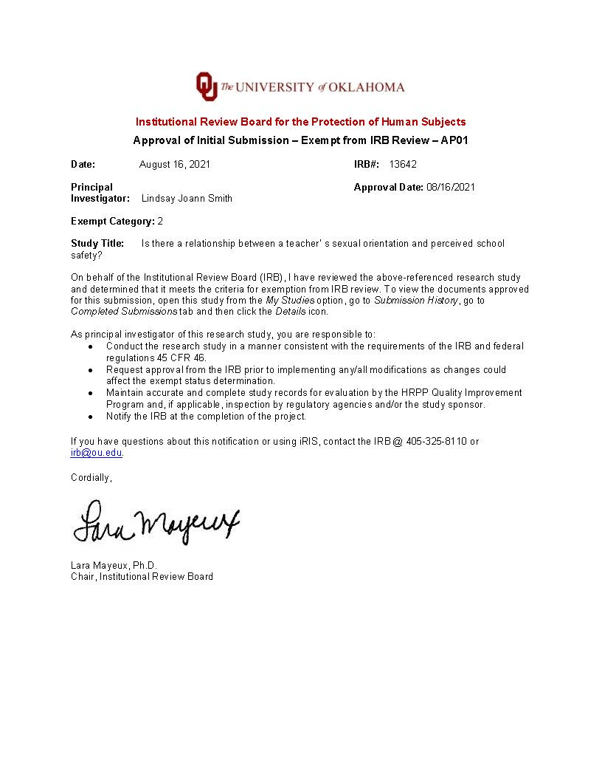
Appendix I
IRB Application
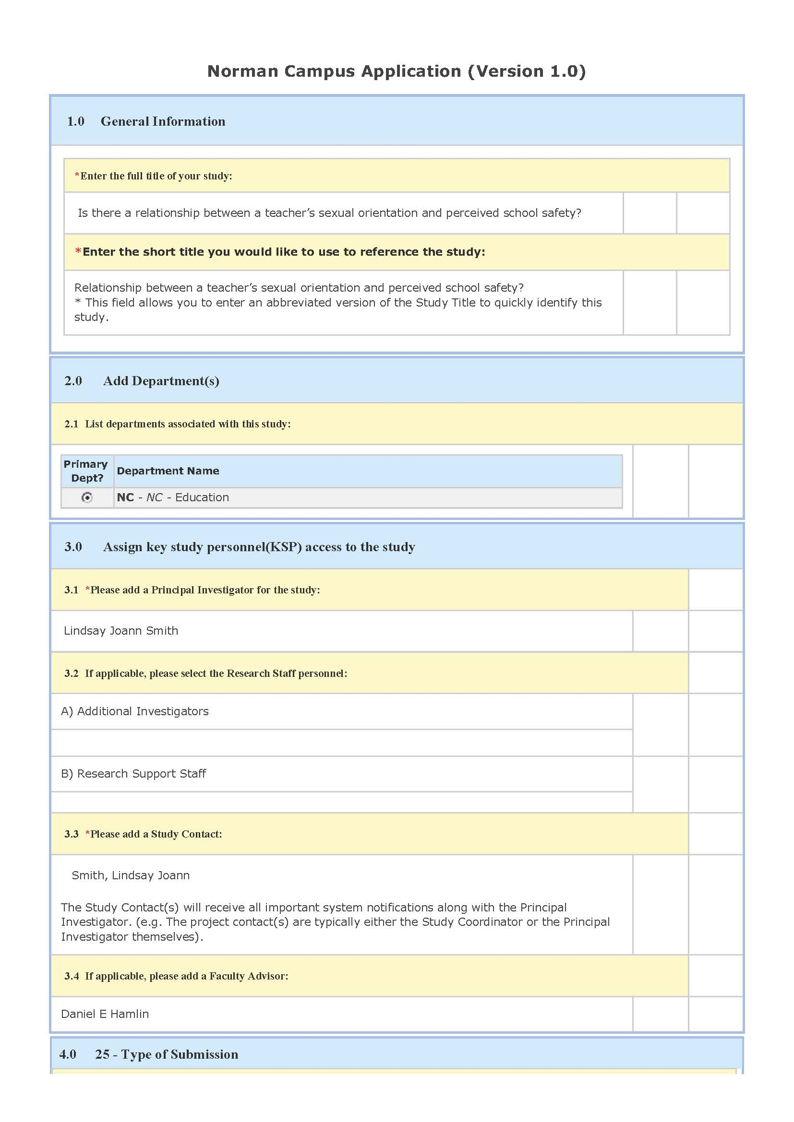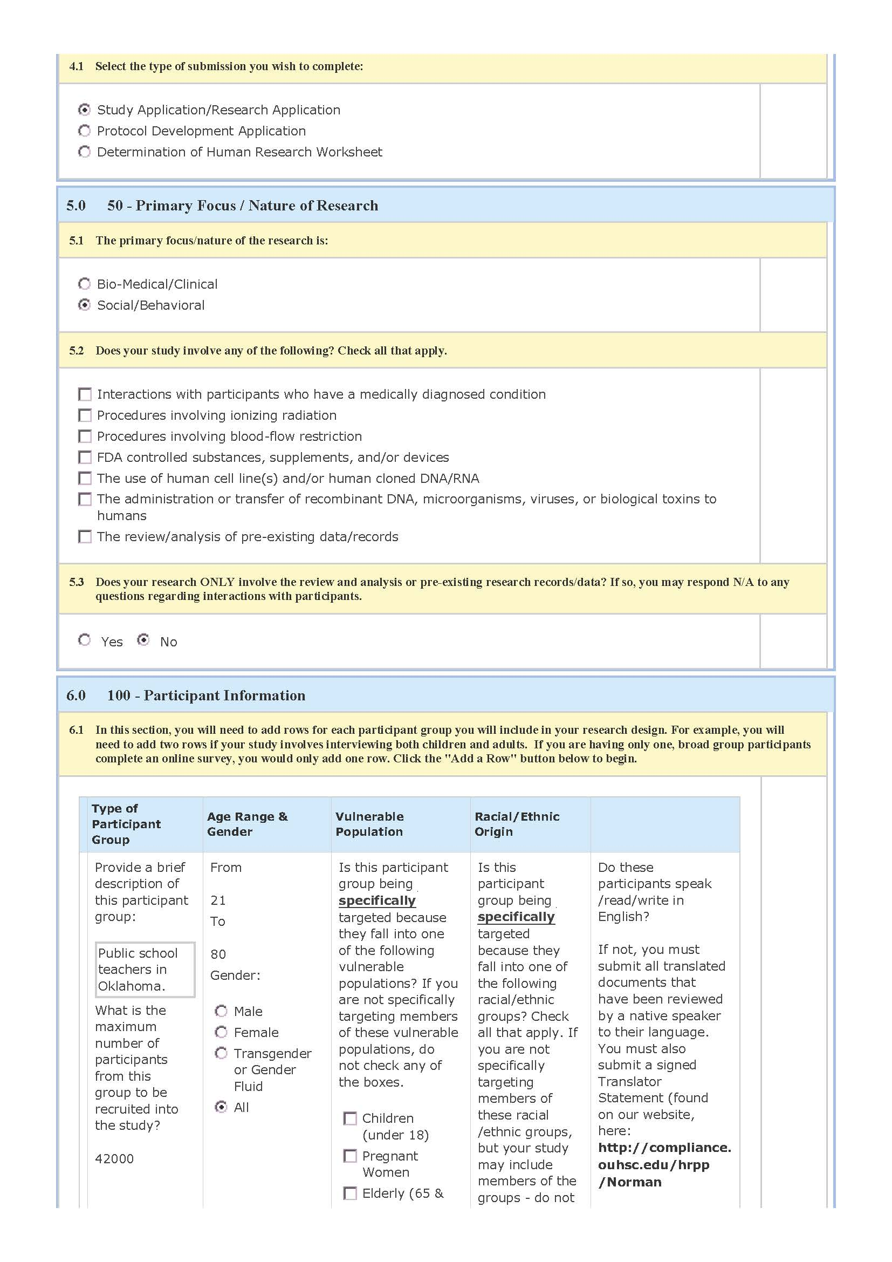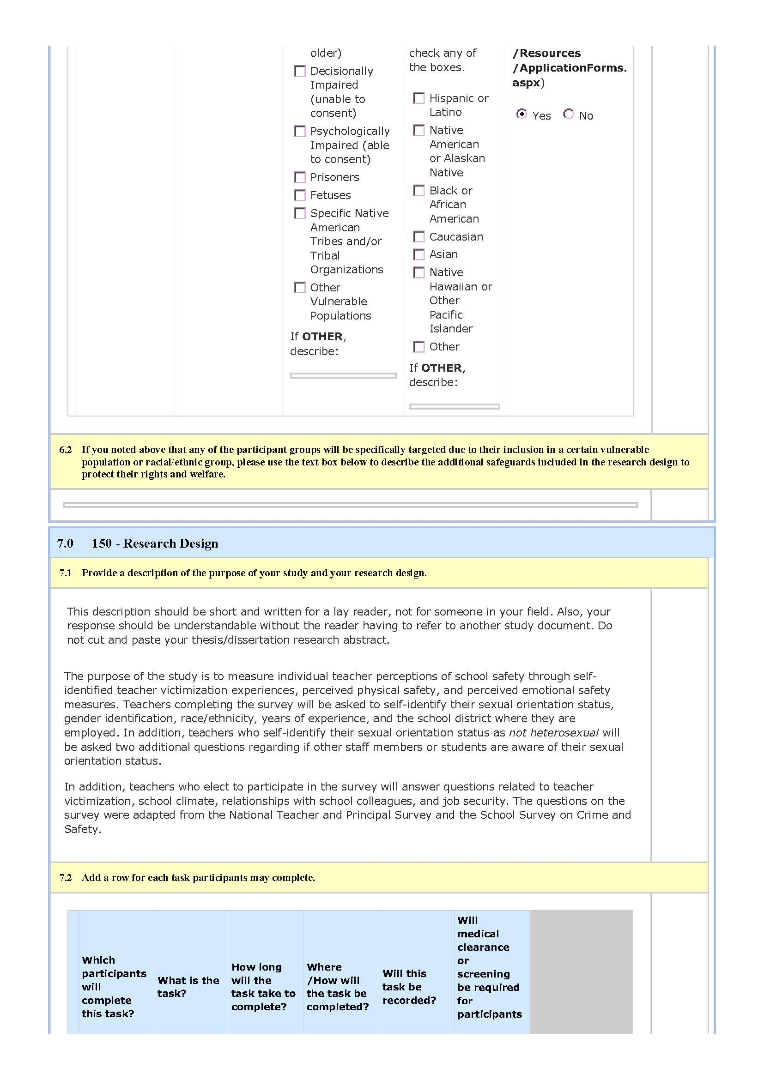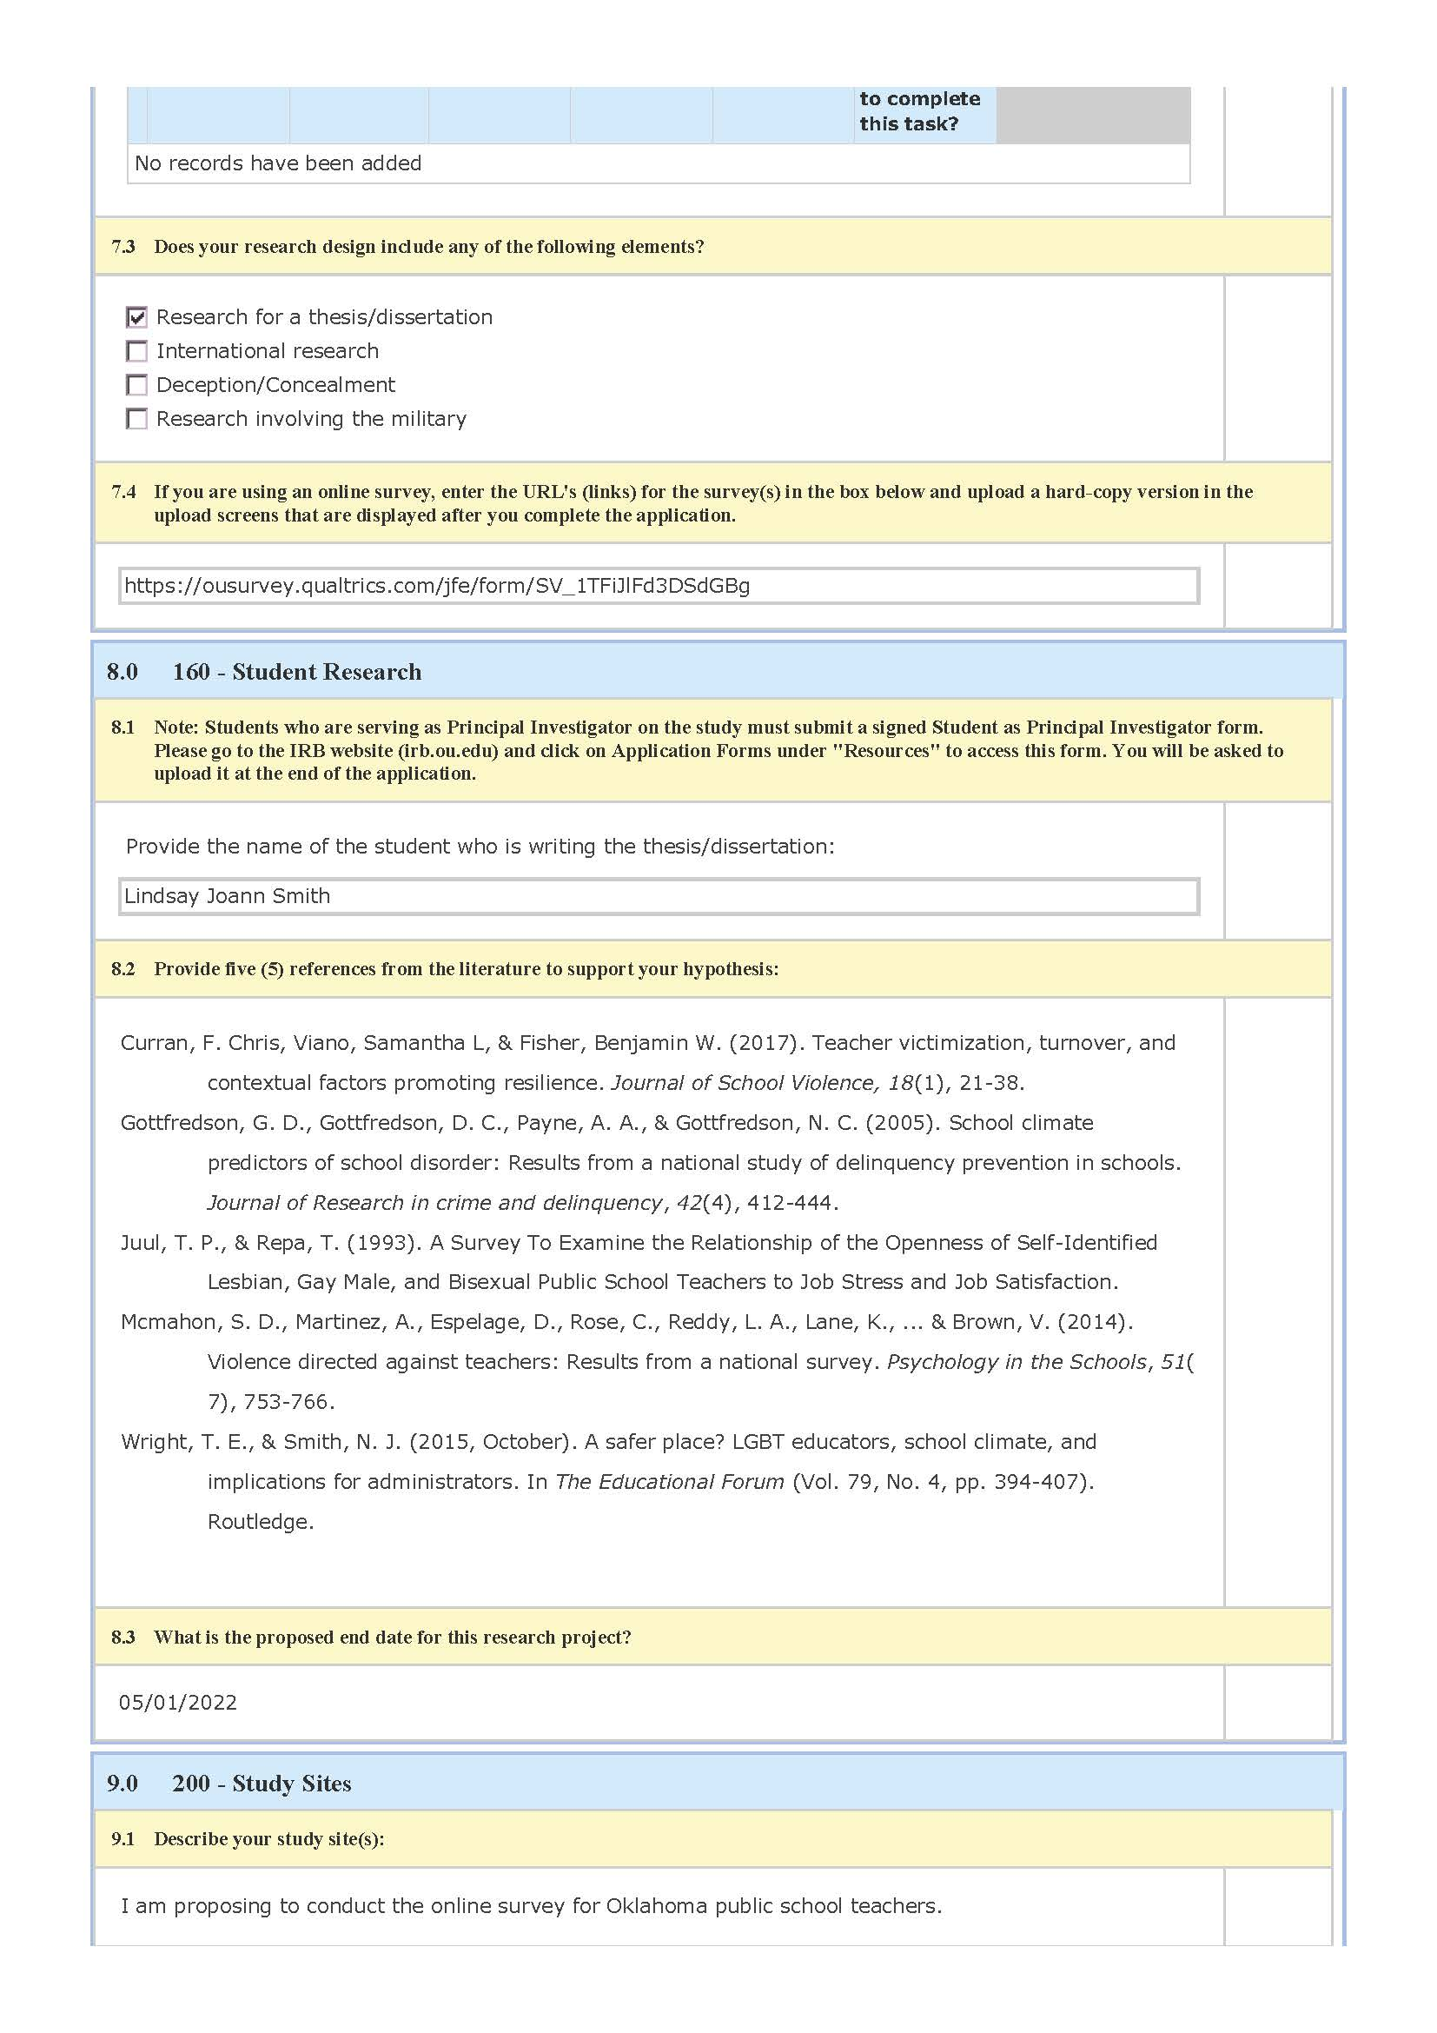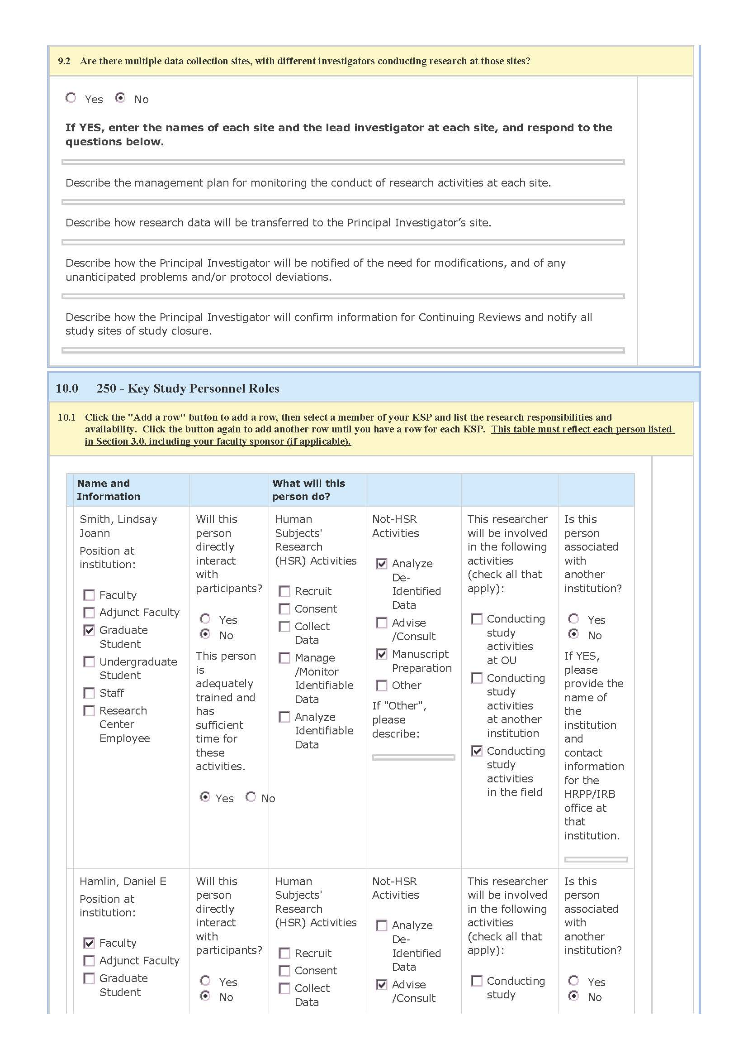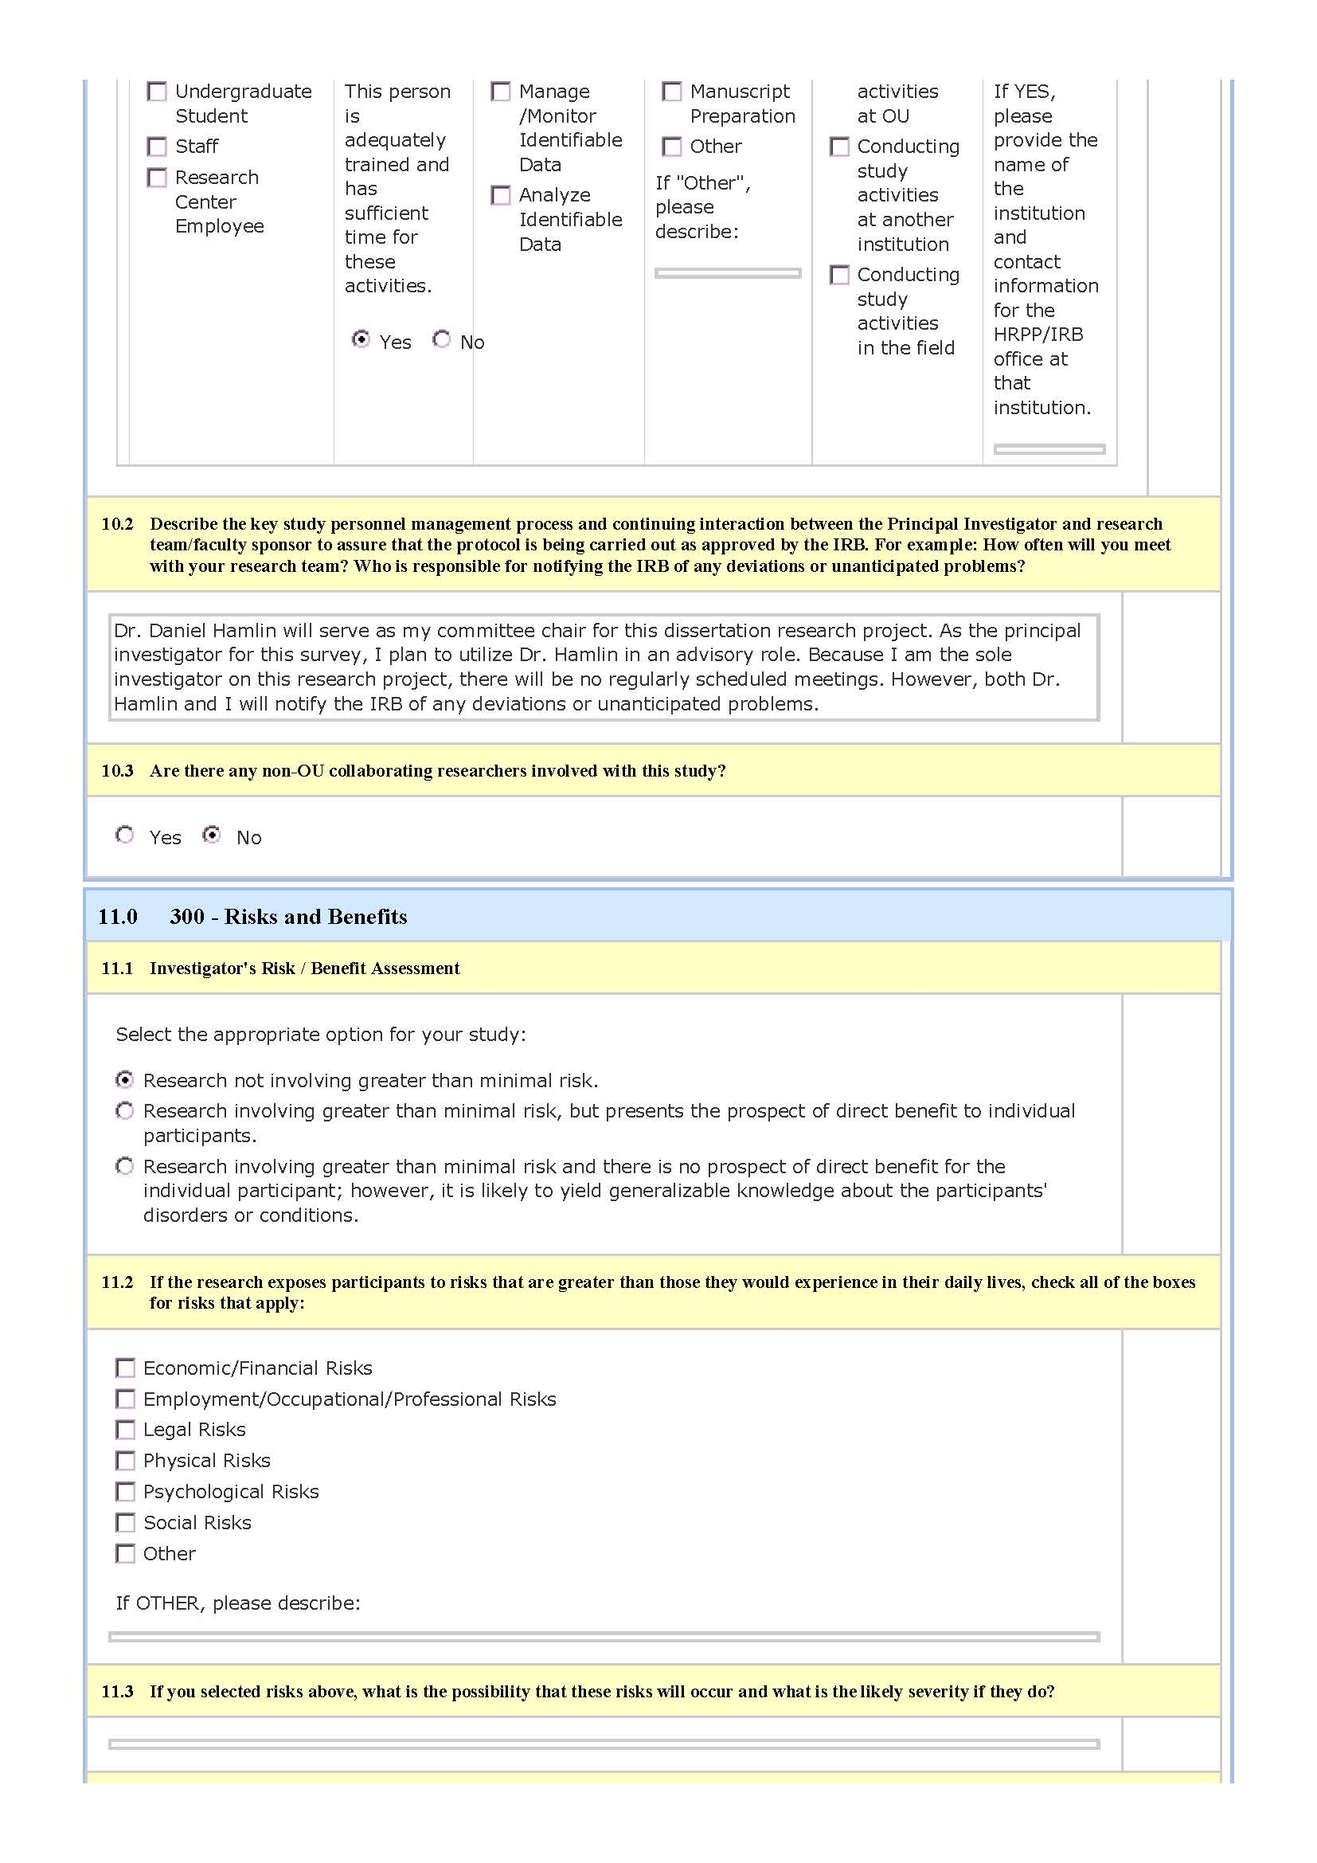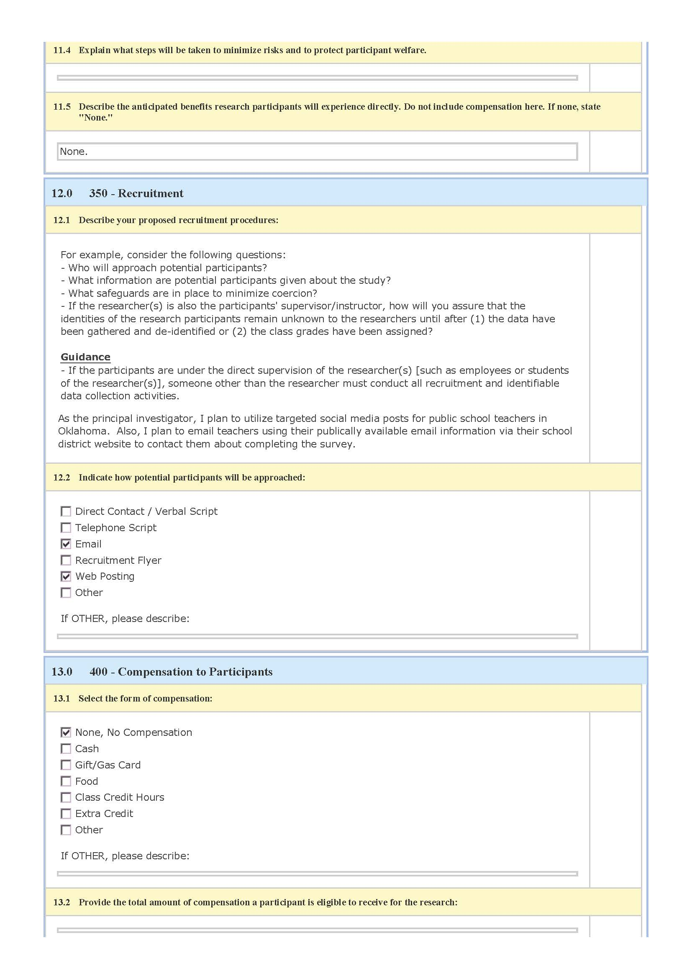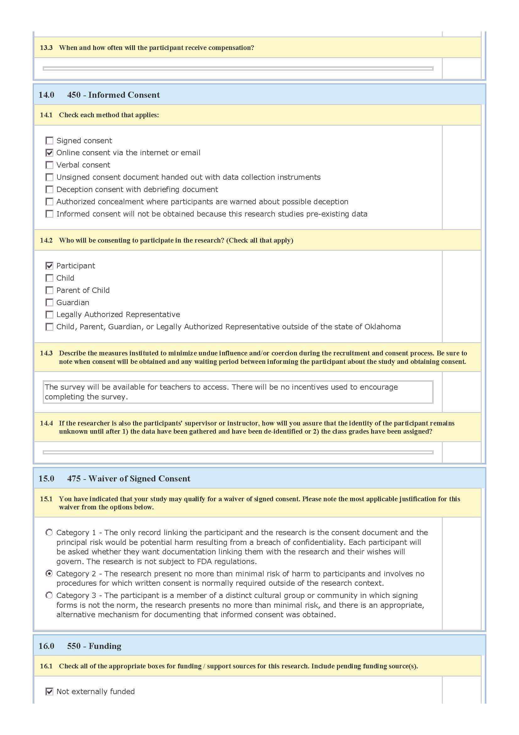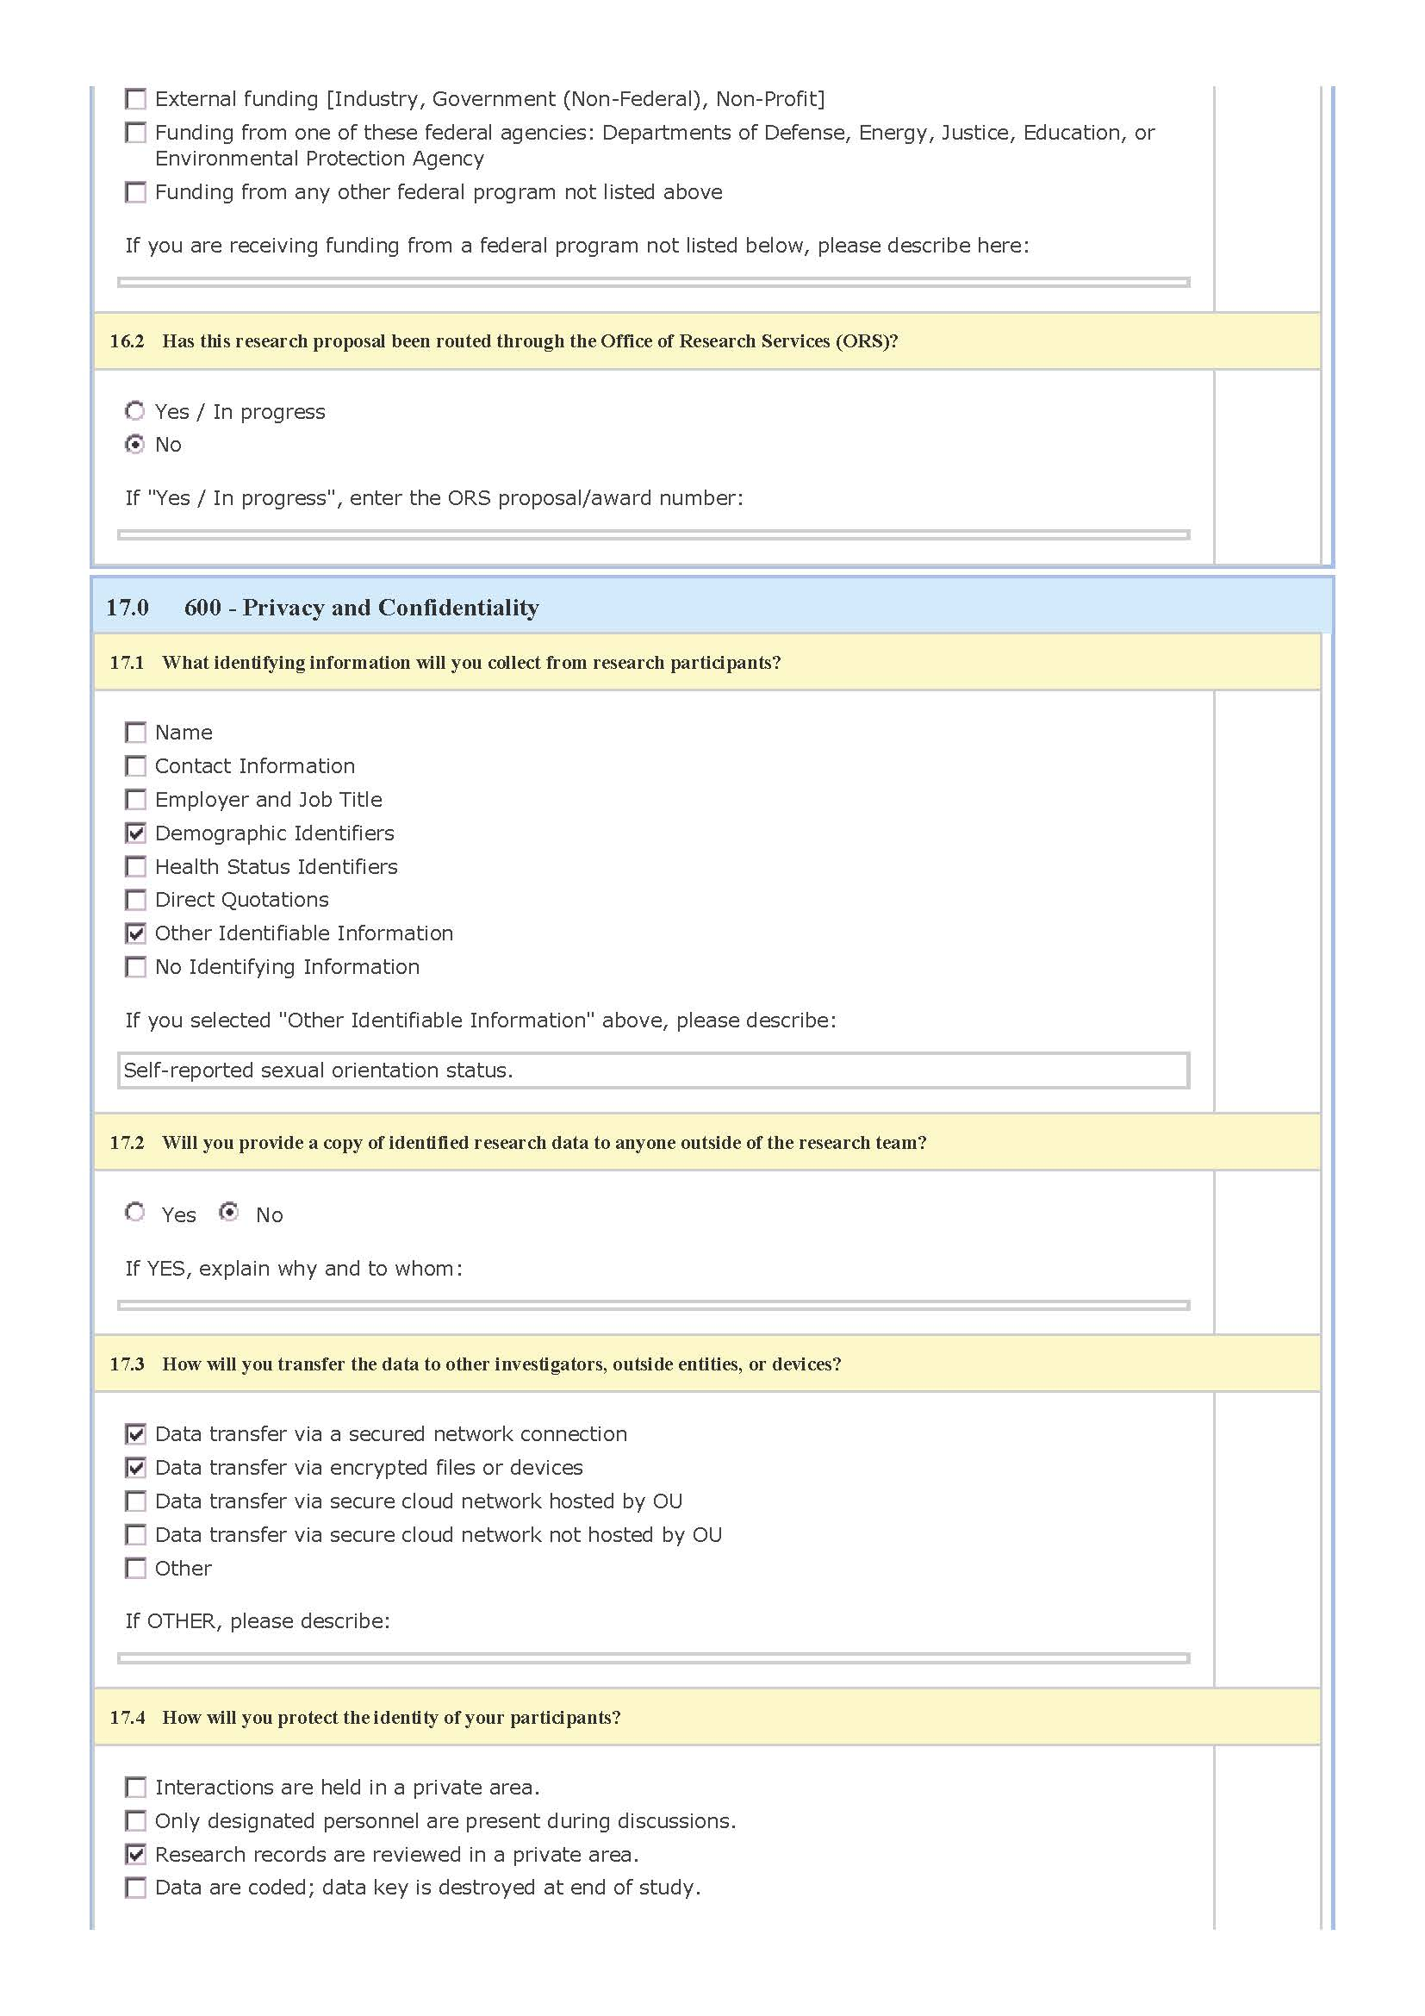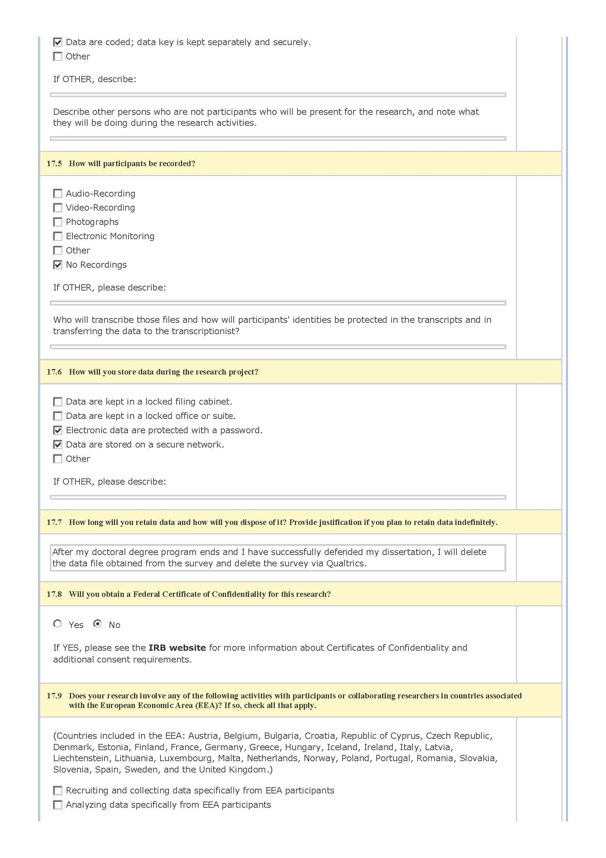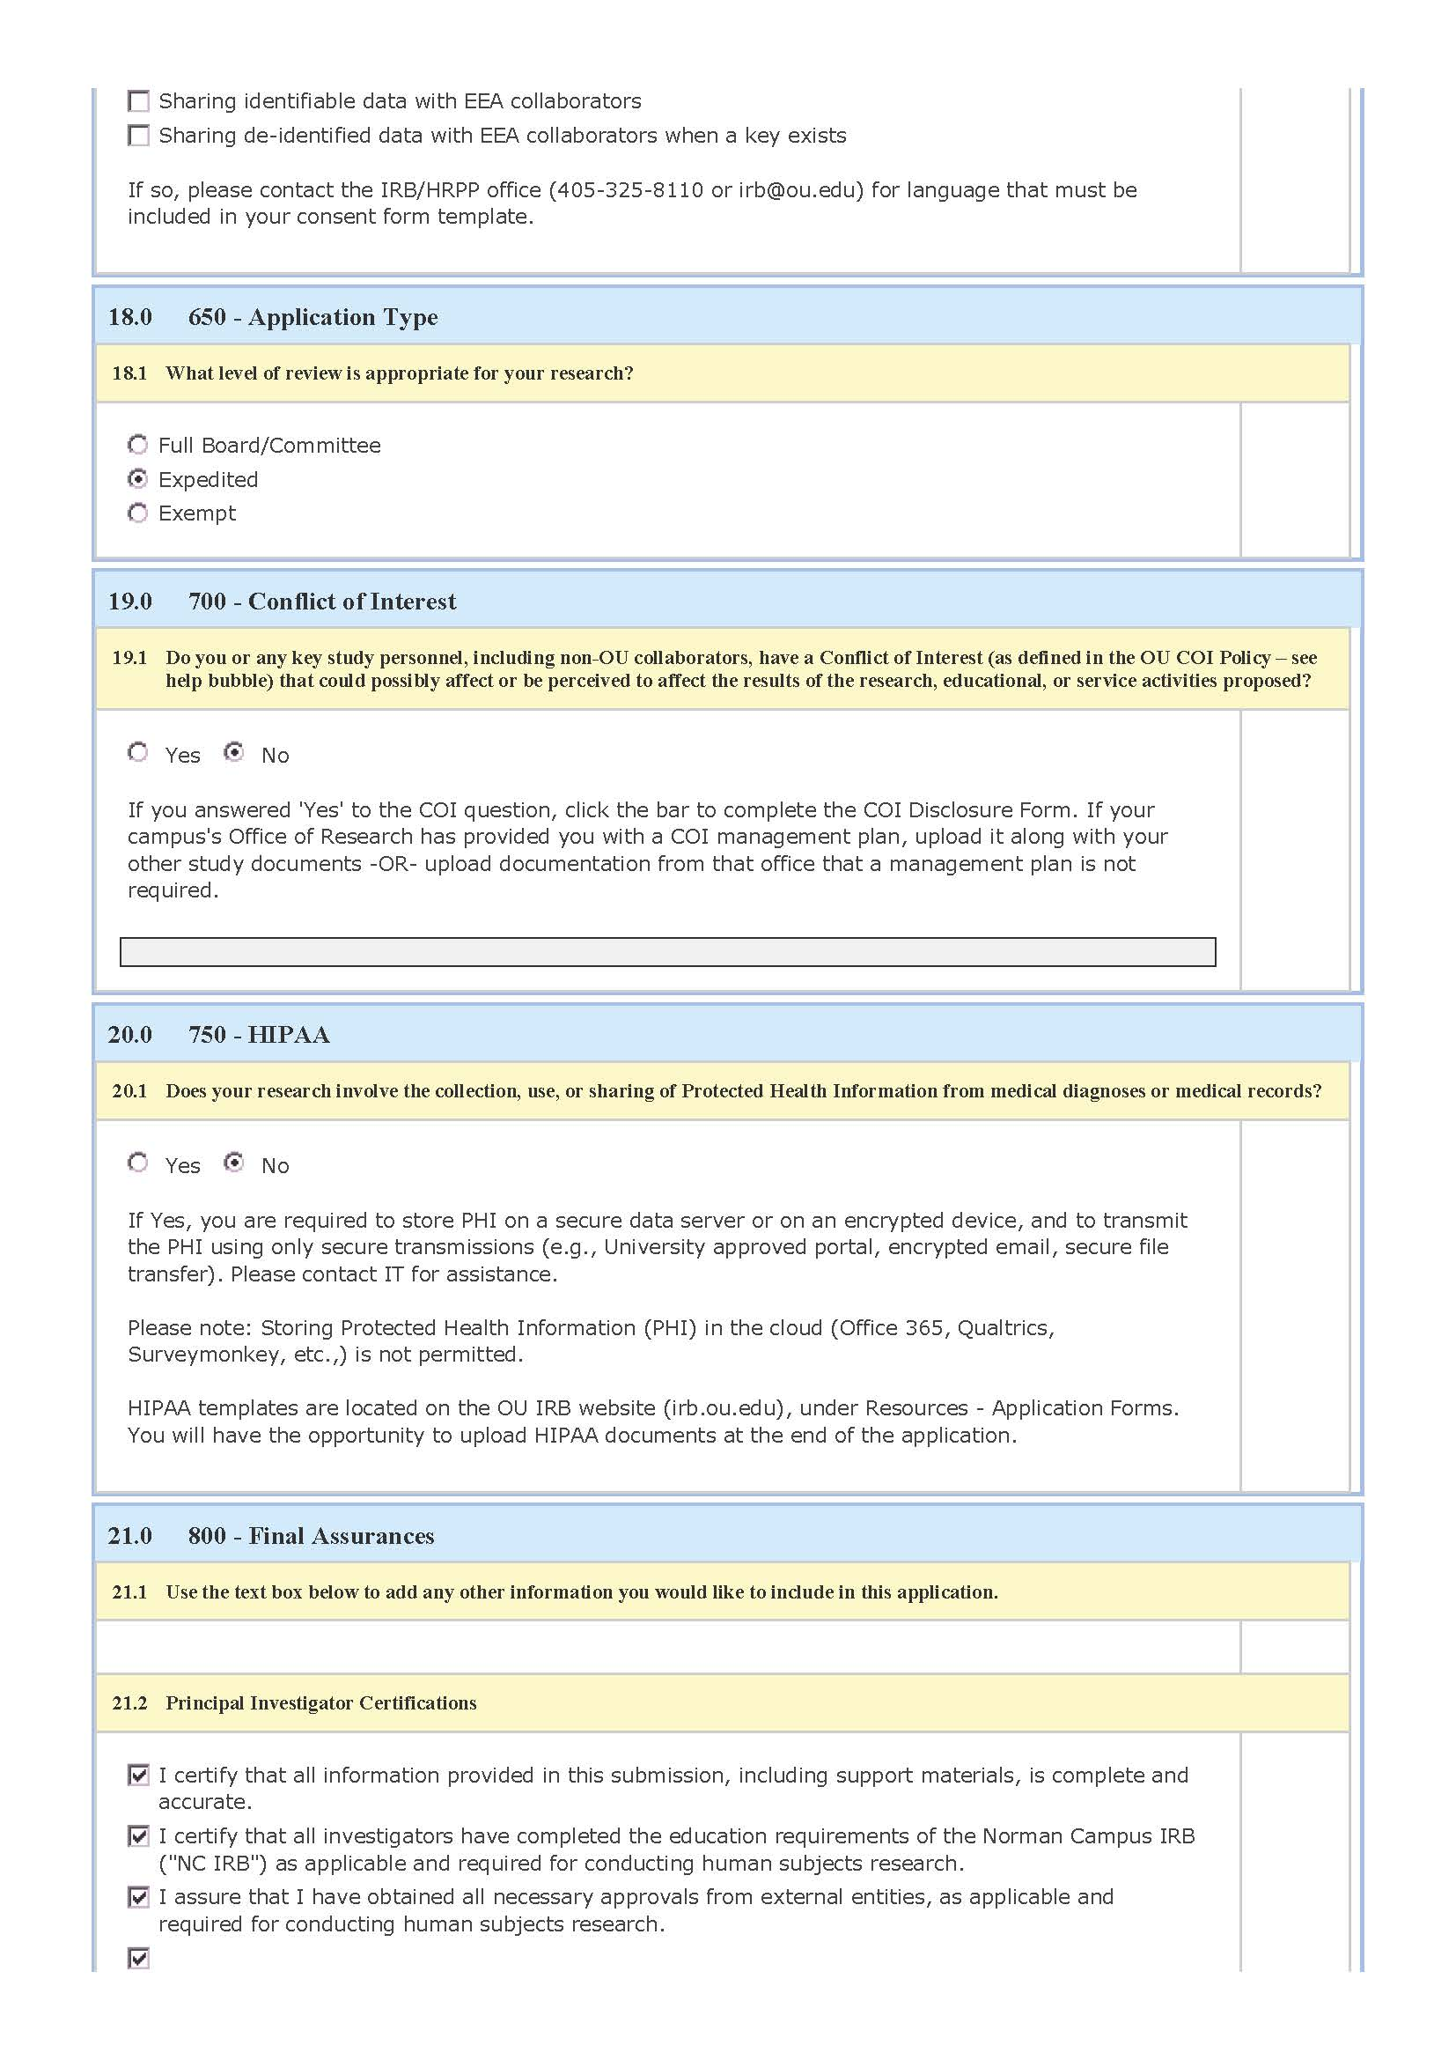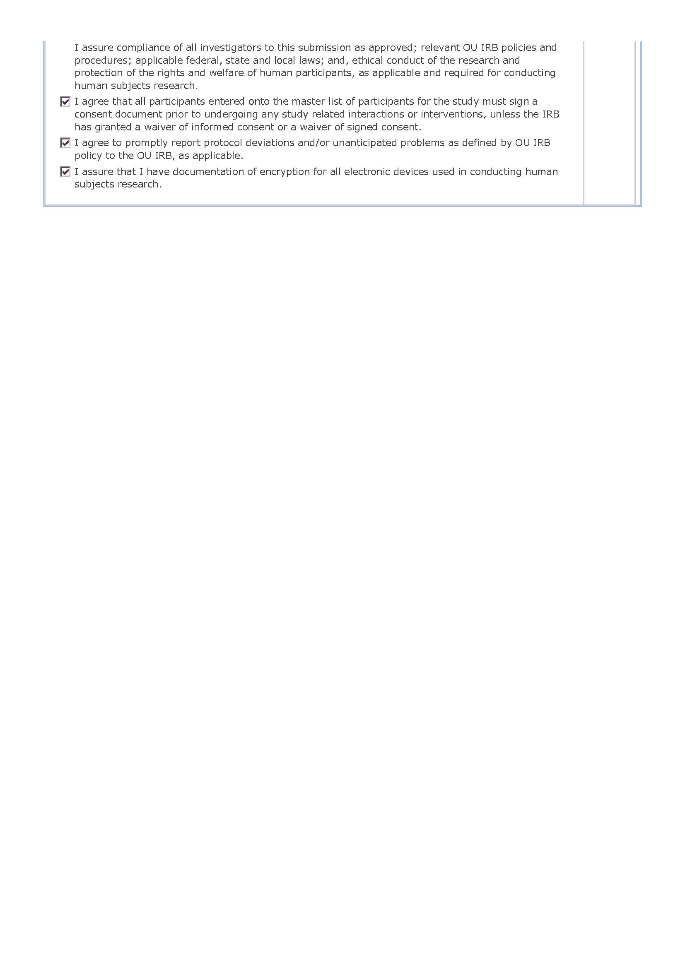
Appendix J
Testimony of Willie Carver on LGBTQ+ Protections
Testimony of Willie Carver Before the Subcommittee on Civil Rights and Civil Liberties U.S. House of Representatives May 18, 2022 Chairman Raskin, Ranking Member Mace, and members of the subcommittee, thank you for this opportunity to come before you to offer my testimony on such an important issue. My name is Willie Carver. I’m a seventeen-year teaching veteran. I sponsor multiple school groups, am published in dozens of professional organizations, am a 2021 Teacher who Made a Difference, and was chosen from 42,000 teachers as the 2022 Kentucky Teacher of the Year. I was born to teach, and I’m good at it. I transform students’ thinking, abilities, and lives. I’ve always faced discrimination as a gay teacher, and I’ve weathered the storm because my presence saves lives. Forty percent of trans people attempt suicide, nearly all before they are 25 years old. Just one affirming adult cuts suicide attempts almost in half. But that was before. Few LGBTQ teachers will survive this current storm. Politicizing our existence has darkened schools. I’m made invisible. We lost our textbooks during lockdown, so I co-wrote and found free printing for two textbooks. I wasn’t allowed to share them. Other schools celebrate similar work, but my name is a liability. I’m from Mt. Sterling, KY and met the President of the United States. My school didn’t even mention it in an email. This invisibility extends to all newly politicized identities. Our administrators’ new directive is “nothing racial.” Parents now demand alternative work when authors are black or LGBTQ; we are told to accommodate them, but I can’t ethically erase black or queer voices. We ban materials by marginalized authors, ignoring official processes. One parent complaint removes all students’ books overnight. Students now use anti-LGBTQ or racist slurs without consequence. Hatred is politically protected now. My Gay-Straight Alliance, or GSA, a campus group dedicated to LGBTQ issues and safety, couldn’t share an optional campus climate survey with classmates. I was told it might make straight students uncomfortable. When posters were torn from walls, my principal responded that people think LGBTQ advocacy is “being shoved down their throats” Inclusive teachers are thrown under the bus by the people driving it. During a teacher shortage crisis, gay educators with perfect records are getting fired. A Kentucky teacher’s message of “You are free to be yourself with me. You matter” with pride flags resulted in wild accusations and violent threats. During this madness, his superintendent wrote to a parent, “This incident … is unacceptable and will not be tolerated.” The situation became unimaginably unsafe. The teacher resigned. Last month, one parent’s dangerous, false allegations that my GSA was “grooming” students were shared 65 times on Facebook. I felt my students and I were unsafe. Multiple parents and I asked the school to defend us. One father wrote simply, “Please do something!” The school refused to support us. There are 10,000 people in my town. The fringe group attacking us doesn’t represent most parents, who trust us. School is traumatic; LGBTQ students are trying to survive it. They often don’t. Year after year, I receive suicidal goodbye texts from students at night. We’ve always struggled to save those students, but now I panic when my phone goes off after 10:00. Meryl, a gentle trans girl from Owen County High, took her life in 2020. She always wanted a GSA. Her friends tried to establish one, but the teachers who wanted to help were afraid to sponsor it. Meryl’s mother, Rachelle, runs an unofficial group, PRISM, from the local library. Forty five percent of LGBTQ youth seriously considered suicide this year. We chip away at their dignity and spaces to exist. The systems meant to protect them won’t even acknowledge them. I recently attended Becky Oglesby’s TED Talk. She described surviving a tornado with first graders, how they huddled, her arms around them, as school walls lifted into the darkness. I sobbed uncontrollably. I realized that for fifteen years, I have huddled around students, protecting them from the winds, and now the tornado’s here. As the walls rip away, I feel I’m abandoning them. But I’m tired. I’ve fought so long, for kids to feel human, to be safe, to have hope. I don’t know how much longer I can do it. I need you. We need you. To be brave. To face the storm with us. Strong public schools are an issue of national security and moral urgency. Political attacks are exacerbating teacher shortages, harming our democracy and, above all, hurting our children. We need you to pass the Equality Act, to make discrimination against LGBTQ people illegal. We need you to pass the Safe Schools Improvement Act, to protect all students from harassment. We’re not asking for special treatment. We’re asking for fundamental human decency, dignity, freedom from fear, and the same opportunity to thrive as everyone else. Thank you.

Appendix K
Categorized District Enrollment by Survey Respondents
# of Students | n | % | M | SD
Categories |  |  | 4.51 | 1.64
0–249 | 39 | 2.4
250–999 | 270 | 16.8
1,000–1,999 | 176 | 11
2,000–4,999 | 191 | 11.9
5,000–9,999 | 205 | 12.8
10,000 or more | 723 | 45.0

References
Abes, E. (2012). Constructivist and intersectional interpretations of a lesbian college student’s
multiple social identities. The Journal of Higher Education (Columbus), 83(2), 186-216.
Acanfora v. Board of Education of Montgomery County, 491 F.2d 498 (4th Cir. 1974).
Addington, L.A. (2009). Cops and cameras: Public school security as a policy response to Columbine. American Behavioral Scientist, 52(10), 1426–1446.
Akiba, M., LeTendre, G. K., Baker, D. P., & Goesling, B. (2002). Student victimization: National and school system effects on school violence in 37 nations. American Educational Research Journal, 39(4), 829–853.
Alcala, N. (2018). Oklahoma education supply & demand report. Oklahoma State Department of Education.
Altimari, D. (2019, December 22). Stories that shaped the decade: After the Sandy Hook school shootings, Connecticut changed forever. Hartford Courant. Retrieved from https://www.courant.com/news/connecticut/hc-news-decade-review-sandy-hook-massacre-20191222-bmtx7qkvtvbarnahia277s5fl4-story.html
American Psychiatric Association. (1952). Diagnostic and statistical manual of mental disorders (1st ed.).
American Psychiatric Association. (1968). Diagnostic and statistical manual of mental disorders (2nd ed.).
American Psychiatric Association. (1987). Diagnostic and statistical manual of mental disorders (3rd ed., rev.).
American Psychiatric Association. (2013). Diagnostic and statistical manual of mental disorders (5th ed.).
American Psychological Association. (2015). APA dictionary of psychology (2nd ed.). Washington, DC: Author.
American Psychological Association Zero Tolerance Task Force. (2008). Are zero tolerance policies effective in the schools? An evidentiary review and recommendations. American Psychologist, 63(9), 852–862.
Ambach v. Norwick, 441 U.S. 68 (1979). https://www.oyez.org/cases/1978/76-808
Anderson, L., File, T., Marshall, J., McElrath, K., & Scherer, Z. (2021, 4 November). New household pulse survey data reveals differences between LGBT and non-LGBT respondents during COVID-19 pandemic. Retrieved from https://www.census.gov/library/stories/2021/11/census-bureau-survey-explores-sexual-orientation-and-gender-identity.html
Astor, R. A., & Benbenishty, R. (2005). Zero tolerance for zero knowledge commentary. Education Week, 24(43), 52.
Astor, R., Guerra, N., & Van Acker, R. (2010). How can we improve school safety research? Educational Researcher, 39(1), 69–78.
Ayres, B. (1977, 8 June). Miami votes 2 to 1 to repeal law barring bias against homosexuals. The New York Times. Retrieved from https://www.nytimes.com/1977/06/08/archives/miami-votes-2-to-1-to-repeal-law-barring-bias-against-homosexuals.html
Badgett, M.V., Goldberg, N., Conron, K., & Gates, G. (2009). Best practices for asking questions about sexual orientation on surveys. School of Law, UCLA. Williams Institute. https://williamsinstitute.law.ucla.edu/publications/smart-so-survey/
Baird, A. A., Roellke, E. V., & Zeifman, D. M. (2017). Alone and adrift: The association between mass school shootings, school size, and student support. The Social Science Journal, 54(3), 261–270.
Bargh, J., & Chartrand, T. (1999). The Unbearable Automaticity of Being. The American Psychologist, 54(7), 462-479.
Barnes, D. M., & Meyer, I. H. (2012). Religious affiliation, internalized homophobia, and mental health in lesbians, gay men, and bisexuals. American Journal of Orthopsychiatry, 82(4), 505.
Bastian, L. D., & Taylor, B. M. (1991). School crime: A national crime victimization survey report (Vol. 97, No. 9). U.S. Department of Justice, Office of Justice Programs, Bureau of Justice Statistics.
Belsky, J. (1980). Child maltreatment: an ecological integration. American psychologist, 35(4), 320.
Birkett, M., Espelage, D. L., & Koenig, B. (2009). LGB and questioning students in schools: The moderating effects of homophobic bullying and school climate on negative outcomes. Journal of Youth and Adolescence, 38(7), 989–1000.
Blad, E. (2018, 27 March). Federal school safety research eliminated to fund new school security measures. Education Week Blogs. Retrieved from https://blogs.edweek.org/edweek/rulesforengagement/2018/03/federal_school_safety_research_eliminated_to_fund_new_school_security_measures.html
Blum, R., Harris, L., Resnick, M., & Rosenwinkel, K. (1989). Technical report on the Minnesota Adolescent Health Survey. Minneapolis, MN: University of Minnesota.
Board of Education v. National Gay Task Force, 470 U.S. 903 (1985).
Board of Education of Hopkins County v. Wood, 717 S.W.2d 837 (1983).
Bowen, N. K., & Bowen, G. L. (1999). Effects of crime and violence in neighborhoods and schools on the school behavior and performance of adolescents. Journal of Adolescent Research, 14(3), 319–342.
Boissoneault, L. (2017, 18 May). The 1927 bombing that remains America’s deadliest school massacre. Smithsonian Magazine. Retrieved from https://www.smithsonianmag.com/history/1927-bombing-remains-americas-deadliest-school-massacre-180963355/
Booren, L. M., Handy, D. J., & Power, T. G. (2011). Examining perceptions of school safety strategies, school climate, and violence. Youth Violence and Juvenile Justice, 9(2), 171–187.
Bostock v. Clayton County, No. 17-1618, 590 U.S.___(2020)
Bosworth, K., Ford, L., & Hernandaz, D. (2011). School climate factors contributing to student and faculty perceptions of safety in select Arizona schools. Journal of School Health, 81(4), 194–201.
Bowers v. Hardwick, 478 U.S. 186 (1986). https://www.oyez.org/cases/1985/85-140
Boysen, G. A., Vogel, D. L., Cope, M. A., & Hubbard, A. (2009). Incidents of bias in college classrooms: Instructor and student perceptions. Journal of Diversity in Higher Education, 2(4), 219.
Brock, M., Kriger, N., & Miró, R. (2017). School safety policies and programs administered by the U.S. federal government: 1990–2016. In Washington, DC: Library of Congress.
Bronfenbrenner, U. (1977). Toward an experimental ecology of human development. American psychologist, 32(7), 513.
Brown v. Board of Education of Topeka, 347 U.S. 483 (1954).
Bryk, A. S., Sebring, P., Allensworth, E., Luppescu, S., & Easton, J. (2010). Organizing schools for improvement: Lessons from Chicago: University of Chicago Press.
Button, S. B. (2001). Organizational efforts to affirm sexual diversity: A cross-level examination. Journal of Applied Psychology, 86(1), 17.
California Proposition 6, the Briggs Initiative (1978). Retrieved from https://ballotpedia.org/California_Proposition_6,_the_Briggs_Initiative_(1978)
Carrol, J. (2007). The divide between public school parents and private school parents. Gallup News Service. Retrieved from https://news.gallup.com/poll/28603/divide-between-public-school-parents-private-school-parents.aspx
Cassem, E. (1995). Depressive disorders in the medically ill: An overview. Psychosomatics, 36(2), S2–S10.
Chetty, R., Friedman, J. N., & Rockoff, J. E. (2014). Measuring the impacts of teachers I: Evaluating bias in teacher value-added estimates. American Economic Review, 104(9), 2593–2632.
Cleveland Board of Education v. LaFleur, 414 U.S. 632 (1974).
Cole, S. W., Kemeny, M. E., Taylor, S. E., & Visscher, B. R. (1996). Elevated physical health risk among gay men who conceal their homosexual identity. Health Psychology, 15(4), 243–251. doi: 10.1037/0278-6133.15.4.243.
Connell, C. (2012). Dangerous disclosures. Sexuality Research and Social Policy, 9(2), 168–177.
Connell, N. M. (2018). Fear of crime at school: Understanding student perceptions of safety as function of historical context. Youth Violence and Juvenile Justice, 16(2), 124–136.
Conron, K. J., & Goldberg, S. K. (2019). LGBT people in the US not protected by state non-discrimination statutes. UCLA School of Law, Williams Institute.
Cooper, H. (2019). The teacher’s closet: lesbian and gay educators in georgia’s public middle schools. Peter Lang.
Cooper, K., Brownell, S., & Gormally, C. (2019). Coming out to the class: identifying factors that influence college biology instructor decisions about revealing their LGBQ identities in class. Journal of Women and Minorities in Science and Engineering, 25(3), 261-282.
Cornell, D., & Huang, F. (2016). Authoritative school climate and high school student risk behavior: A cross‐sectional multi‐level analysis of student self‐reports. Journal of Youth and Adolescence, 45(11), 2246–2259.
Cornell, D. G., & Mayer, M. J. (2010). Why do school order and safety matter? Educational Researcher, 39(1), 7–15.
Cresswell, J. W., & Cresswell, J. D. (2020). Research design: Qualitative, quantitative, and mixed methods approaches (5th ed.). Sage.
Crews, G. A., & Counts, M. R. (1997). The evolution of school disturbance in America: Colonial times to modern day. ABC-CLIO.
Cummings, M. (2009). "Someday this pain will be useful to you": self-disclosure and lesbian and gay identity in the ESL writing classroom. Journal of Basic Writing, 28(1), 71-89.
Curran, F. C., Viano, S. L, & Fisher, B. W. (2017). Teacher victimization, turnover, and contextual factors promoting resilience. Journal of School Violence, 18(1), 21–38.
DeAngelis, K. J., Brent, B. O., & Ianni, D. (2011). The hidden cost of school security. Journal of Education Finance, 312–337.
de Apodaca, R. F., Brighton, L. M., Perkins, A. N., Jackson, K. N., & Steege, J. R. (2012). Characteristics of schools in which fatal shootings occur. Psychological Reports, 110(2), 363–377.
De Boer, C. (1978). The polls: Attitudes toward homosexuality. The Public Opinion Quarterly, 42(2), 265–276.
Dee, T. S. (2005). A teacher like me: Does race, ethnicity, or gender matter? American Economic Review, 95(2), 158–165.
Devoe, J. F., Peter, K., Kaufman, P., Ruddy, S. A., Miller, A. K., Planty, M., Synder, T., Duhart, D., & Rand, M. R. (2002). Indicators of School Crime and Safety, 2002. U.S. Departments of Education and Justice. NCES 2003-009/NCJ 196753, 1-197.
DeVos, B., Nielsen, K. M., & Azar, A. M. (2018). Final report of the Federal Commission on School Safety. Presented to the President of the United States. U.S. Department of Education.
Dinkes, R., Cataldi, E. F., & Lin-Kelly, W. (2007). Indicators of school crime and safety: 2007. U.S. Departments of Education and Justice. NCES 2008-021/NCJ 219553.

Dinkes, R., Kemp, J., and Baum, K. (2009). Indicators of school crime and safety: 2008 (. U.S. Departments of Education and Justice. NCES 2009–022/NCJ 226343.
Dobbs. Jackson Women’s Health Organization, 597 U.S.___(2022).
Drescher, J. (2015). Out of DSM: Depathologizing homosexuality. Behavioral Sciences, 5(4), 565–575.
Dwyer, K., Osher, D., & Warger, C. (1998). Early warning timely response: A guide to safe schools. Washington, DC: U.S. Department of Education.
Egan, T. (2001, March 8). School shooting underlines illusion of safety. The New York Times. Retrieved from https://www.nytimes.com/2001/03/08/national/school-shooting-underlines-illusion-of-safety.html
Elsass, H. J., Schildkraut, J., & Stafford, M. C. (2016). Studying school shootings: Challenges and considerations for research. American Journal of Criminal Justice, 41(3), 444–464.
Engle v. Vitale, 370 U.S. 421 (1962). https://www.oyez.org/cases/1961/468
Espelage, D., Anderman, E. M., Brown, V. E., Jones, A., Lane, K. L., McMahon, S. D., Reddy, L., & Reynolds, C. R. (2013). Understanding and preventing violence directed against teachers: Recommendations for a national research, practice, and policy agenda. American Psychologist, 68(2), 75.
Exec. Order No. 10450, 18 FR 2489, 2, C.F.R. (1949-1953), Com., p. 936.
Executive Order 11246 of Sept. 24, 1965, appear at 30 FR 12319, 12935, 3 CFR, 1964–1965 Comp., p.339.
Fairchild, S., Tobias, R., Corcoran, S., Djukic, M., Kovner, C., & Noguera, P. (2012). White and black teachers’ job satisfaction: Does relational demography matter? Urban Education, 47(1), 170–197.
Farkas, G., Grobe, R. P., Sheehan, D., & Shuan, Y. (1990). Cultural resources and school success: Gender, ethnicity, and poverty groups within an urban school district. American Sociological Review, 55(1), 127–142.
Fedel, L. (2019, April 4). New study: LGBT people a fundamental part of the fabric of rural communities. National Public Radio. Retrieved from https://www.npr.org/2019/04/04/709601295/lgbt-people-are-a-fundamental-part-of-the-fabric-of-rural-communities
Federal Bureau of Investigation (2019). Crime data explorer. Retrieved from https://crime-data-explorer.app.cloud.gov/pages/explorer/crime/crime-trend
Ferfolja, T. (2010). Lesbian teachers, harassment and the workplace. Teaching and Teacher Education, 26(3), 408–414.
Ferraro, K. F. (1995). Fear of crime: Interpreting victimization risk. Albany, NY: SUNY Press.
Fieldstadt, E. (2019, July 29). Arkansas school shooter who killed five in 1998 dies in head-on car crash. NBC News. Retrieved from https://www.nbcnews.com/news/us-news/arkansas-school-shooter-who-killed-five-1998-dies-head-car-n1035606
The 50th annual PDK poll of the public’s attitudes toward the public schools: Teaching: Great respect, dwindling appeal. (2018). Phi Delta Kappan, 100(1), NP1–NP24.
FindLaw (2016, June 20). Teachers’ rights: Tenure and dismissal. FindLaw. Retrieved from https://www.findlaw.com/education/teachers-rights/teachers-rights-tenure-and-dismissal.html#:~:text=The%20Due%20Process%20Clause%20of,procedural%20requirements%20that%20each%20public
Finley, L. L. (2003). Teachers’ perceptions of school violence issues: A case study. Journal of School Violence, 2(2), 51–66.
Fisher, K., & Kettl, P. (2003). Teachers’ perceptions of school violence. Journal of Pediatric Health Care, 17(2), 79–83.
Fitch, S. M. (1985). National Gay Task Force v. Board of Education of Oklahoma City. Akron Law Review, 19, 337.
Fletcher, K., & Lawrence, S. (2015, November 20). Public school teacher, non-renewal of contract v. tenure, property interest, due process. CaseTest. Retrieved from https://casetext.com/analysis/public-school-teacher-non-renewal-of-contract-v-tenure-property-interest-due-process-1
Ford, C.S., & Beach, F.A. (1952). Patterns of sexual behavior. Harper and Row and Paul B. Hoeber, Inc: New York.
Fowler, F. (2014). Survey research methods. Sage.
Furlong, M., Greif, J., Bates, M., Whipple, A., Jimenez, T., & Morrison, R. (2005). Development of the California school climate and safety survey–short form. Psychology in the Schools, 42(2), 137–149.

Furlong, M. J., Morrison, R., & Boles, S. (1991, April). California school climate and safety survey. In Annual Meeting of the California Association of School Psychologists, Los Angeles, CA.
Furlong, M., Paige, L., & Osher, D. (2003). The Safe Schools/Healthy Students (SS/HS) initiative: Lessons learned from implementing comprehensive youth development programs. Psychology in the Schools, 40(5), 447–456.
Galand, B., Lecocq, C., & Philippot, P. (2007). School violence and teacher professional disengagement. British Journal of Educational Psychology, 77(2), 465-477.
Garcia, E., & Weiss, E. (2019). The teacher shortage is real, large and growing, and worse than we thought. Economic Policy Institute. Retrieved from https://www.epi.org/publication/the-teacher-shortage-is-real-large-and-growing-and-worse-than-we-thought-the-first-report-in-the-perfect-storm-in-the-teacher-labor-market-series/
Gates, G. J. (2006). Same-sex couples and the gay, lesbian, bisexual population: New estimates from the American Community Survey. UCLA: The Williams Institute. Retrieved from https://escholarship.org/uc/item/8h08t0zf
Gay, G. (2006). Connections between classroom management and culturally responsive teaching. Handbook of classroom management: Research, practice, and contemporary issues, 343–370. Routledge.
Gerberich, S., Nachreiner, N., Ryan, A., Church, T., McGovern, P., Geisser, M., Mongin, G., Watt, G., Feda, D., Staff, S., & Pinder, E. (2011). Violence against educators: A population-based study. Journal of Occupational and Environmental Medicine, 53(3), 294–302.
Geving, A. M. (2007). Identifying the types of student and teacher behaviours associated with teacher stress. Teaching and Teacher Education, 23(5), 624–640.
Gilliam, W. S., Maupin, A. N., Reyes, C. R., Accavitti, M., & Shic, F. (2016). Do early educators’ implicit biases regarding sex and race relate to behavior expectations and recommendations of preschool expulsions and suspensions? Yale University Child Study Center, 9(28), 2016.
GLAAD. (n.d.a). Glossary of tems: LGBTQ. GLAAD Media Reference Guide, 11th ed.
Retrieved July 1, 2022, from https://www.glaad.org/reference/terms
GLADD/Harris Poll (2019). Accelerating Acceptance. Retrieved from https://www.glaad.org/publications/accelerating-acceptance-2019
Goldhaber, D., Lavery, L., & Theobald, R. (2015). Uneven playing field? Assessing the teacher quality gap between advantaged and disadvantaged students. Educational Researcher, 44(5), 293–307.
Gottfredson, D. (2001). Schools and delinquency. Cambridge University Press
Gottfredson, G. D., Gottfredson, D. C., Payne, A. A., & Gottfredson, N. C. (2005). School climate predictors of school disorder: Results from a national study of delinquency prevention in schools. Journal of Research in Crime and Delinquency, 42(4), 412–444.
Gower, A. L., Rider, G. N., McMorris, B. J., & Eisenberg, M. E. (2018). Bullying victimization among LGBTQ youth: Critical issues and future directions. Current Sexual Health Reports, 10(4), 246–254.
Grace, A. (2006). Writing the queer self: using autobiography to mediate inclusive teacher education in Canada. Teaching & Teacher Education: An International Journal of Research and Studies, 22(7), 826-834.
Gray, E. M. (2013). Coming out as a lesbian, gay or bisexual teacher: Negotiating private and professional worlds. Sex Education, 13(6), 702–714.
Green, A. (2019, January 30). Thurston shooter Kip Kinkel’s 112-year-prison term is
constitutional, high court rules. OregonLive. Retrieved from https://www.oregonlive.com/pacific-northwest-news/2018/05/school_shooter_kip_kinkels_112.html
Green, M. W. (1999). The appropriate and effective use of security technologies in U.S. schools: A guide for schools and law enforcement agencies. U.S. Department of Justice, Office of Justice Programs, National Institute of Justice. Greenwald, A. G., & Banaji, M. R. (1995). Implicit social cognition: Attitudes, self-esteem, and stereotypes. Psychological Review, 102(1), 4.
Gregory, A., Skiba, R. J., & Noguera, P. A. (2010). The Achievement gap and the discipline gap: Two sides of the same coin? Educational Researcher, 39(1), 59–68.
Griswold v. Connecticut, 381 U.S. 479 (1965). https://www.oyez.org/cases/1964/496
Gruberg, S., Mahowald, L., & Halpin, J. (2020). The state of the LGBTQ community in 2020. Center for American Progress. Retrieved from https://www.americanprogress.org/issues/lgbtq-rights/reports/2020/10/06/491052/state-lgbtq-community-2020/#Ca=10
Hamlin, D. (2017). Are charter schools safer in deindustrialized cities with high rates of crime? Testing hypotheses in Detroit. American Educational Research Journal, 54(4), 725–756.
Hamlin, D. (2020). Flight to safety in deindustrialized cities: Perceptions of school safety in charter and public schools in Detroit, Michigan. Education and Urban Society, 52(3), 394–414.
Hamlin, D., & Li, A. (2020). The relationship between parent volunteering in school and school safety in disadvantaged urban neighborhoods. Journal of School Violence, 19(3), 362–376.
Harbeck, K. M. (1992). Gay and lesbian educators: Past history/future prospects. Journal of Homosexuality, 22(3–4), 121–140.
Harbeck, K. M. (1997). Gay and lesbian educators: Personal freedoms. Public Constraints : Amethyst Press and Productions, Maiden, MA. 188–200.
Hauser, C., & O’Connor, A. (2007, April 16). Virginia tech shooting leaves 33 dead. The New York Times. Retrieved from https://www.nytimes.com/2007/04/16/us/16cnd-shooting.html?login=smartlock&auth=login-smartlock
Hernandez, D., Floden, L., & Bosworth, K. (2010). How safe is a school? An exploratory study comparing measures and perceptions of safety. Journal of School Violence, 9(4), 357–374.
Hobbs, T. D. (2019, April 19). Three decades of school shootings: An analysis. Wall Street Journal. Retrieved from https://www.wsj.com/graphics/school-shooters-similarities/
Hooker, E. (1957). The adjustment of the male overt homosexual. Journal of Projective Techniques, 21(1), 18–31.
Hooker, S. D. (2018). Lesbian and gay educators functioning in heteronormative schools. International Journal of Educational Reform, 27(1), 63–85.
House of Representatives, Congress. (2010, December 30). 10 U.S.C. 654 - Policy concerning homosexuality in the armed forces. [Government]. U.S. Government Publishing Office. https://www.govinfo.gov/app/details/USCODE-2010-title10/USCODE-2010-title10-subtitleA-partII-chap37-sec654
H.R.987 - 103rd Congress (1993-1994): Gun-Free Schools Act of 1993. (1993, March 4). http://www.congress.gov/
H.R.2455 - 103rd Congress (1993-1994): Safe Schools Act of 1994. (1994, February 23). http://www.congress.gov/
Huang, F. L., Eddy, C. L., & Camp, E. (2020). The role of the perceptions of school climate and teacher victimization by students. Journal of Interpersonal Violence, 35(23–24), 5526–5551.
Hudson, D. (2014, July 21). President Obama signs a new executive order to protect LGBT workers. The White House-President Barack Obama. Retrieved from https://obamawhitehouse.archives.gov/blog/2014/07/21/president-obama-signs-new-executive-order-protect-lgbt-workers
Jackson, J. M. (2007). Unmasking identities: An exploration of the lives of gay and lesbian teachers. Lanham, MD: Lexington Books.
Jekielek, S., Brown, B., Marin, P., & Lippman, L. (2007). Public School Practices for Violence Prevention and Reduction: 2003–04. Issue Brief. NCES 2007-010. National Center for Education Statistics.
Jones, D. & Franklin, J. (2022, April 10). Not just Florida. More than a dozen states propose so-called “don’t say gay” bills. National Public Radio. Retrieved from https://www.npr.org/2022/04/10/1091543359/15-states-dont-say-gay-anti-transgender-bills
Jones, J. (2018, August 24). More parents, children fearful for safety at school. Gallup News. Retrieved from https://news.gallup.com/poll/241625/parents-children-fearful-safety-school.aspx
Jones, J. & Saad, L (2018, August 12). Americans’ fears for their children and their children’s fears about school safety (trends). Gallup News Service Gallup Poll Social Series: Work and Education. Retrieved from file:///C:/Users/Smith.Lindsay/Downloads/180823SchoolSafety.pdf
Juster, R. P., Smith, N. G., Ouellet, É., Sindi, S., & Lupien, S. J. (2013). Sexual orientation and disclosure in relation to psychiatric symptoms, diurnal cortisol, and allostatic load. Psychosomatic Medicine, 75(2), 103–116.
Juul, T. P., & Repa, T. (1993). A survey to examine the relationship of the openness of self-identified lesbian, gay male, and bisexual public school teachers to job stress and job satisfaction. New York University.
Juvonen, J. (2001). School violence: Prevalence, fears, and prevention. Retrieved July 1, 2020, from https://www.rand.org/pubs/issue_papers/IP219.html
Kaiser, D. A. (2006). School shootings, high school size, and neurobiological considerations. Journal of Neurotherapy, 9(3), 101–115.
Kann, L., McManus, T., Harris, W. A., Shanklin, S. L., Flint, K. H., Hawkins, J., Queen, B., Lowry, R., Olsen, E., Chyen, D., Whittle, L., Thornton, J., Lim, C., Yamakawa, Y., Brener, N., & Zaza, S. (2016). Youth risk behavior surveillance—United States, 2015. Morbidity and Mortality Weekly Report: Surveillance Summaries, 65(6), 1–174.
Kessing, L. V., Agerbo, E., & Mortensen, P. B. (2003). Does the impact of major stressful life events on the risk of developing depression change throughout life? Psychological Medicine, 33(7), 1177.
Kiely, E. (2018, October 11). Trump’s school safety funding falsehood. FactCheck.org. Retrieved from https://www.factcheck.org/2018/10/trumps-school-safety-funding-falsehood/
King, E. B., Reilly, C., & Hebl, M. (2008). The best of times, the worst of times: Exploring dual perspectives of “coming out” in the workplace. Group & Organization Management, 33(5), 566–601. https://doi.org/10.1177/1059601108321834
Kinsey, A. C., Pomeroy, W. B., & Martin, C. E. (1949). Sexual behavior in the human male. The
Journal of Nervous and Mental Disease, 109(3), 283.
Kinsey, A. C., Pomeroy, W. B., & Martin, C. E. (1953). Sexual behavior in the human female.
Philadelphia: Saunders.
Khayatt, D. (1997). Sex and the teacher: Should we come out in class? Harvard Educational Review, 67(1), 126–144.
Kocieniewski, D., & Gately, G. (2006). Man shoots 11, killing 5 girls. Amish school. The New York Times. Retrieved from: https://www.nytimes.com/2006/10/03/us/03amish.html
Korth, R. (2022, July 7). Report reveals graduates of Oklahoma’s teacher prep programs down more than 25 percent in last decard. National Public Radio. Retrieved from https://www.kosu.org/education/2022-07-07/report-reveals-graduates-of-oklahomas-teacher-prep-programs-down-more-than-25-percent-in-last-decade
Korth, R. (2022, August 9). As new school year starts in Oklahoma, a record number of emergency certified teachers will lead classrooms. National Public Radio. Retrieved from https://www.publicradiotulsa.org/local-regional/2022-08-09/as-new-school-year-starts-in-oklahoma-a-record-number-of-emergency-certified-teachers-will-lead-classrooms
Kosciw, J. G., Clark, C. M., Truong, N. L., & Zongrone, A. D. (2020). The 2019 National School Climate Survey: The experiences of lesbian, gay, bisexual, transgender, and queer youth in our nation’s schools. New York: GLSEN.
Koth, C. W., Bradshaw, C. P., & Leaf, P. J. (2008). A multilevel study of predictors of student perceptions of school climate: The effect of classroom-level factors. Journal of Educational Psychology, 100(1), 96.
Kozol, J. (1991). Savage inequalities: Children in America’s schools / Jonathan Kozol. (1st ed.). New York: Crown Pub.
Kupchik, A., & Ward, G. (2014). Race, poverty, and exclusionary school security: An empirical analysis of U.S. elementary, middle, and high schools. Youth Violence and Juvenile Justice, 12(4), 332–354.
Lacoe, J. R. (2015). Unequally safe: The race gap in school safety. Youth Violence and Juvenile Justice, 13(2), 143–168.
Lai, C., Marini, M., Lehr, S., Cerruti, C., Shin, J., Joy-Gaba, J., Ho, A., Teachman, B., Wojcik, S., Koleva, S., Frazier, R., Heiphetz, L., Chen, E., Turner, R., Haidt, J., Kesebir, S., Hawkins, C., Schaefer, H., Rubichi, S., Sartori, G., Dial, C., Sriram, N., Banaji, M., Nosek, B., Gauthier, I.(2014). Reducing implicit racial preferences: I. A comparative investigation of 17 interventions. Journal of Experimental Psychology: General, 143(4), 1765.
Lavietes, M. (2022, June 27). Kentucky’s 2022 teacher of the year quits profession, citing homophobia. NBC News. Retrieved from https://www.nbcnews.com/nbc-out/out-news/kentuckys-2022-teacher-year-quits-profession-citing-homophobia-rcna35224
Lavine, K. S. (1980). Free speech rights of homosexual teachers. Columbia Law Review, 80(7), 1513–1534.
Lawrence v. Texas, 539 U.S. 558 (2003). https://www.oyez.org/cases/2002/02-102

Legate, N., Ryan, R. M., & Rogge, R. D. (2017). Daily autonomy support and sexual identity disclosure predicts daily mental and physical health outcomes. Personality and Social Psychology Bulletin, 43(6), 860–873.
Leithwood, K. & McAdie, P. (2007). Teacher working conditions that matter. Education Canada. 47(2), 42–45.
Lemon v. Kurtzman, 403 U.S. 602 (1971). https://www.oyez.org/cases/1970/89
Lineback, S., Allender, M., Gaines, R., McCarthy, C. J., & Butler, A. (2016). “They think I am a pervert”: A qualitative analysis of lesbian and gay teachers’ experiences with stress at school. Educational Studies, 52(6), 592–613.
Longobardi, C., Badenes-Ribera, L., Fabris, M. A., Martinez, A., & McMahon, S. D. (2018). Prevalence of student violence against teachers: A meta-analysis. Psychology of Violence, 96(6), 596.
López, V., Benbenishty, R., Astor, R. A., Ascorra, P., & González, L. (2020). Teachers victimizing students: Contributions of student-to-teacher victimization, peer victimization, school safety, and school climate in Chile. American Journal of Orthopsychiatry, 90(4), 432.
Loutzenheiser, L., & MacIntosh, L. (2004). Citizenships, sexualities, and education. Theory into Practice, 43(2), 151-158.
Machado, A. (2014, December 16). The plight of being a gay teacher. The Atlantic. Retrieved from https://www.theatlantic.com/education/archive/2014/12/the-plight-of-being-a-lgbt-teacher/383619/
Macintosh, L. (2007). Does anyone have a band-aid? Anti-homophobia discourses and pedagogical impossibilities. Educational Studies, 41(1), 33–43.
Mallory, C., & Sears, B. (2019). Discrimination against LGBT people in Oklahoma. The Williams Institute, UCLA School of Law.
Martin, A. J., Linfoot, K., & Stephenson, J. (1999). How teachers respond to concerns about misbehavior in their classroom. Psychology in the Schools, 36(4), 347–358.
Martinez, M. J. (2020). Does school racial composition matter to teachers: Examining racial differences in teachers’ perceptions of student problems. Urban Education (Beverly Hills, Calif.), 55(7), 992–1020.
Maslow, A. H. (1943). A theory of human motivation. Psychological Review, 50(4), 370.
Mayer, M. J. (2009). Structural analysis of 1995–2005 school crime supplement datasets: Factors influencing students’ fear, anxiety, and avoidant behaviors. Journal of School Violence, 9(1), 37–55.
Meijer, P., Oolbekkink, H., Pillen, M., & Aardema, A. (2014). Pedagogies of developing teacher identity. In International Teacher Education: Promising Pedagogies (Part A) (Vol. 22, pp. 293-309). Emerald Group Publishing Limited.
McLeroy, K., Bibeau, D., Steckler, A., & Glanz, K. (1998). An ecological perspective on health promotion programs. Health education quarterly, 15(4), 351-377.
Mcmahon, S., Martinez, A., Espelage, D., Rose, C., Reddy, L., Lane, K., Anderman, E., Reynolds, C., Jones, A., & Brown, V. (2014). Violence directed against teachers: Results from a national survey. Psychology in the Schools, 51(7), 753–766.
Mohr, J., & Kendra, M. (2011). Revision and extension of a multidimensional measure of sexual minority identity: The lesbian, gay, and bisexual identity scale. Journal of Counseling Psychology, 58(2), 234-245.
Moon, B., & McCluskey, J. (2020). An exploratory study of violence and aggression against teachers in middle and high schools: Prevalence, predictors, and negative consequences. Journal of School Violence, 19(2), 122–137.
Moon, B., Morash, M., Jang, J. O., & Jeong, S. (2015). Violence against teachers in South Korea: Negative consequences and factors leading to emotional distress. Violence and victims, 30(2), 279-292.
Mowen, T. J. (2015). Parental involvement in school and the role of school security measures. Education and Urban Society, 47(7), 830–848.
Mowen, T. J., & Freng, A. (2019). Is more necessarily better? School security and perceptions of safety among students and parents in the United States. American Journal of Criminal Justice, 44(3), 376–394.
Muschert, G. W. (2002). Media and massacre: The social construction of the Columbine story. University of Colorado at Boulder.
Musu-Gillette, L., Robinson, J., McFarland, J., Kewal Ramani, A., Zhang, A., & Wilkinson-Flicker, S. (2016). Status and trends in the education of racial and ethnic groups 2016. NCES 2016–007. National Center for Education Statistics.
Musu-Gillette, L., Zhang, A., Wang, K., Zhang, J., Kemp, J., Dilliberti, M., & Oudekerk, B. (2018). Indicators of school crime and safety: 2017. Washington, DC: U.S. Department of Justice, Bureau of Justice Statistics and U.S. Department of Education, National Center for Education Statistics.
Natanson, G. (2022, May 19). This Florida teacher married a woman. Now she’s not a teacher anymore. The Washington Post. Retrieved from https://www.washingtonpost.com/education/2022/05/19/gay-florida-teacher-desantis-lgbtq/
National Center for Education Statistics (n.d.). Elementary/secondary surveys & programs. Retrieved from https://nces.ed.gov/surveys/SurveyGroups.asp?Group=1.
National Institute of Education. (1978). Violent Schools–Safe Schools: The Safe School Study Report to the Congress;1978 ASI 4688-14.
National Teacher and Principal Survey (2021). Teacher questionnaire. U.S. Department of Education, National Center for Educational Statistics.
National Threat Assessment Center (2018). Enhancing school safety using a threat assessment model: An operational guide for preventing targeted school violence. U.S. Department of Homeland Security, United States Secret Service, National Threat Assessment Center.
Newport, F. (2018, May 22). In U.S., estimate of LGBT population rises to 4.5%. Gallup News. Retrieved from https://news.gallup.com/poll/234863/estimate-lgbt-population-rises.aspx
Nielsen, E. & Alderson, D. (2014). Homosexuality and education. A review of the issue. The High School Journal, 64(5), 191-202.
Noguera, P. A. (2003). Schools, prisons, and social implications of punishment: Rethinking disciplinary practices. Theory Into Practice, 42(4), 341–350.
Obergefell v. Hodges, 576 U.S.___(2015).
Oklahoma School Profiles (2020). School Profiles. Office of Educational Quality and Accountability. https://www.edprofiles.info/report-card.
Oklahoma Statue Title. 70, § 6-103.15 (repealed 1989).
Okonofua, J. A., & Eberhardt, J. L. (2015). Two strikes: Race and the disciplining of young students. Psychological Science, 26(5), 617–624.
Parents’ reaction to Columbine. (2000). USA Today. Retrieved June 30, 2008, from www.usatoday.com
Parkinson, J. (2018, 14 March). House passes STOP school violence act. ABC News. Retrieved from https://abcnews.go.com/Politics/house-passes-stop-school-violence-act/story?id=53749704
Pearson, F. S., & Toby, J. (1991). Fear of school-related predatory crime. Sociology and Social Research, 75(3), 117-125.
Pennebaker, J. W., Chung, C. K. (2011). Expressive writing, emotional upheavals, and health. In Friedman, H. (Ed.), Oxford handbook of health psychology. New York, NY: Oxford University Press.
Pickering v. Board of Education of Township High School District 205, 391 U.S. 563 (1968). https://www.oyez.org/cases/1967/510
Renzulli, L. A., Parrott, H. M., & Beattie, I. R. (2011). Racial mismatch and school type: Teacher satisfaction and retention in charter and traditional public schools. Sociology of Education, 84(1), 23–48.
Ricketts, M. L. (2007). K–12 teachers’ perceptions of school policy and fear of school violence. Journal of School Violence, 6(3), 45–67.
Rockoff, J. E., Jacob, B. A., Kane, T. J., & Staiger, D. O. (2011). Can you recognize an effective teacher when you recruit one? Education Finance and Policy, 6(1), 43–74.
Russo, R. G. (2006). The extent of public education nondiscrimination policy protections for lesbian, gay, bisexual, and transgender students: A national study. Urban Education, 41(2), 115–150.
Ryan, R. M., & Deci, E. L. (2000). Self-determination theory and the facilitation of intrinsic motivation, social development, and well-being. American Psychologist, 55(1), 68.
Ryan, R. M., Deci, E. L., & Grolnick, W. S. (1995). Autonomy, relatedness, and the self: Their relation to development and psychopathology. In D. Cicchetti & D. J. Cohen (Eds.), Developmental psychopathology, Vol. 1. Theory and methods (pp. 618–655). John Wiley & Sons.
Ryan, R. M., & Frederick, C. (1997). On energy, personality, and health: Subjective vitality as a dynamic reflection of well‐being. Journal of Personality, 65(3), 529–565.
Sampson, R. J. (2012). Neighborhood inequality, violence, and the social infrastructure of the American city. In Tate, W. (Ed.), Research on Schools, Neighborhoods, and Communities: toward Civic Responsibility (pp. 11–28). Lanham, MD: Rowman & Littlefield.
Savin-Williams, R. C. (2009). How many gays are there? It depends. In Contemporary perspectives on lesbian, gay, and bisexual identities (pp. 5–41). Springer, New York, NY.
Schildkraut, J. (2014). Mass murder and the mass media: An examination of the media discourse on U.S, rampage shootings, 2000–2012. (Unpublished doctoral dissertation). San Marcos, TX: Texas State University.
Schildkraut, J., & Muschert, G. W. (2014). Media salience and the framing of mass murder in schools: A comparison of the Columbine and Sandy Hook massacres. Homicide Studies, 18(1), 23–43.
Schilt, K., & Westbrook, L. (2009). Doing gender, doing heteronormativity: “Gender normals,” transgender people, and the social maintenance of heterosexuality. Gender & Society, 23(4), 440–464.
School employees-homosexuality California initiative 160. (1977). Retrieved from https://repository.uchastings.edu/ca_ballot_inits/351
School shootings this year: How many and where (2022, January 5). Education Week. Retrieved August 8, 2022, from https://www.edweek.org/leadership/school-shootings-this-year-how-many-and-where/2022/01
Schrimshaw, E. W., Siegel, K., Downing Jr., M. J., & Parsons, J. T. (2013). Disclosure and concealment of sexual orientation and the mental health of non-gay-identified, behaviorally bisexual men. Journal of Consulting and Clinical Psychology, 81(1), 141.
Sears, J. T. (2002). The institutional climate for lesbian, gay and bisexual education faculty: What is the pivotal frame of reference? Journal of Homosexuality, 43(1), 11–37.
Shumow, L., & Lomax, R. G. (2001). Predicting perceptions of school safety. School Community Journal, 11(2), 93–112.
Skiba, R., Simmons, A. B., Peterson, R., McKelvey, J., Forde, S., & Gallini, S. (2004). Beyond guns, drugs and gangs: The structure of student perceptions of school safety. Journal of School Violence, 3(2-3), 149–171.
Smith, N. J., Wright, T., Reilly, C., & Esposito, J. (2008). “A National Study of LGBT Educators’ Perceptions of Their Workplace Climate.” Paper presented at the annual meeting of the American Educational Research Association, New York, March 24-28, 2008.
Snell, C., Bailey, C., Carona, A., & Mebane, D. (2002). School crime policy changes: The impact of recent highly-publicized school crimes. American Journal of Criminal Justice, 26(2), 269–285.
Snyder, T. D. (2018). Mobile digest of education statistics, 2017 (NCES No. 2018-138). Washington, DC: U.S. Department of Education, National Center for Education Statistics.
Stanton, J. M., Balzer, W. K., Smith, P. C., Parra, L. F., & Ironson, G. (2001). A general measure of work stress: The stress in general scale. Educational and Psychological Measurement, 61(5), 866–888.
Suicide Prevention Resource Center. (2008). Suicide risk and prevention for lesbian, gay, bisexual, and transgender youth. Newton, MA: Education Development Center, Inc. Retrieved from http://www.sprc.org/library/SPRC_LGBT_Youth.pdf
Taie, S., & Goldring, R. (2017). Characteristics of public elementary and secondary school
principals in the United States: Results from the 2015–16 National Teacher and Principal Survey First Look. (NCES 2017-070). Washington, DC: National Center for Education Statistics, U.S. Department of Education.
Teacher Due Process Act, Oklahoma Statue Title. 70 § 6-101.20 (1990). https://casetext.com/statute/oklahoma-statutes/title-70-schools/chapter-1-school-code-of-1971/article-vi-teachers/teachers-due-process-act-of-1990/section-6-10122-reasons-for-dismissal-of-career-teachers
Thapa, A., Cohen, J., Guffey, S., & Higgins-D’Alessandro, A. (2013). A review of school climate research. Review of Educational Research, 83(3), 357–385.
Tinker v. Des Moines Independent Community School District, 393 U.S. 503 (1969). https://www.oyez.org/cases/1968/21
Toledo, W., & Maher, B. (2021). On becoming an LGBTQ+-identifying teacher: A year-long study of two gay and lesbian preservice elementary teachers. Journal of Homosexuality, 68(10), 1609–1638.
U.S. Census Bureau (2020). Income and poverty in the United States. Retrieved from https://data.census.gov/cedsci/table?q=United%20States&table=DP05&tid=ACSDP1Y2017.DP05&g=0100000US&lastDisplayedRow=29&vintage=2017&layer=state&cid=DP05_0001E
U.S. Department of Education. (2007). Issue brief: Public school practices for violence prevention and reduction: 2003–04. Washington, DC: National Center for Education Statistics
U.S. Department of Education (2017), National Center for Education Statistics, National Teacher
and Principal Survey (NTPS), “Public School Teacher Data File.” 2017–2018.
U.S. Department of Education, National Center for Education Statistics (2018a). School Survey on Crime and Safety: 2017-2018 Teacher Questionnaire (OMB No. 1850-0761).
U.S. Department of Education, National Center for Education Statistics (2021). National Teacher and Principal Survey (OMB No. 1850-0598).
U.S. Department of Education Office for Civil Rights. (2016). 2013–2014 civil rights data
collection: A first look. https://www2.ed.gov/about/offices/list/ocr/docs/2013-14-first-look.pdf
U.S. Department of Education, Office for Civil Rights [USDOE]. (2018b). Data and research: Civil rights data collection (CRDC).
Valenti, A. (2021). LGBT employment rights in an evolving legal landscape: The impact of the Supreme Court’s decision in Bostock v. Clayton County, Georgia. Employee Responsibilities and Rights Journal, 33(1), 3–23.
Vossekuil, B. (2004). The final report and findings of the Safe School Initiative: Implications for the prevention of school attacks in the United States. Diane Publishing.
Wald, K. D., Rienzo, B. A., & Button, J. W. (2002). Sexual orientation and education politics: Gay and lesbian representation in American schools. Journal of Homosexuality, 42(4), 145–168.
Wallenfeldt, J. (2020, 25 July). Texas tower shooting of 1966. Encyclopedia Britannica. Retrieved from https://www.britannica.com/event/Texas-Tower-shooting-of-1966
Wang, H. (2017, 29 March). U.S. census to leave sexual orientation, gender identity questions off new surveys. National Public Radio. Retrieved from https://www.npr.org/sections/thetwo-way/2017/03/29/521921287/u-s-census-to-leave-sexual-orientation-gender-identity-questions-off-new-surveys
Wang, K., Chen, Y., Zhang, J., & Oudekerk, B. A. (2020). Indicators of School Crime and Safety: 2019. NCES 2020-063/NCJ 254485. National Center for Education Statistics.
Warbelow, S., Avant, C., & Kutney, C. (2020). State equality report. Human Rights Campaign Foundation. Retrieved from https://www.hrc.org/resources/state-equality-index
Welsh, W. N. (2000). The effects of school climate on school disorder. The Annals of the American Academy of Political and Social Science, 567(1), 88–107.
Will, M. (2020, June 15). LGBTQ teachers celebrate supreme court ruling on workplace protections. Education Week. Retried from https://www.edweek.org/teaching-learning/lgbtq-teachers-celebrate-supreme-court-ruling-on-workplace-protections/2020/06
Will, M. (2022, May 12). I’m afraid to return to the classroom: A gay teacher of the year speaks out. Education Week. Retrieved from https://www.edweek.org/teaching-learning/im-afraid-to-return-to-the-classroom-a-gay-teacher-of-the-year-speaks-out/2022/05
Williams, D. (11 April 1977). Homosexuals: Anita Bryant’s crusade. Newsweek, 39-40.
Williams Institute Scholars (2020). Sexual orientation and gender identity (sogi) adult measures recommendations FAQs. UCLA School of Law, Williams Institute. Retrieved from https://williamsinstitute.law.ucla.edu/wp-content/uploads/SOGI-Measures-FAQ-Mar-2020.pdf
Williams, K., & Corvo, K. (2005). That I’ll be killed: Pre-service and in-service teachers’ greatest fears and beliefs about school violence. Journal of School Violence, 4(1), 47–69.
Wilson, C., Douglas, K., & Lyon, D. (2011). Violence Against Teachers: Prevalence and Consequences. Journal of Interpersonal Violence, 26(12), 2353-2371.
Wong, A. (2019, August 9). When “back to school” means back to mass-shooting fears. The Atlantic. Retrieved from https://www.theatlantic.com/education/archive/2019/08/shootings-el-paso-dayton-add-kids-anxiety/595723/
Wright, T. E. (2010). LGBT educators’ perceptions of school climate. Phi Delta Kappan, 91(8), 49–53.
Wright, T. E., & Smith, N. J. (2015, October). A safer place? LGBT educators, school climate, and implications for administrators. The Educational Forum, 79(4) 394–407). Routledge.
Wright, T., Smith, N., & Whitney, E. (2019). LGBT educators’ perceptions of safety and support and implications for equity-oriented school leaders. Journal of Educational Leadership and Policy Studies, Special Issue #2 on Educational Leadership and Social Justice, 3(2), 1-16.
Zambroski, J., & Wohller, J. (1998, December 2). Thanksgiving day theft fuels seconds of horror. The Paducah Sun, p. A1.

This is an outdated clinical term and is now considered derogatory and offensive; multiple press organizations restrict the use of this term (GLAAD, n.d.a)

