THE UNIVERSITY OF OKLAHOMA
GRADUATE COLLEGE

CANTATA PROFANA, BB 100, BY BÉLA BARTÓK (1881-1945): A TRANSCRIPTION FOR WIND ENSEMBLE, SOLO TENOR, SOLO BARITONE, AND SATB CHORUS

A DISSERTATION
SUBMITTED TO THE GRADUATE FACULTY
in partial fulfillment of the requirements for the
Degree of
DOCTOR OF MUSICAL ARTS

By

ANDREW JOSEPH ANDERSON
Tulsa, Oklahoma
2021
CANTATA PROFANA, BB 100, BY BÉLA BARTÓK (1881-1945): A TRANSCRIPTION FOR WIND ENSEMBLE, SOLO TENOR, SOLO BARITONE, AND SATB CHORUS

A DISSERTATION APPROVED FOR THE SCHOOL OF MUSIC

BY THE COMMITTEE CONSISTING OF

Dr. Marvin Lamb

Dr. Shanti Simon

Dr. Zoe Sherinian

Dr. Kash Barker

© Copyright by ANDREW ANDERSON, 2021
All Rights Reserved.
ACKNOWLEDGEMENTS

First, a word of thanks to my doctoral committee; Shanti Simon, Marvin Lamb, Michael Hancock, Zoe Sherinian, and Kash Barker: I appreciate the input from all of you and the directions in which collaboration with each of you has informed by day-to-day teaching, music-making, and student interaction. I am a more complete teacher, musician, and person thanks to your influence!
My most sincere gratitude goes to all the teachers who have encouraged me, supported me, guided me, and sometimes found the patience to deal with me at times when that may have been frustrating! My teachers while growing up in Norman Public Schools were fantastic, and hindsight has allowed me to realize the phenomenal music education I was able to start with –Heather Bellows, Brad Benson, Brenda Wagner, John Clinton, and the late Robert Lee Kidd III, thank you! Time has also allowed me to recognize my good fortune to learn from phenomenal teachers and leaders Brian Britt and William Wakefield during my time at the University of Oklahoma, during both my undergraduate and my doctoral study.
In addition to my OU ties, I also owe a great deal to Joseph Missal of Oklahoma State University for his continued support, guidance, and friendship over the last decade – studying with him for my Master’s degree was a pivotal decision for my career, and I will always value that experience! Entrusted with giving feedback to his wind ensemble reinforced my career choices, improved my listening skills, and gave me the confidence to embark on my collegiate career.
To my University of Tulsa supervisor and friend Richard Wagner, my thanks for your flexibility in my pursuing this degree while working at TU. Not many places can or would allow that, but the ability to work towards my doctorate while still earning income was a deciding factor in pursuing it.
Finally, a word of thanks to my parents, Arthur and Doris Anderson, for all of your love and encouragement over the years – I’m sure you haven’t always understood my career choices, but you’ve always supported them, and I’ll always be grateful for that. I love you!

TABLE OF CONTENTS
Acknowledgements iv
List of Figures viii
Abstract xi

Chapter 1 – Background and Problem 1

Purpose of the Study 6

Chapter 2 – Review of Related Literature 8

Texts on Arranging and Transcription 8
Original Works by Bartók Utilizing Winds and Percussion 11
Music for Wind Band and Chorus
Original Works 21
Transcriptions 24
Frequency of Programming 26
Works by Bartók Transcribed for Band 27

Chapter 3 – Béla Bartók and Cantata Profana, BB 100 30

Cantata Profana as a Reaction to Class-Based Stratification and German 30
Dominance
Interpretations of the Composer’s Motivation 37
Bartók’s Relation to Folklore and the Cantata Profana’s Contrast 43
With Folksong
The Theme of Transformation in the Cantata Profana 47

Chapter 4 – Analysis of Cantata Profana, BB 100 54

Linguistic Features 54
Structural Analysis 58
Movement I: Molto Moderato 59
Movement II: Andante 65
Movement III: Moderato 72

Chapter 5 – Instrumentation 78

Instrumentation of the Transcription 78
Retaining the Use of Dual Choirs 81
Comparison of Analogous Moments from Cantata Profana and Bartók 81
Piano Concertos
Balance Considerations Between Instruments and Voices 88
Chapter 6 – Transcription Process and Retention of the Composer’s Voice 95

Initial Scoring 95
Comparison of Marked Tempos with Performance Practice 99
Clarinet Considerations – Transpositional Adjustments and Use of the 101
Contrabass Register
Saxophone Family Usage 102
Euphonium Usage 105
Use of Muted Brass 109
Mallet Percussion Usage 110
Translation of String Effects 112

Chapter 7 – Summary 117

Appendix A – Transcription of Cantata Profana, BB 100 119

Appendix B – Copyright Permissions 176

Appendix C – Social Media Communication Regarding Technical Passage 178
on B♭ Clarinet vs. A Clarinet

Bibliography 182

LIST OF FIGURES

Figure 2.1 Wind/Percussion Instrumentation – Bartók Piano Concerto No. 1, Mvt. 2 12
Figure 2.2 Piano Concerto No. 1, Mvt. 2 – mm. 29-46 14
Figure 2.3 Piano Concerto No. 1, Mvt. 2, mm. 84-104 15
Figure 2.4 Piano Concerto No. 1, Mvt. 2, mm. 122-131 16
Figure 2.5 Wind/Percussion Instrumentation – Bartók Piano Concerto No. 2, Mvt. 1 17
Figure 2.6 Piano Concerto No. 2, Béla Bartók – mm. 168-173 19
Figure 2.7 Original Works Written for Mixed Choir with Band 22
Figure 2.8 Original Works from Figure 2.7 Listed in Multiple Sources 24
Figure 2.9 Selected Wind Transcriptions of Works Originally Written for Mixed Choir 25
with Various Accompaniment

Figure 2.10 Number of Performances Listed for Figure 2.7 Band/Choral Works in 27
Comparison to Selected Standard Wind Repertoire

Figure 2.11 Béla Bartók Compositions Available as Arrangements for Concert Band 28
Figure 4.1 Cantata Profana “A” Theme, mm. 27-29 61
Figure 4.2 Cantata Profana “B” Theme, mm. 34-36 61
Figure 4.3 Cantata Profana String Motive in Initial Syncopation, mm. 60-63 62
Figure 4.4 Cantata Profana Snare Drum Entrance, mm. 70-73 63
Figure 4.5 Cantata Profana Mvt. 2, mm. 1-5 66
Figure 4.6 Cantata Profana Chorus I Bass, mm. 9-12 67
Figure 4.7 Cantata Profana Chorus I Alto, mm. 17-18 67
Figure 4.8 Cantata Profana Solo Baritone, Mvt. 2 mm. 103-105 69
Figure 4.9 Cantata Profana Chorus I Tenor part, Mvt. 3 mm. 1-6 73
Figure 4.10 Cantata Profana Chorus II Tenor/Bass parts, Mvt. 3 mm. 11-14 74
Figure 4.11 Cantata Profana Chorus I-II Alto part, Mvt. 3 mm. 20-22 74
Figure 4.12 Cantata Profana Chorus II Tenor/Bass parts, Mvt. 3, mm. 35-40 75
Figure 5.1 Original Cantata Profana Instrumentation 78
Figure 5.2 Cantata Profana Instrumentation – Transcription 79
Figure 5.3 Cantata Profana, Clarinet 2, mm. 15-17 (transposition in A) 80
Figure 5.4 Piano Concerto No. 1, Mvt. 2, mm. 127-137 83
Figure 5.5 Cantata Profana Transcription – Trumpet/Horn, mm. 79-83 86
Figure 5.6 Piano Concerto No. 2, Mvt. 1 – Trumpet/Horn, mm. 24-30 86
Figure 5.7 Cantata Profana, mm. 39-42 88
Figure 5.8 Cantata Profana String Ostinato, m. 74 89
Figure 5.9 Cantata Profana – Hunt Motive entrances 90
Figure 5.10 Cantata Profana Chorus I-II Vocal Parts, mm. 139-148 92
Figure 5.11 Cantata Profana Instrumental parts, mm. 171-174 94
Figure 6.1 Cantata Profana, mm. 1-5 96
Figure 6.2 Cantata Profana Transcription, Clarinet Parts - mm. 1-4 97
Figure 6.3 Cantata Profana, Mvt. 2, 115-121 98
Figure 6.4 Cantata Profana Transcription, Mvt. 2 Woodwind Scoring, mm. 115-121 98
Figure 6.5 Cantata Profana Original Tempo Markings, Recorded Tempos from 100
Selected Recordings, and Resulting New Tempo Markings

Figure 6.6 Cantata Profana Mvt. 2, Clarinet 1, m. 78 – Original Part, 101
Transposition in A

Figure 6.7 Cantata Profana Mvt. 2, Clarinet 1, m. 78 – Transposition in B♭ 101
Figure 6.8 Cantata Profana String Parts, Mvt. 1 mm. 132-135 103
Figure 6.9 Cantata Profana Transcription Saxophone Parts, Mvt. 1 mm. 131-135 103
Figure 6.10 Cantata Profana, Mvt. 2 mm. 28-31 104
Figure 6.11 Cantata Profana Transcription, Saxophone Parts – Mvt. 2, mm. 28-31 105
Figure 6.12 Piano Concerto No. 2 – Mvt. 1, mm. 211-212 106
Figure 6.13 Piano Concerto No. 2 – Mvt. 1, mm. 70-71 107
Figure 6.14 Cantata Profana Transcription, Horns & Low Brass – Mvt. 2, 108
mm. 108-11

Figure 6.15 Cantata Profana Transcription, Euphonium Part – Mvt. 1, mm. 176-187 109
Figure 6.16 Cantata Profana Transcription, Glockenspiel Part – Mvt. 1, mm. 34-42 111
Figure 6.17 Cantata Profana Mvt. 2, mm. 78-81 115
Figure 6.18 Cantata Profana Transcription, Saxophone Parts - Mvt. 2, mm. 78-81 115
Figure 6.19 Cantata Profana Transcription, Mallet Percussion Parts – Mvt. 1, 116
mm. 52-54

ABSTRACT
Though the modern wind band includes in its repertoire works encompassing a wide range of composers and prescribed instrumentations, there is relatively little music written for wind band combined with SATB choir, and even less that is not patriotic of functionary in nature. Additionally, despite a repertoire populated abundantly by transcribed and original works from numerous Twentieth Century composers, works by the Hungarian composer Béla Bartók remain almost absent from the wind band’s frequently performed repertoire.
A transcription of Bartók’s Cantata Profana: The Nine Enchanted Stags (1930) for wind ensemble and choir will provide an example of both in a unique combination, in hopes of expanding what is a small base of works for those combined ensembles as well as providing the wind band a large-scale work of significance from the prominent Hungarian composer. The question of timbral density and its relation to instrumental/vocal balance is paramount throughout the transcription process; with no tutti string voice available, suitably transparent substituted instrumental combinations are needed during much of the piece. To this end, an orchestrational study of Bartók’s first two piano concerti provides insight, as movements in each are scored for winds and percussion, without strings, accompanying the piano soloist.
I argue further that the composer’s motivations behind writing the work are essential in order to understand how he musically frames the cantata as an assertion of Eastern European folk cultures in defiance of German hegemony. The theme of transformation that permeates the work is an encoded reinforcement of these folk cultures that creates a rebuke of German dominance, most obviously related to the metamorphosis of the hunter’s sons to stags described in the lyrics but also demonstrated by the arch form (A B A’) utilized throughout the work and by the use of modal scalar patterns that are associated with Eastern European folk music and altered through the course of the cantata.
The compositional intent of the cantata will be adhered to during the transcription, with the idea of transformation emphasized where applicable within the piece. The finished transcription will provide accomplished wind and choral ensembles a rare opportunity for collaboration while utilizing forces that need not approach the massive scale of the orchestral setting.
Chapter 1
BACKGROUND AND PROBLEM

Introduction
Though there are myriad examples of works written for combined choral and orchestral forces, there is a significant lack of musical repertoire written for combined choir and wind bands. Whether due to the recency of the wind band’s development or due to the ease by which such an ensemble may be able to overpower choral forces, the combination of these two mediums has gone largely unexplored by composers and arrangers throughout the late nineteenth, twentieth, and early twenty-first centuries. Nathaniel Johnson in his 2005 Doctor of Arts dissertation laments the same condition because, at that time, there was very little familiarity from polled choral directors regarding potential literature for that particular combination. Similarly, the repertoire of Béla Bartók is also underrepresented within the larger body of available wind band repertoire. His only original wind/percussion writing was for movements within his first two piano concertos and those movements are not generally programmed as standalone pieces. Numerous arrangements of his music for band exist, but mostly focus on his educational pieces or folk songs and are chiefly targeted for the educational band market. Three Bartók works of larger scope exist in wind arrangements, but performances of those arrangements are also relatively rare.
The Cantata Profana represents an assertion of the value of multiple rural lower-class folkloric practices within Eastern Europe. Scholarly writings exist that examine the work from nationalistic, psychological, and theoretical points of view. I synthesize these viewpoints into an assertion that Bartok wrote the work as a veiled criticism of German hegemony. This German dominance was multifaceted, involving Western classical music since the time of Bach, the geopolitical realities of the interwar period, and Hungarian upper-class adherence to German cultural norms. The composer accomplishes his rebuke by utilizing the theme of transformation already present within the Romanian colinde he used as the source text for the piece, emphasizing that theme through the use of A – B – A’ forms, Hungarian folk modes, and extended orchestrational techniques during the moment of the boys’ transformation. Transformation as an organizing principle behind the Cantata Profana is similarly emphasized within the transcription. Orchestrational decisions are made with that theme in mind, since musical material appearing in altered forms after an initial statement is also orchestrated differently when it recurs.

Scarcity of Literature
Scholarly writings concerning works for winds and choir are nearly nonexistent. In

contrast to the torrent of wind literature texts written to aid in conductors’ programming, exactly one book has been written on repertoire for wind band and chorus: Best Music for Chorus and Winds by Keith Kinder in 2005. Kinder’s research focuses on original works of any wind instrumentation with choir; the resulting text includes compositions with a wide array of different prescribed instrumentations, many of which would fall into the category of the chamber ensemble. Of the 146 works listed in the book, only 25 call for instrumental forces approaching the size of even a normal one-per-part wind ensemble. This is of course in contrast to the
thousands of works available for bands or choirs alone and the hundreds of works making up the
existing canon for each type of ensemble.
The band literature website windrep.org reveals additional repertoire for this combination of forces, listing 157 works in total, and including arrangements within its listing (in contrast to Kinder’s text). Of the works listed on the website, many do not appear in the Kinder book, owing partially to the time passed since the book was written and partially to the all-inclusive nature of the website standing in contrast to the title Best Music for Chorus and Winds. An examination of all 157 works on the website reveals that 33 serve a functionary role – patriotic music or music reflecting a particular holiday. Nine more works are arrangements of popular music or movie soundtracks, leaving 111 non-associative pieces which were originally written for band and choir or arranged for that combination, out of 14,306 works. Of those works, only the Anton Bruckner Mass No. 2 in E Minor, Hector Berlioz Grande Symphonie Funèbre et Triomphale, Op. 15, and Johannes Brahms’ Begräbnisgesang, Op. 13 might be considered long-standing cornerstones of wind literature. The Bruckner warranted inclusion in the 1992 Jay Gilbert study of meritorious literature (patterned after the Acton Ostling study of 1978) and the 1993 WASBE listing of International Band Repertoire, while the Brahms and Berlioz were included in the results of Cliff Towner’s 2011 update to the Ostling study seeking works of “serious artistic merit.” The Brahms and Bruckner are also included in Kinder’s book, further emphasizing their position as the most well-respected works for the combined medium. Cross-referencing only the site and Kinder’s book, however, is still slightly problematic, as the book was written in 2005 and the user-edited nature of the website allows for works which, though within the parameters of instrumentation, still distract from the desired results which optimally concentrate focus on non-occasional works. Updated sources to the current day are desirable if any exist; however, finding sources for wind/choir works written in the last decade is still problematic because the combination continues to be utilized sparingly by composers. The preeminent British conductor Tim Reynish lists 37 works in a 2016 article detailing works for “Wind Orchestra and Chorus,” though the listing originally appeared in a 2012 WASBE newsletter. Only five of the listed works appear on windrep.org, and only three – the Bruckner Mass No. 2 in E minor and two Stravinsky works, Symphony of Psalms and Mass, appear in Best Music for Chorus and Winds. Reynish cites a publisher, Maecenas Music, which he states will focus on this combination: “Maecenas is proud to launch a new series of works for chorus and wind ensemble, ideal outings for the amateur or school choir.” However, a search of the publisher’s website reveals only the four works mentioned by Mr. Reynish, with no additions since that time.
A corollary to the problem of wind/choir literature scarcity is a similar scarcity (at least one of large-form pieces) within the wind band idiom of compositions by the preeminent Twentieth-Century Hungarian composer, Béla Bartók. Though his output included over 130 works, only single movements of his first two piano concerti are written for winds and percussion but absent strings. In contrast to 20th Century contemporaries such as Dmitri Shostakovich, Charles Ives, Leonard Bernstein, and Aaron Copland who have had transcriptions of their orchestral compositions become part of the widely accepted wind repertoire, arrangements of Bartók’s music for concert bands seem rarely programmed and mostly focus on his piano miniatures and folk song settings. Consequently, very little of the composer’s large-scale output is represented. Though 75 commercially available arrangements of works by Bartók appear on the music-retailer website J. W. Pepper, large-form works by Bartók only appear on the site through arrangements of Concerto for Orchestra (arranged by Simon Schweiller) and the suite Jocuri Poporale Romanesti (arranged by Yo Goto). Further online
investigation reveals an arrangement of The Miraculous Mandarin by Japanese composer

Kazuhiro Morita which is listed on its publisher’s website but is unavailable in the United

States due to copyright restrictions, as well as another arrangement of Concerto for Orchestra by

Luxembourg Military Band conductor André Reichling.
This combined lack of repertoire leaves room within the wind band idiom for the transcription of a work by Bartók, substantial in architecture, for combined vocal and instrumental forces. The Cantata Profana 'The Nine Enchanted Stags', BB 100 seems a prime candidate for such a transcription. Such a project is reinforced by yet more scarcity, that of performances of the cantata in its original form. The Cantata Profana is originally scored for a full-sized orchestra, two full SATB choirs, and vocal soloists both tenor and baritone. The sheer number of people required to perform the work is in and of itself an obstacle and limits which orchestras can perform the piece. Resultingly, the piece is not often performed: only thirteen professional recordings of the work exist, and the most recent live performance review of the work dates from 2018, from a performance by the London Symphony Orchestra and Chorus. A goal of the transcription of the work, then, is to encourage more performances of the cantata and consequently of Bartók's music for wind band, both by setting an architecturally large work of the composer's for a medium which is eager to consider new additions to the repertoire and by diminishing the resources necessary to perform it.

Purpose of the Study
The purpose of this study is to create a transcription of Cantata Profana by Béla Bartók for wind ensemble while retaining the choral forces prescribed by the composer – two SATB choruses, solo tenor, and solo baritone. By reducing the instrumental forces needed to perform the work, SATB choral size may be reduced as well. This is done for the intended outcomes:
- To demonstrate the feasibility of increased wind band/choral collaboration.
- To demonstrate a process by which works intended for very large ensembles may be re-scored for diminished forces with no loss of musical intent.
- To encourage increased performances of the Cantata Profana due to reduced requirements of instrumental and vocal ensemble size.
- To bring an architecturally significant piece of music by Béla Bartók into the wind band idiom, made unique by its added use of chorus.
- To assert the idea that the Cantata Profana was written as a reaction to German musical, cultural, and political hegemony, providing historical and musicological context to conductors of the work.

Chapter 2
REVIEW OF RELATED LITERATURE

Texts on Arranging and Transcription
As stated above, a goal of the transcription of Cantata Profana is to encourage more performances of the work and consequently of Bartók's music for the wind band, partially by diminishing the resources necessary to perform the piece. This is a tricky proposition, as changing the scope of the cantata risks deviating from the composer's intent. When approaching the task of transcribing any orchestral work for wind band, arrangers are initially presented with a dichotomous choice, articulated in Arranging for the Concert Band by Frank Erickson:
There are two approaches to transcription for band, 1) assign parts from the orchestra to instruments in the band, 2) consider the orchestral score as a general basis for the band piece, maintaining as much of the essence of the original as possible.

Due to the goal of reducing the necessary ensemble size for the Cantata Profana to make it more accessible, the second approach seems the most likely to succeed – directly transferring all possible existing orchestral parts would result in copious octave doublings and a thick texture through which even a large choir would be difficult to hear.
Arrangers have multiple options when choosing texts on the subject; there are orchestration texts by composers and pedagogues ranging from Berlioz to the present day, and books written specifically regarding concert band arranging by Arthur Clappé, Erik Leidzén,
and Frank Erickson. However, none of the texts on band-specific arranging have been updated
since the mid-1980s and no new texts written on the subject since that time, since which the use of pitched percussion has been widely expanded and integrated into the timbral palette of wind bands. Further examination finds dissertations seeking to update the transcription process while more completely incorporating percussion; one such document by Timothy Shade incorporates percussion melodically to reinforce string lines in his transcription of Andre Previn’s Sallie Chisum Remembers Billy the Kid but only mentions doing so in passing and does not address mallet choice to create desired tone colors. Possible percussion tone colors and their development, contrastingly, are a crucial element of a 2018 dissertation by Taylor Cash, though in this document they are discussed through their usage within original compositions rather than transcriptions. Cash traces the development of the percussive timbral spectrum from Bartók and Varese through mid-20th Century composers Vincent Persichetti and Joseph Schwantner, concluding with modern-day composer John Mackey. George Schrader, in his dissertation and transcription of Robert Kurka’s Symphony No. 2, combines these concepts and more specifically advocates for the inclusion of pitched percussion instruments to provide upper register coverage at a lower volume when the brilliance of the piccolo or E♭ clarinet is not warranted: “Mallet percussion instruments can be of great value by supplying the brighter timbre associated with the [upper violin] register.”
Discussion of orchestral balance when accompanying choral works exists within orchestration texts, though that history begins with Hector Berlioz suggesting the ideal of a 126-
member chorus accompanied by a 119-member orchestra and only suggesting numbers larger
from that point, rendering the applicability of his treatise somewhat limited in this situation. In contrast, Rimsky-Korsakov gives examples of choirs that are smaller in numbers, approximating a small chorus numbering 8 to 10 per part for a total of 32-40. He also somewhat curiously encourages orchestral accompaniment not to be too thin when dealing with a chorus, stating that “too great a refinement of orchestral treatment will prove harmful to the resonance of the chorus.” This statement seems more concerned with resultant tone quality during vowel sounds but leaves open a question regarding the clarity of consonants and the subsequent ability to understand the vocalized text.
Samuel Adler incorporates a short section regarding orchestral balance when combined

with chorus but gives the opposite advice from Rimsky-Korsakov. He cautions:

…forcing the voice to sing over a thick orchestral accompaniment for long periods of time not only overtaxes and fatigues the singer, but often causes the vocalist to ‘push’ his instrument abnormally, detracting from the beauty of the natural quality.

Adler’s advice makes sense intuitively, since the lighter the accompaniment underneath choral lines, the more relaxed and resonant the singers can be. Balance is not mentioned explicitly. Instead, the concept is treated more as inference by Adler, with the assumption that appropriately transparent accompaniment will help to relax the vocalists’ technique and result in the proper balance between vocal and instrumental timbres.
No authoritative text, however, incorporates the practice of writing for the modern wind band with the question of balancing that ensemble to a vocal score. A single dissertation, by
Nathan Johnson, sets the Schubert Mass in G and the Faure Requiem for wind bands, but
discusses instrumentation mostly within the frameworks of historical context and timbral quality; instrumental/vocal balance seems to be assumed within the text. This lack of settled and documented best practices leaves any potential arrangers for the combined ensembles to utilize their instincts and experience, with limited guidance provided through applicable texts on orchestration. The goal, of course, is for Bartók’s choral score to be primary whenever singers are active during the work. A large symphonic band such as the Goldman Band of the 1940s or that proposed by CBDNA in 1960 as the “ideal” band instrumentation could easily overwhelm even a large choir. Consequently, the goal of writing for the smallest possible ensemble to accompany a smaller number of singers than existing performances of the original work is established. Given the difficulty of the vocal parts, a small chorus of 32-40 members as proposed by Rimsky-Korsakov seems a good starting point, with instrumentation determined by the timbral characteristics of the original orchestration and concerns regarding vocal/instrumental balance.

Original Works by Bartók Utilizing Winds and Percussion
For such a transcription to faithfully capture Bartók’s intent but still diminish in scope to allow for performance by fewer performers, an exploration of Bartók’s only original sources for winds and percussion playing an accompanimental role – single movements within each of his first two piano concerti – must be undertaken and techniques from those pieces utilized when and if appropriate in the Cantata Profana. This orchestrational phenomenon first occurs in the Andante movement of the composer’s Piano Concerto No. 1 and spends much of the movement creating a percussive interplay between the piano soloist, timpanist, and unpitched percussion instruments.
Figure 2.1 Wind/Percussion Instrumentation – Bartók Piano Concerto No. 1, Mvt. 2
2 Flutes
Oboe
English Horn
2 Clarinets in A
Bass Clarinet in B♭
2 Bassoons
2 Horns in F
Timpani
Percussion (snare drum, field drum, triangle, bass drum, cymbals, tam-tam)

Wind instrumentation is limited mostly to woodwinds, of the brass, only two horns play during the movement while the remaining two horns, trumpet, trombone, and tuba tacet. Sustained musical lines are carried out primarily by the winds; the piano part is lyrical in mm. 30-46 and again in mm. 165-170, but the piano is mostly treated as an extension of the percussion section for the duration of the movement as shown in Figure 2.3. The thickest texture of the movement appears in mm. 119-142, the wind instruments are marked at forte or fortissimo for much of this section. The segment begins with flute 1 and clarinet 1 doubled in octaves, joined by flute 2 and oboe 1 on the last beat of m. 125 and by bass clarinet on the downbeat of m. 126. At this point, the five instruments represent three separate octave registrations. Contrasting lines at m. 119 appear in English horn and bassoon 1, offset rhythmically by one measure and by a diminished unison in pitch; these lines converge to a doubled octave in m. 129. A third voice at the same point (m. 129) includes second bassoon and second horn in unison. At m. 131 voices begin to exit the texture, starting with horns and progressing measures later through flute 2, oboe 1, bassoon 1, bass clarinet, and English horn. Notably, Bartók includes several octave registrations within the thicker portion of this passage, raising the question of balance between the soloist and the ensemble. However, balance concerns may be mitigated by the piano part itself, which sounds a sempre staccato eighth note pattern incorporating a hemiola pattern of octave jumps in the left hand. The difference in articulation between the piano and wind parts would seem to aid the listener in hearing both, allowing the composer a thicker possible texture than might normally be advisable given the instrumentation of the movement. Moving forward from that point, it is also notable that Bartók then chooses a timbre with mixed instrumentation as the textural diminuendo occurs, rather than choosing to thin the texture to a single instrument family such as double reeds. Any similar passages in the Cantata Profana should be treated similarly regarding heterogeneous instrumentation and regarding the use of multiple octave registration.

Figure 2.2 Piano Concerto No. 1, Mvt. 2 – mm. 29-46
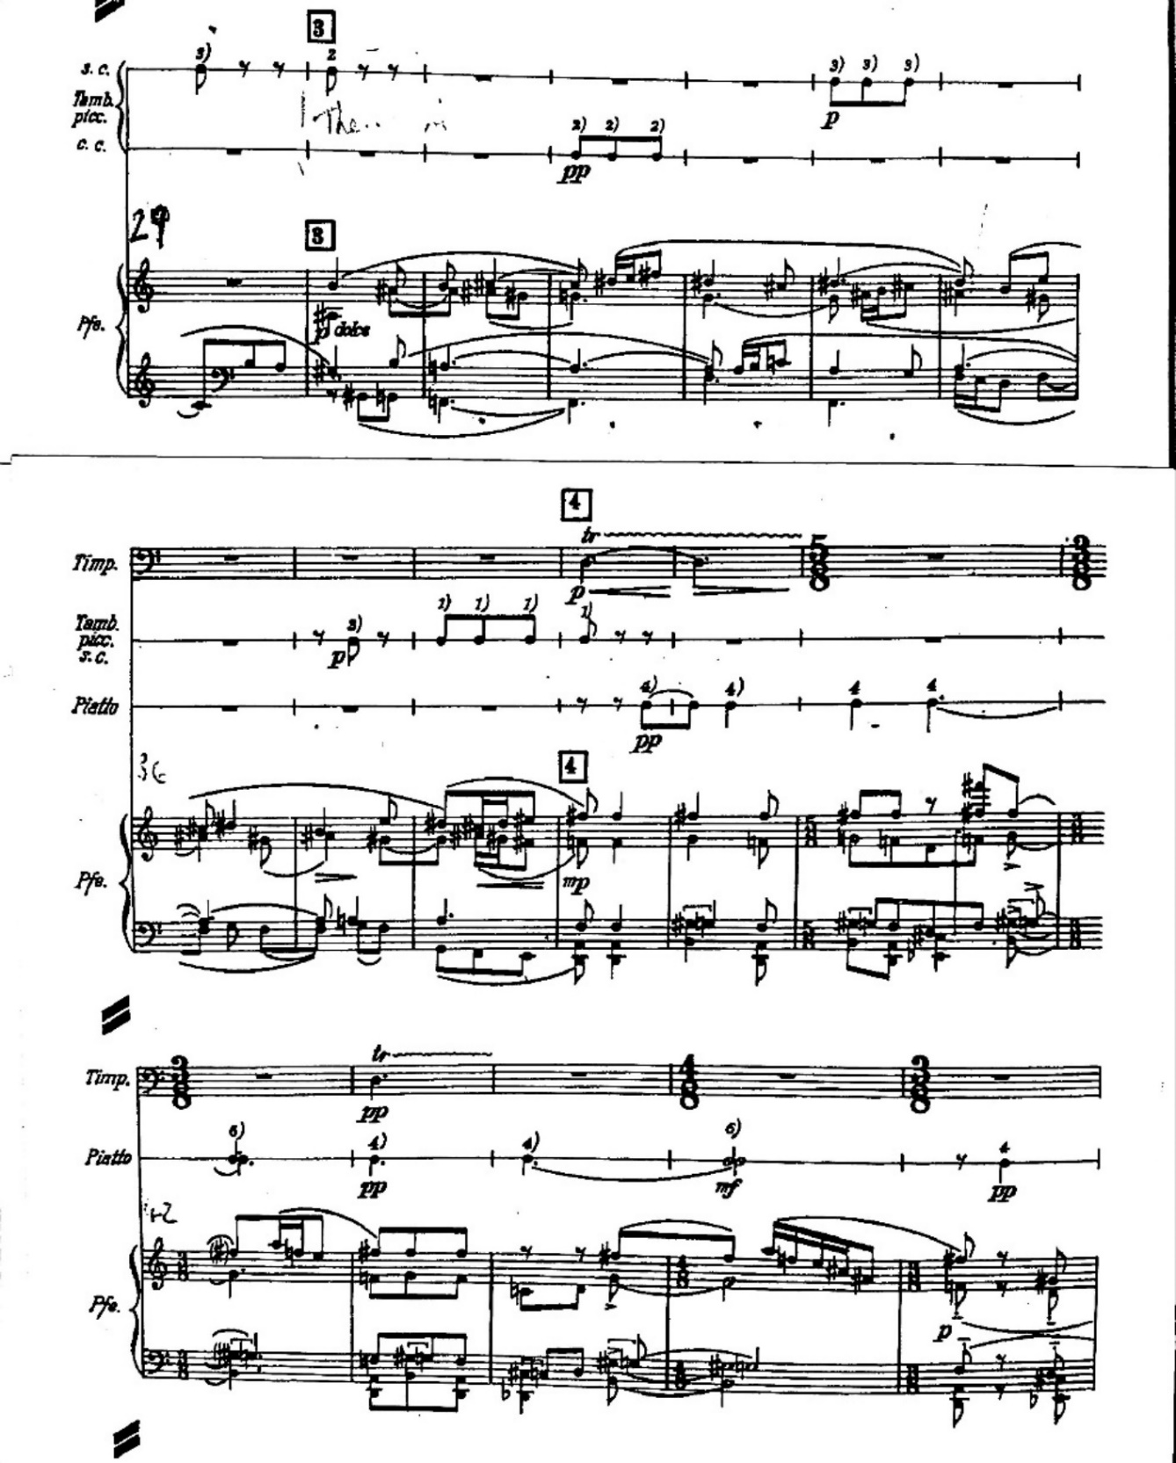
“Piano Concerto No. 1” by Béla Bartók
©1927 Boosey & Hawkes, Inc., A Concord Company
All Rights Reserved. For The Sole Permission of Andrew Anderson, University of Oklahoma.
Figure 2.3 Piano Concerto No. 1, Mvt. 2, mm. 84-104
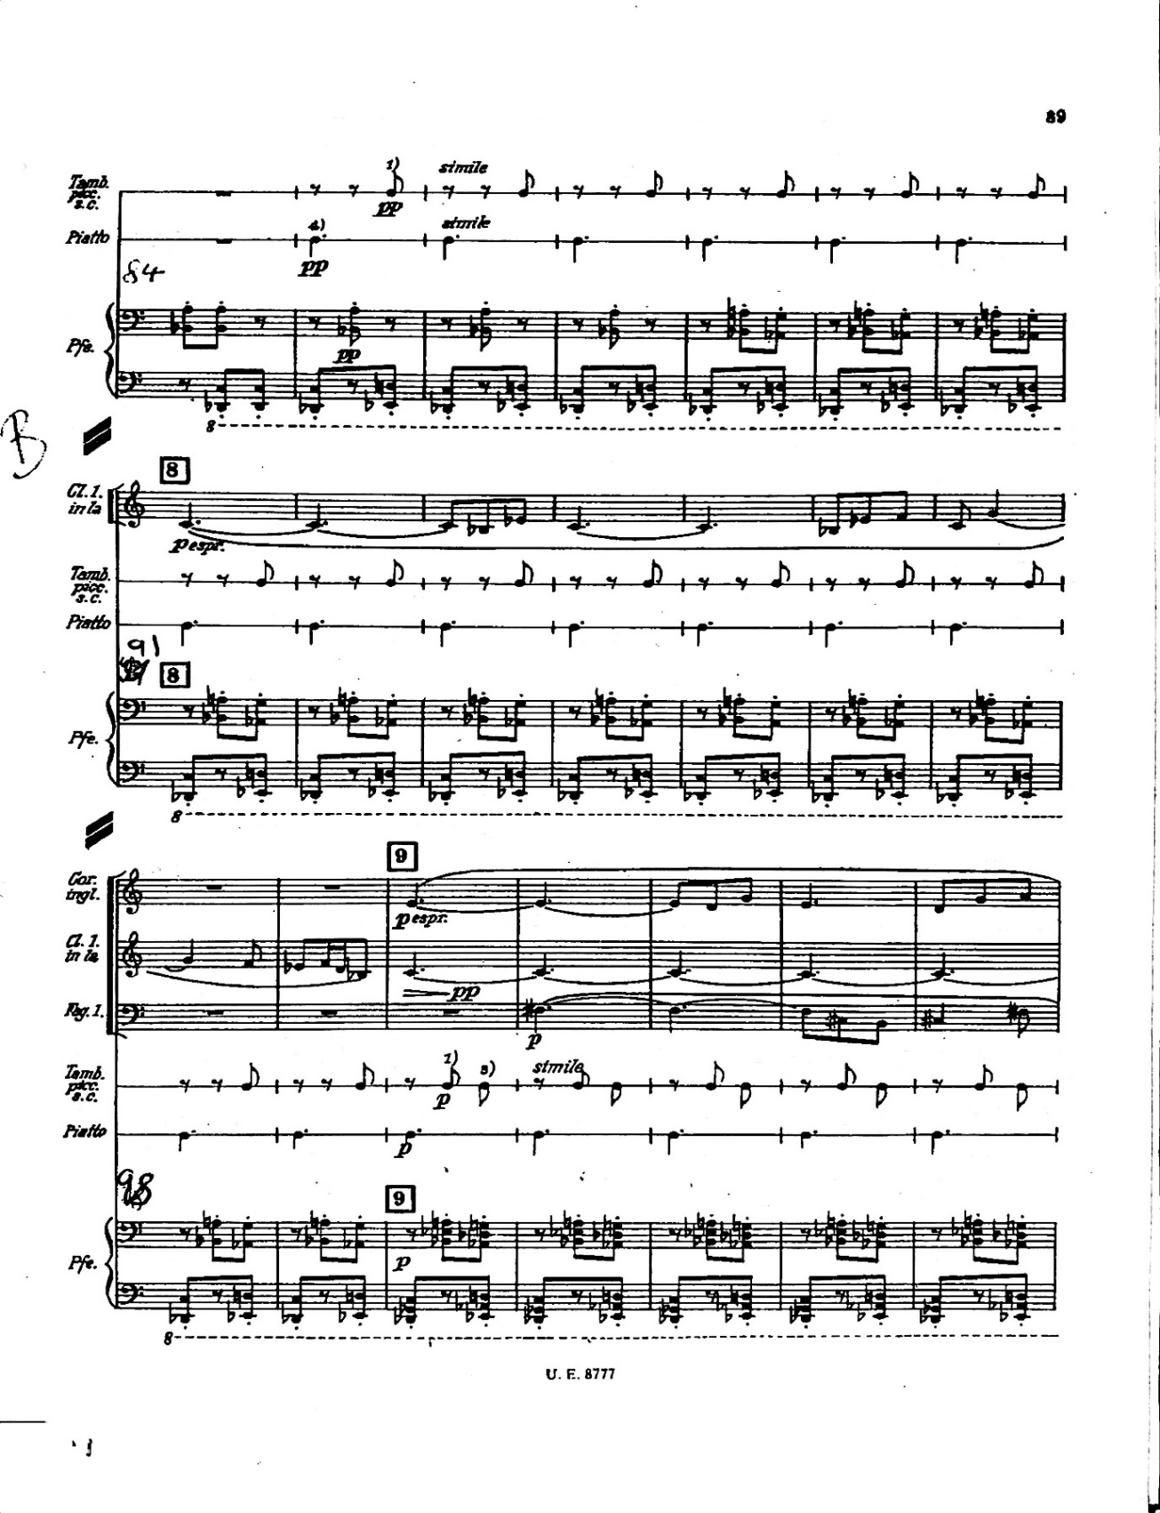
“Piano Concerto No. 1” by Béla Bartók
©1927 Boosey & Hawkes, Inc., A Concord Company
All Rights Reserved. For The Sole Permission of Andrew Anderson, University of Oklahoma.
Figure 2.4 Piano Concerto No. 1, Mvt. 2, mm. 122-131 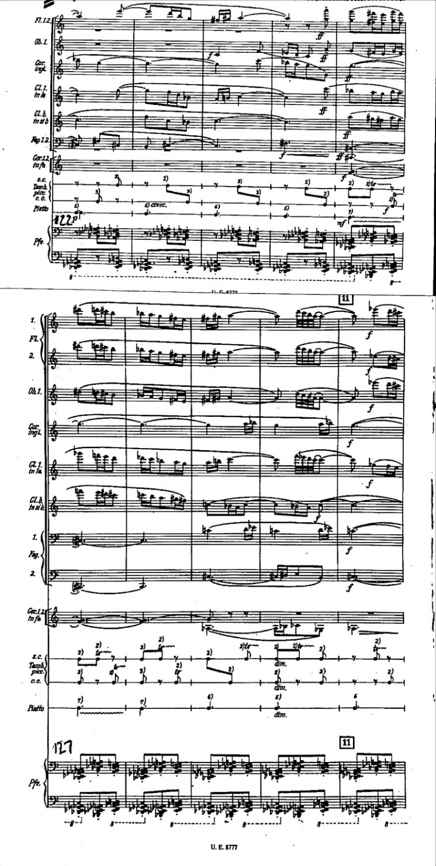
“Piano Concerto No. 1” by Béla Bartók
©1927 Boosey & Hawkes, Inc., A Concord Company
All Rights Reserved. For The Sole Permission of Andrew Anderson, University of Oklahoma.
Bartók’s Piano Concerto No 2., in contrast to the middle movement of his previous piano concerto, uses the entire standard orchestral wind/percussion instrumentation to accompany the solo piano during the first movement of the piece. The piano is treated in a very melodic, soloistic, and virtuosic manner during the movement, also in contrast to the second movement of the Piano Concerto No. 1.

Figure 2.5 Wind/Percussion Instrumentation – Bartók Piano Concerto No. 2, Mvt. 1
Piccolo (doubling Flute III)
2 Flutes
2 Oboes
2 Clarinets (in B♭ and A)
Bass Clarinet in B♭
2 Bassoons
Contrabassoon (doubling Bassoon III)
4 Horns in F
3 Trumpets in C
3 Trombones
Tuba
Timpani
Percussion (snare drum, triangle, bass drum, cymbals)

Once the scope of instrumentation is determined, the thickest textures of the movement must be isolated and analyzed to determine the level of restraint, if any, shown by Bartók in deference to the primacy of the solo line. The opening movement of Bartók’s Piano Concerto No. 2, for all its activity, only calls for tutti wind passages near the end of the movement at measure 175, though the texture within that tutti is contrapuntal. At only two points in the movement are all the winds called for to initiate a note at the same time: the fermata in m. 221, which serves to introduce a quasi-cadenza starting in the next measure, and the exclamatory downbeat which signals the end of the movement. The rest of the movement oscillates between statements utilizing various instrumental combinations. Sections are treated more homogeneously during thinner textures than in the discussed movement of Piano Concerto No. 1, though this may be the case because there are more instruments to choose from. However, increasing texture during polyphonic statements are assigned to the woodwinds which then begin to double in octaves in a heterogeneous way, with horns treated as part of the woodwind choir more than as part of the brass section. (For example, mm. 99-107 sets up a two-part counterpoint, first sounded by horns and then answered by unison flutes, oboes, clarinets, and bassoons.) Bartók often treats the woodwinds (with horns augmenting the bassoon voice in their lower range) as a single unit during already-thick textures, dovetailing entrances and exits to create unified musical ideas which progress through the group’s possible range. An example of this phenomenon occurs in mm. 170-173, during which syncopated entrances begin in bassoon and horn 2. Successive entrances create a textural crescendo just as would happen in a piano or organ part; in order, bassoon 1/horn 3, horn 1, oboes, clarinets/flute 3, and oboe 1/flutes 1-2 join the texture which builds to a sforzando downbeat. A harmonic pedal point prefaces this thickening of texture, scored in the tuba. This choice of using the tuba absent the trombone section suggests that Bartók uses the tuba at times to serve as the bass voice in a conical brass extension of the horn section.

Figure 2.6 Piano Concerto No. 2, Béla Bartók – mm. 168-173
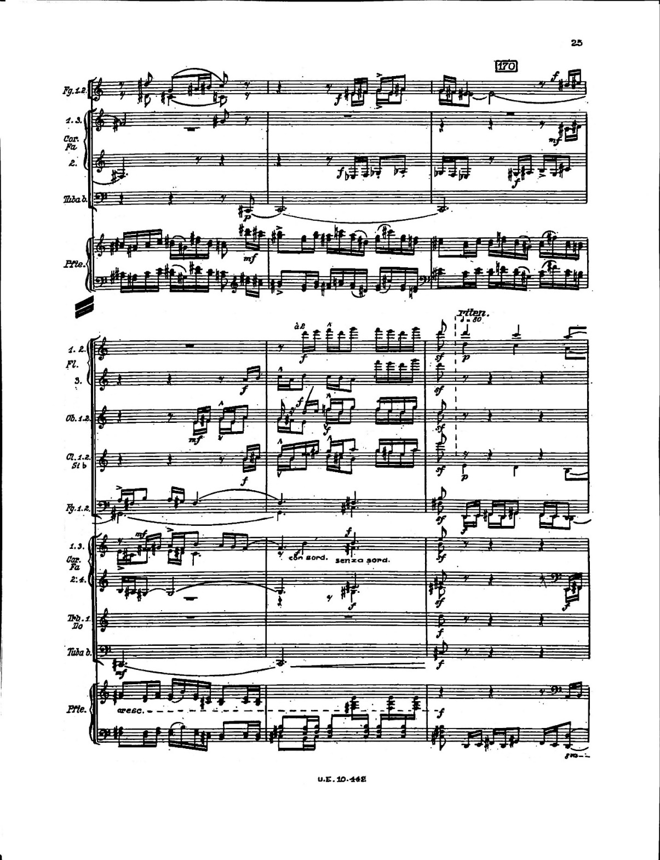
“Piano Concerto No. 2” by Béla Bartók
©1932 Boosey & Hawkes, Inc., A Concord Company
All Rights Reserved. For The Sole Permission of Andrew Anderson, University of Oklahoma.
Combining the study of the two movements yields conclusions that will be extremely important to retaining Bartók’s musical intent during the Cantata Profana. First and most helpfully, that full tutti need not be employed except in extreme cases of musical punctuation – within the two movements discussed, only two such moments appear, both near the end of the movement in the Piano Concerto No. 2. That the time taken by those two movements is roughly equal to the entire length of the cantata (approximately 18 minutes) should reinforce the judicious use of forces. Just as Bartók was in no hurry to use tutti scoring in either concerto, so should any such characteristics found within the Cantata Profana be similarly adhered to. A second conclusion is that Bartók’s octave doublings should be retained. Despite the obstacles presented in retaining all instrumental octave doublings from the original work, it is clear from Bartók’s wind scoring that those doublings are very much intentional and should be mitigated when needed through utilizing fewer players. In extreme ranges, this may counter-intuitively involve the addition of instruments; pitched percussion and contra-range reeds or string bass will be necessary to preserve some of these octave choices.
A third conclusion involves the choice between scoring heterogeneously or homogeneously; Bartók tends towards heterogeneous scoring as the woodwinds increase in texture, often doubling octaves in contrasting lines through different instrument families. The composer also utilizes the range of the woodwind choir to facilitate accompanimental lines which might otherwise be traded between more similar timbres if written for strings. Scoring for thinner textures, however, Bartók utilizes the woodwinds homogeneously more often, utilizing instruments in pairs depending on the desired register and staggering such entrances. Cylindrical brass is written mostly homogeneously (if at times contrapuntally within that homogeneous texture) but primarily called for only at louder dynamics to provide emphasis to desired passages. This practice seems likely to be useful in the Cantata Profana, any addition of trumpet or trombone parts beyond Bartók’s original will need to be carefully considered, with options including muted textures beyond that originally called for and softer dynamics utilized without unnecessary doubling from other voices. Though Bartók was a groundbreaking figure in the use of pitched percussion, the piano concertos predate his Music for Strings, Percussion and Celeste and additional pitched percussion would not have been needed to assist with octave doublings during the orchestral version of Cantata Profana, since strings were available. For purposes of this transcription, however, pitched percussion as a substitute for subdued upper string sounds is treated as a viable practice.

Music for Wind Band and Chorus
Original Works
As previously stated, original music for full wind band and SATB chorus is rare, and a listing of such works can be compiled from the Kinder text along with subsequently published resources such as the website windrep.org and Tim Reynish article. Culled from these sources, the following pieces qualify as works utilizing mixed choir with woodwind and brass accompaniment, utilizing a majority of the instruments available in each family – music written for holidays and patriotic events has been omitted. Many of the pieces listed by Kinder utilize winds from the orchestral wind section rather than the traditional wind band, which in most cases results in the omission of the saxophone. However, if the works utilize at least two instruments of the orchestral woodwind family they remain listed below, since given the “player pool” concept utilized by many present-day university wind bands, literature without saxophones is programmed at times – examples include Steven Stucky’s setting of the Henry Purcell Funeral Music for Queen Mary and Joseph Schwantner’s ...and the mountains rising nowhere.
Figure 2.7 Original Works Written for Mixed Choir with Band
* = Reynish ^ = windrep.org # = Kinder

Abigana, Brett – Miserere*
Abigana, Brett – Symphony No. 1: Omnes
Gentes*^
Abigana, Brett – Symphony No. 3: The Rose*
Adler, Samuel – Serenade#
Alcalde, Anton – Symphony No. 1^
Alcalde, Anton – Symphony No. 2^
Anonymous – Mass in E♭ Major#
Amis, Kenneth – Bell-Tone’s Ring^
Andriessen, Louis – Il Principe^
Ayers, Jesse – Jericho^
Badings, Hank – Cantata VIII#
Ball, Michael – Pageant*
Barnes, James – Lonely Beach^
Basford, Daniel – Night Journey*^
Benson, Warren – The Drums of Summer^
Berio, Luciano – Magnificat#
Berio, Luciano – Passagio#
Berlioz, Hector – Scene Héroïque#
Berlioz, Hector – Grande Symphonie Funèbre et
Triomphale^
Botti, Susan – Cosmosis*^
Botti, Susan – Wonderglass (opera)*
Boysen, Andrew – Symphony VIII^
Brahms, Johannes – Begräbnisgesang^#
Bright, Houston – Now Deck Thyself with
Majesty and Excellence^
Bruckner, Anton – Mass in E minor*^#
Buckley, Robert – Procession of the Sorcerers^
Clarke, Nigel – Gagarin^
Colgrass, Michael – Arctic Dreams^
Conte, David – The Dream of Martin Luther
King^
Cushing, Charles – Angel Camp^
Davis, Daniel – Courage… to follow the way*^
Deak, Casba – Momento Mare*
de Haan, Jacob – Missa Brevis*
de Haan, Jacob – Missa Katerina*
de Haan, Jacob – Sa Musica^
de Meij, Johan – African Harmony^
Dello Joio, Justin – Blue Mountain (opera)*

DiOrio, Dominic – Gathering: A Choral
Symphony^
DiOrio, Dominic – Silent Moves the Symphony
True^
Giroux, Julie – In My Father’s Eyes^
Giroux, Julie – My Soul to Keep^
Gjeilo, Ola – Meridian^
Goh Toh Chai – Sang Nila*
Gorb, Adam – Eternal Voices*
Gorb, Adam – Thoughts Scribbled on a Wall*
Grainger, Percy (ed. Chalon Ragsdale) – The
Lads of Wamphray Ballad^
Gregson, Edward – Missa Brevis Pacem*
Hagen, Daren – Bandanna (opera)*
Hanson, Howard – Song of Democracy#
Hanson, Howard – Symphony No. 7#
Haydn, Johann Michael – Deutsche Messe#
Hedges, Anthony – A Manchester Mass*
Henze, Hans Werner – Muses of Sicily*
Hidas, Frigyes – Requiem*
Holsinger, David – A Song of Moses^
Holsinger, David – In the Spring at the Time
When Kings Go Off to War^
Holsinger, David – Reagan of Illinois Part II^
Holsinger, David – Sinfonia Voci^
Holsinger, David – The Easter Symphony^
Holst, Gustav – Turn Back, O Man#
Holst, Gustav – A Festival Chime#
Honneger, Arthur – King David*
Honneger, Arthur – Nicolas de Flue*
Howard, Emily – Jonah*
Husa, Karel – An American Te Deum#
Husa, Karel – Apotheosis of This Earth#
Iannaconne, Anthony – The Prince of Peace#
Iannaconne, Anthony – Walt Whitman Song#
Izumi, Taku – Look Up at the Stars^
Kataoka, Hiroaki – Itsuka-no-sato, Iizuka^
Klobucar, Andelko – Papinska Missa*
Latham, William – Psalm 130#
Latham, William – Psalm 148#
Likhuta, Catherine – Scraps from a Madman’s
Diary^
Long, Zhou – The Future of Fire*^
Lucic, Franjo – Missa Jubilaris*
Machain, Jorge – Guiding Light^
Marshall, Christopher – U Trau*
Maslanka, David – Mass#
Maslanka, David – Liberation^
Melillo, Stephen – The Speech of Angels^
Newman, Jonathan – Moon by Night^
Novak, Lior – Gleams from the Bosom of
Darkness*^
Penderecki, Krystof – Dies Irae: Oratorium ob
Memoriam in Perniciei Castris in
Oswiecim#
Persichetti, Vincent – Celebrations (Cantata No.
3)^#
Phibbs, Joseph – Rainland*
Reed, H. Owen – Michigan Morn^
Sacco, Peter – Make Haste, O God to Deliver
Me#
Saucedo, Richard – Spirit of the Falcon^
Saunders, Matthew – Progress Through
Knowledge^
Schubert, Franz – Deutsche Messe D.872#
Schubert, Franz – Glaube, Hoffnung und Liebe
D.954#
Stamp, Jack – No Brief Candle^

Stokes, Eric – Out of the Cradle Endlessly
Rocking^
Stravinsky, Igor – Mass*#
Stravinsky, Igor – Symphony of Psalms*^#
Surinach, Carlos – Celebraciones Medievales^
Telfer, Nancy – To Sing of Hopes and Dreams#
Theofanidis, Christopher – The Here and Now*^
Thompson, Randall – The Last Words of David#
Thompson, Randall – The Testament of
Freedom^
Toensing, Richard – A Psalm for Vespers#
Turrin, Joseph – Invocation^
Turrin, Joseph – The Scarecrow (opera)*
Vaughan Williams, Ralph – O How Amiable#
van Beurden, Bernard – Boulevard des
Misereres*
van Beurden, Bernard – La Messe*
van Beurden, Bernard – Song of Skyloom*
Weinstein, Michael – Gott Hammert*
Whitacre, Eric – Deep Field^
Wilby, Philip – A Passion for Our Time*
Wilder, Alec – Children for Peace*
Xenakis, Iannis – Oresteia Suite#
Yagisawa, Satoshi – Hymn to the Sun - with the
Beat of Mother Earth^
Yi, Chen – KC Capriccio

At first glance, this seems like an impressive number of pieces, numbering 113. However, when taken as a percentage of the total available literature for winds, it is found to be only a small amount of the total output – just above half of one percent of all works available. Further, the user-editable nature of the windrep.org website allows for any work to be included, regardless of the work’s quality or publishing status – no vetting of the works is needed for inclusion. This means that there are most likely works included on the site which would fall short of the threshold for programming by many applicable conductors. Given these factors, the number of viable works for winds and mixed choirs must be smaller than that listed, with only the following works listed in any more than one source and as such suggestive of an updated canon for wind/choral works:

Figure 2.8 Original Works from Figure 2.7 Listed in Multiple Sources
Abigana, Brett – Symphony No. 1
Basford, Daniel – Night Journey
Botti, Susan – Cosmosis
Brahms, Johannes – Begräbnisgesang
Bruckner, Anton - Mass No. 2 in E minor
Long, Zhou – The Future of Fire

Novak, Lior – Gleams from the Bosom of
Darkness
Stravinsky, Igor - Mass
Stravinsky, Igor - Symphony of Psalms
Theofanidis, Christopher – The Here and
Now

A corollary question would be the frequency of performances for these works, particularly those from Figure 2.7 having been cited as meritorious. This will be explored later in the chapter.

Transcriptions
Transcriptions of existing works for winds and choir are rarer than original works for the combined groups – only sixteen works are found which are not patriotic or otherwise occasional and fit the choral and instrumental parameters given for the original works already listed, and only the least rigorous source - the user-editable website windrep.org - includes arrangements at all as part of its listing. Forty-two arrangements of music that is patriotic or written for holidays are included on the site, indicating that the combination of bands and choir is associated more with particular special events than it is with standalone music. Of the arrangements listed, only the Juan Vicente Mas Quiles arrangement of Carmina Burana, Paul Noble’s setting of the John Rutter Gloria, and my arrangement of Vaughan Williams’ Five Mystical Songs approach both the choral involvement and compositional scope of the Cantata Profana. (The choir in Donald Patterson’s arrangement of Daphnis and Chloe Suite No. 2 is used for timbre only; there are no words sung.)

Figure 2.9 Selected Wind Transcriptions of Works Originally Written for Mixed Choir with Various Accompaniment

Bernstein, Leonard, arr. Joseph Kreines – “Make
Our Garden Grow” from Candide
Ives, Charles, arr. Jonathan Elkus – The Circus
Band
LaBarr, Susan, arr. J. Eric Wilson – Grace
Before Sleep
Liszt, Franz, arr. Tamas Beischer-Matyo – Via
Crucis
Mascagni, Pietro, arr. Shishikura – Cavalleria
Rusticana
Orff, Carl, arr. Juan Vicente Mas Quiles –
Carmina Burana
Peterson, Oscar, arr. Robert Buckley – Hymn to
Freedom
Ravel, Maurice, arr. Donald Patterson – Daphnis
& Chloe Suite II
Rutter, John, arr. Paul Noble - Gloria
Rutter, John, arr. Paul Noble – What Sweeter
Music
Thompson, Randall, arr. Frank Hudson (separate
arrangement by William Silvester) - Frostiana
Traditional, arr. Travis Cross – Be Thou My
Vision
Vaughan Williams, Ralph, arr. Andrew
Anderson – Five Mystical Songs
Verdi, Giuseppi, arr. Clark McAlister & Lowell
Graham – “Anvil Chorus” from Il Trovatore
Wagner, Richard, arr. Bruce Houseknecht –
“Awake” from Die Meistersinger
Wagner, Richard, arr. Adrian Hernandez – “Ride
of the Valkyries” from Die Walkure

The lack of quantity in this category reveals that there is certainly no existing canon for this subgenre. A causality dilemma is the result: Is there little repertoire because of low demand for the combination, or does the scarcity of music for the two ensembles create a level of demand which is artificially low? For purposes of this project, the latter is assumed; that given an original work or transcription of sufficient quality, interest will pique and demand resultingly increase. A further conclusion to draw from this relative lack of volume is that there are few norms regarding orchestration for such works. The process of retaining compositional and orchestrational intent while effectively balancing the instrumental and vocal ensembles is still very much an open question. Mas Quiles uses a traditionally large wind band; the only deviation from custom is an increase in instrumentation through the use of separate conical and cylindrical brass choirs: three trumpet, three trombone, and baritone parts are scored along with two flugelhorn, four horn, euphonium, and tuba parts.

Frequency of Programming
Though not a perfect assessment tool by any means, a general estimate of performance frequency can be inferred from the webpage of any band composition on the windrep.org website. As an example, the page of the well-known Eric Whitacre piece Lux Aurumque lists 19 performances since December 2018, while the page for Whitacre’s earlier work Godzilla Eats Las Vegas! lists 18 performances dating from May 2011. It is a safe assumption, then, that Lux Aurumque is the more frequently performed work. (It is notable that the site limits listed performances to 20, showing the most recent along with historically notable performances.)
An examination of performance frequency for the works making up the updated band/choir canon from Figure 2.7 in comparison to even very difficult standard wind repertoire reveals a persistent rarity of combined band/choral performances. This suggests that practical concerns may be the chief reason for the rarity of wind/choral collaboration; difficulties in scheduling and available space are the most readily apparent such hurdles. Keeping prescribed instrumental musicians to a minimum should, in addition to helping instrumental/vocal balance, ease these practical concerns and encourage increased performances.

Figure 2.10 Number of Performances Listed for Figure 2.7 Band/Choral Works in Comparison to Selected Standard Wind Repertoire

Abigana, Brett Symphony No. 1 2 performances, 2013-2019
Basford, Daniel Night Journey 2 performances, 2009-2012
Botti, Susan Cosmosis 1 performance, 2019
Brahms, Johannes Begräbnisgesang 1 performance, 2017
Bruckner, Anton Mass No. 2 in E minor 4 performances, 2012-2016
Long, Zhou The Future of Fire 3 performances, 2019
Novak, Lior Gleams from the Bosom 2 performances, 2005-2010
of Darkness
Stravinsky, Igor Mass 3 performances, 2013-2017
Stravinsky, Igor Symphony of Psalms 4 performances, 2007-2019
Theofanidis, Christopher The Here and Now 2 performances, 2019
-----------------------------
Colgrass, Michael Winds of Nagual 20 performances, 2017-2019
Husa, Karel Music for Prague 1968 20 performances, 2018-2020
Maslanka, David Symphony No. 4 20 performances, 2018-2020
Schmitt, Florent Dionysiaques 20 performances, 2010-2019

It is expected that none of the compositions which include choir are as ubiquitous as the four standalone band works, but it is notable that the compositions by Brahms, Bruckner, and Stravinsky are performed at around the same frequency as newer works. Length and complexity are not seemingly the chief obstacles, as the Stravinsky Symphony of Psalms (~20 min.) and the Bruckner Mass No. 2 in E minor (~40 min.) have the largest number of listed performances among the former category. This suggests that logistical and scheduling concerns are the primary deterrents to programming works of this type.

Works by Bartók Transcribed for Band
Music by Bartók transcribed for bands is chiefly marketed towards secondary school ensembles, using short movements of Bartók’s folk song settings. Much of the literature is written to be easily accessible to younger students; only arrangements of Concerto for Orchestra, The Miraculous Mandarin, and Romanian Folk Dances could be classified as advanced, and Allegro Barbaro, though graded as medium-advanced in difficulty, is also miniature in form.
Figure 2.11 Béla Bartók Compositions Available As
Arrangements for Concert Band
Title Arranger Publisher Difficulty Level

Allegro Barbaro Wallace, Tom Arrangers’ Publishing Med. Advanced
Bartók for Band Schaefer, Don Barnhouse Easy
Bartók Suite Clark, Larry Belwin Easy
Bartók Variations Broege, Timothy Grand Mesa Easy
Bartók Folk Trilogy McGinty, Anne Queenwood Easy
Cantata Profana (w/ solo tenor, solo Anderson, Andrew N/A Advanced
baritone, and double mixed chorus)
Concerto for Orchestra Schweiller, Simon Baton Music Advanced
Concerto for Orchestra Reichling, Andre HeBu Music Advanced
Evening in the Country (flex solo w/ band) Davis, Albert & Ludwig-Masters Med. Easy
Harris, Floyd
Evening in the Country Suchoff, Benjamin Boosey & Hawkes Med. Easy
Four Short Bartók Pieces Hope, Garrett Garrett Hope Med. Easy
Four Sketches Schaefer, William TRN Music Medium
The Fox Cook, Paul Belwin Beginning
The Miraculous Mandarin Morita, Kazuhiro Brain Music Int’l Advanced
(unavailable in U.S.)
Petite Suite Cushing, Charles Boosey & Hawkes Medium
Romanian Christmas Carols van Zoelen, Andreas Baton Music Med. Easy
Romanian Christmas Carols #2 van Zoelen, Andreas Baton Music Med. Easy
Romanian Folk Dances Goto, Yo Brain Music Int’l Med. Advanced
Romanian Folk Dances Klaus, Steven NiceChart Medium
Romanian Folk Dances Nakamura, Akihiko Bravo Music Med. Easy
Romanian Folk Dances Valta, Jan Editions Marc Reift Med. Advanced
Romanian Folk Dances van Zoelen, Andreas Baton Music Med. Easy
Song of the Mountain Horn La Plante, Pierre Deahn Pubications Medium
Tanz Suite, Mvt. 2 Morrison, John Cupcake Music Med. Advanced
Three Pieces for Band from Finlayson, Walter Boosey & Hawkes Medium
“For Children”
Three Romanian Christmas Songs Carmody, Bill Bill Carmody Medium
Two Romanian Carols Wagner, Douglas Belwin Very Easy
Two Songs and a Dance Hastings, Ross Wynn Music Easy
The general scope of works and the difficulty levels thereof make the Cantata Profana a project

which can reinforce thinness in wind band literature both in its combination with mixed chorus

and in its form as a large-scale work by Béla Bartók.

Chapter 3

BÉLA BARTÓK AND CANTATA PROFANA, BB 100

Cantata Profana as a Reaction to Class-Based Stratification and German Dominance

Bartók’s Cantata Profana is at its core the presentation of indigenous Eastern European folklore and folk music practice filtered through Bartók’s compositional voice – I propose that this presentation is meant to reclaim folk idioms; opposing what Bartók saw as a hegemony of German ideological, economic, and cultural influence, idealized by the Hungarian proletariat because of longstanding upper class political and cultural associations with Germany. Bartók accomplishes this reclamation in four ways. A threefold theme of transformation occurs within the piece; the first of these is his use of a Romanian colinde wherein nine sons of a hunter are transformed into stags. The second manner through which transformation is reinforced as a theme is through Bartók’s use of ternary musical forms: contrasting B sections often serve as conduits by which original melodic or motivic material is altered; the original material then returns in a different but recognizable manner. Orchestration - particularly at the moment of the boys’ metamorphosis - is the third way by which transformation is emphasized since the sonic pallette used at that point in the story is very different from the rest of the work. The final way Bartók reclaims Hungarian village/folk idioms is through their use within his compositional language. Since they were not derived from the prevailing German common practice aesthetic, the use of these folk practices was not widespread. (Bartók himself did not assert the presence of these patterns, but they are present. The use of non-diatonic folk modes is particularly
widespread.) Through these four processes, Cantata Profana becomes an amalgamation of
Bartók’s folk collection and a rejection of German influence by using musical ideas derived from the rural Hungarian lower classes and utilizing transformation as a recurrent theme within the piece.
Hungarian elites, in Bartók’s view, adhered too closely to a discourse emphasizing a Germanic cultural ideal. A 1934 letter reveals distress at his (particularly upper class) compatriots’ indifference to Hungarian language and folk culture:

[My] irony – as the attentive reader and anyone acquainted with Hungarian conditions can instantly sense – is exclusively directed against the indifference, or rather the hostility, of my own compatriots. For 80 or perhaps 90 per cent of the Hungarian upper classes even now look upon me and my colleagues almost as traitors, simply because I study and propagate the music of the Hungarian village… It was in order to shake people here out of this indifference that I described the plight of Hungarian folk music in such strong terms.

Bartók’s use of the term “traitors” is jarring in this context, revealing what he saw as a conscious choice on the part of the Hungarian upper class to idealize the non-Hungarian, or more specifically German concert music. Musicologist Judit Frigyesi sheds light on the “Germanness” of Budapest’s cultural life and its intersection with Bartók, explaining that Hungary lacked an autonomous musical tradition that was comparable to the Austro-German one. As a result, Hungarian musicians were trained in that Austro-German tradition by professors brought from abroad. Additionally, descendants of Germans who had immigrated centuries earlier made up a large portion of the population in many Hungarian cities, with many ascending to the middle nobility or aristocracy (rather than forming isolated groups outside the Hungarian social
hierarchy). Enough upper-class Germans living in Hungary retained their cultural heritage so

that the aristocracy in fact used the German language, creating a linguistic dichotomy between the upper and middle/lower classes; a cultural divide between those living in urban versus rural settings was also a result. Bartók’s criticism of the neglect shown towards the Hungarian language in this context was long-standing and even extended to his mother. He admonishes her in a 1903 letter not to let the use of the Hungarian vernacular wane by speaking German:

Why didn’t you get used to speaking Hungarian when you were young? Aunt Irma, after all, spent quite a long time in Bekes County; there she learned our language to some extent, and you could have done the rest… Hear now the thesis addressed to every Hungarian: Speak in a foreign language only when absolutely necessary!

Bartók saw Hungarian cultural influences shunned in favor of German ones, not only in the German-dominated canon of Western art music but also in matters of worldview and fiscal policy. The 1938 statement below plainly states his yearning for cultural autonomy.

Three timely wishes in May, 1938

ideological
Liberation from German economic influences
cultural Béla Bartók

The phenomenon of Hungary adhering to German influences is described by Hungarian sociologist Miklos Hadas as a national habitus, a “pattern of thoughts, emotions, and actions occurring obstinately from generation to generation,” an assertion reinforced and explained in a musical framework by Frigyesi. Hadas argues that there are “striking similarities between Germany and Hungary, as far as the characteristics of the national habitus and the state formation are concerned;” Bartók would wholeheartedly but unenthusiastically agree with this conclusion. Frigyesi points out that “when Bartók fought for the survival of multiethnicity in Hungary, the Germans… did not form part of his ethnic caleidoscope [sic], not even in theory,” reinforcing the composer’s antipathy toward the German dominance he perceived.
Though several years following the writing of the Cantata Profana, Bartók presciently laments the association between Hungary and the Axis powers leading up to and during World War II; the political rise of Germany must have been seen by Bartók as a parallel to their already-entrenched cultural hegemony. He states in a 1938 letter to Madame Muller-Widmann: “What a defeat for England and France – all the worse that it should be at the hands of a Hitler… And on top of that [Hungary], too, obtain[s] justice through him…Thus, the prestige and influence of this system based on lies will prevail in Europe to an even greater extent.” Hungary’s increasingly cozy relationship with Hitler’s ascending regime was encouraged, to Bartók’s dismay, by the upper classes of Hungarian society:

The coming into power in Germany of openly aggressive forces was hailed unanimously by the Hungarian ruling classes which, in their efforts to undermine the system of the Versailles peace treaties, were looking for support to German imperialism above all.

Bartók later recounts his refusal, along with Kodaly, to fill out a Nazi questionnaire regarding his ethnicity, joking that if they did fill it out, it should be with genealogical and etymological minutiae. These examples demonstrate Bartók’s continued frustration with Hungarian/German power dynamics, and I propose that they suggest that his collection and use of folk music, implied but not overtly stated within the Cantata Profana, was nonetheless a reclamation of Hungarian folkloric value in opposition to German socio-political and musical hegemony.
The dominance of Germany over Eastern European nations during the interwar period resulted in a devaluation of the nations’ various folk cultures. A 2013 Laszlo Szarka/Alan Campbell article from the journal Hungarian Historical Review states a recurrent Hungarian problem regarding these local cultures:

The position of minorities has usually, throughout the last ninety years, been interpreted as ongoing retreat, shrinkage, and loss. The “moral impossibility” of the minority paradigm, which emerged in the early twentieth century in the wake of world-scale changes, imposed situations, and the homogenizing ambitions of nationalizing nation states may be described as a permanent identity crisis and a process of deprivation leading to the extinction of minority communities.

Bartók seems to have been aware of the plight of local cultures and was concerned with the preservation of them, particularly their music. A 1928 letter to the Matica Slovenka (Slovak cultural institute) mentions an upcoming book collaboration between Bartók and the institute; Bartók suggests appendices that list folk songs of foreign origin and previously published folk songs in Bartók’s other texts. He places the number of folk songs at approximately 8,000. The sheer number of hours required to travel, record, notate, and publish such a large number of songs, along with the fact that he sought to catalog songs of many different cultures, is a clear
indicator of Bartók’s priorities. To him, all folk practices were valid and worthy of archiving.
The plight of minority cultures in Hungary during the 1920s and early 1930s was due in large part a result of Hungary’s post-World War I political situation. The fluctuating nature of Central European nation-states between the World Wars was a concern for those in the Hungarian upper classes due to the Trianon Peace Treaty. As a punitive measure starting World War I, the 1920 signing of the treaty forced Hungary to cede two-thirds of its pre-war territory (and resultingly one-third of the Hungarian speaking population) to Austria and the divided states of the former Hapsburg Empire including Romania, Yugoslavia, Czechoslovakia, and the Kingdom of Serbs, Croats, and Slovenes. Border delineation was a constant concern afterward for the Hungarian upper classes, who lamented the loss of a centuries-old empire and the relegation of Hungary to non-power status within Europe. As a result, during the interwar period, the Hungarian government chose to once again ally itself with Germany, whose ascendant Nazi party promised a return to pre-war strength.
Grouped with its now-bordering nations, a “national homogeneity through assimilation” was a goal for each of these countries’ majority populations, even as each shared sizeable minority groups hailing from neighboring states. However, each country’s aim to homogenize was tempered by an awareness of their own minority culture within the borders of neighboring countries. Given these political preoccupations, any upper-class concern for folk culture or practices was resultingly diminished, and the attachment of the Hungarian upper class to the ascending German fascist regime in the 1930s became a political manifestation of what Bartók saw initially as a cultural problem. Given these upper-class concerns about political influence
and nation-building, it seems that their intersection with folk culture was likely one of neglect

rather than antagonism, despite Bartók’s writings. Nonetheless, Bartók’s concern at the
diminishing valuation of folk culture was justified given either reason; as stated in the Hungarian Historical Review, the extinction of minority communities was ongoing.
It seems consistently clear from the composer’s correspondence that he saw an intersection between his work with folk populations and political decisions that affected the people he encountered. In one such instance, a 1938 letter, he recalls a folk encounter but focuses on political aspects of the meeting as well:

2 so-called ‘Csango’ women were here from Moldavia (East Rumania): the Csango people are the very easternmost of the Hungarians and have never really belonged to Hungary. There are about 20,000 of them, (linguistically) terribly oppressed (politically, too), but they have preserved a remarkable ancient language. All because of the terrible Rumanian oppression it is normally impossible to bring them to Budapest; it is only the Eucharistic World Congress which has now given us this opportunity.

Frigyesi, in her 1994 article “Béla Bartók and the Concept of Nation and ‘Volk’ in Modern Hungary,” discusses the relationship between folk music and Bartók’s mature musical compositions, along with the intersection of both to political and social problems of the interwar period:
The mature Bartók’s devotion to the study of peasant music and its use in composition was hardly an expression of official nationalism, nor was it simply a continuation of romantic ideals. His approach to peasant music was rather a way of opposing those ideals; it was a modernist response to the social crisis of the era… this social consciousness directly influenced Bartók’s artistic decisions.

This interpretation of the mature Bartók’s motivation encompasses the Cantata Profana since it was composed in 1930 – between his fourth and fifth string quartets and nearly simultaneous
with his second piano concerto. The catalog number of the work, BB 100, is immediately

preceded by three separate works made up of arrangements from Hungarian folk songs: Hungarian Folksongs, BB 97 (group of 5), Hungarian Folksongs, BB 98 (group of 20), and Hungarian Folksongs for Mixed Chorus, BB 99 (group of 4). With work on such a large number of folksongs immediately preceding the composition of the Cantata Profana, it is no wonder that folk scale usage, as cited by Antokoletz, became part of Bartók’s original compositional voice. I assert that this usage of folk idioms was a way for Bartók to rebel against German hegemony in Eastern Europe in the way he was best equipped – through his compositional voice.

Interpretations of the Composer’s Motivation
Since its completion Bartók’s impetus behind writing the Cantata Profana has been analyzed through several different historical contexts, most seemingly reflecting the political climate at the time of the analysis. Analyses done during the Cold War ascribe more overtly nationalistic motivations to the work, whether subversive or optimistic. Analyses after that time seek a more detailed understanding of Bartók’s motivations and examine both his conscious and unconscious reasons for composing the piece. I propose that in addition to previously ascribed motivations, an urban/rural dichotomy present in the Romanian colinde used as the text for the work was reinforced by Bartók’s worldview. Given the class divide that accompanied this dichotomy, the Cantata Profana serves as a rebuke of Hungarian elites not only culturally, but economically as well.
Serge Moreux’s 1953 biography ascribes a subversive political motivation to the work, claiming the cantata was a veiled protest of limitations on individual rights imposed by the Hungarian government of the interwar period. This analysis is very much in line with the European political climate of the 1950s, given the entrenched Cold War and the questions surrounding individual expression under Communist rule. Jozsef Ujfalussy, in his 1965 biography of the composer, cites a letter from Bartók to Sandor Albrecht mentioning two additional pieces “similar in scope” to the cantata and conjectures that the additional works may have been Hungarian and Slovak in theme, emphasizing Bartók’s belief in a core “brotherhood of all countries.” Though Ufjalussy’s conclusions are more optimistic than Moreux, this conclusion still ascribes an overt nationalism, especially prescient given the shrinking Hungarian influence in Eastern Europe during the first half of the twentieth century. Gail Geary in her 1983 Master’s thesis at Baylor University synthesizes these conclusions despite her work being, at its core, a theoretical analysis. Geary delves into the motivation behind the work, calling it a “direct result of this turbulent period in history” (referencing the time leading up to the composition of the work) and citing governmental problems the composer encountered when attempting to visit folk cultures that were previously within the borders of Hungary. None of these sources, however, explore the role that economic class systems may have played in the creation of the work.
More recently, Nicky Losseff’s 2007 article “Casting Beams of Darkness into Bartók’s Cantata Profana” looks at the cantata and Bartók from a psychological point of view, presenting
conjectures about the role of idealized “pure sources” (primarily folk music) in his larger body of

work and the loss of that ideal. Losseff also examines the role of transformation in the cantata
and its relationship to Bartók’s early years, presenting a conjecture that the sons’ transformation

into stags during the piece, resulting in stronger bodies, served as a psychological surrogate for the composer. This strength, according to Losseff, psychologically replaced the frail and sickly body Bartók recalled from his youth. She casts prior and more explicitly political interpretations in a psychological light as well, linking the internal and external worlds of Bartók. Losseff proposes that the ending of the piece both laments the loss of “pure [folk] sources” and shows fear for the rise of fascism in Hungary while acknowledging that the work ends on a more optimistic tone through the use of major intervallic relationships (as opposed to the minor intervals used at the beginning). In contrast, Halsey Stevens in The Life and Music of Béla Bartók (1953) does not attempt to ascertain Bartók’s motivations in writing the Cantata Profana, but instead presents a formal overview of the musical features within the piece, citing it as one of Bartók’s most significant because of “skillful and intricate” writing for the orchestra that remains “psychologically and esthetically convincing.” Again, no mention of any class-based motivations exists in these two sources.
University of Leeds musicologist David Cooper addresses class divisions in his 2015 biography of the composer during his discussion of the Cantata Profana:

Bartók’s text stresses that the father had failed to instruct his sons in the crafts of husbandry or any other valuable work and had instead encouraged them to spend their time in pleasure and hunting. He is punished for this negligence in an ironic twist common to many such folk narratives, by the transformation of his sons into the very quarry they had previously pursued and their consequent inability to return to the human world. Arguably the father could be taken to symbolize a modernity that has lost its connection with nature, regarding it as a

resource to be plundered rather than cherished and nurtured. While it is perhaps an exaggeration to suggest that the theme of the Cantata Profana is labor omnia vincit, one is reminded that the source of this phrase is the first volume of Virgil’s The Georgics, a reflection on the value of agricultural labor.

Given the class divisions present in Hungary during the time between the World Wars, the Hungarian elites’ support of German culture and policies, and Bartók’s belief in the value of folk culture, labor omnia vincit (“work conquers all”) may not be an exaggeration; in fact, the transformation of the boys during the colinde may even serve as a veiled rebuke of the upper classes. In this view, the sons play the part of the upper-class, spending their time in leisurely pursuits, who are forced into a more egalitarian existence.
Rather than posthumously ascribing any one definite intent to Bartók’s writing the Cantata Profana, this discussion is intended to frame the work as a reaction by the composer against German ideological dominance in his homeland, seeking more cultural relevance for rural lower class folk idioms. Given that Bartók believed in the “brotherhood of peoples,” it seems a reasonable conclusion that the Cantata Profana was a way by which the composer asserted that belief (perhaps even in both conscious and unconscious ways). That the work marries a Romanian colinde to original music (asserted by Bartók not to be of a folk character) and is set in several different translations is significant; Bartók states in a 1931 letter to Octavian Beu that “[his] creative work, just because it arises from 3 sources (Hungarian, Rumanian, Slovakian), might be regarded as the embodiment of the very concept of integration so much emphasized in Hungary” during that time. It seems likely, then, that Bartók found inspiration for his compositional methods through combining these folk cultures.
The idea of folklore becoming an agent of social change has been explored by James Theophilus Appavoo, through his work with Dalit villagers in India. Violent discrimination from the upper and middle castes characterizes the outcaste Dalit experience. Dalits exist within a society that views them overtly as on the lowest rung of a societal ladder. Appavoo’s work with Dalit villagers and their music resulted in Folklore for Change. In the book, he claims that as an initial step towards social change, the need for such change must be determined along with the type of transformation best suited to the social climate. He further asserts that he proposes that folklore exists within an alternative media structure outside of commoditization systems. Bartók’s writings suggest that he believed in a need for social change in eastern Europe. Such a media structure may have occurred to Bartók had his distress at diminishing Hungarian culture and folk traditions continued into the latter half of the twentieth century. He spent his own money to publish his collection of Romanian colindes, creating a small alternative media structure himself through that act. The depressed economic situation of the folk becomes relevant because, separated from the elite elements of Eastern European society, the folk occupied an increasingly ignored lower class that was subject to the cultural and political whims of the upper classes, whose appetite for German culture, language, and ideology was a frustration to Bartók. He wrote extensively of colindes, often discussing linguistic minutiae, proper pairings of text to melody, or translation issues. Though one would hope to see more detailed feelings about the songs specifically stated within his correspondence, it is clear from his frequent and detailed communication regarding them that he valued these folk songs and their cultural gravity, using his economic advantages to help preserve them and utilizing one as the source text for the Cantata Profana. Additionally, though not always overt, the distillation of folk musical patterns made its way into Bartók’s compositional style as discussed by Antokoletz, also helping to preserve those practices.
With the rapid decline of Hungary as a European power during the interwar years and the scattering of Hungarian cultural subgroups as a result of the Trianon Peace Treaty, any practice resulting in increased awareness and appreciation of these local cultures would have been a valuable enterprise to Bartók. The goal of Bartók’s work was appreciation, consideration, and foremost, preservation of folklore and folk music which he saw as threatened by the dominant Teutonic culture. Bartók preserved these folk legends and songs through transcription and arrangement, bringing “peasant” music into the concert hall at times overtly through direct arrangement (as in Fifteen Hungarian Peasant Songs for piano and Hungarian Peasant Songs for orchestra) or indirectly through the folk music’s effect on his compositional voice (as in the Cantata Profana). The Cantata Profana, in this light, can be viewed as a folk myth set to heavily-folk-influenced original music. This integration of folk idioms and musical practices into Bartók’s compositional style created a cultural synthesis intended to help preserve the practices of socioeconomically disadvantaged folk cultures, which he saw as an aspect of Hungarian society ignored and underappreciated by the upper classes.
Though Bartók’s goal was often to encourage an increased sense of the Hungarian within his country, the Cantata Profana occupies a curious position when viewed as a possible agent of social change. On the one hand, his goal of preserving elements of Hungarian and Romanian folk cultures was certainly an altruistic one and one which he attained. Yet, his chosen medium of transmission, the European concert hall, prevented the colinde from being heard in their original folkloric context and members of those devalued cultures participating in the performance. This lack of folk participation raises a question of accessibility, but a positive aspect of transmission via the concert hall is increased attention being paid to folk practices despite their being in absentia. A question results: Is it still valuable to bring some semblance of a folk experience to the privileged, if for no other reason than to help increase awareness of a particular folk idiom? Bartók’s answer is, of course, an emphatic “yes,” given his large catalog of folk song arrangements and the integration of folk styles into his compositional language.

Bartók’s Relation to Folklore and the Cantata Profana’s Contrast with Folksong
Bartók referred to the Cantata Profana as “[his] most personal confession.” Given that fact, one must consider that the sources of the piece come from more than one folk culture, comparing that cultural plurality with Bartók’s folk song and folklore collecting activities. Additionally, because Bartók emphasized the intrinsic value of rural lower class cultures as discussed earlier in this chapter, his attitudes towards these varied folk cultures reinforce the idea that his composition was a rebuke of German hegemony and a glorification of the rural lower economic classes.
Bartók, a politicized Hungarian nationalist, writes at times of dismay at the everyday Hungarian citizen’s indifference to their language and culture, references political motivations for his “Kossuth” symphony, takes offense at linguistic limitations forced on him by Viennese leadership, and voices concern over war’s toll on his homeland. However, Bartók’s interests did not lie in Hungary alone; his concern about the war extended across Eastern Europe as he also valued other cultures in the region, especially their folk music. Folk music sources mentioned in his writings, and that appeared to draw his interest, encompassed Arab, Bulgarian, Hungarian, Native American, Romanian, Ruthenian, Serbo-Croatian, Slovakian, Szekely, Turkish, and Wallachian cultures. Bartók did not see these cultural distinctions as politically divisive; rather, he saw an opportunity to celebrate these cultures through his compositions. In his own words, he “[did] not reject any influence,” specifically citing “Slovakian, Rumanian, [and] Arabic” music, though his writing makes these citations seem like a non-exhaustive example. While acknowledging that geography made Hungarian idioms strongest in his music, he still attempted to serve the idea of a “brotherhood of peoples” by assimilating disparate influences into his work. This brotherhood can be seen as one especially of the rural lower classes, given Bartók’s professed disdain for Germanic cultural dominance and the Hungarian upper class who enabled it.
The curiosity of the Cantata Profana is that Bartók utilized a colinde as the source of the text for this secular “cantata” but did not utilize the music from that colinde or, in fact, any directly quoted folk melody. These facts are seemingly incongruous with his longstanding practice of folksong collection and arrangement until one considers both the fluctuating political
borders of the time and Bartók’s professed belief in a universal brotherhood of mankind. The
conscious absence of quoted folk melodic material may have been a way to help universalize the work, making it relevant to speakers of multiple languages. Despite the absence of direct folk melodic quotations, both Romanian and Hungarian musical scholars have subscribed to a nationalistic view of the work emphasizing their own cultures, especially when viewing sources written during the Cold War. Ufjalussy cites a 1954 Istvan Palko article describing the cantata as “the Romanian people’s electrifying story of their origin,” while Moreux (1953) is even more assertive in claiming the work for Hungary:

Because it is a homage to liberty, contemporary Hungarian musical scholars like to call it Our Cantata Profana. This explains why the Cantata Profana was very rarely performed in Hungary between the wars, and why Bartók had a peculiar tenderness for it.”

Moreux’s assertion of a Hungarian basis for the composition may have to do with the assimilation of Hungarian folk music into Bartók’s compositional style. Elliot Antokoletz points out modal variation based on the rotation of non-diatonic folk modes in the cantata and asserts that these modes are utilized both melodically and harmonically by the composer. The use of such folk-derived material would be familiar to Hungarian people, even without the presence of specifically quoted folk melodies.
That Romanian and Hungarian people claimed the work as their own is understandable given the Hungarian origin of the composer, folk mode usage, and the Romanian origin of the text, but the passage of time and further available translations have made the work more
universally approachable. The numerous translations (Hungarian, Romanian, German, and

English) serve accessibility, a key element in the dissemination and understanding of folklore.

Bartók himself addressed the necessity of accessibility in terms of understanding the text of the piece, encouraging the BBC to distribute an English translation: “I think it would be advisable to publish the english [sic] words of the Cantata in your radio paper.” In this manner, the function of the work is more easily understood, allowing increased numbers of listeners and scholars to conjecture as to any deeper meaning within the piece.
The counterpoint to this increased accessibility is the medium of the work itself (the European concert stage) and the corresponding absence of folk participation within. The piece was created within the accepted practices of Western classical music regarding written notation and instrumental usage and was composed of melodies original to Bartók (other than one heavily altered quotation of Bach, discussed later in this chapter). Due to these factors, the cantata excludes possible participation by either vocal or instrumental folk musicians. In a similar display of duality, Bartók did not seek participation from non-folk musicians during his folksong collecting. This was perhaps in an effort not to taint what he saw as “pure” folk sources; Losseff notes concern with purity and clarity within the Cantata Profana, pointing out that the last lines of the colinde mention that the boys can no longer drink from glasses, but only from clear springs. She argues that these musical “clear springs” represented pure folk sources and that those pure sources were the ultimate object of Bartók’s collecting efforts.
Bartók’s folksong collecting was observational, archival, and non-participatory. Yet, his
arrangements and orchestrations of the collected folksongs fundamentally change the medium through which the songs were originally transmitted, from indigenous folk performance to the specifications of the European concert hall. He does so both through notational usage (as opposed to oral tradition) and through ensemble specification (through the substitution of orchestral instruments for folk ones). Bartók’s public writings regarding “pure” folk sources were mostly veiled or in passing and are well-cataloged by Moricz in her article “’From Pure Sources Only’: Bartók and the Modernist Quest for Purity.” In his correspondence, Bartók mentions cautioning a colleague: “I warned him most emphatically not to record any teachers’ versions of the songs, and I advised him to go to the most remote places,” perhaps as a way to find the truest version of folksongs; e.g., those unaffected by any non-folk influence. Another commentary by the composer asserts, “…when peasants are asked to sing in a manor house, a school or a priest’s house, etc., they feel embarrassed, are ashamed of themselves and can no longer call to mind some of the things they might remember in other circumstances.” These comments suggest that Bartók held a view that folk music was most ideal performed in its indigenous setting, as free as possible from outside influence and thereby more pure than folk music performed under duress or after influence from outside entities. However, this ideal was in the process of being discredited, as cited by Losseff. Bartók’s reaction to this loss is discussed later in this chapter.
The description of the cantata as “[his] most personal confession” may well have been a personal understanding of the piece as a transformation of folk idioms to the concert stage, one which blended multiple folk cultures into a cohesive whole. Though no specific folk songs are present within the Cantata Profana, the transformation of the colinde text from a folk setting to a Western classical music setting represents a change of medium and musical language. Furthermore, the theme of transformation is a key element of the work, originally stated in the colinde text as the boys change into stags. Bartók emphasizes the transformation in the text with drastically different orchestration during the moment of metamorphosis and utilizes motives altered from their original key, contour, or rhythm.

The Theme of Transformation in the Cantata Profana
Transformation, as a crucial influence within Bartók’s Cantata Profana, may explain why Bartók saw the piece as a deeply personal one. The idea of transformation as a framework influencing the piece is three-fold. An initial framework regarding transformation in the piece is that the idea of “pure” sources is itself twofold: contrasting arguments hold that either Bartók was purifying folk idioms for the concert hall or that he had become disillusioned when discovering previously hidden links between folk musics previously thought to be pure and free from cross-cultural influence. Second is the obvious correlation of the colinde story itself wherein the brothers are transformed into stags while on the hunt. The third is the compositional methods by which Bartók emphasizes these transformative ideas.
Though numerous analyses exist of the piece, most remain theoretically formal, strictly analyzing the musical content of the work and noting the numerous places within the cantata that present altered (but still recognizable) material from earlier in the piece. These altered sections retain scalar, thematic, or harmonic characteristics from previously stated material and serve the theme of transformation. Fewer sources ask the question, “Why?” when addressing these changes within the cantata. Nicky Losseff and Klara Moricz examine that question in detail, utilizing two different frameworks. Moricz examines Bartók’s complete output through the lens of Modernist composers’ sensibilities, their intersection with folksong, and the loss of the idea that folk sources could be completely pure, free from any intervening influence over the centuries. She asserts that Bartók’s heavily altered quotation of Bach’s St. Matthew Passion near the beginning of the cantata has a twofold purpose:

Creat[ing] a link with the great tradition of classical music but also to mark the beginning of the piece as impure, related to death and pollution: in other words, to a state that requires purification.

Thus, in writing the Cantata Profana, Bartók “integrat[ed] foreign elements into his own style [and] thus trigger[ed] purifying processes.” The idea that folk idioms, though altered for the concert hall, could be a purifying element for Bach’s music may also serve as a rebuke of German hegemony and the class system so concerning to Bartók during that period. The most German of German sacred musical influences is referenced almost immediately in the cantata, but in a distorted form, leading Moricz to associate the quotation with death. Further, the Bach quote does not recur, either in an exact restatement or in an altered form. Instead, the work explores transformation through Bartók’s compositional voice and associated folk modal usage rather than through common practice methods, such as functional tertian harmony and major/minor scale systems, so familiar to German compositional language and especially associated with Bach as a progenitor.
Losseff delves into psychological influences, taking Moricz’s assertions into account and intertwining them with the composer’s experiences. She cites Bartók’s personal history to further explain the transformative features within the composition, specifically his experience of childhood illness as well as his discovery, discussed by Moricz, that the “pure” folk sources of his ideal were not as pure as he had initially assumed. In opposition to Moricz’s assertion, Losseff believes that Bartók mourned the loss of an ideal; that of the pure folk source. While acknowledging that Bartók’s writings on the subject were complex and sometimes contradictory, Losseff points to Bartók’s “polemical debate” with Heinrich Moller on the subject of musical purity as a “crisis point” for Bartók:

Beyond which his ideas about race and music could no longer go unchallenged… Bartók’s formerly clear-cut ideas about drinking from the pure source were no longer really tenable. No wonder, then, that the stag’s last cry [in the Cantata Profana] is so agonized and belies simple alignment with the ‘natural’, acoustic scale.

In both cases, the question of transformation is addressed, though two different conclusions are reached. In one instance, the use of folk practices as a transformative agent of purification is asserted, while the other claims that the piece is the result of Bartók’s psychological reaction to the loss of ideal “pure” folk sources. Despite these dueling conclusions, it is clear that in both arguments that the process of transformation is in some way related to the ideal of folk musical purity.
The folk colinde utilized by Bartók for the Cantata Profana is the most obvious example of a transformative theme within the work. The myth, as previously discussed, is a story of transformation from the hunter into the hunted. The text in the piece does not adhere exactly to the myth (or to any translation thereof) until its restatement in the third movement. Instead, Bartók chooses at times to emphasize types of work gone unlearned by the sons, the excitement of the sons on the hunt, or an invented dialogue between the father and his eldest son. Compositional methods employed by Bartók to encourage the listener’s sense of transformation
throughout the Cantata Profana include ternary (A – B – A’) form, motivic and scalar

transformation, and orchestrational techniques. Covered in further detail in Chapter 4, there are numerous (and at times overlapping) instances of ternary form within the Cantata Profana, always resulting in an altered, but recognizable, return of initial material. Bartók’s usage of symmetrical forms is examined by Moricz, who cites the Hungarian musicologist Tibor Tallian comparing these forms to “rites of passage” as described by European folklorist Arnold van Gennep: “initiation or transformation rites, which all have symmetrical (in musical terms recapitulating) but at the same time forward-moving structures.” The most obvious example of scalar transformation is the ascending scalar passage in the first four measures of the work which switches from a minor/diminished tonality (D - E - F - G - A♭ - B♭ - C) to a major one, its inversion, near the end of the piece (D - F# - G# - A - B - C). Additional examples of thematic transformation involve the piu mosso theme at measure 27 in the first movement (which corresponds to the beginning of the third movement, being transformed metrically and by melodic inversion), and the theme in measure 17 of the second movement which is transformed through pitch centers, melodic inversion, and rhythmic offset.
Bartók’s orchestrational decisions are covered in more detail during Chapter 5, but his timbral palette during the moments of the brothers’ entrance into the forest and their transformation is jarringly different than the material before and after that moment (and indeed from the rest of the work). He creates a mysterious atmosphere through the use of harp glissandi and portamento half-step note alterations in bass instruments and timpani. These portamenti may be an instance of folk music encoding within the cantata since Bartók’s folk music notation
included embellishments in his attempts to be faithful to folk singers’ performance practice,
including the use of melodic grace notes and portamenti. However, he uses orchestration to draw attention chiefly to the moment of transformation and does not necessarily use different orchestrations for subsequently altered scalar passages or melodic ideas. In the transcription, I have elected to utilize double reeds for the final ascending scale pattern derived and altered from the scale sounded by the clarinets at the beginning. This orchestrational change is intended to emphasize the finality of the boys’ transformation. The sons’ permanent metamorphosis and resulting inability to return to the human world results in a different instrumental timbre than that heard at the beginning of the work, while the use of double reeds enables the subdued dynamic required for the ending.
Through the previously stated methods of transformation and use of vernacular folk music practices, Béla Bartók’s Cantata Profana represents an assertion of the value of multiple rural lower-class folkloric practices within Eastern Europe. In opposition to ascendant German ideological and economic influences as well as their long-standing hegemonic musical influence,
Bartók creates a work utilizing Hungarian folk music modes and a Romanian colinde that serves

as a foil to German domination. Further, through these folk usages, the cantata serves as a veiled rebuke of Hungarian upper-class indifference to their heritage and reclaims idioms particular to
Eastern European folk. It is hoped that the astute conductor will utilize these historical

perspectives within their interpretation of the work by reviewing and understanding the folk modes employed by Bartok, by emphasizing motives that have been transformed from earlier material, and by creating a dramatic peak to the work at the moment of the boys’ transformation that reinforces the piece as a large-scale arch form. The following chapter will show in further detail the compositional methods used to reinforce the cantata’s theme of transformation.
Chapter 4

ANALYSIS OF CANTATA PROFANA, BB 100

Linguistic Features
The Cantata Profana utilizes a Romanian folk myth (colinde) which is sung as a Christmas song; the cantata sets only the text of the colinde, using no music from the colinde itself. The myth is set in six-syllable verses with five-syllable phrase endings, which Bartók retains in a later English translation:

Once upon a time there
Was an aged man, he
Had nine handsome boys.
Never has he taught them
Any handicraft, he
Taught them only how to
Hunt in forests dark.
There they roamed, hunted
All the year around, and
Changed into stags in
Forests dark and wild.
Never will their antlers
Enter gates and doors, but
Only woods and shrubs;
Never will their bodies
Wear a shirt and coat but
Only foliage;
Nevermore their feet will
Walk on houses' floors but
Only in the sward;
Nevermore their mouth will
Drink from cups and jugs but
From the clearest springs.

The above translation, however, is not utilized in the published Cantata Profana; Bartók, after completing the work and translating the Romanian myth into Hungarian, added German text. He also began work on an English translation, but a finished English translation by Robert Shaw was not added until 1955. The German and English translations are both included in the currently published version by Universal Edition, with cued notes indicating rhythms that must be changed for the English translation. Shaw’s English translation of the text follows the storyline with some changed language, synopsized in the third movement of the work:

Once there was an old man
Whose treasure nine sons
Fair and steady was.
Naught of work he taught them,
Neither trade nor farming,
But only to wander,
Nine huntsmen a-hunting.
And farther, farther
On and on they wandered,
All were changed to stags then,
There, in the forest shadows.
And so their antlers
Cannot pass through doorways,
Only roam the forest groves.
Their slender bodies
Ne’er in clothes can wander,
But only wear the wind and sun.
Their dainty legs can
Never stand the hearthstone,
Only tread the leafy mold.
Their mouths no longer
Drink from crystal glasses,
Only cooling mountain springs.

The cantata presents this text but embellishes the story during the first and second movements with elaborations on, and additions to, the colinde text. The most obvious example is the second movement, which presents a dramatic exchange, narrated by the chorus, between the concerned father and his eldest son during which the father begs for his sons’ return and the son explains why that has become impossible. (The son’s explanation encompasses the latter half of the colinde text but is expanded upon with the son describing the harm he and his brothers could do to their father if approached.) Many passages within the work provide polyphonic embellishment of the lyrical content from the colinde as well, such as during the introduction in the first movement. During the section in measures 34-47, the text includes a polyphonic treatment of the text “naught of work he taught them, neither trade nor farming.” That text is elaborated upon by the additional lyrics “Ploughing not nor sowing, naught of handling horses, nor the care of cattle.” Similarly, the entire hunt scene of the work (movement 1, measures 59-163), is an elaboration on the idea that the brothers were only taught to hunt – Bartók provides a musical depiction of the hunt and includes chorus throughout the section. The chorus provides a description of the hunt itself and reinforces the instrumental depiction through lyrical description and exclamation – the syllables “Hey!” and “Hey-yah!” are used both as depictions of the brothers’ excitement and rhythmic placeholders. “Hoi!” and “Hoi-ho!” serve the same function in the German translation. The entrance of each vocal part on the primary motive echoes the sound of a hunting horn through leaps of a perfect fourth (alto, bass) or fifth (soprano, tenor), doubled in woodwinds and echoed by longer durations in the horns and trumpets played contrapuntally.
The importance of this lyrical embellishment is of obvious relevance to the conductor programming the work. For such a task the Nicky Losseff article “Casting Beams of Darkness into Bartók’s Cantata Profana” proves very useful. Written from an initially psychoanalytical perspective, Losseff provides insight into portions of the cantata, including lyrical content, which can be applied to interpretation. For example, she focuses on the tenor solo during the second movement, pointing out that despite the violent imagery that the son uses to warn off his father (impale, toss, hurl, break, smash), the peak of the phrase and the soloists’ range – C5 – is reached during the phrase “dearest loving father.” She also points out the dichotomy between third-person description (such as during the hunt) and the first-person self-expression coming from the soloists, asserting that the initial minor-second range of the tenor solo is a reflection of the son’s internal struggle with his new identity – a struggle which becomes easier as the tenor’s range becomes wider. With this in mind, the lyrical content is then necessarily seen as the organizing force of the work; any analysis of the work must start with that content and then examine how the musical features of the work reinforce the text.

Structural Analysis of Cantata Profana
As stated above, the primary organizing force behind Bartók’s Cantata Profana is lyrical content derived from the colinde text. Due to the lyrical embellishment present in the work, primary ideas within the colinde myth can be expanded into fully realized musical sections with each such section reinforcing a desired idea. In addition to lyrical content, Bartók, the musicologist, includes links to the musical past as the folk myth provides its storytellers a link to their cultural past. The composer includes references – some subtle, some more obvious – to Bach, Mozart, and Beethoven during the first movement. The full composition is set in a ternary A-B-A’ form. Motives from the opening movement comprise the bulk of the material in the third movement, though altered, reinforcing the transformation of the sons to stags. Ternary form is also a unifying structure for portions of the work, the outer movements are set in the same form and subsections of each movement contain musical passages also constructed in the same manner. Analysis of each movement will be given in outline form and followed by prose elaboration and explanation. For more detailed analyses of pitch content, the reader is directed to Gail Geary’s 1983 Master’s Thesis from Baylor University and the journal Music Analysis, Vol. 12, No. 1, from 1993, and the article by Elliott Antokoletz within.
Movement I: Molto Moderato

- Large-scale form of the movement
A B A’
    - Introduction [ABA’] – [ABA’] – [AA’] Conclusion
B = A
      - (B theme in m. 34 mirrors A theme in m. 164.)

- Introducing the Man and His Sons: mm. 1-58
  - mm. 1-26: Pitch center in D, non-diatonic mode, rotation 3, transposed
  - Paraphrased quote of Bach: St. Matthew Passion – mm. 5-26
    - Colinde text begins m. 17, during Bach paraphrase, two consecutive additive tone clusters in choral parts
  - mm. 27-58: Ternary Form (A-B-A’) Subsection
    - Pitch center unstable but resolves to D at the end of the section
    - A Section: “A” theme introduced in 2-part canon at m. 27
    - B Section: secondary theme presented in 3-part canon at m. 34 with entrances on each measure
    - A’ Section: A theme returns in m. 42 with elongated canonic entrances and motivic fragmentation
    - Form of subsection mirrors the larger movement and work as a whole
  - Applicable colinde text:
Once there was an old man
Whose treasure nine sons
Fair and steady was.
Naught of work he taught them,
Neither trade nor farming,
But only to wander,
Nine huntsmen a-hunting.

- The Hunt: mm. 59-163
  - Ternary Form (A-B-A’)
  - A Section: Introductory motive, pitch center in E♭: m. 59
    - Entrance of hunt motive for use in fugue, pitch center in B♭: m. 74
    - Historical allusion to hunting scenes of Mozart & Beethoven through use of pitch centers
  - B Section: Ostinato and hunt motive end, m. 101
    - “Horn calls” and punctuative gestures throughout
  - A’ Section: m. 126
    - Punctuative text continues combined with hunt motive from A’ section
    - Ostinato motive returns but fragmented – mm. 148-163
  - Applicable colinide text:
And farther, farther
On and on they wandered,
- Transformation of the Sons: mm. 164-198
  - Two-part form, (A-A’)
  - A Section: Pitch center in A
    - Secondary melody at m. 171 in instrumental parts can be seen as a variation of the initial melody
  - A’ Section: Pitch center in E
    - Pitch center changes at m. 178 when the sons are transformed
      - Subsequent melody changed from earlier but still similar to A section
  - Applicable colinide text:

All were changed to stags then,
There, in the forest shadows.

Movement 1: Molto Moderato

Introducing the Man and His Sons: mm. 1-58

The Cantata Profana begins on the ascending scale pattern D - E - F - G - A♭ - B♭ - C, a

transposition of the third rotation of a non-diatonic folk mode described by musicologist Elliott Antokoletz, and is echoed in inversion at the end of the piece. A paraphrased quotation of Bach’s St. Matthew Passion begins at measure 5, an initially curious choice on the composer’s part when considering that the Bach quotation is still present as the chorus enters, creating a conscious and simultaneous dichotomy between sacred and secular. However, this dichotomy makes sense given the title of the work, however; “profane” is simply that which is not sacred, and the secular nature of the folk myth combined with the quotation from Bach creates a combination of the two reflecting the work’s title within the first twenty-five measures. As the choral parts enter, they create a tone cluster, building in order: D, C/E, B/F, G/A, which gives
way and then builds again as the Bach quotation is presented in rhythmic diminution through a

time change to 5/8 for which Bartók shortens the longer durations of Bach’s melody. The quotation ceases at measure 27, progressing to a piu mosso section during which the “A” theme of the work is introduced, so termed because it is the first choral theme presented. The Bach quotation is not considered thematic because it is not sung; instead, its statement within the orchestra is treated as an introduction to the larger structure of the cantata and as a means of presenting the sacred/secular dichotomy of the work.
Figure 4.1 Cantata Profana “A” Theme, mm. 27-29
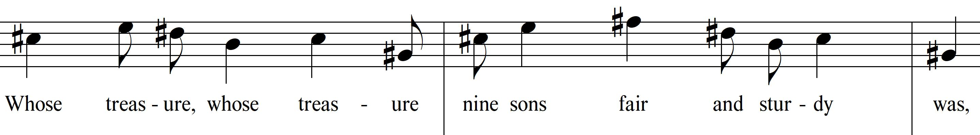

The subsection comprising the remainder of the introduction is set in a ternary A-B-A’ form, mirroring the overall structure of the work. The “A” theme, shown above, is presented in a two-part canon, with male voices sounding one beat after the female voices. A secondary “B” theme is introduced at measure 34, also set in canon with entrances on the downbeat of each successive measure – this pattern is interrupted by the Chorus II basses in measure 38, who enter a beat earlier than would be expected. From that point, motivic entrances become less predictable, and phrases used include those on which the ascending/descending lines have been flipped or truncated.
Figure 4.2 Cantata Profana “B” Theme, mm. 34-36
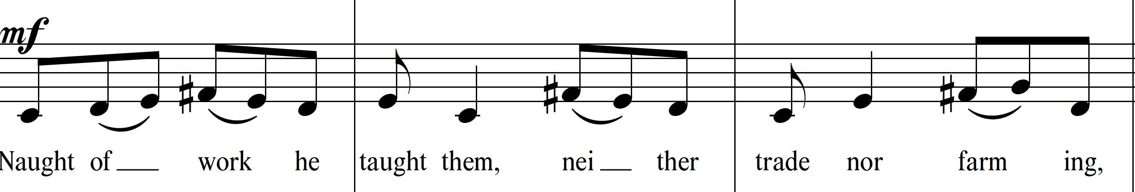

The “A” theme returns in the Chorus I tenor part at measure 42, but canonic entrances are spread farther apart, now only occurring after the initial phrase has been completed. This increased time between entrances serves as an aural rhythmic augmentation since fewer simultaneous layers exist in this A’ section. Pitch centers are ambiguous throughout the subsection, changing quickly, though pedal points in measures 31-33 (F#) and 42-46 (B) seem to have a dominant function to the ear that suggests brief pitch centering on B and E. The section calms in both rhythmic activity and harmonic rhythm, setting up a resolution returning to D as the Chorus II basses arrive on the downbeat of measure 59.
The Hunt: mm. 59-163
The resolution on D is immediately reinforced by the horns in octaves playing fortissimo, but then just as quickly interrupted by bassoons and strings playing a repeated motive which descends from E♭ to B♭ and is syncopated against the marked 2/2 meter. This conflict of meter continues until measure 70 when the motive is expanded by one beat to fit the meter. At this point the snare drum (sans snares) joins and takes an additional four measures seemingly catching up to the newly established motor, perhaps depicting the last of the brothers joining the hunt. As the ostinato stabilizes, the pitch center is revealed to be B♭, though utilizing a large amount of chromatic alteration within the modality; this suggests that the hunt fugue is an example of Bartók’s use of polymodal chromaticism.

Figure 4.3 Cantata Profana String Motive in Initial Syncopation, mm. 60-63
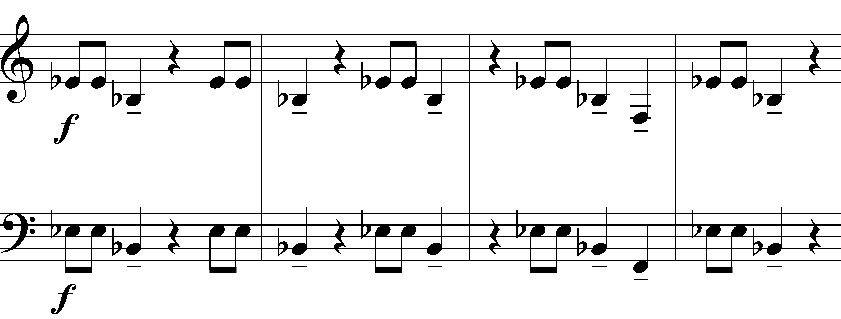

Figure 4.4 Cantata Profana Snare Drum Entrance, mm. 70-73
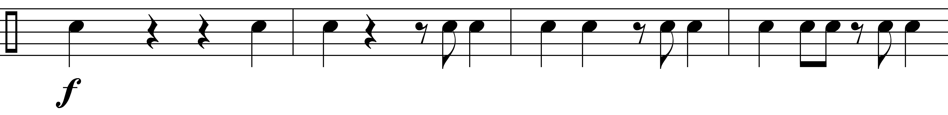
The use of E♭ and B♭ as key centers is notable as a subtle historical allusion. Those key centers
are associated with hunting, and Bartók may have been invoking Beethoven (his Piano Sonata
No. 18 in E♭ Major is nicknamed “The Hunt”) and Mozart (his String Quartet No. 17 in B♭ Major bears the same nickname) in a more subtle way than he did Bach during the outset of the Cantata Profana.
The hunt section of the first movement, like the introduction, is also set in a ternary form. The building of the ostinato and the hunting fugue set over the ostinato comprise the A section of the hunt, which ends at measure 101. The ostinato and fugue both stop and are replaced by long durations in the instrumental parts paired with exuberant leaps in the choral parts. Rhythmic activity is lessened at this moment, but as a punctuative gesture, as energy does not dissipate. Several more iterations of emphasis occur, with false cadential points emphasizing the lyrics “farther still they wandered, farther still, and farther still they wandered.” These false cadential points include trading of rhythmic unisons between choirs and instruments, solo timpani strikes, and trading of the ostinato motive from the A section between trombones, trumpets, and upper woodwinds. These ideas are combined starting at measure 126, marking the beginning of the A’ section; the choral motives which were interspersed with brass in the B section become continuous. A return of the hunt motive occurs in measure 132, the motive persists for the rest
of this section but is scored in the instrumental parts and not in either chorus. Similarly, the
ostinato returns, but not as an ostinato. It instead appears as another layered motive appearing first in canon within the strings, then moving to the woodwinds and truncated as the section accelerates to its end.

Transformation of the Sons: mm. 164-198
The musical mood changes drastically at measure 164, corresponding with the sons
crossing a haunted bridge and becoming lost in the forest. Two thematic ideas appear in the
choral parts, one immediately at measure 164 with A as its pitch center, and one at measure 180 centered on E. Both, however, are similar, starting with ascending figures – the change in the themes reflects the change in the sons since the second theme occurs immediately after the chorus sings “all were changed to stags there in the forest shadows.” A secondary theme appears in the instrumental parts at measure 171, but as it is instrumental only, based around A, and starts similarly to the initial melody, it is termed a variation of that initial melody instead of a separate idea. This twofold structure mirrors the beginning of the movement, and the melodic material beginning at measure 164 is similar enough to the B theme of the introduction that begins in measure 34, that the use of A-B-A’ form is implied. The repeated and varied uses of this form create a unifying principle of the work, further reinforced within the text of the colinde through the transformation of the sons.

Movement 2: Andante
- Father Searches For His Sons: mm. 1-42
  - Initial motive at m. 9 and subsequent motive at m. 17 are both related to the hunt theme; melodic motive is inverted at m. 18 (tenor) and 21-26 (all voices), truncation of initial motive at m. 27-37 (descending line)
  - Lyrical content is not from the colinde, but instead elaborates on the story through third person narrative
- Soliloquy of the Oldest Son: mm. 43-95
  - First person narrative, but text still elaborative and not from the colinde itself
  - Tension throughout, built through pitch centers, intervallic relationships (including semitone cells and tone clusters) orchestration, and
- Father Pleads for the Sons’ Return: mm. 96-159
  - Melodic motive same as mm. 17-19
- Oldest Son Responds: mm. 160-215
  - Applicable colinde text:

And so their antlers
Cannot pass through doorways,
Only roam the forest groves.
Their slender bodies
Ne’er in clothes can wander,
But only wear the wind and sun.
Their dainty legs can
Never stand the hearthstone,
Only tread the leafy mold.
Their mouths no longer
Drink from crystal glasses,
Only cooling mountain springs.

Movement 2: Andante
Father Searches For His Sons: mm. 1-42
The movement opens with the middle and low strings playing a meandering polymodal figure that moves in parallel major thirds in the cellos and basses but is voiced in inversion by the violas. The basses and second cellos are centered around D♭, while the violas are centered on C. Almost all intervals move by step, but half step/whole step relationships do not stay consistent on scale degrees – inflection points are often approached and left by different expressions of the same scale degree. All these factors create an atmosphere of uneasiness; only the bassoon and horns seem to outline a consistent tonality, centering on F. The string introduction also mostly settles on F, reinforced by the Chorus I bass entrance in measure 9, though a C# in the second bassoon and string basses reinforce the uneasiness of the passage.
Figure 4.5 Cantata Profana Mvt. 2, mm. 1-5
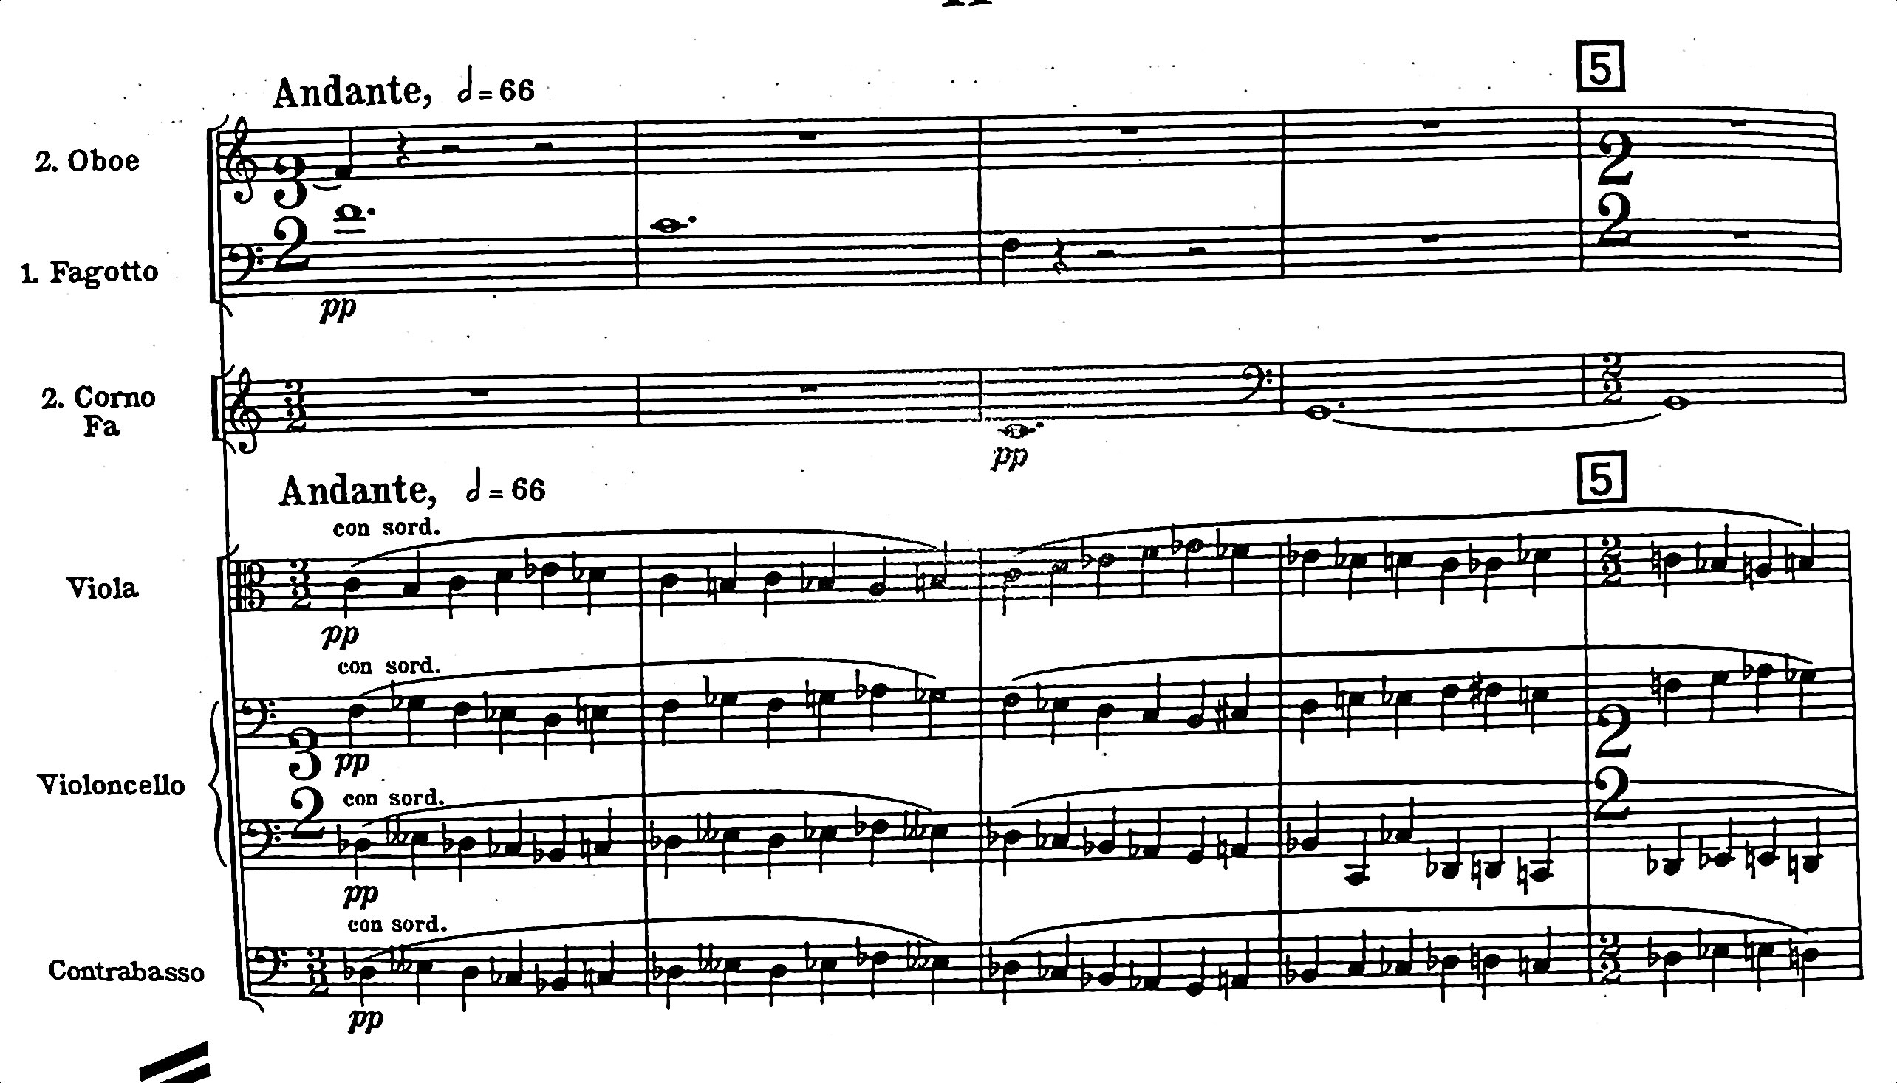
The basses are followed by the tenors on the third beat of measure 9. Together they create a two-voice canon during which they describe the father’s actions in searching for his sons. It is notable that all lyrical content during this section does not come from the colinde source, but instead elaborates upon the story in much the same way as the hunt scene did during the first movement. The motive sung by the male voices at measure 9 seems to be a foreshadowing of the full melodic statement to come at measure 17, a melody that is used again later in the movement during the portion of the story where the father begs his sons to return home. Both melodies descend after initial leaps, but the bass part leaps an augmented fourth while the alto part in measure 17 leaps a perfect fifth.

Figure 4.6 Cantata Profana Chorus I Bass, mm. 9-12
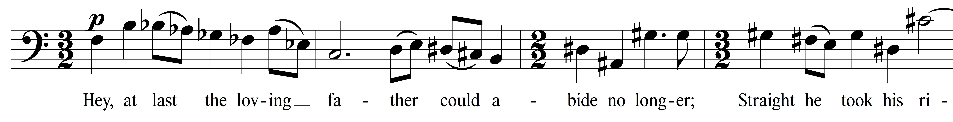
Figure 4.7 Cantata Profana Chorus I Alto, mm. 17-18
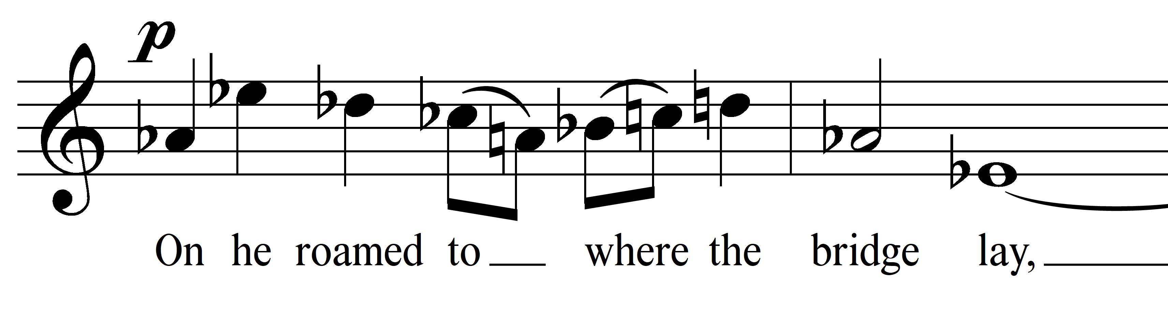
Both motives are related to the fugue theme from the first movement through the use of an upward leap followed by a descending scale; the alto melody at measure 17 follows the fugue’s intervallic structure identically until the fifth note of the phrase. The continuous alteration of thematic material places further emphasis on transformation within the work, reinforcing the story of the colinde. Subsequent entrances later in the movement may be identical (the father’s solo in m. 105), may alter the intervallic relationships between motives, or may use only fragments of the melodic idea. One of these fragmented motives occurs beginning at measure 27, during which the initial theme at measure 9 omits its initial leap and incorporates shorter note durations. Intervallic relationships for this descending motive change as well, while still staying recognizably related to the earlier themes. The music becomes more frantic through increasingly frequent (and sometimes syncopated) entrances on this descending motive, repeated syncopation at the eighth note level from the upper strings, a textural/harmonic crescendo resulting from the addition of parts to the canon, and simultaneous use of both whole tone scales. Vocal parts for each canonic entrance reinforce D and G as pitch centers, but an A♭ pedal point beginning at measure 30 in bassoons, tuba, low strings, and timpani obscures any tonal or modal stability. At the peak of the phrase, third trombone, tuba, and low strings trade rhythmic motion with the vocal parts; their motive is intervallically identical to that of measure 181 in the first movement.

Soliloquy of the Oldest Son: mm. 43-95
The tenor soloist begins a recitative at measure 43 on a half-step interval, which is soon expanded by half steps with every other note returning to G, a “struggle to articulate into being the voice of his new self,” according to Losseff. The downward progression from half step to whole step to third is used again in measures 68-70, during the phrase “dash thee, smash thee, slash thee.” Accompanimental static harmony at measure 43 is a three-note “semitone cell” consisting of B, D, and E♭ (or enharmonic equivalents) which is used again later in the movement, this repeated combination of a simultaneous major and minor third is conjectured to represent the son’s wish, but inability, to return home. More consonant harmonies follow (a B-D dyad moving to C#-E, B♭M, Cm, CM, D°) but the vocal part persistently centers a half step below each harmony. This vocal/harmonic relationship persists until measure 59, where the tenor’s E♭ is heard as the third of a C minor sonority (though an F# is scored for viola, it is obscured by G sounding in both oboes, both clarinets, and violin II). At measure 65, however, the soloist again centers a half step below each sonority’s lowest voice for three measures, until the G# in the tenor sounds a half step above the G in the cellos. The tenor continues increasing his tessitura upwards until arriving at measure 78, where the semitone cell from measure 68
returns, this time with an added F#, reinforcing the feeling of D and E♭ as split major and minor

sonorities. This sonority is augmented further at measure 84 with the addition of a G# pedal
point in second bassoon, second cellos, and basses, and again in measure 90 with an E# pedal underpinning a tone cluster of B, D, E♭, and A# - two pairs of half-step intervals a major third apart. By this time, any concept of B as a tonal center has been blurred out of existence and the ensemble sounds as if searching for an anchor point. The agitation of this harmonic progression and the tenor solo is enhanced timbrally by harp glissandi (doubled in clarinets and first flute) and string tremolandi; as another technique to build tension, the tenor solo’s melodic statements are answered after two measures in an almost mocking tone by piccolo, third flute, and oboes; this occurs in measures 80, 86, and 92.

Father Pleads for the Sons’ Return: mm. 96-159
After a brief choral interlude, the baritone soloist, singing as the father, sings the melody from measure 17 of the same movement, imploring the sons to follow him back home. He is echoed by the choirs singing a fragment of the motive on “go thou now and follow” (a notable third-person interjection during the father’s first-person plea) in canon, with the violins playing the entire one-measure motive in three successive measures utilizing the same intervallic structure as the baritone solo.
Figure 4.8 Cantata Profana Solo Baritone, Mvt. 2 mm. 103-105
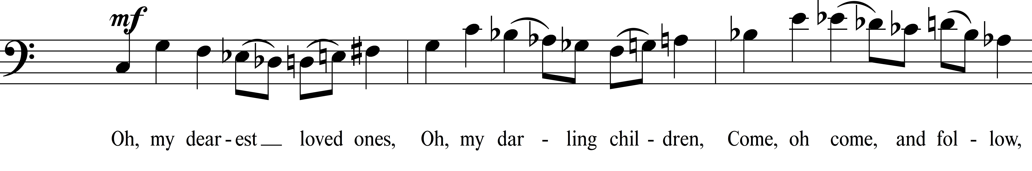
The remainder of the movement includes a continuation of the baritone solo, another short choral interlude narrating the story, and the eldest son’s response to his father. Through the movement, the baritone solo remains simpler than the tenor, with easier intervals to audiate and fewer chromatically altered passages. This comparatively simple melodic writing for the baritone solo may signify the pull of the familiar and its appeal to the sons. Despite the baritone singing an unfamiliar (that is, new to the work) melody beginning at measure 115, the ease of understanding the melodic construction in and of itself reinforces a link to the duality of the work. Agitation and unease are still present but are accomplished more through continued use of tone clusters, minor-second pitch relationships, scalar modifications, and pitch-altered canonic statements.

Oldest Son Responds: mm. 160-215
After another short choral interlude, the son’s response to his father begins in measure 168. As the son responds, he states the remainder of the colinde text within his solo, explaining to his father the reasons that the sons cannot return home. Notably, the tenor soloist does not sing any material related to other motives or themes in the work. Just as the baritone’s use of familiar thematic material represents a link to their home, the uniqueness of the melodic material for the tenor soloist could signify another way in which the sons have transformed. This section features the only simultaneous interplay between the tenor and baritone solos: the father interjects “Why? Why?” at measure 188 and continues asking even as the son answers him beginning in measure 193 on a recitative-like line reminiscent of the initial tenor solo. The tenor solo at this point again moves downward by step with intervals expanding, a seeming reference to measure 43, the moment of self-actualization for the oldest son. Accompaniment remains sparse and mysterious throughout, with sustained pitches scored often only for viola and cello, joined most often by muted horn. Half-step and tritone pitch relationships appear often both melodically and harmonically, though the harmonic appearances of such happen most often on short note durations. These instances, however, are not pervasive and are often contrasted with nearby whole-step and perfect intervals, respectively. Metric feel is obscured through changing time signatures and occasional use of mixed meter, though the moderate tempo of the passage makes this compositional device feel more uneasy than frantic. Only at the final moment of the movement, when the tenor soloist sings “And our mouths no longer drink from crystal glasses, but only cooling mountain springs” does Bartók indicate a crescendo, both dynamic and textural. Strings play tutti beginning at measure 213 and are joined by (in order) horns, clarinets/bassoons, oboes, and flutes, echoing the last melodic fragment of the solo. The movement ends, as the first did, with an attacca segue into the final movement during the tenor’s resolution on the word “springs.”

Movement 3: Moderato

- Restatement – Introduction and Hunt: mm. 1-34
  - Movement is in A-B-A’ form, this section of the movement is its A section
    - A section is itself in A-B-A’ form
  - Re-use of “A” theme from Mvt. 1, mm. 1-10 and 26-34
  - Re-use of “B” theme from Mvt. 1 – m. 11-20
  - Re-use of hunt motive from Mvt. 1 – m. 20-25
  - Applicable colinde text:
Once there was an old man
Whose treasure nine sons
Fair and steady was.
Naught of work he taught them,
Neither trade nor farming,
But only to wander,
Nine huntsmen a-hunting.
And farther, farther
On and on they wandered,
All were changed to stags then,
There, in the forest shadows.

- Restatement – Inability to Return: mm. 35-64
  - B section of movement; canonic entrances, new melodic material
    - Vocal parts build in counterpoint centered on B, E, A, and D, creating quartal harmony
    - Instrumental parts shift with voices, but centered a whole step higher
  - Applicable colinde text:
And so their antlers
Cannot pass through doorways,
Only roam the forest groves.
Their slender bodies
Ne’er in clothes can wander,
But only wear the wind and sun.
Their dainty legs can
Never stand the hearthstone,
Only tread the leafy mold.

- Epilogue/Coda: mm. 65-93
  - A’ section of movement
    - mm. 65-74: Re-use “A” theme from Mvt. 1, mm. 27-58
    - mm. 79-87: Use of opening scalar motive in inversion
  - Large-scale form of the movement
A B A’
    - [ABA’] – Interlude – [AA’] Coda
A = A
      - Both “A” themes are restatements of Mvt. 1 “A” theme
  - Applicable colinde text:
Their mouths no longer
Drink from crystal glasses,
Only cooling mountain springs.
Movement 3: Moderato
Restatement: Introduction and Hunt, mm. 1-34
Movement three of the work restates the folk myth in its entirety, without the textual elaboration or first-person dialogue present in the initial two movements. True to his frequent usage of symmetry, this movement completes an A – B – A’ arch structure with the other movements through the use of motives present in the first movement. This initial section of the final movement re-sets the text from the beginning of the work, first utilizing the “A” theme from Movement 1 re-metered into 3/4, set polyphonically but not densely – the second entrance of the A theme does not occur until measure 6 in the sopranos and altos, eliding the end of the phrase first sounded by the tenors to start the movement.
Figure 4.9 Cantata Profana Chorus I Tenor part, Mvt. 3 mm. 1-6

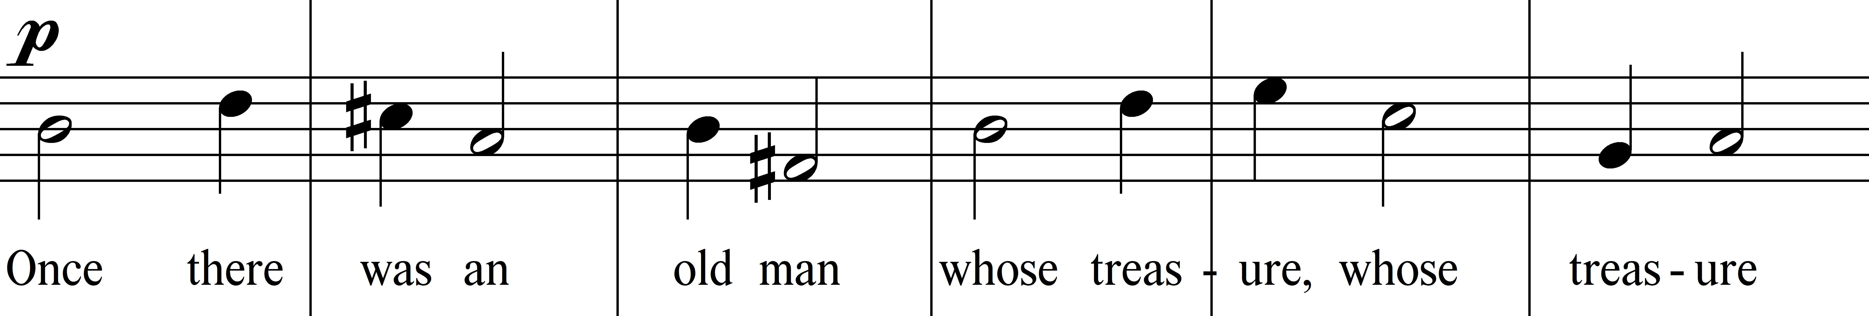

The “B” theme from the first movement is also referenced almost immediately after, beginning at measure 11 in the Chorus II bass part, followed in the next measure by the tenors, up a perfect fifth. Successive measures include entrances by the Chorus I tenors, altos, and sopranos. These successive entrances all enter at perfect fifths or fourths above the previous entrance, creating a relatively consonant harmonic structure. A second additive texture on the same motive follows, but successive entrances during this second statement are at the intervals of a minor seventh, minor third (lower), and another minor seventh, obscuring any tonal center.

Figure 4.10 Cantata Profana Chorus II Tenor/Bass parts, Mvt. 3 mm. 11-14
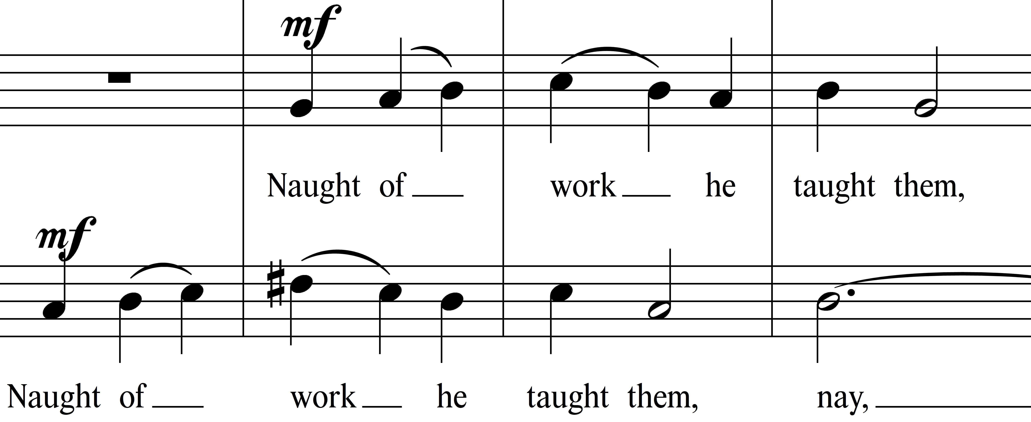
Bartók then uses a motive reminiscent of both the hunt fugue and measure 103 of the second movement that features a similar leap-step pattern. The pattern in this movement more closely resembles the hunt motive; both include a scalar pattern consisting of whole step down – whole step down – half step down – whole step up – whole step up – augmented fourth/diminished fifth down. The motivic usage in the first movement hunting scene is preceded by one downward whole step, while the motive in this final movement proceeds immediately after an upward leap. Regardless, the similarity is obvious and provides the work with yet another example of symmetry.
Figure 4.11 Cantata Profana Chorus I-II Alto part, Mvt. 3 mm. 20-22

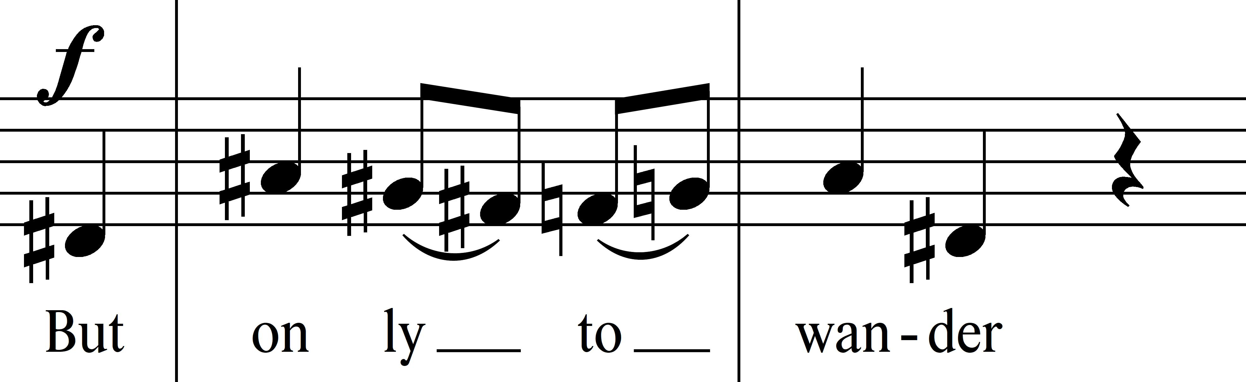

Following this motive, the second half of the “A” melody is utilized in a more homophonic fashion and measures 178-179 of the first movement are recalled when the same text appears in the third movement (“all were changed to stags then, there in the forest shadows”). Because of the partial return of the “A” melody, this subsection of the third movement, like the first movement and like the entire work, creates an A-B-A’ form.
Restatement: Inability to Return, mm. 35-64
This section of the third movement is the last instance of new material occurring in the work. The chorus is again treated polyphonically, with Chorus II tenors and basses sounding an agitated recitative-like melody on the phrase “And so their antlers cannot pass through doorways, only roam the forest groves.” The range of the motive is only a minor third, with each voice part entering on their pitch center and moving by a half step above it or a whole step below it, recalling the Phrygian mode.
Figure 4.12 Cantata Profana Chorus II Tenor/Bass parts, Mvt. 3, mm. 35-40
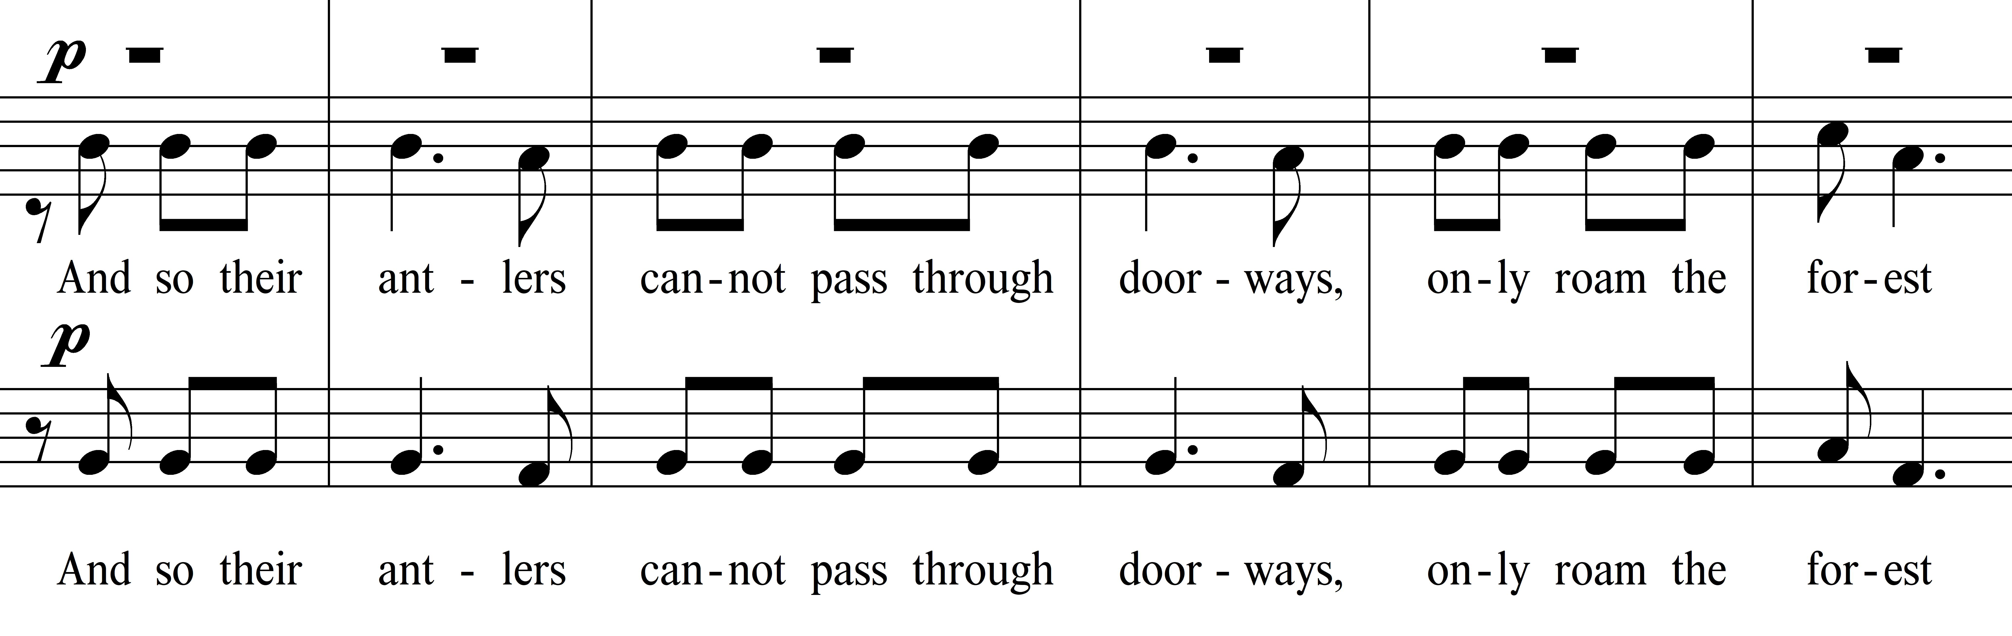
The vocal parts in this passage follow the same interval pattern as shown above and center on B, E, A, and D on their successive entrances. Simultaneously, the low string and timpani parts center on C#, F#, B, and E as each corresponding choral part enters. This section of the movement resultingly features polyphony, incidental quartal harmonies created by the ascending choral entrances, and persistent bi-modality presented by the instrumental parts consistently centering a whole step above the pitch center of the vocal parts. The timpanist is called on to glissando for each of their entrances in this section, creating a faux dominant/tonic relationship by sliding up a perfect fourth during one beat to each of the instrumental pitch centers stated above. Stopped horn is also called for, during the section, though it persists on C# even after the modality has shifted in the other instrumental parts. The horns then follow the same pattern as the strings and timpani, but shift their tonality one section later: when the strings and timpani center on B, the horns move to F#, and when the strings/timpani move to E, the horns move to B. The resulting tension increases further at measures 57-60, which finds the strings, low woodwinds, and timpani centered on E answered by a unison C5 in the oboes, F# 6 in the flutes, and D4 in the clarinets. One beat after the clarinet entrance, the low voices shift to E♭. During all of this activity, the sustained vocal parts, soprano, and bass are singing an F# and an A, respectively. This harmonic density is relieved through attrition; woodwinds exit in a staggered manner – flutes, then oboes, then clarinets, then bassoons – as the choral parts slow in rhythmic activity, they resolve to a D major sonority with an added major second in the alto parts. However, the low strings persist on E♭ until measure 65, at which time they, too, resolve to D. This resolution marks the coda of the work and the beginning of the A’ section of the third movement.

Epilogue/Coda: mm. 65-93
The resolution to D as a melodic pitch center brings the work closer to its end, as D was the pitch center of the beginning of the piece as well. However, the resolution to D as a tonal center is not yet complete, with measure 65 sounding a deceptive B♭ major harmony instead of the expected D chord. The melodic D in the Chorus I soprano voices serves as the third of the sonority, while the bass voices’ resolution to D results in a first-inversion chord rather than one in root position. At this point, the “A” theme also returns a final time, creating a symmetry both with the first movement and with the A section of this movement. The melodic phrase is only partially presented, even though the text is a full statement of the phrase “Now their mouths no longer drink from crystal glasses, only cooling mountain springs” for the Chorus I female voices and Chorus II sopranos. Three repetitions of three measures are scored, with each successive three-measure phrase entering a perfect fourth lower than the previous one; the resulting harmonies settle rhythmically on a quartal G#/C#/F# sonority. The tenor soloist returns for a statement of the final line from the colinde, a melismatic voicing of the phrase “from cooling mountain springs,” and is joined on a sustained C at the end of the phrase by the low strings on an A minor sonority. The sonority resolves, authentically in this case, to D in measure 79, though a G in the Chorus I soprano and altos preceding the measure slightly obscure the modal faux tonic/dominant sonority. At measure 79, the cellos begin an upward scalar pattern through the string section that echoes the beginning of the work, this scale is the inversion of the opening scale and is the final piece of symmetry within the work. As with other formal elements within the Cantata Profana, this is the confirmation of large-scale ternary form within the piece.
Chapter 5

INSTRUMENTATION

Instrumentation of the Transcription

The Cantata Profana is originally scored for a typically fully staffed orchestra of the early Twentieth Century, including the following:
Figure 5.1 Original Cantata Profana Instrumentation
3 Flutes (one doubling Piccolo)
3 Oboes
3 Clarinets in A and B♭ (one doubling Bass Clarinet)
3 Bassoons
4 Horns in F
2 Trumpets in C
3 Trombones
Tuba
Harp
Timpani
Percussion: Cymbals, Tamtam, Snare Drum, Bass Drum
Violin I
Violin II
Viola
Cello
Double Bass

In addition to these instrumental forces, the work calls for two SATB choirs, solo tenor voice, and solo baritone voice. Using the earlier assumption of a 32-40 person choir (then halved to sing both Choir I and Choir II parts), the transcription must err on the side of transparency at all times while the chorus is active. For that reason, I propose the following instrumentation for the wind band transcription, with the caveat that parts should not be doubled unless associated with larger choral numbers.

Figure 5.2 Cantata Profana Instrumentation – Transcription
Piccolo
2 Flutes
2 Oboes
English Horn
2 Bassoons
Contrabassoon (ad libitum)
Clarinet in E♭
2 Clarinets in B♭
Bass Clarinet
Contrabass Clarinet
Soprano Saxophone
Alto Saxophone
Tenor Saxophone
Baritone Saxophone
Harp
2 Trumpets in B♭
4 Horns in F
2 Tenor Trombones
Bass Trombone
Euphonium
Tuba
Double Bass (ad libitum)
Timpani
Mallet Percussion:
Glockenspiel, Crotales, Vibraphone, Marimba – 2 players
Unpitched Percussion:
Suspended Cymbal, Crash Cymbals, Tamtam, Snare Drum, Bass Drum, Triangle – 2 players

Though this is a seemingly lengthy listing of instruments, it bears repeating that each part should be assigned to one person, resulting in the usage of 34-36 players total. Careful use of instrumentation, including mallet percussion at times, is intended to substitute for string parts in the work by lending greater transparency through smaller forces. Notably, wind instruments unutilized by Bartók (even those in regular use during the original composition of Cantata Profana) are added in this transcription, mostly those in the soprano/sopranino range and the contrabass range. These instruments will be tasked with re-creating upper violin or lower contrabass parts, particularly at subdued dynamic levels. Instrumental transpositions for the clarinets and trumpets are changed as well, to better reflect the most frequently used instruments during the present day. Though C trumpets are widely used, B♭ instruments remain more ubiquitous, with range concerns similar for either horn. (Making parts available in either transposition would be feasible for publication.) Clarinets pitched in A are also eschewed in favor of B♭ instruments. The only instances of a written E3 in the original second clarinet part (which would fall outside the lowest range of the B♭ clarinet) occur near the beginning of the work and are easily scored elsewhere in a wind ensemble that has added to the original orchestral wind section an English horn, alto and tenor saxophones, and a dedicated bass clarinet player.
Figure 5.3 Cantata Profana, Clarinet 2, mm. 15-17 (transposition in A)
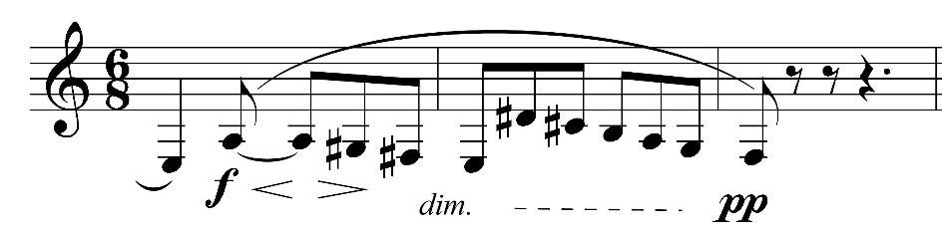

Technical concerns concerning the use of A clarinets in place of B♭ instruments only appear in

one section of the work, which will be discussed in Chapter 6.

Bartók’s brass numbers are retained, with one addition: the euphonium. Given Bartók’s use of the upper tuba range as a conical brass extension of the lower horn sound, the use of the euphonium for the same is appropriate and can serve to decrease the difficulty of both the Horn 4 and Tuba parts. (As euphonium is part of the standard wind ensemble instrumentation, its omission may also serve to dissuade programming of the transcription.) Percussion usage is greatly increased, with glockenspiel, crotales, marimba, and vibraphone parts all added to the existing timpani and non-pitched percussion parts.
Retaining the Use of Dual Choirs
Though re-writing the choral parts of the Cantata Profana to be singable for one choir would simplify logistical concerns regarding the programming of the piece, the choral parts are left for separate choirs for two reasons. First, that the piece begins with a quotation of the St. Matthew Passion cannot be ignored; the relationship between the two pieces is cemented very early in the Cantata Profana. The use of dual choirs seems to be a further allusion to Bach’s masterwork since it also uses dual choirs. This decision would have been made consciously by Bartók. The second is that the practice of singing colinde, in the Romanian tradition, is done by two groups of singers, with a group often interrupting the other group before a stanza is finished. This practice is imitated at numerous points within the Cantata Profana, with polyphonic choral writing often augmented with polylyricism, both within choirs and between them. Given the composer’s intent in quoting Bach and the folk singing practices common with colinde, the use of dual choirs is retained for the transcription.

Comparison of Analogous Moments from Cantata Profana and Bartók Piano Concertos
As discussed previously, the only original works by Béla Bartók for winds and percussion without strings exist as an accompaniment to a piano soloist in single movements within each of his first two piano concertos. As the concerti are by nature concerned with a primary soloist, they are treated as tangentially related to the Cantata Profana, for which the voices and their lyrical content are the primary focus. For this reason, an examination of similarly dense textures within the two piano concertos is warranted, either to reinforce Bartók’s desire for such textures or to search for ways by which any distraction from the soloist is mitigated.
During Bartók’s first piano concerto, the middle movement is initially scored for percussion accompanying the piano soloist, and the texture is very sparse. The only example of tutti scoring which could overwhelm the soloist occurs from measures 126 to 134 in the movement. Flutes, first oboe, first clarinet, and bass clarinet play a unison fortissimo descending figure, with the clarinets playing extremely high in their range; English horn, bassoons, and first/second horn support this figure with a sustained tone cluster of B♭, C, and C♯, octave displacement softening some of the harshness of the intervallic relationship. During this texture in the orchestral winds, the piano soloist continues playing a repeated staccato figure outlined by the percussion, with the only dynamic indication to crescendo from piano starting previously in measure 119. (No destination dynamic for the crescendo is marked.) The staccato nature of the solo piano part makes its perception easier since all wind players are slurring or sustaining longer note duration. However, given the woodwind/horn dynamic, range, and harmonic content, an overwhelming of the piano soloist remains possible, if not likely. For the solo pianist to ensure they are audible, they must decide to take Bartók’s indicated crescendo literally enough to make sure they are heard. Such a suggestion to singers may be counter-productive or even harmful in the performance of Cantata Profana, however, since vocal injury can result from singing in too forceful a manner. Instead, orchestration is reduced to match reductions in choral forces, maintaining vocal/orchestral balance at volumes that will not be damaging to the singers.
Figure 5.4 Piano Concerto No. 1, Mvt. 2, mm. 127-137
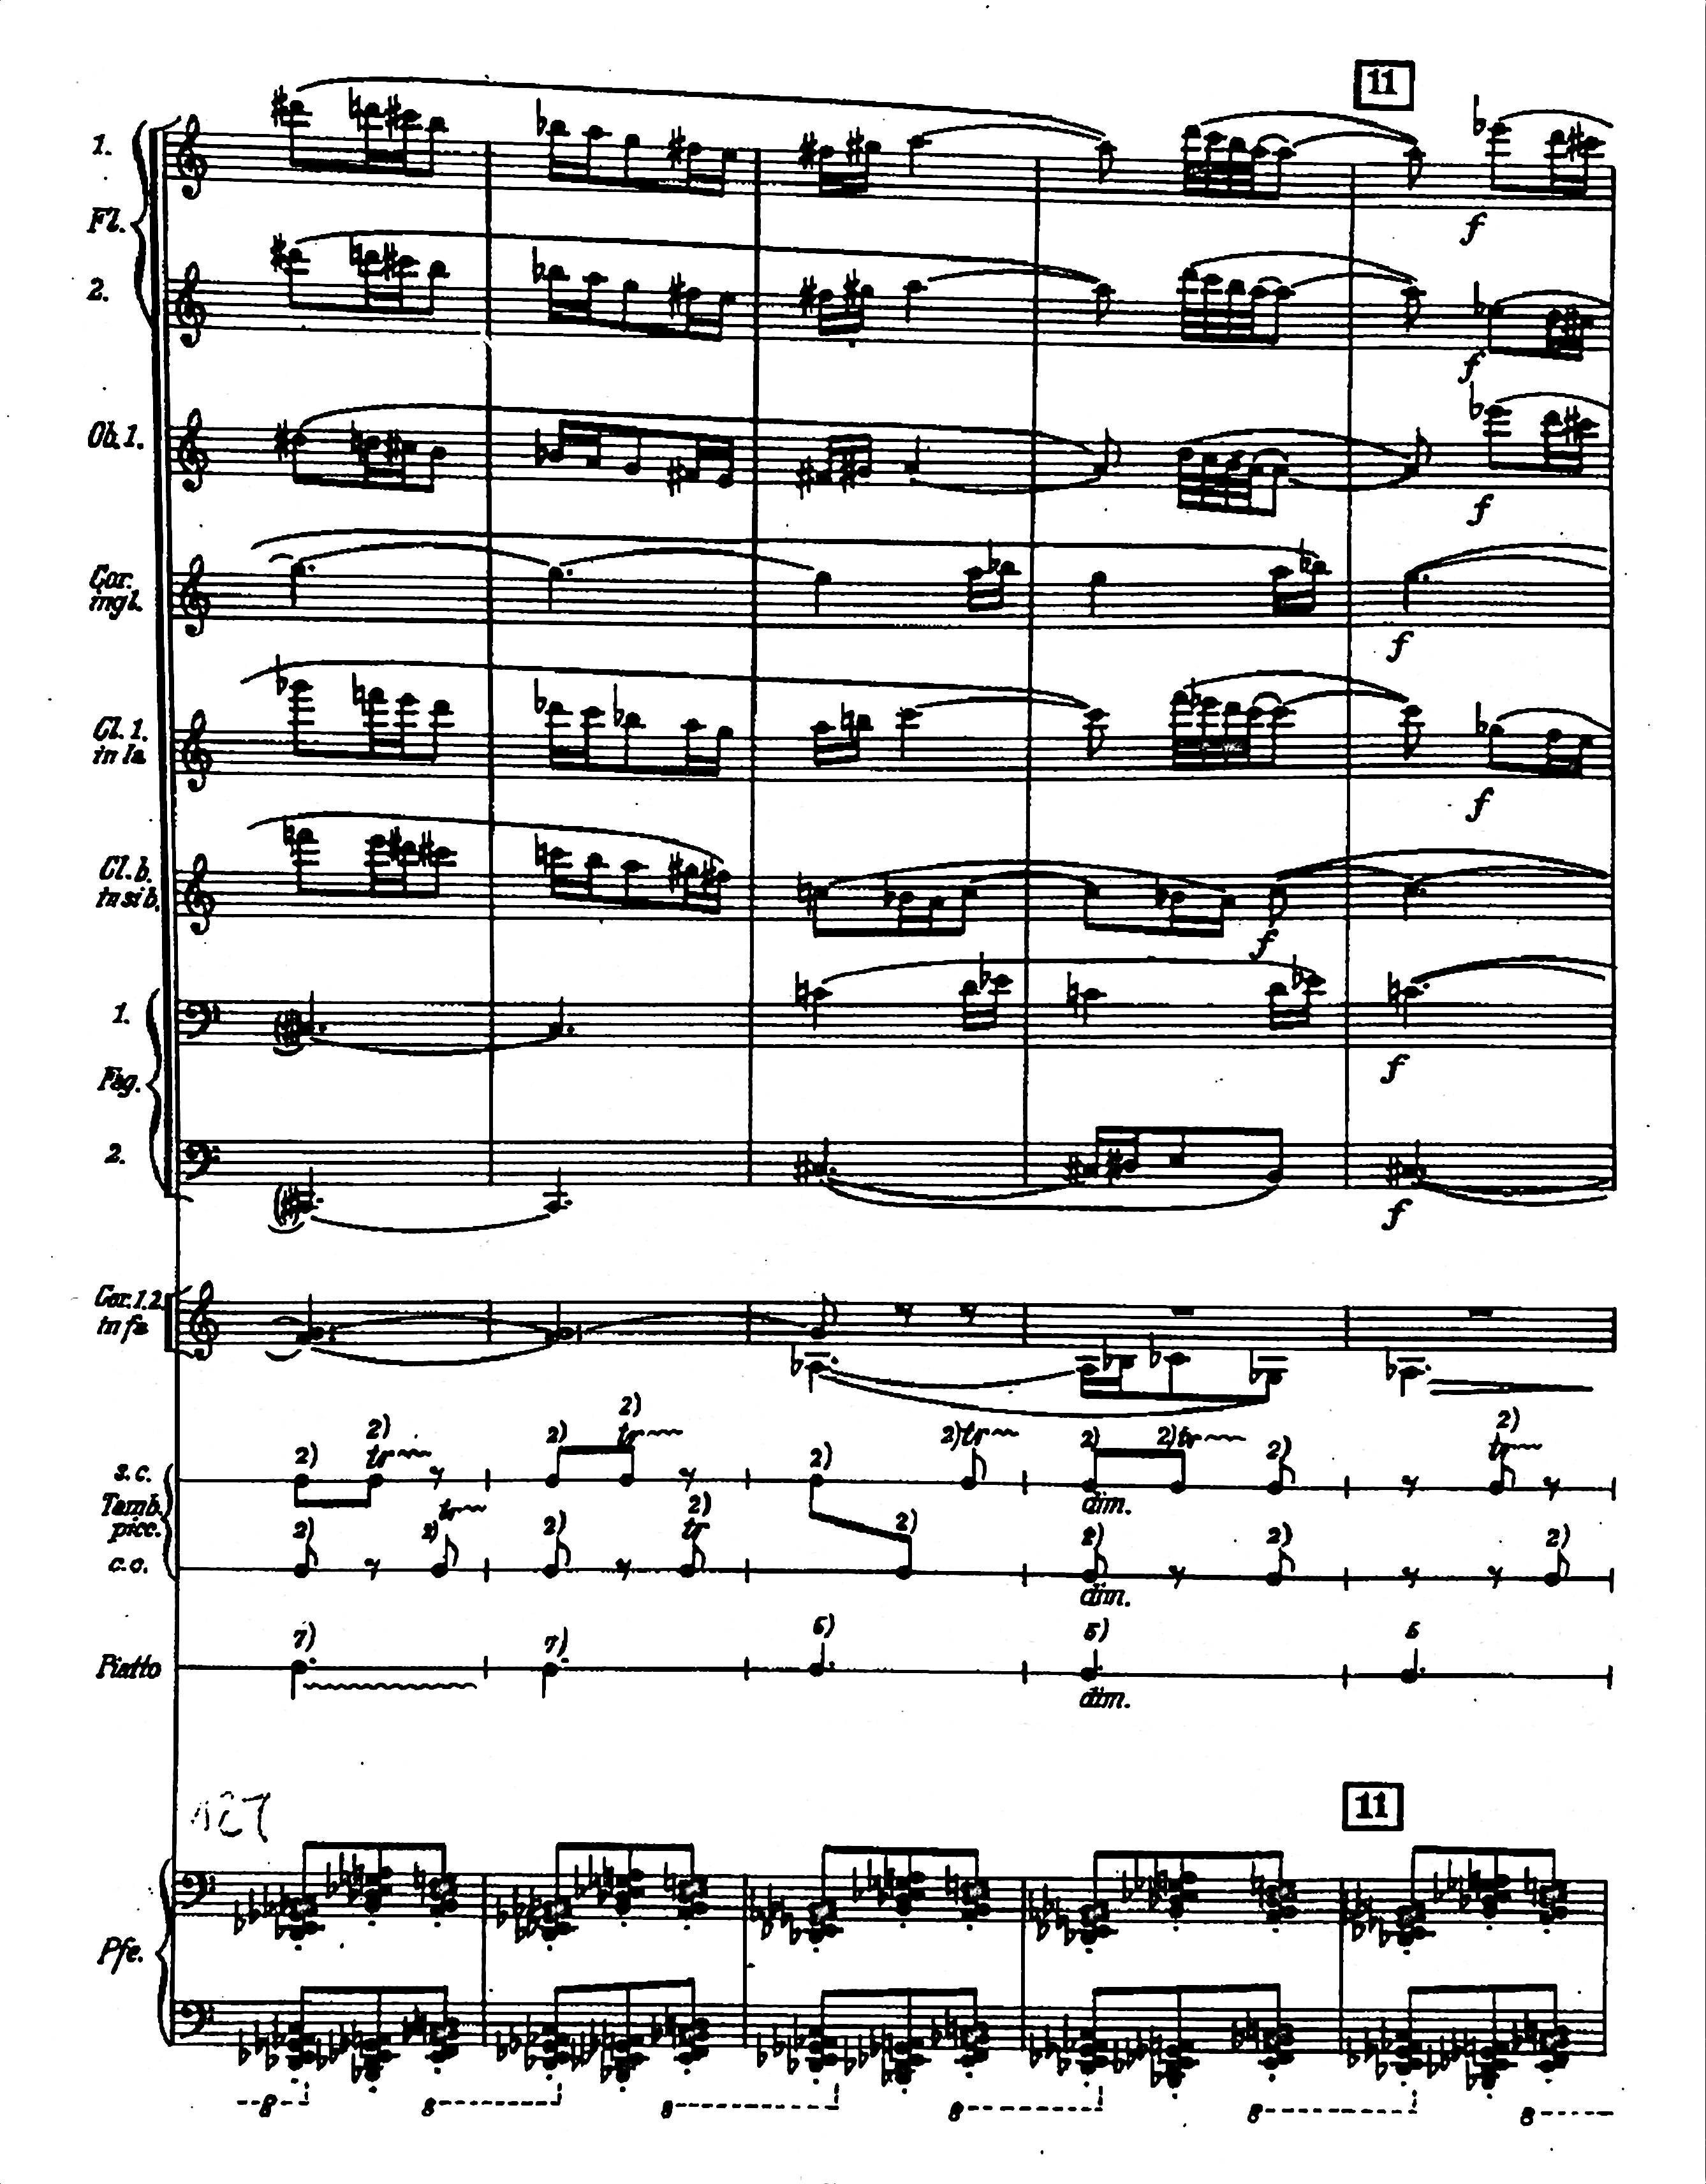
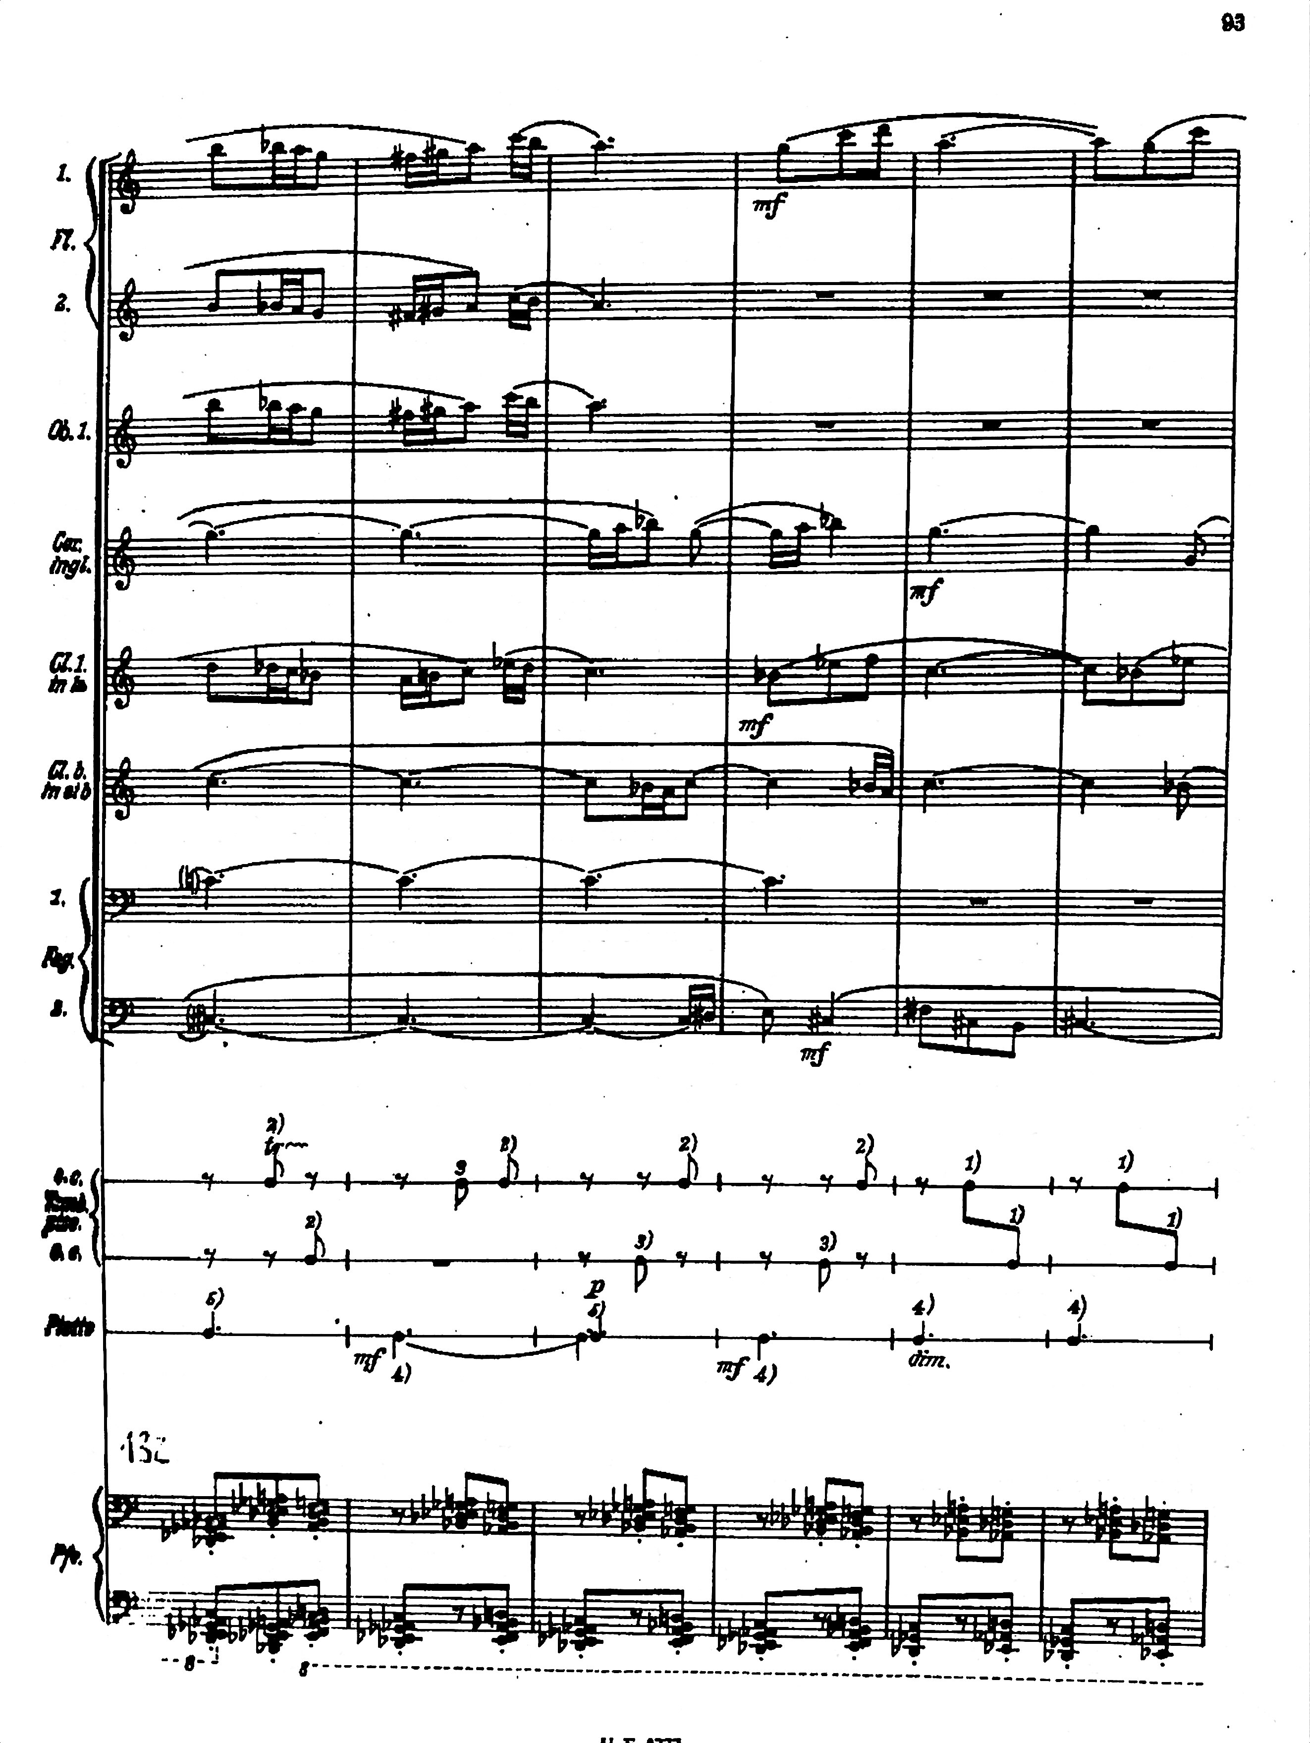

Piano Concerto No. 1” by Béla Bartók
©1927 Boosey & Hawkes, Inc., A Concord Company
All Rights Reserved. For The Sole Permission of Andrew Anderson, University of Oklahoma.

Bartók’s second piano concerto features the piano with accompaniment from winds and percussion during the first movement, where rhythmically active writing for the piano part results in its being heard easily much of the time. Such rhythmic activity in comparison to the accompaniment in the orchestral winds makes this concerto movement less applicable to the Cantata Profana since rhythmic activity from the chorus during the cantata does not approach that of the solo piano during its concerto. However, usage of octave-doubled passages, textural crescendos and diminuendos, rhythmic passages staggered between sections (or between parts within sections), and woodwind doubling of harp glissandi are all techniques that are emulated in the transcription or are retained from the original orchestration of the cantata.
Notably, Bartók utilizes the one-player-per-part concept particularly during his first piano concerto, often indicating passages utilizing only principal players or only a doubling player. For example, in the middle movement of Piano Concerto No. 1, oboe 2 doubles English horn and clarinet 2 doubles bass clarinet, whilethe second oboist plays 43 of 230 measures and the second clarinetist plays 60. The two oboists only play together in 24 measures, however, and the clarinetists play together in only 33. This practice is mirrored in the transcription of Cantata Profana, especially during the latter two movements. Because of the soloistic nature of the second movement and the subdued, ethereal nature of the third, sparse scoring is appropriate for purposes of vocal/instrumental balance, retention of compositional intent, and timbral transparency. However, during the opening movement of his second piano concerto, Bartók uses more tutti section scoring, rarely splitting pairs of woodwinds and calling for unison rhythms within sections in unison, harmony, or octaves. This practice is retained particularly in the first movement of the Cantata Profana through the woodwind doubling discussed earlier in the chapter. Bartók often calls on brass players to perform interlocking rhythmic passages, most notably the trumpet and horn sections in mm. 24-30, the same combination in mm. 181-187, and the trumpet section in mm. 291-294. Though no passage for the brass from Cantata Profana contains the same level of technical demand, the concept of pitch-similar elements being rhythmically offset is demonstrated in the hunt scene, where the brass sound ascending jumps reminiscent of hunting horns. This element already exists in Bartók’s score for the piece and is simply retained in the transcription.

Figure 5.5 Cantata Profana Transcription – Trumpet/Horn, mm. 79-83

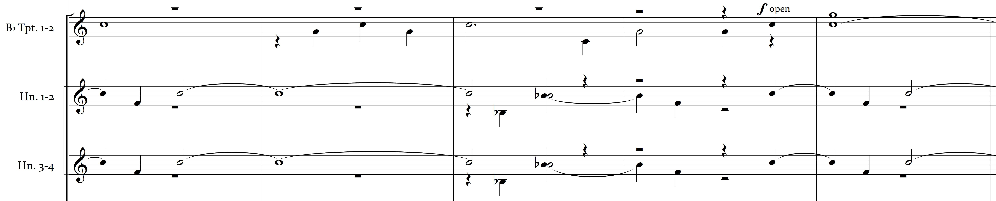

Figure 5.6 Piano Concerto No. 2, Mvt. 1 – Trumpet/Horn, mm. 24-30
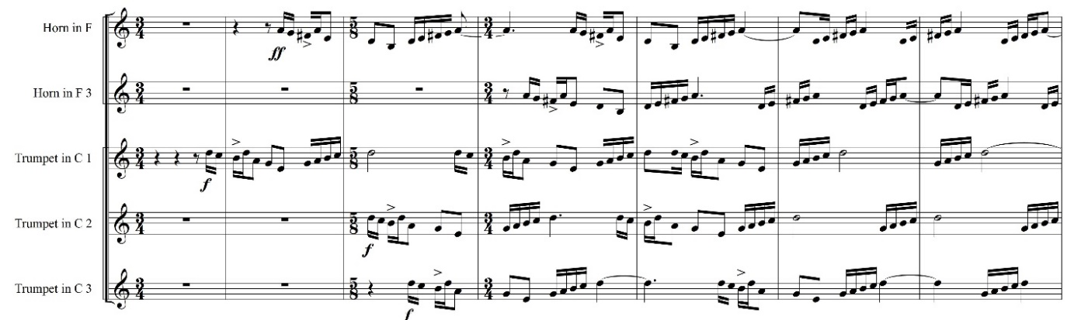
“Piano Concerto No. 2” by Béla Bartók
©1932 Boosey & Hawkes, Inc., A Concord Company
All Rights Reserved. For The Sole Permission of Andrew Anderson, University of Oklahoma.

Balance Considerations Between Instruments and Voices
The need for vocal clarity and the enhancement of, or detraction from, that clarity with relation to the deployment of instrumental forces is a primary concern of this project. Full instrumental ensemble moments sans chorus will use tutti scoring, but as the work revolves around the Romanian folk text, that text must be able to be clearly heard by those in the audience. This is made more difficult because of two musical traits: polyphonic vocal texture and copious use of instrumental octave doublings. Below are highlighted three such problematic areas, with explanations of the difficulties in hearing the chorus clearly, and proposed orchestrational solutions to each.
In a passage from the first movement of the cantata, spanning measures 39-44, basses in Chorus I are doubled or outlined by first and second bassoons, second and fourth horns, violas, cellos, and basses, while tenors in the same chorus are doubled by first and third horn. All other instruments playing: first and second flutes, oboes, clarinets, and violins play more sustained accompanimental lines, with the violins in octaves and upper woodwinds filling out the harmonic structure. However, Chorus I sopranos and altos sing a separate rhythmically similar figure within the polyphonic structure, and Chorus II members join in with yet more different melodic content in measures 40 (bass) and 41 (alto/tenor). These orchestrational choices primarily reinforce the melodic content in the Chorus I basses, but such heavy reinforcement may cover the consonant sounds of the Chorus I basses, obscuring the lyrical content. The thickness of the texture may also cover the remaining voice parts, which would ideally be heard equally within the polyphonic vocal texture. Polyphonic choral textures are used almost exclusively by Bartók in this work and are often accompanied in the orchestra by musical ideas spanning multiple octaves.
Figure 5.7 Cantata Profana, mm. 39-42
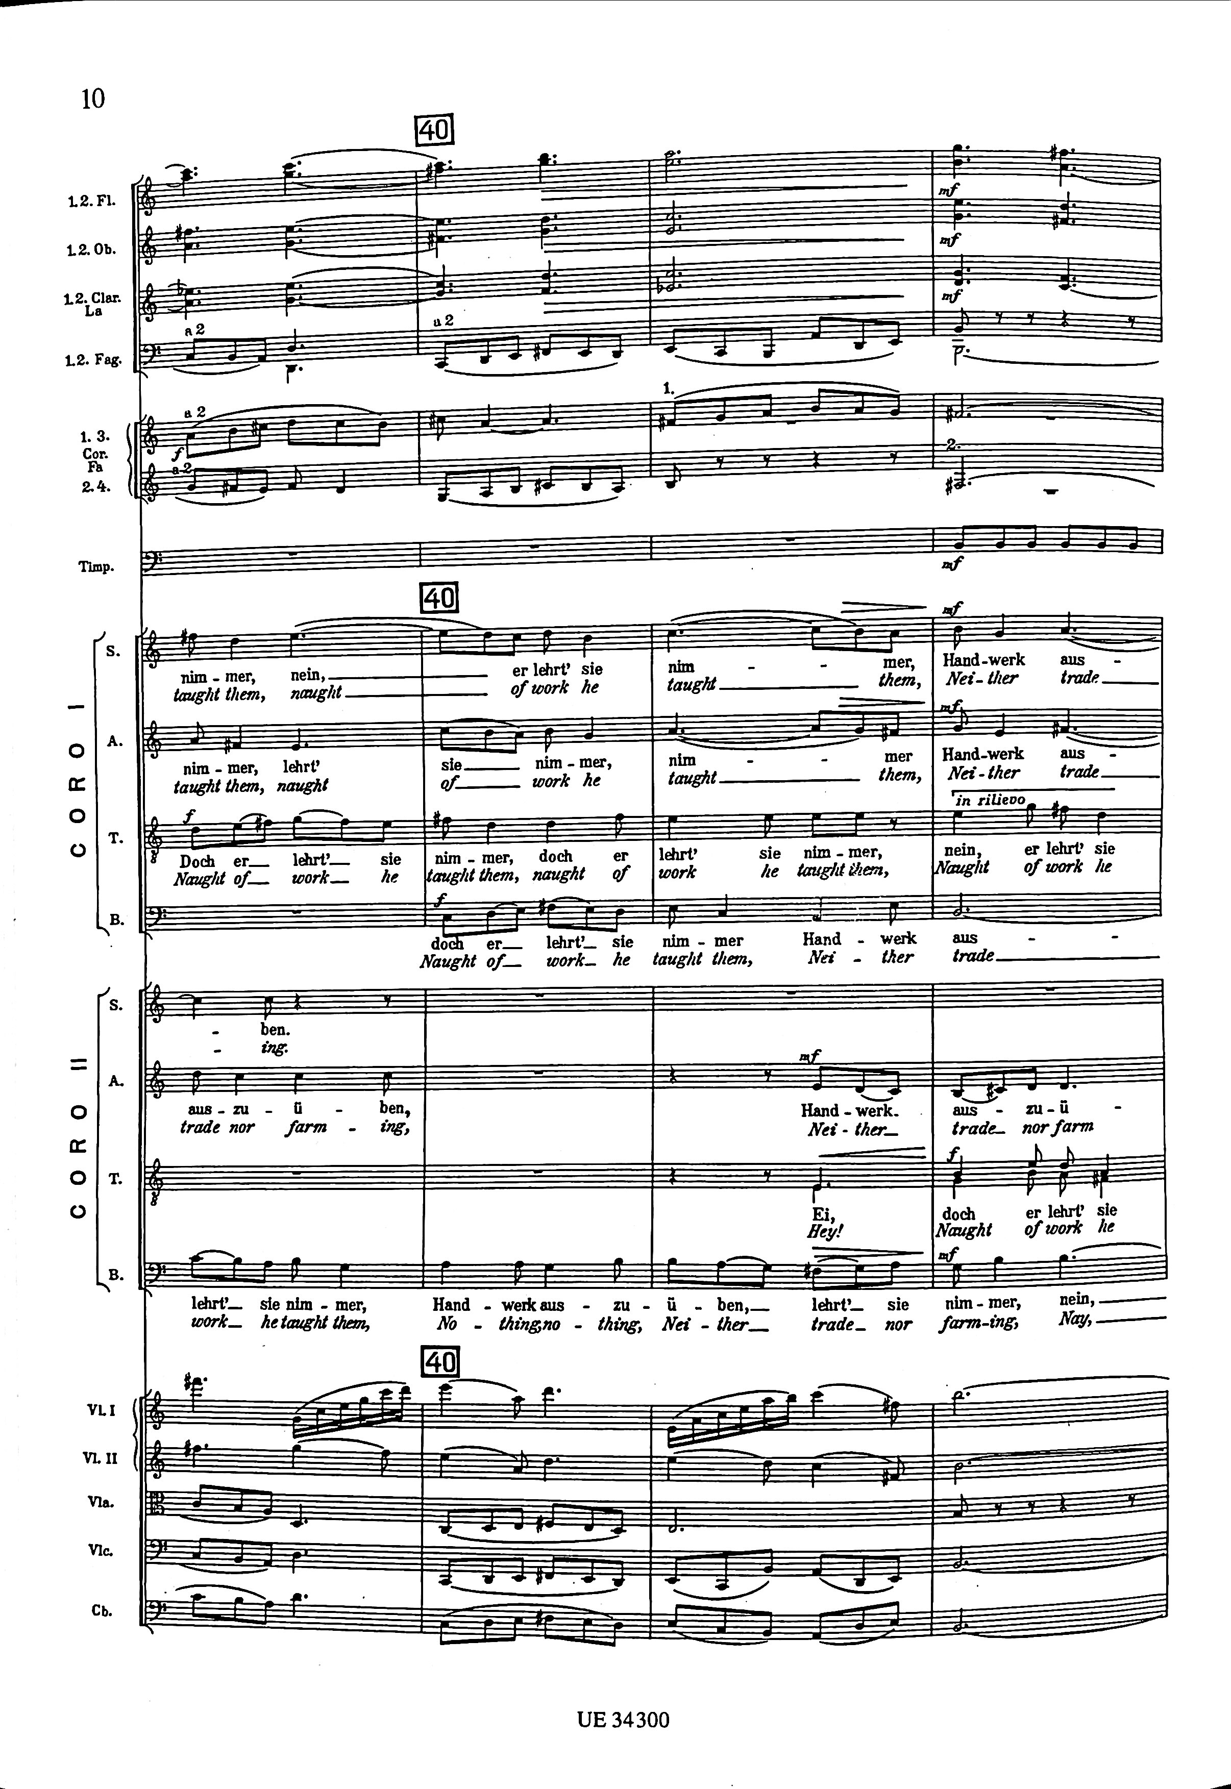
This tendency in his orchestral scoring forces the transcriber to decide how much of Bartók’s original woodwind scoring to keep and which to change. Depending on the potential thickness of the resulting passage, one may choose to utilize Frank Erickson’s second of two methods for band scoring: “consider the orchestral score as a general basis for the band piece, maintaining as much of the essence of the original as possible.” Due to considerations of transparency, for example, the flute, oboe, bassoon, and horn parts from Bartók’s original are retained, but any further doubling of the Chorus I bass part is omitted. This leaves only the violin parts to be transferred – E♭ clarinet (doubled in glockenspiel with soft rubber mallets to approximate the “shimmer” of the upper violin timbre) and first B♭ clarinet are assigned the violin I and II parts, respectively. Second B♭ clarinet is assigned the original first clarinet part, and the original second clarinet part is omitted since it is a double of the second oboe part.
Another instance of potentially heavy orchestration opposite a polyphonic vocal texture occurs in measures 74-107, depicting the brothers on the hunt. An arpeggiated tutti string ostinato appears in three octaves, accompanied rhythmically by snare drum (with snares off).
Figure 5.8 Cantata Profana String Ostinato, m. 74
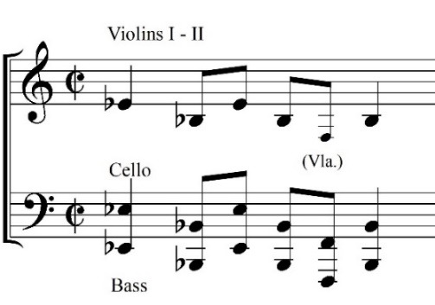
Choirs I and II are in unison within each vocal part and enter on a leap followed by a quick descending and ascending figure which becomes the primary motive of this section of the piece. The motive is initially sounded by the tenors, followed after 4 measures (transposed up a perfect fourth) by the altos. Sopranos and basses enter with the same respective pitch content, sopranos after an identical phrase length and basses after an elided phrase, obscuring the metric feeling.
Figure 5.9 Cantata Profana – Hunt Motive entrances
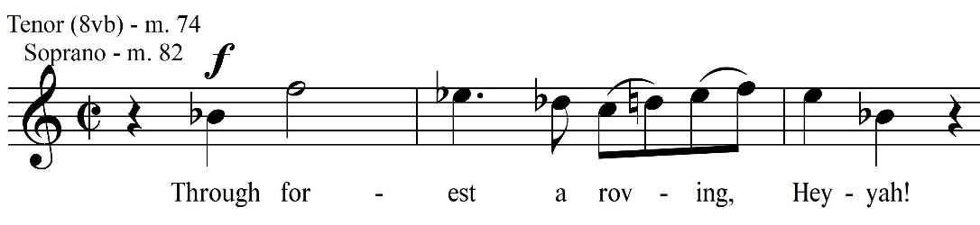
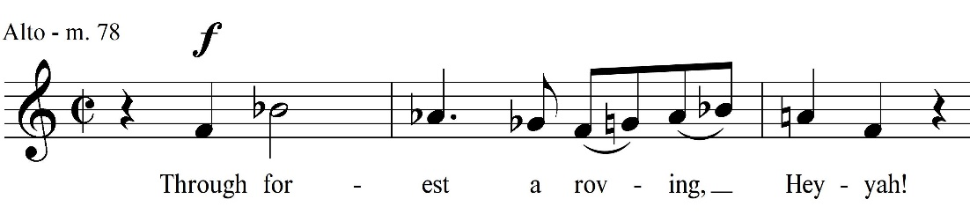
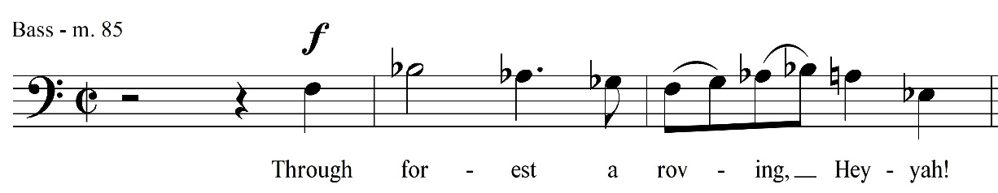
In the orchestral score, all three oboes, clarinets, and bassoons reinforce this motive when it appears in each vocal part, playing in unison. Oboes play in their lower range, clarinets their middle range, bassoons their upper range. However, this reinforcement does not extend beyond the initial motive, leaving each vocal part subsequently unreinforced. The texture further thickens with the addition of horns and trumpets playing “sol-do” ascending perfect fifths rhythmically offset from each other, mimicking both a hunting horn and the beginning of the vocal motives.
During this passage, the question of vocal/instrumental balance will hinge on two elements: the scoring of the ostinato (since the string section and its three-octave span will need to be replaced) and the amount of woodwind doubling requested from reinforcing lines. Scoring for the ostinato is not only problematic because of the octave requirements, but because of its continuous nature and the need for musicians to breathe. Since the group is suggested to be one-person-per-part, multiple instruments per octave will be needed, but will ideally include as small a number as is feasible. The lowest octave, though playable by the tuba, would be somewhat difficult because of the need for repeatedly quick registration of the lowest F1 which is always approached by leap from above. Accordingly, the lowest octave is scored for contrabass clarinet, contrabassoon, and double bass. (Use of contrabassoon and double bass is marked ad libitum, it is hoped that at least one of the instruments is available.) The middle octave, previously scored for cello, is assigned to the marimba, bass clarinet, and baritone saxophone, while cued in the tuba (marked leggiero and at a lower dynamic than other instruments). The upper octave, previously played by violins and viola in unison, is scored for a second player on marimba, tenor saxophone, and euphonium, which is similarly cued and marked as the tuba part. Limiting this doubling to at most 11 players should provide ample coverage of all three written octaves while maintaining the ability to stay transparent so that the differentiated vocal lines may be heard clearly.
The question of woodwind doubling which outlines each entrance of the “hunt motive” beginning at measure 74 remains but is easily solved. Because the scoring of the motor is thinner than in the original, the single-octave registration of oboes, clarinets, and bassoons (joined by flute in m. 82) is retained, with the parts doubled instead of tripled. Octave displacement is introduced in measure 86 with the bassoon playing one octave lower than the oboes and clarinets, and then in measure 89 with the woodwinds covering a three-octave span. All of this material is retained from Bartók’s original, again with parts doubled (absent a third player in each section).
Persistently polyphonic vocal lines remain until measure 108, where the lyrical content is scored in rhythmic unison. This rhythmic monophony is punctuative and aids listeners in clearly hearing the lyrical content. This pattern is sustained until the anacrusis to measure 140, where another potentially problematic passage begins. Lyrical content becomes polyphonic again, and the choral parts incorporate longer note durations as part of the polyphony.
Figure 5.10 Cantata Profana Chorus I-II Vocal Parts, mm. 139-148
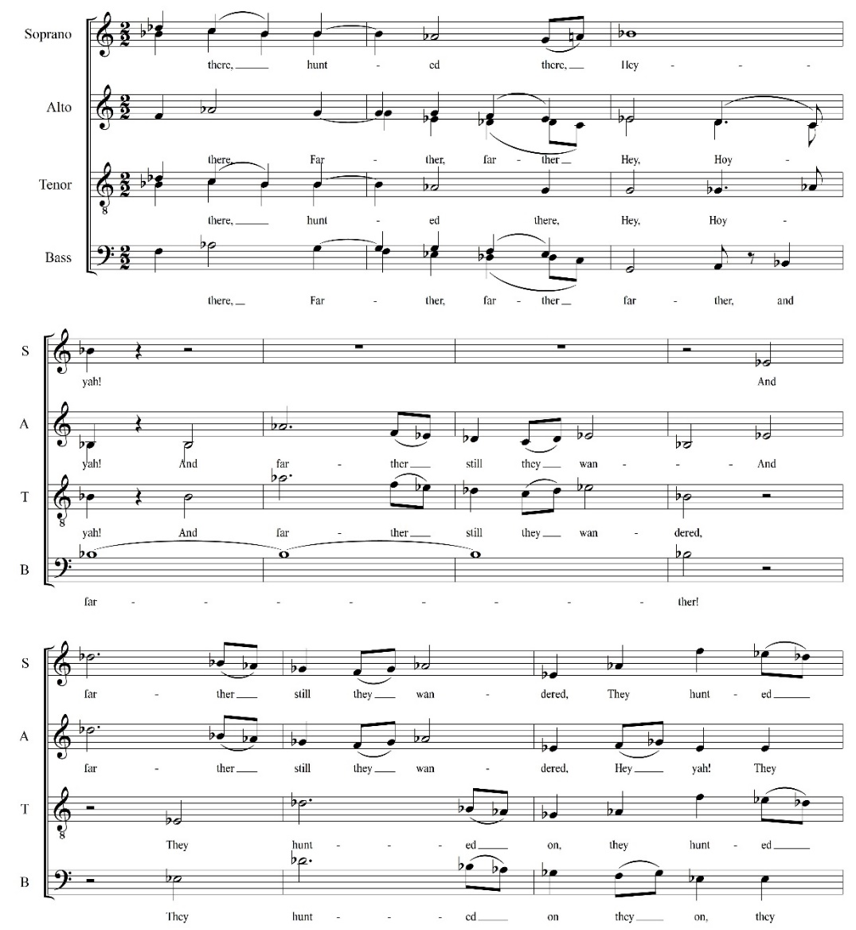
These longer note durations are accompanied by both elements of the hunt motive. The brass are assigned perfect-interval leaps, with the strings and woodwinds playing the descending-ascending scalar pattern, rhythmically offset to begin on the weak beats of each measure and passed around the ensemble. That rhythmic activity occurs more in the instrumental parts than the vocal ones is another obstacle to rhythmic clarity, but instrumental doubling is minimized to counteract that effect as a result. Bartók’s original woodwind and brass scoring is retained, and the violin parts are transferred to soprano (violin I) and alto (violin II) saxophones, marked down one dynamic level from their original fortissimo. The viola, cello, and bass parts are doublings of existing woodwind parts, so no transfer is necessary, or indeed desirable, for purposes of balance and clarity.
A final short section that combines rhythmically dense instrumental writing and a sustained choral passage occurs from measures 171 to 174. Flutes, oboes, clarinets, and strings play an active and contrapuntal passage, with the strings marked tremolo and sul tasto – over the fingerboard. During this activity, the choral parts are very static, with syllabic changes occurring on a scale of measures rather than beats. Due to the elongated nature of the lyrics during this section, clarity of consonants will be vital from the chorus. For the transcription, instrumental scoring during the passage deviates from Bartók’s; though the flute and oboe parts remain unchanged, the ascending scalar passage originally written for violins is moved to E♭ and B♭ clarinets, and the descending passage originally scored for second clarinet, viola, and cello is moved to the bassoons. Saxophones are avoided because of the pianissimo dynamic level – the chosen instruments should be more comfortable playing at that very subdued dynamic.

Figure 5.11 Cantata Profana Instrumental parts, mm. 171-174
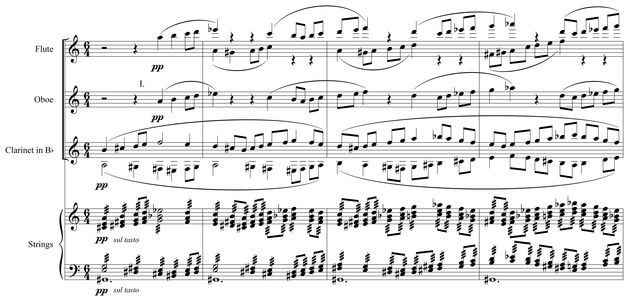

Because of the soloistic nature of the second movement, Bartók’s orchestrational choices are accordingly sparser. This results in a transcription process less concerned with lyrical clarity and even more concerned with tone color and retention of compositional intent. The third movement, in serving as a tranquil epilogue, also does not approach the timbral density of the first movement. For that reason, similarly to the second movement, the transcription process can again be concerned with the same primary factors. Through careful orchestrational choices trending towards the minimal and one-on-a-part instrumental assignments, all the densest moments within the first movement of the Cantata Profana can still achieve syllabic clarity with a chorus that is moderate in number.

Chapter 6
TRANSCRIPTION PROCESS AND RETENTION OF COMPOSER’S VOICE

Initial Scoring
The draft scoring of the Cantata Profana was completed in a very linear fashion, working from start to finish within the work. Both arranging options by Erickson were kept in mind and utilized at different points within the work, and the two options were not treated as mutually exclusive:
“1) assign parts from the orchestra to instruments in the band, 2) consider the orchestral score as a general basis for the band piece, maintaining as much of the essence of the original as possible.”

Generally, tutti scoring took the first approach if string parts were doubled in the orchestral winds – in such cases, doublings may have been transferred to saxophones, euphonium, or omitted entirely if lyrical clarity may have been compromised. Other portions of the piece, especially those featuring only strings, were re-scored with the original timbral intent as a primary concern (since vocal balance would be easier to achieve). This is done to maintain the essence of the work as Erickson suggests. The approach taken in this transcription is at odds with the process described by Dr. Timothy Shade in his dissertation, “A Process for Transcribing Orchestral Works for Wind Band: Andre Previn's Sallie Chisum Remembers Billy the Kid.” He proposes scoring in four steps:
“tutti passages, strings dominant passages, challenging orchestration passages, and the completion of the remaining material. Rescoring a work in this order allows the transcriber to create a foundational sonority early in the process which then can be utilized throughout.”
This advice seems aimed at less experienced transcribers and arrangers in need of a personal process that will result in a viable product; in contrast, for the Cantata Profana, continuity within the transcription process is the practice. The goal of this linear start-to-finish approach is to avoid any unnecessary abruptness, awkward range changes, or inadvertently unwanted shifts in tone color between musical phrases. The concept of a “foundational sonority” in this situation seems somewhat problematic, in that it seems to suggest that the arranger should translate the original work into their own preferred wind scoring idioms rather than considering the composer’s intent as primary. The Bartók is scored in such a way as to consciously retain the composer’s intent as much as possible, with “foundational sonorit[ies]” changing depending on the original musical intent of a particular passage. In this manner, the caveat of Erickson’s second method of transcription, “maintaining as much of the essence of the original as possible,” is fulfilled.
For example, the opening four measures of the Cantata Profana are scored only for strings, playing piano, and muted horns.
Figure 6.1 Cantata Profana, mm. 1-5
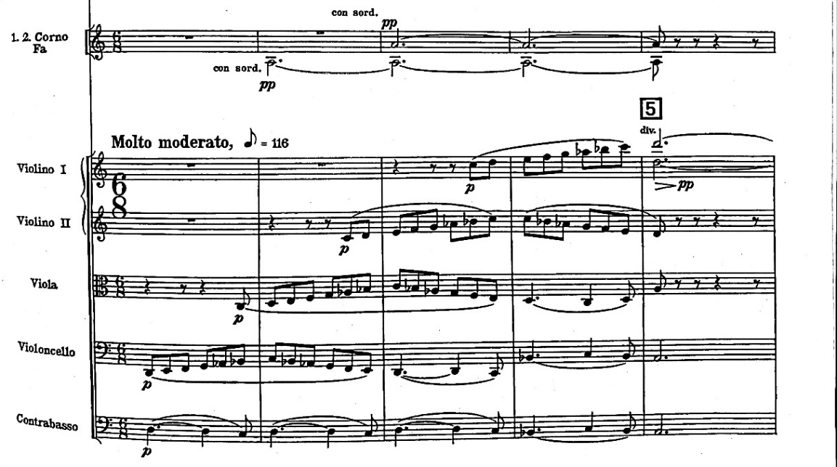
Factors that must be weighed when re-creating this excerpt are the timbrally homogeneous nature of the moving lines and ease of quiet playing in all ranges for the instrument family chosen to replicate the strings. For these reasons, the clarinet family is chosen for the moving lines in this passage. Horn parts are retained and the double bass part from the original is scored for tuba, ad libitum string bass, and ad libitum contrabassoon.
Figure 6.2 Cantata Profana Transcription, Clarinet Parts - mm. 1-4
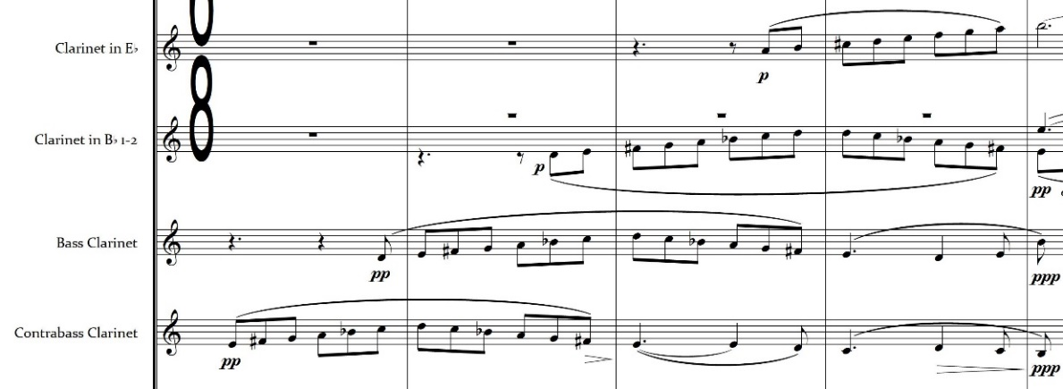
A similar thought process informs all orchestrational decisions within the transcription, with Bartók’s original woodwind and brass scoring adhered to when possible. Often, this results in utilizing the saxophone family (especially in louder and tutti passages) as a homogeneous tone color to replace the strings if the string parts are not doubled elsewhere. However, this practice is not adhered to as a rule and varies depending on musical intent. One instance of this flexible approach appears beginning at measure 115 in the second movement of the work. The solo baritone is accompanied by sparse woodwind scoring (flutes and first clarinet) and mid-low strings marked con sord. As the string mute results in a more subdued tone with fewer harmonics and less resonance, the English horn and bassoons are chosen to replace the strings for this passage. The conical bore of these double reed instruments combined with a low tessitura results in a tone that can be darker than that of the clarinet family or the saxophones, particularly when vibrato is minimized by the players.
Figure 6.3 Cantata Profana, Mvt. 2, 115-121
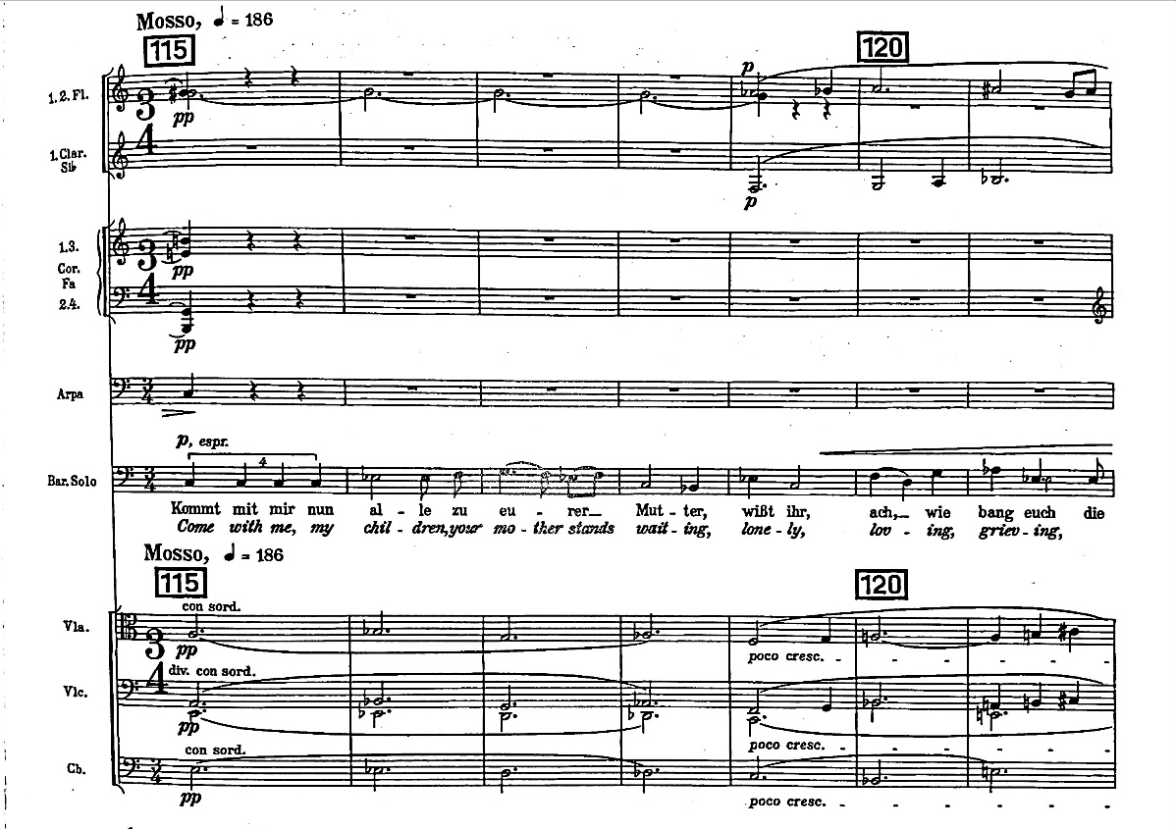
Figure 6.4 Cantata Profana Transcription, Mvt. 2 Woodwind Scoring, mm. 115-121
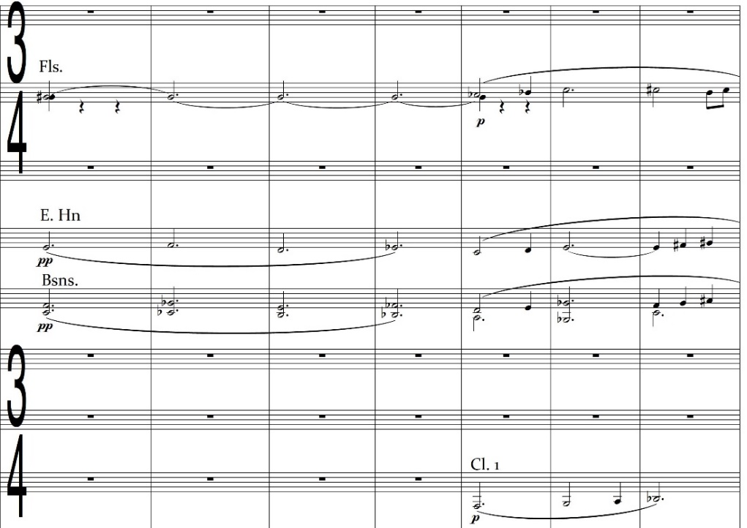

Comparison of Marked Tempos with Performance Practice
Upon listening to different recordings of the Cantata Profana during the transcription process, it becomes increasingly obvious that many of Bartók’s marked tempos are deviated from by conductors. As an extreme example, at measure 115 in the second movement, “Mosso, ♩ = 186” is the marking, but conductors take this section considerably slower, all also allowing for rubato from the solo baritone (none is marked, though the part does include an espressivo marking). Pierre Boulez, Antal Dorati, and Ferenc Fricsay direct this section at around ♩ = 120 while Gyorgy Lehel’s tempo is approximately ♩ = 132. None come close to approaching the marked ♩ = 186 tempo. The beginning of the piece is similarly marked far quicker than performance practice indicates; though the indicated tempo states “Molto Moderato, ♪= 116,” Fricsay and Lehel take the opening at ♪= 80, Boulez at ♪= 96, and Dorati at ♪= 92. This is a consistent phenomenon within the work; tempos are marked at metronome settings far faster than are performed. For that reason, the transcription will use the general tempo markings, but metronome markings will reflect an amalgamation of performance practices from the four mentioned recordings. Recorded tempos will be averaged, and tempo markings in the work altered to reflect those averaged metronome markings. For passages with very wide differences in tempo between recordings, the tempo marking will be used with no metronome marking.

Figure 6.5 Cantata Profana Original Tempo Markings, Recorded Tempos from Selected Recordings, and Resulting New Tempo Markings

Mvt./Measure Marked Tempo Boulez Dorati Fricsay Lehel New Tempo

Movement 1
m. 1 ♪= 116 ♪= 96 ♪= 92 ♪= 80 ♪= 80 ♪= 88
m. 27 ♪= 150-160 ♪= 146 ♪= 120 ♪= 184 ♪= 96 “Più mosso”
m. 53 ♪= 132 ♪= 96 ♪= 94 ♪= 172 ♪= 92 “Più tranquilo”
m. 59 = 132 = 120 = 108 = 116 = 112 = 114
m. 74 = 116 = 116 = 96 = 100 = 104 = 104
m. 126 = 108 = 116 = 92 = 96 = 96 = 100
m. 164 ♩ = 108 ♩ = 92 ♩ = 82 ♩ = 88 ♩ = 92 ♩ = 88
m. 171 ♩ = 100 ♩ = 86 ♩ = 72 ♩ = 76 ♩ = 78 ♩ = 78
m. 178 ♩ = 84 ♩ = 76 ♩ = 52 ♩ = 54 ♩ = 48 ♩ = 58
m. 180 ♩ = 144-150 ♩ = 136 ♩ = 108 ♩ = 138 ♩ = 124 ♩ = 128

Movement 2
m. 1 = 66 = 58 = 48 = 50 = 46 = 50
m. 9 = 69 = 58 = 48 = 50 = 50 = 52
m. 17 = 72 = 58 = 55 = 50 = 50 = 54
m. 36 ♩ = 160 ♩ = 180 ♩ = 152 ♩ = 160 ♩ = 144 ♩ = 160
m. 38 ♩ = 132 ♩ = 124 ♩ = 108 ♩ = 132 ♩ = 132 ♩ = 124
m. 43 ♩ = 150 ♩ = 136 ♩ = 124 ♩ = 150 ♩ = 152 ♩ = 140
m. 68 ♩ = 138 ♩ = 96 ♩ = 108 ♩ = 128 ♩ = 120 “Ritenuto”
m. 78 ♩ = 126 ♩ = 98 ♩ = 100 ♩ = 132 ♩ = 148 “Subito meno
mosso”
m. 90 ♩ = 112 ♩ = 96 ♩ = 102 ♩ = 120 ♩ = 144 “Ancora meno
mosso”
m. 96 ♩ = 132 ♩ = 128 ♩ = 108 ♩ = 112 ♩ = 120 ♩ = 116
m. 103 ♩ = 76-80 ♩ = 116 ♩ = 80 ♩ = 120 ♩ = 76 “Agitato”
m. 115 ♩ = 186 ♩ = 120 ♩ = 120 ♩ = 120 ♩ = 132 ♩ = 124
m. 129 ♩ = 138 ♩ = 90 ♩ = 72 ♩ = 102 ♩ = 80 “Meno mosso”
m. 150 ♩ = 116 ♩ = 88 ♩ = 76 ♩ = 108 ♩ = 84 ♩ = 88
m. 160 ♩ = 132 ♩ = 124 ♩ = 114 ♩ = 100 ♩ = 128 ♩ = 116
m. 168 ♩ = 120-126 ♩ = 116 ♩ = 108 ♩ = 114 ♩ = 120 ♩ = 112
m. 188 +♪ = 53 (♩ = 132) ♩ = 120 ♩ = 106 ♩ = 56 ♩ = 116 ♩ = ♩.
m. 193 ♩ = 100 ♩ = 78 ♩ = 104 ♩ = 52 ♩ = 88 “Un poco
rubato”
m. 195 ♩ = 67 ♩ = 68 ♩ = 58 ♩ = 58 ♩ = 70 ♩ = 64
m. 205 ♪= 192 ♪= 124 ♪= 140 ♪= 112 ♪= 168 ♪= 136
m. 210 ♩ = 80 ♩ = 60 ♩ = 58 ♩ = 60 ♩ = 76 ♩ = 64

Movement 3
m. 1 ♩ = 132 ♩ = 112 ♩ = 98 ♩ = 120 ♩ = 100 ♩ = 108
m. 12 ♩ = 120 ♩ = 112 ♩ = 98 ♩ = 118 ♩ = 102 marking
removed
m. 35 ♩ = 116-120 ♩ = 108 ♩ = 82 ♩ = 100 ♩ = 88 ♩ = 94
m. 65 ♩ = 120 ♩ = 80 ♩ = 72 ♩ = 88 ♩ = 88 ♩ = 82
m. 79 ♩ = 92 ♩ = 74 ♩ = 68 ♩ = 70 ♩ = 72 ♩ = 72

Clarinet Considerations – Transpositional Adjustments and Use of the Contrabass Register
As discussed in Chapter 5, the original clarinet parts for the Cantata Profana were pitched both in A and B♭, with players expected to switch instruments several times during the work (including one player doubling bass clarinet). For the transcription, a full-range clarinet family is specified, including E♭ sopranino, two B♭ sopranos, B♭ bass, and B♭ contrabass clarinets.
The decision is made to keep the soprano clarinets in B♭ throughout the work, rather than switching back and forth to clarinet in A. This decision is made for two reasons: first, that only one measure contains an out-of-range note for the B♭ instrument that is scored for the A clarinet; the re-scoring of that measure is discussed in Chapter 5. Second, that the most difficult technical passage of the piece for the clarinetists is playable in its original form on B♭ clarinet. The passage contains a repeated motive that serves to reinforce the harp glissandi occurring simultaneously.
Figure 6.6 Cantata Profana Mvt. 2, Clarinet 1, m. 78 – Original Part, Transposition in A
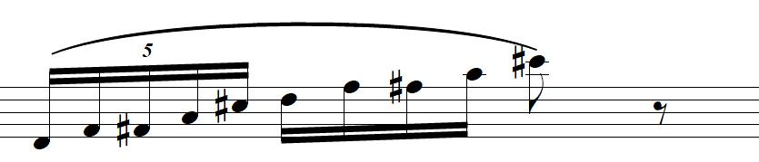
Figure 6.7 Cantata Profana Mvt. 2, Clarinet 1, m. 78 – Transposition in B♭
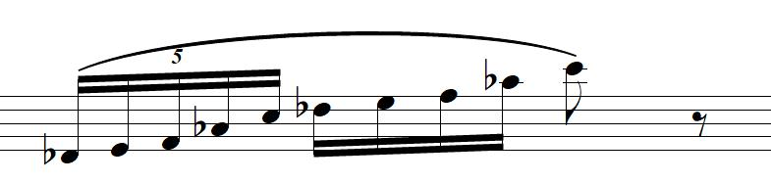

Though informal, a Facebook post was utilized to generate opinions from clarinetists as to the playability of the two excerpts in comparison with one another. The full communication, found in Appendix C, shows that among those clarinetists, opinion was mixed on whether the passage was more difficult on the A or B♭ instrument, and any player who mentioned instrument doubling discouraged the practice and suggested keeping the part on B♭ clarinet. Given this feedback, the clarinet parts stay in B♭ throughout. Isolated punctuative notes originally assigned to the extreme upper register of the B♭ instrument are instead assigned to the E♭ clarinet; examples include the original principal clarinet part in measures 109-112 (written G♯6), 164, 167, and 168 (written F♯6) of the first movement and measures 38, 41 (F♯6), and 157 (written G♯6) of the second movement.
Contrabass clarinet is included to assist with any parts for which the contrabass register is required but may prove unsuitable on the tuba because of volume, balance, or technical concerns. It is the only woodwind instrument of that range required to perform the transcription, since contrabassoon, while desirable, is marked ad libitum. The contrabassoon part doubles the also ad libitum string bass. Since the original string bass part can be active even in its lowest register at times, the contrabass clarinet becomes an integral part of the wind transcription and is required, since the low range necessary drops below that of the E♭ contralto clarinet.

Saxophone Family Usage
The saxophone family is most often utilized as a homogeneous bloc of tone colors, substituting for the string parts in tutti passages. This usage itself is the factor that allows for a homogeneous voice since all other woodwind families are already represented within Bartók’s original score and the initial transcription process keeps musical lines on their original instrument when possible. An instance of this usage occurs in the first movement of the Cantata Profana, during which violins, violas, and celli play a unison passage accompanied elsewhere in the orchestra by longer durations in double bass, clarinets, bassoons, horns, and octave leaps in the first trombone. This usage is mirrored in the transcription by the saxophone section, though the uppermost violin I part is out of the range of even the soprano saxophone. This octave is consequently assigned to the piccolo, for which it is a middle-range passage. This choice will ensure the upper octave of the passage is audible while still allowing the ability for timbres to blend. Vocal clarity and balance should be unaffected, as the saxophones and piccolo are not doubled elsewhere, and the vocal parts in this passage are sung in a staccato manner with chorus I and chorus II each singing their own syllabic unison.
Figure 6.8 Cantata Profana String Parts, Mvt. 1 mm. 132-135
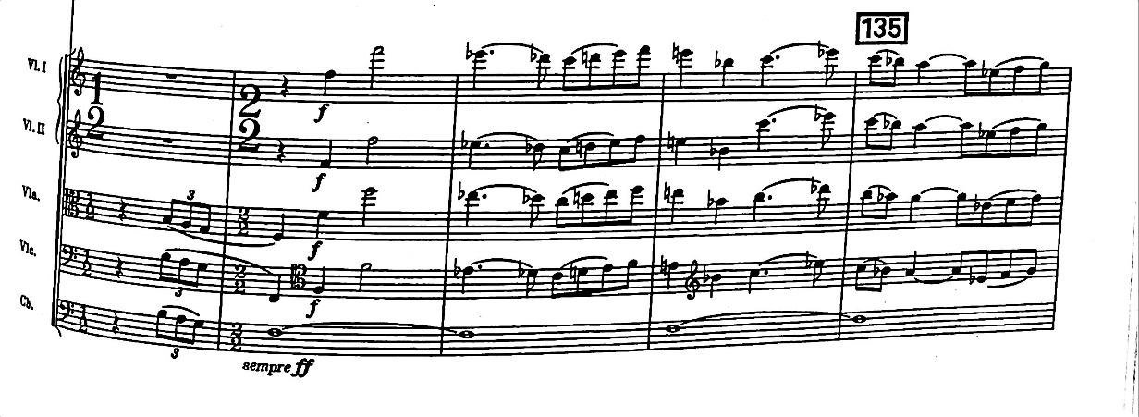
Figure 6.9 Cantata Profana Transcription Saxophone Parts, Mvt. 1 mm. 131-135

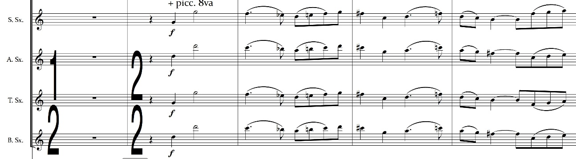
The saxophones are also used to substitute for strings in passages with activity in other wind parts, such as in the second movement, measures 26-34. While the harp plays a rhythm syncopated at the quarter note level, horns outline melodic entrances from both choruses, accentuating the word-painting from the phrase “down on” with a descending three-note motive which is passed around the section. During this passage, the violins and violas also play chord outlines which are syncopated at the eighth note level.
Figure 6.10 Cantata Profana, Mvt. 2 mm. 28-31
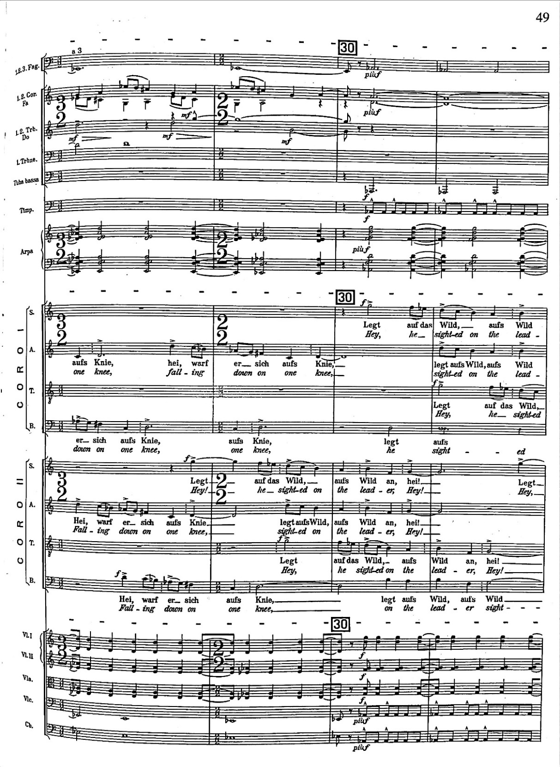

This eighth-note syncopation is transferred to the saxophone section. Though there are six notes represented in the string parts, there are only three pitches present due to octave doubling. Pitches include concert D, E♭, and A♭, changing to D, F, and G in measure 30.
Figure 6.11 Cantata Profana Transcription, Saxophone Parts – Mvt. 2, mm. 28-31
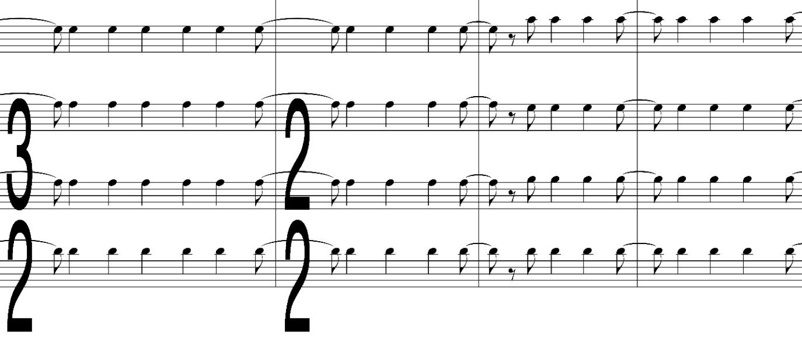
When not replicating string parts, the saxophones are sometimes utilized to supplement the woodwind choir, such as in measures 34-41 of the first movement. Saxophones are scored doubling the oboe and clarinet parts in this passage, reinforcing those voices.

Euphonium Usage
Though the euphonium (and before it more often the cylindrically bored baritone) has been part of wind bands since the early Twentieth Century, literature on orchestrating for the instrument remains sparse. Though Adler and Grantham/Kennan both mention the instrument, any discussion of tone quality characteristic to the euphonium is minimal. “Smooth,” “mellow,” “broad,” and “dark” are some descriptors used about its tone quality. Adler and Erickson both mention the technical facility of the instrument as well, Erickson going so far as to say that the baritone and euphonium are primarily melodic instruments. Given the broadness of the euphonium’s sound, however, widespread melodic usage (especially in the instrument’s upper range) in the context of the Cantata Profana runs the risk of covering the vocal parts and rendering the text unintelligible. Instead, the euphonium is used in two ways during the transcription of the work. First, it provides a bridge between the conical brass voices of the low horn and the tuba, mimicking Bartók’s writing for the tuba in his second piano concerto. As shown below, Bartók at times uses the tuba to reinforce horn and double reed textures without the help of trombones, making a conscious choice for a broader and less focused combined tone color.
Figure 6.12 Piano Concerto No. 2 – Mvt. 1, mm. 211-212
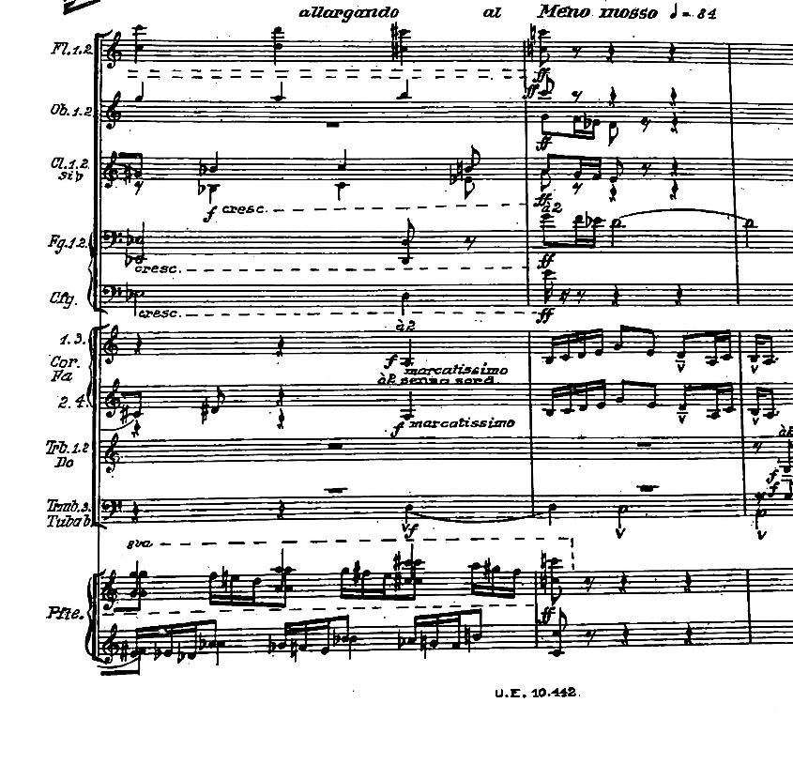
“Piano Concerto No. 2” by Béla Bartók
©1932 Boosey & Hawkes, Inc., A Concord Company
All Rights Reserved. For The Sole Permission of Andrew Anderson, University of Oklahoma.

Figure 6.13 Piano Concerto No. 2 – Mvt. 1, mm. 70-71
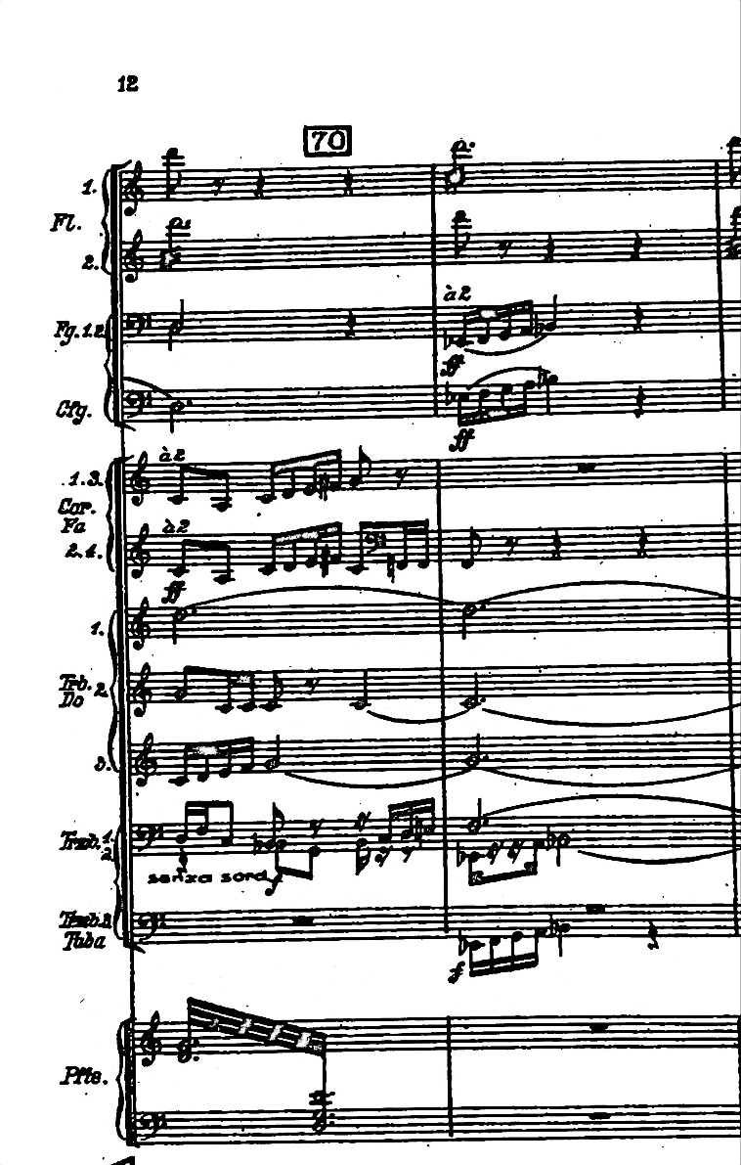
“Piano Concerto No. 2” by Béla Bartók
©1932 Boosey & Hawkes, Inc., A Concord Company
All Rights Reserved. For The Sole Permission of Andrew Anderson, University of Oklahoma.

The addition of the euphonium to an occasional horn/tuba combination creates a homogeneous bloc of conical brass with the ability for comfortable projection in ranges from C5 down to F1, demonstrated simply in the second movement of the transcription. In measures 108-113, the existing horn and double reed parts are combined with the original viola, cello, and bass parts to create a “foundational sonority” for this section of the piece. Euphonium starts replicating the cello, but the viola entrance on E♭ in measure 110 is accentuated by voice crossing in the euphonium, leaping above the horns.
Figure 6.14 Cantata Profana Transcription, Horns & Low Brass – Mvt. 2, mm. 108-114
This scoring is also an example of the second type of usage for the euphonium; one in which it replicates middle to low lines where appropriate. Though this occurs mostly in tutti sections of the work, the technique can also be utilized at quieter volumes due to the one-on-a-part nature of the wind ensemble transcription. Because of these dual functions, much of the euphonium range in the transcription is in its medium-low tessitura, though still well within the useable range of the instrument. String replication in semi-tutti occurs during much of the work, with an example near the end of the first movement, at measure 176. The euphonium and tuba replace the cello and bass sections and are joined by the horns (as in the original) at measure 181. Working from the additive texture of the horn in the original work, this made the choice of assigning the part to tuba/euphonium (rather than a woodwind timbre) a logical one from which to build this accompanimental line.
Figure 6.15 Cantata Profana Transcription, Euphonium Part – Mvt. 1, mm. 176-187
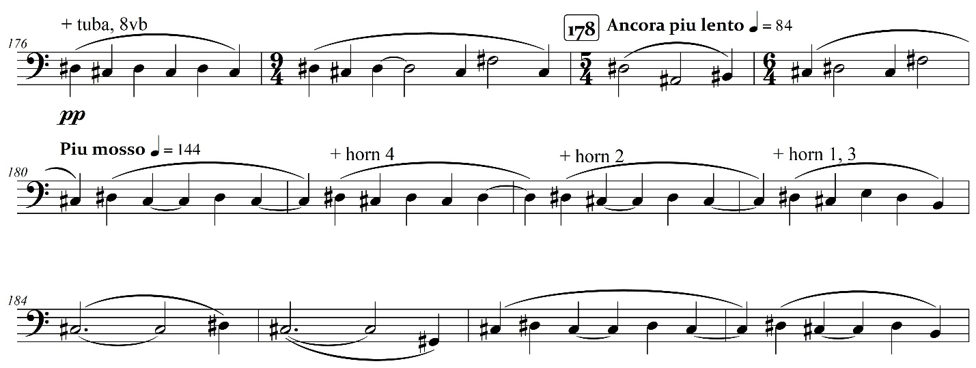
Use of Muted Brass
Bartók specifies muted horn many times in the Cantata Profana, marking the initial entrance of horns 1 and 2 con sord. Using muted horn either sustained underneath quiet moving lines or doubling them when louder volumes are called for is a technique Bartók employs frequently. In addition to the beginning of the work, such instances occur in the first movement at measures 51-52, 55, 164, 172, and 176-181, in the second movement during measures 43-46, 138-158, 163-166, 197-199, 202-203, and 207-208, and in the third movement during measures 35, 37 and 41-47. Measures 41-47 are marked as stopped. Bartók uses the “plus sign” notation for stopped horn notes, allowing players and conductors to infer that physical mutes are desired for the portions marked con sord. Muted trumpet is called for in the second movement at measures 150-152 and 154-158.
The transcription retains the mute specifications that Bartók employs but adds several muted sustained passages for the cylindrical brass, taking advantage of the available timbres that different mutes can supply. In the first movement at measure 17, trumpets and trombones 1-2 are marked “cup mute,” supplying a subdued D-minor 7 chord that was originally assigned to the strings. In addition to this muffled timbre, the decrease in volume that results from this type of mute will make the initial choral entrance easier to hear. The timbral difference between brass and woodwinds will also make the oboe and clarinet entrances in measure 19 more easily discernible and is a primary reason this sustained chord was assigned to muted brass instead of additional woodwind voices. This usage is mirrored in the final movement as well, beginning at measure 65. Cup-muted trombones (doubled by clarinets) begin the ascending line originally scored for viola, cello, and bass, and are joined by similarly muted trumpets in measure 68. The similarity in scoring these two passages is meant to reinforce the lyrical similarity of the passages and the arch form of the work.
Trumpets and all trombones are also marked muted in measure 176 of the first movement, during the moment where the brothers find themselves lost in the forest. The admixture of sustained muted brass along with upper woodwinds is meant to enhance the sense of unease during this passage, heightened by the undulating chromatic bass line in contrabass clarinet, euphonium, and tuba.

Mallet Percussion Usage
The rapid expansion of the mallet percussion section is a notable development of orchestration in the Twentieth and early Twenty-First Centuries, a cycle of development that Bartók mostly predates. His use of mallet percussion extended only to the xylophone; he never scored for the glockenspiel (forgoing it in favor of the celesta), and the vibraphone and marimba were not yet in use within the orchestra in 1930, the year Cantata Profana was written. (The vibraphone was only first utilized by Alban Berg in his 1937 opera Lulu, while the marimba was first scored in the orchestra by Darius Milhaud in 1947). Given the interim seven decades of development in manufacturing processes, playing techniques, and orchestrational practices regarding mallet percussion, it is assumed that Bartók would not object to the use of these instruments.
As discussed in Chapter 2, discussion of mallet percussion in the role of wind transcriptions is still an area that has yet to be fully explored by authors on the subject, and predictably, discussion of mallet technique in wind/choral transcriptions is nonexistent. However, this lack of precedent allows for experimentation with orchestrational techniques, given proper justification. The use of mallet percussion within the transcription of Cantata Profana is one of tone color recreation and reinforcement. The shimmer in the tone of the upper tessitura of the violin is not easily recreated by winds, especially at quiet volumes. In such cases during the transcription of the work, glockenspiel or crotales are added to add brightness without any timbral harshness accompanying it due to problematic ranges. Such instances occur in the melodic line during measures 34-42 (glockenspiel doubles E♭ clarinet, replicating the original violin I line) and 188-197 (crotales double the descending line in the harp and flutes) of the first movement, and during the second movement in measures 140-141, 146-149, and 185-186 (all on glockenspiel, replicating violin I, violin II, and viola, respectively).
Figure 6.16 Cantata Profana Transcription, Glockenspiel Part – Mvt. 1, mm. 34-42
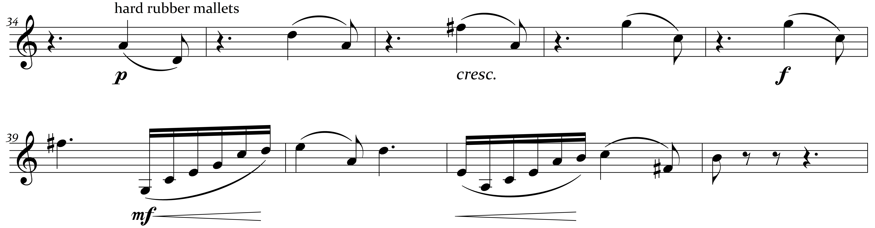
Vibraphone and glockenspiel are used together, played with bows, to replicate string harmonics used in the first movement of the work. This function and performance practice will be discussed in more detail during the next subsection of this chapter. The marimba is used primarily to reinforce technical passages in the lower register, most especially the string motor in the first movement during the passage depicting the brothers on the hunt. It also helps to replicate a low string tremolo during a portion of the second movement, to be discussed in further depth below.

Translation of String Effects
Three string effects that prove difficult for wind bands to replicate are tremolandi, glissandi, and harmonics. Each has an analogous practice somewhere within the wind or percussion instrumentation, but the effect produced is almost always different from the effect from the strings and therefore undesirable as a directly transferrable practice. This necessitates creative problem solving on the part of the transcriber.
The first effect, the tremolo, is utilized by Bartók in the Cantata Profana to infuse additional energy in faster sections of the work, but more frequently to create unease in sections for which the lyrical content depicts anguish or confusion. The former practice occurs in tutti strings at measures 105-107 of the first movement, during the section of the piece depicting the brothers on the hunt. The latter effect occurs when the brothers reach the haunted bridge and become lost; the tremolo is scored in cello and bass from measure 165-170 (doubled in harp, timpani glissando, and fourth horn), immediately following from violins, viola, and cello until measure 175, and then scored in the upper three string parts for the subsequent two measures as the cellos join the basses on an accompanimental line. The second movement incorporates similar and frequent usage, with string parts during measures 38-55, 65-67, 78-102, 153-159, 163-173, and 213-215 playing tremolandi. This corresponds with the lyrical introduction of the oldest brother, the father, the chorus’ narration of the conversation between the two, and emphasized lyrical moments during each solo passage.
The single-note tremolo, which Bartók uses frequently during the Cantata Profana, is inherently problematic for winds. For a single wind instrument to accomplish it, the single-note tremolo necessitates either a “trill” to an alternate fingering for the same note on a reed instrument (assuming there is one) or the use of flutter-tonguing for flutes and brass. None of these techniques can combine the needed technical facility to play melodically while simultaneously producing the tone quality desired. (Erickson flatly claims that tremolos “can be ignored when scoring for winds.”) Percussion can, of course, replicate the practice through rolling on the given pitches using a mallet instrument, but the timbre of any mallet percussion instrument is so different than that of the strings that the substitution should not be viewed as a universally suitable solution. To find a viable substitute for single-note tremolos, the string timbre is separated into two components: resonant pitch content and an unmetered and unpitched but rhythmically intense articulative repetition. Rolling unpitched percussion combined with the suitable reassignment of the string material is proposed as an orchestrational substitute for the single-note tremolo. As an example, during the transcription, at measure 43 in the second movement, a ppp snare drum roll is indicated, as the pitch content from the strings is taken over by the B♭ and bass clarinets. The snare drum is chosen because the pitch content from the strings is in a lower tessitura; the only upper-range tremolo in the violin during the work occurs in the first movement at measures 176-177, this is replicated by a pp triangle roll with pitch content assigned to clarinets and saxophones. There is a single upper-range tremolo in the violins during measure 209 of the second movement; however, this tremolo is doubled by Bartók with flutes on a flutter-tongue. For that reason, any further duplication of the tremolo is omitted.
In other passages of the Cantata Profana, single-note tremolos are omitted entirely in favor of timbres which are intended to have the same “buzzy” quality; during the second movement beginning at measure 38, the viola, cello, and bass parts are melodic, doubled in third trombone and tuba, and marked with tremolos. The transcription retains the melodic content from bass trombone and tuba but adds contrabassoon (if available), bass clarinet, contrabass clarinet, baritone saxophone, and marimba (rolling on all possible durations) in place of the low string tremolo, planning for the reedy timbre of this combination to infuse the passage with the desired energy. The ad libitum string bass part is retained from Bartók’s original and marked with tremolos.
Two-note tremolos are easier for winds to replicate, and appear during the second movement of the work, a turbulent moment during which the tenor soloist sings “Naught but dust survive thee, dearest loving father, naught but dust survive thee.” Rapidly alternating ascending arpeggios in the clarinets and flutes reinforce harp glissandi which alternate hands, underpinned by sustained harmony centered on B with a split major/minor third in second bassoon, horns, and string tremolos. All original wind parts are retained, with the tremolandi moved from the strings to the saxophone section. The given string range is easily transferred to the four saxophones since the upper strings are playing low in their tessitura and there is no contrabass range to navigate. Additionally, as the strings are marked mezzo forte, a sotto voce tremolo, which would be more appropriate for clarinet, is not necessary.
Figure 6.17 Cantata Profana Mvt. 2, mm. 78-81 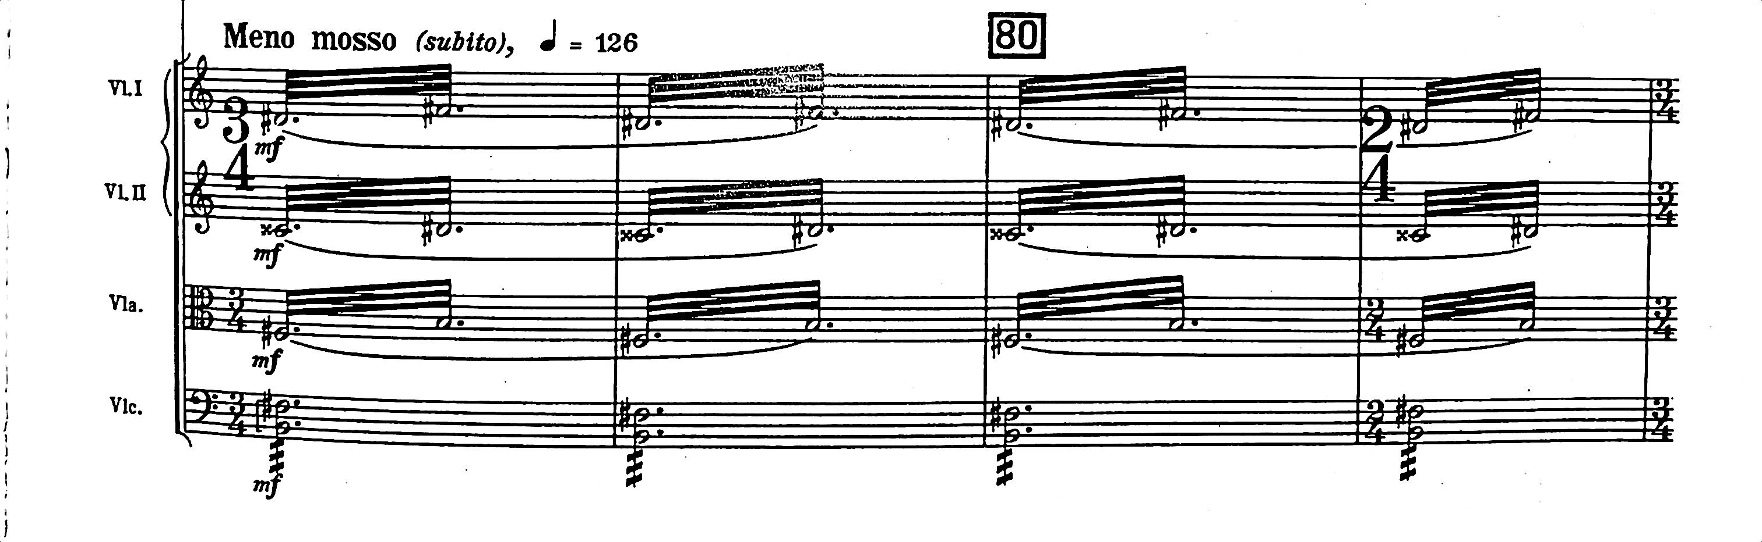

Figure 6.18 Cantata Profana Transcription, Saxophone Parts - Mvt. 2, mm. 78-81

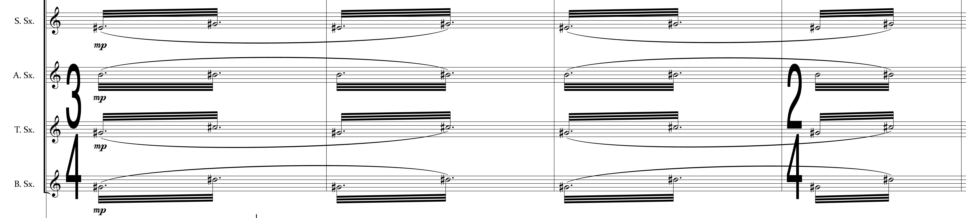

The string glissando is not often used by Bartók but does appear in two forms within the Cantata Profana. The first is a “scoop” up to the defined pitch from an indeterminate lower starting point, the second is a true glissando from one note to the other. Both appear during the first movement, serving as punctuative gestures. As each is echoed in the woodwind technique of the work by use of grace notes or written runs respectively, these string effects are already accounted for. The only other glissando occurs in the viola section during measures 185 and 186 of the second movement and consists of a pianissimo one-octave slide from G5 to G6, as the indicated glissando is also an open harmonic. In the transcription, this glissando is assigned to the glockenspiel using hard rubber mallets - this allows for the instrument to be heard without dominating the texture.
String harmonics by their very nature are almost impossible to recreate with wind instruments – the thinness and transparency of tone resulting from a harmonic, combined with the extremely high range of registration, make the task impossible even for the piccolo or E♭ clarinet. Mallet percussion also initially seems unsuited to the task due to the action of striking the note with a mallet, since the immediacy of attack is exactly the opposite of a string player on a harmonic, which speaks gradually. However, the development of mallet percussion playing techniques allows for bowing as a solution. At the only moment in the work during which Bartók specifies string harmonics, the percussion section is asked to bow the vibraphone and glockenspiel, replicating the ethereal timbre of the quintal harmony originally supplied by the string harmonic.
Figure 6.19 Cantata Profana Transcription, Mallet Percussion Parts – Mvt. 1, mm. 52-54
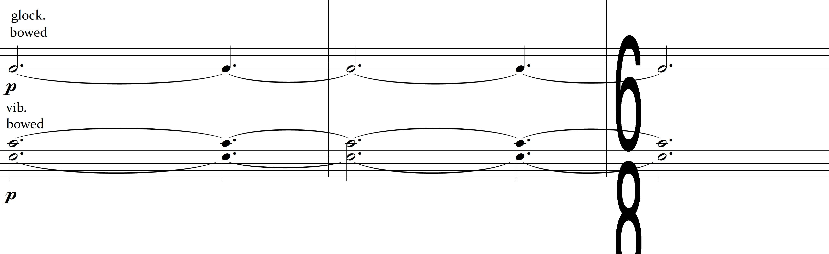
Chapter 7
SUMMARY

This transcription of the Cantata Profana by Béla Bartók seeks to reinforce wind band literature in two areas: combined band/choral works, and music by the composer, which is chiefly limited to transcriptions of works that are miniature in scope. Orchestrational techniques used in this effort are adapted from three sources. The first, and primary, is Bartók himself, whose intent must be fulfilled as the original composer of the work. The second source is best practices as stated by orchestration texts, and the third is my previous experience writing for the combination of wind band and choir. Initially, balance problems may result from those two types of ensemble merging for the same musical work, since large numbers of vocalists are needed to be heard clearly alongside an instrumental ensemble. However, the prescribed use of a one-person-per-part wind ensemble mitigates those concerns. Further concessions to possible balance problems include intentional transparency in wind scoring and, where applicable, orchestrational decisions modeled after those found in movements of his Piano Concerto No. 1 and Piano Concerto 2 that omit strings.
The idea of transformation, an organizing principle of the Cantata Profana, is emphasized within the transcription through adherence to both the form of the work and the colinde text used by Bartók and further reinforced through subtle changes of orchestration when presenting previously heard (and possibly melodically or harmonically altered) material. Further, Bartok’s writings show a strong motivation to challenge German hegemony and upper-class Hungarian antipathy toward folk culture through his use of a Romanian colinde as a source text, encoded Hungarian folk modes within the work, conscious avoidance of common practice methods such as functional tertian harmony, and the constant use of transformation as the primary theme of the cantata.
The finished transcription provides a seldom-seen opportunity for combined wind and choral ensemble performance utilizing groups that can be smaller than those used for the orchestral setting. The resulting performances will feature a large-scale work by Bartók who, unlike many early twentieth-century counterparts, has not had his music widely performed by wind bands.

APPENDIX A
TRANSCRIPTION OF CANTATA PROFANA, BB 100
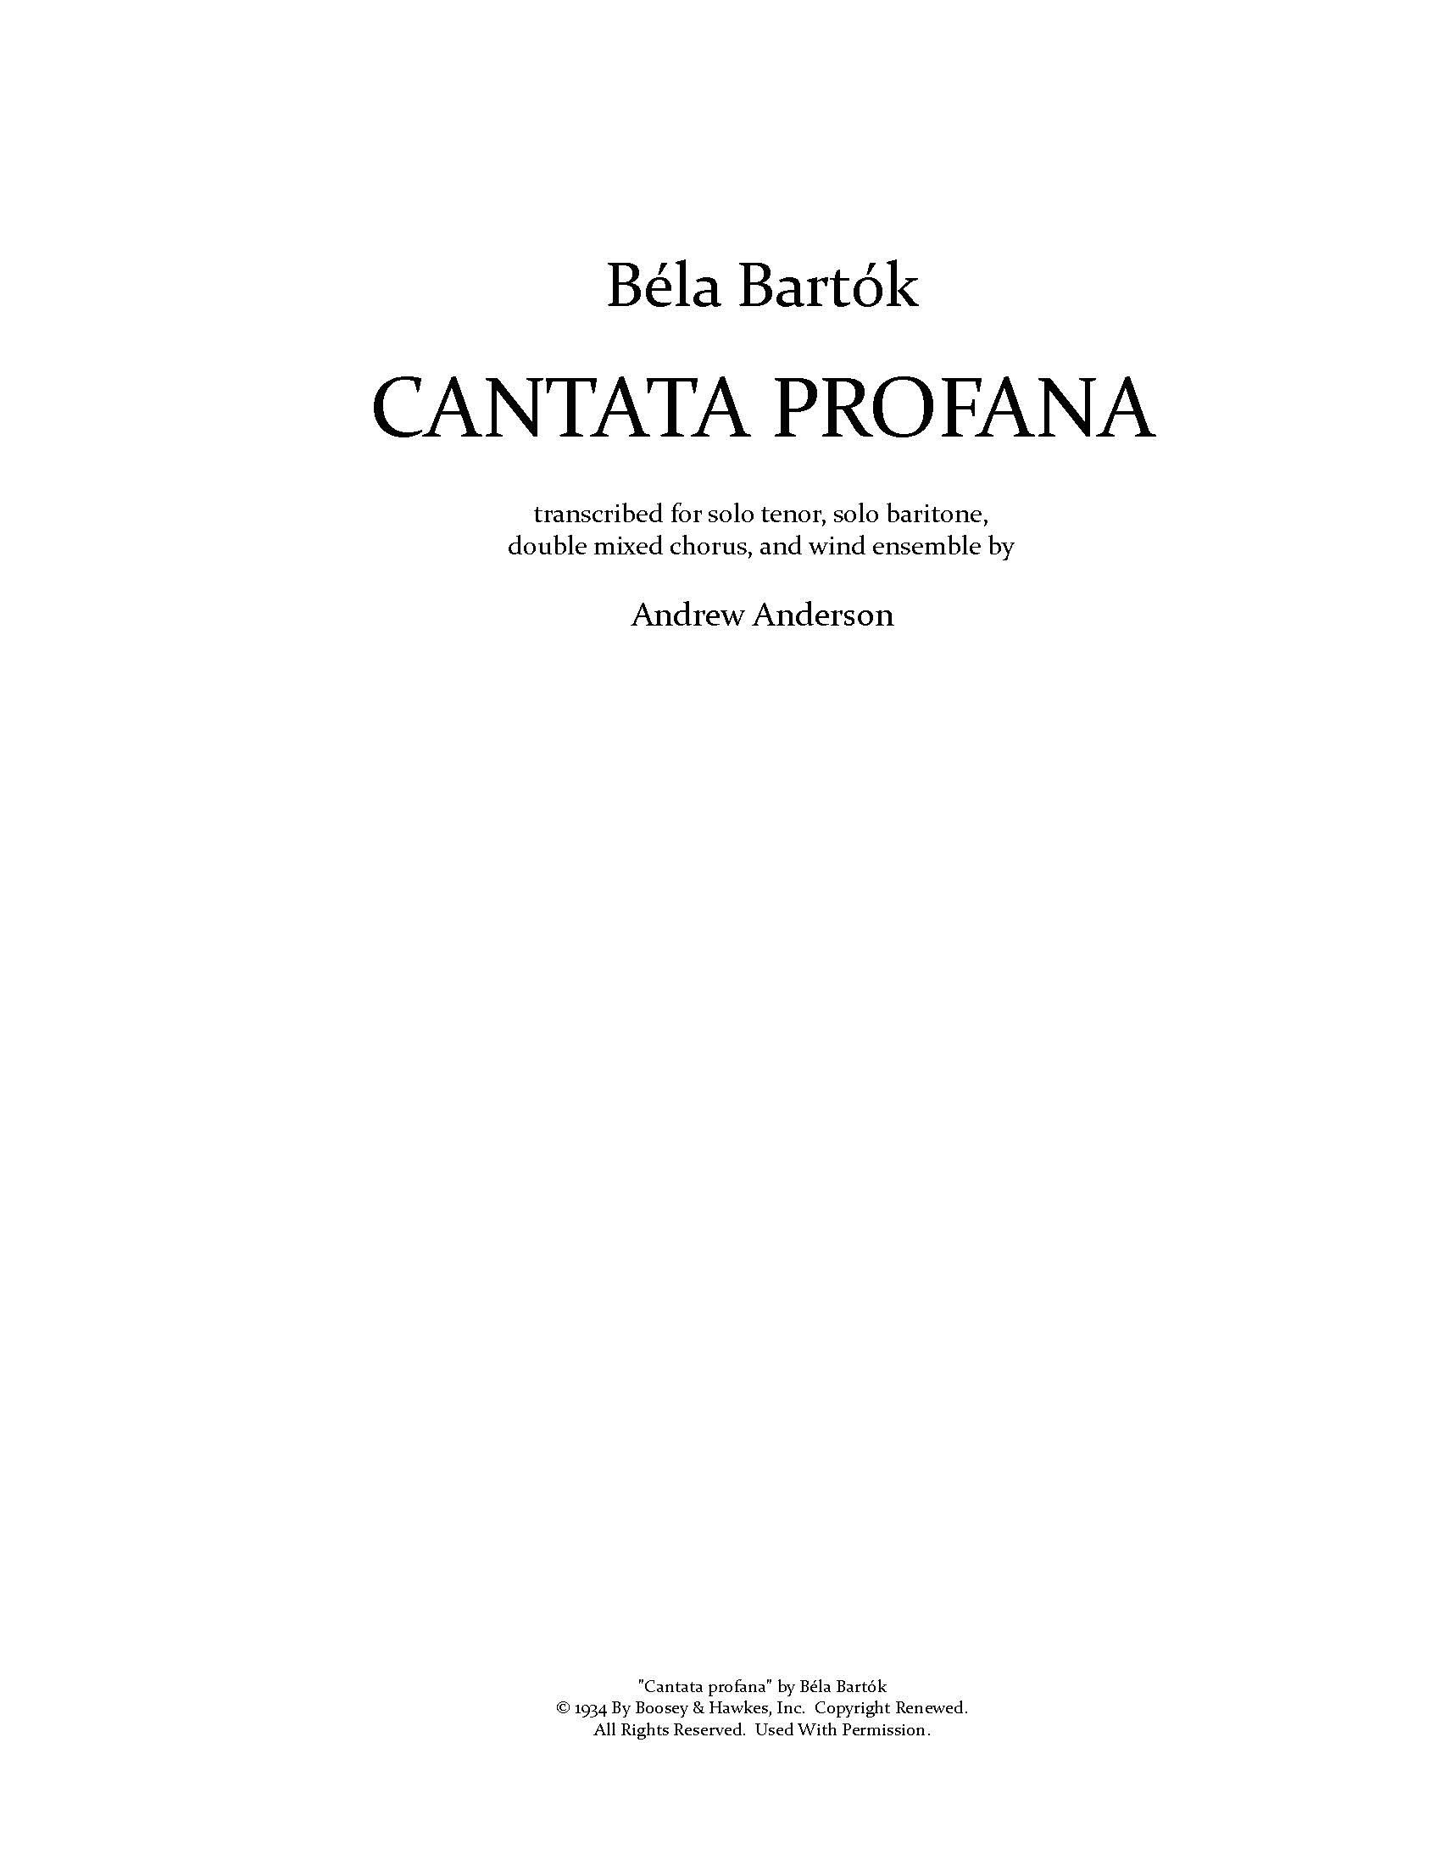
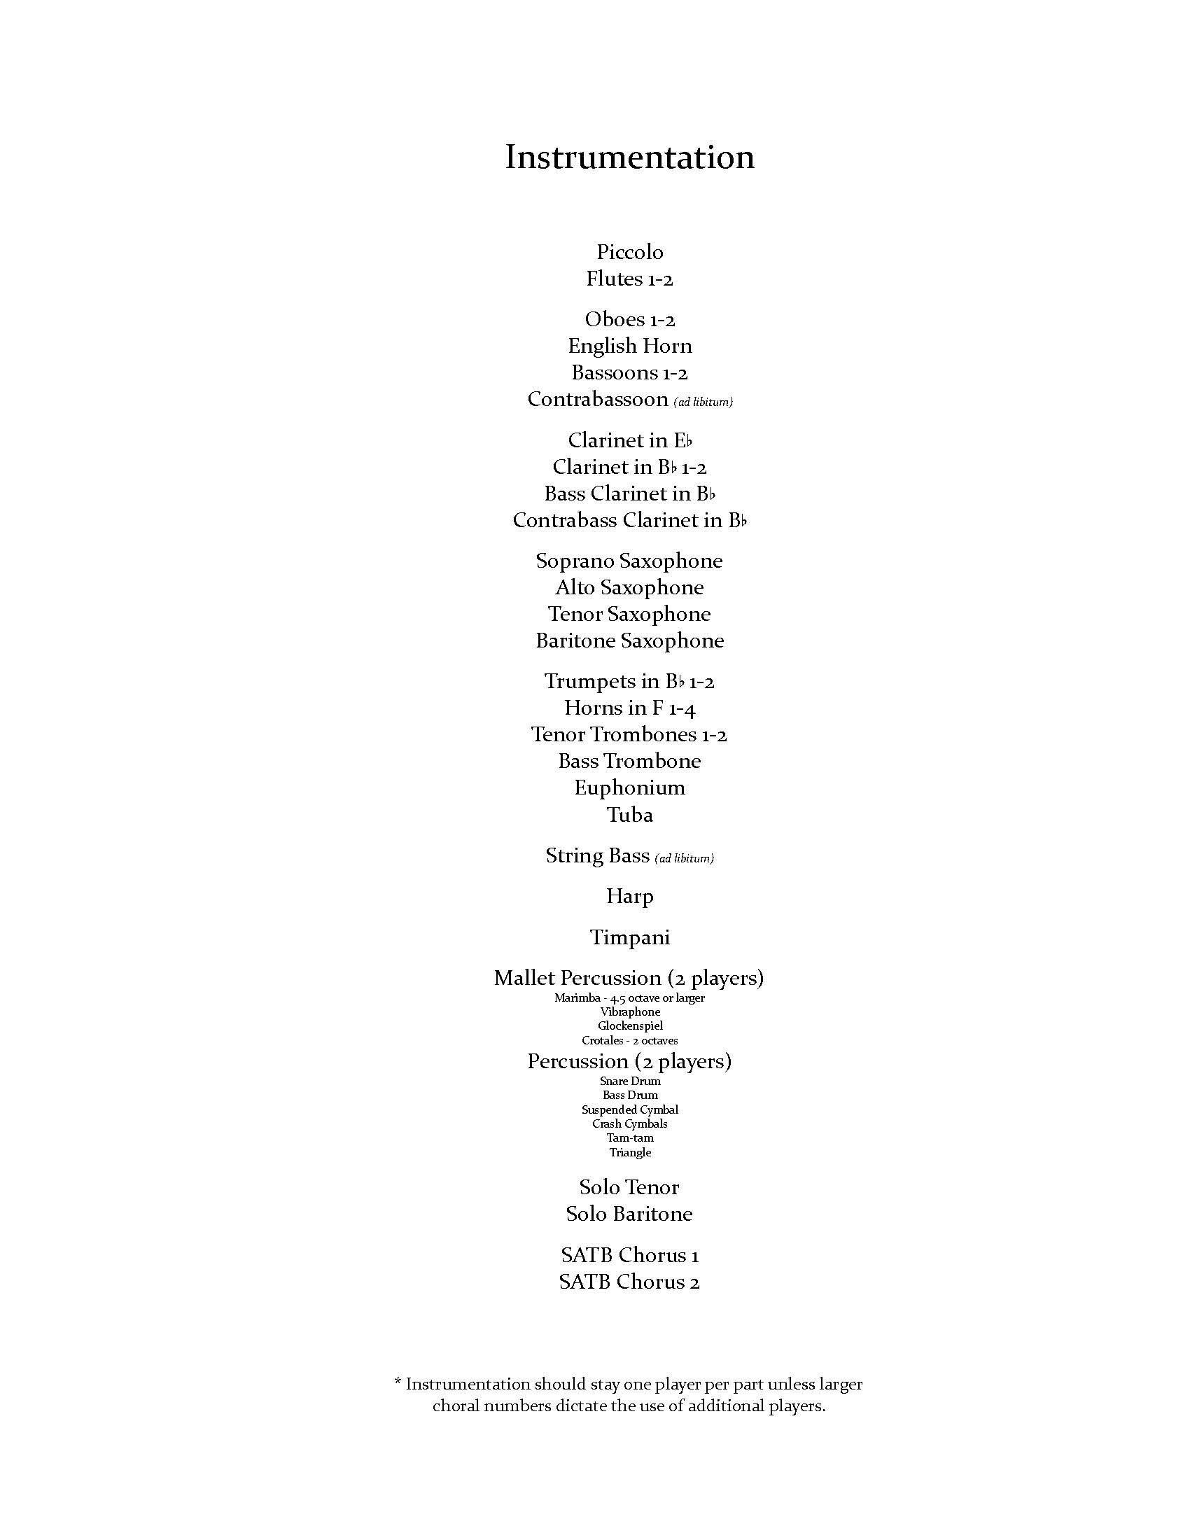
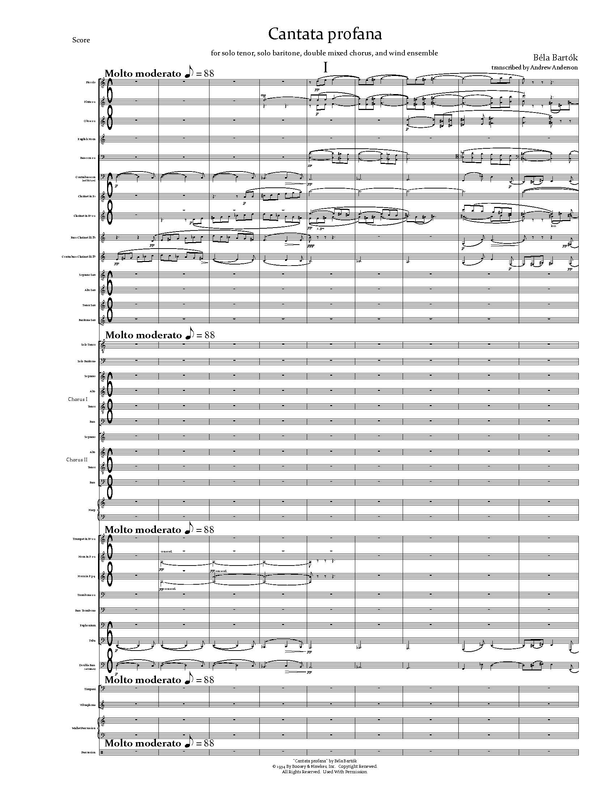

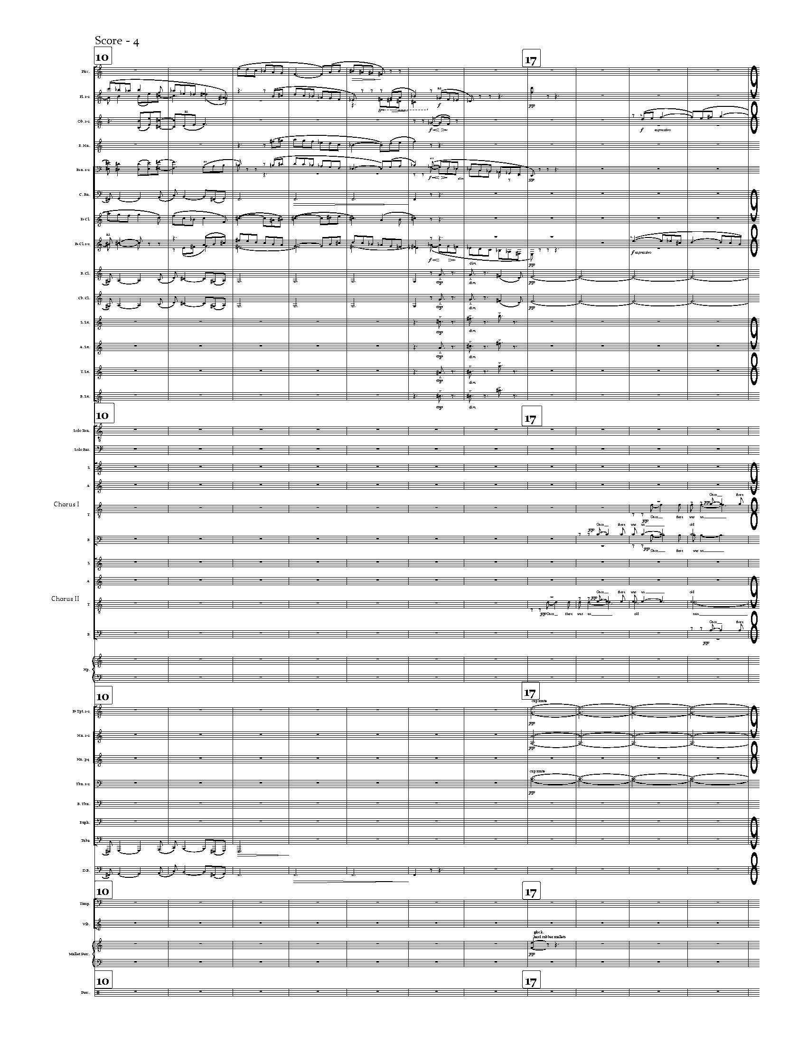

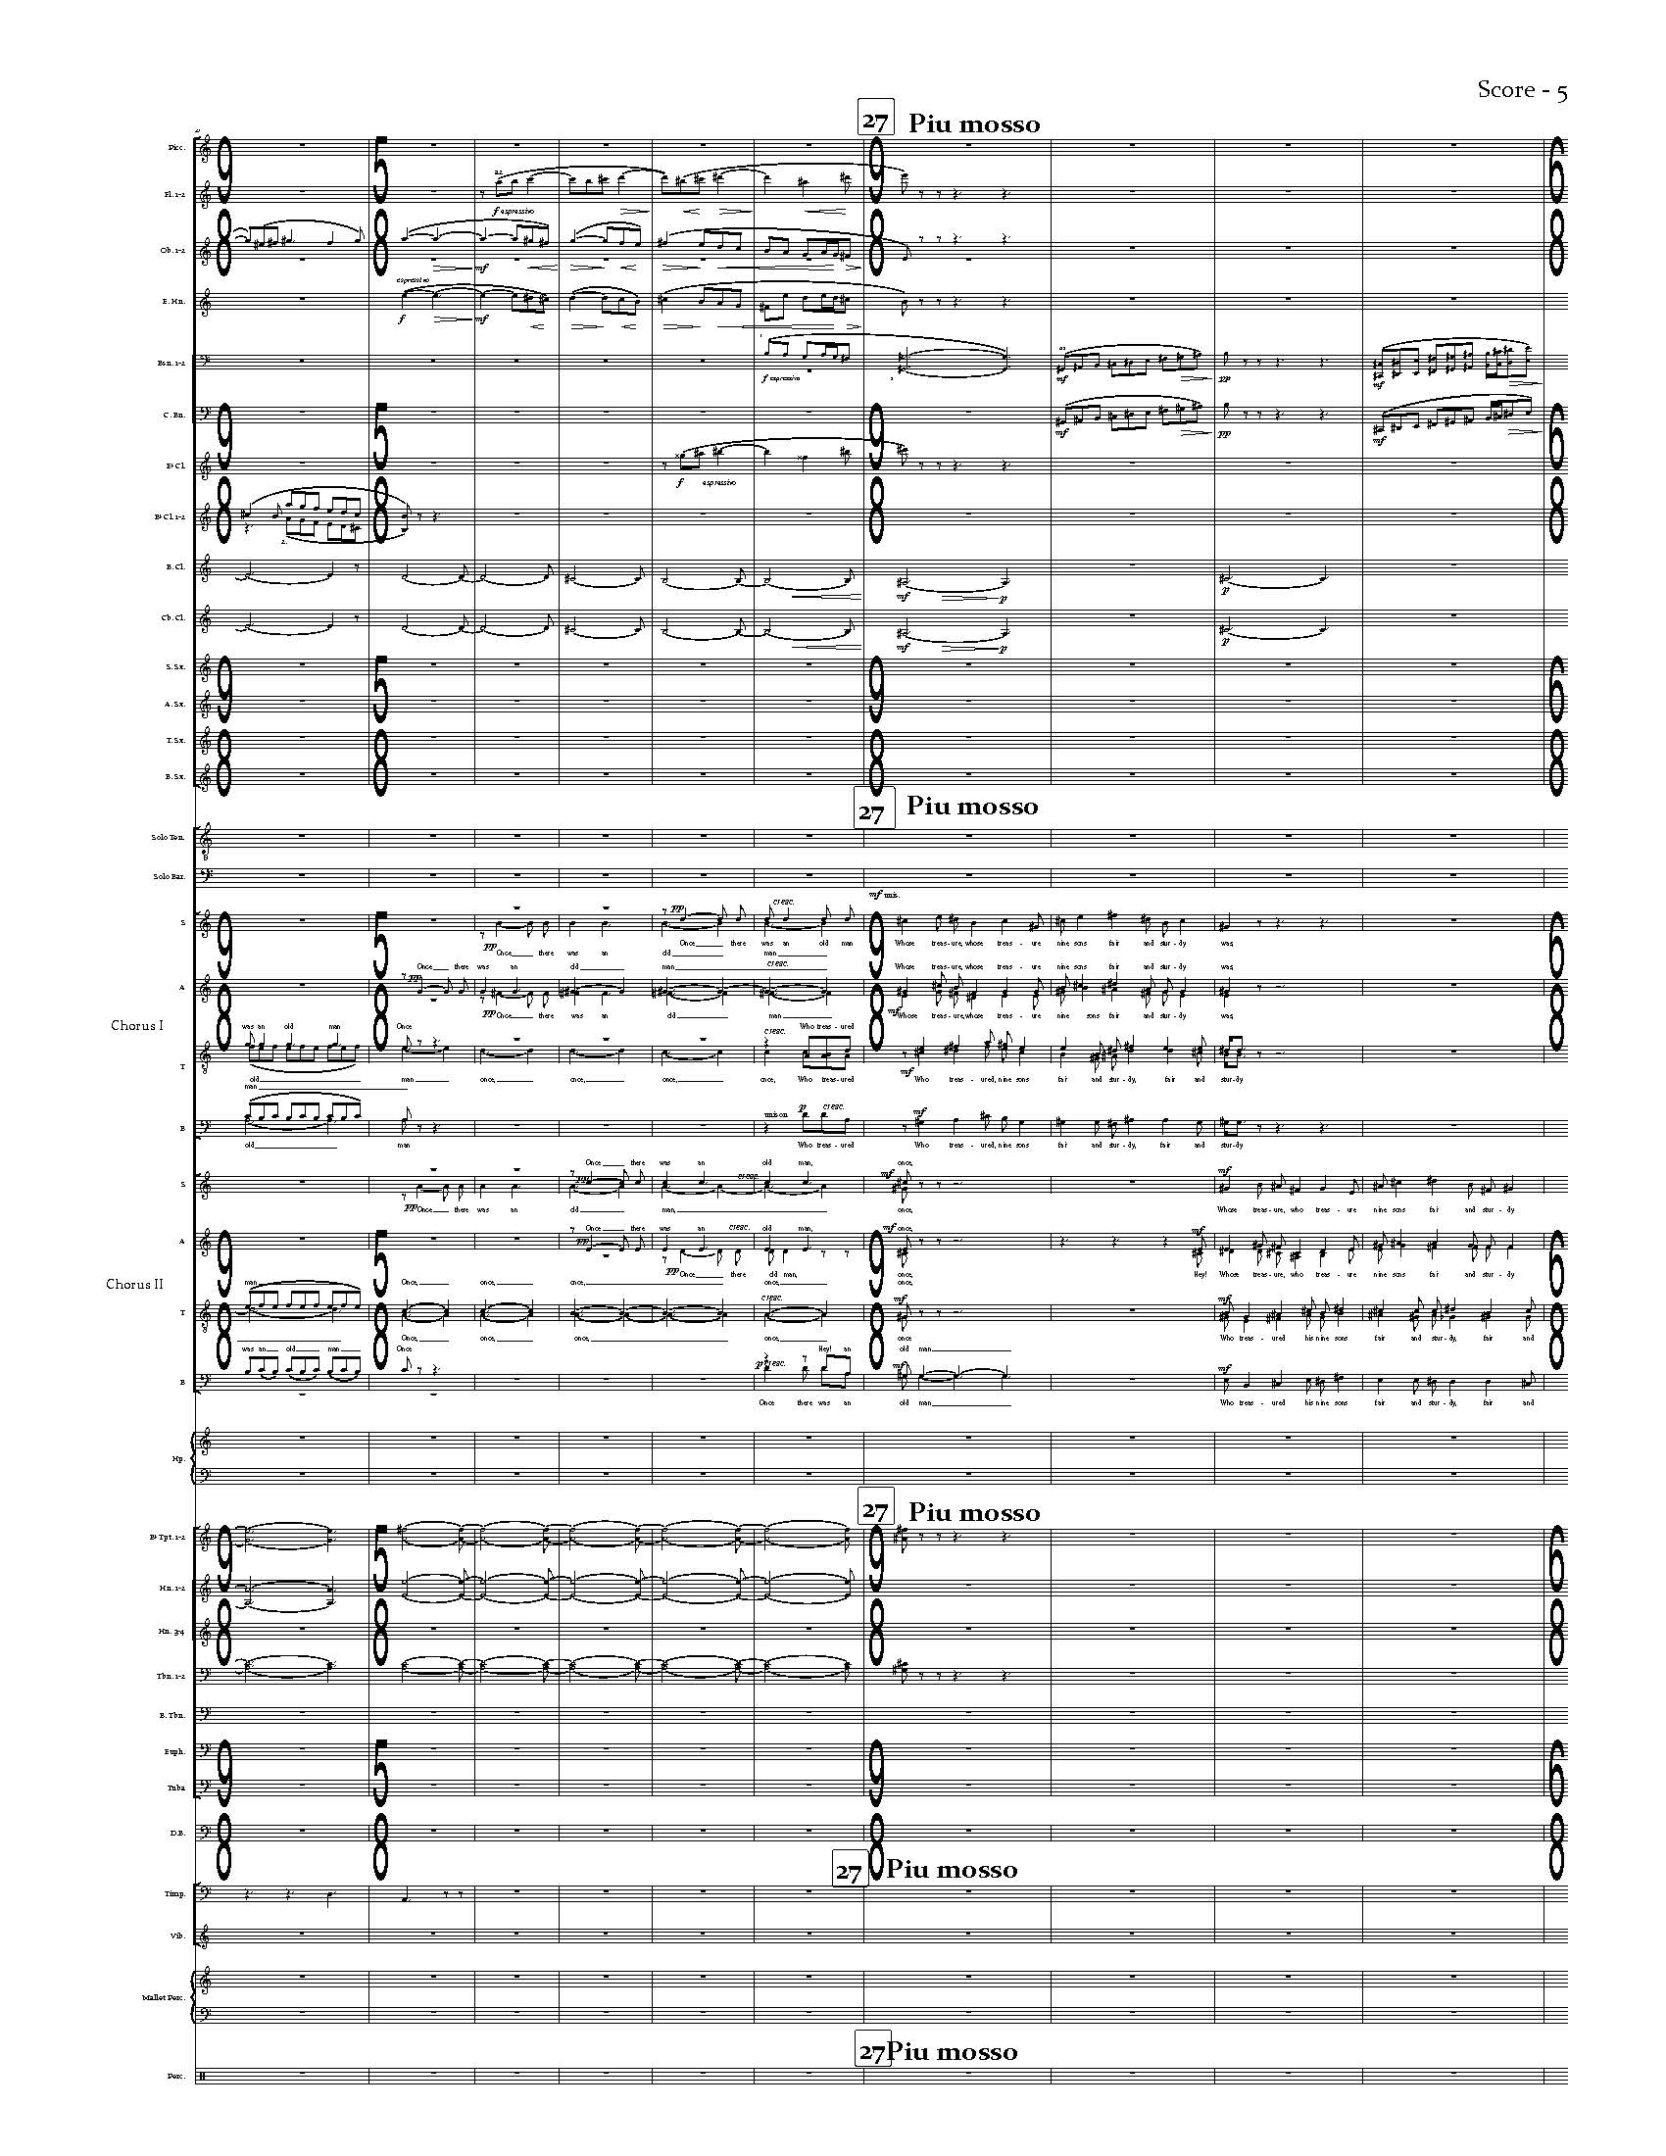

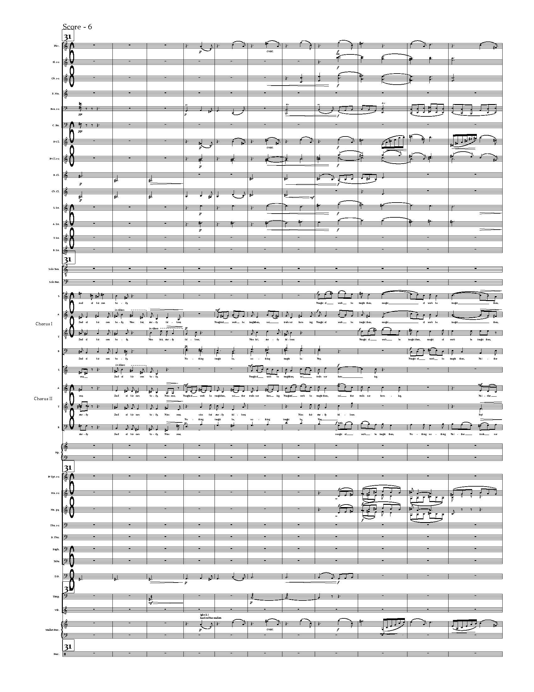

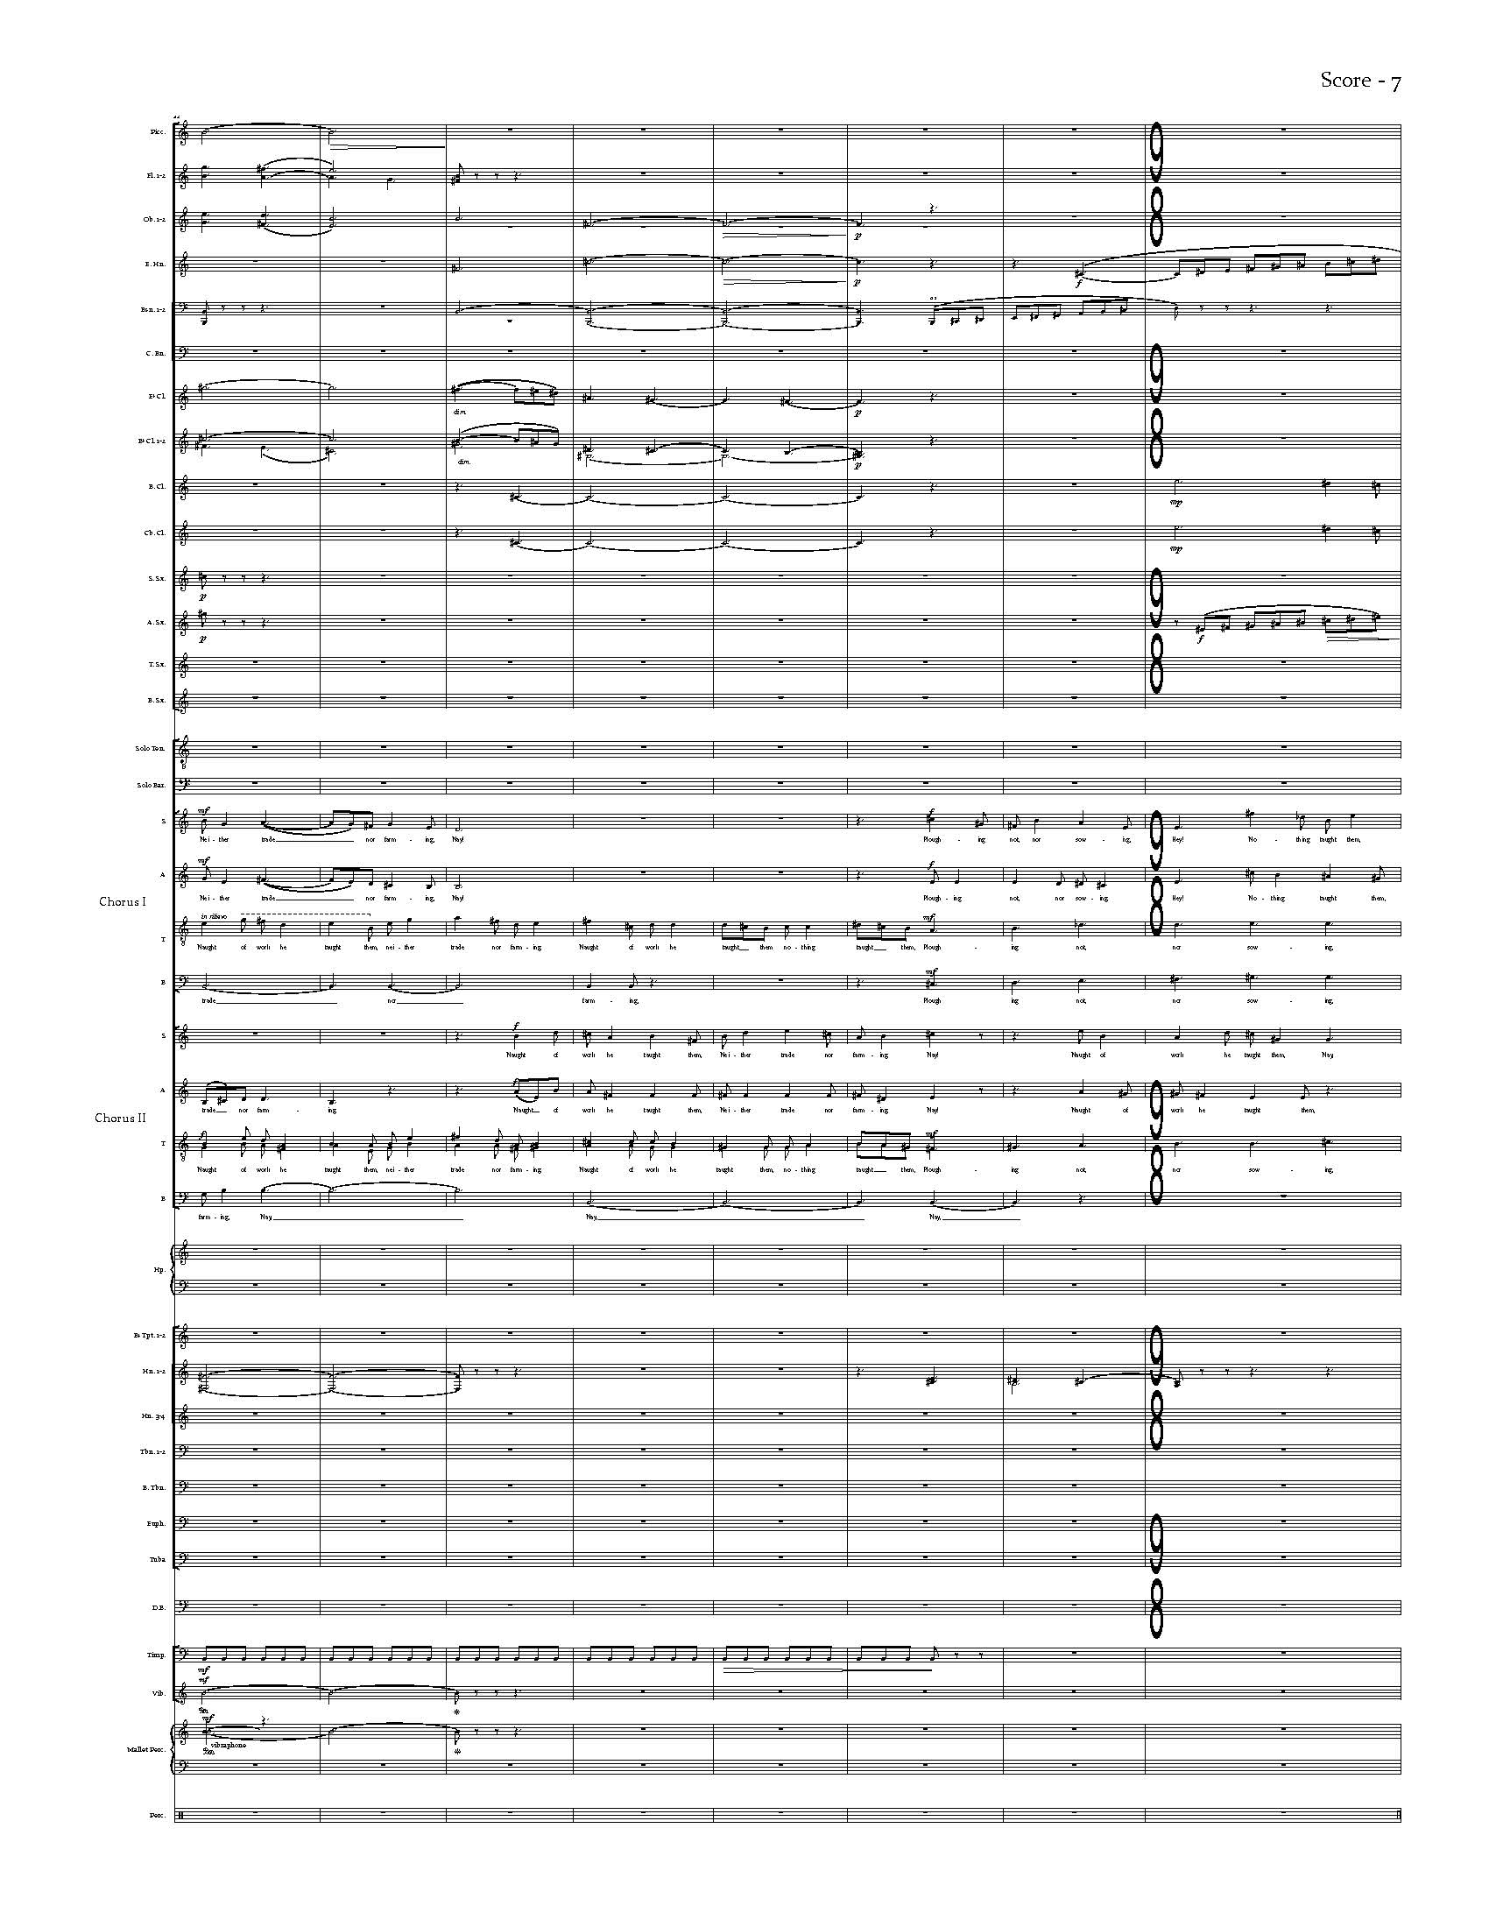

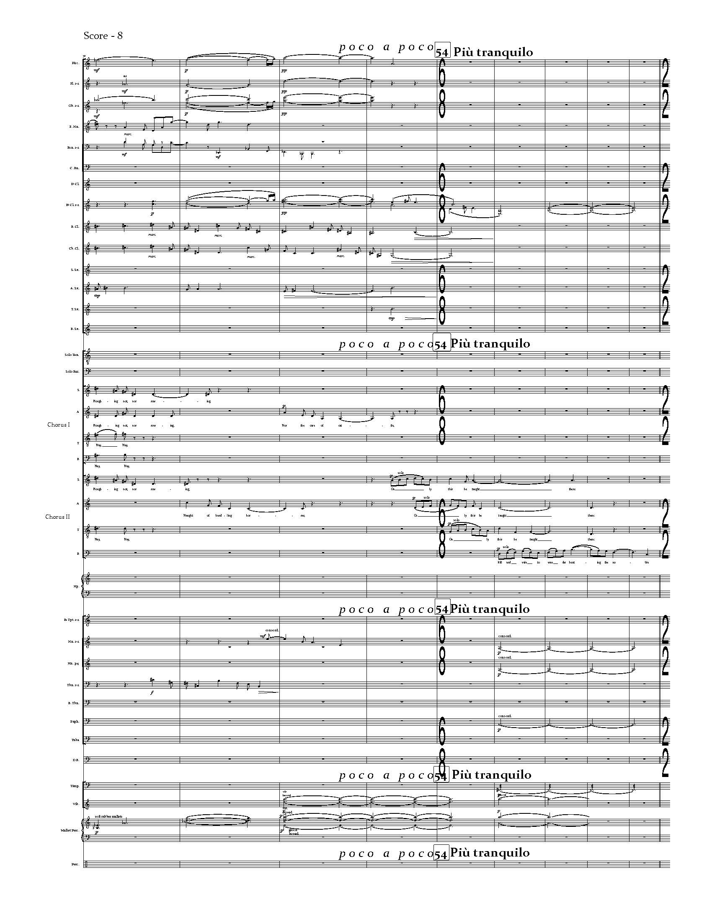

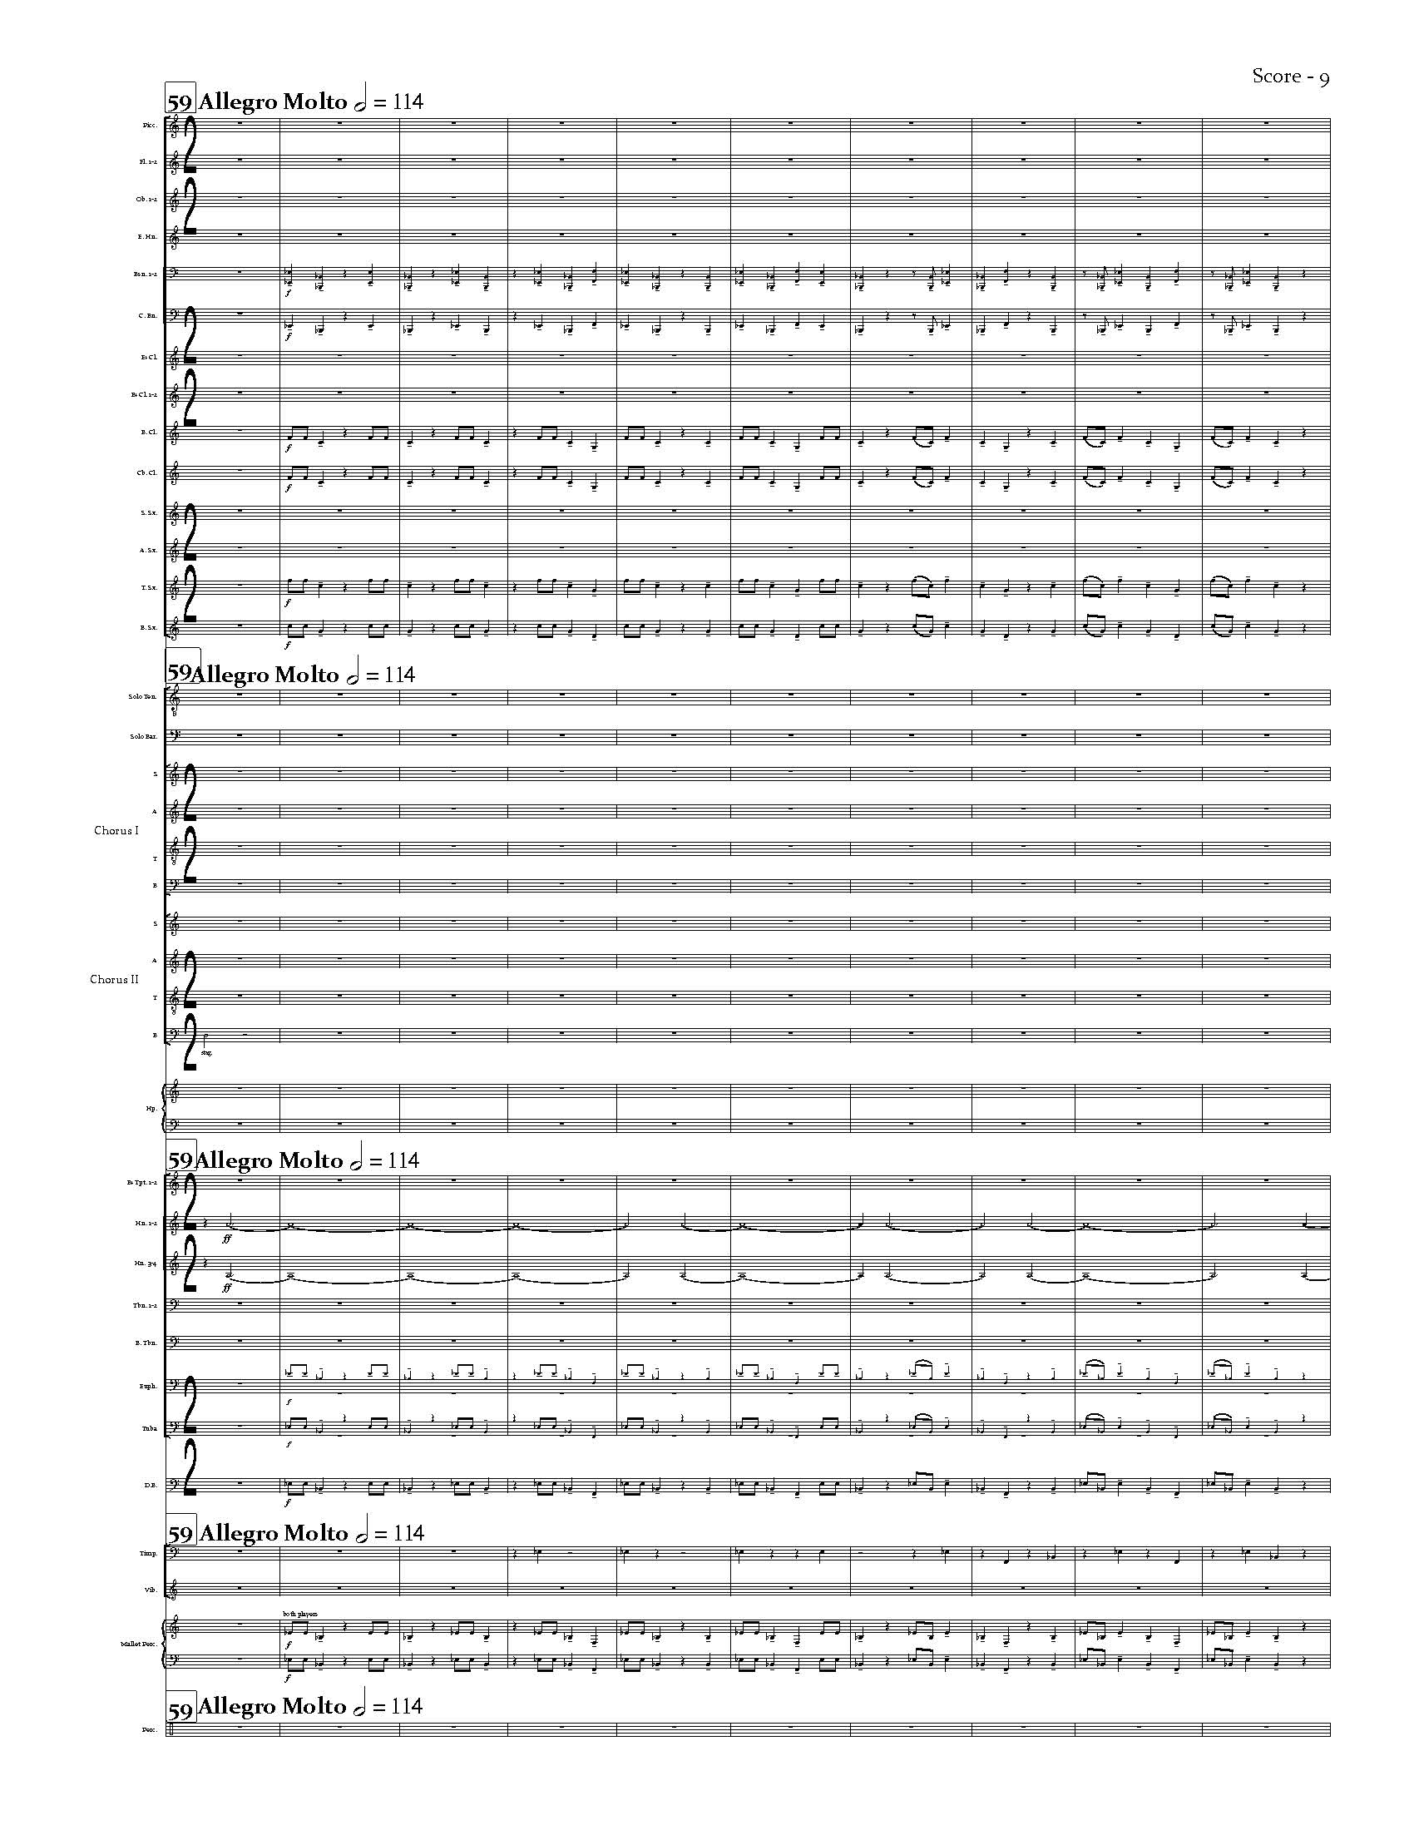

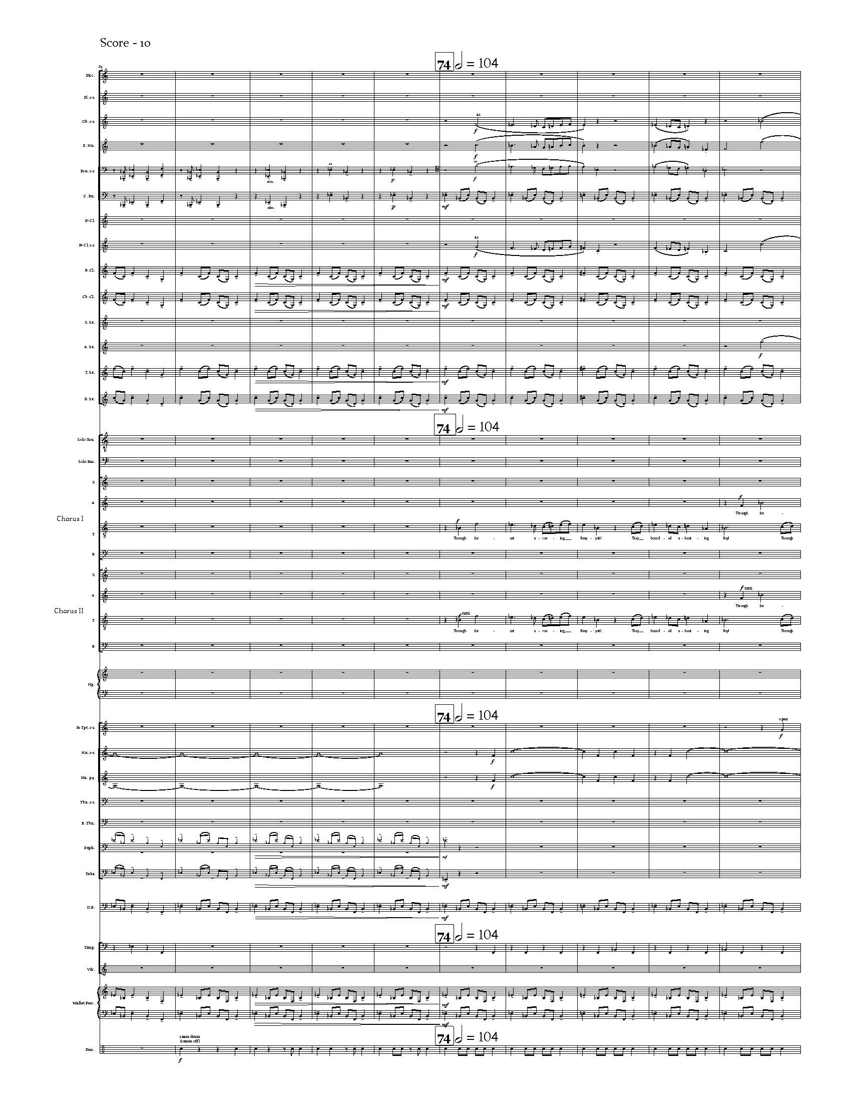

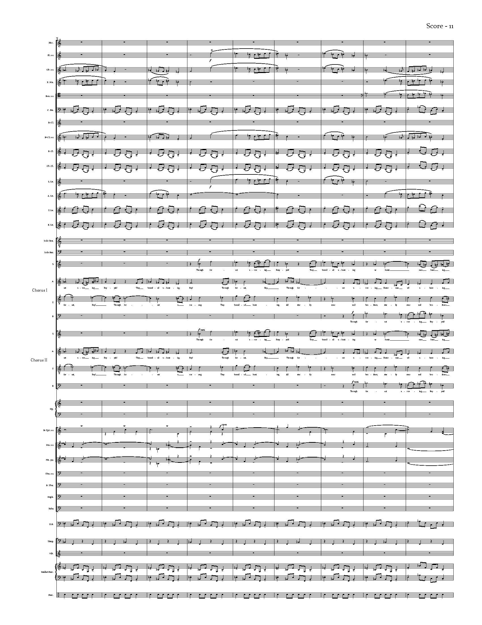

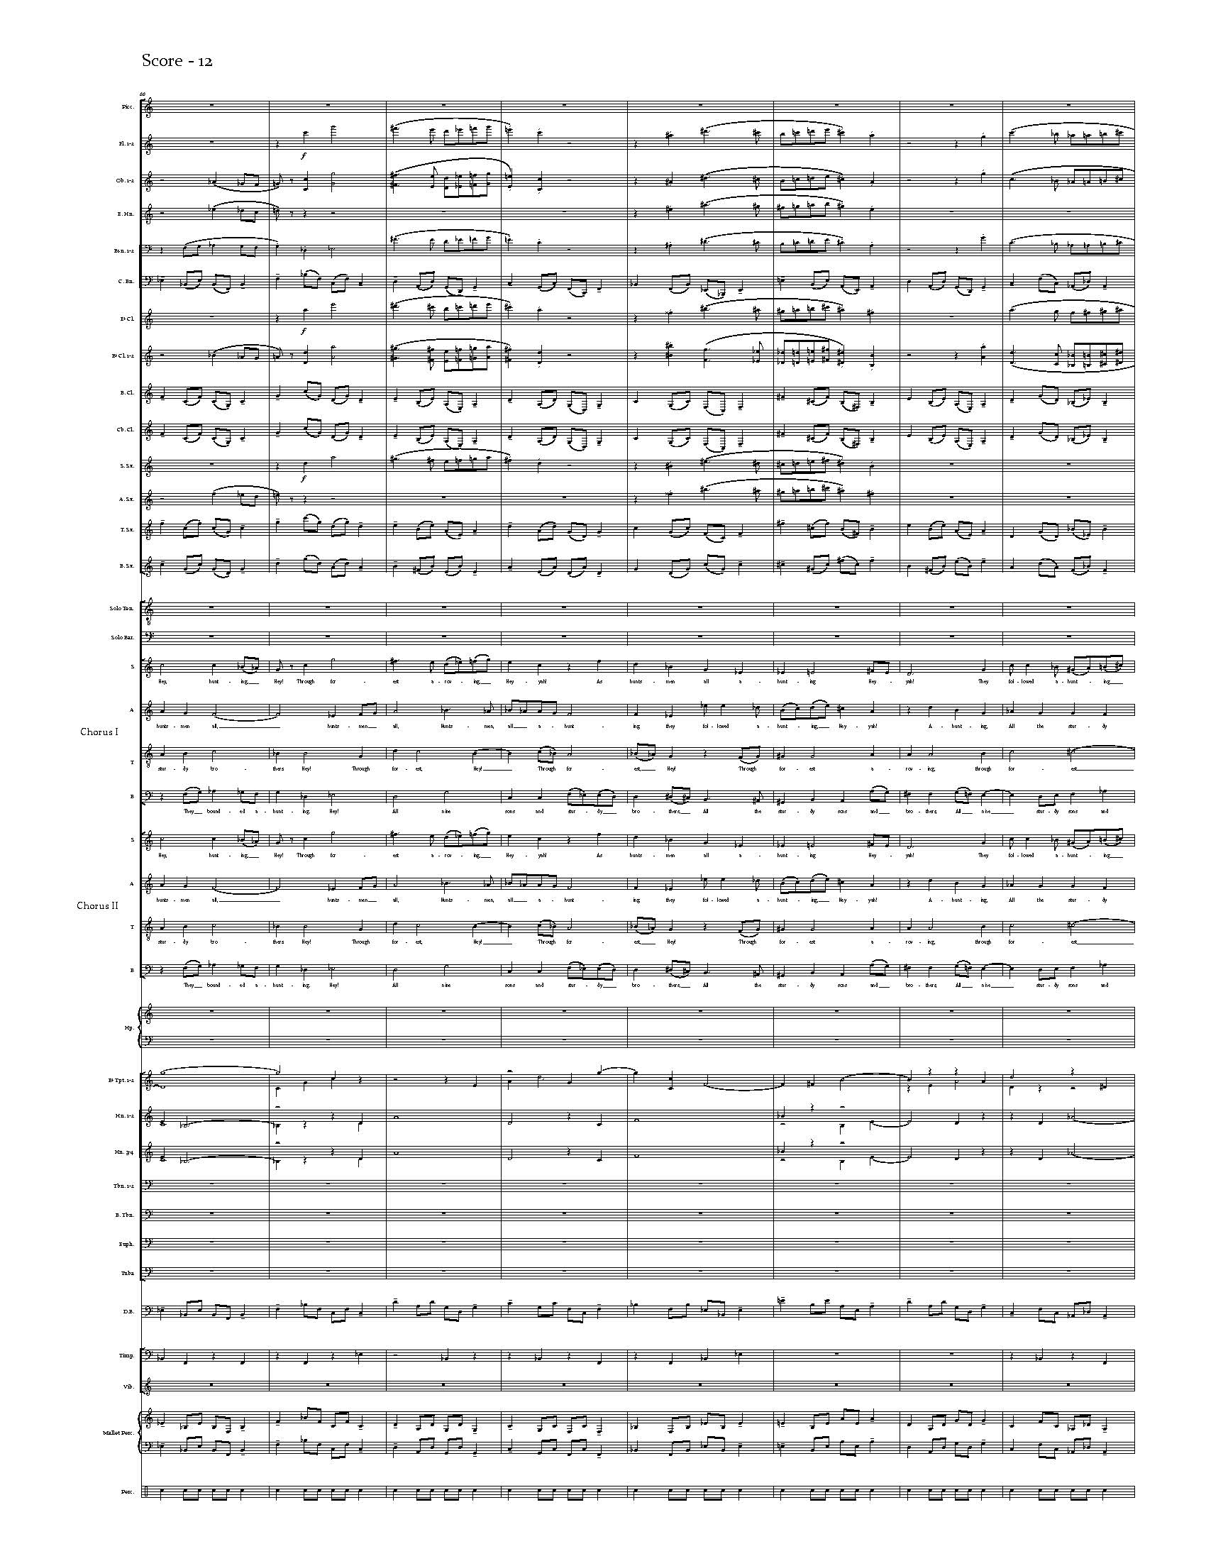

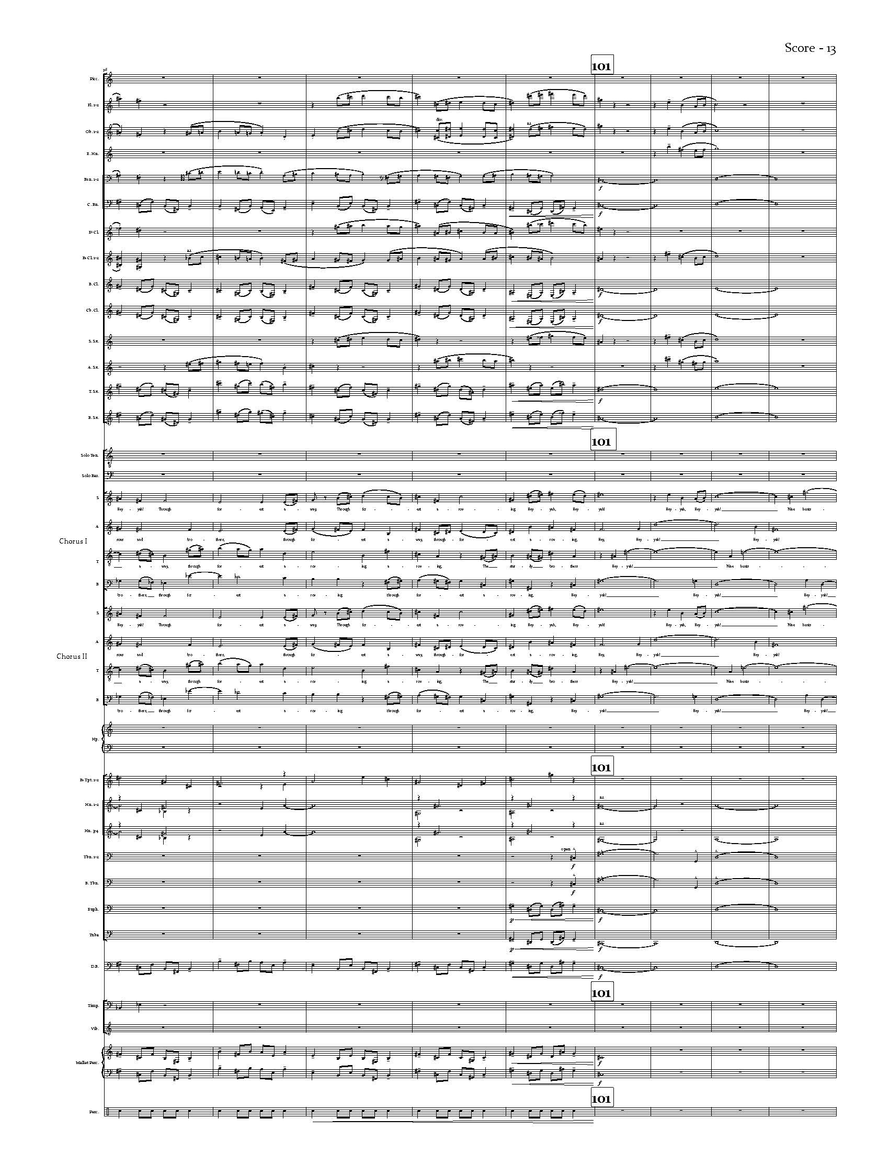

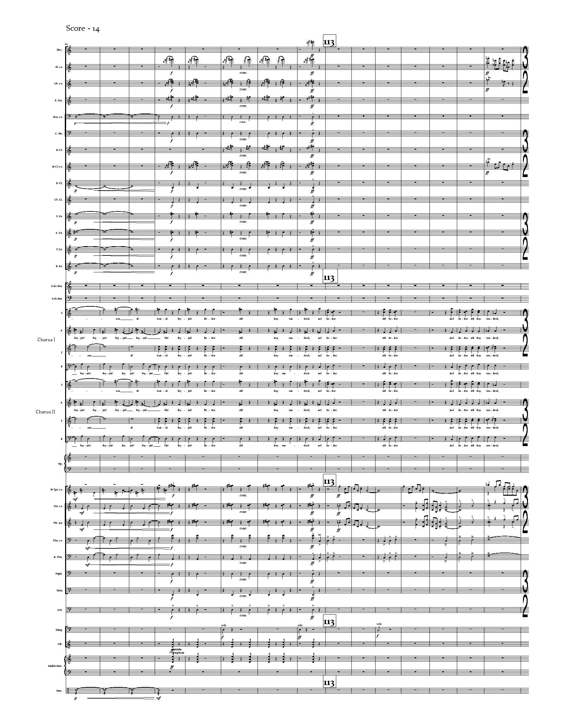

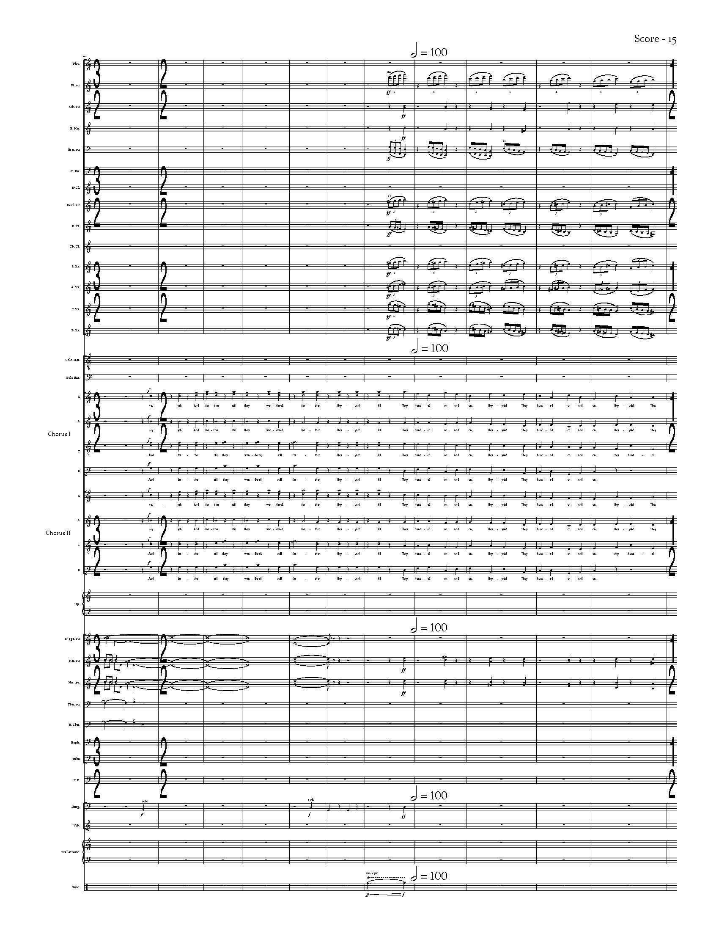

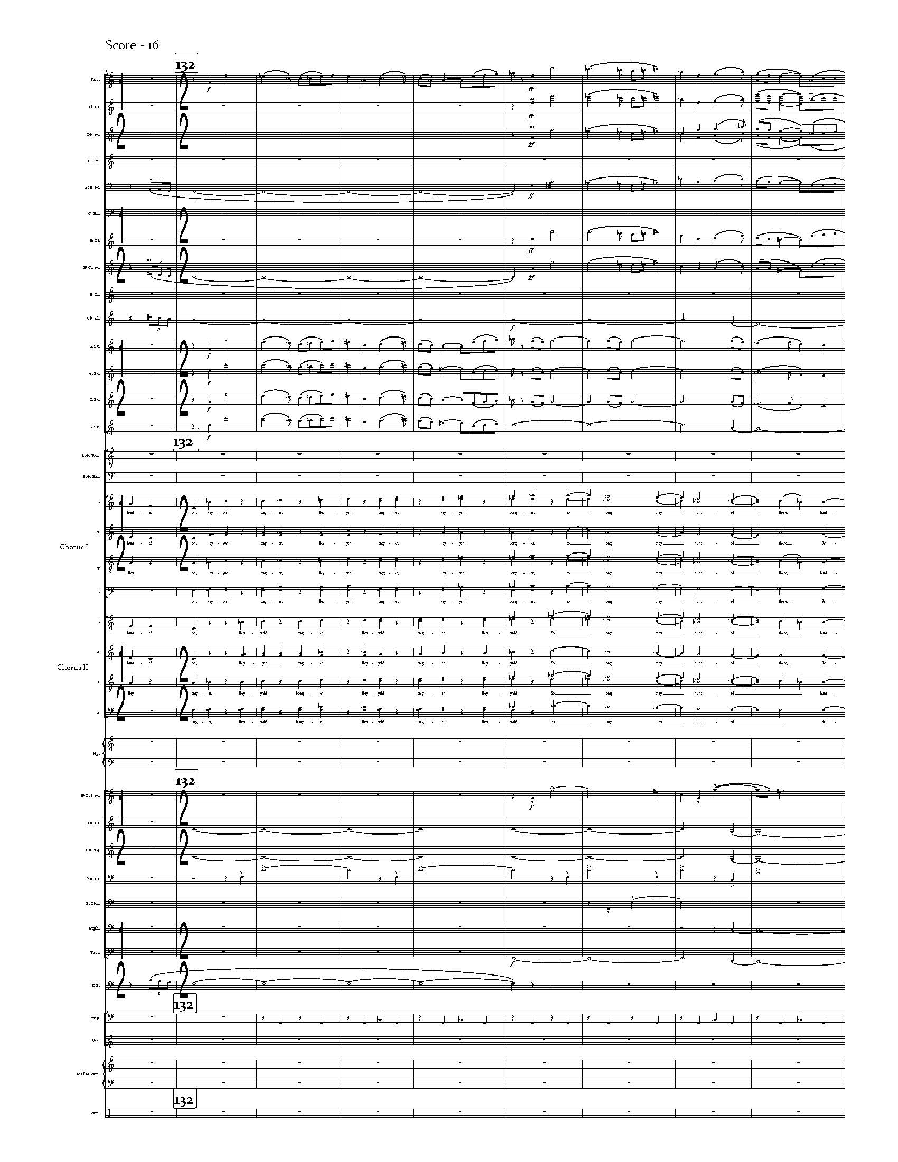

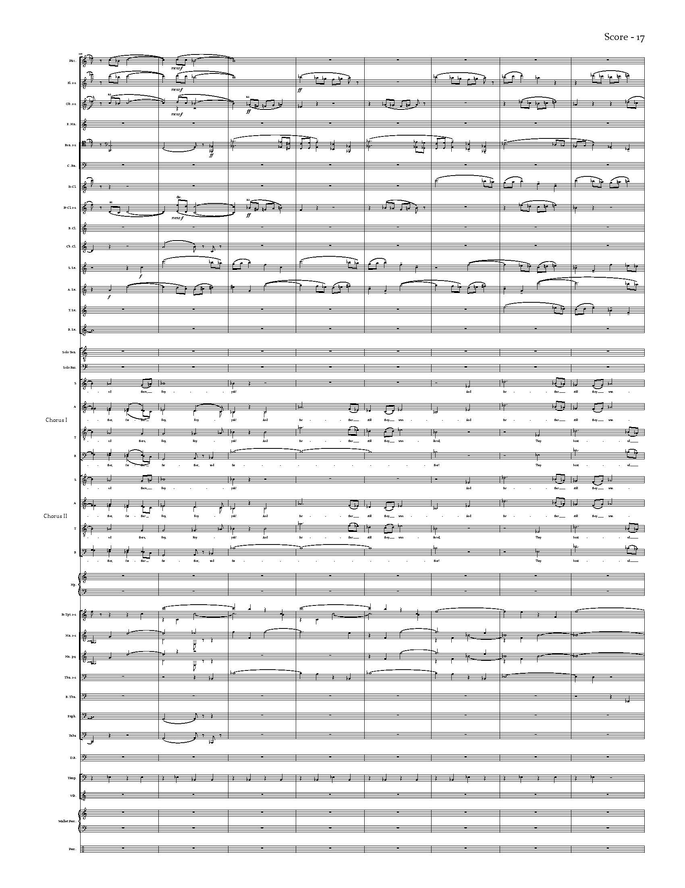

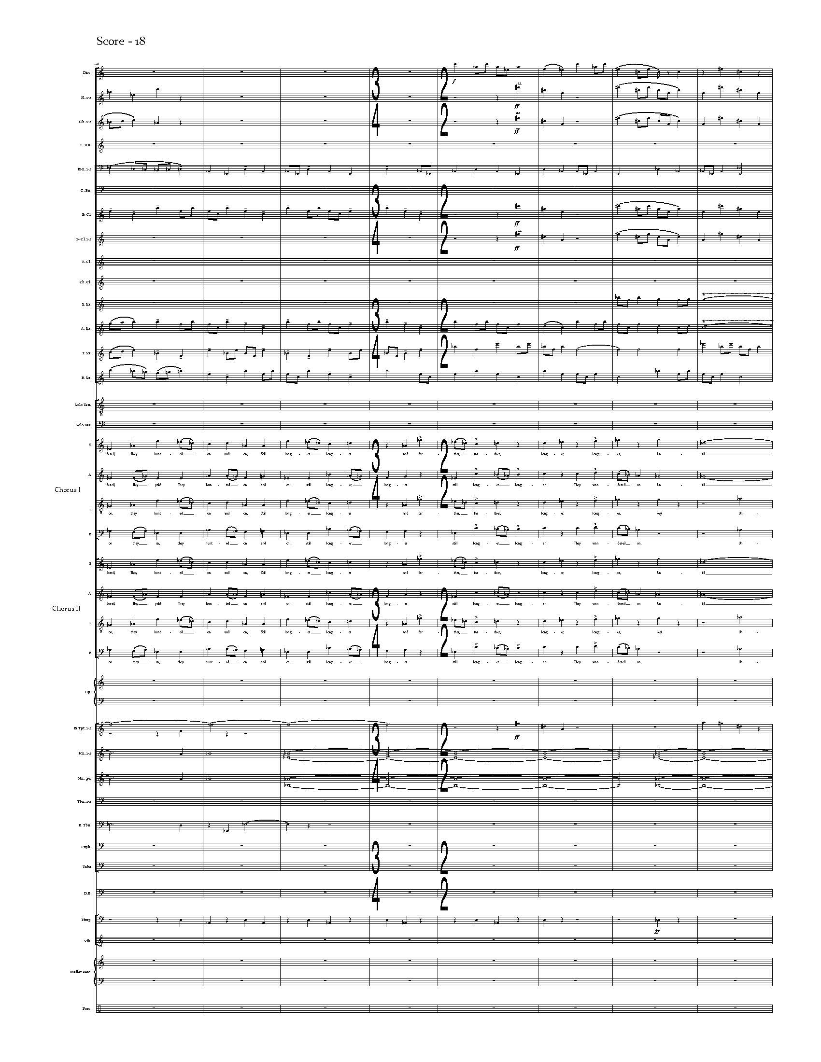

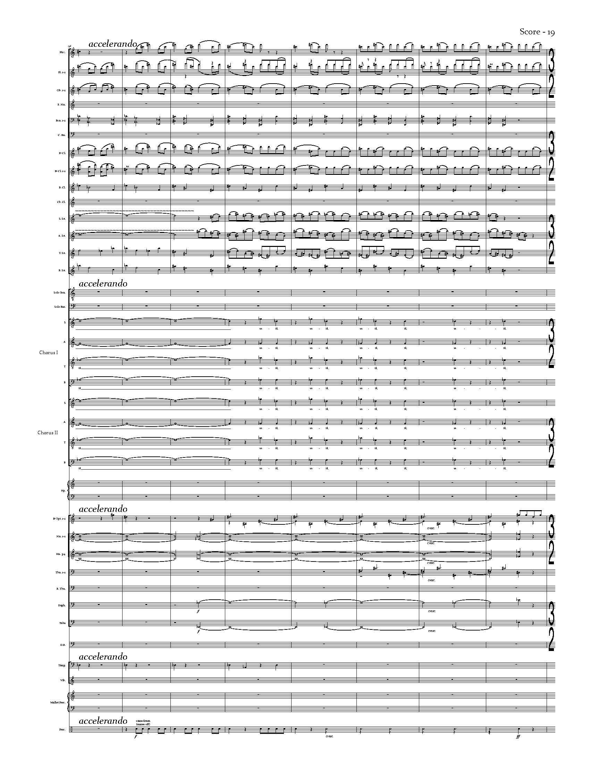

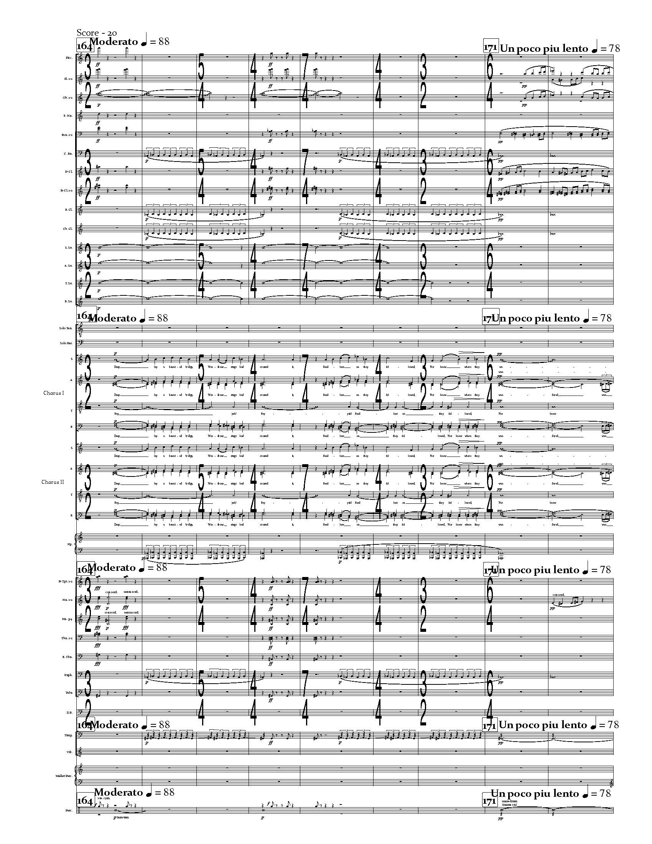

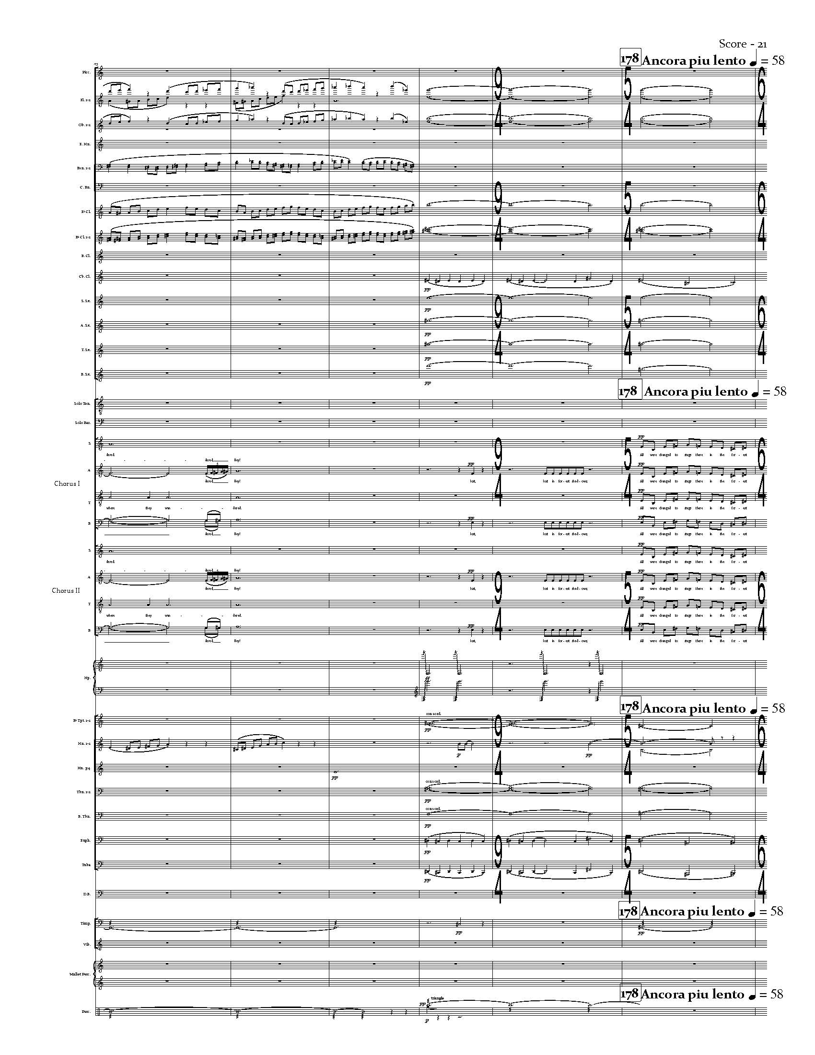

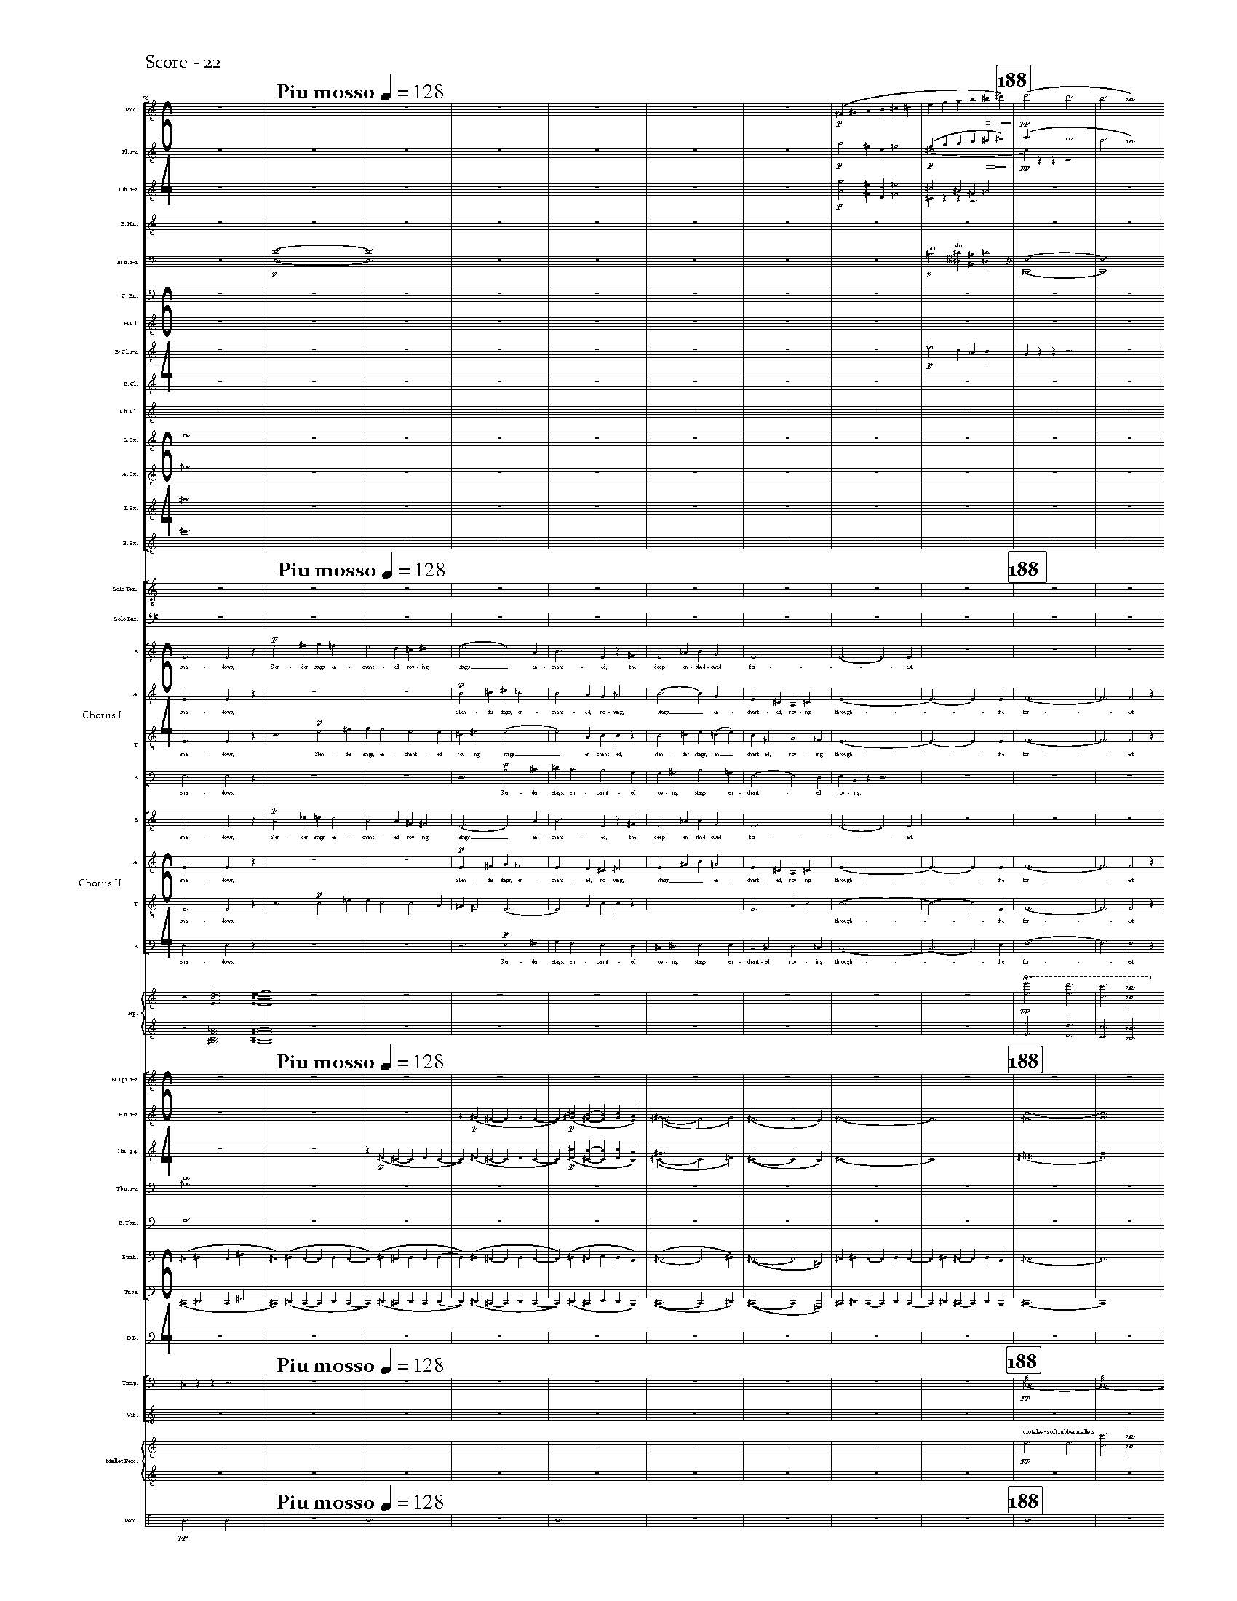

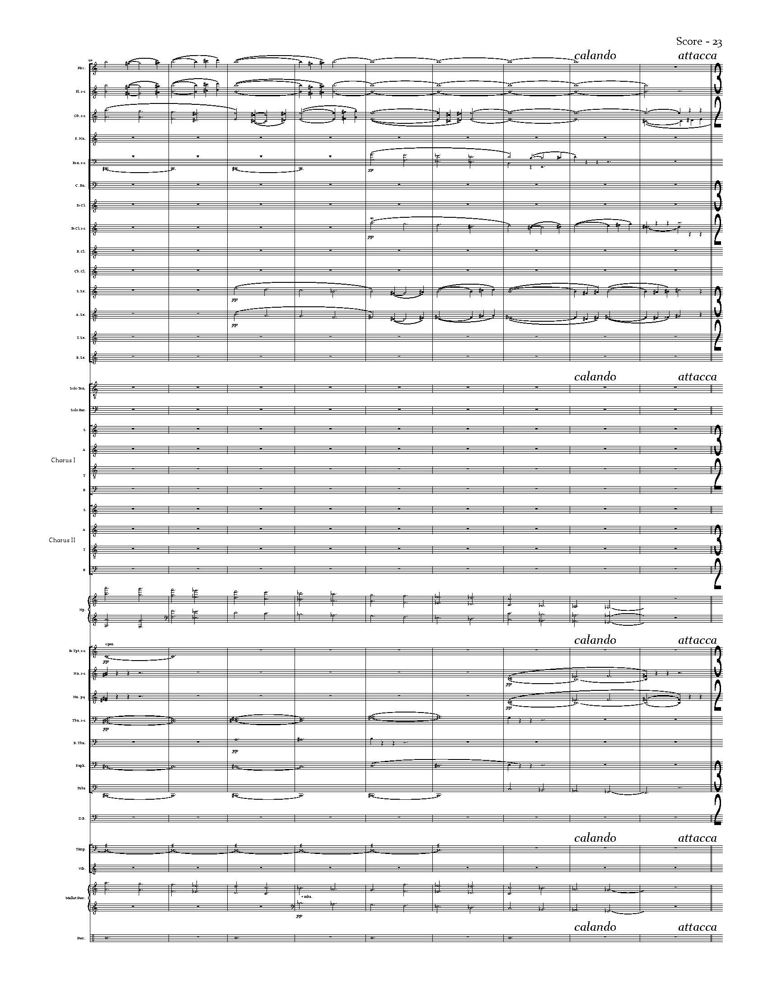

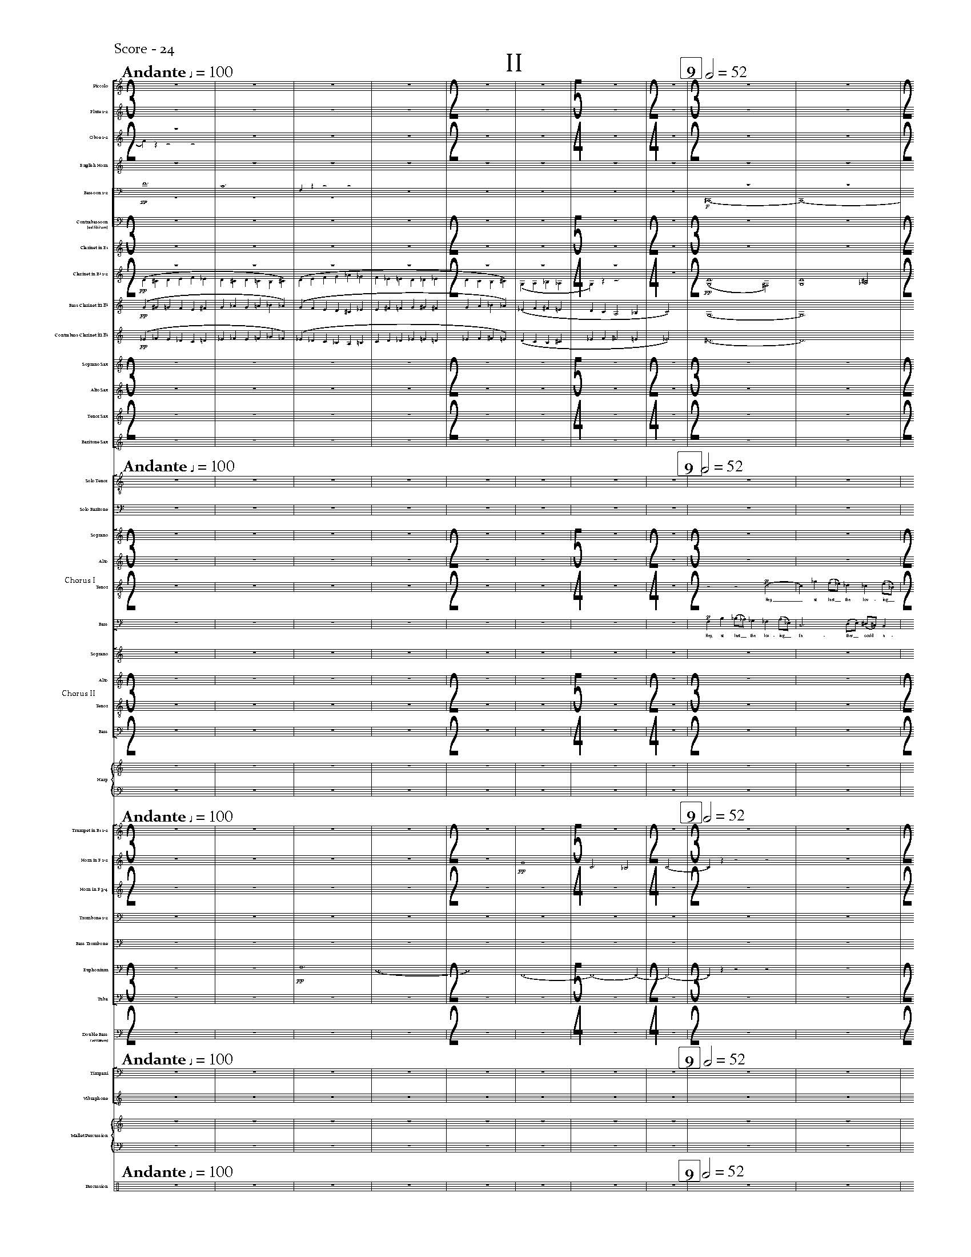

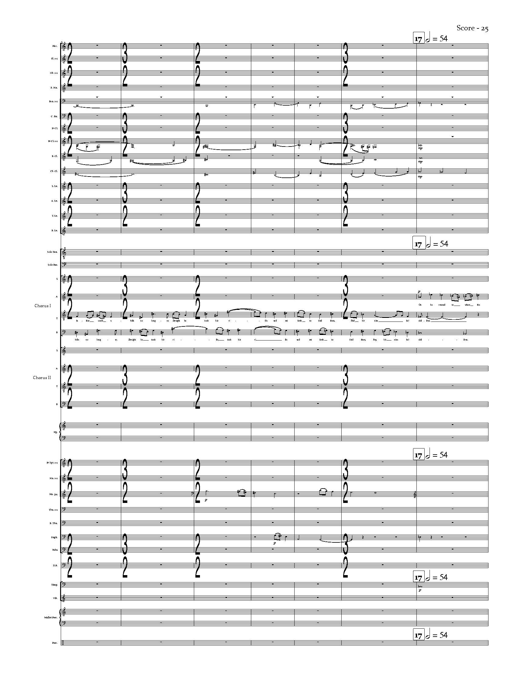

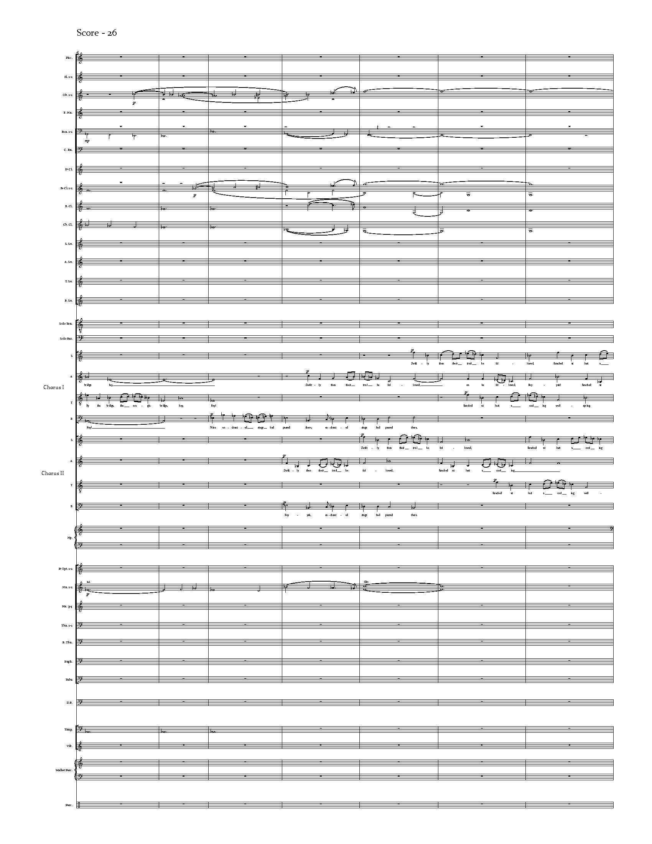

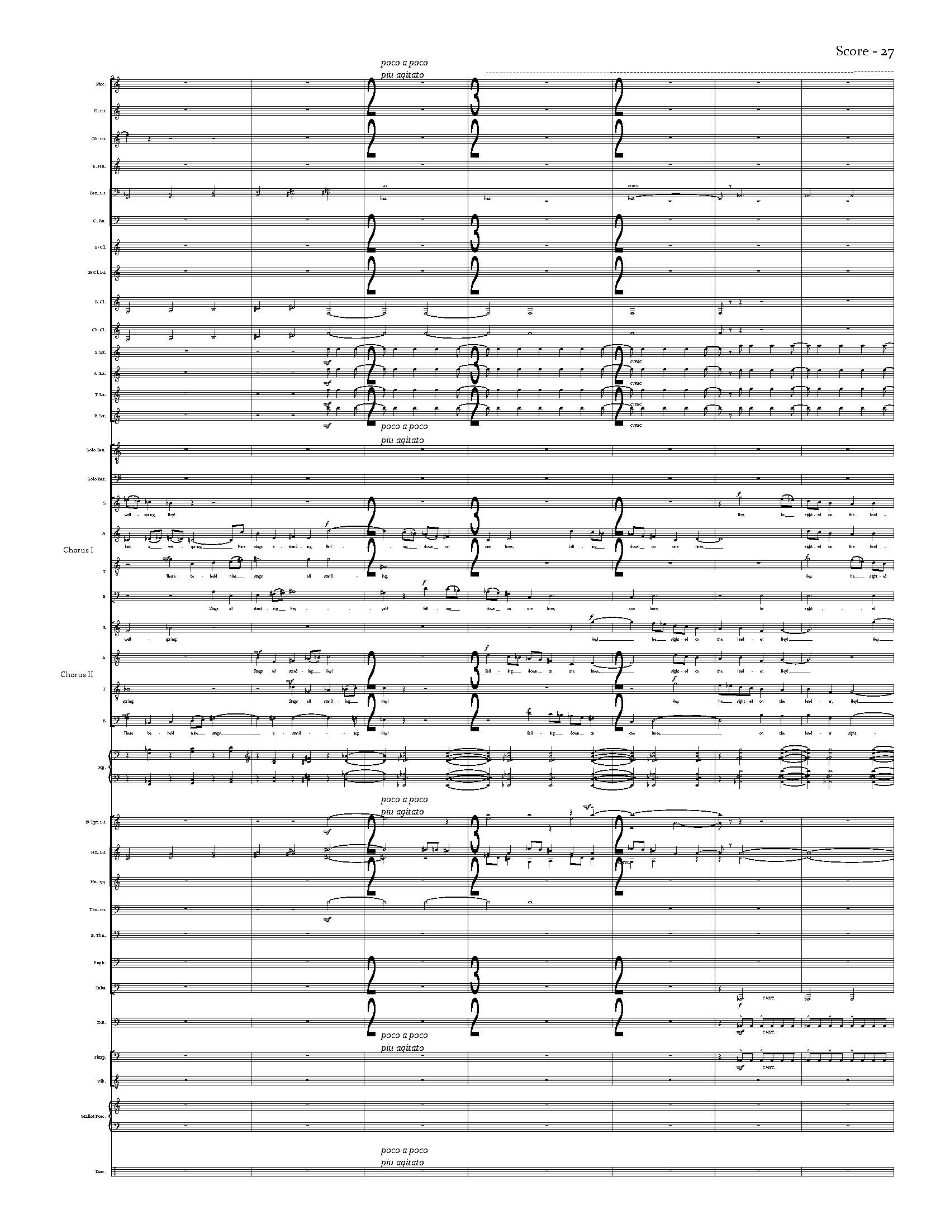

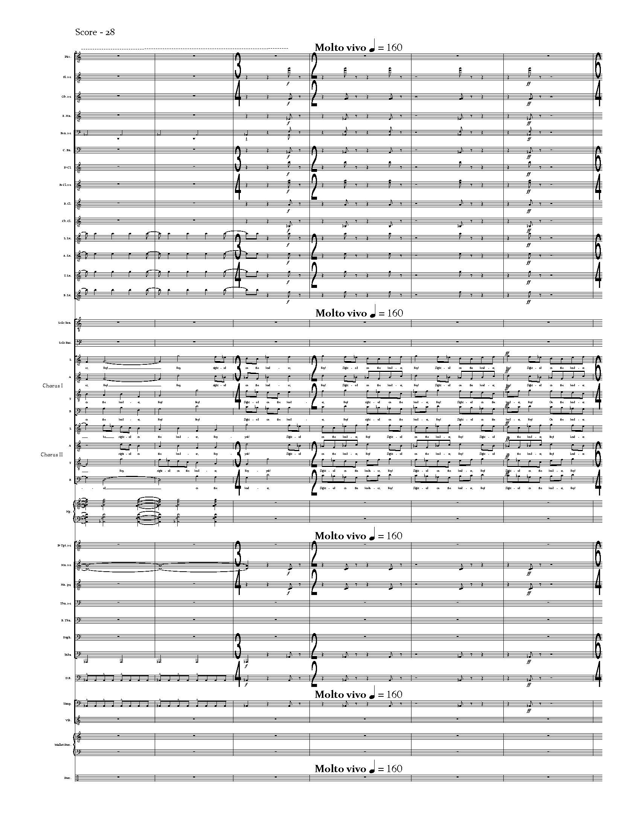

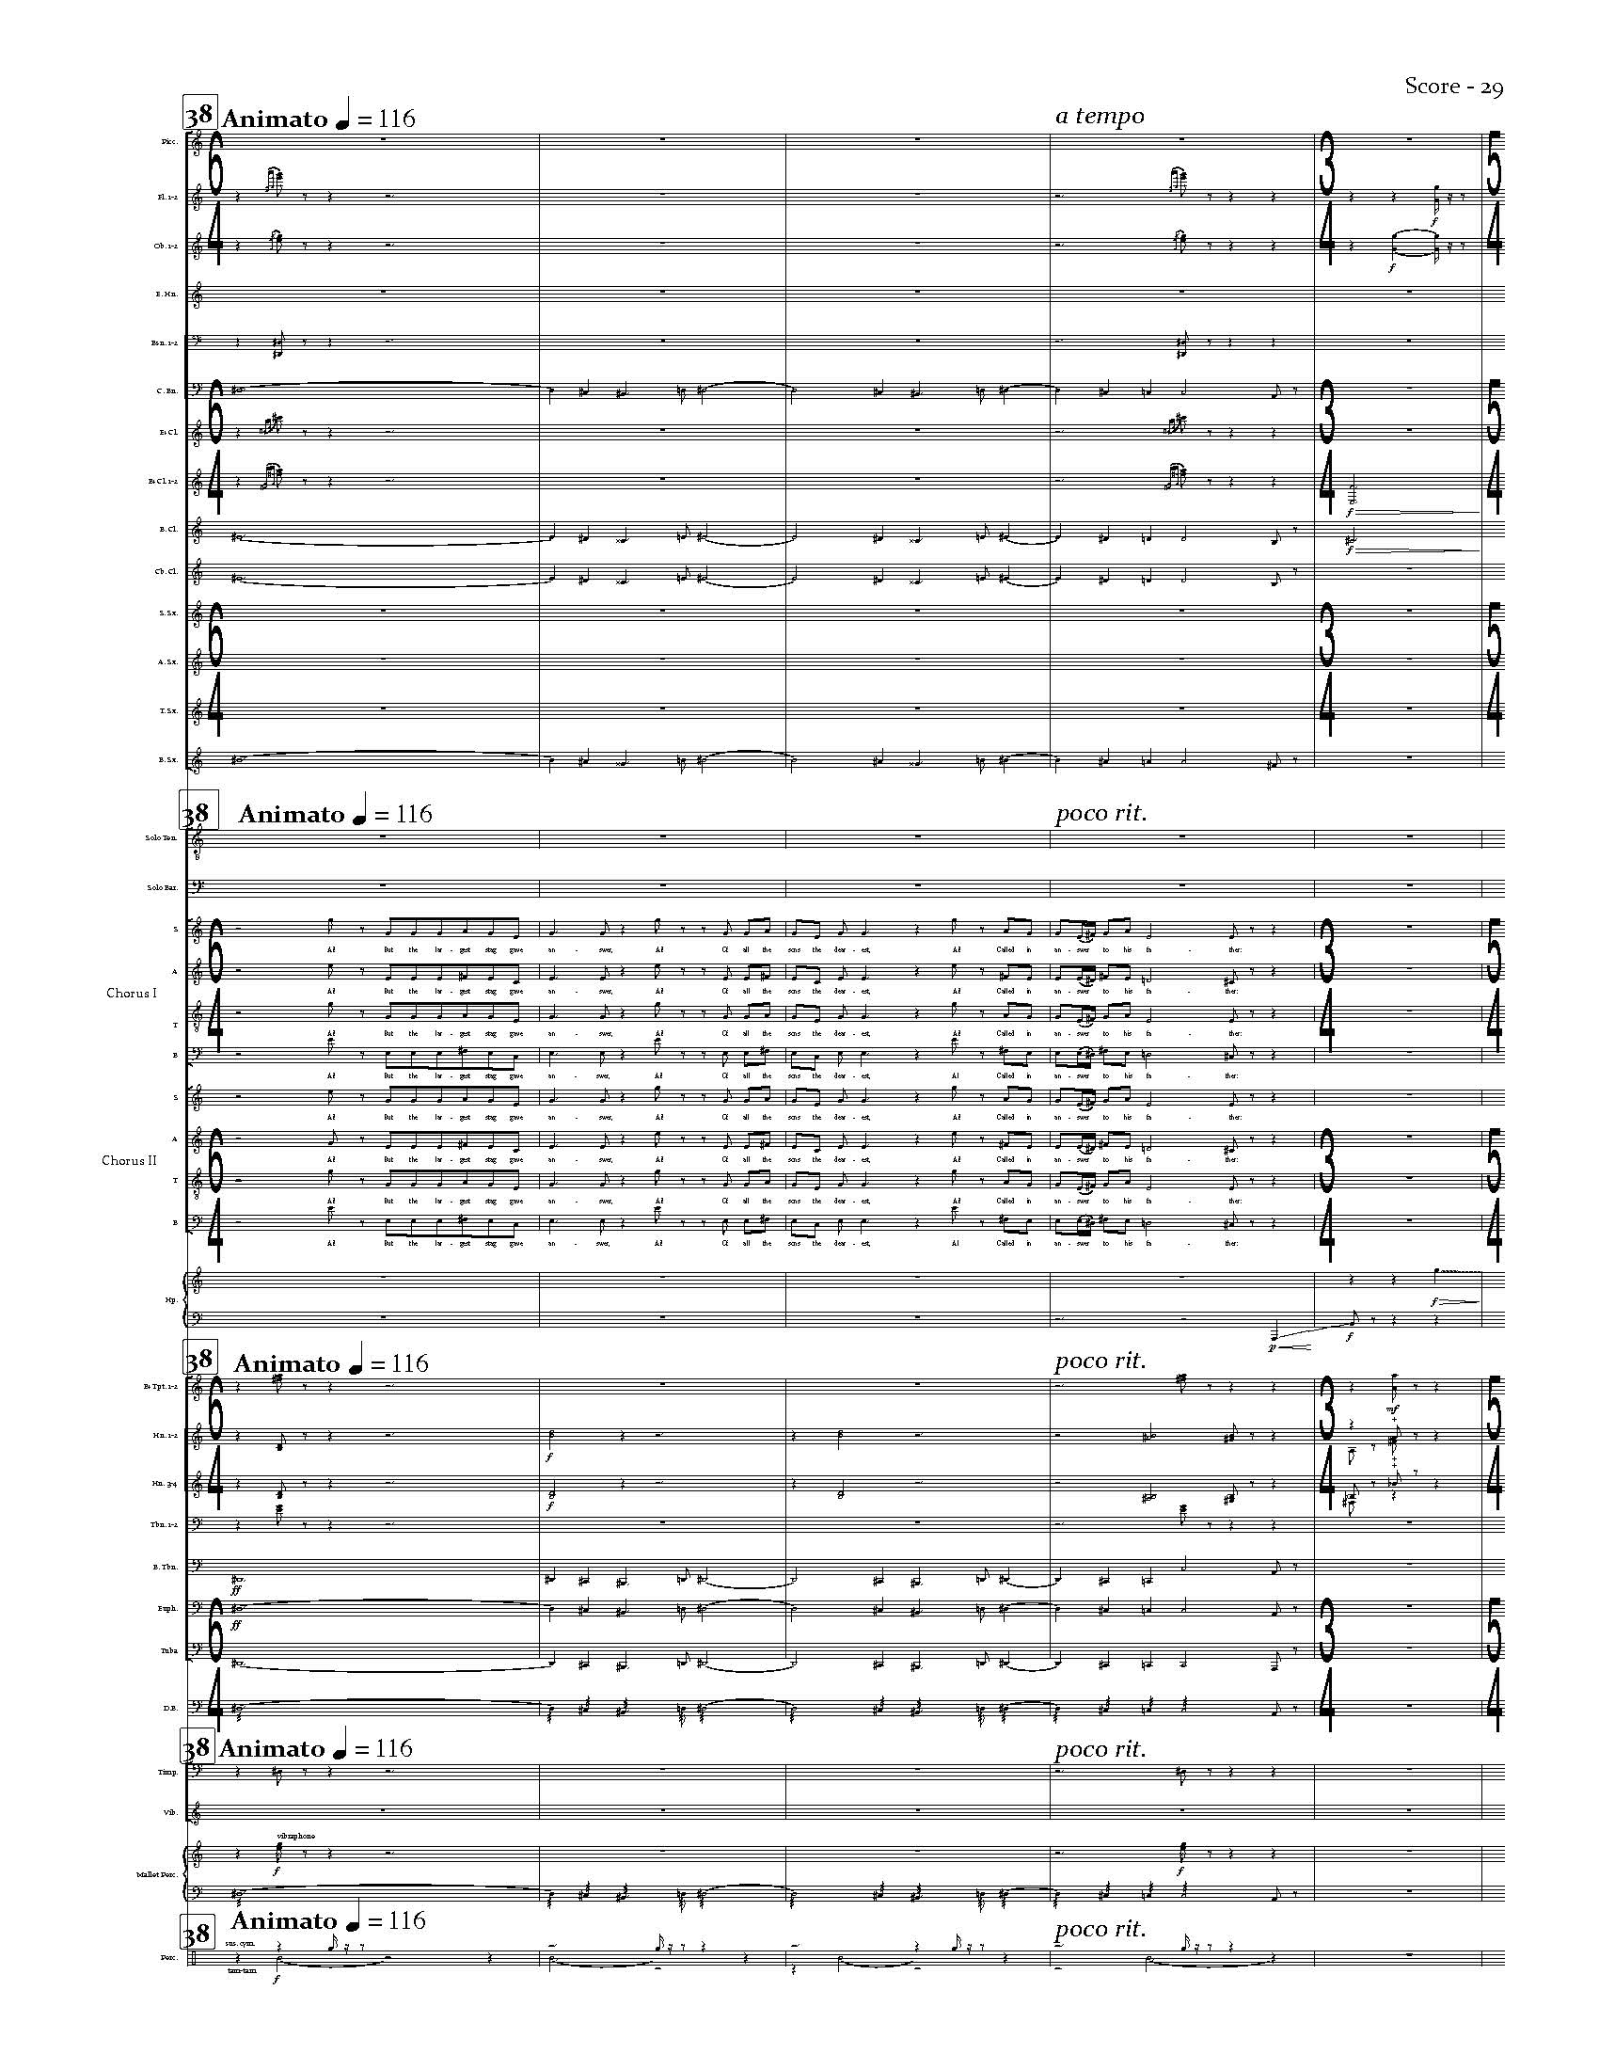

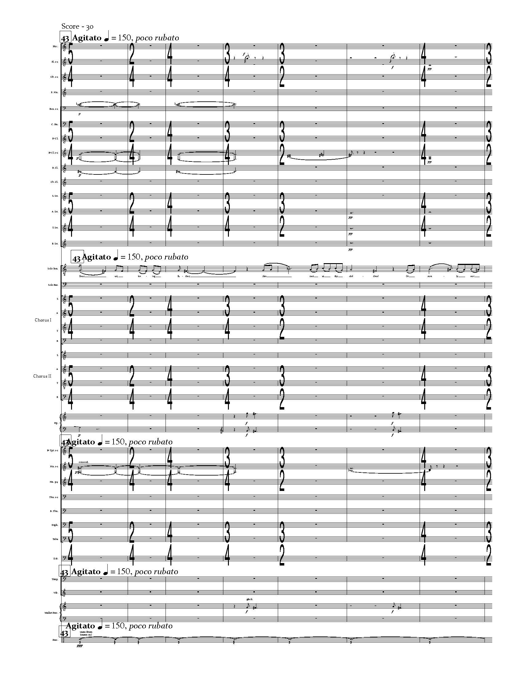

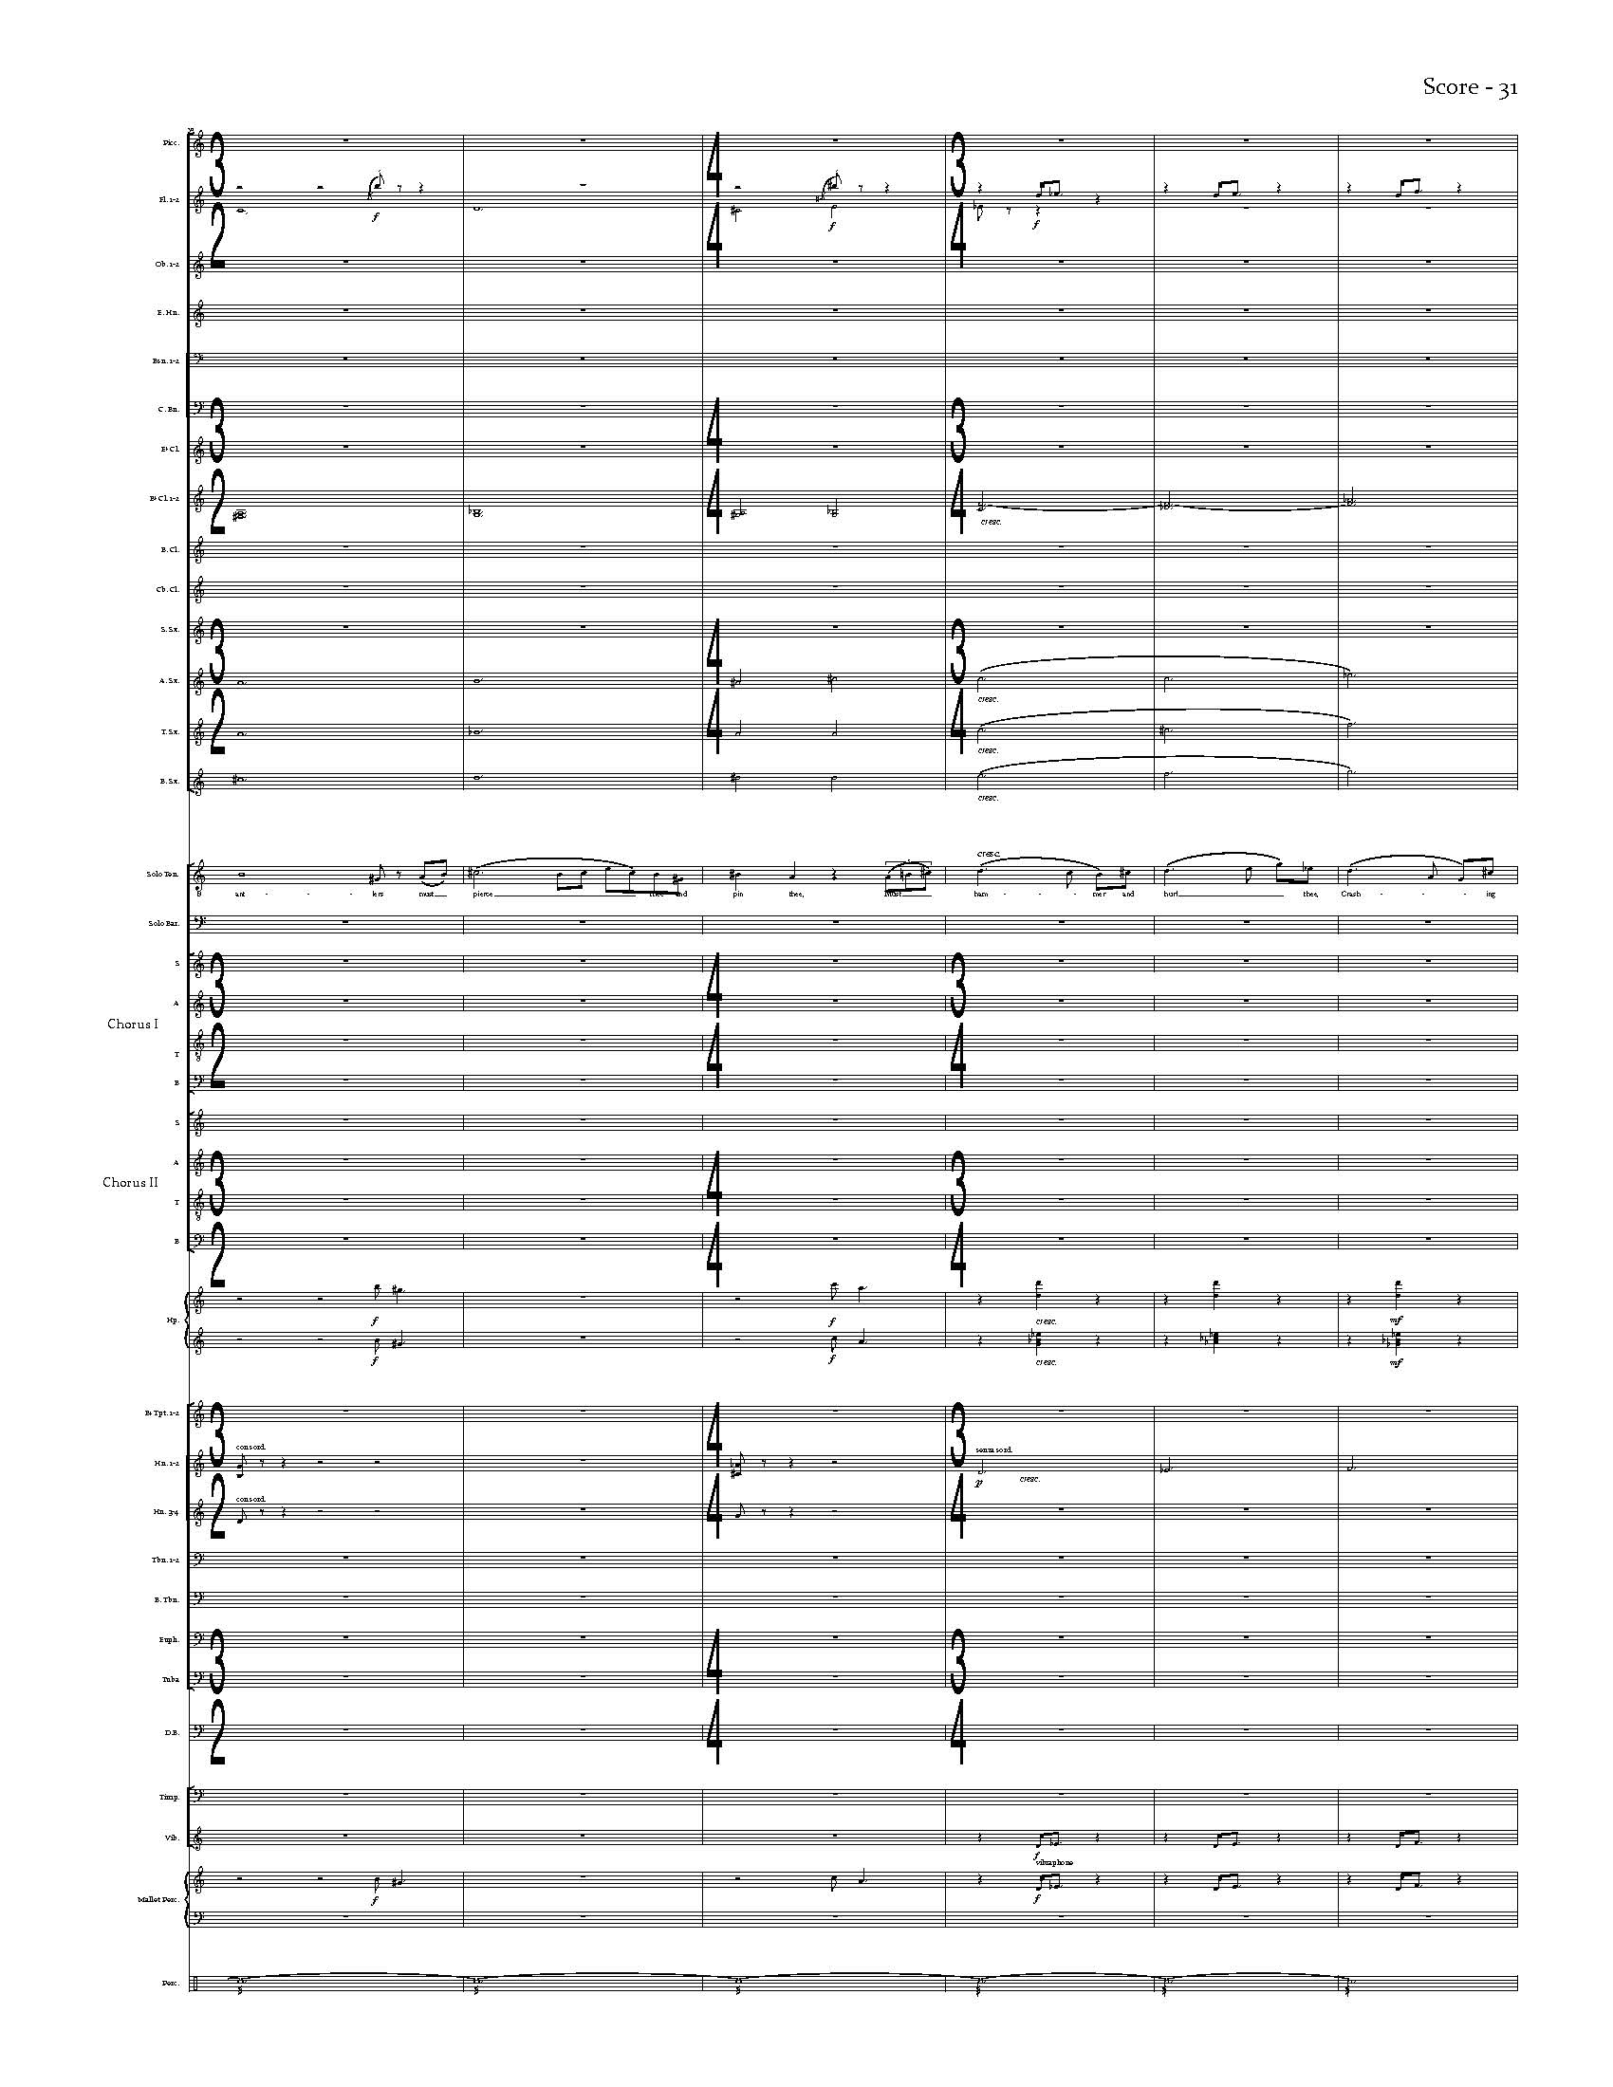

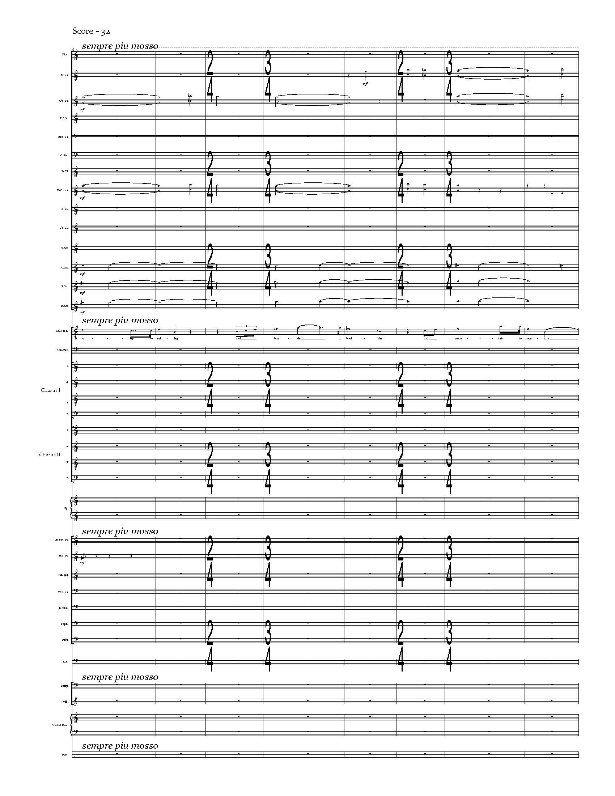

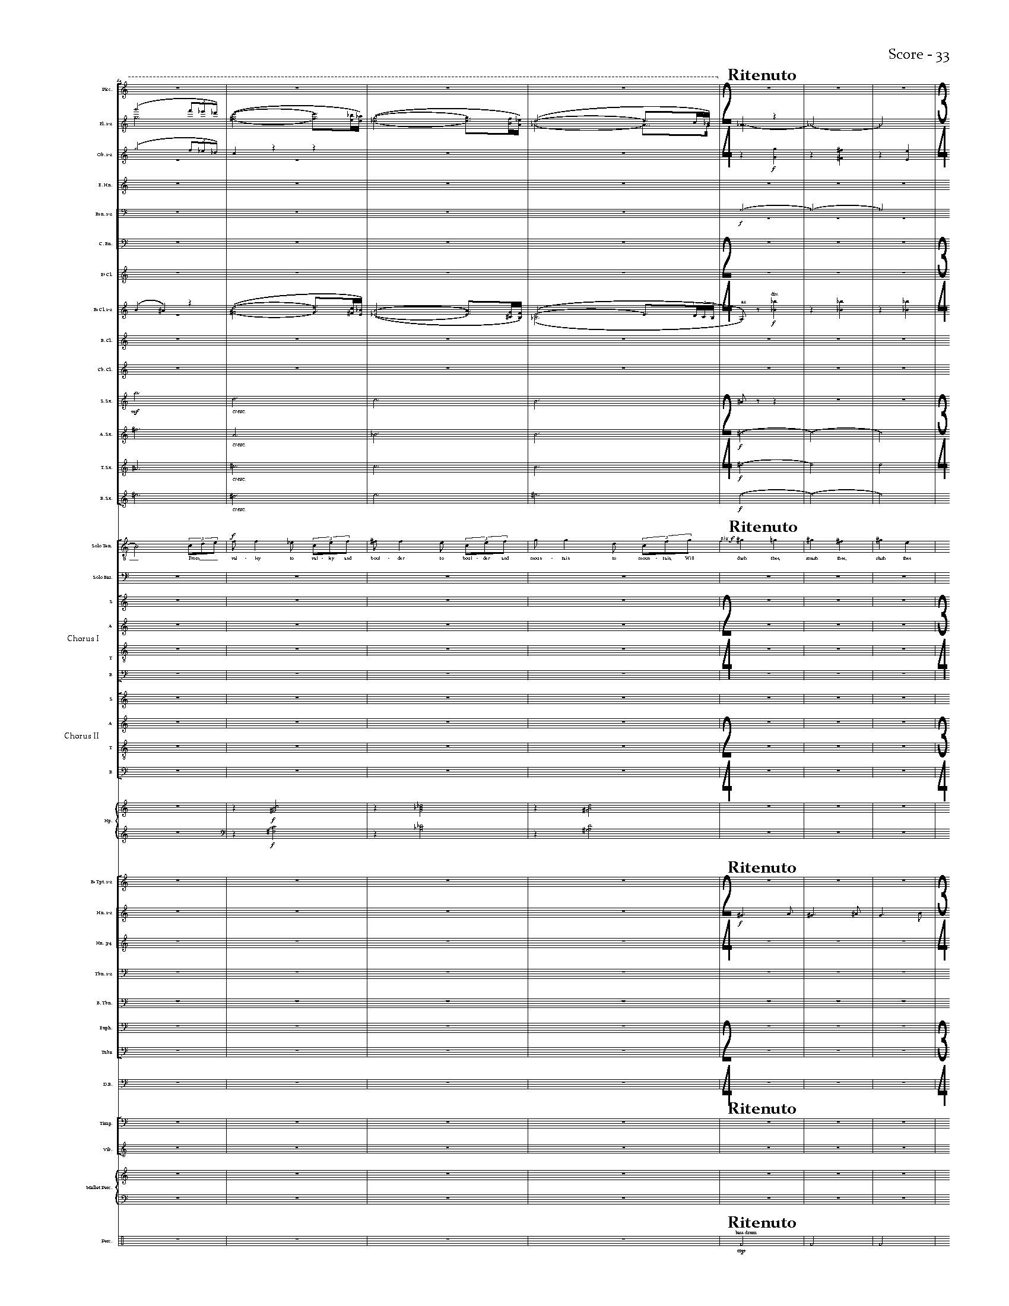

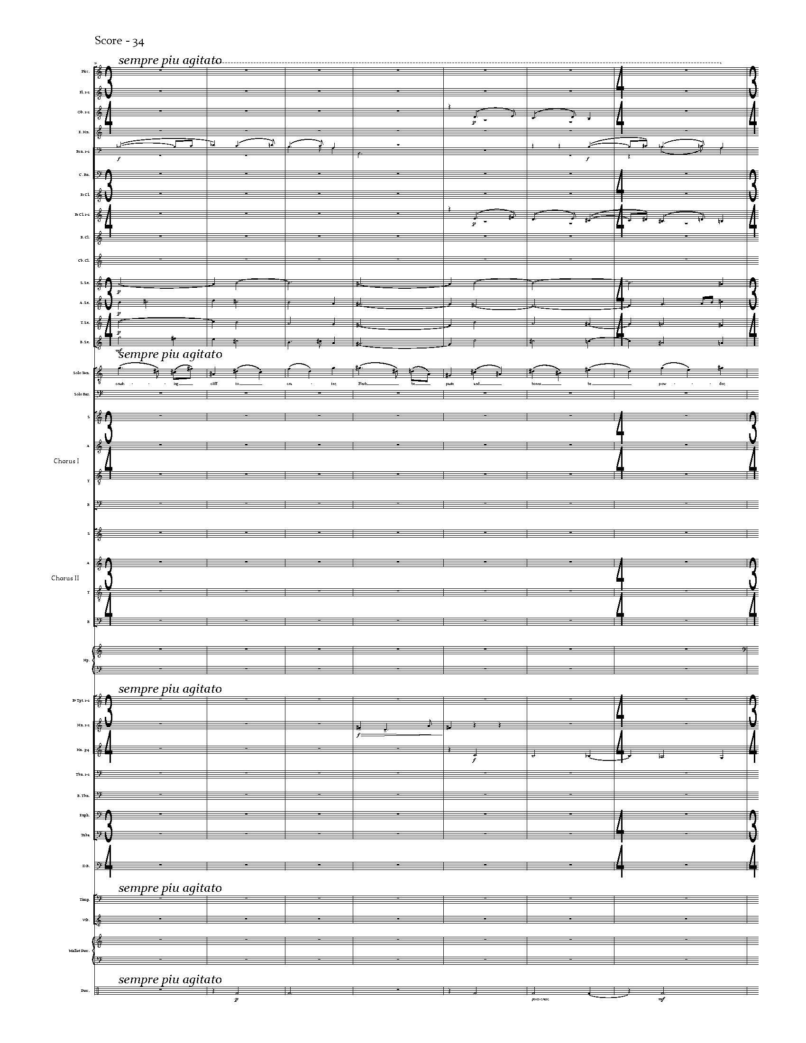

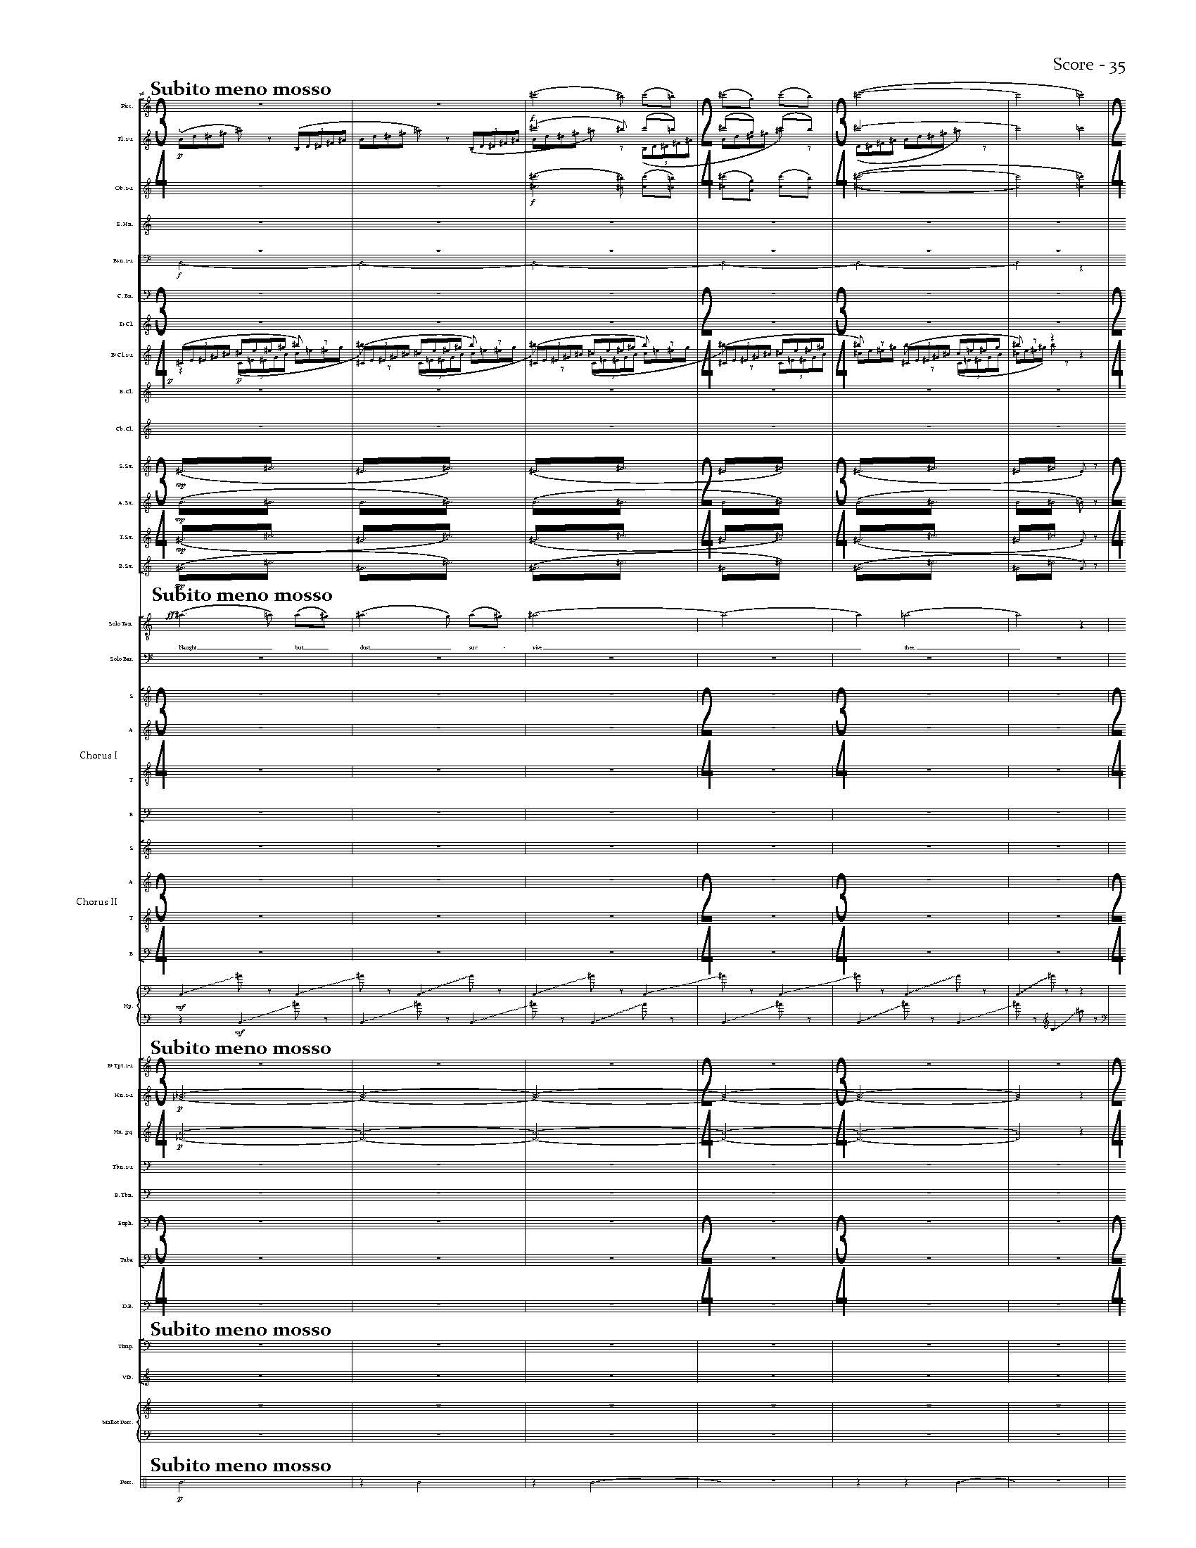

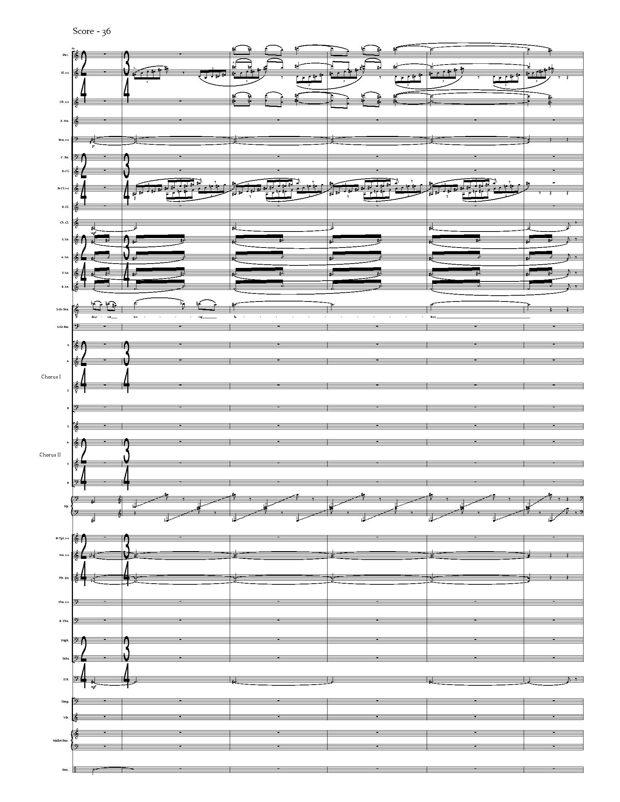

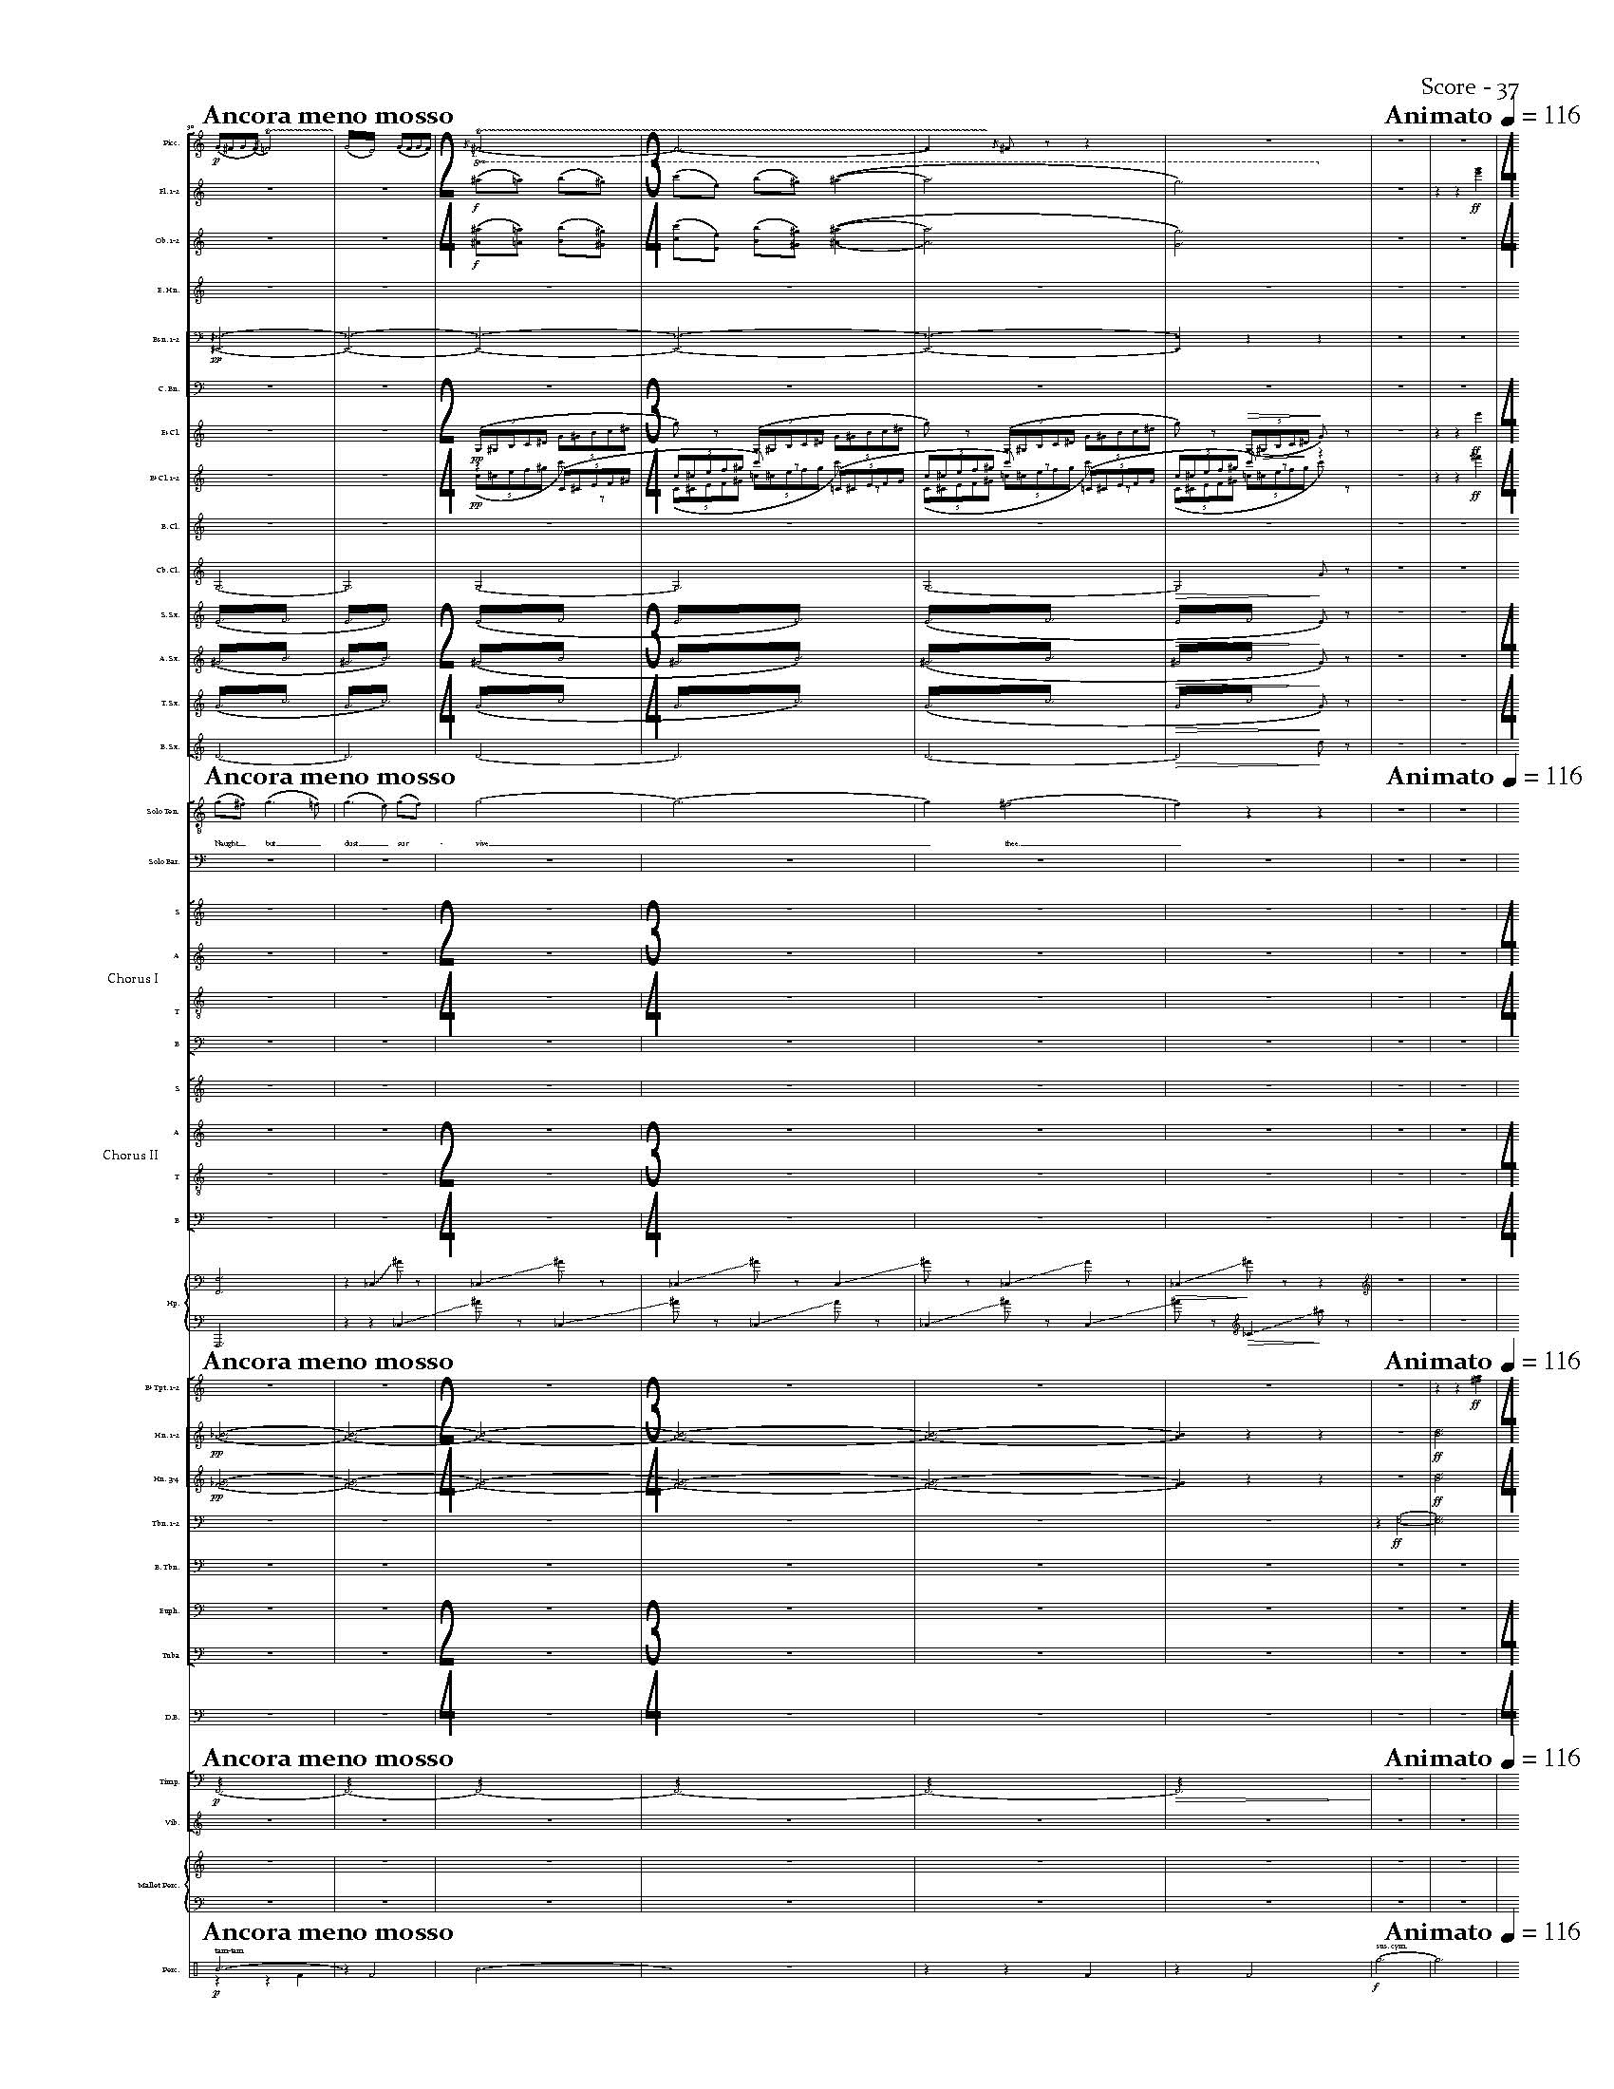

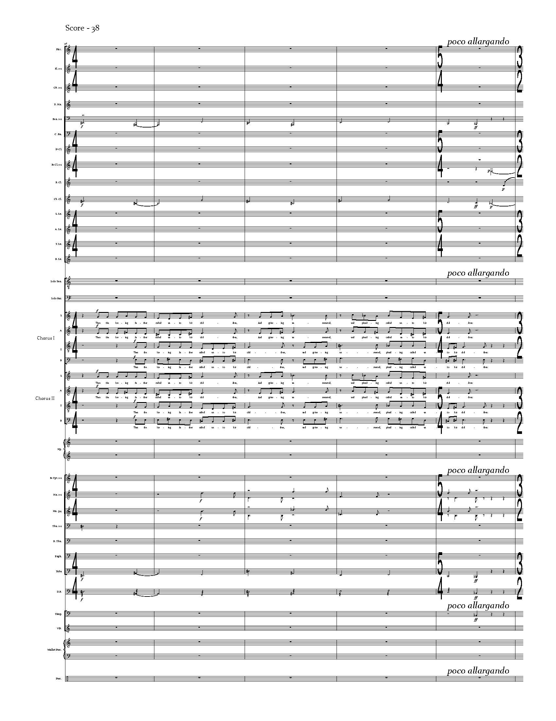

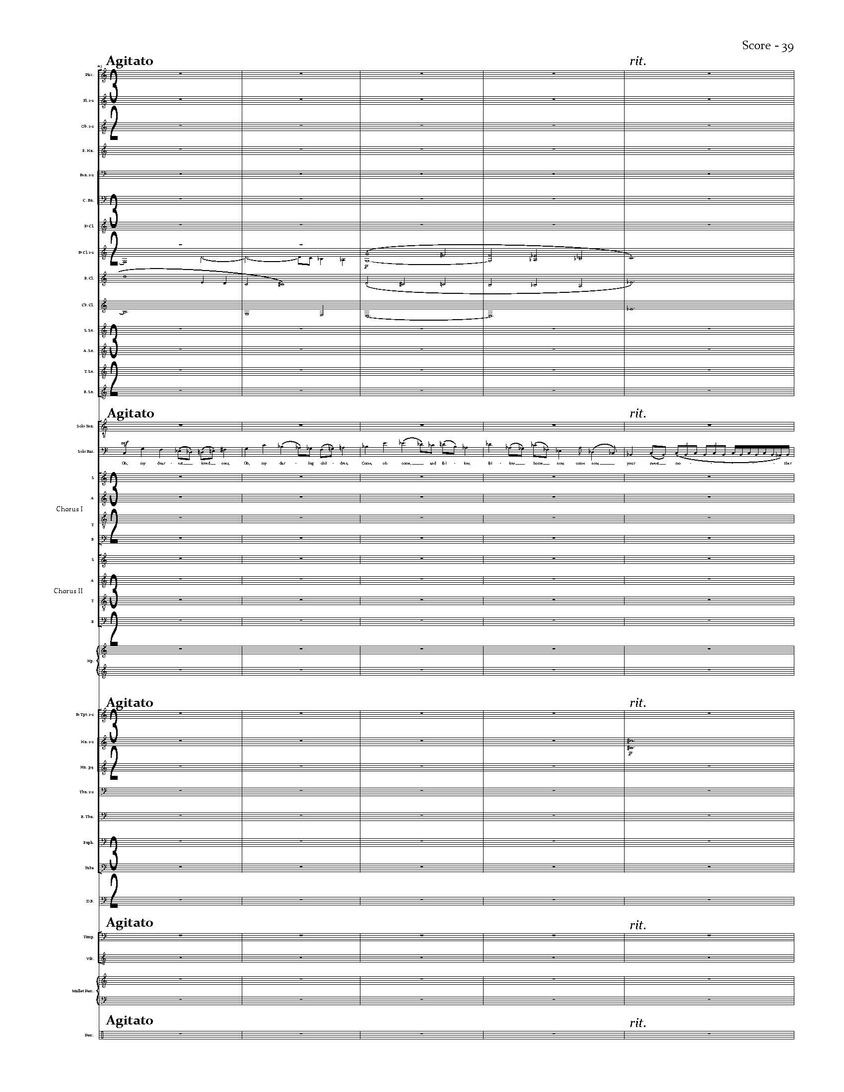

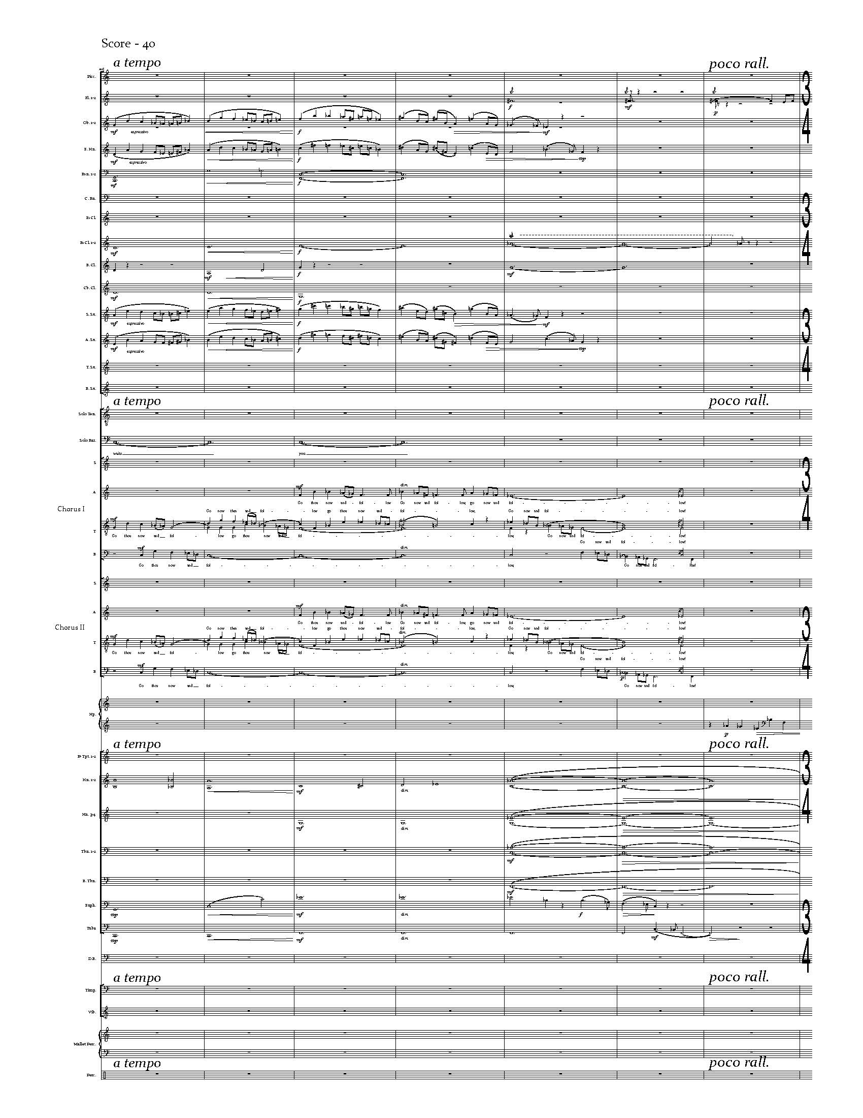

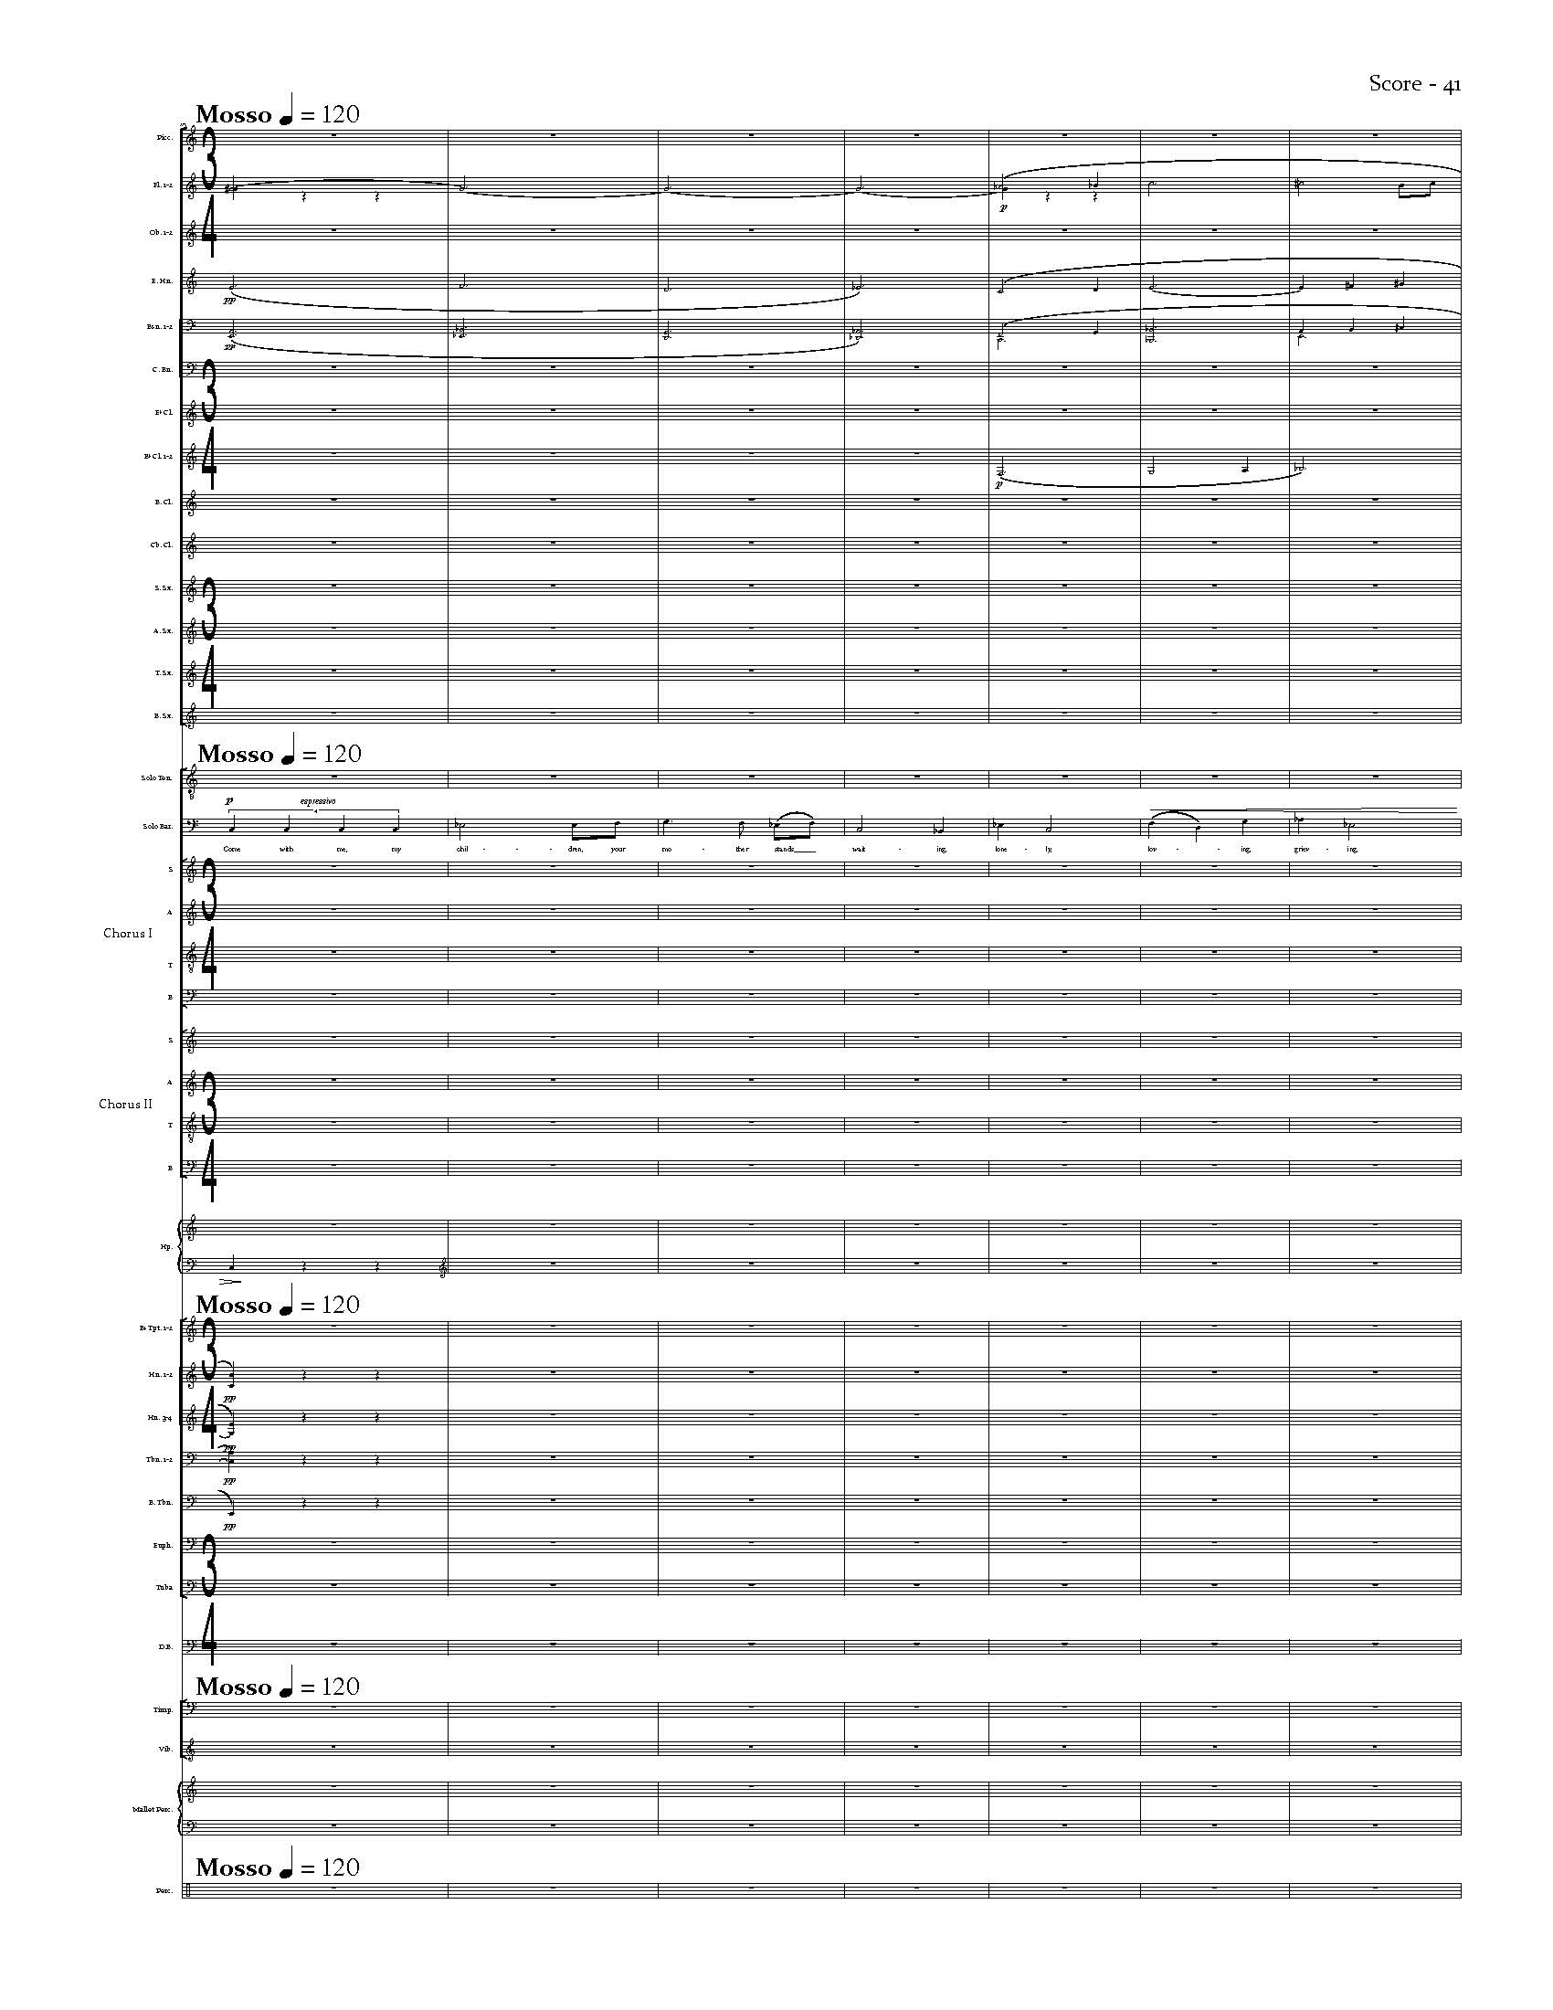

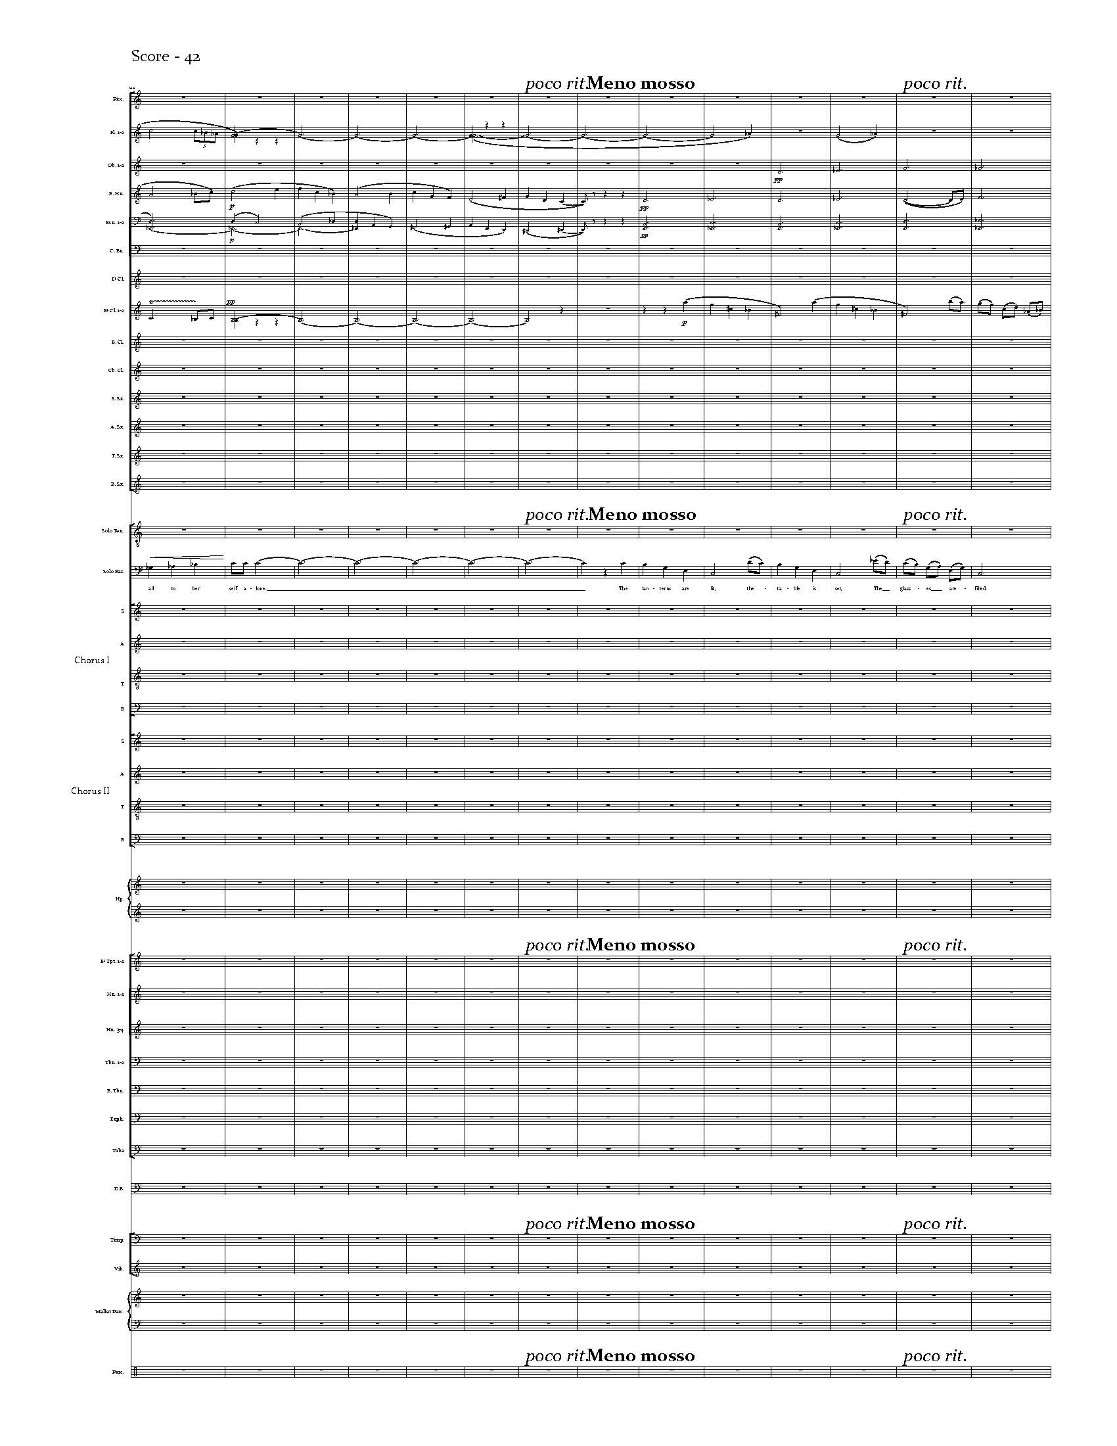

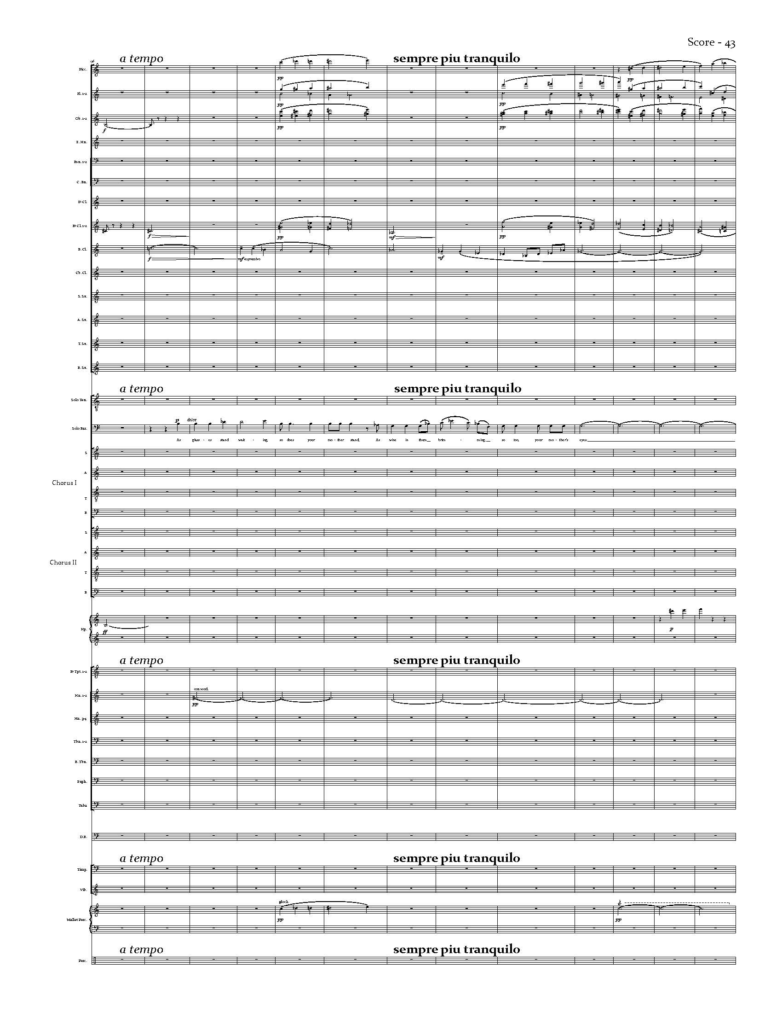

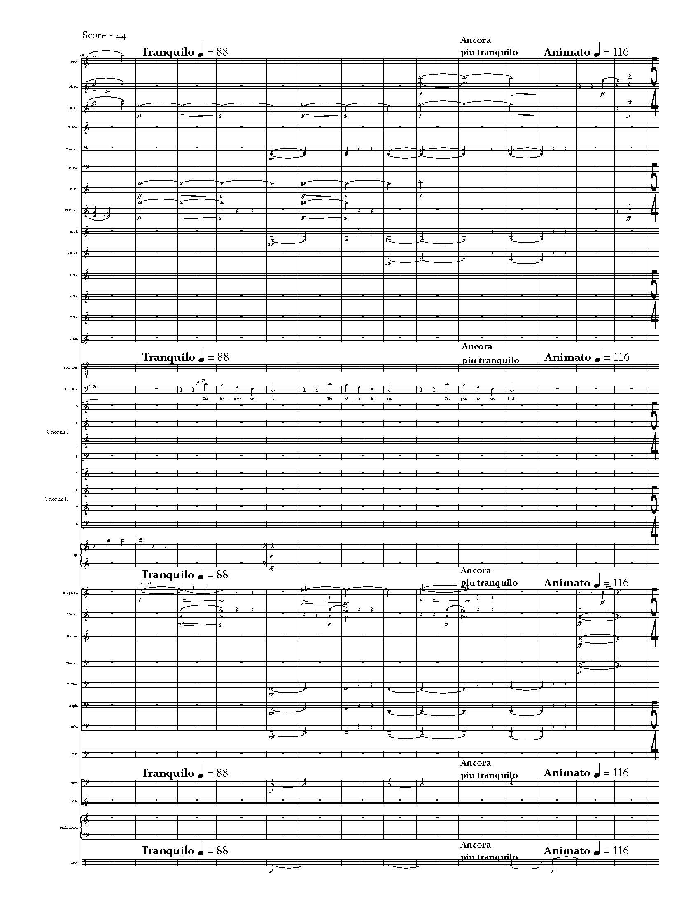

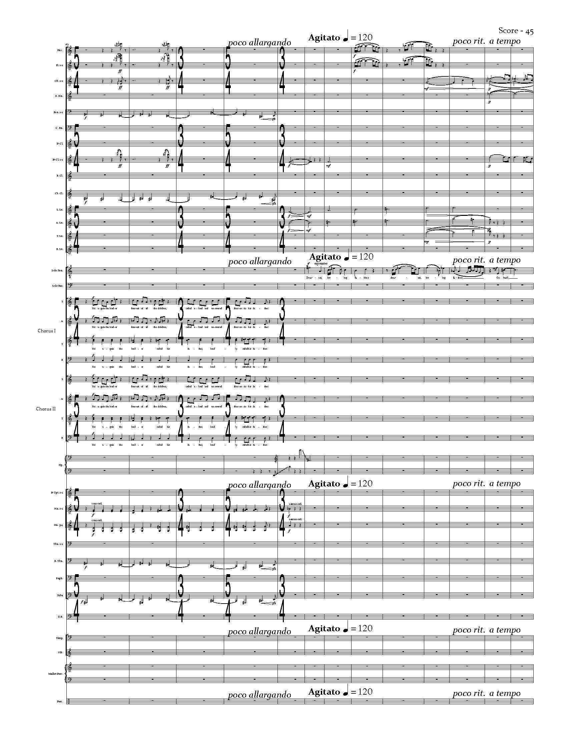

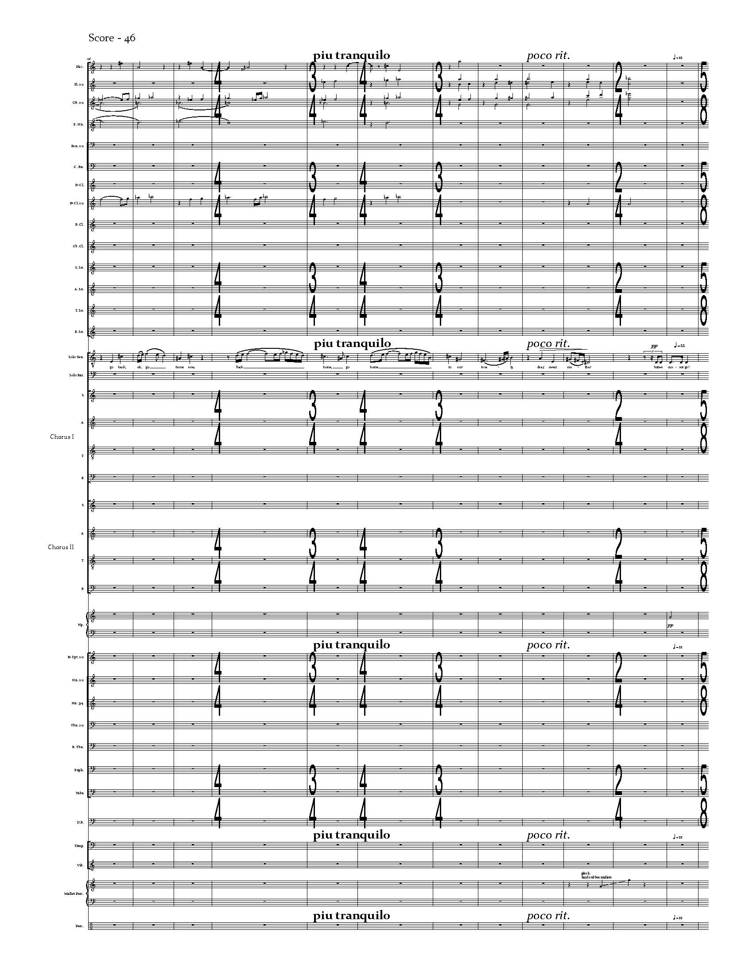

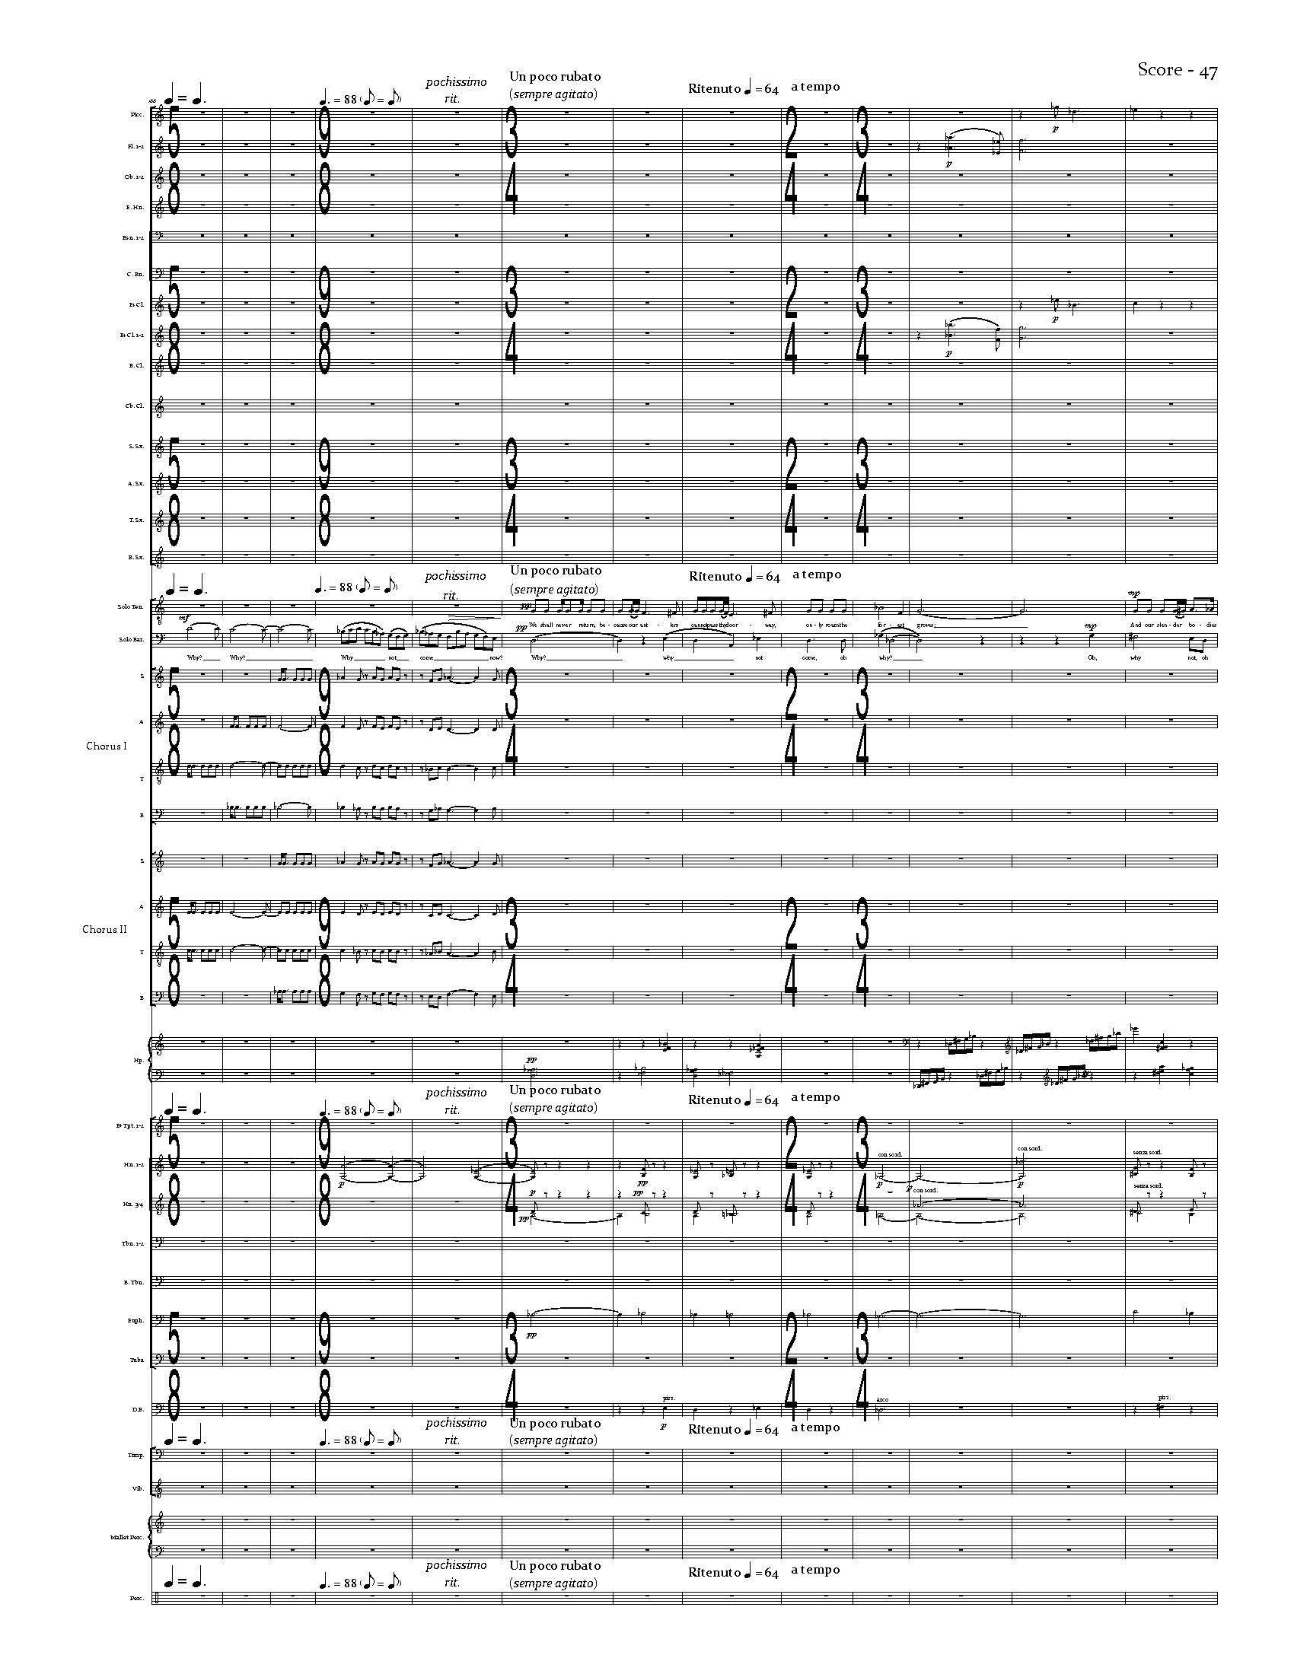

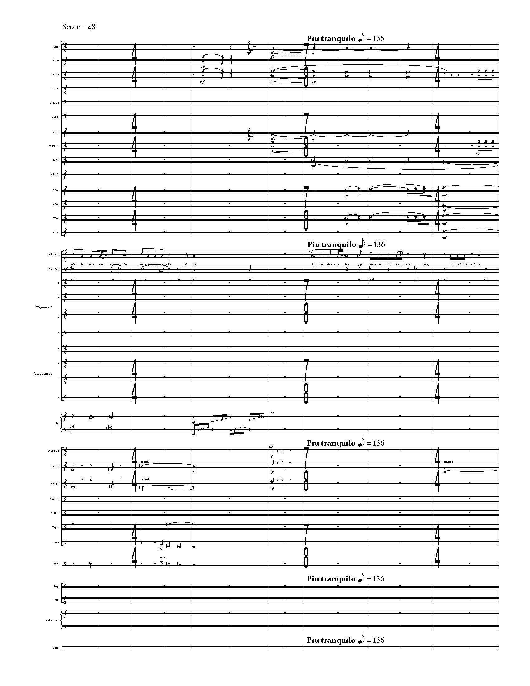

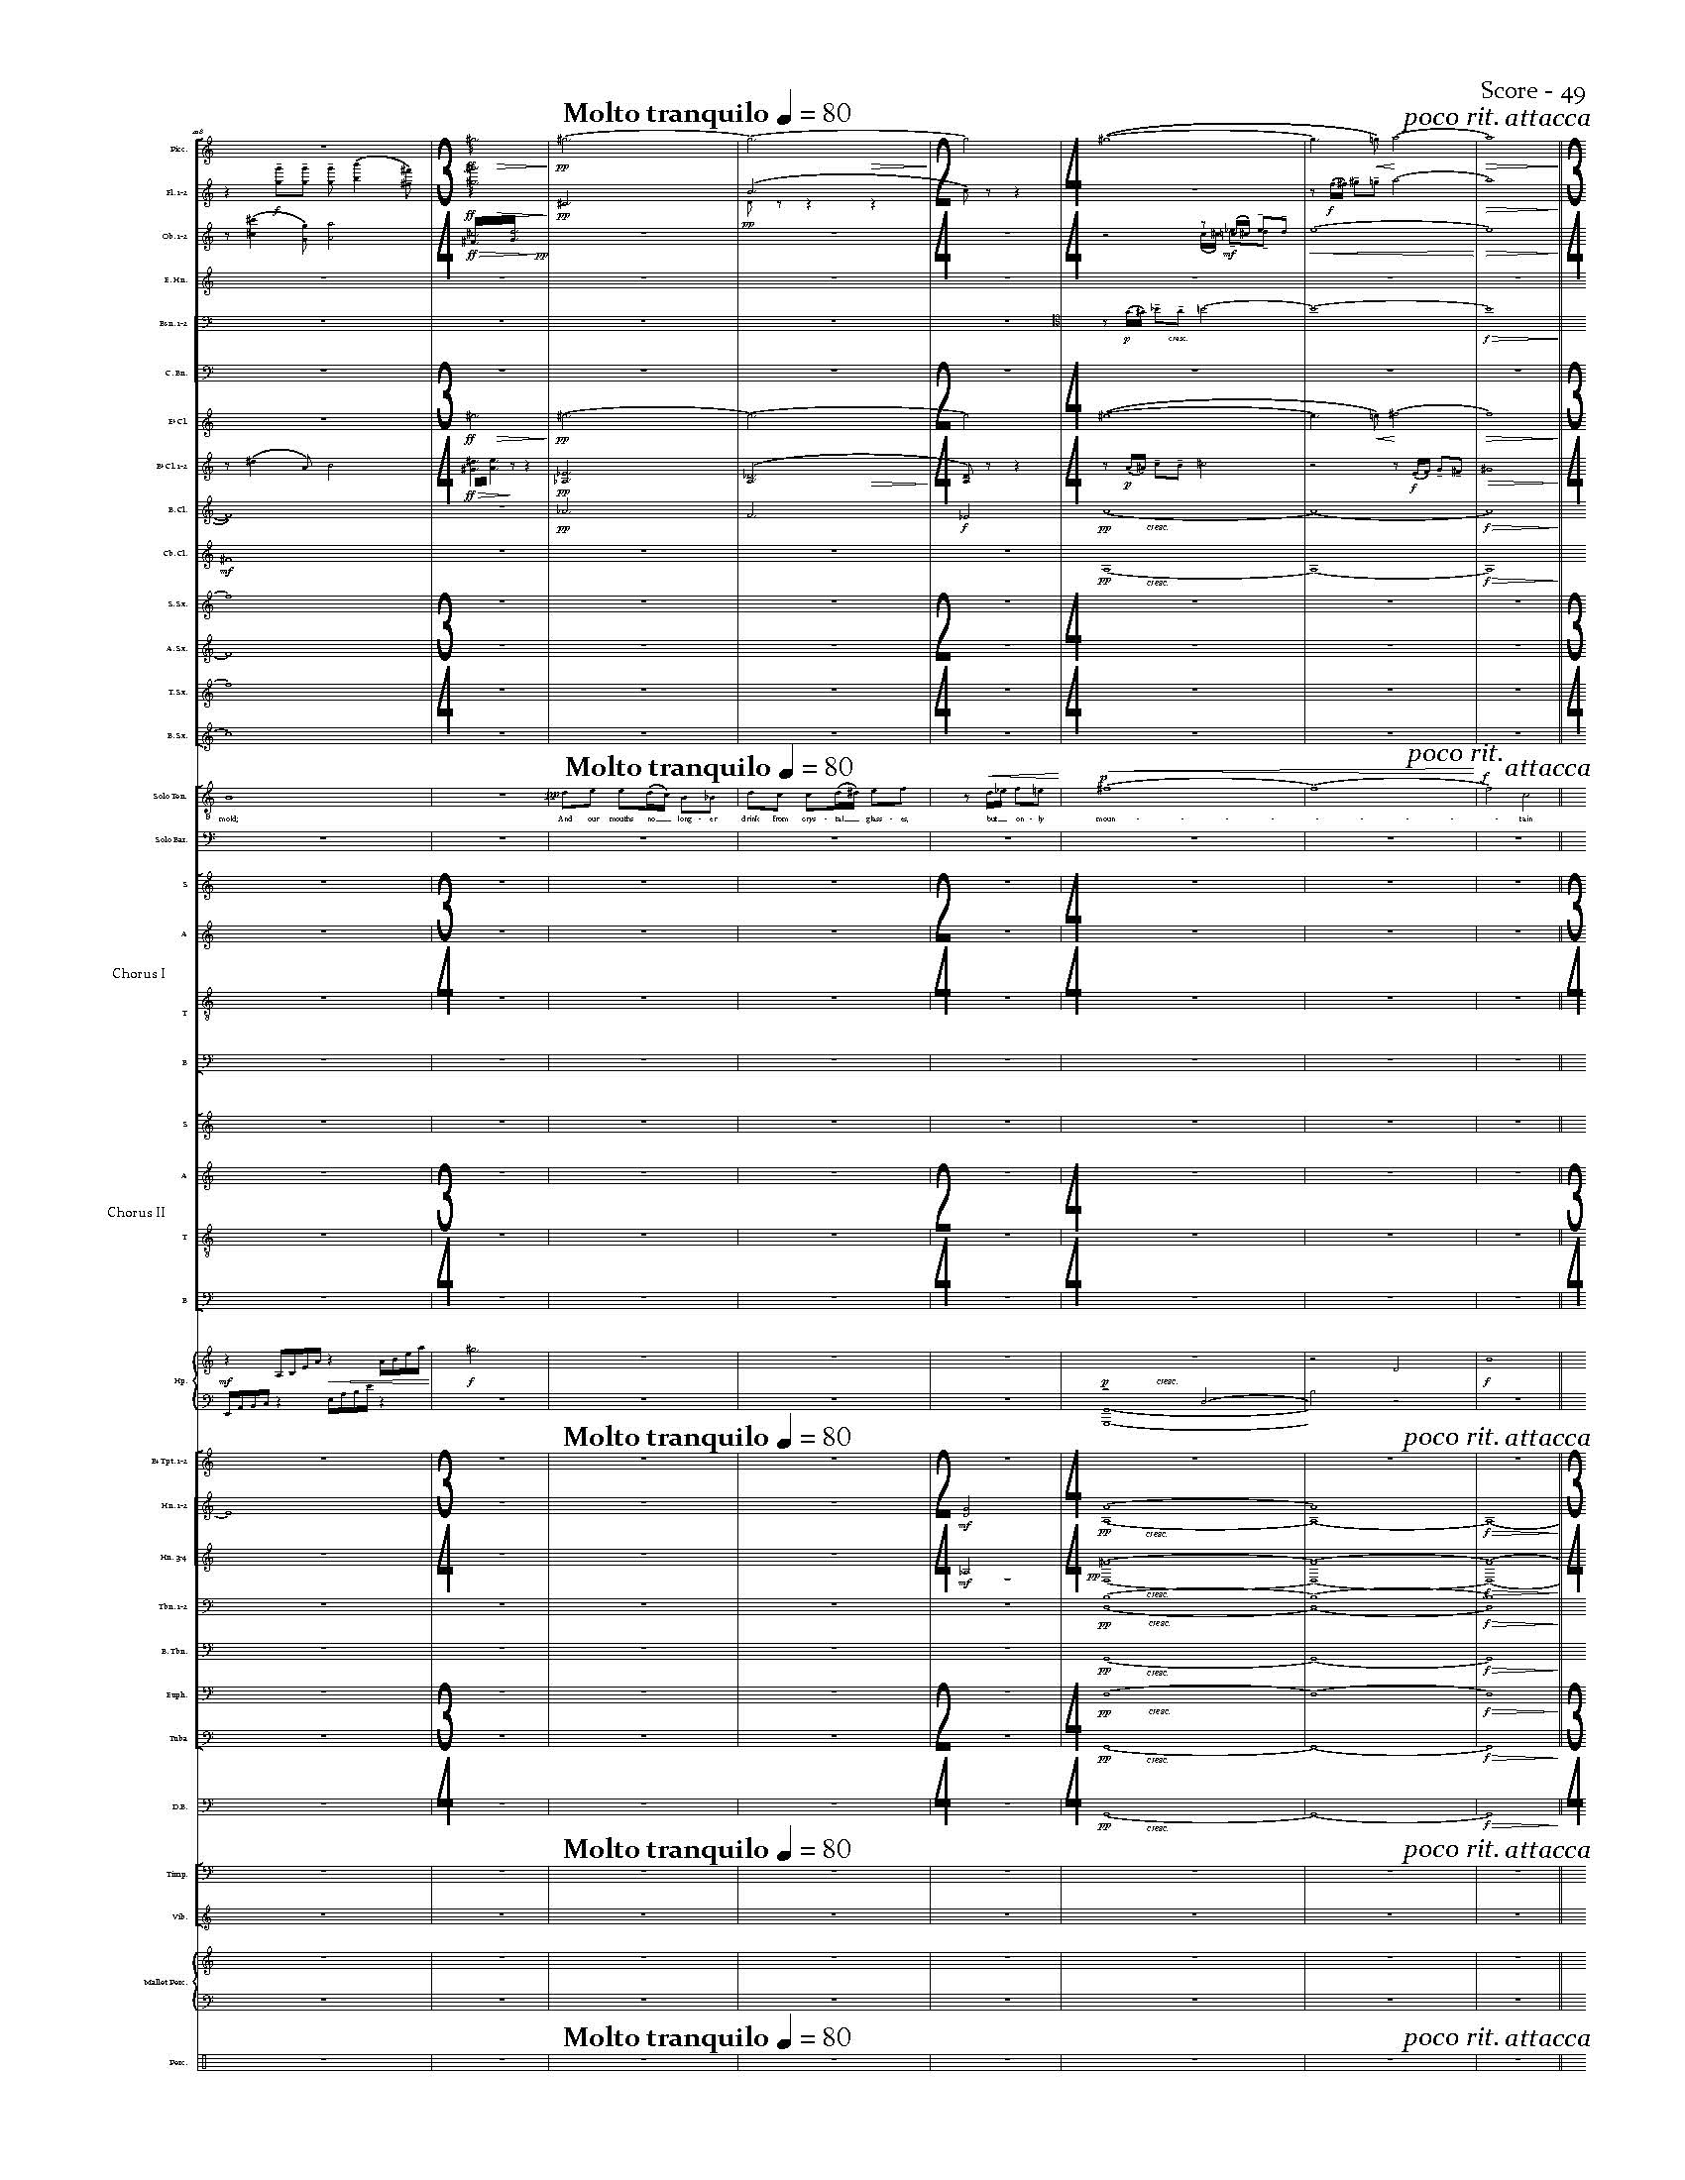

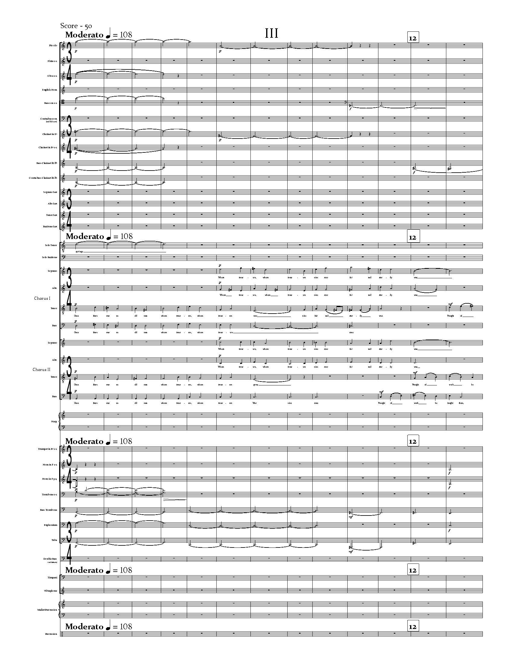

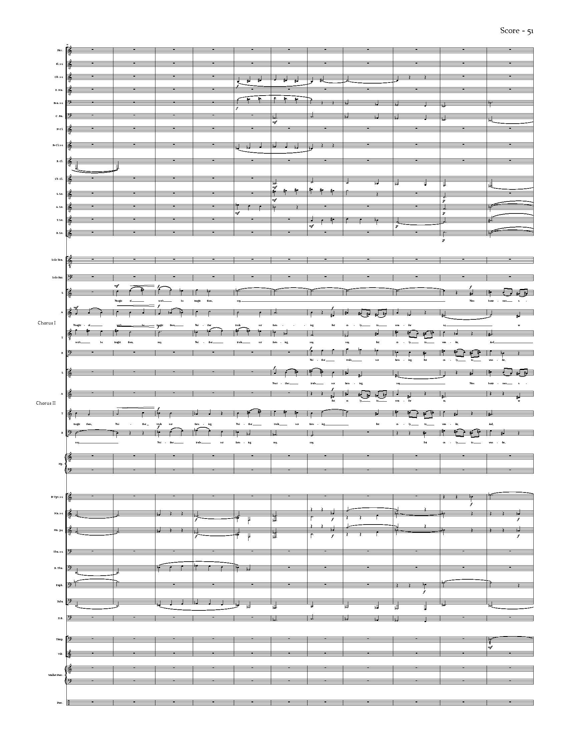

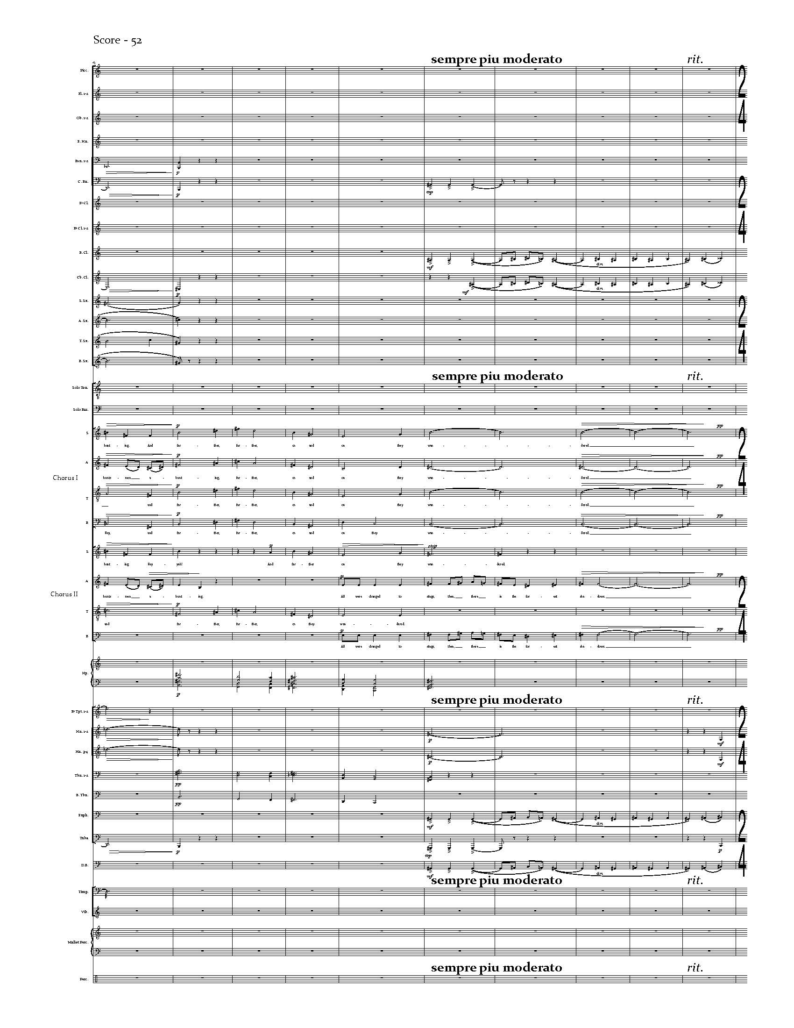

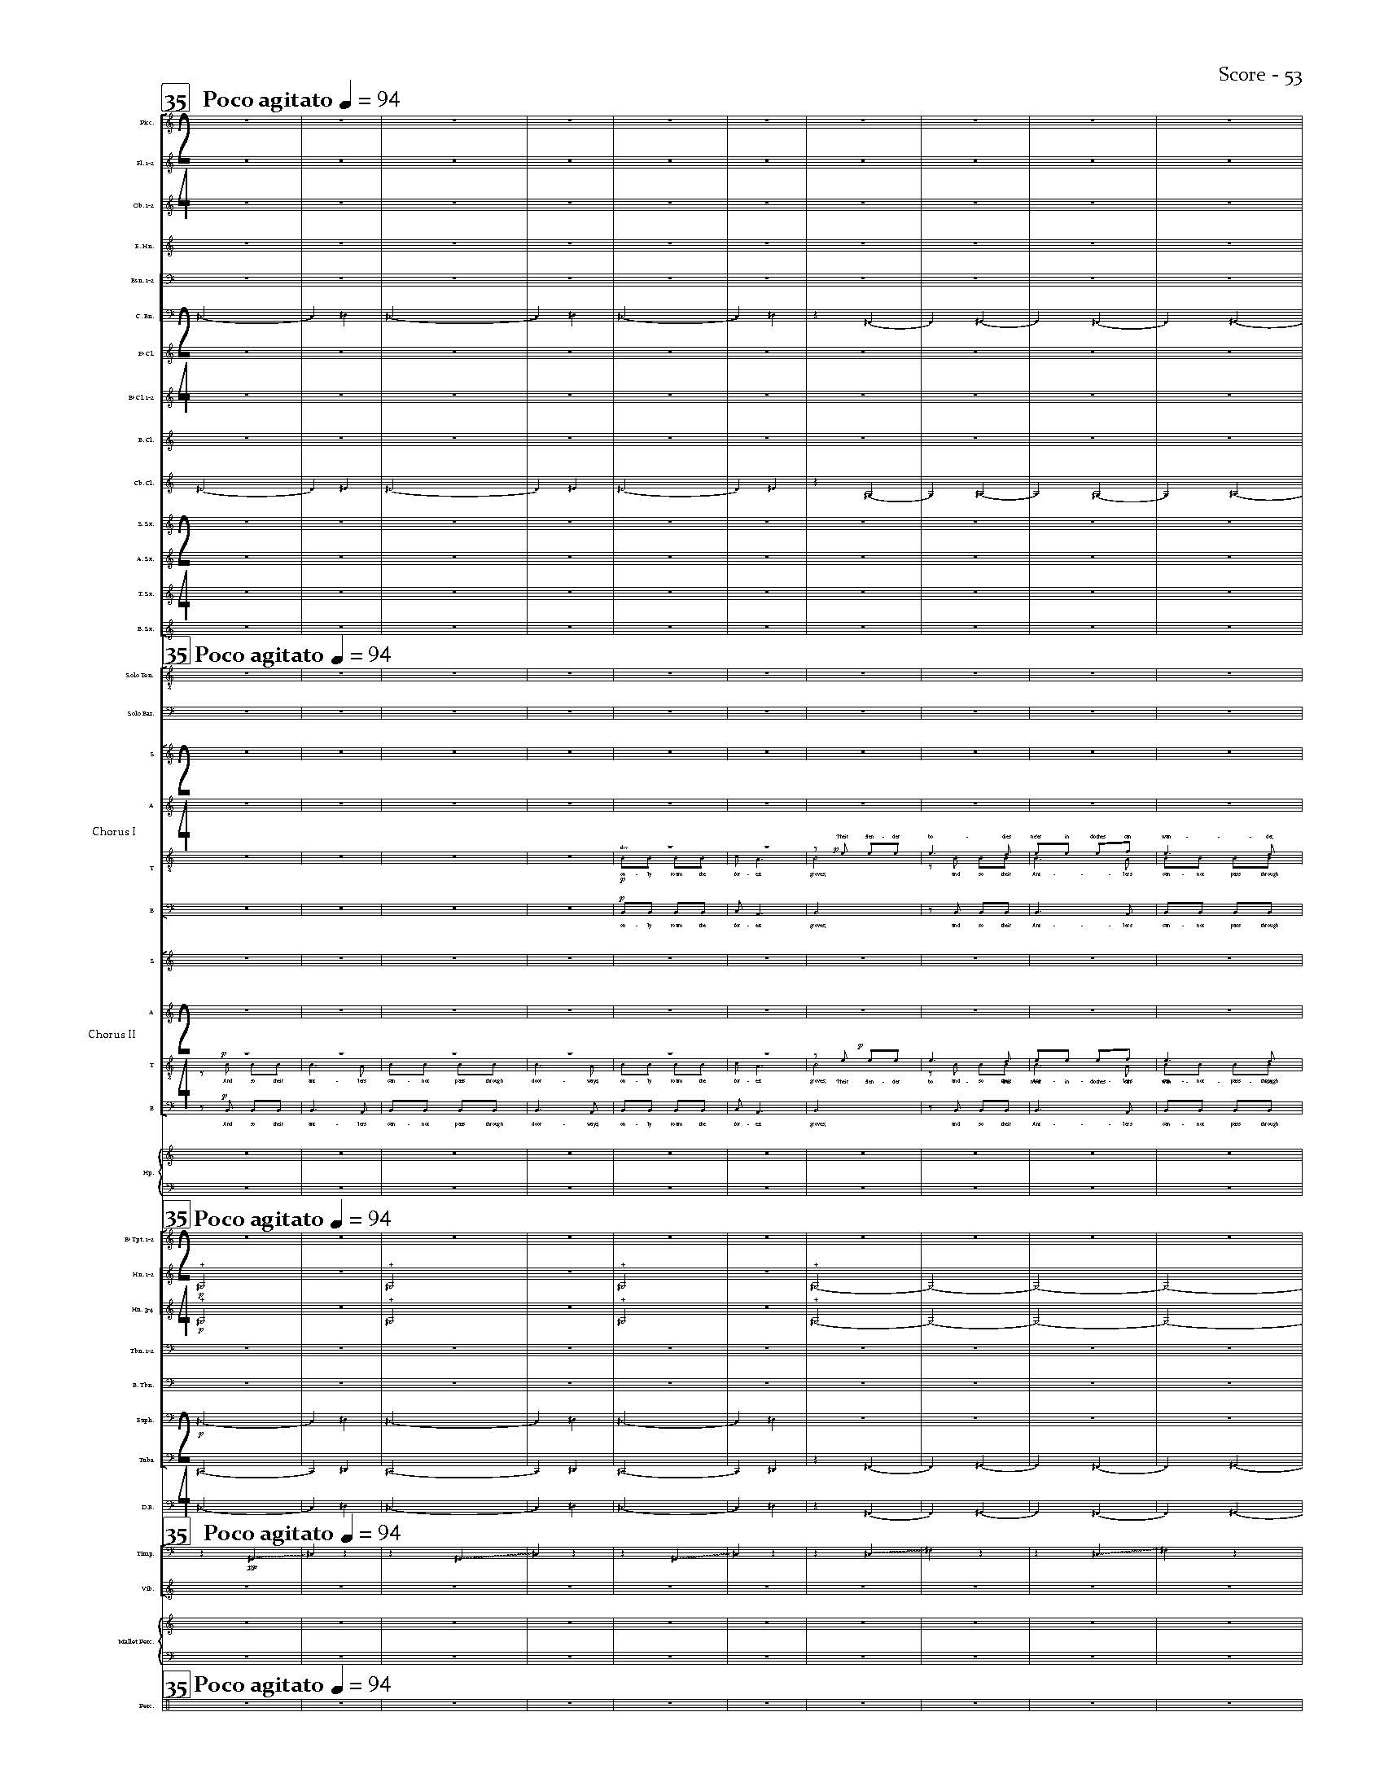

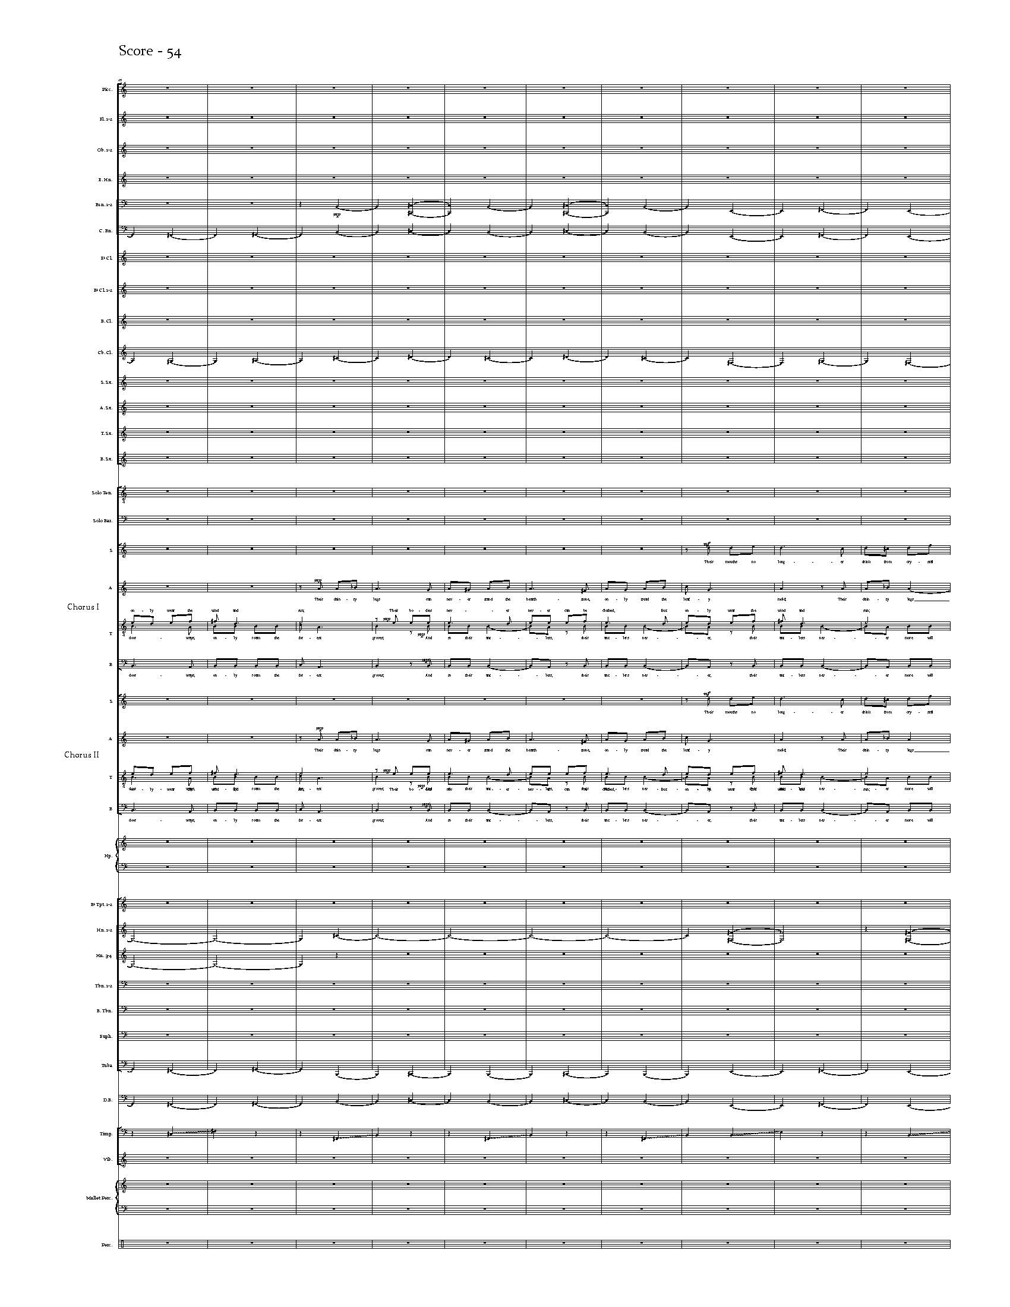

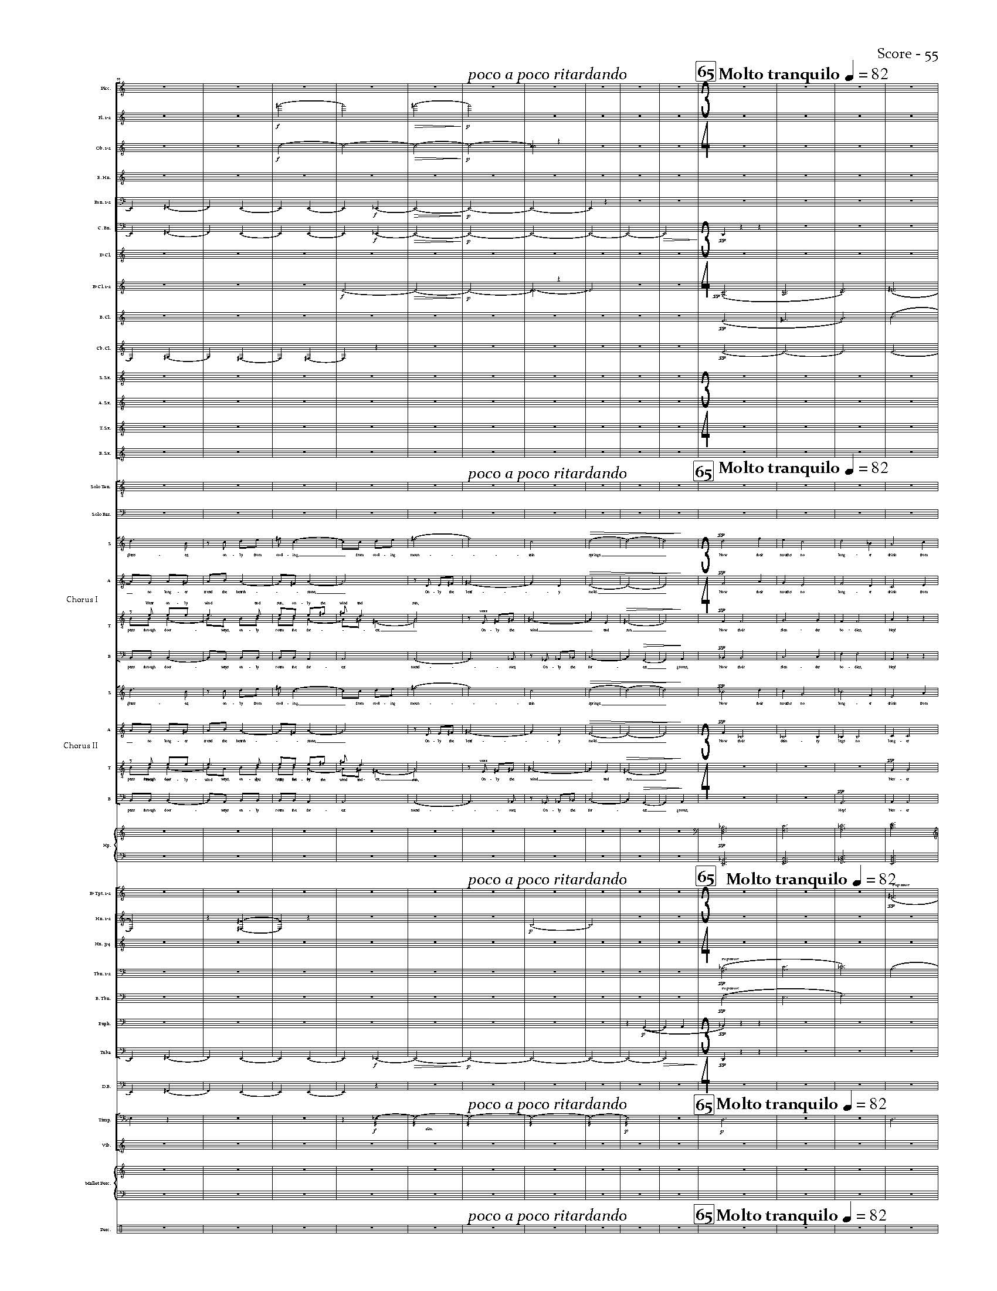

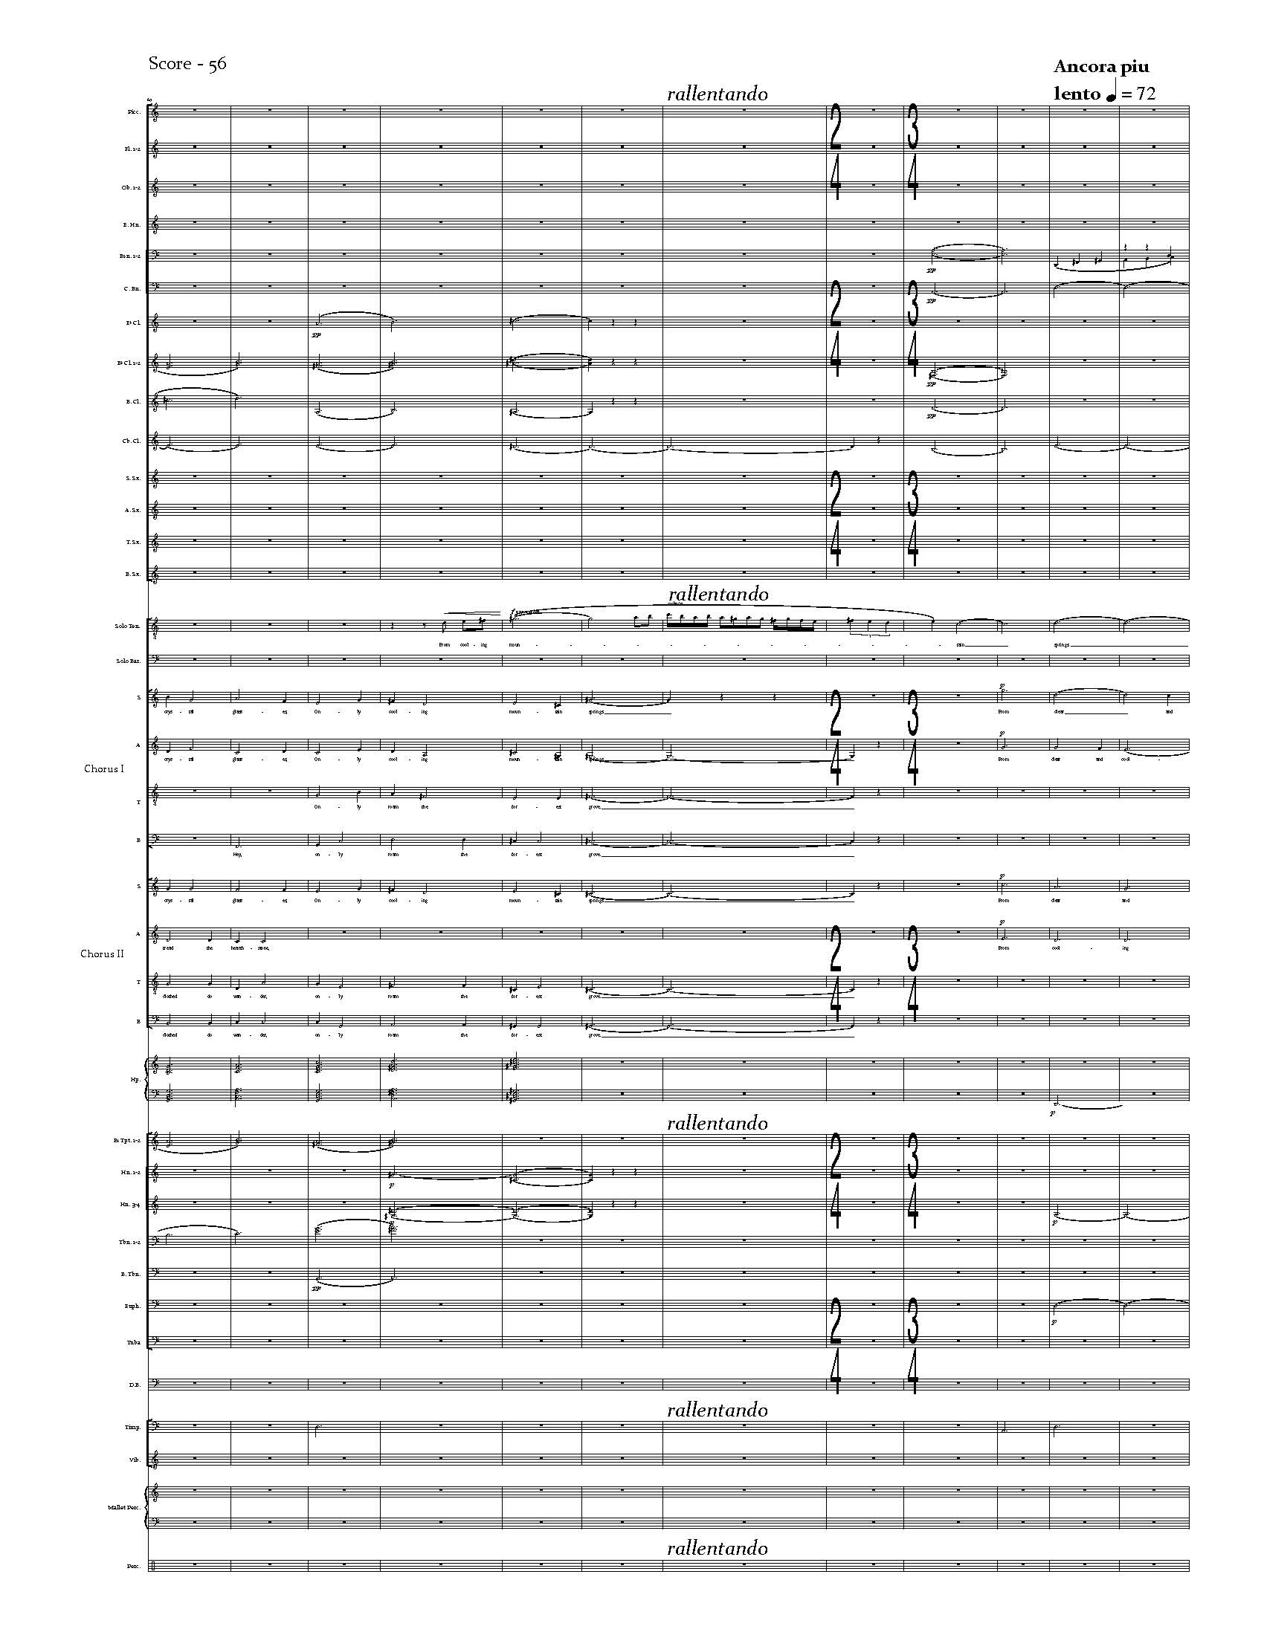

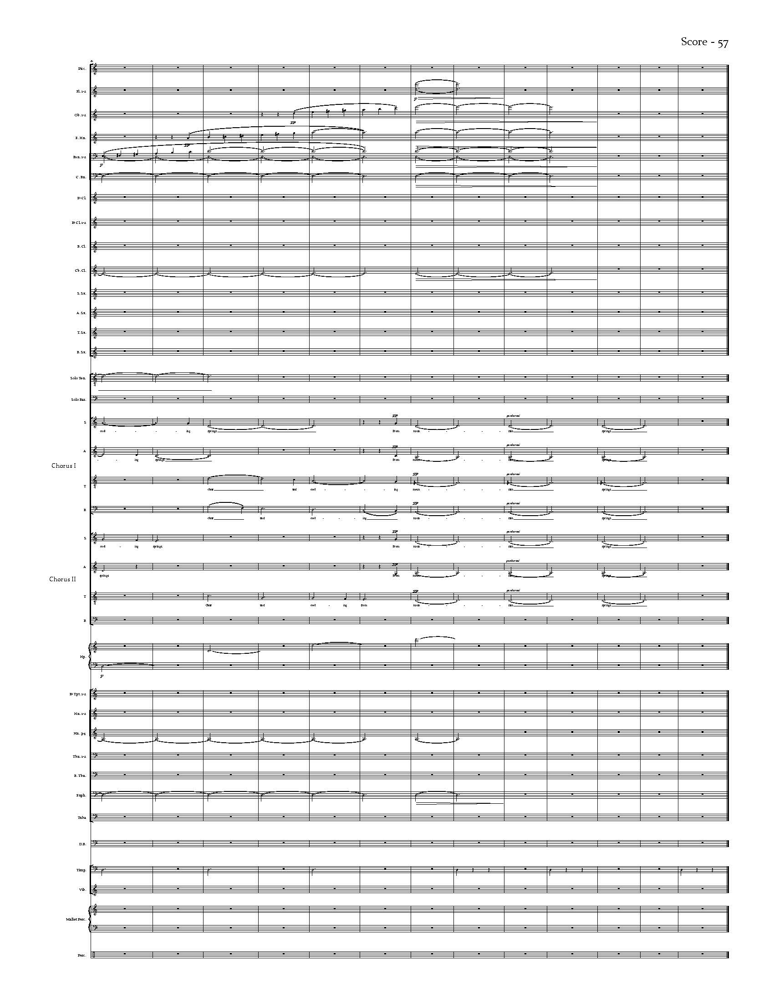

Appendix B – Copyright Permissions

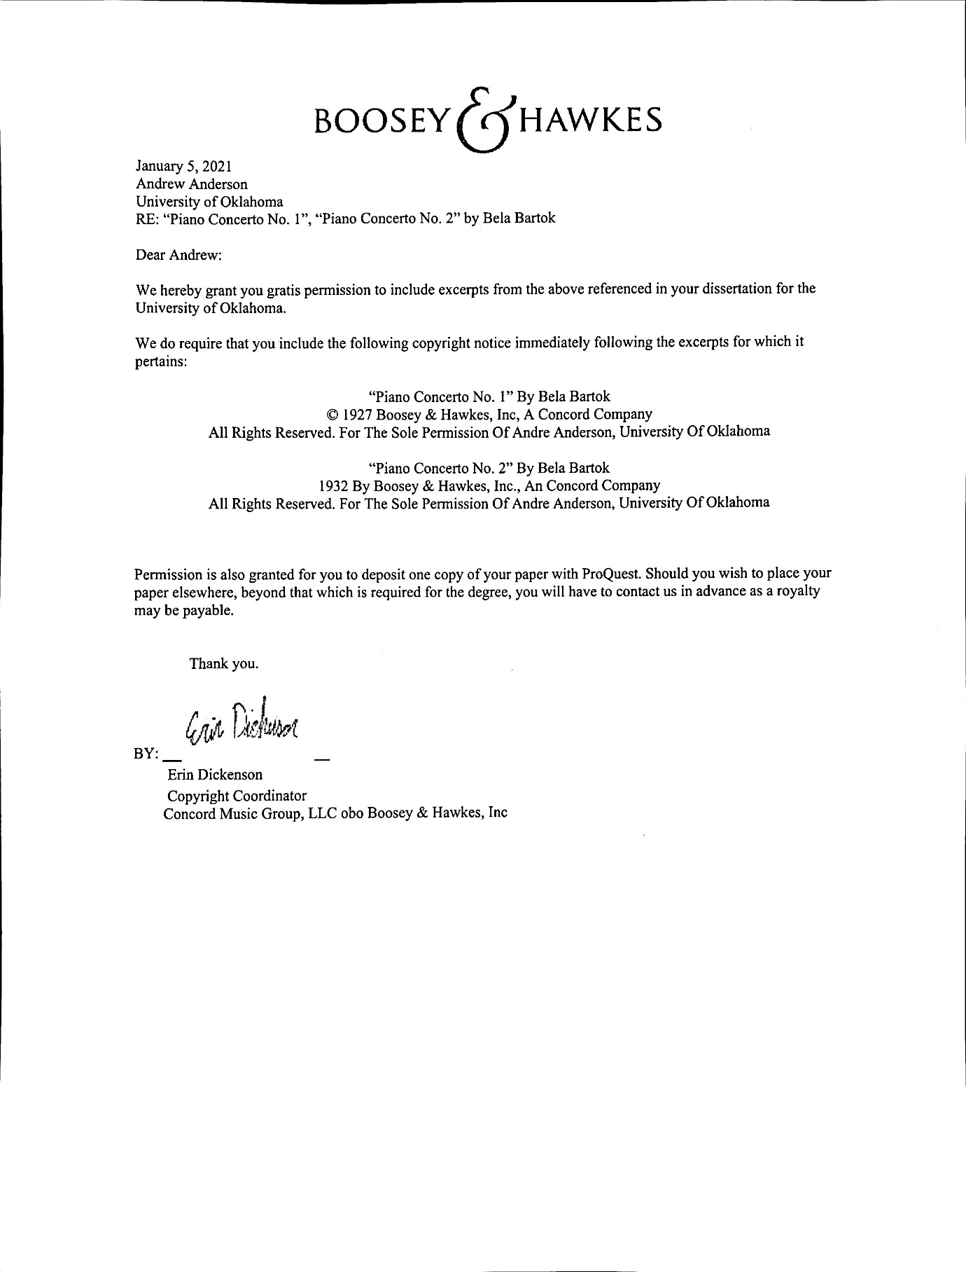

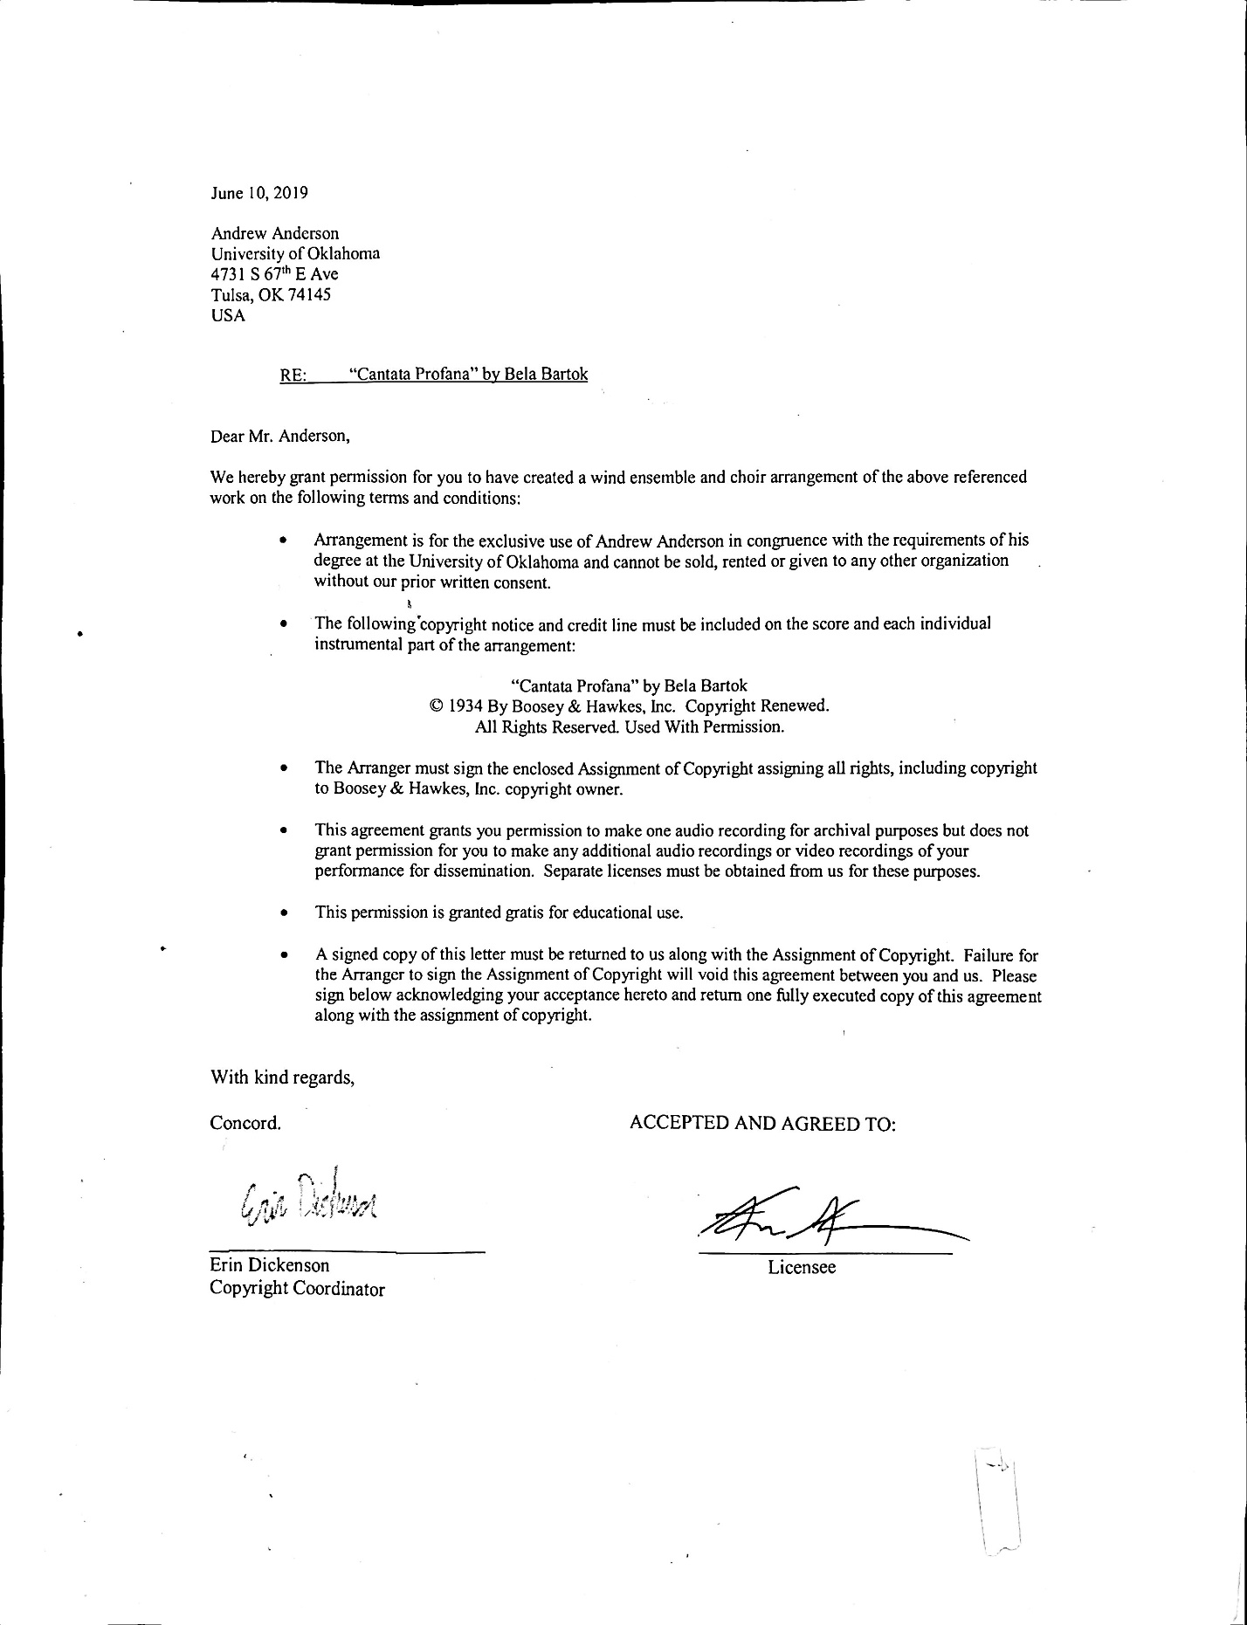

Appendix C – Social Media Communication Regarding Technical Passage on B♭ Clarinet vs. A Clarinet
Bibliography

Adler, Samuel. The Study of Orchestration. New York: W.W. Norton, 1989.

Antokoletz, Elliott. “Transformations of a Special Non-Diatonic Mode in Twentieth-Century Music:
Bartók, Stravinsky, Scriabin and Albrecht.” Music Analysis, vol. 12, no. 1, 1993, pp. 25-45. JSTOR, www.jstor.org/stable/854074. Accessed 26 Apr. 2021.

Appavoo, James Theophilus. Folklore for Change. Arasaradi, Madurai, S. India: T.T.S. Publications, Tamil Nadu Theological Seminary, 1986.

Bartók, Béla. Cantata Profana. Vienna: Universal Edition, 1934.

Bartók, Béla. Piano Concerto No. 1. New York: Boosey & Hawkes, 1927.

Bartók, Béla. Piano Concerto No. 2. New York: Boosey & Hawkes, 1932.

“Bartók - Cantata Profana 'The Nine Enchanted Stags', BB 100, Sz. 94." Presto Classical. Accessed July 11, 2020. https://www.prestomusic.com/classical/works/50318--Bartók-cantata-profana-the-nine-enchanted-stags-bb-100-sz-94/browse.

Battisti, Frank. The Winds of Change. Galesville, MD: Meredith Music Publications, 2002.

Battisti, Frank. The Winds of Change II: The New Millenium. Galesville, MD: Meredith Music Publications, 2012.

“Béla Bartók.” Wind Repertory Project. Accessed October 25, 2020.
https://www.windrep.org/B%C3%A9la_Bart%C3%B3k

Berend, I., and Gy. Ránki. "German-Hungarian Relations Following Hitler's Rise to Power (1933-34)." Acta Historica Academiae Scientiarum Hungaricae 8, no. 3/4 (1961): 313-48. Accessed July 24, 2021.
http://www.jstor.org/stable/42554705.

Blades, James. Percussion Instruments and Their History. United Kingdom, Bold Strummer, 1992.

Cash, Taylor. “The Evolving Role and Instrumentation of the Wind Band Percussion Section.”
DMA dissertation, University of Alabama. 2018

"Category: Choir." Wind Repertory Project. Accessed December 04, 2020. https://www.windrep.org/Category:Choir.

"Category: Compositions." Wind Repertory Project. Accessed December 04, 2020. https://www.windrep.org/Category:Compositions.

“Concerto for Orchestra in a Version for Wind Band Béla Bartók / Arr. André Reichling.”
Concerto for Orchestra in a Version for Wind Band | Béla Bartók / Arr. André Reichling - concert band Noten & Partituren - HeBu Musikverlag GmbH, n.d. https://www.hebu-music.com/en/article/Béla-Bartók/bronsheim-musikverlag/concerto-for-orchestra-in-a-version-for-wind-band.520476/.

Cooper, David. Béla Bartók. New Haven, CT: Yale University Press, 2015.

Erickson, Frank. Arranging for the Concert Band. Melville, N.Y: Belwin-Mills Pub. Corp, 1983.

Frigyesi, Judit Laki. "Béla Bartók and Hungarian Nationalism: The Development of Bartók's Social and Political Ideas at the Turn of the Century (1899-1903)." Order No. 9015090, University of Pennsylvania, 1989.
https://www-proquest-com.ezproxy.lib.ou.edu/dissertations-theses/Béla-Bartók-hungarian-nationalism-development/docview/303789078/se-2?accountid=12964.

Frigyesi, Judit. "Béla Bartók and the Concept of Nation and "Volk" in Modern Hungary." The Musical Quarterly 78, no. 2 (1994): 255-87. Accessed August 11, 2021. http://www.jstor.org/stable/742543.

Geary, Gail. “An Analytical Study of Béla Bartók’s Cantata Profana.” Master’s Thesis,
Baylor University. 1985.

Gillies, Malcolm. "Bartók Performance Practice through Correspondence." Studia
Musicologica 53, no. 1/3 (2012): 103-11. Accessed July 11, 2020. www.jstor.org/stable/23488445.

Hanning, Barbara Russano, and Donald Jay Grout. 2002. Concise History of Western Music. Princeton, N.J., 2002.

Johnson, Nathaniel F, “Creation of Historically Informed Transcriptions for Chorus and Winds
of Franz Schubert’s Mass in G and Gabriel Fauré’s Requiem.” DA Dissertation, University of Northern Colorado. 2005.

Kennan, Kent, and Donald Grantham. The Technique of Orchestration. Upper Saddle River, NJ: Prentice Hall, 2002.

Keréfky, Márton. "BARTÓK'S REVISIONS TO THE INSTRUMENTATION OF 'DUKE BLUEBEARD'S CASTLE'." Tempo 67, no. 264 (2013): 52-65. Accessed July 11, 2020. www.jstor.org/stable/43927820.
Kinder, Keith. Best Music for Chorus and Winds. Brooklyn: Manhattan Beach Music. 2005.
Lampert, Vera. "Nationalism, Exoticism, or Concessions to the Audience? Motivations behind
Bartók's Folksong Settings." Studia Musicologica Academiae Scientiarum Hungaricae 47, no. 3/4 (2006): 337-43. Accessed July 10, 2020. www.jstor.org/stable/25598265.

LaPine, Peter R. “The Relationship between the Physical Aspects of Voice Production and Optimal Vocal Health.” Music Educators Journal, vol. 94, no. 3, 2008, pp. 24–29. JSTOR, www.jstor.org/stable/4623687. Accessed 28 Mar. 2021.

Lomax, Alan. "Appeal for Cultural Equity." African Music 6, no. 1 (1980): 22-31. Accessed June 16, 2021. http://www.jstor.org/stable/30249739.

Losseff, Nicky. “Casting Beams of Darkness into Bartók’s Cantata Profana.” Twentieth-Century Music 3, no. 2 (2006): Cambridge University Press.
"LSO – François-Xavier Roth Conducts Lontano, Cantata Profana and Nelson Mass @www.classicalsource.com." Classical Music. Accessed July 11, 2020. http://www.classicalsource.com/db_control/db_concert_review.php?id=15918.

“Maecenas Music – Choir with band/ensemble listing.” Maecenas Music. Accessed December 4, 2020. https://www.maecenasmusic.co.uk/choir-with-band-ensemble-listing.html
Móricz, Klára. ""From Pure Sources Only": Bartók and the Modernist Quest for
Purity." International Journal of Musicology 9 (2000): 243-66. Accessed July 11, 2020. www.jstor.org/stable/43858009.

Musschenga, Albert W. "Intrinsic Value as a Reason for the Preservation of Minority
Cultures." Ethical Theory and Moral Practice 1, no. 2 (1998): 201-25. Accessed June
18, 2021. http://www.jstor.org/stable/27504028.

Reynish, Timothy. “Works for Choir and Wind Orchestra,” 2016. Accessed September 27, 2020. http://www.timreynish.com/repertoire/categories/chorus.php.

Schrader, George. “Symphony No. 2, Op. 24, by Robert F. Kurka (1921-1957): a Band
Transcription.” DMA dissertation, University of Oklahoma. 2019.

“Search Bartók | Sheet music at J. W. Pepper.” J. W. Pepper. Accessed December 8, 2020.
https://www.jwpepper.com/sheet-music/search.jsp?departmentDescriptions=Concert+Band&keywords=Bartók&pageview=list-view&perPage=48

Seriff, Daniel. “Symmetry in Béla Bartók’s Cantata Profana.” Symmetry in Béla Bartók’s
Cantata Profana, 2001, microtonal.tripod.com/music/papers/Bartók.html.

Shade, Timothy M. “A Process for Transcribing Orchestral Works for Wind Band: Andre
Previn’s Sallie Chisum Remembers Billy the Kid.” DMA dissertation, University of Miami. 2016.

Stevens, Halsey. The Life and Works of Béla Bartók. Oxford: Oxford University Press, 1967.

Suchoff, Benjamin. Béla Bartók: Life and Work. Lanham, MD: Scarecrow Press, 2001.

Thayer, Fred. "The Choral Music of Béla Bartók." The Choral Journal 26, no. 1 (1985): 33-36. Accessed July 11, 2020. www.jstor.org/stable/23546880.

Towner, Clifford. “An Evaluation of Compositions for Wind Band According to Specific
Criteria of Serious Artistic Merit: A Second Update.” DMA diss., University of Nebraska, 2011.

“The Miraculous Mandarin Concert Version (Rental) [YDAB-A05] : Brain Music International, Concert Band Sheet Music from Japanese Composers.” Bravo Music: Brain Music International. Accessed December 8, 2020. https://www.brainmusic-
int.com/index.php?main_page=product_info&products_id=1687

Valiquette, C. C. (2000). The use of percussion in the music of Béla Bartók: Works from 1926 to 1945. Available from ProQuest Dissertations & Theses Global. (304613412). https://login.ezproxy.lib.ou.edu/login?url=https://www-proquest-com.ezproxy.lib.ou.edu/dissertations-theses/use-percussion-music-béla-bartók-works-1926-1945/docview/304613412/se-2?accountid=12964.

Vikárius, László. "Béla Bartók's "Cantata Profana" (1930): A Reading of the Sources." Studia
Musicologica Academiae Scientiarum Hungaricae 35, no. 1/3 (1993): 249-301. Accessed July 11, 2020. doi:10.2307/902206.
Vikárius, László. (2005). His "Personal Credo". Bartók Virtual Exhibition p.7. http://www.zti.hu/Bartók/exhibition/en_P7.htm#top. Accessed May 9, 2021.

Johnson, Nathaniel F, “Creation of Historically Informed Transcriptions for Chorus and Winds of Franz Schubert’s Mass in G and Gabriel Fauré’s Requiem” (DA Dissertation, University of Northern Colorado, 2005), 1-3.
Ibid., 2, 93-97.
Kinder, Keith. Best Music for Chorus and Winds. (Brooklyn: Manhattan Beach Music, 2005), 5-11.
"Category: Choir." Wind Repertory Project. Accessed December 04, 2020. https://www.windrep.org/Category:Choir.
"Category: Compositions." Wind Repertory Project. Accessed December 04, 2020. https://www.windrep.org/Category:Compositions.
Battisti, Frank. The Winds of Change. (Galesville, MD: Meredith Music Publications, 2002), 150-152.
Battisti, Frank. The Winds of Change II: The New Millenium. (Galesville, MD: Meredith Music Publications, 2012), 290.
Reynish, Timothy. “Welcome to Timreynish.com.” Categories | Repertoire | Tim Reynish, 2016. http://www.timreynish.com/repertoire/categories/chorus.php.
Kinder, Keith. Best Music for Chorus and Winds. (Brooklyn: Manhattan Beach Music, 2005), 6-9.
Reynish.
“Maecenas Music – Choir with band/ensemble listing.” Maecenas Music. Accessed December 4, 2020. https://www.maecenasmusic.co.uk/choir-with-band-ensemble-listing.html
Cooper, David. Bela Bartók. New Haven, CT: Yale University Press, 2015. 476-491.
Battisti, 86-88.
Allegro Barbaro (arr Wallace). (2020). Wind Repertory Project. Accessed December 10, 2020. https://www.windrep.org/Allegro_Barbaro_(arr_Wallace)
Jocuri Poporale Romanesti. (2020). Wind Repertory Project. Accessed December 10, 2020. https://www.windrep.org/Jocuri_Poporale_Romanesti
Search Bartok | Sheet music at JW Pepper. (2020). J. W. Pepper. https://www.jwpepper.com/sheet-music/search.jsp?departmentDescriptions=Concert+Band&keywords=bartok&pageview=list-view&perPage=24
Ibid.
The Miraculous Mandarin Concert Version (Rental) [YDAB-A05]: Brain Music International, Concert Band Sheet Music from Japanese Composers. Bravo Music: Brain Music International. https://www.brainmusic-int.com/index.php?main_page=product_info&products_id=1687
“Concerto for Orchestra in a Version for Wind Band Bela Bartok / Arr. André Reichling,” Concerto for Orchestra in a Version for Wind Band | Bela Bartok / Arr. André Reichling - concert band Noten & Partituren – HeBu Musikverlag GmbH, n.d., https://www.hebu-music.com/en/article/bela-bartok/bronsheim-musikverlag/concerto-for-orchestra-in-a-version-for-wind-band.520476/.
Bartók - Cantata Profana 'The Nine Enchanted Stags', BB 100, Sz. 94." Presto Classical. Accessed July 11, 2020. https://www.prestomusic.com/classical/works/50318--bartok-cantata-profana-the-nine-enchanted-stags-bb-100-sz-94/browse.
"LSO – François-Xavier Roth Conducts Lontano, Cantata Profana and Nelson Mass @www.classicalsource.com." Classical Music. Accessed July 11, 2020. http://www.classicalsource.com/db_control/db_concert_review.php?id=15918.
Erickson, Frank, Arranging for the Concert Band (Van Nuys, CA: Belwin-Mills Publishing Corporation and Alfred Publishing Company, Inc., 1983), 134.
Clappé, Arthur, The Principles of Wind-Band Transcription (New York: Carl Fischer, 1921).
Leidzén, Erik, An Invitation to Band Arranging (Bryn Mawr, PA: Theodore Presser, 1950).
Erickson.
Shade, Timothy M. “A Process for Transcribing Orchestral Works for Wind Band: Andre Previn’s Sallie Chisum Remembers Billy the Kid.” (DMA dissertation, University of Miami, 2016), 51-62.
Cash, Taylor. “The Evolving Role and Instrumentation of the Wind Band Percussion Section.” (DMA dissertation, University of Alabama, 2018)
Schrader, George. “Symphony No. 2, Op. 24, by Robert F. Kurka (1921-1957): a Band Transcription.” (DMA dissertation, University of Oklahoma, 2019)
Berlioz, Hector, rev. Strauss, Richard. Treatise on Instrumentation (New York: Edwin F. Kalmus, 1948), 407.
Rimsky-Korsakov, Nikolai, ed. Steinberg, Maximilian, trans. Agate, Edward. Principles of Orchestration (New York: Dover Publications, 1964), 143.
Ibid., 126.
Adler, Samuel. The Study of Orchestration (New York: W. W. Norton, 1989), 588.
Johnson, Nathaniel F, “Creation of Historically Informed Transcriptions for Chorus and Winds of Franz Schubert’s Mass in G and Gabriel Fauré’s Requiem” (DA Dissertation, University of Northern Colorado, 2005).
Battisti, The Winds of Change. 43.
Ibid., 75.
Bartók, Béla. Piano Concerto No. 1. (Vienna: Universal Edition, 1927) 84-100.
Ibid., 85-86.
Ibid., 89.
Ibid., 91-92.
Bartók, Béla. Piano Concerto No. 2. (Vienna: Universal Edition, 1932) 1-43.
Ibid., 25.
"Category: Choir." Wind Repertory Project.
Reynish, Timothy. “Welcome to Timreynish.com.” Categories | Repertoire | Tim Reynish, 2016. http://www.timreynish.com/repertoire/categories/chorus.php.
Kinder, Keith. Best Music for Chorus and Winds. (Brooklyn: Manhattan Beach Music, 2005), 5-11.
"Category: Choir." Wind Repertory Project.
Ibid.
“Lux Aurumque – Wind Repertory Project.” Accessed January 4, 2021. https://www.windrep.org/Lux_Aurumque.
“Godzilla Eats Las Vegas – Wind Repertory Project.” Accessed January 4, 2021. https://www.windrep.org/Godzilla_Eats_Las_Vegas.
Wind Repertory Project – various pages. Accessed January 8. 2021.
“Search Bela Bartok | Sheet music at JW Pepper.” JW Pepper. Accessed January 9, 2021. https://www.jwpepper.com/sheet-music/search.jsp?keywords=bela+bartok&pageview=list view&departmentDescriptions=Concert%20Band.
“Bela Bartok Sheet Music, Music Books & Scores At Sheet Music Plus.” Sheet Music Plus. Accessed January 9, 2021. https://www.sheetmusicplus.com/search/ensembles/concert-band/500059?Ntt=bela+bartok.
“Concerto for Orchestra in a Version for Wind Band.” Accessed January 9, 2021. https://www.hebu- music.com/en/article/bela-bartok/bronsheim-musikverlag/concerto-for-orchestra-in-a-version-for-wind band.520476/.
“The Miraculous Mandarin Concert Version (Rental) [YDAB-A05] : Brain Music International, Concert Band Sheet Music from Japanese Composers.” Accessed January 10, 2021. https://www.brainmusic- int.com/index.php?main_page=product_info&products_id=1687.
Antokoletz, Elliott. “Transformations of a Special Non-Diatonic Mode in Twentieth-Century Music: Bartók, Stravinsky, Scriabin and Albrecht.” Music Analysis, vol. 12, no. 1, 1993, p 26. JSTOR, www.jstor.org/stable/854074. Accessed April 26, 2021.
Bela Bartok Letters, ed. Demeny. (New York: St. Martin’s Press, 1971) 230.
Frigyesi, Judit Laki. "Bela Bartok and Hungarian Nationalism: The Development of Bartok's Social and Political Ideas at the Turn of the Century (1899-1903)." Order No. 9015090, University of Pennsylvania, 1989. 46-47 https://login.ezproxy.lib.ou.edu/login?url=https://www-proquest-com.ezproxy.lib.ou.edu/dissertations-theses/bela bartok-hungarian-nationalism-development/docview/303789078/se-2?accountid=12964.
Ibid., 57-58.
Letters, 30.
Ibid., 270.
Hadas, Miklós. "The Culture of Distrust. On the Hungarian National Habitus." Historical Social Research / Historische Sozialforschung 45, no. 1 (171) (2020): 130-131. Accessed August 10, 2021. https://www.jstor.org/stable/26873883.
Frigyesi, 44-49.
Hadas, 130-131.
Frigyesi, 49.
Letters., 272.
The Treaty of Trianon (discussed on the next page) was signed at Versailles.
Berend, I., and Gy. Ránki. "German-Hungarian Relations Following Hitler's Rise to Power (1933-34)." Acta Historica Academiae Scientiarum Hungaricae 8, no. 3/4 (1961): 313-48. Accessed July 24, 2021. http://www.jstor.org/stable/42554705.
Letters, 268.
Antokoletz, 26.
Szarka, László, and Alan Campbell. "Hungarian National Minority Organizations and the Role of Elites between the Two World Wars: Addenda to the History of Minority Nationalism in Central and Eastern Europe." The Hungarian Historical Review 2, no. 3 (2013): 418. Accessed July 27, 2021. http://www.jstor.org/stable/43264447.
Letters, 188-189.
Ibid., 422.
Ibid., 422-425.
Ibid., 418.
Ibid., 270.
Frigyesi, Judit. "Béla Bartók and the Concept of Nation and "Volk" in Modern Hungary." The Musical Quarterly 78, no. 2 (1994): 257. Accessed August 14, 2021. http://www.jstor.org/stable/742543.
Moreux, Serge. Bela Bartok. (New York: Vienna House, 1974) 163.
Ujfalussy, Jozsef. Bela Bartok. (Boston: Crescendo Publishing, 1971) 283-284.
Moreux, 163.
Ibid., 4.
Ujfalussy, 283-284.
Letters, 201. This is a paraphrase of Bartok’s writings. The composer speaks of a “brotherhood of peoples… in spite of all wars and conflicts.”
Geary, Gail. An Analytical Study of Bela Bartok’s “Cantata Profana.” (Master’s Thesis: Baylor University, 1983) vi.
Ibid., 3.
Losseff, 221.
Ibid., 252
Stevens, Halsey. The Life and Music of Bela Bartok. (New York: Oxford University Press, 1953) 164-165.
Cooper, David. Bela Bartok (New Haven, CT and London: Yale University Press), 246.
Letters, 115.
Ibid., 203.
Ibid, 201.
Appavoo, James Theophilus. Folklore for Change. (Arasaradi, Madurai, S. India: T.T.S. Publications, Tamil Nadu Theological Seminary, 1986) 1.
Appavoo, 11-12.
Letters, 270.
Ibid., 182.
Ibid., 169.
Ibid., 202.
Ibid., 234.
“Béla Bartók: Hungarian Peasant Songs.” Universal Edition. Accessed June 22, 2021. https://www.universaledition.com/hungarian-peasant-songs-for-orchestra-bartok-bela-ue14496.
Antokoletz, 26.
Bence Szabolcsi, personal recollection, cited in Vikarius, p. 250.
Bela Bartok Letters, ed. Demeny. (New York: St. Martin’s Press, 1971) 29, 50, 230.
Ibid., 35-37.
Ibid., 137-138.
Ibid., 130-132.
Ibid.
Ibid., 457.
Ibid., 201.
Ibid.
Ujfalussy, 287.
Moreux, 163.
Antokoletz, Elliott. “Transformations of a Special Non-Diatonic Mode in Twentieth-Century Music: Bartók, Stravinsky, Scriabin and Albrecht.” Music Analysis, vol. 12, no. 1, 1993, pp. 26-28. JSTOR, www.jstor.org/stable/854074. Accessed April 26, 2021.
Access is such an expectation for presentation in the current day that the American Folklore Society even addresses the question of American Sign Language interpreters in its guidelines. “Guidelines for Accessible Presentations.” American Folklore Society. Accessed June 30, 2021. https://www.afsnet.org/page/AFSAccessibilityGuide.
Letters, 228.
Bartok does not reject the idea in his writings but makes no written mention of any participatory element to his folksong collecting. (Letters 65, 68, 70-74, 95, 102, 107, 113-119, 126, 131, 140, 154, 221, 238, 243, 250, 260, 270.)
Losseff, 248.
Letters, 115.
Ibid., 119.
Losseff, 248-250.
Moricz, 252.
Ibid.
Antokoletz.
Losseff, 221.
Ibid., 249.
Ibid., 249-250.
Bartók, Béla. Cantata Profana. Vienna: Universal Edition, 1934.
Moricz, 260.
Vinci, T. (2019). Performance practice in Hungarian folk music and its relationship to the Style Hongrois. (MA Thesis, Edith Cowan University.) 13.
Suchoff, Benjamin. Bela Bartok: Life and Work. (Lanham, MD: Scarecrow Press, 2001). 112.
Ibid.
Ibid., 113.
Vikárius, László. "Béla Bartók's "Cantata Profana" (1930): A Reading of the Sources." Studia Musicologica Academiae Scientiarum Hungaricae 35, no. 1/3 (1993). 261.
Bartók, Béla. Cantata Profana. Vienna: Universal Edition, 1934.
Ibid., 83-94.
Ibid., 9-11.
Ibid., 12.
Ibid., 16-18.
Losseff, 236-237.
Ibid., 238.
Antokoletz, 25–45.
Ibid.
Losseff, 222.
Geary, Gail. “An Analytical Study of Bela Bartok’s Cantata Profana.” Master’s Thesis, Baylor University. 1985. 78.
Ibid., 51.
Losseff, 238.
Geary, 63.
Antokoletz, 29. .
Bartók, Béla. Cantata Profana. Vienna: Universal Edition, 1934. 2.
Ibid., 5.
Vikárius, László. “Béla Bartók's ‘Cantata Profana’ (1930): A Reading of the Sources.” Studia Musicologica Academiae Scientiarum Hungaricae, vol. 35, no. 1/3, 1993, pp. 281. JSTOR, www.jstor.org/stable/902206. Accessed 1 May 2021.
Bartok, Bela. Colinde. pp. XXX-XXXI.
LaPine, Peter R. “The Relationship Between the Physical Aspects of Voice Production and Optimal Vocal Health.” Music Educators Journal, Vol. 94, No. 3. Jan. 2008. 26.
Bartók, Béla. Piano Concerto No. 1. (Vienna: Universal Edition, 1927). 92-93.
Ibid., 84-101.
Bartók, Béla. Piano Concerto No. 2. (Vienna: Universal Edition, 1932). 4-5.
Bartók, Cantata Profana. 10.
Erickson, Frank. Arranging for the Concert Band (Van Nuys, CA: Belwin-Mills Publishing Corporation and Alfred Publishing Company, Inc., 1983), 134.
Bartók, Cantata Profana. 10.
Ibid., 16-18.
Ibid., 29-31.
Ibid., 37-38.
Erickson, Frank, Arranging for the Concert Band (Van Nuys, CA: Belwin-Mills Publishing Corporation and Alfred Publishing Company, Inc., 1983), 134.
Shade, Timothy M. “A Process for Transcribing Orchestral Works for Wind Band: Andre Previn’s Sallie Chisum Remembers Billy the Kid” (DMA dissertation, University of Miami, 2016), 72-73.
Erickson, 134.
Bartók, Cantata Profana. 3.
Ibid., 67.
Bartok, Bela. “Cantata Profana” [Recorded by Pierre Boulez, Chicago Symphony Orchestra & Chorus]. On Bartok: The Wooden Prince – Cantata Profana. Chicago: Deutsche Grammophon.
Bartok, Bela. “Cantata Profana” [Recorded by Antal Dorati, Budapest Symphony Orchestra]. On Bartok: Cantata Profana/Kodaly: Psalmus Hungaricus. Budapest: Hungaroton.
Bartok, Bela. “Cantata Profana” [Recorded by Ferenc Fricsay, RIAS Symphony Orchestra, RIAS Chamber Chorus, St. Hedwig’s Cathedral Choir]. On Ferenc Fricsay conducts Bela Bartok. Berlin: Audite.
Bartok, Bela. “Cantata Profana” [Recorded by Gyorgy Lehel, Symphony Orchestra and Chorus of the Hungarian Radio and Television]. On Bartok: Cantata Profana/J. S. Bach: Motetta, ‘Jesu, meine Freude’, BWV 227. Budapest: Qualiton.
Bartok, Cantata Profana. 57.
Ibid., 2.
Ibid., 49.
Adler, Samuel. The Study of Orchestration. (New York: W. W. Norton, 1989), 324-325.
Kennan, Kent, and Donald Grantham. The Technique of Orchestration. (Upper Saddle River, NJ: Prentice Hall, 2002), 349-350.
Erickson, 134.
Bartók, Béla. Piano Concerto No. 2. (Vienna: Universal Edition, 1932). 32.
Ibid., 12.
Blades, James. Percussion Instruments and Their History. United Kingdom, Bold Strummer, 1992. 409.
Ibid., 408.
Erickson, 143.
Bartók, Cantata Profana. 57-61.
Ibid., 57.

