UNIVERSITY OF OKLAHOMA
GRADUATE COLLEGE

PICTOGRAPHIC MOTIFS: MEMORY AND MOBILITY ON THE UPPER MISSOURI

A DISSERTATION
SUBMITTED TO THE GRADUATE FACULTY
in partial fulfillment of the requirements for the
Degree of
Doctor of Philosophy

By
Kimberly Minor
Norman, Oklahoma
2022

PICTOGRAPHIC MOTIFS: MEMORY AND MOBILITY ON THE UPPER MISSOURI

A DISSERTATION APPROVED FOR THE
SCHOOL OF VISUAL ARTS

BY THE COMMITTEE CONSISTING OF

KENNETH HALTMAN
ALLISON PALMER
ALISON FIELDS
BYRON PRICE
ANNE HYDE

© Copyright by Kimberly Minor, 2022
All Rights Reserved.

Table of Contents

Abstract
List of Figures

Introduction
Chapter I: Spatial and Tactical Practices among Tribes of the Upper Missouri Region
Chapter II: Encounters at the Knife and Heart River
Chapter II: Mató-Tópe, Metamorphosis of a Leader
Chapter III: Síh-Xídä, Self-Fashioning a Warrior
Chapter IV: Little Owl, Migrations and Upheavals at Like-a-Fishhook and Fort Berthold

Abstract

In “Pictographic Motifs: Memory and Mobility on the Upper Missouri” I investigate a small surviving body of Indigenous painted robes, shirts, and drawings that represent mediated images of intratribal conflict. Indigenous men’s lived experiences shaped their visual expressions, influencing them to grapple visually with the threat of violence that unsettled their communities in the late eighteenth century and early nineteenth century. I analyze the self-portraits of Nueta (Mandan) artists and leaders Mató-Tópe (Four Bears) and Síh-Xídä (Yellow Feather) to understand their martial ambitions: capturing enemies, stealing material goods to count coup, and celebrating victories. While my dissertation focuses on historic Nueta (Mandan) and Nuxbáagas (Hidatsa) territories, my final chapter migrates to Like-a-Fishhook village and the nearby Fort Berthold Indian Reservation. In 1906, Nueta artist Little Owl was commissioned by Orin G. Libby, director of the State Historical Society of North Dakota, to interpret sections of the Missouri River based on his geographic knowledge of the area. His map visually reflects critical links to his ancestral past and challenges settler narratives that continue to reverberate along the shores of the Upper Missouri.

List of Figures

  - George Catlin, Bird's-eye View of the Mandan Village, 1800 Miles above St. Louis,
1837-1839
  - Artist(s) once Known, Robe with War Exploits, Upper Missouri, circa 1835
  - Artist(s) once Known, Robe with War Exploits (detail)
  - Artist(s) once Known, Robe with War Exploits (detail)
  - Artist(s) once Known, Robe with War Exploits (detail)
  - Artist(s) once Known, Robe with War Exploits (detail)
  - Elk antler bow, Mandan, 1800 – 1840
  - Artist(s) once Known, Robe with War Exploits (detail)
  - Artist(s) once Known, Robe with War Exploits (detail)
  - Artist(s) once Known, Robe with War Exploits (detail)
  - Artist(s) once Known, Robe with War Exploits (detail)
  - Artist once Known, Pictographic Bison Robe, Upper Missouri, 1780-1825
  - Artist once Known, Pictographic Bison Robe (detail)
  - Artist once Known, Pictographic Bison Robe (detail)
  - Artist once Known, Pictographic Bison Robe (detail)
  - Artist once Known, Pictographic Bison Robe (detail)
  - Artist once Known, Pictographic Bison Robe, Central Plains, 1800 – 1830
  - Artist once Known, Man’s shirt, Upper Missouri River, 1810
  - Karl Bodmer, Hidatsa Scalp Dance, 1833

2.1 War Hatchet, January 28, 1805 (William Clark’s journal)
2.2 Battle Ax, February 5, 1805 (Meriwether Lewis’ journal)
2.3 George Catlin, Wah-kón-ze-kaw (The Snake), 1828
2.4 George Catlin, Mrs. George Catlin (Clara Bartlet Gregory), 1830
2.5 George Catlin, Máh-to-tóh-pa, Four Bears, Second Chief, in Full Dress, 1832
2.6 Karl Bodmer, Mató-Tópe, Mandan Chief, 1833

3.1 Karl Bodmer, Mató-Tópe, Mandan Chief, Joslyn Art Museum,
3.2 George Catlin, Máh-to-tóh-pa, Four Bears, Second Chief, in Full Dress, 1832
3.3 Mató-Tópe drawing, Joslyn Art Museum, 1986.49.384
3.4 Mató-Tópe robe, circa 1830, Bern Historical Museum
3.5 Mató-Tópe robe, circa 1830 (Linden-Museum Stuttgart)
3.6 Catlin, Letters and Notes (detail of Mató-Tópe robe)
3.7 Karl Bodmer, Mató-Tópe, Mandan Chief, Joslyn Art Museum
3.8 George Catlin, Máh-to-tóh-pa, Four Bears, Second Chief, in Full Dress, 1832
3.9 Robe from Mato-Tope. Mandan, 1830 (Ethnological Museum of Berlin)
3.10 George Catlin, Máh-to-tóh-pa, Four Bears, Second Chief in Mourning, 1832
3.11 Mató-Tópe robe, circa 1830, Bern Historical Museum
3.12 Mató-Tópe drawing, Joslyn Art Museum, undated
3.13 Karl Bodmer, Mandan Drum, undated, Joslyn Art Museum

4.1 George Catlin, Mah-tó-he-ha, Old Bear, a Medicine Man, 1832
4.2 George Catlin, Seehk-hée-da, Mouse-colored Feather, a Noted Brave, 1832
4.3 Karl Bodmer, Síh-Xídä, Mandan Man, 1833
4.4 Attributed to Síh-Chidä, Untitled, c. 1833–34
4.5 Attributed to Síh-Chidä, Untitled, c. 1833–34
4.6 Attributed to Síh-Chidä, Untitled, c. 1833–34
4.7 Attributed to Síh-Chidä, Untitled, c. 1833–34
4.8 Attributed to Síh-Chidä, Untitled, c. 1833–34
4.9 Artist once Known, Upper Missouri River region, Quilled war shirt, circa 1800 – 1820
4.10 Attributed to Síh-Chidä, Untitled, c. 1833–34
4.11 Attributed to Síh-Chidä, Untitled, c. 1833–34
4.12 Attributed to Síh-Chidä, Untitled, c. 1833–34
4.13 Attributed to Síh-Chidä, Untitled, c. 1833–34
4.14 Attributed to Síh-Chidä, Untitled, c. 1833–34
4.15 George Catlin, Bull Dance, Mandan O-kee-pa Ceremony, 1832,
4.16 George Catlin, The Cutting Scene, Mandan O-kee-pa Ceremony, 1832
4.17 George Catlin, Máh-to-tóh-pa, Four Bears, Second Chief in Mourning, 1832

5.1 Four Bears Bridge, Elbowoods, N.D., State Historical Society of North Dakota
5.2 Four Bears Bridge dedication ceremony, Elbowoods, N.D., State Historical Society of North Dakota
5.3 Too Né, Carte ethnographique de la vallée du Missouri portant cette inscription, 1806
5.4 Map of the Missouri River: from its mouth to Three Forks, Montana, in eighty-four sheets and nine index sheets published in 1892-1895 by the Missouri River Commission
5.5 Little Owl map, circa 1906 (detail)
5.6 Little Owl map, circa 1906 (detail)
5.7 Little Owl map, circa 1906 (detail)
5.8 Little Owl map, circa 1906 (detail)
5.9 Little Owl map, circa 1906 (detail)
5.10 Little Owl map, circa 1906 (detail)
5.11 Martin Bears Arms, Fishhook Village, 1910
5.12 Little Owl map, circa 1906 (detail)
5.13 Karl Bodmer, Interior of a Mandan Earth Lodge, 1833–34
5.14 “Indian Preachers from the Congregational church at Fort Berthold Reservation”
5.15 Little Owl map, circa 1906 (detail)
5.16 Four Bears Bridge
5.17 Four Bears Bridge

Introduction

In “Pictographic Motifs: Memory and Mobility on the Upper Missouri” I investigate a small surviving body of Indigenous painted robes, shirts, and drawings that represent mediated images of intratribal conflict occurring between 1780-1840. A long history of conflict played out along the banks of the Upper Missouri River as local and interregional alliances cycled and shifted throughout the late eighteenth and early nineteenth century. Indigenous men’s lived experiences shaped their visual expressions, influencing them to grapple visually with the threat of violence that unsettled their communities.
I argue that the persistent scenes of warfare represented on painted bison roes, decorated shirts, and graphic drawings support a view of Indigenous conflict as a of site for ritual and spiritual violence shifting throughout the duration of a male warrior’s life. I emphasize the complex relationship between visual representation, martial bodily practices, and embedded memory informing historic intertribal conflicts represented in their artwork. Art historians and anthropologists have followed Alfred Gell’s concept of secondary agency in studying Indigenous artworks, but no scholar to date has extensively focused on Upper Missouri material culture.
Historians and anthropologists studying Upper Missouri communities from this period have focused largely on assessing the importance of cultural change through the presence and use of Euro-American material culture. Adopted trade goods ranged from metal tools, copper pots, mirrors, and art supplies, to woolen blankets, military ‘frock’ coats, and smoothbore flintlock rifles. I consider how Indigenous individuals integrated these European objects within existing and new practices, shifting their original colonial function to convey meaning within Upper Missouri cultural traditions and material worlds.
In my first chapter, I analyze painted robes and shirts that suggest an evolution of military strategies and tactical thought illustrated through physical combat. Native masculine identity drew from strong leadership ideals, war valor, and spiritual dedication, themes firmly anchored in the artwork itself. I argue that these artworks offered a visual representation of military doctrine, documenting for instance, an uneven circulation of smoothbore flintlock rifles, and more fundamentally, the physical experience of combatants participation in battle. When worn, such garments functioned to affirm masculine identity and acknowledge kinship relations. They resulted in and reflected conscious and unconscious negotiations of social power among military ranks.
In my second chapter, I considers George Catlin’s and Karl Bodmer’s extensive portfolios of Native portraits created during their visits to the Upper Missouri River region in 1832 and 1833. Their portraits of Native communities illuminate the societal and political views of Indigenous men at that time. Catlin’s and Bodmer’s paintings reveal ethnographic, i.e. “accurate” Native subjects, focusing on facial features, bodily modifications such as tattoos and body paint, headdresses, and regalia. Providing an allegedly truthful visual record of Native men and their communities did not necessarily bring about a greater understanding of their lives. Native men represented themselves in different ways, past, present, and future visions weighing upon them.
My next two chapters analyze the self-portraits by Nueta (Mandan) artists and leaders Mató-Tópe (Four Bears) and Síh-Xídä (Yellow Feather) drawn on bison hide and paper and produced during their encounters with Catlin and Bodmer. Oral narratives about these two warriors passed on from Euro-American contemporaries and twentieth century Nueta informants recall their leadership skills and capture the tenor of their martial mindset. Mató-Tópe’s and Síh-Xídä’s drawings reflect a soldier’s ambitions: capturing enemies, collecting material goods to count coup, victoriously dancing after battles, and participating in the Okipa ceremony.
While the dissertation focuses on historic Nueta (Mandan) and Nuxbáagas (Hidatsa) territories, my final chapter concerns Like-a-Fishhook village and the nearby Fort Berthold Indian Reservation. In 1906, Nueta artist Little Owl (also named Sitting Rabbit) was commissioned by Orin G. Libby, director of the State Historical Society of North Dakota, to interpret sections of the Missouri River based on his geographic knowledge of the area. Approximately twenty-three feet, Little Owl’s map centers on the Missouri River and represents landmarks such as earth lodges, bison herds, and spiritual sites as reference points for cosmological stories. The map memorializes collective memories, oral narratives, and veneration of Nueta land. As Little Owl traced the Missouri river, he recalled his family’s migration to Like-A-Fishhook Village following the 1837 smallpox epidemic and the 1880 forced relocation to Fort Berthold Indian Reservation.
Literature Review
Beginning with John Canfield Ewers’ seminal article “Early White Influence Upon Plains Indian Painting” (1957), anthropologists and art historians who have examined painted robes have relied on stylistic conventions of ambiguous Indigenous figures—blocky forms and slender limbs rendered in a limited palette—to describe a natural stylistic progression culminating in drawings that serve to record and visualize the influence of settler-colonialism during the Plains Wars and subsequent forcible removals to reservations. Scholarship on material culture of the Upper Missouri has increased over the past thirty years as American and Canadian art historians, archaeologists, and anthropologists—Candace Greene, John Keyser, and Arni Brownstone, among others—have subjected objects to formal, iconographic, and cultural analysis to consider their interpretive potential. These pictographic representations on painted robes and shirts explore the importance of a male warrior recording his battles, counting coup, horse raiding, or visionary experiences.
During 1930 and 1931, anthropologist Alfred Bowers completed fieldwork among the Nueta and Nuxbáagas which largely focused on tribal culture with minimal attempts to discern Fort Berthold as a homeland, where culture cannot be separated from place. Historian Roy Meyers’ The Village Indians of the Upper Missouri (1977) brought attention to the history of Fort Berthold. Meyer’s work remains one of the more important contributions on the subject, but his narrative is shaped by the contours of the government archives rather than the community histories that existed at the time. Historian Angela K. Parker (Nuxbáagas) in her 2011 dissertation “Taken Lands: Territory and Sovereignty on the Fort Berthold Indian Reservation, 1934-1960” complemented his work with federal archives and expanded primary sources with interviews from Fort Berthold community members.
Methodology
There has been much interdisciplinary attention paid to body-centered images in recent years, often phenomenological in nature. One only has to look at recent publications to see the growing scholarship in an interdisciplinary study of the senses. My dissertation aligns with this trend in considering somatic interactions with material beings and audience reception. Privileging the senses rather than sight alone expands the significance of Native garments. Tactile sensations of hide, cloth, and feathers informed the ways Native men related to their bodies and played a fundamental yet heretofore unacknowledged role in creating and wearing their art.
I examine these physical and sensory aspects informed by methods advanced by French philosopher Maurice Merleau-Ponty and American art historian Jules Prown. Prown suggests material objects constitute the physical embodiment of a culture and signify the conscious or unconscious beliefs of a community and the individuals that made and used them. Merleau-Ponty describes the phenomenal world as “an open and indefinite multiplicity of relationships,” asserting the crucial role of bodily experience in perception, as where he writes that the “body is the vehicle of being in the world.” This reliance on an embodied perspective suggests that Indigenous men creatively constructed elements of their social world, in turn shaping their individual identities. I rely on phenomenology because of its interpretative qualities linking the visual, symbolic, and metaphorical to express a holistic epistemology.
I make a concerted effort to consider Indigenous methodologies, forms of research and knowledge that greatly enrich non-Indigenous scholarly narratives. Walking along the Nueta (Mandan) and Nuxbáagas (Hidatsa) ancestral territories and the Missouri River waterways helped me understand the depth of history that lies within the land. Lisa Brooks (Abenaki) similarly reads land as an archive, stating, “These ancient and ongoing places all have stories attached to them—features that evoke memories, embed oral traditions, and map subsistence and survival, and that can reveal acute insight into a historical document.” Characteristics of Indigenous methodologies modeled by Margaret Kovach (Plains Cree) and Shawn Wilson (Opaskwayak Cree) often include observing cultural protocol and/or alignment with tribal values, honoring ancestral spirits, and conducting research that benefits the tribal community. Joe Horse Capture (A’aninin), Angela Parker (Nuxbáagas), cultural elder Calvin Grinnell (Nuxbáagas) and Mike Barthelemy (Nuxbáagas), archivist at the Mandan Hidatsa Arikara Nation Interpretative Center, have endorsed community-engaged and land-based approaches that also inform my own.
Early documents concerning Native people are few, authored by outsiders, and frequently detailing only a small fraction of their lived experiences. I bridge these silences by examining the material culture of the Upper Missouri as primary historical evidence in conjugation with attention to memories expressed in bodily rituals and oral narratives. This weaving together of Indigenous stories told by Mató-Tópe and Síh-Xídä counterbalance Euro-American travel narratives such as Prince Maximilian zu Wied-Nuwied’s Reise in das Innere Nord-Amerikas (1840) and George Catlin’s Manners, Customs, and Condition of the North American Indians (1841) and American anthropologist Alfred Bowers’ Nueta and Nuxbáagas anthropological fieldnotes taken in 1930 organized and shaped literary representations of Indigenous cultural encounters then and now.
The focus on Nueta and Nuxbáagas material culture tends to terminate with the smallpox epidemic that decimated their population in 1837 – 1838. Even though their world had unraveled, their history and identity remained during the establishment of Like-a-Fishhook village in the 1840s followed by removal to Fort Berthold reservation in the 1880s. Scholarship focused on Like-a-Fishhook and Fort Berthold is still a resource to explore due to the wealth of surviving material items, established provenances, and anthropological papers recounting numerous Indigenous oral narratives.

Chapter I: Spatial and Tactical Practices among Tribes of the Upper Missouri Region
The Nueta historically lived along both banks of the Upper Missouri River and two of its tributaries—the Heart and Knife rivers— in the northern Plains of present-day northwest North Dakota. The Nueta believed in the inextricability of place and memory embedded within the natural environment. Throughout this region, an overwhelming impression of open space, vast blue sky, and a limitless sweep of prairie grass surrounds the beholder. Wind pressing against prairie grass uplifts the fragrance of prairie drop seed and sweetgrass. One can also imagine the sound of vibrating earth beneath bison hooves.
These ancestral lands offer physical, cultural and spiritual narratives that constitute tribal identity in the same way that the Missouri River flows throughout their origin and creation stories. In 1932, Nueta informant Scattercorn recounted and interpreted to anthropologist Alfred Bowers the initial encounter between their creators NumakmaxEna (Lone Man) and Ki'numakci (First Creator or Coyote). Working together, Lone Man and First Creator shaped the lands both to the east and west of the Missouri which served as a natural boundary between these realms. According to Scattercorn, “They reconvened after their work and Lone Man said, "I laid out my land flat. I made lakes and only a little timber here and there so that people on the warpath can see a long ways" and First Creator concluded, "I made the ravines, hills, and rocks; I made plenty of springs.” Wolf Chief, another period informant, added: “They decided that the center of the earth would be at Heart River and that the river would be the ‘Heart of the World’.” This genealogy continues with the creation of the people, connecting their origin to place, to land and river. According to historian Angela Parker, “Place, for the Mandan and neighboring Hidatsa, was constructed not just on land (awa) but in reference to the Missouri river (Awaati) that consistently moved throughout the landscape.”
Historic architecture and agricultural production testify to this reciprocal relationship between land and water. The Missouri river wound a sinuous path across a floodplain that supported groves of cottonwood, ash, and oak trees. From the thirteenth through the early nineteenth centuries, a constellation of Nueta and Nuxbáagas semi-permanent villages were fortified both by location and design. Summer residences were positioned atop bluffs along the Missouri’s tributaries for defensive purposes, naturally protected by the waterways while winter villages were built nearby in heavily timbered land where they were protected from bitter winter winds. This crucial habitat provided a winter refuge for bison, deer, and elk, among other wildlife and offered subsistence for local communities. Archaeological evidence suggests that these fortified villages surrounded by moats and palisades consisted of earth lodge dwellings organized around a central ceremonial plaza that served as a site for social and religious activities. According to Scattercorn, “A cedar post was put up in the center of the village which represent[ed] Lone Man” to pay homage to these creation stories. Families gardened seasonally, cultivating corn, beans, squash, pumpkins, and sunflowers that flourished in the fertile river valley soil.
Archaeologists have estimated that 10,000 to 20,000 Nueta dwelled in some twenty settlements in the region between 1500 and 1750. After ongoing enemy raids and a smallpox outbreak in 1781 decimated the population, the survivors moved north to the Knife River where they consolidated their villages and established Mih-tutta-hang-kusch and Ruptare while the Nuxbáagas resettled in three villages farther upstream. William Clark estimated their combined population at nearly 4,000 in 1804, and twenty years later the American General Henry Atkinson encountered “3,000 souls, of which 500 are warriors.” By 1830, the Plains Cree pushed their southern borders into North Dakota, stretching from just above the Nueta villages in the east to the Milk River in the west.
Beginning in the sixteenth century, transportation along the Missouri River was both economically and politically important for the Nueta and Nuxbáagas communities residing along the riverbanks. Their villages were influential centers for inter-tribal trade networks among nomadic bands of Assiniboine, Arikara, Cheyenne, Crow, various bands of Sioux, and Plains Cree. By the eighteenth century, the Nueta and Nuxbáagas occupied most of the Upper Missouri River region, granting them the ability to be selective with trading partners and threating or occasionally killing Native enemies that thwarted their strategic access to resources. Protection of their territory served to limit invasions from nearby enemies such as the Yankton and Yanktonai Sioux, ensuring their ability to bring in large quantities of fur while maintaining a steady supply of goods from European traders. The Nueta and Nuxbáagas brokered European goods, Indigenous-made objects, and subsistence products despite cycles of inter-tribal conflict that periodically threatened trade relationships. The Crow held a key position as middlemen, moving goods originating from tribes on the Pacific coast, Plateau, and Northwestern Plains eastward to Nueta-Nuxbáagas trade centers and returning with trade goods. Adopting Euro-American goods obtained initially through intertribal trade and later from European fur trading posts fundamentally altered the nature of hunting, food preparation, and battle strategies among communities.
In 1738, the villages received Sieur de la Vérendrye, also known as Pierre Gaultier de Varennes de la Vérendrye, and his sons who traveled from present-day Winnipeg to route new avenues for the French fur trade. By the time he visited the Nueta, he had years of traveling and fur trade experience in southern Canada. Vérendrye recorded in 1738, “By trading their corn, tobacco, buffalo hair, and dyed feathers, they [the Nueta] knew the Assiniboine valued them [these products] highly. The latter brought muskets, axes, kettle, powder, ball knives, and awls to trade.” The possession of rifles and steel knives affected the balance of power among Upper Missouri tribes and the adoption of metal axes, kettles, and awls helped to maintain a technological balance with their neighbors. In 1742, four years after Vérendrye’s visit, two of his sons led an expedition to the Nueta villages where their northern Shoshone enemies endeavored to “keep up the war from spring to autumn.” At war with England for control of the upper Ohio valley in the 1740s and 1750s, the French consolidated their trading practices. After the cession of New France to Britain in 1763, traders from the British Hudson Bay company and Northwest Trading company were frequent visitors to the villages.
In 1793 the Hudson Bay Company built Brandon House on the Assiniboine river near its junction with the Souris river. The following year, the North West Company, an enterprise of Montreal merchants and Scottish traders, built Fort La Souris nearby. Parties from both companies, averaging eight to ten men, traveled 150 – 200 miles (about ten days) in late fall and early spring to trade with the Nueta and Nuxbáagas. Their visits followed a predictable seasonal cycle, and the traders would spend a few weeks near the villages before returning to Brandon House or Fort La Souris. René Jusseaume and his employers working for the North West Company built the first trading post in the area during the summer of 1794.
After France withdrew and ceded Louisiana territory to Spain in 1763, the Spanish did not attempt to establish a trading presence in the upper Missouri until the 1790s. John Evans, under the guidance of James Mackay, traveled to the Nueta villages and took possession of the British fort, renamed it Fort Mackay, and hoisted the Spanish flag. While British and Spanish companies competed with one another for control of Indigenous commerce, their limited physical presence in the region stalled them as a dominant trade partner within the nexus of intertribal trade networks.
The dynamic changes of the eighteenth century largely resulting from the introduction of horses and flintlock rifles sparked intertribal conflicts that would increasingly broaden and intensify in the coming years. Vérendrye’s 1738 journal entries do not describe horse herds among the villages, but Lewis and Clark on February 12, 1805 describe the copious amounts of cottonwood consumed by horses in the area. Horse trade increased mobility, expanded bison hunting territories, and accelerated interregional trade. Following the migration of bison herds encouraged warriors to range farther and for lengthier amounts of time leaving their villages more vulnerable to attack. The Crows traded horses annually with the Nueta and Nuxbáagas in return for supplies to augment their nomadic lifestyle, while the Yankton Sioux, Yanktonai Sioux, and Cheyenne frequently attempted to capture Nueta horses. Intertribal networks, however tenuous, were forged, maintained, and mediated through an exchange of goods and services fostering kinship alliances, serving the immediate and long- term interests of Indigenous communities.
George Catlin’s Bird’s Eye View of the Nueta Village, 1800 Miles above St. Louis, painted in 1837, represents Mih-tutta-hang-kusch (First Village) founded in 1822. Thirty-five round earthen domes cluster together like large hives encircling a large ceremonial plaza. (Figure 1) Thatched roofs support bison skulls, bull boats, and members of the community standing or reclining on the compacted earthen lodges. Ceremonial poles with attached animal skins and feathers arranged in the plaza rise above the homes, piercing the grey overcast sky. Gentle, undulating slopes of fertile land encircle the village. Catlin’s mode of spatial representation engages the viewer in village life through multiple perspectives that merge exterior, frontal, and side views of buildings as well as an active community. Recounting his experience Catlin noted:
I have this morning, perched myself upon the top of one of the earth-covered lodges . . . and having the whole village beneath and about me, with its sachems—its warriors—its dogs—and its horses in motion—its medicines (or mysteries) and scalp-poles waving over my head…

This bird’s eye view also offers a significant clue for understanding period implications of violent unrest. While earth lodges may dominate, defensive palisades surround them, suggesting heightened anxieties about enemy attacks, though the high bluffs along the Missouri River provided a strategic defense. This spatial organization of Nueta villages had been established since the fifteenth century featuring fortifications, sturdy homes, and closely packed populations. Archaeologists like Mark Mitchell have wondered,
It is not clear why the communities of the Heart River region, the most densely settled cluster and therefore the one most able to field a large number of soldiers, would also be the most heavily fortified.

It was certainly the case that while the context of conflict differed from the sixteenth to the nineteenth century, the consistent use of fortifications would have served as a reminder of political and economic turbulence. Construction and maintenance of palisades with walled bastions accompanied by ditches indicate ongoing threats of violence which literally and metaphorically suggest that war loomed for many communities along the Heart and Knife rivers.
Collective violence, or the threat of violence, was woven into the material and cultural fabric of the Upper Missouri. Reconciliation between warring parties or renewals of amity were in constant flux. The Nueta, Nuxbáagas, Sahnish (Arikara), and Dakota Sioux alternated between accommodation and hostility. According to historian Tom Holton, “Tribes were constantly engaged with traditional enemies in long-term duels that had no geopolitical consequences.” Competition over scarce resources (metal, trade cloth, subsistence items) spurred intertribal conflicts and arguably increased when Euro-American companies established trade posts. Personal revenge, desire for captives, and the quest for counting coup were major factors provoking small-scale raids. I argue that visual narratives painted on bison robes responded to specific rituals associated with this pattern of warfare and the desire of warriors to demonstrate their bravery in order to advance in age-graded societies, overshadowing economic motivations.
Combat scenes painted on bison hide and shirts in the following decades of the mid-eighteenth century through the mid-nineteenth century chronicled small scale raids for horses and captives. Violent retaliations were often a result of harm directed at one’s family or community, disputes over subsistence resources, and campaigns for hunting territories. Elaborate martial imagery on painted robes and shirts often represented conflict featuring hand-to hand combat, mounted leaders charging into battle, and warriors discharging rifles and shooting arrows. These pictographs, made almost exclusively by men, stood as visual shorthand for personal accomplishments, likened to one’s résumé on a robe and were first documented in the Northern Plains in the mid eighteenth century. Such painted bison robes were garments that could be worn and became emblems of the wearer’s social status, representing a communion of human and animal realms thought to ensure future success in battle.
The production of the robes involved men and women participating differently through its various phases from tanning to decoration of human and animal figures. Women “primed” bison hides which involved an arduous process of scraping, soaking, stretching, and treatment with various solutions, some made from the brains and bone marrow of the ritually slain beast. Tanning and smoking the animal hide made it more durable and water-resistant. Tanned skin often retained its original form: a flattened head, four outstretched legs, and a small tail.
Women were responsible for stitching quillwork along the spine of the robe which created visual fields for men who would then record their martial exploits. According to Maximilian:
When a horizontal band is made of colorfully dyed porcupine quills, it is narrower [on the robe]. The quilled band is the old, original style [that] they used to wear before the Europeans sold them glass beads…others include the portrayal of slain enemies, blood streaming or spurting from wounds; numbers of scalps taken, [or] weapons taken, [or] stolen horses.. More or less all the Missouri nations paint such robes, but the Mandan and the Hidatsa [robes are] among the nicest.

Carved buffalo hipbones served as brushes; the porous sections to dab paint, a sharpened bone to produce a thin line, or a rounded edge to make a wide stroke. The painted filled bone pressed color into the soft, tanned skin, which absorbed the pigment, and made an outline of the desired form. The inner membrane of a hide, when boiled, produced a type of glue that could be applied to the shirt like varnish or mixed with pigment to brighten the surface. Imagery bordered by the spine tended to move narratively in the direction of the bison’s head as though to remind the viewer of the kinship bond between bison and human. During public ceremonies, the rich array of martial imagery painted on a bison robe helped to shape a community’s perceptions of a warrior’s experience in battle. The visual language allowed viewers to contemplate their own experiences of valor or remember the death of comrades, while young men may have pondered the fate that lay ahead of them.
Recalling and transmitting memories of war held historical weight for individual warriors, their military companies, and elders who carried the responsibility of communicating oral narratives to younger generations. An oral narrator's account could not be replicated as it would naturally shift based on the specific narrator, present audience, and memory of the listener. Achievements painted on articles of clothing complemented these oration of war deeds so that the public re-performance of actions in words became bound in the objects themselves.
Robes often featured specific heroic vignettes from a warrior’s life and or a singular conventional frame of conflict that could correspond to any number of events or without references to specific battles. Striking figures clothed in richly detailed regalia holding weapons enter the viewer's space and assert military prowess. Nearly all surviving robes and shirts lack elements to fix the temporal and spatial context of a historical narrative, without which the garments suggest an accumulation of battles since the clothes themselves remain silent without the original orator present.
The convention among early Plains artists was to represent the unclothed human body (often male) with small knob-like heads, minimal facial features, and long, black hair in a variety of styles. Visual characteristics include a rigid and predominately frontal pose with transparent torsos stretched like an elongated trapezoid and thin upraised arms. The mass of the upper torso imparts a sense of sturdiness and solidity weighing upon slim tapered legs. Figures are often represented in profile, perhaps to bring attention to the colorful horses they ride astride or to allow for greater detail in representing war paraphernalia: medicine shields, rifles, lances, bows and arrows.
Few pictographic images on painted bison robes survive as compared to robes featuring large bands of blue and white beads interspersed with quilled rosettes that bifurcate the skin or others completely lacking in decoration. According to Maximilian, “A beautifully painted robe brings as much as two unpainted robes… [T]hey can bring 8 or 10 dollars (20 to 25 florins)”. Only thirty percent of the National Museum of Natural History (NMNH) and National Museum of the American Indian (NMAI) collections attributed to the Upper Missouri region features martial imagery on bison robes. Much more common were robes decorated with quillwork or beads or feathered motifs symmetrically arranged to resemble an aerial view of a Plains war bonnet.
I
A painted pictographic bison robe attributed to the Dakota Sioux in the collections of the NMNH is one of the few to represent a large-scale conflict with numerous warriors and weapons. (Figure 2) The robe represents forty-eight human figures (in addition to seven truncated figures representing enemies killed or war captives), two horses, and one bear in five distinct horizontal rows. On the right, four sets of red lances strike the ground with ‘u’ shaped horse hoofprints between them. The third register represents anomalies: a red and yellow horse galloping forward in battle; an isolated brown bear in the middle of the robe. (Figure 3) The bear’s body and head have been drawn in profile, yet both eyes observe the viewer. A thick red line originates in the bear’s stomach and unfurls a tongue from its gaping mouth. The interior red line, also known as a heartline, suggests the bear’s vocal growl and its breath, synonymous with the predator’s life and physical power.
Dozens of men lean towards their individual targets, flintlock rifles cocked and bows taut with arrows that energize the space surrounding them. (Figure 4) Their bodies seemingly spring forward as attention to developed calf muscles emphasizes momentum—imperative to surprise or overrun enemies. Multiple scenes of conflict present an uninterrupted field of violence: arrows soar through the air and disembodied rifles discharge cacophonously; almost every vignette features human figures stained with blood. Agitated movements of men and horses serve as visual pivots in the tumult of struggle sweeping down the six-foot robe. The spatial arrangement featuring sparring figures and movement of horse tracks encourages the viewer to become enmeshed in the chaos of combat. Arrows pierce soft flesh and musket balls arc in an indeterminate trajectory towards their targets rendering the experience of pain visible. Bodily mutilation appears in nearly every vignette, more so than in any other contemporaneously painted robes or war shirts.
The abundance of detailed clothing, body paint, and military paraphernalia, including images of fox- and wolf-pelt headdresses, feathered shields, and military society sashes make this robe unusual for its era. (Figure 5) Stylistic variations among facial features suggest a collaboration among artists to represent shared war experiences. A single male warrior appears seven times, identifiable by his large red roach headdress with a single feather, thought to represent either the painter or original owner of the robe. (Figure 6) His eight-inch frame towers over more diminutive warriors, just six inches tall. He appears three times in the top row alone, where he holds a medicine pipe in his right hand signifying his status as a leader in battle.
The NMNH robe represents numerous and substantial injuries caused by both musket balls and arrows. Acquisition of European weaponry gave Indigenous communities distinct advantages, both actual and psychological, in battle. Even though rifles had been circulating throughout the Upper Missouri region for sixty years by 1800, only thirty percent of the figures represented in battle wield smoothbore flintlock rifles. La Vérendrye noted in 1738 that Nueta villagers purchased their muskets from their Assiniboine neighbors who had bought them from the Hudson Bay and Northwest companies. An additional explanation was the high cost of owning such a musket, which according to Maximilian: “they purchased them from the American Fur Trading Company from England for eight dollars each and then sold them to the Indians for the equivalent of thirty dollars.” An uneven distribution of weapons and ammunition, also in part due to their slow loading speed, affected the frequency with which Native warriors owned firearms. The flintlock rifle did not displace the bow and arrow, hatchet, or club, but it become an essential part of a soldier’s arsenal. Aiming and firing a rifle, usually at a distance from the target, ensured a mechanical and anonymous death, whereas arrows, clubs, and knives predicated on close combat and allowed a more personal harm. Catlin explains,
In their buffalo hunting and in war, the speed of their horses brings them alongside of their enemy or game, so that they have but a few paces to throw their arrows, and the great merit in their shooting consists of the rapidity with which they can get their arrows on the string and off.

Bowers recorded Wolf Chief, a bow maker in the Nuxbáagas community, who taught young boys that the thunderbird spirit Burnt Arrow delivered archery rituals to the community and was symbolized by a special sign represented on arrows. Arrows were decorated by their owner with feathers or pigment to specifically mark their intended target and notify their comrades of their ‘kill’ shot. Bows also received special treatment and Wolf Chief recounts, “Red stripes were sometimes painted on bows, meaning, ‘I used this bow to strike an enemy!’.” An elkhorn bow collected by Lewis and Clark also includes decorative features that visually express the military achievements of its owner. (Figure 7) Scored lines appear along the face of the unstrung bow indicating the tally of enemies injured. Despite the size of the bow and its presumed intent for hunting and combat, Wolf Chief relates that the elkhorn bow was only intended for decorative purposes and the bows made from Rocky Mountain sheep horn were better suited for combat and big game hunting.
Weaponry appeared in dreams suggesting a spiritual connotation as Maximilian noted:
They consider what appears in dreams to be true. They did not yet have guns when one Indian dreamed of weapon that could kill enemies from a long distance away. Soon after, the white men brought them the first gun (erừpha)…Once in a while a man gets the idea to make his gun a medicine and if he does, he afterward can never give it away. He holds a Gun Medicine Festival (Erừhpa—Uahäddisch) that usually takes place each year in summer or spring… The host takes his gun, cuts off a little piece of meat, rubs it along the gun barrel, and throws the meat into the fire. He repeats these two more times. Then he takes some meat broth and rubs this, too, along the whole gun barrel; the rest he pours in the fire. Finally, he takes some fat and rubs the whole gun with it; the leftover fat is thrown into the fire.

The mechanical weapon is transformed into a sacred object that had a specific place in the earth lodges. Maximilian noted, “The weapons are kept in the best of order and are often hung on special racks. ”
Flintlock rifles were explosively loud and proved effective in an ambush to disorganize and surprise an enemy. The weapon of choice, however, remained the bow and arrow which could be employed with stealth and accuracy. The penetrative force of an arrow could pierce the body, but the relatively small entry wound meant that survival was still possible. Flintlock rifles fire would almost certainly have been lethal, instantly disabling their victims when fired at close range. For the leader of a war party, preserving the lives of his men was more important than attaining a short-term military goal since loss of life seriously damaged a war leader’s prestige, diminishing his competence in the view of his comrades and community. Large war expeditions became less common by the turn of the nineteenth century, when male warriors had more access to horses and flintlock rifles which increased the possibility of casualties reducing the number of men available to defend a village and participate in hunting expeditions. However, intertribal conflict increased as communities were gradually pressed closer together and expanded their hunting territories in search of decreasing buffalo herds. As a result, warriors tended to focus more on capturing horses from their enemies to increase their own herds and have more horses available for buffalo surrounds. Horses represented status and wealth, and stealing horses was considered a bold deed that counted as a war honor, or coup. Captured horses were incorporated into a man’s present stock, enabling him to lend them to young men who wanted to begin their military careers.
Painted robes often represented local skirmishes: combatants move forward from the left side of the “composition” to engage their opponents on the right. Such attacks were often meant to surprise and harass the enemy to disrupt territorial advances. The abundant wounds and distance represented among combatants on the battlefield enhance their suspensive movement. Yet victors did not always seek the death of their opponents. Tribes across the Great Plains shared a hierarchy of military achievements from capturing horses, to touching an enemy under fire (‘counting coup’), to taking scalps.
One of the principal figures on the Dakota Sioux robe holds an arrow and quiver in his left hand and in his extended right hand holds a bow which he uses to tap the head of his opponent, who raises his own right hand clutching a knife as his wounded body bleeds from a musket ball and multiple arrows wounds in his torso. (Figure 8) The main figure uses a heavy bow to count coup involving a ceremonial touch to the enemy’s head without harm demonstrating a combatant’s courage at a conspicuous risk of death. Killing an enemy at a great distance brought little prestige, while overcoming a foe in hand-to-hand combat or touching an enemy and escaping unscathed were considered acts of valor worthy of honor.
The symbolic power of violated and vulnerable bodies was central to upper Missouri social and political rituals painted on bison robes. As these examples suggest, figures float in a timeless world of indeterminate space where past events collide with present action. Various truncated figures cloaked in monochrome shifts and four scalped heads appear at right in the upper register of the NMNH robe. (Figure 9) These figures most likely represent captives adopted into the community of their captors to bolster a population reduced by raiding activities and epidemics. Acquiring a scalp assisted the soul of a deceased comrade or relative, integral to religious mourning.
On the NMNH robe all weapons and bodily parts such as elbows and wrists feature deeply grooved incisions. (Figure 10 and 11) These deep-set marks at the point of contact between individuals or the visible breath of horses suggest a transference of spiritual power. The ridges create an animated interaction between surface and depth that animates the bison skin. Carved incisions offer haptic feedback, a means for the warrior-artist to recall the experience of lethal contact otherwise dimmed by time. The sense of touch is further evoked by different textures of regalia familiar to the viewer: feathered war bonnets, fringed leggings, feathered roaches, body paint, wool military coats, and beaded moccasins.
Tactile sensations likewise formed part of a ritual as men prepared for armed combat. Nueta and Nuxbáagas warriors traveled to the medicine rock Mih-Chóppenisch to prepare spiritually for battle and pray for the success of their war party. Sanish chief Too Né described and represented the sacred rock on an 1805 map he shared with William Clark, referring to it as a ‘place where one consults fate’.” Clark wrote in an October 21, 1804 entry that the Sanish “had great faith in Medicine Rock and ‘see painted on the stone, calemites [sic] and good fortune to hapin the nation and partes who visit it’.” Almost thirty years later, Maximilian recorded:
Mih-Chóppenisch is located two and half to three days’ travel from the village on the bank of the Cannonball River (Passáchtä). The Indians view this rock as a kind of oracle and sacrifice valuable objects to it… [The rock] is covered with many animal footprints, as well as human handprints and travois tracks. They arrive nearby, smoke their medicine pipes, cry, wail, and stay overnight in the vicinity. The following morning, they approach and draw figures from the stone on a piece of parchment or hide. They bring this to the village, where the elders interpret it. From time to time, new figures are probably added.

Maximilian observed painted handprints at Mih-Chóppenisch which he considered a record of prayers during wartime, and those who touched or rubbed the stone made contact with previous warriors making a spiritual plea. Images representing and implicating the sense of touch created a memorial to forebearers and a tangible reminder for initiates preparing for battle.
II
A painted pictographic bison robe at the Peabody museum also represents a large-scale conflict with the aggressor or victors placed on the right, the enemy or vanquished on the left. (Figure 12) The large heavy robe still smells of smoke two hundred years after its creation. Some bison hair remains and remnants of hooves dangle from flattened feet. Holes pierce the edges of the skin used for stretching during the tanning process. Mineral paints and European trade pigments outline the figures and horses. This robe also features orange mica, metallic in appearance, on a horse and feathered shield, extremely unique among surviving robes. (Figure 13) A horse, recognizable as a pinto, shimmers with its orange patches while the iridescent orange glows within concentric circles on a nearby feathered shield. (Figure 14)
Sixty-four uninjured warriors fill a compressed space bifurcated by orange and white quillwork along the bison’s spinal column. Twenty brightly colored horses gallop across the scene reminiscent of a bison herd. Twelve of the men are associated with medicine drums that levitate near their bodies. The frequency of horses and medicine drums suggest the power of the robe’s owner. (Figure 15) Indeed, the robe also features a scene of counting coup in which a man astride a yellow horse, who carries a feathered shield raises his right arm to tomahawk an enemy, also astride a horse, who raises his arms in surrender, the former figure presumably representing the robe’s owner.
One’s attention is drawn to the transition between transparent torso and solid black legs suggesting an iliac crest marking the groin area from the upper thighs. (Figure 16) Phallic representations are ubiquitous throughout the composition revealing an intimate link between masculinity and the military body as a site of potency. When reading a painted robe or shirt from right to left, many soldiers display erect phalli suggesting the victors’ capture of their enemies’ virility. The placement of weaponry and anatomical parts is too precise to be a mere coincidence and creates an ambiguous and, in a sense, equivocal relationship. For example, a vignette from the Peabody robe features two men standing in proximity to one another both wearing powder horns clasped loosely around their necks. They lift their arms to hoist rifles in the air, the vertical position of which parallels their visible phalli. Soldiers and their weapons form a biomechanistic pairing bound by training and frequent practice in combat. Rifles form an integral part of these warriors, extending like artificial limbs, imbuing the individual with characteristics of rapid mobility and momentum, thus making them more capable combatants.
Castle McLaughlin, curator of North American Ethnography at Harvard's Peabody Museum, describes the Peabody robe’s enigmatic history involving conflicting evidence concerning the object’s acquisition between the Lewis and Clark’s expedition and that of Lieutenant George C. Hutter two decades later (1825 – 1826) when he accompanied the Atkinson – O’Fallon expedition. They all acquired painted robes representing similar conflicts among the Dakota Sioux, Sanish, Nueta, and Nuxbáagas. We know that Clark presented ethnographic items to Thomas Jefferson to display at Monticello, kept some to display in his personal collection in St. Louis, and gave others to his brother Johnathan in Kentucky, among others. Clark wrote to Johnathan describing a Nueta robe representing, in his words, “three actions between the Sioux and Nueta near this place, the Mandan on horseback and sucksessfull [sic].” In an 1810 letter to Nicholas Biddle, editor of the literary magazine The Port Folio, who was editing his journals to be published as History of the Expedition under the Command of Captains Lewis and Clark (1814), Clark also describes a comparable painted robe as “representing a battle fought about eight years since between the Sioux and Ricaras against the Mandan and Minnetarees, in which the combatants are represented on horseback.” The abundant natural resources and permanent villages of the Nueta and Nuxbáagas made the tribes attractive targets for the nomadic Yanktonai and Yankton Sioux, often leading to violent conflicts.
Bands of Sioux originated from the woodlands of the Great Lakes region where the Ojibwe, in particular the Chippewa, succeeded in driving them across the Mississippi and as far as present-day southeastern South Dakota and northeastern North Dakota by the 1730s.
Yanktonai and Yankton dominated the Missouri River drainage below the Sanish villages on the Great Bend River, and these villages, along with those of the Nueta and Nuxbáagas further up the Missouri, blocked further territorial advances. Intertribal feuding was related to the search for bison hunting and beaver pelts to sell to French fur traders in addition to an individual need to acquire military experience for male warriors. The fear of the Dakota and Yanktonai Sioux perpetuating conflict among the tribes of the Upper Missouri River region was noted by French fur trader and explorer Jean Baptiste Truteau, whose party had been stopped by the Sioux in 1794, warning that "all voyagers who undertake to reach the nations of the upper Missouri would do very well to avoid meeting them [the Sioux] for the safety of their merchandise and even of their very lives."
In addition to European accounts, the Dakota tribes attested to their military expansion by marking their victories on winter counts. The narratives, either in pictographic form on painted robes or chronicled in a written account, highlight a particular event occurring from the first snowfall of the year to the following winter season. The winter count thus functioned as a calendar and kept track of a sequential order of historical events. Elizabeth Fenn studied Batiste Good’s winter count and has calculated the escalation of conflict increased by forty-four percent in the four decades after 1740.
Truteau recounted an 1792 conflict where the Sanish and Cheyenne banded with three large Dakota Sioux villages to attack the Nuxbáagas, laying unsuccessful siege to their fortified villages, resulting in more losses to the attackers than to the attacked. Toussaint Charbonneau, who accompanied Lewis and Clark to the Pacific and back with his wife Sakakawea, had lived in a Nuxbáagas village for thirty-seven years when he recounted to Maximilian numerous battles that had occurred during that era. According to Maximilian, for instance,
In the year [1797] of his [Charbonneau’s] arrival among the Nuxbáagas , the Sioux, about 1300 to 1400 men strong and united with about 700 Arikaras, attacked the first Nueta village. About 1000 Nuxbáagas rushed to the aid of the latter. They beat the enemy and killed more than 100 men, among them the son of White Cow, an Arikara chief.

The Nueta-Nuxbáagas alliance and victory are impressive considering that in the years after 1781, the villages remained in a weakened state from disease and consistent threats by bands of Dakota Sioux. In his journal on October 22, 1804, Clark describes his tour of Nueta territory, observing “Upper of the 6 Villages the Mandan occupied about 25 years ago. This village was entirely cut off by the Sioux & one of the others nearly, the Small Pox distroyed [sic] great Numbers.” The impact of smallpox cannot be underestimated. John K. Bear’s winter count marked 1781 as the okicize tanka, translated as a “big battle took place,” which suggests that the Nueta villages had fewer warriors and resources to defend themselves from an invasion.
So few historic painted pictographic robes survive that comparable analysis is difficult and even tribal identification uncertain. Evan Maurer, Joseph D. Horse Capture, and Colin F. Taylor have suggested that Nueta artists produced this particular robe based upon stylistic features such as specific hairstyles and regalia. McLaughlin suggests that a war shirt collected by Lorenz Schoch near St. Louis in 1837 and a painted robe in the Musée du quai Branly share a pictographic vocabulary with the Peabody robe but questions their attribution to the Dakota Sioux or Nueta. (Figure 17 and 18) I suggest that oral narratives strengthen the likelihood that the Peabody robe represents the 1797/1798 battle between the allied Nuxbáagas and Nueta and the Sanish and Yanktonai Sioux. All accounts—Clark’s, Charbonneau’s, and Maximilian’s-- attest to the significance of this “civil” war. Charbonneau additionally recounted to Maximilian conflicts between the Nuxbáagas and Assiniboine in 1823, bands of Sioux and Cheyenne attacks on a Nuxbáagas village in 1828, and numerous raids by the Sanish though not on the immense scale of late-eighteenth century battles.
Men went to war for a variety of reasons: defending or expanding territory, seizing captives for adoption, negotiating tributary relationships between communities, the protection of kin from outside aggressors, and obstructing enemies from stealing items of status (mainly, horses and rifles) to prevent them from earning coup. Indigenous community life hinged on warriors returning from successful raids and ritual thievery, and therefore their cultural practices emphasized war as foundational to male identity. However, women also played active roles in preparing men for battle and welcoming them back home.
III
Karl Bodmer’s Hidatsa Scalp Dance (1833) represents fourteen individuals bundled in robes as they beat drums, shake wooden rattles, or wield battle axes. (Figure 19) They form two uneven lines, nine in one and five in the other, crowding their bodies in less than half of the composition. Five faces are streaked with black pigment and three wear bison with stripes of blue along the center seam suggesting quillwork or beadwork. To the far left, two individuals hoist scalp locks on long poles as mementos of victory.
The Nuxbáagas came to Fort Clark to perform their scalp dance twice in 1834, once in February after a retaliatory raid on horse stealing Assiniboine, and again in April after a surprise attack from a nearby Dakota camp. The scalp dance, a ceremony characterized by similar rituals throughout the Northern Plains, began with the warriors' return to camp, delivering scalps to their sister, mother-in-law, or other female relative, followed by celebratory dances. Maximilian described an instance in this way:
Eighteen women came [from Mih-Tutta-Hangkusch], moving in pairs in a close column into the yard of the fort, [taking] slow, short steps. Seven men from the Dog Society supplied the music. The women’s faces were painted… Most of them wore robes; some, colorful woolen blankets; a few, white buffalo skins. [They were] in short, dressed up like men, warriorlike.

Women played a principal role in these victory dances by clothing themselves in men’s regalia and painting their faces like warriors. In Bodmer’s image, women wear coup feathers (each a single plume in her braided hair) and one woman even wears a horned feather bonnet normally reserved for war leaders. By wearing regalia reserved for men, women were metaphorically incorporated into the military body. As summarized by anthropologist Max Carocci: “Two-spirits and women's bodies carry the prized marker of victory (the scalp), as well as displaying the fragments of all parts of the society (warriors, pre- and post-menopausal females, and two spirits) via the gender pastiche's liminality.” The scalp dance, far from solely serving as an event for warriors to proclaim their heroic feats, can also be seen as a ceremony to define cohesiveness and strengthen collective identity.
Male warriors earned prestige within their community through tests of endurance, leadership skills, and by ensuring the safety of their fellow combatants and kin. Acts of individual and group valor earned advancements in the hierarchy of age-graded societies and established positive examples for younger men learning to defend their village and territory. Indigenous warfare was guided by strategic and ritualistic knowledge, played out in unpredictable physical and spiritual clashes among opposing individuals and groups. Martial imagery on bison robes, such as those works with which this chapter has been concerned, consolidated the social bonds of community and affirmed the shared war experiences of combatants. Strategic raids and defense tactics were staples of Indigenous visual military history, reflecting patterns of alliance and conflict within rapidly shifting political relationships.

Chapter 1 Images
Figure 1
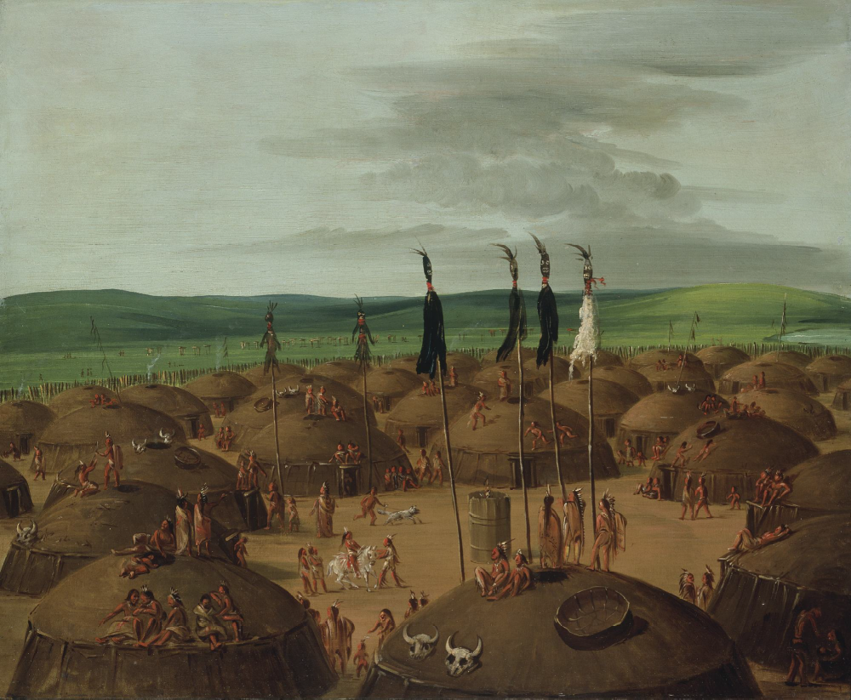

George Catlin, Bird's-eye View of the Mandan Village, 1800 Miles above St. Louis, 1837-1839, oil on canvas, Smithsonian American Art Museum, Gift of Mrs. Joseph Harrison, Jr., 1985.66.502

Figure 2
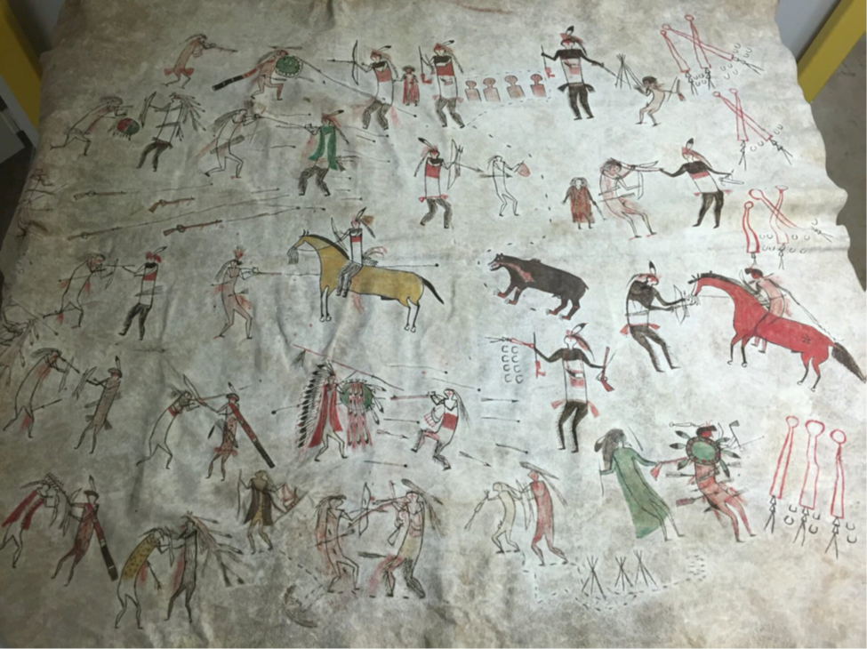
Artist(s) once Known, Robe with War Exploits, Upper Missouri, circa 1835. Native-tanned buffalo hide; brown, red, yellow, and green pigment. 72 x 80 in. National Museum of Natural History, Department of Anthropology, Smithsonian Institution, 2130. Provenance: Transferred from the War Department, 1866. Photograph by the author.

Figure 3
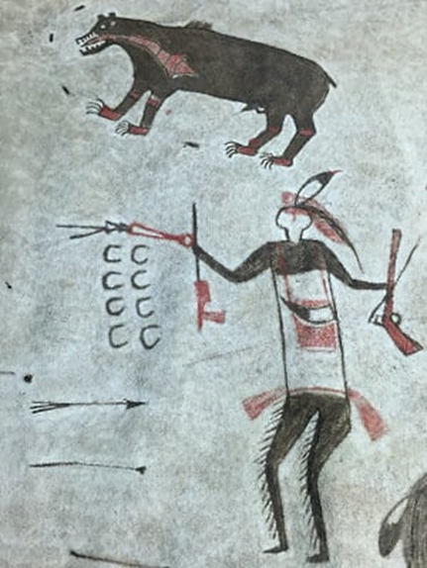

Figure 4
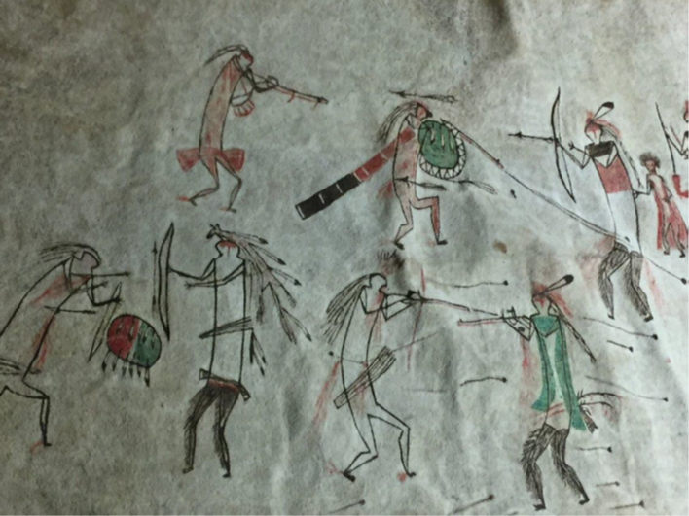

Figure 5
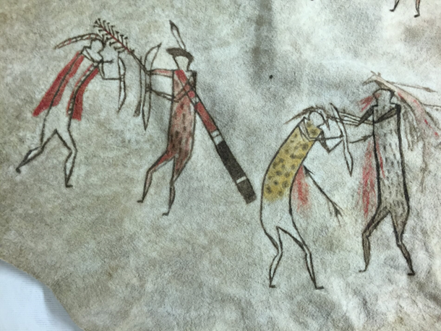

Figure 6
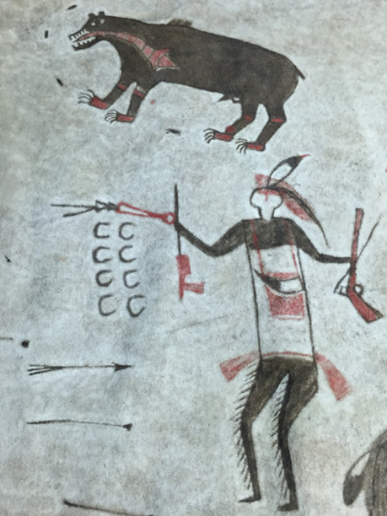

Figure 7
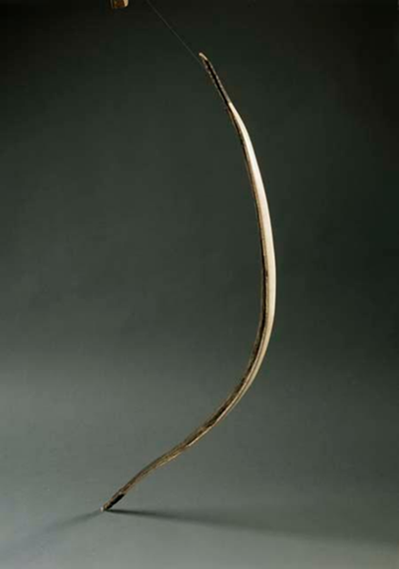

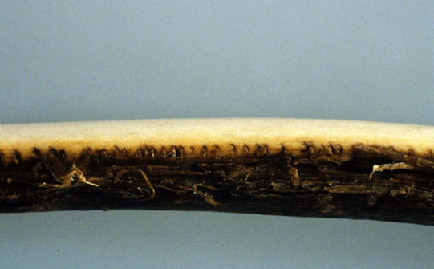
Elk antler bow, Mandan, 1800 – 1840. Horn, Sinew, Antler. 78 x 2.5 x 2 cm (30 11/16 x 1 x 13/16 in.) Cambridge, Massachusetts, Harvard University, Peabody Museum of Archaeology and Ethnology, Gift of the Heirs of David Kimball, 99-12-10/52946.

Figure 8
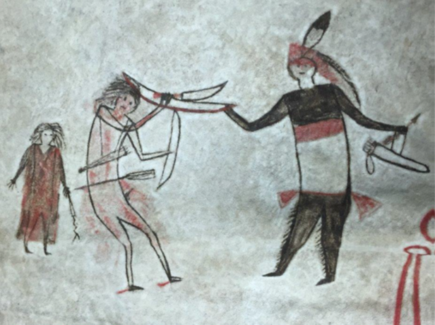

Figure 9
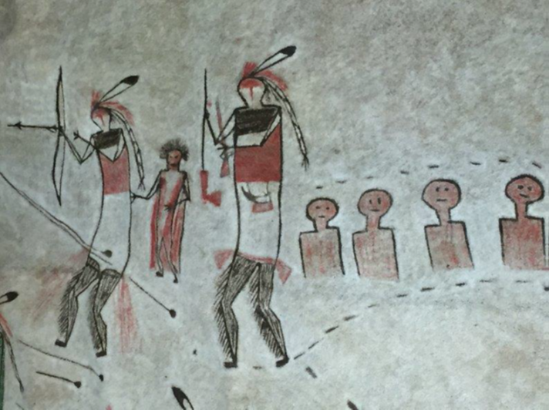

Figure 10
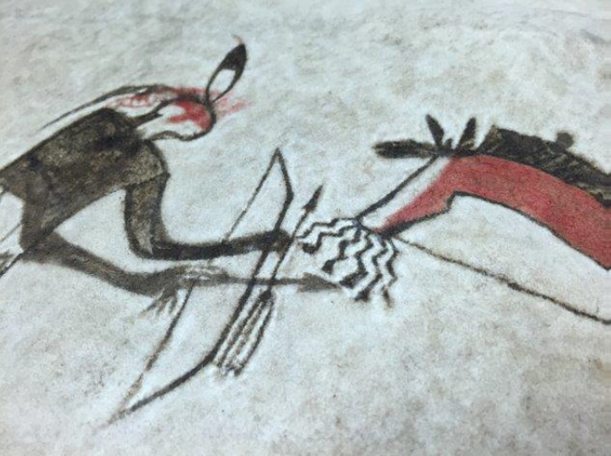

Figure 11
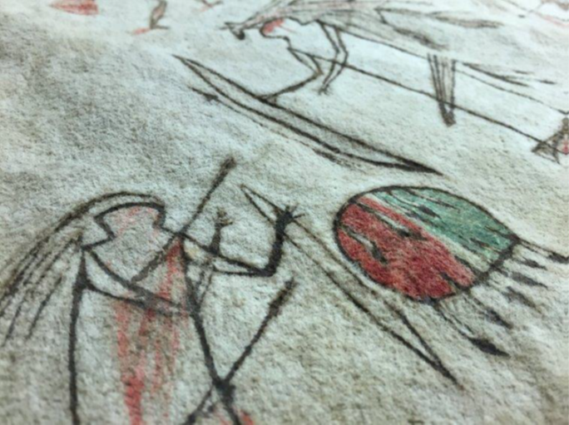

Figure 12
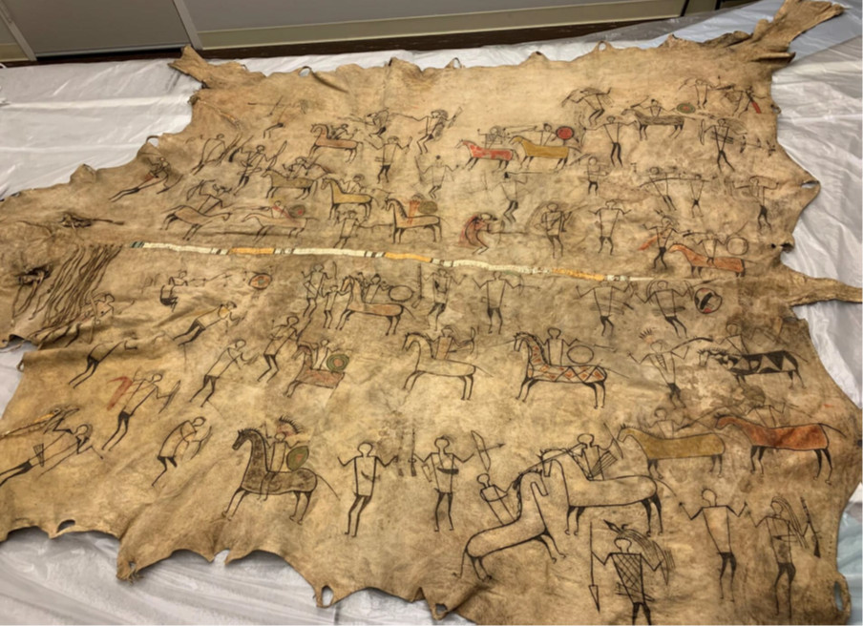
Artist once known, Pictographic Bison Robe, 1780-1825. Native tanned leather, porcupine and bird quills, plant fiber, pigment, 94 ½ x 102 in (239 x 259.1 cm). Cambridge, Massachusetts, Harvard University, Peabody Museum of Archaeology and Ethnology, Gift of the Heirs of David Kimball, 99-12-10/53121. Photograph by the author.

Figure 13
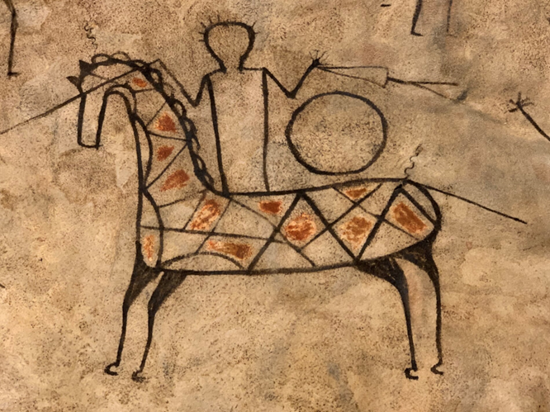

Figure 14
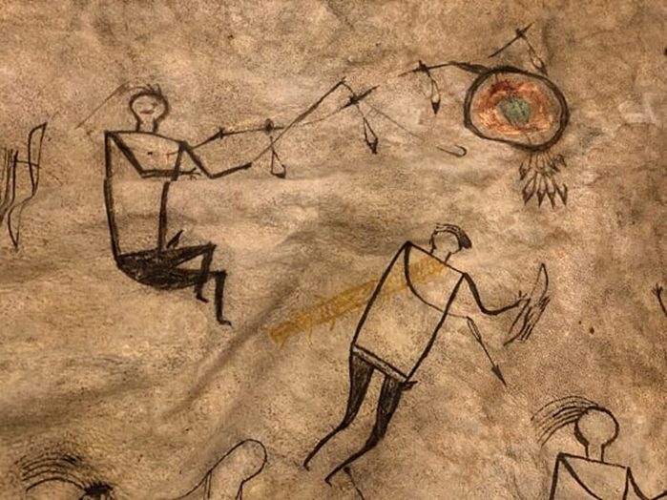

Figure 15
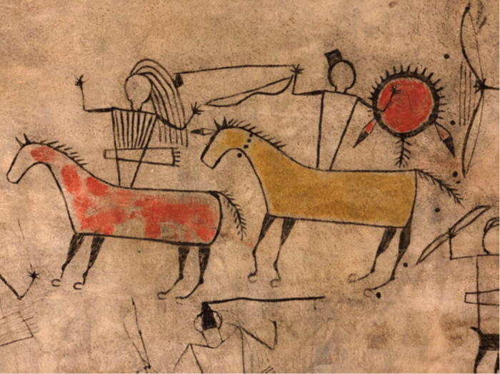

Figure 16
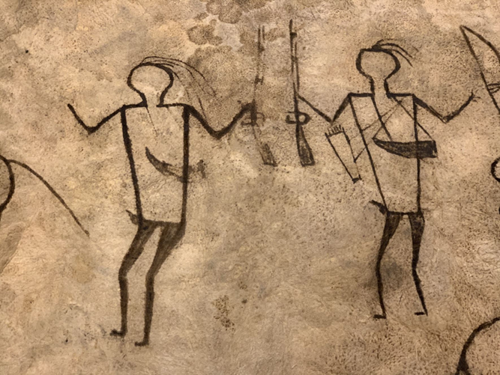

Figure 17
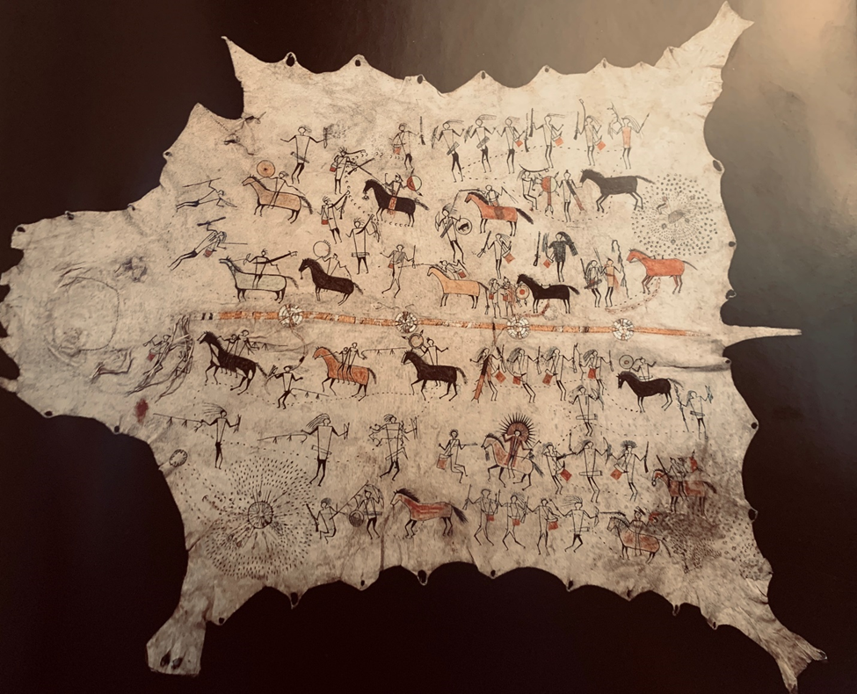

Artist once Known, Robe, 1800 – 1830. Central Plains artists. Native tanned leather, pigment, porcupine quills, 58 3/8 x 88 ¼ in (148.3 x 224.2 cm). Paris, France, Musée du quai Branly, gift of Chaplain-Duparc, 71.1886.17.1

Figure 18
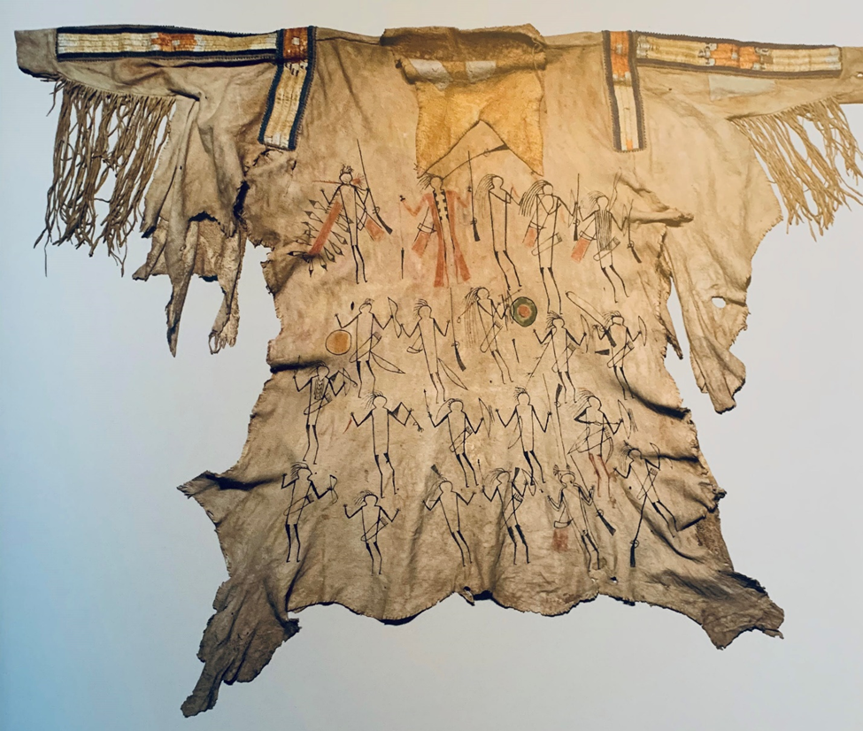
Artist once Known, Man’s shirt, 1810. Upper Missouri River Region artists. Native tanned leather, pigment, porcupine quills, glass beads, maidenhair fern, 35 ½ x 19 ¾ in (90 x 50 cm). Bern (Switzerland), Bernisches Historisches Museum, Collection of L. A. Schoch, 1890.410.15.

Figure 19
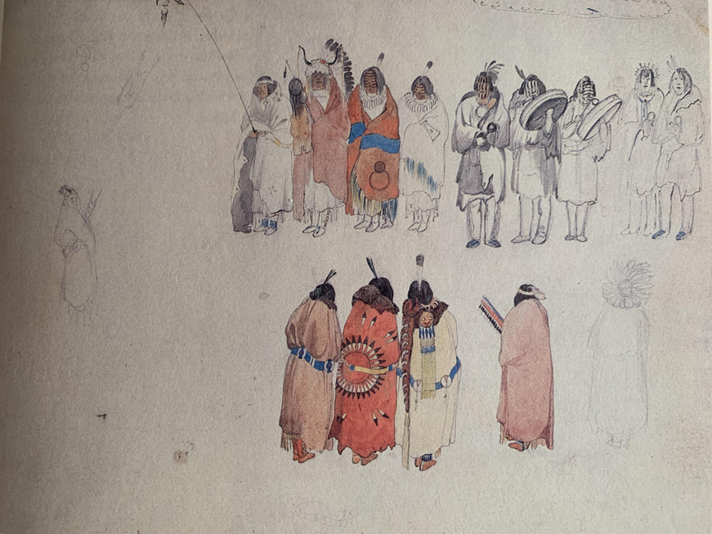
Karl Bodmer, Hidatsa Scalp Dance, watercolor and pencil on paper, 10 x 12 3/8. Joslyn Art Museum. Gift of Enron Art Foundation.

Chapter II: Encounters at the Knife and Heart River

Beginning in the 1780s, fur traders from the Hudson Bay Company and the Northwest Trading Company would complete seasonal trading in the fall and winter along the Upper Missouri. The Nueta and Nuxbáagas became accustomed to these small bands of traders visiting for weeks, conducting business, and then returning to their French-Canadian outposts. The French presence along the Missouri River was commercial in nature; blankets, European utensils, and other items were exchanged for rich beaver furs harvested and processed by Native men and women.
Meriwether Lewis and William Clark’s arrival in 1804 may have seemed familiar—a unit of at least forty men traveling during the winter presumably for trade—but the size of their party and construction of a fort (without storage for pelts) suggested a different type of interaction. They presented an ambitious but unsuccessful political agenda: establish American territorial sovereignty, discredit Canadian rivals, and forge an alliance among the Nueta, Nuxbáagas, and Sanish against the Dakota Sioux. In this chapter, I will trace the impact of these complex political ambitions of Canadian and American fur traders in their dealings with Indigenous communities, and on Euro-Americans naturalists and artists such as Lewis and Clark, Prince Maximillian of Wied-Neuwied, George Catlin, and Karl Bodmer who both interacted with and represented Indigenous subjects, specifically at the Nueta village Mih-Tutta-Hangkusch.
During the winter of 1804, the members of Lewis and Clark’s Corps of Discovery were introduced to Nueta families who extended their hospitality as the men began to build a fort near their village. Construction was supervised by carpenter Patrick Gass, who began the building project in November 1804. The layout of Fort Mandan included eighteen-foot high walls, eight huts for sleeping quarters, a blacksmith shop, and storehouses arranged in a triangular shaped stockade. To Native eyes, the palisade surrounding the fort was comparable to their own fortified structures, but the angular lines of the fort and a heavy, locked gate presented new challenges to navigate their territory. The gate was open daily (except for Christmas) and Native villagers visited frequently to share food, conversations, and barter trade goods.
By December 1804, the consistent clanging of metal against a small anvil reverberated in the air emitting from the blacksmith’s site. Privates John Shields and Alexander Willard hammered and refined molten metal in the heart of the fort, where their work facilitated cultural interactions between the American exploratory party and the local Nueta community. This early relationship between the blacksmiths at Fort Mandan and individual Native community members is perhaps best, and most succinctly, described by Clark in his journal entry from December 31, 1804, as “a mending of axes, hoes, etc for which the Squars [squaws] bring Corn for payment.” This was a mutually beneficial practice since the repair of metal items and sharpening of axe heads was soon in high demand from Native communities and the exchange of goods provided a steady supply of corn to supplement the American travelers’ stores. Although both men and women participated in this way, only prominent warriors were given prominence in Clark’s journals. One such encounter with a Nuxbáagas chief at Fort Mandan is vividly recollected by Clark in his journey on February 1, 1805:
A war chief of the Me ne tar ras [Nuxbáagas] Came with some Corn and requested to have a War hatchet made and requested to be allowed to go to war against the Souis and Ricarres who had killed a Mandan some time past.

The visual and material exposure to Indigenous warriors and their instruments of war at Fort Nueta suggestively informs the numerous drawings of hatchets and axes in Lewis and Clark’s journals, illustrating the objects’ at once practical and ornamental in use. In January 1805, Clark wrote:“Several Indians here wishing to get war hatchets made,” before outlining the metal head of a hatchet with the words “this shape” blocked inside the letters “pe” straddling the edges of the blade. (Figure 1) Clark embeds this drawing of a hatchet in his text whereas Lewis’ image of a spontoon tomahawk, distinctively isolated in the entry, appears as a thin diamond shaped dagger with curled appendages, suggestive of a fleur-de-lis attached to a wooden shaft. (Figure 2) Lewis exaggerates the proportions of the blade to draw attention to the four small holes piercing its surface, perhaps to emphasize its impractically. In fact, Lewis describes his puzzlement at the Nueta penchant for this style of weapon considering its unusual design in his journal on February 5:
the great length of the blade of this ax, added to the small size of the handle renders a stroke uncertain and easily avoided, while the shortness of the handel must render a blow much less forceable if even well directed, and still more inconvenient as they uniformly use this instrument in action on horseback.

Lewis’ bewilderment about Nueta weapon preferences may also be understood to reflect his unfamiliarity with the nuances of Indigenous warfare and the significance of “counting coup.” Weapons were increasingly in demand throughout the winter of 1804 and 1805, and in the
weeks prior to the group’s departure farther west, Clark noted in his journal, “Maney Inds. [sic] Here to day all anxiety for war axes. The Smith have not an hour of idle time to spear.” The popularity of the smithy also arguably allowed Lewis and Clark to solidify and strengthen their relationship with the Nueta not only with the typical gifts establishing diplomatic relations such as silver medals, cloth, or beads, but by repairing weapons.
On their return journey in August 1806, Lewis and Clark again visited Nueta territory and stayed for a week. They reconvened with Nueta leaders Sheheke (Mitutanka village) and Black Cat (Nuptadi village) to discuss diplomatic measures in response to heightened Dakota Sioux aggression in the area. Clark recollected these interactions in his journal on August 17, 1806:
We then Saluted them with a gun and Set out and proceeded on to Fort Nueta where I landed and went to view the old works the houses except one in the rear bastion was burnt by accident, Some pickets were Standing in front next to the river…

This journal entry is particularly significant because it is the only extant source to document the mysterious Fort Mandan burning. Nearly twenty-five years later, a reconstruction of the fort, aptly named Fort Clark, would once again occupy the area.
In 1832, the steamboat Yellow Stone carried large loads of trade goods on its maiden voyage through the upper Missouri region to Fort Clark. The arrival of the steamboat was highly anticipated as it promised to shorten travel time, increase river traffic, and boost the amount of goods traded. Bison robes and beaver pelts flowed down to profit merchants in St. Louis, while rifles, powder and shot, mirrors, metal tools, and European beads traveled upstream.
Fort Clark arguably transformed the region into a year-round production center, concentrating both Euro-American settlers and Native communities along the Upper Missouri. James Kipp, an administrator for the American Fur Company, was the man who built Fort Clark in 1830 and located it near the Nueta village Mih-Tutta-Hangkusch, located a mere 250 yards upstream. Fort Clark also served visiting tribes such as the Nuxbáagas, Crows, Sanish, and Dakota Sioux. The Nueta’s winter residence soon remained occupied year-round instead of seasonally due to the increase in fur trade commerce. The most active period at Fort Clark was during the winter when bison and beaver produce their thickest fur, yielding robes and pelts that brought the highest prices.
In spring 1830, American artist George Catlin was among the passengers on the Yellowstone’s maiden ascent of the Missouri. The 1800-mile journey slowly progressed upstream from to Fort Union and westward to a point near the confluence of the Yellowstone River. Catlin gave particular emphasis to Fort Clark in his correspondence. Indeed, thirteen out of thirty-one letters in his Letters and Notes on the Manners, Customs, and the Condition of the North American Indians focused on life at the fort and the Nueta individuals who visited.
Before achieving recognition as a painter, Catlin had been encouraged by his father to practice law, and, at twenty-one, he began a brief five-year career in law in Litchfield, Connecticut before moving to Philadelphia in 1821 to begin formal artistic training. He established himself as a respected portraitist and miniaturist and was subsequently honored with a membership in the Pennsylvania Academy of Fine Arts in 1824. In the spring of 1828, his portraits broadened from the elite members of Philadelphia society to include Native subjects. This shift may be partially attributed to Catlin’s experience observing nine male Winnebago diplomats visiting Washington city in 1828 for trade negotiations with the federal government. Catlin represented Wah-Kón-Ze-Kaw (The Snake) wearing indistinguishable garments to draw attention to his facial features and weapons. (Figure 3) Wah-Kón-Ze-Kaw stares at the viewer with a solemn expression. Two red tipped eagle feathers pinned to his black hair point downwards to a large wooden club pierced with metal rivets. The curve of the wooden club echoes the curve of his upper body, suggesting that the weapon is an innate part of his militaristic identity.
Catlin’s encounter was not unusual for the period, especially for individuals residing in the capital or in such larger cities as Philadelphia and Baltimore, as Native representatives traveled to political destinations in their efforts to advocate for and maintain tribal sovereignty. They were often invited to meet with the President and other government officials to dispute land cessions, negotiate wartime alliances, and demand that the federal government honor the terms of previous treaty agreements.
For example, between November 1821 and February 1822, representatives from the Kaw, Pawnee, Omaha, and Otoe-Missouri visited the capital on the invitation of President James Monroe, Secretary of War John C. Calhoun, and the Indian Agent for the Upper Missouri Benjamin O’Fallon. This cross-cultural exchange was described by an anonymous attendee, who recounted their experience in the February 11, 1822 edition of the Daily National Intelligencer:
When I entered, I found the whole thirteen, that is twelve men and one woman, seated around the room, and Major O’Fallon, the officer who has charge of them, with four or five other gentlemen standing at the fireplace…They consisted, as I was told, of the Pawnee, Kansas, Otoes, Mahas, and Missouris… The President entered, with the Secretary of War, and taking his seat, delivered to them through the interpreters, an extempore address from notes held in his hand—and, as they used two distinct languages, it was necessary that every sentence should be twice interpreted…

It is impossible to see these people and believe as I so thought that they are destined in not a very long lapse of time to disappear from the face of the earth, without feeling for them great interest. With some vices and much grossness, they possess many fine traits of character, and we never can forget they were the native lords of that soil which they are gradually yielding to their invaders. Yes, I finally believe that all our liberal and human attempts to civilize them are hopeless and unavailing.

This presumably white male eyewitness, along with the President’s cabinet in attendance, affirmed that negotiating land disputes and treaty protocols would only be a temporary measure given the seemingly inevitable demise of Indigenous culture and livelihood since the notion that Native Americans were a romantic and noble race destined to disappear before the advance of Anglo-American settlers.
Earlier American artists such as Charles Bird King had painted Native delegations during their brief visit in Washington D.C., but Catlin became one of the first to paint Native individuals within their homeland. Catlin’s desire to record as many tribes as possible traded quality for quantity, notably expressed in his informal handling of bodily proportions in full length portraits. In comparison, his concentration on the head and shoulders of his subjects built upon his skillset as a miniature portraitist. In his 1830 portrait of his wife, Mrs. George Catlin (Clara Bartlet Gregory) is represented in three-quarter profile. (Figure 4) Her blue eyes gaze into the distance and curly brown hair sways around her shoulders. Her delicate curls and lacey bodice contrast with her pale white skin. Mrs. Catlin’s portrait is enveloped by a rich purple velvet frame, inviting the touch of the viewer. The sparseness of the composition isolates her at the picture plane, lending an impression of closeness and familiarity. Catlin carried this penchant for psychological nuance as he traveled throughout the American West to paint Native communities.
From 1830 to 1836, Catlin claimed to have visited fifty tribes west of the Mississippi, from present-day North Dakota to Oklahoma, creating an extensive visual record of Native life. He proclaimed interest in capturing the lifestyles of Native communities as reflected in the numerous paintings he completed during his travels and albeit brief interactions with tribes over the course of six years. For example, traveling along the Missouri River in 1832, Catlin painted over 135 works in fewer than ninety days and amassed nearly 200 paintings in five months. His twenty-five portraits and landscapes of the Nueta community account for nearly twenty percent of his paintings. He traveled the Great Plains for four summers between 1832 and 1836 and one winter in 1837-38, despite his claim to have spent eight years meeting with Native communities.
Paintings completed during this period are described by Catlin, who emphasized his motives for representing Native tribes as he believed:
I have flown to their rescue—not of their lives or of their race (for they are ‘doomed’ and must perish) but to the rescue of their looks and their modes… yet, phoenix-like, they may rise from ‘the stain of a painter’s palette’ and live again upon a canvas and stand forth for centuries yet to come, the living monuments of a noble race.

His writings, along with those of contemporaneous writers and politicians, attest to an urgent need to represent Native culture threatened by Western expansion. Arguing for the purchase of Catlin’s Indian Gallery by Congress in 1849, Daniel Webster, then a senator from New York, passionately characterized Catlin’s collection as “an American subject, as belonging to us, to our history, to the history of a race whose lands we till, and over whose graves and bones we tread every day.” Native communities were perceived as ghosts in the making, their fate presumably inescapable. Catlin’s paintings were illustrations to enhance his elaborate descriptions of encounters with various Native communities in a series of letters first published in New York newspapers (such as the Spectator and the Daily Commercial Advertiser in 1832) and later republished in his 1841 two-volume monograph Letters and Notes on the Manners, Customs and Conditions of the North American Indians. Between 1836 and 1839 – before taking his travelling show to London, Paris and Brussels – Catlin exhibited his gallery in New York City, Washington, Baltimore, Philadelphia and Boston. He lectured on his collection of paintings and items of material culture to enraptured audiences. In 1843, English audiences observed ceremonial dances performed by a troupe of Ojibwas.
Following a similar route to Catlin’s, the German naturalist, Prince Alexander Phillip Maximilian zu Wied-Neuwied embarked on an exploration along the Missouri River, with a plan to follow the path of Lewis and Clark. Maximilian studied at the University of Göttingen, briefly served in the Prussian army, and fought in the Napoleonic wars. He was educated in anthropology and the natural sciences, and befriended Alexander von Humboldt, the German geographer and biologist. Humboldt's scientific method emphasized direct field observation, measuring and collecting local materials, allowing himself time to experience the emotional and aesthetic sense of one’s surroundings. Maximilian traveled to Brazil between 1814 and 1815 to learn about the Botocudo tribe and viewed his 1832 trip to North America as a complement to his previous work. Maximilian was motivated by Humboldtian science which promoted an insistence on keen scientific observation, and he carried this training with him, closely recording the flora, fauna, and Indigenous people of the Great Plains.
Maximilian hired Swiss artist Karl Bodmer and German taxidermist David Driedoppel to accompany him on his 1832-1834 expedition through the region. Working at a more leisurely pace than Catlin, and responsive to Wied’s scientific interests, Bodmer painted 360 sketches and watercolors of landscape scenes, animal studies, and portraits of Native individuals. Each portrait featured ethnographic signifiers—large painted bison robes and other forms of regalia, body paint, ornamental decorations—to provide Maximilian with a visual resource for his future anthropological study. Among Bodmer’s Native subjects, his most significant body of work involves the Nueta, comprising twenty-five percent of his collection.
Maximilian’s daily reflections and Bodmer’s portraits culminated in the 1839 publication of Reise in das innere Nord-America in den jahren 1832 bis 1834 (Travels in the Interior of North America 1832 to 1834) complete with abridged transcriptions of his journals and supplemented by eighty-one hand-painted aquatints of American wildlife and Native tribes by Bodmer. Maximilian’s journals combined the genre of travel writing with scientific descriptions of the flora, fauna, and geological formations enriched with ethnographical accounts of the various Native tribes he and Bodmer encountered.
Nearly a year after their departure from Prussia in 1832, the European party traveled to St. Louis where Clark served as Superintendent of Indian Affairs. He issued trading licenses, gathered information for a map of the West, on which he was working, and acted as a patron to artists and explorers. Maximilian and Bodmer met with Clark’s nephew Benjamin O’ Fallon, one of the primary agents for Native tribes along the Missouri River. Gifted a set of thirty-four maps, Maximilian’s party traveled on the Yellowstone bound for the upper Missouri river, just as Catlin had two years prior.
Clark kept a collection of cultural items from his 1804 exploration, and had the opportunity to enhance this collection while superintendent. In this position, which he held until his death in 1838, he received numerous Native delegations (who often presented him with gifts) and issued passports to American and European explorers hoping to travel westward. William C. Preston, a family friend who visited Clark in 1816, observed his growing collection. His correspondence provides some of the earliest descriptions of Clark’s so-called museum:
It was adorned with ornamented and painted buffalo robes, numerous strings of wampum, every variety of work of porcupine quills, skins, horns, claws, bird skins, numerous and large Calumets, arms of all sorts, saddles, bridles, spears, powder horns, plumes, red blankets, and flags.

Clark’s collection arguably influenced Catlin, Maximilian, and Bodmer, who all viewed it before traveling northward along the Missouri River between 1832 and 1833, suggestively informing their own sensibilities about the cultural importance of Indigenous material objects.
Maximilian and company wintered at Fort Clark near the Mih-tutta-hang-kusch village for five months in 1833 for practical reasons as they waited for the frozen Missouri River to thaw and become navigable—however, weather was not their only reason for remaining in Nueta territory. In August 1833, they witnessed a bloody conflict between the Blackfeet and Cree, which caused Maximilian and his party to leave Fort McKenzie earlier than expected. They traveled quickly to Fort Union before settling at Fort Clark for the winter in November 1833. Bodmer’s popularity during the party’s stay at Fort Clark suggests that his paintings were viewed positively, as indicated by several village leaders and warriors who visited such as Mató-Tópe and Síh-Xídä, whose biographies and artwork will be explored in later chapters.
Fort Clark resembled other trading posts in design: a palisade surrounded an open courtyard around which business offices, guest quarters, storerooms for merchandise, and a kitchen were arranged. Many people from Mih-Tutta-Hangkusch and Ruptare congregated at the fort to socialize and trade in the courtyard. James Kipp served as Fort Clark’s agent, interpreter, and business liaison, but he also had personal connection to the Nueta village through marriage. Although Maximilian does not provide the name of Kipp’s wife, he does identify her as the daughter of Mandeck-Suck-Choppenih (Medicine Bird). This personal relationship with Nueta residents and his fluency in their language granted the visiting artists an opportunity to establish a warm rapport with and earn the trust of many tribal leaders.
Both Catlin and Bodmer understood themselves to be historians of Native culture although their portrait style differed dramatically due to differences in training and cultural objectives. Mató-Tópe’s portraits reveal Bodmer’s precise attention to details whereas Catlin’s version generalizes visual details. (Figure 5 and 6) Catlin’s portrait presents Mató-Tópe in a rigid profile whereas Bodmer shows him in a three-quarter view. Bodmer defines Mató-Tópe’s facial features such as his jawline, high cheekbones, and fuller lips compared to Catlin’s flatter facial features. Finally, Catlin presents Mató-Tópe with a ruddy skin tone, which softens and blends his features into the red pigment painted on his hide shirt. In contrast, Bodmer concentrates on separate colors to distinguish Mato-Tope’s facial features, bringing the vertical black lines and red pigment outlining his eyes into focus. Although the Nueta leader wears a similarly decorated hide garment in both paintings, one can discern Bodmer’s more extensive knowledge of anatomy. The quilled bands on Mató-Tópe’s sleeves crinkle with the adjustment of his left arm on his hip; he slightly bends his right knee to balance the weight of his lance.
Bodmer’s portraits emphasized the unity between art and science. English philosopher and critic, William Hazlitt, explained the similarities between the two approaches:
The anatomist is delighted with a coloured plate, conveying the exact appearance of the internal parts and dissection of the human body…The learned amateur is struck with the beauty of the coats of the stomach laid bare, or contemplates with eager curiosity the traverse section of the brain.. It is the same in art as in science. The painter sees the picture in nature before he transfers it to a canvas. He refines, he analyzes, he remarks fifty things, which escape common eyes, and this afford a distinct source of reflection and amusement. Art is the microscope of the mind... and conveys every object in a little universe in itself.

Microscopes and other advancing technologies revealed, rendered, and studied fragments of the body. Their lenses could adjust to see closely or clearly, providing a synthesis of knowledge to the viewer. Bodmer’s portraits like medical illustrations, formed a visual encyclopedia of Native subjects. Such representations of the body—whole or partial, real or symbolic—illuminated portraits painted by Catlin, Bodmer, and Native artists themselves.

Chapter II Images
Figure 1
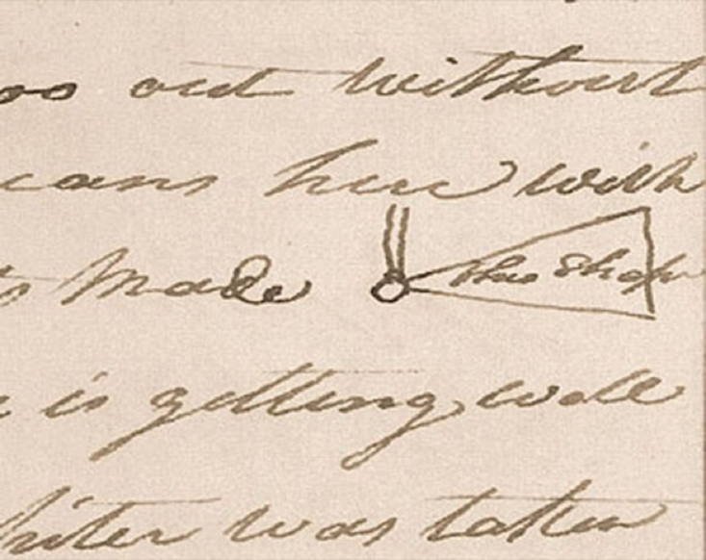
War Hatchet, January 28, 1805, Codex C, p. 158
Journalist: William Clark Source: Codex C 1805 American Philosophical Society library

Figure 2
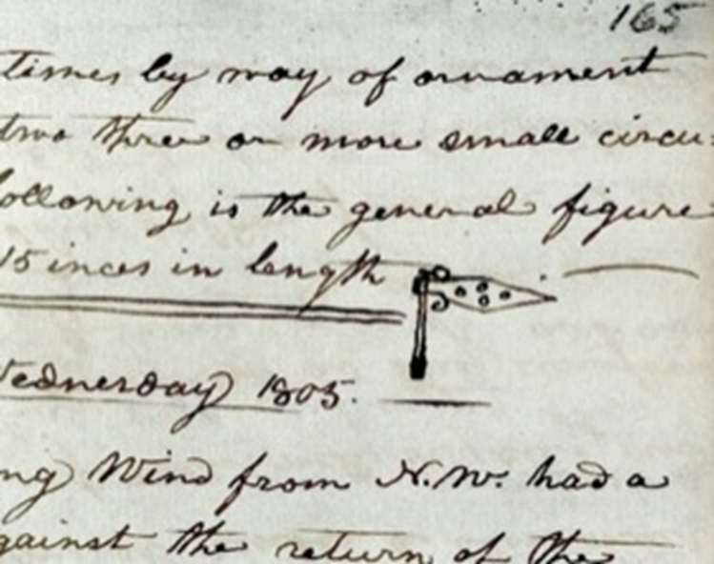
Battle Ax, February 5, 1805, Codex C, p. 165 (American Philosophical Society library)

Figure 3
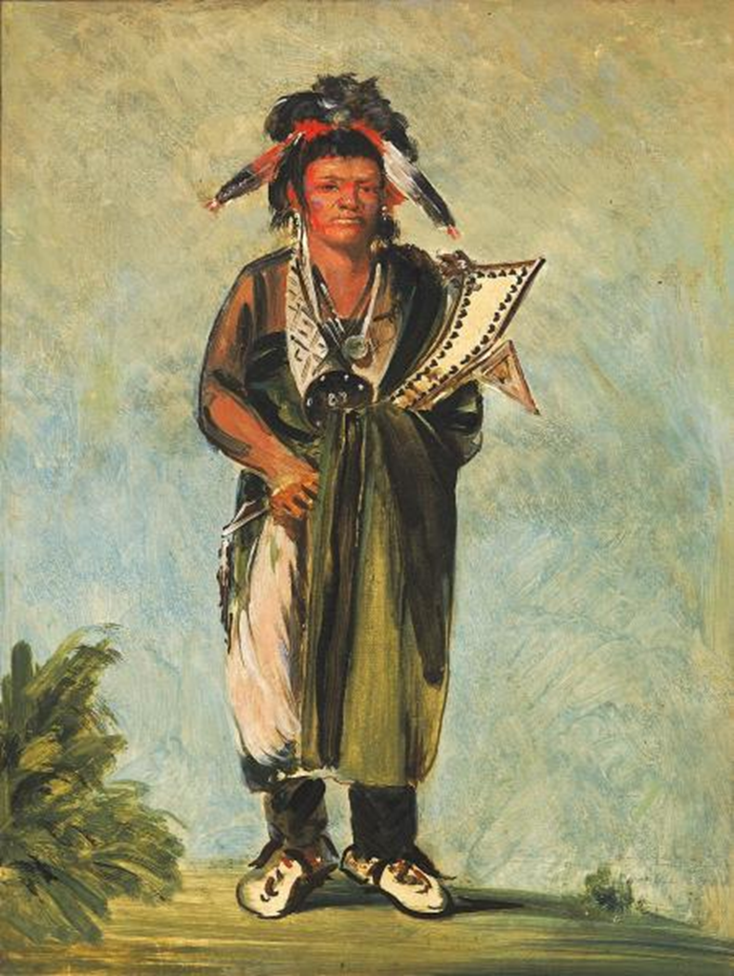
George Catlin, Wah-kón-ze-kaw, The Snake, 1828, oil on canvas, Smithsonian American Art Museum, Gift of Mrs. Joseph Harrison, Jr., 1985.66.213

Figure 4
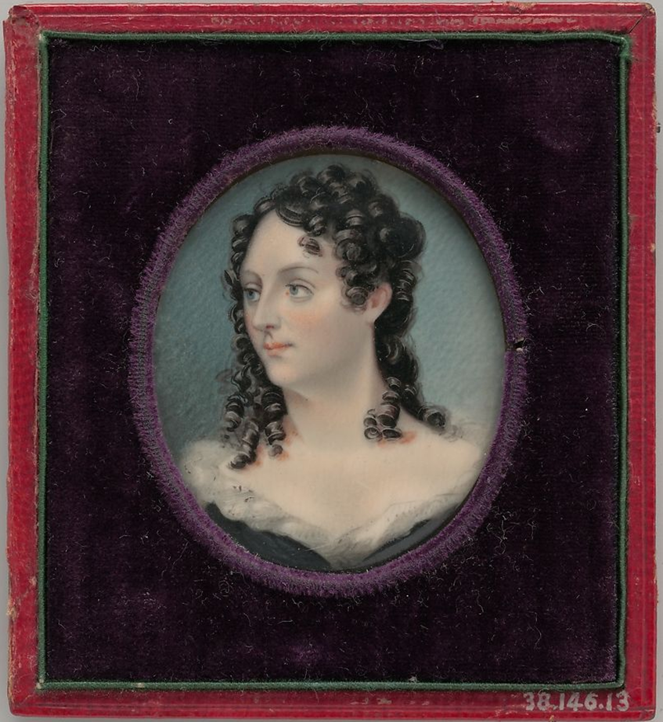
George Catlin, Mrs. George Catlin (Clara Bartlet Gregory), 1830, watercolor on ivory, Metropolitan Museum of Art, Fletcher Fund, 1938, 38.146.13

Figure 5
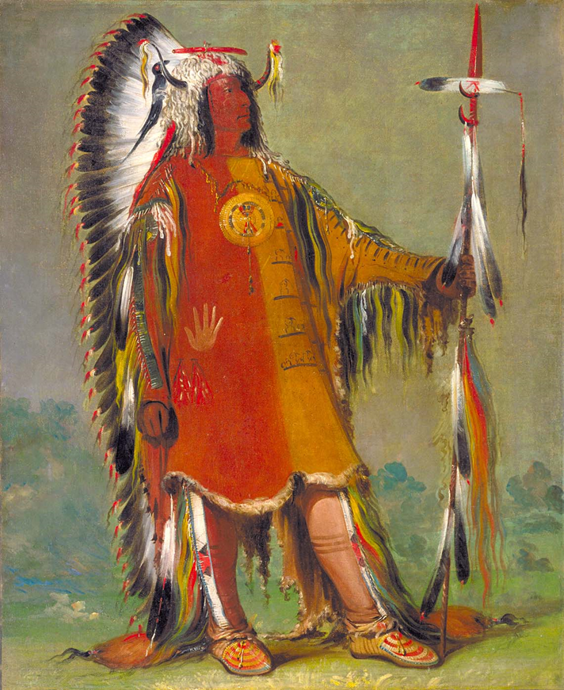
George Catlin, Máh-to-tóh-pa, Four Bears, Second Chief, in Full Dress, 1832, oil on canvas
Smithsonian American Art Museum, Gift of Mrs. Joseph Harrison, Jr., 1985.66.128

Figure 6
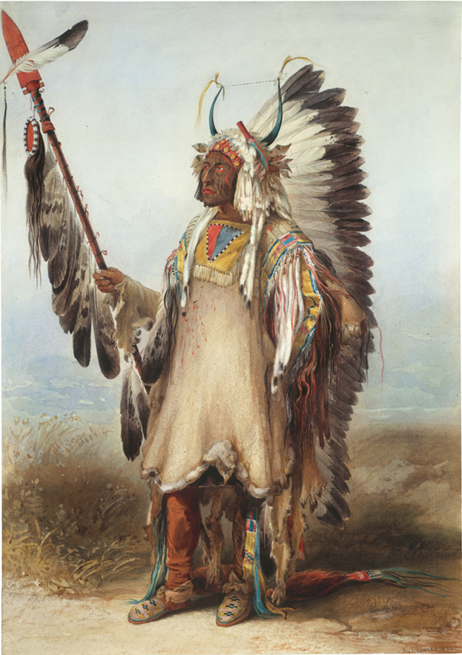
Karl Bodmer, Mató-Tópe, Mandan Chief, Joslyn Art Museum, 1986.49.383

Chapter III: Mató-Tópe, Metamorphosis of a Leader

In this chapter, I analyze the likeness of Nueta leader Mató-Tópe through his self-portraits and those painted by Catlin and Bodmer in 1832 and 1833. The series of drawings creates an unparalleled survey of his military record and chiefly responsibilities throughout his lifetime. Accompanying biographical stories were translated by James Kipp to visiting Euro-American explorers as well as interviews with Mató-Tópe’s descendants. His self-portraits coupled with the Euro-American drawings create an archive of his political power.
Mató-Tópe’s father Suk-shi (Good Boy) was a leader at the On-a-Slant village, named for its terrain sloping downwards to the Heart River. On-a-Slant village was one of seven or perhaps nine fortified settlements, many of which had been inhabited for at least two hundred years. Nomadic tribes most likely carried the smallpox virus as they crisscrossed the grasslands to trade with the Nueta villagers in the 1780s. Lakota artists recorded the impact of smallpox on their winter counts featuring bodies speckled with rashes. The devasting smallpox epidemic of 1781 decimated On-a-Slant village, prompting Suk-shi to relocate his community farther upstream along the Missouri River.
They settled together in the Painted Woods area (near present-day Nueta Lake) because their reduced numbers made them more vulnerable to Dakota Sioux attacks. According to anthropologist Alfred Bowers, “Good Boy was able to unite the remnants of several villages into a single village and to co-ordinate elements with a minimum friction.” By 1787, the Nueta established Ruptare and Mitutanka on opposite banks of the Missouri River in order to be closer to their Hidatsa allies less than twenty miles north of the Knife River. By 1822, villagers maintained their residence at Ruptare but also had established Mih-tutta-hang-kusch (First Village) three miles downstream from their original Mitutanka site.
Mató-Tópe carried on his father’s legacy of leadership by earning a role as second chief at Mih-tutta-hang-kusch village. He served in multiple military societies, was honored as a knowledge keeper, spoke multiple languages, and participated on the larger council of the Awatíkihu (Five Villages). Maximilian’s expedition journals include a report on Mató-Tópe’s military accomplishments:
The Nueta and the Manitaries [Hidatsa] are said to fight well, and there have been frequent acts of individual bravery. One of their most distinguished warriors is Mató-Tópe, who has killed more than five chiefs of other nations.

His reputation as a warrior preceded him, even earning him a war name by the Assiniboine, one of whom apparently observed, “he rushed on [them] like four bears.” He gained the admiration of his community due to his military service and generosity, which Catlin aptly summarized: “This extraordinary man, though second in office is undoubtedly the first and most popular man in the nation.” When Catlin and Bodmer visited the territory, Mató-Tópe, then in his forties, an honored soldier and mentor in his community, served as a primary liaison between the Nueta and their Euro-American introductions.
Mató-Tópe’s rank and role as a knowledge keeper was instrumental in establishing local Indigenous cultural protocols. Both Catlin and Maximilian describe their interactions with Mató-Tópe in journal entries recalling his thoughtfulness and tendency to gift items to non-Native acquaintances, integrating outsiders into social custom among his community. Forming an alliance with a new partner often began with a ritual performance such as gift giving, feasts, speeches, and dances before any commercial exchange occurred. Catlin describes his initial meeting with Mató-Tópe in spring 1832:
In full and splendid dress… he led me through the village and into his own lodge where a feast was prepared in a careful manner and waiting our arrival. I was seated on a very handsome robe, most ingeniously garnished and painted with hieroglyphics; and he seated himself gracefully on another one at a little distance from me…

After the meal, Mató-Tópe offered Catlin a smoke from his own carved pipe as a symbol of friendship. This performative exchange literally and metaphorically breathed the intentions for a harmonious relationship. Mató-Tópe further solidified their relationship by making an offering Catlin described in his journal entry: “Drawing his knife from his belt, he cut off a very small piece of [buffalo] meat, and pronouncing the words “Ho-pe-ne-chee wa-pa-shee’ (meaning a medicine sacrifice) and threw it into the fire.” The scent of tobacco and aroma of smoked buffalo roasting in the central hearth formed an intimate connection of communal food preparation, hospitality, and feasting that were essential to building alliances in Nueta society.
Mató-Tópe’s artwork also provides a framework for understanding Indigenous gift giving practices, suggesting the variable meanings of gifts, their presentation, and intended recipients. The concept of gift exchange was not a barter system for goods, but rather each giver decided which item from their belongings would be considered a valuable gift for each recipient. The exchange itself solidified the relationship in a tangible way and sometimes in a public forum for the approval of others. However, misunderstandings of this social practice could arise based upon the quality of gifts presented. For example, Maximilian recounts a conversation he had with Mató-Tópe on November 9 in which he describes the Nueta leader’s generosity with Catlin, who had visited the village the prior year,
Catlin ordered from him two attractively painted bison robes of great value. Mató-Tópe made every effort to paint them beautifully and also bought two expensive elk hides for that purpose. Catlin gave him in return only a few small, insignificant things. The Indian did not accept this gift but handed it back, saying that, since Catlin must be a very poor man, it would be [Mató-Tópe’s] pleasure to give him the hides as a present.

It was not the act of giving that transformed items, but the intention to give that could facilitate positive relationships. Regardless of the reciprocity of the exchange, the concept of gift giving helped to establish a relationship between Mató-Tópe and visiting artists.
When Maximilian and Bodmer established their living quarters and a makeshift painting studio at Fort Clark from November 1833 to April 1834, Mató-Tópe visited them an astonishing total of fifty-five times. Maximilian invited neighboring Nueta men to have their portraits painted by Bodmer and the studio quickly became a meeting house for village residents to bring their friends and families to view Bodmer’s collection of drawings. Mató-Tópe’s first visit occurred on November 9, and he scrutinized many of Bodmer’s drawings, recognizing men from nearby communities. Maximilian does not record who exactly Mató-Tópe recognized, but I propose that he was referring to Bodmer’s portraits of Cree men Mähsette-Kuiuab and Piäh-Sukah-Ketutt painted in October 1833 at Fort Union, three weeks prior to their arrival at Fort Clark.
On the 13th of November, Mató-Tópe introduced his wife and son Mató-Berockä (Male Bear) to the European men at Fort Clark. Mató-Tópe carried his personal medicine drum and a tall lance decorated with eagle feathers which he had earned from the Kaua-Karakachka society. These items would later be incorporated into Bodmer’s portrait of him. Gifts of tobacco, a double pipe, bear necklace, drawing paper, and colored pencils gifted by Maximilian and Bodmer on November 23 began a cordial exchange among the men resulting in Bodmer’s full-length painting of Mató-Tópe on December 24 followed by another portrait on January 17. An exchange of gifts expressed an extended kinship which carried responsibilities of hospitality and generosity for both giver and receiver.
Catlin’s and Bodmer’s multiple portraits of Mató-Tópe suggest his willingness to be drawn and perhaps even to encourage his male peers to consider the opportunity as a means of self-documentation. Maximilian’s journal entries record multiple occasions where Mató-Tópe visited their Fort Clark studio when other Native men were having their portraits done by Bodmer. Catlin’s oil painting Máh-to-tóh-pa, Mató-Tópe, Second Chief, in Full Dress (1832) and Bodmer’s Mató-Tópe, Nueta Chief (1833) watercolor version, represent the Native leader in similar poses. (Figure 1 and 2) Mató-Tópe’s stature fills both paintings and dominates the compositions. As an esteemed warrior and prominent leader, Mató-Tópe’s regalia befits his status: he wears a bison horn cap adorned with white weasel skins, a trailing war bonnet, quilled moccasins with attached wolf tails, and a feathered lance of scalps, presumably souvenirs of the slain. The clothing invokes a salient reminder of previous injuries suffered in battle and the honor gained from defending his community.
In Bodmer’s image, Mató-Tópe’s lance projects to the right on a diagonal that succeeds in destabilizing his powerful and stationary pose. Its oblique position has an additional reconfiguring effect, in that it reduces his physical attachment to the otherwise threatening weapon, arguably diminishing his power. The intensity of Mató-Tópe’s gaze helps steer the viewer’s senses toward a closer engagement with the image, compelling one’s eye to become conscious of the war scalps hoisted proudly on his lance. He stands among a field of short prairie grass, an ethnographic habitat, personified as a specimen for Maximilian’s future examination.
Catlin’s portrait presents Mató-Tópe’s immense stature against an indistinct background functioning to create a more prominent sense of his enormity. The technique encourages the viewer to see Mató-Tópe as a mythic hero of enlarged proportions. Indeed, Catlin himself acknowledged not having “entirely represented everything in his portrait; having rejected such trappings and ornaments as interfered with the grace and simplicity of the figure.” The effect of rendering Mató-Tópe with few possessions places a greater emphasis on his virtuous character. Sketchy brushstrokes minimize the specific details of his regalia, bringing focus to his facial features and stately countenance. His physical appearance and facial expression conveys a sense of his individuality but in sum represent a generic image.
A man’s military and political reputation was also validated through specialization in other activities. Anthropologist Alfred Bowers has pointed out, “Some were leaders of buffalo hunts, fish-trappings, war expeditions, or various ceremonies, while others specialized as singers, painters, arrow makers, or storytellers.” Each role contributed to the prosperous function of the community, but only the idea of the male warrior earned any acclaim in the documentary records of Catlin and Maximilian, or the portraits painted by Catlin and Bodmer. Mató-Tópe earned renown among his community by his participation in the Dog Society and Black Mouth society, as well as a leader of the Okipa ceremony. According to Bowers, “He had a successful war record and did much fasting. That would never have elevated him to more than a war leader, but the many feasts he made to which the older hereditary bundle-owners were invited gave him the necessary prestige.” Meal preparation and hosting signaled one’s interest to receive and inherit knowledge regarding the transfer of medicine bundles, which required a novice to learn the rituals, songs, and to lead ceremonies.
Mató-Tópe’s drawings immediately locate the viewer in the midst of combat, as discarded rifles in the mid-ground lead to the central image of battle. (Figure 3) In profile, Mató-Tópe has covered his torso with red pigment and wielded a tomahawk to prepare himself against impending harm. His enemy, armed with a knife, lunges to disarm Mató-Tópe. The consequent hand laceration that Mató-Tópe endures bleeds uncontrollably onto the ground, making the assault a central focus of the drawing. The prominent position of Mató-Tópe and his opponent within a vacant space heightens the visceral aggression between the two men. Mató-Tópe’s explicit elaboration of his own dress such as the fringed leggings, prominent coup markings, and extravagant war bonnet arouse ideas of greatness, and further inform the viewer that he visually dominates his enemy. Mató-Tópe’s conflict with the unnamed warrior is replicated on two other painted bison robes. Their compositional arrangement appears similar to that of painted robes by Nuxbáagas artists Péhriska-Rúhpa (Two Ravens) and Lachpitzi-Sihrisch (Yellow Bear), which represent men with rectangular torsos and thin limbs. However, Mató-Tópe’s inclusion of the same scene on multiple drawings remains unique. In the Bern Historical Museum robe the scene appears at the lower right coupled with seven other military vignettes encircling a war bonnet design. (Figure 4) The Linden Museum—Stuttgart painted robe represents a similar clash in the lower left arranged horizontally with seven other scenes. (Figure 5) Both robes identify Mató-Tópe by the red ochre staining his body and the faint outline of a ceremonial pipe hovering near his waist. In contrast, the appearance of the Cheyenne soldier with whom he struggles is marked only by a lone eagle feather atop his head and otter tippets covering his braids minimizing his status as a warrior.
Mató-Tópe’s legendary encounter with this Cheyenne warrior begins with his pursuit of numerous others who stole horses and scalped one Nueta man. Mató-Tópe quickly assembled a war party, and they chased after the Cheyenne on horseback, but the Nueta party was daunted by the large number of enemy soldiers as Catlin vividly described:
Mah-to-toh-pa galloped out in front upon the prairie, and plunged his lance into the ground… calling out to the Nueta, ‘What! Have we come to this? We dogged our enemy two days, and now when we have found them, are we to turn about and go back like cowards? Mah-to-toh-pa’s lance, which is red with the blood of brave men, has led you to the sight of your enemy, and you have followed it… and Mah-to-toh-pa will fight them alone!

The Cheyenne leader admired Mató-Tópe’s valiant speech and agreed to fight him alone. They charged at one another on horseback with muskets loaded until Mató-Tópe’s horse buckled from an injury. Once on foot, the men began discharging arrows until they had emptied their quivers. Then the Cheyenne brandished a knife and approached Mató-Tópe even more closely. In a struggle for dominance, the Cheyenne struck Mató-Tópe’s hand violently with the knife, and as the wound bled heavily, Mató-Tópe wrestled it from him. Catlin dramatically concludes, “He plunged it to his heart… and claimed in deadly silence the knife and scalp of the noble Cheyenne chief.” Mató-Tópe subsequently carried the knife with him as a sign of his victory along with a permanent scar on his hand. Both Catlin’s and Bodmer’s drawings represent Mató-Tópe wearing a war bonnet adorned with the knife that killed the Cheyenne warrior.
Mató-Tópe also represented a personal event twice on painted robes—one at the Ethnological Museum of Berlin and one in Catlin’s personal collection that no longer survives. Catlin’s sketched Mató-Tópe’s pictographs and referenced one of his accomplishments, which “was well attested by Mr. Kipp and several white men who were living in the Mandan village at the time of its occurrence.” While Catlin and Mató-Tópe studied one of his painted robes together, the Nueta leader began describing his brother’s tragic death. Mató-Tópe encouraged his younger brother to take a herd of horses to a grassy field to graze at a distance from their village. A Sanish warrior caught Mató-Tópe’s brother by surprise and impaled his body with a long spear. Mató-Tópe discovered the lifeless body and carried it back to the village. He extracted the lance and kept the weapon stained with his brother’s blood. Catlin’s brief sketch marks Mató-Tópe’s brother’s body fallen to the ground with a lance and arrow piercing his side. His weapons appear just out of reach so he is unable to protect himself from the attack. (Figure 6) His brother’s isolated and bloodied body embedded among other vignettes marks the event as a pivotal moment in Mató-Tópe’s life.
A Nueta woman named Scattercorn in a 1930 interview with anthropologist Alfred Bowers recited a similar narrative nearly one hundred years later, “During his grief and fasting period, he noticed a raven perched in an oak tree and the bird spoke, ‘The one who killed your brother is named Won-ga-tap (Bear Necklace), and he is the one you should kill.’ While in mourning for his brother, Mató-Tópe retreated from his village and fasted for many days awaiting a supernatural vision to confirm his plans for revenge. His self-denial and isolation was believed to ensure that his requests for spiritual intervention would be granted. Four years later Mató-Tópe publicly announced that he was seeking revenge, and emphatically recounted the event to Catlin:
Let every Mandan be silent… until you hear him sound the war-cry in front of the village, when he will enter it and show you the blood of Won-ga-tap. The blade of this lance shall drink the heart’s blood of Won-ga-tap, or Mah-to-toh-pa mingles his shadow with that of his brother.

Mató-Tópe methodically planned his revenge and decided to murder Bear Necklace at his Arikara village. He traveled many days to reach the site and crept into Bear Necklace’s earth lodge late at night. While Bear Necklace slept, Mató-Tópe struck his lance into his enemy’s side, then scalped him. According to Catlin, “He entered his village amidst deafening shouts of applause, while he brandished and shewed [sic] to his people the blade of his lance, with the blood of his victim dried upon it, over that of his brother; and the scalp of Wong-ga-tap suspended from its handle.’ Both Catlin’s and Bodmer’s portraits feature Mató-Tópe wearing a deceased raven nestled atop his eagle feather war bonnet suggesting the raven’s successful prophecy to avenge his brother’s death. (Figure 7)
A painting by Mató-Tópe presumably represents his supernatural vision with a raven looking backwards from its perch atop a buffalo. (Figure 8) A bear paw with long talons and a handprint flank the buffalo. The two symbols served as a signature for Mató-Tópe who frequently scattered representations of disembodied hands throughout his paintings. Drops of blood near the handprint suggest numerous wounds received in battle. The buffalo serves as a focal point, centrally placed on the robe. Mató-Tópe’s precise rendering of the buffalo physiognomy appears in his detailed attention to the hoofs, rotund body, and large shaggy head. The handprint also establishes a powerful sign of contact between the artist’s touch and his slain bison relative. According to Scattercorn, “When Four Bears killed the Arikara without losing a man, and everything happened just as he had said the raven had predicted, he was highly respected.” Mató-Tópe viewed not only the robe as invested with sacred power, but as a memorial to his brother.
Secondary portraits by Catlin and Bodmer represent Mató-Tópe mourning for his brother. Catlin describes the weight of the man’s sorrow: “His breast has been bared [sic] and scarred in defence of his country, and his brows crowned with honours that elevate him conspicuous above all of his nation.” The lower half of his face is coated with ochre and his chest scarred from physically demanding rituals. (Figure 9 and 10) Bowers confirms Mató-Tópe’s accomplishments: “The number of times one had fasted or inflicted self-torture was as much a part of one’s record as the number of enemies killed or struck in battle, and both were related during ceremonial feasts.”
Mató-Tópe drawings represent numerous conflicts addressing his community’s need for spiritual power and territorial protection. Ritualistic activities and local histories rotate around large concentric circles centered in the painting. (Figure 11) Thirty small colored circles dotting the interior allude to the number of lodges in the Mitutanka village reported by Maximilian. Stylized eagle feathers fan outwards from the larger concentric circles echoing the circular, sunburst pattern of feathered war bonnets. The large design also abstractly resembles a sunflower with its large head dotted with seeds and long petals blooming bright as sun rays. Sunflowers were cultivated for their seeds and grown in a seasonal rotation with corn, beans, and squash. Maxi’-diwiac (Buffalo Bird Woman) recounted her agricultural experience to anthropologist George Wilson in 1912: “Although our sunflower seed was the first crop to be planted in the spring, it was the last to be harvested in the fall.” The painted robe aligns the life cycle of a slain buffalo, the achievements of a warrior, and the significance of seasonal planting.
Mató-Tópe’s drawings served as a medium through which he represented his masculinity. This is seen best in an unidentified portrait collected by Maximilian, which shows a suggestive similarity of style to that of Mató-Tópe’s previous drawings. (Figure 12) A feathered lance bifurcates the composition, placing a man standing off-center to the right while his weapons appear on the left. He stands in an indistinct space facing the viewer with red pigment outlining his eyes and open mouth. The red lining of his war bonnet complements the red vertical stripe of pigment snaking from his torso to his right foot. The large eagle feather war bonnet trailing against his body amplifies his stature and the surrounding negative space. Strips of ermine, drawn lightly in pencil, fall over his shoulders fastened to his war bonnet. He hoists a feathered shield in his left hand as if ready for battle, his right arm is hidden by the war bonnet. He does not wield a weapon implying that his presence marks an event of celebration rather than preparation for battle.
On the left side of the drawing, a long-bow lance tipped with a metal head features numerous eagle feathers attached to a pole. The feathered lance is balanced by a staff adorned with eleven scalps and a hanging drum. The drum aligns with the description in Maximilian’s journal entry from November 13: “His medicine drum, black with red figures representing lighting and buffalo tracks. The background is black; the figures are vermilion (see Bodmer’s sketch).” (Figure 13) Scattered horse tracks run between the lance and red staff signifying coups accomplished on horseback. The enlarged proportions of the lance and eagle features impress the viewer with Mató-Tópe’s accomplishments and tower over his figure. The vertical arrangement of his lances leads the eye to a row of thin lines bordering the left side of the drawing. These sketchy lines coupled with a black half circle floating in the upper left suggest the construction of a palisade surrounding Mató-Tópe’s village Mih-tutta-hang-kusch. It is strategically protected by both the outline of the palisade and the Missouri River winding around it. Mató-Tópe’s frontal pose, distinct facial features, and personalized belongings supplement his biographical repertoire. The scene suggestively represents Mató-Tópe’s victory over Bear Necklace by bringing attention to the feathered lance centered in the composition, his confrontational posture, and the presence of Mih-tutta-hang-kusch.
Mató-Tópe’s drawings illustrate a social organizations in which courage and bold action garnered respect and rank. A demonstrated involvement in war signaled the passage from adolescence into maturity, which, in turn, fostered greater gender separation, as few women participated in combat. Maximilian described the sequence of nine age-graded societies: Fox-Kit, Dog (Little Dog and Foolish/Crazy Dog), Crows, Half-Shaved Heads, Soldiers/Black Mouth, Dogs, Old Dog, Buffalo Bull, and Black-Tail Deers. The most esteemed groups for men to earn status as a warrior were the Dog and Black Mouth societies usually reserved for married men ages twenty to fifty. Men would buy membership into the organization by selecting a mentor, addressing them as father, and secured rank by presenting blankets, horses, muskets in exchange for the dances, songs, and regalia characteristic of each society. According to ethnologist Francis Densmore, “Many dancing songs were used in the lodge, and after any of them a warrior might rise, go forward, and strike the drum as a signal that he wished to relate one of his deeds of valor.” Red sashes, gourd rattles, and eagle-bone whistles were worn during the Dog society dances. The purpose of the Dog Society was the protection of women and children and loyalty to comrades during battle if they needed rescue from their enemies or assistance in any way.
Both the Dog society and the Black Mouth society (also referred to as Soldiers by Maximilian) trace their origin to Good-Fur-Robe (or Village Smoke), a mythical hero and founder of these societies. Good-Fur-Robe selected two men to organize the societies and presented them with hooked sticks to strike the ground during battle. According to Wounded Face, “The hooked sticks represented sunflowers, the other sticks, a corn plant. These emblems were to be planted into the ground while fighting an enemy and were never to be abandoned.” While lances decorated with owl or eagle feathers supplemented the oral narrative of Good-Fur-Robe’s hooked sticks, the choice of sunflower and corn stalks emphasizes the value of agricultural cultivation with Nueta communities.
Conclusion
The 1837 smallpox death toll overwhelmed the living, severely disrupting burial norms and mourning rituals. The importance of burial at the affectionate hands of family involved tender gestures: caressing the skin of the beloved, anointing them with oils, and wrapping them in their prized painted bison robes. The prepared corpse was placed upon a scaffold as mourners gave their final farewell. Consolation from grief emerged through interaction with the grave site where individuals could leave offerings.
Earth lodges nestled next to one another made quarantine nearly impossible and fostered the spread of smallpox. Francis A. Chardon assumed charge of Fort Clark in summer 1834 and kept a detailed journal that documented the epidemic and the disease’s progression in the community. He administered doses of Epsom salt, a supposed treatment, to anyone he could, but the remedy had little impact; the deaths continued to mount to the point that Chardon could no longer record the names or numbers of the dead. Chardon’s journal records on July 26, 1837, that Mató-Tópe was infected with smallpox and disappeared from camp only to return four days later and allegedly presented the following speech: “The 4 Bears never saw a White man hungry, but what he gave him to eat, drink, and a buffalo skin to sleep on, in his time of need.” The speech reduces him to a tragic figure physically marred by smallpox, bitterly lamenting the friendly behavior that may have cost his life.
His drawings on paper and painted robes suggest a widely distributed image of his power. By representing himself, he enlarged his reputation abroad for a new audience to view and learn about his military victories. His portraits painted by Catlin and Bodmer provided a framework of moral leadership for his descendants. Mató-Tópe has achieved legendary status in the nearly two hundred years since his untimely death from smallpox in 1837. His name is synonymous with the construction of the Four Bears bridge (1934 followed by a new bridge in 2005), and the Four Bears casino (1993). His name has come to stand for more than one person’s identity—the mention of his name evokes a profusion of impressions and emotions among members of the Nueta tribe today. He was a leader who commanded respect among his soldiers, generously hosted artists and dignitaries, and defended his community from internal and external fears.
Mató-Tópe status as a chief and a highly decorated soldier in First Village made him a role model for many younger warriors, including Síh-Xídä (Yellow Feather), Beróck-Itaïnú (Bull’s Neck), Mah-táhp-ta‑a (Rushes through the Middle), San-ja-ka-ko-kah (Deceiving Wolf), and Mah-tó-he-ha (Old Bear). Learning the tactical aspects of war from elders during the region’s increasingly political instability was necessary to protect the safety of their village and improve their military record. Many of these men were painted by Bodmer and their participation in the Meníss-Ochatä (Dog Society), a prestigious military rank, was observed by Maximilian. The following chapter analyzes Síh-Xídä’s drawings of his military accomplishments as well as camaraderie with Mató-Tópe and European visitors.

Chapter III Images
Figure 1

Karl Bodmer, Mató-Tópe, Mandan Chief, Joslyn Art Museum, 1986.49.383

Figure 2
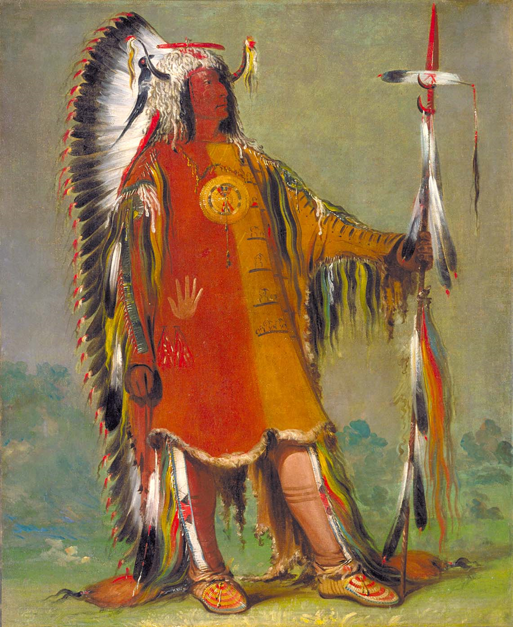
George Catlin, Máh-to-tóh-pa, Four Bears, Second Chief, in Full Dress, 1832, oil on canvas
Smithsonian American Art Museum, Gift of Mrs. Joseph Harrison, Jr., 1985.66.128

Figure 3
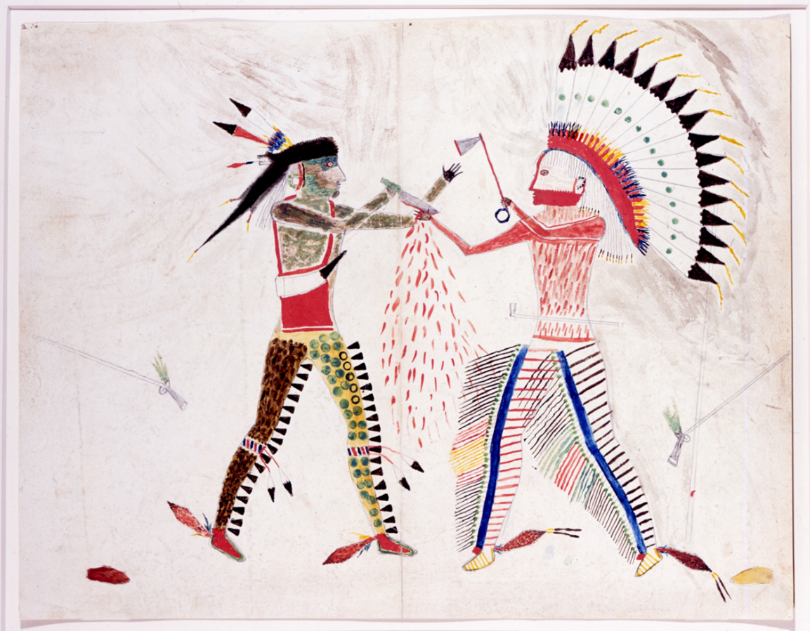
Mató-Tópe drawing, Joslyn Art Museum, 1986.49.384

Figure 4
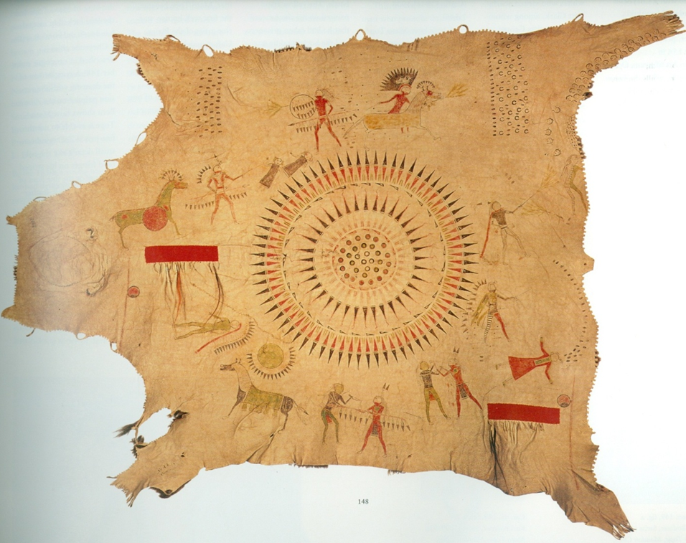

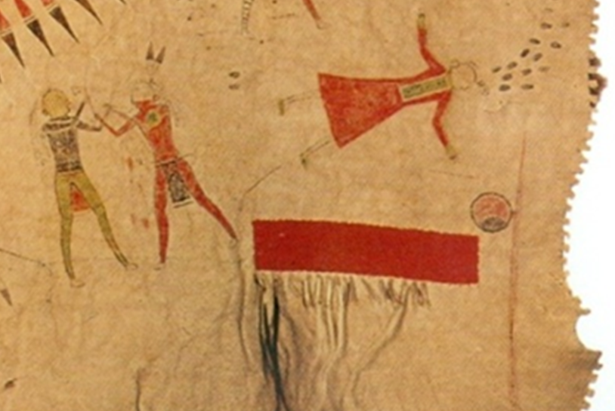
Mató-Tópe robe, circa 1830, Bern Historical Museum

Figure 5
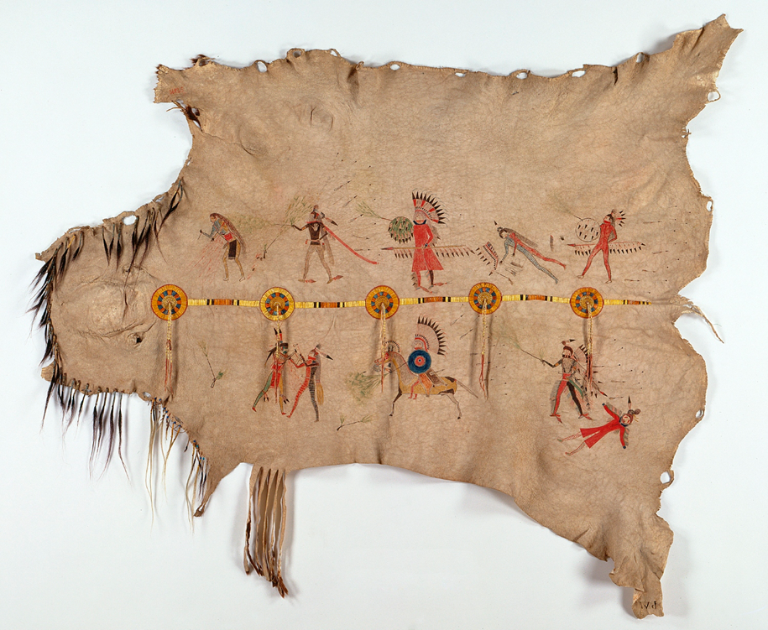
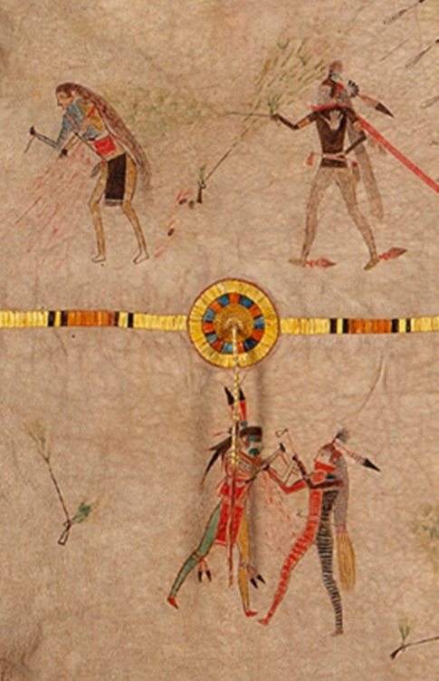
Mató-Tópe robe, circa 1830 (Linden-Museum Stuttgart)

Figure 6
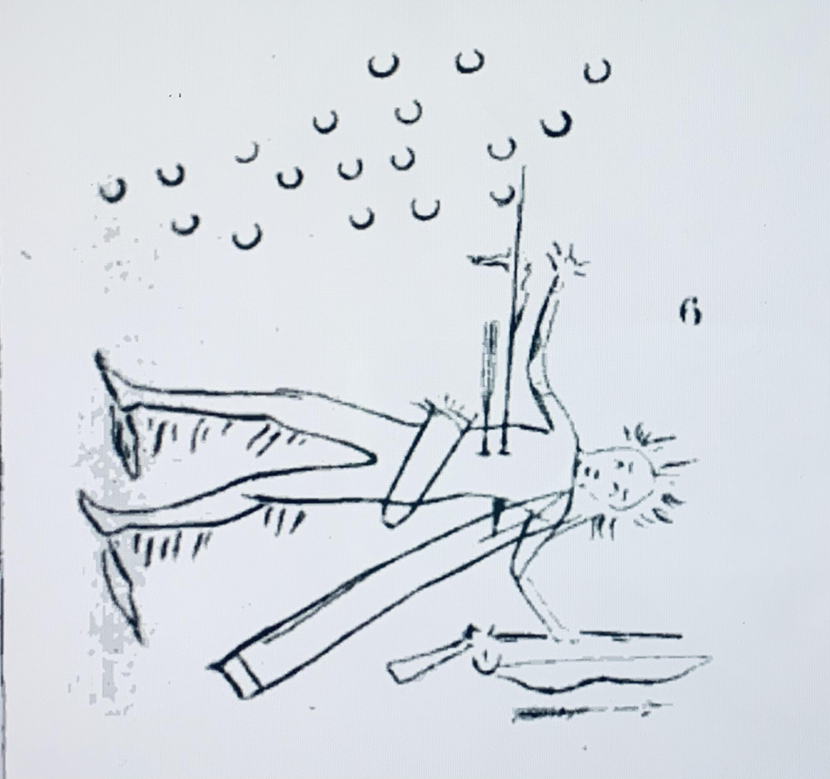
Catlin, Letters and Notes, 150

Figure 7
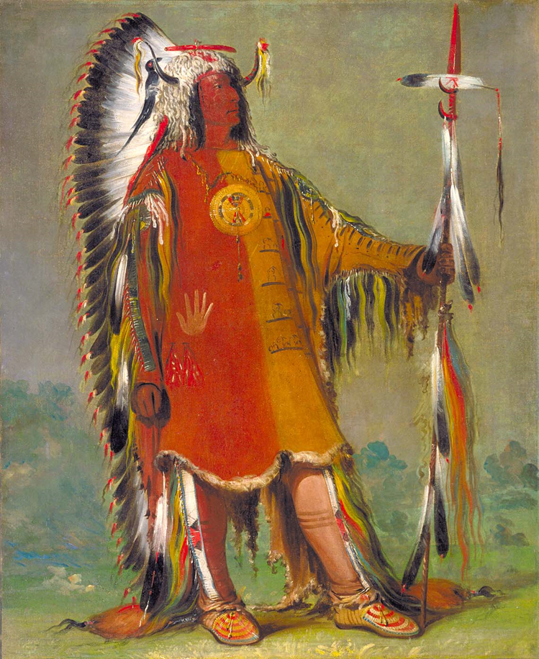

Figure 8
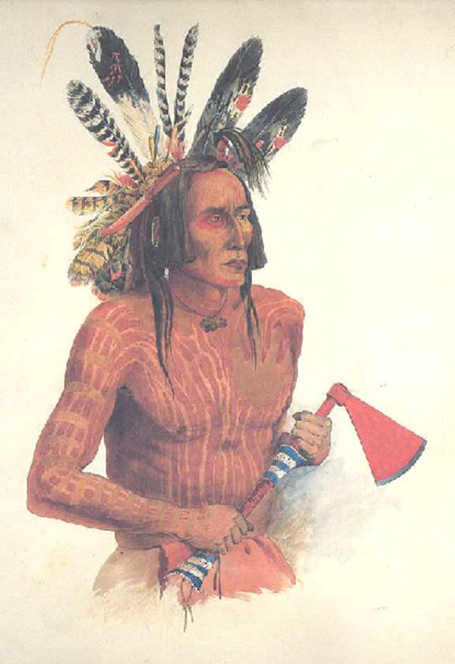

Figure 9
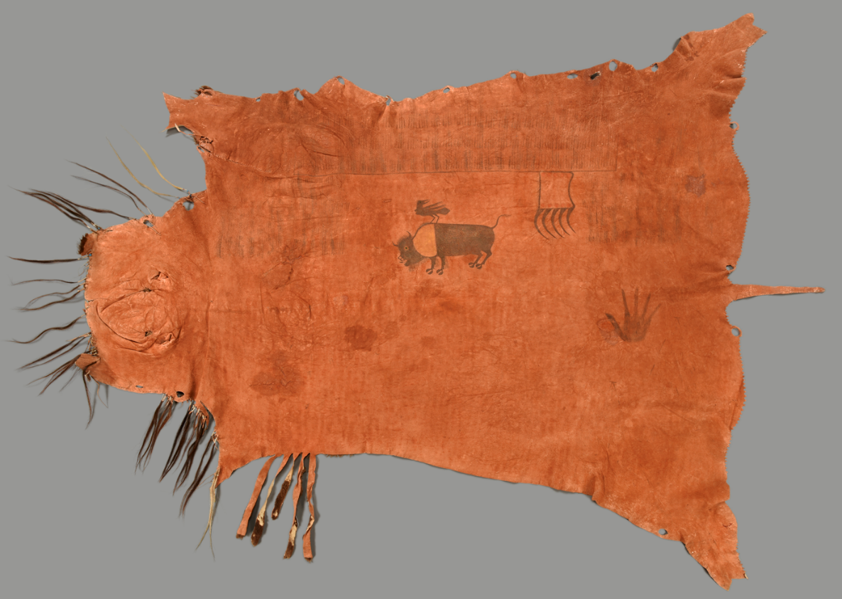
Robe from Mato-Tope. Mandan 1830, Prince zu Wied collection 1844, Inv. Nr. IV B198.
Ethnological Museum of Berlin

Figure 10
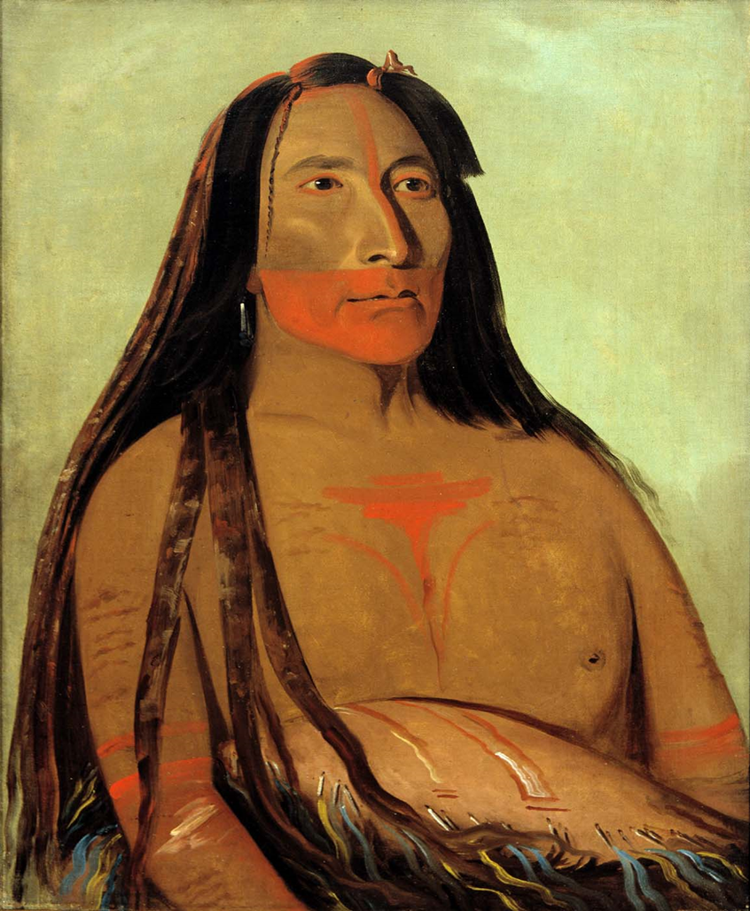
George Catlin, Máh-to-tóh-pa, Four Bears, Second Chief in Mourning, 1832, oil on canvas,
Smithsonian American Art Museum, Gift of Mrs. Joseph Harrison, Jr., 1985.66.131

Figure 11
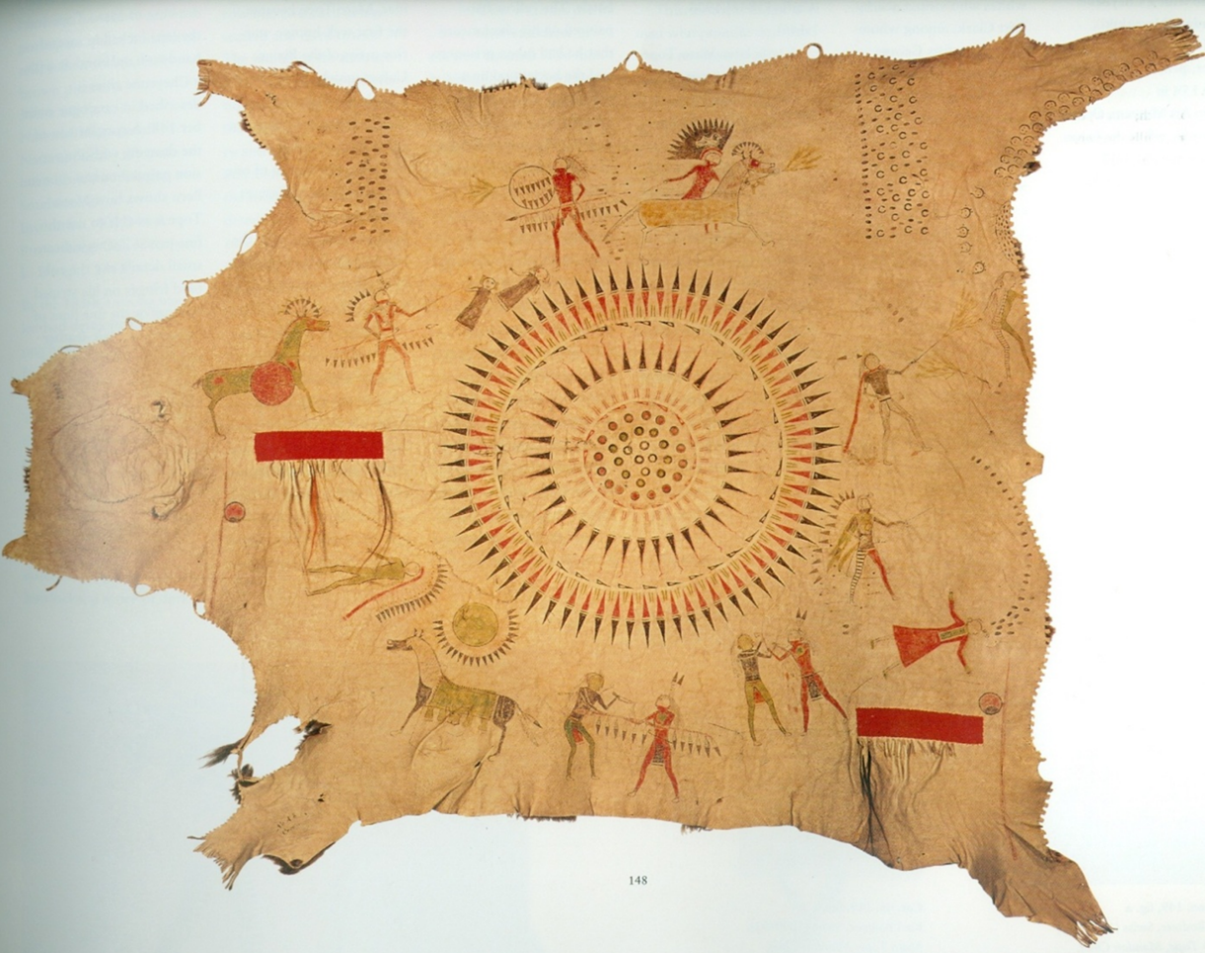
Mató-Tópe robe, circa 1830, Bern Historical Museum

Figure 12
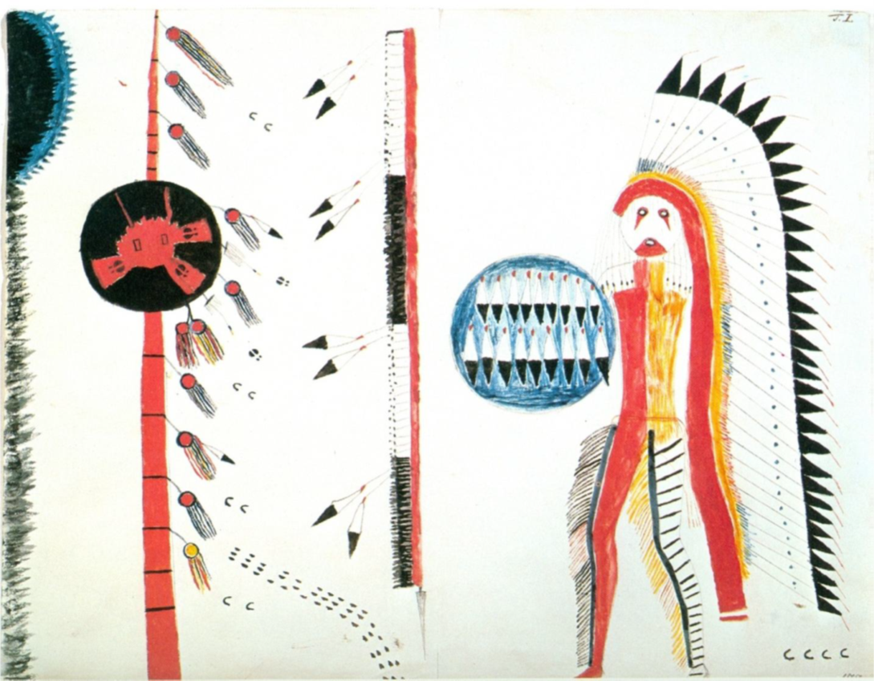
Mató-Tópe drawing, Joslyn Art Museum, 1986.49.318

Figure 13
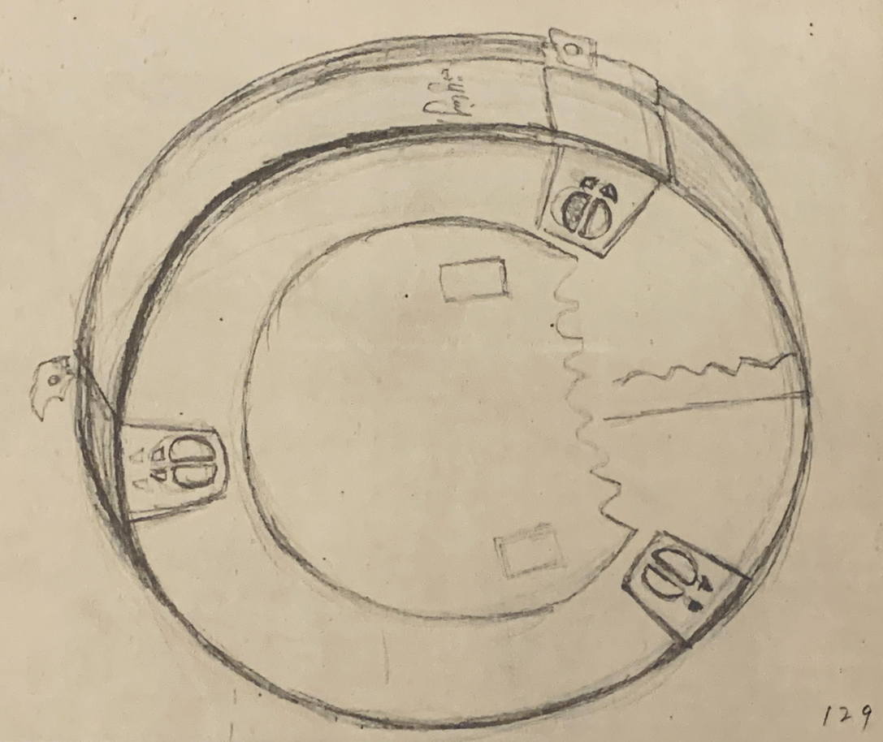
Karl Bodmer, Mandan Drum, undated, Joslyn Art Museum

Chapter IV: Síh-Xídä, Self-Fashioning a Warrior

American settlers lived, worked, interacted, and negotiated a daily peaceful existence among Nueta and Nuxbáagas visiting Fort Clark. During Maximilian and Bodmer’s residence at the fort, they often hosted Nueta men who would smoke, eat, and admire Bodmer’s drawings. As noted previously, Bodmer’s studio at Fort Clark served as an unofficial reception hall. In it he displayed portraits of Native men created during his travels. Over the winter of 1833 and spring 1834, Síh-Xídä visited the Maximilian’s and Bodmer’s residence a total of thirty-two times and frequently stayed overnight. Síh-Xídä’s numerous visits with Bodmer suggest an interest in his painting process while many of his neighbors expressed disinterest.
Maximilian wistfully referred to many who refused to have their portraits painted in his journal on November 22, 1833: “Péhriska-Rúhpa visited us. However, when we talked about drawing, he left right away…several other well-dressed Nuetas visited us—among them a handsome man who did not want to have picture drawn.” One of Bodmer’s drawings represents Awascho-Dickfas (Swallow with the White Belly) who only relented if he could face away from Bodmer. Nueta responses to Catlin’s and Bodmer’s portraits ranged from a sense of wonder, and sometimes fear, to recognition. Hesitation surrounding the production of portraits was palpable during Catlin’s 1832 visit. He described his interaction with Nueta residents:
They said I had made living beings—they said they could see their chiefs alive, in two places—those that I had made were a little alive—they could their eyes move—could see them smile and laugh—and that if they could laugh, they could certainly speak, if they should try, and they must therefore have some life in them.
Some distrusted portrait painting because they believed reproducing a subject’s likeness could diminish their personhood or life force. The small portraits draw the attention of the viewer to the faces of those portrayed, making it almost impossible not to meet their gaze, even though looking directly at a leader in the community was considered taboo. Catlin summarized his experience, in this way:
There has been three or four instances where aspiring young men have been in my lodge, and after gazing at the portraits of the head chief across the room (which sits looking them in the eyes), have raised their hands before their faces and walked around to the side of the lodge, from whence to take a long and fair side-look at the chief instead of staring him full in the face (which is a most unpardonable offence in all Indian tribes)…and when they walked the room ‘the eyes of the portrait followed them’.

The reciprocity of vision suggested the capture of an individual’s intangible spirit and emotional state. It was not merely the likeness of the individual, but a sense of nearness projected in the portrait that intruded in the viewer’s space. Catlin continued his observations about Nueta anxieties regarding portraiture: “A great many have become alarmed, and are unwilling to sit, for fear, as some say, that they will die prematurely if painted; and as others say, that if they are painted, the picture will live after they are dead, and they cannot sleep quiet in their graves.” Catlin’s statement reveals Nueta anxiety concerning self-possession, the fear that others could attain one’s power represented in a portrait. If a portrait imbued the viewer’s spirit with life even beyond death, whose presence would they touch in the future? A likeness duplicated a person’s bodily presence and spirit causing potential harm to an individual or community since the future replication and circulation of an image was uncertain. Viewers confused his lifelike portraits with the sitter’s spiritual afterlife, conflating the image of the person with their
“soul.” Portraits held power—their visual veracity became a contested site in Native communities.
An exception would be Síh-Xídä’s eight self-portraits, which offer a rare glimpse into the life of a young Nueta man. They illustrate not only the man but how he coped with his military duties and personal aspirations. Six of the eight drawings represent military garments and trade items originally circulated by non-Native fur traders, diplomats, and explorers. The remaining two drawings represent Síh-Xídä’s participation in the Okipa ceremony. Throughout Síh-Xídä’s portraits, his clothing and body language prominently communicated symbolic and political status both within his community and at Fort Clark.
Both Catlin and Maximilian comment on Síh-Xídä’s influence in his community. Catlin refers to Síh-Xídä in the company of Mah-táhp-ta‑a (Rushes through the Middle), San-ja-ka-ko-kah (Deceiving Wolf), and Mah-tó-he-ha (Old Bear) as a group of distinguished chiefs and warriors. Nueta men often traveled in groups to tour Catlin’s and Bodmer’s studios and have their portrait painted rather than visit the studio on their own. Síh-Xídä most likely accompanied Mah-tó-he-ha for his portrait session, which would have taken hours to complete. Catlin described their grand entrance:
Bedaubed and streaked with paints of various colours, with bear’s grease and charcoal, with medicine-pipes in his hands and fox tails attached to his heels, entered Mah-tó-he-ha, with a train of his own profession, who seated themselves around him; and also, a number of boys, who it was requested should remain with him.

Catlin represented Mah-tó-he-ha in a full-length portrait holding medicine pipes decorated with hair selected from his horses or family members in each hand and waving two large eagle fans. (Figure 1) His medicine pipe, fox tail trailers, and eagle feathers tinged with red pigment appear in works by both Catlin and Bodmer, suggesting that the men all belonged to the Dog society.
Catlin’s bust length portrait of Síh-Xídä represents him in three-quarter pose staring at the viewer with his lips slightly parted. (Figure 2) Four eagle feathers and a large, feathered roach decorate his brown hair. He wears one vertically indented eagle feather to signify the honor of counting coup. Two vertical rows of dentalium shells and beads frame his face and drape down his bare torso. A large silver gorget weighs upon his collarbones. Red pigment has been smeared on his neck, arms, and hands. He holds a peace pipe wrapped in red and white porcupine quills diagonally against his chest.
Bodmer’s full-length portrait of Síh-Xídä represents him in profile as he stares into the distance, his beaded bison robe wrapped tightly around his body in the frigid cold. (Figure 3) He wears beaded hair bows with long strings of dentalium shells and beads, and a cluster of raven, magpie, and owl feathers atop his head, an insignia of the previously mentioned Dog Society. The Dog Society with its four subgroups (Little Dogs, Crazy Dogs, Dog, and Old Dog), a military unit known for their refusal to retreat during battle. The Dogs in question were wolves: predatory with a capacity for long-distance hunting, silent observation, and tireless strength, all characteristics desired by soldiers. According to Wounded Face, “The Mandan warriors call themselves wolves. The leader of the war party talks to his young wolves and reminds them ‘Young Wolves, do your best’ when preparing for battle.” Both Síh-Xídä and Mató-Tópe were members, although their rank likely differed due to their age difference. Anthropologist Alfred Bowers has established the common understanding that the greatest leaders were affiliated with the Dog Society. The nuanced details of Síh-Xídä’s garments reflect a warrior’s personal experience in the Dog Society. The tippet of otter fur encircling his neck with the ends fringed in quill-wrapped leather is an example. His red otter fur lined heel trailers, and similar to fox tails seen in other portraits representing battle exploits.
Maximilian’s journal entries provide more personal details regarding Síh-Xídä due to the latter’s frequent visits to the studio as compared to Catlin’s singular interaction with the young man. Síh-Xídä extended the same hospitality as Mató-Tópe when greeting the two European men. He invited them to his earth lodge and provided them with dinner prepared by his wife. Maximilian described the November 9: “After we had eaten, our host started the pipe and handed it around to the left for smoking… This man, Yellow Feather, is the son of a famous man of his nation, called les Quartre Hommes [Four Men], who died not long ago.” By inviting Maximilian and Bodmer to his earth lodge, Síh-Xídä reminded the European men that they were strangers who trod on Native ground. His attentiveness to their company, the lavish display of food, and smoking a pipe together fostered a sense of community. Mike Barthelemy, curator at the Nueta, Hidatsa, and Arikara Interpretive Center, comments on the importance of hospitality: “What makes us Nuxbáagas is the way that we interact with each other. Were you welcoming? Were you good to people? Did you acknowledge them? When they came to your house, did you invite them in and give them something to eat?” Eating preceded and enabled communication with the Euro-American foreigners who desired conversations with and portraits of community leaders. Síh-Xídä, Mató-Tópe, and other Native men relied on their own cultural protocols in encounters with non-Native men. Maximilian and Bodmer were expected to keep an open-door policy at their studio to welcome Native visitors. Maximilian recorded large numbers of Native men coming and going, staying the night, smoking the pipe, sitting for portraits, even bringing their families to tour the space.
When visiting the studio, Síh-Xídä would have been surrounded by portraits, in both full figure and bust format, painted at different places and in diverse environments. Síh-Xídä’s attention to Bodmer’s methods of painting suggests an incentive for his own drawing sessions where he quickly adopted the use of colored pencils, watercolors, and paper gifted from the Swiss artist. Síh-Xídä’s capability as an artist was acknowledged by both Maximilian and Bodmer, with Maximilian enthusiastically noting in his journal on November 13, 1833, “Síh-Xídä looked at the drawings with great enjoyment and drew Mr. Bodmer and me, and he cannot be denied some talent.”
Although these drawings no longer exist, Síh-Xídä’s surviving portraits suggest a visual indebtedness to Bodmer’s style based upon format, medium (drawing), attention to military regalia, and empty space surrounding the figures. His drawings represent Native men unanchored to their environment and decontextualized from their social milieu. As a result, the images do not attempt to capture the socially active Nueta community or communal environment with resident traders at Fort Clark. Síh-Xídä’s self-portraits complicate Euro-American categorizations of Native men as he appears mutable in nature, shifting from one image to the next, with variations in gestures and accoutrements.
In one self-portrait, he wears an otter cap, an embellished shirt featuring an extensive fringe with beadwork on the arms, and vibrant red trousers. (Figure 4) The shirt retains the natural contours of the animal, presumably deer or antelope, whose legs gently envelop Síh-Xídä’s shoulders. The animal’s form covering Síh-Xídä’s body suggestively emphasizes Nueta expectations that men serve as hunters, protectors, and providers, in a symbolic narrative of status and gender. In his right hand, Síh-Xídä holds a staff decorated with mixed feathers that complement the two larger feathers atop his otter cap. His direct gaze confronts and engages the viewer. His pose and the delicacy with which facial features such as the pupils of the eye, the shape of the nose, and curve of the mouth have been handled suggest his familiarity with Bodmer’s methodological approach to painting. The painting also reflects Bodmer’s painting process which required subjects to stand motionless for an extended period.
Síh-Xídä’s keen attention to material goods—cloth, skin, and beads—clearly played a pivotal role in his self-fashioning. In one drawing, Síh-Xídä represents himself in profile, highlighting his strong facial features. (Figure 5) Maximilian described the specific drawing on November 18: “Síh-Xídä completed his drawing. It represents himself in a blue and red uniform with a crown of feathers on his head, a bow and arrow in his hands, and is executed quite like Indian drawings on robes.” Síh-Xídä grasps a bow and arrow, extending the weapon in front of him, languidly tilting the arrow toward the ground. Although he bends his arms to orient the arrow on the bow, its relatively small size performatively removes all threat. The details of his headdress and ermine robe strikingly contrast with the impassive depiction and diminutive scale of the bow and arrow. The garments’ vibrant colors, pelts, and drapery suggestively reflect his hunting prowess. He wears a close-fitting high-collar blue military-styled coat with narrow sleeves and tails that drape below the knees. Although the stiff material conforms his body to a regimented standard, these repurposed coats were often loose-fitting and worn unbuttoned allowing free movement during dancing or other public ceremonies. The military garb with its cut, color, and embellishment alone commanded attention and carried status.
Red coats worn by British military personnel were produced in the 1730s in England as an alternative to a more formal coat. Considering the high cost of uniforms—expensive materials and tailoring specifications—Native men received simpler versions referred to as “chiefs coats” or “frock coats” in either red or blue cloth often acquired through trade with the British or French in the late eighteenth century. Coats were the most desirable articles of trade because they could be integrated into ceremonial contexts, signified military rank, and were sometimes presented to younger men as a demonstration of generosity. Chiefs coats were in such high demand that Lewis and Clark purchased similarly styled military uniforms to serve as diplomatic gifts. An anonymous subscriber to the Daily National Intelligencer recounted his visit with Otoe-Missouri diplomats at the White House in February 1822, noted:
They were all dressed in blue cloth, surtouts with red cuffs and capes, blue pantaloons, and boots in short. In complete American costume except that they wore on their heads, coronet bedizened with red and blue foil, and struck all around with feathers of the gayest colours. The five chiefs were distinguished by their two silver epaulets and the two half chiefs by one.

This description not only demonstrates how such frock coats were worn on formal occasions, but also attests to the frequent wear and decoration of such garments through the early nineteenth-century. Within this context, it is important to consider the ways in which Síh-Xídä constructed his own masculine identity through his use of this military garment and its cultural resonance.
Síh-Xídä poignantly integrates military coats in three of his self-portraits, notably in one case, a quilled bison robe. (Figure 6) He extends his right arm to hold a rifle at a distance from his body, his left arm covered by the weight of the robe. The rifle appears more as a ceremonial staff than a weapon. The military coat served as a uniform for a member of Dog Society. Maximilian thoughtfully observed of the Nueta, "some of them wore beautiful robes, or shirts of bighorn leather; others had shirts of red cloth and some blue and red uniforms as they danced." The artificial cobalt blue and vermillion red coats held importance because the colors and specific tailored designs were essentially unique among garments available. Furthermore, the attire identifies the wearer as having earned prestigious honors for military merit, thus reinforcing fictive kinships within the Dog Society.
Two portraits represent Síh-Xídä similarly, wearing a frock coat astride a horse occupying the right side of the composition. (Figure 7 and 8) A peace medal delicately dangles from his neck signaling ongoing diplomatic relationships with distant Euro-American governing bodies. Both drawings feature him adorned with eagle feathers, a large bison horn war bonnet trailing downwards to the flank of his horse, a lance, and shield. His horse, equally decorated, has a red line painted on his face and an eagle feather tied to his tail. According to George Horse Capture, “The red zigzag line running along the horse’s head symbolized lightning—it would have been to provide it with power in battle.” Síh-Xídä’s loose grip on his horse’s reins demonstrates confidence in his horsemanship and the training of his mount. A variation in the color of horses may denote Síh-Xídä’s wealth and status, since horses were widely recognized in Native communities as symbols of prosperity. Additionally, acquiring horses in raids was considered a mode of counting coup and increased a man’s status in his community.
Both drawings demonstrate the importance of warriors earning recognition by protecting their villages from hostile attacks. Síh-Xídä represents multiple hoof prints, alluding to the presence of enemies on horseback, and thin lines suggesting the trajectory of arrows. He holds a coveted flintlock musket in one drawing, cocked near his chest; in the other drawing, multiple flintlocks form a horizontal border. War honor marks formed in an hourglass shape painted white, blue, or red alternate with these muskets. (Figure 8) A similar X-like design appears on an early Upper Missouri pictographic shirt signifying that the wearer had been the first person to strike a fallen enemy with a coup stick. (Figure 9) A small “u”-shaped design brings attention to the fully cocked hammer vertically aligned with the trigger threatening to strike a future target. He points the metal spearhead towards the butt of a musket further identifying the significance of conflict. A small sketch of his village surrounded by a palisade at the bottom left of the composition. The size of the village pales in comparison to the monumental figure of Síh-Xídä triumphantly striding towards to the fortress which reinforces his commitment to protect his village.
Síh-Xídä rushes forward on his horse in each composition, discarded scalps and detached hands appearing as trophies of war. The presence of hands in the red coat drawing represents a bloody interaction between victor and enemy, a visual reminder of those capable and incapable of survival. (Figure 10) Síh-Xídä’s blue coat drawing further emphasizes the violence, however, rare of counting coup. His brown horse gallops by an enemy scalp, that visually echoes the form its tail. (Figure 11) The drawing reinforces Síh-Xídä’s social identity as a warrior and protector of his village, as the path leading to the palisade is free of arrows and threats.
The border of war honors and flintlock muskets horizontally marching across the page seems to weigh upon Síh-Xídä. The alignment of his head with two flintlock muskets suggests his preoccupation with war. Designing tactical objectives and executing them with a dedicated unit could shape a winning strategy satisfying both personal and public ambitions. Yet the conditions of war could result in disorder and uncertainty due to the location and strength of the enemy, distances traveled, and topography. These invasive thoughts are seemingly in tension with the open space unfolding before him. He and his horse stride into the unknown, an area unexplored and potentially filled with enemies.
Síh-Xídä’s collection of drawings includes a portrait of himself and his wife riding on horseback together. (Figure 12) Her conspicuous presence marks a visible sign of gender segregation within Nueta society. Bodmer painted five portraits of women during his American travels; each would arrive at his studio only when accompanied by her husband.
The remaining two drawings by Síh-Xídä represent the Okipa ceremony marking the first Indigenous interpretation of the sacred event. In late July 1832, Catlin arrived at Fort Clark in time to witness the O-kee-pa, an annual summer event designed to ensure the wellbeing of the buffalo. The four-day ceremony featured explicit sexual dances and culminated in a ritual reserved for men who would pierce their chests and suspend themselves by splints hanging from the ceiling of earth lodges.
The center of a Nueta village was a 150-foot dancing ground with a cedar pole painted red surrounded by a cottonwood plank fence, forming a shrine, around which the Okipa ceremony was performed. This shrine was a large barrel-shaped structure that Maximilian referred to as an ark, because he was told it represented Lone Man’s protection of his people from a great flood. The shrine echoed the defensive palisade wall surrounding each village. During the first three days of the ceremony, all devotion centered around the shrine in the open plaza.
A bull dance opened the ceremony, eventually repeated forty times over the course of the Okipa. Catlin describes the choreography: “Eight men, divided into four pairs, took their positions on four different sides of the big canoe, representing thereby the four cardinal points.” Síh-Xídä’s represents a solitary male figure, presumably a self-portrait, who leans towards the ground, cloaked by shaggy bison fur whose arms drape over his own and heavy hooves cover his feet. (Figure 13) The figure’s horizontal body further imitates a bison tossing its head, bellowing, and pounding the earth with its hooves. He also bears the heavy weight of bundled willow boughs upon his back. The second image shows Síh-Xídä facing the viewer holding the bison robe outstretched over his body. (Figure 14) His limbs are smeared in black pigment while his torso is painted red with white horizontal stripes. A shaggy bison head partially obscures his face. Each portrait isolate the dancer from the multiple male buffalo dancers swaying and grunting around the Lone Man shrine. Catlin’s portraits introduce the viewer to a panoramic sweep of the ceremony. (Figure 15) Numerous men wearing bison skins and bundled willow grass perform a ritual dance around the shrine while spectators sit atop earth lodges observing. Every community member witnessed the Okipa, and their gathering emphasized tribal unity.
The buffalo dance climaxed with a sexual performance initiated by a masked man variously referred to as OxinhEde (Catlin), Omahank-Chikia (Maximilian), or Foolish One (in Bower’s translation) painted with charcoal and bear grease wielding a large wooden erect penis. Catlin incredulously recounted the event:
This blackened monster swaggered against one of the men placed under the skin of a buffalo and engaged in the bull dance… and after this he paid visits to three others of the eight, in succession, receiving as before the deafening shouts of approbation which pealed from every mouth in the multitude, who were all praying to the Great Spirit to send them buffalos to supply them with food during the season, and who attribute the coming of buffalos for this purpose entirely to the strict and critical observance of this ridiculous and disgusting part of the ceremonies.

The Foolish One dancer cavorted around the sacred plaza and pantomimed intercourse with the eight bison dancers as a way to define the animal’s fertility. Wearing the skin of a bison identified male dancers with its qualities and sacred powers of the animal because it nourished, clothed, and provided tools for the community.
When the ceremony began, James Kipp and an unnamed Nueta holy man invited Catlin to witness events taking place inside the sacred lodge. The Cutting Scene, Mandan O-kee-pa Ceremony represents men atop an earth lodge’s skylight observing the Okipa ceremony below. (Figure 16) Two men have been suspended from the central poles of the lodge, hoisted by wooden skewers piercing their skin and fastened to ropes around the beams. Bison skulls dangle from one of the male participants, an additional weight on his swaying body. A man’s naked, bloodied body hangs beside him, and his head droops towards his chest, presumably in exhaustion from the skewers pulling the skin taunt on his back. Elders seated near the men’s hanging limp bodies watch them drift into an unconscious state. According to Calvin Grinnell, Cultural Preservation Specialist for the Nueta, Nuxbáagas, and Sanish Nation, “Elders were taking a measure of the young men’s character and their fortitude and their willingness to sacrifice for the common good.” In the lower left, five men rhythmically drum while one man stands shaking turtle shells to heighten the drama. Pain coupled with fasting, hypnotic singing and drumming, brought on spiritual visions. While Síh-Xídä may not have yet offered his body as a sacrifice, Catlin’s portrait of Mató-Tópe reveals scars stretched across his chest and upper arms signaling successful completion of the Okipa ceremony. (Figure 17) The physical piercing and spiritual test constituted a performance of death and rebirth for both individual and community.
Catlin painted five Okipa scenes, all concentrating on male participation. He drew attention to their ritualistic practice of self-harm because he knew this sensationalist imagery would intrigue his non-Native audience. Since the Okipa was hosted during the late spring or early summer, Maximilian and Bodmer did not attend the ceremony, but interviewed men about their participation and Síh-Xídä’s drawings enlivened their conversation. His two portraits on small white pages echo the style of Bodmer’s drawings with the figures of men and women close to the picture plane. On the other hand, the decontextualized space and obscured faces suggests ceremonial knowledge withheld from a non-Native audience to ideally protect the identity of the dancers and integrity of the rituals.
During the four months Bodmer and Maximilian spent with Síh-Xídä, the latter managed the duties incumbent upon him due to his military rank, participated in bison hunts, upheld family obligations, and grieved the loss of his mother-in-law. Síh-Xídä’s multiple self-portraits suggest commitment to his community, his prestigious membership in the Dog Society and participation in the Okipa ceremony. Elements of his composition and style though associated with European portraiture were fashioned for a local Nueta audience. Half of his portraits adhere to pictographic standards of representation, which include presenting figures in profile and minimizing facial details, and the other half not.
Maximilian describes Síh-Xídä’s company on December 27: “He drew Bodmer’s whole figure and took the picture along, perhaps as a protection against his own portrait by Bodmer.” Síh-Xídä, according to this account, believed in the living power of a portrait’s gaze and thus remained superstitious about having his own portrait painted. He deliberately avoided Bodmer’s gaze when the European painted him and in many of his own self-portraits abstains from gazing directly at the viewer. Perhaps Síh-Xídä’s painting of Bodmer (which no longer survives) sufficiently offset the vitality of his own likeness retained in Bodmer’s portrait. While it is difficult to determine what Síh-Xídä may have invested in these portrait exchanges, Maximilian recorded one suggestive incident just weeks before the European company departed for St. Louis. Ahschüpsa-Masihichsi (Chief of the Sharp Horn), a Nuxbáagas war party leader, visited the Fort Clark studio on an afternoon in early March because he “wished to have Bodmer drawn, because the latter [Bodmer] would take his [Ahschüpsa-Masihichsi’s] portrait to Europe, and he [Ahschüpsa-Masihichsi] would be with a war party at that time.” When Maximilian refused the warrior’s request, “he [Ahschüpsa-Masihichsi] started to work himself and drew Bodmer.” Neither artist fully succeed in capturing the other.
When Maximilian and Bodmer packed their notebooks, drawings, and mementoes for their return journey to Prussia, Síh-Xídä kept the portraits he had painted of his European friends. Preserving one another’s portraits continued to bind the men in what I have previously termed as a fictive kinship relationship despite geographic distance after 1834. Síh-Xídä was reportedly killed by Sioux warriors and scalped in 1835—one year after his encounter with Maximilian and Bodmer. Síh-Xídä’s drawings gifted to Maximilian and Bodmer narrate his Indigenous masculinity through the visual record of his personal accomplishments and constituted a critical Indigenous effort to offer alternative representations of Native selfhood in the early nineteenth-century.

Chapter IV Images
Figure 1
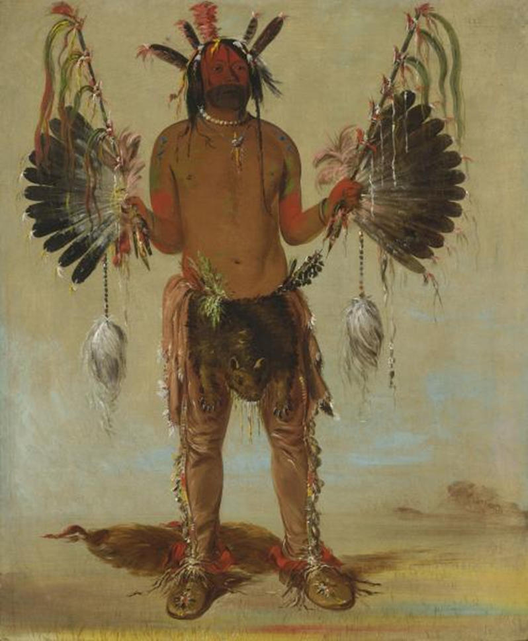
George Catlin, Mah-tó-he-ha, Old Bear, a Medicine Man, 1832, oil on canvas, Smithsonian American Art Museum, Gift of Mrs. Joseph Harrison, Jr., 1985.66.129

Figure 2
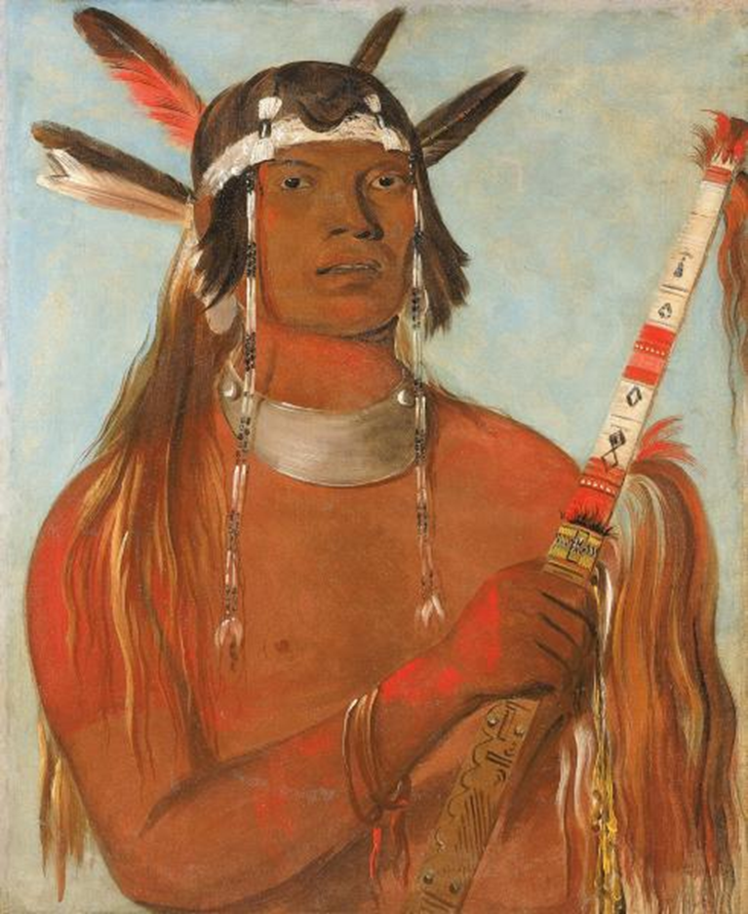
George Catlin, Seehk-hée-da, Mouse-colored Feather, a Noted Brave, 1832,
oil on canvas, Smithsonian American Art Museum, Gift of Mrs. Joseph Harrison, Jr., 1985.66.132

Figure 3
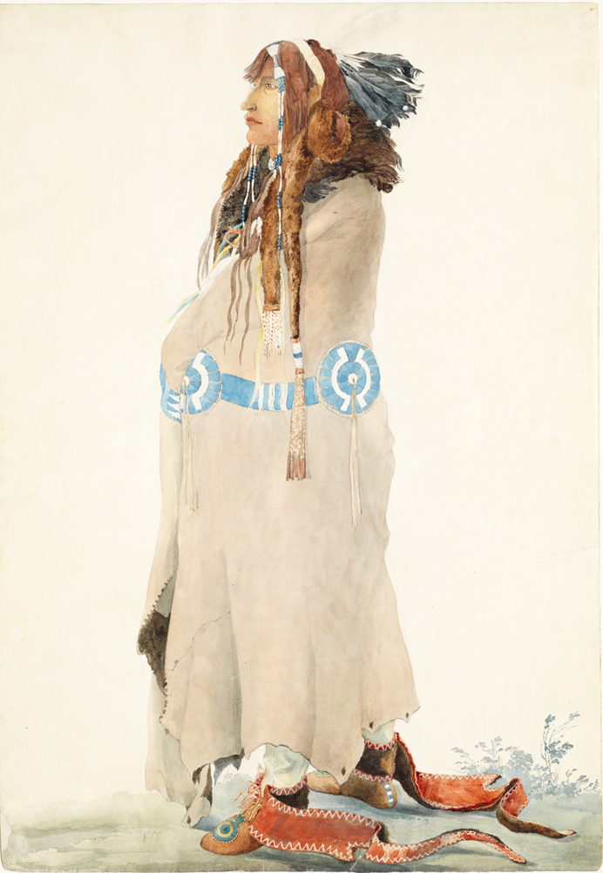
Karl Bodmer, Síh-Xídä, Mandan Man, 1833, Joslyn Art Museum, 1986.49.267

Figure 4
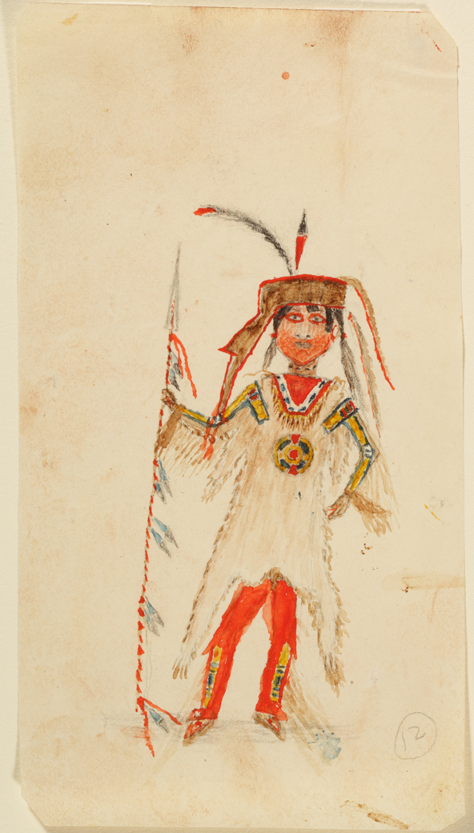
Attributed to Síh-Chidä (Mandan, c. 1809–1834), Untitled, c. 1833–34, watercolor and graphite on paper, 7 3/8 × 12 1/2 in. (18.7 × 31.8 cm), Joslyn Art Museum, Gift of Enron Art Foundation, 1986.49.319.

Figure 5
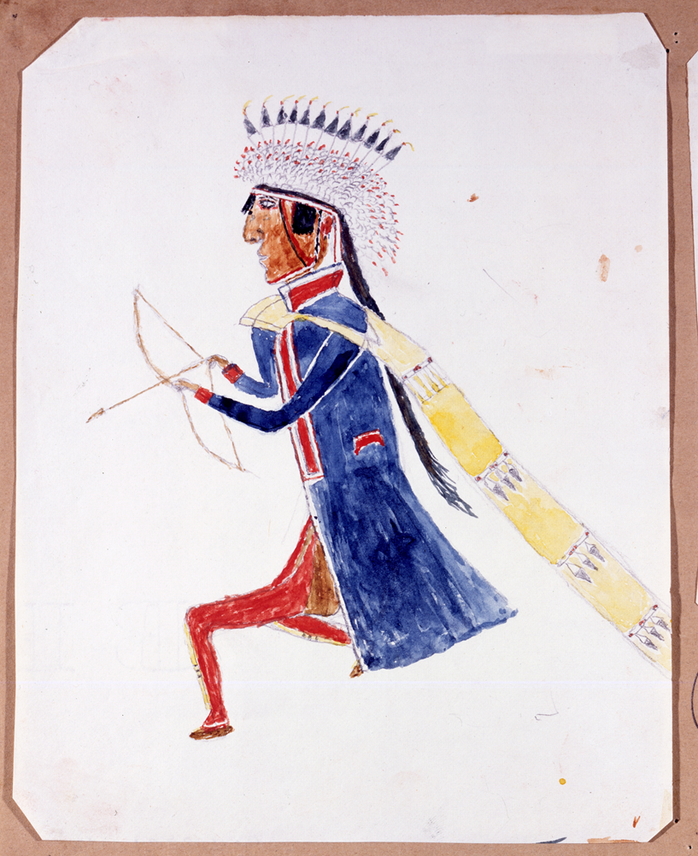
Attributed to Síh-Chidä (Mandan, c. 1809–1834), Untitled, c. 1833–34, watercolor and graphite on paper, Joslyn Art Museum, Gift of Enron Art Foundation, 1986.49.320

Figure 6
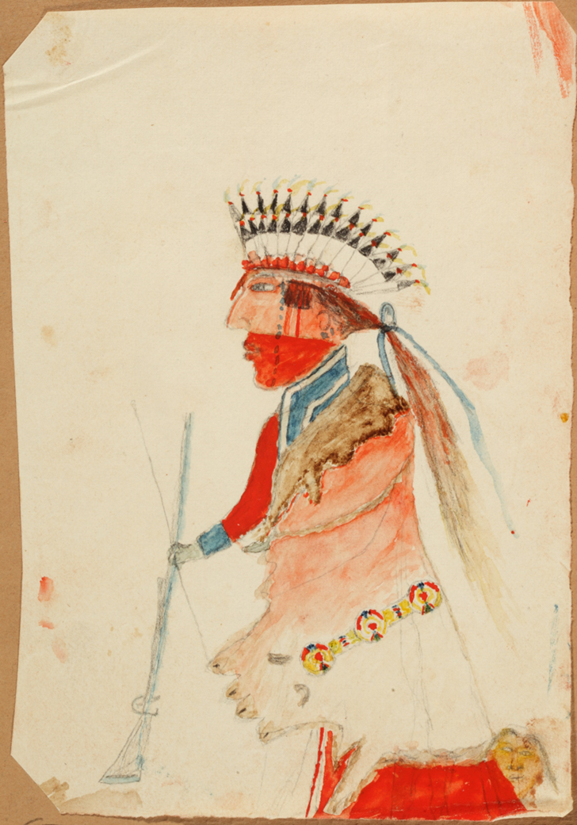
Attributed to Síh-Chidä, Untitled, c. 1833–34, watercolor and graphite on paper, 7 3/8 × 5 3/4 in. (18.7 × 14.6 cm), Joslyn Art Museum, Gift of Enron Art Foundation, 1986.49.321

Figure 7
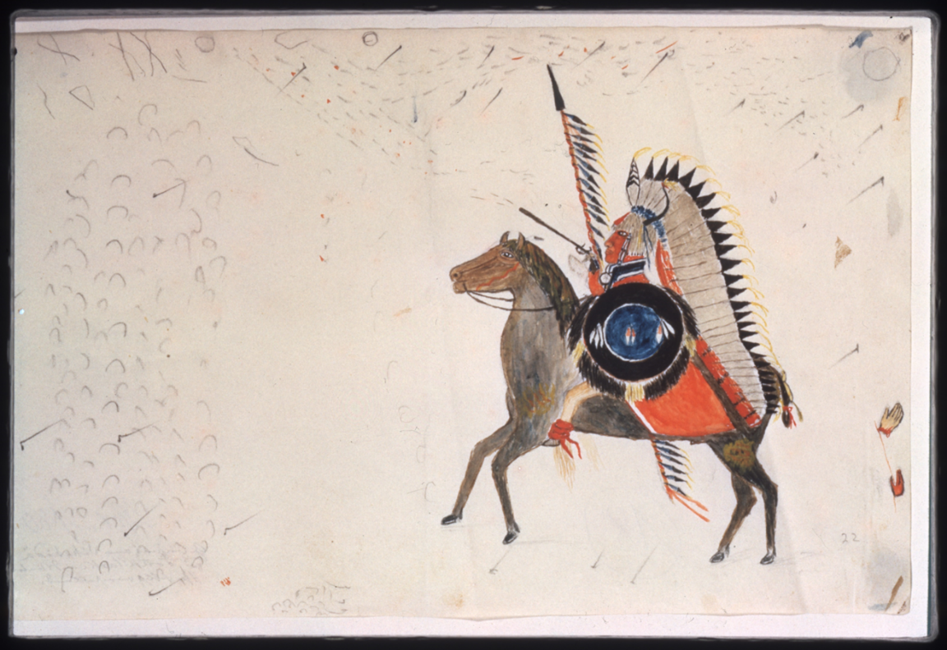
Attributed to Síh-Chidä, Untitled, c. 1833–34, watercolor and graphite on paper, 6 × 3 5/16 in. (15.2 × 8.4 cm), Joslyn Art Museum, Gift of Enron Art Foundation, 1986.49.323

Figure 8
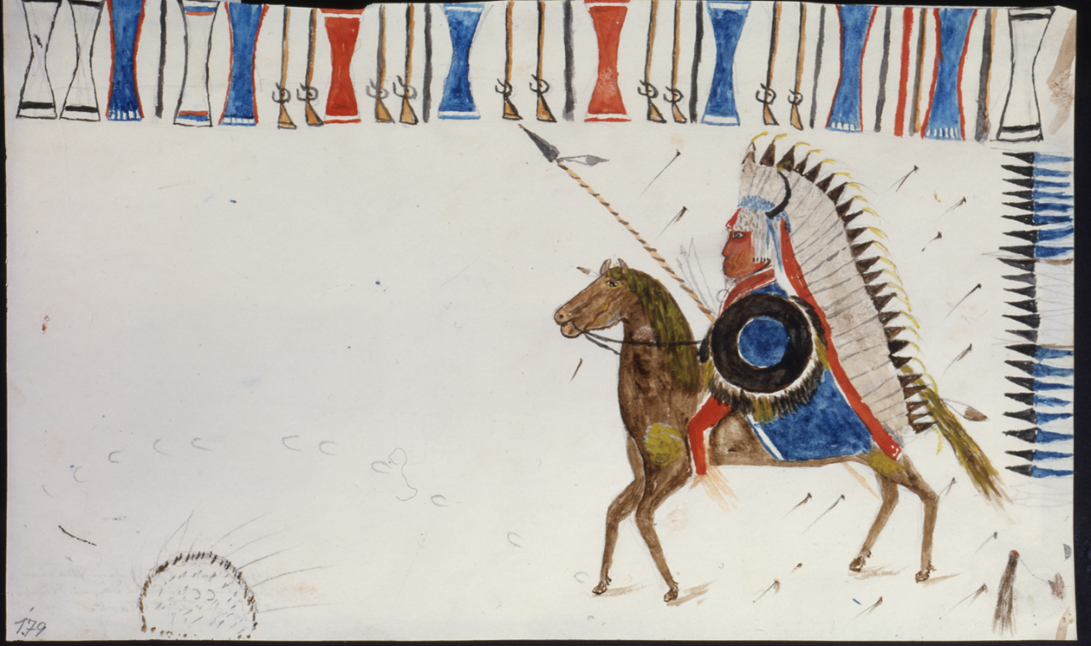
Attributed to Síh-Xídä, Untitled, Joslyn Art Museum

Figure 9
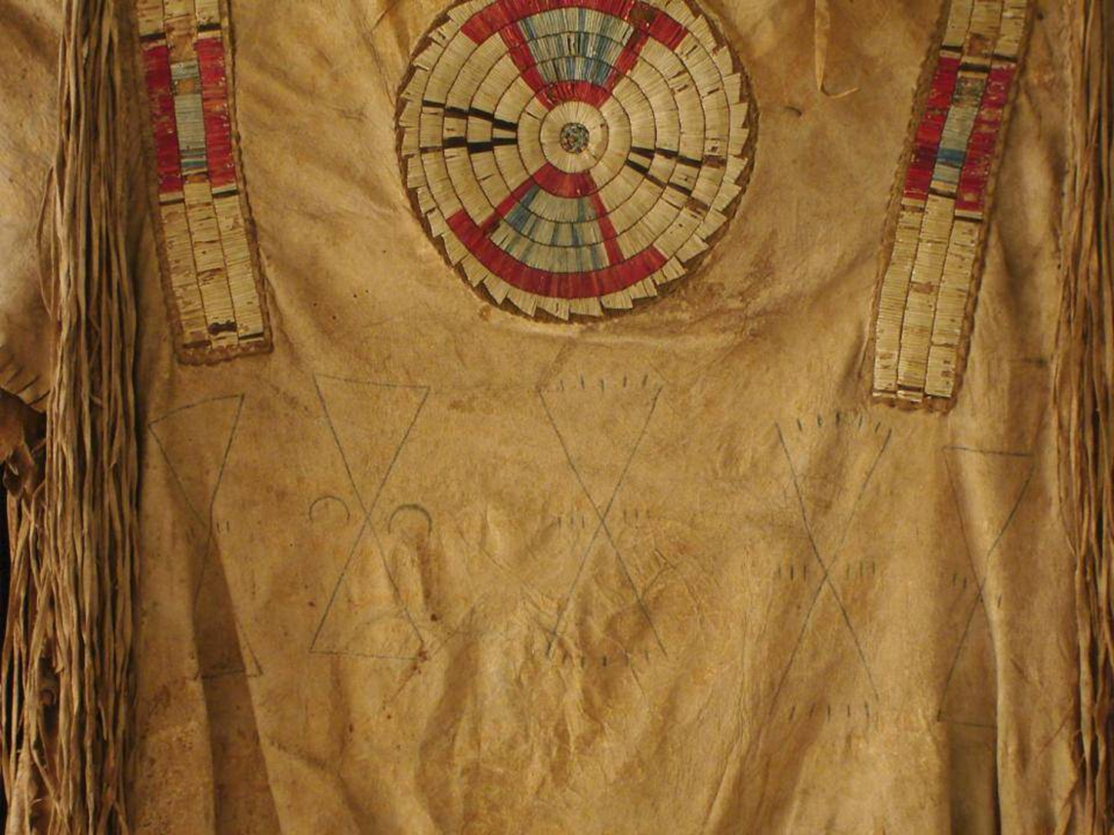
Artist once Known, Upper Missouri River region, Quilled war shirt (front), c. 1800–1820. Native tanned hide, porcupine and possibly bird quills, plant material, red trade cloth, dyes, and sinew. 34 x 43 inches (Denver Art Museum)

Figure 10
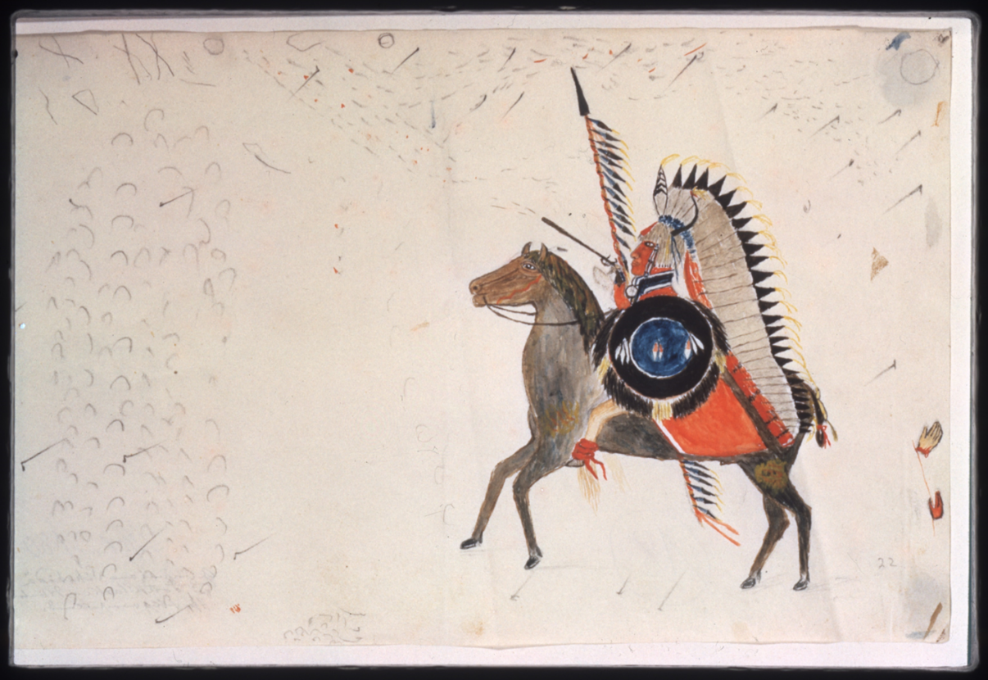

Figure 11
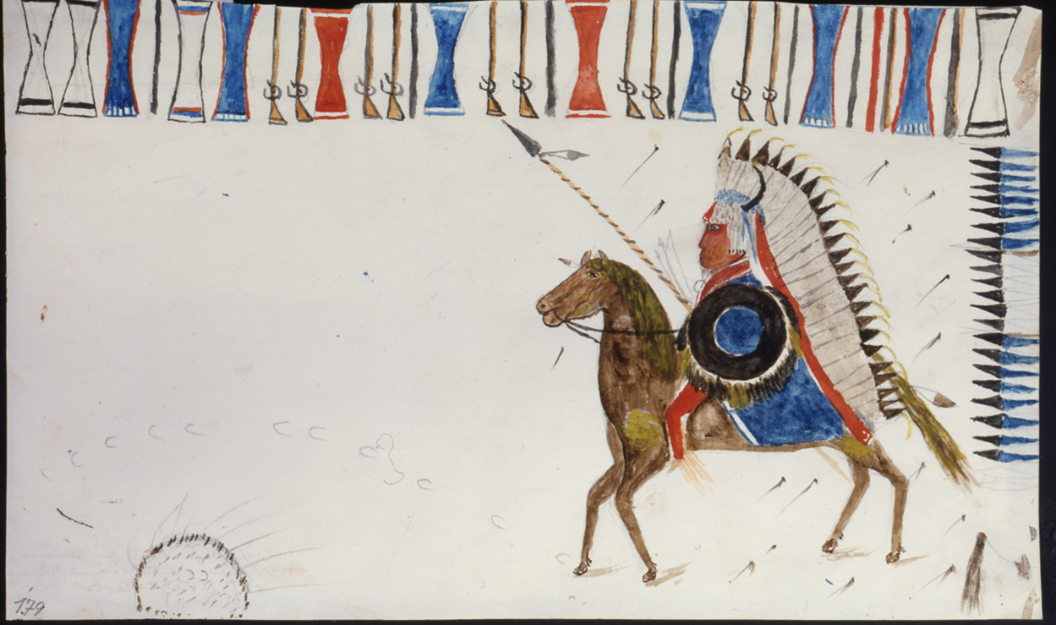

Figure 12
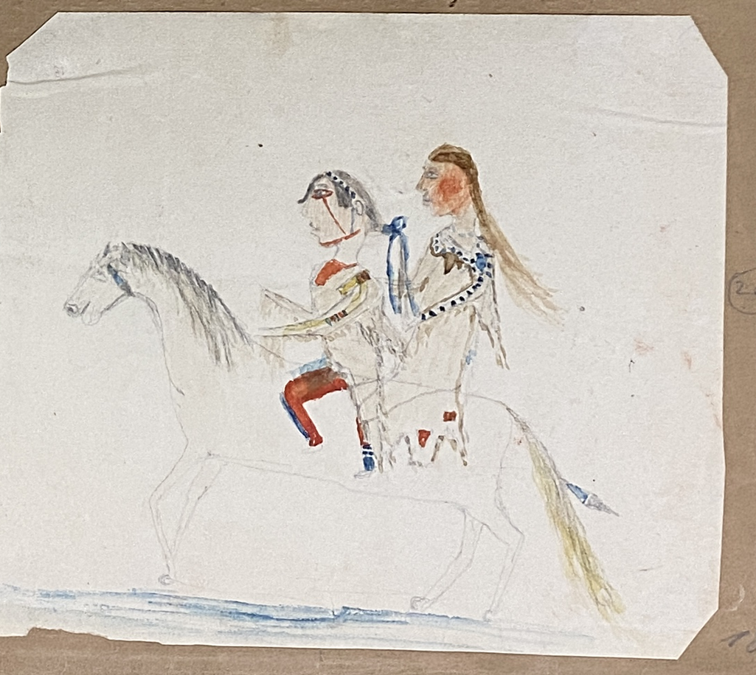
Attributed to Síh-Chidä , Untitled, c. 1833–34, watercolor and graphite on paper, 4 1/4 × 4 7/8 in. (10.8 × 12.4 cm), Joslyn Art Museum, Gift of Enron Art Foundation, 1986.49.324

Figure 13
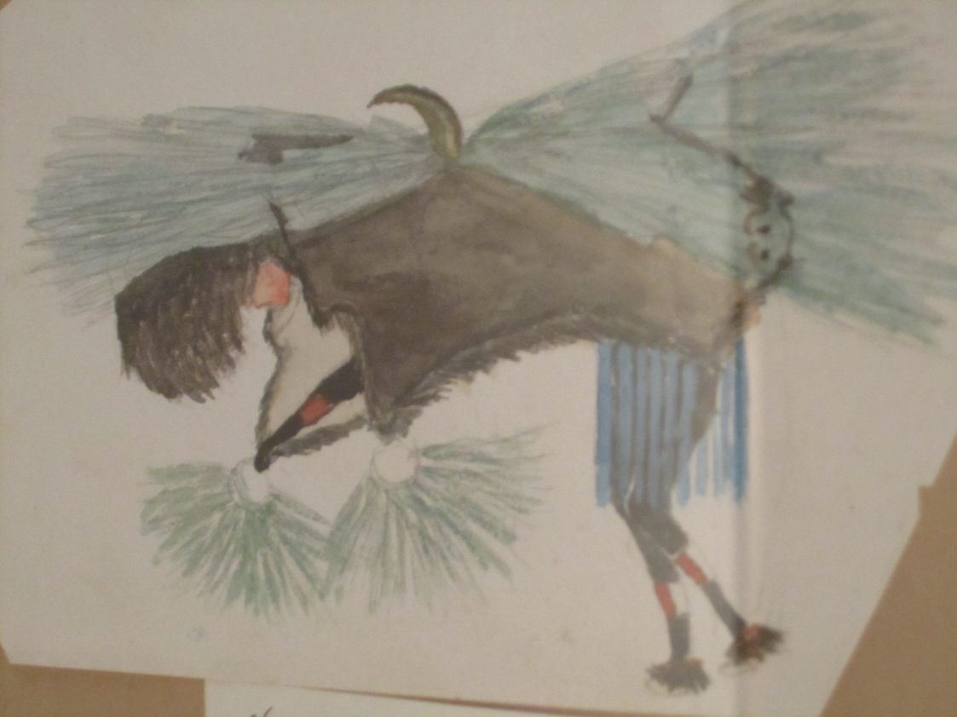
Attributed to Síh-Chidä (Mandan, c. 1809–1834), Untitled, c. 1833–34, watercolor and graphite on paper, Joslyn Art Museum, Gift of Enron Art Foundation, 1986.49.325

Figure 14
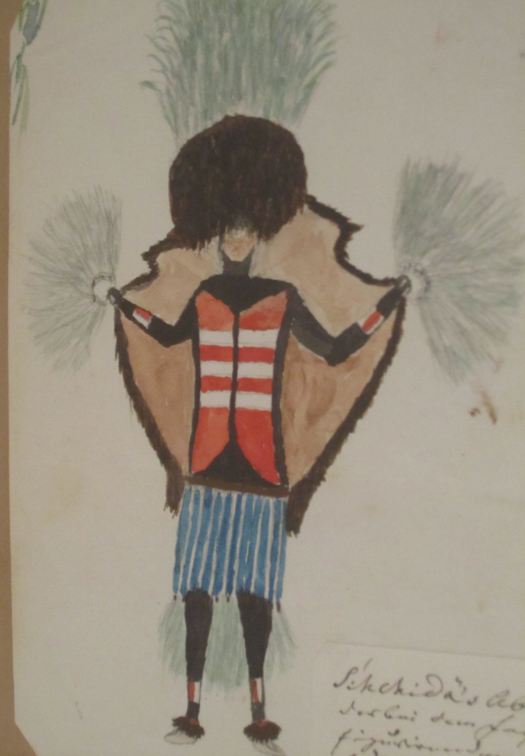
Attributed to Síh-Chidä (Mandan, c. 1809–1834), Untitled, c. 1833–34, watercolor and graphite on paper, Joslyn Art Museum, Gift of Enron Art Foundation, 1986.49.326

Figure 15
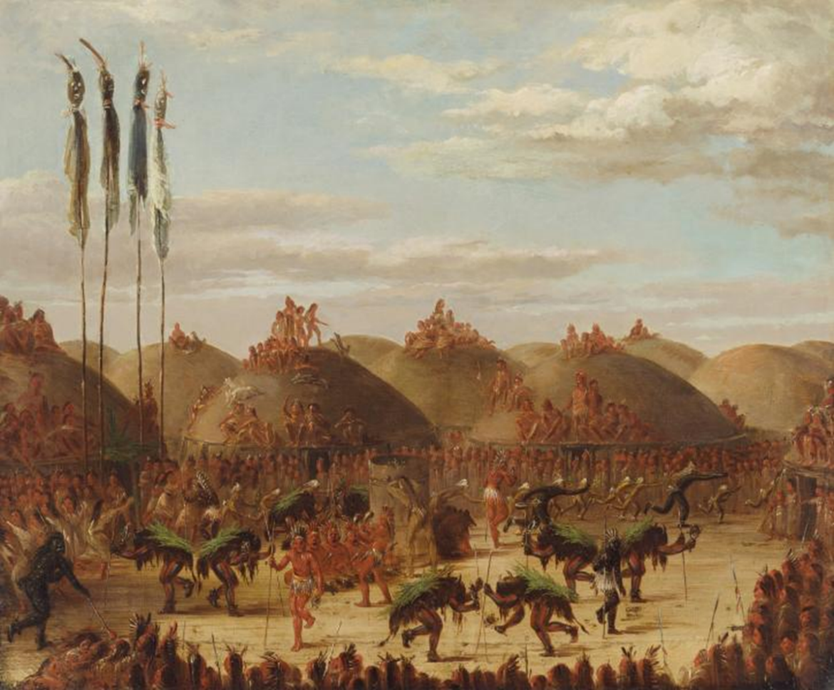
George Catlin, Bull Dance, Mandan O-kee-pa Ceremony, 1832, oil on canvas, Smithsonian American Art Museum, Gift of Mrs. Joseph Harrison, Jr., 1985.66.505

Figure 16
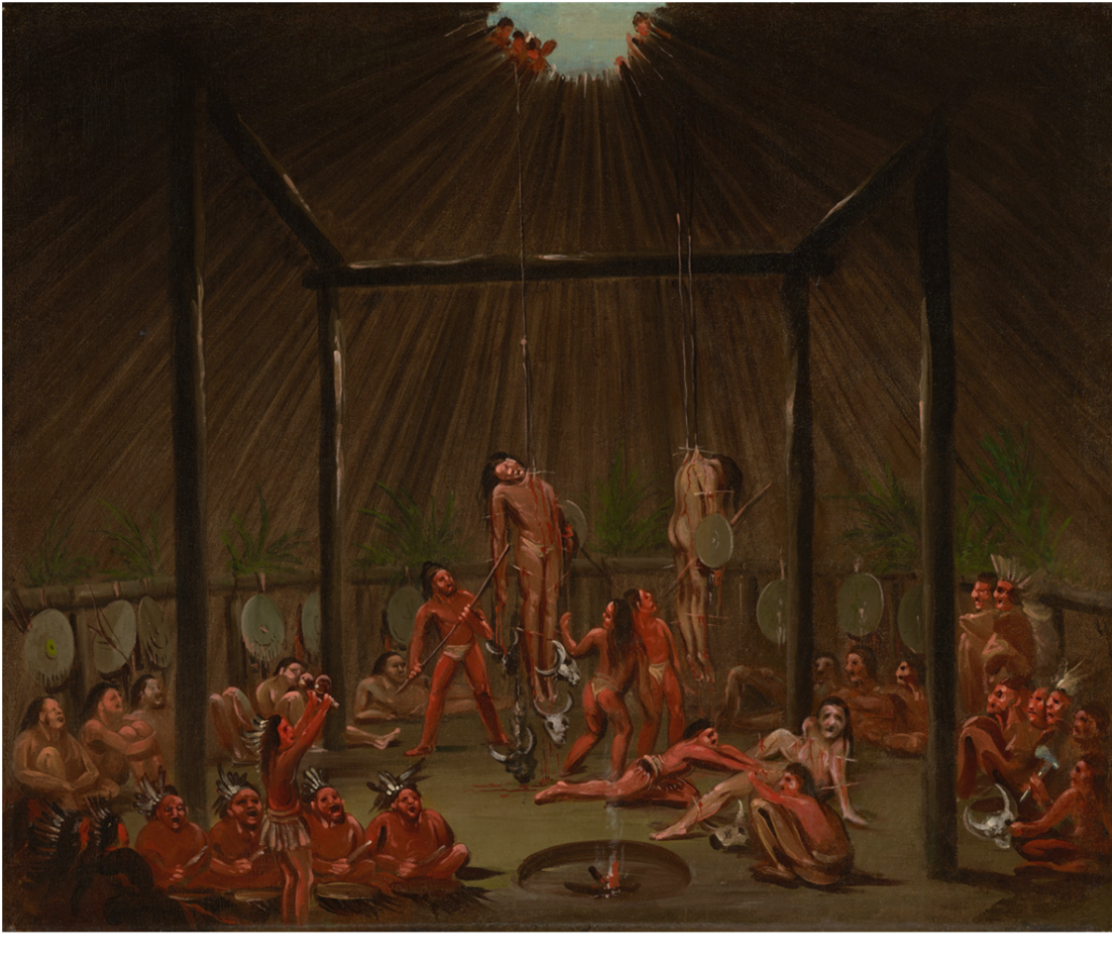
George Catlin, The Cutting Scene, Mandan O-kee-pa Ceremony, 1832. Oil on canvas; 22 7/8 x 27 1/2 in. William Sr. and Dorothy Harmsen Collection at the Denver Art Museum, 2001.456

Figure 17
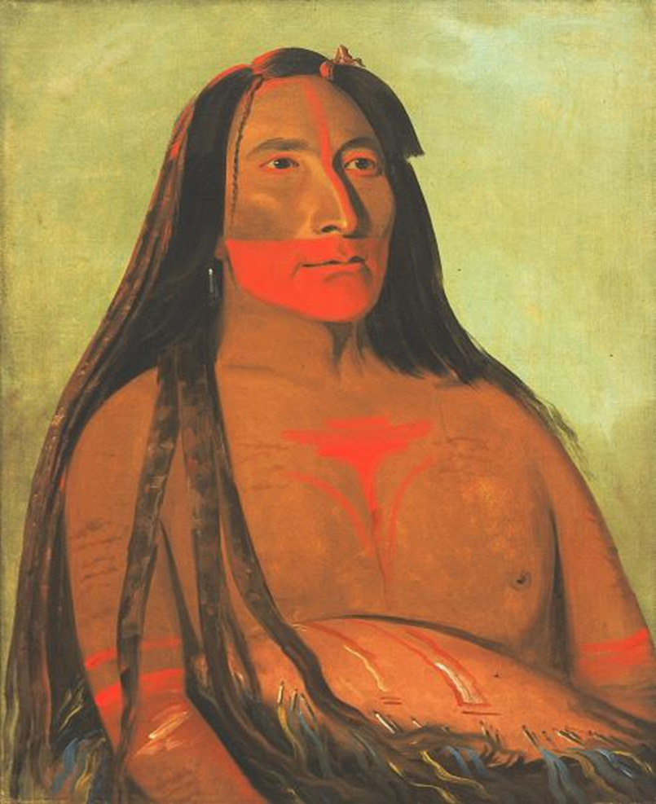
George Catlin, Máh-to-tóh-pa, Four Bears, Second Chief in Mourning, 1832, oil on canvas, Smithsonian American Art Museum, Gift of Mrs. Joseph Harrison, Jr., 1985.66.131

Chapter V: Little Owl, Migrations and Upheavals at Like-a-Fishhook and Fort Berthold

As noted previously, the Missouri river and its tributaries weave throughout Nueta and Nuxbáagas origin stories and the daily experiences of communities crossing the river. Interpreted by James Kipp and recorded by Maximilian, Dipäuch (Broken Leg) described the legends of Óhmahank-Numákschi (Lord of Life) and his son First Man, stating,
The Lord of Life led First Man to the mouth of the Nátka-Pássahä (Heart River) and said,
Let us make medicine pipes here… They set these pipes together and the Lord of Life said, “This is supposed to be the heart –the center of the world—and this river should be called Nátka-Pássahä.

This story highlights one of many narratives that describe the Lord of Life and First Man communing with the Missouri. Dipäuch continued:
The first chief of the Númangkake (Nueta) built a canoe that understood what he told it. He filled it with people and told [the canoe] to ferry them across and [then] come back. He sent it across in this manner several times.

First chief instructed the people learn the water’s characteristics, noting obstacles such as sand bars, sunken trees, or sharp rocks breaking the surface, and remember the expertise required to transverse it. Knowledge of the changing weather assured a safe passage, avoiding dangerous currents that could make paddling difficult or capsize a bull boat, made with a willow frame and covered by buffalo hide.
Traveling across the Missouri River was a major undertaking with channel access varying from a half mile to a mile wide due to shifting sandbars and weather. Steam-powered paddlewheel boats transformed river navigation and the surrounding geography. Cottonwood timber lining riverbanks served as fuel for cooking, warmth, and forage for horses. However, cottonwood now went into the insatiable maw of steam boilers instead of horses’ mouths.
Large steamboats and independently owned ferry businesses carried people, cattle, and agricultural products. While the ferry allowed vehicles to cross, it did not operate in stormy weather, after dark, or in winter when the river froze. By the early twentieth century, ferryboat businesses that had transported people and goods for decades soon became insufficient to meet the needs of increased river traffic.
Between 1932 and 1934, the U.S. Corp of Engineers constructed Four Bears Bridge spanning the Missouri river at Elbowoods on the Fort Berthold Indian Reservation, home of the Nueta, Nuxbáagas, and Sanish tribes, collectively known as the Three Affiliated Tribes. The opening marked a historic moment linking sections of the reservation split by the Missouri River and creating a shorter route to Highway 8 increasing access to cities like Sanish to the north and Bismarck to the south. Photographers, most associated with the Corp of Engineers, surveyed the site and produced nearly one hundred images throughout the bridge’s construction. The photographs place the viewer within two opposing visual fields: immersed within the physical labor performed by construction workers, on the hand; and on the other, kept at a distance from which to admire the monthly progress of riveted steel rising above the river.
A passenger on a ferry could experience the constant flux of water on their journey, whereas a bridge would elevate them above the perpetual motion of water. Building a new bridge altered one’s visual and physical relationship with the river. According to Carlo Rotella, “A bridge is a departure predicated upon a return, no matter whether one goes forward or back, contributes to the experience of the time on the bridge as suspension: flight and inevitable descent contained within one another.” One can float in a state of heightened visual awareness contemplating the vastness of the Missouri river as I know from experience driving across the Four Bears Bridge.
In one photograph, the riveted streel truss bridge gracefully arches over the Missouri river, dwarfs a house in the mid-ground, and places the viewer on the periphery of the scene to survey the completed project. (Figure 1) Three concrete double piers sustain the weight of the bridge deck, braced with a lattice of steelwork. Open spaces between intersecting iron beams create a visual outlet to the expansive sky and river, yet the latter mirrors the industrial structure, a reminder of its heavy physical construction embedded in and over the water.
Crow’s Heart, Little Owl, and an unidentified man dressed in regalia and war bonnets stand before a steel section of the bridge during the ribbon-cutting ceremony. (Figure 2) On June 16, 1934, the bridge was named in memory of not one but two Nuxbáagas and Nueta leaders named Four Bears and the celebration lasted for four days with a rodeo and powwow. The bridge physically and symbolically unified the tribes, naming the southern end for the Nueta leader and the northern end for the Nuxbáagas leader.
Artists Too Né (Sahnish) and Little Owl (Nueta) created maps drawing upon their experiences and memories of the Missouri River. When Lewis and Clark arrived at an Sahnish village on October 3, 1804, Pocasse, a Sahnish chief, used their arrival as an opportunity to send a representative to the Nueta village Mih-tutta-hang-kusch. The Sahnish wanted to establish an alliance against the Dakota Sioux and assure access to European trade items. Sanish elders appointed Too Né as a representative to accompany Lewis and Clark for a council meeting with Nueta leaders Posecopsahe (Black Cat) and Šehékšot (White Coyote) at Mih-tutta-hang-kusch.
As the men traveled along ancestral river routes, Too Né identified forty present and abandoned villages of the Cheyenne, Sanish, and Nueta. (Figure 3) These sites as well as historic landmarks informed the map he later gifted to the Americans explorers.
Nearly one hundred years later in 1906, Little Owl drew a winding section of the Missouri River on twenty-three feet of canvas at the request of Orin G. Libby, the first director of the State Historical Society of North Dakota. Libby sent Little Owl a copy of the Map of the Missouri River from its Mouth to Three Forks, Montana in Eighty-Four Sheets and Nine Index Sheets, based upon an 1892 – 1895 Missouri River Commission published by the War Department. (Figure 4) Little Owl’s own map depicts the topography of the Missouri River beginning from Four Mile Creek, near Standing Rock Agency, to the confluence of the Missouri and Yellowstone Rivers at Fort Buford in western North Dakota. Little Owl’s segmented boundaries align with the Missouri River Commission representation of the Missouri River tributaries and nearby towns. The War Department map compresses 190 miles of territory into less than five feet compared to Little Owl’s twenty-three-foot map, averaging eight miles per foot. His map took nine months to complete and presents the Missouri River as a sustaining element reinforced by both local geography and cultural practices of the Nueta and Nuxbáagas. He collaborated with his elders, whose shared intergenerational knowledge of the river and surrounding territories visually and narratively shaped the contours of his map. Yet, this is not a unified, flowing Missouri, but one drawn and conceptualized in sections, representing a non-linear history of Nueta migration and dispossession.
Nueta leader Water Chief, presented in a bust length portrait, as if emerging from the river, wears a quilled shirt and two eagle feathers in his black plaited hair. (Figure 5) His gaze aligns with the barrel of a rifle and a scalp hovering nearby. He looks towards an earth lodge, one of the first landmarks indicating a populated village. The earth lodges grow organically, spreading irregularly across an uneven terrain.
Little Owl named important locations on the map in Nuxbáagas and collaborated with Congregational minister Charles Hall, a local pastor, to translate the names into English. Turtle Fall Creek is one of the first locations introducing Nueta cosmology. (Figure 6) Hall added the label Turtle Fall Creek, translated from the Nuxbáagas “where the turtle went into the water.” The location marks the beginning of the map commemorating where Lone Man and First Creator shaped the lands and water. The name references a snapping turtle, one that slipped back into the waters of creation—it is a reminder that the fourth turtle still supports the dry land for human habitation. The river and its tributaries served as reference points for Nueta origin narratives embedded in the landscape.
A distance upstream, the Five Villages, two Nueta and three Nuxbáagas cluster on the banks like turtle shells at the mouth of the Knife River. (Figure 7) A drawing of a bison head indicating Buffalo Head Hill hovers nearby and its presence recalls Nueta origin narratives of a great flood. Nueta informant Wolf Chief recounted to Bowers,
Four medicine men changed into buffalos… When the water began to cover the village, the bison started to swim to the Missouri. After a while, one of them was exhausted, and before sinking, he said, ‘In the future there will be plenty of buffaloes if the people come here,’ and he sank.

All the buffalo drowned except for one who successfully reached Eagle Nose Butte. Lone Man and First Creator built a wooden corral at the site to protect people and animals from the incoming flood waters. Little Owl also portrays Eagle Nose Butte, located south of the present-day city of Mandan, with an eagle head pictograph looming over an unnamed earth lodge presumably guarding the area. (Figure 8)
The head of a snake gazes towards the Five Villages from a tributary north of the Knife River. (Figure 9) The pictograph corresponds with the physical location of Like a Snake Nose Bluff, but its presence also indicates spiritual and cultural narratives. The winding Missouri River was often referred to as Grandfather Snake by both Nueta and Nuxbáagas communities, and offerings were required to ensure safe passage along the river. Nueta informants described similar origin stories about Grandfather Snake when interviewed by Alfred Bowers. Two young men, Black Medicine and Sweet Medicine, went hunting and a strong gust of wind blew them onto an island occupied by the Old Woman Who Never Dies. She invited them to her earth lodge and nourished them with corn balls, and then prepared the same meal for their journey home. Mrs. Good Bear recounts,
When the two boys reached the lake shore, they saw a large snake on the water. The snake was about thirty feet long and had two horns resembling deer horns. The Old Woman told the boys to hang onto the horns, sitting on the head while traveling and their Grandfather would take them across safely.

Little Owl walked along the banks of the Missouri River, where seventy years earlier, steamboats had unloaded crews ill with smallpox, decimating his family’s village. Catlin announced in his 1838 Indian Gallery catalogue about the smallpox devastation affecting Nueta villages:
The hospitable and friendly Mandan, who were about 2400 in number when I was amongst them and painted these pictures, have recently been destroyed by the smallpox. It is a melancholy fact, that only thirty-one are left of the number, and these have merged into the tribe of the Rickarees [sic]… so that their tribe is extinct, and they hold nowhere, an existence as a nation, on earth.

In addition to smallpox affecting Nueta and Nuxbáagas villages, the communities also attempted to defend themselves from Dakota Sioux bands raiding the area. Nuxbáagas member Poor Wolf recalled these tumultuous events,
When I was 17, I had the smallpox, which decimated our Hidatsa and Mandan tribes. A few months after that time, the Sioux attacked us, thinking to destroy all that were left from the face of the earth. There were about one hundred of my Hidatsa people who were fighting men, or able to make some defense at the time.

In spring 1838, Nueta survivors became itinerant, traveling west to the Yellowstone River or remaining at Mih-Tutta-Hang-kusch where the Sahnish had claimed the deserted village. In 1845, the Nueta joined the Nuxbáagas thirty miles above Mih-Tutta-Hang-kusch and Fort Clark to form the village Like-a-Fishhook. At the same time as Like-A-Fishhook village was established, the Pierre Chouteau, Jr. and Company (previously named the American Fur Company) built Fort Berthold nearby. The town’s name derives from the unique bend in the Missouri River. When Swiss artist Rudolph Kurz visited Fort Berthold he learned that “Kipp, in return for 100 buffalo hides, enclosed their habitations [at Like-a-Fishhook Village] with palisades, so that they might be secure at least against surprise attacks and possible extermination. Now no huts are visible until one has passed through the entrance to their barricade.” In 1862, the Sahnish joined the Nueta and Nuxbáagas to form a stronger alliance against raids from the Dakota and Yanktonai Sioux. During the Nueta, Sahnish, and Nuxbáagas residence at Like-a-Fishhook there were cycles of cholera (1851 and 1853), intertribal conflict with various bands of Sioux, dwindling timber supplies, and crop failures.
Little Owl identifies Fort Berthold by name in large letters, but does not draw a grid or trading post to distinguish the site. (Figure 10) Instead, he draws an earth lodge on top of the American trading post asserting his community’s control of the surrounding territory. The site had three names: Fort Berthold, Bua-idutskupe-hisa-atis, and Fish-hook house to identify its placement and importance on the map. Nuxbáagas artist Martin Bears Arm’s drew Like-a-Fishhook Village in 1910, which emphasized the continuing social and ceremonial organization of the tribe by situating the village plaza with Lone Man’s central shrine. (Figure 11) The map shows that many earth lodges had been replaced by log cabins, each named by the male provider of a family, and shows a shift in gendered relationships among community members.
Bismarck, Elbowood, and Williston look like outposts on the map with the cities arranged in small rectangular blocks forming a grid. (Figure 12) Carefully measured city blocks run north-south and east-west streets at right angles. Despite a larger population, the scale of cities and earth lodges remain constantly relative to one another. The tight patterns suggest a patrolled space in contrast with the flexible spatial arrangement of earth lodges dotting the landscape..
Earth lodges pepper the urban landscape, their material presence still traceable on the Little Owl’s map. Homes located closest to the central plaza served to confirm a social hierarchy in the community. The earth lodge was a monumental construction that averaged thirty to forty feet in diameter, and featured smoothed, daubed walls upheld by a framework of wood beams. Upon entry, a connective passageway led to a dim interior space. A central opening in the roof allowed for natural light and served as a smoke hole for the hearth. The circular structure provided more uniform heating and socializing was frequent around the hearth. The sloping shape of an earth lodge easily evokes a pregnant woman’s belly, symbolizing the birth of Nueta people generation after generation. Furthermore, the semisubterranean earth lodge architecture reflects cosmological references to subterranean spaces from which the Nueta community originated. Women built the circular earth lodges with help from their female clan members, maintained the structures, and organized the interior spaces. The domestic unit was the dominion of women and even followed a matrilocal custom: when a Nueta man married, he moved into the home of his wife and her sisters, where the space served a multi-generational family.
Furniture regulated and structured movement through an earth lodge’s interior space. Maximilian who carefully observed Nueta living conditions noted: “Around the inside edge of the lodge lies or hangs luggage; saddles; horse harnesses; and dogsleds. Weapons are often hung on racks, as are meat and corn.” When weather or enemies threatened the village, families would corral their best horses in the entry way for safe keeping.
Bodmer’s painting of Dipäuch’s earth lodge represents shields, lances, and powder horns in the foreground while earthenware vessels and utensils surround five seated figures in the midground. (Figure 13) The skylight illuminates the otherwise darkened interior and draws attention to the seated figures around the fire pit and a bison robe folded over a wooden beam behind them. The bison robe hangs like a tapestry, holding power and protection for the family, acknowledging the communal gendered relationship of labor. Suspended on the wooden beam, ‘living’ within the circular earth lodge suggests a presence of timelessness and the cyclical rhythms of daily life. Earth lodges were structurally informed by cosmological narratives, their rounded forms embedded within a memory of the natural environment.
The location of villages includes Nuxbáagas names of landmarks with English translations hovering over the Indigenous text provided by Hall. They serve as a visual reminder of governmental surveillance of Nueta and Nuxbáagas homelands. The 1870s saw a decisive shift in the use of land and agricultural practices, coinciding with increased federal government presence in the community. In 1887, the Dawes Act required Nueta, Nuxbáagas, and Sahnish communities to move from Like-a-Fishhook village to the Fort Berthold reservation. Setting aside territory for Native communities created a space for tribes to be surveyed by reservation agents ensuring their ‘assimilation’ into the dominant Euro-American society and economy. The federal government required male members of families to secure individual allotments of land as a policy to revoke communal landholding and kinship networks. The Three Affiliated Tribes land allotment continued between 1895 and 1929 and the remaining “surplus” land was ceded to the federal government for eventual sale to non-Native speculators.
Little Owl completed his map while living at Elbowoods, which served as the main agency headquarters for the Fort Berthold reservation. He was in his early twenties when his family along with Nueta and Nuxbáagas neighbors were forcibly relocated from Like a Fishhook Village to the reservation in the 1890s. The demography of the reservation in the first half of the twentieth century calculates that there were 1200 members among the Three Affiliated Tribes and Elbowood had one of the largest populations, averaging more than three hundred, while many others were scattered around the valleys.
Little Owl was a member of the Congregational church at Elbowoods in company with other prominent men of the community including Henry Wolf Chief (Nuxbáagas), Edward Good Bird (Sanish/Nuxbáagas), and Howling Wolf (Sanish). (Figure 14) While Little Owl was baptized as a Christian, he retained his Nueta spiritual beliefs in the form of medicine bundles such as a Sikaraxa (Small Hawk) bundle purchased from Hits on Back. The bundle consisted of a bison skull, two rattles, a stuffed hawk, and a sacred painted bison robe, among other material beings. The stuffed hawk presumably recalls the Small Hawk legend who learned buffalo-calling rituals and established himself as a capable hunter.
Little Owl’s membership included the Small Hawk, Fox society, Dog Society, and the Half-Cut society, which involved the purchase and demonstration of specific rituals, garments, and songs. Frances Densmore recorded Little Owl singing songs from both societies. She wrote, “More than half the records of the Young Dog Society songs were made by Sitting Rabbit who also bears the name Little Owl, but said he preferred to have the name of Sitting Rabbit associated with his songs.” The variety of his songs indicates multiple memberships in male societies and his respected status in his community.
Archival records do not indicate why Libby commissioned Little Owl to produce the large map. Reverend Charles Hall may have suggested Little Owl’s skill as an artist and knowledge keeper when Libby requested an artist to draw historic Nueta and Nuxbáagas villages sites along the Missouri River. An exchange of letters documents the commission but the arrangement between Libby and Little Owl was not without tension—letters from Little Owl (translated and written by Rev. Hall) attest to their divergent ideas about mapping his community’s ancestral villages and territory. On November 13, 1905, Libby wrote to Little Owl:
I am sending with this [letter] a check for ten dollars to pay you for your work on the map… I will send cloth [and] a map of the Missouri River which will help you in making your map. If you do not understand about the map have Mr. Hall write me.

Little Owl created three paintings for Libby, including two representations of Nueta and Nuxbáagas villages prior to the 1837 smallpox epidemic and the impressive twenty-three foot map of the Missouri River. Libby described his objectives for Little Owl’s drawing in a February 26, 1906 letter:
Draw the banks and islands of the river just as they used to be. Be sure and put the names of the villages on the map at one side so as not to cover up any part of the map. Make the map a very long one so as to show all the curves, with the creeks, buttes, and woods just as they used to be.

Libby considered the commission a transaction and did not attempt to establish a relationship with Little Owl while the artist diligently drew the twenty-three-foot map. Rev. Hall wrote to Libby in March 1906, “there was more work on these than on the first picture he made for you. So he thinks he should have $25 dollars.” Libby rejected the request for an increased cost due to his dissatisfaction with the quality of Little Owl’s work. Libby critiqued Little Owl’s work six months after his initial commission and wrote in September 3, 1906:
Now my friend, I want you to be careful and get all this right… The map of the Missouri River is not good. I know many more villages than you have put down. You have not put down any on the east side of the river, south of Bismarck, and I know many are there, for I have seen them.. Did you talk to Bad Gun and Poor Wolf about this map? You did not put down the little Nueta village of 15 lodges, where the Nueta went after the smallpox of 1837… Now my friend, Little Owl, you must make this map right, so that all the head men of your tribe, when they see it, will say, ‘It is good’ and be glad that you made it so well… But these pictures you send me now are no good in the book, and you must do them better.

Libby then failed to pay Little Owl his original price and continued to question his knowledge about Nueta and Nuxbáagas historic landmarks. Two weeks later Libby again wrote to Rev. Hall complaining about Little Owl’s lack of specificity regarding the knowledge of his homeland::
As to the map of the Missouri River, I found that many of the old men who knew very much about this, he did not see at all or invite them to his house. I cannot do his work for him and pay him for what he did not do. Little Owl can draw very well, but he does not take care to find out what all his tribe knows about these things. He should have asked Little Crow, Bad Gun, and Wounded Face, as well as Water Chief. Because he did not do this, I cannot pay him more than the price agreed upon.

Though it had been intended, Little Owl’s map was not published with the State Historical Society of North Dakota, and archival material does not indicate if Little Owl updated the map per Libby’s requests. Libby’s frustration with Little Owl’s work reveals his desire to appropriate the knowledge visually recorded or gain confidential material from leaders in the community at Elbowood. Little Owl, aware of Libby’s personal requests, consciously or unconsciously shrouded heritage sites from a non-Native audience.
Thunder Nest Butte includes no pictograph corresponding to the name of the location. (Figure 15) The site held significance within Nuxbáagas legends referred to as the myth of Packs Antelope. The story begins with a skilled hunter who tracked antelope and earned the name Packs Antelope. He traveled to a mountain to hunt but did not locate any game, so he took time to rest. When he awoke, he discovered Thunderbird fledglings gazing at him. He rescued them from a large snake and the fledglings cried, “So now, Packs Antelope, you have both our mysterious song and mysterious sword, and we will go about with you from now on.” Then he was transferred into a Thunderbird and the mountain became a site reserved for spiritual experiences. Little Owl does not draw attention to the Thunder Nest Butte location, marking the site of religious significance accessible only to Nueta and Nuxbáagas believers. Maintaining confidentiality protected individuals who would travel to the site for ceremonies since open suppression of Native American religious practices continued until the passage of the 1934 Wheeler-Howard Act, also known as the Indian Reorganization Act.
Libby’s distraction about Little Owl’s perceived disregard for historic and cultural information on the Missouri map also reveals the importance of which items are represented that attest to tribal knowledge. Little Owl’s map shares histories of Native leaders, physical landmarks, and the evolution of earth lodge villages presented visually and linguistically. By reconsidering how Little Owl drafted his knowledge of the Missouri River informed by inherited and intergenerational cultural practices, his map narratively reflects critical links to his ancestral past and challenges settler narratives that continue to reverberate along the shores of the Upper Missouri.
Postscript
Four Bears bridge remained at Elbowoods for nineteen years, a town now submerged under Lake Sakakawea, after the Army Corps of Engineers built Garrison Dam to flood the valley in 1953. The federal government dismantled Four Bears bridge, trucked the materials fifty miles north to New Town, and enlarged the deck span prior to its grand re-opening in 1955. Lake Sakakawea flooded 150,000 acres of prime agricultural land, submerging or partially submerging eleven communities, and eighty percent of tribal members were forced to relocate to New Town.
A new Four Bears Bridge was constructed between 2003 and 2005 with members of the Three Affiliated Tribes serving as consultants for the bridge’s segmented concrete design. Tribal elders from the Nueta Waterbuster Clan gathered on the new bridge for a private blessing ceremony, accompanied by drums, and prayed for the safety of all generations who cross to the other side of the river. Arches between piers visually replicate the curves of the nearby hills, and the exterior of the piers features fourteen mounted medallions of medicine wheels with an animal significant to each tribe. (Figure 16) The bridge runs 4,500 feet spanning Lake Sakakawea and serving as an important link to the heritage of the Three Affiliated Tribes and the legacy of both Nueta and Nuxbáagas Four Bears. (Figure 17)
Many of these earlier visual cultural practices link to those of the present, with photographs of kin or prints of historical figures given pride of place within the offices or homes of Native peoples. Bodmer’s portraits of Mato-Tópe and Péhriska Rúhpa [Two Ravens; Nuxbáagas] have been reclaimed from Maximilian’s ethnographic research to appear in the tribal logo for the Three Affiliated Tribes, the recognized governmental body in charge of Fort Berthold Reservation. Earth lodge villages and origin stories of the Missouri River suggest Indigenous survival and cultural inheritance. As a visitor travels along the land and river, an opportunity arises for reflection on the diverse experiences and peoples physically layered upon the ancestral Nueta territory. There are many remaining Nueta village sites, and although they are now but a series of depressions in the earth, each nonetheless affords the visitor the sense of a closeknit and social village.

Figure 1
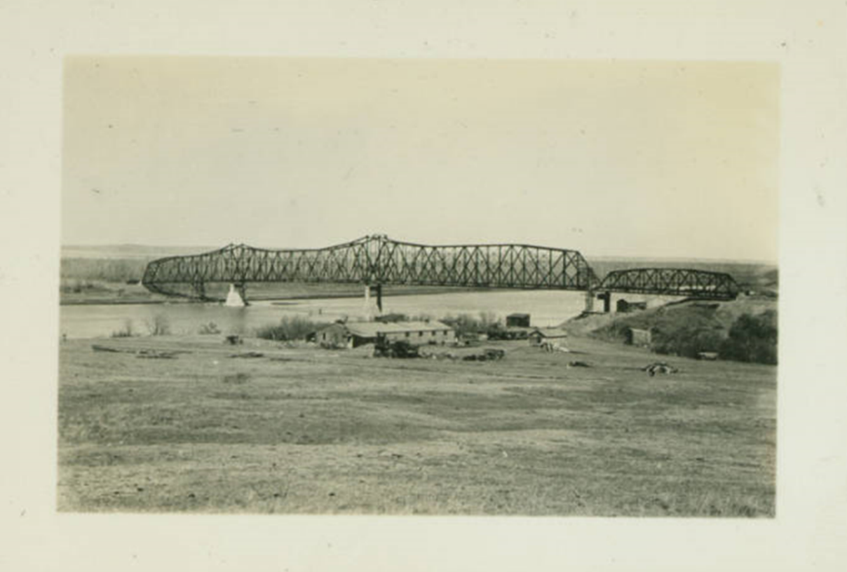
Four Bears Bridge, Elbowoods, N.D., State Historical Society of North Dakota (10898-00152)

Figure 2
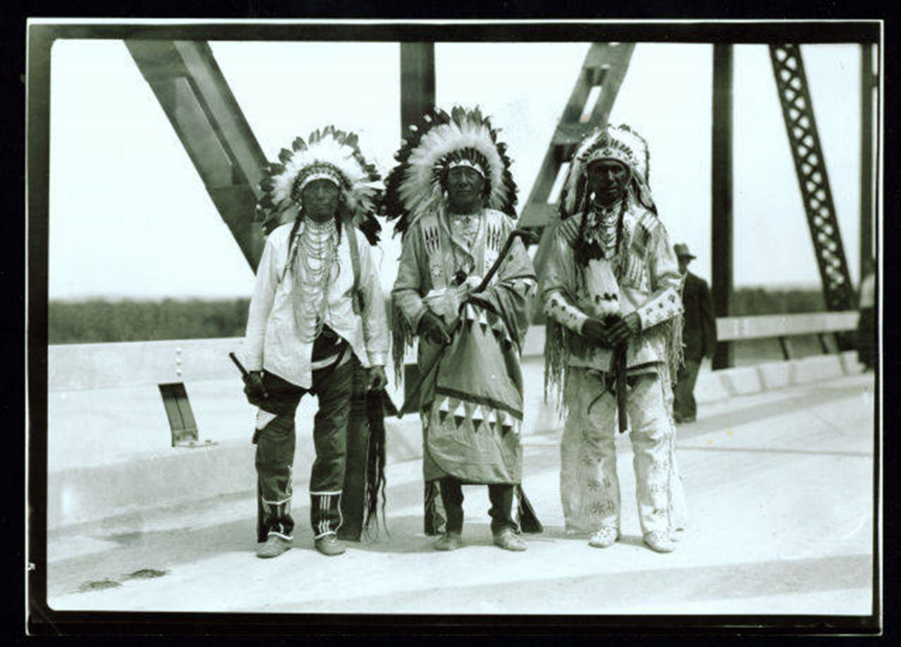
Four Bears Bridge dedication ceremony, Elbowoods, N.D., State Historical Society of North Dakota (2019-P-162-00027)

Figure 3
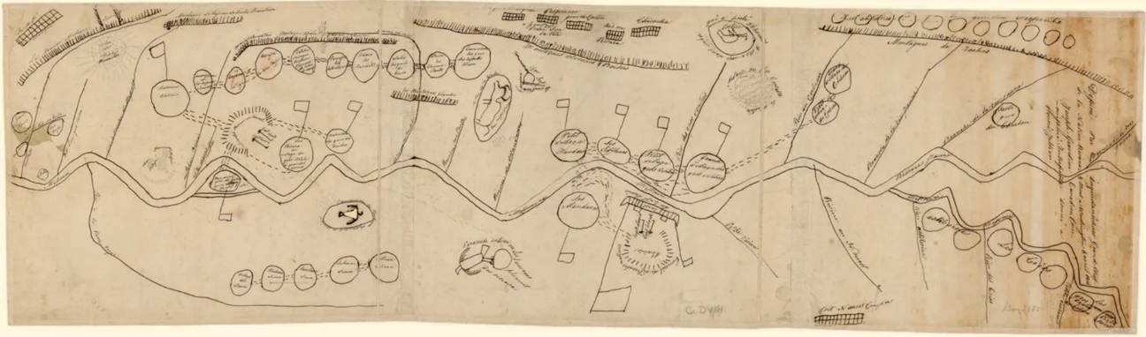
Too Né, Carte ethnographique de la vallée du Missouri portant cette inscription: “Dessiné par Inquidanécharo, grand chef de la nation Ricara et mort à Washington 6 avril 1806. Joseph Graveline, Canadien commissionné interpreter. Donné à Honoré Jullien,” GED-4781, Bibliothèque nationale de France (BNF), Paris.

Figure 4
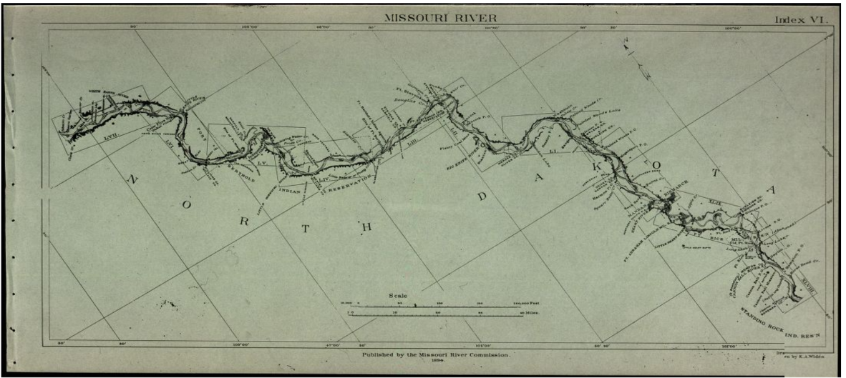
Map of the Missouri River: from its mouth to Three Forks, Montana, in eighty-four sheets and nine index sheets published in 1892-1895 by the Missouri River Commission created by Act of Congress July 5, 1884 (Reproduction of original at Omaha Public Library)

Figure 5
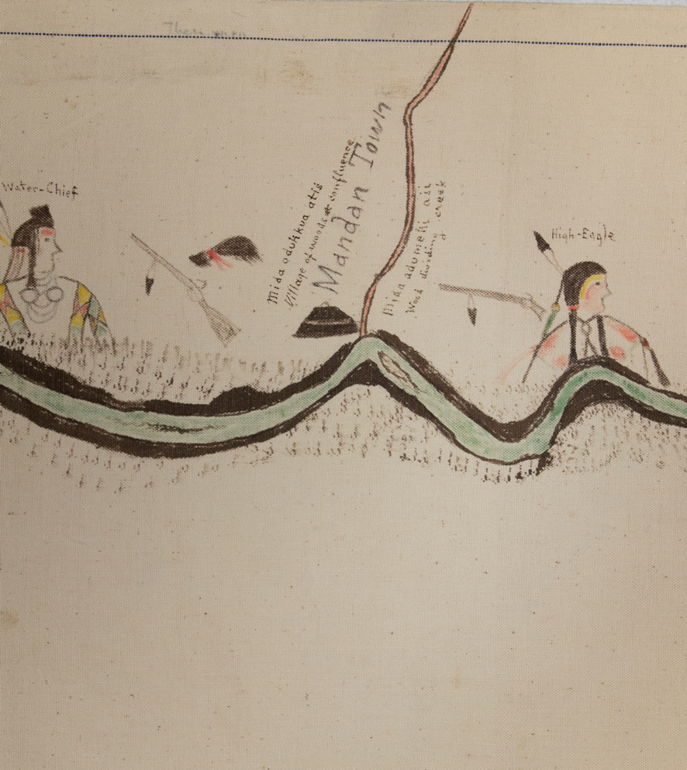
Sitting Rabbit, Map, 1905, 23 ft. 4 in. x 17.5 in., (State Historical Society of North Dakota)

Figure 6
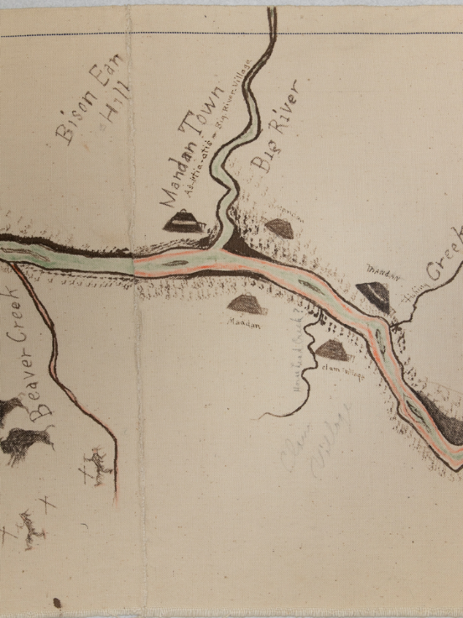
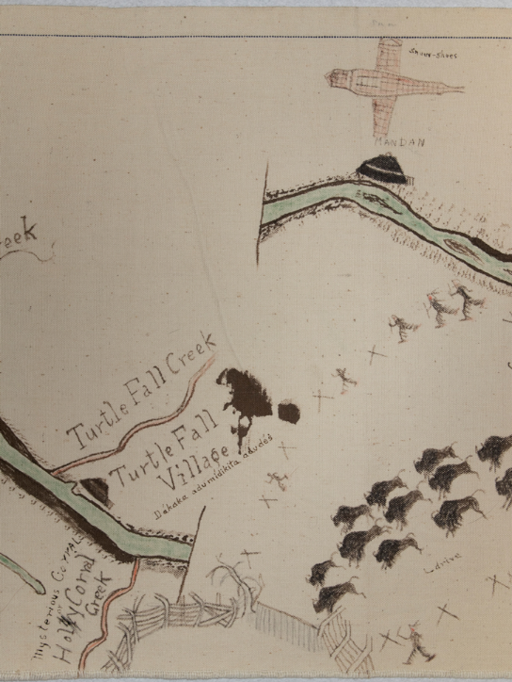
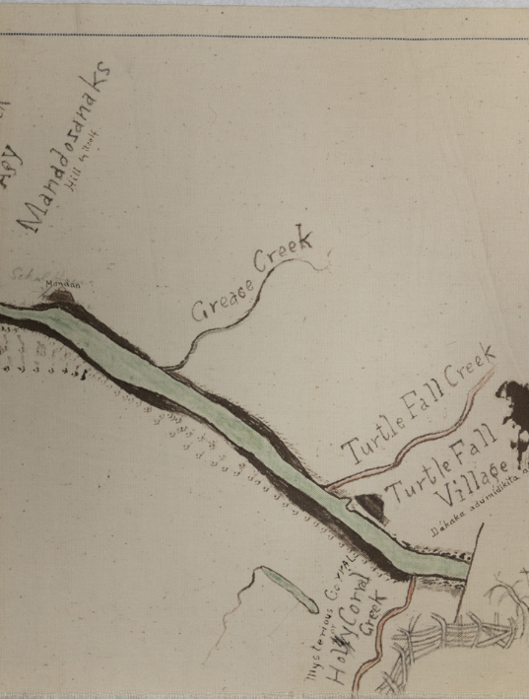

Figure 7
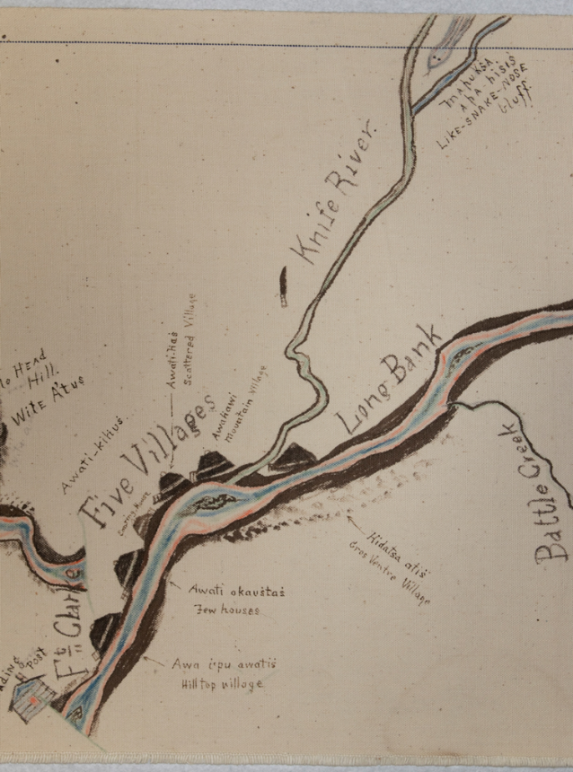
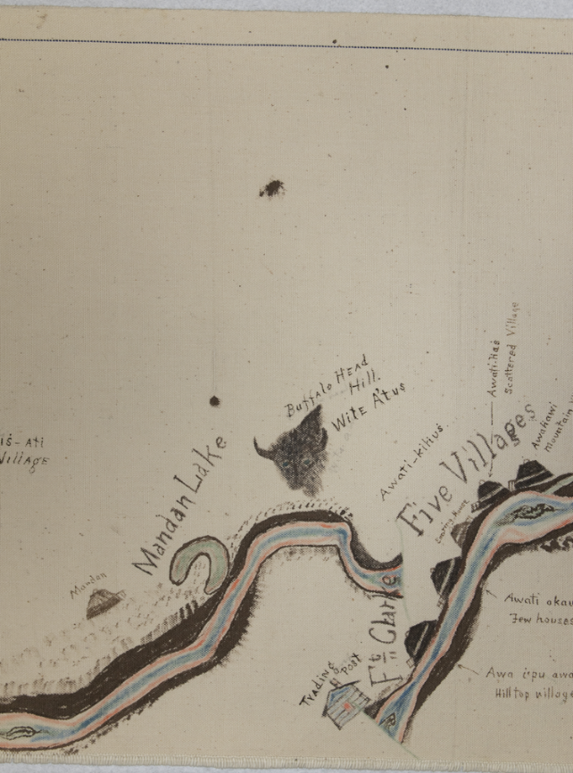

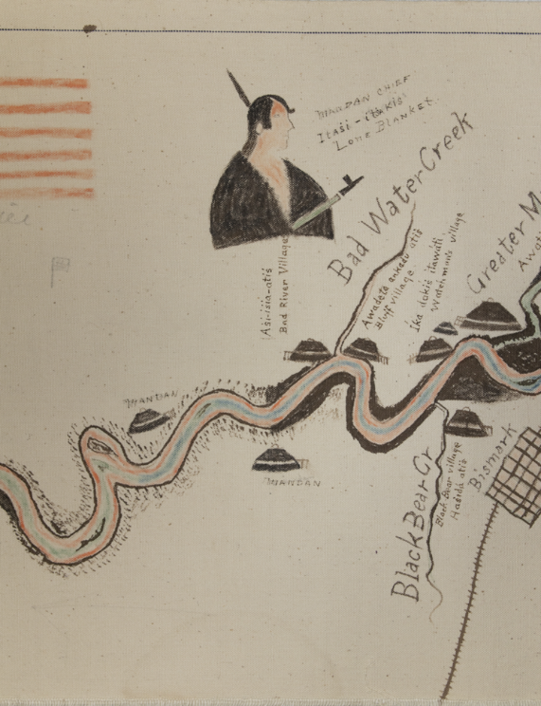
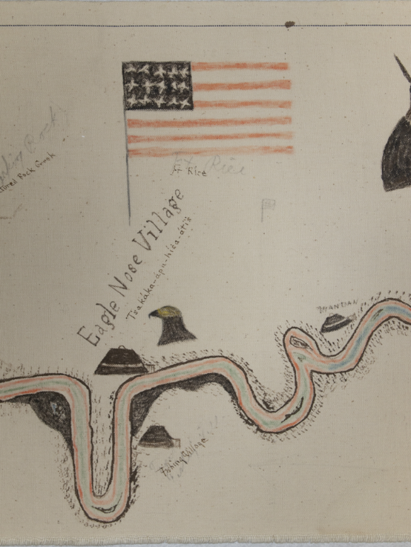
Figure 8
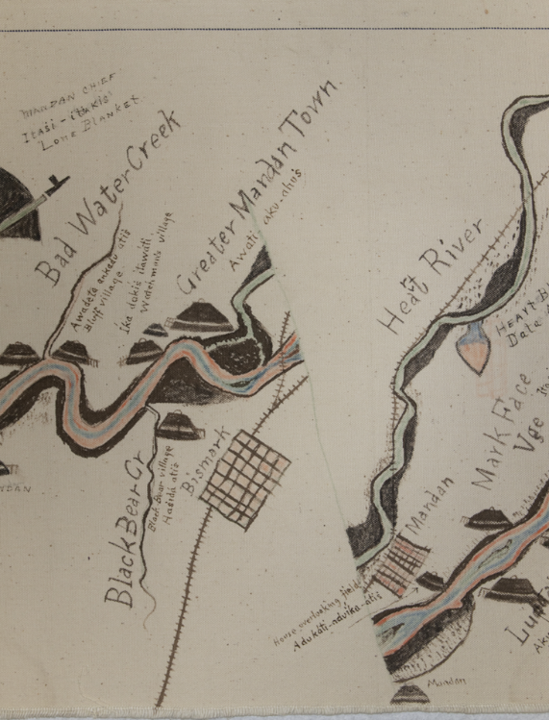

Figure 9
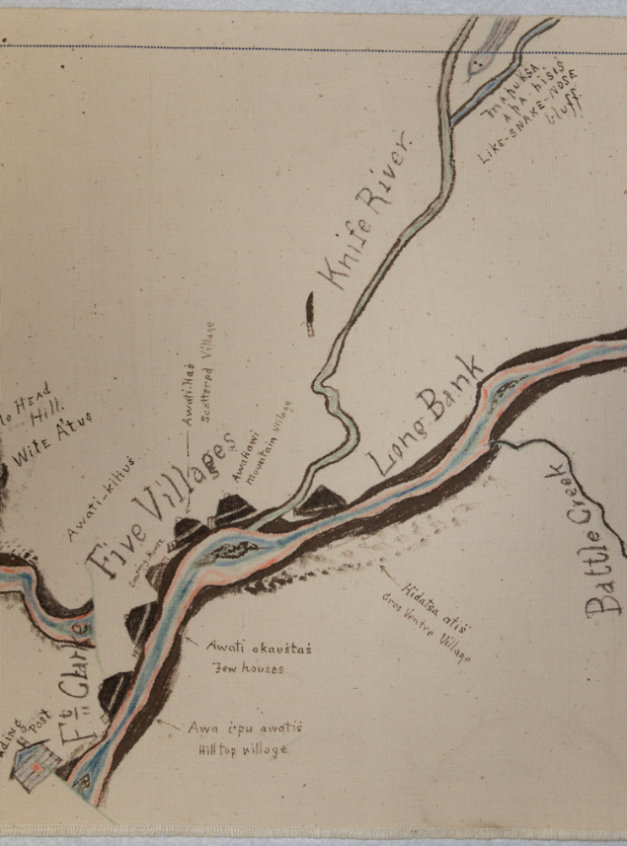
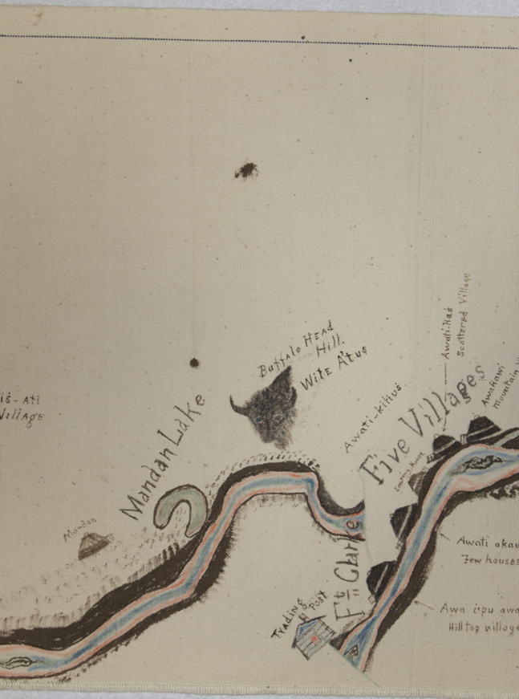

Figure 10

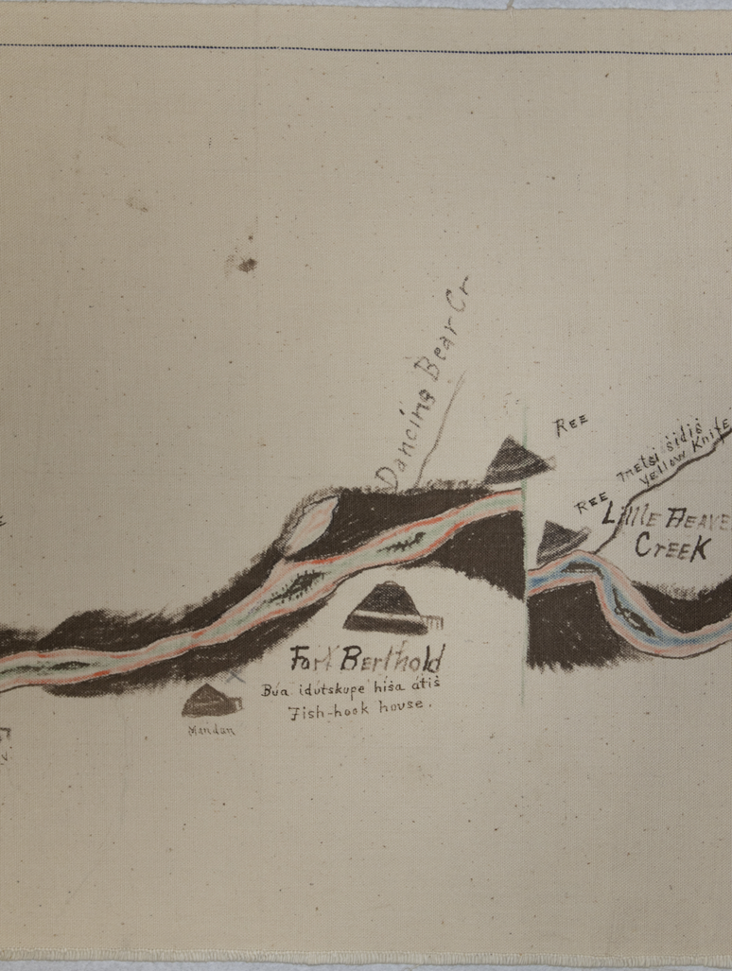

Figure 11
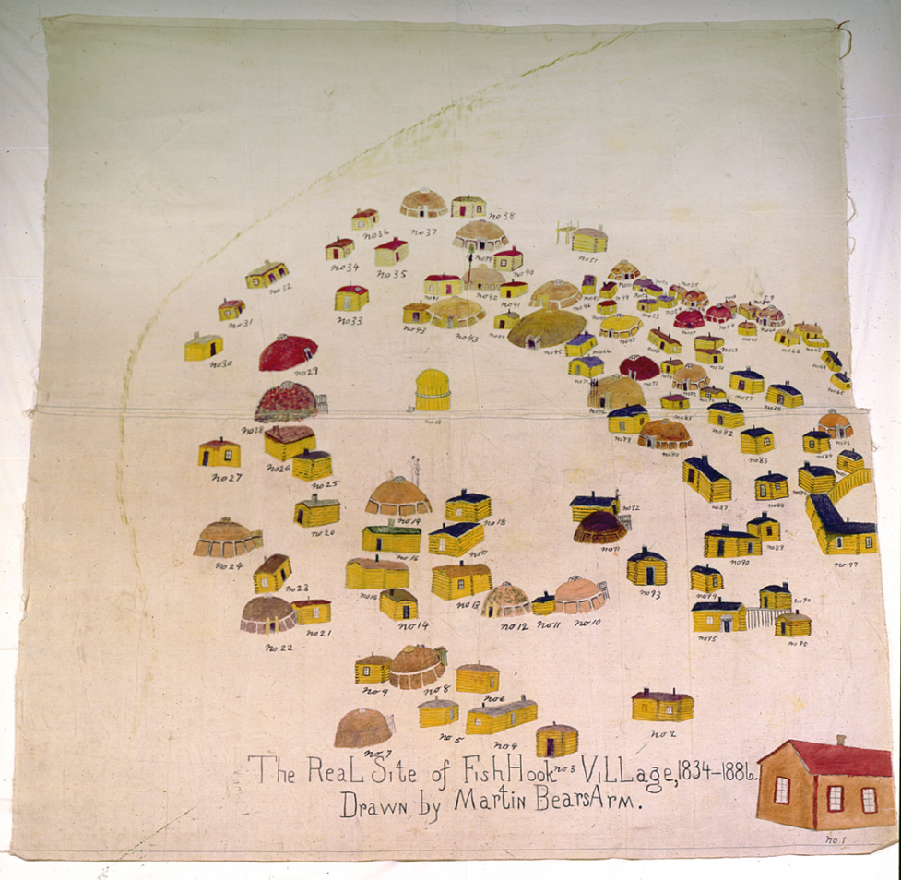
Martin Bears Arms, 1910 (State Historical Society of North Dakota)

Figure 12
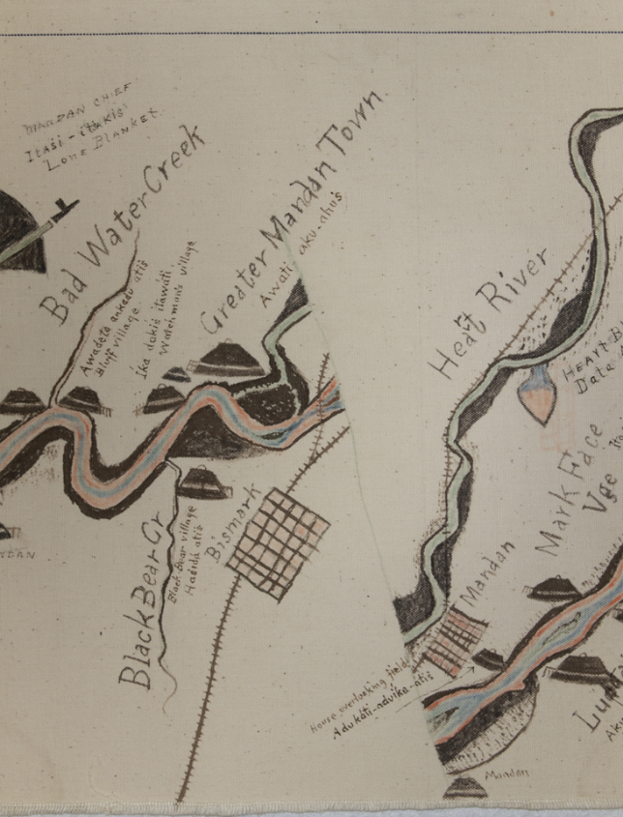
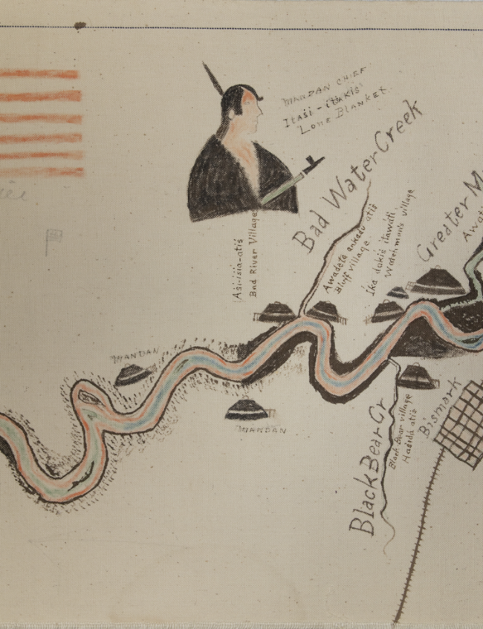
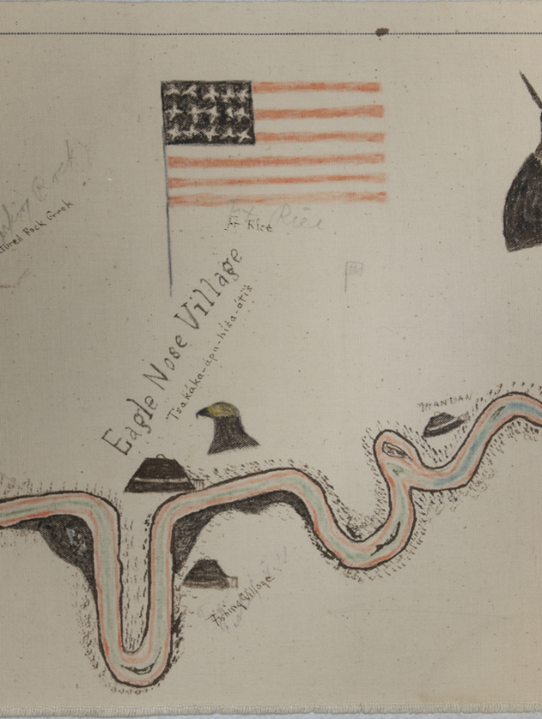

Figure 13

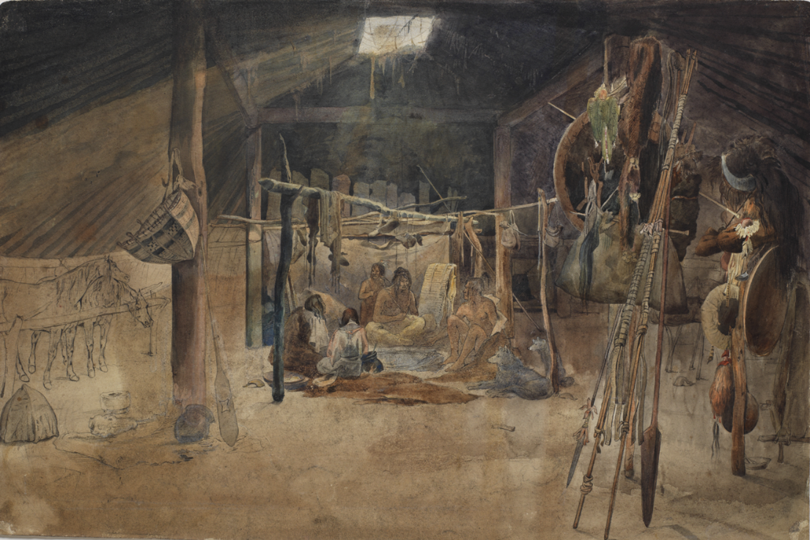

Karl Bodmer, Interior of a Mandan Earth Lodge, 1833–34. Watercolor and ink on paper. Joslyn Art Museum, Omaha. Gift of the Enron Art Foundation, 1986.49.261.A.

Figure 14

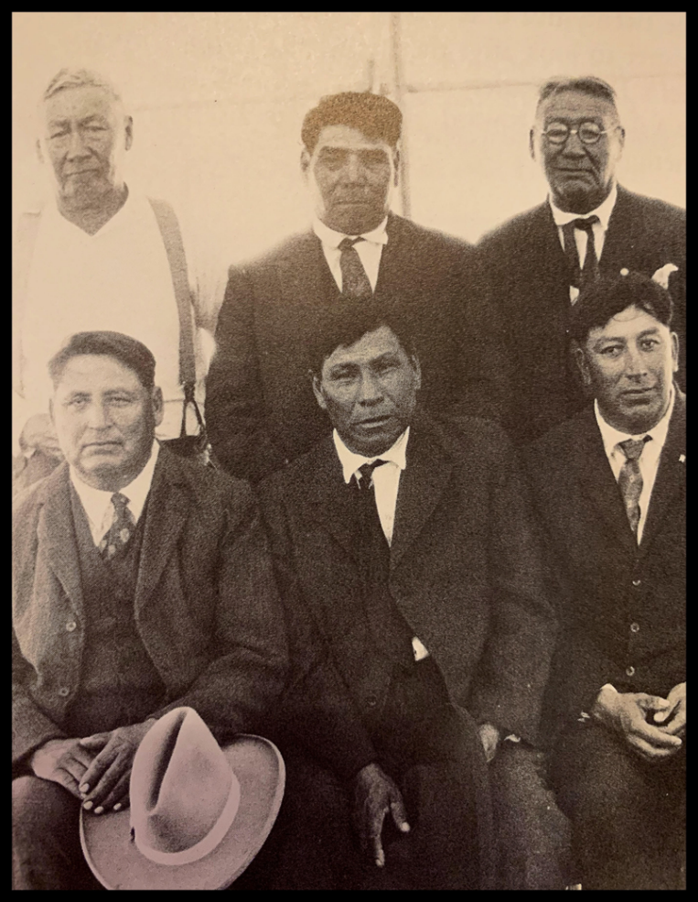

“Indian Preachers from the Congregational church at Fort Berthold Reservation” SHSND B198
Back row left to right:
Little Owl (Mandan), Enemy (Arikara), Henry Wolf Chief (Hidatsa), Edward Good Bird (Arikara/Hidatsa), Whitebull (Arikara), and Howling Wolf (Arikara)

Figure 15
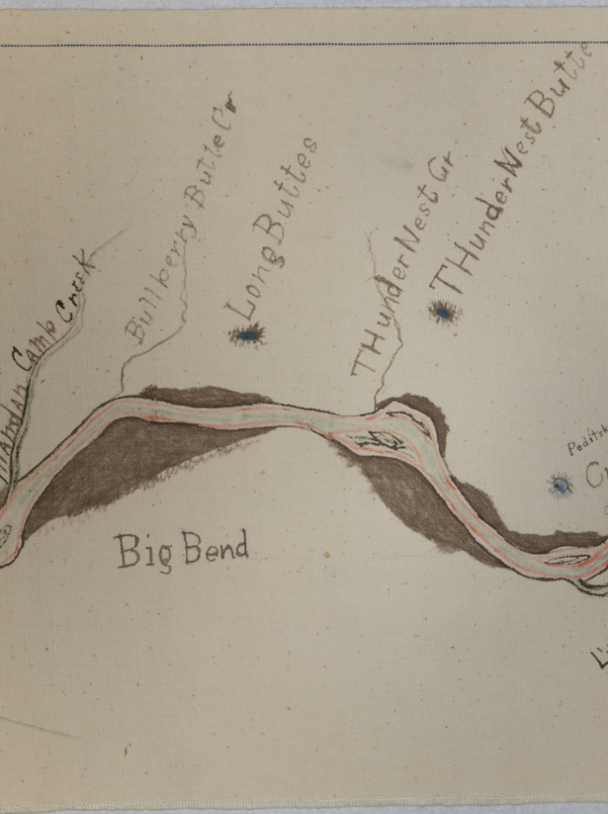
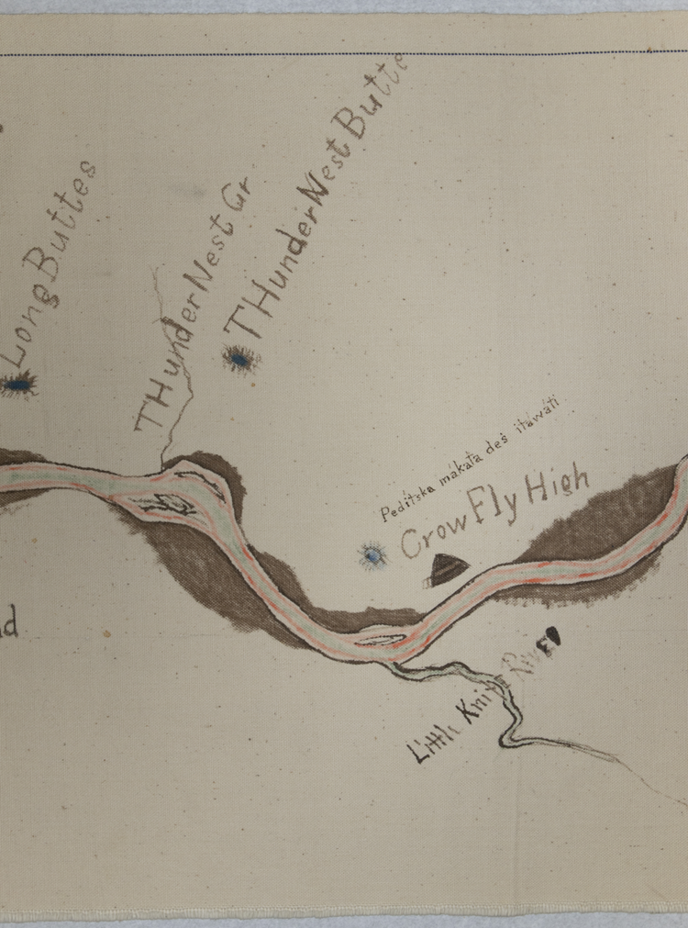

Figure 16



Figure 17
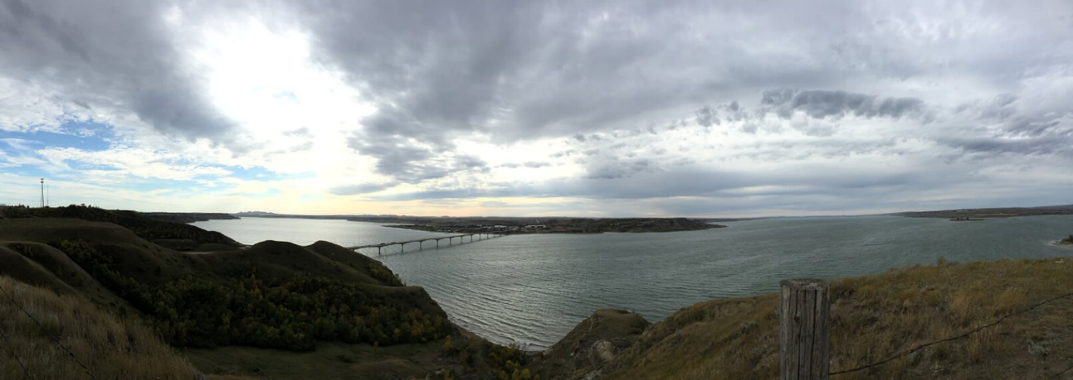

Bibliography

Archival Resources

Charles Lemmon Hall Papers, 1879-1938, Collection Number: 10005, State Historical Society of North Dakota

Fort Berthold Indian Reservation, 1874-1963, Collection Number: MSS 10513, State Historical Society of North Dakota

Frances Densmore, 1912-1918, Collection Number: 10335, State Historical Society of North Dakota

Fred Olson Photographs of Fort Berthold Reservation, 1889-1920, Collection Number: 00197, State Historical Society of North Dakota

Gilbert L. and Frederick N. Wilson Papers, 1894–1936, Hidatsa-Mandan Report—Fort Berthold Reservation. Minnesota Historical Society

Gilbert L. Wilson Papers, 1915-1916, Collection Number: 10166, State Historical Society of North Dakota

Glass Negatives of Indians Collected by the Bureau of American Ethnology, 1850s–1930s, National Museum of Natural History—National Anthropological Archives

Orin G. Libby Papers, 1902-1943, Collection Number: 10085, State Historical Society of North Dakota

Photographs, 1832-1982, Collection Number: A, State Historical Society of North Dakota

Printed Resources

Alwin, John A., "Pelts, Provisions & Perceptions the Hudson's Bay Company Mandan Indian Trade, 1795-1812," Montana: The Magazine of Western History 29, no. 3 (1979): 16 – 27.

Anderson, Gary C. Kinsmen of Another Kind: Dakota-White Relations in the Upper Missouri Valley, 1650 – 1862. Lincoln: University of Nebraska Press, 1984.

Barr, Juliana and Edward Countryman, “Introduction: Maps and Spaces, Paths to Connect, and Lines to Divide,” in Contested Spaces in Early America, edited by Juliana Barr and Edward Countryman, 1 – 30. Philadelphia: University of Pennsylvania Press, 2014.

Becker, Marshall J., “Matchcoats: Cultural Conservatism and Change in One Aspect of Native American Clothing,” Ethnohistory 52:4 (2005): 727–787.

Becker, Marshall. “Match Coats and the Military: Mass-Produced Clothing for Native Americans as Parallel Markets in the Seventeenth Century,” Textile History and the Military 41:1 (2010): 153 – 181.

Biddle, Nicholas. History of the Expedition under the Command of Captains Lewis and Clark New York: A.S. Barnes, 1814.

Bohaker, Heidi. ‘Nindoodemag’: The Significance of Algonquian Kinship Networks in the Eastern Great Lakes Region, 1600 – 1701,” The William and Mary Quarterly Vol. 63:1 (2006): 25 – 52.

Bohr, Roland, “Aboriginal Archery and European Firearms on the Northern Great Plains and in the Central Subarctic: Survival and Adaptation 1670-1870.” Ph.D. dissertation, University of Manitoba, 2005.

Bolz, Peter and Hans-Ulrich Sanner. Native American Art: The Collections of the Ethnological Museum Berlin. Germany: G+H Verlag, 1999.

Bowers, Alfred. Hidatsa Social and Ceremonial Organization. Lincoln: University of Nebraska Press, 1992.

Bowers. Alfred. Mandan Social and Ceremonial Organization. Chicago: University of Chicago Press, 1950.

Brooks, Lisa. Our Beloved Kin: A New History of King Philip’s War. New Haven: Yale University Press, 2018.

Brownstone, Arni, "European Influence in the Mandan-Hidatsa Graphic Works Collected by Prince Maximilian of Wied," American Indian Art Magazine 39: 3 (2014): 55-70.

Brownstone, Arnie. “Composition and Iconography in Painted Plains Shirts.” In Generous Man/ Ahxsi-tapina: Essays in Memory of Colin Taylor, edited by Arnie Brownstone and H.A. Dempsey, 8 – 34. Wyk, Germany: Tatanka, Press, 2008.

Carayon, Céline. Eloquence Embodied: Nonverbal Communication Among French and Indigenous Peoples in the Americas. Williamsburg, Virginia: Omohundro Institute of Early American History and Culture, 2019.

Carocci, Massimiliano. “Women, Temporary Liminality, and Two Spirits: The Plains Indians Scalp Dance’s Masquerad.” Journal of Ritual Studies 13:2 (1999): 12 – 25.

Catlin, George, O-kee-pa: a religious ceremony; and other customs of the Mandans. London, Trübner, 1867.

Catlin, George. Letters and Notes on the Manners, Customs, and the Condition of the North American Indians, Volume 1. London, 1841. Reprint, New York: Dover Publications, Inc., 1973.
Chardon, Francis A., Chardon's Journal at Fort Clark, 1834-1839. Lincoln: University of Nebraska Press, 1997).

Collison, Patrick J. “Bastions, Beads, Baptisms, and Burials: Evidence for Epidemic Disease among the Arikara and Their Ancestors.” Plains Anthropologist, vol. 58, no. 225 (2013): 9–43.

Crowther, Paul. Phenomenology of the Visual Arts, Even the Frame. Stanford, Calif: Stanford University Press, 2011.

DeMallie, Raymond J., Douglas R. Parks, and Robert Vezina, A Fur Trader on the Upper Missouri: The Journal and Description of Jean-Baptiste Truteau, 1794-1796. Lincoln: University of Nebraska Press, 2017.

Densmore, Frances. Mandan and Hidatsa Music. Washington D.C: Government Printing Office, 1923.

Dippie, Brian. Catlin and His Contemporaries: The Politics of Patronage. Lincoln: University of Nebraska Press, 1990.

DuVal, Kathleen. The Native Ground: Indians and Colonists in the Heart of the Continent. Philadelphia: University of Pennsylvania Press, 2011.

Elliot, Kate. Framing First Contact: From Catlin to Russell. Norman: University of Oklahoma Press, 2020.

Emerson, William. Encyclopedia of United States Army Insignia and Uniforms. Norman: University of Oklahoma Press, 1996.

Ewers, John C., George Catlin: Painter of Indians of the West. Washington, D.C.: Smithsonian Institution, 1955.

---- “Early White Influence Upon Plains Indian Painting: George Catlin and Karl Bodmer Among the Mandans, 1832–34,” Smithsonian Miscellaneous Collection 134: 7 (1957): 1- 11.

---- “William Clark’s Indian Museum in St. Louis 1816‐1838,” in A Cabinet of Curiosities: Five Episodes in the Evolution of American Museums, edited by Whitfield Bell Jr. Charlottesville: University Press of Virginia, 1967.

---- “Intertribal Warfare as the Precursor of Indian-White Warfare on the Northern Great Plains," Western Historical Quarterly, VI (October 1975): 397-410.

---- Plains Indian History and Culture: Essays on Continuity and Change. Norman: University of Oklahoma Press, 1997.

Fenn, Elizabeth. Encounters at the Heart of the World: A History of the Mandan People. New York: Hill and Wang Publishing, 2015.

Gell, Alfred. Art and Agency: An Anthropological Theory. Oxford: Clarendon Press, 1998.

Gilman, Carolyn and Mary Jane Schneider. The Way to Independence: Memories of a Hidatsa Indian Family 1840-1920. St. Paul: Minnesota Historical Society Press, 1987.

Given, Brian. A Most Pernicious Thing: Gun Trading and Native Warfare in the Early Contact Period. Ottawa: Carleton University Press, 1994.

Godlewska, Anne Marie Claire, “From Enlightenment Vision to Modern Science? Humboldt’s Visual Thinking,” in Geography and Enlightenment, edited by David N. Livingston and Charles W. J. Vithers, 236 – 276. Chicago: University of Chicago Press, 1999.

Goetzmann, William H., Joseph C. Porter, and David C. Hunt. The West as Romantic Horizon: Selections from the Collection of the InterNorth Art Foundation. Omaha, Neb: Center for Western Studies, Joslyn Art Museum, InterNorth Art Foundation, 1981.

Green, William and Calvin Grinnell et al. "Alfred W. Bowers' History of the Mandan and Hidatsa: A Significant Resource for Plains Anthropology," Plains Anthropologist 63:246 (2018): 113-33.

Greene, Candace. One Hundred Summers: A Kiowa Calendar Record. Lincoln: University of Nebraska Press, 2009.

Greer, Mavis and John Greer Freers. “Bear Imagery in Central Montana Rock Art,” in American Indian Rock Art: Volume 23, edited by Steven M. Freers, 85 – 94. San Miguel, California: American Rock Art Research Association, 1997.

Grinnell, George Bird. “Coup and Scalp among the Plains Indians.” American Anthropologist Vol 12: 2 (1910): 296 – 310.

Gurney, George and Therese Heyman, eds. George Catlin and His Indian Gallery. Washington, D.C.: Smithsonian American Art Museum, 2002.

Haines, Francis. “The Northward Spread of Horses among the Plains Indians,” American Anthropologist (Jul. - Sep., 1938): 429-437.

Haltman, Kenneth. Looking Close and Seeing Far: Samuel Seymour, Titian Ramsay Peale, and the Art of the Long Expedition. University Park: Penn State Press, 2008.

Harvey, Eleanor Jones and Hans-Dieter Sues. Alexander Von Humboldt and the United States: Art, Nature, and Culture. Washington, D.C.: Smithsonian American Art Museum in association with Princeton University Press, 2020.

Hazlitt, William. “On Imitation,” The Collected Works of William Hazlitt: The Round table. Characters of Shakespeare’s plays. A letter to William Gifford, esq.London: J.M. Dent, 1902.

Henning, Elizabeth R. “Western Dakota Winter Counts: An Analysis of the Effects of Westward Migration and Cultural Change.” Plains Anthropologist, vol. 27, no. 95 (1982): 57–65.

Henry, Alexander, David Thompson, and Elliott Coues. New Light on the Early History of the Greater Northwest: The Manuscript Journals of Alexander Henry and of David Thompson, 1799-1814. Volume 1. Cambridge: Cambridge University Press, 2015.

Her Many Horses, Emil, and George P. Horse Capture. A Song for the Horse Nation: Horses in Native American Cultures. Golden, Colo: Fulcrum Pub, 2006.

Hight, Kathryn S.‘“ Doomed to Perish': George Catlin’s Depictions of the Mandan.” Art Journal 49: 2 (Summer 1990): 119-123.

Holm, Tom, “American Indian Warfare: The Cycles of Conflict and Militarization of Native North American,” in Companion to American Indian History, edited by Philip J. Deloria, 154 – 172. Malden: Blackwell Publishing, 2007.

Holmberg, James. Dear Brother: Letters of William Clark to Jonathan Clark. New Haven: Yale University Press, 2002.

Horse Capture, George P. and Joseph D. Horse Capture. Beauty, Honor and Tradition: The Legacy of Plains Indian Shirts. Washington, D.C.: National Museum of the American Indian, Smithsonian Institution, 2001.

Horse Capture, George P. Robes of Splendor: Native American Painted Buffalo Robes. New York: New Press, 1993.

Howard, James H. “Yanktonai Ethnohistory and the John K. Bear Winter Count,” Plains Anthropologist 21:73 (August 1976): 1 – 78.

Hunt, David. C., Marsha V. Gallagher, and William J. Orr Karl Bodmer’s America. Lincoln: University of Nebraska Press, 1984.

Hutchinson, Eliabeth. “The Dress of His Nation”: Romney’s Portrait of Joseph Brant,” Winterthur Portfolio 45: 2 (2011): 209 – 228.

Hutchinson, Elizabeth. From Pantheon to Indian Gallery: Art and Sovereignty on the Early Nineteenth Century Cultural Frontier.” Journal of American Studies 47:2 (2013): 313 – 337.

Iseke, Judy. “Indigenous Storytelling as Research,” International Review of Qualitative Research 6:4 (Winter 2013): 559-577.

John, Gareth E. “Cultural Nationalism, Westward Expansion and The Production of Imperial Landscape: George Catlin’s Native American West,” Ecumene Vol 8, No. 2 (2001): 175 – 203.

Johnson, Annika K. George Catlin, Artistic Prospecting, and Dakhota Agency in the Archive. Archives of American Art Journal 59.1 (2020): 4 – 23.

Johnson, Laura E., "“Goods to Clothe Themselves”: Native Consumers and Native Images on the Pennsylvania Trading Frontier, 1712–1760," Winterthur Portfolio 43:1 (2009): 115-40.

Jung, Jacqueline E., “The Tactile and the Visionary: Notes on the Place of Sculpture in the Medieval Religious Imagination,” in Looking Beyond: Visions, Dreams, and Insights in Medieval Art and History, ed. Column Hourihane, 203-240. University Park: Pennsylvania University Press, 2010.

Jurovics, Toby. Faces from the Interior: The North American Portraits of Karl Bodmer. Omaha Nebraska: Joslyn Art Museum, 2021.

Kelley, Emily D. and Elizabeth Richards Rivenbark. Binding the Absent Body in Medieval and Modern Art: Abject, Virtual, and Alternate Bodies. London: Routledge, 2019.

Keyser, James D.. "Painted Bison Robes: The Missing Link in the Biographic Art Style Lexicon,” Plains Anthropologist 41:155 (1996): 29-52.

Kopp, Mike and Greg Semenko, “Four Bears Bridge: Crossing Time, Cultures, and Technologies in North Dakota,” Transportation Research News, June-July 2006.

Kovach, Margaret. Indigenous Methodologies: Characteristics, Conversations and Contexts. Toronto: University of Toronto Press, 2009.

Krause, Richard. “The Kinship, Tradition, and Settlement Pattern Archaeology of Middle Missouri Community Life” Plains Anthropologist Vol 57: 22 (2012): 125 – 139.

Larson, Lewis. “The Case for Earth Lodges in the Southeast,” in Ocmulgee Archaeology, 1936-1986, ed. David J. Hally, 105 – 115. Athens: University of Georgia Press, 2009.

Lewis, Malcom G. “Indian Maps: Their Place in the History of Plains Cartography,” Great Plains Quarterly, Vol. 4 No. 2 (Spring 1984): 91 – 108.

Lewis, Malcom G., ed. Cartographic Encounters: Perspectives on Native American Mapmaking and Map Use. Chicago: University of Chicago Press, 1998.

Liebersohn, Harry. Aristocratic Encounters: European Travelers and North American Indians. United Kingdom: Cambridge University Press, 2001.

Lindberg, Christer, “George Catlin’s Account(s) of the O-kee-pa in Concordance with Other Sources,” in The Challenges of Native American Studies Essays in Celebration of the Twenty-fifth American Indian Workshop, ed. Barbara Saunders, 185 – 206. Leuven: Leuven University Press, 2004.

Linton, Ralph “The Origin of the Plains Earth Lodge.” American Anthropologist Vol. 26, No. 2 (1924): 247–57

Lowie, Robert H. “Alleged Kiowa-Crow Affinities,” Southwestern Journal of Anthropology Vol.9: No.4 (Winter 1953): 357-368.

Lycett, Stephen and James Keyser. “Beyond Oral History: A Nineteenth Century Blackfoot Warriors’ Biographic Robe in Comparative and Chronological Context,” International Journal of Historical Archaeology 22: 4 (2018): 771-799.

Macdonel, John and W. Raymond Wood. Early Fur Trade on the Northern Plains: Canadian Traders Among the Mandan and Hidatsa Indians, 1738-1818. Norman: University of Oklahoma, 1985.

Mallery, Garrick and J. W Powell. Picture-Writing of the American Indians. New York: Dover Publications, 1972.

Mann, Rob. “True Portraitures of the Indians, and of their own peculiar Conceits of Dress’: Discourses on Dress and Identity in the Great Lakes, 1830 – 1850.” Historical Archaeology 41:1 (2007): 37 – 52.

Maurer, Evan. Visions of the People: A Pictorial History of Plains Indian Life. Minneapolis: Minneapolis Institute of Art, 1992.

McCoy, Ron. “Of Forests and Trees: John C. Ewers’ ‘Early White Influence upon Plains Indian Painting’ Re-Examined,” American Indian Art Magazine (Winter 2001): 62–71.

McLaughlin, Castle, Hillel S. Burger, and Mike Cross. Arts of Diplomacy: Lewis and Clark's Indian Collection. Seattle: Univ. of Washington Press, 2004.

Merleau-Ponty, Maurice. Phenomenology of Perception, trans. Colin Smith. London: Routledge, 1962.

Meyer, Roy W. The Village Indians of the Upper Missouri: The Mandans, Hidatsas, and Arikaras. Lincoln: University of Nebraska Press, 1977.

Miller, Cary. “Gifts as Treaties: The Political Use of Received Gifts in Anishinaabeg Communities, 1820 – 1832.” American Indian Quarterly Vol. 26:2 (2002): 221 – 245.

Mitchell, Mark, “Conflict and Cooperation in the Northern Middle Missouri, A.D. 1450 - 1650,” in Plains Village Archaeology: Bison-Hunting Farmers in the Central and Northern Plains, ed. Stanley A. Ahler and Marvin Kay, 155 – 169. Salt Lake City: University of Utah Press, 2007.

----, “Modeling Middle Missouri Warfare,” in Archaeological Perspectives on Warfare on the Great Plains, eds. Andrew Clark and Douglas Bamforth. Boulder: University Press of Colorado, 2018.

----. Crafting History in the Northern Plains: A Political Economy of the Heart River Region, 1400-1750. Tucson: University of Arizona Press, 2013.

Moffatt, Elizabeth, Janes Sirois, and Judi Miller. “Analysis of the Paints used to Decorate Northern Plains Hide Artifacts during the Nineteenth and Early Twentieth Centuries.” Journal of the Canadian Association for Conservation Vol 22 (1997): 39 - 52.

Moreton-Robinson, Aileen, “Relationality: A Key Presupposition of an Indigenous social research paradigm,” in Sources and Methods in Indigenous Studies, edited by Chris Anderson and Jean M. O’Brien, 50- 70. New York: Routledge, 2017.

Moulton, Gary E. and W. Raymond Wood. “Prince Maximilian and New Maps of the Missouri and Yellowstone Rivers by William Clark.” Western Historical Quarterly 12:4 (October 1981): 372-386.

Moulton, Gary E. The Journals of the Lewis and Clark Expedition. Lincoln: University of Nebraska Press, 1983.

Mt. Pleasant, Alyssa, Caroline Wigginton, and Kelly Wisecup, “Materials and Methods in Native American and Indigenous Studies,” Early American Literature 53:2 (2018): 407- 444.

Muller, Kevin. “From Palace to Longhouse: Portraits of the Four Indian Kings in a Transatlantic Context,” American Art Vol 22: 3 (2008): 26 – 49.

Murray, David. Indian Giving: Economies of Power in Indian-White Exchanges. Amherst: University of Massachusetts Press, 2000.

Murray, Wendi Field and Fern E. Swenson, “Situational Sedentism: Post-Contact Sanish Settlement as Social Process in the Middle Missouri, North Dakota,” Plains Anthropologist, 61:24 (2016): 336-360.

Murray, Wendi. “We Agree as One People: Co-Residence, Convergence, and Community Transformation among the Arikara in North Dakota.” Ph.D. Dissertation, University of Arizona, 2017.

Newcomb, W. W. "A Re-examination of the Causes of Plains Warfare," American Anthropologist, 52 (July-September 1950): 317-330.

Norris, F. Terry and Timothy R. Pauketat. “A Pre-Columbian Map of the Mississippi,” Southeastern Archaeology 27 (Summer 2008): 78-92.

Parker, Angela K. “Taken Lands: Territory and Sovereignty on the Fort Berthold Indian Reservation, 1934—1960.” Ph.D. Dissertation, University of Michigan, 2011.

Parker, Shalon. Painting the Prehistoric Body in Late Nineteenth-Century France. Newark: Delaware, 2018.

Parry, Joseph D. Art and Phenomenology. London: Routledge, 2011.

Pickering, Robert B., F. Kent Reilly, and Barry D. Tayman. Peace Medals: Negotiating Power in Early America. Tulsa, OK: Gilcrease Museum, 2011.

Porter, Joseph. “The Eyes of Strangers: ‘Fact’ and Art on the Ethnographic Frontier, 1832 – 34,” in Karl Bodmer’s Studio Art, ed. W. Raymond Wood, Joseph C. Porter, and David C. Hunt, 23 – 98. Chicago: University of Illinois, 2002.

Prown, Jules D. Art as Evidence: Writings on Art and Material Culture. New Haven, CT: Yale University Press, 2001.

Ray, Arthur J. Indians in the Fur Trade: Their Role as Trappers, Hunters, and Middlemen in the Lands Southwest of Hudson Bay, 1660-1870. Toronto: University of Toronto Press, 1998.

Robinson, Duane. A History of the Dakota or Sioux Indians. Minneapolis, University of Minnesota, 1958.

Rodee, Howard. “The Stylistic Development of Plains Indian Painting and its Relationship to Ledger Drawings.” Plains Anthropologist 10: 30 (1965): 218 – 232.

Ronan, Kristine K. “Káma-Kapúska! Making Marks in Indian Country, 1833–34,” Nineteenth Century Art Worldwide 18, no. 2 (Autumn 2019), https://doi.org/10.29411/ncaw.2019.18.2.23.

Ronda, James P. “Exploring the Explorers: Great Plains People and the Lewis and Clark Expedition,” Great Plains Quarterly 13 (Spring 1993): 81-90.

Ronda, James P., “Exploring the Explorers: Great Plains People and the Lewis and Clark Expedition,” in Lewis and Clark and the Indian Country: The Native American Perspective, ed. Frederick E. Hoxie and Jay T. Nelson. Chicago: University of Illinois, 2007.

Roper, Donna C. and Elizabeth P. Pauls, ed. Plains Earth Lodges: Ethnographic and Archaeological Perspectives. Tuscaloosa: University of Alabama Press, 2005.

Sanger, Alice E. and Siv Tove Kulbranstad Walker, eds. Sense and the Senses in Early Modern Art and Cultural Practices. Aldershot: Ashgarde, 2012.

Schulten, Susan. Mapping the Nation: History and Cartography in Nineteenth-Century America. Chicago: University of Chicago Press, 2012.

Shannon, Timothy. “Dressing for Success on the Mohawk Frontier: Hendrick, William Johnson, and the Indian Fashion,” The William and Mary Quarterly Vol 53: 1 (1996): 13 – 42.

Short, John R. Cartographic Encounters: Indigenous People and the Exploration of the New World. Chicago: University of Chicago Press, 2009.

Silverman, David. Thundersticks, Firearms, and the Violent Transformation of Native America. Cambridge: University of Harvard Press, 2016.

Slipp, Naomi, “Traversing Two Cultures: A Portrait of William McIntosh, Southern Slave Owner and Lower Creek Chief,” Panorama: Journal of the Association of Historians of American Art 6, no. 2 (Fall 2020). https://journalpanorama.org/article/traversing-two-cultures/

Smith, Hubert G., and W. Raymond Wood. The Explorations of the La Vérendryes in the Northern Plains 1738-43. Lincoln: University of Nebraska Press, 1980.

Smith, Huron. “Ethnobotany of the Ojibwe Indians,” Bulletin of the Public Museum of the City of Milwaukee, Vol: 3 (May 1933): 330 - 338.

St. Jean, Wendy. Trading Paths: Mapping Chickasaw History in the Eighteenth Century. American Indian Quarterly Vol 27: 3 (2003): 758 – 780.

Steinke, Christopher. ““Here is my country”: Too Né's Map of Lewis and Clark in the Great Plains,” William and Mary Quarterly, Vol. 71, No. 4 (October 2014): 589-610.

Stephanie Pratt and Joan Carpenter Troccoli, ed. George Catlin: American Indian Portraits. London: National Portrait Gallery, 2013.

Stewart, Austin. “Wielding the Power of Mapping: Cherokee Territoriality, Anglo-American Surveying, and the Creation of Borders in the Early Nineteenth-Century West,” Transactions of the American Philosophical Society, Vol 110, No. 4 (2021): 71-92.

Stewart, Frank H. "Mandan and Hidatsa Villages in the Eighteenth and Nineteenth Centuries,” Plains Anthropologist 19, no. 66 (1974): 287-302.

Sunderstrom, Linea. “Smallpox Used Them Up: References to Epidemic Disease in Northern Plains Winter Counts, 1714-1920.” Ethnohistory 44, no. 2 (Spring 1997): 305-343.

Sundstrom, Linea. “Coup Counts and Corn Caches: Contact-Era Plains Indian Accounts of Warfare,” in Archaeological Perspectives on Warfare on the Great Plains, edited by Andrew J. Clark and Douglas B. Bamforth, 131 – 145. Denver: University Press of Colorado, 2018.

Swenson, Fern E. “Settlement Plans for Traditional Mandan Villages at Heart River,” Bison-Hunting Farmers in the Central and Northern Plains, edited by Stanley Ahler and Marvin Kay, 239-58. Salt Lake City: University of Utah Press, 2007.

Taylor, C. F. and H. A. Dempsey, ed. The People of the Buffalo: The Plains Indians of North America: Essays in Honor of John C. Ewers. Wyk, Germany: Tatanka Press, 2005.

Taylor, Colin F. Native American Weapons. Norman: University of Oklahoma Press, 2008.

Taylor, Colin. “Reading Plains Indian Artefacts: Their Symbolism as Cultural and Historical Documents,” Ph.D. dissertation, University of Essex, 1990.

Thiessen, Thomas, W. Raymond Wood, and A. Wesley Jones. “The Little Owl 1907 Map of the Missouri River in North Dakota.” Plains Anthropologist, 24: 84 (1979): 145-167.

Tobin, Beth, Picturing Imperial Power: Colonial Subjects in Eighteenth Century British Painting. Durham: Duke University Press, 1999.

Truettner, William H. Painting Indians and Building Empires in North America, 1710-1840. Berkeley: University of California Press, 2010.

Tsinnajinnie, Leola R., Robin Minthorn, et al. “Embodying Indigenous Relationality in Research Methods,” in Applying Indigenous Research Methods: Storying with Peoples and Communities, edited by Sweeney Windchief and Timothy San Pedro, 37-55. New York: Routledge, 2019.

Van De Logt, Mark. ‘The Powers of the Heavens Shall Eat of My Smoke’: The Significance of Scalping in Pawnee Warfare. Journal of Military History 72:1 (2008): 71 – 104.

Walls, Laura Dassow. The Passage to Cosmos: Alexander Von Humboldt and the Shaping of America. Chicago: University of Chicago Press, 2009.

Warhus, Mark. Another America: Native American Maps and the History of Our Land. New York: St. Martin’s Press, 1997.

Wasekov, Gregory A. “Indian Maps of the Colonial Southeast,” in Powhatan's Mantle: Indians in the Colonial Southeast, ed. Peter Wood, Gregory A. Wasekov, et al. Lincoln: University of Nebraska, 2006.

White, Bruce. “The Woman who Married a Beaver: Trade Patterns and Gender Relations in the Ojibwa Fur Trade,” Ethnohistory 46:1 (1999): 109 – 147.

White, Richard. “The Winning of the West: The Expansion of the Western Sioux in the Eighteenth and Nineteenth Centuries,” The Journal of American History, Vol. 65:2 (September 1978): 319-343.

William G. Gartner, “An Image to Carry the World within It: Performance Cartography and the Skidi Star Chart,” in Early American Cartographies, ed. Martin Brückner, 169 – 247. Chapel Hill: University of North Carolina Press, 2011.

Wilson, Gilbert L. and Edward Goodbird. Agriculture of the Hidatsa Indians: An Indian Interpretation. Minneapolis: University of Minnesota, 1917.

Wilson, Shawn. Research Is Ceremony: Indigenous Research Methods. Winnipeg: Fernwood Publishing, 2008.

Witte, Stephen S. and Marsha V. Gallagher, et al. North American Journals of Prince Maximilian of Wied: April–September 1833 · Volume 2. Norman: University of Oklahoma Press, 2014.

Witte, Stephen S. and Marsha V. Gallagher, et al. North American Journals of Prince Maximilian of Wied: September 1833–August 1834 · Volume 3. Norman: University of Oklahoma Press, 2014.

Wood, Raymond W. “Integrating Ethnohistory and Archaeology at Fort Clark State Historic Site, North Dakota.” American Antiquity Vol. 58: 3 (1993): 544 – 559.

---- Prologue to Lewis and Clark: The MacKay and Evans Expedition. Norman: University of Oklahoma Press, 2003.

---- “James Kipp: Upper Missouri River Fur Trader and Missouri Farmer,” North Dakota History: Journal of the Northern Plains Vol. 77, No 1 and 2 (2011): 2 – 39.

----, et al. Fort Clark and Its Indian Neighbors: A Trading Post on the Upper Missouri. Norman: University of Oklahoma Press, 2016.

Woods-Marsden, Joanna. About Face: Self-portraits by Native American, First Nations, and Inuit Artists. Wheelwright Museum of the American Indian, 2006.

Yarborough, Minnie C., ed. The Reminiscences of William C. Preston. Chapel Hill: University of North Carolina, 1933.

Young, Jane. Signs from the Ancestors: Zuni Cultural Symbolism and Perceptions of Rock Art. Albuquerque: University of New Mexico Press, 1992.

Scholarship on Indigenous visual and material culture as extensions of a person, resulting in the object’s own personhood or agency, includes the following: Ruth B. Phillips, “Things Anishinaabe: Art, Agency, and Exchange Across Time,” in Before and After the Horizon: Anishinaabe Artists of the Great Lakes, ed. David Penney and Gerald McMaster (Washington D. C.: Smithsonian Institution National Museum of the American Indian, 2013), 51 – 70; Jenny Tone-Pah-Hote, Crafting an Indigenous Nation: Kiowa Expressive Culture in the Progressive Era (Chapel Hill: University of North Carolina Press, 2019), 7 – 8; Beverly Lemire, Laura Peers, and Anne Whitelaw, “Object Lives: Innovating Methodologies,” in Object Lives and Global Histories in Northern North America Material Culture in Motion, c.1780 – 1980, ed. Beverly Lemire, Laura Peers, and Anne Whitelaw (Montreal: McGill-Queen’s University Press, 2021), 26 – 52.
John C. Ewers, “Early White Influence Upon Plains Indian Painting,” Smithsonian Miscellaneous Collection 134: 7 (1957): 8.
Arni Brownstone, "European Influence in the Mandan-Hidatsa Graphic Works Collected by Prince Maximilian of Wied," American Indian Art Magazine 39: 3 (2014): 58-70; Joseph D. Horse Capture and George P. Horse Capture, Beauty, Honor and Tradition: The Legacy of Plains Indian Shirts (Washington: National Museum of the American Indian, Smithsonian institution, 2001), Candace Greene, One Hundred Summers: A Kiowa Calendar Record, (Lincoln: University of Nebraska Press), 2009; James D. Keyser, "Painted Bison Robes: The Missing Link in the Biographic Art Style Lexicon,” Plains Anthropologist 41:155 (1996): 29-52. Stephen Lycett and James Keyser, “Beyond Oral History: A Nineteenth Century Blackfoot Warriors’ Biographic Robe in Comparative and Chronological Context,” International Journal of Historical Archaeology 22: 4 (2018), 771-779.
Medieval art historians have substantially explored the study of the senses prior to its emergence within American Art History and the subfield of Native American Art History. For a diversity of publications, see Alice E. Sanger and Siv Tove Kulbranstad Walker, eds, Sense and the Senses in Early Modern Art and Cultural Practices (Aldershot: Ashgarde, 2012), Jacqueline E. Jung, “The Tactile and the Visionary: Notes on the Place of Sculpture in the Medieval Religious Imagination,” in Looking Beyond: Visions, Dreams, and Insights in Medieval Art and History, ed. Column Hourihane (University Park: Pennsylvania University Press, 2010), 203-240, and Emily D Kelley and Elizabeth Richards Rivenbark. Binding the Absent Body in Medieval and Modern Art: Abject, Virtual, and Alternate Bodies (London: Routledge), 2019.
Jules D. Prown, Art as Evidence: Writings on Art and Material Culture (New Haven, CT: Yale University Press, 2001), 70.
Maurice Merleau-Ponty, Phenomenology of Perception, trans. Colin Smith (London: Routledge, 1962): 71 and 82.
Recent art historical publications on perceptual and bodily engagement with the world include Paul Crowther, Phenomenology of the Visual Arts, Even the Frame (Stanford, Calif: Stanford University Press, 2011) and Joseph D. Parry, Art and Phenomenology (London: Routledge, 2011).
Lisa Brooks, Our Beloved Kin: A New History of King Philip’s War (New Haven: Yale University Press, 2018), 13.
Margaret Kovach, Indigenous Methodologies: Characteristics, Conversations and Contexts (Toronto: University of Toronto Press, 2009) and Shawn Wilson, Research Is Ceremony: Indigenous Research Methods (Winnipeg: Fernwood Publishing, 2008). See also Leola R. Tsinnajinnie, Robin Minthorn, Tiffany S. Lee, “K’E and Tdayp-Tday-Gaw: Embodying Indigenous Relationality in Research Methods,” in Applying Indigenous Research Methods: Storying with Peoples and Communities, edited by Sweeney Windchief and Timothy San Pedro (New York: Routledge, 2019): 37-55; Aileen Moreton--Robinson, “Relationality: A Key Presupposition of an Indigenous social research paradigm,” in Sources and Methods in Indigenous Studies, edited by Chris Anderson and Jean M. O’Brien (New York: Routledge, 2017): 50- 70 and Judy Iseke, “Indigenous Storytelling as Research,” International Review of Qualitative Research 6:4 (Winter 2013): 559-577..
Lisa Brooks, Our Beloved Kin: A New History of King Philip’s War (New Haven: Yale University Press, 2018), Joseph D. Horse Capture and George P. Horse Capture, Beauty, Honor and Tradition: The Legacy of Plains Indian Shirts (Washington: National Museum of the American Indian, Smithsonian institution, 2001), and Angela K. Parker, “Taken Lands: Territory and Sovereignty on the Fort Berthold Indian Reservation, 1934-1960,” Ph.D. Dissertation (University of Michigan, 2011). For a historiography that centers Native history reshaping early American studies, see Alyssa Mt. Pleasant, Caroline Wigginton, and Kelly Wisecup, “Materials and Methods in Native American and Indigenous Studies,” Early American Literature 53:2 (2018): 407- 444.
See Elizabeth Fenn, Encounters at the Heart of the World: A History of the Mandan People (New York: Hill and Wang, 2014), 327 - 336.
See Carolyn Gilman and Mary Jane Schneider. The Way to Independence: Memories of a Hidatsa Indian Family 1840-1920 (St. Paul: Minnesota Historical Society Press, 1987), 327; 338 – 339 and Angela K. Parker, “Taken Lands: Territory and Sovereignty on the Fort Berthold Indian Reservation, 1934-1960,” Ph.D. Dissertation (University of Michigan, 2011), 36 – 89.
Alfred Bowers, Mandan Social and Ceremonial Organization (Chicago: University of Chicago Press, 1950), Appendix 1: Myths of the Okipa Ceremony, see Origin Myth related by Scattercorn, 353.
Ibid. Appendix I: Myths of the Okipa Ceremony, see Origin Myth of the Sacred Pipe related by Wolf Chief, 362.
Angela K. Parker, “Taken Lands: Territory and Sovereignty on the Fort Berthold Indian Reservation, 1934—1960,” Ph.D. Dissertation, University of Michigan, 2011. Page 42.
For a history of migration among Mandan villages, see Frank H. Stewart, "Mandan and Hidatsa Villages in the Eighteenth and Nineteenth Centuries,” Plains Anthropologist 19, no. 66 (1974): 287-302.
Bowers, Mandan Social and Ceremonial Organization, 361.
See Fern E. Swenson, “Settlement Plans for Traditional Mandan Villages at Heart River,” Ed. Stanley Ahler and Marvin Kay, Bison-Hunting Farmers in the Central and Northern Plains (Salt Lake City: University of Utah Press, 2007), 239-58 and Mark Mitchell, Crafting History in the Northern Plains: A Political Economy of the Heart River Region, 1400-1750 (Tucson: University of Arizona Press, 2013), 67-71.
Meriwether Lewis, William Clark, et al. Definitive Journals of Lewis and Clark: Up the Missouri to Fort Mandan (Lincoln: University of Nebraska, 2002), 402-404 and Henry Atkinson, Expedition up the Missouri (Washington D.C.: Gales and Seaton, 1826), 11.
Francis A. Chardon, Chardon's Journal at Fort Clark, 1834-1839 (Lincoln: University of Nebraska Press, 1997), 391; John C. Ewers, Plains Indian History and Culture: Essays on Continuity and Change (Norman: University of Oklahoma Press, 1997), 174.
Hubert G. Smith, and W. Raymond Wood, The Explorations of the La Vérendryes in the Northern Plains 1738-43 (Lincoln: University of Nebraska Press, 1980), 53. See also Arthur J. Ray, Indians in the Fur Trade: Their Role as Trappers, Hunters, and Middlemen in the Lands Southwest of Hudson Bay, 1660-1870 (Toronto: University of Toronto Press, 1998).
Smith and Wood, Explorations of the La Vérendryes, 412. The Shoshone threatened the villages of the Mandan as well as more nomadic tribes such as the Assiniboins and Blackfeet. In the mid-eighteenth century, the Dakota Sioux (Yankton and Yanktonai tribes) still resided east of the Missouri.
The following men left written records detailing the size of the villages, trading habits, and interactions with Native leaders: Jacques d’Eglise (1790), James McKay and John Evans (1795), Jean-Baptiste Truteau (1796), David Thompson (1797), Charles Mackenzie (1804), and Manuel Lisa and Alexander Henry (1807). See Roy W. Meyer, The Village Indians of the Upper Missouri: The Mandans, Hidatsas, and Arikaras (Lincoln: University of Nebraska Press, 1977) and John C. Ewers, Plains Indian History and Culture: Essays on Continuity and Change (Norman: University of Oklahoma Press, 1997).
John A. Alwin, "Pelts, Provisions & Perceptions the Hudson's Bay Company Mandan Indian Trade, 1795-1812," Montana: The Magazine of Western History 29, no. 3 (1979), 22; James P. Ronda, “Exploring the Explorers: Great Plains People and the Lewis and Clark Expedition,” in Great Plains Quarterly 13 (Spring 1993): 82.
W. Raymond Wood, Prologue to Lewis and Clark: The MacKay and Evans Expedition (Norman: University of Oklahoma Press, 2003), 129.
Meriwether Lewis, Feb. 12, 1805, in Moulton, Definitive Journals of Lewis and Clark, 3: 292. For a history of the northward expansion of horse populations from the Pueblo villages along the Rio Grande in the early seventeenth century to the presence of horses among the northern Great Plains in the mid eighteenth century, see Francis Haines, “The Northward Spread of Horses among the Plains Indians,” American Anthropologist (Jul. - Sep., 1938): 429-437.
W. Raymond Wood and John Macdonel, Early Fur Trade on the Northern Plains: Canadian Traders Among the Mandan and Hidatsa Indians, 1738-1818 (Norman: University of Oklahoma, 1985), 64.
George Catlin, Letters and Notes on the North American Indians. (New-York: Wiley and Putnam, 1841; Cambridge: Cambridge University Press, 2011), 99.
Mark Mitchell, “Modeling Middle Missouri Warfare,” in Archaeological Perspectives on Warfare on the Great Plains, eds. Andrew Clark and Douglas Bamforth (Boulder: University Press of Colorado, 2018), 293.
Tom Holm, “American Indian Warfare: The Cycles of Conflict and Militarization of Native North American,” in Companion to American Indian History, ed. Philip J. Deloria (Malden: Blackwell Publishing, 2007), 155.
Pictographic winter counts date back to the late seventeenth century while the earliest surviving painted bison robes are attributed to the Algonquian groups in the eastern Woodlands and currently reside at the Musée du quai Branly. See George P. Horse Capture, Anne Vitart, Michel Waldberg, et al. Robes of Splendor Native American Painted Buffalo Hides (New York: New Press, 1993).
Maximilian Wied, Stephen S. Witte, and Marsha V. Gallagher. North American Journals of Prince Maximilian of Wied, Volume 3, September 1833–August 1834 (Norman: University of Oklahoma Press, 2014), 150.
Joseph D. Horse Capture and George P. Horse Capture, Beauty, Honor and Tradition: The Legacy of Plains Indian Shirts (Washington, D.C.: National Museum of the American Indian, Smithsonian Institution, 2001), 20.
Horse Capture, Beauty, Honor, and Tradition, 19.
Wied, 151. During Maximilian’s journey through the Great Plains in 1832, his accompanying artist Karl Bodmer painted only one portrait of a young man (Piegan) wearing a pictographic robe, compared to the two dozen watercolor drawings of men wearing less decorated robes.
See the following publications for heartline imagery represented on rock art. Mavis Greer and John Greer Freers, “Bear Imagery in Central Montana Rock Art,” in American Indian Rock Art: Volume 23, ed. Steven M. Freers (San Miguel, California: American Rock Art Research Association, 1997), 89 and Jane Young, Signs from the Ancestors: Zuni Cultural Symbolism and Perceptions of Rock Art (Albuquerque: University of New Mexico Press, 1992), 82.
Hubert Smith and W. Raymond Wood, The Explorations of the La Vérendrye’s in the Northern Plains, 1738-43. (Lincoln: University of Nebraska Press, 1980), 56.
Stephen S. Witte and Marsha V. Gallagher, et al. North American Journals of Prince Maximilian of Wied: April–September 1833 · Volume 2 (Norman: University of Oklahoma Press, 2014), 228.
George Catlin, “The North Americans in the Middle of the Nineteenth Century,” George Catlin Collection, HM35183, vol. A, illus.48. Quoted in Elizabeth Fenn, Encounters at the Heart of the World: A History of the Mandan People (New York: Hill and Wang Publishing, 2015), 147.
Alfred W. Bowers, Hidatsa Social and Ceremonial Organization (Lincoln: University of Nebraska Press, 1992), 303-308.
“Hidatsa Mandan Field Report,” Volume 10 (1911), Minnesota Historical Society-- Gilbert L. and Frederick N. Wilson Papers.
Ibid.
Ibid.
Stephen S. Witte and Marsha V. Gallagher, et al. North American Journals of Prince Maximilian of Wied: September 1833–August 1834 · Volume 3 (Norman: University of Oklahoma Press, 2014), 197. Many Indigenous men from other communities named their weapon according to its physical and spiritual powers. For example, the Narragansett word for rifle pésckunch meant thunderbolt and the equivalent Lakota expression, mázawakan is a compound term for metal (maza) and lightening (wakan). They associated the fog of war with the Thunderbird and believed the rifle could embody the fearsome qualities of this spiritual being. See David Silverman, Thundersticks Firearms and the Violent Transformation of Native America (Cambridge: University of Harvard Press, 2016), 11.
Stephen S. Witte and Marsha V. Gallagher, et al. North American Journals of Prince Maximilian of Wied: September 1833–August 1834 · Volume 3, 154.
Roland Bohr, “Aboriginal Archery and European Firearms on the Northern Great Plains and in the Central Subarctic: Survival and Adaptation 1670-1870,” Ph.D. Dissertation (University of Manitoba, 2005), 326 and Brian Given, A Most Pernicious Thing: Gun Trading and Native Warfare in the Early Contact Period (Ottawa: Carleton University Press, 1994), 107.
Bohr, 322.
Bohr, 215.
Emil Her Many Horses, and George P. Horse Capture. A Song for the Horse Nation: Horses in Native American Cultures (Golden, Colo: Fulcrum Pub, 2006), 37.
Not all scalping activities were life-threatening, but they damaged a warrior’s reputation. Maximilian recorded: “Often men who are scalped in skirmishes would become conscious again later and recuperate.” See Stephen S. Witte and Marsha V. Gallagher, et al. North American Journals of Prince Maximilian of Wied: September 1833–August 1834 · Volume 3, 205. To understand the spiritual purpose of scalping, see Linea Sundstrom, “Coup Counts and Corn Caches: Contact-Era Plains Indian Accounts of Warfare,” in Archaeological Perspectives on Warfare on the Great Plains, Ed. Andrew J. Clark and Douglas B. Bamforth (Denver: University Press of Colorado, 2018), 131.
However, the painted robe at the Peabody includes fewer than a third of warriors, weapons, shields, and horses with incised markings.
Christopher Steinke, ““Here is my country”: Too Né's Map of Lewis and Clark in the Great Plains,” William and Mary Quarterly, Vol. 71, No. 4 (October 2014), 604.
October 21, 1804, in Gary E. Moulton, ed., Definitive Journals of Lewis and Clark, vol 3, Up the Missouri to Fort Mandan (Lincoln, University of Nebraska Press., 1987), 189. Later that winter, Clark described another account of Medicine Rock from Mandan village chief Šehékšot (White Coyote), (February 21, 1805, ibid, 3:299).
See Stephen S. Witte and Marsha V. Gallagher, et al. North American Journals of Prince Maximilian of Wied: September 1833–August 1834 · Volume 3, 194.
Judi Miller, Elizabeth Moffant, and Jane Siois. Native American Materials Project Final Report. (Ottawa: Canadian Conservation Institute, 1990).
Castle McLaughlin, Hillel S. Burger, and Mike Cross. Arts of Diplomacy: Lewis and Clark's Indian Collection. (Seattle: Univ. of Washington Press, 2004), 150 – 160.
James Holmberg, Dear Brother: Letters of William Clark to Jonathan Clark (New Haven: Yale University Press, 2002), 86.
Nicholas Biddle, History of the Expedition under the Command of Captains Lewis and Clark (New York: A.S. Barnes, 1814), 240.
Huron Smith, “Ethnobotany of the Ojibwe Indians,” Bulletin of the Public Museum of the City of Milwaukee, Vol: 3, (May 1933): 338. For an account of Sioux expansion see William W. Warren, "History of the Ojibway Nation," Minnesota Historical Society Collections, V (1885), 157; Duane Robinson, A History of the Dakota or Sioux Indians (Minneapolis, 1958), 48-6; 80-84; Gary C. Anderson, Kinsmen of Another Kind: Dakota-White Relations in the Upper Missouri Valley, 1650 – 1982 (Lincoln: University of Nebraska Press, 1984): 1 – 39, and Fenn, Encounters at the Heart of the World: A History of the Mandan People, 34-36 and 144 -145.
Richard White, “The Winning of the West: The Expansion of the Western Sioux in the Eighteenth and Nineteenth Centuries,” The Journal of American History, Vol. 65:2 (September 1978), 319-343.
The cause of intertribal conflicts ranges from accessible buffalo hunting grounds and horses; see Richard White, "The Winning of the West: The Expansion of the Western Sioux in the Eighteenth and Nineteenth Centuries," Journal of American History, Vol 65:2 (September 1978), 319-43. John C. Ewers emphasizes the role of tribal identity as well as material attractions in "Intertribal Warfare as the Precursor of Indian-White Warfare on the Northern Great Plains," Western Historical Quarterly, VI (October 1975), 397-410. For further individual and societal causes, see W. W. Newcomb, Jr., "A Re-examination of the Causes of Plains Warfare," American Anthropologist, 52 (July-September 1950), 31 and Mark Mitchell, “Conflict and Cooperation in the Northern Middle Missouri, A.D. 1450 - 1650,” in Plains Village Archaeology: Bison-Hunting Farmers in the Central and Northern Plains, ed. Stanley A. Ahler and Marvin Kay (Salt Lake City: University of Utah Press, 2007): 155 – 169.
Raymond J. DeMallie, Douglas R. Parks, and Robert Vezina, A Fur Trader on the Upper Missouri: The Journal and Description of Jean-Baptiste Truteau, 1794-1796 (Lincoln: University of Nebraska Press, 2017), 99.
John K. Bear’s winter count also shows a similar increase—roughly thirty-three percent during the same time period. See Fenn, Encounters at the Heart of the World, 144.
Douglas Parks, “Introduction,” in A Fur Trader on the Upper Missouri, 56. Charbonneau also describes this same conflict in conversation with Maximilian.
See Stephen S. Witte and Marsha V. Gallagher, et al. North American Journals of Prince Maximilian of Wied: September 1833–August 1834 · Volume 3, 121-122.
Meriwether Lewis, William Clark, et al. October 22, 1804 entry in The Definitive Journals of Lewis & Clark: Up the Missouri to Fort Mandan Volume 3 ed. Gary Moulton (Lincoln: University of Nebraska Press, 2002), 191.
James H. Howard, “Yanktonai Ethnohistory and the John K. Bear Winter Count,” Plains Anthropologist 21:73 (August 1976), 37.
Evan Maurer, Visions of the People: A Pictorial History of Plains Indian Life (Minneapolis: Minneapolis Institute of Art, 1992); Colin Taylor, “Reading Plains Indian Artefacts: Their Symbolism as Cultural and Historical Documents,” Ph.D. dissertation, University of Essex, 1990; George P. Horse Capture, Robes of Splendor: Native American Painted Buffalo Robes (New York: New Press, 1993).
McLaughlin, Arts of Diplomacy, 158.
See Stephen S. Witte and Marsha V. Gallagher, et al. North American Journals of Prince Maximilian of Wied: September 1833–August 1834 · Volume III, 122.
See Stephen S. Witte and Marsha V. Gallagher, et al. North American Journals of Prince Maximilian of Wied: September 1833–August 1834 · Volume III, 255.
Massimiliano Carocci, “Women, Temporary Liminality, and Two Spirits: The Plains Indians Scalp Dance’s Masquerade,” Journal of Ritual Studies 13:2 (1999), 20.
Texts concerned with the Canadian fur trade include W. Raymond Wood and Thomas D. Thiessen, Early Fur Trade on the Northern Plains: Canadian Traders Among the Mandan and Hidatsa Indians, 1738 – 1818 (Norman: University of Oklahoma Press, 1985), 8 – 17 and 22 – 27.
While the precise number remains elusive, there were at least forty men in the expedition company. See James P. Ronda, “Exploring the Explorers: Great Plains People and the Lewis and Clark Expedition,” in Lewis and Clark and the Indian Country: The Native American Perspective, ed. Frederick E. Hoxie and Jay T. Nelson (Chicago: University of Illinois, 2007), 117.
Dec. 31, 1804 entry in Meriwether Lewis, William Clark, et al. Definitive Journals of Lewis and Clark: Up the Missouri to Fort Mandan Volume 3 (Lincoln: University of Nebraska, 2002), 264.
Feb. 1, 1805 entry in Meriwether Lewis, William Clark, et al. Definitive Journals of Lewis and Clark, 287.
January 28, 1805 entry in Meriwether Lewis, William Clark, et al. Definitive Journals of Lewis and Clark, 278.
For a brief history of the tomahawk in French and British trade, see Colin F. Taylor, Native American Weapons (Norman: University of Oklahoma Press, 2008), 27-29.
February 5, 1805 entry in Meriwether Lewis, William Clark, et al. Definitive Journals of Lewis and Clark, 289.
March 13, 1805 entry in Meriwether Lewis, William Clark, et al. Definitive Journals of Lewis and Clark, 313.
Clark gifted the Mandan with a steel corn mill (see his entry on October 29, 1804). A year later, Alexander Henry found the mill dismantled and its pieces cleverly deconstructed to form arrows. See Alexander Henry, David Thompson, and Elliott Coues. New Light on the Early History of the Greater Northwest: The Manuscript Journals of Alexander Henry and of David Thompson, 1799-1814. Volume 1 (Cambridge: Cambridge University Press, 2015), 238.
August 17, 1806 entry in Meriwether Lewis, William Clark, et al, The Definitive Journals of Lewis & Clark: Over the Rockies to St. Louis Volume 8. (Lincoln: University of Nebraska, 2002), 320.
The lapse of time is curious since other forts became established posts shortly after the Lewis and Clark expedition. For example, John J. Astor established a fur trading post at the mouth of the Columbia River in Astoria, Oregon in 1811, barely five years after the expedition left Fort Clatsop.
W. Raymond Wood, William J. Hunt, and Randy H. Williams. Fort Clark and Its Indian Neighbors: A Trading Post on the Upper Missouri (Norman: University of Oklahoma Press, 2016), 94.
“To the Editor,” Daily National Intelligencer, February 11, 1822. Thomas McKenney, head of the Bureau of Indian Affairs, commissioned Charles Bird King to paint portraits of these delegates such as Pawnee’s Petalesharro (Generous Chief) and the Otoe-Missouria Sumonyeacathee (Prairie Wolf) and his wife Hayne Hudjihini (Eagle of Delight). Their portraits, among many others, would become a portrait gallery in the War Department, but a fire at the Smithsonian destroyed almost all of King’s portraits in 1865.
Art historians and anthropologists have studied Catlin’s romanticized portraits of Native communities for decades, including Brian Dippie, Catlin and His Contemporaries: The Politics of Patronage (Lincoln: University of Nebraska Press, 1990); Kate Elliot, Framing First Contact: From Catlin to Russell (Norman: University of Oklahoma Press, 2020), 41 – 63; John C. Ewers, George Catlin: Painter of Indians of the West (Washington, D.C.: Smithsonian Institution, 1955); George Gurney and Therese Heyman, eds. George Catlin and His Indian Gallery (Washington, D.C.: Smithsonian American Art Museum, 2002); Kathryn S Hight,‘“ Doomed to Perish': George Catlin’s Depictions of the Mandan.” Art Journal (Summer 1990): 119-123; Gareth E. John, “Cultural Nationalism, Westward Expansion and The Production of Imperial Landscape: George Catlin’s Native American West,” Ecumene Vol 8, No. 2 (2001), 175 – 203; Stephanie Pratt, “George Catlin and the Representation of North American Indians,” in George Catlin: American Indian Portraits, ed. Stephanie Pratt and Joan Carpenter Troccoli (London: National Portrait Gallery, 2013), 26–27; and William Truettner, Painting Indians and Building Empires in North America, 1710–1840 (Berkeley: University of California Press, 2010), 4–6, 77–78.
For a comprehensive list of the fifty tribes Catlin visited, see Brian Dippie, Catlin and His Contemporaries: The Politics of Patronage (Lincoln: University of Nebraska Press, 1990), 27.
George Catlin, Letters and Notes on the Manners, Customs, and the Condition of the North American Indians, Volume 1 (London, 1841. Reprint, New York: Dover Publications, Inc., 1973), 35.
Quoted in George Catlin, O-kee-pa: a religious ceremony; and other customs of the Mandans (London, Trübner, 1867), 52.
See, for a review of Humboldt’s influence on German and American science, Anne Marie Claire Godlewska, “From Enlightenment Vision to Modern Science? Humboldt’s Visual Thinking,” Geography and Enlightenment, ed. David N. Livingston and Charles W. J. Vithers (Chicago: University of Chicago Press, 1999), 236 – 276; Eleanor Jones Harvey and Hans-Dieter Sues, Alexander Von Humboldt and the United States: Art, Nature, and Culture (Washington, D.C.: Smithsonian American Art Museum in association with Princeton University Press, 2020), 255 – 312; Susan Schulten, Mapping the Nation: History and Cartography in Nineteenth-Century America (Chicago:: University of Chicago Press, 2012), 79 -118; Laura Dassow Walls, The Passage to Cosmos: Alexander Von Humboldt and the Shaping of America (Chicago: University of Chicago Press, 2009).
For Bodmer’s biography, see: William H. Goetzmann, The West of the Imagination (New York: Norton, 1986), 44-57; William Goetzmann, “Introduction,” in Karl Bodmer’s America, ed. David. C. Hunt, Marsha V. Gallagher, and William J. Orr (Lincoln: University of Nebraska Press, 1984), 1-24; William J. Orr, “Karl Bodmer’s Life,” in Karl Bodmer’s America, ed. David. C. Hunt, Marsha V. Gallagher, and William J. Orr (Lincoln: University of Nebraska Press, 1984), 349 – 373; Joseph Porter, “The Eyes of Strangers: ‘Fact’ and Art on the Ethnographic Frontier, 1832 – 34,” in Karl Bodmer’s Studio Art, ed. W. Raymond Wood, Joseph C. Porter, and David C. Hunt (Chicago: University of Illinois, 2002), 23 – 98;; Scott Manning Stevens, “The Achievement of Karl Bodmer,” in Faces from the Interior: The North American Portraits of Karl Bodmer, ed. Toby Jurovics (Omaha Nebraska: Joslyn Art Museum, 2021), 23-44.
Bodmer supervised printmakers responsible for creating the aquatints and helped to advertise the three-volume publication.
The maps are copies from Clark’s originals made during his and Lewis’ 1804-1806 expedition. Since more than half of the original maps are lost, Maximilian’s copies augment the Lewis and Clark expedition and illustrate over 900 additional miles. See W. Raymond Wood and Gary E. Moulton, “Prince Maximilian and New Maps of the Missouri and Yellowstone Rivers by William Clark,” Western Historical Quarterly 12:4 (October 1981), 381.
Many cultural items collected by Clark were gifted to Thomas Jefferson to decorate his Monticello home, Charles Wilson Peale’s Museum in Philadelphia, and his brother Johnathan Clark in Kentucky. See John C. Ewers, “William Clark’s Indian Museum in St. Louis 1816‐1838,” in A Cabinet of Curiosities: Five Episodes in the Evolution of American Museums, ed. Whitfield Bell Jr. (Charlottesville: University Press of Virginia, 1967), 54.
Minnie C. Yarborough, ed., The Reminiscences of William C. Preston (Chapel Hill, N.C., 1933), 16.
The artists also visited Peale’s Museum in Philadelphia, which fostered a relationships among art, knowledge, and nature perhaps more than any other American institution during the 1820s and 1830s.
Kipp compiled a Nueta vocabulary for Henry Rowe Schoolcraft’s monumental text on Native language. See Henry Rowe Schoolcraft, Historical and Statistical Information Respecting the History, Condition, and Prospects of the Indian Tribes of the United States, vol. 3 (Philadelphia: Lippincott, 1851-1859), 446-459. Kipp also kept a journal which spanned his forty years of employment as a trader, but it was destroyed when his home burned shortly before his death in 1880. For a detailed biography of James Kipp, see W. Raymond Wood, “James Kipp: Upper Missouri River Fur Trader and Missouri Farmer,” North Dakota History: Journal of the Northern Plains Vol. 77, No 1 and 2 (2011), 2 – 39.
William Hazlitt, “On Imitation,” The Collected Works of William Hazlitt: The Round table. Characters of Shakespeare’s plays. A letter to William Gifford, esq (London: J.M. Dent, 1902), 72 – 73.
For a recent study of Bodmer’s paintings as scientific illustrations, see Shalon Parker, Painting the Prehistoric Body in Late Nineteenth-Century France (Newark: University of Delaware Press, 2018), 96 – 105 and Lisa Strong, “No Detail Too Small: Karl Bodmer’s Portraits and Anthropological Illustration,” in Faces from the Interior: The North American Portraits of Karl Bodmer, ed. Toby Jurovics (Omaha Nebraska: Joslyn Art Museum, 2021), 45 – 101.
For a history of smallpox affecting settlements in the Great Plains region, see Fenn, Encounters at the Heart of the World, 154 – 162.
Linea Sunderstrom, “Smallpox Used Them Up: References to Epidemic Disease in Northern Plains Winter Counts, 1714-1920,” Ethnohistory 44, no. 2 (Spring 1997): 305-343.
Meriwether Lewis observed the abandoned On-a-Slant village site on October 12, 1804 as the expedition traveled upstream to the Mitutanka village on October 27. See Gary E Moulton, ed. The Journals of the Lewis & Clark Expedition (Lincoln: University of Nebraska Press, 2002), 3: 186 -189. Additionally, William Clark in conversation with Mandan informant Sheheke (White Coyote) drew a map of Mandan villages along the Heart River in 1804 noting abandoned settlements including On-A-Slant village. The original map has not survived to the present day, but Maximilian made a copy of it in 1833 to prepare for his westward journey.
Bowers, Mandan Social and Ceremonial Organization, 113 – 114.
For a more thorough migration history of Mandan settlements, see Fenn, Encounters at the Heart of the World, 165 - 172; 205 – 209; Frank H. Stewart, “Mandan and Hidatsa Villages in the Eighteenth and Nineteenth Centuries,” Plains Anthropologist Vol 19: 1 (November 1974): 287- 302; and Wood, Hunt, and Williams, Fort Clark and its Indian Neighbors, 32 – 33 and 43- 46. Stephen S. Witte and Marsha V. Gallagher, et al. North American Journals of Prince Maximilian of Wied: September 1833-August 1834, Volume 3 (Norman: University of Oklahoma Press, 2014), 3: 112
Catlin, Letters and Notes, 154.
Catlin even compared Mató-Tópe’s charismatic personality to that of first chief Charata Numakschi (Wolf Chief) who was an “overbearing man, respected and feared by his people rather than loved,” See Catlin, Letters and Notes, 147.
Catlin, Letters and Notes, 114.
Catlin, Letters and Notes, 115.
Further research on gifts and gift theory that have informed my study include the following sources concerned with Native American subjects: David Murray, Indian Giving: Economies of Power in Indian-White Exchanges (Amherst: University of Massachusetts Press, 2000), 34-35; Cary Miller, “Gifts as Treaties: The Political Use of Received Gifts in Anishinaabeg Communities, 1820-183,” American Indian Quarterly 26, no. 2 (2002): 221–45; Céline Carayon, Eloquence Embodied: Nonverbal Communication Among French and Indigenous Peoples in the Americas (Williamsburg, Virginia: Omohundro Institute of Early American History and Culture), 2019.
Witte and Gallagher, et al. North American Journals of Prince Maximilian of Wied, 55.
Witte and Gallagher, et al. North American Journals of Prince Maximilian of Wied, 55.
Ibid, 59. Maximilian did not record the name of Mató-Tópe’s wife. His son earned the names Bad Gun and Charging Eagle later in life. He also had two daughters, and one named Sak’wi-ah-ki (Earth Woman) married the Fort Clark trader James Kipp in the 1840s.
Although Maximilian does not describe the function of the society, he writes the word soldats following his introduction of the Kaua-Karakachka dance in his December 3 journal entry. Witte and Gallagher, et al. North American Journals of Prince Maximilian of Wied, 90-93.
Ibid, 74. Wied also gifted drawings instruments to Mató-Tópe on December 10 which he would later use for his own drawings and later present them to the European visitors.
See the journal entries for December 10. Witte and Gallagher, et al. North American Journals of Prince Maximilian of Wied, 98.
The details that Bodmer records of Mató-Tópe’s regalia have encouraged critics over the decades to consider Bodmer’s drawing solely as an image of anthropological relevance. For example: William H. Goetzmann, Joseph C. Porter, and David C. Hunt, The West as Romantic Horizon: Selections from the Collection of the InterNorth Art Foundation (Omaha, Neb: Center for Western Studies, Joslyn Art Museum, InterNorth Art Foundation, 1981) and William H. Goetzmann, “The Man Who Stopped to Paint America,” in Karl Bodmer's America, ed. David C. Hunt et al, (Lincoln: Joslyn Art Museum & University of Nebraska Press, 1984), 15.
George Catlin, Illustrations of the Manners, Customs, and Condition of the North American Indians: In a Series of Letters and Notes Written During Eight Years of Travel and Adventure Among the Wildest and Most Remarkable Tribes Now Existing (London: H.G. Bohn, 1848), 145. Catlin goes on to provides extensive description of the technical process of creating Mató-Tópe garments, see pages 146 -147. Catlin claims he purchased the shirt from Mató-Tópe, but the original shirt has not survived. A copy at the Smithsonian was based upon personal observations of the shirt, I believe the rudimentary drawings and unusual bands of quillwork attached to the shoulders (presumably Cree) mark it as a fabrication rather than an original produced by Mató-Tópe himself.
Interpreted through a classical framework, Mató-Tópe’s proud stance parallels that of the 1st century marble sculpture Apollo Belvedere. See William H. Truettner, Painting Indians and Building Empires in North America, 1710-1840 (Berkeley: University of California Press, 2010), 7-11, and Beth Tobin, Picturing Imperial Power: Colonial Subjects in Eighteenth Century British Painting (Durham.: Duke University Press, 1999), 223.
Alfred W. Bowers, Mandan Social and Ceremonial Organization (Chicago: University of Chicago Press, 1950), 33.
Ibid, 181.
The Bern Historical Museum robe and the Linden Museum—Stuttgart robe were both presumably collected by Maximilian during his travels.
Both of these Hidatsa robes were collected by Maximilian during his travels in the Upper Missouri region.
Catlin, Letters and Notes, 153. Wied describes the same event in conversation with Mató-Tópe on November 9. See Witte and Gallagher, et al. North American Journals of Prince Maximilian of Wied, 55.
Catlin, Letters and Notes, page 153.
Although the physical robe no longer survives, Catlin published sketches of the pictographs in his Letters and Notes,148 – 154. For a description of Mató-Tópe’s revenge on his brother’s death, see page 149.
Bowers, Mandan Social Organization, 166. Bowers conducted his ethnographic research among the Mandan between 1929 and 1931, compiling his research in Mandan Social and Ceremonial Organization published in 1950. See William Green and Calvin Grinnell et al, "Alfred W. Bowers' History of the Mandan and Hidatsa: A Significant Resource for Plains Anthropology," Plains Anthropologist 63:246 (2018): 113-33.
Catlin, Letters and Notes, 150.
Catlin, Letters and Notes, 151.
The Berlin Ethnological Museum’s 1844 purchase of Maximilian’s ethnographic collection lists the item as “the Mandan chief Mato-Tope’s medicine robe”. The collection also includes eleven painted robes from the Upper Missouri region. Peter Bolz and Hans-Ulrich Sanner, Native American Art: The Collections of the Ethnological Museum Berlin (Germany: G+H Verlag, 1999), 28.
Bowers, Mandan Social Organization, 166.
Catlin, Letters and Notes, 148
Bowers, Mandan Social Organization, 168.
Thirty lodges are represented within the orb, about half of the number counted by Maximilian.
Gilbert L. Wilson and Edward Goodbird, Agriculture of the Hidatsa Indians: An Indian Interpretation (University of Minnesota, 1917), 117. Edward Goodbird, or Tsaka’kasakic, son of Buffalo Bird Woman, also served as Wilson’s interpreter during his initial summer visit in 1912.
Witte and Gallagher, et al. North American Journals of Prince Maximilian of Wied, 59.
Frances Densmore interviewed Holding Eagle who described the rare occurrence of a woman in combat. He recalls the story of a man who rescued a young woman when she was thrown from her horse during battle and quickly realized he had saved his daughter in law. See Frances Densmore, Mandan and Hidatsa Music (Washington D.C: Government Printing Office, 1923), 133.
These correspond with Lowie’s interviews with Mandan informant Wounded Face in 1912, 1915, and 1918. The small number of Mandan who survived the smallpox epidemic of 1837 merged their communities with the Hidatsa in the 1840s which may have led Mandan informants to recall or blend similar rituals with Hidatsa military societies. See Robert Lowie, “Societies of the Crow Hidatsa and Mandan Indians” in Anthropological Papers American Museum of Natural History Vol XI (New York: Order of the Trustees, 1913), 294.
Frances Densmore, Mandan and Hidatsa Music (Washington D.C: Government Printing Office, 1923), 111.
The Dog society shares similar characteristics among neighboring communities such as the Arikara, Cheyenne, and Gros Ventre. See Robert H. Lowie, “Alleged Kiowa-Crow Affinities,” Southwestern Journal of Anthropology Vol.9: No.4 (Winter 1953): 361.
See Lowie, Societies of the Crow Hidatsa and Mandan Indians, 300.
Francis A. Chardon and Annie Heloise Abel, Chardon's Journal at Fort Clark, 1834-1839 (Lincoln: University of Nebraska Press, 1997), 124.
See Maximilian’s journal entry on March 1, 1833 for his account of the Meníss-Ochatä (Dog Society) dance. See Witte and Gallagher, et al The North American Journals of Prince Maximilian of Wied, Volume 3, 269 – 270.
For a description of the room, see Maxmilian’s journal entry November 22. Witte and Gallagher, et al, The North American Journals of Prince Maximilian of Wied, Volume 3 (University of Oklahoma Press, Norman, 2012), 72.
Síh-Xídä’s wife and his five-year-old son accompanied him to Fort Clark twice, although their names are not recorded.
Witte and Gallagher, et al The North American Journals of Prince Maximilian of Wied, Volume 3, 96.
Catlin, Letters and Notes, 107.
Catlin, Letters and Notes, 109-110.
Questions regarding an animate presence within Indigenous portraits has been a popular topic among art historians with an interest in photography. See Kalli Paakspuu, ‘Writing the body’: The hypertext of photography,” International Journal of Media and Cultural Politics Volume 5: 3 (2009): 183-197 and Christopher Wright, “A Devil’s Engine”: Photography and Spirits in the Western Solomon Islands,” Visual Anthropology 21 (2008): 364-380.
Catlin, Letters and Notes, 109.
Catlin, Letters and Notes, 111.
Typescript of notes and music manuscripts of Sanish, Nuxbáagas, and Nueta songs by Frances Densmore, September 17, 1912, MS 10335, Box 9, Folder 12, Frances Densmore Collection. State Historical Society of North Dakota, Bismarck, North Dakota.
Alfred Bowers, Hidatsa Social and Ceremonial Organization (Lincoln: University of Nebraska Press, 1992), 198.
Other members of the Dog Society may have included Mató-Tópe, Awascho-Dickfas (Swallow with the White Belly). and Máhchsi-Karéhde (Flying War Eagle).
Witte and Gallagher, et al The North American Journals of Prince Maximilian of Wied, Volume 3, 56.
Joslyn Art Museum, “Faces from the Interior: Gerard Baker, Michael Barthelemy Jr, Jennifer Young Bear,” YouTube video, Oct 1, 2021, 9:19 - 9:21, https://www.youtube.com/watch?v=IcHfAtXf68k&t=559s.
Nueta families welcomed individuals to their earth lodges at any time for food and conversation, and they expected similar invitations at Fort Clark. During one of Catlin’s conversations with Mato-Tope, “It is a custom among these Northern Indians, anyone who is hungry is allowed to walk into any man’s lodge and eat.” See Letters and Notes, 150.
Witte and Gallagher, et al The North American Journals of Prince Maximilian of Wied, Volume 3, 59.
Although the feathers represented are undiscernible, Síh-Xídä’s staff contained would have contained feathers from birds common to the Great Plains region.
Anthropologist John C. Ewers claims that Síh-Xídä paintings were a direct product of Bodmer’s tutelage, but does not review Mandan aesthetic preferences which would have influenced Síh-Xídä’s choice of subject and representation. See John C. Ewers, “Early White Influence Upon Plains Indian Painting: George Catlin and Karl Bodmer Among the Mandans, 1832–34,” Smithsonian Miscellaneous Collections Vol 134: 7 (April 1957) 1 -13. For the continued influence of Ewers’ thesis on contemporary scholarship, see Arni Brownstone, “European Influence in the Mandan-Nuxbáagas Graphic Works Collected by Prince Maximilian of Wied,” American Indian Art Magazine (Summer 2014) 58–70 and Ron McCoy, “Of Forests and Trees: John C. Ewers’ ‘Early White Influence upon Plains Indian Painting’ Re-Examined,” American Indian Art Magazine (Winter 2001) 62–71.
Witte and Gallagher, et al. North American Journals of Prince Maximilian of Wied, 66.
William Emerson, Encyclopedia of United States Army Insignia and Uniforms (Norman: University of Oklahoma Press, 1996), 439.
Archaeological evidence and written documents suggest that by 1700 tailored coats had become a major part of the trade good supply requested by Natives along the Northeastern coast. See Marshall J. Becker, “Matchcoats: Cultural Conservatism and Change in One Aspect of Native American Clothing,” Ethnohistory 52:4.(2005), 727–787 and Laura E. ‘Johnson, "“Goods to Clothe Themselves”: Native Consumers and Native Images on the Pennsylvania Trading Frontier, 1712–1760," Winterthur Portfolio 43:1 (2009), 115-40.
“To the Editor,” Daily National Intelligencer, February 11, 1822.
Witte and Gallagher, et al The North American Journals of Prince Maximilian of Wied, 199.
Síh-Xídä wears a heavy silver medal draped over his chest forming a tangible connection to the rich history of international relations between Euro-American countries and Native communities. The distribution of peace medals was to secure political, economic, and military alliances. For example, William and Clark carried medals imprinted with President Thomas Jefferson’s profile on the front and the obverse features clasped hands. Maximilian mentions that Cháratä-Numakschi (Wolf Chief) wore a medal from President John Quincy Adams during his visit on November 16, 1833. See Witte and Gallagher, et al The North American Journals of Prince Maximilian of Wied, 63. For a history of earlier peace medals, see Robert B. Pickering, F. Kent Reilly, and Barry D. Tayman, Peace Medals: Negotiating Power in Early America (Tulsa, OK: Gilcrease Museum, 2011).
George Horse Capture, A Song for the Horse Nation: Horses in Native American Cultures (National Museum of the American Indian, Smithsonian Institution, 2006), 51.
See Bowers, Mandan Social and Ceremonial Organization (1950; repr., Lincoln: University of Nebraska Press, 2004), 72 and Garrick Mallery and J. W Powell. Picture-Writing of the American Indians (New York: Dover Publications, 1972), 574.
The annual Okipa ceremony was hosted for centuries until it was banned by the federal government in 1890. See Bowers, Mandan Social and Ceremonial Organization, 118.
See November 16, 1833 entry. Witte and Gallagher, et al The North American Journals of Prince Maximilian of Wied, 64. Catlin also refers to the Christian genesis narrative about the Great Flood, see Catlin, Letters and Notes, 158.
Catlin, Letters and Notes, 164. Lieutenant Henry E. Maynadier witnessed the ceremony on the Fort Berthold reservation in 1860, which he published in 1868 under the heading Report of Brevet Brigadier General W. F. Raynolds on the Exploration of the Yellowstone and the Country Drained by that River. See Christer Lindberg, “George Catlin’s Account(s) of the O-kee-pa in Concordance with Other Sources,” in The Challenges of Native American Studies Essays in Celebration of the Twenty-fifth American Indian Workshop, ed. Barbara Saunders (Leuven: Leuven University Press, 2004): 185 – 206 for a more detailed synopsis.
Catlin, Letters and Notes, 168.
The ceremony holds similar attributes of the Sun Dance practiced among numerous other Northern Plains communities. See Margot P. Liberty, “From Earth Lodge to Medicine Lodge? Probable Cheyenne Origins of the Sun Dance,” in Plains Earth lodges: Ethnographic and Archaeological Perspectives, ed. Donna C. Roper and Elizabeth P. Pauls (Tuscaloosa: University of Alabama, 2005), 75 – 82.
Calvin Grinnell, “The Cutting Scene, Mandan O-kee-pa Ceremony,” Denver Art Museum, 2019, https://www.denverartmuseum.org/en/edu/object/cutting-scene-mandan-o-kee-pa-ceremony
Men’s performances through dancing and physical sacrifice may take precedence in the Okipa ceremony, but women’s contributions were also important. They gathered willow branches for the bison dancers, prepared containers for sacred bundles, and created numerous items for distribution at the annual ceremony. Bowers, Mandan Social and Ceremonial Organization, 123.
George Catlin, Mandan Buffalo Dance; The Last Race, Mandan O‑kee-pa Ceremony; Bull Dance, Mandan O‑kee-pa Ceremony; and Interior View of the Medicine Lodge, Mandan O‑kee-pa Ceremony reside at the Smithsonian American Art Museum. The Cutting Scene, Mandan O-kee-pa Ceremony resides at the Denver Art Museum. For an in-depth review of the Okipa ceremony, see Catlin, Letters and Notes, 155 – 184 and Bowers, Mandan Social and Ceremonial Organization, 111 – 163.
See Maximilian’s November 11, 1833 entry, which describes the scaffold burial of Síh-Xídä’s mother-in-law. Witte and Gallagher, et al The North American Journals of Prince Maximilian of Wied, 56.
Witte and Gallagher, et al The North American Journals of Prince Maximilian of Wied, 110.
Witte and Gallagher, et al The North American Journals of Prince Maximilian of Wied, 266.
Catlin, Catlin’s Notes of Eight Years’ Travels, 264. Catlin does not specify which Sioux band attacked Síh-Xídä and his comrades.
Witte and Gallagher, et al The North American Journals of Prince Maximilian of Wied, 174.
Other versions are recounted in Alfred W. Bowers, Mandan Social and Ceremonial Organization (Lincoln, University of Nebraska Press, 2005), 156-163.
Witte and Gallagher, et al The North American Journals of Prince Maximilian of Wied, 175.
To further understand the struggle for natural resources between Indigenous communities and American steamboat companies along the Missouri River, see Greg Gordon, “Steamboats, Woodhawks, and War on the Upper Missouri River,” Montana: The Magazine of Western History, Vol. 61: 2 (2011), 30 – 46.
Christyann R. Maxfield, Goodbye to Elbowoods: The Story of Harold and Eva Case (Bismarck, N.D.: State Historical Society of North Dakota, 1986), 16.
Five photographs were taken by Congregational minister Harold Case and his son Leo.
Carlo Rotella, “Industry, Nature, and Identity in an Iron Footbridge,” in American Artifacts: Essays in Material Culture, eds. Jules Prown and Kenneth Haltman (East Lansing: Michigan State University Press, 2000), 202.
Greg Semenko and Mike Kopp, “Four Bears Bridge: Crossing Time, Cultures, and Technologies in North Dakota,” Transportation Research News, June-July 2006, 11.
Scholars are expanding the field of cartography to include Indigenous map making practices and evaluate their representations of spatial knowledge. There are few extant examples prior to the nineteenth-century due to ephemera materials such as marking trees, outlining routes in dirt, and oral testimonies. The following scholars have reviewed historic Native maps to study their links with cosmography, cartographic memory, and daily navigation of their territory: Malcom G. Lewis, “Indian Maps: Their Place in the History of Plains Cartography,” Great Plains Quarterly, Vol. 4 No. 2 (Spring 1984), 91 – 108; Malcom G. Lewis, ed. Cartographic Encounters: Perspectives on Native American Mapmaking and Map Use (Chicago: University of Chicago Press, 1998); Mark Warhus, Another America: Native American Maps and the History of Our Land (New York, 1997); John R. Short, Cartographic Encounters: Indigenous People and the Exploration of the New World (London, 2009); Juliana Barr and Edward Countryman, “Introduction: Maps and Spaces, Paths to Connect, and Lines to Divide,” in Contested Spaces in Early America, ed. Juliana Barr and Edward Countryman (Philadelphia: University of Pennsylvania Press, 2014), 1 – 30. For specific case studies, see Gregory A. Wasekov, “Indian Maps of the Colonial Southeast,” in Powhatan's Mantle: Indians in the Colonial Southeast, ed. Peter Wood, Gregory A. Wasekov, and Thomas Hatley (Lincoln: University of Nebraska, 2006), 435 – 502; John C. Ewers, “The Making and Uses of Maps by Plains Indian Warriors,” in Plains Indian History and Culture: Essays on Continuity and Change (Norman: University of Oklahoma Press, 1997), 180- 190; F. Terry Norris and Timothy R. Pauketat, “A Pre-Columbian Map of the Mississippi,” Southeastern Archaeology 27 (Summer 2008), 78-92; William G. Gartner, “An Image to Carry the World within It: Performance Cartography and the Skidi Star Chart,” in Early American Cartographies, ed. Martin Brückner (Chapel Hill: University of North Carolina Press, 2011), 169 – 247; Austin Stewart, “Wielding the Power of Mapping: Cherokee Territoriality, Anglo-American Surveying, and the Creation of Borders in the Early Nineteenth-Century West,” Transactions of the American Philosophical Society, Vol 110, No. 4 (2021), 71 – 92.
Historians Elizabeth Fenn and Wendy Murray have recently focused on the tenuous relationship of the Sanish among Nueta and Nuxbáagas communities in the first half of the nineteenth-century. See Wendi Field Murray and Fern E. Swenson, “Situational sedentism: Post-Contact Sanish settlement as social process in the Middle Missouri, North Dakota,” Plains Anthropologist, 61:240 (2016), 336-360.
For a thorough analysis of Too Né’s map and Sanish place names, see Christopher Steinke, ““Here is my country”: Too Né's Map of Lewis and Clark in the Great Plains,” William and Mary Quarterly, Vol. 71, No. 4 (October 2014), 589-610.
Libby’s desire to chart the history of North Dakota included a review of the Lewis and Clark expedition. He commissioned a young Nuxbáagas woman named Mink to serve as model for a Sakakawea statue installed at the North Dakota Heritage Center in 1910 on the state capitol grounds in Bismarck.The 12-foot-high bronze statue carved by Chicago artist Leonard Crunelle represents Sakakawea and her baby son, Baptiste, looking westward into the distance. Future research will consider Libby’s communication with Rev. Charles Hall in context with both Mink and Little Owl.
Little Owl presumably knew both Nueta and Nuxbáagas languages, the latter which formed the majority of tribal affiliation among community members living in Elbowoods.
I have relied on historian Angela Parker (Nueta / Nuxbáagas) and linguist Wesley Jones for Nuxbáagas translations of placenames. Angela K. Parker, “Taken Lands: Territory and Sovereignty on the Fort Berthold Indian Reservation, 1934-1960,” Ph.D. Dissertation (University of Michigan, 2011), 37. Thomas Thiessen, W. Raymond Wood, and A. Wesley Jones, The Little Owl 1907 Map of the Missouri River in North Dakota, Plains Anthropologist, 24: 84 (1979), 145-167. Our future understanding of the Little Owl map can be enhanced as language keepers translate the multiple meanings of Nueta and Nuxbáagas place names, and their nuances of language can provide insight onto the historical landscape of their ancestral territories.
Parker, Taken Lands, 40. Wolf Chief also provides a detailed description of the legend. See Bowers, Mandan, 156 – 163.
Bowers, Mandan, 198.
A replica of the wooden corral is placed within the central plaza of Nueta villages and honored during the annual Okipa ceremonies with dancing.
Bowers, Mandan, 199. For similar stories, see interviews by Ben Benson in Bowers, 263 – 264.
George Catlin, A Descriptive Catalogue of Catlin's Indian Collection Containing Portraits, Landscapes, Costumes, &c., and Representations of the Manners and Customs of the North American Indians (London: George Catlin, 1848), 46.
Orin G. Libby, Collections of the State Historical Society of North Dakota, volume 1 (Bismarck: State Historical Society of North Dakota, 1906), 437.
Libby compiled a list of Nueta and Nuxbáagas men (over the age of 15 years old) who survived the smallpox epidemic of 1837. Rev. Charles Hall provided the men’s Indigenous names. Little Owl’s father Foolish Soldier is not listed in the catalogue, but he may have been recorded under another name. See Orin G. Libby, Collections of the State Historical Society of North Dakota, volume 1 (Bismarck: State Historical Society of North Dakota, 1906), 436 – 439. Primary accounts of Euro-American travelers to Like-a-Fishhook village include Swiss artist Rudolph Friedreich Kurz in 1851 and Henry A. Boller who worked at the nearby post Fort Atkinson. See See Roy W. Meyer, The Village Indians of the Upper Missouri: The Mandan, Hidatsas, and Arikaras (Lincoln: University of Nebraska Press, 1977), 83 – 133.
Rudolph Friedreich Kurz, The Journal of Rudolph Friedreich Kurz, trans. Myrtis Jarrell, ed. J.N.B. Hewitt. Bureau of American Ethnology, Bulletin 115 (Washington, D.C.: Government Printing Office, 1937), 74.
According to Angela Parker, the Nuxbáagas name Bua-idutskup-hisa-atis translates to bua or mua meaning fish, idutskupe refers to something bent like a hook, hisa means like or similar to, and ait is the word for house or village. See Parker, Taken Lands, 68.
While earth lodges were common on the Northern Plains among semi-sedentary tribes, ancient communities in the Southeast (ancestors of the Cherokee and Creek) also used similar structures. Many of the documented Southeastern earth lodges date from the 10th century through the 17th century, which also corresponds with Nueta and Nuxbáagas domestic construction. See Ralph Linton, “The Origin of the Plains Earth Lodge.” American Anthropologist Vol. 26, No. 2 (1924), 247–57; Lewis Larson, “The Case for Earth Lodges in the Southeast,” in Ocmulgee Archaeology, 1936-1986, ed. David J. Hally (Athens: University of Georgia Press, 2009), 105 – 115; Donna C. Roper and Elizabeth P. Pauls, “What, Where, and When is an Earthlodge?,” in Plains Earth Lodges: Ethnographic and Archaeological Perspectives, ed. Elizabeth P Pauls and Donna C. Roper (Tuscaloosa: University of Alabama Press, 2005), 1 – 31.
For a more detailed description, see Elizabeth P. Pauls, “Architecture as a Source of Cultural Conservation: Gendered Social, Economic, and Ritual Practices Associated with Hidatsa Earth lodges,” in Plains Earth Lodges: Ethnographic and Archaeological Perspectives, ed. Elizabeth P Pauls and Donna C. Roper (Tuscaloosa: University of Alabama Press, 2005), 51 – 74.
Fenn, Encounters, 52.
Witte and Gallagher, et al, The North American Journals of Prince Maximilian of Wied, 154
Little Owl’s map of his cultural knowledge has been understudied and few publications in the past forty years have discussed the historic relevance of his work. See Thomas Thiessen, W. Raymond Wood, and A. Wesley Jones, The Little Owl 1907 Map of the Missouri River in North Dakota, Plains Anthropologist, 24: 84 (1979), 145-167, Angela K. Parker, “Taken Lands: Territory and Sovereignty on the Fort Berthold Indian Reservation, 1934-1960,” Ph.D. Dissertation (University of Michigan, 2011), and Elizabeth Fenn, “The Mandan: Ecology, Population, and Adaptation on the Northern Plains,” in Contested Spaces of Early America, ed. Juliana Barr and Edward Countryman (Philadelphia: University of Pennsylvania Press, 2014).
Parker, Taken Lands, 67.
His father Foolish Soldier died in the 1870s while living at Like-a-Fishhook village and his mother’s death is not recorded. Little Owl and his Nuxbáagas wife (name once known) migrated to Fort Berthold. Typescript list of Mandan Indians at Elbowoods Agency by Orin G. Libby, n.d., MS 10085, Box 9, Folder 28, Orin G. Libby Papers, State Historical Society of North Dakota.
American Missionary Association, The Seventy-Sixth Annual Report of the American Missionary Association (New York City: New York, 1922), 28.
Historians Carolyn Gilbert and Mary L. Schneider identified the Native men in the photograph. See Carolyn Gilman and Mary Jane Schneider, The Way to Independence: Memories of a Hidatsa Indian Family 1840-1920 (St. Paul: Minnesota Historical Society Press, 1987), 282. Additionally, the men’s Indigenous names, age, and marriage status are listed in Orin G. Libby’s papers. Typescript list of Nueta Indians at Elbowoods Agency by Orin G. Libby, n.d., MS 10085, Box 9, Folder 28, Orin G. Libby Papers, State Historical Society of North Dakota, Bismarck, North Dakota. Edward Good Bird later became one of the main informants for Alfred Bowers research on Nueta history conducted during a six-month visit to the Fort Berthold reservation from 1930 – 1931.
Bowers, Mandan, 105.
Bowers lists more of the bundle items and explains their clan transfer to other members. See Bowers, Mandan, 270 – 272.
Bear on the Flat described the Small Hawk legend when interviewed by Bowers. See Bowers, Mandan, 272 – 281.
Little Owl claimed that he was the only living man to remember and have the rights to sing songs associated with the Half-Cut society. According to Frances Densmore, he said the songs ‘were sung on top of the [earth] lodges when the day was fine’”. Typescript of notes and music manuscripts of Sanish, Nuxbáagas, and Nueta songs by Frances Densmore, September 17, 1912, MS 10335, Box 9, Folder 12, Frances Densmore Collection. State Historical Society of North Dakota, Bismarck, North Dakota.
Typescript, Frances Densmore Collection.
Letter, Orin G. Libby to Little Owl, November 13, 1905, MS10085, Box 1, Folder 1, Orin G. Libby Papers, State Historical Society of North Dakota, Bismarck, North Dakota.
Analysis of the Nueta and Nuxbáagas villages are reserved for future research.
Letter, Orin G. Libby to Little Owl, February 26, 1906, MS10085, Box 1, Folder 1, Orin G. Libby Papers, State Historical Society of North Dakota, Bismarck, North Dakota.
Letter, C. L. Hall to Orin G. Libby, March 1906, MS10085, Box 1, Folder 1, Orin G. Libby Papers, State Historical Society of North Dakota, Bismarck, North Dakota.
Letter, Orin G. Libby to Little Owl, September 3, 1906, MS10085, Box 1, Folder 1, Orin G. Libby Papers, State Historical Society of North Dakota, Bismarck, North Dakota.
Letter, Orin G. Libby to Little Owl, September 18, 1907, MS10085, Box 1, Folder 1, Orin G. Libby Papers, State Historical Society of North Dakota, Bismarck, North Dakota.
Orin G. Libby, Collections of the State Historical Society of North Dakota, volume 1 (Bismarck: State Historical Society of North Dakota, 1906), 448.
Semenko and Kopp, Four Bears Bridge, 12.
Lauren Donovan, “A Bridge across the Reservation,” Bismarck Tribune (Bismarck, North Dakota), September 3, 2005.

