UNIVERSITY OF OKLAHOMA

GRADUATE COLLEGE

DEINKING PRINTED PLASTIC USING NONIONIC SURFACTANT AND CATIONIC POLYMER

A THESIS
SUBMITTED TO THE GRADUATE FACULTY
in partial fulfillment of the requirements for the
Degree of
MASTER OF SCIENCE

BY
Asmita Baruah
Norman, Oklahoma
2021

DEINKING PRINTED PLASTIC USING NONIONIC SURFACTANT AND CATIONIC POLYMER

A THESIS APPROVED FOR THE
SCHOOL OF CHEMICAL, BIOLOGICAL AND MATERIALS ENGINEERING

BY THE COMMITTEE CONSISTING OF

Dr. Brian Grady, Chair
Dr. Jie Gao
Dr. Keisha Walters

© Copyright by ASMITA BARUAH 2021
All Rights Reserved.

Acknowledgement

I would like to thank my advisor, Dr. Grady, for the tremendous support and encouragement from conducting experiments to providing constructive feedback throughout my time as a Masters student at the university. The research work would not have been possible without the help of Sam Saley and Onkar Singh who have helped maintain my progress. Additionally, I would also like to thank Dr.Walters and Dr. Gao for being part of my thesis committee and for their support. I have also received consistent support from my friends and family throughout the pursuit of my Masters Degree.

Furthermore, I would also like to thank Procter and Gamble for providing the plastic materials used in the research and I also appreciate the support of the Institute for Applied Surfactant Research

Abstract

Plastic recycling has been an ongoing conversation amongst many environmentalists who aim to reduce consumption and use of plastic. Prior to reducing plastic use, it is crucial to consider the current process of recycling and its effect on inked plastic. Recycling plastic which contains ink degrades the mechanical and optical properties, limiting its use while adding to the weight of the landfill. Our research work focuses on deinking plastic with nonionic surfactant (NPEO₁₀) and cationic polymer (PEI) mix to remove residual ink from LDPE to regain mechanical and optical properties. The research indicated NPEO₁₀ alone was able to deink at 6.25mM, 12.5mM and 25mM at pH 12 after 4 and 24 hours of agitation. PEI alone was unable to deinking at pH 5 or 12 but deinking was noticed with 1:1 mass ratio of NPEO₁₀ and PEI at pH 12 after 24 hour deinking. Blue ink was harder to remove than green ink and required additional scraping of the surface. Tensile tests performed for 1:1 mixtures indicated deinking increased stress at break while colorimeter tests indicated decrease in color, as expected. DSC measurements suggested a change in crystallinity by 5-6% between non processed (not deinked, extruded or compression molded) and processed samples (deinking, extruded and compression molded or extruded and compression molded) which was also indicated by yield points in stress vs strain graphs.

Table of Contents
Acknowledgement iv
Abstract v
Figures viii
Chapter 1: Introduction 1
1.1 Significance of Study 1
1.1.1 Purpose and Specific Scope of Study 3
Chapter 2: Literature Review 6
2.1 Surface Treatment 6
2.2 Ink Components 6
2.3 Surfactant Characteristics Important in Deinking 7
2.3.1 CMC 8
2.3.2 HLB 8
2.3.3 Cloud Point 9
2.4 Other Effects Important in Deinking 9
2.4.1 Mechanical Agitation 9
2.4.2 Soaking Period 10
2.5 Deinking Solution Composition 10
2.5.1 Water 10
2.5.2 Nonionic Surfactant 10
2.5.3 Cationic Surfactant 11
2.5.4 Anionic Surfactant 11
2.5.5 Amphoteric Surfactant 12
2.5.6 Mixture of Nonionic and Cationic Surfactant 12
2.6 Commercial Deinking Processes 12
2.7 Conclusion on Literature Review 14
Chapter 3: Methodology 16
3.1 Materials 16
3.1.1 LDPE Wrappers 16
3.1.2 Nonionic Surfactant and Cationic Polymer 16
3.2 Experimental Procedure 17
3.2.1 Solution Preparation 17
3.2.2 Deinking 18
3.2.2.1 Processing Samples 18
3.3 Measurement Techniques 19
3.3.1 Tensile Tests 19
3.3.2 Colorimeter Tests 20
3.3.3 DSC 20
Chapter 4: Results 22
4.1 Deinking 22
4.1.1 Nonionic Surfactant Solutions 22
4.1.1.1 25 mM NPEO₁₀ 22
4.1.1.2 12.5 mM NPEO₁₀ 23
4.1.1.3 6.25 mM NPEO₁₀ 25
4.1.2 Cationic Polymer 25
4.1.2.1 8.25g P4VP 25
4.1.2.2 8.25g PEI 26
4.1.3 1:1 mass ratio of NPEO₁₀ and PEI 27
4.1.3.1 4.12g NPEO and 4.12g PEI 27
4.1.3.2 2g NPEO₁₀ and 2g PEI 29
4.2 Tensile Properties 30
4.2.1 1:1 mass ratio (4.12g each) of NPEO₁₀ and PEI 30
4.3 Colorimeter Tests 33
4.3.1 DE for 1:1 mass ratio (4.12g each) NPEO₁₀ and PEI 33
4.3.1.2 DE for 4.12g NPEO₁₀ 35
Chapter 5: Conclusion 36
5.1 Deinking 36
5.2 Future Recommendations 37
References 39

Figures
Figure 1: Structure of nonionic surfactant, NPEO₁₀ with 10 ethylene oxide groups. 5
Figure 2: Deinked with 25mM NPEO₁₀ at pH 5 and pH 12, respectively after 24 hour agitation. 23
Figure 3:Deinked with 12.5mM NPEO₁₀ at pH 12 after 24 hour agitation. 24
Figure 4:Deinked with 12.5mM NPEO₁₀ at pH 12 after 4 hour agitation. 24
Figure 5: Deinked with 6.25mM NPEO₁₀ at pH 12 after 4 hour agitation. 25
Figure 6: Deinked with 1:1 mass ratio of NPEO₁₀ and P4VP and pure P4VP, respectively at pH 3 after 24 hour agitation. 26
Figure 7:Deinked with 8.25g PEI at pH 12 and pH 5, respectively after 24 hour agitation. 27
Figure 8:Deinked with (4.12g) NPEO₁₀ and (4.12g) PEI at pH 12 and 5, respectively after 24 hour agitation. 28
Figure 9:Deinked with (4.12g) NPEO₁₀ and (4.12g) PEI at pH 12 after 4 hour agitation. 29
Figure 10:Deinked with (2g) NPEO₁₀ and (2g) PEI at pH 12 after 4 hour agitation. 29
Figure 11:Comparison of tensile properties with (4.12g) NPEO₁₀ and (4.12g) PEI at pH 12 after 24 hours of agitation. Different numbers of stars indicate greater than 95% chance that the means of the samples are different. 31
Figure 12:Stress and strain curve for green and blue ink, respectively with percent crystallinity. 31
Figure 13:DSC non processed and processed samples with (4.12g) NPEO₁₀ and (4.12g) PEI at pH 12 after 24 hours of agitation with percent crystallinity and melting temperature. 32
Figure 14:Tensile Properties of non processed samples with vertical and horizontal direction of cut. 33
Figure 15:DE results for (4.12g) NPEO₁₀ and (4.12g) PEI samples at pH 12 after 24 hour agitation. 34
Figure 16:Comparing extruded and compression molded samples with deinked, extruded and compression molded samples. 34
Figure 17:DE results with 4.12g NPEO₁₀ solution at pH 12 after 4 hours of agitation. 35

Chapter 1: Introduction

1.1 Significance of Study
The use and reuse of plastic has been a controversial topic for many environmentalists for over a decade. As plastic from fossil fuel is non-biodegradable, the presence and impact of its products in the landfills adds years to the problem of waste management. Although corporations are becoming more aware and diverting from single use plastic consumption, the ease of use, accessibility and economic benefits often outweigh the need to transition to a more environmentally friendly approach. The current situation establishes the significance and dire need to address the topic of recycling plastic. With the onset of commercial grade plastic, consumption has increased exponentially; North America generates up to 20% of the total plastic produced annually [1]. In addition, 58% of plastic accumulates in landfill globally with the US producing 75% of plastic waste [2] . Plastics such as high density polyethylene (HDPE), low density polyethylene (LDPE) and polyethylene terephthalate (PET) are some of the most commonly recovered plastics [3] . Products made from these plastics are commonly found in packaging and can be recycled numerous times.

According to the US Environmental Protection Agency (EPA), 8.7% of plastics were recycled in the United States in the year 2018 [4]. Plastics which are printed cause further issues in recycling owing to the presence of ink. Inked plastic can be found in many packaged items, including but not limited to food and beverage, medical goods, cosmetic product wrappers, and grocery bags. Contamination of ink into plastic can be purposefully done for aesthetic, labelling, logo information or to include distinct features such as color for brand identification. Although the presence of ink has many advantages for daily consumer goods, the mechanism of recycling by removing ink is a challenging and expensive procedure.

Without removing the ink from plastic, the original material can only be recycled to produce goods which have significantly lower tensile properties and usually undesirable color. There is an endless system of producing single use goods which are ultimately discarded, adding to the weight and limited space of landfills. Therefore, the cost of recycling inked plastic is not advantageous or profitable in the long run for smaller businesses. Apart from the degraded mechanical and optical properties, recycling inked plastics can also lead to gaseous components and increased odor [5].

Plastic can be recycled or disposed of in multiple ways. Recycling has been achieved through chemical processes where the polymer is broken into its original components to produce monomers. However, the method is nowhere near cost effective as virgin monomers are much cheaper [6]. Such efforts are also very problematic in the presence of impurities, including ink. The focus is shifted then towards mechanically removing ink from plastic leads to an increase in recycling rates and preservation of mechanical and optical properties.

As our society aims at increasing recycling rates, it is also true that single-use plastics will not disappear even with reduced usage. Certain consumer items such as medical goods will need to be disposed of after single use due to health reasons. Disposable products such as gloves, syringes, and other packaged plastics limit the risk of diseases, and are more hygienic [7]. Although the previously mentioned concerns are critical, most of the plastic waste does not stem from the medical industry [7]. Therefore, the focus of recycling should be on plastics with greater consumption, such as LDPE and HDPE used in food or goods packaging. In the food industry, single use plastics are beneficial to ensure safety of consumers. In recent years, there are many alternatives to plastic and although they can be safe for the environment, recycling the material is either expensive, or is targeted towards industries other than packaging. Acknowledging the problems stated above, a deliberate and result driven method to remove ink is necessary and is the subject of this research.

1.1.1 Purpose and Specific Scope of Study
The purpose of this study is to identify a sustainable and economical method to recycle plastic by removing printed ink from plastic. Consequently, the study will aid in reducing the dependence of virgin material to produce consumer/ industrial goods, added weight in landfills, and limiting negative environmental impacts. Previous research in this field has indicated mechanical and optical properties of deinked plastic to be similar to that of noninked, clear plastic. By regaining a significant portion of the mechanical and optical properties through deinking, plastic can be produced and repurposed for high quality products.

Surfactants have been shown previously to deink plastics, and many corollaries can be made with particulate removal in clothes detergency. Surfactants are known for their hydrophobic and hydrophilic groups which are either oil or water soluble while polymers contain groups of repeating units. Both surfactant and polymers can adsorb to the surface of plastic and ink and interact with ink components, especially the binder. Unlike clothes, binders are present to help adhere ink particulates to the surface of plastic. Binders are typically copolymers with one of the monomers containing acidic side groups. In addition to the normal mechanisms involved with particulate removal, both surfactants and polymers may contain charged or uncharged groups which interact with the binder to decrease adhesion and help deink plastic.

A considerable amount of research has been undertaken to deink printed plastic with nonionic, anionic, cationic and amphoteric surfactants at various pH ranges [8–14]. Prior research has indicated cationic surfactant to be the most effective at deinking over a pH range of 4-12, nonionic surfactants have been effective at deinking at pH of 8-12 (although complete deinking requires a pH of ~ 10) and anionic surfactants have been essentially no more effective than just water with deinking noticed at pH 11-12 [14]. The issue with cationic surfactants in deinking is that they are significantly more expensive than nonionic surfactants and therefore not a preferred option. Although nonionic surfactants are effective, the high pH requires the use of specialized materials which adds to the cost of the procedure. Therefore, this research tests whether nonionic surfactants with small amounts of cationic polymer can deink at pH 3-10 to reduce equipment constraints.

Nonionic surfactant, NPEO₁₀, was chosen due to this surfactant’s effectiveness in deinking noticed previously at higher pH. NPEO₁₀ contains an aromatic ring and 10 ethylene oxide groups as seen in Figure 1. The ‘nonyl’ in nonylphenol ethoxylate indicates the presence of 9 alkyl groups. Nonionic surfactants are commonly used due to their effectiveness in wetting and emulsifying effects [15]. Ethylene oxide group gives the surfactant its hydrophilic nature and the aromatic and aliphatic carbon moieties are responsible for the hydrophobicity. Other nonionic surfactants such as alcohol ethoxylates and ethoxylated amines have also been researched for their ability to deink, however, the effectiveness of NPEO₁₀ was much greater [13]. The use of NPEO₁₀ is controversial due to its negative impact on the aquatic environment. After treatment, nonionic surfactants can either be disposed of into sewage treatment plants [16]. Large quantities of nonylphenol ethoxylate can harm aquatic animals. Given that this work is exploratory, even with this environmental drawback we decided to use this material.
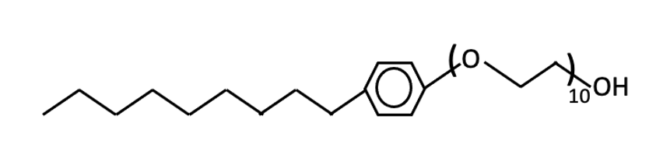
Figure 1: Structure of nonionic surfactant, NPEO₁₀ with 10 ethylene oxide groups.

Along with nonionic surfactant NPEO₁₀, cationic polymers, polyethyleneimine (PEI) and poly(4-vinylpyridine) (P4VP) are utilized for this research with the intention to bind with the binder. Two commonly used positively charged polymers with pKa of ~ 7 and 4.8, respectively, were used in this study [17,18]. Since cationic surfactants have been widely used in previous studies, cationic polymers were replaced as a cheaper alternative. A 1:1 mass ratio of nonionic surfactant and cationic polymer was investigated in this study.

Chapter 2: Literature Review

2.1 Surface Treatment
Prior to application, numerous treatments have been performed on the surface of plastic to retain ink, pigments, and dyes. Flame, UV, plasma treatments or corona discharge are some of the most frequently used methods to process the surface of plastic, with the latter being most common [9]. Treatment procedures increase the surface energy of the surface and allow ink to better attach and adhere to the polymer surface [9]. The process to remove ink does not appear to be extensively dependent on the treatment process, although the efficiency of removal is likely dependent. Accordingly, the procedures discussed in the following sections are not limited and likely can be applied to varying surface treated processes.

2.2 Ink Components
Ink components can include pigments, binders, carriers, and additives [9,14]. Binders are polymers which allow ink to disperse onto the surface of the plastic and promote adhesion [9]. The utmost importance in deinking is given to the process of decreasing the forces of adhesion between the binder and surface. Although further research should investigate the effect of all components of ink, the scope of the research paper is limited to the discussion of the binder.

There are mainly two types of ink delivery systems, water-based and solvent-based [9]. Water-based inks contain water, ink, surfactant, and binder. The surfactant is an additive which prevents agglomeration of the ink while it is suspended in solution by adsorbing on the ink particles. Additionally, surfactants reduce the surface energy of ink and increase wettability [19]. The binders in water-based ink are generally acidic and consist of acrylate groups with carboxylic acid functionality [14].

Solvent-based inks contain only binder, a low-boiling point organic solvent and ink. The binder is dissolved in the solvent and the binder may play a role in dispersing the ink in the solvent. The forces which cause ink particles to agglomerate are less in a properly chosen solvent so no surfactant is usually needed. In both cases, once the ink is applied, the liquid evaporates.

2.3 Surfactant Characteristics Important in Deinking
Deinking plastic in both solvent-based and water-based ink has been researched in the presence of charged and uncharged surfactants [8–14]. Prior research has shown pH of the solution plays an important role in deinking water-based ink. In a basic solution, the acidic carboxylic acid groups of the binder deprotonate to form anionic carboxylate, helping to disperse ink particles to enable deinking [14]. Therefore, deinking at high pH (pH>12) can occur without any added surfactant. Although the type of binder can influence deinking, the binders in solvent-based ink are most likely different from water-based ink. Hence, the effectiveness of deprotonation for the two types of ink will be different; however, the qualitative effect should be similar.

At lower pH, surfactant plays a key role in deinking. The hydrophobic ends of the surfactant adsorb on the surface of plastic and ink while the hydrophilic ends are directed towards water. For charged surfactants, the hydrophilic groups repel each other via charge-charge interactions reducing adhesion. Positively charged surfactants bind with the anionic binder and further decrease the forces of adhesion. For nonionic surfactants, a repulsive force still exists because water molecules surround the hydrophilic head group and the confinement by two surfaces in proximity causes reduced entropy of water, but the magnitude of this repulsive force is much less compared to charge-charge repulsive force. In addition to the physical characteristics of the surfactant, concentration, temperature at which micelles form and emulsion type are crucial for discussion.

2.3.1 CMC
In water, surfactants form micelles as the hydrophobic tails accumulate and merge towards a center. The concentration at which micelles form is known as the critical micelle concentration (CMC). Increasing the concentration of surfactant leads to two effects that help deinking. First, more acrylate (binder) can be solubilized into micelles [10] and second, if the concentration is above the CMC (after accounting for surfactant adsorbed on the ink surface), the ink particles will be completely covered with surfactant.

2.3.2 HLB
The hydrophilic lipophilic balance (HLB) is an indicator of the type of emulsion that forms in a solution, (water in oil (W/O) or oil in water (O/W)) with a quantitative measure of 0-20 [20]. The nonionic surfactant used in this study, NPEO₁₀, has an HLB value of 13.2 [13], indicating that the preferred emulsion is oil in water and that the surfactant is highly soluble in water. Previous research has explored deinking nonionic surfactants by adjusting the length of ethylene oxide or carbon chains to change HLB [13]. HLB increases with addition of hydrophilic ethylene oxide groups and decreases with addition of hydrophobic CH₂ groups [13].

When a surfactant hydrophilic end is long (high HLB), such that the surfactant is soluble in water, the hydrophobic ends determine the mass adsorbed on the surface of plastic and ink. Increasing the hydrophile length will not increase mass adsorption although the moles of surfactant adsorbed decrease as the hydrophilic groups greatly increase in volume. When the hydrophilic end of a surfactant is short, such that the surfactant is not soluble in water, the hydrophobic ends cannot adsorb. When the hydrophile length is constant, increasing the hydrophobic ends reduces the CMC, and maximizes adsorption at a lower surfactant concentration. Since diffusion is faster with smaller molecules, normally the molecule that is used commercially is one in which the hydrophile is as small as possible while the hydrophobe is as large as possible while still maintaining water solubility. Considering the restrictions, it is assumed that the parameters used to deink with NPEO₁₀ are sufficiently large (concentration, agitation period) such that sufficient adsorption takes place even with the relatively large hydrophile length.

2.3.3 Cloud Point
NPEO₁₀ has a cloud point of 60-65°C, the temperature at which NPEO₁₀ forms two phases: micelle-rich and micelle-poor [13, 21]. At the cloud point temperature, the hydrophilic group of the surfactant cannot bind with the water molecules sufficiently, decreasing the solubility of the surfactant [21]. Deinking was observed to be most effective below the cloud point temperature for nonionic surfactants in water-based ink [13]. The inability of the surfactant to adsorb effectively and form micelles for solubilization of dispersed ink impedes the deinking process.

2.4 Other Effects Important in Deinking

2.4.1 Mechanical Agitation
To aid in the process of removing ink from plastic surfaces, mechanical agitation is introduced [10]. The concept of mechanical agitation for deinking is similar to that of a washing machine for oil removal from clothes: in general more agitation is better. Increasing the agitation time provides longer time for surfactants to adsorb and disperse ink particles. Previous research conducted with 25mM NPEO₁₀ at pH 10 indicated that raising the agitation period up to 180 minutes increased deinking but additional periods did not affect residual ink [13].

2.4.2 Soaking Period
Deinking was observed with and without soaking the plastic in surfactant solution prior to agitation [13]. If experiments are conducted without pre-soaking, additional agitation time may be required to completely remove residual ink [13]. Studies have indicated that increasing the pre-soaking time to more than 1 hour does not increase deinking as long as the mechanical agitation period is long [13]. Like agitation periods, longer soaking periods allow more time for surfactant adsorption.

2.5 Deinking Solution Composition

2.5.1 Water
Deinking plastic with only water proved to be effective at pH 11-12 for water-based ink, as expected in basic conditions [14]. In the case of solvent-based ink, deinking was not effective at pH 3 or 12 [9]. A possible explanation is the lower concentration of acid groups on the binder which in turn means the adhesive force was not reduced as much at high pH.

2.5.2 Nonionic Surfactant
NPEO₁₀ effectively deinks water-based ink above its CMC beginning at pH 8, and increases until pH 12 after 4 hours of agitation [13,14] . Most effective deinking is observed below the cloud point temperature at various agitation periods. Nonionic surfactants are not effective at deinking at acidic conditions since the binder remains protonated and adheres the ink to the surface better.

Another group of nonionic surfactants are alcohol ethoxylates, AEO₅, trade name SN-70, which behave similarly to NPEO₁₀ in that deinking is observed at pH 8 and increases at more basic pH, indicating nonionic surfactants to be effective at basic pH ranges [13].

Not all nonionic surfactants are effectively only at basic pH. Amine ethoxylates, AMEO₅, trade name T-205, begins deinking at pH 4. Deinking is reduced at neutral pH of 6-7 but begins to increase at pH 8 [13]. AMEO is protonated at acidic conditions to behave as a cationic surfactant [13]. As with cationic surfactants, at low pH AMEO₅ will interact with the binder and reduce adhesion.

2.5.3 Cationic Surfactant
Cationic surfactants are the most effective group of surfactants as they can deink over a wide range of pH. Hexadecyltrimethylammonium bromide, CTAB, effectively deinks around pH 6-7 but some deinking is observed at pH 4 in water-based ink [14]. Cationic surfactant adsorbs on the surface and binder at low pH, leading to charge repulsion between the positively charged ions to decrease adhesive forces and cause deinking [11,14]. However, at acidic conditions, the amount of cationic surfactant adsorbed is less, but increased adsorption is noticed at basic conditions, due to the negative charges on the surface of ink and plastic.

2.5.4 Anionic Surfactant
An anionic surfactant, sodium dodecylsulfate (SDS), can deink water-based ink above its CMC beginning at a pH of 8 and continues to be effective at higher pH [14]. The issue with using anionic surfactant is that even at high pH, ink is not completely removed from the surface of the plastic [14]. Since the surfactant is anionic and the binder exhibits anionic behavior at high pH, the surfactant cannot effectively bind with the binder. 25mM SDS indicates partial deinking at pH 8 while pure water also partially deinks at pH 9 [14]. At pH 12, comparable deinking is observed with water and SDS [14]. Overall, anionic surfactant shows little, if any, performance improvement over pure water with respect to deinking.

2.5.5 Amphoteric Surfactant
At a pH of 2, the amphoteric surfactant dimethyl dodecylamine oxide (DDAO) behaves as a cationic surfactant and starting at a pH of 8, the surfactant behaves as a nonionic surfactant [14]. The CMC of the amphoteric surfactant is dependent on pH and the deinking performance of this surfactant is difficult to comprehend with changing pH [14].

2.5.6 Mixture of Nonionic and Cationic Surfactant
0.5% wt each of nonionic (AEO₅) and cationic (CTAB) surfactant at pH 12 was effective at removing black solvent-based ink although black ink is harder to remove than other inks [9]. At the same pH, pure water was unable to remove black ink [9]. Solutions prepared with only 1% wt CTAB or only 1% wt AEO₅ were not as effective at deinking compared to the solution mix [9]. Deinking with the solution mix was only slightly better than CTAB alone [9]. Possible reasoning for the mix indicated greater deinking is that the cationic surfactant binds with the binder and allows the nonionic surfactant to deink effectively.

2.6 Commercial Deinking Processes
Deinking printed plastic has been commercially achieved in Europe and patents have been filed. Cadel Deinking, a company in Spain, has introduced a technology to deink plastic and claims to reduce the cost of recycled plastic by 45% [22]. The work has been a ‘spin-off’ from the University of Alicante. The company has also worked in collaboration with Keycycle to further its technology and efficiency of deinking plastic [23]. Although the specifics of their technology are not clear, the company utilizes the process of grinding, deinking, rinsing, drying, and forming the plastic into pellets [22]. The company’s successful methodology to remove ink from plastic has been effective for both water and solvent-based ink [22]. The technology uses a water treatment process to reuse ‘deinking solution and rinsing water’ as a means of reducing cost [22].

The patent with the current assignee as University of Alicante mentions the use of surfactants CTAB (cationic), dodecyltrimethylammonium bromide (cationic) or dodecyl sulfate (anionic) [24]. Other patents have been included in the document which have been submitted to the European Patent Office by inventor Armand Piolat, exploring the method of the deinking of printed plastic [25]. The ‘detergent’ solution consists of nonionic surfactant, organic solvent and ‘aqueous mineral base’ [25]. The use of organic solvents to deink has been previously researched but is environmentally undesirable.

As recently as May 2020 (research started in 2019), Seigwerk and APK AG, companies headquartered in Germany have researched innovative approaches to deink LDPE.
[26]. Siegwek is known for producing printing ink for packaging whereas APK AG produces recycling material from plastic. The research utilizes solvent-based technology, Newcyling®. [27]. According to the company, the solvent-based technology, Newcyling® reduces carbon footprint by 47-88% [28]. The reduction of carbon footprint commits to the sustainable approach of reusing plastic, but the solvent deinking technology has been questioned due to its negative environmental factors caused by disposing of the solution.

Further work undertaken in the area illustrates research advancements and importance given to ink removal. Cationic surfactants have been synthesized from polyethylene terephthalate (PET) to deink plastic with solvent-based ink [29]. The cationic surfactants were named “GT-pyr-Br” and “GD-byr-BR”. The cationic surfactant GD-byr-BR was effective at deinking in high pH ranges of 12.5 -13. However, cationic surfactant GT-pyr-BR was only effective at deinking at acidic conditions of pH 1- 3 [29].

2.7 Conclusion on Literature Review
The demand and need for plastic recycling is increasing. Although companies are focusing on deinking plastic to produce high-grade plastic, most of the research has been conducted in the EU. According to the European Environment Agency, in the year 2016, the recycling of packaging waste was at 67.1%, an exceptionally high figure relative to other countries [30]. Although plastic recycling has been beneficial in the US, the rate at which this is being completed is relatively slow. In the 21st century, consumers are becoming more aware of the sustainable approaches taken by companies and demand sustainable methods for recycling plastics.

Previous studies indicated cationic surfactant’s ability to deink over a wide range of pH. However, cationic surfactants cost much more. CTAB, the cationic surfactant utilized in various research work costs $13-$14 per kg [31]. Nonionic surfactants are more cost-effective ($5 per kg) [32], but 100% effective only at high pH (pH~12) leading to mechanical strains on equipment and higher costs.

The research undertaken in this work focuses on utilizing a mixture of cationic polymer and nonionic surfactant under varying pH to identify optimal deinking ranges. The hypothesis is that cationic polymer will behave similarly to that of cationic surfactant and deink at various pH because the cationic polymer will bind strongly with the negative charges of the binder, while the nonionic surfactant will adsorb on the surface of plastic and ink to decrease adhesion and hence deinking will occur at lower pH. A major factor in considering cationic polymer instead of cationic surfactant is the reduced cost of cationic polymer. The cationic polymers used in this research, PEI costs ~$2 per kg [33] , and polyvinylpyrrolidone (PVP) costs ~$5 per kg [34].

Chapter 3: Methodology

3.1 Materials

3.1.1 LDPE Wrappers
Two rolls of inked low density polyethylene (LDPE) wrappers, green and blue, were provided by Procter and Gamble. The base of both rolls was compounded with white pigment, which of course could not be removed upon deinking. In other words, complete deinking was considered when the blue or green ink was removed and only the white ink could be observed.

3.1.2 Nonionic Surfactant and Cationic Polymer
Two bottles of nonionic surfactant NPEO₁₀, trade name IGEPAL CO 660, were used to prepare surfactant solutions. The first bottle was available through the CBME laboratory and was supplied by Rhodia; the company has since been bought by Solvay. When this bottle was depleted, the second bottle of the surfactant was sent to us by Solvay. The concentration of the surfactant was ~ 99% with a molecular weight of 660 g/mol.

Cationic polymer, polyethyleneimine (PEI), manufactured by Alfa Aesar, was purchased from Fisher Scientific [35]. The molecular weight of PEI listed on the bottle is 60,000 g/mol and the solution was 50% w/w aqueous. P4VP was purchased from Millipore Sigma with an average molecular weight of ~ 60,000 g/mol [36]. Since P4VP was available in a solid form, a 10% w/w solution was prepared by weighing 10g of P4VP with 90g of deionized water at pH 3. Literature suggests P4VP can solubilize at low pH due to protonation [37]. Failed attempts to prepare a 50%w/w P4VP solution led to the preparation of lower than the desired concentration due to difficulty dissolving the powder. PEI could have been diluted to 10% w/w but the process was not deemed necessary as deinking results with P4VP was ineffective at low pH.

3.2 Experimental Procedure
The following experimental procedure was adapted from research methods which have proven to be successful in deinking [13]. Deinking parameters such as pH, agitation period, concentration were modified to improve deinking based on the LDPE wrapper and conditions required for our objective. Previous work used single surfactants of various types; in this work the difference in the methodology is the inclusion of cationic polymer with nonionic surfactant to prepare deinking solution. Experiments were repeated as many times as necessary to collect sufficient samples to process them for quantitative measurements.

3.2.1 Solution Preparation
To reproduce previous deinking results, 25mM NPEO₁₀ of surfactant solution was prepared at pH 11-12. NPEO₁₀ was weighed at 8.25g and deionized water was filled to the 500mL mark of the beaker. Other concentrations were prepared in a similar manner, except the amount of surfactant was reduced; 4.12g and 2g surfactant to prepare 12.5mM and 6.25mM solutions, respectively. To maintain mass of surfactant/polymer to LDPE ratio, cationic polymer P4VP and PEI were weighed to 8.25g to prepare a 500mL solution. The solutions were adjusted to the desired pH.

To prepare a 1:1 mass ratio of surfactant to polymer solution, surfactant and polymer were measured at the appropriate mass ratios; 4.12g or 2g each. The solution was placed in a stirring plate to allow surfactant to completely mix for ~ 5 to 10 minutes. Once the mixing was completed, pH adjustments were made while the solution continued to stir for another ~ 5 to 10 minutes.

To adjust the pH of surfactant and polymer solutions, sodium hydroxide (NaOH) and/or hydrochloric acid (HCl) were added and measured with a pH meter. As pH 8-9 was difficult to stabilize for NPEO₁₀ solutions, a 0.1M buffer solution consisting of boric acid, potassium chloride and sodium hydroxide at pH 9 was added. If necessary, additional NaOH or HCl was added to achieve the pH required.

3.2.2 Deinking
~ 0.15g of LDPE (cut into ~ 1” x 2” rectangles) were placed in 30mL capped vials filled with 20mL of solution. The vials were placed in a ~ 50% water filled oscillating water bath (hot shaker) from Bellco Glass Inc and the highest speed was used; approximately 60 Hz. As the cloud point of NPEO₁₀ is around 60°C, the temperature of the bath was set to 55°C to avoid phase separation [13]. Experiments ranged from 4 to 24 hours and aluminum foil was placed to cover the bath to limit water evaporation and spilling. Once deinking was completed, samples were lightly rinsed, and the surface of the sample was gently scraped with a pair of laboratory forceps, or the LDPE was lightly dabbed in a paper towel and dried.

3.2.2.1 Processing Samples
Deinked and noninked samples were melted in a 5 cm³ Xplore conical twin-screw extruder by Xplore to produce cylindrical shaped strands. The temperature of the extruder was set at 180°C, which was higher than the melting point of LDPE (110°C), to ensure complete melting. The rotating speed of the co-rotating twin-screws were set at 100 RPM and the samples were processed for 5 minutes. Nitrogen was continuously pumped into the extruder system to avoid degradation of polymer. The extruded samples were placed in a Carver Laboratory Press to compression mold the samples at a temperature of 170°C for 5 minutes at 5 metric tons and cooled for ~ 5 minutes to room temperature.

3.3 Measurement Techniques
The two quantitative methods used to evaluate deinked samples were tensile and colorimeter tests. Tensile tests measure stress/strain properties and colorimeter analyzes color before and after deinking. Additionally, differential scanning calorimeter tests were performed to determine crystallinity and melting temperature of samples.

3.3.1 Tensile Tests
To prepare samples for tensile measurements, samples were non processed (not deinked, no extrusion, and no compression mold) or processed (deinked, extrusion and compression mold) or (extrusion, compression molded). All samples were cut using an ASTM D1708 standard die with gauge length of 0.876” and width of 0.196”. The thickness of each sample was measured with a micrometer before assessment.

The tensile tester was provided by United Testing Systems with 200 lbf load cells and tests were performed without preload at a draw rate of 0.5 inches per minute. The program recorded the extension vs force, and the samples were tested to failure or, if tearing occurred, the test was stopped. Each set of samples were repeated five to ten times. Stress and strain values were calculated with a Microsoft Excel VBA program to automate the calculation process.
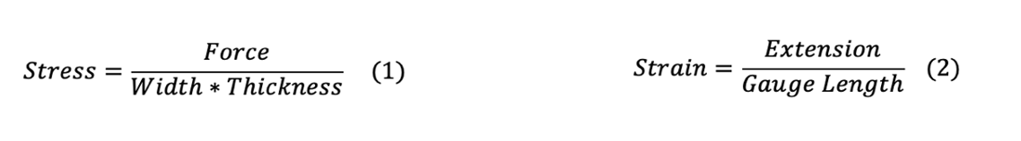

3.3.2 Colorimeter Tests
Optical tests were conducted with HunterLab UltraScan colorimeter in regular transmission mode. Samples measured for tensile properties were also used for colorimeter testing. Each sample was placed in the sample holder with long area view (LAV) lens in place. The instrument was turned on at least two hours prior to its use and was standardized each time. Standardizing materials were provided by HunterLab which included black and white tiles for calibration. Samples were placed in the transmission holder, close to the lens, and two readings of each sample were recorded by displacing the sample in the holder. A clear polyethylene plastic was used as the standard to quantitatively compare to the deinked samples. The total color difference (DE) value was calculated with an equation resembling that of the distance. L, a, b values were provided by the HunterLab program. Each letter is associated with either light or colors such as red, green, yellow, or blue as stated in the HunterLab website [38].The DE is a numerical value, indicating the amount of residual ink. A low DE value indicates limited residual ink in the plastic and therefore, closer to a clear plastic.
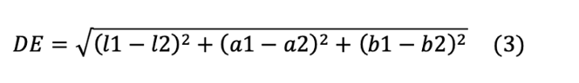

3.3.3 DSC
Differential Scanning Calorimeter (DSC) measurements were used to obtain the crystallinity and melting temperatures of the samples. Plastic samples were cut into very small pieces, immersed in silicone oil to improve heat transfer, and sealed in the DSC pan. The computerized data provides a graph of heat flow vs temperature which is integrated and divided by the weight of the (plastic + oil) to calculate enthalpy/mass. A correlation factor (cf) is then multiplied to the enthalpy/mass to eliminate the weight of the oil to obtain the enthalpy of melting. The enthalpy of heat obtained was divided by 293 J/g*K which was the heat of melting of pure crystalline polyethylene to achieve corrected fractional crystallinity [39].
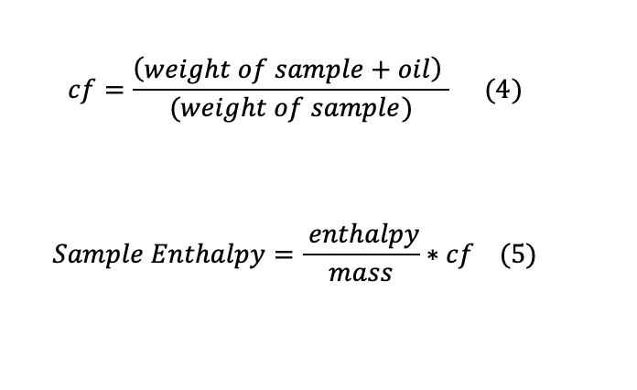

Chapter 4: Results

4.1 Deinking
Deinking experiments were conducted with NPEO₁₀ by varying pH, concentration, and agitation period. Highly basic pH was used to validate previous results that showed deinking could be achieved under these conditions. The pH was then lowered to determine deinking effectiveness. Cationic polymer solutions were prepared with PEI and P4VP to determine deinking performance. As conditions for deinking with nonionic surfactant and cationic polymer were established independently, a 1:1 mass mixture of surfactant and polymer solutions were prepared to evaluate deinking. This section details the results from visual observation after deinking. Sections 4.2 and 4.3 are more quantitative; 4.2 describes tensile test results before and after deinking while section 4.3 describes colorimetric measurement results.

4.1.1 Nonionic Surfactant Solutions

4.1.1.1 25 mM NPEO₁₀
A 25mM (8.25 g) NPEO₁₀ solution was prepared at pH 5 and 12 to deink blue, green and noninked LDPE wrappers at 55°C with a 24 hour agitation period. NPEO₁₀ indicated complete or almost complete deinking at pH 12 and only slight deinking at pH 5, as seen in Figure 2. Scraping was primarily necessary for blue LDPE and shows that the ink is more difficult to remove than green LDPE. More vigorous agitation might have resulted in complete removal, but we did not test that hypothesis. Results were consistent with previous work as NPEO₁₀ deinks at high pH below the cloud point temperature; note that room temperature was not successful previously (when the same surfactant was used in a different material) and we did not vary temperature in our experiments. We then decreased to pH 8-9 and after 24 hour agitation and only slight deinking was observed even after scraping the surface of both plastics; again more deinking is noticed in green LDPE. Due to the inability of NPEO₁₀ to deink at the selected pH, this condition was tested with cationic polymer to enhance deinking as described in Section 4.1.2.
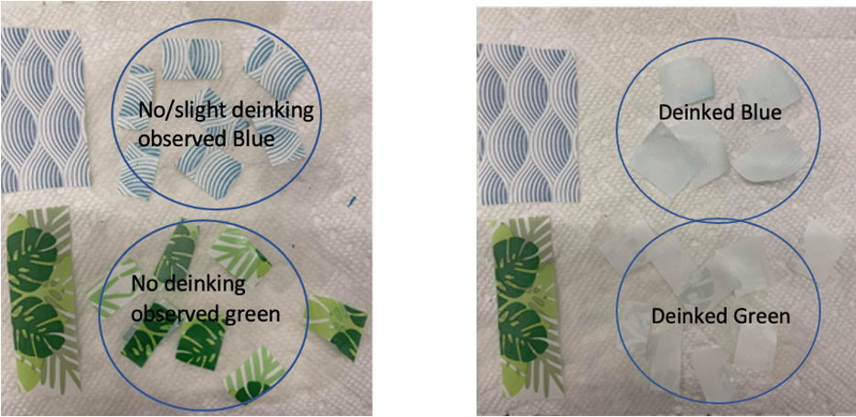
Figure 2: Deinked with 25mM NPEO₁₀ at pH 5 and pH 12, respectively after 24 hour agitation.

4.1.1.2 12.5 mM NPEO₁₀
To serve as a proper control, we tested half the concentration of surfactant at 12.5mM (4.12 g) with results shown in Figure 3. Considerable deinking can be obtained at pH 12, while no deinking was observed at pH 4.4 after a 24 hour agitation period. Deinking results are comparable to 25mM surfactant solution. Instead of pH 5, pH 4.4 was tested as the solution conditions changed drastically after adding small amounts of HCl.
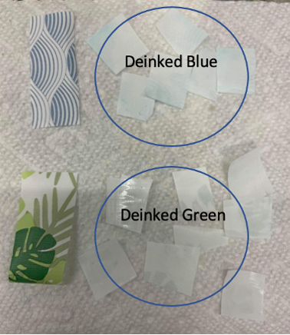
Figure 3:Deinked with 12.5mM NPEO₁₀ at pH 12 after 24 hour agitation.

Additional experiments were performed by reducing the agitation period to 4 hours while maintaining the concentration at 12.5mM and pH 12. A 4 hour agitation period was chosen as previous research has indicated 3 hours to be enough to observe almost complete deinking [13]. Figure 4 indicates blue LDPE to be consistently contaminated with more residual ink compared to green LDPE after agitation. Visually observing results suggests 24 hour agitation increases deinking results. Quantitative DE measurements are performed to identify the extent to which decreasing LDPE to surfactant ratio is impacted in Section 4.3.1.2.
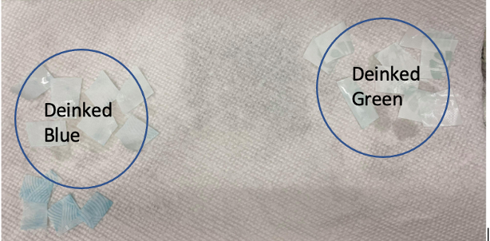
Figure 4:Deinked with 12.5mM NPEO₁₀ at pH 12 after 4 hour agitation.

4.1.1.3 6.25 mM NPEO₁₀
To conclude deinking with NPEO₁₀, 6.25mM (2g) at pH 12 with 4 hour agitation was tested. Again, results indicated deinking after scraping the surface of blue while green ink was easily removed in the deinking process.

In all cases, the amount of surfactant added is still well above the CMC (4.9x 10⁻² mM) [13] and surfactant adsorption does not increase above the CMC [40]. Surfactant adsorption plays a critical role in deinking. However, the amount of surfactant adsorbed does not contribute to the amount in solution and hence the concentration where some deviation is expected from good deinking is expected to be well above that corresponding to the added concentration because of surfactant adsorbed on ink. However, the concentration was not reduced enough to see a drop in deinking efficiency.
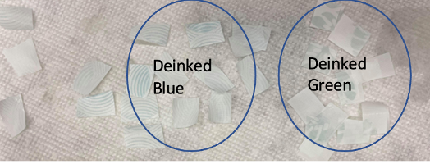
Figure 5: Deinked with 6.25mM NPEO₁₀ at pH 12 after 4 hour agitation.

4.1.2 Cationic Polymer

4.1.2.1 8.25g P4VP
To maintain the mass to LDPE ratio, 8.25g P4VP solution was prepared in a 500mL solution. P4VP was unable to deink blue or green LDPE at pH 3 after 24 hour agitation. As both nonionic surfactant and cationic polymer were ineffective at low pH, not surprisingly, experiments performed with 1:1 mass mixtures of P4VP and NPEO₁₀ at pH 3 after 24 hour deinking did not yield positive deinking results. The inability of the cationic polymer to dissolve at a higher pH posed constraints on the experimental conditions and this material was discontinued for further testing.
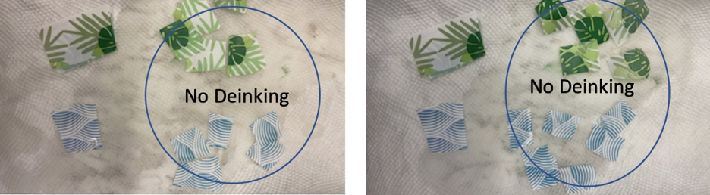
Figure 6: Deinked with 1:1 mass ratio of NPEO₁₀ and P4VP and pure P4VP, respectively at pH 3 after 24 hour agitation.

4.1.2.2 8.25g PEI
PEI solution was tested for deinking at pH 5 and 12 with a 24 hour agitation period. Results indicated no deinking at pH 5 and only light deinking at pH 12 after manually scraping the surface, as seen in Figure 7. Clearly cationic polymer does not work as well as cationic surfactant, with the latter based on previous results. Although adsorption by cationic polymers is much stronger than cationic surfactant on a per molecule basis, the time period for adsorption is also greater. Another possibility for the poorer results was if the polymer could diffuse between an ink surface adsorbed to a plastic surface. An unlikely possibility is that this ink is harder to remove, e.g. if cationic surfactant would have been tested on the same material, deinking would be ineffective.
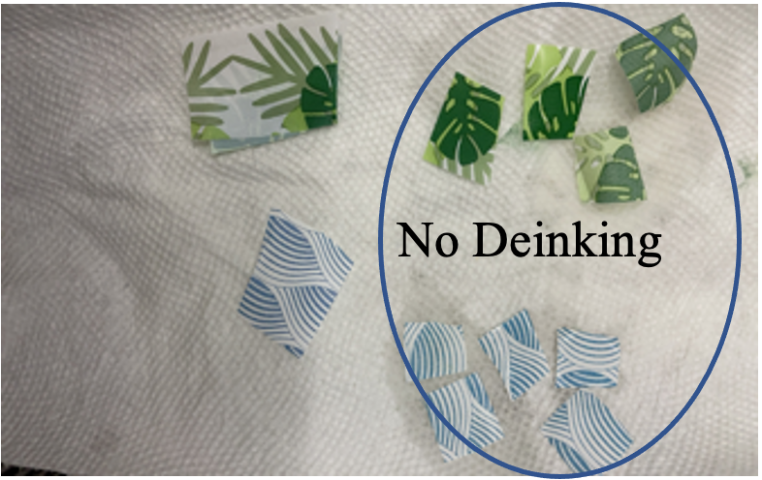
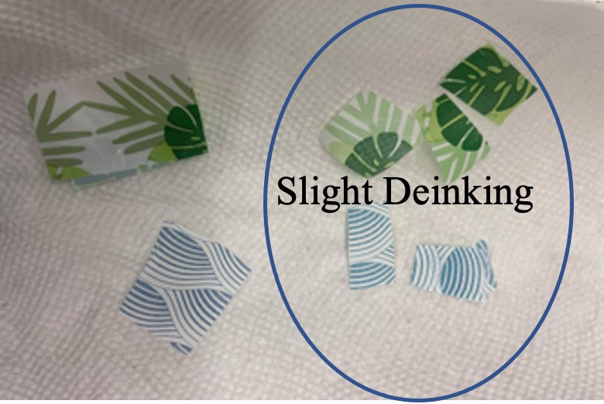
Figure 7:Deinked with 8.25g PEI at pH 12 and pH 5, respectively after 24 hour agitation.

4.1.3 1:1 mass ratio of NPEO₁₀ and PEI
The following experiments attempted to answer three questions; can deinking be observed at low pH with polymer and surfactant mix, is deinking improved with the addition of PEI (e.g. will the need to scrape the surface of LDPE be eliminated), and if so, under what conditions would deinking with PEI and NPEO₁₀ be most effective while economic and environmental cost are considered?

4.1.3.1 4.12g NPEO and 4.12g PEI
1:1 mass ratio of NPEO₁₀ and PEI was prepared at pH 5 and 12 with a 24 hour agitation period. pH 12 indicated almost complete deinking with blue and green plastic while no deinking was observed at pH 5. Blue LDPE posed more issues to deink compared to green LDPE as the surface required additional scraping, similar to deinking with NPEO₁₀ alone. As results were comparable to NPEO₁₀ at pH 12, the question whether PEI helped deinking could not be answered. To answer this question, further experiments were performed by decreasing the pH, mass of surfactant, polymer, and agitation period.
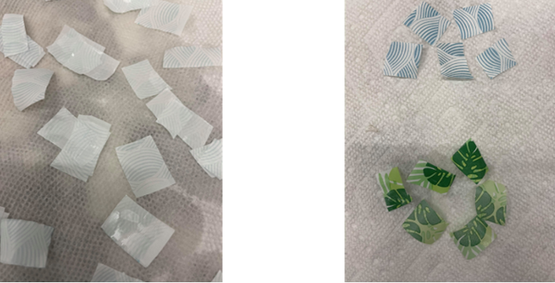
Figure 8:Deinked with (4.12g) NPEO₁₀ and (4.12g) PEI at pH 12 and 5, respectively after 24 hour agitation.

First, the same concentrations of surfactant and polymer were prepared at pH 8-9. After 24 hours of deinking, only slight ink removal was observed for green and blue LDPE after scraping the sample. In other words, pure NPEO₁₀ at the same total mass and pH showed identical results e.g., adding polymer did not enhance deinking. Further experiments were completed at high pH and agitation period as low pH did not indicate close to complete deinking.

As deinking was effective with 12.5mM NPEO₁₀ after 4 hours at pH 12, experiments were repeated to include PEI to the mixture, seen in Figure 9. As before, additional scraping of the surface was not eliminated for blue LDPE. Visual observation could not determine other deinking differences compared to NPEO₁₀ alone.
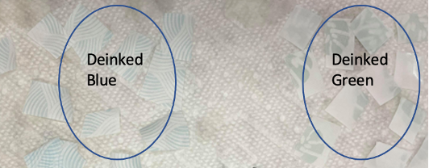
Figure 9:Deinked with (4.12g) NPEO₁₀ and (4.12g) PEI at pH 12 after 4 hour agitation.

4.1.3.2 2g NPEO₁₀ and 2g PEI
Further decreasing the mass of surfactant to polymer indicated deinking was observed for all inked samples with additional scraping of surface, indicated in Figure 10. In comparison to deinking with pure surfactant at 4.12g and 2g at 4 hours, visual observation indicated deinking is achievable even with decreased concentration although scraping the surface of blue LDPE cannot be avoided.
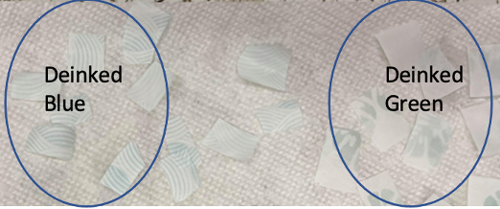
Figure 10:Deinked with (2g) NPEO₁₀ and (2g) PEI at pH 12 after 4 hour agitation.

4.2 Tensile Properties

4.2.1 1:1 mass ratio (4.12g each) of NPEO₁₀ and PEI
Tensile tests were performed for 1:1 mass mixture of NPEO₁₀ and PEI at pH 12 after a 24 hour agitation period, the condition at which most effective deinking was observed visually. Three samples were chosen for comparison; non processed, extruded and compression molded (no deinking) and deinked, extruded and compression molded.

Ideally, comparing non processed samples to deinked samples should have allowed us to determine whether the mechanical properties of the base polymer had been affected by deinking; as will see this comparison was not appropriate. As previously noted, deinking was done with very small squares which necessitated compression molding the samples. This thermal history had a very large effect on the crystallinity which in turn affected the mechanical properties.

To illustrate the effect of processing on mechanical properties, consider the noninked samples in Figure 11. Ideally, the noninked samples, whether processed or non processed, should have similar stresses at break and strains at break. However, Figure 11 indicates that the noninked extruded and compression molded samples are statistically different from the non processed sample. Similarly, all inked extruded and compression molded samples are statistically different from non processed which is confirmed by fractional crystallinity measurements shown in Figure 13. One significant difference in the non-processed samples is the cooling time; the characteristic cooling time for compression molded samples was ~5 minutes but for film blown samples, the characteristic cooling time was ~10 seconds.

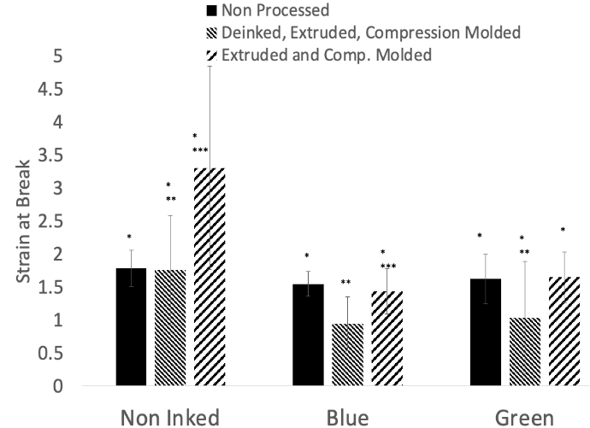
Extruded and compression molded samples for inked materials indicated a decrease in stress at break vs deinked samples confirming the negative effects that ink has on tensile properties. All deinked samples are statistically identical suggesting comparable deinking. Surprisingly, the strain at break is lower for deinked samples vs extruded and compression molded samples. For the blue samples, the higher crystallinity of the deinked samples is consistent with a lower strain at break. For the green samples, a plasticizer effect caused by ink that is present in the bulk polymer is likely causing this anomaly.
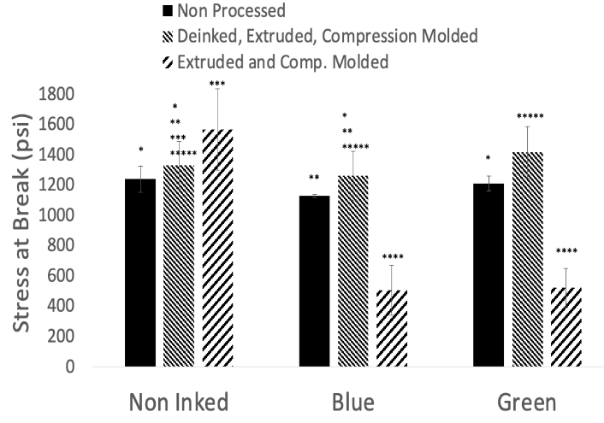
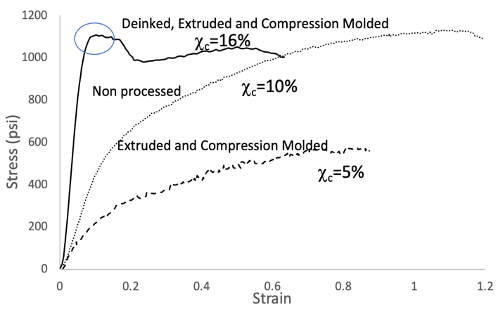
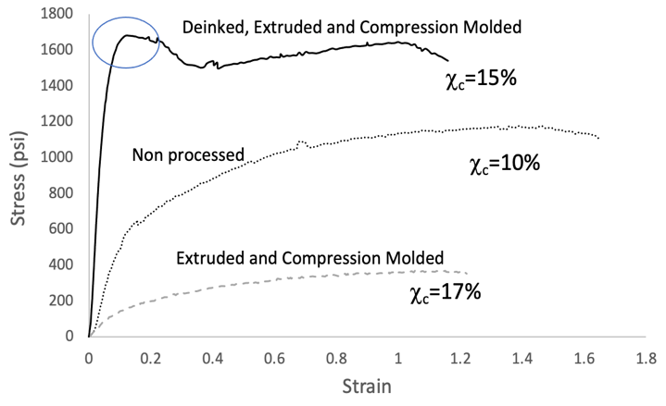
Figure 11:Comparison of tensile properties with (4.12g) NPEO₁₀ and (4.12g) PEI at pH 12 after 24 hours of agitation. Different numbers of stars indicate greater than 95% chance that the means of the samples are different.

Figure 12:Stress and strain curve for green and blue ink, respectively with percent crystallinity.

Only deinked samples showed a yield point as indicated by the circular mark in Figure 12, even though the crystallinity for the green extruded and compression molded sample was higher. Both inks acted as plasticizers in the sense that the stress at a given strain was much less when comparing the samples with the same thermal history. Note also that the effect on crystallinity was very different; the blue ink clearly suppressed crystallinity after being incorporated into the polymer. The melting temperature of all samples was ~122°C indicated in Figure 13. The constant melting temperature suggested that the size of the crystals did not change very much although a change in the percent crystallinity was observed. Only the green deinked sample had a melting temperature significantly different from the other samples.
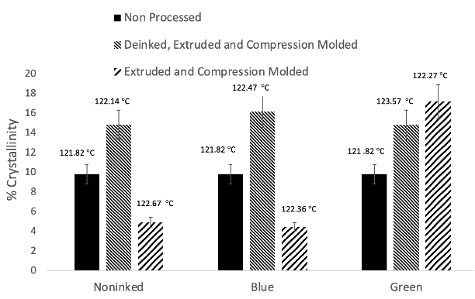
Figure 13:DSC non processed and processed samples with (4.12g) NPEO₁₀ and (4.12g) PEI at pH 12 after 24 hours of agitation with percent crystallinity and melting temperature.

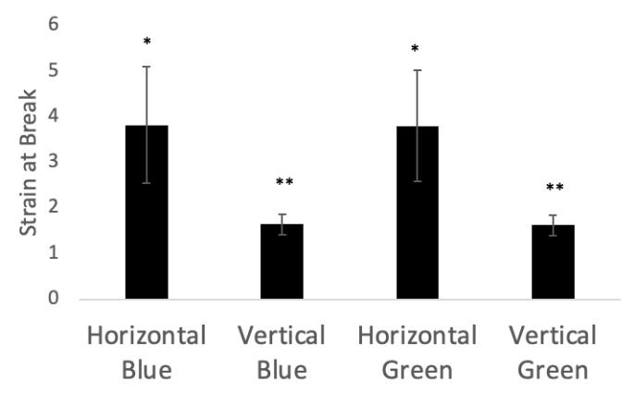
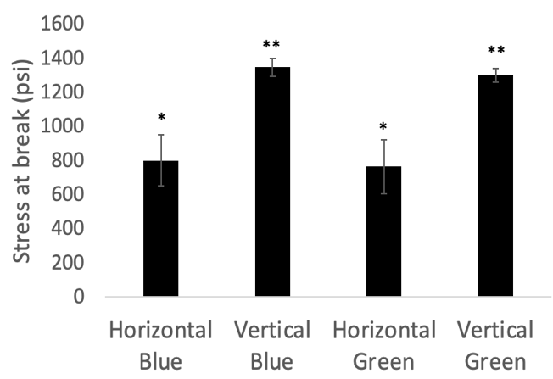
Another characteristic that will affect tensile properties is chain orientation. Additional tensile tests were performed on non processed samples where the orientation of the cut was either vertical or horizontal as seen in Figure 14. All horizontally cut samples were statistically similar and all vertically cut samples were similar in stress and strain properties; however vertically cut samples had higher stress at break and lower strain. The results indicate vertically cut samples to have more alignment in polymer chains, leading to a high stress at break and lower strain. All samples where results are shown in Figure 11 were cut vertically; the point of this analysis is to show that comparison of compression molded samples to non processed samples is impossible because of process-induced orientation differences as well as crystallization differences caused by different thermal histories.

Figure 14:Tensile Properties of non processed samples with vertical and horizontal direction of cut.

4.3 Colorimeter Tests

4.3.1 DE for 1:1 mass ratio (4.12g each) NPEO₁₀ and PEI
Colorimeter tests were performed for 1:1 mass ratio of NPEO₁₀ and PEI samples at pH 12 after a 24 hour agitation. Figure 15 illustrates the DE of deinked samples relative to clear sample. The lower the DE value, the closer the sample is to a clear sample, indicating a decrease in residual ink. A DE value of 0 would indicate a totally clear plastic. Non processed samples are not shown in any of the Figures with colorimetry results due to severe differences in thickness vs. samples that were extruded and compression molded.

Deinked plastics show lower DE values as expected. DE values do not reach a value of 0 because the samples contain white compounded to the polymer. All deinked samples are statistically similar to one another, again suggestive of comparable deinking. However, the samples do retain an outline of the original design that can be noticed visually even after deinking.

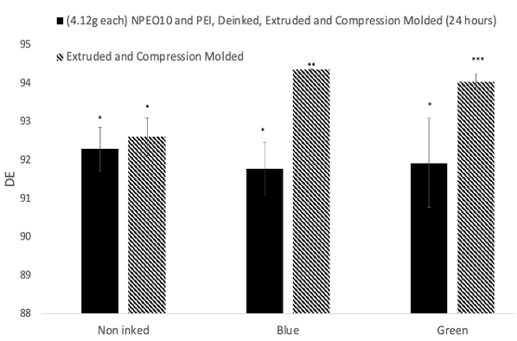
Figure 15:DE results for (4.12g) NPEO₁₀ and (4.12g) PEI samples at pH 12 after 24 hour agitation.

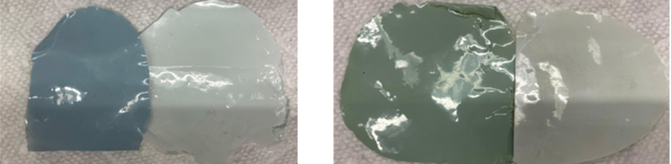
Figure 16:Comparing extruded and compression molded samples with deinked, extruded and compression molded samples.

4.3.1.2 DE for 4.12g NPEO₁₀
Samples deinked with 12.5 mM NPEO₁₀ at pH 12 for 4 hours were also measured through colorimeter and compared with non processed extruded and compression molded samples. Although visual examination of deinked plastic indicated partial removal of ink and close to complete deinking after scraping the surface, quantitative tests indicate no difference before and
after deinking. There is also a significant change in DE values before and after deinking. We do not understand the possible reason for this effect.

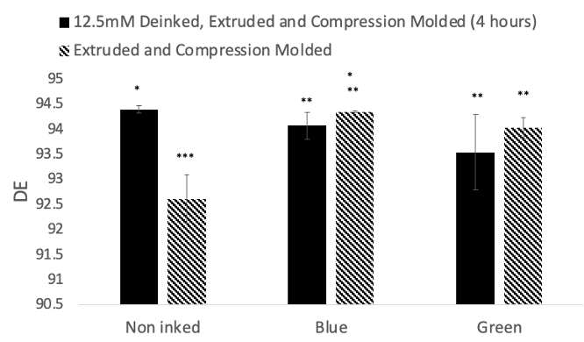
Figure 17:DE results with 4.12g NPEO₁₀ solution at pH 12 after 4 hours of agitation.

Chapter 5: Conclusion

5.1 Deinking
Deinking experiments with pure surfactant, NPEO₁₀ and pure cationic polymer, P4VP and PEI indicated varying deinking results over multiple conditions:
1. NPEO₁₀ can visually deink blue and green ink at 6.25mM, 12.5mM and 25mM at pH 12 with almost complete deinking achieved at all concentrations after 24 hour deinking. However, all samples required scraping the surface of blue LDPE as the ink was harder to remove.
2. Although visual observation obtained deinking at 12.5mM at pH 12 after 4 hours of agitation, colorimetric tests indicated almost no difference in deinking.
3. Cationic polymer, P4VP was unable to deink at pH 3 and PEI was unable to deink at pH 5 or 12 after 24 hour agitation.

Experiments with 1:1 mass mixture of NPEO₁₀ and PEI indicated the following results:
1. With surfactant and polymer mass of 4.12g each, close to complete deinking was observed after a 24 hour agitation at pH 12. However, the requirement to scrape the surface of the blue LDPE could not be eliminated. Visually, the results were comparable to deinking with pure NPEO₁₀. DE values indicated 1:1 mass ratio NPEO₁₀ and PEI at pH 12 after 24 hours deinking to be effective at removing color.
2. Tensile tests performed for the above-mentioned conditions indicated deinking effectively increases mechanical properties for inked samples. Deinked samples increase in crystallinity by 5-6% relative to non processed samples due to changes in cooling rates after heat treatments. For this reason, direct comparison of non processed vs processed samples is not possible.
3. Vertical orientation of the cut had increased tensile strength indicating chain alignment in that direction.

5.2 Future Recommendations
To reduce material constraints, temperature and mechanical agitation period should be reduced from 55°C and 24 hours, respectively. Increased agitation speed could be explored to determine adsorption and dispersion effects. As cationic polymer requires greater time for adsorption, introducing short soaking periods could be beneficial in adsorption and diffusion. Further recommendations on parameters could be explored, such as:
1. Deinking should be performed on the same material with cationic surfactant, such as CTAB, to evaluate deinking effectiveness and compare with cationic polymer.
2. Mechanical and colorimeter measurements should be performed at effective deinking conditions mentioned throughout the paper; 6.25mM, 12.5mM and 25mM pure NPEO₁₀ at pH 12 after 4 and 24 hour period and 1:1 mass mixture of 2g at pH 12 after 4 hour agitation to quantitatively compare results. Although the conditions have been visually observed, tensile properties would allow to quantitative compare deinking effects with concentration and agitation period.
3. If the thickness of non processed samples is maintained, it is possible to directly compare deinked samples for colorimetric measurements.
4. By selecting a wider range of colors, the relation between efficacy of the surfactant and/or polymer and ink could be better understood.

Finally, to consider environmental concerns to dispose of surfactant solution, research should focus on decreasing the amount of nonionic surfactant utilized for deinking by replacing it with alkyl polyglycoside (APG), another group of nonionic surfactants. APG surfactants are relatively safer as they are derived from sugar and therefore biodegradable [41].

References
[1] L. Shen, E. Worrell, Chapter 13 - Plastic Recycling, in: E. Worrell, M.A. Reuter (Eds.), Handbook of Recycling, Elsevier, Boston, 2014: pp. 179–190.
[2] A. Chamas, H. Moon, J. Zheng, Y. Qiu, T. Tabassum, J.H. Jang, M. Abu-Omar, S.L. Scott, S. Suh, Degradation Rates of Plastics in the Environment, ACS Sustainable Chem. Eng. 8 (2020) 3494–3511.
[3] A. Rahimi, J.M. García, Chemical recycling of waste plastics for new materials production, Nature Reviews Chemistry. 1 (2017) 1–11.
[4] U.S. Epa, OLEM, How do I recycle?: Common recyclables, (2013). https://www.epa.gov/recycle/how-do-i-recycle-common-recyclables (accessed June 6, 2021).
[5] O. Horodytska, F.J. Valdés, A. Fullana, Plastic flexible films waste management – A state of art review, Waste Management. 77 (2018) 413–425. https://doi.org/10.1016/j.wasman.2018.04.023.
[6] J. Hopewell, R. Dvorak, E. Kosior, Plastics recycling: challenges and opportunities, Philos. Trans. R. Soc. Lond. B Biol. Sci. 364 (2009) 2115–2126.
[7] E.J. North, R.U. Halden, Plastics and environmental health: the road ahead, Rev. Environ. Health. 28 (2013) 1–8.
[8] A. Chotipong, J.F. Scamehorn, T. Rirksomboon, S. Chavadej, P. Supaphol, Removal of solvent-based ink from printed surface of high-density polyethylene bottles by alkyltrimethylammonium bromides: Effects of pH, temperature, and salinity, Colloids Surf. A Physicochem. Eng. Asp. 297 (2007) 163–171.
[9] H. Gecol, J.F. Scamehorn, S.D. Christian, F.E. Riddell, Use of surfactants to remove solvent-based inks from plastic films, Colloid Polym. Sci. 281 (2003) 1172–1177.
[10] D. Songsiri, S.S. Min, J.F. Scamehorn, S. Osuwan, J.W. Ellis, Use of cationic surfactant to remove solvent-based ink from rigid high density polyethylene surfaces, Colloids and Surfaces A: Physicochemical and Engineering Aspects. 204 (2002) 261–269. https://doi.org/10.1016/s0927-7757(02)00003-1.
[11] A. Chotipong, J.F. Scamehorn, T. Rirksomboon, P. Supaphol, S. Chavadej, Removal of solvent-based ink from printed surface of HDPE bottles by alkyltrimethylammonium bromides: effects of surfactant concentration and alkyl chain length, Colloid Polym. Sci. 284 (2006) 980–989.
[12] H. Gecol, J.F. Scamehorn, S.D. Christian, B.P. Grady, F.E. Riddell, Use of surfactants to remove water-based inks from plastic film: effect of calcium ion concentration and length of surfactant hydrophobe, Colloid and Polymer Science. 283 (2004) 154–163. https://doi.org/10.1007/s00396-004-1082-7.
[13] H. Gecol, J.F. Scamehorn, S.D. Christian, B.P. Grady, F.E. Riddell, Deinking of water-based ink printing from plastic film using nonionic surfactants, J. Surfactants Deterg. 5 (2002) 363–374.
[14] H. Gecol, J.F. Scamehorn, S.D. Christian, B.P. Grady, F. Riddell, Use of surfactants to remove water based inks from plastic films, Colloids and Surfaces A: Physicochemical and Engineering Aspects. 189 (2001) 55–64. https://doi.org/10.1016/s0927-7757(01)00591-x.
[15] W. Xiang, B. Tardy, L. Bai, C. Stubenrauch, O.J. Rojas, Chapter 12 - Measuring the Interfacial Behavior of Sugar-Based Surfactants to Link Molecular Structure and Uses, in: D.G. Hayes, D.K.Y. Solaiman, R.D. Ashby (Eds.), Biobased Surfactants (Second Edition), AOCS Press, 2019: pp. 387–412.
[16] R.J. Maguire, Review of the Persistence of Nonylphenol and Nonylphenol Ethoxylates in Aquatic Environments, Water Qual. Res. J. Can. 34 (1999) 37–78.
[17] K.A. Curtis, D. Miller, P. Millard, S. Basu, F. Horkay, P.L. Chandran, Unusual Salt and pH Induced Changes in Polyethylenimine Solutions, PLoS One. 11 (2016) e0158147.
[18] Y. Wu, K. Wang, H. Tan, J. Xu, J. Zhu, Emulsion Solvent Evaporation-Induced Self-Assembly of Block Copolymers Containing pH-Sensitive Block, Langmuir. 33 (2017) 9889–9896.
[19] J.C.C. Ramirez, T.P. Tumolva, Analysis and optimization of water-based printing ink formulations for polyethylene films, Applied Adhesion Science. 6 (2018) 1–21.
[20] K.C. Cheng, Z.S. Khoo, N.W. Lo, W.J. Tan, N.G. Chemmangattuvalappil, Design and performance optimisation of detergent product containing binary mixture of anionic-nonionic surfactants, Heliyon. 6 (2020) e03861.
[21] A.M. Al-Sabagh, N.M. Nasser, M.A. Migahed, N.G. Kandil, Effect of chemical structure on the cloud point of some new non-ionic surfactants based on bisphenol in relation to their surface active properties, Egyptian Journal of Petroleum. 20 (2011) 59–66.
[22] Administrador, Home, (n.d.). http://cadeldeinking.com/en/ (accessed June 16, 2021).
[23] M. Brunn, Keycycle is intensifying cooperation with Cadel Deinking, (2020). https://www.recycling-magazine.com/2020/12/17/keycycle-is-intensifying-cooperation-with-cadel-deinking/ (accessed June 17, 2021).
[24] A.F. Font, A.L. Morcillo, Method for removing ink printed on plastic films, 2832459:B1, 2017. https://patentimages.storage.googleapis.com/10/f8/dc/4aa273442158d4/EP2832459B1.pdf (accessed June 16, 2021).
[25] A. Piolat, Method and apparatus for recycling printed plastic films, 1419829:A1, 2004. https://patents.google.com/patent/EP1419829A1/en (accessed June 16, 2021).
[26] Siegwerk and APK AG succeed at de-inking of plastic film-recyclate, (2014). https://www.siegwerk.com/en/news/press-releases/details/siegwerk-and-apk-ag-succeed-at-de-inking-of-plastic-film-recyclate.html (accessed June 17, 2021).
[27] Siegwerk and APK AG succeed at de-inking of plastic film-recyclate, (2014). https://www.siegwerk.com/en/news/press-releases/details/siegwerk-and-apk-ag-succeed-at-de-inking-of-plastic-film-recyclate.html (accessed June 17, 2021).
[28] Siegwerk and APK AG succeed at de-inking of plastic film-recyclate, (2014). https://www.siegwerk.com/en/news/press-releases/details/siegwerk-and-apk-ag-succeed-at-de-inking-of-plastic-film-recyclate.html (accessed June 17, 2021).
[29] S.I. El-Sherbiny, F.A. Morsy, A.M. Atta, Synthesis of new cationic surfactants based on recycled poly(ethylene terephthalate) for deinking of solvent-based ink from low-density polyethylene surface, J. Appl. Polym. Sci. (2010). https://doi.org/10.1002/app.32488.
[30] Waste recycling, (2019). https://www.eea.europa.eu/data-and-maps/indicators/waste-recycling-1/assessment-1 (accessed June 17, 2021).
[31] Cetyltrimethylammonium Bromide Price - Buy Cetyltrimethylammonium Bromide Price,Price Of Cetyltrimethylammonium Bromide,Cetyltrimethylammonium Bromide With Price Product on Alibaba.Com, (n.d.). https://www.alibaba.com/product-detail/Cetyltrimethylammonium-bromide-price_1208409715.html?spm=a2700.7724857.normal_offer.d_image.69d82091P3ekUa, (accessed June 17, 2021).
[32] Jiujie Brand Nonylphenol Ethoxylate Np10 (mol9) Np10 Emulsifier Nonylphenol Ethoxylate - Buy Nonylphenol Ethoxylate,Np10,Ethoxylated Nonylphenol Product on Alibaba.com, (n.d.). https://www.alibaba.com/product-detail/Nonylphenol-Ethoxylate-JIUJIE-BRAND-Nonylphenol-Ethoxylate_1600272627446.html?spm=a2700.galleryofferlist.normal_offer.d_image.c7bb12e8cTkKkS&s=p (accessed July 9, 2021).
[33] High Quality Polyethyleneimine Cas 9002-98-6 - Buy Polyethyleneimine,9002-98-6,High Quality Polyethyleneimine Cas 9002-98-6 Product on Alibaba.com, (n.d.). https://www.alibaba.com/product-detail/high-quality-POLYETHYLENEIMINE-cas-9002-98_60850920014.html?spm=a2700.7724857.normal_offer.d_title.68cbfcd93WJjh8, (accessed June 17, 2021).
[34] Cosmetic Raw Materials 99% Purity White Powder Pvp K30 Polyvinylpyrrolidone - Buy Pvp K30,Polyvinylpyrrolidone K30,Pvp K30 Polyvinylpyrrolidone Product on Alibaba.com, (n.d.). https://www.alibaba.com/product-detail/Cosmetic-Raw-Materials-99-Purity-White_62318066973.html?spm=a2700.galleryofferlist.normal_offer.d_title.318851315lEWlE (accessed July 9, 2021).
[35] Alfa Aesar Polyethyleneimine, M.W. 60,000, 50% w/w aq. soln, (n.d.). https://www.fishersci.com/shop/products/polyethyleneimine-m-w-60-000-50-w-w-aq-soln/AAJ6127022 (accessed June 22, 2021).
[36] Poly(4-vinylpyridine), (n.d.). https://www.sigmaaldrich.com/US/en/product/aldrich/472344 (accessed June 22, 2021).
[37] M. Ito, K. Takano, H. Hanochi, Y. Asaumi, S.-I. Yusa, Y. Nakamura, S. Fujii, pH-Responsive Aqueous Bubbles Stabilized With Polymer Particles Carrying Poly(4-vinylpyridine) Colloidal Stabilizer, Frontiers in Chemistry. 6 (2018). https://doi.org/10.3389/fchem.2018.00269.
[38] Measuring Color using Hunter L, a, b versus CIE 1976 L*a*b* - AN-1005b, (n.d.). https://support.hunterlab.com/hc/en-us/articles/204137825-Measuring-Color-using-Hunter-L-a-b-versus-CIE-1976-L-a-b-AN-1005b (accessed June 22, 2021).
[39] D. Li, L. Zhou, X. Wang, L. He, X. Yang, Effect of Crystallinity of Polyethylene with Different Densities on Breakdown Strength and Conductance Property, Materials . 12 (2019). https://doi.org/10.3390/ma12111746.
[40] J.J. Sheng, Chapter 7 - Surfactant Flooding, in: J.J. Sheng (Ed.), Modern Chemical Enhanced Oil Recovery, Gulf Professional Publishing, Boston, 2011: pp. 239–335.
[41] U. Merrettig-Bruns, E. Jelen, Anaerobic Biodegradation of Detergent Surfactants, Materials . 2 (2009) 181–206.

