University of Oklahoma

Graduate College

Baseline contaminants of emerging concern in Bartlesville water supply, evaluating The Caney River EnviroNmental Buffer for indirect potable reuse project

A thesis

submitted to the Graduate Faculty

in partial fulfillment of the requirements for the

Degree of

Master of Science

By

Luan dinh tran
Norman, Oklahoma
2019

BASELINE CONTAMINANTS OF EMERGING CONCERN IN BARTLESVILLE WATER SUPPLY, EVALUATING THE CANEY RIVER ENVIRONMENTAL BUFFER For indirect potable reuse project

A thesis approved for the
SCHOOL OF GEOSCIENCES

By

Dr. Kato T. Dee, Co-Chair

Dr. Kyle E. Murray, Co-Chair

Dr. Xiaolei Liu

© Copyright by Luan dinh tran 2019
All Rights Reserved.
SFC John A. Thigpen - “Tran, go get you that education.”

Table of Contents
Table of Contents……………………………………………………………………...…v
List of Figures vii
List of Tables viii
List of Graphs xi
Abstract xiv
Chapter 1. Introduction 1
1.1 Water Reuse and Oklahoma Comprehensive Water Plan 4
1.2 Background: CEC 5
Chapter 2. Study Area 10
2.1 Geography, Landscape, and Hydrology of the Region 11
2.2 Bartlesville Water Supply and Future Demands 14
2.3 Bartlesville Wastewater Treatment 16
2.4 Study Objectives 18
Chapter 3. Methodology 19
3.1 Field Parameters 20
3.2 Water Sampling for CEC 21
3.3 CEC Analyses: Eurofins Eaton Analytical Laboratory 22
3.4 Mixing model and Half-Life 23
3.5 Theoretical CEC Concentration after IPR 27
Chapter 4. Results and Discussion 29
4.1 CEC Detection 29
4.2 Field Parameters 30
4.3 Mixing Model and Half-Life 32
4.4 IPR Scenarios 36
Chapter 5. Conclusions 45
References 46
Appendix A: Continuation Table of Collection Details. 53
Appendix B: Graphs of CEC Concentration and Half-Life 87

List of Figures
Figure 1. Proposed IPR project to reallocate part of CWWTP effluent discharge back into the Caney River (Modified from Tetra Tech 2019) 3
Figure 2. Land classification map of Basin 76 with the use of the National Land Cover Database (NLCD) data calculation value in Table A 7. Each count represents one pixel or 30m x 30m area within the region (Yang et al. 2018). 12
Figure 3. Land classification map of Bartlesville study area with the location points of the sample sites. Each count represents one pixel or 30m x 30m area within the region (Yang et al. 2018). 13
Figure 4. Surface water demand by sector of Basin 76. The projected demands chart shows a steady increase within each decade (Modified from OWRB 2013). 14
Figure 5. Water demand for actual and different projection within Bartlesville (Modified from Tetra Tech et al. 2019). 15
Figure 6. Sampling location for Bartlesville IPR project. Additional proposed IPR location (Site W1500RD) to test the scenarios. 20
Figure 7. Liquid Chromatography-Mass Spectrometer (LC/MS/MS) diagram (Cwszot 2017). 23
Figure 8. Log-transformed discharge and channel velocity relationship observed at USGS #07174400. 26
Figure 9. USGS gauge #07174400 Caney River above Coon Creek at Bartlesville, Ok hydrograph for 2018 (USGS 2019). 34

List of Tables
Table 1. Sampling parameters from the three sampling events. An “*” indicates an NA result from March parameter that was missing for TDS values. 32
Table 2. CEC half-life values for the three sampling event and average. An “*” indicates an NA result from half-life calculation from non-detect within sites 1, 2, and 3 or having a negative value 34
Table 3. March theoretical calculation from 59 CEC compounds. All values reported in ng L⁻¹. 37
Table 4. July theoretical calculation from 59 CEC compounds. All values reported in ng L⁻¹. 40
Table 5. December theoretical calculation from 59 CEC compounds. All values reported in ng L⁻¹. 42

Table A 1. Sample site number, location description, latitude, and longitude 53
Table A 2. List 99 CEC compounds analyzed by EEA lab including the analyte name, class, Chemical Abstracts Service Registry Number (CAS #), and the typical use of that compound. 53
Table A 3. March sampling results from EEA lab; colored values indicate a detection reading and non-colored values indicate non-detect with the set MRL limit for the analysis. All values reported in ng L⁻¹. 56
Table A 4. July sampling results from EEA lab; colored values indicate a detection reading and non-colored values indicate non-detect with the set MRL limit for the analysis. All values reported in ng L⁻¹. 59
Table A 5. December sampling results from EEA lab; colored values indicate a detection reading and non-colored values indicate non-detect with the set MRL limit for the analysis. An “*” indicates an NA result from Azithromycin reading from EEA lab. All values reported in ng L⁻¹. 63
Table A 6. Blind Duplicate and Blanks sampling results from EEA lab; colored values indicate a detection reading and non-colored values indicate non-detect with the set MRL limit for the analysis. 66
Table A 7. Figure 2 – 3 land classification scheme with the formula to the NLCD_LAND raster value; Each count represents one pixel or 30m x 30m area within the region. 69
Table A 8. Information gathered through USGS stream gauge at the Caney River above Coon Creek #07174400 and Bartlesville’s CWWTP with ODEQ Permit #OK0030333 and ID# S21402 parameters used for our calculation. 70
Table A 9. USGS stream gauge at the Caney River above Coon Creek #07174400 field measurements from the USGS database (USGS 2019). 70
Table A 10. March half-life calculation with highlighted values as a positive half-life. An “*” indicates an NA result from half-life calculation from non-detect within Sites 1, 2, and 3. 77
Table A 11. July half-life calculation with highlighted values as a positive half-life. NA value. An “*” indicates an NA result from half-life calculation from non-detect within Sites 1, 2, and 3. 79
Table A 12. December half-life calculation with highlighted values as a positive half-life. An “*” indicates an NA result from half-life calculation from non-detect within Sites 1, 2, and 3. 81
Table A 13. CEC mixing model for Scenario 1 and 2. All values reported in ng L⁻¹. 83
Table A 14. CEC mixing model for Scenario 3 and 4. All values reported in ng L⁻¹. 85

List of Graphs
Figure B 1. Pesticides class detections in ng L⁻¹ for March sampling date; y-axis set in hours with scale to the log of 2. 87
Figure B 2. Industrials class detections in ng L⁻¹ for March sampling date; y-axis set in hours with scale to the log of 2. 87
Figure B 3. PPCPs class detections in ng L⁻¹ for March sampling date (1/3); y-axis set in hours with scale to the log of 2. 88
Figure B 4. PPCPs class detections in ng L⁻¹ for March sampling date (2/3); y-axis set in hours with scale to the log of 2. 88
Figure B 5. PPCPs class detections in ng L⁻¹ for March sampling date (3/3); y-axis set in hours with scale to the log of 2. 89
Figure B 6. Hormones class detections in ng L⁻¹ for March sampling date; y-axis set in hours with scale to the log of 2. 89
Figure B 7. Others class detections in ng L⁻¹ for March sampling date; y-axis set in hours with scale to the log of 2. 90
Figure B 8. Pesticides class detections in ng L⁻¹ for July sampling date; y-axis set in hours with scale to the log of 2. 90
Figure B 9. Industrials class detections in ng L⁻¹ for July sampling date; y-axis set in hours with scale to the log of 2. 91
Figure B 10. PPCPs class detections in ng L⁻¹ for July sampling date (1/3); y-axis set in hours with scale to the log of 2. 91
Figure B 11. PPCPs class detections in ng L⁻¹ for July sampling date (2/3); y-axis set in hours with scale to the log of 2. 92
Figure B 12. PPCPs class detections in ng L⁻¹ for July sampling date (3/3); y-axis set in hours with scale to the log of 2. 92
Figure B 13. Hormones class detections in ng L⁻¹ for 2018 sampling date; y-axis set in hours with scale to the log of 2. 93
Figure B 14. Others class detections in ng L⁻¹ for July sampling date; y-axis set in hours with scale to the log of 2. 93
Figure B 15. Pesticides class detections in ng L⁻¹ for December sampling date; y-axis set in hours with scale to the log of 2. 94
Figure B 16. Industrials class detections in ng L⁻¹ for December sampling date; y-axis set in hours with scale to the log of 2. 94
Figure B 17. PPCPs class detections in ng L⁻¹ for December sampling date (1/3); y-axis set in hours with scale to the log of 2. 95
Figure B 18. PPCPs class detections in ng L⁻¹ for December sampling date (2/3); y-axis set in hours with scale to the log of 2. 95
Figure B 19. PPCPs class detections in ng L⁻¹ for December sampling date (3/3); y-axis set in hours with scale to the log of 2. 96
Figure B 20 Hormones class detections in ng L⁻¹ for December sampling date; y-axis set in hours with scale to the log of 2. 96
Figure B 21. Others class detections in ng L⁻¹ for December sampling date; y-axis set in hours with scale to the log of 2. 97
Figure B 22. Dumbbell half-life chart for detected pesticides class; x-axis set in hours with scale to the log of 2. 97
Figure B 23. Dumbbell half-life chart for detected industrials class; x-axis set in hours with scale to the log of 2. 98
Figure B 24. Dumbbell half-life chart for detected PPCPs class; x-axis set in hours with scale to the log of 2. 98
Figure B 25. Dumbbell half-life chart for detected Hormones class. 99
Figure B 26. Dumbbell half-life chart for detected others class; x-axis set in hours with scale to the log of 2. 99

Abstract
The City of Bartlesville, Oklahoma is planning to increase their water supply through Indirect Potable Reuse (IPR), by transferring wastewater to a location about five to seven miles upstream from their water supply intake site in the Caney River. One of the many challenges is the presence of Contaminants of Emerging Concern (CEC) in the City of Bartlesville Chickasaw Wastewater Treatment Plant (CWWTP) effluent. The U.S. Environmental Protection Agency (EPA) has established Maximum Contaminant Levels (MCLs) for chemicals in drinking water supplies, but numerous CEC are unregulated because of undefined environmental toxicity or their risk to human health. Therefore, before implementing a wastewater reuse project, water suppliers must examine water quality including CEC to ensure that water delivered to the customer is reliable and safe.
In this study, we sampled six locations, including effluent, river, and lake water in Bartlesville’s water supply during three sampling events (March, July, and December 2018). Samples were analyzed for a suite of 99 CEC classified as either pesticides, industrials, Pharmaceuticals and Personal Care Products (PPCPs), hormones, or others. CEC were detected for 11 of 19 pesticides, four of six industrials, 35 of 53 PPCPs, four of eight hormones, and 10 of 13 “others” in the water samples. The sampling site near Bartlesville’s CWWTP effluent discharge contains the highest CEC concentrations and compounds in the PPCPs class were most abundant in the surface water, with a concentration of up to a few hundred nanograms per liter. Because we detected numerous CEC downstream from the effluent discharge site, we can compare effluent and downstream concentrations to compute bio-chemical half-life for these CEC. This research provides baseline data to assess the environmental risk and potential human exposure to CEC, evaluate periodic tendencies, and the effectiveness of the environmental buffer to sorb and degrade CEC through aerobic microbial reactions. The evaluation of prospective IPR scenarios indicates that a few CEC (e.g., 4-nonylphenol, Amoxicillin, Iohexol, and Sucralose) may be detectable at “Upper” trace concentrations (> 100 ng L⁻¹) after traveling about five to seven miles from the planned upstream discharge point. However, transferring 50% of the effluent to the planned upstream discharge location would have no adverse impact on the water quality at the current water intake point in the Caney River.

Chapter 1. Introduction
The City of Bartlesville, Oklahoma is planning to secure long-term water supply for their residents and surrounding communities of Washington County. An implementation of Indirect Potable Reuse (IPR) project is the most desirable method of augmentation, because sediment continues to be deposited into the city’s water source and the State legislature adopted the Water for 2060 Law, which has a goal to consume no more freshwater in 2060 than consumed in 2012 (Steel et al. 2012; Tetra Tech et al. 2018, 2019).
The IPR project proposes to relocate effluent discharge from the City of Bartlesville Chickasaw Wastewater Treatment Plant (CWWTP) into the Caney River upstream from the City’s existing freshwater intake. The CWWTP currently discharges to the Caney River downstream from their water treatment plant (WTP) raw water intake site, and there are plans to add a second discharge location between five and seven miles upstream (Figure 1). The second discharge location will divert part of the CWWTP effluent back into the Caney River to increase potential water supply within the segment of the river (Tetra Tech et al. 2018, 2019). The Caney River will serve as an environmental buffer where it creates an intermediate discharge and holding point that promotes degradation of potential contaminants through natural processes. These include dilution, blending, and removal through filtration, photolysis, or biological degradation (EPA et al. 2017). Raw water from the Caney River intake will be pumped to Bartlesville’s existing WTP for further treatment to comply with the Safe Drinking Water Act (SDWA) and Oklahoma Department of Environmental Quality (ODEQ) standards and regulation (Tetra Tech et al. 2018, 2019).
Bartlesville CWWTP contacted researchers at the University of Oklahoma (OU) to analyze baseline CEC concentration within the water supply area and effluent discharge point. Three points were selected within the Caney River. These include the potential second discharge location about five miles upstream, the current WTP raw water intake site near Johnson Park, and the evaluation post-mix site downstream from the CWWPT. Two sites located near the southern and northern side of Lake Hudson were selected for further water quality evaluation. The last sampling site is from the CWWTP effluent pipe that discharges directly downstream from the WTP raw water intake location (Table A 1).
Ninety-nine (99) unique CEC compounds were analyzed after three water-sampling events; March 20th, 2018, July 12th, 2018, and December 19th, 2018. Since CEC are so abundant and diverse, they are lumped into categories that describe their purpose, use, or characteristic (Table A 2). For this study, the compounds are categorized into pesticides, industrials, Pharmaceuticals and Personal Care Products (PPCPs), hormones, and “other” classes (Glassmeyer et al. 2017; Kolpin et al. 2002; Murray et al. 2010; Petrie et al. 2014). Compounds in the “other” category are chemicals that did not conveniently fit into one of the other groups but are commonly used and potentially occur in the environment including caffeine, sweetener, food preservative, and nicotine.
Additional data were gathered to find the instantaneous discharge measurements within the CWWTP effluent pipe and Caney River at the raw water intake point during the three water-sampling events. These values are needed to evaluate the Caney River environmental buffering effectiveness by calculating the detected CEC half-life within a mixing model of the CWWTP effluent and Caney River discharge system (Fairbairn et al. 2016; Lu et al. 2008; Vidal-Dorsch et al. 2012; Walters et al. 2010). The CEC half-life is needed to calculate the theoretical concentration of CEC within four scenarios where CWWTP effluent discharge at full flow and half flow to the proposed IPR sites, at about five and about seven miles upstream from Bartlesville’s WTP raw water intake location. The theoretical CEC concentration value will determine if the secondary discharge site should be moved further upstream or implement advance treatment within the CWWTP before discharge back into the Caney River.
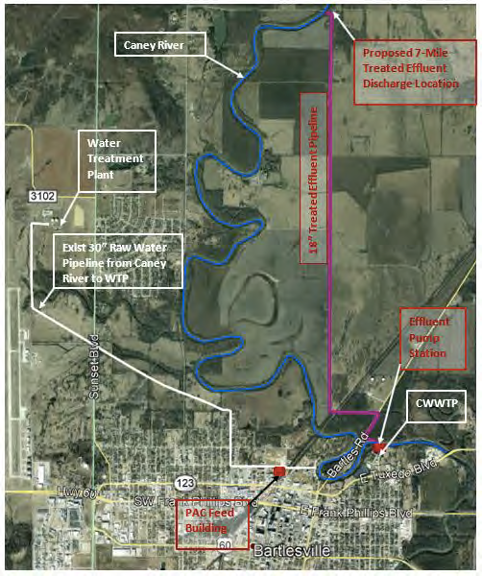
Figure 1. Proposed IPR project to reallocate part of CWWTP effluent discharge back into the Caney River (Modified from Tetra Tech 2019)

Water Reuse and Oklahoma Comprehensive Water Plan
IPR operations have long been implemented in the United States within communities that are prone to severe drought conditions. These operations involve augmenting purified water into an environmental buffer, such as groundwater aquifer or a surface water reservoir, lake, or river, before recollection for further treatment within a water treatment facility. One such example is with the Gwinnett County, Georgia IPR surface water augmentation of a capacity more than 60 million gallons per day (MGD) into the Chattahoochee River and Lake Lanier (EPA et al. 2017). Many states that have demonstrated or implemented full-scale IPR projects include Arizona, California, Colorado, Florida, Georgia, Tennessee, Texas, and Virginia. California is the leading state with the highest number of IPR projects and more than 50 years of experience (EPA et al. 2017; Tricas et al. 2018). All States follow strict Federal and self-implemented State regulations for recycled water to ensure continued protection of human health and the environment.
When the Oklahoma Legislature passed the Water for 2060 Act (House Bill 3055) in 2012, it set a statewide goal of consuming less freshwater in 2060 than in 2012 (Steel et al. 2012). The Bill creates a current cap on the water supply for the City of Bartlesville and set forth efforts toward implementation of indirect potable reuse (IPR). Under ODEQ reserved “Category 1a” for IPR in surface water, the use of reclaimed water for potable purposes by intentionally discharging to a surface water supply source, such as the Caney River (ODEQ 2014). The Caney River would be acting as an environmental buffer to create a natural system with high capacity to further purify water. The retention time of the recycled water in the raw water supply can remove CEC constituent by sorption onto sediments and biodegradation through aerobic microbial reactions (EPA et al. 2017; NRC 1998; Tetra Tech et al. 2019). The blended water is reclaimed back into Bartlesville’s WTP intake site, where it will undergo further advance treatment to improve water quality before entering into Bartlesville’s drinking water distribution system (ODEQ 2014; Tetra Tech et al. 2019).

Background: CEC
Contaminants of emerging concern (CEC), defined as chemicals that have the potential to adversely impact human health and the environment but are presently unregulated and not extensively monitored, may be present at trace concentrations in wastewater, surface water, groundwater, and drinking water (Kolpin et al. 2002; Glassmeyer et al. 2017). CEC are classified as synthetic or naturally occurring compounds or microorganisms that are suspected of having or have demonstrated effects on ecological and human health risks (Raghav et al. 2013). These risks have been linked with numerous endocrine, reproductive, neurologic, and carcinogenic effects within the human body (Mnif et al. 2011; Rahman et al. 2009). CEC belong to diverse chemical classes and are typically detected at trace levels (ng L⁻¹) in surface and subsurface waters. The majority of CEC found in natural water originate from wastewater treatment plants (WWTP), landfills, septic systems, agriculture, residential, commercial, and industrial sources (Acuña et al. 2015; Brooks et al. 2009; Mnif et al. 2011; Rahman et al. 2009;). The CEC are sub-categorized as pesticides, industrials, PPCPs, hormones, and “other” (Glassmeyer et al. 2017; Kolpin et al. 2002; Murray et al. 2010).
Pesticides are substances or mixtures of substances of unrelated chemicals that are used to control pests. They are often classified according to their target organism, which includes all of the following: herbicide, insecticides, nematicide, molluscicide, piscicide, avicide, rodenticide, bactericide, insect repellent, animal repellent, antimicrobial, and fungicide (NASDA 2014). They are heavily used throughout the world in industrial, commercial, and residential applications. The occurrence of pesticides in wastewater treatment plants is mainly from non-agricultural sources, such as management of sports fields, public parks and recreational areas (Köck-Schulmeyer et al. 2013; Mnif et al. 2011) or through the infiltration of agricultural runoff into the sewage systems (Birch et al. 2015). Human exposure to pesticides is through contact with the skin, by ingestion, or inhalation. Depending on the type of pesticide and the duration of the exposure there may be multiple negative health risks including dermatological, gastrointestinal, neurological, carcinogenic, respiratory, reproductive, and endocrinological effects (Alewu et al. 2012; García 2003; Köck-Schulmeyer et al. 2013; Sanborn et al. 2007; Weisenburger 1993; WHO 1990).
Industrial compounds are high production volume chemicals used as flame-retardants, polycarbonate plastic, epoxy resin, textiles, furniture, and many other materials. These industrial compounds fall into three main categories, which include Organophosphates, Alkylphenol Ethoxylates (APEs), and Bisphenol A (BPA). Organophosphates, such as the chlorinated alkyl phosphates compounds in tris-(2-chloroethyl)-phosphate (TCEP), tris-(2-chloro-, 1-methyl-ethyl)-phosphate (TCPP), and tris-(dichloro-iso-propyl)-phosphate (TDCP) have been used for several decades in many industries as flame retardants in polyurethane foam (Andresen et al. 2004; Duirk et al. 2005; EPA 2009c; Reemtsma et al. 2008). APEs, such as nonylphenol and octylphenol, are synthetic surfactants used in some detergents and cleaning products. BPA, also known as 4,4’-isopropylidenediphenol, is an organic compound used primarily to make polycarbonate plastic and epoxy resin (Deblonde et al. 2011; EPA 2009c; Yu et al. 2015). Many industrial compounds are listed as an endocrinological disruptor, with an estrogenic activity even at a concentration below 1000 ng L⁻¹ (Rykowska et al. 2006). The exposure to the compounds can be particularly harmful towards young children, infants, and fetus, because of lack of feedback regulating the activity, synthesis, and elimination of hormones (Groshart et al. 2015; Rykowska et al. 2006; Saal et al. 2008).
PPCPs are a unique group of CEC, due to the effects on humans at low doses (EPA 2009c). Varieties of PPCPs are used for personal health or cosmetic reasons through over the counter medication as well as medications prescribed by a physician. Most ingested pharmaceuticals are only partially metabolized, so the portion is excreted as urine or feces into the sewage system (Ebele et al. 2017; EPA 2009c). Personal care products such as soap, shampoo, cosmetics, skincare, fragrances, and antibacterial compounds, enter wastewater from bathing, laundry, and household cleaning (Birch et al. 2015; EPA 2009c). Additional entry might come from leaching from defecting landfill, leakage from manure storage tanks, or spray irrigation of treated wastewater onto agriculture land (Grassi et al. 2012; Walters et al. 2010). PPCPs are often associated with emerging endocrinological disruptors, which can cause immune dysfunction, cancer risk, and affect the human reproductive system (Jeong et al. 2017; Vimalkumar et al. 2019).
Hormones can be categorized into three major distinct groups according to their composition: peptide/protein, steroid, and amino acid derivatives. They are unique compounds that include both naturally occurring and synthetic analogs that are structurally related to one another. Within the body, their functions can have overall effects on reproduction and sexual differentiation, development and growth, maintenance of the internal environment, and regulating the body metabolism and nutrient absorption. Hormones are intercellular chemical messengers that may disturb more than one of these functions at low doses (Nussey et al. 2001; PubChem 2019; Rahman et al. 2009; Velicu et al. 2009). The CEC compound analyzed in this study belongs within the steroid group; which includes androstenedione, EE2 (17 Alpha-ethynylestradiol), estradiol, estriol, estrone, norethisterone, progesterone, and testosterone.
The “Other” compounds are chemicals that did not conveniently fit into one of the other groups but are commonly used and potentially occur in the environment including a wide array of stimulant, sweetener, insect repellent, and paraben.
Stimulants include paraxanthine (1,7-Dimethylxanthine) and caffeine (1,3,7-Trimethylxanthine). These compounds are a psychoactive Central Nervous System (CNS) stimulant, which results in a heightened activity of medullary, vagal, vasomotor, and respiratory centers in the brain (Fairbairn et al. 2016; PubChem 2019). Sweeteners include acesulfame potassium and sucralose are used as a sugar substitute. The use of artificial sweetener has been popularized because they are stable under heat and over a broad range of pH conditions, and, consequently, have a long shelf life. The majority of the ingested sweetener is not broken down by the body and therefore present in wastewater in notable concentration ( PubChem 2019; Renwick 1986; Rymon et al. 1985, 2013). DEET (N, N-Diethyl-meta-touamide) is the most common active ingredient in insect repellents. Approximately 30% of the U.S. population use some form of DEET repellents that are found in liquids, lotions, sprays, and wristbands. Since 1960, health effects have been reported in children and adults in records from poison control center data, with one of the most common effects being seizures. However, the incidence of seizure is estimated to be very low at an estimation of one per 100 million users. The U.S. EPA Office of Pesticide categorized DEET as Group D cancer classification, which is generally used for agents with inadequate human and animal evidence of carcinogenicity or which no data are available (Adgate et al. 2000; EPA 2007b, 2004). Parabens including butylparaben, ethylparaben, isobutylparaben, methylparaben, and propylparaben, are human-made chemicals often used in small amounts as preservatives in cosmetics, pharmaceuticals, foods, and beverages to prevent the growth of microbes. These endocrine-disrupting chemicals can be absorbed through the skin, blood, and the digestive system. Potential links have been suggested between parabens and breast cancer (Charles et al. 2013; Darbre et al. 2014).

Chapter 2. Study Area
The City of Bartlesville is located in northeastern Oklahoma, bisected by the Caney River that runs from North to South through of the city. The Bartlesville service area is about 282 square miles covering part of Washington, Osage, and Nowata County and part of Basin 76 of the Middle Arkansas Watershed Planning Region (OWRB 2013). The watershed region primarily relies on surface water supplies, such as The Caney River, Hulah Lake, and Lake Hudson, and there is no dependable groundwater source available for Bartlesville (Tetra Tech et al. 2019).
The Caney River, about 155 miles in length, has its headwaters in Elk County, Kansas, and flows in a south to a southeasterly direction to intersect Bartlesville halfway and enter into the Verdigris River in Rogers County, Oklahoma (Tetra Tech et al. 2019). The Caney River in basin 76 typically has flowed greater than 4,300 acre-feet per month throughout the year and greater than 65,000 acre-feet per month in the spring and early summer (OWRB 2013). The Caney River is dammed at the northeastern Osage County, Oklahoma to form Hulah Lake.
Hulah Lake is a 3,570-acre man-made reservoir with normal pool storage of 31,160 acre-feet. Bartlesville has 13,819 acre-feet (12.4 MGD) of water rights. Based on historical and projected silting and sediment deposits, Hulah Lake’s dependable yield is projected to decrease to 6.4 MGD through 2035 and 4.4 MGD by 2055. Raw water from Hulah Lake is transferred into Lake Hudson for further storage. Lake Hudson has normal pool storage of 4,000 acre-feet and is a city-owned lake (OWRB 2013; Tetra Tech et al. 2019; USACE 2007). Due to its size, it is insufficient for water supply yield on its own and is considered part of the Hulah and Hudson Bartlesville supply system reservoirs.

Geography, Landscape, and Hydrology of the Region
The Oklahoma Comprehensive Water Plan (OCWP) divided the state into 82 surface water basins for water supply availability analysis and then aggregated into 13 distinct Watershed Planning Regions. The City of Bartlesville lies centered within Basin 76 of the Middle Arkansas Watershed Planning Region. Basin 76 encompasses 1,016 square miles in northeastern Oklahoma, spanning most of Washington, Osage, and Nowata Counties (OWRB 2013). The basin dominated by two large reservoirs, Hulah Lake and Copan Lake, created by the U.S Army Corps of Engineers damming the Caney River. These two lakes are located directly north of the City of Bartlesville. Lake Hudson, one-tenth in size of Hulah Lake, is a city-owned lake and is located northwest of Bartlesville and in between the two large lakes. U.S. Route 75 runs North to South of Basin 76 and divides the basin with two distinctive terrains. The western region includes lump forest, vast grassland, scattered cultivated land, and abundant river basins, while the eastern area contains mosaic patches of prairie grassland, woodland, massive cultivated land, and urban landscape (Figures 2 – 3) ( OWRB 2009, 2013; Yang et al. 2018).
The surface water demand for Basin 76 in 2010 shows that 12,090 acre-feet per year (AFY) used for Municipal and Industrial, 1,190 AFY for Livestock, 840 AFY for Crop Irrigation, 360 AFY for Self Supplied Residential, and 350 AFY for Oil and Gas sector (Figure 4). Base on the planning horizon projection for 2060 estimate the total demand to be 13,330 AFY (10.26% increase) for Municipal and Industrial, 1,230 AFY (3.36% increase) for Livestock, 2,070 AFY (146.42% increase) for Crop Irrigation, 470 AFY (30.56% increase) for Self Supplied Residential, and 1,180 AFY (237.14% increase) for Oil and Gas (OWRB 2013). These sectors are contributing factors toward the source of CEC contamination by runoff or discharge through sewage.

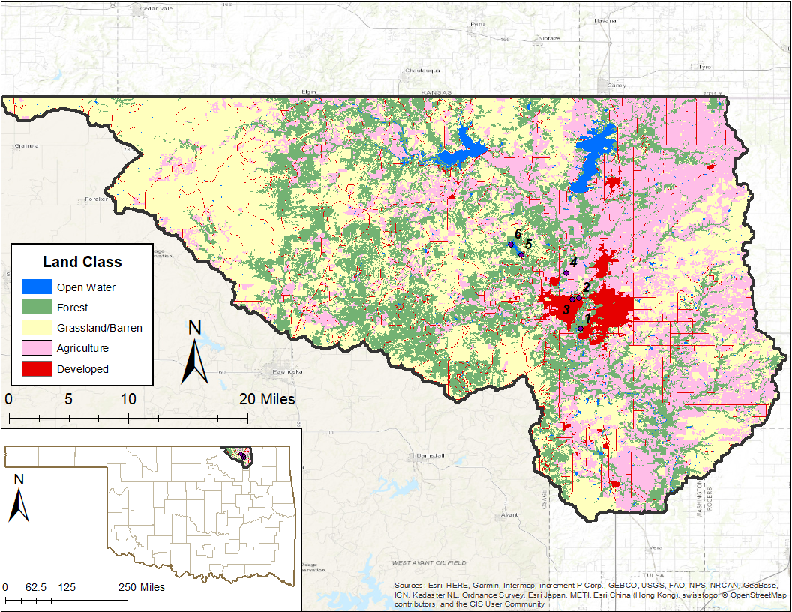
Figure 2. Land classification map of Basin 76 with the use of the National Land Cover Database (NLCD) data calculation value in Table A 7. Each count represents one pixel or 30m x 30m area within the region (Yang et al. 2018).

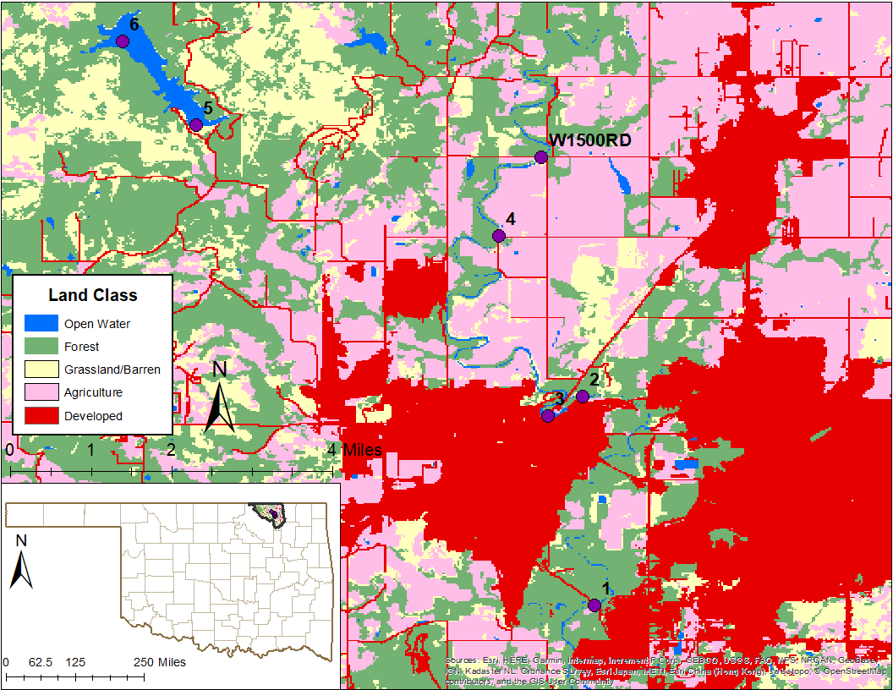
Figure 3. Land classification map of Bartlesville study area with the location points of the sample sites. Each count represents one pixel or 30m x 30m area within the region (Yang et al. 2018).
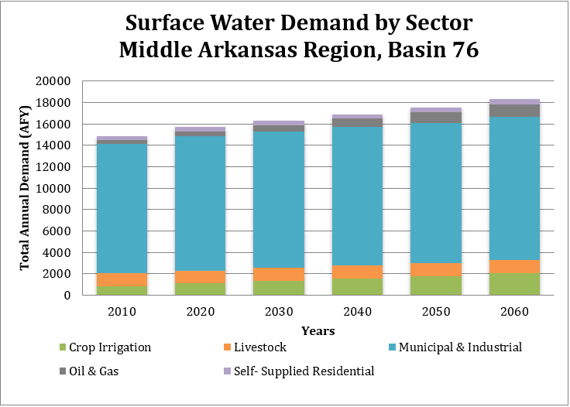
Figure 4. Surface water demand by sector of Basin 76. The projected demands chart shows a steady increase within each decade (Modified from OWRB 2013).

Bartlesville Water Supply and Future Demands
Bartlesville service area is about 282 square miles covering part of Washington, Osage, and Nowata Counties, and serves as the significant regional water supplier within the Basin 76 of the Middle Arkansas Watershed Planning Region. Bartlesville’s primary source of raw water supply is Hulah Lake and has about 12.4 MGD of water rights toward the lake. For additional storage, the water in Hulah Lake is transferred into Lake Hudson as a secondary water source, which Bartlesville wholly owns with 5.4 MGD water rights (OWRB 2013; Tetra Tech et al. 2019).
In December of 2007, the Planning Assistance State (PAS) program was completed by the U.S Army Corps of Engineers (USACE) to evaluate the present and future water supply needs for Bartlesville area. These areas include the City of Bartlesville and the surrounding communities, rural water systems, and the other regions to which the city provides water. Since the City of Bartlesville supplies water to about 99% of the residents in Washington County, the 2005 water usage data from Washington County was used as a baseline to estimate the future demand scenarios for Bartlesville over a 50-year planning period (Tetra Tech et al. 2019).
The PAS Program presents three different water demand scenarios, based on population growth that create the overall drive for water consumption; Baseline Projection, Mid Projection, and High Projection. For the Baseline Projection scenario, we considered historical data and trends in the area of Bartlesville, to project the water demand to be 10.71 MGD by the year 2055. The “High Projection”, which is the projection of higher growth trends in Bartlesville and estimate the water demand to be at 16.19 MGD by the year 2055. The “Mid Projection”, is the average between the “Baseline Projection” and “High Projection” growth scenario, which estimate the water demand to be at 13.45 MGD in 2055 (Figure 5) (Tetra et al. 2019; USACE 2007).
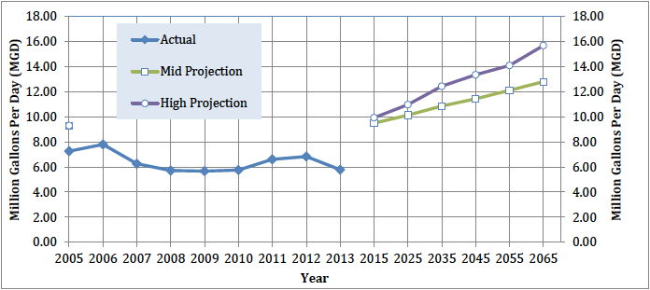
Figure 5. Water demand for actual and different projection within Bartlesville (Modified from Tetra Tech et al. 2019).

Bartlesville Wastewater Treatment
Chickasaw Wastewater Treatment Plant (CWWTP) is located at 230 North Chickasaw Ave., Northwest of Bartlesville. Bartlesville wastewater/sewer service includes a gravity collection system, lift station, flow equalization basins, and the Chickasaw Wastewater Treatment Plant (CWWTP). The wastewater is collected by a gravity system, which is made up of about 237 miles of sewer lines ranging in size from 6 inches to 42 inches in diameter. The wastewater then flows into a collection point at the lift station, which is located directly south of the CWWTP. It is designed to move the wastewater from lower to higher elevation with the use of three vertical, dry-pit centrifugal pump. The lift station holds a capacity of about 18.4 MGD and flows into the Flow Equalization Basin (FEB) for temporary storage with an additional 20 MG during high flow event. When ready to be processed, all flows are transported to the CWWTP for physical, biological, and chemical treatment before discharge continuously into the Caney River.
The CWWTP contains a headworks structure, primary clarification, activated sludge, secondary clarification, chlorination, and dechlorination treatment for wastewater treatment. The headwords structure is equipped with two aerated grit chambers with chain and bucket removal systems and an Auger Monster®. Grit is a heavy mineral matter consisting of a variety of particles including sand, gravel, cinder, and other heavy, discrete inorganic or organic biodegradable solids found in domestic sewage. Removal of grit prevents unnecessary abrasion and wear of mechanical equipment (EPA 2000). The Auger Monster® provides additional grit processing by grinding of influent solids and screening to remove solids greater than ¼-inch in diameter before sending the wastewater into the primary clarifier.
The primary clarifier provides a few hours of detention time for gravity settling to take place. The use of chain and drag scraper system helps remove sludge within the effluent. Floatable solids (scum) are removed from the surface by a skimmers process. Historically, CWWTP has a removal efficiency of 54% for total settleable solids (TSS) and 30% of dilution of biochemical oxygen demand (BOD₅). The effluent then routed to three aeration basins for a secondary treatment process.
The aeration basin provides 250 horsepower centrifugal blowers to promote and increase the rate of decomposition from microbial growth in the wastewater. CWWTP require that the basin volume provide a minimum hydraulic retention time of 6-8 hours and a BOD loading no more than 30-40 pounds BOD₅ per 1000 cubic feet. Before discharge back into the Caney River, the effluent enters through the final clarifier for removal of any remaining sludge and scum (Tetra Tech et al. 2019).
Bartlesville CWWTP (ODEQ Permit #OK0030333 and ID# S21402) has an average permitted capacity of 7.0 MGD. The objective for the relocation discharge site is to reclaim up to 4 MGD of the treated effluent and use it to augment the Caney River water supply (Tetra Tech et al. 2019). The reclaimed water will meet or exceed all the Oklahoma Department of Environmental Quality (ODEQ) rules and treatment requirements.

Study Objectives
The objectives of this study are to evaluate the CEC concentrations within the segment of the Caney River and to build a theoretical model base on the half-life of detected CEC for four scenarios within the IPR project. The four scenarios are based on CEC theoretical calculation at WTP intake site when full flow and half flow of effluent are diverted to the two upstream IPR locations, about 5.59 miles and 7.09 miles from the CWWTP. The results will help to understand the effectiveness of the environmental buffer system within the Caney River and the CEC concentrations once the IPR project is implemented. Additionally, the use of a built-in model can further replicate with other IPR project within a river environment, to assess the half-life of detected CEC and the location of propose IPR sites.

Chapter 3. Methodology
Water samples were collected from three sites within the Caney River, two sites at each end of Lake Hudson, and a treated effluent sampling location at the CWWTP discharge area. Sites within the Caney River include the potential IPR discharge location (Site 4) at the intersection of Durham Road, the current WTP raw water intake (Site 3) at Johnson Park and under Cherokee Street Bridge, and the evaluation post-mix site downstream from the CWWTP (Site 1) and under the bridge of Hillcrest Drive. Sites within Lake Hudson include the southern end of the lake (Site 5) near the Hudson Lake Dam and the northern end (Site 6) of the lake. The last sampling site is from the CWWTP effluent pipe (Site 2) that discharges directly downstream from the WTP raw water intake location (Figure 6). Three sampling events were planned in 2018 to represent different seasons and hydrologic conditions within the year. Additional sites at the second proposed IPR location (Site W1500RD) under the bridge of West 1500 Road and the Caney River, for testing our scenarios.

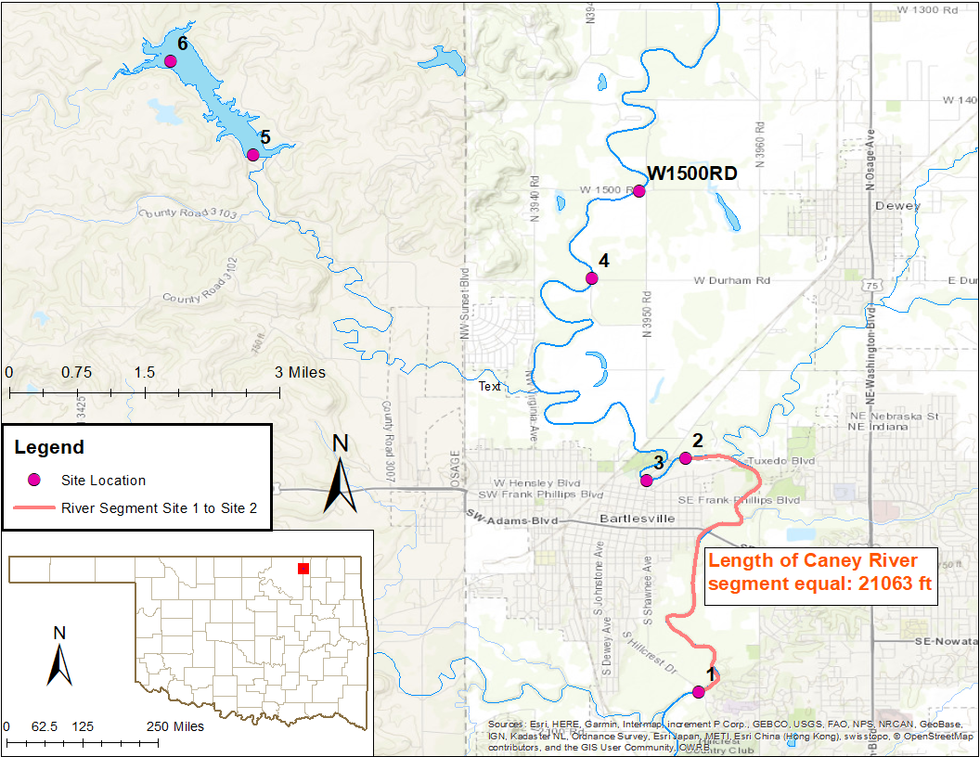
Figure 6. Sampling location for Bartlesville IPR project. Additional proposed IPR location (Site W1500RD) to test the scenarios.

Field Parameters
Parameters measured include temperature (Temp, °C), pH (pH, -Log[H⁺]), conductivity (Cond, μS), oxidation-reduction potential (OPR, mV), total dissolved solids (TDS, mg L⁻¹), dissolved oxygen percent air saturation (DO%, %), and dissolved oxygen (DO, ppm). Field parameters were measured using Yellow Springs Instruments (YSI) DO200, YSI PH100, and YSI EC300 with collected sample water in a one-litter plastic beaker.

Water Sampling for CEC
Additional precautions were taken during the day of sampling since the CEC compounds were measured in trace concentration (ng L⁻¹) and are very prone to contamination. These include the use of powderless nitrile gloves during sampling and processing, avoiding touching or breathing into samples and equipment, direct contact between clothing and the sample, sampling device, and processing equipment, the connection or consumption of PPCPs compounds, such as soap and detergents, DEET and other insect repellents, fragrances, caffeine, sweeteners, prescription drugs, sunscreen, tobacco, and any over-the-counter medication.
The water sample was collected using the EPA grab method (EPA Science and Ecosystem Support Division Quality System and Technical Procedures SESDPROC-306-R4) with a one-gallon glass container sampler and two 40 ml amber vials with 25 mg Ascorbic Acid preservative at each sampling sites (EPA 1982). The one-gallon container was rinsed three times with the sample water before the collection process. The water sample then transferred into two 40 ml amber vials up to the base of the neck, with the precaution that the mouth of the vials does not come in contact with anything other than the sample water. Two blind duplicates were completed for the sampling event of March and December. An equipment blank was completed during December sampling event, by pouring deionized water into the sampling equipment and transfer into the designated sample vial. The vials are then stored in a cooler at a constant temperature of 1-4°C but above the freezing point of water until they were shipped overnight with wet ice to the analyzing laboratory, with the Chain of Custody documentation.

CEC Analyses: Eurofins Eaton Analytical Laboratory
The collected water samples were shipped overnight to Eurofins Eaton Analytical Laboratory (EEA) in Monrovia, California. CEC analysis was completed by liquid chromatography-tandem mass spectroscopy (LC/MS/MS) at EAA that followed EPA Method 537, 538, and 1694 (EPA 2007a, 2009a, 2009b). The advantage of LC/MS/MS method is to detect CEC, since the compounds are found in trace amounts (ng L⁻¹) (Köck-Schulmeyer et al. 2013; Shoemaker et al. 2015).
During the LC/MS/MS analysis, the sample solution containing the CEC compounds of interests are pumped through a porous medium made of granular solid material (stationary phase) by a solvent (mobile phase) at high pressure. The chemical interaction with the different phases causes the chemical to separate the compound one by one, based on their relative affinity to the packing material and the solvent. The wide variety of combination between the stationary phases and mobile phase allows the customization of the target compound. Once the chemicals are separated, the sample is directed to the mass spectrometer to initiate LC/MS/MS analysis for further separation and detection by their molecular masses and charges (i.e., positive and negative ions). This technique involves the exposure of ion to a magnetic or electric field that can alter the movement of ions and separated based on their mass. The information is then relayed into a computer, which graphical present the information as a mass spectrum (Figure 7). The mass spectrum of the sample can then be used to determine the concentration of known and unknown compound at trace (ng L⁻¹) amounts (Eurofins Scientific 2018).
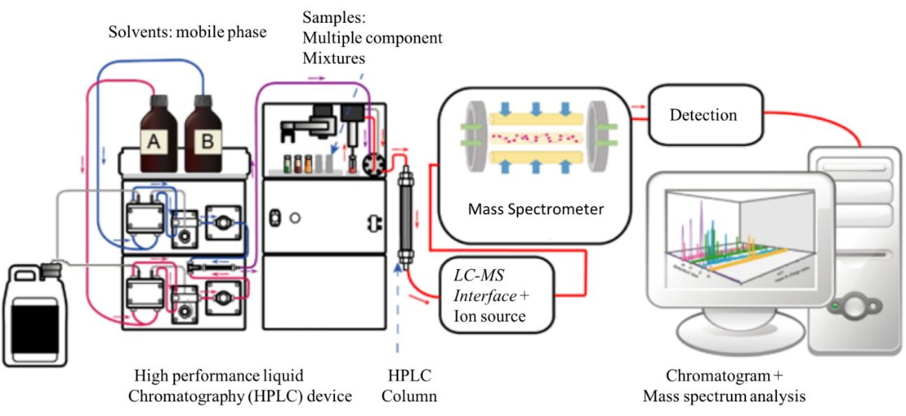
Figure 7. Liquid Chromatography-Mass Spectrometer (LC/MS/MS) diagram (Cwszot 2017).

Mixing model and Half-Life
Since the CWWTP effluent (Site 2) discharge directly after the Caney River intake point (Site 3), the area CEC concentration should be a mixture of these components. The hydrologic mixing model predicts the mixture concentration within the hydrologic flow path, by incorporating a mass balance analysis base on the concentration of CEC from treated CWWTP effluent and the Caney River (Buerge et al. 2006; Can et al. 2006; Gao et al. 2012). The mass balance equation shows that inflow, discharge with concentration from Site 2 combined with Site 3, must be equal to outflow (Harvey et al. 2015; Köck-Schulmeyer et al. 2013; Gao et al. 2012):

$Q_{A}∙C_{A}+Q_{B}∙C_{B}= Q_{T}∙C_{T}$ [Eq. 2.1]
Rearranging and substituting $Q_{T}$ for the combined flow in Site 2 and 3 to calculate the theoretical concentration for the mixing model ($C_{T}$):

$C_{T}=\frac{Q_{A}∙C_{A}+Q_{B}∙C_{B}}{Q_{A}+Q_{B}}$ [Eq. 2.2]

Where Q (ft³ s⁻¹) is discharged, C (ng L⁻¹) is CEC concentration reading, and the subscripts A, B, and T refers to the reading from CWWTP effluent (Site 2) discharge, the Caney River intake point (Site 3), and the theoretical mixing component, respectively. Sites that had non-detect for CEC concentration, the value of ½ the Minimum Reporting Level (MRL) was used for the model.

It was assumed that the speed of decomposition of the CEC takes place according to the first-order reaction model (Köck-Schulmeyer et al. 2013; Walters et al. 2010). The first-order rate constant equation (Eq. 2.3) and the half-life equation (Eq. 2.4) are used to find the half-life time for CEC concentration traveling from mixing model location (Site 2) towards the Caney River post-mix site, downstream from CWWTP (Site 1):

$C_{t}=C_{T}{ e}^{-kt}$ [Eq. 2.3]
$t_{1/2}= \frac{\ln{2}}{k}$ [Eq. 2.4]

By combining the two equations through the rate constant ($k)$, the half-life calculation for each detected CEC calculated within the equation:

$t_{1/2}=\frac{-t ∙\ln{2}}{ln⁡\frac{C_{t}}{C_{T}}}$ [Eq. 2.5]
Where C_{T} (ng L⁻¹) is the CEC theoretical concentration from our mixing model or the initial concentration, C_{t} is the CEC concentration remains at the measured time (Site 1) or final concentration, t (hrs) is travel time from Site 2 to Site 1, and t_{1/2} (hrs) is the half-life value.

Further information gathered through the USGS stream gauge at the Caney River above Coon Creek (#07174400) and Bartlesville’s CWWTP (ODEQ Permit #OK0030333 and ID# S21402) for discharge reading at the time of sampling. The reading from the stream gauge only contained 30 minutes reading intervals of stage height and discharge. Channel velocity was still needed to calculate the time (t) travel from the mixing site to the downstream location (Site 1). Manual hand measurement of channel velocity with the discharge was made by USGS staff on a monthly basis and used in a log-transformed relationship (Figure 8) with data stemming back to 1985 (USGS 2019).
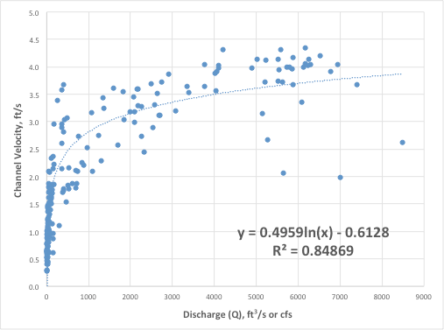
Figure 8. Log-transformed discharge and channel velocity relationship observed at USGS #07174400.

Using the measured gauge discharge at USGS Caney River above Coon Creek gauge and the relationship between log-transformed gauge discharge and channel flow field measurement, channel velocity at the USGS gage can be estimated using the following regression:

$$Channel Velocity=0.4959 ∙\ln\left(Gage discharge in cubic feet per seconds\right)-0.6128$$
R² = 0.84869

This equation yields a strong relationship between the channel velocity and discharge, based on the R² value. The length of the river for the model to be at 21062 feet (3.99 miles) and was used to calculate the time (t) from the calculated channel velocity (Table A 8).

Theoretical CEC Concentration after IPR
With the calculated half-life average for the CEC detected within CWWTP effluent discharge (Table A 10 – 12), it set up four scenarios to theoretically calculate the CEC concentration values at WTP raw water intake site (Site 3) once IPR implemented. The theoretical scenarios involve using the mixing equation (Eq. 2.2) to find the theoretical mixing concentration at both proposed IPR sites and using the half-life equation (Eq. 2.5) to find the concentration that would be measured downstream (C_{t}, Site 3) from the IPR mixing site. These four scenarios include:

Scenario 1: Full flows redirect from CWWTP to Caney River IPR #1 (Site 4)
Scenario 2: Full flows redirect from CWWTP to Caney River IPR #2 (Site W1500RD)
Scenario 3: Half flow redirect from CWWTP to Caney River IPR #1 (Site 4)
Scenario 4: Half flows redirect from CWWTP to Caney River IPR #2 (Site W1500RD)

It was assumed that the value for CEC concentration values for Caney River IPR #1 (Site 4) would be used for site W1500RD. The length of the river from WTP raw water intake site (Site 3) to Caney River IPR #1 (Site 4) to be about 29515.2 feet (5.59 miles) and to Caney River IPR #2 (Site W1500RD) to be about 37435.2 feet (7.09 miles). The measured distance will be used to calculate the time (t) used in the CEC half-life equation.

Chapter 4. Results and Discussion

CEC Detection
A total of 64 out of 99 unique Contaminants of Emerging Concern (CEC) compounds were detected in at least one water sample collected during one or more of the three sampling events. The results showed that 11 of 19 pesticides, four of six analyzed industrials, 35 of 53 PPCPs, four of eight hormones, and 10 of 13 others were detected using LC/MS/MS. The CEC analysis results for the three sampling events are presented in Tables A 3 – 5 and Figures B 1 – 21.
The blind duplicate and equipment blank results are presented in Table A 6. The equipment blank for December shows zero detections, which indicates that very low or no contamination issues resulted from the sampling equipment or sampling process. The blind duplicate for March matched with Site 6 results with an average absolute difference of 7 ng L⁻¹. The blind duplicate for December matched with Site 1 results with an average absolute difference of 7.28 ng L⁻¹. The low value within the two blind duplicate indicates a good quality control for the sampling and analytical methods.
The most frequently detected CEC (detection in all three events) were the 2,4-D, Atrazine, Acesulfame-K, Caffeine, Carbamazepine, Carisoprodol, DEET, Dehydronifedipine, Diclofenac, Dilantin, Diltiazem, Fluoxetine, Gemfibrozil, Iohexol, Lidocaine, Meprobamate, Primidone, Sucralose, and Theophylline. “Upper” trace concentrations (> 100 ng L⁻¹) were detected for NP (4-nonylphenol), Acesulfame-K, Amoxicillin, Iohexol, Lidocaine, Sucralose, and TCPP. The CEC specific minimum reporting level (MRL) should consider when comparing detection frequencies of CEC, which factor in at ½ of MRL.
The results from EEA shows that Chickasaw Wastewater Treatment Plant (CWWTP) discharge location (Site 2) comprised 87% of CEC mass within the study, followed by Caney River downstream post-mix (Site 1) with 9%, and the rest (Site, 3, 4, 5, and 6) with 1 % each. The distribution of CEC mass was similar to those of the entire sampling event. December sampling had the highest total amount of CEC mass, and CWWTP discharge contributed about 92% overall. December results could come from the increased use of PPCPs during cold or flu seasons, which leads to a higher CEC mass within CWWTP. March sampling had the second-highest total amount of CEC mass, and CWWTP discharge contributed about 77% overall. July sampling had the lowest total amount of CEC mass, and CWWTP discharge contributed about 89% overall. The results indicate that the upstream sites within Caney River and Lake Hudson had a generally low CEC concentration, and the greatest contribution to CEC are within the CWWTP discharge site and downstream. Comparable CEC detections are typically found in the Wastewater Treatment Plant (WWTP) effluents from all over the world (Deblonde et al., 2011).

Field Parameters
Table 1 shows the results from our field parameters within the three sampling events. The most substantial changes within the reading of the instrument were in oxidizing-reducing potential (ORP), conductivity (Cond), and total dissolved solids (TDS). Sites from within Lake Hudson (Site 5 and 6), upstream from CWWTP (Site 3 and 4), and downstream from CWWTP (Site 1 and 2) had similar readings within the group.
Conductivity is affected by temperature and the presence of inorganic dissolved solids. Sampling event in July had the highest recorded conductivity average with the temperature at 32°C, while December had the lowest with the temperature at 6.7°C. The conductivity value corresponds to the TDS reading due to related to both specific conductivity and turbidity. The TDS reading from CWWTP effluent yielded the highest and almost doubled the amount compared with the other sites. This stem from the presence of inorganic solids that might come from Bartlesville’s CWWTP (APAH, 1992; Hach Company, 1992).
ORP measures the ability of a lake or river to cleanse itself or break down waste products, such as contaminates and dead organic matters. When the ORP value is positive, the values indicate the presence of dissolved oxygen in the water and the promotion of the bacterial activity. A negative ORP value indicates the lack of dissolved oxygen in the water and could stem from excess algae growth, which causes decomposition to increase and accelerate oxygen consumption (Wetzel, 1983). Sampling event in March had the highest recorded OPR average with the reading at a positive (oxidizing) agents, while July and December were both negative (reducing) agents. The sampling site downstream from the CWWTP group (Site 1 and 2) had the highest OPR values when compared to the four other sites. One reason might come from the increase in flow within the river segment from CWWTP effluent discharged, which helps improve the natural reaeration and increase dissolved oxygen (Tetra et al. 2018, 2019).
Table 1. Sampling parameters from the three sampling events. An “*” indicates an NA result from March parameter that was missing for TDS values.
Sites | Date | Time (CT) | Temp  (°C) | pH  (-Log[H⁺]) | Cond (μS) | OPR (mV) | TDS  (mg L⁻¹) | DO% (%) | DO  (ppm)
1 | March | 0908 | 11.5 | 7.25 | 343.1 | 54 | NA* | 6.01 | 6.51
2 | March | 1052 | 11.4 | 7.3 | 612 | 56 | NA* | 57.11 | 5.76
3 | March | 1116 | 11.1 | 7.71 | 279.1 | 76 | NA* | 73.2 | 7.51
4 | March | 1159 | 11 | 7.94 | 296.4 | 87 | NA* | 64.7 | 6.89
5 | March | 1333 | 11 | 7.91 | 175.9 | 86 | NA* | 75.5 | 8.08
6 | March | 1352 | 11.8 | 8.22 | 169.1 | 87 | NA* | 83.7 | 8.88
1 | July | 0900 | 31.1 | 6.79 | 368.2 | 25 | 214.8 | 53.3 | 3.93
2 | July | 0959 | 31.3 | 6.59 | 670 | -89 | 403 | 62.2 | 4.74
3 | July | 1024 | 30.7 | 8.47 | 346 | -121 | 202.4 | 52.1 | 3.9
4 | July | 1100 | 31.4 | 8.68 | 352.9 | -134 | 204 | 49.7 | 3.62
5 | July | 1245 | 33.1 | 8.37 | 181.3 | -117 | 101.9 | 74.3 | 5.26
6 | July | 1300 | 33.7 | 8.17 | 184.6 | -104 | 102.4 | 63.1 | 4.44
1 | December | 0845 | 5.4 | 6.56 | 231.2 | -31 | 236.2 | 87.5 | 11.01
2 | December | 0950 | 13.6 | 7.31 | 553 | -53 | 461 | 62.7 | 6.37
3 | December | 1015 | 4.8 | 8.29 | 210.1 | -103 | 219.9 | 74.9 | 9.52
4 | December | 1045 | 4.8 | 8.33 | 225.9 | -107 | 237 | 85.9 | 10.93
5 | December | 1215 | 5.8 | 8.2 | 79.1 | -100 | 80 | 81 | 10.06
6 | December | 1240 | 5.8 | 8.21 | 83.2 | -94 | 84.3 | 84.1 | 10.42

Mixing Model and Half-Life
The data obtained in the study (Tables A. 3 – 5) were used to simulate the mixing model for CWWTP discharge and the Caney River, which is shown in Tables A10 – 12. The mixing model equation (Eq. 2.2) is dependent on the discharge value between the two observed sites for the CEC theoretical concentration value. The CWWTP discharge had a constant flow of 9.65 ft³ s⁻¹. The Caney River had a discharge 37.4 ft³ s⁻¹ in March, 23.7 ft³ s⁻¹ in July, and 91.3 ft³ s⁻¹ in December. During the highest recorded flow within the Caney River for December, the detected CWWTP CEC concentration was diluted on average more than 83% upon mixing into the Caney River. Hydrograph for discharge from the 2018 physical year (Figure 9) indicated that December was a greater positive anomaly from the median daily statistic from 33 years. The stretch of August to December the area experienced a long wet period, with peak discharge values in late October and mid-December. The overall average of dilution calculated between the three sampling events were more than 66%.
Two stipulations were needed for a positive calculation in half-life values (Eq. 2.5). The first being that the initial concentration (C_{T}) has to be higher than the final concentration (C_{t}). The second being that sites do not contain the same value, or it will produce an undefined (NA) value from division by zero (0). Within our model, a total of 61 unique CEC compounds were detected at CWWTP and were used for half-life calculation. Only 59 of CEC within our model pass our stipulation for a half-life value. A negative half-life was computed for two compounds, 1,7-Dimethylxanthine and Acetaminophen, which may be because there is an additional source of the CEC between the Site 2 mixing component and Site 1, analytical uncertainty (i.e., ± for concentrations) was high and made it difficult to distinguish between Site 2 mixing component and Site 1 concentrations.
The overall half-life results are shown in Table 2, along with the calculated average. Table 2 shows that 11 pesticide half-lives range from 1.93 to 134.44 hours, four industrial half-lives range from 1.74 to 9.28 hours, 34 PCPPs half-lives range from 0.99 to 187.88 hours, two hormone half-lives range from 2.17 to 4.84 hours, and eight other half-lives range from 1.63 to 245.83 hours within our calculation (Figures B 22 – 26). Amoxicillin and Sucralose have the highest calculated half-life, which suggests that they are most persistent in the environment. One explanation could be due to the concentration detect well above 10000 ng L⁻¹ from the CWWTP, and that the environmental buffers within the Caney River had little effect of degrading the compounds.

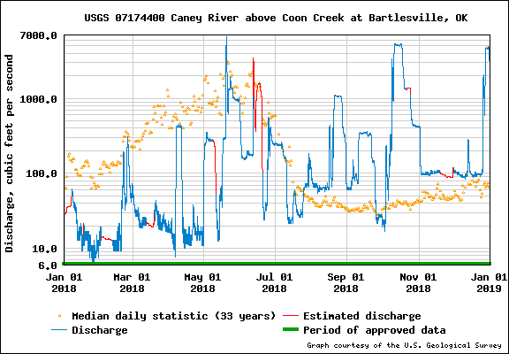
Figure 9. USGS gauge #07174400 Caney River above Coon Creek at Bartlesville, Ok hydrograph for 2018 (USGS 2019).

Table 2. CEC half-life values for the three sampling event and average. An “*” indicates an NA result from half-life calculation from non-detect within sites 1, 2, and 3 or having a negative value
Analyte | Class | March (hrs) | July (hrs) | December (hrs) | Average (hrs)
2,4-D | Pesticides | NA* | 73.67 | NA* | 73.67
NP (4-nonylphenol) | Industrials | NA* | 9.28 | NA* | 9.28
Acesulfame-K | Others | NA* | 2.08 | 3.3 | 2.69
Albuterol | PPCPs | 1.68 | NA* | 7.44 | 4.56
Amoxicillin | PPCPs | 2.63 | NA* | 187.88 | 95.26
Atenolol | PPCPs | 3.29 | 1.41 | 1.79 | 2.16
Atrazine | Pesticides | 3.17 | NA* | 10.46 | 6.82
Bromacil | Pesticides | 2.54 | NA* | NA* | 2.54
Butalbital | PPCPs | NA* | 3.59 | 2.77 | 3.18
Caffeine | Others | NA* | NA* | 6.43 | 6.43
Carbamazepine | PPCPs | 5.35 | 2.44 | 3.27 | 3.69
Carisoprodol | PPCPs | 15.22 | 3.23 | 4.69 | 7.71
Cimetidine | PPCPs | NA* | NA* | 0.99 | 0.99
Cotinine | Others | NA* | 6.47 | 3.74 | 5.11
DEA | Pesticides | 16.49 | NA* | NA* | 16.49
DEET | Others | 3.75 | 11.21 | 13.17 | 9.38
Dehydronifedipine | PPCPs | 11.76 | 7.94 | 4.9 | 8.20
DIA | Pesticides | 2.5 | NA* | NA* | 2.50
Diclofenac | PPCPs | 8.91 | 1.43 | 4.86 | 5.07
Dilantin | PPCPs | 2.75 | 4.17 | 6.32 | 4.41
Diltiazem | PPCPs | 3.14 | 3.49 | 1.19 | 2.61
Diuron | Pesticides | NA* | NA* | 1.93 | 1.93
Erythromycin | PPCPs | 4.84 | NA* | 27.54 | 16.19
Estrone | Hormones | NA* | NA* | 4.84 | 4.84
EE2 (17 Alpha-ethynylestradiol) | Hormones | NA* | 2.17 | NA* | 2.17
Fluoxetine | PPCPs | 1.59 | 2.17 | 2.92 | 2.23
Gemfibrozil | PPCPs | 4.58 | 3.39 | 1.98 | 3.32
Ibuprofen | PPCPs | NA* | 4.51 | 1.96 | 3.24
Iohexol | PPCPs | NA* | 1.81 | 2.62 | 2.22
Ketoprofen | PPCPs | NA* | NA* | 2.49 | 2.49
Ketorolac | PPCPs | NA* | NA* | 1.96 | 1.96
Lidocaine | PPCPs | 5.66 | 1.82 | 3.38 | 3.62
Linuron | Pesticides | NA* | 5.72 | NA* | 5.72
Lopressor | PPCPs | NA* | 2.05 | 2.65 | 2.35
Meclofenamic Acid | PPCPs | 3.49 | NA* | NA* | 3.49
Meprobamate | PPCPs | 3.81 | 1.73 | 5.22 | 3.59
Metformin | PPCPs | 4 | 3.24 | 2.77 | 3.34
Methylparaben | Others | NA* | 46.14 | NA* | 46.14
Metolachlor | Pesticides | 3.06 | NA* | NA* | 3.06
Naproxen | PPCPs | NA* | NA* | 1.82 | 1.82
Nifedipine | PPCPs | 5.7 | NA* | 9.68 | 7.69
OUST | Pesticides | NA* | 3 | NA* | 3.00
Pentoxifylline | PPCPs | 2.4 | NA* | 4.69 | 3.55
Primidone | PPCPs | 2.52 | 1.69 | 4.54 | 2.92
Propylparaben | Others | NA* | 1.92 | NA* | 1.92
Quinoline | Pesticides | 134.44 | NA* | 2.33 | 68.39
Simazine | Pesticides | NA* | 12.78 | 109.85 | 61.31
Sulfadiazine | PPCPs | NA* | 4.21 | NA* | 4.21
Sulfamethoxazole | PPCPs | NA* | 2.05 | 5.91 | 3.98
Sucralose | Others | 245.83 | 1.98 | 3.71 | 83.84
TCEP | Industrials | 5.49 | 2.96 | 2.52 | 3.66
TCPP | Industrials | 4.05 | 1.76 | 2.92 | 2.91
TDCPP | Industrials | 1.74 | NA* | NA* | 1.74
Theophylline | PPCPs | NA* | NA* | 1.14 | 1.14
Thiabendazole | Others | NA* | 61.74 | 1.63 | 31.69
Triclocarban | PPCPs | NA* | 2.64 | NA* | 2.64
Triclosan | PPCPs | 4.84 | NA* | 25.14 | 14.99
Trimethoprim | PPCPs | 3.55 | NA* | 3.37 | 3.46
Warfarin | PPCPs | 14.23 | NA* | NA* | 14.23

IPR Scenarios
IPR scenarios required that the mixing formula (Eq. 2.2) calculate CWWTP effluent redirect to the two proposed locations (Site 4 and Site W1500RD), from Table A 13 – 14. Then it needs to be to plugged into the half-life formula (Eq. 2.5), with the average half-life value from Table 2, to find the theoretical concentration (C_{t}) at the Water Treatment Plant (WTP) intake location (Site 3). The results of our IPR scenario shows in Table 3 for March, Table 4 for July, and Table 5 for December calculation. The highlighted value indicating the theoretical calculation within the scenarios were higher than the actual measured value, and the darker shade represents an upper trace (> 100 ng L⁻¹) CEC concentration.
Scenario one contained the highest amount CEC that theoretically exceeded the actual measured value from Site 3, with a total of 24 on March, 13 in July, and 24 in December. Scenario four had the lowest, with 19 on March, eight in July, and 14 in December. Four CEC compound were label as upper trace amount; NP (4-nonylphenol), Amoxicillin, Iohexol, and Sucralose. These four compounds had some of the largest measured concentration within CWWTP, and the location of the propose IPR project was insufficient to have the environmental buffer remove concentration to acceptable levels. To have every CEC compound to be equal or less than the actual initial readings from Site 3, the location of the IPR project needs to be more than 515 miles of displacement within the Caney River.

Table 3. March theoretical calculation from 59 CEC compounds. All values reported in ng L⁻¹.
March 20th, 2018 |  |  | Full Flow |  | Half Flow
 |  |  | Scenario 1 | Scenario 2 | Scenario 3 | Scenario 4
Analyte | Class | Site 3 (ng L⁻¹) | Site 4  (ng L⁻¹) | W1500RD (ng L⁻¹) | Site 4  (ng L⁻¹) | W1500RD (ng L⁻¹)
2,4-D | Pesticides | 30 | 39.855 | 39.164 | 32.584 | 32.019
NP (4-nonylphenol) | Industrials | 410 | 901.772 | 784.895 | 690.037 | 600.603
Acesulfame-K | Others | 10 | 32.363 | 20.047 | 19.677 | 12.188
Albuterol | PPCPs | 2.5 | 3.932 | 2.964 | 2.578 | 1.944
Amoxicillin | PPCPs | 40 | 304.876 | 300.779 | 186.804 | 184.294
Atenolol | PPCPs | 2.5 | 7.374 | 4.062 | 4.231 | 2.331
Atrazine | Pesticides | 52 | 22.821 | 18.889 | 23.001 | 19.038
Bromacil | Pesticides | 2.5 | 1.456 | 0.878 | 0.979 | 0.590
Butalbital | PPCPs | 2.5 | 0.552 | 0.368 | 0.552 | 0.368
Caffeine | Others | 12 | 9.016 | 7.378 | 6.074 | 4.971
Carbamazepine | PPCPs | 12.5 | 18.467 | 13.016 | 10.596 | 7.468
Carisoprodol | PPCPs | 2.5 | 20.353 | 17.221 | 14.671 | 12.413
Cimetidine | PPCPs | 2.5 | 0.020 | 0.005 | 0.020 | 0.005
Cotinine | Others | 5 | 1.750 | 1.359 | 1.839 | 1.429
DEA | Pesticides | 2.5 | 2.300 | 2.127 | 2.109 | 1.950
DEET | Others | 5 | 20.923 | 18.236 | 12.990 | 11.322
Dehydronifedipine | PPCPs | 2.5 | 1.863 | 1.592 | 1.654 | 1.414
DIA | Pesticides | 2.5 | 1.444 | 0.863 | 0.968 | 0.578
Diclofenac | PPCPs | 2.5 | 45.553 | 35.322 | 25.825 | 20.025
Dilantin | PPCPs | 10 | 11.711 | 8.746 | 8.020 | 5.989
Diltiazem | PPCPs | 2.5 | 3.351 | 2.043 | 2.043 | 1.246
Diuron | Pesticides | 5.3 | 0.413 | 0.212 | 0.437 | 0.224
Erythromycin | PPCPs | 5 | 7.550 | 6.972 | 5.854 | 5.406
Estrone | Hormones | 2.5 | 0.927 | 0.710 | 0.927 | 0.710
EE2 (17 Alpha-ethynylestradiol) | Hormones | 2.5 | 0.272 | 0.150 | 0.272 | 0.150
Fluoxetine | PPCPs | 5 | 4.983 | 2.792 | 3.033 | 1.699
Gemfibrozil | PPCPs | 2.5 | 1.242 | 0.842 | 0.952 | 0.645
Ibuprofen | PPCPs | 5 | 1.133 | 0.761 | 1.133 | 0.761
Iohexol | PPCPs | 50 | 173.999 | 97.173 | 99.532 | 55.586
Ketoprofen | PPCPs | 12.5 | 0.363 | 0.216 | 0.363 | 0.216
Ketorolac | PPCPs | 12.5 | 0.217 | 0.113 | 0.217 | 0.113
Lidocaine | PPCPs | 2.5 | 21.895 | 15.339 | 12.501 | 8.758
Linuron | Pesticides | 2.5 | 1.079 | 0.861 | 1.079 | 0.861
Lopressor | PPCPs | 10 | 1.292 | 0.746 | 1.292 | 0.746
Meclofenamic Acid | PPCPs | 2.5 | 22.939 | 15.861 | 13.069 | 9.036
Meprobamate | PPCPs | 12.5 | 10.796 | 7.538 | 6.309 | 4.405
Metformin | PPCPs | 2.5 | 11.727 | 7.971 | 6.801 | 4.622
Methylparaben | Others | 10 | 9.011 | 8.763 | 9.011 | 8.763
Metolachlor | Pesticides | 6.4 | 2.604 | 1.710 | 2.604 | 1.710
Naproxen | PPCPs | 5 | 0.357 | 0.176 | 0.357 | 0.176
Nifedipine | PPCPs | 10 | 9.774 | 8.265 | 7.818 | 6.611
OUST (Sulfometuron, methyl) | Pesticides | 2.5 | 0.504 | 0.328 | 0.504 | 0.328
Pentoxifylline | PPCPs | 12.5 | 0.645 | 0.449 | 0.645 | 0.449
Primidone | PPCPs | 10 | 7.505 | 4.827 | 5.038 | 3.240
Propylparaben | Others | 2.5 | 0.205 | 0.105 | 0.205 | 0.105
Quinoline | Pesticides | 5.8 | 3.965 | 3.891 | 3.242 | 3.181
Simazine | Pesticides | 12.5 | 24.144 | 23.642 | 16.284 | 15.945
Sulfadiazine | PPCPs | 10 | 5.836 | 4.297 | 4.668 | 3.438
Sulfamethoxazole | PPCPs | 2.5 | 1.365 | 0.987 | 1.092 | 0.790
Sucralose | Others | 50 | 9061.227 | 8922.994 | 5106.170 | 5028.273
TCEP | Industrials | 2.5 | 8.288 | 5.828 | 5.216 | 3.668
TCPP | Industrials | 2.5 | 59.113 | 37.961 | 37.204 | 23.892
TDCPP | Industrials | 2.5 | 12.629 | 6.030 | 8.448 | 4.033
Theophylline | PPCPs | 10 | 0.418 | 0.135 | 0.298 | 0.096
Thiabendazole | Others | 2.5 | 2.148 | 2.063 | 2.148 | 2.063
Triclocarban | PPCPs | 5 | 0.809 | 0.496 | 0.809 | 0.496
Triclosan | PPCPs | 5 | 7.374 | 6.766 | 5.717 | 5.246
Trimethoprim | PPCPs | 2.5 | 33.459 | 23.055 | 18.930 | 13.044
Warfarin | PPCPs | 2.5 | 2.270 | 2.073 | 2.055 | 1.877

Table 4. July theoretical calculation from 59 CEC compounds. All values reported in ng L⁻¹.
July 12th, 2018 |  |  | Full Flow |  | Half Flow
 |  |  | Scenario 1 | Scenario 2 | Scenario 3 | Scenario 4
Analyte | Class | Site 3 (ng L⁻¹) | Site 4  (ng L⁻¹) | W1500RD (ng L⁻¹) | Site 4  (ng L⁻¹) | W1500RD (ng L⁻¹)
2,4-D | Pesticides | 130 | 127.297 | 125.089 | 129.008 | 126.770
NP (4-nonylphenol) | Industrials | 50 | 42.108 | 36.650 | 36.665 | 31.913
Acesulfame-K | Others | 10 | 9.642 | 5.973 | 6.118 | 3.790
Albuterol | PPCPs | 2.5 | 0.872 | 0.658 | 0.872 | 0.658
Amoxicillin | PPCPs | 40 | 38.033 | 37.522 | 38.033 | 37.522
Atenolol | PPCPs | 2.5 | 4.018 | 2.214 | 2.360 | 1.300
Atrazine | Pesticides | 24 | 10.270 | 8.501 | 10.974 | 9.083
Bromacil | Pesticides | 2.5 | 0.379 | 0.228 | 0.379 | 0.228
Butalbital | PPCPs | 2.5 | 1.441 | 0.961 | 1.048 | 0.699
Caffeine | Others | 2.5 | 1.184 | 0.969 | 1.184 | 0.969
Carbamazepine | PPCPs | 2.5 | 14.545 | 10.251 | 8.410 | 5.927
Carisoprodol | PPCPs | 2.5 | 3.943 | 3.336 | 2.792 | 2.362
Cimetidine | PPCPs | 2.5 | 0.020 | 0.005 | 0.020 | 0.005
Cotinine | Others | 5 | 3.240 | 2.517 | 2.670 | 2.074
DEA | Pesticides | 9.3 | 6.394 | 5.913 | 6.011 | 5.559
DEET | Others | 17 | 13.523 | 11.787 | 12.046 | 10.499
Dehydronifedipine | PPCPs | 2.5 | 2.092 | 1.788 | 1.782 | 1.523
DIA | Pesticides | 2.5 | 0.367 | 0.220 | 0.367 | 0.220
Diclofenac | PPCPs | 2.5 | 13.564 | 10.518 | 7.991 | 6.196
Dilantin | PPCPs | 10 | 7.609 | 5.683 | 5.733 | 4.282
Diltiazem | PPCPs | 2.5 | 1.065 | 0.650 | 0.769 | 0.469
Diuron | Pesticides | 2.5 | 0.208 | 0.107 | 0.208 | 0.107
Erythromycin | PPCPs | 5 | 3.716 | 3.432 | 3.716 | 3.432
Estrone | Hormones | 2.5 | 0.927 | 0.710 | 0.927 | 0.710
EE2 (17 Alpha-ethynylestradiol) | Hormones | 2.5 | 1.452 | 0.801 | 0.930 | 0.513
Fluoxetine | PPCPs | 5 | 3.078 | 1.724 | 1.971 | 1.104
Gemfibrozil | PPCPs | 2.5 | 1.629 | 1.105 | 1.168 | 0.792
Ibuprofen | PPCPs | 5 | 2.395 | 1.608 | 1.837 | 1.233
Iohexol | PPCPs | 50 | 230.490 | 128.722 | 131.027 | 73.175
Ketoprofen | PPCPs | 2.5 | 0.363 | 0.216 | 0.363 | 0.216
Ketorolac | PPCPs | 2.5 | 0.217 | 0.113 | 0.217 | 0.113
Lidocaine | PPCPs | 2.5 | 27.374 | 19.178 | 15.556 | 10.898
Linuron | Pesticides | 2.5 | 1.925 | 1.536 | 1.551 | 1.238
Lopressor | PPCPs | 10 | 7.691 | 4.441 | 4.859 | 2.806
Meclofenamic Acid | PPCPs | 2.5 | 0.632 | 0.437 | 0.632 | 0.437
Meprobamate | PPCPs | 2.5 | 5.604 | 3.913 | 3.414 | 2.384
Metformin | PPCPs | 2.5 | 0.593 | 0.403 | 0.593 | 0.403
Methylparaben | Others | 53 | 35.473 | 34.496 | 38.517 | 37.456
Metolachlor | Pesticides | 12 | 1.761 | 1.156 | 1.904 | 1.250
Naproxen | PPCPs | 5 | 0.357 | 0.176 | 0.357 | 0.176
Nifedipine | PPCPs | 10 | 5.354 | 4.528 | 5.354 | 4.528
OUST (Sulfometuron, methyl) | Pesticides | 5.5 | 1.779 | 1.158 | 1.474 | 0.959
Pentoxifylline | PPCPs | 2.5 | 0.645 | 0.449 | 0.645 | 0.449
Primidone | PPCPs | 5 | 8.730 | 5.615 | 5.294 | 3.405
Propylparaben | Others | 29 | 2.012 | 1.029 | 2.176 | 1.113
Quinoline | Pesticides | 2.5 | 2.330 | 2.287 | 2.330 | 2.287
Simazine | Pesticides | 2.5 | 2.960 | 2.899 | 2.673 | 2.618
Sulfadiazine | PPCPs | 10 | 7.155 | 5.269 | 5.404 | 3.979
Sulfamethoxazole | PPCPs | 2.5 | 27.136 | 19.629 | 15.460 | 11.183
Sucralose | Others | 50 | 9196.136 | 9055.845 | 5147.957 | 5069.423
TCEP | Industrials | 5 | 37.723 | 26.524 | 21.627 | 15.207
TCPP | Industrials | 50 | 78.919 | 50.680 | 48.246 | 30.983
TDCPP | Industrials | 50 | 3.180 | 1.518 | 3.180 | 1.518
Theophylline | PPCPs | 10 | 0.146 | 0.047 | 0.146 | 0.047
Thiabendazole | Others | 22 | 15.141 | 14.537 | 14.905 | 14.311
Triclocarban | PPCPs | 5 | 3.111 | 1.908 | 2.092 | 1.283
Triclosan | PPCPs | 5 | 3.629 | 3.330 | 3.629 | 3.330
Trimethoprim | PPCPs | 2.5 | 0.624 | 0.430 | 0.624 | 0.430
Warfarin | PPCPs | 2.5 | 1.784 | 1.629 | 1.784 | 1.629

Table 5. December theoretical calculation from 59 CEC compounds. All values reported in ng L⁻¹.
December 19th, 2018 |  |  | Full Flow |  | Half Flow
 |  |  | Scenario 1 | Scenario 2 | Scenario 3 | Scenario 4
Analyte | Class | Site 3 (ng L⁻¹) | Site 4  (ng L⁻¹) | W1500RD (ng L⁻¹) | Site 4  (ng L⁻¹) | W1500RD (ng L⁻¹)
2,4-D | Pesticides | 7.2 | 6.878 | 6.759 | 7.400 | 7.271
NP (4-nonylphenol) | Industrials | 200 | 119.225 | 103.773 | 119.225 | 103.773
Acesulfame-K | Others | 10 | 91.364 | 56.593 | 51.680 | 32.012
Albuterol | PPCPs | 2.5 | 1.628 | 1.227 | 1.294 | 0.975
Amoxicillin | PPCPs | 10 | 3343.080 | 3298.152 | 1868.054 | 1842.949
Atenolol | PPCPs | 2.5 | 5.584 | 3.076 | 3.233 | 1.781
Atrazine | Pesticides | 2.5 | 1.960 | 1.622 | 1.639 | 1.357
Bromacil | Pesticides | 2.5 | 0.379 | 0.228 | 0.379 | 0.228
Butalbital | PPCPs | 2.5 | 2.307 | 1.538 | 1.531 | 1.021
Caffeine | Others | 5 | 4.812 | 3.938 | 3.731 | 3.053
Carbamazepine | PPCPs | 2.5 | 11.744 | 8.277 | 6.848 | 4.826
Carisoprodol | PPCPs | 2.5 | 3.389 | 2.868 | 2.483 | 2.101
Cimetidine | PPCPs | 2.5 | 0.511 | 0.140 | 0.294 | 0.080
Cotinine | Others | 5 | 5.978 | 4.644 | 4.196 | 3.260
DEA | Pesticides | 2.5 | 1.868 | 1.728 | 1.868 | 1.728
DEET | Others | 5 | 4.356 | 3.796 | 3.754 | 3.272
Dehydronifedipine | PPCPs | 2.5 | 3.402 | 2.907 | 2.512 | 2.147
DIA | Pesticides | 2.5 | 0.367 | 0.220 | 0.367 | 0.220
Diclofenac | PPCPs | 2.5 | 14.364 | 11.138 | 8.437 | 6.542
Dilantin | PPCPs | 10 | 6.914 | 5.164 | 5.346 | 3.992
Diltiazem | PPCPs | 2.5 | 6.519 | 3.975 | 3.810 | 2.323
Diuron | Pesticides | 2.5 | 1.403 | 0.720 | 0.874 | 0.449
Erythromycin | PPCPs | 5 | 4.483 | 4.140 | 4.144 | 3.827
Estrone | Hormones | 2.5 | 6.474 | 4.961 | 4.019 | 3.080
EE2 (17 Alpha-ethynylestradiol) | Hormones | 2.5 | 0.272 | 0.150 | 0.272 | 0.150
Fluoxetine | PPCPs | 2.5 | 3.087 | 1.729 | 1.849 | 1.036
Gemfibrozil | PPCPs | 2.5 | 30.035 | 20.361 | 17.005 | 11.528
Ibuprofen | PPCPs | 5 | 7.444 | 4.998 | 4.652 | 3.123
Iohexol | PPCPs | 5 | 966.412 | 539.712 | 539.555 | 301.325
Ketoprofen | PPCPs | 2.5 | 1.725 | 1.027 | 1.122 | 0.668
Ketorolac | PPCPs | 2.5 | 1.425 | 0.740 | 0.891 | 0.462
Lidocaine | PPCPs | 2.5 | 60.797 | 42.593 | 34.189 | 23.953
Linuron | Pesticides | 2.5 | 1.079 | 0.861 | 1.079 | 0.861
Lopressor | PPCPs | 10 | 21.554 | 12.447 | 12.589 | 7.269
Meclofenamic Acid | PPCPs | 2.5 | 0.632 | 0.437 | 0.632 | 0.437
Meprobamate | PPCPs | 2.5 | 4.198 | 2.931 | 2.630 | 1.836
Metformin | PPCPs | 2.5 | 2.477 | 1.684 | 1.643 | 1.117
Methylparaben | Others | 10 | 9.011 | 8.763 | 9.011 | 8.763
Metolachlor | Pesticides | 2.5 | 0.521 | 0.342 | 0.521 | 0.342
Naproxen | PPCPs | 5 | 2.640 | 1.300 | 1.630 | 0.803
Nifedipine | PPCPs | 10 | 8.779 | 7.424 | 7.264 | 6.143
OUST (Sulfometuron, methyl) | Pesticides | 2.5 | 0.504 | 0.328 | 0.504 | 0.328
Pentoxifylline | PPCPs | 2.5 | 1.630 | 1.133 | 1.194 | 0.830
Primidone | PPCPs | 2.5 | 10.339 | 6.649 | 5.978 | 3.844
Propylparaben | Others | 2.5 | 0.205 | 0.105 | 0.205 | 0.105
Quinoline | Pesticides | 78 | 2.330 | 2.287 | 2.330 | 2.287
Simazine | Pesticides | 2.5 | 17.862 | 17.491 | 10.982 | 10.753
Sulfadiazine | PPCPs | 2.5 | 0.799 | 0.589 | 0.799 | 0.589
Sulfamethoxazole | PPCPs | 2.5 | 62.320 | 45.080 | 35.076 | 25.372
Sucralose | Others | 50 | 8806.405 | 8672.060 | 4930.673 | 4855.454
TCEP | Industrials | 5 | 6.289 | 4.422 | 4.101 | 2.884
TCPP | Industrials | 50 | 37.722 | 24.225 | 25.278 | 16.233
TDCPP | Industrials | 50 | 3.180 | 1.518 | 3.180 | 1.518
Theophylline | PPCPs | 15 | 1.182 | 0.381 | 0.763 | 0.246
Thiabendazole | Others | 2.5 | 19.083 | 18.322 | 11.590 | 11.128
Triclocarban | PPCPs | 10 | 1.617 | 0.992 | 1.617 | 0.992
Triclosan | PPCPs | 10 | 8.906 | 8.172 | 8.177 | 7.503
Trimethoprim | PPCPs | 2.5 | 23.158 | 15.957 | 13.187 | 9.087
Warfarin | PPCPs | 2.5 | 1.784 | 1.629 | 1.784 | 1.629

Chapter 5. Conclusions

In this study, the mixing equation and half-life formula were used to test the theoretical model for four scenarios when IPR is implemented. Out of the 99 CEC compounds, 61 were detected within the CWWTP discharge site. We calculated a half-life for 59 of the 61 CEC to evaluate the environmental buffer within the Caney River. Our model shows by moving the IPR location from Site 4 to Site W1500RD reduced the CEC concentration level by 28%. The transition of full flow to half flow from the CWWTP effluent reduces the CEC concentration level by 21%. Scenario four has the lowest projected CEC concentration and is recommended for the IPR project. Within Scenario four, we estimate that NP (4-nonylphenol), Amoxicillin, Iohexol, and Sucralose will be detected at upper trace concentrations. Our calculation shows that moving the IPR location further be insufficient for the environmental buffer to lower the concentration below the 100 ng L⁻¹ threshold. A recommendation to the City of Bartlesville and the CWWTP would be to continue to collect samples within the Caney River and CWWTP discharge site. This strategy would help to create more accurate half-life values and evaluate the environmental buffer within the Caney River. Additionally, the four compounds identified to be an upper trace amount within scenario 4, could be lowered through advanced treatment at the CWWTP before discharge back into the Caney River.

References
Acuña, Vicenç, Daniel von Schiller, Maria Jesús García-Galán, Sara Rodríguez-Mozaz, Lluís Corominas, Mira Petrovic, Manel Poch, Damià Barceló, and Sergi Sabater. 2015. “Occurrence and In-Stream Attenuation of Wastewater-Derived Pharmaceuticals in Iberian Rivers.” Science of the Total Environment. https://doi.org/10.1016/j.scitotenv.2014.05.067.
Adgate, John L, Anne Kukowski, Chuck Strobel, Pamela J. Shubat, Shana Morrell, James J. Quckenboss, Roy W. Whitmore, and Ken Sexton. 2000. “Pesticide Storage and Use Patterns in Minnesota Households with Children.” Journal of Exposure Science & Environmental Epidemiology. https://doi.org/10.1038/sj.jea.7500078.
Alewu, B., and C. Nosiri. 2012. Pesticides in the Modern World - Effects of Pesticides Exposure. Pesticides in the Modern World - Effects of Pesticides Exposure. https://doi.org/10.5772/943.
American Water Works Association (AWWA). 2016. “Potable Reuse 101.” An Innovative and Sustainable Water Supply Solution. https://doi.org/10.1890/13-0161.1.
Andresen, J. A., A. Grundmann, and K. Bester. 2004. “Organophosphorus Flame Retardants and Plasticisers in Surface Waters.” Science of the Total Environment. https://doi.org/10.1016/j.scitotenv.2004.04.021.
American Public Health Association (APHA). 1992. Standard methods for the examination of water and wastewater. 18th ed. American Public Health Association, Washington, DC.
Birch, G. F., D. S. Drage, K. Thompson, G. Eaglesham, and J. F. Mueller. 2015. “Emerging Contaminants (Pharmaceuticals, Personal Care Products, a Food Additive and Pesticides) in Waters of Sydney Estuary, Australia.” Marine Pollution Bulletin. https://doi.org/10.1016/j.marpolbul.2015.06.038.
Brooks, Bryan W, Duane B Huggett, and Alistair B a Boxall. 2009. “Pharmaceuticals and Personal Care Products in the Environment Editorial Pharmaceutical and Personal Care Products: Research Needs for the Next Decade.” Environmental Toxicology and Chemistry / SETAC--3区. https://doi.org/10.1897/09-325.1.
Buerge, Ignaz J., Thomas Poiger, Markus D. Müller, and Hans Rudolf Buser. 2006. “Combined Sewer Overflows to Surface Waters Detected by the Anthropogenic Marker Caffeine.” Environmental Science and Technology. https://doi.org/10.1021/es052553l.
Can, O. T., M. Kobya, E. Demirbas, and M. Bayramoglu. 2006. “Treatment of the Textile Wastewater by Combined Electrocoagulation.” Chemosphere. https://doi.org/10.1016/j.chemosphere.2005.05.022.
Charles, Amelia K., and Philippa D. Darbre. 2013. “Combinations of Parabens at Concentrations Measured in Human Breast Tissue Can Increase Proliferation of MCF-7 Human Breast Cancer Cells.” Journal of Applied Toxicology. https://doi.org/10.1002/jat.2850.
Cwszot. “Liquid Chromatography Mass Spectrometer.” Wikipedia, 2017, upload.wikimedia.org/wikipedia/en/f/f9/Liquid_chromatography_tandem_Mass_spectrometry_diagram.png.
Darbre, Philippa D., and Philip W. Harvey. 2014. “Parabens Can Enable Hallmarks and Characteristics of Cancer in Human Breast Epithelial Cells: A Review of the Literature with Reference to New Exposure Data and Regulatory Status.” Journal of Applied Toxicology. https://doi.org/10.1002/jat.3027.
Deblonde, Tiphanie, Carole Cossu-Leguille, and Philippe Hartemann. 2011. “Emerging Pollutants in Wastewater: A Review of the Literature.” International Journal of Hygiene and Environmental Health. https://doi.org/10.1016/j.ijheh.2011.08.002.
Duirk, Stephen E, and Timothy W Collette. 2005. “Organophosphate Pesticide Degradation under Drinking Water Treatment Conditions: Modeling Perspectives.” Proc. - Annu. Conf., Am. Water Works Assoc.
Ebele, Anekwe Jennifer, Mohamed Abou-Elwafa Abdallah, and Stuart Harrad. 2017. “Pharmaceuticals and Personal Care Products (PPCPs) in the Freshwater Aquatic Environment.” Emerging Contaminants. https://doi.org/10.1016/j.emcon.2016.12.004.
Eurofins Scientific 2018. n.d. “Liquid Chromatography - Tandem Mass Spectrometry (LC-MS-MS).” Accessed July 3, 2019. https://www.eag.com/techniques/mass-spec/lc-ms-ms/.
Fairbairn, David J., William A. Arnold, Brian L. Barber, Elizabeth F. Kaufenberg, William C. Koskinen, Paige J. Novak, Pamela J. Rice, and Deborah L. Swackhamer. 2016. “Contaminants of Emerging Concern: Mass Balance and Comparison of Wastewater Effluent and Upstream Sources in a Mixed-Use Watershed.” Environmental Science and Technology. https://doi.org/10.1021/acs.est.5b03109.
Fairbairn, David J., M. Ekrem Karpuzcu, William A. Arnold, Brian L. Barber, Elizabeth F. Kaufenberg, William C. Koskinen, Paige J. Novak, Pamela J. Rice, and Deborah L. Swackhamer. 2016. “Sources and Transport of Contaminants of Emerging Concern: A Two-Year Study of Occurrence and Spatiotemporal Variation in a Mixed Land Use Watershed.” Science of the Total Environment. https://doi.org/10.1016/j.scitotenv.2016.02.056.
Gao, Pin, Yunjie Ding, Hui Li, and Irene Xagoraraki. 2012. “Occurrence of Pharmaceuticals in a Municipal Wastewater Treatment Plant: Mass Balance and Removal Processes.” Chemosphere. https://doi.org/10.1016/j.chemosphere.2012.02.017.
García, Ana M. 2003. “Pesticide Exposure and Women’s Health.” In American Journal of Industrial Medicine. https://doi.org/10.1002/ajim.10256.
Glassmeyer, Susan T., Edward T. Furlong, Dana W. Kolpin, Angela L. Batt, Robert Benson, J. Scott Boone, Octavia Conerly, et al. 2017. “Nationwide Reconnaissance of Contaminants of Emerging Concern in Source and Treated Drinking Waters of the United States.” Science of the Total Environment. https://doi.org/10.1016/j.scitotenv.2016.12.004.
Grassi, Mariangela, Gul Kaykioglu, Vincenzo Belgiorno, and Giusy Lofrano. 2012. “Removal of Emerging Contaminants from Water and Wastewater by Adsorption Process.” In. https://doi.org/10.1007/978-94-007-3916-1_2.
Groshart, C.P., P.C. Okkerman, and A.M.C.M. Pijnenburg. 2015. “Chemical Study on Bisphenol A.” Ministerie van Verkeer En Waterstaat.
Hach Company. 1992. Hach water analysis handbook. 2nd ed. Loveland, CO.
Harvey, Jud, and Michael Gooseff. 2015. “River Corridor Science: Hydrologic Exchange and Ecological Consequences from Bedforms to Basins.” Water Resources Research. https://doi.org/10.1002/2015WR017617.
Jeong, Hyeri, Jongwoon Kim, and Youngjun Kim. 2017. “Identification of Linkages between EDCs in Personal Care Products and Breast Cancer through Data Integration Combined with Gene Network Analysis.” International Journal of Environmental Research and Public Health. https://doi.org/10.3390/ijerph14101158.
Köck-Schulmeyer, Marianne, Marta Villagrasa, Miren López de Alda, Raquel Céspedes-Sánchez, Francesc Ventura, and Damià Barceló. 2013. “Occurrence and Behavior of Pesticides in Wastewater Treatment Plants and Their Environmental Impact.” Science of the Total Environment. https://doi.org/10.1016/j.scitotenv.2013.04.010.
Kolpin, Dana W., Edward T. Furlong, Michael T. Meyer, E. Michael Thurman, Steven D. Zaugg, Larry B. Barber, and Herbert T. Buxton. 2002. “Pharmaceuticals, Hormones, and Other Organic Wastewater Contaminants in U.S. Streams, 1999-2000: A National Reconnaissance.” Environmental Science and Technology. https://doi.org/10.1021/es011055j.
Lu, Guoping, Eric L. Sonnenthal, and Gudmundur S. Bodvarsson. 2008. “Multiple Component End-Member Mixing Model of Dilution: Hydrochemical Effects of Construction Water at Yucca Mountain, Nevada, USA.” Hydrogeology Journal. https://doi.org/10.1007/s10040-008-0322-1.
Mnif, Wissem, Aziza Ibn Hadj Hassine, Aicha Bouaziz, Aghleb Bartegi, Olivier Thomas, and Benoit Roig. 2011. “Effect of Endocrine Disruptor Pesticides: A Review.” International Journal of Environmental Research and Public Health. https://doi.org/10.3390/ijerph8062265.
Murray, Kyle E., Sheeba M. Thomas, and Adria A. Bodour. 2010. “Prioritizing Research for Trace Pollutants and Emerging Contaminants in the Freshwater Environment.” Environmental Pollution. https://doi.org/10.1016/j.envpol.2010.08.009.
National Association of State Departments of Agriculture (NASDA). 2014. “Pesticide Application Procedures.” In National Pesticide Applicator Certification Core Manual.
National Research Council (NRC). 1998. “Issues in Potable Reuse: The Viability of Augmenting Drinking Water Supplies with Reclaimed Water.” Water Science and Technology. https://doi.org/10.17226/6022.
Nussey, S., and Whitehead S. 2001. Endocrinology: An Integrated Approach. Oxford: BIOS Scientific Publishers. https://www.ncbi.nlm.nih.gov/books/NBK20/.
Oklahoma Department of Environmental Quality (ODEQ). 2014. “Regulatory Path Forward for Indirect and Direct Potable Reuse of Reclaimed Water.”
Oklahoma Water Resource Board (OWRB). 2009. “OWRB Stream System Management Basins.” http://www.owrb.ok.gov/index.php.
Oklahoma Water Resource Board (OWRB). 2013. “Oklahoma Comprehensive Water Plan Middle Arkansas Watershed Planning Region Report.” https://www.owrb.ok.gov/supply/ocwp/pdf_ocwp/WaterPlanUpdate/regionalreports/OCWP_MiddleArkansas_Region_Report.pdf.
Petrie, Bruce, Ruth Barden, and Barbara Kasprzyk-Hordern. 2014. “A Review on Emerging Contaminants in Wastewaters and the Environment: Current Knowledge, Understudied Areas and Recommendations for Future Monitoring.” Water Research. https://doi.org/10.1016/j.watres.2014.08.053.
PubChem. 2019. “PubChem Compound.” National Center for Biotechnology Information, U.S. National Library of Medicine. 2019. https://doi.org/CID=445639.
Raghav, Madhumitha, Susanna Eden, Katharine Mitchell, Becky Witte, and John Polle. 2013. “Contaminants of Emerging Concern Raise Many Questions.” Water Resources Research Center, The University of Arizona, 2013.
Rahman, M. F., E. K. Yanful, and S. Y. Jasim. 2009. “Endocrine Disrupting Compounds (EDCs) and Pharmaceuticals and Personal Care Products (PPCPs) in the Aquatic Environment: Implications for the Drinking Water Industry and Global Environmental Health.” Journal of Water and Health. https://doi.org/10.2166/wh.2009.021.
Reemtsma, Thorsten, Mónica García-López, Isaac Rodríguez, José Benito Quintana, and Rosario Rodil. 2008. “Organophosphorus Flame Retardants and Plasticizers in Water and Air I. Occurrence and Fate.” TrAC - Trends in Analytical Chemistry. https://doi.org/10.1016/j.trac.2008.07.002.
Renwick, A. G. 1986. “The Metabolism of Intense Sweeteners.” Xenobiotica. https://doi.org/10.3109/00498258609038983.
Rykowska, I, and Wasiak, Wieslaw. 2006. “Properties, Threats, and Methods of Analysis of Bisphenol A and its Derivatives Characteristics of Bisphenol A.” Acta Chromatographica.
Rymon Lipinski, Gert Wolfhard von. 1985. “The New Intense Sweetener Acesulfame K.” Food Chemistry. https://doi.org/10.1016/0308-8146(85)90120-7.
Rymon Lipinski, Gert Wolfhard von. 2013. “Sweeteners.” Advances in Biochemical Engineering/Biotechnology. https://doi.org/10.1007/10_2013_222.
Saal, Frederick S. Vom, and John Peterson Myers. 2008. “Bisphenol A and Risk of Metabolic Disorders.” JAMA - Journal of the American Medical Association, 2008. https://doi.org/10.1001/jama.300.11.1353.
Sanborn, Margaret, K. J. Kerr, L. H. Sanin, D. C. Cole, K. L. Bassil, and C. Vakil. 2007. “Non-Cancer Health Effects of Pesticides: Systematic Review and Implications for Family Doctors.” Canadian Family Physician.
Shoemaker, J., Dan Tettenhorst, and A. DelaCruz. 2015. “Method 544. Determination Of Microcystins And Nodularin In Drinking Water By Solid Phase Extraction And Liquid Chromatography/Tandem Mass Spectrometry (Lc/Ms/Ms).” United States Environmental Protection Agency.
Steel, Kris, James Lockhart, and Paul Roan. 2012. Water for 2060 Act. 53rd Oklahoma Legislature. http://webserver1.lsb.state.ok.us/cf_pdf/2011-12 ENR/hB/HB3055 ENR.PDF.
Tetra Tech, and S2 Engineering PLLC. 2018. “Bartlesville WLA Studies – Caney River Monitoring and Modeling Report.” Bartlesville.
Tetra Tech, and S2 Engineering PLLC. 2019. “Title XVI Feasibility Study Report – Augment Bartlesville Water Supply with Drought-Resilient Reclaimed Water.” Bartlesville.
Tricas, Marisa, Ryan Albert, Robert Bastian, Sharon Nappier, Stig Regli, Lauren Kasparek, and Roger Gorke. 2018. “2017 Potable Reuse Compendium.” https://doi.org/10.13140/RG.2.2.33592.65283.
U.S. Army Corps of Engineer (USACE). 2007. “Bartlesville Water Supply and Conveyance Study, Planning Assistance to States Program.”
U.S. Environmental Protection Agency (EPA). 1982. “EPA Handbook for Sampling and Sample Preservation of Water and Wastewater.”
U.S. Environmental Protection Agency (EPA). 2000. “Wastewater Technology Fact Sheet Screening and Grit Removal.” United States Environmental Protection Agency. https://doi.org/EPA 832-F-99-040.
U.S. Environmental Protection Agency (EPA). 2004. “Chemicals Evaluated for Carcinogenic Potential Annual Cancer Report 2018.”
U.S. Environmental Protection Agency (EPA). 2007a. “Method 1694: Pharmaceuticals and Personal Care Products in Water, Soil, Sediment, and Biosolids by HPLC / MS / MS.” EPA Method, no. December: 77.
U.S. Environmental Protection Agency (EPA). 2007b. “Toxicity and Exposure Assessment for Children’s Health (TEACH) Summaries: Diethyltoluamide (DEET) Chemical Summary.” 2007. http://www.epa.gov/teach/chem_summ/DEET_summary.pdf.
U.S. Environmental Protection Agency (EPA). 2009a. “Method 537: Determination of Selected Perfluorinated Alkyl Acids in Drinking Water by Solid Phase Extraction and Liquid Chromatography/Tandem Mass Spectrometry (LC/MS/MS).” EPA Method, 1–50. https://doi.org/10.1016/j.ces.2015.03.043.
U.S. Environmental Protection Agency (EPA). 2009b. “Method 538. Determination of Selected Organic Contaminants in Drinking Water by Direct Aqueous Injection-Liquid Chromatography/Tandem Mass Spectrometry (DAI-LC/MS/MS).” EPA Method, no. November: 1–40.
U.S. Environmental Protection Agency (EPA). 2009c. “Occurrence of Contaminants of Emerging Concern in Wastewater from Nine Publicly Owned Treatment Works.” United States Environmental Protection Agency. https://doi.org/10.1016/0300-9629(93)90184-6.
U.S. Environmental Protection Agency (EPA), and CDM Smith. 2017. “Potable Reuse Compendium”. Washington, DC: EPA Office of Water.
U.S. Geological Survey (USGS), 2019, National Water Information System data available on the World Wide Web (USGS Water Data for the Nation), accessed June 10, 2019, at URLhttps://nwis.waterdata.usgs.gov/nwis/uv?cb_00060=on&cb_00065=on&format=gif_stats&site_no=07174400&period=&begin_date=2018-01-01&end_date=2019-01-01
Velicu, Magdalena, and Rominder Suri. 2009. “Presence of Steroid Hormones and Antibiotics in Surface Water of Agricultural, Suburban and Mixed-Use Areas.” Environmental Monitoring and Assessment. https://doi.org/10.1007/s10661-008-0402-7.
Vidal-Dorsch, Doris E., Steven M. Bay, Keith Maruya, Shane A. Snyder, Rebecca A. Trenholm, and Brett J. Vanderford. 2012. “Contaminants of Emerging Concern in Municipal Wastewater Effluents and Marine Receiving Water.” Environmental Toxicology and Chemistry. https://doi.org/10.1002/etc.2004.
Vimalkumar, Krishnamoorthi, Sangeetha Seethappan, and Arivalagan Pugazhendhi. 2019. “Fate of Triclocarban (TCC) in Aquatic and Terrestrial Systems and Human Exposure.” Chemosphere. https://doi.org/10.1016/j.chemosphere.2019.04.145.
Walters, Evelyn, Kristin McClellan, and Rolf U. Halden. 2010. “Occurrence and Loss over Three Years of 72 Pharmaceuticals and Personal Care Products from Biosolids-Soil Mixtures in Outdoor Mesocosms.” Water Research. https://doi.org/10.1016/j.watres.2010.07.051.
Weisenburger, Dennis D. 1993. “Human Health Effects of Agrichemical Use.” Human Pathology. https://doi.org/10.1016/0046-8177(93)90234-8.
Wetzel, R. G. 1983. Limnology, 2ndedition. Saunders College Publishing. 760 pp.
World Health Organization (WHO). 1990. “Public Health Impact of Pesticides Used in Agriculture.” Transactions of the Royal Society of Tropical Medicine and Hygiene. https://doi.org/10.1016/0035-9203(92)90345-D.
Yang, Limin, Suming Jin, Patrick Danielson, Collin Homer, Leila Gass, Stacie M. Bender, and Adam Case. 2018. “A New Generation of the United States National Land Cover Database: Requirements, Research Priorities, Design, and Implementation Strategies.” ISPRS Journal of Photogrammetry and Remote Sensing. https://doi.org/10.1016/j.isprsjprs.2018.09.006.
Yu, Xiaohua, Jingchuan Xue, Hong Yao, Qian Wu, Arjun K. Venkatesan, Rolf U. Halden, and Kurunthachalam Kannan. 2015. “Occurrence and Estrogenic Potency of Eight Bisphenol Analogs in Sewage Sludge from the U.S. EPA Targeted National Sewage Sludge Survey.” Journal of Hazardous Materials. https://doi.org/10.1016/j.jhazmat.2015.07.012.

Appendix A: Continuation Table of Collection Details.

Table A 1. Sample site number, location description, latitude, and longitude
Sites | Location Description | Latitude | Longitude
1 | Caney River Post Mix (Downstream) | 36.719890 | -95.963028
2 | CWWTP Effluent Discharge | 36.757421 | -95.965160
3 | Caney River WTP Intake | 36.753889 | -95.971384
4 | Caney River IPR (Upstream) #1 | 36.786332 | -95.980253
5 | Lake Hudson Southern Point | 36.806225 | -96.034694
6 | Lake Hudson Northern Point | 36.821260 | -96.047877
W1500RD | Caney River IPR (Upstream) #2 | 36.800468 | -95.972540

Table A 2. List 99 CEC compounds analyzed by EEA lab including the analyte name, class, Chemical Abstracts Service Registry Number (CAS #), and the typical use of that compound.
Analyte | Class | CAS # | Typical Use
2,4-D | Pesticides | 94-75-7 | Herbicide
Atrazine | Pesticides | 1912-24-9 | Herbicide
Bendroflumethiazide | Pesticides | 73-48-3 | Herbicide
Bromacil | Pesticides | 314-40-9 | Herbicide
Chloridazon | Pesticides | 1698-60-8 | Herbicide
Chlorotoluron | Pesticides | 15545-48-9 | Herbicide
Cyanazine | Pesticides | 21725-46-2 | Herbicide
DACT (Diaminochlorotriazine) | Pesticides | 3397-62-4 | Herbicide
DEA | Pesticides | 6190-65-4 | Herbicide
DIA | Pesticides | 1007-28-9 | Herbicide
Diuron | Pesticides | 330-54-1 | Herbicide
Isoproturon | Pesticides | 34123-59-6 | Herbicide
Linuron | Pesticides | 330-55-2 | Herbicide
Metazachlor | Pesticides | 67129-08-2 | Herbicide
Metolachlor | Pesticides | 51218-45-2 | Herbicide

OUST (Sulfometuron, methyl) | Pesticides | 74222-97-2 | Herbicide
Propazine | Pesticides | 139-40-2 | Herbicide
Quinoline | Pesticides | 91-22-5 | Herbicide
Simazine | Pesticides | 122-34-9 | Herbicide
BPA (Bisphenol A) | Industrials | 80-05-7 | Plastic
NP (4-nonylphenol) | Industrials | 104-40-5 | Detergents
OP (4-tert-octylphenol) | Industrials | 140-66-9 | Food additive
TCEP | Industrials | 5961-85-3 | Flame retardant
TCPP (flame retardant) | Industrials | 13674-84-5 | Flame retardant
TDCPP (flame retardant) | Industrials | 13674-87-8 | Flame retardant
Acetaminophen | PPCPs | 103-90-2 | Analgesic
Albuterol | PPCPs | 18559-94-9 | Bronchodilator
Amoxicillin | PPCPs | 26787-78-0 | Penicillin antibiotic
Atenolol | PPCPs | 29122-68-7 | Beta blocker
Azithromycin | PPCPs | 83905-01-5 | Antibiotic
Bezafibrate | PPCPs | 41859-67-0 | Cholesterol
Butalbital | PPCPs | 77-26-9 | Barbiturate
Carbadox | PPCPs | 6804-07-5 | Animal antibiotic
Carbamazepine | PPCPs | 298-46-4 | Anticonvulsant
Carisoprodol | PPCPs | 78-44-4 | Muscle relaxant
Chloramphenicol | PPCPs | 56-75-7 | Antibiotic
Cimetidine | PPCPs | 51481-61-9 | Antihistamine
Clofibric Acid | PPCPs | 882-09-7 | Cholesterol
Dehydronifedipine | PPCPs | 67035-22-7 | Blood pressure
Diazepam | PPCPs | 439-14-5 | Sedative
Diclofenac | PPCPs | 15307-86-5 | Pain reliever
Dilantin | PPCPs | 57-41-0 | Anticonvulsant
Diltiazem | PPCPs | 42399-41-7 | Blood pressure
Erythromycin | PPCPs | 114-07-8 | Antibiotic
Flumequine | PPCPs | 42835-25-6 | Antibiotic
Fluoxetine (Prozac) | PPCPs | 54910-89-3 | Antidepressant
Gemfibrozil | PPCPs | 25812-30-0 | Cholesterol
Ibuprofen | PPCPs | 15687-27-1 | Pain reliever
Iohexol | PPCPs | 66108-95-0 | Radiographic Contrast Agent
Iopromide | PPCPs | 73334-07-3 | Radiographic Contrast Agent
Ketoprofen | PPCPs | 22071-15-4 | Pain reliever
Ketorolac | PPCPs | 74103-06-3 | Pain reliever
Lidocaine | PPCPs | 137-58-6 | Anesthetic
Lincomycin | PPCPs | 154-21-2 | Antibiotic
Lopressor (Metoprolol) | PPCPs | 51384-51-1 | Beta blocker
Meclofenamic Acid | PPCPs | 644-62-2 | Analgesic
Meprobamate | PPCPs | 57-53-4 | Antianxiety
Metformin | PPCPs | 657-24-9 | Antidiabetic
Naproxen | PPCPs | 22204-53-1 | Anti-inflammatory
Nifedipine | PPCPs | 21829-25-4 | Antihypertensive
Oxolinic acid | PPCPs | 14698-29-4 | Antibiotic
Pentoxifylline | PPCPs | 6493-05-6 | Anti-inflammatory
Phenazone | PPCPs | 60-80-0 | Anti-inflammatory
Primidone | PPCPs | 125-33-7 | Anticonvulsant
Salicylic Acid | PPCPs | 69-72-7 | Anti-inflammatory
Sulfachloropyridazine | PPCPs | 80-32-0 | Antibiotic
Sulfadiazine | PPCPs | 68-35-9 | Antibiotic
Sulfadimethoxine | PPCPs | 122-11-2 | Antibiotic
Sulfamerazine | PPCPs | 127-79-7 | Antibacterial
Sulfamethazine | PPCPs | 57-68-1 | Antibacterial
Sulfamethizole | PPCPs | 144-82-1 | Antibiotic
Sulfamethoxazole | PPCPs | 723-46-6 | Antibiotic
Sulfathiazole | PPCPs | 72-14-0 | Antibiotic
Theophylline | PPCPs | 58-55-9 | Bronchodilator
Triclocarban | PPCPs | 101-20-2 | Antibacterial
Triclosan | PPCPs | 3380-34-5 | Antibacterial
Trimethoprim | PPCPs | 738-70-5 | Antibiotic
Warfarin | PPCPs | 81-81-2 | Blood thinner
Androstenedione | Hormones | 63-05-8 | Steroid hormone
EE2 (17 Alpha-ethynylestradiol) | Hormones | 57-63-6 | Synthetic hormone
Estradiol | Hormones | 50-28-2 | Estrogen hormone
Estriol | Hormones | 50-27-1 | Urinary estrogen
Estrone | Hormones | 53-16-7 | Estrogen hormone
Norethisterone | Hormones | 68-22-4 | Contraceptive
Progesterone | Hormones | 57-83-0 | Contraceptive
Testosterone | Hormones | 58-22-0 | Anabolic steroid
1,7-Dimethylxanthine | Others | 611-59-6 | Stimulant
Acesulfame-K | Others | 55589-62-3 | Sweetener
Butylparaben | Others | 94-26-8 | Paraben
Caffeine | Others | 58-08-2 | Stimulant
Cotinine | Others | 486-56-6 | Nicotine
DEET | Others | 134-62-3 | Insect repellent
Ethylparaben | Others | 120-47-8 | Paraben
Isobutylparaben | Others | 4247-02-3 | Paraben
Methylparaben | Others | 99-76-3 | Paraben
Propylparaben | Others | 94-13-3 | Paraben
Sucralose | Others | 56038-13-2 | Sweetener
Theobromine | Others | 83-67-0 | Food additive
Thiabendazole | Others | 148-79-8 | Antifungal

Table A 3. March sampling results from EEA lab; colored values indicate a detection reading and non-colored values indicate non-detect with the set MRL limit for the analysis. All values reported in ng L⁻¹.
March 20th, 2018
 |  | Sites (ng L⁻¹)
Analyte | Class | Site 1 | Site 2 | Site 3 | Site 4 | Site 5 | Site 6
2,4-D | Pesticides | 86 | 110 | 25 | 30 | 36 | 32
Atrazine | Pesticides | 17 | 43 | 47 | 52 | <5 | 9.1
Bendroflumethiazide | Pesticides | <5 | <5 | <5 | <5 | <5 | <5
Bromacil | Pesticides | <5 | 37 | <5 | <5 | <5 | <5
Chloridazon | Pesticides | <5 | <5 | <5 | <5 | <5 | <5
Chlorotoluron | Pesticides | <5 | <5 | <5 | <5 | <5 | <5
Cyanazine | Pesticides | <5 | <5 | <5 | <25 | <5 | <5
DACT (Diaminochlorotriazine) | Pesticides | <50 | <50 | <50 | <50 | <50 | <50
DEA | Pesticides | <5 | 5.3 | <5 | <5 | <5 | <5
DIA | Pesticides | <5 | 38 | <5 | <5 | <5 | <5
Diuron | Pesticides | 71 | <5 | 5.6 | 5.3 | <5 | <25
Isoproturon | Pesticides | <100 | <100 | <100 | <500 | <100 | <100
Linuron | Pesticides | <5 | <5 | <5 | <5 | <5 | <5
Metazachlor | Pesticides | <5 | <25 | <25 | <5 | <5 | <5
Metolachlor | Pesticides | <5 | <25 | <25 | 6.4 | <5 | <5
OUST (Sulfometuron, methyl) | Pesticides | <5 | <5 | <5 | <5 | <5 | <5
Propazine | Pesticides | <5 | <5 | <25 | <25 | <5 | <5
Quinoline | Pesticides | 6.7 | 11 | <5 | 5.8 | <5 | 6.7
Simazine | Pesticides | 55 | 100 | 6.9 | <25 | <5 | <5
BPA (Bisphenol A) | Industrials | <10 | <10 | <10 | <10 | <10 | <10
NP (4-nonylphenol) | Industrials | 2000 | 4600 | 710 | 410 | 650 | 350
OP (4-tert-octylphenol) | Industrials | <50 | <50 | <50 | <50 | <50 | <50
TCEP | Industrials | 25 | 130 | <10 | <50 | <10 | <10
TCPP (flame retardant) | Industrials | 200 | 1300 | <100 | <500 | <100 | <100
TDCPP (flame retardant) | Industrials | <100 | 770 | <100 | <500 | <100 | <100
Acetaminophen | PPCPs | 14 | 24 | <5 | <5 | 13 | 5.2
Albuterol | PPCPs | <5 | 45 | <5 | <5 | <5 | <5
Amoxicillin | PPCPs | 87 | 1400 | <80 | <80 | <80 | <80
Atenolol | PPCPs | 24 | 320 | <5 | <5 | <5 | <5
Azithromycin | PPCPs | <20 | <20 | <20 | <20 | <20 | <20
Bezafibrate | PPCPs | <5 | <5 | <5 | <5 | <5 | <5
Butalbital | PPCPs | <5 | <5 | <5 | <5 | <5 | <5
Carbadox | PPCPs | <5 | <5 | <5 | <5 | <5 | <5
Carbamazepine | PPCPs | 40 | 320 | <5 | <25 | <5 | <5
Carisoprodol | PPCPs | 23 | 130 | 14 | <5 | <5 | <5
Chloramphenicol | PPCPs | <10 | <10 | <10 | <10 | <10 | <10
Cimetidine | PPCPs | <5 | <5 | <5 | <5 | <5 | <5
Clofibric Acid | PPCPs | <5 | <5 | <5 | <5 | <5 | <5
Dehydronifedipine | PPCPs | <5 | 6.6 | <5 | <5 | <5 | <5
Diazepam | PPCPs | <5 | <5 | <5 | <25 | <5 | <5
Diclofenac | PPCPs | 80 | 560 | <5 | <5 | <5 | <5
Dilantin | PPCPs | <20 | 130 | <20 | <20 | <20 | <20
Diltiazem | PPCPs | 7.1 | 93 | <5 | <5 | <5 | <5
Erythromycin | PPCPs | <10 | 30 | <10 | <10 | <10 | <10
Flumequine | PPCPs | <10 | <50 | <50 | <10 | <50 | <10
Fluoxetine (Prozac) | PPCPs | <10 | 190 | <10 | <10 | <10 | <10
Gemfibrozil | PPCPs | <5 | 16 | <5 | <5 | <5 | <5
Ibuprofen | PPCPs | <10 | <10 | <10 | <10 | <10 | <10
Iohexol | PPCPs | 1800 | 7200 | <100 | <100 | <100 | <100
Iopromide | PPCPs | <5 | <5 | <5 | <5 | <5 | <5
Ketoprofen | PPCPs | <5 | <5 | <5 | <25 | <5 | <5
Ketorolac | PPCPs | <5 | <5 | <5 | <25 | <5 | <5
Lidocaine | PPCPs | 45 | 390 | <5 | <5 | <5 | <5
Lincomycin | PPCPs | <10 | <10 | <10 | <50 | <10 | <10
Lopressor (Metoprolol) | PPCPs | <20 | <20 | <20 | <20 | <20 | <20
Meclofenamic Acid | PPCPs | 34 | 430 | <5 | <5 | <5 | <5
Meprobamate | PPCPs | 20 | 190 | <5 | <25 | <5 | <5
Metformin | PPCPs | 21 | 230 | <5 | <5 | <5 | <5
Naproxen | PPCPs | <10 | <10 | <10 | <10 | <10 | <10
Nifedipine | PPCPs | <20 | <100 | <20 | <20 | <20 | <20
Oxolinic acid | PPCPs | <10 | <10 | <10 | <10 | <10 | <10
Pentoxifylline | PPCPs | <5 | <5 | <5 | <25 | <5 | <5
Phenazone | PPCPs | <5 | <5 | <5 | <5 | <5 | <5
Primidone | PPCPs | <20 | 150 | <20 | <20 | <20 | <20
Salicylic Acid | PPCPs | <100 | <100 | <100 | <100 | <100 | <100
Sulfachloropyridazine | PPCPs | <5 | <5 | <5 | <5 | <5 | <5
Sulfadiazine | PPCPs | <20 | <100 | <20 | <20 | <20 | <20
Sulfadimethoxine | PPCPs | <5 | <5 | <5 | <5 | <5 | <5
Sulfamerazine | PPCPs | <5 | <5 | <5 | <5 | <5 | <5
Sulfamethazine | PPCPs | <5 | <5 | <5 | <5 | <5 | <5
Sulfamethizole | PPCPs | <5 | <5 | <5 | <5 | <5 | <5
Sulfamethoxazole | PPCPs | <5 | <25 | <5 | <5 | <5 | <5
Sulfathiazole | PPCPs | <20 | <20 | <20 | <20 | <20 | <20
Theophylline | PPCPs | 44 | 100 | <20 | <20 | <20 | <20
Triclocarban | PPCPs | <10 | <10 | <10 | <10 | <10 | <10
Triclosan | PPCPs | <10 | 30 | <10 | <10 | <10 | <10
Trimethoprim | PPCPs | 51 | 640 | <5 | <5 | <5 | <5
Warfarin | PPCPs | <5 | 5.8 | <5 | <5 | <5 | <5
Androstenedione | Hormones | <10 | <10 | <50 | <50 | <10 | <10
EE2 (17 Alpha-ethynylestradiol) | Hormones | <5 | <5 | <5 | <5 | <5 | <5
Estradiol | Hormones | <5 | <5 | <5 | <5 | <5 | <5
Estriol | Hormones | <10 | <10 | <10 | <10 | <10 | <10
Estrone | Hormones | <5 | <5 | <5 | <5 | <5 | <5
Norethisterone | Hormones | <5 | <5 | <5 | <5 | <5 | <5
Progesterone | Hormones | <5 | <25 | <5 | <5 | <5 | 5.5
Testosterone | Hormones | <5 | <25 | <5 | <5 | 9.2 | <5
1,7-Dimethylxanthine | Others | 19 | 53 | <10 | <10 | <10 | <10
Acesulfame-K | Others | 220 | 850 | 22 | <20 | <20 | <20
Butylparaben | Others | <5 | <5 | <5 | <5 | <5 | <5
Caffeine | Others | 470 | 73 | <10 | 12 | 34 | <10
Cotinine | Others | <10 | <50 | <10 | <10 | <10 | <10
DEET | Others | 14 | 150 | <10 | <10 | <10 | <10
Ethylparaben | Others | <20 | <20 | <20 | <20 | <20 | <20
Isobutylparaben | Others | <5 | <5 | <5 | <5 | <5 | <5
Methylparaben | Others | <20 | <20 | <20 | <20 | <20 | <20
Propylparaben | Others | <5 | <5 | <5 | <5 | <5 | <5
Sucralose | Others | 9400 | 46000 | 130 | <100 | <100 | <100
Theobromine | Others | 12 | <50 | <10 | <10 | <10 | <10
Thiabendazole | Others | <5 | <5 | <5 | <5 | <5 | <5

Table A 4. July sampling results from EEA lab; colored values indicate a detection reading and non-colored values indicate non-detect with the set MRL limit for the analysis. All values reported in ng L⁻¹.
July 12th, 2018
 |  | Sites (ng L⁻¹)
Analyte | Class | Site 1 | Site 2 | Site 3 | Site 4 | Site 5 | Site 6
2,4-D | Pesticides | 120 | 120 | 140 | 130 | 300 | 270
Atrazine | Pesticides | 21 | 8.4 | 24 | 24 | 9.3 | 11
Bendroflumethiazide | Pesticides | <5 | <5 | <5 | <5 | <5 | <5
Bromacil | Pesticides | <5 | <5 | <5 | <5 | <5 | <5
Chloridazon | Pesticides | <5 | <5 | <5 | <5 | <5 | <5
Chlorotoluron | Pesticides | <5 | <5 | <5 | <5 | <5 | <5
Cyanazine | Pesticides | <5 | <5 | <5 | <5 | <5 | <5
DACT (Diaminochlorotriazine) | Pesticides | <250 | <250 | <250 | <250 | <250 | <250
DEA | Pesticides | 12 | 13 | 7.4 | 9.3 | 7.8 | 9.4
DIA | Pesticides | <5 | <5 | <5 | <5 | <5 | <5
Diuron | Pesticides | <5 | <5 | <5 | <5 | <5 | <5
Isoproturon | Pesticides | <100 | <100 | <100 | <100 | <100 | <100
Linuron | Pesticides | <5 | 12 | <5 | <5 | <5 | <5
Metazachlor | Pesticides | <5 | <5 | <5 | <5 | <5 | <5
Metolachlor | Pesticides | 13 | <5 | 10 | 12 | <5 | <5
OUST (Sulfometuron, methyl) | Pesticides | <5 | 22 | 5.4 | 5.5 | <5 | <5
Propazine | Pesticides | <5 | <5 | <5 | <5 | <5 | <5
Quinoline | Pesticides | <5 | <5 | <5 | <5 | <5 | <5
Simazine | Pesticides | <5 | 5.9 | <5 | <5 | <5 | <5
BPA (Bisphenol A) | Industrials | <10 | <10 | <10 | <10 | <10 | <10
NP (4-nonylphenol) | Industrials | <100 | 150 | <100 | <100 | <100 | <100
OP (4-tert-octylphenol) | Industrials | <50 | <50 | <50 | <50 | <50 | <50
TCEP | Industrials | <10 | 660 | <10 | <10 | <10 | <10
TCPP (flame retardant) | Industrials | <100 | 1800 | <100 | <100 | <100 | <100
TDCPP (flame retardant) | Industrials | <100 | <100 | <100 | <100 | <100 | <100
Acetaminophen | PPCPs | <5 | <5 | <5 | <5 | <5 | <5
Albuterol | PPCPs | <5 | <5 | <5 | <5 | <5 | <5
Amoxicillin | PPCPs | <80 | <80 | <80 | <80 | <80 | <80
Atenolol | PPCPs | <5 | 170 | <5 | <5 | <5 | <5
Azithromycin | PPCPs | <20 | <20 | <20 | <20 | <20 | <20
Bezafibrate | PPCPs | <5 | <5 | <5 | <5 | <5 | <5
Butalbital | PPCPs | <5 | 22 | <5 | <5 | <5 | <5
Carbadox | PPCPs | <5 | <5 | <5 | <5 | <5 | <5
Carbamazepine | PPCPs | 13 | 250 | <5 | <5 | <5 | <5
Carisoprodol | PPCPs | <5 | 26 | <5 | <5 | <5 | <5
Chloramphenicol | PPCPs | <10 | <10 | <10 | <10 | <10 | <10
Cimetidine | PPCPs | <5 | <5 | <5 | <5 | <5 | <5
Clofibric Acid | PPCPs | <5 | <5 | <5 | <5 | <5 | <5
Dehydronifedipine | PPCPs | <5 | 8.6 | <5 | <5 | <5 | <5
Diazepam | PPCPs | <5 | <5 | <5 | <5 | <5 | <5
Diclofenac | PPCPs | <5 | 160 | <5 | <5 | <5 | <5
Dilantin | PPCPs | <20 | 71 | <20 | <20 | <20 | <20
Diltiazem | PPCPs | <5 | 23 | <5 | <5 | <5 | <5
Erythromycin | PPCPs | <10 | <10 | <10 | <10 | <10 | <10
Flumequine | PPCPs | <10 | <10 | <10 | <10 | <10 | <10
Fluoxetine (Prozac) | PPCPs | <10 | 110 | <10 | <10 | <10 | <10
Gemfibrozil | PPCPs | <5 | 24 | <5 | <5 | <5 | <5
Ibuprofen | PPCPs | <10 | 32 | <10 | <10 | <10 | <10
Iohexol | PPCPs | 270 | 9600 | <100 | <100 | <100 | <100
Iopromide | PPCPs | <5 | <5 | <5 | <5 | <5 | <5
Ketoprofen | PPCPs | <5 | <5 | <5 | <5 | <5 | <5
Ketorolac | PPCPs | <5 | <5 | <5 | <5 | <5 | <5
Lidocaine | PPCPs | 14 | 490 | <5 | <5 | <5 | <5
Lincomycin | PPCPs | <10 | <10 | <10 | <10 | <10 | <10
Lopressor (Metoprolol) | PPCPs | <20 | 250 | <20 | <20 | <20 | <20
Meclofenamic Acid | PPCPs | <5 | <5 | <5 | <5 | <5 | <5
Meprobamate | PPCPs | <5 | 94 | <5 | <5 | <5 | <5
Metformin | PPCPs | <5 | <5 | <5 | <5 | <5 | <5
Naproxen | PPCPs | <10 | <10 | <10 | <10 | <10 | <10
Nifedipine | PPCPs | <20 | <20 | <20 | <20 | <20 | <20
Oxolinic acid | PPCPs | <10 | <10 | <10 | <10 | <10 | <10
Pentoxifylline | PPCPs | <5 | <5 | <5 | <5 | <5 | <5
Phenazone | PPCPs | <5 | <5 | <5 | <5 | <5 | <5
Primidone | PPCPs | <10 | 200 | <10 | <10 | <10 | <10
Salicylic Acid | PPCPs | <100 | <100 | <100 | <100 | <100 | <100
Sulfachloropyridazine | PPCPs | <5 | <5 | <5 | <5 | <5 | <5
Sulfadiazine | PPCPs | <20 | 70 | <20 | <20 | <20 | <20
Sulfadimethoxine | PPCPs | <5 | <5 | <5 | <5 | <5 | <5
Sulfamerazine | PPCPs | <5 | <5 | <5 | <5 | <5 | <5
Sulfamethazine | PPCPs | <5 | <5 | <5 | <5 | <5 | <5
Sulfamethizole | PPCPs | <5 | <5 | <5 | <5 | <5 | <5
Sulfamethoxazole | PPCPs | 16 | 430 | <5 | <5 | <5 | <5
Sulfathiazole | PPCPs | <20 | <20 | <20 | <20 | <20 | <20
Theophylline | PPCPs | 120 | <20 | <20 | <20 | <20 | <20
Triclocarban | PPCPs | <10 | 74 | <10 | <10 | <10 | <10
Triclosan | PPCPs | <10 | <10 | <10 | <10 | <10 | <10
Trimethoprim | PPCPs | <5 | <5 | <5 | <5 | <5 | <5
Warfarin | PPCPs | <5 | <5 | <5 | <5 | <5 | <5
Androstenedione | Hormones | <10 | <10 | <10 | <10 | <10 | <10
EE2 (17 Alpha-ethynylestradiol) | Hormones | <5 | 55 | <5 | <5 | <5 | <5
Estradiol | Hormones | <5 | <5 | <5 | <5 | <5 | <5
Estriol | Hormones | <10 | <10 | <10 | <10 | <10 | <10
Estrone | Hormones | <5 | <5 | <5 | <5 | <5 | <5
Norethisterone | Hormones | <5 | <5 | <5 | <5 | <5 | <5
Progesterone | Hormones | <5 | <5 | <5 | <5 | <5 | <5
Testosterone | Hormones | <5 | <5 | <5 | <5 | <5 | <5
1,7-Dimethylxanthine | Others | <10 | <10 | <10 | <10 | <10 | <10
Acesulfame-K | Others | <20 | 240 | <20 | <20 | <20 | <20
Butylparaben | Others | <5 | <5 | <5 | <5 | <5 | <5
Caffeine | Others | 140 | <50 | <50 | <50 | <50 | <50
Cotinine | Others | <10 | 21 | <10 | <10 | <10 | <10
DEET | Others | 17 | 44 | 17 | 17 | 15 | 15
Ethylparaben | Others | <20 | <20 | <20 | <20 | <20 | <20
Isobutylparaben | Others | <5 | <5 | <5 | <5 | <5 | <5
Methylparaben | Others | 37 | <20 | 47 | 53 | 110 | 130
Propylparaben | Others | <5 | 7.2 | 29 | 29 | <5 | 21
Sucralose | Others | 1600 | 47000 | <100 | <100 | <100 | <100
Theobromine | Others | <10 | <10 | 65 | <10 | 59 | <10
Thiabendazole | Others | 20 | 20 | 17 | 22 | 18 | 22

Table A 5. December sampling results from EEA lab; colored values indicate a detection reading and non-colored values indicate non-detect with the set MRL limit for the analysis. An “*” indicates an NA result from Azithromycin reading from EEA lab. All values reported in ng L⁻¹.
December 19th, 2018
 |  | Sites (ng L⁻¹)
Analyte | Class | Site 1 | Site 2 | Site 3 | Site 4 | Site 5 | Site 6
2,4-D | Pesticides | 16 | <5 | 8.6 | 7.2 | 18 | 17
Atrazine | Pesticides | <5 | 9.6 | <5 | <5 | <5 | <5
Bendroflumethiazide | Pesticides | <5 | <5 | <5 | <5 | <5 | <5
Bromacil | Pesticides | <5 | <5 | <5 | <5 | <5 | <5
Chloridazon | Pesticides | <5 | <5 | <5 | <5 | <5 | <5
Chlorotoluron | Pesticides | <5 | <5 | <5 | <5 | <5 | <5
Cyanazine | Pesticides | <5 | <5 | <5 | <5 | <5 | <5
DACT (Diaminochlorotriazine) | Pesticides | <5 | <5 | <5 | <5 | <5 | <5
DEA | Pesticides | <5 | <5 | <5 | <5 | <5 | <5
DIA | Pesticides | <50 | <50 | <50 | <50 | <50 | <50
Diuron | Pesticides | <5 | 72 | <5 | <5 | <5 | <5
Isoproturon | Pesticides | <100 | <100 | <100 | <100 | <100 | <100
Linuron | Pesticides | <5 | <5 | <5 | <5 | <5 | <5
Metazachlor | Pesticides | <5 | <5 | <5 | <5 | <5 | <5
Metolachlor | Pesticides | <5 | <5 | <5 | <5 | <5 | <5
OUST (Sulfometuron, methyl) | Pesticides | <5 | <5 | <5 | <5 | <5 | <5
Propazine | Pesticides | <5 | <5 | <5 | <5 | <5 | <5
Quinoline | Pesticides | <50 | <50 | <50 | 78 | 68 | <50
Simazine | Pesticides | 10 | 84 | <5 | <5 | <5 | <5
BPA (Bisphenol A) | Industrials | <10 | <10 | <10 | <10 | <10 | <10
NP (4-nonylphenol) | Industrials | <400 | <400 | <400 | <400 | <400 | <400
OP (4-tert-octylphenol) | Industrials | <50 | <50 | <50 | <50 | <50 | <50
TCEP | Industrials | <10 | 94 | <10 | <10 | <10 | <10
TCPP (flame retardant) | Industrials | <100 | 760 | <100 | <100 | <100 | <100
TDCPP (flame retardant) | Industrials | <100 | <100 | <100 | <100 | <100 | <100
Acetaminophen | PPCPs | <5 | <5 | <5 | <5 | <5 | <5
Albuterol | PPCPs | <5 | 13 | <5 | <5 | <5 | <5
Amoxicillin | PPCPs | 1600 | 17000 | <20 | <20 | <20 | <20
Atenolol | PPCPs | 6.2 | 240 | <5 | <5 | <5 | <5
Azithromycin | PPCPs | NA* | NA* | NA* | NA* | NA* | NA*
Bezafibrate | PPCPs | <5 | <5 | <5 | <5 | <5 | <5
Butalbital | PPCPs | <5 | 41 | <5 | <5 | <5 | <5
Carbadox | PPCPs | <5 | <5 | <5 | <5 | <5 | <5
Carbamazepine | PPCPs | 9.9 | 200 | <5 | <5 | <5 | <5
Carisoprodol | PPCPs | <5 | 21 | <5 | <5 | <5 | <5
Chloramphenicol | PPCPs | <5 | <5 | <5 | <5 | <5 | <5
Cimetidine | PPCPs | <5 | 300 | <5 | <5 | <5 | <5
Clofibric Acid | PPCPs | <5 | <5 | <5 | <5 | <5 | <5
Dehydronifedipine | PPCPs | <5 | 20 | <5 | <5 | <5 | <5
Diazepam | PPCPs | <5 | <5 | <5 | <5 | <5 | <5
Diclofenac | PPCPs | 11 | 170 | <5 | <5 | <5 | <5
Dilantin | PPCPs | <20 | 61 | <20 | <20 | <20 | <20
Diltiazem | PPCPs | <5 | 190 | <5 | <5 | <5 | <5
Erythromycin | PPCPs | <10 | 10 | <10 | <10 | <10 | <10
Flumequine | PPCPs | <10 | <10 | <10 | <10 | <10 | <10
Fluoxetine (Prozac) | PPCPs | 5.8 | 120 | <5 | <5 | <5 | <5
Gemfibrozil | PPCPs | 17 | 610 | <5 | <5 | <5 | <5
Ibuprofen | PPCPs | <10 | 140 | <10 | <10 | <10 | <10
Iohexol | PPCPs | 1500 | 41000 | 15 | <10 | <10 | <10
Iopromide | PPCPs | <5 | <500 | <5 | <5 | <5 | <5
Ketoprofen | PPCPs | <5 | 48 | <5 | <5 | <5 | <5
Ketorolac | PPCPs | <5 | 70 | <5 | <5 | <5 | <5
Lidocaine | PPCPs | 51 | 1100 | <5 | <5 | <5 | <5
Lincomycin | PPCPs | <10 | <10 | <10 | <10 | <10 | <10
Lopressor (Metoprolol) | PPCPs | 32 | 770 | <20 | <20 | <20 | <20
Meclofenamic Acid | PPCPs | <5 | <5 | <5 | <5 | <5 | <5
Meprobamate | PPCPs | 5.4 | 68 | <5 | <5 | <5 | <5
Metformin | PPCPs | <5 | 41 | <5 | <5 | <5 | <5
Naproxen | PPCPs | <10 | 160 | <10 | <10 | <10 | <10
Nifedipine | PPCPs | <20 | 41 | <20 | <20 | <20 | <20
Oxolinic acid | PPCPs | <5 | <5 | <5 | <5 | <5 | <5
Pentoxifylline | PPCPs | <5 | 21 | <5 | <5 | <5 | <5
Phenazone | PPCPs | <5 | <5 | <5 | <5 | <5 | <5
Primidone | PPCPs | 15 | 250 | <5 | <5 | <5 | <5
Salicylic Acid | PPCPs | <100 | <100 | <100 | <100 | <100 | <100
Sulfachloropyridazine | PPCPs | <5 | <5 | <5 | <5 | <5 | <5
Sulfadiazine | PPCPs | <5 | <5 | <5 | <5 | <5 | <5
Sulfadimethoxine | PPCPs | <5 | <5 | <5 | <5 | <5 | <5
Sulfamerazine | PPCPs | <5 | <5 | <5 | <5 | <5 | <5
Sulfamethazine | PPCPs | <5 | <5 | <5 | <5 | <5 | <5
Sulfamethizole | PPCPs | <5 | <5 | <5 | <5 | <5 | <5
Sulfamethoxazole | PPCPs | 77 | 1000 | <50 | <50 | <50 | <50
Sulfathiazole | PPCPs | <5 | <5 | <5 | <5 | <5 | <5
Theophylline | PPCPs | <10 | 330 | 16 | 15 | <10 | <10
Triclocarban | PPCPs | <20 | <20 | <20 | <20 | <20 | <20
Triclosan | PPCPs | <20 | 21 | <20 | <20 | <20 | <20
Trimethoprim | PPCPs | 21 | 440 | <5 | <5 | <5 | <5
Warfarin | PPCPs | <5 | <5 | <5 | <5 | <5 | <5
Androstenedione | Hormones | <10 | <10 | <10 | <10 | <10 | <10
EE2 (17 Alpha-ethynylestradiol) | Hormones | <5 | <5 | <5 | <5 | <5 | <5
Estradiol | Hormones | <5 | <5 | <5 | <5 | <5 | <5
Estriol | Hormones | <5 | <5 | <5 | <5 | <5 | <5
Estrone | Hormones | 5.6 | 75 | <5 | <5 | <5 | 5.3
Norethisterone | Hormones | <5 | <5 | <5 | <5 | <5 | <5
Progesterone | Hormones | <5 | <5 | <5 | <5 | <5 | <5
Testosterone | Hormones | <5 | <5 | <5 | <5 | <5 | <5
1,7-Dimethylxanthine | Others | <50 | <50 | <50 | <50 | <50 | <50
Acesulfame-K | Others | 120 | 2600 | <20 | <20 | <20 | <20
Butylparaben | Others | <5 | <5 | <5 | <5 | <5 | <5
Caffeine | Others | <10 | 30 | <10 | <10 | <10 | <10
Cotinine | Others | <10 | 55 | <10 | <10 | 110 | 110
DEET | Others | <10 | 16 | <10 | <10 | <10 | <10
Ethylparaben | Others | <20 | <20 | <20 | <20 | <20 | <20
Isobutylparaben | Others | <5 | <5 | <5 | <5 | <5 | <5
Methylparaben | Others | <20 | <20 | <20 | <20 | <20 | <20
Propylparaben | Others | <5 | <5 | <5 | <5 | <5 | <5
Sucralose | Others | 2200 | 45000 | <100 | <100 | <100 | <100
Theobromine | Others | <50 | <50 | <50 | <50 | <50 | <50
Thiabendazole | Others | <5 | 98 | <5 | <5 | <5 | <5

Table A 6. Blind Duplicate and Blanks sampling results from EEA lab; colored values indicate a detection reading and non-colored values indicate non-detect with the set MRL limit for the analysis.
Blind Duplicate and Blanks for Sampling Dates
 |  | (ng L⁻¹)
 |  |  | Blind Duplicate |  | Blank
Analyte | Class | MRL | March | July | July
2,4-D | Pesticides | <5 | <5 | <5 | <5
Atrazine | Pesticides | <5 | <5 | <5 | <5
Bendroflumethiazide | Pesticides | <5 | <5 | <5 | <5
Bromacil | Pesticides | <5 | <5 | <5 | <5
Chloridazon | Pesticides | <5 | <5 | <5 | <5
Chlorotoluron | Pesticides | <5 | <5 | <5 | <5
Cyanazine | Pesticides | <5 | <5 | <5 | <5
DACT (Diaminochlorotriazine) | Pesticides | <5 | <5 | <5 | <5
DEA | Pesticides | <5 | <5 | <5 | <5
DIA | Pesticides | <50 | <50 | <50 | <50
Diuron | Pesticides | <5 | <5 | <5 | <5
Isoproturon | Pesticides | <100 | <100 | <100 | <100
Linuron | Pesticides | <5 | <5 | <5 | <5
Metazachlor | Pesticides | <5 | <5 | <5 | <5
Metolachlor | Pesticides | <5 | <5 | <5 | <5
OUST (Sulfometuron, methyl) | Pesticides | <5 | <5 | <5 | <5
Propazine | Pesticides | <5 | <5 | <5 | <5
Quinoline | Pesticides | <5 | 5.8 | <5 | <5
Simazine | Pesticides | <5 | <5 | <5 | <5
BPA (Bisphenol A) | Industrials | <10 | <10 | <10 | <10
NP (4-nonylphenol) | Industrials | <400 | <400 | <400 | <400
OP (4-tert-octylphenol) | Industrials | <50 | <50 | <50 | <50
TCEP | Industrials | <10 | <10 | <10 | <10
TCPP (flame retardant) | Industrials | <100 | <100 | <100 | <100
TDCPP (flame retardant) | Industrials | <100 | <100 | <100 | <100
Acetaminophen | PPCPs | <5 | 8.4 | <5 | <5
Albuterol | PPCPs | <5 | <5 | <5 | <5
Amoxicillin | PPCPs | <20 | <20 | <20 | <20
Atenolol | PPCPs | <5 | <5 | <5 | <5
Azithromycin | PPCPs | <20 | <20 | <20 | <20
Bezafibrate | PPCPs | <5 | <5 | <5 | <5
Butalbital | PPCPs | <5 | <5 | <5 | <5
Carbadox | PPCPs | <5 | <5 | <5 | <5
Carbamazepine | PPCPs | <5 | <5 | <5 | <5
Carisoprodol | PPCPs | <5 | <5 | <5 | <5
Chloramphenicol | PPCPs | <5 | <5 | <5 | <5
Cimetidine | PPCPs | <5 | <5 | <5 | <5
Clofibric Acid | PPCPs | <5 | <5 | <5 | <5
Dehydronifedipine | PPCPs | <5 | <5 | <5 | <5
Diazepam | PPCPs | <5 | <5 | <5 | <5
Diclofenac | PPCPs | <5 | <5 | <5 | <5
Dilantin | PPCPs | <20 | <20 | <20 | <20
Diltiazem | PPCPs | <5 | <5 | <5 | <5
Erythromycin | PPCPs | <10 | <10 | <10 | <10
Flumequine | PPCPs | <10 | <10 | <10 | <10
Fluoxetine (Prozac) | PPCPs | <5 | <5 | <5 | <5
Gemfibrozil | PPCPs | <5 | <5 | <5 | <5
Ibuprofen | PPCPs | <10 | <10 | <10 | <10
Iohexol | PPCPs | <10 | <10 | <10 | <10
Iopromide | PPCPs | <5 | <5 | <5 | <5
Ketoprofen | PPCPs | <5 | <5 | <5 | <5
Ketorolac | PPCPs | <5 | <5 | <5 | <5
Lidocaine | PPCPs | <5 | <5 | <5 | <5
Lincomycin | PPCPs | <10 | <10 | <10 | <10
Lopressor (Metoprolol) | PPCPs | <20 | <20 | <20 | <20
Meclofenamic Acid | PPCPs | <5 | <5 | <5 | <5
Meprobamate | PPCPs | <5 | <5 | <5 | <5
Metformin | PPCPs | <5 | <5 | <5 | <5
Naproxen | PPCPs | <10 | <10 | <10 | <10
Nifedipine | PPCPs | <20 | <20 | <20 | <20
Oxolinic acid | PPCPs | <5 | 22 | <5 | <5
Pentoxifylline | PPCPs | <5 | <5 | <5 | <5
Phenazone | PPCPs | <5 | <5 | <5 | <5
Primidone | PPCPs | <5 | <5 | <5 | <5
Salicylic Acid | PPCPs | <100 | <100 | <100 | <100
Sulfachloropyridazine | PPCPs | <5 | <5 | <5 | <5
Sulfadiazine | PPCPs | <5 | <5 | <5 | <5
Sulfadimethoxine | PPCPs | <5 | <5 | <5 | <5
Sulfamerazine | PPCPs | <5 | <5 | <5 | <5
Sulfamethazine | PPCPs | <5 | <5 | <5 | <5
Sulfamethizole | PPCPs | <5 | <5 | <5 | <5
Sulfamethoxazole | PPCPs | <50 | <50 | <50 | <50
Sulfathiazole | PPCPs | <5 | <5 | <5 | <5
Theophylline | PPCPs | <10 | <10 | <10 | <10
Triclocarban | PPCPs | <20 | <20 | <20 | <20
Triclosan | PPCPs | <20 | <20 | <20 | <20
Trimethoprim | PPCPs | <5 | <5 | <5 | <5
Warfarin | PPCPs | <5 | <5 | <5 | <5
Androstenedione | Hormones | <10 | <10 | <10 | <10
EE2 (17 Alpha-ethynylestradiol) | Hormones | <5 | <5 | <5 | <5
Estradiol | Hormones | <5 | <5 | <5 | <5
Estriol | Hormones | <5 | <5 | <5 | <5
Estrone | Hormones | <5 | <5 | <5 | <5
Norethisterone | Hormones | <5 | <5 | <5 | <5
Progesterone | Hormones | <5 | 13 | <5 | <5
Testosterone | Hormones | <5 | <5 | <5 | <5
1,7-Dimethylxanthine | Others | <50 | <50 | <50 | <50
Acesulfame-K | Others | <20 | <20 | <20 | <20
Butylparaben | Others | <5 | <5 | <5 | <5
Caffeine | Others | <5 | 13 | <10 | <10
Cotinine | Others | <10 | <10 | <10 | <10
DEET | Others | <10 | <10 | <10 | <10
Ethylparaben | Others | <20 | <20 | <20 | <20
Isobutylparaben | Others | <5 | <5 | <5 | <5
Methylparaben | Others | <20 | <20 | <20 | <20
Propylparaben | Others | <5 | <5 | <5 | <5
Sucralose | Others | <100 | <100 | <100 | <100
Theobromine | Others | 11 | <5 | <5 | <5
Thiabendazole | Others | <5 | <5 | <5 | <5

Table A 7. Figure 2 – 3 land classification scheme with the formula to the NLCD_LAND raster value; Each count represents one pixel or 30m x 30m area within the region.
 | Land Classification | Count | Formula form NLCD_LAND (Value)
 | Open Water | 53582 | (11) Open Water
 | Forest | 732002 | (41) Deciduous Forest + (42) Evergreen Forest + (43) Mixed Forest + (90) Woody Wetlands + (95) Emergent Herbaceous Wetland
 | Grassland/Barren | 1170111 | (31) Barren Land + (52) Shrub/Scrub + (71) Herbaceous
 | Agriculture | 826582 | (81) Hay/Pasture + (82) Cultivated Crops
 | Developed Land | 140965 | (21) Developed, Open Space + (22) Developed, Low Intensity + (23) Developed, Medium Intensity + (24) Developed, High Intensity

Table A 8. Information gathered through USGS stream gauge at the Caney River above Coon Creek #07174400 and Bartlesville’s CWWTP with ODEQ Permit #OK0030333 and ID# S21402 parameters used for our calculation.
 |  |  | Q_{B} |  | Q_{A} |  | t
Date | Collection Time | Gauge Reading Time | Site 3 Discharge (ft³ s⁻¹) | Site 2 EFF Discharge (MGD) | Site 2 EFF Discharge (ft³ s⁻¹) | River velocity (ft s⁻¹) | Time (hrs)
March 20th, 2018 | 11:16 CDT | 11:15 CDT | 37.4 | 6.285 | 9.724 | 1.183 | 5.02
July 12th, 2018 | 10:24 CDT | 10:15 CDT | 23.7 | 6.235 | 9.647 | 0.957 | 6.21
December 19th, 2018 | 10:15 CST | 10:15 CST | 91.3 | 6.183 | 9.567 | 1.626 | 3.66

Table A 9. USGS stream gauge at the Caney River above Coon Creek #07174400 field measurements from the USGS database (USGS 2019).
Measurement Dates | Discharge (ft³ s⁻¹) | Channel Velocity (ft s⁻¹)
3/19/85 | 6080 | 3.36
3/27/85 | 5140 | 3.15
10/17/85 | 1820 | 3.55
1/29/86 | 62.6 | 0.91
2/28/86 | 181 | 1.85
5/15/86 | 2320 | 2.44
7/9/86 | 1370 | 3.24
8/8/86 | 5650 | 2.06
9/24/86 | 752 | 2.73
4/27/87 | 351 | 2.9
6/12/87 | 3380 | 3.53
7/23/87 | 13.4 | 0.79
11/6/87 | 16.2 | 0.94
2/16/88 | 364 | 2.15
4/1/88 | 8490 | 2.62
6/22/88 | 22.1 | 1.08
7/12/88 | 30.9 | 1.24
8/17/88 | 21 | 1.03
12/2/88 | 482 | 3.07
12/21/88 | 21.9 | 1.02
3/2/89 | 79.9 | 1.52
3/2/89 | 79.9 | 1.52
4/14/89 | 419 | 3.04
5/25/89 | 2070 | 3.45
6/20/89 | 6240 | 4.02
6/28/89 | 5720 | 4
8/10/89 | 27.7 | 1.15
9/21/89 | 4100 | 4.03
1/23/90 | 1340 | 3.43
1/25/90 | 1590 | 3.61
4/11/90 | 4030 | 3.57
5/29/90 | 1990 | 3.18
6/28/90 | 42.9 | 2.09
9/20/90 | 90.3 | 1.51
12/7/90 | 40.3 | 1.61
2/7/91 | 29.3 | 0.99
4/4/91 | 30 | 1.48
6/12/91 | 2490 | 3.69
7/25/91 | 56.3 | 1.88
9/16/91 | 67.5 | 1.17
11/25/91 | 24.5 | 0.79
1/21/92 | 76.1 | 1.31
3/19/92 | 48.2 | 0.8
5/12/92 | 39.6 | 1.05
8/5/92 | 133 | 1.69
10/7/92 | 27.8 | 1.01
12/1/92 | 4100 | 3.98
3/3/93 | 2180 | 3.29
4/20/93 | 2160 | 3.59
5/17/93 | 5870 | 3.67
5/19/93 | 5880 | 4.17
5/21/93 | 6930 | 4.05
8/6/93 | 91.3 | 1.69
10/7/93 | 2260 | 3.27
12/8/93 | 968 | 2.53
2/23/94 | 2530 | 2.9
4/26/94 | 5550 | 3.94
6/15/94 | 43.5 | 0.62
8/10/94 | 146 | 0.97
10/14/94 | 36.6 | 0.53
12/7/94 | 52.9 | 0.93
2/16/95 | 28.3 | 0.44
4/5/95 | 392 | 1.74
6/13/95 | 524 | 2.16
8/10/95 | 2670 | 3.12
10/12/95 | 30.8 | 0.89
12/7/95 | 37.9 | 0.95
2/21/96 | 27.5 | 1.01
4/19/96 | 32 | 0.94
6/19/96 | 45.9 | 1.5
8/8/96 | 45.7 | 1.81
10/3/96 | 1080 | 3.16
1/8/97 | 500 | 1.84
3/7/97 | 5800 | 4
4/22/97 | 5010 | 4.14
7/10/97 | 464 | 1.53
8/29/97 | 58 | 1.75
10/17/97 | 607 | 1.88
1/29/98 | 702 | 2.12
3/3/98 | 100 | 1.51
4/16/98 | 846 | 2.25
6/9/98 | 42.2 | 1.02
8/3/98 | 33.1 | 0.89
10/14/98 | 5860 | 3.97
11/12/98 | 6170 | 4.06
1/26/99 | 91.2 | 1.39
3/24/99 | 4900 | 3.98
5/18/99 | 532 | 1.77
6/10/99 | 6780 | 3.91
7/7/99 | 5520 | 3.74
8/25/99 | 48.9 | 0.91
10/1/99 | 29.4 | 1.02
8/9/00 | 31.6 | 0.86
10/4/00 | 20.6 | 0.83
11/30/00 | 28.2 | 1.22
4/3/01 | 389 | 1.71
5/25/01 | 169 | 2.22
7/23/01 | 39.1 | 1.72
10/9/01 | 58.9 | 0.99
11/15/01 | 32.1 | 1.37
12/11/01 | 0.62 | 0.3
3/26/02 | 1.29 | 0.28
4/15/02 | 2.77 | 0.29
4/26/02 | 12.6 | 0.62
5/7/02 | 11.7 | 0.58
5/10/02 | 2640 | 3.51
5/29/02 | 3760 | 3.65
6/20/02 | 3770 | 4.04
7/3/02 | 393 | 1.77
8/20/02 | 33.2 | 1.45
9/6/02 | 28.9 | 1.43
10/16/02 | 70 | 2.08
12/10/02 | 7.86 | 0.54
1/30/03 | 11.3 | 1.01
3/20/03 | 1690 | 2.58
3/28/03 | 6250 | 4.14
5/1/03 | 1840 | 3.03
9/4/03 | 2740 | 3.73
10/15/03 | 3340 | 3.64
12/8/03 | 29.8 | 1.46
12/23/03 | 2690 | 3.12
2/24/04 | 407 | 2.81
3/10/04 | 6130 | 3.99
3/19/04 | 5230 | 4.12
4/16/04 | 355 | 2.96
6/18/04 | 712 | 1.88
8/16/04 | 29.8 | 1.1
10/5/04 | 10.5 | 0.94
12/13/04 | 1230 | 2.75
2/11/05 | 2170 | 3.6
3/29/05 | 2900 | 3.86
6/14/05 | 6170 | 4.35
6/29/05 | 4200 | 4.32
8/8/05 | 22.2 | 0.88
10/7/05 | 12.8 | 0.65
12/6/05 | 6.15 | 0.78
2/8/06 | 14.3 | 0.77
4/4/06 | 14.3 | 0.65
6/5/06 | 30 | 0.4
8/2/06 | 28.2 | 1.04
10/4/06 | 13.3 | 0.65
11/28/06 | 13.9 | 0.54
2/6/07 | 20 | 0.9
3/24/07 | 4050 | 3.92
5/22/07 | 5620 | 3.73
12/6/07 | 33.4 | 1.08
2/6/08 | 741 | 2.09
4/3/08 | 2100 | 3.18
6/4/08 | 5510 | 4.14
6/9/08 | 7400 | 3.68
6/10/08 | 7000 | 1.99
9/3/08 | 135 | 1.86
10/23/08 | 368 | 2.6
11/19/08 | 696 | 1.8
1/16/09 | 108 | 2.34
3/5/09 | 295 | 1.11
6/16/09 | 154 | 2.37
8/21/09 | 49.2 | 1.41
10/7/09 | 22.6 | 0.84
12/14/09 | 886 | 2.2
2/19/10 | 254 | 3.39
4/5/10 | 2270 | 2.74
9/1/10 | 64.4 | 1.53
10/20/10 | 50 | 1.46
12/9/10 | 19.6 | 0.91
4/6/11 | 122 | 1.84
6/13/11 | 27.4 | 0.87
8/16/11 | 15 | 0.89
10/17/11 | 13.1 | 0.66
11/18/11 | 25 | 0.95
3/5/12 | 410 | 3.67
6/14/12 | 368 | 3.58
7/23/12 | 12.4 | 0.63
10/1/12 | 10.9 | 0.67
12/3/12 | 12.6 | 0.64
1/3/13 | 7.5 | 0.41
1/24/13 | 13.7 | 0.61
4/30/13 | 2090 | 2.99
5/22/13 | 4020 | 3.89
6/12/13 | 5580 | 4.31
7/31/13 | 3080 | 3.19
11/19/13 | 155 | 0.87
12/18/13 | 142 | 0.61
2/19/14 | 16.3 | 0.64
4/3/14 | 54.3 | 1.26
6/9/14 | 48 | 0.61
7/31/14 | 31.9 | 0.46
10/27/14 | 47.9 | 0.63
2/18/15 | 19.2 | 0.86
4/21/15 | 1310 | 2.29
5/24/15 | 5270 | 2.67
8/17/15 | 123 | 1.14
10/7/15 | 20.3 | 0.73
1/6/16 | 68 | 1.52
2/12/16 | 145 | 2.14
3/30/16 | 53.6 | 1.19
4/7/16 | 2580 | 3.31
6/2/16 | 6290 | 4.04
8/10/16 | 22.9 | 0.73
10/24/16 | 176 | 2.96
12/6/16 | 42.1 | 1.02
2/15/17 | 122 | 1.76
4/25/17 | 6530 | 4.2
9/7/17 | 23.7 | 0.93
10/5/17 | 103 | 1.63
11/28/17 | 23 | 0.74
2/13/18 | 10.5 | 0.47
3/6/18 | 23.6 | 0.9
4/19/18 | 14.5 | 0.51
6/21/18 | 27.9 | 1.21
8/22/18 | 1090 | 2.1
10/16/18 | 5200 | 3.73
11/7/18 | 104 | 1.6
12/10/18 | 89.7 | 1.56

Table A 10. March half-life calculation with highlighted values as a positive half-life. An “*” indicates an NA result from half-life calculation from non-detect within Sites 1, 2, and 3.
March 20th, 2018 |  | Sites (ng/L) |  |  |  | (hrs)
Analyte | Class | Site 1 (C) | Site 2 (C_{A}) | Site 3 (C_{B}) | Site 2 + 3 Mixing Conc. (C_{T}) | Half-Life (t_{1/2})
1,7-Dimethylxanthine | Others | 19 | 53 | 5 | 14.91 | -14.12
2,4-D | Pesticides | 86 | 110 | 30 | 46.51 | -5.58
NP (4-nonylphenol) | Industrials | 2000 | 4600 | 410 | 1274.63 | -7.61
Acetaminophen | PPCPs | 14 | 24 | 2.5 | 6.94 | -4.88
Acesulfame-K | Others | 220 | 850 | 10 | 183.34 | -18.81
Albuterol | PPCPs | 2.5 | 45 | 12.5 | 19.21 | 1.68
Amoxicillin | PPCPs | 87 | 1400 | 40 | 320.64 | 2.63
Atenolol | PPCPs | 24 | 320 | 2.5 | 68.02 | 3.29
Atrazine | Pesticides | 17 | 43 | 52 | 50.14 | 3.17
Bromacil | Pesticides | 2.5 | 37 | 2.5 | 9.62 | 2.54
Butalbital | PPCPs | 2.5 | 2.5 | 2.5 | 2.50 | NA*
Caffeine | Others | 470 | 73 | 12 | 24.59 | -1.16
Carbamazepine | PPCPs | 40 | 320 | 12.5 | 75.95 | 5.35
Carisoprodol | PPCPs | 23 | 130 | 2.5 | 28.81 | 15.22
Cimetidine | PPCPs | 2.5 | 2.5 | 2.5 | 2.50 | NA*
Cotinine | Others | 5 | 25 | 5 | 9.13 | NA*
DEA | Pesticides | 2.5 | 5.3 | 2.5 | 3.08 | 16.49
DEET | Others | 14 | 150 | 5 | 34.92 | 3.75
Dehydronifedipine | PPCPs | 2.5 | 6.6 | 2.5 | 3.35 | 11.76
DIA | Pesticides | 2.5 | 38 | 2.5 | 9.83 | 2.50
Diclofenac | PPCPs | 80 | 560 | 2.5 | 117.54 | 8.91
Dilantin | PPCPs | 10 | 130 | 10 | 34.76 | 2.75
Diltiazem | PPCPs | 7.1 | 93 | 2.5 | 21.18 | 3.14
Diuron | Pesticides | 71 | 2.5 | 5.3 | 4.72 | -1.26
Erythromycin | PPCPs | 5 | 30 | 5 | 10.16 | 4.84
Estrone | Hormones | 2.5 | 2.5 | 2.5 | 2.50 | NA*
EE2 (17 Alpha-ethynylestradiol) | Hormones | 2.5 | 2.5 | 2.5 | 2.50 | NA*
Fluoxetine | PPCPs | 5 | 190 | 5 | 43.18 | 1.59
Gemfibrozil | PPCPs | 2.5 | 16 | 2.5 | 5.29 | 4.58
Ibuprofen | PPCPs | 5 | 5 | 5 | 5.00 | NA*
Iohexol | PPCPs | 1800 | 7200 | 50 | 1525.44 | -20.71
Ketoprofen | PPCPs | 2.5 | 2.5 | 12.5 | 10.44 | NA*
Ketorolac | PPCPs | 2.5 | 2.5 | 12.5 | 10.44 | NA*
Lidocaine | PPCPs | 45 | 390 | 2.5 | 82.46 | 5.66
Linuron | Pesticides | 2.5 | 2.5 | 2.5 | 2.50 | NA*
Lopressor | PPCPs | 10 | 10 | 10 | 10.00 | NA*
Meclofenamic Acid | PPCPs | 34 | 430 | 2.5 | 90.72 | 3.49
Meprobamate | PPCPs | 20 | 190 | 12.5 | 49.13 | 3.81
Metformin | PPCPs | 21 | 230 | 2.5 | 49.45 | 4.00
Methylparaben | Others | 10 | 10 | 10 | 10.00 | NA*
Metolachlor | Pesticides | 2.5 | 12.5 | 6.4 | 7.66 | 3.06
Naproxen | PPCPs | 5 | 5 | 5 | 5.00 | NA*
Nifedipine | PPCPs | 10 | 50 | 10 | 18.25 | 5.70
OUST | Pesticides | 2.5 | 2.5 | 2.5 | 2.50 | NA*
Pentoxifylline | PPCPs | 2.5 | 2.5 | 12.5 | 10.44 | 2.40
Primidone | PPCPs | 10 | 150 | 10 | 38.89 | 2.52
Propylparaben | Others | 2.5 | 2.5 | 2.5 | 2.50 | NA*
Quinoline | Pesticides | 6.7 | 11 | 5.8 | 6.87 | 134.44
Simazine | Pesticides | 55 | 100 | 12.5 | 30.56 | -5.83
Sulfadiazine | PPCPs | 10 | 50 | 10 | 18.25 | NA*
Sulfamethoxazole | PPCPs | 2.5 | 12.5 | 2.5 | 4.56 | NA*
Sucralose | Others | 9400 | 46000 | 50 | 9532.01 | 245.83
TCEP | Industrials | 25 | 130 | 25 | 46.67 | 5.49
TCPP | Industrials | 200 | 1300 | 250 | 466.67 | 4.05
TDCPP | Industrials | 50 | 770 | 250 | 357.30 | 1.74
Theophylline | PPCPs | 44 | 100 | 10 | 28.57 | -7.94
Thiabendazole | Others | 2.5 | 2.5 | 2.5 | 2.50 | NA*
Triclocarban | PPCPs | 5 | 5 | 5 | 5.00 | NA*
Triclosan | PPCPs | 5 | 30 | 5 | 10.16 | 4.84
Trimethoprim | PPCPs | 51 | 640 | 2.5 | 134.05 | 3.55
Warfarin | PPCPs | 2.5 | 5.8 | 2.5 | 3.18 | 14.23

Table A 11. July half-life calculation with highlighted values as a positive half-life. NA value. An “*” indicates an NA result from half-life calculation from non-detect within Sites 1, 2, and 3.
July 12th, 2018 |  | Sites (ng/L) |  |  |  | (hrs)
Analyte | Class | Site 1 (C) | Site 2 (C_{A}) | Site 3 (C_{B}) | Site 2 + 3 Mixing Conc. (C_{T}) | Half-Life (t_{1/2})
1,7-Dimethylxanthine | Others | 5 | 5 | 5 | 5.00 | NA*
2,4-D | Pesticides | 120 | 120 | 130 | 127.11 | 73.67
NP (4-nonylphenol) | Industrials | 50 | 150 | 50 | 78.93 | 9.28
Acetaminophen | PPCPs | 2.5 | 2.5 | 2.5 | 2.50 | NA*
Acesulfame-K | Others | 10 | 240 | 10 | 76.54 | 2.08
Albuterol | PPCPs | 2.5 | 2.5 | 2.5 | 2.50 | NA*
Amoxicillin | PPCPs | 40 | 40 | 40 | 40.00 | NA*
Atenolol | PPCPs | 2.5 | 170 | 2.5 | 50.96 | 1.41
Atrazine | Pesticides | 21 | 8.4 | 24 | 19.49 | -56.69
Bromacil | Pesticides | 2.5 | 2.5 | 2.5 | 2.50 | NA*
Butalbital | PPCPs | 2.5 | 22 | 2.5 | 8.14 | 3.59
Caffeine | Others | 140 | 25 | 25 | 25.00 | -2.46
Carbamazepine | PPCPs | 13 | 250 | 2.5 | 74.10 | 2.44
Carisoprodol | PPCPs | 2.5 | 26 | 2.5 | 9.30 | 3.23
Cimetidine | PPCPs | 2.5 | 2.5 | 2.5 | 2.50 | NA*
Cotinine | Others | 5 | 21 | 5 | 9.63 | 6.47
DEA | Pesticides | 12 | 13 | 9.3 | 10.37 | -29.04
DEET | Others | 17 | 44 | 17 | 24.81 | 11.21
Dehydronifedipine | PPCPs | 2.5 | 8.6 | 2.5 | 4.26 | 7.94
DIA | Pesticides | 2.5 | 2.5 | 2.5 | 2.50 | NA*
Diclofenac | PPCPs | 2.5 | 160 | 2.5 | 48.06 | 1.43
Dilantin | PPCPs | 10 | 71 | 10 | 27.65 | 4.17
Diltiazem | PPCPs | 2.5 | 23 | 2.5 | 8.43 | 3.49
Diuron | Pesticides | 2.5 | 2.5 | 2.5 | 2.50 | NA*
Erythromycin | PPCPs | 5 | 5 | 5 | 5.00 | NA*
Estrone | Hormones | 2.5 | 2.5 | 2.5 | 2.50 | NA*
EE2 (17 Alpha-ethynylestradiol) | Hormones | 2.5 | 55 | 2.5 | 17.69 | 2.17
Fluoxetine | PPCPs | 5 | 110 | 5 | 35.38 | 2.17
Gemfibrozil | PPCPs | 2.5 | 24 | 2.5 | 8.72 | 3.39
Ibuprofen | PPCPs | 5 | 32 | 5 | 12.81 | 4.51
Iohexol | PPCPs | 270 | 9600 | 50 | 2812.73 | 1.81
Ketoprofen | PPCPs | 2.5 | 2.5 | 2.5 | 2.50 | NA*
Ketorolac | PPCPs | 2.5 | 2.5 | 2.5 | 2.50 | NA*
Lidocaine | PPCPs | 14 | 490 | 2.5 | 143.53 | 1.82
Linuron | Pesticides | 2.5 | 12 | 2.5 | 5.25 | 5.72
Lopressor | PPCPs | 10 | 250 | 10 | 79.43 | 2.05
Meclofenamic Acid | PPCPs | 2.5 | 2.5 | 2.5 | 2.50 | NA*
Meprobamate | PPCPs | 2.5 | 94 | 2.5 | 28.97 | 1.73
Metformin | PPCPs | 2.5 | 2.5 | 12 | 9.25 | 3.24
Methylparaben | Others | 37 | 10 | 53 | 40.56 | 46.14
Metolachlor | Pesticides | 13 | 2.5 | 2.5 | 2.50 | NA*
Naproxen | PPCPs | 5 | 5 | 5 | 5.00 | NA*
Nifedipine | PPCPs | 10 | 10 | 10 | 10.00 | NA*
OUST | Pesticides | 2.5 | 22 | 5.5 | 10.27 | 3.00
Pentoxifylline | PPCPs | 2.5 | 2.5 | 2.5 | 2.50 | NA*
Primidone | PPCPs | 5 | 200 | 5 | 61.41 | 1.69
Progesterone | Hormones | 2.5 | 2.5 | 2.5 | 2.50 | NA*
Propylparaben | Others | 2.5 | 7.2 | 29 | 22.69 | 1.92
Quinoline | Pesticides | 2.5 | 2.5 | 2.5 | 2.50 | NA*
Simazine | Pesticides | 2.5 | 5.9 | 2.5 | 3.48 | 12.78
Sulfadiazine | PPCPs | 10 | 70 | 10 | 27.36 | 4.21
Sulfamethoxazole | PPCPs | 16 | 430 | 2.5 | 126.17 | 2.05
Sucralose | Others | 1600 | 47000 | 50 | 13632.21 | 1.98
TCEP | Industrials | 5 | 60 | 5 | 20.91 | 2.96
TCPP | Industrials | 50 | 1800 | 50 | 556.26 | 1.76
TDCPP | Industrials | 50 | 50 | 50 | 50.00 | NA*
Testosterone | Hormones | 2.5 | 2.5 | 2.5 | 2.50 | NA*
Theobromine | Others | 5 | 5 | 5 | 5.00 | NA*
Theophylline | PPCPs | 120 | 10 | 10 | 10.00 | -1.71
Thiabendazole | Others | 20 | 20 | 22 | 21.42 | 61.74
Triclocarban | PPCPs | 5 | 74 | 5 | 24.96 | 2.64
Triclosan | PPCPs | 5 | 5 | 5 | 5.00 | NA*
Trimethoprim | PPCPs | 2.5 | 2.5 | 2.5 | 2.50 | NA*
Warfarin | PPCPs | 2.5 | 2.5 | 2.5 | 2.50 | NA*

Table A 12. December half-life calculation with highlighted values as a positive half-life. An “*” indicates an NA result from half-life calculation from non-detect within Sites 1, 2, and 3.
December 19th, 2018 |  | Sites (ng/L) |  |  |  | (hrs)
Analyte | Class | Site 1 (C) | Site 2 (C_{A}) | Site 3 (C_{B}) | Site 2 + 3 Mixing Conc. (C_{T}) | Half-Life (t_{1/2})
1,7-Dimethylxanthine | Others | 25 | 25 | 25 | 25.000 | NA*
2,4-D | Pesticides | 16 | 2.5 | 7.2 | 6.754 | -2.89
NP (4-nonylphenol) | Industrials | 200 | 200 | 200 | 200.000 | NA*
Acetaminophen | PPCPs | 2.5 | 2.5 | 2.5 | 2.500 | NA*
Acesulfame-K | Others | 120 | 2600 | 10 | 255.644 | 3.30
Albuterol | PPCPs | 2.5 | 13 | 2.5 | 3.496 | 7.44
Amoxicillin | PPCPs | 1600 | 17000 | 10 | 1621.389 | 187.88
Atenolol | PPCPs | 6.2 | 240 | 2.5 | 25.025 | 1.79
Atrazine | Pesticides | 2.5 | 9.6 | 2.5 | 3.173 | 10.46
Bromacil | Pesticides | 2.5 | 2.5 | 2.5 | 2.500 | NA*
Butalbital | PPCPs | 2.5 | 41 | 2.5 | 6.151 | 2.77
Caffeine | Others | 5 | 30 | 5 | 7.371 | 6.43
Carbamazepine | PPCPs | 9.9 | 200 | 2.5 | 21.232 | 3.27
Carisoprodol | PPCPs | 2.5 | 21 | 2.5 | 4.255 | 4.69
Cimetidine | PPCPs | 2.5 | 300 | 2.5 | 30.716 | 0.99
Cotinine | Others | 5 | 55 | 5 | 9.742 | 3.74
DEA | Pesticides | 2.5 | 2.5 | 2.5 | 2.500 | NA*
DEET | Others | 5 | 16 | 5 | 6.043 | 13.17
Dehydronifedipine | PPCPs | 2.5 | 20 | 2.5 | 4.160 | 4.90
DIA | Pesticides | 25 | 25 | 25 | 25.000 | NA*
Diclofenac | PPCPs | 11 | 170 | 2.5 | 18.386 | 4.86
Dilantin | PPCPs | 10 | 61 | 10 | 14.837 | 6.32
Diltiazem | PPCPs | 2.5 | 190 | 2.5 | 20.283 | 1.19
Diuron | Pesticides | 2.5 | 72 | 2.5 | 9.092 | 1.93
Erythromycin | PPCPs | 5 | 10 | 5 | 5.474 | 27.54
Estrone | Hormones | 5.6 | 75 | 2.5 | 9.376 | 4.84
EE2 (17 Alpha-ethynylestradiol) | Hormones | 2.5 | 2.5 | 2.5 | 2.500 | NA*
Fluoxetine | PPCPs | 5.8 | 120 | 2.5 | 13.644 | 2.92
Gemfibrozil | PPCPs | 17 | 610 | 2.5 | 60.117 | 1.98
Ibuprofen | PPCPs | 5 | 140 | 5 | 17.804 | 1.96
Iohexol | PPCPs | 1500 | 41000 | 5 | 3893.105 | 2.62
Ketoprofen | PPCPs | 2.5 | 48 | 2.5 | 6.815 | 2.49
Ketorolac | PPCPs | 2.5 | 70 | 2.5 | 8.902 | 1.96
Lidocaine | PPCPs | 51 | 1100 | 2.5 | 106.591 | 3.38
Linuron | Pesticides | 2.5 | 2.5 | 2.5 | 2.500 | NA*
Lopressor | PPCPs | 32 | 770 | 10 | 82.081 | 2.65
Meclofenamic Acid | PPCPs | 2.5 | 2.5 | 2.5 | 2.500 | NA*
Meprobamate | PPCPs | 5.4 | 68 | 2.5 | 8.712 | 5.22
Metformin | PPCPs | 2.5 | 41 | 2.5 | 6.151 | 2.77
Methylparaben | Others | 10 | 10 | 10 | 10.000 | NA*
Metolachlor | Pesticides | 2.5 | 2.5 | 2.5 | 2.500 | NA*
Naproxen | PPCPs | 5 | 160 | 5 | 19.701 | 1.82
Nifedipine | PPCPs | 10 | 41 | 10 | 12.940 | 9.68
OUST | Pesticides | 2.5 | 2.5 | 2.5 | 2.500 | NA*
Pentoxifylline | PPCPs | 2.5 | 21 | 2.5 | 4.255 | 4.69
Primidone | PPCPs | 15 | 250 | 2.5 | 25.974 | 4.54
Progesterone | Hormones | 2.5 | 2.5 | 2.5 | 2.500 | NA*
Propylparaben | Others | 2.5 | 2.5 | 2.5 | 2.500 | NA*
Quinoline | Pesticides | 25 | 25 | 78 | 72.973 | 2.33
Simazine | Pesticides | 10 | 84 | 2.5 | 10.230 | 109.85
Sulfadiazine | PPCPs | 2.5 | 2.5 | 2.5 | 2.500 | NA*
Sulfamethoxazole | PPCPs | 77 | 1000 | 25 | 117.472 | 5.91
Sucralose | Others | 2200 | 45000 | 50 | 4313.210 | 3.71
TCEP | Industrials | 5 | 94 | 5 | 13.441 | 2.52
TCPP | Industrials | 50 | 760 | 50 | 117.339 | 2.92
TDCPP | Industrials | 50 | 50 | 50 | 50.000 | NA*
Testosterone | Hormones | 2.5 | 2.5 | 2.5 | 2.500 | NA*
Theobromine | Others | 25 | 25 | 25 | 25.000 | NA*
Theophylline | PPCPs | 5 | 330 | 15 | 44.876 | 1.14
Thiabendazole | Others | 2.5 | 98 | 2.5 | 11.558 | 1.63
Triclocarban | PPCPs | 10 | 10 | 10 | 10.000 | NA*
Triclosan | PPCPs | 10 | 21 | 10 | 11.043 | 25.14
Trimethoprim | PPCPs | 21 | 440 | 2.5 | 43.994 | 3.37
Warfarin | PPCPs | 2.5 | 2.5 | 2.5 | 2.500 | NA*

Table A 13. CEC mixing model for Scenario 1 and 2. All values reported in ng L⁻¹.
Model for IPR proposed 2nd discharge location with effluent at full flow
 |  | March (ng L⁻¹) |  |  | July (ng L⁻¹) |  |  | December (ng L⁻¹)
Analyte | Class | Site 3 | Site 4 Theory Mix | W1500RD  Theory Mix | Site 3 | Site 4 Theory Mix | W1500RD  Theory Mix | Site 3 | Site 4 Theory Mix | W1500RD  Theory Mix
2,4-D | Pesticides | 30 | 39.916 | 42.540 | 130 | 127.490 | 135.873 | 7.2 | 6.888 | 7.341
NP (4-nonylphenol) | Industrials | 410 | 912.686 | 1512.721 | 50 | 42.617 | 70.635 | 200 | 120.668 | 200.000
Acesulfame-K | Others | 10 | 33.735 | 192.862 | 10 | 10.051 | 57.462 | 10 | 95.236 | 544.459
Albuterol | PPCPs | 2.5 | 4.030 | 11.270 | 2.5 | 0.894 | 2.500 | 2.5 | 1.669 | 4.667
Amoxicillin | PPCPs | 40 | 305.234 | 320.643 | 40 | 38.078 | 40.000 | 10 | 3347.003 | 3515.970
Atenolol | PPCPs | 2.5 | 7.765 | 68.018 | 2.5 | 4.231 | 37.064 | 2.5 | 5.880 | 51.509
Atrazine | Pesticides | 52 | 23.198 | 46.175 | 24 | 10.440 | 20.781 | 2.5 | 1.992 | 3.965
Bromacil | Pesticides | 2.5 | 1.522 | 9.619 | 2.5 | 0.395 | 2.500 | 2.5 | 0.395 | 2.500
Butalbital | PPCPs | 2.5 | 0.572 | 2.500 | 2.5 | 1.493 | 6.524 | 2.5 | 2.390 | 10.445
Caffeine | Others | 12 | 9.174 | 19.032 | 2.5 | 1.205 | 2.500 | 5 | 4.897 | 10.159
Carbamazepine | PPCPs | 12.5 | 19.036 | 68.018 | 2.5 | 14.993 | 53.573 | 2.5 | 12.106 | 43.255
Carisoprodol | PPCPs | 2.5 | 20.650 | 37.937 | 2.5 | 4.000 | 7.349 | 2.5 | 3.439 | 6.318
Cimetidine | PPCPs | 2.5 | 0.022 | 2.500 | 2.5 | 0.022 | 2.500 | 2.5 | 0.571 | 63.891
Cotinine | Others | 5 | 1.789 | 4.484 | 5 | 3.311 | 8.302 | 5 | 6.110 | 15.318
DEA | Pesticides | 2.5 | 2.316 | 3.078 | 9.3 | 6.437 | 8.556 | 2.5 | 1.881 | 2.500
DEET | Others | 5 | 21.173 | 34.921 | 17 | 13.685 | 22.572 | 5 | 4.408 | 7.270
Dehydronifedipine | PPCPs | 2.5 | 1.888 | 3.346 | 2.5 | 2.121 | 3.759 | 2.5 | 3.449 | 6.111
DIA | Pesticides | 2.5 | 1.510 | 9.826 | 2.5 | 0.384 | 2.500 | 2.5 | 0.384 | 2.500
Diclofenac | PPCPs | 2.5 | 46.568 | 117.543 | 2.5 | 13.867 | 35.001 | 2.5 | 14.684 | 37.064
Dilantin | PPCPs | 10 | 12.011 | 34.763 | 10 | 7.804 | 22.588 | 10 | 7.091 | 20.524
Diltiazem | PPCPs | 2.5 | 3.498 | 21.175 | 2.5 | 1.112 | 6.730 | 2.5 | 6.805 | 41.192
Diuron | Pesticides | 5.3 | 0.438 | 4.960 | 2.5 | 0.221 | 2.500 | 2.5 | 1.486 | 16.842
Erythromycin | PPCPs | 5 | 7.603 | 10.159 | 5 | 3.742 | 5.000 | 5 | 4.514 | 6.032
Estrone | Hormones | 2.5 | 0.949 | 2.500 | 2.5 | 0.949 | 2.500 | 2.5 | 6.625 | 17.461
EE2 (17 Alpha-ethynylestradiol) | Hormones | 2.5 | 0.287 | 2.500 | 2.5 | 1.529 | 13.334 | 2.5 | 0.287 | 2.500
Fluoxetine | PPCPs | 5 | 5.240 | 43.176 | 5 | 3.236 | 26.667 | 2.5 | 3.246 | 26.747
Gemfibrozil | PPCPs | 2.5 | 1.284 | 5.286 | 2.5 | 1.685 | 6.937 | 2.5 | 31.064 | 127.861
Ibuprofen | PPCPs | 5 | 1.173 | 5.000 | 5 | 2.479 | 10.572 | 5 | 7.706 | 32.858
Iohexol | PPCPs | 50 | 183.010 | 1525.438 | 50 | 242.426 | 2020.690 | 5 | 1016.457 | 8472.457
Ketoprofen | PPCPs | 12.5 | 0.379 | 2.500 | 2.5 | 0.379 | 2.500 | 2.5 | 1.804 | 11.889
Ketorolac | PPCPs | 12.5 | 0.230 | 2.500 | 2.5 | 0.230 | 2.500 | 2.5 | 1.509 | 16.429
Lidocaine | PPCPs | 2.5 | 22.581 | 82.463 | 2.5 | 28.232 | 103.098 | 2.5 | 62.701 | 228.975
Linuron | Pesticides | 2.5 | 1.100 | 2.500 | 2.5 | 1.963 | 4.460 | 2.5 | 1.100 | 2.500
Lopressor | PPCPs | 10 | 1.355 | 10.000 | 10 | 8.066 | 59.525 | 10 | 22.605 | 166.830
Meclofenamic Acid | PPCPs | 2.5 | 23.684 | 90.717 | 2.5 | 0.653 | 2.500 | 2.5 | 0.653 | 2.500
Meprobamate | PPCPs | 12.5 | 11.138 | 41.192 | 2.5 | 5.781 | 21.381 | 2.5 | 4.331 | 16.016
Metformin | PPCPs | 2.5 | 12.127 | 49.446 | 2.5 | 0.613 | 2.500 | 2.5 | 2.562 | 10.445
Methylparaben | Others | 10 | 9.033 | 10.000 | 53 | 35.559 | 39.365 | 10 | 9.033 | 10.000
Metolachlor | Pesticides | 6.4 | 2.701 | 12.500 | 12 | 1.827 | 8.452 | 2.5 | 0.540 | 2.500
Naproxen | PPCPs | 5 | 0.380 | 5.000 | 5 | 0.380 | 5.000 | 5 | 2.807 | 36.985
Nifedipine | PPCPs | 10 | 9.917 | 18.254 | 10 | 5.432 | 10.000 | 10 | 8.908 | 16.397
OUST | Pesticides | 2.5 | 0.523 | 2.500 | 5.5 | 1.847 | 8.825 | 2.5 | 0.523 | 2.500
Pentoxifylline | PPCPs | 12.5 | 0.666 | 2.500 | 2.5 | 0.666 | 2.500 | 2.5 | 1.682 | 6.318
Primidone | PPCPs | 10 | 7.798 | 38.890 | 5 | 9.071 | 45.239 | 2.5 | 10.742 | 53.573
Propylparaben | Others | 2.5 | 0.218 | 2.500 | 29 | 2.133 | 24.501 | 2.5 | 0.218 | 2.500
Quinoline | Pesticides | 5.8 | 3.972 | 4.254 | 2.5 | 2.334 | 2.500 | 78 | 2.334 | 2.500
Simazine | Pesticides | 12.5 | 24.188 | 26.112 | 2.5 | 2.966 | 3.202 | 2.5 | 17.895 | 19.318
Sulfadiazine | PPCPs | 10 | 5.993 | 18.254 | 10 | 7.348 | 22.381 | 2.5 | 0.821 | 2.500
Sulfamethoxazole | PPCPs | 2.5 | 1.404 | 4.564 | 2.5 | 27.908 | 90.717 | 2.5 | 64.094 | 208.339
Sucralose | Others | 50 | 9073.307 | 9595.501 | 50 | 9208.396 | 9738.365 | 50 | 8818.146 | 9325.655
TCEP | Industrials | 2.5 | 8.545 | 30.794 | 5 | 38.892 | 140.162 | 5 | 6.483 | 23.366
TCPP | Industrials | 2.5 | 61.426 | 307.944 | 50 | 82.007 | 411.121 | 50 | 39.198 | 196.512
TDCPP | Industrials | 2.5 | 13.465 | 198.576 | 50 | 3.390 | 50.000 | 50 | 3.390 | 50.000
Theophylline | PPCPs | 10 | 0.461 | 28.572 | 10 | 0.161 | 10.000 | 15 | 1.304 | 80.795
Thiabendazole | Others | 2.5 | 2.156 | 2.500 | 22 | 15.194 | 17.619 | 2.5 | 19.151 | 22.207
Triclocarban | PPCPs | 5 | 0.844 | 5.000 | 5 | 3.246 | 19.238 | 10 | 1.687 | 10.000
Triclosan | PPCPs | 5 | 7.429 | 10.159 | 5 | 3.656 | 5.000 | 10 | 8.972 | 12.270
Trimethoprim | PPCPs | 2.5 | 34.556 | 134.051 | 2.5 | 0.644 | 2.500 | 2.5 | 23.917 | 92.780
Warfarin | PPCPs | 2.5 | 2.288 | 3.181 | 2.5 | 1.798 | 2.500 | 2.5 | 1.798 | 2.500

Table A 14. CEC mixing model for Scenario 3 and 4. All values reported in ng L⁻¹.
Model for IPR proposed 2nd discharge location with effluent at half flow
 |  | March (ng L⁻¹) |  |  | July (ng L⁻¹) |  |  | December (ng L⁻¹)
Analyte | Class | Site 3 | Site 4 Theory Mix | W1500RD  Theory Mix | Site 3 | Site 4 Theory Mix | W1500RD  Theory Mix | Site 3 | Site 4 Theory Mix | W1500RD  Theory Mix
2,4-D | Pesticides | 30 | 31.588 | 31.588 | 130 | 138.450 | 138.450 | 7.2 | 8.127 | 8.127
NP (4-nonylphenol) | Industrials | 410 | 1011.519 | 1011.519 | 50 | 57.751 | 57.751 | 200 | 200.000 | 200.000
Acesulfame-K | Others | 10 | 86.179 | 86.179 | 10 | 27.828 | 27.828 | 10 | 210.754 | 210.754
Albuterol | PPCPs | 2.5 | 5.794 | 5.794 | 2.5 | 2.500 | 2.500 | 2.5 | 3.314 | 3.314
Amoxicillin | PPCPs | 40 | 145.415 | 145.415 | 40 | 40.000 | 40.000 | 10 | 1326.916 | 1326.916
Atenolol | PPCPs | 2.5 | 27.110 | 27.110 | 2.5 | 15.483 | 15.483 | 2.5 | 20.909 | 20.909
Atrazine | Pesticides | 52 | 46.690 | 46.690 | 24 | 22.791 | 22.791 | 2.5 | 3.050 | 3.050
Bromacil | Pesticides | 2.5 | 5.174 | 5.174 | 2.5 | 2.500 | 2.500 | 2.5 | 2.500 | 2.500
Butalbital | PPCPs | 2.5 | 2.500 | 2.500 | 2.5 | 4.011 | 4.011 | 2.5 | 5.484 | 5.484
Caffeine | Others | 12 | 10.271 | 10.271 | 2.5 | 2.500 | 2.500 | 5 | 6.938 | 6.938
Carbamazepine | PPCPs | 12.5 | 27.110 | 27.110 | 2.5 | 21.684 | 21.684 | 2.5 | 17.808 | 17.808
Carisoprodol | PPCPs | 2.5 | 22.991 | 22.991 | 2.5 | 4.322 | 4.322 | 2.5 | 3.934 | 3.934
Cimetidine | PPCPs | 2.5 | 2.500 | 2.500 | 2.5 | 2.500 | 2.500 | 2.5 | 25.560 | 25.560
Cotinine | Others | 5 | 4.806 | 4.806 | 5 | 6.240 | 6.240 | 5 | 8.876 | 8.876
DEA | Pesticides | 2.5 | 2.717 | 2.717 | 9.3 | 7.834 | 7.834 | 2.5 | 2.500 | 2.500
DEET | Others | 5 | 16.239 | 16.239 | 17 | 19.093 | 19.093 | 5 | 5.853 | 5.853
Dehydronifedipine | PPCPs | 2.5 | 2.818 | 2.818 | 2.5 | 2.973 | 2.973 | 2.5 | 3.856 | 3.856
DIA | Pesticides | 2.5 | 5.252 | 5.252 | 2.5 | 2.500 | 2.500 | 2.5 | 2.500 | 2.500
Diclofenac | PPCPs | 2.5 | 45.713 | 45.713 | 2.5 | 14.708 | 14.708 | 2.5 | 15.483 | 15.483
Dilantin | PPCPs | 10 | 19.301 | 19.301 | 10 | 14.728 | 14.728 | 10 | 13.953 | 13.953
Diltiazem | PPCPs | 2.5 | 9.515 | 9.515 | 2.5 | 4.089 | 4.089 | 2.5 | 17.033 | 17.033
Diuron | Pesticides | 5.3 | 5.360 | 5.360 | 2.5 | 2.500 | 2.500 | 2.5 | 7.887 | 7.887
Erythromycin | PPCPs | 5 | 6.938 | 6.938 | 5 | 5.000 | 5.000 | 5 | 5.388 | 5.388
Estrone | Hormones | 2.5 | 2.500 | 2.500 | 2.5 | 2.500 | 2.500 | 2.5 | 8.120 | 8.120
EE2 (17 Alpha-ethynylestradiol) | Hormones | 2.5 | 2.500 | 2.500 | 2.5 | 6.569 | 6.569 | 2.5 | 2.500 | 2.500
Fluoxetine | PPCPs | 5 | 19.340 | 19.340 | 5 | 13.139 | 13.139 | 2.5 | 11.608 | 11.608
Gemfibrozil | PPCPs | 2.5 | 3.546 | 3.546 | 2.5 | 4.166 | 4.166 | 2.5 | 49.588 | 49.588
Ibuprofen | PPCPs | 5 | 5.000 | 5.000 | 5 | 7.093 | 7.093 | 5 | 15.464 | 15.464
Iohexol | PPCPs | 50 | 604.205 | 604.205 | 50 | 790.232 | 790.232 | 5 | 3191.799 | 3191.799
Ketoprofen | PPCPs | 12.5 | 2.500 | 2.500 | 2.5 | 2.500 | 2.500 | 2.5 | 6.027 | 6.027
Ketorolac | PPCPs | 12.5 | 2.500 | 2.500 | 2.5 | 2.500 | 2.500 | 2.5 | 7.732 | 7.732
Lidocaine | PPCPs | 2.5 | 32.536 | 32.536 | 2.5 | 40.287 | 40.287 | 2.5 | 87.569 | 87.569
Linuron | Pesticides | 2.5 | 2.500 | 2.500 | 2.5 | 3.236 | 3.236 | 2.5 | 2.500 | 2.500
Lopressor | PPCPs | 10 | 10.000 | 10.000 | 10 | 28.603 | 28.603 | 10 | 68.909 | 68.909
Meclofenamic Acid | PPCPs | 2.5 | 35.636 | 35.636 | 2.5 | 2.500 | 2.500 | 2.5 | 2.500 | 2.500
Meprobamate | PPCPs | 12.5 | 17.033 | 17.033 | 2.5 | 9.592 | 9.592 | 2.5 | 7.577 | 7.577
Metformin | PPCPs | 2.5 | 20.134 | 20.134 | 2.5 | 2.500 | 2.500 | 2.5 | 5.484 | 5.484
Methylparaben | Others | 10 | 10.000 | 10.000 | 53 | 44.132 | 44.132 | 10 | 10.000 | 10.000
Metolachlor | Pesticides | 6.4 | 12.500 | 12.500 | 12 | 9.419 | 9.419 | 2.5 | 2.500 | 2.500
Naproxen | PPCPs | 5 | 5.000 | 5.000 | 5 | 5.000 | 5.000 | 5 | 17.014 | 17.014
Nifedipine | PPCPs | 10 | 13.100 | 13.100 | 10 | 10.000 | 10.000 | 10 | 12.403 | 12.403
OUST | Pesticides | 2.5 | 2.500 | 2.500 | 5.5 | 6.687 | 6.687 | 2.5 | 2.500 | 2.500
Pentoxifylline | PPCPs | 12.5 | 2.500 | 2.500 | 2.5 | 2.500 | 2.500 | 2.5 | 3.934 | 3.934
Primidone | PPCPs | 10 | 20.852 | 20.852 | 5 | 20.115 | 20.115 | 2.5 | 21.684 | 21.684
Propylparaben | Others | 2.5 | 2.500 | 2.500 | 29 | 27.310 | 27.310 | 2.5 | 2.500 | 2.500
Quinoline | Pesticides | 5.8 | 3.159 | 3.159 | 2.5 | 2.500 | 2.500 | 78 | 2.500 | 2.500
Simazine | Pesticides | 12.5 | 14.116 | 14.116 | 2.5 | 2.764 | 2.764 | 2.5 | 8.817 | 8.817
Sulfadiazine | PPCPs | 10 | 13.100 | 13.100 | 10 | 14.651 | 14.651 | 2.5 | 2.500 | 2.500
Sulfamethoxazole | PPCPs | 2.5 | 3.275 | 3.275 | 2.5 | 35.636 | 35.636 | 2.5 | 79.817 | 79.817
Sucralose | Others | 50 | 3685.441 | 3685.441 | 50 | 3689.153 | 3689.153 | 50 | 3534.131 | 3534.131
TCEP | Industrials | 2.5 | 14.689 | 14.689 | 5 | 55.770 | 55.770 | 5 | 11.899 | 11.899
TCPP | Industrials | 2.5 | 146.889 | 146.889 | 50 | 185.645 | 185.645 | 50 | 105.033 | 105.033
TDCPP | Industrials | 2.5 | 105.808 | 105.808 | 50 | 50.000 | 50.000 | 50 | 50.000 | 50.000
Theophylline | PPCPs | 10 | 16.976 | 16.976 | 10 | 10.000 | 10.000 | 15 | 40.339 | 40.339
Thiabendazole | Others | 2.5 | 2.500 | 2.500 | 22 | 17.233 | 17.233 | 2.5 | 9.902 | 9.902
Triclocarban | PPCPs | 5 | 5.000 | 5.000 | 5 | 10.348 | 10.348 | 10 | 10.000 | 10.000
Triclosan | PPCPs | 5 | 6.938 | 6.938 | 5 | 5.000 | 5.000 | 10 | 10.853 | 10.853
Trimethoprim | PPCPs | 2.5 | 51.913 | 51.913 | 2.5 | 2.500 | 2.500 | 2.5 | 36.411 | 36.411
Warfarin | PPCPs | 2.5 | 2.756 | 2.756 | 2.5 | 2.500 | 2.500 | 2.5 | 2.500 | 2.500

Appendix B: Graphs of CEC Concentration and Half-Life
Figure B 1. Pesticides class detections in ng L⁻¹ for March sampling date; y-axis set in hours with scale to the log of 2.
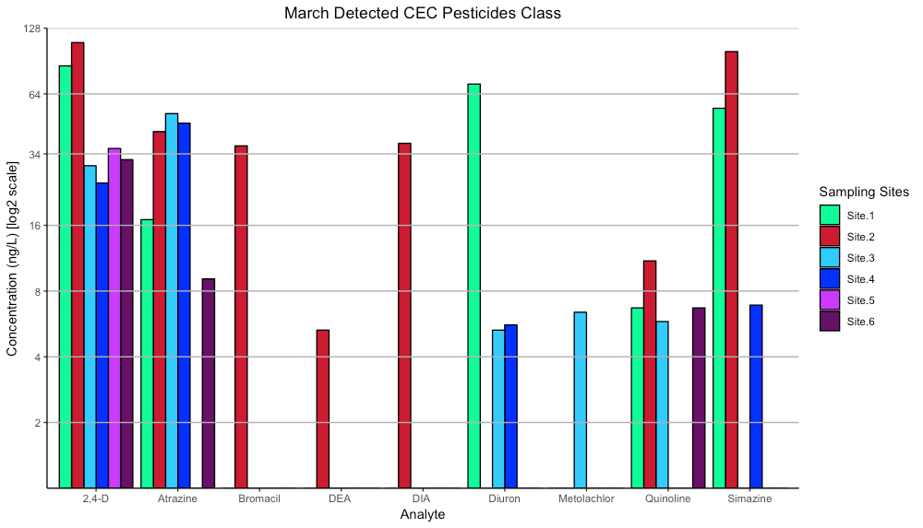

Figure B 2. Industrials class detections in ng L⁻¹ for March sampling date; y-axis set in hours with scale to the log of 2.
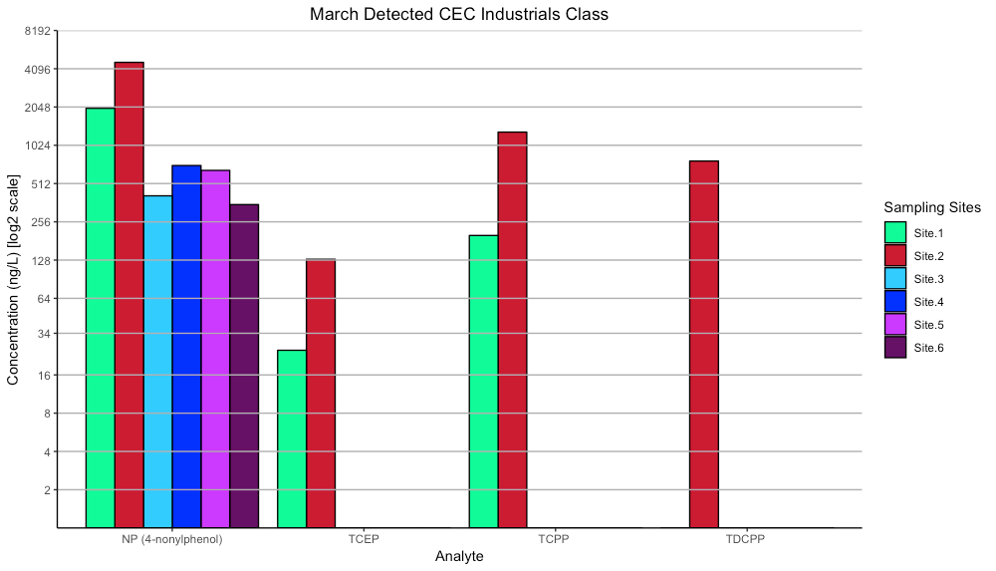

Figure B 3. PPCPs class detections in ng L⁻¹ for March sampling date (1/3); y-axis set in hours with scale to the log of 2.
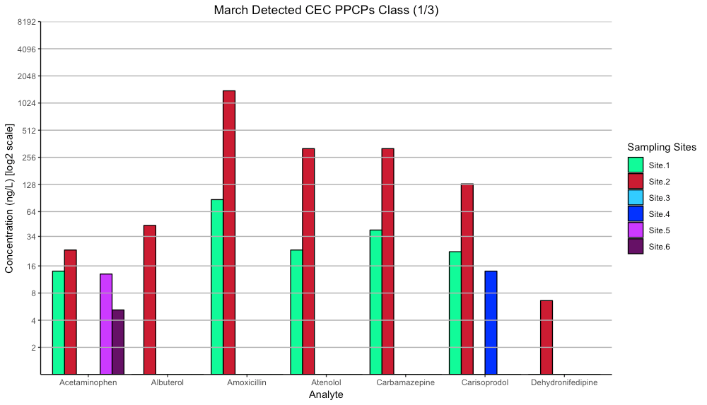

Figure B 4. PPCPs class detections in ng L⁻¹ for March sampling date (2/3); y-axis set in hours with scale to the log of 2.
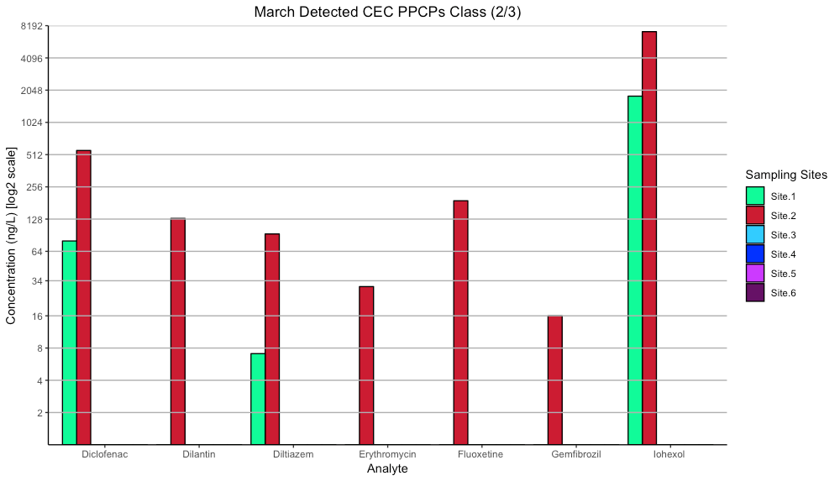

Figure B 5. PPCPs class detections in ng L⁻¹ for March sampling date (3/3); y-axis set in hours with scale to the log of 2.
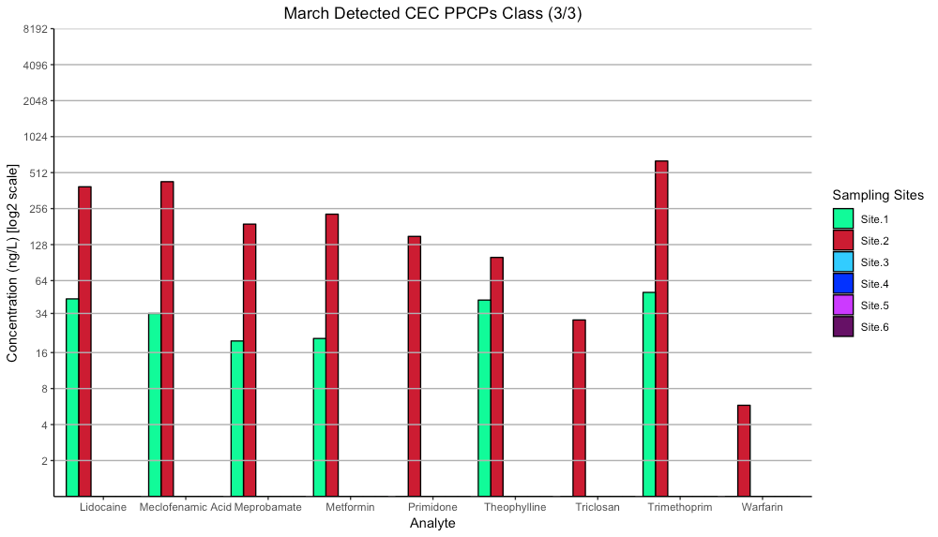

Figure B 6. Hormones class detections in ng L⁻¹ for March sampling date; y-axis set in hours with scale to the log of 2.
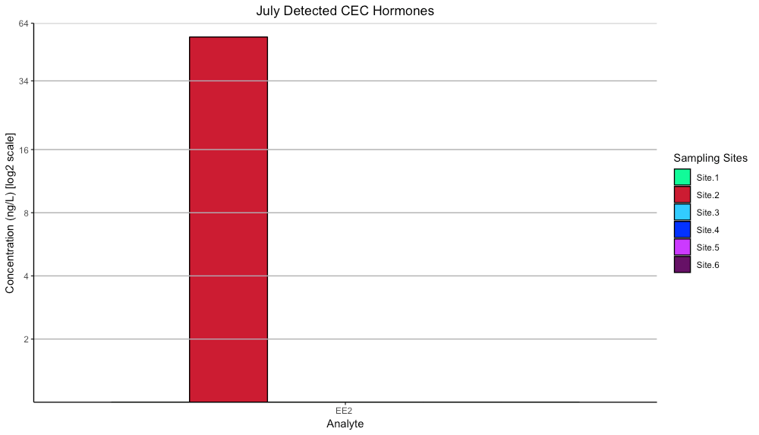

Figure B 7. Others class detections in ng L⁻¹ for March sampling date; y-axis set in hours with scale to the log of 2.
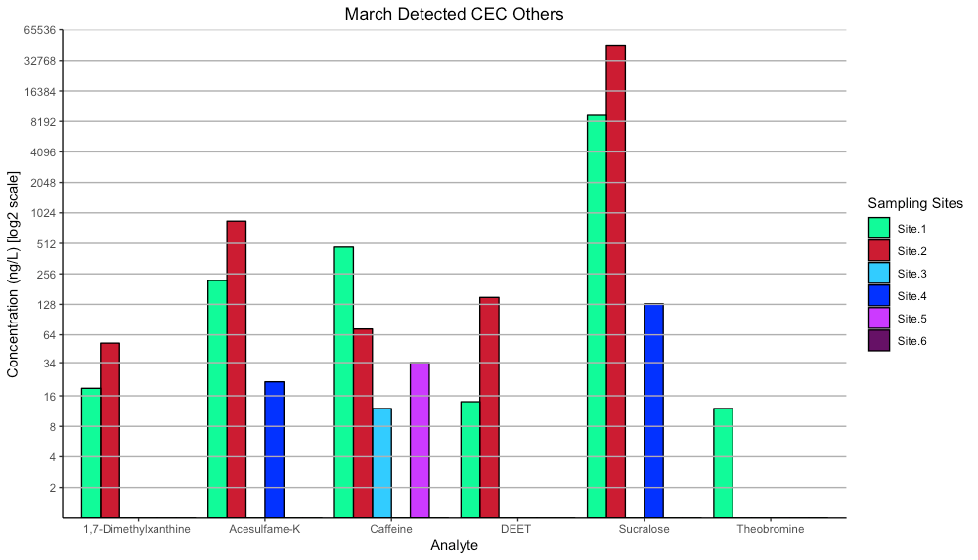

Figure B 8. Pesticides class detections in ng L⁻¹ for July sampling date; y-axis set in hours with scale to the log of 2.
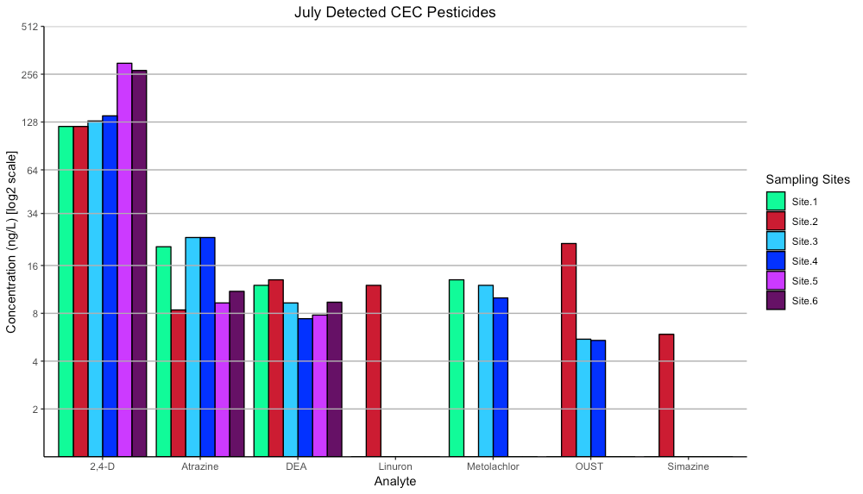

Figure B 9. Industrials class detections in ng L⁻¹ for July sampling date; y-axis set in hours with scale to the log of 2.
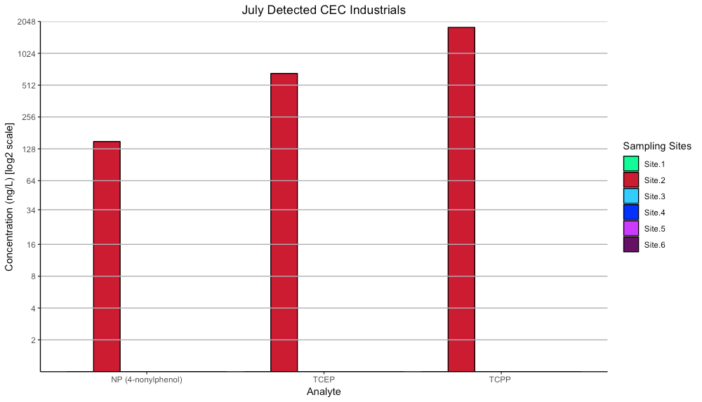

Figure B 10. PPCPs class detections in ng L⁻¹ for July sampling date (1/3); y-axis set in hours with scale to the log of 2.
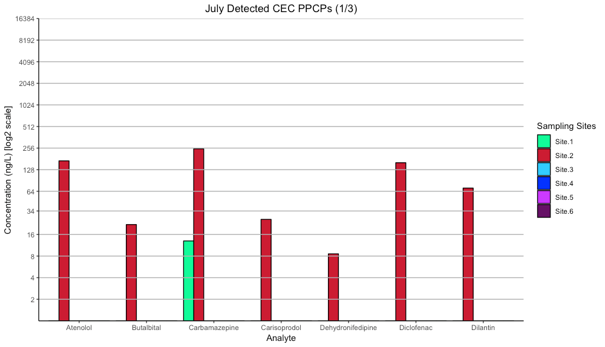

Figure B 11. PPCPs class detections in ng L⁻¹ for July sampling date (2/3); y-axis set in hours with scale to the log of 2.
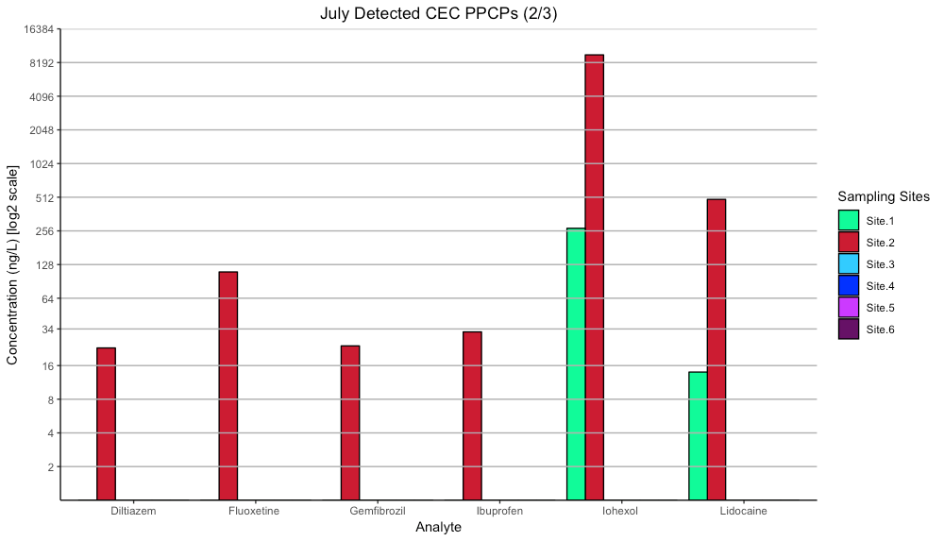

Figure B 12. PPCPs class detections in ng L⁻¹ for July sampling date (3/3); y-axis set in hours with scale to the log of 2.
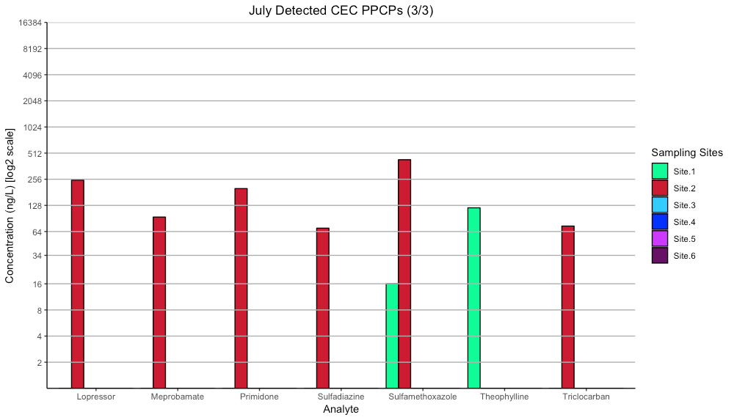

Figure B 13. Hormones class detections in ng L⁻¹ for 2018 sampling date; y-axis set in hours with scale to the log of 2.
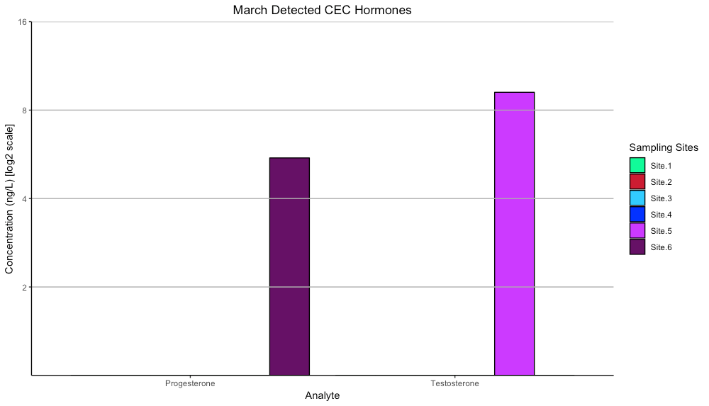

Figure B 14. Others class detections in ng L⁻¹ for July sampling date; y-axis set in hours with scale to the log of 2.
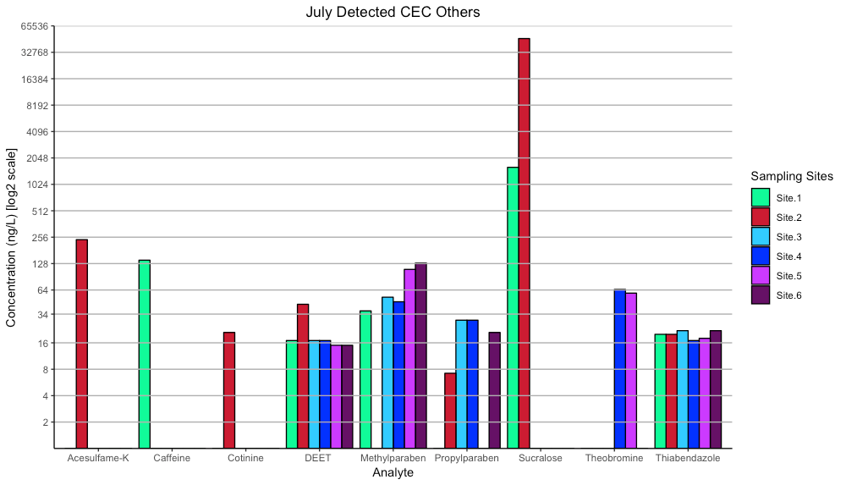

Figure B 15. Pesticides class detections in ng L⁻¹ for December sampling date; y-axis set in hours with scale to the log of 2.
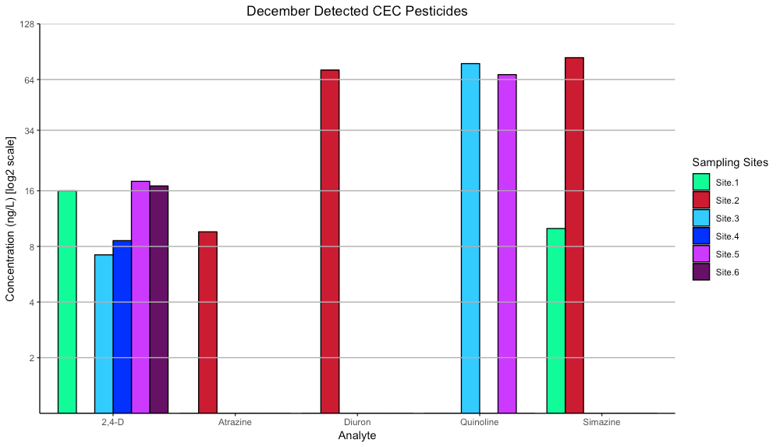

Figure B 16. Industrials class detections in ng L⁻¹ for December sampling date; y-axis set in hours with scale to the log of 2.
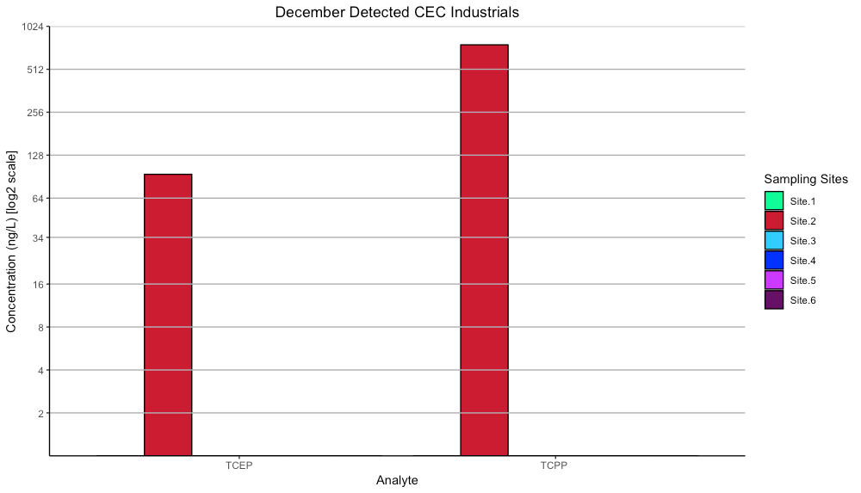

Figure B 17. PPCPs class detections in ng L⁻¹ for December sampling date (1/3); y-axis set in hours with scale to the log of 2.
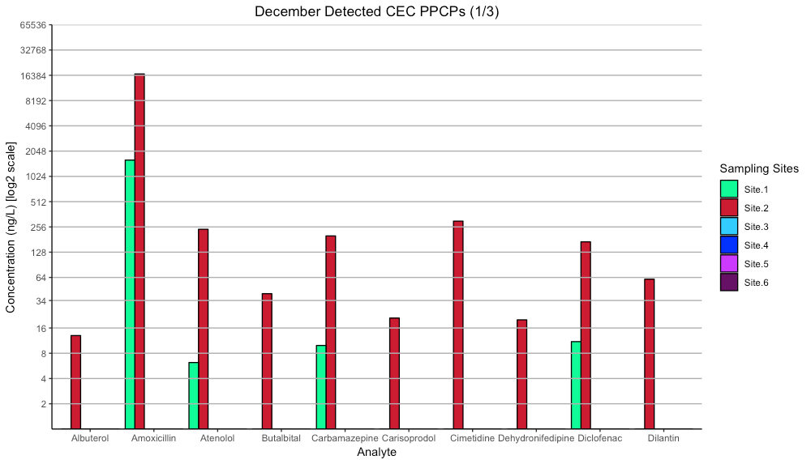

Figure B 18. PPCPs class detections in ng L⁻¹ for December sampling date (2/3); y-axis set in hours with scale to the log of 2.
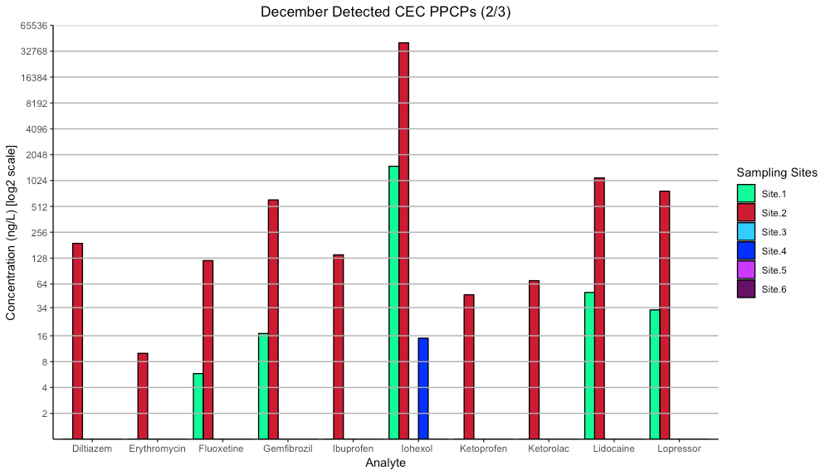

Figure B 19. PPCPs class detections in ng L⁻¹ for December sampling date (3/3); y-axis set in hours with scale to the log of 2.
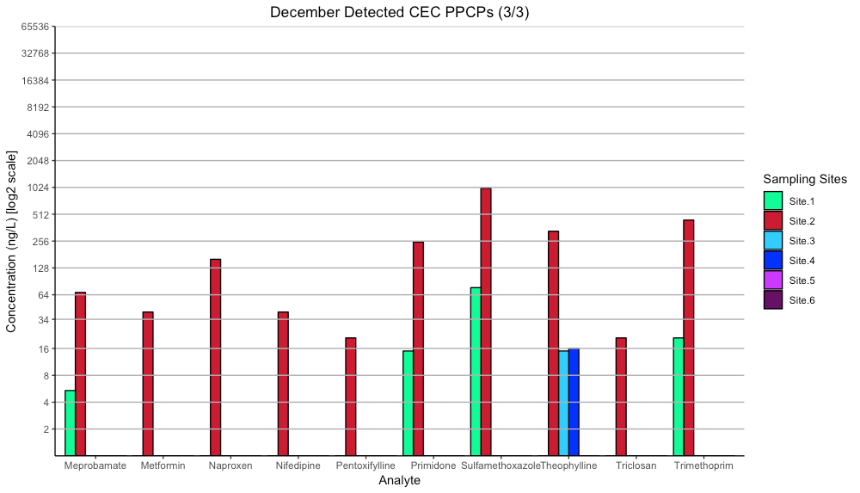

Figure B 20 Hormones class detections in ng L⁻¹ for December sampling date; y-axis set in hours with scale to the log of 2.
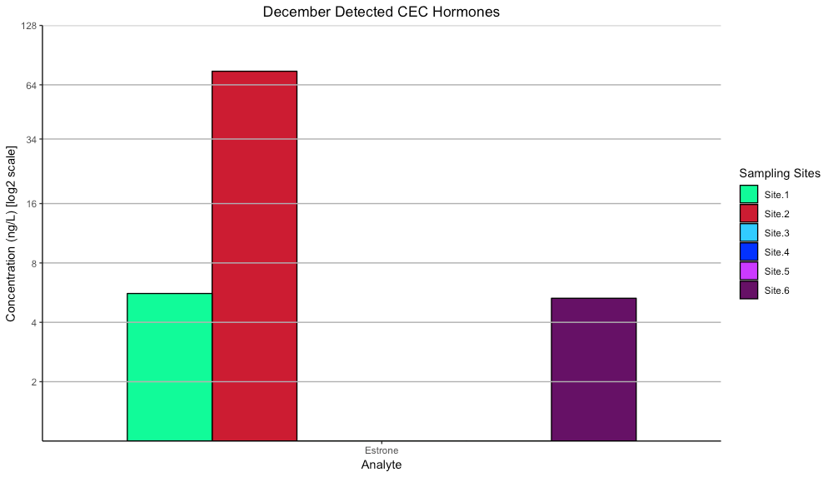

Figure B 21. Others class detections in ng L⁻¹ for December sampling date; y-axis set in hours with scale to the log of 2.
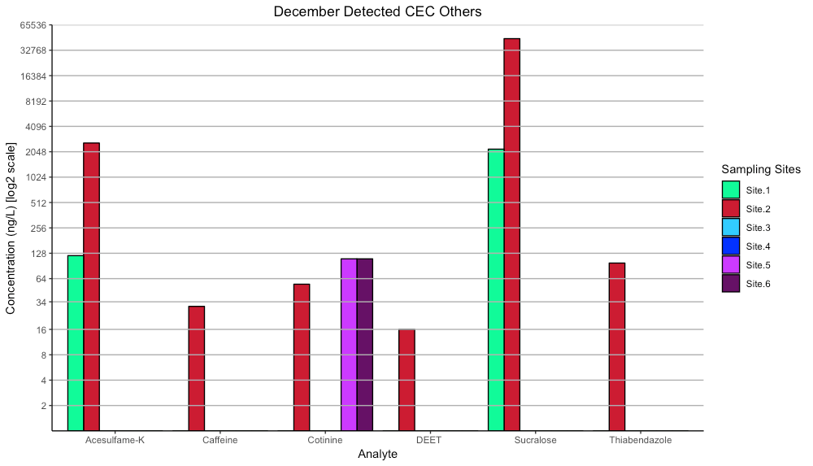

Figure B 22. Dumbbell half-life chart for detected pesticides class; x-axis set in hours with scale to the log of 2.
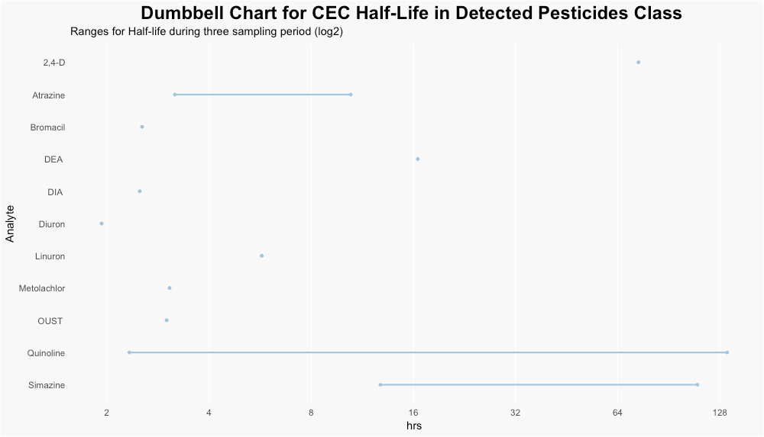

Figure B 23. Dumbbell half-life chart for detected industrials class; x-axis set in hours with scale to the log of 2.
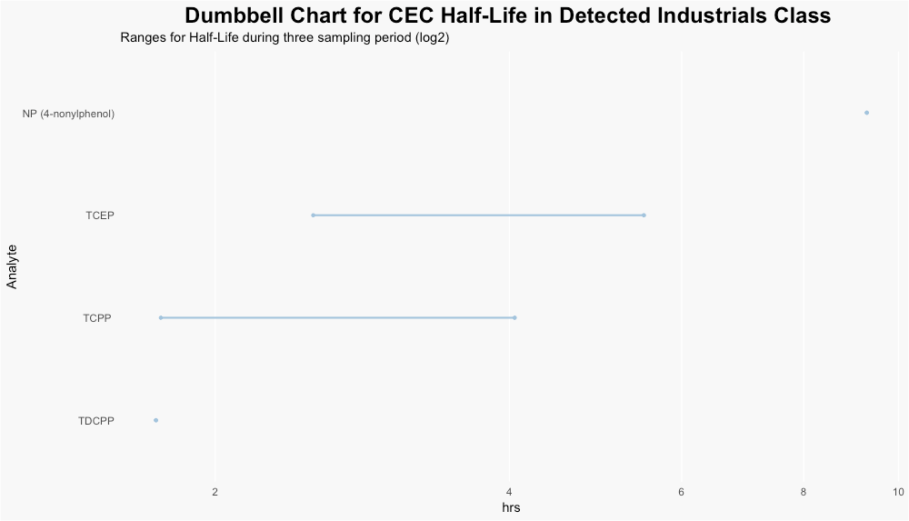

Figure B 24. Dumbbell half-life chart for detected PPCPs class; x-axis set in hours with scale to the log of 2.
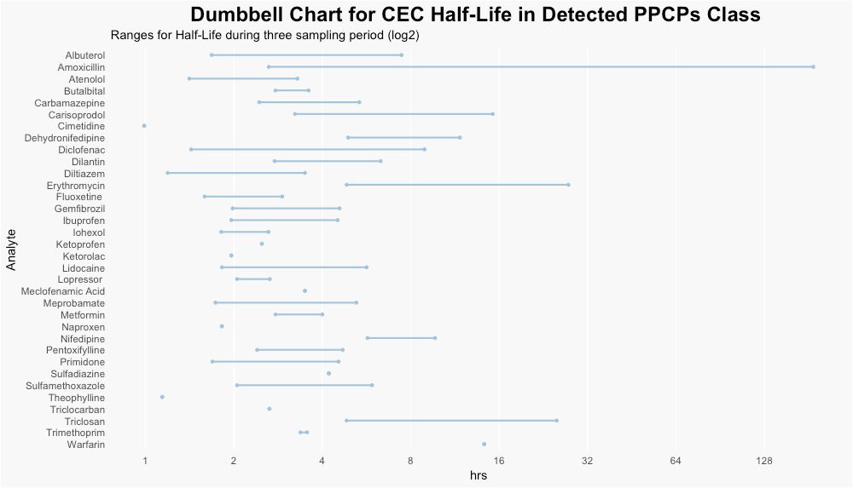

Figure B 25. Dumbbell half-life chart for detected Hormones class.
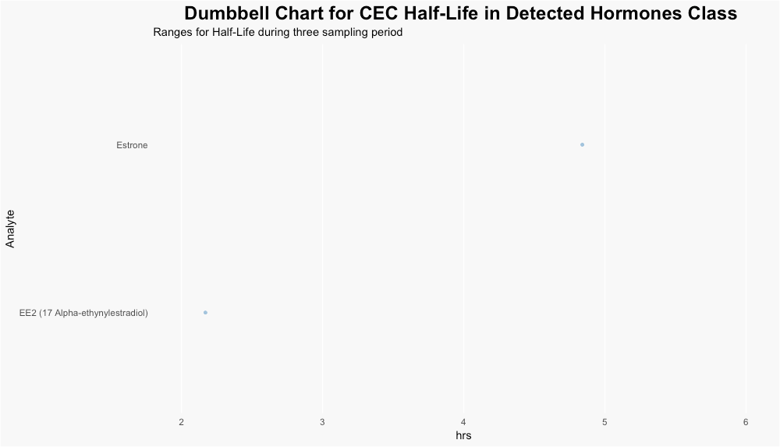

Figure B 26. Dumbbell half-life chart for detected others class; x-axis set in hours with scale to the log of 2.
