UNIVERSITY OF OKLAHOMA

GRADUATE COLLEGE

Willette, Steinlen, and the Interiors and Exteriors of Montmartre

A DISSERTATION

SUBMITTED TO THE GRADUATE FACULTY

In partial fulfillment of the requirements for the

Degree of

DOCTOR OF PHILOSOPHY

By

ERINN FLANNA GAVAGHAN
Norman, Oklahoma
2023
Willette, Steinlen, and the Interiors and Exteriors of Montmartre

A DISSERTATION APPROVED FOR THE

SCHOOL OF VISUAL ARTS

BY THE COMMITTEE CONSISTING OF

Dr. Erin Duncan-O’Neill, Chair

Dr. Allison Palmer

Dr. Alison Fields

Dr. Richard Zielinski

© Copyright by ERINN FLANNA GAVAGHAN 2023
All Rights Reserved.

Table of Contents

Introduction 1

Chapter 1: Adolphe Willette in the Chat Noir 24

Chapter 2: Théophile-Alexandre Steinlen in the
Chat Noir and on the Street 69

Chapter 3: Willette’s Vache enragée 112

Conclusion: The Spirit of Montmartre 151

Images 156

Bibliography 212

Abstract

This dissertation examines artworks by Adolphe Willette and Théophile-Alexandre Steinlen in fin-de-siècle Montmartre, a neighborhood in Paris. Both artists were associated with the Chat Noir cabaret and its eponymous journal. They were hired to decorate the interior space of the cabaret with paintings and, in the case of Willette, stained glass. These were artworks that reflected and helped shape the environments inside spaces that cultivated avant-garde ideas about culture and politics. Following their work with the cabaret, both artists worked in the streets of Montmartre as well. Steinlen became a well-regarded poster artist and Willette created a parade to celebrate and raise money for the artists of Montmartre through moments of media experimentation that expanded their reach to more bigger publics. Through their bold use of media – large-scale paintings, lithographic prints, stained glass, and performance – Willette and Steinlen discovered new ways to reach audiences that eschewed traditional exhibition strategies. Through their works, they participated in dialogues that promoted their shared Bohemian ideologies of anti-capitalism, social justice, and anarchism. Both artists also imbued their work with historical references that aligned with their messaging. Willette turned to Medieval France for his brand of idyllic nationalistic nostalgia, and Steinlen looked to revolutionary history for his. Nostalgia, media, and democratic access will be key themes in a dissertation that illuminates a set of understudied works for and around the cabarets of Montmartre.

Introduction

In the cabarets of fin-de-siècle Montmartre, a new kind of freedom was established. Outside Paris proper, Montmartre was a “privileged space” where the government of the Third Republic seemed to turn a blind eye to the benign critiques playfully hurled down the hill. Perhaps this was due to it being a “delinquent” neighborhood. These delinquents were often overlooked by the authorities, giving the place a reputation for imaginative creativity, pleasures in the form of drinking and prostitution, and crime. Under the surface of pleasure-seeking and creative output, Montmartre was also fertile ground for leftist anarchy and radical right nationalism, strange bedfellows that were both highly critical of new Republican values. Within the ranks of the anarchists and radicals and in the spaces of the cabarets, poets, singers, and writers used humor and satire to critique of the rising middle class, the wealthy, and the government. And artists were hired to decorate the spaces. Large paintings were commissioned to hang in the interiors, stained glass was installed to bridge the space between inside and outside, and large lithographic advertisements filled the exterior streets.
In the cabarets of Montmartre, the exchange of ideas and collaboration between artists resulted in a flourishing subversive creative output. Much scholarly attention has been placed on the significance of the performances of the cabaret musicians and singers who cleverly imbued their entertainment with satire and humor. As has consideration of the innovative journals produced by cabarets which featured critiques by writers, poets, and illustrators. However, less attention is given to the works of art that were produced to adorn the interior of these spaces, which, as this research shows, were equally biting in their social and political critique. Although relegated to the oft-neglected realm of decorative arts, large-scale interior paintings and decorative elements like stained glass became mediums that allowed visual artists to dialogue with audiences in new and democratic ways.
Along with a revival in decorative arts in the fin-de-siècle, and already embraced by the cabarets who sought to advertise the thematic atmospheres within their spaces, large-scale lithographic techniques also emerged at this moment. The artists who worked in lithography recognized the ability of this new medium to speak to mass audiences in a fully democratic way. Through large-scale printmaking, the dialogues of the cabarets expanded to the streets of Montmartre in the form of temporary posters and advertisements. These lithographs were some of the best-known examples of visual culture from this period and were emblematic of a lively commercial culture outside of the Academy through the use of alternative media.
This project will situate the artworks connected to these public spaces in a far more active role of influencing the discourse of the fin-de-siècle through display and content in the form of social and political commentary. The primary artists of the investigation, Adolphe Willette (1857-1926) and Théophile-Alexandre Steinlen (1859-1923) are both understudied and in need of scholarly consideration that examines their output of large public-facing works within the place of nineteenth-century Montmartre. The fact that Willette and Steinlen each contributed to the experimental and satirical literary journals of the time and are both inextricably identified with cabaret culture provides the framework for which the important question can be asked: How did their artwork for the public spaces of Montmartre participate in the development of artistic output as a democratic practice, through experimental media and spaces of display which were unique to Montmartre in fin-de-siècle Paris?
Willette and Steinlen, not unknown artists in the canon of art history but certainly not the names that first come to mind when considering nineteenth-century Montmartre, were prolific in the cabarets, providing interior and exterior décor, contributing to the production of satirical journals, and participating in the dialogue of the spaces. Importantly, Willette and Steinlen worked side-by-side in the most avant-garde of Montmartre’s cabarets, the Chat Noir, and have remained largely under-researched, especially in their contributions to the subversive art that surfaced in Montmartre. Their works literally and metaphorically remained in the background in the most exciting spaces of creative and political output. Their artworks were labeled as décor and advertisement in their own time, devalued today as decorative and commercial. This research will look at the works that decorated and advertised Montmartre and bring them to the forefront, recognizing a collection of artworks in their significance in accessibility and meaning.
The “Spirit” of Montmartre
“The Spirit of Montmartre” is not my term, but one that has been coined and used recurrently by the exclusive group of scholars who have focused on the history and artistic output of this small neighborhood in Paris and remains the best way to encapsulate the time and place of fin-de-siècle Montmartre. This study promises to avoid regurgitation of the previous work done in the study of this place, but one cannot deny “The Spirit” and its importance to artistic practices here. So, once again, it will be applied to the overarching ideas and new research presented in this dissertation.
Fin-de-siècle Montmartre was a site and a time that existed in a constructed, idyllic fantasy of place that produced a tension between the modern and the antique. Montmartre is a physical location, a hill on the northern edge of Paris. It has a geographic boundary, the 18th Arrondissement, annexed into Paris in 1860. It is also a culture. Montmartre is a neighborhood that has clung, sometimes desperately, to an older time while at the same time being the site of avant-garde innovation. When Paris was modernized in the nineteenth century with wide boulevards and a demolishing of Medieval structures and narrow streets, Montmartre sat quietly to the north, willing itself to be ignored. In 1886, the Société le Vieux Montmartre was established to preserve and document the culture. Run completely by volunteers, the Vieux Montmartre still exists today and works to keep the culture and geographical place of “the butte” as distinct from Paris as possible. Interestingly there is little, if any, mention of the Société by scholars of fin-de-siècle Montmartre. The Vieux Montmartre holds documents and materials that preserve the history of the neighborhood and cares for the permanent collection of artworks produced in Montmartre in the Musée de Montmartre. I find this curious as the Société was formed at the same moment that Montmartre came into its significance in the cultural space of Paris. Perhaps at its inception it was little more than a group of interested residents who recognized that something of note was occurring and should be documented. The Société le Vieux Montmartre for whatever reason has not been acknowledged in their role in what is available for study today regarding this very rich history of the place and I would like to thank them for their important work and their generous availability to scholars.
As Paris was modernized in the second half of the nineteenth century, artists, writers, performers, and poets fled the shining new city for the hill, where life was still simple, quiet, and, very importantly, cheap. Montmartre lay outside the boundaries of the City of Paris until 1860. Within the city limits, taxes were levied on cafés for the sale of alcohol. Outside of the city, the alcohol taxes did not exist. This was, in part, what made Montmartre an ideal site for cabarets and other places of entertainment. When Montmartre was annexed, the neighborhood still enjoyed the tax differential, and the popularity of establishments on the hill continued to grow and appealed particularly to the working classes. Additionally, while the cabarets of Paris were required by law to submit a list of their entertainments to the Office of Theatre Inspection, an unofficial agreement exempted the cabarets of Montmartre from the censorship office due to the perceptions of the police that the performers of Montmartre were not professionals and the lower class audiences did not require the same attention from authorities that a venue accessible to bourgeois women and children who passed on the more reputable streets might.
When we talk about the cultural identity of a place, we often think of the types of people who live there, the historic monuments that make it recognizable, the types of food people eat, the regional style of music or art produced there. However, when we talk about the cultural identity of fin-de-siecle Montmartre there are subtle dimensions that are important to an understanding of why this place in those years was significant to the history of visual and performing arts. It is “The Spirit” of Montmartre that makes its cultural identity so deep. There was humor there, a resiliency, a common desire to remain outside of, ahead of, and somehow behind the status quo. It was a place filled with a diversity of people, cultures, art forms, art styles, and political beliefs, and yet there was a common identity that sets it apart in a strangely unified disunity. “The Spirit of Montmartre” was irreverent, and it increasingly attracted the curiosity of those outside its geographical and ideological boundaries.
In the catalog which accompanied the 2014 exhibit at the Musée de Montmartre, L'Esprit de Montmartre et L'Art Monderne 1875-1910, the nineteenth-century Montmartre scholar Phillip Dennis Cate identified the essential characteristics of the “Spirit of Montmartre.” First, this was a place of socialist and anti-bourgeois sentiment that presented itself as opposed to the establishment. Secondly, the artists who found their way to Montmartre were those who had also turned away from the traditional exhibition and performance spaces and found walls and audiences in the cabarets, cafés, experimental theaters, and streets of the neighborhood. From visual artists, a particular form of humor, known as fumisme, was developed. This humor was not outrightly funny but was a subtle use of satire, irony, and critique used to address modernity and the human condition. Importantly, fumisme was an inside joke, designed for a specific audience that would understand a set of language and visual motifs. The people, streets, and cabarets of Montmartre were the primary subject matter of the artists. Building off the observational nature of Realism, Impressionism, and their modernist interest in marginalized subjects from contemporary life, artists turned their focus on fellow artists, prostitutes, vagabonds, and the lower classes they lived and worked among. Artists also used all possible mediums to express their independence and social and political views. And finally, the history of fin-de-siècle Montmartre has been so well preserved because of the very media artists used, particularly presses and printing, which were mass-produced. Journals and lithographic posters designed by artists captured the essence of Montmartre and dispersed it throughout Paris, preserving it for years to come.
These essential characteristics are also what became the ideologies of the “Bohemians” of Paris and Montmartre specifically. Cate’s definitions of “The Spirit” provide the framework for what it meant to be “Bohemian” in Paris and in Montmartre in particular. In Montmartre, “The Spirit” is Bohemianism. I would offer there are several additions that should be considered to these characteristics as well. First, Bohemianism in Montmartre was generally anti-clerical, as will be seen throughout this research, specifically the inclusion (or sometimes exclusion) of the most recognizable profile of Montmartre, the Basilica of Sacré-Cœur. The second is that the characteristics of socialism, anarchism, and anti-bourgeois sentiments found their visual and literary representations often took the form of aggressive anti-Semitism. Finally, and perhaps most at the core of Montmartrois ideals, Bohemianism was anti-modern modernism, defined by a longing for the past that managed to produce some of the most avant-garde works of the fin-de-siècle period. This manifested itself not just in content but also in a nostalgic adaptation of antique techniques and mediums.
Let us address for a moment the word “Bohemian.” It was the realm of young artists who turned life itself into a work of art. In the words of Honoré de Balzac, “Bohemia has nothing and lives from what it has. Hope is its religion, faith in itself is its code, charity is all it has for a budget.” Bohemians lived in a constant state of juxtaposition with the bourgeoisie, they were forever at odds with each other, yet they attracted each other. Jarrold Seigel summarizes the dichotomies and theories of Bohemianism by discussing the other scholars who have also attempted to write the history of this abstract identifier. The key almost always being the opposition and attractions of Bohemians and the bourgeoisie. While an abstract concept in Montmartre, historically Bohemia was a Medieval kingdom situated within the larger Germanic lands. One has to question the irony of the French avant-garde adopting an ideology named for a Medieval, Germanic place in the recent shadow of national defeat in the Franco-German war. Was the appropriation intention or satire? That answer may be as abstract as the identifier itself, but this research suggests an understanding that it must have been a part of the nostalgic nationalism that grew out of this place. The old Bohemia was antimodern and antiurban and represented an idealized usage of the term as referring to a remote and wild land. The romanticism of old Bohemia was the appeal, not its Germanic roots. The Bohemians of Montmartre also viewed themselves as being in a remote and wild land, both antiurban and antimodern.
This research focuses on the work of artists in Montmartre in the Chat Noir cabaret and in the streets of the neighborhood in the last fifteen years of the nineteenth century. The story of Montmartre’s significance to modern art history certainly does not start with the Chat Noir in the 1880s. The Café Guerbois in Montmartre was the birthplace of the Impressionist movement. Edouard Manet, Edgar Degas, Claude Monet, Camille Pissarro, Nadar, and Henri Fantin-Latour all gathered there. (Paul Cézanne was an infrequent visitor, finding the falseness of their anti-bourgeois attitudes repulsive considering the privileged social status of most of them.) When the Café Guerbois became too crowded and noisy, the group moved to the Café de la Nouvelle-Athènes, also on the edge of Montmartre. Here the group expanded and became an artistic and literary community welcoming in writers Émile Zola, Guy de Maupassant, and Charles-Marie-Georges Huysmans.
This mingling of artists and writers together in the cafes of Montmartre would begin with the arrival of the Hydropathes in the 1880s. This was writer Émile Goudeau’s literary and artistic group which had been meeting regularly on the Left Bank of Paris but relocated to Montmartre with the opening of the Chat Noir. The Hydropathes, an irreverent collective, were proof that artists and writers sought out the creative dialogue of collaboration and exchange of ideas in the site of a cabaret with entertainers who also keyed on the power of satire to critique society and politics. In fact, it was the mingling of visual artists with writers, singers, poets, and musicians that was key to the unique and subversive nature of the culture of Montmartre. The influence of that mingling will become apparent in this writing as the works of the visual artists in particular are examined in their roles in the subversiveness of this place.

Anarchy and Public Art

The Chat Noir and other Montmartre cabarets had been deemed by the proprietors, the patrons, and even the French Government as spaces where groups of people were free to gather, drink, and discuss current affairs. However, it was in these spaces where the discomforts of war, political upheaval, and massive modernization were discussed in assembly, that anarchy crept in. There were laws that prohibited anarchists from meeting in groups, so the anarchists moved into the cafés and blended with the artists, creating specific meetings that were focused on art rather than anarchy. Eventually, a cultural revolution was mounted that was anarchist and avant-garde. As Richard D. Sonn asks, were they anarchist artists or artistic anarchists? Perhaps both. They were subversive, satirical, offensive, moving, nihilistic, and shocking. And the media they used was part of their strategy and message.
As these cabarets were spaces of freedom and accessible to the working and lower classes with inexpensive beverages and free entertainment, the artworks in these spaces must also be considered a kind of “public art” due to their installation in the publicly-accessible realm.
Further, while murals and large-scale interior paintings were not new as decorative installations, the discourse in these particular spaces elevated them from décor to discourse in their own right, as the analysis of these works will reveal their commentary on capitalism and class. This a treatment that has been given to the performances and journals produced in the cabarets by scholars like Caroline Crépiat, Mariel Oberthür, and Phillip Dennis Cate in their analyses of the singers, musicians, poets, and the shadow puppet theatre of the Chat Noir as satirical and critical. However, the two-dimensional artwork within the Chat Noir is given little attention beyond brief visual analysis and certainly has not been given in-depth consideration as a part of the dialogues being spoken in Montmartre.
Modernization and Spectacle
In 1896, Émile Zola, the French Realist writer wrote: “Modern Society is racked without end by a nervous irritability. We are sick and tired of progress, industry, and science.” It seemed that years of rapidly developing advancements, all meant to make life better, like a train system, electric street lights, sewers, enormous department stores known as grand magasins, had actually compounded into very real anxiety as Paris made its way to the turn of the century.
David Harvey’s Paris, the Capital of Modernity, dedicates an entire chapter, the “Myth of Modernization,” to the French photographer Charles Marville highlighting the trauma of modernization. In Marvelle’s photograph, Construction of the avenue de l'Opéra: The Butte des Moulins (1876) (fig. i.1), we see a street in Paris in ruins. Not due to revolutionary fighting, these buildings were not torn to build barricades, but due to planned progress. This is an image of what would become the grand boulevard, Avenue de l’Opéra. The rubble that we see is the remains of lower-income apartments and small businesses destroyed to build a wide street with new and expensive apartments and grand magasins that sold commodities to the growing middle and upper classes. However, this renovation was extraordinarily traumatic for many of the people of Paris. This modernization of Paris had come to be known as Haussmannization, named for Baron Georges-Eugène Haussmann who was commissioned by Emperor Napoleon III to carry out massive urban projects in the mid-nineteenth century.
In addition to being commissioned to document the progress of Paris, Marville and fellow French photographer Eugène Atget spent the last decade of the nineteenth century and the first part of the twentieth photographing the remnants of Medieval Paris, the places that managed to remain untouched by modernization. Atget photographed much of Montmartre. Consider the photograph Atget took of the cabaret, the Lapin Agile, in Montmartre in 1922 (fig. i.2). This is the oldest cabaret in Montmartre that is still in existence and is across the street from the only remaining vineyard in Paris. Atget spent over 30 years photographing the streets, neighborhoods, details, and people of Paris in a grand project that attempted to describe the historic character of French life. He sought to capture the nostalgia of Paris at a moment of dramatic transition, the nostalgia and innocence of Paris before the Commune, pre-Franco-Germanic War, and most importantly, pre-Haussmann. Perhaps it is what he did not photograph that speaks the most to his sensibilities. Atget made over 10,000 images in his lifetime. In all of those images, and in over three decades of the most rapid advancements in Paris, he never photographed the Eiffel Tower, the Arc de Triomphe, the Opéra Garnier, or any of Haussmann’s grand boulevards. Instead, he focused his camera on the nostalgic past of Paris such as street merchants, rag pickers, prostitutes, gypsies, and pre-Haussmann architecture. He prioritized the marginal characters and characteristics of the city. Like the artists, poets, and activists of Montmartre, Atget displayed a pattern of class bias in his artistic output. The working classes are ennobled in his photographs, and the bourgeoisie are absent. Modern authorities are not to be found. Atget imagined a city that had not been industrialized. He suggested nostalgia for a city that had no running water or electricity, no trains, no glass pavilions, or grand department stores. Atget ignored nineteenth-century amenities to capture his nostalgic view of the city. It was not just that the places like the Eiffel Tower, the Opéra, or the Boulevards were anachronisms to his study of old Paris, their very existence was frequently destructive to the heritage Atget sought to memorialize.
In the last decades of the nineteenth century, Montmartre was at once the hub of modern art practice and the last vestige of antique Paris. It was largely still rural, yet the hand of Baron Haussmann was inching its way towards the haven. Haussmannization took a different form here. Eventually, whole sections of Montmartre would be plowed down, but for the most part, this neighborhood on the hill watched from afar as grand boulevards and uniform buildings redefined the face of the city. Although by 1885 Montmartre had officially been part of the City of Paris for fifteen years, it managed to stay removed despite the fact that the industrialization of the period was taking its toll on its role as an agricultural outpost to Paris. This was once a micro-economy of its own with gypsum quarries, windmills, and vineyards dominating the landscape. In 1886, Vincent van Gogh, having newly arrived in Montmartre, painted a landscape of the still rural north slope of the hill (fig. i.3). Within the work, one can see the windmills that once occupied this side of the hill as well as the now-closed quarries. These were the last remnants of the traditional and agricultural Montmartre. The last two remaining windmills, which still stand today, became symbolic of a stubborn opposition to modernization and were the favored, alternate symbols of the site shown opposed to the construction of the Sacré-Cœur Basilica as seen in Pierre Videl’s La Vie à Montmartre (1897) (fig. i.4). Both Willette and Steinlen would use the silhouettes of the windmills in the works they produced in Montmartre as a reference to the idyllic past of the place.
Along with modernization came new entertainments, which today we collectively label as “spectacle.” They were the things the bourgeoisie and upper classes would do in their leisure time, but they also extended to the lower classes in the nineteenth century. Enwrapped in the term “spectacle” were consumerism and leisure activities like shopping at department stores and sitting at cafés. The stores were decorated with intricate art nouveau stained glass windows, with their multiple stories of goods for purchase and newly mass-produced for consumers of various levels of buying power, much of this visible to those on the street through carefully and intricately planned window displays that were in their own right spectacle. Sitting at a table of a café on the new sidewalks of the streets, watching the people of Paris in their newly-purchased fashions walk past was equally entertainment. Attending a cabaret, café-concert, or dance hall were more obvious forms of spectacular entertainment. Montmartre specialized in the Cabaret Artistique, inexpensive sites where the avant-garde poets, musicians, and singers entertained a more local audience that understood the satire and humor of the site. Mass media was also a form of spectacle. Montmartre did this well too. The cabarets produced satirical journals that featured their entertainers’ songs along with humorous illustrations by the artists who frequented the space like Willette and Steinlen. The brightly-colored lithographic posters the artists designed were able to be printed in large-scale size and were distributed throughout the city to advertise the dance halls and café concerts of Paris. Steinlen and his Montmartre contemporaries Henri de Toulouse-Lautrec and Jules Cheret were the masters of the lithographic advertisements of Paris.
However, spectacle was a double-edged sword for “The Spirit” of Montmartre. Spectacle was a new phase of “commodity production” in the words of T.J. Clark in The Painting of Modern Life. Clark quotes Guy Debord, the twentieth-century Marxist, who wrote, “The spectacle is capital accumulated until it becomes an image.” In other words, spectacle is capitalism. Here is where it became complicated for Montmartre. As we will see, the increased commercial success of the Chat Noir and other sites of entertainment in Montmartre would challenge the Bohemian unity and “The Spirit.” For Steinlen and Willette, we will explore how each grappled with the ideas of consumerism and spectacle in their work and their audiences.
The Commune of 1871, Atonement, and Nationalism of Montmartre

There are two historic events that bookend fin-de-siècle Montmartre, the Paris Commune of 1871 and the Dreyfus Affair which began in 1894 and was not resolved until 1906. Both of these had profound effects on “The Spirit” of Montmartre and shaped the tone and context of the imagery that will be discussed further in this research. Both Willette and Steinlen used the publicness of the cabarets and streets of Montmartre and the scale of their works to respond to the ways these events wove into and impacted the Bohemian ideologies of the place. As such, a brief history of each is important to understand.
In a photograph of the hillside of Montmartre from 1871, we see the hill covered with cannons (fig. i.5). When the Franco-Germanic war began, the French National Guard stationed their cannons on Montmartre to protect them from being handed over to the enemy. After the defeat of France, the largely working-class members of the National Guard grew in their radical opposition to the newly-established Third Republic. The tipping point came when Adolphe Thiers, the leader of the Third Republic, ordered the cannons be removed from Montmartre. Revolution broke out which culminated in the killing of two soldiers of the Republic’s Versailles troops by the Communards, those revolutionaries who rose up against the government. For two months, the Communards held control of Paris. During that time, they raised their red banners of revolt against the Third Republic government. But it was a bloody two months that saw as many as 20,000 Communards killed in Paris. On May 28, 1871, the Commune was defeated. However, in the minds of Communards and Republicans alike, the hill of Montmartre would from then on represent this bloody revolution against the state.
The Commune, essentially a civil war that centered on a class-based uprising, created a mythical extremism that engrained itself into “The Spirit” of Montmartre. The very first journal produced in Montmartre, Le Mont-Aventin: Echo des Buttes Montmartre went to press a week after the start of the Commune. A short-lived publication with only six issues in 1871, its title references the allusion to Montmartre as the Aventine, one of the seven hills of ancient Rome. The Roman Aventine was also on the periphery of the city and had a reputation as a rough, working-class neighborhood which later became a largely aristocratic space. In its pages, the Commune was praised as being the start of a new Republic, and Montmartre was declared the symbolic home of the uprising: “The following proclamation was posted on all the wall of Montmartre: French Republic!” The status of Montmartre as the home of the Commune became part of the attraction to the site not just for the Bohemians attracted to anarchism, but for curious tourists and “daring” bourgeoisie who would come for the spectacle of rubbing elbows with the ghosts of revolutionaries in their subversive cabarets. This revolutionary history would also weave its way into the imagery produced in the cabarets. We will see this very present in Steinlen’s work from the period where he focused on the real-life figure of the Communard, Louise Michel, a woman who quickly became mythological herself, being morphed into the allegorical figures of Liberty and Marianne, female personifications of France.
The defeat of the Communards did not mean tensions between the ruling state and the proletariat magically evaporated; it simply became more subversive. On January 14, 1882, Le Chat Noir journal published its first issue. In that issue, and as an introduction to the complicated relationship the Chat Noir cabaret and its Bohemians would have with the Catholic Church, an article appeared titled “Montmartre” by Jacques Lehardy. In this fumismic style of writing, Lehardy states, “It is high time to correct an error which has weighed down on more than sixty entire generations…The writing which we call holy – I don’t really know why – has done nothing more, to put it politely, than make a mockery of the people.” Sixty generations, approximately 1,800 years, reference the long history of the Catholic Church while the “writing which we call holy” is the Bible. What we see is a thesis declaring a challenge to the Church from within the walls of the Chat Noir cabaret. This was a challenge that was particularly present in Montmartre as the construction of the Sacré-Cœur was underway at the apex of the hill and directly above the site of the cabaret. While the massive white basilica now epitomizes the profile of Montmartre, at its inception, it was not beloved, especially by those in Montmartre. The Sacré-Cœur Basilica was the government-supported emblem of forced atonement for the uprising of the Commune against the State. The church was meant to cleanse the sins of the site, not only of the rebellious history that the people still cherished, but also of the subversive, dangerous, counter-cultural behavior for which the neighborhood of working-class poor, prostitutes, and artists had become infamous. We will see that the presence of, or allusion to, the Sacré-Cœur in the artwork of Willette and Steinlen carried through the critique of the power of the Church and its general lack of humanity that was popular among the Bohemians.
This was also complicated by the mix of radical ideologies that existed in Montmartre, even between our two artists of interest, Willette and Steinlen. Some scholars claim that because there was a strong support of the nationalist right in Montmartre that the construction of the Sacré-Cœur was positively accepted as a symbol of nationalistic pride. However, it is important to acknowledge the nuanced modes of nationalism in Montmartre. As this study will assert, it was often less about national pride in the present moment but rather a critique in favor of a nationalism expressed through nostalgia. This was held by factions both with tendencies towards an ideal Christianity and those who outright detested what the Sacré-Cœur represented on the hill. We can see these complex reactions in artworks produced in Montmartre as critique of the state, as an inversion of Christianity unique to Bohemians, and as outright anti-Semitism.
As the nineteenth century drew to a close, anti-Semitism and a dramatic plot of espionage captured the attention of all of France, the Dreyfus Affair. The Dreyfus Affair was complex and ripe with intrigue, double-crosses, and culminated in suicide and perhaps even murder. The Dreyfus Affair, began in 1894 and dragged on for over a decade before the final resolution. Artists in Montmartre were divided on the Affair, as was much of Paris, but those opposed to Dreyfus and who believed him guilty of treason were in the majority.
For the purposes of this study what is important is to understand that the Dreyfus Affair centered on a Jewish officer who was accused of treason, bringing to light the anti-Semitism that was prevalent in France in the nineteenth century. Prior to the Dreyfus Affair, anti-Semitism was treated as endemic, meaning it existed and most people knew it existed, but society, Jewish and Christian citizens alike, lived with it. Although endemic, artists in Montmartre, even those who became supporters of Dreyfus, like Steinlen, prior to the Dreyfus Affair often utilized racial stereotypes of Jewish figures to symbolize their ideological opposition to capitalism, corruption, and the oppression of the working classes. Imagery equating the Jewish banker or businessman as a personification of capitalism was unfortunately quite common, particularly in journal illustrations throughout the 1880s and 1890s.
The radical, anti-Semitic journalist Edouard Drumont stoked the fires by publishing a series of attacks on Dreyfus in his journal, La Libre Parole (1892-1924), where he used the platform to align the false accusations that Dreyfus was a traitor and a spy with his Jewish heritage. Willette promoted Drumont’s journal through an illustration that figured the radical antisemite as a noble Gallic warrior, fending off the sharp quills of those who would attack him from the more liberal press (fig. i.6). Drumont tramples over the figure of Moses, sprawled on the ground with the shattered tablets of the Commandments beneath him. In his own campaign to run for a seat in the 14th Arrondissement in 1889, Willette used similar imagery to advocate for a society that would expel the power of the Jewish race in France. In a poster from his 1889 campaign, a warrior holds up the disembodied head of the Golden Calf, symbolic of the anti-Semitic perception of Jewish worship of money (fig. i.7). Liberty triumphantly stands above all as the top-hatted Jewish figure slinks away from Paris. The text of the poster accuses the Jewish people of benefiting “from the hard and hopeless work of thirty million French people who have become their trembling slaves.” Both images invoke figures that connect nationalism to the ancient and heroic Gallic roots of France with a contemporary scapegoating of Jewish people and a critique of Republican corruption and bourgeois capitalistic greed.
Opponents of Dreyfus shared a longing for a nationalistic nostalgia, an escape from capitalism and corruption that seemed to rule modernity. The critique of corruption is coincidentally what those in support of Dreyfus also spoke out on. Writer Émile Zola published his essay “J’Accuse!” in the journal L’Aurore on January 13, 1898 which he addressed to Félix Faure, President of the Republic and condemned the military for falsely accusing Dreyfus. Steinlen also came out in support of Dreyfus which would also lead to his creation of more radical artworks that critiqued Third Republic corruption that he felt repressed the working-class poor of Paris and Montmartre.
Avant-Garde and Medievalism

Medievalism in fin-de-siècle France emerged as a fantasy of a utopian past. The roots of French heritage and identity seemed to spring up in a revival from the Medieval era. Gothic cathedrals soared to the heavens with resplendent light produced by stained glass and Joan of Arc’s brave nationalism and patriotism in the face of invaders created a romanticized notion of the past that the French in the nineteenth century longed for. Centuries of corruption in the hands of aristocratic rulers and bloody revolutions had taken their toll. It was no wonder the avant-garde, in all of their modernism were drawn to the idyllic past as they looked forward, for no other period of French history embodied the national greatness of France than the Gothic Middle Ages, in Bohemian ideology. For many of the Bohemians, this desire for a nationalistic identity was all too often paired with the strong current of anti-Semitism that was present in certain factions of society. During the fin-de-siècle, Medievalism and anti-Semitism were often linked. But Medievalism did not always mean anti-Semitism. Rather, both dogmas held similar distastes for modernity, capitalism, and the rising monied middle class.
Already by the middle of the nineteenth century, artists and writers had keyed into the humoristic and satirical styles of writers from previous centuries to make modern statements about politics and society. Honoré Daumier was well known for his political caricature which drew on the works of François Rabelais’ (c. 1483-1553) early Renaissance writings. The writer would have appealed to the Bohemians of Montmartre for his witty satire and his love of the drink. He would have also been seen as evidence of the impressive cultural patrimony of France. The interest in national cultural production would continue to resonate with artists and writers into the fin-de-siècle as would interest in other writers like Victor Hugo’s writings set in Medieval Paris and the French poet François Villon (1431-1463) who was put forth in the mythology of the Chat Noir as a kind of hero.
As referenced in the Chat Noir-Guide (c. 1887), a promotional and largely hyperbolic account of the décor inside the cabaret, a full room of the interior was named in honor of Villon. Within that room, the décor contained such dubious artifacts as a large painting of the Chat Noir depicted in the Middle Ages, a bust of Lorenzo de’Medici attributed to Donatello, and the right femur bone of Villon himself. The Guide goes on to describe other objects in the interior including a wine jug from Pompeii given to the Chat Noir on New Year’s Eve 1887 by an ambassador of the Pope and various statues from the thirteenth and fourteenth centuries. This renewed interest in the centuries past did not just emerge in literary allusions and artwork subject matter, it became modern to return to Medieval décor and materials in the cabarets and artists revived the use of stained glass and tapestries in their commissions as these mediums seemingly revived the simplicity of Christianity of the Medieval period. The recurrence of Medievalism in the work of Willette and more recent French history in the work of Steinlen in Montmartre will be examined as a vehicle for their shared and sometimes conflicting ideologies.
Chapter one focuses on Adolphe Willette’s artwork for the interior of the Chat Noir cabaret. Discussing the works chronologically, we will see the imagery become more nuanced in its critique of the bourgeoisie, capitalism, and the cabaret itself, particularly in his most highly regarded work, Parce Domine (1884). His attraction to Medievalism culminates in both medium and subject with his massive stained-glass installation Veau d’or (1885) for the front of the second and larger Chat Noir cabaret. Willette’s use of a traditionally religious and Medieval medium was purposeful in his critique and in its accessibility to the audience of the cabaret and those who passed by on the street.
Chapter two is dedicated to Steinlen and begins with his work for the Chat Noir and then transitions to his lithographic advertisements for the streets of Montmartre. Steinlen’s interests in the cabaret were in its opportunities to provide an alternative exhibition space and its audience of working and lower classes who were the people that drew him to Montmartre. As his work progressed through his time with the cabaret, we see a growing narrative of a revolutionary spirit as a means to uplift the workers and the poor. While Steinlen does not draw nearly as much from a Medieval past as Willette, he embraces the avant-garde atmosphere of Montmartre and pulls from a more recent history of revolution and uprising to communicate his nationalistic ideals. This is examined in his heroic cat of the hill, Gaudeamus (c. 1890), and in his response to Willette’s Parce Domine, Apothéose des chats (1889). Steinlen’s interest in the people of Montmartre eventually manifested in work presented in the street for and about them. His enormous lithographs, which can be considered a modern adaptation of antique frescoes and an allusion to the past in much the same way Willette’s use of Medieval stained glass was, speak most directly to the plight of the poor and continue his anarchist calls for revolution as a means to reach equality. Discussion of the content of his massive lithographs La rue (1896) and Paris (1898) are key inclusions in this chapter that emphasize Steinlen’s importance to the ideologies of the Bohemians.
Chapter three returns to Willette and his own project for the streets of Montmartre, the Fête de la vache enragée (1896 and 1897). This festival and parade attempted to establish a neoclassical mythology for the people of Montmartre. By drawing on Medieval traditions and the historical use of parades for protest and celebration in Paris, Willette’s long interests in the idea of a “vachalcade,” or parade of the cow, was a final attempt at satire and criticism of the bourgeois and capitalists and a continuation of his troubling anti-Semitism as a vehicle to campaign for his ideal nationalism.
This research considers the role the visual artists played in promulgating the Bohemian ideologies of fin-de-siècle Montmartre. While often relegated to the literal background in the form of décor or advertisements, Adolphe Willette and Theophile-Alexandre Steinlen were two of the most prolific artists of this time and place. Their work in the satirical journals of Paris is widely documented and preserved. However, what has been given less serious scholarly consideration were the works of art they made for the interiors of cabarets, most notably the Chat Noir. This research argues that these works, while commissioned as decorative objects, partook in discourses framed by ideologies of socialist-anarchy, anti-bourgeois and anti-establishment sentiments, anti-modern modernism, and troubling nationalism that were subversively being practiced in Montmartre.
Willette and Steinlen are artists that have been given little attention in art history, understudied in their significance to the place of Montmartre and its identity as a Bohemian outpost in Paris. By examining the works that the two created for the interior of the Chat Noir and later in the streets of Montmartre, this research reveals works long relegated to the background of life in Montmartre that were in fact at the forefront of the avant-garde.

Chapter 1: Adolphe Willette in the
Chat Noir Cabaret

The Chat Noir was not an organized society, nor a closed circle; whoever wanted to and without running the risk of being rudely bullied entered it…In spite of the careers and various talents, it was not either, as on believed, a chapel of mutual admiration, nor a school. The best things could hatch there without even astonishing the colleagues and the familiars of the place; it sometimes happened to hear the foreign connoisseur, after an interview with one of these artists, exclaim delighted:…”He does not know that he has talent!”
Adolphe Willette, 1919.

On a very dark night, at the base of the butte of Montmartre, a struggling artist who was conceiving of a new kind of cabaret in Paris came upon a beautiful black cat. But like any wise street cat, it refused to be caressed or wooed by the artist’s attempts to capture it. The cat ran away, for none can tame the wild spirit or make captive the wise street cat. The black cat is freedom personified. The artist tried to chase it, but it disappeared into the blackness of the night, pouncing up the narrow streets of the hill to a hiding place only it knew. The artist, Rodolphe Salis, never caught the cat, but he now had a name for his new cabaret, the Chat Noir. What better name for a place that would bring together the creatives of Paris, those painters, writers, poets, and musicians who valued independence, creativity, and a sense of otherness above all? The black cat itself is both strange and familiar. Sometimes it is a domesticated creature, a pet. Other times, it is a portent of bad luck, witchcraft, or the devil. The black cat was coy, a survivor, a watcher, and it was the perfect icon of Salis’ new cabaret.
This is, of course, a mythology, likely apocryphal; a story created by Salis to build the mystique of his Chat Noir. Perhaps there was some inspiration for the cabaret in the wily street cats of Montmartre. Or rather, inspiration could have come from the Edgar Allen Poe story, “The Black Cat” in which a maddened man is haunted by the black cat that he attempted to wall up in his basement, which had been translated into French by Charles Baudelaire in 1862. Or, inspiration could have come from Jules Champfleury’s 1869 novel, Les Chats, which elevated cats and highlighted their various personalities, social behaviors, and interactions with humans throughout history. Or, proximate to those Bohemians of Montmartre, and quite likely considering the influence his cats would continue to have on Montmartre artists, The Chat Noir also referenced fellow artist, Édouard Manet. Manet included a black cat to symbolize the sexuality of a prostitute in Olympia (1865) (fig. 1.1). The animal shares the bed with the nude model, hinting at the implied relationship between women and cats, which Adolphe Willette would later explore in the works discussed in this chapter. Olympia’s cat was a satirical inversion of the symbolic fidelity of a dog at the foot of the bed in Titian’s earlier Venus of Urbino (1534) with its hissing and aggressive attitude of a fiercely independent creature and the embodiment of the lifestyle of Montmartre (fig. 1.2). Anthropomorphizing the cat would have appealed to Salis. The sign of the Chat Noir designed by Willette (fig. 1.3), adopted the arched-back aggressiveness of Olympia’s cat. Manet also created a photo-relief illustration for the cover of Champfluery’s Les Chats. Rendez-vous des chats (1869) depicts a black cat and a white cat on the rooftops of Paris in a kind of oppositional twist (fig. 1.4). The black cat, a male, looks directly at the raised tail and backside of the white, female cat in another sexual entendre. The rooftop domain of the street cats of Montmartre would also be a theme that continued to have resonance with the artists of Montmartre as we will see in the work of both Willette and Théophile-Alexandre Steinlen. The rooftops of Montmartre as the space of independence for cats would become a recurring theme in both artist’s works. The freedom personified in the cat and art historical connections to literary works also remained important to the artists of the Chat Noir and Montmartre. However, the Chat Noir came to be named, the black cat was instantly synonymous with Montmartre and the space upon the opening of the cabaret.
In the years leading up to the opening of the Chat Noir and the years following, Montmartre became a haven for avant-garde artists, writers, and musicians. Beginning in the mid-nineteenth century, creatives gathered in the spaces of Montmartre for literary and cultural activities which often revolved around social and political themes. The historian Richard Sonn documents the use of the spaces in Montmartre for clandestine meetings of socialists, communists, and anarchists, and argues that these spaces, filled with artists, were the ideal mask for the radical discussions in opposition to the conservative Third Republic. In the interiors of Montmartre, the avant-garde creatives drifted closer and closer to the extreme sympathies of the socialists and the anarchists. Many integrated these ideas into their work. For about a decade, The Chat Noir was the most avant-garde of sites in all of Paris to use art to subversively question the rigidity of the Third Republic and to satirize the elite classes of Paris. It opened its doors in 1881 and Salis hired Willette and Steinlen to illustrate the eponymous journal and decorate the walls of the Chat Noir, producing some of the most subversive and critical works of Montmartre. Soon, the term “Chatnoiresque” was coined to describe this modern form of art and performance that came together in humor and irreverence. Under the guise of fumismic humor, many “Chatnoiresque” works were rooted deeply in specific, serious, and often troubling ideologies. Just ten years after the traumatic and bloody revolution of the Paris Commune began on the hillside of Montmartre, Willette, Steinlen, and the artists of Montmartre launched their own bloodless revolution from the hill with images subversively aimed at the government, aristocracy, the bourgeoisie, and commercialism. This chapter focuses on Willette’s works within the space of the Chat Noir. These works recalled traditional media that appealed to the Bohemians – namely murals and stained glass – to reach a newly working-class public audience in a space that catered to their budgets and their ideologies. Within the walls of the Chat Noir, Willette began to explore how décor could be in dialogue with the other artists, writers, and patrons of the space. Through subversive imagery that was meant for an audience in-the-know, he built an oeuvre of works that would espouse Medievalism, nationalism, and a socialist-anarchist opposition to Neo-Catholicism, consumerism, and the bourgeoisie presented often in anti-Semitic representations.
Salis needed a partner for his cabaret to bring the clientele he desired, those who would become the Bohemians of Montmartre. In 1881, he met Émile Goudeau, a journalist, poet, and the founder of a group known as the Hydropathes. The Hydropathes were a group of creatives who would meet regularly to discuss art, literature, politics, and social injustices, and shared artistic creations that used humor and satire to cope with the rapid modernization and the conservatism of the Third Republic that defined fin-de-siècle Paris. “Hydropathe” is a somewhat non-sensical word with its own invented mythology of creation. The linguistic breakdown of the name would suggest a person who is afraid of water. But according the Goudeau (who invented a mythology to explain a word he did not understand), a Hydropath was a species of animal found in the polar regions of Canada, Greenland, and Labrador. A fantastical creature whose paws were made of crystal and stood on glass legs harvested from champagne glasses. They were made of snow and ice and their eyes resembled iridescent pearls. The invention of mythological creatures to explain an ideology was a Hydropathic habit that would follow Goudeau beyond the meetings of this irreverent group, as will be seen in chapter three.
Under Goudeau’s organization, the Hydropathes met beginning in 1878 at the Café de la Rive-Gauche on the Left Bank, far from Montmartre, and their members included Willette, the singer Jules Jouy, the humorist Alphonse Allais, and a variety of poets. In 1881, the Hydropathes lost their space at the Café de la Rive-Gauche, but a chance meeting would serve to the benefit of both the group and the Chat Noir. In his autobiography, Ten Years a Bohemian, Goudeau describes this encounter:
I climbed melancholily up, one evening, the incline of rue des Martyrs, paying a visit to the cabaret of the Grand Pinte, where I hoped to tranquilize myself a bit while drinking with Manet, Desboutins, and others. I was seated for several minutes when a joyful group made its entrance. They were several Montmartre Hydropathes: the painter René Gilbert, the giant Parizel. And this fellow, and that fellow; they came to sit next to me. All of the sudden, Gilbert said, while pointing out a young, strong man with reddish hair, who was with them:
“You know Rodolphe Salis?”
“No,” I said. “Have you ever come to the Hydropathes?”
“Never, I was painting in Cernay, far from the din of the city,” responded the reddish-haired man.
And then he added:
“I’m setting up an artistic cabaret [at] Boulevard Rochechouart, 84, do you want to join us for the opening dinner?”
“Gladly,” I replied.
And that’s how I met Rodolphe Salis.

Goudeau relocated the Hydropathes to Montmartre, bringing with him Willette, Jouy, Allais, and the others. Together, they became Bohemians, nee Hydropathes, of the Chat Noir, the first cabaret artistique of Montmartre.
Taverns and cafés around Paris had been growing in popularity as public spaces for entertainment and leisure time for nearly a hundred years, and in the 1880s it was in vogue for the interiors of these spaces to be decorated with Medieval tapestries and stained glass alongside modern reproductions which were often indistinguishable from the historic items. Salis followed suit and styled the interior of Chat Noir with Medieval décor. The attraction of Medievalism was a key characteristic of the new Bohemians of Montmartre. Goudeau defined modernism as, “the search for the present moment, for the passing moment at the exclusion of antique legends and Medieval recitals.” This contradictory statement epitomizes one of the main dichotomies in Bohemian ideology: anti-modern modernism. In other words, to be modern is to reject the present and be critical of one’s own time. The art, décor, and ideals of the Medieval period fulfilled the ideals of these particular avant-garde artists through a nostalgia for a simpler life where industrialization, commercialism, the wealth associated with the Church, and the new bourgeois class did not exist. These were the targets of the satire that would grow out of the Chat Noir.
For the Chat Noir, Salis made Medieval décor part of the entertainment, creating an immersive space in which songs, paintings, theater, and décor all complemented one another. He called it a Louis XIII-style cabaret, a “neo-medieval café.” It contained “artifacts” with invented provenance. Within the space was the Salle Francois Villon, named for the Medieval French poet, which contained a tapestry, Medieval armor, chandeliers, a painting of the Chat Noir cabaret placing it in the Medieval period, and, according to the lore that Salis had created, the skull and right femur of Villon himself. Salis’ workers in the cabaret were also dressed to the part with the greeters at the entrance dressed as the Swiss Guarde, the Pontifical armed forces established in the early Renaissance. Rustic chairs, benches, and tables in solid wood, illuminated stained glass windows, a large fireplace, ancient armor for décor, and fixtures of glowing brass and copper and iron chandeliers completed the transformation to the past. Salis claimed the origins of the cabaret went back to Julius Caesar and the walls held the cup of Charlemagne. This was, of course, all fiction, a created mythology to place the Chat Noir in a specific kind of idealized history and lure patrons in with its legacy. Here, in the interior of the space, with Salis’ Medieval decorations, we begin find a form for both nationalism and modern critique. Always idyllic to the Bohemians, the distant past was key to their particular brand of romanticism and anti-modern modernism. As Salis and Willette continued to work together, imagery and medium become very important to this neo-Medievalism.
When Adolphe Willette followed Goudeau and the Hydropathes to Montmartre in 1881, he had already been a frequent contributor to the avant-garde journals of Paris, particularly L’Hydropathe and Courrier Français. Willette illustrated the pages of Salis’ Le Chat Noir journal for nearly every issue from 1883 to 1887. Like many artists in Montmartre, he followed “Anarchist-Communism,” which included his opposition to capitalism and neo-Catholicism and included deep-rooted, anti-Semitic views. These ideals, along with the ideals of Bohemianism described in the introduction made their way into his artwork both in the pages of Le Chat Noir and on the walls of the cabaret.
During his first year in Montmartre, Willette completed Une paire d’amis (Pair of Friends) (1881), a large canvas featuring a black cat seductively crawling over the shoulder and down the bare breast of a scantily clad and coquettish woman (fig. 1.5). To Willette’s dismay, it was rejected by the official Salon. However, according to his autobiography, shortly thereafter, the boisterous Salis, accompanied by a mutual acquaintance, burst into Willette’s studio. Salis declared the painting would have a place in the Chat Noir: “So we hung [Une] paire d’amis in a beautiful place, and as the blonde woman and the black cat stood out against the golden background, it made all the more effective, as it could be seen from the boulevard.” The idea that the painting could be seen from the street was important in attracting audiences into the cabaret. The large work was eye-catching and visually expressed the sensual playfulness of the namesake of the space, the black cat. More importantly, its visibility within this newly democratized space made the work the first of Willette’s experiments in public works in a modern realm.
This first painting by Willette installed in the Chat Noir seems almost as if it were manifested by the mythology created by Salis. Additionally, it aligns with the argument that the naming of the Chat Noir was in honor of Manet’s black cats. Phillip Dennis Cate identified that Willette was indeed inspired by Manet for this painting and it is the introduction of the “anthropomorphic sexuality and naughtiness” of a sexual relationship between a woman and a black cat that existed in Willette’s work. The woman is seated in only her undergarments. Her pose is flirtatious, with one hand raised to her blushing cheek. The ribbon around the thigh of her stocking and the rose in her hair echo the blush on her face. Over her shoulder a black cat slinks onto her body. Only the slits of yellow eyes engage the viewer, inviting them into this sensual scene. The cat’s front paw steps down into the fleshiness of the woman’s exposed bosom. The cat is very familiar with the woman. In fact, the cat is a “familiar” to the woman. Women and black cats have been linked in a long history of portrayals tied to witchcraft. The idea of an animal “familiar” to a witch has been documented in art and from the time of the Malleus Maleficarum (Hammer of Witches) first published in 1487. This was a guide to identifying, trying, and exterminating witches connecting women and animal familiars together in unholy bonds that allow for the casting of spells. The cat is the familiar to the woman, powerful in magic and sorcery, and a theme that resonated with both Salis and Willette in their growing fascination with premodern ideas. Willette would use the connection of women, cats, and witchcraft again as his relationship with the Chat Noir progressed.
Stained Glass: From the Sacred to the Popular
Stained glass would be a key element in the Medieval styling of the Chat Noir. On the street-front exterior of the cabaret, Salis installed a large stained-glass by Willette. The use of stained glass for interior décor was quite popular in Paris at this time. One contemporary Medieval scholar, Léon Ottin (1836-1918), described this as “vitromania,” an obsession with the medium. In the nineteenth century, stained glass was used not just in sacred spaces for worship but also in spaces of secular consumption: department stores, cafes, and cabarets. Ottin strongly objected to the use of stained glass in the new leisure spaces of the bourgeoisie. Places that were commonly associated with capitalism, he believed, debased the medium. The use of stained glass in the new public commercial spaces, particularly the cabarets with their debauched activities, was for some an affront to the sacred Christian spaces for which glass had historically been reserved.
An affront to the sacred spaces was precisely what would have attracted Salis and Willette to the use of stained glass in the cabaret, and, despite the critics, stained glass became an important feature of the décor of cabarets. In 1881, on the hill above the cabaret, the construction of the Sacré-Cœur had been underway for six years. The enormous neo-Catholic Basilica was a state-supported monument that was in large part a forced atonement on the people of Paris for their part in the uprising of the Commune of 1871, which began in Montmartre and where the people clung to the anti-establishment ideology that had its roots in revolution. The massive structure, which was designed to be seen from all of Paris, was frequently included in the artworks of the artists of Montmartre throughout its long construction. For the artists, its inclusion in a work typically indicated a disgust for the church and state control that it represented. In the Chat Noir, the use of stained glass likely also represented a subversive objection to the construction of the Sacré-Cœur and the oppressiveness of the Third Republic that it represented.
The use of stained glass was becoming popular in the late nineteenth century in France. Even its use in newly constructed churches often included vernacular themes that explored everyday life in conjunction with religious imagery, subtly blending popular politics and culture in the fabric of religious life. In the hands of Willette, this medium that had been modernized as décor, was now reinvigorated once again with its traditional, narrative aspects while also being used as a vehicle to address the contemporary politics of the site of the Chat Noir:
And how is it that the fervent architects of the “modern style” while, on the façade of the houses, they open these broad bays so favorable to the stained glass, did not think of a renovation of this art? The mist, in our climates, will be alas always modern, and that is why the glazed color which was found to fight the sadness of it can be of the modern style. The stained glass is also the democratic art par excellence: indeed contrary to the enclosed painting, visible from both sides, it also recreates the people of the street.

To display artwork in a cabaret, a public space, increases the democratic potential of said artwork. But a stained-glass artwork increased that potential even more by engaging viewers on both sides of the piece. La vierge au chat or Vierge verte (The Virgin and Cat or The Green Virgin) (1881) was prominent to all who walked by on the streets (fig. 1.6). This was Willette’s first window for the cabaret and it fulfilled to objectives: it established the cabaret as a site of modern worship in the manner of Medieval traditions and it established the Chat Noir as a space of new, democratic social interactions through the use of an old medium that the artist considered to be democratic itself.
While the original glass is lost, Willette made a full-size oil painting as a design-guide for the stained-glass window, which still exists in the collections of the Zimmerli Museum at Rutgers University. In a cartoon for the journal Le Courrier Français by Willette, we can see the stained glass was on the exterior-facing, front window of the cabaret (fig. 1.7). This shows a man advertising the Moulin Galette cabaret (also in Montmartre) to a bourgeois couple, with the woman hiding her face in embarrassment at the seemingly ribald nature of the Montmartre establishments. The scene takes place on the street in front of the Chat Noir, clearly showing the stained glass. This image illustrates the significance of interaction with stained glass that was important to Willette. Both audiences inside the cabaret and those whom the cabaret attempted to lure in had access to the message of the artwork.
The religious and ceremonial dichotomies and inversions present in La vierge au chat reveal a lot about the values of the artist and the community in the space of the cabaret. Like Une paire d’amis, there are two figures, a woman and a black cat. We know that the woman represents a virgin by the title. Tucked into her belt is a white lily, symbolic of the Virgin Mary, and a golden halo surrounds her head drawing in Catholic iconography of sainthood. However, the inclusion of other symbols like the pattern of beetles on her dress and the mice at her feet indicate that she is also symbolic of a pagan religion. Beetles were Egyptian symbols of the transformation of soul out of one body and into another. The inclusion of the beetle on her dress could indicate the transformation of her soul into that of the cat. Mice, also a nocturnal creature, are the pray of the cat. At the feet of the woman, they indicate her rise from the dark underworld. This virgin is both pure and sinister. Cate refers to this as the “Saint-Prostitute Syndrome,” the idea that women are simultaneously good and evil. This theme was present in Une paire d’amis, and Willette instilled that idea here as well. The Sainte-Prostitute is as symbolic of Montmartre as the black cat she holds up as a religious icon. Hollis Clayson identified a similar idea to the “Saint-Prostitute” in her work, Painted Love: Prostitution in French Art of the Impressionist Era. In this, she studies the interest in prostitutes in the late nineteenth century both in the culture of Paris and particularly as the focus of attention of male artists. She also points to the contradiction of a prostitute being both an object of fascination and disgust.
The black cat, the symbol of the cabaret, is again symbolic of sensuality and subversiveness in Vierge vert. Considering the “Anarchist-Communism” of Montmartre, which included an opposition to neo-Catholicism, the raising of the cat as an object of worship should be interpreted as an act of religious inversion. Vierge vert suggests the woman is a pagan priestess or even a witch. The scholarship on the connections between women and cats and witches and cats is extensive. One would only glance at the countless Medieval and early Renaissance images of witches to see that often a cat, her familiar, is by her side. Notice how the body shapes of both virgin and cat mimic each other, suggesting they are one and the same. They are the familiars of Medieval witch lore. The ceremonial raising up of the cat as an icon of religion is an inversion of Christianity and mocks the conservative neo-Catholicism of the time. The window advertises that this is not a place of the nineteenth-century church corrupted by bourgeois hypocrisy, it is a church of Bohemianism.
The medium of stained glass, while antique, in the Chat Noir was used for modern ends and served to describe the site, its openness, and its ideals. Like the windows of churches which communicated religious stories to the people, the windows of the cabaret also had a didactic purpose, communicating the ethos of the interior of a non-sacred space. This anti-modern modernist use of the medium stained glass was in direct rebellion of the construction of the Sacré-Cœur on the hill above. The revival of stained glass in France parallels its revival in England as part of the Pre-Raphaelite movement. Along with stained glass, tapestries, another Medieval medium, came back into popularity with artists. First, as decorative mediums, stained glass and tapestry were elevated for Medieval significance in their communication of stories and ideas to audiences.
The woman, rather than the cat, wears the collar and bell around her neck. A symbol of attempted domestication of the woman, the absence of the collar on the cat represents its freedom. The gilded halo-moon acts as both a literal halo on the Sainte-Prostitute and indicates the hours of the cabaret, a place of the night as advertised by the moon. One need not even enter the space to understand this. Artists were now exploring the medium and its place in everyday life, as Willette suggested in Feu Pierrot. This easily accessible form of art could address vernacular concerns in modern spaces and could communicate popular politics and social issues to viewers. The Chat Noir was a place that was establishing itself as one where political and social ideals were freely addressed. Vierge vert tells viewers that pass by that the Chat Noir is a place of freedom of speech, and it is a place that inverts and ignores the conservative and strict rules of French society. Through a very simple composition, religion has been inverted, and the space itself had been defined.
For Salis, the stained-glass window fit with his program of Medieval décor for the Chat Noir. He may also have understood that this particular artwork had a correlation between witches and cats, a further Medieval association. For Willette, Vierge vert was an early indicator of the artist’s ability to convey messages in the decorative medium of stained glass and that his work for the Chat Noir had the potential to communicate to Bohemian audiences about anti-modern modernism that was critical of the State. With the window, he alerted the audience that this was an establishment for those who are anti-establishment. As Salis continued to commission decorations from Willette, the artist honed his skills at the inclusion of subversive messages that spoke to the activities of the Chat Noir and his own, increasingly radical social stances.
Parce Domine
I love this painting because I see my soul in it as much in danger as our youth!
Adolphe Willette

In 1884, Salis commissioned Willette to paint a mural on the wall of the Chat Noir. The massive mural, Parce Domine, parce populo tuo (c. 1884), has been interpreted as the epitome of the identity and spirit of Bohemian Montmartre (fig. 1.8). The Chat Noir-Guide said of the work, “To describe the painting would be a crime; in front of a page like this the emotions are so diverse that it is impossible to note them…There is not a clever man in Paris who has not admired this vertiginous poem.” Goudeau called it Willette’s “Sad page, wild advertisement” which symbolized the simultaneously happy and atrocious lives of Bohemians and claimed it was a period when death haunted the artist. Willette himself said the work was an “expression of our youth mistreated by ourselves and by others.” As Willette’s most important work, and considering his use of subversive narratives already established in his earlier Chat Noir works, this section will consider Parce Domine in its specific relationship to the Chat Noir, Montmartre, and Willette’s growing tensions with the cabaret’s owner, Salis. The full title of Willette’s painting is the Latin phrase, Parce Domine, parce populo tuo / Ne in aeternum irascaris nobis which translates to “Save, Lord, save your people / Do not remain eternally angry at us.” These are the words of a Catholic hymn lamenting the sins of humankind on the first days of Lent. In Willette’s painting, the words are strung between the musical arms of a windmill in the upper right corner.
The mural appears to reflect the revelry of the cabaret life. A line of dancers, in a hybrid of ballet and the period’s raucous can-can, arch across the evening sky illuminated by stage lights that double as stars above and below them, reflecting the entertainment for which Montmartre had already become notorious. The center of the composition is filled with a cast of characters swept up in music and love, floating across the earth, their feet never touching the ground beneath them in a euphoric parade. The scene appears joyous, the Bohemians are celebratory, and their revelry rejects state-sponsored traditional religious ideals. The scene is set in Montmartre, over the rooftops of the neighborhood, which is identified by its iconic windmills. It is set in the first days of Lent, which can be understood from the title and the February snow still coating the chimneys. Lent is a somber period of self-denial in the Catholic liturgical calendar when a celebration like this would be seen as quite sacrilegious. The street cat, epitomizing independence, watches the scene unfold from the rooftops, a nod to Manet’s rooftop cats of Rendezvous. In the far distance are landmarks of Paris identifiable as the Opera Garnier, a river boat on the Seine, and Notre Dame Cathedral.
In the catalog that accompanied the 2014 retrospective of Willette’s work at the Musée d’art et d’histoire Louis Senlecq in L’Isle-Adam, France, Jean Didier Wagneur contributed the essay, “La bohème de Pierrot,” in which he describes the work as embodying the confusion of Montmartre, at one moment festive, another disillusioned. The title of the painting is itself is a contradiction to the penitent raising of the Sacré-Cœur. The Bohemians of the painting have inverted the hymn as part of their celebration, asking forgiveness for their merriment. Goudeau’s description of Parce Domine declares that the painting symbolized the “simultaneously happy and atrocious life of the Troubadours of poetry,” and that it was a sad and wild advertisement by Willette to the Bohemians of the cabaret to “Turn away before it’s too late!” Goudeau went on to explain that this was a period when death haunted the artist. Pierrot figures prominently though out Parce Domine. He is a tragic character from the commedia dell’arte who Willette used as a cipher for self and tragic self-portraiture. In Parce Domine, Pierrot has taken his own life, symbolic of the death of the ideals of the Bohemians and of idyllic, old Montmartre. In his autobiography titled, Feu Pierrot (1919), Willette wrote:
Certainly the life was not easy in Montmartre, but it was without wearing complaints, and rather of joyful appearance. But when the heart overflows, where to pour out the overflow of its sorrows? In prayer when one is a believer, in the work which can still be a prayer when one is also an artist – Parce Domine!...It is thus of the work of art whose authenticity is recognized with the presence of the artist’s soul, and this soul must lament when it is in a hostile environment or unworthy of it?

Willette’s adoption of the tragic artist persona in the figure of Pierrot dominated his work for the Chat Noir and was symbolic as a Bohemian hero of the oppressed freedom of artistic practice that was traditionally dominated by the official state-supported salons. Always, Pierrot represented Willette and was his alter-ego.
Willette was not the only or even the first to identify with Pierrot. Victor Hugo, Théophile Gautier, Charles Baudelaire, and Jean-Gaspard Deburau are some of the writers who used the figure as a cypher for artistic identity. Jean-Antoine Watteau and Honoré Daumier depicted the character as one who embodied man’s predicament in the changing and modernizing world. Pierrot was the symbol of the creative figure ignored by an unresponsive, modern society. However, he was also a heroic symbol of the working class. A portrait drawing of Willette as Pierrot by Oswald Heidbrinck (date unknown), casts the artist as the poor, penniless, tortured, and misunderstood artist/poet, holding, of course, a black cat (fig. 1.9).
Indeed, one could look at Parce Domine as a funeral procession. The pale moon in the sky is, in fact, a skull. This memento mori watches over the scene as it concludes with a coffin carried into the heavens. Directly below the moon is double decker carriage being pulled by horses that rear up ferociously, worthy of the riders of the Apocalypse. Six Pierrot figures lead a coffin held by nuns across the sky and towards the moon, a reminder of death. The lead Pierrot has a gun and a hint of blood on his chest indicating that he has just committed suicide, and perhaps it is he in the coffin.
Parce Domine is a complex painting that masks meanings in its contradictions. To begin to unravel the work, we begin with not only why it was created, but how it was created. In the June 13, 1885 issue of the Le Chat Noir journal, Henri Rivière contributed an illustration titled “L’ancien ‘Chat Noir’” (The Old Chat Noir) (fig. 1.10). As we read the illustration from the bottom up, we see first a line of people, well-dressed and waiting to enter the Chat Noir cabaret. We can just make out Willette’s stained glass for the window, Vierge vert. Next, our eyes flow upward to the crowded interior of the space, filled with bourgeois clientele being entertained by Salis behind the bar making grand gestures of showmanship. The top third of the illustration is given over to three figures of honor to the cabaret: Maurice Rollinat, the musician of macabre poems playing the piano, Goudeau as king on a throne, and in the center, Adolphe Willette is painting Parce Domine. The illustration celebrates the key figures in the success of the Chat Noir: the writer, the musician, and the artist. The focus, though, is on the work of Willette, top center with Goudeau’s admiring gaze directed at the canvas.
In Rivière’s illustration, Willette appears high on scaffolding above the raucous action below him in the cabaret. The artist was in reality in a darkened room next door to the Chat Noir. The intention was that Salis would knock down the wall to expand the space. Before that demolition, the canvas covered the entire wall in the cramped space next door and the artist set to work, remarkably, without any preliminary sketches of the concept. Nicholas-Henri Zmelty’s essay, “Le Parce Domine” details the horrendous conditions in which the artist was working, stating that Willette spent the time creating this work in total isolation and with only the light of an oil lamp. At one point a hole was drilled in the wall between the two spaces that allowed Willette to at least hear the merriment of the cabaret. It was the atmosphere in which he painted that makes this detailed work monumental. Due to the low light in which it was created, we can assume that the artist worked on very small areas at one time. It seems that in part, the inspiration for the content of the painting came from the isolation of the painter, the stifling working conditions, the artist’s excessive drinking during the process, and even potentially the fumes of the oil lamp by which he painted. To quote the artist himself, “As there was not the slightest opening in this shop…and Salis not having had the wall of the cabaret knocked down in order to ensure my tranquility, I was obliged to paint, at night, with a large kerosene lamp for illumination…” In Rivière’s drawing, we can just make out the scattering of empty bottles of wine and cigarette butts at the artist’s feet indicating the preferred remedy to his isolation.
In the conditions in which the painting was created, we would have to imagine that Willette had little opportunity to step back and consider his entire composition as one large image, but rather painted it in small, detailed sections. Perhaps this is why we see a single figure repeated over and over throughout the piece: the clown, Pierrot. Considering Pierrot’s inclusion, no fewer than twenty-five times in the composition, it would be safe to say that Parce Domine is Pierrot’s story.
Willette would also cast himself as the Pierrot figure throughout his prolific work for Le Chat Noir journal. However, for Parce Domine, Willette created his own Pierrot mythology. This mythology was recounted by Maurice Guillmot in an 1889 description. The story begins when the Golden Calf is carried in triumph by the Jews and hailed as a deity. Unseen in Parce Domine, the Golden Calf was inherent to Willette’s anti-Semitic imagery and would recur in his works from his Montmartre period, as we will see. In the midst of the tragedy of false worship, Pierrot gives a rose to a pretty young woman he is courting. She disregards the gift and tosses it into a dunghill. Pierrot is poor and he turns out his desperately empty pockets and changes his costume from white to black. He is now pessimistic and macabre. The moon which was once a blue face is now a skull with empty sockets, a death’s head that peruses him and sneers at him. Life for Pierrot is nothing but disillusionment. After suicide, Pierrot rises to the heavens and St. Peter lets him pass where he drinks with God. But was it a dream? He wakes, sick, on the floor by his bed. Poor Pierrot! Everything has abandoned him: love, fortune, even death. One day he wins a jackpot and digs a hiding place for his treasure, but the ugly black cat steals it. He is deceived during his life and he will be forgotten after death.
Parce Domine is the visual narrative of Willette cast as Pierrot and aligns with Guillmont’s description in many ways. In Willette’s painting, Pierrot moves through the parade of people, desperately seeking the attention of young women. He is viewed entering the scene twice, by omnibus and simultaneously by a carriage. He dances through the parade on foot as well. He attempts to engage the pretty women with his song, a kiss, and he even pulls the blouse off a tambourine player to attract her attention. But he is ultimately ignored, and we see he turns out his empty pockets. The scene of his suicide leads the parade. An angel of death fatefully kisses him and places his halo atop his head in the moment of his demise, his gun still smoking in his hand. Pierrot ascends to heaven in a coffin, led by cabaret dancers and his own early Pierrot figures in their white costumes. But there is no relief in death. He is met in heaven not by angels and God, but by an empty-eyed skull that has replaced the moon. When Pierrot wakes from his drunken sleep, we see him again, back at the beginning of the composition where a black cat lunges at him and steals his money.
While it is not certain which came first, Parce Domine or Willette’s mythology of Pierrot as recounted by Guillemot, this research is the first interpretation of the painting that ties it directly to Willette’s broader interest in an identity as, Pierrot. While the Bohemians of Montmartre are the supporting cast in the story, and the ridicule of the Church as a body demanding penitence is certainly a theme, the meaning of the piece centers on Willette’s own psyche. Isolation, darkness, and death were Willette’s companions while he created Parce Domine. As he worked through his artistic melancholy, another theme began to manifest itself in the painting: a critique of the Chat Noir cabaret.
The Chat Noir was growing in popularity, not just in Montmartre, but it was also becoming renowned throughout Paris as a site where one could mingle with the Bohemians, a prospect that became quite attractive to the bourgeoisie and filled Salis’ pockets with money. This was problematic for Willette whose anti-bourgeois and anti-capitalist sentiments were being challenged by what he interpreted as greed by the cabaret owner. As was illustrated by Rivière, while Willette was painting Parce Domine, the upper classes of Paris were not just coming to the Chat Noir, they were lining the streets of Montmartre waiting to get into the cabaret. In only three years, the Chat Noir had gone from outsider cabaret artistique and a site of Bohemian comradery to a playground for the very classes it was established to satirize.
The painting and the mythology of Pierrot end tragically with the black cat stealing Pierrot’s money. The black cat has always represented the Chat Noir in Willette’s work, as Pierrot represented Willette. By comparing this part of the painting with Willette’s Une paire d’amis, we see a marked change in the representation of the black cat. The sensual, playful black cat that crawled over and down the woman’s shoulder is now a frenzied beast. Not only are the cats in the two works worthy of comparison, the woman in both paintings are nearly identical, indicating this is, in fact, the same cat, but now corrupted. We established that the woman and cat were familiars, together representing the playful sensuality of the Chat Noir. The cat in Parce Domine still represents the cabaret, and by extension, Salis. Now the cat is greedy and lunges for Pierrot/Willette’s money, and in the artist’s mind, the cat has turned on him. As he painted Parce Domine for Salis, in abhorrent conditions, Willette began to question the purpose of the Chat Noir, itself. This could only have been confirmed for Willette when this very painting was paraded through the streets of Montmartre to its home in the second, even more spectacular and profitable Chat Noir cabaret. Willette recalled this moment in his memoir, Feu Pierrot. He describes having just settled onto the terrasse of a restaurant with some friends when the “pitoyable mascarade” moved down the street. Willette felt he was the pretext for the ridiculous event as at the front of the fanfare was his painting, Parce Domine. Interestingly, a work by Jean Galtier-Boissière of 1959 that states that it was actually a rise in crime that caused Salis to move the Chat Noir and that the Parce Domine procession was a solemn one as the members of the Chat Noir were forced to leave their beloved cabaret for a location in a safer area of Montmartre. Although Willette’s version of events seems perhaps more dramatic, it is not to say that both cannot be somewhat accurate. Salis would want to keep his clients, especially the growing number of those Parisian bourgeoisie, feeling safe as they made their way to the Chat Noir. After all, Salis was working hard to establish his myth of an exotic, yet safe, Bohemian underworld and selling it to the upper classes. For Willette, Parce Domine was a narrative of Bohemian ideals and warning that Salis was falling prey to the very commercialism and capitalism that should have been outside of the Chat Noir.
Veau d’or
Despite Willette’s rising feelings of distaste for Salis, he did accept the commission from the cabaret-owner to create a second stained glass, this one multi-paneled, for the front window of the new space. Te Deum Laudeamus or Triomphe du Veau d’or (1885) was Willette’s rather pointed anti-Semitic and anti-capitalistic critique of greed and the ills of modern society (fig. 1.11).
Like Willette’s works for the first Chat Noir, Veau d’or includes themes that symbolize a distaste for modernity, urbanism, and capitalism. Willette was one of the most vocal antisemites in the Montmartre circle. His distaste for modernity and capitalism were first expressed within the walls of the Chat Noir in Parce Domine. In Veau d’or, these sentiments were expounded and linked with Medievalism in a display of anti-Semitic values that attacked the Jewish people. In her article, “Anti-Semitism, Medievalism, and the Art of Fin-de-Siècle,” Laura Morowitz points out that antisemitism and Medievalism were often linked in the works of Willette. The anti-modern modernism of Montmartre, marked by anarchist-communism, anti-consumerism, and anti-bourgeois sentiments manifested itself in the disturbing malignment of Jewish people. This makes an examination of Veau d’or challenging and sensitive.
The complete stained glass is well-preserved and is in the collection of the Musée Carnavalet in Paris and was closely examined for this research. The work is stunning in its detail and craftsmanship and, as a narrative of fin-de-siècle sensibilities, it is fascinating. However, the subject matter makes it very tough to digest by modern sensibilities because Willette scapegoats many of his criticisms about modern capitalism to a minority group. These were sensibilities shared by others in the Bohemian circle of Montmartre as well, including Goudeau, and on occasion even Steinlen. However, these unfortunately common beliefs in nineteenth-century France are, in large part, why Willette’s work was easily read by the audience of the Chat Noir because they could decode the meaning. Taking into account the mistreatment of a marginalized group, the following analysis is meant only to illustrate the central argument of this research that the decorative work of the cabarets of Montmartre was, in reality, discursive about a particular and historic set of societal beliefs.
Medievalism and anti-Semitism often went hand in hand in fin-de-siècle France. The pairing was shorthand for criticizing all that was wrong with the Third Republic in the eyes of Willette and many of the Bohemians. Anti-Semites could be found in both liberal and conservative ideologies, and they were often united in a specific nationalism with their longing and nostalgia for a better, past time. Medievalism offered a fantasy of valiant morals and social order on the right and of a pre-capitalist, organic society on the left. Even prominent Jewish figures, like artist Camille Pissarro, tended toward an anti-Jewish view as it related to a classed critique of the new bourgeoisie of Paris. This was part of a long and unfortunate history of racism and religious persecution within France which, in the late nineteenth century, was reinvigorated by those who connected the rise of the new bourgeoisie with the wealth of Jewish people.
For Willette, writers like his friends Goudeau and Édouard Drumont, the author of one of the “most savagely anti-Semitic texts ever written,” offered up the language for the ideas Willette expressed visually. In 1886, Willette created advertising illustrations for Drumont’s text, La France juive (fig. i.4). The text that explicitly longed for the Medieval era and stated that the ‘Aryan’ spirit of France had been incarcerated by the influx of the Jewish race. In Willette’s illustration for the Courrier Français on May 16, 1886, Drumont is depicted in the pre-Medieval attire of a Gallic warrior. He tramples atop the horned depiction of Moses. Willette has signed his name on the shattered tablets of the Commandments beneath Moses. Above Drumont, words declare that Jews arrived in France in 1790, poor, but by 1886, they controlled the wealth. Goudeau’s description of the Golden Calf in his book La vache enragée (1885) also greatly influenced Veau d’or and would later guide the writer and the artist in their creation of the La Fête de la vache enragée, explored in chapter three. Themes of powerful anti-materialism, scorn for industry, and ardent anti-Semitic nationalism were certainly present in the works of Drumont and Goudeau and were expressed in Willette’s stained glass for the second Chat Noir. Ottin, who was mentioned as the detractor of the modern uses of stained glass in secular spaces earlier, also wrote in the treatise on stained glass in 1896, Le vitrail: son histoire, ses manifestations diverse à ravers les âges et les peoples, that he believed the debasement of stained glass in modern décor and in the leisure spaces of the bourgeoisie was also the fault of the Jewish people, for “only the Jew…having eyes for money would decorate these secular spaces and squander the medium in the brasseries and casinos.” Ironically, Willette’s use of stained glass in the Chat Noir was, in many ways, in agreement with Ottin’s dogma.
The six panels of the window were designed in a continuous narrative with each having its own allegorical title: Virginitas (Virginity), Panen vel mort (Bread or Death), Spes Nostra (Our Hope), Poesia (Poetry), Potenia (Power), and Amor (Love). A description of the window by Rodolphe Darzens, a contemporary of Willette’s who could have observed the work in place, provides the identity of the figures in the work:
In the center is Death conducting the orchestra of Life, and along the edge appear the instruments of invisible musicians. Facing Death, Wealth – the Golden Calf, Israel – holds court while the naked people, their chains broken, menace it with implements of work. Next to the workers, Virginity is for sale, and elsewhere a mother strangles the child she has just brought into the world – but the gilded Divinity is unmoved. Further on, Poetry appears as Joan of Arc, armed from head to toe, and hideous, maimed Destitution hangs on her legs. Yet Power, the crowned King of Clubs, seizes Beauty, that Dancer-of-Herod, by the wrist while she carries the head of a martyred Saint John the Baptist.

This description is a decoding of the characters in the piece but does not make a comment on meaning. When examined through the lens of Willette’s anti-commercialism and anti-Semitic sensibilities, we can read much more into this work. What was important to Willette was that his fellow Bohemians who frequented the Chat Noir would also be able to read it. They were an audience that was in-on-the-joke and would understand the visual cues Willette provided. In her book, Le Chat Noir Exposed Caroline Crépiat describes the “inside-ness” of the Chat Noir as a the “group logic” of a “closed society” who took delight in the witty lyrics of the poets and song writers of the space and their use of wordplay and familiar themes to the space. But the language was also visual. Characters like the black cat, the Golden Calf, Joan of Arc, Pierrot, and Columbine were familiar to the Bohemians and were allegories that would have appealed to the viewers. Willette carefully designed the glass to express his distaste for the fact that the Chat Noir, and increasingly all of Montmartre, had lost its rural, artistic, and Bohemian character for the lure of money. And here, very directly, this is manifested through the artist’s anti-Semitic sentiments.
Willette made a number of studies for the work and the design. In some of these, details are easier to read, while some details changed from the design sketches to the finished work (figs. 1.12 and 1.13). Willette also returned to the design ten years later when he created the cover for Nouvelle chansons de Paul Delmet (1895) (fig. 1.14). These versions allow for clarity of the artist’s intent. While the glass itself is beautifully detailed, the medium is simply not as flexible in showing detail as drawing. However, the progression from drawing to finished work suggests Willette continued to hone his ideas in a simple, visual language. Within Veau d’or, Willette formed stronger symbols that represented his anti-modern modernism ideologies and his critique of the commercialization and commodification of the Chat Noir. His use of satire certainly took a darker turn as well.
In the left panel, Virginitas, Willette’s virgin is nude, and like in the belt of the Vierge vert, she holds a lily, indicating her purity. The black cat reappears here, however rather than being exalted as in the earlier stained glass, this cat is an aggressor, as it is in Parce Domine, but is now even more directly violent as it attacks purity. The Virgin now represents all of Montmartre. She has been freed from the confines of the Chat Noir and stands on the green hill of the ancient Montmartre. Her nudity is an indication that the purity of the past has been eroded. The cat has jumped on the virgin, biting her neck like a vampire. Her eyes are wide as she attempts to recoil from the feline. In the various drawings of Veau d’or, the cat is even more menacing with visible claws tearing at the skin of the woman and its teeth sinking into her breast. However, interestingly, her face has changed from drawing to glass. In the drawing, she appears to be laughing and petting the cat, as if she is more aligned with the animal, reflecting the affinity between cat and woman that was present in both Une paire d’amis and Parce Domine. In the final version of the glass, the virgin and cat are clearly at odds, his attack has frightened her and pushed her into the rest of the composition, indicating that the purity of Montmartre will be devoured by the evils that are depicted in the rest of the image.
Behind Virginity is the green hill of old Montmartre standing above the river Seine. A Medieval church can be seen in the background, representing Saint-Pierre de Montmartre built in 1147 and one of the oldest remaining churches in Paris, and by 1885 was already being dwarfed by the construction of the Sacré-Cœur. The inclusion of the Sacré-Cœur in the midst of construction was quite popular in the imagery of Paris at the time, appearing often in the background of works by both Willette and Steinlen. Ever looming in the background, it both identified Montmartre and stood for the religious and political domination of Paris that the Bohemians criticized and rejected. The absence of the Sacré-Cœur in Willette’s glass can be read as a nostalgic fantasy for the idyllic, Medieval past of the hill. Absent from the final glass, but visible in the drawings, a pair of geese flaps their wings and run from the action of the entire composition towards the river. In the novel, Nuits à Paris by Rodolphe Darzens (Paris, 1889), a description of Veau d’or makes the claim that the geese were a reference to the middle class (read bourgeois) being frightened off by the uprising of the workers in the next panel. We could also interpret the bourgeois geese as being run out of Montmartre.
The exclusion of geese in the final work may have been to simplify the design for transfer to the medium of stained glass. However, the other primary changes, like the relationship of the cat to the virgin and the positioning of the church in the background, indicate Willette’s changing attitudes towards the Chat Noir and Salis. Sometime between design and the final version, Willette became more disillusioned with the cabaret, its owner, and his role in changing Montmartre into a spectacle for the bourgeois of Paris. Willette’s later 1895 drawing included these changes that were made to the Virginitas panel as well.
In the second panel, titled Panen vel morte (Bread or Death), the Medieval church in the distance gives way to modern industry. Factories serve as the backdrop to the workers who are rising up against oppression. The smoke from the factories is polluting the sky and has drifted into the Viginitas panel, further marring the idyllic hill of Montmartre. The workers rush towards the center of the composition with their tools raised as weapons. Willette includes three archetypical figures rising up – two workers and a soldier. In the glass, the workers are shirtless to show their powerful, yet emaciated bodies. The front worker’s wrist is in chains as he holds aloft a hammer aimed at the figure of the calf in the next panel. The second worker’s depiction changed to become more violent from the drawings in which he was shown in a striped shirt wielding a sickle for cutting wheat. In the glass, his shirt is removed and the sheaf is replaced by a gun. The third figure, that of a soldier, is nearly obscured in the glass, but can still be identified by his helmet and his open eye which is taking aim with his rifle. We can only see the sight of the rifle in the glass, however in the drawings we can make out a full barrel pointed directly at the calf.
In all versions, the main worker is also wearing the red sash of the Communards around his waist – the enduring symbol of anarchy that the Bohemians of Montmartre held in their ideologies. The Commune remained a source of anarchist pride among the residents and artists of Montmartre. A subversive symbol, the red sash makes multiple appearances in art produced in fin-de-siècle Montmartre and should be read as a reminder that the Commune began on the neighborhood hill and was the fight of the poor against the State. The title of this section, Panen vel morte, bread or death, could also be read as an allusion to the Commune. In his 1884 illustration for the March 22 edition of La Caricature journal, “Le Cortège de la vache enragée,” (fig. 1.15) Albert Robida included in a parade of historical recreations important to the poor of France the figure of Louise Michel, the real-life heroine of Commune (fig. 1.15). In the descriptive captions for characters, Robida describes that Louise Michel was at one time arrested and jailed for stealing a loaf of bread to feed the poor.
Willette’s sympathies for the plight of the workers are violently expanded on through the second target of their rage – the racist stereotype of a Jewish man. As the worker in chains lunges toward the Golden Calf, his knee jabs into the face of a figure that can be seen in profile. This figure has more exaggerated caricatural Semitic features in the drawing like a hooked nose and pointed chin. He is wearing a fez and holding a chest of gold coins which he is hoarding and keeping from the workers. The face of the Jewish figure is depicted in a shade of green, suggesting his greed. In the drawings, the figure is frightened as the knee of the worker is only a moment away from smashing violently into his face. In the stained glass, the Jewish figure attempts to block the knee of the worker, but we can guess that it is a futile move.
The workers are rising up on the ruins of ancient structures identifiable by the broken columns with their Corinthian capitals, which are detailed in the sketch, but did not make it into the final glass. This could be interpreted as another symbol of the destruction of the ancient for the new. However, what is even more likely is that this is Willette’s more pointed attack on capitalism. We will see in the next panel that the artist has included a building in the background, the Bourse, the Paris Stock Exchange. In his book, La vache enragée, Goudeau’s downtrodden protagonist, the poet Tignassou, is advised to take his newly-earned money and play the stock market, but is warned, “Always remember that it [the stock market] is a game of the Jews, the circumcised, the ‘youddi!’” The inclusion of the Bourse in the design was not in the earlier drawings, and could have been added after Willette’s friend included the stock market in his book. Considering this, we can read the columns as not symbolic of the destruction of the classical past, but as the destruction of the stock market by the resentful workers. They are trampling the columns which adorn the façade of the Bourse, an appropriation of the power of ancient Rome into the power of the wealthy of France and, for Goudeau and Willette, that power was horded by Jewish citizens (Fig. 1.16). The workers here have destroyed the Bourse, a symbol of capitalism that would have been relevant to Willette and the politically sensitive audience for which he created Veau d’or.
In the center panel, entitled Spes Nostra (Our Hope), the figure of the Golden Calf sits on his throne, which in the drawings appears to be a large safe, presumably holding his treasure. The Golden Calf represented the vanity idol of the Israelites who followed Moses. When Moses came down from the mount with the Ten Commandments, the Israelites, who had tired of waiting for him, began to worship the Golden Calf instead of God. Moses was so angry at their greed that he smashed the stone tablets as punishment. For those outside of the Jewish faith, the Golden Calf became emblematic of materialism, money, and a common symbol of the hatred of the Jewish race in nineteenth-century France. Willette places the Calf centrally in his composition, enthroned in wealth and greed.
The Golden Calf also had a metamorphosis from Willette’s earlier drawings, changes that were important to the message that the artist was conveying with his commission. First, the inclusion of the red halo identifies the meaning of the central figure, whom Willette has named “Israel.” This detail is not present in any of the drawings. Perhaps Willette felt his critique was too subtle and felt the need to identify the character further for the message to be read by his audience.
The second change is in the costuming of the Calf. By costuming him in an imperial style reminiscent of Bonapartist imagery, we can read that Willette also associates the Calf with the Bohemian distaste for elite rulers. A comparison of the Golden Calf to Jean-Auguste-Dominque Ingres’ Napoleon I on his Imperial Throne (1806) is striking (fig. 1.17). The crown for the Calf in the earlier drawings was a more traditional, Medieval crown. But the glass and 1895 drawing both show the laurels of an emperor, like the crown Napoleon wore for his coronation. The cape also has more detail and closely mimics a coronation robe. And finally, the Calf’s eyes are closed in the drawings, indicating a kind of lazy, overly-indulgent ruler. In the glass, the Calf’s eyes are open and stare directly at the viewer in the style of Ingres’ Napoleon. The guillotine serves as the back of the throne upon which the Golden Calf sits. The guillotine was famously symbolic of the people’s revolution against aristocratic rule during the Revolution of 1789. Here, Willette suggests that the Golden Calf, the symbol of Jewish avarice, should be beheaded. Should the Calf just recline, the guillotine could be dropped, decapitating him, his dismembered head tumbling to the feet of the Bourse. “Our Hope,” reads the title of the guillotine.
At the foot of the throne of the Calf, a young mother strangles her newborn son. This image was viscerally more violent in Willette’s drawings. The earlier renditions show the mother actively twisting the child’s head to one side as she holds the tiny body down with all of her weight. This action looks like she is attempting to break the baby’s neck. The child reaches up to instinctively try to stay her action to no avail. The mother’s clothing is in tatters, falling off her body to reveal the breast her child will never suckle from. She is crouched above the baby so the full force of her body can be used in the task ahead. In Willette’s finished glass, the actions of the mother have been softened, and the scene is less gruesome. Here, as in the description by Darzens, it seems the action is to strangle the child, and rather than the aggressive look of the mother in the drawings, in the glass she is softened making her more sympathetic. Her facial expression is one of shock rather than malice. Her body is stretched out behind her in a lounging position, rather than forcefully above the baby, in a way that reduces the violence of the act. But what role does this figure play in the full story that Willette has created? Is she a poor, suffering mother who has no choice but to end the life she cannot support? Or, is she, as Darzens suggests, making a sacrifice at the foot of the Golden Calf? Either way, the meaning is the same, Willette designed the Calf to be an evil figure that either corrupts or tortures the people who worship at his feet.
To the right of the Golden Calf is Poesia (Poetry) personified in the figure of Joan of Arc. The savior of Medieval France, Joan of Arc was an obvious hero for the Bohemians. The Medieval heritage of France and particularly the figure of Joan of Arc represented patriotism, nationalism, and independence which had been sullied in the centuries since under monarchist rule. Situated between the Golden Calf and the figure of a king, she balances and counters the aggression of the workers. For her inclusion, we look back at the writings of Drumont. Drumont wrote, wrongly, that Medieval culture was perceived as alien to the Jewish people. It was a common perception that the Jewish race was incapable of understanding the significance of Medieval France to the cultural heritage of the nation and could only see the commodity of Medievalism. This led to celebrations of Medieval heroes and icons that easily erupted into savage anti-Semitic displays in the nineteenth century. The first Fête national de Jeanne d’Arc was one such event. The event happened in 1896 in Paris and culminated in the crowds marching and screaming, “A bas les Juifs! Vive Drumont!” (Down with the Jews! Long live Drumont!). In Willette’s Veau d’or, the inclusion of Joan of Arc would have read similarly to the audience. Placing her under the allegory of Poetry, she became an idealized anti-modern icon, morphed into a crusader for anti-Semitic dialogue. As an icon of Christendom and French nationalism, she was a visual attack on the Jewish culture.
Joan of Arc is shown in her heavenly sainthood with a halo, resplendent wings, playing the harp, and with a cloak of stars to suggest her place in the skies. Just above her halo are the fragments of two windmills, the last remnants of the many windmills of Montmartre signifying the hill’s ancient, idyllic, agricultural past. Clinging to her legs is a crippled man whom Darzens identified as Destitution. The figure, who looks masculine in the glass but feminine in the preliminary drawings, is amputated above the knees and is strapped to a cart with wheels for mobility. Emaciated and wearing tatters of clothing, Destitution is desperate for help from the Saint. However, like so many of the poor of Montmartre, there is likely no positive outcome for him as the gaze of the figure leads us directly to Death, conducting an unseen orchestra at the bottom of the composition.
Potentia (Power) in panel number five, is represented by the King of Clubs. The large, richly dressed king holds a building in his hand. The image of a king or priest holding a building dates back to the early Medieval period and was a common way to signify the power of a figure. As an example, a manuscript page from the fourteenth century shows King Offa of Mercia holding a miniature of Saint Albans Abbey in his hand (fig. 1.18). In Willette’s drawings, the King is holding what appears to be a model of a Medieval castle. However, in the glass, this building is in the design of Baron Haussmann, who was responsible for modernizing Paris through his grand boulevards, department stores, and housing for the bourgeoisie that displaced many of the poor and all but destroyed the last of Medieval Paris. He reaches into the final panel to grasp the arm of a dancer.
This final, rightmost panel seems to be the most personal to Willette and is titled Amor (Love). The central character of the dancer may represent a number of ideas. She holds a severed head on a platter, relating her to the biblical Salomé having received the head of John the Baptist. The dancer also relates to the Commedia dell’arte and the character of Columbine, the lover of Harlequin, and the wife of Pierrot, Willette’s alter ego. We can interpret the pale-faced, severed head as being that of Pierrot. Another possibility is that she also represented the ballerinas of the Opera. In her background is a building that resembles the Palais Garnier Opéra with the grand Avenue de l’Opéra receding in the distance with the Haussmann-style buildings visible as well. This interpretation ties the King and Dancer figures even closer together in collaboration towards the modernization of Paris and the destruction of its idealized Medieval streets. She also stands at the opening of a sewer with a stream of sewage trickling past her, indicating that her role in the composition is vile. The sewer system was also a Hausmann improvement. She and the King represent the death of Willette and his nostalgic, Medieval ideals and is a statement against modernization.
The medium of stained glass was symbolic for Willette. Although critics of the secular use of the glass decried it as an abomination to the traditional function, for Willette the stained glass of Medieval Gothic cathedrals testified to the patriotic values of a better time and served to reinforce the specific nationalism of the modern era. Le Chat Noir journal itself declared that Veau d’or was “worthy of the great stained-glass artisans of the Middle Ages.” The very fact that the medium was a Medieval one was as important to the Chat Noir as it was to its historic uses because the medium connected the space back to the Medieval period. A time that offered the fantasy of a return to national greatness and one represented by a more idyllic time that the Bohemians sought out in the isolation of Montmartre from the city of Paris.
Additionally, considering Willette’s positioning of stained glass as being a democratic medium, we must consider the choice of this medium to be extremely significant to the Chat Noir. Stained glass is accessible whether a viewer is inside the space or outside. One does not even need to step foot inside the Chat Noir and make a purchase in order to read the work; they may simply pass by on the street, as seen in Willette’s drawing of the couple passing by the Chat Noir discussed earlier. And passersby, as well as patrons inside, would presumably be in on the jokes and satire in the imagery as well. They would understand the symbols and figures included in the compositions. And, even more simply, the glass served as an advertisement to those on the outside about what kinds of dialogues were happening inside as well as a broad set of values. Where a painting can only be read from one side, stained glass is readable from both sides, from the public space of the street and from the interior of the cabaret, a social space.
The 1895 Willette drawing retains most of the changes to the design that were incorporated into the final stained glass as does a photorelief copy of the glass made in 1885 by Ferdinand Fau (fig. 1.19). Although Fau changed the title of the panel with the Golden Calf from Spes Nostra to Fortuna, the reasoning for this is unclear and is an odd change to be made right after the completion of the original. There is one final inclusion in the 1895 cover drawing for the Nouvelles chansons de Paul Delmet, the shadow of Willette’s exterior sign for the cabaret, Chat sur une demi-lune at the feet of the musician (fig. 1.3). On the cover of Nouvelles chansons, the shadow shows the sign inverted. Inversion can be read as a sinister change to something, an upside-down reality. This suggests one more critique of Salis and his corruption of Willette’s beloved cabaret. The purpose of the space has been inverted from Bohemian outpost to site of spectacle catering to a bourgeois audience.
Like with Vierge vert, Willette created a large-scale installation on the façade of the Chat Noir that was democratically accessible to audiences either on the street or in the cabaret. What had progressed in his design for Veau d’or and in the Golden Calf panel in particular, was the rising public critique Willette was making towards consumerism and framing that in highly troubling, anti-Semitic imagery. Now, prominently, in the center of this massive installation, he was boldly referencing Medieval nationalism through both medium and subject. Willette used the commission to put on display his aversion to Jewish people, capitalism, modernization, and the bourgeoisie, sentiments common to the Bohemians of Montmartre. Additionally, this was a direct critique of Salis’ greed in transforming his beloved Chat Noir into a modern, commercial spectacle. The move to the larger location and the addition of entertainment like the Théâtre d’ombres (shadow puppet theatre) made the Chat Noir a sensation, but it pushed aside the artists and poets that frequented the old cabaret in favor of the very bourgeoisie that they hated. The Chat Noir became the place where the elite of Paris would dare to go to mix with the counter-culture of Montmartre, while Salis grew more prosperous as they paid for their entertainment and their drinks.
In the painting, Le Cabaret du Chat Noir: intérieur et extérior du deuxième Chat Noir (c. 1890) by M. Balda, we see Willette’s window installed from the interior view (fig. 1.20). We might also take note of the clientele. A horse-drawn carriage with a driver arrives at the entrance with elegantly dressed passengers stepping out. On the interior, we can see men in top hats and women in upper-class dress. This is a dramatic change in clientele compared to the historic photos of the interior of the first Chat Noir from 1882 which show a humbler clientele (fig. 1.21). The change in social status of clientele is just one more marker that Salis had been consumed, in Willette’s eyes, by capitalist greed and the true spirit of the Chat Noir had faded. Willette used his canvas, the physical buildings of both the first and second Chat Noirs, to cleverly impart his discourse. One of the common themes of the performances that took place with the walls of the cabaret was that in order to understand, one needed to be “in on the joke,” and it was assumed that the audiences of the first Chat Noir were certainly in on the joke. As Willette became more disillusioned, the audience of the second Chat Noir, including Salis himself, were the punchline. Willette’s painting and stained glass of the Vierge vert contained a simpler, more innocent message – that of identifying the cabaret. By the time of the expansion and move to the second location, Willette’s works contained more pointed critiques of Salis, commercialization, and modernity sometimes though angry, racial scapegoating.
In Willette’s memoirs, he recalls a correspondence with the Chat Noir musician, Maurice Donnay. In that correspondence, he makes mention that by 1889, the Chat Noir had fallen into “pandemonium.” He goes on to say that while he respects Donnay’s feelings of gratitude towards Salis, Willette now refers to him as “l’ane rouge (red ass)’ because he is a villain and a liar,” and that he regrets that Donnay produced Salis’ funeral oration. Willette continues to explain that the only reason that the Chat Noir had any success was because the poets and artists he used already had talent prior to the opening of the first cabaret and that it was they who made the Chat Noir and its obscure “Gaudissart.” It is also in this correspondence that we have Willette’s account that he was paid pennies by Salis for his work for the journal and the cabaret and the artist even had to pay for his own drinks and tobacco. Later in Willette’s memoirs, Salis is referred to as Rodolphe Malice, and claims he was as clever as the devil himself. This anger toward Salis continues throughout Willette’s memoirs. Nearly thirty years had passed since Willette’s break with Salis and the Chat Noir when these memoirs were written, and yet the scars that Willette carried from his time at the cabaret never seemed to fade.
In Willette’s memoir, he also has a section titled, “Premier Mècéne,” first sponsor, in which he describes the ways that Salis continued to use the artist’s work for personal gain, even after Willette’s break with the Chat Noir. The artist accused the cabaret owner of forgery. In 1888, an exhibit of Willette’s drawings for both the Chat Noir and the Courrier Français journals along with some of his paintings was organized. Jules Charet created the design for the exposition advertisement (fig. 1.22). Willette was shocked to discover that the exhibit included many works not by himself, but signed in his name by forgers. He then recounts hearing that Salis had painted one of his “Death of Pierrot” drawings into a large canvas for the wall of the Chat Noir. The artist followed some men into the cabaret, saw the forgery, and allegedly pierced a hole in it with his cane. Willette claims that Salis continued to have forgeries after his drawings made for the cabaret in order to attract foreign visitors to the site. This is significant to this dissertation as there is one final, large-scale artwork that should be discussed in relation to the décor of the Chat Noir that has been attributed to Willette.
In 1887, the Chat Noir-Guide was published. Probably written by Salis and perhaps as a marketing ploy to heighten interest in the cabaret, it created a fantastical mythology of the contents of the physical space. Salis describes the provenance of the décor and artwork of the cabaret and reinforces its supremacy as the Louvre of Montmartre. Apart from the contemporary works included in the Guide, which were credible, one must wonder if all of the other works or objects mentioned there belonged to Salis or ever even actually existed. These “secret collections” of the Chat Noir are described in humorous, satirical, and deceptive terms. Items in the guide included a chandelier that once supposedly hung in the Roman Baths of Caracalla, a statue by the court sculptor of King Francis I (1494 – 1547), and a Louis XVI mirror, which was by Salis’ account owned by Marie Antoinette and stolen from her Trianon home at some point and later it ended up in the hands of an obscure viscount who gifted it to the Chat Noir.
Even the very real contemporary works were given apocryphal provenance. Apothéose des chats (c. 1885) by Steinlen was claimed to have been painted in 1873 for a palazzo in Milan and then later given to the Chat Noir by the Duke of Rochefoucauld-Bisaccia. Steinlen would have been fourteen in 1873. The Guide goes on to describe four paintings by Willette. These included Par-dessus les moulins, Pour le Roi de Prusse, Le Père lustrucru, and Névrose. The Guide claims they were commissioned by the Minister of the Beaux-Arts, but he did not like them and that they were then bought by Victor Hugo and donated to the Chat Noir on his death in 1885. Pour le Roi de Prusse definitely existed as it was included in the Catalogue de la collection du Chat Noir in 1898 as a work by Willette along with a sketch of the painting but the other three are not listed. Willette’s stained glass, Veau d’or, was claimed to have been commissioned for the fictional tower of “Chatnoirville,” but the artists of Paris got together and demanded it be installed in the Chat Noir. The guide also claimed that on a trip to Paris, the English poet Percy Bysshe Shelley wrote a poem about the stained-glass piece. Of course, Shelley died in 1822, sixty-two years before the work was made. Parce Domine, it was said was made for the Russian Grand Duke Alexi and was given to the Chat Noir under the order of the Tsar.
Clearly, Salis was writing fiction but tinged with just enough truth to make the Chat Noir all the more exotic to Parisians and visitors. The Guide is roughly seventy pages long, but included here is a selection of some of the more interesting entries. There is one other curiosity in the Chat Noir-Guide, a painting identified as by Willette called, Esotérisme. The Guide describes it as the illustration of a chapter from the Treatise of Magic by Maurice Montégut, an author and book that do not seem to have existed. However, the title is intriguing. “Esoterism” is an inner secret or tradition, understood by few. In other words, you would need to be “in on the joke” to understand. A treatise on magic would be a book that would perhaps have Medieval beliefs of sorcery and witchcraft and even contain recipes for spells. These types of books did exist, for example, Pictatrix: A Medieval Treatise on Astral Magic (c. 954-955) was quite popular throughout Europe after its translation from its original Arbic to Latin around 1300.
There are no other mentions of this painting anywhere in the documentation of the contents of the interior of the cabaret. However, in 1995 at an auction in Paris, a large painting attributed to Willette was advertised as part of the sale and was titled, Scène de la cour des miracles (Scene from the Court of Miracles) and that it had been painted for the Chat Noir (fig. 1.23). The painting was very similar in size to Parce Domine. The same painting was documented in the Hotel Drouot in 1974 with the title, Scène de magie (Magic Scene). The painting contains a crowd of people in Medieval dress who appear to celebrating, dancing, and drinking. It is a general scene of revelry and magic. A wizard stands on a table next to a cauldron and a black owl. The wizard points his wand toward a hill in the distance. Above the hill, in the sky is the large head of a black cat acting as a moon looking down on the scene. This would not be the only time that Willette would have used the cat in the sky to replace the moon. In an undated lithograph in the collection of the Musée du Montmartre, Chat nuageux et femme (Cloudy Cat and Woman) a large cat in the skies over Montmartre peers down on female figure and a bird, both comically dead with their legs in the air (fig. 1.24). Because both the Scène de la cour des miracle and the Chat nuageux et femme are undated, it is impossible to discern which came first, but the moon cats are strikingly similar.
The style of Scene de magic is far more bucolic than Willette’s style in Parce Domine. This appears to be a Medieval village rather than the streets of Paris. This type of scene will be described further in chapter three. However, for the purposes of work within the Chat Noir, there are three possible explanations for this painting that certainly existed. One is that Willette painted it, but it never hung in the Chat Noir. This seems unlikely, considering that the work that Cate and Bihl have done on various contemporary exhibits and retrospectives of Willette’s work makes no mention or inclusion of a painting that looks like this. The second possibility is that it did hang in the Chat Noir, but Willette did not paint it and was misattributed to him later. In the 1896 auction catalogue of the Collection du Chat Noir lists a work by the artist only identified as Pagès titled La Fête des Fous (Feast of Fools) and sized identically to this painting. This indicates that this may be the painting that has more recently been attributed to Willette as Scène de la cour des miracle. The Feast of Fools will be discussed in chapter three as a Medieval happening that may have inspired Willette’s Fête de la vache enragée. Perhaps it was the auction catalogue that misattributed the work of Willette to Pagès as the subject matter would have been of interest to Willette. The third possibility, and perhaps the most likely, is that it was a forgery. As mentioned earlier, in his autobiography, Feu Pierrot, Willette described the exhibition of his work that took place in 1888 which certainly contained works by a forger that were sold as Willette’s own. He also claimed that when he left the Chat Noir that Salis began to make paintings and sign them as Willette and sell them. From the Chat Noir-Guide, we know that Salis invented entire provenances for objects and paintings. Painting a work by another artist and selling it does not seem out of character for the cabaret owner.
From the beginning, the Chat Noir positioned itself as the home of the avant-garde, welcoming the dialogues of the Bohemian spirit that was quickly taking root in fin-de-siècle Montmartre. The mix of artists and socialist-anarchist radicals was appealing to both the cabaret owner and those he commissioned to decorate his space. Willette embraced the possibilities of discourse that the Chat Noir allowed him. The opportunities to experiment with like-minded audiences to express his own Bohemian ideals in a variety of large-scale and accessible media made his work at the Chat Noir some of the most significant of the time and place and elevated the idea of cabaret décor to artwork worthy of art historical analysis. While his anti-Semitic tendencies are troubling to audiences today, Willette was in dialogue with many of his fellow Bohemians in that particular scapegoating. As will be seen in chapter three, Willette would take his ideologies to an even larger audience in a grand spectacle that also continued his critique of the commercialization of the Chat Noir.

Chapter 2: Théophile-Alexandre Steinlen in the Chat Noir and on the Street

Then, every moonlit night, a strange concert was heard;
what were all those cats screaming for?

Théophile-Alexandre Steinlen moved to Montmartre to be among the people, drawn there after reading Émile Zola’s (1840-1902) L’Assommoir (1877) and to use his artwork to advocate for the struggles of the working class and poor. Yet he remained an outsider and was described by his contemporaries as timid and mild and not one to enter discussions. He would wander the streets endlessly observing the figures he came to paint.
Steinlen, like Willette, was a well-known artist in Paris mostly through his time in Montmartre, where he lived with his family, and through the Chat Noir specifically. His lithographic poster for the cabaret is one of the most, if not the most, reproduced and recognizable artworks ever produced in Montmartre, however the artist remains understudied and is now known only superficially (fig. 2.1). There was a steady interest in his work, particularly his illustrations, engravings, and lithographic posters at the height of his career from the 1890s through 1913. There was a gap where Steinlen fell into obscurity from the end of his life in 1923 through the 1960s when there was an uptick in interest and his work was shown in a number of exhibitions, mostly in Eastern European museums for audiences that were drawn to his Communist leanings. In 1973, the Musée Municipal d’Art et d’Histoire, Saint-Denis mounted an exhibit of his paintings and drawings. Following that, in 1978 the Musée Toulouse-Lautrec in Albi, also exhibited his work. Then interest quieted again until 2008, when the Musée Cantonal des Beaux-Arts in Steinlen’s hometown of Lausanne, Switzerland mounted an enormous exhibition of the artist’s life’s work accompanied by a large catalog, L’œil de la rue (The Eye of the Street). The Musée du Montmartre is exhibiting his work in the fall of 2023. Today, many of his paintings are held in the collection of the now-closed Petit Palais in Geneva, making them difficult to study in person.
Art historians have seldom addressed his work, and when they have, they have had difficulty placing it. He does not stylistically match other post-impressionist schools like the Nabis or Art Nouveau. His lithographic posters demonstrate the influence of contemporaries like Henri de Toulouse-Lautrec and Alphonse Mucha, but his style remained singular. However, as this research recognizes, Steinlen should be placed site-specifically in the environment where his political interests were encouraged, rather than stylistically. In the limited essays and monographs that address Steinlen’s work, most analyses focus on his technique. Little attention is given to the allegorical and social content of the works, particularly those with cats as subjects, which, when given serious intellectual rigor, reveal a depth of meaning regarding his interests in social and political issues and which were in dialogue with his contemporaries like Willette and the writers Zola and Zo d’Axa (1864-1930).
The historical information available about Steinlen tells us the Swiss-born artist was compelled to move to Paris and become an artist after reading Zola’s L’Assommoir. The novel is about the lower classes of Montmartre who are drawn into a wretched life of alcoholism, prostitution, and meager wages. The novel inspired the artist to make the plight of these “misérables” his subjects. More than any other Montmartre artist Steinlen was an enemy of social injustice. While more obvious in his poster work, which will be examined later in this chapter, Steinlen’s work in the Chat Noir addressed the lower-class residents of Montmartre and themes of anarchy and revolution leading to the more critical works produced outside of the cabaret. While Steinlen was not as enamored with the Medievalist nationalism that Willette was, his works looked to the French Revolution and the Commune for reference in his advocacy for the poor and working-classes of Montmartre in calls for reform of the Third Republic.
Steinlen’s arrival in Paris marked the beginning of a great friendship with Willette. It was very likely that Willette introduced Steinlen to Salis and the Chat Noir, and both began their work with Salis with illustrations for the journal produced by the cabaret around 1883. The friendship would last beyond the time of the Chat Noir. In 1902, Steinlen referred to Willette as his best friend, and in 1911 Steinlen wrote of his admiration for his friend in the journal Les hommes du jour. What is extremely important to this study is the understanding that Willette and Steinlen were working side-by-side in the confines of the Chat Noir and while Willette’s ideologies tended toward the nationalistic right and Steinlen’s toward the Communist left, their core ideologies remained aligned with the ideologies of the Bohemian spirit of the site.
We recognize Steinlen through his iconic poster work and advertisements that were commercial in that they were designed to sell a product to consumers. However, this research will explore how he used these advertisements as a platform to address the suffering of the lower classes. Advertising poster work was a medium outside of traditional beaux-arts categories, keeping him understudied in scholarly circles. Additionally, art history has largely overlooked his paintings, several of which came directly through work in the Chat Noir. The Chat Noir was accessible to the people Steinlen was most interested in, the working class of Paris and Montmartre in particular. We will see that the cat figures prominently in Steinlen’s work, as it is the singular subject he is most closely aligned with. The artist understood feline physiognomy, as can be seen in his hundreds of depictions of the creatures through his artwork. If Willette’s alter-ego was Pierrot, the cat was Steinlen’s. While both represented the cat in their Chat Noir work, Steinlen’s treatment of the cat is quite different from Willette’s. In Steinlen paintings, the cat is heroic, sometimes comical, and is an anthropomorphic representation of the people of Montmartre, making them his protagonists. For Willette, the cat was synonymous with the cabaret. While Willette abandons the cat after his time with the Chat Noir, the cat remained a constant in Steinlen’s work. Even as his work became more politically charged after the turn of the century and into World War I, he returned to the figure of the cat as a motif treated with warmth representing a familial comfort for the artist.
This chapter will examine Steinlen’s paintings of cats in the Chat Noir as serious representations of the people of the hill. As Steinlen’s work moves into the street with his lithographic posters, the cats as metaphor for the people of Montmartre are replaced by actual people as he began to engage with his audience through the use of large-scale imagery that both reflected the people of the street and advocated for them. Lithographs were Steinlen’s chosen medium to address an audience in a visual language. For Willette, this chosen medium was stained glass, adapted from its traditional and Medieval use in churches. For Steinlen, the large lithographic prints were a modernization of ancient frescos and served to communicate democratically to the largest audience possible in Montmartre, those who occupied the streets.
The vast majority of the illustrations Steinlen created for the Chat Noir journal revolved around the humorous antics of cats. Drawings like “Comment l’amour vient aux chats” (How Love Comes to Cats) (1884) and “Histoire de Maigriou et de Blanchet” (History of Maigriou and Blanchet) (1884) showed his affinity for the animals and their diverse personalities. In both of these examples, black and white cats tumble about the rooftops of Montmartre fighting in one scene and creating a pack of black and white kittens in another (figs. 2.2 and 2.3). Both of these examples are from the March 1884 editions of Le Chat Noir Journal. The cats, while far more comical than those in Manet’s Le Rendez-vous des Chats of 1869, are clearly influenced by that earlier work. The influence of Manet’s Rendez-vous de chats as well as Champfleury’s Les Chats, is seen strongly in these examples of the artist’s work, through the pairing of black and white cats on rooftops. Steinlen painted these playful cats into his first commissioned paintings for the Chat Noir interior, a series of seven large oil-on-canvas paintings titled Une fries de chats et de lunes (A Frieze of Cats and Moons) (c. 1885) (figs. 2.4 and 2.5).
Une frise de chats et de lunes
Une frise de chat et de lunes, Steinlen’s first attempt at centering cats as a painting motif for the cabaret, was not wholly successful. While Willette’s early Chat Noir work contained deep, ideological critiques of power through imagery and medium, as in the Vierge vert, Steinlen’s first paintings for the cabaret were whimsical and decorative. Yet, Steinlen’s interior works would progress in their depth, and it did not take the artist long to fall into a visual dialogue with Willette and the Bohemians of the cabaret.
The attribution of Une frise to Steinlen is fairly recent and comes to us with an exhibition that Phillip Dennis Cate curated for the Musée de Montmartre in 2019, Collection Weisman & Michel: Find de Siècle – Belle Époque (1880 – 19160). Before that exhibition, it is possible to find these works attributed to Henri Rivière, another artist synonymous with the Chat Noir. At one point, one of the paintings in the series was sold as a Rivière because that artist’s monogram had been scratched onto the surface of the piece. However, Rivière did not use that monogram until the 1890s and also worked exclusively on paper with inks and watercolors, he did not paint on canvas. In his research, Cate located all seven of the panels and re-attributed to them to Steinlen. Steinlen most likely created this series of panels for the first Chat Noir cabaret. There are two in the collection of the Musée du Montmartre which were studied in person for this research.
The panels combine to become one, very long image of cats toying with a full moon, at least thirty-two feet long end-to-end. The background is a sketchy field of gold. Throughout the series, the cats play with and torment the Man in the Moon. They can be seen leaping over, nuzzling, howling at, and scratching the moon whose face transitions through a series of expressions from delight to agony. Nearly all of the cats are active and are a display of Steinlen’s understanding and close study of the feline form and the many, many positions it can take. There is no record of the intended order of the panels, but one panel features a black cat, that sits regally with its back to the action and is shown in profile and another features a white cat as its opposition. One would wonder if these are the “book-ends” of the series.
Perhaps Steinlen chose this design as a kind of catalog of his abilities at portraying cats. Or, perhaps he thought it an expansion of the simplicity of Willette’s Vierge vert in advertising that the cabaret was a place of the night through the repeated use of a full moon. Maybe it was both. Unfortunately, since the panels do not seem to have been installed in the cabaret, it seems they did not appeal to Salis.
Yet, there is an aspect of Une frise that does seem to have been significant in work yet to be produced by Steinlen, the stoic black cat at the one end of the composition. The pure black cat is in profile, only one slit of a yellow eye breaks the blackness. Prominent whiskers protrude from the profile. The fur is thick and spikes out from its body. The feline chest is strong and creates a powerful profile. Steinlen returned to this cat figure several times in subsequent works, including the Chat Noir poster and L’Apothéose des chats (The Apotheosis of Cats) (c. 1885) (fig. 2.6). It also resembles the cats in a series of magnificent bronze sculptures, one of which is in the collection of the Musée du Montmartre, Chat à collarette (Collared Cat) (c. 1905) (fig. 2.7). For this version of the stoic cat, the fur and chest have been exaggerated into lion-like main surrounding the cat’s face. This series was clearly a metamorphosis for Steinlen in his cat practice as he began to render his cats and experiment with their forms in three dimensions. As we will see, for Steinlen cats would begin to represent not the Chat Noir, but the very people of Montmartre which would significantly increase the artist’s participation in the discourse of the site.
Apothéose des chats
There is no question that Apothéose des chats hung on the wall of the Chat Noir. The Chat Noir-Guide (c. 1887) and the 1898 exhibition catalog of the Collection du the Chat Noir both listed the painting in the collection. The painting was sold during the 1898 exhibition to an unknown buyer. In 1994 was purchased for the Petit Palais in Geneva. The painting is no longer accessible to the public, there are few high-quality images of it, and very little information on the work exists. Apothéose was in the 2008 Lausanne exhibit, but the catalog does not go into detail or analysis of the work. Later, it was loaned to the Musée de Montmartre in 2014 for the exhibit, L’Esprit de Montmartre et L'Art Moderne 1875-1910 where it appears on the cover of the catalog, but again, it receives little mention in the catalogue text. In the 1995 book, Steinlen: of Cats and Men by Magdaleen van Herk, the author confirms there is virtually no documentation on the painting beyond its provenance. The painting appeared in exhibition catalogs for Toulouse-Lautrec and Montmartre produced by the National Gallery of Art and The Art Institute of Chicago (2005) and Autour du Chat Noir: Arts & plaisirs à Montmartre 1880-1910 produced by the Musée de Montmartre (2012). But neither catalogue details the work in essays or text. Van Herk appears to be correct, there is virtually no documentation of the painting and little scholarly analysis on it. What follows is an interpretation of the work that situates in a dialogue with the habitués of the Chat Noir cabaret and with works by Willette that have already been examined.
The painting is very large at 65 by 118 inches, nearly the same size as Willette’s Parce Domine, and a monumental mural-sized painting of significance to the site. Like many of Steinlen’s drawings for Le Chat Noir journal, and again referencing Manet’s Rendez-vous, the scene takes place on the rooftops of Montmartre and is filled with an enormous number of cats, all focused on the silhouette of one cat on the horizon with the moon behind. One might dismiss the painting beyond those initial details. However, unlike Une frise, Steinlen made a more careful composition with this painting, one that would have ideally appealed more to Salis. In comparison with Parce Domine, which according to the Chat Noir-Guide hung in a neighboring room of the second Chat Noir next door to Apothéose, it would appear that Steinlen was influenced by his friend’s work and included several common elements in his painting, creating a visual dialogue between the two painters and their paintings.
Like Willette’s work, we can identify the setting as Montmartre by the windmills of the Moulin Galette in the far right of the composition. Here, the hill is not the hill of 1885 Montmartre, but rather that of a more idyllic past. In 1885 the hill would have been much more developed; this empty hill serves the Bohemian nostalgia for the past when Montmartre was a rural escape from the busy city of Paris. Steinlen also uses Willette’s element of the distant city below the hill. On the horizon, the silhouette of the Arc d’Triomphe can be seen as well as the Seine River, just as Willette included the river, Notre Dame, and the Opéra. In point of fact, both paintings are made from nearly identical viewpoints above the rooftops of Montmartre. In Parce Domine there are two cats, one black with a woman riding its back and the other seen only in silhouette, observing the scene from a Montmartre rooftop. Steinlen’s cats seem to replicate this observer and fill the rooftops of Montmartre. While Willette’s painting replicates Pierrot as a symbol of the Bohemians, Steinlen’s depicts the people of Montmartre in the guise of cats.
Hundreds of cats have gathered to worship a single black cat, the focal point of the entire composition. The stoic black cat, first introduced in Une frise, is featured again, but this time it is the main subject of the work. While in both paintings the black cat represents the Chat Noir cabaret, this is where Apothéose verges from Parce Domine. By 1885, Willette was already disillusioned with the cabaret, but Steinlen was still interested in the ways the space could reach a public audience for his work and his work could speak to the working-class patrons.
While Willette’s black cat is frenzied with greed, Steinlen’s is worshiped. Sitting higher up than all the rest, this is an idolized creature. The same powerful profile with the strong chest from Une frise is depicted. This cat is the apotheosis of all of Montmartre. Every other cat in the composition draws our eyes to the black cat. A full moon completely encircles the black cat’s body in a luminous halo. The audience of worshipping cats is lifting up their voices in song, many of their mouths can be seen to be open in a howling chorus of praise.
Since Manet’s Rendez-vous, street cats have represented Montmartre as an allegory for the identity of place. For Steinlen, the cats are allegorical and elevated to represent the working-class and poor people of Montmartre. The cats and the people of Montmartre are scrappy, getting by on very little and making the most of what they have. They are hard-working and like many people in Montmartre, cats are night workers, spending their dark hours in the streets, nobly keeping the mice and rats at bay. They are both fiercely independent, a quality that mattered deeply to the Bohemians of the hill and one that would have resonated with Steinlen who was himself an outsider and shared the anti-establishment leanings of those who gathered in the Chat Noir.
The full moon silhouetting the cat is significant in its role as a halo. Here, we can draw a line back to Willette’s Vierge vert and the use of the full moon as a halo. Both works use the moon to establish the Chat Noir as a site of the night but also a place of alternative worship. The black cat, symbolic of the physical site of the Chat Noir, was being presented in Vierge vert as a figure of idolatry, one that sought out the gaiety and freedom that the cabaret had come to be known for, a place of humor, satire, and critique of modern society. The full moon itself was popularly thought to be the moment when cats rediscovered their original undomesticated and unbound natures. Apothéose can be seen as a reinforcement of the ideas that Willette originally conveyed with Vierge vert. The very idea of worshipping the black cat is visibly present in both works. One can understand why Salis would have proudly hung this painting in his cabaret rather than Steinlen’s silly cats toying with the moon. This was a tribute to Salis’ church, the Chat Noir, and Salis was the God of that church.
If we could view this scene from the point of view of the black cat, we would see that the cats have turned their back on the actual apotheosis of Montmartre, the Sacré-Cœur. Instead, the cats are worshipping their own site, the Chat Noir. The absence of this highly visible monument was discussed in its significance in Willette’s works as well. The construction of the Sacré-Cœur was felt to be an affront to the people of Montmartre, meant to punish them for their rebellious history as the site of the start of the Commune. For someone like Steinlen, who was already at this point in his early career beginning to express anti-establishment, anarchist, and communist ideals in his work, the state-sponsored construction of a new Catholic church of Montmartre was symbolic of the oppression and repression of the people that he now worked among. His people, the cats, have turned their backs on the symbol of forced atonement. For Steinlen, this was very significant. Although he was not living in Paris during the Commune and would have been too young to take part in the revolution, he was clearly very impacted by the fight of the Communards as many of his works will suggest. Steinlen would have very likely been sympathetic to the Bohemian distaste for the church on their hill.
Interestingly, the installation of Apothéose in the Chat Noir coincided with the start of Willette’s disillusionment with Salis. One can only imagine the lively discussions between the two artists as Steinlen’s painting was hung. Perhaps, as van Herk suggested, this black cat was an ironic metamorphosis of Salis. But rather, what this analysis poses is, like Willette, Steinlen was beginning to use his large canvases, these interior murals, to express contemporary ideals that would have appealed to, and been visually understood, by the working-class patrons of the cabaret, a large collection of figures worshiping the black cat was symbolic of their own enjoyment of the nocturnal spectacle of the site. For Steinlen, the Chat Noir was a site where he began to experiment with a visual language that could express his anti-establishment ideologies and have them understood by the fellow Bohemians on the interior.
Gaudeamus
Steinlen came to Montmartre as an outsider. He was neither artist, nor Frenchman, nor Bohemian when he arrived. However, he quickly found himself in the midst of the Bohemians and began to explore not only the anarchist-communism that was popular in Montmartre in his work but some of the historical origins of those political leanings, including the French Revolution and the Commune. One of his earliest works to embrace these ideals was made for the Chat Noir, Gaudeamus (c. 1890) (fig. 2.8).
Gaudeamus was a wholly new cat to Steinlen. While the cats of Une frise were playful and mischievous and the central cat of Apothéose was stoic and regal, the black cat in Gaudeamus was heroic, revolutionary, and highly animated in a fictional way that was unusual in Steinlen’s treatment of cats. This creature was an anthropomorphized version of numerous revolutionary figures of importance to the French. According to van Herk, Steinlen is depicting the liberty of the outsider in this work. One could go further, as the liberty of the outsider was the appeal of Montmartre and of the Chat Noir. Steinlen was addressing the history of revolution, revolution’s significance to Montmartre, and the revolutionary ideals within the site where the painting hung.
Although a painting, Gaudeamus has a strong lithographic quality to it with limited colors and little dimension, giving it a sense of being a large poster on the wall. This painting for the Chat Noir can be seen as an important evolution in the artist’s style that would lead him into lithography and poster work, which didn’t begin for him until the 1890s. The palette of Gaudeamus, red and black on a uncolored, neutral background, was one that recurred in his later poster work including Mothu et Doria (1893), A la Bondiniére (1894), and Cocorico (1899) just to name a few (figs. 2.9– 2.11). The latter two were advertisement posters for exhibitions of his and others’ work in the Montmartre circle.
In Gaudeamus, a cat stands on its hind legs with arms raised victoriously. In its paw, a pole with a red banner swirling around the cat’s body and reads, “Gaudeamus,” translated to “we rejoice,” taken from a secular song which translates to, “Let’s enjoy as long as we are young.” The cat climbs a hill of stylized structures which can be read as Montmartre, rendering the cat as a giant as he uses the buildings of the hill as his stairsteps.
Steinlen illustrated for the journal La feuille (1897-99), founded by Zo d’Axa, an outspoken anarchist in fin-de-siècle Paris. D’Axa and Steinlen became close friends and just as Goudeau was an influence on Willette’s work, d’Axa influenced Steinlen’s. For the journal, Steinlen’s artistic output shifted from the comical cats for Le Chat Noir journal to explorations of social and political issues. The figure of Louise Michel seems to have had a profound effect on Steinlen as was described by André Warnod in his writings about the artist, “It is Steinlen’s red muse who waves the red flag and breaks the chains… The street is in mourning, misery, the homeless, the rain, the cold, and Steinlen’s pencil is moved; the artist weeps and suffers in the street, his domain, his kingdom, his homeland.” It would seem Warnod was describing an earlier painting by Steinlen, Louise Michel sur le barricades (Louise Michel on the Barricades) (c. 1884), one that was re-imagined by Steinlen for the Chat Noir with the black cat standing in for the Commune heroine (fig. 2.12). Louise Michel, the very real Communard who was arrested for her involvement in the brief revolution, was also a figure that was mythologized by the Bohemians of Montmartre. In Steinlen’s painting, she is shown climbing the rubble of an unknown street during the insurrection. Dressed in the red, white, and blue of the French tricolor flag, she represents French nationalism. She also carries in her hand the red banner of the Communards, and around her waist is the red sash of the fighters, representing the uprising against the oppression of corrupt rule. Her white blouse is torn from her shoulders revealing her breasts, aligning her with the allegory of France as a woman from whom the people receive nourishment. Her blouse is stained with the blood of the communards. A fallen fellow fighter is identified only by the visible foot of his fallen body, the toes just reaching the pole of Louise Michel’s banner. On the wall is the blood splatter from the gunshot that killed him. His bloody hand print above suggests that the man was backed up against the wall and killed in a horrific manner. Louise Michel’s body leans dramatically from the scene of the killing, her eyes are dark and shadowed, and her mouth is open in horror at the sight. Across the surface of the painting are trails of smoke from the unseen fighting.
The similarities between these two paintings by Steinlen are remarkable. For the cabaret, Steinlen has adapted the very heavy and brutal scene of the Commune to a lighter and more joyous remembrance of the significance of the fight. Louise Michel would have been wholly inappropriate in the site of humor and entertainment. However, Steinlen cleverly brought her into the space in the form of the heroic black cat and was able to convey the same anti-establishment message in the simplified visual language of the large painting.
Louise Michel and the Commune are not the only references that Steinlen appears to have been making in this work of revolution. The red banner and the hill in Gaudeamus can also be seen as being influenced by a pair of significant earlier French revolutionary artworks. At the start of the nineteenth century, Jacques-Louis David painted the glorified Napoleon Crossing the Alps (1802) (fig. 2.13). David painted a magnificent red cloak swirling around Napoleon as he and his horse climbed a great hill victoriously. In Eugène Delacroix’s Liberty Leading the People (1830), the allegorical heroic woman of France, Liberty personified, raises the tricolor flag of the French Revolution above her head as she leads a mixture of social classes up to the top of a barricade (fig. 2.14). Steinlen’s Louise Michel bears a striking resemblance to Delacroix’s Liberty, with her bare chest, and her red flag waving, while also climbing the hill of a barricade. All three of these works seem to have influenced Steinlen in his creation of Gaudeamus as a new allegory specific to the neighborhood of Montmartre. The color red, the swirling fabric, the hills, and the ideas of liberty and victory in the three earlier works appear to come together in the simplicity of a black cat in Montmartre.
In 1894 the journalist Jules Lemaître described the image of the black cat and its place in creating a heroic period for the cabaret as thus: “This eclectic cat…this socialist and Napoleonic, mystical and saucy, macabre and romantically inclined cat, was a very ‘Parisian’ and almost national cat. It expressed in its way the amiable disorder of our mind.” There is little to argue with the idea that Steinlen took the figure of Louise Michel that he painted a few years earlier and adapted it to the ideologies of the Chat Noir. The lineage from Liberty Leading the People to Louise Michel has been connected by others, including van Herk and Cate. And while the comparison with Steinlen’s own work is visually evident and also made by both of the scholars, what they don’t delve into is: Why is Gaudeamus, as a cat, in the Chat Noir? The black cat represented the cabaret, a space where the values of Bohemians were expressed in a variety of formats including, increasingly, the paintings of Steinlen. Steinlen made a direct correlation between the Chat Noir and the revolution of Louise Michel and the Communards through Gaudeamus.
Louise Michel, the figure known as the “Red Virgin,” became synonymous with Montmartre even though she had little connection with the place specifically. She was a real person who was instrumental in the Commune, who was soon mythologized. She was an anti-clerical feminist who became a communist and then an anarchist. She fought in the Franco-Germanic war alongside her male comrades. She was one of the leading figures in the fight against the troops of Versailles during the “bloody week” (May 22-28) and dressed in the uniform of the National Guard. After the Communards were defeated, she was deported to New Caledonia along with other fellow Communards where she was kept until allowed to return to Paris in 1880. This is when she became the symbol of the anarchist spirit of Montmartre and was the subject of works by artists like Steinlen. She became the “Révolutionnaire de Montmartre.”
On the wall of the Chat Noir, Gaudeamus did two things. First, it connected the history of revolution and anarchy and the fight for liberty and freedom against one’s own government. The cabaret was a place where the history of revolution was invoked with specific and subversive ideologies symbolic of the life of the Montmartois Bohemian. Second, the red banner of the cat echoes the hymn of Parce Domine as well, rejoice as long as we are able in a celebration of pleasures and hedonism in the context of oppressive government rule. The black cat, as with the cats in Apothéose, represents the people of Montmartre as well as the cabaret. With Gaudeamus, Steinlen created an allegorical figure that tied the people of Montmartre to their revolutionary past and their socialist hopes for the present.
Tournée du Chat Noir
When a class of ninety Introduction to Art History students were asked if they had ever seen an image of Tournée du Chat Noir avec Rodolphe Salis (The Tour of the Chat Noir with Rodolphe Salis) (1896), the vast majority of them had seen a reproduction somewhere (fig. 2.1). Some knew the image had something to do with Paris, some even knew it was from Montmartre. Few knew the name of the artist. Few, if any, knew that it advertised a cabaret. No one knew who Rodolphe Salis was. What makes an image become iconic? Is it its simplicity? Gaudeamus and Tournée du Chat Noir are both quite simple, drawing from the world of graphic advertising. In fact, they are remarkably similar. A single black cat with a red field; just two colors in each composition and on the surface, a black cat as protagonist. However, we do not see Gaudeamus as we walk the streets of Paris today, and Tournée du Chat Noir is everywhere. While Willette and Steinlen were both very recognized in their time, of all the work these two produced for the Chat Noir, Tournée du Chat Noir is really the only one that continues to be recognized in popular culture today.
There were six years between Gaudeamus and Tournée du Chat Noir. In that period, Willette had completely severed ties with the cabaret. Steinlen also moved away from work with the Chat Noir for a time. He never seemed to have the same animosity for Salis that Willette did, although he did find the cabaret owner to be “too pretentious,” according to his niece. Steinlen did return to work for Salis just as the cabaret was coming to its end in Montmartre. Salis devised a new plan to make money, take the Chat Noir on a grand tour of Europe, bringing its famous shadow puppet theatre and singers to stages far and wide. He needed to advertise, and Steinlen, established as a poster artist by that time, was hired to create the advertisement.
The black cat in Tournée du Chat Noir was Steinlen’s most stylized yet but is the distant relative of the cat in Une frise. The same cat was the worshiped feline in Apothéoses and the heroic cat of Gaudeamus, yet now more aloof. Again, we see the full black body of the cat in profile and the powerful chest protrudes dramatically. Where one eye breaks the field of black in Une frise, here the cat turns his head directly to the viewer so we see not only both yellow eyes but also ears, slightly flattened in that way that only cats have of showing mild annoyance. The whiskers are perfectly symmetrical and far more pronounced than earlier relatives. The hooked tail curls around the “R” of Salis’ name. The fur has the spiky quality of the earliest black cat but is more exaggerated into points that deter, rather than welcome a petting. A series of long front claws hook over the edge of the red platform upon which it sits. The playfulness of Une frise and the human qualities of Gaudeamus are gone.
This is also the most literal haloed cat of those we have examined. The moon-haloes of Willette’s Vierge vert and Steinlen’s Apothéose are glowing orbs that surround the feline body. In Tournée du Chat Noir, we see a Medieval-style halo atop the cat’s head. Within the filagree of the halo are the words, “Montjoye Montmartre.” This inclusion of words is one of the rare instances of Steinlen referencing a distant, past time or Medievalism. The words are a play on “Montjoie Saint Denis” the rejoicing of Saint Denis, the third-century martyred Saint who was said to have been beheaded at the foot of the hill of Montmartre (hence the name, Hill of Martyrs) and who then carried his severed hand in his arms for several miles to a new resting place where the Cathedral of Saint-Denis was constructed just beyond the limits of Paris. The Chat Noir had adopted the words as their motto at least by the time of the move to the second space.
The inclusion of the halo with the black cat has been seen multiple times throughout this research. It was meant to signify the importance of the Chat Noir and posit that it was a space of non-traditional worship and a subversive attack on the presence of the Sacré-Cœur. In addition to those already examined, another Medieval-style halo also appeared in a drawing of the interior of the Chat Noir that has sometimes been attributed to Steinlen from around 1884 (fig. 2.15). Here we see Salis visiting with several ladies in the cabaret. It is unusual in that it appears through the brightly lit windows to be daytime. As a stained glass and part of the windows, a black cat arching its back appears with a radiant halo behind its body. Another version of the haloed cat appears as a sculptural relief on the exterior of the Chat Noir and was documented in Le Cabaret du Chat Noir – interior et exterior du deuxième Chat Noir, a painting by M. Balda (fig. 1.20). The cat relief was by Alexandre Charpentier. This seems to have directly influenced Steinlen, “On the façade, very high, on top of it, in the middle of a glittering sun, a black cat, enormous, in triumph, one that seems to shoot its beams over Paris, as to affirm Montmartre in its place…ready to jump upon people passing by.” These two haloed cats in the Chat Noir along with Steinlen’s in Tournée du Chat Noir represent overtly religious cats. These applications of the Medieval haloes, emanating from behind the cat identifying it as a religious icon, reinforced the placement of the Chat Noir as one of an alternate, exciting, and subversive new place of worship presented in a simple, visual form. Montmartre and the Chat Noir had, by this point, affirmed their place in the canon of avant-garde entertainments in Paris. In order to take the cabaret on tour, the black cat needed a more idealized persona to carry the joy of Montmartre to a broader and foreign audience. The poster announced the outsider ideology of the Chat Noir and its place at the apotheosis of Montmartre to the world. At least that was the intention of the poster and Steinlen’s design, however Salis’ tour of the Chat Noir did not achieve much and was cut short due to the toll on his health it took. The founder of the Chat Noir died in 1897 at his family home in Naintré, France.
Of all the works examined from the Chat Noir, Tournée du Chat Noir is in some ways the simplest. It does not have inside jokes or radical Bohemian messages hidden in its imagery, but it did rely on familiarity with cabaret in order for it to have been successful as an enticement to see the tour. Montmartre understood the Chat Noir, but the complexities of Bohemian dogma may have been lost on audiences outside of Paris. And yet, after the turn of the century, it remained iconic of Montmartre. Where it failed to advertise the Chat Noir’s touring show, it survived as the most recognizable symbol of Montmartre. A simple work in graphic language, like the poster, can live on in visual culture where a complex painting, a near-forgotten stained glass, or an oddly revolutionary cat are no longer understood with the passage of time. So, ironically, despite it being the last of the Chat Noir works and for an unrealized tour that helped accelerate the end of the cabaret, Tournée du Chat Noir is what is most memorable about the space that was once the most famous of all cabarets in Paris. Additionally, Steinlen’s style of lithographic work in the poster was established and the simple visual language he established would serve him as he merged this medium with the subversive language of the Bohemians that he grew into from his time working in the Chat Noir.
As the Chat Noir progressed from small cabaret artistique to the larger cabaret with an expanded audience and commercialized entertainment to the total commodified attempt to tour as a spectacle, the works of Willette and Steinlen for the space also evolved. For Willette, his paintings and stained glass spoke to the Bohemian ideals of anti-commercialism and anti-Semitic nationalism and were the personification of the downtrodden artist. Steinlen’s paintings embraced anti-establishment ideals, the revolutionary past and potential future, and ennobled the underprivileged of society. Interestingly, neither focused their work in the Chat Noir on the decadence and pleasure-seeking that also defined Bohemianism and characterized the cabarets, dance halls, and cafés of Montmartre. Salis successfully built his cabaret on a Medieval fantasy that gave those pleasure-seeking Parisians a thematic atmosphere of nostalgia and entertainment while his artists subversively introduced radical nationalism and anti-establishment critiques. Willette and Steinlen were the most prolific artists that Salis worked with to decorate his cabaret’s interior and build its reputation as an exotic place of the night. However, both artists held firm to their own Bohemian ideals and used the Chat Noir as a platform to express their convictions. For Willette is was a nationalism based on anti-capitalism and anti-Semitism. For Steinlen, it was a socialist-anarchy that was in support of the lower classes and sought to speak out against an elitist ruling class. Steinlen would expand on these ideals as his work expanded into and about the streets of Montmartre.
Black cat imagery in Montmartre always represented the Chat Noir cabaret. Willette’s work grew increasingly critical of the cabaret and commercialism as can be seen in the changes to the way the artist portrayed the black cat in his work. Starting as an idol in the Vierge vert, to aggressively seeking a fortune in Parce Domine, and finally attacking the virgin in Veau d’or. In Steinlen’s work, the black cat began as a playful, naturalistic creature in Une frise. In Apothéose, the regal black cat stands in for both the Cabaret and its owner as a near-religious figure to be worshipped. With Gaudeamus, Steinlen embraced the anti-establishment aspect of both the cabaret and Montmartre by aligning the site with the revolutionary past of France. Finally, the poster became the icon of the cabaret and Montmartre just as the sun was setting on the great run of Salis, or as Willette called it, a decline into “pandemonium.”
The Frescos of Paris: Steinlen in the Streets
Everything comes from the people, everything emerges from the people and we are nothing but their megaphones, the stills where its confused thinking condenses, and which our mouth clarifies, distills, and purifies. The artist does not have to please anybody. Like the scientist he serves the truth.
Théophile-Alexandre Steinlen
Originally drawn to Montmartre through his affinity for the people of the hill described by Zola in his novels, Steinlen’s proclivity to life of socialist would define his work after the Chat Noir. As we will see with Willette in the final chapter, the streets of Montmartre were the new canvas that both artists discovered. By displaying work in exterior spaces, an even larger number of people had access to their art and ideas. This accessibility to the visual culture of the day is what drew Steinlen to his most recognizable media, the lithographic poster. For Steinlen, the street was not just a canvas, but a subject as well. Here, the democracy of the cabaret was even more democratic.
Steinlen was also associated with other cabarets following his work at the Chat Noir. He managed to navigate the competitive nature between Salis and Aristide Bruant, a cabaret singer who rather surreptitiously inhabited the first Chat Noir after Salis’ move to the larger space and opened his own competing establishment, The Mirliton. Steinlen worked for Bruant, illustrating the new cabaret for the accompanying journal of the same name. The artist was also a regular contributor to other journals including Le Mirliton (1885-1906), he became the chief illustrator for Gil Blas Illustrée (1891-1903), and was a regular contributor to the anarchist journals Le chambard socialiste and La feuille established by his friend, d’Axa. It was the work illustrating for these more radical journals that lead Steinlen to his most socially charged work of the fin-de-siecle which primarily presented itself in the lithograph poster form.
By 1898, Steinlen was celebrated along with Jules Cheret, Henri de Toulouse-Lautrec, and Alphonse Mucha as one of the leaders in French poster art, despite his output of only two or three posters per year. According to a 1988 exhibition catalogue of Steinlen’s posters and lithographs, he and his contemporaries, who largely worked by creating the advertising posters for the cabarets and dance halls of Montmartre, were responsible for giving the “French poster its letters of nobility.” In the introductory essay by Roger Marx for Ernest de Cruzat’s catalog of Steinlen’s lithographs (1913), Marx saw posters as modern-day frescos to enliven Haussmann’s uniformity Paris, these were the “frescos of Paris.” What a beautiful way to describe the application of color to the walls of Paris in an anti-modern modernism. The fresco again ties the avant-garde work of the artists of Montmartre to an ancient tradition. Even older than stained glass, the most notable frescoes of France date back to pre-history with the Lascaux cave paintings (ca. 15,000 BCE). Likely it was the more recent frescos of the interiors of Medieval churches that would have appealed to Steinlen and his contemporaries. Like stained glass, a fresco tells a visual story, accessible to audiences in a more democratic way than a painting in a salon or gallery. These are big artworks situated in the places where people are, namely the street. While the frescos of sacred spaces communicated liturgical stories, the posters pasted up on the walls of Paris advertised the new spectacles of the city, as demonstrated in the Eugene Atget photograph, Rue L‘Abbaye (1898) (fig. 2.16). In the hands of Steinlen, the medium also communicated with the public about the tyranny of contemporary social injustices through its democratic access and legible graphic style. Steinlen recognized the power of this medium to represent the causes of the poor and working classes. We will see that his works in the street included a resurrection of some of the allegorical figures of the Revolution and the Commune and were a call to an end of the injustices and corruption of the Third Republic.
By the time Steinlen created the famed Tournée du Chat Noir poster, he had already developed a distinctive poster style that was influenced by contemporaries like Toulouse-Lautrec and Mucha, but his style was marked by a specific color palette and often expressed the social concerns that were so important to him. He also quickly recognized the power of the lithograph in both advertising and other messaging. In 1893, Steinlen illustrated the cover of the June 9 issue of Aristide Bruant’s Le Mirliton journal (fig. 2.17). In the illustration, a wealthy man regards a lithograph by Toulouse-Lautrec that advertises Bruant’s cabaret, the Mirliton. The original poster by Toulouse-Lautrec, Aristide Bruant dans son cabaret, (Aristide Bruant in his Cabaret) (1893) was made with a flat and simple color palette of primarily black and red, the palette that Steinlen adopted as a favorite of his lithographic work but also first appeared in Gaudeamus (fig. 2.18). Toulouse-Lautrec depicts the cabaret owner and singer from the back with his distinctive face in profile and wearing his signature costume of a black cape and red scarf. Bruant’s image by Toulouse-Lautrec and his signature style were highly recognizable in fin-de-siècle Montmartre. The painting introduced at the start of this writing, La via a Montmartre by Pierre Videl (fig. i.4), includes Bruant among the iconic figures of Montmartre dancing in the sky. He is identified by his black suit and hat and red scarf even though his head is turned away from the viewer.
Steinlen’s recreation of the poster on the cover of Le Mirliton adds layers to the original by Toulouse-Lautrec and illustrates the satirical nature of Bruant and The Mirliton cabaret. The figure in the top hat appears to be the subject of the illustration and is the recognizable likeness of Maurice Barrès, a poet turned politician. Barrès was a member of the Chamber of Deputies and a leader of the Nationalists movement, which by the 1890s was directed against socialism and was opposed to progressive measures. Within the Mirliton, Bruant was known for scathing attacks on the bourgeoisie and establishment in his songs. The performances were actually what attracted those very ranks to the space. While they were the subject of the joke, they loved it. Barrès would have been exactly the type of figure of Bruant’s teasing and would have been deplored by Steinlen. Why make him the subject of the illustration then? The monologue by Bruant also on the cover, Les quat’pattes (The Four Feet), identifies the mangy dogs as belonging to the figure, Barrès. One of the dogs has lifted its leg to urinate on another advertisement for the singers of the Mirliton cabaret. Steinlen used the very recognizable poster of Bruant by Toulouse-Lautrec to create the narrative on the cover of the journal that casts the bourgeois politician as the enemy of the artists and singers of Montmartre. As Steinlen’s and Bruant’s friendship grew, they would often travel together to the outskirts of Paris where more of the poor lived and where each would find inspiration for their critique of the upper classes, like Barrès.
That same year Steinlen created the poster that fully solidified his place as master of lithography, Mothu et Doria (fig. 2.9). The simplicity of palette and line communicate an easy-to-read story for the audiences of the street. The title, included on the poster itself, identifies the two figures. One is dressed in the clothing of an aristocratic gentleman with a top hat and cape covering his tuxedo. A gloved hand raises to light the cigarette of the other figure. The stoic and polished face of the aristocrat contrasts with the grizzled face of the other. The second figure leans in to have his cigarette lighted and is dressed in the drab clothing of a low-class vagrant of the streets. In the background, we see street lights, hazy through the fog of the night. The entire composition is again colored only in red and black.
The figures are performers known for their songs in the café concerts of Paris. Their characters, Mothu and Doria, were a contrast in social classes. Steinlen was commissioned to create the poster to advertise their repertoire of songs. Through his poster design, Steinlen confronts the social inequities of the day by placing the two figures in direct contact with each other in a scene that would perhaps rarely happen in reality. At what point would the well-dressed aristocrat cross paths with a vagrant and offer to light his cigarette in the foggy night-time of Paris? The unlikely interaction of the two classes was Steinlen’s interest. But this was also a advertisement for a performance about social inequity. Both figures represented fictional characters, who were recognizable from this popular skit and as such, the poster was easily understood by the public audience on the street.
In 1897 Alexandre Henriot organized an evening where actors were hired to re-enact posters in a “tableaux vivant.” His description of the actors who brought Mothu et Doria to life is as interesting as the poster is itself, which in turn is advertising a performance by actors:
It is Steinlen who in his beautiful print Mothu et Doria…has best captured the spirit, both disillusioned and seductive, of our end of the century. By the light of the pale street lamps the young hoodlum… methodically lights his end of the cigarette, picked up on the terrace of the local café, to the suave “Régalia” that hands him without hesitation, but with an air of supreme contempt, this beautiful “rasta.” Did he pay for his stunning mackintosh and a pair of Isigny gloves, his tie and his impeccable shirt front where two pearls as big as peas shine? The prefect of police alone could tell; but we, who no longer have confidence and know that the tailor does not make the man, we ask ourselves if this meager social reject which accosts him, tomorrow, by the natural play of vicious fears which ferment in the big city, will not become this young god, and if the latter, fallen, will not be obliged to be content with the threadbare trousers, the red tie and the crushed cap of his villainous solicitor…

The layers of audience interception with the subject present in this poster, its depiction of performers, and the re-enactment of the subject by yet another set of performers is akin to the layers of audience interception presented in Les quat’pattes. These point to the complexity of messaging that Steinlen was able to capture in relatively simple graphic poster designs. This was also seen in his painting Gaudeamus discussed earlier.
Susan Gill’s essay “Steinlen’s Posters: Aesthetics and Influence,” (1982) highlights the influence of Toulouse-Lautrec’s posters on the advancement of Steinlen’s style in Mothu et Doria but it is important to note that Steinlen seems to have been honing the style for some time, and that while this work is drastically different from his earlier posters like Le rêve (1891) (fig. 2.19), it was a return to a style that he first experimented with in the Chat Noir cabaret. Simplicity of design can express ideals that would be easily interpreted by the audience. The revolutionary cat of Gaudeamus expressed the complexities of the significance of the place of Montmartre in the fight for social justice just as the chance meeting and interaction of Mothu and Doria expressed the complexities of class inequities.
In 1894-1896, Steinlen embarked on a period where people in the streets became a primary subject matter. Throughout his time with the Chat Noir, cats had always stood in for the people of Montmartre, but by 1885 Steinlen’s rendered streets were filled with the actual people he was observing. A lithograph entitled “18 Mars” (March 18) (1894) and the small painting Le 14 juillet (July 14) (1895) appear to be the start of this interest (figs. 2.20 and 2.21). Both works focus on important dates in the revolutionary history of Paris, March 18 being the start of the Commune of 1871 and July 14 the anniversary of the storming of the Bastille and the start of the French Revolution in 1789. Both of these works display the continuation of Steinlen’s socialist and activist ideals and are extensions of the work he created in the Chat Noir, Gaudeamus in particular.
In “18 Mars,” we see an uprising of people marching forward and singing. They are led by the allegorical figure depicting Marianne or Liberty, the personification of French democracy. Marianne is depicted with one breast exposed as Steinlen depicted Louise Michel on the barricades in his 1885 painting and as Delacroix depicted Liberty in Liberty Leading in People in 1830. We will see that Steinlen continued to depict this allegorical figure of importance in this way. On either side of Marianne are two workers, one dressed in white and one in blue. They clasp their hands together defiantly above the red hat of Marianne and together the three symbolize the French tricolor flag. On the right of the worker in blue is a painter in a red coat carrying his palate and brush. In the deep space behind the leaders of this revolutionary march are throngs of workers in silhouette, lifting up the tools of their trades.
In Le 14 Juillet, a crowd of people gathers for the night-time celebration of Bastille Day. This national holiday had, by Steinlen’s time, become a grand festival in Paris, one that recognized the uprising of the lower classes against the aristocracy of France and, during the Third Republic, was representative of a socialist uprising of the lower classes. However, in the minds of some, like Willette, the celebration was one that had also been usurped by the bourgeoisie and had as such been altered from its original intent, as will be shown in chapter three. Of significance to this study are the classes of people Steinlen focused on in Le 14 Juillet. For this painting, Steinlen appears to take the fictional and unlikely pairing of Mothu et Doria and has turned it into an ideology that serves to balance class distinctions. The lead marchers in the painting, who are about to step out of the left side of the frame, are a mix of classes and genders. Arm in arm in the fight for social equality are an upper-class woman and a worker. This mix of classes and the ennobling of women would lead to Steinlen’s next important poster, La rue (1896) (fig. 2.22).
La rue was an enormous lithographic poster commissioned by Charles Verneau to advertise his print shop. Steinlen chose for his subject matter a representation of the people of Paris, crowded into a small section of a street. This lithograph, by far the largest Steinlen created (nearly eight feet tall by ten feet long) had to be printed in six pages and pasted together on a wall to form the entire image of life-sized people. The result must have been a remarkable sight. Visible on the street was a life-sized parade of people frozen and representative of Steinlen’s ideology of raising up the lower classes. The people of La rue walked alongside the actual people on the street in which it was installed. If ever there were a fresco of modernity, this had to be the epitome.
Upon first glance at La rue, we appear to see another gathering of people from a variety of classes, drawn together in a claustrophobic rendering of a crowded street. The foreground and middle ground figures appear to be divided by class, those on the left side of the composition are the working class while those on the right are the upper class. The background figures, handled in a more transparent application, are nearly all from the lower classes. Like with Gaudeamus and Mothu et Doria, La rue is a nuanced rendering of fin-de-siècle social anxiety and injustices, displayed as a life-sized statement “frescoed” onto the walls of Paris.
Gill’s essay identifies the figures from left to right as a young mother carrying her baby, a laundress with a basket of laundry, a variety of laborers in the background, and a hired nanny leading the child in her care. A wealthy man and woman pass each other without acknowledging the presence of the other. A milliner, or a hatmaker, glances sideways at a younger woman who is her errand girl. There is a sketchier line of people behind those in the frontal plane which include a nurse, an elderly figure with a dark face, and a middle-class man in a checkered suit and a bowler hat. There are some interesting details and design choices in this monumental work that Gill also points out, such as the young girl with the nanny being a portrait of Steinlen’s own daughter, Colette, whom he often used in advertising posters as a model. Gill also identified a change in style from left to right in the image. The figures on the left side are created with curves that accentuate the movement of people walking the street. In particular, the laundress is a lovely counterbalanced “s” curve that shows the flow of her body as she makes her way through the crowded street with her heavy basket and long skirt. Gill described this side of the lithograph as having Art Nouveau design qualities. At the center where Colette and the upper-class woman line up, the figures become upright and static.
The women, eight of them counting the infant, represent the social range of women that might be seen on the streets of Paris. There are caregivers, working class, and bourgeois women. Those who are caregivers, the mother and the nanny with Colette, have soft and kind faces and pretty profiles. Collette, as the object of the nanny’s attention, must be considered to be the child of a bourgeois family. Directly behind her is the other bourgeois woman, this one much older and making eye contact with no one the crowd. She is very well dressed, her hair swept up under her highly decorative hat.
While most of the figures do seem to be as Gill has identified them, there are some that may not be what they seem and would inform Steinlen’s choices more with alternate readings. Specifically, we could read every figure, with the exception of the wealthy man in the top hat and the children, as all working or lower-class people. The figure identified as the young mother by Gill is dressed similarly to woman with Collette, indicating that she is likely also a nanny caring for the infant of a wealthy family rather than a mother herself. Additionally, both children are in clothing that appears much finer than that of the women looking after them.
The laundress and the milliner are complex figures. Both represent professions that have a cruel history of being the only options for females of working-class families who were often forced into labor at young ages and paid meager wages. Those same young women were often also forced into a turn towards prostitution to earn enough money to even survive. So often these young women faced life-threatening poverty and were faced with the terrifying choice of prostitution or suicide.
Steinlen has ennobled the laundress. Her stride is confident and her figure is upright, strong, and open to the viewer. She boldly walks through the crowd appearing unafraid to make eye contact with anyone in her way. She is a proud working-class woman, and the artist has not connected her figure to that of the clandestine prostitute. However, the milliner is perhaps the representation of the profession that would be emblematic of the lot of women who turn to prostitution as a means of survival. This is interesting, as Steinlen appears to illustrate what Hollis Clayson would later identify as the fin-de-siècle anxieties of “Menace of Fashion” and “Working Women for Sale” in her book Painted Love. This is the problem of high fashion being readily available through mass-production manufacturing and available for affordable prices in the grand magasins of Paris. Clayson details the problems of women’s fashion and sales of fashions as they relate to class identity in her research. The problems were two-fold. First, the availability of uniform dress for women of means, or apparent means in the case of the prostitute, caused an identity crisis in that made it impossible to tell the difference between a proper bourgeois woman and one who was paid enough to dress in that fashion in order to appear proper on the arm of a bourgeois man. The second problem was the professions of those women were “suspicious,” meaning often a mask for prostitution, lower-class jobs like flower sellers, seamstresses, hairdressers, chambermaids, laundresses, and milliners. Steinlen’s milliner, on the more rigid side of the lithograph, suggests the sad fate of those women who have been entrenched in the clandestine profession of prostitution. The most direct exchange of communication within the work occurs between the milliner and the wealthy man as both of their gazes rest on the young errand girl. The man leers at the young girl in a chilling manner, and her mistress’ eyes regard her with a stern and domineering look. What we read is a transaction in sex. The young errand girl has been forced into a profession that pays little and will require her to sell her body to survive. In the dichotomy of nineteenth-century fashion, both milliner and assistant are dressed very well, the problem that both Clayson and Steinlen identified as a central anxiety of fin-de-siècle Paris. Additionally, Steinlen has ominously depicted both Colette and the errand girl in red clothing, and their profiles and rosy cheeks echo each other. Perhaps this is an indication of the loss of innocence that was so often the lot of lower-class women in Paris.
This fashion problem is further addressed by Steinlen in the guise of the bourgeois woman who crosses paths with wealthy man. If we read Steinlen’s lithograph as one which documents a cross-section of working and lower-class women, then we must consider that the elegantly dressed woman with her hair carefully swept up into an elaborate hat and her coat with its fur collar is not what she seems. Steinlen has made commentary on the social concern that a “courtesan’s ostentatiousness” was in competition with “respectable women.” In fact, as we consider the these two apparently high society figures, the wealthy man and the woman who crosses his path, we can also read the injustices placed on women at this time as they relate to sexual relations. Let us assume for a moment that both figures are upper class. Should a husband commit adultery, as would appear to be the case in his subtle proposition to the young assistant, he would receive a light fine. If the woman were to commit the same offense, her punishment would be a fine, imprisonment, and sanctioned murder at the hand of her husband if caught directly in the act. Steinlen adroitly addresses the two injustices for women in La rue with the seemingly simple visual of the passing of a wealthy man and a well-dressed woman.
Steinlen treated the various positions of the women in Parisian society in La rue, whether nanny, laundress, milliner, child, or prostitute, with respect. La rue is firmly focused not just on the people who are on the streets of Paris, but in particular the women on the streets. To further that, Steinlen’s own daughter within the composition points to his care and affinity for the people and symbolized hope for working-class women.
Like in Mothu et Doria, La rue created a strong message about the inequities of social classes by unnaturally mingling them in a tight space and interacting in exaggerated exchanges. The transaction of prostitution is implied and also out in the open surrounded by a public, which in reality was not that unusual. However, to depict such a clandestine transaction in a public work or art was a bold statement about class inequities. Presumably, Steinlen could have chosen any subject matter in his commission to create an advertisement for Charles Verneau, as long it was a monumental lithograph that advertised both the shop and its capabilities in printing. By utilizing this new technology to extent of its capabilities, the enormous poster advertised the commodity of printing. At the same time, Steinlen carefully curated specific types of people for his content, which mirrored the people of the street. La rue was a life-sized proclamation of Steinlen’s ideology of social justice for the poor of Paris in a powerful, life-sized scene.

Steinlen and Zola
Steinlen continued to represent scenes of people on the streets for years to come and with more overt political overt messages, including works inspired by and for the writer Émile Zola. For Steinlen, the necessity of political action for the betterment of society was a natural progression in his output. While he never actually claimed to be an anarchist, a socialist, or a communist, his works with the journals and writers of such beliefs, certainly placed him in their particular political milieu and “outside” the establishment. Additionally, during this period, the Dreyfus Affair had a profound effect on Steinlen and his circle which would divide Montmartre, as well as all of Paris, into two sides of a controversy that blurred the lines between conservative and progressive ideologies demarcated by anti-Semitism.
The Dreyfus Affair, summarized in the introduction of this writing, re-affirmed Steinlen’s associations with the anti-establishment and his work became more political. In a period that parallels the Affair (1894-1906), Steinlen created a series of works that visually affirmed the dire state of political and social unrest in Paris. Most of these works continued to be situated in the revolutionary past and present of Montmartre. In this section, we will examine Steinlen’s imagery as his ideologies grew more leftist and his visual language became more directly critical of an oppressive state government. In “Les fous” (1895), “Le Veau d’or” (1896), Paris (1897), and Le petit sou (1900) there is a connectedness to the ways the atmosphere of the Dreyfus Affair affected the political nature of his work. Additionally, these works demonstrate Steinlen’s interest in the power of people in the street.
As we lead up to Steinlen’s massive collaboration with Zola, we will examine two works that preceded the lithographic poster, Paris, and then two that followed it. “Les fous”, (The Fools) was a drawing for the cover of the December 15, 1895 Gil Blas illustré journal (1891-1903) (fig. 2.23). This is a chaotic illustration by Steinlen that seems to be heavily influenced by the work of Willette. Like Parce Domine, there is a mad swirl of activity. Musicians and nude women cyclone up from two skeletons. The central woman is completely nude, an anomaly for Steinlen’s public works, wearing the black gloves of the famous café concert singer of the time, Yvette Gilbert. The dead figures below have been murdered, the gun lays at the head of one, the wound on his chest visible. A second skeleton is being devoured by a black cat. If we will remember, Steinlen did not have the falling out with the Chat Noir and Salis that Willette did in 1889, but he did take a break from his work with the cabaret for many of the same reasons that Willette and Goudeau did, primarily the shift in focus from cabaret artistique to that of commercial enterprise catering to a bourgeois audience. A year before he was commissioned for his now-famous poster for the traveling show of the Chat Noir, Steinlen takes a page out of Willette’s metamorphosis of the black cat to show the creature far more stylized than his usual careful physiognomic renderings of cats. Like Willette’s Parce Domine and Veau d’or, this black cat is the aggressor.
But what is “Les fous” about? December 1895 was shortly after Alfred Dreyfus, a Jewish military officer, was accused of espionage against the French government and was sentenced to life in prison. There was a divide in Montmartre between those who sided with conservative nationalists (Anti-Dreyfusards) and liberal republicans (who were largely in support of Dreyfus). In some cases, like Steinlen’s friends Willette and Goudeau, the divisions were more about their antisemitic ideologies than they were about who actually committed the treason. Interestingly, it was for a poem by Goudeau that Steinlen created “Les fous.” If we look to the short stanza of text included on the cover of Gil Blas with the illustration, we may see the warning by Goudeau that this was an issue that threatened the liberty of Montmartre that the Bohemians had been benignly fighting for over the last decade:
The black vertigo invites them
To frolic on the path:
The Fools go fast, fast, fast!...
Do we know who will be crazy tomorrow?

The warning in “Les fous” was to be aware that moving quickly to judgment could easily degrade into chaos. As Gill asserts, during the Dreyfus Affair many of the radicals of the avant-garde felt that the fundamental rights of the Republic were in peril due to the antisemitic leanings of many of their own friends and colleagues. A pairing of Goudeau and Steinlen for the cover of Gil Blas in the midst of a heated national debate once again illustrates the dichotomies of Montmartre in the fin-de-siècle. Despite the fact that Goudeau was anti-Dreyfusard, his words were a warning to all of Montmartre.
Following “Les fous,” Steinlen created another journal illustration that also appears to have had some influence from Willette. This was his illustration “Veau d’or” (1896) (fig. 2.25). The subject of Veau d’or was introduced in Chapter One with Willette’s stained glass for the Chat Noir of the same name. In that chapter, the anti-Semitic qualities of the subject were discussed. Yet here, in Steinlen’s hands and as a supporter of the Jewish officer Dreyfus, confusion of that anti-Semitic symbol surfaced. The reason for this confusion lies in the different interpretations of the symbolism of the Golden Calf. For Willette, the Golden Calf was symbolic of his hatred of the Jewish people of France. However, as Philip Dennis Cate explained in a lecture for the Musée de Montmartre in 2023, the Golden Calf did not always carry anti-Semitic symbolism and was often, rather, associated with the corrupt Third Republic, unfair wealth distribution to the rising bourgeoisie, over-reaching power of the military, and the Church. This can be a confusing distinction, especially when the imagery produced contains subtle nuances that would need to be fully understood in relation to the artist that produced it, and especially considering that despite such radical differences in ideology, these artists not only worked alongside each other, but produced work with similar symbols, and remained close friends.
Steinlen’s “Veau d’or” includes a parade of poor on a street at the foot of a monument to the Golden Calf. When Steinlen made this, Willette was simultaneously producing the first Fête de la vache enragée, which will be discussed in detail in chapter three. Steinlen alludes to his awareness of the Féte with the inclusion of a Medusa-like figure riding a mad cow in the distant shadows of his scene. This illustration will be compared in detail to Willette’s in relation to the Vache Enragée in chapter three, but for the purposes of the discussion of this chapter, we see another scene of people on the street in a call for social justice from Steinlen.
Like Steinlen’s Apothéose, we can identify the location of this work as being the hill of Montmartre by Notre Dame Cathedral in the distant background. This is, in fact, an inversion of Apothéose, another warning of what could be the future if the corruption of authority that Steinlen so abhorred continued. The Golden Calf has replaced his black cat at the apotheosis of the hill. The moon now halos the head of the calf. Below the altar of the calf are a cast of characters that Steinlen associated with the symbol, a military general as a skeletal Death figure, a fat bourgeois man, the ridiculous and dated aristocratic king, and with his back to the viewer, the church represented by a cleric.
The poor of Montmartre parade past, completely downtrodden. Some have fallen in the street, left long enough for the carrion birds to begin to pick at their flesh. Some have lain so long in the street that they have decayed to bones, an indication that the suffering of the poor has gone on for a long period of time.
Both “Les fous” and “Veau d’or” were illustrations for journals, but Steinlen went on to create lithographic posters on themes that would directly confront the injustices addressed in the illustrations. To advertise Émile Zola’s novel Paris (1898), Steinlen designed another enormous lithographic poster (fig. 2.25). The poster, Paris (1898) was 55 inches by 79 inches, a monumental size that was actually smaller than Steinlen had hoped as the artist was forced to reduce the size of the entire design because it was too large to be posted. Zola’s novel was crafted as a way of analyzing the ideals and shortcomings of the anarchist movement in Paris. Steinlen’s visual representation of the story features a view of Paris from Montmartre. Like in Apothèose, in the distance are the silhouettes of Notre Dame Cathedral and the Pantheon. However, this view prominently features Sacré-Cœur with the scaffoldings of construction around it. While other depictions of Montmartre excluded the Basilica purposely, like Apothèose and Willette’s Parce Domine, this view of the church is significant as it was a plot point for Zola’s story in which one of the anarchist characters planned to blow up the building on its opening day.
Above the skyline and rising out of swirls of smoke is a ghostly woman seen from the waist up. Unlike Marianne and Louise Michel, the allegorical female is completely nude. She is identified by Gill as Truth, but could be read as Liberty as well. Her figure rising above a crowd of people also closely ties her to the entertainer in “Les fous.” But rather than the gaiety of the singer, she shares the look of horror that Louis Michel had on her face on the barricades in Steinlen’s earlier painting. Her hand is raised as if attempting to stop an approaching threat. Perhaps, even holding up her hand to stop the eventual completion of the Sacré-Cœur, as would illustrate the plot point in Zola’s story. She is lit by an unseen light source which also highlights the crest of a wave of nude figures fighting their way up the hill. A second wave of people approaching the hill has morphed into a literal wave cresting and crashing just below Sacré-Cœur. The city of Paris continues in the background as additional layers of waves approach the hill.
In the foreground of the poster, in shadows behind the author’s name, is another wave of figures, a terrifying mix of innocent and nightmarish demons. Visible in the space between the author’s first and last name is the profile of a young woman who raises her eyes in a hopeful manner toward Truth/Liberty. Directly in front of her, a grotesque figure appears to wrap around her. Behind the woman, a fallen figure with hands clasped in prayer seems dead as other menacing beings crush in. Within the shadows a crush of humanity claws and grasps, fighting their way up the hill to the only figure lit in the foreground, a man holding a bag of coins above his head. The coins, also illuminated by the unseen light, tumble out of the bag as greedy hands grasp to capture the money. Here is also an allusion to Willette’s Parce Domine which showed Pierrot with a bucket of coins that the greedy black cat was lunging towards to steal.
The size of this lithograph must have added to the terrifying imagery. It was an apocalyptic scene of greed and class struggle. Anarchy gave way to a violent uprising of people and Truth/Liberty was unable to fight back the waves approaching. At nearly five feet tall, a viewer would have felt the crush of the shadowy crowd while gazing desperately up at the allegorical savior, who herself seemed desperate to hold back the maddened crowd. In 1898, Steinlen made a second version of this work titled Vision de Paris (fig. 2.26). This version, a small painting, is even more bleak. Painted completely in gray tones, the waves of people are less defined but seem to have multiplied the number of figures crushed together. Paris is an abstract blur in the distance. The Sacré-Cœur is no longer in scaffolds, it is finished and not destroyed by the anarchist plot of Zola’s character. Truth/Liberty no longer raises an arm against the onslaught but sits above the scene looking dejectedly at the now-completed Basilica. Her hand touches her face in a manner that portrays her despair.
In 1900, Steinlen created a lithographic poster that seems to be a response to his own imagery in Paris, Le petit sou (The Small Penny) (fig. 2.27). This poster was an advertisement for the journal of the same name. Here the perspective is reversed and the viewer looks up towards the Sacré-Cœur and is part of the crowd of workers led forward in an uprising by a heroic Liberty who has broken the shackles of oppression. Here again, we see Steinlen’s favorite palette of red and black, this time used to dramatically sway the balance of the composition between the heroes shown to be dramatically large in the foreground with the darkened symbols of greed and oppression in the background. The red sash of the Communards is tied around the waist of the worker whom Liberty lifts and pulls forward. The wave of crushed figures in Paris now looks up to Liberty with their frightened expressions. Their greed will be undone by an uprising of the working class. Liberty directly references Louise Michel in Steinlen’s earlier painting, Louise Michel sur les barricades. Her exposed breast and her mouth open in a holler echoing the earlier Communard figure.
The Golden Calf has been enthroned within the walls of the Sacré-Cœur. With this imagery, Steinlen has separated the Golden Calf from its anti-Semitic representation and has firmly placed it as symbolic of the greed and corruption of the Catholic church. The corrupted military has taken control of Montmartre and turned the cannons of the Commune on the workers, and Liberty rises to take back the hill.
In 1903, Steinlen painted La libératrice, and second version of Le petit sou. In this version, Liberty is within a crowd of workers who hold up their shackled wrists to her (fig. 2.28). She holds up a light to reveal the Golden Calf within the walls of the Sacré-Cœur on the hill. This much darker painting was given as a gift by Steinlen to the Confederated Unions of the Paris Labor Exchange.
Le petit sou was Steinlen’s most radically oppositional work. On the streets of Paris, the poster was a call for a new revolution. Liberty rises up as Gaudemus before her. Steinlen’s evolution from the subversive suggestions of revolution and allusions to the Commune as an event of significance to Montmartre that were present in his cats of the Chat Noir cabaret, boldly expanded in his posters on the streets where cats were replaced by working and lower classes to make radical statements about the injustices of the government of the Third Republic.
During his time working in the interior of the Chat Noir, Steinlen expanded the metaphor of the singular black cat as a representation of the cabaret to cats representing all the people of Montmartre. Within the walls of the cabaret, the cats served well as humorous and whimsical figure that played well with fumisme of the space, where artists, writers, and singers had fun with the characteristics and double entendres cats offered up. When Steinlen painted Gaudeamus, a shift to a more radical ideology began to occur. Still, using the form of a cat, Steinlen found his way to the usefulness of revolutionary and historical imagery to speak even more boldly about the social inequities that mattered deeply to him. When he took his work to the streets of Montmartre with lithographic poster-making, the cats were replaced by people and the medium became a partner to the subject matter in his art. While still exploring ideas in painting, lithography solidified Steinlen’s visual language through the use of simple graphic designs in a large-scale format. While the cabaret provided a newly democratic space for exhibition that appealed to Steinlen, the street was completely open to the view of anyone, beggar or bourgeoisie, to encounter the socialist messaging in his work. The concept of a lithographic poster, pasted up on a wall in public view was as accessible, although more ephemeral, than a fresco. Modern technology adapted to the use of a wall with new art that could be produced quickly and in multiples to speak to a large, contemporary audience in the visual language Steinlen first experimented with in the cabaret.

Chapter 3: Willette’s Vache enragée
Call to Montmartre,
Citizen of the mound,
Noble children of the Sacred Hill,
Artists and merchants,
Craftsmen and poets,
Everyone, especially in Montmartre, knows what “la vache enragée is!

As the cafes and cabarets of Montmartre became increasingly popular, the artists who made these spaces their canvases and galleries would turn their attention to the streets of the 18th Arrondissement in the face of the increased commercialization of their beloved Bohemian spaces. As for Steinlen, the street would provide the next space of work for Willette. While the artists distanced themselves from the Chat Noir, their works in the exterior spaces of Montmartre remained closely tied to cabaret life but in an expanded public site, the street. For Willette, this meant a project that honored the struggle of artists, above all else, through a rather impressive display that was part visual art and part performance art. In 1896, an announcement was posted around Montmartre setting the stage for the Fête de la vache enragée. Unfortunately, in the end, Willette’s project, the Fête de la vache enragée, met little success.
The Fête de la vache enragée or the celebration of the mad cow, saw the continued collaboration of Willette with the writer Émile Goudeau. Disillusioned with the Chat Noir, they found that their Bohemian ideals and those of Rodolphe Salis no longer aligned. A new space for creative collaborations presented itself in the Cabaret des Quat’z’arts, which was opened in 1893 by the proprietor François Trombert. This space quickly became the new cabaret artistique of choice for those formally associated with the Chat Noir. Along with Willette and Goudeau, Steinlen, Auguste Rœdel, and Alexandre Grün were among the Chat Noirisques to now spend their time at the Quat’z’arts. The Quat’z’arts adopted several of the successes of the Chat Noir. The front window had a stained-glass work, likely by Louis Abel-Truchet, the artist in residence. The glass can be seen in early photographs of the exterior (fig. 3.1) and from the interior in an illustration for a Quat’z’arts pamphlet by Lucien Tardieu (fig. 3.2). The interior of the space was decorated with pseudo-Medieval furniture and large murals by artists like Joseph Faverot, Abel-Truchet, Willette, Alexandre Grün, Jules Chéret, and Henri Pille. In 1897, the Quat’z’arts journal was created and modeled on the Chat Noir journal. Even the piano player from the Chat Noir, Charles de Sivry, made his way to the Quat’z’arts as seen in the same illustration by Tardieu.
This new cabaret was named for the Bal des Quat’z’Arts a parade and celebration that began as an annual event in 1892. This invite-only party was known for its outrageous costumes and for attracting the negative attention of Senator René Bérenger due to its inclusion of nude models in the event.
It was from the Quat’z’arts that the Bohemians, led by Willette and Goudeau, embarked on creating the Fête de la vache enragée. For two years, this oft-troubled event attempted to celebrate everything about Montmartre that Willette and Goudeau loved, especially the downtrodden artists and workers who were meant to be the beneficiaries of the Fête. As we will see, the event both confused and enthralled audiences in Paris and further afield. With a grand parade through the streets of Montmartre, this was performance art for Willette as he choreographed everything from the community constructed parade chariots, publicity of the event, and the grand finale at another new site of spectacle, the Moulin Rouge developed by Joseph Oller, another one of the founders of the Fête de la vache enragée. This chapter will revisit some of Willette’s work during his Chat Noir period as precursors to the Vache Enragée and the event itself as a culmination of his work in Montmartre towards the expression of Bohemian ideals that centered on critiques of the upper classes, often still in the form of troubling anti-Semitism, and the commodification of Montmartre.
Vache enragée: The last stand of the cultural revolutionaries of Montmartre
Willette and Steinlen were both embracing the power of “spectacle” in the streets of Montmartre. In The Painting of Modern Life, Clark tells us that “spectacle” in nineteenth-century Paris was largely a phenomenon that came out of Haussmannization, when Medieval buildings from Paris were purged and the city was reorganized to build new residences and entertainments built along new grand boulevards. Charles Rearick’s, Pleasures of the Belle Epoque proclaims that everything on the new, wide commercial streets of Paris was spectacle, everyone was in costume and everyone performed. These studies detail the excitement and vitality taking place in Paris at this time with its novel entertainments. The rise of the middle class necessitated this modernization of Paris and with the new entertainments, the petite-bourgeoisie, the bourgeoisie, and the aristocracy were mingling together in the enjoyment of dance halls, department stores, and other popular spaces. Watching-as-entertainment, a natural extension of the street-wanderings of the flâneur, was transformed into a commercial enterprise. Both Willette and Steinlen expanded this form of spectacle, but also inverted commercialism to socialist principles through the democratic access of an event presented in the streets that was free to the public.
In Montmartre, “spectacle” was initially created firmly for the lower classes and by the artists and writers of the cabaret artistiques. Audiences were small, local, and largely poor. Even dance halls like the Moulin de la Galette were working-class spaces. It wasn’t until the Moulin Rouge was opened that there was a dance hall that catered to the upper classes of Paris with professional dancers. However, as we saw with the Chat Noir, the petite-bourgeoisie, the bourgeoisie, and the aristocracy began to be enthralled by this seedier version of spectacle that could be found in Montmartre.
La Fête de la vache enragée was the celebration of the mad cow, a mythological creature invented by Goudeau and Willette and specific to Montmartre. The celebration included a parade, or vachalcade, the crowning of the “Muse of Montmartre,” an idyllic good woman from Montmartre, and concluded with a party at one of the dance halls at the base of the butte. As we move through this chapter, the title La Fête de la vache enragée will be used to describe the entirety of the event, shortened to “Vache enragée” and “vache enragée” will be used to describe the figure of the mad cow. “Vachalcade” will be used to describe the parade.
Several excellent scholars have written about the Vache enragée, including Venita Datta and Laurent Bilh. However, it remains understudied in its importance in the scholarship around artistic practice, experimental media, and performance in fin-de-siècle Montmartre, often given only a few sentences in writings about Willette or Montmartre. Here we will examine first the history of the power of a parade in Paris, early visual iterations of the event, including specific works by Willette that show his interest in this kind of spectacle, and finally the production of Vache enragée and what that meant for Willette and his Montmartre period. What this chapter intends to do is to frame the contributions of Adolphe Willette to the Vache enragée as a new medium for the artist to express his Bohemian ideals of democratic forms of art that address anti-modern modernism, anti-commercialism, nostalgia, and his troubling nationalistic anti-Semitism.
This performative event will be examined in its significance to the site of Montmartre and the ideology of those associated with the place in three ways. First through the imagery of the Golden Calf and the mad cow to examine these subjects as related in a history between the two figures and how tension was central to one of the missions of the Vache enragée, the anti-Semitism that continued to cast the calf as symbolic of the wealthy and the antithesis of the ideals of Montmartre. Then we will look specifically at two large paintings by Willette that featured processions as the early genesis of his ideas for the Vache enragée. And, finally, we will examine the planning, implementation, and aftermath of the event and what, if any, significance it had on the ideology of Montmartre.
The Vache enragée was short-lived, occurring only twice in 1896 and 1897. The event invoked the power and popularity of Parisian parades which celebrated significant events and specific social themes. Willette and Goudeau were the founding committee members. As the organizers began to imagine their Vachalcade, they landed on three “ingredients” for success: the event should happen annually, a satirical journal should be published to accompany the event, and a cabaret artistique was needed as a base of operation. Willette and Goudeau’s experience with Le Chat Noir, Le Rire, and Le Courrier Français meant that establishing a journal to accompany the Vache enragée would be a relatively easy task for the publishing veterans. August Rœdel took on the task of directing the journal which was published only in 1896 and 1897.
Willette and Joseph Oller, the founder of the Moulin Rouge, served as the presidents of the planning committee, and Goudeau was the President of Honor. The planning took about a year, with the date of the event landing in the middle of Lent, Mi-Carême, when fasts were broken, after some negotiations between Willette and the police for permitting.
The first, and most publicly facing purpose of the Vache enragée was as a charity fundraiser for the poor artists of Montmartre. Goudeau described the event: “It is therefore for the benefit of the poor artists and the poor in general of Montmartre, that the committee of the Vache enragée, where the most notable merchants are found alongside illustrious artists, appeals to all goodwill, that this “vachalcade” became splendid as a feast and remunerate as a charity.” Unfortunately, this goal remained unfulfilled through both iterations.
The second purpose, and less obvious to anyone who was not directly engaged in the planning, was to create a tableaux vivant of ideologies of the Bohemians of Montmartre through the floats of the parade. This goal also failed rather remarkably, despite, and perhaps because of, the enormity of the crowds that were drawn to witness the spectacle in 1896 and 1897. Writing for the 1896 official Vache enragée program, Willette explains the event:
The infernal beast eaten, in small doses, sometimes gives us ideas…Glory walks ahead of the vache enragée, let’s follow her, let’s try to join her, there’s even still honor for those who succumb along the way. In the procession, nothing is left to chance, everything has been regulated according to a thought, a memory relating to the enraged cow…see the drawings and their legends, and you will see that, having neither time nor money, despite the mistrust, the mockery, the difficulty of finding a place for the floats and the meetings, we can be proud of our first attempt.

We will not speak here of those who have refused us their assistance, of those who could have harmed us, but we would like to that with all our hearts the devoted comrades how have helped us…

Willette established that the legend of the vache enragée had given birth to this event with his opening line. He invites those even on the day of the parade to follow along in worship and in the end to witness the sacrifice of the beast. He explains that every detail has been thought through and then encourages the reader to continue on through the program to see the drawings of each float to understand their significance to the cause.
Satire would again be the mode of critique that was used to attack those who continued to oppress the poor. Willette and Goudeau, both of whom helped to establish the Golden Calf as a symbol of the wealth of the Third Republic, the Church, and the bourgeoisie, would use their shared anti-Semitic views to establish the vache enragée as the antithesis of the Golden Calf. The Veau d’or theme of Willette’s earlier works featured prominently in the event.
There are two important aspects to keep in mind about the Vache enragée as we examine the spectacle. The first is that this was a happening that was site-specific to Montmartre. Montmartre was a space of Bohemian ideologies, sacred to the people who lived and worked there, the artists in particular. The festival was their way of “asserting social solidarity within a symbolically demarcated democratic space.” Further, the Vache enragée was symbolic of the poor and starving artists of Montmartre and was created for them. The key visual of the event was a deprived, mad, skinny, suffering cow which was symbolic of the Montmartre artist, suffering for their art. The second is that this event was about revenge. Willette, Goudeau, and the other artists who made up the planning committee, designed floats, and celebrated the Vache enragée were launching a cultural attack through satire, critique, and parody at those individuals that, in their minds, were threatening to destroy that symbolically-demarcated democratic culture of Montmartre. Included in the aims of their revenge was Salis for his commercialization of the beloved Chat Noir, the singer Aristide Bruant for his crass and money-grabbing antics in his own cabaret, The Mirliton, and Senator René Béranger for his crackdown on the freedom of expression and repression of avant-garde imagery.
In a March 5, 1896, newspaper interview, Willette spoke out against Salis and Aristide Bruant and their greed to seduce the ever-growing bourgeois audience overrunning Montmartre:
This [the Fête de la vache enragée] is the revenge of the painters on the singers. For too long the latter have monopolized the hill, to the point of annihilating us and making us confused with them, by the bourgeoisie. We condemn, in fact, the manners of some of these industrialists who are rude towards their customers, by principle, and who assume that insults will take the place of their wit. It brings money, perhaps, but certainly little consideration and we, other artists, suffered to see Montmartre invaded like this!

Some of the organizers attempted to ground the event in a nationalism that manifested in anti-capitalism and anti-Semitism, a theme that carried through from their works in their paintings and posters for the cabarets of Montmartre. The threads of socialist and anarchist ideals were also woven into the mission, despite the fact that the event could not be held without the approval of the police who tightly regulated all such parades and festivities under the fear that they could germinate revolution. Willette also wanted the event to be presented in the spirit of “charivari,” a European folk custom to shame or mock a member of the community, specifically Salis and Bruant, as the quote from Le Petit Moniteur indicated, and Senator Rene Béranger who first became an enemy to the Bohemians during the Bal des Quat’z’arts as will be discussed.
The culmination of the parade was to be a spectacle unlike anyone had seen since the French Revolution, namely the hanging and burning of the likenesses of public figures they detested. In the same interview in Le Petit Moniteur, Willette was asked about the rumors that Salis was not happy with Vache enragée. Willette responded:
It doesn't matter to us, besides we won't spare it. As the procession will be quite serious, although enhanced by several orchestras organized by Charles de Sivry, we will have some entertainment to amaze the crowd at our stops. One of the amusements will consist of hanging from a gallows placed on an ad hoc float the characters that we do not like: the bailiffs, the owners, and Salis! Mannequins representing these various characters will, in turn, undergo these tortures and, at the last stop, we will burn them.

Willette and the organizers appear to have been drawing on the acts of political iconoclasm that were popular at the start of the French Revolution. On July 12, 1789, insurrectionists created a parade through the streets of Paris in which the wax busts of political leaders, looking eerily like severed heads, were carried to the Place Vendôme. By the time they reached the site, nearly 6,000 people had joined the parade. The event has been identified as being a key moment of insurrection among the lower and middle classes, igniting the Revolution.
This particular element of the event was just one reference to events in the history of Paris that would play a role in the planning of the festivities. Willette and Goudeau envisioned Vache enragée as a parody of popular celebrations in Paris like Mardi Gras and the Fête de Bœuf Gras which celebrated the fatted calf, or Bastille Day, a national and nationalist holiday. These were popular celebrations that allowed the people of Paris to break out of their daily existence and became popular among the growing, middle classes.
Bastille Day, the fourteenth of July, originally memorialized the start of the French Revolution and the rise of the people against the monarchy. However, the century after 1789 was one that continued to be fraught with revolutions, uprisings, social injustices, and unrest. By the time of the Third Republic, Bastille Day morphed, in the eyes of critics, from a national remembrance of revolution to a celebration representative of a bourgeois republic that rose up and continued the social inequities of the past monarchies. This was reprehensible to the lower classes. However, those with socialist leanings found ways to use the celebration to their own ends. Consider, Le 14 Juillet by Steinlen, a painting in which we can see a mix of the classes of Paris marching and singing in the streets in celebration of the liberation from the royal rule in France (fig. 2.21). But, for Willette and Goudeau, Bastille Day celebrations had become too bourgeois and removed from their nationalism and critique of the rule of the Third Republic.
The Fête du Bœuf Gras in Paris, closely associated with Mardi Gras festivities and parades, dates from the mid-eighteenth century. This was a celebration of butchers and the abundance of meats they produce as an important commodity. The festivities were outlawed for a time during the French Revolution but re-instituted by Napoleon on the celebration of his coronation as Emperor. While the Bœuf Gras was heavily controlled by the Imperial Police, it was presented as a grand gift to the people of Paris from the Emperor. As it continued, it became an increasingly commercial event. The concept of an event that celebrated the wealth of those able to afford rich cuts of meat from a butcher went hand-in-hand with the ideals of consumerism, capitalism, and the bourgeois society that the Bohemians found reprehensible. The maddened cow of the Bohemian Vache Enragée is the direct inverse of the Bœuf Gras. This excerpt from the 1897 Programme de La Vachalcade tied the event directly to the critique of the Bœuf Gras:
A little over a year ago, when the traditional promenade du Bœuf Gras was being reborn, a striking symbol of the bourgeois and fat class, some Montmartre artists and writers also had the idea of organizing a symbolic cavalcade. The antithesis, - dear to Victor Hugo - in order by the very power of exaggeration, to strike the crowd deeply, was put to contribution. Opposite Bœuf Gras, father of the golden calf, the painters and poets of the hill of the martyrs wanted to parade before the eyes of Parisians the often-poignant picture of their struggles, their miseries, their ideals, their Chimera, of their always disappointed dreams, of their always illusory hopes.

The commercialization of Mardi Gras and its celebration of excess tied to the aristocracy and ruling class and made it the ideal focus of satire that would be a central theme of the Montmartre festival. This excerpt also ties the Bœuf Gras to the Golden Calf, which continued to be the central antagonist to the ideologies of Willette and Goudeau. This was a natural progression for Willette who’s stained-glass Veau d’or and its use of the Golden Calf in antisemitic imagery, was his first very public attack on the Jewish people of Paris (fig. 1.11). The critique of the Golden Calf would also be a central theme of the Vache enragée.
The quote also invokes the works of Victor Hugo, and this was quite significant to the establishment of the Vache enragée. Two other traditional French celebrations that can be seen as inspiration for the Vache enragée were the Feast of Fools and the Court of Miracles. These were Medieval celebrations and, significantly, both were included in the novels of Victor Hugo. The Feast of Fools, which had been celebrated between the eleventh and sixteenth centuries, was a celebration that reversed the notions of reason and order of the church and was generally celebrated by lower classes as a sanctioned reprieve from the rigidity of church rituals and rites. Participants would dress as priests and other religious figures and behave in ways meant to mock the church and its decorum like singing wanton songs, eating black pudding on the altar, and playing dice. It became popular in fin-de-siècle France to re-enact this Medieval celebration. Perhaps the resurgence in interest in the Feast of Fools was due to the opening of Hugo’s, Notre-Dame de Paris (1831). The Feast of Fools, of course, appealed to the organizers of the Vache enragée in its modern critique of the church as another form of aristocratic rule that favored the wealthy over the poor.
The Court of Miracles was an event that utilized lower-class critical humor to deliberately dupe the wealthy of Paris. In the Medieval tradition, the poor would leave their slums in disguises of cripples and other deformities during the day and disperse out into the streets of Paris and beg for money. As the day ended, they would return to their slum neighborhoods, throw off their disguises, be miraculously cured of their deformities, and use the money earned to celebrate into the night. Also in Notre-Dame de Paris, Hugo’s character Gringoire happened upon a Court of Miracles:
At last, he reached the end of the street. It opened out into an immense square, where hundreds of scattered lights flickered in the hazy night mist. Gringoire leapt forward, hoping that the speed of his legs would save him from the three infirm specters who had battened on to him.
‘Onde vas, hombre?’ cried the cripple, throwing away his crutches and running after him on the soundest two legs that ever measured out a regulation yard on the pavements of Paris.
The legless man, meanwhile, was on his feet, and had put his heavy iron bowl on Gringoire’s head, while the blind man was staring at him in the face with blazing eyes.
‘Where am I?’ said the terrified poet.
‘In the Court of Miracles,’ replied a fourth specter, who had accosted them.
‘Upon my soul,’ Gringoir went on, ‘I can see blind men staring and lame ones running, but where’s the Saviour?’
The answer was a peal of sinister laughter.
The poor poet looked around him. He was indeed in the redoubtable Court of Miracles.

Both the Feast of Fools and the Court of Miracles did two things to inspire the planners of the Vache enragée. First, they are Medieval events that poked fun at authority. Second, they were both featured in works by Hugo, the hero of the Bohemians. Interestingly, both Medieval festivals could also be the subject of the painting in the chapter one that has been attributed to Willette at the Chat Noir. The themes certainly would have appealed to the artist and considering that both were potential inspirations for his ambitious work with the Vache enragée, the connection suggests that Willette was indeed the artist behind the work variously called Scène de la cour des miracles, Scène buccolique, and Scène de magie, despite there being no mention of it in any of the inventories of the Chat Noir (fig. 1.23).
It was perhaps the Bal de Quat’z’Arts that was the celebration that most immediately inspired the Vache enragée. The first Bal was organized in 1892 involved a parade of floats and culminated at the Elysée Montmartre dance hall. Much more than a simple party, it was a coming together of art students and the people of Montmartre, an “improbable marriage of a Montmartre festival with the ritual of ‘Charivari’ of the Beaux-Arts students.” Participants would spend weeks creating art-themed floats. The people of Montmartre would lead their parade down the hill and the students would parade from the Ecole des Beaux-Arts on the Left Bank through the street of Paris. The two groups would meet up at the Elysée Montmartre. Here, ribald festivities of the two parades would come together in an all-night, raucous celebration of hedonism. An illustration for Le Courrier Français from April 29, 1894 by August Rœdel represents a selection of costumes and floats of a Bal du Quat’z’Arts parade (fig. 3.3).
There are several paintings contemporary to the event that show the gathering. Louis-Abel Truchet (c. 1903) and Henry de Groux (1902) depict the interior of a vast dance hall, presumably the Elysée Montmartre (figs. 3.4 and 3.5). Within the space, we can see large floats from the parade entering the interior. One float is topped with a phoenix-like bird and carries several nude women. Behind that comes a float with a water wheel being turned from the inside by two other nude women. Within the throngs of participants are many more nude or gauzily-covered women. In Truchet’s painting, there is a nude woman riding on the shoulders of a man with her arms raised in a victorious pose. In de Groux’s, she is walking at the lead of the parade. This is a motif that can be connected back to the “Sainte-Prostitute” figure associated with Willette’s earlier work in Montmartre, Vierge vert. The iteration of the “Sainte-Prostitute” can now be seen as a “triumphant nude,” a figure that held deep relevance to the Bohemians in their fight for freedom of artistic expression.
During the 1893 Bal des Quat’z’Arts, a nude model was carried through the streets drawing the attention and wrath of Senator René Béranger and his League Against Licentiousness, a group established by Béranger to protect the decency of the streets. In the nineteenth century, the rules against obscenity in art were well-documented. Obscenity appears when art does not tend toward the ideal, when the appeal to instincts, to the gross appetite, is neither counterbalanced nor exceeded by a more intellectual or historical sentiment. Meaning nudity was only acceptable in public view in the academic sense of art, i.e. allegory, historic reference, or Biblical motifs. If the nude image were to stray from the ideals and enter the real world (or, worse yet, depict prostitutes or prostitution), the image would be censored. These rules were also applied to public events of by Béranger, and he brought the organizers of the Bal des Quat’z’arts to trial in 1893, an event itself that was known for its absurdity of the charges levied against the organizers, who were indicted for indecency. The indictments led to a series of protests in Paris, and a protester was killed by the police, which in turn, led to riots. It was this Bal and the attack on freedom of expression that led to Truchet naming the cabaret after the Bal des Quat’z’arts.
Many works associated with Montmartre and the Vache enragée, like the two paintings of the Bal de Quat’z’arts, feature nude women in triumphant poses, a pose that is both symbolic of the revolutionary past and the anarchist future of Montmartre. Sen. Bérenger would become a central focus of the ire of Vache enragée and the “triumphant nude” would continue to be a prominent, defiant trope in the art of Montmartre.
Returning to the Vache enragée announcement quoted at the beginning of this chapter, why would “Everyone, especially in Montmartre” know the vache enragée? Perhaps because the allegorical figure had been associated with the poor of Paris for nearly thirty years by the time of the first festival of the maddened cow. In Hugo’s 1862 novel, Les Misérables, there is reference to the poor “manger de la vache enragée,” eating the mad cow: “Life became hard for Marius. It was nothing to eat his clothes and watch. He ate of that terrible, inexpressible thing that is called de la vache enragée; that is to say, he endured great hardships and privations.” The vache enragée was a metaphor for the final stages of desperation of the poor. Goudeau, Willette, and others had keyed onto that brief sentence in Hugo’s work and had expanded on it for a decade until it became the Fête de la vache enragée.
In 1884, the artist Albert Robida also created a vachalcade-themed work (fig. 1.15). In this drawing the Golden Calf has been supplanted in its place of honor by the vache enragée. This was an illustration in a supplement of the journal, La Caricature, entitled “Le Cortege de la vache enragée.” The captions below the drawing identify all of the participants of the parade which winds its way across the pages. Of particular note are a few that point to the long and important history of the parade to what will become the vachalcade of Montmartre.
First is the chariot in the foreground of the composition, identified as the “Friday Chariot” driven by le Carême, a chef who is sitting in a soft-boiled egg. Le Carême, or “Mi Carême” is the mid-Lent celebration when the fast is broken for a day of celebration and feasting before returning to the rest of the austere period. On the cart are various foods of mostly peasant fare: dried plums, pumpkin, pasta, cheese, and dried fish. Pulling the cart are seven skinny cows. The seven cows represent both the Biblical tale of Joseph and his dreams in which the seven cows represent seven years of famine, and also the connection of the skinny cow of Hugo’s poor. Even more significant, the inclusion of the float is in a direct critique of the Fête de Bœuf Gras as part of the Mardi Gras celebrations, which, as mentioned earlier, had become an event that celebrated wealth and commercialization.
Up and around the bend in the parade are the Impressionist painters who have the devil by the tail. Just beyond is the figure of Louise Michel, that female leader of the Commune so adored by the Bohemians of Montmartre and Steinlen in particular, as discussed in his works in the streets in chapter two, identified by the loaf of bread she holds for which she was imprisoned for stealing. Around another curve is a recreation of Théodore Géricault’s Raft of Medusa (1818-19), a painting of hunger, desperation, and class conflict, in the form of a float (fig. 3.6). Here is an early inspiration for the Bal des Quat’z’Arts as well. The inclusion of floats that referenced works of art that were significant in critiquing the state would be a central feature of the Bal.
In the center of the drawing is the float of the vache enragée. In the place of the ancient fat cow is a thin, muzzled cow baring angry teeth. On either side of the cow are women dressed and the allegorical figures of Fame and Fortune. On the chariot are the writer Émile Zola and others who were familiar with the skinny animal. At the front of the chariot is the “Wandering Jew,” a mythical figure said to have taunted Christ on his way to the cross and was thus cursed to walk the Earth until the Second Coming.
Émile Goudeau’s book of poems, La vache enragée (1885), and Willette’s paintings, Cortége nocturne (1884) (fig. 3.7) and Parce Domine (1885) can each be considered as early ideas of the Vache enragée. The poems in La vache enragée and the painting Parce Domine were created in a year of significance to the author and artist. It was the year that the Chat Noir moved to its larger location, and it was the year that Goudeau cut his ties with the cabaret, followed shortly thereafter by Willette.
Goudeau’s book expanded the idea of the poor only being able to eat the skinny and mad cow and established it as a symbolic creature that was the antithesis of the Egyptian cow deity, Apis. The god, Apis was ceremoniously paraded out on significant occasions, particularly related to fertility ceremonies, and was important to Egyptian royalty. By dating the vache enragée to ancient Egypt, it established the creature as part of mythology and lore as far back as c. 2800 BCE when Apis was commonly worshipped. Secondly, by creating this mythology, the ideals of the Montmartre Bohemians which railed against consumerism and scapegoated Jewish citizens were given an icon of survival to worship.
In 1885, Willette made an illustration for Le Courrier Français entitled, “Les Juifs et la Samaine Sainte” (The Jews and the Holy Week) (fig. 3.8). Here we see some of the same elements that were present in his stained glass, Veau d’or of the same year. Primarily is the disturbing caricature of a Jewish figure connected to the Bourse, or stock exchange in Paris, the symbol of wealth and greed built on the backs of workers and the poor. In this two-page spread, a parade of people, many drawn in caricature, descends a hill from the stock market. The central figure rides atop a horse-drawn carriage, the title “Baron” across his chest. His feet are propped up on stone tablets, a reference to the Ten Commandments, Moses, and the Golden Calf, with the words, “la loi par l’argent” (the law by money) inscribed on them. The baron is barely able to keep a reign on the two rearing horses pulling the carriage. The parade circles around a statue of the Golden Calf. The top-hatted men seem oblivious to the working-class Pierrot figures who are astonished at the display of greed and wealth that passes them by. Two other figures carry shields that identify them each as “huissier,” offices of the Court of Justice. A murder of crows brings up the rear of the parade. In the distance, another parade, carrying Christian crosses ascends a hill, a dual representation of Golgotha and Montmartre. At the head of the group, a nude woman offers up a baby to the cross at the top. The drawing seems to imply that on the Holy Week, Jewish people will worship money and power while Christians offer up their souls to Christ. The sacrifice of the soul of a child is also a recurring theme in Willette’s work, as we have seen in both the Veau d’or and Parce Domine. This illustration depicts a parade of wealth, which is the antithesis of the intentions of the Vache Enragée.
Although we do not see Steinlen as a primary participant in the Fête de vache enragée, in 1896 he made an ink drawing of the Golden Calf for L’Écho de Paris, discussed in chapter two which appears to respond directly to Willette’s earlier work and also the themes of the Vache enragée (fig. 2.24). Steinlen’s version was likely less about anti-Semitism and more about the plight of the poor. As we saw in Steinlen’s Le petit sou, in chapter two and which also included the Golden Calf, his treatment of the symbol was different than Willette’s. For Steinlen, the Calf represented corruption and oppression. However, this drawing directly presents the Golden Calf and the mad cow in opposition by including both in the image. We see a horde of unfortunate souls marching away from the Golden Calf on its pedestal. Cartoonish birds are attacking the crowd, one has a half-naked man pinned to the ground, pecking at his emaciated body. A man in the foreground has already fallen dead while a weakened man behind has fallen to his knees, unable to move forward. A woman drags two young children behind her. All of the faces of the poor are weary and downtrodden. They trudge over bones suggesting a long history of injustice. Around the pedestal of the Golden Calf is a cast of characters that imply there are many responsible for the miserable plight of the poor. A top-hatted wealthy man is standing pleased as he overlooks the crowd of the poor. In his right hand is a sovereign’s orb, one of the items of royal coronations that indicate the bearer’s earthly and Christian rule. The baron, as in Willette’s drawing, stands rotund and proud. Just below the Golden Calf are a rather dumbfounded-looking royal, a skeletal military man, and a religious figure with his back to the crowd. The Golden Calf is the apotheosis of the drawing and is crowed in a halo, just as was Steinlen’s cat of worship in Apothéose (fig. 2.6). Silhouetted in the distance is a Medusa-like female figure, nude and astride the vache enragée. Here is where we see the tension illustrated between these two bovines. The woman and the mad cow directly face the Golden Calf and his aristocratic minions on the pedestal. None acknowledge the dark ire in the faces of both woman and cow. However, she will lead the poor out of their misery. For Steinlen, the imagery of the Golden Calf is more about class struggle than an anti-Semitic message.
A common element in Willette and Steinlen’s illustrations as well as in Robida’s, is the procession or parade. Considering the long history of the fête, the parade, and the use of such for parody, celebration, and calls for social justice, we can now look to two of Willette’s large paintings as precursors to the Vache enragée through their framing of the idea of a procession as a cultural revolution and call for social justice.
In 1884, Willette painted Cortége nocturne. Laurent Bihl points to this work as being the piece that inspired the artists of Montmartre to create the “Vachalcade.” Bihl identifies the subject as a “vachalcade” through the inclusion of a maddened cow in the procession. Cortége nocturne was painted the same year as Robida’s Vache enragée and a year before the publication of Goudeau’s Vache enragée and more than a decade before the actual event would be realized. This indicates that it was actually Victor Hugo’s mention of eating of the skinny cow in Les Misérables that all three reference and that it was in the book that the seeds of the mythology of the Vache enragée were first planted.
Willette’s night parade begins in Paris on the Rive Gauche (the Left Bank) as a mass of people lit only by torches descend the hill from the Pantheon towards the River Seine. The night sky is black with a full moon obstructed by the tower of a fortress-like structure. Although the recognizable Pantheon tells us this is a parade through the streets of Paris, the landscape seems fantastical in all other ways. The parade does not seem to be passing through an urban cityscape, but rather a barren and mountainous region. If this is, as Bihl has suggested, an early rendition of a “vachalcade,” then what could the setting suggest? In Willette and Steinlen’s illustrated parades which include the Veau d’or, the landscape is equally mysterious. Perhaps this is a parody of the ancient legends of the Golden Calf, particularly Moses coming down from the mountain with the Ten Commandments, angered that his people had worshiped the cow in his absence. A mount would be an important element in the inversion of this legend. Montmartre is, of course, a natural hill, but this vachalcade, in reality, took place in a far less elevated area of the city, if it is leaving the Pantheon. The parade is filled with characters that are more Bohemian in nature than the Veau d’or illustrations as well. Easily identifiable is the artist with his easel. Wearing a long overcoat, his light clothing sets him out in the dark composition. Equally drawing the viewers’ attention is the well-attired woman in a pink dress, fashionable hat, and feathered boa around her shoulders. She could be either a bourgeois visitor to the cabarets of Montmartre or she could be a courtesan of the night. She seems to float above the ground. Next to her is a nude woman straddling the neck of another well-attired figure. Her arms are lifted in a victorious manner, here is an early inclusion of the “triumphant nude” that would later be used to object to the censorship of Sen. Bérenger. With the red banners flying around her, perhaps this is Louise Michel. In the middle of the grouping is a raucous band. Even a member of the clergy seems to be enjoying the parade. Pierrot is at the very front, nearly hidden in the darkness, with his back to the viewer, leading them all. A banner with the phrase “tu ten vas et tu nous” (you are leaving, you leave us) indicates that this group is leaving a place or a person behind. It is the cow at the back of the crowd that identifies this parade as a vachalcade. The mad cow is not easy to make out in the reproductions, but she is massive in the crowd with huge, almost demonic horns, and a long, serpentine body. It appears there is a woman riding the shoulders of a man who reaches back to guide the beast by one horn. In the distant background, just as in Steinlen’s Veau d’or, a mass of blackbirds fills the skies.
If Cortége nocturne was an early version of a vachalcade, then it would indicate that Willette, Goudeau, and even Robida were sharing these ideas of how this vache enragée could give voice to the people of Montmartre, the downtrodden classes, and the political and social goals of the founders of the Vache enragée.
There is another Willette work that should also be considered as an inspiration, Parce Domine (fig. 1.8). This work was discussed in detail in chapter one, but upon revisiting this 1884 mural in its pre-figuration of Willette’s involvement in the Vache enragée, some interesting details emerge. The first, and most obvious, is that this is another “cortége nocturne,” a nighttime procession of people through the streets of Montmartre. When discussed earlier in this work, it was revealed to be a visual telling of the story of Pierrot and of Willette’s growing animosity towards Salis and the commercialization of Montmartre. This cortege also prefigures the procession organized by Salis to ceremoniously lead the Chat Noir habitués to their new bigger home, an event during which this very painting was carried in a place of honor to be reinstalled in the second Chat Noir.
In the June 13, 1885 issue of the Le Chat Noir journal, Henri Rivière contributed an illustration “L’ancien ‘Chat Noir’” (fig. 1.10). As we read the illustration from the bottom up, we see first a line of well-dressed people waiting to enter the cabaret. We can just make out Willette’s stained glass, Vierge vert. Next, our eyes flow upward to the crowded interior of the space, filled with more bourgeois clientele, and Salis himself behind the bar, making his grand gestures of showmanship. The space is filled with the neo-Medieval decorations that were a signature theme of the site. The top third of the illustration is given over to three figures of honor to the space: Maurice Rollinat, a primary musician of the Chat Noir playing the piano, Émile Goudeau on a throne, and in the center, Adolphe Willette is painting his Chat Noir masterpiece, Parce Domine. In the catalog for the exhibit at the Musée d’art et d’histoire Louis Sinlacq, Nicholas-Henri Zmelty details the rather terrible conditions in which Willette painted Parce Domine. First discussed in chapter one, the conditions of the creation of the painting and its subjects can now be examined in new reading as Willette’s idea of the parade as an anti-commercialism statement as it appears the artist wished to express many ideas in the night parade, ideas that were the seeds of his final work in Montmartre, the Vache enragée.
As we consider Parce Domine in relation to ideas that would become the Vache enragée, we begin with the female figures in the bottom right of the composition. Here we see a woman riding a black cat. The cat lunges towards the parade and the woman riding the cat laughs and holds up in her hand a swaddled infant. Following behind her are six nude women. We examined in the Veau d’or stained glass the transformation of the black cat from symbolic of the creatives of Montmartre to symbolic of Salis, in Willette’s mind. The cat was no longer the companion, it became evil incarnate. In Veau d’or, the cat attacks the virgin, biting at her neck. The Parce Domine black cat lunges towards a Pierrot figure stealing his money. The cat’s eyes are wide and wild, greedy for the coin that Pierrot is abandoning.
Riding atop the cat is another transformation. The woman from Willette’s first work in the Chat Noir, Une paire d’amis from 1881, has reappeared in Parce Domine in 1884. In Une paire d’amis, both woman and cat are friendly (fig. 1.5). They are symbolic of the original playfulness of the Chat Noir. There is an expressed sexual context between the two figures that merges the woman with the cat in a sensual relationship. However, in Parce Domine, the playful innocence of both figures is distorted. The woman, while in identical costume and pose, is now complicit with the black cat in its evil doings. The animal is her familiar now, a creature that will do her bidding. This was a connection that was suggested in the analysis of Vierge vert in chapter one as well.
Riding the cat, who is now the aggressor, the woman holds aloft an infant in sacrifice. This is not the sacrifice of the infant in Willette’s illustration, “Les Juifs et la Samaine Sainte”, rather this is an inversion of that sacrifice of souls and is an act of evil. The figure offers the child to the women following who can be identified as witches. A woman sacrificing a child appeared in both Veau d’or and “Les Juifs et la Samaine Sainte” as Christian and anti-Semitic symbols. This offering seems more nefarious. The six female nudes are witches identified by the inversion of the way nature interacts with them, namely the direction their hair is blowing. Everything in the image flows in one direction across the canvas, following the movement of the crowd. The gauzy clothing of the angel, coattails, dresses, and robes all flow out behind the forward movement. The exception to this natural movement is the hair of the nude women. An impossible inversion of reality, but one that has precedent in artwork that shows the attributes of witchcraft. The wild hair blowing in the opposite direction of movement signifies the evil powers of the women. This can be seen in examples of witch imagery from the early Renaissance period and in particular Witch Riding Backwards on a Goat (c. 1500) by Albrecht Dürer (fig. 3.9). In this etching, the nude witch sits astride her familiar, in this case, a goat. The goat flies forward in flight. Her hair should be blown in the opposite direction of the flight, yet it does not. A child being offered up as a sacrifice was also not uncommon in the folklore of the belief in witchcraft where child mortality was often attributed to witchcraft. These fears also had deep roots in the Medieval anti-Semitic myths of Jewish ritual murder of Christian children. One will also notice that the cat and woman rider are not actually part of this procession, but rather lunging towards it.
The Medieval interest in the depiction of women and cats and their association with witchcraft does seem to have been popular among the Montmartre artists. Steinlen may have been inspired by the witches in Parce Domine in his illustration for a poem by Raoul Gineste. The poem and the illustration were published in Gil Blas in 1893 (fig. 3.10). The poem describes the metamorphosis of witches to cats at midnight. The twelve stanzas walk the reader through the twelve strokes of the clock and the transformation that occurred with each. Steinlen’s illustration, also titled “Métamorphose,” takes place on the now-familiar rooftops of Montmartre where a chorus of black cats sings out to the witches in the sky that ride backward on their broomsticks. The only color in the work is a line of red across the horizon of the city as if clouds have settled in the sky with the night. The witches are all nude and resemble both Willette’s and Dürer’s depictions. In Parce Domine, Willette was using a renewed popularity of the Medieval fear of witches and witchcraft as a trope to assign an enemy to the Bohemian people of the night parade in the painting. The Chat Noir, represented by the black cat and the woman of Une paire d’amis, is the evil inversion of Montmartre values.
This painting foreshadows both Willette’s falling out with Salis, a premonition that is echoed in the journey of the painting itself through the streets in a parade, and the Vache enragée. In order to consider it as a foreshadowing, some of the ideas that would lead to the Vache enragée must have been already at work in Willette’s mind, even a decade prior. While Willette could not have known that the painting itself would be carried through the streets of Montmartre to the new Chat Noir in a procession, he had already been using the power of processions in his work. A procession was an important event in Paris. Perhaps, it was the painting itself that inspired Salis to make a grand spectacle of moving the cabaret and carrying it through the streets.
While the idea of an event themed on the vache enragée likely came from Hugo’s mention of the beast in Les Misérables, the concept of a parade as part of a celebration of the vache enragée appears to go back to 1884 when both Willette’s Cortège nocturne and Robida’s illustration, “Le Cortege de la vache enragée” were created. Which inspired the actual event? Likely, it was both. When the organizers of the first Vache Enragée event began to make their plans known publicly, it caused a bit of a stir with the founder of Le Rire journal, Felix Juvin. Le Rire supported the Bœuf Gras festival and felt that Willette and the other organizers, many of whom illustrated for Le Rire, had stolen the idea from the Bœuf Gras festival. So, rather than fight the journal, Willette ceded the notion that he came up with the festival in Cortège Nocturne and instead said it was inspired by Robida’s illustration.
The Robida Vache enragée is a fascinating illustration of a parade and certainly deserves consideration as at least one of the inspirations for the event. A serpentine cortége of characters marches across a two-page spread of the journal. The illustration is filled with proverbial, allegorical, and historically important vignettes. The iconography would have been legible to a readership that would have understood the meaning of the vache enragée as a mythological figure that represented the downtrodden people of Paris. There is a spirit of what would come with the 1896 and 1897 parades in Robida’s illustration, however, it lacks the drama and grandiosity of Willette’s two parade paintings. What Willette, Goudeau, and the organizers of the Fête de la vache enragée had in mind was an expression of the mythology of the cow that would eclipse any two-dimensional, static rendering of a parade. They planned a live parade and celebration in the streets of Montmartre. The temporality and the spectacle of the event promised public notoriety and the potential to raise money that a journal or a painting could not.
But first, a cow. Maddened, preferably.
The central figure of the event needed to be addressed. The poet Alphonse Allais recounted this conversation among the planning committee members of the event:
‘-Where to buy a maddened Cow’
Willette – ‘Let’s make it.’
General silence.
‘Yes, let’s buy a cow and enrage her.’

Willette goes to the slaughterhouse and buys a very thin cow. He makes her listen to the dialogue of two famous theatre critics. The cow gave a long bellow and her eyes rolled back. She was enraged.

More than a mascot, the cow was an essential element of the parade. Likely Willette’s technique of enraging her was not practical but it was clearly a joke and a jab at critics and as part of establishing the mythology of the event, the presence of the skinny, yet ferocious beast would have been one of the highlights. The beast, in real life, must have been disappointing in comparison with the various renditions of the mythical creature that were printed in journals leading up to the parade. Take, for instance, the monstrous serpentine creature illustrated for Le Grand Journal by Charles Léandre and published on the day of the parade, March 12, 1896 (fig. 3.11). Bleeding from several stab wounds, the cow's tongue hangs out and its eyes are wide in a combination of fear and pain. A grotesque cupid floats along, gripped onto a horn, calling out to the others behind him who have climbed on for the wild ride to massacre: a figure has taken Cupid’s arrow and has raised it to stab the beast, a painter with palette documents the sacrifice from astride the creature, behind the painter a dark, hairy figure crawls onto the cow’s haunches, which are covered in scales rather than fur; on the rear is a plump man whose hat has flown off and there are two figures at the tail. The beast’s drill-like tail and five utters snake off the body towards the poor crawling on the street trying to feed.
Tied into the mythological imagery of the vache enragée is the critique of censorship. Léandre shared the organizers’ opposition of the censorship attempted by Sen. Bérenger after the Bal des Quat’z’Arts incident. The artists of Montmartre would continue to push the limits of the freedom of press law of 1881 with their humorous and sexually charged journal illustrations. In 1902, Léandre directly criticized Bérenger by portraying him as a shriveled, gray demon in “L’Érotisme porongraphique” for the cover of the journal La Vie en rose (fig. 3.12). Perhaps in the Le Grand Journal illustration the artist also included the senator as the hapless figure with the bald head, wiry hair, and pig nose behind the vache enragée. By introducing this critique in the imagery leading up to the event, the organizers were using that freedom of the press to attempt to announce the enemies of the Vache enragée.
Other depictions of the Vache Enragée were equally dramatic and meant to illustrate the mythology mad beast and the critique it promoted. Toulouse-Lautrec illustrated the cover of the first edition of La Vache enragée in 1896 (fig. 3.13). In his lithograph, the mad cow charges down the hill of Montmartre, cheered on by Pierrot who rides passenger on a bike driven by Columbine. The target of the cow’s rage is also Bérenger running scared with a dog nipping at his heels. The cow is red with rage, head down and ready to gore the enemy of the Bohemians. A hapless policeman brings up the rear of the chase. Jules-Alexandre Grün’s 1897 lithograph for the Vache enragée shows the cow with wide, crazed, blood-shot eyes and its tongue ridiculously hanging out of its mouth (fig. 3.14). In his drawing for the official program that year, his same cow is upright, in police dress, running down the hill cheered on by nude women (fig. 3.15). In both the Grün images, the nude woman plays a prominent role, connecting the advertisements to the maligning of Sen. Bérenger, important to the planners of the event. It is perhaps the 1896 lithographic poster for the first Vache enragée by the artist PAL that is the darkest interpretation of the theme (fig. 3.16). In this image, a writer or artist sits by the low light of a small lamp. He appears tortured by the dream of the vache engragée on the hill of Montmartre. This version of the cow is very naturalistic and aggressive with its head down to charge forward. The scene is rendered in dark black and red tones. Also in the dream is the victorious nude of the Bal des Quat’z’arts images. Her arms are lifted and she spills coins out of her hands.
These horrific depictions of the mythological beast sharply contrasted with reality. An illustration by an unknown artist on the cover of Le Petit Journal from March 22, 1896, recounts the vachalcade (fig. 3.17). Rather than wrangling a fierce serpent-like creature, the mad cow stands muzzled and still between two young ladies who are able to easily manage the beast by holding its reins. Photographs of the Vachalcade also depict the reality of the mad cow (fig. 3.18). In an image from 1896, the chariot of the Vache enragée is visible as it travels through the streets of Montmartre. Far from the fantastical artistic renderings, the cow that Willette allegedly maddened appears to be quite fat and docile in the parade.
The chariot of the Vache enragée may have been the most anticipated and recognizable of the chariots, but was it particularly compelling as a message about the plight of the poor of Montmartre? When the committee determined that only a live cow would do, they may have already caused one of the main issues of confusion on the part of the audience: what is the point of the cow?
The reality of the cow was just one of the troublesome and confusing aspects of the Vache Enragée. The difference between the traditional parades and the Vache enragée was that Bastille Day, Mardi Gras, Bœuf Gras, and even the Bal des Quat’z’arts were obvious in what their purpose or celebration was about. They each had a very clear mission. The purpose of the Vache enragée was amorphous and based on the mythology created to fit a complex identity of a very specific site requiring a complex key in a specialty journal. While the crowds of spectators were large, they were not “in on the joke” and the themes of the chariots and the spectacle of the parade was simply confounding to the audience. Bohemian humor worked in an intimate cabaret setting where the audience was comprised largely of peers of a similar ilk (fig. 3.19). It did not work on a visual and performance scale of this magnitude. In the end, it was only understood by the small population of that site.
The disunification of missions and its complex mythology based on a single sentence written by Victor Hugo three decades prior and built up by Goudeau, Willette, and the other committee members of the Vache enragée can be seen as the reasons the event was ultimately a failure. Was it a fundraiser to celebrate and support artists? Was it a critique of consumerism and bourgeois? Was it an anti-Semitic attack on the Jewish race? “The idea of a vachalcade could only germinate in the brains of artists, that is to say, in the midst of the banal. Leaving to the bourgeois, Jews and others, Le Veau d'or and le Bœuf Gras, Willette offers us La vache enragée.” Even the organizers seemed divided on the mission and despite the press and attempts to build the mythology through images and words, the confusion persisted.
The 1896 event experienced several mishaps including chariots that toppled over in the streets and one that ran over a spectator, yet avoided being completely disastrous. The conclusion of the parade was the hanging and burning of the effigies of Salis and other “owners” and bailiffs” as Willette described them in his interview quoted earlier, which only served to frighten and confuse the spectators, likely because they did not know who the figures were meant to be and because this suggested violence.
The majority of the sources about the Vache enragée come from the 1897 event. The publicity was actually quite extensive and focused largely on the artist-designed chariots for the Vachalcade proper. A writer from Le Figaro, a major daily newspaper, had access to where the chariots were being made and provided a summary. Willette was the designer of the first five chariots in the parade: Liberty – The Barricade, The Fighters, The Workers, The Court of Miracles, and Paris by Night. Grün designed the second group including The Chariot of Imagination. An artist by the name Chize designed the eponymous Vache Enragée chariot. Rœdel designed Free the Fatherland, which spoke to the organizer’s brand of nationalism by featuring historic French heroes including Vercingetorix, the Gauls, Ste. Génevieve, Joan of Arc, and Napoleon Bonaparte. The writer goes on to preview everything in the parade including giant heads of the known enemies of Montmartre, The Owners, and finally the last chariot, The Temple of the Golden Calf. The parade would end with the crowning of the Muse of Montmartre, a modest and pretty girl meant to elevate the dignity of the women of Montmartre. And the finale of the parade would be a performance of music by the composer Charpentier with ballet dancers from the Opera Garnier. “This whole program is proposed with love, not by professionals, but by artists, proud and happy to cooperate in this interesting work, the proceeds of which, if any, will be devoted to the relief of poverty.” The author ends with a plea to postpone the event if there is bad weather and then provides a few suggestions to the organizers to make it a better event than the previous year.
The journal Paris promoted the event in their June 20, 1897 edition saying, “The parade will bring joy, courage, and beauty,” and that it “symbolizes the highest and noblest idea: The love of misery and also the contempt of the sufferings it can cause.” This writer also provided useful descriptions of several of the chariots. Willette’s The Fighters was described as including poets, servants, and artists showing their attributes. The press also figured among the ranks of those who fought for art and freedom. Paris at Night featured the youth of Paris reveling at night alongside prostitutes. Grün’s Freedom and Imagination was the story of the unfortunate artist trying to free himself from the miseries of life by transporting himself to the land of dreams. This chariot’s setting was an artist’s studio. The painter is thinking and behind him, his thoughts evoke a slender woman who personifies fortune, pleasure, freedom, and glory. On the front of the chariot is Cupid smoking a large pipe and in the smoke dreams appear. Quite a complex story to be conveyed on a parade float.
Le Petit Journal reported on the day of the Vache enragée that the event would take place under an angry, almost black sky, with a gusty wind, weather that had been expected, but did not “lack spice” nonetheless. The procession began at two o’clock, an hour late. The chariots of the Fatherland and the Chimera were both well-received by the crowd. At the end of the parade, there were a few accidents that were not serious. The director of the Opera forbade his dancers from participating in the finale at the last moment, and the Muse was never crowned. The procession was so late arriving at the end, the police said the finale could no longer take place. It had to end without Charpentier’s music.
A clipping from an unknown journal, dated June 22, 1897, the day after the Vache Enragée, provided a positive review of the event, “Yesterday’s party – the procession on the streets of Montmartre – was met with popular enthusiasm. It was a great success despite the weather.” The clipping goes on to claim that more than 300,000 Parisians were in attendance, lining the street to watch the parade. But, one would have to wonder if that number was not somewhat exaggerated by the paper.
On the other hand, the journal L’Éclair had less-than-kind words about the spectacle with headlines that read, “A contrary party. – The symbolism appears obscure. – The ceremony did not take place.” The writer pointed out that unless a chariot represented something very specific, there was little to tell them apart. For example, the chariot of the Golden Calf was impressive, although it did continuously threaten to break down and tip over on the sloping streets, which it eventually did, and the symbolism was lost on the spectators. The social commentary by Willette’s chariots was overshadowed by neighboring chariots. The event was not well-organized and suffered from too many leaders. The parade was sloppy and was too long for so few chariots and the crowds were disappointed, hoping for a spectacle that never happened. The Muse got stuck in her float and then everyone went home. The artist Pelez, who designed the ill-fated chariot of the Golden Calf, sadly returned to the Butte and was quoted as saying, “I wanted to express an idea. I was not understood. There was some tension. There was trouble! Human misery, what! The enraged cow always!”
L’Éclair reported the following week on June 30, 1897 that Sen. Bérenger accused the event of being a mockery of la Fête-Dieu, the Feast of Corpus Christi, and bemoaned that the parade had been allowed to take place on that holy day, a day that processions were forbidden. He also logged complaints about the women of the parade being dressed only in flimsy gauze. The paper stated:
We believed in some mystification when it was said that Mr. Bérenger would ask a question in the Senate on the Montmartre Vachalcade. If the street spectacle seemed unlikely to disturb the upper chamber, solicited by such numerous and severe tasks, it was indeed this outing of the Montmortrois painters. The public had seen the floats that made up the procession pass without showing any shock; no hostile demonstration marked the parade. The crowd left in disappointment this evening when, due to lack of time, they were forced not to give the Coronation of the Muse.

The reviews were in, and they were mixed. On the surface, despite what L’Éclair reported, it would seem that a spectacle certainly happened. If in fact, 300,000 people came out to watch the parade, how could that possibly be denied? Photos of the parade do show enormously large crowds in attendance. However, large crowds do not a success make, and in the case of the Vache Enragée, actually contributed to the failure. As an exterior expression of the Bohemian ideals of Willette and Goudeau and to raise money for the poor artists of Montmartre, it would seem that the event was a massive miss on both intents.
At the simplest, and most obvious mission, the event not only failed to raise money for the poor artists of Montmartre, it ended in debt. Considering the only part of the Vache enragée that could have potentially made money, the Fête at the conclusion, only occurred the first year, a debt was unavoidable. The 1897 event ended with crowds dispersing and organizers leaving deflated, as the Pelez quote alludes to. The tickets that were sold to attend the Fête at the must have gone unused and no others purchased at the door. The failure of the Vache enragée can be attested to by the Fête du Défecit, a third event organized to bail out the first two, that took place in December 1897. In the December 19, 1897 edition of the Quat’z’arts journal, Goudeau explains the debt by attempting to connect it to the mythology of the mad cow by saying the deficit itself dated back to antiquity, just as the cow did:
The deficit dates back to antiquity and likewise does the maddened cow…

The professor E.V. Hyspa, specially commissioned by the newspaper Quat'z'arts to find through the vanished centuries the trace of the enraged cow, a flightless quadruped devoid of udders, was unable to complete, at the time we go to press, the considerable work to which he had already set about….

The juggernaut of science is sometimes difficult for the bulls of erudition to bear. Professor Hyspa, our eminent ornithologist and collaborator, had the sad experience of it in the form of a migraine heavier on his temples than the yoke could be on the forehead of the most Apis oxen…

Is the deficit the father of the vache enrage or the son?...

But this discussion of principle seems unnecessary. The mad cow gives birth to Deficit and the Deficit which, usually, engenders the enraged cow, must, by one of those miracles of which Montmartre is renowned, engender Fortune. Or the Deficit gives rise to the mad cow, which ends up giving birth to Fortune. It is all the same.

In other words, the deficit, in the end, was spun to be the point of the event. Unfortunately, six months after the Fête de la vache enragée, the moment had passed and the event was remembered as a failure. At the most obscure, the audience was too big to be “in on the joke.” 300,000 people from across Paris, if that number could possibly be accurate, could never have been privy to the satire, humor, and special blend of socialist-anarchism that worked in the small interior of the Chat Noir. The mythology of the Vache enragée was unknown outside of the circle of the Quat’z’Arts cabaret. The symbolic use of the Golden Calf as an expression of the anti-Semitic views of these specific Bohemians was lost on the crowds. The burning of the giant likeness of Salis’ head was not funny, it was perplexing. In the end, the Vache enragée was neither socialist or anarchist. It was too esoteric. The social messages of the organizers worked well in the confines of a cabaret interior but failed in the streets. At least in the form of a spectacle.
For Willette, the failure must have been tough. Two illustrations by Willette can be seen as premonitions of the ultimate failure of the event. For the cover of the 1896 La Vache enragée program, Willette drew the skinny cow eating one of his own paintings (fig. 3.20). Willette cleverly signed both the illustration and the painting in the illustration with one signature. A nude female identified as “La Cigale captive” is tied to the cow and holding a tambourine. La Cigale and the Tambourine were two other cabarets in Montmartre, and the windmill of Moulin de la Galette is seen in the distant background. The message is the symbiotic relationship between the artists of Montmartre and their work in the cabarets, and the cow. The cow eats the artists, the cow is the only thing the artists can afford to eat. One year later, Willette draws Ah! J’ai oublié l’étude de vache enragée (I forgot to study the mad cow) (1897). In this illustration, Willette, as Pierrot, protectively holds a destroyed canvas and faces off with the even more enraged cow (fig. 3.21). In his other hand, the artist holds an oversized fork. The title indicates that the symbiotic relationship has dissolved. The artist failed to follow his own mythology and now the vache enragée no longer provides sustenance for the starving artist but has turned on him.
However, does monetary failure equal concept failure? The Vache enragée did succeed in satire and raising the ire of Sen. Bérenger. While it attempted to tie into a mythological nostalgia, its lack of nostalgic specificity to France and Montmartre seems to have further confused its mission. However, as a spectacle, it was spectacular. While an audience of 300,000 on the streets of Montmartre, as the papers declared, seems an exaggeration, the photos that document the event do show enormous crowds. Perhaps the most remarkable thing about the Vache enragée was that Willette, Goudeau, and the other organizers expanded the platform of art beyond a space, or a wall, or a window, or a street to what we might classify today as “a happening.” One might even consider this attempt at a large-scale, public happening to be an early form of performance art that could be seen to have influenced twentieth-century avant-garde movements like Surrealism and Dada.
The Fête de la vache enragée was Willette’s last major work in Montmartre. After breaking with the Chat Noir and spending the following decade seeking an act of hollow revenge for his fellow artists, Willette was finished with his time in Montmartre. However, Willette’s presence and participation in the dialogues generated by the Bohemians of Montmartre were of the utmost significance to the site. Following his part in the establishment of the Montmartre as a fringe artist colony, another generation of artists followed in his footsteps.

Conclusion: The Spirit of Montmartre

By the turn of the century, Montmartre had attracted a new generation of visual artists. This was the time of Picasso, Modigliani, and Braque. The Chat Noir cabaret had closed its doors after the death of Salis. The Vache enragée marked the end of Willette’s activism in Montmartre. Perhaps it was the failure of the spectacle, or it was just time for the artist to face the inevitable commercialization of his beloved Bohemian neighborhood. Steinlen continued to work and live in Montmartre for the rest of his life and continued in the vein of reformist imagery that he leaned into after his time with the Chat Noir cabaret.
The work of Willette and Steinlen in Montmartre was radical and extraordinary, but somehow overlooked, yet another dichotomy of the place and their Bohemian ideals. Do we not study Willette and Steinlen in the canon of modern European art history because they are not relevant? Is it that they are difficult? Perhaps we have omitted Willette for his problematic politics and racism, which would be entirely fair. But why have we omitted Steinlen who was a champion of so many causes that we can empathize with to this day? When their contemporaries like Van Gogh, Picasso, Pissarro, Degas, Monet, and Renoir are staples of the canon of European art history, why are these two artists, who were lauded in their time, forgotten today? Was it because they resisted the system of art connoisseurship, the Salon, and other traditional spaces of exhibition? The Impressionists also resisted, but they made it into the art history tomes nonetheless. Was it because to be avant-garde rejected any recognition beyond the present moment?
What is apparent from this research is that because these works have been considered décor and advertisement in their history, they have not been given to the same art historical study that works of Manet, Van Gogh, and the other contemporaries of Willette and Steinlen. This research has worked to reexamine their contributions to Bohemian ideologies and the “spirit” of Montmartre in the fin-de-siècle and give them scholarly consideration.
The publicness of the work that Willette and Steinlen made in Montmartre was key in their dialoguing with audiences. The newly publicly accessible spaces of cabarets, specifically the Chat Noir, which catered to the working class, social anarchists, and writers were the first opportunities for visual artists to participate in the conversation through works that were originally conceived decoratively. Willette and Steinlen adopted a visual language that was understood by their particular audiences. Additionally, through the revival of mediums like stained glass and “frescoes,” in the sense of artwork directly on a wall, and the history of the parade, the audience expanded to the publicly accessible streets. The choice of the medium became as integral to the conversation as the subject matter itself. By using Medieval and historical applications for modern subjects, the artists were adding a layer of Bohemian ideology to their work, the anti-modern modernism of their thoughts. Whether adapting Gothic stained glass to a modern cabaret window or infusing the anti-government ideologies of the French Revolution and the Commune into avant-garde thinking, the works of Willette and Steinlen revived history for modernity. Willette’s work in Montmartre grew increasingly anti-Semitic in its opposition to consumerism and capitalism, as was examined throughout this research. Steinlen became more vocal in his anarchist views against the government of the Third Republic. Through advertisements that catered to consumers, he imparted politically subversive dialogues.
Perhaps one of the most intriguing aspects of the time of Willette and Steinlen in Montmartre is that these two artists who took divergent paths in their expression of Bohemian ideologies, remained close friends for the rest of their lives and appear to have been equally celebrated by their peers in their work. A charming painting by Steinlen in 1889 alludes to the warmth of their friendship, Pierrot et le chat (fig. 4.1). Here a toddler version of Willette’s alter-ego holds up a black cat who is nearly as large as the child. There is an innocence in Pierrot, the figure is free of the woes of the adult Pierrot of Willette’s work or the despair of the portrait by Heidbrinck (fig. 1.9). The black cat has the same surliness as earlier cats of Chat Noir imagery, showing the feline irritation of being mauled by a toddler. Pierrot et le chat prefigures both Gaudeamus and Tournée du Chat Noir, but the cat shares the personality of both in the upright posture, unnatural to a cat, claws extended, and slit yellow eyes. While Pierrot has always been read as a portrait of Willette, this painting is the sole example of the cat directly representing Steinlen. The black cat who is nearly as large as the child – the cat and the clown are equals and friends.
Willette and Steinlen continued to collaborate and worked together, along with other significant Montmartre artists such as Chéret, Grün, and Léandre, on the interior murals for the Taverne de Paris just outside of Montmartre in 1905 (fig. 4.2). Steinlen’s murals for the interior of the Taverne were reminiscent of La rue and La boulevard, scenes of life-sized people on familiar streets in Paris. Willette’s murals were a new style for the artist and featured the revelries of what appeared to be the bourgeois of Paris as they stepped out at night in turn-of-the-century fashions. These murals had a much lighter and whimsical feel than any of the artist’s Chat Noir murals.
In the August 10, 1902 edition of La vie en rose journal, artist František Kupka created an illustration that lauded both artists (fig. 4.3). The scene is set in Montmartre, as identified again with the windmill of Moulin de la Galette in the background. This is a classicized version of the hill with a Roman temple and classical architecture throughout the composition. Included is a bizarre collection of figures and animals. A dog and a monkey hold up a mirror to a street sweeper. A dinosaur skeleton rises in the background. The victorious nudes entertain the audience, one comically twirling the crown of a throned king behind her on her finger as she dances about. A giant table of food feeds the reveling audience topped with a sign declaring “Buffet pour tout le monde,” a buffet for everyone. Other signs declare “A la santé de tout le monde” (To everyone’s health), “Joyez! Avie est courte” (Joy! Life is Short), “Habitations gratis” (Free housing), and the flag flying over a grand magasin reads “Gratis” (Free).
On the stage of the celebration statues of Willette and Steinlen are elevated on classical pedestals of honor. Willette, dressed as Pierrot, is depicted in a confident stance with a sketch pad and pen in hand. Two smaller Pierrot figures hold up a young woman who reaches up to place a laurel crown on the statue’s head. Steinlen’s inclusion in the composition is more subtle. Cut off by the left edge and top of the composition, his statue is only visible from the waist down. His left hand holds a crayon as if he too is depicted in that act of art-making. Around his feet and lounging on the base of the statue are a variety of cats.
Despite the absurdity of the imagery, Kupka created an illustration that celebrated both artists for their work in fighting for the lower classes through art. “Hommage à Steinlen et Willette” captured the now-overlooked significance of these two Montmartre artists. Certainly, to be honored in their own time by a fellow artist was a great compliment. This illustration also suggests that their works, which decorated the walls and activated the streets of this place were, in fact, in dialogue with Bohemian ideologies and should be regarded as important art historical objects alongside the words of the Bohemian writers and with as much scholarly attention as those artists who have long been studied in depth.
The work Willette and Steinlen contributed to the space and place of Montmartre is, in large part, what has made this neighborhood enduring and endearing in the 150 years since they first placed paintings on its walls. But, like their works, which were the literal background of the place, they also have remained in the background of the site’s difficult and complex identity. The fin-de-siècle spirit of Montmartre was established by the many characters of the place. There is no doubt visual artists provided significance to that atmosphere, yet the scholarly analysis of their contributions has been vastly underestimated and deserves the consideration given by this study. By unpacking the visual language of the works of Willette and Steinlen, we are now, art historically, in on the joke.

In Montmartre, fantasy allows you to expect all the surprises.

Images
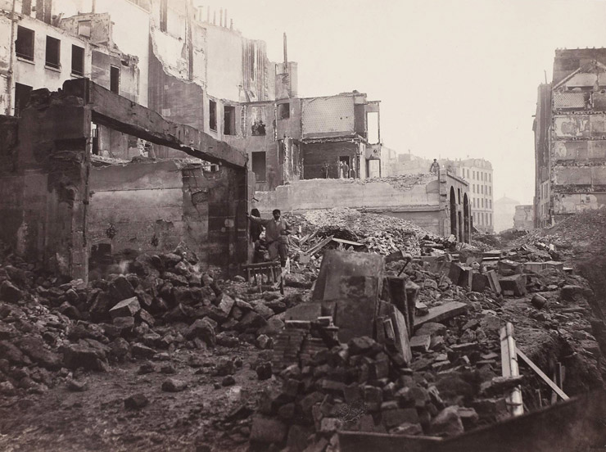

fig. i.1. Charles Marville, Construction of the avenue de l'Opéra: The Butte des Moulins, 1876.

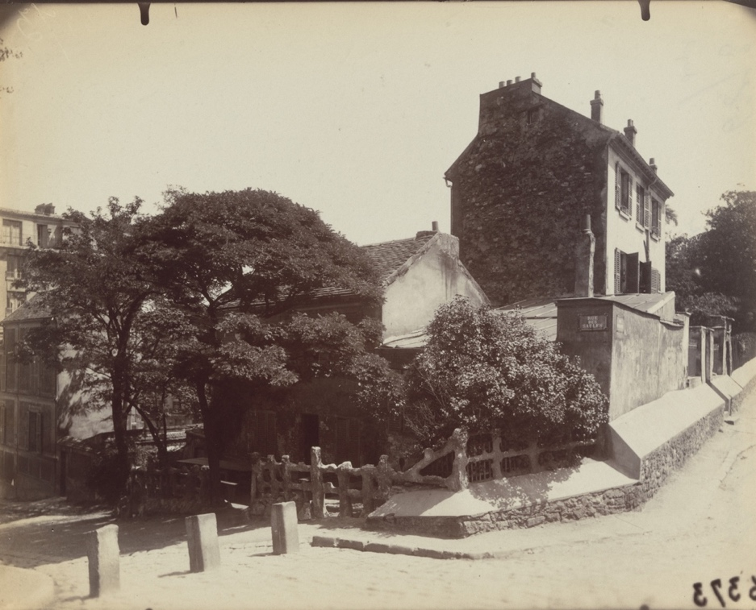

fig. i.2. Eugène Atget, Montmartre, cabaret du Lapin Agile, 1922.
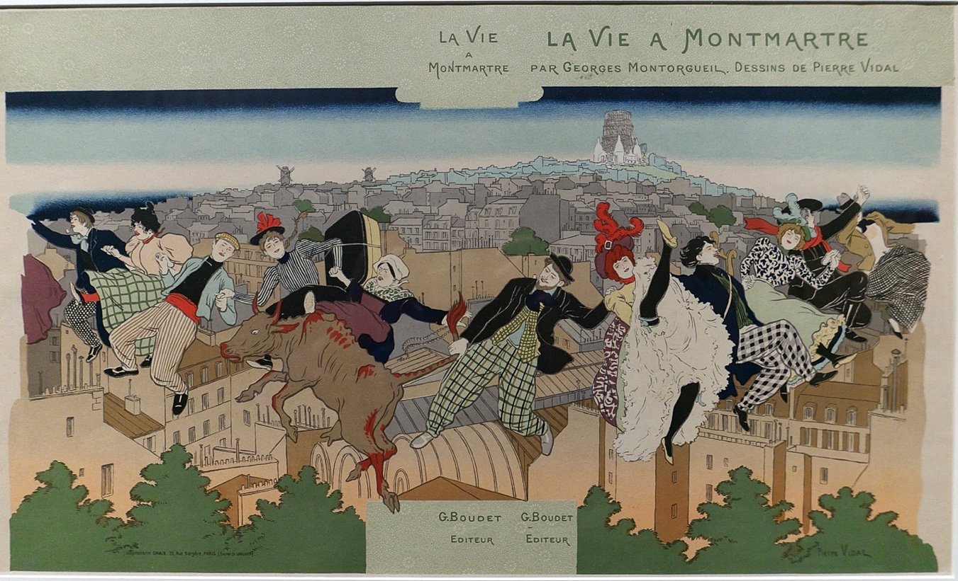
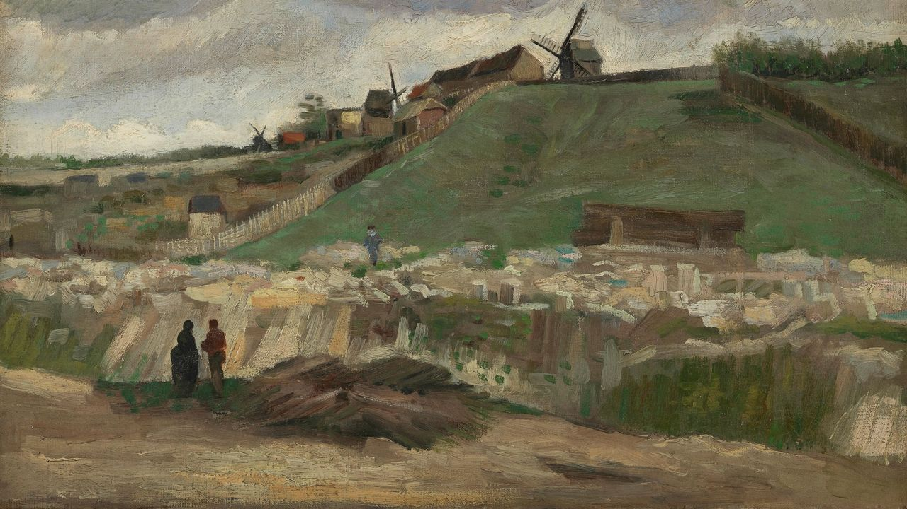
fig. i.4. Pierre Videl, La Vie à Montmartre, 1897. Lithograph.
fig. i.3. Vincent van Gogh, La Colline de Montmartre avec une carrière des pierres, 1886. Oil on canvas. Van Gogh Museum, Amsterdam.
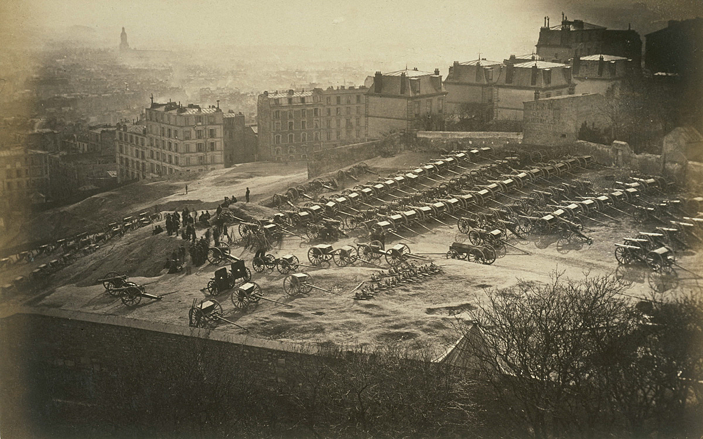
fig. i.5. Unknown, Le 18 mars 1871, 1871.
Fig. i.3. Unknown, le 18 mars 1871. 1871.

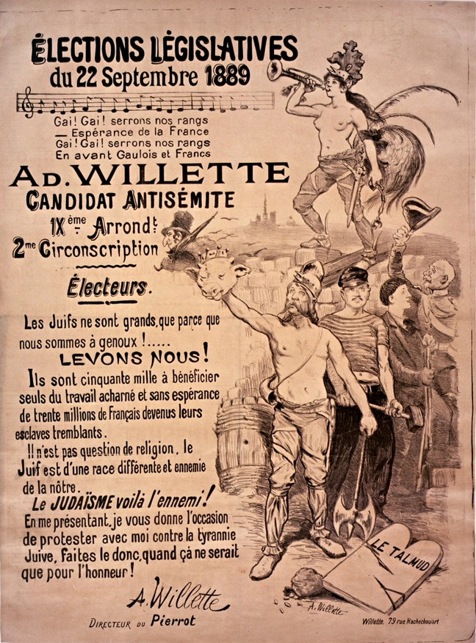
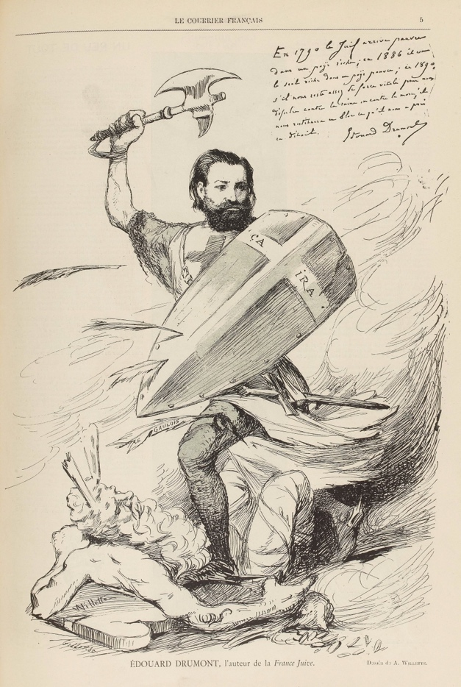
fig. i.6. Adolphe Willette, La Courrier Français, May 16, 1886,
“Édouard Drumont, l’auteur de la Fance Juive.” Lithograph.
fig. i.7. Adolphe Willette, Élection Législatives, 1889. Lithograph.

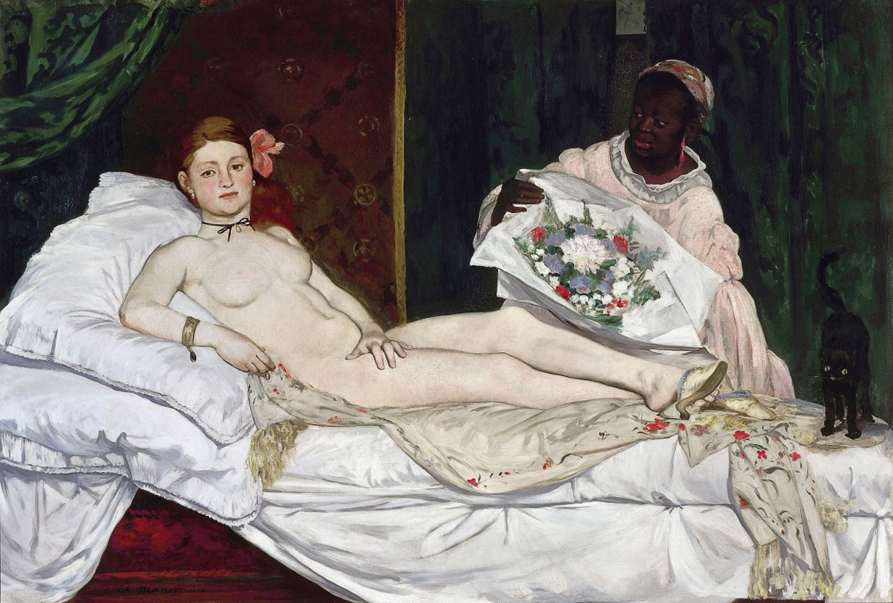

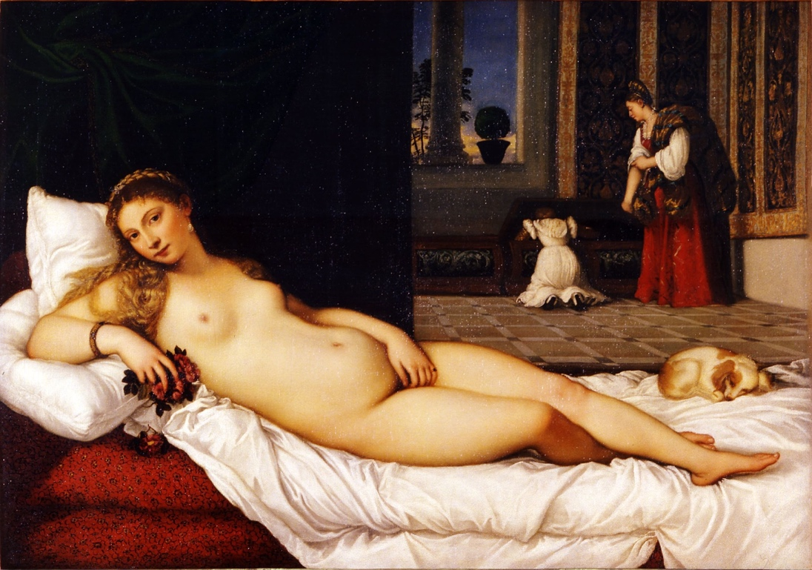
fig. 1.2. Titian, Venus of Urbino, 1534. Oil on canvas. Uffizi, Florence.
fig. 1.1. Édouard Manet, Olympia, 1863-65. Oil on canvas. Musée d’Orsay, Paris
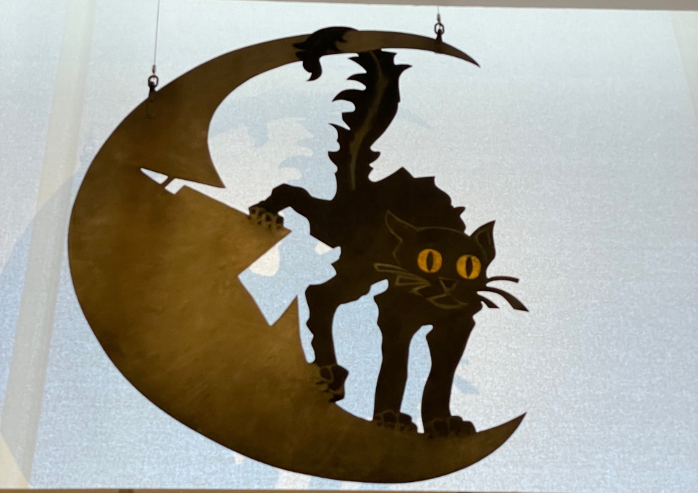

fig. 1.3. Adolphe Willette, Enseigne du cabaret Le Chat Noir, 1881. Painted metal, 51.2 in x 37.8 in. Musée Carnavalet, Paris. (Image by author)

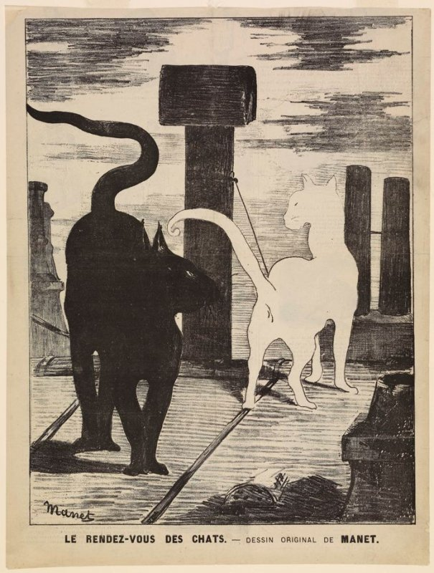

fig. 1.4. Édouard Manet, Le rendez-vous des chats, 1868. Gillotage.
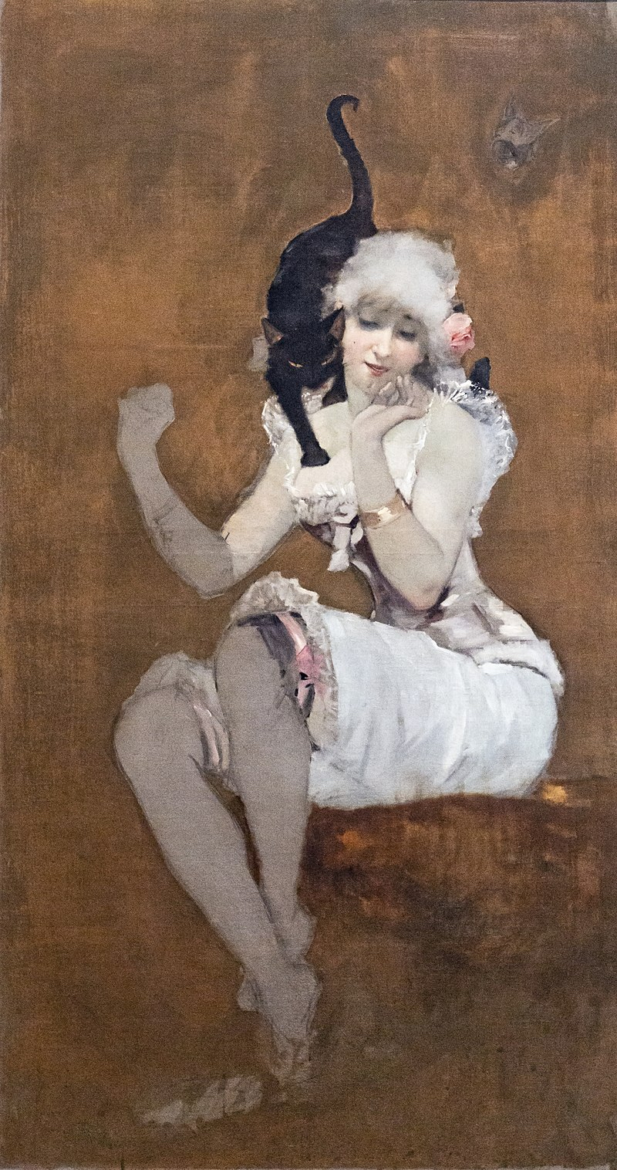
fig. 1.5. Adolphe Willette, Une paire d’amis, 1881. Oil on canvas, 64.8 in x 39.2 in. Private collection.

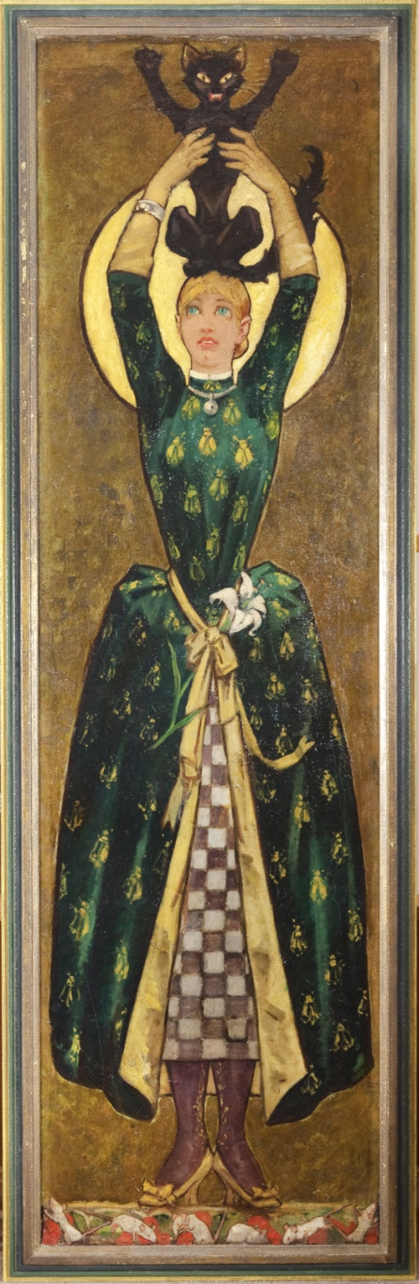
fig. 1.6. Adolphe Willette, La vierge au chat or Vierge verte, 1881. Oil on canvas study for stained glass, 78.3 in x 22.6 in. Zimmerli Art Museum, Rutgers University, New Brunswick.

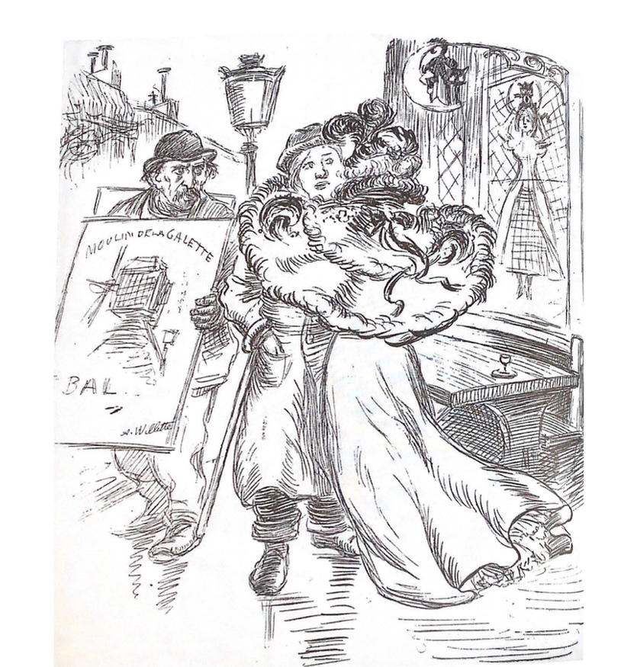

fig. 1.7. Adolphe Willette, Le Courrier Français, 1897.
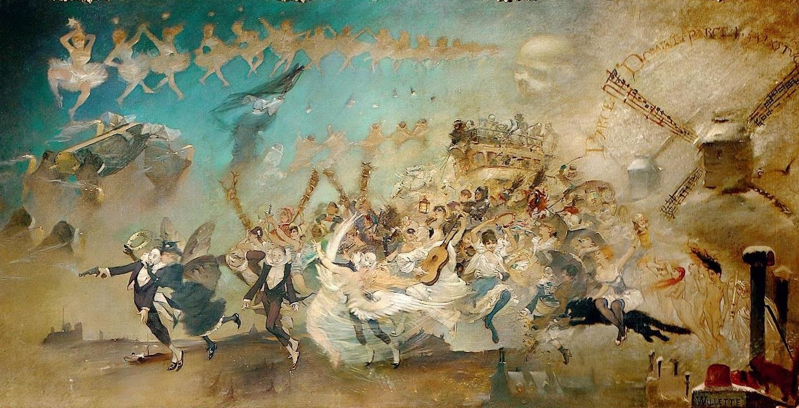
fig. 1.8. Adolphe Willette, Parce Domine, parce populo tuo / Ne in aeternum irascaris nobis, 1884. Oil on canvas, 78.3 in x 153.5 in. Musée de Montmartre, Paris.
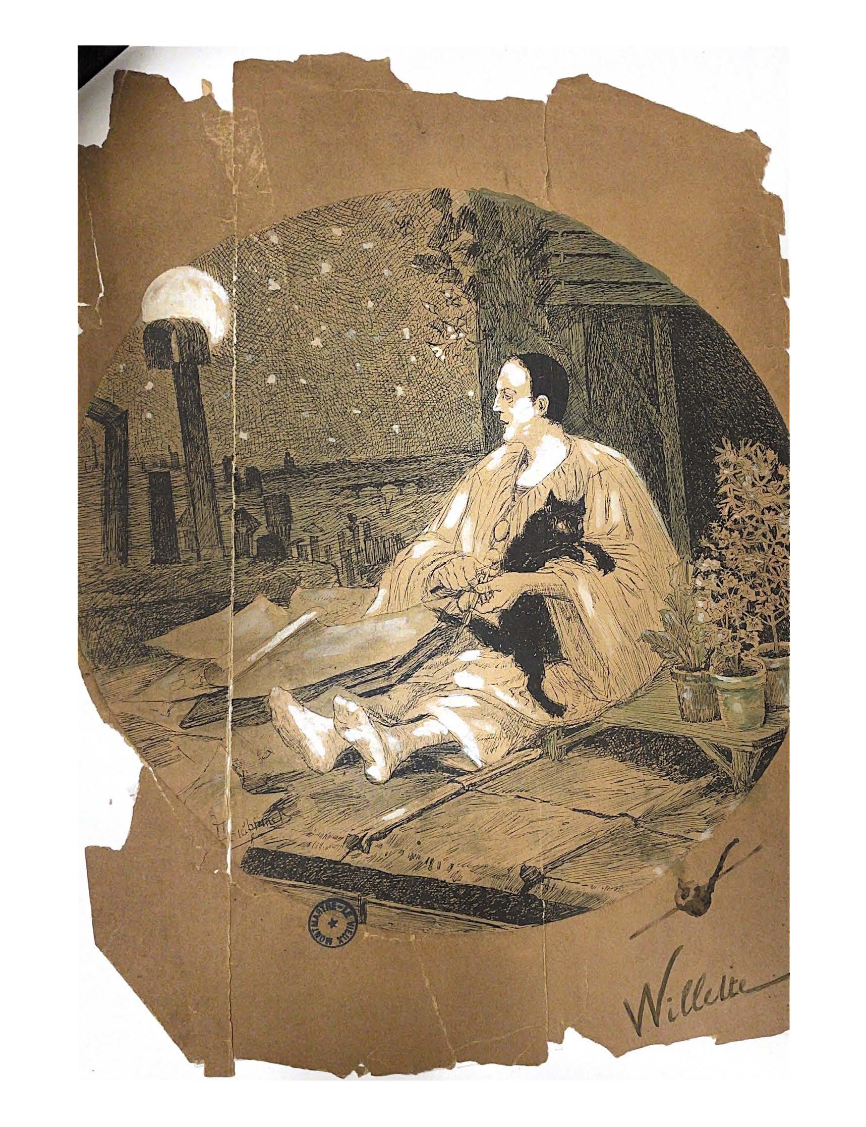
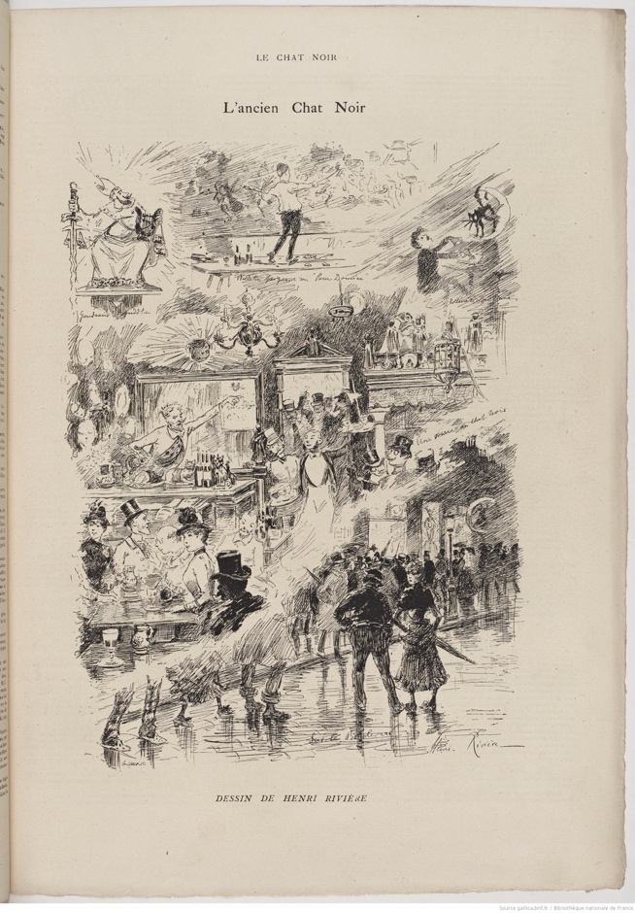
Fig. 1.9. Oswald Heidbrinck, Willette, undated.
Fig. 1.10. Henri Rivière, Le Chat Noir journal, June 13, 1885, “L’ancien ‘Chat Noir.’”

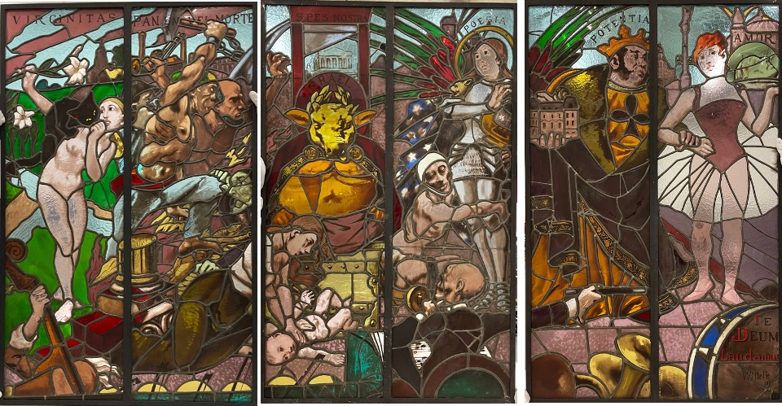
fig. 1.11. Adolphe Willette, Te Deum Laudeamus or Triomphe du Veau d’or, 1885. Stained Glass, 59 in x 116 in. Musée Carnavalet, Paris. Photographed by the author.
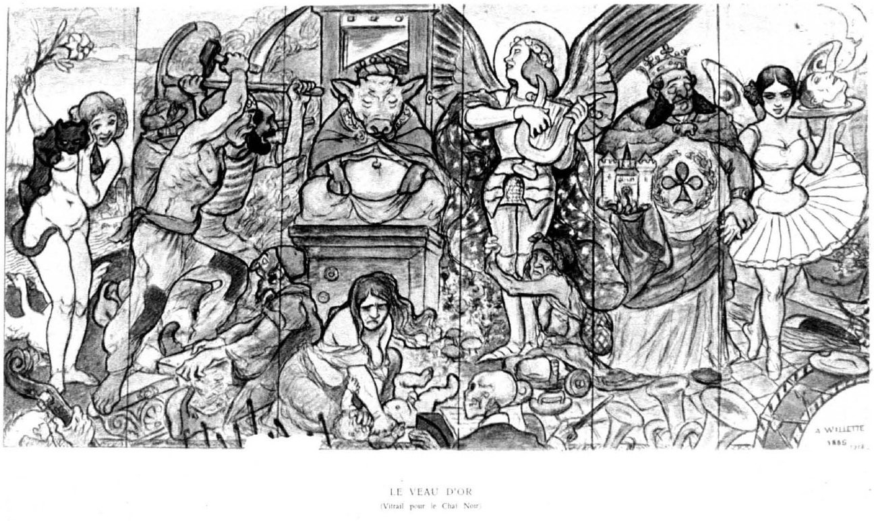
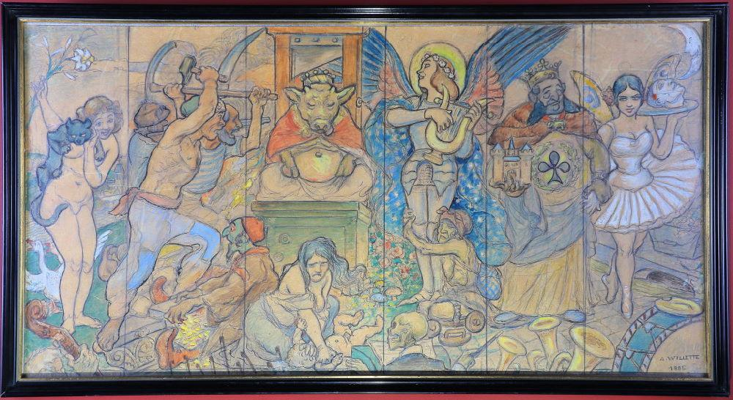
fig. 1.12. Adolphe Willette, Te Deum Laudeamus or Triomphe du Veau d’or, 1885. Drawing.
fig. 1.13. Adolphe Willette, Te Deum Laudeamus or Triomphe du Veau d’or, 1885. Maquette for stained glass. Châtallerault.
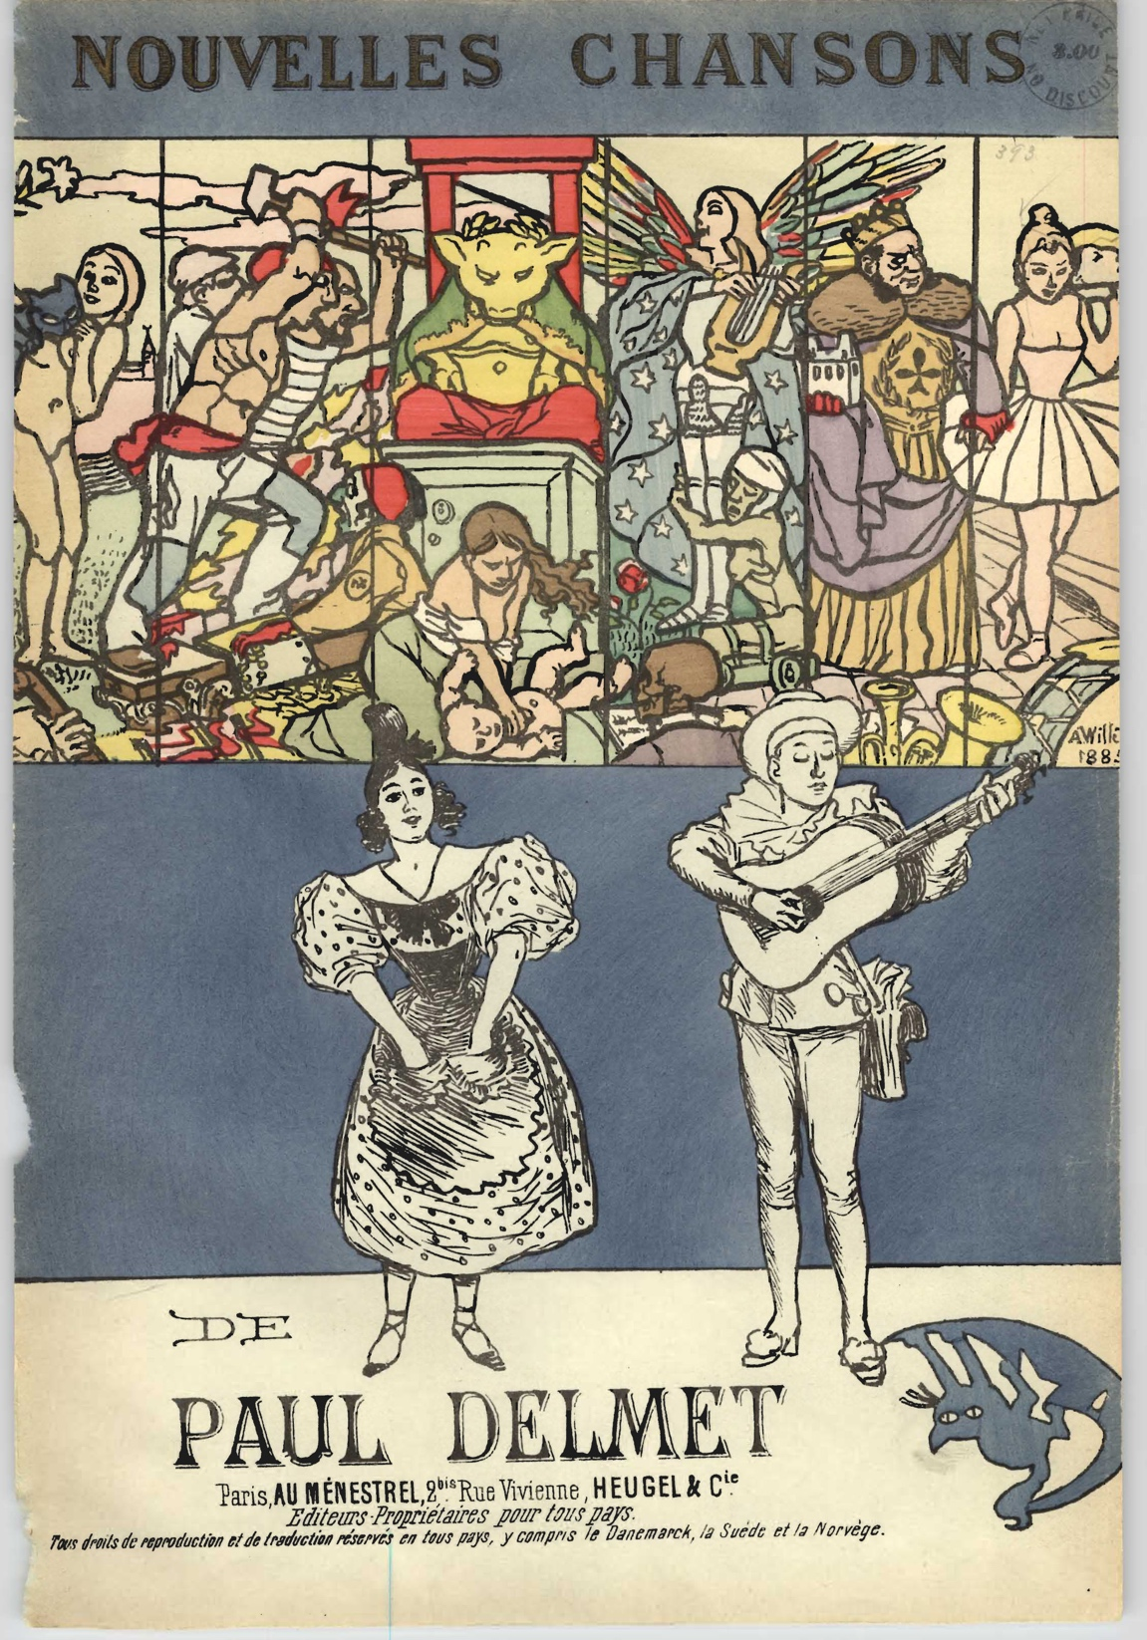
fig. 1.14. Adolphe Willette, Nouvelles Chansons de Paul Delmet, 1895.
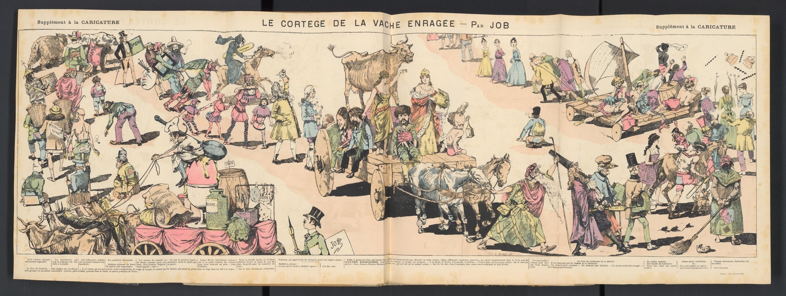
fig. 1.15. Robida, La Caricature, March 22, 1884, “Le cortège de la vache enragée,”
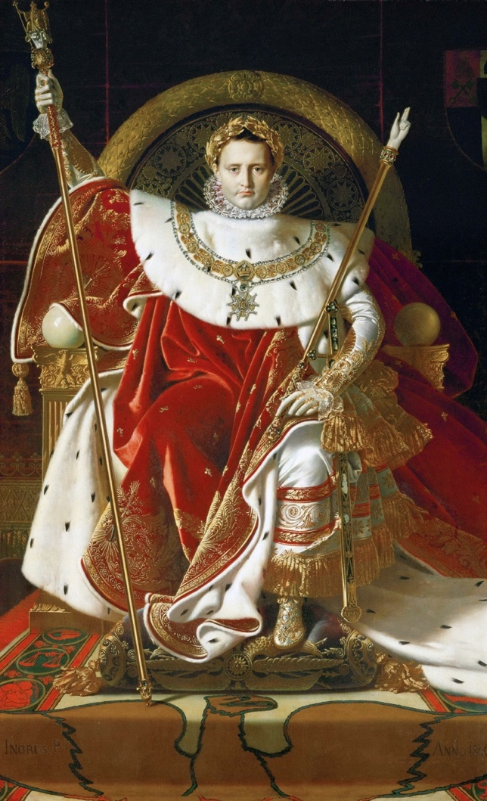
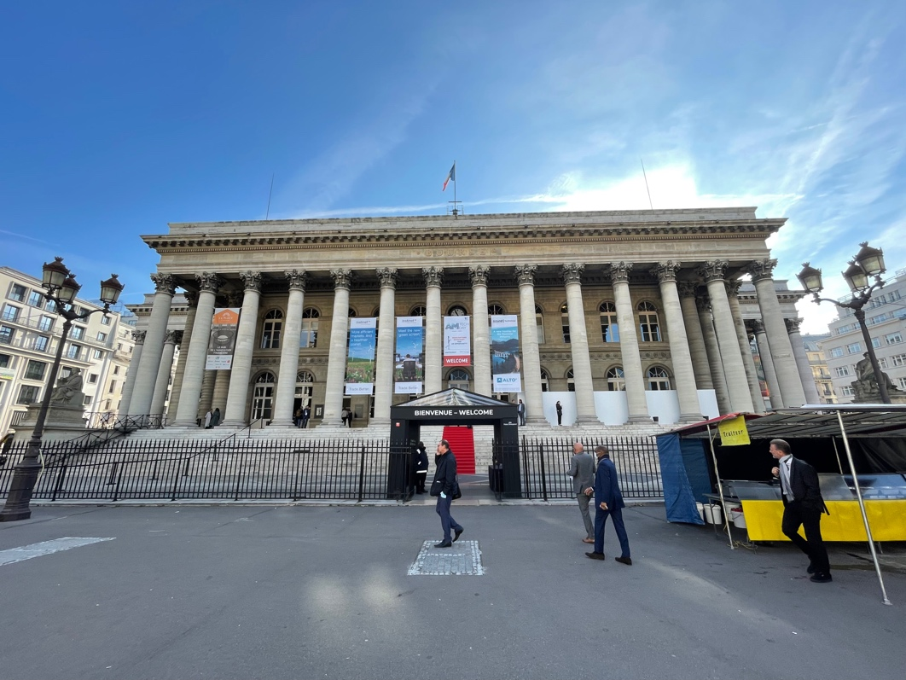
Fig. 1.17. Jean-Auguste-Dominique Ingres, Napoleon I on his Imperial Throne, 1806. Oil on canvas. Musée de l’Armée, Hôtel des Invalides, Paris.
Fig. 1.16. Exterior of The Bourse, 2022. Photograph by author.
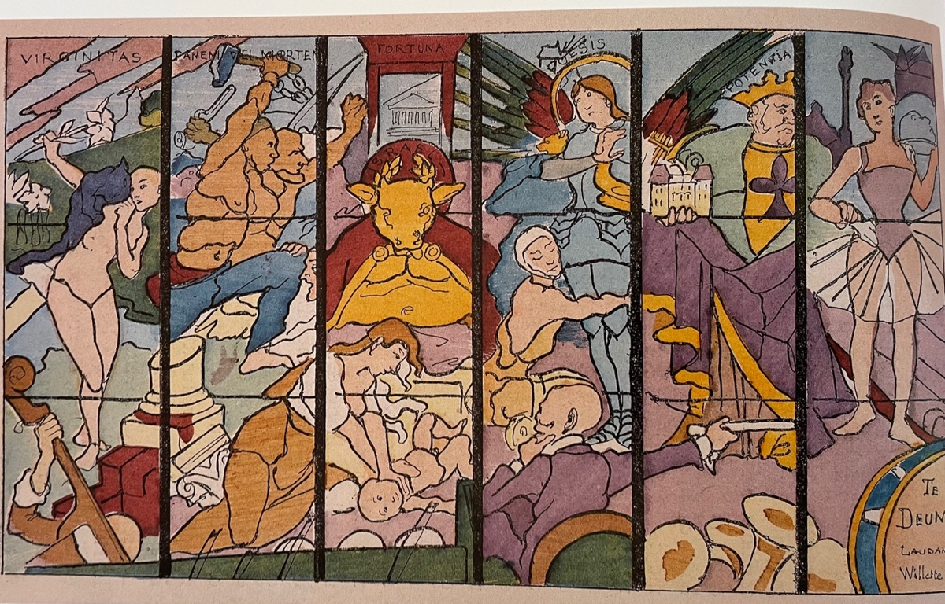
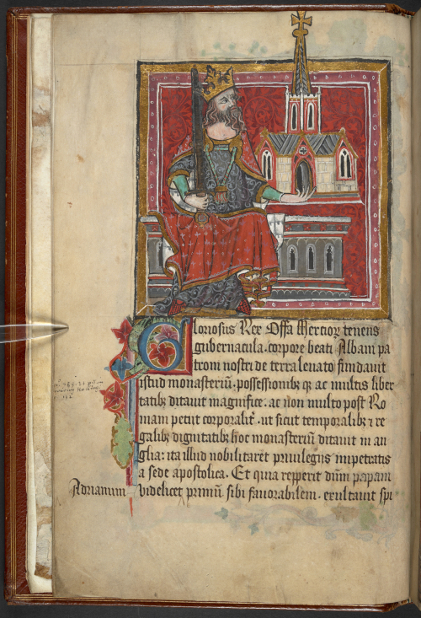
fig. 1.19. Fernand Fau after Willette, Le Veau d’or, 1885. Stencil-colored photorelief. Zimmerli Art Museum, Rutgers University.
fig. 1.18. Benefactors Book of Saint Alban’s Abby, 1380. Access at British Library Digitized Manuscripts website.
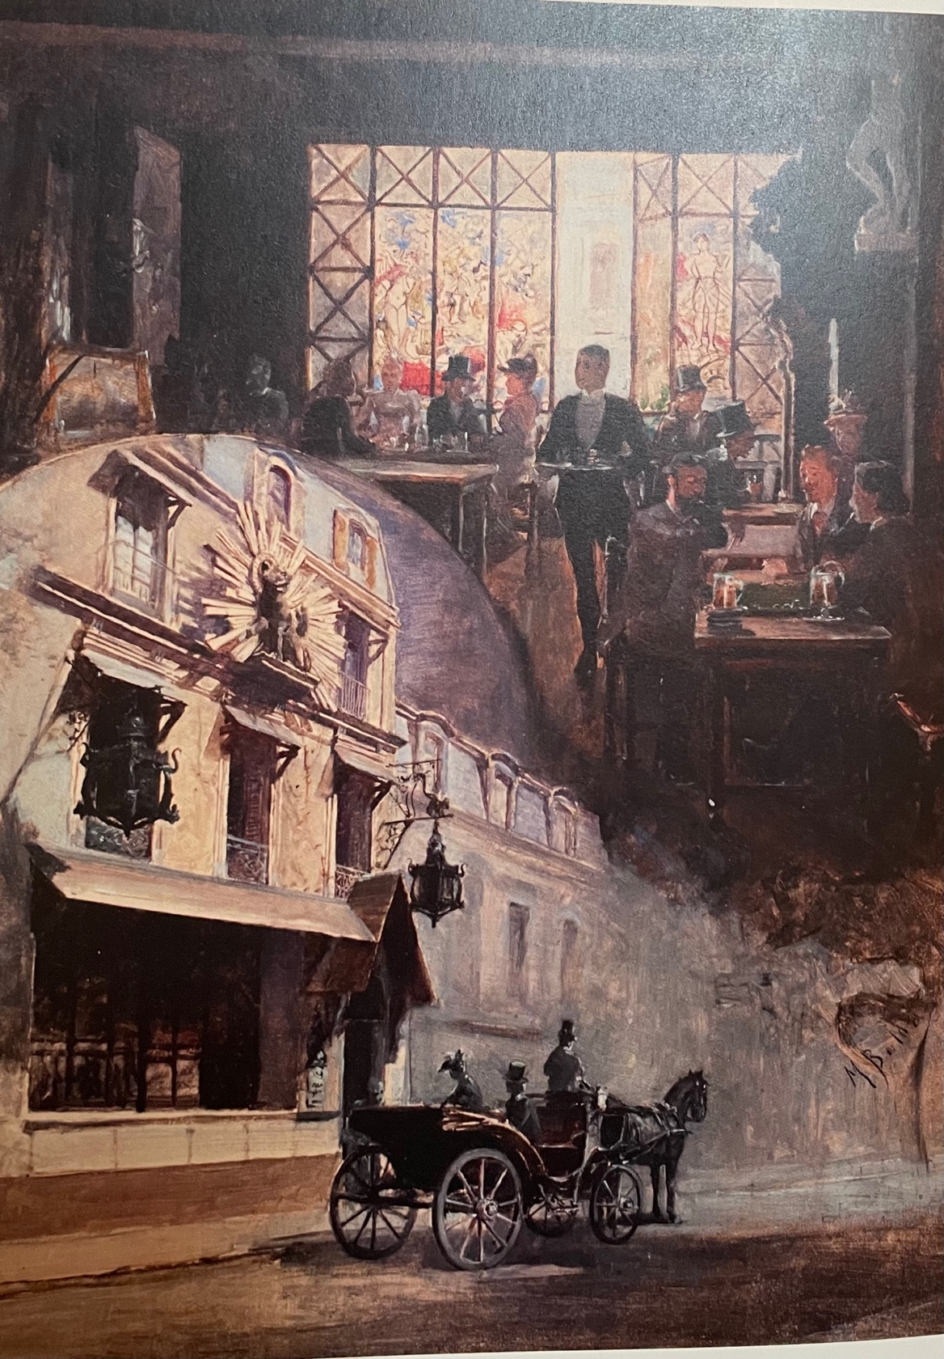
fig. 1.20. M. Balda, Le Cabaret du Chat Noir: intérieur et extérior du deuxième Chat Noir, c. 1890. Oil on canvas. Musée de Montmartre, Paris.
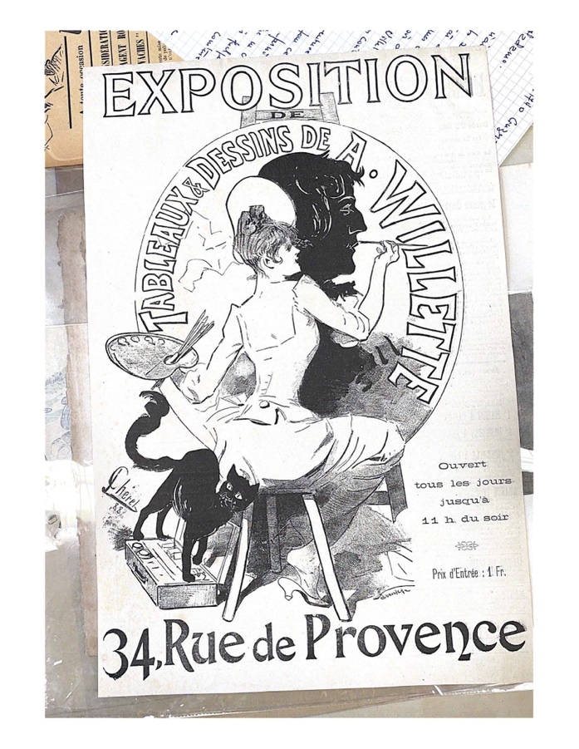
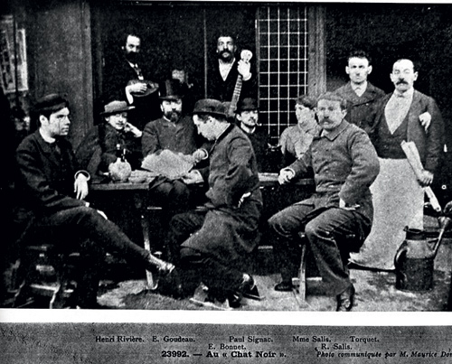
fig. 1.22. Jules Cheret, Exposition de Tableaux & Dessins de A. Willette, 1888. Advertisement.
fig. 1.21. Anonymous, Le Premier Chat Noir et ses habitués, 1882. Photograph.
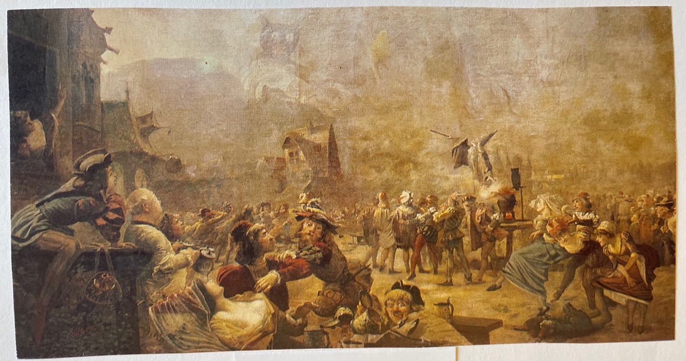
fig. 1.23. Adolphe Willette (attributed), Scène de la cour des miracles or Scène Buccolique or Scène de magie, undated. Oil on canvas, 138 in x 71 in. Location unknown.
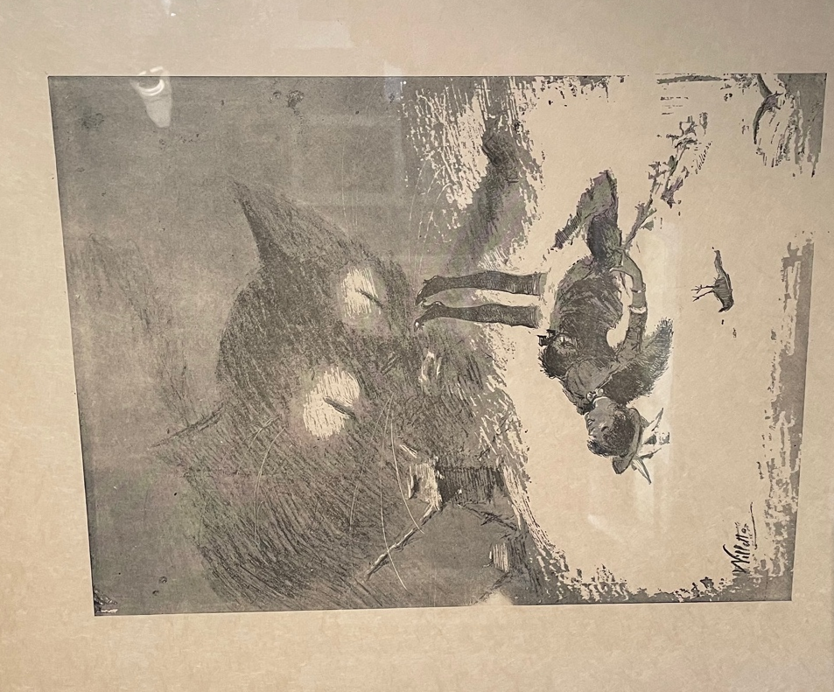
fig. 1.24. Adolphe Willette, Chat nuageux et femme, undated. Lithograph, Musée de Montmartre, Paris.
Fig. 1.24. Adolphe Willette, Chat nuageux et femme, undated. Lithograph. Musée de Montmartre.

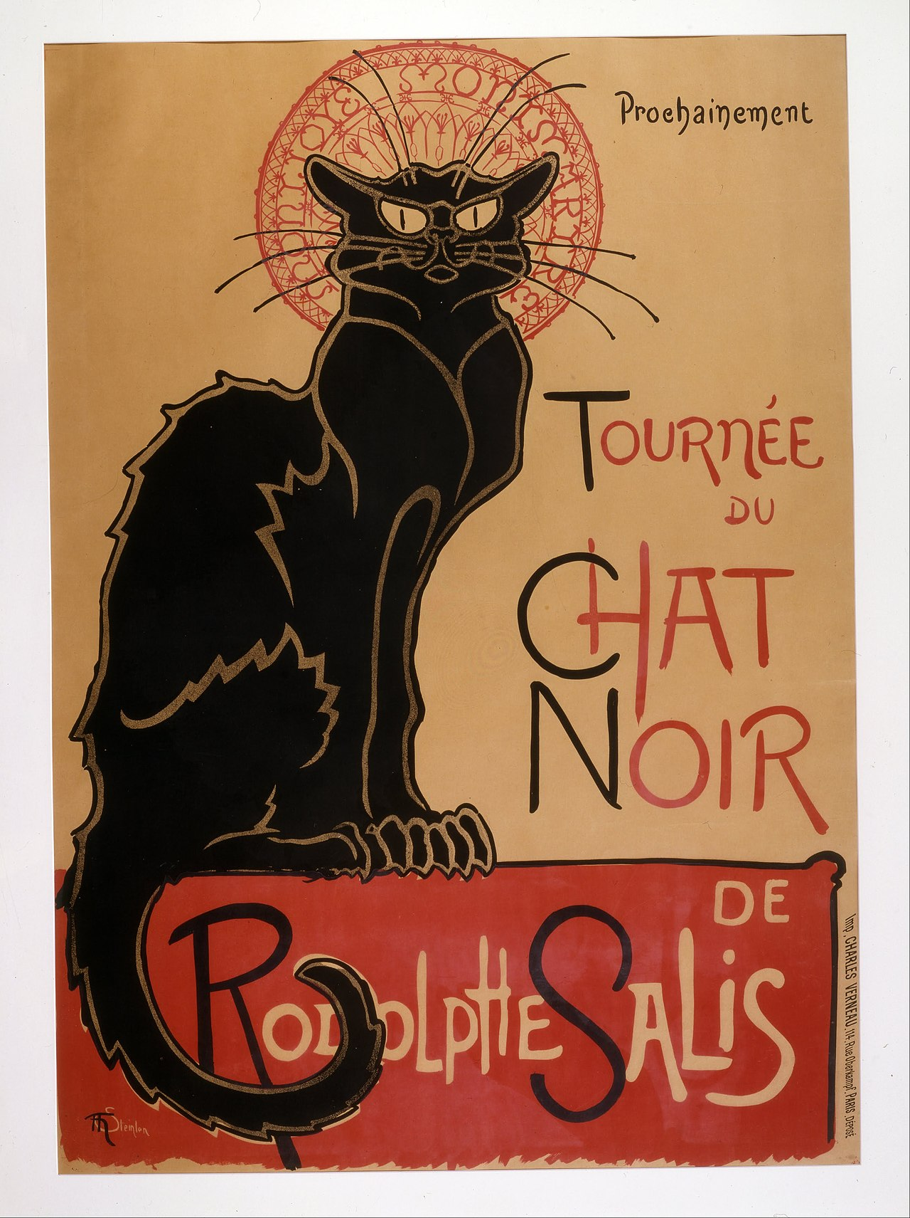
fig. 2.1. Théophile-Alexandre Steinlen, Tournée du Chat Noir, 1896. Lithograph, 56 in x 39 in.
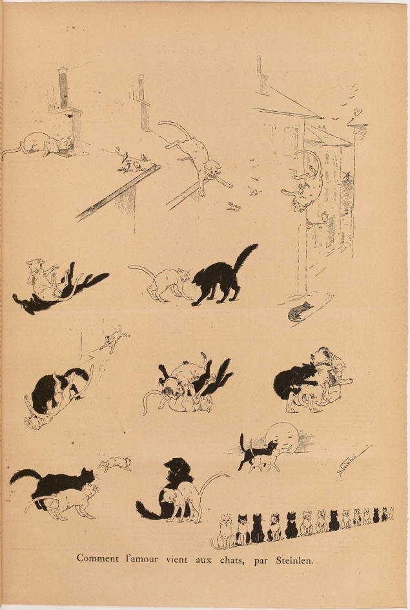
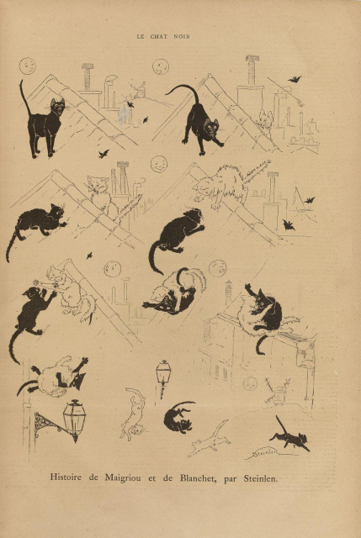
fig. 2.2. Théophile-Alexandre Steinlen, Chat Noir, March 29, 1884, “Comment l’amour vient aux chats.”
fig. 2.3 Théophile-Alexandre Steinlen, Chat Noir, March 8, 1884, “Histoire de Maigriou et de Blanchet.”
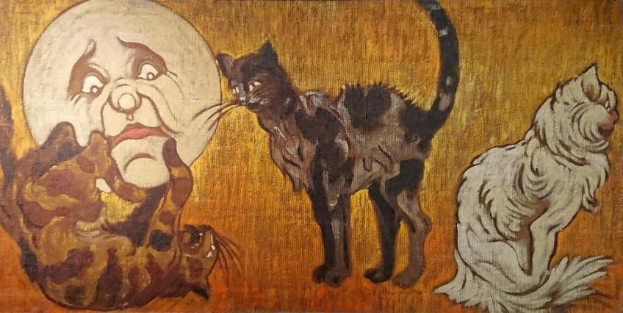
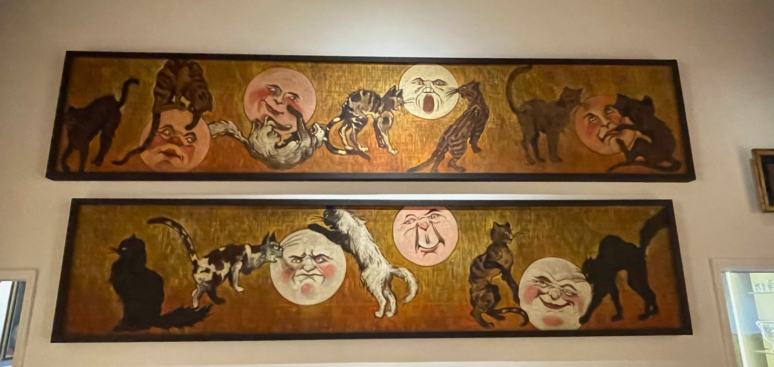
figs. 2.4 and 2.5 Théophile-Alexandre Steinlen, portions of Une fries de chats et de lunes, c.1885. Oil on canvas, 386 in x 22 in. (seven panels total). Musée de Montmartre, Paris. Photographs by author.
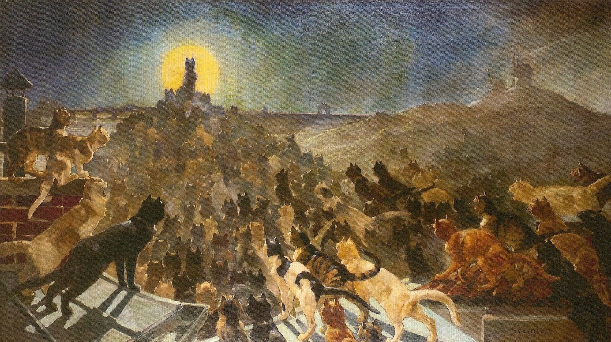
fig. 2.6 Théophile-Alexandre Steinlen, Apothéose des chats, 1885. Oil on canvas, 65 in x 118 in. Petit Palais, Geneva.
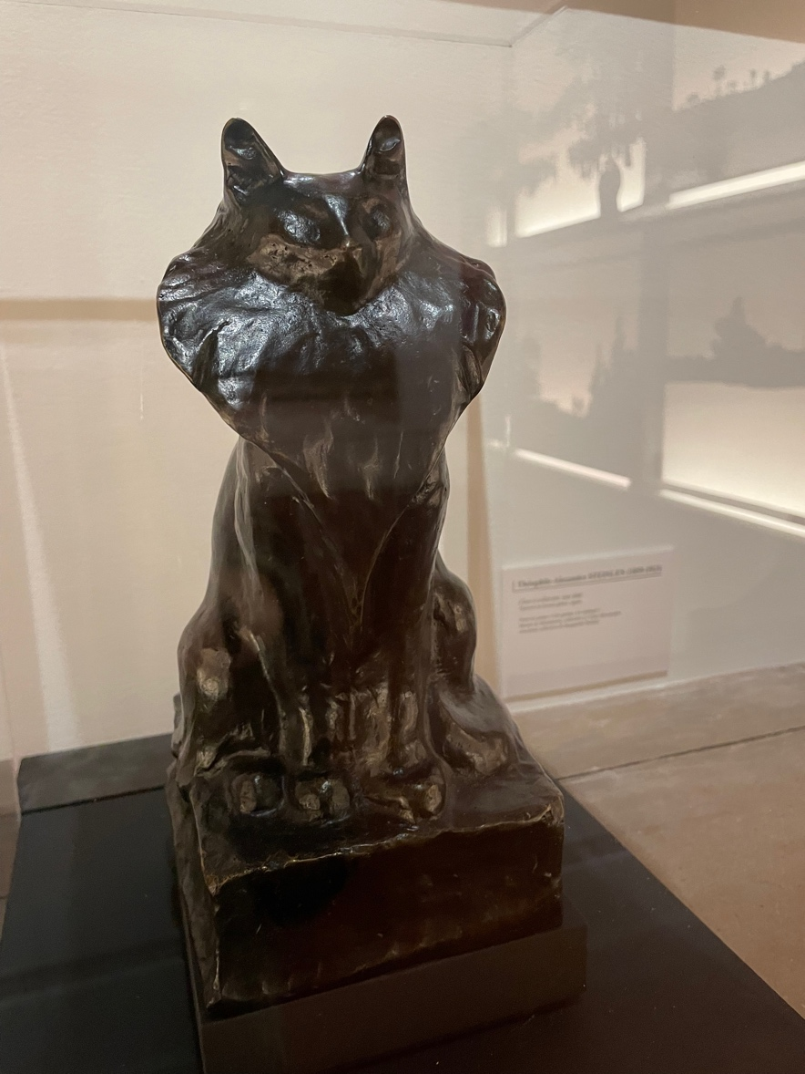
fig. 2.7 Théophile-Alexandre Steinlen, Chat à collarette, c.1905. Bronze sculpture. Musée de Montmartre, Paris. Photograph by author.
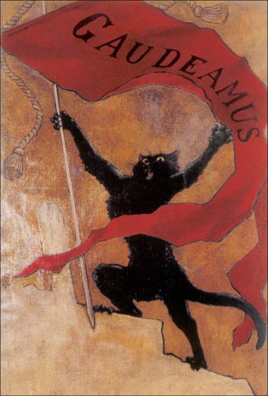
fig. 2.8 Théophile-Alexandre Steinlen, Gaudeamus, c. 1890. Oil on canvas, 68 in. x 33 in. Petit Palais, Geneva.
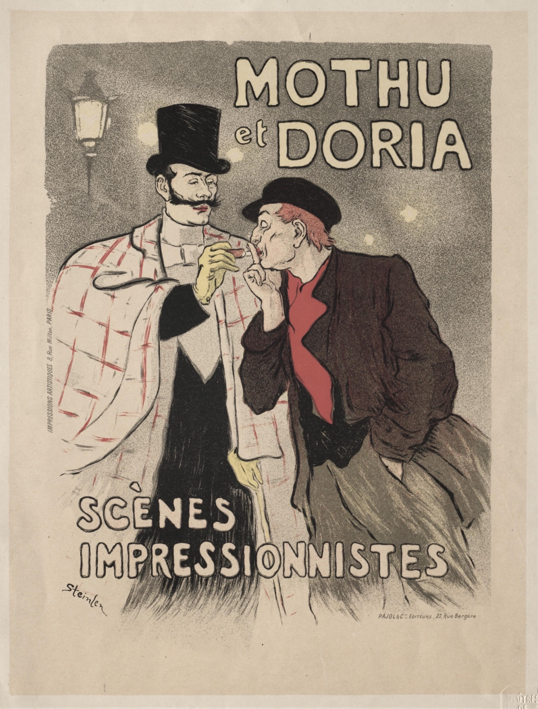
fig. 2.9 Théophile-Alexandre Steinlen, Mothu et Doria, 1893. Lithograph, 48 in. x 37 in.
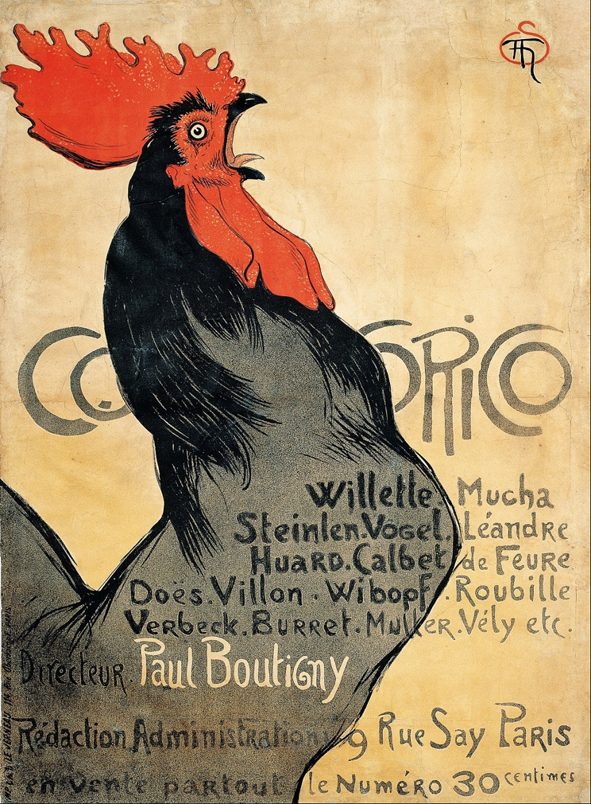
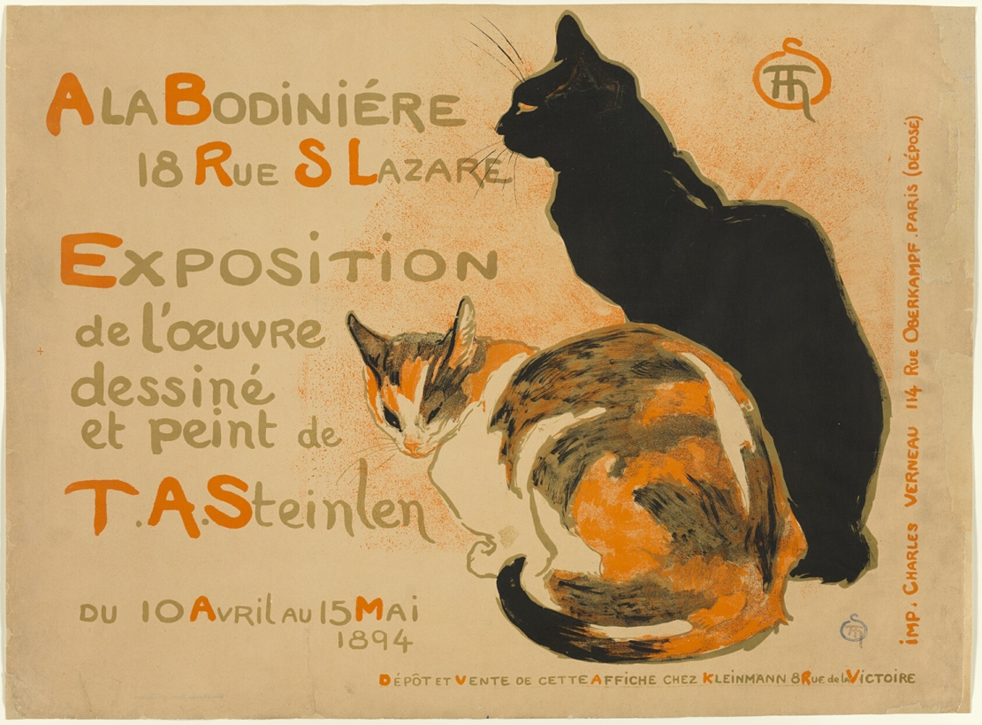
fig. 2.11 Théophile-Alexandre Steinlen, Cocorico, 1899. Lithograph.
fig. 2.10 Théophile-Alexandre Steinlen, A la Bodiniére, 1894. Lithograph.
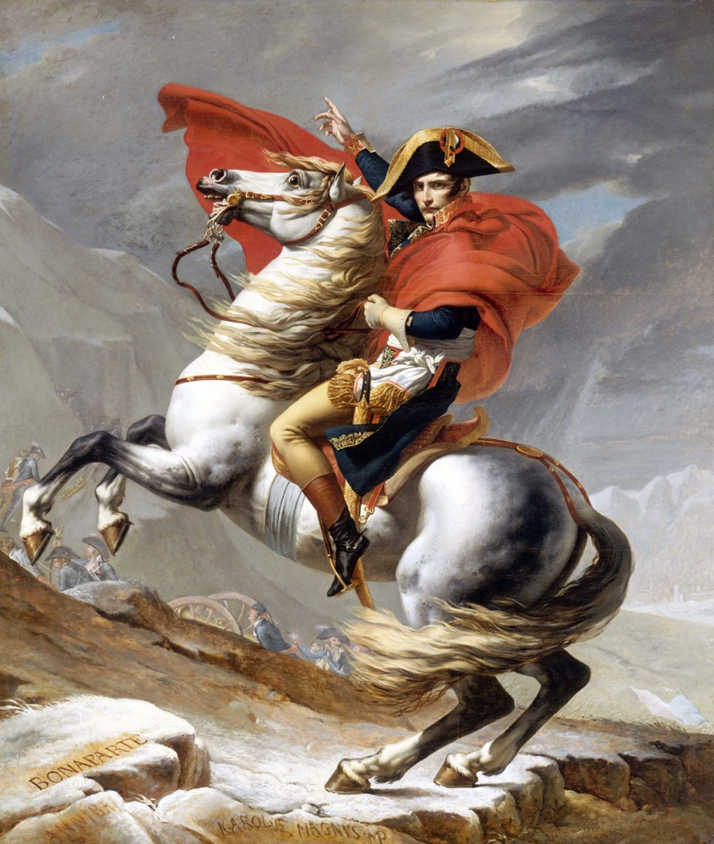
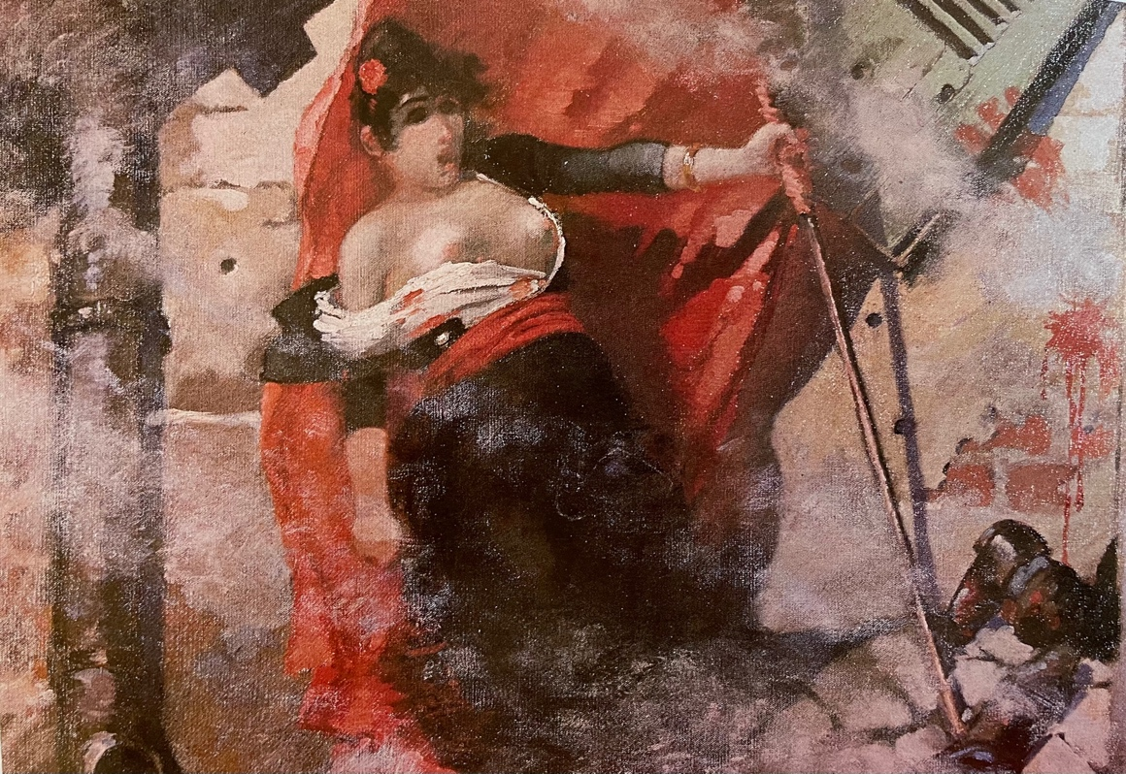
fig. 2.13 Jacques-Louis David, Napoleon Crossing the Alps, 1802. Oil on canvas. Palace of Versailles.
fig. 2.12 Théophile-Alexandre Steinlen, Louise Michel sur les barricades, c. 1884. Oil on canvas, 44 in. x 34. Petit Palais, Geneva.
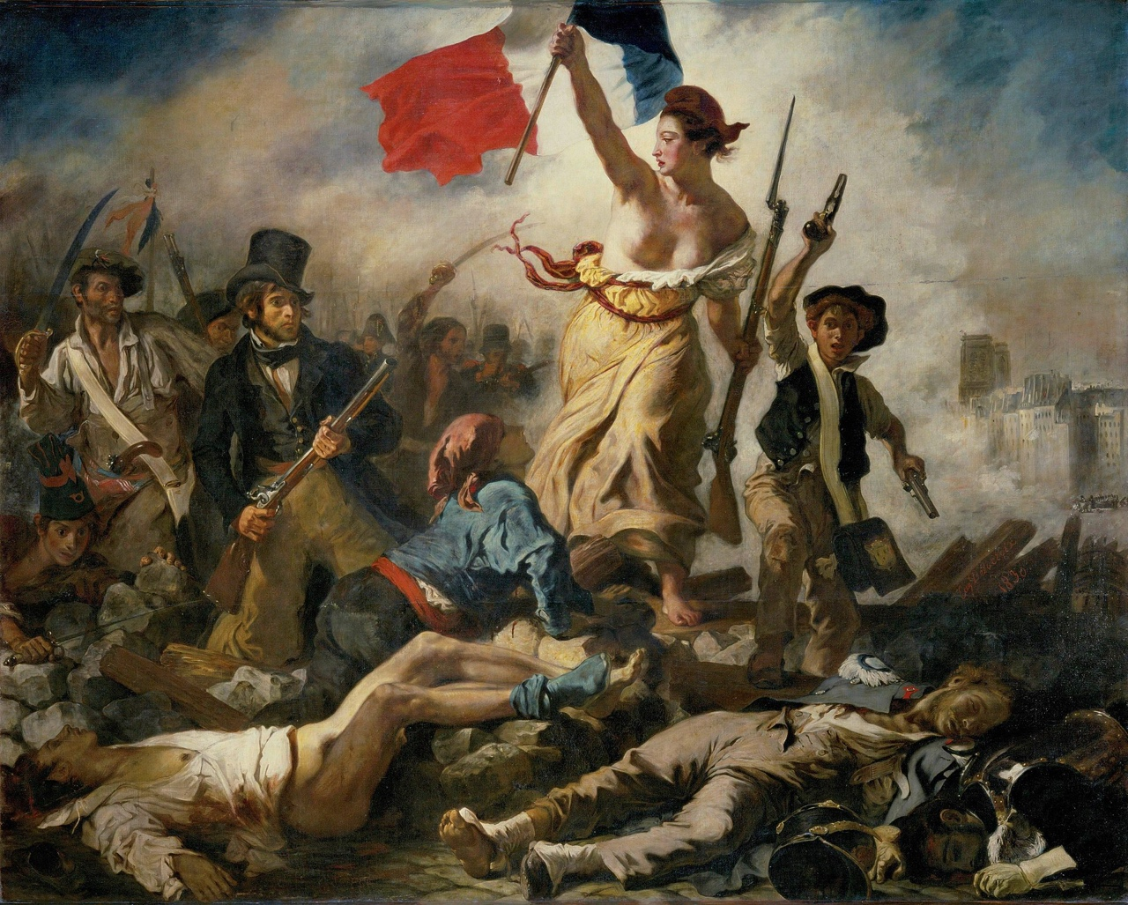
fig. 2.14 Eugène Delacroix, Liberty leading the People, 1830. Oil on canvas. Louvre, Paris.
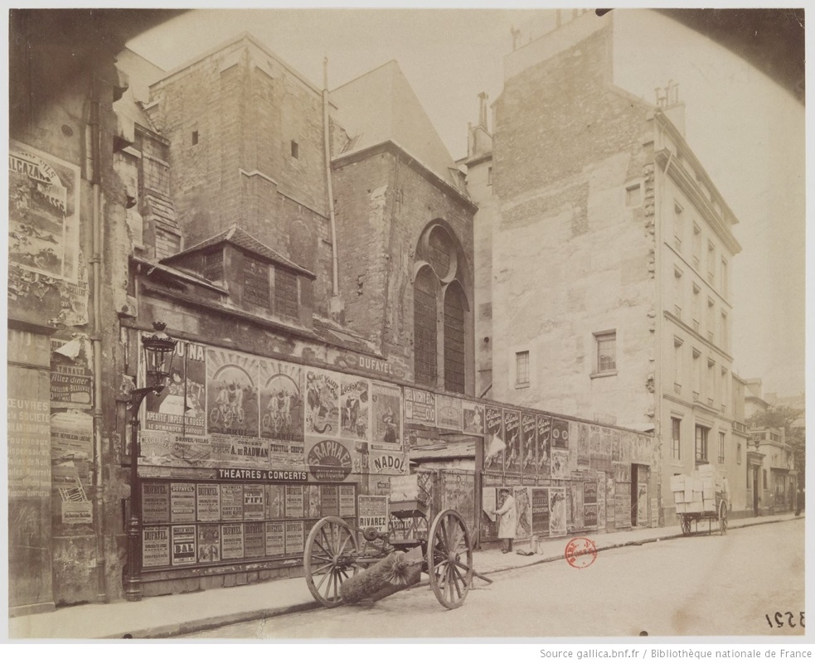
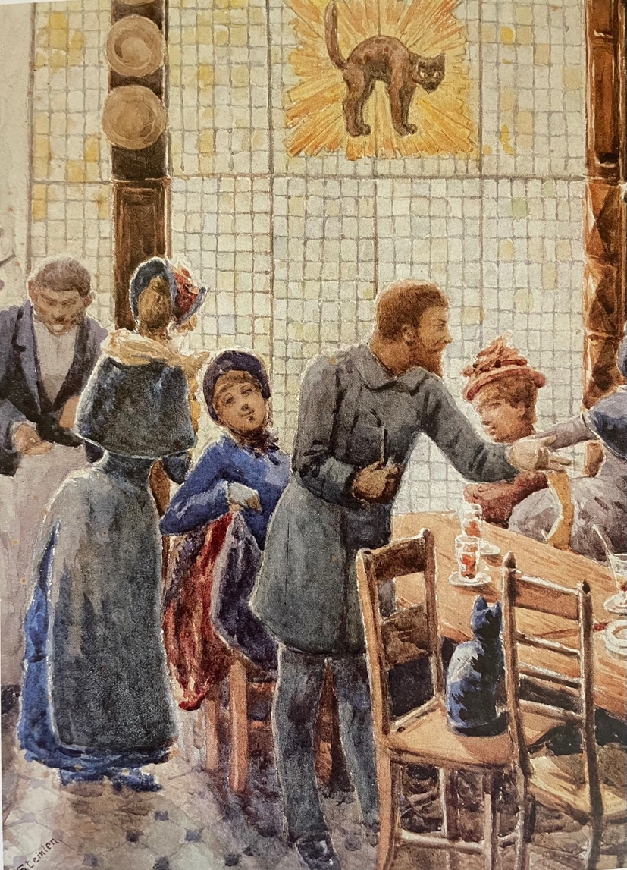
fig. 2.16 Eugène Atget, Rue l’Abbaye, 1898.
fig. 2.15 Attributed to Théophile-Alexandre Steinlen, Rodolphe Salis at the Chat Noir Cabaret, c. 1884. Watercolor. Petit Palais, Geneva.
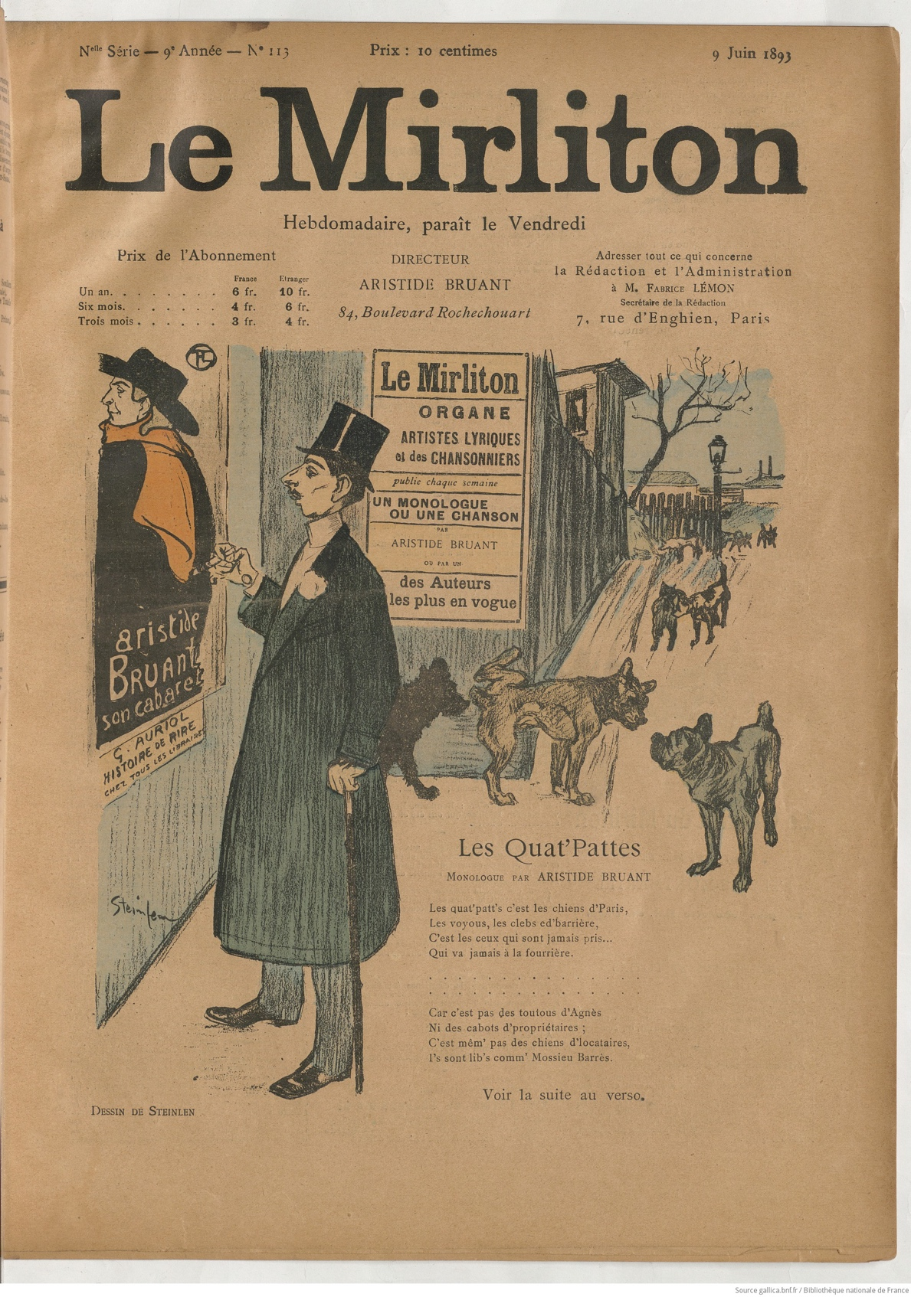
fig. 2.17 Théophile-Alexandre Steinlen, Le Mirliton #113, June 8, 1893, “Les Quat’Pattes.” Cover, photorelief.
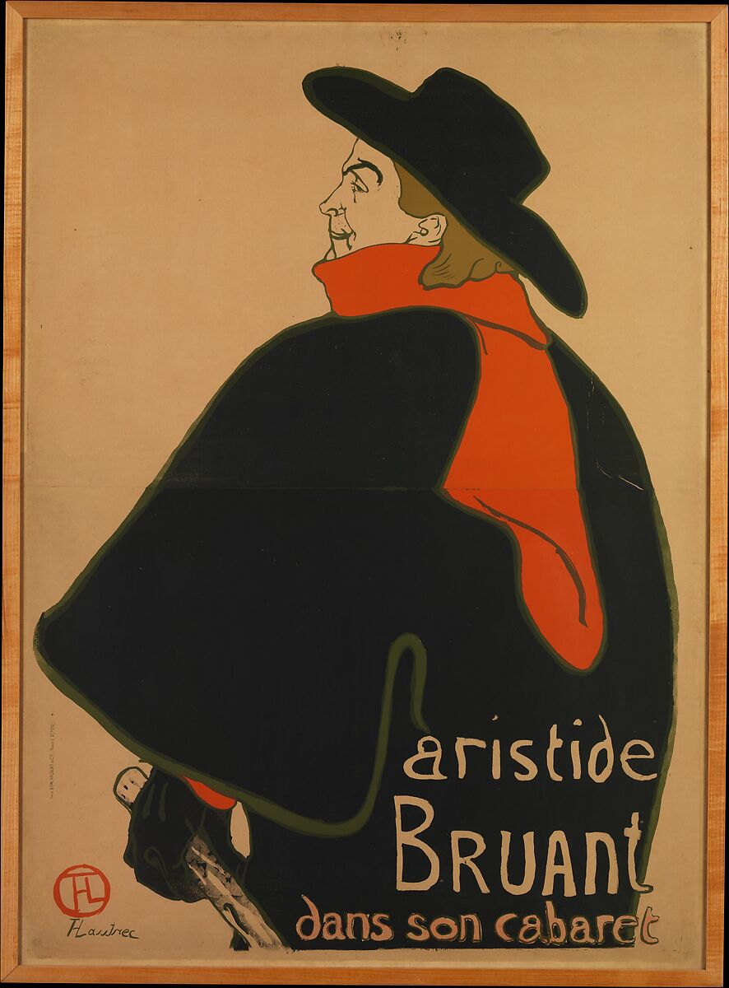
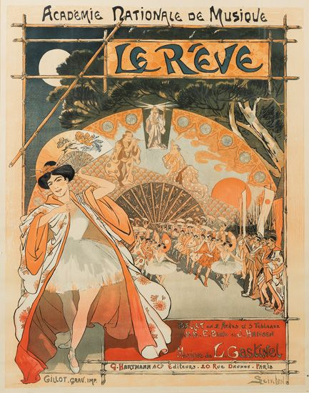
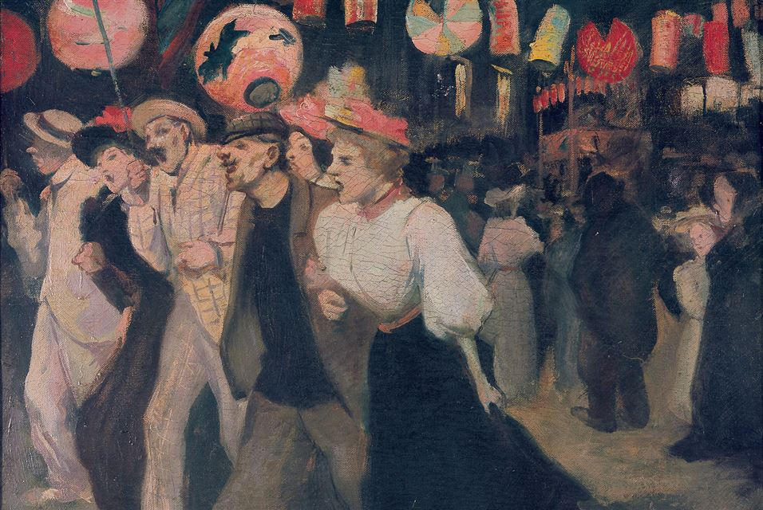
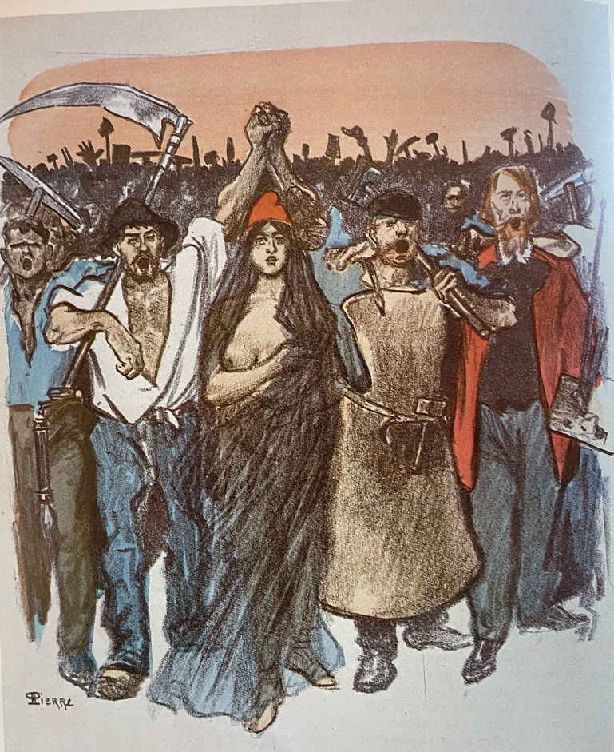
fig. 2.18 Henri de Toulouse-Lautrec, Aristide Bruant dans son cabaret, 1893. Color lithograph.
fig. 2.19 Théophile-Alexandre Steinlen, Le rêve, 1891. Color photorelief.
fig. 2.21 Théophile-Alexandre Steinlen, Le 14 juillet, 1895. Oil on canvas. Petit Palais, Geneva.
fig. 2.20 Théophile-Alexandre Steinlen (signed “Pierre”), Le 18 Mars, 1894. Stencil colored lithograph.

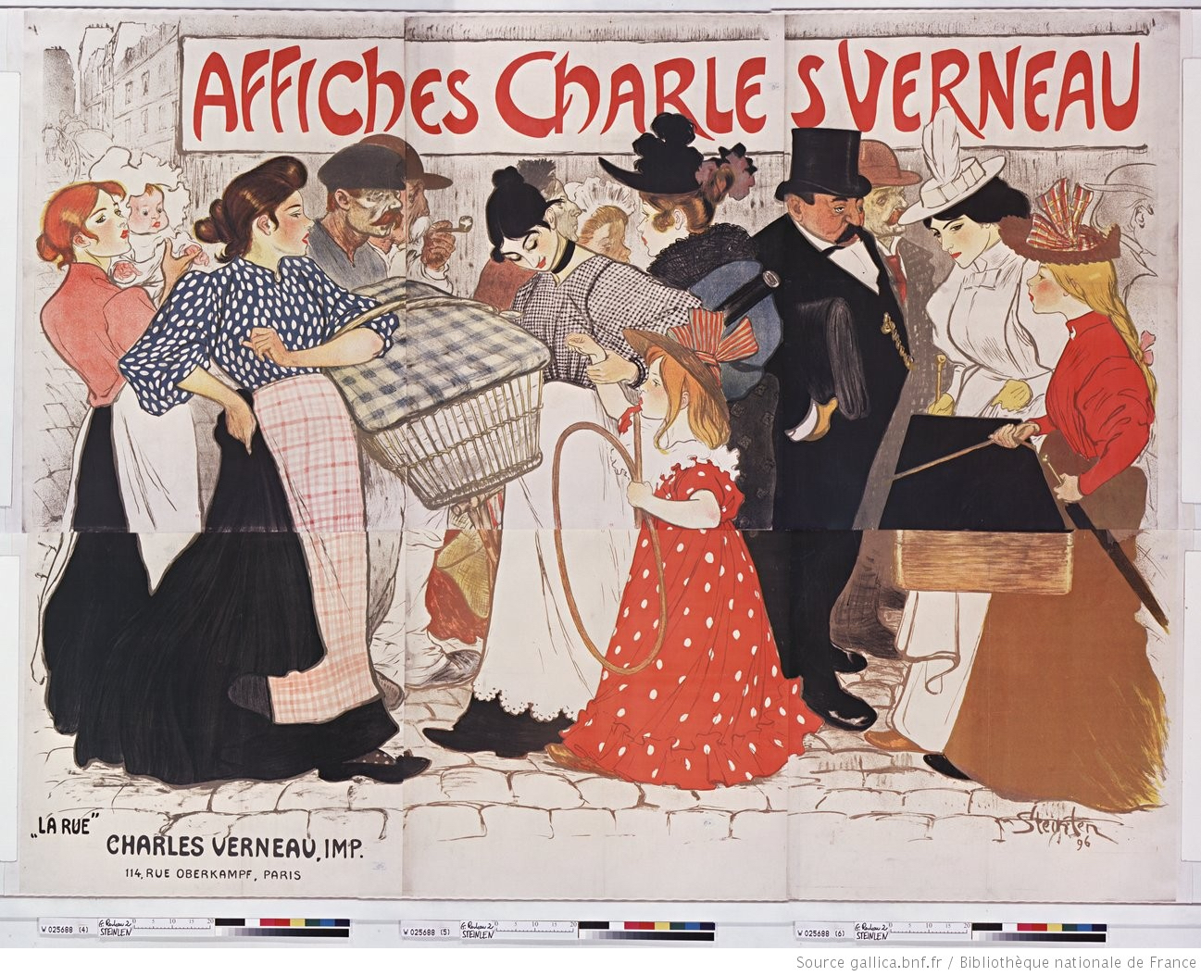
fig. 2.22 Théophile-Alexandre Steinlen, La rue, 1896. Color lithographic poster, 94 in. x 120 in. Zimmerli Art Museum, Rutgers.
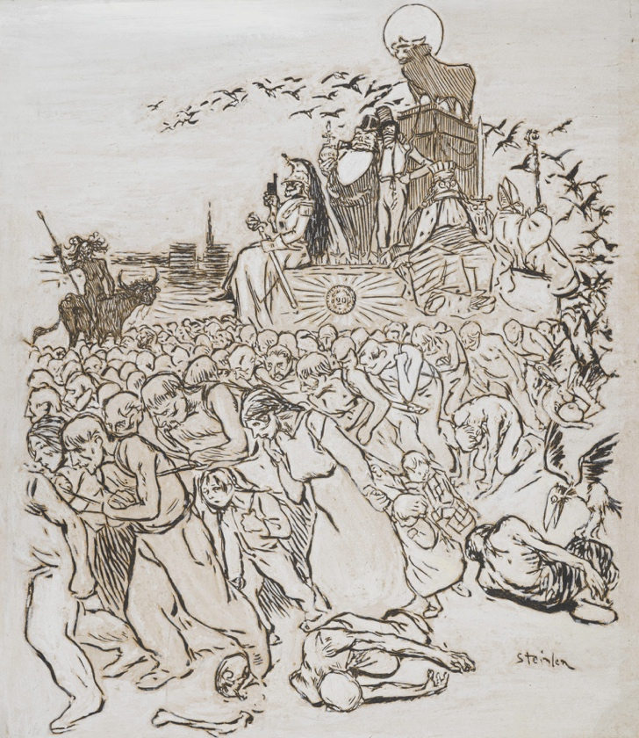
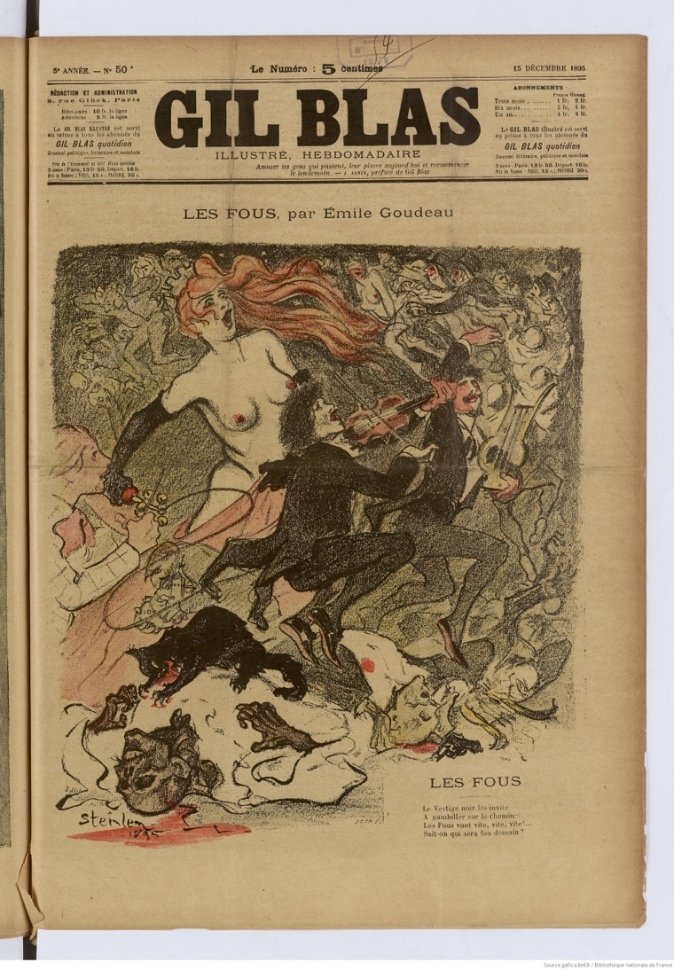
fig. 2.24 Théophile-Alexandre Steinlen, L’Écho de Paris #4285, February 18, 1896, “Le Veau d’or.” Photorelief.
fig. 2.23 Théophile-Alexandre Steinlen, Gil Blas illustré #50, December 15, 1895, “Les fous.” Cover, color photorelief.
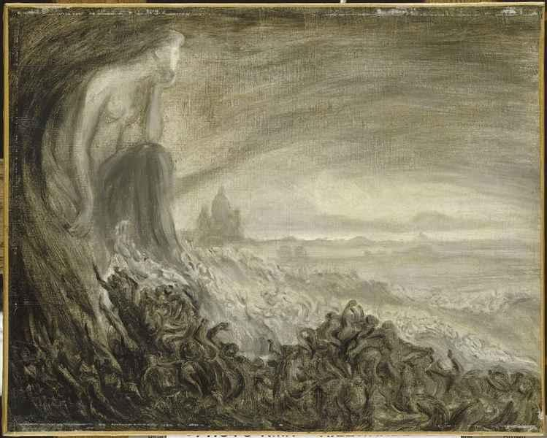
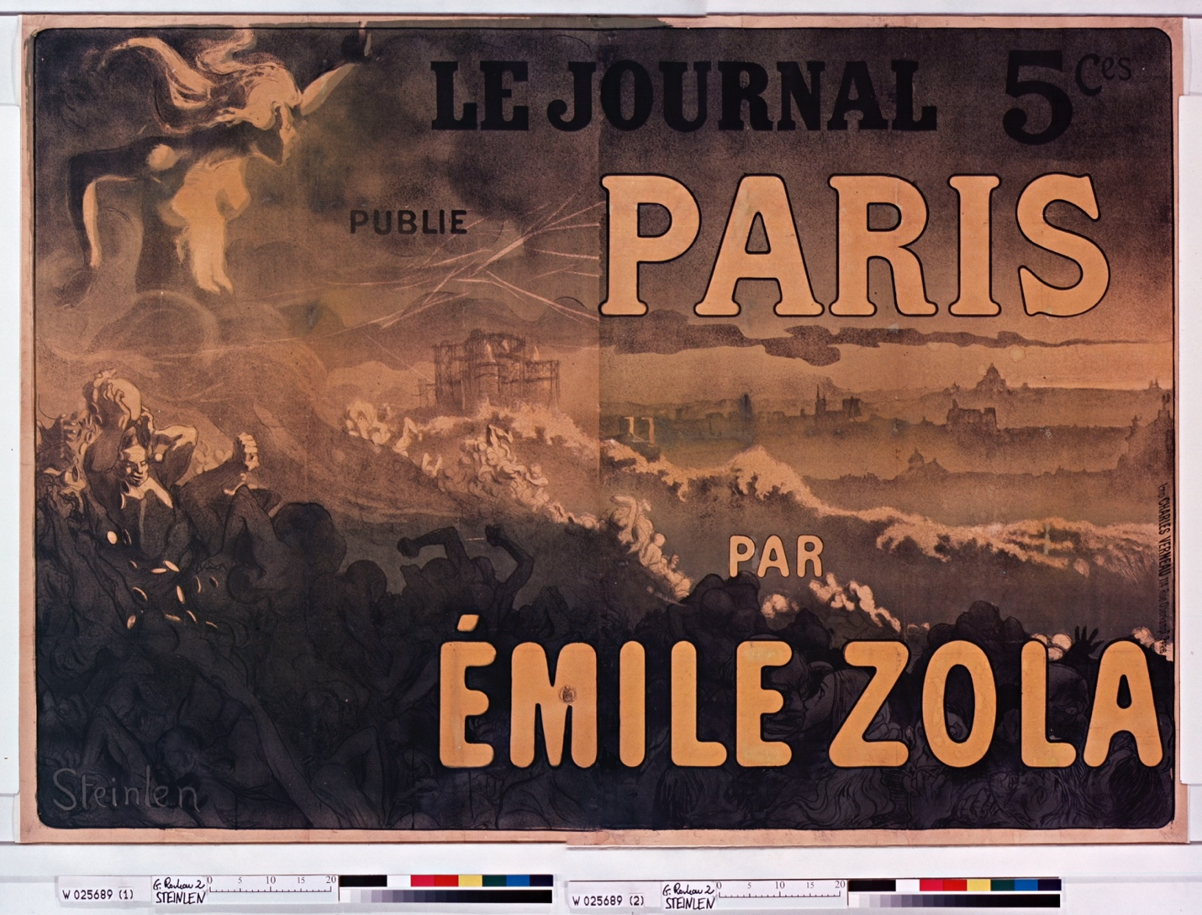
fig. 2.26 Théophile-Alexandre Steinlen, Vision de Paris, 1898. Oil on canvas, 13 in. x 16 in. Musée d’Orsay, Paris.
fig. 2.25 Théophile-Alexandre Steinlen, Paris, 1898. Color lithographic poster, 55 in. x 79 in.
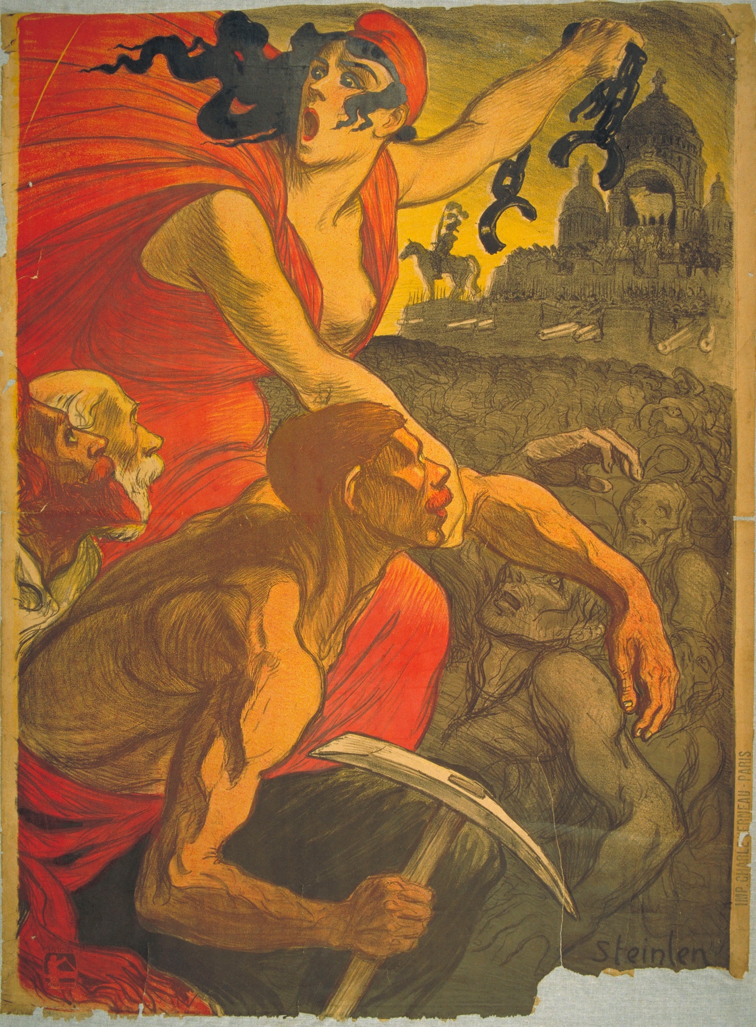
fig. 2.27 Théophile-Alexandre Steinlen, Le petit sou, 1900. Color lithographic poster, 53 in. x 38 in. Petit Palais, Geneva.
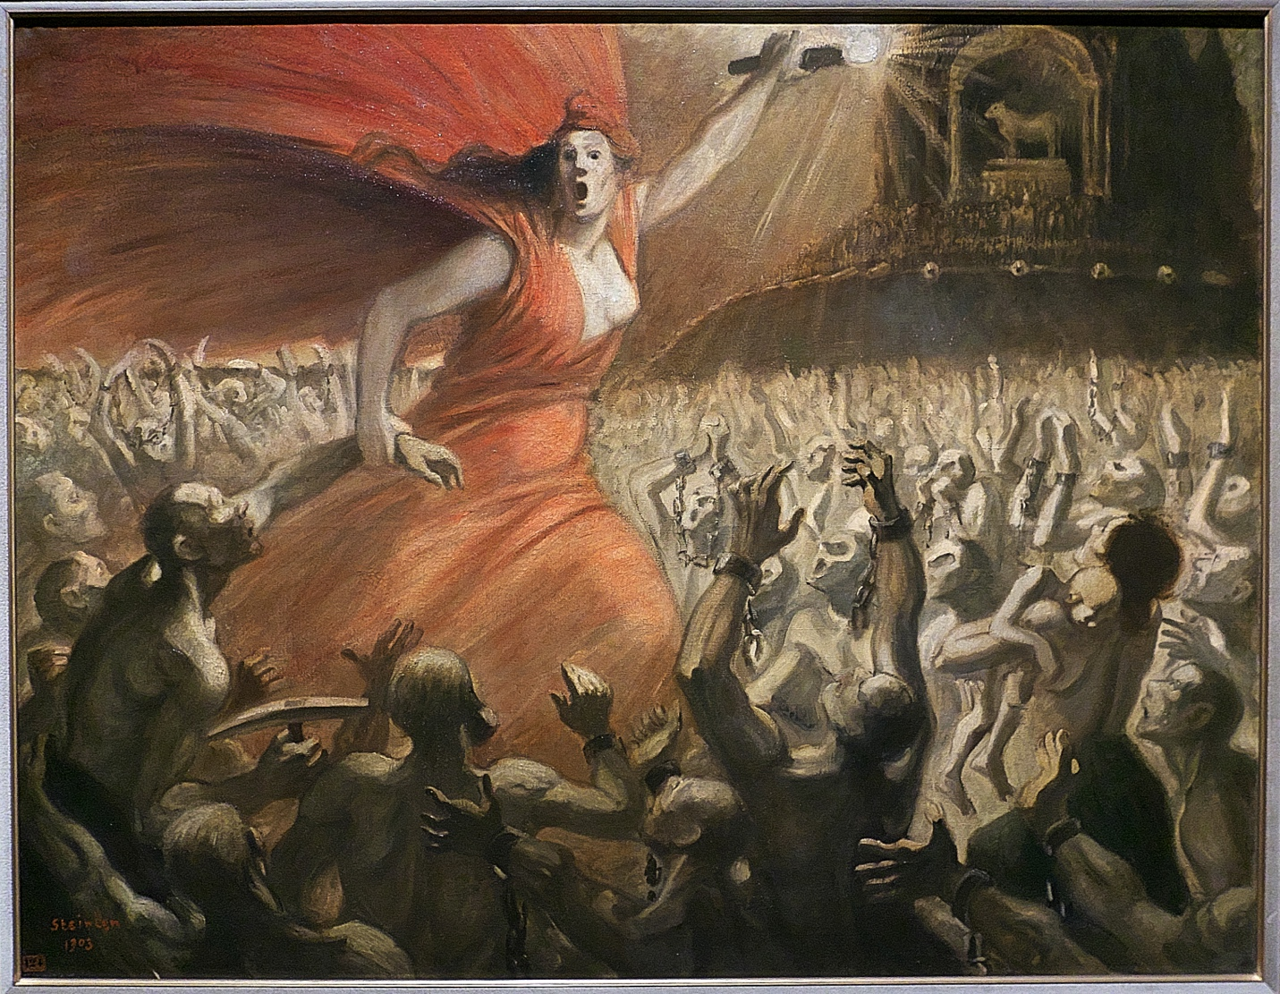
fig. 2.28 Théophile-Alexandre Steinlen, Le libératrice, 1903. Oil on canvas, 45 in. x 57 in. Petit Palais, Geneva.

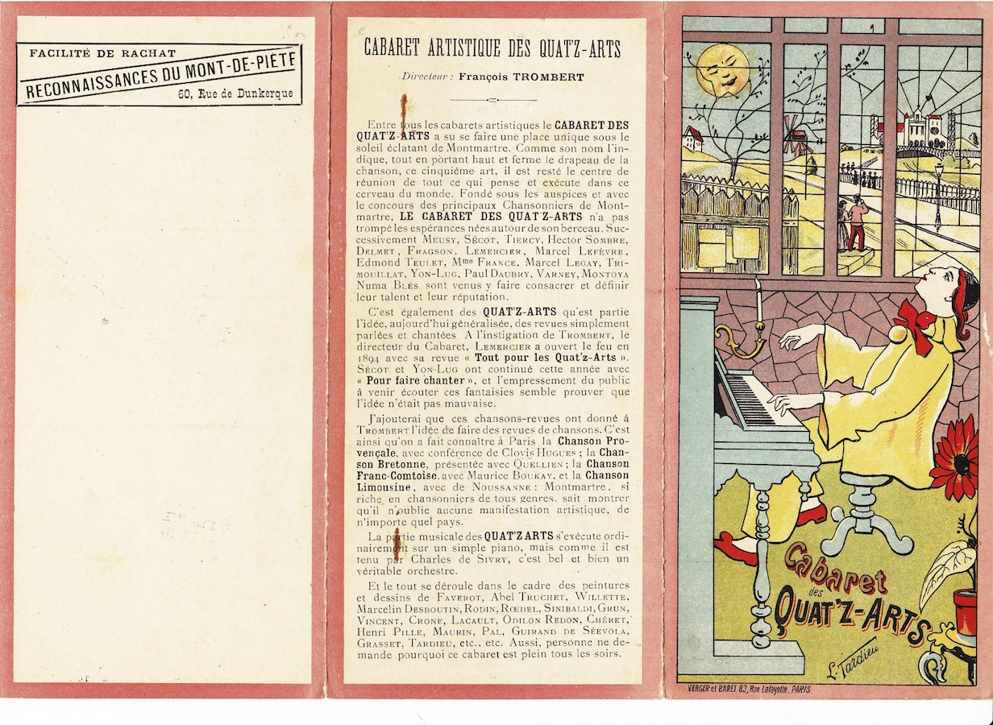
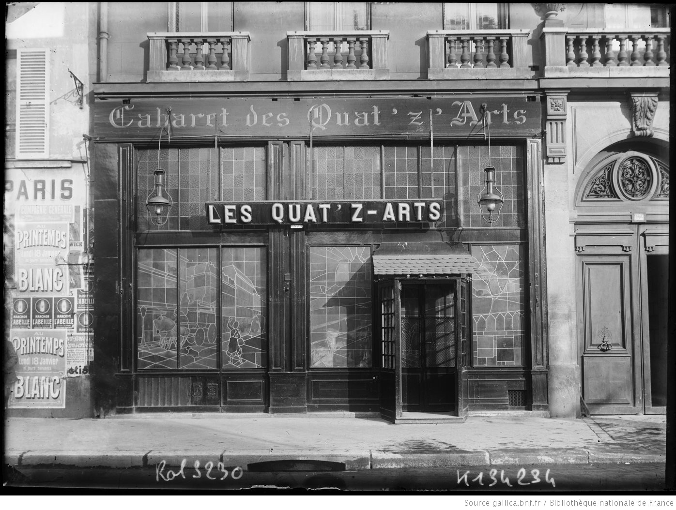
fig. 3.2 Lucien Tardieu, Cabaret Les Quat’z’arts, 1898. Advertising pamphlet.
fig. 3.1 Unknown, exterior of Les Quat’z’arts, c. 1895.
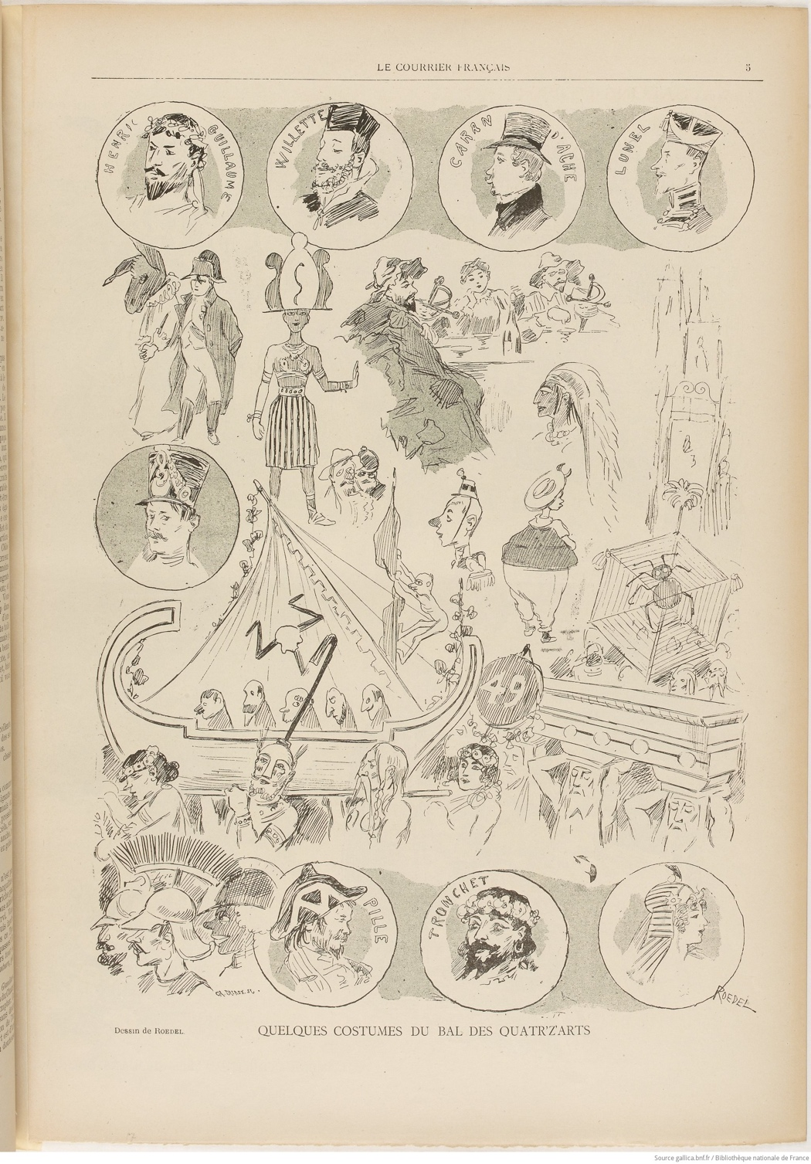
fig. 3.3 August Rœdel, Le Courrier Français #17, April 29, 1894, “Quelques costumes du Bal des Quat’z’arts.” Photorelief.
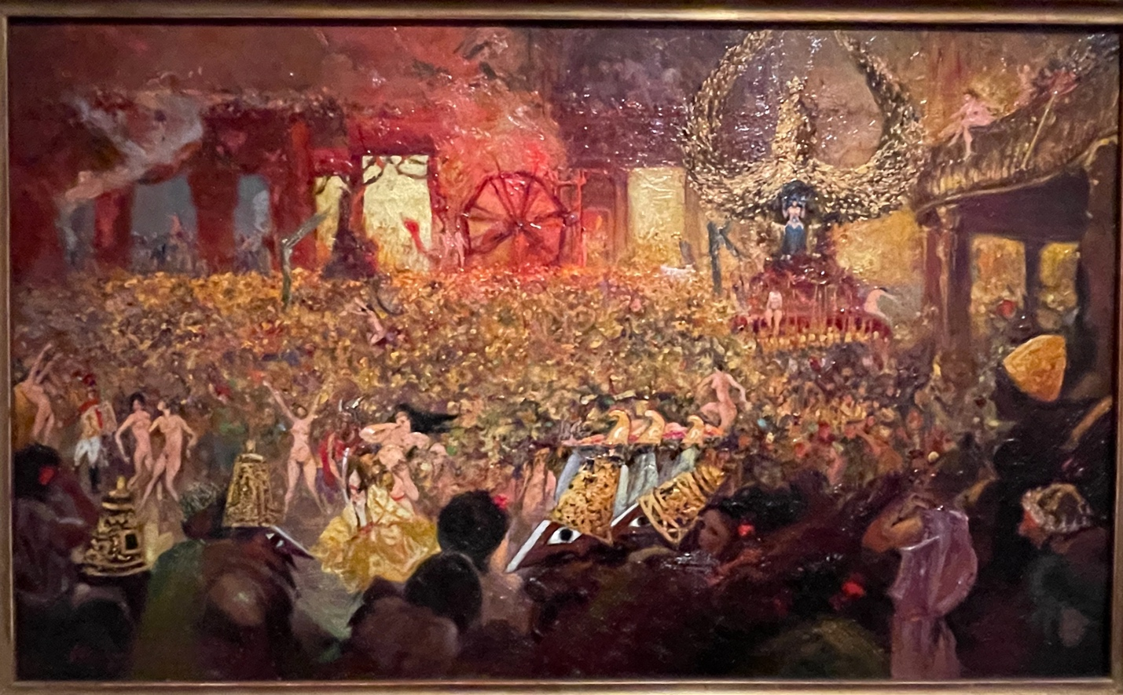
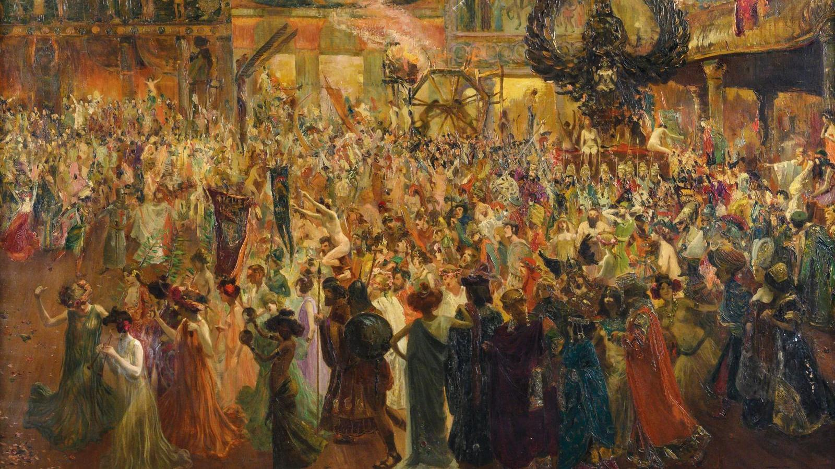
fig. 3.5 Henry de Groux, Bal des Quat’z’arts, 1902. Oil on canvas. Musée de Montmartre, Paris.
fig. 3.4 Louis Able-Truchet, Bal des Quat’z’arts, c. 1903. Oil on canvas.
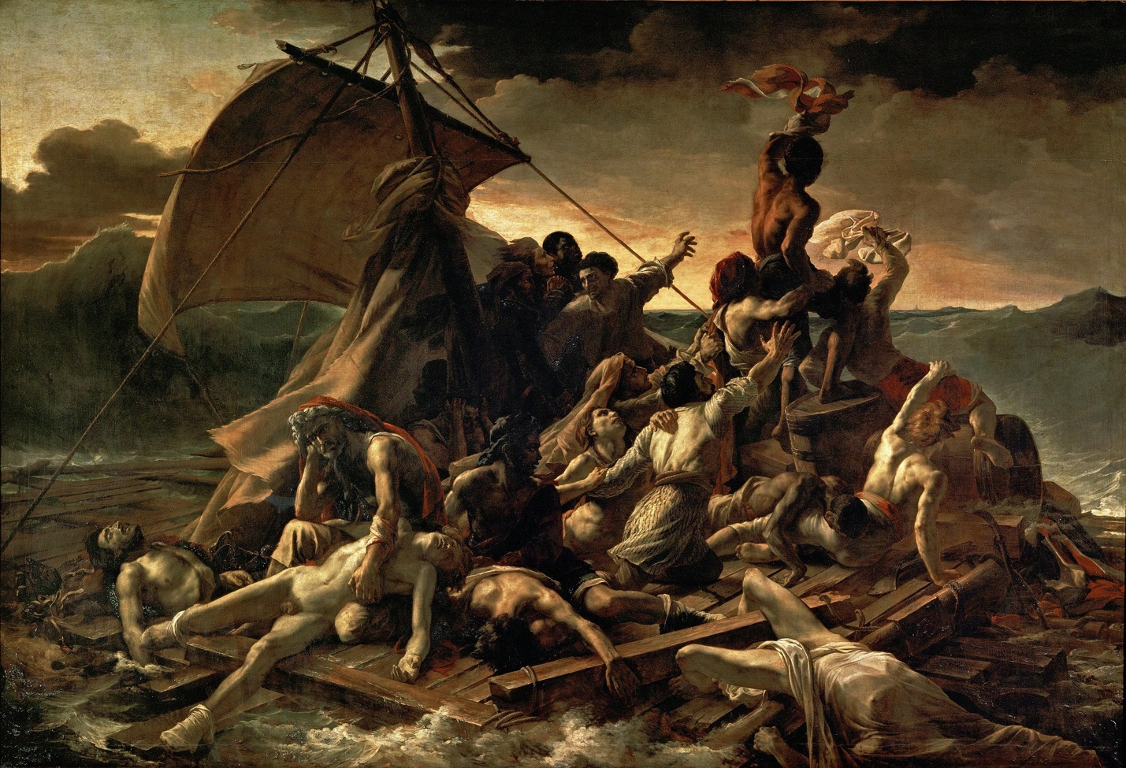
fig. 3.6 Théodore Géricault, The Raft of the Medusa, 1818-1819. Oil on canvas. Louvre, Paris.
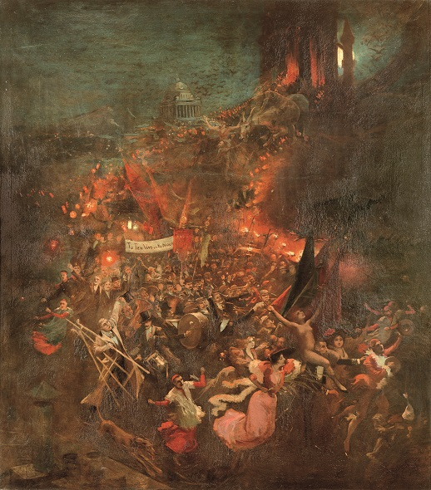
fig. 3.7 Adolphe Willette, Cortège nocturne, 1884. Oil on canvas, 67 in x 59 in. Petit Palais, Geneva.

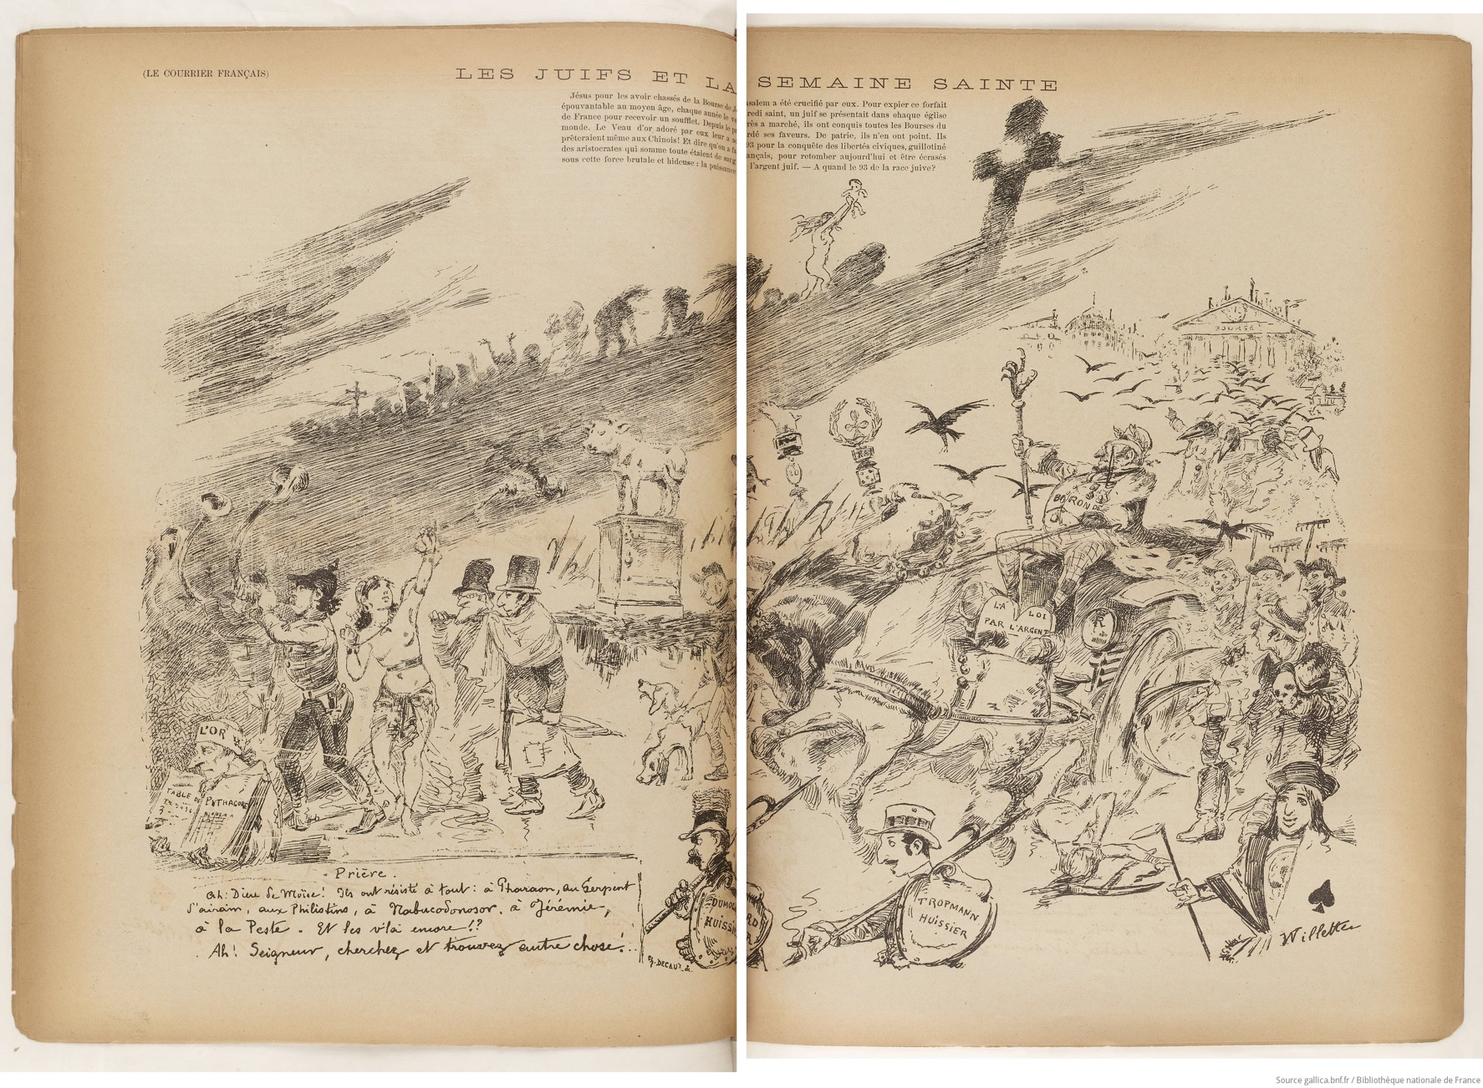
fig. 3.8 Adolphe Willette, Le Courrier Français, April 5, 1885, “Les Juifs et la Semaine Sainte.”
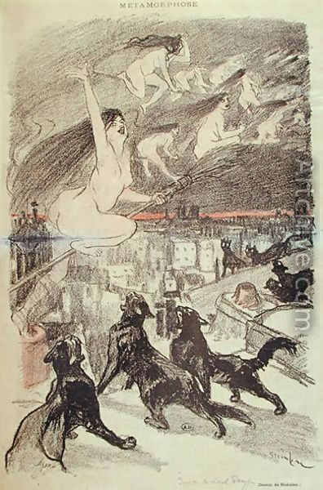
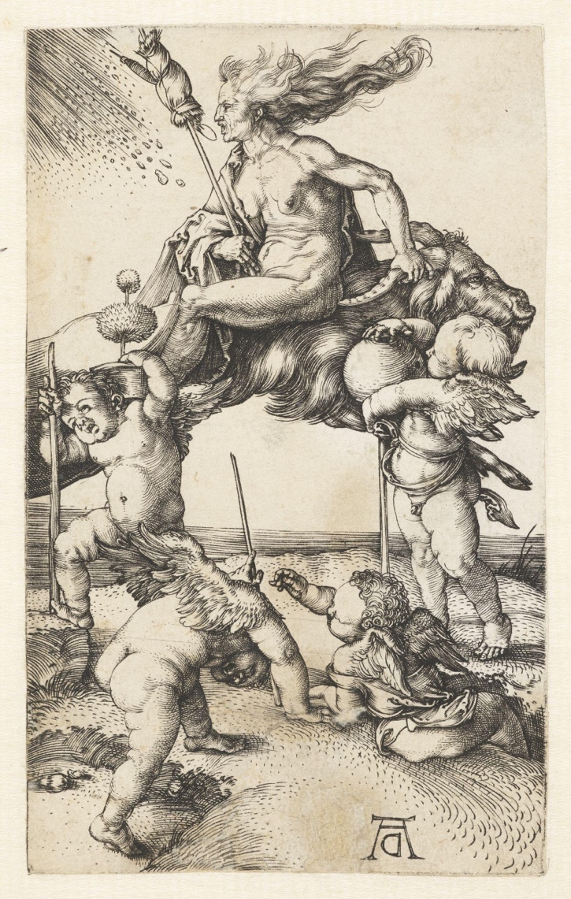
fig. 3.10 Théophile-Alexandre Steinlen, Gil Blas #23, June 4, 1893, “Métamorphose.” Photorelief.
fig. 3.9 Albrecht Dürer, Witch Riding Backwards on a Goat, c. 1500. Print, etching.

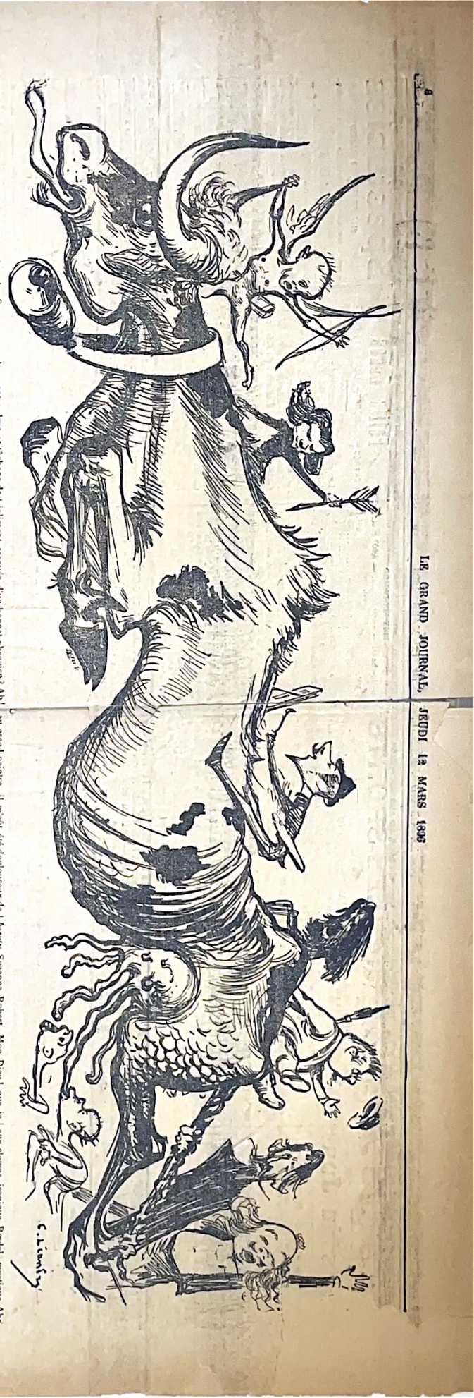
fig. 3.11 Charles Léandre, Le Grand Journal, March 12, 1896, “La Vachalcade Montmartrois.” Photorelief.
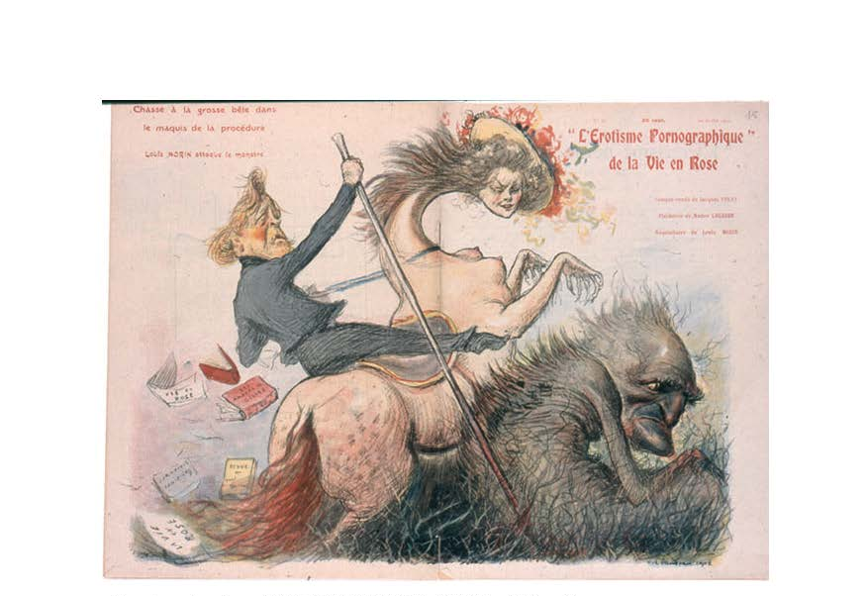
fig. 3.12 Charles Léandre, La Vie en rose, #40, July 20, 1902, “L’Érotisme pornographique.” Photorelief.
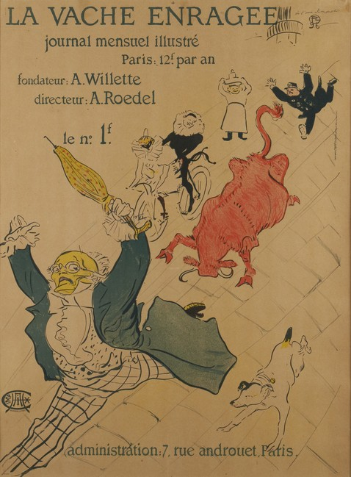
fig. 3.13 Henri de Toulouse-Lautrec, La Vache Enragée, #1, 1896. Photorelief.
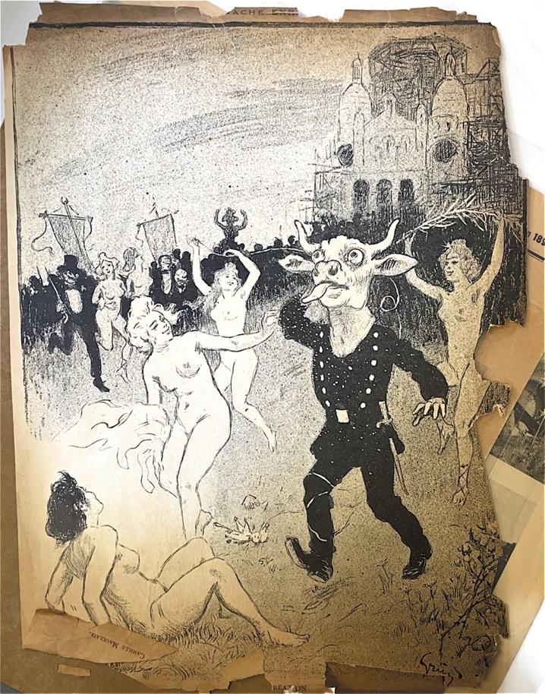
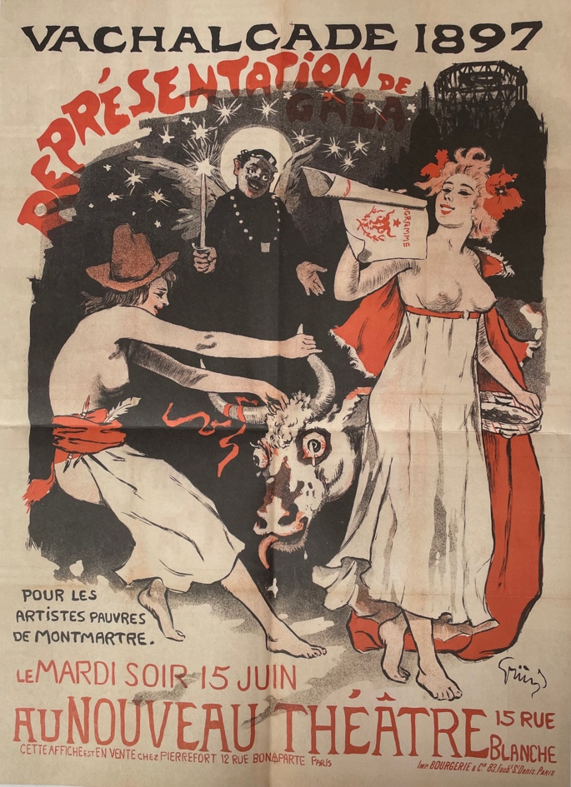
fig. 3.15 Jules-Alexandre Grün, Vachalcade, 1897. Lithograph.
fig. 3.14 Jules-Alexandre Grün, Vachalcade, 1897. Lithograph.
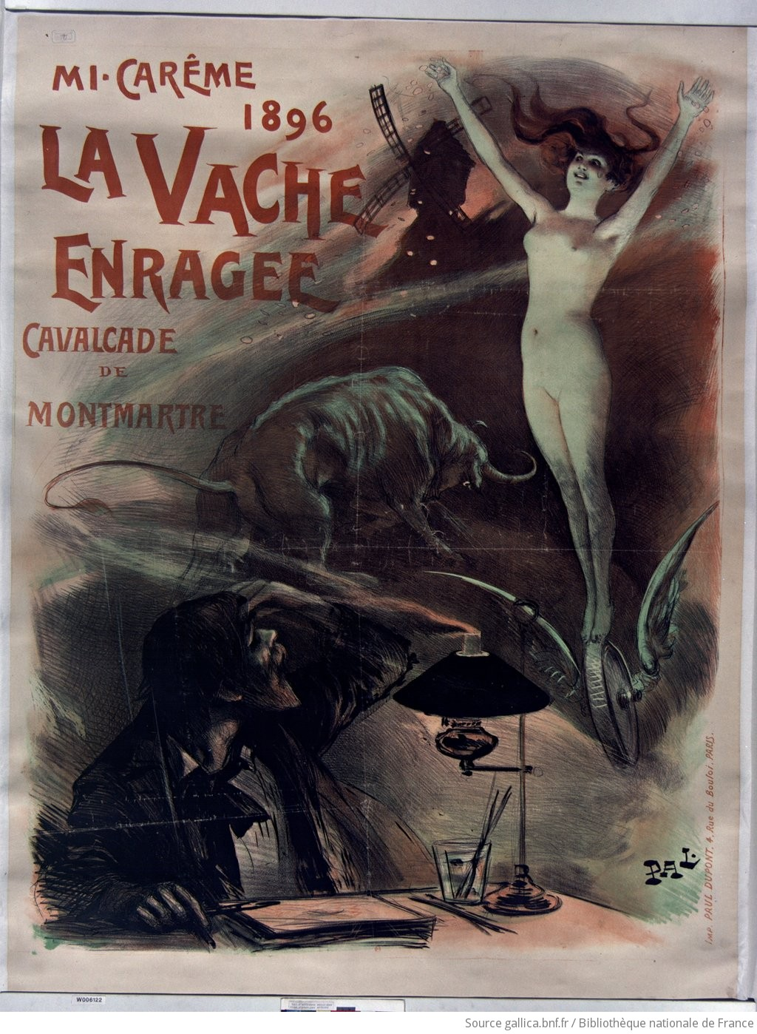
fig. 3.16 PAL, Mi-carême 1896 La Vache enragée cavalcade de Montmartre, 1896, Color lithographic poster.
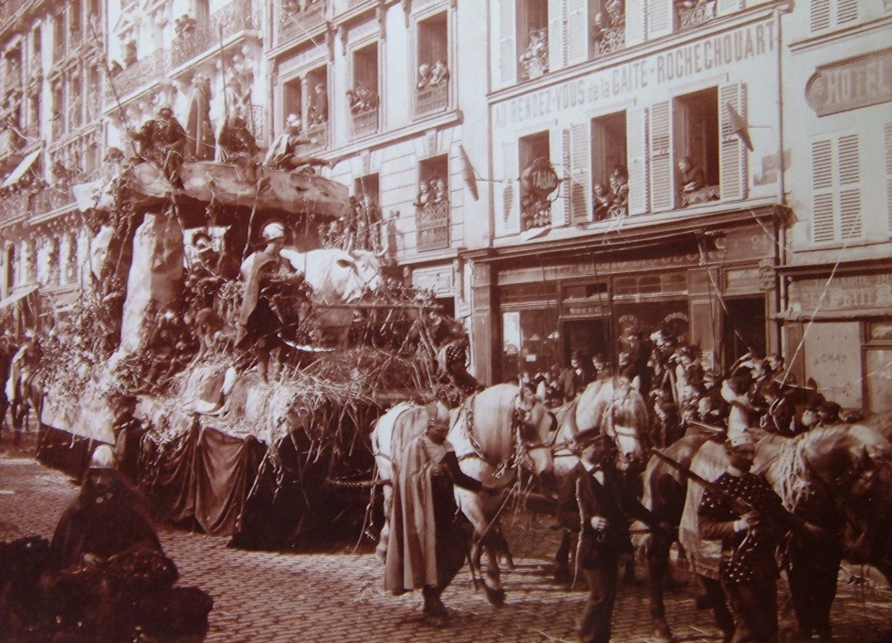
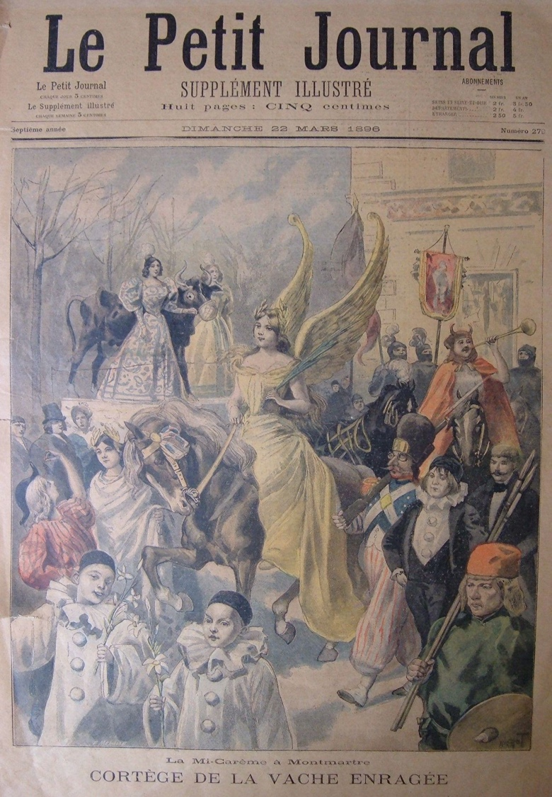
fig. 3.18 Anonymous, Vachalcade, 1896. Photo provided by Laurent Bihl, Bihl-Willette Family Collection.
fig. 3.17 Anonymous, Le Petit Journal, #279, March 22, 1896, “Cortége de la Vache enragée.” Cover.
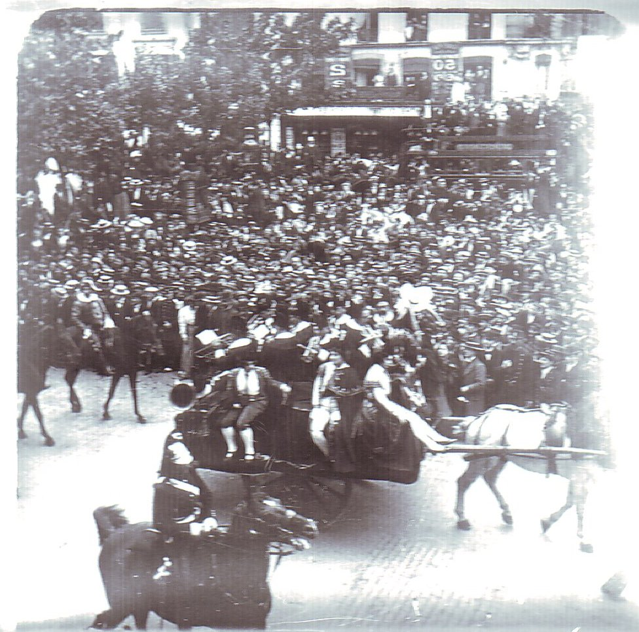
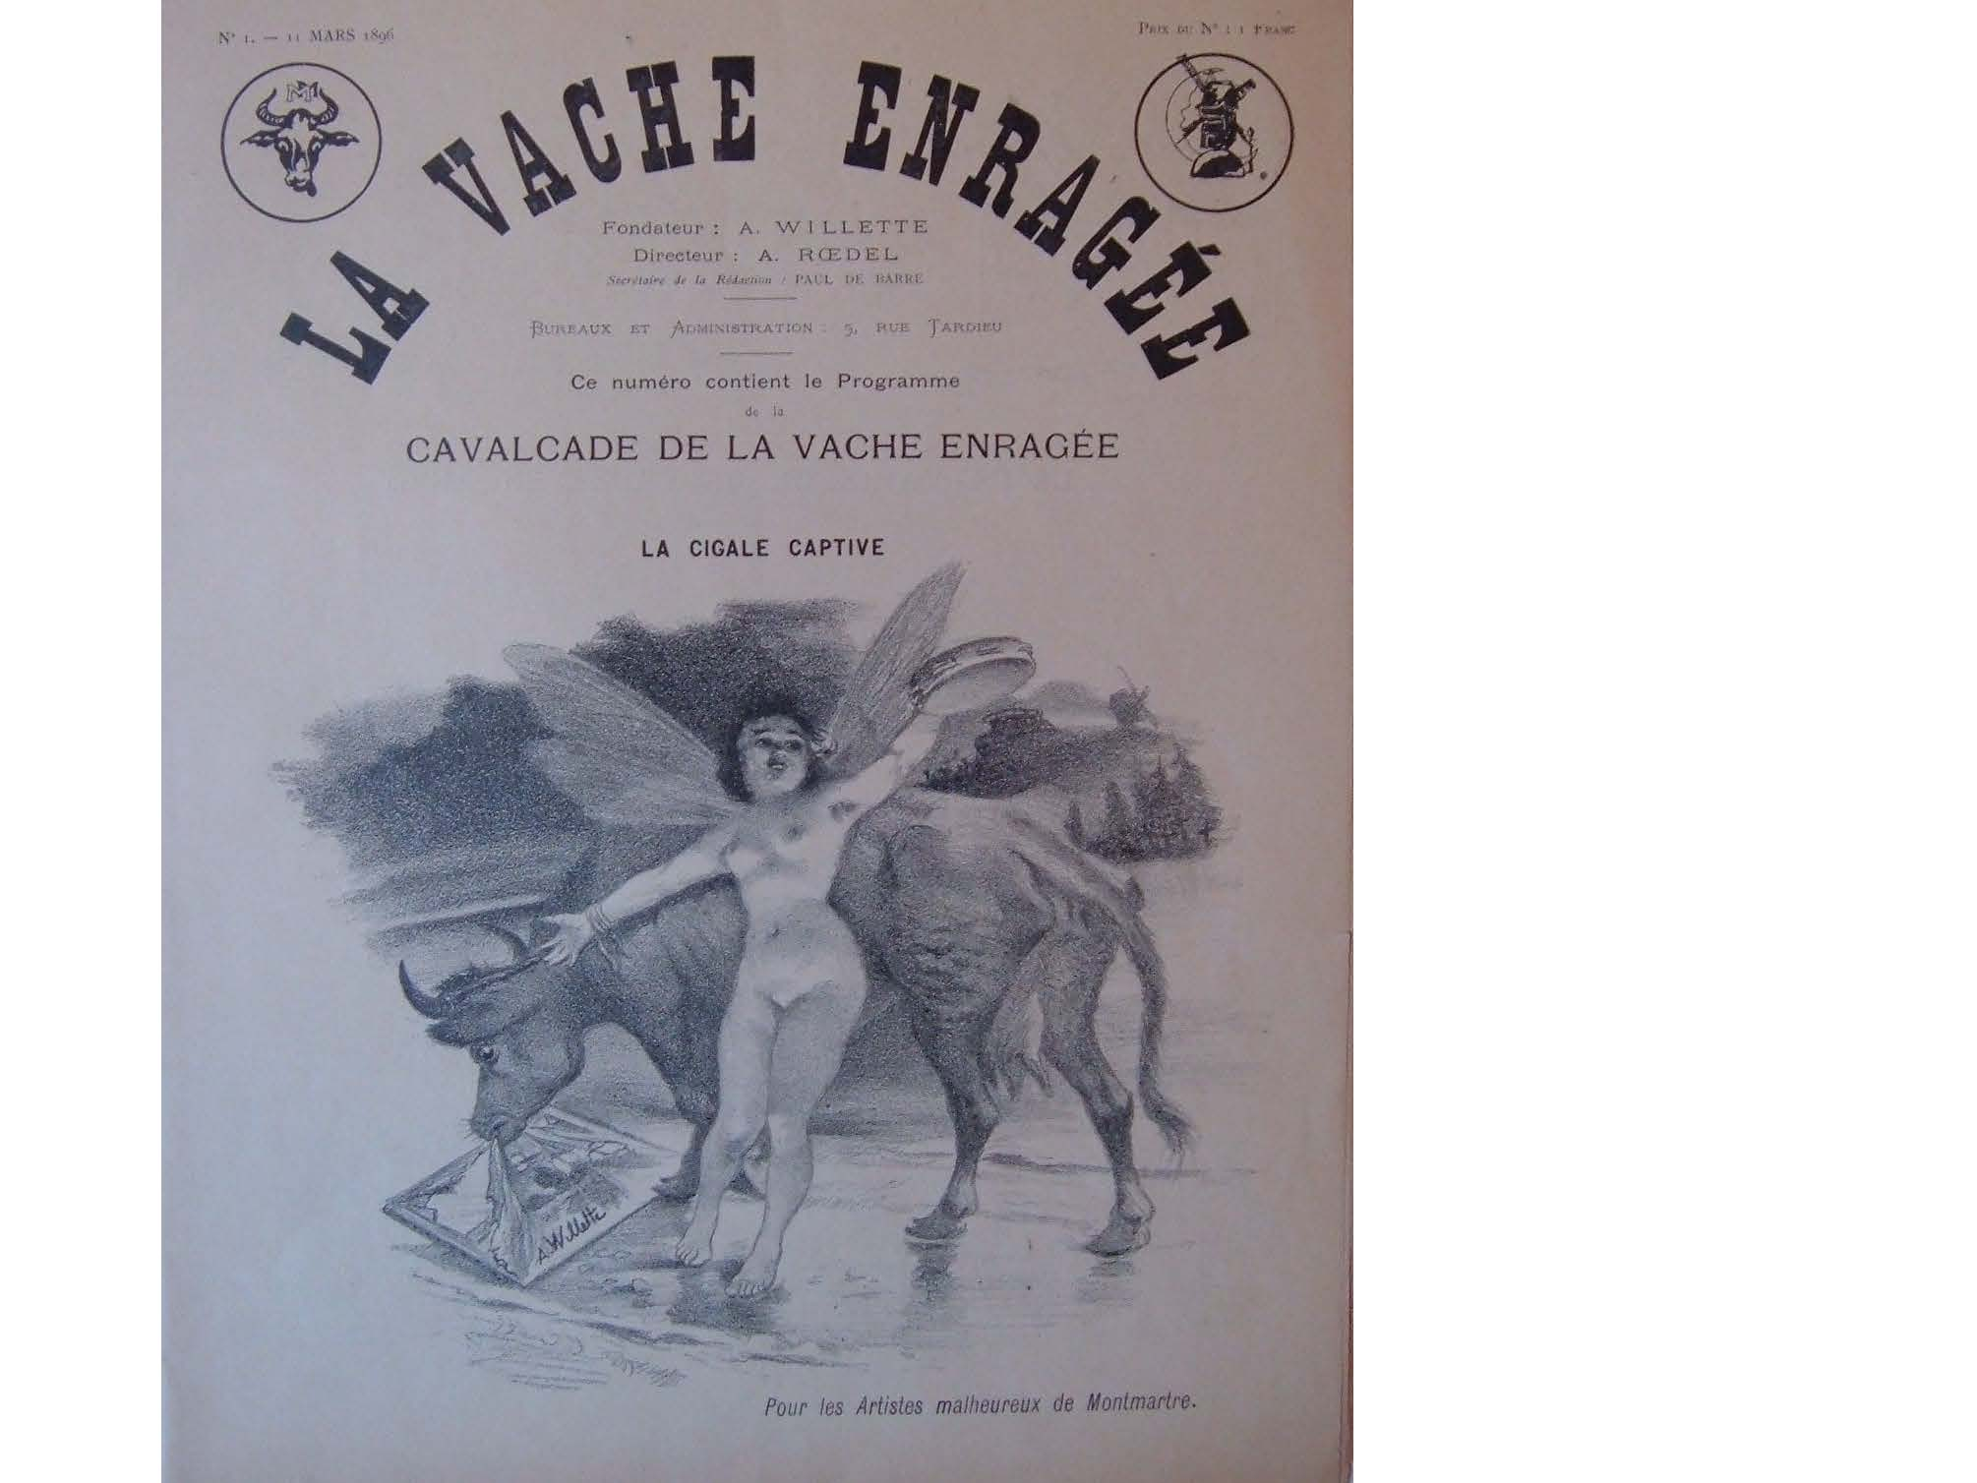
fig. 3.20 Adolphe Willette, La Vache enragée, #1, March 11, 1896, “La Cigale captive.”
fig. 3.19 Anonymous, Vachalcade, 1896. Photo provided by Laurent Bihl, Bihl-Willette Family Collection.
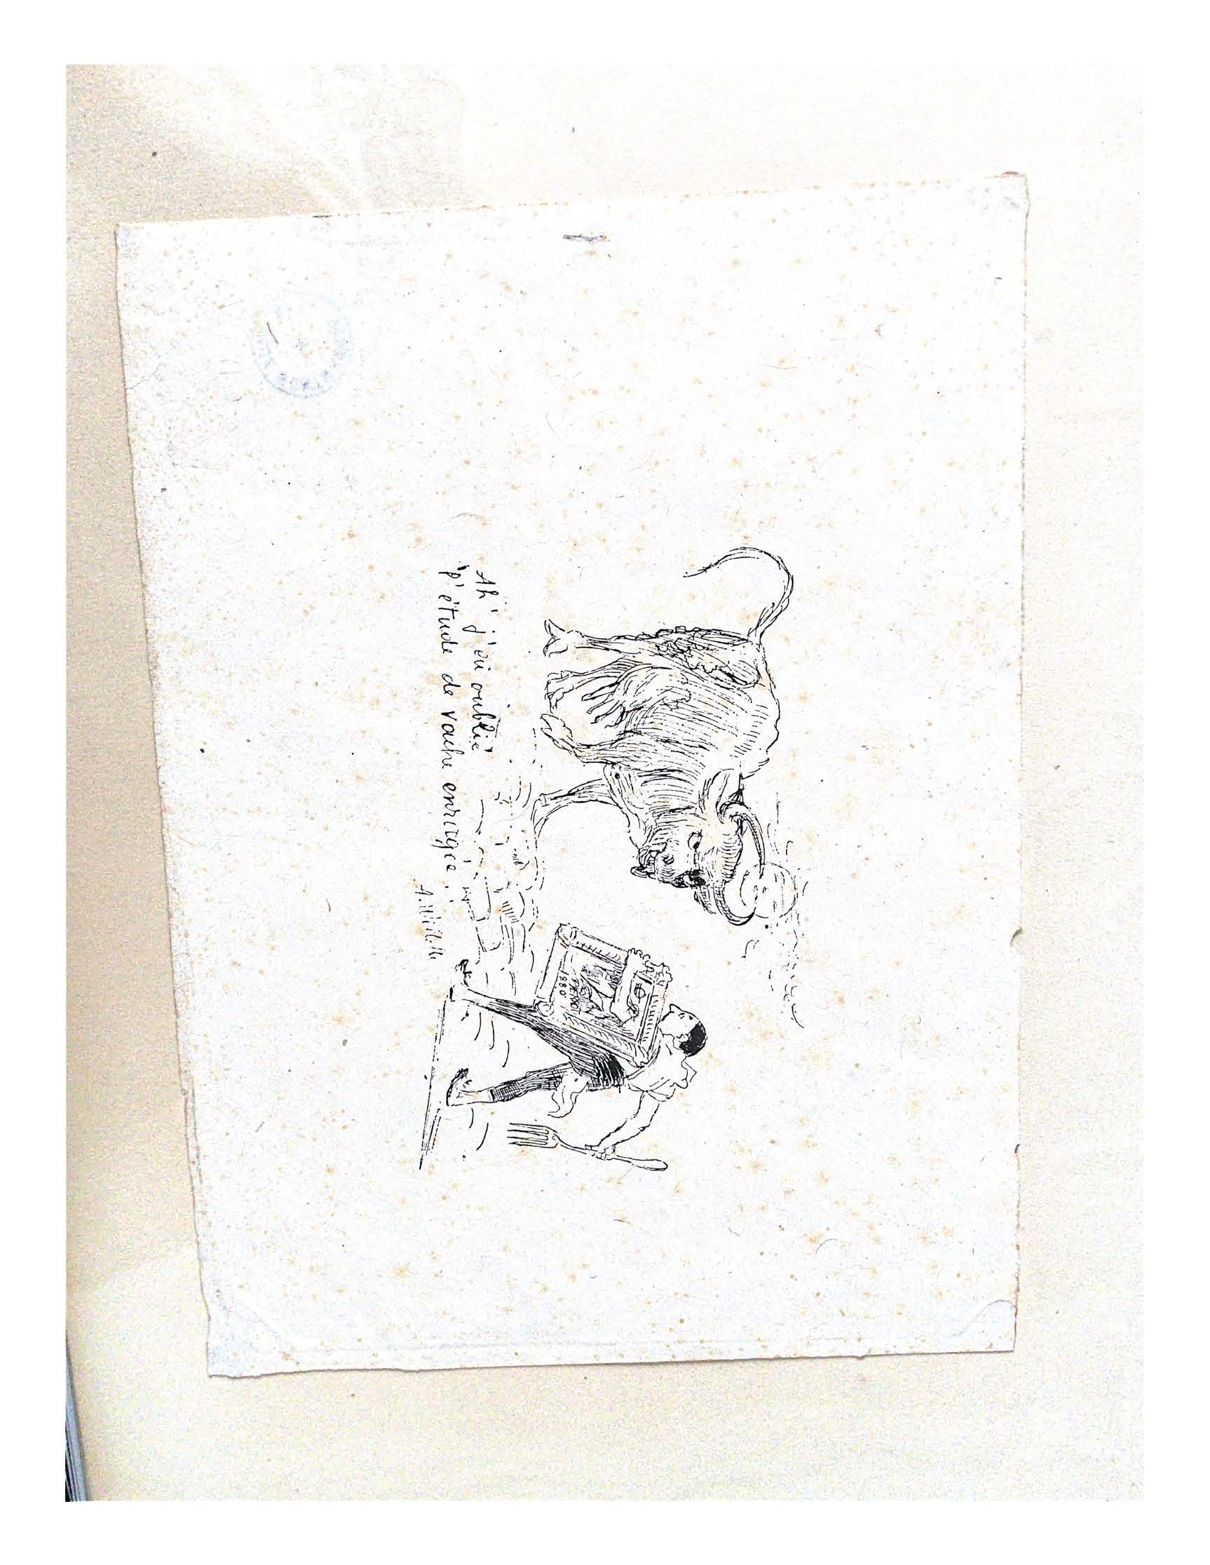
fig. 3.21 Adolphe Willette, Ah! J’ai oublié l’étude de vache enragée. 1897.
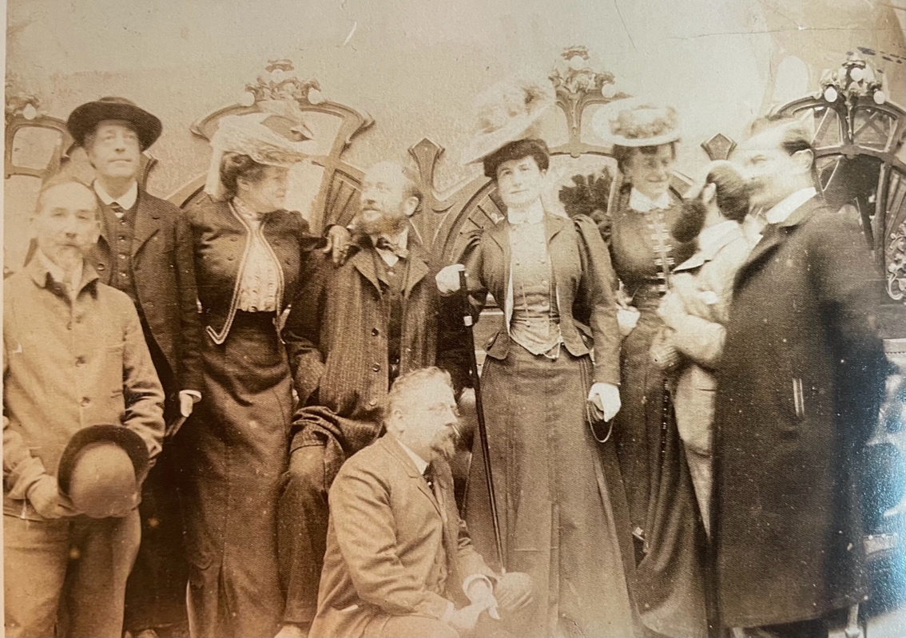
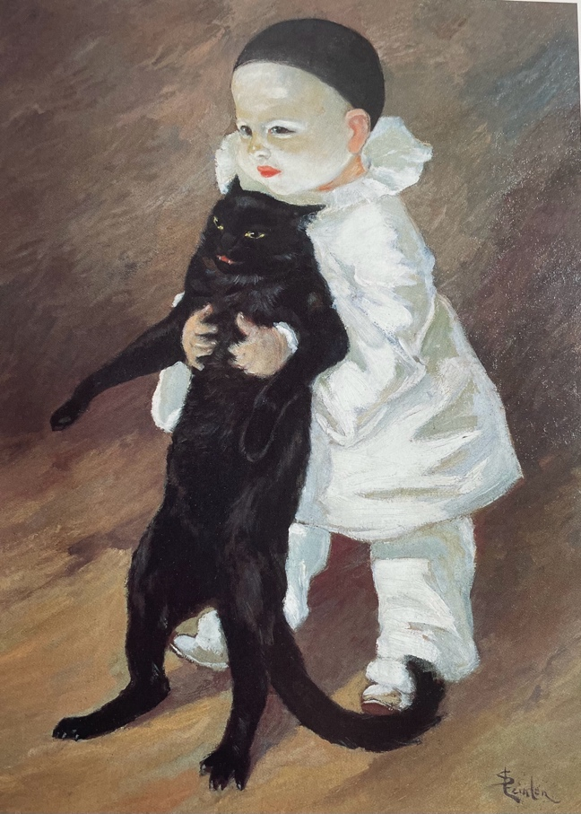
fig. 4.2 Les artistes de la Taverne de Paris en 1905. (left to right: Steinlen, Willette, Mme Métivet, Lucien Métivet, Charles Léandre, madame Léandre, madame Grün, Jules-Alexandre Grün, and the owner, Henri Chailly.
fig. 4.1 Théophile-Alexandre Steinlen, Pierrot et la chat, 1889. Oil on carton. Petit Palais, Paris.

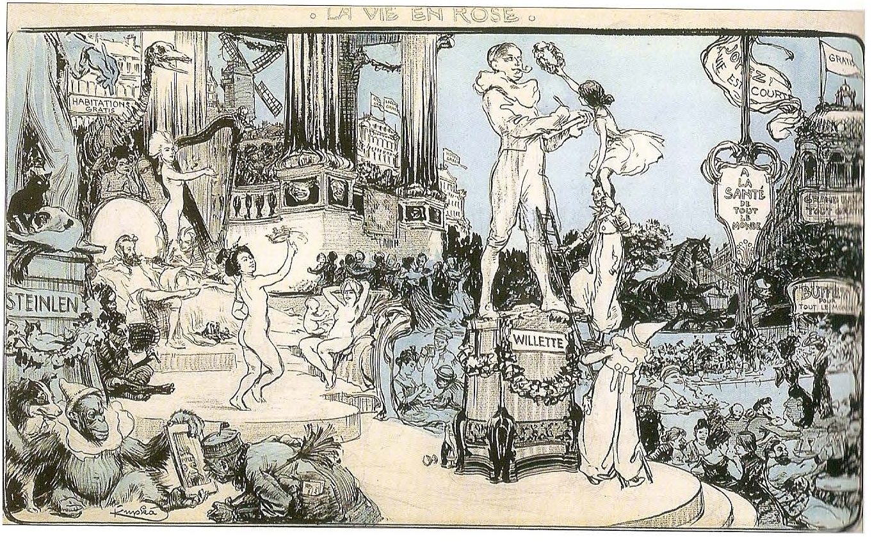
fig. 4.3 František Kupka, La vie en rose, 43, August 10, 1902, “Hommage à Steinlen et Willette.” Crayon and ink, Zimmerli Art Museum.
Bibliography

Appignanesi, Lisa. The Cabaret. New Haven: Yale University Press, 2004.

Arscott, Caroline. William Morris & Edward Burne-Jones: Interlacings. New Haven: Yale University Press, 2008.

Arnold, Dorthea. “An Egyptian Bestiary.” The Metropolitan Museum of Art Bulletin (1995): 1-64.

Bakker, Nienke. “A ‘Man from the North’ in Paris, Van Gogh and Montmartre.” In Esprit Montmartre, Bohemian Life in Paris Around 1900: 191 – 195. Frankfurt: Schirn Kunsthalle, 2014. 191-195.

Bihl, Laurent. “Les deux Vachalcades montmartroises (1896 et 1897).” In Adolphe Willette: 1857-1926: 80-89. L’Isle-Adam: Musée d’Art et d’Histoire Louis-Senlecq, 2014.

———. “L’Armée du Chahut: Les Deux Vachalcades de 1896 et 1897,” Éditions de la Sorbonne 1, no. 27 (2009): 167-191.

Boime, Albert. “The Second Republic’s Contest for the Figure of the Republic.” The Art Bulletin 53, no. 1 (March 1971): 68-83.

Borowitz, Helen O. “Painted Smiles: Sad Clowns in French Art and Literature.” The Bulletin of the Cleveland Museum of Art 17, no.1 (1984): 23-35.

Brigstocke, Julian. The Life of the City: Space Humour, and the Experience of Truth in Fin-de-Siècle Montmartre. New York: Routledge, 2016.

———. “Defiant Laughter: Humour and the Aesthetic of Place in Late 19th Century Montmartre.” Cultural Geographies 19, no. 2 (2012): 217-235.

Bürger, Peter. Theory of the Avant-Garde. Translated by Michael Shaw. Minneapolis: University of Minnesota Press, 1984.

Catlogue de la collection du Chat Noir “Rodolphe Salis.” Paris: Hotel Drouot, 1898.

Cate, Phillip Dennis. “Autour du Chat Noir.” In Autour du Chat Noir: Arts & plaisirs à Montmartre 1880-1910: 20-39. Paris: Musée du Montmartre, 2012.

———. “Montmartre Artists and the Chat Noir Cabaret.” In Collection Weisman & Michel: Fin-de-siècle – Belle époque (1880-1916): 25-57. Paris: Musée de Montmartre, 2019.

———. “Montmartre: The Center of the World.” In Collection Weisman & Michel: Fin-de-siècle – Belle époque (1880-1916): 59-133. Paris: Musée de Montmartre, 2019.

———. “Prints Abound: Paris in the 1890s.” In Prints Abound: Paris in the 1890’s: 12-47. Washington: National Gallery of Art, 2000.

———. “The Social Menagerie of Toulouse-Lautrec’s Montmartre.” In Toulouse-Lautrec and Montmartre: 26-43. Washington: National Gallery of Art and Chicago: The Art Institute of Chicago, 2005.

Cate, Phillip Dennis and Susan Gill. Théophile-Alexandre Steinlen. New Brunswick: Rutgers University Press, 1982.

Cate, Phillip Dennis, Sandrine Nicollier, and Saskia Ooms. L'Esprit de Montmartre et L'Art Moderne 1875-1910. Paris: Musée de Montmartre, 2014.

Cate, Phillip Dennis and Mary Shaw, eds. The Spirit of Montmartre: Cabarets, Humor, and the Avant-Garde, 1875-1905. New Brunswick: Rutgers University Press, 1996.

Cate, Phillip Dennis, Saskia Ooms, et al. Toulouse-Lautrec y el Espíritu du Montmartre. Barcelona: Fundación ‘la Caixa,’ 2018.

Centenaire du Chat Noir. Paris: Musée de Montmartre, 1981.

Champfleury, Jules. Les Chats. Paris, 1869.

Chapin, Mary Weaver. “The Chat Noir and the Cabarets,” in Toulouse-Lautrec and Montmartre. Washington: National Gallery of Art and Chicago: The Art Institute of Chicago, 2005.

———. “Stars of the Café-Concert” In Toulouse-Lautrec and Montmartre. Washington: National Gallery of Art and Chicago: The Art Institute of Chicago, 2005.

Chat Noir-Guide. Paris: Charles Blot, c. 1887.

Childs, Elizabeth. “Big Trouble: Daumier, Gargantua, and the Censorship of Political Caricature.” Art Journal 51 (Spring 1992): 26-37.

Clark, T.J. The Painting of Modern Life: Paris in the Art of Manet and His Followers. Princeton: Princeton University Press, 1984.

Classen, Albrecht. Mediaevistik 32 (2019): 530-532.

Clayson, Hollis. Painted Love: Prostitution in French Art of the Impressionist Era. Los Angeles: Getty Publications, 2005.

Crépiat, Caroline. Le Chat Noir Exposed: The Absurdist Spirit Behind a 19th Century French Cabaret. Translated by Doug Skinner. San Francisco: Black Scat Books, 2021.

Crépiat, Caroline, Denis Saint-Amand, and Julien Schuh, eds. Poétique du Chat Noir. Paris: Presses universitaires de Paris Nanterre. 2021.

Datta, Venita. “A Bohemian Festival: La Fête de la Vache Enragée.” Journal of Contemporary History 28 (April 1993): 195-213.

Emery, Elizabeth and Laura Morowitz. Consuming the Past: The Medieval Revival in fin-de-siècle France. New York: Routledge, 2018.

Fossier, François. Steinlen’s Cats. New York: Harry N. Abrams, Inc., 1990.

Gilhus, Ingvild Salid. “Carnival in Religion: The Feast of Fools in France.” Numen 37, no.1 (1990): 24-52.

Gill, Susan. “Steinlen's Prints: Social Imagery in Late Nineteenth-Century Graphic Art.” The Print Collector's Newsletter 10, no. 1 (1979): 8-12.

Gineste, Raoul. L’art à la Taverne de Paris. Chéret, Abel Faivre, Grün, Léandre, Métivet, Steinlen, Willette, artistes peintres. Emile Robert, ferronnier d’art. Jacques Hermant, architecte. Photogravures de Ducourtioux et Huillard, d’après les chlichés de Simonet. Paris: H. Chailly, 1906.

Gineste, Raoul. “Métamorphose.” Gil Blas 23 (June 4, 1893).

Goudeau, Émile. “Déficit et Vache Enragée.” Les Quat’z’arts (December 17, 1897): 2.

———. La vache enragée. Paris: Paul Ollendorff, 1885.

———. “Cavalcade de la ‘vache enragée.’” Le Temps (February 10, 1896): 2-4.

———. Ten Years a Bohemian. Translated by Richard Robinson. Portland: Sunny Lou, 2022. First published as Dix ans de Bohème. Paris, 1888.

Grand-Carteret, John. Raphaël et Gambrinus, ou, L’arts dan la brasserie. Paris: Louis Wethausser, 1886.

Grigsby, Darcy Grimaldo. Extremities: Painting Empire in Post-Revolutionary France. New Haven: Yale University Press, 2002.

Guillemot, Maurice. La Mort de Pierrot. Paris: Libraire de la Société des gens de lettres, 1889.

Hambourg, Maria Morris and John Szarkowski. The Work of Atget. New York: The Museum of Modern Art, 1981.

Harvey, David. Paris, Capital of Modernity. New York: Routledge, 2006.

Herbert, Robert L. and Eugenia W. Herbert. “Artists and Anarchism: Unpublished Letters of Pissarro, Signac and Others.” The Burlington Magazine 103, no. 692 (1960): 472-482.

Hewitt, Nicholas. Montmartre A Cultural History. Liverpool University Press, 2020.

Houchin, John. “The Origins of the ‘Cabaret Artistique.’” The Drama Review: TDR 28, no. 1 (1984): 5-14.

Hugo, Victor. Les Misérables. Translated by Isabel F. Hapgood. Digireads.com Publishing, 2016. First published in Paris, 1862.

Hugo, Victor. Notre-Dame de Paris. Translated by John Sturrock. New York: Penguin Random House, 2018. First published in Paris, 1831.

Hults, Linda C. Witch as Muse: Art, Gender, and Power in Early Modern Europe. Philadelphia: University of Pennsylvania Press, 2005.

Hyman, Paula. “The Dreyfus Affair: The Visual and the Historical.” The Journal of Modern History 28, no. 1 (1989): 88-109.

———. “New Perspectives on the Dreyfus Affair.” Historical Reflections / Réflxions Historiques 31, no. 3 (2005): 335-349.

Jonas, Raymond. “Vox Dei, Vox Populi: Sacred Art and Popular Culture in Late Nineteenth-Century France.” Studies in the Hisotry of Art 68 (2005): 194-207.

Kaenel, Phillipe. Steinlen: L’œil de la rue. Lausanne: Musée cantonal des Beaux-Arts, 2009.

Kalifa, Dominique. Vice, Crime, and Poverty: How the Western Imagination Invented the Underworld. New York: Columbia University Press, 2013.

Kenny, Nicholas. “Je Cherche Fortune: Identity, Counterculture, and Profit in Fin-de-siècle Montmartre.” Urban History Review. 32, no. 2 (2004): 21-32.

Lay, Howard G. “Pictorial Acrobatics.” In Montmartre and the Making of Mass Culture. Edited by Gabriel P. Weisberg: 145-179. New Brunswick: Rutgers University Press, 2001.

Lehardy, Jacques. “Montmartre.” Le Chat Noir 1 (January 14, 1882).

Levack, Brian. The Witch-Hunt in Early Modern Europe. London and New York: Longman, 1987.

Mainardi, Patricia. The End of the Salon: Art and the State in the Early Third Republic. Cambridge: Cambridge University Press, 1993.

McCallam, David. “Waxing Revolutionary: Reflections on a Raid on a Waxworks at the Outbreak of the French Revolution.” French History 16, no. 2 (2002): 153-173.

Morowitz, Laura. “Anti-Semitism, Medievalism and the Art of the Fin-de-Siècle.” Oxford Art Journal 20 (1997): 35-49.

Morrow, W.C. Bohemian Paris of To-Day. Philadelphia: J.B. Lippencott Company, 1900.

Munholland, John Kim. “Republican Order and Republican Tolerance in fin-de-siècle Montmartre.” In Montmartre and the Making of Mass Culture: 15-36. New Brunswick: Rutgers University Press, 2001.

Oberthür, Mariel. Le cabaret du Chat Noir à Montmartre (1881-1897). Geneva: Éditions Slatkine, 2007.

Piantoni, Antoine. “Le Contes du Chat Noir de Rodolphe Salis.” In Poétique du Chat Noir: 325-340. Paris: Presses universitaires de Paris Nanterre. 2021.

Pfeiffer, Ingrid and Max Hollein, eds. Esprit Montmartre: Bohemian Life in Paris Around 1900. Frankfurt: Schirn Kunsthalle, 2014.

Programme de La Vachalcade. Paris, 1897.

Rearick, Charles. Pleasures of the Belle Epoque: Entertainment & Festivity in Turn-of-the-Century France. New Haven: Yale University Press, 1985.

Schiau, Daina B. “L’or et le noir: le Chat Noir et la transfiguration du lieu du spectacle.” In Autour du Chat Noir: Arts & plaisirs à Montmartre, 1880-191: 40-53. Paris: Musée de Montmartre, 2012.

Seigel, Jarrold. Bohemian Paris: Culture, Politics, and the Boundaries of Bourgeois Life, 1830-1930. Baltimore: Johns Hopkins University Press, 1986.

Sonn, Richard D. Anarchism & Cultural Politics in Fin de Siècle France. Lincoln: University of Nebraska Press, 1989.

Steinlen 1885-1923: Affiche et Lithographies. Paris: Musée de l’Affiche et de la Publicité. 1988: 1-4.

Thomson, Richard, “Introducing Montmartre.” In Toulouse-Lautrec and Montmartre. Washington: National Gallery of Art and Chicago: The Art Institute of Chicago: 65-70, 2005.

Van Herk, Magdaleen. Steinlen: Of Cats and Men. Amsterdam: KatttenKabinet, 1995.

Velbel, Horace. Les Chansonniers et les cabarets artistiques de Paris. Paris: E. Dentu, 1895.

Verhagen, Marcus. “Bohemia in Doubt.” In The Nineteenth-Century Visual Culture Reader, edited by Vanessa R. Schwartz and Jeannene M. Przyblyski: 327-337. New York: Routledge, 2004.

Vircondelet, Alain. In the Footsteps of Toulouse-Lautrec: Nights of the Belle Epoque. Eckbolsheim: Éditions du Signe, 2019.

Wagneur, Jean-Didier. “La bohème de Pierrot.” In Adolphe Willette, 1857-1926: 52-76. Paris: Lienart Editions, 2014. 52-76.

Weisberg, Gabriel P., ed. Montmartre and the Making of Mass Culture. New Brunswick: Rutgers University Press, 2001.

Willette, Adolphe. “Édouard Drumont, l’auteur de la France Juive.” Courrier Français 3, no 20 (May 16, 1886).

Willette, Adolphe. Feu Pierrot: 1857 – 19? Paris: Floury, 1919.

Willette, Adolphe. “Le Calvaire de la vache enragée.” La Vache enragée, March 11, 1896.

Willette, Adolphe. “Le Vache enragée.” Le Petit Moniteur, March 5, 1896.

Willette, Luc. Adolphe Willette, Pierrot de Montmartre. Précy-sous-Thil: Éditions de l’Amrançon, 1991.

Zmelty, Nicholas-Henri. “Le Parce Domine.” In Adolphe Willette 1857-1926: 77. Paris: Lineart éditions, 2014.

Zola, Émile. “J’Accuse!.” L’Aurore 2, no. 87 (1898): 1-4.

Julian Brigstocke, Life of the City: Space, Humour, and the Experience of Truth in Fin-de-Siècle Montmartre (New York: Routledge, 2016), xiii.
John Kim Munholland, “Republican Order and Republican Tolerance in Fin-de-Siècle France,” in Montmartre and the Making of Mass Culture, ed. Gabriel P. Weisberg (New Brunswick: Rutgers University Press, 2001), 17.
Phillip Dennis Cate and Susan Gill, eds. Théophile-Alexandre Steinlen (New Brunswick: Rutgers University Press, 1982), 105.
The 1996 exhibition, The Spirit of Montmartre: Cabarets, Humor, and the Avant-Garde, 1875 – 1905 mounted by the Zimmerli Art Museum at Rutgers University, New Jersey appears to be the first to popularize the term. The exhibit was curated by Phillip Dennis Cate. Following that were the exhibits Esprit Montmartre: Bohemian Life in Paris Around 1900 (Schirn Kunsthalle, Frankfort in 2014), L’Esprit de Montmartre et L’Art Monderne: 1875 – 1910 (Musée de Montmartre, Paris in 2014), Toulouse-Lautrec y el Esprítu de Montmartre (Fundación “la Caixa,” Barcelona in 2018), and the book, The Life of the City: Space Humour, and the Experience of Truth in Fin-de-siècle Montmartre by Julian Brigstocke (2016) are just a few of the titles to replicate the idea that there was, in fact, a “Spirit” in this place.
Brigstocke, Life of the City, 1.
The Société le Vieux Montmartre manages a collection of 6,000 works of art and over 1000,000 documents that detail the history of Montmartre. The Vieux Montmartre works closely with the Musée de Montmartre, yet both are independent organizations that share the same tiny campus on the hill. In collaboration, the two also produce exhibits and support scholarly research. The Vieux Montmartre was exceedingly generous in opening up their archives for this project.
Nicholas Hewitt, Montmartre A Cultural History (Liverpool University Press, 2020), 24.
Richard D. Sonn, Anarchism & Cultural Politics in Fin de Siècle France (Lincoln: University of Nebraska Press, 1989), 72-73. Also in Brigstocke, Life of the City, 92-97.
The brief life of Henri de Toulouse-Lautrec and his time in fin-de-siècle Montmartre is arguably the most famous example of those who defined art in this place. Although not the focus of this study, the significance of his Montmartre output is certainly not to be dismissed.
Phillip Dennis Cate, “L'Esprit de Montmartre et L'Art Moderne, 1875-1910” in L'Esprit de Montmartre et L'Art Monderne 1875-1910 (Paris: Musée de Montmartre, 2014), 26-27.
Quoted in Jarrold Seigel, Bohemian Paris: Culture, Politics, and the Boundaries of Bourgeois Life, 1830-1930, (Baltimore: Johns Hopkins University Press, 1986), 4. From Honoré de Balzac, “Un prinde de la Bohème,” Oeuvres completes de Balzac, 24 vols. (Club de l’Honnête Homme, 1956), 294-295.
Seigel, Bohemian Paris, 401- 404.
Hewitt, Cultural History, 32. Hewitt also points out that for all of their subversive and critical treatment of the bourgeois, many of the artists of fin-de-siècle Montmartre came from those same bourgeois backgrounds. Both Willette and Steinlen came from upper middle-class families.
Phillip Dennis Cate, “The Social Menagerie of Toulouse-Lautrec’s Montmartre,” in Toulouse-Lautrec and Montmartre (Washington: National Gallery of Art and Chicago: The Art Institute of Chicago, 2005), 27.
Lisa Appignanesi, The Cabaret (New Haven: Yale University Press, 2004), 5.
Nicholas Kenny, “Je Cherche Fortune: Identity, Counterculture, and Profit in Fin-de-siècle Montmartre,” Urban History Review 32, no. 2 (2004): 21.
Sonn, Anarchism, 78-88.
Sonn, Anarchism, 78.
For more on the poets, singers, shadow puppet theatre, and other aspects of Montmartre cabaret life not specifically addressed in this work, see Caroline Crépiat, Le Chat Noir Exposed: The Absurdist Spirit Behind a 19th Century French Cabaret, trans. Doug Skinner (2021) and Poétique du Chat Noir, eds. Crépiat, Denis Saint-Amad, and Julien Schuh (Paris: Presses universitaires de Paris Nanterre, 2021); Mariel Oberthür, Le Cabaret du Chat Noir à Montmartre (1881-1897) (Geneva: Éditions Slatkine, 2007); and Phillip Dennis Cate and Mary Shaw, eds., The Spirit of Montmartre: Cabarets, Humor, and the Avant-Garde, 1875 – 1905 (New Brunswick: Rutgers University Press, 1996).
Émile Zola, quoted in “Souvinirs des Goncourts,” in La Revue encyclopédique, no. 153 (August 8, 1896): 552.
David Harvey, Paris, Capital of Modernity (New York: Routledge, 2006), 3.
Maria Morris Hambourg and John Szarkowski, The Work of Atget (New York: The Museum of Modern Art, 1981), 12-13.
Hambourg and Szarkowski, Atget, 167.
Nienke Bakker, “A ‘Man from the North’ in Paris, Van Gogh and Montmartre” in Esprit Montmartre, Bohemian Life in Paris Around 1900, eds. Ingrid Pfeiffer and Max Hollein, (Frankfurt: Schirn Kunsthalle, 2014), 192.
Harvey, Paris, 209-212.
Hewitt, Cultural History, 35-63.
T.J. Clark, The Painting of Modern Life: Paris in the Art of Manet and His Followers (Princeton: Princeton University Press, 1984), 9. Clark references Guy Debord, La Société du spectacle (Paris, 1967), 24.
Hewitt, Cultural History, 26-27.
Harvey, Paris, 325-329.
Harvey, Paris, 28.
Brigstocke, Life of the City, 75.
“La proclamation suivant a été affichée tous les murs de Montmartre: République Française!” Le Mont-Aventin: Echo des Buttes Montmartre, no. 2 (March 26, 1871).
“Il est grand temps de rectifier une erreur qui a pesé sur plus de soixante gérérations completes. L’Ecriture que l’on dit sainte – je ne sais trop pourqoui – n’a fait pour parler poliment, que se moquer du peuple.” Jacques Lehardy, “Montmartre,” Le Chat Noir, no. 1 (January 14, 1882).
Brigstock, Life of the City, 105.
Richard Thompson, “Introducing Montmartre,” in Toulouse-Lautrec and Montmartre (Washington: National Gallery of Art and Chicago: The Art Institute of Chicago, 2005), 66.
Paula Hyman, “The Dreyfus Affair: The Visual and the Historical,” The Journal of Modern History 28, no.1 (1989): 91.
Paula Hyman, “New Perspectives on the Dreyfus Affair,” Historical Reflections 31, no. 3 (2005): 336.
Hyman, “The Dreyfus Affair,” 99.
“Ils sont cinquante mille à bénéficier seuls du travail acharné et sans espérance de trente million de Français devenus leurs esclaces tremblants,” Adolphe Willette, lithograph campaign poster, 1889.
Seigel, Bohemian Paris, 279.
Émile Zola, “J’Accuse!” L’Aurore 2 no. 87 (January 13, 1898): cover.
Cate and Gill, Steinlen, 100.
Elizabeth Emery and Laura Morowitz, Consuming the Past: The Medieval Revival in fin-de-siècle France (New York: Routledge, 2018), 35.
Laura Morowitz, "Anti-Semitism, Medievalism and the Art of the Fin-de-Siècle," Oxford Art Journal 20, no.1 (1997): 35.
Elizabeth Childs, “Big Trouble: Daumier, Gargantua, and the Censorship of Political Caricature,” Art Journal, 51 no. 1 (Spring 1992): 26.
Emery & Morowitz, Consuming the Past, 183-184.
Chat Noir-Guide (Paris: Charles Blot, c. 1887), 5-8.
Emery and Morowitz, Consuming the Past, introduction. Also in Venita Datta, “A Bohemian Festival: La Fête de la Vache Enragée,” Journal of Contemporary History 28 no. 2 (April 1993): 200.
“Le Chat Noir n’etait pas une Société organinée, ni un cercle fermé; y entrait qui voulait et sans courir le risque d’être brimé grossièrement… Malgré les carrières et les talents divers, ce n’ètait pas non plus, comme on l’a cru, une chappelle d’admirational mutuelle, pas plus une Ecole. Les meilleures choses pouvaient y écloresansmême étonner les confrères et les familiers du lieu; il arrivait parfois d'entendre l'étranger connaisseur, après un entretien avec l'un de ces artistes, e'exlamer ravi: “… Il ne sait pas qu'il a du talent!” Adolphe Willette, Feu Pierrot: 1857 – 19? (Paris: Floury, 1919), 141.
Julian Brigstock, “Defiant Laughter: Humour and the Aesthetic of Place in Late 19th Century Montmartre,” Cultural Geographies Vol. 19, No. 2 (2012): 31-46.
Jules Champfluery, Les Chats (Paris 1869).
Clark, Painting, 93-94.
Venita Datta, “A Bohemian Festival: La Fête de la Vache Enragée,” Journal of Contemporary History 28, (April 1993): 197.
For more, see Richard D. Sonn’s Anarchism & Cultural Politics in Fin de Siècle France and his essay "Marginality and Transgression: Anarchy's Subversive Nature" in Montmartre and the Making of Mass Culture, edited by Gabriel P. Weisberg (New Brunswick: Rutgers University Press, 2001): 120-141.
Mary Weaver Chapin, “The Chat Noir & the Cabarets” in Toulouse Lautrec and Montmartre (Washington: National Gallery of Art and Chicago: The Art Institute of Chicago, 2005), 89.
Émile Goudeau, Ten Years a Bohemian, trans. Richard Robinson (Portland: Sunny Lou, 2022. Originally published Paris, 1888), 98-99. A Hydropathe was also a “wet apostle” or one who refused to drink water and would only drink wine in John Houchin, “Origins of the ‘Cabaret Artistique’” The Drama Review TDR 28, no. 1 (1984): 5.
Goudeau, Ten Years a Bohemian, 164-165.
John Grand-Carteret, Raphaël et Gambrinus, ou, L’Art dans las Brasserie (Paris, Louis Westhausser, 1886). This entire book is about the décor of the cabarets and brasseries of Paris in the fin-de-siècle.
“à l’exclusion des légends antiques et des récits moyenâgeaux, la recherche du moment présent, de l’heure qui passes avec nous.” Émile Goudeau, preface to Charles Baudelaire, My Heart Laid Bare (1864).
Emery and Morowitz, Consuming the Past, 112.
Antoine Piantoni, “Les Contes du Chat Noir de Rodolphe Salis,” in Poétique du Chat Noir, eds. Caroline Crépiat, Denis Saint-Amand, and Julien Schuh, 325-340. Additionally, the Chat Noir-Guide takes the reader through the Chat Noir, room by room. It describes the interior décor, objects and paintings, and assigns each a provenance/mythological tale of how they came to be in the possession of the cabaret.
Emery and Morowitz, Consuming the Past, 114-116.
Alain Vircondelet, In the Footsteps of Toulouse-Lautrec: Nights of the Belle Epoque (Eckbolsheim: Éditions du Signe 2019), 99.
Phillip Dennis Cate and Mary Shaw, eds., The Spirit of Montmartre: Cabarets, Humor, and the Avant-Garde, 1875-1905 (New Brunswick: Rutgers University Press, 1996), 22.
“On accrocha done La paire d’amis en belle place, et comme la blonde femme et le chat noir se détachaient sur un fond or, cela faisait d’autant plus d’effet, qu’elle se voyanit du boulevard.” Willette, Feu Pierrot, 118-119.
Phillip Dennis Cate, “The Chat Noir: What, Where, When, and Why it is Important.” Lecture for the Musée de Montmartre, January 15, 2023.
Willette made several version of Une paire d’amis. In an undated version, the woman’s nipples are visible over her corset. The painting from the Chat Noir and the un-dated version are both in private collections. A third is in the collection of the Musée de Montmartre and I have studied it in person. This version is from 1882-1884. It is an oil on canvas but has a very sketchy, unfinished appearance. The woman and cat are only lined in. The gold background is metallic gold that shimmers brightly.
Brian P. Levack, The Witch-Hunt in Early Modern Europe (London and New York: Longman, 1987), 93 and 291. See also Heinrich Kramer and James Sprenger, Malleus Maleficarum, edited by P.G. Maxwell-Stuart (Manchester and New York: Manchester University Press, 2007).
Morowitz, “Anit-Semitism,” 37.
Emery and Morowitz, Consuming the Past, 119. See also Grand-Carteret, Raphaël et Gambrinus, ou, L’art dan la Brasserie which documented the décor of cafes and cabarets. Within its pages are numerous instances of stained glass being a part of the décor program in cabaret spaces.
Ingrid Pfeiffer, “Esprit Montmartre: La Bohème and a View of Unfamiliar Paris,” in Esprit Montmartre: Bohemian Life in Paris around 1900 (Frankfort: Schirn Kunsthalle, 2014), 27.
Raymond Jonas, “Vox Dei, Vox Populi: Sacred Art and Populare Political Culture in Late Ninettendth-Century France,” Studies in the History of Art 69 (2005): 196.
“Et comment se fair-il que les architects fervents du “modern style” alors que, sure la façade des maisons, ils ouvrent ces larges baies si propices au vitrail, n’aint pas pensé à une renovation de cet art? La brume, dan nos climats, sera hélas toujours modern, et c’est pourquoi la couleur vitrifée qui a été trouvée pour en combattre la tristesse peut être du monder style. Le vitrail est aussi l’art démocratique par excellence: en effet, au contrait du tableau enfermé, visible des duex côtés, il récrée également les gen de La rue.” Willette, Feu Pierrot, 160.
Once the first Chat Noir moved and the space became the Mirliton cabaret, the glass no longer appears in drawings or paintings of the space. The exhibit that the Musée de Montmartre mounted for the one-hundred-year anniversary of the Chat Noir in 1981 had a small gallery guide, Centenaire du Chat Noir, which indicated that Salis took the Vierge vert with him to the second Chat Noir and installed it on the second floor, but there isn’t an indication if that was the actual glass or the painting. An illustration of the space by Caran d’Ache (1887) shows the painting hanging on the wall, which would indicate that the glass was unaccounted for at that date.
Dorthea Arnold, “An Egyptian Bestiary,” The Metropolitan Museum of Art Bulletin (Spring 1995), 49.
Cate, “Chat Noir” lecture, January 2023.
Hollis Clayson, Painted Love: Prostitution in French Art of the Impressionist Era, (Los Angeles: Getty Publication, 2005), xviii.
Linda C. Hults, Witch as Muse: Art, Gender, and Power in Early Modern Europe (Philadelphia: University of Pennsylvania Press, 2005), 57-108.
Caroline Arscott, William Morris & Edward Burne-Jones: Interlacings (New Haven: Yale University Press, 2008), 10-11.
“J'aime cette toile parce que j'y vois mon âme aussi en danger que notre jeunesse!” Willette, Feu Pierrot, 163.
Willette, Feu Pierrot, 161. Willette quotes Salis as offering him one hundred and fifty francs for the mural. Equivalent to approximately $48 USD in 1900 and $1,700 USD today.
“Décrire ce tableau serait un crime; devant une page comme celle-là les émotions sont si diverses, qu’il est impossible de les noter…Venez revoir; car il n’est pas à Paris un homme d’esprit qui n’ait admiré ce vertigineaux poème.” Chat Noir-Guide, 39.
Goudeau, Ten Years a Bohemian, 172.
“Cette œuvre, qui est l'expression de notre jeunesse maltraitée par nous-mêmes et par les autres” Willette, Feu Pierrot. 162.
Brigstocke, Life of the City, 132.
Jean-Didier Wagneur, “La bohème de Pierrot,” in Adolphe Willette, 1857-1926 (Paris: Lienart Editions, 2014), 62-63.
Goudeau, Ten Years a Bohemian, 172-173.
Helen O. Borowitz, “Painted Smiles: Sad Clowns in French Art and Literature,” The Bulletin of the Cleveland Museum of Art 17, no.1 (1984): 23.
“Certes la vie n’était pas facile à Montmartre, maid elle était san plaints lassantes, et plutôt Joyeuse. Mais quand le cœur en déborde, où déverser le trop-plein de ses peines?... dans la prière wuand on est croyant, dal lœuvre qui peut ètre encore une preière quand on est aussi un artiste – Parce Domine!... Il e nest ainsi de l’œuvre d’art don’t l’authenticité se reconnaît à la presence de l’âme de l;artiste, et cette âme doit se lamenter quand elle se trouve dans un milieu hostile ou indigne d’elle.” Willette, Feu Pierrot, 162-163.
Borowitz, “Painted Smiles,” 23-24.
Goudeau, Ten Years a Bohemian, 173. The figures are identified as Goudeau, Rollinat, and Willette by the hand of Rivière on the illustration who named each below their likeness. Salis is not actually identified as such, but can be recognized by his signature facial hair.
Willette, Feu Pierrot, 161. Willette says he began work on the canvas “without any sketch, without the smallest project drawn.”
Nicholas-Henri Zmelty, “Le Parce Domine,” in Adolphe Willette 1857-1926, (Paris: Lineart éditions, 2014), 77.
“comme il n’ya avait pas, dans cette échoppe, la moindre ouverture… et Salis n’ayant pas fait abattre le mur du cabaret afin d’assurer ma tranquillité, je fus obligé de peindre, la nuit, avec pour tout éclairage une grosse lampe à pétrole,” Willette, Feu Pierrot, 161.
Maurice Guillemot, La Mort de Pierrot (Paris: Libraire de la Société des gens de lettres, 1889), 79-82.
Willette, Feu Pierrot, 169.
Hewitt, Cultural History, 41.
Hewitt, Cultural History, 59.
Phillip Dennis Cate, “Montmartre Artists and the Dreyfus Affair.” Lecture for the Musée de Montmartre, May 16, 2023.
Morowitz, “Anti-Semitism,” 35-49.
Veau d’or was removed from exhibit after the Carnavalet’s extensive renovation (2015-2021). In 2022, I was able to visit the piece in the museum’s storage and photograph it in detail. The museum’s curator of paintings and glass, Ann-Laure Sol, explained that the work would probably not go back on view in the museum due to the difficult nature of the images.
Morowitz, “Anti-Semitism,”35-36.
Morowitz, “Anti-Semitism,” 35.
Adolphe Willette, “Édouard Drumont, l’auteur de la France Juive,” Courrier Français 3, no 20 (16 May 1886): 5.
Quoted in Morowitz, “Anti-Semitism,” L. Ottin, Le vitrail: son histoire, ses manifestations diverse à ravers les âges et les peoples, 1896, 361.
Marcus Verhagen, “Bohemia in Doubt,” in The Nineteenth-Century Visual Culture Reader, edited by Vanessa R. Schwartz and Jeannene M. Przyblyski (New York: Routledge, 2004), 330. From original source, Nuits à Paris by Rodolphe Darzens (Paris, 1889). However, as we will see in the details of the work, that Darzens was actually looking at an earlier design by Willette for the glass and not the glass itself.
Crépiat, Le Chat Noir Exposed, 15-22.
Verhagen, “Bohemia in Doubt,” 330-31.
Verhagen, “Bohemia in Doubt,” 330 – 31.
Robida, “Le Cortege de la vache enragée,” La Caricature, no. 221 (March 22, 1884).
Phillip Dennis Cate, “The Social Menagerie of Toulouse-Lautrec’s Montmartre” in Toulouse-Lautrec and Montmartre (Princeton: National Gallery of Art and the Art Institute of Chicago in Association with Princeton University, 2005), 33.
Émile Goudeau, La vache enragée (Paris: Paul Ollendorff, 1885). I believe “Youddi” is a version of “Yehudi” of “Ioudaios” which is an ethnonym used in the time to describe Jewish people.
According to collections notes at the Musée de l’Armée, Ingres’ Napoleon I on this Imperial Throne was donated to the collections of the Hôtel des Invalides in by King Louise-Phillipe in 1832 and where Willette could easily have studied it.
Emery and Morowitz, Consuming the Past, 22.
Emery and Morowitz, Consuming the Past, 141.
Morowitz, “Anti-Semitism,” 38.
In an earlier work by Willette, Zut v’là l’printemps (Musée du Montmartre, 1882) Joan of Arc and Pierrot walk arm in arm in an idyllic, pastoral setting. A bloody hand print is stamped on the canvas.
There is one more curious element to Poesia in the stained glass – there is a small creature, some kind of rodent peering out from behind Joan of Arc’s shoulder and seems to be screeching at the Golden Calf. The creature does not appear in the drawings and is unmentioned in accounts of the glass.
Benefactors Book of Saint Alban’s Abby, 1380. Access at British Library Digitized Manuscripts website: https://www.bl.uk/manuscripts/FullDisplay.aspx?ref=Cotton_MS_Nero_D_VII.
Verhagen, “Bohemia in Doubt,” 331.
Emery and Morowitz, Consuming the Past, 114-116.
Handwritten on the photograph are the names of some of those pictured, including Émile Goudeau, Paul Signac, and Salis and his wife.
Willette, Feu Pierrot, 119. “Gaudissart” is a reference to a Honoré de Balzac short story from 1844 in which a shop keeper sells a cheap shawl at an inflated price by claiming it once belonged to the Empress Joséphine.
Willette, Feu Pierrot, 137.
Willette, Feu Pierrot, 145-146. Willette does not indicate who organized the exhibition.
Cate, “Autour du Chat Noir,” in Autour du Chat Noir: Arts & plaisirs à Montmartre 1880-1910 (Paris: Musée du Montmartre, 2012), 32. Cate cites: Paul Eudel, “L’Auberge du Chat Noir,” La Lecture illustrée, no. 242 (1897): 365.
Centenaire du Chat Noir (Paris: Musée de Montmartre, 1981), 13.
The Chat Noir-Guide contains the poem, which must have been written by Salis. While it is an accurate description of Veau d’or, it demonstrates that Salis was unaware of the critical message embedded in the window in Cabaret.
Albrecht Classen. Mediaevistik 32 (2019): 530–32.
Gazette de Drouot, no. 38, November 3, 1995.
Musée d’Orsay archives, accessed in-person on October 4, 2022.
Catalogue de la Collection du Chat Noir, 1898, 3.
Willette, Feu Pierrot, 145-146.
“Alors, chaque nuit de lune, on entendit un bizarre concert; qu’avaient à crier tous ces chats?” Caption from advertisement for Phosphatine Falières (a kind of powdered milk) designed by Steinlen, c. 1895-1900. Photogravure. The final panel is a version of Apothéose des chats.
Cate and Gill, Steinlen, 23
Magdaleen van Herk, Steinlen: Of Cats and Men (Amsterdam: KattenKabinet, 1995), 9.
Van Herk, Cats and Men, 28-29. Some of these exhibits include a 1964 Museum de Art Republici Romania in Bucharest, a pair of Russian exhibits in 1977 at the Pushkin Museum in Moscow and the Hermitage in St. Petersburg, 1978 at the Staatlichte Kunsthalle in Berlin, and the 1979 at the Kunsthaus Bahler in Stuuttgart.
Cate and Gill, Steinlen, 83.
Phillip Dennis Cate, “Montmartre Artists and the Chat Noir Cabaret,” in Collection Weisman & Michel: Fin-de-siècle – Belle époque (1880-1916) (Paris: Musée de Montmartre, 2019), 39.
Phillipe Kaenel, “Le Chat Noir, l’artiste et le cabaret” in Steinlen: L’œil de la rue (Lausanne: Musée cantonal des Beaux-Arts, 2009): 37.
Van Herk, Cats and Men, 7.
Email dialogue with Phillip Dennis Cate, January 31, 2023. He also explained that while the seven panels are now together in the Weisman & Michal collection with two on loan to the Musée de Montmartre, that he is always on the lookout for more to emerge. As am I, now.
In his January 25, 2023 lecture for the Musée du Montmartre, Cate stated that Salis did not like this work.
Van Herk, Cats and Men, 57.
It appears there was a later version of the Apothéose dated 1905 which will be in the Steinlen exhibit at the Musée du Montmartre scheduled for Fall 2023 – Winter 2024.
Van Herk, Cats and Men, 57.
Van Herk, Cats and Men, 57.
Van Herk, Cats and Men, 53.
Cate and Gill, Steinlen, 109.
Van Herk, Cats and Men, 52.
Quoted André Warnod by François Fossier, Steinlen’s Cats (New York: Harry N. Abrams, Inc., 1990), 10.
Howard G. Lay, “Pictorial Acrobatics,” in Montmartre and the Making of Mass Culture, ed. Gabriel P. Weisberg (New Brunswick: Rutgers University Press, 2001), 160.
Albert Boime, “The Second Republic’s Contest for the Figure of the Republic,” The Art Bulletin 53, no. 1 (March 1971), 76.
Diana B. Schiau, “L’or et le noir: le Chat Noir et la transfiguration du lieu du spectacle,” in Autour du Chat Noir: Arts & plaisirs à Montmartre, 1880-1910 (Paris: Musée de Montmartre, 2012), 43. Quoting Jules Lemaître, “Le Chat Noir,” preface to Les Gaîtes du Chat-Noir (Paris: Ollendorff, n.d.).
Van Herk, Cats and Men, 53 and Cate and Gill, Steinlen, 70.
Hewitt, Cultural History, 22.
Phillip Dennis Cate, “L’Esprit de Montmartre et L’Art Moderne 1875-1910,” 30- 31. Also of interest, the small park that sits below Sacré-Cœur is named Square Louise Michel. This is a re-naming of the park, as it was first named Square Willette. I am not sure either namesake would have approved of the Sacré-Cœur park being named for them.
Van Herk, Cats and Men, 41.
Cate, “Montmartre Artists and the Chat Noir Cabaret,” 57. In 1897 Salis took the Chat Noir troupe to St. Petersburg, Russia. That seems to have been the extent of the grand tour.
Cate, “Montmartre Artists and the Chat Noir Cabaret,” 32. For reference of poster to Saint Denis, see Susan Fossier, Steinlen’s Cats, 24.
Horace Velbel, Les Chansonniers et les cabarets artistiques de Paris (Paris: E. Dentu,1895), 60.
Willette, Feu Pierrot, 162.
“Tout vient du peuple, tout sort du peuple et nous ne sommes que ses porte-voix, les alambics où se condense sa confuse pensée, et que notre bouche éclaircit, distille et purifie. L’Artiste veritable n’a à complaire à personne. Il doit comme le sevant la verité.” Steinlen quoted in van herk, Steinlen of Cats and Men, 81. From the catalog Théophile Alexandre Steinlen, 1859 – 1923: œuvres du Musée du Petit Palais Genève: exposition du 30 juin au 30 septembre 1993 at the Musée Paul Dupuy (1993).
Susan Gill, "Steinlen's Prints: Social Imagery in Late Nineteenth-Century Graphic Art," The Print Collector's Newsletter 10, no. 1 (1979): 8.
Van Herk, Cats and Men, 32.
Steinlen 1859 – 1923: Affiches et Lithographies, 2.
Cate and Gill, Steinlen, 113.
The poem by Bruant also on the cover of Le Mirliton identifies the figure as Barrès.
Gill, “Steinlen’s Prints,” 8.
Cate and Gill, Steinlen, 155.
“C’est Steinlen qui dans sa belle estampe de Mothu et Doria… a le mieux fixé l’esprit à la fois désabusé et poseur de notre fin de siècle. À la lueur des pâles réverbères, le jeune voyou, gibier de correctionnelle ou héros, suivant l’occasion qui passes, allume d’un geste méthodique son bout de cigarette, ramassé à la terrasse du café du coin, au suave “Régalia” que lui tend sans hésitation, mais d’un air de mépris supreme, ce beau rasta. A-t-il payé son étourdissant mackintosh et sa paire de gants Isigny, sa cravate et son impeccable devant de chemise où brillent deux perles grosses comme des pois? Le préfet de police seul pourrait le dire; mais nous, qui n’avon plus confiance et savons que le tailleur ne fait pas l’homme, nous nous demandon si ce maigre rebut social qui l’accoste, demain, par le jeu naturel des forces vicieuses qui fermentent dans la grande ville, ne deviendra pas ce jeune dieu, et si ce dernier, déchu, ne sera pas obligé de se contenter du pantalon râpé, de la cravate rouge et de la casquette écrassée de son crapuleux solliciteur…” Alexandre Henriot, “Soirée chez un amateur d’affiches,” Le Monde modern (1897), 189-190. Quoted in Kaenel, Théophile-Alexandre Steinlen: l’œil de a rue, 64.
Cate and Gill, Steinlen, 118.
Cate and Gill, Steinlen, 118.
Cate and Gill, Steinlen, 118.
Clayson, Painted Love, 116.
Clayson, Painted Love, chapters three and four explain this in detail. Clayson points to the prints entitled “Little Girls Jobs” (1890) in the Cabinet des Estampes, Bibliothèque Nationale, Paris as examples of professions that were acceptable for little girls to dream of, but wholly inappropriate for a woman of higher class to work in due to their association as a clandestine cover for prostitution.
Clayson, Painted Love, 64.
Clayson Painted Love, 113.
In 1902 Steinlen made a similar work to La rue called Le boulevard. This one is also large at approximately five feet by seven feet. Not a print, rather an ink and watercolor, it mirrors and updates La rue. The painting is in the collection of the Friends of the Petit Palais in Geneva, and there is little information to be found on the work so it is unclear why Steinlen created such a large painting or where it was ever shown after its creation. Like so many of his works, red and black are the primary colors used on the natural paper. Like in La rue, there are also inclusions of blue to allude to the red, white and blue of the French flag. The central figure is still a young girl in red, she is slightly older than Colette in La rue. There are other children in this work as well, a newspaper boy and a girl selling roses.
Steinlen 1859 – 1923, 1988: 3.
Mary Weaver Chapin, “Stars of the Café-Concert,” in Toulouse-Lautrec and Montmartre (Washington: National Gallery of Art and Chicago: The Art Institute of Chicago, 2005), 140.
Cate and Gill, Steinlen, 100.
“Le Vertige noir les invite a gambiller sur le chemin: Les Fous vont vite, vite, vite! Sait-on qui sera fou demain?” Goudeau, “Les fous,” Gil Blas illustré (December 15, 1895): cover.
Cate and Gill, Steinlen, 100.
L’Ècho de Paris (February 18, 1896).
Cate, “The Quat’z’arts Ball and Cabaret” lecture, March 2023.
Cate and Gill, Steinlen, 125.
Cate and Gill, Steinlen, 125.
Cate and Gill, Steinlen, 125.
The “waves crashing” have a similar quality to The Great Wave off the Coast of Kanagawa (1831) by Katsushika Hokusai. Considering Steinlen’s interest in Japanese woodblock prints, it is possible that he was directly referencing Hokusai with his waves.
Kaenel, Steinlen: L’œil de la rue, 121.
“Appel a Montmartre, citoyens de la Butte, nobles enfants de la colline sacrée, artistes et négocients, artisnas et poets, tout le monde, surtout á Montmartre, siat ce qu’est la Vache Enragée.” Announcement poster for the first Fête de la vache enragée, 1896.
Cate, “Quat’z’Arts Ball and Cabaret” lecture, 2023. Cate identifies the stained glass as being designed by Abel-Truchet.
What was new about this cabaret artistique was Le Mur (The Wall), an area of the interior that was open to any and all contributions of graphic arts and led to non-sensical, obscure, and irreverent freedoms of expression. This could easily be seen as a precursor to the cabarets that gave birth to the Dada movement as well. For more on Le Mur, see Olga Anna Dull, “From Rabelais to the Avant-Garde: Wordplays and Parody in the Wall-Journal Le Mur,” in The Spirit of Montmartre: Cabarets, Humor, and the Avant-Garde, 1875-1905, 199-241.
Phillip Dennis Cate “Prints Abound: Paris in the 1890s,” in Prints Abound: Paris in the 1890’s (Washington: National Gallery of Art, 2000), 36. Also Bihl, “L’Armée du Chahut,” 170.
Clark, Painting, 9.
Charles Rearick, Pleasures of the Belle Epoque: Entertainment & Festivity in Turn-of-the-Century France (New Haven: Yale University Press, 1985), 169.
Clark, Painting, 205-236.
Phillip Dennis Cate, “Montmartre: Center of the World,” in Collection Weisman & Michel: Fin-de-siècle – Belle époque (1880-1916) (Paris: Musée de Montmartre, 2019), 101.
Datta, “Bohemian Festival,” 195-213 and Bihl, “L’Armée du Chahut: Les Deux Vachalcades de 1896 et 1897,” Éditions de la Sorbonne. 1, no. 27 (2009): 167-191. Both articles give great details about the Vache Enragée, but neither one connects the event to Willette’s ideologies or its significance to artistic practice in Montmartre.
August Rœdel, director, La vache enragée, 1 (1896) and 2 (1897).
Bihl, “L’Armée,” 177.
“C’est donc au profit des artistes pauvres et des pauvres en.général de Montmartre, que le comité de la Vache enragée, où se rencontrent les plus notables commerçants â côté d’artistes illustres, fait appel à toutes les bonnes volontés, afin que cette ‘vachalcade’ devienne spledide comme fête et rémunératrice comme œvre de charité.” Goudeau, “Cavalcade de la ‘vache enragée,’” Le Temps (February 10, 1896): 2.
“Le béte infernale mangée, à petites doses bien entendu, donne qulquefois des idees … La gloire marche devant la Vache Enragée, suivon-la, táchon de la joinder, il y a meme encore de l’honneur pour ceuz qui succombest en chemin. Dans le cortège, rien n’est livre au hassard, tout a éte réglé d’apres une pensé, un souvenir ayant rapport a la Vache enragée, theme unique. Voyez les dessins et leurs legends, et vous verrez que, n’ayant ni temps, ni argent, malgré les défiances, les railleties, la difficulte de trouver un local pour les chars et la reunion definitive, nous pouvonss être fiers de notre premier tntative.” Adolphe Willette, “La Calvaire de la vache enragée,” La Vache Enragée, program (March 11, 1896). Published the day before the 1896 event.
Datta, “Bohemian Festival,” 205.
It is interesting to note that as this is written in 2023, many states in the US are facing similar restrictions to freedom of expression in the forms of rabid book-banning in our public schools and laws that threaten to prosecute artists and produce work in public view that are deemed obscene by a radical right.
“…c’est la revanche des peintres sur les chansonniers. Trop longtemps ces derniers avaint accaparé la butte, au point de nous annihiler et de nours faire confondre avex eux, par le bourgeois. Nous réprouvons, en effet, les manieres de fairs de certains de ces industriels, grossiers à l’égard de leur cliantèle, par prinipe, et qui peasent que les injures leur tiendront lieu d’esprit. Ça rapporte de l’argent, peut-être, mais à coup sûr peu de consideration et nous souffrions, nour autres artistes, de voir Montmartre envahi de la sorte!” Adolphe Willette “La Vache enragée,” Le Petit Moniteur (March 5, 1896).
Datta, “Bohemian Festival,” 196.
Datta, “Bohemian Festival,” 205-206.
“Ça nour est égal, d'ailleurs nour ne le ménagerons pas. Comme le cortège sera assez sérieux, quoique agrémenté de plausieurs orchestres organisés par Charles de Sivry, nous aurons quelques divertissements pour esbaudir la foule dans nos haltes. Un des amusement consistera à pendre à une potence placée sur un char ad hoc, les personnages qui ne nous plaisent pas: les huissiers, les propriétaires et Salis! Des mannequins représentant ces divers personnages, subiront, tour à tour, ce supplies et, à la dernière halts, nous les brûlarons.” Willette, Le Petit Moniteur (March 5, 1896).
David McCallam, “Waxing Revolutionary: Reflections on a Raid on a Waxworks at the Outbreak of the French Revolution,” French History 16, no. 2 (2002): 160.
Datta, “Bohemian Festival,” 205.
Datta, “Bohemian Festival,” 201.
“Il y a un peu plus d’un an, alors que s’opérait las renaissance de la traditionnelle promenade du Bœuf Gras, symbole frappant de la classe bourgeoise et adipeuse, quelpues artistes et littérateurs montmartrois eurent l’idée, eux aussi, d’organiser une cavalcade symbolique. L’antithèse, – chère à Victor Hugo, - devant par la puissance même d’exagération, frapper profondément la foule, fut mise à contribution. En face de Bœuf Gras, père du veau d’or, les painters et les poètes du mont des Martyrs voulurent faire defiler aux yeux des Parisiens le tableau souvent poignant de leurs luttes, de leurs misères, de leurs ideals, de leurs courses à la Chimère, de leurs rêves toujours déçus, de leurs espérances toujours illusoires.” Programme de La Vachelcade (1897).
Ingvild Salid Gilhus, “Carnival in Religion: The Feast of Fools in France,” Numen. 37, no.1 (1990): 24-25.
Emery and Morowitz, Consuming the Past, 3-4.
Victor Hugo, Notre-Dame de Paris. Translated by John Sturrock (London: Penguin Random House, 2018), 8-9.
Dominique Kalifa, “Courts of Miracles,” in Vice, Crime, and Poverty: How the Western Imagination Invented the Underworld (New York: Columbia University Press, 2013): 52.
Hugo, Notre-Dame de Paris, 79.
Bihl, “L’Armée du Chuhut,” 170.
W.C. Morrow, Bohemian Paris of To-Day. (Philadelphia: J.B. Lippencott Company, 1900), 79-108.
Cate, “L’Esprit de Montmartre et l’art modern, 1875-1910,” 35.
Phillip Dennis Cate, “Prints Abound: Paris in the 1890s,” 36. Also Bihl, “L’Armée du Chahut,” 170.
Cate, “The Quat’z’Arts Ball and Cabaret” lecture, March 2023.
Victor Hugo, Les Misérables (Digireads.com Publishing, 2016). Trans. Isabel F. Hapgood. 489.
Darcy Grimaldo Grigsby, Extremities: Painting Empire in Post-Revolutionary France (New Haven: Yale University Press, 2002), 168.
Morrow, Bohemian Paris, 80.
Robida, La Caricature, no. 221 (March 22, 1884). All of the information on the figures in the parade is included in the captions to the illustration in the journal.
Datta, “Bohemian Festival,” 200.
Arnold, “An Egyptian Bestiary,” 54.
Harvey, Paris, 118.
Laurent Bihl, “Les deux Vachalcades montmartroises (1896 et 1897),” in Adolphe Willette: 1857-1926 (L’Isle-Adam: Musée d’Art et d’Histoire Louis-Senlecq, 2014), 80. Other than in Bihl, there is virtually no reference to this work in the scholarship on Willette. And it seems no one really wants to talk about it. When I asked Cate about it, he replied in an email on January 31, 2023, “It is a strange work. And the Petit Palais is a strange collection.” When I asked Bihl about obtaining a better image of the work, after he had shared with me many other photographs and works from the Bihl-Willette Family Collection, he replied on September 15, 2022 that it is “forbidden for me to give this picture. Sorry, but I promised.” Laurent Bihl, e-mail message to author, September 15, 2022.
The monumental structure in the far background is identified as the Panthéon by Laurant Bihl. It is reminiscent of the Panthéon, with some artistic license taken. For instance, there appears to be a flattened level of columns below the dome of the structure, rather than having them part of a barrel between the dome and the roof top. Additionally, there are also what appear to be sculptural figures on either side of the pediment that do not appear in actuality. The building looks more like an amalgam of several buildings in Paris, including the Panthéon, the Opera Ganier, and the Bourse. All three of which could stand in to represent various aspects of Willette’s dogma.
Because there is so little information on this painting by Willette, and the only reference to it is in the catalogue for the exhibition at the Musée d’art et d’histoire Louis Senlacq, it would not be far-fetched to wonder if the date of the painting may be 1885 rather than 1884. The reason for the significance of the 1885 date would explain the banner “tu ten vas et tu nous.” Victor Hugo died in 1885 and was entombed in the Pantheon. There was a grand parade leading to his entombment. Willette’s vachalcade departing the Pantheon at night could easily be read as the Bohemian celebration of reverence for the departed writer who was so important to their ideologies.
It is interesting to note that in all images of the vache enragée the cow is given both female udders and male horns, making it a kind of bisexual beast.
Hults, Witch, 73-74.
Hults, Witch, 74.
Hults, Witch, 82-83.
Raoul Gineste, “Métamorphose,” Gil Blas, no. 23 (June 4, 1893): 6. Steinlen’s illustration is on page 5 just ahead of the poem.
Bihl, “L’Armée,” 173-174.
“- Où acheter une vache enragée? Willette: - fabriquons-la. Silence general. – Oui, achetons une vache et enrageons-la. Willette se rend au abattoirs et achète une vache très maigre. Pour le render enragée, il lui fait écouter le dialogue de deux critiques de théâtre. Le vache eut un long beuglement, et ses yeux se révulsèrant. Elle était enragée.” Luc Willette, Adolphe Willette, Pierrot de Montmartre, (Précy-sous-Thil: Éditions de l’Armançon, 1991). 95.
Cate, “L’Esprit,” 35.
Cate, “Spirit of Montmartre” lecture, February 2023.
Historic photos from the Vachalcade were provided by the Musée de Montmartre and the Photographie collection familie Bihl-Willette, Paris.
Marius Réty, “La Vachalcade,” Programme Officiel – Iténraire des Cortèges, Fête de la Mi-Carême (March 12, 1896).
Datta, “Bohemian Festival,” 208.
Willette’s design of a float on the theme of the Court of Miracles further supports the idea that painting given the same title by an auction house in the 1990s and discussed in chapter one as a possible Willette for the Chat Noir cabaret could have been properly attributed to the artist.
“Tout ce programme est préparé avec ardeur, non par des professionnels, mais par des artistes, fiers et heureux de coopérer gracieusement à une œuvre intéressante dont le produit, s’il y en a un, sera consacré au soulagement de la misère.” Le Figaro (June 19, 1897).
“Demain, le cortège de Montmartre, le défilé de la “Vache enragée,” parcoura sa bonne ville…un peu de joie, un peu de courage, un peu d’idéal…il symbolize l’idée la plus haut et la plus noble: l’amour de la misère, et aussi le inépris des souffrences qu’elle peut causer.” Paris (June 20, 1897).
Paris (June 20, 1897).
Le Petit Journal (June 21, 1897).
“La fête d’hier. – Le cortège dans les rues de Montmartre. – Enthousiasme populaire.” Clipping found in the archive of the Musée de Montmartre; publication unknown (22 June 1897).
“Une fête contrariée. – Le symbolism apparat obscure. – La cémémonie de la place Blanche n’a pas lieu.” L’Éclair (June 22, 1897).
“J’ai voulu exprimer une idée, ditil. Je n’ai pas été compris. Il y a eu des tiraillements. Il y a eu des ennuis! La misère humaine, quoi! La vache enragée toujours!” L’Éclair (June 22, 1897).
“On croyait à quelque mystification lorqu'il fut di que M. Bérenger poserait une question au Sénat sur la Vacalcade de Montmartre. Si specacle de la rue semblait devoir ne point déranger la Chambre haut, sollicitée par des besongnes si nombreuses et si sévères, c'étit bien cette sortie des peintres montmortrois. Le public avait vu passer les chars qui composaient le cortège sans se montrer choqué; aucune manifestation hostile n'avait marqué le défilé. Si la foule se retira désappointée ce tut lorsque, faute de temps, on se vit contraint de ne pas donner le Couronnement de la Muse.” L’Éclair (June 30, 1897).
Datta, “Bohemian Festival,” 207.
“Le Déficit remonte à la plus haute antiquié, de même la Vache enragée… Le professeur ---Hyspa, chargé tout spécialement par le journal les Quat'z'arts de retrouver à travers les siècles disparus la trace de la vache enragée, quadrupède aptère et dénué de pis, n'a pu terminer, à l'heure où nóus mettons sous presse, le considéable travail auquel il s'était attelé dés… Le jong de la science est parfois pénible à porter pour les taureaux de l'érudition. Le proffesseur Hyspa, notre éminent ornithologue et collaborateur, en a fait la triste expérience soues la forme d.une migraine plus lourde à ses tempes que le joug ne saurait l'être au frontail des bœufs les plus Apis… Le déficit est-il le père de la Vache Enragée, ou bien en est-il les fils?... Mais cette discussion de principe paraît inutile. La vache enragée enfant le Déficit et le Déficit qui, d'habitude, engendre la vach enragée, doit, par un de ces miracles dont Montmartre a la coulume, engendrer la Fortune. Ou bien le Déficit engendrer la vache enragée, laquelle finit par enfanter la Fortune. C'est kif-kif.” Émile Goudeau, “Déficit et Vache Enragée,” Les Quat’z’arts (December 17, 1897): 2.
Datta, “Bohemian Festival,” 206.
Raoul Gineste, L’Art à la Taverne de Paris. Chéret, Able Faivre, Grün, Léandre, Métivet, Steinlen, Willette, artistes peintres. (Paris: H. Chailly, 1906).
“A Montmartre, la fantaisie permet de s’attendre à toutes les surprises.” L’Éclair (June 22, 1897).

