University of Oklahoma

Graduate College

feasibility study of geosynthetic reinforced soil integrated briDge systems (GRS-IBS) in oklahoma

A thesis

submitted to the Graduate Faculty

in partial fulfillment of the requirements for the

Degree of

Master of Science

By

THERESA NGO
Norman, Oklahoma
2016

feasibility study of geosynthetic reinforced soil integrated bridge systems (GRS-IBS) in oklahoma

A thesis approved for the
School of Civil Engineering and Environmental Science

By

______________________________
Dr. Kianoosh Hatami, Chair

______________________________
Dr. Gerald Miller

______________________________
Dr. Kanthasamy Muraleetharan

© Copyright by theresa ngo 2016
All Rights Reserved.

Dedicated to my beloved husband and family

ACKNOWLEDGEMENTS
I would like to express my sincerest gratitude to my academic advisor, Dr. Kianoosh Hatami, who has been giving me constructive ideas to improve my work with tremendous patience and geniality. His broad and yet deep knowledge in theory, numerical simulation, and laboratory study helped shape my all-rounded academic achievement. As a mentor, he not only made possible my academic success, but more importantly, he cares about his students, works with us closely, and accommodates our needs with magnanimity. I simply could not wish a better supervisor.
I would like to thank the committee members, Dr. Gerald Miller and Dr. K. K. Muraleetharan, for their time in reviewing this thesis. Their professional feedbacks are crucial to ensure the highest quality of this study. The faculty and staff of the School of Civil Engineering and Environmental Science (CEES) have provided me with great assistance throughout this study. I would like to express my appreciation towards Dr. Keith Strevett and Dr. Russell Dutnell for training us on surveying. Additionally, I would like to express my appreciation towards Mr. Michael Schmitz, a professional technician, who helped our test station in Fears Laboratory. His valuable knowledge and time made the entire testing setup process smooth and precise.
I would like to offer my appreciation to my colleagues: Luis Pena, Edmund Chuen Ping Chan, Benjamin Bahrami, Yewei Zheng, Dr. Hessam Yazdani, and Dr. Danial Esmaili. Luis greatly involved in later stage of my research. Edmund and Dr. Danial dedicated valuable time in training me with Large-scale Direct Shear test. Ben assisted me in early stage of my study. I would like to thank Ms. Susan Williams, Ms. Brenda Clouse, Ms. Audre Carter, and Ms. Molly Smith for their valuable assistance throughout my graduate study. Without them, this research could not be complete.
Last but definitely not least, I would like to render my appreciation to the following great list of professional resources. This research thesis could not have accomplished this extent of completeness without them. Mr. Tom Simpson, P.E. and Michael Vasquez, P.E. of Bureau of Indian Affairs (BIA) provided the expertise in planning, funding, design, and construction of the six bridges under study in Kay County, OK. Shannon Sheffert, P.E., Chris Clarke, P.E., and SPR Office of Oklahoma Department of Transportation (ODOT) provided SPR Funding of feasibility study and technical assistance. Mr. Tyson Rowe GRS-IBS was in charge of constructions in Kay County. Mr. Daniel Alzamora, P.E., Randy Leonard, P.E., Mike Adams, P.E. of Federal Highway Administration and Ms. Rebecca Alvarez, P.E. of Guy Engineering Services planned the showcases and helped follow-ups on our GRS-IBS research effort. Mr. and Mrs. Curl, local residents in Kay County, rendered kind assistance during our research. It has been a privilege to work with such exemplary individuals.

TABLE OF CONTENTS
1. INTRODUCTION 1
1.1 Background 1
1.2 Need for the Study 2
1.3 Study Objectives and Tasks 3
1.4 Thesis Layout 4
2. LITERATURE REVIEW 6
2.1 Background on GRS-IBS 6
2.2 Advantages 8
2.3 Design Requirements 9
2.4 Case Studies 10
2.4.1 Bowman Road Bridge, OH 12
2.4.2 1121 and 1122 Bridges, PR 14
2.4.3 250th Street Bridge, IA 16
2.4.4 Mattamuskeet National Wildlife Refuge Bridges, NC 19
2.4.5 The Strawberry Creek Bridge, NV 21
2.4.6 Route B Bridge, MO 22
2.4.7 Knox County Beach Bridge, ME 24
2.4.8 I-70 over Smith Road and Union Railroad Bridges in Adams County, CO 25
2.4.9 Veterans Administration Hospital Bridge, WV 26
2.4.10 Fergus County Road Bridge in Fergus County, MT 27
2.4.11 Grove Township / Sportsman Bridge in Cameron County, PA 29
2.4.12 Saddle Road Bridge in Hawaii County, HI 30
2.4.13 Village of Lombard Bridge in DuPage County, IL 30
2.4.14 27th Street Bridge over Broad Branch Stream, Washington DC 32
3. ANALYSIS OF DATA ON SURVEYED GRS-IBS PROJECTS 33
3.1 Cost 33
3.2 Facing Type 37
3.3 Traffic Volume AADT 40
3.4 Performance Monitoring 41
3.5 Reported Problems and Lessons Learned in Different States 44
3.6 Conclusions and Recommendations from Experiences in Different States 46
4. GRS-IBS AND COMPARABLE CONVENTIONAL BRIDGES IN KAY COUNTY, OK 52
4.1 General Information on the Six Bridges in Kay County, Oklahoma 52
4.2 Geotechnical Data 57
4.3 Design and As-Built Drawings 58
4.4 Construction Time and Cost 60
4.5 Flash Flooding Event 61
4.6 Laboratory Testing of Backfill Materials 62
4.6.1 Sieve Analysis of Abutment Aggregate 63
4.6.2 LA Abrasion Tests 64
4.6.3 Large Scale Direct Shear Tests 66
4.6.4 Large Scale Interface Shear Tests 72
4.7 Performance Monitoring of GRS-IBS Bridge No. 2 and Conventional Bridge No. 6 75
4.7.1 Methodology 75
4.7.2 Survey Results 80
4.8 Challenges and Lesson Learned on GRS-IBS projects in Kay County, Oklahoma 93
5. NUMERICAL MODELING OF BRIDGE NO. 2 GRS ABUTMENT 96
5.1 Introduction 96
5.2 Model Configuration and Material Properties 97
5.3 Parametric Study on the Numerical Model for Bridge No. 2 104
5.3.1 Influence of Backfill Friction Angle 104
5.3.2 Influence of Reinforcement Spacing 107
6. CONCLUSIONS AND RECOMMENDATIONS FOR FUTURE WORK 114
6.1 Summary and Conclusions 114
6.2 Recommendations for Future Work 116

LIST OF TABLES
Table 1: GRS vs. MSE walls (Phillips 2014) 6
Table 2: Database from literature search 11
Table 3: GRS-IBS cost savings relative to conventional bridge construction 34
Table 4: GRS-IBS cost savings in Pennsylvania (Albert 2015) 36
Table 5: Information on the facing types used in GRS-IBS projects across the U.S. 38
Table 6: Pros and cons of different facing types used in GRS-IBS projects 39
Table 7: Statistics on the AADT values of GRS-IBS projects across the U.S. 40
Table 8: Selected GRS-IBS bridges with a reported performance monitoring program (Hatami et al. 2015) 42
Table 9: Summary of different monitoring instruments used in GRS-IBS projects surveyed in this study 44
Table 10: Reported problems and lessons learned in GRS-IBS construction across the U.S. 45
Table 11: Summary of reported advantages of GRS-IBS technology 49
Table 12: Comparison of recommended GRS-IBS specifications according to the FHWA guidelines (Adams et al. 2012) with those reported in constructed projects across the United States 50
Table 13: Summary information on the GRS-IBS and conventional bridges in Kay County, OK 56
Table 14: Originally planned and as-built superstructure systems for the bridges in Kay County, OK 59
Table 15: Comparison of costs and construction periods for the six bridges in Kay County, OK 60
Table 16: Gradation of LA abrasion test samples (ASTM C131) (Hatami et al. 2014) 66
Table 17: Results of the L.A. Abrasion test (Hatami et al. 2014) 66
Table 18: Comparison of AASHTO No. 89 aggregate strength properties from this study with those reported by Nicks and Adams (2014) 72
Table 19: Shear strength parameters for No. 89 aggregate-geotextile interface 74
Table 20: Benchmark coordinates and ancillary information germane to surveying of Bridges Nos. 2 and 6 in Kay County 77
Table 21: Completion and survey start dates for Bridges Nos. 2 and 6 80
Table 22: Survey schedule for Bridges Nos. 2 and 6 80
Table 23: Static loading conditions (applied pressure) in GRS-IBS numerical (FLAC) models (1 kPa = 20.89 psf) 99
Table 24: Model properties for GRS-IBS Bridge No. 2 103

LIST OF FIGURES
Figure 1: Typical GRS-IBS cross-section (Adams et al. 2012) 2
Figure 2: EDC Implementation Goals (FHWA 2015) 7
Figure 3: Completed and on-going GRS-IBS projects across 41 states in the U.S. 12
Figure 4: Bowman Road Bridge in Defiance County, OH (Defiance 2016) 13
Figure 5: Settlement versus log-time to predict creep settlement for the Bowman Road Bridge at 100 years (Adams et al. 2011) 14
Figure 6: Completion View (Alzamora et al. 2015) 15
Figure 7: Side view (facing north) of 1121/1122 GRS-IBS Bridge in Yauco County (Pagan et al. 2014) 15
Figure 8: Location of semiconductor and vibrating wire EPCs embedded in the fill for 250th Street project (Vennapusa et al. 2012) 17
Figure 9: Installation of inclinometer for 250th Street project in Iowa (Vennapusa et al. 2012) 17
Figure 10: Installation of earth pressure cells for 250th Street project in Iowa (Vennapusa et al. 2012) 18
Figure 11: Abutment settlement readings for 250th Street Bridge (Vennapusa et al. 2012) 18
Figure 12: Completed Central Canal Bridge in Mattamuskeet National Wildlife Refuge in Hyde, North Carolina (Nguyen 2012) 20
Figure 13: A cellular confinement system (CCS) with gravel infill was used for the Central Canal Bridge abutment in Hyde, North Carolina (Nguyen 2012). 20
Figure 14: Construction phase of the East Canal Bridge in Mattamuskeet National Wildlife Refuge in Hyde, North Carolina (Mohamed et al. 2011) 21
Figure 15: Superstructure Placement (Alzamora 2015) 22
Figure 16: The Strawberry Creek Bridge in Nevada (Alzamora et al. 2011) 22
Figure 17: Completed Route B Bridge in Missouri (Bartlett 2015) 23
Figure 18: Large wet cast CMU block in Missouri (Bartlett 2015) 23
Figure 19: Knox County Beach Bridge in Maine (Alzamora et al. 2015) 24
Figure 20: 457 mm × 1168 mm × 711 mm Redi-Rock Texture for Knox County Beach Bridge in Maine (Redi-Rock 2016) 25
Figure 21: Sheet pile installation during I-70 over Smith Road and Union Pacific Railroad Bridge construction (Geocomp 2014) 25
Figure 22: Bird view on the I-70 over Smith Road and Union Pacific Railroad Bridge construction site (Luber 2015) 26
Figure 23: Veterans Administration Hospital Bridge abutment construction (Orders 2013) 26
Figure 24: Veterans Administration Hospital Bridge completion side view (Clowser et al. 2015) 27
Figure 25: Flooding event in 2011 in Fergus County Road (Jenkins 2015) 28
Figure 26: Damaged Culverts in Fergus County Road (Jenkins 2015) 28
Figure 27: Superstructure placement of Fergus County Road Bridge (Jenkins 2015) 28
Figure 28: Front view of completed Fergus County Road Bridge (Jenkins 2015) 28
Figure 29: Side view of Grove Township / Sportsman Bridge (Alzamora et al. 2015) 29
Figure 30: Bottom view of Grove Township / Sportsman Bridge (Alzamora et al. 2015) 29
Figure 31: Saddle Road Bridge side view (Alzamora et al. 2015) 30
Figure 32: Village of Lombard Bridge (Alzamora 2015) 31
Figure 33: Elevation design plan for Village of Lombard Bridge (Wahab et al. 2015) 31
Figure 34: Bottom view of 27th Street Bridge (Diop et al. 2015) 32
Figure 35: 27th Street Bridge opening ceremony (Forest 2015) 32
Figure 36: GRS-IBS per-square-foot costs in Pennsylvania (Albert 2015) 35
Figure 37: Construction time vs. total cost of 19 GRS-IBS projects 37
Figure 38: Pie chart distribution of facing types reported in the surveyed GRS-IBS projects with documented facing type (from a total of 80 projects) 38
Figure 39: Classification of roads according to their traffic volume (AADT) in the United States 41
Figure 40: Locations of GRS-IBS bridges in Kay County, OK (Hatami et al. 2015) 53
Figure 41: Side-by-side comparisons between the old (conventional) and new (GRS-IBS) bridges in Kay County; (a) Bridge No. 2; (b) Bridge No.3; (c) Bridge No. 4; (d) Bridge No. 5 (Photographs Courtesy of Mr. Tom Simpson) 54
Figure 42: Specifications for the geotextile used in the GRS-IBS projects in Kay County (HanesGeo 2015) 56
Figure 43: Proposed location for single-span GRS-IBS Bridge 2 (Bridge ‘B’, METCO 2012) 58
Figure 44: As-built cross-section of the GRS-IBS Bridge No. 2 in Kay County; 1 ft = 0.305 m 59
Figure 45: Flooded bridges in Kay County on 05/24/2015; Bridges Nos. 2, 3, 5 and 6 (Photo Courtesy of local residents, Mrs. Curl) 61
Figure 46: Potholes in the approach roadway of GRS-IBS Bridge No. 2 after the flooding event in May 2015 62
Figure 47 : Gradation curves for the backfills of GRS-IBS projects near Blackwell in Kay County, OK (AASHTO No. 89 gravel); 1 inch = 25.4 mm 64
Figure 48: Test sample with eight steel spheres inside the L.A. Abrasion machine (Hatami et al. 2014) 65
Figure 49: Oven-dried backfill sample retained on sieves Nos. 4 and 12 in Kay County (Hatami et al. 2014) 65
Figure 50: Grain size distribution for No. 89 aggregate used in the interface tests in this study (D₈₅ = 9 mm ≈ 3/8 in) 67
Figure 51: Schematic of the LSDS test setup for compacted aggregate samples 67
Figure 52: Shear-displacement curves for LSDS tests on compacted No. 89 aggregate 69
Figure 53: Side-view of the LSDS test box after shearing at 104 kPa normal stress 69
Figure 54: Schematic of the LSDS test setup for loose and nearly loose aggregate samples 70
Figure 55: Shear-displacement curves for LSDS tests on No. 89 aggregate:(a) nearly loose; (b) loose (1 kPa = 20.9 psf) 71
Figure 56: Linear Mohr-Coulomb failure envelopes for No. 89 aggregate tested in this study in different compaction conditions as compared to the results from Nicks and Adams (2014) in loose condition; 1 kPa = 20.9 psf 71
Figure 57: Large-scale interface shear test setup: (a) Schematic diagram (b) Geotextile specimen attached to the lower box 73
Figure 58: Shear-displacement curves for large-scale interface tests on No. 89 aggregate and TerraTex HPG-57 woven geotextile in the cross-machine direction 74
Figure 59: Linear Mohr-Coulomb failure envelope from large-scale interface tests on geotextile reinforcement and No. 89 aggregate in this study (aggregate was placed in loose condition) 74
Figure 60: Total Station model Topcon GTS-211D used in this study to survey and monitor the deformations of GRS-IBS and conventional bridges in Kay County, OK 75
Figure 61: Different steps of installing survey benchmarks for Bridge No. 2 76
Figure 62: Benchmarks set up to monitor: (a) Bridge No. 2; (b) Bridge No. 6 78
Figure 63: Survey points marked with permanent red paint on Bridge No. 2 79
Figure 64: Transverse axes with 9 survey points (0.91m apart) on each axis: (a) Bridge No. 2; (b) Bridge No. 6 79
Figure 65: Survey data on Bridge No. 2 from six different visits to the site during May-Nov 2015: (a) North end, (b) North center, (c) South center, (d) South end 83
Figure 66: Measured vertical movements of Bridge No. 2 north abutment during May – November 2015 (1in = 25.4 mm) 85
Figure 67: Measured vertical movements of Bridge No. 2 north center abutment during May – November 2015 (1in = 25.4 mm) 87
Figure 68: Measured vertical movements of Bridge No. 2 south center abutment during May – November 2015 (1in = 25.4 mm) 89
Figure 69: Measured vertical movements of Bridge No. 2 south abutment during May – November 2015 (1in = 25.4 mm) 91
Figure 70: Survey data on Bridge 6 from three visits to the site: (a) North end, (b) Center, (d) South end; 1in = 25.4 mm 92
Figure 71: A geotextile is recommended in the FHWA guidelines (Adams et al. 2012) to be placed on the top of the GRS abutment before placing the beam seat 94
Figure 72: No geotextile layer was used on the top of abutment before placing the beam seat 95
Figure 73: Setback for the beam seat as recommended by FHWA guidelines (Adams et al. 2012) 95
Figure 74: GRS-IBS Bridge No. 2 with an 18 in-wide concrete-filled steel channel as the bearing pad for the steel girders 95
Figure 75: Model Configuration for GRS-IBS Bridge 2 (all dimensions are in feet) 99
Figure 76: Numerical modeling for Bridge 2 at reinforcement spacing of 0.2 m 102
Figure 77: Predicted bridge settlements for the GRS abutment with different friction angle values: (a) end of construction (EOC); (b) subjected to equivalent traffic load 105
Figure 78: Predicted lateral deformations of Bridge No. 2 GRS abutment facing for different friction angle values assumed in the model (a) end of construction (EOC); (b) subjected to equivalent traffic load 106
Figure 79: Numerical model for Bridge No. 2 GRS abutment with an assumed reinforcement spacing of 0.4 m (16 in) 108
Figure 80: Predicted bridge settlements at the end of construction (EOC) with different spacing in various friction angles: (a) $ϕ=34$; (b) $ϕ=38$; (c) $ϕ=44$ 109
Figure 81: Predicted bridge settlements under equivalent traffic load with different spacing in various friction angles: (a) $ϕ=34$; (b) $ϕ=38$; (c) $ϕ=44$ 110
Figure 82: Predicted facing wall deflection at the end of construction (EOC) with different spacing in various friction angles: (a) $ϕ=34$; (b) $ϕ=38$; (c) $ϕ=44$ 111
Figure 83: Predicted facing wall deflection under equivalent traffic load with different reinforcement spacing in various friction angles: (a) $ϕ=34$; (b) $ϕ=38$; (c) $ϕ=44$ 112
Figure 84: Maximum facing deflection as a function of backfill friction angle in the numerical model 113
Figure 85: Maximum bridge settlement as a function of backfill friction angle in the numerical model 113

ABSTRACT
Bridges supported on deep foundations constitute the conventional and standard construction practice. While deep foundations provide several advantages for bridges with respect to their stability and performance, they also have some important drawbacks including higher costs, and long construction time, in addition to the recurring problem of “bump at the end of the bridge”. However, over the last decade a new technology has developed that would be specifically suited for comparatively low volume and short span bridges which is termed as Geosynthetic Reinforced Soil-Integrated Bridge System (GRS-IBS). GRS-IBS has been promoted by the Federal Highway Administration (FHWA) over the last few years as a viable and cost-effective bridge supporting system for low volume and short span bridges across the United States. So far, more than 250 completed GRS-IBS projects have been documented and reported across the United States.
The purpose of this study was to carry out an extensive survey of GRS-IBS projects across the United States and monitor and document the performance of new GRS-IBS projects in the State of Oklahoma. An extensive database was developed to document different specifications, cost, instrumentation, monitored performance, lessons learned and recommendations for 140 GRS-IBS projects from across the U.S. (as available) including five (5) recent projects in Oklahoma. Additionally, a numerical model was developed to simulate the performance of GRS-IBS abutments during construction and when subjected to service loads from the approach roadway and the bridge superstructure. Material properties for the GRS abutment fill, reinforcement and facing blocks were determined through laboratory tests and/or manufacturer’s specifications for the bridges in Kay County, OK. A parametric study was carried out to investigate influences of selected design parameters such as the reinforcement and backfill properties on the predicted performance of model GRS-IBS abutments with respect to settlements and facing deformation. The simulation results for different cases examined suggest that performances of the GRS-IBS abutments in Kay County are expected to be satisfactory with small settlements and lateral deformation.
The review of all GRS-IBS projects across the U.S. with reported performance measures has indicated that they have all been performing well so far with reported settlements within the set tolerance limits. These bridges are located in a wide range of geographical locations and weather conditions, and have been built with different types of facing and geosynthetic reinforcement materials. Four GRS-IBS projects in Kay County, OK successfully withstood a historic flooding event in May and June 2015. Also noteworthy are several multiple-span GRS-IBS projects in Colorado and Maine which constitute pioneering cases beyond the single-span categories in the current FHWA guidelines, and two GRS-IBS bridges in Puerto Rico which were built on heavily trafficked highways with traffic volumes significantly greater than those included in the FHWA guidelines.
The database and the simulation program developed in this study together with the analysis of results presented in this thesis are expected to be beneficial to the department of transportation and counties in Oklahoma and other states in determining the expected cost and comparative performance of future GRS-IBS projects in their respective localities.
CHAPTER ONE

INTRODUCTION

Background
There are numerous old bridges in the U.S., dating back to the early 19th century or earlier. In fact, 607,380 bridges exist throughout the U.S., and 66,749, 11% of which are classified as structurally deficient (ASCE 2013). Among those bridges, a significant percentage has a short span length below 42.7 m (140 ft), which is focus of this research.
In addition to structural deficiency, the formation of bumps at the end of the bridge is a long-existing issue plaguing the Oklahoma Department of Transportation (ODOT), and other Departments of Transportation (DOTs) across the U.S. These bumps result from differential settlements between the bridge abutment and the approach embankment. This issue causes discomfort to motorists and poses a safety risk to bikers. All the U.S. DOTs have funded extensive research in order to find a solution to the problem. The total cost of research on ‘bump at the end of the bridge’ has exceeded $100 million dollars per year on 150,000 bridges across the nation (Briaud et al. 1997). Geosynthetic Reinforced Soil Integrated Bridge System (GRS-IBS) provides an effective solution to those foregoing problems. In the U.S., GRS-IBS is a feasible technological option for construction of primarily single-span bridges with a span length less than 42.7 m (140 ft) (Adams et al. 2011; Adams et al. 2012). Geosynthetic Reinforced Soil (GRS) abutments were first proposed in the 1970s. GRS-IBS offers a relatively fast and economical bridge construction method incorporating the approach section of the roadway with the bridge superstructure to form a smooth transition between the bridge and the roadway (red circle in Figure 1). There are three main components of substructure in GRS-IBS technology which include the integrated approach, the GRS abutment and the reinforced soil foundation (RSF). Therefore, GRS-IBS could be an ideal approach to address many problematic bridges.

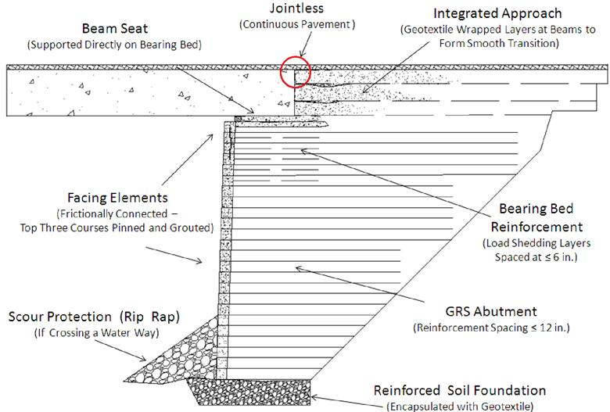
Figure 1: Typical GRS-IBS cross-section (Adams et al. 2012)

Need for the Study
DOTs constantly seek cost-effective solutions to transportation-related problems, especially during the periods of enhanced budgetary restrictions. Longevity, stability and efficiency in time and cost are priorities to combine in any solution affecting roads and highways. In this regard, GRS-IBS technology has shown significant promise for the construction of new bridges or replacement of deficient bridges on many county and local roads. Thus, three objectives serve the need for this study. Firstly, GRS-IBS has been used across the U.S. with an overall great success but no comprehensive study had been done to compile and discuss all the related information that exists so far. And that is one main contribution of this study. Secondly, the GRS-IBS technology is very new in Oklahoma, and there was a need to document and monitor the performance of the newly constructed projects over time and determine if the current FHWA guidelines are adequate to be followed in OK, or any adjustments would be necessary. Finally, it was necessary to (i.e. an analysis tool was developed in the form of a numerical simulation model to help) investigate the influences of different design factors on the expected performance of these systems.

Study Objectives and Tasks
The main objective of this study was to investigate the feasibility of GRS-IBS and adequacy of existing FHWA guidelines for adoption of the technology by ODOT and different counties in Oklahoma. Therefore, the following tasks were defined and carried out to meet this objective:
- A database was developed that includes a wide range of data on 140 GRS-IBS projects in the U.S. including construction-related data (construction time and technique, cost, materials used and facing type), geotechnical data (foundation soil and properties), traffic data (on low- or high-volume roads) and hydraulic data as well as other information related to their location (urban or rural), performance monitoring methods/results, and feedback from the corresponding local agencies.
- Collected all information related to the GRS-IBS bridges in Kay County (e.g. design drawings, backfill materials, geosynthetics, geotechnical reports, as-built drawings, construction periods, costs, and local feedback on the construction experience as available. This information was collected through direct contacts with Mr. Tom Simpson, PE, at the Bureau of Indian Affairs (BIA) in Anadarko, OK, and Mr. Pete Lively, who is a Road Foreman at Kay County District 3.
- A monitoring program was set up to measure and document the serviceability performance of the four GRS-IBS bridges in Kay County, OK through periodic visits to the sites and surveying of the bridges.
- Carried out laboratory tests on the GRS fill material including gradation, Los Angeles (LA) abrasion, large-scale direct shear tests, and large-scale interface shear tests.
- Developed a numerical model that could be used to simulate the performance of GRS-IBS bridges subjected to an equivalent traffic load.

Thesis Layout
This thesis consists of six chapters. Chapter 1 includes a discussion on the need for the study leading to the study objectives and tasks. Chapter 2 presents an introduction to the GRS-IBS technology and its advantages, design requirements, selected case studies and a survey of related numerical modeling studies. Chapter 3 provides a more detailed analysis and discussion of the GRS-IBS literature review presented in Chapter 2 on factors such as cost, facing type, traffic volume, performance monitoring, lessons learned, and conclusions and recommendations for future projects. Chapter 4 provides detailed information on six bridges in Kay County, OK (two conventional and four GRS-IBS bridges) including flood event, their design plans, geotechnical data, construction cost and time, in addition to the laboratory testing and results, and field survey data to compare settlement performance of one of the GRS-IBS bridges against that of one of the conventional bridges within the set of six bridges. Chapter 5 describes details of the numerical model that was developed using the computer program Fast Lagrangian Analysis of Continua (FLAC; Itasca 2011 and results of a parametric study on the GRS fill friction angle and reinforcement spacing. Chapters 6 presents conclusions of this research and recommendations for future work.
CHAPTER TWO

LITERATURE REVIEW
This chapter briefly describes the GRS-IBS background, advantages, and design requirements. Then, a series of selected case studies of several GRS-IBS projects across U.S. are presented. The literature review concludes with some numerical modeling-related papers.

Background on GRS-IBS
Reinforced soil technology is not a totally new idea. Its roots can be traced back to our ancestors utilizing straw and plant matter to improve the soil’s tensile strength (Adams et al. 2011). Thousands of years later, this technology has evolved into two categories: mechanically stabilized earth (MSE) since the 1960s and GRS since the 1980s (Table 1).

Table 1: GRS vs. MSE walls (Phillips 2014)
 | GRS Abutment | MSE Walls
Spacing | Typically 203 mm (8 in), no greater than 305 mm (12 in) | Greater than 305 mm (12 in)
Reinforcement | Geosynthetics (e.g. geogrid or geotextile) | Steel strips
Backfill | Typically high quality well-compacted granular backfill | Often lower quality backfill material
Methodology | Composite Behavior | Tie-Back Wedge
Design | Load is transferred directly to the GRS mass instead of facing wall. Composite system strains the soil and reinforcement together. Facing material is not a structural element. | Facing material is a structural element that is restrained by the reinforcement. Active zone is essential to ensure adequate length of reinforcement.
Both MSE and GRS retaining wall structures utilize reinforcement to provide tensile capacity within soil structures and contribute to a significant cost savings. Nonetheless, MSE has to deal with steel reinforcing strip corrosion over time. Using geosynthetics reinforcement helps solve this problem. Additionally, GRS provides enhanced confinement, restrains dilation and lessens lateral deflection (Adams et al. 2011).
GRS-IBS is a recently-proposed construction technology that integrates the GRS method with bridge construction for cost and time savings. It has been selected by FHWA as part of its Every Day Counts (EDC) initiatives (Alzamora et al. 2015). In 2015, the technology was upgraded to GRS-IBS and has since been applied in more than 250 bridges in the U.S. through the Federal Highway Administration’s (FHWA) Every Day Counts initiative (Alzamora et al. 2015). Figure 2 summarizes EDC-1, EDC-2, and EDC-3 implementation goals.

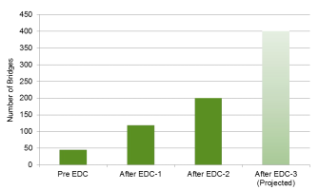
Figure 2: EDC Implementation Goals (FHWA 2015)
FHWA has recently published a set of design and construction guidelines (Adams et al. 2011; Adams et al. 2012) to assist interested design engineers, counties and DOTs to adopt GRS-IBS in their prospective projects. The guidelines include recommendations germane to the design and construction of GRS-IBS and expected in-service performance, inspection, maintenance and repair, along with special requirements for hydraulic and seismic conditions.

Advantages
The main advantages of GRS-IBS construction over the conventional methods include: (1) inherent structural flexibility that helps reduce differential settlements in the approach embankment and hence mitigates the bump at the end of the bridge problem, (2) reduced cost by avoiding deep foundation and/or the cast-in-place concrete process and by using local available materials and equipment, (3) less expensive and more environmentally friendly than other reinforcement material because of its resistance to biodegradation, (4) reduced construction time, (5) reduced labor skill and crew size requirements, (6) good performance in seismic events, (7) improved durability, (8) facilitative on field-modified flexible design for unforeseen site conditions, (9) minimal environmental impact and constructible in variable weather impacts, (10) adaptable to accommodate different skews, grades and any combination of headwalls, abutments and roadside walls, among others (Alzamora et al. 2015), (11) easier to design, and (12) easier maintenance in the design life cycle of the bridge.

Design Requirements
The current expectations of this technology are focused on small- to medium-scale projects, although there are some notable exceptions as pointed out in Section 2.4. Based on FHWA guidelines (Adams et al. 2012), GRS-IBS is an advisable option if a prospective project meets these conditions:
- it is single-span with span length no longer than 42.7 m (140 ft),
- the GRS abutment and wing walls should not exceed a height of 9.1 m (30 ft),
- allowable bearing pressure is below 191.5 kPa (4,000 lb/ft²) on GRS abutment,
- it suffers low scour potential with maximum stream velocity no greater than 3.66 m/sec (12 ft/sec),
- high-quality granular backfill material serves as the main component to support the traffic load, in which the friction angle of the backfill should be ≥ 38º, and the aggregates shall achieve 95 percent or greater maximum dry unit weight based on the American Association of State Highway and Transportation Officials (AASHTO) T-99 (Standard Proctor) procedure (AASHTO 2012). For GRS abutment backfills, open-graded aggregates provide better drainage and are easier to construct. Well-graded aggregates are preferred to the open-graded type for reinforced soil foundations (RSF) and integrated approach backfills.
- 0.3 m (12 in) or less spaced layers of geosynthetic reinforcement should be used to reinforce the GRS abutment with a minimum ultimate strength of 328.9 MN/m (4800 lb/ft),
- the pH of the soil should be between 5 and 9, and
- outlet pipes must not run through the bridge.

Case Studies
This research project started in the summer of 2014 with a survey of the literatures on GRS-IBS projects as published by the FHWA and several states that have adopted this technology. The information on the previous and ongoing GRS-IBS projects is collected via online sources, direct contacts with DOTs and participating contractors. The projects surveyed are documented in a database and their reported specifications and performances are compared to the corresponding FHWA guidelines (Adams et al. 2012). Table 2 shows the parameters used in the GRS-IBS database developed in this study. This database will be subsequently used to investigate the advantages and challenges of different construction techniques and project conditions (e.g. different types of superstructures, facing walls, weather conditions, volume road conditions, etc.) for prospective projects in Oklahoma. Specifically on the GRS-IBS projects in Oklahoma, geotechnical reports, bridge design plans and construction photographs have also been collected through direct contacts with the BIA and county personnel. This database will be further completed during the course of this study.
To date, we have identified six ongoing and 134 completed GRS-IBS bridges (i.e. in total of 140 projects) in 41 different states including Puerto Rico and District of Columbia. The map in Figure 3 shows the geographical distribution of all completed and ongoing GRS-IBS projects across the U.S., which have so far been identified in this study.

Table 2: Database from literature search

Location
Region | State | County | Bridge Name

General Information
Span Length (m) | Abutment Height (m) |  | Bridge Width  (m) | Skew (Degree) | Cost  ($) | Completion Year | Type of Superstructure
 |  |  |  |  |  |  | Concrete | Steel | Timber
Span Length (m) | East/  North | West/ South

Loading / Traffic
Functional Class |  | AADT | LL (kPa) | DL (kPa) | Design Code
No. Lanes Serviced | Service under Bridge

Materials
Facing Type | Backfill |  |  | Geosynthetic Reinforcement | Ultimate Tensile Strength  T_{f} (kN/m)
Facing Type | Materials | c' | ᶲ' | Geosynthetic Reinforcement | Ultimate Tensile Strength  T_{f} (kN/m)

Construction |  |  | Geotechnical Data |  |  | Hydraulic Data
Duration | Number of Workers | Equipment Used | Existing Soil |  |  | Scour Countermeasure | Maximum Water Velocity
Duration | Number of Workers | Equipment Used | Subgrade Soils | c' | $$ϕ'$$ | Scour Countermeasure | Maximum Water Velocity

Monitoring |  |  |  | Reported output parameters
Survey |  | Instruments | Monitoring Period | Facing Deformation | Settlements
Technique | Precision/Accuracy

Notes
Owner/Contractor | Special Features

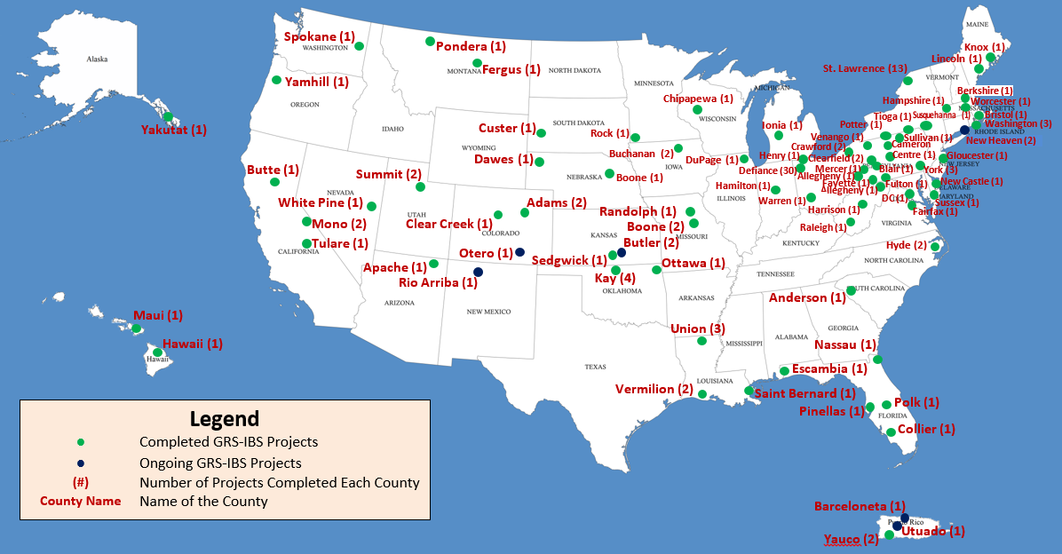
Figure 3: Completed and on-going GRS-IBS projects across 41 states in the U.S.
This study only presents some highlighted GRS-IBS cases with respect to different factors including weather, cost, span length, instrumentation, unique facing wall type, and type of superstructure.

Bowman Road Bridge, OH
As of 2015, the state of Ohio has built the most GRS-IBS bridges (40 bridges) in the U.S. (courtesy of Mr. Warren). Defiance County established one of the earliest thorough documentations of GRS-IBS cases. Among those, the Bowman Road Bridge was built in 2005 (Figure 4) and was the first to employ GRS-IBS technology with an abutment design based on the recommendations provided in the NCHRP Report 566 (Wu et al. 2006). The Bowman Road Bridge was constructed in six weeks versus several months for a conventional alternative, which resulted in significant time and monetary savings (approximately 20 percent cost savings according to Adams et al. 2012) as compared to traditional design alternatives.
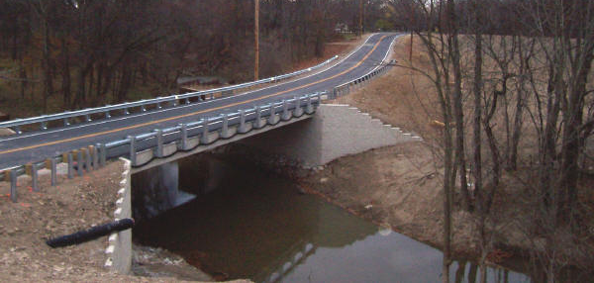
Figure 4: Bowman Road Bridge in Defiance County, OH (Defiance 2016)
Split-face cylinder blocks were used for the facing of the 4.6 m high Bowman Bridge abutment. Two types of woven polypropylene geotextile were used in this project, having wide-width test ultimate strength values of 70 kN/m and 31 kN/m. The bridge superstructure is pre-stressed concrete beams.
In the Bowman Road Bridge, a survey station was installed to record bridge settlement and movement of the GRS abutments. Earth pressure cells were installed to measure the stress beneath the beams and at the base of the GRS abutments. After 1.5 years of monitoring, the maximum bridge settlement was estimated to be about 22 mm (0.85 in). Adams et al. 2011 used a logarithmic time scale model as shown in Figure 5 to predict the 100-year bridge service life settlement of the Bowman Road Bridge. At the end of the 100-year period, the maximum creep settlement was projected to be 30 mm (1.2 in).
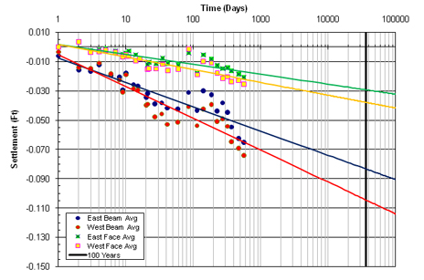
Figure 5: Settlement versus log-time to predict creep settlement for the Bowman Road Bridge at 100 years (Adams et al. 2011)

1121 and 1122 Bridges, PR
These twin single-span GRS-IBS bridges were completed in September 2013 (Figure 6) to replace the twin three-span structurally deficient 1121 and 1122 Bridges in Puerto Rico. These bridges were built on dry land for cattle passage, and therefore scour was not expected to be an issue (Figure 7). The 1122 Bridge was reported to take a total of 57 construction days from demolition to laying the asphalt pavement. The specifications of this bridge are summarized as 11.1 m (36.5 ft) long, 12.2 m (40 ft) wide and 4.9 m (16 ft) high (Pagan et al. 2014). The total cost for the twin bridges was $2,286,485. The crew size of both projects was five members. This GRS-IBS project has the highest traffic load by far with 39,402 average annual daily traffic (AADT), which far exceeds the low volume road recommendation (<400 AADT) prescribed by FHWA guidelines (Adams et al. 2012). During the 1122 Bridge facing wall reconstruction, an issue was encountered with the lightweight 15 kg (33 lbs) hollow Concrete Masonry Unit (CMU) blocks because they were easily pushed out during compaction. Later during the 1121 Bridge reconstruction, the 30 kg (66 lbs) solid CMU blocks were utilized instead to avoid that issue. Thus, Pagan et al. 2014 recommended solid CMU blocks over lighter hollow CMU blocks. Only open-graded material was permitted due to its abundant source in Puerto Rico and faster placement and compaction. From this project, based on Pagan et al. 2014, the crew has experienced some advantages of GRS-IBS technology over conventional bridges and are planning four more GRS-IBS bridges in high AADT highways.

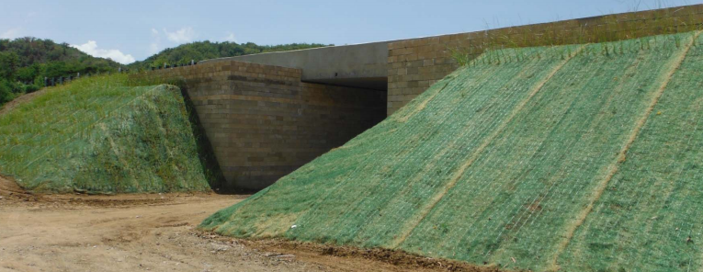
Figure 6: Completion View (Alzamora et al. 2015)
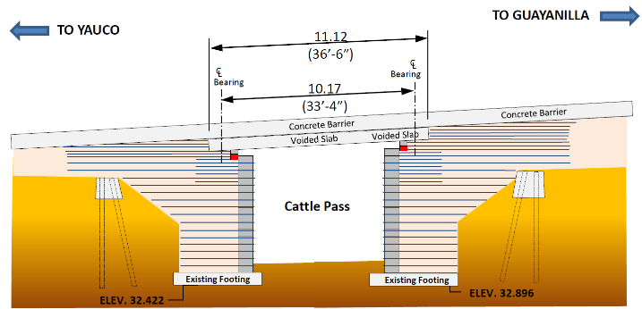
Figure 7: Side view (facing north) of 1121/1122 GRS-IBS Bridge in Yauco County (Pagan et al. 2014)

250th Street Bridge, IA
The state of Iowa has approximately 25,000 bridges of which about 80 percent are on low-volume roads. Therefore, GRS-IBS is a sufficient and economical solution. The 250th Street Bridge in Buchanan County was built for the feasibility evaluation study to replace a shorter 90 year-old steel bridge on concrete abutments. This new bridge utilizes the existing concrete abutments which serve as the GRS facing wall. Steel sheet piles were placed on site for scour protection. Riprap was installed over the geosynthetic faces as a scour protection in case of flooding. It has a span length of 20.9 m (68.5 ft) with a Rail Road Flat Car (RRFC) as the superstructure. The backfill material used in the construction of the RSF, GRS abutment, and approach roadway consisted of 10 mm (3/8 in) size crushed limestone gravel with a friction angle of 48º. The existing soil under the new footing location was excavated and replaced with this backfill material to improve the support. Mirafi® 500X woven geosynthetic, provided by Northern Iowa Construction Products, was used as geosynthetic reinforcement for this project. The geosynthetic tensile strength is 1785.8 kg/m (1200 lbs/ft) in machine direction and 2143.0 kg/m (1440 lbs/ft) in cross-machine direction. This reinforcement strength value is lower than the minimum recommended value of 328.9 MN/m (4800 lb/ft) by Adams et al. 2012.
Multiple types of instrumentations were installed to monitor the bridge abutment settlements including inclinometers, piezometers, semiconductor and vibrating wire EPCs within one year and two months (Figure 8). The inclinometers (Figure 9) and piezometers were installed in the clay foundation to monitor lateral ground movements and pore water pressure, respectively. Three semiconductor earth pressure cells (EPCs) were installed in the GRS fill to measure total vertical stresses and four (4) vibrating wire (VW) EPCs were installed along the excavation walls to measure horizontal pressures in Figure 10 (Vennapusa et al. 2012).

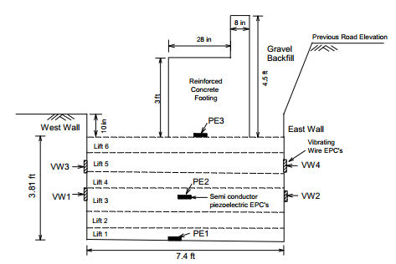
Figure 8: Location of semiconductor and vibrating wire EPCs embedded in the fill for 250th Street project (Vennapusa et al. 2012)
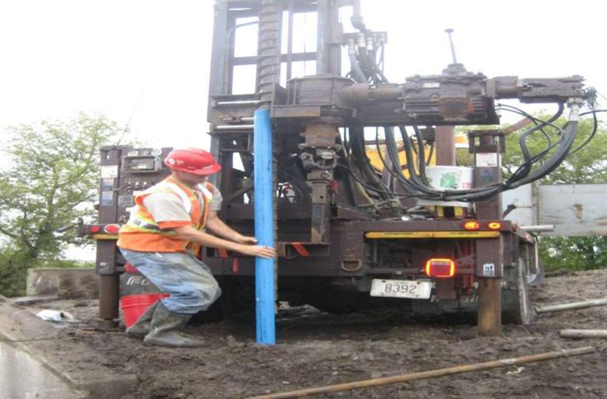
Figure 9: Installation of inclinometer for 250th Street project in Iowa (Vennapusa et al. 2012)
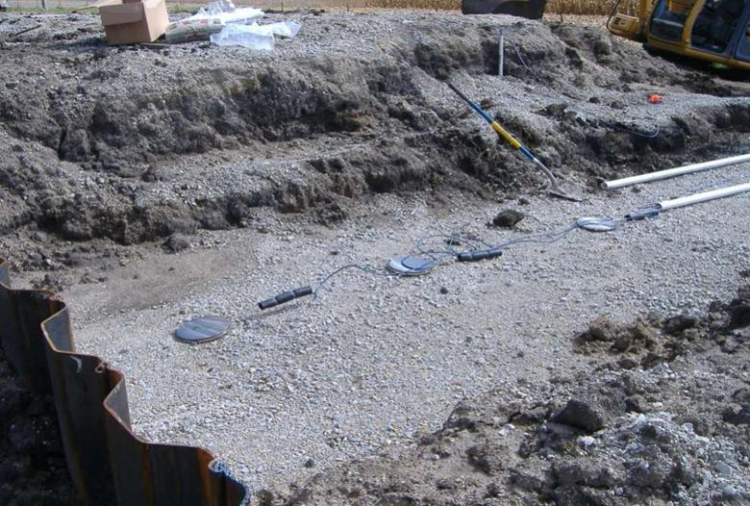
Figure 10: Installation of earth pressure cells for 250th Street project in Iowa (Vennapusa et al. 2012)
The results for 250th Street Bridge indicate that the average settlements were approximately 4 mm (0.15 in) on west and 8 mm (0.3 in) on east abutments. The northwest corner on the west abutment footing displaced unusual a positive reading due to heave under the footing (Vennapusa et al. 2012) (Figure 11).

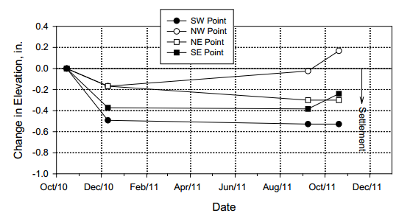
Figure 11: Abutment settlement readings for 250th Street Bridge (Vennapusa et al. 2012)
With total of 6 crew members, the construction cost of $43K was 50-60 percent lower than a bridge of the same size built by using traditional methods, which costs between $105K to $130K (Vennapusa et al. 2012). 250th Street Bridge is by far the most economical GRS-IBS project on record. As of 2014, this bridge was performing well after facing two floods in 2012 and 2013 (Keierleber et al. 2014).

Mattamuskeet National Wildlife Refuge Bridges, NC
Two unique 7 m (23 ft) long East Canal and 14m (46 ft) long Central Canal Bridges were constructed in Hyde County to replace two bridges with severe erosion in the abutment and a structurally deficient timber bridge, respectively. Figure 12 shows a completed Central Canal Bridge. The GRS abutments consist of a Cellular Confinement System (CCS) filled with gravel (Figure 13). CCS is a honeycomb structure of cells which are made of high-density polyethylene (HDPE) geosynthetic strips that can contain, confine, and reinforce a variety of fill materials such as topsoil, native soil, sand, aggregate, and concrete. CCS has many advantages over traditional CMU block facing with respect to the capability to protect the abutment against erosion and shallow scour, the ability to tolerate settlements, and also the added value of providing aesthetic appeal, as it can be vegetated (Mohamed et al. 2011). Nevertheless, the use of CCS requires an experienced contractor during the installation process (Nguyen 2012).
Construction phases of East Canal Bridge are shown in Figure 14. These bridges are unique. They were built on a very soft, silty fat clay soil, classified as A-7-6 according to the AASHTO M-145 standard (Mohamed et al. 2011). A 2.1 m (7 ft) high compacted surcharge fill was used to preload each abutment foundation to help reduce long-term settlements of both bridges (Mohamed et al. 2011). It was estimated that approximately 90% of the predicted total settlement had occurred after the first 100 days of the preloading period, which was expected to significantly reduce the magnitude of the long-term settlement (Mohamed et al. 2011). Standpipe piezometers and settlement plates were used to determine the preloading efficiency and to monitor deformations of the GRS abutments during service. According to Mohamed et al. (2011), the GRS abutments of this bridge have been performing well so far.

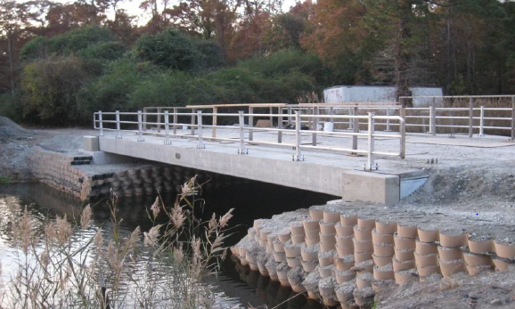

Figure 12: Completed Central Canal Bridge in Mattamuskeet National Wildlife Refuge in Hyde, North Carolina (Nguyen 2012)
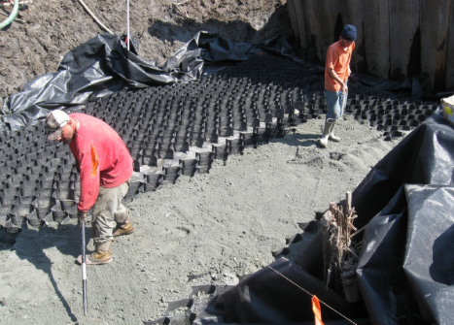
Figure 13: A cellular confinement system (CCS) with gravel infill was used for the Central Canal Bridge abutment in Hyde, North Carolina (Nguyen 2012).
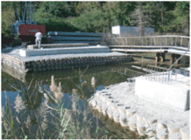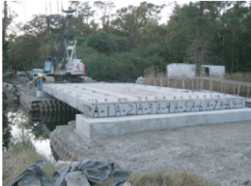
Figure 14: Construction phase of the East Canal Bridge in Mattamuskeet National Wildlife Refuge in Hyde, North Carolina (Mohamed et al. 2011)

The Strawberry Creek Bridge, NV
Due to the remote location of this bridge, the initial bid for cast-in-place concrete to construct the abutments caused the total construction cost to be significantly higher than the engineers’ estimate. Since the road needed to be closed during construction, their initial proposal also called for approximately a three week closure. In order to reduce costs and closure time, the bridge was redesigned as a GRS-IBS. By adopting GRS-IBS, the total cost saving was 30% compared to the conventional bridge. The superstructure was built with steel girder, precast concrete footing, and prefabricated timber deck (see Figure 15). The Strawberry Creek Bridge was the first GRS-IBS bridge in Nevada and was completed in 2013 with 8.5 m (28 ft) span length and 4.9 m (16 ft) wide (Figure 16).

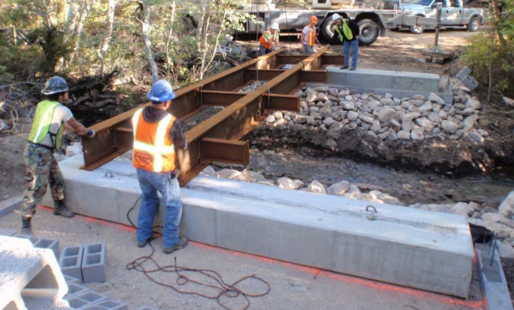
Figure 15: Superstructure Placement (Alzamora 2015)
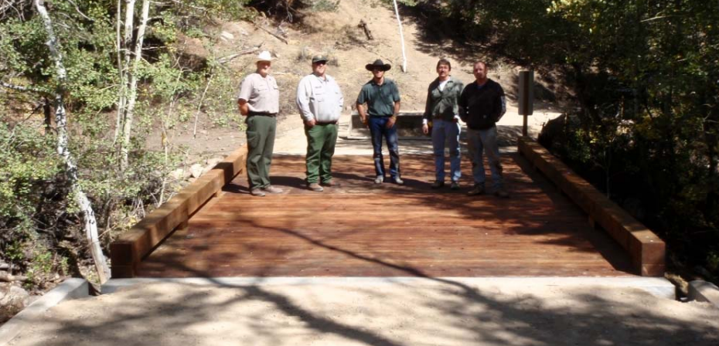
Figure 16: The Strawberry Creek Bridge in Nevada (Alzamora et al. 2011)

Route B Bridge, MO
In Boone County, Missouri, Route B Bridge was one of three GRS-IBS bridges constructed in 2014 (Figure 17). The bridge’s span length, width, and height were reported as 20 m (65 ft), 8.8 m (29 ft), and 5.9 m (19.5 ft), respectively. The cost of this project was $514k. Eight prestressed concrete beams were used for the superstructure. Two unique features differentiate this project from the majority of other existing GRS-IBS projects. Instead of using geotextile as reinforcement, the geogrid was used. Traditionally, 203 mm × 203 mm × 406 mm (8" × 8" × 16") CMU blocks were used. The construction of Route B Bridge utilized the large wet cast 406 mm × 1219 mm × 610 mm (16" × 48" × 24") blocks (Figure 18). The large wet cast blocks have several advantages including: (1) wet cast blocks are more durable than dry cast blocks; (2) larger blocks allow for shorter construction time (time to place one large block is equivalent to the time required to place six typical size CMU blocks); and (3) using a big roller compactor behind the blocks does not pose a stability concern (Bartlett 2015).

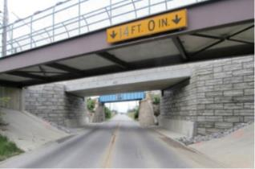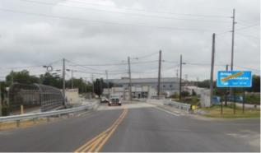
Figure 17: Completed Route B Bridge in Missouri (Bartlett 2015)
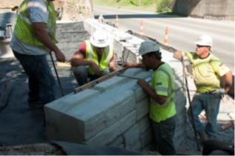
Figure 18: Large wet cast CMU block in Missouri (Bartlett 2015)

Knox County Beach Bridge, ME
Built in 2013, Knox County Beach Bridge was the first GRS-IBS project built with double spans—12.2 m (40 ft) and 18.3 m (60 ft) long, respectively, by reusing the existing pier in the middle of the span. It took 120 construction days from demolition to completion (Figure 19), and was the first project located in a marine environment. It encounters 3.7 m (12 ft) maximum daily tide (Alzamora et al. 2015). The abutment height is 4.6 m (15 ft). The superstructure for this bridge consisted of four lightweight New England Extreme Tees (NEXT) precast concrete. The total cost of this project was two million dollars. TenCate Mirafi geotextile HP 770 PET was used as reinforcement, with spacing at 229 mm (9 in) for the GRS abutments. Breskin (2012) reported that the CMU (8" × 8" × 16") did not meet the freeze-thaw requirements of MaineDOT Standard Specifications. Thus, the 689 kg (1520 lbs) Redi blocks, made of larger wet cast concrete measuring 457 mm × 1168 mm × 711 mm (18" × 46" × 28"), were utilized for the wing walls and abutments (Figure 20) and help sustains the strong tidal environment (Redi-Rock 2016).

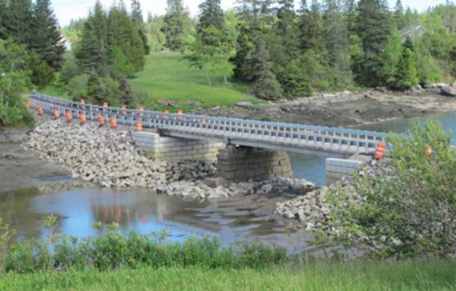
Figure 19: Knox County Beach Bridge in Maine (Alzamora et al. 2015)
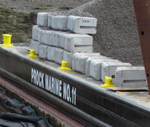
Figure 20: 457 mm × 1168 mm × 711 mm Redi-Rock Texture for Knox County Beach Bridge in Maine (Redi-Rock 2016)

I-70 over Smith Road and Union Railroad Bridges in Adams County, CO
As part of I-70 expansion, two GRS-IBS projects started in February of 2014 in Aurora, Colorado and are being built side by side to replace the existing structurally deficient bridges (Figures 21 and 22). They are expected to complete in early 2016. The AADT of these two bridges are 34,350 with 17% truck traffic (2013), which are the second highest AADT for this GRS-IBS so far. Once completed, they will mark two milestones for GRS-IBS case history: the longest bridge of 120 m (394 ft), and a total of three spans; the greatest number of spans used. The spans are 32.6 m (107 ft), 48.2 m (158 ft), and 39.3 m (129 ft).

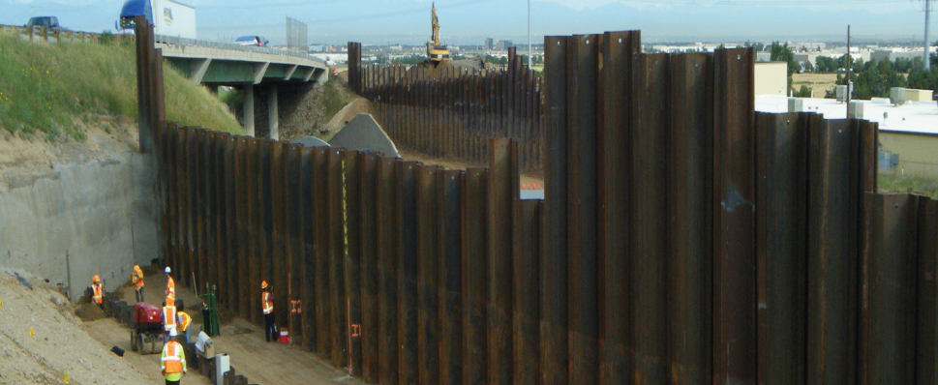
Figure 21: Sheet pile installation during I-70 over Smith Road and Union Pacific Railroad Bridge construction (Geocomp 2014)
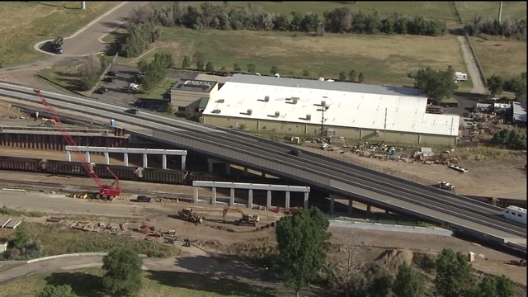
Figure 22: Bird view on the I-70 over Smith Road and Union Pacific Railroad Bridge construction site (Luber 2015)

Veterans Administration Hospital Bridge, WV
The Veterans Administration Hospital Bridge was the first GRS-IBS on State Route 68 in Harrison County, West Virginia. It was completed in 2013 by Orders Construction Company with total cost of approximately $1.9 million. This project features the tallest GRS abutment of 9.8 m (32 ft) (Figures 23 and 24). The abutment facing walls were made of traditional 203 mm × 203 mm × 406 mm (8" × 8" × 16") CMU blocks, supplied by Peerless Block and Brick, St. Albans. To place the huge amount of backfill aggregate materials, a truck mounted telebelt was used for the abutment construction (Clowser et al. 2015).

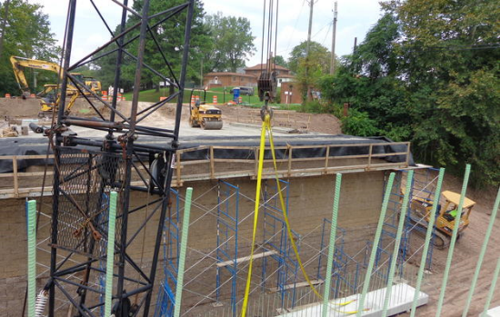
Figure 23: Veterans Administration Hospital Bridge abutment construction (Orders 2013)
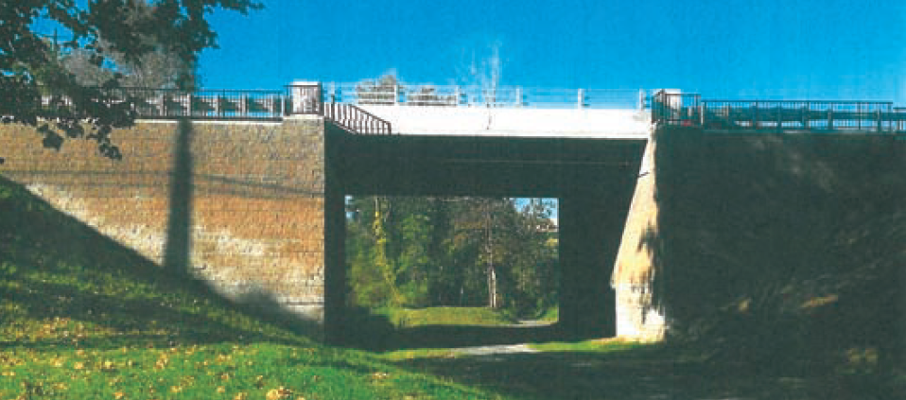
Figure 24: Veterans Administration Hospital Bridge completion side view (Clowser et al. 2015)

Fergus County Road Bridge in Fergus County, MT
This project was constructed in 2015, by Stahly Engineering and under County Bridge Supervisor, Mr. John Anderson, in order to replace the defective culvert which led to the flooding event of 2011 (Figures 25 and 26). With only eight construction days and $44k, this has been among the cheapest and fastest GRS-IBS projects to date. This $44k total cost was broken down as $16k for equipment, $4k for rip rap and cement block, $1k for geogrid and geotextile fabric, $9k for aggregate backfill materials and rental equipment, and $16k for labor. It is worth mentioning that the superstructure was made of available bridge decks from Mr. Anderson’s yard, and therefore saved total project cost (Jenkins 2015). For the abutment facing wall, large cement blocks were used instead of traditional CMU or steel piles (Figures 27 and 28). It is reported that Mr. Anderson was satisfied with this new technology and looked forward to building another GRS-IBS bridge using the same design as this project, except he would prefer block wall instead of this cement blocks (Jenkins 2015).
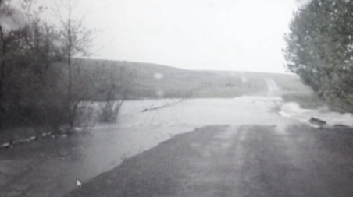
Figure 25: Flooding event in 2011 in Fergus County Road (Jenkins 2015)
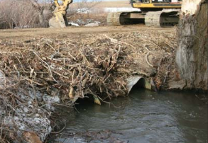
Figure 26: Damaged Culverts in Fergus County Road (Jenkins 2015)
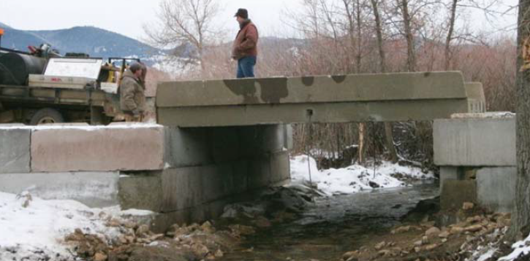
Figure 27: Superstructure placement of Fergus County Road Bridge (Jenkins 2015)
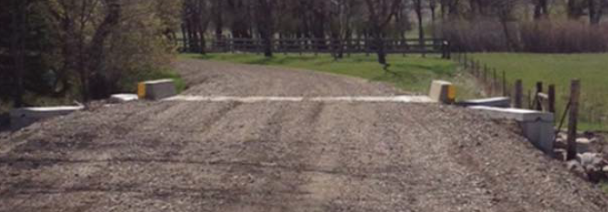
Figure 28: Front view of completed Fergus County Road Bridge (Jenkins 2015)

Grove Township / Sportsman Bridge in Cameron County, PA
To date, state of Pennsylvania has built the second most number of GRS-IBS bridges (19 bridges) in the U.S. Among those bridges is the Grove Township/Sportsman Bridge, which was completed in 2014 and features a one-sided GRS abutment construction (Figure 29). The other abutment reused the existing rock abutment (Figure 30). With this flexibility, the abutment cost was kept low as $21k, merely 8% of total construction cost $258k. Normally, the abutment cost can attribute up to 40% of the total construction cost.

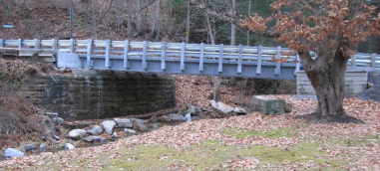
Figure 29: Side view of Grove Township / Sportsman Bridge (Alzamora et al. 2015)
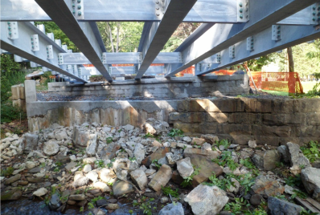
Figure 30: Bottom view of Grove Township / Sportsman Bridge (Alzamora et al. 2015)

Saddle Road Bridge in Hawaii County, HI
State of Hawaii has constructed two GRS-IBS bridges to date. The Saddle Road Bridge was completed in 2012 in Hawaii County. This bridge features a wide abutment design specifically to withstand frequent seismic activities. Majority GRS-IBS bridges have built over passing water, but this one was built above a roadway instead.

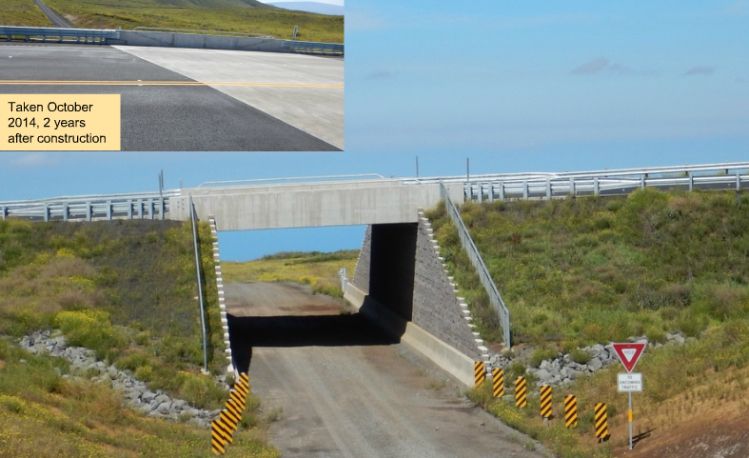
Figure 31: Saddle Road Bridge side view (Alzamora et al. 2015)

Village of Lombard Bridge in DuPage County, IL
This 30.5 m (100 ft) long bridge was completed in 2012, as part of Great Western Trail projects, and is used solely for pedestrian use (Figure 32). However, it was originally designed for H-20 loading to accommodate occasional utility truck crossing. The Village of Lombard Bridge has the bridge width and height of 4.9 m (16 ft) and 5.5 m (18 ft), respectively. Four 1.2 m (48 in) deep precast, prestressed I-beams were used as the superstructure. The poorly compacted fill and soft clay beneath this construction site caused settlement and bearing capacity concerns. In order to address these concerns, approximately 65 aggregate columns (Figure 33) were installed under 1.8 m (6 ft) RSF per abutment, to stabilize the foundation. It utilized 726 kg (1600 lb), 406 mm × 1219 mm × 610 mm (16" × 48" × 24") in Recon blocks for the facing blocks, and each block costed $655.74/m² ($61/ft²), which is more expensive than the tradition CMU block $354.74/m² ($33/ft²). With these large facing blocks, it required heavier machinery and extra labor to lay these blocks on the facing wall. Tenax TT L type 70 geogrid was used for the reinforcement with spacing at 203 mm (8 in). Figure 33 shows the profile view for this bridge design plan.

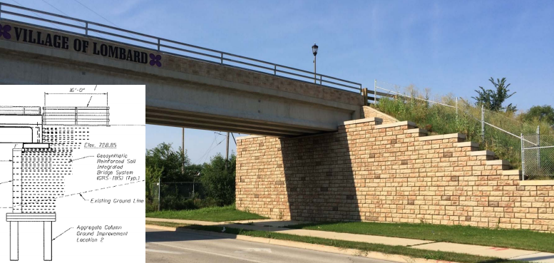
Figure 32: Village of Lombard Bridge (Alzamora 2015)
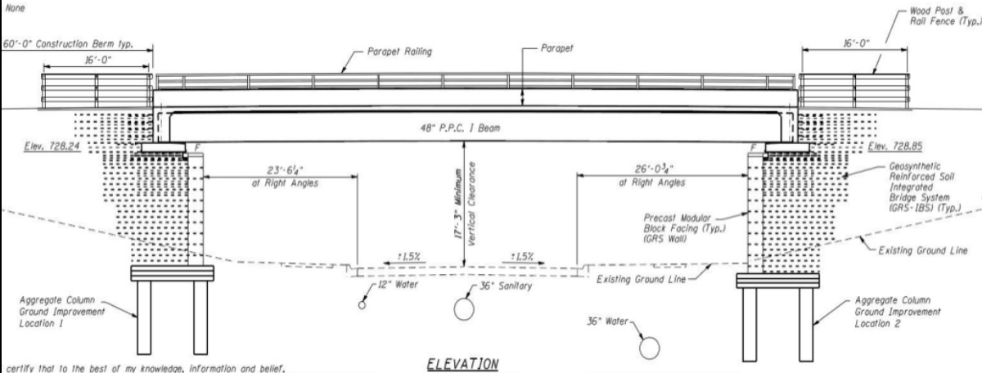
Figure 33: Elevation design plan for Village of Lombard Bridge (Wahab et al. 2015)

27th Street Bridge over Broad Branch Stream, Washington DC
Constructed in 2015, this is the first GRS-IBS project in Washington DC with the total cost of $1.4 million, under the FHWA Highway for Life grant (Geosynthetics 2015). This project started after another environmental project; Broad Branch Stream Restoration, led by the Department of Energy & Environment of Washington DC (DOEE 2014). Figures 34 and 35 show the bottom view and completed of 27th Street Bridge, respectively. This project took in total of 70 construction days to transform the existing one lane bridge to a two lane bridge. They utilized the Rosphalt LT 50, an asphalt waterproofing mix with advantages of lower life cycle costs, quick dry (only 1 hour), easy installation, dry mix, and long term durability (Forest 2015).

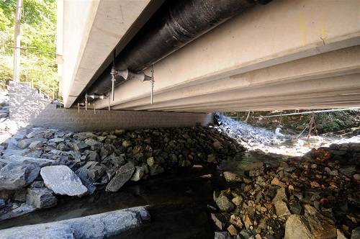
Figure 34: Bottom view of 27th Street Bridge (Diop et al. 2015)
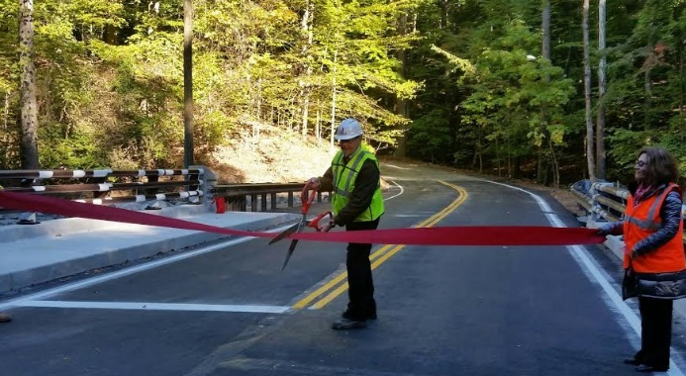
Figure 35: 27th Street Bridge opening ceremony (Forest 2015)
CHAPTER THREE

ANALYSIS OF DATA ON SURVEYED GRS-IBS PROJECTS
Based on the literature review of GRS-IBS projects across the United States which was presented in the previous chapter, a summary and analysis of factors such as cost, facing type, traffic volume and performance monitoring methods used are presented in this chapter. The objective was to summarize the advantages of GRS-IBS over conventional bridge construction technologies, as reported by different state DOTs and other transportation agencies above and beyond those articulated in the FHWA guidelines (Adams et al. 2012).

Cost
Cost is one of the greatest advantages of GRS-IBS over conventional bridges. Among 140 GRS-IBS projects surveyed in this study, 76 have reported or estimated the construction cost, but only 12 reported the cost with calculated savings compared to traditional alternatives as shown in Table 3. Several factors dictate the cost of a bridge, including construction materials, labor, completion time, and equipment. GRS-IBS projects have consistently reported reduced construction time, labor and equipment relative to conventional bridge abutments. They also typically require simpler and less expensive equipment and do not require highly skilled labor. Collectively, the above factors result in significant cost savings in GRS-IBS projects relative to conventional bridge abutments.

Table 3: GRS-IBS cost savings relative to conventional bridge construction
 | GRS-IBS Bridge | Conventional Bridge | Difference | % Saving
FL - Blackrock Road Bridge
Total Cost | $512,009 | $612,009 | $100,000 | 16%
OH -Bowman Road Bridge (GRS vs. Pile Cap Abutment)¹
Superstructure | $95,000 | $105,000 | $10,000 | 10%
Abutment | $171,000 | $233,000 | $62,000 | 27%
Total Cost | $266,000 | $338,000 | $72,000 | 21%
PA – Mount Pleasant Road Bridge (GRS vs. Pre-cast Box Culvert)^{2, 3}
Abutment | $40,000 | $56,000 | $16,000 | 40%
Total Cost | $101,893 | $150,000 | $48,000 | 32%
LA – Cutoff Creek, Cecil Creek, Big Lake 2 Bridges (GRS vs. Pile Supported)⁴
Total Cost | NR | NR | NR | 40%
MA - Route 7A over Housatonic RR (GRS vs. Micropile-supported)⁵
Total Cost | $1,163,000 | $2,299,000 | $1,136,000 | 49%
NM - White Swan Bridge⁶
Labor | $52,897 | $105,000 | $52,897 | 50%
Total cost | $419,331 | $1,000,000 | $580,669 | 58%
IA – Olympic Ave & 250th Street Bridge⁷
Total Cost | $49,000 | $105,000- $130,000 | $56,000-$81,000 | 53-62%
NY – CR12 Project Bridge¹
Material | $160,000 | $300,000 | $140,000 | 47%
Labor | $50,000 | $150,000 | $100,000 | 67%
Equipment | $30,000 | $200,000 | $170,000 | 85%
Total Cost | $240,000 | $650,000 | $410,000 | 63%
NY – CR38 over Plum Brook Bridge⁸
Superstructure | $95,000 | $180,000 | $85,000 | 47%
Abutment | $65,000 | $125,000 | $60,000 | 48%
Total Cost | $308,000 | $453,000 | $145,000 | 32%
Total Percentage Saving Range 16%-63%
1. FHWA 2010 2. Albert 2011
3. Bloser et al. 2012 4. Meunier 2013
5. Connors 2015 6. Mermejo 2015
7. Vennapusa et al. 2012 8. Bogart 2011

It should be noted that cost comparison in this study is focused on the bridge abutments and the associated labor, material and equipment because the cost of the superstructure cost is essentially independent of the abutment type and construction technique. In this regard, the State of Pennsylvania conducted an abutment cost analysis on their state projects which is summarized in Table 4. Figure 36 shows per-square-foot abutment costs of 11 GRS-IBS projects together with an average cost of $95.54. Compared to the per-square-foot cost of $208.54 for traditional abutment techniques in other local projects, GRS-IBS resulted in a 54% reduction in the abutment costs (Albert 2015).

Figure 36: GRS-IBS per-square-foot costs in Pennsylvania (Albert 2015)
Figure 37 shows the relationship between construction time and the total construction cost for 19 available records found in the GRS-IBS projects surveyed in this study. The data show a positive and fairly conclusive correlation given that it is impacted by a number of factors including the span length, abutment height, superstructure type, and design traffic volume, among others. It can be concluded that construction time is a measure of the construction challenge level, which directly impacts the total cost of a bridge construction project.

Table 4: GRS-IBS cost savings in Pennsylvania (Albert 2015)
Bridge | County | Cost | Abutment Cost | Abutment Cost/ft² | Saving
Huston Township/Mt Pleasant Road Bridge | Clearfield | $101,894 | $40,000 | $71.02 | 40%
Sandy Township/Old Bliss | Clearfield | $210,000 | $84,000 | $110.53 | 40%
North Hopewell Township/Huson Road Bridge | York | $120,000 | $48,000 | $54.84 | 40%
PennDOT District 1-0 SR 2016/Brown Hill | Crawford | $250,000 | $122,000 | $231.49 | 40%
PennDOT District 4-0 SR 2063/Harford | Susquehanna | $310,000 | $124,000 | $143.35 | NR⁽¹⁾
PennDOT District 11-0 | Allegheny | $386,549 | NR | NR | NR
PennDOT District 2-0 SR 2001/T-433 over KETTLE CREEK/Rausch | Potter | $354,931 | $50,400 | $96.15 | NR
Grove Township/ Sportsman | Cameron | $258,000 | $21,194 | $77.26 | NR
Potter Township, DCNR Penn Nursery State Forest | Centre | $214,000 | $45,000 | $55.90 | NR
T-606/Lick Island | Blair | $431,000 | $88,000 | $60.29 | NR
T-315 Greenwood Township/Mattocks | Crawford | $154,301 | $28,236 | $45.66 | NR
Liberty Township | Tioga | $403,800 | $104,000 | $190.48 | 40%
- Not Reported

Figure 37: Construction time vs. total cost of 19 GRS-IBS projects

Facing Type
The facing of a GRS-IBS abutment is not a structural element. Its main purpose is to facilitate backfill compaction, to serve as a façade, and to protect the gravel backfill from weathering, vandalism and other deleterious effects (e.g. Adams et al. 2012). In the survey that was carried out over the course of this study, nine (9) different types of facing wall has so far been identified for the GRS-IBS projects across the United States. A total of 80 out of 140 surveyed projects documented the facing wall types. Table 5 shows a complete list of different facing types and sizes found in this study. Among a wide range of options available on the market, the hollow and solid forms of the 203 mm × 203 mm × 406 mm (8" × 8" × 16") CMU is the prevalent choice, which has been used in 80% of the cases surveyed (Figure 38). This type of facing is particularly suitable for the projects that require a minimum compressive strength of 27.6 MPa (4,000 psi) and water absorption limit of 5% according to the FHWA guidelines (Adams et al. 2012). Table 6 summarizes the feedback from different states on the pros and cons of the facing types used in their projects.
Table 5: Information on the facing types used in GRS-IBS projects across the U.S.
Facing Wall Type | Nominal Dimension | Number of Bridges
CMU¹ | 203 mm × 203 mm × 406 mm (8" × 8" × 16") | 62
Sheet Piling¹ | NR | 6
Large precast blocks | 457 mm × 1168 mm × 711 mm (18" × 46" × 28")² and  406 mm × 1219 mm × 610 mm (16" × 48" × 24")³ | 4
Treated Timber | 50 mm (2") thick and  152 mm × 152 mm (6" × 6") | 2
Cellular confined system (CCS) ⁴ | 152 mm (6") tall | 2
Flexible geosynthetic wrapped facing⁵ | Reinforcement layer spacing | 1
Pre-cast panels | 203 mm (8") thick | 1
Segmental Retaining Wall (SRW) | NR | 1
Redi-precast wet modular blocks | 152 mm (6") tall | 1
A total of 80 GRS-IBS projects out of the 140 surveyed reported specific information on the facing wall type used
1. Adams et al. 2012 2. Redi-Rock 2016
3. Wahab et al. 2015 4. Mohamed et al. 2011
5. Vennapusa et al. 2012

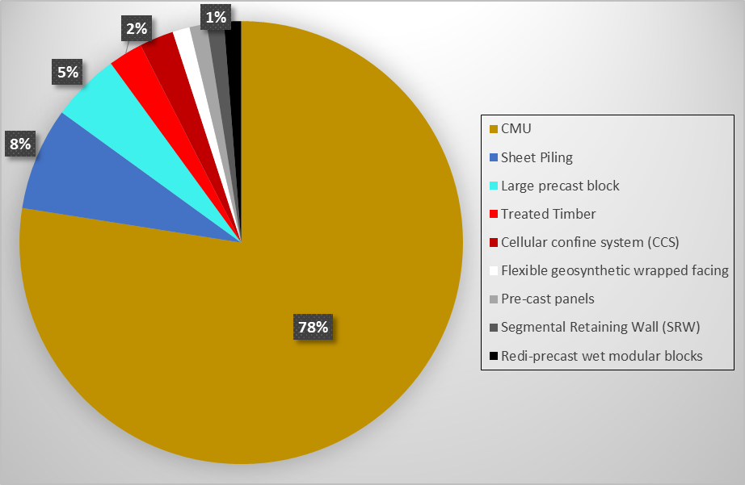
Figure 38: Pie chart distribution of facing types reported in the surveyed GRS-IBS projects with documented facing type (from a total of 80 projects)
Table 6: Pros and cons of different facing types used in GRS-IBS projects
Facing Wall Type | Pros | Cons
CMU | * Light weight  * Enhanced aesthetics  * 203 mm (8") spacing each layer  * Reduced dimensional tolerances  * Less prone to impact damage at front face | * Should use solid CMU blocks of 29.9 kg (66 lbs) or greater rather than hollow 20.4 kg (45 lbs) CMU, because light CMU will be easily pushed out during compaction  * Dry cast concrete generally doesn't meet the freeze-thaw requirements  * Challenge to avoid a frontal gap at the corners of the abutment wall with small radius
Large precast blocks | * Enhanced aesthetics  * Fast construction outcome 1 large block = 6 CMU | * The large block used in IL was heavy and large, so it required heavy machinery and added labor to set them in place  * Cost almost double compared to CMU  * Less uniform in size than regular CMU  * Design considerations in the case of weak foundations
Sheet Piling | * Light weight  * Ease of construction | *Reduced aesthetics
Cellular confined system (CCS) | * Used as a flexible facing system and footing base for scour countermeasures | * Contractor must have CCS installation experience
Flexible geosynthetic wrapped facing | * Reduced costs  * Eliminates the need to transport and set blocks for the facing | * Reduced aesthetics  * Fill materials can be washed out if the geosynthetic is damaged by debris
Redi-precast wet modular blocks | * Alternative for dry CMU blocks  * Enhanced aesthetics  * Can be used in region experiencing freeze-thaw cycles | * Not Reported

Traffic Volume AADT
A total of 56 out of the 140 GRS-IBS bridges in 14 states surveyed in this study included information on their traffic volume in the form of Annual Average Daily Traffic (AADT) as listed in Table 7. According to an FHWA report (FHWA 2013), a low-volume road is defined as that with AADT ≤ 400 in rural areas or AADT ≤ 700 in urban areas. Ranges of AADT values for each road category are given in (Figure 39). To date, 34 out of the 56 bridges with the AADT data have been built in low-volume roads as per the data given in Table 7. Even though the FHWA guidelines (Adams et al. 2012) primarily recommend GRS-IBS for low-volume roads, they have been built on higher volume roads (e.g. with AADT as large as nearly 40,000 in the case of 1122 Bridge in Yauco, Puerto Rico), and they are all performing well to date.

Table 7: Statistics on the AADT values of GRS-IBS projects across the U.S.
 | Functional Classification | AADT | Number of bridges
Rural Area | Local | 15-400 | 18
Rural Area | Minor Collector | 150-1110 | 8
Rural Area | Major Collector | 300-2600 | 2
Rural Area | Principal Arterial (interstate) | 12000-34000 | 2
Urban Areas | Collector | 1100-6300 | 1
Urban Areas | Principal Arterial (interstate) | 34500-129000 | 2
Not Reported (NR) | NR 1 | <400 | 16
Not Reported (NR) | NR 2 | 400-1110 | 5
Not Reported (NR) | NR-3 | >1110 | 2
Total GRS-IBS projects with reported AADT values in 14 States = 56
61% of the bridges were built on low-volume roads

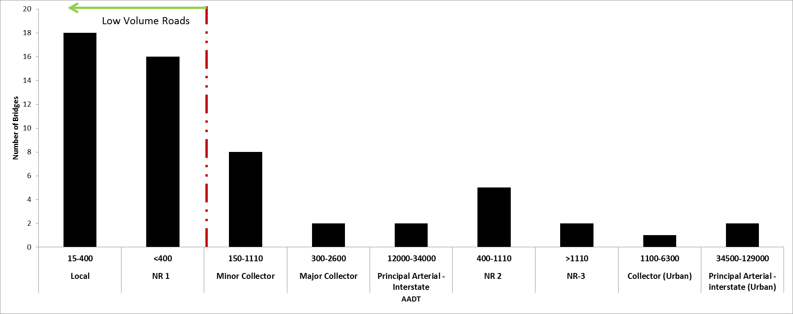
Figure 39: Classification of roads according to their traffic volume (AADT) in the United States

Performance Monitoring
In-service performance monitoring is essential to ensure the health of a bridge and traffic safety by acquiring periodical or real-time quantitative data, and transforming data into useful information through statistical and engineering analysis. This is even more crucial for GRS-IBS technology, given the infancy of its development. Different measurands have been collected including vertical deformations (settlement), lateral deformations, thermal movements, stress distributions and scour monitoring through visual observation in order to monitor GRS-IBS bridges in different states. To date, the performances of 21 GRS-IBS bridges in 13 states have been reported (Table 8), which indicated that surveying was the most widely used technique due to its comparatively low cost and ease of implementation (Table 9). In addition, vertical and lateral deformations were among the most monitored measurands reflecting the serviceability of the GRS-IBS abutment composed of compacted granular materials.

Table 8: Selected GRS-IBS bridges with a reported performance monitoring program (Hatami et al. 2015)
State | Bridge | Instrumentation Type | Survey Period | Bridge Settlement | Lateral Deformation
DE | BR 1-366¹ | Surveying, inclinometer sensors, piezometers, pressure cells, strain gauges, thermistors, volumetric water content sensors | NR (Not Reported) | NR | NR
HI | Kauaula Stream Bridge² | Surveying | 12 months | 22 mm (0.85 in) | 25 mm (1 in)
IA | 250th Street³ | Inclinometers, piezometers, semiconductor and vibrating wire earth pressure cells | 12 months | 13 mm (0.5 in) | 10 mm (0.4 in)
IA | Olympic Avenue Bridge³ | Surveying | 14 months | 18 mm (0.7 in) | 0
LA | Cecil Creek^{4, 11} | Inclinometers and extensomers | 5 months | 30 mm (1.18 in) | NR
LA | Big lake^{4, 11} | inclinometers and extensomers | 5 months | 9 mm (0.35 in) | NR
LA | Cut off Creek^{4, 11} | inclinometers and extensomers | 5 months | 24 mm (0.94 in) | NR
MA | SR 7A over Housatonic RR⁵ | Pressure Cell, Inclinometer | NR | NR | NR
MN | CR 55 over MN Southern Railway^{6, 7} | Horizontal and Vertical ShapeAccelArray (SAA), Vibrating-wire (VW) Earth pressure cells (EPC), optical prism, weather station | 10 months | 43 mm (1.7 in) | 48 mm (1.9 in)
MO | Rustic Road Bridge⁸ | Surveying on facing wall, Earth Pressure Cell, Tensiometer, Telltale, inclinometer, SAA | NR | NR | NR
MT | US HGW 89 south of Dupuyer⁹ | Surveying | 19 months | 9 mm (0.36 in) | N/A
NC | East Canal Bridge¹⁰ | Standpipe piezometers and settlement plates | NR | 15 mm (0.6 in) | N/A
NC | Mattamuskeet National Wildlife Refuge - Central Canal Bridge¹⁰ | Standpipe piezometers and settlement plates | NR | 12 mm (0.48 in) | NR
OH | Bowman Road¹¹ | EDM and total station, Earth pressure cells, strain gauge | 20 months | 21 mm (0.84 in) | 1 mm (0.02 in)
OH | Vine street¹¹ | Surveying | 40 months | 11 mm (0.42 in) | 3 mm (0.13 in)
OH | Glenberg road¹¹ | Surveying | 43 months | 33 mm (1.28 in) | 8 mm (0.32 in)
OH | Tiffin River¹¹ | EDM and total station, Vibrating wire earth pressure cell | 18 months | 53 mm (2.1 in) | 1 mm (0.047 in)
OH | Huber road¹¹ | Surveying | 40 months | 1 mm (0.05 in) | 2 mm (0.06 in)
PA | Mount Pleasant Road Bridge¹² | Surveying | 7 months | 9 mm (0.36 in) | NR
PR | 1121 Bridge (West Bound)¹³ | Pressure Cells and geosynthetic fiber-optic sensors | NR | NR | NR
WI | STH 40 Bloomer over Hay creek¹⁴ | Surveying | 10 months | 15 mm (0.58 in) | NR
1. Talebi et al. 2014 2. Lawrence 2014
3. Vennapusa et al. 2012 4. Nguyen 2012
5. Bardow 2015 6. Budge et al. 2014
7. Barr 2015 8. Campbell et al. 2015
9. Abernathy 2015 10. Mohamed et al. 2011
11. Adams et al. 2011 12. Bloser et al. 2012
13. Torres et al. 2014 14. Oliva 2013

Table 9: Summary of different monitoring instruments used in GRS-IBS projects surveyed in this study
Instrumentation Type | # Bridges Installation
Surveying | 9
Pressure Cells | 8
Inclinometers | 7
Piezometers | 4
Extensomers | 3
Strain Gauges | 3
Settlement Plates | 2
ShapeAccelArrays (SAA) | 2
Tensiometers | 1
Fiber Optic Sensors | 1
Telltales | 1
Volumetric Water Sensors | 1
Weather Stations | 1
Optic Prisms | 1
Thermistors | 1
15 different types of instrumentation have been used in 21 bridges

Reported Problems and Lessons Learned in Different States
A summary of reported problems, lessons learned, and recommendations encountered during the survey of GRS-IBS projects in this study is given in Table 10. In summary, GRS-IBS is still considered as a rather unconventional construction technique, and a certain level of stereotype and misunderstanding still exist surrounding this technology. It is beneficial to provide thorough education using prior case studies throughout an intended project, from bidding to closing, in order to streamline the bidding process and eliminate any unnecessary delays or repeated work during the construction or inspection process.
Table 10: Reported problems and lessons learned in GRS-IBS construction across the U.S.
 | State | Reported Problems/Lessons Learned
Knowledge | DE | * Inspectors need to understand how the GRS-IBS bridge works¹
Attitude | OH | * The most vital lesson was a readiness to try it with an open mind²
Experience | DE  MT  NC  OH | * Allow for learning curve, so the second abutment will be much better than the first¹  * The contractor needs to provide proper training to their project managers and workers on basic elements of assembling this type of bridge support  * Highly dependent on contractor’s QA/QC; otherwise can become distorted during construction³  * Take advantage of others’ experiences is crucial²
Cost | NY | * Construction would be more expensive in water⁴
Design | MO  OH | * Check buoyancy and consider anchorage⁵  * GRS-IBS design is about getting comfortable that it acts as a composite material²
Equipment | MO | * Big roller compactor next to blocks was not a concern⁵
Geosynthetics | MO | * Geogrid orientation and placement are key⁵
Backfill Materials | MO | * Using an open graded granular backfill increases production and can reduce testing requirements⁵
Backfill Materials | MT | * One fill layer was overly saturated and had to be removed and replace with new backfill⁶  * Excessive water in the backfill during compaction should be avoided
Backfill Materials | PR | * Only open-graded material is permitted and also easier to source in Puerto Rico and faster to place and compact  * The compaction process can affect the alignment of the hollow blocks on the well-graded materials because a 95% compaction is required. Thus, the loose materials caused increased forces on the blocks, which made them outward⁷
Backfill Materials | IA | * Backfill with proper compaction is imperative⁸
Spacing | IA | * Ultimate Tensile Strength of geosynthetics ≥ 4800 lbs/ft and good permeability (30gal/min/ft²) is required⁸
Foundation | IA | * Avoid the excavation at the toe of slopes because of its instability. Any excavation at the toe of slope must be done before constructing the fill layer⁸  * Subsurface soil information before bridge construction is important⁸
Bearing Capacity | IA | * Evaluate the bearing capacity in full-scale field testing to failure to determine the ultimate bearing capacities with different backfill and geosynthetic materials⁸
Facing Block | MO  MT  PR | * Hollow facing blocks were pushed outward during compaction^{5, 6, 7}
Facing Block | DE | * East abutment appears broken blocks¹  * 3/4" wide joint gap in 2nd row from top¹  * If the edges are too smooth, the blocks slide easily; thus, a batter is necessary to allow movement¹  * First course of block is vital. Must be straight, level and plumb¹
Facing Block | MO | * Wet cast block is more durable⁵  * Dry cast CMU block does not meet freeze-thaw requirement⁵
Facing Block | PR | * Solid blocks with a minimum weight of 66 pounds (30 kilograms) for the facing of the abutments. Lighter (hollow) CMU (~45 lbs) will be easily pushed out during the compaction⁷
Facing Block | OK | * The abutments’ leaning profiles and some gaps in the facing blocks
Facing Block | MT | * A frontal gap was created at the abutment corner radius caused by rectangular shape of CMU blocks⁶  * Grout patching of the gaps between the blocks is substandard⁶
Bidding | OH  MO | * Good education prior to bidding is essential^{2, 5}
Bidding | MO | * Allow flexibility in the construction timeframe⁵
Performance monitoring | IA | * Must evaluate long-term performance of GRS abutment with different facing elements (sheet piles, CMUs, and timber-faced wall)⁸
1. Walls 2014 2. Schlatter 2012
3. Nguyen 2012 4. Bogart 2011
5. Bartlett 2015 6. Abernathy 2015
7. Pagan 2014 8. Vennapusa et al. 2012

Conclusions and Recommendations from Experiences in Different States
The following conclusions and recommendations have so far been expressed relative to the GRS-IBS projects in different states across the U.S.:
- GRS-IBS construction results in a shorter construction schedule as well as cost savings in materials, labor and equipment
- The abutments can be completed in one day for small projects by an experienced crew of four
- GRS-IBS construction provides opportunities for local employment
- In many cases, the backfill material can be obtained from local sources
- No advanced manufacturing procedures are involved, minimizing or eliminating the need for highly skilled labor
- In soft clay, a preloading system was effective in eliminating most of the primary consolidation settlements, thereby reducing post construction settlements
- GRS-IBS abutments are fairly easy to access for inspection and minimize differential settlements relative to the bridge superstructure, eliminating the bump at the end of bridge problem
Table 11 summarizes the advantages of GRS-IBS technology based on the reported experience across the U.S. Additionally, a comparison between the specifications for GRS-IBS bridges as recommended by the FHWA guidelines (Adams et al. 2012) and those of actual projects across the U.S as surveyed in this study is given in Table 12. Based on the reported data, it is found that: (1) 74% of the 101 bridges with known span length are shorter than 9.1 m (30 ft); only the twin bridges in I-70 over Smith Road and Union Railroad project exceed the FHWA’s 42.7 m (140ft) limit recommendation (Figure 22) , (2) 97% of the 100 GRS-IBS with reported number of spans are single span bridges with the exception of the twin bridges in I-70 over Smith Road and Union Railroad project (with 3 spans) and Knox County Beach Bridge (with 2 spans), which exceed FHWA’s single-span recommendation (Figure 19). The Bassett Road over I-91 project is composed of two consecutive single-span GRS-IBS bridges and is considered a single-span project (GM2 2015), (3) 97% of the 31 bridges with known abutment height are within FHWA’s 9.1 m (30ft) height limit recommendation, except for the Veterans Administration Hospital Bridge with 9.8 m (32 ft) (Figure 24), (4) the AADT value for most bridges is within the FHWA recommendation, with some exceptions including 1122 Bridge (AADT = 39,402) (Figure 6) and I-70 over Smith Road and Union Railroad (AADT = 34,350), (5) 86% of the 49 bridges with known type of geosynthetic material included geotextile reinforcement versus 14% with geogrid, (6) 89% of the 126 bridges with known service under bridge cross waterways, as opposed to the rest which cross driveways, interstate highways, or railroads, (7) 20% of the 25 bridges with known construction days took under 30 days and 60% under 60 days to build, (8) majority of bridges utilized standard 203 mm × 203 mm × 406 mm (8” × 8” × 16”) CMU with a few which included wet-cast concrete blocks, sheet pilings/panels, CCS, or timber, (9) all bridges meet backfill friction angle and RSF thickness recommendations.
Additionally, the following projects were found to be especially noteworthy: (1) I-70 over Smith Road and Union Railroad in Adams County, CO for the 3-span design with largest span length of 48.2 m (158 ft) and AADT = 34,350, (2) Bassett Road over I-91 in New Haven County, CT (GM2 2015) for its unique two consecutive 130 ft span GRS-IBS architecture with AADT = 2,305, (3) Knox County Beach Bridge in Knox County, ME for a 2-span design in marine environment with a 3.7 m (12 ft) high daily tidal range, (4) Mattamuskeet National Wildlife Refuge – East/Central Canal Bridge in Hyde County, NC (Figure 12) which was built on a very soft, gray, silty fat clay foundation soil, (5) 1121/1122 Bridge in Yauco, PR for a comparatively large AADT value of 39,402, and (6) Veterans Administration Hospital Bridge in Harrison County, WV for its 9.8 m (32 ft) abutment height.
In summary, while a majority of the GRS-IBS projects to date have adhered to FHWA’s conservative recommendations, quite a few projects have been pushing the recommended limits in various aspects, which can result in increased acceptance of GRS-IBS technology across the U.S. as long as those projects perform well.

Table 11: Summary of reported advantages of GRS-IBS technology
 | Advantage
Application | * Can be used for bridge abutments, culvert headwalls, and retaining walls
Integrated Approach | * Outperform traditional approach slabs
Construction | * Less weather sensitive (can work in cold weather or rain)  * Common equipment and reduce amount of it was used  * Typical 14 - 75 days construction time depending on the project size. (1-2 abutment/day in IA and OH). Ease of construction and reduced construction time lead to less disruption in traffic)
Cost | * Saved 16-63% due to cost savings from construction days, labor quality/quantity, and materials
Experience | * OH: Replaced bridges at approximately 50% of the costs of conventional bridges in a substantially shorter time; new construction experience was gained  * NY: Save 50% cost with experience growth
Labor | * 4-6 person local crew with no GRS experience can carry out the construction
Traffic (AADT) | * 32 % of GRS bridges have higher volume roads (> 400 veh/day)
Performance Monitoring | * All bridges perform well so far
Foundation | * Can be used on a wide range of soil conditions

Table 12: Comparison of recommended GRS-IBS specifications according to the FHWA guidelines (Adams et al. 2012) with those reported in constructed projects across the United States
Design Matrix | FHWA Recommendations | 140 GRS-IBS projects in the U.S. (as of February 2016)
Span Length | Max Span < 140 ft | 101 bridges reported with span length. Among those:
Span Length | Max Span < 140 ft | 74% (75 bridges) longer than 9.1 m (30 ft),
Span Length | Max Span < 140 ft | 34% (34 bridges) longer than 18.3 m (60 ft), and
Span Length | Max Span < 140 ft | 2% (2 bridges) longer than 42.7 m (140 ft).
Span Length | Single span bridge | 100 bridges reported number of spans. Among those:  97% (97 bridges) is single span bridges, except ME (2 spans) and CO (2 side-by-side bridges each with 3 spans).
Abutments height | <30 ft | 31 bridges reported with abutment height. Among those:
Abutments height | <30 ft | 42% (13 bridges) greater than 4.6 m (15 ft), and
Abutments height | <30 ft | 3% (1 bridge) greater than 9.1 m (30 ft).
Facing elements | CMU 8 × 8 × 16 block with a minimum compressive strength of 4,000 psi and water absorption limit of 5% | Majority CMU 8 × 8 × 16, Large Wet Cast Concrete 16 × 48 × 24 and 18 × 46 × 28, Sheet Piling, Panel, Cellular Confinement System, 6" × 6" Treated Timber
GRS abutment backfill | Well/Open graded or with max aggregate size ranges from 0.5" to 2" with fine content < 12% (well-graded) and <6% (open-graded), Φ'>38º | All meets this requirement except NC with Φ'=34º
Geosynthetic | Geogrid or geotextile in abutment but must use geotextile in RSF and approach roadway | 49 bridges reported with geosynthetic type. Among those:
Geosynthetic |  | 86% (42 bridges) geotextile, and
Geosynthetic |  | 14% (7 bridges) geogrid.
Geosynthetic | Geosynthetic Ultimate Strength ≥ 4800 lb/ft for GRS load-bearing application with minimum FS_{bearing} = 3.5 | Almost all geotextiles meet this requirement. . Except Iowa (1200 lbs/ft Lower FS_{bearing} = 1.8 to 2.6)
Spacing of the reinforcement | ≤ 12" for primary reinforcement and 4" for secondary in the top 5 layers of the GRS abutment bearing beds for CMU 8" × 8" × 16" blocks | All meets this requirement, typically 8" spacing for primary reinforcement and 4" spacing for secondary reinforcement due to CMU 8" tall
Thickness of RSF | 24" or 0.25B | All meets this requirement
AADT | Low volume local road < 400 (rural) or <700 (urban) based on FHWA 2013, Highway Functional Classification Concepts, Criteria and Procedures | Most of the DOT’s uses GRS-IBS in low volume roads, some uses in heave traffic
Performance Monitoring | Standard survey level and rod system or EDM survey | Typical surveying. Others are inclinometer, extensomer, strain gauge, earth pressure cell, piezometer, settlement plate, weather station, tensiometer, ShapeAccelArray, and thermistor
Scour Countermeasure | Riprap aprons, gabion mattresses, and articulating concrete blocks | Most of the project use riprap, cellular confinement system, sheet piling
Service under Bridge | Bridge crossing driveway is more advisable. When crossing waterway, precaution should be taken regarding the stream instability, scour, and adverse flow conditions. | 126 bridges reported with the service under bridge. Among those:
Service under Bridge |  | 89% (112 bridges) over waterways only,
Service under Bridge |  | 7% (9 bridges) over driveways only, including 2 interstate highways,
Service under Bridge |  | 2% (3 bridges) over railroads only, and
Service under Bridge |  | 2% (2 bridges) in Colorado over both railroad and driveway.
Construction Days |  | 25 bridges reported with construction days. Among those:
Construction Days |  | 20% (5 bridges) under 30 days,
Construction Days |  | 60% (15 bridges) under 60 days, and
Construction Days |  | 8% (2 bridges) in Colorado has taken more than 120 days and still under construction, due to its complex 3-span design.
CHAPTER FOUR

GRS-IBS AND COMPARABLE CONVENTIONAL BRIDGES IN KAY COUNTY, OK
This chapter provides detailed information and discussion on six low-volume road bridges (i.e. two conventional and four GRS-IBS bridges) that were constructed in Blackwell in Kay County, OK during the period of this study. The information presented includes the geotechnical data, design plans, construction times and cost. The chapter continues with a description of the laboratory tests that were carried out on the GRS-IBS backfill material to determine its gradation, durability and shear strength against the FHWA recommended values (Adams et al. 2011; Adams et al. 2012). A surveying program is described that was used to measure the settlements of the bridges and monitor their performance over time. A unique aspect of the Kay County bridges was that it allowed a side-by-side comparison between the GRS-IBS and conventional bridges during and beyond the period of this study. The chapter concludes with the challenges and lessons learned through the county’s experience with these six bridges to date.

General Information on the Six Bridges in Kay County, Oklahoma
The ensemble of bridges which is the focused of this study includes six 15.2 m (50 ft) long single-span bridges within 3.22-km (2-mi) range of County Road 80 northwest of Blackwell in Kay County, OK. For ease of reference in this chapter, all these bridges are labeled 1 through 6 (Figure 40). Bridges Nos. 1 and 6 are conventional bridges on H-Pile foundations that were driven to the bedrock at approximately 50 feet and 35 feet, respectively, while Bridges Nos. 2 through 5 are GRS-IBS bridges with geosynthetic reinforced soil abutments that were built on 0.61 m (2 ft) thick reinforced soil foundations (RSF). As shown in Figure 40, except for Bridge No. 4 all of these bridges are located on the 44th Street cross Dry Creek in Blackwell. Figure 41 shows side-by-side comparisons of the old and the recently replaced GRS-IBS Bridges Nos. 2 through 5 in Kay County, OK.

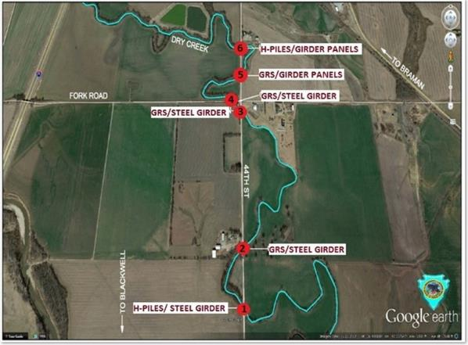
Figure 40: Locations of GRS-IBS bridges in Kay County, OK (Hatami et al. 2015)
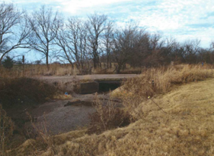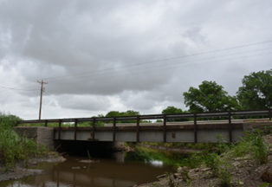
(a)
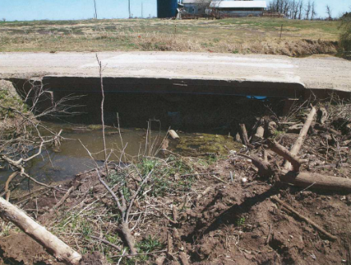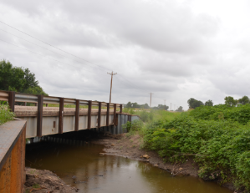
(b)
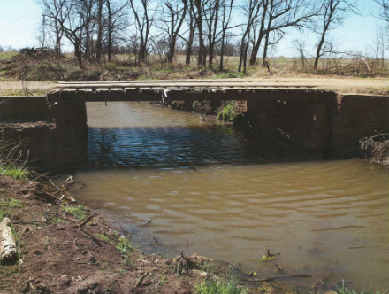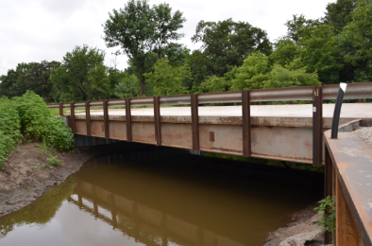
(c)
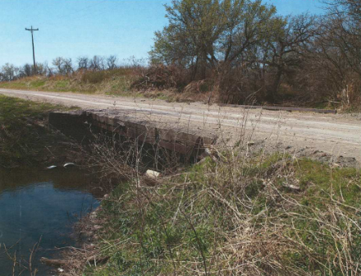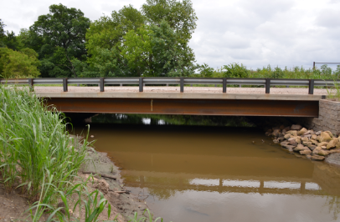
(d)
Figure 41: Side-by-side comparisons between the old (conventional) and new (GRS-IBS) bridges in Kay County; (a) Bridge No. 2; (b) Bridge No.3; (c) Bridge No. 4; (d) Bridge No. 5 (Photographs Courtesy of Mr. Tom Simpson)
Detailed information on these bridges is given in this section. This information was obtained from Mr. Tom Simpson at the Bureau of Indian Affairs (BIA) in Anadarko, OK and Mr. Pete Lively, who is District 3 Bridge Foreman in Kay County. These bridges share some common specifications which make them a unique field case study on a national level to compare the performance of GRS-IBS systems (i.e. Bridges Nos. 2 through 5) with that of those on conventional deep foundation (i.e. Bridges Nos. 1 and 6). The common specification among these bridges include their size which includes a 2.1-m (7 ft) abutment height, 9.1 m (30 ft) bridge width and 15.2 m (50 ft) bridge span, in addition to the fact that all of these bridges are built over a creek with a low maximum water velocity of 0.5-0.6 m/sec (~2 fps), and service a low traffic volume of AADT < 400 in rural area. Table 13 summarizes the general comparison among the six bridges. Note that 203 mm × 203 mm × 406 mm (8" × 8" × 16") CMUs were used in the facing of Bridges Nos. 2 and 5 utilized whereas 4.57 m (15 ft) long sheet piles were used for the facing and wing walls of Bridges Nos. 3 and 4. From Mr. Lively’s perspective (District 3 Bridge Foreman), the installation of sheet piles was easier and faster than that of the CMU blocks. No. 89 aggregate was used for the backfill of the GRS abutment, and No. 57 granular backfill (coarser than No. 89) was used for the approach roadway and the RSF. Gradations of these aggregates are shown in section 4.6.1. Both backfill materials are considered as free draining aggregates. They were supplied majority by the Whitaker plant in Winfield, Kansas and a few loads came from the APAC plant near Pawhuska, OK (Simpson 2015). TerraTex HPG-57 woven geotextile reinforcement with specifications as given in Figure 42 was used at 0.2 m (8 in) spacing in cross machine direction parallel to the GRS facing wall. All bridges were built with a camber making their decks approximately 25 mm (1 in) thicker in the middle than on the sides so that the rain will drain off each side.

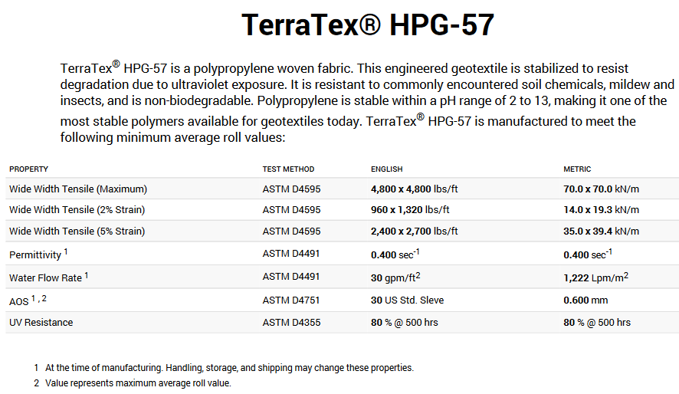
Figure 42: Specifications for the geotextile used in the GRS-IBS projects in Kay County (HanesGeo 2015)

Table 13: Summary information on the GRS-IBS and conventional bridges in Kay County, OK
Bridge | Completion Year | Facing blocks | Backfill Materials | Geosynthetic | Foundation Type | Scour Protection
Conventional Bridge 1 | 2014 | Sheet piling | N/A | N/A | H-Piles driven to bedrock | No Riprap
GRS-IBS Bridge 2 | 2014 | CMU | No. 89 stone in abutment, No. 57 gravel in approach roadway and RSF | TerraTex HPG-57 woven geotextile | RSF | Riprap
GRS-IBS Bridge 3 | 2015 | 15-foot Sheet piling |  | TerraTex HPG-57 woven geotextile | RSF | No Riprap
GRS-IBS Bridge 4
GRS-IBS Bridge 5 | 2014 | CMU |  | TerraTex HPG-57 woven geotextile | RSF | Riprap
Conventional Bridge 6 | 2014 | Sheet piling | N/A | N/A | H-Piles driven to bedrock | No Riprap

Geotechnical Data
Prior to construction of the bridges in Kay County, geotechnical investigation was carried out by a consulting company (METCO 2012) for the Circuit Engineering District # 8 which included 1 borehole at each bridge site. A summary of the METCO geotechnical report for GRS-IBS Bridge No. 2 (Bridge B in their report) is given below. The reports on the nearby bridges (i.e. Nos. 3 through 5, or C, D and E, respectively) contain fairly similar data.
For Bridge No. 2, one 18.29-m (60-ft) deep boring was drilled by a truck-mounted hollow-stem drill rig at the proposed bridge location (Figure 43). From the ground level down to 11.89 m (39 ft) below, the soil was composed of mostly clayey soil overlain by approximately 100 mm (4 in) of gravel and topsoil. Standard penetration resistance (N-Value; ASTM D1586) recorded for the soils ranged between weight-of-hammer (soft consistency) and 85 blows per foot of penetration (stiff soil). Texas cone penetration test results in the sandy weathered shale bedrocks ranged between 100 blows/127 mm (5 in) of penetration and 100 blows/51 mm (2 in) of penetration indicating soft to moderately hard rock. Ground water was encountered at approximately 3.66 m (12 ft) to 3.96 m (13 ft) below ground level (METCO 2012).

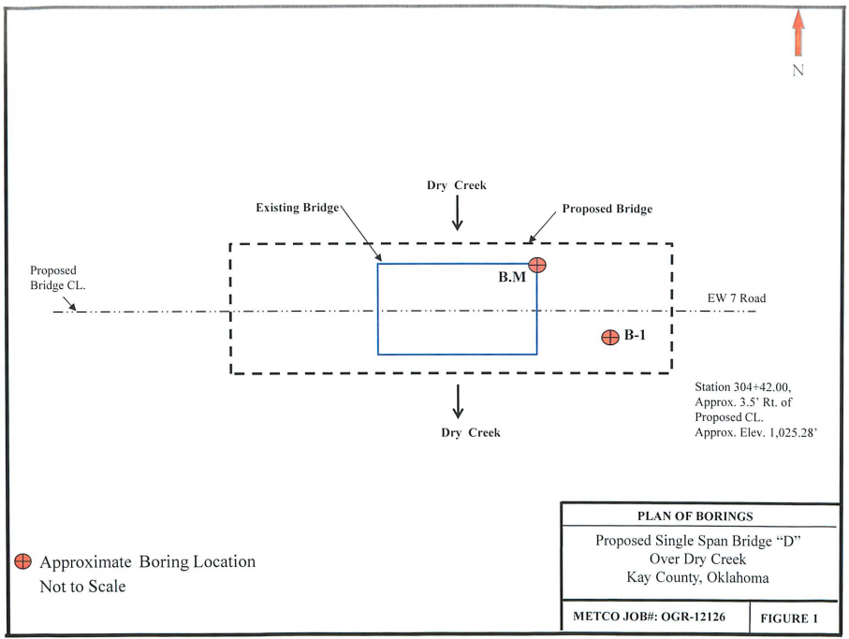
Figure 43: Proposed location for single-span GRS-IBS Bridge 2 (Bridge ‘B’, METCO 2012)

Design and As-Built Drawings
The GRS-IBS bridges in Kay County were built in overall compliance with the FHWA standard drawings (FHWA 2011). However, some adjustments were made on certain bridges due to individual site conditions and material availabilities along with other factors. For instance, the hollow CMU blocks were filled with grout and #4 rebar reinforcement (shown with a yellow line in Figure 44) throughout the facing, which effectively turned them into solid blocks. A 0.46 m (18 in) steel channel filled with concrete was used as the seating pad underneath the superstructure beams instead of Styrofoam panels which are recommended in the FHWA standard drawings (e.g. Adams et al. 2012). Table 14 provides a summary of the differences between planned and actual superstructure systems used in these six bridges. Figure 44 shows a detailed as-built cut-away section of the GRS-IBS Bridge No. 2 based on information obtained from related sources (Simpson 2015, Lively 2015, METCO 2012).

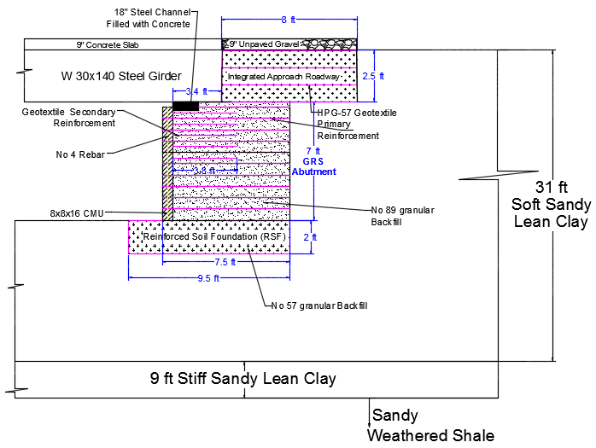
Figure 44: As-built cross-section of the GRS-IBS Bridge No. 2 in Kay County; 1 ft = 0.305 m

Table 14: Originally planned and as-built superstructure systems for the bridges in Kay County, OK
Bridge | Abutment Type | Superstructure (Planned) | Superstructure (As built)
1 | Driven H-piles | Steel girder | Steel girders and tied rebar concrete deck
2 | GRS | Steel girder | Steel girders and tied rebar concrete deck
3 | GRS | Slab span | Steel girders and tied rebar concrete deck
4 | GRS | Box beams | Steel girders and tied rebar concrete deck
5 | GRS | Girder/slabs | Steel girder and precast concrete deck slab channels
6 | Driven H-piles | Girder/slabs | Steel girder and precast concrete deck slab channels

Construction Time and Cost
Table 15 lists approximate costs and construction periods for the six bridges in Kay County (Simpson 2016). The approximate nature of the reported construction days is due to the fact that there were times when the county crew would start a project and then they would have to be away on other activities for several weeks before resuming their bridge construction activity. With respect to the cost, data in Table 15 indicate that the abutment costs for the conventional bridges are almost twice that of GRS abutments. Furthermore, sheet pile facing resulted in significantly faster construction in GRS-IBS Bridges Nos. 3 and 4, albeit at slightly greater costs (nearly $4k) relative to the CMU facing in Bridges Nos. 2 and 5. It is noted that GRS-IBS Bridge No. 5 and the conventional Bridge No. 6 have identical superstructure systems, but Bridge No. 5was constructed in a shorter period of time and it was significantly less expensive than Bridge No. 6. Similarly, Bridges Nos. 1 through 4 have identical superstructure systems, but GRS-IBS Bridges Nos. 2 through 4 are significantly more cost-effective than Bridge No. 1 due to cost savings in the abutment.

Table 15: Comparison of costs and construction periods for the six bridges in Kay County, OK
Bridge | Abutment Cost | Total Cost | Construction Time (days)
Conventional Bridge 1 | $60,000 | $105,000 | 30 - 40
GRS-IBS Bridge 2 | $31,000 | $79,000 | 30
GRS-IBS Bridge 3 | $35,000 | $82,000 | 30
GRS-IBS Bridge 4 | $35,000 | $82,000 | 30
GRS-IBS Bridge 5 | $31,000 | $ 142,000 | 21
Conventional Bridge 6 | $60,000 | $165,000 | 24

Flash Flooding Event
As was mentioned in Section 4.1, the collection of six bridges in Kay County presented a unique opportunity for this study to compare GRS-IBS projects with similar conventional bridges in practically identical environments with respect to their geographical location, site conditions, traffic demand and climatic conditions. Another unique opportunity during the period of this study was that all six bridges experienced record-breaking rainfalls and flash flooding in May and early June 2015. For instance, the one-day precipitation amount on May 23th, 2015 reached 141 mm (5.54 in), exceeding the local monthly average precipitation of 108 mm (5.04 in) for the entire May (Dolce et al. 2015, US Climate Data 2015, 2016). Figure 45 shows the conditions of these bridges one day after the flooding event courtesy of local residents, according to Mr. Curl, Bridges Nos. 5 and 6 were submerged by approximately 0.3 m (1 ft) on May 24th, 2015. Potholes on the approach roadways were caused by the washout of gravel on the unpaved gravel road (Figure 46), which were later patched up by the county personnel. In spite of this significant flooding event, all bridges have been performing well to this day.
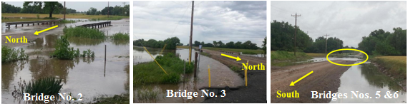
Figure 45: Flooded bridges in Kay County on 05/24/2015; Bridges Nos. 2, 3, 5 and 6 (Photo Courtesy of local residents, Mrs. Curl)

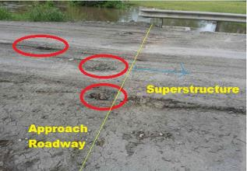
Figure 46: Potholes in the approach roadway of GRS-IBS Bridge No. 2 after the flooding event in May 2015

Laboratory Testing of Backfill Materials
In April 2014, two 50-lb buckets of aggregate samples were delivered by the BIA personnel from the GRS-IBS sites in Blackwell, OK. One bucket was collected from the edge of the Bridge No. 2 abutment, which was tested as the abutment backfill. The other sample, which was observably coarser, was from a stockpile which had been used in the approach roadway and the RSF backfill. In August 2014, two additional 50-lb buckets of aggregate samples, labeled as the abutment backfill, were delivered by the BIA from the same GRS-IBS Bridge No. 2. In January 2015, five 50-lb buckets of aggregate samples were collected by the research team from the top of the GRS abutment of the GRS-IBS Bridge No. 3 during its construction.
A series of laboratory tests was carried out in the Geosynthetics Laboratories at the University of Oklahoma to determine the material properties of the aggregates that were used in the GRS-IBS abutments. These tests included sieve analysis based on the American Society for Testing and Materials ASTM D2487 (ASTM D2487-11 2011), Los Angeles (LA) abrasion test based on ASTM C131 (ASTM C131/C131M-14 2006), large-scale direct shear (LSDS) tests based on ASTM D3080 (ASTM D3080-03 2003), and large-scale interface shear (LSIS) tests based on ASTM D5321 (ASTM D5321-12 2012) to determine gradation, durability and friction angle, and density in different placement conditions of the aggregate used in these bridge projects. The gradation tests also indicated whether the backfill material was open graded or well graded. The large-scale direct shear and interface shear test results (i.e. friction angles), which conducted in both slight compaction, were used as input in the numerical simulations.

Sieve Analysis of Abutment Aggregate
Four gradation tests were carried out in 2014 and 2015 on aggregate samples following ASTM D2487 test protocol (Figure 47). It was observed that sieve analysis results for April and August 2014 samples were quite comparable with D₁₀ = 3 mm, D₃₀ = 5 mm, D₆₀ = 7 mm, C_{u} = 2.84 < 4, and 1 < C_{c} = 1.47 < 3. However, their gradation curves were slightly lower (i.e. coarser) than the specified limits for AASHTO No. 89 aggregates. On the other hand, the sieve analysis results for 2015 samples were also very comparable with D₁₀ = 2 mm, D₃₀ = 5 mm, D₆₀ = 7 mm, C_{u} = 3.32 < 4, and 1 < C_{c} = 1.62 < 3, but their gradations were more compatible with the specified limits of AASHTO No. 89 aggregates. The difference between the two sets of gradation is attributed to different sampling locations (i.e. edge versus top of the abutment), where some samples might have experienced compaction, resulting in reduced aggregate size, and possible cross contamination between the abutment aggregates and the coarser batches used in the RSF and approach roadway. Nevertheless, all samples are classified as uniformly-graded gravel according to ASTM D2487 and A-1-a per the AASHTO M145 standards.

Figure 47 : Gradation curves for the backfills of GRS-IBS projects near Blackwell in Kay County, OK (AASHTO No. 89 gravel); 1 inch = 25.4 mm

LA Abrasion Tests
A series of LA Abrasion tests was carried out on the April 2014 No. 89 aggregate sample following the ASTM C131 test protocol. First, the sample was washed and then oven-dried. The dried sample was then passed through a series of sieves (ASTM C131/C131M-14 2006). Most of the sample was retained on the 6-mm (¼-in) and No. 4 sieves. Thus, the sample was graded as Grade C. According to ASTM C131, eight steel balls were required to test a Grade C sample in the abrasion machine (Figure 48). The machine was set to rotate for 500 revolutions at the speed of 33 rev/min. The soil sample then was removed from the machine and passed through sieves No. 4 and No. 12. The reason for using two sieves was to separate the coarser sample from the finer sample so that the finer sample can be sieved through more easily. The sample retained on the two sieves was washed and oven-dried until it was completely dry (Figure 49). The loss was the difference between the original and the final mass of the test sample (Table 17). According to ODOT specifications, aggregates used in highway bridge construction must have a maximum wear of 40% (ODOT 2009). Therefore, the backfill used in the GRS projects in Blackwell met the ODOT abrasion resistance requirement.

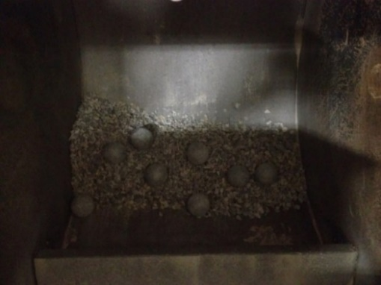
Figure 48: Test sample with eight steel spheres inside the L.A. Abrasion machine (Hatami et al. 2014)

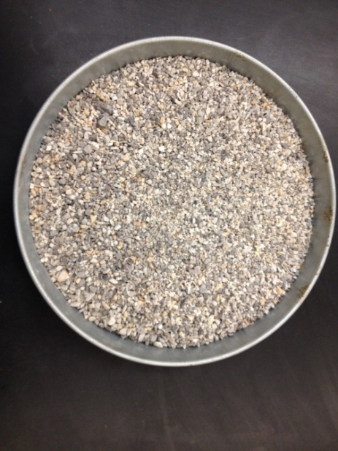
Figure 49: Oven-dried backfill sample retained on sieves Nos. 4 and 12 in Kay County (Hatami et al. 2014)
Table 16: Gradation of LA abrasion test samples (ASTM C131) (Hatami et al. 2014)
Sieve Size (Square Openings) |  | Mass of Indicated Sizes, g
Passing | Retained on | Grading
Passing | Retained on | A | B | C | D
38 mm (1 ½ in.) | 25 mm (1 in.) | 1250 ± 25 | - | - | -
25.0 mm (1 in.) | 19 mm (¾ in.) | 1250 ± 25 | - | - | -
19 mm (¾ in.) | 13mm (½ in.) | 1250 ± 10 | 2500 ± 10 | - | -
13 mm (½ in.) | 10 mm (⅜ in.) | 1250 ± 10 | 2500 ± 10 | - | -
10 mm (⅜ in.) | 6 mm (¼ in.) | - | - | 2500 ± 10 | -
6 mm (¼ in.) | 5 mm (No. 4 ) | - | - | 2500 ± 10 | -
5 mm (No. 4 ) | 2 mm (No. 8) | - | - | - | 5000 ± 10
Total |  | 5000 ± 10 | 5000 ± 10 | 5000 ± 10 | 5000 ± 10

Table 17: Results of the L.A. Abrasion test (Hatami et al. 2014)
Original mass of sample (g) | 5000.0
Final mass of sample (g) | 3487.4
Mass difference of sample (g) | 1512.6
Percentage mass loss (%) | 30.3
ODOT’s requirement for use in highway bridges (%) (ODOT 2009) | Less than 40.0

Large Scale Direct Shear Tests
A series of large-scale direct shear (LSDS) tests was carried out on aggregate No. 89 at different densities such as compaction (γ = 16.3 kN/m³), slight compaction (γ = 14.6 kN/m³), and loose condition (i.e. no compaction with (γ = 13 kN/m³)). All these tests were performed in a 0.3 m (W) × 0.3 m (L) × 0.2 m (T) (12" × 12" × 8") box following the ASTM D3080 test protocol. Before shearing, the gap between the upper and lower halves of the test cell was set at approximately 9 mm (0.35 in), corresponding to D₈₅ of the aggregate specimen (Figure 50) per ASTM D5321. Shearing rate was set at 1 mm/min (0.04 in/min) since no excess pore water pressure would develop in the dry sample. The tests were terminated at 50 mm (2 in) of horizontal displacement.
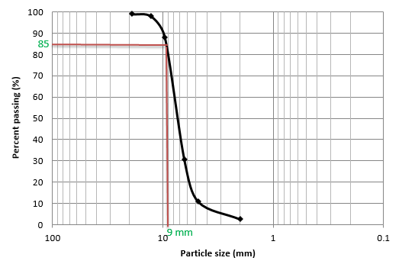
Figure 50: Grain size distribution for No. 89 aggregate used in the interface tests in this study (D₈₅ = 9 mm ≈ 3/8 in)
In July 2014, a series of LSDS tests was performed, in which the No. 89 gravel sample was compacted to γ=16.3 kN/m³. Since there was not enough No. 89 aggregate for one LSDS test, 0.3 m (W) × 0.3 m (L) × 0.1 m (T) (12" × 12" × 4") timber plates were placed at the bottom and top of the aggregate (Figure 51). It should be noted that the total height of the aggregate in the test cell (i.e. 0.1 m or 4 inches) was still comparable to the minimum specimen height specified in ASTM D3080 (i.e. 6 times the maximum particle size equal to 0.11 m or 4.5 inches).

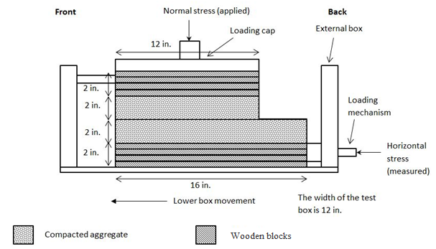
Figure 51: Schematic of the LSDS test setup for compacted aggregate samples
Figure 52 shows the test results for overburden pressures between 34 and 104 kPa (5 to 15 psi). The test results for each overburden pressure show a peak shear strength which is consistent with the expected response of granular material in a compacted state. However, each curve also shows a strain hardening behavior resulting in greater shear strength values at larger displacements, which was discounted as it was attributed to the boundary effects due to the comparatively large size of the aggregates relative to the depth of the test cell. Similar observations have been reported by Bareither et al. (2008), which were attributed to particle-box interaction. Bareither et al. (2008) found that as the normal stress applied on the sample increased, it showed a greater strain hardening behavior, which was referred to as the “plowing effect”. They explained that aggregate settlement is larger under greater normal stresses. Therefore, during shearing, the aggregate has to undergo greater dilation, resulting in a larger particle-to-particle force concentration and measured shear stress. They also observed that at the end of the test, the front end of the loading cap dilated and the back end settled. A similar phenomenon occurred in the tests carried out in this study as shown in Figure 53. The dilation of aggregate was believed to be the cause of the loading cap’s uneven dilation and settlement. Based on the above discussion, the first reliable peak stress values as shown in Figure 52 were used to determine the friction angle of the No. 89 aggregate for the numerical model developed in this study using a linear Mohr-Coulomb failure envelope (Figure 56).

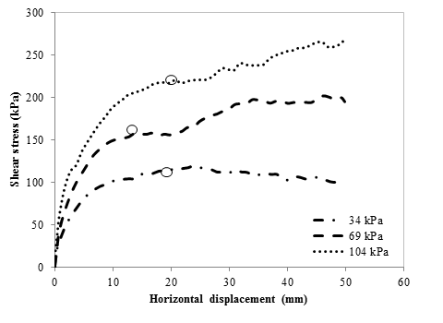
Figure 52: Shear-displacement curves for LSDS tests on compacted No. 89 aggregate
(1 kPa = 20.9 psf)

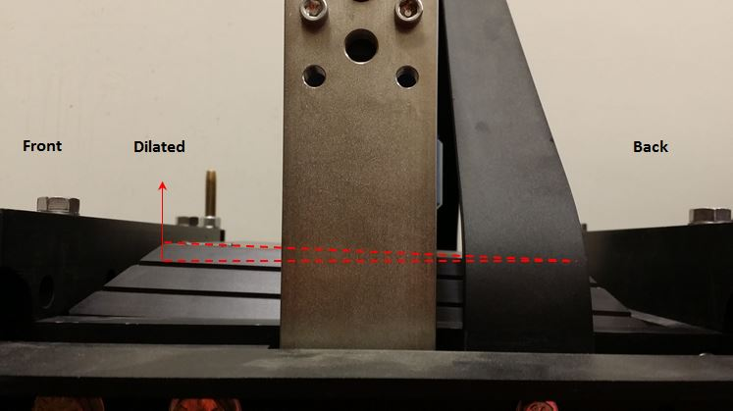
Figure 53: Side-view of the LSDS test box after shearing at 104 kPa normal stress
Additional LSDS tests were carried out on aggregate samples that were placed in the test cell in two other placement conditions: (1) nearly loose (i.e. with a slight amount of compaction resulting in unit weight γ=14.6 kN/m³) and (2) loose (i.e. no compaction effort with γ = 13 kN/m³). These tests were carried out at normal stresses equal to 34, 69 and 138 kPa (i.e. 5, 10 and 20 psi - Figure 54). Figure 55 shows the horizontal shear stress-displacement response curves for the aggregate sample from these tests. Since the aggregate tested is a cohesionless material, the apparent cohesion observed in the results is attributed to interlocking and dilation of the material (Nicks and Adams 2014). In both cases of nearly loose and loose conditions, the shear stress increased until the test was terminated at larger strains, which is consistent with expected behavior for granular soils in loose condition.

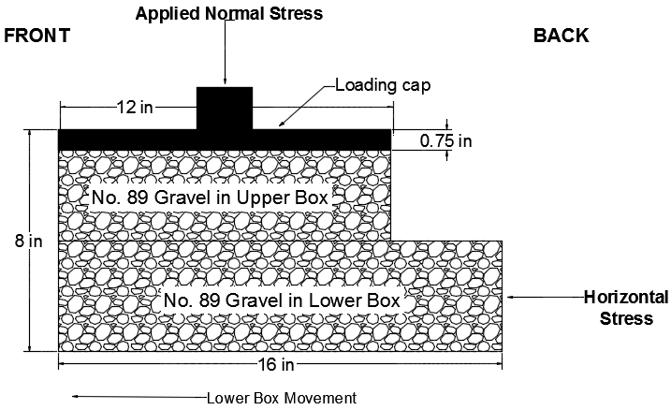
Figure 54: Schematic of the LSDS test setup for loose and nearly loose aggregate samples

(a)
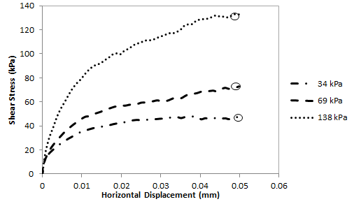
(b)
Figure 55: Shear-displacement curves for LSDS tests on No. 89 aggregate:(a) nearly loose; (b) loose (1 kPa = 20.9 psf)

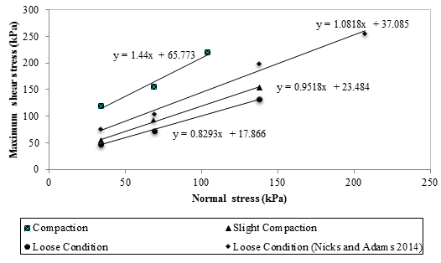
Figure 56: Linear Mohr-Coulomb failure envelopes for No. 89 aggregate tested in this study in different compaction conditions as compared to the results from Nicks and Adams (2014) in loose condition; 1 kPa = 20.9 psf
Table 18: Comparison of AASHTO No. 89 aggregate strength properties from this study with those reported by Nicks and Adams (2014)
 | This Study |  |  | Nicks and Adams (2014)
LSDS Test Conditions | Compacted | Slightly Compacted | Loose Condition | Loose Condition
Friction Angle, ɸ (degree) | 55 | 44 | 40 | 47
Cohesion, c (psi) | 66 | 23 | 18 | 38

Large Scale Interface Shear Tests
Large-scale interface shear tests were carried out using AASHTO No. 89 aggregate samples and TerraTex HPG-57 woven geotextile, which were used in the Kay County GRS-IBS projects. Same as LSDS tests described earlier, the gap between the upper and lower halves of the test cell for the LSIS tests was set at approximately 9 mm (0.35 in), corresponding to D₈₅ of the aggregate specimen (Figure 50) as per ASTM D5321.
The interface shear tests were carried out at normal stresses of 14, 34 and 69 kPa (2, 5 and 10 psi, respectively). As shown in Figure 57, the geotextile was attached to the lower box of the test device in the cross-machine direction using a row of bolts at each end. The geotextile specimen was kept level and in an even and taught position by placing a stack of 305 × 406 mm steel plates in the lower half of the test cell underneath the geotextile up to the gap level. The interface tests were carried out on the geotextile specimen in the cross-machine direction because geotextile reinforcement layers were rolled out parallel to the front facing of the abutments in the Kay County GRS-IBS projects. Similar to earlier direct shear tests (DST), the aggregate samples were placed loosely inside the upper box in dry condition (i.e. with a slight amount of compaction resulting in unit weight γ=14.6 kN/m³). Also similar to the DST, the interface tests were carried out at a shear rate of 1 mm/min (0.04 in/min) as per ASTM D5321 because there was no excess pore water pressure in the specimen. The tests ended after horizontal displacement reached approximately 50 mm (2 in) (Figure 58). The peak shear stresses from interface tests were used to plot linear Mohr-Coulomb failure envelopes as shown in Figure 59 with the soil-geotextile interface shear strength parameters (i.e. adhesion intercept and friction angle) as given in Table 19.

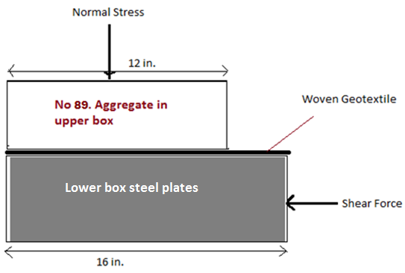
(a)
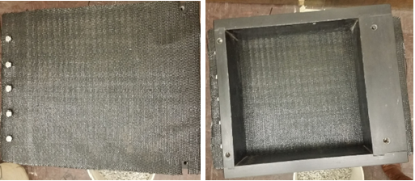
(b)
Figure 57: Large-scale interface shear test setup: (a) Schematic diagram (b) Geotextile specimen attached to the lower box
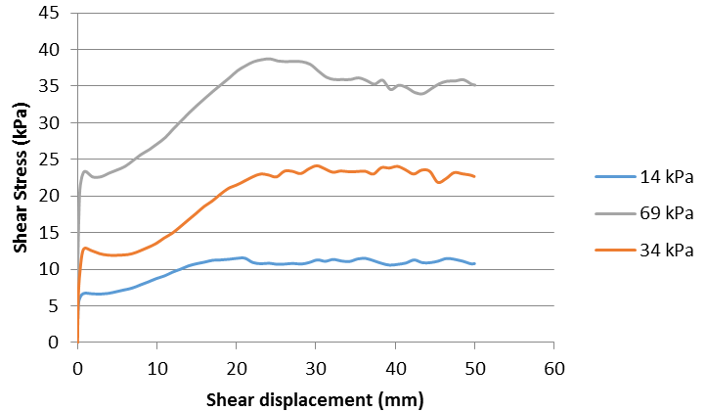
Figure 58: Shear-displacement curves for large-scale interface tests on No. 89 aggregate and TerraTex HPG-57 woven geotextile in the cross-machine direction

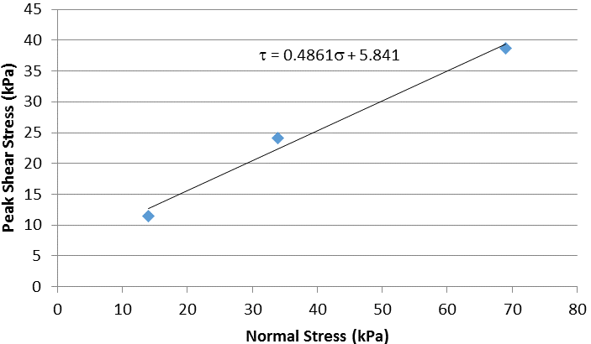
Figure 59: Linear Mohr-Coulomb failure envelope from large-scale interface tests on geotextile reinforcement and No. 89 aggregate in this study (aggregate was placed in loose condition)

Table 19: Shear strength parameters for No. 89 aggregate-geotextile interface
Aggregate-geotextile shear strength parameters (cross-machine direction) | Value
Friction angle, δ (deg) | 26
Adhesion, c_{a} (kPa) | 6

Performance Monitoring of GRS-IBS Bridge No. 2 and Conventional Bridge No. 6

Methodology
In order to monitor the performance of the GRS-IBS bridges in Kay County, different instrumentation-based and surveying techniques were reviewed. It was determined that surveying bridge abutment settlements using an EDM total station would be the most practical option due to its comparatively low operating cost given the project budget, and the comparatively small (low-rise) abutments of these bridges. The total station model Topcon GTS-211D with an accuracy within 1 mm (0.04 in) shown in Figure 60 was used to survey the GRS abutments.

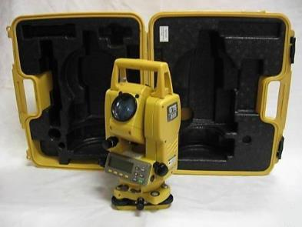
Figure 60: Total Station model Topcon GTS-211D used in this study to survey and monitor the deformations of GRS-IBS and conventional bridges in Kay County, OK
A three-week surveying training program was offered by Dr. Russell Dutnell on the University of Oklahoma campus. Twelve permanent benchmarks were later installed near six bridges in Kay County by staking 0.91 m (3 ft) long #4 (13 mm or ½" in diameter) steel rebars in the center of 152-mm (6-in) diameter, 508-mm (20-in) deep concrete cylinders which were poured in boreholes. A step by step installation procedure for Bridge No. 2 is described below (Figure 61): (1) A 533 mm (21-in) deep, 152-mm (6-in) diameter hole was dug at a higher terrain location near Bridge No. 2, (2) A 30 inch-long, #4 rebar was placed in the hole, (3) Water was carefully added to a concrete mix to obtain a desired strength of greater than 2000 psi for the benchmark concrete cylinder, (4) The concrete was poured in the hole around the benchmark rebar and was tamped to expel the air bubbles, and (5) The top surface of the concrete was leveled and completed with a benchmark cap. There were approximately two benchmarks per bridge (except Bridge No. 2 which had three benchmarks) including two conventional bridges (i.e. Bridges Nos. 1 and 6), which serve as reference for measuring the settlements of the bridges and their abutments.

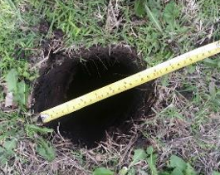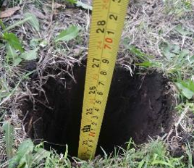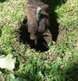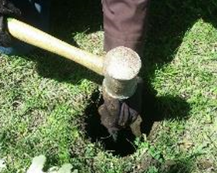
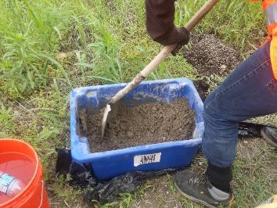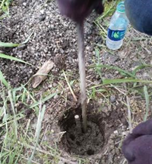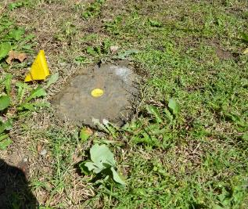
Figure 61: Different steps of installing survey benchmarks for Bridge No. 2
(Hatami et al. 2015)
Table 20 shows the information and assigned coordinates of the benchmarks for Bridges Nos. 2 and 6. Figure 62 depicts the locations of the benchmarks for Bridges Nos. 2 and 6.
For ease of reference, the benchmarks are labeled as BMXY where:
- X = Bridge designation number ranging between 1 (southern) and 6 (northern)
- Y = Benchmark designation number ranging between 1 (eastern) and 3 (western)
Similarly, for all bridges on the 44th street (i.e. except for Bridge No. 4, Figure 40), the control points for surveying are labeled as SSX_{n}Y_{n}, SCX_{n}Y_{n}, NCX_{n}Y_{n,} CCX_{n}Y_{n}, or NNX_{n}Y_{n} where:
- SS = Transverse South Axis (Figure 64)
- CS = Transverse South Center Axis (Figure 64a)
- NC = Transverse North Center Axis (Figure 64a)
- CC = Transverse Center Axis (Figure 64b)
- NN = Transverse North Axis (Figure 64)
- X_{n} = Bridge designation number ranging between 1 and 6
- Y_{n} = Benchmark designation number ranging between 1 (western) and 9 (eastern)

Table 20: Benchmark coordinates and ancillary information germane to surveying of Bridges Nos. 2 and 6 in Kay County
Designation | Depth (cm) | Diameter (cm) | # 4 Rebar Length (cm) | North Coordinate* | East Coordinate*
Bridge 2 Benchmarks
BM-21 | 55 | 19 | 75 | 36°54.374" | 97°20.224"
BM-22 | 53 | 17 | 88 | 36°54.382" | 97°20.218"
BM-23 | 46 | 18 | 76 | 36°54.343" | 97°10.206
Bridge 6 Benchmarks
BM-61 | 51 | 15 | 76 | 36°54.977" | 97°20.208"
BM-62 | 51 | 15 | 76 | 36°54.928" | 97°20.210"
* The accuracy of the GPS used to determine the benchmark coordinates is +/- 1.5 m.
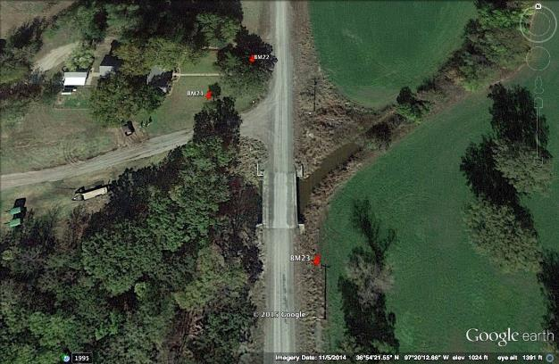
(a)
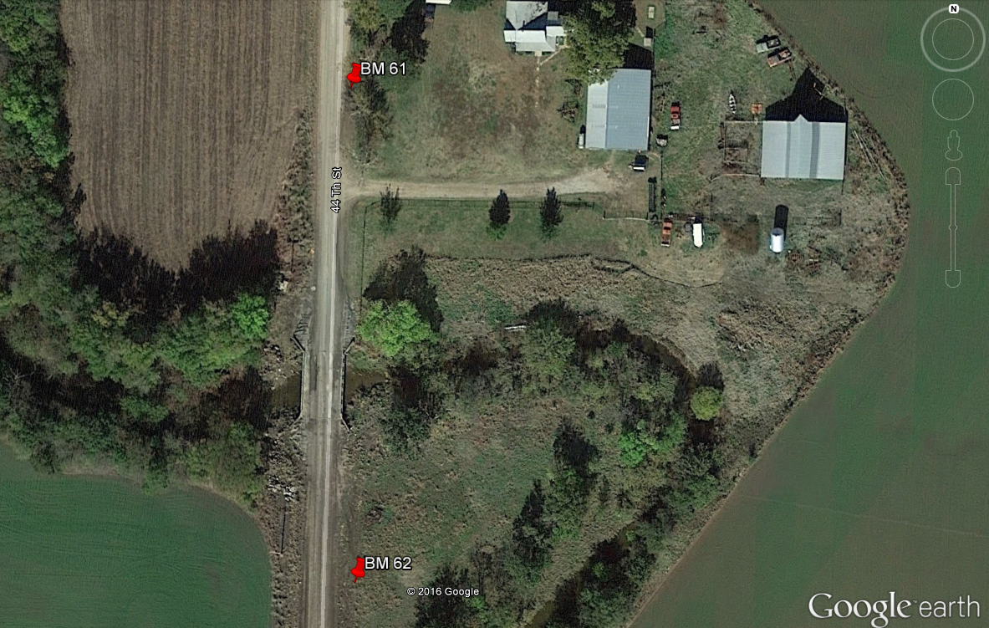
(b)
Figure 62: Benchmarks set up to monitor: (a) Bridge No. 2; (b) Bridge No. 6
Since these bridges have been built on unpaved gravel road, the survey points need to be placed directly on the bridge superstructure for accurate measurement. Nine survey points were marked on the three transverse axes used on Bridge No. 6 and the four transverse axes that were used on Bridge No. 2 using permanent red spray paint (Figures 63 and 64). The survey points on each axis are 1 m (3.3 ft) apart from one another.
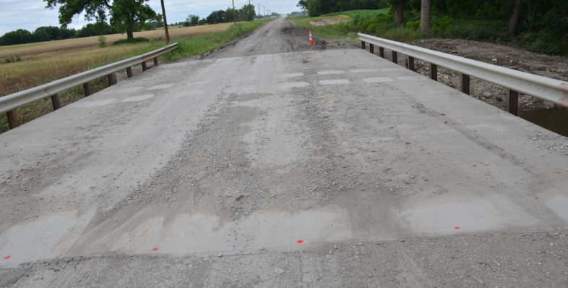
Figure 63: Survey points marked with permanent red paint on Bridge No. 2

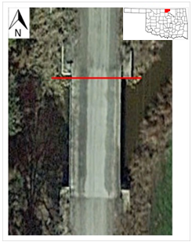 | 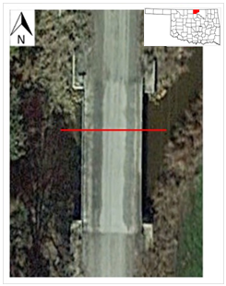 | 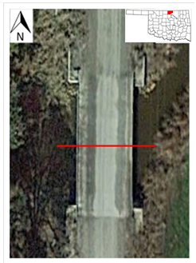 | 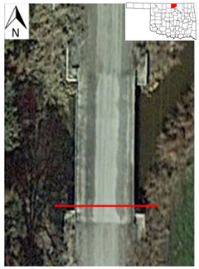
Transverse North  Axis (NN) | Transverse North Center  Axis (CN) | Transverse South Center  Axis (CS) | Transverse South  Axis (SS)
(a)
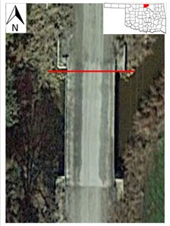 | 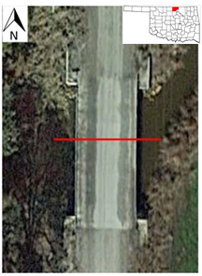 | 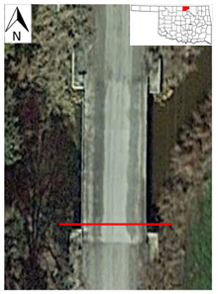
Transverse North  Axis (NN) | Transverse Center  Axis (CC) | Transverse South Axis (SS)
(b)
Figure 64: Transverse axes with 9 survey points (0.91m apart) on each axis: (a) Bridge No. 2; (b) Bridge No. 6

Survey Results
The construction completion and survey start dates for Bridges Nos. 2 and 6 and their survey schedules during the course of this study are given in Tables 21 and 22, respectively. Surveying of both bridges started approximately one year after the construction of each bridge had been completed primarily because of the timeline for this thesis study and the subsequent time it took to review possible monitoring methods, decide on surveying and complete the related training program. For Bridge No. 2, there were six separate visits to the bridge sites during a six-month period between May and November 2015. As for Bridge No. 6 three different surveys were carried out during the six-month period between August 2015 and January 2016.

Table 21: Completion and survey start dates for Bridges Nos. 2 and 6
Bridge | Completion Date | First Survey
GRS-IBS Bridge No. 2 | May 2014 | May 2015
Conventional Bridge No. 6 | July 2014 | August 2015

Table 22: Survey schedule for Bridges Nos. 2 and 6
GRS-IBS Bridge No. 2 | Conventional Bridge No. 6
May 8, 2015 | August 30, 2015
May 31, 2015 | October 24, 2015
June 8, 2015 | January 29, 2015
July 17, 2015
August 30, 2015
November 20, 2015
Figure 65 shows the survey results for Bridge No. 2 from the six separate visits. Results show that over the period of six months between May and November 2015, there have not been significant settlements or heave in the bridge abutments in spite severe weather conditions, record rainfall and flooding in the spring (as described in Section 4.5). Aside from the survey results, the bridge has not shown any visible signs of serviceability or aesthetics-related problems since its construction in April 2014 either. These observations indicate that GRS-IBS could provide reliable and cost-effective alternatives for new construction or replacement of bridges on many rural and county roads in Oklahoma.
Closer inspection of the survey results in Figure 65 show that the measured movements of the bridge deck are by and large limited to 5-15 mm, which could be considered within the accuracy of the surveying method adopted in this study. However, in order to investigate any possible movements beyond the expected random variations in the survey data from different visits, the data for each survey point was plotted separately as per the examples shown in Figures 66 through 69. These results suggest that the bridge deck has undergone a seemingly consistent and predominantly upward movement between 5 and 15 mm (~¼ and ½ inch) during this monitoring period. A slight settlement of the benchmarks in the vicinity of the bridge may be a possible reason for this relative upward movement of the bridge. However, further monitoring of the bridge movement should help us determine the validity and accuracy of this movement and its possible cause. The diagram on the left of each plot in Figures 65 through 69 shows the corresponding cross section of the bridge indicating the locations of its girders and survey points. The survey point specific to the data presented in each graph is shown with a larger arrow on the diagram. Different seasons during the surveying period are also marked on the graph for future analysis of any possible climate-related effects.
Figure 70 shows the survey results for the conventional Bridge No. 6 (i.e. pile foundation) which as opposed to Bridge No. 2 indicate approximately 25 mm (one inch) of nearly uniform settlement in both the north and south abutments. However, this bridge has not shown visible signs of serviceability or aesthetics-related problems either.

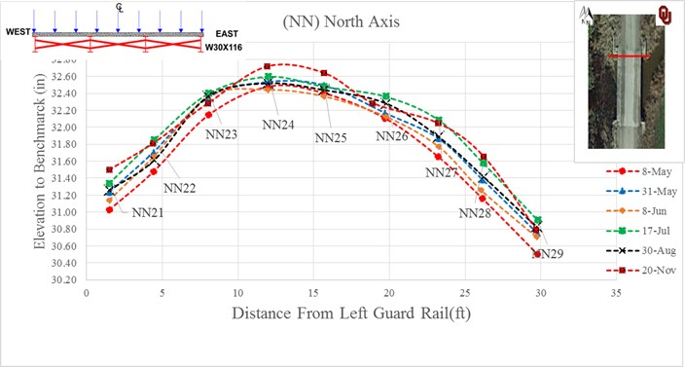
(a)
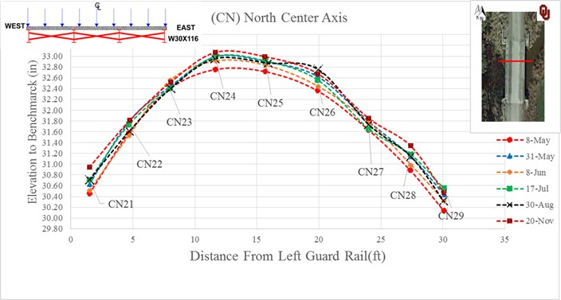
(b)
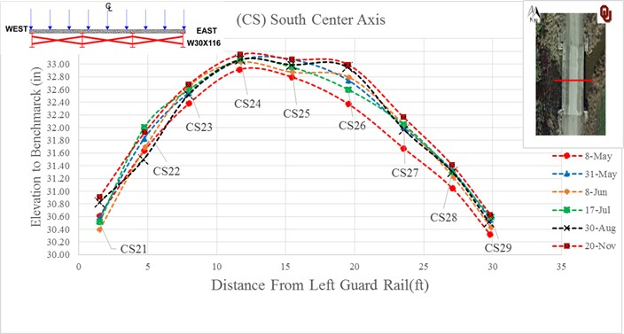
(c)
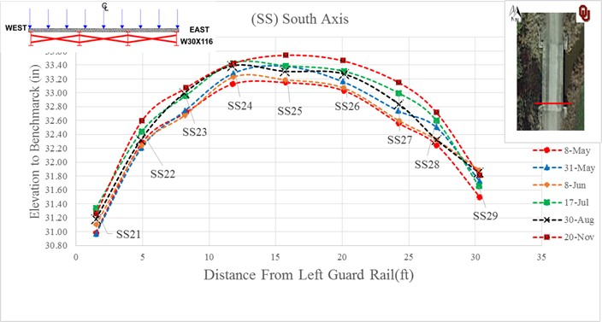
(d)
Figure 65: Survey data on Bridge No. 2 from six different visits to the site during May-Nov 2015: (a) North end, (b) North center, (c) South center, (d) South end
(1ft = 305 mm)

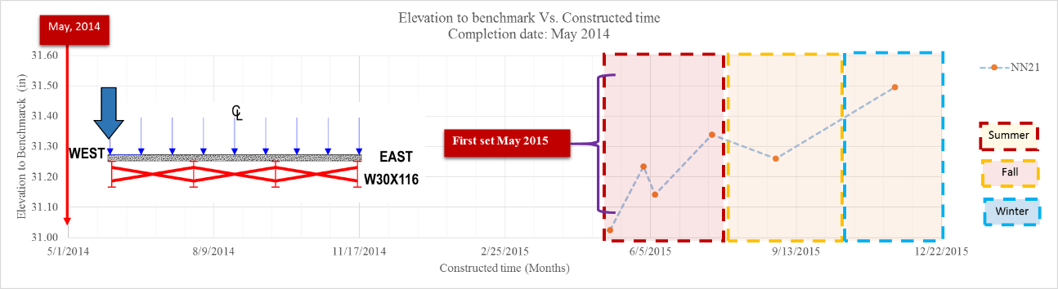
(a)
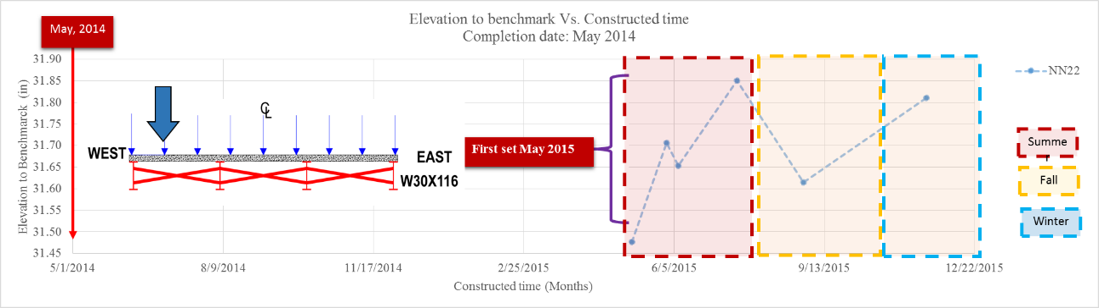
(b)
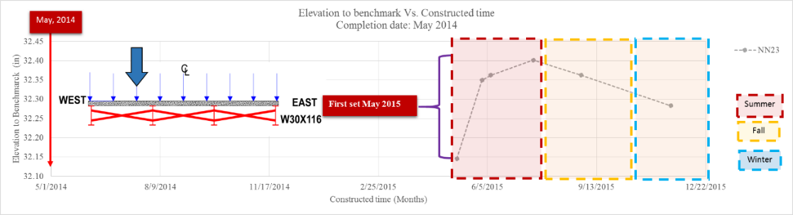
(c)
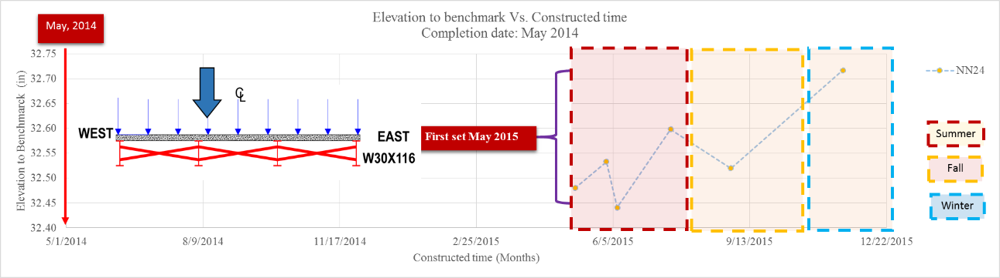
(d)
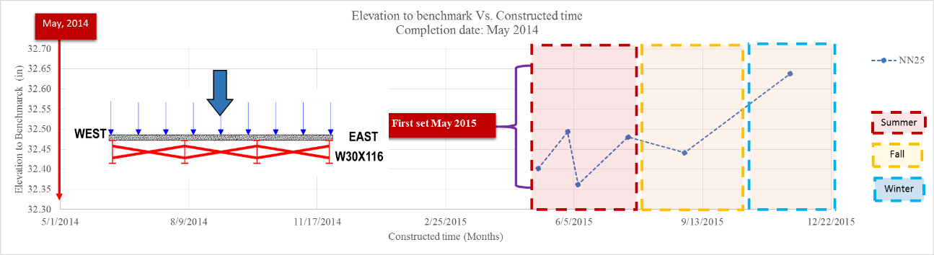
(e)
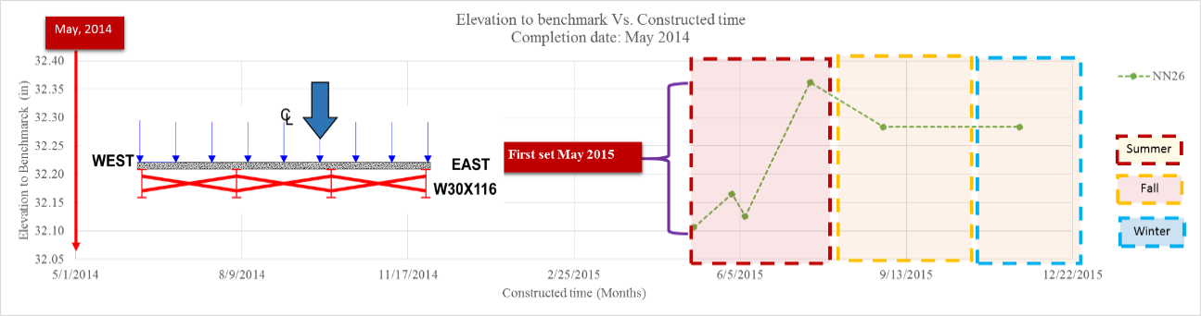
(f)
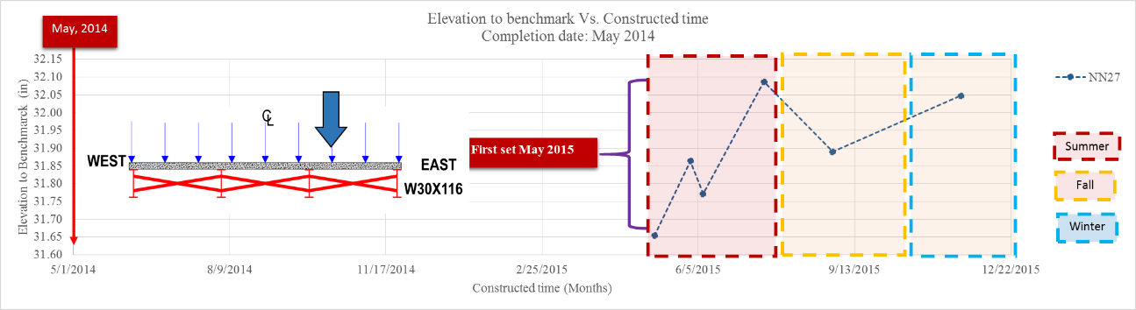
(g)
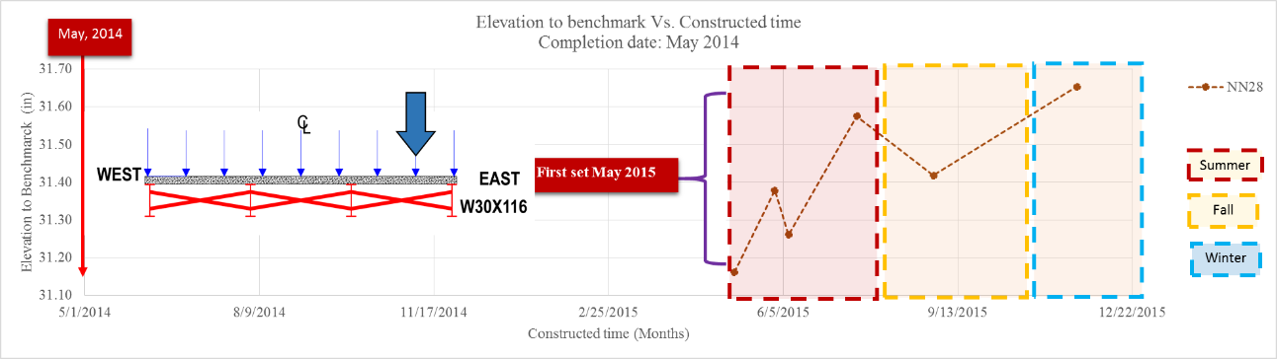
(h)
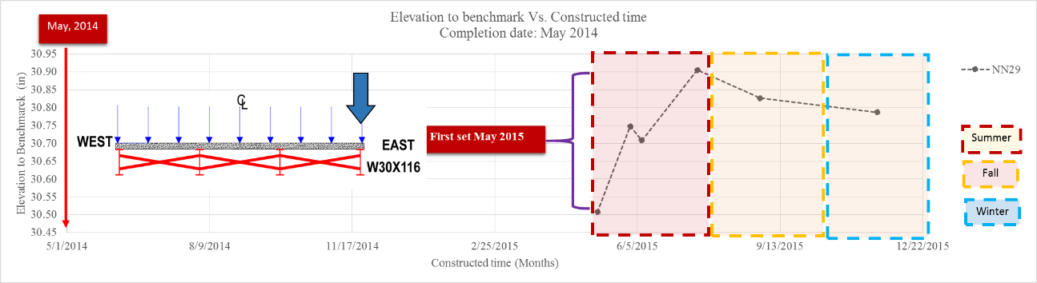
(i)
Figure 66: Measured vertical movements of Bridge No. 2 north abutment during May – November 2015 (1in = 25.4 mm)

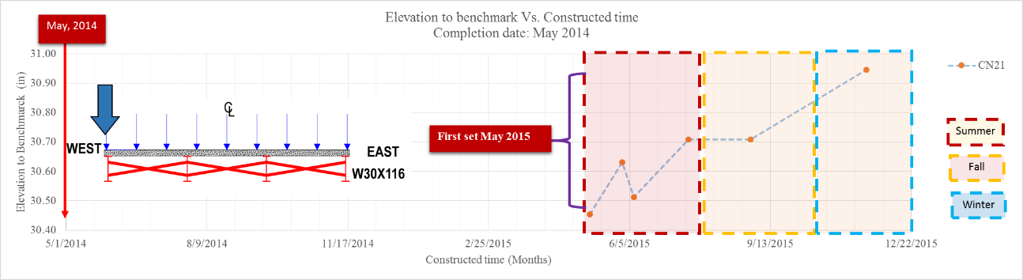
(a)
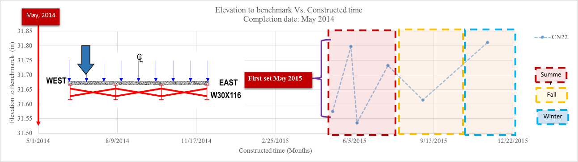
(b)
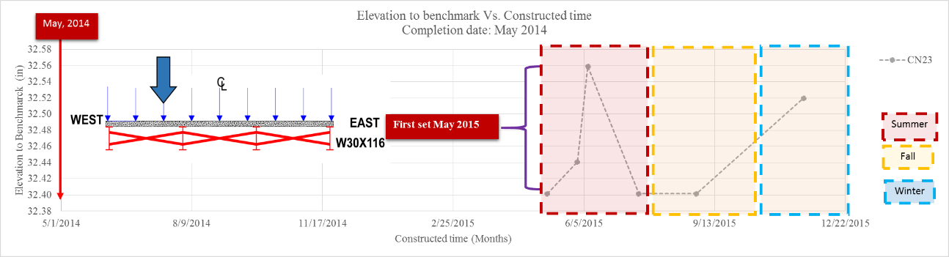
(c)
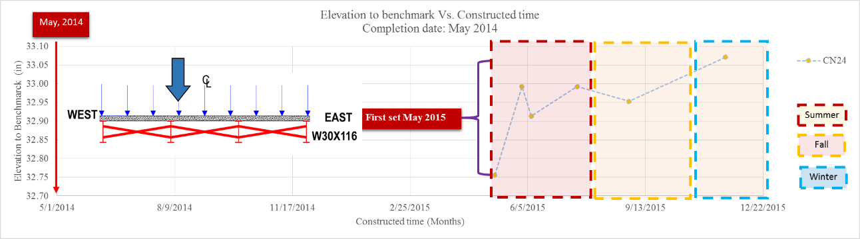
(d)
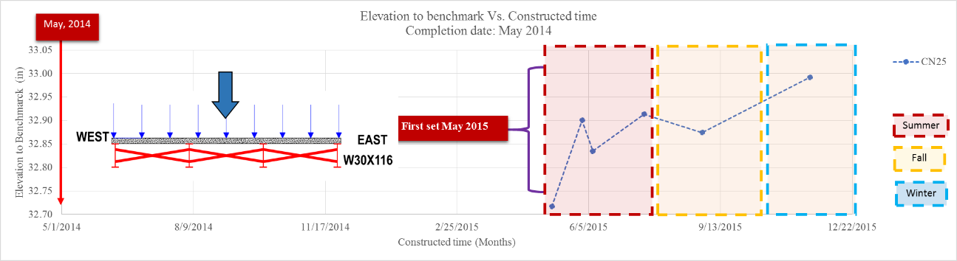
(e)
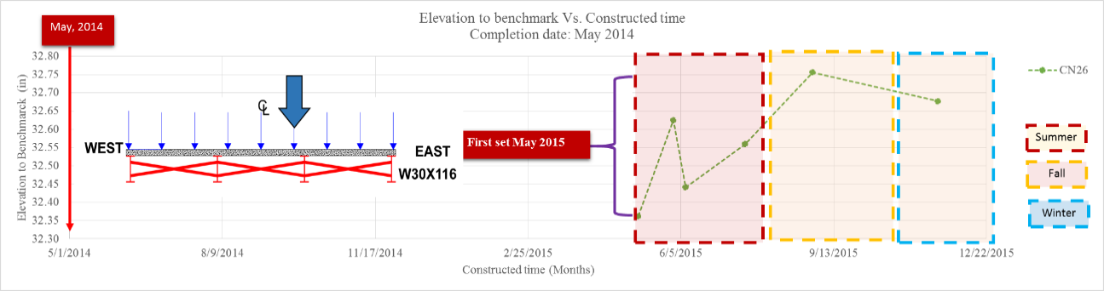
(f)
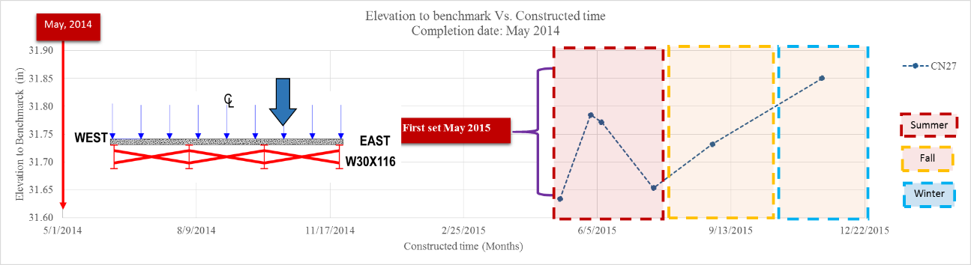
(g)
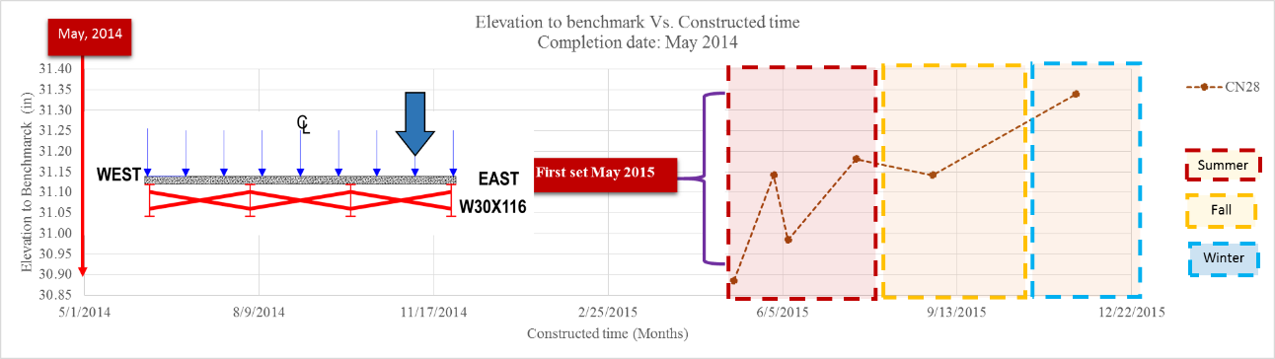
(h)
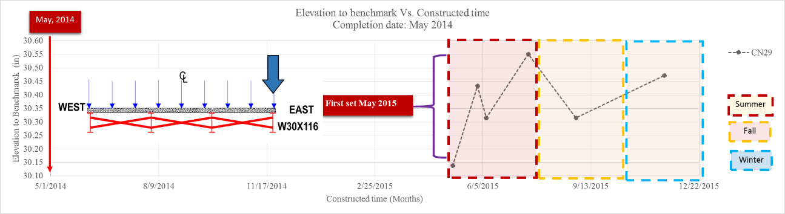
(i)
Figure 67: Measured vertical movements of Bridge No. 2 north center abutment during May – November 2015 (1in = 25.4 mm)

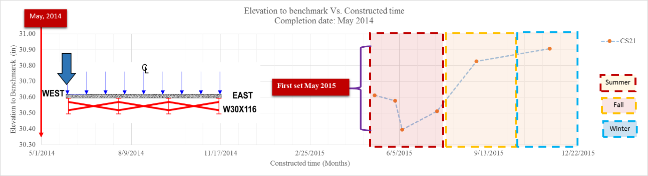
(a)
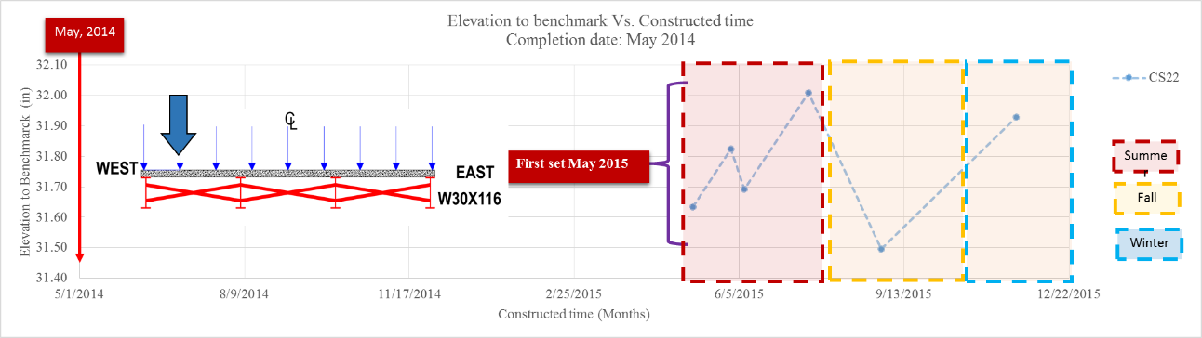
(b)
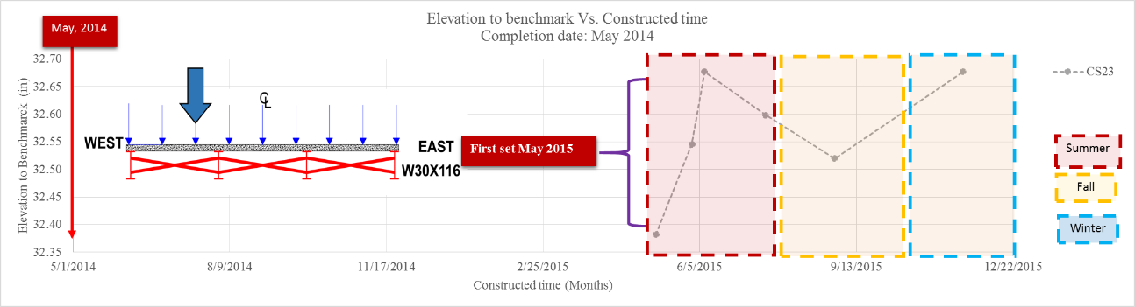
(c)
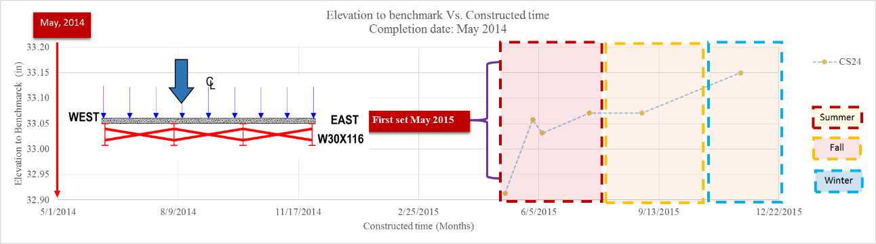
(d)
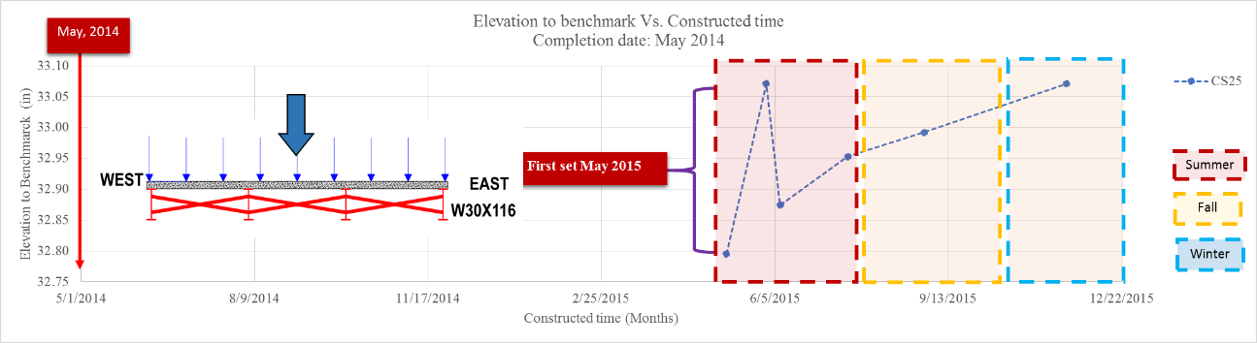
(e)
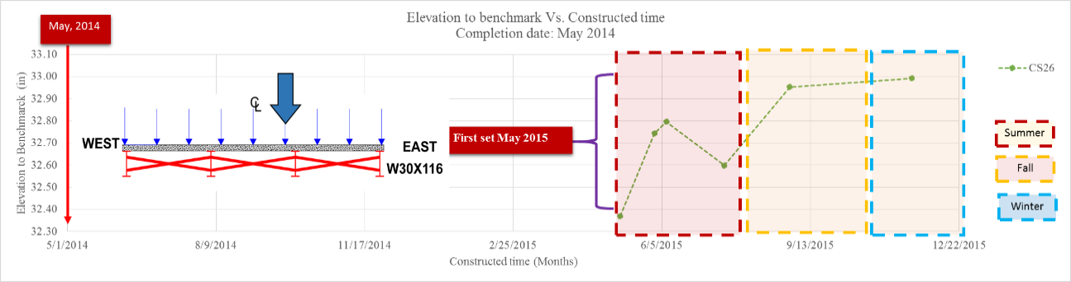
(f)
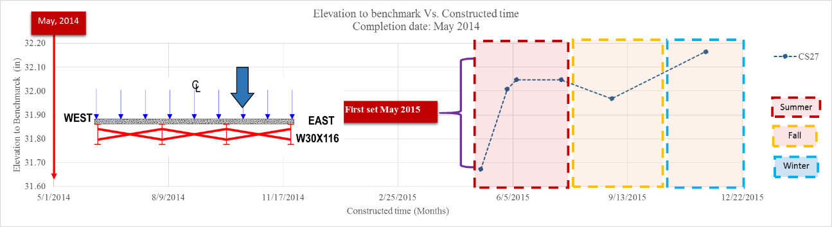
(g)
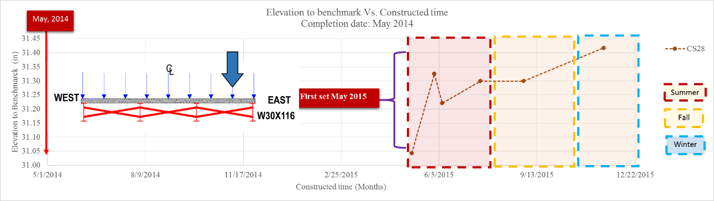
(h)
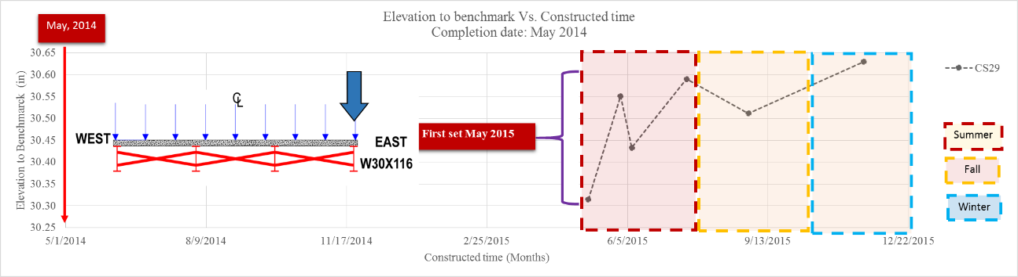
(i)
Figure 68: Measured vertical movements of Bridge No. 2 south center abutment during May – November 2015 (1in = 25.4 mm)

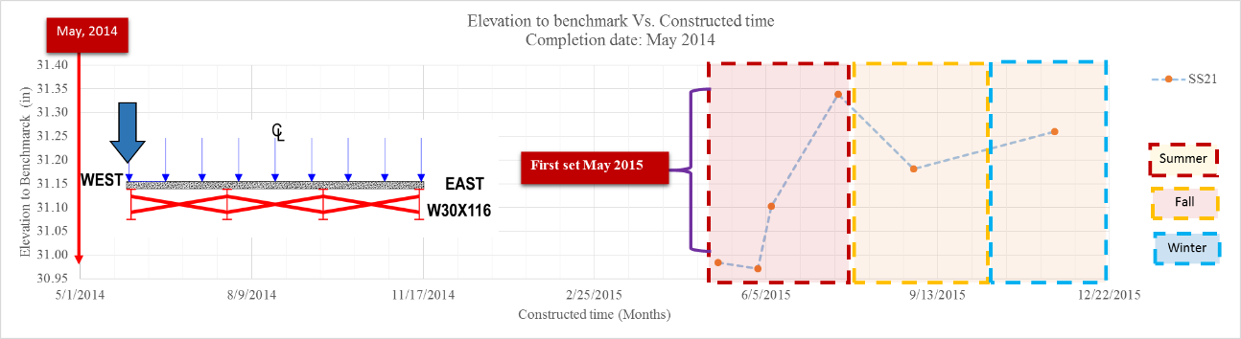
(a)
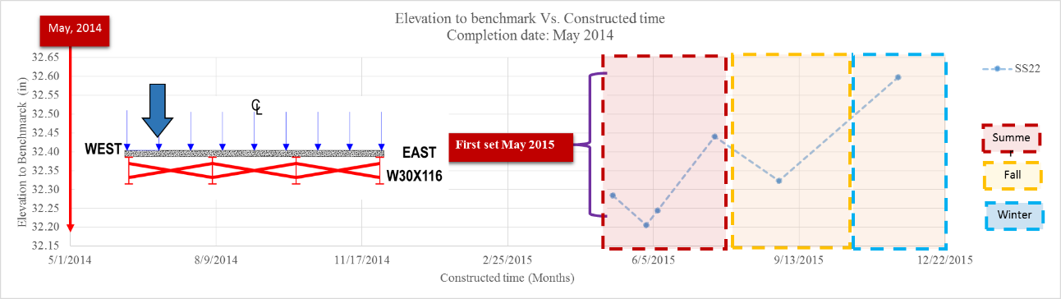
(b)
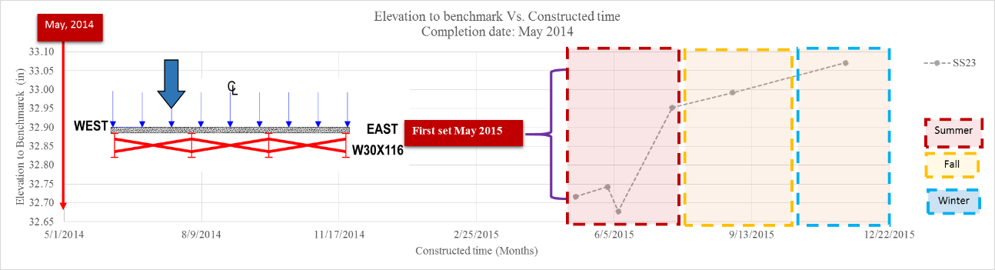
(c)
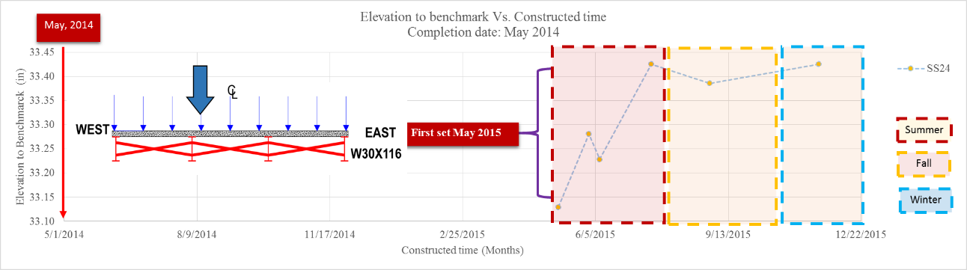
(d)
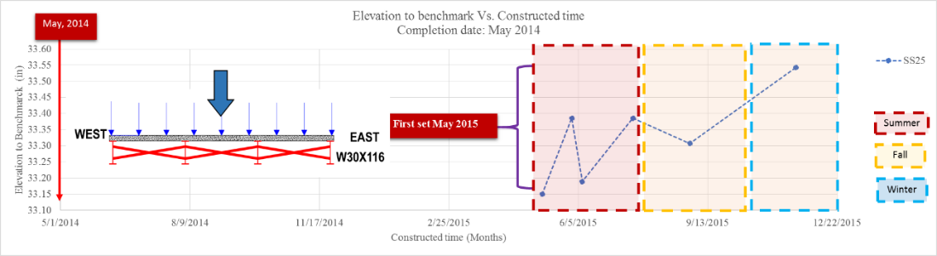
(e)
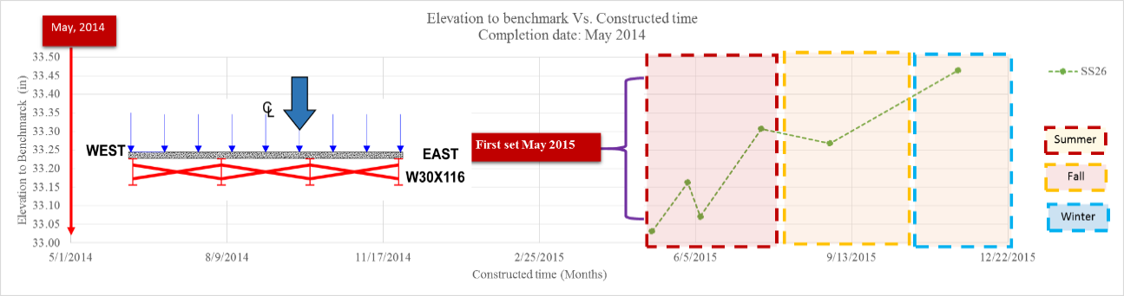
(f)
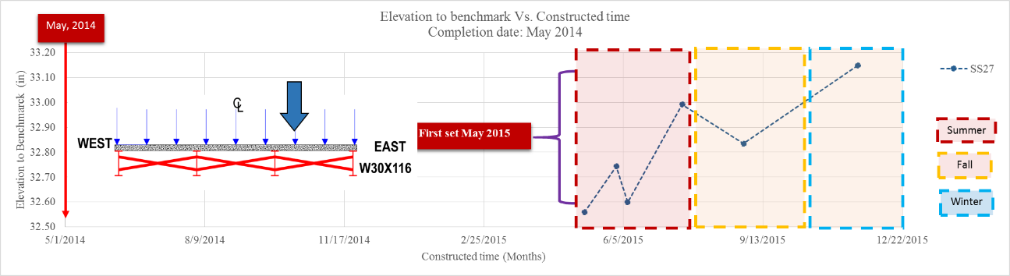
(g)
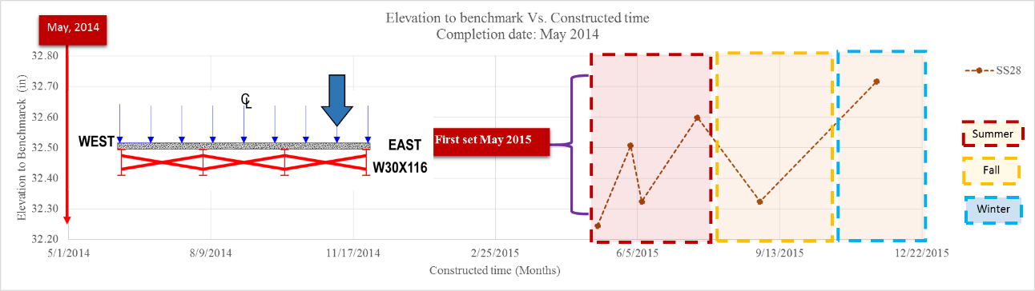
(h)
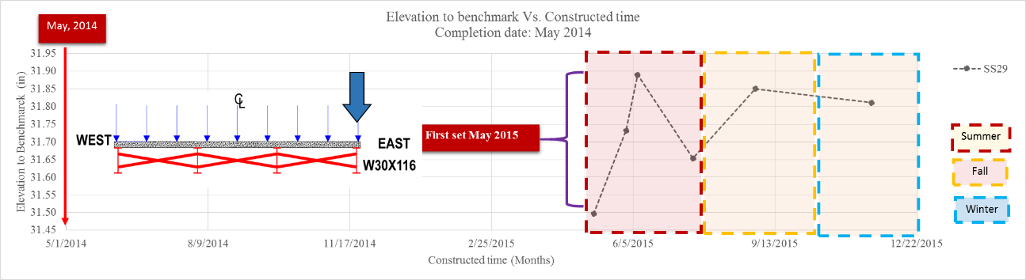
(i)
Figure 69: Measured vertical movements of Bridge No. 2 south abutment during May – November 2015 (1in = 25.4 mm)

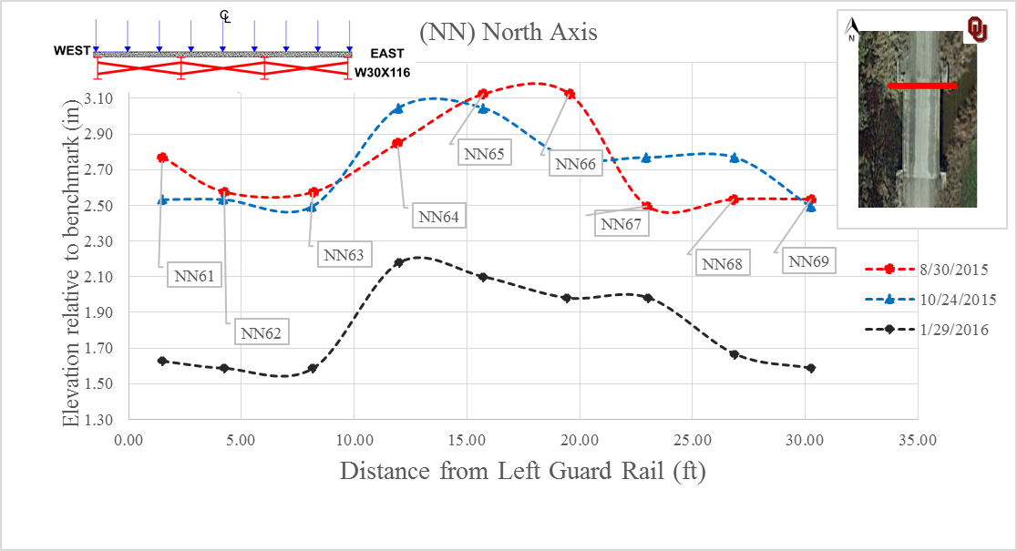
(a)
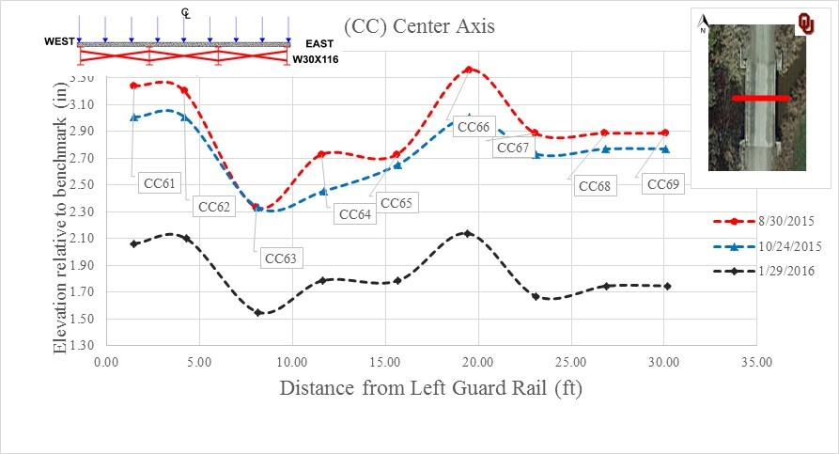
(b)
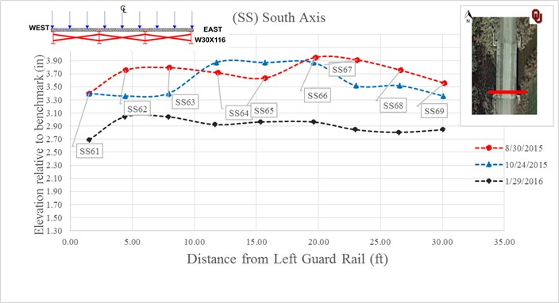
(c)
Figure 70: Survey data on Bridge 6 from three visits to the site: (a) North end, (b) Center, (d) South end; 1in = 25.4 mm

Challenges and Lesson Learned on GRS-IBS projects in Kay County, Oklahoma
- Since all the roads to the six bridges in Kay County are unpaved gravel roads, it is necessary to perform regular road maintenance, especially after a heavy rainfall when a significant quantity of gravel washes off the road.
- According to FHWA guidelines (Adams et al. 2012), a layer of geotextile should be installed on the top of the GRS abutment to encapsulate the backfill material before placing a beam seat (Figure 71). However, a top geotextile layer was not used in the GRS abutment of Bridge No. 2, as shown in Figure 72. Consequently, the backfill aggregate is exposed and potentially vulnerable to weathering and erosion during the future flooding events. As a result, the county has to promptly inspect and remedy the aggregate loss after each flooding event during the bridge service life.
- FHWA guidelines (Adams et al. 2012) also recommend a minimum setback equal to the greater value of 203 mm (8 in) or the height of CMU block for the beam seat behind the facing including a stack of Styrofoam panels to provide a compressible seating condition for the bridge and prevent a direct load transfer to the abutment facing (Figure 73). While all GRS bridges in Kay County was replaced with an 18 inch-wide concrete-filled steel channel as the bearing pad for the bridge steel girders, which was just an equivalent solution compared with the design guidelines (Figure 74).
- Sheet piling was found to be a favorable facing option relative to the CMU blocks because it was found easier and faster to construct and required less labor. However, the cost of sheet piling was found approximately 30% higher than CMU block facing.
Nevertheless, the Kay County’s success with the GRS-IBS bridges (i.e. Bridges Nos. 2 through 5) so far suggests that GRS-IBS bridges can serve as reliable and economical substitutes for many functionally obsolete and structurally deficient bridges on county roads across the state of Oklahoma.

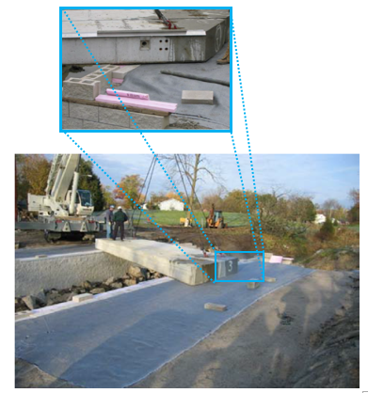
Figure 71: A geotextile is recommended in the FHWA guidelines (Adams et al. 2012) to be placed on the top of the GRS abutment before placing the beam seat

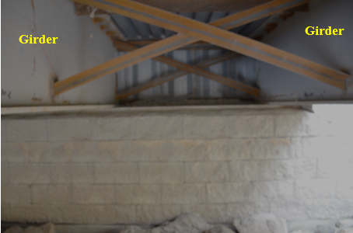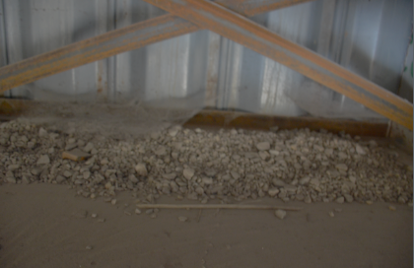
Figure 72: No geotextile layer was used on the top of abutment before placing the beam seat

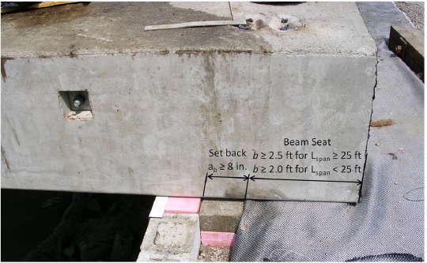
Figure 73: Setback for the beam seat as recommended by FHWA guidelines (Adams et al. 2012)

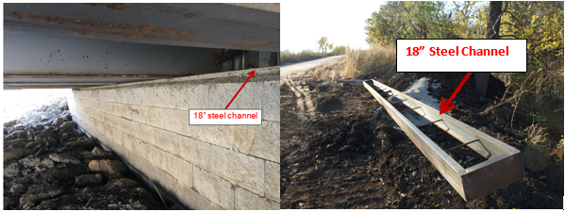
Figure 74: GRS-IBS Bridge No. 2 with an 18 in-wide concrete-filled steel channel as the bearing pad for the steel girders
CHAPTER FIVE

NUMERICAL MODELING OF BRIDGE NO. 2 GRS ABUTMENT
A numerical model was developed in this study to estimate the influences of factors such as abutment aggregate and reinforcement properties on the predicted settlements and facing deformations of the GRS abutments. Mechanical properties of the No. 89 backfill and backfill-geotextile interface were determined from large-scale direct shear tests (LSDS) and large-scale interface shear tests (LSIS) tests as described in Chapter Four. This chapter provides a description of the computer program including its input parameters and concludes with predicted results of numerical models for selected parametric cases.

Introduction
An as-built design drawing was prepared for Bridge No. 2 (Figure 75) based on the information obtained from Mr. Tom Simpson of the BIA and Mr. Pete Lively of Kay County District 3 (see Chapter 4). Foundation soil properties were taken from the geotechnical report prepared by METCO (2012). The computer program Fast Lagrangian Analysis of Continua (FLAC; Itasca 2011) was used in this study to develop a numerical model for the GRS abutment of Bridge No. 2. It is understood that the GRS abutment is in fact a three-dimensional structure. However, it was judged that a two-dimensional plane-strain model simulating the centerline of the GRS abutment and the bridge could provide useful results to investigate the comparative influences of backfill and reinforcement properties on the performance of the GRS abutment within the scope and objectives of this study. Therefore, the two-dimensional program FLAC Version 7.0 was used to develop the numerical model and carry out the parametric studies described in this chapter. The results are interpreted for a unit width of facing perpendicular to the plane of the analysis. Therefore, the dimension of the CMU block in the running length of the facing is irrelevant to the analysis and the blocks are merely referred to as 203 mm × 203 mm (8" × 8") designation in the analysis and discussion of results presented below.

Model Configuration and Material Properties
Figure 75 shows the numerical model for the GRS-IBS Bridge No. 2 which is set up in six different stages as shown. Also as shown in the figure, the model boundaries for the GRS abutment are located at considerable distances from the reinforced mass to minimize boundary effects in the model. For instance, the far-end boundary is located 4.72 m (15.5 ft) from the back of the GRS abutment, which is twice as large as the abutment width 2.1 m (7 ft). Figures 76a-e show snapshots of model construction as listed below to determine the model performance (e.g. stresses and deformations) at each stage (see Table 23 for load magnitudes):
- Stage 1: Excavation of the abutment and shallow foundation (Figure 76a)
- Stage 2: Construction of reinforced soil foundation (RSF) (Figure 76b)
- Stage 3: Construction of the GRS abutment with CMU facing in lifts (Figure 76c)
- Stage 4: Application of the beam seat load on the GRS abutment (Figure 76d)
- Stage 5: Application of a surcharge load representing the weight of the approach roadway (Figure 76e)
- Stage 6: Application of an equivalent static traffic load (Figure 76f)
Traffic load on the GRS abutment was simulated using an equivalent 13.2 kPa uniform surcharge load (2 ft of soil) on the top of the entire model as recommended by FHWA design guidelines (Berg et al. 2009).
Properties of the GRS and RSF backfill materials, geotextile reinforcement and their interfaces are given in Table 24. Data from the large-scale direct and interface shear tests and other reported material properties were used as input for the numerical model. The CMU facing block was modeled as an elastic material with Young’s modulus E = 20 GPa and Poisson’ ratio $υ$ = 0.2 (Engineering Tool Box). The native soil and backfill materials were modeled as an elastoplastic dilatant material with Mohr-Coulomb failure criterion. Measured values of friction angle for No. 89 aggregate and its interface with the geotextile reinforcement were obtained from LSDS and LSIS tests, respectively (Section 4.6). The friction angle value for the open-graded No. 57 gravel in loose condition from large scale direct shear tests was reported as 52º by Nicks and Adams (2014), which was used in this model. TerraTex HPG-57 woven geotextile reinforcement was modeled using cable elements with tensile strength at 2%, T_{2%} = 19.3 kN/m and tensile modulus, J_{2%} = 965 kN/m. These tensile properties were determined from the product’s specifications sheet in the cross machine direction (Figure 42) consistent with the direction the geotextile was installed in Bridge No. 2. The backfill-facing block and backfill-native soil interfaces were modeled using interface elements with friction angles equal to 2/3φ. The backfill dilation angle, $Ψ$, was estimated from Bolton’s equation (Bolton 1986; Jewell 1989):
$ϕ_{ps}=ϕ_{cv}+0.8Ψ$ [1]
Where:
$ϕ_{ps}$= the backfill peak friction angle
$ϕ_{cv}$ = the backfill residual (constant volume) friction angle
The values of the bulk modulus, $K,$ and shear modulus, $G$, of the soil were expressed as:
$K=\frac{E}{3\left(1-2υ\right)}$ [2]
$G=\frac{E}{2\left(1+υ\right)}$ [3]
Where:
$υ$ = Poisson’ ratio

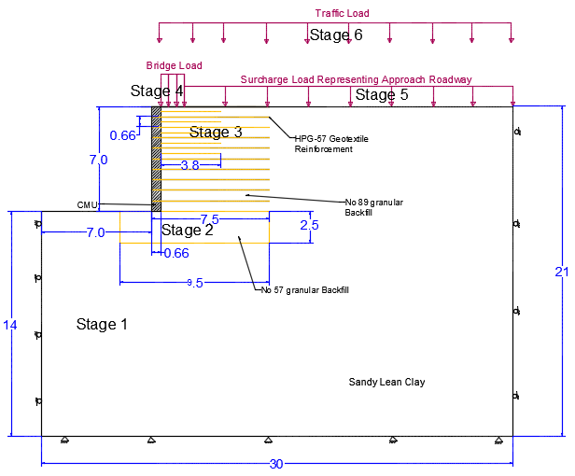
Figure 75: Model Configuration for GRS-IBS Bridge 2 (all dimensions are in feet)
(1ft = 0.305 m)

Table 23: Static loading conditions (applied pressure) in GRS-IBS numerical (FLAC) models (1 kPa = 20.89 psf)
 | Bridge Load | Approach Roadway Equivalent static load, σ_{v}
End of Construction (kPa) | 65.32 | 18.8
Traffic Surcharge Load (kPa) | 78.52 | 32
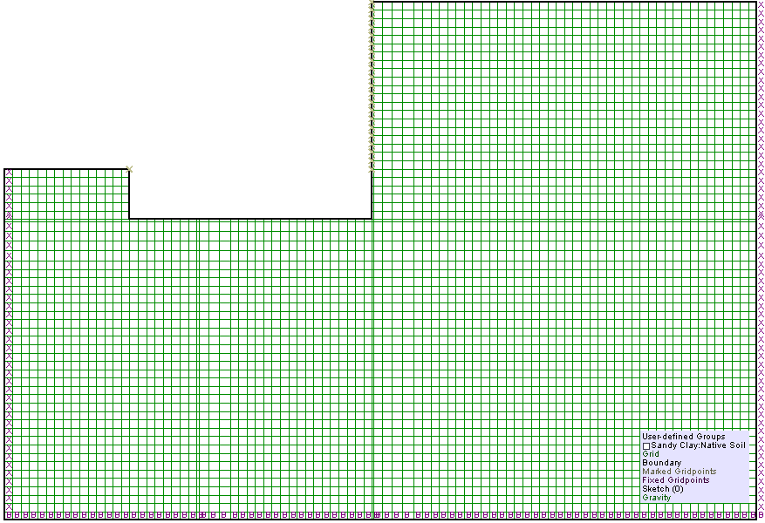
(a)
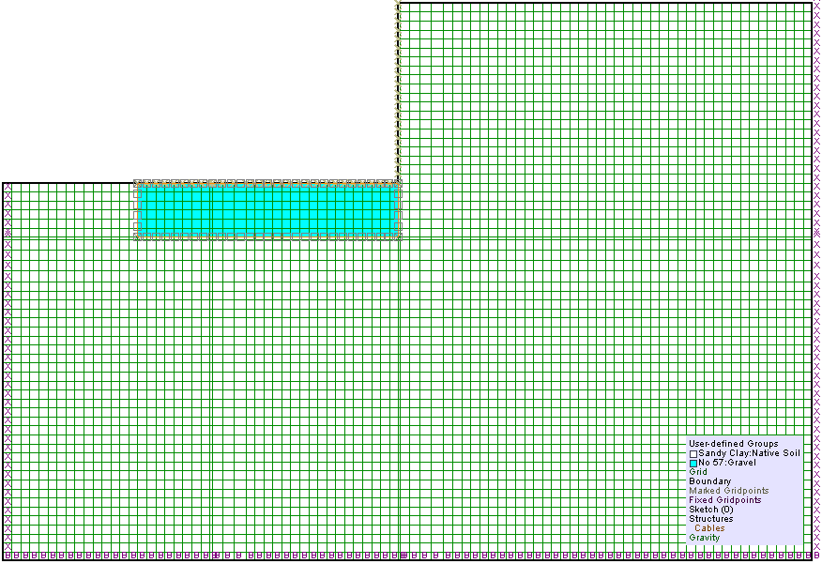
(b)
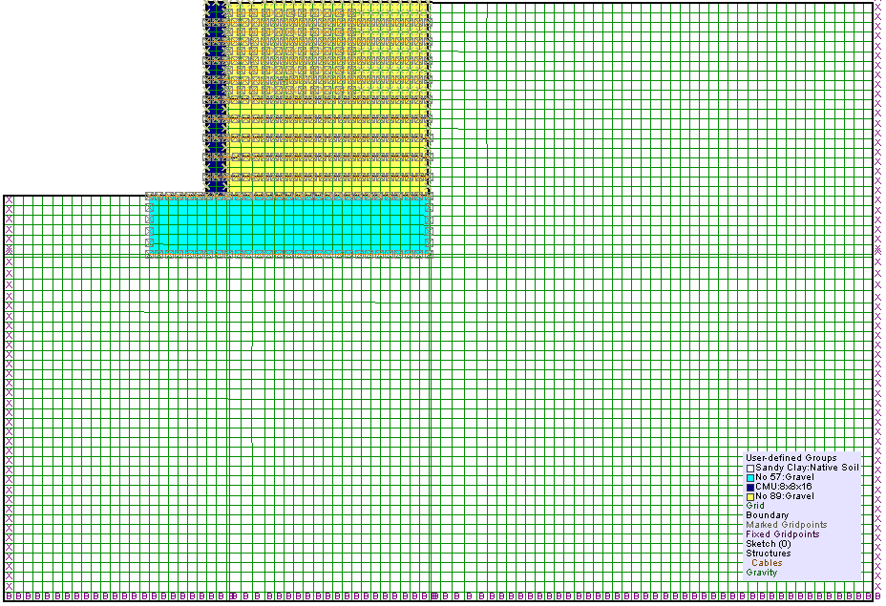
(c)
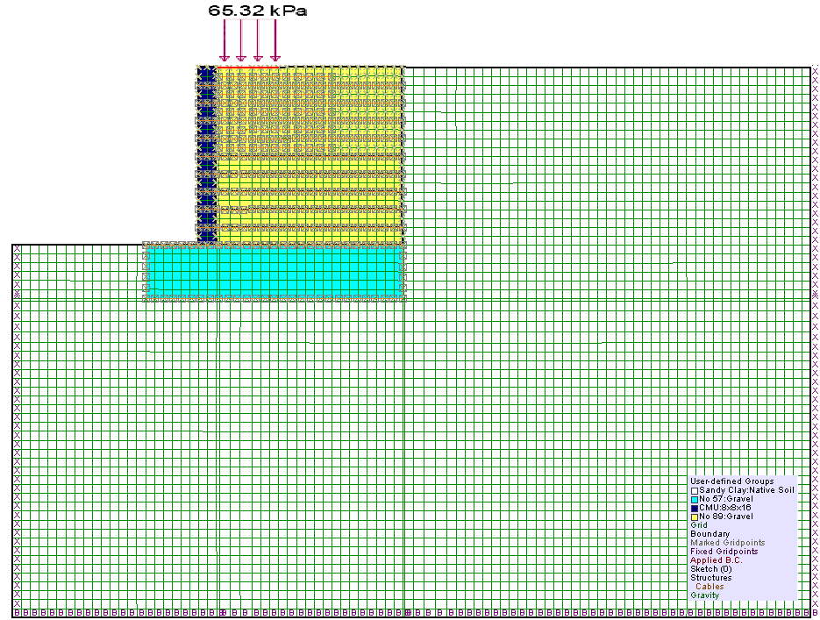
(d)
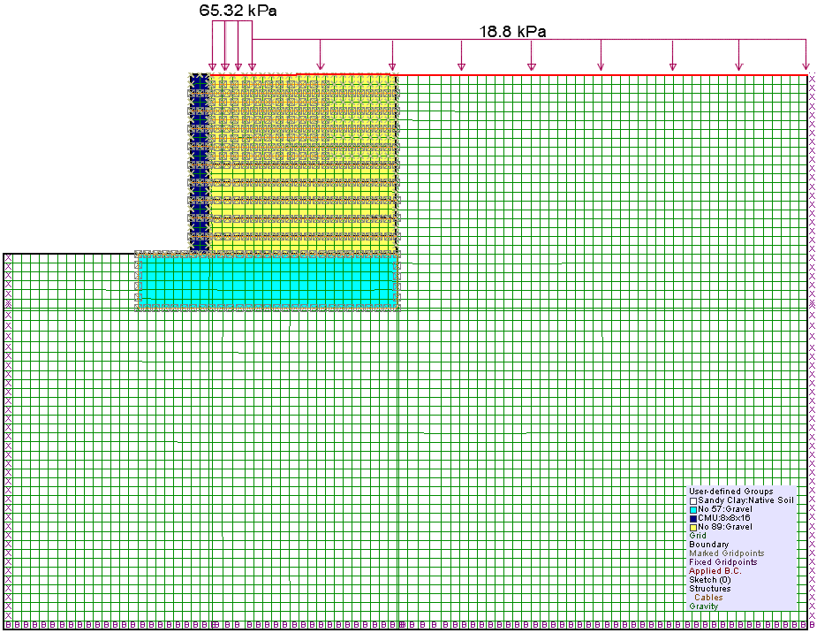
(e)
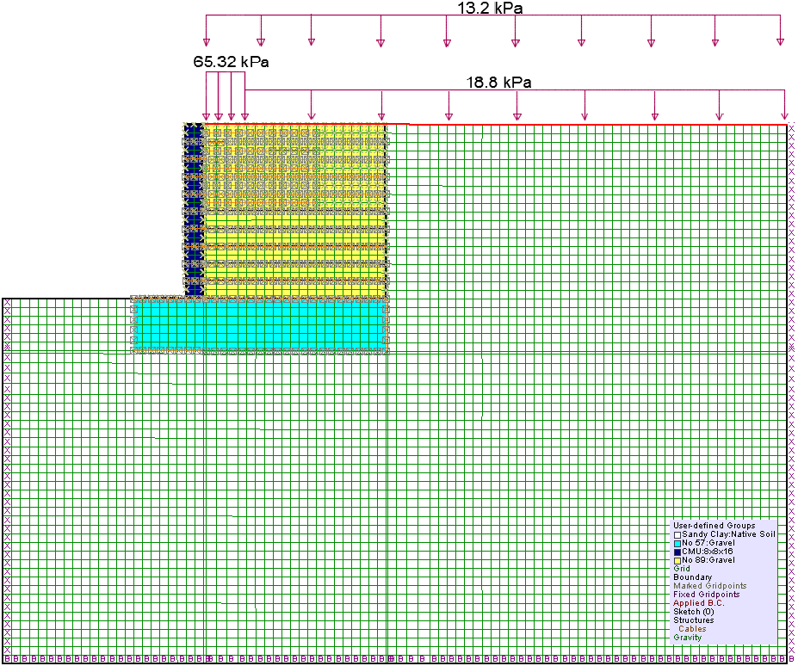
(f)
Figure 76: Numerical modeling for Bridge 2 at reinforcement spacing of 0.2 m
Table 24: Model properties for GRS-IBS Bridge No. 2
Backfill AASHTO No.89 gravel (GRS abutment backfill) properties
Density (kg/m³) | 1834.9
Friction angle (deg) | 44
Dilation angle (deg) | 14
Bulk Modulus, K (MPa) | 104
Shear Modulus, G (MPa) | 60
Backfill AASHTO No. 57 gravel (RSF backfill) properties
Density (kg/m³) - Modified Proctor | 1937.6
Friction angle (deg) | 52
Bulk Modulus, K (MPa) | 111
Shear Modulus, G (MPa) | 63
Sandy lean clay - Native soil properties
Density (kg/m³) | 1735
Friction angle (deg) | 20
Cohesion (kPa) | 20
Bulk Modulus, K (MPa) | 33
Shear Modulus, G (MPa) | 15
Solid 8" × 8" × 16" CMU (facing block) properties
Young’s Modulus, E (MPa) | 20000
Poisson’s ratio | 0.2
Density (kg/m3) | 2240
Bulk Modulus, K (MPa) | 11111
Shear Modulus, G (MPa) | 8333
Geotextile properties (TerraTex HPG-57) Structural element: Cable
Area, A (m² ) = 1 m width * thickness | 0.0016
Tensile strength, T(kN/m) in cross machine direction | 19.3
Tensile stiffness, J_{2%}=T_{2%}/0.02 (kN/m) | 965
Young’s Modulus, E (MPa) = J/A | 603
Geotextile-backfill (No.89) interface
K_{bond} (N/m/m) | 48000
S_{bond} (N/m/m) | 45500
Friction Angle, δ (deg) | 26
Interface properties between No. 89 backfill and CMU
Friction angle (deg) | 29
Cohesion (kPa) | 0
Interface properties between No. 89 backfill and native soil
Friction angle (deg) | 29
Cohesion (kPa) | 13

Parametric Study on the Numerical Model for Bridge No. 2

Influence of Backfill Friction Angle
Three different friction angle values were examined for Bridge No. 2 GRS-IBS numerical model with the same reinforcement spacing of 0.2 m (8 in) to examine the influence of the backfill aggregate quality with respect to its shear strength on the predicted behavior of the GRS abutment. The friction angle values included the minimum recommended value of $ϕ={38}^{o}$ in FHWA guidelines (Adams et al. 2012) in addition to $ϕ={34}^{o}$ and $ϕ={44}^{o}$. Predicted settlements at the top and facing deformations are shown in Figures 77 and 78, respectively. These results indicate that lower backfill friction angle values consistently result in larger deformations. However, the magnitudes of both the settlement at the top and facing deformation for all friction values examined are judged to be satisfactory. According to the results shown in Figure 78, predicted maximum lateral deformations of the three models with $ϕ={34}^{o}, ϕ={38}^{o}$ and$ϕ={44}^{o}$ are approximately 8 mm, 6 mm and 4 mm, respectively. Also, maximum deformation occurs between 0.7H and 0.8H from the base of the abutment for models with $ϕ={34}^{o}$ and$ϕ={44}^{o}$, respectively. Predicted maximum settlements of the models are only slightly different and all within 5-6 mm.

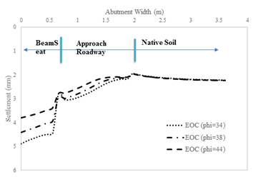
(a)

(b)
Figure 77: Predicted bridge settlements for the GRS abutment with different friction angle values: (a) end of construction (EOC); (b) subjected to equivalent traffic load

(a)

(b)
Figure 78: Predicted lateral deformations of Bridge No. 2 GRS abutment facing for different friction angle values assumed in the model (a) end of construction (EOC); (b) subjected to equivalent traffic load

Influence of Reinforcement Spacing
The GRS-IBS models with backfill friction angle values noted in Section 5.3.1 were examined with reinforcement spacing S_{v} = 0.40 m (16 in), which is twice as large as the reference value for Bridge No. 2 and exceed the design criteria (spacing equal 12 in or less) (Figure 79). The model geometry, material properties and loading conditions were otherwise the same as the reference model described in Section 5.2. The objective was to examine the influence of reinforcement spacing on the predicted behavior of GRS-IBS abutment. As a reminder, reinforcement spacing is a key factor in the stability and performance of GRS-IBS projects. Predicted results of bridge settlement and GRS facing deformation are shown in Figures 80 through 83. These results indicate that the performance of the GRS-IBS abutments with different combinations of reinforcement spacing and backfill friction angle examined in this study can be considered as satisfactory. For instance, maximum settlements and lateral deformations for the most critical case of S_{v} = 0.40 m and $ϕ={34}^{o}$ are limited to 8 mm and 15 mm, respectively. Nevertheless, predicted bridge settlements for S_{v} = 0.40 m are noticeably different (i.e. larger) than those for tighter spacing of S_{v} = 0.40 m (Figure 81). Furthermore, maximum facing deformations of the three models with different friction angle values for the backfill (i.e. $ϕ={34}^{o}, ϕ={38}^{o}$, and$ϕ={44}^{o}$ ) and S_{v} =0.4 m are approximately twice as large as those for the corresponding models with S_{v} = 0.2 m both during construction and when subjected to traffic load. However, results in Figures 82 and 83 indicate that the location of maximum facing deformation up the height of the facing is essentially independent of the reinforcement spacing or the backfill friction angle value. Figure 84 and 85 provide a summary of the influences of backfill friction angle and reinforcement spacing on the predicted magnitudes of facing deformation and bridge settlement, respectively, which are both deemed significant.

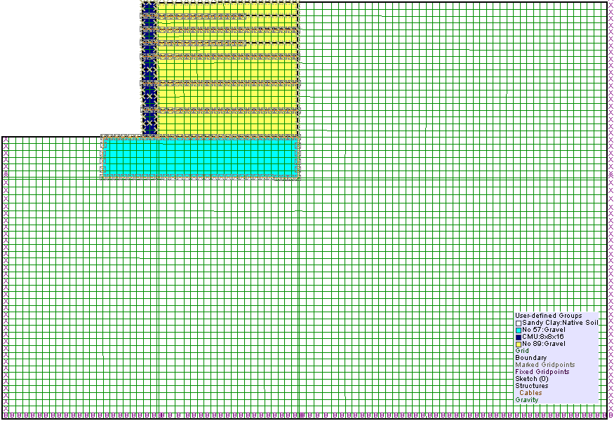
Figure 79: Numerical model for Bridge No. 2 GRS abutment with an assumed reinforcement spacing of 0.4 m (16 in)

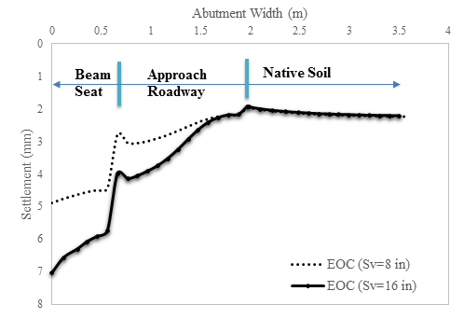
(a)
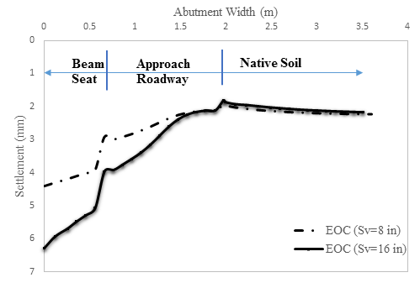
(b)
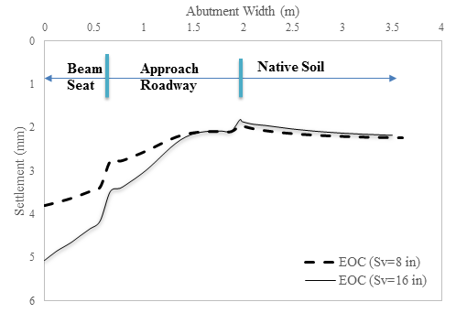
(c)
Figure 80: Predicted bridge settlements at the end of construction (EOC) with different spacing in various friction angles: (a) $ϕ=34$; (b) $ϕ=38$; (c) $ϕ=44$
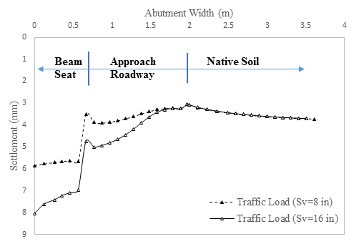
(a)
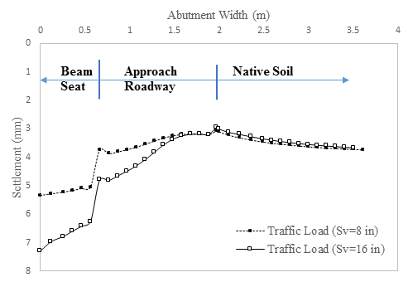
(b)
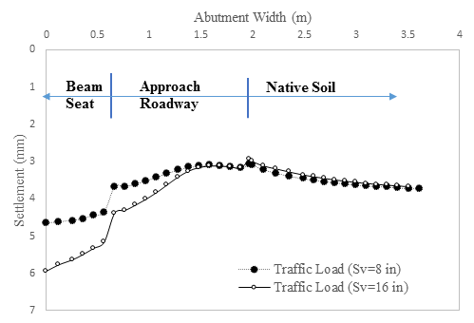
(c)
Figure 81: Predicted bridge settlements under equivalent traffic load with different spacing in various friction angles: (a) $ϕ=34$; (b) $ϕ=38$; (c) $ϕ=44$
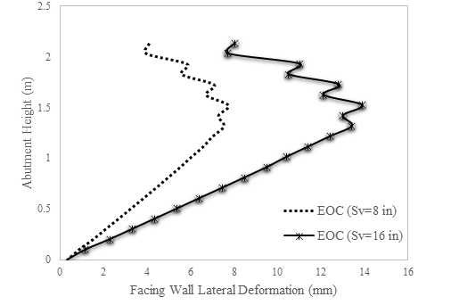
(a)
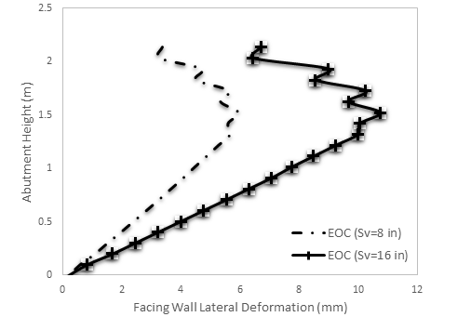
(b)
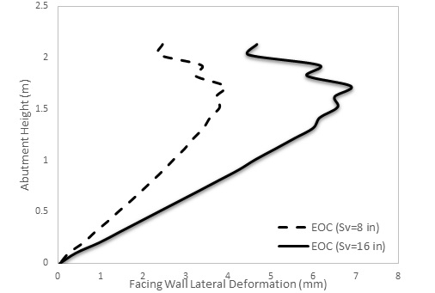
(c)
Figure 82: Predicted facing wall deflection at the end of construction (EOC) with different spacing in various friction angles: (a) $ϕ=34$; (b) $ϕ=38$; (c) $ϕ=44$
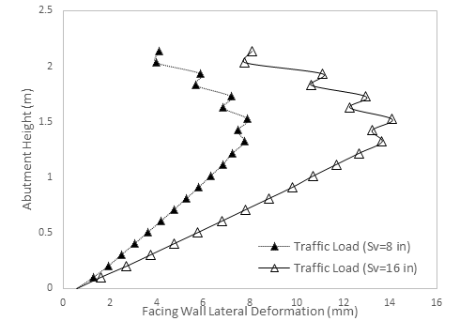
(a)
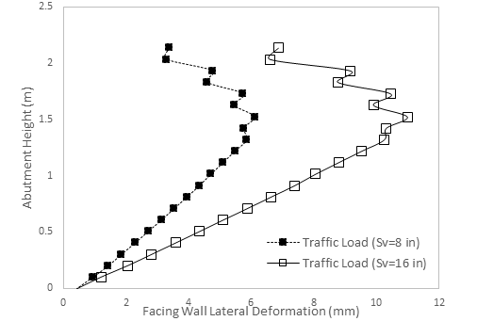
(b)
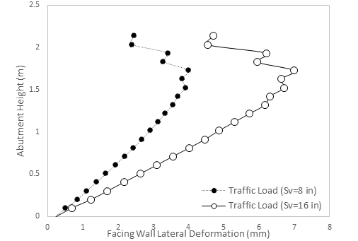
(c)
Figure 83: Predicted facing wall deflection under equivalent traffic load with different reinforcement spacing in various friction angles: (a) $ϕ=34$; (b) $ϕ=38$; (c) $ϕ=44$

Figure 84: Maximum facing deflection as a function of backfill friction angle in the numerical model

Figure 85: Maximum bridge settlement as a function of backfill friction angle in the numerical model
CHAPTER SIX

CONCLUSIONS AND RECOMMENDATIONS FOR FUTURE WORK

Summary and Conclusions
GRS-IBS is the technology with a track record of widespread field projects that includes more than 250 recorded bridges to date. However, it is estimated that a significantly higher number of projects have been completed throughout the United States. These projects have been demonstrated that the GRS-IBS technology is a fast and cost-effective construction alternative to conventional (i.e. deep foundation) supporting systems for bridge abutments on low-volume roads. Additionally, GRS-IBS afford the designers and owners significant flexibility with respect to facing type and design, superstructure type, and equipment and labor requirements. Current FHWA guidelines conservatively limit GRS-IBS applications to projects with low traffic volume, single span, 42.7 m (140 ft) in span length, and 9.1 m (30 ft) in abutment height. Over the course of this study, a total of 21 bridges were found with reported performance monitoring programs which have met these limitations and shown satisfactory performance. . However, several other projects were found that have exceeded the FHWA limitations including a 3-span interstate project and a GRS-IBS project with 9.8 m (32 ft) tall abutments, which have also performed very well so far.
In this study, a database was developed that includes a wide range of data on 140 GRS-IBS projects in the U.S. on which at least some basic information was available. The bridges documented in the database include those from 79 different counties in 41 different states. The information on the surveyed bridges included their geographical locations, size, geometry and other related design information, geotechnical, hydraulic and traffic data, types of superstructure, facing wall, backfill material and geosythetic used, performance monitoring methods/results, and feedback from the corresponding local agencies.
In Oklahoma, five GRS-IBS bridges have so far been constructed. The first bridge in Ottawa County was an isolated pilot project. However, the set of four GRS-IBS bridges in Kay County together with two other bridges with conventional driven pile support systems all with a 2-mile segment of 44th street in Blackwell provided a unique opportunity for this and future studies to measure and monitor comparative performances of different GRS-IBS and conventional systems that are subjected to essentially the same geotechnical, traffic and climatic conditions. Additionally, the same construction crew built all six bridges. The four GRS-IBS bridges were reported to be more cost effective than their conventional counterparts. All of the GRS-IBS bridges have also been found to perform well so far despite experiencing historic precipitation and flooding events within a year after their construction.
Another main objective of this research was to develop a numerical model for the GRS-IBS projects to help investigate the influences of select design factors such as the backfill shear strength and reinforcement spacing on their predicted performance. A FLAC numerical model was developed based on the as-built geometry and construction details of Bridge No. 2 in Kay County and material properties that were either tested or otherwise obtained during the course of this study.
Parametric study was carried out which showed that both the backfill friction angle and reinforcement spacing can have significant influence on the performance of the GRS abutment, especially its facing deformation. Further development of the numerical model together with its more rigorous validation can lead to a useful tool for GRS-IBS design and their more widespread acceptance in the U.S. and internationally.
Since 2005, GRS-IBS technology has expanded its footprint in 44 states nationwide (FHWA 2015). With continuous accumulation and sharing of lessons learned from more than 250 projects and growing interests from local level due to their low-cost and labor and equipment requirements, GRS-IBS has been demonstrated to be a viable and affordable alternative to conventional bridge systems for local and county roads in Oklahoma and other states in the U.S..

Recommendations for Future Work
The following recommendations are made for future work in continuation of this study:
- The GRS-IBS database developed in this study needs to be expanded and kept up to date as more GRS-IBS projects are reported in different counties and states across the U.S. As more data becomes available, the database and its analysis can provide valuable insight into the success and possible challenges experienced in different projects with respect to their size, geotechnical and hydraulic conditions, climate-related factors, traffic volume, superstructure system, facing type and construction methods. Further analysis needs to be done with respect to labor training and updating construction drawings and instructions to prevent any construction-related problems and minimize costs even further. The experience gained over time on GRS-IBS construction methods and observed performance can help spread their applications for larger projects with respect to span size, abutment height and traffic load, which can result in significant cost savings across the U.S. and internationally.
- Specifically for Oklahoma, geotechnical reports, bridge design plans and construction photographs were collected and complied through direct contacts with the Bureau of Indian Affairs (BIA) and Kay County personnel. This database need be further expanded in the continuation of this study. Also, factors such as locally available materials, labor and construction practices should be taken into account to help position GRS-IBS projects as a truly viable alternative for new bridge construction or replacement projects across the state. As an example, ODOT is interested in the performance of GRS-IBS bridges with very large (e.g. 0.6 m × 0.6 m × 1.2 m) facing blocks that are already available by a local manufacturer. Field projects that allow the use of these blocks in the GRS abutment and ideally, side-by-side comparison of their performance against standard facing blocks would be valuable to develop construction specifications that will include several cost-effective and locally viable GRS abutment alternatives across the state.
- A website needs to be developed to disseminate the GRS-IBS database with direct links to external resources, such as FHWA guidelines and case history projects, which would help provide a more comprehensive picture of the GRS-IBS technology in the United States to the interested parties. Such a website can provide valuable information on both the existing and developing design and construction methods, lessons learned and guidelines for successful projects in the future.
- Physical models and numerical simulation need to be carried out to investigate and address scouring and other hydraulic-related concerns for GRS-IBS projects. Existing design guidelines and recommended countermeasures need to be developed further accordingly.
- Additional site investigation and laboratory testing on GRS materials (e.g. backfill aggregates and reinforcement) will have to be conducted to more accurately determine their mechanical properties to further develop and improve the numerical model for GRS-IBS (e.g. interface properties) for future analysis and developing of more reliable design methods. The numerical model will need to be validated against measured performance of carefully survey and instrumented projects. A comprehensive parametric study needs to be carried out on factors such as the abutment height, facing type (larger blocks or sheet piling), reinforcement type, spacing and properties, foundation conditions in order to provide a more in-depth insight on the influence of major design parameters on the predicted performance of GRS-IBS leading to more accurate and reliable design methodologies. Simplified and more user-friendly charts and design software can help the spread and popularity of GRS-IBS for bridge construction projects in different states.

REFERENCES
AASHTO M-43 (2009). Standard Specification for Sizes of Aggregate for Road and Bridge Construction, American Association of State Highway and Transportation, Washington, D.C., USA.
AASHTO M-145-91 (2008). Classification of Soil and Soil-Aggregate Mixtures For Highway Construction Purposes, American Association of State Highway and Transportation, Washington, D.C., USA.
AASHTO T-99 (2012). Moisture-Density Relations of Soils: Using a 2.5 kg (5.5 lb) Rammer and a 305 mm (12 in.) Drop, American Association of State Highway and Transportation, Washington, D.C., USA.
Abernathy, C. (2015). Experimental Projects Construction and Site Inspections Report. Geosynthetic Reinforced Soil Integrated Bridge System (GRS-IBS).Montana Department of Transportation Research Programs. Retrieved from: https://www.google.com/url?q=http://www.mdt.mt.gov/other/webdata/external/research/docs/epsl/grs/EVAL_jun15.pdf&sa=U&ved=0ahUKEwi7hLeG_ZjLAhWCFh4KHWwICxcQFggFMAA&client=internal-uds-cse&usg=AFQjCNGej59QZTUjgZnAIg0DHO0JF-OibA.
Adams, M., Nicks, J., Stabile, T., Wu, J., Schlatter, W., and Hartmann, J. (2011). Geosynthetic Reinforced Soil Integrated Bridge System Synthesis Report, Report No. FHWA-HRT-11-027, Federal Highway Administration, McLean, VA.
Adams, M., Nicks, J., Stabile, T., Wu J., Schlatter, W., and Hartmann, J. (2012). Geosynthetic Reinforced Soil Integrated Bridge System—Interim Implementation Guide, Report No. FHWA-HRT-11-026, Federal Highway Administration, McLean, VA.
Adams, M. (2014). GRS-IBS 28th Annual Construction Industry Conference 2014. Saratoga Springs, New York.
Albert, R. (2011). Huston township Clearfield county Mount Pleasant Road Bridge. The Pennsylvania State University. Retrieved from: http://www.dirtandgravel.psu.edu/sites/default/files/Education%20Training/workshops/2012/documents/GRS_Huston_twp.pdf.
Albert, R. (2015). GRS-IBS EDC Webinar - Penn DOT. GRS-IBS EDC Webinar. U.S. Department of Transportation - Federal Highway Administration. Retrieved from https://connectdot.connectsolutions.com/p7t4uvdqg9c/?launcher=false&fcsContent=true&pbMode=normal
Alzamora, D., Adams, M., Nicks, J. (2011). Geosynthetic Reinforced Soil Integrated Bridge System. U.S. Department of Transportation - Federal Highway Administration. Retrieved from Upper Great Plains Transportation Institute: http://www.ndltap.org/events/conference/downloads/2011_geosynthetic_reinforced_soil.pdf.
Alzamora, D. (2015). Geosynthetic Reinforced Soil Integrated Bridge System North West Geotechnical Workshop. Gleneden Beach, OR. U.S. Department of Transportation - Federal Highway Administration. Retrieved from Oregon Department of Transportation (ODOT) FTP site: ftp://ftp.odot.state.or.us/techserv/Geo-Environmental/NW_Geotechnical/NW%20Geotech/4_August_Tuesday/1_GRS-IBS%20update_Alzamora%208-2015.pdf.
Alzamora, D., Hogan, S., Mermejo, C., Carroll, N., Albert, R. (2015). GRS-IBS EDC Webinar - Penn DOT. GRS-IBS EDC Webinar. U.S. Department of Transportation - Federal Highway Administration. Retrieved from https://connectdot.connectsolutions.com/p7t4uvdqg9c/?launcher=false&fcsContent=true&pbMode=normal.
Arounpradith, A. (2014) Geosynthetic Reinforced Soil (GRS) Abutment Project. Route B over Bus. Loop 70 Columbia, MO. American Association of State Highway and Transportation (AASHTO) website. Retrieved from: http://shrp2.transportation.org/Pages/showcase_columbia2015.aspx.
ASCE (2013). 2013 Report Card for America's Infrastructure – Bridges. American Society of Civil Engineers (ASCE). Retrieved from 2013 Report Card for America's Infrastructure: http://www.infrastructurereportcard.org/bridges/.
ASTM C131 / C131M-14 (2006). Standard Test Method for Resistance to Degradation of Small-Size Coarse Aggregate by Abrasion and Impact in the Los Angeles Machine, American Society for Testing and Materials (ASTM) International, West Conshohocken, PA.
ASTM D2487-11 (2011). Standard Practice for Classification of Soils for Engineering Purposes (Unified Soil Classification System), American Society for Testing and Materials (ASTM) International, West Conshohocken, PA.
ASTM D3080-03 (2003). Standard Test Method for Direct Shear Test of Soils Under Consolidated Drained Conditions, American Society for Testing and Materials (ASTM) International, West Conshohocken, PA.
ASTM D5321-12 (2012). Standard Test Method for Determining the Shear Strength of Soil-Geosynthetic and Geosynthetic-Geosynthetic Interfaces by Direct Shear, American Society for Testing and Materials (ASTM) International, West Conshohocken, PA.
ASTM D1586-11 (2011). Standard Test Method for Standard Penetration Test (SPT) and Split-Barrel Sampling of Soils, American Society for Testing and Materials (ASTM) International, West Conshohocken, PA.
Bareither, C.A., Benson, C.H., Edil, T.B. (2008). Comparison of Shear Strength of Sand Backfills Measured in Small-Scale and Large-Scale Direct Shear Tests, Can. Geotech. J., Vol. 45, No. 9, pp. 1224 – 1236.
Barr (2015). Rock County GRS-IBS Project Website. Retrived from https://gims.barr.com/index.html.
Bardow, A. K. (2015). Infrastructure Health Monitoring through the Use of Remote Sensing Technology. 2015 Innovation Conference. Retrieved from: www.massdotinnovation.com/Pdfs/Session7D-RemoteSensing.pdf.
Bartlett (2015). Missouri's experience with GRS-IBS bridges: Lesson Learned. Bartlett & West. Transportation Engineers Association of Missouri, Missouri Department of Transporation. Retrieved from: http://www.modot.org/TEAM/2015/documents/06GeosyntheticallyReinforcedSoil-IntegratedBridgeSystemAbutmentsandBridges.pdf.
Benton, B. (2014). BR 1-366 on Chesapeake City Road: DelDOT’s First GRS-IBS Bridge, Delaware Department of Transportation (DelDOT), February 14, 2014.
Berg, R.R., Christopher, B.R., and Samtani, N.C. (2009). Design and Construction of Mechanically-Stabilized Earth Walls and Reinforced Soil Slopes – Volume I. Publication No. FHWA-NHI-10-024, FHWA, U.S. Department of Transportation, Washington, D.C., USA.
Bloser, S., Shearer, D., Corradini, K., Scheetz, B., Larson, T. D. (2012). Geosynthetically Reinforced Soil-Integrated Bridge System (GRS-IBS) Specification Development for PennDOT Publication 447. Approved Products for Low Volume Roads. Commonwealth of Pennsylvania Department of Transportation Institute. Retrieved from: www.paconstructors.org/wp-content/uploads/2013/01/GRSIBSreport.pdf.
Bogart, T. (2011). Geosynthetically Reinforced Soil-Integrated Bridge System. GRS-IBS User Perspective. Retrieved from: http://www.countyengineers.org/events/annualconf/2011%20Presentations/4-18-11%203.15%20-%204.30%20Tracks%201-4/Bogart%20-%20GRS-IBS%20Track%202%204-18-11%20.pdf.
Bolton, M.D. (1986). The strength and dilatancy of sands. Géotechnique. 36(1): 65–78.
Breskin, K. (2012). Geotechnical Design Report for the Replacement of State Route 32 Strut, Bremen, Maine. Highway Bridge Program, Maine Department of Transportation, Augusta, Maine.
Briaud, J. L., James, R. W., Hoffman, S. B. (1997). Settlement of Bridge Approaches : (the Bump at The End of The Bridge). National Cooperative Highway Research Program (NCHRP), Report 234.
Budge. A. S., Dasenbrock, D. D., Mattison, D. J., Bryan, G. K., Grosser, A. T., Adams, M., Nicks, J. (2014). Instrumentation and Early Performance of Large Grade GRS-IBS Wall, Geo-Congress 2014 Technical Papers.
Campbell, D., Gilbert, B., Leaf, T. (2015). Rustic Road Bridge: Lesson Learned. Retrived from: .
Clowser, M. L., McDonald, P. E., Long, W. M., Webb, C. D., Clark, C. R., Parsons, P. M., George, A. H. (2015). West Virginia Construction News – March/April. Retrieved from Contractors Association of West Virginia, Inc. website: http://www.cawv.org/site/publisher/files/WVCN%20Mar%20Apr%202015%20for%20WEB.pdf.
Connors, P. J. (2015). GRS-IBS at MassDOT. February 2015
Defiance (2016). What is GRS? Geosynthetically Reinforced Soil. Defiance County Engineer's Office, Defiance County. Retrieved from: http://www.defiance-county.com/engineer/GRS.htm.
Diop, M., Barros, H. (2015). 27th Street NW Bridge Replacement. Fort Myer Construction, Washington, DC. Retrieved from Fort Myer Construction official website: http://fortmyer.com/projects/27th-street-nw-bridge-replacement/.
DOEE (2014). Stream Restoration Projects | Stream Projects in Design: Broad Branch Stream Restoration. Retrieved from Department of Energy and Environment, Washington DC: http://doee.dc.gov/service/habitat-restoration.
Dolce, C., Wiltgen, N., Erdman, J. (2015). Texas and Oklahoma Set All-Time Record Wet Month; Other May Rain Records Shattered in Arkansas, Nebraska. The Weather Channel, LLC. Retrieved from: https://weather.com/forecast/regional/news/plains-rain-flood-threat-wettest-may-ranking
EngineeringToolBox. Concrete - Properties. The Engineering Toolbox. Retrieved from: http://www.engineeringtoolbox.com/concrete-properties-d_1223.html
FHWA (2013). Highway Functional Classification Concepts, Criteria and Procedures, U.S. Department of Transportation, Federal Highway Administration.
FHWA (2010). Geosynthetic Reinforced Soil – Integrated Bridge System (GRS-IBS). Retrieved from: http://www.fhwa.dot.gov/innovation/everydaycounts/pdfs/summits/GRS-IBS_full_presentation.pdf.
Forest (2015). 27th Street bridge reopens after 3-month replacement project. Retrieved from Forest Hill Connection: http://www.foresthillsconnection.com/news/27th-street-bridge-reopens-after-3-month-replacement-project/#comment-616497.
Geocomp (2014). Geosynthetic Reinforced Soil – Integrated Bridge System (GRS-IBS). Retrieved from Geocomp Corporation website: https://www.geocomp.com/files/newsletters/NewsEvents_14021_CO%20I-70_final.pdf.
Geosynthetics (2015). First GRS-IBS bridge for D.C. Industrial Fabrics Association International. Retrived from Geosynthetics: http://geosyntheticsmagazine.com/2015/07/08/first-grs-ibs-bridge-for-d-c/.
GM2 (2015). Replacement of Bridge #01320 Bassett Road over I-91, Retrieved from GM2 Associates, Inc.: http://gm2inc.com/archives/portfolio/replacement-of-bridge-01320-bassett-road-over-i-91.
HanesGeo (2015). TerraTex HPG-57, Hanes Geo Components, Wnston Salem, NC. Retrieved from: http://hanesgeo.com/files/documents/terratex-hpg-57-spec-sheet-1043.pdf
Hatami, K., Ngo, T., Miller, G. (2014). “Feasibility Study of GRS Systems for Bridge Abutments in Oklahoma”, Annual Project Status Report ~FFY 2014, ODOT SP&R Item No. 2262, ODOT, OKC, OK.
Hatami, K., Ngo, T., Pena, L. (2015) “Feasibility Study of GRS Systems for Bridge Abutments in Oklahoma”, Annual Project Status Report ~FFY 2015, ODOT SP&R Item No. 2262, ODOT, OKC, OK.
Jenkins, S., Houska, G., Beck, M. (2015). Modified GRS IBS for Fergus County. LTAP Matters – Montana’s Answers to Technical Education of Roads & Streets. Summer 2015. Retrieved from Montana State University website: http://www.montana.edu/ltap/newsletter/documents/MT_LTAP_Summer_2015.pdf
Jewell, R.A. (1989). Direct shear tests on sand. Géotechnique. 39(2): 309–322.
Keierleber, B., Vennapusa, P., White D. (2014). A Case Study of Geosynthetic Reinforced Soil I a Low Volume Bridge Abutment in Iowa, Geo-Congress 2014 Technical Papers, GSP 234, American Society of Civil Engineers.
Keller, G. (2012). Smarter, Faster, Cheaper: Geosynthetic Reinforced Soil (GRS) Bridge Abutments – Part 2. (Aug 17, 2012). Retrieved from geosynthetica.net: http://www.geosynthetica.net/smarter-faster-cheaper-geosynthetic-reinforced-soil-grs-bridge-abutments-part-2/.
Lawrence, J. B. (2014). Structural Health Monitoring of the First Geosynthetic Reinforced Soil – Integrated Bridge System in Hawaii. Master's Thesis. Hamilton Library, University of Hawaii at Manoa. Retrived from: http://scholarspace.manoa.hawaii.edu/handle/10125/100440.
Luber, J. (2015). Driving You Crazy: I-70 Tower Road Lane Squeeze. When Will This Project Ever Be Finished? Extracted from 7News Denver: http://www.thedenverchannel.com/traffic/driving-you-crazy/driving-you-crazy-i-70-tower-road-lane-squeeze.
Mermejo, C. (2015). GRS-IBS EDC Webinar - Penn DOT. GRS-IBS EDC Webinar. U.S. Department of Transportation - Federal Highway Administration. Retrieved from https://connectdot.connectsolutions.com/p7t4uvdqg9c/?launcher=false&fcsContent=true&pbMode=normal.
METCO (2012). Geotechnical Engineering Services Report. Midwest Engineering & Testing Corporation.
Meunier, S. M. (2013). GRS-IBS Technology. 2013 Louisiana Transportation Conference. LA Transportation Research Center. Retrieved from: http://www.ltrc.lsu.edu/ltc_13/pdf/presentations/S56_Innovative%20Bridge%20Applications%20in%20Louisiana%20Geosynthetic%20Reinforced%20Soil%20Integrated%20Bridge%20System%20(GRS%20IBS)_LTC2013.pdf.
Mohamed, K., Abouzakhm, M., Elias, M. (2011). Applications and Performance of Geosynthetic-Reinforced Soil Abutments on Soft Subsurface Soil Conditions. Transportation Research Record: Journal of the Transportation Research Board Volume 2212. Retrieved from: http://trrjournalonline.trb.org/doi/abs/10.3141/2212-08.
Nguyen, Q. (2012). GRS Abutments for Bridge Replacement National Wildlife Refuge. A New Era of Partnerships - Investing in America's Treasures, U.S. Department of Transportation, FHWA, EFLHD. Retrieved from State of New Hampshire website: https://www.nh.gov/dot/org/projectdevelopment/bridgedesign/presentations/documents/grsabutments2012.pdf.
ODOT (2009). 2009 Standard Specifications Book. Oklahoma Department of Transportation. Retrieved from: http://www.odot.org/c_manuals/specbook/oe_ss_2009.pdf.
Oliva, B. (2013). FHWA – NDOT GRS-IBS Workshop. WisDOT STH 40 GRS-IBS Project. Retrived from: ftp://ftp.dot.wi.gov/dtsd/structures/pub/NEV-GRS-Workshop/NV%232%20STH%2040%20GRS%20Presentation1.pdf.
Orders (2013). Veterans Administration Hospital Bridge, Harrison County, WV. Retrieved from Orders Construction Company website: http://ordersconstruction.com/projects/bridges/veterans-administration-hospital-bridge.
Phillips, E. K. (2014). Investigation of Required Tensile Strength Predicted by Current Reinforced Soil Design Methodologies, Virginia Polytechnic Institute and State University.
Pagan, H. R. L., Marrero, E., Rosado, F. O. P., Pacheco, J. R. R., Leon, Z. L., Acevedo, J. C. (2014). Puerto Rico PR-2 Geosynthetic Reinforced Soil Integrated Bridge System Showcase. Retrieved from Puerto Rico Transportation Technology Transfer Center website: http://prltap.org/eng/wp-content/uploads/2014/04/Handout_Puerto-Rico-PR-2-GRS-IBS-Showcase.pdf.
Redi-Rock. (2016). Unique Bridge Repair Using GRS Wall Solution. Maine Bridge Uses First GRS Wall in a Marine Environment. Redi-Rock International. Retrieved from: https://www.redi-rock.com/unique-bridge-repair-using-GRS-wall-solution.htm.
Russell, H. (2011). Adjacent Precast Concrete Box-Beam Bridges: State of the Practice, Precast/Prestressed Concrete Institute Journal, Vol. 56 (1): 75-91.
Schlatter, W. (2012). Geosynthetic Reinforced Soil - Integrated Bridge System (GRS-IBS). Defiance County's GRS Experience. Center for Technology & Training, Department of Civil & Environmental Engineering, Michigan Technological University. Retrieved from: https://www.ctt.mtu.edu/sites/ctt/files/resources/cew2013/2013schlatter_grs-ibs.pdf.
Talebi, M., Meehan, C., Cacciola, D., and Becker M. (2014). Design and Construction of a Geosynthetic Reinforced Soil Integrated Bridge System (2014), Geo-Congress 2014 Technical Papers, GSP 234, American Society of Civil Engineers.
Torres, C., Munoz, J. (2014). Instrumentation and Monitoring Program. Retrieved from Puerto Rico Transportation Technology Transfer Center website: http://prltap.org/eng/wp-content/uploads/2014/04/Handout_Puerto-Rico-PR-2-GRS-IBS-Showcase.pdf.
USClimateData (2015). Weather history Blackwell may 2015. US Climate Data. Retrieved from: http://www.usclimatedata.com/climate/blackwell/oklahoma/united-states/usok0049/2015/5.
USClimateData (2016). Climate Blackwell - Oklahoma. US Climate Data. Retrieved from: http://www.usclimatedata.com/climate.php?location=USOK0049.
Vennapusa, P., White, D., Klaiber, W., and Wang, S. (2012). Geosynthetic Reinforced Soil for Low-Volume Bridge Abutments, Iowa Highway Research Board and Iowa Department of Transportation (IDOT), January 2012.
Wahab, R., Sargent, K. K. (2015). First Use of Geosynthetic Reinforced Soil - Integrated Bridge System (GRS-IBS) In Illinois, Thomas Engineering, Retrieved from LinkedIn: http://www.slideshare.net/thomas-engineering/first-use-of-geosynthetic-reinforced-soil-integrated-bridge-system-in-illinois-44059440.
Walls, S. (2014). DelDOT and the GRS-IBS Experience, Delaware Department of Transportation (DelDOT), July 21, 2014.
Wu, J. T. H., Lee, K. Z. Z., Helwany, S. B., Ketchart, K. (2006). Design and Construction Guidelines for Geosynthetic-Reinforced Soil Bridge Abutments With a Flexible Facing. National Cooperative Highway Research Program (NCHRP), Report 556.

