UNIVERSITY OF OKLAHOMA

GRADUATE COLLEGE

THE INVISIBLE ARTIST:

THE EDITOR’S PERSPECTIVE ON RHETORIC, ETHICS, AND REPRESENTATION IN

FILM EDITING

A DISSERTATION

SUBMITTED TO THE GRADUATE FACULTY

in partial fulfillment of the requirements for the

Degree of

DOCTOR OF PHILOSOPHY

By

STEPHANIE SALYER
Norman, Oklahoma
2024

THE INVISIBLE ARTIST:

THE EDITOR’S PERSPECTIVE ON RHETORIC, ETHICS, AND REPRESENTATION

IN FILM EDITING

A DISSERTATION APPROVED FOR
GAYLORD COLLEGE OF JOURNALISM AND MASS COMMUNICATION

BY THE COMMITTEE CONSISTING OF

Dr. Ralph Beliveau, Chair

Dr. David Craig

Dr. Robert Kerr

Dr. Kimberly Wieser-Weryackwe

© Copyright by STEPHANIE SALYER 2024
All Rights Reserved.

Acknowledgements

I would like to take the opportunity to thank my chair, Dr. Ralph Beliveau and my committee members, Dr. Robert Kerr, Dr. David Craig, and Dr. Kimberly Wieser-Weryackwe. With their guidance and support this dissertation idea came to fruition. To my friends that supported me through this entire adventure, thank you for always bring there. Finally, this dissertation is dedicated to my parents, James and Virginia Salyer, and to my family. It was with their strong support, morals, and values that brought to me where I am today.

Abstract

This dissertation explores the impact that the film editor has on films and what their beliefs are when it comes to the content that they create. Examining history, this dissertation shows that film editors have always impacted movies and the story that is shown. Historically film editors have been overlooked, with only a handful of editors, such as Walter Murch, being known amongst film viewers. Very few editors talk about what they do in the editing room and instead, when conversing focus on the story of the film. This dissertation is a qualitative study that interviewed narrative film editors, those that edit fictional films. The study attempted to interpret (1) what editors understand about their editing; (2) what editors think they are doing to the audience; (3) whether an accurate representation of ethnicities and minorities were ever a consideration; and (4) whether the ethics of their own edits are ever a consideration during the editing process. This dissertation attempted to understand what methods narrative film editors use and to what extent these editors understand the rhetorical aspects of editing, and attempted to understand to what extent these film editors recognize the way these editing methods affect their film viewers. Nine editors were interviewed. Among many other things, it was found that the editor always considers the audience of the film, while at the same time the editor believes they are not responsible for any ethical considerations and that these considerations is a job for someone else. At the same time, the editors’ identity determined if representation was a factor in the way they edited.

Table of Contents

Chapter 1: An Introduction……………………………………………………………………..….1

Chapter 2: A Brief History of Film.…………………………………………………….………….6

Chapter 3: The Rhetoric of Editing………………………………………..…………..….………20

Chapter 4: Different Editing Techniques…………………...…………………...………………..37

Chapter 5: Representation in Film………………………………………………………………..47

Chapter 6: The Examination of Content Before and After an Editing Transition…………………70

Chapter 7: The Ethics of Film…………………………………………………...…………..……87

Chapter 8: Methods of the Study………………………….……………………………...…..…111

Chapter 9: Findings and Conclusion…………………….………………..……………….….…122

References………………………………………………………………………………………154

Chapter 1: An Introduction
Editing is the only process. The shooting is the pleasant work.
The editing makes the movie, so I spend all my life in editing.
- Garry Marshall

Introduction
Film editors have one of the few major and creative roles when it comes to filmmaking. Part of their role is to create a story from the material they are given, whether it be just recreating the story from a script or creating additional stories that appear in the footage that they are given. Many of these film editors are hidden artists, because their work is meant to be unnoticed, or in standard filmmaking textbook terms of explaining Hollywood editing, it is “invisible editing” (Corrigan & White, 2017). If someone does notice the editing within a film, the editor is criticized for not doing their work correctly (Murch, 2001; Dmytryk, 2018). Not being noticed has continued into academics and research, with there being very little studied and written about editors. Editors play a major role in the final creation and formation of the film, with much of their own work being subjective and shared with only a few key collaborators of the film. However, film editors do understand the importance of their role, while also believing that others within their own community do not understand what they really do when it comes to the editing of a movie.
It is through the history of film that we understand how far film editing has come (Corrigan & White, 2017), who the key editors are (Landler, 2019; Corrigan & White, 2017; Reisz & Millar, 2010; Dancyger, 2018; Kaganovsky, 2018), and what role editing now has in filmmaking (Murch, 2001; Corrigan & White, 2017; Dancyger, 2018; Prince, 2013). Understanding the rhetoric of editing helps to explain just how persuasive editing can be to film viewers. Throughout the years different editing techniques have been invented (Bordwell et al., 2017; Corrigan & White, 2017; Prince, 2013), with each one of these techniques meant to cause certain emotions with the film audience or created to make implications within the film story. These editing techniques are meant to go unnoticed, while also influencing the film viewer as they are watching the movie.
As society continues to become more aware and culturally competent of other races, ethnicities, genders, and sexual orientation, unlike the films from just a few decades ago (Price, 1973; Berny, 2020), it is filmmaking that continues to mirror society and attempt to become better stewards of the work that they are given, and then to provide that work to their film audiences. The representation of different groups has become a consideration among organizations and art (Corrigan & White, 2017; Prince, 2013) more than it has in the past (Price, 1973; Berny, 2020). Because filmmaking is becoming increasingly aware of these changes in society, it would stand to reason that the creative players on a film also take this type of awareness into consideration.
Ethics play a major role in many different areas of life, such as healthcare, journalism, academia, etc. (Beauchamp, 2007; Prima facie duty, 1999; Elliott, 2007; Mill, 1863). However, the creation of film does not have any ethical standards (Sinnerbrink, 2019; Stadler, 2008). While this might seem unusual, it stands to reason that because film is “art” that ethics should not apply in the same way that it does to other areas. Although ethics should play some type of role in the thought process while editors are performing their work, it also stands to reason that because film is subjective, that the role ethics plays should be subjective and therefore could only be applied on a case-by-case basis, and not an across-the-board ruling. Because of the subjectivity of their work, editors shouldn’t have the same ethical considerations that others in different jobs have, but some consideration should be taking place, for example when visually violent and explicit material is present.
Film editors and their editing is a relatively neglected area of study, where almost all current literature consists of interviews with practitioners or instructions on how to learn to edit. This dissertation takes that a step further by also being a qualitative study, when most of the film research is quantitative (Smith & Martin-Portugues Santacreu, 2017; Smith, 2011; Smith, 2012). It is the hope that this dissertation will start to add to this neglected area of study and bring to attention the need for research in this field of work.
Chapter organization and outline
For this chapter, Chapter 1, the dissertation topic is introduced. Chapter 2 provides a brief history of film editing that readers will need in order to understand the impact that editing has made with films. The chapter also provides further understanding of continuity in relation to film directors, editors, and film theorists. Chapter 3 discusses the rhetoric of editing. It first discusses classical rhetoric and how this relates to film, going into what film rhetoric is and sound rhetoric. We delve into the history of editing, in relation to rhetoric and how the developments of sound and color film are also elements of film rhetoric. Chapter 4 explains the different editing techniques used in film. It covers the impact that digital film editing has made on film editors, the types of transitions that they use, and what those transitions are supposed to do for the film viewer. Sound is discussed again, because it can also be used in editing techniques, and plays an important role in film viewers' perceptions and emotions. Chapter 5 covers representation in film. The people who are in control of the production ultimately also control who is represented in the film and how they are represented. This chapter also covers how much control the editors have in the film. The chapter finishes off with an analysis of the short film Thistle Creek and the feature film Smoke Signals. Chapter 6 examines the definition of race and analyzes the film Remember the Titans. The intention of the analysis is to show that it is also the content that the editor juxtaposes against each other, before and after a cut, that also leads viewers to interpret scenes in a particular way. Chapter 7 covers the potential ethics of film and how ethical theory can be applied to film editing. This chapter examines the questionable methods of authenticity and how sound and visuals in film can cause feelings in the film viewer. It also analyzes a scene from the television series Carnival Row, and then concludes with the reasoning for what filmmakers should consider with ethics. Chapter 8 delves into the research methods that the dissertation uses, focusing on in-depth interviews and using grounded theory, while also providing the list of questions that a group of film editors will be asked, with each category of questions taking form from the chapters previously listed: Personalities, Understanding of editors’ role, Editors’ communicative goals and practices, Achieving quality editing, Genre/music/sound, The audience, and Ethics and representation. Finally, Chapter 9 explains the findings of the dissertation and the conclusion. A codebook is provided, along with a uniform response to the questions that were asked to the film editors. This concludes with the study limitations and the potential for further research with film editing. Each one of these chapters are necessary to understand how film editing has evolved and continues to evolve, what role the film editors play, and to understand why certain questions were asked of the editors.
Goal of the dissertation
It is the hope that this research will help others realize the important role and responsibility that editors have when they edit a film. Editing is a specific role when it comes to the creation of a film and while some do enjoy the editing process, there are others that do not. Many filmmakers and crew members understand the job of an editor as being the person that has the “instinct” to put it together or that an editor is “good” at what they do, without really being able to describe what they (the film crew) are talking about. Unfortunately, many editors are the same way when it comes to describing what they do. It is the goal of this research to be able to put to words what editors are doing, while also elevating to others just how important editors are to the film, the film audience, and to the film crew.

Chapter 2: A Brief History of Film Editing
Since its early stages in the 1880s, film has developed from telling small and simple stories, many as short as a single clip, to intricate tales that last over three hours. The most drastic developments happened during the early years, with major technological innovations including synchronized sound and colored films, allowing for even more drastic rhetorical developments in editing. Yet, in the late twentieth century, a further dramatic shift occurred in the technology used to create films: the move to digital. All of these developments ushered in new film editing techniques, allowing for editors to take advantage of these new techniques to aid in their rhetorical choices in editing. As time has moved forward, more of these editing techniques have been used frequently to the point where many editors no longer notice that they are even using them.
There has been little to no research studies about film editors. Many of the books and papers published are quantitative studies that focus on surveys or eye tracking (Smith & Martin-Portugues Santacreu, 2017). These studies focus on the film viewer and what the film viewer believes (Baranowski & Hecht, 2016; Knight-Hill, 2019) or how the film viewer reacts (Smith, 2011). Only a small number of books published actually talk to film editors, but these books are conversations (Oldham, 1992) and not research focused.
This dissertation is a qualitative study that interviews narrative film editors, those that edit fictional films. The research will attempt to interpret (1) what editors understand about their editing; (2) what editors think they are doing to the audience; (3) whether an accurate representation of ethnicities and minorities were ever a consideration; and (4) whether the ethics of their own edits are ever a consideration during the editing process. This study attempted to understand what methods narrative film editors use and to what extent these editors understand the rhetorical aspects of editing. The study also attempted to understand to what extent these film editors recognize the way these editing methods affect their film viewers.
Problem statement
Very few editors talk about what they are doing in the editing room, and if they do they give very loose interviews that discuss the films that the editors have edited (Oldham, 1992). When editors typically talk about editing they say that it is “intuitive” (Pearlman, 2015) or “instinctual,” that they have to search for the “heart” (Oldham, 1992) of the story when they edit. However, many editors have a mastery with editing that they have perfected over the years. They have been taught by others or taught themselves. Many books and academic textbooks have been written on the different ways of editing and many of these books teach and explain how to edit (Bordwell, Thompson, & Smith, 2017; Corrigan & White, 2017). While it sounds like editors are not even aware they are systematic with their editing, it is this same system that performs a rhetoric directed towards the film viewer when that viewer watches a movie. Editing is one of the major steps in the postproduction stage that controls the way the film is presented to the film viewer. The ethics of editing methods used to manipulate or trick, and the role that representation plays, is something that film editors should also understand. However, it is unknown if any of these elements are taken into consideration. The main purpose of this qualitative study is to understand what narrative film editors think they are doing when they edit.
Continuity in films
The intention of Classical Hollywood films is for viewers to not notice the edits of the film and to be focused entirely on the storyline; for the film to have continuity. Continuity in films is where all the details, such as objects, characters, and the physical space, are consistent and similar from shot to shot. If a cup on a table suddenly disappears or moves to the other side of the table, this is a break in the film continuity. If the color of a character’s shirt changes or the sleeves suddenly roll up, this is a break in the film continuity. For continuity editing of each shot, there is “a continuous relationship to the next shot” (Corrigan & White, 2017, p. 180). Another example is if there is extensive makeup on a character and that makeup looks different in the next shot, this is also a break in continuity. The goal of this is to provide “minimal mental effort on the part of viewers” (Corrigan & White, 2017, p. 180). In addition to objects, characters, and the physical space in general, continuity also includes lighting (Prince, 2013), because each shot in a scene must be consistent with one another, and eyeline match continuity (Prince, 2013). Eyeline matching is where the character is looking in the shot. If Character A is looking to the right and talking to Character B, and Character B responds to Character A’s questions, but is also looking to the right of the screen, then it appears that Character B is not talking to Character A. If characters are talking to one another and looking in the same direction (not at each other), this is a break in continuity.
Continuity in films by filmmakers and film editors
According to American film theorist David Bordwell, continuity style in films “aims to transmit narrative information smoothly and clearly over a series of shots” (Bordwell et al., 2017, p. 230). There are several different ways for films to have continuity, such as character clothing, set design, and character movement and placement (Prince, 2013). Filmmakers do work prior to filming and during filming, to keep continuity. Continuity editing works along with everything that the filmmakers have done before, to help with the storyline. Film editors make sure that when editing, they cut on action and follow the continuity rules that have been set in place (Bordwell et al., 2017; Prince, 2013). Cutting on action, means that when Character A sets a cup down on a table, the cut will happen as the cup is being placed on the table, not after. The next shot will be a different camera angle and will be a continuation of the cup being placed on the table.
There are various things that filmmakers do to make sure that films have continuity, so that film viewers are not taken out of the story. During the production stage of filmmaking, there is the 180 Degree Rule that is kept in mind. This is where an invisible line is drawn between two characters and the camera must not cross over that line or the characters faces will not be on the correct side of the screen and it will appear as if they are looking in the same direction, not at each other (Frierson, 2018). If the characters are talking to one another, but do not appear to be looking at each other, then this breaks the continuity of the film. An example of the 180 Degree Rule being followed can be found in many films that have one-on-one conversations between characters. However, breaking the 180 Degree Rule can create tension in a scene, if done correctly. This can be found in many avant-garde films in film history that experimented with filmmaking rules. An example of the 180 Degree Rule being intentionally broken to create tension in a scene, can be found in the film Hulk (2003) (Lee, 2003, 1:14:14). In this scene, Betty Ross is confronting her father General Ross about the treatment of Bruce Banner. As the conversation continues, the camera moves from side to side, and the placement of the characters’ faces also move on the screen. This results in the characters talking to each other, but looking in the same direction. When General Ross is looking towards the right, his daughter is also looking towards the right. This is a break in the eye line match, which results in a loss of continuity. However, this film broke the 180 Degree Rule, with the intention of causing tension and confusion within the film viewers.
Characters must wear the same clothing in different shots in the same scene. Actor movements and placements must also be similar, or continuity will be broken when shots change, and characters will continuously move back and forth. This can be seen in the recent film Crazy Rich Asians (2018), when the main characters Henry and Constance are sitting on a couch in a hotel and Constance’s arms cross and uncross themselves repeatedly (Chu, 2018, 1:05:25). Constance’s arms never made movements during the conversation. Instead, her arms crossed and uncrossed themselves without warning. This is a break in the visual continuity of the scene.
Continuity in films by film theorists
The older film theories from the early 1920s developments of film, also came up with ideas relating to continuity editing. Soviet film director and film theorist Sergei Eisenstein came up with five methods of montage for film editing. There is Metric Montage, Rhythmic Montage, Tonal Montage, Overtonal Montage, and Intellectual Montage (Eisenstein, 1949). Eisenstein’s five montages for film editing, focus on the juxtaposition of each shot and what impact it has on the viewer (Eisenstein, 1949). Rhythmic and overtonal montage took sound into consideration and explained how it impacted the shots and the film viewers (Eisenstein, 1949). While metric, tonal, and intellectual montage focused more on the shots and what impact these shots had when they were combined (Eisenstein, 1949). However, these methods of montage still show Eisenstein’s idea that editing and sound are connected, pointing out that rhythm is aided by sound, affects the montage, and thus affects the film viewer. The combination of seeing and hearing “opens the possibility of what… Eisenstein called ‘synchronization of sense’ - making a single rhythm or expressive quality bind together image and sound” (Bordwell et al., 2017, p. 264).
French film critic and film theorist André Bazin said that “the use of montage can be ‘invisible’ and this was generally the case in the prewar classics” (Bazin, 1967, p. 24). Soviet filmmaker and film theorist Lev Kuleshov conducted an experiment in the 1910s and 1920s that showed an image of a neutral faced man juxtaposed with an image of a bowl of soup, which viewers connected to the man being hungry (Corrigan & White, 2017; Cook, 2016). When a photo was shown of the man and then an image of a young girl in a coffin, participants connected the man to grief (Corrigan & White, 2017; Cook, 2016). This experiment showed that viewers can make connections between shots and that they can fill in gaps of information and make assumptions depending on what the shots are.
Rick Altman said that “logically every theory of cinema should address the problem of film sound” (Altman, 2016, p. 297), but that “such has hardly been the case” (Altman, 2016, p. 297). Eisenstein provided his five methods of montage, however rhythmic and overtonal montage were the only ones that took sound into consideration (Eisenstein, 1949). The Lev Kuleshov study also did not take sound into consideration, (Corrigan & White, 2017; Cook, 2016), but his study did take place in the 1910s, before synchronous sound had been added to films. However, most film theorists have acknowledged that sound impacts films and as a result also impacts the film viewers.
Cognitive and editing theorists
Sound plays an important part in the film viewers' understanding of the films that they watch. Cognitive film theory focuses on the experiences of the film viewers, their perceptions of video and sound, and their reactions to watching a film (Anderson, 1996). It also focuses on several different ideas. These include motion perception, sound and image, continuity, narrative (Anderson, 1996), and many others.
Cognitive film theorist Joseph D. Anderson points out that “we can hear in the dark, though our sense of hearing tells us almost nothing about the placement of objects” (Anderson, 1996, p. 27). In the era of digital editing, sound designers are now able to move audio left or right, to provide a direction of the source. Surround sound used to be something that was only available in movie theaters, but now that home entertainment systems are becoming more common, surround sound is now available in homes. A character can speak from the right side of the screen, and the audio placement can come from that direction. According to Smith and Martin-Portugues Santacreu’s (2017) study, viewers expect to see someone when they hear a voice off-screen. If the voice is coming from the left, then viewers might expect to see that character appear on the left. If the off-screen voice character appears on the right of the screen instead of the left, this could be a break in film continuity for the film viewer. Or they could still expect another character to appear on the left, where the off-screen voice was.
Anderson also says that, in film audio, “any element that stands out from the flow, any false note, any effect that does not ring true, any interruption sets off an internal alarm that something is wrong” (Anderson, 1996, p. 80). Going off this idea, if there is no sound at all, then it is possible film viewers become aware of the edits in the film because “something is wrong.” This idea goes along with Smith and Martin-Portugues Santacreu’s (2017) research experimental study, that found when sound was removed from film clips, film viewers were able to notice the edits more than if the sound had been left in the original clip.
Film editor and sound designer Walter Murch, best known for his work on Apocalypse Now (1979) and The Godfather Trilogy, says that an ideal cut fits six of the requirements for a editing cut, with the first being the most important and the last being the least important: emotion, story, rhythm, eye-trace, two-dimensional place of screen, and three-dimensional space of action (Murch, 2001). All of these combine to help distract the film viewer so that they do not notice when a cut happens in the scene. Murch (2001) gives examples on knowing when to cut, cutting on action/motion, picking the right frames, making a hard cut, and having that continuity without the film viewer knowing that a cut has been made. Murch also pointed out that “film is actually being ‘cut’ twenty-four times a second” (Murch, 2001, p. 6), but the film is cut so close together that the motion can’t be seen.
Attentional Theory of Cinematic Continuity

The Attentional Theory of Cinematic Continuity (AToCC), proposed by Tim J. Smith provides ways to test how film viewers do or do not notice continuity in films based on the editing in a scene. He said that this theory focuses on the relationship between the film and the film viewer (Smith, 2012). Smith says that in the AToCC
the viewer is active…and through their gaze they seek out information on the screen, formulate expectations about future events, attend to objects across cuts, and represent minimal details of a scene that are relevant to the narrative. (Smith, 2012, p. 2)
Smith says that there are three stages to AToCC, which are (1) Attending to a shot, (2) Cueing attention across a cut, and (3) Matching expectations after a cut (Smith, 2012). Each of these explain the process of the film viewer and what needs to be done for continuity to continue. The main “assumption of AToCC is that viewers do not and should not construct a detailed spatiotemporal representation of the depicted scenes” (Smith, 2012, p. 8) and that continuity is about “enabling the viewer to shift their attention to the audiovisual details currently relevant to them and the narrative” (Smith, 2012, p. 8).
He says viewers focus on a small part of the screen and that when a cut takes place and the film viewer is not expecting it, discontinuity occurs (Smith, 2012). Examples of this can be found in other research experiments completed by Smith, that have been used to measure continuity and to test his AToCC theory (Smith, 2011; Smith & Martin-Portugues Santacreu, 2017).
Smith then goes on to say that when filmmakers and film theorists talk about continuity “they mean coherent space and continuous time” (Smith, 2012, p. 5). He also points out that these same filmmakers “acknowledge that ‘continuity’ is an illusion created in the mind of a viewer and not an inherent feature of the stimulus itself, i.e. the film” (Smith, 2012, p. 5) and that because of this, the theory must focus on the relationship between the film viewer and the film (Smith, 2012). AToCC is a “cognitive theory of how continuity is perceived across an edited film sequence that is derived from contemporary theories of real-world scene perception and active vision” (Smith & Martin-Portugues Santacreu, 2017, p. 7).
The main assumption of Smith’s AToCC theory “is that viewers do not and should not construct a detailed spatiotemporal representation of the depicted scenes” (Smith, 2012, p. 8) and that
editing a scene in a way that allows the perception of “continuity” is not about enabling
the construction of a detailed spatiotemporal representation. Instead it is about enabling
the viewer to shift their attention to the audiovisual details currently relevant to them and
the narrative. (Smith, 2012, p. 8)
The study with There Will Be Blood (2007) showed that viewers look around the screen to find what they should be looking for, when there is a new cut in the scene (Smith, 2011). Because of this, it is highly possible that film viewers look all over the screen when a scene transition takes place. It is also possible that when a new scene appears, the film viewer would be searching for the next object to look for.
AToCC also explains that the
sudden onsets of movement within a shot draw attention to the screen location of the movement and its future trajectory…. If a match-action cut is timed to coincide with the onset of the action and presents a new viewpoint of the same action at the same screen location as pre-cut the viewers’ expectations will be satisfied and a priori continuity will be perceived. (Smith, 2012, p. 15)
Smith also acknowledged that sound plays a role in where the viewers look. Smith said that his AToCC theory focused “on viewer attention: what audiovisual feature is the viewer currently attending, how are they shifting attention between features and what expectations do they have about the future form of the attended features” (Smith, 2012, p. 15). As mentioned previously, this includes examples such as when an off-screen voice speaks, the viewer will expect to see that speaker (Smith, 2012). This research shows that sound does have an impact on where viewers will look on screen.
Image 1
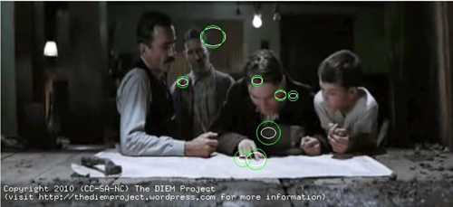
Screenshot from There Will Be Blood (2007)

There have been a handful of research studies that look into sound and what it does to the film viewer. In one film study, the researchers removed sound from a film clip and while also playing sound from the original clip, thus turning one film clip into a silent film. This study found that in clips with the sound removed, the viewers were able to notice the edits more than in the original clips with audio (Smith & Martin-Portugues Santacreu, 2017). It showed that sound contributed to “edit blindness” (Smith & Martin-Portugues Santacreu, 2017), where viewers do not notice the edits of the scene. When audio is played during a film clip, the cuts become hidden and less noticeable. Meanwhile, if there is no sound, the cuts are much more noticeable. It showed that sound in films can act as another layer that helps hide the cuts and edits from the film view. The authors stated that they were surprised at how critical a role audio played in edit blindness and that “cut detection time was significantly quicker when clips were presented without audio and the impact of cut type on miss rate disappeared” (Smith & Martin-Portugues Santacreu, 2017, p. 24). While this study was not able to determine why audio played such an important role, the researchers were able to narrow it down to two different things. They said that “participants were either less engaged with the visual content [when there was no sound]... or have more cognitive resources to allocate to the primary task” (Smith & Martin-Portugues Santacreu, 2017, p. 24) of detecting cuts.
Research with film and editing - Murch and Bordwell
Research in film has tried to determine how the film audience is affected by what they are seeing. Well known film editor, Walter Murch, discussed his experiences and thoughts on film editing in his book In The Blink of an Eye (Murch, 2001). In the book, Murch explained his ideas on the impact of film with the audience and how this could be discovered through the audience when they are blinking, hence the title of the book. Murch claimed that when there was “coherent blinking” (Murch, 2001, p. 71) or group blinking among the audience, that meant the film was edited correctly and it was holding focus of the audience. However, if looking at the film viewers when they are watching a film and there is “scattered blinking” (Murch, 2001, p. 71) or the blinking is random, then the viewers have lost focus and the film was not edited correctly enough to hold the viewers’ attention.
Film theorist and historian David Bordwell (and Murch) have pointed out the importance of sound (Murch, 1994; Bordwell et al., 2017), even though sound has been commonly used for decades (Bordwell et al., 2017) and was even experimented on in the very early stages. Bordwell states there are also different types of sound used in films to keep the flow of the film going and to help the film viewer process and understand what is happening in the film (Bordwell et al., 2017). New usages of sounds, like ambient sound, sound effects (SFX), and diegetic and nondiegetic sound all have some impact on film viewers and what the film does to them. All of these things combined form different ways that sound impacts a film viewer and how the viewers process and focus on a film. Meanwhile, there are other researchers who claim that editing is intuitive (Pearlman, 2015), while some believe that editing is more than just instinct (Pearlman, 2015).
History of film and film editing rhetoric
While the beginning and the inventor of films will never be agreed upon, it is agreed that films themselves originated in the 1880s, when photographer Eadweard Muybridge wanted to discover whether or not when a horse ran, if at some point all four hooves were off the ground (Shah, 2018). This can be seen in Figure 1. He set up cameras all around the racetrack, so that when the horse ran by the still cameras would take a picture. When all of these pictures were put together, it looked like the horse was running, and it also showed that at some point during the run all four of the horses’ hooves were in the air (Shah, 2018).
Image 2
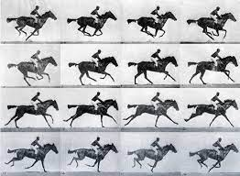
This work was done in 1878 and was later presented in motion in 1880, which was allowed by Muybridge’s invention of the zoopraxiscope (Shah, 2018). This was the beginning of editing rhetoric, by taking frames/pictures and combining them to tell a story and to make a point.
When moving pictures started, these films were one clip that lasted just a few seconds. Films by The Lumière Brothers, such as Workers Leaving the Lumière Factory (1895) and Arrival of a Train (1896) lasted only a few seconds. Films by Thomas Edison in his studio, the Black Maria, such as Washing the Baby (1893) also lasted a short amount of time. It only took a few years of making films for these stories to start becoming longer. Because these films were one clip, there was no editing taking place.
However, it only took a few years for films to develop and the cutting of film (editing) to become a common element. Films such as Trip to the Moon (1902) and Life of An American Fireman (1903) show that cutting was not drastic or dramatic, but was slowly being used to help with the storytelling. While editing did not take off drastically, it did not take long before all films were using editing to tell stories.

Chapter 3: The Rhetoric of Editing
Classical rhetoric and film
Meanwhile, the writings of rhetoric have come from centuries ago. The arguments of rhetoric have been debated and written on for hundreds of years. Greek philosopher, Aristotle claimed that rhetoric was a form of persuasion and gave guides on how to use rhetoric and particular definitions (Aristoteles & Kennedy, 2007). Isocrates, an orator, said that rhetoric was also persuasion, but that the orator had to be talented for rhetoric to work well (Haskins, 2006). With the constant developments of film editing, from the invention of sound to the invention of color, words from the classical rhetoricians can still explain the rhetorical methods that are being used in film editing.
Film rhetoric
Just like the classical rhetoricians, the definition of rhetoric in film studies varies. Film studies overall lack a universal definition of rhetoric. They say that films are meant to persuade based on the story that is being told. Films use different rhetorical devices, which include camera angles, lighting, editing, sound (Photinos & Tateishi, 2022), and many others. Even classical rhetoricians’ definitions of rhetoric differ. This study proposes that film rhetoric be defined as a combination of methods used to create a meaning and to send a message to the viewer.
Classical rhetoricians
The rhetorician Aristotle, claims that rhetoric was to be defined as “an ability, in each [particular] case, to see the available means of persuasion” (Aristoteles & Kennedy, 2007, p. 37). He claimed that “character is almost…the most authoritative form of persuasion” (Aristoteles & Kennedy, 2007, p. 39), leaning more towards the individual being the main cause of effect. In his writing, Aristotle gives guidelines or a how-to on ways to use rhetoric, and almost providing a list and a dictionary for what rhetoric means. Rhetoric has various definitions, but is typically defined as a way to persuade others, to resolve conflict, to inform readers of a particular audience, and to stir audiences emotions. Rhetoric is also meant to entertain while giving a message.
Another classical rhetorician, Isocrates, claimed that rhetoric was performative (Haskins, 2006), saying that “performance implicates the speaker (or writer) in a relationship with an audience, and the speaker's reputation is intimately tied to this audience’s approval or disapproval” (Haskins, 2006, p. 195). Rhetorician Ekaterina Haskins pointed out that
the audience's response is not simply a matter of agreement or disagreement with the statements about the past or future, or judgments about the rhetorician’s ability to use words (as Aristotle's Rhetoric would have it); rather, it either ratifies or invalidates one’s very position within the political sphere. (Haskins, 2006, p. 195)
Isocrates also said that some orators were naturally talented, while other orators could be trained (Haskins, 2006). It can be argued that editors are similar to Isocrates’ definition of orators. Some editors are naturally talented, while many editors can be trained.
The last classical rhetorician example is Quintilian. He claimed that with rhetoric came the art of speaking (Quintilianus & Butler, 1995). Quintilian said that an orator must speak well, while also pointing out that there is a “forensic oratory” (Quintilianus & Butler, 1995, 3.9.1), which includes exordium, statement of facts, proof, refutation, and peroration. With editing and films, it can be argued that films include a statement of facts, proof, and refutation. When the characters speak this is a “statement of facts.” Films are meant to show reality or “proof” and viewers get this through the visuals. While the refutation in a film can come from what is shown on the screen, and the clashing of ideas or beliefs of the film viewer.
Story and plot are also affected by the editing. Story is the film as a whole, while plot is the series of events that make up the story and push the story forward. The editing focuses on the plot, making sure that the editing is assisting and helping to push the story forward. Film editing focuses on both the plot and the story, making sure that their editing choices are helping with both.
Sound Rhetoric
Sound played a large influence on editing techniques and how those techniques are used to influence film viewers. Some of these techniques are meant to be smooth, so smooth that the film viewer does not even notice when an edit takes place (sound bridge), or the techniques are meant to be jarring and frighten the viewer (smash cut) (Bordwell et al., 2017).
Quintillion talks about sound in the form of oratory. In a way, films are oratory when characters talk. He says that oratory is persuasive (Quintilianus & Butler, 1995). Voices in films are oratory and make the film a physical being, resulting in a film that is full and realistic. Sound in film works in a similar way. Film editors make sure that the audio is clear so that the dialogue is easily heard. Editors add in sound effects to make the film more realistic and dimensional. Meanwhile, editors also choose to add in music to help with their edits, whether it be to help the emotion of the scene or to create a musical montage. Many of the sounds in a film are meant to be persuasive.
Rhetoric recognition
Films have long been recognized as having some kind of impact on the film viewers. Documentaries are used as a form of persuasion and filmmakers do not try to hide this. Narrative/fictional films are also used as a form of persuasion, but are much more subtle about it. Instead of relying on the rhetoric of the storyline and the storytelling, editors use the rhetoric of editing to aid in the rhetoric of storytelling. Without the editing and “the cut,” the storytelling would be much harder to perform.
Russian filmmaker Lev Kuleshov researched the impact that images had on the film viewer. In the 1910s and 1920s, he took an image of a neutral faced man and juxtaposed the man’s image with an image of a bowl of soup, then back to the image of the man. After viewing the three images, participants would say the man was hungry. When the same image of the man was juxtaposed with the image of a dead girl, the participants would say that the man was sad (Corrigan & White, 2017; Cook, 2016). These same images can be seen in Image 3.
Image 3
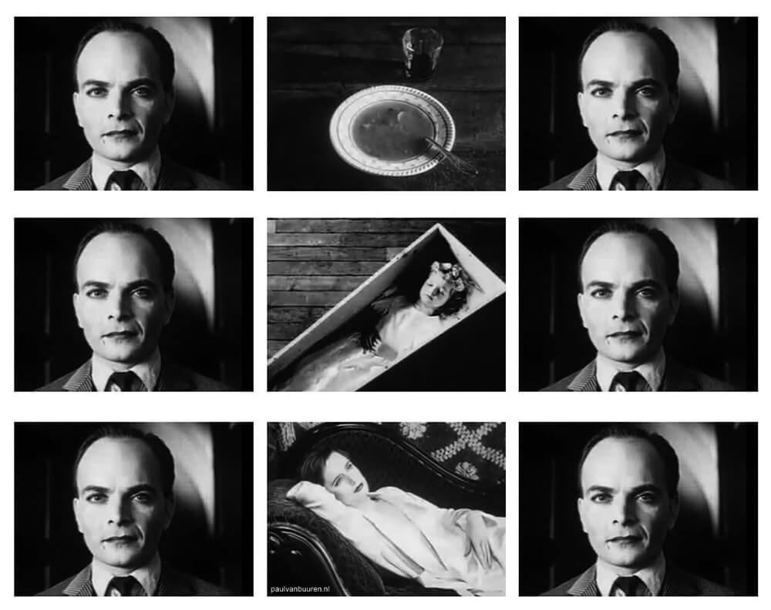
The Kuleshov study showed that film viewers can make their own inferences and fill in gaps of information. However, because the Kuleshov study took place in the 1910s, before audio was added to films, the study only used pictures. A new study took the same concept of the Kuleshov study, but instead used clips of different facial expressions that had happy, sad, and neutral in them and combined those clips with neutral scenes and music. This study found that the addition of music significantly influenced the viewers emotional judgments of facial expressions that were shown (Baranowski & Hecht, 2016).
Sound has also been acknowledged to have an impact on the rhetoric of filmmaking and how it impacts the film viewers. As mentioned earlier, Sergei Eisenstein believed that sound would ruin the montage and destroy the cinema (Eisenstein et al., 2016). Charlie Chaplin was very reluctant to use audio in his films and even held out for several years before he finally caved and used dialogue in his movies (Howe, 2013; Chaplin & Hayes, 2005).
As discussed, films have long been known to persuade film viewers. Films are meant to capture reality and the world around us. Classical rhetoricians Aristotle and Isocrates, discussed how they thought rhetoric could be achieved. For many filmmakers, part of their goal is to get the film viewers to believe what is on the screen, and much of this success can be given to editing. Editing has its own rhetoric and has been used for over a century, constantly changing and developing. In the digital age, editing rhetoric will continue to evolve.
Editing history and evolution
Film editing has evolved from being completely nonexistent to being an intricate job that can sometimes employ multiple people at one time for one job. The early stages of filmmaking consisted of taking a large camera to a location, outdoors or a studio set, and filming what happened in front of the camera (Corrigan & White, 2017). From this recording, was the complete film. Examples of this come from The Lumiére Brother’s films, such as Arrival of a Train at La Ciotat (1895) and Workers Leaving the Lumiére Factory (1895) and Thomas Edison’s studio, the Black Maria, with films like Washing the Baby (1893) and the Blacksmith Scene (1893).
It wasn’t too long after the beginning of films that editing started to take place. Interestingly enough, some claim that the first person to use a “cut” in a film was a magician, French illusionist Georges Méliès (Landler, 2019). During a time when many filmmakers were using a theatre stage for their films, Georges Méliès was doing the same. Only because of his prior background knowledge, Méliès sought to tell stories in a manner that was familiar. Also considered the father of special effects in film and the man that discovered the stop-motion technique (Landler, 2019), Méliès was the first person to use a “cut” inside a scene, which at the time, meant a scene was the whole film. In his movie A Mysterious Portrait (Le Portrait Mystérieux) (1899), a magician stands on stage with an empty picture frame. The magician shows that there is no way for anyone to sneak into the frame, he waves his hands, there is an unusual jump/movement (this is the cut), and slowly a copy of the magician himself appears in the frame and starts moving and conversing with the magician on the stage. This film also features a special effect (those that Méliès was known for), which for this film is the moving man in the picture frame. Méliès would cut the filmstrip of the magician to the correct size of the picture frame (in the filmstrip) and place it on top of the film of the original magician, thus creating his “magic.” Unfortunately, because of the time period and lack of documentation, it is uncertain if this is the first film to do this type of edit.
However, there has been another film from early years discovered to have an “edit.” Created in Britain by Robert W. Paul a year earlier, Come Along, Do! (1898) has been the oldest film discovered (so far) to have two scenes and location changes (BFI Screenonline). In this film, an elderly couple sit outside on a bench, watching passersby. The second scene puts the elderly couple inside an art museum, where the husband looks at the art. Unfortunately, this historical film is no longer complete, decaying over time, and only still images of the second scene remain (BFI Screenonline).
Just a few years (and films) later, in his A Trip to the Moon (Le Voyage dans la Lune) (1902), Méliès showed just how much he had learned using his same techniques to create an even more complex film (Corrigan & White, 2017). In Trip to the Moon, Méliès now uses multiple locations and multiple special effects. In the film there are multiple scenes. There are astronomers gathered in a room, engineers work on the spaceship, and the astronomers stand on the rooftop and look up at the night sky. These scenes continue to change and progress as the story gets further along. Some of the special effects include the face of a man in the moon and the sudden appearance/landing (a cut) of the spaceship in the moon man’s face. The astronomers land on the moon, are viewed by celestial objects, meet aliens, and then return to earth. In just a short period of time, Méliès created an intricate story that was more than just a scene and one location. It was a full narrative, complete with cuts that end a scene and cuts (special effects) in the middle of a scene.
However, while all this was happening in France, editing developments were also taking place in the United States. Life of an American Fireman (1903) by Edwin S. Porter was doing similar things (Reisz & Millar, 2010), with scene changes. This film was made up of 20 shots (Dancyger, 2018), which included multiple men in a fire station, the firetruck traveling through town to a burning building, and the inside and the outside of the burning building. The interior and exterior of the building is repeatedly shown to the film viewer so they know what is happening both inside and outside. In addition to this full story, complete with scene cuts and changing locations, are special effects. At the beginning of the film, a fireman sits in a chair and a thought bubble slowly appears to the right of his body. Inside of the circle is a woman putting to bed a small curly haired girl. This is very similar to Méliès’ tricks used for similar editing techniques (Landler, 2019; Reisz & Millar, 2010), where filmstrips are placed on top of each other.
Just a few months after Porter made Life of an American Fireman, he made The Great Train Robbery (1903). In a few short months, the editing techniques in this film evolved drastically from the film earlier. The Great Train Robbery had 14 shots (Dancyger, 2018), but contained a new editing technique, parallel editing. Parallel editing is a technique used to show different scenes happening at the same time (Cook, 2016). In the film, bandits knock out a telegraph operator and rob a train. The operator's daughter arrives and helps her father. Next, at a dancehall a hunting party is formed, and a chase takes place with the party and the bandits. Finally, the notable ending is the leader of the bandits, who looks straight into the camera, points his pistol directly into the lens, and fires.
Women editors
Even the physical practice of cutting the film and editing it changed early on. Originally, films were edited by the directors. However, this too changed. Soon editing became work for women, with some speculating that the reason for this was because editing was similar to sewing, weaving, telegraph operating, and typing (Corrigan & White, 2017; Kaganovsky, 2018). In Europe, the job of an editor, also known as the cutter, was to “sift through enormous quantities of filmed footage by hand to find the shots that worked best and then put them together in the optimal way to tell stories” (Kaganovsky, 2018). This was low-paying work, menial, that was connected to jobs with traits for women and this meant that “usually young women just out of high school with little or no professional training – were considered ideal candidates for the job” (Kaganovsky, 2018). Unfortunately, “going into the 1920s, in the USSR and elsewhere, women often worked as screenwriters, editors/cutters, costume designers, and the like, often without receiving on-screen credit” (Kaganovsky, 2018). With the lack of credit given to female editors during this time, it is unknown what impact these women editors had on editing practice and concepts.
The change of sound
Another big practice change was the addition of sound-on-disk into the creation of movies. With this change also came the concept of what sound could do to the film and the film audience. Sound itself was used in the early films by the movie theaters when the organist or the pianist would play music during the movie (Corrigan & White, 2017). Sometimes movie studios would send out sheet music for theaters to play (Corrigan & White, 2017). But the experimentation with sound happened early on, with Thomas Edison’s studios performing sound experiments in 1895 (Corrigan & White, 2017). W. K. L. Dickson “actually achieved a rough synchronization of the two machines as early of 1889” (Cook, 2016, p. 151) and “at the Paris World Exposition of 1900, three separate systems that synchronized phonograph recordings with projected film strips where exhibited” (Cook, 2016, p. 151). In 1903, a German man, Oskar Messter, began to create synchronized sound films (Cook, 2016).
This sound experimentation and invention was also happening in other countries. Britain had Gaumont’s Chronophone and Cecil Hepworth’s Vitaphone, and in the United States, there was Edison’s Cinephonograph and Kinetophone (Cook, 2016). However, “all of these early systems relied on the phonograph to reproduce the sound component of the filmed performance” (Cook, 2016, p. 152). However, it didn’t take long to solve this issue. The Vitaphone was developed by Western Electric and Bell Telephone, a subsidiary of American Telephone and Telegraph Corporation (AT&T) around 1925. This was then leased to Warner Brothers in 1926 (Cook, 2016). Soon after, in 1927, Fox Studios created their Movietone, allowing other studios to also create sound-on-disk films.
The addition of the use of sound opened up new concepts and ideas for editors to use with films, all of which have continued to develop through the decades. However, this additional element faced backlash early on. Russian filmmaker Sergei Eisenstein believed that sound would destroy the montage (Eisenstein et al., 2016). According to Eisenstein, each montage had a different effect on the film viewers and how they were supposed to be able to process what they were watching. Each one of these montages were also connected to the way a film was edited. While Eisenstein did support the addition of music in films, he opposed the use of dialogue, claiming that it would cause the viewers to not need to think about the film (Eisenstein et al., 2016).
Important films and color rhetoric/color theory
While many of the early films are lost, there are several that have managed to last through the years. One of the important things to note is that many of the new techniques and technologies that were taking place, were happening at the same time in different countries. Early films were being made around the same time, in different parts of the world. Washing the Baby (1893) created by Thomas Edison’s crew, was made around the same time as Workers Leaving the Lumière Factory (1895) created by the Lumière Brothers.
The painting of filmstrips was taking place at the same time as well. Trip to the Moon (1902) by Georges Méliès had scenes painted, along with The Great Train Robbery (1903) made by Edwin S. Porter. Porter's Life of An American Fireman (1903) also showed the first time “the cut” was used, to edit a film. The Great Train Robbery (1903), created a few months later, featured cutting in the film and had the first recorded use of parallel editing.
The move to color happened much earlier than Technicolor and the infamous brightness of The Wizard of Oz (1939), with the physical painting of the filmstrip. However, because the technology for automatic color wasn’t invented yet, these filmmakers did hand paint their films. Hand-tinting was widely practiced with many short films (Cook, 2016). Georges Méliès “employed twenty-one women at Montreuil to hand-tint his most spectacular films by frame; and Edison regularly tinted portions of his films, for example the burst of gunsmoke in Porter’s The Great Train Robbery” (Cook, 2016, p. 161). By painting films, and continuing to have films in color, helped make films real to the point that people believe the story that is being told, because color helps capture the realistic world. Later on, multiple stencils for one film would be made to help make the tinting process faster (Cook, 2016), while colored film like Technicolor and Kocak, was also being experimented by multiple people at the same time (Cook, 2016). There was Eastman Kodak’s Sonochrome demonstrated in 1908, Gaumount’s Chronochrome that was patented in 1912, and the Technicolor company formed in 1915 (Cook, 2016), just to name a few. Movies with Kinemacolor and Technicolor made the colorization of films easier. In the digital age, coloring a film is much easier. LUTs (Look Up Tables), used in editing and coloring software, are used to aid in the coloring of a film.
Color film was a technological invention that developed early on. Different from the painting of film, colored film did not need to have paint placed on each frame. Instead, the film captured the color of real life on the film strip when it was recorded. A Visit to the Seaside (1908), which was made in Britain and had a runtime of 8 minutes, was the first color film. This was made on Kinemacolor (A Visit to the Seaside), seen in Image 4, before Technicolor was invented.
Image 4
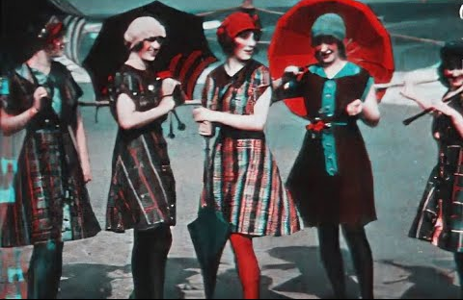
Screenshot from A Visit to the Seaside (1908)

The color of a film is considered in preproduction as well. Production designers' costume and set choices impact color and the cinematographer and gaffer’s lighting style also affects the color. The color palette of a film and the colors chosen, help to convey symbolic meaning, establish narrative organization, and convey mood and tone. All of these things carry forward when the editor receives the footage. It is then the editor’s job to help with the intention of those colors.

Image 5
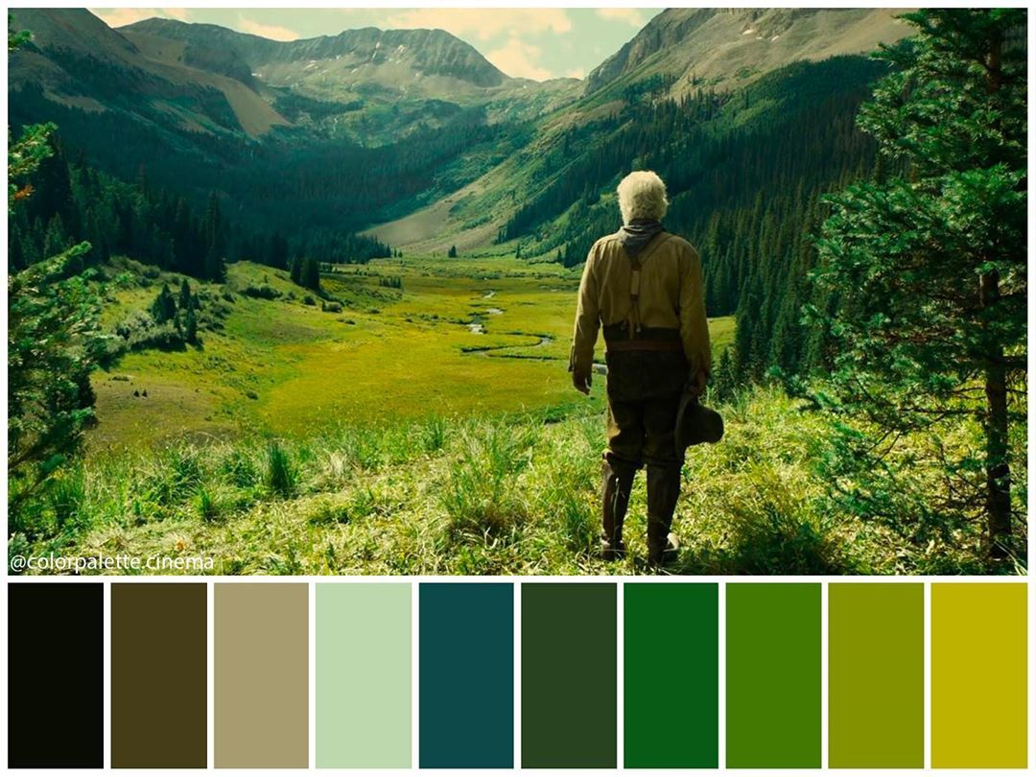
The Ballad of Buster Scruggs (2018) - Source: Pinterest

Image 6
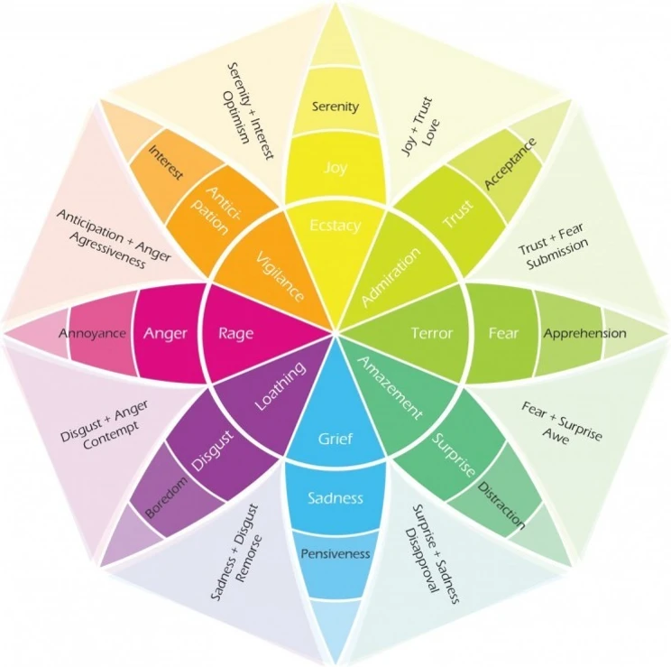

Psychology Color Theory - Source: No Film School

Color theory exists in psychology and in film. While some of the color representations are different, many do overlap and can apply to various films. Films will use the meanings of these colors to help with the emotional meaning of the scene.

Image 7
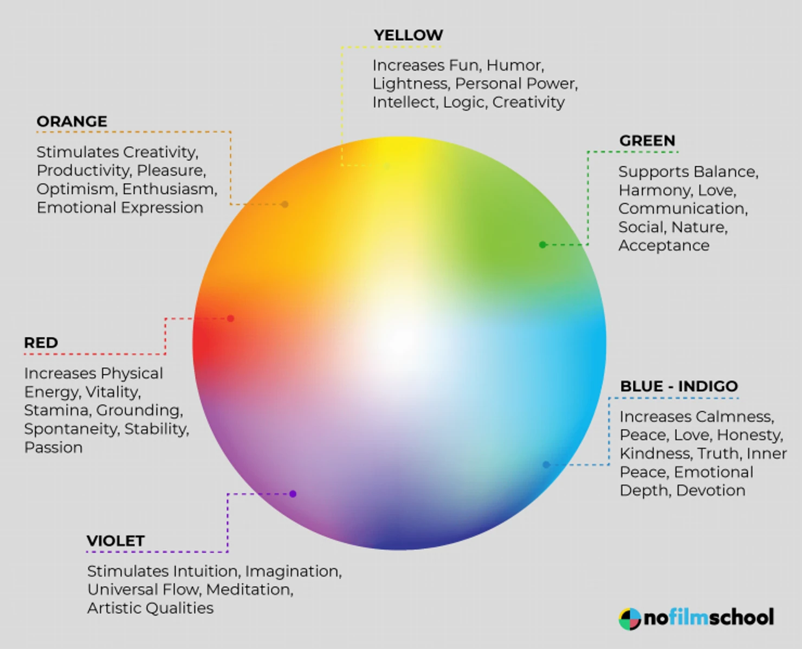
Film Color Wheel - Source: No Film School

As mentioned earlier, some films use color to help tell their stories. Scenes with a death might have a blue color palette, like Gladiator (2000). When Maximus is in the field where he will see and walk towards his family, the tone of the dream scene is blue.

Image 8
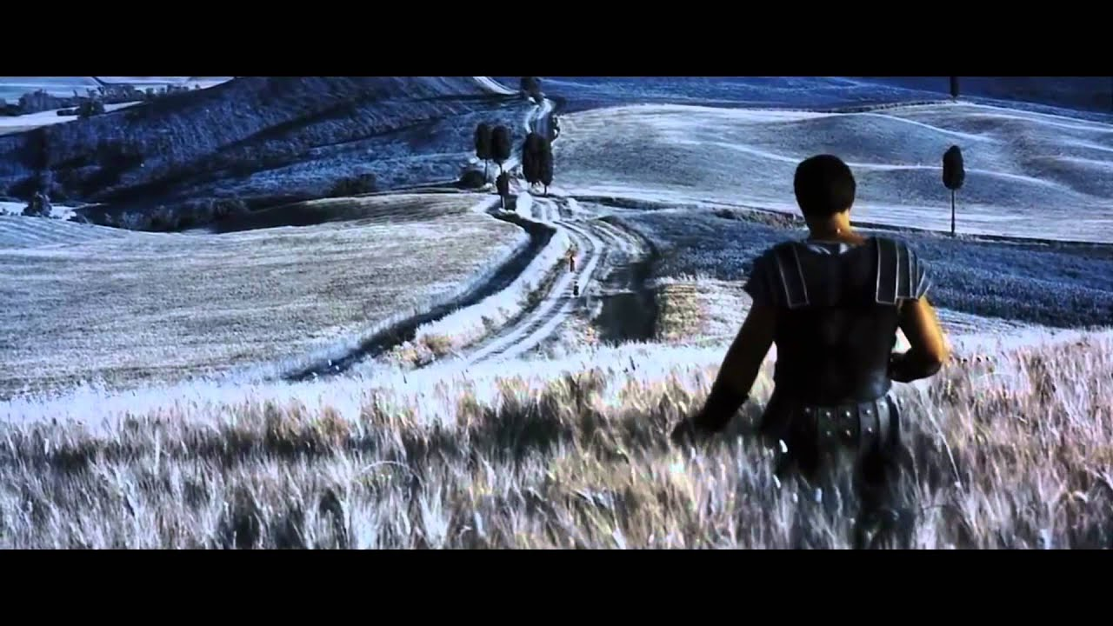
Screenshot from Gladiator (2000)

Other films use color to represent different stories and characters. For example, the movie Traffic (2000), uses an orange and blue tone to represent the different storylines. Blue represents the American storyline, while the yellow/orange tone represents the Mexican storyline.
Image 9
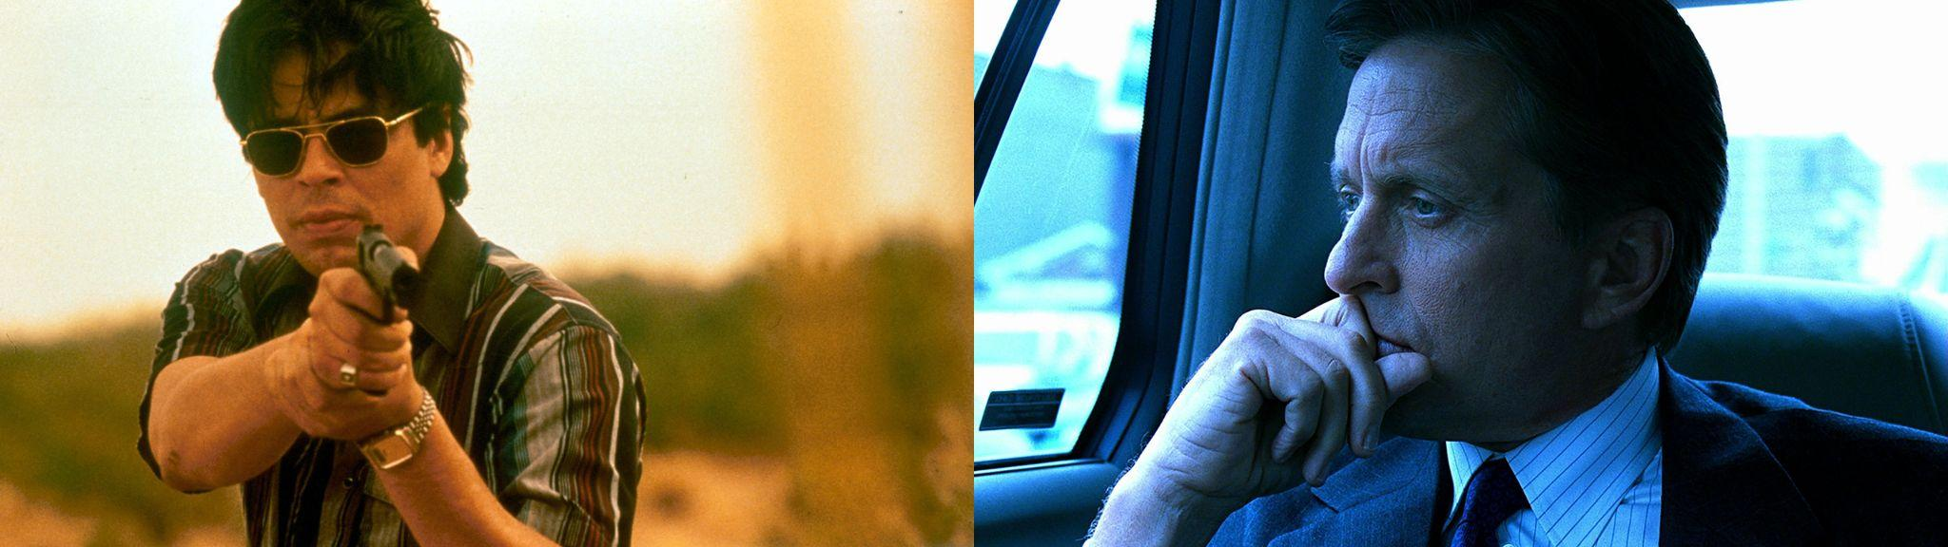
Traffic (2000) - Source: Ohio State University

Depending on the size of the movie set, some film editors might not touch the color of the footage. If the set is small, the film editor might do all the color grading. However, many editors will do their best to help with the color tone that was already provided and suggested by the director and the crew.
Sound development

Finally, as mentioned earlier, the last early invention was sound. Sound was used early on in the creation of films. Sheet music was sent out with film reels, for pianists and organists to play when the film was playing (Bordwell et al., 2017). Some of these pianists and organists were not given sheet music and instead played music based on what they were seeing in the film while the movie was screening. Because of this, many film audiences heard different music. While The Jazz Singer (1927) is credited to be the first sound film, it is important to note that this movie was the first sound feature-length film, while other short films were experimenting with sound long before The Jazz Singer was created. Each of these new inventions helped push forward the development of films and helped with the development of editing rhetoric, the techniques that are used to capture the film viewer’s attention and guide them into how they understand the film that they are watching.
This chapter provides the background information to understand rhetoric and how it applies to film and film editing. Rhetoric takes place throughout the entire film, with visual editing rhetoric, sound editing rhetoric, and color rhetoric taking place at the very end of the film creation process. All three of these rhetorical methods are used by the film editor when they are editing the movie and are used to help create feelings with the film viewer. Editing rhetoric, sound rhetoric, and color rhetoric were all discovered and developed early on in film history, and as this chapter shows, these methods of film rhetoric continue to evolve.

Chapter 4: Different Editing Techniques

This chapter will cover the different editing techniques and how digital film has impacted film editing. It will cover the different types of editing transitions and explains how sound also plays a role in editing transitions. The chapter concludes with an explanation of the history of sound in film and how sound rhetoric is used in film editing.
Digital film
Finally, the most recent practice change has been the one in the 1990s: the move to digital (Murch, 2001; Corrigan & White, 2017; Dancyger, 2018). Prior to this, film editing was a linear process. With the change over to digital, editing has become nonlinear, allowing for easier experimentation with ideas and sound.
Originally, there were zero editing concepts and practices for film. With the birth of editing came concepts and techniques that soon followed (Dancyger, 2018; Corrigan & White, 2017; Cook 2016). Once a technique was discovered, it would be used to an even greater extent, but the general idea has stayed the same, even until now. This includes techniques such as parallel editing, first recorded in The Great Train Robbery (1903) (Corrigan & White, 2017). Color and sound have also played an important role in editing. These new styles and techniques would become more intricate and complex, and these elements added to the film were used to help with the meaning and intent of the edit. As mentioned previously, much of the editing done in early films was by women who were not given credit (Kaganovsky, 2018; Corrigan & White, 2017). Unfortunately, it is impossible to say who helped with the development of certain techniques and concepts. However, it is clear from history that most experimentation starts with an individual, not a company. It is through an individual that editing techniques and concepts are played with and discovered.
Switch to digital and editing considerations on set
The final aspect of film evolution has been the switch to digital. With this move, it is easier to experiment with edits, compared to how it was in the past. Editing became easier, quicker, nonlinear, and can now be easier to organize and store digitally (Corrigan & White, 2017). Digital also means that editing does not cost as much as before, needs less people in the editing room, is easier for directors and producers to review, and it is now possible to save different versions of the film (Murch, 2001). The editing of sound and adding in visual effects are also much easier to do during the editing process.
There are now written and universally understood rules for film crews to follow that will help the editor once they have received the film footage. One of the first things that filmmakers are taught is the 180-degree rule (Corrigan & White, 2017). This explains to the filmmakers that there is an invisible line in a scene when two characters are talking. This line is drawn down the middle of the room and the camera is not to cross that line. If the camera does cross the line and goes to the opposite side, then the image does not look right and is off-putting (Corrigan & White, 2017). The other rule taught is the 30-degree rule (Corrigan & White, 2017, p. 183). This is to help the editor avoid jumpcuts. A jumpcut is a technique that is usually used accidentally in film, although sometimes an editor does this because there is no other footage. A jumpcut is where a cut takes place in a scene, but the camera angles do not change, and the location does not change. Instead, there was a cut in the scene and nothing changed. Many editors avoid doing this type of technique, because it brings the film viewer out of the movie and is jarring (Bordwell et al., 2017). However, some independent films will use this technique to their advantage when they are telling artistic stories. The 30-degree rule says that when facing a character, and there is a camera placement, the camera must move 30 degrees and change frame size in order to avoid a jumpcut (Corrigan & White, 2017).
Filmmakers are also taught to capture an establishing shot (Corrigan & White, 2017), which is used in the editing room by the editor when a new scene location is introduced. Editors are also taught to follow certain rules in the editing room. Film editors have gone from no rules, to their own set of rules when it comes to cutting, and the rules that filmmakers and film crews have created and set for themselves to help the editor.
Shots are now more specific and have names that the filmmakers, film crew, and editors all understand. There are shot/reverse shots, eyeline matches, point-of-view shots, and reaction shots that crew members understand that they must try and get (Corrigan & White, 2017). They are also taught to get room tone (a sound), so that an editor can edit the sound of the scene correctly. Room tone is the name of sound that is captured on set that is the sound of the location that they are currently filming. For example, the room tone of a classroom will have the sound of the air conditioner or heater and the hum of the lights. Typically, while in production, the sound crew will get the room tone of a scene right before filming and again at the end after filming. Meanwhile, back in the editing room, the editor has names for the cuts that they make with the shots that they have received. Through the editor's cut is also the pacing and rhythm of the entire movie (Corrigan & White, 2017).
The general concept of editing has stayed the same and editing styles for big films have also stayed the same. Films like the Marvel movies still follow the classical Hollywood editing style (Corrigan & White, 2017). Only compared to the movies from the 1930s, 1940s, and 1950s, do recent films show to have more cuts, with some cuts being more rapid than others depending on the genre. Editors are usually not on set and are editing material that they have seen for the first time. This means that they have no idea to what lengths that it took to gather the content and they are not attached to any particular shot. Instead, they focus on finding what they believe is the best material. This has not changed since the beginning of editing, when shot selection became an option in the editing room. Dmytryk claimed that an editor “may improve a film by eliminating excessive and/or redundant dialogue, by selective editing of inadequate acting, by creating manipulation of the film’s pace and the timing of reactions, by mitigating the weaknesses of badly directed scenes, and on rare occasions, by more unusual editorial maneuvers” (Dmytryk, 2018, p. 4). Even during Dmytryk’s time, editors were known to come up with creative ways to help a film.
Editing techniques
Since the one-cut-wonders of the early days, film editing has continued to evolve and become more complex. “The cut” is a term used by film editor Walter Murch, when describing the process of editing. Aside from the invention of “the cut,” there have been other editing techniques that have been created and developed. One of the early editing developments and theories that came along was from Sergei Eisenstein and his methods of montage. As mentioned earlier, each montage had a different effect on the film viewers and how they were supposed to be able to process what they were watching.
The next editing technique that came about was the parallel editing technique that was first seen in The Great Train Robbery (1903). This showed a back and forth from outside of the train station to inside of the train station. This technique shows what is taking place at the same time, in two different locations. Cross cutting is similar to parallel editing, however, the main difference is that cross cutting jumps back and forth from locations, but does not take place at the exact same time (Prince, 2013).
A match action cut is where the second shot that takes place after the first shot, matches the action that happened before (Prince, 2013). An example of this would be when someone starts to place a cup on the table. The cup is put down in the first clip and in the second clip, the cup is picked up where it was placed and moved to another location by a different person. There are also different types of match cuts, such as graphic matches where one image matches the image before (Bordwell et al., 2017). An example of this would be the bone and satellite in 2001: A Space Odyssey (1968), which can be seen in Image 10. The ape throws the bone into the air, there is a cut, and the image of the bone is replaced by an image of a satellite. This scene uses the match cut technique to bring the audience from the past and into the future. For a cut to be a match cut, the next cut/image must match the placement of the image before and keep the pacing of that image, if there was movement.
Image 10
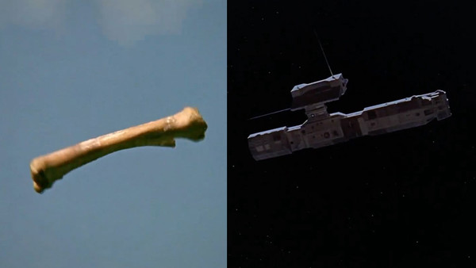
Screenshots from 2001: A Space Odyssey (1968)

Another editing technique is cutting on action. This is a much more subtle technique rarely noticed by film viewers. Cutting on action is when the actual cut takes place during an action movement (Bordwell et al., 2017). An example of this would be when someone is taking a sword and they make a slicing motion, the cut takes place mid-slice, leaving the next clip to show the end of the slicing movement.
The eyeline match is a technique that almost all films use. This is when characters are looking at each other, the editor makes sure that their eyes are looking in the correct direction. Otherwise, it will look like the characters are looking in different places and not at each other. An example of this would be when character #1 is talking, their head is on the left side of the screen, looking to the right of the screen. Character #2’s head is on the right side of the screen, looking to the left. If character #1 and character #2 are talking to each other, and the eyeline match was not lined up, it would look like the characters were talking to different people or looking in the wrong direction.
In addition to cuts that take place on the screen, there are editing techniques that take place in the audio that go along with what is being seen visually. A sound bridge (also known as a J or L cut, in the digital age), is when “sound from the previous scene may linger briefly while the image is already presenting the next scene” (Bordwell et al., 2017, p. 298). An example of this comes from the movie Smoke Signals (1998). In this movie, Arnold is talking to Suzy about his son, Victor. Arnold is on a dirt basketball court, in the desert, while his story about Victor is inside a gym on a basketball court. He talks about how Victor helped him beat two Jesuits at a basketball game, and during the story the sound of Arnold's voice and the ball can be heard in both scenes. This is a long sound bridge. Meanwhile, a smash cut is when on the cut, audio suddenly starts or stops. This tends to be very jarring to the audience. An example of this is when once a scene is silent, the cut happens, and suddenly music from a radio is playing in the next scene.
Types of Transitions
There are several different types of transitions and cuts in film editing. However, for the purpose of this chapter, only the transitions between scenes will be discussed. First, there is the typical “cut.” This brings together different frames, without any type of effect. While in some cases this can be jarring, for some scenes this jarring transition is intentional. The next transition is the “fade.” For a “fade out” the film slowly gets darker, until the screen is black. For a “fade in” the screen slowly goes from black until the picture is visible. Next is the “dissolve.” This takes two different scenes, and places them on top of each other, gradually bringing one scene in and the other scene out. The last transition is the “wipe.” This pushes one scene off the screen, using a line or a shape, and replaces it with another scene (Bordwell et al., 2017). The wipe can be seen multiple times in between scenes from the original Star Wars films.
Along with these types of editing transitions are editing techniques called the “graphic match” (Bordwell et al., 2017) which is a “match cut,” as mentioned earlier, that can be seen in films like 2001: A Space Odyssey (1968), with the bone and the spaceship transition bringing the film viewer from the past all the way to the future (Kubrick 0:19:52). In addition to the graphic match, which focused on colors, shapes, etc., there is the “match on action” cut, which cuts based on action and movement. An example of this would be when a character in a kitchen goes to place a cup down, there is a CUT, the viewer sees the cup and then another character is revealed to have placed that cup down, while also being in a different location.
Sound rhetoric
As mentioned earlier, the common usage of synchronized sound in films took off in the 1920s (Bordwell et al., 2017). Bordwell said that “even before recorded sound was introduced in 1926, silent films were accompanied by orchestra, organ, or piano” (Bordwell et al., 2017, p. 264), showing that sound in general had been involved with films years before “talkies” were developed. Film studios would send out sheet music with their film reels that the pianist or organist would perform while the film was playing in the movie theater (Bordwell et al., 2017). During the silent film era, sound was used to help display the emotions of the character on the screen or it was used to intensify a scene. Even from the early days of film, before synchronized sound/audio, sound played an important part in the film viewing experience.
Diegetic sound and nondiegetic sound are typically used differently, with diegetic sound acting as “sound that has a source in the story world. The words spoken by the characters, sounds made by objects in the story, and music represented as coming from instruments in the story space are all diegetic sound” (Bordwell et al., 2017, p. 285) and nondiegetic sound being “represented as coming from a source outside the story world. Music added to enhance the film’s action is the most common type of nondiegetic sound” (Bordwell et al., 2017, p. 285). Both diegetic and nondiegetic sounds are used together in this same way throughout the film. The editing combines oral storytelling with visual storytelling to present the scenes in interesting ways that typically were not done before.
Well known film director, actor, comedian, and music composer, Charlie Chaplin knew the importance of sound in films and composed most of his own music in his silent films (Maland, 2007). However, when sound started to become more popular and common in film during the 1930s, Chaplin refused to join the others and continued with his silent filmmaking (Howe, 2013; Chaplin & Hayes, 2005). His films were loaded with physical comedy along with clear facial expressions. Chaplin believed that sound did have a place in films, but was cautious about using dialogue in his films (Howe, 2013; Chaplin & Hayes, 2005). This is understandable, considering that Chaplin was a silent film comedian, whose work was primarily based on physical comedy. Possibly realizing the change in the times, in his movie Modern Times (1936), Chaplin used vocals in a song that his character performed, but the rest of the movie was still a silent film. It was not until his film The Great Dictator (1940), over a decade after synchronized sound started to be used, did Chaplin cave and start to use dialogue in his films.
Aspects of change in film and film editing
At the very beginning of film, there was no editing and no sound. Movies consisted of a short clip, a scene that took place in one location. As film stories continued to become more complex, so did the need to find new ways to tell those stories. As mentioned earlier, Georges Méliès was the first recorded person to use a cut inside of a film scene (Landler, 2019). Soon after this, Edwin S. Porter used an editing technique that is now known as parallel editing (Corrigan & White, 2017). The 1930s-1950s were a time of the Hollywood studio system that used the classical Hollywood editing style, also known as continuity editing and invisible editing (Corrigan & White, 2017). Continuity editing is said to give “the viewer the impression that the action unfolds with spatiotemporal consistency” (Corrigan & White, 2017, p. 173). By the early 1960s, editors outside of the studio system were experimenting with continuity in films (Corrigan & White, 2017; Dancyger, 2018), this includes films like Breathless (1960) that used with jumpcuts to create disorientation.
From the 1960s to the late 1980s, editors were playing with alternative editing styles “that aimed to fracture classical editing’s illusion of realism” (Corrigan & White, 2017, p. 174), which was partly to do with political and artistic changes. These films would condense or expand time, and attempt to confuse past, present, and future (Corrigan & White, 2017). Contrast the early films to the movies that take place now, and there are drastic changes. Movies have dozens of scenes, combined with slow editing and rapid editing. Certain action films are known for their rapid editing, such as the Bourne series and various Marvel movies, and this rapid editing is thought to help intensify a scene. Editing techniques are more advanced now and they have had over a century to evolve.
The other aspect of evolution that has affected the change in film is the addition of sound. Sound not only helps make the film more realistic (Corrigan & White, 2017), but it helps tell the story, sometimes with extremely loud sound like Dunkirk (2017) with the multiple sounds of bombs, planes, and gunfire at the same time, or with lack of sound like A Quiet Place (2018), when the characters must be as quiet as possible to avoid attracting the monsters. Sound plays such an important part in films now that sound is its own department on a film set and in post production. Jobs can be as specific as being a Foley artist, a person that creates sound effects from objects to make noises more “real.” This includes the famous coconut clapping trick, to make the sound of horse hooves running. In addition to this, there are other elements that have been added with sound that can help a film, such as ADR (automated dialogue replacement) for when sound recorded on set was not good, so the actors go in during postproduction and re-record just their dialogue for the editor (Corrigan & White, 2017).
The issues discussed in this chapter show that there are various elements that can be considered rhetorical methods in film editing. The creation of digital film and digital editing has paved the way for more film editing experimentation. Because of this, more editing considerations are taken into account when the film is being created on set. Various editing techniques and editing transitions have been developed that help push the plot and story forward, while also impacting the film viewers' understanding of the movie. Sound rhetoric has also developed through the decades, even though there was reluctance among directors during the early stages of sound development. Finally, all of these aspects have helped to change the way that film and the different elements of film rhetoric are presented to the film viewer.
Chapter 5: Representation in Film
This chapter will cover representation in film and in film editing. Throughout the history of film editing, editors have developed “rules” or a set of guidelines that other editors can use when they are cutting a film. One of the most misrepresented and exploited groups in film history is the American Indian, however, in recent years the representation of American Indians has become better, largely due to the fact that those creating the films are also of the same ethnicity as those presented on the screen. This chapter shows just how much impact and say the editor has when it comes to the final cut of the film. By analyzing the short film Thistle Creek (2020) and the feature film Smoke Signals (1998), this dissertation shows that production control, editing, and sound all play a role in how the film story is told. This analysis also shows that these sets of rules that other editors in history have provided are typically followed, but also do not always apply.
Film editing and representation
While the editor might or might not be trained to edit, editing in-part is an opinion. While editors like Walter Murch and Edward Dmytryk have their own set of rules of making an edit (Murch, 2001; Dmytryk, 2018), these are still their “rules,” and in editing textbooks what is written down is what people have discovered to have worked in the past. The “rules” and the information in the textbook might act as a loose guide. Editing is personal. In the end, it is the editor of that film that makes the decision on how the film is edited.
As mentioned earlier, films were originally edited by the film director, but quickly changed to being edited by women (Kaganovsky, 2018; Corrigan & White, 2017). However, filmmaking and film editing has been dominated mainly by White men. It is because of this that the representation of ethnicities have not been accurate.
Historically, the representation of American Indians has been inaccurate and exploited (Price, 1973; Berny, 2020), continuing to be shown in stereotypical ways. Small silent films used American Indians as attractions and when films started to become more complex, they were used as the bad guys (Price, 1973; Berny, 2020). However, all of these examples are also connected to the reality that the people making these films probably did not identify as American Indian, and instead were made by White people.
Even during the 1960s and 1970s, American Indians were represented not by themselves, but by others pretending to be American Indians. In the 1960s television series F Troop, an Italian, Frank de Kova, played Chief Wild Eagle of the Hekawi tribe. De Cova frequently played an American Indian on television shows. Edward Everett Horton, who was of Cuban and European descent, played the medicine man, Roaring Chicken. Ed Ames, a Ukrainian American, singer-turned-actor played Mingo in the 1960s television show Daniel Boone. Some American Indian tribes were given fake names, while in some movies, in order to have American Indian characters speak in a different language, they had the actors speak in English and then in postproduction play the English language backwards and that would become the American Indian “language” (Berny, 2020).
Control of production
It is through the people that help make the film that the representation, inaccurate or accurate, is made. The production control of a film happens in a general order, although it might change depending on if the film is with a studio or if it is independent. The film itself usually starts with a screenwriter (Corrigan & White, 2017; Prince, 2013) and they are the ones to determine what kind of impact the American Indian characters are going to have on the story. This will usually go to a producer or director, who will then push for all the funding and gathering of the film crew. Before filming even starts, other production control elements take place.
The production design team, composed of many people, must decide on costumes and aim for the most historical accuracy of clothing, jewelry, weapons, food, and more. Another important aspect that the production design team decides is the colors of all these objects. Colors “can subtly convey dramatic moods and impressions to the audience, making them more receptive to whatever emotional effect the scenes, action, and dialogue may convey” (Kalmus, 1935, p. 26), and this plays an important role in preproduction. The casting director, director, and producer are the ones that decide which actors play the characters in the film. Ideally, it is their job to make sure that the representation is accurate with the character in the film and with the actor that will be playing that character.
When filming is taking place, production control gets expanded to even more people. It is the cinematographer, who does the camera placements, movements, and angles, that decides on how the camera is going to act when a character is in the frame. It is said that “cinematography (literally, ‘writing in movement’) depends to a large extent on photography (‘writing in light’)” (Bordwell et al., 2017, p. 159). With the input of the director, the cinematographer decides on the framing of the shot, the aspect ratio, the angles, the various types of shots, long takes, and more. They decide on the type of mobile framing (movement) that will take place, such as a tracking or dolly, crane, tilt, or pan (Corrigan & White, 2017; Prince, 2013).
Another person that has some input in production control is the gaffer, the person who, along with the cinematographer, creates the lighting look in the entire film (Corrigan & White, 2017; Prince, 2013). In addition to having lots of preproduction work before the film starts shooting, the production design team has lots of work to do on set. Inside of this crew are the costumes, props, and makeup. They are the ones that decide how the American Indian characters are going to look (Corrigan & White, 2017; Prince, 2013).
One of the first and last people to have major production control is the director. This is the person that is going to decide on if the characters are going to follow the script, or if they are going to stray away from it and try something else. Sometimes they are the person who decides on removing an actor, or if a part of a scene gets cut. They are typically the person with full control and the final say (Corrigan & White, 2017; Prince, 2013). It is all of these people, and more, who have a say in the production control of a film, before any of the footage reaches the editing room.
While “on set a director anticipates the cuts that the editor will make. And the director tries to set up the scene so that there are no jump cuts” (Dmytryk, 2018, p. 13). The director tries to make sure that the editor will have all the information (footage) that they need and that the information (footage) looks good. Of course, much of this can vary depending on the size of the film set, if it is connected to a film studio, or if it is an independent, and how much control the director has, wants, or is allowed.
The editor’s say in the film
While the initial look of the film’s footage is determined by the director, casting director, gaffer, production design, and many others, it is the editor that determines what footage is allowed to stay (Corrigan & White, 2017; Prince, 2013; Dmytryk, 2018) and how that footage is presented.
In the early days of filmmaking, the editor was also the director of the film. These “film directors in the US cinema industry did their own cutting, which in the first years of filmmaking was fairly rudimentary” (Kaganovsky, 2018). However, it didn't take long before editors became people who had not been on set (Dmytryk, 2018). Instead, it was their job to comb through the footage and use what they determined was the best, and even use creative means (Dmytryk, 2018).
Editors are familiar with different types of cuts and things to look for. There are shot/reverse shots, eyeline matches, matching on action, graphic matches, point-of-view shots, and reaction shots (Corrigan & White, 2017). Editors also use different transitions, to move from one scene to the next. They will use shock cuts, fade-in and out of black, dissolves, and wipes (Corrigan & White, 2017). All of these types of cuts and shots editors will use to help tell the story, from footage that they have never seen before, because “the editor works only with the material handed him by the director” (Dmytryk, 2018, p. 4).
When an editor starts cutting on the footage, they are one of the last people to work on the film. They are the ones that decide on what shots to use, if some scenes get cut, or if dialogue gets cut (Dmytryk, 2018). An editor “may improve a film by eliminating excessive and/or redundant dialogue, by selective editing of inadequate acting, by creating manipulation of the film’s pace and the timing of reactions, by mitigating the weaknesses of badly directed scenes, and on rare occasions, by more unusual editorial maneuvers” (Dmytryk, 2018, p. 4). They are the ones that set the pace and rhythm of the film (Pearlman, 2015), and the “exact cutting point would depend on the cutter’s sense of proper timing” (Dmytryk, 2018, p. 28). There are some that claim an editor’s sense of where to cut is intuitive and instinctual, while others say that it is not (Pearlman, 2015).
Some editors have also come up with rules and criteria that they must follow. Film editor Walter Murch claimed that there were six criteria need at one time for making a film edit, which are:
- It is true to the emotion of the moment
- It advances the story
- It occurs at a moment that is rhythmically interesting and “right”
- It acknowledges what you might call “eye-trace” - the concern with the location and movement of the audience’s focus of interest within the frame
- It respects “planarity” - the grammar of three dimensions transposed by photography to two (the questions of stage-line, [i.e., the 180* line] etc.)
- It respects the three-dimensional continuity of the actual space (where people are in the room and in relation to one another
(Frierson, 2018, p. 93; Murch, 2001)
Noir film director Edward Dmytryk claimed that there were six rules when making a cut, with those being:
Rule 1: never make a cut without a positive reason
Rule 2: when undecided about the exact frame to cut on, cut longer rather than shorter
Rule 3: whenever possible, cut “in movement”
Rule 4: the “fresh” is preferable to the “stale”
Rule 5: all scenes should begin and end with continuing action
Rule 6: cut for proper values rather than for proper “matches”
(Frierson, 2018, p. 86; Dmytryk, 2018)
Once the editor has made a rough cut of the film, which is when they gather together all of the good shots and create the story, the cut goes to the director, and sometimes producer and others, for feedback. The film will come back with notes, improvements or critiques, and the editor will edit again, fine tuning to make the film even better. However, unless the director remembers a specific shot, they are only getting back the information (footage) that the editor has chosen to let them see. The editor has the ability to remove and cut short whoever and whatever they want, based on how they are feeling about that shot. Some say that it is subjective work (Pearlman, 2015).
After the edit has been made, the editor or the colorist (depending on the size of the film) will change the look of the film further, by color grading it. Visual effects can also change the look, by adding in or removing objects. As can be seen in the discussion above, production control is done by many people and is a group effort. However, there is a hierarchy to the production control, and it is the editor who is usually the last person to work on the visuals of the film and to have a major say in how the footage is presented (Corrigan & White, 2017; Prince, 2013).
Thistle Creek example
In the short film Thistle Creek (2020), the levels of production control mentioned also take place. Before filming happens, it is the job of the production design team to make sure that the costumes of the characters, the hairstyle, color of the clothes, accessories like the beads, and the weapons are all historically accurate and accurate to the representation of the tribe. Even the clothing of the White women and children, the men, and the wagon, have to be accurate for the time period to be correct.
The director and editor choose to include text at the beginning of the film, sets not only the area and time period for the film viewer, but also lets them know whose story is being told. The last part of the text says “Brokenhearted, some [White Indians] escape to search for their Native families. And some Native families go in search of them…” (Walton, 2020, 00:00:46). The storytelling and editing choice to include this, instead of letting the film audience try and figure it out on their own, sets up the world that the audience needs to be aware of and be prepared for the emotions that the characters will have.
The opening of the Thistle Creek starts with the main character, a female Comanche, Tomo Ebi, as she walks through a field. A Native song and drums play as she walks slowly (Walton, 2020, 00:00:55). Multiple dissolves take place, slowly dissolving from one shot to the next, implying Tomo Ebi has been walking for a long time. The singing stops, but the drums keep beating. She sees a covered wagon with a White family. Tomo Ebi couches in the tall grass and pulls back her bow and arrow. The White man sees her and raises his rifle. The drums keep beating. This sound helps to intensify the scene. The drums suddenly stop and the screen goes to black. Then a rifle shot is heard (Walton, 2020, 00:02:11). The sudden stop of the drums and then the rifle shot, all taking place through the editing, leaves the viewer wondering what has happened to Tomo Ebi.
As the next scene is brought in, the sound from the previous scene overlaps and changes to background noise of crickets and bugs: a sound bridge. The scene slowly fades from black to an empty field. Tomo Ebi is now bloody and tied to a tree in the middle of an empty field (Walton, 2020, 00:02:35). She stares forward, the shot/edit lingering on her face. There is a cut and then we see a White girl sitting in a creek bank. Presumably from this cut, the White girl would be in front of Tomo Ebi. However, from the longshot provided earlier, we know that there is not a creek near the tree where Tomo Ebi is tried. There is another cut back and forth between Tomo Ebi and the White girl.

Images 11
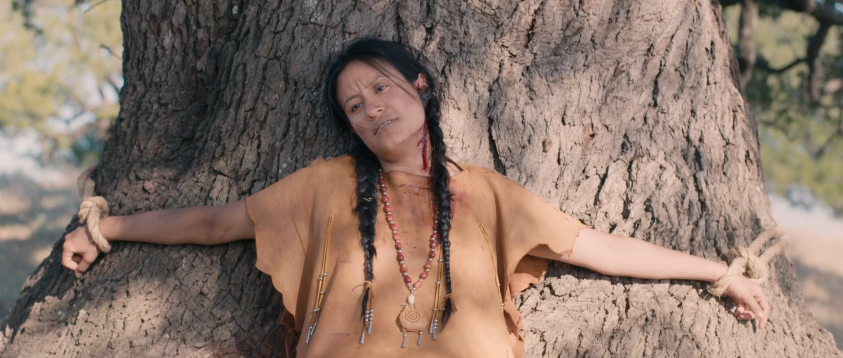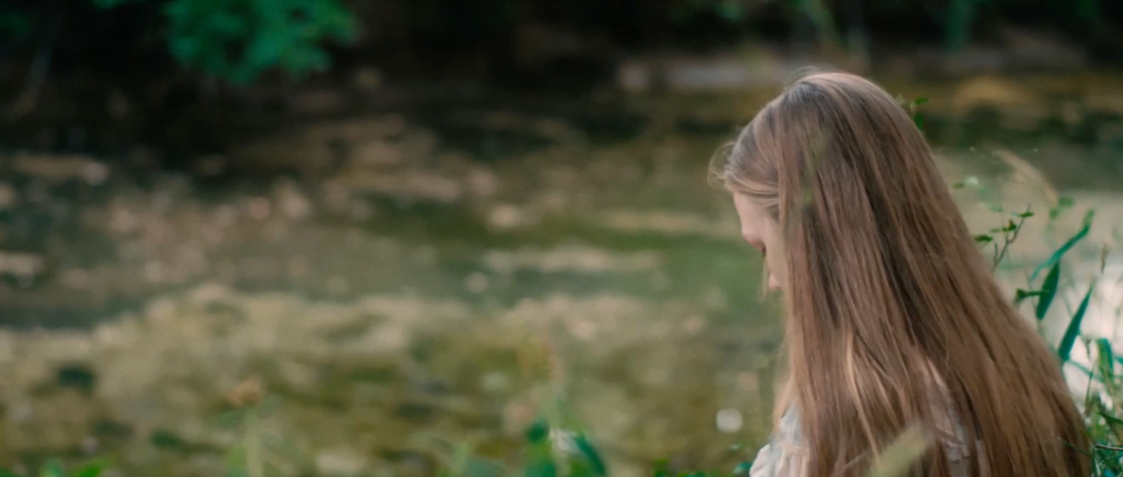
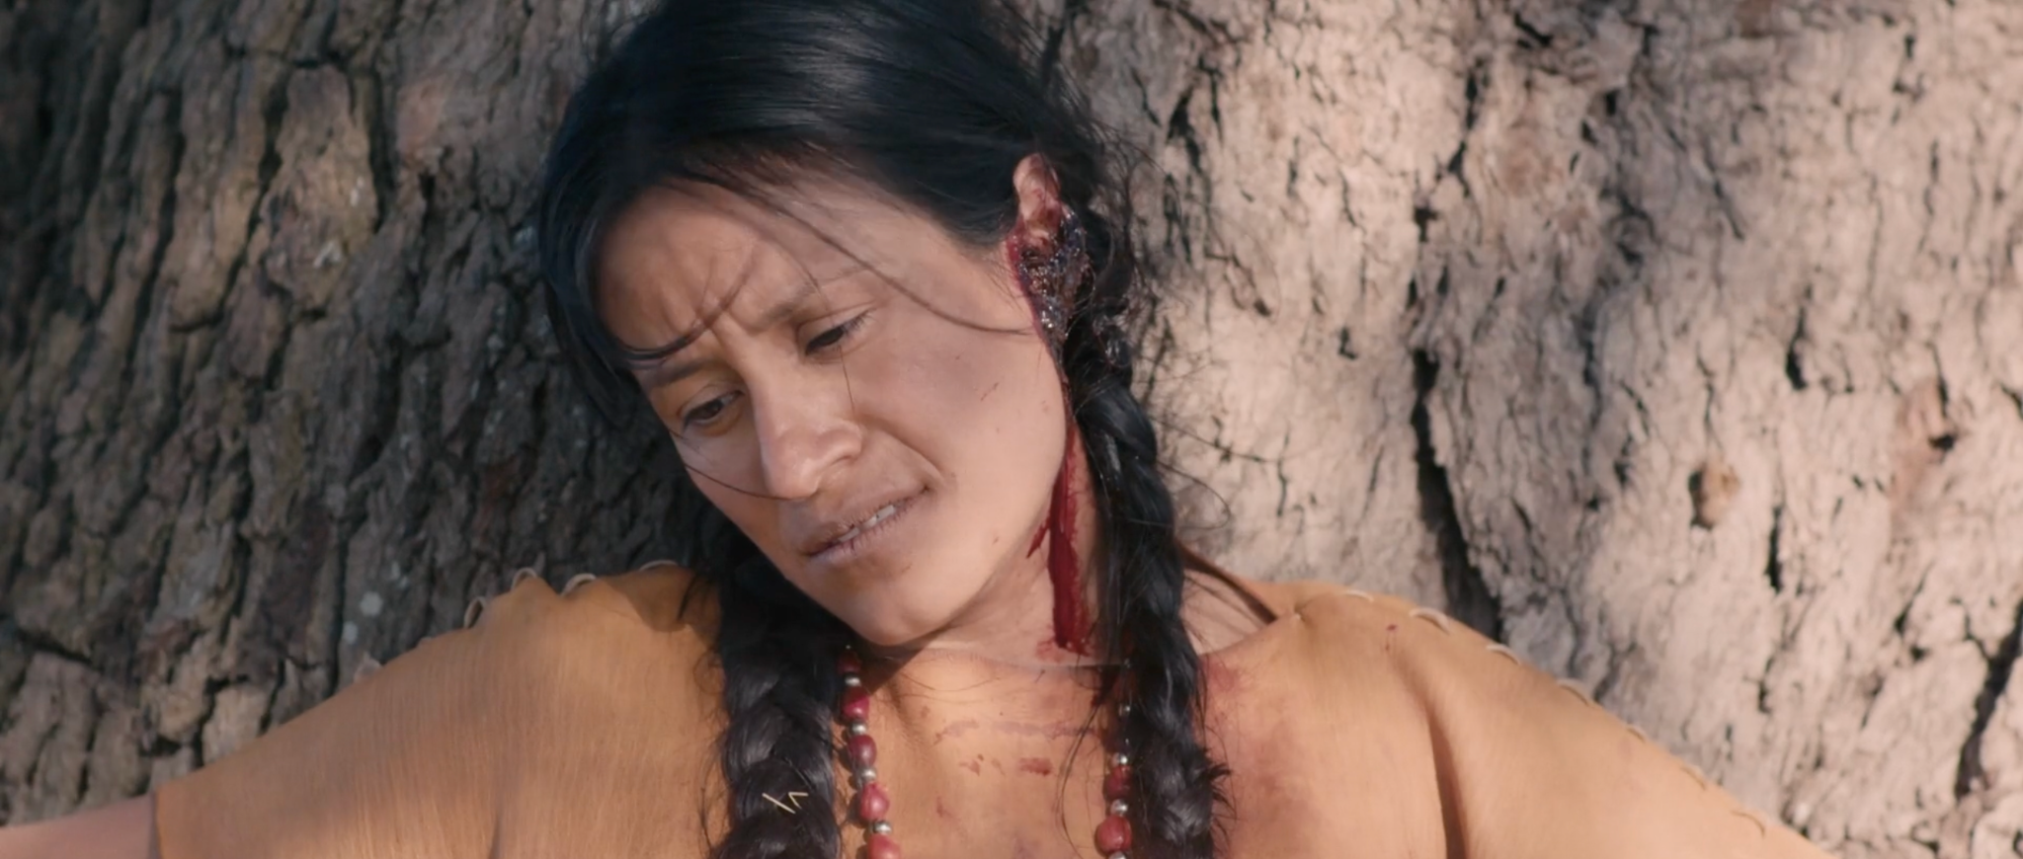
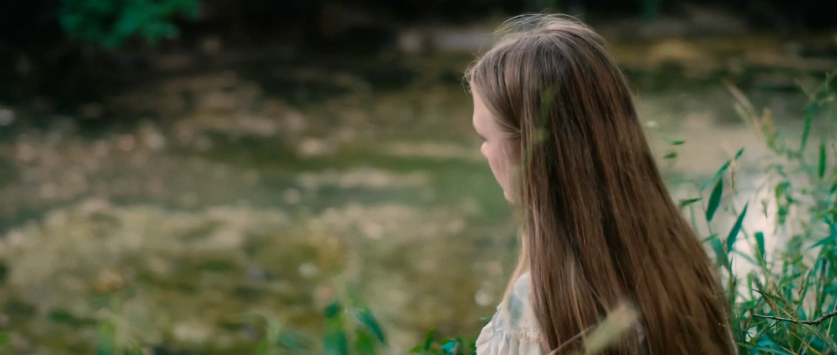
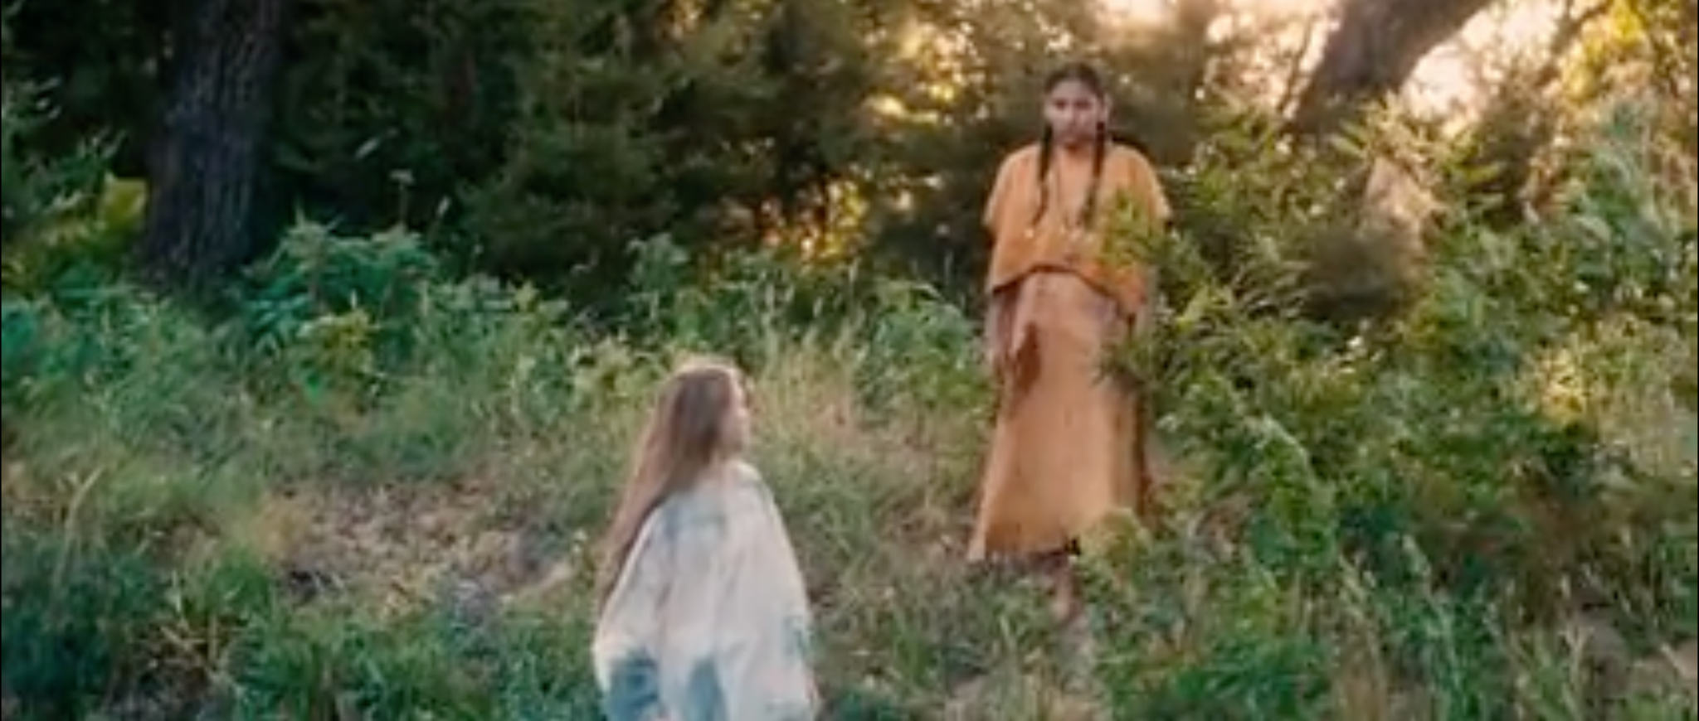
Screenshots from Thistle Creek (2020)
The white girl throws a rock into the creek and slowly a Native girl, Young Tomo Ebi (although the viewer doesn’t know this yet), walks up. It is through the cuts of the editor, that the film viewer is “tricked” for a moment. Now the viewer understands that we are in a different location than Tomo Ebi.
In the next scene, we are with a White family, a mother and two young girls. Once we see all of the main and secondary characters, it is no accident that all of the White characters are blonde or have extremely light brown hair. This is a choice made not only by the director or casting director, but also by the production design crew. Doing this type of production control, allows a stark contrast between Tomo Ebi and the White characters.
The mother washes and hangs the laundry out on a line. When she looks forward, she is shocked to see a White girl standing past the flowing sheets. The girl looks back towards the mother and suddenly the girl is gone (Walton, 2020, 00:04:57). The sound effects of “whooshing” that take place here, presumably from the sheet and the wind, lets the film viewer know that this was either a ghost or the mother’s imagination.
The two young White girls are sent out by their mother to gather wood. While out, they find Tomo Ebi tied to the tree. They have a conversation, where we discover that Tomo Ebi is looking for her sister, a White Comanche captive, Eka Huutsu. Eka Huutsu also happens to be the sister of the two White girls. The scene continues, showing the girls slowly learning Comanche words, becoming friends with Tomo Ebi, and showing a connection between all of the girls, with Tomo Ebi saying, “Eka Huutsu, our sister” (Walton, 2020, 00:07:55).
Then we have a flashback, Tomo Ebi walks through the tipis and enters one of them (Walton, 2020, 00:08:09). Inside we find Eka Huutsu, wearing Comanche clothing, getting her blonde hair braided by her Comanche mother. This shows the film viewer part of Tomo Ebi and her sister’s life together in the tribe.
Later that evening in the cabin, the older girl braids the younger girl's hair. Their mother tells them to “take out those braids” (because Comanches wear braids) with the little one commenting that Tomo Ebi is pretty (Walton, 2020, 00:11:00). Meanwhile, underneath the night sky, Tomo Ebi dreams of sunshine with her and Eka Huutsu laying in the grass and laughing (Walton, 2020, 00:14:50). Editing back and forth between scenes of Tomo Ebi tied to the tree and her dreams of her and Eka Huutsu together, shows their connection that Tomo Ebi misses and is trying to find again.
Near the end of the movie, the mother takes Tomo Ebi inside to see the room where Eka Huutsu stayed and drew a turtle (a symbol of their connection) on the floor. The mother tells Tomo Ebi, “Her heart was with you” (Walton, 2020, 00:16:00). As all of the emotions rush in, a flashback starts. Edits happen back and forth between the scene of Tomo Ebi and the mother in the cabin and a flashback scene of Tomo Ebi and Eka Huutsu hiding from the White men that have stormed their home (Walton, 2020, 00:16:23). As Eka Huutsu stands to reveal herself to the White men, Tomo Ebi tries to stop her. Eka Huutsu slaps Tomo Ebi across the face. At the sound of the slap, there is a cut, and we are back in the cabin where Tomo Ebi slaps the mother across the face (Walton, 2020, 00:16:31).
Images 12
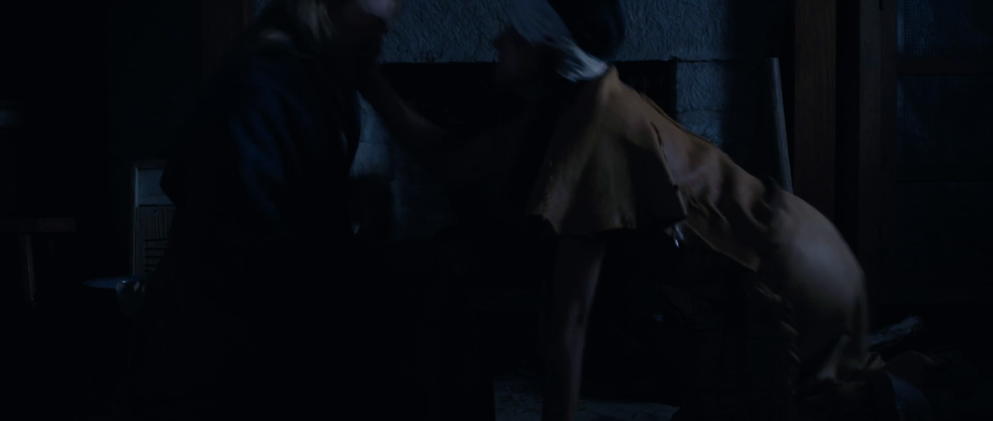
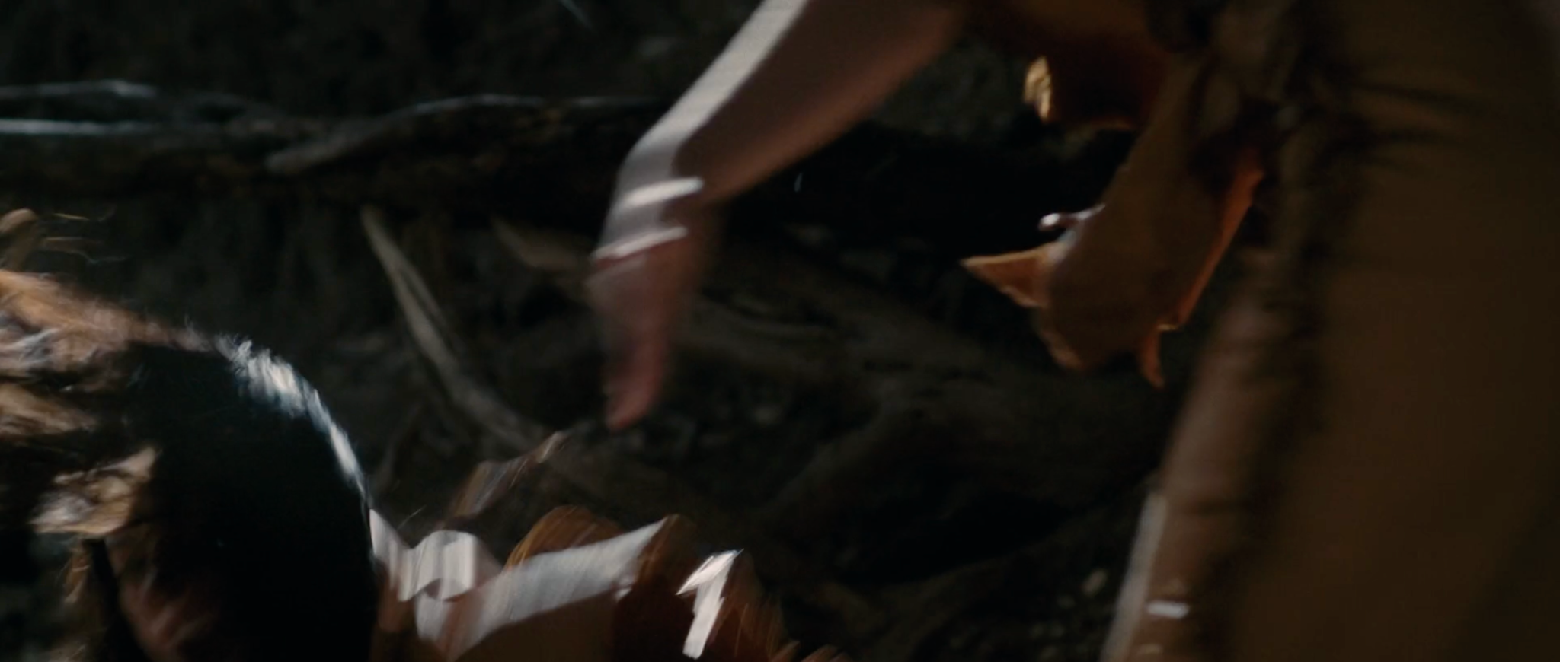
Screenshots from Thistle Creek (2020)
Both the mother in the present and Tomo Ebi in the flashback, fall to the ground, shocked. Tomo Ebi learns that Eka Huutsu left to return home, so Tomo Ebi gets on a horse and rides off to continue her search. The text at the end of the film connects to the text at the beginning:
This film is dedicated to the families that loved and cared for these children.
(Walton, 2020, 00:18:49)
Many of the people on Thistle Creek had some input in the production control of the film, making it the most accurate production that they could create together as a team. The edits used in this film help show the connections that Tomo Ebi and Eka Huutsu had with each other. The flashbacks created by the editor, interwoven between the present scenes, show their connection and what Tomo Ebi is seeking to find. Combined with the storytelling and the editing, the editor was able to use the sound of the slap across the face (from the past and present scenes) to mesh together the two timelines. The production control of this film, including the editing, did its best to show not only a positive representation of Comanches, but also show a connecting link of friendship, family, and love.
Thistle Creek Director and Editor
The director of Thistle Creek, Annalee Watson, and the editor Hailey Choi were interviewed for the dissertation. The film was created as part of a project for an Advanced Workshop for a Bachelor of Fine Arts at New York University. Annalee came from Texas and grew up with family stories about there being a Comanche presence within the region. When discussing Texans and the Comanche connection, she says that “Anglo Texans choose to deny that side of our history.” The story of Thistle Creek comes from those family tales and the history that Texans choose to ignore.
Annalee, a big fan of Western films, says that movies are “kind of a battleground of how America has worked out its priorities on the screen.” Through her own historical research and through the knowledge of consultants she had for the film, Annalee learned of the importance of turtles, pronunciations, and cultural meanings that she tried to get right in the film. Some of the details included into the film were so fine that many viewers outside of the Comanche culture would not have noticed, like the color of the beads.
Annalee explained that directors need to be prepared for the rough cut of their film, saying that the script is the first draft of the film, while the first edit is the second draft. This reasoning being that for Thistle Creek, it wasn’t until the footage reached the editing room and the rough cut was being created, that Annalee and her editor Hailey, realized something wasn’t working. Hailey explained, “We didn’t really have enough coverage of angles to be able to cut as much.” Because of this issue, Annelee and Hailey didn’t know if it would be a workable film. After going through many different cuts, Annalee told Hailey to throw out the script and do whatever she wanted, to see if there was something in the footage that she would weave together. Hailey said that they “used footage that worked and took out footage that didn’t work.” When Hailey finished her version of the film, there were blank pockets of space. A reshoot was done and the footage from the reshoot is what filled in those empty pockets, which also happened to be the scenes where the past and present intermingled. Annalee explained that the script was not as strong as the final edit, saying that “what made the film was the edit.”
Smoke Signals example
Another example of a Native-made film is Smoke Signals (1998) directed by Chris Eyre of Cheyenne and Arapaho descent. For the general American audience, the film Smoke Signals is one of the most well-known Native produced films. The production control for this film was largely American Indian, allowing for a more accurate representation than what was given in the past (Price, 1973; Berny, 2020). Different from the images of what film audiences have traditionally been told an American Indian looks, talks, and acts like, in the story of Smoke Signals “Sherman Alexie challenges hegemonic and stereotypical images of American Indians through portraying a complex, humanizing, and contemporary image of American Indians” (Mihelich & Mihelich, 2001, p. 129). It is through this story that the American Indian film stereotypes are broken and shown in a more accurate way.
The film Smoke Signals
challenges, partially through humor and satire, these stereotypes and images as he presents the lives of the main characters in Smoke Signals situated within a contemporary context. The traditional warrior or shaman is not found in the film, but the image of drunkenness plays a prominent role because alcohol abuse is part of the subject matter and integral to the story line. (Mihelich & Mihelich, 2001, p. 131)
By being a Native based production, with Native production control, but also
a film steeped in classical Hollywood norms, yet rooted in an American Indian epistemology, the filmmakers have created a space that invites Euramerican viewers in and then uses humor as tool for incisive political commentary. The palliative effect of humor works to dissolve racist stereotypes even as it softens the blow of social commentary. (Gilroy, 2001, p. 25)
This film breaks those stereotypes that have been typically told, while also telling the Native story in a more natural and authentic way.
Film storytelling and the American Indian traditional oral way of storytelling are combined in this film (Gilroy, 2001). Both of these types of storytelling are shown early on to play an important role, by being meshed together at the beginning of the film. One of the main characters, Thomas, has a voiceover near the beginning, while a house burns in flames. Throughout the movie, Thomas is known for his way of storytelling. As a fire is shown on the screen, Thomas tells his story:
On the fourth of July, 1976, my mother and father celebrated white people’s independence, by holding the largest house party in Coeur d’Alene tribal history. I mean, every Indian in the world was there. And then at 3 in the mornin’, after everyone had passed out or fallen asleep on couches, on chairs, on beds, on the floor, a fire rose up like general George Armstrong Custer, and swallowed up my mother and father. I don’t remember the fire. I only have the stories. And in every one of those stories, I could fly. (Eyre, 1998, 00:01:35)
In addition to using traditional oral storytelling as a technique to help tell the film story, sound and sound editing also play a large role in the movie. Combining these stories and creating meaning through sound, are sound bridges, one of the major ways that Smoke Signals uses audio. A sound bridge is when “sound may belong to an earlier time than the image in another way. The sound from the previous scene may linger briefly while the image is already presenting the next one” (Bordwell et al., 2017, p. 298). In addition to a regular sound bridge, this film also used “two sound bridges, drawn from specific folk music traditions, function as bounded motifs that can be attached and detached from the contextual images that contribute to their meaning” (Hearne, 2005, p. 194). The use of sound plays a significant role in most of the scenes in the film.
One flashback scene that stands out significantly is when Victor’s dad, Arnold, is playing basketball and talking with Suzy at the same time. There is a flashback (inside of a flashback) that is weaved in and out of the other flashback. In the flashback scene that Arnold is telling, Little Victor is playing basketball with two Jesuits. While there are medium shots of Victor and Victor’s face is clearly shown, the Jesuits’ faces are hardly shown, except for a medium long shot near the beginning (Eyre, 1998, 00:52:30). The camera comes alive while Arnold is talking, moving around with him as he moves back and forth in front of the basketball hoop. Arnold’s voice acts as a voiceover inside of the other flashback, but becomes regular when the scene is back in the present flashback with him. Arnold throws the basketball into the air and it thumps on the ground in the distance. There is a cut, and the scene returns to the present with Victor and Suzy on the porch. The basketball bounces to Victor, the noise blending with the basketball noise from the previous scene (Eyre, 1998, 00:54:27).
Images 13
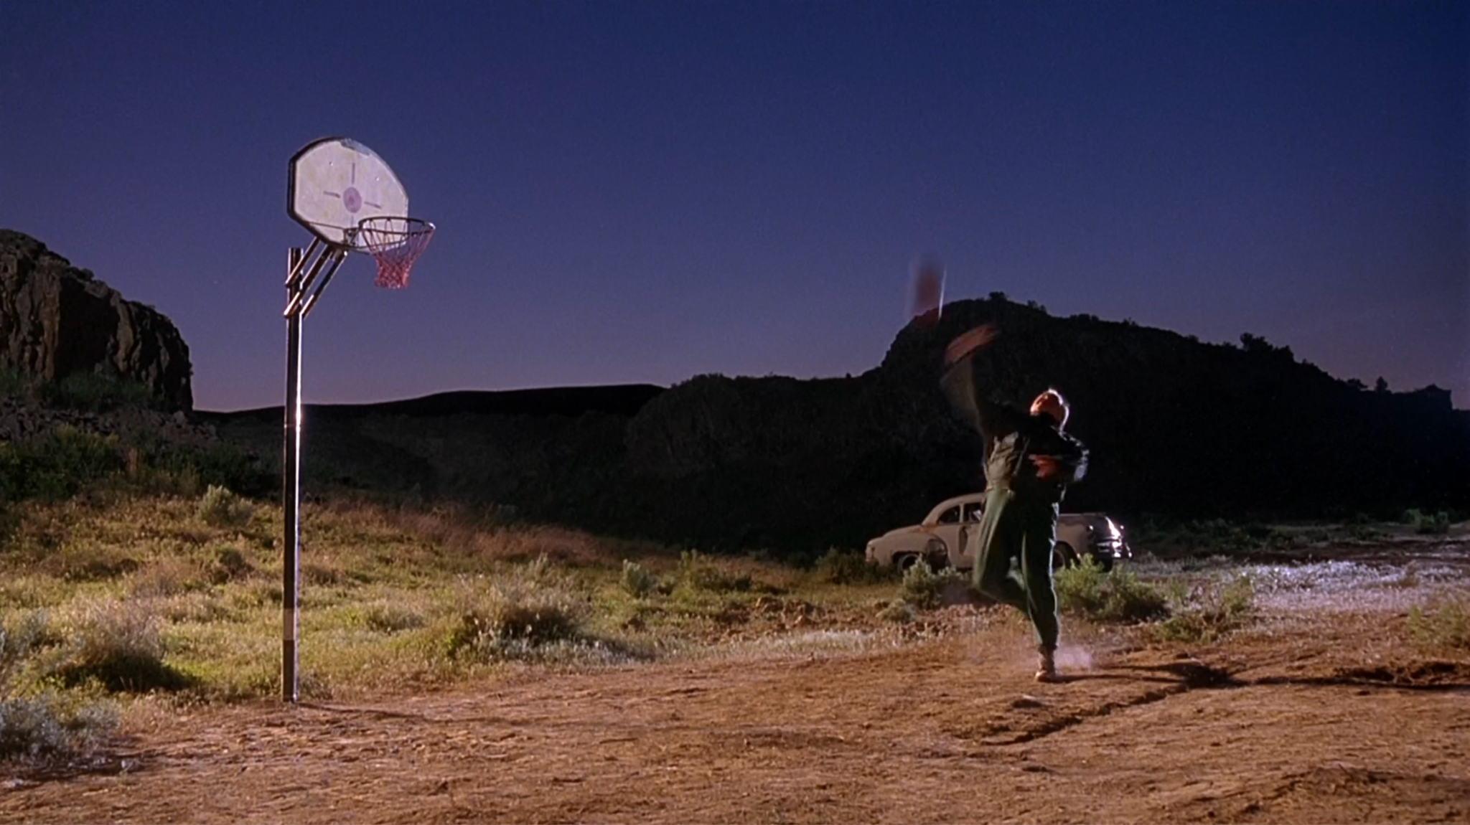
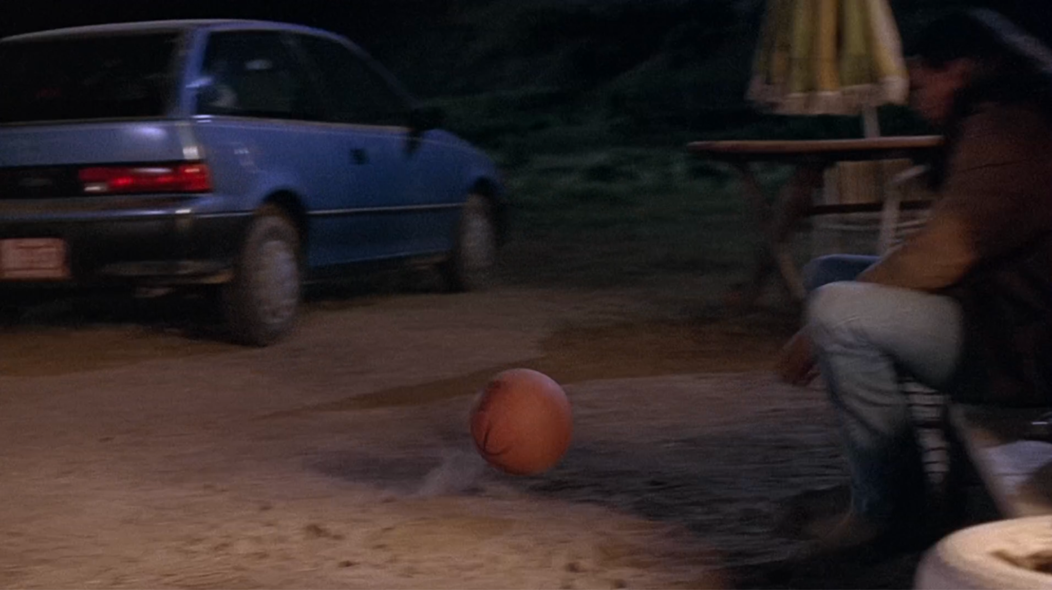
Screenshots from Smoke Signals (1998)
Using a flashback scene inside a flashback scene and combining that with oral storytelling and a voiceover scene, represents Native storytelling. The editing breaks away from the stereotypical Indian sitting by a fire and telling a story, to movement and multiple visuals, creating a better representation of Natives and how storytelling occurs.
Another example of sound being used distinctly is when Thomas and Victor are on the bus to Arizona. Victor and Thomas sit in the back of the bus, after having a confrontation with two White men that took their seats. Victor and Thomas start singing a song “John Wayne’s Teeth.” There is a cut to a long shot of the bus from the outside. Thomas and Victor’s voices can still be heard singing (Eyre, 1998, 00:39:45). Their singing is then weaved together with others singing, which has been “picked up by a professional drum group, the EagleBear Singers. The diegetic sound becomes non-diegetic sound as the shots of the interior of the bus cut to long shots of the bus moving through the Western desert landscape in the warm light of early evening” (Hearne, 2005, p. 198).
In addition to having different sound editing techniques, this film also frequently uses dissolves to combine past and present scenes. When Victor and Thomas happen upon a car crash and wreak their own truck, Victor runs into town to get help. As Victor reaches exhaustion from running, editing dissolves of him running and scenes of the fire, from the burning house at the start of the film, are shown at the same time (Eyre, 1998, 1:07:35). This connects Victor to the past, and the past to the present.
The dissolves used in this scene work with connecting the two moments, because in editing “the dissolve is the filmmaker's ‘time machine,’ transporting the viewer instantly backward or forward in time and location at his will. In more sophisticated usage, dissolves aid greatly in the manipulation of pace and mood” (Dmytryk, 2018, p. 84). The viewers understand that Victor is feeling emotional about the house fire. Different from past movies (Price, 1973; Berny, 2020), Smoke Signals represents Natives in more accurate and less stereotypical ways, showing emotions, caring, and sadness, all which are visible through the editing that was presented in the movie.
Lingering shots also play an important role in movies and the use of rapid cuts. Typically, lingering shots or reaction shots imply something, or try to draw the viewer’s attention away from the character that is speaking (Corrigan & White, 2017; Prince 2013). For example, when Thomas and Victor return to the bus after a stop, they discover that two White men have taken their seats (Eyre, 1998, 00:37:51). Thomas and Victor confront them and during the scene, while the White men refuse to move, the reaction shots linger on Thomas and Victor, not on the White men. This keeps the story with Thomas and Victor, while at the same time showing just how uncomfortable they are.
Rapid cuts are used to intensify a scene (Corrigan & White, 2017; Prince, 2013). However, even the lack of rapid cuts can hold a significant meaning. After the car crash, when Thomas and Victor are in the hospital, the police show up and take them to the sheriff’s office where the sheriff questions them, because they have been accused of causing the wreck and attempting to kill the White male driver (who was drunk). During the conversation, the sheriff sits down in his chair, choosing not to stand and lord over Thomas and Victor. Instead, the sheriff sits down, placing himself at the same level as Thomas and being lower than Victor, who is standing (Eyre, 1998, 01:11:36).
Images 14
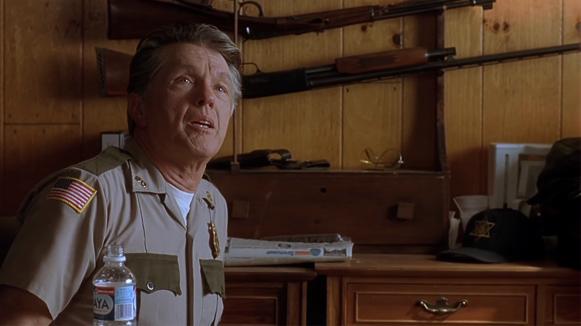

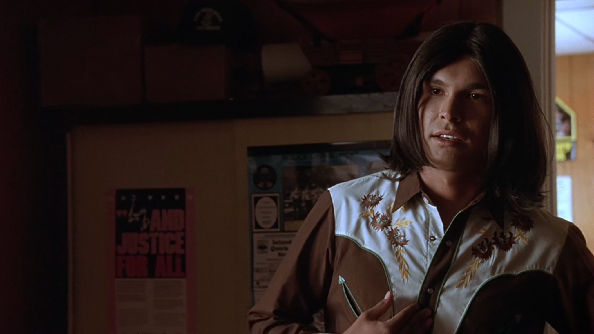
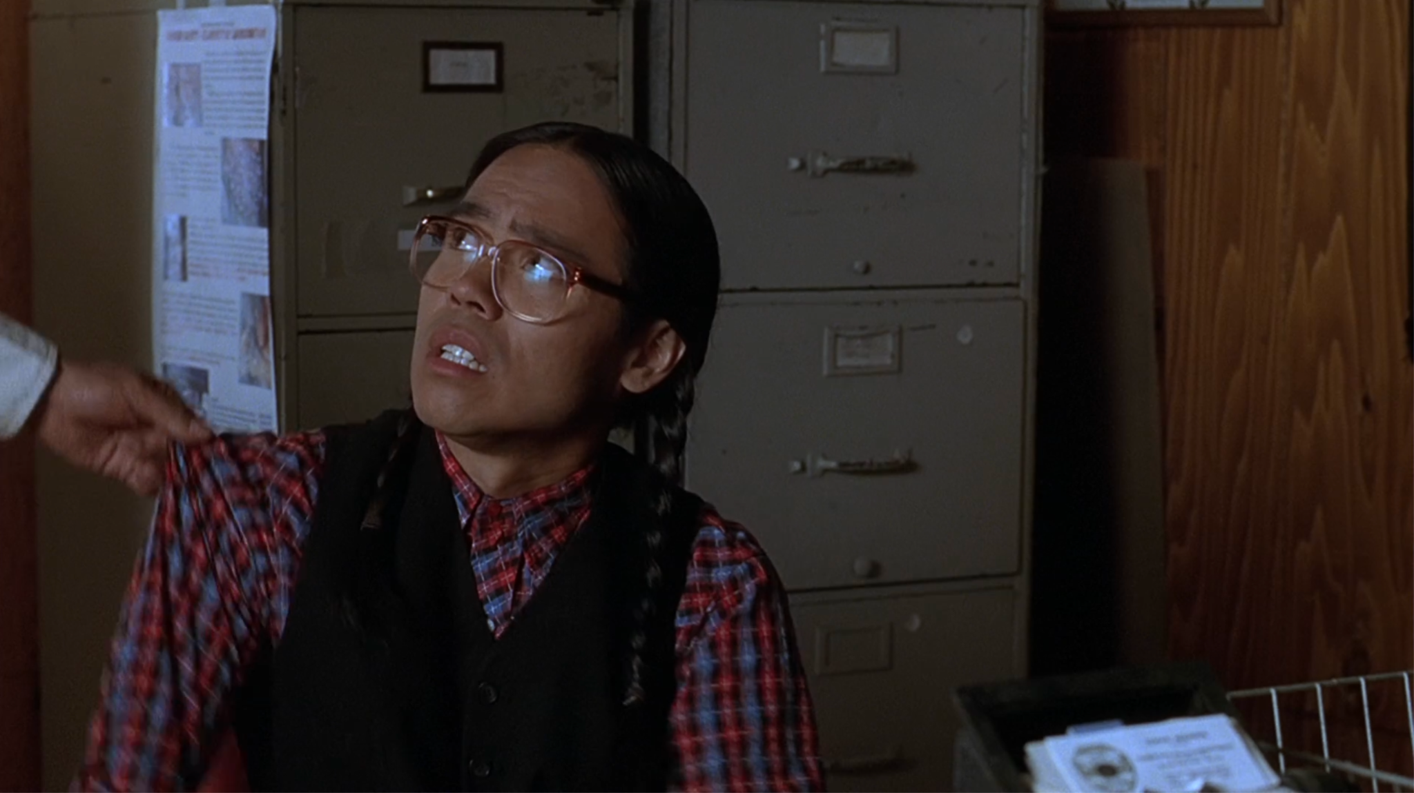
Screenshots from Smoke Signals (1998)
Throughout the scene, the editing does not change its pace. Rapid editing is used to help intensify a scene. However, the editing in this scene stays at a consistent, easy pace, even when Thomas and Victor are told of what they have been accused of and when it looks like the sheriff might not believe them. The slow editing in this scene, instead of rapid editing, represents the innocence of Thomas and Victor. The editing breaks away from other films, like Westerns (Corrigan & White, 2017; Prince, 2013), that would use rapid editing during scenes of accusation.
The editing in Smoke Signals weaves together visual storytelling and the much older traditional oral storytelling of American Indians. This becomes extremely successful using sound editing techniques, such as sound bridges and voiceovers. The film showed the non-Native crowd of film viewers a more accurate representation of Natives and attempted to break the stereotypes that are typically shown. When Thomas and Victor are on the bus, Victor attempts to teach Thomas how to act like an Indian.
Victor: Don’t you even know how to be a real Indian?
Thomas: I guess not.
Victor: Well, shit. No wonder. Geez. I guess I’ll have to teach you then, enit? First of all, quit grinnin’ like an idiot. Indians ain’t supposed to smile like that. Get stoic. No like this. You gotta look mean, or people won’t respect you. White people will run all over you if you don’t look mean. You gotta look like a warrior. You gotta look like you just came back from killing a buffalo.
Thomas: But our tribe never hunted buffalo. We were fishermen.
(Eyre, 1998, 00:36:00).
Teaching another Native how to act like a stereotypical Native, challenges the expectations of many who are only familiar with these stereotypes.
In addition to this, having a Native cast and crew also helped with removing the stereotype, because representation was present during the creation. The editing used in Smoke Signals combines storytelling with even older ways of storytelling, by using editing techniques to challenge expectations and help tell the story.
This chapter provides a brief history of American Indian misrepresentation in films, along with two film examples of American Indians represented in recent history. Famous editors, Walter Murch and Edward Dmytryk provided a set of “rules” they claimed editors should follow when deciding on a cut, although many “rules” in textbooks can be viewed as guidelines. This chapter goes over the potential impact that the editor can have on a film, just by their editing decisions. The films Smoke Signals (1998) and Thistle Creek (2020) stand as examples of positive and accurate (to the best of their ability) American Indian representation. Through scene analysis, this chapter shows that there are editing choices an editor makes that can impact how the story of the film is told. Both Thistle Creek and Smoke Signals show that production control, editing choices, and sound design impact not only the story but also impacts the representation of the American Indians in the films.

Chapter 6: The Examination of Content Before and After an Editing Transition
How Race is Defined
Race has been defined in various ways, but the majority of the time it is defined socially. One author said that “the state-sanctioned and/or legal production and exploitation of group-differentiated vulnerabilities to premature death, in distinct yet densely interconnected political geographies’’ (Gilmore, 2002, p. 261). This definition is important because “it focuses not on how race is imagined or intended by white people but rather on how it is experienced by people of color” (Brooks, 2006, p. 313). It was also pointed out that “people of color experience racism as a set of political and economic conditions that compromise the quality or the longevity of their lives” (Brooks, 2006, p. 313), explaining that race consists of experiences throughout their lives.
Another definition of race says that “the white race is a historically constructed social formation. It consists of all those who partake of the privileges of white skin in this society. Its most wretched members share a status higher, in certain respects, than that of the most exalted persons excluded from it, in return for which they give their support to a system that degrades them’’ (Ignatiev & Garvey, 1996, p. 9). This definition of the white race shows that the experiences of each group has an impact on race.
Another author discussed the definition of race scientifically and socially. This author said that “social world refers to people who possess not only similar biological characteristics but also identical social experiences” (Sun, 1995, p. 43), which include things like discrimination. They went further on to explain that “individuals’ memberships in the social categories of race are defined, not according to their alterable or learned attributes - such as their cognitions, actions, or achievements - but according to their inherited and unchangeable biological characteristics” (Sun, 1995, p. 43), discussing how physical features are a part of the definition of race, mostly by the social definition. For the purposes of this section, the definition of race from the social perspective will be used.
Argument
As mentioned earlier, previous film research with eye tracking has been shown that film viewers look at various parts of a screen, when a new cut takes place (Smith, 2011). The authors of this research claim that their participants look all over the screen, because the viewer is searching for what to look at next (Smith, 2011). This chapter will argue that there is more to films and the film viewer than just eye movements. The chapter will examine certain scenes from Remember the Titans (2000) and explain how the content of the scene not only provides viewers with the information they need to understand the next scene, but that the content of one scene sometimes tells the viewers where to look. Thus, showing that film viewers are active participants in the film viewing process and are not just receivers of information.
Remember the Titans analysis

Brief intro to film

Although a Disney movie from 2000, Remember the Titans covers the issues of race and hints of homosexuality. A period piece film set primarily in 1971, this movie starts with a newly integrated high school, located in Alexandria, Virginia. The White head coach, Bill Yoast, of the high school is up for nomination of the hall of fame, but is then told that the Black head coach, Herman Boone, of the other school will be the head coach of the new football team, thus placing a Black man as their head coach and a White man as the assistant coach. These two coaches must learn to work together, while also getting their young football players to work as a team. Once that is completed, the coaches and football team must deal with the White community against them.
Content from previous scenes
Once Coach Yoast is told that he is no longer the head coach of the football team and that the Black coach is the head, Yoast and his young daughter, Sheryl, who is 10 years old, gets angry.
Sheryl: You can’t just walk in here and take my daddy’s job away.

As Yoast walks away after being told the news, the other man says, “It’s the world we live in, God help us all!” (Yakin, 2000, 00:05:50), clearly setting the tone for how the rest of the community will be thinking. A few scenes after this, Coach Boone shows up to the home of Yoast. The little girl, Sheryl, opens the door. Her tone and words echo what everyone else around her is saying and feeling.
Image 15
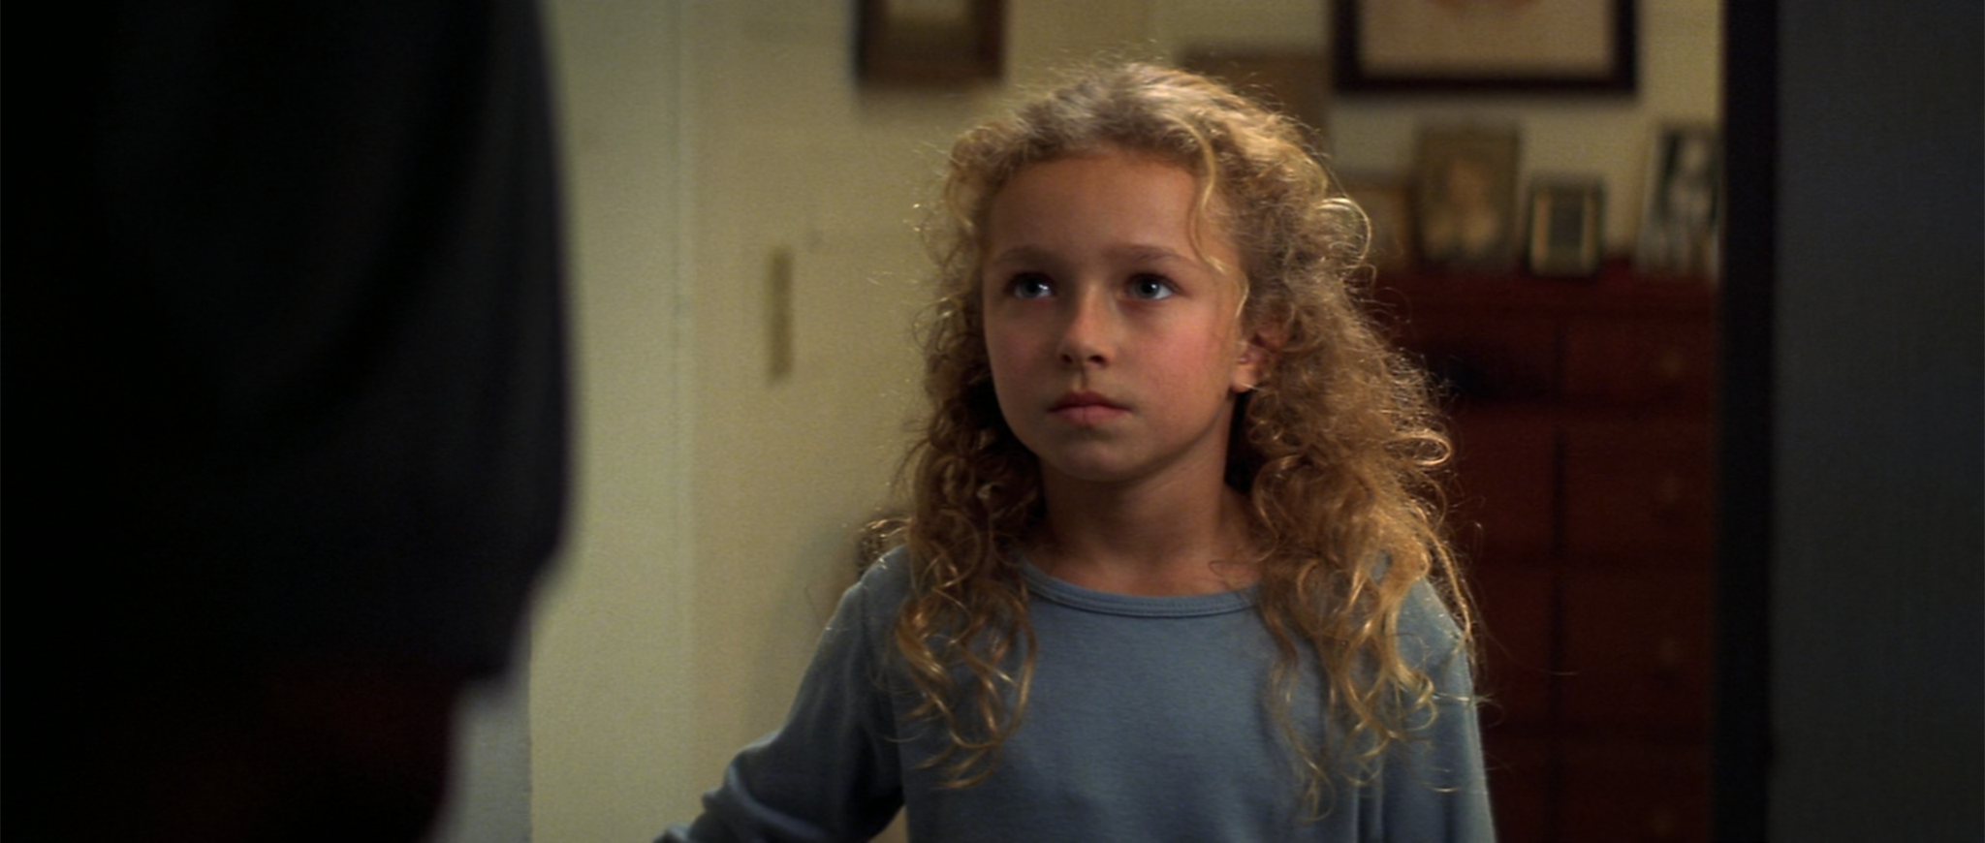
Screenshot from Remember the Titans (2000)
Sheryl: What do you want?
Boone: Is Coach Yoast here?
Sheryl: We’re busy. Interviewin’ for head coachin’ jobs. Gotten eleven offers and certainly no time for you.
(Yakin, 2000, 00:07:49)
When the scene CUTS, it is a hard cut that brings us to the barn, where Yoast’s office is. Boone tries to convince Yoast to stay on as the assistant coach, but Yoast doesn’t like the idea of working “under” Boone. Based on this scene, we know that Yoast has decided to leave and look for a new team to coach. We CUT to the next scene.
Word has gotten out to the football team and to the community about Coach Boone being the new head of the team. Coach Yoast and the White community have a meeting. The room is filled with parents of players and players, who say things like “Our boys aren’t playin’ for some coach coon!” and “He stole your job. I’m not playin’ for him” (Yakin, 2000, 00:09:22). Coach Yoast tries to convince one of the parents that not playing would be a bad idea and that they cannot afford to go to another district. But once more of Yoast’s players say, “If you go, I go,” “Don’t go, Coach,” “I only play for you, Coach Yoast,” everyone in the room starts clapping for him and chanting his name. The scene ends with a shot on Yoast’s face, as he stands in silence, listening to the others around him. There is a TRANSITION, a CUT, with a sound bridge. The players clapping and chanting continues into the next scene, where Yoast is sitting with his back against a tree.
Images 16
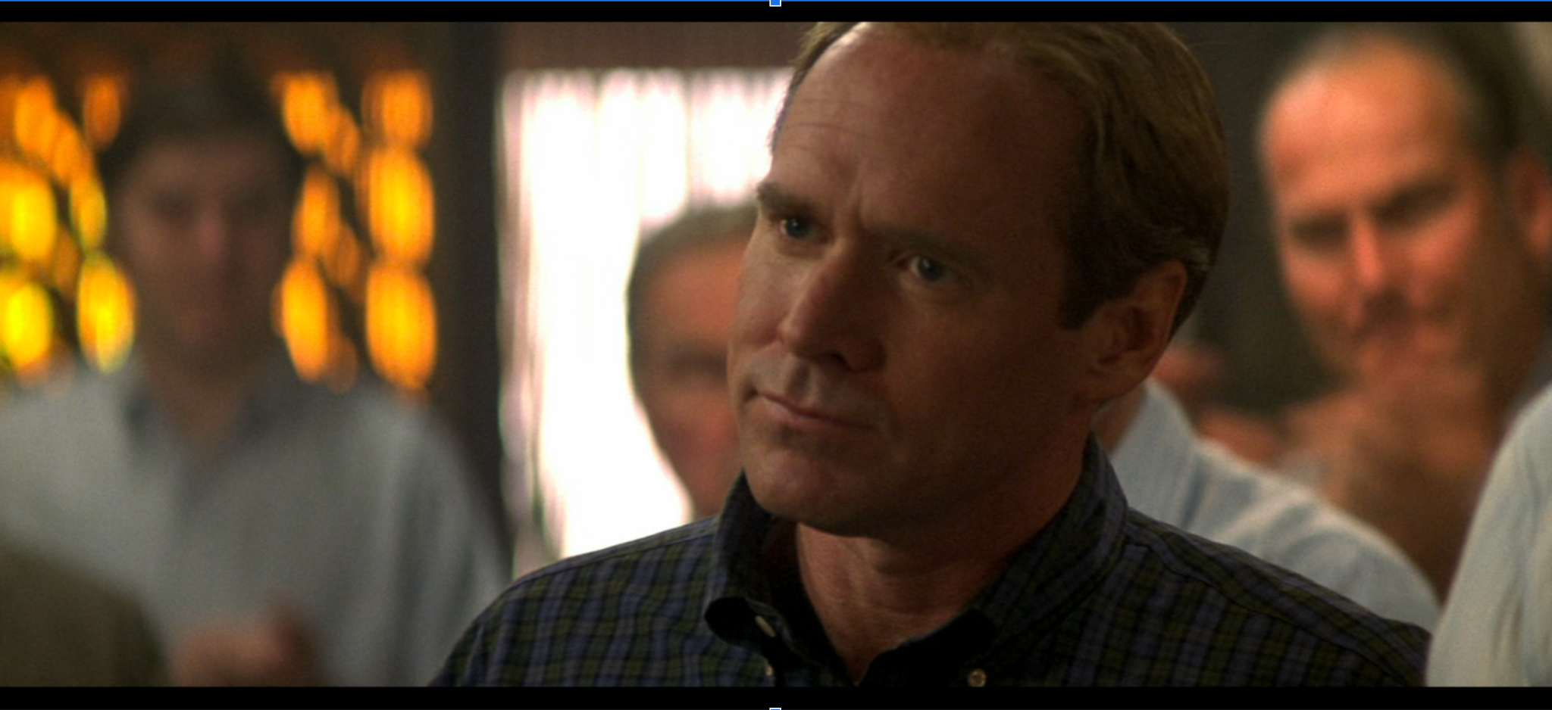
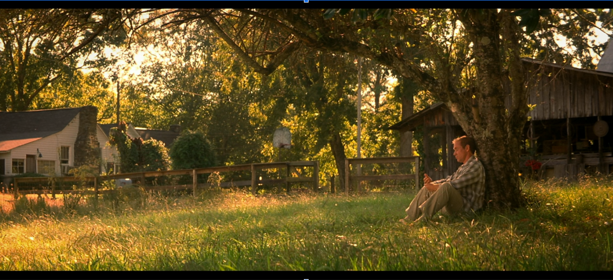
Screenshots from Remember the Titans (2000)
Everything is peaceful, as the chanting and clapping from the crowd fades away. Just from this small transition of sound, the fading of the chanting and clapping, we know what Coach Yoast is thinking about. The information from the previous scene provides the viewers with the information needed to understand what is about to happen in the new scene. In the next scene the sun is shining, and a white farmhouse and barn are seen in the distance. Yoast tells his daughter that he has seen the boys on his team grow up since they were her age and that it is like they are his own kids. Sheryl asks what he is going to do. The scene cuts to Yoast’s face, where we have the start of the scene TRANSITION (Yakin, 2000, 00:10:29). While still on Yoast’s face, there is a sound bridge and the audio from the next scene is heard. We can hear the sound of a Black kid’s voice yelling “We’re gonna,” we then CUT to the Black football players in the high school gym “play some ball y’all!”
Images 17
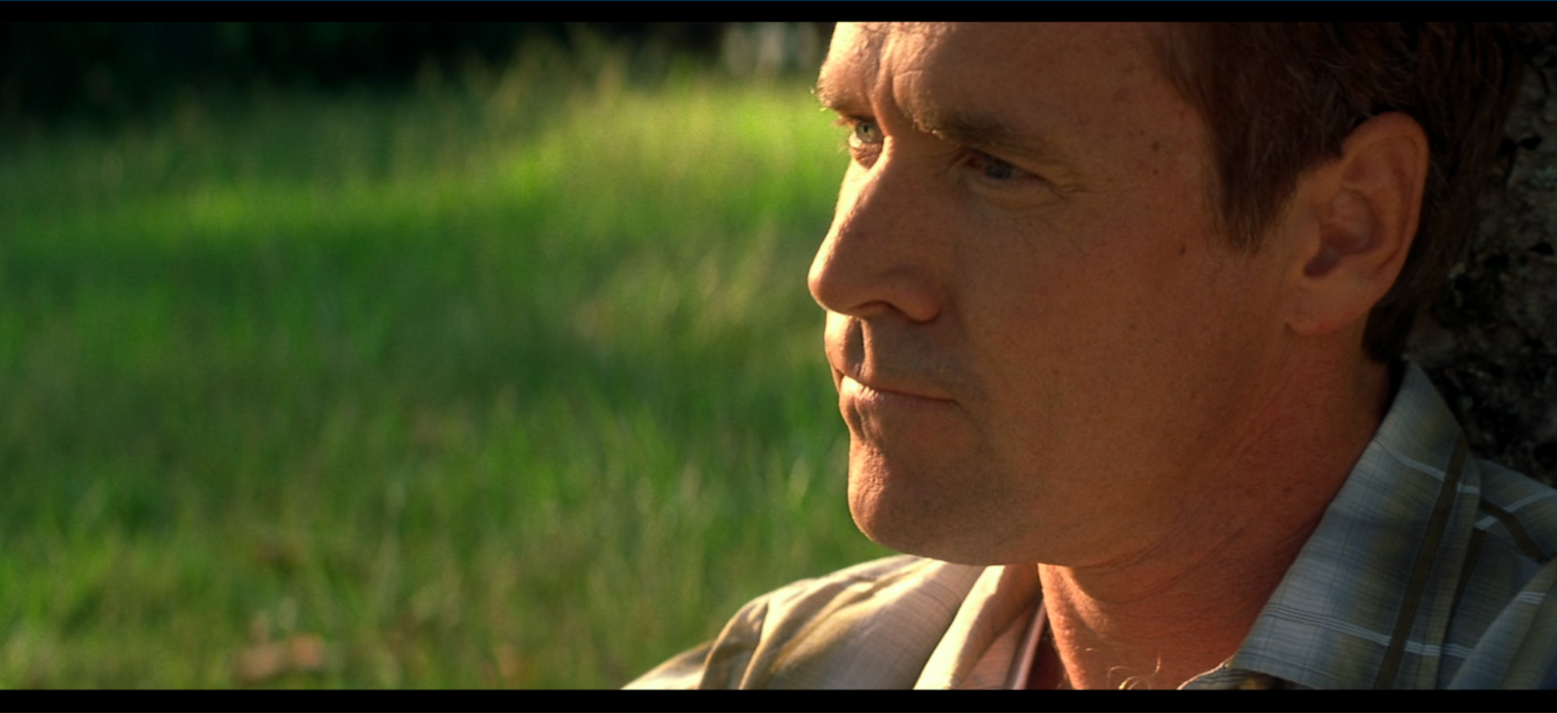
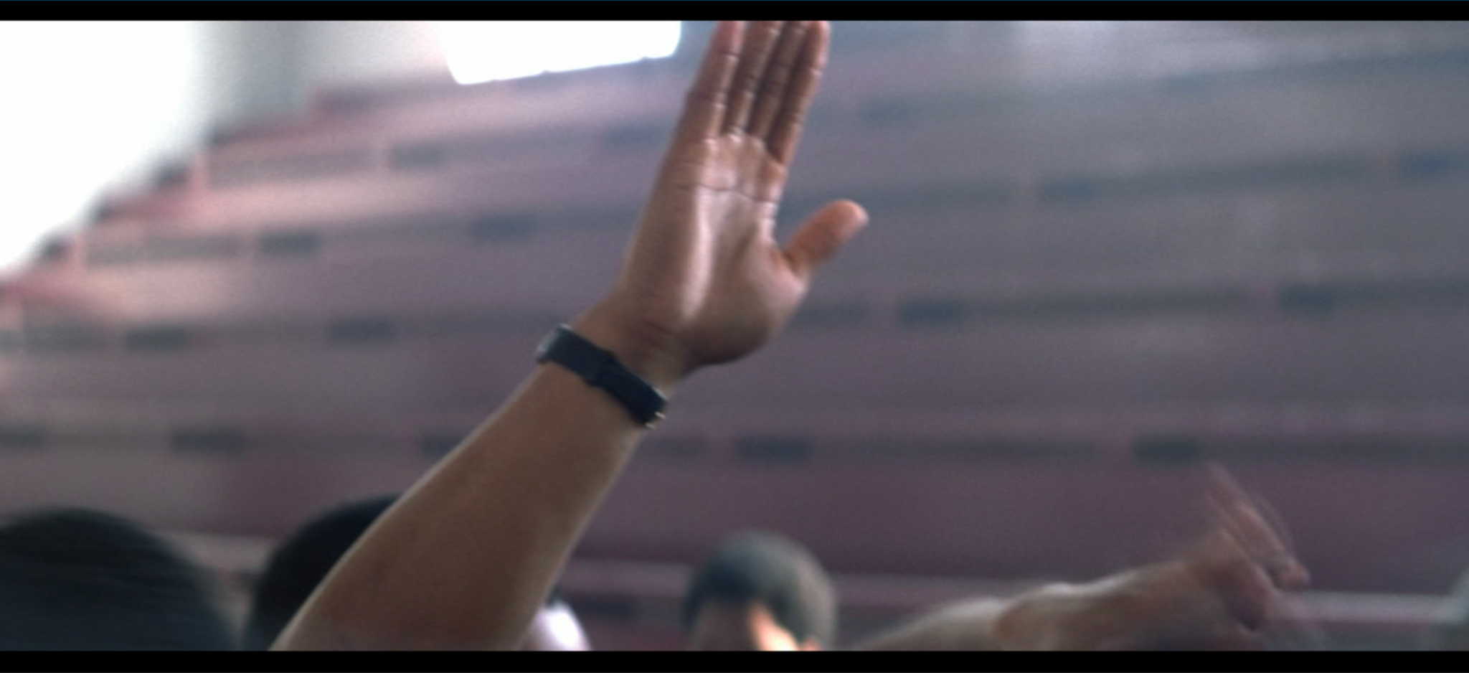
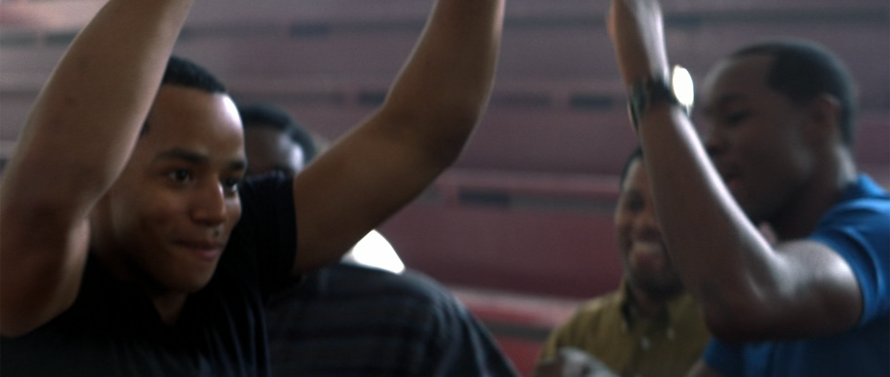
Screenshots from Remember the Titans (2000)
Based on the content at the start of the gym scene, we know what Yoast’s decision was in the scene before. He plans to stay and “play some ball.” Based on the four scenes that are examined back-to-back, this shows that the content before and after a scene aid in the understanding of the scenes before and after each other.
Outsider understanding - viewer understanding
Another situation that helped in the understanding of where the film was headed, was the “native” outside character, Louie Lastik. This new kid, Louie, grew up as a Navy brat, was used to traveling and not staying in one spot for too long, never fitting in, and is also the largest/biggest person in the room.
Image 18
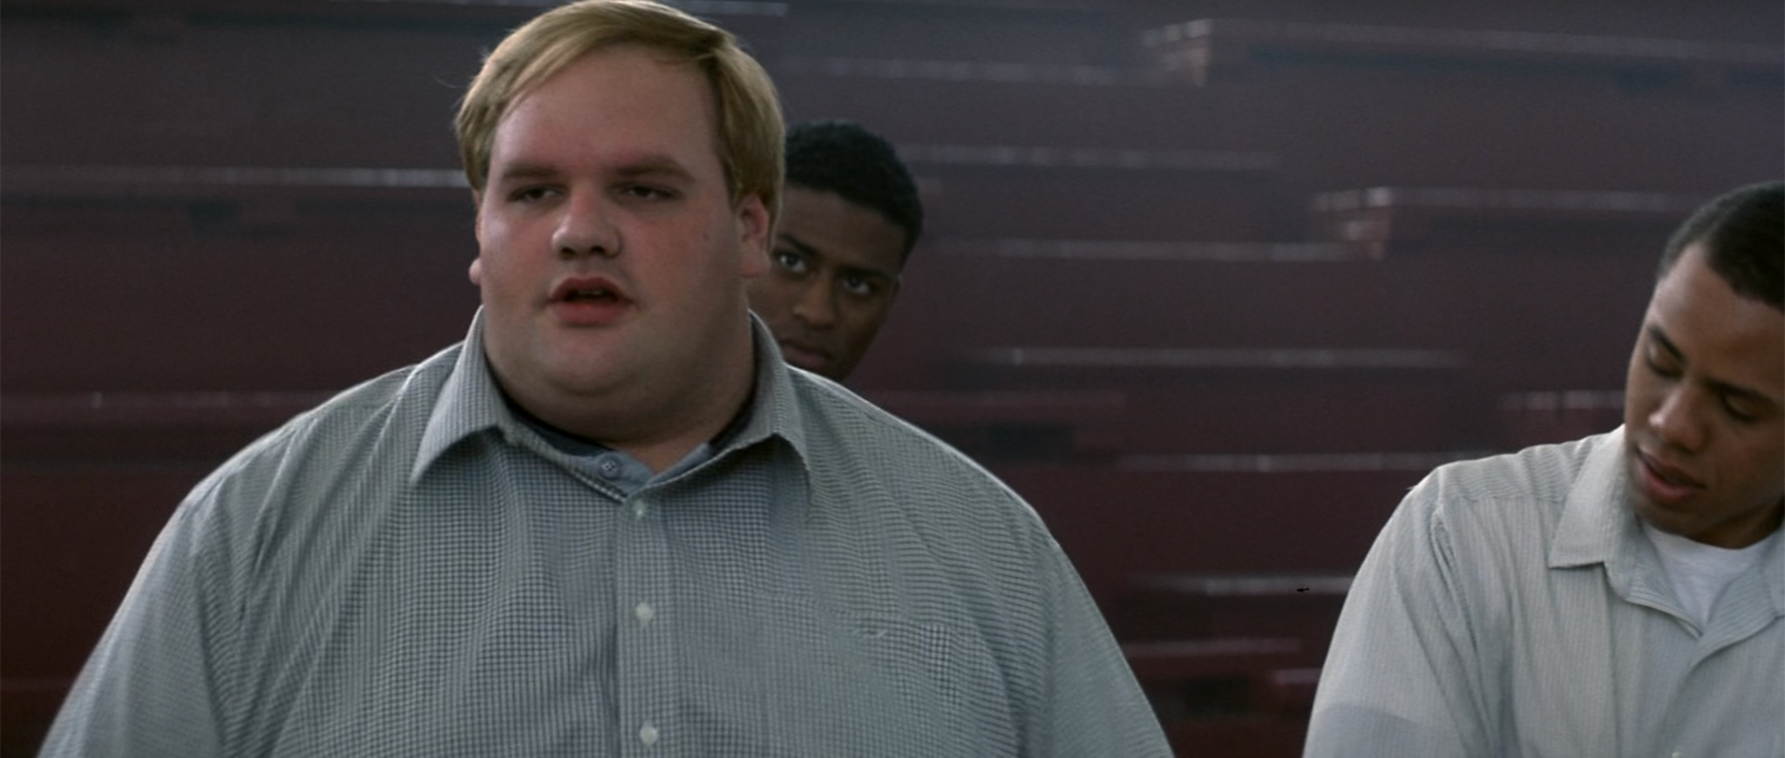
Screenshot from Remember the Titans (2000)
Louie Lastik represents the film viewer. He is not part of the town and the conflict that is going on. He is not aware of the racial divide, does not even care, and thus is not truly part of the community.
Louie: I’m Louie Lastik. Offensive lineman. Naval family, just moved here from Bayon.

Someone said football, so I come runnin’. What’s goin’ on everybody?

(Yakin, 2000, 00:13:07)

In this gym scene, Louie does not appear to notice that he is the only White kid in the room. If he does know it, it is not shown. Because of this, the Black kids are confused. This is the first interaction between the Black football players and a White football player. Just like the White football players from the previous scenes, the Black football players do not want to play with the White football players.
Images 19
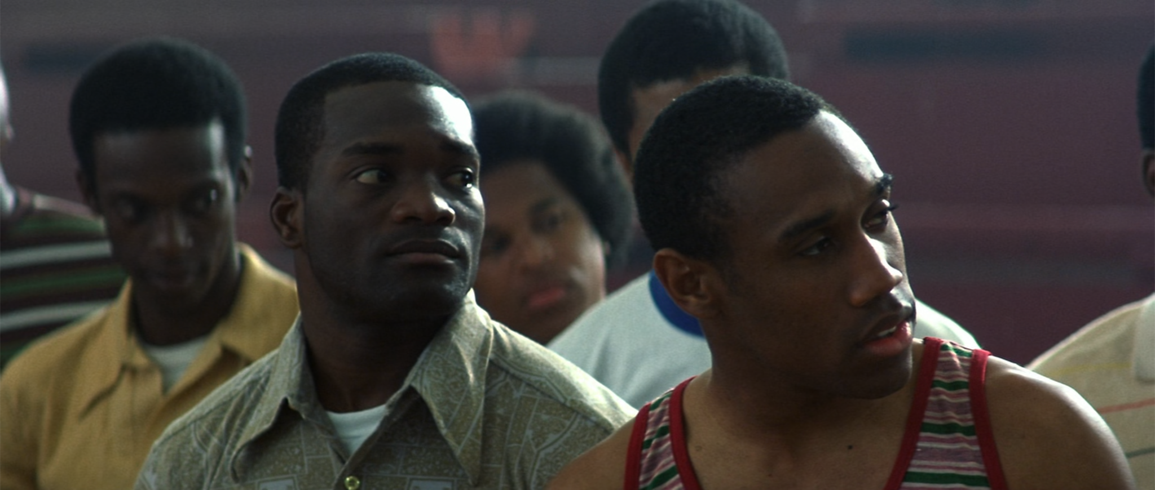

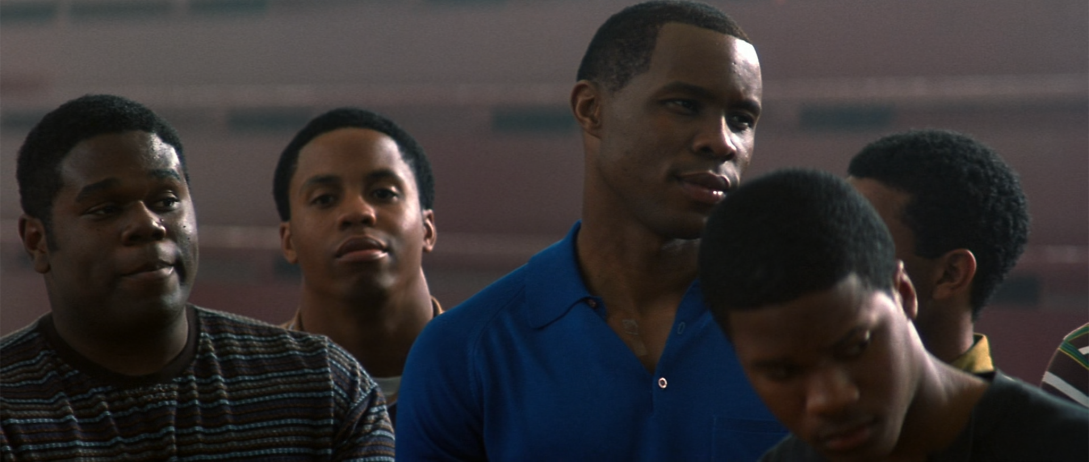
Screenshots from Remember the Titans (2000)
Later on in the film, when Coach Boone asks the White and Black players to tell him something about one of their teammates of another color, Louie is the only one that is able to say something about the other players. Meanwhile, the other Black and White players do not know anything about each other, because they do not interact with the other race. Louis is the only one that chooses to interact with someone that is not of his race.
When Louie goes to sit down with his Black teammates for the first time, there is confusion with the Black players.
Julius: What you doin’ man?
Louie: Eatin’ lunch.
Julius: I see you eatin’ lunch. But why you eatin’ over here? Why don't you go on over there, eat with your people?
(Julius nods toward the white players at the other table)
Louis: Man, I don’t have any people. I’m with everybody, Julius.
Petey: Yeah, he justa light-skin brother.
(Petey and Louie shake hands)
Julius: Yeah and I’m a dark-skinned cracker.
(Yakin, 2000, 00:22:08)
From this conversation, the Black players start to hum “Amazing Grace,” which is loud enough for the White players to hear on the other side of the room. While some of the Black players are welcoming to Louie, some of the players from the White table are not so kind to his behavior.
Ray: Look at that traitor. The Rev. He better be prayin’ I block for his Black behind.
Gerry: Yeah, well, Ray if you don’t block you’re not gonna start.
Ray: I’ll start. I’m just buyin’ my time.
(Yakin, 2000, 00:22:57)
This scene shows the conflict that is still taking place among the team, even though they do not sit together or even interact with one another.
As mentioned before, Louie represents the film viewer, because like the film viewer, he is a neutral party. Even though he is White, Louie does not hold the same racial views as the White football players and also does not hold the same views as the Black football players. Louie has the ability to travel from one group to the other, just like the film viewer. Although Louie does spend most of his time with his Black teammates, he can still fit in with his White teammates if he chose to do so. Louie sees and hears what his teammates racial beliefs are, but he has his own beliefs and is not affected by the views of the other players. Louie’s racial beliefs are the only ones that do not change by the end of the film. Instead, many of the other football players start to have the same racial beliefs as Louie, and many start to travel from one group to the other just like him.
Race combined with teamwork
While it appears that the majority of the football players do not want to play on the same team with each other, because of race, the team captain Gerry (who is White) and one of the new Black players, Julius, have issues with each other that do not involve race. It is the upcoming friendship between these two characters that helps unite the team.
In the gym scene mentioned above, Gerry is shown to have a strong leadership position with his White teammates. They appear to listen to him. In that same gym scene mentioned, Gerry and another White football player, Ray, enter the gym with Coach Yoast and the rest of the team.
Ray: With him callin’ the shots, ain’t not of us gonna see nothin’ but the bench this year.
Gerry: He ain’t callin’ the shots, you’ll play.
(Yakin, 2000, 00:13:33)
A crucial turning point with the team happens when Gerry and Julius have a fight with each other. While on the surface it looks like the animosity towards Gerry and Julius is about race, it is from this fight that they discover the conflict is not from them disliking each other because of race, but because of the lack of leadership from Gerry and the lack of teamwork from Julius.
Julius: Well what I got to say you really don’t want to hear, cause honesty ain’t too high up on your people’s priority list, alright.
Gerry: Honesty, you want honesty? Alright, honestly, I think you’re nothin’. Nothin’ but a pure waste of God-given talent. You don't listen to nobody, man. Not even Doc or Boone. Shiver push on the line every time and you blow right past him. Push him, pull him, do somethin’. You can’t run over everybody in this league, and every time you do, you leave one of your teammates hanging out to dry. Me in particular!
Julius: Why should I give a hoot about you? Huh? Or anybody else out there? You wanna talk about a waste, you captain, right?
Gerry: Right.
Julius: Captain is supposed to be the leader, right?

Gerry: Right.

Julius: You have a job?

Gerry: I have a job.

Julius: You been doin’ your job?

Gerry: I’ve been doin’ my job.

Julius: Then why don’t you tell your White buddies to block for Rev Better, because they have not blocked for him worth a plug nickel, and you know it! Nobody plays. Yourself included. I'm supposed to wear myself out for the team? What team? Nah, nah, what I’m gonna do is look out for myself and I’ma get mine.
Gerry: See man, that’s the worst attitude I ever heard.
Julius: Attitude reflects leadership, captain.
(Yakin, 2000, 00:29:32)
It is through this scene that Gerry, Julius, and the film viewers discover that the issue they have is not with each other’s race, but with their lack of action in helping the rest of the team members.
Viewer confirmation
As mentioned earlier, past research done with eye tracking, has found that when there is a cut, the viewers’ eyes look all over the screen (Smith, 2011). The researchers of this study claim that it is because the viewer is looking to see what they should focus on next (Smith, 2011). However, the argument that this dissertation is putting forth, is that sometimes the film viewers are not searching the screen for what to look at next, but are searching the screen for verification and confirmation.
In the early part of the film, at the very start of the scene (Image 20) in the canteen (the first CUT), Louie gets his food and is walking to a table, the viewers can clearly see that the team players are divided amongst each other racially. The White players are sitting with each other, and the Black players are sitting with each other. Later in the film, after unity has been created amongst the players, a similar scene happens again, only this time the tables are racially mixed (Yakin, 2000, 00:40:45). On the first cut of this scene, the film viewer would be looking around the screen to confirm that the players are mixed with each other, not looking around the screen to find what they should focus on. Instead, the viewer is looking around to verify that all tables are mixed and that the players do get along with each other.
Images 20
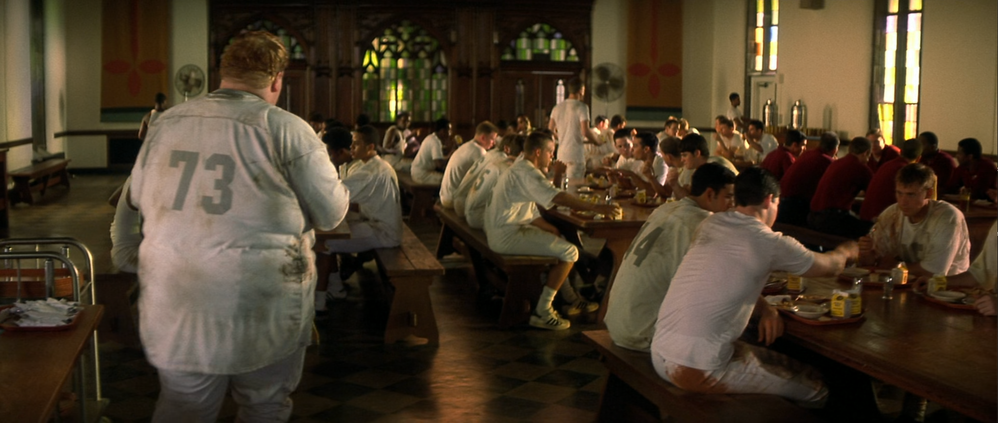First cafeteria scene shown above.
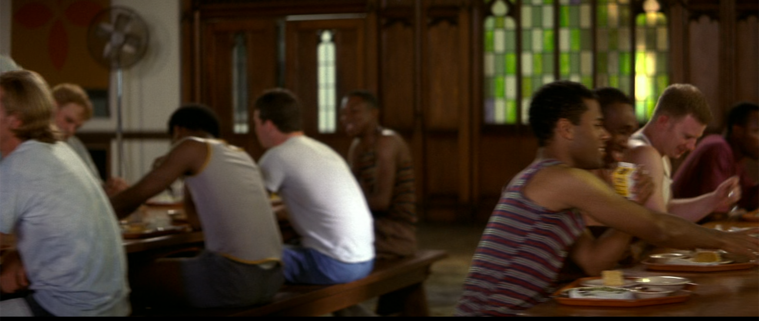Second cafeteria scene shown above.
Screenshots from Remember the Titans (2000)
Religion to support beliefs
Religion is shown to be a strong belief among the White and Black communities. However, religion is used casually and those from the White community do not realize the irony of what they are saying. Meanwhile, when the Black football players bring in the Gospel it is meant in fun or as a way to show unity with one another. The Black players would sing “Amazing Grace” in the cafeteria. When Julius tries to get Louie to go eat at another table, the others use religion to defuse the situation so that Louie can stay.
Petey: Come on, Julius, he’s just another blessed child in God’s loving family.
(Blue starts humming “Amazing Grace”)
Julius: Come on, Blue, let me--
Rev: Lord, we come before you today... and ask you to soften big Julius Campbell’s heart.
(Yakin, 2000, 00:22:49)
Later on in the film, the players have started to hang out with each other off the field. Gerry is going to see Julius, Gerry’s mom gets upset.
Gerry: I’m going to play basketball with Julius, then we’re going to come back here for dinner.
Gerry’s Mom: Gerry, your father is still alive.
Gerry: Ma, just give him a chance. Just get to know him. Listen to him for two seconds.
Gerry’s Mom: I don’t want to get to know him…You are comin’ to church with your mother.
(Yakin, 2000, 00:56:57)
Religion is used in another way, by Coach Yoast. After Coach Boone has a brick thrown through the window of his house, he is questioned by reporters. After he speaks with the reporters, Coach Yoast tries to get Boone to calm down.
Yoast: I think it’s time you stopped antagonizing everybody and learned a little humility.
Boone: Humility, huh?
Yoast: You know, if you could just keep your mouth shut and if you didn’t brag so much-
Boone: I see. So, you’re blaming me for what happened last night?
Yoast: No. I am talking about setting a good example for our boys and for the community. I don’t scratch my head unless it itches, and I don’t dance unless I hear some music. I will not be intimidated. That’s just the way it is.
Yoast: If you want to carry your sinful pride with you to your grave, that’s your business, but when your sins endanger my little girl, it becomes mine.
Boone: My sins? You think my sins had something to do with what happened last night? I’m sorry about what happened to your daughter, I really am, but maybe you got a small taste of what my girls go through. Hmm? Welcome to my life, Yoast.
(Yakin, 2000, 01:06:30)

Yoast immediately thinks that what happened to Boone was because of his bragging, or his sins. Yoast did not realize that what happened at the Boone home was because of race. However, once it was pointed out, Yoast appeared to understand and did not mention bragging or sins again.
Singing to show unity

The first time music is shown to be important, is the first time singing is performed. When the Black players are shown for the first time in the gym, Blue starts singing “Soul Power.” It is immediately noticeable that the Black football players use songs to show their unity with each other. This same showing continues when the White players start to become their friends.
In the beginning of the film, when the players are on their way to camp and Coach Boone has mixed them up, Blue attempts to sing “Ain’t No Mountain High Enough,” but Julius tells him to stop. After unity has been created at camp, and the boys are returning on the bus, they sing “Sha na na na, Hey hey hey goodbye” on the way back to town.
A similar thing happens while at camp. The Black players sing “Amazing Grace” in the cafeteria, to show unity with Louie and to defuse a potentially awkward situation. Once all of the players start to get along with each other, and they tell “your momma” jokes in the locker room, the Black players also start to sing “Ain’t No Mountain High Enough.” Only this time Louie sings with them and slowly the other White players start to join in and dance.
When all of the football players are back in town, and the community is still divided, the players have their first game of the season. To show their unity, the football players walk out onto the field together, dancing and chanting/singing “Hoo, ha, we feel” and “Hoo, ha, real good” (Yakin, 2000, 01:07:50).
Finally, at the end of the film, when the entire team is at Gerry’s funeral, presumably set decades later, they sing “Sha na na na, Hey hey hey goodbye.” This is one final presentation of unity with the whole team, showing that even in death, they are together. Each time singing is used in the film, is it to show some kind of unity, whether it be with the race or with the football team in general. However, the film viewer would not know that songs were used for this reason, unless they continued to gather content from previous scenes. Without the content from the other scenes, the film viewers would not understand the deep meaning of singing for the players. Understanding what singing means to these characters, helps the film viewer to know what is going to happen when the singing takes place.
Findings
After doing an analysis of certain scenes from the film, Remember the Titans (2000), this chapter shows that the content from one scene, not only is built upon in the following scene, but the information from the previous scene also provides the viewer with enough information for them to know what is going on in the next scene, or what the character is thinking based on the content from that previous scene. Content from previous scenes is also held on to by the film viewer, so that confirmation of change can take place in later scenes. This analysis shows that content from previous scenes can continue into the other scenes, so that the film viewer knows what to expect from certain things that happen, like singing. Content from one scene to the next scene can be used by the film viewer to know where to look with the new scene and to understand what to expect next.
This analysis, using scenes from the film, shows that the content that the editor uses before an editing transition and the content used after the editing transition, are still connected to each other and therefore combined help with the plot and the story. Even though the editor is cutting for a scene, they are still cutting for the scenes before and for the scenes after. The juxtaposition of each scene helps push the plot forward, while also weaving together the storytelling. It is the editor’s role to focus on all of these elements when they are editing. Therefore, not only do editors cut the film, but they are also responsible for the story that the film is trying to tell, while also using their editing tools to hint and signal messages to the film audience.

Chapter 7: The Ethics of Film
Ethics of film editing
Originally, films were moving images that were recordings of actual events that took place. For example, the Lumiére Brothers films such as Arrival of a Train at La Ciotat (1895) and Workers Leaving the Lumiére Factory (1895) and Thomas Edison films Washing the Baby (1893) and the Blacksmith Scene (1893) all were natural situations that took place in front of the screen. Once narrative films became common, those films started to create messages inside of those movies, messages that the director wanted the audience to receive. This includes films like Birth of a Nation (1915) and Sergei Eisenstein’s Battleship Potemkin (1925). Meanwhile, the way of creating those stories started to become more dangerous, with some actors doing their own life risking stunts. This includes silent film actors like Buster Keaton, who frequently rode atop moving machines or let large builds fall next to him. Films have long been a medium to send messages and stories to large groups of people. However, some of these films have been made with questionable ethical methods, in order to achieve that message and/or story. Unfortunately, film theory avoids the talk of film ethics with claims that “film theory traditionally has been wary of cinema's ethical potential” (Sinnerbrink, 2019, p. 185) and that while “philosophers of film have begun exploring the question of ethics and cinema, there is surprising little consensus on what this means” (Sinnerbrink, 2019, p. 185). Using ethical theory and applying it to certain situations in filmmaking, can help filmmakers decide on their own ethics and methods of creation.
As mentioned, there is a clear lack of ethical comments and suggestions in filmmaking.
Film theorists and filmmakers largely avoid the topic (Sinnerbrink, 2019), choosing instead to give themselves free reign for the sake of art. A few film professors have pointed out the lack of film ethics being discussed (Sinnerbrink, 2019), saying that film is a manipulated medium (Sinnerbrink, 2019) and that it “also has the potential to be ethically transformative” (Sinnerbrink, 2019, p. 189). While there have been some that have written on the ethics of film (Sinnerbrink, 2019; Stadler, 2008), the writing focuses on the type of story that is presented, in other words the content (Stadler, 2008), not how the story is presented. Overall, there is a lack of universal agreement on what film ethics means and how it can be understood and implemented into the filmmaking community.
Film editing is personal for the editors. These editors make their own choices on when and where to cut in a scene and when the scene ends. They are the ones that make most of the decisions on where scenes get placed, what takes they will and will not use, if certain scenes get cut, and much more. For the most part, editors work alone and only show their rough cuts to directors, producers, key personnel, and other editors. Their work is subjective and therefore a representation of themselves and their decision making. With film editing being so siloed, it stands to reason that film editors also have their own ethical beliefs that they bring to the editing room when they do their work.
Ethics and representation
Film ethics also connects to the previous chapter on representation. Providing an accurate representation of ethnicity and minorities is an ethical choice and consideration that is made by those that created the film. Consciously using stereotypes of these minorities and ethnicities, is not following ethical considerations for the characters on the screen and for the film viewers that are also within that minority or ethnicity. Choosing to make fun of a group, just for being, is not ethical. For those making the film, consciously choosing to do their best in representing a group, is an ethical choice and consideration that all should follow.
How ethical theory can apply
While film ethics is clearly lacking, there are other ethical theories that can be used and applied to help filmmakers with the development of film ethics. Deontological ethics and utilitarianism are two ethical theories that can be used and applied to filmmaking. While all of the elements of these theories cannot apply to film, there are certain aspects of these theories that do fit well with films and how they are made and viewed.
Deontological theories “judge the morality of choices by criteria different from the states of affairs those choices bring about” (Alexander & Moore, 2007). Deontology also believes that “that some choices cannot be justified by their effects—that no matter how morally good their consequences, some choices are morally forbidden” (Alexander & Moore, 2007.) and that “what makes a choice right is its conformity with a moral norm” (Alexander & Moore, 2007). It also holds that “certain actions can be right even though not maximizing of good consequences, for the rightness of such actions consists in their instantiating certain norms” (Alexander & Moore, 2007). Deontological theories have traditionally been divided between agent-centered and patient-centered theories. Agent-centered theory believes that everyone has “both permissions and obligations that give [them] agent-relative reasons for action” (Alexander & Moore, 2007), while also centering on
the idea is that morality is intensely personal, in the sense that we are each enjoined to keep our own moral house in order. Our categorical obligations are not to focus on how our actions cause or enable other agents to do evil; the focus of our categorical obligations is to keep our own agency free of moral taint. (Alexander & Moore, 2007)
Meanwhile, patient-centered theory says that focus’ on people’s rights. It is described as “the right against being used only as means for producing good consequences without one’s consent” (Alexander & Moore, 2007) and “a right against being used by another for the user’s or others’ benefit” (Alexander & Moore, 2007). According to patient-centered theory
if an act is otherwise morally justifiable by virtue of its balance of good and bad consequences, and the good consequences are achieved without the necessity of using anyone’s body, labor, or talents without that person’s consent as the means by which they are achieved, then it is morally immaterial (to the permissibility of the act but not to the culpability of the actor) whether someone undertakes that act with the intention to achieve its bad consequences. (Alexander & Moore, 2007)
Both agent-centered and patient-centered theories can be allied to filmmaking and film editing. With deontological ethics, particularly in healthcare, there are four principles that are discussed:
(1) respect for autonomy (a principle requiring respect for the decision-making capacity of autonomous persons); (2) nonmaleficence (a principle requiring not causing harm to others); (3) beneficence (a group of principles requiring that we prevent harm, provide benefits and balance benefit against risks and costs); (4) justice (a group of principles requiring appropriate distribution of benefits, risks and costs fairly). (Beauchamp, 2007, p. 4)
While principle 1 (autonomy) and principle 4 (justice) can apply to filmmaking, it is principle 2 (nonmaleficence) and principle 3 (beneficence) that will be discussed and applied to how films are made and how they impact the film viewer. When writing about beneficence, it was said that “the principle of beneficence requires us to help others further their important and legitimate interests, often by preventing or removing possible harms” (Beauchamp, 2007, p. 5). In other words, do not do harm to others and try to prevent harm. For filmmakers, directors, editors, etc., attempting to do the best work possible for film viewers, while also removing any known harm, leads to beneficence in their films.
William David Ross and his ideas of prima facie duty are implemented in health care principle 2 (nonmaleficence) and principle 3 (beneficence) mentioned above. When discussing nonmaleficence, Ross says that we must “not to harm others, this being a duty whether or not we have an inclination that if following would lead to our harming them” (Prima facie duty, 1999, p. 280). When discussing beneficence, he points out that “there are other beings in the world whose condition we can make better in respect to virtue, or of intelligence, or of pleasure. These are the duties of beneficence” (Prima facie duty, 1999, p. 280). Ross claims that we should not do harm to others and that “to injure others is incidentally to fail to do them good” (Prima facie duty, 1999, p. 280), which does not follow the idea of beneficence. Filmmakers should try to take nonmaleficence and beneficence into consideration when they are making their films and also consider it when it comes to what impact it will have on the film viewer.
Utilitarianism can also be applied to filmmaking and film editing. John Stuart Mill says that utilitarianism “holds that actions are right in proportion as they tend to promote happiness, wrong as they tend to produce the reverse of happiness” (Mill, 1863), with “happiness is intended pleasure, and the absence of pain; by unhappiness, pain, and the privation of pleasure” (Mill, 1863). This theory is grounded in the idea that “pleasure, and freedom from pain, are the only things desirable as ends” (Mill, 1863).
For utilitarianism, Mill discusses “special protection for individuals who might otherwise be sacrificed for the good of the whole” (Elliott, 2007, p. 100), which means that “Mill requires calculating what is truly good for the whole community” (Elliott, 2007, p. 100). Mill claims that “it is justified on the basis that causing harm in those particular types of cases is good for the community, including the individual harmed” (Elliott, 2007, p. 100). In the case of filmmaking and on set work, Mill’s belief would mean that if an individual gets harmed during the making of the film, but it results in good for a large group of people, then the harm to the individual might be acceptable. Another example that can apply to film viewing is if one film viewer is emotionally harmed from the content on the screen, but the majority of the viewers experience their own emotional harm to be a good call-to-action, then the harm was good overall.
As discussed above, deontological ethics and utilitarianism can be applied to filmmaking. However, deontological ethics says that no harm should be done to anyone (Prima facie duty, 1999), while utilitarianism says that harm to just a few people is okay, as long as it results in good to a much larger group of people (Elliott, 2007), and that pleasure is intended, while the absence of pain is the goal (Mill, 1863). However, the decision on which one should be applied to filmmaking would ultimately be the choice of the filmmaker and what level of harm they believe is acceptable. It is up to the film crew and the creators of the film to decide on if their movie should only result in good, or if some harm and pain to others is worth the message of the movie.
Questionable methods for authenticity
With films being made for over 100 years, there have been moments of questionable choices by the filmmakers. In the early stages of film, American Indians were represented in stereotypical ways (Price, 1973; Berny, 2020) and this has continued for decades. Instead of using real Native languages, filmmakers would have their actors speak their lines in English, then while in postproduction, they would play the English lines backwards, thus creating the Native language that was on the screen (Berny, 2020). These older films would also use White people to play American Indians, instead of American Indians to play themselves (Price, 1973; Berny, 2020). As mentioned earlier, White actors from the 1960s television series’ F Troop and Daniel Boone played and represented characters of a different race and culture.
The methods used to capture reality can also be questionable. For example, extreme cinema has become an area of filmmaking used to show extreme violence (Brown, 2013; Choi & Frey, 2014). Some of these filmmakers believe that by showing these types of images, that the film audience will be uncomfortable (Brown, 2013), while others believe that it is another type of voyeurism and want, because the film viewer cannot do that type of harm in real life (Brown, 2013). The article, “Violence in Extreme Cinema and the Ethics of Spectatorship” by William Brown (2013), discusses how the depictions of extreme violence in films raises issues about the ethics of not regarding the pain of other people (Brown, 2013). In his article, Brown says
once we have engaged with it in the fashion that I am describing here, then we can carry forward the ethical mode of viewing and bring it to all films that we see. That is, we can begin to see all films from the ethical perspective, such that we view all films in terms of showing us that of which mankind is capable, that of which we ourselves might also be capable. Furthermore, it may encourage in us a desire to see films that seem themselves to adopt a more ethical stance towards their subject matter. That is, to see films that do not necessarily ask us to take pleasure in screen violence, but which approach violence in a more responsible fashion.
I do not suggest that one cannot enjoy fantastic screen violence. Nor do I wish to suggest that screen violence cannot function as some sort of release or substitute for the impulse to commit violent acts in the real world. (Brown, 2013, p. 38-39)
He continues saying,
this ethical mode of engagement is not necessarily easy. As explained above, it involves viewing difficult films and understanding that we could be like the violent characters within them. It involves understanding that we all have the capacity for monstrous behavior and that monsters are all too human, as opposed to being inhuman or supernatural. This is difficult because it asks us to view ourselves as potentially very bad, violent people. But the benefits—ethical life in which we choose not to be violent—perhaps outweigh the difficulties. (Brown, 2013, p. 39-40)
Instead of saying that we should eliminate extreme violence in cinema, we as viewers should use it in our own ethical mode of engagement with the film and the content. While it could be claimed that a film audience watches extreme film violence because of their voyeuristic tendencies and because they know they cannot perform violent acts themselves, Brown believes that this is not the case. Rather, Brown believes that a film audience should occasionally watch extreme violence to recognize that as humans we have the capability to perform such violent behavior. While it would be difficult to do, considering the violence, in the end it would be beneficial to have attempted this type of engagement.
The other questionable methods used in the past were the treatment of animals. Harm used to be done to creatures on set, even to the point of killing. Fortunately, that has since changed, but steps must be taken on set to ensure that no animals are harmed. At the end of a film that uses animals, there is always a note to the film viewer stating that the creatures were not harmed in the making of the film. However, a big part of this change came from animal rights activists and not from film ethics.
Another thing to consider in capturing reality, is what is actually real when the camera is recording. As mentioned before, in the past animals were actually killed during a movie. Examples of this would be in Westerns when horses were shot or made to fall. A more extreme version of capturing reality comes from the film Last Tango in Paris (1972) directed by Bernardo Bertolucci. In the film Marlon Brando, who plays Paul, rapes Jeanne, played by Maria Schneider, using a stick of butter as lubricant. According to Schneider, the scene was not in the script and she was only told about what was going to happen by director Bertolucci, right before the scene was filmed (Lewis, 2023). Brando, unfortunately, was told the opposite by the director, that Schneider was completely aware of the use of butter and of what was going to happen (Lewis, 2023). Bertolucci’s excuse was that he wanted a real reaction out of Schneider and that was why he did not tell her the full truth of what was going to happen during filming of the scene (Lewis, 2023).
Other less extreme situations like this have happened, by directors wanting to capture real reactions from their cast. In the television show M*A*S*H, when the character Colonel Henry Blake gets to leave South Korea and go home back to the States, none of the actors are told what really happens to the character until the scene was being filmed. The only one that was told about Henry Blake’s plane crash, was Gary Burghoff who played Radar O’Reilly. Gary Burghoff was told about the character’s death, right before going out to announce the news to the rest of the cast during the actual recording of the scene (MeTV Staff, 2022). The shock shown by Radar/Burghoff and the silent surprise and sadness shown by the rest of the cast in the scene, was real.
The next film, where the director withholds information from the actor comes from Die Hard (1988). In the scene where Alan Rickman’s character, Hans Gruber, falls from the top of the building, Rickman was told that he would be released from the rope to fall at the count of three. However, the director, Charlie Picerni, then told the stuntmen to release Rickman at the count of one (Parker, 2020). The shocked reaction that Rickman has, as Hans Gruber falls to his death, is a real surprise. The last director withholding information from an actor, is Andrew Adamson the director of The Chronicles of Narnia: The Lion, the Witch and the Wardrobe (2005). The scene discussed is the first visit that Lucy has in Narnia. The actress that played Lucy, Georgie Henley, was never shown the Narnia set (The Lion’s Call, 2015), so when her character sees Narnia for the first time, Georgie Henley is also seeing it for the first time. The awe and wonder shown on the actress's/Lucy’s face is real.
While directors choose to withhold information from their cast, to have authentic reactions, it is still up for debate on how much is too much, of the information that they can withhold from the actors before it is unethical.
Emotions and feelings with film
For many filmmakers, one of their major goals is for the film audience to have feelings for the characters in the movie. Studies have shown that films do cause emotions in the film viewer (Chong et al., 2013; Tan et al., 2007). Filmmakers have been taught how to use various tricks with the camera (Corrigan & White, 2017; Prince, 2013), tricks in editing (Dmytryk, 2018) and tricks with sound (Corrigan & White, 2017; Prince, 2013) to help cause those emotions and feelings.
Sound and how that is used to cause feelings
As mentioned earlier, sound can be used to help create feelings and emotions in the film viewer. In the early days of film, before synchronized sound became the norm, studios felt that sound was so important to the film that they would send out sheet music to the movie theaters for the pianist or organist to play (Bordwell et al., 2017). Since then, various sound studies have taken place, showing that sound and music do play an impact on the feelings of the film audience (Chong et al., 2013; Tan et al., 2007).
There was a recent study done that replicated the famous Lev Kuleshov effect. As mentioned in an earlier chapter, the Lev Kuleshov study, from in the 1920s, took an image of an expressionless male actor and juxtaposing his image with that of a bowl of soup or the image of a girl in a coffin (Corrigan & White, 2017; Cook, 2016). Kuleshov’s study showed that film viewers will make inferences based on the information they are given, creating the rest of the story. This new study tried adding music to the images. The study found that by adding in music to the images shown, with the music chosen being intended to cause some type of emotion, that the music would influence the viewers emotional judgments of the facial expressions that were shown (Baranowski & Hecht, 2016).
One of the most recent sound elements used in film is the use of infrasound. Infrasound is a sound frequency so low that it cannot be heard by humans, but can be felt (Zarrelli, 2016). It has also been known to cause uncomfortableness, fear, and physical illness (Garuso, 2020). The first recorded use of this technique in a film happened in 2002 with the first screening on Irreversible (2002). According to journalists, some audience members became so physically sick that they had to leave the screening (Zarrelli, 2016). The director, Gaspar Noé, credited the use of infrasound as the cause of the illness (Zarrelli, 2016).
Infrasound has been used in films like Paranormal Activity (2007), The Conjuring II (2016), and A Quiet Place (2018). However, some studies have shown that long exposure to infrasound can be damaging. It has been known to cause hearing loss, pain, (Leventhall, 2006) and hair damage (Lim et al., 1981). This shows that sound plays a large element in the creation of film and even more films are starting to use sound “tricks” to help cause the emotions and physical feelings of the film viewer. This brings back the discussion of healthcare ethics and not causing harm to others.
How visuals are used to cause feelings
Film is a persuasive medium (Sinnerbrink, 2019). The visual element is where most of the rhetoric discussions are focused (Sinnerbrink, 2019). Filmmakers are taught to use certain visual methods to help influence the film viewer. This includes using the camera with movement, such as tracking shots (Corrigan & White, 2017; Prince, 2013), different camera angles, such as a low angle to suggest power and a high angle to suggest weakness (Corrigan & White, 2017; Prince, 2013), and high key (bright) lighting for happiness and low key (dark) lighting for mysteriousness, suspense, and fear (Corrigan & White, 2017; Prince, 2013). All of these techniques are common and well known among those that make films.
Rapid cutting is used to cause suspense and anticipation (Corrigan & White, 2017; Prince, 2013), while slower cutting is also meant to drag out certain situations (Corrigan & White, 2017; Prince, 2013). There are entire textbooks that teach aspiring filmmakers the ways they can use the camera and editing software to influence the feelings and emotions of the film viewer based on what the viewers are seeing.
Making people uncomfortable
Some film scenes are meant to make people uncomfortable (Brown, 2013; Choi & Frey, 2014), which is still a feeling. This could be excessive violence (Brown, 2013; Choi & Frey, 2014), embarrassment (Brown, 2013), and fear (Garuso, 2020). In addition to the visuals making people uncomfortable, such as the use of camera angles making a character feel weak and vulnerable, and lighting used to manipulate the look of a scene (Corrigan & White, 2017; Prince, 2013), sound is also used to make people feel uncomfortable (Garuso, 2020). This trick can be used in various ways. It could be something as simple as nails on a chalkboard or a fork scraping on a plate.
History of questionable methods in film
As mentioned earlier, directors not providing full information about a scene, in order to get the authentic reaction from the actor, has been under fire through the years, the most notable being director Bernardo Bertolucci and his treatment of Maria Schneider and Marlon Brando in The Last Tango of Paris (1972). In the past, American Indians were not the ones to play other Natives on television, people of other ethnicities were used instead. Later on, American Indians played other Natives, but they were never given the lead role, but instead played background characters without any lines (Price, 1973; Berny, 2020).
As discussed earlier, the film Irreversible (2002) was known to cause physical illness in its film audience, with the credit for this going to the use of infrasound (Zarrelli, 2016). Since 2002, more films, particularly horror films, have started to use infrasound to help with causing uncomfortableness and fear in the film viewer.
How ethical theory applies to film
As previously mentioned, there are no ethical standards for filmmaking. However, some form of right and wrong does exist when it comes to filmmaking and storytelling. While many ethical considerations have already taken place during the preproduction and production stage of the filmmaking process, editors do have some responsibility when it comes to the message and material that the audience receives.
Discussed earlier, there are editing techniques that can be used to create messages to the film viewer. Rapid editing back and forth between scenes or characters creates suspense and anticipation. This would be used in fight scenes or car chases. Slow editing would be used for more intimate and emotional scenes. While most job roles should have some sort of ethics involved, editing is subjective work, therefore creating a standard of ethics would be difficult. However, keeping ethical considerations in mind should be the norm, when it comes to the editing work that is produced. This dissertation proposes that choosing to not include extremely violent material, unless crucial to the story and to the message of the film, should be the norm for editors. The same goes for ensuring that editors are not accidently implying ethnic guilt, using the editing techniques previously discussed. While applying a standard code of ethics to film editing will not be possible, editors can follow a looser ethical code, similar to the healthcare ethics discussed.
Carnival Row example
The way a film is recorded and edited, can also raise questions. A more recent example comes from the Amazon television series Carnival Row (2019). A brief explanation of the television show: Set in the 700s, but looks like Victorian era England, this show features conflict between humans and fae, mythical creatures that are treated as lesser than humans. These creatures are believed to be criminals, servants, and most of the humans are against them. This is very similar to how Black people were treated by White people in the past.
In Season 1, Episode 4, titled “The Joining of Unlikely Things,” Agreus Astrayon, a Black male faun, purchases a house in a rich neighborhood that is inhabited by humans, who believe that his kind do not belong in their society. Imogen Spurnrose is a White human woman, born into a wealthy family. She, like the others, looks down upon the fae and only employs them as servants. However, Imogen’s brother made some bad investments and is now asking around for loans. Earlier in the episode, Imogen invited Agreus over for tea, with the agreement that he uses the back entrance of the home, testing the waters to see if he might give them a loan. Agreus, however, assumed that she was toying with him, only to run off and tell her rich friends. After their confrontation, Agreus leaves. He soon discovers that Imogen’s family does not have any money and the reason she invited him over was to test if he would be generous to them or not.
To understand the implications and effects that casting, costumes, lighting, camera angles, sound, and editing have on a scene, a scene analysis will take place. Imogen stands in the doorway of her house and Agreus stands at the bottom steps. It is nighttime.
Images 21
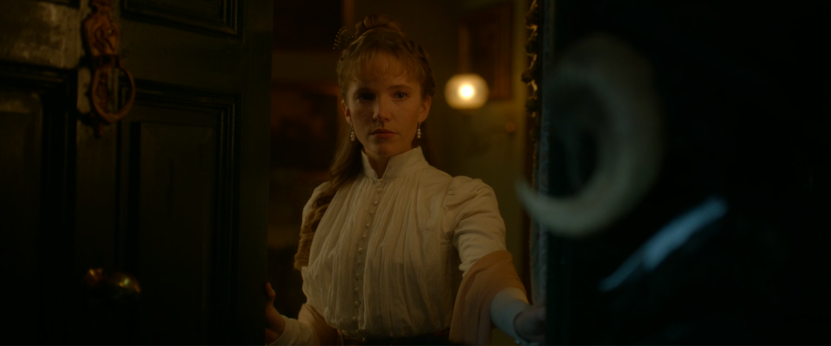
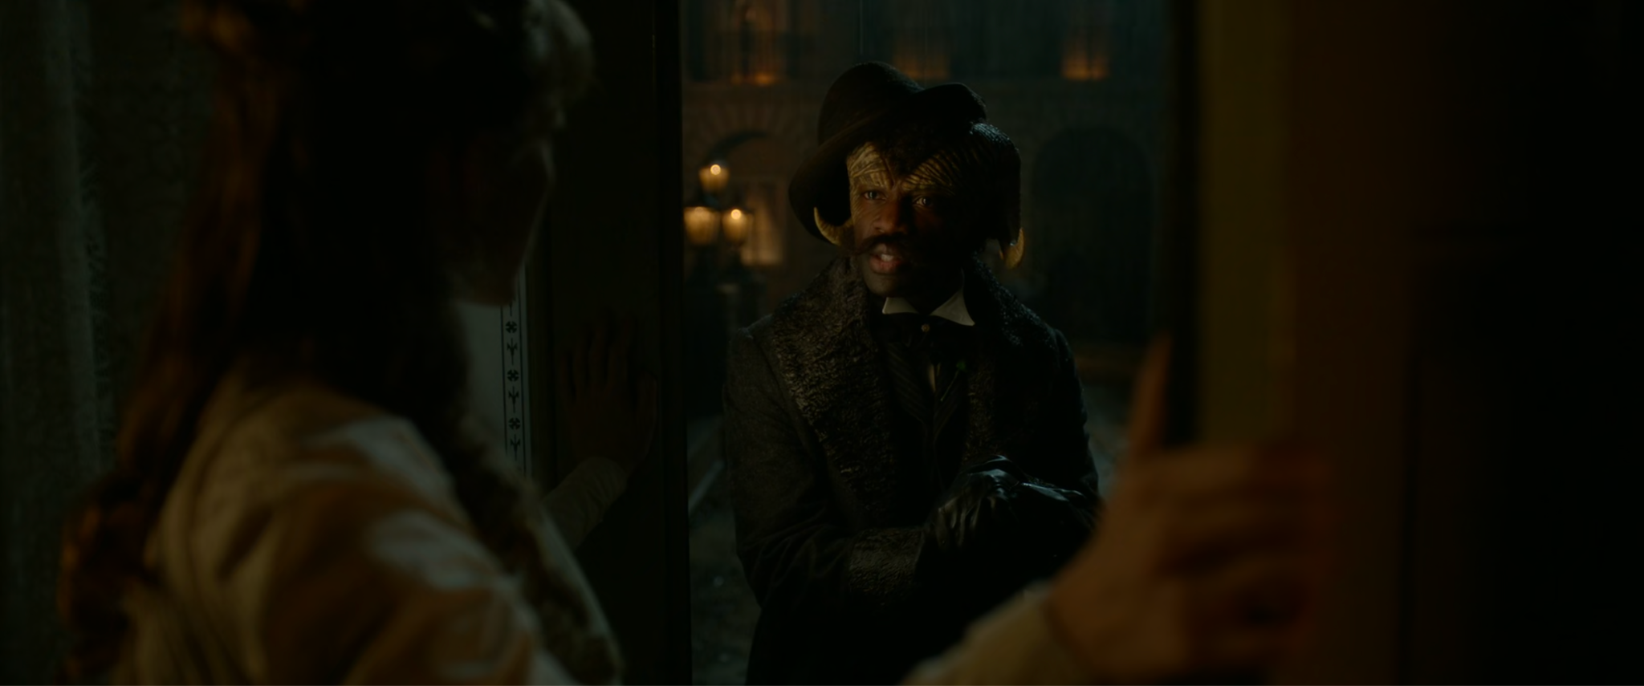
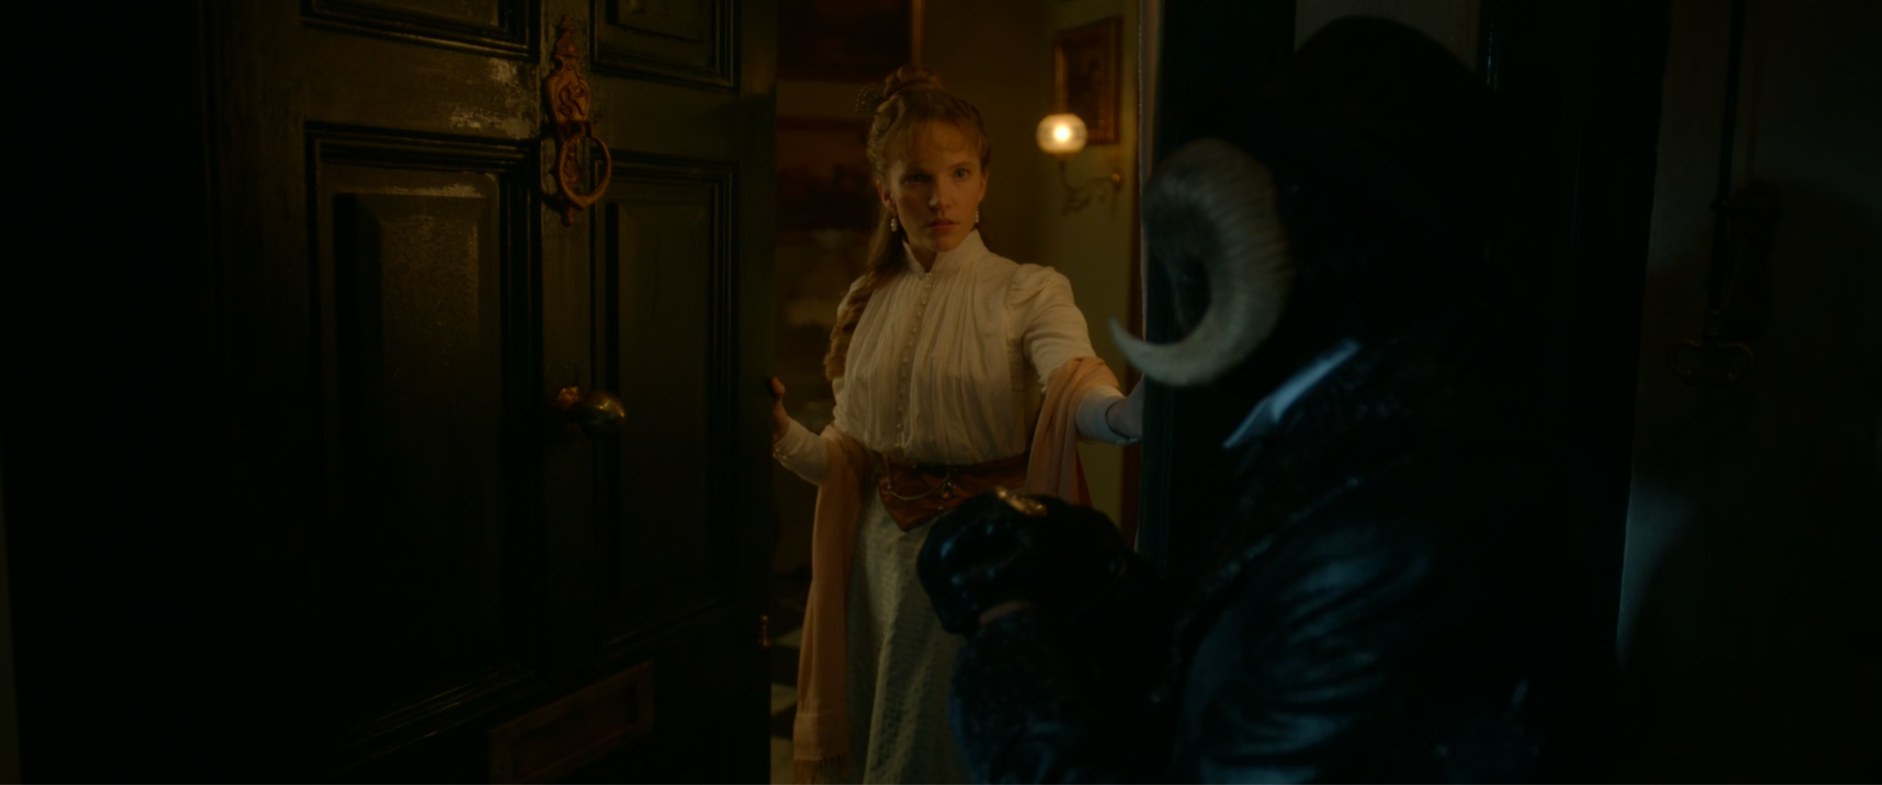
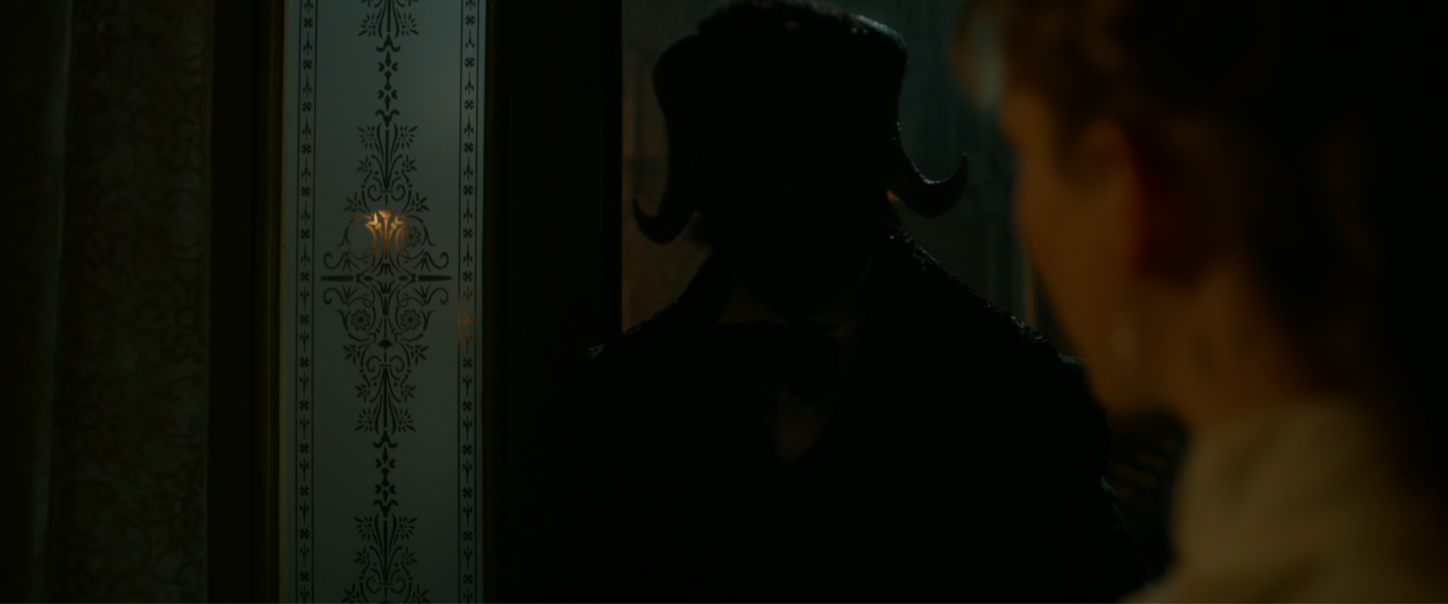
Screenshots from Carnival Row (2019)
Agreus: What’s the matter? Are they staring? Wondering what a Puck is doing at your front door. Imagine how they’ll stare when you and your brother are forced to sell this house.
Imogen: What do you know of our affairs?
Agreus: Only what your neighbors’ servants are saying about the trouble your brother’s gotten himself into. I am sorry. One can only guess at your desperation.
Imogen: It is. It is desperation. You are right to call it so. My brother and I, we find ourselves drowning and we were never taught to swim.
Agreus: This is honesty.
Imogen: My invitation to tea was not for sport. I meant to test the waters of your generosity. I sensed that you lack a proper invitation to society here.
Agreus: And you smelled a bargain to be made.
Imogen: I am sorry, Mr. Agreus. It was foolish of me. I see that now.
Agreus: Was it?
Imogen: Please don’t toy with me.
Agreus: Far from it. I see no reason why we can’t come to an accommodation. The first step, of course….[Looks back] you have to let me through your front door.
(Amiel, 2019, 44:24)
The first thing to discuss is the choice in casting. While a fae/Puck is meant to represent a non-human, one that many humans believe to be of no worth, the casting directors choose to cast a Black man (Agreus) for the role of a recently wealthy fae. The rich, female human (Imogen) is played by a White woman. It is not known if the person doing casting made this choice not knowing the intended life of the character, or if the choice was a commentary on society’s racial history.
The second object to discuss is the choice in clothing. There is a clear choice in the color of the clothing. Imogen wears mostly white. She has on white top with her dress, white pearls for her earrings and pearls on the buttons of her front dress. Agreus wears all black. He has on a black hat, black suit, and carries a black cane.
The next piece to discuss is lighting. Imogen’s image appears to be lit up by the lights of the lamps in the house. Her face is bright from what is assumed to be streetlamps from outside. Agreus’ face is darker, but still lit up by the light coming from inside of the home. When Agreus enters the home, his face becomes dark, even though the house is where the light is located. It is so dark that it is impossible to see him anymore (see above Images 21). However, Imogen stays bright, even as she shuts the front door.
Camera angles also impact the characters of a film. Imogen stands inside the home. The camera facing her, is tilted up, giving her the appearance of power. Agreus stands at the bottom of the steps, outside of the home. The camera facing him is tilted down, giving him the appearance of being weaker.
The next element to discuss is sound. When Imogen and Agreus have the start of their conversation, there is no music. As soon as Imogen says “generosity” gentle piano music starts to play. When Agreus says, “I see no reason why we can’t come to an agreement,” the piano music stops and is then replaced by violin music. The violins change the tone of the scene from sympathetic and sad, to suspicious and mysterious. Because the music changed when Agreus made his suggestion, it is assumed that he has ulterior motives.
The last element to discuss is editing. Although subtle, editing also plays an important role in this scene. Throughout the scene, the pacing of the editing is consistent. There are back and forth cuts as they have their conversation. When Agreus makes his suggestion that they help each other, the shot lingers on Imogen, implying to the film viewer that Imogen is thinking about what to do, but is also at Agreus’ mercy.
All of these tricks and methods show that various film elements can cause emotions and assumptions with the film viewer. However, if the filmmaker has the wrong intentions, with the right combination of tricks they can cause a film audience to believe the wrong thing about a person or a race. While probably not the intention, using these elements, combined with race, can put forward the wrong implications, if not careful. Or using all of these elements could be a subtle commentary on the history of society.
When it is acceptable to cause emotions in others
In an article that discussed media ethics (not film ethics) the author writes that “visual behavior - all the ways that we make and use images - interacts with technology - from body/brain through globalized digital brain - in ways that both create and draw upon ideology” (Newton, 2020, p. 133). This is one reason why films are thought to have an impact on viewers. Films are meant to capture reality and if a viewer watching a film is not familiar with what they are seeing on the screen, they might assume that what they are seeing is true. When discussing visual ethics theory, the author said that it “grows through exploration of the interdependency of the brain, heart, and medium” (Newton, 2020, p. 134) and that “all runs through the core thread known as truth” (Newton, 2020, p. 134). Because many films are meant to show the truth, or to capture reality, then viewers could automatically believe it. What makes this relevant to the idea of sound ethics in films is that music can manipulate the film viewer, by creating emotions (Chong et al., 2013; Tan et al., 2007). If a film viewer is going to be scared of something or someone in a film, and the music or background noise helps this, then the music impacts how the viewer thinks and feels about reality.
Film ethics
There are only a small number of articles and books that focus entirely on ethics in films. In more recent years film ethics has been discussed more, but these are still more proposals than agreements. With there being so few articles on film ethics, the idea of sound ethics in films has not been discussed. Instead, these ethics writings focus on the visual aspect of what is happening, instead of the listening aspect. However, sound and visuals go hand-in-hand with films, and one cannot be discussed without the other.
Even during the early stages of filmmaking, people were cautioning others on what films could do to viewers. In 1919, sociologist Thorstein Veblin claimed that films were “a manipulative medium that would rob the masses of their critical awareness” (Sinnerbrink, 2019, p. 186). One of the leading authors on the philosophy of film and its ethics is Australian philosopher Robert Sinnerbrink. He has pointed out that “film theory traditionally has been wary of cinema’s ethical potential” (Sinnerbrink, 2019, p. 185). While film theorists discuss what impact film has on the viewers, rarely (if at all) is ethics discussed. It is also pointed out that “although philosophers of film have begun exploring the questions of ethics and cinema, there is surprisingly little consensus on what this means” (Sinnerbrink, 2019, p. 185). With the idea of film ethics being new to those who study and create films, there is no universal agreement on what is right and wrong.
Films are known to have the ability to manipulate others and be persuasive (Sinnerbrink, 2019). Part of the reasoning for this is that films are meant to capture reality and thought, and then show it to the viewer. Even though films can be manipulative they “also [have] the potential to be ethically transformative” (Sinnerbrink, 2019, p. 189). Films have the power to cause people to be suspicious of certain groups and can reinforce stereotypes, but it can also create understanding of those certain groups, provide insight, and break stereotypes. Sinnerbrink mentioned that films can also “expose us to morally confronting, ethically estranging and emotionally challenging forms of experience that demand some kind of philosophical response on our part” (Sinnerbrink, 2019, p. 191). Examples of this can be found in many independent films, which causes viewers to think about what they saw and, in some films, seek a “call to action.”
Types of ethics in film
Sinnerbrink proposed three approaches to ethics in film. The first is “ethics in cinema” (Sinnerbrink, 2019, p. 192), when it comes to situations and stories told in the film. The second is “the ethics (and politics) of cinematic representation” (Sinnerbrink, 2019, p. 192), which shows and points out ethical issues on the screen. The third is “the ethics of cinema as a cultural medium expressing moral beliefs, social values or ideology” (Sinnerbrink, 2019, p. 192), which would use ideas focusing on groups, such as those by feminist film theorist Laura Mulvey. Viewers are the receivers of ideas shown in films, but it is how those ideas are presented that can become questionable.
When it comes to experiencing a film, Sinnerbrink says that there are three aspects of the cinema-ethics relationship, which are: “ethical content in narrative cinema; the ethics of cinematic representation…; and the ethics of cinema as a symptomatic of broader cultural, social and ideological concerns” (Sinnerbrink, 2019, p. 196). All of these are important elements to think about when viewing and making a film. Having something hidden in a film (such as audio and editing) that a viewer does not know about, could pose some potential problems. Infrasound is one hidden audio technique now being used that can have ethical implications. Infrasound would fall under the category of “ethical content in narrative cinema” (Sinnerbrink, 2019, p. 196). Film viewers are aware of “jump scares” in horror films. They might go into the film hoping that a jump scare gets them. However, infrasound is new and many film viewers are not aware of it being used or how it is used to “trick” them. One solution to this unawareness is to tell the film viewer at the beginning of the film what infrasound is and that the movie will be using it. But if that happened, then it is also possible that telling viewers what they are going to hear/see/feel could remove part of the “magic” of the film experience.
One big issue that film ethics needs to consider is that what one individual viewer takes from the film could be different from another viewer, depending on their own race, personal experiences, and culture. While it is true that films have the power to influence those who watch them, part of what the viewer takes away after seeing the film, depends on the person. Everyone will not develop the same ideas, beliefs, assumptions, or fears, after watching the same movie. Films have the ability to show “complex moral situations or forms of ethical experience that might otherwise escape our notice” (Sinnerbrink, 2019, p. 199-200). Films can do this by placing the viewers in situations that they did not know existed or situations they would never be part of. Films show viewers these issues and situations, instead of telling viewers about them. However, films can also show viewers situations that are too graphic, such as films that fall into the category of extreme cinema (Brown, 2013). This includes films that show and provide audio of extreme violence, such as sexual violence and killing (Brown, 2013). Films such as these can make viewers extremely uncomfortable with what they are hearing and seeing (Brown, 2013). This has raised the question: How far is too far?
What filmmakers should consider with ethics
Through this discussion, it is shown that there are various aspects to filmmaking that can have implications on the film viewer. The choice of using the wrong ethnicities to represent a culture or a group has been done numerous times throughout film history (Price, 1973; Berny, 2020). While the representation of groups has been getting better, the choice of casting the wrong ethnicity for a role, brings to question if it is the ethical thing to do for that group of people. Is stereotyping ethical if it shows a group negatively, when it is not true? Ideally, the filmmakers will cast the correct ethnicity, and not show a fake representation of a group.
Filmmakers should consider the film elements used in their creation. This includes the combination of camera angles, lighting, and sound. Certain sound tricks have also been shown to cause harm to film viewers (Garuso, 2020), with studies on infrasound showing that it can cause physical damage to the human body (Leventhall, 2006; Lim et al., 1981). Because of this, filmmakers should consider the physical impact that their filmmaking will have on the film viewer. Trigger warnings have become more frequent and common because of health concerns regarding the film viewers, and in the case of infrasound, trigger warnings should probably be used at the beginning of films for anyone with health concerns that could be harmed with the excessive use of damaging sound.
Ethical theory, such as deontological ethics and utilitarianism can be used by filmmakers in the creation of their movies. While there has been some discussion on film and ethics, for the most part all of these discussions cover the content and the story that is being shown (Stadler, 2008; Sinnerbrink, 2019), not how the film is made. Various elements of filmmaking need to be considered by the filmmakers. Correct and authentic representation of a cultural group, film production techniques used on the film set, postproduction elements such as harmful sound, and the withholding of information to get authentic reactions of the actors, all need to be considered by the filmmaker when they make decisions. Through the application of deontological ethics and utilitarianism the filmmaker can decide on whether or not the choices they make are worth the harm and pain.
Editing also plays a role in representation of ethnicities and minorities. It is through editing that stereotypes can also be reinforced. It is the responsibility of the editor to make sure that they are making the audience afraid of a character, because the character is supposed to be scary, not because of the character or actor’s ethnicity.

Chapter 8: Methods of the Study
Editing is a collective effort and other considerations
Editing has developed drastically from its origins. History has shown there are gradual changes that take place in multiple places, by multiple people, simultaneously. There is no one “source” because these techniques and inventions were happening through different people at the same time (Landler, 2019; Corrigan & White, 2017; Reisz & Millar, 2010). Because of this, it can be easily claimed that editors were experimenting with other elements at the same time, yet not providing this information to others. It is through the independent/small film editors that editing experimentation is most likely happening and those editors are the ones that should be questioned for more information. The one small independent editor is probably not the only editor experimenting with different editing techniques. History shows that the same experimentation happens with others around the same time (Landler, 2019; Corrigan & White, 2017; Reisz & Millar, 2010).
As mentioned, films have become more complex with the storytelling, editing, and the elements used with editing, such as sound, have also become intricate. There have been some studies on sound and films, such as from Smith who discovered that when a sound in a scene is heard, film viewers look and expect to see the source of the sound (Smith & Martin-Portugues Santacreu, 2017). However, sound is still a largely under focused element in film research (Murch, 2001).
There are several editing practices that must also be considered. The first one being women editors during the early films and the lack of editing credit received for their work (Kaganovsky, 2018). Because of this, it would be extremely difficult to know the impact that women had on editing practices and editing concepts. In addition to this, editors no matter the gender were sometimes not given credit for the work that they did (Corrigan & White, 2017). This also proves to be a challenge for historical accuracy and work.
The next consideration that will be made is the impact of films outside of the United States. History shows that while editing practices, concepts, and technological inventions were taking place in the United States (Reisz & Millar, 2010; Dancyger, 2018), these similar practices, concepts, and technological inventions were taking place in Europe (Landler, 2019; Corrigan & White, 2017). For example, the world’s first feature film was made and released in Australia, The Story of the Kelly Gang (1906) (National Museum of Australia), nowhere physically near where the other inventions and ideas were being created. Another example is the tinted version of Trip to the Moon (1902). Méliès had this film tinted, but through the years it was believed that all of the colored prints were lost. A copy of the painted film was discovered in the 1990s and was finally restored in 2011 (Eagan, 2011), which leaves some hope that other older films could be discovered and saved. However, because of the lack of documentation and because of the location where these inventions and ideas were taking place, it is impossible to know the full history. It is also possible that these same practices, concepts, and technological inventions were happening outside of the United States and Europe, but we have not become aware of it yet, or worse, there was never any documentation.
Another consideration is the impact that digital editing has made on editing concepts. No longer does the editor have to run back and forth between their edit station and the metal bins, where the filmstrips are located. Instead, all of the footage is available in a single digital location. Software has made editing video, sound design, and color grading much easier than it was in the past. In the digital age, coloring a film is also very easy. Look Up Tables (LUTs) are used to aid in the coloring of a film. Software like Adobe Premiere Pro and Avid Media Composer allow for easy video editing, while DaVinci Resolve is used for color grading. Adobe Audition and Avid Pro Tools can be used for audio editing and Blender, Adobe After Effects, and Nuke are used for editing visual effects. All of these software programs mean that the editing is no longer done by one person, but instead by multiple people, all who have a say in what the film looks and sounds like.
After going through the history of film editing and examining the practice and concepts from then and now, it is reasonable to seek out individual film editors that work on small independent films, instead of those that make a living working for a large movie company. It is these independent film editors that are more likely to experiment with editing and how they help tell the film’s story. This overview of history also shows that there are multiple people throughout history that have experimented with editing concepts (Landler, 2019; Corrigan & White, 2017; Reisz & Millar, 2010; Cook, 2016), some of whom have never been given credit for their work (Corrigan & White, 2017; Kaganovsky, 2018). History shows that even though there are rules to editing (Dmytryk, 2018; Murch, 2001), there can be exceptions and these rules can change depending on the technology that is available (Eisenstein et al., 2016; Chaplin & Hayes, 2005). It also shows that even now, these editing practices and concepts are changing, and it is through these editing concepts of the past that we can understand what the editing concepts of the present and future are trying to achieve.
Research Questions
Connecting back to the four points of interest listed in Chapter 1, these research questions will search for commonalities in the data collected to find shared meaning.
- What do in-depth interviews indicate are the film editors’ understandings of their editing?
- What do in-depth interviews reveal about what the film editors’ think they are doing to their audience?
- Through analyzing in-depth interviews, to what extent does an accurate representation of ethnicities and minorities take place during the edit and what does the editor do?
- Through analyzing in-depth interviews, what evidence do editors give that explain whether the ethics of their own edits are ever a consideration during the editing process?
Methods
Reasoning
Due to the complexities of editing styles and different editing methods for all types of films, documentary, mock-umentary, etc., this project only focused on narrative fiction editors and their methods of editing. Documentary film editors were not considered, because documentary films are formatted differently than narrative films, which means that the editing will also be a different process.
Pilot Study
A pilot study, with one editor, took place. This pilot study mimicked the same format and questions that were used in the major study. The phrasing of the questions in the pilot study were altered slightly, based on participant confusion and to attain easier understanding.
Selection of participants
Participants were selected through the snowball sampling method, due to the complex nature of obtaining access to narrative film editors. Many narrative editors have different jobs and job titles, which also makes them difficult to find. It is for this reason that snowball sampling was been selected. These connections were made through various faculty at several universities in the midwestern part of the United States. Each interview averaged about one hour in length and took place on Zoom. For the full study, nine editors were interviewed.
Grounded Theory
Glaser and Strauss
The grounded theory method was used for this study. The original grounded theory by Glaser and Strauss (1967) focuses on theory grounded in the data that is gathered by the researcher. The grounded theory method, formed by Glaser and Strauss, was said to use the following practices:
- Simultaneous involvement in data collection and analysis
- Constructing analytic codes and categories from data, not from preconceived logically deduced hypotheses
- Using the constant comparative method, which involves making comparisons during each stage of the analysis
- Advancing theory development during each step of data collection and analysis
- Memo-writing to elaborate categories, specify their properties, define relationships between categories, and identify gaps
- Sampling aimed toward theory construction, not for population representativeness
- [Finalizing] the literature review after developing an independent analysis
(Charmaz, 2006, p. 5-6).
Glaser and Strauss said that “generating grounded theory is a way of arriving at theory suited to its supposed uses” (Glaser & Strauss, 1967, p. 3). They also claimed that theory based on data can “usually not be completely refuted by more data or replaced by another theory” (Glaser & Strauss, 1967, p. 4) and that “generating a theory from data means that most hypotheses and concepts not only come from the data, but are systematically worked out in relation to the data during the course of the research” (Glaser & Strauss, 1967, p. 6). Moving further into the grounded theory method is the comparative analysis. For Glaser and Strauss, comparative analysis is used for the generation of theory that can “be used for social units of any size” (Glaser & Strauss, 1967, p. 21), meaning that it does not have to be overly large. They also say that “comparative data is to specify a unit of analysis for a one-case study” (Glaser & Strauss, 1967, p. 25). When discussing the difference between an adequate theoretical sample and an adequate statistical sample, the researchers say that an adequate theoretical sample “is judged on the basis of how widely and diversely the analyst chose his groups for saturating categories according to the type of theory he wished to develop” (Glaser & Strauss, 1967, p. 63). Meanwhile an adequate statistical sample “is judged on the basis of techniques of random and stratified sampling used in relation to the social structure of a group or groups sampled” (Glaser & Strauss, 1967, p. 63). Therefore, an adequate theoretical sample is better used for this study.
Glaser and Strauss explain that theoretical sampling “requires only collecting data on categories, for the generation of properties and hypotheses” (Glaser & Strauss, 1967, p. 69) and that “no one kind of data on a category nor technique for data collection is necessarily appropriate” (Glaser & Strauss, 1967, p. 65). Instead, they prefer “slices of data” (Glaser & Strauss, 1967, p. 65). This is why with grounded formal theory, Glaser & Strauss believe that it is “highly useful in predictions and explanations when we are consulted about substantive areas where we have no theory, and no time or inclination to develop one” (Glaser & Strauss, 1967, p. 98).
Updated grounded theory methods

Going a few years later, researchers noticed that there were some things missing with
grounded theory, such as
methodological gaps in seminal texts written by first-generation grounded theorists have led to students of grounded theory needing to figure out what was (to borrow a famous grounded theory mantra) 'going on' ontologically and epistemologically in order to plan and execute a rigorous study that would pass examination. Because of this, many second-generation grounded theorists developed methodological frameworks for grounded theory methods underpinned by a range of philosophies.
(Birks & Mills, 2015, p. 6)
Grounded theory is said to be inductive because, it is “a process of building theory up from the data itself[.] Induction of theory is achieved through successive comparative analyses” (Birks & Mills, 2015, p. 11-12). Experts of the grounded theory method say that a core category needs to be identified, followed by coding, a theoretical integration, and generating a theory (Birks & Mills, 2015).
Constructivist grounded theory
Pushing further into the grounded theory method, this dissertation uses the Constructivist Grounded Theory approach by Kathy Charmaz (Charmaz, 2006). Charmaz believed that for research “we start with gathering data and end by writing our analysis and reflecting on the entire process” (Charmaz, 2006, p. 10), but that “in practice, however, the research process is not so linear. Grounded theorists stop and write whenever ideas occur to them. Some of our best ideas may occur to us late in the process and may lure us back to the field to gain a deeper view” (Charmaz, 2006, p. 10). For a researcher using the Constructivist Grounded Theory approach, Charmaz says that “we learn how our research participants make sense of their experiences, we begin to make analytic sense of their meanings and actions” (Charmaz, 2006, p. 11). This dissertation does the same. The dissertation focuses on interviews and analyzes the data based on themes and the meaning that the editors are trying to explain.
When analyzing data, the grounded theory method provides multiple ways of analysis. Charmaz provides two ways of coding once the data is collected. She explains coding as ways researchers
attach labels to segments of data that depict what each segment is about. Coding distills data, sorts them, and gives us a handle for making comparisons with other segments of data. Grounded theorists emphasize what is happening in the scene when they code data. (Charmaz, 2006, p. 3)
This dissertation focuses on coding, “which permits you to separate, sort, and synthesize large amounts of data” (Charmaz, 2006, p. 11). The dissertation codes the transcriptions of the interviews based on themes and meanings/intention of words. It is through that interpretation and coding that results of the data is formed to draw a conclusion, based on information gathered from the participants interviewed. Charmaz also says that the “initial or open coding is the first step of data analysis. It is a way of identifying important words, or groups of words, in the data and then labelling them accordingly” (Charmaz, 2006, p. 10). She claims that the Constructivist Grounded Theory approach “places priority on the phenomena of study and sees both data and analysis as created from shared experiences and relationships with participants and other sources of data” (Charmaz, 2006, p. 130) and that “Constructivist grounded theory lies squarely in the interpretive tradition” (Charmaz, 2006, p. 130).
Charmaz further claimed that “constructivists study how-and sometimes why-participants construct meanings and actions in specific situations” (Charmaz, 2006, p. 130) and that they look “at how individuals view their situations. It not only theorizes the interpretive work that research participants do, but also acknowledges that the resulting theory is an interpretation” (Charmaz, 2006, p. 130), meaning there is no guarantee that the theory is correct because it is an interpretation of the data collected from the participants of that particular study. It is through this belief that Charmaz claims a “constructivist approach means learning how, when, and to what extent the studied experience is embedded in larger and, often, hidden positions, networks, situations, and relationships” (Charmaz, 2006, p. 130). While the methods for the Charmaz’s Constructivist Grounded Theory approach is the same as Glaser and Strauss’ methods for their Grounded Theory Approach, it is the interpretation and the meaning of that data and the impact of the researcher that makes the two grounded theory methods different.
Questions

Participants were interviewed using a semi-structured format. Questions were prepared beforehand, but were also altered during the interview, depending on what the participant chose to discuss. This followed a more ethnographic method. These interviews ranged from 40 minutes to 2 hours in length, with the average interview lasting about one hour. The interviews were held on Zoom, to open up more participant availability and to be able to gather participants from various locations across the United States.
Questions were chosen based on the research article, Provider–interpreter collaboration in bilingual health care: Competitions of control over interpreter-mediated interactions (Hsieh, 2010) and on conversations and questions in the editing book First cut: Conversations with film editors (Oldham, 1992). The questions brought up in these writings were altered to fit in line with what this study would like to focus on. In addition to this, questions from the dissertation author were also added to the list.
Questions were as follows:
Personalities
1. What got you started in editing? Why did it interest you? Why do you like it?
2. Do you believe editing is an intuitive/instinctive process? Why?
Understanding of editors’ role
3. How did you train to become an editor?
4. If you need to explain the role of an editor, what would you say?
Editors’ communicative goals and practices
5. What do you think is the goal of editing?
6. When do you know you are finished editing the scene/film?
Achieving quality editing
7. What is the most difficult aspect of your job?
8. What is the most important skill for an editor?
Genre/music/sound
9. Do you find there are different principles for editing different genres of films? Please explain.
10. Do you cut to music? If so, why? How influential is the beat of music in your cutting?
11. Do you do anything to the sound when you edit? If so, what do you do?
12. Do you provide any direction to the sound designer? If so, please explain.
The audience
13. Do you consider the audience when you cut? Why or why not?
14. Do you find that editing is affected by the audience that the film is targeted towards? Please explain.
Ethics and representation
15. How do you cause emotions in the film viewer?
16. Does ethnic representation of the characters/actors in the film play a role in how you edit? i.e. Length of time shown on screen, insinuations of guilt, etc. Please explain.
17. Some areas of ethics say that we are not to harm others. With editing having the capability of a physical response (such as disgust or shock) and an emotional response from the audience, is causing harm a consideration when editing? Please explain.
18. Another area of ethics says that we should help other people further important interests by preventing or removing possible harms. For example, implying harm instead of showing, due to emotional strain on the audience or a viewer that might have some type of connection to the type of harm shown on the screen. Is this a consideration when editing? Please explain.
19. Keeping in mind the questions discussed on harm, do you think editors have an ethical responsibility when it comes to the end product that the audience receives? Why or why not? What do you think that ethical responsibility would look like, if there was one?

Chapter 9: Findings and Conclusion
As mentioned earlier, grounded theory (Charmaz, 2006) was used to perform a thematic analysis out of the interview data. For the thematic analysis, the transcripts of the interviews were read through to search for patterns in speech/words/meaning and in what was discussed. Several themes were developed that were selected through coding of the data.
Saturation and sample size justification
As mentioned earlier, nine editors were interviewed for this dissertation. The gathering of participants from a close and hidden community is difficult, while also being particularly difficult when the hope is that through word-of-mouth, they contact you and offer up their time and expertise. Around interviews #6 and #7, much of the interview data being collected was similar to the previous interviews. By the time interview #9 took place, almost all of the interview data was the same as the rest of the data that had already gathered.
CODEBOOK
Code | Definition/Explanation | Example
Ethics | Doing what they think is right and what they should do (research questions discussed viewer harm with them) | These editors did not discuss ethics in the same way that it was questioned. Instead this definition comes from their understanding of right and wrong
Collaborator | A team player, a communicator | “We have to be good collaborators and communicators”
Intuition/Feeling/Works | A belief that someone knows when the material is good or bad | “Sometimes the edit just works”
Audience/Viewer | General audience of a film, another editor, person in the building | To an editor, the audience is whoever watches the film. This definition was discovered and determined over time
Practice | Frequently editing material, while gaining experience and learning new methods | “Constant practice with other people’s films and my own”
Product | The film, the footage, the director’s work | “Our role is to give the director the best product”
Director | The leader, the person with the final say | “The director has the final say”
Happy | Content with the cut or the scene | “You have to learn to be happy with the cut and let it go”
Empathy | Understanding of the characters in the film. Understanding of the viewers watching the film | “To be a good editor you have to have empathy for the characters”
Music | A nondiegetic song | Editors discussed music as sound that only the audience could hear and was used to cause emotions
Communicate | Discussion/mediator between crew members | “You have to be a good communicator”
Flowing | Invisible editing/cutting. Nothing jarring | “The edit just flows”
Emotion | Feelings belonging to themselves while cutting, feelings of the characters, feelings of the viewers | Editors refer to emotions when discussing the film viewer and how they want the viewer to feel
Invisible editing | Cuts that no one notices | Editors refer to themselves as invisible, as well as their editing. Therefore, their work is “invisible”
Organization | The arranging of footage or a system to editing | “You have to have good organization skills, in order to communicate well with others that know the footage”
Subjective | Different people have their own opinions of the film | “Film is personal and very subjective”

Editor backgrounds, race, ethnicity, and gender
As mentioned earlier, these editors were gathered through the snowball method, using contacts from university faculty in the Midwest. Each editor had an extensive background in film. These ranged from editors who cut independent films, those who edited for a living in a production house, and editors who were American Cinema Editor members. These film editors’ experience in the industry as editors varied from over 5 years to several decades.
It is important to note the diversity of the editors interviewed for this dissertation. Out of the nine editors, two editors were female and seven were male. One editor was Black, one was Asian, and one was Hispanic. A total of six editors were White. Out of this group, one editor was a transgender male.
Findings
1. How they got started
Many of the editors developed an interest in editing early on, being drawn to the method in various ways, with most of them developing interest in high school and college. These editors started off comparing editing to many different things. They would say that editing is “magical” and it is an “invisible art.” They say editing is “its own language” and that as an editor they have to be “able to communicate things to people without having to literally say things” or “without spelling it out.” This first question is also where many editors mentioned the audience without being prompted.
These editors believe that editing is also storytelling, because it builds characters and a story. Editing was compared to puzzles, chess, collages, scrapbooking, recipes, and Legos. Another editor compared editing film footage to a dead fish (the shot footage) and turning it into an angel with wings (the finished film). They claim that editing is “how the film is made” and it is where “the movie is born.” They are piecing the story together by selecting only the best material. Many also mentioned that they must collaborate with the director, because they are working with the director’s vision.
Many of these editors were self-taught or had been taught by other editors. These editors like their roles because of the creativity of the job. Combining through film shots gives a different reality and a different feel, saying that they can edit “tiny pieces and [put] that together into a fully fleshed film.” This was the first section where someone mentioned a film being made three different times, through the writing, shooting, and editing. Editing creates emotion, rhythms, and feelings. One editor pointed out that “if it’s good [the edit], no one will notice it. And if it’s bad, everyone will.”
Without being prompted, some of these editors discussed sound design and editing instincts. It was in this first question that editors hinted at the belief that editing instincts and intuition existed. The impact of digital editing on film editing was also mentioned, with one editor saying that digital editing is a luxury. Before digital, editors had to think about an edit or a scene before actually cutting, which they claimed was a skill.
2. Is editing intuitive
Many of the editors do believe that that editing is intuitive, however their understanding of intuitive does differ. Editors believed that the mechanics of editing are intuitive. Pressing a certain button will do this specific thing to the clip on the timeline. That part is instinctual, like typing on a keyboard. The other area they think is instinctual is the emotion of the editing. While the editors say that they base their cuts on the emotions of the characters, there were no explanations for what this means. The emotions they are cutting seem to be subjective or interpretive. Along with other editors in previous editing discussions that were mentioned (Oldham, 1992), these editors talk about cuts “working” or “feeling right.”
All of the editors interviewed agreed that there is intuition in editing and that it can be instinctual. However, many of these editors also add additional notes about this intuition. Several editors speculated that the intuition was developed by watching movies and cartoons, being that this viewing might have affected their knowledge and influenced their ways to cut. One editor believed that how much film they had been exposed to had a huge impact on their instinctive nature with editing, it laid the groundwork for them being good at editing, and that for a good edit, they “can just feel it” or they can “feel when something is working.” When asked to elaborate on this “feeling” many editors continued with the feeling examples, saying things like they “feel the story” and that the “audience is going to feel that story” and that they “have to have intuition, otherwise, it’s just robotic.” Many of the editors also claimed that editing is emotional and therefore they are talking about emotional intuition.
When asked about their editing instincts, they said that it was this instinct that would let them know when it was a good time to cut (or if they were lingering too long) or when it was time to cut to something else. Some editors claimed that editing instincts are inherent, like dancing, because editing also has a musical tone. While all the editors believed there was some sort of instinct or intuition involved with their editing, a few also believed that anyone can learn to be an editor and work and improve overtime. Sound was also mentioned as being intuitive, meaning that they select music based on what they feel the scene needs. However, one editor pointed out that everyone’s intuition is different, so cuts will always vary. One editor stated that a musical beat could have an impact on this instinctive editing, while others claimed that you have to “find your connections to the story” in order to get that instinct.
Other editors claimed that instinct and intuition was not always necessary. They said that editing was also “a skill that is developed, like riding a bike” and that it is technical. Claiming that “if you don’t really have much of an instinct for editing, you can still edit scripted out things that are written.” Another editor claimed that the harder editing skills they now have, they “learned through other editors and learned through practice.”
Editing was described as being “cohesive,” “coherent,” and “deliberate” and that they can put together an edit by closely reading the script and having conversations with the director, because editing is also collaborative and the editor is part of a team. One editor said that putting something together for the crew to react to, is intuitive, but that they must find what’s most important and what is trying to be said in the film. They just have to find ways to recite “back that information in your own way.” One example given was action films. With these films, “you have to go fast, yet still relay information to the audience. You don't want them to be lost.” One editor explained that they “look for a performance that knocks my socks off and it just has some magic in it” and that they cut on emotion, not motion.
3. Editor training
This group of editors started their editing training differently. Some started in high school, some started in college, while others were shown how to edit by other editors, and others taught themselves. When asking these editors how they trained to become a skilled editor, they all had the same response: practice. However, the ways and methods of practicing do differ. Some of these editors practiced early on by creating their own projects with friends. Others learned through taking on projects that belonged to different people. Another different way some of these editors learned how to edit was watching other editors, in-person and on YouTube. Other editors said that they developed their editing skills by assisting editors. However, practice, learning from director’s notes (feedback), and willing to learn something new, were consistent responses.
Going along with the first question on how some editors speculated that what they viewed had an impact on their editing styles, one editor claimed that learning documentary editing was more intuitive than narrative editing and thus bringing that to a narrative film setting was a useful skill. Others claimed that watching movies also helped with their editing training. Watching a film and editing a film was also compared to reading, saying that watching films was “similar to reading a lot. You may not know grammar and syntax perfectly, but your ear begins to tell you and your eye begins to tell you, this is a good paragraph. I think it’s the same with film.” These editors believe that if you do something enough (and sometimes if you have the instinct), you’ll eventually learn when it is good or not.
4. The role of the editor
For these editors, they see their role as the one that cuts and pieces the film together. They are the ones that make sure the video flows and the audio sounds good. They describe themselves as working closely with the director, while also being a collaborator and needing to work with others. A few editors pointed out that many people get the editor’s roles mixed with other roles on set. One editor said that “cinematography is the literal camera angles, but editing is specifically choosing what goes where.” However, they also believe that as editors they have much more control over how the film looks. Because of their role and how long it takes for them to complete their job, they believe that while they are “not the director, but [they] are the closest in terms of how much influence [they] have on the final project.”
These editors compare receiving the footage to getting a Lego set or a puzzle, “the Lego set might already be there. They have all the pieces, but they’re the master builder. They’re the ones that have to put it together properly.” As the editor, they are also the storyteller that is “molding the clay.” It was also mentioned that the role of the editor “is to rewrite film … for the third time.” They are an organized artist that shifts through footage to find the best takes. They must be objective, giving the director suggestions and helping the director rearrange the puzzle pieces of the story. This will sometimes bring a new side of the film that the director and crew might not have seen before.
As the editor, they also believe that it is their job to align themselves with the idea of the film and try to make the film the best that it can be, while also trying to make something that everyone is happy with. They believe they must be brave enough to make decisions, but also be open to other ideas that are brought to them by their collaborators. They say that they have to be good at receiving feedback from multiple places, while also being good at reading feedback that might not always be clear or understandable. One editor said, “I think that to the general public and even some people who work in films, there’s still an idea that what editors do is cut out mistakes. And yes, we do, do that. But in a way, I think the editor's contribution begins with the opposite of that. I think an editor finds the best moment, the gold, and mines that, and works those great moments into the film.”
5. The goal of editing
For many of the editors interviewed, they see the goals of editing as helping the director and the film. They believe that it is their job and responsibility to “best convey the director’s vision for the final movie” because as the editor they should “honor the story that the director is trying to tell.” They view the footage as if it were a puzzle that they are trying to solve. They also understand that the director might be attached to certain footage and scenes, so they are mindful and understanding that the editing stage could be rough for the director, because this is the death of the script movie for the director and birth of a new movie. But it is their role to guide the director towards a finished product and to make the footage flow. In addition to staying true to the director’s vision, they also believe that it is their role to help honor the work of the crew and to reflect the work that the crew has done. They view themselves as being part of a larger team and their role is to help that team.
Another goal that editors have focuses on the film viewers. They believe that it is their job to keep the attention of the film viewer and to direct the viewer’s attention to what is important and to what the director is trying to communicate. These editors believe that it is part of their task to “make sure that the viewer is able to follow something and also remain interested until the very end.”
They see it as their job to guide everyone watching the movie towards the same thing and that “the goal of editing is just to make sure that whatever the audience or you are seeing, is what you want to be seen.” These editors claim that all of their cuts are important. One editor said, “I’m not saying every shot or every cut needs to have a purpose, but it definitely helps when it does and it makes sense.” Another editor said that “if it doesn’t advance the story, if it doesn’t increase the emotion, it probably should go,” with the goal of the final product being able to evoke the emotions within the film.
These editors also pointed out that the genre of the film affects the goals. If the film is a comedy, then part of the goal is to make people laugh. If the film is a drama, then the goal is to make people feel.
6. When the film is done
For this question, all of the editors had a similar response: the film is never done. These editors say that they stop cutting on the film when the job ends, when there is a deadline, when someone takes it away and says they are done, when they run out of time, and more. These editors say that they are willing to let the film go when they feel that it is ready and when they are confident it is saying what they want it to say and what the director wants it to say. They have to force themselves to stop working on the film, but will watch it again in theaters and see things that they would want to change. They know when it is time to let the film go, when they can no longer make it better. They say that another way to tell when the film is done is when they keep working on it and the film does not get any better. One editor said, “You know you’re done when you start to make it a little bit worse” and another editor claimed “I think it’s done when you are so sick of it you hate it.” More eloquently put, one editor said that they are “trying to find that point where you feel that you’ve done almost everything you can and you’re not going to overextend your welcome in this space of this film.” All of these similar descriptions for how they know the film is close to finished, shows that it is based on how they are feeling, which brings back the editor’s intuition on when the film “works.”
7. The most difficult part of the job
When asked what the most difficult aspect of their job was, the editors had various things to say. They said that editing is personal, because everything for the director can be personal, which leads for the editor to have a lot of psychological work to maintain. It was explained that editors have to voice their perspective without crushing dreams, but they also cannot be too honest because sometimes it can be tough for the director to handle. This shows that not only are these editors mindful and careful with the footage that they are editing, but they are also mindful and careful of other people’s feelings and their attachment to the film. With the director being one of the people the editor works closely with, they are also attempting to balance and counterbalance what the director, producer, and writers all want, while also “doing right by the film.” They describe their role working with different people being tense and personal, because art is specific to each person.
In addition to working with others, communication plays a big role. Editors have to have thick skin, because “people don’t know how to describe what they want, but they sure know how to get upset when they don’t get it.” They explain that since editing and film is subjective, someone might not like the edit and they have to learn to be accepting of that. This shows that while on the surface it appears that editors work alone, a large part of their role is communicating to others that have a say in how the film looks, and balancing all of their wants while still making sure that the film has a good, cohesive story that “works” and “flows.”
The next difficult part of their job is the interpretation of when the film is done. This connects back to the previous question, where editors say they never feel as if they are done, but they have to learn to let the film go. Editors describe themselves as working in the edit room alone and saying that the process is repetitive. They explain that organization and the watching of footage takes a large part of their time, but also is one of the hardest tasks. One editor said that beginning an edit was like the beginning of writing a paper.
Another hard element of the job is making sure that they “keep it simple. Less is always more” and “you don’t have to show everything.” Meaning that simpler is better, for the audience. The last difficult part is sound, because “sound is very subjective.” This is why many of the editors do sound work on their edit and then provide notes or have meetings with the sound designer, when it’s time for that new person to take over.
8. Most important skill
When asked about what they believe the most important skill is for an editor, they all had different things to say. This can also vary depending on where the editor is in the editing process. The most common skill mentioned was to be a good collaborator. They say that editors work with the director and that the director is the one in charge. Because of this collaboration, they must also have good communication skills and patience in communication. They have to be willing to listen to feedback and to what the director wants, but also should have the confidence to “[stand] up for what [they] think is right for the movie,” while at the same time picking and choosing their battles. One editor described this as, “You have to care about the art, but then you have to let it go pretty easily.” Because these editors have many conversations with others that have connections to the footage, they have to find ways of being objective and to forget what others have said about a take when they are editing.
The other frequently mentioned skill relates to the film audience. One editor said that they need to be able to put themselves in the audience’s shoes, because this will help them to better understand how the audience follows along and understands a scene. They also said that editors need to have the intuition that knows how to keep the audience’s attention. Because of all of the things that an editor needs to be able to do, one of the editors said, “I don’t think everyone can be a film editor.”
The last skill mentioned focuses on the footage. These editors claimed that they need to have timing to be able to cut the footage, and empathy for the narrative film and empathy for characters, so they can tell the story the way it should be told. They say that as editors they need to know how a movie is supposed to feel in their own minds and try to bring that to life. The editors also pointed out that they are representing other people’s work, and those people should be honored. As editors they are crafting performances and it is their job to give the audience the best. Since they are watching all of these takes, editors must also have a strong sense of performance, while also knowing when to cut and when not to cut.
9. Editing for different genres
All of the editors agreed that editing is different with each genre, but that editors also have their own style that can be brought into films regardless of the genre. These editors pointed out that the style and approach of editing can depend on the story being told, the kind of movie being made, and the style of the director. Some of these editors believed that the edit is also dictated by the filmmaker’s style and the material. One editor explained that just like there are different styles of filmmaking, there are also different styles of editing, saying that “I do think we all do have styles that we bring with us from genre to genre, even if our approach might change from genre to genre.”
Just like many roles in filmmaking, there are certain “rules” for editing that they tend to follow. These rules were mentioned in the earlier chapters. However, these editors believe that they are not “the rules, because more like guidelines” since they can always be bent, broken, or flipped. All of this depends on what the editor is feeling as they watch the footage, claiming that “every film has its own desire for what it wants to be.”
All of the editors had different examples for editing styles for genres. Screwball comedy was said to have a fast pace, while a drama is slower paced. A regular comedy’s cuts depend on the timing and space and can be fast paced or slow paced depending on what effect the editor is trying to achieve. While a drama or romance is slow, action films are fast. Car chase scenes also have lots of cutting. Interestingly, horror films were described in different ways. One editor said that horror films have quick cuts for jump cuts, while another editor claimed horror films have longer shots to help create suspense. This difference in describing a film’s editing style, shows that the style can vary throughout the movie.
10. Music
When questioned on the role that music plays in their editing, many of the editors had the same thing to say: they add in music after the cut. However, this can also depend on the story and the style of the director. One editor also claimed that this type of technique approach to editing changes depending on the kind of movie being made. Another editor said that they edited to music in the background of their editing room and that “it’s not necessarily the music for the edit. It’s more for the characters.”
One of the editors said that if they choose to cut to a music track, then there is a beat to the edit, and it gives rhythm to the editing. They claim that music tells the editor how long to stay on a shot, making the edit less tedious and also less subjective. One editor claimed that music does not need to be added to an edit because editing video is its own form of music and that there is an “internal dialogue rhythm.” Another editor stated that they did use music to edit, just to be lazy and rely on music to time out beats. A different editor said that in the beginning of their editing career they did cut to music, but now they do not, because cutting to music or the beat is instinctive and is a trap. The majority of editors said they do not edit to music, only the sync sound.
When asked about editing and not using music, one editor said that “editing is so much more than cutting on the beat. It’s cutting on the rhythm, cutting on the kinetic energy. It’s so much more than cutting to music.” These editors claimed that sometimes films can have too much music and they sometimes view this as a level of insecurity. They say that music is very forgiving and that they see music as a crutch, because without music they can see everything, all the flaws. The editors interviewed said that once they believe they have finished the cut and then add music to it, sometimes it can be “magic,” saying that “if you can make something make sense, feel right without music, it’ll feel right with it.” More eloquently put, one editor said, “Work the cut. Until it works perfectly. And very often what you’ll find is you land a piece of music, and it really works, because you had some sort of rhythm in that you were aiming for all along. And now you’ve achieved it, and the music that you think would be right for the scene will work.” These editors also pointed out that musical montage is different, but many still choose to cut before adding music, because even a musical montage, before the music, has its own musicality.
11. Sound while editing
While editors are thought to just work with the picture, many of these editors are also working with sound. Some of them work with the sound levels (balancing) or they have an assistant editor fix the sound levels. They work with syncing the sound, different microphones focused on actors, having left and right channels, adding in sound effects, and putting in temporary (temp) music. They also clean up the sound, removing the bumps in the background, and aiming for clarity. Some of the editors described all of this work as doing the bare minimum on the sound. Their reasoning for doing all of this work is that bad or missing audio will make people think that there is something wrong with the edit, saying that “if there are footsteps that are missing, it definitely tricks your brain into thinking that cut is bad if it’s not flowing well.” When fixing and adding audio their goal is to create “that illusion that it’s a finished film” even though they know that it will be going to the sound designer later on. They believe that the dialogue is the most important and needs to be clear and sound effects (SFX) will be noticed if they are missing. These editors believe that the audience (who they categorized as anyone that watches the film) needs to hear everything that is supposed to be in the film, even if that sound will be replaced later on when the sound designer works on the movie. Even though editors do all this work with the sound, many believe that they are not doing much, because sound editing is “a whole ’nother monster to deal with.”
Editors say that even though they add in sound effects and music to the cut, they know that those sound elements will not be used later on, but they do their best to get as close as possible to what they think it should sound like. Many choose to use a temp score while editing, but they make sure to pick music with a tone that is similar to what they want. Some choose to pick a score from a film that has a similar tone to the film they are cutting, or to pick music that the director can fall in love with so that it can be used later. These editors tend to be careful with the music, because music “can be the spine in a lot of places” for music driven moments. Sound also affects the length of cuts. For example, the editor will stay on a shot longer than normal, because they know that music will be added later to help with the emotion of that shot. Even though the editors know that they are doing important work, they also know that sound is just as important, claiming “they say that sound is 50% of the viewing experience of the film. I think it’s 51%.”
12. Direction to sound designer

When asked if they provide the sound designer with directions on the sound in the film edit, all of the editors said that they provided some kind of direction or input. Some editors choose to tell the director what the sound should be like and then have them relay that to the sound designer. Others choose to have meetings with the sound designer themselves to avoid confusion.
These editors believe this communication is an important step, because they see the sound designer’s role as the person to make the sound better. By this they mean that “usually by the time sound gets it [the film], there’s already an entire world that we’ve tapped.” They describe their direction to the sound designer as telling them to “make it sound how it already sounds.” The editors do their best to provide the best sound to the sound designer, so that the “sound department will replicate that to the best of their ability…make it better.” Other editors use timestamps to provide direction, while some choose to go with physical meetings. They see this direction as providing the sound designer with a map and an understanding of the concept of what is going to be filled in. The editors see this communication as important, because they are the ones that have worked on the film the longest. It is in these meetings and digital/online direction that the editor is able to provide a detailed description of what they imagine the sound to be.
These editors view the sound as important because “sometimes it’s more important than picture in terms of suspension of disbelief for someone who’s watching it.” Fixing the sound will make a scene better and help with the edit, but sound can also make a scene bad depending on what is done. They believe that sound makes the movie world bigger. Sound creates motion and space, a sense of reality. One example an editor provided was how the sound would change in a scene as the day changes time. This included car traffic noise and wind noise.
13. Considering the audience
When asked if they ever consider the audience when they cut the film, all of the editors said that they did consider the audience. One editor claimed that the audience was the only consideration. Some editors claimed that the audience was all they thought about, while other editors said that it was difficult to consider them because the audience and the audience’s knowledge can vary.
These editors say that they are the ones interpreting the film and they are supposed to bring the audience into the movie and be part of it. That means to give the audience enough flexibility to imagine, as in “less is more.” One editor said, “I like for the audience to be treated like, not babies, you don’t want to be explaining literally everything to them.” Other editors said to “try to treat the audience as they’re an intelligent group of people,” because “I don't edit to where it seems like I’m making my audience seem like they’re stupid, because they’re never stupid.”
Even though these editors say that they should not be explaining everything to the audience, they do understand that there is a balance to how much material they should leave out. They still keep in mind if the audience will understand what’s happening in a cut or not. One of the ways to do this is to “put yourself in other people’s point of view” and to “make yourself a first-time viewer.” In addition to the film audience, editors also consider themselves and the director, because all three of them will be watching the film.
One editor also pointed out that “a lot of things that we spend time on [in the edit], they [the audience] won’t notice.” Part of this is because it is the editor’s job to be invisible and to do work that is not noticeable. As editors working on a scene, there are moments when they want to push the audience one way or another and one editor said, “If you want somebody to feel something, you better be thinking about your audience.”
14. Editing affected by audience
When asked if their editing is affected by the audience, these editors said yes, but that they think of the audience as generic. They did say that the audience is not the governing influence, the director also affects the edit, because it is the editor’s job to tell the story that the director wants to tell. They pointed out that the edit is also dictated by the genre and the story, in addition to the audience. These editors believe that anyone can be their audience. Their audience could be another editor, the person down the hall, or people in a test screening. This is because an audience can tell if things aren't working and as an editor “you’re always refining based on audience reactions.”
The editors interviewed say that editing is a way of communicating and sometimes they have to add in extra details, depending on who the audience is. Laugh tracks was an example used, because it encourages and tells the audience to laugh. For comedies, the editing must be on point, because “if you’re not in the right spot editing, your joke can fall flat, even if someone said something funny.” A negative to having the audience affect the editing is that this impact can sometimes cause restraints, because the editor does not want to offend anyone watching the movie. In other words, the editor would remove material from the film, because they don’t want to offend a film viewer, but because they had to do this, it limits what they can do with the film and the story.
15. Causing emotions
These editors were also asked about how they cause emotions in the film viewers. Most of these editors said that music, or lack of music, played a large role in helping cause emotions. They say that the music needs to fit the tone and the flow of the shots, and that “if the music is really powerful, it will overpower any sort of bad visuals.” These editors believe that making people cry is easier than making people laugh. They believe that editing for comedy is harder than editing for a drama. The reason for this belief is unknown. Music helps with the creation of emotion, unless the intention is to make the audience uncomfortable, then no music would be used. One editor pointed out that the sound designer is important in the creation of emotions and that a good sound designer will not be putting sound effects on the dialogue.
Another editor said that in order to get emotions, they have to cut sincerely. These editors also said that they are aiming for emotions, not physical reactions, “I don’t know that we’re ever trying to make people cry. It’s not something we’re thinking about being, like, we should get tears at this point, so let’s do this.”
The length of the cuts impact viewers’ emotions, however different genres have different tools for how they can create emotions. They say that sometimes emotions are created by editing and sometimes they are created by not editing. For example, quick cutting creates a sense of urgency, while lingering shots creates suspense.
Editors gave credit to the actors for being able to create emotions in the audience. These editors are pulling out the best performances, cutting around bad performances, and still creating an emotional effect. They see themselves crafting the performance of the actors to “help the actors be the best they can be.” As an editor, they believe they are sensitive to many things and “if this is moving me, it's going to be moving to an audience.”
16. Ethnic representation
Editors were asked if ethnic representation affects how they edit. All of the editors said that for the ways of editing, ethnic representation did not affect how they choose to cut. Instead, these editors believe that it is their job to cut in a way that helps move the story forward. They approach the footage in the same way, with honor, respect, and the intention to do the best for every character. They say that ethnic representation “figures more into the storytelling and in the writing, and certainly in the casting. The editing just has to be true to the story that’s being told in the performances.” For these editors, “a human story is a human story,” and they are the ones to try and express people’s humanity. They believe that the ethnic representation should be taking place in preproduction and it is their role as editors to focus on the story and to showcase the best material.
However, ethnic representation is thought about when considering the audience. The editors believe that they should know the audience and edit for that audience. For example, Black comedies are edited differently than White comedies. The editors also consider how cuts might be perceived by the group being represented. Another thing they consider is if the edit is going to work or will it appear insincere and set people off. One example provided was a comedy where the girlfriend found out her boyfriend was gay. The editor said, “The joke is not that he is gay, but rather the joke was the girlfriend being down and out. The film is not poking fun at gay people.” It is the editor’s job to make sure the boyfriend’s character is “real,” “valued,” “given emotional depth,” and “protected.” The editors make sure they are “making a movie for everyone as best [they] can.”
17. Ethic causing harm
When it comes to causing harm, these editors had two views. The first view is that if there is the potential for the footage to cause harm, then the decisions should have already come before the cutting of the film took place. They did agree that there can be times when things go too far. The editors are always trying to walk a line, but that is a discussion and decision that is made amongst a group of others that are also connected to the film. This includes the director, the producers, the writers, and even crew from the film set. The other view is that pain should be shown in a film, but only if it is essential to the story. These editors also say that perspective is important. For example, if a female character is sexually assaulted, “the idea isn’t that you can’t portray that in a movie because that is a real thing that happens to people. The idea is how are you portraying it? Are we seeing it from her?” They say that it is emotional, it’s about the experience, and it is their responsibility to make that character appear as a human and to be empathetic. She should not be used as a device, just a plot point. They believe that editors should not be careless in these situations.
Editors should think about the consequences of how they treat characters on screen. They should show the emotional experience and bring the audience with them. One editor said, “If you’re going out of your way to be editing and telling a story of a certain demographic of people in a negative connotation for no reason, but just to crap on that demographic, they’re not going to be your audience. So that’s not necessarily going to hurt your audience, but you’re still hurting people outside of your film for no reason.”
Editors pointed out that you can’t make everyone happy with the film. Someone will always be upset. They also say that, for the most part, they are not trying to disgust the audience (shock maybe). One example is that they choose to not have lingering shots on bodies because it’s unnecessary, saying “sometimes taking those things out, makes it a better story,” unless it’s essential to the story.
Editors also think that trigger warnings are important for films that can cause harm or films that show harm, with some editors even suggesting that it should be in the marketing of film. They believe that harm is “a bigger deal, if you [the audience] didn’t consent to being exposed to it.” They also claim that if there are trigger warnings then “you can’t really be mad at the filmmakers for what you inflicted upon yourself.” However, one editor pointed out that they “don’t ever want art of any kind to abandon its goal of shaking people up and altering their world.” While showing harm might be shocking to the audience, sometimes that harm is needed to make a point.
18. Ethics removing harm
While discussing with the editors about removing footage that can cause harm, most of the editors say that they don’t consider that, unless the footage is extremely violent. There has to be a reason, a good intention, to show something bad or graphic in the film. As editors they do try to make sure that they are showing what is necessary for the story and are not overdoing things. At the same time editors try to come at the footage in an “empathetic way,” with one editor saying, “I see my own experiences on screen, and that made me feel like someone else out there in the world has been through what I’ve been through.” In other words, if someone goes through a traumatizing experience and they see that on the screen, then there is a connection and they are not alone. At the same time, these editors also say that they only show what is necessary. One example an editor provided was a dog getting hit by a car. The dog is in a wide shot in the distance. The audience does not need to see the body of the dog, because it is not part of the story. The dog dying is an important emotional part of the story and should be included. They also seek an “honest emotional response” out of the film viewer, not a response done “cheap and quick.”
The editors also pointed out that “there’s a balance as storytellers and editors that we can’t take it on ourselves and apologize to everybody because we offended someone or hurt their feelings.” They believe that they have a responsibility to the cast, crew, and audience to provide the best footage, in a meaningful way. But they also keep in mind how realistic they want the depiction to be to tell the story. They pointed out that the world is not perfect and happy and that they cannot do anything without triggering someone, because as editors they are trying to evoke an emotional response, with one editor saying, “I don’t want to live in a censored world.” Another editor pointed out that concentration camp films evoke emotional responses from film viewers, and they do show graphic footage, saying “If those were reedited to hint, rather than show the horror, I don't know that they’d be as effective.”
19. Ethical responsibility
For the last interview question, editors were asked if they thought they had an ethical responsibility to the film audience, and if so what it would be. All of the editors believed that there was some sort of ethical responsibility to the footage that the audience receives, but that in the end the director of the film has the final say. One editor stated that, “We have to look carefully at what the meaning of what we’re working on really is and we don’t want to inadvertently encourage bad kinds of behavior or pernicious ideas.” Since the editor has watched the footage multiple times, they cannot remove themselves from that responsibility. Another editor said that their basic ethical responsibility is “sharing the best possible experience of this film with the audience.” They further elaborated by saying, “We do have a responsibility to move people in the way that we are moved by being privy to every single take and seeing the best one. I think we have a responsibility to give them the best film. At the same time, we have a responsibility to give them the best experience by not wasting their time on unnecessary scenes and self-indulgent scenes.”
Even though these editors agreed that ethical responsibility is something to consider, what is most important to them as editors is the story. If it doesn’t help the film, then they shouldn’t use it. At the same time, they also pointed out that the footage has already been shot and that “editors do have a responsibility, but it’s a very small slice of the pie.” It is their job as editors to help tell the story and tell the truth. These editors described their work as their art, saying “no one ever watches a movie and was like that was edited so ethically incorrect.” Instead, they seek to have an open ended conversation, stating that if they are pushing what the balance of being human is, it’s going to go in different directions, good or bad. Since editors view their work as art, they place it in the same category as other art, stating “I don’t know that I would want a code of ethics for sculpture or music,” because sculpture, music, and film, are art and the human experience.
20. More to say
When asked if there were other things that they would like to mention, many of the editors chose to speak about how they feel like their roles were not seen, noticed, and sometimes even felt underappreciated by viewers and by their own people within their film communities. They would say things like, “Editing is really where the movie is made” and “I wish that was more seen at large.” These editors think they are invisible, because “editing in particular is so invisible.” Editing is one of the biggest jobs on a movie and is “one of the biggest creative roles,” with many editors wishing there was more attention to it. They also think that they get confused with other departments when people don’t know what editing is. These editors also believe that within their own community they are unseen, saying “I think we’re used to being forgotten.” Even when speaking about actors, editors believe they have an important role in the performance that the audience sees, stating, “We’re putting that together and when they go up and win an Oscar, we have a huge part in that.”
One editor pointed out that the current editing method is in digital non-linear form and it is very different than in the past when editors had to cut with film, saying “In those days, the craft of editing was really passed along from master craftspeople to apprentices,” but with digital non-linear editing being the norm “there’s no need for the assistant to be in the room. So assistant editing has become something very different, and it doesn’t entail that amazing learning experience that came from being in the room with the editor and director.” This editor said that when they were assistant editing, they were “privy to these amazing conversations about why we wouldn’t cut at all why we would use this take instead of that take, why would we cut here instead of there, why we wouldn’t cut at all, why we would delete a scene that seems good in of itself, but held the film back.” However, with editing being digital, these ways of learning how to edit no longer exist.
Limitations of the study
Even though nine editors were interviewed for the study, differences were being picked up throughout each interview, such as the contrast between editing mentors versus digital and self-taught editors. More interviews would be needed to determine if there are stylistic editing differences between digital and legacy editing and if those different learning methods affect how they edit.
The other limitation is the time constraint. As mentioned earlier, each interview averaged about one hour. While lots of data was gathered, more data could have been gathered if more time and additional questions would have been possible. However, because each editor was a professional, limited time was all that was available.
Conclusions
As mentioned previously, editing has gradually evolved through the years (Bordwell et al., 2017; Corrigan & White, 2017). Now there are textbooks (Bordwell et al., 2017; Corrigan & White, 2017; Murch, 2001; Dmytryk, 2018) and online tutorials that teach people how to edit. Editing has been described as “intuitive” or “instinctual” (Pearlman, 2015; Oldham, 1992), by many editors, while not describing what they do when they are editing. By applying classical rhetoricians’ writings (Aristoteles & Kennedy, 2007; Haskins, 2006; Quintilianus & Butler, 1995) to film editing, this dissertation shows that editing is another form of rhetoric, with many different ways of influencing the film audience (Bordwell et al., 2017; Prince, 2013). Representation has been lacking, with misrepresentation and stereotyping being particularly prominent for American Indians (Price, 1973; Berny, 2020). However, in more recent years this has changed, which could be because minorities are now making their own films (Price, 1973; Berny, 2020; Mihelich & Mihelich, 2001; Gilroy, 2001). Editors take on a role in this, because they are also the ones with the film footage. Finally, ethical theory has been left out of film theories (Sinnerbrink, 2019), while also being overlooked in filmmaking (Sinnerbrink, 2019; Stadler, 2008). As people with a large creative role, editors have some responsibility when it comes to the footage that they receive and the product that they create for the director and the film audience.
The editor’ beliefs
After interviewing the editors and examining the data, the analysis of the interviews showed that these particular editors viewed their work as art and that it should not be censored by putting ethical rules on their work. Editors believe that ethical considerations about the footage are not part of their role, although they agree that ethical considerations with the audience in mind should be a thing. Overall, they believe that this step should take place prior to filming and during filming, not when they receive the footage. The editors did not consider the ethics of the material they were pushing out to audiences, because in their eyes the ethical considerations of this footage should have already happened in preproduction and in production. For them, all of the questionable storylines, camera angles, character dialogue, etc., was already vetted by groups of people before the material got to them. The ethical considerations that they take into account focus on the material that they received and showing the best takes to the audience, while also showing the best work of the cast and crew. They see it as their responsibility to provide the best work for all involved, for those that made the film and for those that are watching it. However, if editors do believe that they are the ones that create the third film out of the original script story, but that all of the questionable/ethical and representation decisions should have been made beforehand, this becomes contradictory, because each version of the film should be careful examined for any questionable ethics or misrepresentation of a group.
Editors’ identity
As mentioned earlier, there were nine editors interviewed. Two editors were female and seven were male. There was one Black editor, one Asian editor, one Hispanic editor, six White editors. One editor was a transgender male. Interestingly enough, it was the female editors and the Hispanic editor who were more mindful of representation and of race and identity shown in a film. While all editors did say that representation was important, it was one of the female editors and the Hispanic editor that said it did impact how they chose to cut their footage.
The audience
It was also learned that the audience is in the forefront of the editors’ mind, as well as the construction of the story. The audience, in general, is the primary target and these editors see it as their role to make sure that the audience receives the best material and that the audience’s time is not wasted. However, these editors constantly pointed out that in the end, they are doing what the director wants. It is the director that makes the final call on decisions and it is the director that can make any type of change they want.
Invisibility
These editors also feel like they are invisible to the film viewers and that they have been forgotten by their own film community. Unfortunately, this is a product of their own good work, because editing is not supposed to be noticed by anyone watching a movie. Even though directors and cinematographers are almost never seen by the audience, their work is noticed by the film viewer. The audience understands the film to be the director's work. Audiences also understand that what they are seeing on the screen, as in the pretty picture, is the work of the cinematographer, because they are the ones that handle the camera. However, even though the audience is aware that someone had to cut together the film, because the work is meant to go unnoticed, the editor also goes unnoticed. Cinematographers, production designers, and directors all do work that is meant to be noticed. These editors wish they were noticed and appreciated by the people they work with. They also wish that audiences and people within the film community understood the work that they do.
Ethics for the editor
Even though editors say that all of the ethical considerations should have happened in preproduction and production, those considerations should never stop. Editors still have ethical considerations when it comes to the material they are given and how they choose to cut and present the characters that are shown on the screen. Just because the majority of work should have already happened, does not mean that the work is done. Editors are also working on the material and with editing being so personal and subjective, it is the editors job to make sure they also feel the material is appropriate.
A Rogerian argument
Editors constantly point out that they are working for the director. It is the director’s job, the producer’s job, the cinematographer’s job, etc. to make sure the content is appropriate, accurate, and does not harm others. Editors take a step back and say that it is not their responsibility and their only role is to create the story. However, these editors do understand that they are the ones that make the film. The director of Thistle Creek (2020), even claimed that there would not have been a movie if it was not for the editor. Editors have the power to go back to the director and say pickup shots are needed. Bringing the film crew back together again is a big undertaking and is very expensive. However, editors have the power to say that it needs to be done and the director and the producer will do it. Editors need to own the power that they have. They do have control of certain aspects of the film, even if they do not realize it.
With editors having so much power, it stands to reason that they also should be focused on ethical considerations of content and with the accurate representation of ethnicities and minorities. Steps need to be in place for this to happen. To what extent is unknown, but editors should be part of the process. A few of the editors interviewed suggested trigger warnings as an example of one step to protect the audience. However, recent studies about trigger warnings suggest that these have no effect (Bridgland et al., 2023) and can sometimes cause anxiety. Among the filmmaking community, some directors do not like trigger warnings because it can ruin the surprise of the content. The next step that can be used to protect the film audience is still unknown, but it should be in place.
This dissertation brings attention to an area of research that has been neglected. Film editing and film editors have largely been overlooked, with only a handful of related research being quantitative (Smith & Martin-Portugues Santacreu, 2017; Smith, 2011). This dissertation is the first study to focus on the film editors. It takes a qualitative and ethnographic approach, to learn what their thoughts are and their beliefs about what role they play in the final version of the film. Sinnerbrink (2019) has pointed out that film and film theory have largely avoided the topic of ethics. While previous discussions of film ethics only focus on the content that is in the film (Stadler, 2008), and not the methods of creation (Sinnerbrink, 2019). This dissertation tackles that issue, by discussing with film editors on what role ethics takes for them and why they do not want ethics to affect films. With the idea of film ethics being so new, the dissertation findings help add to that current conversation.
Future research
How these film editors got started in editing movies varies. Younger editors started editing their own short films while still in high school, other editors started editing with necessity of their work, editing after catching an interest in film school, or by shadowing other editors. While it is not certain that there is a big difference between these editors, more research would be needed to determine what the ages are that these differences occur.
As mentioned earlier, these older editors and newer editors started differently. This has resulted in newer editors learning how to edit differently than editors in the past. These newer editors learn from watching movies and watching Youtube videos. These younger editors also say that practice is how they train. Even the editors that went to film school say that they learned about film theory, but the actual editing was something that they had to learn and practice on their own. Meanwhile, the older film editors learned by watching experienced editors in the editing room, and trying to anticipate what those experienced editors would want for the next cut. Being an assistant editor or intern allowed them to be in the editing room with the editor and the director, which allowed them to hear the editor and director talk with each other about takes and scenes. They pointed out that in their day, the craft of editing was passed down from master to apprentices. But in the digital age of editing, the assistant editor does not need to be in the room with the editor. More research would be needed to determine if there are other differences to self-taught learning and master/apprentice learning and what impact the various types of learning styles have on their editing.
Another topic that needs further study is the potential consideration and impact of ethics in other areas of film, such as preproduction and during production. Interviews with people from these areas, within specific departments, will help determine if ethical considerations take place in the beginning creation stage of film and the filming of the movie, which is where the film editors say any questionable moments/scenes should have had group discussions, and why these film editors do not see it as their place to concern themselves with ethical considerations for the audience. Research in these film production stages would help determine if these considerations actually happen.
The last potential study would be to focus on women film editors in history and what impact they had on the current film editing techniques and styles. With female editors being prominent in the early stages of film and not given credit for their work, further research would be needed to determine what type and level of impact these women had on film editing. Even though female film editors have existed for over a century, they still only make up a small percentage of the film editor population. According to The Celluloid Ceiling, female editors make up 21% of film editors working on the top 250 films for 2023 (Lauzen, 2023). This has increased 1% since 1998 (Lauzen, 2023). A few documentaries and historical articles exist discussing female editors, but more research is needed to help determine what impact these unknown women made.

References
A visit to the seaside: 1908: Acmi Collection. ACMI. (n.d.). Retrieved from https://www.acmi.net.au/works/60833--a-visit-to-the-seaside/
Alexander, L., & Moore, M. (2007). Deontological ethics. Stanford Encyclopedia of Philosophy.
https://plato.stanford.edu/entries/ethics-deontological

Amiel, J. (2019). Carnival Row. Season 1, Episode 4. Amazon
Aristoteles, & Kennedy, G. A. (2007). On rhetoric: A theory of civic discourse (2nd ed.). Oxford University Press.
Baranowski, A. & Hecht, H. (2016). The Auditory Kuleshov Effect: Multisensory Integration in
Movie Editing. Perception. 46. 10.1177/0301006616682754.

Beauchamp, T. L. (2007). The ‘four principles’ approach to health care ethics. Principles of
health care ethics, 29, 3-10.

Berny, M. (2020). The Hollywood Indian Stereotype: The Cinematic Othering and Assimilation
of Native Americans at the Turn of the 20th Century. Angles. New Perspectives on the Anglophone World, (10).

BFI Screenonline. (n.d.). Come Along, Do! (1898). BFI Screenonline. Retrieved March 21,
2023, from http://www.screenonline.org.uk/film/id/444430/index.html

Bridgland, V. M. E., Jones, P. J., & Bellet, B. W. (2023). A Meta-Analysis of the Efficacy of
Trigger Warnings, Content Warnings, and Content Notes. Clinical Psychological Science, 0(0). https://doi.org/10.1177/21677026231186625

Bordwell, D., Thompson, K., Smith, J. (2017). Film Art: An Introduction Vol. 11th. New York,
USA: McGraw Hill.

Brooks, J. (2006). Working Definitions: Race, Ethnic Studies, and Early American Literature.
Early American Literature, 41(2), 313–320.

Brown, W. (2013). Violence in Extreme Cinema and the Ethics of Spectatorship. Projections,
7(1), 25-42.

Chaplin, C., & Hayes, K. J. (2005). Charlie Chaplin: Interviews. University Press of Mississippi.

Charmaz, K. (2006). Constructing grounded theory: A practical guide through qualitative
analysis. Sage.

Choi, Jinhee and Frey, Mattias (eds). Cine-Ethics: Ethical Dimensions of Film Theory, Practice,
and Spectatorship. Abingdon and New York: Routledge, 2014.

Chong, H. J., Jeong, E., & Kim, S. J. (2013). Listeners' perception of intended emotions in
music. International Journal of Contents, 9(4), 78-85.

Cook, D. A. (2016). A History of Narrative Film (Fifth ed.). W. W. Norton & Company.

Corrigan, T., & White, P. (2017). The Film Experience (Fifth ed.). Bedford/St. Martin’s.

Dancyger, K. (2018). The technique of film and video editing: history, theory, and practice.
Routledge.

Dmytryk, E. (2018). On film editing: an introduction to the art of film construction. Routledge.

Eagan, D. (2011, September 2). A trip to the Moon as you've never seen it before. Smithsonian
Magazine. Retrieved from https://www.smithsonianmag.com/arts-culture/a-trip-to-the-moon-as-youve-never-seen-it-before-68360402/

Eisenstein, S., Pudovkin, V., & Alexandrov, G. Statement on Sound. In Cohen, M., & Braudy, L.
(Eds.). (2016). Film Theory and Criticism: Introductory Readings (8th ed.). Oxford
University Press.

Elliott, D. (2007). Getting Mill right. Journal of Mass Media Ethics, 22(2-3), 100-112.

Eyre, C. (1998). Smoke Signals. Miramax.

Frierson, M. (2018). Film and video editing theory: How editing creates meaning. New York,
NY: Routledge.

Garuso, A. (2020, October 15). How Horror Movie Composers Use Hidden Sound To Freak Us
Out. Atom. https://atomtickets.com/movie-news/how-sound-is-used-in-horror-movies/

Gilmore, R. W. (2002). Race and Globalization. Geographies of Global Change, 2d ed. Ed.
P. J. Taylor, R. L. Johnstone, and M. J. Watts. Oxford: Blackwell.

Gilroy, J. W. (2001). Another Fine Example of the Oral Tradition? Identification and Subversion
in Sherman Alexie's Smoke Signals. Studies in American Indian Literatures, 23-42.
https://www.jstor.org/stable/20736999

Glaser, B., & Strauss, A. (1967). Discovery of grounded theory: Strategies for qualitative
research. Aldine de Gruyter..

Haskins, E. (2006). Choosing between Isocrates and Aristotle: Disciplinary Assumptions and
Pedagogical Implications. Rhetoric Society Quarterly, 36(2), 191–201. http://www.jstor.org/stable/3886176

Hearne, J. (2005). John Wayne's Teeth: Speech, Sound and Representation in" Smoke Signals"
and" Imagining Indians". Western Folklore, 64(3/4), 189-208.
https://www.jstor.org/stable/25474748

Hsieh, E. (2010). Provider–interpreter collaboration in bilingual health care: Competitions of
control over interpreter-mediated interactions. Patient education and counseling, 78(2),
154-159.
https://www.sciencedirect.com/science/article/pii/S0738399109000925
Ignatiev, N., & Garvey, J. eds. (1996). Race Traitor. New York: Routledge.

Kaganovsky, L. (2018). Film Editing as Women’s Work: Ėsfir’Shub, Elizaveta Svilova, and the
Culture of Soviet Montage. Apparatus. Film, Media and Digital Cultures of Central and Eastern Europe, (6).

Kalmus, N. M. (1935). Color consciousness.

Kubrick, S (1968). 2001: A Space Odyssey. Stanley Kubrick Productions.

Lauzen, M. M. (2023). The celluloid ceiling: Employment of behind-the-scenes women on top
grossing US films in 2022. Center for the Study of Women in Television & Film–Home to the longest running and most comprehensive studies of women in film and television. https://womenintvfilm.sdsu.edu/wp-content/uploads/2024/01/2023-Celluloid-Ceiling-Report.pdf

Landler, E. (2019, July 1). When editing began: The Cut that launched a filmmaking craft.
CineMontage. From https://cinemontage.org/when-editing-began/

Leventhall, G. (2007). What is infrasound?. Progress in Biophysics and Molecular Biology,
93(1-3), 130-137.

Lewis, I. (2023, February 2). The dark story behind last tango in Paris' most infamous scene.
The Independent. Retrieved from https://www.independent.co.uk/arts-entertainment/films/news/last-tango-in-paris-butter-scene-b2270513.html

Lim, D. J., Dunn, D. E., Johnson, D. L., & Moore, T. J. (1982). Trauma of the ear from
infrasound. Acta Oto-Laryngologica, 94(1-6), 213-231.

Maland, C. J. (2007). City Lights (BFI Film Classics). British Film Institute.

MeTV Staff. (2022, July 27). The cast of M*A*S*H didn't learn of col. Blake's fate until just
before the scene was shot. MeTV. Retrieved, from
https://metv.com/stories/the-cast-of-m-a-s-h-didnt-learn-of-col-blakes-fate-until-the-scene-was-shot

Mihelich, J., & Mihelich, J. (2001). Smoke or signals? American popular culture and the
challenge to hegemonic images of American Indians in Native American film. Wicazo Sa Review, 16(2), 129-137.
https://muse.jhu.edu/article/36304?casa_token=B4OQIA7GZjEAAAAA:Z1py6tIMfg6hwmAETgs9lzqsLULJfTU8VmNX06bIzEa53Rh7MCCTJSBUiJRW_XRQ6oD78hpCHnQ

Mill, J. S. (1863) Utilitarianism. [Pdf] Retrieved from Lander University,
https://philosophy.lander.edu/intro/articles/mill.pdf

Murch, W. (2001). In the Blink of an Eye: A Perspective on Film Editing. SilmanJames Press.

National Museum of Australia. World's first feature film. National Museum of Australia. (2023,
March 6). Retrieved from https://www.nma.gov.au/defining-moments/resources/world-first-film

Oldham, G. (1992). First cut : Conversations with film editors / Gabriella Oldham. Berkeley:
University of California Press.

Parker, R. (2020, February 21). When Alan Rickman got tricked for that 'die hard' fall. The
Hollywood Reporter. Retrieved from https://www.hollywoodreporter.com/movies/movie-news/alan-rickman-got-tricked-die-hard-fall-1280396/

Pearlman, K. (2015). Cutting rhythms: Intuitive film editing. Routledge.
Photinos, C., & Tateishi, R. (2022, September 13). Rhetorical analysis of film - elements of film.
Price, J. A. (1973). The stereotyping of North American Indians in motion pictures.
Ethnohistory, 153-171.

Prince, S. (2013). Movies and Meaning: An Introduction to Film, 6th Edition (6th ed.). Pearson
Quintilianus, M. F., & Butler, H. E. (1995). Institutio Oratoria. Harvard University Press.
Reisz, K., & Millar, G. (2010). Technique of film editing (2nd ed.). Focal Press.

Shah, H. (2018, December 13). How a 19th-century photographer made the first 'gif' of a galloping horse. Smithsonian.com. Retrieved from https://www.smithsonianmag.com/smithsonian-institution/how-19th-century-photographer-first-gif-galloping-horse-180970990/

Sinnerbrink, R. (2019). Film and ethics. In Rawls, C., Neiva, D., Gouveia, S. S. (Eds.),
Philosophy and film: Bridging divides (pp. 185-206). Routledge.

Smith, T. J. (2011, February 14). Watching you watch THERE WILL BE BLOOD. David
Bordwell’s website on Cinema.
http://www.davidbordwell.net/blog/2011/02/14/watching-you-watch-there-will-be-blood/

Smith, T. J. (2012). The Attentional Theory of Cinematic Continuity, Projections, 6(1), 1-27.

Smith, T. J. and Martin-Portugues Santacreu, J.Y. (2017). Match-action: the role of motion and
audio in creating global change blindness in film. Media Psychology 20 (2), pp. 317-348.

Stadler, Jane. Pulling Focus: Intersubjective Experience, Narrative Film, and Ethics. New York
and London: Continuum, 2008.

Sun, K. (1995). The Definition of Race. The American Psychologist, 50(1), 43–44.

Tan, S. L., Spackman, M. P., & Bezdek, M. A. (2007). Viewers' interpretations of film
characters' emotions: Effects of presenting film music before or after a character is shown. Music Perception, 25(2), 135-152.

The Lion's Call. (2015, May 12). Retrieved from
https://www.thelionscall.com/2015/05/12/facts-from-behind-the-scenes-of-the-lion-the-witch-and-the-wardrobe/

Walton, A. (2020). Thistle Creek.

Writing Commons. Retrieved from
https://writingcommons.org/section/research/research-methods/textual-methods/rhetorical-analysis/rhetorical-analysis-of-film/#:~:text=Rhetorical%20choices%20in%20film%20are,meaning%2C%20tone%2C%20and%20emotions.

Yakin, B. (2000). Remember the Titans. Buena Vista Pictures.

Zarrelli, N. (2016, October 31). How the Hidden Sounds of Horror Movie Soundtracks Freak
You Out. Atlas Obscura. https://www.atlasobscura.com/articles/how-the-hidden-sounds-of-horror-movie-soundtracks-freak-you-out/

